|  |
| --- |
| **Date of first round report: 30 November 2015**  **Date of second round report: 03 May 2016** |

|  |
| --- |
| AusPAR Attachment 2 |
| Extract from the Clinical Evaluation Report for Albutrepenonacog alfa rch |
| Proprietary Product Name: Idelvion |
| Sponsor: CSL Behring (Australia) Pty Ltd |

About the Therapeutic Goods Administration (TGA)

* The Therapeutic Goods Administration (TGA) is part of the Australian Government Department of Health, and is responsible for regulating medicines and medical devices.
* The TGA administers the *Therapeutic Goods Act 1989* (the Act), applying a risk management approach designed to ensure therapeutic goods supplied in Australia meet acceptable standards of quality, safety and efficacy (performance), when necessary.
* The work of the TGA is based on applying scientific and clinical expertise to decision-making, to ensure that the benefits to consumers outweigh any risks associated with the use of medicines and medical devices.
* The TGA relies on the public, healthcare professionals and industry to report problems with medicines or medical devices. TGA investigates reports received by it to determine any necessary regulatory action.
* To report a problem with a medicine or medical device, please see the information on the TGA website <<https://www.tga.gov.au>>.

About the Extract from the Clinical Evaluation Report

* This document provides a more detailed evaluation of the clinical findings, extracted from the Clinical Evaluation Report (CER) prepared by the TGA. This extract does not include sections from the CER regarding product documentation or post market activities.
* The words [Information redacted], where they appear in this document, indicate that confidential information has been deleted.
* For the most recent Product Information (PI), please refer to the TGA website <<https://www.tga.gov.au/product-information-pi>>.

Copyright

© Commonwealth of Australia 2016  
This work is copyright. You may reproduce the whole or part of this work in unaltered form for your own personal use or, if you are part of an organisation, for internal use within your organisation, but only if you or your organisation do not use the reproduction for any commercial purpose and retain this copyright notice and all disclaimer notices as part of that reproduction. Apart from rights to use as permitted by the *Copyright Act 1968* or allowed by this copyright notice, all other rights are reserved and you are not allowed to reproduce the whole or any part of this work in any way (electronic or otherwise) without first being given specific written permission from the Commonwealth to do so. Requests and inquiries concerning reproduction and rights are to be sent to the TGA Copyright Officer, Therapeutic Goods Administration, PO Box 100, Woden ACT 2606 or emailed to <[tga.copyright@tga.gov.au](mailto:tga.copyright@tga.gov.au)>.

Contents

List of common abbreviations 5

1. Introduction 7

1.1. Drug class and therapeutic indication 7

1.2. Dosage forms and strengths 7

1.3. Dosage and administration 7

1.4. Other proposed changes to the PI 8

2. Clinical rationale 8

3. Contents of the clinical dossier 9

3.1. Scope of the clinical dossier 9

3.2. Paediatric data 10

3.3. Good clinical practice 10

4. Pharmacokinetics 10

4.1. Studies providing pharmacokinetic data 10

4.2. Summary of pharmacokinetics 11

4.3. Evaluator’s overall conclusions on pharmacokinetics 13

5. Pharmacodynamics 13

6. Dosage selection for the pivotal studies 14

7. Clinical efficacy 14

7.1. Pivotal efficacy studies 14

7.2. Other efficacy studies 34

7.3. Analyses performed across trials (pooled analyses and meta-analyses) 38

7.4. Evaluator’s conclusions on clinical efficacy 39

8. Clinical safety 40

8.1. Studies providing evaluable safety data 40

8.2. Patient exposure 41

8.3. Adverse events 42

8.4. Laboratory tests 48

8.5. Post-marketing experience 49

8.6. Safety issues with the potential for major regulatory impact 49

8.7. Evaluator’s overall conclusions on clinical safety 50

9. First round benefit-risk assessment 50

9.1. First round assessment of benefits 50

9.2. First round assessment of risks 50

9.3. First round assessment of benefit-risk balance 51

10. First round recommendation regarding authorisation 51

11. Clinical questions 51

11.1. Efficacy 51

11.2. Safety 51

12. Second round evaluation of clinical data submitted in response to questions 52

12.1. Efficacy 52

12.2. Safety 54

13. Second round benefit-risk assessment 56

14. Second round recommendation regarding authorisation 56

15. References 56

## List of common abbreviations

| Abbreviations | Meaning |
| --- | --- |
| AE | Adverse Event |
| ALT | Alanine Transaminase |
| aPPT | Activated Partial Thromboplastin Time |
| AST | Aspartate Transaminase |
| AUC | Area Under the Concentration versus Time Curve |
| BUN | Blood Urea Nitrogen |
| Cmax | Maximum Concentration |
| ECG | Electrocardiograph |
| ELISA | Enzyme-linked immunosorbent assay |
| EMA | European Medicines Agency |
| FIX | Factor IX |
| FDA | Food and Drug Administration |
| GCP | Good Clinical Practice |
| IU | International Units |
| LDH | Lactate Dehydrogenase |
| LFTs | Liver Function Tests |
| pdFIX | Plasma-derived factor IX |
| PI | Product Information |
| PK | Pharmacokinetics |
| PT | Prothrombin Time |
| PTP | Previously Treated Patient |
| PUP | Previously Untreated Patient |
| rFIX | Recombinant factor IX |
| rIX-FP | Recombinant factor IX – fusion protein (Albutrepenonacog alfa) |
| SAE | Serious Adverse Event |
| TAT | Thrombin-Antithrombin Complex |
| TGA | Therapeutic Goods Administration |
| WBC | White Blood Cell |

## Introduction

This is a full submission to register a new biological entity.

### Drug class and therapeutic indication

Albutrepenonacog alfa is a fusion protein in which a recombinant factor IX (rFIX) molecule is covalently linked to a recombinant albumin molecule. In the submission the sponsor used the abbreviation ‘rIX-FP’ to refer to the product.

The proposed indication is:

*Idelvion® is indicated in all patients with haemophilia B for:*

* + *Routine prophylaxis to prevent or reduce the frequency of bleeding episodes;*
  + *Control and prevention of bleeding episodes;*
  + *Control and prevention of bleeding in the perioperative setting.*

### Dosage forms and strengths

The product is presented as a lyophilised powder, for reconstitution with sterile water for injection (WFI). Four vial strengths are proposed:

* 250 IU (reconstituted with 2.5 mL of WFI);
* 500 IU (reconstituted with 2.5 mL of WFI);
* 1,000 IU (reconstituted with 2.5 mL of WFI);
* 2,000 IU (reconstituted with 5.0 mL of WFI).

### Dosage and administration

The reconstituted solution is administered intravenously slowly (at a rate comfortable for the patient) as a bolus dose, without further dilution.

There is several dosage regimens proposed depending on the clinical scenario. In general, dosing is based on the finding that the incremental recovery of factor IX (FIX) is such that a dose of 1 IU of FIX per kg body weight is expected to increase the circulating level of FIX by an average of:

* 1.3 IU/dL (1.3% of normal) in patients ≥12 years of age; and
* 1.0 IU/dL (1.0% of normal) in patients <12 years of age.

The required dose is therefore given by the formula:

*Required dose (IU) = [Desired increase in FIX levels (IU/dL) ÷ incremental recovery (IU/dL per IU/kg)] X weight (kg).*

For the three clinical scenarios described in the proposed indication, the proposed doses are summarised as follows, based on the draft product information (PI):

#### Treatment of a bleeding episode

Dosing guidance is given in the following table taken from the draft PI:

Table 1: Dosing guidance for treatment of bleeding episode

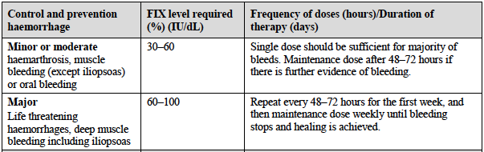

#### Perioperative setting:

Dosing guidance is given in the following table taken from the draft PI:

Table 2: Dosing guidance for perioperative setting

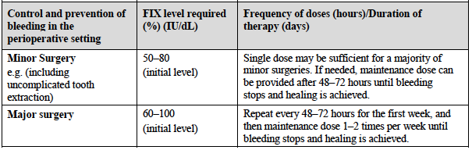

#### Routine prophylaxis:

Two regimens are proposed:

* 25–40 IU/kg once weekly (every 7 days), or
* 50–75 IU/kg every 14 days.

### Other proposed changes to the PI

Not applicable.

## Clinical rationale

Haemophilia B is an X-linked congenital bleeding disorder caused by a deficiency of coagulation factor IX (FIX). It is characterised by recurrent bleeding episodes, typically into joints and muscles. It is less common than haemophilia A (factor VIII deficiency), accounting for 15-20% of all haemophilia cases.[1] The Haemophilia Foundation of Australia estimates that there are approximately 2,950 subjects with haemophilia in Australia.[2] The prevalence of the haemophilia B in Australia would therefore be approximately 442 – 590 subjects. Haemophilia is often classified as mild, moderate or severe based on factor levels (Table 3).1

Table 3: Classification of Severity of Haemophilia

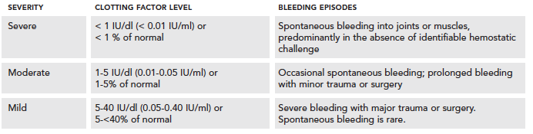

The current standard treatment of haemophilia B is based on the use of replacement FIX therapy. Replacement therapy products that are currently registered in Australia are:

* Plasma-derived FIX (Monofix-VF, CSL Ltd) which is manufactured from blood donated to the Australian Red Cross Blood Service;
* Recombinant FIX (nonacog alfa; Benefix; Pfizer Australia Pty Ltd);
* Recombinant FIX (nonacog gamma; Rixubis; Baxalta Australia Pty Ltd); and
* Recombinant long-acting FIX (eftrenonacog alfa; Alprolix; Biogen Australia Pty Ltd).

The FIX contained in Monofix-VF, Benefix and Rixubis has a half-life of approximately 24 hours. For the treatment of bleeding episodes and for surgical prophylaxis it is recommended that dosing be repeated every 12-24 hours. For routine prophylaxis, dosing is recommended twice per week.[3]

Alprolix is a long-acting form of recombinant FIX in which the FIX molecule is bound to the Fc fragment of an immunoglobulin G1 (IgG1) molecule. It has a half-life of 82 hours. For the treatment of bleeding episodes and for surgical prophylaxis the dosing interval is up to 48 hours, and for routine prophylaxis, the recommended dosing interval is up to 10 days.[4]

Combining the FIX molecule with an albumin molecule is intended to produce a prolonged half-life, with less frequent dosing required. The draft PI states that albutrepenonacog alfa has an elimination half-life of 104 h and the recommended dosage interval for the treatment of bleeding episodes and surgical prophylaxis is up to 72 hours. The recommended initial dosage interval for routine prophylaxis is up to 14 days.

## Contents of the clinical dossier

### Scope of the clinical dossier

The submission contained the following clinical information:

* 1 Phase I safety and PK study using ascending single doses (Study 2001);
* 1 population pharmacokinetic analysis;
* 1 phase I/II study examining PK, safety and efficacy (Study 2004);
* 1 pivotal phase II/III PK, efficacy and safety study in adults and adolescents (Study 3001):
* 1 pivotal phase III PK, efficacy and safety study in children (Study 3002);
* 1 phase III extension efficacy and safety study (Study 3003).
* Tabulated data for pooled analyses of PK, efficacy and safety;

The submission was lodged in electronic format only.

### Paediatric data

The submission included paediatric pharmacokinetic, efficacy and safety data (Study 3002).

### Good clinical practice

The clinical study report for each of the submitted studies included an assurance that they were carried out in accordance with the ICH (International Conference on Harmonization) Good Clinical Practice (GCP) guidelines and the Declaration of Helsinki.

## Pharmacokinetics

### Studies providing pharmacokinetic data

Four of the five submitted clinical studies provided PK data. Table 4 shows the studies relating to each pharmacokinetic topic and the location of each study summary.

Table 4: Submitted pharmacokinetic studies

|  |  |  |  |
| --- | --- | --- | --- |
| PK topic | Subtopic | Study ID | * |
| **PK in adults and adolescents with haemophilia B** | General PK - Single dose | 2001 | * |
| 2004 |  |
| 3001 |  |
| - Repeat-dose | 3001 |  |
| **PK in children with haemophilia B** | General PK - Single dose | 3002 | * |
| **Population PK analyses** |  | RA21020032 | * |

* Indicates the primary aim of the study.

None of the pharmacokinetic studies had deficiencies that excluded their results from consideration.

### Summar**y** of pharmacokinetics

The information in the following summary is derived from conventional pharmacokinetic studies unless otherwise stated.

#### Physicochemical characteristics of the active substance

The following information is derived from the sponsor’s summaries. rIX-FP is a fusion protein combining human coagulation factor IX and recombinant albumin. It contains 1018 amino acids and has a molecular weight of approximately 125 kilo Daltons. It is produced by recombinant DNA technology in a Chinese hamster ovary (CHO) cell line.

#### Pharmacokinetics in haemophilia B subjects

##### Absorption

rIX-FP is only administered intravenously and by definition has 100% absorption and bioavailability. In the studies the first PK sample was not collected until 30 minutes after the end of the infusion. Tmax for plasma FIX activity generally occurred around this time.

##### Incremental recovery

In adults and adolescents, mean incremental recovery after a single dose of 50 IU/kg rIX-FP was

1.31 IU/dL per IU/kg. This value was higher than that obtained with recombinant FIX (0.961 IU/dL per IU/kg) and comparable to that obtained with plasma-derived FIX (1.30 IU/dL per IU/kg).

In children aged < 12 years incremental recovery for rIX-FP was lower than in adults (1.01 IU/dL per IU/kg) but greater than that obtained with recombinant FIX (0.731 IU/dL per IU/kg) or plasma-derived FIX (0.756 IU/dL per IU/kg).

##### Dose proportionality

An analysis based on FIX antigen Cmax and AUC values indicated that the PK of rIX-FP was dose proportional over the dose range 25 to 75 IU/kg.

###### PK during multiple-dosing

In Study 3001, 15 subjects had an assessment of rIX-FP PK before and after 6 months of prophylaxis treatment. The PK of rIX-FP was not altered to a clinically significant extent.

#### Distribution

##### Volume of distribution

In adults and adolescents, values for volume of distribution at steady state (Vss) were approximately 1.0 dL/kg (100 mL/kg), equating to 7.0 L in a 70 kg subject. In the population PK analysis, for a 70 kg subject, the predicted value for central volume was 6.48 L for central volume and 1.58 L for peripheral volume, using a two-compartment model.

In children, volume of distribution was higher (131.6 mL/kg for Vss).

In the three studies (2001, 3001 and 3002) that included a comparison of rIX-FP with rFIX (e.g. BeneFIX), volume of distribution was lower following rIX-FP, indicating less distribution outside the vascular space.

###### Other distribution parameters

There were no clinical data submitted on plasma protein binding, erythrocyte distribution or tissue distribution.

**Comment:** The guideline on PK of therapeutic proteins adopted by the TGA[5] states that ‘... binding capacity to plasma proteins should be studied *when considered relevant*’. It contains no recommendations regarding the need to measure distribution to tissues. The EMA guideline on factor IX products[6] does not require investigation of these parameters. The absence of data on other distribution parameters is therefore not considered a deficiency in the submission.

##### Metabolism and Excretion

###### Routes of metabolism and excretion

There were no clinical data in the submission regarding the routes of metabolism and excretion of rIX-FP.

**Comment:** According to the guideline on PK of therapeutic proteins, the elimination of large proteins can be predicted to occur through catabolism by proteolysis. The absence of data on metabolism and excretion is therefore not considered a deficiency.

###### Clearance

In adults and adolescents, following single intravenous doses of rIX-FP, clearance was approximately 0.75 mL/hr per kg. This equates to 0.875 mL/min for a 70 kg individual. In the population PK analysis, for a 70 kg subject, the predicted value for clearance was 0.575 dL/hr (0.958 mL/min).

In children, clearance was higher (1.112 mL/hr per kg).

###### Half-life

In adults and adolescents, following single intravenous doses of rIX-FP, half-life was in the range of 90 to 100 hours. In children, the observed mean half-life was 91.4 hours. In the three studies that compared rIX-FP with conventional FIX products, the half-life of rIX-FP was consistently longer.

##### Intra- and inter-individual variability of pharmacokinetics

Variability in PK parameters was modest with values for co-efficient of variation generally being <25%. In the population PK analysis the only covariate with a significant effect on rIX-FP PK was body weight.

#### Pharmacokinetics in other special populations

##### Pharmacokinetics in subjects with impaired hepatic function

No dedicated clinical studies were conducted in subjects with hepatic impairment. In the population PK analysis baseline AST level, ALT level or hepatitis positivity had no significant effect on rIX-FP PK.

##### Pharmacokinetics in subjects with impaired renal function

No dedicated clinical studies were conducted in subjects with renal impairment. In the population PK analysis baseline creatinine clearance had no significant effect on rIX-FP PK.

##### Pharmacokinetics according to age

In the sponsor’s Summary of Clinical Pharmacology the sponsor presented an analysis of pooled PK data based on age. Results of the analysis are summarised in Table 5. For a dose of 50 IU/kg, children demonstrated higher clearance and a larger volume of distribution than adults. Consistent with increased clearance, children had lower Cmax, AUC and incremental recovery.

The population PK analysis did not detect a significant effect of age (in addition to bodyweight) on rIX-FP PK. The sponsor commented that this was likely to be due to the strong correlation between age and total body weight in children.

Table 5: Pooled PK data – PK according to age

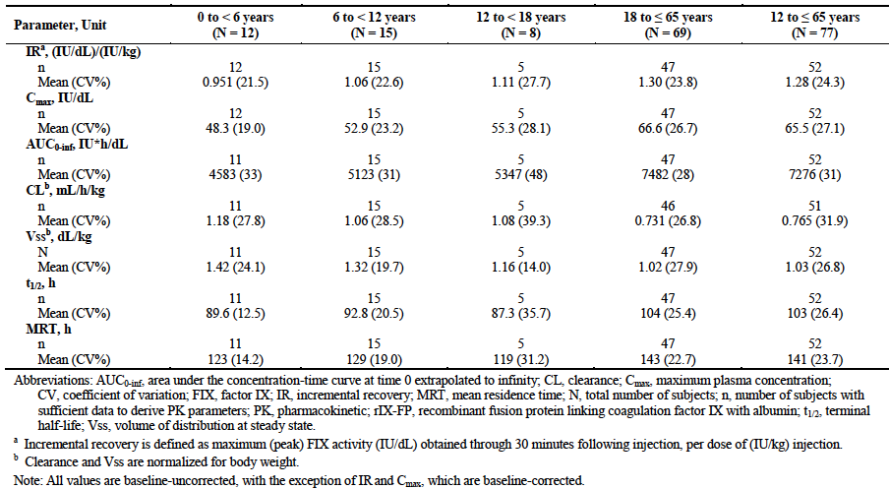

#### Pharmacokinetic interactions

No data were submitted on PK interactions.

### Evaluator’s overall conclusions on pharmacokinetics

The PK of rIX-FP have been adequately characterised, given the rarity of haemophilia B and the fact that rIX-FP is a large protein administered IV. The data generated meet the requirements for PK data laid down in the relevant EMA guidelines.

The data demonstrate that administration of rIX-FP is associated with restoration of FIX activity in plasma in subjects with severe FIX deficiency. This FIX activity in plasma is prolonged when compared to conventional FIX replacement products such as rFIX and pd-FIX. Compared to adults, children have increased clearance of rIX-FP and a higher volume of distribution, and as a result achieve lower plasma FIX activity levels.

rIX-FP was associated with a higher incremental recovery than the comparator FIX products used in the submitted studies.

## Pharmacodynamics

FIX activity was measured in four of the five studies submitted. In haemophilia B studies this is considered to be a pharmacokinetic endpoint and results have therefore been described above in section 4 of this report. There were no other PD data submitted.

## Dosage selection for the pivotal studies

The doses used in the pivotal studies were based on PK data from the phase 1 PK study (Study 2001). For Study 3001, doses were calculated using the formula described in section Dosage and administration above. For Study 3002 prophylaxis dose was set at 35-50 IU/kg every 7 days, which could be adjusted based on the individual subject’s PK data. Target FIX activity levels for the treatment of bleeding episodes were based on the recommendations of the World Federation of Haemophilia (WFH).

**Comment:** The dosage regimens recommended in the draft PI for the treatment of bleeding episodes and use in surgery are not identical to those used in the pivotal studies. Rather the sponsor has incorporated the incremental recovery values obtained from the PK assessments in the studies into a dosing formula (see section Dosage and administration above) to obtain desired plasma FIX activity levels. This is an acceptable approach used with other FIX products.

## Clinical efficacy

### Pivotal efficacy studies

#### Study 3001

##### Study design, objectives, locations and dates

###### Study design

Study 3001 was an open-label trial in previously treated patients (aged 12-65 years) with severe haemophilia B. The study design is summarised in Figure 1 and Figure 2. After initial screening, subjects were allocated to one of the two treatment arms; Arm 1 (prophylaxis treatment) or Arm 2 (on demand treatment). Subjects were allocated on the basis of their current treatment; that is, subjects currently receiving on-demand treatment were allocated to Arm 2.

Figure 1: Study 3001 - Study schema (overall)

Figure 1: Study 3001 - Study schema (overall)
After initial screening, subjects were allocated to one of two treatment arms; Arm 1 (prophylaxis treatment) or Arm 2 (on demand treatment). Subjects were allocated on the basis of their current treatment; that is, subjects currently receiving on-demand treatment were allocated to Arm 2.

Figure 2: Study 3001 - Study schema (Arm 1)

Figure 2: Study 3001 - Study schema (Arm 1)
Subjects allocated to Arm 1 (prophylaxis treatment) were further stratified in to one of three treatment blocks. The 3 blocks differed with respect to the PK evaluation to be undertaken.
See text for more detail.

Subjects allocated to Arm 1 (prophylaxis treatment) were further stratified in to one of three treatment blocks. The 3 blocks differed with respect to the PK evaluation to be undertaken.

* Block A was to include all subjects who had completed an earlier phase 1/2 study (Study 2004). These subjects already had a PK assessment in the earlier study. Therefore no *initial* PK assessment would be performed prior to the commencement of prophylaxis treatment. However, if 6 months of prophylaxis treatment was successful with a dose of ≤ 50 IU rIX-FP per week, they would undergo a PK assessment of a dose of 75 IU rIX-FP with a view to extending the dosage interval.
* Block B was to include the first 15 subjects who had not participated in Study 2004. These subjects would undergo three PK assessments – a PK assessment of their previous FIX product, an *initial* PK assessment of 50 IU/kg rIX-FP, and a *repeat* PK assessment of 50 IU/kg rIX-FP after approximately 6 months of prophylaxis treatment.
* Block C was to include all further subjects who had not participated in Study 2004. These subjects were to only undergo an *initial* PK assessment of 50 IU/kg rIX-FP prior to prophylactic treatment.

After approximately 6 months of prophylaxis treatment using a 7 day dosing interval subjects in Arm 1 could switch to a 10 or 14 day dosage interval provided that certain criteria (described below) were met. After approximately 6 months of on-demand treatment, subjects in Arm 2 could switch to prophylaxis treatment using a 7 day dosing interval, provided certain criteria were met.

All subjects were also eligible to participate in a sub-study that examined the efficacy and safety of rIX-FP in the surgical setting.

###### Objectives

The primary objectives were to evaluate the efficacy of rIX-FP in preventing bleeding episodes (prophylaxis) and safety of rIX-FP with respect to the development of inhibitors against FIX in subjects with severe hemophilia B (FIX activity of ≤ 2%). The primary objective of the surgical sub-study was to evaluate the efficacy of rIX-FP in the prevention and control of bleeding in subjects with severe hemophilia B during surgical procedures.

The secondary objectives of the study were:

* To evaluate the PK of a single dose of rIX-FP;
* To evaluate the clinical response to rIX-FP for the prevention and treatment of bleeding episodes in subjects with severe hemophilia B;
* To evaluate the safety of rIX-FP, based on AEs and the development of antibodies to rIX-FP;
* To evaluate the safety of rIX-FP during the intraoperative and postoperative periods.

###### Locations and dates

The trial was conducted in 32 centres in 10 countries (Austria, Bulgaria, France, Germany, Israel, Italy, Japan, Russia, Spain and the United States) between February 2012 and July 2014. The study report was dated 7 November 2014. At the time of writing the study does not appear to have been published.

##### Inclusion and exclusion criteria

**Comment:** The key inclusion and exclusion criteria are consistent with those recommended for studies in previously treated patients by the relevant EMA guideline.[7]

##### Study treatments

Doses used in the PK evaluations are described above. The following describes the dosage regimens used for treatment.

###### For Arm 1 (prophylaxis treatment) the following dosage regimens were used:

* Block A subjects continued with the same prophylaxis dose used at the end of Study 2004. This regimen continued for 26 weeks.
* Block B subjects were treated with a prophylaxis regimen of 35-50 IU/kg every 7 days for 30 weeks.
* Block C subjects were treated with a prophylaxis regimen of 35-50 IU/kg every 7 days for 30 weeks.

If a subject experienced a spontaneous haemorrhage during prophylaxis, the prophylaxis dose could be increased by an increment of 10 ± 5 IU/kg, up to a maximum dose of 75 IU/kg with a target of maintaining the trough FIX activity level above 1% between the 7 day doses. These increments could occur once in any 28 day period. Haemorrhages were treated using the same regimen used for on-demand treatment in Arm 2 (see below).

After completion of the treatment period specified for each block, subjects could be switched from a 7 day regimen to a 10 or 14 day regimen if they met the following criteria:

* No dose adjustment had occurred in the previous month;
* No spontaneous bleeding episodes had occurred in the previous month;
* Subject was currently on a weekly prophylaxis dose of ≤ 50 IU/kg;
* Subject was willing to switch to a longer treatment interval.

A new dose regimen was assigned using the following algorithm (Table 6)

Table 6: Algorithm for dosage assignment

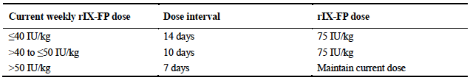

The 10 and 14 day regimens were to be continued for at least 30 weeks and 50 exposure days. If a subject being treated with a 14 day regimen experienced two spontaneous haemorrhages in a two-month period, the dosage interval could be reduced to 10 days. A 10 day interval could be reduced to a 7 day interval in the same circumstances.

###### For Arm 2 (on-demand treatment) the following dosage regimens were used:

* On-demand dose was based on each subject’s PK results, with a minimum dose of 35 IU/kg and a maximum dose of 75 IU/kg. After haemostasis was achieved, maintenance doses could be prescribed at the discretion of the investigator.
* Patients could switch to a prophylaxis regimen after completing 26 weeks of on-demand dosing, or after experiencing at least 12 spontaneous bleeding episodes, whichever occurred first. The prophylaxis regimen was 35-50 IU/kg every 7 days. During the first 4 weeks the dose could be increased, up to a maximum of 75 IU/kg every 7 days. This dose was maintained for the remainder of the study (approximately 26 weeks in total).

###### For surgical procedures the following regimen was used:

* Approximately 1 hour prior to surgery, a single dose of rIX-FP was administered. The dose was based on the subject’s PK assessment but was in the range of 50 – 75 IU/kg. The aim was to increase plasma FIX activity levels to 60-80%;
* During surgery additional doses could be administered depending on plasma FIX activity levels, type of surgery and local standard of care. Plasma FIX activity levels were to be measured prior to these repeat doses;
* Post-operative doses could be administered for up to 14 days after surgery depending on plasma FIX activity levels and type of surgery.

rIX-FP was administered as a bolus IV injection at a rate of approximately 250 IU per minute or in approximately 5 to 15 minutes. During the PK evaluation period all injections were administered at the study centre by study staff. During the treatment evaluation period injections could be administered by the subject, the subject’s caregiver or by the study staff.

##### Efficacy variables and outcomes

###### The main efficacy variables were

* The number of bleeding episodes;
* The amount of rIX-FP used for on-demand and prophylactic treatment;
* The investigator’s overall assessment of efficacy.

The primary efficacy endpoint was the annualized spontaneous bleeding rate (AsBR) in the on-demand treatment arm (Arm 2).

###### Secondary efficacy endpoints were

* Various sensitivity analyses of the primary efficacy endpoint;
* Number of spontaneous bleeding episodes per year in Arm 2, assuming a Poisson distribution;
* Annualized bleeding rate for *total* bleeding episodes in Arm 2;
* Number of infusions of rIX-FP required to achieve haemostasis in the treatment of minor/moderate bleeding episodes;
* Investigator’s overall clinical assessment of haemostatic efficacy for the treatment of bleeding episodes. This was assessed using two separate 4-point scales; one for mild/moderate bleeds and another for major trauma/life-threatening bleeds
* rIX-FP consumption during routine prophylaxis;
* Comparison of annualized spontaneous bleeding rate between the 7 day and >7 day prophylaxis regimens.

###### Other efficacy analyses performed were:

* Time from last dose of rIX-FP to the onset of a spontaneous bleeding episode;
* Annualized bleeding rates by category of bleeding (spontaneous, traumatic, non-traumatic [that is,, spontaneous or unknown]), joint, and total bleeding episodes;
* Analyses of bleeding episodes by type (overall, spontaneous, traumatic, unknown), location, dose used in treatment and time between onset of bleeding and treatment;
* Subject assessment of efficacy in mild or moderate bleeding episodes;
* Monthly consumption of rIX-FP versus previous FIX for routine prophylaxis.

Subjects recorded details of their dose, dose interval, rIX-FP consumption, and details of any bleeding episodes in an electronic diary. Subjects were reviewed in the clinic every 4 weeks.

###### For the surgical sub study, efficacy outcomes were:

* The investigator’s/surgeon’s overall clinical assessment of haemostatic efficacy for surgical prophylaxis, based on a 4-point ordinal scale;
* A comparison of the preoperative predicted surgical blood loss for a subject without haemophilia undergoing the same type and extent of surgical procedure and the estimated intraoperative blood loss;
* A comparison of the preoperative predicted surgical blood loss for a subject without haemophilia undergoing the same type and extent of surgical procedure and the actual transfusion requirements;
* Changes in haemoglobin between baseline and the lowest intraoperative and postoperative levels;
* Weekly rIX-FP consumption;
* Wound hematoma/surgical evacuation, blood loss through surgical drainage (mL), and any late bleeding episodes within 72 h of surgery.

##### Randomisation and blinding methods

Subjects were not randomised to treatment. Allocation to Arm 1 or Arm 2 was based on the subject’s existing treatment regimen. Allocation to the different blocks of Arm 1 was done in a sequential manner. The study was an open-label trial with no blinding.

**Comment:** Given the rarity of haemophilia B, adequately powered randomised double blind trials would be difficult to perform. The trial design complies with the EU guideline adopted by the TGA.

##### Analysis populations

###### The following analysis populations were defined:

* The safety population consisted of all subjects who received at least 1 dose (or partial dose) of rIX-FP during the study;
* The efficacy population consisted of all subjects who received at least 1 dose of rIX-FP as part of either routine prophylaxis treatment or on-demand treatment during the study;
* The primary efficacy population consisted of all subjects in the efficacy population assigned to the on-demand treatment arm (Arm 2) who received at least 1 dose of on-demand treatment and also received at least 1 dose of routine prophylaxis treatment;
* The per-protocol (PP) population consisted of all subjects in the efficacy population who did not have any inclusion or exclusion criteria deviations and who incurred no protocol deviations that pertained to the assessment of treatment efficacy;
* The PK population consisted of subjects who received at least 1 dose of rIX-FP for PK assessment and for whom a sufficient number of analysable;
* The surgical population included all subjects who received at least 1 dose of rIX-FP for a major or minor surgical procedure.

##### Sample size

Arm 2 of the study was designed to show that 7 day prophylaxis treatment with rIX-FP was superior to on-demand treatment with rIX-FP with respect to the AsBR. To demonstrate a 50% reduction in AsBR (ratio of AsBR with prophylaxis to AsBR with on-demand < 0.50), with at least 89% power it was calculated that a sample size of 21 subjects would be required, assuming a coefficient of variation not more than 1.6 and a type I error α of 0.025 (1-sided). It was therefore planned to recruit a total of 25 subjects to allow for at least 21 evaluable subjects.

Approximately 35 subjects were planned for Arm 1 of the study. These would ensure a total of 50 subjects in the study as a whole. Advice received by the sponsor from a regulatory agency was that a rate of no more than 1 inhibitor in 50 subjects would be acceptable.

For the surgical sub study the target enrolment was at least 5 subjects and 10 major surgeries, in line with the requirements of the EMA guideline.

##### Statistical methods

For the primary efficacy endpoint, the difference in AsBR between on-demand and prophylaxis was to be tested using the Wilcoxon signed rank test. In general, descriptive statistics were used for the remaining endpoints.

##### Participant flow

Overall subject disposition is summarised in Figure 3, and disposition with respect to PK assessments is summarised in Table 7. A total of 63 subjects were enrolled and treated, 40 in the prophylaxis arm (Arm 1) and 23 in the on-demand arm (Arm 2). Analysis populations are summarised in Table 8.

Figure 3: Study 3001 Subject disposition

Figure 3: Study 3001 – Subject disposition
A total of 63 subjects were enrolled and treated, 40 in the prophylaxis arm (Arm 1) and 23 in the on-demand arm (Arm 2).

Table 7: Study 3001 Subject disposition (PK assessments)

|  |  | N | Assess-ment of previous FIX PK | Assessment of  rIX-FP PK | | | | No PK  Assess-ment |
| --- | --- | --- | --- | --- | --- | --- | --- | --- |
| Initial PK | | Repeat PK | |
| 50 IU/kg | 25 IU/kg | 50 IU/  kg | 50 IU/kg | 75 IU/  kg |
| Arm 1 prophylaxis | Block A | 6 | - | - | - | - | 5 | 1 |
|  | Block B | 18 | 13 | - | 18 | 15 | - | 0 |
|  | Block C | 16 | - | 1 | 10 | - | - | 5 |
| Arm 2  on-demand |  | 23 | - | 5 | 18 | - | - | 0 |
| **Totals** |  | **63** | **13** | **6** | **46** | **15** | **5** | **6** |

Table 8: Study 3001 Analysis populations

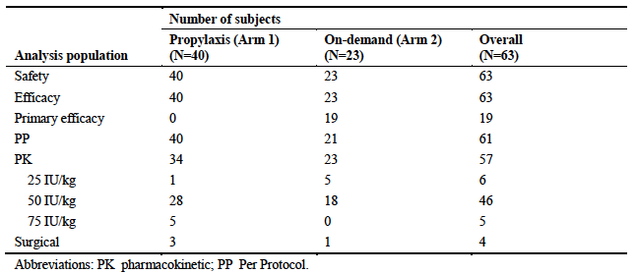

**Comment:** Recruitment numbers approximately met the planned sample sizes for both prophylaxis and on-demand treatment. However, only 4 subjects participated in the surgical sub study.

##### Major protocol violations/deviations

Two subjects had major protocol violations that resulted in them being excluded from the per-protocol population (1 non-compliance, 1 did not document study treatment in electronic diary). Other major violations that did not result in exclusion included use of study medication beyond the expiry date and non-adherence to the schedule of laboratory tests.

**Comment:** These violations are unlikely to affect the efficacy outcomes of the study.

##### Baseline data

Mean age was 33.0 years (with a range of 12-61 years) and 87.5% of subjects were White.

History of haemophilia B at baseline: The mean (± SD) time since diagnosis was 351.33 (± 160.037) months for the total study population. Time since diagnosis and was similar for Arm 1 and Arm 2. At baseline, hepatitis C, HIV infection and hepatitis B were reported in 36.5%, 19.0% and 3.2% of subjects respectively.

##### Results for the primary efficacy outcome

Results for the primary endpoint are summarised in Table 9. There were 19 subjects in the primary efficacy population. In these subjects, the mean AsBR decreased from 14.6 spontaneous bleeding episodes per year while receiving on-demand treatment to 0.73 spontaneous bleeding episodes per year while receiving prophylaxis treatment. The mean reduction in episodes was 96.0%. The difference was statistically significant (p<0.0001).

Table 9: Study 3001 - AsBR in Arm 2 (Primary endpoint)

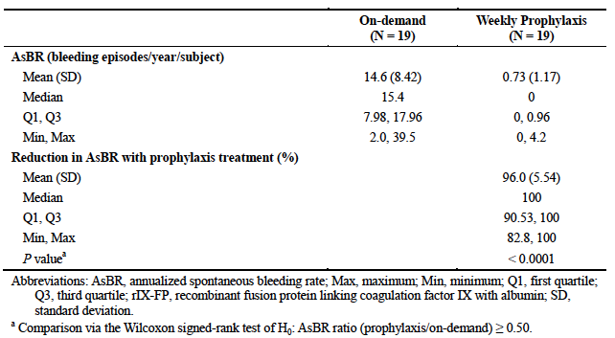

##### Results for secondary efficacy outcomes

###### Sensitivity analyses

Three sensitivity analyses of the primary endpoint were conducted all using different methods to check for potential impact of imputing missing AsBR data during prophylaxis treatment. Results of these analyses were consistent with the primary analysis, in that a statistically significant benefit was demonstrated for prophylaxis over on-demand treatment (p < 0.0001) for each analysis.

###### Number of spontaneous bleeding episodes per year, assuming a Poisson distribution

During prophylaxis in Arm 2, the average number of spontaneous bleeding episodes per year was 0.55 (95% CI: 0.233, 1.322). During on-demand treatment it was 13.62 (95% CI: 11.001, 16.868). The difference was not analysed statistically.

###### Annualized bleeding rate for total bleeding episodes in Arm 2

In the primary efficacy population, the mean ABR for total bleeding episodes decreased from 20.78 bleeding episodes per year while receiving on-demand treatment to 2.87 bleeding episodes per year while receiving prophylaxis treatment. The mean reduction in bleeding episodes was 88.8%. The difference was statistically significant (p<0.0001).

###### Number of infusions of rIX-FP required to achieve haemostasis (mild to moderate bleeds)

The number of infusions required to achieve haemostasis after bleeding is summarised in Table 10. Overall there were 358 bleeding episodes that required treatment during the study. In 98.6% of episodes, haemostasis was achieved with 1 or 2 infusions. The percentage was similar for spontaneous bleeds, traumatic bleeds, and bleeds of unknown cause.

Table 10: Study 3001 – Number of infusions required to achieve haemostasis

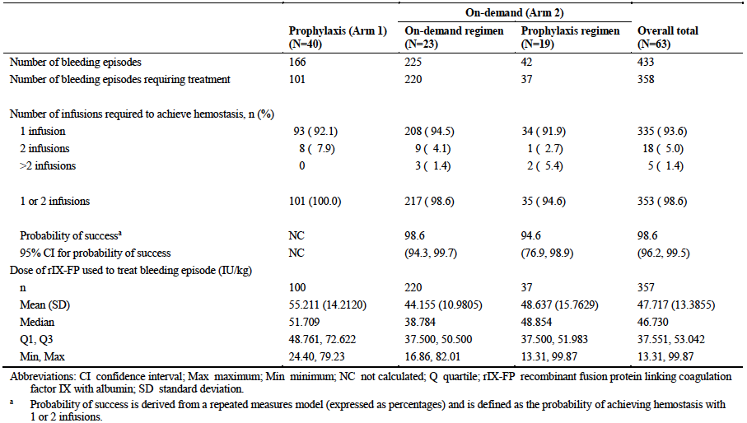

###### Investigator’s overall clinical assessment of efficacy for the treatment of bleeding

Results for the investigator’s overall assessment of efficacy are summarised in Table 11. For mild or moderate haemorrhages, efficacy was rated as excellent or good in 94.2% of episodes, and moderate in 2.5%.

Table 11: Study 3001 Investigator’s overall clinical assessment of efficacy for the treatment of bleeding episodes (efficacy population)

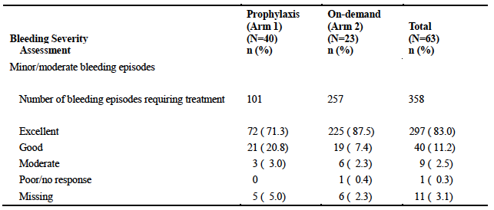

There was 1 bleeding episode for which efficacy was assessed as poor/no response. This was a lower leg haemorrhage in a 24-year-old male. The subject reported that the bleed was not adequately treated with a single dose of rIX-FP (39.37 IU/kg) but did not require administration of a second dose or another FIX product. The bleed therefore did not strictly meet the criteria for ‘no response’. The same subject subsequently had two further bleeds for which efficacy of rIX-FP was assessed as good for one and excellent for the other episodes.

There were no life-threatening or major trauma bleeds during the study.

###### rIX-FP consumption during routine prophylaxis

Table 12 summarises monthly rIX-FP consumption during prophylaxis for subjects in Arm 1. Compared to their previous FIX product, mean overall consumption was reduced; consistent with the longer half-life for rIX-FP. Subjects who were able to switch to a 14 day dose interval had even lower monthly consumption. However these subjects were not eligible to switch to a 14 day dose interval unless they had demonstrated low consumption while on a 7 day dose interval.

Table 12: Study 3001 rIX-FP monthly consumption during routine prophylaxis compared to previous FIX product (efficacy population)

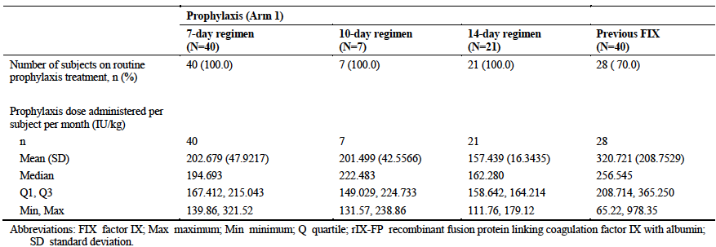

In Arm 2, 19 subjects were switched to receive a prophylaxis treatment with a 7 day dosage interval. Mean (± SD) monthly consumption for these subjects during prophylaxis was 191.687 (± 36.331) IU/kg per month, which was similar to that observed with a 7 day interval in Arm 1 (202.679 [± 47.922] IU/kg per month).

###### Annualized spontaneous bleeding rate (7 day versus >7 day prophylaxis regimens)

The analysis was conducted as a matched-pairs analysis on those subjects from Arm 1 who received at least 12 weeks of treatment with both the 7 day and > 7 day (extended) regimens. There were 26 subjects who met this criterion. Non-inferiority of the extended regimens would be concluded if the lower 95% CI for the difference in bleeding rate (rate with 7 day dosing minus rate with extended dosing) was not lower than -6.0.

Results are summarised in Table 13. The mean AsBR was low with both regimens: 0.23 bleeds per year with the 7 day regimen and 0.85 per year with the extended regimen. The mean difference was -0.62 (95%CI: -1.411 to + 0.163). As the lower 95% CI was > -6.0, non-inferiority was concluded.

Table 13: Study 3001 Annualised spontaneous bleeding rate (7-day versus >7 day prophylaxis regimens)

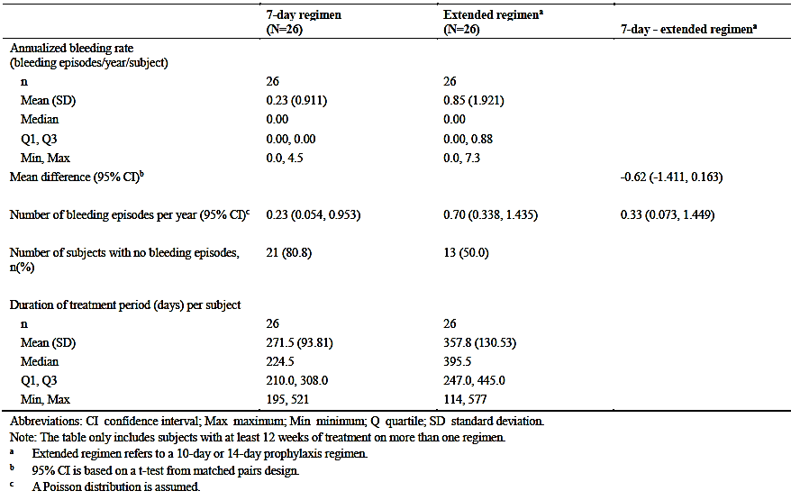

##### Results for other efficacy outcomes

###### Time from last dose of rIX-FP to onset of a spontaneous bleeding episode

Across both arms of the study, among 59 subjects receiving prophylaxis treatment with a 7 day dosage interval, a total of 51 spontaneous bleeds occurred. In these subjects, the mean (± SD) time between the onset of a spontaneous bleeding episode and the previous dose of rIX-FP was 106.36 (± 77.32) h (that is, approximately 4.5 days).

###### Annualised bleeding rates during prophylaxis by category of bleeding

Results are summarised in Table 14. Regardless of the bleeding category, results were generally consistent with other analyses of annualised bleeding rates described above, with rates being notably lower with prophylaxis than with on-demand treatment. Rates were also generally comparable between the different dose intervals used in prophylaxis.

Table 14: Study 3001 Annualised bleeding rate by bleeding category

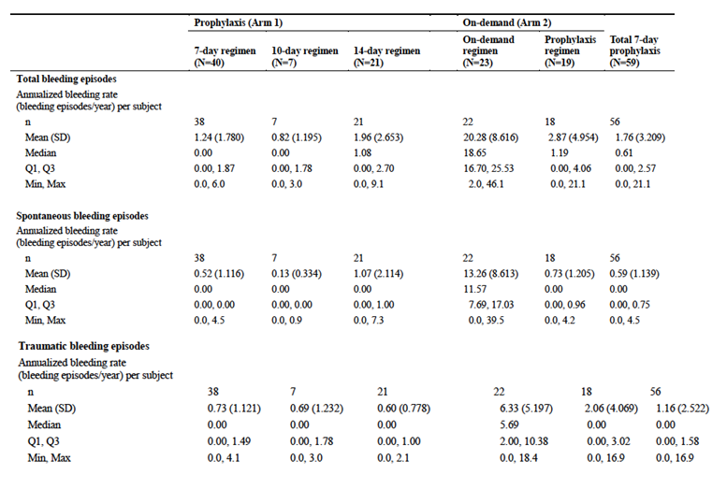

Table 14: (continued) - Study 3001 - Annualized bleeding rate by bleeding category

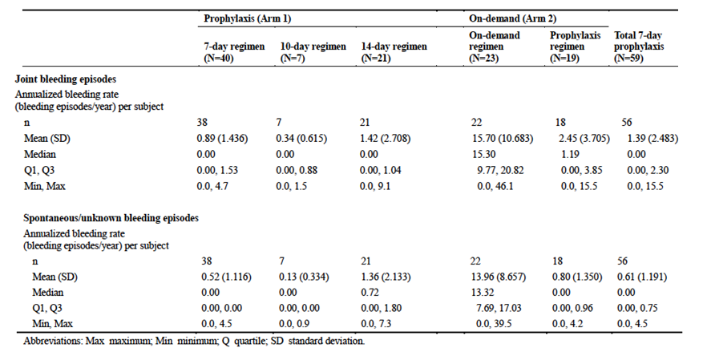

###### Analyses of bleeding episodes by category of bleeding

Analyses were presented on the number of infusions of rIX-FP required to achieve haemostasis, by cause of bleed (spontaneous, traumatic, unknown cause) and location of bleed (joint, muscle, other). Results were consistent with the overall results. Analyses were also presented on the time from onset of bleeding to treatment. Results for total bleeds are shown in Table 15. The mean time between onset of bleeding and commencement of treatment was approximately 4 h (median 0.867 h or 50 minutes).

Table 15: Study 3001 Time from start of bleeding to treatment / Subject assessment of efficacy

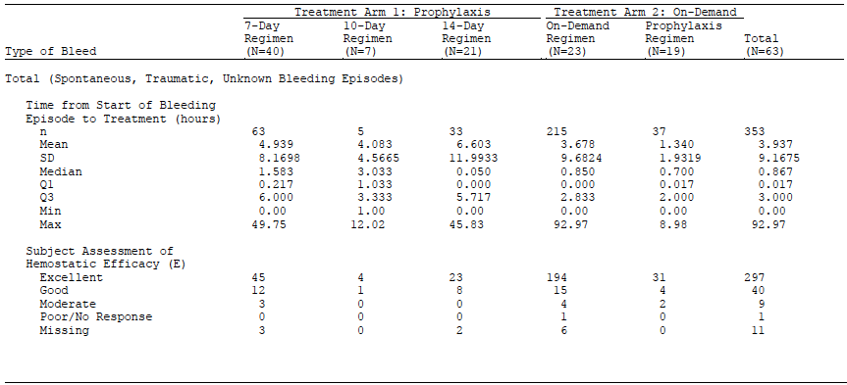

###### Subject assessment of efficacy in mild or moderate bleeding episodes

Results (for total bleeds) are summarised in Table14. Efficacy was assessed as excellent or good in 337/358 bleeds (94.1%).

###### Monthly consumption of rIX-FP versus previous FIX for routine prophylaxis

See Table 16.

Table 16: Study 3001 rIX-FP monthly consumption during routine prophylaxis compared to previous FIX product (efficacy population)



##### Results in the surgical setting

A total of four patients underwent a total of 6 surgeries during the study. One subject accounted for three of the surgeries; a bilateral mastectomy (for gynaecomastia) and bilateral total knee replacements. Efficacy results are summarised in Table 17.

Table 17: Study 3001 Efficacy in surgery

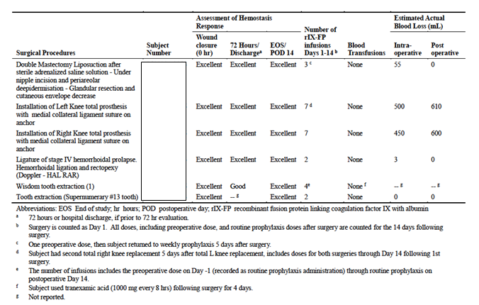

###### Investigator’s overall clinical assessment of haemostatic efficacy

Efficacy was assessed as excellent or good for all surgeries, at time of wound closure, at 72 h or at discharge and on the 14th postoperative day.

###### Surgical blood loss

In all cases the estimated actual blood loss was less than, or within the range of the blood loss predicted pre-operatively by the surgeon.

###### Transfusion requirements

No subjects required transfusion.

###### Changes in haemoglobin

One subject developed anaemia, beginning 24 h after his first knee replacement. The anaemia persisted for approximately two months during which he underwent a second knee replacement. Nadir value was 65 g/L (at 72 h after the 2nd replacement). The subject was treated with intravenous iron and erythropoietin.

###### Other endpoints

There was one post-operative haematoma that required evacuation (after the first knee replacement). Post-operative blood loss only occurred after the knee replacements (610 mL and 600 mL respectively). The subject who had a wisdom tooth extraction had two late post-operative bleeds (at 3 and 7 days post-operatively), which were treated with single doses of rIX-FP.

#### Study 3002

##### Study design, objectives, locations and dates

###### Study design

This trial was a Phase III, open-label, single arm study in previously treated paediatric patients (aged < 12 years) with severe haemophilia B. After an initial screening period, subjects underwent a 14 day PK evaluation period in which they received a single dose of 50 IU/kg of rIX-FP. This was followed by an active treatment period with weekly prophylaxis therapy with rIX-FP for approximately 11 months. All subjects were also eligible to participate in a surgical sub study. A study schema is shown in Figure 4.

Figure 4: Study 3002 Study schema

Figure 4: Study 3002 Study schema
After an initial screening period, subjects underwent a 14 day PK evaluation period in which they received a single dose of 50 IU/kg of rIX-FP. This was followed by an active treatment period with weekly prophylaxis therapy with rIX-FP for approximately 11 months.

###### Objectives

The two primary objectives of the study were:

* To evaluate the PK of a single dose of rIX-FP; and
* To evaluate the safety of rIX-FP with respect to the development of inhibitors to FIX in subjects with severe haemophilia B (FIX activity of ≤ 2%).

The secondary objectives of the study were:

* To evaluate the safety of rIX-FP, based on AEs;
* To evaluate the clinical response to rIX-FP for the prevention of bleeding episodes;
* To evaluate the clinical response to rIX-FP for the treatment of bleeding episodes.

###### Locations and dates

The study was conducted at 18 sites in 10 countries (Australia, Austria, Canada, Czech Republic, France, Germany, Israel, Italy, Russia and Spain) between January 2013 and October 2014. The study report was dated 15 January 2015. At the time of writing the study does not appear to have been published.

##### Inclusion and exclusion criteria

**Comment:** These criteria are generally consistent with those recommended in the relevant EU guideline.[8]

##### Study treatments

For the initial PK evaluation, subjects received a single dose of 50 IU/kg rIX-FP. In a subset of patients, the PK of their previous FIX product was assessed as well. The assessment of the previous FIX product was conducted prior to any administration of RIX-FP.

For prophylaxis, subjects were initially treated with 35 to 50 IU/kg rIX-FP every 7 days. If a subject experienced a spontaneous breakthrough haemorrhage, the dose of rIX-FP could be increased by an increment of 5 to 15 IU/kg, up to a maximum dose of 75 IU/kg, with a target of maintaining trough FIX activity level above 3% to 5%. The dose could also be reduced in the event of an unnecessarily high trough FIX level. The 7 day dosage interval was maintained throughout the study.

For the treatment of haemorrhages, the initial dose was 35 to 50 IU/kg rIX-FP. The subject’s caregiver was requested to contact the study centre for instruction if haemostasis was not achieved after the first rIX-FP administration. If a maintenance dose was required, the FIX activity level was to be tested prior to the second rIX-FP administration (if feasible) and the second dose was to be administered at least 24 h after the first. The dose could be increased up to a maximum of 75 IU/kg for subsequent haemorrhages. The prophylaxis schedule would resume 7 days after the last dose.

###### For surgical procedures the following regimen was used:

* Approximately 1-3 h prior to surgery a single dose of rIX-FP was administered. The dose aimed to increase plasma FIX activity levels to 60-80%;
* During surgery, additional doses could be administered depending on the individual subject’s known incremental recovery and/or clearance. Plasma FIX activity levels were to be measured prior to and 30 minutes after these repeat doses;
* Post-operative doses could be administered at 3 to 7 day intervals depending on plasma FIX activity levels and type of surgery.

In all scenarios, rIX-FP was administered as a bolus IV injection at a rate of approximately 250 IU per minute or over approximately 5 to 15 minutes. During the PK evaluation, all injections were administered at the study centre by study staff. During prophylaxis, injections could be administered by the subject, the subject’s caregiver or by the study staff.

##### Efficacy variables and outcomes

The evaluation of efficacy was a secondary objective of the study and hence all efficacy measures were considered as secondary or ‘other’ endpoints.

###### The main efficacy variables were

* The number of bleeding episodes;
* The amount of rIX-FP used for on-demand and prophylactic treatment;
* The investigator’s overall assessment of efficacy;
* Quality of life.

###### Secondary efficacy endpoints specified were

* Proportion of bleeding episodes requiring 1, 2, or >2 infusions of rIX-FP to achieve haemostasis;
* Consumption of rIX-FP;

###### Other efficacy endpoints specified were:

* Investigator’s overall clinical assessment of haemostatic efficacy in the treatment of bleeding episodes. This was assessed using two separate 4-point scales: one for mild/moderate bleeds and another for major trauma/life-threatening bleeds
* Investigator’s overall clinical assessment of haemostatic efficacy in surgery;
* Annualised bleeding rate for *spontaneous* bleeding episodes (ABsR) during prophylaxis;
* Quality of life as assessed by the Haemo-QoL instrument. This is a haemophilia-specific set of questionnaires, with different versions for different age groups; 4 to 7 years, 8 to 12 years and 13 to 16 years. The questionnaires cover various domains of HRQoL including psychological, physical and social factors. Raw scores are transformed into a score between 0 and 100 with higher scores indicating worse quality of life. In this study, questionnaires were to be administered to subjects aged 4 and over at baseline and after 50 exposure days or the end of the study. Another QoL questionnaire (Hemo-Sat) was given to caregivers. However no analyses of the data generated with this questionnaire were presented in the study report

##### Randomisation and blinding methods

The study was an open-label, single-arm trial with no randomisation or blinding.

##### Analysis populations

The following analysis populations were defined:

* The safety population consisted of all subjects who received at least 1 dose (or partial dose) of rIX-FP during the study;
* The pharmacokinetic population consisted of subjects who received at least 1 dose of rIX-FP for PK assessment and for whom a sufficient number of analyzable PK samples had been obtained to permit the evaluation of the PK profile of rIX-FP.
* The efficacy population consisted of all subjects who participated in the efficacy portion of the study and received at least 1 dose of rIX-FP.
* The per-protocol (PP) population consisted of all subjects in the efficacy population who completed the study without any major protocol deviations; that is, those who did not have any inclusion or exclusion criteria deviations; and who incurred no protocol deviations that affected the assessment of efficacy.

##### Sample size

For a study in previously treated paediatric subjects with haemophilia B, the relevant EMA guideline recommends a minimum of 10 evaluable subjects aged 6 to <12 years and 10 evaluable subjects <6 years of age. The planned sample size was therefore set at 22 subjects, to enable enrolment of 20 evaluable subjects.

##### Statistical methods

Descriptive statistics were used to analyse efficacy outcomes.

##### Participant flow

A total of 27 subjects were enrolled in the study. All subjects completed the trial. Subject disposition and the analysis populations are summarised in Table 18.

Table 18: Study 3002 Subject disposition

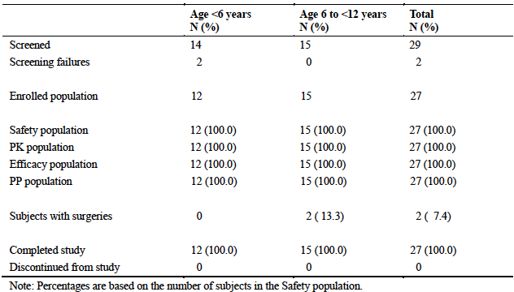

##### Major protocol violations/deviations

There were 3 major protocol deviations. Two of these related to consent issues. The other involved a subject who was treated with multiple doses of another product (BeneFIX) after undergoing surgery for a fractured arm. Data from the period of the surgery was excluded from analyses of efficacy. Therefore no subjects were completely excluded from the PP population.

##### Baseline data

Mean age was 5.9 years with a range of 1 to 10. The median number of bleeds in the preceding 12 months was 3.0. Most subjects had been on a prophylaxis regimen with a recombinant FIX product.

##### Results for the secondary efficacy outcomes

Proportion of bleeding episodes requiring 1, 2, or >2 infusions of rIX-FP to achieve haemostasis.

Results for this endpoint are summarised in Table 19. Over the course of the study there were a total of 106 bleeding episodes that required treatment. In 97.2% of these, haemostasis was achieved after 1 or 2 infusions.

Table 19: Study 3002 Number of infusions required to achieve haemostasis.

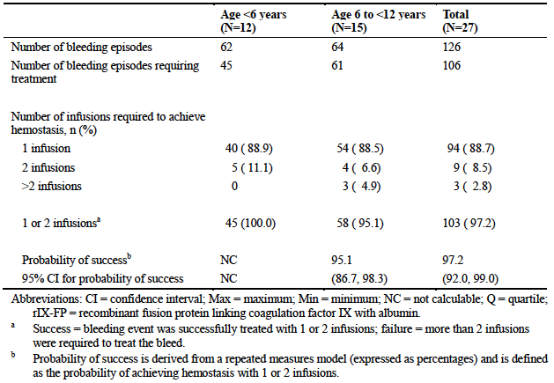

There were 3 bleeds that required > 2 infusions. All of them were joint haemorrhages, 2 being traumatic and 1 spontaneous. They were each treated with 3 or 4 infusions. In each instance, there was some delay in initiation of treatment.

###### Consumption of rIX-FP

Compliance with the prescribed prophylaxis regimen was high with the mean overall compliance rate being 97.88%. Details of rIX-FP consumption during prophylaxis are summarised in Table 20. The median dose of rIX-FP per infusion was approximately 46 IU/kg. For all measures, consumption was slightly greater in the subgroup of children aged < 6 years.

Table 20: Study 3002 rIX-FP consumption (for prophylaxis)

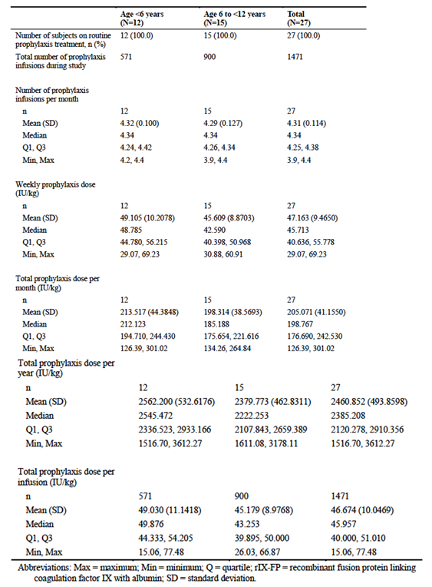

##### Results for other efficacy outcomes

###### Investigator’s overall assessment of efficacy in the treatment of bleeding episodes

For mild or moderate haemorrhages, efficacy was assessed as excellent or good for 96.2% of episodes. Efficacy was not rated as poor in any episode.

There were two major bleeding episodes. These occurred in the same subject and were both traumatic hip joint bleeds. Efficacy of rIX-FP was assessed as good by the investigator in both instances.

###### Investigator’s overall assessment of efficacy in surgery

A total of two subjects underwent a total of two surgeries during the study. Both of them also underwent multiple tooth extractions. Efficacy was assessed as good or excellent at all assessment times.

###### Annualised bleeding rate for spontaneous bleeding episodes (ABsR) during prophylaxis

Annualized bleeding rates are summarised in Table 21. The rate for spontaneous bleeds during prophylaxis was low (mean = 0.57 per year).

Table 21: Study 3002 Annualised bleeding rates

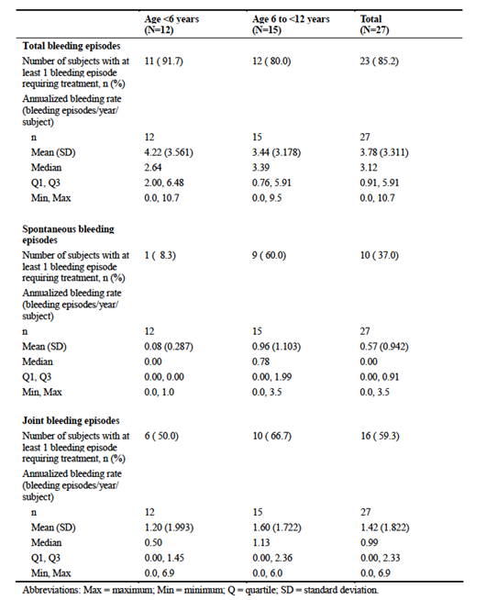

###### Quality of life (Haemo-QoL)

In the subgroup of children aged 8-12 years mean total score decreased from 27.94 at baseline to 20.35 at the end of the study, indicating some improvement in QoL. In the subgroup aged 4-7 years there was no improvement.[9]

### Other efficacy studies

#### Study 2004

Study 2004 was an open-label Phase I/II trial. A study schema is shown in Figure 5. After an initial screening visit subjects underwent a PK evaluation lasting 7-14 days in which they received a single IV infusion of rIX-FP at a dose of 25 IU/kg. After the PK evaluation subjects entered a treatment period during which they received rIX-FP as either prophylaxis or on-demand treatment for 20 weeks.

Figure 5: Study 2004 Study schema

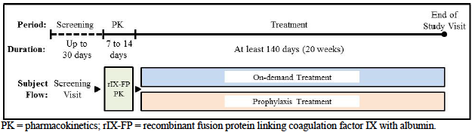

The primary objective of the study was to evaluate safety of rIX-FP. One of the secondary objectives was to evaluate the clinical efficacy of routine prophylaxis with rIX-FP with respect to the prevention of bleeding episodes. The study was conducted at 2 centres (1 in Bulgaria and 1 in Israel) between July 2011 and June 2012.

The study included male subjects aged between 12 and 65 years, with previously documented severe haemophilia B (FIX activity ≤ 2%), previous exposure to FIX products with > 150 exposure days and no detectable inhibitors or past history of inhibitors. Exclusion criteria were similar to those used in Study 3001.

Treatment regimens were as follows:

* For prophylaxis, the initial dose was 15 to 35 IU/kg given once per week, based on the subject’s previously determined PK profile and bleeding history. Dose was subsequently adjusted up to 75 IU/kg once per week to maintain trough FIX activity levels at > 1%. If bleeding episodes occurred at this dose, the treatment interval was shortened and the maximum dose was maintained at 75 IU/kg.
* For on-demand treatment subjects received 1 or more doses of at least 25 IU/kg. Doses were decided by the investigator and were based on the subject’s previously determined PK profile and bleeding history.

Doses were administered at a rate of approximately 250 IU per minute.

There was one secondary efficacy endpoint specified; the number of bleeding episodes in subjects receiving a prophylaxis treatment regimen with rIX-FP during the last 12 weeks (from Week 9 to Week 20) in the per-protocol population.

‘Additional’ efficacy endpoints specified were:

* rIX-FP consumed during the last 12 weeks period compared with previous FIX consumed during the 12 weeks of prophylactic therapy prior to screening:
* Proportion of prophylaxis subjects on weekly routine prophylactic treatment on Week 20 or at end of the study;
* rIX-FP consumed per infusion, while maintaining weekly prophylactic treatment interval during routine prophylaxis on week 20 or at end of the study;
* Proportion of bleeding episodes requiring 1 or 2 infusions of rIX-FP to achieve haemostasis;
* Investigator’s overall clinical assessment of haemostatic efficacy for treatment of bleeding episodes, based on a 4-point ordinal scale (excellent, good, moderate, poor / none).

A total of 17 subjects were enrolled and treated; 13 received prophylaxis treatment and 4 received on-demand treatment. Mean age was 26.1 years (range 13-46). All were Caucasians.

###### Results

Results for the specified secondary efficacy endpoint are summarised in Table 22. For the 13 subjects receiving prophylaxis treatment, the mean (± SD) number of bleeding episodes in the last 12 weeks of treatment was 0.8 (± 1.24). For the 4 subjects receiving on-demand treatment the mean number was 6.8 (± 1.26).

Table 22: Study 2004 Number of bleeding episodes

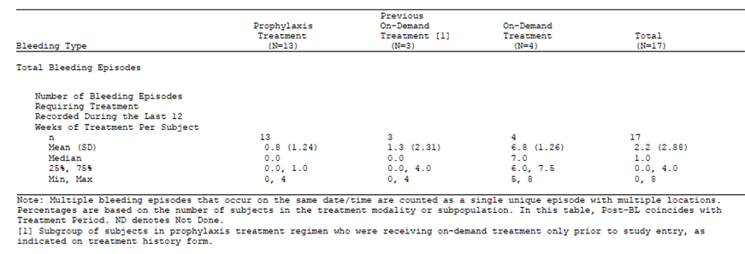

Results for the additional efficacy endpoints were as follows:

* There were 10 subjects in the prophylaxis group who had received prophylaxis with another FIX product prior to study entry. In these 10 subjects, mean (± SD) FIX consumption during the 12 weeks prior to study entry was 87.7 (±45.8) IU/kg per week. For the same 10 subjects, mean (± SD) rIX-FP consumption during the last 12 weeks of the study was 58.6 (±10.7) IU/kg per week;
* Of the 13 subjects who were commenced on the prophylaxis regimen, all were able to maintain a 7 day dosage interval to the end of the study;
* The mean (± SD) amount of rIX-FP consumed per infusion during weekly prophylaxis over the course of the study was 55.1 (± 13.9) IU/kg;
* Over the course of the study there were a total of 85 mild or moderate bleeding episodes that required treatment. All these episodes were successfully managed with 1 infusion (89.4%) or 2 infusions (10.6%). There were no major bleeding episodes during the study.
* The investigators assessed efficacy as excellent in 53 episodes (62.4%), good in 29 episodes (34.1%) and moderate in 3 episodes (3.5%).

#### Study 3003

Study 3003 is an open-label Phase IIIb trial. A study schema is shown in Figure 6. The study design includes 4 arms:

* Arm 1 enrolled subjects who had previously been treated with rIX-FP in a previous study, *except* those who had participated in Arm 2 of Study 3001;
* Arm 2 enrolled subjects who had previously been treated with rIX-FP in Arm 2 of Study 3001 (these subjects had received 26 weeks of on-demand treatment and then had been switched to prophylaxis treatment with a 7 day dosage interval);
* Arm 3 enrolled any new PTPs (who had not previously received rIX-FP) who require major non-emergency surgery;
* Arm 4 is to enrol previously untreated patients (PUPs).

Figure 6: Study 3003 Study schema

Figure 6: Study 3003 – Study schema
Arm 1 enrolled subjects who had previously been treated with rIX-FP in a previous study, except those who had participated in Arm 2 of Study 3001;
Arm 2 enrolled subjects who had previously been treated with rIX-FP in Arm 2 of Study 3001 (these subjects had received 26 weeks of on-demand treatment and then had been switched to prophylaxis treatment with a 7 day dosage interval);
Arm 3 enrolled any new PTPs (who had not previously received rIX-FP) who require major non-emergency surgery;
Arm 4 is to enrol previously untreated patients (PUPs).

Arm 3 was specifically designed to enrol subjects due to undergo surgery. However, subjects enrolled in the other three arms could also participate in a surgical sub study.

The primary objective of the study as a whole was to evaluate the safety of rIX-FP, as measured by the development of inhibitors. The primary objective of the surgery sub study was to evaluate the efficacy of rIX-FP in the prevention and control of bleeding in subjects with haemophilia B undergoing surgery. There were a number of secondary and exploratory objectives related to evaluation of efficacy and safety of prophylaxis and on-demand treatment.

The study commenced in February 2014 and is ongoing. It is being conducted at 39 centres in 15 countries. The date for data cut-off for inclusion in the submitted study report was 9 January 2015. The study report itself was dated 24 February 2015. It was described as an abbreviated study report presenting interim analyses only. The sponsor proposes to prepare a final study report on completion of the study.

**Comment:** The submitted study report presented efficacy data from the surgical substudy only. Hence only the surgical substudy will be discussed any further with respect to efficacy. The report also included safety data, which is reviewed as part of section 8 of this report.

Doses of rIX-FP used in subjects undergoing surgery were as follows:

* Approximately 3 h prior to surgery a single dose of rIX-FP was administered. The dose was based on the subject’s PK data but was in the range of 50 – 100 IU/kg. The aim was to increase plasma FIX activity levels to 60-80% or higher;
* During surgery additional doses could be administered depending on plasma FIX activity levels, type of surgery and local standard of care. Plasma FIX activity levels were to be measured prior to these repeat doses. For major surgery it was aimed to maintain trough FIX activity levels at 60-80%;
* Post-operative doses could be administered for up to 14 days after surgery depending on plasma FIX activity levels and type of surgery. FIX activity levels were to be measured before repeat dosing.

Efficacy was to be assessed in the surgery sub study through:

* The investigator’s overall assessment of haemostatic efficacy. The scale used was the same as that used in Study 3001.
* Intraoperative and postoperative haemoglobin levels;
* A comparison of the preoperative predicted surgical blood loss for a subject without haemophilia undergoing the same type and extent of surgical procedure and the estimated intraoperative blood loss;
* A comparison of the preoperative predicted surgical blood loss for a subject without haemophilia undergoing the same type and extent of surgical procedure and the actual transfusion requirements;

By the time of data cut-off a total of 80 subjects had been enrolled and treated in the study. 76 of these subjects had participated in earlier studies and 4 new subjects had enrolled and been treated in Arm 3. Overall a total of 7 subjects had participated in the surgical sub study; 3 from Arm 1, 1 from Arm 2 and 3 from Arm 3 (one subject enrolled and treated in Arm 3 had yet to undergo surgery by the time of data cut-off). The 7 subjects had undergone a total of 7 surgical procedures.

Results for the 7 subjects undergoing surgery are summarised in Table 23. Haemostasis was rated as excellent or good in all cases. One subject undergoing total knee replacement had clinically significant low haemoglobin during surgery (102 g/L). Estimated intraoperative blood loss was below or within the range predicted preoperatively by the surgeon. One subject (undergoing total knee replacement) required a blood transfusion of 280 mL. This amount was within the range predicted preoperatively by the surgeon.

Table 23: Study 3003 Investigator’s overall assessment of haemostasis in surgery

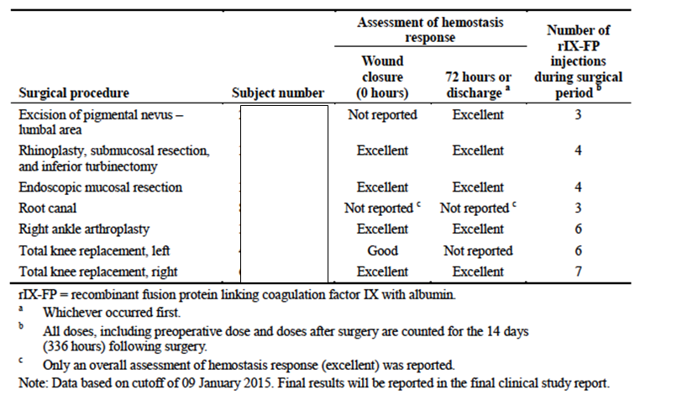

Mean pre-operative dose was 79 IU/kg. No intraoperative doses were given. The total number of doses ranged from 3 to 7.

### Analyses performed across trials (pooled analyses and meta-analyses)

There were no pooled analyses or meta-analyses presented.

### Evaluator’s conclusions on clinical efficacy

The pivotal studies complied with the requirements of the EU guideline for Factor IX products. The guideline states that pharmacokinetic endpoints such as incremental recovery, half-life, AUC and clearance are important surrogate endpoints for efficacy for a FIX product. As described in section 4 of this report, the PK data for rIX-FP indicate that the product restores FIX activity to plasma of subjects with severe FIX deficiency, with a half-life that is prolonged compared to conventional FIX products.

As recommended by the EU guideline, the two pivotal studies were conducted in previously treated patients (PTPs).

Study 3001 examined efficacy in adults and adolescents. This study demonstrated that switching subjects from an on-demand regimen with rIX-FP to a prophylaxis regimen resulted in a significant reduction in the incidence of spontaneous (and total) haemorrhages. It also demonstrated that in certain subjects, the dosage interval for prophylaxis could be extended to 10 or 14 days without a notable increase in the frequency of bleeding episodes.

For the treatment of mild or moderate bleeding, 98.6% of episodes could be managed with 1 or 2 infusions of rIX-FP. Efficacy of rIX-FP in the treatment of bleeding was assessed as excellent or good in 94.2% of episodes by the investigators, and 94.1% of episodes by the subjects. In this study there were no episodes of major bleeding.

Study 3002 examined efficacy in paediatric subjects aged < 12 years. In this study a prophylaxis regimen using a 7 day dosage interval was found to be associated with a low rate of spontaneous haemorrhage.

For the treatment of bleeding, 97.2% of episodes could be managed with 1 or 2 infusions of rIX-FP. Efficacy of rIX-FP in the treatment of mild or moderate bleeding was assessed as excellent or good in 96.2% of episodes by the investigators. Efficacy was also assessed as good in 2 episodes of major bleeding.

These data indicate that rIX-FP is effective for prophylaxis therapy and the treatment of bleeding episodes in previously treated patients.

Efficacy in surgery was assessed with a total of 15 surgeries in 13 subjects. Where the investigator reported on overall assessment of haemostasis, the assessments were ‘excellent’ or ‘good’ in all cases.

#### Limitations of the efficacy data

* One of the proposed dosage regimens for prophylaxis therapy in the draft PI is 50-75 IU every 14 days. The text implies that subjects can commence prophylaxis with rIX-FP using this regimen. The efficacy data do not support such an approach. In Study 3001 all subjects commenced prophylaxis with a 7 day dosage interval and only those subjects who met certain criteria could be transitioned to a 10 or 14 day dosage interval (see section *Study 3001; Study treatments*). It is likely that a 14 day regimen will have reduced efficacy in subjects who do not meet these criteria. Therefore the use of a 14 day dosage interval should be similarly restricted in the PI.
* For prophylaxis, a dosage interval of more than 7 days has not been studied in children aged < 12 years. The sponsor is proposing that a suitable prophylaxis regimen for use in this group is 50-75 IU/kg every 14 days. The population PK modelling suggests that the median trough FIX activity level in children will be lower than adults, due to increased clearance. With a 14 day dose interval, there is a risk that the efficacy of prophylaxis will be reduced in children compared to that seen in adolescents and adults in Study 3001. Prophylaxis regimens have traditionally aimed to maintain a factor IX activity level of > 1% at trough. Bleeding episodes are observed infrequently in subjects who are able to maintain such levels.[10] According to the population PK model, the predicted median trough level of FIX activity in subjects aged 0-6 years receiving the proposed regimen of 50 IU/kg every 14 days is only 1.1%. A sizeable proportion of these subjects are therefore likely to develop trough levels of < 1%. In the absence of clinical evidence of efficacy, the dosage interval for prophylaxis in children aged < 12 years should be limited to 7 days.
* The EU guideline requires that efficacy in the surgical setting should be studied in at least 10 *major* surgeries (in at least 5 separate individuals). Although efficacy of rIX-FP has been studied in 15 surgeries in total, many of these appeared to be fairly minor procedures, and it seems unlikely that the EMA minimum requirements have been met. The sponsor should be asked to identify which of the 15 procedures it considers to be ‘major’ and provide a definition of what constitutes major surgery.
* Efficacy has not been studied in previously untreated patients (PUPs). The EU guideline does not require a study in PUPs prior to initial marketing approval for a novel FIX product; however it does suggest that such a trial should be conducted and submitted at a later time. The sponsor is planning to study PUPs in Study 3003.
* No studies were submitted examining efficacy in patients with inhibitors.

## Clinical safety

Safety issues associated with FIX products in general include:

* Immunogenicity, including inhibitor development and allergic reactions (e.g. anaphylaxis);
* Thrombogenicity;
* Fevers, chills etc.

### Studies providing evaluable safety data

All the five studies submitted provided safety data. In the Summary of Clinical Safety the sponsor provided a pooled analysis of safety data from Studies 2001, 2004, 3001 and 3002. Data from the ongoing Study 3003 were presented separately. 76 of the 80 subjects enrolled in Study 3003 had been previously treated with rIX-FP in one of the earlier studies. Only 4 new subjects were enrolled (all in Arm 3). The pooled analysis has been used as the primary basis for the review of safety in this report.

Safety data collected in the studies included the following:

#### Pivotal efficacy studies (3001 and 3002)

In the pivotal efficacy studies, the following safety data were collected:

* General adverse events (AEs) were assessed on an ongoing basis throughout the studies. At each visit, investigators specifically inquired (via non-leading questioning) about any AEs that might have occurred since the last visit. AEs were classified according to severity (mild, moderate or severe) and causality (not related, unlikely to be related, possibly related, probably related, and related).
* AEs of special interest were immunogenic events (for example, inhibitor development), hypersensitivity events and thrombogenic events.

##### Immunogenicity testing

Inhibitors against factor IX: Anti-FIX neutralising antibodies were quantified using the Bethesda assay with the Nijmegen modification. Results were expressed as Bethesda units (BU) per mL. A positive assay was defined as ≥ 0.6 BU/mL.

Antibodies against rIX-FP: A screening assay (direct-binding ELISA) was used to detect antibodies against the rIX-FP molecule in blood samples. If this assay was positive, the samples were tested with a second confirmatory direct-binding ELISA, which was able to discriminate between antibodies directed at plasma-derived FIX, BeneFIX and albumin. If this confirmatory assay was negative for all three antibody signals, then the screening assay was considered a false positive.

Antibodies against CHO host cell protein: An ELISA screening assay was performed. In the event of a positive assay confirmatory assays were performed.

These tests were performed at a central laboratory. They were performed at screening and at regular intervals throughout the studies (3001: weeks 12, 28, 44 and 60 or end of study; 3002: weeks 4, 12, 24, 36 and end of study for inhibitors and weeks 12, 36 and end of study for antibodies).

###### Other laboratory tests, including the following, were performed:

* Biochemistry: blood urea nitrogen (BUN) or urea, creatinine, aspartate aminotransferase (AST), alanine aminotransferase (ALT), lactic dehydrogenase (LDH), bilirubin, alkaline phosphatase (ALP), total protein and albumin. Sodium, potassium, calcium, phosphate, bicarbonate and glucose were measured in 3001 only.
* Haematology: haemoglobin, haematocrit, mean corpuscular volume (MCV), red blood cell (RBC) count, white blood cell (WBC) count (including differential neutrophils, lymphocytes, monocytes, eosinophils, and basophils) and platelets.
* Urinalysis (3001 only); specific gravity, pH, blood (and erythrocytes if blood positive), protein, glucose, ketones, and bilirubin.
* These were performed at screening and at regular intervals throughout the studies (3001: weeks 12, 28, 44 and 60 or end of study; 3002: weeks 4, 24 and end of study). Tests were performed at local laboratories.
* Markers of activation of coagulation (D-dimer, prothrombin fragments 1+2, thrombin-anti-thrombin) were measured in Study 3001, during the PK evaluation (at baseline, 30 minutes and 24 hours) and in subjects undergoing surgery.

#### Non-pivotal efficacy studies

Similar safety monitoring was performed in the other studies (2001, 2004 and 3003). In Study 3003 laboratory parameters were only measured at screening and months 12 and 24 for subjects on prophylactic treatment.

### Patient exposure

The pooled safety population (from Studies 2001, 2004, 3001 and 3002) included a total of 107 unique subjects. The extension Study 3003 is still ongoing and has enrolled 76 of the 107 patients together with 4 new patients. All subjects were treated with rIX-FP and no comparators or placebos were used. In some studies subjects also received a single dose of their prior FIX product to enable a comparison of PK parameters.

Exposure to rIX-FP is summarised in Table 24. In the pooled safety population the median number of exposure days (EDs) was 63.0. A total of 75 subjects had at least 50 EDs, and 16 subjects had at least 100 EDs. The median number of days on study was 469.0. In the ongoing Study 3003, extent of exposure was lower (median EDs = 21.0; see Table 24).

**Comment:** The EU guideline requires a total exposure of 40 subjects receiving > 50 EDs, including 10 subjects aged < 6 years and 10 subjects aged 6 to < 12 years. The actual numbers achieved in the rIX-FP clinical program (pooled safety population) were 75, 10 and 15.

Table 24: Extent of rIX-FP exposure

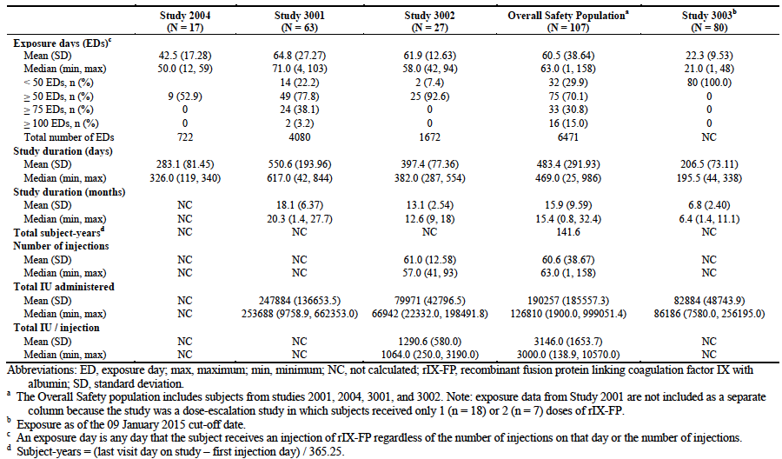

### Adverse events

The overall incidence of AEs, serious AEs etc. is shown in Table 25.

Table 25: Overall incidence of AEs

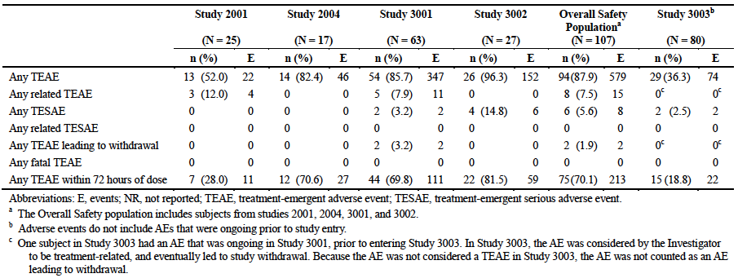

#### All adverse events (irrespective of relationship to study treatment)

Common AEs (incidence > 5%) that occurred in the studies are summarised in Table 26.

Table 26: Common AEs (incidence > 5%)

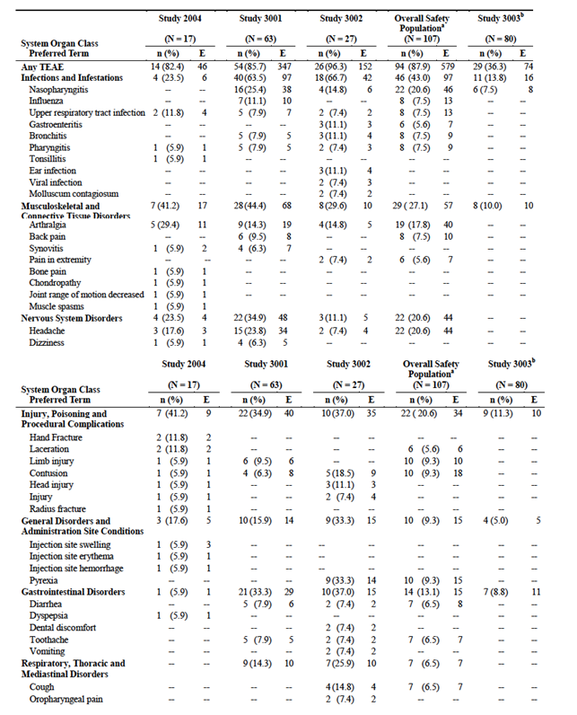

Table 26 continued: Common AEs (incidence > 5%)

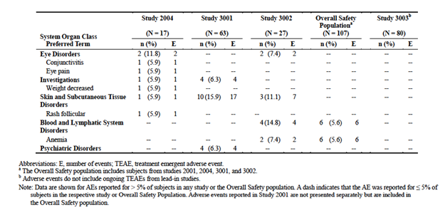

##### Pooled safety population

The overall incidence of AEs in the pooled safety population was 87.9**%**. A total of 579 events were reported. Of these, 483 (83.4%) were rated as mild, 88 (15.2%) as moderate and 8 (1.4%) as severe.

**Comment:** The most frequent AEs were events that commonly occur in the general population (headache, nasopharyngitis, injuries, respiratory tract infections, influenza, and gastroenteritis) and might be expected in a group of subjects followed for over a year. Musculoskeletal events were also common. Haemophilic arthropathy was common among adult subjects at baseline (23.4% of the pooled safety population, 38.1% of subjects in Study 3001) but not among children (0% of subjects in Study 3002). Pyrexia was reported in 9.3% of subjects (most in children in Study 3002).

##### Study 3003

The overall incidence of AEs was 36.3%[11] . The pattern of common AEs was similar to that observed for the pooled safety population.

#### Treatment-related adverse events (adverse drug reactions)

##### Pooled safety population

AEs that were assessed as being related to rIX-FP occurred in 7.5% of subjects. These are listed in Table 27. The only treatment-related event that occurred in more than 1 subject was headache (n=2). One subject developed a hypersensitivity reaction. This event is discussed further below (section *Liver function* below).

Table 27: Treatment related AEs (Pooled safety population)

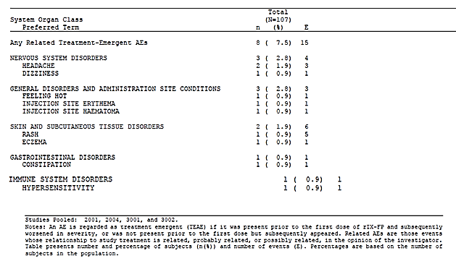

##### Study 3003

There were no AEs assessed as being related to rIX-FP in Study 3003 at the time of evaluation.

#### Deaths and other serious adverse events

##### Deaths

There were no deaths reported in any of the submitted studies.

##### Serious AEs

A serious AE (SAE) was defined as any untoward medical occurrence that:

* Results in death;
* Is life-threatening;
* Requires in-patient hospitalization or prolongation of existing hospitalization;
* Results in persistent or significant disability or incapacity;
* Is a congenital anomaly or birth defect;
* Is ‘medically significant’ – defined as an event that does not necessarily meet any of the above SAE criteria, but which is judged by a physician to potentially jeopardize the subject or require medical or surgical intervention to prevent one of the above outcomes.

###### Pooled safety population

The incidence of SAEs in the pooled safety population was 5.6% (n=6). A total of 8 events were reported. None were assessed as being related to rIX-FP.

There was one case of ‘acquired epileptic aphasia’. This event occurred in a 55-year-old White male with a previous history of epilepsy. He experienced an ‘epileptic crisis with persistent aphasic disorders’. The aphasia had resolved one month later.

###### Study 3003

The incidence of SAEs in Study 3003 was 2.5% (n=2). Only 2 events were reported – oesophagitis and colonic polyp. Both required hospitalisation. Neither was assessed as being related to rIX-FP.

#### Discontinuation due to adverse events

##### Pooled safety population

Two subjects (1.9%) discontinued treatment due to an adverse event:

* Hypersensitivity. A 22-year-old Caucasian male with no significant past history apart from haemophilia B experienced a hypersensitivity event while receiving his fourth infusion of rIX-FP while on a prophylaxis regimen in Study 3001. He complained of nausea, a sweet taste in the back of his throat and tachycardia approximately 1 minute after the start of the infusion. Prior to the infusion his pulse was 51 beats/minute (bpm) and his blood pressure was 110/69. During the event his pulse increased to only 60 bpm and his blood pressure rose to 134/78. There was no rash, oedema or wheezing. The infusion was stopped and he was treated with IV normal saline. The symptoms resolved after 23 minutes. Immunogenicity testing conducted approximately 3 weeks later was negative for FIX inhibitors and antibodies to rIX-FP.
* Headache. A 30-year-old-Japanese male received on-demand treatment with rIX-FP in Arm 2 of Study 3001. He experienced a mild headache (lasting 4 days) after his 7th infusion and a moderate headache (lasting 1 day) after his eighth infusion. The investigator assessed both events as being related to rIX-FP and the subject was withdrawn.

**Comment:** Another subject in Study 3001 (24-year-old, Caucasian male) chose to withdraw from the study after experiencing five episodes of rash over a period of four months, while on a prophylaxis regimen. The episodes were mild or moderate in severity and all were assessed as being related to rIX-FP. All the episodes lasted for up to one month and eventually resolved. Immunogenicity testing conducted at the end of the study was negative for FIX inhibitors and antibodies to rIX-FP. It is not clear from the patient narrative provided whether these events contributed to the subject’s decision to withdraw.

##### Study 3003

One subject was withdrawn due to elevated gamma-GT values. This was a [information redacted] who had a history of alcoholic liver disease and hepatitis C at baseline, when originally enrolled in Study 3001[information redacted]. Throughout Study 3001, including at screening, monitoring of LFTs demonstrated mild elevation of transaminases, alkaline phosphatase and LDH with bilirubin in the normal range. The investigator classified the elevated GGT as being related to rIX-FP, since a causal relationship could not be ruled out.

**Comment:** The sponsor considered that the pre-existing alcoholic liver disease was more likely to be a plausible explanation for the event.

#### Adverse events of special interest

##### Immunogenic events

###### Inhibitors against FIX

No inhibitors against factor IX were reported in any of the submitted studies.

**Comment:** The development of inhibitors is the major safety issue associated with FIX replacement products. Inhibitors develop in less than 5% of haemophilia B patients overall, but in 9-23% of patients with severe FIX deficiency.[12] They usually occur early in treatment. In an international registry of haemophilia B subjects with inhibitors, development of inhibitors occurred after a median of 11 exposure days (range 2 – 180 EDs).[13] rIX-FP is a novel molecule, and it is possible that it may be more antigenic than plasma derived or recombinant FIX and be associated with a higher rate of inhibitor development. The submitted studies only included subjects previously treated for > 150 EDs, and excluded those with a past history of inhibitors or a family history of inhibitors. Such a population would have a low risk of developing inhibitors. In order to reliably document the rate of inhibitor development associated with rIX-FP it would be necessary to conduct a study in previously untreated patients (PUPs). As described above such a study is apparently underway.

###### Antibodies against rIX-FP

No *treatment-emergent* antibodies to rIX-FP were detected in any of the submitted studies. One subject in study 2004 had a positive test at baseline and at Day 10, with negative tests at weeks 4 and 12.

###### Antibodies against CHO proteins

No treatment-emergent antibodies to CHO proteins were detected in any of the submitted studies.

##### Hypersensitivity reactions

One hypersensitivity event was reported (see section *Discontinuation due to adverse events; Pooled safety population* above).

##### Thrombogenic events

No thrombogenic AEs were reported.

##### Local tolerability of infusions

Local tolerability of rIX-FP infusions was assessed by the subjects and by the investigators. In the pooled safety population, subjects rated injection site reactions as very slight, mild, moderate and severe for 2.0%, 0.3%, 0.1% and 0% of injections, respectively (Table 28). Investigators reported erythema after 0.3% of injections. Similar results were reported in Study 3003.

Table 28: Local tolerability of infusions (Pooled safety population)

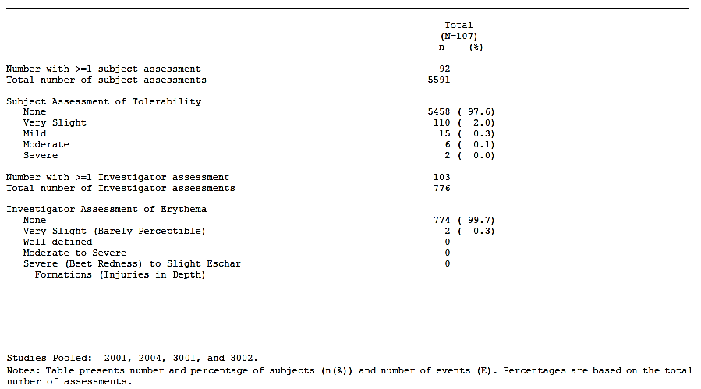

### Laboratory tests

The sponsor did not present a pooled analysis of laboratory testing data (biochemistry, haematology etc.).

In each study report the sponsor presented only limited analyses of the laboratory testing data. For example, for the pivotal Study 3001, changes from baseline were presented for each parameter as mean, median, range etc. Tables presenting, for each parameter, the proportion of subjects with an abnormal value at each post-baseline study visit were also presented. However, it was not possible to determine the severity of these abnormal results, as high or low values were not reported separately (for example, the incidence of abnormal haemoglobin values was reported for each study visit, but the incidence of low haemoglobin and high haemoglobin was not reported). Although long listings of individual patient results were provided it was not possible to cross-reference the tables with the individual patient data.

For Study 3003 the only haematology data presented were those obtained from 4 subjects undergoing surgery. No biochemistry data were presented.

**Comment:** The analyses of laboratory data presented in the submission were of limited value. It would have been preferable for the sponsor to present analyses of the incidence of clinically significant changes from baseline for each parameter, preferably as a pooled analysis. The sponsor should be asked to provide an analysis of clinically significant abnormalities occurring in Study 3001.

#### Liver function

In Study 2001, two subjects had clinically significant abnormal LFTs. Both were known to have chronic hepatitis (HCV in both, HBV in one).

In Study 2004, one subject with a history of hepatitis C at baseline had mildly elevated transaminases at screening and throughout the study. Four other subjects with a history of Gilbert’s syndrome had elevated bilirubin levels without any other LFT abnormalities.

The report for Study 3002 included brief summaries of 9 subjects who developed LFT values outside the normal range (AST, ALT or bilirubin). In each case the abnormal values were not clinically significant (increases < 1.5x ULN, or decreases to < LLN).

LFT results were not presented for subjects in Study 3003.

#### Kidney function

In Studies 2001 and 2004, there were no clinically significant changes in individual or mean values for serum creatinine.

The report for Study 3002 included brief summaries of 3 subjects who developed creatinine values outside the normal range. In each case the abnormal values were not clinically significant (1 subject with an increase only slightly above the normal range, and two with decreases below the normal range). Two subjects developed minor elevations in urea.

Creatinine and urea results were not presented for subjects in Study 3003.

#### Other clinical chemistry

In Studies 2001 and 2004, there were no clinically significant changes in individual or mean values for other biochemistry parameters.

Other clinical chemistry parameters were not measured in Studies 3002 and 3003.

#### Haematology

In Studies 2001 and 2004, there were no clinically significant changes in individual or mean values for haematology parameters.

In Study 3002, four subjects developed low haemoglobin values [information redacted]. In two subjects the reduction in haemoglobin values was clinically significant with nadir values of 88 and 90 g/L respectively. In three of the cases the low haemoglobin values were associated with reduction in mean corpuscular volume. Three of the cases were reported as AEs of anaemia. These were assessed as being not related to rIX-FP. No further discussion of these cases was included in the study report.

In Study 3003 there were no clinically significant changes in haematology parameters in 4 subjects participating in the surgical sub study.

#### Markers for activation of coagulation

In Study 2001 markers for activation of coagulation (D-dimer, prothrombin fragment 1+2 [F1+2] and thrombin-antithrombin [TAT]) were measured pre-infusion and at 30 minutes and 6 h post-infusion. One subject showed elevation of TAT and F1+F2 at 30 minutes and 6 hours. D-dimer was also elevated at 30 minutes. This subject also had elevation of TAT and F1+F2 after infusion of his prior recombinant FIX product. There were no clinical signs of thrombosis.

In Study 3001, D-dimer, F1+F2 and TAT were measured (during the PK assessment) pre-infusion and at 30 minutes and 24 h post-infusion. No abnormal values were observed.

#### Urinalysis

In Studies 2001 and 2004, there were no clinically significant changes in urinalysis parameters.

Urinalysis was not performed in Studies 3002 and 3003.

#### Electrocardiograph

ECGs were not recorded in any of the clinical studies.

#### Vital signs

In Studies 2001, 2004, 3001 and 3002, there were no clinically significant changes in mean systolic or diastolic blood pressure, pulse rate or temperature.

In Study 3003 there were no clinically significant changes in mean systolic or diastolic blood pressure, pulse rate or temperature in individuals participating in the surgical sub study.

### Post-marketing experience

No post-marketing data were included in the submission.

### Safety issues with the potential for major regulatory impact

#### Liver toxicity

There was no evidence of severe hepatotoxicity in the submitted studies. However, further details of the results of liver function tests performed in Study 3001 should be sought from the sponsor.

#### Haematological toxicity

There was no evidence of severe haematological toxicity. As described above there were 4 cases of anaemia in Study 3002 which are unexplained. Further information on these cases should be sought from the sponsor.

#### Serious skin reactions

No serious skin toxicity was observed in the submitted studies.

#### Cardiovascular safety

No cardiovascular toxicity was observed in the submitted studies.

#### Unwanted immunological events

Immunogenic AEs, including the development of inhibitors, have been summarised in section *Adverse events; Immunogenic events* and hypersensitivity events in section *Adverse events; Hypersensitivity reactions*. Overall there was a low incidence of unwanted immunological events.

### Evaluator’s overall conclusions on clinical safety

The total number of subjects exposed to rIX-FP in the submitted clinical studies was approximately 110. The clinical safety database for the product is therefore small, but meets the EU guideline requirements for extent of exposure for FIX products for the treatment of haemophilia B.

The major safety issue with FIX products is the development of inhibitors. No cases of inhibitor development were observed in the submitted studies of rIX-FP. However, only previously treated subjects at low risk of inhibitor development were enrolled in the submitted studies. The sponsor is conducting a study in previously untreated subjects, which will provide further information on this risk. Only one hypersensitivity reaction was observed. The symptoms and signs of this event appeared minor and there were no features of anaphylaxis. There were no thromboembolic AEs and monitoring of markers of activation of the coagulation system did not suggest any increased risk of such events compared to other FIX products.

Pyrexia was reported very commonly among children in Study 3002. However, none of these events were assessed as being related to rIX-FP. The only treatment-related AE that occurred in more than one subject was headache.

Overall the safety profile of rIX-FP is considered acceptable.

## First round benefit-risk assessment

### First round assessment of benefits

The benefits of rIX-FP in subjects with haemophilia B are:

* Restoration of plasma factor IX activity. The duration of plasma FIX activity is prolonged when compared to conventional FIX products (either plasma-derived or recombinant);
* A reduction in the incidence of bleeding episodes when prophylaxis regimen is used;
* Control of bleeding episodes, usually with 1 or 2 injections only;
* Adequate control of bleeding during surgical procedures.

### First round assessment of risks

The risks of rIX-FP in subjects with haemophilia B are:

* Potential risk of inhibitor development and hypersensitivity reactions;
* Other minor adverse events (such as headache).

### First round assessment of benefit-risk balance

The benefit-risk balance of rIX-FP is favourable, for the treatment of bleeding episodes and for prophylactic treatment.

Experience with the use of rIX-FP in major surgical procedures is limited and may not justify the proposed indication of *‘Control and prevention of bleeding in the perioperative setting’*.

## First round recommendation regarding authorisation

It is recommended that the application be approved. Approval of the perioperative setting indication should be dependent upon the sponsor’s response to questions below. As discussed in section *Evaluator’s conclusions on efficacy*, it is recommended that use of a prophylaxis regimen with a 14 day dosage interval in adults and adolescents should be restricted to subjects who have previously achieved very good control with a 7 day dosage interval. The 14 day dosage interval should not be approved for use in children aged < 12 years.

## Clinical questions

### Efficacy

1. The EU guideline requires that efficacy in the surgical setting should be studied in at least 10 *major* surgeries (in at least 5 separate individuals). Although efficacy of rIX-FP has been studied in 15 surgeries in total, many of these appeared to be fairly minor procedures, and it seems unlikely that the EMA minimum requirements have been met. Please identify which of the 15 procedures are considered to be ‘major’ together with a definition of what constitutes major surgery.
2. Please provide a summary of efficacy data for any additional major surgical procedures that have been conducted with rIX-FP since data cut-off for the submission.

### Safety

1. The report for Study 3002 included brief narratives for subjects who developed clinically significant abnormalities on laboratory testing (haematology and biochemistry). The sponsor needs to provide similar details for subjects who developed clinically significant abnormalities in Study 3001(haematology, biochemistry and urinalysis).
2. In Study 3002, four of 27 subjects (14.8%) developed low haemoglobin values. In two subjects the decreases were clinically significant with nadir values of 88 and 90 g/L respectively. In three of the cases the low haemoglobin values were associated with reduction in mean corpuscular volume. Three of the cases were reported as AEs of anaemia and these were assessed as being not related to rIX-FP. Is the sponsor able to provide any information on the cause of anaemia in these cases?
3. Please provide a summary of any available data on inhibitor development and hypersensitivity events in previously untreated patients treated with rIX-FP.

## Second round evaluation of clinical data submitted in response to questions

### Efficacy

#### Question 1

*The EU guideline requires that efficacy in the surgical setting should be studied in at least 10 major surgeries (in at least 5 separate individuals). Although efficacy of rIX-FP has been studied in 15 surgeries in total, many of these appeared to be fairly minor procedures, and it seems unlikely that the EMA minimum requirements have been met.*

*Please identify which of the 15 procedures are considered to be ‘major’ together with a definition of what constitutes major surgery.*

***Sponsor response***

Major surgery is defined in CSLB clinical study protocols as a surgical procedure that involves anaesthesia (general, spinal, epidural, or regional block) or respiratory assistance.

For patients with haemophilia, procedures including dental extractions may constitute major surgery depending on the setting, the type of anaesthesia and the duration of procedure.

In the initial submission, 15 surgeries were reported in 13 patients, 11 of which meet the criteria for major surgery (including 2 dental procedures [multiple tooth extraction]); therefore, the minimum number of major surgeries outlined in the EMA guideline was exceeded. Table 3-12 from Module 2.7.3 [not in this document] has been annotated to include a column denoting major or minor surgery and is presented in Table 29.

Please note that the sponsor discussed the surgical requirements of the European Guideline on FIX Products (2011) with EU in a pre-submission meeting on 05 December 2014. EU confirmed that the sponsor had met the requirements of the guideline. The sponsor was encouraged to continue collecting surgery data, and is currently doing so, in the extension study among the current study subjects. Furthermore, the surgery data was accepted by the CHMP during the Marketing Authorization Application (MAA) evaluation in EU.

Table 29: Peri-operative haemostatic response with rIX-FX

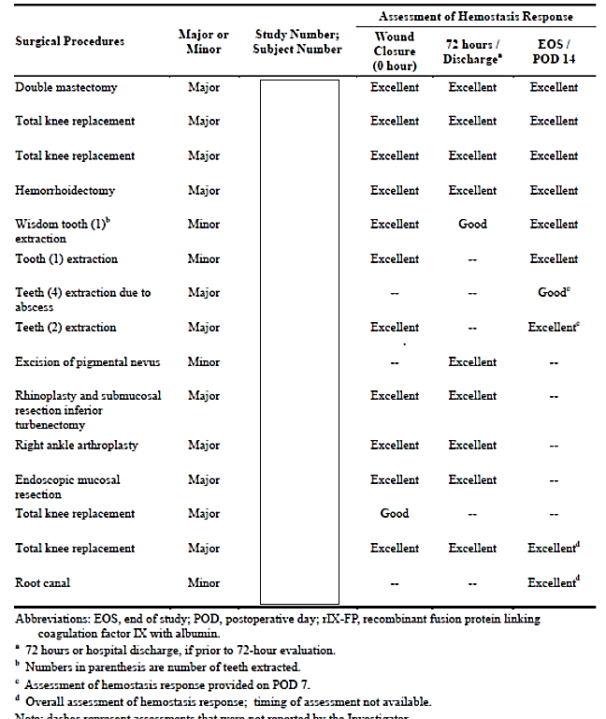

Note: dashes represent assessments that were not reported by the investigator. Subject identifiers have been deleted from this table.

***Evaluation of response***

The sponsor’s response is satisfactory.

#### Question 2

*Please provide a summary of efficacy data for any additional major surgical procedures that have been conducted with rIX-FP since data cut-off for the submission.*

***Sponsor response:***

Since the data cut-off date of 09 January 2015 for the Australian submission, one additional data cut for Study 3003 was performed on 28 July 2015.

Collectively, with the 15 surgeries in 13 patients submitted in the original application, data are now available.

Of these, joint replacements have been performed in subjects across the clinical program.

***Evaluation of response:***

The additional events of six major operations and the reported haemostasis responses are noted.

### Safety

#### Question 3

*The report for Study 3002 included brief narratives for subjects who developed clinically significant abnormalities on laboratory testing (haematology and biochemistry). Please provide similar details for subjects who developed clinically significant abnormalities in Study 3001 (haematology, biochemistry and urinalysis).*

***Sponsor response****:*

In Study 3001, 11 subjects had laboratory values that were noted by the investigator as clinically significant for at least one study time-point. None of the clinically significant values were reported as adverse events (AEs) related to rIX-FP. The following section provides details for subjects with treatment emergent clinically significant abnormalities in laboratory parameters.

Six subjects had clinically significant abnormalities at screening only.

* Five subjects [information redacted] all had clinically significant bilirubin at screening and medical history of Gilbert’s syndrome.
* Subject [information redacted] had clinically significant ALT elevations at screening only.
* Five subjects reported clinically significant abnormalities at study time-points other than screening.
* Subject [information redacted] had clinically significant low erythrocytes, haematocrit, and haemoglobin at Week 44, and mean corpuscular volume (MCV), erythrocytes, haematocrit and haemoglobin at Week 60. The AEs of ‘deterioration of reflux esophagitis’ and decreased haemoglobin were reported on the Week 44 visit date [information redacted]. The decreased haemoglobin was moderate and not related to rIX-FP as the investigator determined the cause to be related to the GI reflux. Concomitant medication was added for the reflux, and both AEs of reflux and decreased haemoglobin resolved.
* Subject [information redacted] had elevations in liver enzymes aspartate aminotransferase (AST) and alanine aminotransferase (ALT) that were determined by the investigator to be clinically significant at various time-points throughout the study (AST: Screening, Week 28, Week 60 and end of study; ALT: Week 12, Uns, Week 28, Week 60, and end of study). At Week 60, alkaline phosphatase was also clinically significant. The subject had a medical history of alcoholic liver disease and the AE of aggravated alcoholic liver disease was ongoing during the study. The subject also had ongoing hepatitis C and HIV infections which were recorded in his medical history.
* Subject [information redacted] had clinically significant low erythrocytes, MCV, haematocrit and haemoglobin at Week 92. An AE of anaemia was reported the same day at Week 92. The investigator reported the AE as mild and a side effect of the subjects hepatitis C therapy that was ongoing (sofosbuvir and ribavirin). No action was taken and the AE resolved.
* Subject [information redacted] had clinically significant low MCV, erythrocytes, haematocrit and haemoglobin at the Week 12 visit, and MCV, haematocrit and haemoglobin at the end of study visit. No AEs were reported during this time.
* Subject [information redacted] had clinically significant elevations in ALT and AST at the end of study visit. The subject had a medical history of hepatitis C and an ongoing AE of exacerbation of chronic hepatitis C at the time the elevations in liver enzymes were recorded.

In conclusion, of the 11 subjects with clinically significant abnormalities in laboratory testing, the majority had alternative explanations (eg, medical history or concomitant medications) for the lab abnormalities. Review of these abnormal laboratory findings by the Independent Data Review Committee did not identify any new safety concerns for rIX-FP.

***Evaluation of response***

The description of events does not yield any additional safety concerns.

#### Question 4

*In Study 3002, four of 27 subjects (14.8%) developed low haemoglobin values. In two subjects the reduction in haemoglobin values was clinically significant with nadir values of 88 and 90 g/L respectively. In three of the cases the low haemoglobin values were associated with reduction in mean corpuscular volume. Three of the cases were reported as AEs of anaemia and these were assessed as being not related to rIX-FP. Is the sponsor able to provide any information on the cause of anaemia in these cases?*

***Sponsor response****:*

Further information for the 3 subjects for whom the AE of anaemia was reported during

Study 3002 ([information redacted]) is summarised below.

For Subject [information redacted], the AE of tongue injury was reported 2 weeks prior to the AE of anaemia. The AE of tongue injury (06 March 2014) was moderate in intensity and required 3 procedures (06, 10 and 13 March) with multiple stitches. CSLB considers that the AE of deep tongue injury may have contributed to the AE of anaemia reported shortly thereafter. The AE of anaemia resolved 02 June 2014. The subject is currently enrolled in Study 3003 with no AE of anaemia reported to date.

For subject [information redacted], the AE of anaemia was reported from 24 January 2014 to 07 March 2014, and assessed as mild in severity. No further information about the cause of anaemia was provided by the investigator. This AE resolved without treatment. This subject is currently enrolled in Study 3003, and while no Month 12 haematology was collected for this subject.

For subject [information redacted], several laboratory values were noted as clinically significant by the investigator for this subject: low haematocrit and haemoglobin at Week 24; clinically significant low MCV, erythrocytes, haematocrit, and haemoglobin at the End-of-study visit.

All 3 subjects are currently enrolled in Study 3003 and are being monitored for haematology testing results within the scope of the study and local standard of care.

***Evaluation of response:***

The information presented by the sponsor is limited, but does not provide any substantial safety concern for Idelvion use.

#### Question 5

*Please provide a summary of any available data on inhibitor development and hypersensitivity events in previously untreated patients treated with rIX-FP.*

***Sponsor response*:**

As of the 28 July 2015 data cut, previously untreated patients (PUPs) were enrolled in Study 3003. Two of the three subjects were not dosing as of 28 July 2015.

***Evaluation of response***

The information is noted.

## Second round benefit-risk assessment

In addition to the already demonstrated efficacy and safety, the sponsor has satisfactorily demonstrated sufficient use in patients undergoing major surgery to permit approval in the peri-operative setting.

## Second round recommendation regarding authorisation

It is recommended that the application be approved for the indication:

*Idelvion is indicated for the treatment and prophylaxis of bleeding in patients with haemophilia B (congenital factor IX deficiency), including the peri-operative setting. Idelvion can be used in all age groups.*

|  |
| --- |
| Therapeutic Goods Administration |
| PO Box 100 Woden ACT 2606 Australia  Email: [info@tga.gov.au](mailto:info@tga.gov.au) Phone: 1800 020 653 Fax: 02 6232 8605  [**https://www.tga.gov.au**](https://www.tga.gov.au) |

1. World Federation of Hemophilia. Guidelines for the Management of Hemophilia (2nd edition). 2012. Available from: <http://www.wfh.org/en/resources/wfh-treatment-guidelines>
2. Haemophilia Foundation Australia. *Haemophilia* [online] March 2015 [viewed 29 October 2015]. Available from: <https://www.haemophilia.org.au/bleedingdisorders/haemophilia>
3. Therapeutic Goods Administration. MonoFIX-VF Product Information [online] 30 July 2015 [viewed 29 October 2015]. Available from: <https://www.ebs.tga.gov.au/>

   Therapeutic Goods Administration. Benefix Product Information [online] 15 August 2013 [viewed 29 October 2015]. Available from: <https://www.ebs.tga.gov.au/>

   Therapeutic Goods Administration. Rixubis Product Information [online] 27 May 2015 [viewed 29 October 2015]. Available from: <https://www.ebs.tga.gov.au/>
4. Therapeutic Goods Administration. Alprolix Product Information [online] 15 July 2015 [viewed 29 October 2015]. Available from: <https://www.ebs.tga.gov.au/>
5. European Medicines Agency. Guideline On The Clinical Investigation Of The Pharmacokinetics Of Therapeutic Proteins (CHMP/EWP/89249/2004); 2007
6. European Medicines Agency. Guideline on clinical investigation of recombinant and human plasma-derived factor IX products (EMA/CHMP/BPWP/144552/2009); 2011.
7. European Medicines Agency. Guideline on clinical investigation of recombinant and human plasma-derived factor IX products (EMA/CHMP/BPWP/144552/2009); 2011.
8. European Medicines Agency. Guideline on clinical investigation of recombinant and human plasma-derived factor IX products (EMA/CHMP/BPWP/144552/2009); 2011.
9. From the sponsor’s Summary of Clinical Efficacy: *However, there were improvements in scores associated with physical health and feeling more positive when dealing with the disease.*
10. Jiménez-Yuste V, Auerswald G, Benson G et al. Achieving and maintaining an optimal trough level for prophylaxis in haemophilia: the past, the present and the future. Blood Transfus; 2014; 12: 314-9.
11. Data from the on-going study at the time of analysis: extracted from Study 3003 data-cut date 28 July 2015
12. DiMichele D. Inhibitor development in haemophilia B: an orphan disease in need of attention. Br J Haem. 2007; 138 (3), 305–315.
13. Chitlur M, Warrier I, Rajpurkar M et al. Inhibitors in factor IX deficiency a report of the ISTH-SSC international FIX inhibitor registry (1997–2006). Haemophilia 2009; 15 (5) 1027–1031.