|  |
| --- |
| **First round evaluation: 17 August 2016**  **Second round evaluation:28 November 2016** |

|  |
| --- |
| AusPAR Attachment 2 |
| Extract from the Clinical Evaluation Report for Alectinib |
| Proprietary Product Name: Alecensa |
| Sponsor: Roche Products Pty Limited |

About the Therapeutic Goods Administration (TGA)

* The Therapeutic Goods Administration (TGA) is part of the Australian Government Department of Health, and is responsible for regulating medicines and medical devices.
* The TGA administers the *Therapeutic Goods Act 1989* (the Act), applying a risk management approach designed to ensure therapeutic goods supplied in Australia meet acceptable standards of quality, safety and efficacy (performance), when necessary.
* The work of the TGA is based on applying scientific and clinical expertise to decision-making, to ensure that the benefits to consumers outweigh any risks associated with the use of medicines and medical devices.
* The TGA relies on the public, healthcare professionals and industry to report problems with medicines or medical devices. TGA investigates reports received by it to determine any necessary regulatory action.
* To report a problem with a medicine or medical device, please see the information on the TGA website <<https://www.tga.gov.au>>.

About the Extract from the Clinical Evaluation Report

* This document provides a more detailed evaluation of the clinical findings, extracted from the Clinical Evaluation Report (CER) prepared by the TGA. This extract does not include sections from the CER regarding product documentation or post market activities.
* The words [Information redacted], where they appear in this document, indicate that confidential information has been deleted.
* For the most recent Product Information (PI), please refer to the TGA website <<https://www.tga.gov.au/product-information-pi>>.

Copyright

© Commonwealth of Australia 2017  
This work is copyright. You may reproduce the whole or part of this work in unaltered form for your own personal use or, if you are part of an organisation, for internal use within your organisation, but only if you or your organisation do not use the reproduction for any commercial purpose and retain this copyright notice and all disclaimer notices as part of that reproduction. Apart from rights to use as permitted by the *Copyright Act 1968* or allowed by this copyright notice, all other rights are reserved and you are not allowed to reproduce the whole or any part of this work in any way (electronic or otherwise) without first being given specific written permission from the Commonwealth to do so. Requests and inquiries concerning reproduction and rights are to be sent to the TGA Copyright Officer, Therapeutic Goods Administration, PO Box 100, Woden ACT 2606 or emailed to <[tga.copyright@tga.gov.au](mailto:tga.copyright@tga.gov.au)>.

Contents

Common abbreviations 5

1. Submission details 11

1.1. Dosage administration, forms and strengths 11

1.2. Background 12

1.3. Clinical rationale 15

1.4. Formulation 16

1.5. Guidance 19

1.6. Evaluator’s commentary on the background information 19

2. Contents of the clinical dossier 19

2.1. Scope of the clinical dossier 19

2.2. Paediatric data 22

2.3. Good clinical practice (GCP) 22

2.4. Evaluator’s commentary on the clinical dossier 23

3. Pharmacokinetics 24

3.1. Studies providing pharmacokinetic information 24

3.2. Summary of pharmacokinetics 25

3.3. Evaluator’s overall conclusions on pharmacokinetics 37

4. Pharmacodynamics 38

4.1. Studies providing pharmacodynamic information 38

4.2. Summary of pharmacodynamics 38

4.3. Evaluator’s overall conclusions on pharmacodynamics 41

5. Dosage selection for the pivotal studies 42

5.1. Pharmacokinetics and pharmacodynamics: dose finding studies 42

5.2. Phase II dose finding studies 42

5.3. Phase III pivotal studies investigating more than one dose regimen 43

5.4. Evaluator’s conclusions on dose finding for the pivotal studies 43

6. Clinical efficacy 43

6.1. Studies providing evaluable efficacy data 43

6.2. Pivotal or main efficacy studies 43

6.3. Other efficacy studies 63

6.4. Analyses performed across trials: pooled and meta-analyses 65

6.5. Evaluator’s conclusions on clinical efficacy 65

7. Clinical safety 69

7.1. Studies providing evaluable safety data 69

7.2. Integrated safety analyses 70

7.3. Patient exposure 71

7.4. Adverse events 74

7.5. Evaluation of issues with possible regulatory impact 98

7.6. Other safety issues 126

7.7. Post marketing experience 129

7.8. Evaluator’s overall conclusions on clinical safety 132

8. First round benefit-risk assessment 134

8.1. First round assessment of benefits 134

First round assessment of risks 136

8.2. First round assessment of benefit-risk balance 139

9. First round recommendation regarding authorisation 141

10. Clinical questions 141

10.1. Pharmacokinetics/Pharmacodynamics 141

10.2. Efficacy 142

10.3. Safety 144

10.4. PI and CMI 145

10.5. General 146

10.6. Additional expert input 146

11. Second round evaluation 147

11.1. Responses to clinical questions (module 5 evaluation) 147

11.2. Efficacy 150

11.3. Safety 154

12. Second round benefit-risk assessment 166

12.1. Second round assessment of benefits 166

12.2. Second round assessment of risks 166

12.3. Second round assessment of benefit-risk balance 167

13. Second round recommendation regarding authorisation 167

## Common abbreviations

| Abbreviation | Meaning |
| --- | --- |
| (Su) | Suspected |
| (U) | Unsuspected |
| [14]- | Radiolabelled (prefix) |
| µg | Microgram(s) |
| ADME | Absorption, distribution, metabolism and excretion |
| AE | Adverse event |
| AIC | Akaike information criterion |
| AJCC | American Joint Committee on Cancer |
| ALCL | Anaplastic large cell lymphoma |
| ALK | Anaplastic lymphoma kinase |
| ALP | Alkaline phosphatase |
| ALT | Alanine aminotransferase |
| alt. | Alternate |
| AMS | Accelerated mass spectrometry |
| ARTG | Australian Register of Therapeutic Goods |
| AST | Aspartate aminotransferase |
| AUC | Area under the curve (of plasma concentration versus time) |
| AUC0-10 | AUC from time 0 to10 hours post-dose |
| AUC0-∞ | AUC from time 0 post-dose extrapolated to infinity |
| AUC0-last | AUC from time 0 to last measured time point post-dose |
| BIRC | Blinded independent review committee |
| BMI | Body Mass Index |
| bpm | Beats per minute |
| Br | Bilirubin |
| CDOR | CNS Duration of Response |
| CI | Confidence Interval |
| Cl | Clearance |
| Cmax | Maximum Observed Plasma Concentration |
| CNS | Central Nervous System |
| CORR | CNS Objective Response Rate |
| CPR | CNS progression rate |
| CR | Complete Response |
| CSF | Cerebrospinal Fluid |
| CSR | Clinical Study Report |
| CT | Computed Tomography Imaging |
| Ctrough | Minimal Observed Plasma Concentration (Trough Concentration) |
| CV% | Coefficient Of Variation (%) |
| DCR | Disease Control Rate |
| DDI | Drug-Drug Interaction |
| DIC | Disseminated Intravascular Coagulation |
| DOR | Duration of Response |
| DVT | Deep vein thrombosis |
| ED50 | Estimated dose required to have 50% of the maximal effect |
| EMA | European Medicines Agency (European Union regulator) |
| FaSSIF | Fasting state simulated intestinal fluid |
| FDA | Food and Drug Administration (United States of America regulator) |
| FeSSIF | Fed state simulated intestinal fluid |
| FISH | Fluorescence In Situ Hybridisation |
| GAM | Generalised Additive Modelling |
| GCP | Good Clinical Practice |
| GGT | Gamma glutamyl transferase |
| GI | Gastrointestinal |
| GLP | Good laboratory practice |
| GMR | Geometric mean ratio |
| h | Hours |
| hERG | Human ether-a-go-go-related gene |
| HLM | Human liver microsomes |
| HPLC | High performance liquid chromatography |
| HR | Hazard ratio |
| HRQoL | Health-Related Quality of Life |
| IC50 | Concentration at which 50% of maximal inhibition is achieved |
| IMP | Investigational medicinal product |
| INR | International Normalised Ratio |
| IRC | Independent (radiological) review committee |
| IRR | Independent radiology review |
| IV | Intravenous |
| LC/MS-MS | Liquid chromatography/tandem mass spectrometry |
| LFT | Liver function test |
| LP | Lumbar puncture |
| LSC | Liquid scintillation counting |
| M/P | Metabolite/parent ratio |
| M1b | Minor metabolite of alectinib, also ‘UK’ |
| M4 | Major and active metabolite of alectinib, also ‘RO5428924’ |
| max | Maximum |
| MDZ | Midazolam |
| mg | Milligram(s) |
| min | Minimum OR minute(s) |
| MS | Mass spectrometry |
| ms | Millisecond(s) |
| msec | Millisecond(s) |
| MTD | Maximum tolerated dose |
| N | Number |
| N/A | Not applicable |
| NCCN | National Comprehensive Cancer Network |
| NCE | New Chemical Entity |
| NCI-CTCAE | National Cancer Institute-Common Terminology Criteria for Adverse Events |
| ng | Nanogram(s) |
| nM | Nanomole/nanomolar |
| NSCLC | Non-small cell lung cancer |
| OCT1 | Hepatic uptake transporter ‘organic cation transporter 1’ |
| OCT2 | Renal uptake transporter ‘organic cation transporter 2’ |
| ORR | Objective response rate |
| OS | Overall survival |
| PBPK | Physiologically-based pharmacokinetic(s) |
| PD | Progression of Disease |
| PFS | Progression-free survival |
| P-gp | P-glycoprotein |
| PI | Product information |
| PK | Pharmacokinetic(s) |
| pKa | Dissociation constant |
| PO | Per oral |
| PopPK | Population pharmacokinetic(s) |
| PPI | Proton-pump inhibitor |
| PR | Partial response |
| PV | Pharmacovigilance |
| QTc | Corrected QT interval |
| QTcB | QT interval corrected using Bazett's formula |
| QTcF | QT interval corrected using Fridericia's formula |
| RANO | Response Assessment in Neuro-Oncology (criteria) |
| RE | Response evaluable |
| RECIST | Response Evaluation Criteria in Solid Tumors |
| RET | Rearranged during Transfection (tyrosine kinase) |
| RMP | Risk management plan |
| RO5424802 | Alectinib |
| RO5428924 | Major metabolite of alectinib, also ‘M4’ |
| RP2D | Recommended Phase II dose |
| RR | Respiratory rate |
| SAE | Serious adverse event |
| SCS | Summary of Clinical Safety |
| SD | Standard deviation OR Stable Disease |
| SLS | Sodium lauryl sulfate |
| TEAE | Treatment-emergent adverse event |
| TGA | Therapeutic goods administration |
| Tlast | Time to last measurable plasma concentration |
| Tmax | Time at which maximum concentration was reached |
| TRAE | Treatment-related adverse event |
| UK | Unknown |
| ULN | Upper limit of normal |
| URTI | Upper respiratory tract infection |
| WBC | White blood cell |
| WCC | White blood cell count |

## Submission details

This is a Category 1 application for registration of a new active substance (New Chemical Entity [NCE]), alectinib, in the Australian Register of Therapeutic Goods (ARTG).

Alectinib is a tyrosine kinase inhibitor with affinity for anaplastic lymphoma kinase (ALK) and Rearranged during Transfection (RET) tyrosine kinase.

The proposed indication is:

*Alecensa is indicated for the treatment of patients with anaplastic lymphoma kinase (ALK)-positive, locally advanced or metastatic non-small cell lung cancer (NSCLC) who have progressed on or are intolerant to crizotinib.*

### Dosage administration, forms and strengths

* 150 mg hard capsules.
* To be supplied as multipacks of 224 (4 packs of 56) in blister foil packs.

The draft PI states the following regarding dosage and administration:

*DOSAGE AND ADMINISTRATION*

***Standard Dosage***

*The recommended dose of Alecensa is 600 mg (four 150 mg capsules) given orally, twice daily with food (total daily dose of 1200 mg).*

*Alecensa hard capsules should be swallowed whole and must not be opened or dissolved.*

***Duration of Treatment***

*Treatment with Alecensa should be continued until disease progression or unacceptable toxicity.*

***Delayed or Missed Doses***

*If a planned dose of Alecensa is missed, patients can make up that dose unless the next dose is due within 6 hours. If vomiting occurs after taking a dose of Alecensa, patients should take the next dose at the scheduled time.*

***Dose Modifications***

*Management of adverse events may require temporary interruption, dose reduction, or discontinuation of treatment with Alecensa. The dose of Alecensa should be reduced in steps of 150 mg twice daily based on tolerability. Alecensa treatment should be permanently discontinued if patients are unable to tolerate the 300 mg twice daily dose.*

Table 1 below gives general dose modification advice for Alecensa.

Table 1: Dose reduction schedule

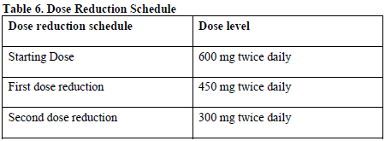

Dose modification advice for specified adverse events and special populations is also included in the draft PI following the above information, in brief:

*Specified adverse events*

* Interstitial Lung Disease (ILD)/Pneumonitis
* Bilirubin and hepatic transaminase elevations
* Bradycardia

*Special populations*

* Children: safety and efficacy has not been studied.
* Elderly: no dose adjustment required.
* Renal impairment: no dose adjustment required.
* Hepatic impairment: no dose adjustment required in mild hepatic impairment, moderate to severe impairment has not been studied.

**Comment**: Changes to the dosage and administration section of the PI are recommended.

### Background

#### Information on the condition being treated

The condition being treated is locally advanced or metastatic ALK+ non-small cell lung cancer (NSCLC). In their cover letter for this application, the sponsor has provided an introduction to the condition being treated:

*Lung cancer (ICD10 C33-C34) is the fifth most commonly diagnosed invasive cancer in Australia and causes more deaths than any other cancer in both males and females. In 2012 there were 8,137 deaths from lung cancer in Australia and in 2011 10,511 new cases were diagnosed.[1] Despite the fact that there are a number of treatments currently available for patients with NSCLC, most have limited effectiveness in the advanced stages of the disease, and therefore the prognosis for these patients remains poor.*

*Recent progress in the identification of genetic mutations or chromosomal rearrangements in epidermal growth factor receptor (EGFR), Kirsten rat sarcoma viral oncogene homolog (KRAS), mesenchymal-epithelial transition factor (MET), and other genes has provided new opportunities to use targeted therapeutic agents for the treatment of NSCLC.*

[information redacted]

The clinical overview of this submission contains a definition of ‘ALK+’ as ‘tumors harboring a rearranged ALK gene/fusion protein’.

**Comment**: This definition is accepted.

#### Current treatment options

UpToDate, a pre-eminent medical reference, provides comprehensive clinical guidelines around treatment options for advanced (stage 4) NSCLC.[2] Initial systemic therapy for patients with advanced NSCLC depends on whether a driver mutation, such as ALK re-arrangement, is identified (Figure 1). For patients whose tumour contains a driver mutation, specific inhibitors are recommended as first-line treatment.

#### First line therapy

In the case of ALK+ tumours, the first-line specific inhibitor is crizotinib (Xalkori).[3]

Crizotinib is a small molecule ALK, cMET and ROS-1 inhibitor, and is the current standard of care first line therapy for the treatment of locally advanced or metastatic ALK+ NSCLC.[4]

Conditional approval for crizotinib in the United Stated was initially based on data from 255 patients with ALK+ NSCLC, enrolled in two single-arm trials, with response rates of 50% and 61%. Common adverse events with crizotinib use include ‘mild transient visual disorders, mild gastrointestinal toxicities, fatigue, rare alanine transaminase elevations, and even rarer pneumonitis (1.6%).[5]

Figure 1: Initial systemic therapy for patients with advanced non-small cell lung cancer.[6]

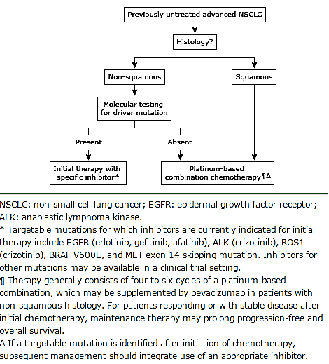

Subsequent confirmatory Phase III trials compared crizotinib to standard chemotherapy.

[information redacted]

**Comment**: The current application for alectinib is based on very early data without a control arm. The chemotherapy overall response rates of 20% in ALK+ NSCLC seen in the crizotinib Phase III trials provide a useful point of comparison for the response with alectinib, in the absence of an actual control arm.

#### Second-line therapy

If a patient with an ALK+ tumour did not receive crizotinib as a first-line treatment then crizotinib targeted treatment is indicated as the second- line therapy.[7] If a first-line targeted treatment fails then second-line targeted agents are indicated, where available, followed by combination chemotherapy and then single-agent chemotherapy.

Figure 2: Second line therapy

Figure 2: Second line therapy
If a first-line targeted treatment fails then second-line targeted agents are indicated, where available, followed by combination chemotherapy and then single-agent chemotherapy.

The only other ALK-targeted therapy approved in Australia at the time of review is ceritinib, another small molecule inhibitor. It is described in UpToDate as follows:[8]

Ceritinib is a second generation TK inhibitor of ALK that is approximately 20 times more potent than crizotinib. Ceritinib is indicated for patients who are resistant to or unable to tolerate crizotinib. Preclinical studies suggested that ceritinib had significant activity against cells that were either sensitive or resistant to crizotinib, including resistant tumors with the most common L1196M and G1269A resistance mutations.

After the maximum tolerated dose was established in the Phase I study, ceritinib was studied in a dose expansion cohort of NSCLC patients with the ALK rearrangement. Results from that expansion cohort were updated at the 2014 ASCO meeting:

1. A total of 246 patients with ALK positive NSCLC were treated with ceritinib. Of these patients, 163 had previously been treated with an ALK inhibitor and 83 were ALK inhibitor naïve.
2. The objective response rate was 58 percent overall, 55 percent in those with prior crizotinib treatment, and 66 percent in ALK inhibitor naïve patients. The median duration of response was 10 months in the entire cohort, and 7.4 months in those with prior crizotinib treatment. The median progression-free survival for the entire cohort was 8.2 months, including 6.9 months for those previously treated with an ALK inhibitor and not estimable (lower bound of 95% CI 8.3 months) for those who had not previously received an ALK inhibitor.

Two Phase III trials are currently recruiting patients with ALK+ NSCLC, one in which ceritinib is being compared with single-agent chemotherapy after progression on a platinum-based doublet and on crizotinib (NCT01828112), and the other as first line treatment compared with a platinum-based doublet (NCT01828099).

Ceritinib has received accelerated approval by the FDA for patients who have progressed on or are intolerant of crizotinib. Because it was not full approval, the need was considered still unmet in this group of patients when a new drug application for alectinib was submitted, and alectinib subsequently also received accelerated approval from the FDA in the same population.[9]

Ceritinib (Zykadia) was not registered in Australia at the time the current application for alectinib was submitted, however, approval has since been granted (March 31, 2016) for a similar indication to that which received accelerated approval in the USA:

* Zykadia is indicated as monotherapy for the treatment of adult patients with anaplastic lymphoma kinase (ALK) positive locally advanced or metastatic non-small cell lung cancer (NSCLC) whose disease has progressed on or who are intolerant of crizotinib.

Note to Indication: This indication is approved based on tumour response rates and duration of response. An improvement in survival or disease –related symptoms has not been established.

However, as ceritinib is not PBS listed, the need for medical therapy (other than second-line chemotherapy) in patients in whom disease progression has been seen after crizotinib therapy remains unmet.

### Clinical rationale

The sponsor’s cover letter for the current application summarises the population in which the sponsor states that alectinib has a potential treatment role supported by the currently available evidence. They state:

The ALK-fusion protein is an appropriate target for the treatment of patients with NSCLC harbouring ALK gene rearrangements as demonstrated with crizotinib (Xalkori® Product Information) and ceritinib (Zykadia™ SmPC) both of which have received marketing authorization in ALK+ NSCLC in Europe and the United States (US). In Australia, crizotinib is indicated, ‘for the treatment of patients with anaplastic lymphoma kinase (ALK)-positive advanced NSCLC.

Although substantial benefit has been observed with crizotinib therapy, relapse remains the norm and survival after relapse is poor.[10] This is believed to be due to three main reasons:

* 1. Development of acquired resistance because of secondary mutations in ALK or amplification of ALK fusions[11]
  2. Development of acquired resistance driven by alternative signalling pathways such as EGFR, mast/stem cell growth factor receptor (c-KIT), KRAS or due to unknown mechanisms[12]
  3. Progression of disease in the central nervous system (CNS), which has been reported to be the primary site of initial treatment failure in 46% of patients with ALK+ NSCLC treated with crizotinib[13]

The sponsor notes in the introduction to the CSR for Phase I/II Study NP-28761 that a high incidence of brain or central nervous system (CNS) relapse is:

…consistent with the fact that crizotinib cannot cross the blood−brain barrier and the level of crizotinib in CSF is significantly lower than that in serum.

The cover letter continues:

There remains an unmet need following disease progression on crizotinib for an effective, well-tolerated ALK inhibitor with proven activity against ALK resistance mutations, as well as a proven CNS activity. In this context, Roche believes that the consistent efficacy demonstrated by Alecensa in the two pivotal Phase I/II studies (NP28761 and NP28673), both overall and specifically in the CNS, together with the well-tolerated and manageable safety profile, represents a significant advance over currently available treatment options in this population and supports the application to register Alecensa in this setting.

### Formulation

#### Formulation development

Initially, 20 mg (formulation Ro 542-4802/F01) and 40 mg (formulation Ro 542-4802/F02) capsules were developed for a first-in-human study. When it was apparent that much higher doses were clinically required, a higher strength 150 mg capsule (formulation Ro 542-4802/F03) was developed to improve patient compliance and convenience for Phase II and Phase III studies by reducing the capsule count per administration. The formulation capsule that was used in each clinical study is summarised in Table 2.

The formulation used in the non-clinical studies did not contain SLS, with the exception of the comparative toxicity study that was done with alectinib with and without SLS.

Due to local requirements regarding SLS content, three further formulations with lower percentages of SLS relative to active substance were developed (Ro 542-4802/F07, Ro 542-4802/F14 and Ro 542-4802/F08). These were directly compared to each other in Study NP29040 and the 50% and 25% formulations were shown to be bioequivalent.

All oral capsules used in the clinical studies (except for the bioequivalence Study NP29040) were Ro 542-4802/F01, Ro 542-4802/F02 or Ro 542-4802/F03 and contained 50% SLS relative to active substance (see Table 2). The Ro 542-4802/F03 formulation is designated as the global commercial formulation and is the formulation proposed for registration in Australia.

Table 2: Cross-reference of formulations used in clinical studies and of relevant bioavailability or bioequivalence studies (from page 15 of ‘drug-product.pdf’, in the quality overall summary)

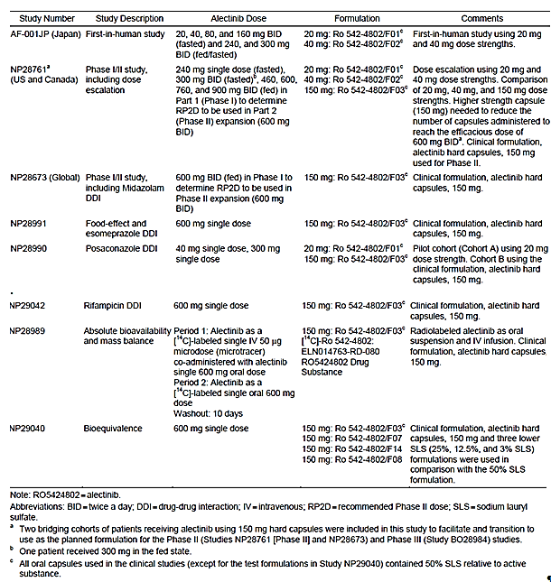

#### Excipients

The product appears as hard White capsules with ‘ALE’ printed in black ink on the cap and ‘150 mg’ printed in black ink on the body.

In addition to the active, 150 mg of alectinib free base as alectinib hydrochloride (161.33 mg), the following excipients are included in each hard capsule:

* lactose – intolerance is mentioned in CMI.
* hydroxypropylcellulose
* sodium lauryl sulfate [SLS]
* carmellose calcium
* magnesium stearate
* carrageenan
* potassium chloride
* titanium dioxide
* carnauba Wax
* starch – Maize
* hypromellose

The printing ink contains:

* iron oxide red (E172)
* iron oxide yellow (E172)
* indigo carmine aluminium lake
* carnauba wax
* shellac
* glycerol mono-oleate

#### Pre-submission phase

A pre-submission meeting was held in October 2015 between Roche and the TGA to discuss the proposed package for submission. Concerns that the TGA held at the time of the pre-submission meeting included:

* Phototoxicity
* QT prolongation
* Lack of Phase III data
* Deaths in Phase II trials

The summary of TGA’s overall position was as follows:

TGA currently do not have an 'accelerated' or 'conditional' type approval pathway; therefore TGA needs to be confident of the safety and benefit of the product at the time of approval

For approval to be considered with such a limited number of patients in trials to date would rely upon a niche being identified where it could be clearly stated that efficacy and safety had been satisfactorily demonstrated. Any decision on the application would be some time away and as such, would have to take into account the treatment algorithm that exists at that time for patients with ALK+ NSCLC. The evidence base on which a decision might be made, if it were approved, would have to presented prominently eg in a note to the indication, and that marketing that would be a condition of registration.

Overall TGA see that alectinib may address the unmet need that is, a group of patients where unmet need is indisputable. The limitation of the data set is expected to be clearly made transparent to physicians and public.

A pre-submission planning form was submitted in December 2015, and pre-submission planning was completed in April 2014. The pre-submission planning form states:

Alectinib is a highly selective and potent anaplastic lymphoma kinase (ALK) and Rearranged during Transfection (RET) tyrosine kinase inhibitor for oral administration.

Alectinib capsules contain 150mg alectinib, with a total daily dose of 1200 mg alectinib (four capsules taken twice a day).

The results from both pivotal studies demonstrated consistent CNS benefit in patients with CNS metastases at baseline. This is of significant clinical importance given the lack of effective therapies in patients with metastases in the CNS, and the morbidity associated with CNS metastases both because of the involvement of the brain, and because of treatments required for disease control.

Safety findings were consistent between pivotal Studies NP28761 and NP28673. The most commonly reported AEs were constipation, fatigue, peripheral edema and myalgia. The majority of AEs were of a Grade 1 or 2 severity. Most deaths were due to disease progression and safety-related deaths occurred at a low incidence. Rates of AEs leading to study drug withdrawal, interruption, or dose reduction showed good tolerability of alectinib treatment.

The supportive Phase I/II study, AF-001JP, was conducted in ALK+ advanced NSCLC patients in Japan who were ALK treatment-naïve and had progressed on one or more lines of chemotherapy. The safety and efficacy data from AF-001JP are consistent with those of the pivotal Phase I/II studies.

Orphan designation for alectinib was sought in a letter dated 27 October 2015, and granted in a letter dated 17 November 2015.

Orphan drug designation was granted for the treatment of patients with ALK+ non-small cell lung cancer. The current submission applies for registration of an indication which is more restricted as it only includes patients who have also failed crizotinib therapy. Therefore, orphan designation still applies.

### Guidance

The only specific requirements from the TGA given in pre submission guidance were:

* Inclusion of the 90 day updated safety report in the dossier.
  + This has been undertaken and the report is provided in the dossier.
* Inclusion of further information in the dossier outlining the rationale for a capsule being chosen as the optimal formulation for development.
  + The sponsor states that this has been done.

Whether the RMP advice has also been incorporated will be reviewed by the RMP section.

### Evaluator’s commentary on the background information

For patients with ALK+ NSCLC who have progressed on or are intolerant to crizotinib, treatment options are limited to ceritinib, which appears to have significant safety concerns, or chemotherapy with a lower response rate. In this context, alectinib may meet unmet need or provide a viable alternative treatment, provided the safety and efficacy profile is similar to or compares favourably to that of ceritinib.

Results from the Phase III trials are expected to provide further insight into the safety profile of alectinib and direct comparison of its efficacy to that of crizotinib.

**Comment**: When does the sponsor expect that the data from the two Phase III trials (ALEX and J-ALEX) will be reported on?

## Contents of the clinical dossier

### Scope of the clinical dossier

The clinical dossier includes scientific report documents for the following studies (Table 3-5):

* 11 biopharmaceutics studies establishing the methodologies employed in the clinical studies and bioequivalence of an alternative, lower SLS formulation (still in development) (see Table 3).
* Clinical pharmacology studies providing PK, PD and safety data:
  + One Phase I dedicated PK study (see Table 4).
  + Three Phase I drug-drug interaction (DDI) studies (CYP3A inhibition, CYP3A induction, effect of food and inhibition of gastric pH) (see Table 4).
* Pivotal efficacy/safety and dose-finding studies
  + No Phase III studies available
  + Two pivotal Phase I/II studies (NP28673 and NP28761)
* Population PK (popPK) analyses.
  + 3 population PK analyses, including an exposure-efficacy and safety (dose-finding) analysis, carried out using data from both of the pivotal studies.
* Other efficacy/safety studies
  + 1 Phase I/II trial from Japan, which supported registration in Japan and provides supportive PK, efficacy and safety data and guided dose-finding in the two subsequent pivotal Phase I/II studies
  + The CSR is provided in an English translation, with separate PK analyses for both alectinib and its metabolites.
* Other reports such as pooled analyses, meta-analyses, periodic safety update reports PSURs), integrated analyses across more than one study: efficacy, safety, resistance.
  + A 90 day safety report, encompassing data from both of the English-language ongoing Phase I/II trials.
  + A QT report based on pooled data from the two pivotal Phase I/II studies. As agreed with the EMA during their pre-submission process, rather than a dedicated QT study, thorough QT assessments were conducted in these Phase I/II pivotal trials.
* Literature references.
  + 107 references are listed including:
    - Foreign labelling (PI from Japan) ‘alecensa pi’

Tables 3-5. Tabular summary of studies submitted with this application.

| Comparative BA and Bioequivalence (BE) Study Reports | |
| --- | --- |
| NP29040 | A Randomized, Open-Label, Single Dose, Crossover Study to Investigate the Bioequivalence of Three RO5424802 Test Formulations Versus a Reference Formulation Following Oral Administration in Healthy Subjects |
| Reports of Bioanalytical and Analytical Methods for Human Studies | |
| 1058284 | Validation of a LCMS/MS[14] method for the determination of CH5424802-000[15] in human plasma, Study No. ADM10-0003, Chugai Pharmaceutical Co., Ltd. |
| 1063383 | Validation of a LCMS/MS method for the measurement of CH5468924-000[16] in human plasma (Study No.: ADM13-0101). Chugai Pharmaceutical Co., Ltd. In-house study. |
| 1063987 | Partial validation of a bioanalytical method for the measurement of CH5468924-000 in human plasma using LCMS/MS (Study No.: ADM14-0023). Chugai Pharmaceutical Co., Ltd. In-house study. |
| 1057698 | Method Validation for the Quantitation of RO542480215 and RO546892416 in Human Plasma by Turbo Ion Spray LC/MS/MS, Quintiles Report Reference 121321VCWB_HBS_R1 |
| 1061870 | Method Validation for the Quantitation of RO5424802 and RO5468924 in Treated Human Urine by Turbo Ion Spray LC/MS/MS, Quintiles Report Reference 131516VCWB_HBS |
| 1063686 | Cross Validation of an LC-MS/MS Assay for the Quantitation of RO5424802 and RO5468924 in Human Plasma |
| 1060263 | Validation of a quantitative method for the HPLC[17] and AMS[18] analysis of [14C]-RO5424802 in human plasma (K3EDTA – anti-coagulant), Xceleron Study No. 18/009V |
| 1063680 | The long term freezer storage stability of CH5424802-000 in human plasma, Study No. ADM10-5032, Chugai Pharmaceutical Co., Ltd |
| ADM10-5043_R | The determination of CH5424802-000 in human plasma using LC MS/MS for the phase I/II study of CH5424802 in patients with non-small cell lung cancer harboring ALK fusion gene (Protocol No. AF 001JP), Chugai Pharmaceutical Co |
| ADM10-5061_R | Determination of CH5424802 metabolites in human (Protocol AF 001JP) (Including Amendment 1). |
| Healthy Subject PK and Initial Tolerability Study Reports | |
| NP28989 | A Phase I, Single-Center, Open-Label Study Investigating the Excretion Balance, Pharmacokinetics and Metabolism of a Single Oral Dose and Pharmacokinetics of an Intravenous Tracer of [14C]-RO5424802 in Healthy Male Subjects |
| NP28990 | An Open-Label, Three-Period, Fixed Sequence Study to Investigate the Effect of Multiple Oral Doses of Posaconazole, a Potent Cytochrome P450 3A Inhibitor, on the Single Dose Pharmacokinetics of RO5424802 in Healthy Subjects. |
| NP29042 | An Open-Label, Three-Period, Fixed Sequence Study to Investigate the Effect of Multiple Oral Doses of Rifampin, a Potent Cytochrome P450 3A Inducer, on the Single Dose Pharmacokinetics of RO5424802 in Healthy Subjects |
| Extrinsic Factors PK Study Reports | |
| NP28991 | An Open-Label, Two Group Study to Investigate the Effect of Food (Group 1) and Esomeprazole (Group 2) on the Single Oral Dose Pharmacokinetics of RO5424802 in Healthy Subjects. |
| Population PK Study Reports | |
| 1064536 | Population Pharmacokinetic Analysis and Exposure-Efficacy and Safety Analyses of Alectinib of Phase I/II Studies NP28673 and NP28761 in Patients with ALK-Positive Non-Small Cell Lung Cancer Previously Treated with Crizotinib |
| 1064597 | Alectinib (RO5424802) - Physiologically based Pharmacokinetic Modeling using SimCYP®(R) |
| 1064595 | Alectinib (RO5424802) - Physiologically based pharmacokinetic modeling using GastroPlus(TM) |
| Study Reports of Uncontrolled Clinical Studies | |
| NP28673 | An Open-Label, Non-Randomized, Multicenter Phase I/II Trial of RO5424802 Given Orally to Non Small Cell Lung Cancer Patients who have ALK Mutation and Failed Crizotinib Treatment |
| NP28761 | A Phase I/II Study of the ALK Inhibitor CH5424802/RO5424802 in Patients with ALK Rearranged Non Small Cell Lung Cancer Previously Treated With Crizotinib. |
| AF-001JP | Phase I/II Study of CH5424802 in Patients with Non-small Cell Lung Cancer Harboring the ALK Fusion Gene  (including Pharmacokinetic Analysis Report and Metabolite Analysis) |
| Reports of Analyses of Data from More than One Study | |
| 1060441 | ECG Report for Alectinib in Studies Conducted in Patients with ALK-Positive Non-Small Cell Lung Cancer |
|  | 90-Day Safety Update Report for Alectinib (RO5424802) September 2015 |

### Paediatric data

No paediatric data was included with this submission. Toxicology data regarding developmental toxicity is referred to in the US label.

### Good clinical practice (GCP)

The clinical study reports for both of the pivotal phase I/II trials (NP28673 and NP28761) contain detailed assurances of compliance with ICH E6 guideline for Good Clinical Practice (another name for the CPMP/ICH/135/95 guideline referred to by the TGA in their ‘Note for guidance on good clinical practice’.[19]

Specific reference has not been made to the TGA-annotations, which explain that although the guideline has been adopted in principle, there are sections which are exceptions:

* Not adopted:
  + Section 3 Institutional Review Board/Independent Ethics Committee (IRB/IEC)
    - TGA comment:

The Therapeutic Goods Act 1989 defines an ethics committee as a committee constituted and operating in accordance with guidelines issued by the National Health and Medical Research Council as in force from time to time; and which has notified its existence to the Australian Health Ethics Committee established under the National Health and Medical Research Council Act 1992. The responsibilities, composition, function, operations, procedural and record keeping requirements for Human Research Ethics Committees in Australia are set out in the NHMRC National Statement on Ethical Conduct in Research Involving Humans.

* Requiring further explanation:
  + Section 4.8 Informed Consent of Trial Subjects
    - TGA comment:

More detailed information about requirements for obtaining informed consent in special cases can be found in the NHMRC National Statement on Ethical Conduct in Research Involving Humans, as follows: children (section 4); persons with intellectual or mental impairment (section 5); persons highly dependent on medical care (section 6) and persons in dependent or unequal relationships (section 7).

* + Section 5.5.11 Retention of records by sponsors of clinical trials
    - TGA comment:

The TGA requires records to be retained by a sponsor for 15 years following the completion of a clinical trial. However, in Australia, the overriding consideration for sponsors with respect to record retention is the issue of product liability and the potential need for sponsors of products to produce records at any time during, and possibly beyond, the life of a product in the event of a claim against the sponsor as a result of an adverse outcome associated with the use of the product.

* + Section 5.17 Adverse Drug Reaction Reporting
    - TGA comment:

The TGA has adopted the 'ICH Guideline for Clinical Safety Data Management: Definitions and Standards for Expedited Reporting' in principle. A copy of this guideline, annotated with TGA comments, is available from the TGA.

The sponsor also states in the CSR for NP28761 that the studies shall be conducted:

… in full conformance with the principles of the ‘Declaration of Helsinki’ or with the laws and regulations of the country in which the research is conducted, whichever affords the greater protection to the individual. The study must fully adhere to the principles outlined in ‘Guideline for GCP’ ICH Tripartite Guideline [January 1997] or with local law if it affords greater protection to the patient.

and in NP28673, that:

This study will be conducted in full conformance with the ICH E6 guideline for Good Clinical Practice and the principles of the Declaration of Helsinki, or the laws and regulations of the country in which the research is conducted, whichever affords the greater protection to the individual.

As a result, it appears that although not directly stated, these studies are in conformance with TGA guidelines on GCP.

### Evaluator’s commentary on the clinical dossier

The development program for alectinib is in a relatively early phase but the data from it has been considered by the FDA (with the same data cut-off dates as that submitted herein) to support accelerated approval in the US. Early phase submissions are expected to become more common in Australia as they are increasingly accepted elsewhere in the world, particularly with the advent of an early phase approval system in the European Union. Oncology is an area in which early data is often considered to sufficiently inform a benefit-risk analysis, on the basis of the life-threatening nature of the disease and the presence of population subsets (based on prior therapies) in which unmet need is present. The submitted data for alectinib is early phase and efficacy in an area of unmet need must outweigh the suboptimal safety dataset if registration in Australia is to be supported.

TGA pre-submission advice appears to have been addressed (see above).

Designation of studies as pivotal or supporting was appropriate. Consideration of nonclinical data and pivotal trial data instead of dedicated pharmacodynamics studies is also appropriate in oncology studies due to the nature of the disease.

The absence of paediatric data or paediatric investigation plans is expected given the nature of the disease. The sponsor cites a European Medicine Agency class waiver for 'treatment of lung carcinoma (small cell and non-small cell carcinoma)', approval for which was received on 12 April 2013 (class waiver number CW/1/2011). Similarly, the US pediatric study requirement was waived under a disease-specific waiver indicated for the treatment of the condition in adults (small cell and non-small cell lung cancer).

Sufficient data was submitted to allow the evaluation of alectinib pharmacokinetics, the optimal dose range and pharmacodynamics. Efficacy and safety data is limited but also sufficient to allow assessment of a benefit-risk balance in the context of unmet need. The justification for not including a dedicated QT study, and the QT report submitted in its place, are appropriate.

## Pharmacokinetics

### Studies providing pharmacokinetic information

The following pharmacokinetics (PK) studies were submitted:

Table 6: Submitted pharmacokinetic studies

| **PK topic** | **Subtopic** | **Study ID** | **\*** |
| --- | --- | --- | --- |
| PK in healthy adults | General PK - Single dose | NP28989 | * |
| - Multi-dose | N/A |  |
| Bioequivalence †- Single dose | NP29040 | * |
| - Multi-dose | N/A |  |
| PK in special populations | Target population §- Single dose | NP28673 |  |
| - Multi-dose | NP28673  NP28761 | *  * |
| Hepatic impairment (mild) | POPPK-1064536 |  |
| Renal impairment (mild to moderate) | POPPK-1064536 |  |
| Neonates/infants/children/  adolescents | N/A |  |
| Elderly | POPPK-1064536 |  |
| Asian patients, similar to target population but crizotinib-naïve, multi-dose. | AF-001JP | * |
| Genetic/ gender related PK | Males versus females | POPPK-1064536 |  |
| Other genetic variable | POPPK-1064536 |  |
| Food effect | In healthy adults | NP28991 | * |
| In target population | *NP28761* |  |
| In crizotinib-naïve with ALK+ve NSCLC | *AF-001JP (Japan)* |  |
| PK interactions | Posaconazole (CYP3A inhibitor) – healthy subjects | NP28990 | * |
| Rifampin (CYP3A inducer) – healthy subjects | NP29042 | * |
| Esomeprazole (PPI) – healthy subjects | NP28991 | * |
| Midazolam – *in ALK+ve NSCLC patients* | NP28673 (substudy) | * |
| Population PK analyses | Healthy subjects | N/A |  |
| Target population | PK1064595 (GastroPlus™) |  |
| PBPK 1064597 (SimCYP®) |  |
| POPPK-1064536 |  |
| Other | N/A |  |

* Indicates the primary PK aim of the study. † Bioequivalence of different formulations. § Subjects who would be eligible to receive the drug if approved for the proposed indication.

### Summary of pharmacokinetics

#### Physicochemical characteristics of the active substance

The physicochemical characteristics of alectinib (also known as RO5424802 or CH5424802) are as follows:

* Molecular formula: C30H35CIN4O2
* Molecular weight: 482.62 g/moL (free base form) and 519.08 g/moL (hydrochloride salt), compatible with blood-brain barrier permeability by size (<60,000 Da, 1 g/mol = 1 Da)
* Achiral.
* Chemical name: 9-ethyl-6, 6-dimethyl-8-[4-(morpholin-4-yl)piperidin-1-yl]-11-oxo-6, 11-dihydro-5H-benzo[b]carbazole-3-carbonitrile hydrochloride
* Aqueous solubility: low across the pH range (in water = 0.0221 mg/mL)

#### Pharmacokinetics in healthy subjects/in the target population

Alectinib pharmacokinetic (PK) data is available from both healthy subjects and the target population.

An FDA reviewer undertook a cross-study comparison to look at alectinib exposure in healthy subjects versus patients in the population (page 20 of the clinical pharmacology and biopharmaceutics review document for alectinib) see Table 7 and found the following:

A cross study comparison of alectinib and M4 exposure suggests that alectinib geometric mean exposure is similar in healthy subjects compared to cancer patients following the administration of a single 600 mg dose with food (Table 7); the difference between the geometric mean alectinib values was less than 32% when comparing the value obtained in NP28671 to that obtained in NP29042 or NP28991 - esomeprazole. Alectinib and M4 exposure appear substantially higher for one study (NP28991 – food effect) conducted in healthy subjects compared to other studies conducted in the patient population. The higher exposures likely reflect the meal content. Alectinib was administered with an FDA specified high-fat, high-calorie meal in this study cohort, whereas the other studies did not specify the meal content.

Table 7: Summary of geometric mean (CV%) pharmacokinetic parameters of alectinib following a single 600 mg dose under fed conditions in healthy subjects and cancer patients.

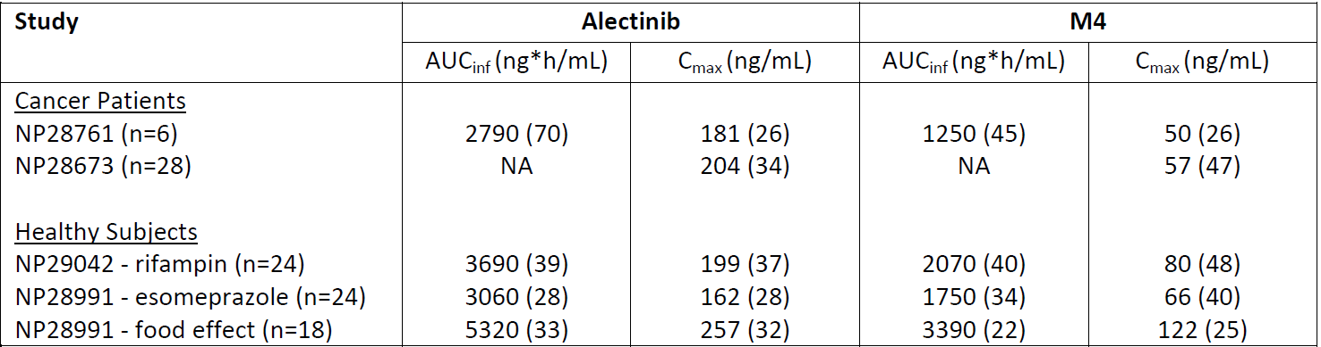

The FDA reviewer also noted that the results in Study NP28761 came from an assay that on average returns results 20% lower than the assay used in the rest of the studies.

PK data described in the following sections of this review comes from:

* Patients with ALK+ NSCLC if it comes from study NP28761, NP28763 and its midazolam substudy or AF001JP.
* Both healthy subjects and patients with ALK+ NSCLC if it is relating to population PK studies (1064536, 1064595 or 1064597) which amalgamated data from both, and
* Healthy volunteers if it comes from the remaining 5 dedicated PK studies (NP28989, NP28990, NP28991, NP29040 and NP29042)

Due to the similar exposure in healthy volunteers compared to patients with ALK+ NSCLC, The pharmacokinetic data for alectinib is described below in an integrated fashion.

#### Pharmacokinetics summary

##### Absorption

###### Sites and mechanism of absorption

Absorption of the proposed oral formulation of alectinib is best described by a one-compartment open model with zero-order then first-order absorption. Under fed conditions, time to maximum observed plasma concentration (Tmax) is reached after approximately4 to 6 hours.

##### Bioavailability

###### Absolute bioavailability

The absolute bioavailability of a 600 mg oral dose of alectinib with food was determined (in healthy subjects) to be moderate at 36.9% (90% CI [33.9%, 40.3%]) in Study NP28989. Physiologically-based population PK modelling showed that this was due to low solubility leading to incomplete absorption.

###### Bioavailability relative to an oral solution or micronised suspension

There was no study formally comparing the bioavailability of alectinib capsules to an oral solution or micronised suspension. However, Study NP28989 (in healthy subjects) included a mass-balance study using an oral suspension of radiolabelled-alectinib 600 mg.

The single dose PK with the capsule showed an exposure approximately double that seen for the same capsule in NP29042, another PK study using the capsule in healthy volunteers. Both studies were also reasonably small, NP28989 particularly so (N=6), and the subjects of NP28989 had a lower mean BMI.

The single-dose PK seen with the 600 mg radiolabelled alectinib oral suspension was more in keeping with the single-dose PK seen with the 600 mg alectinib capsule dosing in NP29042. However, a lower metabolite to parent (M: P) ratio was also seen with the suspension compared to the oral capsule in the two phases of Study NP28989. It is possible that the oral solution formulation affected regional dissolution or absorption of alectinib/M4.

The oral solution formulation is not proposed for marketing.

###### Bioequivalence of clinical trial and market formulations

The Ro 542-4802/F03 formulation is designated as the global commercial formulation and is the formulation proposed for marketing.

Both pivotal clinical studies (Phase II of NP28761 and all of NP28673) used the proposed commercial drug product.

The formulations used in clinical trials all contained 50% SLS (Ro 542-4802/F01, Ro 542-4802/F02 and Ro 542-4802/F03; see Table 2). The only exception is Study NP29040 which directly compared three further formulations with lower SLS content to Ro 542-4802/F03 (Ro 542-4802/F07, Ro 542-4802/F14 and Ro 542-4802/F08).

The PK parameters obtained with Ro 542-4802/F01 and Ro 542-4802/F02 were shown to be comparable to Ro 542-4802/F03 in the crossover portion of Study NP28761. This observation is supported by the findings of Japanese Study JP28927, a 2-arm crossover study that directly compared the different formulations at a 300 mg dose level.[20] The results showed the formulations to be bioequivalent

Figure 3: Bioequivalence of the Ro 542-4802/F01, Ro 542-4802/F02 and Ro 542-4802/F03 formulations as demonstrated by Nakagawa et al (2014).[21]

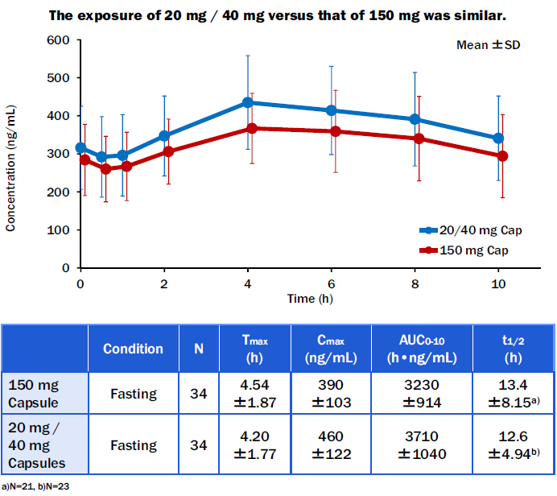

###### Bioequivalence of different dosage forms and strengths

Only one dosage form and strength is proposed for marketing: Ro 542-4802/F03, which is the 150 mg hard capsule with 50% SLS and that has been shown to be bioequivalent to the other formulations used in clinical studies (see above).

###### Bioequivalence to relevant registered products

Not applicable.

###### Influence of food

Administration of alectinib after a meal increases its bioavailability by two to four fold (Study NP28991).

As noted above, alectinib solubility is about five times higher in fed state simulated intestinal media than fasted (FESSIF versus FASSIF).

Exploratory analysis of data from Japanese trial AF-001-JP in patients with ALK+ NSCLC showed increased exposure when alectinib was dosed with food, but after multiple dosing the effect was no longer seen. The data was limited by different fasting times used in the two conditions, and the small PK sample sizes (15 in the fasted state, 9 fed).

Study NP28991 in mixed race population (six healthy subjects) showed that when a single dose of 600 mg PO of alectinib was administered after a high-fat, high-calorie meal, exposure to alectinib and its major metabolite, M4, were increased by factors of 2 to 4-fold, and Tmax­ was delayed by 6-12 hours. Again the sample size was small however the food effect was supported by the physiologically-based absorption model described in report PK-1064595. This model has been verified by comparison to data from multiple clinical studies, and supports the following hypotheses:

* First pass losses in the gut and liver are small.
* It is the low solubility of alectinib which most affects oral exposure.
* Low solubility explains:
  + The increase in exposure seen when alectinib is given with food
  + The very limited DDI seen with gastric acid inhibitors
  + The relevance of SLS as an excipient.
* The observed effects of the low SLS formulations on alectinib and M4 exposure are plausibly related to:
  + Tendency for forming a hypothetical precipitate more easily absorbed at the colon and
  + Location of GI tract CYP3A activity and SLS effect on principal location of absorption

The sponsor states that in the pivotal clinical studies (Studies NP28761 and NP28673), alectinib is administered under fed conditions to maximize bioavailability and ‘maintain GI tolerance’.

**Comment**: It is not clear on what data the sponsor bases their statement regarding GI tolerance, however clearly bioavailability is higher under fed than fasted conditions. Could the sponsor please clarify this for our understanding? See Clinical question 1.

###### Dose proportionality

In Study NP28761, linear regression analysis was performed on log-transformed alectinib Cmax and AUCparameters after both single dose and multiple dose administration. Dose proportionality over the investigated dose range (460 to 900 mg BD) was unable to be excluded for all parameters, as the confidence intervals all included 1.

A dose proportionality analysis in NONMEM population PK report 1064536 used data from Study NP28761 and confirmed dose proportionality over the range 300 mg – 900 mg.

###### Bioavailability during multiple-dosing

Steady-state appeared to be reached in NP28673 by day 8 of cycle 1 and this was supported by the data from NP28761. The data was later refined using population PK analysis to illustrate that following twice daily (BD) dosing of 600 mg alectinib under fed conditions:

* it took 6.75 days for alectinib serum concentrations to reach steady state (6.42 days for M4)
* the peak-to-trough (Cmax/Ctrough) ratio was low at of 1.16 (1.11 for M4)
* the accumulation ratio (Racc) was 5.56 for alectinib (6.45 for M4).

###### Effect of administration timing

The physiologically-based PK (PBPK) GastroPlus™model supported that slight variation in time of administration after a meal would not greatly change exposure: administration two hours, compared to thirty minutes, after starting a meal were modelled to result in within a 20% decrease in exposure at steady-state dosing. These results are in agreement with Japanese Study JP28927.

##### Distribution

###### Volume of distribution

Use of an IV microtracer technique in healthy subjects in Study NP28989 showed a large steady state volume of distribution (Vss): 480 L (6.4 L/kg).

###### Plasma protein binding

It is stated in the summary of clinical pharmacology that alectinib and M4 are >99% bound to plasma proteins, with an unbound fraction of alectinib in plasma of 0.3%, and that alectinib has an extraction ratio of 0.14 (determined from measured IV clearance and blood/plasma ratio, using known human hepatic blood flow). Between the high Vss, low clearance and low hepatic extraction ratio the sponsor states that ‘no interaction on human plasma proteins is expected’.

###### Erythrocyte distribution

The mass balance study conducted as part of Study NP28989 showed that after a radiolabelled single PO dose of 600 mg alectinib, the geometric mean ratio of blood/plasma radioactivity was 2.70 for Cmax and 4.07 for AUC0-last, indicating association of the radioactivity with the non-plasma component of whole blood. The apparent terminal T1/2 of the radioactivity was twice as long in whole blood as in plasma (172 versus 65 hours), also suggesting slower elimination from the whole blood compartment compared to plasma.

###### Tissue distribution

In the NONMEM population PK analysis, a statistical association was seen between body weight and apparent volume of distribution (V/F) for both alectinib and for M4. In conjunction with the lipophilic nature of alectinib (see physicochemical characteristics, above), the large Vss indicates extensive distribution into tissues/organs, explaining the effect of body weight on V/F.

##### Metabolism

###### Interconversion between enantiomers

No enantiomers are described in the dossier, other than metabolite M1a/M1b.

###### Sites of metabolism and mechanisms / enzyme systems involved

In vitro studies have indicated the following:

* CYP3A4 is the main cytochrome P450 isoenzyme that metabolises alectinib
* CYP3A contributed:
  + 40-50% of alectinib metabolism in human hepatocytes
  + 80% of alectinib metabolism in human liver microsomes (HLM)

The SimCYP® PBPK modelling supported a fraction metabolised by CYP3A4 of approximately 0.4.

###### Non-renal clearance

In the NONMEM population PK analysis, a statistical association was seen between body weight and apparent clearance (CL/F) for alectinib and for M4. Alectinib is a hepatically metabolised compound with low extraction, so apparent clearance is more dependent on hepatic clearance than hepatic blood flow. As hepatic clearance depends on hepatic size which is correlated to body size, the association between weight and apparent clearance was expected.

###### Metabolites identified in humans: active and other

In Study NP28989, a probable metabolic pathway of alectinib was proposed, as shown in Figure 4. Metabolite profiling identified the following metabolites:

1. M4
   * + This is the major metabolite, contributing approximately 15% of the 76% total plasma radioactivity made up by parent drug plus M4 in the mass balance study.
2. M1b, also known as ‘unknown’/UK in Study NP28989
   * + Also detected in plasma, but only at 4-6 hours and to a lesser extent than M4
3. M1a
   * + Not detected in plasma
4. M6
   * + Not detected in plasma

The sponsor states that the metabolite profile depicted by Study NP28989 is in keeping with that indicated by in vitro data.

Figure 4: The proposed metabolic pathway of alectinib in humans

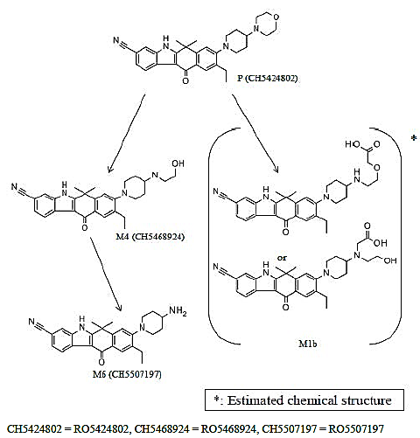

###### Pharmacokinetics of metabolites

In vitro studies using a panel of recombinantly expressed human CYP enzymes indicated that CYP3A4 is the main enzyme that metabolises metabolite M4.

The SimCYP® PBPK modelling suggested that non-CYP enzymes are also likely involved in producing the M1a/b metabolites.

It is noted on page 43 of pharmkin-written-summary.pdf that the assay results for metabolite M4 *did* show it to be a substrate of P-gp, unlike alectinib.

**Comment**: This is important as there are multiple PK outcomes – particularly in discussing the clinical relevance of potential DDIs – that were measured in terms of the total molar concentration of alectinib plus M4, on the basis that they show very similar in vitro potency (see M4 activity testing below).

See Clinical question 1.

###### Consequences of genetic polymorphism

No data on the effect of genetic polymorphisms on PK has been submitted.

##### Excretion

###### Routes and mechanisms of excretion

Radiolabelled alectinib administered orally in Study NP28989 showed near complete recovery of radioactivity by 168 hours post-dose with the majority excreted in faeces and only a small amount seen in urine (mostly minor metabolite M1b).

The plasma clearance of alectinib after IV administration was 34.5 L/h. Intestinal and hepatic first pass metabolism and biliary excretion of alectinib are all considered to be low.

###### Mass balance studies

Collection of excreta for the mass balance study in NP28989 showed that faecal material contained mostly unchanged alectinib (84% of dose), in conjunction with active metabolite M4 (5.8%), M1a/b (7.2%: isomers at an M1a:M1b ratio of approximately 1:9) and M6 (0.2%).

###### Renal clearance

Urinary excretion overall was very small (0.467% of administered radioactivity was recovered in urine), and consisted mostly of metabolite M1b. Recovery of unaltered alectinib or M4 in urine was minimal (0.015% and 0.151% of administered alectinib dose) supporting that excretion into urine is a minor elimination pathway.

##### Intra and inter individual variability of pharmacokinetics

Trough PK values in Study NP28673 showed high coefficients of variation (45% to 65%) across visits, suggesting persistent moderate inter-individual variability in steady-state exposure.

#### Pharmacokinetics in special populations

##### Pharmacokinetics in subjects with impaired hepatic function

Based on the NCI Criteria, of the patients in Study NP28673:

* 78% (N=107) had normal hepatic function
* 22% (N=30) had mild hepatic impairment
* None had moderate hepatic impairment and
* 1% (N=1) had severe hepatic impairment

There was no statistically significant effect of baseline liver laboratory parameters on alectinib or M4 PK. The sample size for severe hepatic impairment is not large enough to draw any conclusions from. The individual clearance for this person was one standard deviation above the mean clearance of the 107 patients with normal hepatic function.

The sponsor concludes that

The PK of alectinib has not been studied in patients with moderate to severe hepatic impairment. A dedicated study to evaluate the effect of hepatic impairment on the PK of alectinib and M4 is planned.

The sponsor proposes routine pharmacovigilance and RMP risk minimisation measures to manage the safety of alectinib in the hepatic impairment population in the interim while study data is not available.

##### Pharmacokinetics in subjects with impaired renal function

Amongst the patients who were enrolled in Study NP28673, baseline CrCL ranged from 46.3 to 244 mL/min:

* 77 patients had normal CrCL (CrCL ≥ 90 mL/min),
* 48 patients had mild renal impairment (60 mL/min ≤ CrCL < 90 mL/min), and
* 13 patients had moderate renal impairment (30 mL/min ≤ CrCL < 60 mL/min).

There was no statistically significant effect of baseline creatinine clearance on alectinib or M4 PK.

The sponsor concludes that

Based on the negligible renal elimination of the active moieties, the absence of any effect of mild or moderate renal impairment on exposure and the fact that the target population is closely monitored, sufficient information is available to conclude that the dose does not need to be adapted in patients with renal impairment. Further, these data support that a dedicated renal impairment study would not be warranted for alectinib.

**Comment**: The evaluator agrees with the sponsor’s conclusions but would advise retaining the caveat in the PI that said alectinib has not been studied in severe renal impairment.

##### Pharmacokinetics according to age

No age-dependent effect on PK was seen in the popPK analysis.

#### Pharmacokinetics related to genetic factors

##### Race – pharmacokinetics in an all-Asian (Japanese) versus a mixed-race population

It has been observed that the PK data from Study AF-001JP appears to show a higher exposure than the data from NP28761 and NP28673.

The following table (Table 8) is derived from NP28761, AF001JP, NP28761, NP28761 and AF001JP and summarises data for cohorts in these two studies who were most easily comparable (taking doses either 300 mg BD or 600 mg BD). The coefficients of variation are noted to be high and the sample sizes relatively small.

Both studies were conducted in patients with ALK+ NSCLC, and the data in able 8 is the PK determined from samples taken after multiple oral doses. Both studies also used the same alectinib quantification LC-MS/MS assay (see discussion on inter-assay differences below).

The values in Table 8 for cohort 1A/1B weight are not the same as what was entered in for cohort 1, as cohort 1A/1B did not include a 7th patient from the original cohort 1 (who was separated out into his own cohort [1C] due to a question over whether he ate prior to dosing). The mean baseline weight for cohort 1A/1B was therefore calculated from the without including that of subject [information redacted].

Table 8: Comparison of PK and weight data recorded in the AF-001JP and NP28761 trials

A= Alectinib; GM=geometric mean; MBaseW=Mean baseline weight

| Trial | Cohort | A  PO dose  mg BD | *Cmax (ng/mL)* | | *AUClast (h*ng/mL)* | | MBaseW  kg | SD |
| --- | --- | --- | --- | --- | --- | --- | --- | --- |
| GM | CV% | GM | CV% |
| AF-001JP | 6 | 300 | 521 | 56.1 | 4340 | 65.6 | 54.3 | 9.5 |
| 8 | 300 | 512 | 26.1 | 4070 | 28.1 | 50.4 | 11.6 |
| NP28761 | 1A/1B ᶽ | 300 | 247 | 34.6 | 1720 | 32.4 | 76.4 | 11.3 |
| 3 ᶤ | 600 | 747 | 24.6 | 5880 | 19.5 | 83.4 | 14 |
| 6 | 600 | 607 | 49.0 | 4620 | 61.5 |

ᶽ Dosed under fasted conditions. All other cohorts fed. ᶤ n=5. All other cohorts n=6.

As can be seen from Table 8, when the patients in both cohorts of AF-001JP were given multiple doses of 300 mg BD PO alectinib, the average Cmax was in a similar range to a group of mixed race patients in Study NP28761 who had been taking double the dose (600 mg BD; cohorts 3 and 6 of NP28761). Whilst not explicitly stated, it is assumed that all subjects of trial AF-001JP were of Asian (Japanese) race. The population of NP28761 was a mixed American/Canadian population, including people from White, Black and Asian races. In keeping with the generalisation that Asian people are smaller than White and Black people, the average weight of the two Japanese cohorts were both much smaller – almost half – that of the cohorts from the NP28761 study. There is a possibility that there are race-specific differences in alectinib pharmacokinetics. However, given the known effect of body weight on exposure, the large differences in baseline weight between the groups confounds the interpretation of the difference in PK as being due to race.

Cohort 1A/1B received the same dose as the two AF-001JP cohorts (300 mg BD) but in the fasted state rather than fed, and with a baseline weight 50% higher. Food is known to increase exposure by approximately 3-fold, and increasing weight is known to correlate with decreasing exposure, so the Cohort 1A/1B PK most likely illustrates the effect of food on bioavailability, with a lower exposure (approximately 40%-50% lower) in this group of fasted patients despite their larger mean baseline weight.

The recommended dose in Japanese Study AF-001JP (300 mg BD) is only half that of the recommended dose in the two pivotal studies, NP28761 and NP28673 (600 mg BD). The maximum possible dose imposed in the Japanese studies was based on local restrictions on SLS content, and the maximum tolerated dose was not identified in that study due to this limitation. So the usage of a lower dose was not based on safety concerns regarding alectinib.

**Comments**: Whether a race-specific difference in PK is present can’t be concluded from the available data. It is likely that differences in average body weight accounts for the observed differences in PK.

##### Pharmacokinetics in the CNS

An exploratory analysis in Study NP28761 on a small set of patients who consented to CSF studies, showed that alectinib is present in the CSF after oral dosing, at concentrations of 0.2%-0.5% of the plasma concentration. This is a similar concentration to the unbound fraction of alectinib in plasma based on in vitro protein binding (see Plasma protein binding), supporting that unbound alectinib could penetrate freely into the CNS, and suggesting it is not an efflux transporter substrate. Serum and CSF concentrations were correlated.

* This exploratory analysis was limited by the sample size (8) and further so by the fact that two of the eight samples were not actually time matched as collection packs weren’t available at the time. It is unclear where the matched serum samples have then been chosen from.

##### Population pharmacokinetics

The FDA conducted a review of the same three population pharmacokinetic reports as part of their clinical pharmacology and biopharmaceutics review. This PopPK review concluded the following:

* The integrated alectinib-M4 PBPK models can predict the effect of CYP3A modulators (such as posaconazole and rifampin) on the PK of alectinib and M4.
* Integrated alectinib-M4 PBPK models can predict minimal CYP inhibition in humans
* The limitations of the modelling were:

…prediction of the effect of rifampicin on the exposure of M4 by integrated alectinib-M4 PBPK models was not satisfactory. If one were to use PBPK to predict the effect of various patient factors on the PK of M4, additional elimination mechanisms of M4 need to be understood and be quantitatively incorporated into the model of M4.

The applicant also conducted PBPK modelling and simulation to understand oral absorption of alectinib and to evaluate the effect of the timing of alectinib dosing with respect to a meal. This report was not reviewed.

The FDA reviewer concluded that:

The applicant’s integrated alectinib-M4 PBPK models accounting for CYP inhibition mechanisms (TDI and induction of CYP3A, and reversible inhibition of CYP2C8) predicted no effect on CYP2C8 substrate repaglinide at clinical doses. Simulations using integrated alectinib-M4 PBPK models are determined to be adequate to support the applicant’s proposed labeling language regarding the lack of CYP2C8 inhibition potential.

**Comment**: The language regarding CYP2C8 in the PI is adequate. Rewording of it has been undertaken to make it more concise but the meaning is unchanged.

Regarding the pharmacometrics described in the population PK report 1064536, the same document contains the following recommendation:

The Division of Pharmacometrics in Office of Clinical Pharmacology has reviewed the information contained in NDA 208434. This NDA is considered acceptable from a pharmacometrics perspective.

**Comment**: This commentary is reassuring.

##### PopPK analysis 1064536

Population PK modelling and analysis using NONMEM version 7.2.0 software was undertaken.

The principal findings were:

A population one-compartment open model with first-order elimination and with sequential zero and first-order absorption/formation could describe alectinib and M4 plasma concentration-time profiles adequately in patients with ALK+ NSCLC. Body weight was the only covariate which had a statistically significant effect on alectinib and M4 PK. In the range of exposure achieved by the 600 mg BID dose, there was no significant relationship between exposure and any AE, and variability in exposure was not associated with variability in efficacy. Therefore, despite the significant body weight effect on the apparent clearance of alectinib, no body weight based dose adjustment is needed. All analysis results indicated that the alectinib 600 mg BID dosing regimen is appropriate for patients with ALK+ NSCLC who have been previously treated with crizotinib.

The analysis was limited by the introduction of significant variation by the use of two different assays for quantification of serum alectinib/M4 between the two pivotal trials NP28761 and NP28673. The assay developed by Chugai Pharmaceuticals and used in Study NP28761 gave concentration readings ranging from 11.8% to 31.1% lower for alectinib (and 13.7% to 30.0% lower for M4) than assay developed by Quintiles which was used in Study NP28673 (page 22, poppk-1064536.pdf). The variability was limited by using only the data from Study NP28763 to first develop the model, and then by later incorporating the data from NP28673 using an adjustment factor of 0.8 to account for the average difference between the two tests.

**Comment**: The evaluator is not an expert in population pharmacokinetics and as such was unable to comment on whether this methodology is appropriate. That the FDA expert statistical reviewer did not raise concerns over it is reassuring.

##### PopPK analysis 1064595

PBPK modelling using GastroPlus™ software was undertaken.

The principal findings were:

A population one-compartment open model with first-order elimination and with sequential zero and first-order absorption/formation could describe alectinib and M4 plasma concentration-time profiles adequately in patients with ALK+ NSCLC. Body weight was the only covariate which had a statistically significant effect on alectinib and M4 PK. In the range of exposure achieved by the 600 mg BID dose, there was no significant relationship between exposure and any AE, and variability in exposure was not associated with variability in efficacy. Therefore, despite the significant body weight effect on the apparent clearance of alectinib, no body weight based dose adjustment is needed. All analysis results indicated that the alectinib 600 mg BID dosing regimen is appropriate for patients with ALK+ NSCLC who have been previously treated with crizotinib.

##### PopPK analysis 1064597

PBPK modelling using SimCYP® software was undertaken.

The principal findings were:

* The estimated fraction of alectinib metabolized by CYP3A4 enzyme (fmCYP3A4) is approximately 40% and the extent of intestinal metabolism by CYP3A4 is low with around 90% escaping gut metabolism.
* PBPK model simulations and sensitivity analyses indicate alectinib and M4 produce negligible time-dependent inhibition of CYP3A4 at clinically relevant concentrations, consistent with the observations of a midazolam sub-study of NP28673.
  + The magnitude of interactions with potent CYP3A4 inhibitors and inducers (such as posaconazole and rifampin) observed after a single dose of alectinib should be predictive of what would occur with multiple doses.
* Investigation of the effect of competitive inhibition by alectinib on the PK of repaglinide, a probe CYP2C8 substrate, supports that at clinically relevant concentrations alectinib does not have the potential to increase plasma concentrations of co-administered CYP2C8 substrates.

#### Pharmacokinetic interactions

##### Posaconazole (potent CYP3A inhibitor)

In Study NP 28990, co administration of multiple oral doses of posaconazole with a single oral 300-mg dose of alectinib led to:

* An increase in the geometric mean exposure of alectinib
  + 75% increase in AUC0-∞
  + 18% increase in Cmax
* A decrease in the geometric mean PK exposure of the metabolite M4
  + 25% decrease in AUC0-∞
  + 71% decrease in Cmax
* A reduction of the molecular weight adjusted metabolite to parent (M/P) ratio
  + 57% decrease based on AUC0-∞
  + 61% decrease based on Cmax
* An increase in the total molar concentrations (molar sum of alectinib and M4) during the elimination period (or post-Cmax): geometric mean ratios of the total molar concentration in the presence compared to absence of posaconazole were
  + 0.93 for Cmax
  + 1.36 for AUC0-∞
  + 1.38 for AUC0-last

##### Rifampin (potent CYP3A inducer)

In Study NP 29042 co-administration of alectinib with rifampin resulted in:

* Reduced alectinib exposure
  + Geometric mean exposure ratios:
    - Cmax 48.6% (90% CI: 43.5 to 54.3)
    - AUC0-∞ 26.8% (90% CI: 23.8 to 30.1)
* Increased M4 exposure
  + Geometric mean exposure ratios
    - Cmax 220% (90% CI: 190 to 255)
    - AUC0-∞ 179% (90% CI: 158 to 202)
* Slight reduction in total molar concentration of alectinib plus M4:
  + Geometric mean exposure ratios:
    - Cmax 96.1% (90% CI: 87.7 to 105)
    - AUC0-∞ 0.81 (90% CI: 74.0to 90.1)

**Comment**: Given the similar in vitro inhibitory activity of M4 to alectinib, the small change in total molar exposure suggests little change to efficacy would occur in a setting of CYP3A induction. The caveat to this is that M4 is a substrate of P-gp. In the setting of CNS metastases, could the increased conversion to M4 result in reduced CNS retention of total active substance and therefore decreased CNS efficacy? See Clinical question 1.

##### Esomeprazole (inhibitor of gastric acid secretion)

In Study NP28991 elevation of gastric pH by co-administration of esomeprazole (a proton pump inhibitor [PPI]), demonstrated a small, not clinically relevant effect (approximately 20% increase) on the single dose pharmacokinetics (PK) of alectinib and M4:

* M4 geometric mean exposure ratios:
  + Cmax 102% (90%CI 87-119)
  + AUC0-inf 110 (90%CI 96-126)
* Alectinib geometric mean exposure ratios:
  + Cmax 116% (90%CI 103-132)
  + AUC0-inf 122 (90%CI 109-136)

##### Midazolam (substrate for CYP3A4 activity)

In vitro, alectinib and M4 has shown weak time-dependent inhibition of CYP3A4. Midazolam (MDZ) is a sensitive in vivo probe substrate for CYP3A4 activity. In a DDI substudy of NP28672, multiple oral dose administration of alectinib 600 mg BID did not affect the exposure of a single oral dose of MDZ.

#### Clinical implications of in vitro findings

It is noted in both the CSR for NP 29040 and NP29042 that in vitro studies indicated that M4 has similar potency to alectinib against ALK (half maximal inhibitory concentration [IC50] = 1.9 nM for alectinib and 1.2 nM for M4). The implication of this for the purposes of other studies was that the total molar concentration of alectinib and M4 together is relevant in considering alectinib exposure and efficacy. However, the fact that M4 is a P-gp substrate must be taken into account. See Clinical question.

### Evaluator’s overall conclusions on pharmacokinetics

Alectinib pharmacokinetics has been adequately profiled, including direct clinical studies in healthy volunteers, studies of population PK data from clinical trials and physiologically-based PK modelling of the same data, directed by nonclinical data. Alectinib PK shows moderate inter-individual variability.

The solubility of alectinib appears to most influence its bioavailability, and this is changed most significantly by SLS content of the formulation (higher SLS giving more exposure) and dosing relativity to food intake (higher exposure with fed state intake).The factor most influential on alectinib exposure for an individual is body weight (lower exposure with higher weight). PK does not seem to be affected by sex, age, race or gender, mild to moderate renal impairment or mild hepatic impairment.

No CYP3A4-related DDIs are expected. PBPK modelling predicts no CYP2C8 DDIs are expected. Interaction with CYP3A inhibitors or inducers is not expected to be clinically relevant, and gastric acid-lowering medications should not have a clinically significant effect.

The fact that major metabolite M4 is a substrate of P-gp may have relevance to efficacy in the CNS, and may confound the conclusions drawn from PK calculations that have relied on total molar concentration of both alectinib and M4 due to their similar potency. See Clinical question1.

Alternative PI text regarding PK information is proposed for clarity.

## Pharmacodynamics

### Studies providing pharmacodynamic information

No specific pharmacodynamics studies have been submitted. Pharmacodynamic information is provided principally by population PK analysis of the pivotal efficacy studies, and is supported by non-clinical pharmacodynamics data. Exposure-safety and exposure-efficacy analyses were performed as part of the popPK study.

### Summary of pharmacodynamics

#### Mechanism of action

Alectinib inhibits anaplastic lymphoma kinase (ALK).

#### Pharmacodynamic effects

##### Primary pharmacodynamic effects

###### Recombinant enzyme assays

In vivo studies with recombinant human kinases showed alectinib to show potent inhibition ALK (IC50=1.9 nM) and RET tyrosine kinase (IC50=4.8 nM), but to have no or little inhibition against other tested kinases (including cMET, KDR and ROS1). Alectinib’s kinase specificity profile is therefore narrower than crizotinib and ceritinib.

Alectinib also showed high potency against ALK mutants with point mutations known to be associated with acquired crizotinib resistance (L1196M [a gatekeeper], C1156Y, G1202R, 1151Tins, L1152R, and G1269A) or neuroblastoma development (F1174L and R1275Q), with IC50 values that ranged from 0.93 to 41 nM.

###### Human cell line studies

Human cancer cell line studies showed alectinib to have very little inhibitory effect on ALK fusion-negative lines (negative controls), but to inhibit growth of all of the tested ALK-activated lines:

* lung adenocarcinoma cell line NCI-H2228 (EML4-ALK-fusion-positive) with an IC50 of 12 nM
* anaplastic large cell lymphoma (ALCL) cell lines KARPAS-299 and SR (nucleophosmin (NPM)-ALK fusion-positive) with an IC50 of 14 nM
* neuroblastoma cell line NB1 (ALK amplification) with an IC50 of 4.5 nM
* lines with crizotinib resistant mutations (such as L1196M, G1269A, and S1206Y): these did not respond to crizotinib

Immunoblotting for ALK phosphorylation as a marker of ALK activity showed alectinib to suppress phosphorylation of ALK in both ALK fusion-positive cell lines NCI-H2228 and KARPAS-299. In the NCI-H2228 line, downstream signalling of ALK substrates STAT3 and AKT were also strongly inhibited.

###### Xenograft models

Mice bearing subcutaneous NSCLC xenografts (NCI-H2228) were treated with oral alectinib at 0.2 to 20 mg/kg to investigate the anti-tumour effect of alectinib in vivo. Dose-dependent inhibition was observed above the control group with an estimated dose required to inhibit 50% of tumour growth (ED50) of 0.46 mg/kg. Tumour regression was observed at doses 6 mg/kg and higher. Immunoblotting of xenografted tumours after a single 20 mg/kg oral dose showed suppression of ALK phosphorylation and kinase activity.

ALCL (KARPAS-299) and neuroblastoma (NB-1) xenografts in severe combined immunodeficiency (SCID) mouse models also showed inhibition of tumour growth, with regression at the 20 mg/kg dose.

Mice bearing xenografts of murine Ba/F3 cell lines carrying crizotinib-resistant EML4-ALK mutants were treated with 60 mg/kg alectinib or 100 mg/kg of crizotinib. The alectinib-treated group showed tumour inhibition and regression for all but the G1202R mutant, including gatekeeper mutation L1196M.

Investigation of the effect of previous crizotinib treatment using xenograft models was also undertaken using the NCL-H2228 cell line. Mice bearing xenografts were given oral crizotinib (100 mg/kg/day) or vehicle (placebo) daily for 21 days, then re-randomised into three groups and treated with vehicle, alectinib (60 mg/kg/day) or crizotinib (100 mg/kg/day) daily for 21 days. Mice treated first with crizotinib then with alectinib showed further regression of the tumour whilst those treated with crizotinib in both periods showed no further regression during the second period.

To study alectinib activity against CNS tumours in a mouse model, xenografts of NCI-H2228 cells were implanted by intracranial injection and mice treated orally with alectinib (60 mg/kg/day) or crizotinib (100 mg/kg/day) from day 20 until day 45 or death. Alectinib treatment, compared to crizotinib, significantly prolonged survival. A second intracranial study involved NCI-H2228 xenografts expressing a luciferase reporter and assessment of bioluminescence. Tumours were allowed to grow for 20 days after implantation and then mice were treated with alectinib or crizotinib. Bioluminescence revealed a strong anti-tumour effect of alectinib but not crizotinib. This is in keeping with alectinib having better CNS availability due to it not being a substrate of CNS efflux transporter P-gp, as shown in previous in vitro PK studies. By comparison, crizotinib and ceritinib are substrates of P-gp (see US labels for Xalkori and Zykadia).

Mice carrying NCI-H2228 tumours were also assessed for combination treatment of alectinib and standard chemotherapeutics (cisplatin, paclitaxel, gemcitabine and bevacizumab). Alectinib 3 mg/kg/day in conjunction with these enhanced efficacy and did not affect mouse body weight (assessed as a surrogate for tolerability).

###### M4 activity testing

Testing of major human metabolite M4 was undertaken in order to determine its activity. Inhibition of ALK by M4 showed an IC50 of 1.2 nM, making it equivalent to alectinib (IC50 1.9 nM). Kinase selectivity, activity against ALK mutants and inhibition of NCI-H2228 cell line growth (at IC50 37 nM) were all found to be very similar to the parent drug.

It is noted on page 43 of pharmkin-written-summary.pdf that the assay results for metabolite M4 *did* show it to be a substrate of P-gp, unlike alectinib. See Clinical question 1.

##### Secondary pharmacodynamic effects

In vitro binding screening assays were carried out at 10 µM alectinib on 109 receptors, ion channels and transporters and 42 enzymes. These showed that alectinib had a >50% inhibitory effect on the enzyme activity of CaMK2ɑ and on ligand binding to the following:

peripheral benzodiazepine receptors, dopamine receptors, muscarinic receptors, neurokinin receptors, serotonin receptors, sigma receptors, glucocorticoid receptors, urotensin receptors, L-type Ca2+ channels, Cl-channels, serotonin transporters, norepinephrine transporters, dopamine transporters

Follow-up in vitro functional assays on 20 types of receptors (including dopamine, muscarine, neurokinin, serotonin, urotensin and monoamine uptake receptors) were subsequently undertaken. These showed alectinib to inhibit synaptosomal uptake of norepinephrine and dopamine, suggesting that CNS functions would be affected by alectinib. However, in vivo CNS testing (modified Irwin test) in rats showed no behavioural or clinical signs up to doses of 300 mg/kg or with 60 mg/kg/day over 13 weeks of repeated dosing.

#### Time course of pharmacodynamic effects

Non-clinical: xenograft responses appear to have been assessed over a period of up to 25 days (luciferase study).

Due to the indication for use, clinical pharmacodynamics for alectinib is akin to efficacy. Time-to-event efficacy outcomes are not yet assessable as this data is immature. See Section 7

#### Relationship between drug concentration and pharmacodynamic effects

Non-clinical: dose-dependent inhibition was observed in xenograft models (see above).

Due to the indication for use, clinical pharmacodynamics for alectinib is akin to efficacy. See Section 7. Population pharmacokinetics study 1064536 included an assessment of the exposure-efficacy relationship.

Graphical analysis of the data from Phase 1 patients of Study NP28761 (n=46) showed that trough concentrations in the medium and higher thirds of the population taking alectinib doses of 600 mg BD who had measurable lesions were associated with larger decreases in tumour size than the lower third. The magnitude of decrease LOESS was similar in the medium and the high trough concentration groups. This suggests that higher doses may not provide additional efficacy.

Analysis of the pooled data from all patients on 600 mg BD (Phase I patients of Study NP28673 (n=46) plus all patients in NP28763) found that:

* Baseline tumor size and prior crizotinib treatment duration were the only covariates which were statistically significant predictors of PFS on Cox proportional-hazards analysis.
  + Larger tumour at baseline = increased risk of progression
  + Longer duration of prior crizotinib treatment = decreased risk of progression
  + As the time-dependent endpoints are not yet mature this analysis will have to be repeated.
* Variability in exposure did not explain the variability in efficacy. There was no significant correlation between exposure and the probability of:
  + having a CR or PR
  + duration of response (DOR)
  + CNS BOR for measurable disease (exploratory due to small sample size for CNS measurable disease, N=47)

These results suggest that the dose of 600 mg BD provides a normal distribution of alectinib exposure that falls around a point of plateau in the exposure-response association, that doses higher than 600 mg BD may not provide higher efficacy and doses lower than 600 mg BD could potentially results in reduced efficacy (in the population of ALK+ NSCLC patients who have progressed on crizotinib).

#### Genetic, gender and age related differences in pharmacodynamic response

A comparison of results (objective response rate by IRC) in subpopulations of the pivotal studies was provided. The sponsor concludes that:

For the pivotal studies, results of the ORR based on subgroups defined by baseline characteristics (age, gender, race, ECOG PS, CNS metastasis, smoking status, baseline body weight, and prior chemotherapy use) were generally consistent with the primary endpoint, especially when considering the small number of patients in some subgroups.

An imbalance is noted, for example, between the efficacy rate in the Asian subgroup of Study NP28761 (66.7%) versus White (48.3%) or other (20%), however there were 6 Asian patients, 58 White patients and 5 patients categorised as ‘other’.

Statistical analyses are not provided for these subgroup analyses, presumably due to the subgroup sizes being underpowered for such analysis.

The co-primary endpoint of IRC-assessed ORR in the subgroup of chemotherapy-pretreated patients in Study NP28673 did not reach statistical significance, as the lower 95% CI bound was 33.6%, below the pre-specified bound of 35%. However, the result (43.8% ORR) is still considered clinically meaningful, particularly given that the same subgroup in Study NP28761 did show statistical significance.

#### Pharmacodynamic interactions

See Pharmacodynamic effects above.

### Evaluator’s overall conclusions on pharmacodynamics

The pharmacodynamics data from non-clinical studies and the population PK report support that alectinib should show efficacy in treating cancer patients with ALK+ tumours and with CNS disease.

The reliance on nonclinical data and population PK analyses of data in assessing pharmacodynamics is appropriate due to the nature of the disease, as a pharmacodynamics effect on a neoplasm cannot be studied clinically in the absence of a neoplasm.

## Dosage selection for the pivotal studies

### Pharmacokinetics and pharmacodynamics: dose finding studies

The first in-human study of alectinib was AF-001-JP, conducted in Japan [information redacted]. As part of the study design for AF-001-JP, the maximum allowable dosage was restricted to 300 mg BD due to local restrictions on the daily allowable intake of sodium lauryl sulphate (SLS) and the SLS content of the study formulation (50%SLS). A lower SLS formulation of alectinib is in development and a bioequivalence study has been provided with this dossier.

In Study AF-001JP, no maximum tolerated dose (MTD) was identified, as DLT did not emerge prior to reaching 300 mg BD. The two pivotal studies (Study NP28761 and Study NP28673) in this dossier are Phase I/II studies, and included Phase I dose-finding elements.

Study NP28761 used the maximum dose reached in Study AF-001JP as their starting dose as it was well-tolerated in AF-001JP, in conjunction with existing nonclinical and PK data. Dose escalations were then guided by safety and tolerability, proceeding until the MTD was reached[22] starting at 300 mg BD and progressing to 460 mg, 600 mg, 760 mg and 900 mg BD (Table 1). The recommended Phase II dose (RP2D) for the Phase II portion of the study was determined to be 600 mg BD, based on two patients who experienced DLT:

* Patient [information redacted]: Grade 3 headache
* Patient [information redacted]: Grade 3 neutrophil count decrease, which resulted in interruption of alectinib treatment for 7 days

Both of these patients resumed alectinib at 600 mg BD with no further DLTs.

In Study NP28673, a modified 3+3 dose escalation methodology was planned. Dosing commenced at 600 mg BD because data from Study NP28761 was available at that time to show that this dose was well tolerated, with no DLTs, and was expected to give systemic exposure in keeping with the anticipated efficacious range. When the 600 mg dose cohort was completed in Part 1 of Study NP28673, the RP2D had already been defined in Study NP28761, and so Study NP28673 moved directly to Part 2.

### Phase II dose finding studies

Not applicable. See Pharmacokinetics and pharmacodynamics: dose finding studies.

### Phase III pivotal studies investigating more than one dose regimen

Not applicable. See Pharmacokinetics and pharmacodynamics: dose finding studies.

### Evaluator’s conclusions on dose finding for the pivotal studies

The 600 mg BD dose is well supported by the evidence.

## Clinical efficacy

### Studies providing evaluable efficacy data

The application for registration of alectinib relies on efficacy evidence from Phase I/II clinical trial data.

* NP28673:
  + ‘NP28673 − An open-label, non-randomized, multicenter Phase I/II trial of RO5424802 given orally to non-small cell lung cancer patients who have ALK mutation and who have failed crizotinib treatment.’
  + Pivotal Phase I/II trial (global) 138 patients enrolled
* NP28761:
  + ‘NP28761/AF-002JG − a Phase I/II Study of the ALK Inhibitor CH5424802/RO5424802 in Patients with ALK-Rearranged Non-Small Cell Lung Cancer Previously Treated with Crizotinib’
  + Pivotal Phase I/II trial (USA and Canada) 135 enrolled
* AF001-JP:
  + ‘Phase I/II Study of CH5424802 in Patients with Non-small Cell Lung Cancer Harboring the ALK Fusion Gene’
  + First-in man study (Japan)
  + The Phase I/II trial on which registration was based in Japan
  + Consisted of a dose-escalation phase followed by a safety and efficacy at recommended dose phase.
  + A supporting trial for the purposes of this study as the exclusion criteria included prior use of ALK-inhibitors

### Pivotal or main efficacy studies

#### Study NP 28673

##### Study design, objectives, locations and dates

Design: Multi-centre, single arm, open-label, dose escalating study.

Objectives:

* Phase I dose escalation study (Part 1)
  + Dose finding for Phase II (‘recommended Phase II Dose (RP2D)’
  + Assess safety, tolerability, and PK of alectinib at 600 mg BD and 900 mg BD (if reached)
* Phase II study (Part 2)
  + Efficacy (see below for measures/outcomes)
  + Safety profile of alectinib using the National Cancer Institute-Common Terminology Criteria for Adverse Events (NCI-CTCAE, v4.03)[23] [see section 8]
  + The effect of alectinib on cardiac repolarization (measured by corrected QT interval: QTc)
  + PK of alectinib and metabolite(s) in patients with ALK-mutated NSCLC
  + PK of alectinib in Taiwanese and Korean patients (for Taiwanese and Korean sites only)
  + DDI: the effect of multiple oral doses of alectinib on the PK of a single oral dose of midazolam (MDZ), an in vivo probe substrate of cytochrome P450 3A (CYP3A) activity, in a subset of 15 patients.
* Post-progression treatment (Part 3)
  + Following progression of disease:
    - Patients whose pre-treatment tumor specimens did not show EGFR mutation, or who did not have optional pre-treatment biopsy (that is, EGFR mutation status unknown) were offered continuation of treatment with alectinib if their treating physicians considered it beneficial.
    - Patients who experienced disease progression on alectinib, and whose pre-treatment tumor tissue showed EGFR mutations (e.g., Exon19 deletion or L858R in Exon21) were to be offered a combination of alectinib at the RP2D and erlotinib at 100 mg once a day (QD), as permitted by local authorities and ethics committees.

**Comment**: To date, all patients receiving treatment beyond progression in Part 3 have continued with alectinib monotherapy and no patients have received erlotinib in combination with alectinib.

* + Exploratory Part 3-related objectives:
    - To evaluate ORR in patients with EGFR mutation who had experienced disease progression on alectinib alone and were subsequently treated with a combination of alectinib and erlotinib
    - To evaluate the PK of alectinib and metabolite(s), and erlotinib in patients with EGFR mutation who have experienced disease progression on alectinib alone and who received the combination of alectinib and erlotinib
    - To evaluate the safety profile of alectinib in combination with erlotinib using the NCI-CTCAE v 4.03
  + Other exploratory objectives:
    - To evaluate the ALK mutations in tumour and blood samples and correlate it with response to alectinib, where possible
    - To evaluate the co-expression of EGFR mutation with ALK translocation and ALK mutation status
    - To investigate potential bypass mechanisms of ALK inhibition, such as cMET, KRAS and cKIT

*Locations*: France (11 centres), USA (10), Italy (8), Spain (6), Republic of Korea (4), Taiwan and Germany (3), Netherlands (2), Australia (2) and United Kingdom, Luxemburg, Belgium, Sweden, Singapore, Denmark, Russian Federation (1 each)

*Dates*: 20 June 2013 - 18 August 2014 (first patient in until data cut-off date for primary analysis)

##### Inclusion and exclusion criteria

*Inclusion*:

* + Locally advanced (American Joint Committee on Cancer [AJCC] Stage IIIB), not amenable to curative therapy or metastatic (AJCC Stage IV) histologically confirmed NSCLC with documented ALK rearrangement
  + Prior treatment with crizotinib and progression based on RECIST v1.1
  + Adequate haematologic, hepatic and renal function
  + If present, brain or leptomeningeal metastases had to be stable (≥2 weeks): either asymptomatic, or previously treated with whole-brain radiotherapy or gamma-knife radiosurgery, and stable without use of corticosteroids
  + Measurable disease (by RECIST v1.1) at baseline
  + Life expectancy >12 weeks (investigator opinion)
  + Eastern Oncology Cooperative Group (ECOG) Performance Status of 0 – 2
  + Negative serum pregnancy test in women who could fall pregnant and agreement to barrier contraception use in men during and for 3 months after treatment
  + Adequate haematological, renal and hepatic function

*Exclusion*:

* + Use of ALK inhibitors other than crizotinib
  + Cytotoxic chemotherapy for ALK+ NSCLC within 4 weeks prior to the first dose of study drug
  + Less than a 1 week washout period after crizotinib or other tyrosine kinase inhibitors before the first dose of study drug
  + A previous malignancy within the past 3 years (other than curatively treated basal cell carcinoma of the skin, early gastrointestinal [GI] cancer by endoscopic resection, in situ carcinoma of the cervix or any cured cancer that was considered to have no impact on PFS and OS for the current NSCLC)
  + Active or uncontrolled infectious diseases requiring treatment
  + NCI CTCAE (v 4.03) Grade 3 or higher toxicities due to prior therapy that had not shown improvement and was considered to interfere with current study drug.
  + History of organ transplant
  + Co-administration of anti-cancer therapies other than those administered in this study.
  + Baseline QTc > 470 msec, or baseline symptomatic bradycardia < 45 bpm
  + Pregnant or lactating women
  + Known Human Immunodeficiency Virus positivity or Acquired Immunodeficiency Syndrome-related illness
  + Any significant concomitant disease determined by the investigator to be potentially aggravated by the investigational drug
  + Administration of strong/ potent CYP3A inhibitors or inducers (except for oral corticosteroids up to 20 mg prednisolone equivalent per day), or agents with potential QT prolonging effects within 14 days prior to first administration of study drug(s) and while on treatment.
  + History of hypersensitivity to any of the additives in the alectinib formulation
  + Any clinically significant concomitant disease or condition that could interfere with, or for which the treatment might interfere with, the conduct of the study or absorption of oral medications, or that would, in the opinion of the Principal Investigator, pose an unacceptable risk to the subject in this study.
  + Any psychological, familial, sociological or geographical condition potentially hampering compliance with the study protocol requirements and/or follow-up procedures; those conditions should be discussed with the patient before entry into the study.

**Comment**: It is not clear whether per protocol steroid doses could have affected efficacy results, particularly with regard to CNS lesions. Expert advice should be sought on this matter. A subgroup analysis of efficacy results stratified for receipt of steroids may also assist in clarifying this question. See Clinical question 5.

*Co-Medications:*

Caution advised with:

* + - Substrates of P-gp or breast cancer resistance protein (BCRP) transporters, particularly those with narrow therapeutic windows.
    - Inhibitors of P-gp
    - Drugs metabolised by CYP3A AND CYP2C8

Not permitted from two weeks prior to the study through to study completion:

* + - Potent inhibitors or inducers of CYP3A (not allowed within 2 weeks or 5 half-lives of commencing study medication, whichever was longer)
    - Drugs that could alter upper GI pH and affect erlotinib bioavailability, applicable only to the erlotinib part of the study.
    - Drugs known to affect QT interval
    - Systemic chemotherapy, systemic immunosuppressive drugs, other cytotoxic or chemotherapeutic agents, radiation therapy, ergot derivatives, probenecid, and bile acid binding resins
    - Radiotherapy/radionuclide therapy except for palliative radiotherapy to bone lesions or for pain control
    - Additional investigational drug (except for during the survival follow-up period)

##### Study treatments

* Alectinib as a single agent:
  + 600 mg PO BD within 30 minutes after meals in the morning and evening
  + Continuing for 5 ‘cycles’ (periods of 28 days), starting on Cycle 1, Day 1.
  + In the case of a missed dose, a make-up dose was allowed if within 4 h of the scheduled dose. If not or the dose was missed due to vomiting, the dose was to be skipped and intake recommenced at the next scheduled dose time.
* Alectinib in combination with erlotinib:
  + As above with addition of erlotinib 100 mg PO daily one hour before a meal.
  + The standard dose of erlotinib for NSCLC as a single agent is 150 mg daily, but erlotinib exposure is increased by potent CYP3A4 inhibitors, and as in vitro data showed alectinib may inhibit CYP3A4, the erlotinib dose was reduced accordingly.

N.B At the time of analysis, no patients had been commenced on this treatment.

##### Efficacy variables and outcomes

Independent radiological review committee (IRC) was used to provide a non-investigator assessment of response rates for comparison to the investigator assessments. Images were reviewed in a blinded independent review setting by physicians certified at a company contracted by Roche for this work [information redacted].

All tumour response assessments made use of the Response Evaluation Criteria in Solid Tumors (RECIST) version 1.1, and IRC assessments also used the Response Assessment in Neuro-Oncology Criteria (RANO) criteria. An objective response was to be confirmed by repeat assessments ≥4 weeks after initial documentation. Efficacy was considered in the overall population, and also by subgroup: in patients with and without prior exposure to cytotoxics.

Efficacy measures (summarised and defined in Table 9) were:

* Objective response rate (ORR) (proportion of patients achieving best response of complete response [CR] or partial response [PR])
* Disease control rate (DCR)
* Duration of response (DOR)
* Progression-free survival (PFS)
* Central nervous system [CNS] ORR (CORR)
* CNS DOR (CDOR)
* CNS progression rate (CPR)
* Overall survival (OS)

Table 9: Summary of efficacy measures used in Study NP28673

| **Co-Primary endpoints** | **Definition** |  | |
| --- | --- | --- | --- |
| ORR (IRC-assessed) | Proportion of patients achieving best response of CR or PR in the Response Evaluable (RE) population | | |
| ORR (IRC-assessed) | Proportion of patients achieving best response of CR or PR in the group of patients who received previous chemotherapy(s) | | |
| Secondary endpoints | Definition | | Censoring |
| ORR (investigator- assessed) | Proportion of patients achieving best response of CR or PR | | N/A |
| DOR | Interval between 1st documented response (CR or PR) and 1st documented progression of disease (PD) or death | | Last tumour measurement |
| PFS | Interval between 1st dose of alectinib and date of 1st documented PD (IRC or investigator) or death | | Last tumour assessment of non-PD or at date of 1st dose for those without post-baseline assessments. |
| OS | Interval between 1st dose of alectinib and date of death | | Time patient last known to be alive |
| DCR | Proportion of patients achieving CR, PR or SD lasting ≥ 16 weeks | | N/A |
| CORR (IRC-assessed) | Proportion of patients achieving CR or PR of baseline CNS lesions | | N/A |
| CDOR | Interval between 1st documented CNS response (CR or PR) and 1st documented CNS PD or death | | Time of last tumour measurement |
| CPR (IRC-assessed) | Proportion of patients with new CNS lesions or progression of pre-existing baseline CNS lesions | | N/A |

In addition to the main analyses listed in Table 9, sensitivity (concordance between IRC and Investigator response assessment) and subgroup analyses of ORR were included. Subgroups were age, sex, race and baseline prognostic characteristics (including baseline ECOG Performance Status, CNS metastases at baseline and prior exposure to at least one line of platinum-based chemotherapy). Sensitivity analyses for patients with confirmed ALK rearrangement were also performed.

##### Randomisation and blinding methods

Not applicable. This was a non-randomised, open-label study.

##### Analysis populations

For Parts 2 and 3:

* Response Evaluable (RE) Population (for Part 2 and Part 3): all patients with measurable disease at baseline who had a baseline tumour assessment and received at least one dose of alectinib at the R2PD.
* Safety Population: all patients who received any dose of alectinib.

Part 2 only:

* Pharmacokinetic Evaluable Population: all patients who received any dose of alectinib who had at least one post-baseline PK sample available.
* ECG Evaluable Population: all patients who received any dose of alectinib, had at least one interpretable pre-dose ECG and had at least one interpretable post-dose ECG.

##### Sample size

The threshold for a clinically relevant response rate was set at 35%. A sample size of 85 patients previously treated with chemotherapy was then chosen such that the lower 95% CI bound (using the Clopper-Pearson method) for ORR would be just over 35% if the observed rate was 46%. Similarly, an overall sample size of 130 (including both chemotherapy-naïve and non-naïve patients) was chosen such that the lower 95% CI bound (using the Clopper-Pearson method) for ORR would be just over 35% if the observed rate was 44%. A total enrolment of 130 patients was therefore planned, with a maximum of 45 chemo-naïve patients to ensure the minimum number requirement of 85 prior chemotherapy patients was met.

An FDA statistical review of alectinib[24] makes the following comments regarding this sample size consideration:

1. ‘Without control arm, statistical inference cannot be drawn from this trial.
2. The sample size consideration was amended for hypothesis assumption and threshold to claim clinically relevant response on Protocol V5 dated on March 8, 2013. The original null hypothesis of the best ORR for alectinib was 50% in the protocol V1.
3. On July 22, 2013, FDA agreed on an ORR of 50% with the 95% lower bound of CI of 35%.
4. On September 30, 2014, FDA agreed on SAP for Trials NP28761 and NP28673 that the primary analysis would test the null hypothesis of ORR=35%.’

Enrolled:

* Part 1 (dose-escalation): 12 planned; 6 enrolled
  + During the conduct of Part 1 for this study, the RP2D (600 mg BID) was confirmed in Study NP28761 (AF-002JG) and Part 1 and Part 2 were combined for reporting purposes.
* Part 2 (Phase II – efficacy and safety): 130 planned; 138 enrolled (including the 6 patients who completed Part 1)

The 138 patients of the Phase II cohort were enrolled at:

56 centers in 16 countries globally (11 centers in France, 10 in the US, 8 in Italy, 6 in Spain, 4 in the Republic of Korea, 3 each in Taiwan and Germany, 2 each in the Netherlands and Australia, and 1 each in the UK, Luxemburg, Belgium, Sweden, Singapore, Denmark and the Russian Federation).

**Comment**: It remains unclear as to why 35% was decided upon as the minimum threshold for a clinically meaningful effect. Can the sponsor please clarify this? See Clinical question 5.

##### Statistical methods

ORR was analysed in the Response Evaluable population, using best overall response based on IRC radiological review. Two-sided 95% confidence intervals were calculated based on the Clopper-Pearson method.

The null hypothesis (ORR = 35%) versus alternative hypothesis (ORR ≠ 35%) were tested at a two-sided 5% significance level.

PK findings are summarised in Section 4.

ECG studies included QT correction for heart rate (QTc) and were based on the average of triplicate observations (except the T-wave and U-wave morphology). Least squares mean changes from baseline were used to assess investigational effects. Findings are summarised in section Evaluation of issues with possible regulatory impact.

##### Participant flow

Participant flow is summarised in Figure 5. Most discontinuations (n=33, 23.9%) were due to progressive disease, ten (7.2%) were due to adverse events (see Adverse events section), and three were due to deaths that occurred prior to withdrawal of study drug. The discontinuations that fell under categories other than these were:

* Other:

‘Patient [information redacted] experienced an AE (hyperbilirubinaemia) that led to study drug interruption for more than 3 weeks and was taken off the study as per protocol.’

NB this patient was a White [information redacted] male

* Physician decision:

‘Patient [information redacted] was in treatment beyond progression in Part 3 when the physician discontinued his treatment due to a lack of clear benefit in continuing treatment, despite no clear evidence of further radiological progression.’

* Withdrawal by subject:

‘One patient (Patient [information redacted]) withdrew himself from treatment beyond progression after experiencing a Grade 2 AE of asthenia which led to study drug interruption. This event was considered unrelated to study drug by the investigator.’

Figure 5: Participant flow in Study NP 28673 at the data cut-off date (18 August 2014)

Figure 5: Participant flow in Study NP 28673 at the data cut-off date (18 August 2014)
Most discontinuations (n=33, 23.9%) were due to progressive disease, ten (7.2%) were due to adverse events (see Adverse events section), and three were due to deaths that occurred prior to withdrawal of study drug

Table 10: Discontinuation reasons

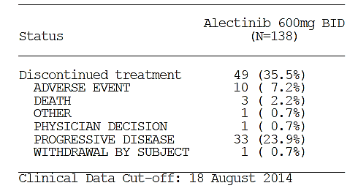

##### Major protocol violations/deviations

A post-hoc exploratory analysis for DCR was added with a shorter (5 weeks versus 16 weeks) definition of best overall response duration required to be counted in the percentage of the population to achieve disease control. The change to 5 weeks was done ‘as per IRC charter’. This refers to advice from the independent radiological review committee (contracted from [information redacted] by Roche) which states that:

For the assessment of stable disease, BioClinica’s standard convention is to use a minimum timeframe equivalent to twice the cycle time for cycle times ≤ 4 weeks (e.g., if the cycle time is 3 weeks, the minimum time on study is equivalent to 6 weeks; similarly, if the cycle time is 4 weeks, the minimum timeframe for calling SD is 8 weeks). This allows the subject to have had at least 2 doses of drug.

Four sets of amendments have been made to the protocol. Amendments of significance included:

* Addition of the use of RANO criteria for IRC review of CNS lesions.
* The addition of a sub-study of the potential for midazolam DDI which had previously been intended for a separate study in patients with solid tumours.
  + Because such patients without the appropriate fusion gene target may not benefit from treatment with alectinib, for ethical reasons the study was instead incorporated into the existing trial. (A dedicated QT study in healthy volunteers was not conducted for the same reasoning – a possible risk in the absence of potential benefit)

A restriction ‘for the last dose of crizotinib to be within 60 days from the first dose of alectinib’ was also removed. The sponsor states:

This restriction was first put in place to avoid possible resensitization to crizotinib and ensure that all patients are true crizotinib-failure. However, this limitation was thought to potentially affect enrolment as it may not have allowed enough time for patients to progress on subsequent chemotherapy treatments.

**Comment**: These changes are acceptable. Other amendments have been reviewed for meaningful impact on the study and were not found to be of concern, excepting the addition of the ‘Response Evaluable’ population as the population in whom primary outcomes would be assessed.

Violations at baseline included 16 patients for whom ALK mutation status was found to be positive using a non-FDA approved FISH test. One patient subsequently tested negative with an FDA-approved test. An exploratory analysis of results excluding this group was done to assess the impact of this on results.

Major protocol violations with regard to prohibited medication and procedures occurred in two patients of concern:

* Patient [information redacted] received prohibited medication (dexamethasone at doses above those allowed per protocol). Problem noticed 23-Sep-14.
* Patient [information redacted] underwent prohibited palliative radiation of a non-target lesion in brain during study prior to detection of progression.

Both were retained in the study.

**Comment**: Can the sponsor please state whether these patients were classed as responders, particularly CNS responders, whether they were included in the analysis populations, and whether their inclusion in the analysis population is appropriate given the nature of the major protocol violations?

See Clinical question 9.

##### Baseline data

Table 11 describes the baseline demographics of the study population.

Table 11: Baseline demographics of the subjects of Study NP28673

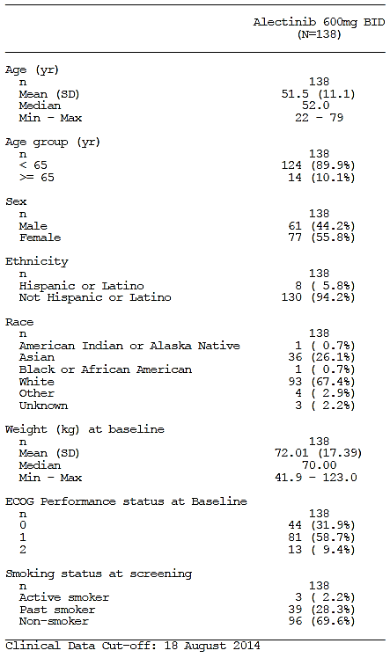

**Comment**: The demographics are consistent with that of a NSCLC ALK+ population, that is, young age of onset and majority non-smokers with a slight excess of female patients. The population is predominantly of White and Asian race.

##### Results for the primary efficacy outcome

Table 12: Summary of primary efficacy outcomes

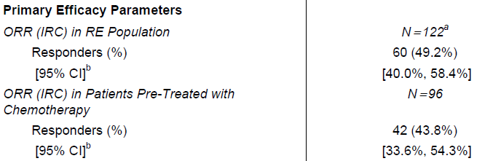

The primary efficacy outcomes were summarised.

* Objective response rate (ORR) (Proportion of patients achieving best response of complete response [CR] or partial response [PR]) in the Response Evaluable (RE) population: 49.2% (95% CI [40.0%, 58.4%]).
  + The null hypothesis was thus rejected as the lower CI bound was greater than the pre-defined nominated relevance threshold (35%).
  + ORR results stratified by age, gender, race, ECOG PS, CNS metastasis and prior chemotherapy use (Table 13) were generally consistent with the primary endpoint. Older age was associated with a lower ORR (33.3%) [4/12] and lack of prior chemotherapy exposure was associated with a better response rate (69.2%) [18/26], however low subgroup numbers meant that these analyses can only be considered exploratory.

Table 13: Summary of primary efficacy outcome stratified results

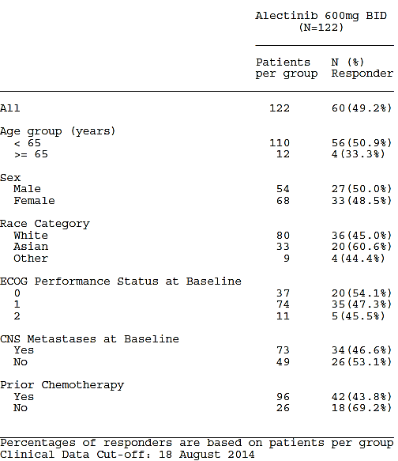

* Objective response rate (ORR) in the group of patients who received previous chemotherapy(s): 43.8% (95% CI [33.6%, 54.3%]
  + This did not reach statistical significance as the lower bound of the CI was just below 35%; however it was consistent with the findings of the investigator assessment of the same endpoint, the lower CI bound for which did fall just inside the threshold (see below).

##### Results for other efficacy outcomes

The secondary efficacy outcomes are summarised in Table 14.

Table 14: Summary of secondary efficacy outcomes

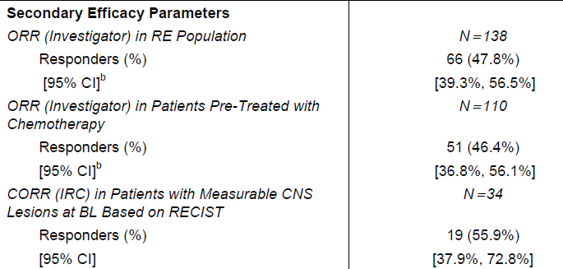

* ORR based on investigator assessment in the RE population: consistent with IRC findings.
* ORR based on investigator assessment in the chemo-pretreated population: consistent with IRC findings but just within statistical significance thresholds.

Table 15: Summary of exploratory efficacy

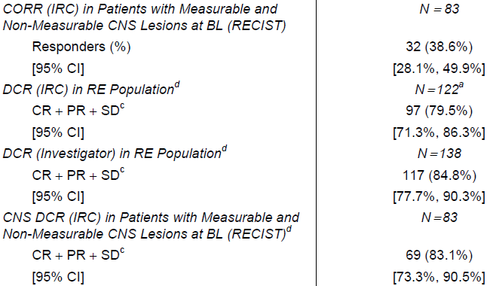

* Disease control rate (DCR) (rate of stable disease) by IRC as per protocol (duration minimum 16 weeks): 63.9% (95% CI [54.8%, 72.4%])
  + DCR by investigator assessment: 68.8% (95% CI [60.4%, 76.5%])
  + DCR by IRC with minimum set to 5 weeks (exploratory analysis): 79.5%
  + DCR by investigator assessment with minimum set to 5 weeks (exploratory analysis): 84.8%.
* DOR/PFS/OS/CPR:
  + At the data cut-off for this analysis, of the 60 patients achieving a PR in the IRC analysis of the RE population, 12 had experienced an event (9 progressions, 3 deaths). Due to the short duration of follow-up, all time-to-event parameters were immature.
  + At a later cut-off date (according to an FDA statistical review) of 8 January 2015, 61 patients had achieved a response, and of these, 20 (32.8%) had then progressed. The median duration of response was 11.2 months (95% CI 9.6, upper inevaluable).
* Central nervous system [CNS] ORR (CORR)/ CNS DOR (CDOR)
  + Half of all patients enrolled in the study had received prior radiotherapy to the brain for CNS metastasis.
  + Of the 34 patients with measurable CNS lesions, the CORR assessed by the IRC was 55.9% (95% CI [37.9%, 72.8%]); this included 5/34 patients (14.7%) whose CNS tumours achieved a CR. See Table16.
  + In this population the DCR was 85.3%.

Table 16: Summary of response results using RECIST and RANO criteria Of the 34 patients assessed by the differing criteria to have measurable CNS lesions, 31 qualified by both sets of criteria

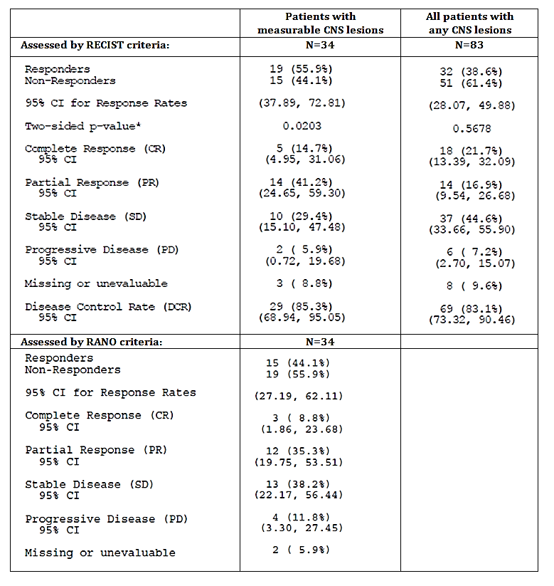

The ORR in all patients with CNS lesions at baseline (whether measurable or unmeasurable) was smaller than that in patients with measurable lesions only, however, the DCR was consistent in both groups. Thirteen of the 49 patients with non-measurable CNS disease achieved a CR using the RECIST criteria.

**Comment**: Measurable and unmeasurable lesions are distinguished based on a number of factors including clarity of margins and lack of interslice gaps on imaging (such as may be due to non-solid tumours with cystic or surgical cavities). For a patient with non-measurable lesions to be considered a responder, they must achieve a CR. The different ORR between the group with measurable lesions and all those with CNS disease is therefore not surprising. RANO also have stricter criteria in that patients can only be considered responders if they show a confirmed response in two assessments performed at least 4 weeks apart.

##### Evaluator commentary

Regarding the Safety population and Response Evaluable (RE) populations, the SAP in csr-np28673.pdf pre specifies that:

The Safety Population is defined as all patients who received any dose of alectinib. This population will also be used to analyse efficacy endpoints which are not response based, e.g. time to event analyses, as well as all safety endpoints.

The Response Evaluable population will be comprised of patients with measurable disease at baseline who have a baseline tumor assessment and received at least one dose of alectinib at the R2PD (including patients from Part 1 and Part 2 as stated in Section 2.3). This population will be used to analyse the primary endpoint of ORR as well as other response endpoints (DCR and duration of response). All other analyses, including time to event endpoints, will be performed on the population of patients who received at least one dose of alectinib (Safety Population).

On page 64 of the CSR for NP28673 the sponsor states:

The RE population included all patients with measurable disease at baseline, who had a baseline tumor assessment and received at least one dose of alectinib at the RP2D of 600 mg BID. The investigator-assessed RE population included 138 patients, while the IRC-assessed RE population included 122 patients (16 patients did not have measurable disease at baseline according to the IRC and were not included in the IRC RE population). The primary efficacy endpoint of the study was based on the RE population as assessed by the IRC.

The FDA statistical reviewer for alectinib points out that:[25]

The results of the investigator’s review of radiographs were used to determine whether or not patients had measurable disease at baseline to determine whether or not patients could be enrolled and remain on trial. Due to discordance between IRC and INV determined measurable disease at baseline, the applicant defined RE as patients with measurable disease per IRC at baseline in the CSR. The refined RE population was used as the primary analysis set in CSR. The applicant only provided efficacy outcomes based RE population in the CSR, which was inconsistent with protocol pre-specified primary analysis population.

The discrepancy between the assessment of baseline ‘measurable disease’ between the investigator and the IRC is most likely due to the complexity of the RECIST criteria. Non-measurable disease can include all of the following:[26]

Non-measurable tumor lesions encompass small lesions (longest diameter < 10 mm or pathological lymph nodes with ≥ 10 to < 15 mm short axis) as well as truly non-measurable lesions. Lesions considered truly non-measurable include leptomeningeal disease, ascites, pleural or pericardial effusion, inflammatory breast disease, lymphangitic involvement of skin or lung, peritoneal spread, and abdominal mass/abdominal organomegaly identified by physical examination that is not measurable by reproducible imaging techniques.

Bone scan, positron emission tomography (PET) scan, or plain films are not considered adequate imaging techniques for measuring bone lesions. However, these techniques can be used to confirm the presence or disappearance of bone lesions. Lytic bone lesions or mixed lytic−blastic lesions, with identifiable soft tissue components, that can be evaluated by cross-sectional imaging techniques such as CT or MRI can be considered as measurable lesions if the soft tissue component meets the definition of measurability described above.

Blastic bone lesions are non-measurable.

Lesions that meet the criteria for radiographically defined simple cysts should not be considered as malignant lesions (neither measurable nor non-measurable) since they are, by definition, simple cysts.

Cystic lesions thought to represent cystic metastases can be considered as measurable lesions, if they meet the definition of measurability described above. However, if noncystic lesions are present in the same patient, these are preferred for selection as target lesions.

Tumor lesions situated in a previously irradiated area, or in an area subjected to other loco-regional therapy, are usually not considered measurable unless there has been demonstrated progression in the lesion. Study protocols should detail the conditions under which such lesions would be considered measurable.

**Comment**: This is a critical issue relevant to both pivotal studies.

The evaluator agrees that the protocol pre-specified that:

* whether or not a patient was considered part of the RE would depend on whether or not they had measurable baseline lesions
* that the investigator review of radiographs would be used to determine whether or not patients should be enrolled and remain on study
* that IRC review would only be used in the final analysis

If a patient was included in the study due to having measurable disease at baseline by investigator assessment, but was at time of final analysis determined by the IRC to have non-measurable disease, then they should be included in the denominator population for investigator-determined endpoints but not for IRC-determined endpoints.

The number of patients excluded from the RE population due to not having measurable disease by RECIST at baseline in studies NP28673 and NP28761 were 16 (12%) and 18 (21%) respectively.

Amendments to the PI efficacy section include addition of a results table that includes both the appropriately amended IRC efficacy results and the investigator assessed rates side by side for ease of comparison.

Can the sponsor please provide further details regarding the patients for whom baseline disease was thought to be measurable by the investigator but not by the IRC? See Clinical question 8.

#### Study NP 28761

##### Study design, objectives, locations and dates

*Design*: Multi-centre, single arm, open-label, dose escalating study.

*Objectives*:

* Primary objectives:
  + Phase I dose escalation study (Part 1)
    - Dose finding for Phase II (‘recommended Phase II Dose (RP2D)’
  + Phase II study (Part 2)
    - Efficacy (see below for measures/outcomes)
* Secondary objectives:
  + Tumour response (in Part 1)
  + Safety/tolerability (including ECG monitoring in triplicate)
  + PK (including food effect and CNS penetration using lumbar puncture to collect cerebrospinal fluid [CSF])
  + Quality of life as assessed by a validated core instrument (EORTC QLQ-C30) supplemented by a lung cancer specific module (EORTC QLQ-LC13), both developed by the European Organisation for Research and Treatment of Cancer[27]

*Locations*: USA (26 centres), Canada (1 centre)

*Dates*: 03 May 2012 - 24 October 2014 (first patient enrolled until data cut-off date for primary analysis)

##### Inclusion and exclusion criteria

Inclusion and exclusion criteria for NP28761 were consistent with those for NP 28673.

##### Study treatments

Phase I:

* Dose escalation cohorts: alectinib 240 to 900 mg per oral (PO) single dose on Day -3 of first 21-day treatment cycle; alectinib 300 to 900 mg PO twice daily (BID) on Days 1 to 21 of each 21-day cycle.
  + Dose escalation used a modified 3+3 design: at each dose level, the first patient in each cohort was observed for dose-limiting toxicity (DLT) for the first 3 days of treatment before an additional 2 patients could be enrolled in that cohort. Maximum tolerated dose (MTD) was thus defined as the highest dose of alectinib at which no more than one patient had DLT during the first treatment cycle, given that at least 2 patients encountered DLT at the next higher dose level.
* Alectinib was initially provided as 20 mg and 40 mg capsules, then two additional PK bridging cohorts were enrolled and received alectinib 600 mg and 900 mg BID using 150 mg capsules.
* Cohort 1 received alectinib under fasted conditions, and received a totally daily dose of 480 mg (patients 1-3) or 600 mg (patients 4-6). All cohorts after Cohort 1 received alectinib under fed conditions ‘to improve bioavailability and gastrointestinal tolerance’.

Phase II:

* Alectinib 600 mg PO BID (150 mg capsules) on Days 1 to 21 of each cycle.

##### Efficacy variables and outcomes

* Phase I secondary endpoints: ORR, DCR and DOR *by investigator review*
* Phase II primary endpoint: IRC assessed ORR
* Secondary endpoint: investigator-assessed ORR, DCR, DOR, PFS, OS, CORR, CDOR and CPR and health related quality of life (HRQoL)

##### Randomisation and blinding methods

Not applicable. This was a non-randomised, open-label study.

##### Analysis populations

These populations were the same as defined for NP-28673: see above.

##### Sample size

Phase I: 42 (planned), 48 (enrolled)

Phase II: 85 (planned) 87 (enrolled)

##### Statistical methods

There was no statistical hypothesis for Part I.

For Part II the primary analysis tested the hypothesis that ORR = 35% (null hypothesis) versus ORR ≠ 35% at a two-sided alpha level of 5%. The 95% confidence interval (CI) for the response rate was based on the Clopper-Pearson approach. The primary endpoint was based on IRC assessment of ORR. The reason for selection of 35% as the null hypothesis value is unclear. See Clinical question 5.

HRQoL assessments followed the procedure given by the handbook for the tool.

PK findings are summarised in Section 3.

##### Participant flow

Participant flow is described in Figures 6 and 7 below.

Withdrawal from treatment in the Phase I cohort was due in all 32 cases to progression of disease (30/32) or death secondary to progression of disease (2/32). Withdrawal from treatment in the Phase II cohort was due in 22 of the 31 discontinuations to progression of disease. The other discontinuations were due to:

* Death (n=3)
  + 2 due to disease progression
  + 1 due to a serious adverse event of haemorrhage
* Adverse event (AE) (n=2)
  + 2 due to liver-related AEs:
    - DILI
    - ALT, AST and bilirubin increased
* Other (n=2)
  + Patient [information redacted]: dose interruption for longer than 21 days (as per protocol) because of an SAE of intestinal obstruction
  + Patient [information redacted]relocated to another country during the study
* Withdrawal by subject (n=2)
  + Patient [information redacted] withdrew due to refusal of treatment / did not cooperate. The patient had nine ongoing AEs at the time of discontinuation (insomnia, fatigue, faecal and urinary incontinence, nausea, anemia, AST, ALT and PK increased), all of which were Grade 1/2 and non-serious. None were considered by the investigator to be related to the study drug.
  + Patient [information redacted] withdrew consent. The patient had eight ongoing AEs at the time of consent withdrawal (dyspepsia, visual acuity reduced, fatigue, decreased libido, weight increased, urinary retention, arthralgia and depression). All were non serious and all but ‘weight increased’ (Grade 2) were Grade 1. Only fatigue was considered to be related to the study drug.

Figure 6: Participant flow in Phase I cohort of Study NP-28761

Figure 6: Participant flow in Phase I cohort of Study NP-28761
Withdrawal from treatment in the Phase I cohort was due in all 32 cases to progression of disease (30/32) or death secondary to progression of disease (2/32). 

Figure 7: Participant flow in Phase II cohort of Study NP-28761 Figure 7: Participant flow in Phase II cohort of Study NP-28761 
Withdrawal from treatment in the Phase II cohort was due in 22 of the 31 discontinuations to progression of disease.

##### Major protocol violations/deviations

No protocol violations of concern have been described for the Phase I cohort.

In the Phase II group, some major protocol violations were noted that may have affected results. The protocol specifies that systemic corticosteroid dose could not exceed oral 20 mg prednisone daily equivalent. The following additional detail is included in the CSR:

Three patients received corticosteroids at doses higher than allowed per protocol:

* 1. Patient [information redacted] received 4mg of dexamethasone (oral prednisone equivalent approximately25 mg) BD to treat an adverse event of seizure.
  2. Patient [information redacted]
     1. received 125 mg methylprednisolone (oral prednisone equivalent approximately 156 mg)[28] for one day to treat an adverse event of cerebral oedema due to radiation necrosis and
     2. received 8 mg dexamethasone (oral prednisone equivalent approximately50 mg) daily for brain metastases.
  3. Patient [information redacted] also received 8 mg dexamethasone daily for brain metastases.

Four patients underwent procedures that were outside the protocol:

* 1. Patient [information redacted] also received radiosurgery to the brain prior to documentation of PD
  2. Patient [information redacted] underwent craniotomy for brain metastases prior to documentation of PD
  3. Patient [information redacted] underwent CyberKnife radiotherapy to the right lung prior to documentation of PD
  4. Patient [information redacted] received palliative radiotherapy to the lung prior to documentation of PD

**Comment**: Can the sponsor please state whether these patients were classed as responders, particularly CNS responders, whether they were included in the analysis populations, and whether their inclusion in the analysis population is appropriate given the nature of the major protocol violations?

See Clinical question 9.

##### Baseline data

Phase I cohort: No gross imbalances noted except for a high male to female ratio (10:3) in the 600 mg BD cohort.

Phase II cohort: see Table 17.

Table 17: Baseline demographics of the Phase II cohort in Study NP28761

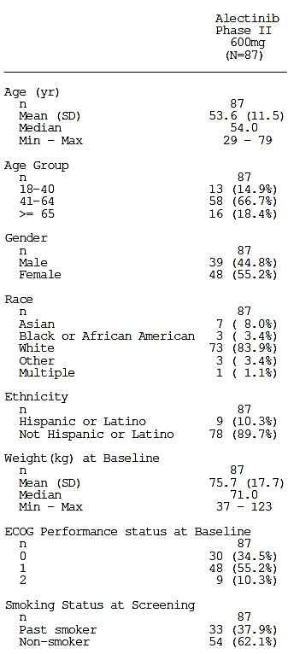

**Comment**: The demographics for both the Phase I and Phase II groups are consistent with that of a NSCLC ALK+ population, that is, young age of onset and majority non-smokers. There was a slight excess of males in Phase I and females in Phase II, and the population is predominantly White but with a small cohort of Asian and black American people.

##### Results for the primary efficacy outcome

The IRC-assessed ORR in the RE population was 47.8% (95% CI [35.6%, 60.2%]) see below.

##### Results for other efficacy outcomes

Table 18: Summary of all non-time-to-event efficacy outcomes for Phase II of NP29761

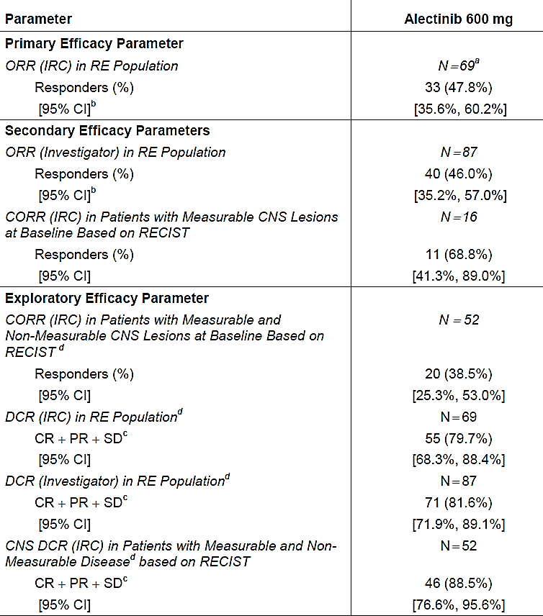

The IRC-assessed CORR in patients with measurable CNS lesions at baseline based on RANO criteria rather than RECIST was 45.5% (95%CI: 16.8%-76.6%].

Table 19: Summary of non-time-to-event secondary efficacy outcomes for Phase I of NP29761

| Outcome | Result [95% CI, %] |
| --- | --- |
| Investigator assessed ORR (Phase I) | 59.6% [44.3, 73.6] |
| Investigator assessed DCR (SD at least 12 weeks (Phase I) | 72.3% [57.4, 84.4] |

The time-to-event endpoints (DOR, CDOR, PFS and OS data) were immature at the data cut-off date (24 October 2014). At this time, 33 patients had achieved a response, and of these, 6 (18.2%) had then progressed. The median duration of response was 7.5 months (95% CI 4.9, upper not evaluable), and the longest observation time was 11.8 months.

HRQoL results did not reveal large changes in quality of life. Global Health Status showed a median increase from baseline of 16.7 points (see Figure 8): a significant change is considered ten points. Median improvements of more than ten points were also seen in functional scale items ‘Emotional Functioning’ and ‘Social Functioning’; however no significant changes were seen in symptom scales.

Figure 8: Results of HRQoL survey for Global Health Status, with dots marking the median values

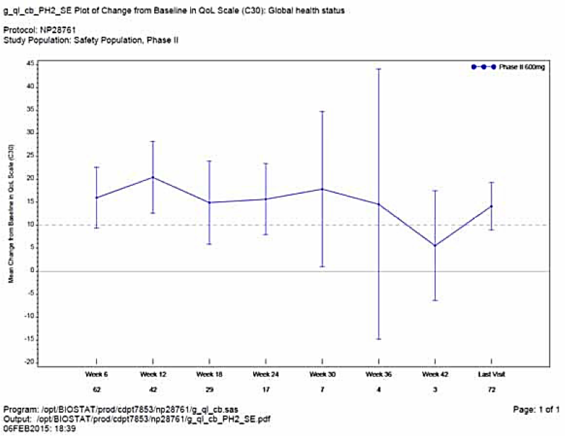

**Comment**: The secondary outcomes do not contradict the primary outcome. Quality of life questionnaire results suggest alectinib use has not made patient quality of life worse and possibly made it marginally better, but are difficult to interpret.

##### Evaluator commentary

These results support those of the other pivotal Phase I/II trial, showing a similar objective response rate. However, the same concerns are present in the statistical analysis in terms of RE population definitions.

### Other efficacy studies

#### Study AF001-JP

*Design*: Multi-centre, single arm, open-label, dose escalating study *in crizotinib-naïve patients.*

*Objectives*:

* Step 1: dose escalation (1a: fasted conditions, 1b: fed conditions)
  + To investigate the safety, tolerability, and PK of alectinib in patients with ALK+ NSCLC and identify the RP2D.
* Step 2: investigation at recommended dose
  + To investigate the efficacy and safety of alectinib at the RP2D in patients with ALK+ NSCLC.
  + Primary efficacy outcome was response rate by IRC evaluation. The null hypothesis for clinically relevant response was set at 25%.

*Locations*: Japan

*Dates*: August 24, 2010 to April 18, 2013 (ALK test consent date for first patient to data cut-off date). Date of report: August 26, 2013.

Enrolled:

* Step 1: 24 total patients
  + Dose-escalation:
    - 1a (BD administration in 10 hour fasted state) subtotal : 15
    - 1b (BD administration immediately after a meal) subtotal: 9
  + 45.8% male, mean age 45.6 years (range 28-67 years), 2 patients (8.3%) were 65 years or older
* Step 2: 46 total
  + Dosing: BD dosing with recommended dose identified in step 1
  + 47.8% male, mean age 49.5 years (range 26-75 years), 4 patients (8.7%) were 65 or older
* The patients who received 300 mg BD (all of Step 2 plus 12 from Step 1): 58 total
  + 43.1% male, mean age 49.6 years (range 26-75 years), 5 patients (8.6%) were 65 or older
    - BMI average 22.18 (SD 4.12, range 15.6-35.3)
    - Weight average 58.18 kg (SD 14.13, range 36.8-108.1, median 56.25 kg)

**Comment**: The average BMI and weight is much smaller in this study compared to the pivotal trials, as would be expected given the differences in races and likely cultural background between the studies. This accounts for any differences in PK seen between this study and the pivotal trials.

*Inclusion/Exclusion Criteria:*

Principle differences to the pivotal trials:

* ECOG could not be >1
* Prior NSCLC treatment must have included at least one chemotherapy regimen and either treatment with a second chemotherapy regimen or not amenable to treatment with existing regimens. The definition of ‘chemotherapy regimen’ was:

‘Combination chemotherapy including the use of platinum agents or molecular-targeted drugs, or monotherapy using an anticancer drug (docetaxel, pemetrexed, erlotinib, gefitinib, etc.), and so on’

* Prior treatment with an ALK inhibitor (such as crizotinib) was an exclusion criterion
* Concurrent treatment at any dose with systemic steroids was an exclusion criterion in Study AF-001JP (in both pivotal trials, systemic corticosteroid was allowed, but the daily dose could not exceed the equivalent of 20 mg prednisone PO)

**Comment**: The key difference between the inclusion/exclusion criteria for this trial and the two pivotal trials of this application is that the subjects of AJ-001JP were all crizotinib-naïve.

*Efficacy outcomes:*

* The RP2D identified in Phase I was 300 mg BD. Phase II dosing did not exceed 300 mg BD due to region-specific limitations on the allowable daily dose of SLS.
* The IRC-evaluated ORR in the 46 patients enrolled in Step 2 was 93.5% (95% CI: 82.1%–98.6%).
* Seven patients achieved a CR and 36 achieved a PR.
* Tumour size ‘decreased by at least 30% from baseline’ in all 46 patients.
* The IRC-evaluated DCR was 95.7% (95% CI: 85.2%–99.5%).
* Time-dependent outcomes could not be reported as the data is not yet mature.

#### Evaluator commentary: other efficacy studies

The RP2D (300 mg BD) identified in the Japanese Phase I/II trial AF-001-JP is half of the RP2D used in both pivotal trials, yet the response rate is much higher than seen in the two pivotal trials of this application. The difference in efficacy between them is likely to be mostly attributable to the fact that the subjects were crizotinib-naïve. The fact that only half the dose was required to obtain such good efficacy is probably related to higher exposure relative to dose size, in turn related to lower average body weight than the pivotal trials.

### Analyses performed across trials: pooled and meta-analyses

Data for most of the efficacy endpoints from the pivotal trials was not pooled (to avoid systematic differences in duration of endpoints such as DOR and PFS), as the study treatment cycle lengths, the collection of data (scans), and schedule of assessments between the two studies was different: 3 weekly in Study NP28761 and 4-weekly in Study NP28673. However, the CNS-specific endpoints (CORR and CDOR, and exploratory endpoint CNS DCR) were pooled due to the small sample size. These analyses used the updated data cut-off date of 08 January 2015 for Study NP28673 and the usual cut-off date of 24 October 2014 for Study NP28761.

Data from supporting Study AF-001JP was not pooled with that of the pivotal trials as it had critical differences to them: that is, the population were crizotinib-naïve and were treated with half the dose.

In the pooled group of patients with measurable CNS lesions there were a higher proportion of women (62%) but the remainder of the baseline demographics were similar to the overall study populations.

Pooled analyses results:

* In the total pooled population (n=135) of patients with CNS lesions at baseline, 51 had measurable CNS lesions according to the IRC. In this group, there was a CORR of 61% (95% CI: 46%, 74%), consisting of 9 (18%) CRs and 22 (43%) PRs.
* In the total population (n=135) of patients with CNS lesions at baseline according to IRC (whether measurable or not) the CORR was lower, at 38.5% (95% CI 30.3% - 47.3%). This is because if a CNS lesion wasn’t measurable at baseline, it would have to achieve a CR to be counted towards the ORR (as per RECIST criteria).
* There were 29 total CRs seen in CNS lesions (both measurable and unmeasurable), a rate of 21.5%.
* Of 31 patients with CNS measurable lesions at baseline who achieved a CNS response as assessed by the IRC, 12 patients (39%) had progressed or died at the time of the data cut-off (median CDOR 9.1 months, 95% CI 5.8 months [lower bound], upper bound not estimable).
* Of 56 patients with CNS measurable or non-measurable lesions who achieved a CNS response as assessed by the IRC, 20 patients (36%) had progressed or died at the time of the data cut-off (median CDOR 10.3 months, 95% CI 7.6 - 11.2 months).
* The CNS DCR (exploratory) was 90% (95% CI 78.6% - 96.7%)

### Evaluator’s conclusions on clinical efficacy

Evidence for efficacy of alectinib in the treatment of ALK positive NSCLC to date is available from two pivotal Phase I/II studies (in patients with ALK positive NSCLC who have failed crizotinib therapy) and one supporting Phase I/I study (in patients with ALK positive NSCLC who are crizotinib naïve).

There is reasonable external validity to these studies as the target population in Australia can be expected to be similar to those enrolled in the study. Screening failures were seen at a rate of 21% and 26% in Studies NP28673 and NP28761 respectively. Data is not present for children, patients with severe hepatic impairment, pregnant or breastfeeding women or patients who are less high functioning (with higher ECOG scores), as they have not been represented in the clinical studies so far.

The optimal dose range appears to have been established on the basis of dose limiting toxicities (DLT) seen in Phase I of Study NP28761, and is supported by the exposure-efficacy analyses in popPK studies. Subgroups requiring dose adjustment for efficacy reasons, and predictors of positive or negative responses have not been identified, as subgroup analyses were underpowered and therefore can only be considered exploratory.

Whether the study population represented the population in the proposed indication in two aspects was specifically considered by the FDA in their assessments:

* There were 2 patients with locally advanced, rather than metastatic disease.
* There were 5 patients who were intolerant to, rather than had progressed on crizotinib.

Inclusion of ‘intolerant to’ in the Australian indication is considered reasonable. Whether the pooling of Stage IIIB and Stage IV patients is appropriate, and whether inclusion of ‘locally advanced’ in the indication is acceptable is unclear. See Clinical question 13.

The magnitude of the primary treatment effect has been measured using a widely used, well-validated set of radiological diagnostic criteria (RECIST) for treatment-response in solid tumours, with assessments made by the investigator and reviewed by an independent radiological review committee (IRC) for the final analysis. The Statistical Analysis Plan for Study NP28673 states the following:

The results of the investigator review of radiographs will still be used to determine whether or not patients should be enrolled and remain on study. IRC review will only be used in the final analysis. All decisions during the study will be based on a local investigator read.

The primary outcome was overall response rate (ORR), with a predetermined lower clinical significance bound of 35%, as agreed with the FDA. The reason for selection of this bound is not explicitly stated in the dossier, only that this is ‘considered to be clinically relevant.’ See Clinical question 5.

One would estimate this might relate to the only other treatment options available to patients with ALK+ NSCLC after failure of crizotinib (other than palliative radiotherapy and supportive treatment): ceritinib or cytotoxic chemotherapy. Second-line platinum-based chemotherapy achieves an ORR of around 20% (95% CI 14%-26%) in ALK+, crizotinib-naïve NSCLC patients. Ceritinib was initially assessed by blinded IRC in the pivotal registration studies to achieve an ORR of 44% (95% CI 36% - 52%) in ALK+ crizotinib-pretreated patients.[29] However, subsequently published data from the Phase II ASCEND-2 study of ceritinib found the ORR in this group to be 38.6% (95% CI 30.5-47.2%).[30]

The FDA statistical review for the alectinib new drug application in the US states that the size of the population studied was adequate to identify a clinically relevant response by rejecting a null hypothesis of ORR=35%.[31]

The alectinib efficacy results can be summarised as follows:

* There has been one complete response recorded in each of the pivotal trials, and the remaining responses have all been partial.
* The primary endpoint was ORR as assessed by the IRC in the response evaluable (RE) population:
  + ORR in Study NP28761: 47.8% (95% CI 35.6% - 60.2%)
  + ORR in Study NP28673: 49.2% (95% CI 40.0% - 58.4%)
    - These response rates both were significant within the pre-determined bounds and were very consistent with each other.
  + ORR in Study NP28673 (updated): 50.0% (95% CI 40.8% - 59.1%)
    - *Updated efficacy analysis was performed for Study NP28673 (IRC-assessed endpoints only) with a data cut-off date of 8 January 2015.*
* In Study NP28673, a co-primary endpoint was considered of ORR in the subset of ALK+ NSCLC patients who have failed crizotinib therapy: those who were also chemotherapy pre-treated. In this subgroup, the ORR was 43.8% (95% CI 33.6% - 54.3%)
  + Although this co-primary endpoint didn’t reach statistical significance according to the pre-determined bound, the result still is likely to be of clinical significance given the ORRs for second-line chemotherapy in this population. This finding also does not invalidate the first primary endpoint.
* The secondary endpoint was ORR as assessed by the investigator in the response evaluable (RE) population:
  + Investigator-assessed ORR in Study NP28761: 46.0% (95% CI 35.2% - 57.0%)
  + Investigator-assessed ORR in Study NP28673: 47.8% (95% CI 39.3% - 56.5%)
    - These response rates both were significant within the pre-determined bounds and were very consistent with each other and with the IRC-assessed ORR result.
* The key CNS endpoint was CNS ORR (CORR), assessed by IRC, in patients with measurable CNS lesions at baseline RECIST v1.1:
  + CORR in Study NP28761: 68.8% (95% CI 41.3% - 89.0%)
  + CORR in Study NP28673: 55.9% (95% CI 37.9% - 72.8%)
  + CORR in Study NP28673 (updated): 60.8% (95% CI 46.1% - 74.2%)
    - These results don’t show as close a consistency as those seen for ORR but are still concordant.
* Concordance between the IRC and investigator-assessed best overall response (BOR) in studies NP28673 and NP28761 were 72% and 74% respectively for the patients that were assessed by both sets of assessors to have measurable lesions at baseline. In the context of very consistent results despite the 25% discordance, this likely reflects the independence of the assessments, including choice of baseline lesion.

Results from Study AF-001JP are supportive of those in the pivotal studies but were carried out in a crizotinib-naïve population. In this study the IRC-assessed response rate in patients who had progressed on at least one line of chemotherapy (Phase II) was 93.5% (95% CI 82.1% - 98.6%), and all patients had a reduction of their target lesions of at least 30%.

During the FDA’s consideration of the application, an updated data cut-off date of 8 January 2015 was agreed upon, providing an additional 4 months of follow up to the efficacy results for NP28673. Due to the discordance between results based on differences in analysis set definitions and cut-off dates, the FDA statistical reviewer re-calculated the efficacy results for Study NP28673 and NP28761, using the later cut-off date and the AT population rather than RE. The FDA statistical reviewer’s conclusions were that:

Trial NP28673 had ORR of 44% (95% confidence interval [CI]: 36%, 53%), consisting of 61 (44%) PRs. This trial had ORR-PC of 39% (95% CI: 30%, 49%). The CORR with baseline measurable lesions was 57% (95% CI: 39%, 74%).

Trial NP28761 had ORR of 38% (95% CI: 28%, 49%). The CORR with baseline measurable lesions was 69% (95% CI: 41%, 89%). Fifty one CNS patients with baseline measurable lesion in Trials NP28761 and NP28673 had ORR of 61% (95% CI: 46%, 74%), consisting of 9 (18%) CRs and 22 (43%) PRs.

Without control arm, statistical inference cannot be drawn from this trial.

If adhering to the predefined 35% significance cut-off criterion, the ORR point estimates in both trials still met this but the lower 95% CI bound for the ORR found in NP28761 fell below this mark.

The primary endpoints of the two pivotal alectinib studies, despite the lack of a control arm and the small study population, suggest that it is effective against metastatic ALK+ NSCLC in patients who have failed crizotinib therapy. Previously determined rates of response to other treatment options (see above) provide some point of comparison in the absence of a formal control arm, which was not possible to have due to the ethics of allocating patients to a known ineffective treatment.

The use of a blinded, independent radiological review committee (IRC) in duplication of radiological assessment of disease response, concordance between the IRC and the investigator-assessed results, as well as the concordance between results of the two pivotal studies, gives additional credence to the findings.

Time-dependent endpoints for the pivotal studies are not yet mature and so upper confidence interval bounds cannot yet be determined. Estimates based on interim analyses gave median point estimates for duration of response in NP28761 (as at Oct 2014) of 7.5 months and in NP28673 (as at Jan 2015) of 11.2 months. Time-to-event based outcomes will require further follow up before they can be meaningfully interpreted. Longer-term efficacy data is expected in the near future: a Phase III trial, the ‘ALEX’ study, with PFS as the primary endpoint is currently underway. When last discussed by the TGA with Roche, the projection was that data was expected to be reported in the first half of 2018.

Although overall survival data is not yet mature, and response rates are lower if measured in the as-treated population rather than the response evaluable population, evidence of alectinib efficacy is consistent in the response rates across analyses, and the magnitude of ORR for alectinib is in keeping with rates seen with crizotinib and ceritinib, and higher than those seen with chemotherapy in similar populations.

With regard to disease control rate (DCR), this information has not been included in the FDA label, as:[32]

.. DCR was not a measure of clinical benefit as the treatment effect could not be discerned in a single arm trial as compared to the natural history of CNS metastases in ALK+ NSCLC.

…it was unclear how DCR leads to patient benefit, in contrast to partial responses (PR) or complete responses (CR) where reduction in tumor size may be linked to a reduction in tumor-related symptoms.

DCR is a weaker endpoint than ORR in the context of a single arm, open label trial, and it is agreed that inclusion of this data in product documentation is not appropriate. The PI has been amended appropriately. Waterfall plots showing change in lesion size have also removed from the proposed PI as these are redundant in repeating the primary efficacy outcome given that all responses were partial, and do not provide any insight into whether the findings were correlated with symptomatic relief.

Finally, it is noted that around 65% of patients had at least one treatment with radiation therapy prior to study (90-Day Safety Update Report), which is not surprising as it is part of the standard of care. 47% of patients had previous radiotherapy to the brain. Whether this had an effect on the efficacy outcomes was explored by the FDA statistical reviewer by subgroup analysis, who found that previous CNS radiation therapy did not affect efficacy outcomes in the CNS.

Overall, the efficacy results support the intended indication for the target population. In this group of patients where there is unmet need; in a context where all other treatment options have failed or are not available or tolerated; this evidence is supportive of registration. Similarly, the evidence of activity in CNS disease, coupled with biological plausibility for such effects, supports usage in patients where progression of disease on crizotinib has occurred in the CNS.

## Clinical safety

### Studies providing evaluable safety data

#### Pivotal studies that assessed safety as the sole primary outcome

Not applicable. There are no clinical trials that assessed safety as the sole primary outcome for alectinib.

#### Pivotal and/or main efficacy studies

* NP28673
* NP28761

#### Other studies

Not applicable.

##### Other efficacy studies

* AF-001-JP

##### Studies with evaluable safety data: dose finding and pharmacology

* NP28989 – PK/PD in healthy volunteers
* NP28990 - posaconazole (CYP3A inhibitor)
* NP28991 - food and esomeprazole
* NP29040 - bioequivalence SLS
* NP29042 - rifampin (CYP3A4 inducer)

##### Studies evaluable for safety only

Not applicable.

### Integrated safety analyses

There are three integrated safety analyses provided in the dossier whose sole focus is assessment of safety:

* The module 2 Summary of Clinical Safety (SCS) (which contained data up to 24 October 2014 and 18 August 2014 for Study NP28761 and Study NP28673, respectively)
* Report 1060441: ‘ECG Report for Alectinib in Studies Conducted in Patients with ALK-Positive Non-Small Cell Lung Cancer’
* ‘90-Day Safety Update Report for Alectinib (RO5424802) September 2015’

The summary of clinical safety is the same document that was originally submitted to the FDA in support of alectinib registration, and the 90 Day Safety Update Report contains more recent data, with a cut-off date of 27 April 2015. The report presents updated safety data in the following three groups:

* Group 1 includes patients from Phase II of pivotal Study NP28761.
* Group 2 includes patients from Phase II of pivotal Study NP28673.
* Group 3 includes patients from:
  + Phase I and II of Study NP28761 (only patients in Phase I who received alectinib at 600 mg twice daily [BID] were included)
  + Phase II and the midazolam (MDZ) drug-drug interaction (DDI) substudy of Study NP28673.

As it contains more recent safety data cumulatively with the same data as the SCS, information from the 90-Day Safety Report data will be used in preference to the SCS. Table 20 outlines the differences in patient disposition between the last data lock point used for integrated safety analysis and the latest one.

Table 20: Patient disposition summary update

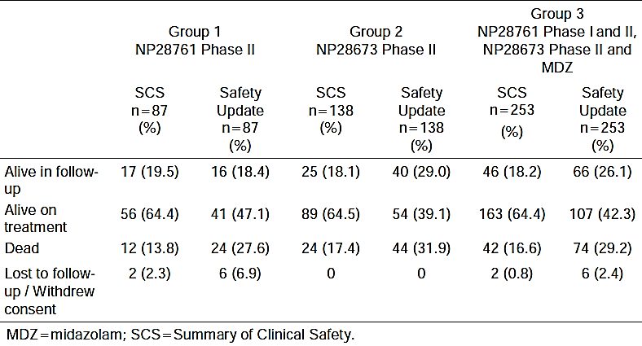

### Patient exposure

The most recent safety and exposure data comes from the 90 Day Safety Report, with a data cut-off date of 27 April 2015. Information from this and from the CSRs for all of the clinical pharmacology studies, pivotal and supporting efficacy studies has been summarised in Table 21 to describe exposure, although dose changes and dose intensity are not reflected in this table. In the pivotal trials (including the midazolam substudy [15 patients] and the 600 mg cohort of Phase I of Study NP28761 [13 patients]), there were a total of 253 patients exposed to alectinib at the recommended dose of 600 mg BD, with a median duration of exposure of 40.6 weeks (range 0.1-114 weeks) up to the cut-off date.

Table 21: Exposure to alectinib in clinical studies according to dose and duration (as at the cut off for the 90 day safety report: 27 April 2015, data sourced from 90 day safety report and CSR for NP28761).

| **Study type/indication** | | **Number of people exposed at any dose** | **Number of people exposed at proposed dose (600 mg BD)** | | | |
| --- | --- | --- | --- | --- | --- | --- |
| **> 24 wks** | **> 36 wks** | **> 52 wks** | **Any duration** |
| **Clinical pharmacology studies** | | | | | | |
| NP28989 | | 6 | - | - | - | 6 |
| NP28990 | | 23 | - | - | - | 0 |
| NP28991 | | 42 | - | - | - | 42 |
| NP29040 | | 97 | - | - | - | 97 |
| NP29042 | | 24 | - | - | - | 24 |
| *(pharmacology studies subtotals)* | | *192* | *-* | *-* | *-* | *169* |
| **Pivotal Phase I/II trials** | | | | | | |
| NP28673 | *Phase II* | 138 | 102 | 86 | 67 | 138 |
| *midazolam substudy* | 15 | 18 | 14 | 0 | 15 |
| NP28761 | *Phase I* | 47 | 7 | 13 |
| *Phase II* | 87 | 57 | 46 | 26 | 87 |
| *(pivotal studies subtotals)* | | *287* | *177* | *146* | *100* | *253* |
| **Supporting Phase I/II trials** | | | | | | |
| AF001JP | | 70 | - | - | - | 0 |
| *(supporting studies subtotal)* | | *(70)* | *-* | *-* | *-* | *(0)* |
| **TOTAL ALL STUDIES** | | **549** | **177** | **146** | **100** | **442** |

The characteristics of the safety population were summarised from the 90 day safety report by the FDA medical reviewer, as shown in Table 22. The FDA reviewer commented that although the quality of the submission was adequate for review and the data was representative of the US population, there was not sufficient numbers of people older than 65 to determine whether alectinib safety was different in this group compared to younger patients. This reviewer agrees and suggests similar comment in the Australian PI.

The 90-day Safety Update report also contains an updated exposure table including dose intensity, which is reproduced in Table 23. The extent of exposure in supporting efficacy Study AF-001JP (in which the standard dose was 300 mg BD) is summarised in Table 24.

Table 22: Characteristics of the safety population and their baseline disease, as outlined in the FDA medical review of alectinib

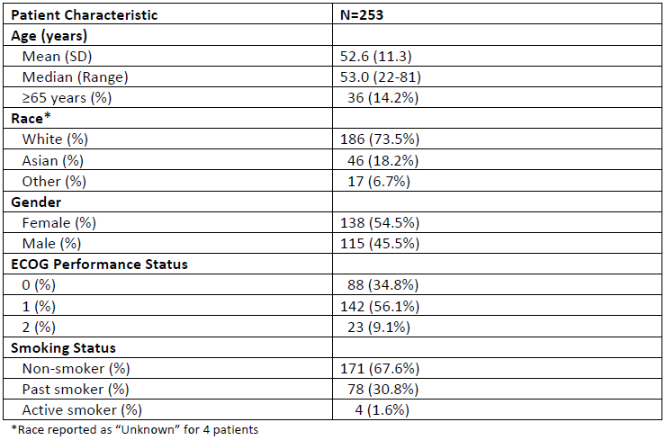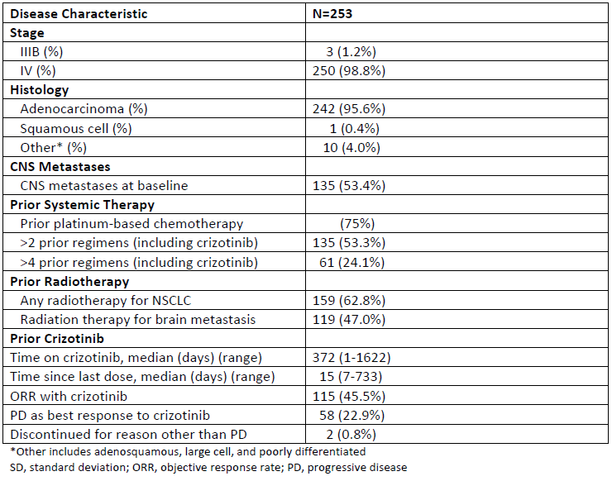

Table 23: Patient exposure summary as at 27 April 2015

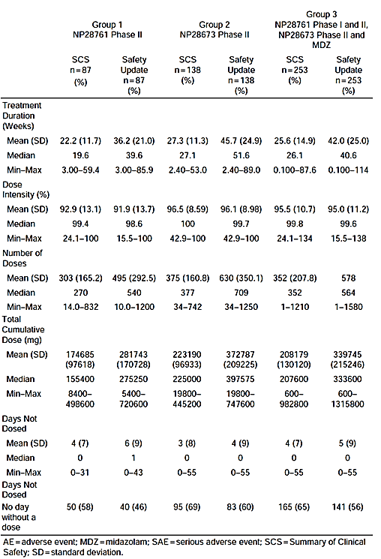

Table 24: Summary of extent of exposure in Study AF-001JP

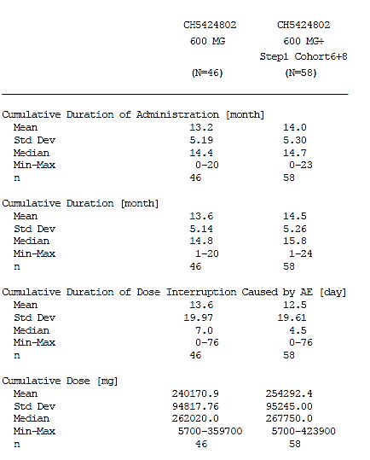

### Adverse events

#### All adverse events (irrespective of relationship to study treatment)

Adverse events (AEs) temporally associated with treatment, regardless of causality, are referred to hereafter as Treated-Emergent Adverse Events (TEAEs).

##### Integrated safety analyses

An overview of adverse events in the pivotal trials according to the 90-Day Safety Update (as at April 2015) is shown in Table 25.

Table 25: An overview of adverse events in the groups defined by the 90 day safety report

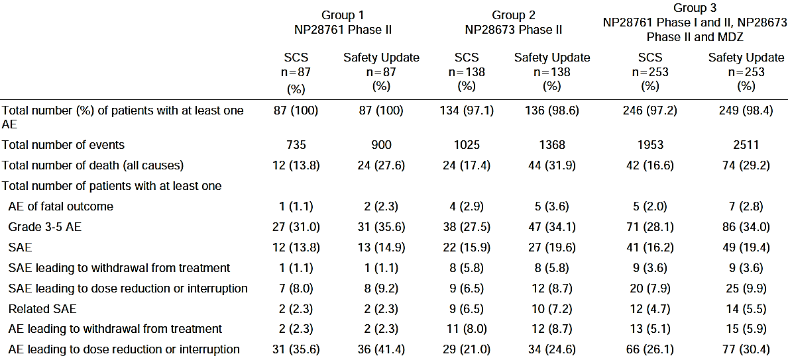

As stated in the 90 day Safety Report:

The SOCs with the highest incidence of reporting in the safety update report were general disorders and administration site conditions (66%, most commonly fatigue), gastrointestinal disorders (61%, most commonly constipation), and musculoskeletal disorders (53%, most commonly myalgia).

At the time of the data cut-off for the safety update, AEs that were reported in ≥20% of patients were similar to the SCS and included constipation (34%), fatigue (30%), edema peripheral (26%), and myalgia (24%)...

The majority of patients (78%) reported at least one AE considered by the investigator to be related to study drug. The most commonly reported (≥ 10%) treatment-related events were fatigue (18%), constipation (17%), myalgia (16%), edema peripheral (13%), ALT increased (13%), AST increased (13%), blood CPK increased (11%), and photosensitivity reaction (10%). Photosensitivity was the only treatment-related event that moved from < 10% in the SCS (9%) up to ≥ 10% in the safety update.

##### Pivotal and/or main efficacy studies

###### Study NP28673

An overview of AEs in Study NP28673 is provided in Table 26, and a summary of the most common treatment-emergent adverse events (TEAEs) is provided in Table 27, separated by system organ class. The most common TEAEs were constipation (32.6%), fatigue (26.1%) and asthenia (18.1%), peripheral oedema (24.6%), myalgia (22.5%) and headache (15.9%).

Table 26: Overview of AEs in Study NP28673

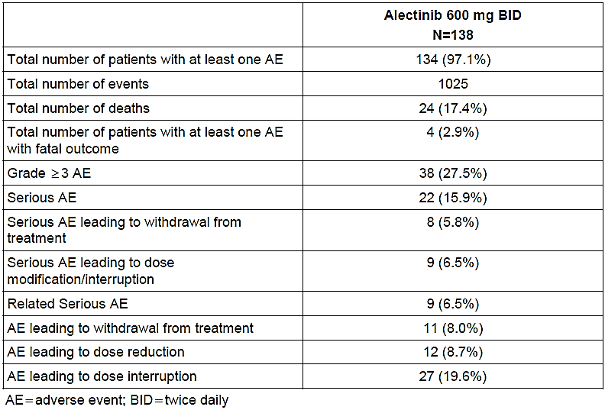

Table 27: Summary of TEAEs in Study NP28673 with an incidence rate of ≥10

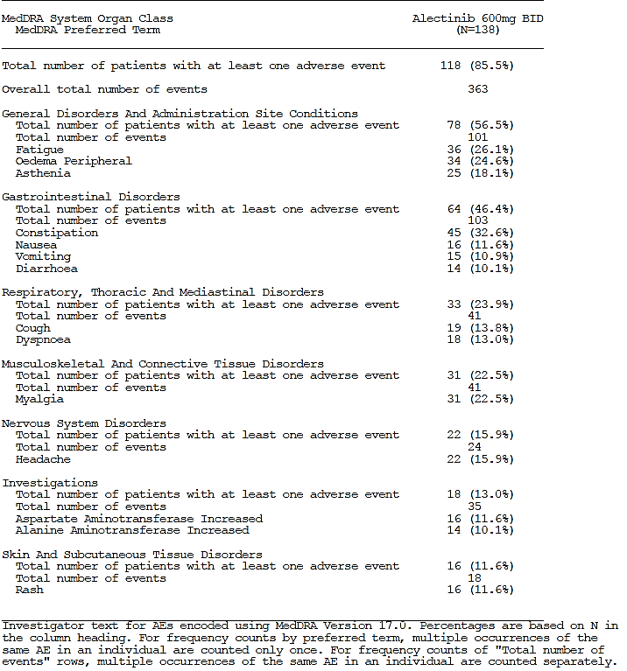

###### Study NP28761

An overview of AEs in Study NP28761 is provided in Table 28 and a summary of the TEAEs with incidence ≥10% TEAEs is provided in Table 27.

The most common TEAEs in the Phase II cohort were constipation (36%), fatigue (30%), peripheral oedema (22%), myalgia (22%), AST increased and blood CPK increased (both 21%). These are very similar to those seen in Study NP28673 with the exception of AST and CPK increased, both of which were reported in NP28673 but didn’t reach such high overall incidence (11.6% and 2.9% TEAE incidences respectively in Study NP 28673).

The most common TEAEs in the Phase I cohort were also similar to the Phase II cohort and the Study NP28673 safety cohort, but in different proportions: the most common being fatigue (44.7%), myalgia (25.5%), cough (21.3%), elevated CPK (19.1%) and peripheral oedema (19.1%). No clear dose-related trends are present, in keeping with the findings of report popPK-1064536; however it was noted that 4 occurrences of headache were seen in the 900 mg BD group, 1 in the 460 mg BD group, and none in the other groups. Additionally, one of the two adverse events that identified the MTD was a Grade 3 headache, which resolved and did not recur when the patient changed to a 600 mg BD dose.

Table 28: Overview of TEAEs in Study NP28761

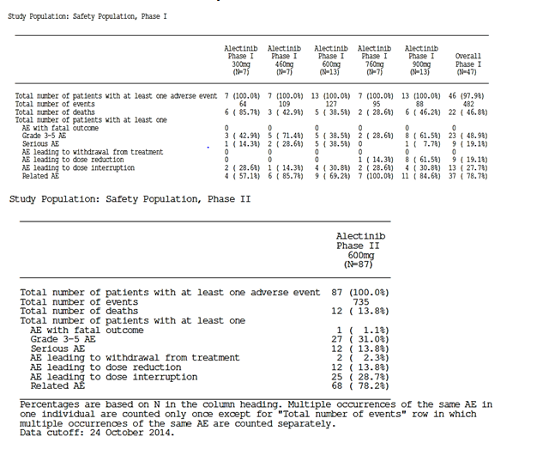

Table 29: Summary of AEs in Phase II of Study NP28761 with an incidence rate of ≥10

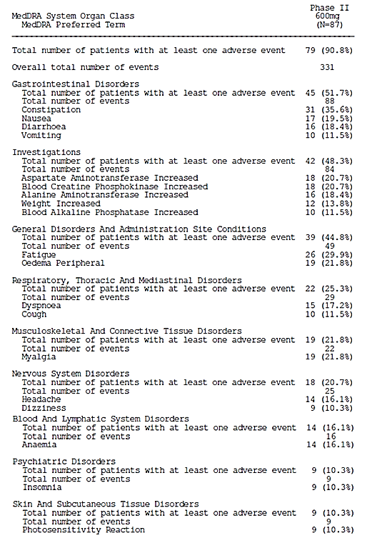

Table 30: Summary of AEs in Phase I of Study NP28761 with an incidence rate of ≥10

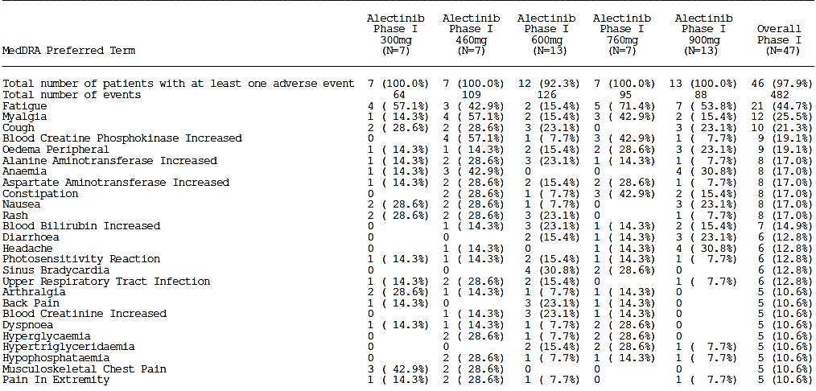

##### Other studies

###### Study AF-001JP

In step 1 of Study AF-001JP there were 300 adverse events, 200 for which a causal relationship to alectinib couldn’t be ruled out. All 24 patients had at least one event.

As described in the CSR:

Adverse events with an incidence of ≥20% were ‘constipation’ (13 patients, 54.2%), ‘nasopharyngitis’ (12 patients, 50.0%), ‘diarrhoea,’ ‘neutrophil count decreased’ (each 10 patients, 41.7%), ‘blood creatine phosphokinase increased,’ ‘dysgeusia,’ ‘White blood cell count decreased’ (each 9 patients, 37.5%), ‘headache,’ ‘malaise’ (each 8 patients, 33.3%), ‘aspartate aminotransferase increased,’ ‘back pain,’ ‘blood bilirubin increased,’ ‘stomatitis’ (each 7 patients, 29.2%), ‘alanine aminotransferase increased,’ ‘blood creatinine increased,’ ‘myalgia,’ ‘nausea,’ ‘rash,’ and ‘weight increased’ (each 6 patients, 25.0%).

In step 2 of Study AF-001JP there were 341 adverse events, 225 for which a causal relationship to alectinib couldn’t be ruled out. All of the 46 patients had at least one event. A summary of the most common adverse events in the step 2 (Phase II) cohort is reproduced in Table 31. All 58 patients who received what was the maximum dose in this study (300mg BD) experienced at least one adverse event, and in 96.6%, causality could not be ruled out so the event was considered a treatment-related adverse event (see below).

Table 31: Summary of adverse events and adverse drug reactions with an incidence of ≥10% in patients enrolled in step 2 and patients who received 300 mg BD

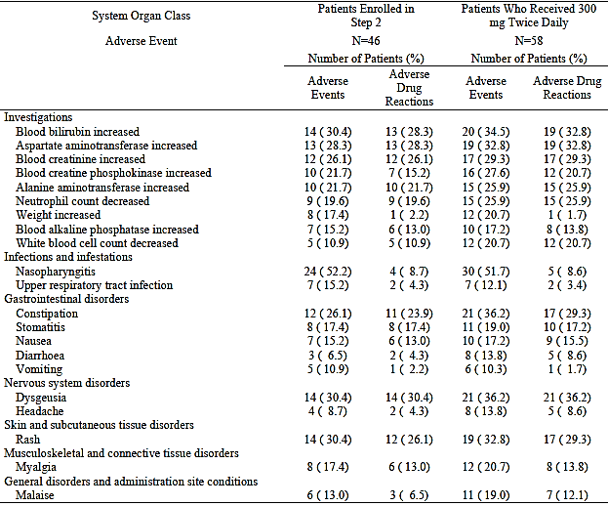

###### Studies with evaluable safety data: dose finding and pharmacology

Study NP28989

Four subjects experienced 14 non-serious TEAEs, and two subjects experienced TRAEs. All of the AEs were classified as mild.

Study NP28990

Three subjects experienced 4 non-serious TEAEs, and there were no TRAEs.

Study NP28991

In group 1 of this study (fasted versus fed dosing):

* Eight subjects (44.4%) experienced 14 TEAEs with fasting alectinib
* Eight subjects experienced 12 TEAEs with fed-state alectinib dosing.

In group 2 of this study (alectinib alone versus concurrent esomeprazole):

* Five subjects (20.8%) experienced 9 TEAEs with alectinib alone
* Three subjects (12.5%) experienced 5 TEAEs with esomeprazole alone
* Four subjects (16.7%) experienced 6 TEAEs with the combined treatment

All adverse events, whether TEAEs or TRAEs, were mild in intensity except for one patient (a 42 year old male) who experienced nausea and vomiting of moderate severity after having alectinib in the fasted state and also after having alectinib in the fed state.

Study NP29040

The TEAEs that were reported in this study are summarised in Table 32. Those for which causality was not considered unrelated (TRAEs) are listed in Table 35. The incidence of TEAEs and TRAEs was higher in the fed than in the fasted state dosing.

Table 32: TEAEs in Study NP29040

| Formulation | TEAEs | Subjects (%) |
| --- | --- | --- |
| **(fasted)** |  |  |
| 50% SLS | 4 | 3 (6.4%) |
| 25% SLS | 5 | 3 (6.7%) |
| 12.5% SLS | 3 | 3 (6.5%) |
| 3% SLS | 3 | 3 (6.4%) |
| **Formulation** | **TEAEs** | **Subjects (%)** |
| **(fed)** |  |  |
| 50% SLS | 6 | 6 (13.3%) |
| 25% SLS | 8 | 6 (12.8%) |
| 12.5% SLS | 6 | 4 (8.7%) |
| 3% SLS | 9 | 7 (15.2%) |

Study NP29042

TEAEs that occurred in this study are summarised in Table 33.

Table 33: TEAEs from Study NP29042

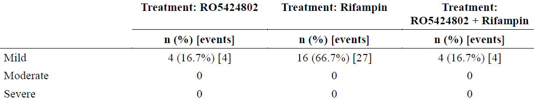

#### Treatment related adverse events [TRAEs] (adverse drug reactions)

##### Integrated safety analyses

The 90 day Safety Update report contains a table of ‘adverse reactions’ that were ‘identified based on the assessment of data from clinical trials, non-clinical data, mechanism of action, and causal relationship.’ The table of adverse reactions is reproduced in Table 34.

Table 34: Adverse reactions in Group 3 as described in the 90 day safety update report

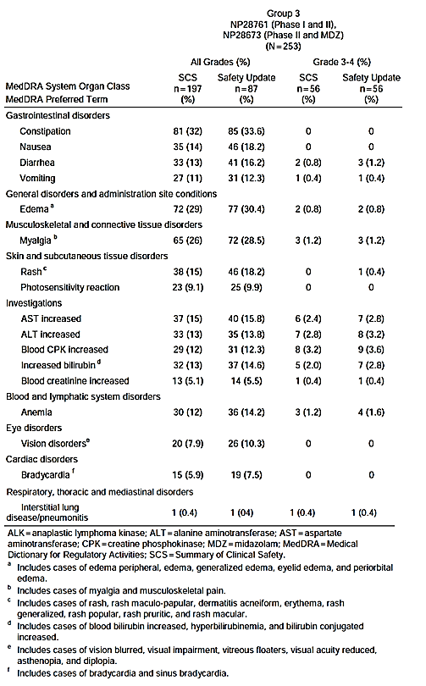

##### Pivotal and/or main efficacy studies

###### Study NP28673

TRAEs were seen in 71% of patients, and the highest incidence of reporting was seen in the following SOCs (incidences in brackets):

* ‘General disorders and administration site conditions’ (33%; most commonly fatigue [14%], asthenia [11%] and peripheral oedema [sic] [9%])
* ‘Gastrointestinal disorders’ (30%; most commonly constipation [15%])
* ‘Skin and subcutaneous tissue disorders’ (27%; most commonly photosensitivity reaction [9%] and rash [9%])
* ‘Investigations’ (21%; most commonly AST increased [10%] and ALT increased [9%]) and
* ‘Musculoskeletal and connective tissue disorders’ (21%; most commonly myalgia [17%])

There were adverse events reported in Study NP28673 that fell under the SOCs ‘Ear and labyrinth disorders’, ‘Endocrine disorders’, ‘Infections and infestations’ and ‘Renal and urinary disorders’, but no adverse events from these categories were reported in Study NP 28761.

The most commonly reported TRAEs by MedDRA preferred term (PT) were:

* Myalgia (16.7%)
* Constipation (14.5%)
* Fatigue (13.8%)
* Asthenia (10.9%)
* AST increased (10.1%)

###### Study NP28761

TRAEs were seen in 79% of the Phase I patients and the highest incidence of reporting were seen in the following SOCs (incidences in brackets):

* ‘Investigations’ (40%; most commonly blood CPK increased [19%])
* ‘General disorders and administration site conditions (36%; most commonly fatigue [30%])
* ‘GI disorders’ (26%; most commonly constipation [11%] and nausea [11%]) and
* ‘Musculoskeletal and connective tissue disorders’ (26%; most commonly myalgia [17%])

TRAEs were seen in 78% of the Phase II patients, and the highest incidence of reporting was seen in the following SOCs (incidences in brackets):

* ‘Investigations’ (40%; most commonly AST [18%] CPK [18%] and ALT increased [17%])
* ‘GI disorders’ (37%; most commonly constipation [20%])
* ‘General disorders and administration site conditions (35%; most commonly fatigue [23%]) and
* Musculoskeletal and connective tissue disorders (22%; most commonly myalgia [14%])

The most commonly reported TRAEs by MedDRA preferred term (PT) in the Phase I cohort were:

* Fatigue (29.8%)
* Blood CPK increased (19.1%)
* Myalgia (17%)
* ALT increased (14.9%)
* Bilirubin increased (14.9%)
* AST increased (12.8%)
* Photosensitivity reaction (12.8%)
* Peripheral oedema (10.6%)
* Constipation (10.6%)
* Nausea (10.6%)
* Headache (10.6%)

The most commonly reported TRAEs by MedDRA preferred term (PT) in the Phase II cohort were:

* Fatigue (23%)
* Constipation (19.5%)
* AST increased (18.4%)
* Blood CPK increased (18.4%)
* ALT increased (17.2%)
* Diarrhoea (13.8%)
* Peripheral oedema (13.8%)
* Myalgia (13.8%)
* Photosensitivity reaction (10.3%)

##### Other studies

###### Study AF-001JP

In Study AF-001JP, if causality couldn’t be ruled out, an AE was considered a TRAE. Of the 300 AEs that occurred in the Step 1 cohort (N=24), 200 fell into this category. As stated in the CSR:

Adverse drug reactions with an incidence of ≥20% were ‘neutrophil count decreased’ (10 patients, 41.7%), ‘constipation,’ ‘dysgeusia,’ ‘White blood cell count decreased’ (each 9 patients, 37.5%), ‘headache,’ ‘malaise,’ ‘aspartate aminotransferase increased,’ ‘blood bilirubin increased’ (each 7 patients, 29.2%), ‘blood creatine phosphokinase increased,’ ‘stomatitis,’ ‘alanine aminotransferase increased,’ ‘blood creatinine increased,’ ‘rash’ (each 6 patients, 25.0%), ‘diarrhoea,’ and ‘nausea’ (each 5 patients, 20.8%).

In the combined 300 mg BD group of Study AF-001JP (all enrolled step 2 patients plus cohorts 6 and 8 from step 1), all 58 patients (100%) experienced 508 adverse events, and 56 patients experienced 341 TRAEs.

TRAEs with an incidence of ≥20% in this group were:

* ‘dysgeusia’ (21 patients, 36.2%)
* ‘aspartate aminotransferase increased’ and ‘blood bilirubin increased’ (each 19 patients, 32.8%)
* ‘rash’, ‘constipation’ and ‘blood creatinine increased’ (each 17 patients, 29.3%)
* ‘alanine aminotransferase increased’ and ‘neutrophil count decreased’ (each 15 patients, 25.9%)
* ‘White blood cell count decreased’ and ‘blood creatine phosphokinase increased’ (each 12 patients, 20.7%).

###### Studies with evaluable safety data: dose finding and pharmacology

Study NP28989

Two subjects experienced AEs that were thought to possibly be related to alectinib:

* Dysgeusia and headache, experienced by subject 1003 both in the capsule + IV phase and with the oral suspension
* Dysgeusia and headache, experienced by subject 1005 with the oral suspension only

These TRAEs resolved.

Study NP28990

There were no TRAEs in this study.

Study NP28991

The adverse events considered possibly related to alectinib in this study were:

* Group 1 (fasted versus fed)
  + Nausea, vomiting, and headache (1 [5.6%] subject each) for both the fasted and the fed conditions
* Group 2 (alectinib alone versus concurrently with esomeprazole)
  + Period 1 (alectinib alone)
    - dyspepsia (1 [4.2%] subject)
  + Period 2a (esomeprazole alone)
    - dizziness, headache, and pruritus (1 [4.2%] subject each)
  + Period 2b (alectinib + esomeprazole)
    - constipation (1 [4.2%] subject)

All adverse events, whether TEAEs or TRAEs, were mild in intensity except for the nausea and vomiting which were experienced by subject [information redacted] (a [information redacted] year old White male) in both the fasted state and again when given alectinib in the fed state.

**Comment**: The positive dechallenge-rechallenge makes it pretty likely that the nausea and vomiting seen with patient [information redacted] is alectinib-related GI toxicity.

Study NP29040

The TRAEs reported in this study are summarised in Table 35. There is a higher incidence of TRAEs in the fed state dosing than in the fasted state, including two instances of headache, one in the lowest and one in the highest SLS formulation groups, both considered probably related to alectinib. This is in keeping with higher alectinib exposure when it is dosed in the fed state compared to fasted, as shown in Study 28991. It is also supportive of the findings of PBPK report 1064595. Both simulated data from the model and observed data from food effect Study 28991 showed a lesser impact of SLS on absorption when dosing occurred in the fed state, as can be seen from a less steep difference between the PK parameters with decreasing SLS concentration. Noting the y-axis scales of these graphs, it is clear that exposure is much higher when dosing occurs in the fed state.

Table 35: TRAEs in Study NP29040

| **Formulation** | **TRAEs** | **Subjects** | **TRAEs: probable** | **causality possible** | | **causality remotely possible** |
| --- | --- | --- | --- | --- | --- | --- |
| **(fasted)** | | | | | | |
| 50% SLS  (N=47) | 2 | 2 (4.3%) |  | diarrhoea, infrequent bowel movements | |  |
| 25% SLS  (N=45) | 3 | 3 (6.7%) |  | headache | | ear pain, cough |
| 12.5% SLS  (N=46) | 2 | 2 (4.3%) |  |  | | thirst, haemorrhoidal haemorrhage |
| 3% SLS  (N=47) | 1 | 1 (2.1%) |  | photosensitivity reaction | |  |
| Formulation | TRAEs | Subjects (%) | TRAEs: probable | TRAEs: possible | | TRAEs: remotely possible |
| **(fed)** | | | | | | |
| 50% SLS  (N=45) | 4 | 4 (8.9%) | headache | | myalgia, headache | infrequent bowel movements |
| 25% SLS  (N=47) | 6 | 4 (8.9%) |  | | diarrhoea, infrequent bowel movements (x 2), blood CPK increased | skin irritation, psychogenic  respiratory distress |
| 12.5% SLS (N=46) | 2 | 2 (4.3%) |  | | infrequent bowel movements | polyuria |
| 3% SLS  (N=46) | 5 | 5 (10.9%) | headache | | constipation, headache, blood CPK increased | nasopharyngitis |

Study NP29042

The TRAEs reported in this study are summarised in Table 36.

Table 36: TRAEs in Study NP29042

| **Medication condition** | **TRAEs** | **Subjects** | **TRAEs: probable** | **causality possible** | **causality remotely possible** |
| --- | --- | --- | --- | --- | --- |
| alectinib alone  (N=24) | 4 | 4 (16.7%) | decreased appetite | myalgia | gingival bleeding, headache |
| rifampin alone  (N=24) | 26 | 16 (66.7%) | chromaturia (x14), urine abnormality, urine odour abnormal, dyspepsia, faeces discoloured (x2), infrequent bowel movements (x2), nausea, headache (x2) | abdominal discomfort, | contact dermatitis |
| alectinib + rifampin  (N=46) | 3 | 3 (12.5%) | abdominal pain, chromaturia | dyspepsia | dermatitis contact |

**Comment**: It is noted that there are 14 reports of chromaturia in Period 2 with rifampin alone dosing, yet there is only one report of chromaturia in Period 3 when rifampin and alectinib were given concurrently. This can be explained by the fixed-sequence nature of the study, given that rifampin dosing was continuous daily throughout Period 2 and into the directly consecutive Period 3.

#### Deaths and other serious adverse events (SAEs)

##### Integrated safety analyses

An overview of deaths and cause of death for the pivotal trials up until the middle of 2015 is provided in Table 37. Of the seven deaths that were not due to disease progression, all but two are described above. The two previously undescribed cases are

* Endocarditis (subject [information redacted] of Study NP28673)
  + Endocarditis occurred day 380
  + A [information redacted]-year-old White male (enrolled in Italy) developed progressive disease on Study Day 345, and was changed to ‘Part 3’ of the study – that is, post-progression treatment with alectinib.
  + On Study Day 380, he was hospitalised with dyspnoea, and an echocardiogram showed endocarditis. He was treated with vancomycin and meropenem but died of worsening endocarditis on Study Day 387.
  + This event was considered not related to the study drug.
* ‘Death’ (subject [information redacted] of Study NP28671)
  + A death with unknown cause was reported.
  + A [information redacted]-year-old White male (enrolled in the USA) had an ischaemic stroke on Study Day 208, when he presented at an emergency department with left-sided hemiparesis. A CT revealed progressive vasogenic oedema associated with a metastatic lesion in the right occipital lobe. He subsequently developed seizures and was treated with anticonvulsants and IV steroid. A repeat non-contrast CT on Study Day 210 showed ‘stable posterior right hemisphere vasogenic edema related to mass lesion and right hemisphere stroke without haemorrhage’. His subsequent clinical course included changing to oral dexamethasone, weaning off levetiracetam and commencement of valproate, and an episode of chest pain for which an angio chest scan was done. He was discharged on Study Day 227 from a rehab facility.
  + At a follow up outpatient visit with his oncologist on Study Day 230, the chest angio scan was reviewed and showed disease progression, at which point he was withdrawn from the study and ceased alectinib. He was commenced on doxycycline for an URTI and dexamethasone for oedema-related headaches.
  + Two days later, the site received a phone call to inform them the patient had died.
  + The Investigator assessed the event to be unrelated to study drug and related to disease progression and recent history of stroke.

**Comment**: The evaluator agrees that this is the most likely scenario.

Table 37: Overview of deaths and cause of death in all patients taking 600 mg doses in the pivotal trials, grouped as per the 90-Day Safety Update

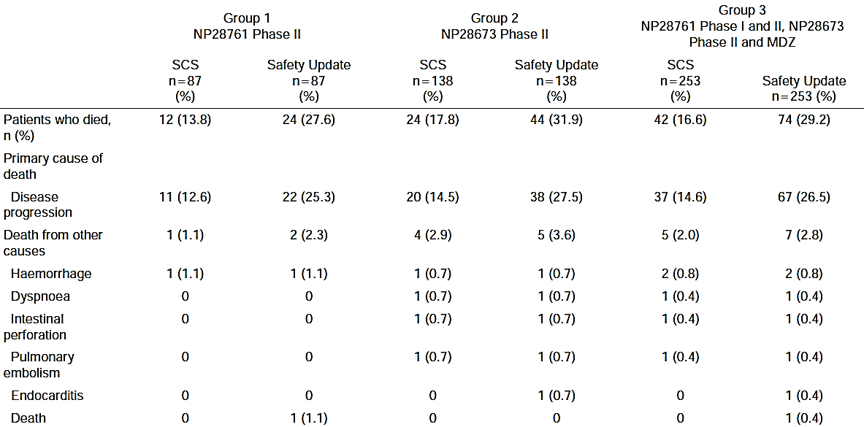

Regarding SAEs, the 90 Day Safety Update provides the following summary:

Forty-nine patients (19%) experienced 68 SAEs... All events were reported in single patients, with the exceptions of dyspnea (3 patients [1%]), hyperbilirubinemia (3 patients [1%]), pulmonary embolism (3 patients [1%]), AST increased (2 patients [1%]), ALT increased (2 patients [1%]), influenza (2 patients [1%]), and haemorrhage (2 patients [1%]).

Low rates were observed for SAEs leading to dose reduction (1 patient) and dose interruption (4 patients). No event led to study drug withdrawal.

It is of note that Group 3 contains patients from Group 1 and 2 (events described above).The additional SAEs reported since the SCS data cut-off date for patients who were included only in Group 3 are described below.

• Patient [information redacted], a [information redacted]-year-old White female, reported a Grade 3 SAE of spinal compression fracture beginning on Day 231 and resolving 2 days later. The investigator considered this event to be not related to the study drug. Study drug was interrupted as a result of this event.

• Patient [information redacted], a [information redacted]-year-old male (race: other), reported a Grade 2 SAE of hemoptysis beginning on Day 124 and resolving 3 days later. The investigator considered this event to be not related to study drug. Study drug dose was not interrupted as a result of this event.

##### Pivotal and/or main efficacy studies

###### Study NP28673

Up to the data cut-off date of 24 October 2014, there were 24 deaths that had occurred in Study NP28673 (see Figure 5), and three of these are listed as having occurred prior to discontinuation of study treatment, whilst the fourth (Patient [information redacted]) is listed as a withdrawal secondary to an adverse event. Twenty deaths were due to disease progression, and four deaths were associated with an AE. Out of these, only the case of intestinal perforation was considered to be related to alectinib. As described in the CSR, the fatal cases were (Su = suspected to be related to alectinib, U = thought to be unrelated to alectinib):

* Intestinal perforation (Su)

Patient [information redacted]: A 69 year old White female with a history of diverticulitis and concomitant steroids use died from an intestinal perforation (perforation of diverticulum). The patient was hospitalized on Day 47 due to Grade 3 asthenia and Grade 4 intestinal perforation; on Day 48, a blood culture revealed bacterial infection leading to sepsis, and the patient died on Day 54. The event of intestinal perforation led to withdrawal from study drug, and was considered by the investigator as related to alectinib.

* Dyspnoea (U)

Patient [information redacted]: A 70 year old White female died from dyspnea. The day of onset of this SAE was Day 26 and the event led to withdrawal from study treatment and her subsequent death on Day 29. This event was considered by the investigator as unrelated to study drug; a possible cause was not specified.

* Pulmonary Embolism (U)

Patient [information redacted]: A 51 year old White male died from a worsening pulmonary embolism 17 days after first administration of study drug. The SAE was considered by the investigator as unrelated to alectinib, but possibly related to NSCLC and the patient's medical history of a previous pulmonary thromboembolism.

* Haemorrhage (U)

Patient [information redacted]: A 76 year old White female on concomitant anticoagulants (tinzaparin sodium) died from a hemorrhage caused by a ligament rupture. This SAE (day of onset, Day 35) led to withdrawal from study drug (see Section 7.7) and her subsequent death on Day 37. The event was considered by the investigator as unrelated to study drug. The cause of the ligament rupture was unknown, however, a possible cause of the hemorrhage was indicated to be femur wrenching due to a medium gluteal ligament tear.

There were 35 SAEs in Study NP28673 that occurred in 22 patients (see Table 39). Of the 35 events, 12 events in 9 patients were considered to be related to study treatment (see Table 38).

Table38: SAEs that were suspected to be related to alectinib use in Study NP28673

| SAE | Demographics | Study day onset  Worst CTCAE grade | Alectinib action  Outcome | Notes |
| --- | --- | --- | --- | --- |
| Hyperbilirubinaemia | 37/M/White | Onset day 39  Grade 3 | Withdrawn  Resolving | ALT 1.1xULN  Homozygote for Gilbert’s |
| Intestinal Perforation | 69/F/White | Onset day 47  Grade 5 | Withdrawn | See Deaths and other serious adverse events (SAEs) |
| Hyperbilirubinaemia | 50/M/Asian | Onset day 71  Grade 3 (Br 3-4xULN) | Withdrawn  Unresolved. Br 2xULN at Study Day 112 | ALT 4.3xULN  AST 2.4xULN  tested negative for Gilberts |
| ALT increased and  AST increased | 40/F/White | Onset day 171  Grade 3 | Interrupted until day 185, recommenced at 450 mg BD  Resolved | Original dose 600 mg BD |
| Pulmonary embolism | 75/M/White | Onset day 107  Grade 3 | Interrupted  Not resolved (died due to disease prog 7 days later) | Was on nadroparin and diclofenac at time. Rx w tinzaparin. |
| Interstitial lung disease | 63/F/White | Onset day 110  Grade 3 | Withdrawn day 113  Not resolved | No significant history or meds. CT showed ground-glass opacity, lavage negative for infectious cause. dx as drug-induced |
| Pneumonia | 55/M/Asian | Onset day 28  Grade 4 | Interrupted, recommenced day 39 at 600 mg BD, decreased to 450 mg BD day 40. CXR showed consolidation recurring day 41, and alectinib was permanently withdrawn.  Resolved day 68 | Died due to progressive disease day 102. |
| Constipation  ALT increased and  AST increased | 45/F/White | Onset day 21/215  Grade 2/4 | Interrupted (due to liver enzymes) day 208  Withdrawn day 215  Resolved day 268 | Liver biopsy: centrilobular hepatic injury, consistent with toxic effect. Specified in advised PI text:. |
| Depression | 54/F/Asian | Onset day 10  Grade 2 | Interrupted  Resolved | History of depression was on sertraline. Depression worsened with restlessness, crying, insomnia and anxiety. Treated with alprazolam, unsuccessfully. Psychiatry consult advised drug interaction was possible and alectinib was interrupted. Worsened depression resolved Study Day 16, and she continued in the study without recurrence. |

Table 39: Summary by SOC of SAEs in Study NP28673

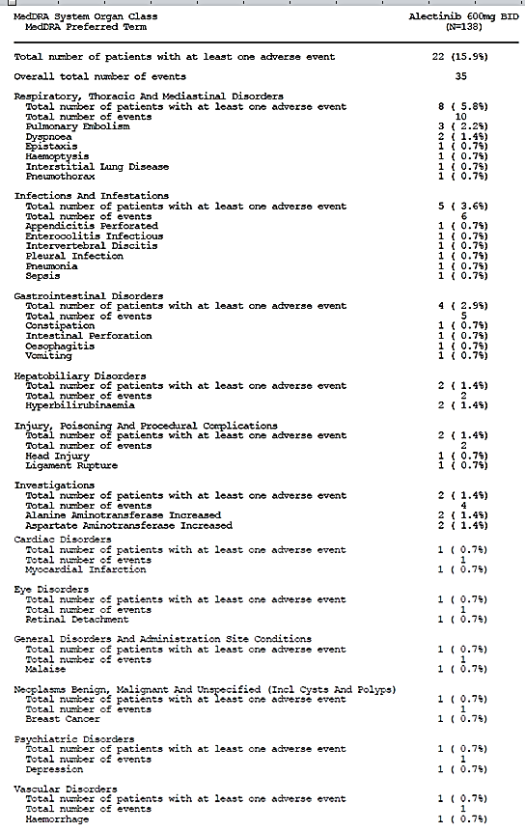

###### Study NP28761

Up to the data cut-off date of 24 October 2014, there were 12 deaths in the Phase II cohort of Study NP28671 (13.8%), and 22 deaths in the Phase I cohort (46.8%). All of the deaths in the Phase I cohort (see Table 40) were due to disease progression. All but 1 of the deaths in the Phase II cohort was due to disease progression. The death in a Phase II patient that was not due to disease progression was suspected to be due to haemorrhage and is described in the CSR for Study NP28761 as follows:

Patient [information redacted], a [information redacted] year old White male, died from hemorrhage (onset Day 56, duration one day). The location of the haemorrhage was suspected to be retroperitoneal. The event of haemorrhage was diagnosed after the patient presented to the emergency ward on Study Day 55 with severe back pain, swollen legs, followed by pain in the right hip and buttock, and a seizure, on Study Day 56. Full details are provided in the patient’s narrative. The AE was considered by the investigator to be related to study drug. Since the patient was on anticoagulants, the investigator reported the event to be also related to concomitant medication enoxaparin, and specified that the event was unlikely to be caused by alectinib but the possibility could not be excluded.

This patient had a palliative surgical procedure to the right parietal lobe and palliative radiotherapy in June 2014, prior to treatment with crizotinib (July 9-22), and then when he progressed on crizotinib entered the alectinib trial, with an ECOG of 2. He was treated with alectinib from August 5-25, when seizures with associated hyperammonaemia led to re-hospitalisation and interruption of alectinib. The seizures were not reported as an adverse event but the hyperammonaemia was. The patient recommenced alectinib on September 2. An abdominal CT scan was done on September 22 (reason not stated), and showed ‘*mixed lytic sclerotic lesions and hepatomegaly with mild diffuse hepatic steatosis. Reportedly, several short segment intussusceptions were also noted for the first time within the jejunum, which could be related to mucosal hyperplasia*.’

On September 28, the patient presented to emergency with severe back pain (later described as right hip and buttock pain) and swollen legs. There were no fractures seen on X-ray and he was given analgesia (including cyclobenzaprine). At some point he then suffered a seizure – according to part of the narrative this was shortly after standing up – and was admitted. He was hypotensive with an SBP of 82 but not tachycardic, anaemic with a haemoglobin of 7.3 (normal range: 13.2 − 17.3), and had acute renal impairment with creatinine 1.75 (normal range: 0.7 − 1.3). His clotting parameters worsened over the course of 24 hours and it was decided to treat him palliatively. He suffered a second generalised seizure prior to cardiac arrest and death.

The haemorrhage suspected to have caused death in this case was never actually confirmed as no CT was done at the time of the incident, however it was suspected on the basis of the clinical picture suggestive of an intra-abdominal or retroperitoneal bleed in conjunction with the presence of jejunal intusussception identified on a CT taken a week prior to the patient’s presentation to emergency.

Table 40: Numbers of deaths in each dose level of the Phase I part of Study NP28761 and causes of death

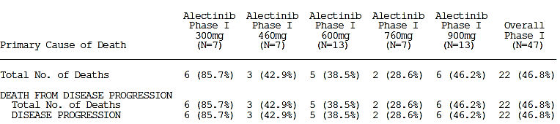

In the Phase I cohort, there were 10 SAEs in nine patients (19%) (Table 41). All SAEs were single cases except for convulsion which occurred in two patients, one on 460 mg BD and one on 600 mg BD. None were considered by the investigator to be related to alectinib other than possibly the case of pericardial effusion:

* Briefly, this case ([information redacted]) involved a [information redacted] year old White male who developed shortness of breath on day 41 of the study, and a CT showed a pericardial effusion. A BRAF test the same day showed chest wall recurrence. Pericardial fluid, pleural and pericardial biopsies were negative for malignancy. Alectinib was recommenced after effusion treatment and resolution, and the event did not recur. Alectinib was ceased day 273 due to insufficient therapeutic response and the patient died on day 333 due to disease progression.

In the Phase II cohort, there were 13 SAEs in 12 patients (14%). No patient had more than one SAE, except for Patient [information redacted] (who died due to suspected haemorrhage, as described above), who also experienced Grade 3 hyperammonemia, which was not suspected to be related to alectinib. Other than the haemorrhage, one other case was considered by the investigator to be related to alectinib:

* Briefly, this case ([information redacted]) involved a [information redacted] year old White male who had an SAE of asymptomatic Grade 3 drug induced liver injury, with concomitantly elevated ALT and AST (7.3 − fold ULN and 10.2 − fold ULN respectively) but no concomitant bilirubin increase. Investigations were negative for other causes, although the liver biopsy suggested an autoimmune component. The case did not meet the criteria for Hy’s law, and the patient was never hospitalised.

Table 41: Serious adverse events (SAEs) in Phase I of Study NP28761

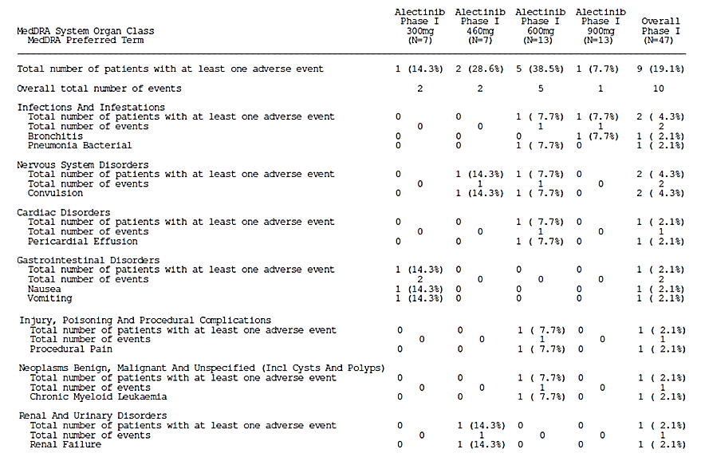

Table 42: SAEs in Phase II of Study NP28761

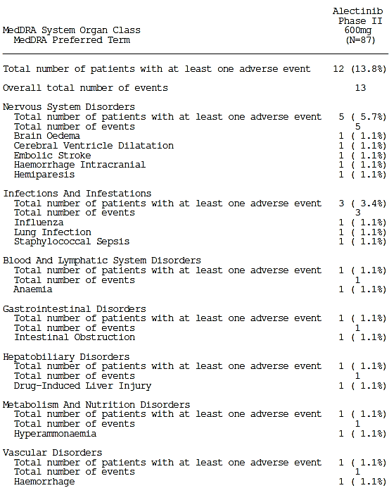

**Comment**: Details of case narratives have been checked and the causality assessments are reasonable.

##### Other studies

###### Study AF-001JP

Case descriptions for five serious TRAEs are included verbatim from the CSR in the below list of serious adverse events seen in Study AF-001JP, whether serious due to CTCAE grade or investigator assignment.

In the Step 1 cohort of AF-001JP (N=24):

* Serious adverse events, as defined by CTCAE grade, were as follows:
  + there were no CTCAE Grade 4 or higher events
  + Fourteen Grade 3 TEAEs occurred in 8 patients (33.3%)
    - Blood creatine phosphokinase increased
    - Neutrophil count decreased (all 3 TRAEs)
    - Blood phosphorus decreased (1 TRAE/2 TEAEs)
    - Weight increased
    - Blood bilirubin increased (TRAE)
    - Blood magnesium increased
    - White blood cell count decreased (TRAE)

**Comment**: It is noted that neutropenia was one of the two adverse events that defined dose-limiting toxicity in Study NP28671. The incidence of neutropenia was 4% in the pivotal studies overall (90-Day-Safety-Update Report), and none of the cases were serious. One case was Grade 3 but not thought to be related to alectinib and no dose change was undertaken.

* Serious adverse events, as defined by seriousness status assigned by the investigators, were as follows:
  + Six Grade 3 TRAEs occurred in 4 patients (16.7%)
  + Four serious TEAEs (two serious TRAEs) occurred in 3 patients (12.5%), and two TRAEs occurred in 2 patients (8.3%)
    - ECG T-wave inversion (160 mg BD/cohort 4)

*ECG T-wave inversion*

T wave inversion was seen in a protocol-specified ECG and was considered a serious adverse event because the investigator decided to postpone discharge and keep the patient under observation, although it was not an event that required treatment. It was confirmed that the T wave inversion on the ECG resolved without discontinuing the IMP. However, the investigator concluded that a causal relationship to the IMP cannot be completely ruled out because the event occurred after starting treatment with the IMP and no other causes could be identified. The sponsor also supported the investigator’s conclusions but believed that the event was unlikely to be related to the IMP because it resolved while continuing treatment with the IMP.

* + - Neutrophil count decreased (TRAE) and convulsion (300 mg BD/cohort 6)

*Neutrophil count decreased:*

A decrease in the neutrophil count (Grade 3) occurred after starting treatment with the IMP, and the investigator prolonged hospitalization to keep the patient under observation. The investigator concluded that a causal relationship to the IMP cannot be ruled out because ‘neutrophil count decreased’ was an event that occurred after starting treatment with the drug. The sponsor also supported the investigator’s conclusions.

* + - Lung infection (TEAE) (240 mg BD/cohort 7)

In the Step 2 cohort of AF-001JP (n=46):

* Serious adverse events, as defined by CTCAE grade, were as follows:
  + There were no CTCAE Grade 4 or higher events, and no patients died during the treatment or follow up periods.
  + Twenty-one Grade 3 TEAEs occurred in 19 patients (41.3%)
  + Fourteen Grade 3 TRAEs occurred in 13 patients (28.3%)
  + Six serious TEAEs occurred in 6 patients (13.0%) and three serious TRAEs occurred in 3 patients:
    - Maculopathy (TRAE)

During treatment with CH5424802, the patient experienced increasingly blurred vision in the right eye as a symptom of concurrent right preretinal membrane and she underwent surgery for this. The investigator commented that although the mechanism of action is unknown, a relationship to CH5424802 cannot be completely ruled out because no other definite causes have been identified at this point and because of the time course showing that the symptoms progressed after starting treatment with CH5424802. The investigator therefore concluded that although the event could also have occurred spontaneously in association with aging, it was possible that CH5424802 hastened its progression, so a causal relationship cannot be ruled out. The sponsor also supported the investigator’s conclusions.

* + - Cholangitis sclerosing (IgG4-associated autoimmune cholangitis) (TRAE)

It was suspected that this patient might fulfil the criteria of Hy’s law because AST increased to greater than three-fold and blood bilirubin to greater than two-fold the upper limit of the site reference range. However, Hy’s law did not apply in this case because ALP also increased in this patient, suggesting that the increase in AST and blood bilirubin had another cause. Later, treatment with the IMP was discontinued and the patient was hospitalized because hyperbilirubinemia occurred. The investigator suspected IgG4-associated cholangitis and concluded that corticosteroids were indicated. The investigator concluded that it is difficult to rule out a relationship with the IMP, including the possibility that the patient had drug-induced cholestasis. The sponsor also supported the investigator’s conclusions. Treatment was not resumed after that and the patient was withdrawn from the study in accordance with the study withdrawal criteria. IgG4-associated autoimmune cholangitis (‘cholangitis sclerosing’) was definitively diagnosed from the response to corticosteroids.

* + - Tumour haemorrhage (TRAE)

In the patient who showed a sudden decrease in Hb during the study and underwent surgery at a metastatic site in the sigmoid colon, it was concluded that it would be reasonable to believe that the bleeding was basically due to necrosis of the gastrointestinal tumour associated with tumour enlargement after checking the surgical specimen of tumour tissue at the pathology department at the study site. However, the event occurred after starting treatment with the IMP and the investigator also believed that the IMP could have had some effect on this mass-like lesion in the gastrointestinal tract in light of the antitumor effects of the IMP that have been seen to date. It was therefore concluded that the event was possibly related to the IMP because a relationship to the IMP cannot be completely ruled out. The sponsor also supported the investigator’s conclusions.

* + - Radius fracture (TEAE)
    - Brain oedema (TEAE)
    - Alveolitis allergic (TEAE)

**Comment**: In all of the five serious cases which were suspected by the CSR authors to be possibly related to alectinib, causality is not clear but can’t be convincingly ruled out. The events do not suggest any new signals in context of the safety profile seen in the pivotal studies.

###### Studies with evaluable safety data: dose finding and pharmacology

Studies NP28989, NP28990, NP28991, NP29040 and NP29042

There were no deaths, SAEs or other significant AEs in these studies.

#### Discontinuations due to adverse events

##### Integrated safety analyses

An overall summary of AEs that led to study discontinuation in patients taking 600 mg BD in the two pivotal trials is shown in Table 43.

Table 43: Overall summary of AEs leading to study discontinuation in groupings according to the 90-Day Safety Update

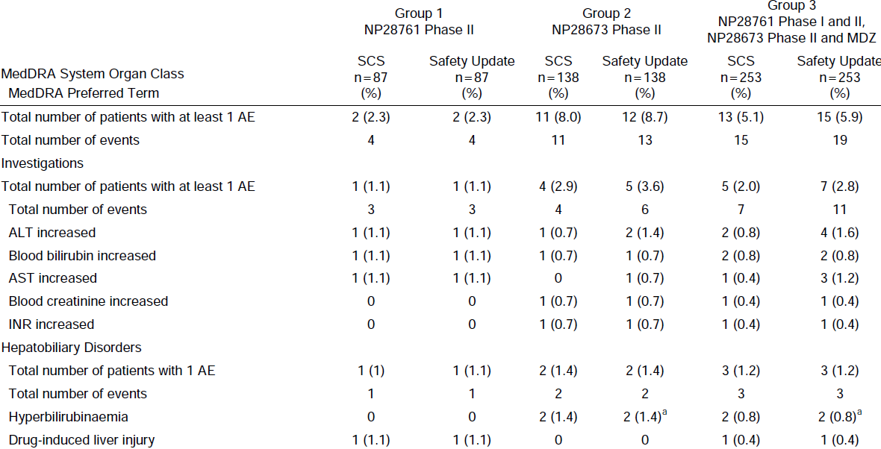

##### Pivotal and/or main efficacy studies

###### Study NP28673

The overall rate of complete withdrawal from treatment in Study NP28673 was 35.5%. Of these, most (n=33, 23.9%) were due to progressive disease. Ten subjects (7.2%) withdrew due to adverse events. These were (S = serious [see section 8.4.3.2], Su = suspected to be related to alectinib, U = thought to be unrelated to alectinib):

* Abnormalities in liver function tests (LFT):
  + Hyperbilirubinaemia ([information redacted]) (S, Su)
  + Hyperbilirubinaemia ([information redacted]) (S, Su)
  + Blood bilirubin increased ([information redacted]) (Su)
  + Alanine aminotransferase increased ([information redacted]474202) (S, Su)
* Intestinal perforation– fatal ([information redacted]) (S, Su)
* Ligament rupture leading to haemorrhage – fatal ([information redacted], see above) (S, U)
* Pneumonia ([information redacted]) (S, Su)
* Interstitial lung disease ([information redacted]) (S, Su)
* Blood creatinine increased ([information redacted]) (U)
* Dyspnoea – fatal ([information redacted], see page 90, above) (S, U)
* INR increased ([information redacted]) (U)

###### Study NP28761

There were 32 cases of withdrawal from treatment in the Phase I cohort of study NP28761, none due to adverse events.

In the Phase II cohort, withdrawal from treatment was due in 22 (25% of total cohort) of the 31 (36% of total cohort) cases to progression of disease. Three were due to deaths, two of them secondary to disease progression and a third secondary to haemorrhage ([information redacted]). The other two discontinuations that were due to adverse events were as follows (S = serious, Su = suspected to be related to alectinib, U = thought to be unrelated to alectinib):

* Drug-induced liver injury (S, Su) (case [information redacted])
* ALT, AST and bilirubin increased (Su) (case [information redacted]).

##### Other studies

###### AF-001JP

There were 5 patients in whom adverse events led to discontinuation of treatment with alectinib in this study, all from the Part 2 cohort (300 mg BD). The cases are summarised in Table44. Alectinib was suspended in 29 patients (50%) for median 7 days (range 1-22) per suspension, due to the adverse events summarised in Table 45 and Table 46.

Table 44: Cases in study AF-001JP where adverse events led to discontinuation

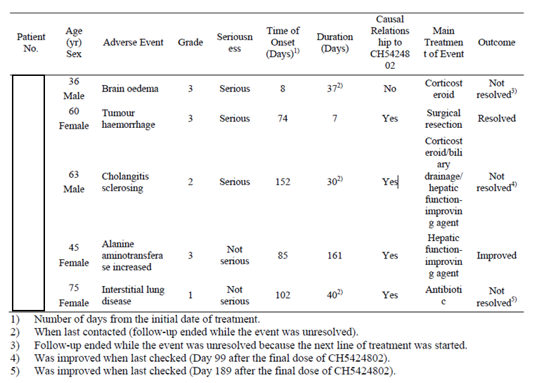

Table 15: AEs leading to treatment suspension (step 1)

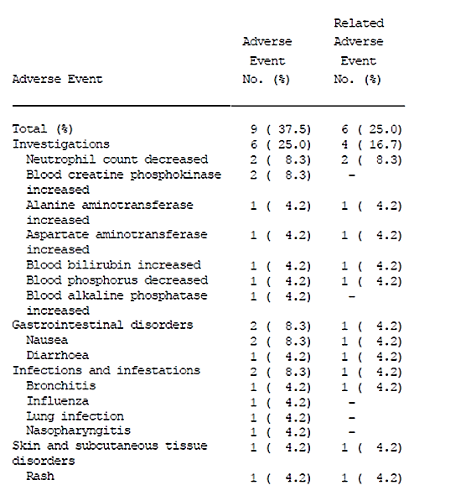

Table 46: AEs leading to treatment suspension (step 1)

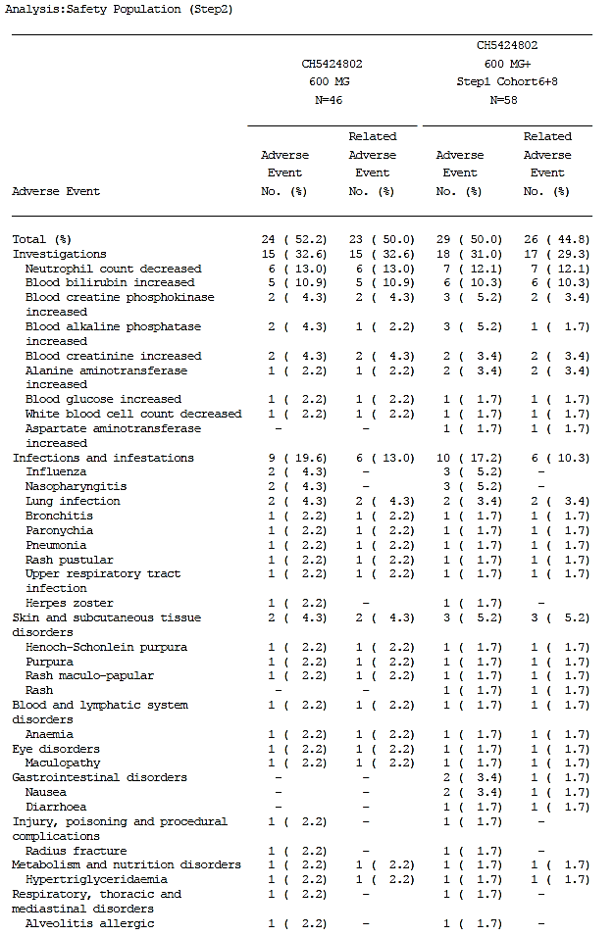

###### Studies with evaluable safety data: dose finding and pharmacology

Study NP28989

No AEs led to discontinuation of dosing or subject participation in this study.

Study NP28990

TRAEs led to study discontinuation for two subjects, one from cohort A and one from cohort B (see page 99 for more detail):

* + Tooth abscess due to broken tooth in subject 2662091006
  + Mild blood creatine phosphokinase elevation in subject 2662092013 which was considered unrelated to alectinib and possibly related to posaconazole

**Comment**: The CPK elevation could have been related to alectinib also.

Study NP28991

No AEs led to discontinuation of dosing or subject participation in this study.

Study NP29040

There were two study withdrawals related to adverse events in this study. Both of these events were considered unrelated to alectinib by the investigator.

* One subject withdrew from part 1 (fasted, 50% SLS formulation cohort) due to respiratory tract infection.
* One subject withdrew from part 2 (fed, 50% SLS formulation cohort) due to ECG abnormal.

Study NP29042

No AEs led to discontinuation of dosing or subject participation in this study.

### Evaluation of issues with possible regulatory impact

Adverse event terms pertaining to safety issues of interest were selected by the sponsor and described in the pooled analysis in the safety summaries. The classification system for selected adverse events of interest was:

…defined in the study protocols based on potential risks identified from clinical and non-clinical data with alectinib and from data with ALK inhibitors, and were based on grouping AE terms by Standardized Medical Dictionary for Regulatory Activities (MedDRA) queries (SMQs) and/or System Organ Classes (SOCs)

Further detail is included below describing which AEs were considered under which classifications for these adverse events of interest.

#### Liver function and liver toxicity

##### Integrated safety analyses

Bilirubin and hepatic transaminase elevations are commonly seen with ALK inhibitors[33], and have been included by the sponsor as an important identified risk in the alectinib risk management plan (RMP).

Hepatocellular or cholestatic TEAEs have been reported in about a third of patients taking the recommended dose of alectinib in the pivotal trials (31%), and of these, about four in five were TRAEs (25% overall, see Table 47). A summary of hepatobiliary adverse events that were serious, high-grade and/or led to study discontinuation in the clinical trials as assessed by FDA review was included.

Table 47: Adverse events in the category ‘Hepatocellular or cholestatic damage AE and abnormal liver function tests’ that occurred at any incidence rate in all patients taking 600 mg BD alectinib in both pivotal trials

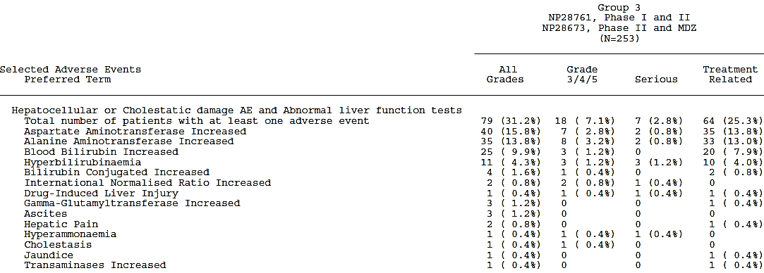

Up to the cut-off date for the 90 Day Safety Report (27 April 2015), there have been no cases of hepatic failure or cases consistent with Hy’s law in association with alectinib use. Few patients with hepatocellular or cholestatic TEAEs have reported higher than Grade 2 events (7.1%) or serious events (2.8%). These have all shown reversibility on alectinib withdrawal or dose decrease.

There has been one case of drug-induced liver injury (DILI), which was well documented and occurred in subject [information redacted] year old White male with a history including alcohol abuse. There was no clear symptomatology reported but on day 22 of study, he was diagnosed with grade 2 DILI. Blood tests on study Day 28 showed concomitantly elevated ALT and AST (7.3 − fold ULN and 10.2 − fold ULN respectively) in the absence of a bilirubin increase. He tested negative for Epstein-Barr virus, hepatitis B and C, Herpes Simplex virus 1,2, Herpes Simplex virus 2 and cytomegalovirus. He also had a normal IgA with slightly elevated IgG, mildly positive anti-smooth muscle antibody but negative anti-mitochondrial antibody M2 and negative anti-nuclear antibody. On study Day 39, a liver biopsy was done to document presumed DILI and ‘to see if there was an autoimmune component that may be steroid-responsive’. The liver biopsy showed

* *‘…moderate to severe panlobular hepatitis with predominant mononuclear inflammatory infiltrate and scattered plasma cells’*
* *‘The morphological features were those of autoimmune hepatitis.’*
* *‘portal and periportal fibrosis, 2+ stainable iron predominantly in hepatocytes*.’

The investigator states that, given the clinical setting, a drug-induced hepatitis was favoured, as there was no clear diagnostic evidence of a separate autoimmune hepatitis. Alectinib was ceased, and replaced with pemetrexed on study Day 42. The case did not meet the criteria for Hy’s law, and the patient was never hospitalised. Steroid treatment was not undertaken but the injury showed resolution spontaneously: bloods done on study Day 53 showed his AST, ALT and ALP to be resolving, close to normal range, indicating a positive de-challenge.

**Comment**: Distinguishing DILI from idiopathic autoimmune hepatitis (AIH) can be difficult pathologically.[34] Nevertheless, a diagnosis of DILI is strongly suggested by the consistent biopsy, the mostly negative auto-immune blood results (except for the slightly elevated IgG and mildly positive anti-smooth muscle antibody) and the positive de-challenge.

The number of cases with liver biopsies suggestive of DILI has been included in the advised PI text.

Case details for serious, high-grade or discontinuation-causing adverse events in this category are described above. Since the cut-off date for the CSRs for the pivotal studies, there has been one more serious report in this category; one of hyperbilirubinaemia:

Patient [information redacted]in Study NP28673 was a [information redacted] year-old White male experiencing a serious event of Grade 3 hyperbilirubinaemia (related to alectinib) with jaundice (onset Study Day 253) concomitantly to a serious event of Grade 3 INR increased (unrelated to alectinib; patient was on anticoagulants) leading to hospitalization. The event started with jaundice on Study Day 253; laboratory parameter assessment revealed elevated AST (2.0 × ULN) and ALT (1.1×ULN), elevated total (3.5×ULN) and direct bilirubin (12×ULN), elevated alkaline phosphatase (4× ULN), and INR> 10 (normal range: 0.90−1.20). A hepatic ultrasound did not reveal gallbladder disease, and the patient was negative for hepatitis A, B, and C. The event of hyperbilirubinemia led to permanent discontinuation. After study drug discontinuation, bilirubin improved but remained unresolved.

A summary of terms under ‘hepatocellular or cholestatic damage and abnormal liver function tests’ that compares the incidence at the data cut off of the 90 Day Report compared to the incidences at the cut-off date for the SCS (which combines two cut-off dates: a slightly different one for each of the pivotal trials) is reproduced in Table 48. The period of time elapsed between these cut-off dates (18 August/24 October 2014 and 27 April 2015) is approximately 6-8 months.

Table 48: Summary of hepatobiliary adverse events including abnormal LFTs in the Integrated Safety Population (Group 3)

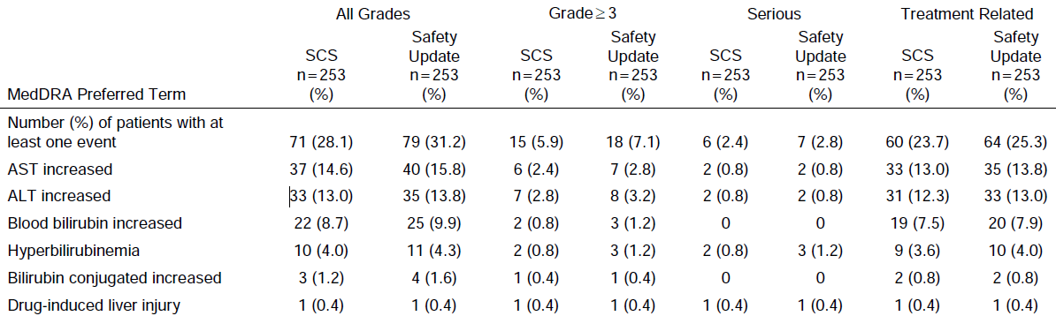

**Comment**: The incidence of these events appears reasonably stable. Adverse event reports of elevation of hepatic transaminases or bilirubin in patients taking the recommended dose appears to occur at an incidence of approximately 10 to 15% with alectinib use, with a fifth of cases being grade 3 or higher, and a tenth of cases being serious. See page 111.

##### Pivotal and/or main efficacy studies

The safety data regarding hepatic toxicity from both pivotal trials is amalgamated in the 90-Day Safety Update Report, and is described above. The rate of adverse events in the category ‘Hepatocellular or cholestatic damage AE and abnormal liver function tests’, depicted in Table 49, was reasonably similar between the two pivotal studies (p-value 0.13 for a chi squared comparison of rate of events of all grades between the two studies).

Table 49: Adverse events with incidence of at least 10% in the category ‘Hepatocellular or cholestatic damage AE and abnormal liver function tests’ in each of the two pivotal trials

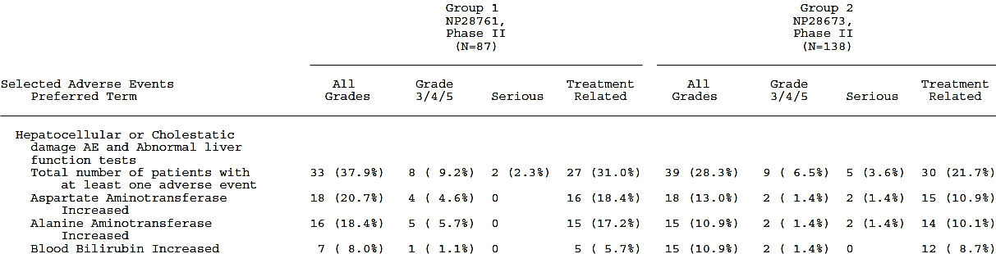

##### Other studies

###### Study AF-001JP

In Study AF-001JP, TEAEs that were classified under the SMQ ‘drug related hepatic disorders – comprehensive search’ occurred in 33 patients (56.9%). The events are listed in Table 50.

Table 50: TEAEs that were classified under the SMQ ‘drug related hepatic disorders – comprehensive search’ in study AF-001JP

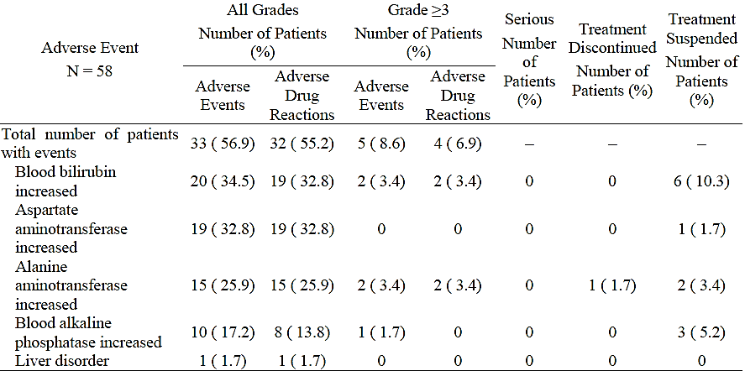

There were no Grade 4 or 5 events, and no event was considered serious. No case met the criteria for Hy’s law, but there was one case in which AST was greater than three-fold the upper limit of the site reference range and total bilirubin was greater than two-fold the upper limit of the site reference range (in patient [information redacted] at 160 days after starting treatment with alectinib). This was also accompanied by an increase in ALP, however, so the criteria of Hy’s law were not met. The event was diagnosed as Grade 2 sclerosing cholangitis (IgG4-associated autoimmune cholangitis) based on elevated serum IgG4 and response to corticosteroids.

**Comment**: There appears to be a higher rate of non-serious, Grade 2 or lower hepatic disorder TEAEs (particularly bilirubin elevations) in this AF-001JP study population, compared to the two pivotal trials. Can the Sponsor please comment on this observation and provide their interpretation? See Clinical question 10.

#### Renal function and renal toxicity

##### Integrated safety analyses

Abnormal kidney function TEAEs were reported in 48 (19.0%) of patients in Group 3 according to the 90-Day Safety Update Report, and in 12 patients (5%) these were considered TRAEs (see Table 51). Events reported in more than one patient were consistent with the previous summary of clinical safety (SCS): blood creatinine increased (6%), pollakuria (4%), nocturia (3%), hematuria (2%), dysuria (2%), proteinuria (1%), urinary retention (1%), azotemia (1%), and urinary incontinence (1%) with the majority of the events Grade 1 or 2 severity.

There was one abnormal kidney function report in the group of all patients taking 600 mg BD in the pivotal trials that was Grade 3 or above: a non-serious case of Grade 3 blood creatinine increased, that was recorded in subject [information redacted]: a [information redacted] year-old Asian male. The creatinine increase event occurred on Study Day 117, the same days as events azotaemia, anaemia and hyperglycaemia were reported; all with an outcome of recovered after two days duration. The hyperglycaemia was the only event recorded as treated, and the action taken with alectinib was a reduction of dose. None of the events were recorded to be caused by the study drug.

Laboratory results recorded in the shift tables of the 90-Day Safety Update report provide details of laboratory findings in the study, regardless of whether these led to adverse event reports. These allow a more accurate estimate of the incidence of changes in laboratory parameters than adverse event report analysis.

The incidences of laboratory abnormalities as calculated from these tables have been included in the recommendations for PI changes. With regard specifically to increased creatinine, the incidence rate is inflated by the nature of the CTCAE criteria. As described by the FDA medical reviewer for alectinib:

For increased creatinine, NCI-CTCAE v4.03 defines Grade 1 as ‘>1-1.5x baseline; >1-1.5x ULN’. Using these criteria, the incidence of increased creatinine among 250 patients with laboratory shift data available was 95%. Due to the inclusion of patients with creatinine >1-1.5x baseline, this group may include a significant number of patients whose creatinine is still within normal limits for the laboratory test. For the estimation of increased creatinine used in the above table, creatinine above the ULN was used to define all Grade increased creatinine, as this definition is more clinically relevant. The reviewer used JMP to estimate a head count incidence of creatinine above the ULN based on the datasets provided for the ISS; this yielded an incidence of 29% (74 of 253 patients). These results do not account for baseline creatinine values. Only 7 patients had creatinine greater than ULN at baseline based on laboratory shift tables.

… The sponsor has been asked to perform a similar assessment to determine the percentage of patients with creatinine greater than ULN for use in labeling.

**Comment**: The estimated incidence of increased creatinine in the FDA review is 34% (1.2% Grade 3 or above), and in the Adverse Events table in the US label is 28% (no Grade 3 or higher events). Given the sponsor has been stated to have had the right of response in the above paragraph, the rates of creatinine elevation cited in the US label provided by the sponsor with this application are assumed to reflect the incidence rates based on ULN as calculated from the raw data and agreed upon by both US Sponsor and FDA. This value has therefore been used in the recommendations for PI changes.

Table 51: Adverse events in the category ‘Abnormal kidney function adverse events’ that occurred in over 1% of all patients taking 600 mg BD alectinib in both pivotal trials 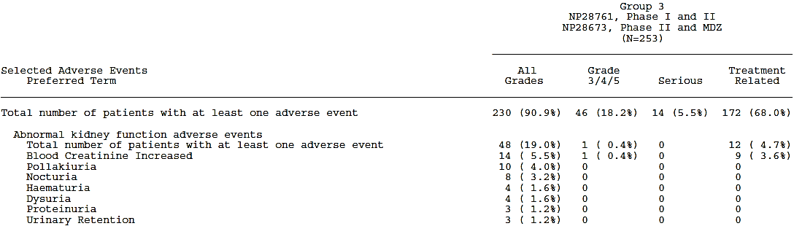

**Comment**: A paucity of renal adverse events is in keeping with the expected involvement of the renal system in alectinib clearance.

##### Pivotal and/or main efficacy studies

The safety data regarding renal toxicity from 600 mg dose cohorts in both pivotal trials is amalgamated in the 90-Day Safety Update Report, and is described above. The rate of adverse events in the category ‘Abnormal kidney function adverse events’ was reasonably similar between the two pivotal studies, see Table 52.

Table 52: Adverse events in the category ‘Abnormal kidney function adverse events’ in each of the two pivotal trials (90-day-safety-report)

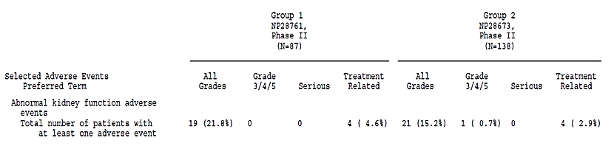

There has been one report of a serious renal AE but this was not in a patient taking 600 mg, and so was not included in the integrated safety analysis.

This was a case of Grade 4 renal failure which started on Study Day 44 in subject [information redacted] in Phase I of NP28761, and was not suspected to be alectinib-related. This was a [information redacted] year old White female patient who was in the 460 BD (fed state dosing) cohort, who had multiple risk factors in her history including a family history of oxalate uropathy, renal calculi, diabetes (on insulin), hypertension, ongoing treatment with furosemide and existing renal insufficiency. The same patient also had a Grade 3 event of anaemia. A renal biopsy was done on Study Day 47 which showed:

…acute tubular injury with extensive oxalate crystal deposition, suggesting a hyperoxaluric state, isolated uric acid tophus in medulla, mild IgA nephropathy, and thin glomerular basement membranes suggesting inherited abnormality of basement membrane collagens. Moderate chronic changes of the parenchyma included global glomerulosclerosis (‘15 glomeruli’), tubular atrophy and interstitial fibrosis and arterial and arteriolar sclerosis (moderate to severe).

**Comment**: The causality of this case is strongly confounded by the other more likely causative factors in this patient’s history.

##### Other studies

###### Study AF-001JP

There were 19 TEAEs in Study AF-001JP that fell under the SMQ ‘acute renal failure’, none of which led to study discontinuation. These are listed in Table 53. There were no serious events or events higher than Grade 2.

Table 53: TEAEs falling under the SMQ ‘acute renal failure’ in Study AF-001JP

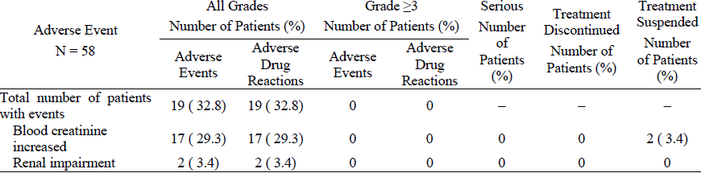

#### Other clinical chemistry

##### Integrated safety analyses

A table included in the 90 Day Safety Update Report shows clinical chemistry blood test results by NCI CTCAE grade in a shift table, allowing identification of clinically relevant shifts (defined as a change from Grade 0, 1, or 2 at baseline to Grade 3 or 4 post-baseline). CPK was not measured systematically in Group 2.

According to this definition, the following clinically relevant shifts were seen in patients taking 600 mg BD alectinib in the pivotal trials (percentages are of the total 253 patients in Group 3):

Table 54: Clinically relevant shifts in laboratory chemistry parameters in the patients taking 600 mg BD of alectinib in pivotal trials

| **Parameter** | **Decreased in (%)** | **Increased in (%)** | **high grade measurement but missing baseline** |
| --- | --- | --- | --- |
| Albumin | 1 patient (0.4%) |  |  |
| Alkaline phosphatase |  | 3 patients (1.2%) |  |
| Alanine aminotransferase |  | 12 patients (4.7%) |  |
| Aspartate aminotransferase |  | 9 patients (3.6%) |  |
| Calcium | 1 patient (0.4%) | 1 patient (0.4%) |  |
| Creatine phosphokinase |  | 8 patients (3.2%) | 2 patients with Grade 3 increases (0.8%) |
| Creatinine |  | 3 patients (1.2%) |  |
| Fasting blood glucose |  | 3 patients (1.2%) | 1 patient with Grade 4 hypoglycaemia (0.4%) |
| Blood glucose | 1 patient (0.4%) |  |  |
| Gamma gultamyl transferase |  | 3 patients (1.2%) |  |
| Magnesium | 3 patients (1.2%) | 3 patients (1.2%) |  |
| Phosphorous | 7 patients (2.8%) |  |  |
| Potassium | 10 patients (4.0%) | 1 patient (0.4%) |  |
| Sodium | 4 patients (1.6%) |  |  |
| Bilirubin |  | 6 patients (2.4%) |  |
| Triglycerides |  | 5 patients (2.0%) |  |

##### Pivotal and/or main efficacy studies

* Urinalysis (performed in Study NP28761 only) did not show any findings of clinical relevance.
* Testing for total testosterone, free testosterone, follicle-stimulating hormone and thyroid-stimulating hormone was performed in Study NP28673 only and didn’t find any clinically relevant change.

##### Other studies

###### Study AF-001JP

Elevations in transaminases, CPK and bilirubin as well as blood cell count decreases were the most common abnormalities seen in laboratory results in Study AF-001JP (see Table 55).

It is stated in the SCS that:

No findings of clinical relevance were identified in Study AF-001JP from tabulations and plots of mean values over time or from tabulations of shifts from baseline to last observation.

Table 55: Summary of abnormal laboratory test values in patients who received 300 mg twice daily

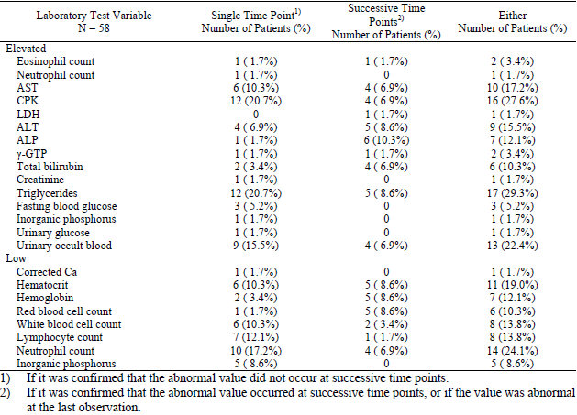

###### Studies with evaluable safety data: dose finding and pharmacology

In general, there were no significant clinical chemistry abnormalities in the clinical pharmacology studies. There were 3 reports of CPK elevation in Studies NP28990 and NP29040 which are discussed below (under Pivotal and/or main efficacy studies).

#### Haematology and haematological toxicity

##### Integrated safety analyses

Haematological abnormalities were reported in Group 3 of the 90-Day Safety Update Report (see Table 56) at a rate of 21% (53 patients). Events reported in at least 2 patients were: anaemia (14%), neutropenia (3%)/neutrophil count decreased (1%), leukopenia (3%)/WBC decreased (1%), lymphopenia (1%) and haemoglobin decreased (1%). No cases of agranulocytosis, aplastic anaemia or severe thrombocytopenia were reported.

Table 56: Pooled adverse events in the category ‘haematological abnormalities’ that occurred at any incidence rate in patients taking 600 mg BD alectinib in both pivotal trials (90-day-safety-report)

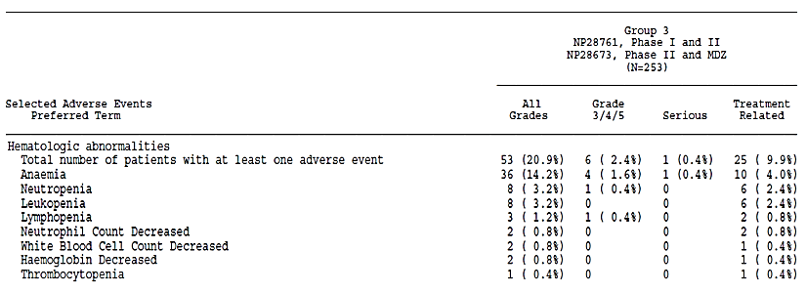

There were two new non-serious but Grade 3 reports in this category between the original data cut-off dates for the pivotal trials and the 90-Day Safety Update Report:

Patient [information redacted] experienced a non-serious Grade 3 event of neutropenia starting on Day 407. This event was considered related to the study drug. At the time of reporting, the event was considered not recovered/not resolved. The dose of the study drug was not changed as a result of this event.

Patient [information redacted] experienced a non-serious Grade 3 event of anemia starting on Day 211. This event was considered unrelated to the study drug. At the time of reporting, the event was considered recovered/resolved. The dose of the study drug was not changed as a result of this event.

As was seen in the SCS with earlier cut off dates, the median values for haematological analyses remained in the normal range throughout the studies except for haematocrit, haemoglobin, and RBC count. These three parameters tended to fall during the first month of alectinib therapy, then stabilised slightly below the normal range.

**Comment**: By comparison, the PI for crizotinib describes neutropenia in 21% (all grades), compared to 30% in the chemotherapy arm, and leucopenia [sic] at 7% of the crizotinib arm and 15% in the chemotherapy arm.

##### Pivotal and/or main efficacy studies

The safety data regarding haematological abnormalities from patients taking the recommended daily dose in both pivotal trials is amalgamated in the 90-Day Safety Update Report, and is summarised above. The rate of adverse event terms in the category ‘Hematologic abnormalities’ was higher in Study NP28761 than NP28673 (see Table 57), however, the difference between them was not significant (chi-squared 3.13, p=0.077).

Table 57: Adverse events in the category ‘Hematologic abnormalities’ in each of the two pivotal trials 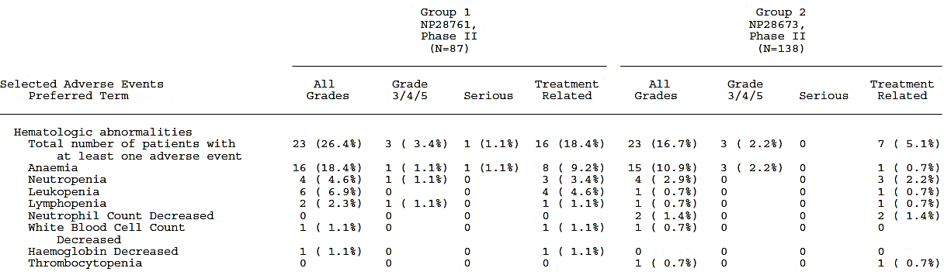

##### Other studies

###### Study AF-001JP

There were 17 TEAEs in Study AF-001JP that fell under the SMQ ‘haematopoietic cytopenias’, none of which led to study discontinuation. These are listed in Table 58.

Table 58: TEAEs falling under the SMQ ‘haematopoietic cytopenias’ in Study AF-001JP

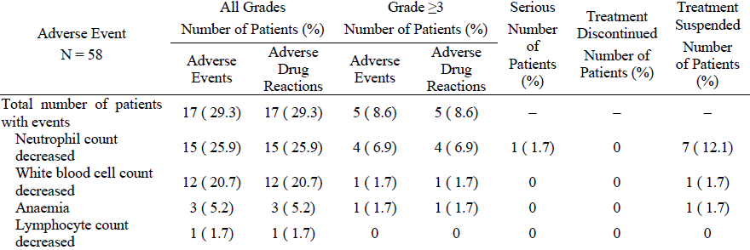

There were no Grade 4 or 5 events, and there were five Grade 3 events: neutrophil count decreased (4 patients, one case was serious) and white blood cell count (WCC) decreased (1 patient). No events of WCC or neutrophil decreases were associated with febrile events or serious infections.

Red blood cell (RBC) related adverse events were given separate consideration by the authors of the CSR for AF-001JP as abnormal red blood cell morphology and mild anemia had been reportedly seen in some toxicology studies. Anaemia was seen in three patients (see Table 58), one of which was Grade 3 and had onset 15 days after commencing alectinib, but which resolved with interruption of treatment and a transfusion.

Bleeding-related adverse events were also given separate consideration as haemorrhagic changes in the intestine with prolongation of coagulation times were reportedly seen in the 3-month repeated-dose rat toxicology study. No abnormalities of coagulation times were seen in Study AF-001JP. However, eleven patients (19%) in this study had bleeding-related adverse events (see Table 59). All but one case were not serious or higher than Grade 2. The serious case was a Grade 3 tumour haemorrhage, which was treated surgically and led to study discontinuation.

Table 59: TEAEs falling under the SMQ ‘haemorrhages’ in Study AF-001JP

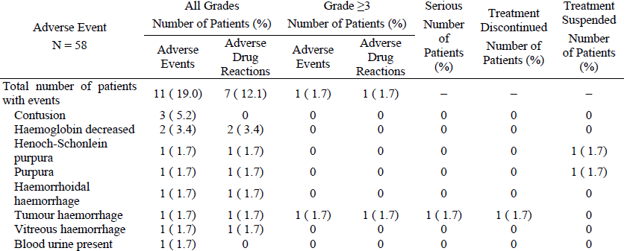

#### Electrocardiograph findings and cardiovascular safety

##### Integrated safety analyses: pooled ECG analysis

In the absence of a Thorough QT study, a pooled ECG analysis of data from both of the pivotal trials has been conducted (report 1060441). The data from the pivotal trials, with cut-off dates of 18 August 2014 (NP28673) and 24 October 2014 (NP28761), was pooled as the patient populations were similar, however the data from Study AF-001JP was considered separately as these patients were on maximum half the dose compared to the pivotal trials and were all crizotinib naïve. Data from Study AF-001JP (data cut-off date 18 April 2013) is therefore described in section Evaluation of issues with possible regulatory impact. No data from PK studies (as these did not involve steady-state dosing) was included.

###### Justification for lack of formal dedicated QT study in healthy volunteers

As part of the introduction to this report, justification for not completing a dedicated QT study is given:

* Non-clinical studies predict the risk of QT prolongation to be low:
  + An in vitro assay showed the concentrations of alectinib required to inhibit the human ether-à-go-go−related gene (hERG) were 8-30 fold the predicted clinical unbound fraction of alectinib (7 ng/mL, due to alectinib’s plasma protein binding ratio of >99%).
  + ‘Good Laboratory Practice’ (GLP) telemetry studies on monkeys showed no effects on ECGs, other cardiovascular parameters or body temperatures with doses up to 15 mg/kg (4-hour post-dose plasma concentration of 279 ng/mL).
    - There was a preliminary telemetry monkey study, not conducted under GLP, which showed a slight hypotensive effect without change of heart rate at 60 mg/kg and 20 mg/kg but not 15 mg /kg doses. However, two in vitro studies concluded this was likely due to vasodilatation secondary to L-type Ca2+ channel inhibition.
* It would not be possible to conduct a thorough QT study in healthy subjects according to the ICH E14 guideline (2005), on the basis of the available data:
  + In vivo micronucleus testing showed alectinib to cause aneugenic effects (abnormal chromosome segregation)
  + When performed in rats, no aneugenic effects were seen with doses of 200 mg/kg/day (plasma mean Cmax 1850 ng/mL; mean AUC0-24h, 36700 ng/h/mL), thus plasma levels below these can be reasonably expected not to be of toxicological concern.
  + Clinical trial plasma levels with single alectinib 600 mg doses can be expected remain outside a robust safety margin of such plasma exposures, however with multiple doses and a mean accumulation ratio of 5.56-fold at 600 mg BD this could not be guaranteed.
  + Therefore it is not ethical to give alectinib to healthy volunteers at 600 mg BD dosing so as to reach steady state and assess ECG effects in non-patients. In such situations, the ICH guideline recommends the collection of ECGs at multiple time points under tightly controlled settings in patient populations.

**Comment**: A plasma concentration of 279 ng/mL (as was seen in the telemetry studies on monkeys 4 hours post dose) is low relative to the steady state Cmax seen in clinical studies. The relevance of the non-clinical findings is not clear. However, the justification remains valid on the basis of the potential risk of steady-state exposure to healthy volunteers.

###### Methodology

The data from in patients taking 600 mg BD of alectinib in Studies NP 28761 and NP28673 were pooled in this report, however, due to differences in the schedules of ECG/PK collection between the two studies, baseline values were selected using a common approach, and only the central ECG assessments for both studies were included. The report outcomes therefore slightly differ from some of the values in the CSRs for the two studies separately.

Fridericia’s formula (QTcF) was used for QT correction for respiratory rate (RR). Regression modelling of QT: RR and QTcF: RR showed a reduction in slope from 0.1835444 to 0.0349887, confirming good adjustment of QT by the formula.

Four patients were excluded from the ECG Evaluable populations of the two studies (3 from NP287761 due to baseline abnormalities [n=2] or artefact [n=1] and 1 from NP28763, due to missing baseline measurement). The demographics of the ECG Evaluable populations were representative, with the only major difference a more global population in Study NP28673, resulting in a higher proportion of Asian patients (26% versus 8%).

###### Overall ECG results

ECG findings overall are summarised in Table 60.

Table 60: Summary of ECG findings in the pivotal studies

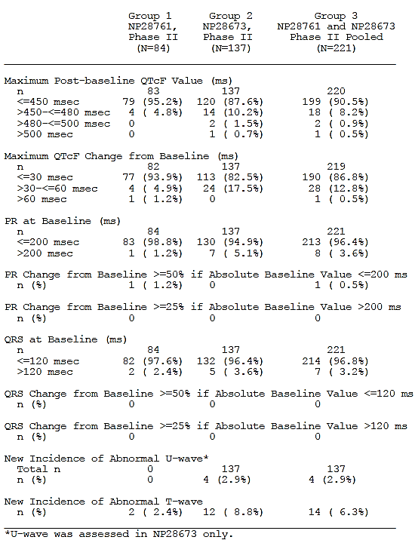

###### Results: QT interval

No effect of alectinib on QTcF was demonstrated (see Figure 9). Time points with too low a number of contributing measurements to support meaningful interpretation (with less than ten patients available) were excluded from graphing, but were included in tabular form.

**Comment**: The data points not included in the graph were reviewed: they do not change the overall impression significantly, and their exclusion from the graph is reasonable.

Figure 9: Mean QTcF changes from baseline in the ECG evaluable populations of Study NP28673 and NP28761. Only sufficiently powered time points (at least 10 patients) were included

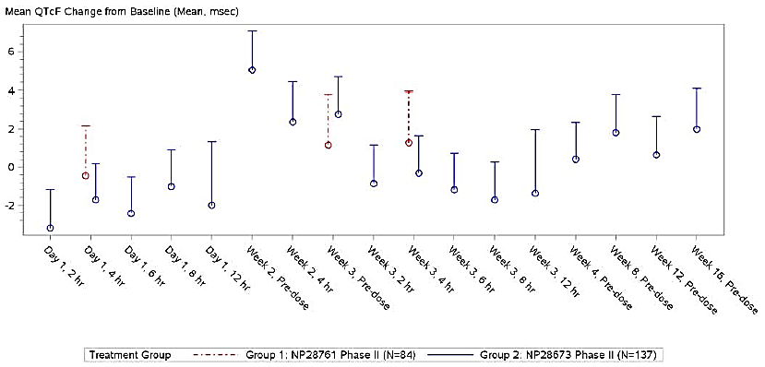

Linear regression analysis of individual baseline QTcF values against time-matched alectinib plasma concentrations (n=1928 data points; 221 patients) showed a slope of 0.0014, indicating no apparent correlation.

Regarding the different assays involved in determining those plasma concentrations, the author of the pooled ECG report states the following:

Although the use of different analytical methods for the analysis of alectinib plasma concentration revealed a mean bias of − 21% for Chugai (Studies AF-001JP and NP28761) versus Quintiles (Study NP28673) data, PK data from the two pivotal studies were pooled since results from the individual studies were sufficiently consistent to explore the overall correlation between QTcF change from baseline and alectinib plasma concentration. These results revealed no apparent exposure-dependent trends in change from baseline in QTcF.

**Comment**: Linear regression analyses performed on the data from each of NP28761 and NP28673 separately from one another showed similar findings. However, it is not clear why the difference between assays was not adjusted for prior to linear regression analysis, such as was done in the popPK analysis. Can the sponsor please discuss why this was not done? See Clinical Question 10.

##### Results: heart rate (HR) [see also section Evaluation of issues with possible regulatory impact]

Alectinib treatment resulted in a median decrease in HR of 11.6 bpm at Week 2, which was then stable at that level throughout the 16 week treatment period (Figure 10). Individual corrected HR values plotted against time-matched plasma alectinib concentrations showed a trend suggesting a dose-response correlation (Figure 11). The decrease in HR was also seen in the ECG analyses of individual studies, and was consistent with local clinical assessment of pulse rate, and patients were generally asymptomatic, however the following adverse events possibly related to bradycardia were reported:

* One patient in Phase I of study 28761 (patient [information redacted]) had a bradycardia of 53 at baseline, with minimum heart rate of 38 while being treated with alectinib, and reported an AE of fall on day 161. Although bradycardia and hypotension were not reported as adverse events, it can’t be ruled out that a lowered heart rate due to alectinib didn’t contribute to the fall. It was also noted that the patient had non-target brain lesions at baseline and a new lesion during the study.
* Three patients in Phase II of study (patients [information redacted]) all had reductions in heart rate of at least 15 bpm from baseline, and all reported an AE of dizziness, with patient [information redacted] also reporting a fall. This patient was also noted to have had non-target brain lesions at baseline and a new lesion during the study.

Follow-up visit data suggested that decreases seen in pulse rates went back to pre-treatment values upon treatment discontinuation.

Figure 10: Graph of mean heart rate (+/- SD) over time in the pivotal trial pooled data

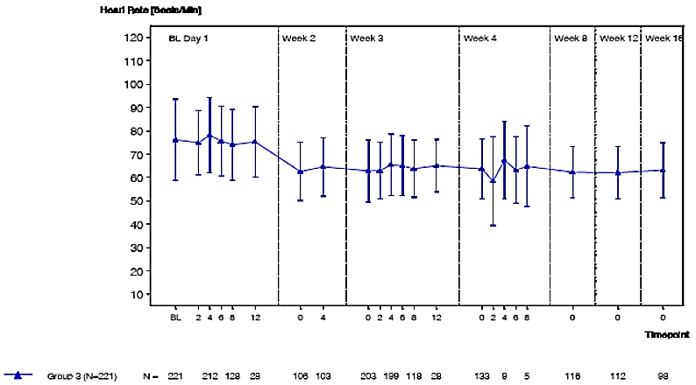

Figure 11: Scatter plot of pooled individual corrected heart rate measurements from the clinical trials against time-matched alectinib plasma concentrations

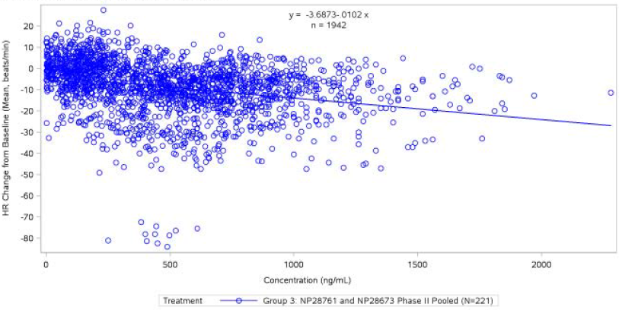

*Results: significant outliers*

Outliers included:

* Patient [information redacted]:
  + had a HR of 41 bpm at baseline, and post-baseline had a HR of 30-40 bpm
  + had a baseline QTcF of , and post baseline a maximum QTcF of >500 ms
  + no clinical symptoms were reported
* Patient [information redacted]:
  + had a baseline HR of 132 bpm, but 11 subsequent ECG measurements of HR between 48 and 60 bpm, resulting in a change from baseline of -70 to -80 bpm.

**Comment**: The high baseline rate in this instance is likely to be an error, possibly of automatic/mechanical HR measurement.

###### Results: PR interval and QRS complex

Mean PR interval increased by approximately 6 ms during treatment with alectinib, seen both in the pooled analysis and in individual studies. Mean QRS duration did not change.

###### Relevant adverse events

Adverse events potentially relevant to cardiac function disorders are outlined in Table 61.

Table 61: Adverse events possibly related to prolongation of cardiac repolarisation

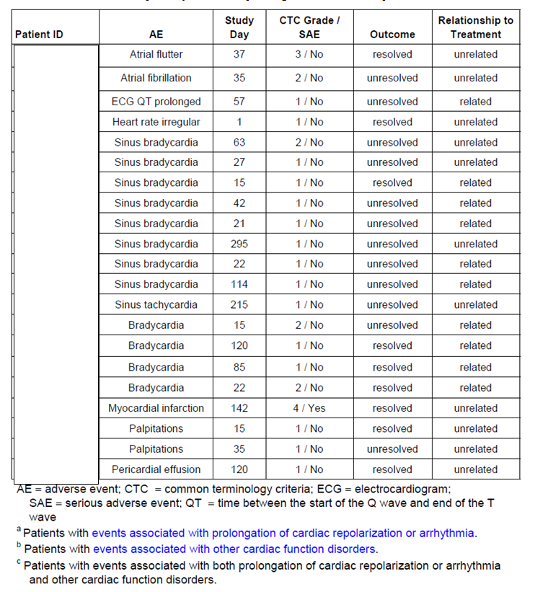

* The only serious case is a Grade 4 case of MI, which occurred in a 61 year old White male (patient [information redacted]) who reportedly had no reported previous disease or any risk factors (but had a DVT and had been on warfarin since two years prior), and was treated with urgent angioplasty. He later developed a PE.
* The only other case higher than Grade 2 is a Grade 3 case of atrial flutter, which occurred in a [information redacted] year-old Asian male (patient [information redacted]) 4 days after a febrile episode and 4 days before anaemia was reported.
* The rest of the adverse events were non-serious, and Grade 2 or below:
  + The case of QT prolongation was reported in a [information redacted] year old White male (patient [information redacted]) enrolled in trial NP28673, who had an atrial pacemaker and whose pre-dose ECG showed a QTcF of 452, when his QTcF at baseline had been already elevated at 468 ms. No medical history was reported for this patient but he had a pacemaker and was on metoprolol. The case was considered possibly related. The QT prolongation was not resolved at the time of patient death.

**Comment**: The evaluator does not agree with the causality assessment in this case as the QTcF was higher at baseline than when the AE report of QT prolongation was made.

* + The case of pericardial effusion (in patient [information redacted]) is discussed in section Deaths and other serious adverse events (SAEs).
  + ‘Heart rate irregular’, reported for patient [information redacted], a White, [information redacted] year old female, was Grade 1, lasted a day, and resolved without treatment while the dose of alectinib remained unchanged.
    - A second case of ‘heart rate irregular’ (also Grade 1) occurred in Study NP28761 in a non-600 mg group (460 mg BD) in an -year old (patient [information redacted]) on day 25 of the study. The event resolved and was considered unrelated to alectinib.
  + The case of atrial fibrillation occurred in a [information redacted] year old White male (patient [information redacted]) on day 35 and did not resolve. Palpitations were reported as a concurrent adverse event for this patient.
    - A second case of atrial fibrillation occurred in Study NP28761 in a non-600 mg group (900 mg BD) in an [information redacted] -year old White female (patient [information redacted]) on day 31 of the study. Dosing was interrupted but the event did not resolve.
  + One case of bradycardia (in patient [information redacted]) led to alectinib interruption but resolved without sequelae and another (in patient [information redacted]) led to dose reduction. Bradycardia has been discussed in more detail on below.

##### Integrated safety analyses: 90 Day Safety Report

ECG data from both pivotal trials shows approximately 90% patients have absolute QTcF values at or below 450 ms, and approximately 80% of patients don’t have a change from baseline QTcF of larger than 30 msec.

After the data cut-off date for the pooled ECG analysis, and before the cut-off date for the 90-Day Safety Update Report, there have been 6 additional reports in patients taking 600 mg BD alectinib in the pivotal trials that could be associated with prolongation of cardiac repolarization or arrhythmia or other cardiac function disorders:

* Four cases of bradycardia, one reported as PR prolongation and sinus bradycardia, and one case of tachycardia, all Grade 1-2, all non-serious, and none leading to treatment interruption, withdrawal or dose change.
* One case of QT prolongation, Grade 3, in Study NP28761:
  + A [information redacted] year old White female (subject [information redacted]) experienced a non-serious Grade 3 event of ECG QT prolonged starting on Day 22. Her baseline QTcF was elevated at screening (469) and the event was considered unrelated to the study drug. The patient had concurrent conditions of cardiomyopathy and left bundle branch block, and a history of prophylactic defibrillator implantation, and her QTcF varied during the treatment period between 333 and 531 (on day 295).

This brings the total number of cases of QT prolongation reported as AEs to 2 (see Cardiac adverse events section).

**Comment**: Both cases of QT prolongation that have been reported involved patients with pre-existing cardiac conditions that confound the causality. Without a comparator arm, it is impossible to absolutely determine alectinib effect on QT interval. However, the evidence summarised in the pooled ECG report regarding the population distribution of QT values, and the lack of serious cardiac adverse events (particularly serious arrhythmias) indicate that alectinib does not affect the QT interval.

##### Pivotal and/or main efficacy studies

The safety data from both pivotal trials is included in the pooled ECG report and 90 Day Safety Update Report. See above for combined analysis. The individual ECG analyses included in the CSRs for NP28673 and NP28761 have also been reviewed and the findings are in keeping with the results of the pooled analysis.

##### Other studies

###### Study AF-001JP

There were no adverse events reported that fell under the SMQ ‘torsades de pointes/QT prolongation’ in this study (data cut-off date 18 April 2013).

Fifty-eight patients received 300 mg BD in this study. In 53 of those, the baseline ECG was normal, and of the five abnormal ECGs, three normalised after starting treatment.

In four patients, ECG was normal at baseline and abnormal after starting treatment:

* Three cases of sinus bradycardia (all reported as AEs)
* One case of a low heart rate (39), but not reported as an AE because another measurement of their heart rate taken on the same day was 58 and so it was deemed a transient change

QT prolongation by >30 ms occurred in 3 patients. In two of those cases, the corrected QT interval still remained below 450 ms, and there were no cardiovascular adverse events. The third patient with QT prolongation >30 ms had a corrected QT of >450 ms (QTcB = 452 ms/QTcF 464 ms [Grade 1]) in association with T wave inversion that developed on Study Day 24. This patient had tumour invasion of the pericardium on the anterior surface of the heart, likely disrupting the myocardium:

The cardiologist commented that the event was quite likely to be T wave inversion due to compression and inflammation caused by this tumour.

The IRC’s comment was that the T-wave inversion could be incidental or could be related to the anterior pericardial lesion, and that the QT prolongation was probably due to the T-wave inversion.

###### Studies with evaluable safety data: dose finding and pharmacology

One subject in Study NP29040 discontinued due to ST elevation V2-4 with a urine test positive for cocaine. All other ECG findings in the clinical pharmacology studies were not clinically relevant.

#### Vital signs and clinical examination findings

##### Integrated safety analyses

The 90-Day Safety Update Report summarises the findings of vital sign and clinical examinations during the pivotal trials for all patients taking the recommended dose of alectinib (600 mg BD).

Bradycardia is considered a class effect of ALK inhibitors and a decreased heart rate was seen consistently through the pivotal trials as described in the section titled ‘Results: Heart rate (HR)‘ (from the pooled ECG report). According to the 90-Day Safety Update Report, post-baseline minimum heart rates, as measured from ECGs, were:

* below 60 bpm in 55% of patients and below 50 bpm in 25% of patients in Group 1 (Phase II NP28761)
* below 60 bpm in 62% of patients and below 50 bpm in 22% of patients in Group 2 (Phase II NP28673)

Between the cut-off dates for the pooled ECG report and the 90-Day Safety Update Report, three reports of bradycardia, one of PR prolongation and sinus bradycardia, and one of tachycardia have been reported. All were non-serious, and none led to alectinib withdrawal, interruption or dose change.

No other significant trends in clinical examination or vital signs were reported in the 90 Day Safety Report.

##### Pivotal and/or main efficacy studies

In Study NP28673, the pulse rate statistics from clinical vital sign measurements at the 28 day follow up visit suggest that the decrease in pulse rate in both ECG and vital signs seen across studies (see ‘Results: Heart rate (HR)‘ (from the pooled ECG report)) may be reversible upon discontinuation of alectinib (see Table 62).

Table 62: Pulse rate statistics for the safety population of Study NP28673

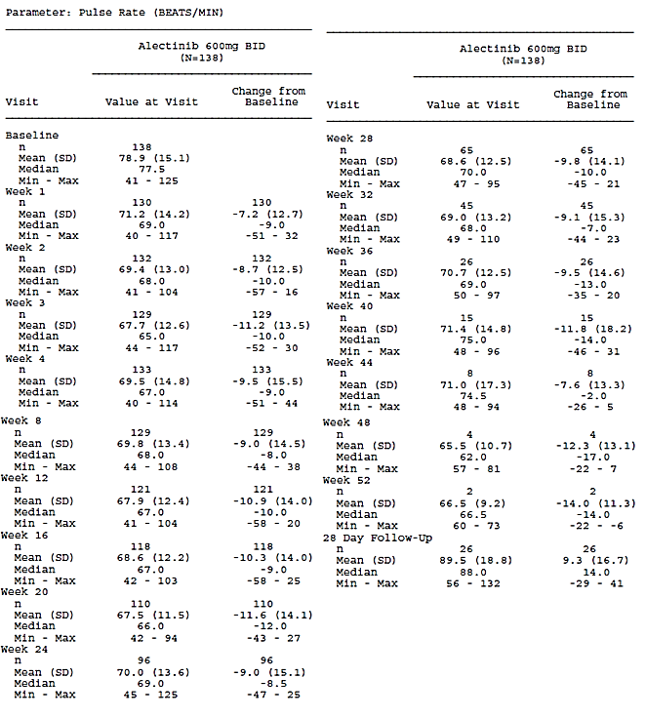

##### Other studies

###### Study AF-001JP

No clinically relevant changes in vital signs were reported in AF-001JP or the clinical pharmacology studies.

#### Immunogenicity and immunological events

There was no evidence of serious immune responses or hypersensitivity reactions to this product. An overview of cases of rash in the clinical trials is included below.

A single case of liver injury was reported in which a biopsy was consistent with autoimmune injury, IgG was slightly elevated and anti-smooth muscle antibody testing was mildly positive, however on cessation of alectinib the injury resolved without steroid treatment and the case is considered one of DILI (more case detail is described in section Gastrointestinal toxicity).

#### Serious skin reactions

There were no cases of erythema multiforme, Stevens Johnson syndrome, drug reaction with eosinophilia and systemic symptoms (DRESS) or toxic epidermal necrolysis reported in any of the clinical studies. Photosensitivity cases have been reported with other ALK inhibitors and photosensitivity has been classified as an important identified risk for alectinib.

##### Integrated safety analyses

The 90 Day Safety Report describes adverse events reported in patients taking 600 mg BD in the pivotal trials. A table of selected adverse events classed under ‘skin disorders’ that were reported in these patients is reproduced in Table 63.

Skin disorders were reported in 38% of patients overall, most commonly rash (12%) and photosensitivity reaction (10%). This is consistent with the notes from pre-submission that phototoxicity was an adverse event noted in the toxicology studies. In the 6-8 months between the cut-off dates for the original CSRs and the cut-off date for the 90 Day Safety Update, there have been 2 additional reports of TRAEs of photosensitivity to bring the TRAE total to 10% in this group.

No events were considered SAEs, and there was one report higher than Grade 2: a Grade 3 report of rash:

Patient [information redacted] experienced a non-serious Grade 3 event of rash starting on Day 388. This event was considered unrelated to the study drug. At the time of reporting, the event was considered resolving/recovering. The action taken with the study drug was reported as not applicable.

Table 63: Selected adverse events in the category ‘skin disorders’ that occurred at an incidence of 1% or higher in all patients taking 600 mg BD alectinib in both pivotal trials.

**Note: A couple of AE terms not reaching 1% incidence are included as the table has been copied directly from the report in which the terms are not in proper descending order of incidence**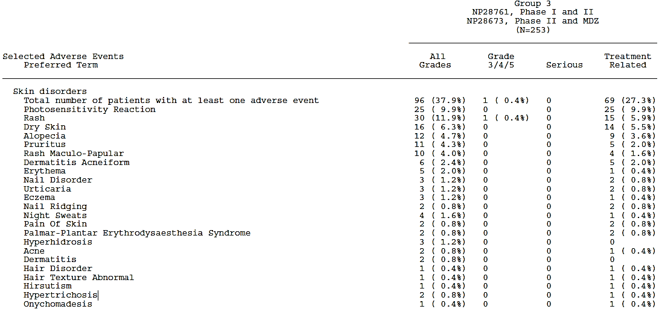

##### Pivotal and/or main efficacy studies

The adverse events from patients taking 600 mg BD of alectinib in both pivotal trials relating to skin disorders is analysed together in the 90-Day Safety Update Report, as described above. The rate of adverse event terms in the category ‘Skin disorders’ was reasonably similar between the two pivotal studies (see Table 64), including photosensitivity which was seen in about 10% of patients.

Table 64: Adverse event terms with incidence at least 10% in the category of skin disorders in both pivotal trials

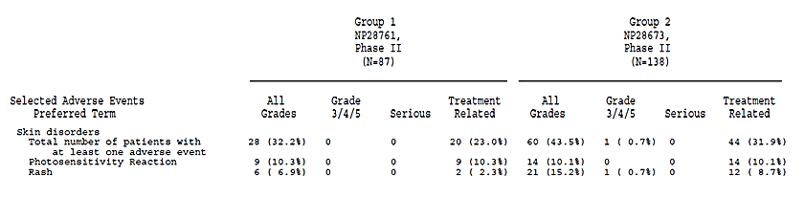

In Study NP28761, photosensitivity reaction was reported as a TRAE in 12.8% of Phase I patients as at the CSR cut-off date of 24 October 2014 (not all of these patients were taking 600 mg BD alectinib, and so not all of them are represented in the above table).

##### Other studies

###### Study AF-001JP

Rash was reported in about a third of the patients in this study, but no cases were serious and only one was higher than Grade 2: a Grade 3 case of ‘rash maculopapular’. None of the cases led to study discontinuation as suspension of treatment was sufficient to allow resolution in all cases. Dose reduction was undertaken for one patient following the interruption for rash, but this was not a protocol requirement – it was undertaken at the discretion of the investigator. Rash treatments used were topical (such as betamethasone, gentamicin and heparinoids) or oral anti-allergy drugs (such as fexofenadine). Oral corticosteroids were not required.

During in vitro studies, quantitative whole-body autoradiography in rats was suggestive that phototoxicity may be a concern. There were 11 TRAEs classed under the SOC ‘eye disorders’, but no events related to photosensitivity reactions were reported in this study.

###### Studies with evaluable safety data: dose finding and pharmacology

There was a single, non-serious report of mild photosensitivity from a patient in Study NP29040 (ID number [information redacted; a White [information redacted]-year old male) who was in the 3% SLS formulation cohort. This event resolved without intervention. Headaches suspected to be treatment-related were also reported in five patients in the pharmacology clinical studies. Whether these could be manifestations of photosensitivity is not clear.

#### Vision disorder

##### Integrated safety analyses

Vision disorders were reported in 17% of patients taking 600 mg BD alectinib in the pivotal trials (Table 65). The most common reported events were vision blurred (4%), vitreous floaters (2%), and visual impairment (2%). All events were below Grade 3 severity and non-serious, except for one serious Grade 3 event of retinal detachment (patient [information redacted]), which was considered not related to alectinib use, treated surgically and resolved without sequelae.

Table 65: Adverse events specified in the category ‘vision disorders’ that occurred in at least 1% of all patients taking 600 mg BD alectinib in both pivotal trials

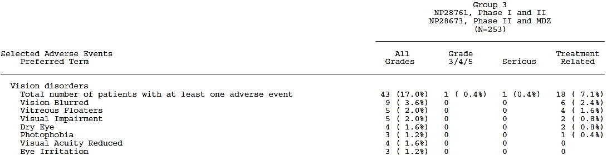

**Comment**: By comparison, the PI for crizotinib describes vision disorders occurring in 71% at all grades, and 10% in the chemotherapy arm.

##### Pivotal and/or main efficacy studies

The adverse events from patients taking 600 mg BD of alectinib in both pivotal trials that could relate to vision disorders are included in the 90-Day Safety Update Report, as reviewed above. The rate of adverse event terms in the category ‘Vision disorders’ was reasonably similar between the two pivotal studies. No individual adverse events in this category occurred at rates higher than 6%. Blurred vision had the highest incidence, reported in 5 patients in Study NP28761 and 4 patients in Study NP28673.

Table 66: Adverse event term totals in the category of ‘Vision disorders’ in both pivotal trials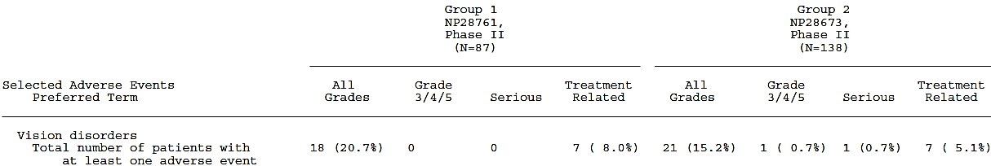

##### Other studies

###### Study AF-001J

Adverse events classified as eye disorders (SOC) in Study AF-011JP occurred in 19% of patients (11 patients in total), including one report of ‘vision blurred’ and one of ‘visual impairment. Except for a case of maculopathy treated surgically, none of the cases were serious or Grade 3 or above. No case led to alectinib discontinuation.

#### Interstitial lung disease/pneumonitis

##### Integrated safety analyses

Interstitial lung disease (ILD) is considered a class effect of TKIs, including ALK inhibitors.

One case of ILD has been reported in the clinical studies of alectinib. This Grade 3 case (patient [information redacted) was reported in Study NP28673 and occurred in a [information redacted year-old White female patient on day 110 of study treatment. She developed dyspnoea and hyperthermia, and was hospitalised on Day 112. An angiogram was negative for PE, but CT revealed disseminated ground-glass opacity, and Grade 3 drug-induced ILD was diagnosed. Bronchial lavage on Day 115 confirmed absence of legionella, mycoplasma, streptococcus and chlamydia. Treatment with alectinib was withdrawn on Study Day 113, and the patient was treated with oxygen, ceftriaxone, cefpodoxime, spiramycin, colecalciferol, calcium carbonate and prednisolone. The event hadn’t resolved at time of reporting, no discharge information was provided, and no updates as to the resolution status of the event had been received at the time of the 90-Day Safety Report. The patient was, however, reported to be alive on 26 February 2015 (Study Day 373).

##### Other studies

In Study AF_001JP, the IRC independently evaluated all patients with ground-glass opacity on CT and any respiratory symptoms during the study period, to identify possible cases of ILD. Of nine patients evaluated, ILD was ruled out in 7 cases.

The remaining two cases were as follows:

* Subject number [information redacted (a [information redacted year old female) had a CT done for lesion evaluation on day 1 of cycle 6 that showed ground-glass opacity (Day 102 of study). Four days later, the patient reported having had a slight cough a week earlier that had settled, and it was decided to suspend alectinib and give antibiotic treatment (Zithromac). Bronchoscopy was performed on Day 108 but no organisms were identified, other testing for signs of infection was negative, and lung biopsy specimens showed signs of interstitial pneumonia. Antibiotics and alectinib were discontinued and drug-induced pneumonia was diagnosed. ‘It was concluded that the event was Grade 1 and not serious because it was accompanied only by abnormal CT findings and elevation of serum markers and the patient had no symptoms of interstitial lung disease.’ Follow up was lost after Day 142, and the ILD was unresolved at that time.
* Subject number [information redacted year old female) had a shadow suggestive of DILI/ILD what was identified before treatment with alectinib commenced. The IRC concluded that it couldn’t be ruled out that alectinib contributed to prolongation of the existing DILI. The IRC’s comments were as follows:

It is unlikely that the shadow was caused by infection because of the time course of body temperature and CRP and the fact that resolution of the shadow was protracted. It is also unlikely that the shadow was caused by lymphangiosis carcinomatosa given the therapeutic course. Although this is an unusual case in that a shadow was seen only in the right lung and not in the left, it is suspected that the patient had drug-induced lung injury from the imaging findings and clinical course. However, the shadow suggestive of drug-induced lung injury appeared before starting treatment with CH5424802 and it is therefore more than likely that a drug other than CH5424802 was involved (first-line treatment was cisplatin + docetaxel + bevacizumab), which causes some confusion when trying to determine the effect of CH5424802. Confirmation of the clinical course of the shadow showed that although healing was eventually occurring, the fact was that the shadow was tending to resolve after discontinuing treatment with CH5424802 and that it was healing after that. While it is true that the shadow was not exacerbated by treatment with CH5424802, the possibility that CH5424802 contributed to prolongation of drug-induced lung injury cannot be completely ruled out. This does not present a major problem because this was not a case that lead to death or that became serious.

#### Gastrointestinal toxicity

##### Integrated safety analyses

Gastrointestinal tract TEAEs were reported in 153 (60.5%) of patients in Group 3 according to the 90-Day Safety Update Report, and in 83 patients (32.8%) these were considered TRAEs (see Table 67). Four serious cases have occurred one each of constipation, vomiting, intestinal perforation and intestinal obstruction.

* The intestinal obstruction (Grade 3) occurred on Day 5 and was very unlikely to be related to study treatment: a CT on day 7 showed ‘*diffuse peritoneal carcinomatosis ascites and subcapsular implants in the hepatic capsule, and distal small bowel obstruction, likely due to several implants or adhesions*.’
* The case of constipation was considered serious due to hospitalisation for investigation (Study Day 23) but imaging was not concerning and the patient was treated with sodium amidotrizoate and discharged. ‘*On Study Day 226 the event of worsening of constipation was resolved without sequelae*.’
* The case of nausea and vomiting developed after alectinib discontinuation and was due to emetogenic chemotherapy used as a subsequent line of treatment.
* The case of intestinal perforation was of unclear causality and alectinib involvement in the pathogenesis couldn’t be ruled out. This case is discussed further in section Treatment related adverse events above.

It is noteworthy that gastrointestinal perforation is a risk specified under ‘Special warnings and precautions for use’ in the European SmPC for crizotinib as GI perforation was reported in clinical trials and fatal events had occurred in the post-market setting. However, this is not listed in the US PI for crizotinib.

Table 67: Pooled adverse events in the category ‘Abnormal kidney function adverse events’ that occurred in at least 1% of all patients taking 600 mg BD alectinib in both pivotal trials

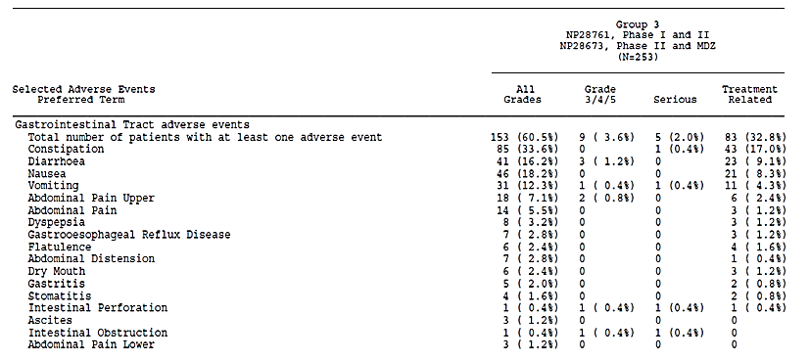

##### Pivotal and/or main efficacy studies

The safety data regarding gastrointestinal toxicity from patients taking 600 mg BD of alectinib in both pivotal trials is amalgamated in the 90-Day Safety Update Report, and is described above. The rate of adverse events in the category ‘Gastrointestinal tract adverse events’ was reasonably similar between the patients on the recommended dose in both pivotal studies, see Table 68. Approximately a third of patients experienced constipation in both trials.

Table 68: Adverse event terms that occurred at a rate of at least 10% in the category ‘Gastrointestinal tract adverse events’ in both pivotal trials

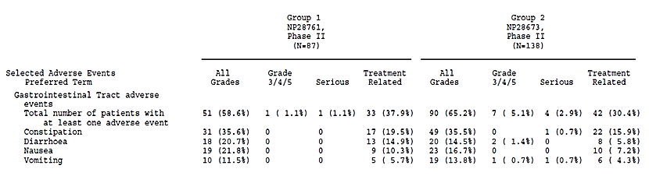

The rate of TRAEs in Phase I of Study NP28761 (not all of whom were taking 600 mg BC doses of alectinib) under the ‘GI disorders’ category was 26%. The most commonly reported terms were constipation (11%) and nausea (11%).

##### Other studies

###### Study AF-001JP

The most common TEAEs in Study AF-001JP related to gastrointestinal disorders are listed in Table 69. Most were considered treatment-related. None of the events were higher than Grade 2.

Table 69: TEAEs relating to GI toxicity in patients taking 300 mg BD alectinib in Study AF-001JP that had an incidence of at least 10%

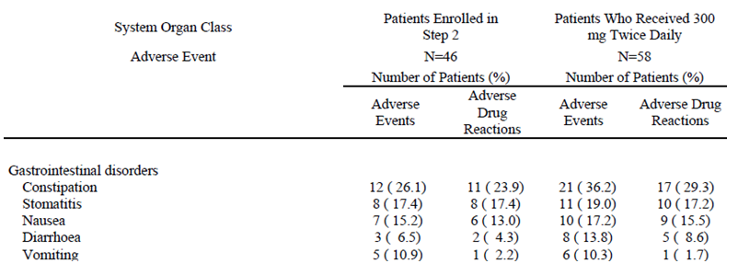

###### Studies with evaluable safety data: dose finding and pharmacology

Serious nausea and vomiting were experienced by subject [information redacted} year old White male) in Study NP28991 after alectinib dosing in both the fasted state and the fed state. The positive dechallenge-rechallenge over a number of days in this case makes it pretty likely that the nausea and vomiting represented alectinib-related GI toxicity.

Further evidence of GI toxicity in healthy subjects comes from Study NP29040 in which infrequent bowel movements (3 cases), diarrhoea (2 cases) and constipation (1 case) were reported.

#### Muscular adverse events and CPK elevation

##### Integrated safety analyses

Muscular TEAEs or CPK elevation TEAEs were reported in 142 (56.1%) of patients in Group 3 according to the 90-Day Safety Update Report, and in 76 patients (30%) these were considered TRAEs (see Table 70).

There were 90 patients (38%) who had muscular AEs, and 29 of these had concomitantly increased CPK, in three cases elevated to Grade 3 levels, with maximum values between 813 U/L to 1184 U/L. No cases met the definition for rhabdomyolysis as per the European Atherosclerosis Society Consensus Panel.[35]

Adverse events of myalgia and CPK occurred in 28.5% of patients overall and dose modification (reduction or interruption) due to CPK elevation or myalgia occurred in 5.1% of patients. Grade 3 myalgia occurred in three patients and Grade 3 CPK elevations in ten patients, three of whom had concomitant myalgia, whilst elevation of CPK in blood samples was seen in 43% of those tested for CPK.

Table 70: Selected adverse events in the category ‘Muscular adverse events, CPK elevations’ that occurred in patients taking 600 mg BD alectinib in both pivotal trials 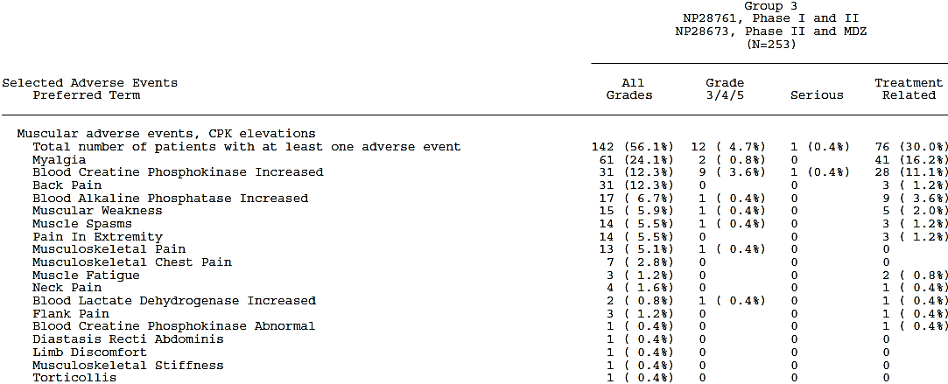

##### Pivotal and/or main efficacy studies

The safety data regarding adverse events in patients taking 600 mg BD of alectinib in both pivotal trials that could relate to rhabdomyolysis is amalgamated in the 90-Day Safety Update Report, and is described above. The rate of adverse event terms in the category ‘Muscular adverse events, CPK elevations’ was reasonably similar between the two pivotal studies (see Table 71) although again a difference is present in the likelihood of an event being assessed as possibly causally related to alectinib.

Table 71: Adverse event terms with incidence at least 10% in the category of muscular adverse events or CPK elevations in both pivotal trials

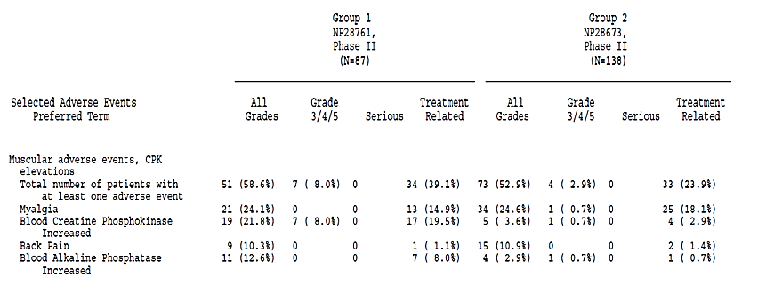

TRAEs of ‘blood CPK increased’ occurred at a rate of 19% in the patients in Phase I of study N28671, not all of whom were taking 600 mg BD alectinib and therefore not all of whom are included in the above table.

##### Other studies

###### Study AF-001JP

There were 16 TEAEs of ‘blood creatine phosphokinase increased’ in Study AF-001JP, none of which were considered serious or led to study discontinuation, though five cases were Grade 3. Causality was ruled out for three of the five Grade 3 cases (the CPK rises were instead attributed to convulsions, myalgia related to walking and an incidental contusion, respectively). There were 12 reports of myalgia in the study in total, none at Grade 3 or higher, and six of the myalgia cases coincided with patients who had a CPK elevation, but a review of adverse event terms in the ‘rhabdomyolysis/myopathy’ SMQ were not suggestive of a signal (see Table 72).

Table 72: Patients who had a CPK elevation of Grade 3 or higher in Study AF-001JP who were taking 300 mg BD alectinib

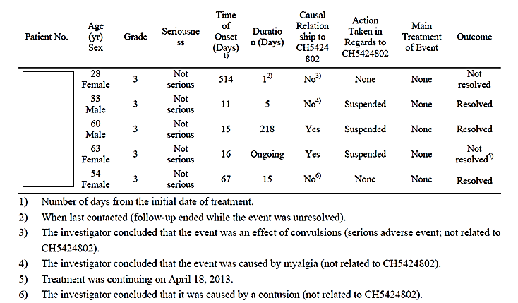

###### Studies with evaluable safety data: dose finding and pharmacology

Subject [information redacted] of Study NP28990 discontinued secondary to a mild CPK elevation that occurred on Day 15 after a second dose of alectinib the day before and 14 days of dosing with posaconazole. Biochemistry testing was included in the laboratory safety tests done on samples taken days 2-4 after the initial alectinib dose and CPK was not noted. The investigator suspected the CPK elevation may have been related to posaconazole.

Two subjects (one each from the 3% SLS and 25% SLS cohorts) in Study 29040 experienced CPK elevations. Both were reported as adverse events, but were mild and resolved. No associated myalgia or muscle weakness was reported.

There was one other report of myalgia, in a subject in Study NP29042. Again the event was mild and resolved without sequelae.

**Comment**: Although all these events were nonserious and the case in Study NP28990 could have been related to posaconazole, equally it could have been related to alectinib. These cases further support the inclusion of a precaution regarding CPK and myalgia, given the early nature of the safety dataset.

#### Oedema

##### Integrated safety analyses

The adverse events in patients taking 600 mg BD of alectinib in both pivotal trials relating to oedema are amalgamated in the 90-Day Safety Update Report (see Table 73). Between the data cut-off for the SCS and the data cut-off for the 90-Day Safety Update Report, there were:

* 5 additional patients reporting peripheral oedema (bringing the total Group 3 incidence to 66 patients: 26%). Two were TRAEs, bringing the rate of peripheral oedema TRAEs to 13%.
* 1 additional patient reporting oedema (bringing the total Group 3 incidence to 11 patients: 4%). One was a TRAE, bringing the rate of oedema TRAEs to 3%.

No events have been reported as serious, but two patients had events Grade 3 or above:

* Oedema peripheral
  + Occurred in a [information redacted] year old White female in Study NP28673 ([information redacted]) on day 15. Not recorded as ‘serious.’ The dose of alectinib was reduced to 300 mg BD due to an SAE of intervertebral discitis, secondary to a previous sepsis due to a catheter-related infection.
* Generalised oedema
  + Occurred in a [information redacted] year old White male ([information redacted]) on day 14 in the setting of hypoalbuminaemia and staphylococcal sepsis (study day 7) secondary to a lung abscess that started from an infected drain site (study day 5). Remained unresolved at time of death (day 51).

Table 73: Adverse event terms related to oedema that occurred in patients taking 600 mg BD alectinib in both pivotal trials

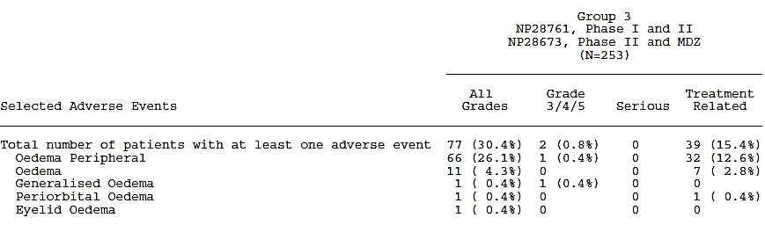

##### Pivotal and/or main efficacy studies

Combined pivotal trial data is described above. The rate of adverse events related to oedema in the pivotal trials is described in Table 74. There was a similar rate of events between the two trials.

Table 74: Adverse event terms related to oedema that occurred in the Phase II arms of each of the pivotal trials 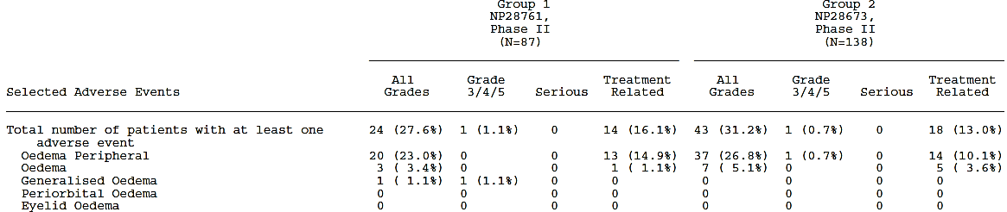

##### Other studies

###### Study AF-001JP

In Study AF-001JP, the following adverse events related to oedema were reported:

* ‘Oedema peripheral’ in two patients (3.4%) and ‘face oedema’ in one patient (1.7%), all non-serious, all grade 1 and none of which led to treatment suspension or discontinuation.
* ‘Brain oedema’ in two patients (1.7%):
  + 1 serious case of Grade 3, which did not resolve with corticosteroids but was not thought to be caused by alectinib. This led to treatment discontinuation.
  + 1 non-serious case of Grade 2, which resolved with corticosteroid treatment and was considered possibly related to alectinib.

#### Headache

##### Integrated safety analyses

Headache was one of the most commonly reported adverse events in the clinical studies. Patients taking 600 mg BD of alectinib in pivotal trials experienced headaches at an incidence rate of 16.6% as at 27 April 2015. Of all of these cases, one was higher than Grade 2: subject [information redacted] (a 49 year old White female) experienced a Grade 3 headache on day 63. No case details regarding this event have been provided other than that it was non-serious, not related to alectinib, that alectinib dose was not changed and that the headache was not recorded to have resolved.

##### Pivotal and/or main efficacy studies

In Study NP28761, 5 occurrences of headache were seen, but none were seen with 600 mg doses. There were four cases in the 900 mg BD cohort and one case in the 460 mg BD cohort. One of the four headaches with 900 mg BD was a Grade 3 headache – this was one of the two adverse events that identified the MTD, but it resolved and did not recur when the patient changed to a 600 mg BD dose.

##### Other studies

###### Study AF-001JP

Headache occurred in a third of patients taking 300 mg BD in Study AF-001JP.

###### Studies with evaluable safety data: dose finding and pharmacology

Headaches suspected to be treatment-related but non-serious were reported in two patients in Study NP28989, two patients in Study NP28991 and three patients in Study NP29040.

### Other safety issues

#### Safety in special populations

There was no clear effect of age, sex or race on the overall safety profile seen in the clinical studies. The frequency of AEs leading to death (8% versus 1%) or study withdrawal (14% versus 4%) was higher in patients 65 years and older than compared to those younger, but the older group were only 14% of the overall study population, and the FDA concluded this was not large enough a sample size to draw any statistically significant conclusions. The majority of patients in the studies were White (74%), with the next largest race being Asian (18%).

Patients with CNS metastases at baseline (135/253 patients in Group 3) had a 10% higher rate of Grade 3 - 5 AEs than those without (33% versus 23%). Patients who had received prior chemotherapy (78% of the 253 patients in Group 3) also had a higher rate of Grade 3 - 5 AEs (31% versus 18%), SAEs (19% versus 7%), and dose reduction or interruption due to AEs (28% versus 18%) or SAEs (10% versus 2%). This may reflect greater morbidity in both of these subgroups and possible carryover effects from prior treatment in the previously treated subgroup.

#### Safety relating to fertility

No clinical data on pregnancy and lactation is available as these groups were excluded from the clinical studies and no accidental exposures of this kind occurred. There is also therefore no data on the presence of alectinib or metabolites in human breastmilk, effects on a breastfed infant or milk production.

No specific fertility non-clinical studies have been performed, but events reported in toxicology studies suggest alectinib may be harmful to a foetus if administered to a pregnant woman: reported events included embryonic and foetal death, abortion, and visceral abnormalities (rat and rabbit).

Rat studies yielded reports of glandular atrophy in the prostate and seminal vesicles at doses corresponding to 2.4 times the estimated human exposure at the recommended dose. Monkey studies yielded reports of interstitial fibrosis of the testis at exposures approximately 0.2 times the estimated human exposure at the recommended dose.

The FDA sought formal advice from the Division of Pediatric and Maternal Health (DPMH) on this issue, and in a memorandum written by [information redacted], recommendations were made that:

* ‘Pregnant women considering use of alectinib should be advised of the potential risk to a fetus and females of reproductive potential should be advised to use effective contraception during treatment with alectinib and for 1 week following the final dose.’
* ‘Based on genotoxicity findings, males with female partners of reproductive potential should be advised to use condoms during treatment with alectinib and for 3 months following the final dose.’
* ‘Breastfeeding is not recommended during treatment with alectinib and for 1 week after the final dose.’

#### Safety related to drug-drug interactions and other interactions

No patterns of adverse events related to drug-drug interactions or timing of food administration relative to dose have been noted in the dossier.

Details of the effect of food on alectinib and active metabolite exposure are discussed in Pharmacokinetics section.

As stated in the SCS:

The controlled high-fat, high-calorie meal content in Studies NP28991 and NP29040 represented worst-case conditions, resulting in maximum food effect on alectinib PK. Non-controlled meal content resulted in a less pronounced but still positive food-effect based on cross-study comparison of alectinib exposure in Studies NP29042, NP28991 and AF-001JP.

In the two pivotal studies, alectinib was given under fed conditions (within half an hour of eating) without controlling for meal type, to maximise bioavailability ‘and GI tolerance’. The variability introduced by this can be expected to mimic real-world dosing conditions, including the associated safety and efficacy profile. As discussed previously, the timing of dosing relative to a meal has been simulated using PBPK modelling and showed minimal impact (20% difference between immediately after a meal or 2 hours later) on steady-state exposure.

The sponsor concludes in the SCS:

Cumulatively, the available data support alectinib administration with food in order to maximize alectinib exposure, without any specified time-window relative to drug intake’

**Comment**: The evaluator agrees with this conclusion.

In vitro studies showed alectinib to be predominantly metabolised by CYP3A4, and its solubility to be better in acidic pH ranges. DDI studies were conducted to investigate the effect of CYP3A4 inhibition/induction and the inhibition of gastric acid secretion on exposure, as measured by composite molar concentration of alectinib plus M4. These studies found the following geometric mean ratios (GMR) of composite molar concentration Cmax and AUCinf:

Table 75: Summary of DDI study findings

| GMR with/without | Cmax (90%CI) | AUCinf (90%CI) |
| --- | --- | --- |
| posaconazole  *(prototypic strong CYP3A4 inhibitor)* | 0.93 (0.81 – 1.08) | 1.36 (1.24 – 1.49) |
| rifampin  *(prototypic strong CYP3A4 inducer)* | 0.96 (0.88 – 1.05) | 0.82 (0.74 – 0.90) |
| esomeprazole  *(proton pump inhibitor)* | 1.13 (1.00 – 1.28) | 1.17 (1.04 – 1.31) |

As these changes are not of clinical significance, no dose adjustments are required when alectinib is co-administered with CYP3A inhibitors, CYP3A inducers or PPIs and other drugs that raise gastric pH such as H2 receptor antagonists or antacids.

In vitro studies also investigated the potential for alectinib and its major metabolite to affect the PK of other medicines.

Alectinib and major metabolite M4 showed the following properties:

Table 76: Summary of in vitro data regarding effect of alectinib and M4 on CYP isoforms

| **In vitro findings suggest** | **Alectinib** | **metabolite M4** |
| --- | --- | --- |
| does not inhibit at clinically relevant concentrations | CYP1A2, CYP2B6, CYP2C9, CYP2C19, CYP2D6, OATP1B1, OAT1, OAT2, OCT2 | CYP1A2, CYP2B6, CYP2C9, CYP2C19, CYP2D6, CYP2C8, OATP1B1, OAT1, OAT2, OCT2 |
| non-specified inhibtion | MDR1, BCRP, P-gp, BSEP | MDR1, BCRP, P-gp |
| weak time dependent inhibition | CYP3A4 | CYP3A4 |
| competitive inhibition | CYP2C8 | - |
| weak induction | CYP3A4 and CYP2B6 | - |

To further elucidate the in vitro findings, a clinical study using midazolam was carried out, and showed that midazolam exposure with/without multiple doses of alectinib didn’t change significantly (GMRs Cmax 0.92 [90% CI: 0.65 – 1.31] and AUCinf 0.97 [90% CI: 0.72, 1.32]). Therefore, no dose adjustment is needed for concomitant medications that are CYP3A substrates.

PBPK modelling supports that no interaction with CYP2C8 substrates is expected either.

The SCS states:

In vitro, alectinib and M4 are inhibitors of the efflux transporters P-gp and BCRP (breast cancer resistance protein). Therefore, alectinib may have the potential to increase plasma concentrations of co-administered substrates of P-gp or BCRP transporters. The increase in exposure is not expected to be more than 2-fold. When alectinib is co-administered with P-gp or BCRP substrates with narrow therapeutic index (e.g., digoxin, dabigatran, methotrexate) appropriate monitoring is recommended.

This conclusion is supported by the data in the sponsor’s summary of clinical pharmacology.

**Comment**: Again it is noted that M4, but not alectinib, has been shown in vitro to be a substrate of P-gp. See Clinical Question 1.

#### Safety related to overdose, abuse, dependence, rebound and impairment

There is no specific antidote for alectinib, nor would haemodialysis be predicted to be effective in case of overdose as alectinib is predominantly protein-bound in plasma. No cases of overdose relative to the recommended dose have been reported, other than the two cases of dose-limiting toxicities that were considered to identify the RP2D in Study NP28761, and both of these involved events that resolved upon dose reduction (see Dosage selection section above). Doses higher than recommended in AF-001JP were not as high as the proposed dose for marketing.

No specific data regarding abuse potential, rebound phenomena, driving safety or dependence is available, however the adverse event profile is not suggestive of such issues and the pharmacology of alectinib does not predict such problems.

Off-label use in patients with other ALK positive tumours may occur, but specific safety concerns due to such use are not anticipated.

### Post marketing experience

Alectinib at the recommended dose has only been registered in the US since December 2015, so the available post-market safety data is limited. Alectinib has been registered in Japan since mid-2014, but at half the proposed dosage for registration in Australia, and for a different indication: for the treatment of ‘ALK fusion gene-positive unresectable, recurrent or advanced non-small cell lung cancer’. The post-market section in the 90 Day Safety Update Report states that

…as of 3 January 2015, no regulatory actions were undertaken for safety reasons by the regulatory authorities or the Marketing Authorization Holder in Japan (Chugai Pharmaceuticals Co Ltd for alectinib 300 mg BID). A review of the post-marketing data did not reveal any new, pertinent safety information for alectinib.

…As of 3 January 2015, an estimated 634 patients have received 300 mg BID alectinib in the post-marketing setting in Japan.

The serious post-marketing case list from Japan includes -

* 3 patients with gastrointestinal perforations:
  + ‘gastrointestinal perforation’ and ‘sepsis’ [fatal] in patient [information redacted]
  + ‘rectal perforation’, ‘constipation’ and ‘haemorrhagic shock’ in patient [information redacted])
  + ‘intestinal perforation’, ‘ileus of intestine’ and ‘constipation’ in patient [information redacted]
* 2 patients with ileus, including the patient with perforation and constipation, above
* 14 cases of interstitial lung disease:
  + ‘Drug-induced Pneumonia’ in patient [information redacted]
  + Eleven cases of ‘Interstitial Pneumonia (Interstitial Lung Disease)’ in patients [information redacted] [n=11]
  + ‘Drug-Induced Interstitial Pneumonia (Interstitial Lung Disease) in patient [information redacted]
  + ‘Idiopathic Interstitial Pneumonia’ (Interstitial Lung Disease)’ in patient [information redacted]
* A case of myalgia in conjunction with increased blood CPK 5 days post commencing alectinib (patient [information redacted])
* A case of erythema multiforme 38 days post commencing alectinib (patient [information redacted]), in a setting of multiple concurrent medications: zetia, lansoprazole, lac-b, tsumura goshajinkigan, trazenta, glimepiride, novorapid, lantus, risperidone, desyrel, decadron, glycereb loxoprofen and ipragliflozin.

**Comment**: Interstitial lung disease is reported in the post-market setting in Japan at a rate of 2.2% according to these data. Cases of intestinal perforation are also of interest/concern. Of note, the Australian PI for crizotinib contains a precaution regarding gastrointestinal perforation. See comments at end of section.

The FDA Medical review of alectinib for registration states:

The most recent Development Safety Update Report (DSUR) for alectinib, covering the reporting interval from 4 Jun 2014 to 3 Jun 2015, states that post-marketing data that became available from Japan during the reporting interval did not reveal any new, pertinent safety information. During the reporting interval, no safety-related amendments were made to the Japanese label for alectinib or to Chugai’s risk management plan for alectinib based on the post-marketing data.

To complement the study data and generate safety-related hypotheses to compare to the known safety issues with alectinib, a search of the WHO global individual case safety report (ICSR) database, VigiBase[36] was conducted on July 5, 2016. Although the WHO Uppsala Monitoring Centre (UMC) has provided the data, it is important to note that the information extracted from the database and the results and conclusions drawn in this document, do not represent the opinion of the World Health Organization the Uppsala Monitoring Centre or National Centres but are those of the author.

The drugs recorded on the reports have been coded according to the WHO Drug Dictionary Enhanced, and MedDRA adverse reaction terminology version 19.0, in keeping with the dictionary used in the dossier by the sponsor (though the sponsor used earlier MedDRA versions 16.1 to 18.0, depending on the most recent version available at the time of study data collection). A variety of sources contribute information to the reports in VigiBase, and it should be noted that the likelihood of a suspect event being drug-related is also variable.

The search extract of VigiBase [from entry commencement in November 2000] to July 2016 contained 140 unique ICSRs: 4 from the Americas, 102 from Asia (primarily Japan) and 34 from Europe, all with initial database entry dates between April 2014 and April 2016. Males and females accounted for 49.3% of the reports respectively, with 1.4% of reports not having recorded sex. Patient age was in keeping with an ALK+ NSCLC population (see Figure 12). The MedDRA system organ class (SOC) distribution of reports in the Vigibase extract is illustrated in Figure 13.

Figure 12: Age distribution of reports in a VigiBase extract of 140 reports pertaining to alectinib.

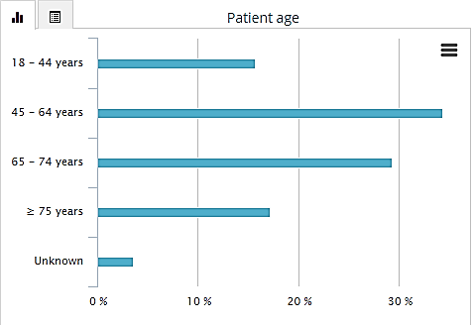

Figure 13: MedDRA SOC distribution of reports in a VigiBase extract of 140 reports pertaining to alectinib.

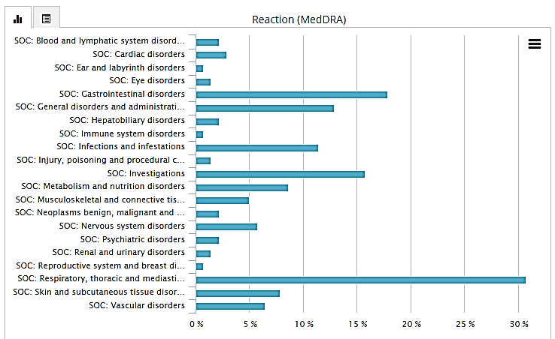

A measure called the IC (information component) was developed by the UMC as a measure of disproportionality, calculated as follows:

IC = log2 ((Nobserved + 0.5)/(Nexpected + 0.5))

where Nexpected = (Ndrug * Nreaction) / Ntotal

* Nexpected: the number of case reports expected for the drug-reaction combination
* Nobserved: the actual number of case reports for the drug-reaction combination
* Ndrug: the number of case reports for the drug, regardless of reactions
* Nreaction: the number of case reports for the reaction, regardless of drug

The lower 95% credibility interval of the IC is the IC025, and a positive IC025 value is the traditional statistical basis for signal detection at UMC. Table 77 shows the events for which a positive IC025 value was obtained. Generally these event terms reflect the safety data seen in the clinical studies.

Given the limitations of these data extracts, the only signal for which a true association can be really predicted is interstitial lung disease. However, the presence of a rhabdomyolysis case recorded to have a positive dechallenge and rechallenge is noted. This case (DE-BFARM-15247580) occurred in June 2015 and involved a 53 year old male patient in Germany. It was reported by a physician and entered into the database in October 2015, with a recorded positive dechallenge, followed by a positive rechallenge. The case details are not available on the VigiBase website.

**Comment**: Given the post-market data available in the safety update report and in Vigibase, the sponsor is requested to provide an updated post-market incidence estimate for ILD with alectinib use, case analyses for all reported cases of intestinal perforation and a safety signal analysis for rhabdomyolysis? See Clinical question 12. The reactions identified from the VigiBase extract that had a positive IC025 value.

Table 77: Reactions from the VigiBase extract that had a positive IC025 value

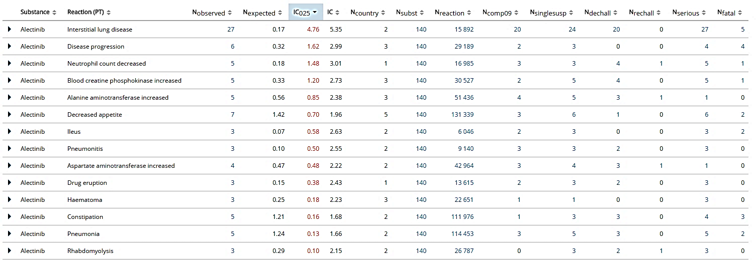

### Evaluator’s overall conclusions on clinical safety

The safety profile of alectinib has not been studied in a Phase III trial but instead relies on data from two pivotal Phase I/II trials, as has become increasingly common in oncology drug development.[37] The total number of subjects from the target population exposed to alectinib at the recommended dose (600 mg BD) is 253 patients, of whom just over half had CNS metastases at baseline and 100 have been exposed to alectinib for over a year. The median duration of exposure across all 253 subjects as at 27 April 2015 is 40.6 weeks, with a median total cumulative dose of 333600 mg (see Patient exposure section). Although the safety database is limited in size, the study population is a fair representation of the intended population (albeit the least unwell few percent that meet enrolment criteria). The safety evaluation of this product is therefore limited, but given the lack of alternative therapies for this life-threatening disease, is acceptable for the purposes of this evaluation.

The safety profile of alectinib overall, based on this evaluation, is reasonable. No particular risk factors were noted for adverse events, the most common of which were fatigue, oedema, constipation and myalgia (see Adverse events section).

The adverse reactions that have been identified for alectinib based on the assessment of data from clinical trials, non-clinical data, mechanism of action, and causal relationship are summarised in First round benefit risk assessment below and include gastrointestinal toxicity (constipation, nausea, diarrhoea and vomiting), oedema, myalgia and CPK elevation, rash, photosensitivity, hepatotoxicity (indicated by elevation of AST, ALT and bilirubin), anaemia, bradycardia and interstitial lung disease. The incidence of all of these reactions has shown small proportional increases between the data cut-off dates for the SCS and the 90-Day Safety Update Report (see Adverse events section).

Of patients taking the recommended dose of 600 mg BD in the pivotal studies, 5.9% permanently discontinued due to adverse events, and the majority of these that were not fatalities were related to signs of hepatotoxicity on investigations (see Adverse events section).

There have been seven deaths (2.8%) that were not due to disease progression. Within these cases, there is no clear pattern of risk, although the two deaths that were considered by the investigator to be possibly related to alectinib were a case of intestinal perforation and a case of haemorrhage, presumed intraabdominal. The presence of an additional fatal case and two other cases of gastrointestinal perforation in the post-market data from Japan, as well as the high incidence of constipation as an adverse event, suggests that this is a signal which warrants further attention (see Clinical Question 2). One death is not properly explained as no detail of the death has been provided, although what is available suggests death due to disease progression (see Adverse events section).

Safety issues of potential regulatory importance which should receive specific attention in the Precautions section of the PI include hepatotoxicity, interstitial lung disease, bradycardia and myalgia and CPK elevation (see Adverse events section above). Myalgia and CPK have not yet been included in the PI under Precautions, and new text including dose modification advice is provided for this purpose.

Given the incidence of photosensitivity despite participants being advised to protect themselves from UV exposure in the clinical studies and the nonclinical evidence for phototoxicity, this should also be included as a precaution.

Regarding use in pregnancy: pregnancy and breastfeeding should be avoided during treatment with alectinib and for 1 week following the final dose. Pregnant women considering use of alectinib should be advised of the potential foetal risk and males with female partners of reproductive potential should be advised to use highly effective contraception during treatment with alectinib and for 3 months following the final dose.

As discussed in Other safety issues section above, there are no particular intrinsic or extrinsic risk factors that have been identified for dosing. Variability in exposure with dose time relative to food and body weight is not expected to affect exposure to a significant extent, and dose modification or specific timing advice is not indicated. There are no specific safety concerns related to overdose/ abuse/withdrawal, off label use or impairment of mental ability/ability to drive or off-label use.

There is not currently long-term safety data available. The sponsor states in the clinical overview that enrolment in the Phase I/II trials is complete and follow up is ongoing. Ongoing safety data will also be available from the two ongoing Phase III trials comparing alectinib head to head with crizotinib. One of these, the Japanese ‘J-ALEX’ trial was recommended for early cessation as its endpoints had been met early. The other, the ‘ALEX’ study, was initiated in July 2014, recruiting globally except in Japan, and will compare alectinib 600 mg BID versus crizotinib in treatment-naive ALK+ advanced or metastatic NSCLC patients.

Long-term safety issues are therefore currently unknown, and short-term safety issues are those listed above. Most adverse events have shown reversibility; including bradycardia and elevation of hepatic transaminases. The exception to this rule is ILD, which has not been documented to have been reversible in case [information redacted] (see Evaluation of issues with potential regulatory impact above) but has been reported to show positive dechallenge in 20 of the 27 cases lodged in VigiBase (see Postmarketing section). See Clinical question 12.

Post-marketing experience remains limited, but existing post-marketing data is generally in agreement with the clinical trial data. A single case of rhabdomyolysis with a positive rechallenge has been reported in Germany. See Clinical Question 12.

The safety assessment program is suboptimal in terms of population exposure but is sufficient to support registration, given the treatment of unmet need, preclinical data and global experience with other ALK inhibitors: crizotinib and more recently, ceritinib.

## First round benefit-risk assessment

### First round assessment of benefits

| **Indication** | |
| --- | --- |
| **Benefits** | **Strengths and Uncertainties** |
| Alectinib has shown efficacy in treating patients with ALK+ NSCLC who have progressed on or were intolerant to crizotinib therapy. The primary outcome of efficacy, ORR, is an accepted clinical trial surrogate endpoint for accelerated approval of NSCLC medicines according to FDA guidance[38] as long as the treatment effect size is large and responses durable, because this is then reasonably likely to predict clinical benefit. The same guidance states that in conjunction with proven improvements in tumour related symptoms, ORR can support regular registration in the US. The treatment effect size has been demonstrated to be reasonably large for alectinib in this population with otherwise limited treatment options – see below – and the durability of the effect is supported by the preliminary PFS results, although OS is yet to be demonstrated. | These efficacy rates are based on updated January 2015 data (see Efficacy, Pivotal studies).  Evidence supporting efficacy is present but limited, being available from only two Phase I/II studies and a supporting study in crizotinib-naïve patients. More mature data, including that from the Phase III studies (currently underway) would be required before the efficacy could be directly compared to current earlier-line therapies.  Time-to-event outcomes, particularly overall survival, are immature. If Phase III studies indicate that there is no overall survival benefit and direct clinical benefit cannot be demonstrated (as opposed to surrogate markers), then a reconsideration of the risk-benefit balance of treatment with alectinib would need to be undertaken. |
| In a Phase I/II study (NP28673) of 138 such patients:   * Partial responses were seen in 61 patients, giving an objective response rate (ORR) of 44% (95% CI: 36% - 53%) in the IRC RE population. * The ORR in a subset of patients pre-treated with chemotherapy was 39% (95% CI: 30% - 49%) in the IRC RE population. * The ORR in CNS disease that was measurable at baseline (CORR) (n=35)[39] was 57% (95% CI: 39% - 74%). * In the investigator RE population, the ORR was higher than in the IRC RE population: 49.2% (95% CI 40.0% - 58.4%) * The investigator-assessed ORR in the IRC RE population at cut-off date Jan 8 2015 was consistent with the above: 50.0% (95% CI 40.8% - 59.1%), with estimates of PFS (median 8.9 months) and DOR (median 11.2 months) available. | * 16 (12%) of the 138 patients did not have measurable disease at baseline according to independent review committee (IRC), and were not included in their response-evaluable (RE) population. The decision not to include these patients was not pre-specified in the SAP which suggested that inclusion in the RE would be determined by baseline measurability as determined by the investigator (none of the 138 patients were said to have unmeasurable baseline disease by their determination). * RE population inclusion by determination of baseline did not match who was measuring the final outcome for the investigator-assessed ORR (see Clinical Question 8). * Consistency was seen between endpoints. |
| In a second Phase I/II study (NP28761) of 87 such patients:   * Partial responses were seen in 33 patients, giving an objective response rate (ORR) of 38% (95% CI: 28% - 49%). * The ORR in CNS disease that was measurable at baseline (CORR) (n=16) was 69% (95% CI: 41% - 89%). * In the IRC RE population, the ORR was higher than in the investigator RE population: 47.8% (95% CI 35.6%-60.2%) * The investigator-assessed ORR in the IRC RE population was consistent with the above: 46.0% (95% CI 35.2% - 57.0%) | * 18 (21%) of the 87 patients did not have measurable disease at baseline according to independent review committee (IRC), and were not included in their response-evaluable (RE) population. The decision not to include these patients was not pre-specified in the SAP as above. * RE population inclusion by determination of baseline did not match who was measuring the final outcome for the investigator-assessed ORR (see Clinical question 8). * Consistency was seen between endpoints. |
| Fifty one CNS patients with baseline measurable lesion in both of the pivotal studies combined had CORR of 61% (95% CI: 46%, 74%), consisting of 9 (18%) CRs and 22 (43%) PRs.  In the total population (n=135) of patients with CNS lesions at baseline according to IRC (whether measurable or not) the CORR was lower, at 38.5% (95% CI 30.3% - 47.3%). This is because if a CNS lesion wasn’t measurable at baseline, it would have to achieve a CR to be counted towards the ORR (as per RECIST criteria).  There were 29 CRs seen in CNS lesions (both measurable and unmeasurable), a rate of 21.5%.  Median CDOR was 10.3 months (95% CI: 7.6, 11.2 months) for all patients with CNS metastases and 9.1 months (95% CI: 5.8 months, upper bound not estimable) for patients with measurable CNS lesions. | * Data regarding CNS efficacy was pooled from both studies due to small sample size. There were differences in schedules of assessment between the pivotal studies that limit interpretability (see section Analyses performed across trials: pooled and meta-analyses * Patients in whom a CNS response was demonstrated included both patients with measurable and/or not measurable CNS lesions at baseline, and patients with no prior CNS radiation. * FDA exploratory statistical analysis found that ‘CNS responses were observed in both patients who had and had not received prior CNS radiation, and CNS duration of response was similar across these subgroups’. * There were a number of major protocol violations that may have affected results (see Clinical Question 9). |
| Study AF-001JP supports the results of the pivotal studies in that it showed alectinib to have efficacy in ALK positive NSCLC, of whom the target population for the purposes of registration in Australia are a subset. | * The response rates seen in AF-001JP were much higher but this trial was carried out in crizotinib-naïve patients. Data from a Phase III trial directly comparing crizotinib to alectinib in the ALK positive NSCLC population should be available in the future as the trial is underway (J-ALEX trial). |

### First round assessment of risks

| **Risks** | **Strengths and Uncertainties** |
| --- | --- |
| The most common adverse events seen with alectinib use at the recommended dose were constipation (32%), fatigue (26%), peripheral edema (24%), and myalgia (21%). SAEs were observed in 16% of patients. The most common Grade 3 or 4 AEs were blood CPK increased (3%), dyspnea (3%), ALT increased (3%), and AST increased (2%). Rates of AEs leading to study drug withdrawal, interruption and dose reduction were 5%, 23% and 10% respectively.  Treatment-emergent adverse events occurring very commonly (≥ 10%) at any grade or ≥ 2% (Grade 3-4) of patients treated with alectinib in the pivotal studies were as follows:   | Adverse events (MedDRA) | Alecensa (N=253) | | | --- | --- | --- | | System Organ Class | All Grades (%) | Grade 3-5* (%) | | Fatigue a | 43 | 1.2 | | Constipation | 34 | 0 | | Oedema b | 32 | 0.8 | | Myalgia c | 29 | 1.2 | | Cough | 19 | 0 | | Rash d | 18 | 0.4 | | Nausea | 18 | 0 | | Headache | 17 | 0.8 | | Diarrhoea | 16 | 1.2 | | Dyspnoea | 16 | 3.6 | | Vomiting | 12 | 0.4 | | Back pain | 12 | 0 | | Increased weight | 11 | 0.4 | | Vision disorder f | 10 | 0 |   *Per Common Terminology Criteria for Adverse Events (CTCAE) version 4.0. a Includes fatigue and asthenia. bIncludes peripheral edema, edema, generalised edema, eyelid edema, and periorbital edema. cIncludes myalgia and musculoskeletal pain. dIncludes rash, maculopapular rash, acneiform dermatitis, erythema, generalized rash, papular rash, pruritic rash, and macular rash. fIncludes blurred vision, vitreous floaters, visual impairment, reduced visual acuity, asthenopia, and diplopia.  Safety issues with alectinib appear to be:   * Gastrointestinal toxicity (constipation , nausea, diarrhoea and vomiting) with possible gastrointestinal perforation [0.4%] (see Clinical Question 12) * Interstitial lung disease [0.4% in trials, 2.2% in postmarket] (possibly irreversible; see Clinical Question 12) * Hepatotoxicity (indicated by elevation of AST, ALT and bilirubin) [Grade 3 ALT rises in 4.8%, and AST in 3.6%] * Myalgia and CPK elevation [4.6% Grade 3+], possibly rhabdomyolysis (postmarket report; Clinical Question 12) * Bradycardia – nonserious [7.5%] * Peripheral oedema * Photosensitivity [9.9%] and rash * Embryofetal harm   Other treatment-emergent events that should be listed in the PI as there is no control data to inform whether these can be attributed to alectinib use are:   * Anaemia, leukopenia, lymphopenia * Elevation of blood creatinine, alkaline phosphatase and glucose * Low blood sodium, potassium, phosphate and calcium * Fatigue, headache * Cough, dyspnoea * Weight increase * Back pain * Vision disorder | The current safety profile of alectinib is defined by a group of 253 subjects from the target population exposed to alectinib at the recommended dose (600 mg BD), of whom just over half had CNS metastases at baseline. One hundred subjects have been exposed to alectinib for a year or longer. The median duration of exposure across all 253 subjects as at 27 April 2015 is 40.6 weeks, with a median total cumulative dose of 333600 mg. External validity of the data is good as the study population are reasonably representative of the intended target population and likely treatment settings – that is, under oncology specialist supervision.  Current data is limited by both sample size and lack of control arm for comparison. Duration of exposure is comparable to durations in the crizotinib PI [23 and 43 weeks for two different trials] and ceritinib PI [33 weeks].  There is also no data for patients with severe renal impairment, although this is not a concern given the negligible renal clearance. There is no data in moderate to severe hepatic impairment, which is of probable concern given the observed risk of hepatotoxicity.  Further safety information will need to be gathered during ongoing Phase III studies to improve safety knowledge. The submission of Phase III data helping to clarify the safety/efficacy profile of alectinib subsequently should be made a condition of registration.  Due to the limited safety dataset, postmarket safety monitoring is of elevated importance.  Existing therapies provide some insight into expected safety profile with ALK inhibitors however; targeted therapies can be unpredictable in their off-target effects.  Off-label use may be expected to possibly occur in patients with other cancers who have ALK+ tumours, but no specific safety risk is expected.  Generally the safety profile appears more tolerable than ceritinib and comparable to crizotinib, however this is limited by the size of the dataset. |
| No dose-response relationship was seen with any adverse events on popPK analysis. The adverse events that occurred in clinical trials are generally able to be monitored for, and have generally been manageable by dose reductions as described in the PI. The consequence of discontinuation of treatment is essentially the same as the risk of not treating – the options for therapy after this are limited to conventional chemotherapy (with a lower response rate), palliative radiotherapy and supportive therapies.  The adverse event profile of alectinib is generally comparable to the other two ALK-targeted therapies, crizotinib and ceritinib, particularly with regard to ILD (incidences of 2% and 3.2% respectively) and hepatotoxicity (Grade 3 ALT elevation incidences of 11% and 25% respectively). Two cases of DILI [0.4%] were seen in ceritinib trials.  Exceptions include:   * Ceritinib has significantly more severe and frequent gastrointestinal toxicity (Grade 3-4 diarrhoea, nausea and vomiting occurred in 5.3%, 5.3% and 4.6% of patients, respectively). It also caused hyperglycaemia that required dose reduction and showed pancreatic toxicity, and Grade 3 hepatic transaminase increase was much more common. * Ceritinib and crizotinib both cause QT interval prolongation where alectinib does not * Ceritinib and crizotinib are both P-gp substrates and unlikely to persist in the CNS * There have been fatal cases of ILD with ceritinib * There have been fatal cases of hepatotoxicity with crizotinib * Myalgia and CPK elevation are not described in the PI for ceritinib or crizotinib. |
| Of all the deaths not due to disease progression, two were considered by the investigator to be related to alectinib: one event of haemorrhage (presumed retroperitoneal) and one of intestinal perforation. Although these do not present a clear signal, gastrointestinal perforation and bleeding should be considered an important potential risk.  A second case of fatal gastrointestinal perforation in addition to two other non-fatal cases, have been reported in the post-market in Japan. These require further attention (see Clinical Question 12) |

### First round assessment of benefit-risk balance

ALK+ locally advanced or metastatic NSCLC is a life-threatening condition associated with poor survival. The current first-line therapy for this population is a targeted ALK inhibitor, crizotinib. The target population for this submission are patients for whom crizotinib is not/no longer effective or not tolerated.

A second ALK inhibitor, ceritinib, was recently approved for treatment of this same target population, on the basis of an ORR of 44% with median DOR of 7.4 months. Ceritinib is not currently supplied in Australia, however, and has an inferior safety profile to crizotinib (with dose reductions and permanent discontinuations due to adverse events occurring in around 60% and 10% of patients, respectively). Australian patients who have progressed on or are intolerant to crizotinib therefore have only one remaining treatment option: second line chemotherapy, in conjunction with supportive therapy and palliative radiotherapy.

Platinum-based chemotherapy has demonstrated ORRs of 15%-32% in unselected NSCLC[40] and 45% in ALK+ NSCLC[41] when used first-line. Second-line chemotherapy (pemetrexed or docetaxel) in patients who have already received platinum-based chemotherapy demonstrated an ORR of 20%.[42] These therapies are also associated with the usual toxicities associated with chemotherapy.

Therefore there remains an unmet need in Australia for medical treatment for patients with metastatic ALK+ NSCLC who have progressed on crizotinib.

In two early phase, single-arm trials conducted in a total of 253 patients with metastatic or locally advanced ALK+ NSCLC who had progressed on or were intolerant to crizotinib, alectinib therapy at a dose of 600 mg BD (taken after meals) led to a response in over a third of patients (44% in one trial and 38% in the other). The confidence intervals around these findings indicated that the rate of response in this population to alectinib therapy is likely to be higher than the response rate seen with second-line chemotherapy, and in keeping with the response rate seen with ceritinib. Alectinib therefore could provide another treatment option in this population with a different safety profile to existing therapies (regardless of the availability of ceritinib).

The safety profile of alectinib is somewhat similar to crizotinib, with the principle features being interstitial lung disease, mild hepatotoxicity with rare events of DILI, gastrointestinal toxicity (mainly constipation but possibly rarely intestinal perforation), embryofetal toxicity (pregnancy Category X), mild, reversible bradycardia and low red and white cell counts. Unlike crizotinib and ceritinib, the potential for drug-drug interactions is likely to be very low, and no QT prolongation was seen. Unique to alectinib are clinical photosensitivity and frequent elevations of CPK and/or myalgia, although no cases consistent with rhabdomyolysis have been seen in trials. A post-market case has been reported which requires further investigation (see section Clinical Questions).

In addition to the differing safety profile, alectinib is different to crizotinib and ceritinib in that it is not a substrate of CNS efflux transporters P-gp. As noted previously, metastasis to the CNS has been reported to be the primary site of initial treatment failure in 46% of patients with ALK+ NSCLC treated with crizotinib. Pooled data from the two pivotal trials demonstrated an ORR of 61% in patients who had a baseline measurable disease, and 41% in all patients with any CNS lesions.

The response rates seen in the two submitted alectinib trials, in conjunction with early data on PFS, are surrogate markers that are likely to be correlated with clinical benefit in this population. However, whether overall survival or clinical outcomes are improved is yet to be demonstrated. Further uncertainty is introduced by the small population treated in the submitted pivotal trials, as well as a number of questions raised throughout the dossier, which are listed in Clinical Questions section and must be addressed before registration can be recommended. Additional data on safety and efficacy is expected to be available in the near future as the data in the two pivotal studies matures, and as ongoing Phase III trials of alectinib in both crizotinib-naïve (J-ALEX) and crizotinib pre-treated (ALEX) studies continue to progress.

The submitted data does not suggest that the benefit-risk balance of alectinib should be expected to be different in any particular subset of patients within the target population, although no evidence is available in patients with moderate to severe hepatic impairment.

The unmet need for treatment in this population of patients is indisputable as the alternatives are limited by loss or lack of efficacy, toxicity and inaccessibility, and the condition is life-threatening. The efficacy and safety of alectinib has been demonstrated by the sponsor sufficiently for registration to be supported, however, confirmatory data from Phase III trials, a note to the indication, addressing of outstanding clinical questions and modification of the proposed PI, CMI and RMP should all be conditions of registration.

The benefit-risk balance of alectinib, for the proposed usage, is favourable providing the conditions recommended below are adopted.

## First round recommendation regarding authorisation

Approval of Alecensa (alectinib) is recommended *for the treatment of patients with anaplastic lymphoma kinase (ALK)-positive, locally advanced or metastatic non-small cell lung cancer (NSCLC) who have progressed on or are intolerant to crizotinib*, subject to:

* Satisfactory responses to the clinical questions in this evaluation report.
* Modification of the PI and CMI, to ensure that it meets the requirements specified in the pre-submission meeting, that is, that ‘*the limitation of the data set is expected to be clearly made transparent to physicians and public*.’
* Particularly, inclusion of a note to the indication regarding the surrogate nature of the efficacy data, and a requirement that this note to the indication must accompany the indication in all reproductions and publications of any kind, including marketing.
* Further modifications of the PI and CMI if required based on the responses to clinical questions.
* Subsequent submission to the TGA of data from Phase III trials to confirm overall survival benefit and clinically meaningful benefit, with recognition that failure to show overall survival benefit or clinically meaningful benefit to patients would necessitate reconsideration of the overall benefit-risk balance of the product.
* Subsequent submission to the TGA of the findings of studies addressing the uncertain risk-benefit balance in patients with moderate to severe hepatic impairment.

## Clinical questions

### Pharmacokinetics/Pharmacodynamics

1. ***Regarding effect of dosing proximity to feeding on GI tolerance***

It is not clear on what data the sponsor refers to when they state that dosing under fed conditions was chosen both to increase bioavailability and increase GI tolerance. Can the sponsor please clarify the basis of this? Were there higher rates of gastrointestinal adverse events with fasted than fed dosing? See section ‘Influence of food’.

1. ***What is the significance of M4 being a substrate of P-gp?***

As noted, major metabolite M4, but not alectinib, was shown to be a substrate of the CNS efflux transporter P-gp.

Multiple outcomes – particularly in the PK/DDI studies – discussed alectinib exposure as measured in terms of the total molar concentration of alectinib plus M4, on the basis that they show very similar in vitro potency (see M4 activity testing).

If M4 is expelled from the CNS, then total molar concentration of alectinib plus M4 is not an appropriate measure of exposure for the purposes of CNS exposure. CNS exposure may be just as important as peripheral exposure for a patient who is choosing a therapy on the basis of intracranial lesion control. Additionally, if a person has intracranial disease, a DDI that causes more metabolism of alectinib to M4 could have more relevance than for a person without intracranial disease.

This may partly explain why ‘a Cox proportional hazard analysis confirmed no statistically significant relationship between the combined exposure of alectinib and M4 and PFS following alectinib 600 mg BID’.

Can the sponsor please address whether the total molar concentration of alectinib plus M4 is an appropriate PK endpoint for the purposes of describing CNS exposure and relationship to CNS efficacy? How does this change the interpretation of any findings that rely on the total molar concentration of alectinib (that is, in the setting of CYP3A4 induction)? Does this change the clinical relevance of any other contentions in the dossier?

1. ***Regarding data points that were excluded from NP28673 PK analysis***

As part of Study NP28673, standard non-compartmental PK analyses (NCA) were undertaken on PK data for alectinib and its metabolite M4 (RO5468924) collected from 28 patients who underwent serial/intensive PK sampling. Patients were excluded from the PK analysis if they ‘significantly deviated from the protocol or if data were unavailable or incomplete which may have influenced the PK analysis.’

The table appears to contain 294 rows. Many of the entries are duplicates, but not all (for example: patient number [information redacted] at relative nominal time 2016, in Cycle 4 Day 1.) The body text of the CSR for Study NP28673 states that ‘A list of 147 PK time points (<7%) that were excluded from PK analysis and the reasons for exclusion is provided on page 399’.

Can the sponsor please identify the number 147 came from in the CSR body text if not referring to the total number of rows in this table? Why are some lines duplicated and not others?

Additionally in the CSR there is a statement that ‘Two Asian patients were not included in the summary statistics on Day 21 due to dose deviation.’ There appear to be many instances of dose deviation in this table. Why these two instances of exclusions were specifically singled out in the body of the text? Was it because they occurred in the intensive, rather than the sparse sampling population?

1. ***Regarding data points that were excluded from NP28761 PK analysis***

A number of data points were excluded from PK analysis in Study NP28671. Excluded points are listed in the table and there appear to be entries in this table that have not been discussed in the CSR text. On page 113 of the CSR, it is stated that:

‘The PK parameters of patients who had a dose deviation (reduction or interruption) within 8 days of a PK measurement were excluded from the summary statistics but are reported in the individual listings. Patient numbers and reasons for exclusion are summarized in ‘Table 35’. Six patients were excluded from the summary statistics for Cycle 2 Day 1.’

The table in the CSR only contains the details of the six patients whose data from Cycle 2 Day 1 were excluded, and there is no individual listing appended regarding the data points excluded from analysis and the reason for each (as was done for NP28673). Can the sponsor please provide this information, along with a summary of the incidence of reasons for exclusion?

### Efficacy

1. ***Regarding per protocol steroid use***

In the pivotal trials, small doses of steroid, up to a daily limit of the equivalent of an oral 20 mg prednisone dose were allowed per protocol.

Could the sponsor please comment on whether steroid use could have affected efficacy results, particularly with regard to CNS lesions?

Can the sponsor please provide a sensitivity analysis by stratifying CNS efficacy results by steroid exposure?

Can the sponsor please provide an analysis of the temporal proximity of steroid treatment to tumour measurement events?

1. ***Why is a response rate of 35% considered to be clinically relevant?***

The threshold for a clinically relevant response rate in both the pivotal trials in this application was set at 35%. Sample sizes were then chosen so that the lower bound of a 95% CI would be expected to be above 35%.

The FDA statistical reviewer for alectinib makes the following comments regarding this sample size consideration:

‘1. Without control arm, statistical inference cannot be drawn from this trial.

2. The sample size consideration was amended for hypothesis assumption and threshold to claim clinically relevant response on Protocol V5 dated on March 8, 2013. The original null hypothesis of the best ORR for alectinib was 50% in the protocol V1.

3. On July 22, 2013, FDA agreed on an ORR of 50% with the 95% lower bound of CI of 35%.

4. On September 30, 2014, FDA agreed on SAP for Trials NP28761 and NP28673 that the primary analysis would test the null hypothesis of ORR=35%.’

The reason for selection of this bound is not explicitly stated in the dossier, only that this is ‘considered to be clinically relevant’, and the FDA statistical reviewer’s comments do not make it clear on what basis the agreement was reached that clinical relevance was indicated by a null hypothesis of ORR=35%.

Can the sponsor please clarify the clinical reasoning behind this?

1. ***Regarding plasma samples chosen to match CSF samples***

An exploratory analysis was conducted in Study NP28761 on eight patients who consented to CSF collection, and showed that alectinib is present in the CSF after oral dosing, at concentrations of 0.2%-0.5% of the plasma concentration. For two of the eight patients samples were not actually ‘time matched’ as collection packs weren’t available at the time. Can the sponsor please clarify what this means?

Does this mean that there were two CSF samples for which a concurrent plasma sample was not collected?

If so, how were plasma samples chosen to match the two CSF samples? What were the times of those samples with relation to the CSF sampling time? And if the two samples were excluded from the exploratory analysis, what is the effect on the result?

1. ***Regarding the Response Evaluable population***

The subgroup of patients with baseline disease considered unmeasurable by IRC but not by the investigator is reasonably large. The number of patients excluded from the RE population due to not having measurable disease by RECIST at baseline in studies NP28673 and NP28761 were 16 (12%) and 18 (21%) respectively. Inclusion of these patients in the denominator changes the absolute primary outcomes considerably: decreasing the ORR by 12% and 20%, respectively, compared to the IRC-assessed values cited in the dossier.

For the purposes of registration, PI changes incorporating the correct values have been advised.

It is recognised that there are bound to be reader-dependent differences in opinion over measurable and unmeasurable lesions due to the nature and complexity of the RECIST (and RANO for that matter) criteria. However, for the purposes of investigating why such large discrepancies were seen between the investigator and IRC opinion of whether measurable disease was present at baseline, and whether these patients represent a different subset with regard to efficacy, can the sponsor please provide the following:

* In each instance where baseline disease was thought to be measurable by investigator but this was not in agreement with the IRC:
  + The details of the assessment of the lesions that were chosen by the investigator as a measurable baseline, including their reasons for believing the lesion to be measurable
  + The IRC reasons for determining disease to not be measurable in each corresponding case of assessment
* A summary of why the decisions were discordant
* A subgroup analysis of investigator-determined efficacy outcomes in patients for whom baseline disease was thought by IRC to be not measurable.

1. ***Regarding major protocol violation, per protocol steroid use and CNS efficacy***

There were a number of major protocol violations where doses of steroid higher than allowed or disallowed procedures (radiotherapy or surgery) were reported in Study NP28671 and NP 28673. Can the sponsor please provide the following analysis?

In each case: whether the patient was classed as a responder, whether they had CNS measurable or not measurable disease, whether they were included as responders in the analysis and if so, in which analyses, and whether their response may have been confounded by the prohibited therapy.

In specific reference to pop PK analysis 1064536, in which exposure-efficacy analyses were conducted, it was noted that the sample size was limited (N=46) and that six of these patients (13%) were those with significant protocol violations, including 3 cases of out-of-acceptable range doses of steroid and four cases of surgical procedures.

Can the sponsor please repeat the popPK exposure-efficacy analysis without including the data for patients who had major protocol violations, and comment on how this changes the conclusions drawn from this analysis?

### Safety

1. ***Regarding hepatic adverse events in AF-001JP compared to the pivotal trials***

There appears to be a higher rate of non-serious, Grade 2 or lower hepatic disorder TEAEs (particularly bilirubin elevations) in the AF-001JP study population, compared those in to the two pivotal trials. Can the sponsor please comment on this observation and provide their interpretation?

1. ***Regarding plasma concentration assay differences and linear regression analysis of plasma concentration versus QTcF***

In the ECG report, no effect of alectinib on QTcF was demonstrated. Linear regression analysis of individual baseline QTcF values against time-matched alectinib plasma concentrations was undertaken (n=1928 data points; 221 patients) and showed a slope of 0.0014, indicating no apparent correlation.

Regarding the different assays involved in determining those plasma concentrations, the author of the pooled ECG report states the following:

Although the use of different analytical methods for the analysis of alectinib plasma concentration revealed a mean bias of − 21% for Chugai (Studies AF-001JP and NP28761) versus Quintiles (Study NP28673) data, PK data from the two pivotal studies were pooled since results from the individual studies were sufficiently consistent to explore the overall correlation between QTcF change from baseline and alectinib plasma concentration. These results revealed no apparent exposure-dependent trends in change from baseline in QTcF.

Can the sponsor please clarify why a similar approach was not taken to the one taken in the popPK analysis, essentially applying a scaling factor to alectinib plasma measurements from NP28673 to approximate a correction for the different assays used? On what evidence is the author of the ECG report basing their statement that ‘results from the individual studies were sufficiently consistent to explore the overall correlation between QTcF change from baseline and alectinib plasma concentration’? What was the definition of ‘sufficient’ used?

1. ***Regarding postmarket safety data for ILD, intestinal perforation and rhabdomyolysis***

Postmarket data suggests a higher rate of interstitial lung disease/pneumonitis (ILD) than what has been seen in clinical trials, and elicited safety signals for gastrointestinal perforation and rhabdomyolysis. Of note, gastrointestinal perforation has been seen with crizotinib, and the Australian PI for crizotinib contains a precaution regarding gastrointestinal perforation.

Can the sponsor please provide, incorporating postmarket data:

**12A.** A signal analysis for ILD/pneumonitis, including

* + An updated signal analysis for all cases of CPK elevation and myalgia to date, whether from clinical studies or the postmarket space
  + A post-market incidence estimate for ILD with alectinib use
  + An assessment for the potential for this event to resolve
  + An assessment of whether there is an association between older age and cases of ILD, or whether there are other subgroups that appear to be more susceptible

**12B.** A safety signal analysis for intestinal perforation, including

* + Case analyses for all reported cases of intestinal perforation to date, whether from clinical studies or the postmarket space

**12C.** A safety signal analysis for rhabdomyolysis, including

* + Case analysis for the positive dechallenge-rechallenge case reported in Germany
  + An updated signal analysis for all cases of CPK elevation and myalgia to date, whether from clinical studies or the postmarket space

**12D.** As a result of the findings of these analyses, can the sponsor please identify whether any of the post-market data should be reported in the PI? This may be particularly relevant if there is a higher incidence of cases in the postmarket than would be expected based on the incidence seen in trials.

### PI and CMI

1. ***Regarding inclusion of ‘or locally advanced’ in the indication***

It is unclear whether the efficacy or safety of alectinib should be expected to be any different in a person with Stage IIIB versus Stage IV disease.

Can the sponsor please provide a description of the efficacy and safety seen in the enrolled Stage IIIB patients? It is recognised that the dataset is very limited in size and prevents proper subgroup analysis.

Can the sponsor please provide justification as to why a different efficacy-safety profile should not be expected for Stage IIIB patients as compared to Stage IV patients in terms of the mechanism of action of alectinib and the differences between Stage IIIB and Stage IV patients?

### General

1. ***Regarding the progress of Phase III trials***

When does the sponsor expect that the data from the two Phase III trials (ALEX and J-ALEX) will be reported on?

### Additional expert input

#### Regarding inclusion of ‘locally advanced’ in the indication for use

Expert advice would be valuable as to whether including ‘locally advanced’ in the indication is reasonable, given the following:

* Locally advanced disease refers to AJCC Stage IIIB, that is, those who do not have proven metastatic disease but are not amenable to multimodality curative therapy.
* Stage IIIB was part of the inclusion criteria for the pivotal trials.
* There was one patient in Study NP28761 and two patients in Study NP28673 who were Stage IIIB at study entry. All of the other patients (N=250) were Stage IV.
* Stage IIIB patients are treated the same way as those with Stage IV disease according to the NCCN guidelines.
* The sponsor has been asked to provide additional detail regarding efficacy and safety outcomes in the two patients who were Stage IIIB at study entry.

Specific questions include:

1. Clinical expert question 1

Do Stage IIIB patients and Stage IV patients generally differ in how they respond to treatment options or the safety profile of those options? That is, could alectinib be expected to be a more or less attractive treatment option based on comparison to other treatment options?

1. Clinical expert question 2

Are there any additional treatment options that Stage IIIB patients can be candidates for that Stage IV patients cannot according to current standard of practice that might change whether a person with Stage IIIB disease would be in the same situation of unmet need as a person with Stage IV disease?

1. Clinical expert question 3

Is there any biological reason that cancers in Stage IIIB patients should be expected to respond differently to treatment with an ALK inhibitor than cancers that have reached Stage IV?

#### Regarding the use of steroids in the pivotal trials

In the pivotal trials, small doses of steroid, up to a daily limit of the equivalent of an oral 20 mg prednisone dose were allowed per protocol. One of the major outcomes of the pivotal trials, particularly by comparison to other ALK inhibitors, was that alectinib showed CNS efficacy.

1. Clinical expert question 4

Is it possible that doses of steroid this small would confound findings of partial or complete response according to RECIST criteria?

1. Clinical expert question 5

How large a steroid dose (per day) would you expect to typically have an effect on CNS lesions large enough to be seen as a response according to RECIST criteria?

## Second round evaluation

### Responses to clinical questions (module 5 evaluation)

#### Pharmacokinetics/pharmacodynamics

***Response to Question 1***

The sponsor responds that dosing under fed conditions was chosen in order to increase GI tolerance ‘on the basis of known published information for SLS that suggests GI tolerability is maintained or enhanced under fed conditions.’ The sponsor states:

SLS is a surfactant excipient in the alectinib clinical formulation that enhances the dissolution of alectinib to facilitate oral absorption and is used at an amount of 50% (relative to the active pharmaceutical ingredient). SLS is a GI tract mucosa irritant and may be associated with GI adverse events such as nausea, vomiting, diarrhea and abdominal pain. Notably, the GI tract toxicity as the safety determinant of SLS is not thought to be due to systemic toxicity but rather are a consequence of local irritation to the GI tract. In general, when mixed with diet, higher levels of SLS are tolerated versus gavage administration (HERA 2002).

Reference:   
[HERA] Human & Environmental Risk Assessment on ingredients of European household cleaning products: Alcohol Sulphates, Human Health Risk Assessment [resource on the Internet]. 2002 [cited 2016 Oct 18]. Available from: http://www.heraproject.com/files/3-hh-04-%20hera%20as%20hh%20web %20wd.pdf.

**Evaluator comment**

The sponsor’s response is accepted.

***Response to Question 2***

The sponsor’s response to Clinical Question 2 is that the use of combined M4/alectinib exposure in analyses of CNS exposure-response is reasonable despite M4 being a substrate of CNS efflux transporter P-gp. The sponsor makes the following reasoning for that conclusion:

‘… chemotherapeutic agents that are substrates for efflux by P-gp such as paclitaxel, etoposide, and, vinorelbine have shown to be active in patients with brain metastases and result in durable responses (25%-40% response rates) for patients with brain metastases that are associated with non-small cell lung cancer (NSCLC) when given without radiation across multiple studies (Ushio et al. 1991; Lesser 1996; Franciosi et al. 1999; Postmus and Smit 1999). Likewise, targeted agents that are substrates of P-gp efflux have also shown activity in patients with brain metastases from underlying systemic cancers with the inclusion of dabrafenib, lapatinib, and erlotinib (Gabay et al. 2015).’

The physicochemical properties of M4 are in keeping with blood-brain barrier (BBB) permeability

* 1. Lipophilic
  2. Low molecular weight

The presence of metastatic disease in the CNS can compromise blood-brain barrier integrity

* 1. PET (positron emission tomography) imaging studies using radiolabelled (11C)-lapatinib (a drug which is a substrate of both P-gp and BCRP efflux transporters) showed increased radioactivity in metastases but not in normal brain tissue (with patients without CNS metastases as controls).[43]
  2. Lapatinib has been seen in resected brain metastases.[44]

High affinity for target binding may reduce M4 efflux

Non-clinical data showed ‘a good distribution of all alectinib-associated radioactivity in brain tissue’

Population PK- efficacy analyses support CNS efficacy of M4:

* + 1. ‘no significant exposure relationship between the probability of achieving a response in the CNS and either alectinib exposure alone or the combined exposure of alectinib and M4’

**Evaluator comment**

CNS best overall response versus combined exposure (M4 plus alectinib) was based on limited sample size (n=47) and the assessment of combined exposure would dilute assessment of M4 alone by including alectinib in both denominator and numerator. M4 made up only 15% of the 76% total plasma radioactivity attributable to parent drug plus M4 in the mass balance study. An assessment of CNS best overall response versus M4 exposure alone is not provided in the original popPK report, which would be more likely to show a difference if there was one. To address this question, the sponsor provides two new analyses as follows.

* + 1. ‘no significant exposure-response relationship between the probability of achieving a response for measurable+ non-measurable CNS disease and M4 exposure’ (new figure provided by Sponsor, ‘Figure 1’, reproduced as Figure 14, below).

Figure 14: ‘Figure 1’ from the sponsor’s end-of-first-round response to clinical question 2. Evaluation of the relationship between the probability of response for measureable + non-measureable CNS disease and M4 exposure

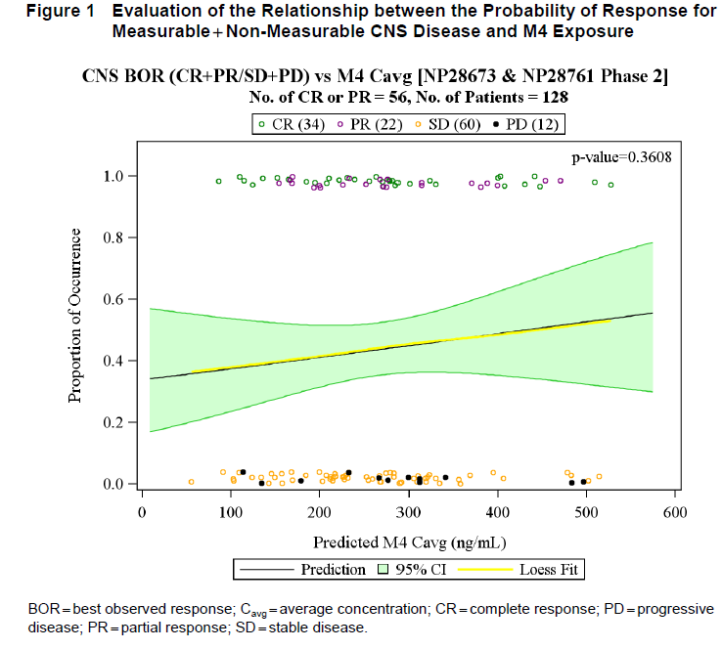

* + 1. ‘no significant relationship between CNS efficacy and M4 metabolite/parent ratio where for > 9-fold range of M4 contribution to overall alectinib exposure, there was no relationship to CNS response’ (new figure provided by Sponsor, ‘Figure 2’, reproduced as Figure 15).

Figure 15: ‘Figure 2’ from the sponsor’s end-of-first-round response to clinical question 2 Evaluation of the relationship between the probability of response for measureable + non-measureable CNS disease and M4 M/P ration at steady-state

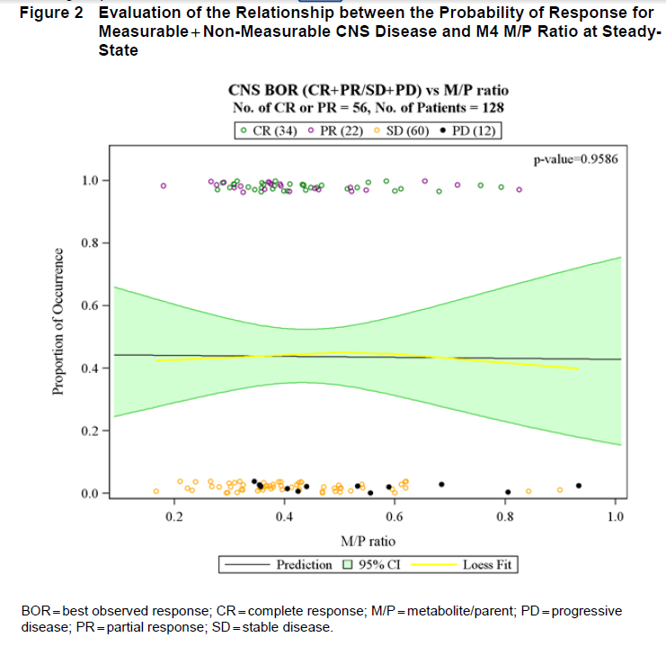

To further assess the possible effect of increased M4: alectinib ratio, the sponsor conducted an additional (non-exhaustive) review of retrospective claims data (using the MarketScan Commercial Claims database and the MarketScan Medicare Supplemental and Coordination of Benefits database) and of the two pivotal trials of this submission. They report that

…available epidemiological data of patients with ALK+ NSCLC show that in the 180 days after a lung cancer diagnosis frequently prescribed CYP3A inducers (that is,, the rate of rifampin [rifampicin], rifabutin, carbamazepine, or phenytoin use) did not exceed 1.10% (95% CI: 0.30, 3.92%)

…Upon examination of the two pivotal Phase II studies (Studies NP28761 and NP28673), 16 of 128 patients with measurable or non-measurable CNS disease were identified to take a CYP3A inducer at any point during the study. Importantly, most patients (12 of 16 patients) derived a clinical benefit with alectinib treatment and experienced a stable disease or a response in the CNS, which supports a favourable disease control rate for CNS efficacy with alectinib treatment even in patients who take CYP3A inducers.

**Evaluator comment**

Potent CYP3A4 induction with rifampin led to about a 50 to 75% reduction in alectinib exposure and approximately doubling of M4 exposure. The number of patients who were identified in the two pivotal studies to have taken a CYP3A4 inducer at any point was very small, in keeping with the observed rate of inducer use in the epidemiological search. No data has been provided for the group of 16 who took a CYP3A4 inducer in the pivotal trials as to what inducers they were, how strong an inducer each was, for how long it was taken, or what the corresponding change seen in alectinib and M4 exposure was. Due to these limitations, principally the small sample size, these data neither support nor refute whether CNS efficacy was affected in this subgroup.

The sponsor concludes:

Cumulatively, the known factors that govern CNS accessibility and the available clinical and nonclinical data all support that M4 may penetrate in the CNS to provide a clinical benefit in patients with ALK+ NSCLC who developed brain metastases and support the approach to use the combined exposure of alectinib and M4 in the evaluation of exposure-response analyses both systemically and in the CNS.

**Evaluator comment**

The main outcome affected by this question is not exposure response analysis but CYP3A4 inducer PI recommendations. Even if it is a small proportion of patients who are prescribed such medications in conjunction with alectinib this would be important to notify if the resultant shift of alectinib: M4 ratio was relevant to CNS efficacy.

The evaluator does not disagree that M4 is likely able to cross the blood brain barrier.

The reasoning cited in support of M4 retention in the CNS is indirect or circumstantial, however, the population PK analysis of pivotal trial data not showing a correlation between M4 exposure and CNS efficacy (measurable and unmeasurable disease) is reassuring, as is the fact that other substrates of P-gp show CNS efficacy.

The sponsor’s response is accepted.

***Response to Question 3***

The sponsor responds that the number of rows in the table of excluded PK data points in the CSR for Study NP28673 is 294, compared to the in-text reference of 147 PK time points having been excluded, as there are separate rows for each of the alectinib and for the M4 data points. The table inadvertently missed including whether a row referred to an alectinib or an M4 time point, leading to the confusion.

The sponsor also confirms that the two instances of exclusion specifically singled out in the body of the text were done so because they occurred in the intensive, rather than the sparse sampling population.

**Evaluator comment**

The sponsor’s response is accepted.

***Response to Question 4***

The sponsor has provided a table of excluded data points, as requested.

**Evaluator comment**

The sponsor’s response is accepted.

### Efficacy

#### Response to Question 5

The sponsor responds that corticosteroids are used for symptomatic control of oedema related to cerebral metastases, and the doses allowed pre protocol are lower than the usual maintenance dose that is typically administered for symptom control (20 mg prednisolone or equivalent; approximately3.2 mg dexamethasone daily, when the usual daily maintenance dose of dexamethasone is 4-8 mg).

The sponsor states that improvement in neurological symptoms secondary to steroid use per protocol would not have affected radiological assessment regarding new CNS lesions or deterioration of existing ones.

##### Evaluator comment

The reason for the evaluator’s concern regarding efficacy analysis in context of steroid use was not around symptom control but related to whether it could confound radiological outcome – the evaluator was not sure whether steroids could reduce oedema, resulting in the false appearance of a decrease in CNS lesion size due to difficulty differentiating between oedema and lesion border. The assumption in the sponsor’s response appears to be that this was not likely. This could be clarified by a radiological expert.

The sponsor has provided a subgroup analysis of CNS efficacy results according to steroid exposure (Table 78).

Table 78: ‘Table 1’ from the sponsor’s end-of-first-round response to clinical question 5 Summary of CNS ORR and CNS DOR in patients with CNS disease at baseline by concomitant use of systemic corticosteroids

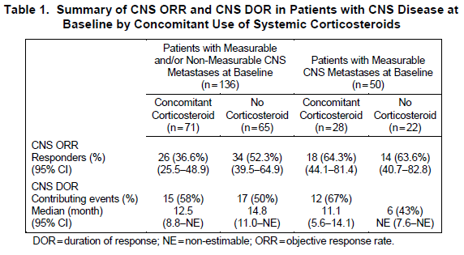

**Comment:** The subgroup analysis does not suggest that steroid use confounded the CNS ORR or DOR.

As requested, the sponsor has also provided an analysis of timing of corticosteroid use relative to date of CNS BOR (Table 79).

Table 79: ‘Table 2’ from the sponsor’s end-of-first-round response to clinical question 5 Summary of Corticosteroid use relative to date of CSN BOR

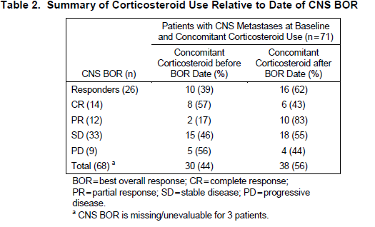

##### Evaluator comment

The time of administration analysis indicates that in more than half of the patients who responded and were treated with corticosteroids, the steroid was given after best overall response lesion measurement, negating the possibility of confounding by steroid use in these patients.

The sponsor’s response is accepted.

#### Response to Question 6

The sponsor states that in consultation with the FDA, 35% was chosen as the lower limit of what would be considered a clinically significant benefit based on:

the predicted benefit that would be provided by available alternative treatments in this setting (second-line setting). At the time of the start of these studies, these consisted of second-line chemotherapies that are known to deliver approximately 10%-20% ORR in this population.[45]

##### Evaluator comment

The sponsor’s response is accepted.

#### Response to Question 7

The sponsor responds that the two of eight CSF samples that weren’t able to be time-matched with a corresponding systemic sample were matched instead with the closest possible time point, and that due to steady-state dosing having been reached in these patients, this shouldn’t be an issue for validity of results. The sponsor provides a repeated analysis excluding those two time points without significant change to the linear relationship seen (Figure 16). The sponsor concludes that:

…the effect of these two pairs of data is unlikely to have changed the outcome because the remaining data points still indicate at least a proportional relationship and it is clear that alectinib is present in the CNS with oral dosing.

Figure 16: ‘Figure 1’ from the sponsor’s end-of-first-round 1 response to clinical question 7. Relationship between concentration of Alectinib in CSF and paired systemic Alectinib with exclusions of the 2 patients without paired systemic Alectinib samples

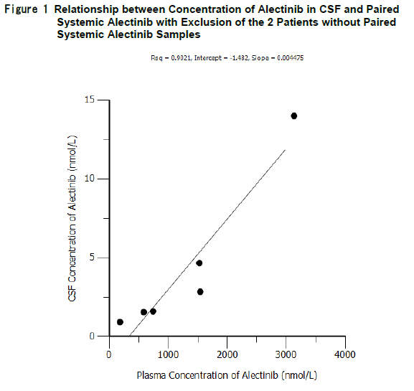

CSF = cerebrospinal fluid; Rsq =R squared. Source: Table 1 of the CSR for Study NP28761.

##### Evaluator comment

The sponsor’s response is accepted.

#### Response to Question 8

The sponsor provides an analysis document ‘Discordance Review’, dated 28 August 2015, which details the reasoning of the independent radiological committee in rejecting the ‘measurability’ of lesions under RECIST criteria which led to the discrepancy between analyses populations. Notably, the sponsor points out that the IRC were not told that having measurable disease was an inclusion criterion:

It is conceivable that if the IRC would have known this, some patients with borderline lesions would have been ‘pushed’ into the subgroup of having measurable disease and thus target lesions identified. However, this information was not provided by the sponsor on purpose to ensure a truly completely unbiased look at the data by the IRC.

The Discordance Review provides a number of reasons, stemming from the investigator and the IRC’s use of the RECIST criteria, as to why differences existed, with pictorial examples of each reason.

##### Evaluator comment

This explains the differences well.

As requested, the sponsor also provided an analysis of the investigator-determined efficacy outcomes in patients for whom baseline disease was determined by the IRC to be not measurable (Table 80).

Table 80: ‘Table 2’ from the sponsor’s end-of-first-round s31 response to clinical question 8 ORR according to investigator in patients with no measurable disease as per the IRC assessment

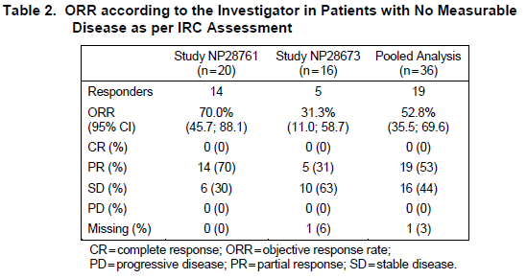

The sponsor concludes that the findings are:

…consistent with the overall benefit observed in these studies and suggests that the analysis according to the RE population as identified by the IRC was not biased by the potential exclusion of patients who were less likely to derive a clinical benefit.

##### Evaluator comment

The evaluator agrees. The sponsor’s response is accepted. The values cited in the PI should still be based on the ITT population, however the results should be considered significant regardless of the lower CI bound falling slightly lower than 35 in the ITT analysis. Partly because alternative current therapies in this group offer 10-20% ORR, and partly because it is likely that the true population mean falls higher than that.

#### Response to Question 9

The sponsor has provided the requested analyses. Of eight patients whose protocol violations could have affected efficacy findings, two were not included in efficacy analyses as they were from the Phase 1 part of Study NP28761 only. For the other six patients, IRC-assessed results have been summarised (Table 81).

Table 81: Table of results from the sponsor’s end-of-first-round s31 response to clinical question 9

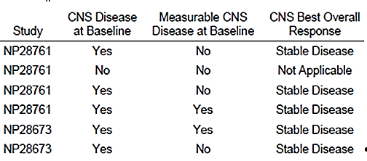

None of the patients had a result that would have contributed to findings of CNS efficacy.

The sponsor states that the two patients from Phase 1 of Study NP28761 were the only ones of the eight with protocol violations who were included in the popPK exposure-response analysis with the small sample size (n=46). Removing them from the group didn’t change the conclusions of the analysis.

##### Evaluator comment

The sponsor’s response is accepted.

### Safety

#### Response to Question 10

The sponsor responds that the difference between rates of low grade hepatic AEs between the pivotal trials and Study AF-001JP may be related to cohort size (253 versus 58, respectively). Preliminary results from the Phase III study J-ALEX are in keeping with the rates seen in the pivotal trials, supporting the theory that the difference is not significant and is due to sample size and stochasticity.

##### Evaluator comment

The sponsor’s response is accepted.

#### Response to Question 11

The sponsor has provided a retrospectively updated concentration-QTcF analysis using the same scaling approach that was used in the PopPK analysis to confirm a lack of relationship between the change from baseline in QTcF and alectinib concentrations (Figure 17).

Figure 17: ‘Figure 1’ from the sponsor’s end-of-first-round response to clinical question 11. Scatter plot of individual QTcF change from baseline versus Alectinib concentration in plasma at all time points (population evaluable for ECG) Adjusted for bioanalytical bias

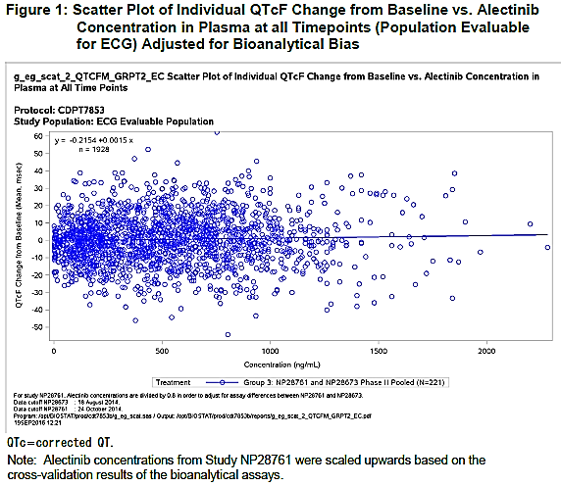

The sponsor concludes:

Results from this updated linear regression analysis are consistent with the original analysis and confirm that there is no apparent correlation and a similar slope of 0.0015. This updated analysis further supports the results that were observed in the pivotal studies on the basis of intensive ECG assessment and shows there is no evidence that alectinib causes any clinically-relevant QTcF prolongation (see the ECG Report).

##### Evaluator comment

The sponsor’s response is accepted.

#### Response to Question 12

The sponsor has carried out the three signal analyses as requested. Cumulatively, until 3 July 2016 (data lock point for the most recent PBRER), the estimated market exposure of alectinib is 3344 patients (Japan, n= 2679; United States, n= 651; and Israel, n= 14).

#### *Interstitial Lung Disease (ILD) and pneumonitis*

Characteristics of clinical study and postmarket cases found by PT search of the sponsor’s safety database (ARISg) relating to ILD and pneumonitis are summarised in Table 82.

Table 82: Characteristics of the cases identified by the sponsor in their signal analysis by searching for Preferred Terms ILD or pneumonitis as part of the end-of-first-round s31 response to clinical question 12

| Postmarket cases (ARISg database) | | | | Clinical trials cases | | | |
| --- | --- | --- | --- | --- | --- | --- | --- |
|  | ***n=*** | ***cases*** | ***%*** |  | ***n=*** | ***cases*** | ***%*** |
| **TOTAL** | **3344** | **48** | **1.4%** |  | **601** | **14** | **2.3%** |
| **SOURCE COUNTRY** |  |  |  | **SOURCE STUDY** |  |  |  |
| Japan | 2679 | 44 | 1.6% | J-ALEX (JO28928) | 103 | 8 | 7.8% |
| United States | 651 | 4 | 0.6% | ALEX (BO28984) | 152 | 2 | 1.3% |
| Israel | 14 | - |  | JP28927 | 35 | 2 | 5.7% |
|  |  |  |  | NP28673/NP28761 | 253 | 1 | 0.4% |
|  |  |  |  | AF-001JP | 58 | 1 | 1.7% |
| **SERIOUSNESS** |  |  |  | **SERIOUSNESS** |  |  |  |
| Serious |  | 48 | 100.0% | Serious |  | 12 | 85.7% |
| Not serious |  | - |  | Not serious |  | 2 | 14.3% |
| FATAL |  | - |  | FATAL |  | 0 | 0.0% |
| **GRADE** |  |  |  | **GRADE** |  |  |  |
| Unknown |  | 13 | 27.1% | Unknown |  | - |  |
| 1/2 |  | 26 | 54.2% | 1/2 |  | 7 | 50.0% |
| 3 |  | 9 | 18.8% | 3 |  | 7 | 50.0% |
| 4 |  | - |  | 4 |  | - |  |
| 5 |  | - |  | 5 |  | - |  |
| **AGE (years)** |  |  |  | **AGE (years)** |  |  |  |
| 80-89 |  | 5 | 10.4% |  |  |  |  |
| 70-79 |  | 16 | 33.3% |  |  |  |  |
| 60-69 |  | 14 | 29.2% |  |  |  |  |
| 50-59 |  | 3 | 6.3% |  |  |  |  |
| 40-49 |  | 5 | 10.4% |  |  |  |  |
| 30-39 |  | 1 | 2.1% |  |  |  |  |
| 20-29 |  | 1 | 2.1% |  |  |  |  |
| Unknown |  | 3 | 6.3% |  |  |  |  |
| **RESOLU-TION** |  |  |  | **RESOLUTION** |  |  |  |
| Resolved |  | 22 | 45.8% | Resolved |  | 5 | 35.7% |
| Resolving |  | 19 | 39.6% | Resolving |  | 6 | 42.9% |
| Unresolved |  | 5 | 10.4% | Unresolved |  | 3 | 21.4% |
| Unknown |  | 2 | 4.2% | Unknown |  | - |  |
| **ACTION TAKEN** |  |  |  | **ACTION TAKEN** |  |  |  |
| Withdrawn |  | 14 | 29.2% | Withdrawn |  | 9 | 64.3% |
| Interrupted |  | 28 | 58.3% | Interrupted |  | 5 | 35.7% |
| Maintained |  | 3 | 6.3% | Maintained |  | - |  |
| Unknown |  | 3 | 6.3% | Unknown |  | - |  |

Source: Sponsor’s s31 response document.

Of the 42 postmarket cases where treatment with alectinib was withdrawn or interrupted, 22 (52%) resolved, 17 (41%) were resolving and 3 (7.1%) were unresolved. Of the cases where alectinib was continued unchanged, 2 were resolving and 1 was unresolved.

In clinical trials, treatment was interrupted or withdrawn in all 14 cases. Of these, 5 (36%) resolved, 6 (43%) were resolving and 3 (21%) were unresolved.

Regarding age distribution of events, the sponsor states:

A majority of the ILD events were reported in Japan (44 of 48 patients). The crude reporting rate of ILD for alectinib per the available cumulative exposure data in Japan in patients of age ³75 years is 6 of 282 patients (2.1%), which is similar to the reporting rate in the age group ³ 15 to <75 years (37 of 2397 patients; 1.54%). However, this direct comparison should be made with caution because of the difference in size of the two subgroups.

The reported rates for ILD were similar between the sexes with 26 of 48 events (54.2%) reported in female patients and 22 of 48 events (45.8%) in male patients.

Currently, there are no known risk groups or factors for ILD in patients who are treated with alectinib. In general, factors that could potentially be associated with an increased risk of drug-induced ILD include history of pre-existing lung disease, radiation, prior or concomitant treatment with medications with known pulmonary toxicity (e.g., some antimicrobial, anti-inflammatory, and cardiovascular agents, biologics, and chemotherapeutics), inflammatory conditions (e.g., rheumatoid arthritis and inflammatory bowel disease), increased age, oxidative stress in the lung tissue due to reactive oxygen species, potentially race/ethnicity, and other factors.[46]

In the current dataset, there are 10 patients with metastasis in the lungs, 7 patients with a history of pre-existing lung disease with inclusion of interstitial pneumonia, organizing pneumonia, and unspecified lung disorder. Three patients were reported with concurrent bacterial pneumonia, asthma, and chronic obstructive pulmonary disease. Four patients were administered medications that were suspected of causing pulmonary toxicity (docetaxel, paclitaxel, sulbactam, and rivaroxaban).

Of the 48 patients who reported ILD, 4 patients were cardiac impaired and had pre-existing cardiac disease. One event of ILD was reported in a patient with hepatic impairment. No cases of ILD were reported in patients with renal impairment.

Sponsor comment: The crude reporting rate of ILD for alectinib in Japan in patients of age ³ 75 years was comparable with the reporting rate in the age group ³ 15 to <75 years (2.1% versus 1.54%). A diagnosis of ILD occurs mostly in the fifth and sixth decades of life but differs between the ILD diseases and ranges from the fourth decade for sarcoidosis to the seventh decade for drug-related ILD[47]. The older age distribution of patients with underlying lung cancer is another element that has to be taken into account with the assessment of a possible association between patients’ older age and ILD. Similarly, exposure to the drug long after radiation therapy in a few cases may be another factor for the development of ILD later in life. There are a limited number of events that further preclude an adequate assessment of the association. Despite the higher incidence of ILD that is reported with alectinib treatment in the age group of 70-79 years, an association of older age with ILD cases reported cannot be established given the above-listed considerations. In summary, there was no specific trend of susceptibility that was seen in any specific patient subgroup.

Regarding the need for PI changes, the sponsor states:

The sponsor therefore proposes to amend the information on selected adverse reactions (page 13 of the Product Information) with new text underlined in Italic as follows: Interstitial Lung Disease (ILD)/pneumonitis Severe ILD/pneumonitis occurred in patients treated with alectinib. In the pivotal Studies NP28761 and NP28673, 1 of 253 patients (0.4%) who were treated with alectinib had a Grade 3 ILD that led to a withdrawal from alectinib treatment. *Cases of ILD and pneumonitis have also been reported from postmarket use of alectinib*. There were no fatal cases of ILD reported.

##### Evaluator comment

On the basis of this data, the range of incidence seen in clinical trials is between 1% and 8%, and incidence post-market around 1.4%. Incidence of resolution appears consistent between trial and postmarket data also, around 80% or higher with current management strategies, that is, treatment interruption.

The evaluator agrees with the sponsor’s appraisal of the data around risk factors for ILD. The ages of patients with ILD related events in the trials was not explored but the existing analysis is sufficient.

The sponsor’s proposal for PI inclusion is accepted.

The sponsor’s response regarding ILD/pneumonitis is accepted.

#### Intestinal perforation

Eight relevant cases were identified by the sponsor using a PT search for intestinal perforation-related terms: one from the pivotal Study NP28673, as previously described, and seven other cases

* + Three cases from the postmarket surveillance program in Japan (of patients who received 300 mg alectinib)
  + One spontaneous report, also from Japan,
  + Three cases from the global compassionate use and expanded access programs (600 mg BD), one of which was fatal.

All cases were confounded by factors known to be associated with intestinal perforation (Table 83). A ninth case - of appendicitis leading to perforation in a 29 year old patient in Study NP28673 in China was not discused in the signal analysis (presumably due to the reasonably clear causality) but was included in the line listing appended to the signal analysis.

The sponsor provides a discussion as follows:

From published studies, the overall prevalence of GI perforation among all cases of lung cancer ranges from 0%-0.29% in clinical cohorts.[48] Among cases of lung cancer with GI metastasis, the prevalence of GI perforation ranges from 0%-66.7%.[49] The large range was due to the low number of events across the studies and the variability in diagnosis of GI metastases, which may be diagnosed at the time of GI perforation.

In the postmarket data, there were 2 cases of GI perforation ([information redacted]), 1 case of rectal perforation (([information redacted]), and 1 case of small intestinal perforation (([information redacted]) that were reported from Japan. An estimated 2679 patients were exposed to treatment with alectinib 300 mg BID in the postmarket setting in Japan as of 3 July 2016. Therefore, the estimated incidence of GI perforation in the postmarket setting of alectinib in Japan is 0.15%.

In summary, the estimated incidence of GI perforation did not exceed the incidence that was expected in patients with metastatic lung cancer.

GI perforation is not considered an ALK inhibitor class effect because this risk is not consistently listed as an adverse drug reaction (ADR) in the labelling documents for crizotinib (GI perforation is listed as an ADR in the Summary of Product Characteristics [SmPC], but not in the United States Product Insert [USPI], or Canadian Product Monograph) or ceritinib (GI perforation is not listed as an ADR in the SmPC, USPI, or Canadian Product Monograph).

On the basis of the nonclinical data with alectinib that shows no findings of GI perforation, the clinical cases that have all occurred in patients with general GI perforation risk factors, and the estimated incidence rate that did not exceed the incidence that was expected in patients with metastatic lung cancer, there is no conclusive evidence of an association between GI perforation and treatment with alectinib.

The sponsor concludes:

According to the analysis in response 9B, 4 cases of GI perforation (with inclusion of rectal perforation) have been reported in the postmarket setting. This corresponds to a frequency of 0.15%, which is within the literature-reported range that is expected for GI perforation in this patient population. Moreover, contributing factors were present in all patients who were treated with alectinib and who reported GI perforation events. As discussed under 9B, a conclusive association between GI perforation events and alectinib treatment cannot be established and GI perforation is not regarded as an ADR of alectinib. Therefore, the sponsor considers that the listing of postmarket events of GI perforation in the PI is not warranted.

##### Evaluator comment

The evaluator agrees with the sponsor’s conclusion.

The sponsor’s response regarding GI perforation is accepted

Table 83: Characteristics of the cases identified by the sponsor in their signal analysis by searching for Preferred Terms related to gastrointestinal perforation as part of the end-of-first-round s31 response to clinical question 12.

| Source | Country | Daily dose | AE term | Age (yrs) | | | Relevant history | Relevant concurrent medication | Outcome |
| --- | --- | --- | --- | --- | --- | --- | --- | --- | --- |
| pivotal Study NP28673 | Italy | 1200 mg | intestinal perforation | | 69 | concurrent diverticulitis | | systemic corticosteroid | Fatal |
| surveillance study ALC1401 | Japan | 600 mg | rectal perforation (and diverticulum intestinal haemorrhagic) | | 79 | brachytherapy for prostate cancer at the site of perforation, history of diverticulitis | |  | Recovered |
| surveillance study ALC1401 | Japan | 600 mg | gastrointestinal perforation | | 70 | concurrent ileus | |  | Recovered |
| expanded access trial ML29453 | USA | 1200 mg | perforated diverticulitis | | 69 | concurrent diverticulosis | | systemic corticosteroid | Recovered |
| compassionate use MO29499 | France | 1200 mg | gastrointestinal perforation | | 43 | concurrent diverticulosis | | systemic corticosteroid | Fatal |
| surveillance study ALC1401 | Japan | 600 mg | gastrointestinal perforation | | 69 | advanced disease stage[50] | | systemic corticosteroid | Not recovered |
| compassionate use MO29499 | Germany | 900 mg | perforated sigmoid | | 64 | sigmoid diverticulitis | | systemic corticosteroid | Recovered |
| pivotal Study NP28673 | China | 900 mg | perforated appendicitis | | 27 | appendicitis | |  | Recovered |
| spontaneous | Japan | 600 mg | small intestinal perforation | | 74 | none reported | | none reported | Recovered |

#### Rhabdomyolysis, CPK elevation and myalgia

The sponsor’s search for rhabdomyolysis adverse events in their safety database ARISg identified three cases. In all three, the case details are not consistent with the diagnosis of rhabdomyolysis per the National Lipid Association definition (>10 x the ULN for CPK). All three cases also improved on cessation and did not recur on recommencing alectinib, albeit at a lower dose.

As requested, an updated signal analysis for all cases of CPK elevation and myalgia to date whether from clinical studies or the postmarket space has also been provided.

The sponsor concludes:

Three patients who were treated with alectinib had reported events of rhabdomyolysis. Two of the cases had a strong alternative causality (strenuous physical activity) or a concurrent risk factor (epilepsy). None of the 3 cases met the criteria for a rhabdomyolysis diagnosis in accordance with the guidance of the National Lipid Association Statin Safety Assessment Task Force and the event had no sustained relevant impact on the renal function of these patients. The sponsor concludes that an association of alectinib treatment and rhabdomyolysis is not established; therefore, the inclusion of postmarket events of rhabdomyolysis is not warranted. Notwithstanding, although severe myalgia and CPK elevations have been observed in patients who were treated with alectinib in clinical studies and postmarket use and have been manageable with dose modifications, the sponsor proposes to include ‘severe myalgia and CPK elevation’ under Precaution and provide a corresponding dose modification guidance in the PI.

##### Evaluator comment

The updated analysis is in keeping with the risk for CPK elevation and myalgia noted in the pivotal trials, and a convincing report of rhabdomyolysis has not yet been seen. The evaluator agrees with the sponsor’s appraisal and conclusion, and the inclusion of severe myalgia and CPK elevation under Precautions with corresponding dose modification guidance.

The sponsor’s responses regarding rhabdomyolysis, CPK elevation and myalgia are accepted.

#### PI and CMI

#### Response to Question 13

The sponsor states:

The sponsor would like to clarify that the patients with locally advanced disease that are proposed to be included in the indication are those patients who are not amenable to combined modality treatment (chemoradiation), which is in line with the protocol inclusion criteria for both pivotal Phase I and II Studies NP28761 and NP28673 (that is, unresectable and not a candidate for chemoradiation treatment). Although their disease is not considered metastatic, patients with locally advanced disease who are not amenable to chemoradiation are treated in the same way as patients with metastatic disease (see National Comprehensive Cancer Network [NCCN] guidelines). Therefore, to include patients with locally advanced disease who are not amenable to combined modality treatment in the indication would be consistent with the current guidelines for treatment of this disease as well as with the studied population in both pivotal studies.

##### Evaluator comment

The evaluator had not realised that ‘not amenable’ referred specifically to treatment with curative intent.

A specification in the inclusion criteria for pivotal trial NP28673 states: ‘*To clarify the Stage IIIB NSCLC study patients to be included in the study, as per FDA request: Only Stage IIIB NSCLC patients whose disease was not amenable to curative therapy would be eligible for the study, as other Stage IIIB patients may be eligible to other multimodality treatments.*’

So when the sponsor uses the phrase ‘not amenable to combined modality treatment (chemoradiation)’, the evaluator believes they mean ‘not amenable to curative combined modality treatment (chemoradiation).’

The sponsor states that the benefit-risk balance should not be any different in this population than in the studied population of patients with metastatic disease as:

* 1. alectinib treatment is expected to equally benefit their anaplastic lymphoma kinase (ALK)-positive non-small cell lung cancer
  2. safety of a drug is mainly dependent on its mechanism of action and not on the status of the disease itself

The sponsor provides specific data on Stage IIIB patients in the Phase II studies: three such patients were enrolled however one of them died because of a gluteal ligament tear before week 8, and no post-baseline tumour assessments are therefore available for this patient. Partial responses were seen in both of the remaining two patients, providing a small case series of evidence for efficacy.

The sponsor concludes:

Despite the small sample size, these data suggest that patients with ALK+, locally advanced disease that is not amenable to combined modality treatment can experience a clinically-meaningful benefit when they are treated with alectinib. Because these patients cannot be treated with surgery or chemoradiation, they are faced with very limited options once their disease progresses during treatment with crizotinib. Alectinib would present an additional, important treatment option for these patients that meet with the current guidelines for the treatment of this disease.

With regard to safety profiles in these three patients, adverse events in these patients were generally in keeping with the safety profile observed in the rest of the Phase I/II cohort. Response listings, baseline demographics, PK measurements and adverse event listings in the original CSRs were reviewed for additional detail.

For patient ([information redacted] (a ([information redacted] year old male in Study 28673), only the first three adverse events (flank pain, asthma and photosensitivity reaction) had been reported by the time the CSR was written. The additional terms listed in the response (asthma, abdominal pain upper, bronchitis, weight increased, dyspepsia and pneumonia) presumably have been reported for the same patient since that time. No data could be identified on first-line treatment, other than that progression had occurred despite it.

For patient ([information redacted] year old male in Study 28761), enrolment history was provided that explained why he was not a candidate for curative chemoradiation, which was essentially that he had already been treated with bevacizumab (25 November 2009 to 08 June 2011), paclitaxel and carboplatin (09 December 2009 to 29 March 2010) crizotinib (27 June 2011 to 31 March 2014), then had progressed on crizotinib. Patient 20205 had a serious adverse event of intracranial haemorrhage (Grade 2, and subsequently recovered), presenting with headache, that was biopsied in case of CNS metastasis but malignancy was not identified in the biopsy. His concurrent therapy with heparin (APTT at time of haemorrhage was 138 seconds [normal range: 21-33 seconds]) and underlying factor V Leiden mutation were thought to be significant contributors.

Patient ([information redacted] year old female in Study NP28673), died after a haemorrhage secondary to ligament rupture whilst on concurrent anticoagulant tinzaparin. She was enrolled as her disease had progressed after treatment with carboplatin and pemetrexed (11 January 2013 to June 2013) and again after crizotinib second line. She was hospitalised on Study Day 35 with right hip pain and ‘alteration in general status’. A hip X-ray on Day 36 was normal but ultrasound revealed serious Grade 3 medial gluteal ligament rupture and a ‘wrenching of the femur with major hematoma on the buttocks and on the right thigh’. A chest X-ray showed left lung disease progression, and the patient died the following day despite transfusion and supportive therapy.

##### Evaluator comment

Whether Stage IIIB ALK+ NSCLC should be expected to differ from Stage IV disease in terms of treatment options, biology other than ALK-positivity or natural clinical history is an issue that may require expert clinician advice (see above).

With regard to safety and efficacy in Stage IIIB patients, the small number included in the pivotal trials prevents meaningful analysis however the presence of partial responses in both Stage IIIB patients with available efficacy results is supportive.

Although not being amenable to (curative) combined modality treatment was an inclusion criterion in the pivotal studies, not being a candidate for combined modality treatment is not specified in the current indication, nor is it implied by the specification that alectinib is only to be used after the failure of crizotinib, as the NCCN guidelines specify that if ALK positivity is discovered, crizotinib should be used first line. So a Stage IIIB patient could have been treated with and progressed on crizotinib therapy without having been offered treatment with combined modality therapy.

The reasons that a patient would not be considered a candidate for chemoradiotherapy are not clear from the NCCN guidelines. The comment the evaluator made in the round 1 evaluation, that ‘Stage IIIB patients are treated the same way as those with Stage IV disease according to the NCCN guidelines’ is not accurate, on further review of the guidelines. The evaluator believes in this instance that the evaluator had misinterpreted the sponsor’s statement that ‘patients with locally advanced disease *who are not amenable to chemoradiation* are treated in the same way as patients with metastatic disease’, not having properly noted the underlined caveat.

The evaluator therefore agree with the sponsor’s statement that ‘to include patients with locally advanced disease who are not amenable to combined modality treatment in the indication would be consistent with the current guidelines for treatment of this disease’, however the evaluator does not see how the current wording of the indication makes any implicit specification regarding amenability to combined modality treatment,as crizotinib is indicated first line in patients with ALK+ disease according to the NCCN guidelines. The evaluator is not aware of any reason that would make this indication specific only to Stage IIIB patients who weren’t candidates for chemoradiation.

The US label does not include ‘locally advanced’. The reasoning for the removal of this term by the FDA from the indication proposed by the sponsor is described in publicly available FDA documentation, essentially being:

‘FDA recommended limiting the indication to metastatic (rather than locally advanced) patients, consistent with practice across mNSCLC therapies, and consistent with patient population actually studied.’[51]

In terms of consistency with practice across NSCLC therapies, the Australian PIs for both crizotinib and ceritinib both *do* include locally advanced disease:

XALKORI is indicated for the treatment of patients with anaplastic lymphoma kinase (ALK)-positive advanced non-small cell lung cancer (NSCLC)’

(‘advanced’ is taken to mean both locally advanced and metastatic)

‘ZYKADIA is indicated as monotherapy for the treatment of adult patients with anaplastic lymphoma kinase (ALK) positive locally advanced or metastatic non-small cell lung cancer (NSCLC) whose disease has progressed on or who are intolerant of crizotinib.’

The indication proposed for alectinib is consistent with these:

‘Alecensa is indicated for the treatment of patients with anaplastic lymphoma kinase (ALK)-positive, locally advanced or metastatic non-small cell lung cancer (NSCLC) who have progressed on or are intolerant to crizotinib.’

In terms of consistency with patient population studied, the pivotal trial population did include two patients with evidence of efficacy (partial responses in both cases). This is a very small case series. However, the incidence of Stage IIIB diagnoses (18%) is smaller than that of Stage IV diagnoses to begin with (approximately35%)[52], and the number of these who are not amenable to combined modality treatment is presumably small. Again, specialist expertise may be able to advise regarding this, as the evaluator was unable to find literature to cite incidences.

This issue requires specific consideration by the delegate and may require expert clinician or committee advice. Further clarification as to why the three Stage IIIB patients included in the pivotal trials were not candidates for chemoradiotherapy may be of assistance. In its current iteration, I don’t see how the wording of the indication makes any implicit specification to include only patients not amenable to combined modality treatment.

#### Response to Question 14

The sponsor states:

The recommended missed dose instructions for alectinib that were initially proposed for the Package Insert (PI) were based on instructions that were similar to those provided in the pivotal study protocols and in consideration of alectinib time to maximal concentrations (Tmax). The original protocol instructions were based on the initial limited observations of alectinib pharmacokinetics from the dose escalation portion of the Phase I Study NP28761 to support the conduct of Phase II of Studies NP28761 and NP28673. The final robust population pharmacokinetic analysis of the cumulative Phase I and II study data has demonstrated that alectinib and M4 geometric mean elimination half-life (t½) is > 30 hours with a 6-fold accumulation ratio and an alectinib peak/trough ratio of approximately 1.2. Given the long t½ and high accumulation for both alectinib and M4, instructions to skip a missed dose and take the next scheduled dose would not be expected to negatively affect efficacy and can provide more practical missed dosing instructions for patients. Thus, the sponsor proposes to update the PI for missed dose instructions to state that for missed doses patients should take the next dose at the scheduled time consistent with recommendations included in the U.S. PI.

##### Evaluator comment

The sponsor’s response is accepted.

#### General

##### Response to Clinical question 15

The sponsor states:

The Phase III global Study BO28984 (ALEX) completed recruitment of patients in January 2016. The primary analysis is expected to occur in Q2 2017 when the required number of progression-free survival events is achieved and the Clinical Study Report is expected to become available in Q3 2017.

The results from a preplanned interim analysis of a Phase III study (J-ALEX) that was conducted in Japan were presented during the 2016 annual congress of the American Society of Clinical Oncology. The results of this interim analysis and the efficacy and safety results from the pivotal Phase II Studies NP28673 and NP28761 were included in the addendum to the Clinical Overview and the updated Safety Report that were submitted to the European Medicines Agency as part of the Day 120 responses (updated clinical cutoff dates for the two pivotal studies were 1 February 2016 for Study NP28673 and 22 January 2016 for Study NP28761). The sponsor also includes these two documents in this response package to the TGA (see Clinical Overview Addendum and Safety Update Report); and the PI has been revised in line with the latest safety data from these cut-offs (described in the various responses to the Clinical PI requests).

##### Evaluator comment

The Clinical Overview Addendum and updated Safety Report have been reviewed, with data cut-off dates for included studies as follows:

Table 84: Study details

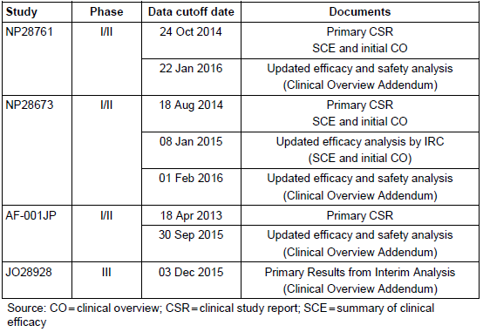

It is noted that alectinib has been approved in Israel since the original submission.

The efficacy results cited in the clinical overview addendum still use the RE population as the denominator for the primary efficacy outcome, which as described in Efficacy section is not statistically correct. However, the PI still contains both the ITT-calculated IRC ORR alongside the investigator determined ORR with a contextual note explaining the reason for the differences, which is appropriate.

The updated safety document and clinical overview addendum provide a large amount of new data, with more mature time-to-event outcomes, and a preliminary look at data from the J-ALEX trial, showing alectinib to have a lower rate than crizotinib for most adverse events, significant exceptions being CPK elevation and severe myalgia (35% alectinib versus 20% crizotinib) and ILD (6% alectinib versus 5% crizotinib). Very significant differences in the rates of nausea and vomiting are noted, with rates of 11% and 6% (respectively) in the alectinib arm (n=103) compared to 74% and 58% with the crizotinib comparator (n=104).

The new efficacy data and data from the J-ALEX trial are not appropriate for inclusion in the current PI during the current submission process, but are supportive of registration. An updated clinical trial summary picture will presumably be considered by a clinical evaluator in future if this registration is supported by the delegate and submission of the results of the Phase III ALEX trial are required as part of the conditions of registration.

The sponsor’s response is accepted.

## Second round benefit-risk assessment

### Second round assessment of benefits

In addition to the issues discussed under the first-round assessment of benefits:

* Dosing under fed conditions probably increases tolerability in relation to reducing the nauseating effects of SLS.
* M4 efflux by P-gp is not likely to decrease CNS efficacy enough that the extent of metabolism of alectinib to M4 would significantly affect overall CNS efficacy. This is supported by additional sensitivity analyses.
* Exclusion of PK data points appears reasonable and consistent.
* The use of corticosteroids in the study is not likely to have significantly changed efficacy outcomes.
* An ORR of 35% is a significant lower threshold based on alternative therapies for this group (second line chemoradiation). The lower limit of confidence intervals around ORRs in both the IRC and investigator assessed ORR endpoints were higher than 10-20% which is the historical comparator being used. Phase III data is required to confirm efficacy relative to best care.
* Exploratory CNS efficacy measurement was not likely affected greatly by the temporal separation of CNS sampling and serum sampling (which occurred in two of eight cases).
* A discordance review confirms that the IRC assessments of measurable baseline disease were discordant based on differential interpretation of images, and gives clear reasons for differing opinions. Analysis of efficacy (according to investigator) in the subgroup considered not to have measurable baseline disease by the IRC confirms that this group showed similar distributions of efficacy results to the overall study population.
* The use of corticosteroids in the study is not likely to have significantly changed CNS efficacy outcomes. Amended sensitivity analyses are supportive of this.
* Benefits to stage IIIB patients who are not candidates for curative combined chemoradiotherapy can probably be predicted to be the same as the benefits to patients with stage IV disease however this point requires *Delegate consideration.*

### Second round assessment of risks

In addition to the issues discussed under the first-round assessment of risks:

* The higher rate of low grade hepatic adverse events in Japanese trial AF-001JP is not likely to be significant.
* Assay bias is not likely to have affected the results of ECG analysis showing no correlation between plasma concentration of alectrinib and QTc. This is supporting by repeat analysis using adjusted values.
* Signal investigation regarding ILD suggests its incidence in the postmarket is similar to that seen in the clinical studies as a collective. No specific susceptibility trend was seen on demographic analysis.
* Insufficient evidence of an association between alectinib use and gastrointestinal perforation is present in signal analysis to warrant confirmation of this signal. PI inclusion is not appropriate at this point.
* Severe myalgia and CPK elevation are a confirmed potential risk of alectinib and have been appropriately included in the PI under Precautions, with appropriate dose modification instructions under Dosage and Administration.
* Risks to Stage IIIB patients who are not candidates for curative combined chemoradiotherapy can probably be predicted to be the same as the benefits to patients with stage IV disease *however this point requires Delegate consideration.*
* Missed dose instructions are in keeping with appropriate risk management.
* Additional safety data has been submitted by the sponsor and they propose to update rates of adverse events in the PI to match the updated data. This is accepted.

### Second round assessment of benefit-risk balance

Following on from the benefit-risk balance assessment described in the round 1 evaluation, satisfactory responses to the clinical questions outlined in this evaluation report have been received.

The response rates seen in the pivotal trials for alectinib, including the uncertainty around these rates, support its efficacy compared to the only other alternatives available to this population (second-line chemotherapy and ceritinib). The safety profile of alectinib is different to the alternatives and arguably better. In addition to the differing safety profile, alectinib shows surrogate evidence of CNS efficacy.

The small population studied in the pivotal trials and the surrogate nature of efficacy endpoints do introduce uncertainty and overall survival or direct evidence of clinical benefit has not yet been clearly shown. There is, however, indisputable unmet need for treatment in this population of patients, as survival remains poor and treatment alternatives are limited by loss or lack of efficacy, toxicity and inaccessibility. The efficacy and safety of alectinib has been demonstrated by the Sponsor sufficiently for registration to be supported, however, confirmatory data from phase III trials and hepatic safety study should be conditions of registration.

The benefit-risk balance of alectinib, for the proposed usage, remains favourable as per the first round evaluation, subject to the conditions recommended below.

## Second round recommendation regarding authorisation

Approval of Alecensa (alectinib) is recommended

*for the treatment of patients with anaplastic lymphoma kinase (ALK)-positive, metastatic non-small cell lung cancer (NSCLC) who have progressed on or are intolerant to crizotinib*.

Whether the indication should be amended to include locally advanced disease, plus or minus specification that this must be in the situation where a patient is not amenable to curative combined modality therapy should be considered by the Delegate. Alternative wording of the indication may be for example:

*…for the treatment of patients with anaplastic lymphoma kinase (ALK)-positive, locally advanced or metastatic non-small cell lung cancer (NSCLC) who are not candidates for curative chemoradiotherapy, and have progressed on or are intolerant to crizotinib*.

Conditions of approval should include:

* The note to the indication (regarding the surrogate nature of the efficacy data) must accompany the indication in all reproductions and publications of any kind, including marketing.
* The CMI currently does not sufficiently reflect the PI and should be modified to include a lay warning of the same nature.
* Data from Phase III trials to confirm overall survival benefit and clinically meaningful benefit must be submitted to the TGA when available. The timeframe within which this data should be required should be the end of 2017, in keeping with the predicted availability of a clinical report for the ALEX trial (third quarter 2017). The sponsor must recognise that failure to show overall survival benefit or clinically meaningful benefit to patients would necessitate reconsideration of the overall benefit-risk balance of the product.

The findings of studies addressing the risk-benefit balance in patients with moderate to severe hepatic impairment must be submitted to the TGA when available.

|  |
| --- |
| Therapeutic Goods Administration |
| PO Box 100 Woden ACT 2606 Australia  Email: [info@tga.gov.au](mailto:info@tga.gov.au) Phone: 1800 020 653 Fax: 02 6232 8605  [**https://www.tga.gov.au**](https://www.tga.gov.au) |

1. AIHW ACIM book for lung cancer (ICD10 C33-C34) 2014; http://www.aihw.gov.au/acim-books/
2. UpToDate clinical reference site. Available at: www.uptodate.com
3. Shaw et al., 2016. UpToDate topic: Anaplastic lymphoma kinase (ALK) fusion oncogene positive non-small cell lung cancer. Available at: http://www.uptodate.com/contents/anaplastic-lymphoma-kinase-alk-fusion-oncogene-positive-non-small-cell-lung-cancer
4. Chan BA and Hughes BGM. Targeted therapy for non-small cell lung cancer: current standards and the promise of the future. Transl Lung Cancer Res. 2015 Feb; 4(1): 36–54. doi: 10.3978/j.issn.2218-6751.2014.05.01
5. Ou SH. Crizotinib: a novel and first-in-class multitargeted tyrosine kinase inhibitor for the treatment of anaplastic lymphoma kinase rearranged non-small cell lung cancer and beyond. Drug Des Devel Ther 2011;5:471-85.
6. UpToDate infographic on initial systemic therapy for patients with advanced non-small cell lung cancer.
7. Ou SH. Crizotinib: a novel and first-in-class multitargeted tyrosine kinase inhibitor for the treatment of anaplastic lymphoma kinase rearranged non-small cell lung cancer and beyond. Drug Des Devel Ther 2011;5:471-85.
8. UpToDate infographic on initial systemic therapy for patients with advanced non-small cell lung cancer.
9. Summary Review for NDA 208434. Dated December 9, 2015. Accessed 10/06/2016.
10. Solomon B, Wilner KD, Shaw AT et al. Current Status of Targeted Therapy for Anaplastic Lymphoma Kinase–Rearranged Non–Small Cell Lung Cancer. Clin Pharmacol Ther. 2014; 95(1):15-23.
11. Doebele RC, Pilling AB, Aisner DL, et al. Mechanisms of resistance to crizotinib in patients with ALK gene rearranged non-small cell lung cancer. Clin Cancer Res 2012;18:1472-82

    Katayama R, Khan TM, Benes C, et al. Therapeutic strategies to overcome crizotinib resistance in non-small cell lung cancers harboring the fusion oncogene EML4-ALK. 2011. PNAS 108:7535-40
12. Roche Media Release. July 4 2014. Japan becomes first country to approve Roche’s alectinib for people with a specific form of advanced lung cancer.’ Accessed 27/04/2016 at: <http://www.roche.com/media/store/releases/med-cor-2014-07-04.htm>

    McKeage K. Alectinib: a review of its use in advanced ALK-rearranged non-small cell lung cancer. Drugs. 2015 Jan;75(1):75-82. doi: 10.1007/s40265-014-0329-y. Abstract accessed 27/04/2016

    Kim S, Kim TM, Kim DW, et al. Heterogeneity of Genetic Changes Associated with Acquired Crizotinib Resistance in ALK-Rearranged Lung Cancer. J Thorac Oncol 2013;8(4):415-22.
13. Costa DB, Kobayashi S, Pandya SS, et al. CSF concentration of the anaplastic lymphoma kinase inhibitor crizotinib. J Clin Oncol 2011;29:e443-5.

    Chun SG, Choe KS, Iyenger P et al. Isolated central nervous system progression on crizotinib. Cancer Biol Ther. 2012;13(14):1376-83.

    Weickhardt AJ, Scheier B, Burke JM, et al. Continuation of EGFR/ALK inhibition after local therapy of oligoprogressive disease in EGFR mutant (Mt) and ALK+ non-small cell lung cancer (NSCLC). J Clin Oncol 2012;30(suppl):ASCO Abstract 7526.
14. liquid chromatography/tandem mass spectrometry
15. alectinib
16. alectinib major metabolite, ‘M4’
17. high performance liquid chromotography
18. accelerated mass spectrometry
19. Note for guidance on good clinical practice. Published on TGA website. Last updated July 7, 2000. http://www.tga.gov.au/publication/note-guidance-good-clinical-practice
20. Nakagawa K, Hida T, Seto T, et al. Antitumor activity of alectinib (CH5424802/RO5424802) for ALK-rearranged NSCLC with or without prior crizotinib treatment in bioequivalence study [Poster]. J Clin Oncol 2014;32(suppl 5).
21. Rothenstein JM, Letarte N. Managing treatment–related adverse events associated with Alk inhibitors. Current Oncology. 2014;21(1):19-26. doi:10.3747/co.21.1740
22. Defined as:

    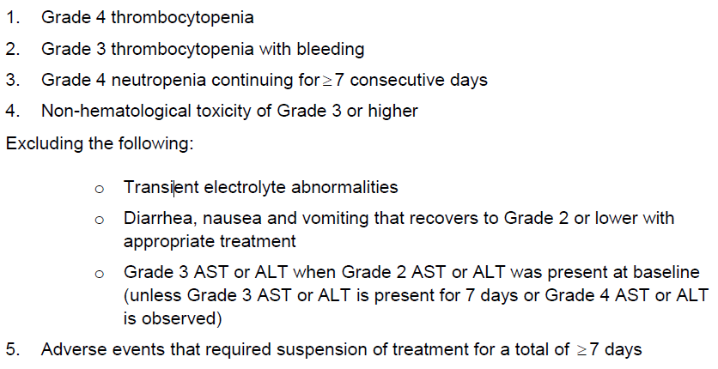
23. US Dept of Health (2010). Common Terminology Criteria for Adverse Events (CTCAE) – EVS. Published: May 28, 2009 (v4.03: June 14, 2010). Accessed 20/07/2016. Available at evs.nci.nih.gov/ftp1/CTCAE/CTCAE_4.03_2010-06-14_QuickReference_8.5x11.pdf
24. FDA: Statistical Review for application number 208434Orig1s000.
25. Lindquist M (2008) Vigibase, the WHO Global ICSR Database System: Basic Facts. Drug Information Journal 42: 409–19
26. Eisenhauer EA, Therasse P, Bogaerts J, et al. New response evaluation criteria in solid

    tumors: revised RECIST guideline (Version 1.1). Eur J Cancer 2009;45:228–47
27. Bergman B, Aaronson NK, Ahmedzai S, Kaasa S and Sullivan M. The EORTC QLQ-LC13: a modular supplement to the EORTC Core Quality of Life Questionnaire (QLQ-C30) for use in lung cancer clinical trials. EORTC Study Group on Quality of Life. Eur J Cancer. 1994;30A(5):635-42.
28. Corticosteroid conversion calculator available online at clincalc.com: http://clincalc.com/Corticosteroids/default.aspx
29. US label for Zykadia (ceritinib) - appended as a literature reference to the dossier. Label number T2014-41/T2014-42. Issued: April 2014
30. Mok T, Spigel D, Felip E, et al. ASCEND-2: A single-arm, open-label, multicentre phase II study of ceritinib in adult patients (pts) with ALK-rearranged (ALK+) non-small cell lung cancer (NSCLC) previously treated with chemotherapy and crizotinib (CRZ). J Clin Oncol. 2015; 33 (suppl): ASCO abstract #8059.
31. Mok T, Spigel D, Felip E, et al. ASCEND-2: A single-arm, open-label, multicentre phase II study of ceritinib in adult patients (pts) with ALK-rearranged (ALK+) non-small cell lung cancer (NSCLC) previously treated with chemotherapy and crizotinib (CRZ). J Clin Oncol. 2015; 33 (suppl): ASCO abstract #8059
32. Lindquist M (2008) Vigibase, the WHO Global ICSR Database System: Basic Facts. Drug Information Journal 42: 409–19
33. Rothenstein JM, Letarte N. Managing treatment–related adverse events associated with Alk inhibitors. Current Oncology. 2014;21(1):19-26. doi:10.3747/co.21.1740.
34. Suzuki A, Brunt EM, Kleiner DE, Miquel R, Smyrk TC, Andrade RJ, Lucena MI, Castiella A, Lindor K, Björnsson E. The use of liver biopsy evaluation in discrimination of idiopathic autoimmune hepatitis versus drug-induced liver injury. Hepatology. 2011 Sep 2;54(3):931-9. doi: 10.1002/hep.24481. Epub 2011 Aug 8
35. Stroes ES, Thompson PD, Corsini A et al. Table 1 Definitions of statin-associated muscle symptoms proposed by the EAS Concensus Panel. From Statin-associated muscle symptoms: impact on statin therapy—European Atherosclerosis Society Consensus Panel Statement on Assessment, Aetiology and Management. Eur Heart J. 2015 May 1; 36(17): 1012–1022.
36. Lindquist M (2008) Vigibase, the WHO Global ICSR Database System: Basic Facts. Drug Information Journal 42: 409–19
37. Prowell TM, Theoret MR and Pazdur R. Seamless Oncology-Drug Development. N Engl J Med 2016; 374:2001-2003May 26, 2016DOI: 10.1056/NEJMp1603747
38. US Department of Health and Human Services Food and Drug Administration. FDA Guidance for Industry: Clinical Trial Endpoints for the Approval of Non-Small Cell Lung Cancer Drugs and Biologics. Available at http://www.fda.gov/downloads/Drugs/.../Guidances/UCM259421.pdf Accessed 27/07/2016
39. Derived from Table 22 of summary-clin-efficacy-nsclc and the statement in the clinical overview that the number of patients with measurable CNS lesions at baseline increased from 50 to 51 when the updated NP28673 data (as at Jan 2015) was included
40. Ramalingam S and Belani C. Systemic chemotherapy for advanced non-small cell lung cancer: Recent advances and future directions. The Oncologist 2008; 13(suppl 1):5-13.
41. Kim S, Kim TM, Kim DW, et al. Heterogeneity of Genetic Changes Associated with Acquired Crizotinib Resistance in ALK-Rearranged Lung Cancer. J Thorac Oncol 2013;8(4):415-22
42. UpToDate clinical reference site. Available at: www.uptodate.com
43. Saleem A, Searle GE, Kenny LM, et al. Lapatinib access into normal brain and brain

    metastases in patients with Her-2 overexpressing breast cancer. EJNMMI Res 2015;5:30.
44. Morikawa A, Peereboom DM, Thorsheim HR, et al. Capecitabine and lapatinib uptake in

    surgically resected brain metastases from metastatic breast cancer patients: a prospective

    study. Neuro Oncol 2015;17:289-95.
45. Barnfield PC, Ellis PM. Second-line treatment of non-small-cell lung cancer: New

    developments for tumours not harbouring targetable oncogenic driver mutations. Drugs

    2016;76:1321-36.

    Shaw AT, Kim DW, Nakagawa K, et al. Crizotinib versus chemotherapy in advanced

    ALK-positive lung cancer. N Engl J Med 2013;368:2385-94.
46. Schwaiblmair M et al. Drug Induced Interstitial Lung Disease. The Open Respiratory Medicine Journal, 2012, 6, 63-74
47. Lim G-I et al. Clinical features of interstitial lung disease. The Korean J Internal Med 1996 11 (2):113-121

    Johnston IDA et al. British Thoracic Society study of cryptogenicfibrosing alveolitis: current presentation and initial management. Thorax 1997;52:38–44

    Thomeer M et al. Registration Of Interstitial Lung Diseases By 20 Centres Of Respiratory Medicine In Flanders. Acta Clinica Belgica, 56:3, 163-172, DOI:10.1179/acb.2001.026

    Thomeer M et al. Comparison of registries of interstitial lung diseases in three European countries. Eur Respir J 2001; 18: Suppl. 32, 114s–11
48. Berger A et al. Small Bowel Metastases From Primary Carcinoma of the Lung: Clinical Findings and Outcome. The American Journal of Gastroenterology. Vol. 94, No. 7, 1999: 1884-1887

    Yang C-J et al. Gastro-intestinal metastasis of primary lung carcinoma: Clinical presentations and outcome. Lung Cancer (2006) 54, 319—323
49. McNeill PM et al. Small Bowel Metastases From Primary Carcinoma of the Lung. Cancer 59:1486-1489, 1987.

    Berger A et al. Small Bowel Metastases From Primary Carcinoma of the Lung: Clinical Findings and Outcome. The American Journal of Gastroenterology. Vol. 94, No. 7, 1999: 1884-1887
50. This patient commenced alectinib at a very advanced disease stage (performance status 4), and was treated for 19 days before she developed DVT (11 Nov), followed by a CT suggestive of GI perforation (12 Nov), at which point alectinib was ceased. No scope was done to confirm or treat the suspected perforation, instead best supportive care was commenced, due to advanced disease. On 13 Dec, she died due to sepsis, DIC and progression of primary disease, without resolution of the perforation being documented.
51. FDA Centre for Drug Evaluation and Research. Cross Discipline Team Leader review for application

    208434Orig1s000. Accessed 27 April 2016
52. Juan P Wisnivesky, David Yankelevitz, Claudia I Henschke, Stage of Lung Cancer in Relation to Its Size: Part 2. Evidence, Chest, Volume 127, Issue 4, April 2005, Pages 1136-1139, ISSN 0012-3692, http://dx.doi.org/10.1016/S0012-3692(15)34458-5.

    (http://www.sciencedirect.com/science/article/pii/S0012369215344585)