Date of CER: 7 March 2013

AusPAR Attachment 2

Extract from the Clinical Evaluation Report for Alemtuzumab
  - Proprietary Product Name: Lemtrada/Remniq
  - Sponsor: Sanofi-Aventis Australia Pty Ltd

About the Therapeutic Goods Administration (TGA)
- The Therapeutic Goods Administration (TGA) is part of the Australian Government Department of Health, and is responsible for regulating medicines and medical devices.
- The TGA administers the Therapeutic Goods Act 1989 (the Act), applying a risk management approach designed to ensure therapeutic goods supplied in Australia meet acceptable standards of quality, safety and efficacy (performance), when necessary.
- The work of the TGA is based on applying scientific and clinical expertise to decision-making, to ensure that the benefits to consumers outweigh any risks associated with the use of medicines and medical devices.
- The TGA relies on the public, healthcare professionals and industry to report problems with medicines or medical devices. TGA investigates reports received by it to determine any necessary regulatory action.
- To report a problem with a medicine or medical device, please see the information on the TGA website <http://www.tga.gov.au>.
About the Extract from the Clinical Evaluation Report
- This document provides a more detailed evaluation of the clinical findings, extracted from the Clinical Evaluation Report (CER) prepared by the TGA. This extract does not include sections from the CER regarding product documentation or post market activities.
- The words [Information redacted], where they appear in this document, indicate that confidential information has been deleted.
- For the most recent Product Information (PI), please refer to the TGA website <http://www.tga.gov.au/hp/information-medicines-pi.htm>.
Copyright
© Commonwealth of Australia 2014
This work is copyright. You may reproduce the whole or part of this work in unaltered form for your own personal use or, if you are part of an organisation, for internal use within your organisation, but only if you or your organisation do not use the reproduction for any commercial purpose and retain this copyright notice and all disclaimer notices as part of that reproduction. Apart from rights to use as permitted by the Copyright Act 1968 or allowed by this copyright notice, all other rights are reserved and you are not allowed to reproduce the whole or any part of this work in any way (electronic or otherwise) without first being given specific written permission from the Commonwealth to do so. Requests and inquiries concerning reproduction and rights are to be sent to the TGA Copyright Officer, Therapeutic Goods Administration, PO Box 100, Woden ACT 2606 or emailed to <tga.copyright@tga.gov.au>.

Contents
List of abbreviations 4
1. Introduction 4
2. Product development and regulatory background 5
2.1. Clinical rationale 6
2.2. Guidance 6
3. Contents of the clinical dossier 7
3.1. Scope of the clinical dossier 7
3.2. Paediatric data 8
3.3. Good clinical practice 8
4. Pharmacokinetics 8
4.1. Studies providing pharmacokinetic data 8
4.2. Population Pharmacokinetic report 8
4.3. Summary of pharmacokinetics 13
4.4. Evaluator’s overall conclusions on pharmacokinetics 16
5. Pharmacodynamics 16
5.1. Studies providing pharmacodynamic data 16
5.2. Mechanism of action 19
5.3. Pharmacodynamic effects 20
5.4. Evaluator’s overall conclusions on pharmacodynamics 21
6. Dosage selection for the pivotal studies 21
7. Clinical efficacy 22
7.1. For the treatment of patients with relapsing forms of multiple sclerosis to slow or reverse the accumulation of physical disability and reduce the frequency of clinical relapses 22
7.2. Evaluator’s conclusions on clinical efficacy 94
8. Clinical safety 95
8.1. Studies providing evaluable safety data 95
8.2. Patient exposure 96
8.3. Adverse events 97
8.4. Laboratory tests 112
8.5. Post-marketing experience 117
8.6. Safety issues with the potential for major regulatory impact 118
8.7. Infusion associated reactions 119
8.8. Evaluator’s overall conclusions on clinical safety 138
9. First round benefit-risk assessment 139
9.1. First round assessment of benefits 139
9.2. First round assessment of risks 139
9.3. First round assessment of benefit-risk balance 140
10. First round recommendation regarding authorisation 140
11. Clinical questions 140
12. Second round evaluation of clinical data submitted in response to questions 140

List of abbreviations
Abbreviation | Meaning
anti-TPO antibodies | Autoantibodies to thyroid peroxidase
B-CLL | B - cell chronic lymphocytic leukaemia
CAMPATH | alemtuzumab
GBM | glomerular basement membrane
IARs | Infusion-associated reactions
IFNB-1A | Interferon β-1a
ISE | Integrated Summary of Efficacy
ITP | Immune Thrombocytopenic Purpura
SAD | sustained accumulation of disability
WRES | weighted residual

Introduction
Alemtuzumab is a recombinant DNA-derived humanized monoclonal antibody.
The proposed indication is:
for the treatment of patients with relapsing forms of multiple sclerosis (MS) to slow or reverse the accumulation of physical disability and reduce the frequency of clinical relapses.
The approved indication for a formulation of alemtuzumab registered currently (30 mg/mL, MabCampath) is: MabCampath is indicated for the treatment of patients with B - cell chronic lymphocytic leukaemia (B - CLL).
The major differences between existing and proposed dosage and Administration are contrasted in the following table:
Table 1. Lemtrada and MabCampath dosage and administration comparison
Proposed Lemtrada (10 mg/mL) | Existing MabCampath (30 mg/mL)
The recommended dose of Lemtrada is 12mg/day administered by IV infusion for 2 treatment courses.  Initial treatment course: 12mg/day for 5 consecutive days (60mg total dose)  Second treatment course: 12mg/day for 3 consecutive days (36mg total dose) administered 12 months after the initial treatment course. | During the first week of treatment, MabCampath should be administered in escalating doses: 3mg on day 1, 10mg on day 2 and 30mg on day 3 assuming that each dose is well tolerated. Thereafter, the recommended dose is 30mg daily administered 3 times weekly on alternate days up to a maximum of 12 weeks.
by IV infusion over a period of ~ 4 hours | by intravenous infusion over ~ 2 hour
premedicated with corticosteroids immediately prior to Lemtrada administration for the first 3 days of any treatment course. | premedicated with an appropriate antihistamine and analgesic prior to the first dose at each escalation and prior to subsequent infusions, as clinically indicated
 | Women who are pregnant or planning pregnancy should not handle MabCampath.

Product development and regulatory background
The relevant Guideline has:
2.1 Different goals of treatments
- Treatment of acute relapses to shorten their duration and/or severity of symptoms and/or preventing their sequelae.
- Modification of the natural history of the disease. This includes:
- Preventing or delaying the accumulation of disability. This may refer to the sustained accumulation of disability related with relapses or to the progression of disability either in the progressive phase of the disease (SPMS) or in PPMS. Those three situations demand a separate approach.
- Preventing or modifying relapses. It is not clear to what extent the effect on relapses is related to the prevention or delay in the long-term accumulation of disability, which is considered a more clinically relevant effect.
- Improvement of an apparently stable residual disability

Clinical rationale
Alemtuzumab depletes circulating B and T lymphocytes. The mechanism by which alemtuzumab exerts its therapeutic effects in MS is not fully elucidated but may involve immuno-modulation through the depletion and repopulation of lymphocytes. MS is an autoimmune disease in which lymphocyte-mediated inflammation in the central nervous system has a fundamental role in the pathogenesis of the disease (in MS, the objective is to achieve immunomodulation via depletion of autoreactive lymphocytes followed by repopulation of T and B lymphocytes potentially leading to a rebalancing of the immune system).
MS is characterized by demyelinated plaques in the brain and spinal cord combined with inflammatory infiltrates consisting of lymphocytes (T cells and B cells) and activated macrophages/microglia; axonal loss and gliosis with astrocyte proliferation and glial fibre production are also noted. The clinical course of MS typically manifests as initial episodes of transient neurological compromise (relapses, clinical exacerbations or attacks) with variable recovery (remissions), eventually leading to cumulative deficits that may increase acutely with each new relapse episode (RRMS). It is estimated that as many as 80% of all MS patients present with RRMS.
Over time, approximately 70% of patients with relapsing forms of MS develop secondary progressive MS (SPMS), characterized by deterioration that steadily worsens with or without superimposed relapses.
Subclinical disease activities detected by MRI, where new inflammatory lesions develop in the CNS without affecting eloquent areas and thus remain clinically silent, comprise the majority of inflammatory events in MS with approximately only 1 in 5 actually leading to clinical symptoms. Early in the disease course inflammation is the most prominent factor behind the pathogenesis and clinical manifestations of RRMS. The pronounced T- and B-cell inflammatory infiltrates in the brains of acute and relapsing MS patients correlate with the activity of demyelinating lesions with a highly significant association with axonal injury. Further, acute axonal damage is most extensive early in MS and correlates with the degree of inflammation and cortical neuronal loss is directly associated with inflammatory demyelination in patients with early stage MS.

Guidance
A Pre-submission Meeting for this submission was held on 12 June 2012. The following outcomes were recorded:
- TGA agreed that the proposed clinical dataset would support an application for use in multiple sclerosis, although a generalised claim for reversal of disability in the indication was ambitious. Inclusion of the relevant information on disability in the clinical trials section of the Product Information would be acceptable.
- Long term safety would be of importance to the safety assessment, particularly in light of the experience with cladribine, and the availability of data in the CLL population would be helpful whilst recognising the differing populations.
- Considering the CLL population experience, data relating to malignancy risk and pregnancy outcomes were discussed. Lymphoproliferative disorders had been noted in the CLL population relating to Epstein Barr virus but no other signals identified. These data would be included in the10 year PSUR for CLL. It was noted that the different age demographics of the CLL population limited the information on pregnancy, however information on approximately 65 pregnancies that had occurred during the alemtuzumab MS development program would be included in the data package.
- The clinical management of patients post the 2 year treatment cycle was discussed. In the Phase II studies where a third treatment cycle was an option only a 1/3 of patients had required additional treatment and the majority of patients received no further cycles. In the ongoing extension study patients that may need a third treatment cycle are being monitored as well as those patients where the treating physician deems alternative treatment agents to be required.
- It was also noted that in those patients who received a third cycle of therapy there was no accumulation of risk of SAEs i.e. infections, autoimmunity etc. Follow up after 2-3 years saw a drop in the initially higher incidence of auto-immunity after the third year and the peak incidence of thyroid effects between 2-3 years was not related to additional treatment cycles. It was confirmed that monitoring for identified risks such as thyroid function was planned for 4 years after the last dose.
- The TGA advised that the indication was very ambitious based on the inclusion of the reversal of physical disability claim. Lemtrada would be the first application to include such wording. It was considered appropriate to include the relevant details in the clinical trials section where it would be referenced to the specific trial data. The rationale for the phrasing of the indication was outlined based on the wording used for other agents such as Tysabri relating to slowing of the accumulation of disability that is also not applicable to all patients, but is reflected in the indication wording. It was also noted that the efficacy in patients treated with disease modifying agents was better than in naïve patients and may need to be considered in the indication. It was acknowledged that the proposed indication wording could form the basis of a submission but it should be anticipated that it would be revised during evaluation.

Contents of the clinical dossier

Scope of the clinical dossier
The submission contained the following clinical information:
Module 5
- Clinical Pharmacology study: CARE-MS Semen Substudy Analysis of sperm count, motility, morphology, agglutination, and antisperm antibodies in a subgroup of male patients participating in CAMMS323 or CAMMS324
- A Population Pharmacokinetic/Pharmacodynamic Report Using Pooled Data from Clinical Studies 223, 323 & 324
- Efficacy/safety studies
  - CAMMS223 A 3 year Phase 2, Randomized, Open-Label, Three-Arm Study Comparing Low- and High-Dose Alemtuzumab and High-Dose Subcutaneous Interferon β-1a (Rebif) in Patients With Early, Active Relapsing-Remitting Multiple Sclerosis
  - CAMMS323(CARE-MS I) A 2year Phase 3 Randomized, Rater-Blinded Study Comparing Two Annual Cycles Of Intravenous Alemtuzumab To Three-Times Weekly Subcutaneous Interferon β-1a (Rebif) In Treatment-Naïve Patients With Relapsing Remitting Multiple Sclerosis
  - CAMMS32400507(CARE-MS II) A 2 year Phase 3 Randomized, Rater- and Dose-Blinded Study Comparing Two Annual Cycles of Intravenous Low- and High-Dose Alemtuzumab to Three-Times Weekly Subcutaneous Interferon β-1a (Rebif) in Patients with Relapsing-Remitting Multiple Sclerosis who Have Relapsed on Therapy
- Postmarketing Experience Summary for Campath/MabCampath (alemtuzumab)
Module 1
- Application letter, application form, draft Australian PI and CMI,
Module 2
- Clinical Overview, Summary of Clinical Efficacy, Summary of Clinical Safety and literature references.

Paediatric data
The submission did not include paediatric data. A copy of the EMA agreed paediatric investigation plan was included in the submission.

Good clinical practice
The studies were carried out in accordance with Good Clinical Practice.

Pharmacokinetics

Studies providing pharmacokinetic data
The submission included only a Population Pharmacokinetic/Pharmacodynamic report using pooled data from clinical efficacy studies 223, 323 & 324.

Population Pharmacokinetic report
The primary objectives for the population PK analysis in patients with multiple sclerosis were:
- To develop a pop PK model for alemtuzumab
- To identify and characterize patient factors that influence variability in the PKs of alemtuzumab
- To estimate the magnitude of unexplained variability in alemtuzumab PKs
- To evaluate the performance of the PK model developed for alemtuzumab.
The objectives for the exploratory graphical PK/PD analyses were:
- To conduct graphical evaluation of concentration or dose response relationships for alemtuzumab using selected PD measures of activity (e.g., blood cell counts of CD8⁺, CD4⁺, CD16⁺ and CD56⁺ lymphocytes).
The objectives for the population PK/PD analyses were:
- To develop a pop PK/PD- model to describe the concentration effect of alemtuzumab for three selected pharmacodynamic markers (blood cell counts of CD3⁺ lymphocytes, CD19⁺ lymphocytes and total lymphocytes)
- To estimate the magnitude of unexplained variability in alemtuzumab PDs
- To evaluate the performance of the PD model developed for alemtuzumab.
In the studies providing data (223, 323 & 324), alemtuzumab was administered at doses of 12 or 24mg/day IV given as multiple cycles (3-5 day annual cycles), for up to 3 years.
Data exclusions:
1266 records excluded:
- primarily due to outlier concentration values being identified based on previous PK analyses,
- the first concentration record prior to a dose that was below the LLQ of the assay (BLQ) (n=204),
- records identified as having weighted residual (WRES) values greater than ± 5 during preliminary model development.
5224 alemtuzumab concentration records in the dataset, 1442 (27.6%) samples were BLQ.
Most patients were positive for anti-alemtuzumab antibodies, particularly after second cycle (i.e., 128/170 at Month 13 and 145/187 at Month 15).
Table 2. Summary of the Number of Subjects by Study and Dataset
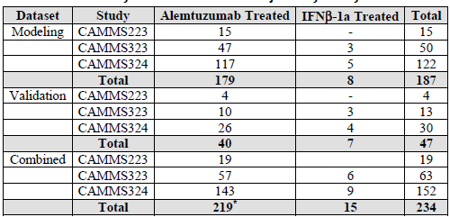
*Three alemtuzumab treated patients who did not have PK samples drawn were included in the database.
Table 3. Baseline Categorical Covariates
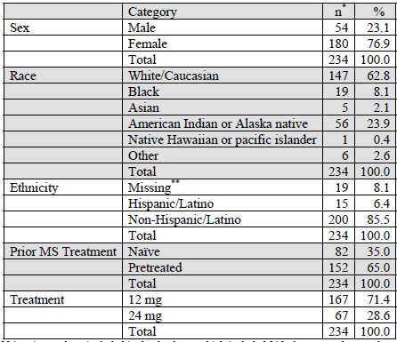
*A total of 234 patients were included in the database, which included 219 alemtuzumab treated patients, 3 of whom did not have PK samples collected, and 15 IFNβ-1a patients.
**Ethnicity for 19 patients from CAMMS223 was not included in the database; however, all 19 were Non-Hispanic/Latino.
Note: For all but one patient all baseline antibody status was listed as Not Available (NA).
Table 4. Baseline Continuous Covariates
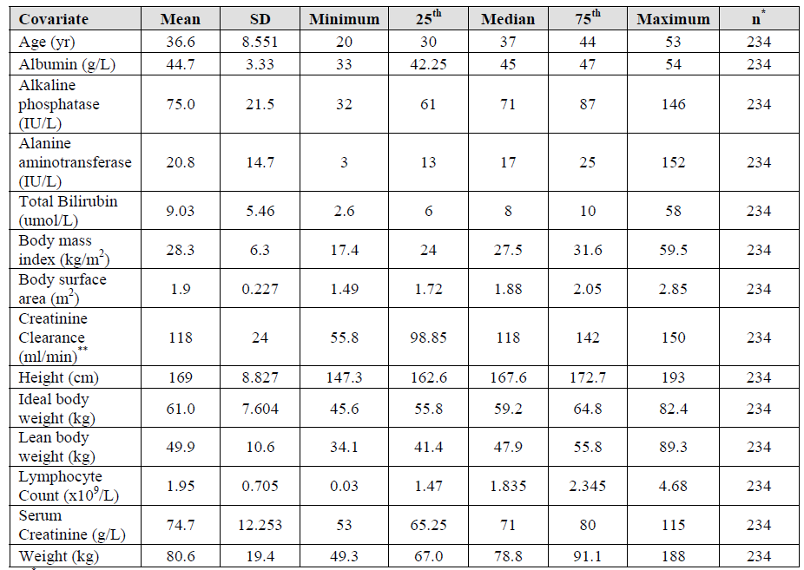
*A total of 234 patients were included in the database, which included 219 alemtuzumab treated patients, 3 of whom did not have PK samples collected, and 15 IFNβ-1a patients.
**maximum value capped at 150 ml/min
For all but one patient all baseline antibody titres were listed as Not Available (NA).
Data were analysed using mixed effects modelling methods with NONMEM (version VII, level 2 or higher). Diagnostic graphics, exploratory analyses, and post-processing of NONMEM output were performed using the SPlus 6.2 or R version 2.10 or later.
Covariate identification was conducted for the PK and PK/PD models. The covariates listed in the 2 Tables above were assessed for influence on the PK and PD of alemtuzumab. These were initially assessed by a graphical analysis and then by using a modelling approach for those covariates where a clear graphical difference in parameter estimates was evident.
The CIs of the parameter were taken from the asymptotic standard errors of the model. Since these values were obtained for all models using First-order conditional estimation method in NONMEM, bootstrapping was not performed.
No formal statistical evaluations of predictive performance were performed. A visual predictive check (VPC) evaluation was performed by simulating 250 replicates of the dataset and constructing the 2.5th and 97.5th prediction interval (PI) from which the model was developed.

Results
The 2 compartment model was selected.
Table 5. Parameter Estimates for the Final Pharmacokinetic Model
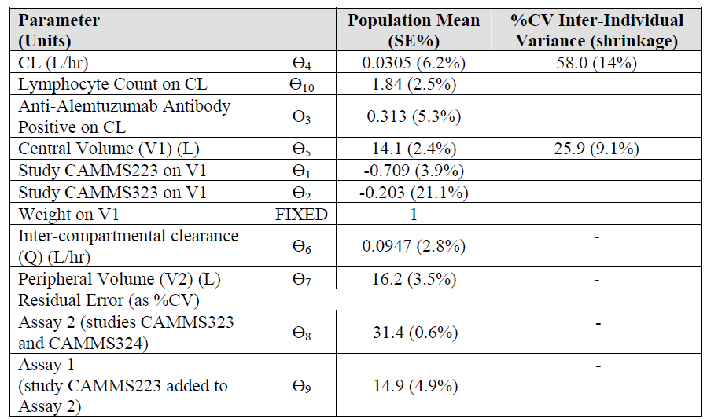
The condition number for the final model was 3.1. The shrinkage of the inter-individual parameter values were below 20% for both clearance and central volume of distribution.
Table 6. Comparison of Parameter Estimates for the Final Model Between Model Building and Full Datasets
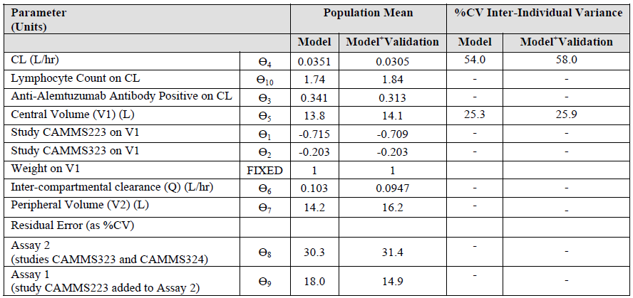
With the modelling clearance increased with increasing lymphocyte counts and anti-alemtuzumab antibody positive status resulted in a lower clearance.
Table 7. Mean (SD) Pharmacokinetic Parameters By Dose Group, Cycle and Pre-Treatment Anti-Alemtuzumab Antibody Treatment Status at Cycle 2
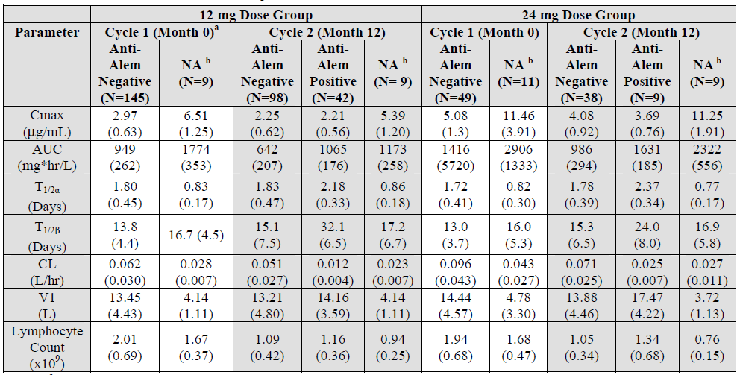
ª Low titre anti-alemtuzumab antibody was detected in 1 patient included in the PK dataset immediately prior to treatment with alemtuzumab at Month 0. As this observation is possibly due to baseline cross-reactivity, PK parameters for this patient are not reported.
^{b} Positive/Negative anti-alemtuzumab antibody status was not imputed for patients enrolled in CAMMS223 due to differences in methodology and reporting of titre values relative to the Phase 3 studies CAMMS323 and CAMMS324.

Summary of pharmacokinetics

Physicochemical characteristics of the active substance
The description is essentially similar in the proposed and existing PIs.
Comment: The proposed and existing PIs differ in their statement on generation of the product. Both statements are in Module 2.

Pharmacokinetics in MS subjects

Absorption
Not Applicable.

Bioavailability
Not Applicable.

Distribution
Table 8. Alemtuzumab PKs C_{max} & Accumulation Ratio CAMMS323 324 - PK Analysis Set
 | 12 mg/day, C_{max} (ng/mL) |  |  |  | 24 mg/day, C_{max} (ng/mL)
 | Cycle 1 |  | Cycle 2 |  | Cycle 1 |  | Cycle 2
 | Day 5 | Accumul  Ratio | Day 3 | Accumul  Ratio | Day 5 | Accumul  Ratio | Day 3 | Accumul  Ratio
n | 142 | 139 | 134 | 132 | 46 | 46 | 47 | 46
Mean | 3014.479 | 3.088 | 2276.037 | 2.108 | 3965.391 | 2.154 | 3357.489 | 1.647
Geo. Mean | 2880.198 | 2.963 | 2152.3 | 2.056 | 3843.965 | 2.004 | 3172.713 | 1.571
SD | 940.5459 | 0.9187 | 803.5738 | 0.4915 | 1036.7322 | 0.9446 | 1198.3592 | 0.4969
CV (%) | 31.201 | 29.749 | 35.306 | 23.317 | 26.145 | 43.855 | 35.692 | 30.178
Median | 2892.5 | 2.931 | 2144 | 2.05 | 3924 | 1.971 | 3106 | 1.552
Minimum | 911 | 1 | 974 | 1.23 | 2471 | 1.04 | 1452 | 0.48
Maximum | 5986 | 6.75 | 5226 | 3.87 | 7388 | 6.12 | 7971 | 2.96
Alemtuzumab is a genetically engineered humanised IgG1 kappa monoclonal antibody specific for a 21-28 kD lymphocyte cell surface glycoprotein, (CD52) antigen.
CD52 antigen, which is expressed on the surface of essentially all B and T lymphocytes (benign and malignant) as well as monocytes, thymocytes and macrophages, sperm and epithelial cells of epididymis and seminal vesicle. The antigen has also been found on a small percentage (<5%) of granulocytes, but not on erythrocytes or platelets.

Volume of distribution
From the final model of the POP PK study Central Volume is 14.1L (SE 2.4%; CV 25.9%); Peripheral Volume16.2L (SE 3.5%).

Excretion
Concentrations became low or undetectable within approximately 30 days (Month 1) following each treatment cycle for the 12mg/day dose, and became low or undetectable within approximately 90 days (Month 3) for the 24 mg/dose following each treatment cycle.
Systemic clearance decreased with repeated administration due to decreased receptor mediated clearance (i.e. loss of CD52 receptors in the periphery). Thus clearance should be lower in MS subjects with their lower lymphocyte counts and hence lower receptor pool. The model Clearance was 0.0351L/h (CV 54%) with a similar result for the validation. Further with the much longer dosing regimens (as well as the greater decrease in lymphocytes from treatment) steady state concentrations were reached after about 6 weeks of thrice weekly dosing in B-CLL so that clearance with a maximum of 5days treatment for MS should be different.

Intra- and inter-individual variability of pharmacokinetics
In building the model Inter-individual variability parameters were included on Clearance and Central volume (V1). Models that included inter-individual variability parameters on Apparent inter-compartmental clearance (Q) and Peripheral volume (V2) resulted in minimization terminated and rounding errors and were excluded.
Anti-alemtuzumab antibody status on CL and a study effect in V1 were statistically significant covariates and remained in the model.
Generally the parameters were estimated with reasonable precision. The Inter-individual variability on CL was high at 58.0%CV but lower for V1 at 25.9%CV. Shrinkage was acceptable on both parameters indicating individual derived parameters, such as AUC, could be generated and would be expected to reflect the individual values as opposed to the population values.
However in estimating the AUC during the first cycle for patients (n = 49) on 24mg/day who were Anti-alemtuzumab antibody negative at the start of their second cycle AUC was 1416 mg.hr/L with an SD of 5720mg.hr/L.

Pharmacokinetics in the target population
This submission is for a 5 day continuous regime at a lower dose than the currently approved (alternate days for up to 12 weeks) hence the re-evaluation of the PKs.

Pharmacokinetics in other special populations

Pharmacokinetics in subjects with impaired hepatic function
Not available.

Pharmacokinetics in subjects with impaired renal function
Not available.

Pharmacokinetics in other special populations
Covariates tested in the model included Sex, Race, Ethnicity, Prior MS Treatment, Treatment 12 or 14mg, Age, Albumin, Alkaline phosphatase, Alanine aminotransferase, Total Bilirubin, Body mass index, Body surface area, Creatinine Clearance, Height, Ideal body weight, Lean body weight, Lymphocyte Count, Serum Creatinine. Only Lymphocyte Count and Weight were retained in the model.

Pharmacokinetic interactions
No formal drug interaction studies.

Evaluator’s overall conclusions on pharmacokinetics
The sponsor in the PI refers to the results of combining only studies 323 & 324, rather than combining all 3 studies as in the Pop PK study. No explanation was given for excluding 223.,

Pharmacodynamics

Studies providing pharmacodynamic data
The submission included only a Population Pharmacokinetic/Pharmacodynamic report using pooled data from clinical efficacy studies 223, 323 & 324, and the CARE-MS Semen Substudy Analysis of sperm count, motility, morphology, agglutination, and antisperm antibodies in a subgroup of male patients participating in CAMMS323 or CAMMS324.

Population pharmacodynamic report
PK/PD models were developed for three key endpoints: CD3⁺ lymphocytes, CD19⁺ lymphocytes and total lymphocytes. The basic PD model examined was an indirect response model where lymphocytes are produced at a constant zero-order rate per day (K_{in}) and eliminated by a first-order degradation rate (K_{out}) and the baseline lymphocyte count prior to treatment is equal to the ratio of K_{in} to K_{out}. It is assumed that alemtuzumab causes cell lysis and acts to increase the rate of the lymphocyte degradation through a direct effect of its concentration in plasma.

CD3⁺ lymphocyte pharmacodynamics
A plot of the observed CD3⁺ lymphocyte count vs. time since last dose shows that counts rapidly decrease (from 1-2 x10⁹) after administration of alemtuzumab which is then followed by a gradual increase over time back towards baseline.
Of the models tested the best base model (and final model) was one where the rate of cell loss was proportional to the plasma alemtuzumab plasma concentration (Cp).
The Objective function was -4061.718 and condition number of 2 indicated a well-conditioned model.
Table 9. Parameter Estimates for the Final CD3⁺ Lymphocyte Count PK/PD Model
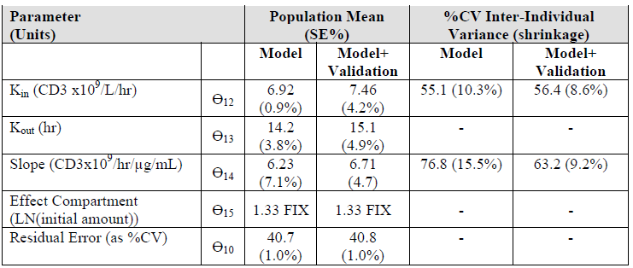

CD19⁺ lymphocyte pharmacodynamics
A plot of the observed CD19⁺ lymphocyte vs. time since last dose shows a drop (from 0.2-0.5 x10⁹) before returning towards baseline levels.
The best model of the relationships between alemtuzumab concentration and CD19⁺ lymphocyte counts was a proportional model that included estimating the initial amount in the effect compartment (CMT3I) and including Inter-individual variability on K_{in}. and S (Objective function =-4320).
Table 10. Parameters Estimates for the Final CD19⁺ Lymphocyte Count PK/PD Model
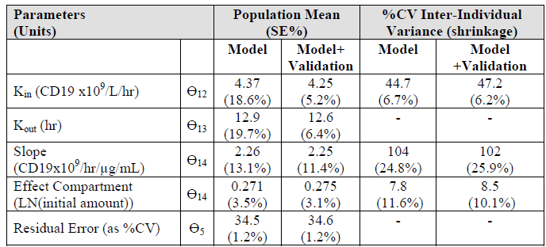

Total lymphocytes pharmacodynamics
A plot of the observed total lymphocyte count vs. time since last dose shows that counts rapidly decrease (from 1-4 x10⁹) after administration of alemtuzumab which is then followed by a gradual increase over time.
The best model of the relationships between alemtuzumab concentration and total lymphocyte counts was a proportional model that included Inter-individual variability terms on S and K_{in} and a fixed value for the effect compartment (CMT3I). Of the covariates analysed, antialemtuzumab antibody status had a statistically significant impact on S and K_{in}. The final model had an anti-alemtuzumab antibody effect on slope only.
Table 11. Parameters Estimates for the Final Total Lymphocyte Count PK/PD Model
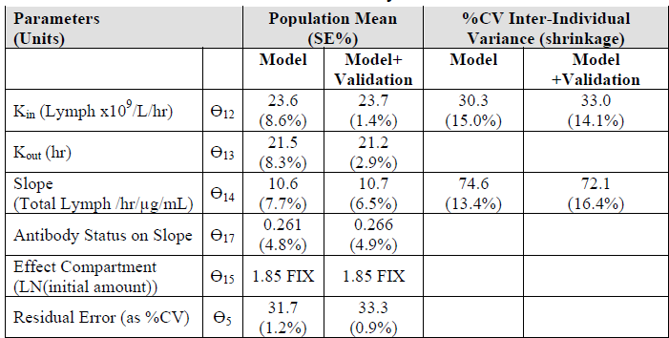

CARE-MS semen substudy of CAMMS323 and CAMMS324
Table 12. Semen Substudy 323 Results
 | Alemtuzumab 12mg/day  (N=1) | SC IFNB-1a  (N=1)
Volume | 2.0 to 6.1 mL | 1.5 to 2.8 mL.
Concentration | Within or above the range of baseline values | Below the lowest mean value for the alemtuzumab patient
Motility | Within the range of baseline values | Below the mean value for the alemtuzumab- patient
Percentage of sperm with normal morphology | 5 to 14 | 5 to 12
Agglutination | None | 3 of 9 (at baseline, prior to treatment, and at 1 month post-treatment)
Anti-Sperm Antibody (Sperm Mar) Testing | None | None
Table 13. Semen Substudy 324 Results
 | SC IFNB-1a  (N=2) | Alemtuzumab 12mg/day  (N=9) | Alemtuzumab 24mg/day  (N=3)
Volume | 1 patient all < N  1 patient all N | Mean 2.2mL (Range 0.5 - 4.5mL) 5 of 9 patients < N | 1 patient 1.1 to 3.1 mL, Mean 2.1mL
Concentration | Mean 28 M/mL. Range 26 to 31M/mL | Mean 83 M/mL. Range 26 to 212M/mL | 2 patients Mean 146 to 118M/mL.  1 patient 6 of 8 samples < N Mean 9.5M/mL.
Motility | 1 patient within the range of the baseline or normal values  1 patient Mean 10%. Range 6 to 17% | Within the range of the baseline or normal values Mean 62% Range 42 to 78% | Within the range of the baseline  or normal values  Mean 60% Range 49% to 88%
Percentage of sperm with normal morphology | All< N  Mean 9%, Range 8% to 10% | Within or above the range of baseline values or the initial sample analysed.  Mean 13% Range 6% to 31% | Mean 8%  Range 8% to 9%
Agglutination | 1 patient had agglutination at 13 & 15 Months. But not in Month 12 or Month 21. | 2 patients had agglutination in some samples (months 13 & 18 but not 15 for one patient and only month 1 for the other patient | 1 patient had agglutination in 7 of 8 samples, including the first (prior to dosing at Month 12) and last He have did not have a pre-treatment baseline analysis
Anti-Sperm Antibody (Sperm Mar) Testing | None | Of 8 tested 1 had < 25% Sperm Mar-free sperm, at month 1 only | None
Samples were collected prior to receiving methylprednisolone and study drug at baseline and at Months 1, 3, and 6. For patients entering the substudy after initiating therapy, samples were collected prior to receiving methylprednisolone and study drug at Month 12 (second cycle) and at Months 13, 15, and 18. Two samples were collected and analysed at each timepoint to account for sample variability that frequently occurs in normal, healthy volunteers. If the sperm count and/or motility were abnormal in either sample tested at Month 6 (or Month 18, for second cycle enrolees), 2 additional samples were collected and tested at Month 9 (or Month 21, for second cycle enrolees).
The Semen Analysis included Volume, Sperm Concentration and Motility, Morphology, Agglutination and Anti-Sperm Antibody (Sperm Mar) Testing.

Mechanism of action
The mechanism by which alemtuzumab exerts its therapeutic effects in MS is unknown, but may involve immunomodulation through the depletion and repopulation of lymphocytes. Research suggests that the potential immunomodulatory effects in MS may include alterations in the number, proportions, and properties of some lymphocyte subsets post-treatment.
Exploratory pooled analysis of the co-primary endpoints of relapse and 6-month SAD was performed on the Phase 3 data to investigate any potential correlations with the depletion or repopulation of lymphocytes. This showed no correlation between the efficacy endpoints of relapse and 6-month SAD with the extent of depletion and repopulation of the total lymphocyte population over both treatment cycles.

Pharmacodynamic effects

Primary pharmacodynamic effects
Alemtuzumab causes the lysis of lymphocytes by binding to CD52 antigen. The antibody mediates the lysis of lymphocytes via complement fixation and antibody-dependent cell mediated cytotoxicity.
‘Through 2 cycles of treatment with alemtuzumab 12 mg/day, the presence and titre level of anti-alemtuzumab or inhibitory antibody generally had no discernible effects on T or B lymphocyte depletion or repopulation for CD3⁺, CD4⁺, CD8⁺ and CD19⁺ lymphocyte subsets. The absolute counts of CD3⁺, CD4⁺, CD8⁺, and CD19⁺ cells were similar post-treatment for patients with anti-alemtuzumab or inhibitory antibodies compared with those who were always negative for those antibodies.
The number of pre-cycle antibody positive patients was adequate for correlative analyses only for anti-alemtuzumab antibodies at Cycle 2, and these analyses similarly showed no discernible effects on T or B lymphocyte depletion or repopulation for these lymphocyte subsets While they had no apparent effect on T and B lymphocytes, anti-alemtuzumab or inhibitory anti-alemtuzumab antibody-positive status and titre appeared to be associated with reduced depletion of CD16⁺56⁺ cells by alemtuzumab. The presence of antialemtuzumab pre-cycle was associated with reduced depletion of CD16⁺56⁺ cells by alemtuzumab in Cycle 2; among antibody positive patients, no effect of antibody titre level was apparent.
The clinical significance of an apparent association of anti-alemtuzumab with reduced depletion of CD16⁺56⁺ NK cells is uncertain.

Secondary pharmacodynamic effects
The submitted reference [IL-21 drives secondary autoimmunity in patients with multiple sclerosis, following therapeutic lymphocyte depletion with alemtuzumab. J. Jones, Chia-Ling P, A. Cox, S. Thompson, M. Ban, J. Shawcross, A. Walton, S. Sawcer, A. Compston, and A. Coles. The Journal of Clinical Investigation Volume 119 Number 7 July 2009; p.2052] contains the following:
“30% of patients develop autoimmunity months to years after pulsed exposure to alemtuzumab, usually targeting the thyroid gland and, more rarely, blood components. In this study, we show that autoimmunity arose in those patients with greater T cell apoptosis and cell cycling in response to alemtuzumab-induced lymphocyte depletion, a phenomenon that is driven by higher levels of IL-21.”

Time course of pharmacodynamic effects
Following administration of Cycle 1 with 12mg/day alemtuzumab in CAMMS223, mean lymphocyte counts were reduced from a baseline value of 1.97x10⁹/L to a nadir of 0.28x10⁹/L at Week 1 (assessed ~2 days after the final dose [Day 5] of the first cycle), a reduction by ~85%, started to increase by Week 2, and reached LLN by 9 months after Cycle 1.

Relationship between drug concentration and pharmacodynamic effects
Pop PK plots show a decrease in total lymphocyte count with exposure to alemtuzumab, with no apparent further decrease with increasing AUC or C_{max}. Overall, there appears to be no difference in lymphocyte depletion and repopulation across the exposure range evaluated following administration of 12mg and 24mg dosages. There was inter-individual variability in both the ratio (proportionality or slope) of the relationship and the rate of production of lymphocytes. The presence of anti-alemtuzumab antibody had an effect on the rate of lymphocyte production and the amount of lymphocyte depletion relative to the alemtuzumab concentration.

Genetic-, gender- and age-related differences in pharmacodynamic response
The covariates listed for the PK modelling were also tested on the PD model.

Evaluator’s overall conclusions on pharmacodynamics
The mode of action relates to lymphocyte depletion. It is of concern that one of the references provided relates the development of auto-antibodies to the degree of lymphocyte depletion. A higher dose however did not result in an observed lower total lymphocyte count.
Figure 1. Mean (± SE) Total Lymphocyte Counts over Time CAMMS 323 324
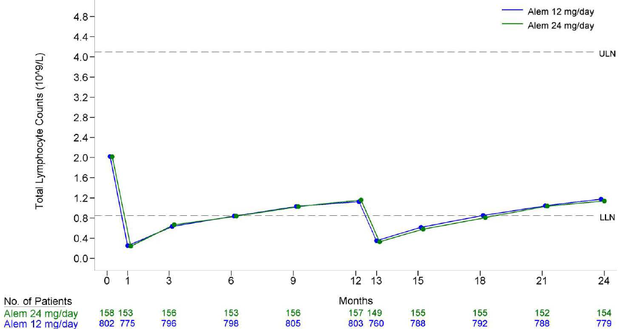

Dosage selection for the pivotal studies
- Study 323 and 324:
The selection of the alemtuzumab dose level and administration timing was based on safety and efficacy data from the CAMMS223 Phase 2 study’s Year 2 interim analysis and previously conducted pilot studies with alemtuzumab in RRMS.
- Study223:
The 2 alemtuzumab dose levels (12mg/day and 24mg/day) used in the initial 3-year treatment period of this study were selected to identify dose-dependent relationships in terms of efficacy or safety variables. Pilot studies of alemtuzumab treatment for MS used dosages in the same range (Moreau, 1994, Lancet; Coles, 2006, J Neurol). In pilot studies with Relapsing Remitting patients, a dosage of 20mg/day for 5 days appeared efficacious but with associated toxicities. The 2 alemtuzumab dose levels selected for study CAMMS223 were, respectively, higher or lower than the pilot study regimen. The alemtuzumab retreatment dose was calculated as 60% of the initial dose, that is, a 3-day cycle instead of 5 days, to account for the reduction in lymphocyte levels at Month 12 and 24 compared with baseline. These regimens were selected following discussions with clinical experts and regulatory authorities.
For ease of prescription and administration, a fixed dose for all patients was selected regardless of the patient’s body weight, as had been the practice in treating MS patients with alemtuzumab in prior investigator sponsored studies. The initial administration period of 5 consecutive days to deliver the desired total cumulative dose was specified to reduce the amount of alemtuzumab administered in a single day or by a single infusion to minimize infusion reactions (the “first dose” phenomenon) that were reported in pilot studies (Moreau, 1996, Brain) and other potential issues with tolerability.
And: The alemtuzumab retreatment dose of 36 mg (12mg/day over 3 consecutive days) in the retreatment period was selected based on interim safety and efficacy data from this study suggesting that the 12mg/day regimen was comparably safe and effective as the higher dose.

Clinical efficacy

For the treatment of patients with relapsing forms of multiple sclerosis to slow or reverse the accumulation of physical disability and reduce the frequency of clinical relapses

Pivotal efficacy studies

Study CAM 323

Study design, objectives, locations and dates
A randomized, multi-centre, rater-blinded study comparing alemtuzumab with Interferon β-1a (Rebif) in treatment naïve patients with early, active RRMS comparing two annual cycles of intravenous alemtuzumab to three-times weekly subcutaneous IFNB-1a.
Conducted in a total of 101 sites in Argentina, Australia, Brazil, Canada, Croatia, Czech Republic, France, Germany, Mexico, Poland, Russia, Serbia, Sweden, Ukraine, the UK, and the US, from 7 September 2007 to 13 May 2011.
The objectives were to compare the safety and efficacy of 2 annual cycles of IV alemtuzumab to 3-times weekly SC-administered interferon β-1a (Rebif) in treatment-naïve patients with RRMS who have recent MS disease activity as demonstrated by clinical relapses.

Inclusion criteria
Included:
- Diagnosis of MS per updated McDonald criteria, and cranial MRI scan demonstrating white matter lesions attributable to MS within 5 years of screening
- Onset of MS symptoms (as determined by a neurologist, either at screening or retrospectively) within 5 years of the date the ICF was signed
- EDSS score 0.0 to 3.0 (inclusive) at screening
- ≥2 MS attacks (first episode or relapse) occurring in the 24 months prior to the date the ICF was signed, with ≥ 1 attack in the 12 months prior to the date the ICF was signed, with objective neurological signs.

Exclusion criteria
Included:
- Prior therapy for MS other than corticosteroids, e.g., alemtuzumab, interferons, IV immunoglobulin, glatiramer acetate, natalizumab, and mitoxantrone
- Exposure to azathioprine, cladribine, cyclophosphamide, cyclosporine A, methotrexate, or any other immunosuppressive agent other than systemic corticosteroid treatment
- Treatment with a monoclonal antibody for any reason
- Any progressive form of MS
- Any disability acquired from trauma or another illness that, in the opinion of the Investigator, could interfere with evaluation of disability due to MS
- Intolerance of pulsed corticosteroids, especially a history of steroid psychosis
- CD4⁺ cell count (absolute CD3⁺ CD4⁺) < lower limit of normal (LLN) at screening
- CD8⁺ cell count (absolute CD3⁺ CD8⁺) < LLN at screening
- B-cell count (absolute CD19⁺) < LLN at screening
- Absolute neutrophil count < LLN at screening
- Known bleeding disorder (e.g., dysfibrinogenemia, factor IX deficiency, haemophilia, Von Willebrand’s disease, disseminated intravascular coagulation, fibrinogen deficiency, or clotting factor deficiency)
- Significant autoimmune disease including but not limited to immune cytopenias, rheumatoid arthritis, systemic lupus erythematosus, other connective tissue disorders, vasculitis, inflammatory bowel disease, severe psoriasis
- Presence of anti-thyroid stimulating hormone (TSH) receptor (TSHR) antibodies (i.e., above the LLN)
- Infection with hepatitis C virus
- Past or present hepatitis B infection (positive hepatitis B serology)
- Major psychiatric disorder not adequately controlled by treatment
- Epileptic seizures not adequately controlled by treatment
- Confirmed platelet count < LLN of the evaluating laboratory at screening or documented at <100,000/mcgL within the past year on a sample without platelet clumping
- Prior history of invasive fungal infections
- Cervical high risk human papilloma virus (HPV) positivity or abnormal cervical cytology other than abnormal squamous cells of undetermined significance (ASCUS)
- Seropositive for Trypanosoma cruzi or the Human T-lymphotropic virus type I or type II (HTLV I/II) (testing required in endemic regions only).
- Any hepatic or renal function value Grade 2 or higher at Screening, with the exception of hyperbilirubinaemia due to Gilbert’s syndrome.

Study treatments
Alemtuzumab IV infusions (initially 4h for 2days then ≥ 2h or ≤ 8h):
Month 0 over 5 consecutive days IV:
- a total dose of 60mg (12mg/day)
Month 12 over 3 consecutive days IV:
- a total dose of 36mg (12mg/day).
There was no provision for alemtuzumab dose modification other than interrupting or extending the daily infusion period.
Premedication with antipyretics, antihistamines and histamine-H2 receptor blockers, and anti-emetics was permitted at the Investigator’s discretion, to minimize IARs known to be associated with alemtuzumab administration (e.g. rash).
Interferon β-1a:
Following initial dose titration (20% dose the first 2 weeks, 50% dose the next 2 weeks, and full dose after 4 weeks), IFNB-1a was taken 44mcg SC 3 times/week (total weekly dose of 132 mcg). The dose could be decreased or discontinued at the investigator’s discretion.
All patients received IV methylprednisolone (1g/day) on Days 1, 2, and 3 at Months 0 and 12. (If a patient assigned to the IFNB-1a arm had received corticosteroids for symptomatic treatment of a relapse within 1 month (30 days) of a scheduled steroid infusion, that infusion was omitted).
From 05 Jan 2009 prophylaxis with acyclovir 200 mg twice daily (or a therapeutic equivalent), was added, starting on the first day of each alemtuzumab cycle and for 28 days after the last day of each cycle.

Efficacy variables and outcomes
Primary efficacy endpoints were time to SAD and relapse rate.
Secondary Endpoints
- Proportion of patients who are relapse free at Year 2
- Change from baseline in EDSS
- Acquisition of disability as measured by change from baseline in MSFC
- Percent change from baseline in MRI-T2-hyperintense lesion volume at Year 2.
There were multiple Tertiary Endpoints

Randomisation and blinding methods
Patients were randomized to alemtuzumab or IFNB-1a using an interactive voice response system. Treatment assignment was at a ratio of 2:1 for alemtuzumab or IFNB-1a. The randomization was stratified by centre using blocks of fixed size (3 in each block). The block size was not revealed to clinical sites until after database lock. No site could originally enrol > 5% of all patients (this was changed to no country randomize > 50% of the total sample size 3 July 2008).

Analysis populations
Table 14. Data Sets Based on Randomized Patients, N (%)
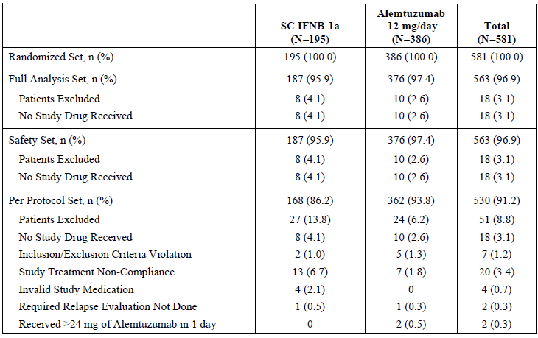
Note: Patients may have more than 1 reason for exclusion
The Full Analysis was all patients who were randomized to treatment and had received any amount of study drug.
The PP set included all:
- Patients who had no major protocol deviations or inclusion/exclusion criteria deviations that might potentially affect efficacy
- Alemtuzumab-treated patients who received alemtuzumab at 0 and 12 months without any major protocol deviations at either dose, or if SAD was experienced in the first 12 months, who had received alemtuzumab at Month 0 without any major protocol deviations
- IFNB-1a-treated patients who took at least 80% of the required IFNB-1a doses and remained on therapy for at least 12 months, or if SAD was experienced, who took at least 80% of the required IFNB-1a doses prior to that event.

Sample size
The Statistical Analysis Plan refers to the protocol for this, the original protocol states:
Sample size estimation for the time to SAD co-primary efficacy endpoint was based on the following assumptions:
- Log rank test used to test for statistical significance of treatment effect
- 2:1 alemtuzumab: SC interferon β-1a randomization ratio
- Two-year rate of SAD of 20% for SC interferon β-1a; equivalent to a 0.11 hazard rate assuming an exponential time to SAD distribution
- Hazard ratio of 0.40 comparing alemtuzumab to SC interferon β-1a which corresponds to a 60% treatment effect
- Accrual period of approximately 1 year
- The analysis of SAD will be based on the 2-year follow-up data
- Dropout rate of approximately 10%
- Two-sided significance level of 2.5% (first step of Hochberg procedure).
With these assumptions, a sample size of approximately 450 patients provides >90% power to detect a treatment difference in time to SAD.
Sample size estimation for the relapse rate co-primary efficacy endpoint can be approximated using the time to first relapse endpoint. Assuming 40% of patients treated with SC interferon β-1a relapse in 2 years (equivalent to a hazard rate of 0.26 with an exponential distribution of time to first relapse), a hazard ratio of 0.40 comparing alemtuzumab to SC interferon β-1a, and the other assumptions made for the time to SAD endpoint, the power for detecting a treatment difference in the relapse rate endpoint is >90% at a 2.5% significance level (second step of Hochberg procedure).

Statistical methods
The primary efficacy analysis was to be conducted on the available 2-year follow-up data for all patients, and was to be adjusted for multiple comparisons via the Hochberg method. Using the Hochberg procedure, the study was to be considered to have met its primary efficacy objective if the p-values corresponding to the analysis of the primary endpoints satisfied at least 1 of the following conditions:
- The maximum of the two p-values was ≤0.05
- The minimum of the two p-values was ≤0.025.
Therefore, the study would be considered to have met its efficacy objective if a statistically significant treatment effect of alemtuzumab over SC interferon β-1a was demonstrated in either or both of the co-primary efficacy endpoints: time to SAD and relapse rate.
The comparison of the time to SAD co-primary endpoint was to use a Cox proportional hazards regression model with treatment group indicator, geographic region, and baseline EDSS as the only covariates in the model.
The comparison of the relapse rate co-primary endpoint was to use the proportional means model. Treatment group indicator, geographic region, and baseline EDSS were to be the only covariates in the model. The negative binomial model with robust variance estimation replaced Poisson regression as the method used to estimate the annualized relapse rate.
The secondary efficacy analyses used the available 2-year follow-up data for all patients.
Hypothesis testing for the secondary efficacy analyses was to be performed using a closed testing procedure with the following rank order:
- Proportion of patients who are relapse free at Year 2.
- Change from baseline in EDSS.
- Acquisition of disability as measured by the MSFC.
- Percent change from baseline in MRI-T2 hyperintense lesion volume at Year 2.
Comment: This order was changed with Acquisition of disability moved to last in the order. This change was only seen in the Final SAP and not in any of the protocol amendments submitted.
The hypothesis testing was to proceed from highest rank (1. Proportion of patients who are relapse free at Year 2) to lowest rank (4. Percent change from baseline in MRI-T2 hyperintense lesion volume at Year 2), and if statistical significance was not achieved at an endpoint (p ≤ 0.05), then endpoints of lower rank would not be considered to be statistically significant.
The proportion of patients who are relapse free at Year 2 was to be estimated via the Kaplan- Meier method, in the final SAP this was to be tested using the Cox proportional hazards model rather than the previously proposed logistic regression. The comparison between the treatment groups was to be based on the difference of these estimates.
Change from baseline in EDSS and Acquisition of disability (as measured by the MSFC and MSFC components plus Sloan Charts) was to be analysed using the Wei-Lachin method for nonparametric analysis of repeated measures. For the comparison of change from baseline in EDSS, the stochastic ordering test was to be used to test for differences in the EDSS change from baseline over time.
The percent change from baseline in MRI measures of MS-related changes was to be analysed using the Wilcoxon rank sum test. This was replaced by a ranked ANCOVA. Comparisons between the treatment groups were to be made, separately, at Year 1 and Year 2.
The number of new gadolinium-enhancing lesions on MRI-T1 at Year 1 and Year 2, and the number of new or enlarging hyperintense lesions as measured by T2-weighted MRI at Year 1 and Year 2 was to be analysed using ordinal logistic regression models. This was replaced in the final SAP by the negative binomial model with robust variance estimation.
The time to SAD, sustained over a 3-month period, was to be analysed using a Cox proportional hazards model with treatment-group indicator and baseline EDSS the only covariates in the model.
The proportion of patients who have worsened, remained stable or improved at Year 1, Year 2, and end of study based on change from baseline in EDSS scores was to be analysed using a proportional odds model with treatment group and baseline EDSS as the only covariates in the model.
The comparison of the relapse rate based on relapses that are treated with corticosteroid therapy was to be conducted using the proportional means model. Treatment group indicator and baseline EDSS were to be the only covariates in the model.

Participant flow
Figure 2. Study 323: Patient Disposition
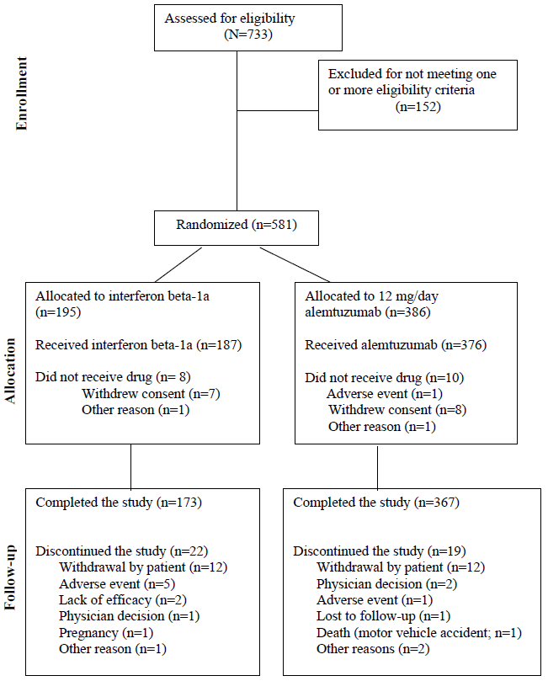

Major protocol violations/deviations
There were multiple protocol amendments including changes to the analyses of 1 primary and 3 of the secondary endpoints. That of greatest impact was moving the ranking of acquisition of disability to last in the order of analysis.
10/195 (5%) of IFNB-1a subjects violated eligibility criteria vs. 2.6% of alemtuzumab.
2 patients at a single study site inadvertently received an infusion of alemtuzumab > 12mg (48mg for one patient and 60mg for the other patient) and both patients subsequently experienced serious infusion associated reactions.
Table 15. Major Protocol Deviations Randomized Set
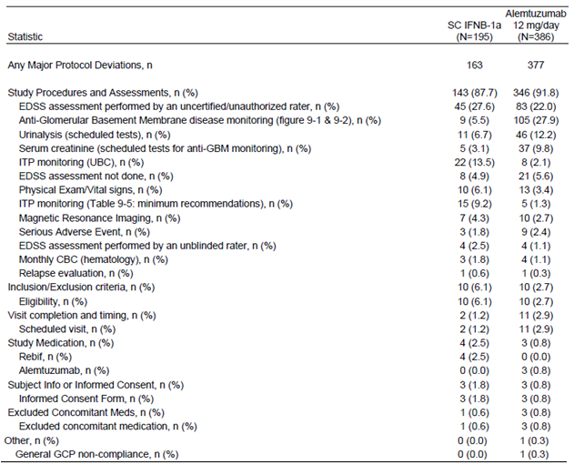

Baseline data
Table 16. Demographic Characteristics: Full Analysis Set
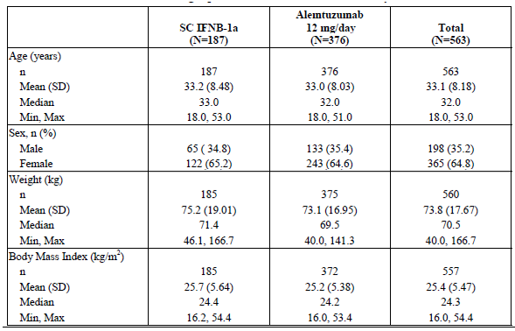
Only 3 (1.6%) IFNB-1a-treated patients and 4 (1.1%) alemtuzumab-treated patients switched to an alternative disease-modifying therapy during the 2-year period.
Table 17. Change to Alternative MS Medication
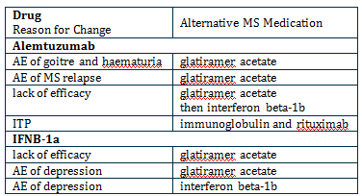
Table 18. Baseline MS Disease Characteristics: Full Analysis Set
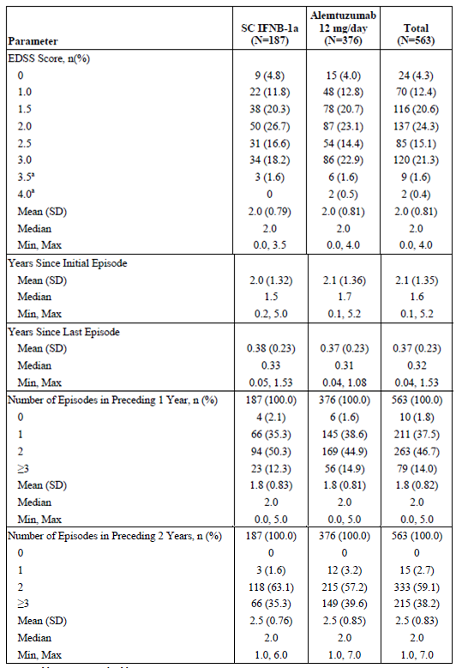
6 patients who did not receive the full dose of alemtuzumab in Cycle 1 due to IARs, then went on to complete Cycle 2; 6 patients discontinued treatment after Cycle 1 (4 due to AEs [3 thyroid and 1 ITP], 1 due to withdrawal of consent, and 1 due to lack of efficacy), and 4 patients who initiated but did not complete Cycle 2 due to IARs (one of which was reported as a discontinuation due to AE).
Table 19. Alemtuzumab Exposure Through 2 Years: Safety Set
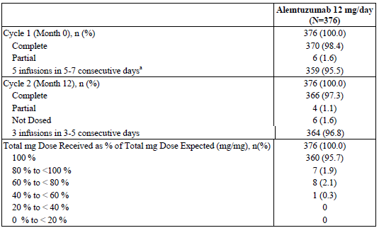
Note: Partial refers to < 100% of target doses.
Note: Total mg Dose Received as % of Total mg Dose Expected calculated as (Total mg Dose Received / 60mg) for Cycle 1 (Month 0) and (Total mg Dose Received / 36mg) for Cycle 2 (Month 12).
a Excludes Patients who received the full planned dose for Cycle 1 in a single infusion
Table 20. IFNB-1a Exposure Through 2 Years: Safety Set
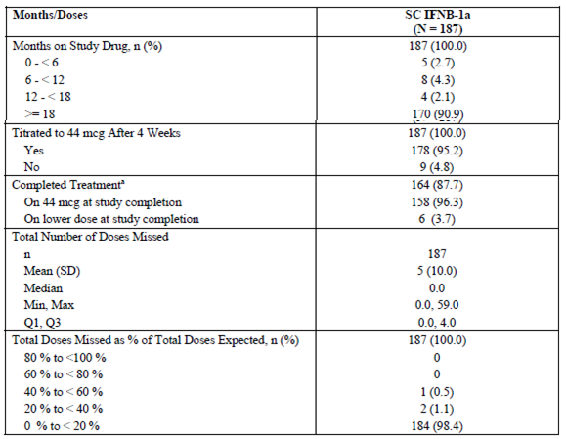
ª Percentages are based on the number who completed treatment, N = 164
Note: Months on Study Drug derived from the total days expected on study drug (calculated as last dose date minus first dose date +1)/30.4375)
During the study, there were 10 EDSS assessments performed by an unblinded rater in 8 patients in the IFNB-1a group and 11 unblinded assessments in 7 patients in the alemtuzumab group, most of which occurred at unscheduled relapse assessments.

Results for the primary efficacy outcomes
- Time to Sustained Accumulation of Disability
A statistically significant treatment effect compared to IFNB-1a was not shown in the co-primary efficacy endpoint time to SAD.
Table 21. Primary Analysis Time to Sustained Accumulation of Disability (6-Month Criteria) Event and Treatment Effect Summary: Full Analysis Set
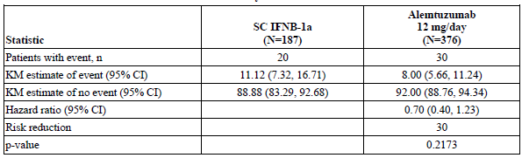
Note: Hazard ratio and p-value are from proportional hazards regression with robust variance estimation and covariate adjustment for geographic region. Risk reduction is summarized for hazard ratios less than 1 only.
- Relapse Rate
Alemtuzumab significantly reduced the relapse rate through 2 years by 55% compared with IFNB-1a (p <0.0001). The estimated ARR through 2 years was 0.18 for alemtuzumab vs. 0.39 for IFNB-1a. Based on these results, 2.3 patients would need to be treated with alemtuzumab instead of IFNB-1a to prevent 1 relapse during this period. Confirmatory analyses supported these results.
Sensitivity analyses showed minimal influence of alternative MS treatments, unblinded EDSS raters, and other factors that could potentially affect the primary relapse analysis.
Table 22. Annualized Relapse Rate, Relapse Rate Ratio, and Risk Reduction Full Analysis Set Primary Analysis
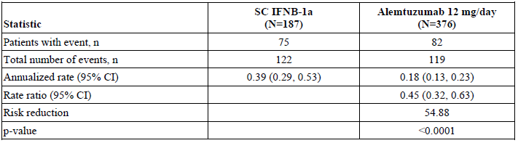
Note: ARR is estimated through negative binomial regression with robust variance estimation and covariate adjustment for geographic region. Rate ratio and p-value are from proportional means regression with robust variance estimation and covariate adjustment for geographic region. Risk reduction is summarized for rate ratios less than 1 only.
Table 23. On-Study Relapses Full Analysis Set
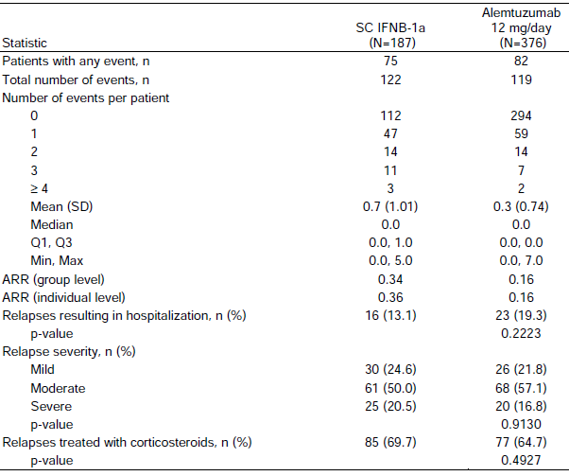
Note: ARR (group level) is the total number of relapses divided by the total years of follow-up (all patients). ARR (individual level) is the mean per-patient ARR (per-patient relapse count divided by the per-patient years of follow-up).
Figure 3. Cumulative Plot of Relapse Rate: Full Analysis Set
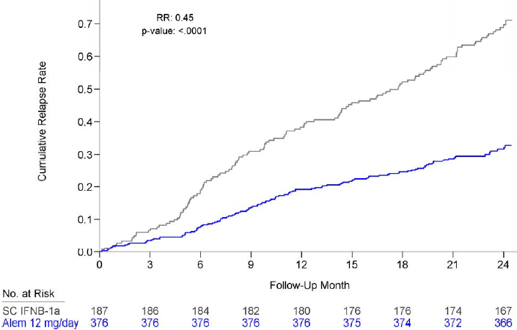
Figure 4. Summary of Relapse Rate Ratio Sensitivity Analyses Full Analysis Set
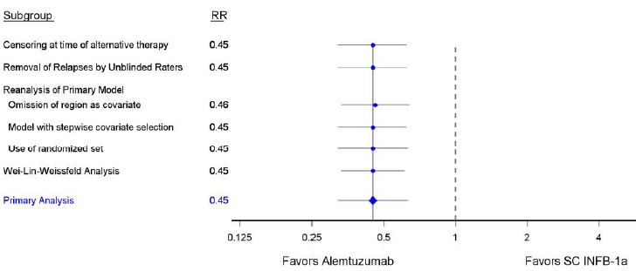
Figure 5. Summary of Relapse Rate Ratio Subgroup Analyses Full Analysis Set
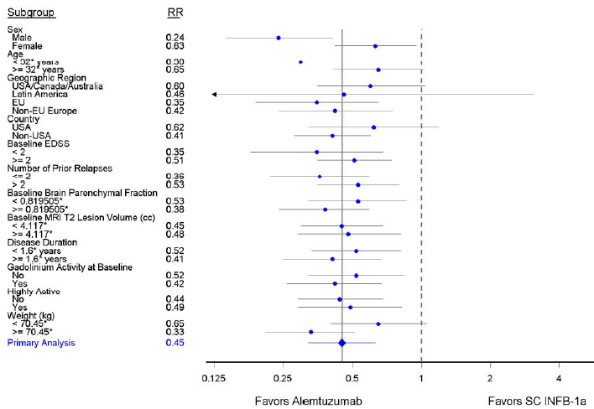
Note: Age, baseline brain volume, T2 lesion volume, disease duration and weight are split at the sample median of the Full Analysis Set.
Comment: Thus since the study was to be considered to have met its primary efficacy objective if the p-values corresponding to the analysis of the primary endpoints satisfied at least 1 of the following conditions:
- The maximum of the two p-values was ≤ 0.05
- The minimum of the two p-values was ≤ 0.025
Therefore, the study would be considered to have met its efficacy objective if a statistically significant treatment effect of alemtuzumab over SC interferon β-1a was demonstrated in either or both of the co-primary efficacy endpoints: time to SAD and relapse rate.

Results for other efficacy outcomes
- Proportion of patients who are relapse free at Year 2
Alemtuzumab significantly increased the proportion of patients who were relapse free through 2 years compared with IFNB-1a. At Year 2, 78% of alemtuzumab vs. 59% of IFNB-1atreated patients remained relapse free.
Table 24. Time to First Relapse and Proportion of Patients Who Are Relapse-Free at Month 24 Full Analysis Set
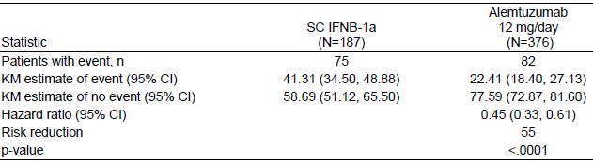
Note: Hazard ratio and p-value are from proportional hazards regression with robust variance estimation and covariate adjustment for geographic region. Risk reduction is summarized for hazard ratios less than 1 only.
- Change from baseline in EDSS.
Table 25. Change from Baseline at Year 2 in EDSS Score: Full Analysis Set
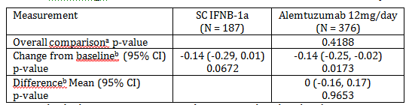
ª Wei-Lachin (multivariate, non-parametric test) Note: Empirical p-value is based on 10,000 permutations of the treatment codes.
^{b} Using mixed model for repeated measures. Changes from baseline and group differences are estimated using an unstructured covariance model with a time by treatment interaction and covariate adjustment for geographic region and baseline EDSS score.
Figure 6. EDSS Mean Change from Baseline Through 2 Years
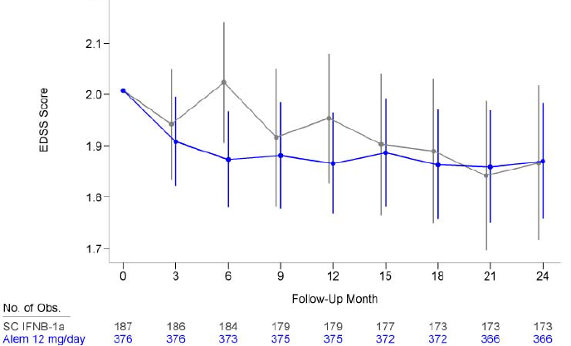
While both alemtuzumab and IFNB-1a-treated patients had a mean reduction in EDSS scores at year 2 the difference between the groups was not statistically significant (p = 0.4188; multivariate nonparametric test).
Comment: Hypothesis testing for the secondary efficacy analyses was to be performed using a closed testing procedure with the following rank order:
- Proportion of patients who are relapse free at Year 2.
- Change from baseline in EDSS.
Thus since testing failed to show a significant difference for Change from baseline in EDSS the subsequent analyses steps (in whatever the order) could not be made. Descriptive results only could be provided.

Study CAM 324

Study design, objectives, locations and dates
A randomized, multi-centre, rater-blinded study comparing alemtuzumab with IFNB-1a in patients with active RRMS who relapsed during prior treatment. Active RRMS was defined as having at least 2 clinical episodes (i.e., attacks, exacerbations) of MS in the 2 years prior to study entry, of which at least 1 episode had to be in the year prior to study entry.
Conducted in 181 centres in Argentina, Australia, Austria, Belgium, Brazil, Canada, Croatia, Czech Republic, Denmark, France, Germany, Israel, Italy, Mexico, Netherlands, Poland, Russia, Serbia, Spain, Sweden, Ukraine, the UK and the US; from 10 October 2007 to 15 September 2011.
The objectives were to compare the safety and efficacy of 2 annual cycles of IV alemtuzumab either 12mg/day or 24mg/day to 3-times weekly SC-administered interferon β-1a (Rebif) in patients with RRMS who had experienced at least 1 relapse during prior treatment with interferon β or glatiramer acetate after having received that therapy for ≥ 6 months. However, enrollment into the alemtuzumab 24mg/day group was closed 03 July 2008.

Inclusion criteria
Included:
- Diagnosis of MS per update of McDonald criteria
- Onset of MS symptoms (as determined by a neurologist; could be retrospectively) within 10 years of the date the ICF was signed
- An EDSS score 0.0 to 5.0 (inclusive) at Screening
- ≥2 MS attacks (first episode or relapse) occurring in the 24 months prior to the date the ICF was signed, with ≥ 1 attack in the 12 months prior to the date the ICF was signed
- ≥1 MS relapse during treatment with a β interferon therapy or glatiramer acetate after having been on that therapy for ≥ 6 months within 10 years of the date the ICF was signed
- MRI scan demonstrating white matter lesions attributable to MS and meeting at least 1 of the following criteria, as determined by the neurologist or a radiologist
  - ≥ 9 T2 lesions at least 3 mm in any axis
  - A gadolinium- (Gd-) enhancing lesion at least 3 mm in any axis plus ≥ 1 brain T2 lesions
  - A spinal cord lesion consistent with MS plus ≥ 1 brain T2 lesion.

Exclusion criteria
Included:
- Previous treatment with alemtuzumab
- Treatment with natalizumab, methotrexate, azathioprine, or cyclosporine in the past 6 months.
- Previous treatment with mitoxantrone, cyclophosphamide, cladribine, rituximab or any other immunosuppressant or cytotoxic therapy (other than steroids)
- Any progressive form of MS
- Any disability acquired from trauma or another illness that, in the opinion of the Investigator, could interfere with evaluation of disability due to MS
- Previous hypersensitivity reaction to any immunoglobulin product
- Known allergy or intolerance to interferon β, human albumin, or mannitol
- Intolerance of pulsed corticosteroids, especially a history of steroid psychosis
- Confirmed platelet count < the lower limit of normal (LLN) of the evaluating laboratory at Screening or documented at <100,000/mcL within the past year on a sample without platelet clumping
- CD4⁺, CD8⁺, or CD19⁺ (i.e., absolute CD3⁺CD4⁺, CD3⁺CD8⁺, or CD19⁺/mm³) count < LLN at Screening; if abnormal cell count(s) returned to within normal limits (WNL), eligibility could be reassessed
- Absolute neutrophil count < LLN at Screening; if abnormal cell count returned to WNL, eligibility could be reassessed
- Known bleeding disorder
- Significant autoimmune disease
- Presence of anti-thyroid stimulating hormone (TSH) receptor (TSHR) antibodies (i.e. above LLN)
- Active infection
- In the Investigator’s opinion, at high risk for infection
- Latent tuberculosis unless effective anti-tuberculosis therapy has been completed, or active tuberculosis
- Infection with hepatitis C virus
- Past or present hepatitis B infection (positive hepatitis B serology)
- Prior history of invasive fungal infections
- Cervical high risk human papilloma virus (HPV) positivity or abnormal cervical cytology other than abnormal squamous cells of undetermined significance (ASCUS). The patient may have been eligible after the condition resolved (e.g., follow-up HPV test was negative or cervical abnormality had been effectively treated)
- Seropositive for Trypanosoma cruzi or the Human T-lymphotropic virus type I or type II.

Study treatments
Alemtuzumab IV infusions (initially 4h for 2days then ≥ 2h or ≤ 8h):
Month 0 5 consecutive days IV infusions (~ 4 h) either:
- a fixed total dose of 60mg (12mg/day) or
- 120 mg (24mg/day).
Month 12 over 3 consecutive days IV a total dose of:
- 36mg (12mg/day) or
- 72mg (24mg/day).
There was no provision for alemtuzumab dose modification other than interrupting or extending the daily infusion period. Enrolment into the alemtuzumab 24mg/day group was closed 03 July 2008.
Premedication with antipyretics, antihistamines and histamine-H2 receptor blockers, and anti-emetics was permitted at the Investigator’s discretion, to minimize IARs known to be associated with alemtuzumab administration (e.g., rash).
Interferon β-1a:
Following initial dose titration, IFNB-1a was taken 44mcg SC 3 times/week (total weekly dose of 132mcg).
All patients received IV methylprednisolone (1g/day) on Days 1, 2, and 3 at Months 0 and 12. (If a patient assigned to the IFNB-1a arm had received corticosteroids for symptomatic treatment of a relapse within 1 month (30 days) of a scheduled steroid infusion, that infusion was omitted).
From 22 December 2008 prophylaxis with acyclovir 200 mg twice daily, was added, starting on the first day of each alemtuzumab cycle and for 28 days after the last day of each cycle.

Efficacy variables and outcomes
Co-Primary Endpoints
- Time to SAD
- Relapse rate.
Secondary Endpoints
- Proportion of patients who are relapse free at Year 2
- Change from baseline in EDSS
- Acquisition of disability as measured by change from baseline in MSFC
- Percent change from baseline in MRI-T2 hyperintense lesion volume at Year 2.
There were multiple tertiary endpoints.
The endpoints were similar to those for study 323 and the Secondary Endpoints were likewise modified by making Acquisition of disability the last in the order of step down testing.(after final amendment 11 May 2010).

Randomisation and blinding methods
Patients were randomized to alemtuzumab or IFNB-1a using an interactive voice response system (IVRS). The randomization was stratified by centre using blocks of fixed size (3 in each block). The block size was not revealed to clinical sites until after database lock.
After sites approved Amendment 2, randomization to the alemtuzumab 24 mg/day arm was closed within the IVRS on a site-by-site basis. The original randomization codes were not modified so that post-approval patients were randomized in a 2:1 alemtuzumab 12mg/day to IFNB-1a ratio.
No site could originally enrol > 5% of all patients (this was changed to no country could randomize > 50% of the total sample size 3 July 2008).

Analysis populations
Table 26. Analysis Sets; Randomized Set
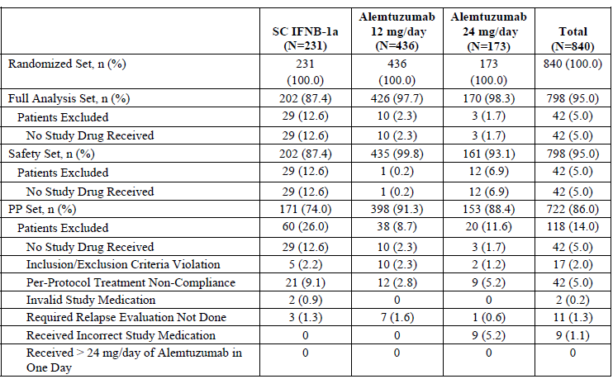
Note: Percentages are based on the number of patients randomized. The FA set includes all randomized patients who received study medication. The Safety set includes all randomized patients who received study medication. For the PP set, inclusion/exclusion refers to all protocol violations identified as affecting efficacy. Study drug refers to SC IFNB-1a or alemtuzumab. The randomized treatment group is summarized for the Randomized, Full Analysis, and PP sets; the actual treatment group is summarized for the Safety set. Patients may have more than 1 reason for exclusion.
The populations were defined similar to Study 323.

Sample size
In the original protocol, assuming a 2:2:1 randomization to alemtuzumab12mg/day, alemtuzumab 24mg/day, or IFNB-1a, a sample size of 1200 patients was planned in order to provide > 80% power to detect a 45% treatment effect in time to SAD, assuming a 2-year SAD rate of 20% for the IFNB-1a patients.
Sample size estimation for the time to SAD co-primary efficacy endpoint for the original protocol was based on the following assumptions:
- Log rank test used to test for statistical significance of treatment effect
- 2:2:1 alemtuzumab 12 mg/day: alemtuzumab 24 mg/day: IFNB-1a randomization ratio
- 2-year rate of SAD of 20% or 25% for IFNB-1a; equivalent to a 0.11 and 0.14 hazard rate, respectively, assuming an exponential time to SAD distribution
- Accrual period of approximately 1 year
- The analysis of SAD would be based on the 2-year follow-up data
- Dropout rate of 10%
- 2-sided significance level of 5% (first step of Hochberg procedure).
The 20% 2-year SAD rate for IFNB-1a was based on the IFNB-1a SAD rate in the Phase 2 study (CAMMS223).
With Amendment 2, the 24mg/day arm was closed to further enrolment, and randomization continued until approximately 382 patients were assigned to alemtuzumab 12mg/day and 191 were assigned to IFNB-1a. The same assumptions utilized in the original protocol were used to determine the number of patients needed to provide 80% power for the time to SAD endpoint for Amendment 2. However, given the 3-year results from CAMMS223 study, which demonstrated that annual treatment with alemtuzumab reduced the risk of SAD by 71% compared with IFNB-1a, statistical assumptions were adjusted with Amendment 2 such that the study was powered to detect a 50% rather than a 45% treatment effect. Approximately 573 patients should provide >80% power to detect a 50% treatment effect in time to SAD given a 2-year SAD rate of 20% for the IFNB-1a patients.
Sample size estimation for the relapse rate co-primary efficacy endpoint was approximated using the time to first relapse endpoint. Assuming 68% of patients treated with IFNB-1a relapse in 2 years (equivalent to a hazard rate of 0.57 with an exponential distribution of time to first relapse), a hazard ratio of 0.60 comparing alemtuzumab with IFNB-1a, a 2-sided significance level of 2.5% (second step of Hochberg procedure), and the other assumptions made for the time to SAD endpoint, the power for detecting a treatment difference in the relapse rate endpoint is > 95%.

Statistical methods
This was similar to Study 323 with similar amendments.

Participant flow
Figure 7. Patient Disposition; Randomized Set
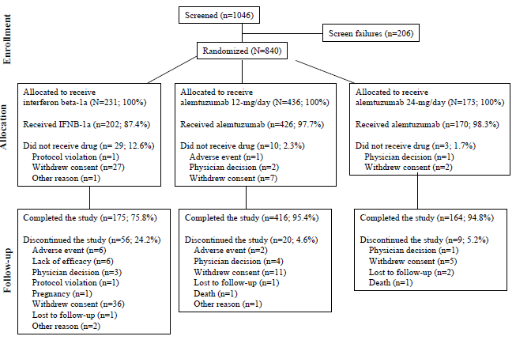

Major protocol violations/deviations
There were 6 major deviations reported for unblinded EDSS assessments (3 in the alemtuzumab 12mg/day group and 3 in the IFNB-1a group), which represented 0.001% of all EDSS assessments in these groups.
Table 27. Major Protocol Deviations FA Set
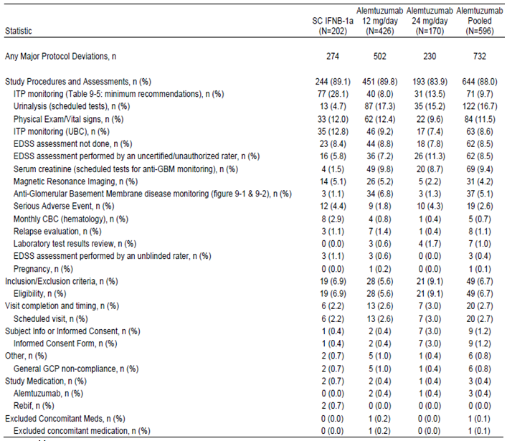

Baseline data
Table 28. Demographics and Baseline Characteristics; Full Analysis Set
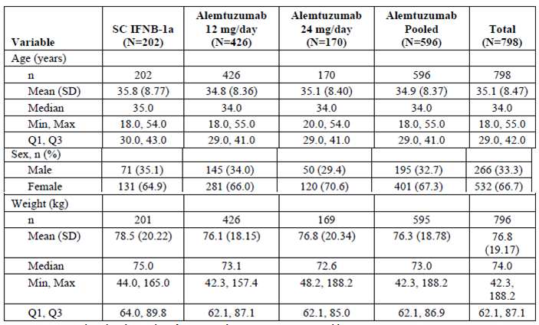
Note: Percentages are based on the number of patients in the FA set.
Table 29. Baseline Multiple Sclerosis Disease Characteristics; Full Analysis Set
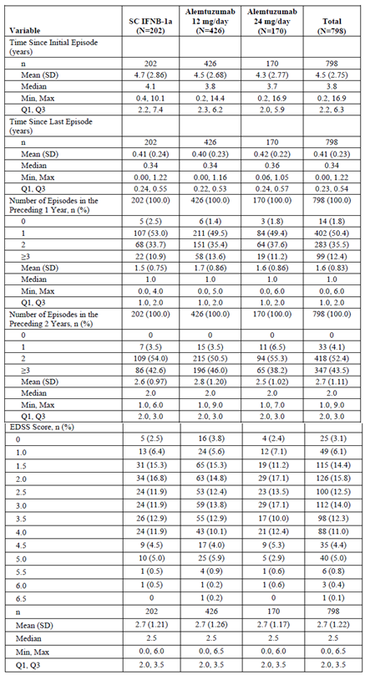
Percentages are based on the number of patients in the FA set. Episodes 'preceding' refers to episodes prior to randomization. The start date of an episode was used when determining counts of episodes occurring in prior years.
Table 30. Baseline Magnetic Resonance Imaging Parameters; Full Analysis Set
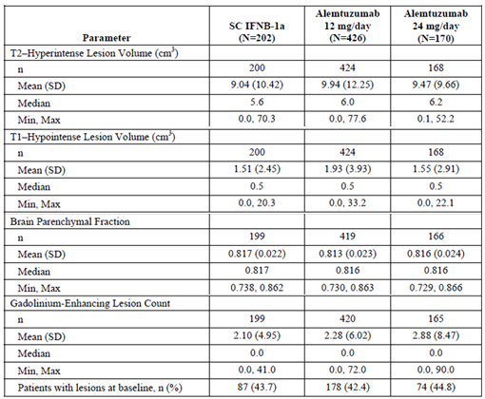
The percentage of patients with Gd-enhancing lesions at baseline is based on the number of patients in the FA set with a non-missing baseline count.
Table 31. Prior MS Medications by Generic Name; Full Analysis Set
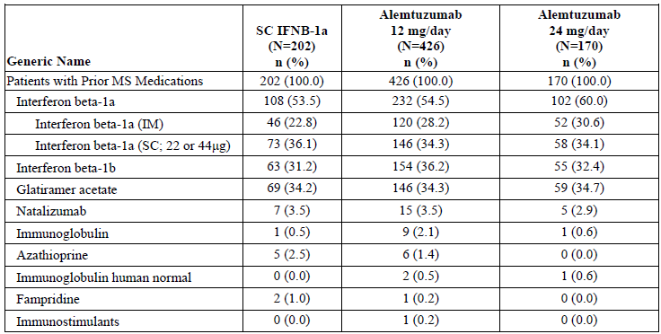
Percentages are based on the number of patients in the FA set. Multiple records of the same generic drug used by a patient are counted once within a generic name. Generic names are presented by decreasing incidence in the alemtuzumab 12mg/day group. Prior MS medications defined as any MS medication taken prior to first study drug dose.
Table 32. Prior MS Medications Duration & Number; Full Analysis Set
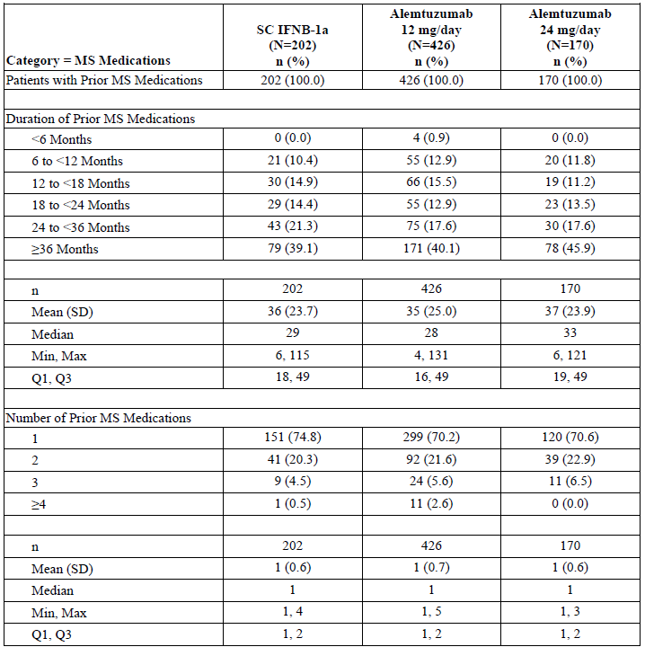
Percentages are based on the number of patients in the FA set except percentages for ‘Duration of Prior MS Medications’ and ‘Number of Prior MS Medications’ based on ‘Patients with Prior MS Medications’. Duration is summarized on the patient level. Prior MS medications defined as any MS medication taken prior to first study drug dose.
5 patients who did not receive the full dose of alemtuzumab 12mg/day in Cycle 1 due to IARs went on to complete Cycle 2. 11 patients (2.5%) patients received partial doses of alemtuzumab 12mg/day in Cycle 2 due to IARs. 15 patients (3.4%) in the 12mg/day group who were still in the study at Month 12 did not receive Cycle 2 infusions (8 due to AEs, 2 due to withdrawal of consent, 1 due to pregnancy, 1 due to non-compliance with study drug, 1 due to Investigator decision, and 2 “other”).
Table 33. Alternative MS Medications while on study drug by Generic Name; Full Analysis Set
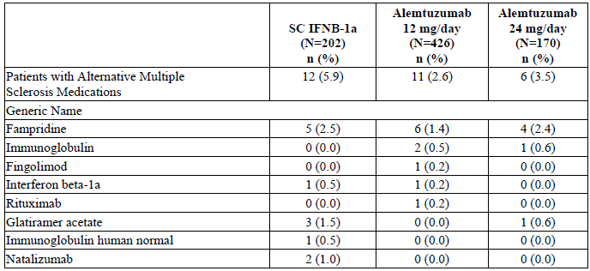
Percentages are based on the number of patients in the FA set. Multiple records of the same generic drug used by a patient are counted once within a generic name. Generic Names are presented by decreasing incidence in the alemtuzumab 12mg/day group. Alternative MS medications defined as any MS medication taken while on study drug.
Table 34. Treatment Exposure to Alemtuzumab Infusions Alemtuzumab Patients; Safety Set
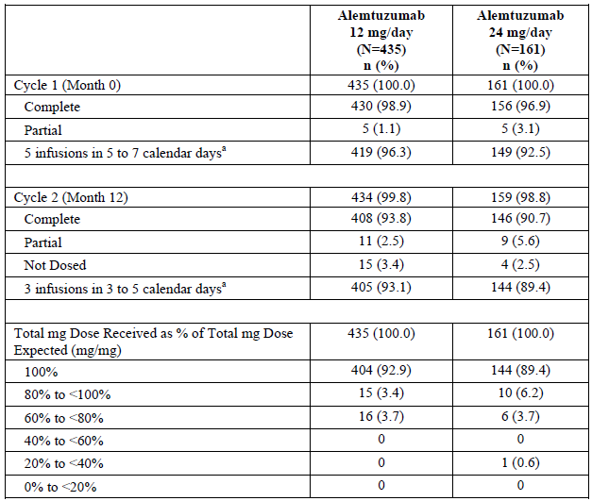
ª Infusions were to be given on consecutive days except for weekends.
Partial refers to < 100% of target doses. Patients who discontinued in Year 1 are not included in the Cycle 2 summary. ‘Not Dosed’ refers to patients in the study in Year 2 that did not receive Cycle 2. Total mg Dose Received as % of Total mg Dose Expected calculated as (Total mg Dose Received/60mg) for Cycle 1 (Month 0) and (Total mg Dose Received/36mg) for Cycle 2 (Month 12) for the alemtuzumab 12mg/day group and (Total mg Dose Received/120mg) for Cycle 1 (Month 0) and (Total mg Dose Received/72mg) for Cycle 2 (Month 12) for the alemtuzumab 24mg/day group.
Table 35. Treatment Exposure to SC Interferon β-1a; SC Interferon β-1a Patients; Safety Set
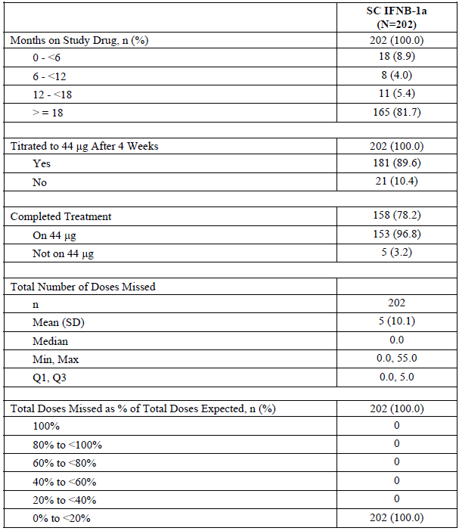
Percentages are based on the number of SC IFNB-1a patients in the Safety set except the percentages for “On 44 μg” and “Not on 44 μg” are based on the number of patients who Completed Treatment. Months on study drug derived from the total days expected on study drug: (last study drug date - first study drug date + 1)/30.4375. Total doses expected derived as (total days expected on study drug x 3/7).

Results for the primary efficacy outcome
- Time to Sustained Accumulation of Disability
Alemtuzumab significantly reduced the risk of SAD through 2 years by 42% compared with IFNB-1a (p= 0.0084), this was supported by sensitivity analyses.
Table 36. Primary Analysis Time to Sustained Accumulation of Disability (6-Month Criteria) Event and Treatment Effect Summary: Full Analysis Set
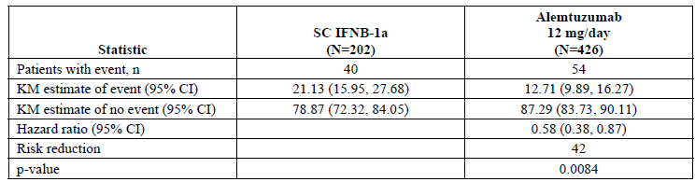
Note: Hazard ratio and p-value are from proportional hazards regression with robust variance estimation and covariate adjustment for geographic region. Risk reduction is summarized for hazard ratios less than 1 only.
Figure 8. Cumulative Plot of Time to Sustained Accumulation of Disability Full Analysis Set
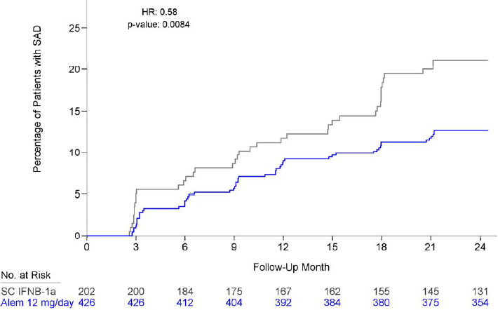
Figure 9. Summary of Sustained Accumulation of Disability Sensitivity Analyses
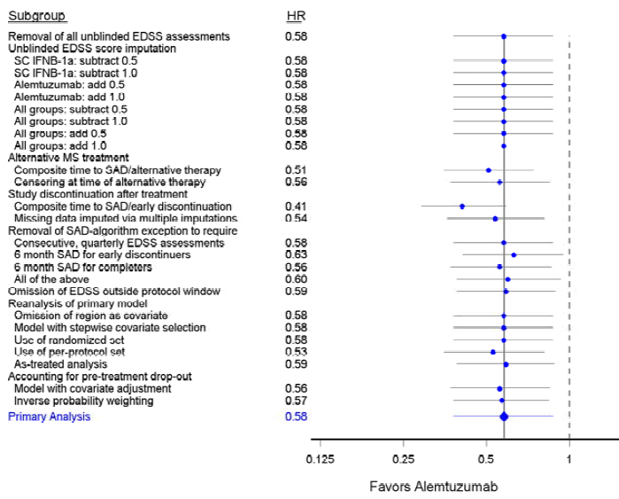
Figure 10. Summary of Sustained Accumulation of Disability Subgroup Analyses; Full Analysis
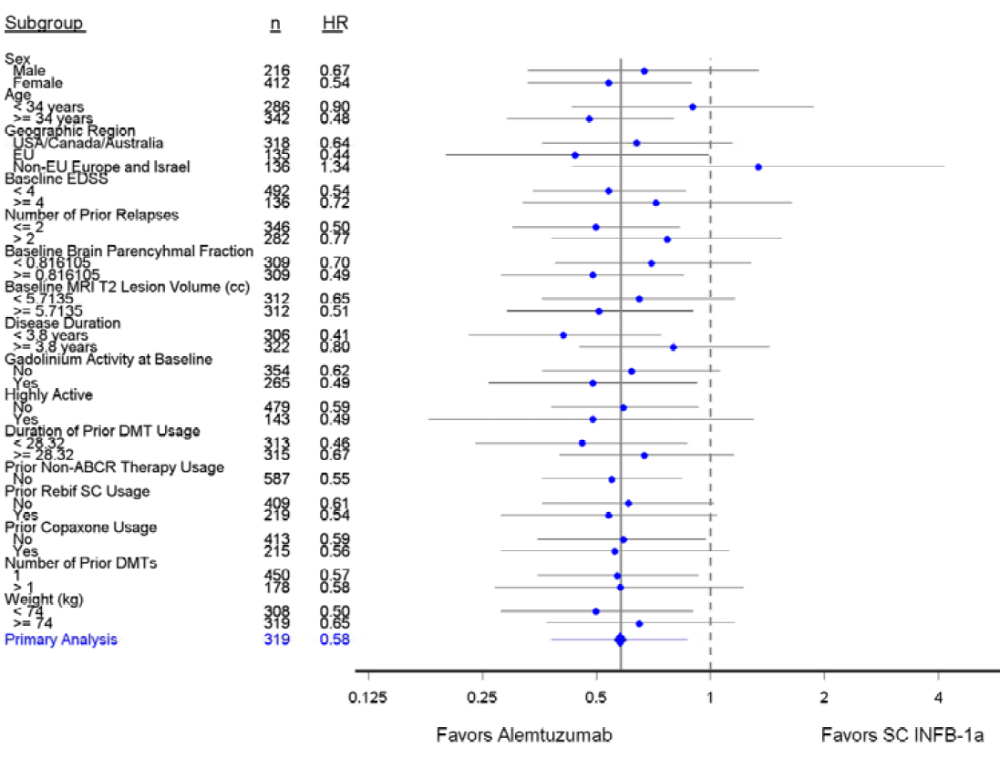
Subgroups with less than 15 patients in either treatment group are not presented in this figure. Subgroups are split at the sample median of the FA set. Age, baseline brain parenchymal fraction, T2 lesion volume, disease duration, duration of DMT usage, duration of interferon therapy, and weight are split at the sample median of the FA set.
- Relapse Rate
Alemtuzumab significantly reduced the relapse rate through 2 years by 49% compared with IFNB-1a (p <0.0001), this was supported by sensitivity analyses.
Table 37. Annualized Relapse Rate, Relapse Rate Ratio, and Risk Reduction; Full Analysis Set, Primary Analysis
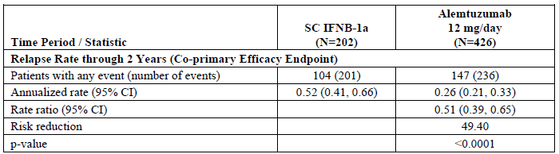
ARR is estimated through negative binomial regression with robust variance estimation and covariate adjustment for geographic region. Rate ratio and p-value are from proportional means regression with robust variance estimation and covariate adjustment for geographic region.
Figure 11. Nelson-Aalen Plot of the Cumulative Relapse Rate; Full Analysis Set
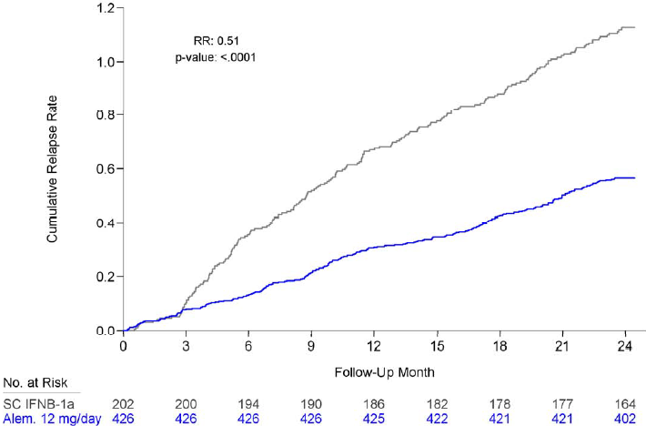
Figure 12. Summary of Relapse Rate Ratio Sensitivity Analyses; Full Analysis Set
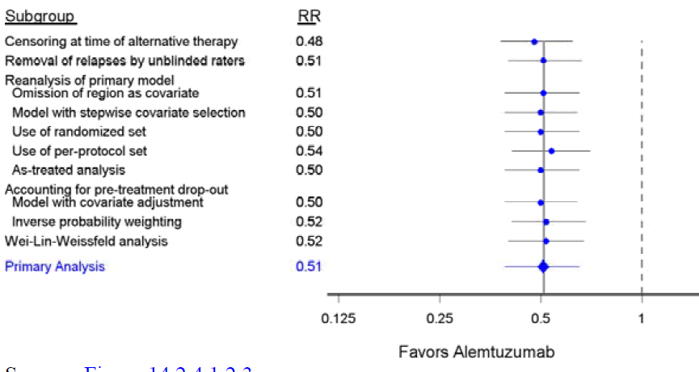
Figure 13. Summary of Relapse Rate Ratio Subgroup Analyses; Full Analysis Set
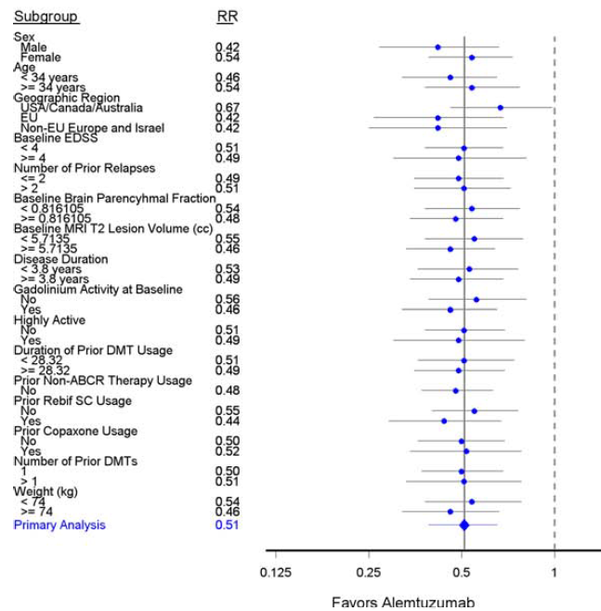
Subgroups with less than 15 patients in either treatment group are not presented in this figure. Subgroups are split at the sample median of the FA set. Age, baseline brain parenchymal fraction, T2 lesion volume, disease duration, duration of DMT usage, duration of interferon therapy, and weight are split at the sample median of the FA set.

Results for other efficacy outcomes
- Proportion of Patients who are Relapse-Free at year 2
Alemtuzumab significantly increased the proportion of patients who were relapse-free through 2 years compared with IFNB-1a. At Year 2, 65.4% of patients receiving alemtuzumab remained relapse-free compared with 46.7% of IFNB-1a-treated patients.
Table 38. Time to First Relapse and Proportion of Patients Who Are Relapse-Free at Month 24 Full Analysis Set
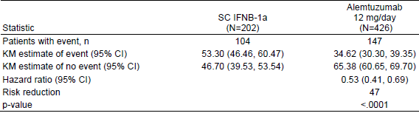
Hazard ratio and p-value are from proportional hazards regression with robust variance estimation and covariate adjustment for geographic region. Risk reduction is summarized for hazard ratios less than 1 only.
Figure 14. Kaplan-Meier Plot of Time to First Relapse; Full Analysis Set
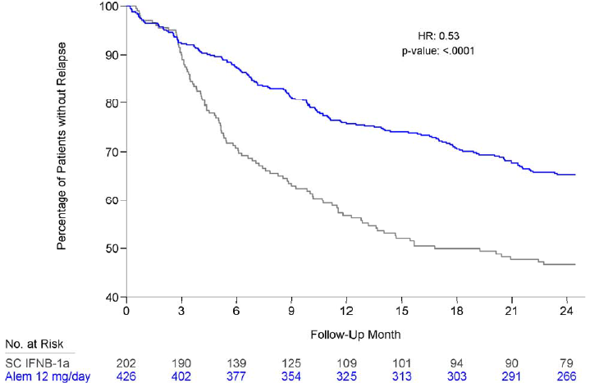
- Change from Baseline in Expanded Disability Status Scale
Alemtuzumab-treated patients had significantly lower EDSS scores after treatment compared with IFNB-1a-treated patients (p <0.0001).
Table 39. Change from Baseline at Year 2 in Expanded Disability Status Scale Score; Full Analysis Set
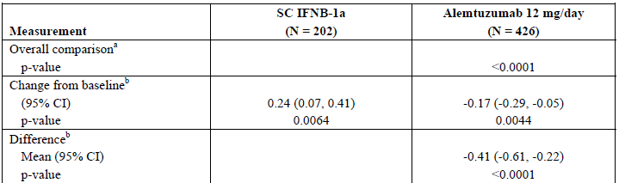
ª. Wei-Lachin (multivariate, non-parametric test). Empirical p-value is based on 10,000 permutations of the treatment codes.
^{b}. Using mixed model for repeated measures. Changes from baseline and group differences at each time period are estimated using an unstructured covariance model with a time by treatment interaction and covariate adjustment for geographic region and baseline EDSS score.
Figure 15. Estimated Mean Expanded Disability Status Scale Mean Score and 95% CI at Each Assessment; Full Analysis Set
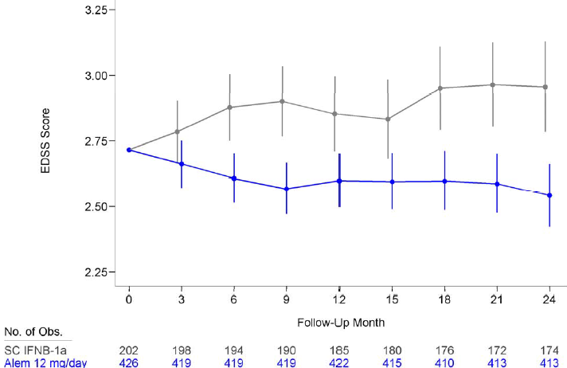
- Change in MRI T2-Hyperintense Lesion Volume
There was no significant difference between alemtuzumab and IFNB-1a in the secondary efficacy endpoint of percent change in T2-hyperintense lesion volume from baseline to Year 2 (p = 0.1371).
Table 40. Observed T2-Hyperintense Lesion Volumes and Volume Changes Over Time; Full Analysis Set
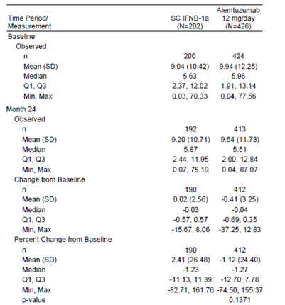
p-values are from ranked ANCOVA models with covariate adjustment for geographic region and baseline T2 lesion volume.
Comment: Hypothesis testing for the secondary efficacy analyses was to be performed using a closed testing procedure with the following rank order:
- Proportion of patients who are relapse free at Year 2.
- Change from baseline in EDSS.
- Percent change from baseline in MRI-T2 hyperintense lesion volume at Year 2.
- Acquisition of disability as measured by the MSFC.
The above is the order that the analysis was changed to in the Final SAP with Acquisition of disability moved to last in the order. Thus since testing failed to show a significant difference for percent change in T2-hyperintense lesion volume from baseline to Year 2 the subsequent analyses steps could not be made. Descriptive results only could be provided.

Other efficacy studies

Study CAM 223

Design
A Phase 2, randomized, open-label, rater-blinded, 3-arm study comparing 2 dosing regimens of alemtuzumab and IFNB-1a in treatment-naïve patients with early, active relapsing-remitting multiple sclerosis (RRMS). Eligible patients were randomly assigned 1:1:1 to receive IFNB-1a, or low- (12mg/day) or high- (24mg/day) dose alemtuzumab.
The original study plan called for a 3-year treatment period. [Dosing in] this study was interrupted because of safety concerns from 16 September 2005 to 07 April 2008.
First patient randomized: 04 December 2002; Last patient randomized: 21 July 2004; Retreatment/follow-up period, last visit: 12 January 2010.
Figure 16. Flow chart disposition to month 36
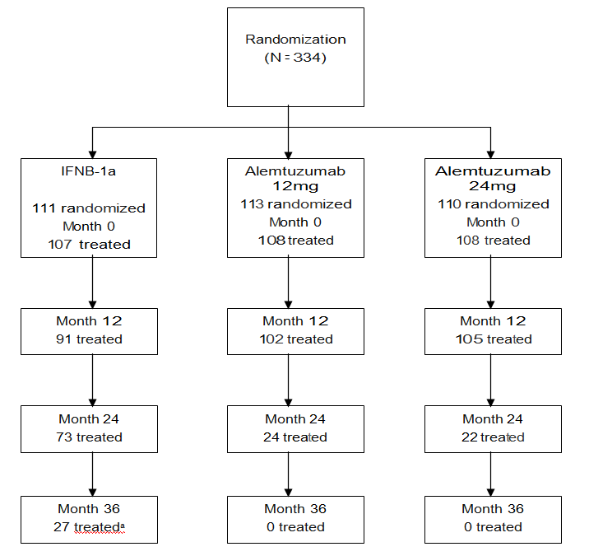
ª Figure 9-1 in the CSR gives 66 treated 3 years.
The study was carried out in 49 centres in the US, UK, the Russian Federation, Poland, and Croatia.
It had an open-label design because differences in the timing and mode of administration, side effect profiles for alemtuzumab and IFNB-1a, and proprietary IFNB-1a container/closure (pre-filled syringes) made a true double-blind design unfeasible. However, key assessments including the EDSS, MSFC, and evaluation of on-study relapses were performed by personnel who were blinded to treatment assignment. In addition, cranial MRIs, except those performed during screening (at study entry) were blindly evaluated at a central facility.

Treatment
Alemtuzumab:
Month 0 5 consecutive days IV infusions (~ 4 h) either:
- a fixed total dose of 60mg (12mg/day) or
- 120 mg (24mg/day).
Month 12 and possible Month 24 over 3 consecutive days IV a total dose of:
- 36mg (12mg/day) or
- 72mg (24mg/day).
After the suspension of treatment ended, there was only a fixed total dose of 36mg IV over 3 days (12mg/day).
Interferon β-1a:
Following initial dose titration, IFNB-1a was taken 44mcg SC 3 times/week (total weekly dose of132 mcg).
All patients received IV methylprednisolone (1g/day) on Days 1, 2, and 3 at Months 0, 12, and 24.
After April 2008, consenting alemtuzumab patients could receive additional doses of alemtuzumab in either a “fixed” (annual) retreatment arm or an “as needed” retreatment arm. Patients in the fixed retreatment arm could receive 2 annual 3-day cycles of 12mg/day alemtuzumab; patients in the as-needed retreatment arm could receive up to 2, 3-day cycles of 12mg/day alemtuzumab upon documented evidence of resumed multiple sclerosis disease activity.
Patients who declined retreatment with alemtuzumab were permitted alternative disease modifying treatments (DMTs) at their own expense as it was no longer supplied by the sponsor. After the initial 3 years of treatment, IFNB-1a patients continued with IFNB-1a or began treatment with other DMTs at their own expense.
334 Patients were randomized (111 IFNB-1a; alemtuzumab, 113 at 12mg/day, 110 at 24mg/day); 323 were treated (107 IFNB-1a; alemtuzumab 108 12 mg/day, 108 24 mg/day).

Objectives
The primary objectives were changed after the trial began and a secondary objective was added.
The primary objectives originally were to establish superior efficacy of alemtuzumab compared to SC IFNB-1a in (a) the time to sustained accumulation of disability (SAD) and (b) relapse rate. and reduction in tissue damage as assessed by MRI.
Secondary objectives were:
- to establish the safety, efficacy, and tolerability of the 2 dose levels of alemtuzumab compared to SC IFNB-1a
- to determine the dose effect of alemtuzumab regarding Graves’ disease and other thyroid dysfunction;
- to refine the process of administering alemtuzumab
- to determine the preferred dose of alemtuzumab
- to gather additional pharmacokinetic and immunogenicity data on alemtuzumab in this population.
The single primary efficacy endpoint was the time to SAD. to be analysed 3 years after all patients had received initial treatment. However relapse rate was subsequently added to the original single primary endpoint, (despite there being 3 original primary objectives).
Secondary efficacy endpoints were:
- Proportion of patients without SAD at 1, 2, and 3 years after initial treatment
- Accumulation of disability as measured by MSFC 1, 2, and 3 years after initial treatment
- Change in MRI T2 lesion volume at 1, 2, and 3 years after initial treatment
- Change in MRI MTR histograms 1, 2, and 3 years after initial treatment
- Rate of cerebral atrophy (decrease in cerebral volume) as seen on MRI scan as measured by the Losseff technique13 at 1, 2, and 3 years after initial treatment
- SF-36 scores at 1, 2, and 3 years after initial treatment
- Changes in EDSS at 1, 2, and 3 years after initial treatment
- Time to first relapse
- Relapse rate (defined as total number of relapses, regardless of duration or severity) at 1, 2, and 3 years after initial treatment
- Proportion of patients who are relapse free at 1, 2, and 3 years after initial treatment
- Correlation of relapse rate and SAD with T-cell counts.
Comment: The only primary efficacy endpoint that persisted throughout the study and matched the original primary objectives was the time to SAD. Relapse rate was originally one of the 13 secondary efficacy endpoints promoted to a primary endpoint 3 years after the study started and MRI assessment was a secondary endpoint.
The following laboratory tests were to be conducted:
- Complete blood count (CBC), including haemoglobin (Hg), platelets, white blood cells (WBC), and differentials.
- Urea and electrolytes (U + E), including sodium, potassium, creatinine, and urea.
- Liver function tests (LFTs), including AST, ALT, GGT, alkaline phosphatase, and total bilirubin.
- C-reactive protein (CRP), a marker of serum levels of interleukin-6, to detect infection/inflammation.
- Thyroid function, including TSH and T4 (thyroxin); if thyroid tests are abnormal, free T4 and T3 will be performed.
- Autoantibody screen: anti-TSH receptor antibodies, anti-nuclear antibodies (ANA), anti-smooth muscle antibodies (ASMA), anti-thyroid peroxidase antibodies (anti-TPO)/anti-thyroid microsomal antibodies, antimitochondrial antibodies (AMA), anti-ribonucleoprotein antibodies (Anti- RNP), anti-SSA antibodies (Anti-RO), anti-SSB antibodies (Anti-LA). NB: Anti-RNP, anti-RO, and anti-LA are to be performed only if there is a significant titre of ANA.
- Lymphocyte phenotyping by flow cytometry (for alemtuzumab patients only). CD4, CD8, CD19, and CD45RO lymphocyte counts will be measured. CD4, CD8, and CD19 will be measured to determine the extent of T-lymphocyte depletion (and B-lymphocyte expansion); CD45RO will be measured as a potential biomarker of the occurrence of Graves’ disease after alemtuzumab administration.
- Antiglobulin responses (anti-alemtuzumab antibodies, including human anti-humanized antiglobulin response [HAHA]).
- Baseline samples will be taken from the high-dose Rebif patients and held for later determination of the presence of neutralizing antibodies in patients who fail treatment. Subsequent samples will be taken at the Month 36 timepoint or at early discontinuation for treatment failure.
- Sperm count, motility, and viability only on consenting male patients treated with alemtuzumab

Inclusion criteria
- Diagnosis of MS per McDonald’s update of the Poser criteria, including cranial MRI consistent with those criteria.
- Onset of first MS symptoms within 3 years prior to screening
- EDSS score 0.0 to 3.0 (inclusive) at the screening visit
- At least 2 clinical episodes of MS in the 2 years prior to study entry (i.e., the initial event if within 2 years of study entry plus ≥ 1 relapse, or ≥ 2 relapses if the initial event was between 2 and 3 years prior to study entry)
- ≥ 1 enhancing lesion on any 1 of the up to 4 screening gadolinium-enhanced MRI scans during an up to 3-month run-in period (inclusive of the Month 0 baseline scan).

Exclusion criteria
- Previous immunotherapy for MS other than steroids, including treatment with interferons, glatiramer acetate, and mitoxantrone
- Personal history of thyroid autoimmune disease
- Personal history of clinically significant autoimmune disease (egg, inflammatory bowel disease, diabetes, lupus, severe asthma)
- History of thyroid carcinoma (previous thyroid adenoma is acceptable and is not to be considered an exclusion criterion)
- Previous treatment with alemtuzumab
- History of anaphylaxis following exposure to humanized monoclonal antibodies
- Inability to undergo MRI with gadolinium administration
- Impaired renal function (i.e., serum creatinine ≥ 2 times the Institutional upper limit of normal [ULN])
- Abnormal CD4 count or thyroid function
- presence of anti-TSH receptor antibodies
- known seropositivity for HIV
- Intolerance of pulsed corticosteroids, especially a history of steroid psychosis
- Presence of a monoclonal paraprotein.
An interactive voice response system was used to register patients at Month –3 and randomize eligible patients at baseline. 11% of IFNB-1a patients and 9% of alemtuzumab patients had EDSS raters who correctly identified their treatment assignment.

Statistical methods
The statistical analysis plan (29 August, 2006): Time-to-event parameters were summarized by Kaplan-Meier method. Patients who had not reached the endpoint before ending participation in the study were censored at the date of last known follow-up for the analysis. The estimated median with 95% CI, range and percent censored were to be summarized. A Kaplan-Meier graph summarizing event probability over time was to be presented for each time-to-event parameter.
The primary comparison of time to SAD was to be conducted using a Cox proportional hazard (PH) model with treatment group, country and baseline EDSS score (grouped by 0 to 1.5 and 2.0 to 3.0) as factors. Patients who did not reach the SAD endpoint were to be censored at their last visit.
The primary comparison of relapse rates was to be conducted using an Andersen-Gill multiplicative intensity model with robust sandwich-type variance estimate. The proportional means model is a semi-parametric model that allows for the relapse rate to change over time but assumes that the relapse rate ratio between the treatment groups is constant over time. A relapse event was registered at the time of onset. Treatment group, EDSS group (grouped by 0 to 1.5 and 2.0 to 3.0), and country (investigative centre grouped by country) were to enter the model as baseline factors. Patients who do not relapse were to be censored at their last visit. The Year 1, 2, and 3 annualized relapse rates (ARRs) were to be estimated using Poisson regression.
A sensitivity analysis of the co-primary endpoints was to be conducted. The first sensitivity analysis was a repeat of the analysis using the per-protocol population. The second sensitivity analysis was to be a repeat of the analysis without adjustment for covariates on both ITT and PP populations.
The statistical analysis plan (12 March 2010): Time to SAD. Modifications for Post-Year 3 Analyses: For extended follow-up analyses, no imputation of missing EDSS assessments associated with gaps in follow-up was to be performed. The lack of imputation may overestimate the time to SAD as an EDSS rise may have occurred in a follow-up gap. For extended follow-up analyses, censoring variables were to be date of final assessment and, separately, date of entry into the retreatment period (under amendment 8 or 10).
Relapse Rate: To perform the recurrent event analysis, the data can be represented as a counting process. In the counting process data representation for relapses, there was to be 1 record for each time period a patient is at risk for a relapse. The data for each patient was to be represented as a sequence of observations with a definitive beginning and end, both defined as the number of days post randomization. The beginning of the first period was to be the date of randomization (start day 0). The end of the first period was to be the day the relapse began for a patient that had an on-study relapse, or the day of study discontinuation for a patient that did not have an on-study relapse. For patients that had at least 1 on-study relapse, the beginning of the period following the relapse was to be 30 days after the start of the first relapse. Modifications for Post-Year 3 Analyses: For extended follow-up analyses, the counting process data structure was not to be modified to include gaps in follow-up. This approach assumes that all relapses occurring in the period between randomization and final completion of the study are captured on the relapse assessment CRFs and may, therefore, underestimate the actual relapse rate. For extended follow-up analyses, censoring variables were to be date of final assessment and, separately, date of entry into the retreatment period (under amendment 8 or 10).
Ranked analysis of covariance (ANCOVA) models were planned for the EDSS, Multiple Sclerosis Functional Composite (MSFC) and MRI endpoints. In order to estimate change from baseline to specific time points, the ranked ANCOVA was replaced with a repeated measures ANCOVA model (also known as a Mixed Model for Repeated Measures; MMRM) for the EDSS and MSFC endpoints. For the MRI analysis, the ranked ANCOVA was used due to non-normality of the data but the respective baseline measure was added to the ANCOVA model.

Sample size and analysis populations
The original randomised sample size of 180 patients, 60 per treatment arm was for time to sustained accumulation of disability (SAD). With an anticipated dropout rate of 16%, this should result in approximately 50 patients per arm reaching the primary endpoint or completing 3 years of therapy. The sample size was to allow for the detection of a treatment effect in time to SAD in the high-dose alemtuzumab arm compared to patients in the high-dose Rebif arm, assuming the 3-year progression rate to SAD is 8% in the high-dose alemtuzumab arm and 30% in the high-dose Rebif arm (hazard ratio of 4.3). Under these assumptions, the study has 80% power with a 2-sided alpha = 0.05.
The 3-year progression rate to SAD of 8% for alemtuzumab was based on prior experience with alemtuzumab in MS patients treated at Addenbrooke’s Hospital, Cambridge, UK. The 3-year progression rate to SAD of 30% for high-dose Rebif is based on the Multiple Sclerosis Collaborative Research Group (MSCRG) study and the Prevention of Relapses and Disability by Interferon β-1a Subcutaneously in Multiple Sclerosis (PRISMS) study of IFN-β in the treatment of patients with relapsing-remitting MS.
The sample size in November 2003 was also amended without explanation though apparently based on the same data. The sample size of 285 patients with an anticipated dropout rate of 16% (~ 80 per treatment arm or 240 total) allowed for the detection of a clinically significant improvement from 30% IFNB-1a to 12% (higher dose level of alemtuzumab) in the 3-year rate of SAD with 80% power.
The per-protocol population excludes:
- Alemtuzumab patients who did not receive any alemtuzumab, who received only 1 infusion or who received any partial infusions.
- IFNB-1a treated patients who received < 80% of their planned injections.
- Inclusion/exclusion criteria violation for those criteria which have a potential effect on efficacy, which included:
  - Inclusion criteria
- Diagnosis of MS per McDonald’s update of the Poser criteria
- Onset of first MS symptoms within 3 years prior to screening as of signing the ICF
- EDSS score 0.0 to 3.0 (inclusive) at the screening and BL visits
- At least 2 completed clinical episodes of MS in the 2 years prior to study entry
- In addition to the clinical criteria (3 to 6 above), >1 enhancing lesion on any 1 of the up to 4 screening gadolinium-enhanced MRI brain scans.
  - Exclusion criteria
    - 1. Previous immunotherapy for MS other than steroids
- 2. Any disability acquired from trauma or other illness
- 3. Previous treatment with alemtuzumab
- 4. Inability to undergo MRI with gadolinium administration
- 5. Epileptic seizures that are not adequately controlled by treatment
- 6. Major systemic disease or other illness that would, in the opinion of the Investigator, have compromised patient safety or interfered with the interpretation of study results
- 7. Patients who, in the opinion of the Investigator, have any form of MS other than relapsing-remitting
- 8. Patients currently participating in a clinical trial of an experimental or unapproved/unlicensed therapy
- 9. Use of alternate MS therapy.
Table 41. Data Sets Based on Randomized Patients
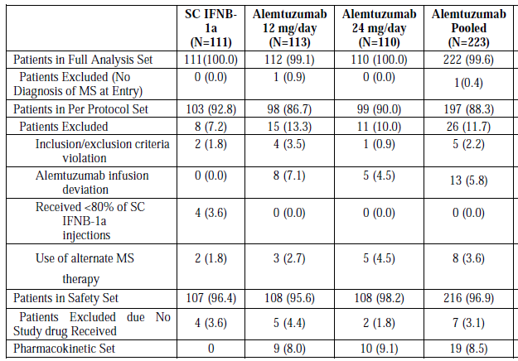
Only 46 patients total on alemtuzumab received the planned 3 treatments in 3 years.
Comment: The evaluator found it difficult to reconcile the populations particularly between those who were treated (≥ 36months IFN-β & 3 cycles alemtuzumab) and the greater number of who were considered to have completed the study, the explanation for the alemtuzumab numbers might lie in the numbers who had a clinically significant titre of anti-alemtuzumab antibodies present or low peripheral T-cell concentrations at month 24.
There were multiple major protocol amendments after the first patients were randomised. The major changes related to the suspension for safety reasons of alemtuzumab treatment and its subsequent re-instatement.
Table 42. Patient Disposition All Randomized Patients Initial 3-Year Study Participation
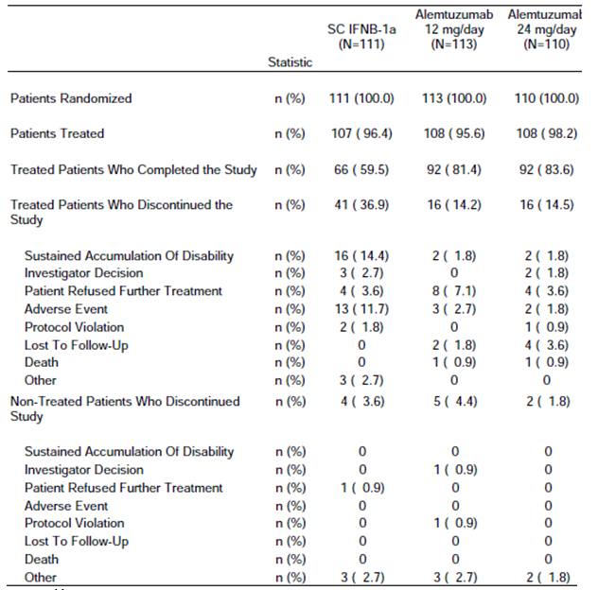
Table 43. Demographics and Baseline Characteristics Safety Set Summarized by Number of Alemtuzumab Cycles Received in Initial 3-Years
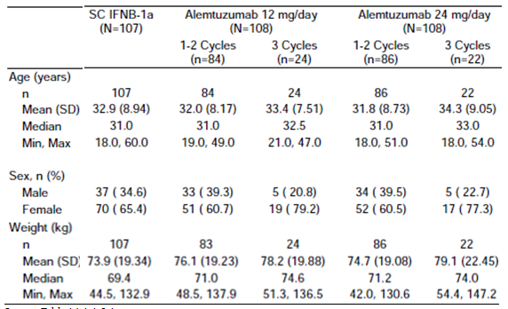
Table 44. Patient Participation over Course of Study All Randomized Patients Complete Follow-Up
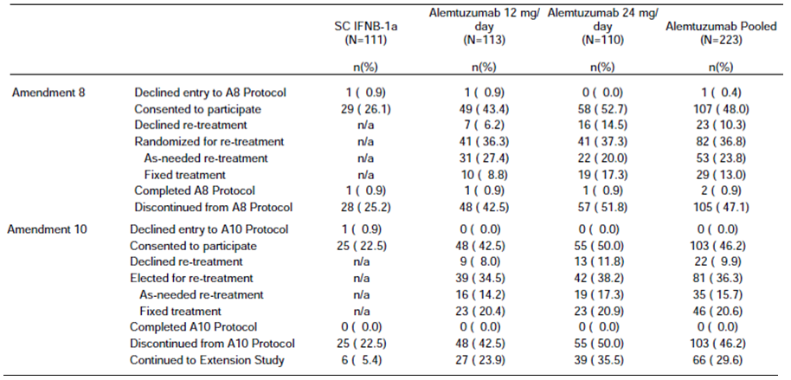
Table 45. Patient Disposition All Patients Who Enrolled in Amendment 8
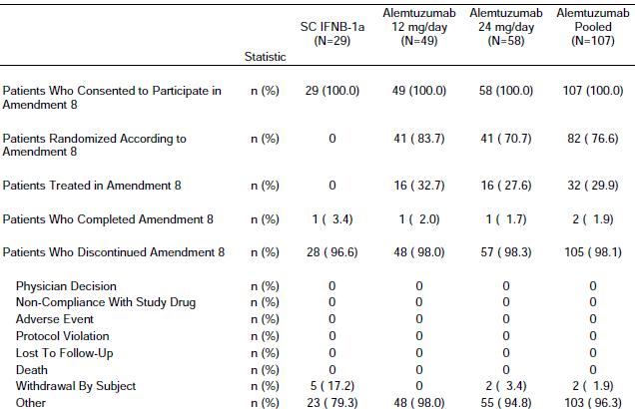
Table 46. Patient Disposition All Patients Who Enrolled in Amendment 10
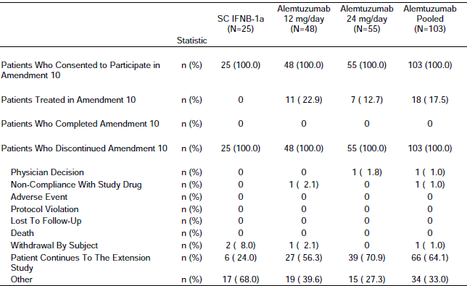
Table 47. Time on Study Safety Set Initial 3-Year Study Participation
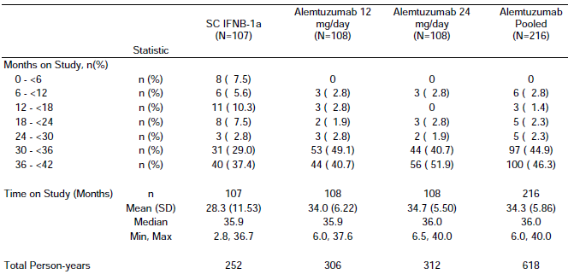
Table 48. Time on Study Safety Set Complete Follow-Up
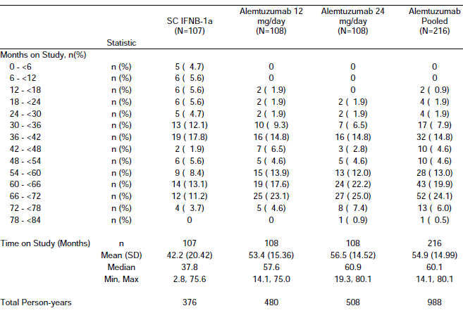

Results for the primary efficacy outcomes
Table 49. SAD (6-Month Criteria) Event and Treatment Effect Summary by Year FA Set From Randomization through Initial 3-Year Study Participation
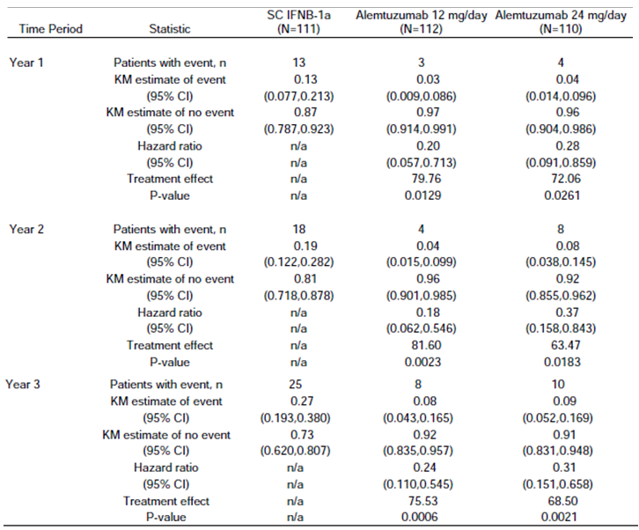
Note: Hazard ratio and p-value are from proportional hazards regression with treatment group, baseline EDSS group and country as covariates.
Table 50. Extended Follow-Up SAD (6-Month Criteria) Event and Treatment Effect Summary by Year FA Set From Randomization through Complete Follow-Up
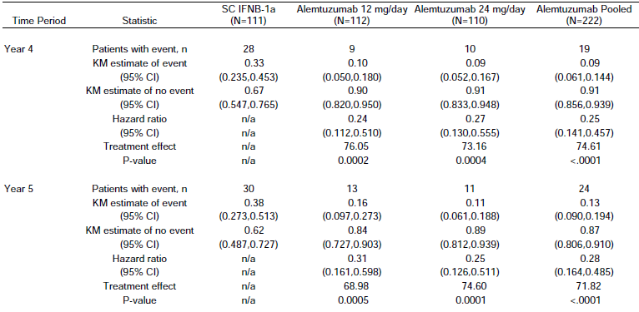
Table 51. Relapse Rate and Treatment Effect Summary by Year FA Set From Randomization through Initial 3-Year Study Participation
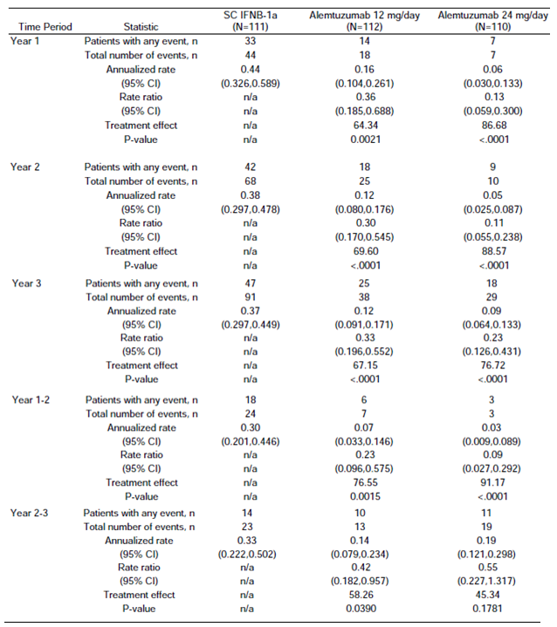
Table 52. Extended Follow-Up Relapse Rate and Treatment Effect Summary by Year FA Set From Randomization through Entry into Retreatment Phase
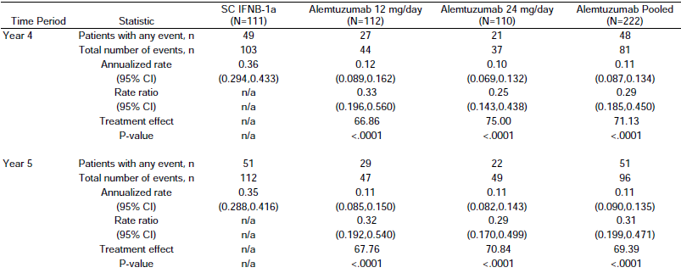
Figure 17. SAD (6-Month Criteria) Kaplan Meier Estimate From Randomization through Initial 3-Year Study Participation FA Set
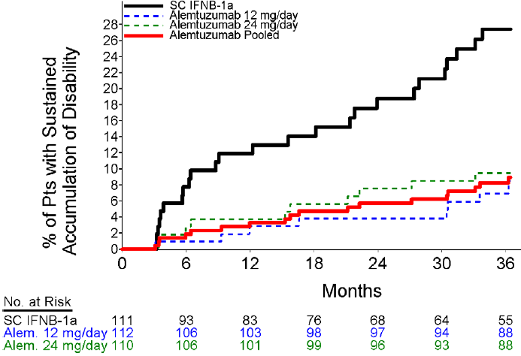
Figure 18. SAD (6-Month Criteria) Kaplan Meier Estimate FA Set From Randomization through Entry into Retreatment Phase
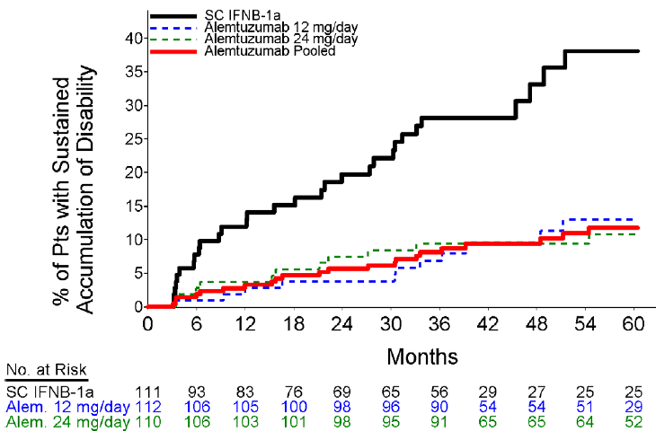
Figure 19. Cumulative Number of Relapses FA Set From Randomization through Initial 3-Year Study Participation
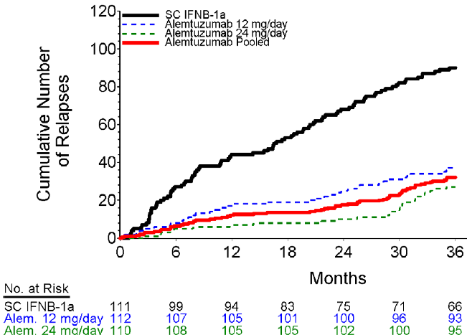
Figure 20. Cumulative Number of Relapses FA Set From Randomization to Complete Follow-Up
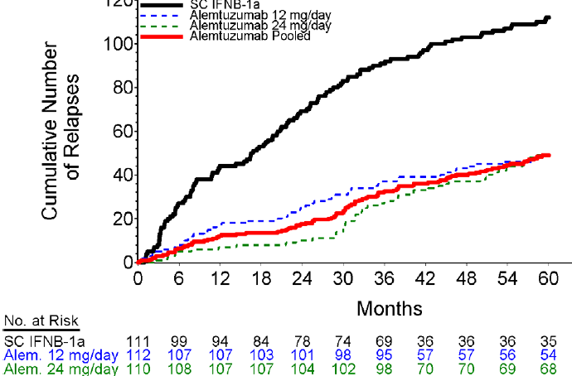
Comment: The relevance of these results to efficacy in the proposed usage is unclear. At 36 months at least 46 (22%) of the patients had at 24 months received a further course of alemtuzumab (contrary to proposed usage) and 42 received this third cycle after retreatment was in place under Amendments 8 or 10. Most were given approximately 4 years after the prior infusion (range, 44 to 58 months), while at 3 years 30% of those on INFβ-1a had left the trial (and by 5 years 68%).
Sensitivity analyses all supported these results: Exclusion of Patients with Potentially Unblinded EDSS Raters, Censoring at Time of Alternative MS Therapy, Restricted to Treated Patients, Geographic Region or Baseline EDSS, No Adjustment for Geographic Region or Baseline EDSS, Inclusion of Post- Discontinuation EDSS Assessments, and Per-protocol.

Results for other efficacy outcomes
MRIs In 2009, the methods used to read the MRI scans changed and, therefore, the data was not pooled. Scans through the first 4 years of follow-up and T1 and T2 endpoints were analysed. Using this data scans after the first 4 years of follow-up (including those used to determine retreatment eligibility under amendments 8 and 10) were read, summarized and listed only.
The alemtuzumab 12 mg group had a 0.8% median reduction in brain volume at Year 3, when compared to the IFNB-1a group (1.7% median reduction) it was not statistically significant (p=0.0885). Likewise, the change from baseline in T2 lesion volume at Year 3 for the alemtuzumab 12mg group was an 18% median reduction, when compared to the IFNB-1a group (11% median reduction) it was not statistically significant (p = 0.3077).
Table 53. Change from Baseline in EDSS Score at 3 Years; FA Set
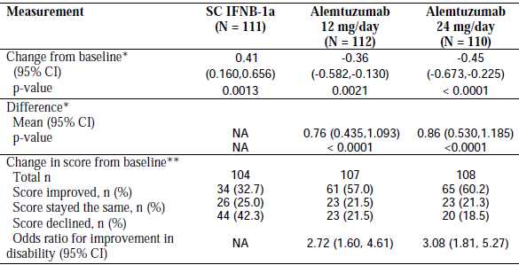
Using mixed model for repeated measures ** Based on last observed value
Figure 21. EDSS Change from Baseline Through 3 Years
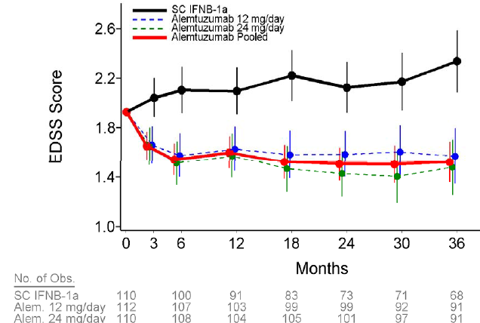
Note: Estimate based on a mixed model for repeated measures

Study CAMS 223 Retreatment phase (commencing with amendment 8 dated 15 February 2008)
The protocol-specified, 2-year interim analysis showed with respect to safety, a variety of thyroid abnormalities were reported, consistent with other studies suggesting that thyroid dysfunction may occur in up to 30% of alemtuzumab-treated patients. In addition, 6 alemtuzumab-treated patients had developed immune thrombocytopenic purpura (ITP). The first had premonitory symptoms of thrombocytopenia, but did not seek medical attention until the onset of a cerebral haemorrhage that proved fatal; the 5 subsequent cases were identified in a timely fashion and responded to medical management without sequelae. Following the first 3 cases of ITP, Genzyme announced a voluntary, temporary suspension of alemtuzumab administration (16 September 2005).
With Amendment 8 (15 February 2008), the alemtuzumab suspension for CAMMS223 was lifted so that study participants who met qualification criteria could receive further alemtuzumab treatment (described by the sponsor as retreatment). Such patients were manually re-randomized at the site level at a ratio 1:2 to either Fixed (annual) or As-Needed alemtuzumab retreatment. Amendment 10 allowed such patients to choose their treatment regime of these two.
Figure 22. Flow Chart dispositions Amendments 8 & 10
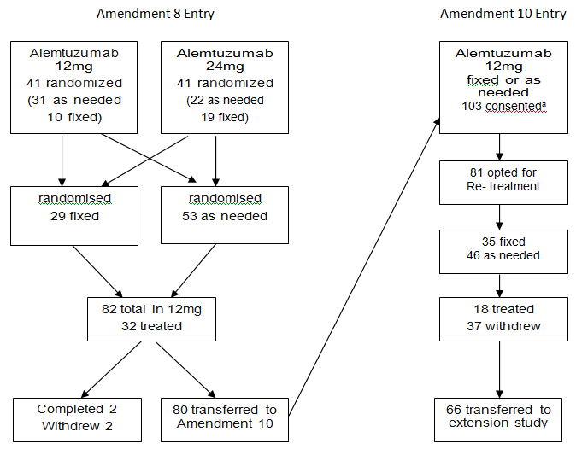
ª 23 patients consented to Amendment 8 but weren’t randomised and transferred consent to Amendment 10

Criteria for retreatment
Key Criteria for Retreatment with Alemtuzumab After Dosing Suspension
Disqualifying Criteria
- Exposure within past 28 days to interferon β or glatiramer acetate.
- Treatment with natalizumab, methotrexate, azathioprine, cyclosporine, or rituximab, unless approval was granted by the Sponsor and the patient had not received any of these medications during the past 6 months.
- Treatment with mitoxantrone, cyclophosphamide, cladribine or other (non-steroid) immunosuppressant therapy, unless approval granted by the Sponsor and the medication was not received during the past year.
- Previous treatment with any investigational therapy for MS unless prior approval had been granted by the Sponsor and the patient had completed a washout/discontinuation period of ≥ 28 days.
- Known bleeding disorder or therapeutic anticoagulation.
- History of malignancy, except basal skin cell carcinoma.
- Cervical high risk human papilloma virus positive or abnormal cervical cytology other than abnormal squamous cells of undetermined significance.
- Platelets < lower limit of normal; CD4+, CD8+, CD19+ ≤50 cells/mcL; neutrophils ≤1000 cells/mcL.
- Autoimmune disease that the investigator considered sufficiently serious to preclude retreatment.
- Infection with hepatitis B or C virus, seropositivity for HIV, latent or active tuberculosis.
- Other infection that the Investigator considered sufficiently serious to preclude retreatment.
- In the investigator’s opinion, was at high risk for infection.
- Pregnant or lactating.
- Major psychiatric disorder or epileptic seizures not adequately controlled by treatment.
- Diagnosed with ITP, or other autoimmune hematologic abnormality.
- Any hepatic or renal function value ≥ grade 2, with the exception of hyperbilirubinaemia due to Gilbert’s syndrome, unless, in the Investigator’s opinion, the abnormality was due to a condition that had resolved.
Alemtuzumab patients were eligible for a first retreatment cycle in the “as-needed” retreatment arm if they met at least 1 of the following criteria:
- Had, within the previous year experienced at least one protocol-defined relapse.
- Had, within the previous year or since their last on-study MRI, accumulated at least 2 unique lesions on brain/spinal cord MRIs comprised of any combination of gadolinium-enhancing lesion(s) or new/enlarging MRIT2 lesion(s).
18 (22%) had a further course of alemtuzumab in this phase which started 5 years after the study’s original start.
Table 54. SAD and Relapse Events in Retreatment Phase Patients Enrolled in Retreatment Phase Retreatment and Post-Retreatment Follow-Up
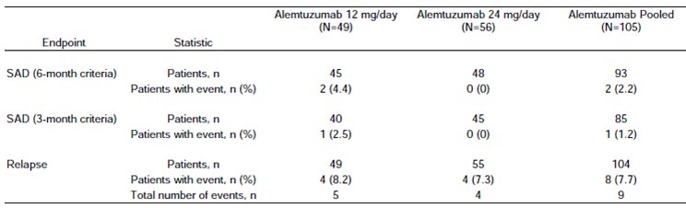
Comment: The relevance of these results to efficacy in the proposed usage is unclear. In this period 50 (32/82, 39% with amendment 8; 18/81, 22% with amendment 10) of the patients had received a further course of alemtuzumab (some may have had their initial course or courses up to 5 years before ); while at 5years 68% of those on INFβ-1a had left the trial.
Table 55. Alemtuzumab Exposure Through Complete Follow-up (Safety Set)
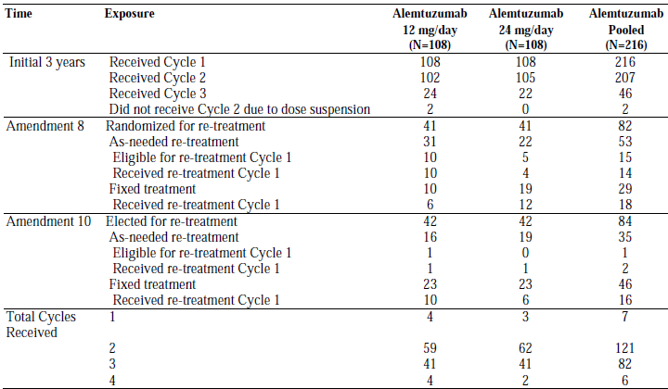

Extension study (CAMMS03409)
Study CAMMS03409 is an ongoing Extension Study for patients from CAMMS223, CAMMS323, and CAMMS324.
A clinical study report is not yet available. Efficacy data included are based on a database cut-off date of 31 Dec 2011, and may include data on which there are outstanding queries.
305 patients had received IFNB-1a in a prior study and 1015 patients had received alemtuzumab in a prior study. 29 patients had discontinued.
Exposure: 496 patients had received alemtuzumab in the Extension Study: 199 patients previously treated with alemtuzumab received re-treatment with alemtuzumab and 297 patients previously treated with IFNB-1a (received alemtuzumab for the first time). 8 patients who had previously been treated with IFNB-1a had not received the first dose of alemtuzumab as of 31 Dec 2011.
Comment: The numbers exposed beyond 36 weeks were low. The data did not include the total number of courses of alemtuzumab patients were exposed to.
Figure 23. Cumulative Plot of Time to Sustained Accumulation of Disability CAMMS323 Full Analysis Set ISE
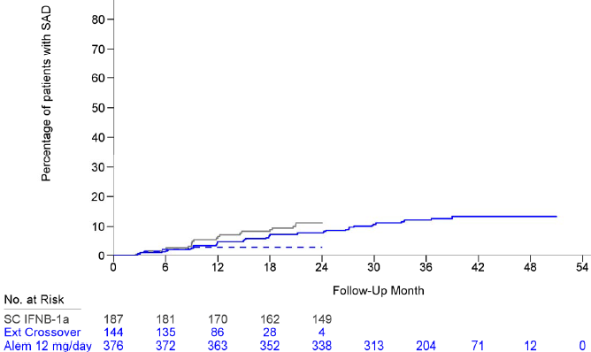
Groups: From First Dose through Extension Study Follow-up for CAMMS323 Alemtuzumab 12mg/day. From First Dose through CAMMS323 Completion for SC IFNB-1a. From Extension Study Baseline through Extension Study Follow-up for CAMMS323 SC IFNB-1a Crossovers.
Figure 24. Cumulative Plot of Time to Sustained Accumulation of Disability CAMMS324 Full Analysis Set ISE
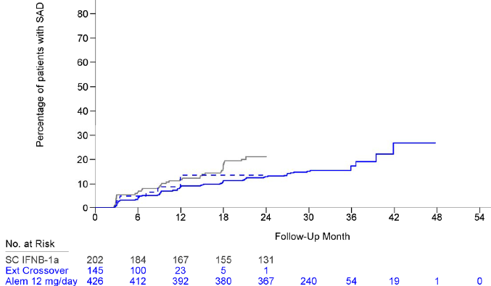
Groups: From First Dose through Extension Study Follow-up for CAMMS324 Alemtuzumab 12mg/day. From First Dose through CAMMS324 Completion for SC IFNB-1a. From Extension Study Baseline through Extension Study Follow-up for CAMMS324 SC IFNB-1a Crossover.

Development of antibodies to Alemtuzumab
Table 56. Overall Summary of Anti-Alemtuzumab Antibodies and Anti-Alemtuzumab Inhibitory Antibodies CAMMS323 324
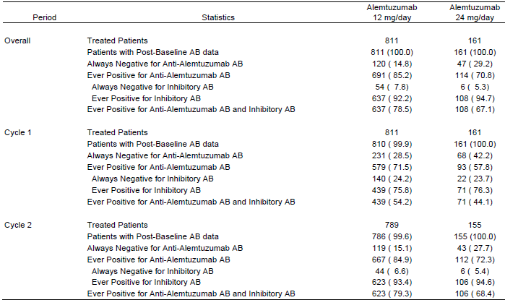
The percentages for “Patients with Post-Baseline AB data” use the number of “Treated Patients” in the respective period as denominator. The percentages for “Always Negative for Inhibitory AB” and for “Ever Positive for Inhibitory AB” use the number of “Patients ever Positive for Anti-Alemtuzumab AB” in the respective period as denominator. All other percentages use the number of “Patients with Post-Baseline AB data” in the respective period as denominator. Patients are classified as “always negative” if all samples in the specific period are negative. Patients are classified as “ever positive” if at least one sample in the specific period is positive. Only patients with post-baseline data for the specific period are classified. Only samples positive for anti-alemtuzumab AB were tested for inhibitory AB.
Figure 25. Median Anti-Alemtuzumab Antibody Titre over Time CAMMS323 324
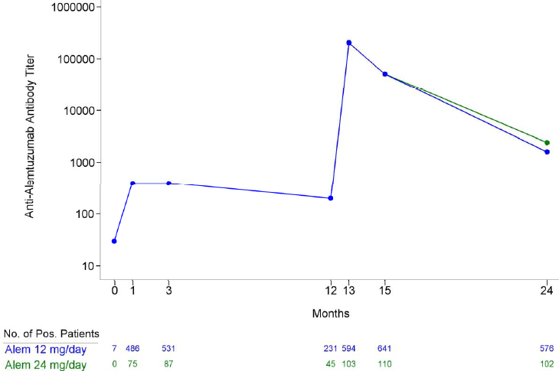
Only patients who received treatment cycle 2 are included in the Months 13, 15 and 24 summaries. The lines between Month 1 and Month 15 are overlapped for 2 treatment groups, and only the line for alemtuzumab 12mg/day group is shown at these visits.

Studies 323 & 324
85.2% (691/811) of patients treated with 12mg/day alemtuzumab in the studies 323 & 324 tested positive for anti-alemtuzumab antibodies.
With a higher proportion of patients (667/786, 84.9%) testing positive in Cycle 2 as compared with Cycle 1 (579/810, 71.5%).
At Month 12 (pre-administration of treatment Cycle 2), 29.3% of patients remained positive for anti-alemtuzumab antibodies, with the median titre decreasing to 200.
Antibody incidence rose after Cycle 2 and titres peaked 1 month post-dose at Month 13 (83.2% positive; median titre 204,800; range: 30 to 6,553,600). Peak anti-alemtuzumab antibody titres were higher following Cycle 2 than Cycle 1 and decreased to a median value of 51,200 at Month 15 (83.4% of patients positive for anti-alemtuzumab antibody 3 months post-administration of Cycle 2). While 75.4% of patients with available samples tested positive for anti-alemtuzumab antibodies at the Month 24 visit, the median titre had decreased to 1,600 (range: 30 to 204,800).
Figure 26. Median Anti-Alemtuzumab Inhibitory Antibody Titre Over Time CAMMS323 and 324
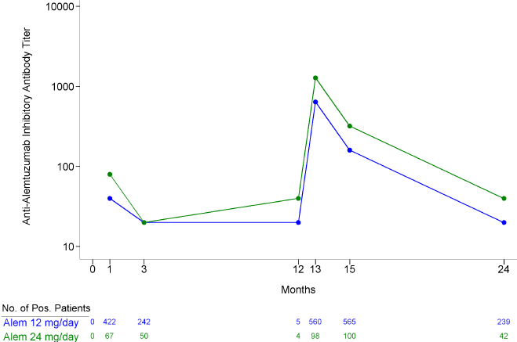
The overall incidence of anti-alemtuzumab antibodies in the 24mg/day dose group was 70.8% vs. 85.2% for 12mg/day, but the incidence of inhibitory antibodies was similar (94.7% vs. 92.2%, respectively). The observed difference in the median anti-alemtuzumab inhibitory antibody titre between the alemtuzumab 24mg/day group and the 12mg/day group was not considered to be of clinical importance.

Study 223
Anti-alemtuzumab (binding) antibody incidence and serum concentration were negative immediately prior to treatment, peaked by 1 month post-dose, and gradually lessened thereafter unless and until a next treatment cycle was administered. The longitudinal pattern of anti-alemtuzumab antibody levels was similar in the 2 dose groups, and with each treatment cycle. Through 3 treatment cycles in CAMMS223, peak antibody responses were higher with increasing cycle number.

Potential effects of antibodies on efficacy
Of the 802 patients treated with alemtuzumab 12mg/day in the combined Full Analysis set, 629 (78.4%) tested positive for inhibitory antibodies, 219 (27.3%) had detectable antialemtuzumab antibodies at Month 12 before administration of Cycle 2. Of these 219 patients, 213 were negative for inhibitory antibodies, and 6 of the 219 patients (2.7%) tested positive for pre-cycle inhibitory antibodies.

Analyses performed across trials (pooled analyses)
The sponsors conducted an Integrated Summary of Effectiveness.
Analyses were to be performed to evaluate the consistency of the alemtuzumab treatment effect across relevant subgroups. This subgroup analysis was to be restricted to the primary efficacy endpoints, time to sustained accumulation of disability and relapse rate, and to the Expanded Disability Status Scale change from baseline but only the first 2 years of post-treatment follow-up were used from CAMMS223.
Comment: The only primary efficacy endpoint that persisted throughout study 223 and matched the original primary objectives was the time to SAD (this was to be analysed at year 3 i.e. after possibly 3 treatments). Relapse rate was originally one of the 13 secondary efficacy endpoints promoted to a primary endpoint 3 years after the study started and MRI assessment was a secondary endpoint.
In all studies Expanded Disability Status Scale (EDSS) change from baseline was a secondary endpoint.

Statistical methods
There were 9 patients from CAMMS223 who later enrolled in CAMMS324. For the subgroup analyses, only the CAMMS223 follow-up were to be used for these 9 patients.
Factors & Subgroups in analyses:
Patient Demographic and Baseline Characteristics assessed included Sex, Age, Race, Weight, Geographic Region and Country.
MS Clinical and MRI Characteristics assessed included Disease Duration, Baseline EDSS, Number of Relapses in Year Prior to Study, Number of Relapses in 2 Years Prior to Study, Baseline T2 Lesion Volume, Number of Gd-Enhanced T1 Lesions At Baseline, Brain Parenchymal Fraction At Baseline, and High Activity at Baseline.

Time to sustained accumulation of disability
For each subgroup analysed (per the characteristics) the number of patients, the number of patients experiencing SAD, the Kaplan-Meier estimate of the probability of SAD and the associated 95% CI over 2 years of follow-up were to be produced.
The data from the clinical studies was to be pooled and with no adjustment for clinical study made. The treatment effect within a subgroup was to be estimated using a Cox proportional hazards model, stratified by clinical study. The only covariate in the model was to be treatment group and the empirical variance estimator was to be used. Additionally, a treatment-by-factor interaction test was to be performed using a Cox proportional hazards model that was stratified by clinical study. The covariates in the model were to be treatment group, factor and treatment-by-factor interaction. The treatment-by-factor interaction p-value was to be based on the Wald test statistic and be reported for each factor that would have subgroup data summarized; the p-value was to be based on a multiple degree-of-freedom test statistic when there was more than 2 subgroups within a factor.

Relapse rate
For each subgroup analysed, the number of patients, the total number of relapses, and the annualized relapse rate over 2 years of follow-up was to be produced. The annualized relapse rate was to be estimated using a negative binomial model with robust variance estimation. The model was to include treatment group and clinical study as covariates. The treatment effect within a subgroup was to be estimated using the proportional means model (Lin et al. 2000), stratified by clinical study. The only covariate in the model was to be treatment group and the empirical variance estimator would be used. Additionally a treatment-by-factor interaction test was to be performed using a proportional means model that was stratified by clinical study. The covariates in the model were to be treatment group, factor and treatment-by-factor interaction. The treatment-by-factor interaction p-value was to be based on the Wald test statistic and would be reported for each factor that had subgroup data summarized.

EDSS change from baseline
In order to assess whether the alemtuzumab treatment effect was consistent across subgroups, analysis of covariance (ANCOVA) was to be used to estimate the EDSS change from baseline to year 2, with baseline, clinical study and treatment group as covariates. Missing year 2 EDSS scores were to be imputed using LOCF. Additionally, a treatment-by-factor interaction test was to be performed using ANCOVA. The covariates in the model would be baseline, clinical study, treatment group, factor and treatment-by-factor interaction. The treatment-by-factor interaction p-value was to be based on the likelihood ratio test.

Concomitant medication
Patients who discontinued study treatment continued to be followed in the study for 2 years after initiation of treatment. If study treatment was discontinued, alternative (‘rescue’) therapy could be initiated, this was recorded as concomitant medication. Use of fampridine (dalfampridine) did not require discontinuation of study drug because it is a symptomatic treatment rather than a disease-modifying MS therapy.
Table 57. Alternative MS Medications by Generic Name: Full Analysis Sets
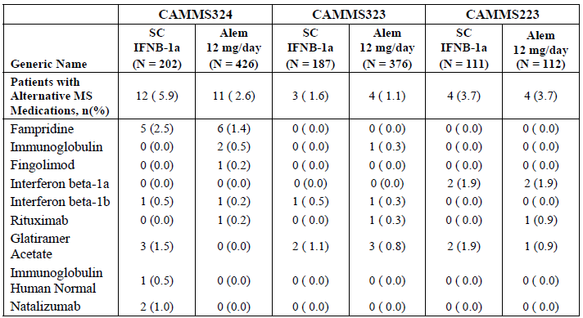
Table 58. Baseline Disease Characteristics: Full Analysis Sets
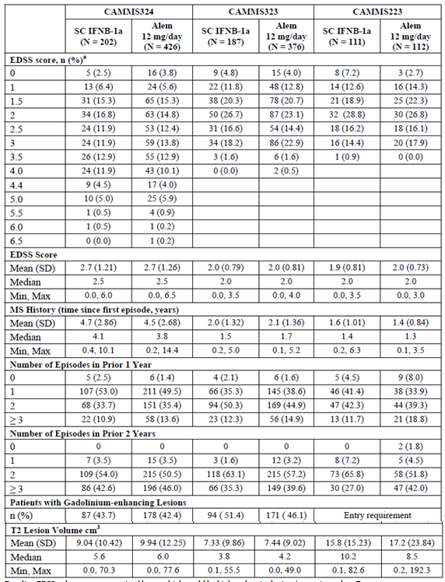
a Baseline EDSS values are summarized here, which could be higher than inclusion/screening values

Results

Time to sustained accumulation of disability
As can be seen in the subgroup analyses there were several subgroups where the 95% CIs overlapped 1.
Figure 27. Summary of Sustained Accumulation of Disability (SAD) up to Year 2 Subgroup Analyses ISE Analysis Set
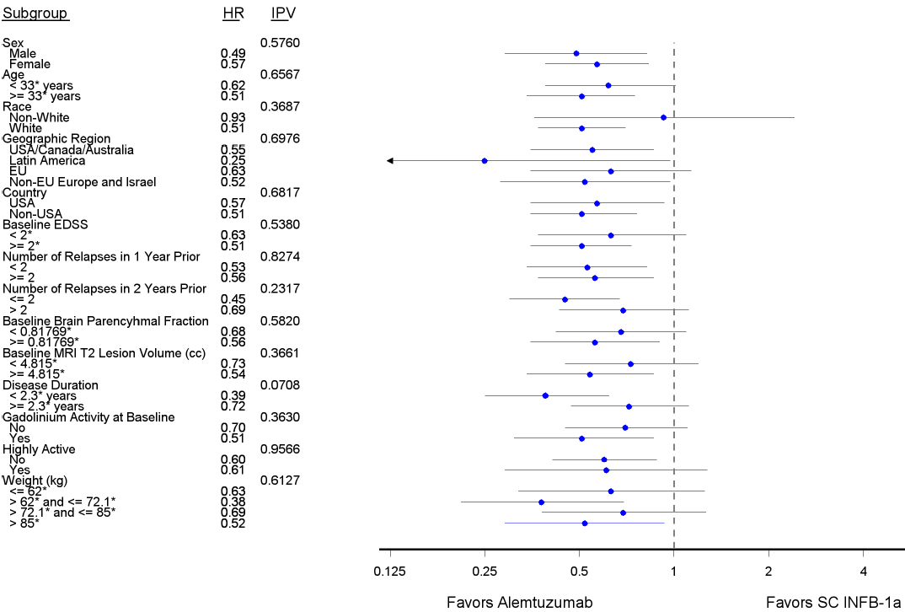
Age, baseline EDSS, baseline brain volume, T2 lesion volume and disease duration are split at the sample median of the ISE Analysis Set. Weight is split at the quartiles of the ISE Analysis Set. IPV denotes the p-value from the multiple degree of freedom interaction test of treatment effect homogeneity.
Table 59. Time to Sustained Accumulation of Disability (SAD) up to Year 2 ISE Analysis Set Subgroup Analysis
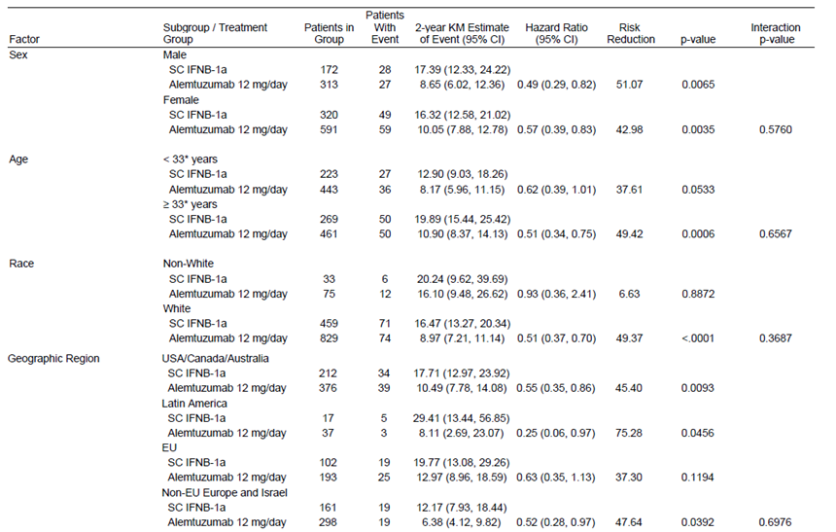
Table 59 continued. Time to Sustained Accumulation of Disability (SAD) up to Year 2 ISE Analysis Set Subgroup Analysis
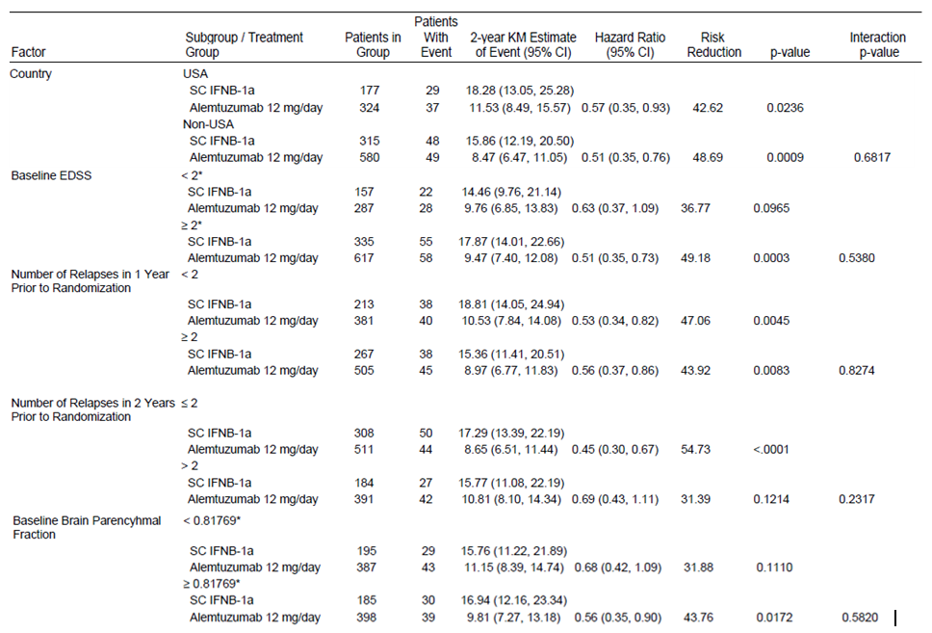
Table 59 continued. Time to Sustained Accumulation of Disability (SAD) up to Year 2 ISE Analysis Set Subgroup Analysis
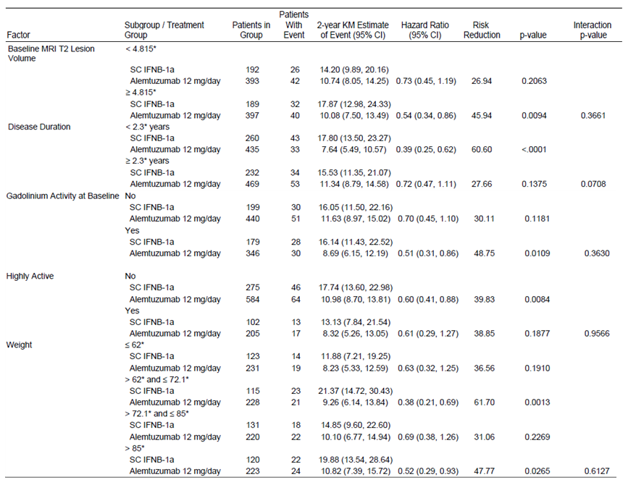
* indicates the baseline median or quartile within the ISE Analysis Set. Hazard ratios and p-values are from proportional hazards regressions with robust variance estimation and stratification by clinical study within each subgroup. Interaction p-value is from a multiple degree of freedom interaction test of treatment effect homogeneity between each factor subgroup and treatment arm.

Relapse rate
Relapse rate was not affected by the subgroup analyses the 95% CIs for the Hazard Ratios were all below 1.
Figure 28. Summary of Relapse Rate Ratio up to Year 2 Subgroup Analyses ISE Analysis Set
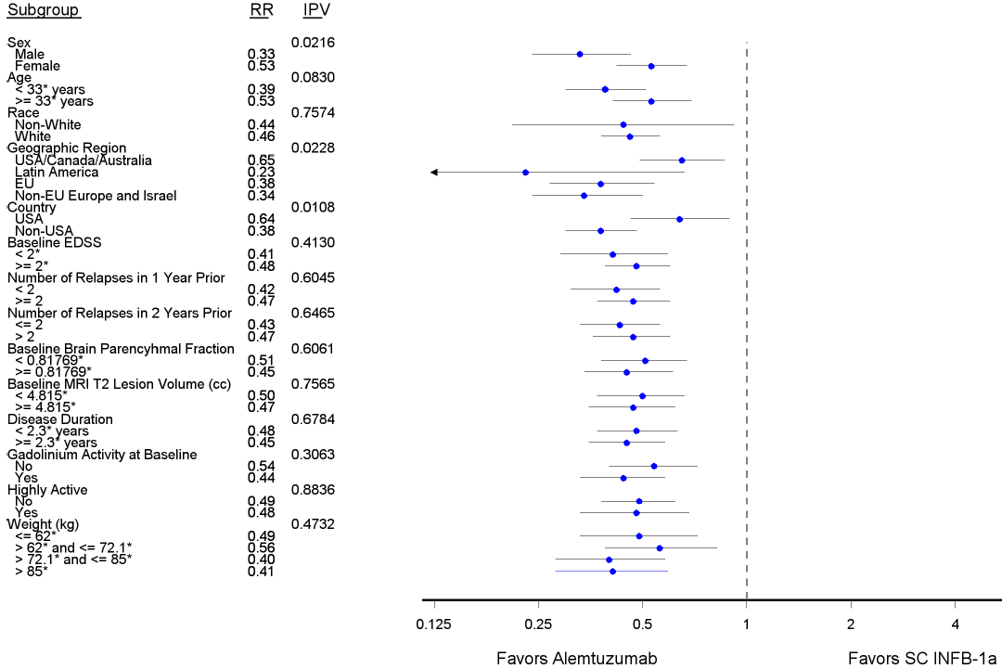
Age, baseline EDSS, baseline brain volume, T2 lesion volume and disease duration are split at the sample median of the ISE Analysis Set. Weight is split at the quartiles of the ISE Analysis Set. IPV denotes the p-value from the multiple degree of freedom interaction test of treatment effect homogeneity.
Table 60. Annualized Relapse Rate (ARR), Kaplan-Meier Estimate of Event, Relapse Rate Ratio, and Risk Reduction up to Year 2 ISE Analysis Set Subgroup Analysis
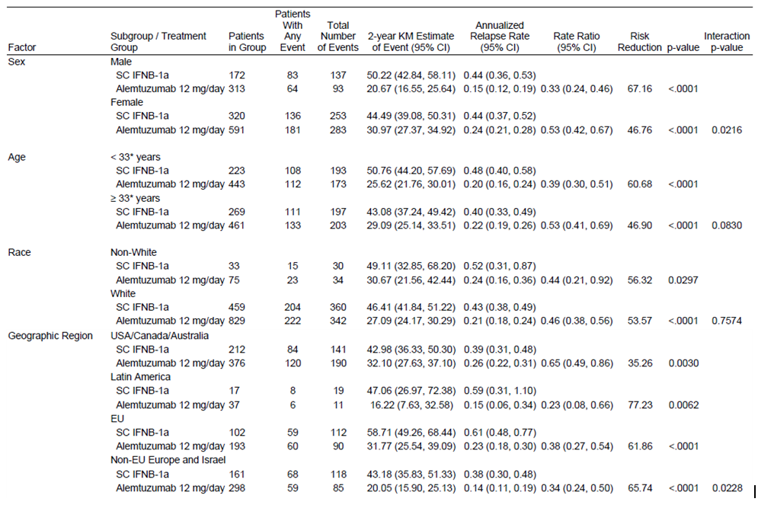
Table 60 continued. Annualized Relapse Rate (ARR), Kaplan-Meier Estimate of Event, Relapse Rate Ratio, and Risk Reduction up to Year 2 ISE Analysis Set Subgroup Analysis
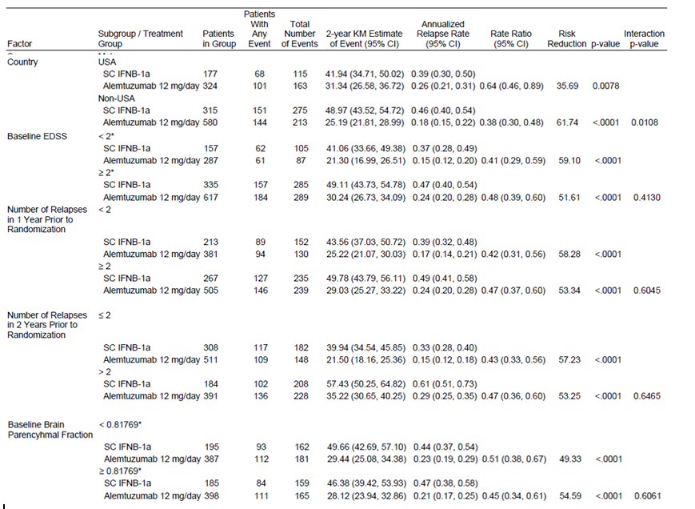
Table 60 continued. Annualized Relapse Rate (ARR), Kaplan-Meier Estimate of Event, Relapse Rate Ratio, and Risk Reduction up to Year 2 ISE Analysis Set Subgroup Analysis
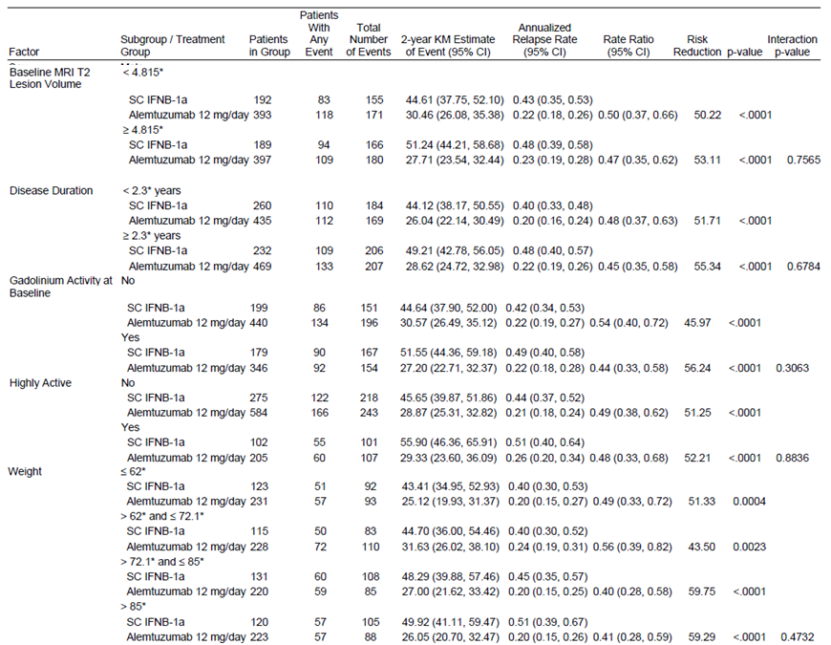
* indicates the baseline median or quartile within the ISE Analysis Set. ARRs are estimated through negative binomial regressions with robust estimation and stratification by clinical study for each subgroup. Rate ratios and p-values are from proportional means regressions with robust variance estimation and stratification by clinical study within each subgroup. Interaction p-value is from a multiple degree of freedom interaction test of treatment effect homogeneity between each factor subgroup and treatment arm.

Change from baseline in EDSS score
Some of the 95% CIs for the difference cross zero. There was no significant difference between treatment groups with respect to change from baseline in EDSS for the subgroup of patients with baseline EDSS <2 (p-value=0.7432).
Figure 29. Summary of EDSS Score Difference at Year 2 Subgroup Analyses ISE Analysis Set
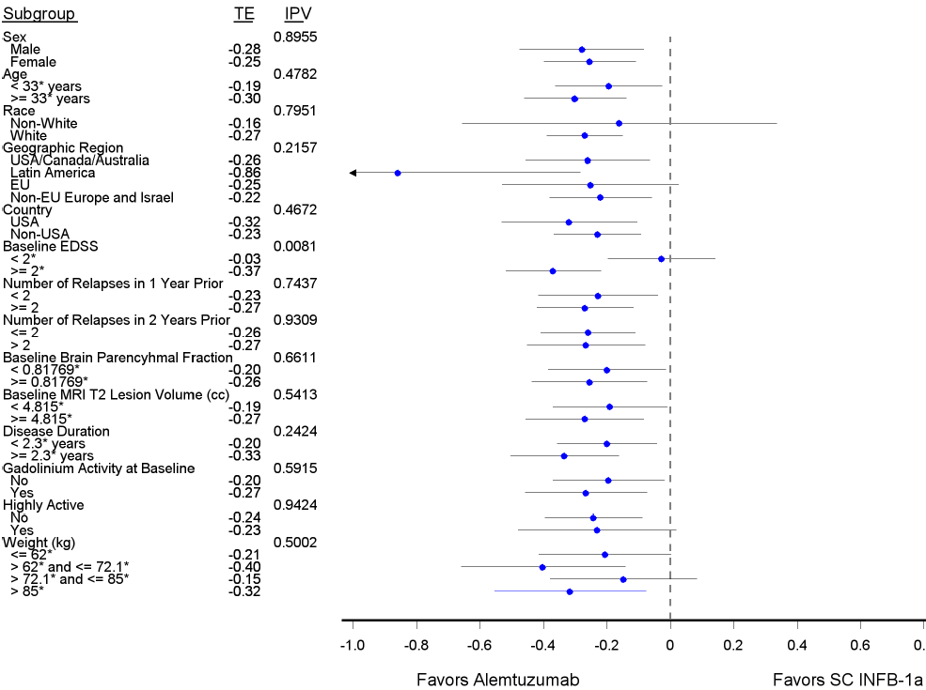
Age, baseline EDSS, baseline brain volume, T2 lesion volume and disease duration are split at the sample median of the ISE Analysis Set. Weight is split at the quartiles of the ISE Analysis Set. IPV denotes the p-value from the multiple degree of freedom interaction test of treatment effect homogeneity.

Table 61. Analysis of covariance (ANCOVA) Analysis of the Change from Baseline in EDSS Score ISE Analysis Set Subgroup Analysis
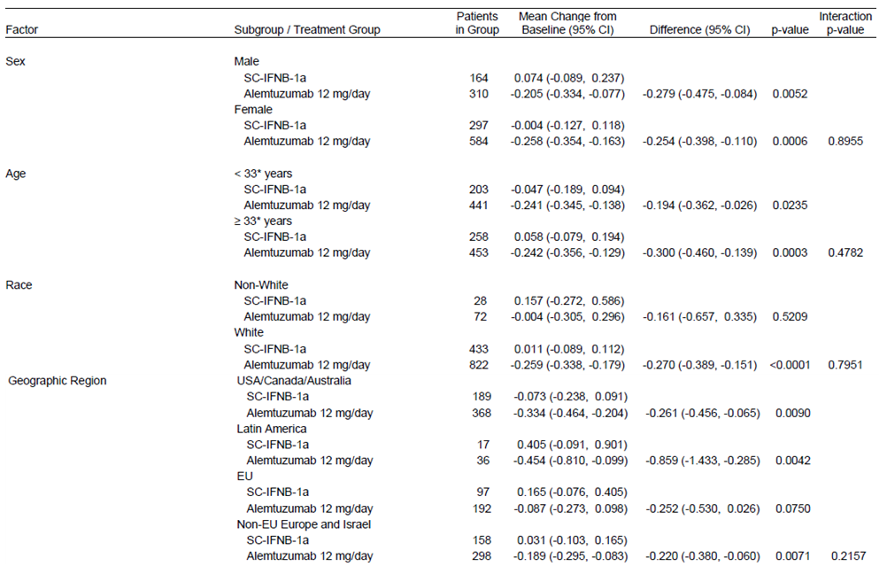
Table 61 continued. Analysis of covariance (ANCOVA) Analysis of the Change from Baseline in EDSS Score ISE Analysis Set Subgroup Analysis
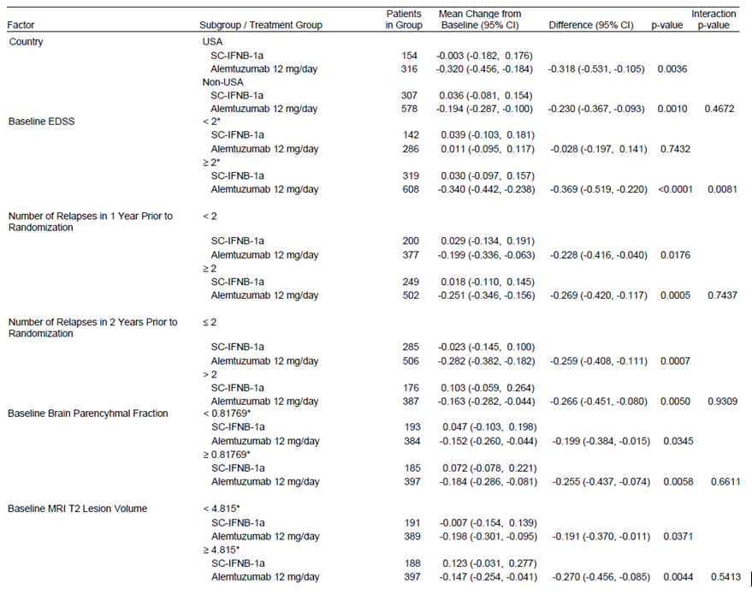
Table 61 continued. Analysis of covariance (ANCOVA) Analysis of the Change from Baseline in EDSS Score ISE Analysis Set Subgroup Analysis
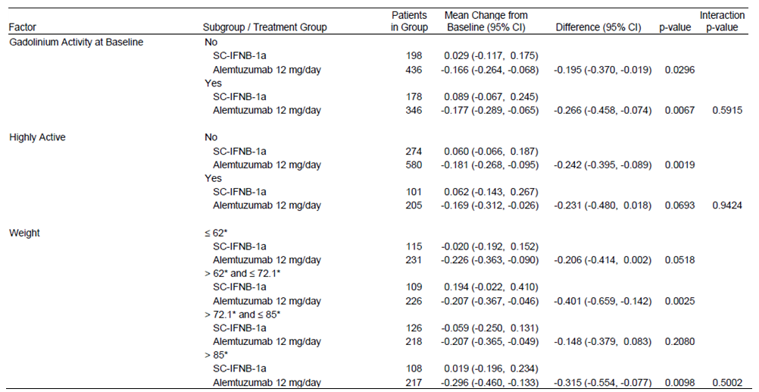
* indicates the baseline median or quartile within the ISE Analysis Set. Mean changes from baseline, differences, and p-values are from analysis of covariance (ANCOVA) with covariate adjustment for clinical study. Interaction p-value is from a multiple degree of freedom interaction test of treatment effect homogeneity between each factor subgroup and treatment arm.

There was no significant difference shown between treatment groups with respect to change from baseline in EDSS for the subgroup of patients with baseline EDSS less than the median of 2.
This was also seen in Time to Sustained Accumulation of Disability (SAD) up to Year 2 for Baseline EDSS < median of 2, No Gadolinium Activity at Baseline, Baseline Brain Parenchymal Fraction < the median of 0.81769, Yes Highly Active, and also Disease Duration ≥ 2.3 years, Number of Relapses in 2 Years Prior to Randomization ≥ 2,. Weight > 72.1 and ≤ 85 likewise had Hazard Ratio 95% CIs overlapping.
Through 3 cycles of treatment, the presence and concentration of binding or blocking antibody did not seem to consistently affect lymphocyte depletion or recovery.
There were no notable associations when relapse rate and SAD were compared by positive/negative antibody status, or across titre quartiles for antibody positive patients, or by pre-cycle anti-alemtuzumab antibody status.

Evaluator’s conclusions on clinical efficacy
There were 2 similar pivotal studies each with 2 primary variables and 4 secondary variables. There were in addition 20 efficacy tertiary endpoints.
The study was to be considered to have met its primary efficacy objective if the p-values corresponding to the analysis of the primary endpoints satisfied at least 1 of the following conditions: (1) The maximum of the two p-values was ≤ 0.05 (2) The minimum of the two p-values was ≤ 0.025. Therefore, the study would be considered to have met its efficacy objective if a statistically significant treatment effect of alemtuzumab over SC interferon β-1a was demonstrated in either or both of the co-primary efficacy endpoints: time to SAD and relapse rate.
Hypothesis testing for the secondary efficacy analyses was to be performed using a closed testing procedure with the following rank order:
- Proportion of patients who are relapse free at Year 2.
- Change from baseline in EDSS.
- Percent change from baseline in MRI-T2 hyperintense lesion volume at Year 2.
- Acquisition of disability as measured by the MSFC.
The above is the order that the analysis was changed to in the Final SAP with Acquisition of disability moved to last in the order.

To slow or reverse the accumulation of physical disability
Primary Variable Time to Sustained Accumulation of Disability showed no statistical difference between treatments in study 323, and while it did in study 324 (p <0.0001), the 95% CIs for the KM estimate of event overlapped (15.95, 27.68 vs. 9.89, 16.27).
Secondary Variables:
In all studies Expanded Disability Status Scale (EDSS) change from baseline was a secondary endpoint.
Change from baseline in Expanded Disability Status Scale Score (EDSS), with treatment naive patients in study 323 (mean baseline EDSS 2.0), at year 2 the difference between the alemtuzumab and Interferon β-1a groups was not statistically significant (with the step down procedure no further [secondary] variables were analysed for study 323).
In study 223 (also treatment naive patients, mean baseline EDSS 2.0, but a study that had an interrupted and different from the proposed treatment history) at year 2 there was a statistically significant difference in change from baseline in EDSS between the groups, favouring alemtuzumab which also showed a statistically significant difference in improvement from baseline.
In Study 324 (previously treated patients who relapsed - mean baseline EDSS 2.7), alemtuzumab-treated patients had significantly lower mean changes in EDSS scores after treatment compared with IFNB-1a-treated patients (p < 0.0001).
The Integrated Summary of Effectiveness (studies, 323, 324 and 223) showed there was no significant difference between treatment groups with respect to change from baseline in EDSS for the subgroup of patients with baseline EDSS < 2. Tabulation of subgroup analyses but not of the total combined effect on change from baseline in EDSS either in the combined analysis or the combined primary Studies 323 and 324.
Percent Change in T2-Hyperintense Lesion Volume from Baseline to Year 2 there was no significant difference between alemtuzumab and IFNB-1a (p = 0.1371) in Study 324 (with the step down procedure no further [secondary] variables were analysed).
While the changes from baseline in EDSS were statistically significant for alemtuzumab in the absence of a placebo group the clinical significance is unclear.
Subgroup analyses across studies of the endpoints Change from Baseline in EDSS score at 2years and Time to Sustained Accumulation of Disability up to 2 year show no statistical difference from IFNB-1a in those patients with less than the median EDSS score of 2 (less severe disability).

To reduce the frequency of clinical relapses
Primary Variable Relapse Rate at 2 years was significantly reduced in alemtuzumab patients compared with those on IFNB-1a in both studies.
Secondary Variables:
Proportion of patients who are relapse free at Year 2 both studies were claimed to show a significant increase in the proportion of patients who were relapse free through 2 years compared with IFNB-1a. This evaluator could not find the supporting analysis (that in the reports’ Tables 14.2.2.1 appears to be for the reduction in risk of relapse).
Study 223 was a phase 2 study with considerable changes to primary objective and primary & efficacy endpoints after the study commenced. The study was interrupted for 2 years by safety concerns. The numbers of patients dwindled, the numbers of courses in many patients exceeded the proposed alemtuzumab regime as did the dose for some. Thus the study has limited relevance of its results to efficacy in the proposed usage.

Clinical safety

Studies providing evaluable safety data
The following studies provided evaluable safety data:
- CAMMS223
- CAMMS323(CARE-MS I)
- CAMMS32400507(CARE-MS II)
- CAMMS03409
Table 62. Safety Analysis populations
Study | All Active- Controlled Studies, 2-Year Follow up (Pool A) (N=1684) | All Active- Controlled Studies, 3- Year Follow up (Pool E) (N=1684) | Phase 3 Studies, 2- Year Follow up (Pool B) (N=1361) | Treatment -Naïve Patients, 2- Year Follow up (Pool D) (N=886) | Treatment -Naïve Patients, 3- Year Follow up (Pool F) (N=886) | Alemtuzumab All Treated Patients, All Available Follow up (Pool C) (N=1485)
CAMMS223 | X | X |  | X |  | X
CAMMS323 | X | X | X | X | X | X
CAMMS324 | X | X | X |  |  | X
CAMMS03409 |  |  |  |  |  | X

Patient exposure
In Study 323, 2 patients at a single study site inadvertently received an infusion of alemtuzumab > 12mg (48mg for one patient and 60mg for the other patient) and both patients subsequently experienced serious infusion associated reactions.
Table 63. Exposure to IFNB-1a in All Active- Controlled Studies (2-Year Follow Up, Pool A)
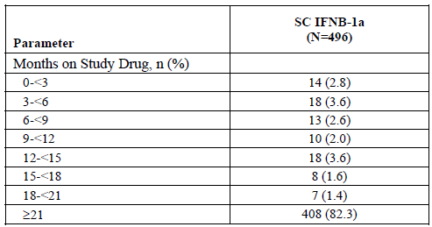
Table 64. Exposure to Alemtuzumab in All Alemtuzumab-Treated Patients (All Available Follow Up, Pool C)
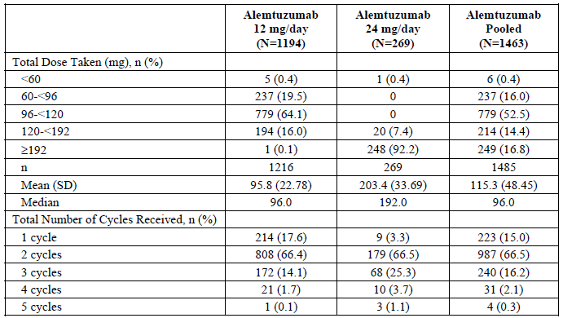
Percentages in the rows under each cycle are based on the number of alemtuzumab-treated patients who received that specific cycle in the corresponding treatment group.
Table 65. Duration of Follow Up in All Alemtuzumab-Treated Patients (All Available Follow Up, Pool C)
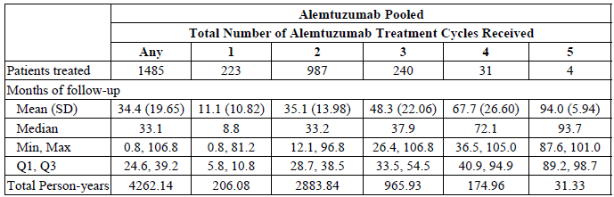
Percentages are based on the total number of alemtuzumab-treated patients in the corresponding treatment group and column. Follow-up duration computed from start of first alemtuzumab treatment cycle to completion/discontinuation or data cut-off .Q = quartile.

Adverse events

All adverse events (irrespective of relationship to study treatment)
Of major concern is the disruption of the initial study 233 for safety concerns from 16 September 2005 to 07 April 2008. The DSMB recommended suspension of alemtuzumab dosing after receiving reports of 3 cases of Immune Thrombocytopenic Purpura (ITP) including 1 fatal case. There were no separate AEs listing for the ongoing Study CAMMS03409.
Table 66. Overview of AEs in All Active-Controlled Studies (2-Year Follow Up, Pool A)
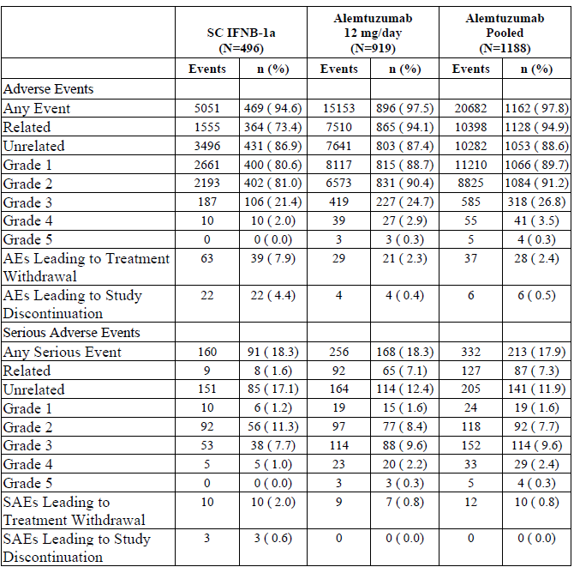
Percentages are based on the number of treated patients in the corresponding treatment group. Data not available from study CAMMS223 for SAEs leading to study discontinuation due to the design of the CRFs.
Table 67. Overview of Adverse Events in All Alemtuzumab-Treated Patients (All Available Follow Up, Pool C)
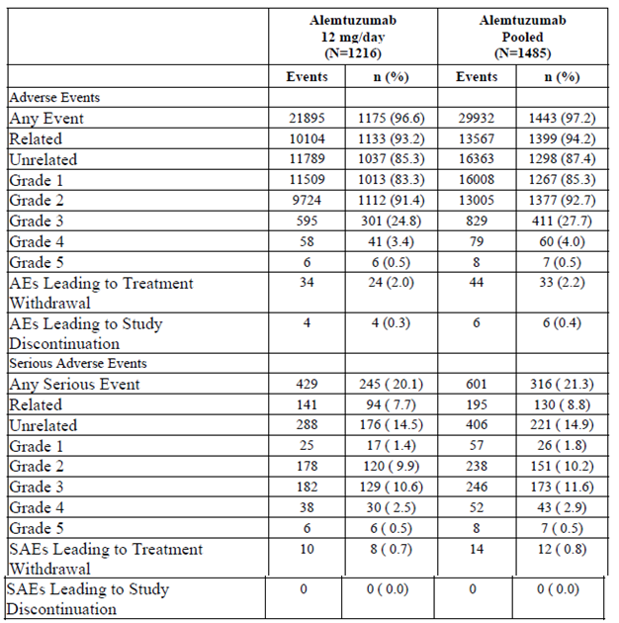
Data not available from study CAMMS223 for SAEs leading to study discontinuation.

Table 68. Incidence of Treatment-Emergent Adverse Events by MedDRA SOC Pool A
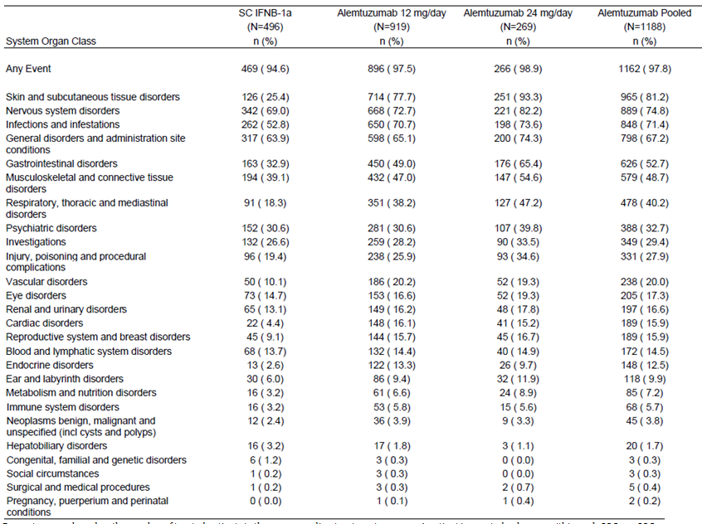
Percentages are based on the number of treated patients in the corresponding treatment group. A patient is counted only once within each SOC. SOCs are presented by decreasing incidence in the Alemtuzumab 12mg/day group.

Treatment-related adverse events (adverse drug reactions)

Pivotal studies
Table 69. Study 323 Alemtuzumab Treatment Related AEs (Incidence ≥ 2 patients or 0.5%) by MedDRA SOC and Preferred Term comparison with IFNB-1a Safety Set
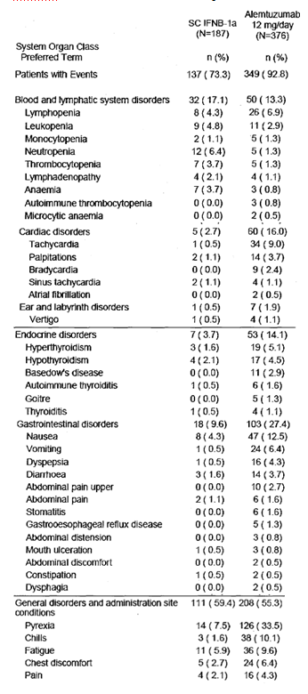
Table 69 continued: Study 323 Alemtuzumab Treatment Related AEs (Incidence ≥ 2 patients or 0.5%) by MedDRA SOC and Preferred Term comparison with IFNB-1a Safety Set
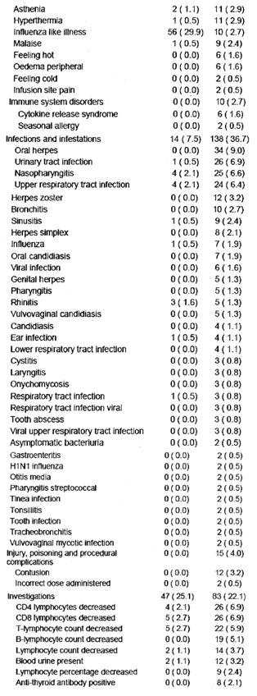
Table 69 continued: Study 323 Alemtuzumab Treatment Related AEs (Incidence ≥ 2 patients or 0.5%) by MedDRA SOC and Preferred Term comparison with IFNB-1a Safety Set
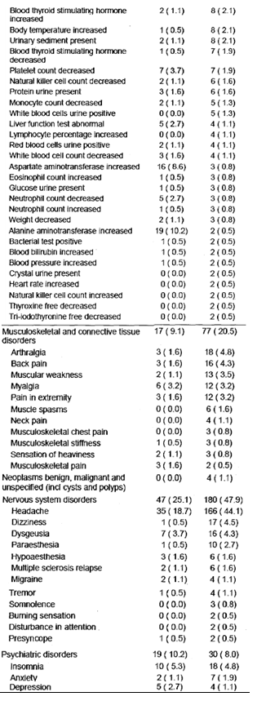
Table 69 continued: Study 323 Alemtuzumab Treatment Related AEs (Incidence ≥ 2 patients or 0.5%) by MedDRA SOC and Preferred Term comparison with IFNB-1a Safety Set
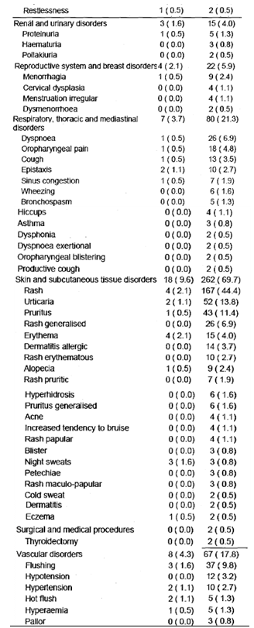
Percentages are based on the number of patients in the Safety Set. A patient is counted only once in the most related category within each SOC/PT. SOCs are presented alphabetically, and within each SOC the PTs are presented by decreasing incidence in the most related category in the Alemtuzumab group. Related AEs are defined as possible, probable, or definitely related and Unrelated AEs are defined as unrelated or remote/unlikely.
Table 70. Study 324 Alemtuzumab Treatment Related AEs (Incidence ≥ 5 patients or 0.8%) by MedDRA SOC and Preferred Term comparison with IFNB-1a Safety Set
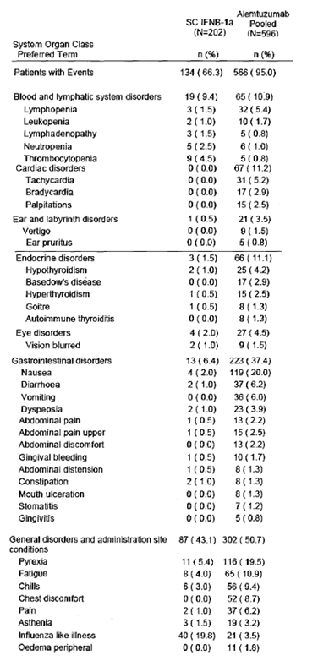
Table 70 continued. Study 324 Alemtuzumab Treatment Related AEs (Incidence ≥ 5 patients or 0.8%) by MedDRA SOC and Preferred Term comparison with IFNB-1a Safety Set
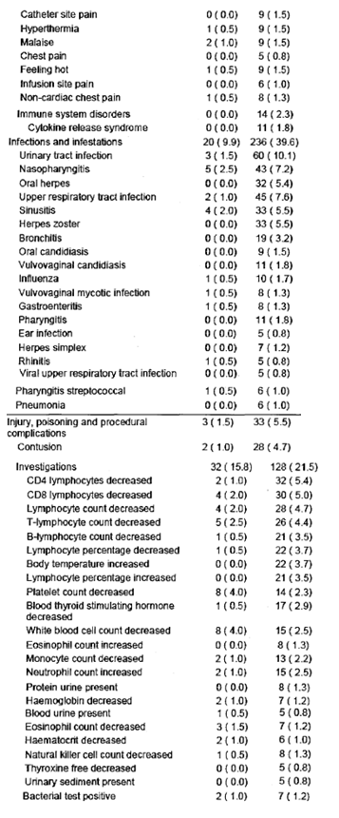
Table 70 continued. Study 324 Alemtuzumab Treatment Related AEs (Incidence ≥ 5 patients or 0.8%) by MedDRA SOC and Preferred Term comparison with IFNB-1a Safety Set
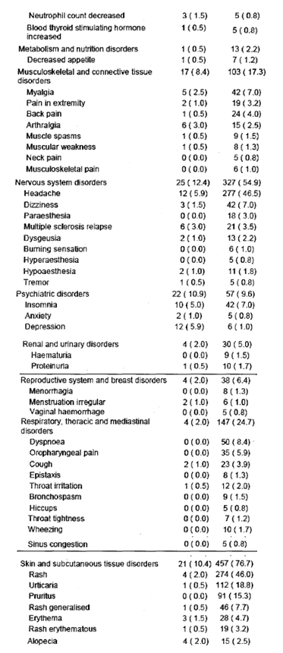
Table 70 continued. Study 324 Alemtuzumab Treatment Related AEs (Incidence ≥ 5 patients or 0.8%) by MedDRA SOC and Preferred Term comparison with IFNB-1a Safety Set
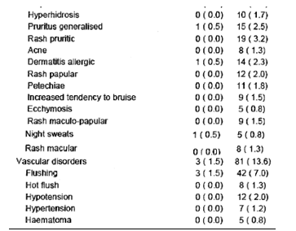
Percentages are based on the number of patients in the Safety Set. A patient is counted only once in the most related category within each SOC/PT. SOCs are presented alphabetically, and within each SOC the PTs are presented by decreasing incidence in the most related category in the Alemtuzumab 12mg/day group. Related AEs are defined as possible, probable, or definitely related and Unrelated AEs are defined as unrelated or remote/unlikely.

Other studies
Table 71. Study 223 Alemtuzumab Treatment Related AEs (Incidence ≥ 0.9%) by MedDRA SOC and Preferred Term comparison with IFNB-1a Safety Set Complete Follow-Up
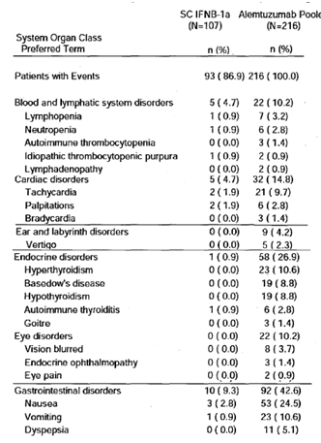
Table 71 continued. Study 223 Alemtuzumab Treatment Related AEs (Incidence ≥ 0.9%) by MedDRA SOC and Preferred Term comparison with IFNB-1a Safety Set Complete Follow-Up
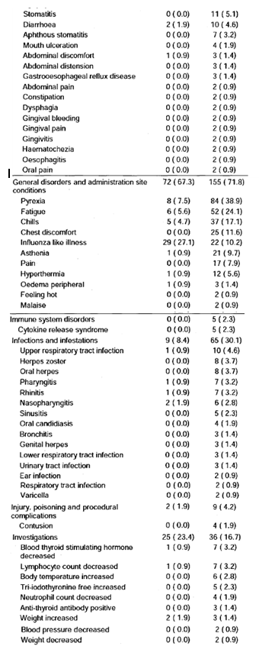
Table 71 continued. Study 223 Alemtuzumab Treatment Related AEs (Incidence ≥ 0.9%) by MedDRA SOC and Preferred Term comparison with IFNB-1a Safety Set Complete Follow-Up
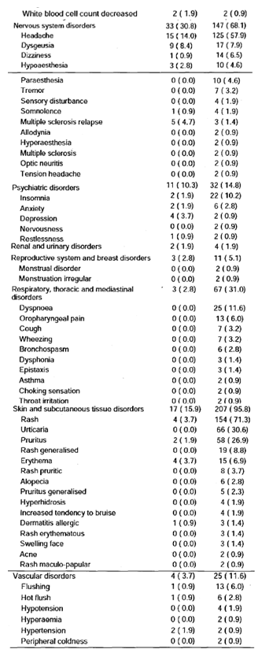
Percentages are based on the number of patients in the safety set in the corresponding treatment group. A patient is counted only once according to the most related category within each system organ class/preferred term. Preferred terms are presented by decreasing incidence in the most related category in the Alemtuzumab Pooled within each system organ class.
Thus the common treatment related AEs in Study 323 were: Headache 44%, Rash 44%, Pyrexia 34%, Nausea 12.5%; in Study 324 they were: Headache 47%, Rash 46%, Nausea 20%, Pyrexia 20%, Urticaria 19%; and in Study233 they were: Rash 71%, Headache 58%, Pyrexia 39%, Urticaria 31%, Pruritus 27%, Nausea 25%, Fatigue 24%.

Deaths and other serious adverse events

Pivotal studies
There was 1 death in study 323:
- A patient in the alemtuzumab group died in a motorcycle accident 9 months after Cycle 2
and 2 in 324:
- A patient in the alemtuzumab group died on Day 589 after being hit by a car
- A patient in the alemtuzumab group died 10 months after his second cycle of alemtuzumab. He had previously experienced a brainstem relapse 11 months after the first cycle of alemtuzumab, which left him severely disabled. He developed a second event of Grade 3 aspiration pneumonia and only palliative measures were initiated.
All 3 were considered unrelated to treatment (alemtuzumab).

Other studies

Treatment (alemtuzumab) related
A 39-year-old male patient enrolled in study 223 died from idiopathic thrombocytopenic purpura and a cerebral haemorrhage 7 months after the second annual cycle of alemtuzumab 24mg/day. A computed tomography (CT)-scan of the head showed a large extensive intracranial haemorrhage. The platelet count was 4 x 10⁹/L. A serum sample taken 3 months prior to alemtuzumab treatment was negative for antiplatelet antibody and positive 1.5 months prior to the event and at the time of the event. This was the safety event that disrupted the study.
45-year-old female patient enrolled in CAMMS223 (died from cardiovascular disorder 2 months after receiving the third annual cycle of alemtuzumab 12mg/day. The patient had a medical history of cardiac risk factors including obesity, hypertension, smoking, and oestrogen therapy. The coroner ruled the death a result of cardiovascular disorder. In the opinion of the site investigator, the cause of death was unknown. The investigator assessed the event as related to the study drug.
A 46-year-old male patient enrolled in study 03409 (Patient 7105-3488) died from sepsis a year and a half after the second annual cycle of alemtuzumab 12 mg/day. The patient was hospitalized for autoimmune pancytopaenia, febrile neutropaenia, and sepsis. He died from sepsis 2 days after his hospitalization.

Not related to treatment
There was one other death in Study 3409on alemtuzumab and one on IFNB-1a in study 223.

Discontinuation due to adverse events
Study discontinuation was defined as permanent discontinuation from study participation. Since (except for alemtuzumab-treated patients who met the protocol definition for ITP or any patient with anti-GBM disease ) patients who discontinued alemtuzumab treatment in studies CAMMS223, CAMMS323, or CAMMS324 could remain in the studies (to be followed for efficacy and safety) and could receive additional cycles of alemtuzumab at the investigator’s discretion in the extension study (CAMMS03409), it could thus be claimed that there were no patients who discontinued alemtuzumab because of treatment related AEs.

Treatment discontinuation
Treatment discontinuation is defined as defined as permanent discontinuation of treatment (i.e., alemtuzumab or IFNB-1a).
Of those who discontinued alemtuzumab due to AEs: 3 had immune thrombocytopaenic purpura, 1 purpura, 2 hypothyroidism, 1 goitre, there was a group that included 1 rash, 1 allergic rash, 1 urticaria, 1 anaphylactoid reaction 1 probably anaphylaxis, 1allergic reaction, there were 2 with chest pain, 1 chest pain, 1 asthma, 2 lymphocytopaenia, 1 Tb, and 1 cervical dysplasia.
There were more who discontinued IFNB-1a for AEs that included Injection site reactions 5, flu-like illness 4, pyrexia 3, urticaria 3, Increased LFTs 6, hepatitis (acute & chronic) 2, hepatic failure 1, lymphopaenia 2, neutropaenia 1, thrombocytopaenia 2, mood alteration 2, steroid psychosis 1, depression 1, hypothyroidism 1, tachycardia 1 CVS disease NOS 1, increased migraines 1, muscle spasms 1 and acute myeloid leukaemia 1.
For Study 223, the specific preferred term for the event leading to discontinuation was not recorded.

Laboratory tests

Liver function
In 2 years of follow up, mild increases in bilirubin values (≥ 1.5 x ULN) were more common on the alemtuzumab12 mg/day, while elevations ≥ 3 x ULN in AST and ALT were more common on the IFNB-1a group than alemtuzumab 12mg/day.
There was no apparent increase in the proportion of patients with high AST, ALT, or bilirubin or the severity of the abnormalities with the number of alemtuzumab cycles received or the total alemtuzumab dose received.
1 patient on alemtuzumab 12mg/day had an isolated elevation in LFTs 12 months after Cycle 2 (ALT = 464IU/L; AST = 235IU/L; bilirubin = 92mcmol/L). 3 patients on IFNB-1a had similar elevations.

Kidney function
In all but 1 case, Grade 2 or higher values for creatinine elevation were followed by normal assessments (either a repeat measurement or the next monthly assessment). The exception was a patient who developed anti-glomerular basement membrane disease. The incidence of Grades 1 & 2 CTC Grade for Creatinine doubled between cycles 1 & 2, otherwise there was no apparent increase in serum creatinine or severity of creatinine elevations with the number of alemtuzumab cycles received or the total alemtuzumab dose received.

Urinalysis
Pooled data on urinalysis was provided for the Phase 3 studies through 2 year follow up only (Pool B). “Positive, clinically significant” changes in occult blood using only quarterly assessments, were similar for alemtuzumab 12mg/day and IFNB-1a patients in Year 1 (1.4% vs. 2.0%), but an increased percentage was observed in the alemtuzumab 12mg/day group in Year 2 (3.1% vs. 1.4%). Likewise “positive, clinically significant” changes in protein were reported for similar proportions of alemtuzumab 12mg/day patients and IFNB-1a patients (1.7% vs. 2.0% in Year 1; 1.5% vs. 1.1% in Year 2).

Other clinical chemistry
There were no medically significant or persistent changes or notable differences between the alemtuzumab 12mg/day group and the IFNB-1a group for albumin, alkaline phosphatase, calcium, carbon dioxide, chloride, glucose, phosphate, potassium, protein, or sodium during 2year follow up.

Haematology
Alemtuzumab is a recombinant DNA-derived humanized IgG1 kappa monoclonal antibody directed against CD52, a 21-28 kD cell surface glycoprotein. In humans, CD52 is present at high levels on T and B lymphocytes and at lower levels on natural killer cells, monocytes, and macrophages. There is little or no CD52 detected on neutrophils, plasma cells, and bone marrow stem cells.

Platelets
Mean platelet counts fluctuated over time but remained within the normal range for all treatment groups in the active-controlled studies (Pool A) and through Year 4 for alemtuzumab-treated patients (Pool C). Mean platelet counts decreased from baseline at Month 1 but trended towards baseline values for alemtuzumab-treated patients at Month 2; the mean platelet count for IFNB-1a patients decreased below that observed for alemtuzumab-treated patients at Month 2 and remained lower throughout 2-year follow up. Post-baseline shifts to below normal were reported in a larger percentage of IFNB-1a patients than alemtuzumab 12mg/day patients (15.6% vs. 6.7% in Year 1; 13.5% vs. 4.9% in Year 2).
Figure 30. Platelet Counts over Time Pool A (Mean ± SE).
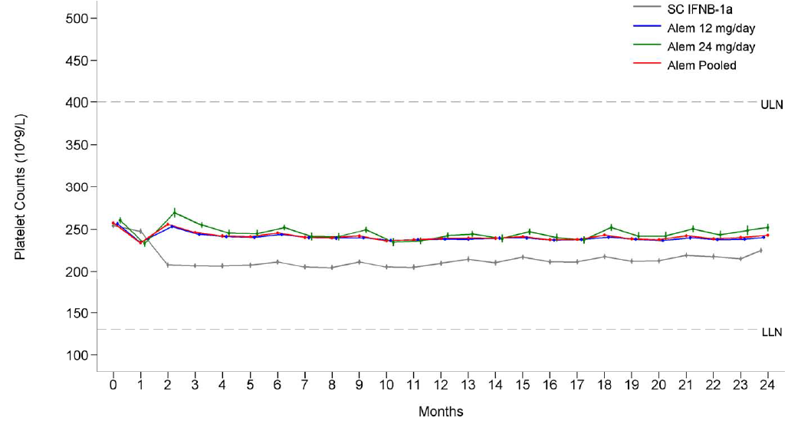
Normal Range (from Phase III central lab) in 10⁹/L: LLN=130, ULN=400.
In Pool A post-baseline shifts to below normal were reported in a larger percentage of IFNB-1a patients than alemtuzumab 12mg/day patients (15.6% vs. 6.7% in Year 1; 13.5% vs. 4.9% in Year 2).
An isolated platelet count of 4 x 10⁹/L (Grade 4) that was 263 x 10⁹/L 3 days later, was seen in 1 alemtuzumab 24mg/day patient during Year 1. During Year 2 there were 4 alemtuzumab 24mg/day patients with Grade 4 values 3 were confirmed ITP cases and 1 patient had an isolated platelet count <25 x 10⁹/L that was within normal limits 3 days later.
During all available follow up in all alemtuzumab patients (Pool C), Grade 4 platelet counts were reported for 3 patients during Year 1, 8 patients during Year 2, 7 patients during Year 3, and 1 patient during Year 4. All patients were confirmed ITP cases with the exception of an isolated value in 1 patient which was within normal limits on repeat measurement 3 days later.

Table 72. CTC Grade for Baseline Platelets and Worst Post-Baseline Values by Cycle Pool C
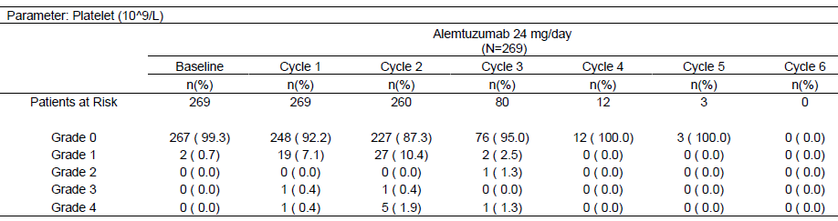
Percentages are based on the number of patients in the treatment group with data for the specific laboratory parameter in the corresponding cycle. A cycle starts with the 1st infusion of the cycle and ends with the start of the subsequent cycle. If there is no subsequent cycle, the cycle continues until the end of follow-up. Platelet CTC Grade Ranges in 109/L Units: 0: ≥LLN; 1: ≥75 - <LLN; 2: ≥50 - <75; 3: ≥25 - <50; 4: <25.
Table 73. Summary of Shifts from Baseline in Platelet Results by Calendar Year and Overall Pool C
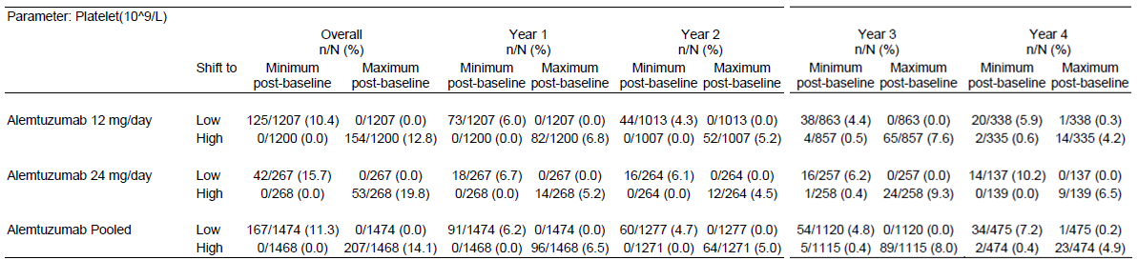
Entries are number low (or high)/number at risk (%). Number at risk for shift to low (or high) is the number of patients whose baseline value was not low (or high) and who had at least one post-baseline value in each Year or Overall. Shift to low includes normal to low, high to low, and unknown to low. Shift to high includes normal to high, low to high, and unknown to high. Years defined by calendar time. Baseline is defined as the last value prior to first treatment in Year 1 for all summaries. Overall time period includes all valid years of Pool C follow-up.

Absolute Neutrophil Count
The mean neutrophil counts in all treatment groups in Pool A decreased at Month 1, but the mean neutrophil count for alemtuzumab patients had increased by Month 2, while that for IFNB-1a remained low.
During all available follow up through Year 4, shifts from baseline CTC Grade 0 to Grade 3 post-baseline neutrophil values were reported in 2.1% of alemtuzumab 12mg/day patients and 4.8% of alemtuzumab 24 mg/day patients. Shifts from baseline CTC Grade 0 to Grade 4 post-baseline values were reported in 1.0% of alemtuzumab 12mg/day patients and 4.5% of alemtuzumab 24 mg/day patients.

Haemoglobin
The mean haemoglobin values for alemtuzumab 12mg/day patients were below those for IFNB-1a patients at Month 1, but recovered to baseline levels by Month 3 and remained higher than the mean values for IFNB-1a patients throughout 2year follow up.
In the 2 years study Grade 3 or 4 haemoglobin only occurred in alemtuzumab-treated patients: 6 patients (0.5%) overall had Grade 3 values ( most on 12mg/day); 2 patients (0.2%) on alemtuzumab 24 mg/day had Grade 4 values – 1 in a patient with thrombocytopenia and 1 in a patient with hereditary spherocytosis.

Leukocytes
Mean leukocyte (WBC) counts decreased from baseline in all treatment groups (with alemtuzumab primarily influenced by the results in the lymphocyte subpopulation) in over 2-years of follow up (Pool A) and all alemtuzumab-treated patients through Year 4 (Pool C), with the largest changes in the alemtuzumab-treated patients observed at Month 1 and Month 13.

Monocytes
While mean monocyte counts remained within the normal range without notable fluctuations over time in both the alemtuzumab and the IFNB-1a dose groups, those for alemtuzumab were consistently lower.

Electrocardiograph

Potential effects on QT interval (QT substudy)
The effect of alemtuzumab on the QT/QTc interval was evaluated in a subset of patients in the CAMMS03409 Extension Study as part of a US post-marketing commitment for Campath. Fifty-three (53) patients who were treated with SC IFNB-1a in a prior study (CAMMS323, or 324), received alemtuzumab for the first time in the QT substudy. Patients in the substudy received a single oral dose of 400mg of moxifloxacin as a positive control to establish assay sensitivity, followed by alemtuzumab 12mg/day for 5 consecutive days starting 4 days following the dose of moxifloxacin. Digital ECGs were sent to a central laboratory for measurement of the cardiac intervals and morphological assessment by blinded cardiologists.
Based on interim data currently available, there was no significant effect on cardiac repolarisation, as measured by the lack of a significant change in QTcF and QTcB; i.e., there were no cases of ECG QTc measurements > 500ms. There were no cases of Torsade de pointes, ventricular tachycardia, ventricular fibrillation, or flutter. There was also no effect on AV conduction or cardiac depolarization as measured by the PR and QRS interval durations.
T wave and ST segment changes on ECGs were observed in 21 patients after alemtuzumab treatment. These ECG findings generally did not persist during subsequent alemtuzumab infusions during Cycle 1.
A mean increase in time-averaged heart rate of 7.3 bpm was observed, which was driven by a 20 to 26 bpm increase in heart rate during the 2 hours after the initial dose of alemtuzumab on Day 1. This increase was only seen on Day 1 and not with subsequent doses of alemtuzumab or methylprednisolone.

Vital signs
No meaningful differences in vital sign shifts from baseline were seen when comparing alemtuzumab 12mg/day patients to IFNB-1a patients over 2 years of follow up or in all alemtuzumab-treated patients through all available follow up. Vital sign findings for the alemtuzumab pooled and 24mg/day dose groups were similar to those observed for the 12mg/day group.

Post-marketing experience
Approximately 38,441 patients were treated with Campath as of 07 May 2011 (current indication is for B-CLL).
Infusion reactions occur in the majority of patients receiving Campath for B-CLL, serious and sometimes fatal reactions including bronchospasm, hypoxia, syncope, pulmonary infiltrates, Acute Respiratory Distress Syndrome respiratory arrest, myocardial infarction, arrhythmias, acute cardiac insufficiency and cardiac arrest have been observed following Campath treatment for B-CLL.
Hematologic AEs are commonly associated with using Campath in B-CLL, including lymphopaenia, neutropaenia, thrombocytopenia, and anaemia. Severe, prolonged, and in rare instances fatal myelosuppression has occurred in patients with leukaemia and lymphoma receiving Campath.
Serious and sometimes fatal viral (e.g., adenovirus, parainfluenza, hepatitis B, progressive multifocal leukoencephalopathy [PML]), bacterial (e.g. tuberculosis, atypical mycobacterioses, nocardiosis), protozoan (e.g., toxoplasma gondii) and fungal (e.g., rhinocerebral mucormycosis) infections, including those due to reactivation of latent infections, have been observed in B-CLL patients.
Autoimmune conditions have been reported following treatment with Campath, and occur in both B-CLL and the MS setting.

Safety issues with the potential for major regulatory impact
Table 74. Kaplan-Meier Estimate of Cumulative Proportion over Time for Patients Experiencing First Specific Treatment-Emergent Adverse Events Pool C
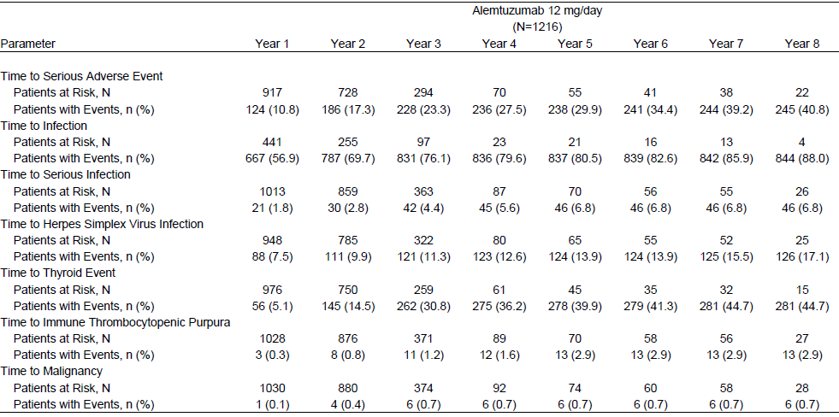
Percentages of patients with the event are based on Kaplan-Meier estimation of cumulative probability of the event over the corresponding time period.

Infusion associated reactions
Infusion associated reactions are defined as AEs that occur between the start and stop of any alemtuzumab infusion plus 24 hours.
Table 75. Infusion-Associated Reactions Reported in ≥5% of Patients in Any Treatment Group for All Alemtuzumab-Treated Patients, All Available Follow Up (Pool C)
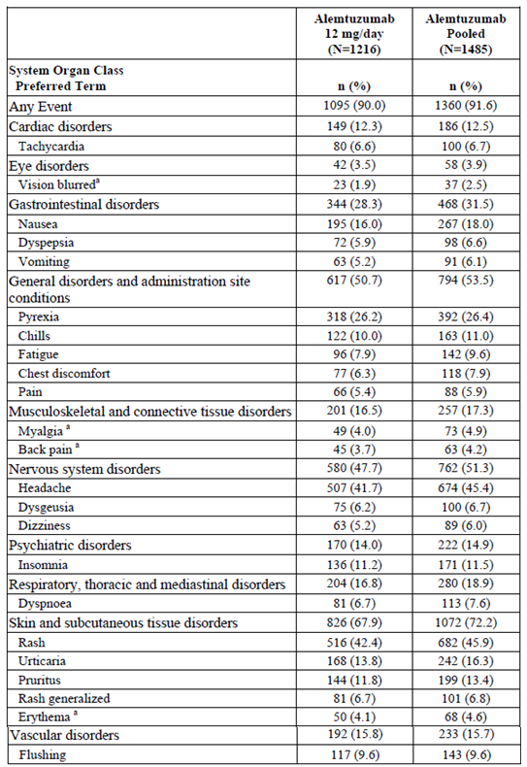
Percentages are based on the number of treated patients in the corresponding treatment group. A patient is counted only once within each SOC/PT. SOCs are presented alphabetically, and within SOC the PTs are presented by decreasing incidence in the Alemtuzumab 12mg/day group. IARs refer to AEs that occur between the start and stop of any Alemtuzumab infusion + 24 hours^{. a}These events occurred at an incidence of ≥ 5% in the alemtuzumab 24 mg/day group only.
In the 2-Year Follow Up ( Pool A) the overall incidence of IARs was 91.1% in the alemtuzumab 12mg/day group, and 97.8% in the 24mg/day group. The incidence of IARs decreased from Cycle 1 to Cycle 2 and decreased over the course of the infusion treatment cycle, with the highest incidence reported on Day 1. 26 (2.8%) patients on alemtuzumab 12mg/day had Serious IARs. Serious IARs in the alemtuzumab 12mg/day group included 3 (0.3%) patients each with pyrexia and urticaria; 2 (0.2%) patients each with atrial fibrillation, nausea, chest discomfort, infusion-related reaction, incorrect dose administered, and hypotension. All of these events were considered to be related to study drug. Grade 4 IARs for 5 (0.5%) patients in the alemtuzumab 12mg/day group included non-cardiac chest pain (2 patients), dyspnoea (2 patients), and tachycardia, atrial fibrillation, chills, generalized rash, and angioedema (1 patient each). Additional Grade 4 IARs identified in the pooled dose group were lymphopaenia, hepatotoxicity, and muscular weakness.
In all alemtuzumab-treated patients, IARs were reported for 90.0% of patients in the alemtuzumab 12mg/day group. The overall incidence of IARs was highest for Cycle 1 compared with subsequent cycles (85.2% of patients in alemtuzumab 12mg/day group in Cycle 1 compared with 69.3%, 68.0%, and 68.2% for Cycles 2, 3, and 4, respectively). The average number of IARs was greatest with the first infusion (Day 1) of each cycle, but the average number of IARs with the first infusion decreased from Cycle 1 to Cycle 3. Serious IARs were reported for 30 (2.5%) patients in the alemtuzumab 12mg/day group; this included 2 events not reported in Pool A: atrial fibrillation and hypotension.
The most common Grade 3 IARs (≥ 1% of patients) in the alemtuzumab 12mg/day group were rash 16 patients, 1.3%) and headache (13 patients, 1.1%); Grade 4 IARs were identified for 5 (0.4%) patients in the alemtuzumab 12mg/day group: non-cardiac chest pain (2 patients), dyspnoea (2 patients), and tachycardia, atrial fibrillation, chills, generalized rash, and angioedema (1 patient each). Additional Grade 4 IARs identified in the pooled dose group were lymphopaenia, hepatotoxicity, anaphylactoid reaction. There was a decrease in incidence of IARs after Cycle 1 and with each subsequent cycle of alemtuzumab.
In the alemtuzumab 12mg/day group, the incidence of IARs leading to dose adjustment was higher in Cycle 1 than Cycles 2 and 3 (95 [7.8%] patients vs. 40 [4.0%] and 7 (3.6) patients, respectively).
For the fourth infusion of Cycle 1, when alemtuzumab was administered without prophylactic methylprednisolone, the number of IARs increased to an average of 0.83 events and were likewise higher with the fifth infusion (0.58 average number of events) compared with the second and third infusions.

Infections
In the 2-Year Follow Up (Pool A) the incidence of infection AEs overall for the alemtuzumab 12mg/day group was 70.9%, compared with 53.2% in the IFNB-1a group. Infections tended to occur earlier in the alemtuzumab groups than in the IFNB-1a group with the largest increase during the first month following initiation of the first treatment cycle. These data illustrate that over the 2-year treatment period there is no increase in the risk of infection that would be indicative of cumulative immunosuppressive effects.
The most frequently reported infections (≥ 5% of patients) for both the alemtuzumab 12mg/day and IFNB-1a groups were nasopharyngitis, urinary tract infection (UTI), upper respiratory tract infection (RTI), sinusitis, and influenza. Additionally, for the alemtuzumab 12mg/day group, oral herpes (8.6%) and bronchitis (7.0%) were on the list of frequent events.
Table 76. Incidence of Infections Reported in ≥5% of Patients in Any Treatment Group in All Active-Controlled Studies (2-Year Follow Up, Pool A)
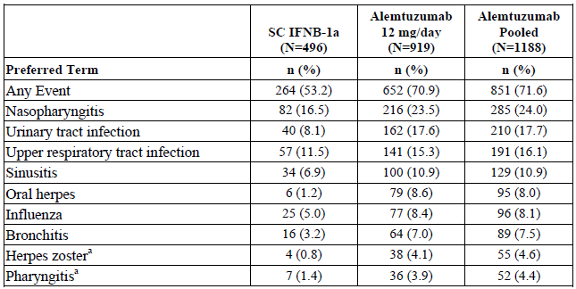
Percentages are based on the number of treated patients in the corresponding treatment group. Infections refers to AEs with MedDRA SOC ‘Infections and infestations’. A patient is counted only once within each SOC/PT. PTs are presented by decreasing incidence in the alemtuzumab 12mg/day group. ª Events occurred at an incidence of ≥5% in the alemtuzumab 24 mg/day group only.
Serious infections were reported for 25 (2.7%) patients in the alemtuzumab 12mg/day group and 5 (1.0%) patients in the IFNB-1a group over 2 years of follow up. Grade 3 infections were reported for 33 (3.6%) patients in the alemtuzumab 12mg/day group and 6 (1.2%) patients in the IFNB-1a group. The most common Grade 3 event was herpes zoster, reported in 6 (0.7%) patients in the alemtuzumab 12mg/day group. Two Grade 4 infections were reported for 1 (0.1%) patient in the alemtuzumab 12mg/day group: nasopharyngitis and pneumonia.
Table 77. Incidence of Serious Infections in All Active-Controlled Studies (≥ 2cases in 2-Year Follow Up, Pool A)
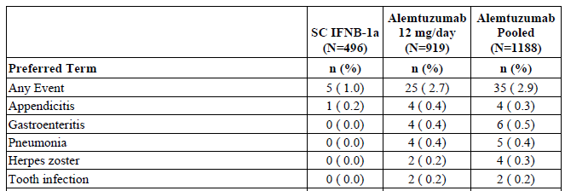
Percentages are based on the number of treated patients in the corresponding treatment group. Infections refers to AEs with MedDRA SOC ‘Infections and infestations’. A patient is counted only once within each PT. PTs are presented by decreasing incidence in the alemtuzumab 12mg/day group.
Overall the incidence of infections decreased from Years 1 to 4 in the alemtuzumab 12mg/day treatment group (54.9%, 49.2%, 38.9%, and 23.2%, respectively). The rate of infection decreased by cycle in the alemtuzumab 12mg/day group: 1.263, 1.022, and 0.853 per person-year for Cycles 1, 2, and 3, respectively. The risk of experiencing a first infection tended to be highest after receiving Cycle 1 before gradually decreasing and remaining constant beyond 2 years.

Table 78. Incidence of Infections in ≥ 5% of Patients Overall in Any Treatment Group by Calendar Year, Alemtuzumab Patients (Pool C)
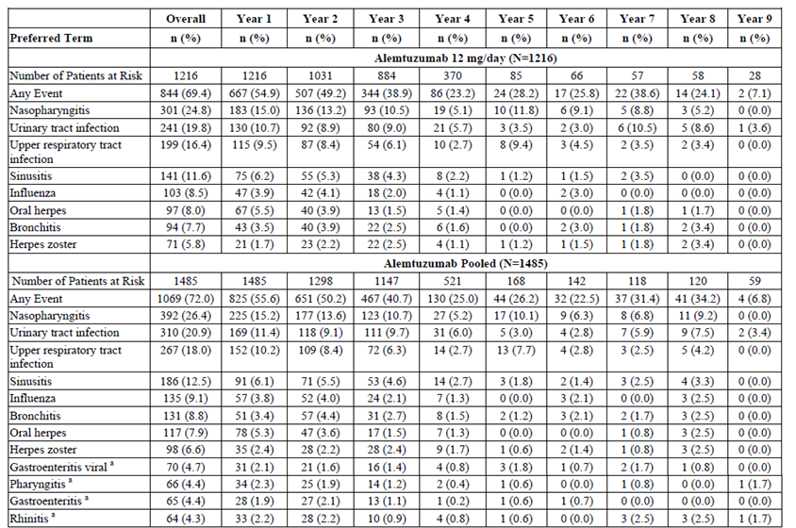
Percentages are based on the number of treated patients in the corresponding time period and treatment group. A patient is counted only once within each PT, within each column. PTs are presented by decreasing incidence in the Overall Alemtuzumab 12mg/day group. Years defined by calendar time. Infections refers to AEs coded to MedDRA SOC ‘Infections and infestations’, or to AEs coded to MedDRA HLGT 'Microbiology and serology investigations' under the SOC 'Investigations'. ªThese events occurred at an incidence of ≥5% in the alemtuzumab 24 mg/day group only.

Overall serious infections were reported for 46 (3.8%) patients in the alemtuzumab 12mg/day group, they included for ≥ 2 patients: herpes zoster (6 patients, 0.5%), pneumonia (6 patients, 0.5%), appendicitis (5 patients, 0.4%), gastroenteritis (4 patients, 0.3%), sepsis (3 patients, 0.2%), and 2 patients (0.2%) each with cellulitis, lower respiratory tract infection, subcutaneous abscess or tooth infection, with bronchitis, UTI, and pyelonephritis also reported in ≥2 patients in the overall alemtuzumab pooled dose group. The rate of serious infection did not increase with cycle number or cumulative dose in the alemtuzumab 12mg/day group. 53 (4.4%) of 12mg/day patients had Grade 3 infections; 3 had Grade 4 infections: 1 patient had nasopharyngitis and pneumonia, 1 had appendicitis perforated and 1 patient had a fatal infection, an SAE of sepsis.

Respiratory tract infections
In the 2-Year Follow Up (Pool A) the overall incidence of any upper RTI was 50.4% in the alemtuzumab 12mg/day group compared with 36.7% in the IFNB-1a group The most common AEs (for ≥ 5% of patients) in the alemtuzumab 12mg/day and IFNB-1a groups were nasopharyngitis, upper RTI, sinusitis, and influenza. The overall incidence of any lower RTI was 9.5% in the alemtuzumab 12mg/day group compared with 4.2% in the IFNB-1a group the most common AE in both groups was bronchitis.
Overall serious respiratory infections on alemtuzumab 12mg/day were pneumonia in 6 patients, lower respiratory tract infection in 2 patients, and single events of sinusitis, URTI, and influenza. There were 4 additional patients with serious respiratory infections in the alemtuzumab 24mg/day dose group: 2 with bronchitis, 1 with pneumonia and 1 with tracheo-bronchitis.

Herpetic infections
During the active-controlled studies, a DMC review of safety data suggested that MS patients treated with alemtuzumab were at an increased risk of developing herpes simplex virus (HSV) within 1 month of receiving alemtuzumab. Therefore, to reduce the risk of herpetic infections, alemtuzumab patients in the Phase 3 studies received prophylactic treatment with acyclovir 200mg twice daily (or a therapeutic equivalent) beginning on the first day of any alemtuzumab treatment cycle and continuing for 28 days following the last infusion day of any cycle.
In the 2-Year Follow Up (Pool A) the overall incidence of any herpetic infection was 15.3% in the alemtuzumab 12mg/day group and 2.8% in the IFNB-1a group.
Table 79. Incidence of Treatment-Emergent Herpes Viral Infections by MedDRA High Level Term and Preferred Term Pool A
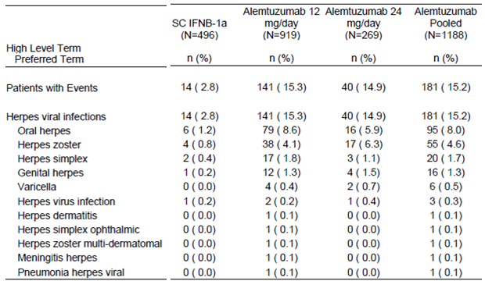
Percentages are based on the number of treated patients in the corresponding treatment group. A patient is counted only once within each HLT/PT. HLTs are presented alphabetically, and within HLT the PTs are presented by decreasing incidence in the Alemtuzumab 12mg/day group.
In Cycle 1 in all active-controlled studies over 2 years of follow up (Pool A), 205/919 (22.3%) patients in the alemtuzumab 12mg/day group received prophylactic acyclovir. The incidence of herpes infections during the first month following Cycle 1 was lower in patients who received prophylactic acyclovir than in those who did not (0.5% vs. 4.9%, respectively). In Cycle 2, 522/891 (58.6%) patients in the alemtuzumab 12mg/day group received prophylactic acyclovir, the incidence of herpes infections during the first month following alemtuzumab was lower in patients who received prophylactic acyclovir than in those who did not (0.8% vs. 2.4%, respectively).
Serious herpetic infections were reported for a total of 13 patients in the alemtuzumab pooled dose group over all available follow-up. Nine of the 13 patients had localized herpes zoster (6 patients in the 12mg/day group and 3 patients in the 24mg/day group. The remaining 4 patients with serious herpetic events were: oral herpes, herpes (varicella) meningitis, herpes ophthalmic and varicella (chickenpox) infection.

Fungal infections
In the 2-Year Follow Up (Pool A) the incidence of any fungal infection was higher in the alemtuzumab 12mg/day group (12.1%) than in the IFNB-1a group (3.4%).

Tuberculosis
In all active-controlled studies during the first 2 years of follow up, the overall incidence of any TB infection was 0.3% (4 patients) in the alemtuzumab pooled dose group (0.1% (1 patient) in the alemtuzumab 12mg/day group and 0.2% (1 patient) in the IFNB-1a group (recorded as renal TB).
No additional cases occurred in Pool C i.e. all events were in the first 2 years of follow up.

Malignancies
The annualized rates of malignancies reported through 2 years of follow up were 0.002, 0.003, and 0.003 per person-year for the alemtuzumab 12mg/day, IFNB- 1a, and alemtuzumab pooled treatment groups, respectively. The annualized rate of malignancies overall in the alemtuzumab pooled dose group (Pool C) was 0.004 per person-year.
Figure 31. Time to First Treatment-Emergent Malignancy Pool C
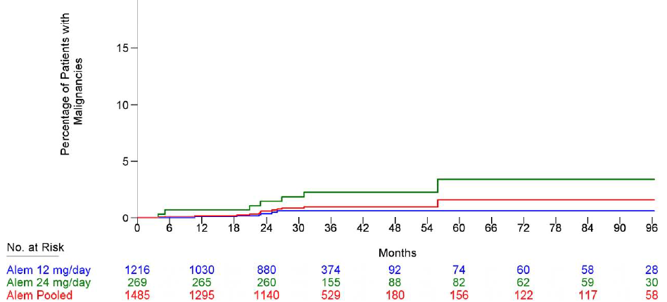
Malignancies are identified through medical review of AEs with SOC = Neoplasms benign, malignant, and unspecified (including cysts and polyps) for which the HLGT does not include the word ‘benign’, according to MedDRA version 13.1 coding. Percentages of patients with the event are based on Kaplan-Meier estimation.

Table 80. Listing of Malignancies in IFNB-1a-Treated Patients Over All Available Follow Up
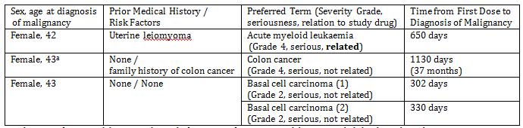
a Colon cancer for patient did not occur during the first 2 years of CAMMS223, and thus is not included in the Pool A analysis.
Table 81. Listing of Malignancies in Alemtuzumab 12mg Patients Over All Available Follow Up
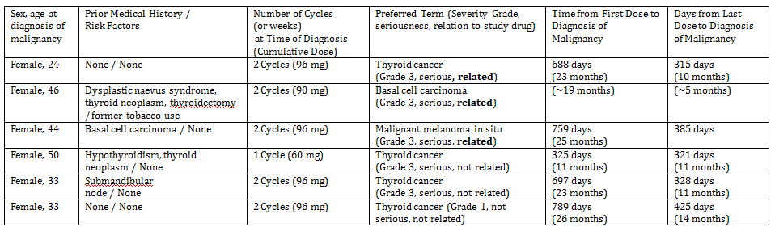
Table 82. Listing of Malignancies in Alemtuzumab 24mg Patients Over All Available Follow Up
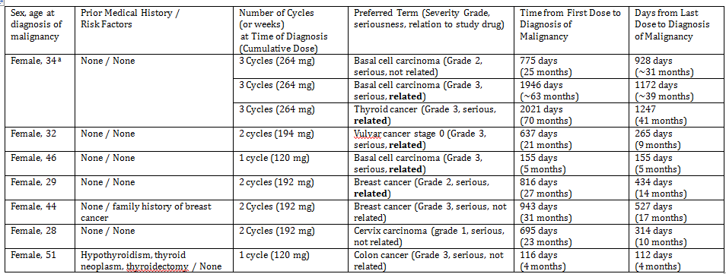
a Following discontinuation of CAMMS223, Patient enrolled in a study of fingolimod (treatment assignment unknown) (FTY720: "A 24-month Double-Blind, Randomized, Multicenter, Placebo-Controlled, Parallel-Group Study Comparing the Efficacy and Safety of 0.5 mg and 1.25 mg Fingolimod Administered Orally Once Daily vs. Placebo in Patients With Relapsing-Remitting Multiple Sclerosis") and was diagnosed with basal cell carcinoma 25 months after first alemtuzumab treatment (and following treatment in the fingolimod study).

Autoimmunity
Treatment with alemtuzumab may result in autoimmune-mediated conditions including immune thrombocytopenic purpura (ITP), thyroid disorders or nephropathies (e.g., anti-glomerular basement membrane [anti-GBM] disease). Alveolar haemorrhage manifested as haemoptysis is a common component of anti-GBM disease but has not been observed in the alemtuzumab clinical studies.

Thyroid disorders
There is a significant co-occurrence of Graves' disease, and a trend to co-occurrence for Hashimoto's disease, in patients with MS. Graves' disease (hyperthyroidism) was observed in 3.1% of the MS population compared to 0.4% in the general population. Similarly, Hashimoto’s disease (hypothyroidism) was observed in 5.5% of the MS population compared to 2.2% in the general population.
The mean duration of the MS in the population above (85% had RRMS) was 13.5y, mean ages of general and MS populations similar. Thus this was the increased incidence resulting from 13.5 y of MS.
This is being compared in Pool A with Safety data through 2 years after first study treatment i.e. the expected incidence in pool A would be expected to be lower but a clear comparison cannot be made.
Thus a lower incidence (than in the quote above) in patients on IFNB-1a of 1.6% for hypothyroidism and 0.8% for hyperthyroidism is not unexpected. However the corresponding figures for alemtuzumab 12mg/day (3.5% & 4.6%) suggest a higher incidence than expected in MS patients by year. This is supported by the overall incidence in Pool C of 6.7% for hypothyroidism and 7.1% for hyperthyroidism.
In Pool A, TSH < LLN in the alemtuzumab 12mg/day and IFNB-1a groups was 24.0% and 15.9%, respectively, abnormal free T4 was 20.8% in the alemtuzumab 12mg group compared to 9.2% in the IFNB-1a group. Abnormal TSH and free T3/T4 combined was16.4% in the alemtuzumab 12mg/day group vs. 4.2% in the IFNB-1a group.
In all alemtuzumab-treated patients over all follow up (Pool C), an abnormal TSH with simultaneous abnormal free T3 or free T4 was reported in 23.3% in the alemtuzumab 12mg/day group with a higher frequency in Cycles 2 and 3 than in Cycle 1 in the alemtuzumab 12mg/day group (24.1% and 18.0% vs. 5.5%).
In Pool A baseline anti-TPO antibodies were associated with higher incidences of thyroid AEs and thyroid laboratory abnormalities across all treatment groups, including the IFNB-1a group. In the alemtuzumab 12mg/day group, 29/67(43.3%) patients with positive anti-TPO antibodies at baseline had a thyroid AE compared with 123/842 (14.6%) for patients with a negative anti–TPO test. In the IFNB-1a group, 6/36 (16.7%) patients with positive anti-TPO antibodies at baseline had a thyroid AE compared with 19/451 (4.2%) for patients with a negative baseline anti-TPO.
Similarly, in Pool C baseline alemtuzumab 12mg/day group, 39/89 (43.8%) patients with positive anti-TPO antibodies at baseline had a thyroid AE reported compared with 239/1114 (21.5%) of patients with a baseline negative status.
However, although patients with antibodies were more likely to develop thyroid disease, the majority of patients (approximately 85%) who developed a thyroid disorder were antibody negative prior to treatment.
Of the 5 patients on alemtuzumab who had thyroid cancer (0.4%), 2 had a history of thyroid neoplasm 3 were felt to be related to treatment.
Table 83. Incidence of Thyroid AEs in All Active-Controlled Studies (2-Year Follow Up, Pool A)
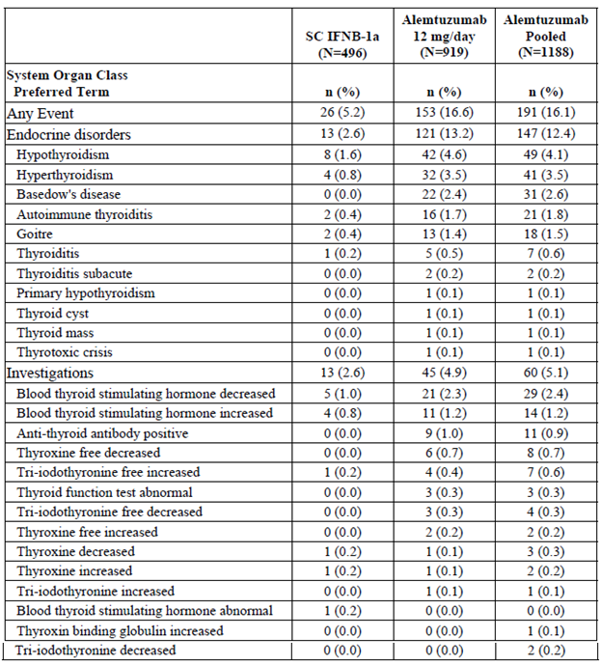
Thyroid disorders refers to AEs where HLGT = Thyroid gland disorders or HLT=Thyroid analyses or PT=Blood thyroid stimulating hormone abnormal, Blood thyroid stimulating hormone increased, or Blood thyroid stimulating hormone decreased. HLGT = high level group term; HLT = high level term; PT = preferred term.
Serious thyroid AEs (both hypo & hyper) were reported in 0.8% of Pool A patients(17 patients 1.4% overall in Pool C)) in the alemtuzumab 12mg/day group; no serious thyroid AEs were reported in the IFNB-1a group. All thyroid AEs for IFNB-1a-treated patients were mild or moderate in severity.
Table 84. Incidence of Treatment-Emergent Thyroid Adverse Events by MedDRA SOC and Preferred Term Overall and by Calendar Year Pool C
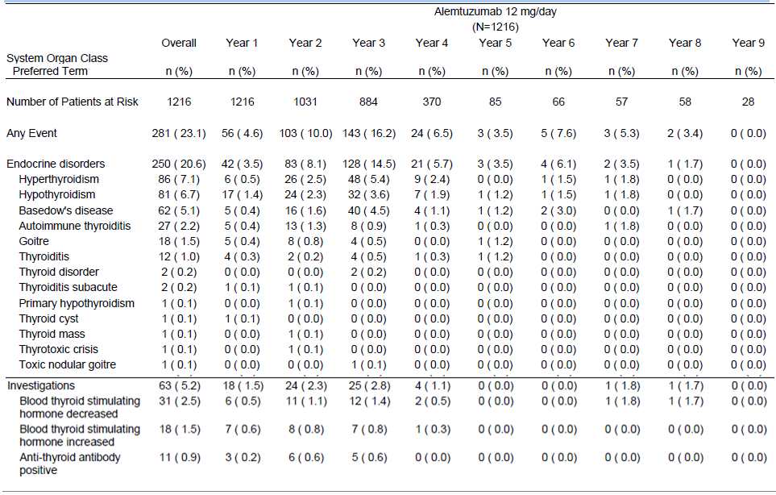
Table 84 continued. Incidence of Treatment-Emergent Thyroid Adverse Events by MedDRA SOC and Preferred Term Overall and by Calendar Year Pool C
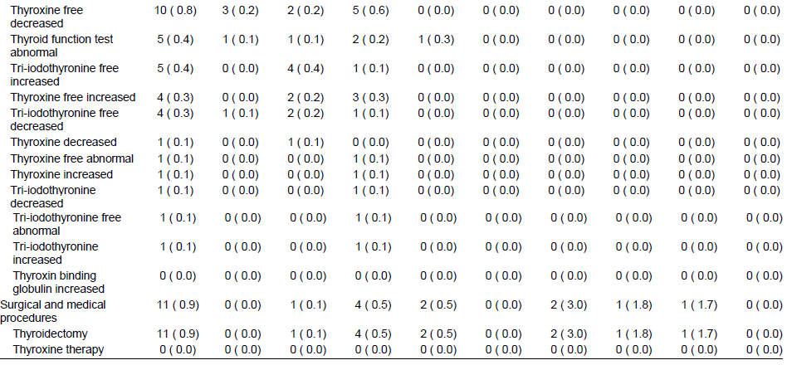Percentages are based on the number of treated patients in the corresponding time period and treatment group. A patient is counted only once within each SOC/PT, within each column. SOCs are presented alphabetically, and within SOC the PTs are presented by decreasing incidence in the Overall Alemtuzumab 12mg/day group. Years defined by calendar time. Thyroid AEs refer to AEs coded to MedDRA HLGT ‘Thyroid gland disorders’, or coded to HLT ‘Thyroid analyses’, ‘Thyroid radiotherapies', ‘Thyroid therapeutic procedures', 'Thyroid histopathology procedures', or coded to PT ‘Blood thyroid stimulating hormone abnormal’, ‘Blood thyroid stimulating hormone increased’, ‘Blood thyroid stimulating hormone decreased
Table 85. Incidence of Treatment-Emergent Thyroid Disorder Pool A
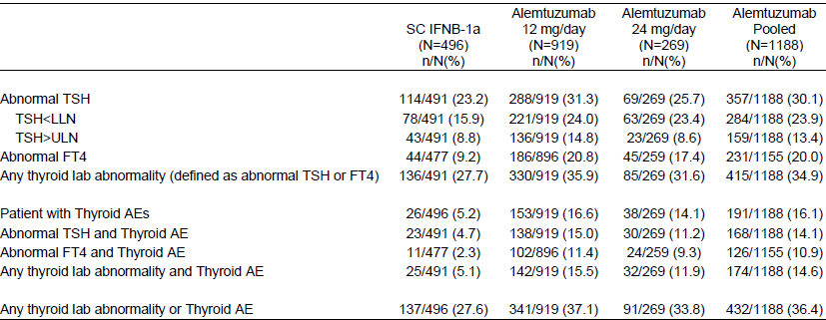
Thyroid AEs refer to AEs coded to MedDRA HLGT ‘Thyroid gland disorders’, or coded to HLT ‘Thyroid analyses’, ‘Thyroid radiotherapies', ‘Thyroid therapeutic procedures', 'Thyroid histopathology procedures', or coded to PT ‘Blood thyroid stimulating hormone abnormal’, ‘Blood thyroid stimulating hormone increased’, ‘Blood thyroid stimulating hormone decreased’. FT4 = Free T4.
Table 86. Incidence of Treatment-Emergent Thyroid Disorder by Baseline Anti-Thyroid Peroxidase (TPO) Antibody Status Pool A
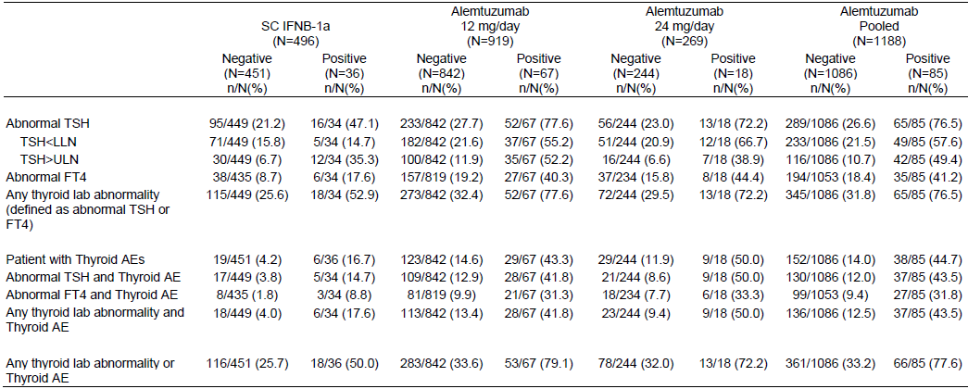Thyroid AEs refer to AEs coded to MedDRA HLGT ‘Thyroid gland disorders’, or coded to HLT ‘Thyroid analyses’, ‘Thyroid radiotherapies', ‘Thyroid therapeutic procedures', 'Thyroid histopathology procedures', or coded to PT ‘Blood thyroid stimulating hormone abnormal’, ‘Blood thyroid stimulating hormone increased’, ‘Blood thyroid stimulating hormone decreased’. FT4 = Free T4.
Table 87. Incidence of Treatment-Emergent Thyroid Disorder by Post-Baseline TSH Receptor (TSHR) Autoantibody Pool A
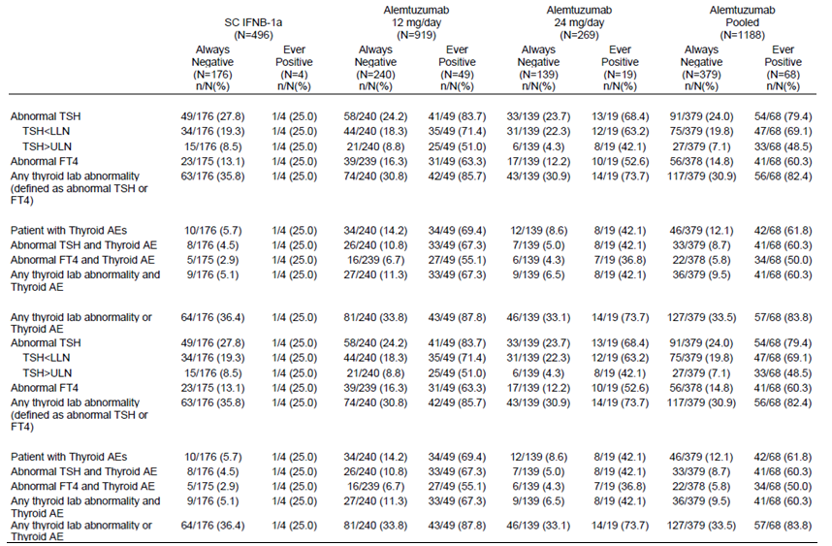
Thyroid AEs refer to AEs coded to MedDRA HLGT ‘Thyroid gland disorders’, or coded to HLT ‘Thyroid analyses’, ‘Thyroid radiotherapies', ‘Thyroid therapeutic procedures', 'Thyroid histopathology procedures', or coded to PT ‘Blood thyroid stimulating hormone abnormal’, ‘Blood thyroid stimulating hormone increased’, ‘Blood thyroid stimulating hormone decreased’. FT4 = Free T4.

Nephropathies
Anti-GBM disease is a rare autoimmune disorder in which circulating antibodies are directed against an antigen normally present in the renal GBM and alveolar basement membrane. In the 2 year studies the only 2 nephropathies were on alemtuzumab 12mg/day - both non serious: a grade 3 treatment related membranous glomerulonephritis and a grade 2 treatment unrelated tubulointerstitial nephritis. Over 2 years of follow up, the incidence of haematuria or proteinuria AEs in the alemtuzumab 12mg/day group was 3.0% and 2.1%, compared with 0.6% and 0.6% in the IFNB-1a group. Overall 5 (0.4%) patients all in the 12mg/day alemtuzumab dose group had nephropathies. The additional cases were all considered treatment related being glomerulonephritis (anti-GBM glomerulonephritis grade 3 SAE), Goodpasture’s syndrome (grade 3 SAE), and nephropathy (non serious grade 1).
Anti-GBM disease was reported in 2 MS patients who received alemtuzumab outside of Genzyme-sponsored trials, with onset 9 and 10 months respectively after the last alemtuzumab dose (Coles, 2006, J Neurol; Clatworthy, 2008, N Engl J Med). Anti-GBM disease in these patients went unrecognized so, despite treatment, both patients became dialysis-dependent. In the Genzyme Phase 2 clinical study (CAMMS223), there was a single case of anti-GBM disease that occurred in an alemtuzumab-treated patient 39 months after the patient received their last alemtuzumab dose. In this case, anti-GBM was identified early and successfully treated with restoration of renal function. The safety monitoring program was subsequently modified to include monthly urinalysis and creatinine assessment to help detect such events. The sponsor is recommending RFTs to 48 months after ceasing treatment.

Immune thrombocytopenic purpura
ITP was defined as platelet count < 100 x 10⁹/L in the absence of other causes or disorders that may be associated with thrombocytopenia.
Overall 22 (1.5%) alemtuzumab-treated patients met the AE-based or platelet-based definitions for ITP. In the 2 year follow up the incidence was 1.6% for IFNB-1a and 1.25% for alemtuzumab pooled. The incidence was higher in the 24mg/day than the 12mg/day patients in both Pools A & C. The onset of ITP (AE-based or platelet-based) occurred in the majority of alemtuzumab-treated patients after 2 cycles (14/22 patients, 63.6%), most of the cases occurred in Year 2 (14 to36 months). The incidence of serious AEs was higher in the in the 24mg/day than the 12mg/day patients in both Pools A & C, with none in IFNB-1a patients.
A medical review of all ITP cases found that none of 8 ITP cases in IFNB- 1a-treated patients suggested were consistent with ITP. While of the 22 ITP cases in alemtuzumab-treated patients 18 cases were confirmed as ITP, but 2 of these had a confirmed cause, leaving 16 cases with no confirmed alternative etiology for ITP and likely related to alemtuzumab treatment. Of these 16 there was 1 death and the other 15 responded to treatment within 3 months of ITP onset.
Table 88. Incidence and Annualized Rate of First Treatment-Emergent ITP Pool C
 | Alemtuzumab  12mg/day  (N=1216) |  | Alemtuzumab  24mg/day  (N=269) |  | Alemtuzumab  Pooled  (N=1485)
 | n(%) | Rate | n(%) | Rate | n(%) | Rate
Platelet-based or AE-based definition | 13 (1.1) | 0.0041 | 9 (3.3) | 0.0084 | 22 (1.5) | 0.0052
Platelet-based definition | 13 (1.1) |  | 7 (2.6) |  | 20 (1.3)
AE-based definition | 9 (0.7) |  | 8 (3.0) |  | 17 (1.1)
Autoimmune thrombocytopenia | 7 (0.6) |  | 3 (1.1) |  | 10 (0.7)
Idiopathic thrombocytopenic purpura | 2 (0.2) |  | 5 (1.9) |  | 7 (0.5)
Serious AE | 7 (0.6) |  | 5 (1.9) |  | 12 (0.8)
Autoimmune thrombocytopenia | 5 (0.4) |  | 3 (1.1) |  | 8 (0.5)
Idiopathic thrombocytopenic purpura | 2 (0.2) |  | 2 (0.7) |  | 4 (0.3)
Percentages are based on the number of treated patients in the corresponding treatment group. Rates are based on the total number of person-years in the corresponding column. An individual patient’s contribution to the total number of person-years is censored at the time of the event. PTs are presented by decreasing incidence in the Alemtuzumab 12mg/day group. Platelet-based definition: Platelet count ≤ 100 x 10⁹/L on ≥ 2 occasions over a period of at least 30 days with no platelet counts above the LLN during the 30 day period, or platelet count ≤ 50 x 10⁹/L on ≥ 2 occasions over any time period with no platelet counts above the LLN in the period between the 2 platelet counts ≤ 50 x 10⁹/L. AE-based definition: AEs with PT of ‘Autoimmune thrombocytopenia’, ‘Idiopathic thrombocytopenic purpura’ or ‘Thrombocytopenic purpura’.
Table 89. Incidence and Rate of First Immune Thrombocytopenic Purpura in All Active-Controlled Studies (2-Year Follow Up, Pool A)
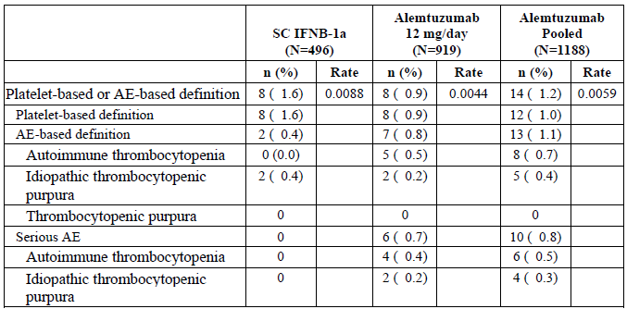
Percentages are based on the number of treated patients in the corresponding treatment group. Rates are based on the total number of person-years in the corresponding column. An individual patient’s contribution to the total number of person-years is censored at the time of the event. Platelet-based definition: Platelet count ≤ 100 x 109/L on ≥ 2 occasions over a period of at least 30 days with no platelet counts above the LLN during the 30 day period or platelet count ≤ 50,000/mcL on ≥ 2 occasions over any time period with no platelet counts above the LLN in the period between the 2 platelet counts ≤ 50,000/mcL. AE-based definition: AEs with PT of Autoimmune thrombocytopenia, Idiopathic thrombocytopenic purpura, or Thrombocytopenic purpura.
Table 90. Listing of Medically Confirmed Cases of Immune Thrombocytopenic Purpura, All Alemtuzumab-Treated Patients (All Available Follow Up, Pool C)
Age in years at first onset of ITP (sex) | Number of Alemtuzumab Cycles at ITP onset (cumulative dose, mg) | Months From First Dose (Last Dose) to ITP Onset | Platelet Count Nadir (10⁹/L)
Alemtuzumab 12mg/day
49(female) | 3 (132) | 25.2 (1.0) | 1
34(female) | 3 (132) | 40.1 (16.1) | 41
23(female) | 2 (96) | 22.0 (9.7) | 1
 | 2 (96) | 24.3 (11.7) | 2
22(female) | 2 (96) | 19.6 (7.1) | 1
42(female) | 1 (60) | 11.2 (11.0) | 26
 | 1 (60) | 17 (17) | 42
35(female) | 1 (60) | 3.7 (3.6) | 1
30(female) | 2 (96) | 20.1 (7.9) | 3
44 (male) | 2 (96) | 20.5 (8.2) | 14
43(female) | 2 (96) | 15.2 (3.2) | 10
27(female) | 2 (84) | 24.9 (13.1) | 28
Alemtuzumab 24mg/day
35(female) | 3 (264) | 84.3 (60.0) | 69
37(female) | 3 (264) | 36.2 (12.0) | 4
39 (male) | 2 (192) | 19.2 (7.2) | 4
30 (male) | 2 (192) | 23.8 (11.5) | 2
33(female) | 2 (192) | 21.0 (9.0) | 3
40(female) | 2 (192) | 24.5 (12.2) | 6
27(female) | 2 (192) | 22.4 (10.3) | 34
39 (male) | 1 (120) | 5.3 (5.2) | 37
Only medically confirmed cases in alemtuzumab-treated patients are included in this table. There were 8 cases in IFNB-1a treated patients and 4 cases in alemtuzumab-treated patients that were not consistent with ITP. ITP = immune thrombocytopenic purpura; IFNB-1a = interferon β-1a.
Table 91. Incidence of Treatment-Emergent Immune Thrombocytopenic Purpura by MedDRA Preferred Term by Worst NCI Toxicity Grade Pool C
Preferred Term | Alemtuzumab | Overall | Standard Toxicity Grade
 |  |  | 1 | 2 | 3 | 4 | 5
 |  | n (%) | n (%) | n (%) | n (%) | n (%) | n (%)
Any Event | 12mg/day (N=1216) | 9  (0.7) | 0 (0.0) | 1 (0.1) | 3 (0.2) | 5 (0.4) | 0 (0.0)
 | 24mg/day  (N=269) | 8  (3.0) | 1 (0.4) | 1 (0.4) | 3 (1.1) | 2 (0.7) | 1 (0.4)
Autoimmune thrombocytopenia | 12mg/day (N=1216) | 7  (0.6) | 0 (0.0) | 1 (0.1) | 3 (0.2) | 3 (0.2) | 0 (0.0)
 | 24mg/day  (N=269) | 3  (1.1) | 0 (0.0) | 0 (0.0) | 2 (0.7) | 1 (0.4) | 0 (0.0)
Idiopathic thrombocytopenic purpure | 12mg/day (N=1216) | 2  (0.2) | 0 (0.0) | 0 (0.0) | 0 (0.0) | 2 (0.2) | 0 (0.0)
 | 24mg/day  (N=269) | 5  (1.9) | 1 (0.4) | 1 (0.4) | 1 (0.4) | 1 (0.4) | 1 (0.4)
Percentages are based on the number of treated patients in the corresponding treatment group. A patient is counted only once in the worst grade within each PT. AE-based definition: AEs with PT of ‘Autoimmune thrombocytopenia’, ‘Idiopathic thrombocytopenic purpura’ or ‘Thrombocytopenic purpura’. PTs are presented by decreasing incidence in the Overall toxicity column in the Alemtuzumab 12mg/day group.
Other autoimmune cytopenias (e.g., 2 cases of haemolytic anaemia and 2 cases of pancytopaenia) were observed in alemtuzumab-treated MS patients in the sponsored clinical studies.

Other safety issues

Safety in special populations

Gender
‘Endocrine Disorders’ were reported more frequently for females (17.3%) compared to males (5.6%) in the alemtuzumab 12mg/day group: hypothyroidism, hyperthyroidism, and Basedow’s disease were all reported more frequently in female alemtuzumab patients.
The incidence of infections was greater in female patients in the alemtuzumab 12mg/day group in the active-controlled studies over 2 years of follow up (77.2% female vs. 59.2% male; primarily respiratory and urinary tract infections) as well as over all available follow up (73.8% female vs. 61.1% male).

Prior treatment for MS
In the active-controlled studies over 2 years of follow up, infections were more common in previously treated patients than treatment naive patients in the both the alemtuzumab 12mg/day group and the IFNB-1a group (77.2% vs. 65.3% and 66.8% vs. 43.9%, respectively). Over all available follow up, the incidence of infections was similar in previously treated patients and treatment-naïve patients in the alemtuzumab 12mg/day group (70.4% and 68.5%, respectively).

Safety related to drug-drug interactions and other interactions
No formal drug interaction studies have been conducted with alemtuzumab using the recommended dose in patients with MS.
AEs were analyzed by anti-alemtuzumab antibody and anti-alemtuzumab inhibitory antibody status (positive or negative) and titer values overall and before and during each cycle. There was no effect of immunogenicity on the incidence of AEs or IARs.

Pregnancy
A total of 72 pregnancies for female patients treated with alemtuzumab have been reported as of 31 December 2011. Of these, 10 were reported between treatment Cycle 1 and Cycle 2 and included 4 full term pregnancies, 2 spontaneous abortions, and 4 elective abortions.
The remaining 62 pregnancies occurred after Cycle 2 and included 28 full term pregnancies (25 patients), 3 preterm pregnancies (2 patients), 14 spontaneous abortion (12 patients), 5 elective abortions (5 patients), 1 still birth, and 11 pregnancies with unknown outcomes.
No congenital abnormalities or birth defects have been reported in the MS clinical program.

Evaluator’s overall conclusions on clinical safety
The incidence of treatment related AEs was much higher (by 29%) with alemtuzumab than interferon β-1a. This was reflected in most system organ classes except Investigations where they were higher (by 14%) for interferon β-1a (reflecting primarily a much higher incidence of elevated liver enzymes) and General Disorders and Administration Site Conditions which showed an overall similar incidence (but with considerable differences in individual preferred terms, and of the number of injections/infusions the patient is exposed to).
There were however considerably more (85%) study discontinuations (defined as permanent discontinuation from study participation) due to AEs in those patients on interferon β-1a. Much of the difference was due to Injection/Infusion Reactions and Elevated Liver Function Tests.
There were no deaths related to interferon β-1a, but for alemtuzumab there were 3 deaths that were considered treatment related. That from idiopathic thrombocytopenic purpure was of concern.
Overall 5 (0.4%) patients all in the 12mg/day alemtuzumab dose group had nephropathies, 4 of which were considered treatment related.
While mean platelet levels remained normal and post-baseline shifts to below normal were reported in a larger percentage of IFNB-1a patients, during all available follow up in all alemtuzumab patients, Grade 4 platelet counts were reported for 3 patients during Year 1, 8 patients during Year 2, 7 patients during Year 3, and 1 patient during Year 4. All patients were confirmed ITP cases with the exception of an isolated value in 1 patient which was within normal limits on repeat measurement 3 days later.
The mean neutrophil counts in all treatment groups in Pool A decreased at Month 1, but the mean neutrophil count for alemtuzumab patients had increased by Month 2, while that for IFNB-1a remained low. Shifts from baseline CTC Grade 0 to Grade 3 & 4 were greater for alemtuzumab 24mg than 12mg suggesting a dose related effect.
While mean monocyte counts remained within the normal range without notable fluctuations over time in both the alemtuzumab and the IFNB-1a dose groups, those for alemtuzumab were consistently lower.
The incidence in patients on IFNB-1a of 1.6% for hypothyroidism and 0.8% for hyperthyroidism is not unexpected. However the corresponding figures for alemtuzumab 12mg/day (3.5% & 4.6%) suggest a higher incidence than expected in MS patients by year. This is supported by the overall incidence in Pool C of 6.7% for hypothyroidism and 7.1% for hyperthyroidism. Of the 5 patients on alemtuzumab who had thyroid cancer (0.33%), 2 had a history of thyroid neoplasm and 3 were felt to be related to treatment while there was no thyroid cancer among 496 patients on Interferon β-1a.
A medical review of all Immune Thrombocytopenic Purpura (ITP) cases found that no consistent cases in IFNB- 1a-treated patients, while in alemtuzumab-treated patients 18 cases were confirmed as ITP, but 2 of these had a confirmed cause, leaving 16 cases with no confirmed alternative etiology for ITP and likely related to alemtuzumab treatment.

First round benefit-risk assessment

First round assessment of benefits
The benefits of alemtuzumab in the proposed usage are:
- Relapse Rate at 2 years was significantly reduced in alemtuzumab patients compared with those on Interferon β-1a in both pivotal studies both in patients with RRMS who were treatment-naïve and in patients with active RRMS who relapsed during prior treatment.
- A lower incidence of elevated liver enzymes compared with Interferon β-1a.
- A lower incidence of discontinuations due to AEs compared with Interferon β-1a (the difference mostly from elevated liver enzymes and Injection/Infusion Reactions).
- A less intense treatment programme: two annual cycles (5 consecutive days and 3 consecutive days) of intravenous alemtuzumab vs. three times weekly subcutaneous Interferon β-1a.

First round assessment of risks
The risks of alemtuzumab in the proposed usage are:
- 3 deaths that were considered treatment related with alemtuzumab.
- An incidence of Immune Thrombocytopenic Purpura (1.3% medically confirmed) with one death.
- An incidence of treatment related adverse events much higher than with Interferon β-1a.
- A similar incidence of Infusion Associated Reactions compared with Interferon β-1a despite the latter requiring more injections/infusions.
- An increased incidence of hypothyroidism and hyperthyroidism (overall incidence in Pool C of 6.7% for hypothyroidism and 7.1% for hyperthyroidism. Of the 5 patients on alemtuzumab who had thyroid cancer (0.33%), 2 had a history of thyroid neoplasm and 3 were felt to be related to treatment while there was no thyroid cancer among 496 patients on Interferon β-1a.
- An incidence of nephropathies, 4 of which were considered treatment related.

First round assessment of benefit-risk balance
The benefit-risk balance of alemtuzumab, given the proposed usage, is unfavourable.
While alemtuzumab has been shown to have benefit in treatment naive patients (study 323) by reducing relapse rate it does so with an increased risk of treatment related deaths and AEs.
This evaluator therefore recommends the more restricted population of:
in whom treatment with Interferon β or glatiramer is not possible or contraindicated
The qualifier “not possible” allows for patients in whom the advantage of a less intense treatment programme.
The qualifier “contraindicated” allows an alternative to Interferon β or glatiramer for such patients. Study 324 in patients with active RRMS who relapsed during prior treatment with interferon β or glatiramer acetate that alemtuzumab showed benefit by reducing relapse rate (54.5% had Interferon β-1a previously, 36.2% had Interferon β-1b and 34.3% had glatiramer acetate).

First round recommendation regarding authorisation
It is not recommended that the proposed Extension of Indications be approved.
It is recommended that the following Extension of Indications be approved [evaluator’s modification in bold text]:
Alemtuzumab Genzyme is indicated for the treatment of patients with relapsing forms of multiple sclerosis (MS) in whom treatment with Interferon β-1a or glatiramer is not possible or contraindicated to reduce the frequency of clinical relapses

Clinical questions
Not applicable.

Second round evaluation of clinical data submitted in response to questions
Not applicable.

ITP search produced both Idiopathic and Immune Thrombocytopaenic Purpura even on the same hospital (RCH) website.
defined as: for patients with a baseline EDSS of 0.0, an increase of ≥ 1.5 points sustained over a 6-month consecutive period. For patients with a baseline EDSS of ≥ 1.0, an increase of ≥ 1.0 point sustained over a 6-month consecutive period.
CPMP/EWP/561/98 Rev 1 Guideline on clinical investigation of Medicinal Products for the Treatment of Multiple Sclerosis 1. Introduction The term relapsing MS (RMS) applies to those patients either with a RRMS form or a SPMS form that are suffering relapses 2.3.1 The term relapsing MS includes 1) patients with RRMS, 2) patients with SPMS and superimposed relapses and 3) patients with a single demyelinating clinical event who show lesion dissemination on subsequent MRI scans according to McDonald’s criteria.
CPMP/EWP/561/98 Rev 1Guideline on clinical investigation of Medicinal Products for the Treatment of Multiple Sclerosis
TYSABRI is indicated as monotherapy for the treatment of patients with relapsing remitting multiple sclerosis (MS) to delay the progression of physical disability and to reduce the frequency of relapse.
Sponsor clarification: the PopPK report states: Of the 5224 alemtuzumab concentration records in the dataset, n=1646 (31.5%) were reported as BLQ. The BLQ samples collected just prior to the first dose (n=204) were excluded from the analysis, leaving n=1442 (27.6%) BLQ samples retained in the analysis dataset.
The low number of non-BLQ observations from the antibody-positive subgroup at these timepoints limits the reliability of predictions based on modelling from these data regarding the impact of antibody status on drug clearance.
Indicates a well conditioned model.
Indicating that derived parameters such as AUC reflect the individual behaviour of the subject.
Mabcampath (alemtuzumab) approved PI.
Mabcampath (alemtuzumab) approved PI.
Mabcampath (alemtuzumab) approved PI.
2.7.2 Summary Clin Pharm Page 48 comes closest with The observed values of Cmax and Cmin for the Phase 3 studies CAMMS323 and CAMMS324 were similar, while the values reported for the Phase 2 study tended to be higher. This observation is likely explained by the different assays that were used for the Phase 2 vs. the Phase 3 studies. Note: The sponsor’s response to this evaluation report included an explanation for excluding Study 223.
S is the slope of the cell loss-alemtuzumab concentration relationship.
Normal volume range is 2-5mL
Normal sperm concentration is > 20M/mL
(≥ 50%motile)
Normal Kruger Strict morphology is ≥ 15% normal forms
Normal agglutination is considered none to slight
Normal samples have < 20% SpermMar bound or ≥ 80% SpermMar-free sperm
This statement is supported by literature references.
Mabcampath alemtuzumab PI
Also used for re-treatment period in Study 223.
Primary and secondary objectives were not identified.
original protocol Final: 13 July 2007 Page 96.
For patients with a baseline EDSS score of 0.0, SAD is defined as an increase of ≥ 1.5 points sustained over a 6-month consecutive period. For patients with a baseline EDSS score of ≥ 1.0, SAD is defined as an increase of ≥ 1.0 point sustained over a 6-month consecutive period.
defined as new neurological symptoms or worsening of previous neurological symptoms with an objective change on neurological examination. Symptoms must be attributable to MS, last at least 48 hours, be present at normal body temperature, and be preceded by at least 30 days of clinical stability.
This was changed in Amendment 1 to 5%. And then With these assumptions, a sample size of approximately 525 450 patients provides ≥ 90 95% power to detect a 60% treatment effect in time to SAD. Oct 5 2007.
last being amendment 5, 11 May 2010, last patient out 13 May 2011.
Sponsor comment: The changes to the statistical analyses affect one of the primary outcomes and two of the secondary outcomes as follows: • The Annualized Relapse Rate (ARR) was to be analyzed using negative binomial regression with robust variance estimation instead of Poisson regression The proportion of patients relapse-free at Year 2 was to be analyzed using Kaplan-Meier methodology and a Cox proportional hazards regression model instead of logistic regression • The median percent change in T2-hyperintense lesion volume was to be analyzed using a ranked ANCOVA model instead of a Wilcoxon-Mann-Whitney test
Amendment 8 Feb 08 removed reduction in tissue damage as assessed by MRI.
Defined as new neurological symptoms or worsening of previous neurological symptoms with an objective change on neurological examination. Symptoms must be attributable to MS, last at least 48 hours, be present at normal body temperature (i.e. no infection, excessive exercise, or excessively high ambient temperature), and be preceded by at least 30 days of clinical stability.
Not in original protocol as an objective inserted amendment 1.
defined as: for patients with a baseline EDSS of 0.0, an increase of ≥ 1.5 points sustained over a 6-month consecutive period. For patients with a baseline EDSS of ≥ 1.0, an increase of ≥ 1.0 point sustained over a 6-month consecutive period.
By adding relapse rate Dec 2005.
The 3rd treatment at month 24 was conditional on if there is no significant titre of anti-CAMPATH antibodies present and peripheral T-cell regeneration had recovered
The sponsor’s response to this evaluation report included clarification of subject flow and population numbers
The Final Report Study page 99 gives 42 total for this period, with another 6 having a fourth course range, 37 to 54 months after the last/prior infusion.
The assay method used for 323 & 324 differed from that of 223.
Either given as a number or they were described as < or ≥ Observed Median.
Defined as having 2 or more relapses in the prior year and at least one gadolinium-enhancing lesion at Baseline
Defined as having 2 or more relapses in the prior year and at least one gadolinium-enhancing lesion at Baseline
Tables 14.2.2.1 Time to First Relapse and Proportion of Patients Who Are Relapse-Free at Month 24 Full Analysis Set, 5.3.5.1 / camms32400507-body / 1180 & 5.3.5.1 / camms323-body / 783.
Patients may have had more than one Grade 4 IAR

