Date of first round CER: 20 January 2013
Date of second round CER: 23 April 2013

AusPAR Attachment 2

Extract from the Clinical Evaluation Report for Alogliptin (as benzoate)
  - Proprietary Product Name: Nesina, Vipidia
  - Sponsor: Takeda Pharmaceuticals Australia Pty Ltd

About the Therapeutic Goods Administration (TGA)
- The Therapeutic Goods Administration (TGA) is part of the Australian Government Department of Health, and is responsible for regulating medicines and medical devices.
- The TGA administers the Therapeutic Goods Act 1989 (the Act), applying a risk management approach designed to ensure therapeutic goods supplied in Australia meet acceptable standards of quality, safety and efficacy (performance), when necessary.
- The work of the TGA is based on applying scientific and clinical expertise to decision-making, to ensure that the benefits to consumers outweigh any risks associated with the use of medicines and medical devices.
- The TGA relies on the public, healthcare professionals and industry to report problems with medicines or medical devices. TGA investigates reports received by it to determine any necessary regulatory action.
- To report a problem with a medicine or medical device, please see the information on the TGA website <http://www.tga.gov.au>.
About the Extract from the Clinical Evaluation Report
- This document provides a more detailed evaluation of the clinical findings, extracted from the Clinical Evaluation Report (CER) prepared by the TGA. This extract does not include sections from the CER regarding product documentation or post market activities. Minor errors in the original CER text have been corrected for this Extract.
- The words [Information redacted], where they appear in this document, indicate that confidential information has been deleted.
- For the most recent Product Information (PI), please refer to the TGA website <http://www.tga.gov.au/hp/information-medicines-pi.htm>.
Copyright
© Commonwealth of Australia 2013
This work is copyright. You may reproduce the whole or part of this work in unaltered form for your own personal use or, if you are part of an organisation, for internal use within your organisation, but only if you or your organisation do not use the reproduction for any commercial purpose and retain this copyright notice and all disclaimer notices as part of that reproduction. Apart from rights to use as permitted by the Copyright Act 1968 or allowed by this copyright notice, all other rights are reserved and you are not allowed to reproduce the whole or any part of this work in any way (electronic or otherwise) without first being given specific written permission from the Commonwealth to do so. Requests and inquiries concerning reproduction and rights are to be sent to the TGA Copyright Officer, Therapeutic Goods Administration, PO Box 100, Woden ACT 2606 or emailed to <tga.copyright@tga.gov.au>.

Contents
List of abbreviations 5
1. Introduction 9
2. Clinical rationale 9
2.1. Formulation development 10
2.2. Guidance 10
2.3. Overseas regulatory history 10
3. Contents of the clinical dossier 10
3.1. Scope of the clinical dossier 10
3.2. Paediatric data 11
3.3. Good clinical practice 11
4. Pharmacokinetics 11
4.1. Studies providing pharmacokinetic data 11
4.2. Summary of pharmacokinetics 15
4.3. Evaluator’s overall conclusions on pharmacokinetics 22
5. Pharmacodynamics 22
5.1. Studies providing pharmacodynamic data 22
5.2. Summary of pharmacodynamics 22
5.3. Evaluator’s overall conclusions on pharmacodynamics 23
6. Dosage selection for the pivotal studies 23
6.1. Data on dose frequency 23
6.2. Dose finding studies 23
7. Clinical efficacy 25
7.1. Pivotal efficacy studies 25
7.2. Supportive studies 81
7.3. Analyses performed across trials (pooled analyses and meta-analyses) 87
7.4. Evaluator’s conclusions on clinical efficacy in T2DM 87
8. Clinical safety 89
8.1. Studies providing evaluable safety data 89
8.2. Pivotal studies that assessed safety as a primary outcome 89
8.3. Patient exposure 89
8.4. Adverse events 92
8.5. Laboratory tests 105
8.6. Post-marketing experience 111
8.7. Safety issues with the potential for major regulatory impact 113
8.8. Evaluator’s overall conclusions on clinical safety 113
9. First round benefit-risk assessment 114
9.1. First round assessment of benefits 114
9.2. First round assessment of risks 115
9.3. First round assessment of benefit-risk balance 116
10. First round recommendation regarding authorisation 116
11. Clinical questions 116
11.1. Pharmacokinetics 116
11.2. Pharmacodynamics 116
11.3. Efficacy 117
11.4. Safety 117
12. Second round evaluation of clinical data submitted in response to questions 117
13. Second round benefit-risk assessment 119
13.1. Second round assessment of benefits 119
13.2. Second round assessment of risks 119
13.3. Second round assessment of benefit-risk balance 119
14. Second round recommendation regarding authorisation 119

List of abbreviations
Abbreviation | Meaning
ADR | adverse drug reaction
AE | adverse event
ALT | alanine aminotransferase
ANCOVA | analysis of covariance
AUC_{0-t} | area under the plasma concentration-time curve from the time of dosing (0 hour) to the time of the last quantifiable concentration
AUC₀₋₂₄ | area under the plasma concentration-time curve from the time of dosing (0 hour) to 24 hours after dosing
AUC₀₋₄₈ | area under the plasma concentration-time curve from the time of dosing (0 hour) to 48 hours after dosing
AUC_{0-inf} | area under the plasma concentration-time curve extrapolated to infinity
AUEC_{0-t} | area under the effect-time curve from 0 hour to the time of the last quantifiable effect
AUEC₀₋₂₄ | area under the effect-time curve from 0 hour to 24 hours after dosing
AUEC₀₋₄₈ | area under the effect-time curve from 0 hour to 48 hours after dosing
BLQ | below the limit of quantitation
BMI | body mass index
Cavg | postprandial plasma (glucose) concentrations
Cavg B | postprandial plasma (glucose) concentrations following breakfast
Cavg L | postprandial plasma (glucose) concentrations following lunch
Cavg D | postprandial plasma (glucose) concentrations following dinner
Cavg | All postprandial plasma (glucose) concentrations averaged across all three meals
CI | confidence interval
CLr | renal clearance
CL/F | apparent plasma clearance
C_{max} | maximum plasma concentration
CrCL | creatinine clearance
CV | coefficient of variation
CYP | cytochrome p450
DAE | discontinuation due to adverse event
DBP | diastolic blood pressure
DPP-IV | dipeptidyl peptidase IV
EC | Ethics committee
ECG | electrocardiogram
eCRF | electronic case report form
E_{max} | maximum observed effect
E_{min} | minimum observed effect
FAS | full analysis set
FDA | Food and Drug Administration
Fe%₀₋₂₄ | fraction of the dose excreted unchanged in the urine from 0 to 24 hours after dosing
FBC | full blood count
FBG | fasting blood glucose
FPG | fasting plasma glucose
GIP | glucose-dependent insulinotropic peptide
GLP-1 | glucagon-like peptide 1
HbA1c | glycosylated haemoglobin
HDL-C | high density lipoprotein cholesterol
HIV | human immunodeficiency virus
HOMA-BCF | homeostasis model assessment of β-cell function
HOMA-IR | homeostasis model assessment of insulin resistance
hs-CRP | high sensitivity C-reactive protein
IAS | Integrated Analysis of Safety
ICAM | intracellular adhesion molecule
IRB | Institutional Review Board
ITT | intent-to-treat
IVRS | interactive voice response system
LDL-C | low density lipoprotein cholesterol
LOCF | last observation carried forward
LS | least squares
MACE | major adverse cardiovascular event
MedDRA | Medical Dictionary for Regulatory Activities
MET | metformin
MTD | Maximum tolerated dose
NYHA | New York Heart Association
Pgp | p-glycoprotein
PPS | per protocol set
QTc | corrected QT interval
QTcF | corrected QT interval using the method of Fridericia
R | accumulation ratio
SAE | serious adverse event
SD | standard deviation
SE | standard error
SU | sulfonylurea
TEAE | treatment emergent adverse event
t½ | apparent terminal elimination half-life
T_{max} | time to achieve maximum plasma concentration or maximum effect
TZD | thiazolidinedione
VCAM | vascular cell adhesion molecule
V/F | apparent volume of distribution
XU₀₋₂₄ | cumulative amount excreted in the urine from 0 to 24 hours after dosing

Introduction
This is a Category 1 Application to register a new chemical entity, NESINA/VIPIDIA (alogliptin [as benzoate]) 6.25 mg, 12.5 mg and 25 mg film-coated tablet blister packs.
Alogliptin is an orally available, potent, and highly selective dipeptidyl peptidase-4 (DPP-4) inhibitor for the treatment of Type 2 Diabetes Mellitus (T2DM).
The proposed indications for NESINA/VIPIDIA are:
Add-on combination:
NESINA / VIPIDIA is indicated to improve glycaemic control in adult patients (≥18 years old) with type 2 diabetes mellitus when diet and exercise do not provide adequate glycaemic control, as add on to metformin, a sulphonylurea, a thiazolidinedione, metformin and a thiazolidinedione, or insulin (with or without metformin).
Initial combination:
NESINA / VIPIDIA is indicated for use as initial combination with metformin to improve glycaemic control in adult patients (≥ 18 years old) with type 2 diabetes mellitus when diet and exercise do not provide adequate glycaemic control and dual alogliptin and metformin therapy is appropriate.
The proposed therapeutic dose of alogliptin is one 25 mg tablet taken daily. Lower daily dose presentations will be made available for patients with moderate renal impairment (12.5 mg) or end-stage renal disease (6.25 mg).

Clinical rationale
The sponsor has provided the following rationale for the development of alogliptin:
“T2DM is a chronic condition resulting from three distinct deficiencies: impaired insulin secretion, insulin resistance and hypersecretion of glucagon. T2DM is associated with a number of long-term microvascular and macrovascular complications. The United Kingdom Prospective Diabetes Study Group showed that the risk of microvascular complications was dramatically reduced among patients with T2DM when an HbA1c target level of <7% was achieved (UKPDS, 1999). Current pharmacologic interventions for T2DM include a diverse range of antidiabetic medications with different mechanisms of action including insulin and insulin analogues, sulfonylureas, biguanides such as MET, meglitinides, thiazolidinediones (TZDs), inhibitors of alpha-glucosidase, analogues of glucagon-like peptide-1 (GLP-1), dipeptidyl peptidase-4 (DPP-4) inhibitors, and synthetic analogues of human amylin. Despite the variety of antidiabetic medications, many patients have difficulty achieving an HbA1c target level of <7% due to side effects, restricted use, long-term tolerability issues, or compliance issues resulting from side effects, route of administration, and pill burden. During the first 3 years of monotherapy with a first-line oral antidiabetic medication, up to 50% of patients exhibit inadequate glycaemic control (Inzucchi, 2002). As an added complication, the progressive nature of T2DM makes it difficult to maintain glycaemic control with traditional agents and generally necessitates the escalation of drug doses and the use of combination therapies. Upon failure of monotherapy, combination therapy is initiated, typically with a second (and sometimes third) oral antidiabetic agent, with or without insulin (Inzucchi, 2002).”
However, there are several DPP-IV inhibitors currently approved for the treatment of T2DM in Australia (including linagliptin, saxagliptin and sitagliptin).

Formulation development
A different formulation was used in the Phase 2 and Phase 3 studies to that intended for marketing in Australia. Bioequivalence was demonstrated for these formulations.

Guidance
There were no formal pre-submission meetings between the Sponsor and the TGA. The Sponsor did seek advice from the TGA on the provision of data from Studies SYR-322-305 and SYR-322-402.

Overseas regulatory history
Alogliptin was approved for marketing in Japan on 16th April 2010.
An application was lodged in the US on 27th December 2007 but the FDA required a Cardiovascular Safety Study to be conducted in accordance with FDA Guidance for Industry: Diabetes Mellitus- Evaluating Cardiovascular Risk in New Antidiabetic Therapies to Treat Type 2 Diabetes. A reapplication was lodged on 25th July 2011 but the FDA had identified a potential signal for hepatic safety with alogliptin, precluding approval of alogliptin products at that time. The FDA has requested additional post-marketing data from outside the US as well as additional clinical data to provide reassurance of the hepatic safety profile. The Sponsor planned to lodge a further application in July 2012 that would include the same data package as submitted in EU and planned for Australia. However, it is not explicitly stated in the Australian Dossier the type of data requested by the FDA (and specifically whether this includes details of potential cases of drug induced liver injury) and whether such data are included in the Australian Dossier.
An application was lodged in the EU on 4th May 2012. At the time of lodging the Australian application, similar applications had not been lodged in Switzerland, Canada or New Zealand.
The Sponsor states that Modules 2–5 of the Dossier submitted in Australia are identical to the European MAA submitted to the EMA on the 4th May 2012. However the wording of the proposed indication in Europe is different from the proposed indication for Australia and does not include the use as initial combination with MET. Consequently, the Dossier does not make reference to this indication and Study MET-302 is considered a supportive study in the EU MAA documentation.

Contents of the clinical dossier

Scope of the clinical dossier
The dossier represents a full development program for a new medical entity.
The submission contained the following clinical information:
Module 5:
- 28 clinical pharmacology studies, including 28 that provided pharmacokinetic data and five that provided pharmacodynamic data.
- One population pharmacokinetic analysis.
- Nine pivotal efficacy/safety studies, including:
  - Three as add on to MET: Study SYR-322-MET-008, Study SYR-322-MET-302, Study SYR-322-305
  - One as add-on to SU: Study SYR-322-SULF-007
  - Two as add-on to TZD: Study SYR-322-TZD-009, Study 01-06-TL-322OPI-002
  - Two as monotherapy: Study SYR-322-PLC-010, Study SYR-322-303
  - One as add-on to insulin: Study SYR-322-INS-011
There were no studies that used other DPP-IV inhibitors as comparators.
- One dose-finding study: Study SYR-322-003
- Ten other efficacy/safety studies: Study SYR-322-301; Study 01-05-TL-322OPI-001; Study 01-06-TL-322OPI-004; Study SYR-322-OLE-012; Study SYR-322-308; Study SYR-322-CCT-001/ Study SYR-322-OCT-001; Study SYR-322-CCT-003/ Study SYR-322-OCT-003; Study SYR-322-CCT-004/ Study SYR-322-OCT-004; Study SYR-322-CCT-005/ Study SYR-322-OCT-005 (SU); Study SYR-322-CCT-006/ Study SYR-322-OCT-005 (MET)
- Three safety studies: Study SYR-322-402, Study SYR-322-004 and Study SYR-322-019
- Three PSURs, an Integrated Summary of Efficacy, and an Integrated Summary of Safety
Module 1:
- Application letter, application form, draft Australian PI and CMI, and Risk Management Plan.
Module 2:
- Clinical Overview, Summary of Clinical Efficacy, Summary of Clinical Safety and literature references.

Paediatric data
The submission did not include paediatric data.

Good clinical practice
The clinical studies presented in the Dossier are stated to have been, and appear to have been, conducted according to GCP.

Pharmacokinetics

Studies providing pharmacokinetic data

Conventional PK analyses
Table 1 shows the studies relating to each pharmacokinetic topic.
Table 1. Submitted pharmacokinetic studies.
PK topic | Subtopic |  | Study ID |  | Main objective of the study
PK in healthy adults
General PK- |  | -Single dose |  | Study SYR-322-103 |  | Absolute bioavailability
 |  |  |  | Study SYR-322-001 |  | Ascending dose
 |  |  |  | Study SYR-322/CPH-001 |  | Metabolism
 |  |  |  | Study SYR-322/CPH-002 |  | Metabolism
 |  |  |  | Study SYR-322-014 |  | Mass balance
 |  | -Multi-dose |  | Study SYR-322-101
Bioequivalence† - |  | Single dose |  | Study SYR-322-027 |  | Commercial formulation
 |  | Food effect |  | Study SYR-322-026 |  | 25 mg dose
 |  |  |  | Study SYR-322/CPH-006
 |  |  |  | Study SYR-322-CPH-007
 |  |  |  | Study SYR-322-005
PK in special populations
Target population§ |  | -Single dose |  | None
 |  | -Multi-dose |  | Study SYR-322-002 |  | Target population PK
 |  | Hepatic impairment |  | Study SYR-322-023 |  | Hepatic impairment
 |  | Renal impairment |  | Study SYR-322-006 |  | Renal impairment
 |  | Neonates/infants/ children/ adolescents |  | None
 |  | Elderly |  | Study SYR-322-022 |  | General PK
 |  |  |  | Study SYR-322/CPH-003 |  | General PK
Genetic/ gender-related PK
 | Males versus females |  |  | Study SYR-322-022 | General PK
PK interactions
 | MET, cimetidine |  |  | Study SYR-322-005 | Interaction
 | caffeine, tolbutamide, dextromethorphan, midazolam, fexofenadine |  |  | Study SYR-322-015 | Interaction
 | ketoconazole, fluconazole, gemfibrozil |  |  | Study SYR-322-016 | Interaction
 | Pioglitazone |  |  | Study SYR-322-017 | Interaction
 | Gliburide |  |  | Study SYR-322-018 | Interaction
 | Cyclosporin |  |  | Study SYR-322-020 | Interaction
 | Warfarin |  |  | Study SYR-322-021 | Interaction
 | Ethynyl oestradiol, norethindrone |  |  | Study SYR-322-024 | Interaction
 | Atorvastatin |  |  | Study SYR-322-025 | Interaction
 | Digoxin |  |  | Study SYR-322-029 | Interaction
 | Voglibose |  |  | Study SYR-322/CPH-004 | Interaction
Population PK analyses
 | Healthy subjects |  | None
 | Target population |  | Study SYR-322-met-008-002342-1

None of the pharmacokinetic studies had deficiencies that excluded their results from consideration.

Population PK analysis

Objective of the analysis
Study SYR-322-met-008-002342-1 was a population PK analysis of once daily orally administered alogliptin in subjects with T2DM. The objective of the study was develop a structural population PK model for alogliptin in subjects with T2DM, to perform covariate analyses to explore sources of variability in PK parameters, and to generate PK parameter estimates and calculate individual exposure measures using the final population PK model.

Data
The data were obtained from a single Phase 3 trial of either alogliptin 12.5 mg or 25 mg once daily, in combination with MET. There were 527 subjects. Two blood samples (one trough, one non-trough) were obtained from each subject. The covariate data were: age, weight, BSA, CrCL, sex, race, and concomitant CYP2D6 substrates, CYP2D6 inhibitors, and renal cation transporter substrates.
There were 840 alogliptin concentrations from 398 subjects available for analysis. Median age was 56 years (range 23 to 80 years). Weight ranged from 45.5 to 141.6 kg, with a mean (SD) of 88 (19.1) kg. Median HbA1c at Baseline was 7.7% (range, 6.3% to 10.2%). More than half of the subjects had mild renal impairment (CrCL between 50 and 80 mL/min) and about one third had normal renal function (CrCL >80). Following exclusion of 52 (6.2%) alogliptin concentrations from 23 (5.8%) subjects as outliers, there were 788 alogliptin concentrations from 375 subjects used for modelling purposes.

Methods
Based on exploratory data analysis (using plots of time vs concentration) and prior PK studies, a two compartment model parameterized in terms of ka, CL/F, central volume of distribution (Vc)/F, intercompartmental clearance (Q), and peripheral volume of distribution (Vp) was employed as the base model. However the final model appears to be written as a non-compartmental model. Interindividual variability (IIV) for each PK parameter was estimated using an exponential error model. A proportional error model was used to describe residual error (RV). The population PK analysis was performed using NONMEM, Version VI.
The influence of covariates on selected PK parameters for alogliptin (CL/F and Vc/F) was evaluated using a standard forward selection and backward elimination strategy.
Missing covariate data were imputed using prior or subsequent observations, or the population median. Alogliptin concentrations below the level of quantification were excluded from the analysis. Covariates where more than 10% of the data were missing were excluded from the analysis.
Model selection and hypothesis tests used a change in the minimum value of the objective function (MVOF) of at least 3.84 (α=0.05, 1 degree of freedom) to define statistical significance for the addition of a single parameter.

Results:
The base model estimated the population mean CL/F as 18.1 L/hour with %SEM of 2.2; and Vc/F as 148 L with %SEM of 11.1.
The final model was as follows (Figure 1):

Figure 1. Population PK base model
Where:
- TVCL/Fi = the typical value of the apparent oral clearance for the ith subject;
- TVVc/Fi = the typical value of the apparent central volume of distribution for the ith subject;
- CrCLi = creatinine clearance in the ith subject;
- WTKGi = weight (kg) for the ith subject.
Hence increasing CrCL and increasing weight resulted in increased CL; and Vc also increased with weight. Age, sex, race (white versus other than white), CYP2D6 inhibitors, CYP2D6 substrates, and renal cation transporter substrates were not included in the final model.
The final population PK model for alogliptin predicted a 15% reduction in CL/F for subjects with mild renal impairment, and a 30% reduction in alogliptin CL/F for subjects with moderate renal impairment, compared with subjects with normal renal function
AUC and Cmax were proportional to dose. The VPCs indicated a good fit for the model to the observed data.

Summary of pharmacokinetics
The information in the following summary is derived from conventional pharmacokinetic studies unless otherwise stated.

Physicochemical characteristics of the active substance
The following information is derived from the Sponsor’s Product Information document in Module 1: Alogliptin benzoate is a white to off-white, crystalline powder, containing one asymmetric carbon in the aminopiperidine moiety. It is soluble in dimethyl sulfoxide, sparingly soluble in water and methanol, slightly soluble in ethanol, and very slightly soluble in octanol and isopropyl acetate.

Pharmacokinetics in healthy subjects

Absorption

Sites and mechanisms of absorption
Alogliptin is completely and rapidly absorbed from the gastrointestinal tract.

Bioavailability

Absolute bioavailability
Dose adjusted mean (90% CI) ratio oral/intravenous for AUC₀₋₂₄ was 102.42 (98.72 to 106.26) % (Study SYR-322-103. Dose adjusted mean (90% CI) ratio oral/intravenous for C_{max} was 42.38 (38.39 to 46.79) %.

Bioavailability relative to an oral solution or micronised suspension
Bioavailability of the tablet formulation was 100%.

Bioequivalence of clinical trial and market formulations
For the 12.5 mg dose the mean (90% CI) for the ratio commercial/ Phase 3 for AUC_{0-inf} was 101.40 (99.62 to 103.20) % and for C_{max} was 89.20 (81.92 to 97.14); and for the 25 mg dose for AUC_{0-inf} was 100.49 (98.73 to 102.28) % and for C_{max} was 104.75 (98.50 to 111.38) (Study SYR-322-027).

Bioequivalence of different dosage forms and strengths
There was no formal testing of bioequivalence for the different tablet strengths. However the formulations had 100% bioavailability.

Bioequivalence to relevant registered products
Not applicable.

Influence of food
For the 25 mg dose, the mean (90% CI) for the ratio Fed/Fasted for AUC₀₋₂₄ was 97.59 (95.00 to 100.25) % and for C_{max} was 103.41 (92.38to 115.75) % (Study SYR-322-026. The median Tmax was 1.98 hours in the fed state and 1.51 hours in the fasted.
In Japanese male volunteers, for a 50 mg oral dose, the mean (90%) CI for the ratio of AUC_{0-inf} fed/fasted was 0.951 (0.904 to 1.000) (Study SYR-322/CPH-006). The mean (90%) CI for the ratio of C_{max} fed/fasted was 0.859 (0.711 to 1.037). The mean (90% CI) for the ratio of fed/fasted AUC_{0-inf} for the 12.5 mg dose was 100.9 (97.7 to 104.1) %; and the mean (90% CI) for the ratio of fed/fasted AUC_{0-inf} for the 25 mg dose was 97.1 (94.9 to 99.3) (Study SYR-322-CPH-007). The mean (90% CI) for the ratio of fed/fasted C_{max} for the 12.5 mg dose was 122.7 (112.1 to 134.3) %; and the mean (90% CI) for the ratio of fed/fasted C_{max} for the 25 mg dose was 107.1 (97.6 to 117.5) % (Study SYR-322-CPH-007).
Food decreased the exposure to a 100 mg single dose of alogliptin: LS mean (90% CI) for AUC_{0-∞} 0.953 (0.938 to 0.968) and C_{max} 0.856 (0.798 to 0.917) (Study SYR-322-005).

Dose proportionality
There was dose proportionality for AUC and C_{max} from a 12.5 mg oral dose through to a 50 mg oral dose (Study SYR-322-CPH-007; Study SYR-322/CPH-006). Dose proportionality was also demonstrated for AUC and C_{max} for the dose range 25 mg to 800 mg (Study SYR-322-001). There was dose proportionality for AUC_{0-inf} and C_{max} in the range 6.25 mg to 200 mg (Study SYR-322/CPH-001.

Bioavailability during multiple-dosing
Not evaluated.

Distribution

Volume of distribution
The median (range) volume of distribution following administration of 12.5 mg alogliptin intravenously was 410.6 (286.2 to 597.8) L (Study SYR-322-103).

Plasma protein binding
Plasma protein binding was approximately 20% and this was not altered in renal failure (Study SYR-322-006).

Erythrocyte distribution
No clinical data was evaluated.

Tissue distribution
No clinical data.

Metabolism

Interconversion between enantiomers
In a healthy male Japanese population, in the dose range 6.25 mg to 200 mg, the cumulative urinary excretion of alogliptin as s-alogliptin was 0.12% to 0.31% of the oral dose (Study SYR-322/CPH-001). With multiple daily dosing, the mean AUC₀₋₂₄ of s-alogliptin was 0.2 to 0.3% that of alogliptin (Study SYR-322/CPH-002).

Sites of metabolism and mechanisms / enzyme systems involved
Metabolism of alogliptin was minimal and was primarily mediated by CYP2D6 and CYP3A4.

Non-renal clearance
Non-renal clearance was minimal.

Metabolites identified in humans
- Active metabolites
No active metabolites were identified.
- Other metabolites
The major metabolites were the M-I and M-II metabolites.

Pharmacokinetics of metabolites
Following a 50 mg oral dose, the half-life of the M-I metabolite was 26 hours and the half-life of the M-II metabolite was 13.5 hours. Following a 12.5 mg oral dose, the half-life of the M-I metabolite was 50 hours and the half-life of the M-II metabolite was 11.4 hours. Following a 25 mg oral dose, the half-life of the M-I metabolite was 35 hours and the half-life of the M-II metabolite was 10.6 hours. This would suggest some concentration dependent kinetics for the M-I metabolite, possibly related to protein binding.
For the M-I and M-II metabolites, there was dose proportionality for AUC_{0-inf} and C_{max} in the range 6.25 mg to 200 mg.

Consequences of genetic polymorphism
There were no issues identified in the dossier relating to polymorphisms of drug metabolising enzymes or of transporters.

Excretion

Routes and mechanisms of excretion
Following a 12.5 mg oral dose, 70% of the dose was recovered in the urine; 67% as alogliptin parent, 0.6% as the M-I metabolite and 3% as the M-II metabolite (Study SYR-322-CPH-007). Following a 25 mg oral dose (fasted), 78% of the dose was recovered in the urine; 74% as alogliptin parent, 0.6% as the M-I metabolite and 3% as the M-II metabolite. Following a 50 mg oral dose, over 72 hours 75% of a 50 mg oral dose was recovered from the urine (Study SYR-322/CPH-006); 70% as parent alogliptin, 0.7% as the M-I metabolite and 3.2% as the M-II metabolite. For single doses up to 800 mg, the proportion of an oral dose excreted unchanged was in the range of 60% to 71% (Study SYR-322-001). In a healthy male Japanese population, in the dose range 6.25 mg to 200 mg, the fraction excreted unchanged was 61.6% to 78.5% (Study SYR-322/CPH-001).
Excretion did not exhibit auto-induction: AUC0-24 following 7 days of dosing was mean (CV%) 1362.22 (17.877) ng.hr/mL, which was similar to that for single dose (Study SYR-322-101).
In Japanese male healthy volunteers CL/F was stable in the dose range 6.25 mg to 200 mg at 13.6 L/hour to 17.74 L/hour (Study SYR-322/CPH-001).
With multiple dosing, mean (SD) CL/F was 18.33 (1.72) for the 25 mg dose, 16.56 (1.79) for the 50 mg dose and 16.17 (1.10) for the 100 mg dose (Study SYR-322/CPH-002). Mean (95% CI) accumulation ration was 1.31 (1.15 to 1.47) for the 25 mg dose, 1.37 (1.24 to 1.50) for the 50 mg dose and 1.19 (1.06 to 1.31) for the 100 mg dose (Study SYR-322/CPH-002).
The cumulative urinary excretion ratio of alogliptin was 72.8% to 78.3% with multiple dosing, in the range of 25 mg to 100 mg, at day 7 (Study SYR-322/CPH-002).

Mass balance studies
The overall mean (range) recovery of radioactivity in urine and faeces was 88.53% (84.93% to 90.23%). There was 75.59% of the dose excreted in urine and 12.94% excreted in faeces through to 13 days post-dose (Study SYR-322-014). The M-I and M-II metabolites were detected in small amounts in both urine and faeces: 0.7% and 1.6% of the radioactivity in urine and 2.2% and 4.8% in faeces, respectively. Only 2.1% and 5.6% of the total radioactivity recovered in urine and faeces, respectively, were attributed to other components.

Renal clearance
Renal CL of alogliptin following a 50 mg oral dose was 10.5 L/hr (Study SYR-322/CPH-006). Following a 12.5 mg dose, renal clearance of alogliptin was 9.5 L/hour and after a 25 mg dose 11.3 L/hour (Study SYR-322-CPH-007). Renal clearance was unchanged for single doses from 25 mg up to 800 mg (range 9.8 to 13.1 L/hour). In a healthy male Japanese population, in the dose range 6.25 mg to 200 mg, the renal clearance of alogliptin was 8.64 L/hour to 13.83 L/hour (Study SYR-322/CPH-001). With multiple daily dosing in the range of 25 mg to 100 mg, renal clearance of alogliptin was in the range from 12.27 L/hour to 13.60 L/hour on both Day 1 and Day 7 (Study SYR-322/CPH-002).

Intra- and inter-individual variability of pharmacokinetics
The population pharmacokinetic study indicated relatively low inter-individual variability in the primary PK parameters. This is also indicated in the following section.

Pharmacokinetics in the target population
In subjects with T2DM, in the dose range 25 mg to 400 mg once daily for 14 days, there was dose proportionality for AUC₀₋₂₄ and C_{max} (Study SYR-322-002; see Table 2). The mean (90% CI) accumulation ratio for AUC₀₋₂₄ was 1.34 (1.28 to 1.40) and for C_{max} was 1.09 (0.99 to 1.21). CL/F ranged from 10.43 L/hour to 16.11 L/hour. Renal CL ranged from 9.93 L/hour to 15.23 L/hour. The fraction excreted unchanged in urine ranged from 60.8% to 63.4%. The CV% for CL/F ranged from 22% to 32%, the CV% for V/F ranged from 26% to 41%. V/F ranged from 286.7 L to 299.0 L.
Table 2. Summary of alogliptin pharmacokinetics in the target population. Study SYR-322-002
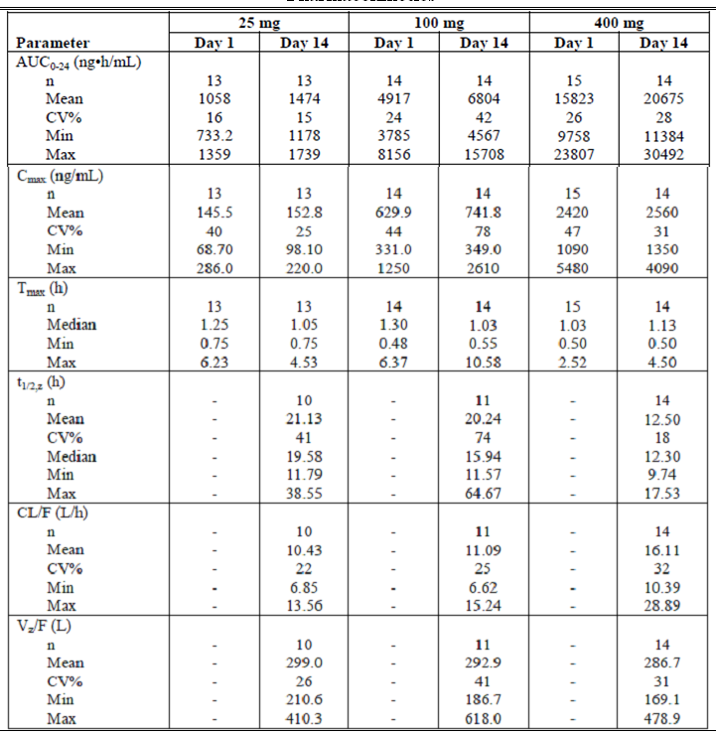

Pharmacokinetics in other special populations

Pharmacokinetics in subjects with impaired hepatic function
There was reduced exposure to alogliptin in subjects with moderate hepatic impairment. Following 25 mg oral dose the mean (90% CI) ratio of AUC_{0-∞} hepatic impairment/healthy was 90.99 (74.19 to 111.60) %, and for C_{max} was 92.34 (68.27 to 124.90) % (Study SYR-322-023).

Pharmacokinetics in subjects with impaired renal function
In Study SYR-322-006, in healthy subjects (creatinine clearance [CrCl] >80 mL/min) the CL/F was 14.43 L/hour to 16.19 L/hour, mild renal impairment (CrCl 51-80 mL/min) 9.53 L/hour, with moderate renal impairment (CrCl 30-50 mL/min) 8.21 L/hour, with severe renal impairment (CrCl <30 mL/min but not on dialysis) 4.30 L/hour and with ESRD 3.42 L/hour. In healthy subjects (creatinine clearance [CrCl] >80 mL/min) the fraction excreted unchanged was 60 to 65 %, mild renal impairment (CrCl 51-80 mL/min) 60%, with moderate renal impairment (CrCl 30-50 mL/min) 53% and with severe renal impairment (CrCl <30 mL/min but not on dialysis) 24%.

Pharmacokinetics according to age
In a population of elderly subjects (aged 65 to 85 years) compared with younger subjects (18 to 45 years) following a 25 mg dose over 8 days, C_{max} was similar: mean (90% CI) ratio (elderly/younger) 100.1 (89.61 to 111.59) %; but there was higher exposure to alogliptin in the elderly age group: mean (90% CI) ratio (elderly/younger) for AUC₀₋₂₄ 127.9 (120.84 to 135.46) % (Study SYR-322-022).
In a Japanese male population treated with a single dose of 25 mg, overall exposure to alogliptin was increased in the elderly: mean (90% CI) ratio (elderly/non-elderly) for AUC₀₋₇₂ 127.6 (116.1 to 140.2) % (Study SYR-322/CPH-003). CL/F was reduced in the elderly: mean (SD) 12.10 (1.084) L/hour compared with 15.84 (1.996) L/hour. Renal clearance was reduced in the elderly: mean (SD) 8.13 (1.274) L/hour compared with 11.04 (1.240) L/hour. The fraction excreted unchanged was similar: 67.3% in the elderly compared with 70.1% in the non-elderly.

Pharmacokinetics related to genetic factors
There was no indication of pharmacogenetic variability in the metabolism or transport of alogliptin.

Pharmacokinetics according to other population characteristics
In females compared with males, there was higher exposure to a 25 mg daily dose for 5 days: mean (90% CI) for the ratio of female/males for C_{max} was 122.0 (108.65 to 136.96) % and for AUC₀₋₂₄ was 119.5 (112.39 to 126.95).
In White subjects compared with African American, there was higher exposure to a 25 mg daily dose for 5 days: mean (90% CI) for the ratio of White/African American for C_{max} was 119.7 (107.17 to 133.72) % and for AUC₀₋₂₄ was 128.0 (120.80 to 135.72).

Pharmacokinetic interactions

Pharmacokinetic interactions demonstrated in human studies

Effects of other drugs on the PK of alogliptin
- In a study of the interaction of alogliptin and MET, there was no effect on the PK of alogliptin: LS mean ratio for AUC_{0-tau}: 1.000 (0.972 to 1.029); but greater exposure to MET: 1.189 (1.095 to 1.291) % (Study SYR-322-005).
- When administered concomitant with fluconazole (CYP2C9 inhibitor) there was no change in the exposure to alogliptin: geometric mean ratio (90% CI) for AUC_{0-∞} 99.13 (96.45 to 101.89) % (Study SYR-322-016).
- When administered concomitant with ketoconazole (CYP3A4 inhibitor) there was an increased exposure to alogliptin: geometric mean ratio (90% CI) for AUC_{0-∞} 115.39 (110.99 to 119.97) % (Study SYR-322-016).
- When administered concomitant with gemfibrozil (CYP2C8/9 inhibitor) there was an increased exposure to alogliptin: geometric mean ratio (90% CI) for AUC_{0-∞} 112.88 (109.20 to 116.69) % and also to the M-I metabolite: 191.14 (164.78 to 221.71) % (Study SYR-322-016).
- There was an increase in exposure to alogliptin when administered concomitantly with pioglitazone: LS mean ratio (90% CI) for AUC₀₋₂₄ 110.22 (107.75 to 112.75) % (Study SYR-322-017).
- There was an increase in overall exposure to alogliptin with concomitant administration of cyclosporin: LS mean ratio (90% CI) for AUC₀₋₄₈ 113.20 (104.12 to 123.06) % (Study SYR-322-020).
- Concomitant administration of atorvastatin resulted in no change in exposure to alogliptin: LS mean ratio (90% CI) for AUC₀₋₂₄ 100.07 (96.35 to 103.94) (Study SYR-322-025).
- With concomitant digoxin administration there was no effect on exposure to alogliptin: LS mean ratio (90% CI) 102.79 (99.46 to 106.23) (Study SYR-322-029).
- Voglibose decreased overall exposure to alogliptin: LS mean ratio (90% CI) for AUC₀₋₇₂ 76.8 (74.6 to 79.1) % (Study SYR-322/CPH-004).

Effects of alogliptin on the PK of other drugs:
- In a study of the interaction of alogliptin and cimetidine, there was no effect on the PK of alogliptin: LS mean ratio for AUC_{0-tau}: 1.065 (1.032 to 1.099); or of cimetidine: 1.043 (0.982 to 1.107) % (Study SYR-322-005).
- There was no significant effect on the PK of caffeine (CYP1A2 probe): ratio of geometric means (90% C1) for AUC_{0-∞} 105.28 (93.06 to 119.12) % (Study SYR-322-015).
- There was no significant effect on the PK of tolbutamide (CYP2C9 probe): ratio of geometric means (90% C1) for AUC_{0-∞} 97.41 (92.87 to 101.60) % (Study SYR-322-015).
- For dextromethorphan (CYP2D6 probe) there was increased exposure: ratio of geometric means (90% C1) for AUC_{0-∞} 126.92 (103.68 to 155.37), but this effect was not due to inhibition of CYP2D6 because the AUC of the CYP2D6 mediated metabolite (dextrophan) was unchanged: ratio of geometric means (90% C1) for AUC_{0-∞}: 99.70 (96.10 to 103.45) % (Study SYR-322-015).
- There was no significant effect on the PK of midazolam (CYP3A4 probe): ratio of geometric means (90% CI) for AUC_{0-∞} 107.05 (97.16 to 117.95) % (Study SYR-322-015).
- For fexofenadine (Pgp probe) there was increased exposure: ratio of geometric means (90% C1) for AUC_{0-∞} 133.64 (112.27 to 159.09) % (Study SYR-322-015).
- There was no effect of alogliptin on pioglitazone exposure when administered concomitantly: LS mean ratio (90% CI) for AUC₀₋₂₄ 105.78 (97.49 to 114.78) % (Study SYR-322-017).
- Overall exposure to gliburide was unchanged by concomitant administration of alogliptin: geometric mean ratio (90% CI) for AUC_{0-∞} 96.26 (89.21 to 103.87) %; but there was an increase in C_{max}: geometric mean ratio (90% CI) 115.36 (105.98, 125.57) % (Study SYR-322-018).
- When concomitantly administered with warfarin, alogliptin did not increase exposure to r-warfarin, LS mean ratio (90% CI) for AUC₀₋₂₄ 98.80 (94.2 to 103.60) %; or to s-warfarin: LS mean ratio (90% CI) for AUC₀₋₂₄ 101.09 (97.22 to 105.11) (Study SYR-322-021). There was no effect for alogliptin on PT or INR.
- Alogliptin administered concomitantly had no effect on exposure to ethynyl oestradiol, LS mean ratio (90% CI) for AUC₀₋₂₄ 98.59 (94.92 to 102.40), or norethindrone, LS mean ratio (90% CI) for AUC₀₋₂₄ 102.48 (99.51 to 105.55) (Study SYR-322-024). There was also no effect on endogenous LH, FSH, E2, progesterone or SHBG.
- Concomitant administration of alogliptin resulted in a small increase in exposure to atorvastatin: LS mean ration (90% CI) for AUC₀₋₂₄ 114.17 (101.36 to 128.59) (Study SYR-322-025).
- With concomitant alogliptin administration there was no effect on exposure to digoxin: LS mean ratio (90% CI) for AUC₀₋₂₄ 99.71 (96.02 to 103.55) (Study SYR-322-029).

Clinical implications of in vitro findings
Study SYR-322-00013 examined the potential for alogliptin to inhibit CYP1A2, CYP2C9, CYP2C19, CYP2D6 and CYP3A4 using baculovirus expressed protein. No inhibition was observed for any of these enzymes at concentrations of 40 μM.

Evaluator’s overall conclusions on pharmacokinetics
Alogliptin has been characterised as having rapid and complete oral absorption and predictable renal excretion. There were few significant drug interactions.
Because alogliptin is predominantly cleared renally dose adjustment in renal failure would be necessary. The dosing regimen proposed by the Sponsor is appropriate for this.
There was no study of renal excretion or re-absorption. This could be provided from the data already available if renal clearance of unbound drug were related to GFR.

Pharmacodynamics

Studies providing pharmacodynamic data
There were five studies that contribute PD data:
- Study SYR-322-CPH-007
- Study SYR-322-001
- Study SYR-322/CPH-001
- Study SYR-322/CPH-002
- Study SYR-322-002

Summary of pharmacodynamics
The information in the following summary is derived from conventional pharmacodynamic studies in humans unless otherwise stated.

Mechanism of action
There were no clinical studies on mechanism of action.

Pharmacodynamic effects

Primary pharmacodynamic effects
In Study SYR-322-CPH-007, time to maximal effect was approximately 1.5 hours. The maximum effect was 92% inhibition of DPP-IV activity at the 12.5 mg dose and 96% inhibition at the 25 mg dose. AUC₀₋₇₂ for inhibition of DPP-IV was similar at the 12.5 mg and 25 mg doses.
Peak inhibition of DPP IV activity (Emax) exceeded 93% across all alogliptin dose levels administered, with median time to peak inhibition ranging from 2 to 3 hours after dose administration (Study SYR-322-001). EC₅₀ for inhibition of DPP-IV was estimated to be 3.73 ng/mL. There were similar effects on GLP-1 across the dose range from 25 mg to 800 mg.
In a healthy male Japanese population (Study SYR-322/CPH-001), in the dose range 6.25 mg to 200 mg, inhibition of DPP-IV appeared to plateau at the 25 mg dose level. Activated GLP-1 also appeared to plateau at the 25 mg dose level. There was no difference between the dose levels or placebo in plasma glucose AUC or plasma insulin AUC.
In a healthy male Japanese population (Study SYR-322/CPH-002), with multiple dosing in the range 25 mg to 100 mg daily, DPP-IV inhibition appeared to plateau at the 25 mg dose, at 96.2% inhibition. Activated GLP-1 plateaued at the 50 mg dose, and there was no apparent difference between the dose levels for plasma glucose.
In subjects with T2DM, in the dose range 25 mg to 400 mg once daily for 14 days, there was little difference in DPP-IV inhibition between the 25 mg dose, the 100 mg dose and the 400 mg dose (Study SYR-322-002). AUC for plasma glucose was lowest in the 100 mg group. AUC for plasma insulin was greatest in the 100 mg group. The 4 hour postprandial glucose concentrations decreased from baseline, in comparison with placebo, to Day 14 by LS mean (SE) -39.9 (14.42) mg/dL in the 25 mg group, -48.6 (14.71) mg/dL in the 100 mg group and -68.3 (15.08) mg/dL in the 400 mg group. HbA1c changed, in comparison with placebo, by a mean (SE) of -0.27 (0.129) % in the 25 mg group, -0.45 (0.128) % in the 100 mg group and -0.32 (0.131) in the 400 mg group.

Evaluator’s overall conclusions on pharmacodynamics
The proposed dosing regimen is supported by the PD data. Near maximal DPP-IV inhibition is achieved by the 25 mg dose level over a 24 hour dosing interval.

Dosage selection for the pivotal studies

Data on dose frequency
The exposure to alogliptin (AUC₀₋₂₄) was similar for 12.5 mg twice daily and 25 mg once daily (Study SYR-322-101). The inhibition of DDP-IV was also similar for the two dosing regimens.

Dose finding studies

Study SYR-322-003
Study SYR-322-003 was a multicenter, randomised, double blind, placebo controlled comparison of alogliptin in subjects with T2DM who are either receiving no current treatment, or treated with diet and exercise, a sulfonylurea, MET, or a combination of a sulfonylurea and MET. The study was conducted at 62 centres in two countries, the US and Chile, from March 2005 to October 2005. The study included: male or female subjects aged 18 to 75 years inclusive, diagnosed with T2DM, who must also have been either receiving no treatment (ie, either newly diagnosed or experiencing inadequate glycemic control with diet and exercise alone for 3 months prior to Screening), or they must have been receiving treatment with a sulfonylurea, MET, or a combination of a sulfonylurea and MET and experiencing inadequate glycemic control; BMI ≥23 kg/m² and ≤40 kg/m²; fasting C-peptide concentration ≥0.8 ng/mL; HbA1c concentration between 6.8% and 11.0%; DBP ≤110 mmHg and SBP ≤180 mmHg. The study treatments were:
- Alogliptin 6.25 mg
- Alogliptin 12.5 mg
- Alogliptin 25 mg
- Alogliptin 50 mg
- Alogliptin 100 mg
- Placebo
Study treatments were administered orally once daily, 30 minutes prior to the first meal of the day for 12 weeks. The efficacy outcome measures were:
- Change from baseline in HbA1c at Week 12 (primary efficacy outcome measure)
- Change from baseline in average daily blood glucose
- Change from baseline in HbA1c at Week 6
- Change from baseline in FPG, fasting fructosamine
- Change from baseline in lipid profile
- Incidence of hyperglycaemia
The safety outcome measures were: AEs, laboratory test results, ECG, and hypoglycaemic events. Hypothesis tests were performed using ANCOVA models.
There were 265 subjects randomised, 259 received treatment, and 157 were included in the ITT population. There were 42 (15.8%) subjects that discontinued, six because of AE. There were 139 (52.5%) females, 126 (47.5%) males, and the age range was 26 to 75 years. The treatment groups were similar in demographic and baseline characteristics.
For the primary efficacy outcome measure, change in HbA1c at Week 12, there was a plateau in effect at the 12.5 mg dose level, with a decrease in HbA1c% from baseline of 0.52% (Table 3). However, the improvements in FPG and fructosamine peaked at the 25 mg dose level (at -35.5 mg/dL and -24.1 μmol/L respectively). At Week 6, the improvement in HbA1c also plateaued at the 12.5 mg dose level at -0.37%. There was an increase in LDL cholesterol relative to placebo in all the alogliptin groups of around 10 mg/dL.
Table 3. Changes from Baseline observed for HbA1c, FPG, and fasting fructosamine after 12 weeks of treatment with alogliptin
The incidence of hyperglycaemia was reduced compared to placebo for all the alogliptin groups relative to placebo (Table 4). The improvements in diabetes control occurred in subjects who were treatment naïve as well as those with prior antidiabetic treatment.
Table 4. Incidence of Hyperglycemia and Hyperglycemic Rescue—ITT Sample

Clinical efficacy

Pivotal efficacy studies

Alogliptin in combination with MET

Study SYR-322-MET-008

Study design, objectives, locations and dates
Study SYR-322-MET-008 was a multicentre, randomised, double blind, placebo controlled, three treatment arm study to assess the efficacy and safety of two dose levels of alogliptin in combination with MET versus MET alone (Table 5). The study was conducted at 115 total sites in 15 countries from March 2006 to June 2007.

Table 5. Summary of Study SYR-322-MET-008
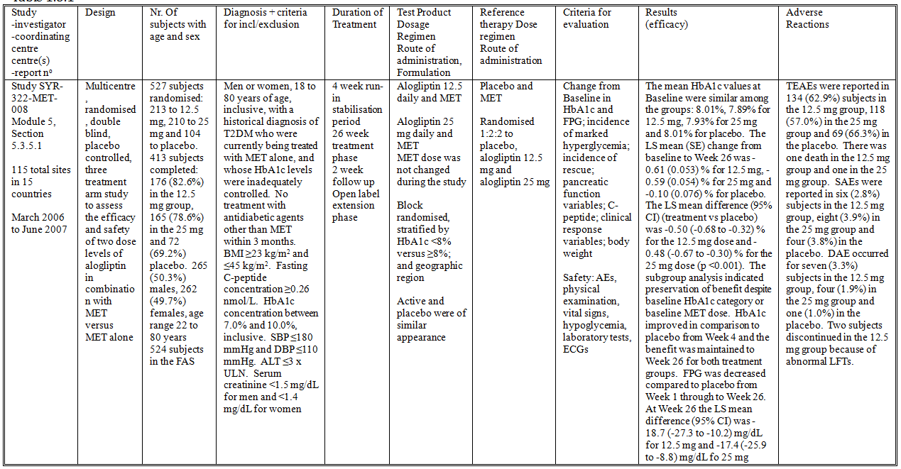

Inclusion and exclusion criteria
The inclusion criteria included:
- Men or women, 18 to 80 years of age, inclusive, with a historical diagnosis of T2DM who were currently being treated with MET alone, and whose HbA1c levels were inadequately controlled
- The subject was to have received MET monotherapy for at least 3 months prior to Screening with a stable dose of ≥1500 mg MET for at least 8 weeks prior to randomization. Subjects with a maximum tolerated dose documented to be <1500 mg of MET could have been enrolled if this dose had been stable for 8 weeks prior to randomisation
- No treatment with antidiabetic agents other than MET within the 3 months prior to Screening
- BMI ≥23 kg/m² and ≤45 kg/m²
- Fasting C-peptide concentration ≥0.26 nmol/L
- HbA1c concentration between 7.0% and 10.0%, inclusive
- Regular use of other, nonexcluded medications was allowed if a stable dose had been established for at least the 4 weeks prior to Screening
- SBP ≤180 mmHg and DBP ≤110 mmHg
- Haemoglobin ≥120 g/L for men and ≥100 g/L for women
- ALT ≤3 x ULN
- Serum creatinine <1.5 mg/dL for men and <1.4 mg/dL for women
- TSH ≤ULN and the subject was considered clinically euthyroid
- Neither pregnant nor lactating.
- Women of childbearing potential must have been practicing adequate contraception and continue to do so for the duration of participation in the study
The exclusion criteria included:
- Urine albumin/creatinine ratio of >113 mg/mol
- History of cancer, other than squamous cell or basal cell carcinoma of the skin, that had not been in full remission for at least 5 years
- History of laser treatment for proliferative diabetic retinopathy within 6 months
- History of treated diabetic gastric paresis
- NYHA Class III or IV heart failure regardless of therapy
- History of coronary angioplasty, coronary stent placement, coronary bypass surgery, or myocardial infarction within the 6 months
- History of any haemoglobinopathy that could have affected determination of HbA1c
- History of infection with hepatitis B, hepatitis C, or human immunodeficiency virus
- History of a psychiatric disorder that could have affected the subject’s ability to participate
- History of angioedema in association with use of angiotensin-converting enzyme inhibitors or angiotensin-II receptor inhibitors
- History of alcohol or substance abuse within 2 years

Study treatments
- Alogliptin 12.5 daily and MET
- Alogliptin 25 mg daily and MET
- Placebo and MET
Alogliptin and matching placebo were administered once daily. MET dose was not changed during the study.

Efficacy variables and outcomes
The primary efficacy outcome measure was the change from Baseline in HbA1c at Week 26. The secondary efficacy outcome measures were:
- Change from Baseline in HbA1c level at Weeks 4, 8, 12, 16, and 20
- Change from Baseline in FPG at Weeks 1, 2, 4, 8, 12, 16, 20, and 26
- Incidence of marked hyperglycemia (fasting plasma glucose ≥11.1 mmol/L)
- Incidence of hyperglycaemic rescue
- Pancreatic function variables: change from Baseline in fasting proinsulin, insulin and proinsulin/insulin ratio
- Change from Baseline in C-peptide
- Clinical response variables: incidence of Week 26 HbA1c ≤6.5%, ≤7.0%, and ≤7.5%; and incidence of Week 26 HbA1c decrease from Baseline ≥0.5%, ≥1.0%, ≥1.5%, and ≥2.0%.
- Change from Baseline in body weight
The safety outcome measures included AEs, vital signs, laboratory tests, ECGs and hypoglycaemia episodes.
The schedule of study visits is summarised in Table 6.
Table 6. Schedule of Assessments (Study SYR-322-MET-008)
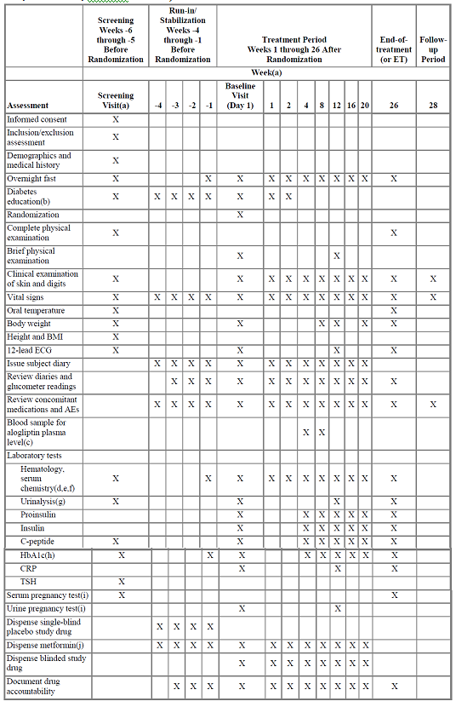

Randomisation and blinding methods
Subjects were block randomised, stratified by HbA1c <8% versus ≥8%; and geographic region. Subjects were randomised 1:2:2 to placebo, alogliptin 12.5 mg and alogliptin 25 mg. Active and placebo were of similar appearance.

Analysis populations
The FAS included all randomized subjects in the Safety Set. The Safety Set included all subjects who took at least one dose of double-blind study drug.

Sample size
The sample size calculation used prior data from another DPP-IV inhibitor. For comparison of either alogliptin dose versus placebo using a two-sample t-test, a sample size of 500 (randomized in the ratio 1:2:3) would provide 95% power to detect a treatment group difference in the change from Baseline HbA1c as small as 0.4%, assuming a SD of 0.8%, a two-sided 0.05 significance level, and no less than 80% of randomised subjects evaluable.

Statistical methods
The primary analysis was performed for the FAS using ANCOVA with LOCF values. The primary model included study treatment and geographic region as class effects, and Baseline MET dose and Baseline HbA1c as continuous covariates.

Participant flow
There were 527 subjects randomised to treatment: 213 to 12.5 mg, 210 to 25 mg and 104 to placebo. There were 413 subjects that completed: 176 (82.6%) in the 12.5 mg group, 165 (78.6%) in the 25 mg and 72 (69.2%) in the placebo. Subject disposition is summarised in Table 7.
Table 7. Overall Disposition—Randomized Set (Study SYR-322-MET-008)

Major protocol violations/deviations
Eight subjects were discontinued from the study due to a protocol deviation; two had been randomised to placebo, two to 12.5 mg, and four to 25 mg.

Baseline data
There were 265 (50.3%) males, 262 (49.7%) females and the age range was 22 to 80 years. The treatment groups were similar in demographic and disease characteristics. All subjects were previously treated with MET and continued MET at the commencement of the study. There were few additions to anti-diabetic regimen during the study.

Results for the primary efficacy outcome
The mean HbA1c values at Baseline were similar among the groups: 7.89% for 12.5 mg, 7.93% for 25 mg and 8.01% for placebo. The LS mean (SE) change from baseline to Week 26 was -0.61 (0.053) % for 12.5 mg, -0.59 (0.054) % for 25 mg and -0.10 (0.076) % for placebo (Table 8). The LS mean difference (95% CI) (treatment vs placebo) was -0.50 (-0.68 to -0.32) % for the 12.5 mg dose and -0.48 (-0.67 to -0.30) % for the 25 mg dose (p <0.001). The subgroup analysis indicated preservation of benefit despite baseline HbA1c category or baseline MET dose.
Table 8. Summary of Change from Baseline (CFB) in HbA1c—Full Analysis Set (LOCF) (Study SYR-322-MET-008)

Results for other efficacy outcomes
- For the secondary efficacy outcome measures, HbA1c improved in comparison to placebo from Week 4 and the benefit was maintained to Week 26 for both treatment groups.
- The proportion of subjects with HbA1c <6.5% at Week 26 was 42 (19.7%) for 12.5 mg, 36 (17.4%) for 25 mg and four (3.8%) for placebo p<0.01.
- The proportion of subjects with HbA1c <7.0% at Week 26 was 110 (51.6%) for 12.5 mg, 92 (44.4%) for 25 mg and 19 (18.3%) for placebo p<0.001.
- The proportion of subjects with HbA1c <7.5% at Week 26 was 153 (71.8%) for 12.5 mg, 137 (66.2%) for 25 mg and 47 (45.2%) for placebo p<0.001.
- The proportion of subjects with a decrease from baseline in HbA1c ≥0.5% at Week 26 was 123 (57.7%) for 12.5 mg, 122 (58.9%) for 25 mg and 28 (26.9%) for placebo p<0.001.
- The proportion of subjects with a decrease from baseline in HbA1c ≥1.0% at Week 26 was 61 (28.6%) for 12.5 mg, 62 (30.0%) for 25 mg and nine (8.7%) for placebo p<0.001.
- The proportion of subjects with a decrease from baseline in HbA1c ≥1.5% at Week 26 was 20 (9.4%) for 12.5 mg, 24 (11.6%) for 25 mg and six (5.8%) for placebo (p<0.05 for the comparison 25 mg vs placebo).
- The proportion of subjects with a decrease from baseline in HbA1c ≥2.0% at Week 26 was seven (3.3%) for 12.5 mg, five (2.4%) for 25 mg and four (3.8%) for placebo p>0.05.
- FPG was decreased compared to placebo from Week 1 through to Week 26. At Week 26 the LS mean difference (95% CI) was -18.7 (-27.3 to -10.2) mg/dL for 12.5 mg and -17.4 (-25.9 to -8.8) mg/dL for 25 mg.
- The incidence of marked hyperglycaemia was higher in the placebo group: 51.0% compared with 28.9% for 12.5 mg and 31.6% for 25 mg.
- The incidence of hyperglycaemic rescue was higher in the placebo group: 24.0% compared with 9.0% for 12.5 mg and 8.2% for 25 mg.
- Plasma insulin concentrations were greater in the alogliptin groups relative to placebo at Week 26: LS mean difference (95% CI) 2.87 (0.50, 5.23) μU/mL for 12.5 mg and 2.22 (-0.15, 4.60) μU/mL for 25 mg. The C-peptide concentration was higher and proinsulin/insulin ratio was lower in the 12.5 mg group than placebo. There was no significant difference between the groups in proinsulin concentrations or in body weight.
- There was no significant difference between the groups in plasma lipids.

Study SYR-322-MET-302

Study design, objectives, locations and dates
Study SYR-322-MET-302 was a multicentre, randomized, double blind, placebo controlled study to determine the efficacy and safety of alogliptin plus MET, alogliptin alone, or MET alone in subjects with T2DM (Table 9). The study was conducted at 198 study sites from November 2009 to June 2011.

Table 9. Summary of Study SYR-322-MET-302
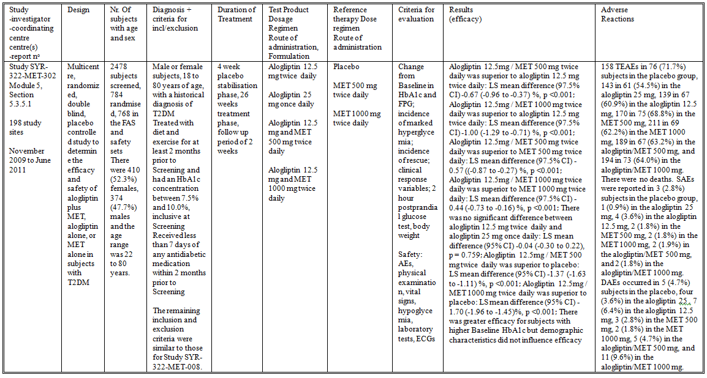

Inclusion and exclusion criteria
The inclusion criteria included:
- Male or female subjects, 18 to 80 years of age, with a historical diagnosis of T2DM
- Treated with diet and exercise for at least 2 months prior to Screening and had a HbA1c concentration between 7.5% and 10.0%, inclusive at Screening
- Received less than 7 days of any antidiabetic medication within 2 months prior to Screening
The remaining inclusion and exclusion criteria were similar to those for Study SYR-322-MET-008.

Study treatments
The study treatments were:
- Alogliptin 12.5 mg twice daily
- Alogliptin 25 mg once daily
- Alogliptin 12.5 mg and MET 500 mg twice daily
- Alogliptin 12.5 mg and MET 1000 mg twice daily
- Placebo
- MET 500 mg twice daily
- MET 1000 mg twice daily
Treatment duration was for 26 weeks.

Efficacy variables and outcomes
The primary efficacy outcome measure was change from baseline in HbA1c at Week 26. The secondary efficacy outcome measures were:
- Change from Baseline in HbA1c at Weeks 4, 8, 12, 16, and 20
- Change from Baseline in fasting plasma glucose at Weeks 1, 2, 4, 8, 12, 16, 20, and 26
The exploratory efficacy endpoints were:
- Incidence of clinical response endpoints (HbA1c <6.5% and <7.0%, or decreases from Baseline ≥0.5%, ≥1.0%, or ≥2.0%)
- Changes over time in insulin sensitivity and β-cell function (proinsulin, insulin, proinsulin/insulin ratio, and HOMA-BCF)
- Body weight and waist circumference
- Lipids (total cholesterol, high-density lipoprotein, low-density lipoprotein, triglycerides)
- Markers of inflammation (hsCRP)
- Two hour postprandial glucose test
- The safety outcome measures included AEs, vital signs, laboratory tests, ECGs and hypoglycaemia episodes.
The schedule of study visits is summarised in Table 10.
Table 10. Schedule of Study Procedures (Study SYR-322-MET-302)
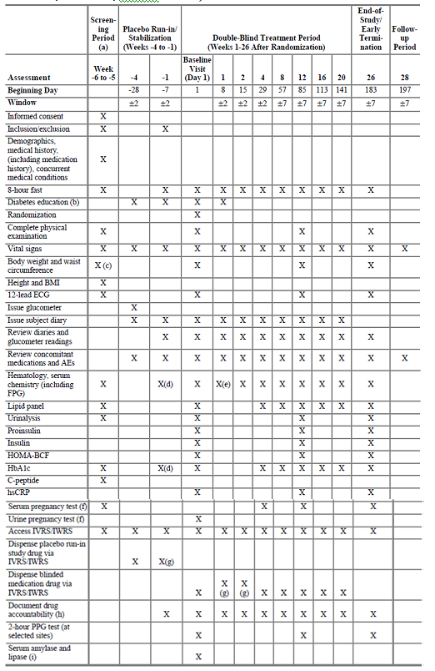

Randomisation and blinding methods
Subjects were block randomised, stratified by HbA1c <8% versus ≥8%; and geographic region; and randomised 1:1:1:1:1:1:1 to placebo, alogliptin 12.5 mg twice daily, alogliptin 25 mg once daily, alogliptin 12.5 mg/ MET 500 mg twice daily, alogliptin 12.5 mg/ MET 1000 mg twice daily, MET 500 mg twice daily and MET 1000 mg twice daily. Active and placebo were of similar appearance.

Analysis populations
The FAS included all randomized subjects in the Safety Set. The Safety Set included all subjects who took at least one dose of double-blind study drug.

Sample size
The sample size estimation calculated that 105 subjects per treatment group would provide 90% power, at a level of significance of 0.05, assuming a treatment effect of 0.55% between a twice daily combination and its constituent doses, and a standard deviation (SD) of 1.0%.

Statistical methods
Hypothesis tests were performed using ANCOVA models with HbA1c change from Baseline at Week 26 as the response variable, treatment and geographic region as fixed effects, and baseline HbA1c as a continuous covariate. Missing variables were imputed using LOCF.

Participant flow
Of the 784 subjects randomized to treatment, 609 completed the study (Table 11). There were 112 subjects randomized to alogliptin 25 mg once daily; 113 to alogliptin 12.5 mg twice daily; 114 to MET 500 mg twice daily; 111 to MET 1000 mg twice daily, 114 to alogliptin 12.5 mg plus MET 1000 mg twice daily; and 109 to placebo.
Table 11. Primary Reasons for Premature Discontinuation From Study Drug and Study Visits (Study SYR-322-MET-302)

Major protocol violations/deviations
Fourteen subjects were excluded from the FAS and the Safety Set after it was discovered that they were duplicate subjects.

Baseline data
There were 410 (52.3%) females, 374 (47.7%) males and the age range was 22 to 80 years. There were 109 (13.9%) subjects aged ≥65 years, and 13 (1.7%) aged ≥75 years. The treatment groups were similar in demographic and baseline disease severity characteristics. The treatment groups were similar in the distribution of comorbid medical conditions. Drugs used to treat diabetes had been taken by 31 (4.0%) subjects in the 90 days prior to randomization. Fewer subjects in the combined alogliptin/MET groups commenced treatment with SU during the study.

Results for the primary efficacy outcome
- Alogliptin 12.5mg / MET 500 mg twice daily was superior to alogliptin 12.5 mg twice daily: LS mean difference (97.5% CI) -0.67 (-0.96 to -0.37) %, p <0.001 (Table 12).
Table 12. HbA1c Changes From Baseline (%) at Week 26 (FAS) (Study SYR-322-MET-302)
- Alogliptin 12.5mg / MET 1000 mg twice daily was superior to alogliptin 12.5 mg twice daily: LS mean difference (97.5% CI) -1.00 (-1.29 to -0.71) %, p <0.001
- Alogliptin 12.5mg / MET 500 mg twice daily was superior to MET 500 mg twice daily: LS mean difference (97.5% CI) -0.57 ((-0.87 to -0.27) %, p <0.001
- Alogliptin 12.5mg / MET 1000 mg twice daily was superior to MET 1000 mg twice daily: LS mean difference (97.5% CI) -0.44 (-0.73 to -0.16) %, p <0.001
- There was no significant difference between alogliptin 12.5 mg twice daily and alogliptin 25 mg once daily: LS mean difference (95% CI) -0.04 (-0.30 to 0.22), p = 0.759
- Alogliptin 12.5mg / MET 500 mg twice daily was superior to placebo: LS mean difference (95% CI) -1.37 (-1.63 to -1.11) %, p <0.001
- Alogliptin 12.5mg / MET 1000 mg twice daily was superior to placebo: LS mean difference (95% CI) -1.70 (-1.96 to -1.45)%, p <0.001
- There was greater efficacy for subjects with higher Baseline HbA1c but demographic characteristics did not influence efficacy (Table 13).
Table 13. HbA1c Changes From Baseline to Week 26 by Subgroup (FAS, Analysis 1a) (Study SYR-322-MET-302)

Results for other efficacy outcomes
Secondary efficacy endpoints:
- The improvement in HbA1c for the combined alogliptin/MET treatments relative to either alogliptin of MET alone was significant from Week 4 through to Week 26.
- For the comparison of change in FPG from baseline to Week 25:
  - Alogliptin 12.5mg / MET 500 mg twice daily was superior to alogliptin 12.5 mg twice daily: LS mean difference (97.5% CI) -22.1 (-34.5 to -9.6) mg/dL, p <0.001
  - Alogliptin 12.5mg / MET 1000 mg twice daily was superior to alogliptin 12.5 mg twice daily: LS mean difference (97.5% CI) -36.2 (-48.5 to -23.9) mg/dL, p <0.001
  - Alogliptin 12.5mg / MET 500 mg twice daily was superior to MET 500 mg twice daily: LS mean difference (97.5% CI) -20.2 (-32.7 to -7.7) mg/dL, p = 0.002
  - Alogliptin 12.5mg / MET 1000 mg twice daily was superior to MET 1000 mg twice daily: LS mean difference (97.5% CI) -14.0 (-26.2, -1.8) mg/dL, p = 0.025
Exploratory efficacy endpoints
- The incidence of hyperglycaemic rescue was 19.6% for alogliptin 25 mg once daily; 17.3% for alogliptin 12.5 mg twice daily; 22.9% for MET 500 mg twice daily; 10.8% for MET 1000 mg twice daily, 12.3% for alogliptin 12.5 mg plus MET 500 mg twice daily, 2.6% for alogliptin 12.5 mg plus MET 1000 mg twice daily; and 38.7% for placebo.
- The incidence of HbA1c ≤6.5% was 14 (13.5%) subjects for alogliptin 12.5 mg twice daily; seven (6.8%) for MET 500 mg twice daily; 20 (18.5%) for MET 1000 mg twice daily, 21 (20.6%) for alogliptin 12.5 mg plus MET 500 mg twice daily, 36 (32.4%) for alogliptin 12.5 mg plus MET 1000 mg twice daily.
- The incidence of HbA1c ≤7.0% was 21 (20.2%) subjects for alogliptin 12.5 mg twice daily; 28 (27.2%) for MET 500 mg twice daily; 37 (34.3%) for MET 1000 mg twice daily, 48 (47.1%) for alogliptin 12.5 mg plus MET 500 mg twice daily, 66 (59.5%) for alogliptin 12.5 mg plus MET 1000 mg twice daily.
- The incidence of HbA1c decrease from baseline ≤0.5% was 56 (53.8%) subjects for alogliptin 12.5 mg twice daily; 60 (58.3%) for MET 500 mg twice daily; 84 (77.8%) for MET 1000 mg twice daily, 81 (79.4%) for alogliptin 12.5 mg plus MET 500 mg twice daily, 97 (87.4%) for alogliptin 12.5 mg plus MET 1000 mg twice daily.
- The incidence of HbA1c decrease from baseline ≤1.0% was 35 (33.7%) subjects for alogliptin 12.5 mg twice daily; 37 (35.9%) for MET 500 mg twice daily; 60 (55.6%) for MET 1000 mg twice daily, 60 (58.8%) for alogliptin 12.5 mg plus MET 500 mg twice daily, 80 (72.1%) for alogliptin 12.5 mg plus MET 1000 mg twice daily.
- The incidence of HbA1c decrease from baseline ≤1.5% was nine (8.7%) subjects for alogliptin 12.5 mg twice daily; 11 (10.7%) for MET 500 mg twice daily; 21 (19.4%) for MET 1000 mg twice daily, 26 (25.5%) for alogliptin 12.5 mg plus MET 500 mg twice daily, 39 (35.1%) for alogliptin 12.5 mg plus MET 1000 mg twice daily.
- Proinsulin levels were lower in the alogliptin alone group compared with alogliptin/MET or MET alone. The proinsulin/insulin ratio was lower in the combined treatment groups than the individual components.
- There was no significant difference between the groups in HOMA beta cell function
- At Week 26, LS mean changes in body weight from Baseline were -0.57 kg for alogliptin 12.5 mg/MET 500 mg twice daily, -1.17 kg for alogliptin 12.5 mg/meformin 1000 mg twice daily, -0.01 kg for alogliptin 12.5 mg twice daily, -0.80 kg for MET 500 mg twice daily and -1.25 kg for MET 1000 mg twice daily
- At Week 26, LS mean percent change from baseline in total cholesterol was -1.7 mg/dL for alogliptin 12.5 mg/MET 500 mg twice daily, -2.6 mg/dL for alogliptin 12.5 mg/meformin 1000 mg twice daily, 2.6 mg/dL for alogliptin 12.5 mg twice daily, -0.9 mg/dL for MET 500 mg twice daily and 2.0 mg/dL for MET 1000 mg twice daily
- There was no significant difference between the treatment groups in mean HDL cholesterol
- At Week 26, LS mean percent change from baseline in LDL cholesterol was -3.6 mg/dL for alogliptin 12.5 mg/MET 500 mg twice daily, -4.9 mg/dL for alogliptin 12.5 mg/meformin 1000 mg twice daily, 7.7 mg/dL for alogliptin 12.5 mg twice daily, 2.1 mg/dL for MET 500 mg twice daily and 1.5 mg/dL for MET 1000 mg twice daily
- At Week 26, LS mean percent change from baseline in triglycerides was 11.1 mg/dL for alogliptin 12.5 mg/MET 500 mg twice daily, -3.2 mg/dL for alogliptin 12.5 mg/meformin 1000 mg twice daily, 6.8 mg/dL for alogliptin 12.5 mg twice daily, 6.4 mg/dL for MET 500 mg twice daily and 9.5 mg/dL for MET 1000 mg twice daily

Study SYR-322-305

Study design, objectives, locations and dates
Study SYR-322-305 was a multicentre, randomized, double blind, active controlled study to evaluate the durability of the efficacy and safety of alogliptin compared to glipizide when used in combination with MET in subjects with T2DM (Table 14). The study was conducted at 310 study sites worldwide from March 2009 to November 2011. The current report was a 52 week interim report.

Table 14. Summary of Study SYR-322-305
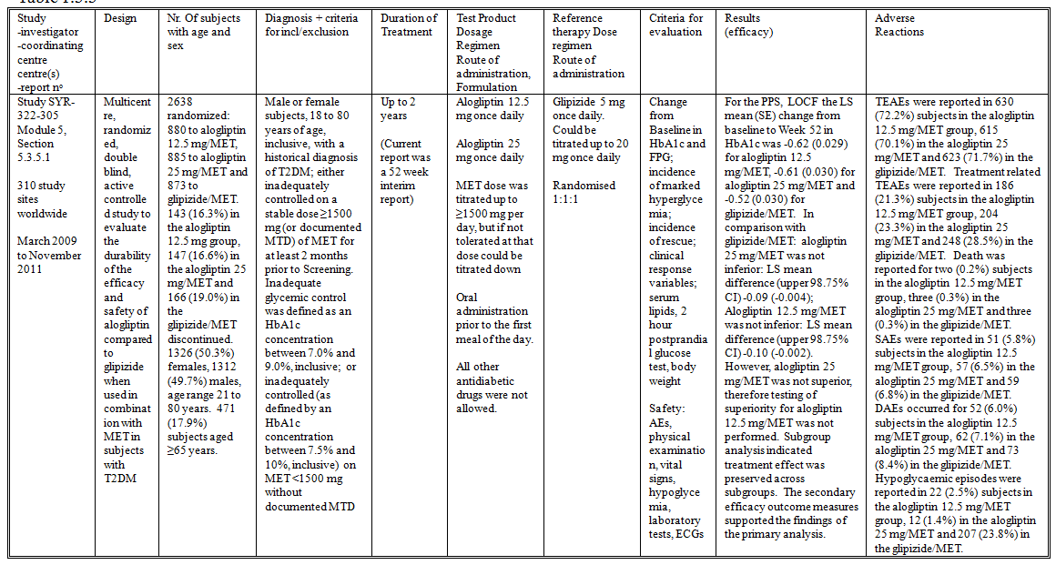

Inclusion and exclusion criteria
The inclusion criteria included:
- Male or female subjects, 18 to 80 years of age, inclusive, with a historical diagnosis of T2DM.
- The subjects must have met one of the following criteria:
  - Study Schedule A: The subject was inadequately controlled on a stable dose ≥1500 mg (or documented MTD) of MET for at least 2 months prior to Screening. Inadequate glycemic control was defined as an HbA1c concentration between 7.0% and 9.0%, inclusive.
  - Study Schedule B: The subject was inadequately controlled (as defined by an HbA1c concentration between 7.5% and 10%, inclusive) on MET <1500 mg without documented MTD. After completing the Pre-Screening Visit, these subjects had their MET dose immediately increased to ≥1500 mg (or MTD) for an 8-week period. Following this 8-week period, the subject had to qualify for entry into the Stabilization Period by completing the Screening Visit, having inadequate glycemic control defined as an HbA1c concentration between 7.0% and 9.0%, inclusive.
- No treatment with antidiabetic agents other than MET within 2 months prior to Screening.
- BMI ≥23 kg/m² and ≤45 kg/m² unless the subject was Asian or of Asian descent, for whom the allowable BMI was ≥20 kg/m² and ≤35 kg/m², inclusive.
The remaining inclusion criteria were similar to those for Study SYR-322-MET-008.
The exclusion criteria that differed to those for Study SYR-322-MET-008 were:
- Systolic blood pressure ≥150 mm Hg and /or diastolic pressure ≥90 mm Hg.
- ALT >2.5xULN.

Study treatments
- Alogliptin 12.5 mg once daily plus MET
- Alogliptin 25 mg once daily plus MET
- Glipizide 5 mg once daily plus MET. Could be titrated up to 20 mg once daily
The treatments were administered orally prior to the first meal of the day. Treatment duration was for up to 2 years. MET dose was titrated up to ≥1500 mg per day, but if not tolerated at that dose could be titrated down. No other antidiabetic drugs were allowed.

Efficacy variables and outcomes
The primary efficacy outcome measure of the interim report was change in HbA1c from Baseline at Week 52. The secondary efficacy outcome measures were:
- Change from Baseline in HbA1c at Weeks 4, 8, 12, 16, 20, 26, 39.
- Change from Baseline in FPG at Weeks 2, 4, 8, 12, 16, 20, 26, 39 and 52.
- Clinical response endpoints, including incidence of HbA1c ≤6.5% and HbA1c ≤7.0%.
- Change from Baseline in body weight.
Exploratory efficacy outcome measures were:
- Clinical response endpoints including: incidence of HbA1c decrease from Baseline ≥0.5%, ≥1.0%, ≥1.5% and ≥2.0%
- Incidence of marked hyperglycemia (FPG ≥11.1 mmol/L).
- Incidence of hyperglycemia rescue and time to hyperglycemic rescue event.
- Pancreatic beta cell function: proinsulin, insulin, proinsulin/insulin, HOMA-BCF.
- Change from Baseline in hsCRP.
- Change from Baseline in lipid parameters: total cholesterol, HDL, LDL, and triglycerides.
- Change from Baseline in 2-hour PPG (at selected sites only).
The safety outcome measures included AEs, vital signs, laboratory tests, ECGs and hypoglycaemia episodes.
The schedule of study visits is summarised in the CSR.

Randomisation and blinding methods
Block randomization was performed in the ratio 1:1:1 using IVRS, stratified by country, Study Schedule (A or B), and Baseline HbA1c (<8.0% vs ≥8.0%). Glipizide and matching placebo were over-encapsulated. Alogliptin and matching placebo were identical.

Analysis populations
The PPS included all FAS subjects who had no major protocol violations. The FAS included all randomized subjects in the Safety Set. The Safety Set included all subjects who took at least one dose of double-blind study drug.

Sample size
The sample size calculation was performed for a test of non-inferiority for the primary efficacy outcome variable in the PPS population. The calculation used a power of 95%, to detect a non-inferiority margin of 0.3%, assuming no difference between either alogliptin dose and glipizide, a SD 1.2%, an evaluability rate of 60%, and a 1-sided 0.0125 significance level. The study aimed to randomize between 815 and 897 subjects, inclusive, per treatment arm.

Statistical methods
The primary efficacy analysis (non-inferiority) was conducted using the PPS. The hypothesis tests were conducted in a fixed sequence:
- Alogliptin 25 mg was inferior in HbA1c change from Baseline vs glipizide.
- Alogliptin 12.5 mg was inferior in HbA1c change from Baseline vs glipizide.
- Alogliptin 25 mg was not superior in HbA1c change from Baseline vs glipizide.
- Alogliptin 12.5 mg was not superior in HbA1c change from Baseline vs glipizide.
The hypothesis tests were performed using ANCOVA models from which LS means and SEs were used to construct 1-sided 98.75% CIs. Study treatment, geographic region, and the study schedule the subject was randomized under were included as class effects, and Baseline HbA1c and Baseline MET dose as continuous covariates. All other efficacy analyses used the FAS. Missing data were imputed using LOCF.

Participant flow
There were 2638 subjects randomized to treatment: 880 to alogliptin 12.5 mg/MET, 885 to alogliptin 25 mg/MET and 873 to glipizide/MET. There were 143 (16.3%) subjects in the alogliptin 12.5 mg group, 147 (16.6%) in the alogliptin 25 mg/MET and 166 (19.0%) in the glipizide/MET that discontinued (Table 15).
Table 15. Primary Reasons for Premature Discontinuation From Study Drug and Study Visits (Randomized Set) (Study SYR-322-305)

Major protocol violations/deviations
A summary table of protocol deviations and reasons for exclusion from the PPS was not provided.

Baseline data
There were 1326 (50.3%) females, 1312 (49.7%) males, and the age range was 21 to 80 years. There were 471 (17.9%) subjects aged ≥65 years. The treatment groups were similar in demographic and baseline characteristics. The treatment groups were similar in concurrent medical conditions. Concomitant medications taken by ≥10% of total subjects were: acetylsalicylic acid (30.9%), paracetamol (19.2%), simvastatin (19.1%), hydrochlorothiazide (15.8%), lisinopril (12.7%), amlodipine (12.4%), and atorvastatin (12.3%).

Results for the primary efficacy outcome
For the PPS, LOCF the LS mean (SE) change from baseline to Week 52 in HbA1c was -0.62 (0.029) for alogliptin 12.5 mg/MET, -0.61 (0.030) for alogliptin 25 mg/MET and -0.52 (0.030) for glipizide/MET (Table 16). In comparison with glipizide/MET:
Table 16. Comparison of Primary Efficacy Variable Across Analysis Sets (Study SYR-322-305)
- Alogliptin 25 mg/MET was not inferior: LS mean difference (upper 98.75% CI) -0.09 (0.004)
- Alogliptin 12.5 mg/MET was not inferior: LS mean difference (upper 98.75% CI) -0.10 (-0.002)
- However, Alogliptin 25 mg/MET was not superior, therefore testing of superiority for alogliptin 12.5 mg/MET was not performed. Subgroup analysis indicated treatment effect was preserved across subgroups.

Results for other efficacy outcomes
For the secondary efficacy outcome measures:
- Change from Baseline in HbA1c was preserved in all three groups through to Week 52.
- There was a significant improvement in FPG for all three groups initially, but by Week 52 FPG was significantly lower in the alogliptin groups: LS mean difference (95% CI) -5.9 (-9.27 to -2.48) mg/dL, p <0.001, for alogliptin 12.5 mg; and -8.1 (-11.47 to -4.68) mg/dL, p <0.001 for alogliptin 25 mg.
- HbA1c ≤6.5% was achieved by 210 (24.4%) subjects in the 12.5 mg group, p = 0.065; 215 (24.8%) in the 25 mg, p = 0.017; and 178 (20.8%) in the glipizide.
- HbA1c ≤7.0% was achieved by 444 (51.5%) subjects in the 12.5 mg group, p = 0.076; 479 (55.3%) in the 25 mg, p <0.001; and 406 (47.4%) in the glipizide.
- For body weight, the LS mean change from Baseline was -0.64 kg in the 12.5 mg group, p <0.001; -0.91 kg in the 25 mg, p <0.001; 0.89 kg in the glipizide.
The results for the exploratory efficacy outcome measures were (statistical comparisons are with the glipizide group):
- More subjects in the alogliptin 25 mg group achieved a ≥0.5% decrease in HbA1c, and more subjects in both alogliptin groups achieved ≥1.0% decrease in HbA1c than in the glipizide group.
- The incidence of marked hyperglycemia was 192 (22.1%) in the 12.5 mg group, p = 0.301; 178 (20.5%) in the 25 mg, p = 0.029; and 210 (24.5%) in the glipizide.
- The incidence of hyperglycaemic rescue was 101 (11.6%) in the 12.5 mg group, p = 0.876; 79 (9.1%) in the 25 mg, p = 0.036; and 103 (12.0%) in the glipizide.
- Plasma proinsulin and insulin concentrations, and HOMA-BCF all increased in the glipizide group relative to alogliptin.
- Total cholesterol and LDL cholesterol both decreased in the alogliptin 25 mg group relative to glipizide, and triglycerides decreased in both alogliptin groups.
- hsCRP decreased in the 12.5 mg group relative to glipizide.
- The change from Baseline in 2-hour PPG was -0.294 (0.1348) mmol/L for 12.5 mg, -0.590 (0.1299) mmol/L for 25 mg and -0.707 (0.1358) mmol/L for glipizide. There was a significantly greater decrease in the glipizide group compared with alogliptin 12.5 mg: LS mean (95% CI) difference 0.413 (0.0369 to 0.7887) mmol/L, p = 0.031.

Alogliptin in combination with Sulfonylurea

Study SYR-322-SULF-007

Study design, objectives, locations and dates
Study SYR-322-SULF-007 was a multicentre, randomised, double blind, placebo controlled, three treatment arm study to assess the efficacy and safety of two dose levels of alogliptin in combination with a sulfonylurea versus a sulfonylurea alone (Table 17). The study was conducted at 125 centres in 16 countries in North and South America from April 2006 to June 2007.

Table 17. Summary of Study SYR-322-SULF-007
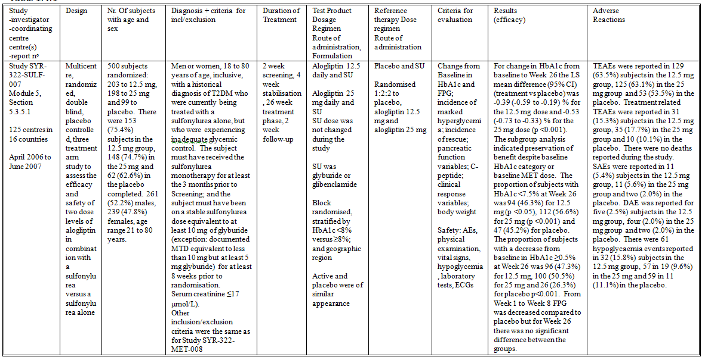

Inclusion and exclusion criteria
The inclusion criteria included:
- Men or women, 18 to 80 years of age, inclusive, with a historical diagnosis of T2DM who were currently being treated with a sulfonylurea alone, but who were experiencing inadequate glycemic control. The subject must have received the sulfonylurea monotherapy for at least the 3 months prior to Screening; and the subject must have been on a stable sulfonylurea dose equivalent to at least 10 mg of glyburide (except where the documented MTD was equivalent to less than 10 mg but at least 5 mg glyburide) for at least 8 weeks prior to randomisation.
- No treatment with antidiabetic agents other than a sulfonylurea within the 3 months prior to Screening.
- Serum creatinine ≤17 micromol/L.
Other inclusion/exclusion criteria were the same as for Study SYR-322-MET-008.

Study treatments
- Alogliptin 12.5 daily and SU
- Alogliptin 25 mg daily and SU
- Placebo and SU
SU dose was not changed during the study. SU was glyburide or glibenclamide, commenced at a dose of 10 mg glyburide equivalent and decreased by 2.5 or 5 mg increments by tolerability.

Efficacy variables and outcomes
The primary efficacy outcome measure was the change from Baseline in HbA1c at Week 26. The secondary efficacy outcome measures were:
- Change from Baseline in HbA1c level at Weeks 4, 8, 12, 16, and 20
- Change from Baseline in FPG at Weeks 1, 2, 4, 8, 12, 16, 20, and 26
- Incidence of marked hyperglycemia (FPG ≥11.1 mmol/L)
- Incidence of hyperglycaemic rescue
- Pancreatic function variables: change from Baseline in fasting proinsulin, insulin and proinsulin/insulin ratio
- Change from Baseline in C-peptide
- Clinical response variables: incidence of Week 26 HbA1c ≤6.5%, ≤7.0%, and ≤7.5%; and incidence of Week 26 HbA1c decrease from Baseline ≥0.5%, ≥1.0%, ≥1.5%, and ≥2.0%.
- Change from Baseline in body weight
- The safety outcome measures included AEs, vital signs, laboratory tests, ECGs and hypoglycaemia episodes.
The schedule of study visits was the same as for Study SYR-322-MET-008.

Randomisation and blinding methods
Subjects were block randomised, stratified by HbA1c <8% versus ≥8%; and geographic region, and allocated 1:2:2 to placebo, alogliptin 12.5 mg and alogliptin 25 mg. Active and placebo were of similar appearance.

Analysis populations
The FAS included all randomized subjects in the Safety Set. The Safety Set included all subjects who took at least one dose of double-blind study drug.

Sample size
The sample size calculation used prior data from another DPP-IV inhibitor. For comparison of either alogliptin dose versus placebo using a two-sample t-test, a sample size of 500 (randomized in the ratio 1:2:2) would provide 95% power to detect a treatment group difference in HbA1c change from Baseline as small as 0.4%, assuming an SD of 0.8%, a two-sided 0.05 significance level, and no less than 80% of randomised subjects evaluable.

Statistical methods
The primary analysis was performed for the FAS using ANCOVA with LOCF values. The primary model included study treatment and geographic region as class effects, and Baseline HbA1c as a continuous covariate.

Participant flow
There were 500 subjects randomized to treatment: 203 to 12.5 mg, 198 to 25 mg and 99 to placebo (Table 18). All randomized subjects were included in the FAS. There were 153 (75.4%) subjects in the 12.5 mg group, 148 (74.7%) in the 25 mg and 62 (62.6%) in the placebo that completed the study.
Table 18. Overall Disposition—Randomized Set (Study SYR-322-SULF-007)

Major protocol violations/deviations
Four subjects were discontinued because of major protocol deviations.

Baseline data
There were 261 (52.2%) males, 239 (47.8%) females and the age range was 21 to 80 years. There were 130 (26.0%) subjects ≥65 years. The treatment groups were similar in demographic characteristics and disease characteristics. The treatment groups were similar in prior and concomitant anti-diabetic treatment.

Results for the primary efficacy outcome
The mean (SD) HbA1c values at Baseline were similar among the groups: 8.08 (0.827) % for 12.5 mg, 8.09 (0.898) % for 25 mg and 8.15 (0.847) % for placebo. The LS mean (SE) change from baseline to Week 26 was -0.38 (0.058) % for 12.5 mg, -0.52 (0.058) % for 25 mg and 0.01 (0.084) % for placebo (Table 19). The LS mean difference (95% CI) (treatment vs placebo) was -0.39 (-0.59 to -0.19) % for the 12.5 mg dose and -0.53 (-0.73 to -0.33) % for the 25 mg dose (p <0.001). The subgroup analysis indicated preservation of benefit despite baseline HbA1c category or baseline MET dose.
Table 19. Summary of the Change from Baseline in HbA1c—Full Analysis Set (LOCF) (Study SYR-322-SULF-007)

Results for other efficacy outcomes
- For the secondary efficacy outcome measures, HbA1c improved in comparison to placebo from Week 4 and the benefit was maintained to Week 26 for both treatment groups.
- The proportion of subjects with HbA1c <6.5% at Week 26 was 19 (9.4%) for 12.5 mg, 28 (14.1%) for 25 mg and seven (7.1%) for placebo p>0.05.
- The proportion of subjects with HbA1c <7.0% at Week 26 was 60 (29.6%) for 12.5 mg (p <0.05), 69 (34.8%) for 25 mg (p<0.01) and 18 (18.2%) for placebo.
- The proportion of subjects with HbA1c <7.5% at Week 26 was 94 (46.3%) for 12.5 mg (p <0.05), 112 (56.6%) for 25 mg (p <0.001) and 47 (45.2%) for placebo.
- The proportion of subjects with a decrease from baseline in HbA1c ≥0.5% at Week 26 was 96 (47.3%) for 12.5 mg, 100 (50.5%) for 25 mg and 26 (26.3%) for placebo p<0.001.
- The proportion of subjects with a decrease from baseline in HbA1c ≥1.0% at Week 26 was 38 (18.7%) for 12.5 mg (p>0.05), 59 (29.8%) for 25 mg (p <0.001) and 13 (13.1%) for placebo.
- The proportion of subjects with a decrease from baseline in HbA1c ≥1.5% at Week 26 was 13 (6.4%) for 12.5 mg, 24 (12.1%) for 25 mg and seven (7.1%) for placebo, p >0.05.
- The proportion of subjects with a decrease from baseline in HbA1c ≥2.0% at Week 26 was five (2.5%) for 12.5 mg, 12 (6.1%) for 25 mg and four (4.4%) for placebo p>0.05.
- From Week 1 to Week 8 FPG was decreased compared to placebo but for Week 26 there was no significant difference between the groups. At Week 26 the LS mean difference (95% CI) was -6.8 (-18.3 to 4.6) mg/dL for 12.5 mg and -10.5 (-22.0 to 0.9) mg/dL for 25 mg
- The incidence of marked hyperglycaemia was lower in the 25 mg group compared with placebo (p <0.05): 47.0% for 12.5 mg, 39.9% for 25 mg and 53.5% for placebo.
- The incidence of rescue was lower in the alogliptin groups compared with placebo (p <0.01): 14.9% for 12.5 mg, 15.7% for 25 mg and 28.3% for placebo.
- There was no significant difference between the groups in proinsulin, insulin or C-peptide concentrations, or in proinsulin/insulin ratio.
- There was weight gain in the alogliptin groups compared with placebo: LS mean difference (95% CI) 0.80 (0.14 to 1.46) kg for 12.5 mg and 0.88 (0.21 to 1.54) kg for 25 mg.
- There was no significant difference between the groups in plasma lipids.

Alogliptin in combination with thiazolidinedione

Study SYR-322-TZD-009

Study design, objectives, locations and dates
Study SYR-322-TZD-009 was a multicentre, randomised, double blind, placebo controlled, three treatment arm study to assess the efficacy and safety of two dose levels of alogliptin-in combination with pioglitazone (with or without MET or a SU) versus pioglitazone alone (with or without MET or a SU) (Table 20). The study was conducted at 125 centres in 13 countries from February 2006 to August 2007.

Table 20. Summary of Study SYR-322-TZD-009
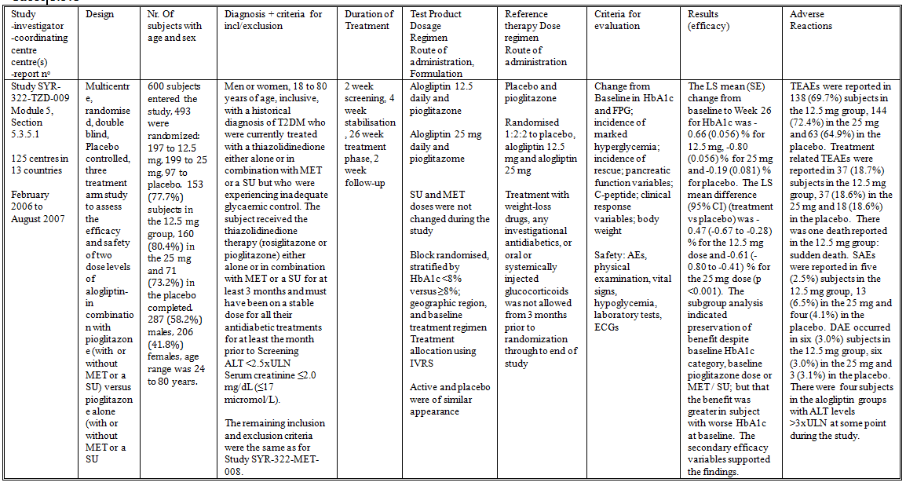

Inclusion and exclusion criteria
- Men or women, 18 to 80 years of age, inclusive, with a historical diagnosis of T2DM who were currently treated with a thiazolidinedione either alone or in combination with MET or a SU but who were experiencing inadequate glycaemic control. The subject received the thiazolidinedione therapy (rosiglitazone or pioglitazone) either alone or in combination with MET or a SU for at least the 3 months prior to Screening and must have been on a stable dose for all their antidiabetic treatments for at least the month prior to Screening
- No treatment with antidiabetic agents other than a thiazolidinedione alone or in combination with either MET or a SU within the 3 months prior to Screening
- ALT <2.5xULN
- Serum creatinine ≤17 μmol/L
The remaining inclusion and exclusion criteria were the same as for Study SYR-322-MET-008.

Study treatments
- Alogliptin 12.5 daily and pioglitazone
- Alogliptin 25 mg daily and pioglitazone
- Placebo and pioglitazone
Subjects could also be treated with either MET or SU. SU and MET doses were not changed during the study. Treatment with weight-loss drugs, any investigational antidiabetics, or oral or systemically injected glucocorticoids was not allowed from 3 months prior to randomization through to end of study.

Efficacy variables and outcomes
The primary efficacy outcome measure was the change from Baseline in HbA1c at Week 26. The secondary efficacy outcome measures were:
- Change from Baseline in HbA1c level at Weeks 4, 8, 12, 16, and 20
- Change from Baseline in FPG at Weeks 1, 2, 4, 8, 12, 16, 20, and 26
- Incidence of marked hyperglycemia (fasting plasma glucose ≥11.1 mmol/L)
- Incidence of hyperglycaemic rescue
- Pancreatic function variables: change from Baseline in fasting proinsulin, insulin and proinsulin/insulin ratio
- Change from Baseline in C-peptide
- Clinical response variables: incidence of Week 26 HbA1c ≤6.5%, ≤7.0%, and ≤7.5%; and incidence of Week 26 HbA1c decrease from Baseline ≥0.5%, ≥1.0%, ≥1.5%, and ≥2.0%.
- Change from Baseline in body weight
- The safety outcome measures included AEs, vital signs, laboratory tests, ECGs and hypoglycaemia episodes.
The schedule of study visits was the same as for Study SYR-322-MET-008.

Randomisation and blinding methods
Block randomised, stratified by HbA1c <8% versus ≥8%; geographic region and baseline treatment regimen (combination of TZD with or without MET or SU). Randomised 1:2:2 to placebo, alogliptin 12.5 mg and alogliptin 25 mg. Active and placebo were of similar appearance.

Analysis populations
The FAS included all randomized subjects in the Safety Set. The Safety Set included all subjects who took at least one dose of double-blind study drug.

Sample size
The sample size calculation used prior data from another DPP-IV inhibitor. For comparison of either alogliptin dose versus placebo using a two-sample t-test, a sample size of 500 (randomized in the ratio 1:2:2) would provide 95% power to detect a treatment group difference in HbA1c change from Baseline as small as 0.4%, assuming an SD of 0.8%, a two-sided 0.05 significance level, and no less than 80% of randomised subjects evaluable.

Statistical methods
The primary analysis was performed for the FAS using ANCOVA with LOCF values. The primary model included study treatment and geographic region as class effects, and Baseline MET dose and Baseline HbA1c as continuous covariates.

Participant flow
A total of 600 subjects entered the study and 493 were randomized to treatment. There were 197 subjects randomized to 12.5 mg, 199 to 25 mg and 97 to placebo. All randomized subjects were included in the FAS. There were 153 (77.7%) subjects in the 12.5 mg group, 160 (80.4%) in the 25 mg and 71 (73.2%) in the placebo that completed the study (Table 21).
Table 21. Overall Disposition—Randomized Set (Study SYR-322-TZD-009)

Major protocol violations/deviations
Four subjects were discontinued from the study due to a protocol deviation.

Baseline data
There were 287 (58.2%) males, 206 (41.8%) females and the age range was 24 to 80 years. There were 85 (17.2%) subjects aged ≥65 years. The treatment groups were similar in demographic characteristics, disease characteristics and in add-on therapy. There were 226 (45.9%) subjects taking rosiglitazone rather than pioglitazone and these subjects continued to take rosiglitazone during the study. After the end of the study, 65 (13.2%) subjects continued on pioglitazone.

Results for the primary efficacy outcome
The mean (SD) HbA1c values at Baseline were similar among the groups: 8.08 (0.910) % for 12.5 mg, 8.01 (0.837) % for 25 mg and 7.97 (0.818) % for placebo. The LS mean (SE) change from baseline to Week 26 was -0.66 (0.056) % for 12.5 mg, -0.80 (0.056) % for 25 mg and -0.19 (0.081) % for placebo (Table 22). The LS mean difference (95% CI) (treatment vs placebo) was -0.47 (-0.67 to -0.28) % for the 12.5 mg dose and -0.61 (-0.80 to -0.41) % for the 25 mg dose (p <0.001). The subgroup analysis indicated preservation of benefit despite baseline HbA1c category, baseline pioglitazone dose or MET / SU; but that the benefit was greater in subject with worse HbA1c at baseline.
Table 22. Summary of Change from Baseline (CFB) in HbA1c—Full Analysis Set (LOCF) (Study SYR-322-TZD-009)
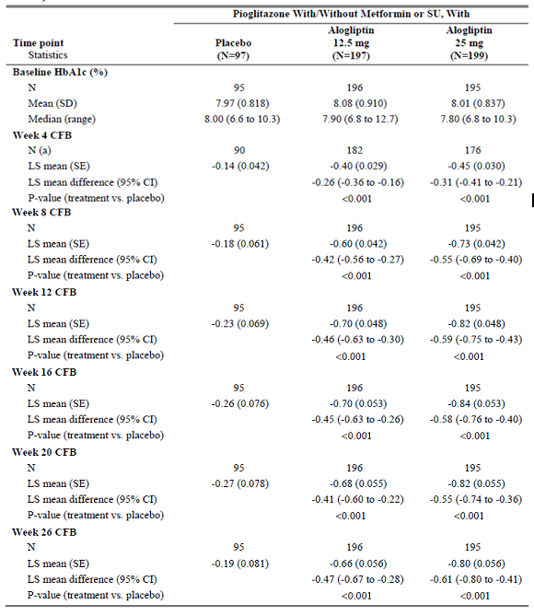

Results for other efficacy outcomes
- For the secondary efficacy outcome measures, HbA1c improved in comparison to placebo from Week 4 and the benefit was maintained to Week 26 for both treatment groups.
- The proportion of subjects with HbA1c <6.5% at Week 26 was 34 (17.3%) for 12.5 mg, 41 (20.6%) for 25 mg and five (5.2%) for placebo p<0.01.
- The proportion of subjects with HbA1c <7.0% at Week 26 was 87 (44.2%) for 12.5 mg, 98 (49.2%) for 25 mg and 33 (34.0%) for placebo, p <0.05.
- The proportion of subjects with HbA1c <7.5% at Week 26 was 127 (64.5%) for 12.5 mg, 141 (70.9%) for 25 mg and 47 (48.5%) for placebo, p <0.001.
- The proportion of subjects with a decrease from baseline in HbA1c ≥0.5% at Week 26 was 118 (59.9%) for 12.5 mg, 128 (64.3%) for 25 mg and 26 (26.8%) for placebo p<0.001.
- The proportion of subjects with a decrease from baseline in HbA1c ≥1.0% at Week 26 was 64 (32.5%) for 12.5 mg, 73 (36.7%) for 25 mg and 12 (12.4%) for placebo, p <0.001.
- The proportion of subjects with a decrease from baseline in HbA1c ≥1.5% at Week 26 was 32 (16.2%) for 12.5 mg (p >0.05), 37 (18.6%) for 25 mg (p <0.01) and five (5.2%) for placebo.
- The proportion of subjects with a decrease from baseline in HbA1c ≥2.0% at Week 26 was 12 (6.1%) for 12.5 mg (p <0.05), 14 (7.0%) for 25 mg (p <0.01) and three (3.1%) for placebo.
- From Week 1 to Week 8 FPG was decreased compared to placebo from Week 1 through to Week 26. At Week 26 the LS mean difference (95% CI) was -13.9 (-23.1 to -4.8) mg/dL for 12.5 mg and -14.1 (-23.3 to -5.0) mg/dL for 25 mg, p <0.01.
- The incidence of marked hyperglycaemia was lower in the 12.5 mg and 25 mg groups compared with placebo (p <0.001): 25.0% for 12.5 mg, 21.7% for 25 mg and 44.3% for placebo.
- There was no significant difference between the groups in the incidence of hyperglycaemic rescue: 9.7% for 12.5 mg, 9.0% for 25 mg and 12.4% for placebo.
- There was no significant difference between the groups in proinsulin, insulin or C-peptide concentrations. The proinsulin/insulin ratio in the 12.5 mg group was slightly lower than placebo: LS mean difference (95% CI) -0.050 (-0.095 to -0.005) p <0.05.
- There was weight gain in all the treatment groups, with no significant difference between the groups. LS mean (SE) gain from baseline was 1.46 (0.230) kg for the 12.5 mg group, 1.09 (0.232) for the 25 mg and 1.04 (0.329) for placebo.
- There was no significant difference between the groups in plasma lipids.
- There was no significant difference between the groups in HOMA-BCF.

Study 01-06-TL-322OPI-002

Study design, objectives, locations and dates
Study 01-06-TL-322OPI-002 was a multicentre, randomized, double blind, four treatment arm study in subjects with T2DM who have failed treatment with diet and exercise, to assess efficacy and safety of alogliptin in combination with pioglitazone as compared with either alogliptin or pioglitazone alone (Table 23). The study was conducted at 268 sites in 23 countries from November 2006 to February 2008.

Table 23. Summary of Study 01-06-TL-322OPI-002
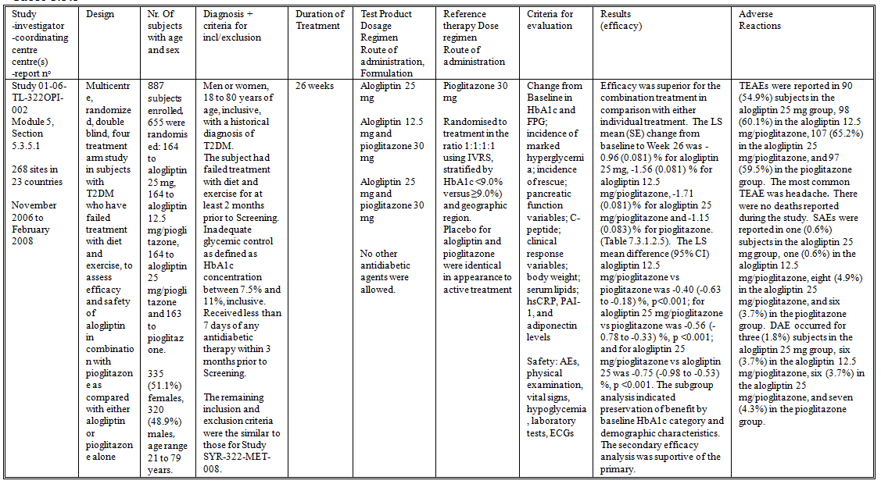

Inclusion and exclusion criteria
The study included:
- Men or women, 18 to 80 years of age, inclusive, with a historical diagnosis of T2DM.
- The subject had failed treatment with diet and exercise for at least 2 months prior to Screening.
- Inadequate glycemic control as defined as HbA1c concentration between 7.5% and 11%, inclusive.
- Received less than 7 days of any antidiabetic therapy within 3 months prior to Screening.
The remaining inclusion and exclusion criteria were the similar to those for Study SYR-322-MET-008.

Study treatments
- Alogliptin 25 mg
- Alogliptin 12.5 mg and pioglitazone 30 mg
- Alogliptin 25 mg and pioglitazone 30 mg
- Pioglitazone 30 mg
The study treatments were administered prior to the first meal of the day for 26 weeks. No other antidiabetic agents were allowed.

Efficacy variables and outcomes
The primary efficacy outcome measure was the change from Baseline in HbA1c at Week 26. The secondary efficacy outcome measures were:
- Change from Baseline in HbA1c level at Weeks 4, 8, 12, 16, and 20
- Change from Baseline in FPG at Weeks 1, 2, 4, 8, 12, 16, 20, and 26
- Incidence of marked hyperglycemia (fasting plasma glucose ≥11.1 mmol/L)
- Incidence of hyperglycaemic rescue
- Clinical response variables: incidence of Week 26 HbA1c ≤6.5%, ≤7.0%, and ≤7.5%; and incidence of Week 26 HbA1c decrease from Baseline ≥0.5%, ≥1.0%, ≥1.5%, and ≥2.0%.
- Pancreatic function variables: change from Baseline in fasting proinsulin, insulin, proinsulin/insulin ratio, HOMA insulin resistance, HOMA beta cell function
- Change from Baseline in C-peptide
- Change in plasma lipids
- Change in FFA, hsCRP, adiponectin and apolipoproteins
- Change from Baseline in body weight
The safety outcome measures included AEs, vital signs, laboratory tests, ECGs and hypoglycaemia episodes.
The schedule of study visits was the same as for Study SYR-322-MET-008.

Randomisation and blinding methods
Subjects were randomised to treatment in the ratio 1:1:1:1 using IVRS, stratified by HbA1c <9.0% versus ≥9.0%) and geographic region. The placebos for alogliptin and pioglitazone were identical in appearance to their respective active treatment.

Analysis populations
The FAS included all randomized subjects in the Safety Set. The Safety Set included all subjects who took at least one dose of double-blind study drug.

Sample size
The estimated sample size was 580 subjects (145 per treatment group) assuming a SD of 1.1% for the change from Baseline in HbA1c in order to provide a power of 97% power to detect a difference of 0.5% in the average change from Baseline in HbA1c at Week 26 (the primary efficacy outcome measure) at the 2-sided 0.05 significance level.

Statistical methods
Hypothesis tests were performed for the FAS using ANCOVA models that included study treatment and geographic region as class effects, and Baseline HbA1c as a continuous covariate.

Participant flow
There were 887 subjects enrolled in the study and 655 were randomised to treatment: 164 to alogliptin 25 mg, 164 to alogliptin 12.5 mg/pioglitazone, 164 to alogliptin 25 mg/pioglitazone and 163 to pioglitazone. There were 126 (76.8%) subjects in the alogliptin 25 mg, 126 (76.8%) in the alogliptin 12.5 mg/pioglitazone, 136 (82.9%) in the alogliptin 25 mg/pioglitazone and 126 (77.3%) in the pioglitazone that completed the study (Table 24).
Table 24. Overall Disposition—Randomized Set (Study 01-06-TL-322OPI-002)

Major protocol violations/deviations
There were 18 subjects discontinued from the study due to protocol deviations.

Baseline data
There were 335 (51.1%) females, 320 (48.9%) males and the age range was 21 to 79 years. There were 98 (15.0%) subjects aged ≥65 years. The treatment groups were similar in demographic characteristics and duration of diabetes. There were five subjects treated with antidiabetic drugs within 3 months and six treated with other antidiabetic drugs during the study.

Results for the primary efficacy outcome
Efficacy was superior for the combination treatment in comparison with either individual treatment. The mean (SD) HbA1c values at Baseline were similar among the groups: 8.80 (0.988) % for alogliptin 25 mg, 8.85 (1.039) % for alogliptin 12.5 mg/pioglitazone, 8.80 (0.962) % for alogliptin 25 mg/pioglitazone and 8.76 (1.005) % for pioglitazone. The LS mean (SE) change from baseline to Week 26 was -0.96 (0.081) % for alogliptin 25 mg, -1.56 (0.081) % for alogliptin 12.5 mg/pioglitazone, -1.71 (0.081) % for alogliptin 25 mg/pioglitazone and -1.15 (0.083) % for pioglitazone (Table 25). The LS mean difference (95% CI) alogliptin 12.5 mg/pioglitazone vs pioglitazone was -0.40 (-0.63 to -0.18) %, p<0.001; for alogliptin 25 mg/pioglitazone vs pioglitazone was -0.56 (-0.78 to -0.33) %, p <0.001; and for alogliptin 25 mg/pioglitazone vs alogliptin 25 was -0.75 (-0.98 to -0.53) %, p <0.001. The subgroup analysis indicated preservation of benefit by baseline HbA1c category and demographic characteristics.
Table 25. Summary of Change from Baseline in HbA1c—FAS (LOCF) (Study 01-06-TL-322OPI-002)
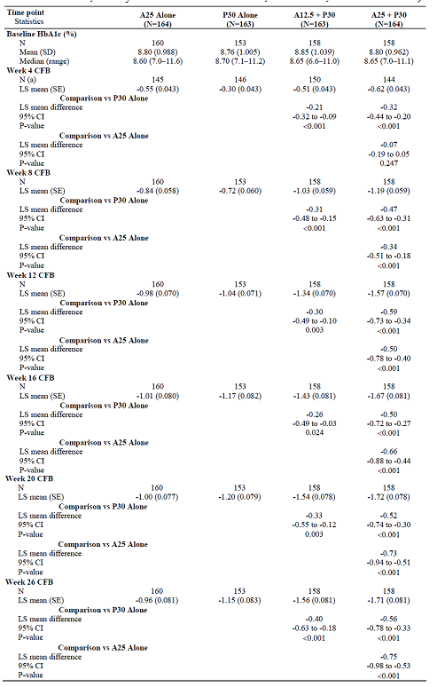

Results for other efficacy outcomes
- HbA1c improved for the combinations in comparison with individual components from Week 4 and the benefit was maintained to Week 26.
- The clinical response variables indicated better response for both combination treatments than for either individual component.
- FPG was decreased in the combination groups compared to individual components from Week 2 through to Week 26.
- The incidence of marked hyperglycaemia was lower in the alogliptin 25/pioglitazone group compared with individual components: 72 (44.4%) subjects for alogliptin 25 mg, 50 (30.9) for alogliptin 12.5 mg/pioglitazone, 41 (25.3) for alogliptin 25 mg/pioglitazone and 60 (38.2) for pioglitazone.
- The incidence of hyperglycaemic rescue was higher in the alogliptin alone group compared with alogliptin 25 mg/pioglitazone, p = 0.018: 18 (11.3%) subjects for alogliptin 25 mg, six (3.8%) for alogliptin 12.5 mg/pioglitazone, four (2.5%) for alogliptin 25 mg/pioglitazone and 10 (6.4%) for pioglitazone.
- There was a statistically significant decrease in the proinsulin concentrations for subjects treated with alogliptin 25 mg/pioglitazone compared with either individual component, p <0.05. The change from baseline was -4.8 pmol/L for alogliptin 25 mg, -15.1 pmol/L for alogliptin 12.5 mg/pioglitazone, -18.3 pmol/L for alogliptin 25 mg/pioglitazone and -13.2 pmol/L for pioglitazone.
- Insulin concentrations decreased in the pioglitazone groups: LS mean change from baseline -0.47 μU/mL for alogliptin 25 mg, -3.72 μU/mL for alogliptin 12.5 mg/pioglitazone, -3.86 μU/mL for alogliptin 25 mg/pioglitazone and -4.06 μU/mL for pioglitazone.
- The decrease in HOMA insulin resistance was greater in the pioglitazone treated groups: LS mean change from baseline -1.353 for alogliptin 25 mg, -3.508 for alogliptin 12.5 mg/pioglitazone, -3.646 for alogliptin 25 mg/pioglitazone and -3.350 for pioglitazone.
- The increase in HOMA beta cell function was greater in the pioglitazone treated groups: LS mean change from baseline 10.472 for alogliptin 25 mg, 24.887 for alogliptin 12.5 mg/pioglitazone, 39.153 for alogliptin 25 mg/pioglitazone and 17.500 for pioglitazone.
- The decrease in C-peptide concentrations was greater in the pioglitazone treated groups: LS mean change from baseline -0.068 ng/mL for alogliptin 25 mg, -0.444 ng/mL for alogliptin 12.5 mg/pioglitazone, -0.541 ng/mL for alogliptin 25 mg/pioglitazone and -0.577 ng/mL for pioglitazone.
- There was weight gain in the pioglitazone treated groups. LS mean (SE) change from baseline was -0.29 (0.291) kg for alogliptin 25 mg, 2.51 (0.296) kg for alogliptin 12.5 mg/pioglitazone, 3.14 (0.295) kg for alogliptin 25 mg/pioglitazone and 2.19 (0.302) kg for pioglitazone alone.
- Relative to alogliptin 25 mg alone, there was an increase in HDL cholesterol and a decrease in triglycerides in the alogliptin 25 mg/pioglitazone group. Apolipoprotein A concentrations were higher, Apolipoprotein B were lower, PAI-I levels lower (-8.85 [-17.67 to -0.03] ng/mL, p = 0.049), hsCRP lower (-1.791 [-2.994 to -0.589] mg/L, p = 0.004), and adiponectin higher (6.94 [5.33 to 8.55] μg/mL, p <0.001) in the alogliptin 25 mg/pioglitazone group than the alogliptin 25 mg.

Alogliptin as monotherapy

Study SYR-322-PLC-010

Study design, objectives, locations and dates
Study SYR-322-PLC-010 was a multicentre, randomised, double blind, placebo controlled study to determine the efficacy and safety of alogliptin compared with placebo in subjects with T2DM (Table 26). The study was conducted at 117 sites in 16 countries from February 2006 to July 2007.

Table 26. Summary of Study SYR-322-PLC-010
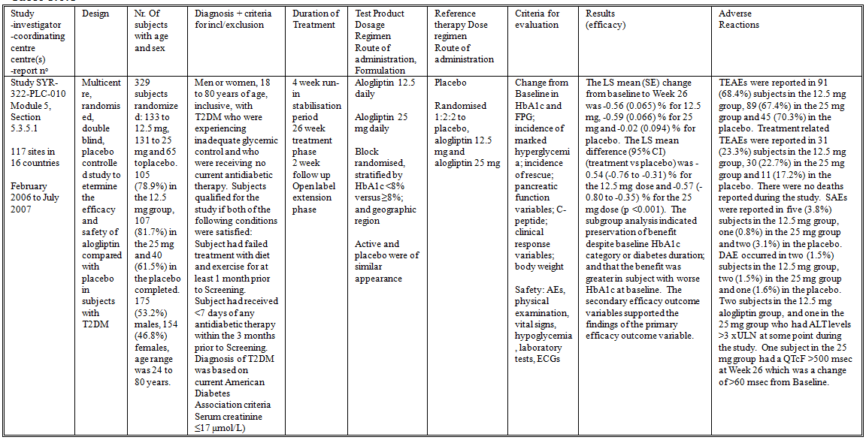

Inclusion and exclusion criteria
- Men or women, 18 to 80 years of age, inclusive, with T2DM who were experiencing inadequate glycemic control and who were receiving no current antidiabetic therapy. Subjects qualified for the study if both of the following conditions were satisfied:
- Subject had failed treatment with diet and exercise for at least 1 month prior to Screening.
- Subject had received <7 days of any antidiabetic therapy within the 3 months prior to Screening.
- Diagnosis of T2DM was based on current American Diabetes Association criteria: fasting plasma glucose ≥6.99 mmol/L, oral glucose tolerance test at 2-hour post-load was ≥11.10 mmol/L, or symptoms of diabetes plus casual plasma glucose ≥11.10 mmol/L.
- Serum creatinine ≤17 μmol/L.
Other than these criteria, the inclusion and exclusion criteria were the same as for Study SYR-322-MET-008.

Study treatments
- Alogliptin 12.5 daily
- Alogliptin 25 mg daily
- Placebo
There was a 4 week run-in stabilisation period, a 26 week treatment phase and a 2 week follow up. At the end of the study the remaining subjects could enter an open label extension phase.

Efficacy variables and outcomes
The primary efficacy outcome measure was the change from Baseline in HbA1c at Week 26. The secondary efficacy outcome measures were:
- Change from Baseline in HbA1c level at Weeks 4, 8, 12, 16, and 20
- Change from Baseline in FPG at Weeks 1, 2, 4, 8, 12, 16, 20, and 26
- Incidence of marked hyperglycemia (fasting plasma glucose ≥11.1 mmol/L)
- Incidence of rescue
- Pancreatic function variables: change from Baseline in fasting proinsulin, insulin and proinsulin/insulin ratio
- Change from Baseline in C-peptide
- Clinical response variables: incidence of Week 26 HbA1c ≤6.5%, ≤7.0%, and ≤7.5%; and incidence of Week 26 HbA1c decrease from Baseline ≥0.5%, ≥1.0%, ≥1.5%, and ≥2.0%.
- Change from Baseline in body weight
The safety outcome measures included AEs, vital signs, laboratory tests, ECGs and hypoglycaemia episodes.
The schedule of study visits was the same as for Study SYR-322-MET-008, with the exception that there was no dispensing of MET.

Randomisation and blinding methods
Subjects were block randomised, stratified by HbA1c <8% versus ≥8%; and geographic region using IVRS; and allocated in the ratio 1:2:2 to placebo, alogliptin 12.5 mg and alogliptin 25 mg. Active and placebo were of similar appearance.

Analysis populations
The FAS included all randomized subjects in the Safety Set. The Safety Set included all subjects who took at least one dose of double-blind study drug.

Sample size
The sample size calculation used prior data from another DPP-IV inhibitor. For comparison of either alogliptin dose versus placebo using a two-sample t-test, a sample size of 325 (randomized in the ratio 1:2:2) would provide 95% power to detect a treatment group difference in HbA1c change from Baseline as small as 0.5%, assuming an SD of 0.8%, a two-sided 0.05 significance level, and no less than 80% of randomised subjects evaluable.

Statistical methods
The primary analysis was performed for the FAS using ANCOVA with LOCF values. The primary model included study treatment and geographic region as class effects, and diabetes duration and Baseline HbA1c as continuous covariates.

Participant flow
There were 329 subjects randomized to treatment: 133 to 12.5 mg, 131 to 25 mg and 65 to placebo (Table 27). Of the randomized subjects 105 (78.9%) in the 12.5 mg group, 107 (81.7%) in the 25 mg and 40 (61.5%) in the placebo completed the study. One subject in the placebo group did not receive study treatment and was excluded from analysis.
Table 27. Overall Disposition—Randomized Set (Study SYR-322-PLC-010)

Major protocol violations/deviations
Two subjects were discontinued because of protocol violations.

Baseline data
There were 175 (53.2%) males, 154 (46.8%) females and the age range was 24 to 80 years. There were 55 (16.7%) subjects aged ≥65 years. The treatment groups were similar in demographic characteristics except for a higher proportion of males, and shorter mean disease duration in the 25 mg group. Only five (1.5%) subjects received antidiabetic drugs in the 3 months prior to randomization. Only three (0.9%) subjects received concomitant antidiabetic treatment during the study.

Results for the primary efficacy outcome
The mean (SD) HbA1c values at Baseline were similar among the groups: 7.91 (0.810) % for 12.5 mg, 7.91 (0.788) % for 25 mg and 8.03 (0.910) % for placebo. The LS mean (SE) change from baseline to Week 26 was -0.56 (0.065) % for 12.5 mg, -0.59 (0.066) % for 25 mg and -0.02 (0.094) % for placebo (Table 28). The LS mean difference (95% CI) (treatment vs placebo) was -0.54 (-0.76 to -0.31) % for the 12.5 mg dose and -0.57 (-0.80 to -0.35) % for the 25 mg dose (p <0.001). The subgroup analysis indicated preservation of benefit despite baseline HbA1c category or diabetes duration; and that the benefit was greater in subject with worse HbA1c at baseline.
Table 28. Summary of Change from Baseline in HbA1c—Full Analysis Set (LOCF) (Study SYR-322-PLC-010)
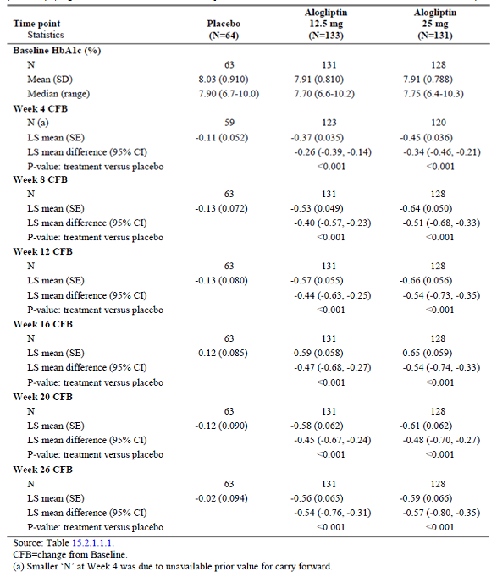

Results for other efficacy outcomes
- For the secondary efficacy outcome measures, HbA1c improved in comparison to placebo from Week 4 and the benefit was maintained to Week 26 for both treatment groups.
- The proportion of subjects with HbA1c <6.5% at Week 26 was 23 (17.3%) for 12.5 mg, 27 (20.6%) for 25 mg and seven (10.9%) for placebo p>0.05.
- The proportion of subjects with HbA1c <7.0% at Week 26 was 63 (47.4%) for 12.5 mg, 58 (44.3%) for 25 mg and 15 (23.4%) for placebo, p <0.01.
- The proportion of subjects with HbA1c <7.5% at Week 26 was 81 (60.9%) for 12.5 mg (P <0.01), 88 (67.2%) for 25 mg (p <0.001) and 25 (39.1%) for placebo.
- The proportion of subjects with a decrease from baseline in HbA1c ≥0.5% at Week 26 was 67 (50.4%) for 12.5 mg (p <0.01), 72 (55.0%) for 25 mg (p<0.001) and 19 (29.7%) for placebo.
- The proportion of subjects with a decrease from baseline in HbA1c ≥1.0% at Week 26 was 38 (28.6%) for 12.5 mg (p <0.01), 39 (29.8%) for 25 mg (p <0.001) and seven (10.9%) for placebo.
- The proportion of subjects with a decrease from baseline in HbA1c ≥1.5% at Week 26 was 11 (8.3%) for 12.5 mg, 16 (12.2%) for 25 mg and three (4.7%) for placebo (p >0.05).
- The proportion of subjects with a decrease from baseline in HbA1c ≥2.0% at Week 26 was three (2.3%) for 12.5 mg, six (4.6%) for 25 mg and one (1.6%) for placebo.
- From Week 1 to Week 8 FPG was decreased compared to placebo from Week 1 through to Week 26. At Week 26 the LS mean difference (95% CI) was -21.6 (-34.1 to -9.0) mg/dL for 12.5 mg and -27.8 (-40.4 to -15.1) mg/dL for 25 mg, p <0.001.
- The incidence of marked hyperglycaemia was lower in the 12.5 mg and 25 mg groups compared with placebo: 33.1% for 12.5 mg (p >0.05), 25.4% for 25 mg (p <0.01) and 46.9% for placebo.
- There was no significant difference between the groups in the incidence of hyperglycaemic rescue: 9.8% for 12.5 mg (p <0.01), 7.6% for 25 mg (p <0.001) and 29.7% for placebo.
- There was no significant difference between the groups in proinsulin, insulin, C-peptide or glucagon concentrations. The proinsulin/insulin ratios in the alogliptin groups were slightly lower than placebo: LS mean difference (95% CI) -0.086 (-0.138 to -0.034) p <0.01 for the 12.5 mg group and -0.084 (-0.137 to -0.032) p <0.01 for 25 mg.
- There was no significant difference between the groups in weight change from baseline. LS mean (SE) change from baseline was -0.09 (0.258) kg for the 12.5 mg group, -0.22 (0.259) for the 25 mg and 0.18 (0.368) for placebo.
- There was a significant decrease in total cholesterol in the alogliptin groups compared with placebo: LS mean (95% CI) difference -11.3 (-19.2 to -3.3) mg/dL for 12.5 mg and -13.9 (-21.9 to -5.9) mg/dL for 25 mg. There was also a significant decrease in triglycerides relative to placebo in the 25 mg group: -44.3 (-79.9 to -8.6) mg/dL.
- There was no significant difference between the groups in HOMA-BCF.
- The change from baseline in HbA1c was not affected by demographic subgroup.

Study SYR-322-303

Study design, objectives, locations and dates
Study SYR-322-303 was a multicentre, randomized, double blind, comparator controlled study to evaluate the efficacy and safety of alogliptin monotherapy compared to glipizide in elderly subjects with T2DM (Table 29). The study was conducted at 110 centres in 15 countries from June 2008 to August 2010.

Table 29. Summary of Study SYR-322-303
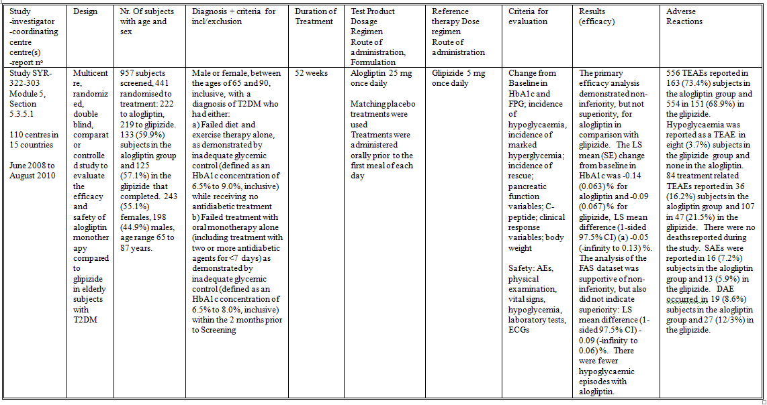

Inclusion and exclusion criteria
The inclusion criteria included:
- Male or female, between the ages of 65 and 90, inclusive, with a diagnosis of T2DM who had either:
  - Study Schedule A: Failed diet and exercise therapy alone, as demonstrated by inadequate glycemic control (defined as an HbA1c concentration of 6.5% to 9.0%, inclusive) while receiving no antidiabetic treatment (defined as <7 days of any antidiabetic treatment) within the 2 months prior to Screening (Schedule A). Subjects following Schedule A may have been randomized immediately upon confirmation of eligibility.
  - Study Schedule B: Failed treatment with oral monotherapy alone (including treatment with two or more antidiabetic agents for <7 days) as demonstrated by inadequate glycemic control (defined as an HbA1c concentration of 6.5% to 8.0%, inclusive) within the 2 months prior to Screening (Schedule B). Subjects following Schedule B underwent a 4-week Washout Period including an assessment at the end of washout to reconfirm eligibility prior to randomization.
- BMI ≥23 kg/m² and ≤45 kg/m²
- The subject had no major illness or debility that, in the investigator’s opinion, prohibited him or her from completing the study.
The exclusion criteria included
- SBP ≥160 mm Hg and/or DBP ≥100 mmHg.
- Haemoglobin ≤120 g/L for men or ≤100 g/L for women.
- ALT ≥3×ULN.
- Calculated CrCL ≤50 mL/min.
- TSH level outside of the normal range.
- History of cancer, other than squamous cell or basal cell carcinoma of the skin, that had not been in full remission for at least 5 years prior to Screening
- History of laser treatment for proliferative diabetic retinopathy within 6 months.
- History of treated diabetic gastroparesis, gastric banding, or gastric bypass surgery.
- NYHA Class III or IV heart failure regardless of therapy.
- History of coronary angioplasty, coronary stent placement, coronary bypass surgery, or myocardial infarction within the 6 months prior to Screening.
- History of any haemoglobinopathy that may affect determination of HbA1c.
- History of infection with HIV.
- History of angioedema in association with use of angiotensin-converting enzyme inhibitors or angiotensin-II receptor inhibitors.
- History of alcohol or substance abuse within 2 years.
- History of treatment with any weight-loss drugs or oral or systemically injected glucocorticoids within 3 months.
- Clinically significant medical abnormality or disease or clinically significant abnormal findings at Screening (other than T2DM) that, in the opinion of the investigator, should have excluded the subject from the study.

Study treatments
- Alogliptin 25 mg once daily
- Glipizide 5 mg once daily
Treatment duration was for 52 weeks. No concomitant antidiabetic drugs were allowed. Treatments were administered orally prior to the first meal of each day

Efficacy variables and outcomes
The primary efficacy outcome measure was change from baseline in HbA1c at Week 52. The secondary efficacy outcome measures were:
- HbA1c at Weeks 4, 8, 12, 16, 20, 26, 34, and 42.
- FPG at Weeks 2, 4, 8, 12, 16, 20, 26, 34, 42, and 52.
- Incidence of hypoglycemia.
- Clinical response endpoints including: incidence of Week 52 HbA1c ≤6.5% and ≤7.0% and incidence of Week 52 HbA1c decrease from Baseline ≥0.5%, ≥1.0%, ≥1.5% and ≥2.0%.
- 2-hour PPG at Weeks 26 and 52.
- Incidence of marked hyperglycemia (FPG ≥11.10 mmol/L).
- Incidence of hyperglycemic rescue.
- Proinsulin, Insulin, Proinsulin/insulin ratio and HOMA β-cell function at Weeks 12, 26, 42, and 52.
- Body weight at Weeks 8, 12, 26, 42, and 52.
- Serum lipids at Weeks 8, 12, 26, 42, and 52.
- hsCRP at Weeks 12, 26, 42, and 52.
- QOL scale scores and PRO measures: SF-12, EQ-5D with VAS, DTSQs, DTSQc, and HypoSRQ.
- The safety outcome measures included AEs, vital signs, laboratory tests, ECGs and hypoglycaemia episodes.
The schedule of study visits is summarised in the CSR.

Randomisation and blinding methods
Randomisation was in the ratio of 1:1 using IVRS, and was stratified by baseline HbA1c, study schedule (Schedule A or Schedule B), and geographic region. Active and placebo tablets were of similar appearance.

Analysis populations
The primary efficacy (non-inferiority) analysis was performed on the PPS, which included all FAS subjects who had no major protocol violations. The FAS included all randomized subjects in the Safety Set. The Safety Set included all subjects who took at least one dose of double-blind study drug.

Sample size
The sample size calculation was performed for a non-inferiority analysis for the PPS population, on the primary efficacy outcome variable, for a t-test. The calculation was for a samples size of 430 to 470 subjects (215-235 per treatment) to provide a power of 90%, assuming an SD of 1.1%, a non-inferiority margin of 0.4%, no difference between the treatment arms, an evaluability rate (ie, protocol correct rate) of 75%, and a 1-sided significance level of 0.025.

Statistical methods
The primary analysis was conducted using the PPS and an ANCOVA model with change from Baseline in HbA1c at Week 52 (LOCF) as the response variable. The analysis was conducted at the 1-sided 0.025 significance level. The model included study treatment, the study schedule (A or B) under which the subject was randomized, and geographic region as class effects, and baseline HbA1c as a continuous covariate. The LS means and SEs were used to construct a 1-sided 97.5% CI for the LS mean difference in change from Baseline in HbA1c at Week 52 between the alogliptin group and the glipizide group. Non-inferiority was demonstrated if the upper confidence limit for the LS mean difference was less than +0.4%. If non-inferiority was declared, an additional comparison for statistical superiority of the alogliptin group relative to the glipizide group was performed using the PPS and the same ANCOVA model. Superiority was declared if the upper limit 1-sided 97.5% CI of the LS mean difference was less than 0%. Missing variables were imputed using LOCF.

Participant flow
There were 957 subjects screened and 441 randomised to treatment: 222 to alogliptin and 219 to glipizide (Figure 2). There were 133 (59.9%) subjects in the alogliptin group and 125 (57.1%) in the glipizide that completed the study. All randomised subjects were included in the FAS. There were 180 (81.1%) subjects from the alogliptin group and 162 (74.0%) in the glipizide included in the PPS.
Figure 2. Disposition of Subjects (Study SYR-322-303)

Major protocol violations/deviations
A tabulation of reasons for exclusion from the PPS was not provided.

Baseline data
There were 243 (55.1%) females, 198 (44.9%) males and the age range was 65 to 87 years. The treatment groups were similar in demographic characteristics. The treatment groups were similar in comorbid medical conditions. The treatment groups were similar in concomitant medications.

Results for the primary efficacy outcome
The primary efficacy analysis demonstrated non-inferiority, but not superiority, for alogliptin in comparison with glipizide. The LS mean (SE) change from baseline in HbA1c was -0.14 (0.063) % for alogliptin and -0.09 (0.067) % for glipizide, LS mean difference (upper 97.5% CI) -0.05 (0.13) %, i.e. the upper confidence limit for the LS mean difference was less than +0.4% (Table 30). The analysis of the FAS dataset was supportive of non-inferiority, but also did not indicate superiority: LS mean difference (lower 97.5% CI) -0.09 (0.06) %. There was no apparent subgroup effect. There was no difference between the treatment in response base on whether the subjects were treatment naïve or had received prior antidiabeteic drugs.
Table 30. Comparison of Primary Efficacy Variable Across Analysis Sets (Study SYR-322-303)

Results for other efficacy outcomes
- The improvement in HbA1c for alogliptin was similar to that for glipizide at all time points, and maximal at Week 12.
- There was no significant difference between the treatment groups in change in FPG from baseline at any visit.
- There were 31 hypoglycaemic episodes in 12 (5.4%) subjects in the alogliptin group and 232 in 57 (26.0%) in the glipizide. None of the events in the alogliptin group were severe compared with three in the glipizide.
- There was no significant difference between the groups in the incidence of clinical response.
- There was no significant difference between the groups in 2-hour PPG at Weeks 26 and 52.
- There was no significant difference in the incidence of marked hyperglycemia: 50 (22.5%) subjects for alogliptin and 37 (16.9%) for glipizide.
- There was no significant difference in the incidence of hyperglycemic rescue: 55 (24.9%) subjects for alogliptin and 47 (21.5%) for glipizide.
- Proinsulin concentrations decreased in the alogliptin group relative to glipizide: LS mean difference (95% CI) -7.8 (-11.9, -3.8) pmol/L, p <0.001. There was no significant difference for insulin or proinsulin/insulin ratio. There was an increase in HOMA β-cell function in the glipizide group relative to alogliptin: LS mean difference (95% CI) -45.036 (-84.419 to -5.654), p = 0.025.
- Body weight decreased over 52 weeks in the alogliptin group and increased in the glipizide: LS mean (SE) change from baseline -0.62 (0.227) kg for alogliptin and 0.60 (0.233) kg for glipizide.
- There was no significant difference between the groups in total cholesterol, HDL-cholesterol or LDL-cholesterol; but triglyceride concentrations were lower in the alogliptin group at Week 52: LS mean difference (95% CI) -15.1 (-30.0 to -0.2) mg/dL p = 0.046.
- There was no significant difference between the groups in change from baseline in hsCRP at Week 52: LS mean (SE) 0.01 (0.656) mg/L for alogliptin and 0.21 (0.679) mg/L for glipizide.
- The results of the QOL scale scores and PRO measures (SF-12, EQ-5D with VAS, DTSQs, DTSQc, and HypoSRQ) were not presented in the study report and were stated to be in a separate report.

Alogliptin in combination with Insulin

Study SYR-322-INS-011

Study design, objectives, locations and dates
Study SYR-322-INS-011 was a multicentre, randomized, double blind, placebo controlled, three arm study to evaluate the efficacy and safety of two dose levels of alogliptin in combination with insulin (with or without MET) versus insulin alone (with or without MET) (Table 31). The study was conducted at 110 sites in 13 countries from February 2006 to May 2007.

Table 31. Summary of Study SYR-322-INS-011
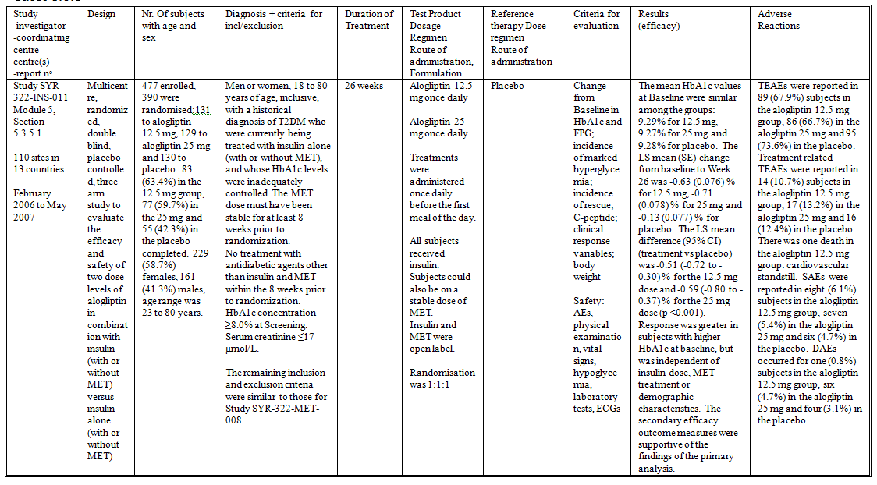

Inclusion and exclusion criteria
The study included:
- Men or women, 18 to 80 years of age, inclusive, with a historical diagnosis of T2DM who were currently being treated with insulin alone (with or without MET), and whose HbA1c levels were inadequately controlled. The MET dose must have been stable for at least 8 weeks prior to randomization.
- No treatment with antidiabetic agents other than insulin and MET within the 8 weeks prior to randomization.
- HbA1c concentration ≥8.0% at Screening.
- The insulin dose must have been ≥15 units and ≤100 units per day for at least 8 weeks prior to randomization. A dose of insulin that varied by up to 15% of the mean was considered stable.
- Serum creatinine ≤17 μmol/L.
The remaining inclusion and exclusion criteria were similar to those for Study SYR-322-MET-008.

Study treatments
- Alogliptin 12.5 mg once daily
- Alogliptin 25 mg once daily
- Placebo
Treatments were administered once daily before the first meal of the day for 26 weeks. All subjects received insulin. Subjects could also be on a stable dose of MET. Insulin and MET were open label. No other antidiabetic drugs were allowed.

Efficacy variables and outcomes
The primary efficacy outcome measure was the change from Baseline in HbA1c at Week 26. The secondary efficacy outcome measures were:
- Change from Baseline in HbA1c level at Weeks 4, 8, 12, 16, and 20
- Change from Baseline in FPG at Weeks 1, 2, 4, 8, 12, 16, 20, and 26
- Incidence of marked hyperglycemia (fasting plasma glucose ≥11.1 mmol/L)
- Incidence of rescue
- Change from Baseline in C-peptide
- Clinical response variables: incidence of Week 26 HbA1c ≤6.5%, ≤7.0%, and ≤7.5%; and incidence of Week 26 HbA1c decrease from Baseline ≥0.5%, ≥1.0%, ≥1.5%, and ≥2.0%.
- Change from Baseline in body weight
The safety outcome measures included AEs, vital signs, laboratory tests, ECGs and hypoglycaemia episodes.
The schedule of study visits was similar to that summarised for Study MET-008 in Table 6

Randomisation and blinding methods
Subjects were block randomized in the ratio 1:1:1 using IVRS, stratified by HbA1c <9.0% vs ≥9.0%; geographic region; and Baseline treatment regimen (insulin alone vs insulin plus MET). Alogliptin and placebo were of identical appearance. Insulin and MET were open label.

Analysis populations
The FAS included all randomized subjects in the Safety Set. The Safety Set included all subjects who took at least one dose of double-blind study drug.

Sample size
The sample size calculation was performed for the primary efficacy outcome measure, for a two sample t-test, with a power of 94% to detect a treatment group difference in HbA1c change from Baseline of 0.4% assuming a SD of 0.8%, a two-sided 0.05 significance level, and no less than 80% of randomized subjects evaluable. This calculated that 390 subjects in total would be required.

Statistical methods
Hypothesis tests were performed using ANCOVA models with study treatment, geographic region, and Baseline treatment regimen as class variables, and Baseline daily insulin dose and Baseline HbA1c as continuous covariates.

Participant flow
There were 477 subjects enrolled in the study, of whom 390 were randomised to treatment: 131 to alogliptin 12.5 mg, 129 to alogliptin 25 mg and 130 to placebo. There were 83 (63.4%) subjects in the 12.5 mg group, 77 (59.7%) in the 25 mg and 55 (42.3%) in the placebo that completed the study (Table 32).
Table 32. Overall Disposition—Randomized Set (Study SYR-322-INS-011)

Major protocol violations/deviations
Twelve subjects were discontinued from the study due to a protocol deviation; three from the placebo group, five from the alogliptin 12.5 mg group, and four from the alogliptin 25 mg group.

Baseline data
There were 229 (58.7%) females, 161 (41.3%) males and the age range was 23 to 80 years. The treatment groups were similar in demographic characteristics, duration of diabetes, insulin dose and MET dose at baseline. The treatment groups were similar in the types of insulin used during the study.

Results for the primary efficacy outcome
The mean HbA1c values at Baseline were similar among the groups: 9.29% for 12.5 mg, 9.27% for 25 mg and 9.28% for placebo. The LS mean (SE) change from baseline to Week 26 was -0.63 (0.076) % for 12.5 mg, -0.71 (0.078) % for 25 mg and -0.13 (0.077) % for placebo (Table 33) The LS mean difference (95% CI) (treatment vs placebo) was -0.51 (-0.72 to -0.30) % for the 12.5 mg dose and -0.59 (-0.80 to -0.37) % for the 25 mg dose (p <0.001). Response was greater in subjects with higher HbA1c at baseline, but was independent of insulin dose, MET treatment or demographic characteristics.
Table 33. Summary of Change from Baseline (CFB) in HbA1c—Full Analysis Set (LOCF) (Study SYR-322-INS-011)
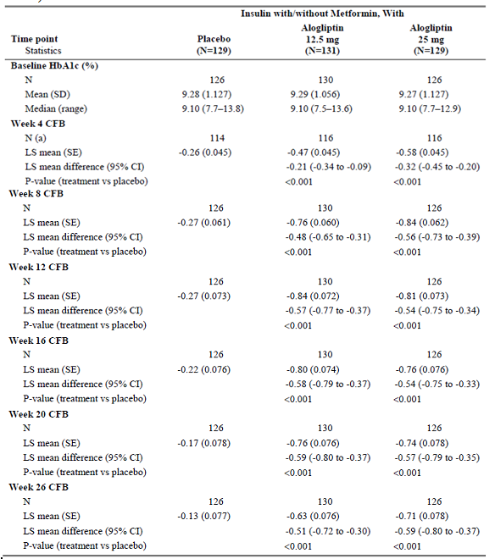

Results for other efficacy outcomes
- HbA1c improved in comparison to placebo from Week 4 and the benefit was maintained to Week 26 for both treatment groups.
- The proportion of subjects with HbA1c <6.5% at Week 26 was three (2.3%) for 12.5 mg, three (2.3%) for 25 mg and none for placebo.
- The proportion of subjects with HbA1c <7.0% at Week 26 was 11 (8.4%) for 12.5 mg (p = 0.048), 10 (7.8%) for 25 mg (p = 0.227) and one (0.8%) for placebo.
- The proportion of subjects with HbA1c <7.5% at Week 26 was 22 (16.8%) for 12.5 mg (p = 0.016), 33 (25.6%) for 25 mg (p < 0.001) and five (3.9%) for placebo.
- The proportion of subjects with a decrease from baseline in HbA1c ≥0.5% at Week 26 was 70 (53.4%) for 12.5 mg (p <0.001), 70 (54.3%) for 25 mg (p = 0.001) and 40 (31.0%) for placebo.
- The proportion of subjects with a decrease from baseline in HbA1c ≥1.0% at Week 26 was 41 (31.3%) for 12.5 mg (p = 0.002), 47 (36.4%) for 25 mg (p = 0.001) and nine (8.7%) for placebo.
- The proportion of subjects with a decrease from baseline in HbA1c ≥1.5% at Week 26 was 22 (16.8%) for 12.5 mg (p = 0.030), 23 (17.8%) for 25 mg (p = 0.050) and six (4.7%) for placebo.
- The proportion of subjects with a decrease from baseline in HbA1c ≥2.0% at Week 26 was eleven (16.8%) for 12.5 mg (p = 0.092), eleven (8.5%) for 25 mg (p = 0.23) and none for placebo p>0.05.
- There was no significant difference in FPG at Week 26 between alogliptin 12.5 and placebo, but FPG for alogliptin 25 mg was significantly lower. At Week 26 the LS mean difference (95% CI) was -3.5 (-19.2 to 12.2) mg/dL for 12.5 mg and -17.6 (-33.4 to -1.7) mg/dL for 25 mg.
- The incidence of marked hyperglycaemia was higher in the placebo group: 82.0% compared with 75.6% for 12.5 mg (p = 0.047) and 67.2% for 25 mg (p = 0.002).
- The incidence of rescue was higher in the placebo group: 40.3% compared with 20.6% for 12.5 mg and 19.5% for 25 mg, p <0.001.
- There was no significant difference between the groups in C-peptide concentrations.
- There was no significant difference between the groups in change in body weight: LS mean change 0.68 kg for alogliptin 12.5 mg, 0.60 kg for alogliptin 25 mg and 0.63 kg for placebo,
- There was no significant difference between the groups in plasma lipids.

Supportive studies

Other efficacy studies

Study SYR-322-301
Study SYR-322-301 was a multicentre, randomized, double blind, placebo controlled, parallel group study comparing alogliptin alone and in combination with pioglitazone versus placebo on postprandial lipids in subjects with T2DM. The study was conducted at two sites in Sweden and the Netherlands from July 2007 to December 2009. The study included:
- Male or female subjects with T2DM; 18 to 70 years of age, inclusive;
- Who had either failed treatment with diet and exercise for 3 months prior to Screening or had been receiving a stable dose of MET, sulfonylurea, nataglinide, or repaglinide for more than 3 months
- Inadequate glycemic control, as defined by HbA1c concentration between 6.5 and 9.0%, inclusive
- FPG <13.3 mmol/L
- Fasting serum triglyceride level of 1.7 to 5.0 mmol/L, inclusive
- No lipid-lowering therapy within 3 months prior to Screening or on a stable statin and/or ezetimibe therapy (same drug and dose) for at least 3 months
- BMI >23 kg/m² and <45 kg/m².
The study treatments were:
- Alogliptin 25 mg
- Alogliptin 25 mg and pioglitazone 30 mg
- Placebo
Treatments were administered once daily for 16 weeks. Subjects were randomised 1:1:1, stratified by statin and ezetimibe use.
The primary efficacy outcome variable was the change from Baseline in postprandial incremental AUC for total triglycerides at Week 16. Secondary variables included postprandial incremental AUC changes for triglycerides at Week 4, lipid parameters, and lipoprotein parameters; postprandial changes over time in GLP-1, glucose, insulin, and glucagon; fasting plasma glucose, C-peptide, hs-CRP, adiponectin, HbA1c, insulin, proinsulin, VCAM, ICAM, e-selectin; and pulse wave tonometry.
A total of 298 subjects were screened, and 71 subjects were randomised. All randomised subjects were included in FAS and safety sets. One subject in the alogliptin/ pioglitazone group did not complete. There were 50 (70.4%) males, 21 (29.6%) females, and the age range was 42 to 70 years. The treatment groups were similar in demographic characteristics.
There was a decreased in triglyceride AUC compared to placebo for alogliptin 25 mg; LS mean difference (95% CI) -307.229 (-443.168 to -171.290) mg.hr/dL; and also, but to a lesser extent, for the alogliptin 25 mg/pioglitazone group: -307.229 (-443.168 to -171.290) mg.hr/dL. The benefit was regardless of concurrent lipid lowering treatment. There was also a significant decrease in cholesterol relative to placebo. Activated GLP-1 concentrations were higher in the alogliptin groups compared with placebo. Plasma glucagon levels were lower in the alogliptin 25 mg and alogliptin 25 mg/pioglitazone groups compared with placebo. There was a significant decrease in postprandial plasma glucose from 30 minutes to 3 hours postprandial. HbA1c decreased significantly relative to placebo. Compared with placebo, there were also decreases in proinsulin, C-peptide and insulin concentrations at Week 16. There were no significant differences in VCAM, ICAM, e-selectin; and pulse wave tonometry. There was a significant increase in adiponectin in the pioglitazone treated group.

Study 01-05-TL-322OPI-001
Study 01-05-TL-322OPI-001 was a multicenter, randomized, double blind, placebo controlled, 12-treatment arm study in subjects with T2DM who were inadequately controlled on a current regimen of MET alone. The study was conducted at 327 sites in 20 countries from May 2006 to March 2008. The study included male or female subjects with T2DM; aged 18 to 80 years, inclusive; currently treated with a stable dose (at least 2 months prior to Screening) of MET of ≥1500 mg alone but who are experiencing inadequate glycemic control defined as HbA1c concentration between 7.5% and 10.0%, inclusive, or who were experiencing inadequate glycemic control defined as HbA1c between 7.5% and 12%, inclusive who were on MET 1000 mg alone. The treatment groups were:
- Alogliptin 12.5 mg alone.
- Alogliptin 12.5 mg + Pioglitazone 15 mg.
- Alogliptin 12.5 mg + Pioglitazone 30 mg.
- Alogliptin 12.5 mg + Pioglitazone 45 mg.
- Alogliptin 25 mg alone.
- Alogliptin 25 mg + Pioglitazone 15 mg.
- Alogliptin 25 mg + Pioglitazone 30 mg.
- Alogliptin 25 mg + Pioglitazone 45 mg.
- Placebo.
- Pioglitazone 15 mg alone.
- Pioglitazone 30 mg alone.
- Pioglitazone 45 mg alone.
Subjects were randomised in equal proportions to treatment group. Subjects were blinded to alogliptin and pioglitazone allocation. MET was continued during the study in an open label manner. The efficacy endpoints were: change from Baseline in HbA1c and FPG; incidence of marked hyperglycemia; incidence of rescue; pancreatic function variables; C-peptide; clinical response variables; body weight; serum lipids; hsCRP, PAI-1, and adiponectin levels. The safety endpoints were: AEs, physical examination, vital signs, hypoglycemia, laboratory tests, and ECGs.
There were 1554 subjects randomised to treatment: 128 to 130 per group; and 1232 (79.3%) completed the study. There were 857 (55.1%) females, 697 (44.9%) males, and the age range was 22 to 80 years. The treatment groups were similar in demographic characteristics.
Alogliptin improved the efficacy of the combination, but alogliptin 25 mg did not result in improved efficacy compared to 12.5 mg in combination with pioglitazone: LS mean (95% CI) difference compared to pioglitazone alone -0.54 (-0.67 to -0.41) % for alogliptin 12.5 mg/pioglitazone and -0.53 (-0.66 to -0.41) for alogliptin 12.5 mg/pioglitazone, P-value <0.001. For improvement in HbA1c, there was increasing efficacy with increasing pioglitazone dose, but at all dose levels the combination was superior to the individual components. Clinical response was greater for alogliptin in combination with pioglitazone compared with pioglitazone alone, but there was no difference between the dose levels of alogliptin. For improvement in FPG, there was increasing efficacy with increasing pioglitazone dose, but at all dose levels the combination was superior to the individual components. The incidence of marked hyperglycaemia was 95 (24.6%) for alogliptin 12.5 mg/pioglitazone; 85 (22.1%) for alogliptin 25 mg/pioglitazone and 150 (39.4%) for pioglitazone alone, p <0.001. The incidence of marked hyperglycaemic rescue was 15 (3.9%) for alogliptin 12.5 mg/pioglitazone; 13 (3.4%) for alogliptin 25 mg/pioglitazone and 43 (11.4%) for pioglitazone alone, p <0.01. Proinsulin concentrations in the aliogliptin/pioglitazone groups were decreased compared with pioglitazone alone, but insulin concentrations were similar. There was no difference between the groups in HOMA-insulin resistance, but HOMA-beta cell function increased in combination with alogliptin. There was no difference between the groups in C-peptide. At Week 26, the LS mean change in body weight was 1.49 kg for pioglitazone alone, 1.81 kg for alogliptin 12.5 mg/pioglitazone and 1.87 kg for alogliptin 25 mg/pioglitazone. There was no significant difference between the treatment groups in serum cholesterol, HDL-cholesterol, LDL-cholesterol, triglycerides, hs-CRP, PAI-I or adiponectin.

Study 01-06-TL-322OPI-004
Study 01-06-TL-322OPI-004 was a multicentre, randomized, double blind, two treatment arm study in subjects with T2DM who were experiencing inadequate glycemic control on MET (≥1500 mg or MTD) plus pioglitazone 30 mg. The study was essentially designed as a non-inferiority study, but as it could be interpreted as alogliptin in comparison with placebo (given that both treatment arms received pioglitazone). Hence it is difficult to interpret as a non-inferiority study. The study was conducted at 235 sites in 16 countries from January 2007 to June 2009. The study treatments were:
- Alogliptin 25 mg once daily
- Pioglitazone 15 mg once daily
All subjects received open label MET (≥1500 mg or MTD) and pioglitazone 30 mg.
The study included male or female subjects, 18 to 80 years of age, with a historical diagnosis of T2DM, who were inadequately controlled on a stable dose of MET ≥1500 mg (or MTD) and pioglitazone 30 mg for at least 2 months prior to Screening. Inadequate glycemic control was defined as an HbA1c concentration between 7.0% and 10.0%, inclusive. No treatment with antidiabetic agents other than MET and pioglitazone was allowed within 2 months prior to Screening and during the study.
The efficacy outcome measures were: change from Baseline in HbA1c and FPG; incidence of marked hyperglycemia; incidence of rescue; pancreatic function variables; C-peptide; clinical response variables; body weight; serum lipids; hsCRP, PAI-1, and adiponectin levels. The safety outcome measures were: AEs, physical examination, vital signs, hypoglycemia, laboratory tests, and ECGs. The study was designed as a non-inferiority study with the criterion for non-inferiority being the upper 97.5% CI for the LS mean difference being <0.3%, using the PPS dataset. An ANCOVA model was used to construct the 97.5% CI. The sample size calculation was based on this analysis and assumed an SD of 1.1%.
There were 969 subjects enrolled in the study and 803 were randomized to treatment: 404 to alogliptin/ MET/ pioglitazone and 399 to MET/ pioglitazone. There were 414 (51.6%) males, 389 (48.4%) females and the age range 25 to 80 years. There were 144 (17.9%) subjects aged ≥65 years.
For the primary efficacy outcome measure, superiority was demonstrated for alogliptin/ MET/ pioglitazone 30 mg in comparison with MET/ pioglitazone 45 mg: LS mean difference (upper 97.5% CI) -0.40 (-0.29) %. There was a greater decrease in HbA1c for the alogliptin group at all time points. There was a greater clinical response in the alogliptin group. The decrease in FPG was greater in the alogliptin group at all time points. Fewer subjects in the alogliptin group had episodes of marked hyperglycaemia: 109 (27.3%) compared with 143 (36.1%), p <0.001. Fewer subjects in the alogliptin group had hyperglycaemic rescue: 44 (10.9%) compared with 86 (21.7%), p <0.001. HOMA beta cell function improved in the alogliptin group. The LS mean (SE) weight gain was 1.10 (0.194) kg for alogliptin/ MET/ pioglitazone 30 mg and 1.60 (0.194) kg for with MET/ pioglitazone 45 mg. There was no significant difference between the groups in lipid parameters.

Study SYR-322-OLE-012
Study SYR-322-OLE-012 was an open label, multicentre, extension study of seven controlled phase 3 studies, including four placebo controlled add-on studies of alogliptin. The study was conducted at 423 study sites from March 2006 to November 2011. The study included subjects that had completed studies SYR-322-PLC-010, SYR-322-SULF-007, SYR-322-MET-008, SYR-322-TZD-009, SYR-322-INS-011, 01-05-TL-322OPI-001 and 01-06-TL-322OPI-002. The study treatments were alogliptin 12.5 mg and alogliptin 25 mg. The efficacy variables were: HbA1c, FPG, Proinsulin, Insulin, C-peptide, Body weight, Incidence of marked hyperglycemia (FPG ≥11.10 mmol/L). The safety variables were: AEs, physical examination, vital signs, hypoglycemia, laboratory tests, and ECGs.
The study included 3323 subjects, 1718 (51.7%) females, 1605 (48.3%) males, and the age range was 22 to 81 years. There were 594 (17.9%) subjects aged ≥65 years, and 76 (2.3%) aged ≥75 years. The efficacy results were difficult to interpret because baseline was entry into the open-label phase. Mean HbA1c increased for those subjects continuing on alogliptin but decreased for those subjects rescued on alogliptin 25 mg. There was a similar finding for FPG. Incidents of marked hyperglycaemia were reported in 1160 (60.7%) subjects. The data for proinsulin, insulin and C-peptide levels, and body weight, were not presented in a format that enabled comparison with initial study entry.

Study SYR-322-308
Study SYR-322-308 was a multicentre, randomized, double blind, placebo controlled, 16 week study in subjects with T2DM. The study was conducted at 30 centres in China, Taiwan and Hong Kong from December 2010 to December 2011. The study included male or female subjects with T2DM, 18 to 75 years, inclusive, BMI of 20 to 45 kg/m²; experiencing inadequate glycemic control defined as a HbA1c concentration 7.0% to 10.0%, inclusive, and met one of the following criteria at screening: monotherapy group: the subject had been treated with diet and exercise for at least 2 months prior to screening; add-on to MET therapy group: the subject had been treated with stable dose of MET and/or pioglitazone. The study treatments were: alogliptin 25 mg or placebo, once daily for 16 weeks. The efficacy outcome measures were: change from Baseline in HbA1c and FPG; incidence of marked hyperglycemia; incidence of rescue; clinical response variables; and body weight. The safety outcome measures were: AEs, physical examination, vital signs, hypoglycemia, laboratory tests, and ECGs. There were 807 subjects screened, and 506 randomised. There were 185 monotherapy subjects, 197 MET, and 124 pioglitazone. There were 275 (53.3%) males, 231 (45.7%) females, and the age range was 23 to 74 years. For the primary efficacy outcome variable, change in HbA1c from baseline, alogliptin 25 mg was superior to placebo in the monotherapy group (LS mean [95% CI] difference -0.32 % [-0.49 to -0.16] %), the MET add-on group (-0.28 [(-0.38 to -0.18] %) and the pioglitazone add-on group (-0.35 [-0.51 to -0.19] %). The secondary efficacy analyses were supportive of the primary efficacy analysis.

Study SYR-322-CCT-001
Study SYR-322-CCT-001 was a Phase 2, multicentre, randomized, double blind, parallel group study to evaluate the dose-response relationships of the efficacy and safety of alogliptin at doses of 6.25, 12.5, 25, and 50 mg in T2DM with uncontrolled blood glucose despite diet and exercise therapies. There was an open label extension of up to one year. The study was conducted at 54 centres in Japan from January to December 2007. The study included Japanese males and females aged ≥20 years, HbA1c ≥6.5% and <10.0%, receiving specific diet and exercise. The study treatments were: alogliptin 6.25 mg, alogliptin 12.5 mg, alogliptin 25 mg, alogliptin 50 mg, placebo or voglibose. There were 679 subjects enrolled in the study and 480 were randomized to treatment. There were 345 (71.9%) males, 135 (28.1%) females, and the age range was 29 to 87 years. There were 161 (33.5%) subjects aged ≥65 years. All alogliptin dose levels were superior to placebo, with a plateau of effect from the 25 mg dose level. The mean (95% CI) difference from placebo was -0.570 (-0.755 to -0.386) % for 6.25 mg, -0.762 (-0.925 to -0.598) % for 12.5 mg, -0.826 (-0.987 to -0.665) % for 25 mg and -0.887 (-1.035 to -0.739) % for 50 mg. The secondary efficacy outcome measures were supportive of the primary analysis.

Study SYR-322-CCT-003
Study SYR-322-CCT-003 was a Phase 2/3, multicentre, randomized, double blind, parallel group study to evaluate the efficacy and safety of alogliptin at a dose of 12.5 or 25 mg combined with an α-glucosidase inhibitor in comparison with the α-glucosidase inhibitor alone in T2DM. There was an open label extension of up to one year. The study was conducted at 31 centres in Japan from January 2007 to April 2008. The study included Japanese subjects with T2DM with uncontrolled blood glucose despite an α-glucosidase inhibitor as well as diet and exercise therapies (HbA1c value ≥6.5% or more and <10.0%). The study treatments were: alogliptin 12.5 mg, alogliptin 25 mg or placebo. All subjects received voglibose 0.2 mg three times daily. The outcome measures were HbA1c, FBG, C-peptide, and pancreatic function. A total of 345 subjects were enrolled, and 230 were randomised: 76 to 12.5 mg, 79 to 25 mg, and 75 to placebo. There were 74 subjects in the 12.5 mg group, 74 in the 25 mg and 68 in the placebo that completed the study. There were 142 (61.7%) males, 88 (38.3%) females, and the age range was 33 to 85 years. There were 100 (43.5%) subjects aged ≥65 years. The mean (95% CI) change from baseline in HbA1c was -0.96 (-1.090 to -0.837) % for 12.5 mg, -0.91 (-1.016 to -0.799) % or 25 mg and 0.04 (-0.067 to 0.145) % for placebo. The mean (95% CI) difference in HbA1c at Week 20 (alogliptin – placebo) was -1.002 (-1.166 to -0.838) % for 12.5 mg and -0.947 (-1.097 to -0.796) % for 25 mg. The benefit was apparent from Week 2 through to Week 20. The mean (95% CI) difference in FBG at Week 20 (alogliptin – placebo) was -13.53 (-21.46 to -5.60) mg/dL for 12.5 mg and -12.97 (-21.53 to -4.41) mg/dL for 25 mg.

Study SYR-322-CCT-004
SYR-322-CCT-004 was a Phase 2/3, multicentre, stratified, randomized, double blind, parallel group study to evaluate the efficacy and safety of alogliptin at a dose of 12.5 or 25 mg as an add-on to pioglitazone versus pioglitazone alone in T2DM. There was an open label extension of up to one year. The study was conducted at 33 centres in Japan from November 2007 to October 2008. The study included Japanese male or female subjects who had been taking pioglitazone at a stable dose (15 mg/day or 30 mg/day) for at least 16 weeks with HbA1c of ≥6.5% or <10.0% and had received specific diet and exercise therapies. The study treatments were: alogliptin 12.5 mg; alogliptin 25 mg; or placebo; once daily, orally, before breakfast for 12 weeks. All subjects also received pioglitazone 15 mg or 30 mg once daily. The efficacy outcome measures were HbA1c, FBG, C-peptide, pancreatic function, adiponection and hsCRP. The safety outcome measures were: AEs, vital signs, ECGs and laboratory tests. There were 339 subjects randomised: 111 to 12.5 mg, 113 to 25 mg and 115 to placebo. All were included in the FAS. There were 213 (62.8%) males, 126 (37.2%) females, and the age range was 33 to 88 years. There were 115 (33.9%) subjects aged ≥65 years. The mean (95% CI) for the difference in change from baseline in HbA1c, relative to placebo, was -0.717 (-0.848 to -0.586) % for alogliptin 12.5 mg and -0.773 (-0.913 to -0.634) % for alogliptin 25 mg. The treatment benefit was present from Week 2 though to Week 12. For FBG, the mean (95% CI) for the difference in change from baseline, relative to placebo, was -12.46 (-18.51 to -6.40) mg/dL for alogliptin 12.5 mg and -16.49 (-22.78 to -10.19) mg/dL for alogliptin 25 mg. The secondary efficacy analyses were supportive of the primary efficacy analysis. There were no significant differences in serum lipids. The mean (SD) change in body weight was 0.48 (1.263) kg for alogliptin 12.5 mg. 0.46 (1.417) kg for 25 mg and -0.03 (1.520) kg for placebo.

Study SYR-322-CCT-005
Study SYR-322-CCT-005 was a Phase 2/3, multicentre, randomized, double blind, parallel group comparative study to evaluate the efficacy and safety of alogliptin at a dose of 12.5 or 25 mg as an add-on to an SU versus an SU alone in T2DM. There was an open label extension of up to one year. The study was conducted at 33 centres in Japan from August 2008 to April 2009. The study included male or female Japanese subjects taking glimepiride at a stable dose regimen, 1 to 4 mg, once or twice daily for at least 12 weeks with a HbA1c of ≥7.0% and <10.0% and receiving specific diet and exercise therapies. The study treatments were: alogliptin 12.5 mg, alogliptin 25 mg, or placebo; administered once daily, orally, before breakfast for 12 weeks. All subjects also received glimepiride 1 to 4 mg daily once or twice daily. The efficacy outcome measures were HbA1c, FBG, C-peptide, pancreatic function, adiponection and hsCRP. The safety outcome measures were: AEs, vital signs, ECGs and laboratory tests. There were 312 subjects randomised: 105 to 12.5 mg, 104 to 25 mg and 103 to placebo. All randomised subjects were included in the FAS. There were 204 (65.4%) males, 108 (34.6%) females, and the age range was 30 to 80 years. There were 109 (34.9%) subjects aged ≥65 years. The mean (95% CI) for the difference in change from baseline in HbA1c, relative to placebo, was -0.936 (-1.097 to -0.775) % for alogliptin 12.5 mg and -0.998 (-1.160 to -0.837) % for alogliptin 25 mg. The treatment benefit was present from Week 2 though to Week 12. For FBG the mean (95% CI) for the difference in change from baseline, relative to placebo, was -28.37 (-37.14 to -19.59) mg/dL for alogliptin 12.5 mg and -21.93 (-30.33 to -13.54) mg/dL for alogliptin 25 mg. The secondary efficacy analyses were supportive of the primary efficacy analysis. There were no significant differences in serum lipids. The mean (SD) change in body weight was 0.27 (1.225) kg for alogliptin 12.5 mg. 0.56 (1.105) kg for 25 mg and -0.37 (1.213) kg for placebo.

Study SYR-322-CCT-006
Study SYR-322-CCT-006 was a Phase 2/3, multicentre, randomized, double blind, parallel group comparative study to evaluate the efficacy and safety of alogliptin at a dose of 12.5 or 25 mg as an add-on to MET versus MET alone in T2DM. There was an open label extension of up to one year. The study was conducted at 30 centres in Japan from August 2008 to April 2009. The study included male or female Japanese subjects taking MET at a stable dose regimen (500 mg/day twice daily after meal or 750 mg/day three times daily after meal) for at least 12 weeks; HbA1C of 6.5% or more and below 10.0%; and receiving specific diet and exercise therapies. The study treatments were: alogliptin 12.5 mg, alogliptin 25 mg, or placebo; administered once daily, orally, before breakfast for 12 weeks. All subjects also received MET 500 mg to 750 mg daily. The efficacy outcome measures were HbA1c, FBG, C-peptide, pancreatic function, adiponection and hsCRP. The safety outcome measures were: AEs, vital signs, ECGs and laboratory tests. There were 288 subjects randomised: 92 to alogliptin 12.5 mg, 96 to 25 mg and 100 to placebo. All the randomized subjects were included in the FAS. There were 198 (68.8%) males, 90 (31.3%) females, and the age range was 26 to 64 years. The mean (95% CI) for the difference in change from baseline in HbA1c, relative to placebo, was --0.751 (-0.923 to -0.579) % for alogliptin 12.5 mg and -0.858 (-1.019 to -0.697) % for alogliptin 25 mg. The treatment benefit was present from Week 2 though to Week 12. For FBG, the mean (95% CI) for the difference in change from baseline, relative to placebo, was 18.24 (-26.32 to -10.16) mg/dL for alogliptin 12.5 mg and -22.38 (-30.87 to -13.88) mg/dL for alogliptin 25 mg. The secondary efficacy analyses were supportive of the primary efficacy analysis. There were no significant differences in serum lipids. The mean (SD) change in body weight was 0.17 (1.375) kg for alogliptin 12.5 mg. -0.09 (1.294) kg for 25 mg and -0.23 (1.368) kg for placebo.

Analyses performed across trials (pooled analyses and meta-analyses)
In the Integrated Analysis of Efficacy, there was a naïve pooled analysis of the data that supports efficacy in subjects aged ≥65 years in comparison with placebo: LS mean difference (95% CI) in HbA1c from baseline to Week 26 -0.59 (-0.79 to -0.38) % for alogliptin 12.5 mg and -0.67 (-0.88 to -0.46) % for alogliptin 25 mg, p <0.001. The other subgroup analyses were supportive of those conducted in the individual studies.

Evaluator’s conclusions on clinical efficacy in T2DM
Alogliptin 12.5 mg and 25 mg were superior to placebo as add-on therapy in subjects on stable doses of MET (Study SYR-322-MET-008). The LS mean difference (95% CI) (treatment vs placebo) was -0.50 (-0.68 to -0.32) % for the 12.5 mg dose and -0.48 (-0.67 to -0.30) % for the 25 mg dose (p <0.001). The benefit was maintained for 26 weeks.
Alogliptin 12.5 mg and MET 500 mg or 1000 mg twice daily was superior to the individual components as monotherapy, and to placebo (Study SYR-322-MET-302). The treatment differences were:
- Alogliptin 12.5mg / MET 500 mg twice daily was superior to alogliptin 12.5 mg twice daily: LS mean difference (97.5% CI) -0.67 (-0.96 to -0.37) %, p <0.001
- Alogliptin 12.5mg / MET 1000 mg twice daily was superior to alogliptin 12.5 mg twice daily: LS mean difference (97.5% CI) -1.00 (-1.29 to -0.71) %, p <0.001
- Alogliptin 12.5mg / MET 500 mg twice daily was superior to MET 500 mg twice daily: LS mean difference (97.5% CI) -0.57 ((-0.87 to -0.27) %, p <0.001
- Alogliptin 12.5mg / MET 1000 mg twice daily was superior to MET 1000 mg twice daily: LS mean difference (97.5% CI) -0.44 (-0.73 to -0.16) %, p <0.001
- There was no significant difference between alogliptin 12.5 mg twice daily and alogliptin 25 mg once daily: LS mean difference (95% CI) -0.04 (-0.30 to 0.22), p = 0.759
- Alogliptin 12.5mg / MET 500 mg twice daily was superior to placebo: LS mean difference (95% CI) -1.37 (-1.63 to -1.11) %, p <0.001
- Alogliptin 12.5mg / MET 1000 mg twice daily was superior to placebo: LS mean difference (95% CI) -1.70 (-1.96 to -1.45)%, p <0.001
The treatment benefit was maintained for 52 weeks.
Alogliptin was not inferior to glipizide in subjects on stable doses of MET (Study SYR-322-305). In comparison with glipizide/MET:
- Alogliptin 25 mg/MET was not inferior: LS mean difference (upper 98.75% CI) -0.09 (-0.004)
- Alogliptin 12.5 mg/MET was not inferior: LS mean difference (upper 98.75% CI) -0.10 (-0.002)
The non-inferiority comparison was made at Week 52 of treatment.
Alogliptin 12.5 mg and 25 mg were superior to placebo in subjects on stables doses of SU (Study SYR-322-SULF-007). The LS mean difference (95% CI) (treatment vs placebo) was -0.39 (-0.59 to -0.19) % for the 12.5 mg dose and -0.53 (-0.73 to -0.33) % for the 25 mg dose (p <0.001). The benefit was maintained for a minimum of 26 weeks.
Alogliptin 12.5 mg and 25 mg were superior to placebo as add-on therapy in subjects on stable doses of TZD, with or without concomitant treatment with MET or SU (Study SYR-322-TZD-009). The LS mean difference (95% CI) (treatment vs placebo) was -0.47 (-0.67 to -0.28) % for the 12.5 mg dose and -0.61 (-0.80 to -0.41) % for the 25 mg dose (p <0.001). The treatment benefit was maintained for 26 weeks.
Alogliptin 12.5 mg and 25 mg in combination with pioglitazone was superior to alogliptin alone, or pioglitazone alone (Study 01-06-TL-322OPI-002). The LS mean difference (95% CI) alogliptin 12.5 mg/pioglitazone vs pioglitazone was -0.40 (-0.63 to -0.18) %, p<0.001; for alogliptin 25 mg/pioglitazone vs pioglitazone was -0.56 (-0.78 to -0.33) %, p <0.001; and for alogliptin 25 mg/pioglitazone vs alogliptin 25 was -0.75 (-0.98 to -0.53) %, p <0.001. The treatment benefit was maintained for 26 weeks.
Alogliptin 12.5 mg and 25 mg as monotherapy were superior to placebo (Study SYR-322-PLC-010). The LS mean difference (95% CI) (treatment vs placebo) was -0.54 (-0.76 to -0.31) % for the 12.5 mg dose and -0.57 (-0.80 to -0.35) % for the 25 mg dose (p <0.001). The treatment benefit was maintained for 26 weeks.
Alogliptin 25 mg was not inferior to SU (glipizide) in monotherapy: LS mean difference (upper 97.5% CI) -0.05 (0.13) %, i.e. the upper confidence limit for the LS mean difference was less than +0.4% (Study SYR-322-303). Non-inferiority was demonstrated after 52 weeks of treatment. There were fewer hypoglycaemic episodes with alogliptin than with SU.
Alogliptin 12.5 mg and 25 mg were superior to placebo as add-on treatment in subjects treated with insulin (Study SYR-322-INS-011). The LS mean difference (95% CI) (treatment vs placebo) was -0.51 (-0.72 to -0.30) % for the 12.5 mg dose and -0.59 (-0.80 to -0.37) % for the 25 mg dose (p <0.001). The treatment benefit was maintained for 26 weeks.
Alogliptin appeared to interact with SU and TZD in increasing body weight. However, there did not appear to be an adverse effect on weight in monotherapy or in combination with MET.
Overall, efficacy was demonstrated in subjects aged ≥65 years in comparison with placebo. Efficacy was independent of gender, race or baseline HbA1c.
The study populations included in the pivotal studies were similar to those for which alogliptin is intended for marketing in Australia. The concomitant and comparator treatments are also widely available and used in Australia. The clinical endpoints used in the efficacy studies were appropriate as were the statistical methods used to test the hypotheses. The treatment effect was both clinically and statistically significant.

Clinical safety

Studies providing evaluable safety data
Safety data were available from all the efficacy studies discussed in Section 7. In addition there were three studies that assessed safety variables as a primary outcome: one cardiovascular safety study (Study SYR-322-402) and two thorough QT studies (Study SYR-322-004 and Study SYR-322-019). These studies are discussed in Section 8.5.6.3 and 8.5.10.

Pivotal studies that assessed safety as a primary outcome
There were no pivotal studies that assessed safety as the primary outcome.

Patient exposure
In Phase 2 and Phase 3 controlled trials there were a total of 2476 subjects treated with alogliptin 12.5 mg once daily (with 468 treated for more than one year) and 3749 with alogliptin 25 mg, (with 678 treated for more than one year) (Table 34). There were 1144 subjects treated with alogliptin that were aged 65 to 74 years, 140 aged 75 to 84 years and one aged ≥85 years. There were 1916 subjects treated with alogliptin with mild renal impairment (Cockroft-Gault GFR ≥60 and <90 mL/min/1.73 m²); 600 with moderate renal impairment (Cockroft-Gault GFR ≥30 and <60 mL/min/1.73 m²) and two subjects with severe renal impairment (Cockroft-Gault GFR <30 mL/min/1.73 m²).
Table 34. Exposure by Dose and Duration of Dosing Phase 2 and 3 Controlled-Study Pool (IAS)
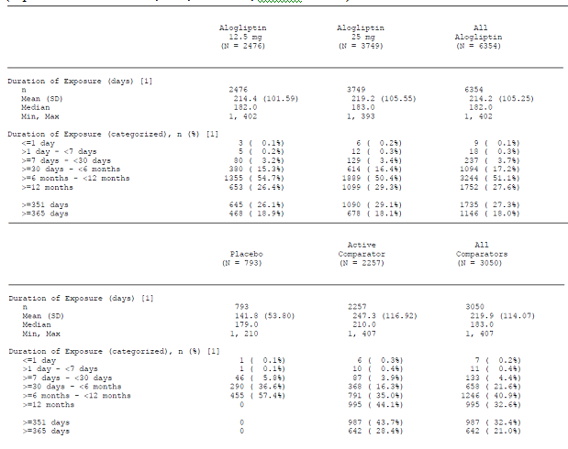

Pivotal studies
In Study SYR-322-MET-008, summarised in Table 5, there were 213 subjects exposed to alogliptin 12.5 mg/ MET, 130 (61.0%) for more than 26 weeks, and 207 to alogliptin 25 mg/MET, 135 (65.2%) for more than 26 weeks.
In Study SYR-322-MET-302, summarised in Table 9, there were 112 subjects exposed to alogliptin 25 mg once daily, with 67 (59.8%) exposed for ≥26 weeks, 110 to alogliptin 12.5 mg twice daily, with 55 (50.0%) exposed for ≥26 weeks, 106 to alogliptin 12.5 mg/MET 500 mg twice daily, with 68 (64.2%) exposed for ≥26 weeks, and 114 to alogliptin 12.5 mg/MET 1000 mg, with 69 (60.5%) exposed for ≥26 weeks.
In Study SYR-322-SULF-007, summarised in Table 17, there were 203 subjects exposed to alogliptin 12.5 mg/SU, 115 (55.2%) for ≥26 weeks, and 198 exposed to alogliptin 25 mg/SU, 97 (49.0%) for ≥26 weeks.
In Study SYR-322-TZD-009 (TZD ± MET or SU), summarised in Table 20, there were 197 subjects exposed to alogliptin 12.5 mg/TZD (±SU or MET), with 103 (52.0%) exposed for ≥26 weeks; and 199 exposed to 25 mg/TZD (±SU or MET), with 115 (57.8%) exposed for up to 26 weeks.
In Study SYR-322-PLC-010 (monotherapy), summarised in Table 26, there were 133 subjects exposed to alogliptin 12.5 mg, with 72 (54.1%) exposed for ≥26 weeks, and 131 exposed to 25 mg, with 83 (62.9%) exposed for ≥26 weeks.
In Study SYR-322-303 (monotherapy), summarised in Table 29, there were 222 subjects aged ≥65 years exposed to alogliptin 25 mg daily in monotherapy, with 139 (62.6%) exposed for more than 365 days.
In Study SYR-322-305 (MET), summarised in Table 14, there were 873 subjects exposed to alogliptin 12.5 mg/MET, with 653 subjects exposed for ≥365 days; and 877 exposed to alogliptin 25 mg/MET, with 672 (76.6%) exposed for ≥365 days.
In Study SYR-322-INS-011 (Insulin ± MET), summarised in Table 31, there were 131 subjects exposed to alogliptin 12.5 mg/insulin, with 59 (45.0%) exposed for ≥26 weeks, and 129 exposed to alogliptin 25 mg/insulin, with 57 (44.2%) exposed for ≥26 weeks.
In Study 01-06-TL-322OPI-002, summarised in Table 23, there were 164 subjects exposed to alogliptin 25 mg, with 87 (53.0%) exposed for ≥26 weeks, 163 to alogliptin 12.5 mg/pioglitazone, with 88 (54.0%) exposed for ≥26 weeks, and 164 exposed to alogliptin 25 mg/pioglitazone, with 92 (56.1%) exposed for ≥26 weeks.

Dose finding studies
In Study SYR-322-003, there were 213 subjects exposed to alogliptin for up to 12 weeks. There were 42 subjects exposed to 50 mg daily and 43 subjects exposed to 100 mg daily.

Supportive efficacy studies
In Study SYR-322-301, there were 25 subjects treated with alogliptin, and 22 treated with alogliptin in combination with pioglitazone for up to 16 weeks.
In Study 01-05-TL-322OPI-001, there were 390 subjects exposed to alogliptin 12.5 mg/ pioglitazone/ MET, 239 (61.3%) for ≥26 weeks, and 390 exposed to alogliptin 25 mg/ pioglitazone/ MET, 241 (61.8%) for ≥26 weeks.
In Study 01-06-TL-322OPI-004, there were 404 subjects exposed to alogliptin 25 mg/ MET/ pioglitazone with 195 (48.3%) exposed for ≥52 weeks.
In Study SYR-322-OLE-012, there were 1394 subjects exposed to alogliptin 12.5 mg, with 871 (62.5%) exposed for ≥180 weeks, and 1926 exposed to alogliptin 25 mg, with 1166 (60.5%) exposed for ≥180 weeks.
In Study SYR-322-308, 252 Chinese subjects were exposed to alogliptin 25 mg, with 149 (59.1%) exposed for ≥16 weeks.
In Study SYR-CCT-001, there were 79 Japanese subjects exposed to alogliptin 6.25 mg, 84 to 12.5 mg, 80 to 25 mg, and 79 to 50 mg for up to 12 weeks. In the open label extension, Study SYR-322-OCT-001, there were 96 subjects exposed to alogliptin 6.25 mg, 101 to 12.5 mg, 97 to 25 mg and 97 to 50 mg, all in combination with voglibose, for up to one year.
In Study SYR-322-CCT-003, there were 76 Japanese subjects exposed to alogliptin 12.5 mg and 79 to 25 mg for up to 20 weeks. In the open-label extension, Study SYR-322-OCT-003, there were 108 subjects exposed to alogliptin 12.5 mg/voglibose and 105 to alogliptin 25 mg/voglibose for up to one year.
In Study SYR-322-CCT-004, there were 111 subjects exposed to alogliptin 12.5 mg/pioglitazone and 113 exposed to alogliptin 25 mg/pioglitazone for up to 12 weeks. In the open label extension, Study SYR-322-OCT-004, there were 166 subjects exposed to alogliptin 12.5 mg/pioglitazone and 165 exposed to alogliptin 25 mg/pioglitazone for up to one year.
In Study SYR-322-CCT-005, there were 105 subjects exposed to alogliptin 12.5 mg/glimepiride and 104 to alogliptin 25 mg/glimepiride. In the open label extension, Study SYR-322-OCT-005 (SU), there were 150 subjects exposed to alogliptin 12.5 mg/SU and 153 exposed to alogliptin 25 mg/SU.
In Study SYR-322-CCT-006, there were 92 subjects exposed to alogliptin 12.5 mg/MET and 96 to alogliptin 25 mg/MET for up to 12 weeks. In the open label extension, Study SYR-322-OCT-005 (MET), there were 142 subjects treated with alogliptin 12.5 mg/MET and 145 treated with alogliptin 25 mg/MET for up to one year.

Adverse events

All adverse events (irrespective of relationship to study treatment)

Pivotal studies
In Study SYR-322-MET-008 (alogliptin/MET) TEAEs were reported in 134 (62.9%) subjects in the 12.5 mg group, 118 (57.0%) in the 25 mg group and 69 (66.3%) in the placebo. The pattern of common TEAEs was similar for alogliptin and placebo.
In Study SYR-322-SULF-007 (alogliptin/SU) TEAEs were reported in 129 (63.5%) subjects in the 12.5 mg group, 125 (63.1%) in the 25 mg group and 53 (53.5%) in the placebo. The pattern of TEAEs was similar for the three treatment groups.
In Study SYR-322-TZD-009 (TZD ± MET or SU) TEAEs were reported in 138 (69.7%) subjects in the 12.5 mg group, 144 (72.4%) in the 25 mg and 63 (64.9%) in the placebo. The distribution of TEAEs was similar for the three treatment groups.
In Study SYR-322-PLC-010 (monotherapy) TEAEs were reported in 91 (68.4%) subjects in the 12.5 mg group, 89 (67.4%) in the 25 mg group and 45 (70.3%) in the placebo. The frequency and pattern of TEAEs was similar for alogliptin and for placebo.
In Study SYR-322-MET-302 (monotherapy and MET) there were 158 TEAEs reported in 76 (71.7%) subjects in the placebo group, 143 in 61 (54.5%) in the alogliptin 25 mg once daily, 139 in 67 (60.9%) in the alogliptin 12.5 mg twice daily, 170 in 75 (68.8%) in the MET 500 mg, 211 in 69 (62.2%) in the MET 1000 mg, 189 in 67 (63.2%) in the alogliptin/MET 500 mg, and 194 in 73 (64.0%) in the alogliptin/MET 1000 mg. Gastrointestinal TEAEs were more common with MET and increased with MET dose.
In Study SYR-322-303 (monotherapy) there were 556 TEAEs reported in 163 (73.4%) subjects in the alogliptin group and 554 in 151 (68.9%) in the glipizide. Hypoglycaemia was reported as a TEAE in eight (3.7%) subjects in the glipizide group and none in the alogliptin group.
In Study SYR-322-305 (MET) TEAEs were reported in 630 (72.2%) subjects in the alogliptin 12.5 mg/MET group, 615 (70.1%) in the alogliptin 25 mg/MET and 623 (71.7%) in the glipizide/MET. The pattern of TEAEs was similar for the three treatment groups.
In Study SYR-322-INS-011 (Insulin ± MET) TEAEs were reported in 89 (67.9%) subjects in the alogliptin 12.5 mg group, 86 (66.7%) in the alogliptin 25 mg and 95 (73.6%) in the placebo. There was no apparent pattern to the TEAEs and no TEAE was reported in ≥10% of any treatment group.
In Study 01-06-TL-322OPI-002 (monotherapy and pioglitazone) TEAEs were reported in 90 (54.9%) subjects in the alogliptin 25 mg group, 98 (60.1%) in the alogliptin 12.5 mg/pioglitazone, 107 (65.2%) in the alogliptin 25 mg/pioglitazone, and 97 (59.5%) in the pioglitazone group. The most common TEAE was headache, occurring in 11 (6.7%) subjects in the alogliptin 25 mg group, 11 (6.7%) in the alogliptin 12.5 mg/pioglitazone, 14 (8.6%) in the alogliptin 25 mg/pioglitazone, and 20 (12.2%) in the pioglitazone group.

Other studies
In Study SYR-322-003 TEAEs were reported in 21 (50.0%) subjects in the 6.25 mg group, 30 (68.2%) in the 12.5 mg, 27 (60.0%) in the 25 mg, 22 (51.2%) in the 50 mg, 29 (65.9%) in the 100 mg and 24 (58.5%) in the placebo. There did not appear to be a pattern of TEAEs associated with increasing alogliptin dose.
In Study SYR-322-301 there were 30 TEAEs reported in 19 (76.0%) subjects in the alogliptin 25 mg group, 31 in 13 (59.1%) in the alogliptin/pioglitazone group and 20 in 15 (62.5%) in the placebo. Hypoglycaemia was more common in the alogliptin/ pioglitazone group.
In Study 01-05-TL-322OPI-001 (pioglitazone and MET) TEAEs were reported in 238 (61.0%) subjects in the alogliptin 12.5 mg/pioglitazone/MET group, 251 (64.4%) in the alogliptin 25 mg/pioglitazone/MET group and 236 (61.0%) in the pioglitazone/MET group. No TEAE occurred in >10% of any treatment group and the patterns of TEAEs were similar for the three treatment groups.
In Study 01-06-TL-322OPI-004 (MET and pioglitazone) there were 1019 TEAEs reported in 289 (71.5%) subjects in the alogliptin 25 mg/ MET/ pioglitazone 30 mg group and 863 in 275 (68.9%) in the MET/ pioglitazone 45 mg group. No TEAE was reported in ≥10% of either group and the pattern was similar for the two groups.
In Study SYR-322-OLE-012, TEAEs were reported in 1215 (87.2%) subjects in the 12.5 mg group and 1665 (86.4%) in the 25 mg. TEAEs occurring in ≥10% subjects were: urinary tract infection (11.7%), upper respiratory tract infection (11.0%) and nasopharyngitis (10.2%).
In Study SYR-322-308, TEAEs were reported in 92 (36.5%) Chinese subjects in the alogliptin 25 mg group and 99 (39.1%) in the placebo. The commonest TEAEs were: hyperlipidemia, 19 (7.5%) subjects in the alogliptin group compared to five (2%) in the placebo; upper respiratory tract infection, ten (4.0%) in the alogliptin, 14 subjects (5.5%) placebo; and urinary tract infection, eight (3.2%) alogliptin, nine (3.6%) placebo.
In Study SYR-CCT-001 there were 75 TEAEs in 41 (51.9%) Japanese subjects in the 6.25 mg group; 70 in 41 (48.8%) in the 12.5 mg; 54 in 35 (43.8%) in the 25 mg; 78 events in 50 (63.3%) in the 50 mg group, 96 events in 50 (60.2%) in the voglibose; and 62 in 44 (58.7%) in the placebo. In the open label extension, Study SYR-322-OCT-001 (Voglibose),there were 264 TEAEs in 79 (82.3%) subjects in the alogliptin 6.25 mg group, 255 in 82 (81.2%) in the 12.5 mg, 256 in 82 (84.5%) in the 25 mg, 299 in 89 (91.8%) in the 50 mg and 272 in 74 (89.2%) in the voglibose alone.
In Study SYR-322-CCT-003 there were 66 TEAEs reported in 38 (50.0%) subjects in the alogliptin 12.5 mg group, 50 in 35 (44.3%) in the 25 mg and 40 in 28 (37.3%) in the placebo. The most common TEAE was nasopharyngitis: 14 (18.4%) subjects in the 12.5 mg group, seven (8.9%) in the 25 mg and three (4.0%) in the placebo. No other TEAE was reported in more than two subjects in any treatment group. In the open-label extension, Study SYR-322-OCT-003, there were 289 TEAEs reported in 86 (79.6%) subjects in the 12.5 mg group and 207 in 82 (78.1%) in the 25 mg.
In Study SYR-322-CCT-004 (pioglitazone) 63 TEAEs were reported in 42 (37.8%) subjects in the alogliptin 12.5 mg group, 85 in 51 (45.1%) in the 25 mg and 76 in 55 (47.8%) in the placebo. The only TEAE reported in ≥3% in any treatment group was nasopharyngitis: five (4.5%) subjects in the 12.5 mg group, 14(12.4%) in the 25 mg and six (5.2%) in the placebo. In the open label extension, Study SYR-322-OCT-004, there were 458 TEAEs reported in 145 (87.3%) subjects in the alogliptin 12.5 mg group and 500 in 147 (89.1%) in the 25 mg.
In Study SYR-322-CCT-005 (SU) there were 85 TEAEs reported in 49 (46.7%) subjects in the alogliptin 12.5 mg group, 103 in 59 (56.7%) in the alogliptin 25 mg and 84 in 50 (48.5%) in the placebo. TEAEs that occurred in ≥3% or more of the subjects for each treatment group were: nasopharyngitis (19.0%) and gastroenteritis (3.8%) in the alogliptin 12.5 mg group; nasopharyngitis (19.2%), upper respiratory tract inflammation (11.5%), and back pain (3.8%) in the 25 mg; and nasopharyngitis (21.4%), headache (3.9%), and fall (3.9%) in the placebo. In the open label extension, Study SYR-322-OCT-005 (SU), there were 374 TEAEs reported in 122 (81.3%) subjects in the alogliptin 12.5 mg/SU group and 408 in 134 (88.2%) in the alogliptin 25 mg/SU group.
In Study SYR-322-CCT-006 (MET) there were 76 TEAEs reported in 45 (48.9%) subjects in the alogliptin 12.5 mg/MET group, 88 in 51 (53.1%) in the alogliptin 25 mg/MET and 74 in 53 (53.0%) in the placebo/MET. TEAEs occurring in ≥3% of each treatment group were: nasopharyngitis (19.6%), headache (6.5%) and diarrhoea (5.4%) in the alogliptin 12.5 mg/MET; nasopharyngitis (22.9%), constipation (4.2%), conjunctivitis allergic (3.1%), abdominal discomfort (3.1%), and hepatic steatosis (3.1%) in the alogliptin 25 mg/MET; and nasopharyngitis (20.0%) and blood lactic acid increased (3.0%) in the placebo/MET group. In the open label extension, Study SYR-322-OCT-005 (MET), there were 342 TEAEs reported in 110 (77.5%) subjects in the alogliptin 12.5 mg/MET group and 360 in 114 (78.6%) subjects in the alogliptin 25 mg/MET group.

Pooled tabulations
From the Integrated Analysis of safety, the overall pattern of TEAEs for alogliptin was similar to that for placebo and comparator, and there was no overall increase in the incidence of TEAEs in the alogliptin 25 mg group compared with the alogliptin 12.5 mg group (Table 35).

Table 35. Treatment-Emergent Adverse Events by System Organ Class and Preferred Term Phase 2 and 3 Controlled-Study Pool (from IAS)
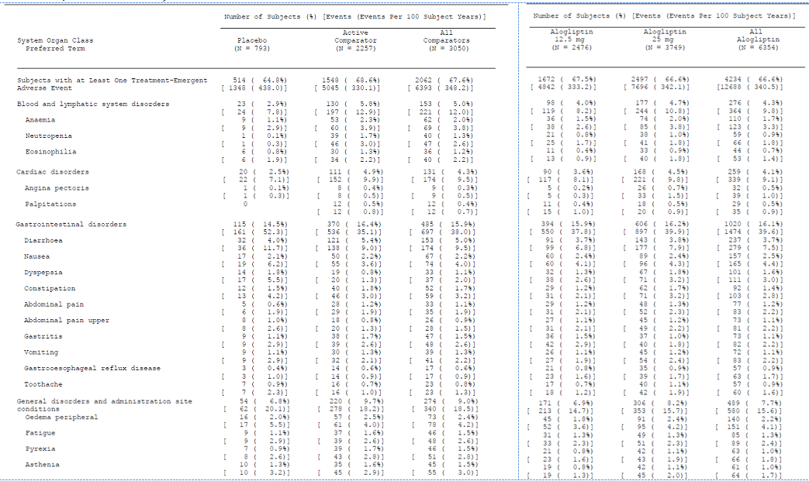
Table 35 continued. Treatment-Emergent Adverse Events by System Organ Class and Preferred Term Phase 2 and 3 Controlled-Study Pool
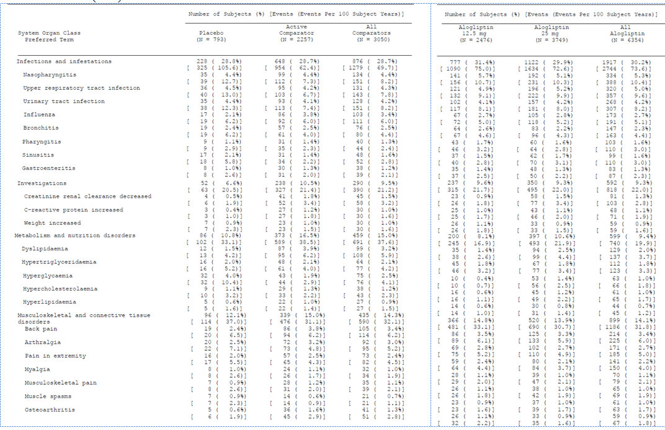
Table 35 continued. Treatment-Emergent Adverse Events by System Organ Class and Preferred Term Phase 2 and 3 Controlled-Study Pool
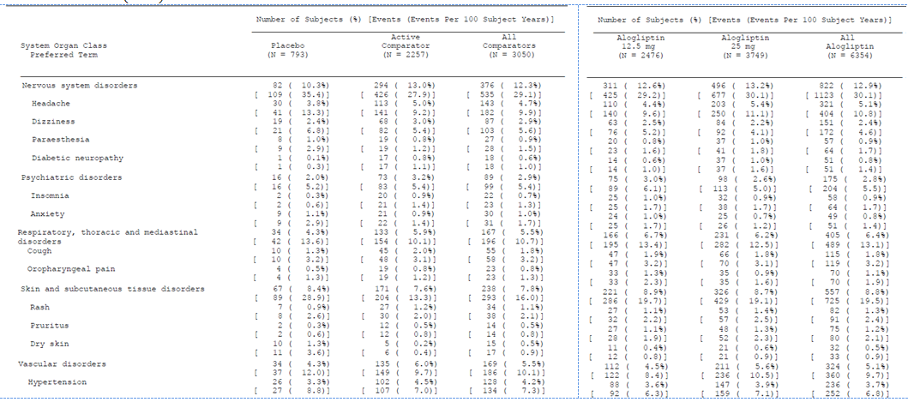

Treatment-related adverse events (adverse drug reactions)

Pivotal studies
In Study SYR-322-MET-008 (alogliptin/MET) treatment related TEAEs were reported in 24 (11.3%) subjects in the 12.5 mg group, 26 (12.6%) in the 25 mg group and ten (9.6%) in the placebo. The only treatment-related TEAE occurring in >1% subjects was constipation (reported in six [1.1%] subjects overall).
In Study SYR-322-SULF-007 (SU) treatment related TEAEs were reported in 31 (15.3%) subjects in the 12.5 mg group, 35 (17.7%) in the 25 mg group and 10 (10.1%) in the placebo. The treatment related TEAEs occurring in >1% of the study population were: nausea in eight (1.6%) subjects and hypertriglyceridaemia in six (1.2%).
In Study SYR-322-TZD-009 (TZD ± MET or SU) treatment related TEAEs were reported in 37 (18.7%) subjects in the 12.5 mg group, 37 (18.6%) in the 25 mg and 18 (18.6%) in the placebo. The treatment related TEAEs occurring in >1% of the alogliptin treated subjects were: nausea, five (1.3%) subjects; peripheral oedema, five (1.3%) subjects; weight increased, five (1.3%) subjects; and pruritus, five (1.3%) subjects.
In Study SYR-322-PLC-010 (monotherapy) treatment related TEAEs were reported in 31 (23.3%) subjects in the 12.5 mg group, 30 (22.7%) in the 25 mg group and 11 (17.2%) in the placebo. Treatment related TEAEs that occurred in ≥3% of subjects were the headache in four (3.0%) subjects in the 12.5 mg group; fatigue in four (3.0%) in the 25 mg; and nausea, two (3.1%) in the placebo.
In Study SYR-322-MET-302 (monotherapy and MET) treatment related TEAEs were reported in eleven (10.4%) subjects in the placebo group, 13 (12.7%) in the alogliptin 25 mg once daily, nine (8.0%) in the alogliptin 12.5 mg twice daily, 14 (12.8%) in the MET 500 mg, 22 (19.8%) in the MET 1000 mg, nine (8.5%) in the alogliptin/MET 500 mg, and 23 (20.2%) in the alogliptin /MET 1000 mg. Gastrointestinal treatment related TEAEs were more common in the higher dose MET groups (Table 36).
Table 36. Study Drug Related On-Study Adverse Events Occurring in ≥1% by System Organ Class and Preferred Term (Safety Set, Summary 1) (Study SYR-322-MET-302)
In Study SYR-322-303 (monotherapy) there were 84 treatment related TEAEs reported in 36 (16.2%) subjects in the alogliptin group and 107 in 47 (21.5%) in the glipizide. Hypoglycaemia was reported as a treatment related TEAE in eight (3.7%) subjects in the glipizide group and none in the alogliptin (Table 37).
Table 37. Drug-Related Treatment-Emergent AEs Occurring in ≥1% of Subjects in Either Treatment Group (Safety Set) (Study SYR-322-303)
In Study SYR-322-305 (MET) treatment related TEAEs were reported in 186 (21.3%) subjects in the alogliptin 12.5 mg/MET group, 204 (23.3%) in the alogliptin 25 mg/MET and 248 (28.5%) in the glipizide/MET. Hypoglycaemia was more common in the glipizide group (Table 38)
Table 38. Study Drug Related TEAEs Reported by ≥1% of Subjects in Any Treatment Group by Preferred Term (Safety Set) (Study SYR-322-305)
In Study SYR-322-INS-011 (Insulin ± MET) treatment related TEAEs were reported in 14 (10.7%) subjects in the alogliptin 12.5 mg group, 17 (13.2%) in the alogliptin 25 mg and 16 (12.4%) in the placebo. The treatment related TEAEs that occurred in ≥2% of subjects were nausea in the alogliptin 25 mg group (3.1%) and diarrhoea in the placebo group (2.3%).
In Study 01-06-TL-322OPI-002 (monotherapy and pioglitazone) treatment related TEAEs were reported in 22 (13.4%) subjects in the alogliptin 25 mg group, 32 (19.6%) in the alogliptin 12.5 mg/pioglitazone, 35 (21.3%) in the alogliptin 25 mg/pioglitazone, and 28 (17.2%) in the pioglitazone group (Table 39).
Table 39. Study Drug-Related Treatment-Emergent AEs Occurring ≥2% Subjects in Any Treatment Group—Safety Analysis Set (Study 01-06-TL-322OPI-002)

Other studies
In Study SYR-322-003 treatment related TEAEs were reported in five (11.9%) subjects in the 6.25 mg group, eight (18.2%) in the 12.5 mg, seven (15.6%) in the 25 mg, six (14.0%) in the 50 mg, six (13.6%) in the 100 mg and four (9.8%) in the placebo.
In Study 01-05-TL-322OPI-001 (pioglitazone and MET) treatment related TEAEs were reported in 79 (20.3%) subjects in the alogliptin 12.5 mg/pioglitazone/MET group, 86 (22.1%) in the alogliptin 25 mg/pioglitazone/MET group and 72 (18.6%) in the pioglitazone/MET group. The pattern of treatment related TEAEs was similar for the three groups.
In Study 01-06-TL-322OPI-004 (MET and pioglitazone) there were 183 treatment related TEAEs reported in 88 (21.8%) subjects in the alogliptin 25 mg/ MET/ pioglitazone 30 mg group and 138 in 75 (18.8%) in the MET/ pioglitazone 45 mg group. There was no apparent pattern to the treatment related TEAEs.

Deaths and other serious adverse events

Pivotal studies
In Study SYR-322-MET-008 (alogliptin/MET) there was one death in the 12.5 mg group (hypertensive heart disease) and one in the 25 mg group (death recorded as myocardial infarction 19 days after last dose of alogliptin, but the subject was recorded as having cirrhosis, excessive bleeding and ascites). SAEs were reported in six (2.8%) subjects in the 12.5 mg group, eight (3.9%) in the 25 mg group and four (3.8%) in the placebo. There was no apparent pattern to the SAEs.
In Study SYR-322-SULF-007 (alogliptin/SU) there were no deaths reported during the study. SAEs were reported in 11 (5.4%) subjects in the 12.5 mg group, 11 (5.6%) in the 25 mg group and two (2.0%) in the placebo. There was no apparent pattern to the SAEs.
In Study SYR-322-TZD-009 (TZD ± MET or SU) there was one death reported in the 12.5 mg group: sudden death. SAEs were reported in five (2.5%) subjects in the 12.5 mg group, 13 (6.5%) in the 25 mg and four (4.1%) in the placebo. Cardiac SAEs were more common in the 25 mg group: five (2.5%) compared with two (1.0%) in the 12.5 mg group and none in the placebo.
In Study SYR-322-PLC-010 (monotherapy) there were no deaths reported during the study. SAEs were reported in five (3.8%) subjects in the 12.5 mg group, one (0.8%) in the 25 mg group and two (3.1%) in the placebo. There was no pattern to the SAEs.
In Study SYR-322-MET-302 (monotherapy and MET) there were no deaths reported during the study. SAEs were reported in three (2.8%) subjects in the placebo group, one (0.9%) in the alogliptin 25 mg once daily, four (3.6%) in the alogliptin 12.5 mg twice daily, two (1.8%) in the MET 500 mg, two (1.8%) in the MET 1000 mg, two (1.9%) in the alogliptin/MET 500 mg, and two (1.8%) in the alogliptin/MET 1000 mg. There was no pattern to the SAEs.
In Study SYR-322-303 (monotherapy) there were no deaths reported during the study. SAEs were reported in 16 (7.2%) subjects in the alogliptin group and 13 (5.9%) in the glipizide. There was no apparent pattern to the SAEs.
In Study SYR-322-305 (MET) death was reported for two (0.2%) subjects in the alogliptin 12.5 mg/MET group (haemorrhagic stroke; non-small cell lung cancer), three (0.3%) in the alogliptin 25 mg/MET (myocardial infarction; acute pulmonary oedema; sepsis) and three (0.3%) in the glipizide/MET (septic shock; complete atrioventricular block; myocardial infarction). SAEs were reported in 51 (5.8%) subjects in the alogliptin 12.5 mg/MET group, 57 (6.5%) in the alogliptin 25 mg/MET and 59 (6.8%) in the glipizide/MET. There was no apparent pattern to the SAEs.
In Study SYR-322-INS-011 (Insulin ± MET) there was one death in the alogliptin 12.5 mg group: cardiovascular standstill. SAEs were reported in eight (6.1%) subjects in the alogliptin 12.5 mg group, seven (5.4%) in the alogliptin 25 mg and six (4.7%) in the placebo. There was no apparent pattern to the SAEs.
In Study 01-06-TL-322OPI-002 (monotherapy and pioglitazone) there were no deaths reported during the study. SAEs were reported in one (0.6%) subjects in the alogliptin 25 mg group, one (0.6%) in the alogliptin 12.5 mg/pioglitazone, eight (4.9%) in the alogliptin 25 mg/pioglitazone, and six (3.7%) in the pioglitazone group. There was no apparent pattern to the SAEs.

Other studies
There were no deaths reported in Study SYR-322-003. SAEs were reported in one (2.4%) subject in the 6.25 mg group, two (4.5%) in the 12.5 mg, two (4.4%) in the 25 mg, none in the 50 mg, one (2.3%) in the 100 mg and three (7.3%) in the placebo.
In Study SYR-322-301 SAEs were reported in two (8.0%) subjects in the alogliptin 25 mg group (ventricular ulcer; nephrolithiasis), one (4.5%) in the alogliptin/pioglitazone group (fall/ head injury/ concussion) and none in the placebo.
In Study 01-05-TL-322OPI-001 (pioglitazone and MET) there was one death in the pioglitazone/ MET group. SAEs were reported in seven (1.8%) subjects in the alogliptin 12.5 mg/pioglitazone/ MET group, twelve (3.1%) in the alogliptin 25 mg/ pioglitazone/ MET group and 13 (3.4%) in the pioglitazone/MET group. There was no apparent pattern to the SAEs.
In Study 01-06-TL-322OPI-004 (MET and pioglitazone) there was one death in the alogliptin 25 mg/ MET/ pioglitazone 30 mg group: myocardial infarction. SAEs were reported in 20 (5.0%) subjects in the alogliptin 25 mg/ MET/ pioglitazone 30 mg group and 20 (5.0%) in the MET/ pioglitazone 45 mg group. There was no apparent pattern to the SAEs.
In Study SYR-322-OLE-012, death occurred for 20 (1.4%) subjects in the 12.5 mg group and 19 (1.0%) in the 25 mg. There was one death from acute pancreatitis and ten due to acute myocardial infarction. SAEs were reported in 233 (16.7%) subjects in the 12.5 mg group and 311 (16.1%) in the 25 mg. The most common category for SAEs was cardiovascular events. Neoplasms, benign or malignant, were reported in 197 (5.9%) subjects.
In Study SYR-322-308, there were no deaths reported during the study. SAEs were reported in three (1.2%) subjects in the alogliptin 25 mg group and five (2.0%) in the placebo.
In Study SYR-CCT-001 there were no deaths reported during the study. SAEs were reported in one (1.3%) subject in the 6.25 mg group; one (1.2%) in the 12.5 mg; one (1.3%) in the 25 mg; two (2.5%) in the 50 mg group, two (2.4%) in the voglibose; and one (1.3%) in the placebo. In the open label extension, Study SYR-322-OCT-001 (Voglibose), there was one death in the voglibose only group. SAEs were reported in one (1.0%) subject in the alogliptin 6.25 mg group, five (5.0%) in the 12.5 mg, eight (8.2%) in the 25 mg, five (5.2%) in the 50 mg and four (4.8%) in the voglibose alone.
In Study SYR-322-CCT-003 there were no deaths. SAEs were reported in no subjects in the alogliptin 12.5 mg group, one (1.3%) in the 25 mg (pyelonephritis) and three (4.0%) in the placebo. In the open-label extension, Study SYR-322-OCT-003, there were no deaths reported. SAEs were reported in 6 (5.6%) subjects in the 12.5 mg group and seven (6.7%) in the 25 mg.
In Study SYR-322-CCT-004 (pioglitazone) there were no deaths reported during the study. SAEs were reported in one (0.9%) subjects in the alogliptin 12.5 mg group (fall), two (1.8%) in the 25 mg (cataract, nasopharyngitis) and two (1.7%) in the placebo. In the open label extension, Study SYR-322-OCT-004, there was one death in the alogliptin 25 mg group: myocardial infarction. SAEs were reported in 14 (8.4%) subjects in the alogliptin 12.5 mg group and 13 (7.9%) in the 25 mg.
In Study SYR-322-CCT-005 (SU) there were no deaths reported during the study. SAEs were reported in three (2.9%) subjects in the alogliptin 12.5 mg group (breast cancer, lung cancer, cerebral infarction), one (1.0%) in the alogliptin 25 mg (angina pectoris) and none in the placebo. In the open label extension, Study SYR-322-OCT-005 (SU), there were two (1.3%) deaths in the alogliptin 12.5 mg/SU group (gas gangrene, sudden death). SAEs were reported in 16 (10.7%) subjects in the alogliptin 12.5 mg/SU group and three (2.0%) in the alogliptin 25 mg/SU group.
In Study SYR-322-CCT-006 (MET) there were no deaths reported during the study. SAEs were reported in no subjects in the alogliptin 12.5 mg/MET group, two (2.1%) in the alogliptin 25 mg/MET (lung cancer, Mallory-Weiss syndrome) and none in the placebo/MET. In the open label extension, Study SYR-322-OCT-005 (MET), there were no deaths reported during the study. SAEs reported in seven (4.9%) subjects in the alogliptin 12.5 mg/MET group and five (3.4%) subjects in the alogliptin 25 mg/MET group.

Discontinuation due to adverse events

Pivotal studies
In Study SYR-322-MET-008 (alogliptin/MET) DAE occurred for seven (3.3%) subjects in the 12.5 mg group, four (1.9%) in the 25 mg group and one (1.0%) in the placebo. Two subjects discontinued in the 12.5 mg group because of abnormal LFTs.
In Study SYR-322-SULF-007 (alogliptin/SU) DAE was reported for five (2.5%) subjects in the 12.5 mg group, four (2.0%) in the 25 mg group and two (2.0%) in the placebo group.
In Study SYR-322-TZD-009 (TZD ± MET or SU) DAE occurred in six (3.0%) subjects in the 12.5 mg group, six (3.0%) in the 25 mg and three (3.1%) in the placebo. There was no apparent pattern to the DAEs.
In Study SYR-322-PLC-010 (monotherapy) DAE occurred in two (1.5%) subjects in the 12.5 mg group, two (1.5%) in the 25 mg group and one (1.6%) in the placebo. There was no pattern to the DAEs.
In Study SYR-322-MET-302 (monotherapy and MET) DAEs occurred in five (4.7%) subjects in the placebo group, four (3.6%) in the alogliptin 25 mg once daily, seven (6.4%) in the alogliptin 12.5 mg twice daily, three (2.8%) in the MET 500 mg, two (1.8%) in the MET 1000 mg, five (4.7%) in the alogliptin/MET 500 mg, and eleven (9.6%) in the alogliptin/MET 1000 mg. There was no pattern to the DAEs.
In Study SYR-322-303 (monotherapy) DAE occurred in 19 (8.6%) subjects in the alogliptin group and 27 (12.3%) in the glipizide. Hypoglycaemia was a reason for discontinuation in seven (3.2%) subjects in the glipizide group and none in the alogliptin.
In Study SYR-322-305 (MET) DAEs occurred for 52 (6.0%) subjects in the alogliptin 12.5 mg/MET group, 62 (7.1%) in the alogliptin 25 mg/MET and 73 (8.4%) in the glipizide/MET. Hypoglycaemia leading to discontinuation was more common in the glipizide group.
In Study SYR-322-INS-011 (Insulin ± MET) DAEs occurred for one (0.8%) subject in the alogliptin 12.5 mg group, six (4.7%) in the alogliptin 25 mg and four (3.1%) in the placebo group. There was no apparent pattern to the DAEs.
In Study 01-06-TL-322OPI-002 (monotherapy and pioglitazone) DAE occurred for three (1.8%) subjects in the alogliptin 25 mg group, six (3.7%) in the alogliptin 12.5 mg/pioglitazone, six (3.7%) in the alogliptin 25 mg/pioglitazone, and seven (4.3%) in the pioglitazone group. There was no apparent pattern to the DAEs.

Other studies
In Study SYR-322-003 DAE was reported in no subjects in the 6.25 mg and 12.5 mg groups, one (2.2%) in the 25 mg, three (7.0%) in the 50 mg, two (4.5)%) in the 100 mg and none in the placebo. Two subjects in the 50 mg group discontinued because of rash.
In Study SYR-322-301 DAEs occurred in one (4.0%) subject in the alogliptin 25 mg group (nephrolithiasis), one (4.5%) in the alogliptin/pioglitazone group (fall/ head injury/ concussion) and none in the placebo.
In Study 01-05-TL-322OPI-001 (pioglitazone and MET) DAE occurred in eight (2.1%) subjects in the alogliptin 12.5 mg/pioglitazone/MET group, six (1.5%) in the alogliptin 25 mg/pioglitazone/MET group and eleven (2.8%) in the pioglitazone/MET group. There was no apparent pattern to the DAEs.
In Study 01-06-TL-322OPI-004 (MET and pioglitazone) DAE occurred in twelve (3.0%) subjects in the alogliptin 25 mg/ MET/ pioglitazone 30 mg group and 16 (4.0%) in the MET/ pioglitazone 45 mg group.
In Study SYR-322-OLE-012, DAEs occurred in 98 (7.0%) subjects in the 12.5 mg group and 126 (6.5%) in the 25 mg. The most common TEAE leading to discontinuation was myocardial infarction in 17 (0.5%) subjects.
In Study SYR-322-308, DAEs occurred in four (1.6%) subjects in the alogliptin 25 mg group and five (2.0%) in the placebo.
In Study SYR-CCT-001, DAE occurred in two (2.5%) subjects in the 6.25 mg group; two (2.4%) in the 12.5 mg; one (1.3%) in the 25 mg; two (2.5%) in the 50 mg group, two (2.4%) in the voglibose; and two (2.7%) in the placebo. In the open label extension, Study SYR-322-OCT-001 (Voglibose) DAE occurred in two (2.1%) subjects in the alogliptin 6.25 mg group, eight (7.9%) in the 12.5 mg, eleven (11.3%) in the 25 mg, eight (8.2%) in the 50 mg and three (3.6%) in the voglibose alone.
In Study SYR-322-CCT-003, DAE occurred in two (2.6%) subjects in the alogliptin 12.5 mg group (nasopharyngitis, vision blurred), two (2.5%) in the 25 mg (arthralgia, generalized erythema) and three (4.0%) in the placebo. In the open-label extension, Study SYR-322-OCT-003, DAE occurred in eleven (10.2%) subjects in the 12.5 mg group and eleven (10.5%) in the 25 mg.
In Study SYR-322-CCT-004 (pioglitazone) DAE occurred in one (0.9%) subjects in the alogliptin 12.5 mg group (headache/malaise), two (1.8%) in the 25 mg (nasopharyngitis, hypoaesthesia, malaise) and four (3.5%) in the placebo. In the open label extension, Study SYR-322-OCT-004, DAE occurred in twelve (7.2%) subjects in the alogliptin 12.5 mg group and 13 (7.9%) in the 25 mg.
In Study SYR-322-CCT-005 (SU) DAE occurred in four (3.8%) subjects in the alogliptin 12.5 mg group (breast cancer, lung cancer, prostate cancer, cerebral infarction), one (1.0%) in the alogliptin 25 mg (headache/aptylalism) and two (1.9%) in the placebo. In the open label extension, Study SYR-322-OCT-005 (SU), DAE occurred in 19 (12.7%) subjects in the alogliptin 12.5 mg/SU group and eight (5.3%) in the alogliptin 25 mg/SU group.
In Study SYR-322-CCT-006 (MET) DAE occurred in two (2.1%) subjects in the alogliptin 25 mg/MET and none in the alogliptin 12.5 mg/MET or placebo/MET. In the open label extension, Study SYR-322-OCT-005 (MET), DAE occurred in seven (4.9%) subjects in the alogliptin 12.5 mg/MET group and five (3.4%) in the alogliptin 25 mg/MET group.

Laboratory tests

Liver function

Pivotal studies
In Study SYR-322-MET-008 (alogliptin/MET) there were two subjects in the placebo group, four in the 12.5 mg group, and two in the 25 mg alogliptin group with ALT levels >3xULN at some point during the study. No subject had an ALT level >3xULN in combination with a total bilirubin >2 mg/dL, and no subject had an ALT level >10x ULN.
In Study SYR-322-SULF-007 (alogliptin/SU) one subject in the 25 mg alogliptin group discontinued study drug due to an increased level of ALT.
In Study SYR-322-TZD-009 (TZD ± MET or SU), two subjects in the 12.5 mg alogliptin group and two subjects in the 25 mg alogliptin group with ALT levels >3xULN at some point during the study. No subject had an ALT level >3x ULN in combination with a total bilirubin >2 mg/dL. One subject in each of the 12.5 mg and 25 mg groups had an ALT level >10x ULN.
In Study SYR-322-PLC-010 (monotherapy) two subjects in the 12.5 mg alogliptin group, and one in the 25 mg group who had ALT levels >3 xULN at some point during the study. At the Endpoint visit, one subject in the 12.5 mg alogliptin group had a markedly abnormal ALT level 122 U/L at the Week 16 visit, but the baseline value was 139 U/L. No subject had an ALT level >3 xULN in combination with a total bilirubin >2 mg/dL; and no subject had an ALT level >10 xULN.
In Study SYR-322-MET-302 (monotherapy and MET) ALT >3xULN was reported in one (1.0%) subject in the placebo group, two (1.8%) in the alogliptin 25 mg once daily, one (0.9%) in the alogliptin 12.5 mg twice daily, one (0.9%) in the MET 500 mg, three (2.8%) in the MET 1000 mg, two (1.9%) in the alogliptin/MET 500 mg, and four (3.6%) in the alogliptin/MET 1000 mg.
In Study SYR-322-303 (monotherapy) ALT >3xULN was reported in two (0.9%) subjects in the alogliptin group and eight (3.7%) in the glipizide. One subject in the alogliptin group met the criteria for Hy’s Law.
In Study SYR-322-305 (MET) ALT >3xULN was reported in 22 (2.5%) subjects in the alogliptin 12.5 mg/MET group, 11 (1.3%) in the alogliptin 25 mg/MET and 24 (2.8%) in the glipizide/MET group.
In Study SYR-322-INS-011 (Insulin ± MET) there were two subjects in the alogliptin 12.5 mg group, and one in the 25 mg and two in the placebo with ALT >3xULN. No subject had an ALT level >3xULN in combination with a total bilirubin >2 mg/dL.
In Study 01-06-TL-322OPI-002 (monotherapy and pioglitazone) ALT >3xULN was reported in two subjects in the alogliptin 25 mg group, one in the alogliptin 12.5 mg/pioglitazone, two in the alogliptin 25 mg/pioglitazone, and three in the pioglitazone group.

Other studies
In Study SYR-322-003 two subjects had elevated liver enzymes during the study but both had elevated liver enzymes at baseline.
In Study 01-05-TL-322OPI-001 (pioglitazone and MET) ALT >3xULN was more frequent in the pioglitazone treated groups and related to pioglitazone dose.
In Study 01-06-TL-322OPI-004 (MET and pioglitazone) ALT >3xULN was reported in three (0.8%) subjects in the alogliptin 25 mg/ MET/ pioglitazone 30 mg group and two (0.5%) in the MET/ pioglitazone 45 mg group.
In Study SYR-322-OLE-012, ALT >3xULN occurred in 60 (4.3%) subjects in the 12.5 mg group and 85 (4.5%) in the 25 mg. ALT >10xULN occurred in four (0.2%) subjects. Two subjects, both in the alogliptin 25 mg group, met biochemical Hy’s Law criteria, defined as ALT or AST >3×ULN and total bilirubin >2.0×ULN, but both had alternative aetiologies and completed the study.
In Study SYR-322-308, ALT >3xULN was reported in two subjects in the alogliptin 25 mg group and three in the placebo.
In Study SYR-322-CCT-003 “hepatic function abnormal” was observed in 2 subjects each in the alogliptin 12.5 mg and placebo groups. “Liver disorder” was observed in one subject each in the alogliptin 25 mg and placebo groups. In the open-label extension, Study SYR-322-OCT-003, elevated ALT occurred in two (1.9%) subjects in the 12.5 mg group and one subject discontinued due to hepatic dysfunction.
In Study SYR-322-CCT-004 (pioglitazone) there were no abnormalities of laboratory tests reported as TEAEs. In the open label extension, Study SYR-322-OCT-004, elevated ALT was reported in one subject in the 12.5 mg group, and elevated AST in two subjects in the 25 mg.
In Study SYR-322-CCT-005 (SU) one subject in the alogliptin 25 mg group had abnormal hepatic function. In the open label extension, Study SYR-322-OCT-005 (SU), hepatic steatosis was reported in four (2.7%) subjects in the alogliptin 12.5 mg/SU group and two (1.3%) in the alogliptin 25 mg/SU group. Abnormal hepatic function was reported in two (1.3%) subjects in the alogliptin 12.5 mg/SU group and one (0.7%) in the alogliptin 25 mg/SU group.
In Study SYR-322-CCT-006 (MET) hepatic steatosis was reported in three (3.1%) Japanese subjects in the alogliptin 25 mg/MET group and one (1.0%) in the placebo/MET. There was one (1.1%) subject in the alogliptin 12.5 mg/MET group reported with abnormal hepatic function. In the open label extension, Study SYR-322-OCT-005 (MET), ALT was increased in six (4.2%) subjects in the alogliptin 12.5 mg/MET group and two (1.4%) in the alogliptin 25 mg/MET group. AST was increased in three (2.1%) in the 12.5 mg group.
There were no significant abnormalities of LFTs in Study SYR-322-301. In the open label extension, Study SYR-322-OCT-001 (Voglibose), there were no clinically significant alterations in laboratory tests.
In the Integrated Analysis of Safety, in the pooled Phase 2 and Phase 3 studies increased ALT was reported as a TEAE in three (0.4%) subjects in placebo groups, 13 (0.6%) in active comparator, 15 (0.6%) in alogliptin 12.5 mg and 14 (0.4%) in alogliptin 25 mg.

Kidney function

Pivotal studies
In Study SYR-322-MET-008 (alogliptin/MET) one subject had an elevation of creatinine (to 1.4 mg/dL at Week 26), 1.5x their Baseline value of 0.9 mg/dL.
In Study SYR-322-SULF-007 (alogliptin/SU) increased blood creatinine was reported as an AE for one subject in the placebo group and for two subjects in the 12.5 mg group.
In Study SYR-322-TZD-009 (TZD ± MET or SU), three subjects each in the 12.5 mg and 25 mg groups had markedly abnormal creatinine values (>1.5x Baseline) during the study, compared with no subjects in the placebo group.
In Study SYR-322-MET-302 (monotherapy and MET) creatinine >1.5 x baseline was reported in no subject in the placebo group, one (0.9%) in the alogliptin 25 mg once daily, two (1.9%) in the alogliptin 12.5 mg twice daily, two (1.9%) in the MET 500 mg, one (0.9%) in the MET 1000 mg, one (1.0%) in the alogliptin/MET 500 mg, and two (1.8%) in the alogliptin/MET 1000 mg group.
In Study SYR-322-303 (monotherapy) creatinine >1.5xBaseline was reported in six (2.8%) subjects in the alogliptin group and seven (3.2%) in the glipizide group.
In Study SYR-322-305 (MET) creatinine >1.5xbaseline was reported in 15 (1.7%) subjects in the alogliptin 12.5 mg/MET group, 12 (1.4%) in the alogliptin 25 mg/MET and 22 (2.6%) in the glipizide/MET group.
In Study 01-06-TL-322OPI-002 (monotherapy and pioglitazone) creatinine >1.5x baseline was reported in one subject in the alogliptin 25 mg group, one in the alogliptin 12.5 mg/pioglitazone, three in the alogliptin 25 mg/pioglitazone, and one in the pioglitazone group.

Other studies
In Study 01-06-TL-322OPI-004 (MET and pioglitazone) creatinine >1.5x Baseline was reported in eight (2.0%) subjects in the alogliptin 25 mg/ MET/ pioglitazone 30 mg group and eight (2.0%) in the MET/ pioglitazone 45 mg group.
In Study SYR-322-OLE-012, creatinine >1.5x Baseline was reported in 60 (4.3%) subjects in the 12.5 mg group and 78 (4.1%) in the 25 mg group.

Other clinical chemistry

Pivotal studies
In Study SYR-322-MET-008 (alogliptin/MET), Study SYR-322-SULF-007 (alogliptin/SU), Study SYR-322-TZD-009 (alogliptin/TZD ± MET or SU), and Study SYR-322-PLC-010 (monotherapy) there were no clinically significant abnormalities in other clinical chemistry.

Other studies
There were no significant abnormalities of clinical chemistry in Study SYR-322-301.

Haematology

Pivotal studies
In Study SYR-322-MET-008 (alogliptin/MET), Study SYR-322-SULF-007 (alogliptin/SU) and Study SYR-322-PLC-010 (monotherapy) there were no clinically significant abnormalities in haematology parameters.
In Study SYR-322-MET-302 (monotherapy and MET) thrombocytopenia was reported in one subject in the alogliptin/MET 1000 mg group.
In Study SYR-322-303 (monotherapy) three subjects in the alogliptin group were reported with thrombocytopenia.
In Study SYR-322-305 (MET) the pattern of abnormalities in haematology parameters was similar for the three treatment groups.
In Study SYR-322-INS-011 (Insulin ± MET) one subject in the alogliptin 25 mg group had thrombocytopenia reported as an AE.
In Study 01-06-TL-322OPI-002 (monotherapy and pioglitazone) neutropenia was reported in two subjects in the alogliptin 12.5 mg/pioglitazone group and one in the alogliptin 25 mg/pioglitazone. Thrombocytopenia was reported in one subject in the alogliptin 25 mg/pioglitazone group.

Other studies
There were no significant abnormalities of haematology in Study SYR-322-301 or Study SYR-322-MET-008.

Urinalysis

Pivotal studies
In Study SYR-322-TZD-009 (TZD ± MET or SU), two subjects in the 25 mg group had haematuria that subsequently resolved.

Electrocardiograph

Pivotal studies
In Study SYR-322-SULF-007 (alogliptin/SU) there were two ECG related SAEs: T wave inversion and bradycardia/T wave inversion. Two subjects had QTcF >500 msec and a change from Baseline of >60 msec at the Week 26 visit. Two further subjects had QTcF values of >500 msec and a change from Baseline of >60 msec at one or more time points during the study.
In Study SYR-322-TZD-009 (TZD ± MET or SU), one subject in the 25 mg group had QTc at baseline of 408 ms and at end of study 564 ms. The subject had a history of cardiac disease and borderline LVH.
In Study SYR-322-PLC-010 (monotherapy) one subject in the 25 mg group had a QTcF >500 msec at Week 26 which was a change of >60 msec from Baseline.
In Study SYR-322-303 (monotherapy) an increase in QTcF from baseline of ≥60 ms was reported in three (1.4%) subjects in the alogliptin group and one (0.5%) in the glipizide group.
In Study SYR-322-305 (MET) a summary tabulation of ECG abnormalities was not provided.
In Study SYR-322-INS-011 (Insulin ± MET) one subject in the placebo group had a QTcF value >500 msec, which was more than a 60 msec change from Baseline.
In Study 01-06-TL-322OPI-002 (monotherapy and pioglitazone) one subject in the alogliptin group was reported with a QTc of 440 ms.

Other studies
In Study SYR-322-003 one subject had prolongation of the QTc interval: 430 ms at Baseline and 465 milliseconds on Day 85.
In Study 01-05-TL-322OPI-001 (pioglitazone and MET) QTcF >500 ms was reported in two subjects in the alogliptin 12.5 mg/pioglitazone/MET group, and one in the pioglitazone/MET group.
In Study 01-06-TL-322OPI-004 (MET and pioglitazone) four subjects, all in the MET/ pioglitazone 45 mg group, had QTcF >500 ms. One subject in each group was reported with drug-related QT prolongation as a TEAE.
In Study SYR-322-OLE-012, 33 subjects had a QTcF >500 msec and change from Baseline of >60 msec at least once during the course of the 4-year study.
There were no significant abnormalities of ECGs in Study SYR-322-301.

Thorough QT studies
Study SYR-322-004 was a thorough QT study: conducted as an evaluator blinded, active and placebo controlled, multiple-dose, four period, crossover study designed to evaluate the effects of SYR-322 on QT/QTc interval in healthy volunteers. The study was conducted at a single centre from June to September 2005. The study included 48 healthy volunteers: 26 (54.2%) males, 22 (45.8%) females, age range 18 to 43 years. The study treatments were: alogliptin 100 mg, alogliptin 400 mg; moxifloxacin (positive control) and placebo (negative control). Treatments were administered orally, once daily, for 7 days. There was a 7 day washout period between dosing periods.
The positive control (moxifloxacin) was effective. At no timepoint for the Day 1 data was the upper 90% CI for either alogliptin dose >10 ms. However, on Day 6 the upper 90% CI was >10 ms for the 400 mg dose 1 hour postdose. For the 100 mg dose, the upper 90% CI was <10 ms at all timepoints.
The ICH Guidance for Industry E14 Clinical Evaluation of QT/QTc Interval Prolongation and Proarrhythmic Potential for Non-Antiarrhythmic Drugs states that “a negative” thorough QT/QTc study” is one in which the upper bound of the 95% one-sided confidence interval for the largest time-matched mean effect of the drug on the QTc interval excludes 10 ms”. However, in Study SYR-322-004 the 90% CI instead of the 95% CI were provided.
Study SYR-322-019 was a thorough QT study: conducted as a single blind, randomized, placebo and positive controlled, four arm, parallel-group, study comparing two dose levels of alogliptin, moxifloxacin (positive control), and placebo (negative control). The study was conducted at a single centre from January to March 2006. The study included 257 healthy volunteers: 64 received alogliptin 50 mg, 64 alogliptin 400 mg, 65 moxifloxacin 400 mg, and 64 placebo. There were 155 (60.3%) males, 102 (39.7%) females, and the age range was 19 to 45 years.
The positive control (moxifloxacin) was effective. At no timepoint for the Day 1 data was the upper 90% CI for either alogliptin dose >10 ms. However, on Day 6 the upper 90% CI was >10 ms for the 400 mg dose 1 hour postdose. For the 50 mg dose, the upper 90% CI was <10 ms at all timepoints.
As for Study SYR-322-019, the ICH Guidance for Industry E14 Clinical Evaluation of QT/QTc Interval Prolongation and Proarrhythmic Potential for Non-Antiarrhythmic Drugs states that “a negative “thorough QT/QTc study” is one in which the upper bound of the 95% one-sided confidence interval for the largest time-matched mean effect of the drug on the QTc interval excludes 10 ms”. However, in Study SYR-322-004 the 90% CI instead of the 95% CI were provided.

Vital signs

Pivotal studies
In Study SYR-322-MET-008 (alogliptin/MET) there was a small increase in SBP in the alogliptin treatment groups of 2 mmHg.
In Study SYR-322-SULF-007 (alogliptin/SU), Study SYR-322-TZD-009 (TZD ± MET or SU), Study SYR-322-PLC-010 (monotherapy), Study SYR-322-MET-302 (monotherapy and MET), Study SYR-322-305 (MET), and Study SYR-322-INS-011 (Insulin ± MET) there were no significant changes in vital signs.

Other studies
There were no significant abnormalities of vital signs in Study SYR-322-301 or Study 01-06-TL-322OPI-004.

Hypoglycaemia

Pivotal studies
In Study SYR-322-SULF-007 (alogliptin/SU), there were 61 hypoglycaemia events reported in 32 (15.8%) subjects in the 12.5 mg group, 57 in 19 (9.6%) in the 25 mg and 59 in 11 (11.1%) in the placebo. One subject in the 12.5 mg group had an SAE of hypoglycemia which led to discontinuation of study drug.
In Study SYR-322-TZD-009 (TZD ± MET or SU), there were 32 hypoglycaemia events reported in 10 (5.1%) subjects in the 12.5 mg group, 31 in 14 (7.0%) in the 25 mg and eight in five (5.2%) in the placebo group.
In Study SYR-322-PLC-010 (monotherapy) hypoglycaemic episodes occurred in four (3.0%) subjects in the 12.5 mg group, two (1.5%) in the 25 mg group and one (1.6%) in the placebo group.
In Study SYR-322-MET-302 (monotherapy and MET) hypoglycaemia was reported in one (0.9%) subjects in the placebo group, two (1.8%) in the alogliptin 25 mg once daily, six (5.5%) in the alogliptin 12.5 mg twice daily, two (1.8%) in the MET 500 mg, seven (6.3%) in the MET 1000 mg, two (1.9%) in the alogliptin/MET 500 mg, and six (5.3%) in the alogliptin/MET 1000 mg group.
In Study SYR-322-305 (MET) hypoglycaemic episodes were reported in 22 (2.5%) subjects in the alogliptin 12.5 mg/MET group, 12 (1.4%) in the alogliptin 25 mg/MET and 207 (23.8%) in the glipizide/MET group.
In Study SYR-322-INS-011 (Insulin ± MET) hypoglycaemic episodes were reported in 35 (26.7%) subjects in the alogliptin 12.5 mg group, 35 (27.1%) in the alogliptin 25 mg and 31 (24.0%) in the placebo group.
In Study 01-06-TL-322OPI-002 (monotherapy and pioglitazone) hypoglycaemic events were reported in one (0.6%) subject in the alogliptin 25 mg group, three (1.8%) in the alogliptin 12.5 mg/pioglitazone, five (3.0%) in the alogliptin 25 mg/pioglitazone, and three (1.8%) in the pioglitazone group.

Other studies
In Study SYR-322-301 there were three subjects in the alogliptin 25 mg/ pioglitazone group who were reported with hypoglycaemia as TEAEs.
In Study 01-05-TL-322OPI-001 (pioglitazone and MET) hypoglycaemic events occurred in four (1.0%) subjects in the alogliptin 12.5 mg/pioglitazone/MET group, six (1.5%) in the alogliptin 25 mg/pioglitazone/MET group and eight (2.1%) in the pioglitazone/MET group.
In Study 01-06-TL-322OPI-004 (MET and pioglitazone) hypoglycaemic events were reported in eight (2.0%) subjects in the alogliptin 25 mg/ MET/ pioglitazone 30 mg group and ten (1.2%) in the MET/ pioglitazone 45 mg group.
In Study SYR-322-OLE-012, hypoglycaemic episodes were reported in 178 (12.8%) subjects in the 12.5 mg group and 258 (13.4%) in the 25 mg group.
In Study SYR-322-308, hypoglycaemic episodes were reported in four (1.6%) subjects in the alogliptin 25 mg group and two (0.8%) in the placebo group.

Pancreatitis
In Study SYR-322-MET-302 there were two subjects reported with acute pancreatitis: one in the alogliptin /MET 500 mg group; one in the alogliptin/ MET 1000 mg group.
In Study 01-06-TL-322OPI-002 (monotherapy and pioglitazone) there was one subject in the alogliptin 25 mg/pioglitazone with acute pancreatitis.
In Study SYR-322-OLE-012, pancreatitis was reported in 13 (0.4%) subjects.
In the Integrated Analysis of Safety, in the pooled Phase 2 and Phase 3 studies increased lipase was reported in two (0.3%) subjects in placebo groups, five (0.2%) in active comparator, one (<0.1%) in alogliptin 12.5 mg and ten (0.3%) in alogliptin 25 mg.

Cardiovascular risk
Study SYR-322-402 is an ongoing multicentre, randomized, double blind, placebo controlled study to evaluate cardiovascular outcomes following treatment with alogliptin in addition to standard of care in Subjects with T2DM and acute coronary syndrome. An interim analysis was provided in the submission. The study includes males or females with a diagnosis of T2DM who have a diagnosis of ACS (myocardial infarction or unstable angina requiring hospitalization) within 15 to 90 days prior to randomization. The study treatments are: alogliptin 6.25 mg, 12.5 mg or 25 mg depending upon renal function; or matching placebo. There were 1058 subjects randomised to alogliptin and 1076 to placebo. There were 1487 (69.7%) males, 647 (30.3%) females, and the age range was 29 to 91 years; 749 (35.1%) subjects aged ≥65 years and 198 (9.3%) aged ≥75 years. In the interim analysis MACE was reported in 37 (3.5%) of the alogliptin group and 46 (4.3%) of the placebo: HR 0.814 (upper 95% CI 1.507).

Post-marketing experience

Post-marketing Data
Three Periodic Safety Update Reports were provided covering the period from 16th April 2010 to 15th October 2011. During that time period alogliptin was approved for marketing in Japan. Cumulative patient exposure was estimated to be 117,359 patient-years since approval. In addition, cumulative exposure to a fixed dose alogliptin-pioglitazone product was estimated to be 7,215 patient-years in Japan.
During the reporting period 16th April 2010 to 15th October 2010 there were two ADRs with fatal outcome: hepatic neoplasm, myocardial infarction. There were 62 cases of adverse drug reactions received globally; 17 were received from clinical trials and 45 through spontaneous reporting sources. Four of the adverse reactions were serious. There was one report of necrotising pancreatitis.
During the reporting period 16th October 2010 to 15th April 2011 there were three cases of ADRs with a fatal outcome: brain tumour, acute pulmonary oedema, severe pancreatitis (pancreatic necrosis)/liver disorder. A total of 100 cases of ADRs were received: 76 cases from marketed product in Japan (75 spontaneous reports and one from a regulatory authority) and 24 cases received from clinical studies in other regions. There was one case of Stevens Johnson syndrome and one case of drug induced liver disease.
During the reporting period 16 April 2011 to 15 October 2011, there were no cases of ADRs with a fatal outcome. There were 171 cases received for the monoproduct, 44 cases contained at least one suspected serious ADR. Twenty one cases were received from clinical studies, three cases from literature, one case from a regulatory authority and 146 cases were received through spontaneous reporting sources. There were six cases of pancreatitis reported, of which one was from clinical Study SYR-322-402, the remaining five cases were from spontaneous reporting. There were three spontaneous reports containing an event that met biochemical Hy’s law criteria.

Risk management plan
The Sponsor has not identified any Important Identified Risks for alogliptin.
The Important Potential Risks identified by the Sponsor are:
- Hypersensitivity
- Pancreatitis
The Sponsor has not identified any interactions or potential interactions with other medicinal products, food, and other substances have been identified.
The Important Missing Information identified by the Sponsor are:
- Patients with concurrent CV disease
- Patients with severe renal impairment or ESRD requiring dialysis
- Patients with severe hepatic impairment
- Pregnant or lactating women
- Children and adolescents
- Use in clinical practice
The Sponsor proposes to address the Important Potential Risks with:
- Routine Pharmacovigilance
- Targeted follow-up questionnaires
- Analysis of ongoing and planned clinical trial safety data
- Drug utilisation and prescription event monitoring studies. The prescription event monitoring study is proposed to be conducted by the Drug Safety Research Unit at Southampton. The protocol for the drug utilisation study had not been finalised at the time of submission but is proposed to be conducted in the Netherlands.
The Sponsor also states that a cardiovascular outcome study is currently being conducted (Study 402, A Multicenter, Randomized, Double-Blind, Placebo-Controlled Study to Evaluate Cardiovascular Outcomes Following Treatment with Alogliptin in Addition to Standard of Care in Subjects with Type 2 Diabetes and Acute Coronary Syndrome).
However, given the interest from the FDA in the incidence of drug induced liver injury, this should also be included as an Important Potential Risk.

Safety issues with the potential for major regulatory impact

Liver toxicity
As discussed in Section 8.5.1, elevation of ALT has been reported in subjects treated with alogliptin and hepatic safety is cited as the reason for the FDA declining marketing approval of alogliptin.

Haematological toxicity
Thrombocytopenia has been reported with alogliptin, as discussed in Section 8.5.4.

Serious skin reactions
The rate of serious skin reactions did not appear to be greater than that for comparator or placebo.

Cardiovascular safety
At supratherapeutic doses, with multiple dosing, QTc prolongation greater than the threshold for regulatory concern was demonstrated, as discussed in Section 8.5.6.3.

Unwanted immunological events
Allergic reactions did not appear to occur at a greater frequency than with placebo or comparator.

Evaluator’s overall conclusions on clinical safety
The overall pattern and frequency of TEAEs was similar for alogliptin and placebo or comparator. There was no significant difference in the frequency of TEAEs between the 12.5 mg dose and the 25 mg dose. The pattern of treatment related TEAEs reflected that of concomitant medications (e.g. gastrointestinal for MET and hypoglycaemia for SU). There did not appear to be a specific pattern of ADRs for alogliptin. Death was uncommon and SAEs did not appear to occur in a greater frequency than with comparator or placebo. DAE did not appear to occur at greater frequency with alogliptin than placebo or comparator, and was not dose related.
Elevation of ALT did not appear to occur at greater frequency with alogliptin than with placebo or comparator. However, the tabulation of all subjects with elevation of ALT or meeting Hy’s criteria could not be located.
QTc prolongation of regulatory interest did not occur at therapeutic doses or at 100 mg daily (four times the recommended dose), but did occur at 400 mg once daily after a week. This dose level is 16 times the proposed dose.
Hypoglycaemia was uncommon with alogliptin and was related to co-medication with SU or insulin. The incidence of hypoglycaemia was lower than with SU in monotherapy.
There were subjects reported with acute pancreatitis with alogliptin, but the overall incidence of elevated lipase was no greater than with comparator or placebo.

First round benefit-risk assessment

First round assessment of benefits
Alogliptin 12.5 mg and 25 mg were superior to placebo as add-on therapy in subjects on stable doses of MET (Study SYR-322-MET-008). The LS mean difference (95% CI) (treatment vs placebo) was -0.50 (-0.68 to -0.32) % for the 12.5 mg dose and -0.48 (-0.67 to -0.30) % for the 25 mg dose (p <0.001). The benefit was maintained for 26 weeks.
Alogliptin 12.5 mg and MET 500 mg or 1000 mg twice daily was superior to the individual components as monotherapy, and to placebo (Study SYR-322-MET-302). The treatment differences were:
- Alogliptin 12.5mg / MET 500 mg twice daily was superior to alogliptin 12.5 mg twice daily: LS mean difference (97.5% CI) -0.67 (-0.96 to -0.37) %, p <0.001
- Alogliptin 12.5mg / MET 1000 mg twice daily was superior to alogliptin 12.5 mg twice daily: LS mean difference (97.5% CI) -1.00 (-1.29 to -0.71) %, p <0.001
- Alogliptin 12.5mg / MET 500 mg twice daily was superior to MET 500 mg twice daily: LS mean difference (97.5% CI) -0.57 (-0.87 to -0.27) %, p <0.001
- Alogliptin 12.5mg / MET 1000 mg twice daily was superior to MET 1000 mg twice daily: LS mean difference (97.5% CI) -0.44 (-0.73 to -0.16) %, p <0.001
- There was no significant difference between alogliptin 12.5 mg twice daily and alogliptin 25 mg once daily: LS mean difference (95% CI) -0.04 (-0.30 to 0.22), p = 0.759
- Alogliptin 12.5mg / MET 500 mg twice daily was superior to placebo: LS mean difference (95% CI) -1.37 (-1.63 to -1.11) %, p <0.001
- Alogliptin 12.5mg / MET 1000 mg twice daily was superior to placebo: LS mean difference (95% CI) -1.70 (-1.96 to -1.45)%, p <0.001
The treatment benefit was maintained for 52 weeks.
Alogliptin was not inferior to glipizide in subjects on stable doses of MET (Study SYR-322-305). In comparison with glipizide/MET:
- Alogliptin 25 mg/MET was not inferior: LS mean difference (upper 98.75% CI) -0.09 (-0.004)
- Alogliptin 12.5 mg/MET was not inferior: LS mean difference (upper 98.75% CI) -0.10 (-0.002)
The non-inferiority comparison was made at Week 52 of treatment.
Alogliptin 12.5 mg and 25 mg were superior to placebo in subjects on stables doses of SU (Study SYR-322-SULF-007). The LS mean difference (95% CI) (treatment vs placebo) was -0.39 (-0.59 to -0.19) % for the 12.5 mg dose and -0.53 (-0.73 to -0.33) % for the 25 mg dose (p <0.001). The benefit was maintained for a minimum of 26 weeks.
Alogliptin 12.5 mg and 25 mg were superior to placebo as add-on therapy in subjects on stable doses of TZD, with or without concomitant treatment with MET or SU (Study SYR-322-TZD-009). The LS mean difference (95% CI) (treatment vs placebo) was -0.47 (-0.67 to -0.28) % for the 12.5 mg dose and -0.61 (-0.80 to -0.41) % for the 25 mg dose (p <0.001). The treatment benefit was maintained for 26 weeks.
Alogliptin 12.5 mg and 25 mg in combination with pioglitazone was superior to alogliptin alone, or pioglitazone alone (Study 01-06-TL-322OPI-002). The LS mean difference (95% CI) alogliptin 12.5 mg/pioglitazone vs pioglitazone was -0.40 (-0.63 to -0.18) %, p<0.001; for alogliptin 25 mg/pioglitazone vs pioglitazone was -0.56 (-0.78 to -0.33) %, p <0.001; and for alogliptin 25 mg/pioglitazone vs alogliptin 25 was -0.75 (-0.98 to -0.53) %, p <0.001. The treatment benefit was maintained for 26 weeks.
Alogliptin 12.5 mg and 25 mg as monotherapy were superior to placebo (Study SYR-322-PLC-010). The LS mean difference (95% CI) (treatment vs placebo) was -0.54 (-0.76 to -0.31) % for the 12.5 mg dose and -0.57 (-0.80 to -0.35) % for the 25 mg dose (p <0.001). The treatment benefit was maintained for 26 weeks.
Alogliptin 25 mg was not inferior to SU (glipizide) in monotherapy: LS mean difference (upper 97.5% CI) -0.05 (0.13) %, i.e. the upper confidence limit for the LS mean difference was less than +0.4% (Study SYR-322-303). Non-inferiority was demonstrated after 52 weeks of treatment. There were fewer hypoglycaemic episodes with alogliptin than with SU.
Alogliptin 12.5 mg and 25 mg were superior to placebo as add-on treatment in subjects treated with insulin (Study SYR-322-INS-011). The LS mean difference (95% CI) (treatment vs placebo) was -0.51 (-0.72 to -0.30) % for the 12.5 mg dose and -0.59 (-0.80 to -0.37) % for the 25 mg dose (p <0.001). The treatment benefit was maintained for 26 weeks.
Alogliptin appeared to interact with SU and TZD in increasing body weight. However, there did not appear to be an adverse effect on weight in monotherapy or in combination with MET.
Overall, efficacy was demonstrated in subjects aged ≥65 years in comparison with placebo. Efficacy was independent of gender, race or baseline HbA1c.
The study populations included in the pivotal studies were similar to those for which alogliptin is intended for marketing in Australia. The concomitant and comparator treatments are also widely available and used in Australia. The clinical endpoints used in the efficacy studies were appropriate as were the statistical methods used to test the hypotheses. The treatment effect was both clinically and statistically significant.
The proposed dosing regimens, and the indications sought by the Sponsor, are supported by the efficacy and clinical pharmacology data presented in the submission.

First round assessment of risks
The overall pattern and frequency of TEAEs was similar for alogliptin and placebo or comparator. There was no significant difference in the frequency of TEAEs between the 12.5 mg dose and the 25 mg dose. The pattern of treatment related TEAEs reflected that of concomitant medications (e.g. gastrointestinal for MET and hypoglycaemia for SU). There did not appear to be a specific pattern of ADRs for alogliptin. Death was uncommon and SAEs did not appear to occur in a greater frequency than with comparator or placebo. DAE did not appear to occur at greater frequency with alogliptin than placebo or comparator, and was not dose related.
Elevation of ALT did not appear to occur at greater frequency with alogliptin than with placebo or comparator. However, a tabulation of all subjects with elevation of ALT or meeting Hy’s criteria could not be located.
QTc prolongation of regulatory interest did not occur at therapeutic doses or at 100 mg daily (four times the recommended dose), but did occur at 400 mg once daily after a week. This dose level is 16 times the proposed dose.
Hypoglycaemia was uncommon with alogliptin and was related to comedication with SU or insulin. The incidence of hypoglycaemia was lower than with SU in monotherapy.
Acute pancreatitis has been reported with alogliptin, but in the Integrated Analysis of Safety the overall incidence of elevated lipase was no greater than with comparator or placebo. It is not clear whether the risk of pancreatitis is greater, or lesser, than other DPP-IV inhibitors.

First round assessment of benefit-risk balance
Although the treatment benefit of alogliptin, both as add-on therapy and monotherapy, is clinically significant and adequately demonstrated, there remain some safety concerns. The risk of drug induced liver injury requires further review, and consideration should be given to deferring the decision on approval pending the decision of the FDA.

First round recommendation regarding authorisation
The data submitted in the Dossier support the requested indication:
Add-on combination:
NESINA / VIPIDIA is indicated to improve glycaemic control in adult patients (≥18 years old) with type 2 diabetes mellitus when diet and exercise do not provide adequate glycaemic control, as add on to metformin, a sulphonylurea, a thiazolidinedione, metformin and a thiazolidinedione, or insulin (with or without metformin).
Initial combination:
NESINA / VIPIDIA is indicated for use as initial combination with metformin to improve glycaemic control in adult patients (≥ 18 years old) with type 2 diabetes mellitus when diet and exercise do not provide adequate glycaemic control and dual alogliptin and metformin therapy is appropriate.
Specifically, the data support the individual components of the requested indication. These components are:
- Add-on therapy as:
  - Dual therapy with a SU, a TZD or MET
  - Triple therapy with a TZD and a SU or MET
  - Triple/dual therapy with insulin with or without MET
- Initial combination therapy:
  - Initial combination therapy with MET
However, the decision on marketing authorisation should be deferred pending the decision of the FDA with regard to the risk of drug induced liver injury with alogliptin.

Clinical questions

Pharmacokinetics
Is there any evidence for net renal excretion or reabsorption? What is the renal clearance of free (unbound) alogliptin in relation to creatinine clearance?

Pharmacodynamics
The Evaluator does not have any questions relating to pharmacodynamics.

Efficacy
The sponsor should provide summary tabulations of the reasons for exclusion of subjects from the PPS for Study SYR-322-303 and Study SYR-322-305.

Safety
What are the details of the FDA concerns regarding hepatic safety and which data have been provided by the Sponsor in response?
The Sponsor should provide a tabulation of all cases of potential drug induced liver injury, and all cases satisfying the criteria of Hy’s Law.

Second round evaluation of clinical data submitted in response to questions
- Is there any evidence for net renal excretion or reabsorption? What is the renal clearance of free (unbound) alogliptin in relation to creatinine clearance?
The Sponsor has responded that there is evidence of net renal excretion of alogliptin because the renal clearance, measured as approximately 170 mL/min exceeds GFR, measured as 120 mL/min in healthy adults. The Sponsor has performed further in-vitro studies of this phenomenon in cell cultures using the transporters OAT1, OAT3 and OCT2. Alogliptin was not a substrate for any of these transporters and did not exhibit significant inhibition of these transporters at clinically relevant concentrations.
From the known protein binding of alogliptin (20%) and the renal clearance of alogliptin (170 mL/min) the Sponsor estimates the clearance of free alogliptin to be 212.5 mL/min. The Sponsor estimates the ratio of free alogliptin clearance to creatinine clearance to be 1.77.
These data indicate significant net renal excretion of alogliptin by an unknown mechanism.
- The sponsor should provide summary tabulations of the reasons for exclusion of subjects from the PPS for Study SYR-322-303 and Study SYR-322-305.
The Sponsor has provided these summary tabulations for Study SYR-322-303, and for Study SYR-322-305 has provided directions as to where the tabulation is in the dossier.
In Study SYR-322-303 there were more subjects in the glipizide group excluded because of shorter duration of therapy than in the alogliptin: 44 (20.1%) subjects compared with 33 (14.9%) respectively.
In Study SYR-322-305 the reasons for exclusion, and proportions of subjects excluded, were similar for the three treatment groups.
These data do not change the conclusions with regard to efficacy.
- What are the details of the FDA concerns regarding hepatic safety and which data have been provided by the Sponsor in response?
In their initial review of the alogliptin dossier the FDA had identified an imbalance in the proportion of subjects with elevated liver enzymes. The Sponsor states that the initial FDA dossier did not include data from Study SYR-322-305.
The Sponsor has provided a summary tabulation of subjects with elevations in liver enzymes for the Phase 2 and 3 studies from the studies initially submitted to the FDA. Overall, there were more subjects with marked elevation in ALT (>5xULN) in the alogliptin treated groups: 17 (0.3%) subjects compared with three (0.1%) in the comparator. However, for other measures of liver injury there were similar proportions in the alogliptin and comparator groups.
On 26th July 2012 the Sponsor provided further data to the FDA and an updated summary table of these data was provided by the Sponsor. This still indicates a slight imbalance in the proportion of subjects with ALT >5xULN: 34 (0.35%) subjects in the alogliptin groups, corresponding to 0.49 per hundred patient years exposure, compared with 17 (0.29%) in the placebo, corresponding to 0.39 per hundred patient years exposure.
At the request of the FDA the Sponsor also provided data from Study SYR-322_402, in January 2013. There were 19 (0.80%) subjects in the alogliptin group and twelve (0.51%) in the placebo with ALT >5xULN.
- The Sponsor should provide a tabulation of all cases of potential drug induced liver injury, and all cases satisfying the criteria of Hy’s Law.
The Sponsor has provided tabulations of cases satisfying the biochemical criteria of Hy’s Law for the Phase 2 and 3 studies and the postmarketing data. In addition the Sponsor has provided a tabulation of subjects with potential drug induced liver injury from the postmarketing data.
There were five subjects exposed to alogliptin in clinical trials that developed ALT/AST >3×ULN with concurrent total bilirubin >2×ULN. Of these five cases three were serious but all had alternative explanations.
There were eight serious post-marketing cases of ALT/AST >3×ULN with concurrent total bilirubin >2×ULN. One case was associated with pancreatitis. One case was associated with progression of pancreatic cancer. One case did not appear to have an alternative explanation. The remaining five cases had alternative explanations.
There were six post-marketing cases of potential Drug Induced Liver Injury. All six had alternative explanations.
The Sponsor also convened an independent panel of five hepatologists that made the following findings:
“We independently reviewed each of the 13 subjects experiencing ALT> 10 X ULN during the first 120 days blinded to treatment allocations using the DILIN methodology. None of these cases was considered by any of us to have a “definite” (>95% probability), or “highly likely” (75-94% probability) causal link to alogliptin treatment. Only two cases were considered by any of us to have a causality grade of “probable”. For one case [information redacted] a causal relationship to study drug was considered “probable” by one expert but “possible” (25-50% probability) by the other four hepatologists. This subject carried a diagnosis of hemochromatosis and experienced an asymptomatic spike in aminotransferases that resolved despite continued treatment with study drug. There was only one case ([information redacted]) where a causal relationship to study drug was considered “probable” by all five experts. This patient apparently also experienced an asymptomatic aminotransferase elevation that resolved with discontinuation of study drug treatment. It should be noted that potentially important information, such as viral serologies, is not available for this case. Both cases [information redacted] were receiving alogliptin treatment; neither had evidence of liver dysfunction.
We found no Hy’s Law cases in the clinical trials database (i.e. cases with ALT>3x with total bilirubin >2x and alkaline phosphatase<2x or R value > 5 in whom other potential causes were excluded by adequate investigation).”
With regard to postmarketing data the panel found:
“We reviewed eight cases of potential concern reported from Japan, the only country with postmarketing experience with alogliptin. Each of us independently assessed causality in these cases according to the DILIN methodology. No cases were deemed “definite” (>95% probability) or “highly likely” (75-94% likely). Three of the eight cases ([information redacted]) were deemed “probable” (50-74% probability), four ([information redacted]) were deemed “possible” (25-49% probability) and one case ([information redacted]) could not be assessed due to insufficient data. Two probable cases met the criteria for Hy’s law designation, one of whom was recovering from liver failure when she developed pneumonia and died. No characteristic or “signature” presentation could be discerned among the 8 cases reviewed.”

Second round benefit-risk assessment

Second round assessment of benefits
After consideration of the responses to clinical questions, the benefits of alogliptin in the proposed usage are unchanged from those identified in Section 9.1.

Second round assessment of risks
After consideration of the responses to clinical questions, the risks of alogliptin in the proposed usage are unchanged from those identified in Section 9.2. The additional data supplied by the Sponsor, whilst reassuring, do not exclude a potential association between alogliptin and drug induced liver injury.

Second round assessment of benefit-risk balance
The benefit-risk balance of alogliptin, given the proposed usage, is favourable.

Second round recommendation regarding authorisation
The data submitted in the Dossier support the requested indication:
Add-on combination:
NESINA / VIPIDIA is indicated to improve glycaemic control in adult patients (≥18 years old) with type 2 diabetes mellitus when diet and exercise do not provide adequate glycaemic control, as add on to metformin, a sulphonylurea, a thiazolidinedione, metformin and a thiazolidinedione, or insulin (with or without metformin).
Initial combination:
NESINA / VIPIDIA is indicated for use as initial combination with metformin to improve glycaemic control in adult patients (≥ 18 years old) with type 2 diabetes mellitus when diet and exercise do not provide adequate glycaemic control and dual alogliptin and metformin therapy is appropriate.

UK Prospective Diabetes Study (UKPDS) Group Intensive blood-glucose control with sulphonylureas or insulin. compared with conventional treatment and risk of complications in patients with type 2 diabetes (UKPDS 33). Lancet 1998; 352: 837–53.
Inzucchi SE. Oral antihyperglycemic therapy for type 2 diabetes. JAMA 2003:287;360-372.
Sponsor clarification: M-I is a minor metabolite of alogliptin that is formed by the cytochrome P-450 (CYP)2D6 isozyme, and has DPP-4 inhibitory activity similar to that of alogliptin.
According to IAS Table 1.2.4a Exposure by Dose and Duration of Dosing by Baseline Renal Function (Cockcroft-Gault) Phase 2 and 3 Controlled-Study Pool there were 279 patients with moderate renal impairment. IAS Table 1.2.3a Exposure by Dose and Duration of Dosing by Baseline Renal Function (MDRD) Phase 2 and 3 Controlled-Study Pool, indicates a total of 600 patients with moderate renal impairment.
The sponsor subsequently provided the location of these.
The sponsor subsequently provided the location of these.

