|  |
| --- |
| **June 2016** |

|  |
| --- |
| Australian Public Assessment Report for alprostadil |
| Proprietary Product Name: Proshaeos |
| Sponsor: Commercial Eyes Pty Ltd |

About the Therapeutic Goods Administration (TGA)

* The Therapeutic Goods Administration (TGA) is part of the Australian Government Department of Health and is responsible for regulating medicines and medical devices.
* The TGA administers the *Therapeutic Goods Act 1989* (the Act), applying a risk management approach designed to ensure therapeutic goods supplied in Australia meet acceptable standards of quality, safety and efficacy (performance) when necessary.
* The work of the TGA is based on applying scientific and clinical expertise to decision-making, to ensure that the benefits to consumers outweigh any risks associated with the use of medicines and medical devices.
* The TGA relies on the public, healthcare professionals and industry to report problems with medicines or medical devices. TGA investigates reports received by it to determine any necessary regulatory action.
* To report a problem with a medicine or medical device, please see the information on the TGA website <<https://www.tga.gov.au>>.

## About AusPARs

* An Australian Public Assessment Report (AusPAR) provides information about the evaluation of a prescription medicine and the considerations that led the TGA to approve or not approve a prescription medicine submission.
* AusPARs are prepared and published by the TGA.
* An AusPAR is prepared for submissions that relate to new chemical entities, generic medicines, major variations and extensions of indications.
* An AusPAR is a static document; it provides information that relates to a submission at a particular point in time.
* A new AusPAR will be developed to reflect changes to indications and/or major variations to a prescription medicine subject to evaluation by the TGA.

Copyright

© Commonwealth of Australia 2016  
This work is copyright. You may reproduce the whole or part of this work in unaltered form for your own personal use or, if you are part of an organisation, for internal use within your organisation, but only if you or your organisation do not use the reproduction for any commercial purpose and retain this copyright notice and all disclaimer notices as part of that reproduction. Apart from rights to use as permitted by the *Copyright Act 1968* or allowed by this copyright notice, all other rights are reserved and you are not allowed to reproduce the whole or any part of this work in any way (electronic or otherwise) without first being given specific written permission from the Commonwealth to do so. Requests and inquiries concerning reproduction and rights are to be sent to the TGA Copyright Officer, Therapeutic Goods Administration, PO Box 100, Woden ACT 2606 or emailed to <[tga.copyright@tga.gov.au](mailto:tga.copyright@tga.gov.au)>.

Contents

About AusPARs ii

Common abbreviations 5

I. Introduction to product submission 7

Submission details 7

Product background 7

Regulatory status 8

II. Quality findings 10

Introduction 10

Drug substance (active ingredient) 10

Drug product 11

Advisory committee considerations 12

Quality summary and conclusions 13

III. Nonclinical findings 13

Introduction 13

Pharmacology 13

Pharmacokinetics 14

Toxicology 15

Nonclinical summary and conclusions 24

IV. Clinical findings 26

Introduction 26

Pharmacokinetics 28

Pharmacodynamics 29

Dosage selection for the pivotal studies 30

Efficacy 31

Safety 40

First round benefit-risk assessment 49

First round recommendation regarding authorisation 50

Clinical questions 51

Second round evaluation 54

Second round recommendation regarding authorisation 55

V. Pharmacovigilance findings 56

Risk management plan 56

VI. Overall conclusion and risk/benefit assessment 68

Quality 68

Nonclinical 69

Clinical 70

Risk management plan 78

Risk-benefit analysis 79

Outcome 90

Attachment 1. Extract from the Clinical Evaluation Report 90

## Common abbreviations

|  |  |
| --- | --- |
| Abbreviation | Meaning |
| ACPM | Advisory Committee on Prescription Medicines |
| ACSOM | Advisory Committee on the Safety of Medicines |
| AE | adverse event |
| ASA | Australian Specific Annex |
| Cmax | maximum plasma concentration of a drug after administration |
| CMI | Consumer Medicines Information |
| DDAIP | dodecyl-2-N, N-dimethylaminopropionate |
| ECG | electrocardiogram |
| ED | erectile dysfunction |
| EF | Erectile Function (score) from International Index of Erectile Function |
| ER | exposure ratio |
| FDA | Food and Drug Administration |
| HCl | hydrochloride |
| IC50 | inhibitory concentration 50% |
| ICH | International Conference on Harmonisation of Technical Requirements for Registration of Pharmaceuticals for Human Use |
| IIEF | International Index of Erectile Function |
| ITT | Intention to Treat |
| IV | intravenous |
| LD50 | lethal dose 50% |
| mcg | microgram (µg) |
| MHRA | Medicines and Healthcare Products Regulatory Agency (UK) |
| PD | pharmacodynamic/s |
| PGE0 | prostaglandin E0 |
| PGE1 | prostaglandin E1 |
| Ph. Eur | European Pharmacopoeia |
| PI | Product Information |
| PIL | Patient Information Leaflet |
| PK | pharmacokinetic/s |
| PP | Per Protocol |
| PSUR | Periodic Safety Update Report |
| RMP | Risk Management Plan |
| SAE | serious adverse event |
| SC | subcutaneous |
| SEP | Sexual Encounter Profile |
| SPC | Summary of Product Characteristics |
| STD | sexually transmitted disease |
| STI | sexually transmitted infection |
| TEAE | treatment emergent adverse event |
| USP | United States Pharmacopeia |

## I. Introduction to product submission

### Submission details

|  |  |
| --- | --- |
| *Type of submission:* | Major variation (new dosage form, new dose, new strength and new route of administration) |
| *Decision*: | Withdrawn |
| *Active ingredient:* | Alprostadil | |
| *Product name:* | Proshaeos | |
| *Sponsor’s name and address:* | Commercial Eyes Pty Ltd  Level 11  500 Collins Street  Melbourne VIC 3000 | |
| *Dose form:* | Cream | |
| *Strengths:* | 0.2% w/w (200 µg) and 0.3% w/w (300 µg) | |
| *Container:* | AccuDose Dispenser placed into a foil laminate pouch and packed into a box | |
| *Pack size:* | 4 dispensers | |
| *Route of administration:* | Topical | |
| *Dosage:* | Used as needed; patients should be initiated with the 300 µg dose and titrated down to 200 µg dose based on patient tolerance | |

### Product background

This AusPAR describes the application by Commercial Eyes Pty Ltd, on behalf of Montrose Pharma Pty Ltd, to register a new dosage form of alprostadil. The cream will be available in 200 and 300 µg strengths and are proposed to be registered under the trade name Proshaeos.[1]

Erectile dysfunction (ED) is a common problem, with physiological and psychological (sometimes mixed) aetiologies. It is more frequent in patients with increasing age, and in the setting of diabetes, vascular disease or neurological disorders. The strategies for management include treatment of any underlying disorder and pharmacological therapies that enhance vasodilation, such as phosphodiesterase type-5 inhibitors. Many commonly used medications are administered orally and potentially have systemic adverse effects.

Prostaglandin E1 (PGE1) is a naturally occurring acidic lipid that is synthesised from fatty acid precursor by most mammalian tissues. It has a number of pharmacological effects including vasodilation, inhibition of platelet aggregation, inhibition of gastric secretions, and stimulation of intestinal and uterine smooth muscle. Systemic blood pressure generally falls but blood flow is increased to most organs include in the heart, mesentery and kidney. The inhibition of platelets is presumed to be caused by the dissociation of activating ligands from their platelet receptors. The effect in the treatment of ED is presumed to be mediated by the relaxing effect on cavernosa smooth muscle and dilation of cavernosa arteries, with smooth muscle relaxation resulting in engorgement of sinusoidal blood vessels. It is also thought that there may be some vasodilator effect on the vaginal mucosa, increased secretions and increased lubrication. Human seminal fluid is a rich source of prostaglandin E1.

Alprostadil is a synthetically produced form of prostaglandin E1. An intravenous (IV) dose is rapidly transformed to relatively inactive metabolites (Caverject Product Information [PI]). The principle site of prostaglandin metabolism is the lung. In healthy men, 70-90% of alprostadil is extensively extracted and metabolised in a single pass through the lungs, with a metabolic half-life of less than 1 minute. Enzymatic oxidation also occurs in the lower genital tract (urethra, prostate and corpus cavernosum). Alprostadil has two main metabolites 13, 14-dihydro-PGE1 (PGE0) and 15-keto-PGE0. After intracavernosal injection, no intact alprostadil was detected in plasma and levels of the 15-oxo-13, 14-dihydro-PGE1 metabolite were not significantly elevated in the peripheral circulation.

Caverject, Caverject Impulse and Prostin VR are Australian registered alprostadil products for intracavernosal injection. A transurethral suppository of alprostadil (Muse) was previously registered in Australia and is currently registered in the US. Muse was not withdrawn from the Australian market for safety reasons. Another formulation of alprostadil cream (Befar) is available internationally for use in ED. Misoprostol is another PGE1 analogue registered in Australia. Misoprostol 200 µg controlled release vaginal pessaries are indicated for the induction of labour women with an unfavourable cervix, from 36 weeks duration.

Proshaeos contains alprostadil and dodecyl-2-N, N-dimethylaminopropionate (DDAIP) hydrochloride (HCl). DDAIP is added to the formulation in order to optimise the absorption of alprostadil.

### Regulatory status

This formulation of alprostadil has not been previously considered by the Advisory Committee on Prescription Medicines (ACPM) in Australia.

An application to register alprostadil cream in 2007 in the US was rejected by the Food and Drug Administration (FDA) because:

* the findings of a transgenic mouse carcinogenicity study identified DDAIP HCl as a potential carcinogen at concentrations of 1.0% and 2.5%,
* the potential carcinogenic risk posed by DDAIP in male users of the product and their partners was not adequately characterised,
* the amount of DDAIP transferred to partners was not completely characterised, and
* the potential for DDAIP to facilitate the transmission of sexually transmitted infections to partners.

In addition, the FDA noted the treatment effect size was modest and reached statistical significance in five of the six primary endpoints in the two primary Phase III studies, and noted the occurrence of syncope and discontinuations due to adverse events (AEs) in the Phase III trials, as specific issues to be considered in risk-benefit determination of the drug product.

A similar application to Health Canada to that provided in Australia ultimately resulted in approval in 2010 for the following indication:

*Treatment of erectile dysfunction which is the inability to achieve or maintain a penile erection sufficient for satisfactory sexual performance*

Because of stability issues with the formulation, the Canadian product has a shelf-life of 6 months and is not marketed.

An application to the EU via the Decentralised Procedure in 2011 was approved in 2013. The approved indication is:

*Treatment of men ≥ 18 years of age with erectile dysfunction which is the inability to achieve or maintain a penile erection sufficient for satisfactory sexual performance.*

This product is registered in a number of EU countries including Belgium, France, Germany, Italy, Spain, Sweden, and the UK.

The international regulatory status of Proshaeos (under the product name Vitaros) at the time of submission to the TGA is listed in Table 1.

Table 1: International regulatory status of Proshaeos at time of submission.

|  |  |  |  |  |
| --- | --- | --- | --- | --- |
| Country | Submission date | Current status | Approval date | Approved indications |
| EU (NL/H/2379/001-002) | 30 Apr 2011 | Approved | 30 May 2013 | Treatment of men ≥ 18 years of age with erectile dysfunction, which is the inability to achieve or maintain a penile erection sufficient for satisfactory sexual performance |
| EU (NL/H/3144/001-002) | 24 Feb 2014 | Approved | 25 Apr 2015 | Treatment of men ≥ 18 years of age with erectile dysfunction, which is the inability to achieve or maintain a penile erection sufficient for satisfactory sexual performance |
| EU (NL/H/3303/001-002/DC) | 31 Jul 2014 | Approved | 19 Aug 2015 | Treatment of men ≥ 18 years of age with erectile dysfunction, which is the inability to achieve or maintain a penile erection sufficient for satisfactory sexual performance |
| US | 21 Sep 2007 | Not approved (letter received 21 Jul 2008) | N/A | N/A |
| Canada | 5 Oct 2007 | Approved | 10 Nov 2010 | Treatment of erectile dysfunction, which is the inability to achieve or maintain a penile erection sufficient for satisfactory sexual performance |
| New Zealand | Intend to submit post TGA approval |  |  |  |
| Switzerland | 15 July 2011 | Under evaluation |  |  |

## II. Quality findings

### Introduction

This is an application to register Proshaeos Cream 0.2% w/w and 0.3% w/w, which is a new topical formulation of alprostadil, an agent that is already registered and in clinical use for the treatment of ED.

### Drug substance (active ingredient)

The active substance is alprostadil (Figure 1), an established active substance described in European Pharmacopoeia (Ph. Eur) and United States Pharmacopeia (USP). It is the active isomer and is a naturally occurring form of prostaglandin E1.

Figure 1: Chemical structure of alprostadil.

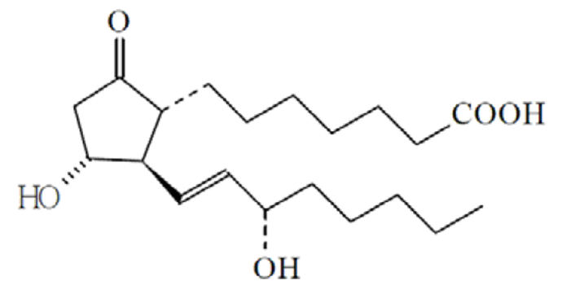

It is freely soluble in alcohol, soluble in acetone, slightly soluble in ethyl acetate, very slightly soluble in chloroform and in ether, and practically insoluble in water. Polymorphism is not known. As the drug substance is dissolved in ethanol during the manufacturing process of the drug product, its initial physical form and particle size distribution are not relevant.

The Drug Master File (DMF) procedure is used for the active pharmaceutical ingredient (API).

The synthesis comprises twelve synthetic steps. The starting materials are acceptable and controlled adequately. No class I organic solvents are used. The active substance has been suitably characterised. The API from the proposed DMF holder has previously been used in Australia in other registered products.

The drug substance specification is in line with the Ph. Eur monograph, with additional requirements for residual solvents, residual catalysts/heavy metals, and one specific related substance. The specification is acceptable in view of the route of synthesis and the various EU guidelines. A requirement for the microbial quality has been included. Batch analytical data demonstrating compliance with the drug substance specification have been provided for three full scale batches.

Stability data on the active substance have been provided for three full scale batches stored for four years at 5°C, in the proposed packaging. All results remained within the specification. The proposed re-test of four years, stored between 2°C and 8°C (protected from light and humidity), is acceptable.

### Drug product

Proshaeos 200 and 300 µg are white to off-white creams.

Each single use container contains 200 µg of alprostadil in 100 mg of cream (0.2% w/w) or 300 µg of alprostadil in 100 mg of cream (0.3 %).

Proshaeos is supplied in individual sachets containing one AccuDose container. Each single container contains 100 mg cream. The sachets are composed of aluminium foil/laminate. The container components are composed of polypropylene and polyethylene. Each box is packed with 4 dispensers.

The excipients are: purified water, anhydrous ethanol, ethyl laurate, hydroxypropyl guar gum, DDAIP HCl, potassium dihydrogen phosphate, sodium hydroxide for pH adjustment, phosphoric acid for pH adjustment.

This alprostadil cream formulation was developed as a more convenient topical dosage form, and as an alternative to the approved invasive treatments like the intracavernosal injections. The development of the product has been described, the choice of excipients and their functions explained. The cream contains the novel excipient, DDAIP HCl. DDAIP HCl is a surfactant that should promote the absorption of alprostadil after penile application (in the urethra). Full information on this novel excipient has been provided.

The main development studies concerned the performance of DDAIP HCl, the applied stability overage of 10%, and the dispenser. The applied concentration range of DDAIP HCl was based on in vitro permeation studies with alprostadil and in vivo clinical studies. The proposed permeation enhancement characteristics of DDAIP HCl over the proposed range DDAIP HCl are supported by the clinical and nonclinical assessment. The stability overage for the active substance is acceptable in view of the observed degradation in the stability studies and the concentrations in the clinical batches.

The single use product is formulated and manufactured to have a low bioburden content, but it is not manufactured as a sterile product and does not contain preservatives. It has been demonstrated that a preservative is not needed due to the preservative activity of the drug product itself. The stability results demonstrate adequate microbial quality over the whole shelf life. A clear overview of the formulations and batches used in the clinical studies has been provided. The Phase III clinical studies have been performed with the commercial formulation manufactured according the proposed process. The submitted results of batch analysis and validation of the commercial batches manufactured at the proposed site confirm consistent quality of the drug product.

The DDAIP HCl used for the clinical batches is from a different manufacturer than the proposed commercial manufacturer. This has been adequately discussed and substantiated by characterisation data and analytical results. The proposed dispenser has been used in the clinical studies and the stability batches. Accuracy of the dispenser is adequately controlled by batch-to-batch control of weight variation of the delivered dose, as % of target dispense weight, content uniformity and alprostadil assay.

In view of the manufacturing process, that is, suspension in aqueous phase of oil-in-water emulsion, the low concentration and unit dose, the instability of the active substance (low temperature, nitrogen purging, light protection), and the required low microbial burden, the process is a non-standard process in line with the guidelines on process validation. Appropriate, large scale validation data of eight batches have been provided of the process performed at the development manufacture site together with validation data of commercial scale batches manufactured at the proposed site. The validation is appropriate.

In house specifications are applied for ethyl laurate, hydroxypropyl guar gum and DDAIP HCl. Full information has been provided on novel excipient DDAIP HCl. The synthesis comprises three synthetic steps and re-crystallisation. The starting materials are acceptable. Potential genotoxic impurities have been adequately discussed. Adequate characterisation of DDAIP HCl has been provided. The control specifications are suitable. A re-test of 24 months has been justified based on 18 months long term and 6 months accelerated stability data. An adequate specification is applied for hydroxypropyl guar gum (modified). For the other excipients reference is made to the Ph. Eur.

The product specification includes tests for appearance, identity, assay alprostadil and DDAIP HCl, degradation products of alprostadil and DDAIP HCl (1-dodecanol), pH, viscosity, oxygen content, leak test, microbial quality, uniformity of delivered weight as % of label claim, particle size distribution and uniformity of content. Wider shelf life requirements are applied for assay alprostadil, DDAIP HCl, degradants and pH. The methods are suitable and have been adequately validated. Batch analytical data have been provided of all validation/stability batches. Results of batch analysis of commercial-scale batches manufactured at the proposed site, and tested for all proposed specifications and with the proposed methods have been provided. Limits for known degradants are qualified in view of the stability results and as these are metabolites of endogenous PGE1 and present in comparable amounts in human ejaculate.

Stability data on the product have been provided of three batches of both strengths stored at long term (5°C) and accelerated conditions (25°C/60%). The conditions used in the stability studies are according to the stability guidelines outlined by the International Conference on Harmonisation of Technical Requirements for Registration of Pharmaceuticals for Human Use (ICH). The batches were stored in the commercial packaging.

It is clear that the product in the proposed packaging is not very stable. The concentration of DDAIP HCl decreases due to sorption by the plastic packaging. The lower limit for DDAIP HCl was required to be set in accordance with the limits observed in finished product batches used in the pivotal Phase III trials and the shelf life was set accordingly. Moreover, PGE1 degrades rapidly in the formulation.

The justification of the safety of the levels of these degradation impurities is acceptable.

Therefore, the shelf life of 6 months for the 200 and 300 µg product is acceptable in view of the submitted stability data and the lower limits accepted for DDAIP HCl.

### Advisory committee considerations

The application was not considered by the Pharmaceutical Subcommittee of the Advisory Committee on Prescription Medicines (ACPM).

### Quality summary and conclusions

Provided that the outstanding issues raised by the evaluator are adequately addressed, registration can be recommended with respect to chemistry, manufacturing and quality control aspects.

## III. Nonclinical findings

### Introduction

The safety and efficacy of alprostadil has been previously established and therefore the aim of this report is to establish the safety profile of the new excipient (DDAIP) and of the final formulation.

Some data were submitted but not evaluated. Some studies were not useful due to the fact that the excipient was not present at all in the formulations tested, or it was tested in all the experimental groups without a control or comparator. Other studies did not provide useful data since they were performed with a formulation containing DDAIP with terbenafine (which is not the subject of this submission). Preliminary studies with lower concentrations of DDAIP and/or a shorter duration than other studies in the same species were also not evaluated.

### Pharmacology

#### Primary pharmacology

The rationale for the inclusion of DDAIP in the formulation is that it enhances absorption of alprostadil. No nonclinical studies were submitted to demonstrate that DDAIP enhances dermal or mucosal absorption/penetration of alprostadil. A study in cadaveric human skin (Study TR-034) showed that after application of 100 mg of 0.3% alprostadil cream to human cadaver skin, no permeation of alprostadil was observed for up to 8 h. However, a clinical study (NM-AP-40C-CH – NM-AP-40F-CH) demonstrated that the presence of DDAIP (0.05 to 0.3%) significantly increased the efficacy of the formulation.

#### Secondary pharmacodynamics and safety pharmacology

Safety pharmacology studies were only performed with DDAIP alone. Two in vivo safety pharmacology studies (central nervous system [CNS] in rats and cardiovascular in dogs), and two in vitro hERG assays (one on DDAIP HCl and one on its metabolites) were performed. No studies were submitted that evaluated the safety pharmacology of the combination alprostadil and DDAIP or the potential drug interaction between alprostadil and DDAIP.

CNS safety pharmacology tests in rats showed no DDAIP related effects on body weight, body temperature, or behavioural assessments at up to 30 mg/kg subcutaneous (SC).

In anaesthetised dogs, subcutaneous administration of the vehicle (0.5% w/v Tween 20) and DDAIP (3 mg/kg) was well tolerated and did not induce significant effects on the measured cardiovascular or respiratory parameters (that is, blood pressure, heart rate, left ventricular systolic pressure, left ventricular dp/dt, max, electrocardiogram, femoral flow, femoral resistance, respiration rate, minute volume and tidal volume). DDAIP Cmax in this study was 3.49 ng/mL (Study TR-149).

DDAIP inhibited hERG tail current in HEK-293 cells (IC50 178 nM, 57 ng/mL) more potently than its metabolites dodecanol (IC50 1.72 μM, 320 ng/mL), DDAIP-N-oxide (IC50 12.73 μM, 3840 ng/mL) and N,N-dimethylalanine (IC50 ≥10 mM). The IC50 value of DDAIP in the hERG assay (57 ng/mL) is 1140 times higher than the human DDAIP plasma low limit of qualification (0.05 ng/mL) in clinical studies following topical application of formulations containing 2.5% DDAIP HCl in men. Therefore, DDAIP is not predicted to prolong the QT interval in patients.

Hypotension was observed when dogs received alprostadil at 0.4% together with DDAIP at 5% (TR-089). However, hypotension is a known possible adverse effect of the administration of alprostadil. Based on the large safety margins, no additional adverse cardiovascular, respiratory and CNS effects are predicted with clinical use of the Vitaros formulation of alprostadil.

### Pharmacokinetics

The nonclinical and clinical PK of alprostadil when administered alone to treat similar indications has been well established.

The nonclinical PK studies focused on DDAIP and DDAIP HCl and not on any possible differences between the previously approved substance alprostadil with or without the new excipient.

Both alprostadil and DDAIP become systemically available after dermal absorption. No clinical drug-drug interactions are known and are not expected due to the low systemic concentrations achieved with both compounds (very low to undetectable). Neither alprostadil nor DDAIP are metabolised via the CYP pathway.

The interpretation of PK parameters obtained for DDAIP is difficult due to the low levels achieved and also to a large variability between animals.

The bioavailability of 3H-14C-radiolabeled DDAIP after dermal application on hair-free skin was ~5% in rat. This bioavailability is expected to under represent the bioavailability after absorption through the penis mucosa.

Plasma protein binding of DDAIP is very high (>99%) in rat, dog and human plasma. The distribution of DDAIP in rats has only been determined after SC administration and not after application on the penis. After SC administration, the highest tissue concentrations were in the kidney, bladder, skin, adrenals, stomach and gonads. After 72 h, tissue radioactivity was still measurable indicating slow elimination from tissues.

Metabolism of DDAIP is primarily mediated by carboxylesterases, which produce the primary metabolites, the two (endogenous) compounds n-dodecanol and N,N-dimethylalanine. Dodecanol (lauryl alcohol) is an endogenous alcohol of low water solubility, and is oxidized to the corresponding aldehydes and on to carboxylic acids and ultimately to carbon dioxide. The other primary metabolite, N,N-dimethylalanine, a tertiary amino acid, is a zwitterion at physiological pH and would likely be excreted in the urine without further metabolism due to its low molecular weight and high water solubility. Further metabolism into the endogenous amino acid alanine is also possible. DDAIP is most likely mainly excreted via urine, as N,N-dimethylalanine, in both rats and dogs. Excretion via faeces was a minor route of elimination. No significant differences in PK have been found between nonclinical species and humans that preclude the use of the animal species for the determination of the safety profile of DDAIP.

#### Permeation of alprostadil and DDAIP through condoms

Application of a 0.3% alprostadil cream containing 2.5% DDAIP HCl did not affect the viral barrier integrity of lubricated and non-lubricated latex condoms (Study TR-260). Although application of a 0.4% alprostadil cream containing 5% DDAIP did not cause leakage failure, the cream significantly decreased the strength (14% decrease in burst volume and 11% decrease in burst pressure) of non-lubricated condoms after 2 h of exposure (lubricated condoms had a non-significant decrease in strength parameters), although the condoms retained burst strength values above the minimum American Society for Testing and Materials (ASTM) standard for condom acceptability (at least twice the threshold criteria) (Study TR-255). Elongation or breakage (tensile strength) was not affected in lubricated condoms, whereas in the non-lubricated condoms there was a significant decrease in elongation and decrease in breakage (Study TR-255).

Importantly, no permeation of alprostadil through the condom was detected after 1 h (below limit of detection of 0.05 μg/mL) following application of 100 mg of 0.3% alprostadil cream containing 2.5% DDAIP HCl (single recommended clinical dose and formulation).

Low levels of DDAIP HCl permeated through lubricated (15.7 ± 19.8 μg) and non-lubricated (3.8 ± 4.0 μg) condoms after 1 h following application of a 2.5% DDAIP HCl cream without alprostadil. Similarly, low quantities of DDAIP permeated through lubricated (3.8 ± 1.0 μg) and non-lubricated (9.9 ± 10.5 μg) condoms 1 h after application of a 2.5% DDAIP HCl cream with alprostadil (0.3%). Therefore the worst case scenario of DDAIP permeating through a condom after application of the proposed clinical formulation is **9.9 μg** (ca. 0.4 % of the 2.5 mg dose; Study TR-029).

In summary, it is expected that the use of a condom will prevent the transfer of alprostadil to the sexual partner. Since DDAIP is an irritant (see local tolerance discussion below), it is recommended that a condom is used to significantly decrease the amount of DDAIP transferred to the sexual partner.

### Toxicology

#### Acute toxicity

Single dose toxicity studies with DDAIP and DDAIP HCl were conducted in mice, rats and rabbits. All studies were conducted under Good Laboratory Practice (GLP) conditions and had an appropriate observation period. All of the studies (except for one) lacked an appropriate control. The acute LD50 was >5000 mg/kg orally in mice and rats, and >750 mg/kg IV in mice. Single dose local application of DDAIP 5% (in the cream, with or without alprostadil) caused irritation to the vagina of rabbits. Thus, the only DDAIP related toxicity observed via the clinical route is local irritation (discussed further below), with a very low order of toxicity via the oral and intravenous routes.

#### Repeat dose toxicity

A multitude of studies were performed to investigate the repeat dose toxicity of alprostadil cream formulation, DDAIP and DDAIP HCl, in male and female animals through topical, subcutaneous and intravenous routes of administration in mice, rats, rabbits and dogs.

Since the toxicological profile of alprostadil has already been established, this assessment focuses on the new excipient DDAIP.

The studies were well designed to evaluate the safety of the product. The clinical dose was used, as well as the clinical route. Although the maximum concentration of DDAIP used (5%) was only twice the proposed concentration in the clinical formulation, this concentration was sufficient to characterise the effects of DDAIP topically. The potential systemic effects were addressed with subcutaneous administration to rabbits, rats and dogs, providing high exposure margins. The design of some studies did not allow for meaningful safety data for Vitaros or DDAIP to be obtained; thus, these studies were not evaluated (see scope of nonclinical data).

The duration (up to 11 months), route (dermal, SC, mucosal), dosing frequency (once to twice daily), species used, and groups sizes, were appropriate and were also consistent with ICH guidelines.

##### Relative exposure

Exposure ratios (ERs) have been calculated based on animal:human plasma Cmax when available, and on a ratio of the concentration used in the studies in animals cf. concentration proposed for men (it would be inappropriate to compare doses in mg/kg when the drug is applied topically and the effects are caused locally). No toxicokinetic data were provided for rabbits. Human reference values are not available and therefore the low limit of quantification was used for calculations. Systemic relative exposures to DDAIP were high and provide a significant safety margin for systemic exposure to DDAIP at the recommended dose/concentration and route of administration. The local relative exposure achieved during the studies was only ≤2.

Table 2: Relative exposure to DDAIP in repeat-dose toxicity and carcinogenicity studies.

|  |  |  |  |  |  |  |
| --- | --- | --- | --- | --- | --- | --- |
| Study; species; route | Sex | Dose DDAIP  (mg/kg/ day) | % DDAIP | DDAIP Cmax (ng/mL) | Local ERa | Systemic ERb |
| Mouse (CD-1)  Study TR-256 [3 months]  Topical. DDAIP HCl | M | 2 | 0.05 | 1.67 | 0.02 | NA |
| 20 | 0.5 | 11.8 | 0.2 | NA |
| 40 | 1 | 16.9 | 0.4 | NA |
| 100 | 2.5 | 44.4 | 1 | NA |
| 200 | 5 | 105 | 2 | NA |
| F | 2 | 0.05 | 1.48 | 0.02 | NA |
| 20 | 0.5 | 10.6 | 0.2 | NA |
| 40 | 1 | 16.1 | 0.4 | NA |
| 100 | 2.5 | 41.7 | 1 | NA |
| 200 | 5 | 102 | 2 | NA |
| Mouse (hemizygous Tg.AC)  Study TR-067 [26 weeks]  Topical. DDAIP | M | 25 | 0.5 | - | 0.2 | NA |
| 50 | 1 | - | 0.4 | NA |
| 125 | 2.5 (P) | - | 1 (P) | NA |
| F | 25 | 0.5 | - | 0.2 | NA |
| 50 | 1 (P) | - | 0.4 (P) | NA |
| 125 | 2.5 (P) | - | 1 (P) | NA |
| Mouse (CD-1)  Study TR-282 [2 years]  Topical. DDAIP HCl | M/F | 20 | 0.5 | 5.2-6.3 (1.5h) | 0.2 | NA |
| 100 | 2.5 | 14 (1.5h) | 1 | NA |
| 200 | 5.0 | 24-26 (1.5h) | 2 | NA |
| Rat (SD)  Study TR-280 [28 days]  Topical  Terbinafine HCl Nail Lacquer (with DDAIP HCl 0.5%) | M/F | 3 | 0.5 | 1.1-4.4 | 0.2 | NA |
| Rat (SD)  Study TR-246 [6 months; sampling day 90]  Topical. Terbinafine HCl Nail Lacquer (with DDAIP HCl 0.5%) | M/F | 3 | 0.5 | 1.1-9.8 | 0.2 | NA |
| Minipig (Gottingen);  Study TR-251 [9 months; sampling day 90]  Topical. Terbinafine HCl Nail Lacquer in alcoholic vehicle (with DDAIP HCl 0.5%) | M/F | 3 | 0.5 | 0.2-1.4 | 0.2 | NA |
| Rats  Study TR-283 [2 years] Topical. Terbinafine HCl Nail Lacquer in alcoholic vehicle (with DDAIP HCl 0.5%) | M/F | 3 | 0.5 | 0.4-4.3 (plasma levels at 2h) | 0.2 | NA |
| Rabbits  Study TR-082 [28 days] Topical b.i.d. on the glans penis, Alprostadil (0.4%) cream (with DDAIP 0.5%) | M | 2.5, 5, 10 | 5 (S) | - | 2 (S) | NA |
| Dogs  Study TR-100 [28 days]  Topical b.i.d. on the penis, DDAIP | M | 10 | 5 | 1.1 | 2 | NA |
| 2.5 | 5 | 0.5 |
| 5 | 5 | 1.3 |
| 10 | 5 | 2.0 |
| Rat (SD)  Study TR-092/818-015 [6 months]  Subcutaneous DDAIP | M | 3 | NA | 1.7 | NA | 35 |
| 10 | NA | 12 | NA | 245 |
| 30 | NA | 15 | NA | 306 |
| F | 3 | NA | 2.6 | NA | 53 |
| 10 | NA | 5.0 | NA | 102 |
| 30 | NA | 40 | NA | 816 |
| Dogs  Study TR-088 [7 days]  Oral DDAIP | F | 30 | NA | 85 | NA | 1735 |
| 300 | NA | 138 | NA | 2816 |
| Dog (beagle)  Study TR-095 [11 months]  Subcutaneous DDAIP | M | 0.3 | NA | 2.2 | NA | 45 |
| 1 | NA | 6.2 | NA | 127 |
| 3 | NA | 21 | NA | 429 |
| F | 0.3 | NA | 3.3 | NA | 67 |
| 1 | NA | 7.6 | NA | 155 |
| 3 | NA | 22 | NA | 449 |
| Men  Topical on the opening of the penis | M | 2.5 mg DDAIP (2.5% DDAIP in 100 mg cream) | 2.5 | 0.049 (C) | NA | NA |

**a** = animal:human DDAIP concentration; **b** = animal:human plasma Cmax; **C** = low limit of quantitation was 0.05 ng/mL; **bold** = NOAEL; **NA** = not applicable. **1.5h** = plasma levels at 1.5h; **P** = concentration and relative exposure at which significant increases in the incidence of papilloma were observed; **S** = concentration and relative exposure at which significant increases in the incidence of degeneration of seminiferous tubules was observed

The calculated relative exposure (both systemic and local) is much lower for the sexual partner of the patient, as follows:

* The DDAIP relative exposures ratio for the sexual partner (without a condom) are 5.5 times the Relative Exposure of the male patient, since 18% of the applied DDAIP has been calculated to be potentially transferred to the sexual partner (0.45 mg out of 2.5 mg; Study TR-286).
* The DDAIP relative exposure ratio for the sexual partner of the patient when using a condom is 250 times the Relative Exposure of the sexual partner without a condom, since up to 0.4% of the applied DDAIP has been shown to pass through a condom when the formulation is used (10 μg out of 2.5 mg).

###### Papillomas

An increased incidence of papillomas was observed in transgenic mice at a DDAIP local relative exposure to DDAIP of ≥0.4 (for the patient), ≥2.2 (for their sexual partners without condom) and 550 (for sexual partner when using condom). See Carcinogenicity discussion below.

###### Degeneration of seminiferous tubules

An increased incidence of degeneration of the epithelium of the seminiferous tubules was observed in the rabbit at a local relative exposure to DDAIP of 2 (for the patient), 11 (for their sexual partners without condom) and 2750 (for sexual partner when using condom). This finding was observed in all the groups receiving DDAIP (with or without alprostadil), was not observed in animals receiving a formulation without DDAIP, and was dose-dependent (see Reproductive Toxicity below).

#### Relative exposure to alprostadil

The Caverject PI states that when administered IV to man, alprostadil had a metabolic half-life of less than one minute, rapidly transforming to relatively inactive metabolites. No alprostadil was detected in the peripheral circulation after intracavernosal administration. After Vitaros application via the topical route, it was difficult to demonstrate systemic absorption due to the rapid metabolism of prostaglandin E1, resulting in low or undetectable systemic blood levels of alprostadil in most patients.

Due to the history of use of alprostadil, the fact that alprostadil is chemically identical to the naturally occurring hormone prostaglandin E1, and the lack of measurable systemic exposure after the proposed route of administration, it is not expected that the patient’s exposure to alprostadil in Vitaros will be higher than to alprostadil in currently approved formulations for similar indications.

The exposure of the sexual partner to alprostadil after topical Vitaros application is expected to be higher than with previously approved formulations which are injected into the corpus cavernosum, since in the current proposed formulation the sexual partner will be in direct contact with the site of application (the glans penis and semen containing non-absorbed alprostadil from the urethra). A submitted modelling study (TR-286) has calculated that up to 58 μg of alprostadil may be transferred to the sexual partner. Since 25 μg misoprostol administered vaginally has been used to induce labour,[2] it is recommended that the patient wear a condom when having sexual contact with a woman who is pregnant or who is unsure of her pregnant status. During condom use, no alprostadil is expected to transfer from the male to the sexual partner, based on the results of a submitted study (TR-029/NEXM-030508).

##### Major toxicities

The major target organ for Vitaros was the local application site (skin, penis or vagina). See local tolerance and carcinogenicity.

Male rabbits receiving DDAIP subcutaneously at 60 mg/kg/day for 4 weeks had reduced thymus weight (relative to body weight), which was not accompanied by macroscopic or microscopic thymic effects (TR-081). Male dogs receiving a cream with DDAIP (5%; topically on the penis) displayed a decrease in thymus weight compared to body weight (accompanied by thymic atrophy) compared with animals not receiving DDAIP, and a further decrease was observed in animals which additionally received alprostadil (0.4%). Since systemic exposure is negligible after topical use in humans, and this effect was not observed in other 28 day dog studies with DDAIP being applied intrameatally, this finding is unlikely to be clinically relevant. No immunotoxicity was observed in any other of the repeat dose toxicity studies.

Small but significant treatment (DDAIP and/or alprostadil) related increases in kidney weight (relative to body weight) were observed sporadically in repeat dose toxicity studies in different species and using different routes of administration(female rats, SC; female rabbits, vaginal application; male dogs, topical application on the penis). This finding was not encountered in other studies, and was not accompanied by treatment related microscopic renal findings. This effect is unlikely to be of human relevance.

Inflammation and hyperplasia of the urinary bladder with a trend for dose dependency of alprostadil and DDAIP was observed in a study of 28 days in rabbits using vaginal application. This effect was not replicated in an almost identical study or observed in any other species, and is unlikely to be clinically relevant.

#### Local tolerance

Rabbits displayed local signs of acute and chronic inflammation at the injection site, and rats displayed scabs at the injection site accompanied by signs of inflammation following repeated SC administration of ≥15 mg/kg/day DDAIP for 4 weeks. After 6 months of SC injection of 30 mg/kg/day DDAIP, rats presented haematological signs of inflammation, while dogs receiving up to 3 mg/kg/day DDAIP for 11 months showed no treatment related local effects. Since the cream is being applied topically to the penis, the local effects after subcutaneous administration are not directly relevant to human use.

After receiving alprostadil (0.4%) with DDAIP (5%) topically in dedicated local tolerance studies, varying degrees of effects were observed, including only very slight reversible irritation of the rat penis, only very slight erythema in the rat skin, and ocular irritation in the rabbit. Local tolerance studies with ≥5 % DDAIP demonstrated the production of erythema of increasing severity in guinea pigs and rabbits. In one study in rabbits, DDAIP under occlusion caused erosions in the skin, and in another it caused corrosion. DDAIP was not considered to be a contact sensitiser in guinea pig, but was found to be a vaginal irritant in rabbits. Application of 5% DDAIP for 5 days did not cause irritation to the penis of 2 dogs. Repeated topical application (4 weeks) of DDAIP with alprostadil did cause swelling and oedema of the penis in rabbits.

A formulation of 0.4% alprostadil containing 5% DDAIP HCl caused severe cytotoxicity in mouse fibroblasts. This effect was not observed when DDAIP was applied by itself, and was still present when only alprostadil was tested, suggesting the cytotoxic effect is due to the presence of alprostadil. However, irritation due to DDAIP was confirmed when application of DDAIP at ≥1% to the skin of mice (transgenic and non-transgenic) for ≥4 weeks caused epidermal hyperplasia at the site of application.

In 2-year studies in mice (TR-282) and rats (TR-283), dermal application of ≥ 0.5% DDAIP caused skin erythema (accompanied by epidermal hyperplasia in the mice).

Results from repeat dose toxicity studies, as well as dedicated local tolerance studies indicate that topical application of Vitaros may cause at least a low degree of irritation in the penis, and possibly of the vagina of a sexual partner if a condom is not used. Since alprostadil is cytotoxic and DDAIP is an irritant, consideration must be given to post-market monitoring for adverse local reactions.

#### Genotoxicity

DDAIP was negative in a chromosomal aberration test in vitro, a bacterial reverse mutation test and a forward mutation in mammalian cells. Other tests were invalid or DDAIP was not tested appropriately. None of the genotoxicity tests provided were positive and there is no evidence to suggest that either alprostadil, DDAIP or DDAIP HCl have genotoxic potential.

#### Carcinogenicity

Two carcinogenicity studies were completed on DDAIP (26 week dermal application in Tg.AC mice and a 2 year subcutaneous dosing study in rats) and two on DDAIP HCl (2 year dermal study in mice and a 2 year dermal study of terbinafine HCl Nail Lacquer containing 0.5% DDAIP HCl in rats). All the studies were well conducted.

Vitaros (containing alprostadil 0.4% and DDAIP ≥1%) caused papillomas in the transgenic mouse model of carcinogenicity (at a relative exposure of ≤1). The other three carcinogenicity studies were negative (at relative local exposures to DDAIP of between 0.2 and 2).

The increased incidence of papillomas was observed in transgenic mice (associated with skin irritation signs such as inflammation, hyperkeratosis, and epidermal hyperplasia) at a DDAIP local relative exposure to DDAIP of ≥0.4 (for the patient), ≥2.2 (for their sexual partners without condom) and 550 (for sexual partner when using condom). This transgenic model was used since it is particularly sensitive to dermally applied carcinogens. However, it has been found that Tg.AC mice are not only sensitive to carcinogenic compounds but also to proliferative and pro-inflammatory stimuli (wounding is a true tumour promoting stimulus in this transgenic mice model).[3] Agents that cause severe, chronic and overt irritation, inflammation, and increased proliferation have been found to be tumorigenic in Tg.AC mice.[4] Irritation associated tumourigens in Tg.AC mice that were nontumourigenic in long-term rodent studies include tripropylene glycol diacrylate,[5] resorcinol,[6] and lauric acid diethanolamine.[7]

Although chronic irritation may induce carcinogenesis in humans,[8] the fact that chronic application of DDAIP (which was an irritant in several nonclinical studies) did not cause papillomas or other tumours in studies of up to 2 years in mice or rats, provides reassurance that the mechanistic pathway by which papillomas developed due to DDAIP application is not relevant to humans. Furthermore, in a model for HPV infected tumour cells, DDAIP-HCl at 5% did not induce increased human cervical tumour growth or increase the expression of oncoproteins.

Furthermore, in a HPV infected mouse xenograft model, DDAIP-HCl did not promote tumour growth or increased the expression of oncoproteins E6/E7. Taken together, the weight of evidence suggests that it is unlikely that DDAIP HCl is a tumour promoter in humans.

Nevertheless, due to the local irritation/inflammation likely caused by administration of Vitaros, and taking into account findings of regenerative epidermal hyperplasia in mice, its prolonged use may pose a risk for the development of a regenerative local response.

#### Reproductive toxicity

Embryofoetal studies were performed in rats and rabbits, and fertility and post-natal development studies were performed in rats. All the studies used the subcutaneous route and provided sufficient exposure margins. The choice of species, group sizes, timing and duration of treatment was appropriate.

##### Relative exposure to DDAIP

No toxicokinetic data were available for rabbits.

Table 3: Relative exposure to DDAIP in repeat dose toxicity and carcinogenicity studies.

|  |  |  |  |  |  |
| --- | --- | --- | --- | --- | --- |
| Study | Study | Day of sampling (treatment period) | DDAIP Dose (mg/kg/ day); SC | Cmax (ng/ mL) | ER# |
| Rat (SD)  Study TR-320 | Embryofoetal development; SC | Dams GD20; (GD6–PP21) | 10 | 49.9 | 5601 |
| 30 | 143 | 16051 |
| 60 | 200 | 22449 |
| Dams PP7; (GD6–PP21) | 10 | 25.8 | 2896 |
| 30 | 51.1 | 5736 |
| 60 | 83.5 | 9372 |
| Male pups  PP7 | ≤30 | - | - |
| 60 | 4.13 | 464 |
| Female pups  PP7 | ≤30 | - | - |
| 60 | 1.82 | 204 |
| Men  Topical on the opening of the penis | M | 2.5 mg DDAIP (2.5% DDAIP in 100 mg cream) | 2.5 | 0.049 (C) |  |

– = not calculable; GD = gestation day; PP = postpartum; # = animal:human Cmax x 5.5 (to take into account only ~18% of the dose applied would be transferred to the sexual partner); C = low limit of quantitation was 0.05 ng/mL.

In a dedicated fertility and early embryonic study in rats, the only effect observed was a decrease in viable embryos per animal, in the group of animals receiving 60 mg/kg/day DDAIP.

In the embryofoetal study in rabbits, a maternotoxic (decreased food consumption) dose of 60 mg/kg/day caused decreased foetal body weight and an increased incidence of skeletal malformations, vertebral/rib defects, and fused sternebrae above historical controls. No effects were observed (apart from local effects at the injection site) in clinical signs or embryofoetal development in rats receiving up to 60 mg/kg/day.

In the postnatal study in rats, no effects were observed in the mothers (apart from local effects at the injection site) or the F1 generation, at relative exposures of between 200 and 22,000 times the exposure expected at the Maximum Recommended Human Dose (MRHD). Only a decrease in weight gain was observed in the pups, at a relative exposure of between 200 and 464.

No reproductive toxicity studies were performed with the salt form DDAIP HCl, nor were any studies done with a formulation also containing alprostadil. Developmental toxicity was only observed in rabbits, displaying lower foetal body weights at 60 mg/kg/day. Only a slight increase in the incidence of skeletal malformations was seen at ≥30 mg/kg/day, and it was likely due to maternal toxicity.

The relative exposure ratio for DDAIP achieved in the embryofoetal development study was high, especially taking into account that only a portion of the DDAIP dose applied would be transferred to a sexual partner (further reduced by the use of a condom). Placental transfer and/or excretion in milk were demonstrated in animals since DDAIP was found in the plasma of pups at post-partum day 7.

In the repeat dose toxicity studies, isolated effects were observed in the reproductive system. In a 28 day topical (on the penis) study in rabbits (TR-082) a decrease in testes weights and degeneration of the seminiferous tubule epithelium were observed, at a relative local exposure to DDAIP of 2. Although unilateral degeneration of seminiferous tubules was observed in mice receiving 2.5% DDAIP topically, this effect was not observed in rats or dogs in repeat dose toxicity studies of between 4 weeks and 2 years.

In a fertility study, sperm motility was unaffected in rats receiving up to 60 mg/kg/day DDAIP (TR-098). However, in a study using human sperm, **0.4% alprostadil containing 5% DDAIP HCl inhibited sperm motility after a 30-minute incubation.**

Taking into account calculations provided in a review by the sponsor, it is expected that up to 18% of the DDAIP administered to the patient may be transferred to his sexual partner. Although this dose is approximate, it is expected that in case of transfer, the systemic exposure will be negligible. Nevertheless, taking into account the abortifacient properties of alprostadil, it is recommended that men use a condom when they use Vitaros during sexual contact with a woman of reproductive age. The potential effect on sperm motility should be described in the PI document, and is appropriately documented in the RMP.

##### Pregnancy classification

Since Vitaros is not proposed for use in women, pregnancy categorisation is not applicable. However, due to the possibility that the drug may be transferred to women during intercourse, statements are required on Use in Pregnancy and Use in Lactation.

#### Impurities

The proposed specifications for impurities/degradants in the drug substance/product are below the ICH qualification thresholds.

#### Paediatric use

Vitaros is not proposed for paediatric use and no specific studies in juvenile animals were submitted.

### Nonclinical summary and conclusions

#### Summary

* The safety and efficacy of alprostadil has been previously established. The rationale for the inclusion of DDAIP in the formulation is to enhance absorption of alprostadil. However, no nonclinical studies were submitted that assessed the effects of DDAIP on dermal or mucosal absorption/penetration of alprostadil.
* Since the toxicological profile of alprostadil has already been established, this evaluation focusses on the new excipient DDAIP HCl. DDAIP and DDAIP HCl had a very low order of acute toxicity via the oral and IV routes in mice, rats and rabbits. However, vaginal irritation was observed after topical application.
* Safety pharmacology studies on DDAIP alone suggested that no additional adverse effects on major organ systems aside from those already identified for alprostadil (for example, hypotension).
* Both alprostadil and DDAIP are systemically available, albeit at very low levels, after dermal application. Systemic exposure to alprostadil using the Vitaros formulation will not exceed the current acceptable levels associated with alprostadil use for similar indications. Up to 18% of the DDAIP administered to the patient may potentially be transferred to his sexual partner; however, the systemic exposure of the sexual partner is expected to be negligible.
* Metabolism of DDAIP is primarily mediated by carboxylesterases (not CYPs), which produce the primary metabolites n-dodecanol and N,N-dimethylalanine, both endogenous compounds. The animal species used were metabolically appropriate for the determination of the safety profile of DDAIP and Vitaros.
* The major target organ for Vitaros was the local application site (skin, penis or vagina). Topical administration of the formulation (with concentrations of 5% DDAIP) caused slight irritation of the rat penis, slight erythema in the skin if the rat, rabbits and guinea pigs, as well as ocular and vaginal irritation in the rabbit. Local skin erythema and/or epidermal hyperplasia were observed following topical application of ≥0.5% DDAIP for 2 years, or ≥1% for 4 weeks, in mice. Skin erythema was also observed in rats (≥0.5% DDAIP for 2 years). The local relative exposure achieved during the studies was low (≤2).
* The alprostadil cream containing DDAIP did not affect the viral barrier integrity of lubricated and non-lubricated latex condoms. The cream may decrease the strength of condoms (especially non-lubricated) although condoms may retain an acceptable level of strength. During condom use no alprostadil is expected to transfer from the male to the sexual partner, whereas approximately 0.4% of the DDAIP dose may be transferred. Since alprostadil is embryotoxic in rats, and PGE1 administered vaginally has been used to induce labour, it is recommended that the patient wear a condom when having sexual contact with a woman of reproductive age. The exposure to DDAIP for the sexual partner is 5.5 times less than to the patient, and it is further reduced 250 times when a condom is used.
* Results from nonclinical studies indicate that topical application of Vitaros may cause a low degree of irritation in the penis, and possibly of the vagina of a sexual partner if a condom is not used. Since alprostadil is cytotoxic and DDAIP is an irritant (which caused regenerative hyperplasia of the skin), consideration must be given to post-market monitoring for adverse local reactions (including the potential development of a regenerative response).
* Subcutaneous administration of 60 mg/kg/day DDAIP caused a decrease in viable embryos per animal in rats, and in rabbits caused maternal toxicity, decreased foetal body weight and an increase in the incidence of skeletal malformations, vertebral/rib defects, and fused sternebrae above historical controls. The relative exposure to DDAIP achieved in these studies was high, especially taking into account that only a portion of the DDAIP dose applied would be transferred to a sexual partner (further reduced by the use of a condom). Placental transfer and/or excretion in milk were demonstrated in animals. Since Vitaros is not proposed for use in women, pregnancy categorisation is not applicable.
* A decrease in testes weights and degeneration of the seminiferous tubule epithelium were observed in a topical (on the penis) study in rabbits, at a relative local exposure to DDAIP of 2, and unilateral degeneration of seminiferous tubules was observed in mice receiving 2.5% DDAIP topically. In a direct spermatotoxicity study, a formulation containing 0.4% alprostadil and 5% DDAIP HCl produced spermicidal activity (that is, inhibited motility) after 30 minutes of incubation. The risk of spermatoxicity warrants the post authorisation study proposed by the sponsor in the RMP.
* Repeated subcutaneous administration of DDAIP produced local reactions. Systemic exposure ratios to DDAIP were high and provide a significant safety margin for systemic exposure to DDAIP at the recommended dose/concentration and route of administration.
* DDAIP was negative in a chromosomal aberrations test in vitro, a bacterial reverse mutation test and a forward mutation in mammalian cells. There is no evidence to suggest that the proposed formulation has genotoxic potential.
* An increased incidence of papillomas was observed at a DDAIP local relative exposure of ≥0.4 in transgenic (Tg.AC) mice. However, since Tg.AC mice are not only sensitive to carcinogenic compounds but also to proliferative and pro-inflammatory stimuli, and DDAIP was found not to be tumorigenic in long term (non-transgenic) rodent studies (of up to 2 years duration), it is likely that the mechanistic pathway by which papillomas developed due to DDAIP application is not relevant to humans.

#### Conclusions and recommendation

* There are no nonclinical objections to registration.
* The product may cause irritation to the patient. A condom should be used with this product.
* It is not expected that the product will be carcinogenic in humans.
* Consideration should be given to post-market monitoring for adverse local reactions (including the potential development of a regenerative response).
* The product may be spermatotoxic. The risk of spermatoxicity warrants the post authorisation study proposed by the sponsor in the RMP.

## IV. Clinical findings

A summary of the clinical findings is presented in this section. Further details of these clinical findings can be found in Attachment 1.

### Introduction

#### Clinical rationale

The development of a penile erection is a complex physiological process in which psychological and physical cues trigger vasodilation of penile blood vessels, which in turn causes compression of venous outflow tracts and vascular engorgement of the penis.

ED is a common problem, which may cause significant psychological distress for men and their partners. There are two broad aetiological categories of ED, psychological and physical, with some subjects having a mixed aetiology. The incidence of ED increases with age, and it is more common in the setting of significant medical conditions such as vascular disease, diabetes, or neurological disorders, particularly those affecting the spinal cord. Endocrine disorders, particularly those that lower levels of male hormones such as testosterone, may also cause ED and are usually treated by correcting the underlying hormonal deficiency.

In addition to addressing any psychological barriers to normal erectile function, and reversing underlying medical problems, treatments for ED have primarily focussed on enhancing vasodilation. Viagra (sildenafil), the best known treatment for ED, as well as the related drugs Levitra (vardenafil) and Cialis (tadalafil), work by inhibiting phosphodiesterase type-5 (PDE5), subsequently producing vasodilation. These drugs are administered orally, potentially leading to systemic side effects, such as hypotension, resulting from more widespread vasodilation. Topical treatments have the potential advantage of reducing systemic side effects, or allowing relatively greater local vasodilation in the target organ than the systemic circulation. Endogenous compounds such as alprostadil also have the potential theoretical advantage of being free of unexpected immunological or other toxicities, so they represent natural targets for research in this area.

Vitaros was developed as a refinement of existing topical approaches to the use of alprostadil in treating ED. Alprostadil has already been available in the parenteral form, Caverject, for many years, but the invasive route of administration is potentially unappealing to many patients, and can cause scarring with repeated use. Alprostadil is also available internationally as a urethral suppository, in the product Muse, but the insertion of a suppository into the urethra may be considered invasive and unappealing to many subjects. Muse is not registered in Australia. Befar cream has been registered in China, and resembles Vitaros in that it is a topical cream applied to the penile meatus, but the sponsor proposes that Vitaros produces better targeted absorption of alprostadil because it uses a permeation enhancing agent, DDAIP HCl.

#### Guidance

The submission does not indicate that the sponsor received guidance from the regulatory authorities on the design of their studies. One study (a long term safety study, MED 2000-006) was paused and then closed prematurely because of FDA concerns about a toxicity study in mice.

Correspondence with the TGA indicates that a few other issues were discussed pre-submission, as follows:

* The proposed indication was changed, at the request of the TGA, from “treatment of erectile dysfunction” to “treatment of erectile dysfunction in adult males”.
* The TGA made the following request:

*Please provide full details and copies of correspondence in the submission regarding the rejection by the FDA and the clinical hold that was placed on the product by Health Canada.*

The sponsor replied as follows:

*For the US the NDA was deemed “not approvable” and an end of review meeting was held with a discussion on what was needed for approval. The non-approvable letter is provided. Subsequently, the NDA was sold to Warner Chilcott (now Actavis) and any follow up to provide a response was then transferred to the new licensor. The previous global sponsor is not aware of any further action regarding this NDA.*

*With regard to the dossier submitted in to Health Canada, the information originally provided to the TGA was not accurate. There was not a clinical hold placed on this product. Instead, a NOD (Notice of Deficiency) and a NON (Notice of Non-compliance) were issued by Health Canada during the evaluation process. The sponsor responded satisfactorily to both of these notices and the application was approved. There was not a clinical hold, this was the result of a misunderstanding regarding region specific terminology. A copy of the NOD and NON are provided.*

The “not approvable” rejection letter from the FDA and the Notices of Deficiency and Non-compliance from the Canadian authorities are discussed below.

#### Contents of the clinical dossier

The submission contained the following clinical information:

* Two clinical pharmacology studies, including one that provided PK data and one that used radiolabelled topical cream to assess migration of the cream into the urethra
* No population PK analyses
* Two pivotal Phase III efficacy/safety studies
* One open label Phase III extension study
* Four Phase II efficacy studies, including a high dose study that was abandoned because of poor tolerability and a single dose crossover study that might be better considered a pharmacodynamic (PD) study
* Eighteen efficacy/safety studies performed in China with various alprostadil formulations differing from the proposed Vitaros formulation
* Studies for unrelated conditions, such as female sexual dysfunction, premature ejaculation, and fungal toe infection (included because the nail lacquer contained the same permeation enhancer, DDAIP, that is contained in Vitaros)
* Integrated Summary of Efficacy
* Integrated Summary of Safety

#### Paediatric data

The submission did not include paediatric data. The treatment is proposed for use in adult males.

#### Good clinical practice

All of the major studies, and in particular the pivotal studies, contained statements of compliance with Good Clinical Practice (GCP) and the conduct and reporting of the studies appeared to be consistent with GCP. For some of the studies performed in China, the studies were not submitted in sufficient detail to confirm that they complied with GCP.

### Pharmacokinetics

#### Studies providing pharmacokinetic data

Because Vitaros is a topical preparation, with very limited systemic absorption, a standard PK program was not performed or submitted. Instead, the sponsor provided a single PK study in which subjects were treated with topical Vitaros and serum was collected for assays of prostaglandin E1 (PGE1, equivalent to alprostadil), prostaglandin E0, 15-keto-PGE0 and DDAIP. Levels of PGE1 were below levels of quantitation, so no direct PK analysis of alprostadil could be performed.

The sponsor also submitted a cream migration study that used radiolabelled topical cream to determine how much cream migrated proximally along the urethra after correct and deliberately incorrect application.

No other PK studies were submitted. The PK of alprostadil was initially characterised in the lead up to marketing of Caverject, and the proposed PI for Vitaros largely relies on that original characterisation.

#### Evaluator’s conclusions on pharmacokinetics

The PK of alprostadil has previously been defined during development of parenteral preparations of alprostadil (Caverject), and the current submission provides very little new information. After administration of the proposed doses, alprostadil levels are undetectable, but its major metabolite 15-keto-PGE0, reaches a peak within one hour and is then cleared over the next few hours. Although this metabolite is said to have only 1-2% of the activity of alprostadil, Vitaros does produce systemic hypotensive responses in some subjects, indicating that clinically relevant systemic levels of active metabolites must be achieved.

There is indirect evidence that lung disease may increase exposure to alprostadil, by reducing first pass metabolism, but this has not been directly assessed with Vitaros. There is also indirect evidence suggesting that age and gender are unlikely to have a major effect on the PK of Vitaros.

The permeation agent, DDAIP, is also absorbed systemically after topical use of Vitaros, but the levels were below the limits of quantitation in most subjects.

No data was submitted that directly confirms that DDAIP, the permeation-enhancing agent, increases absorption of alprostadil.

### Pharmacodynamics

#### Studies providing pharmacodynamic data

The sponsor did not submit any studies characterised as PD studies, but some of the efficacy studies had a design more consistent with a PD study than an efficacy study. Study NM 2000-007, for instance, was presented as a Phase II efficacy study, but it used a crossover design and a laboratory based assessment of the erectile response to different doses of alprostadil.

Many of the efficacy studies performed in China could also be considered as PD studies, but they did not directly assess the PD of alprostadil; instead they assessed the improvement in efficacy that resulted from the addition of various strengths of DDAIP to alprostadil cream. These studies did not use a non-alprostadil placebo arm, so they did not directly assess the efficacy or PD of alprostadil. Three of them had a similar design and were considered together in an integrated study report that provides indirect evidence that the addition of DDAIP improves the efficacy of alprostadil. This integrated data is discussed in the Efficacy Section.

Two of the Chinese studies assessed erectile responses to alprostadil creams, using a penile rigidity recorder in one, and Doppler ultrasound in another, but Vitaros was not used in either of these studies, and both studies lacked a placebo control group, so they do not provide any PD data of direct relevance to Vitaros.

Summaries of the Chinese studies are presented in this report.

No studies were performed that assessed the potential for PD drug interactions, and no study specifically assessed the potential of alprostadil to modify the QT interval.

#### Evaluator’s conclusions on pharmacodynamics

The PD of alprostadil have been characterised in the development of other alprostadil products, but no new PD data were submitted. The mechanism of action of alprostadil is reasonably well understood, and alprostadil appears to improve erections by enhancing vasodilation.

Significant gaps in knowledge of the PD effects of alprostadil remain, particularly in relation to the systemic hypotensive effects of alprostadil. This issue is discussed further in the Safety section of this report.

### Dosage selection for the pivotal studies

Several lines of evidence led to the selection of three doses to be assessed in the pivotal Phase III studies (100 µg, 200 µg and 300 µg). Befar, an alternative alprostadil cream lacking DDAIP, which is registered for treatment of ED in China, is used at two doses: 1000 µg alprostadil in 250 mg of cream and 400 µg alprostadil in 100 mg cream. The Chinese formulation studies showed better efficacy with DDAIP containing formulations than DDAIP free formulations of alprostadil, reflecting improved absorption arising from the addition of DDAIP. The maximum proposed dose of Vitaros, 300 µg, resembles the lower Befar dose, and might be expected to have broadly similar efficacy allowing for improved absorption.

The DDAIP strength adopted for further studies was based on evidence that at least 0.05% was needed to improve efficacy relative to DDAIP free formulations, balanced against the potential for DDAIP to cause some local irritation. The Chinese studies had not shown a clear increase in adverse events across the DDAIP strength range of 0.05% to 5.0%, as shown in Table 4, and so it appears that an intermediate dose was chosen for further study. The sponsor has not provided any specific rationale for choosing 2.5% over lower strengths.

Table 4: Adverse Events in Chinese Studies NM-AP-40B, NM-AP-40C-CH and NM-AP-40F-CH.

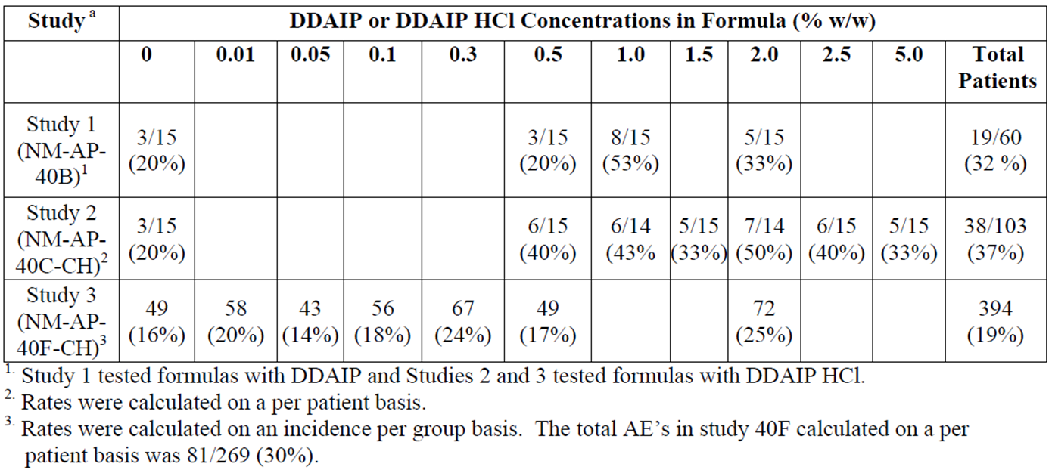

The first USA Phase II study of alprostadil with DDAIP was performed with alprostadil doses similar to the Befar doses: 500 µg, 1000 µg and 1500 µg, in conjunction with 2.5% DDAIP. This study produced unacceptable side effects, with 9 of 21 subjects not tolerating the first test dose, so the dose range was reduced to 50 µg, 100 µg, 200 µg and 300 µg for the other Phase II studies (the study in mild-to-moderate ED used 50-200 µg; the study in severe ED used 100-300 µg; the instrumental study assessed 100-300 µg). Overall, these studies suggested alprostadil had better efficacy at 200 µg and 300 µg than at lower doses, but the efficacy difference between 200 µg and 300 µg appeared to be small and inconsistent. Subsequently, 3 doses (100 µg, 200 µg and 300 µg) were selected for the Phase III studies. The Phase III studies did not assess different DDAIP strengths.

As will be discussed below, the Phase III studies subsequently showed similar efficacy in the 200 µg and 300 µg groups, with inferior results in the 100 µg dose group. Most AEs showed a dose trend across the range 100 µg to 300 µg, but tolerability at the highest dose was acceptable to most subjects. The 200 µg and 300 µg doses have therefore both been proposed for marketing, with the 200 µg dose offered as an alternative lower dose if down titration is needed in response to side effects.

In conclusion, although there is some rationale behind the dose and formulation chosen for the Phase III studies, the evidence is inconclusive. It could be argued that it would be as or more appropriate for subjects to start with an alprostadil dose of 200 µg and titrate upwards to 300 µg, if needed. The limited evidence from formulation studies suggests that a lower strength of DDAIP might offer similar efficacy, with less exposure of subject to the risk of carcinogenesis.

### Efficacy

#### Studies providing efficacy data

The sponsor submitted 7 efficacy studies (three Phase III studies and four Phase II studies) that were performed in the US with Vitaros (or an equivalent formulation containing a higher alprostadil dose, in the case of MED 99-001), as summarised in the tables below.

Table 5: Phase III clinical studies.

|  |  |  |  |  |
| --- | --- | --- | --- | --- |
| Study Number | Patients enrolled / completed | Design | Purpose | Comments |
| MED 2000-004 | 878 enrolled ITT  850 evaluable efficacy population ITT-E | 3 month home use randomised, placebo controlled, double blind, parallel safety and efficacy study  doses of 100, 200, 300 µg alprostadil  initial in-clinic safety check | Pivotal safety and efficacy | Well designed and executed  Clear demonstration of efficacy and safety on 100, 200, 300 µg |
| MED 2000-005 | 854 enrolled ITT  819 evaluable ITT-E | 3 month, home use randomised, placebo controlled, double blind, parallel safety and efficacy study  doses of 100, 200, 300 µg alprostadil  initial in-clinic safety check | Pivotal safety and efficacy | Second pivotal trial essentially identical to MED 2000-004 above  Demonstration of efficacy and safety on 100, 200, 300 µg |
| MED 2000-006 | 1161 treated for various lengths of time  999 of these rolled over from other Phase III studies  998 rollover patients treated  163 new patients | Open label safety and efficacy study  12 month intended period  Most patients rolled over from other Phase III studies  doses of 100, 200, 300 µg alprostadil | Primarily generated long term safety and efficacy information | Interrupted by sponsor after about 6 months  Provides efficacy and long term safety data |

Two of the Phase III studies (MED 2000-004, MED 2000-005) can be considered pivotal Phase III studies. The third Phase III study was an open label extension study with no placebo group, which was prematurely terminated because of toxicity concerns arising from a mouse study, and it should be considered only weakly supportive.

Table 6: Phase II Clinical Studies.

|  |  |  |  |  |
| --- | --- | --- | --- | --- |
| Study Number | Patients enrolled / completed | Design | Purpose | Comments |
| MED 99-001 | 128 intended 29 randomised | Placebo controlled, randomised, double blind, multiple dose at high levels 500, 1000, 1500 µg alprostadil | Develop preliminary efficacy and safety data on high dose cream | Study stopped by sponsor due to higher than expected AEs |
| MED 99-002A | 161 randomised 111 evaluable for efficacy | Placebo controlled, double blind, randomised, parallel, 6 week home study in mild to moderate patients treated with 50, 100, 200 µg alprostadil | Develop preliminary efficacy and safety data at low doses | Study successful. Useful data on mild to moderate patients. No 300 µg alprostadil |
| MED 2000-002A | 142 enrolled ITT  127 completed ITT-E  104 fully evaluated | Placebo controlled, double blind, randomised, parallel, 6 week at home use trial in severe patients  100, 200, 300 µg alprostadil | Develop preliminary safety and efficacy data on severe patients | Demonstrated efficacy and tolerability in severe patients and first use of the extract dose levels later used in Phase III |
| MED 2000-007 | 27 randomised 26 evaluable | Instrumental measurement of erections in clinic setting, randomised, placebo, 4 way, crossover doses of 100, 200, 300 µg alprostadil | Complement clinical efficacy measures with instrumental in-clinic measurements | Few differences in efficacy between groups. Demonstrated tolerability to study medication |

Of the four Phase II studies, two were supportive efficacy studies focussing on mild-to-moderate (MED 99-002A) or severe (MED 2000-002A) ED. One study (MED 99-001) was a high dose study that was abandoned prematurely because of poor tolerance of high doses; this study produced no useful efficacy data, but it provided useful insights into the relatively narrow therapeutic window for Vitaros. One study (MED 2000-007) was presented as an efficacy study but was primarily designed like a PD study; it used instruments to record erectile responses to erotic videos rather than using Vitaros in a natural setting. This study was a negative study, showing no significant therapeutic effect of Vitaros in this setting, but this could be due to technical issues in the recording set-up.

In addition, 18 studies with alprostadil were performed in China, but these studies did not employ the formulation proposed for registration, did not generally include a true placebo group, and in many cases were performed with an open label design. Three of the studies assessed alprostadil for a completely different indication (premature ejaculation), producing, at best, some safety data. Most of the Chinese studies were primarily intended to assess the effect of the DDAIP vehicle, and all subjects received alprostadil, including the so-called “placebo” group (the placebo was actually a placebo for the DDAIP vehicle, not a placebo for alprostadil).

Of the 18 Chinese studies submitted, only one of them compared the efficacy of alprostadil to placebo in a randomised, placebo controlled, double blind design and can therefore be considered a supportive efficacy study: NM-AP-38. This study did not use the proposed Vitaros formulation, but instead used Befar, so it is only indirectly relevant.

#### Evaluator’s conclusions on efficacy

The submitted studies characterised the efficacy of Vitaros in men with ED of varying severity and showed a statistically robust but clinically modest benefit over placebo. The benefit appeared to be more consistent in subjects with severe ED.

The main evidence establishing the efficacy of Vitaros came from two identically designed pivotal studies (MED 2000-004 and MED 2000-005), which tested three alprostadil doses (100 µg, 200 µg and 300 µg) in comparison to placebo over 12 weeks. The two highest doses in these studies correspond to the proposed doses. The pooled pivotal population achieved a positive result for each dose and for each of three different co-primary endpoints (giving nine dose endpoint combinations, all positive), as shown in the table below. For two of the endpoints (International Index of Erectile Function [IIEF] Domain scores, and Mean Percent Ejaculation Success), the 200 µg dose group achieved results that were numerically superior to the 300 µg dose group; for the third endpoint (Mean Vaginal Penetration Success), the 300 µg dose group was numerically superior to the 200 µg dose group. For all endpoints, doses of ≥ 200 µg achieved improvements that were numerically superior to those obtained with 100 µg. The individual studies were broadly concordant with these results, but did not achieve significance for every dose endpoint combination. For the 300 µg dose group, five of six co-primary endpoints across the two studies were positive, but significance was not achieved for Mean Percent Ejaculation Success in Study MED 2000-005, as shown in the tables below. For the 200 µg dose, significance was achieved in six of six co-primary endpoints across the two studies.

Table 7: Pooled efficacy results, pivotal studies MED 2000-004 and -005.

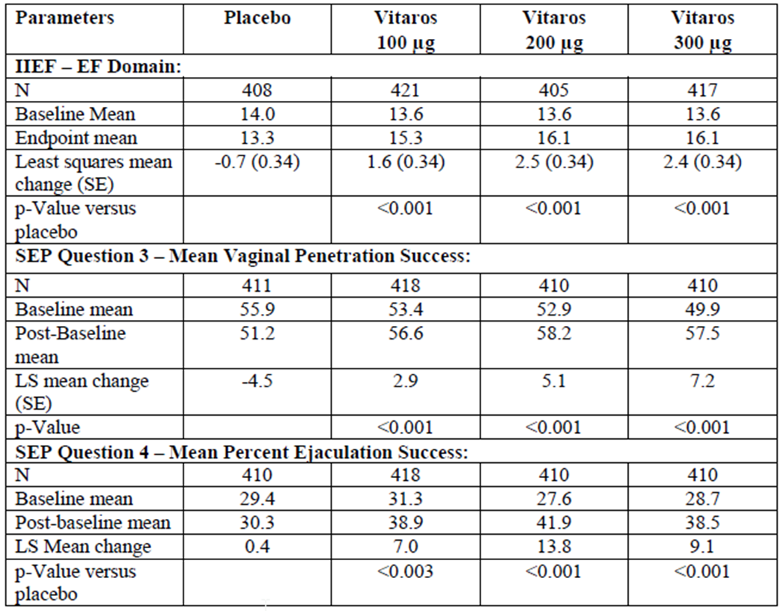

Table 8: Erectile Function Domain scores, Studies 004 and 005 individually (ITT-E)

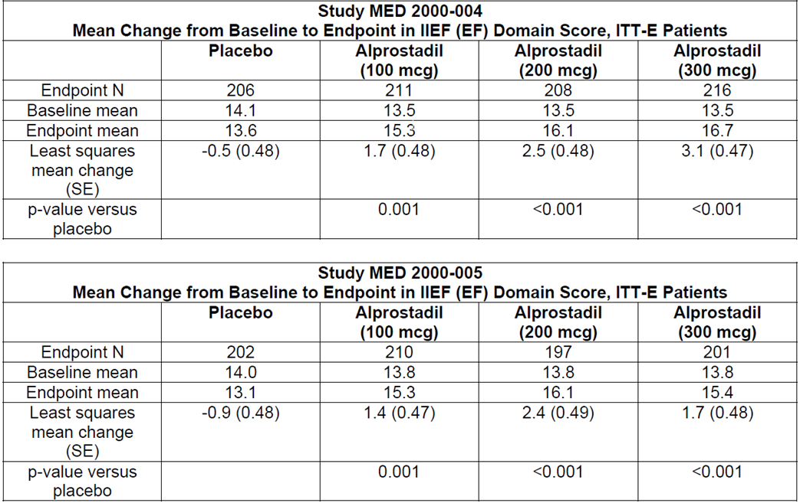

Table 9: Mean Vaginal Penetration Success, Studies 004 and 005 individually (ITT-E).

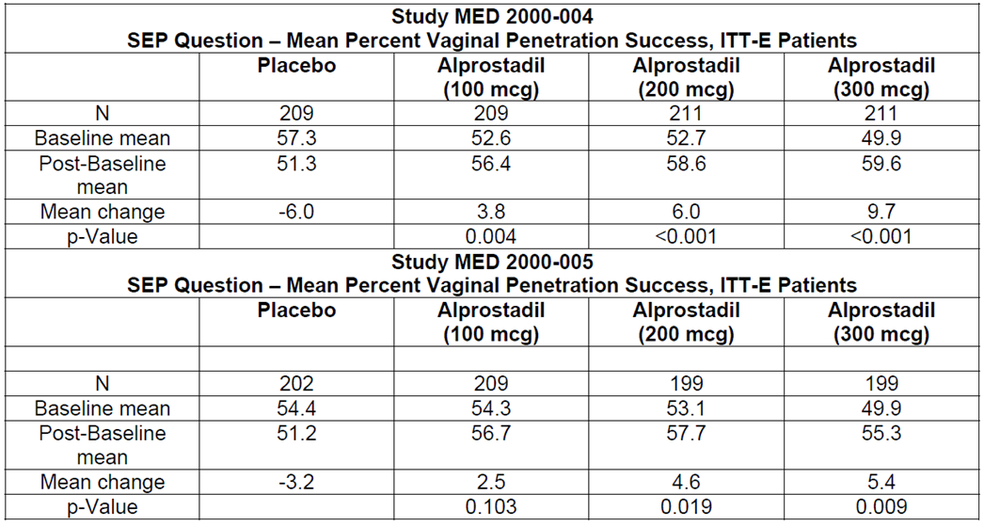

Table 10: Mean Ejaculation Success, Studies 004 and 005 Individually (ITT-E).

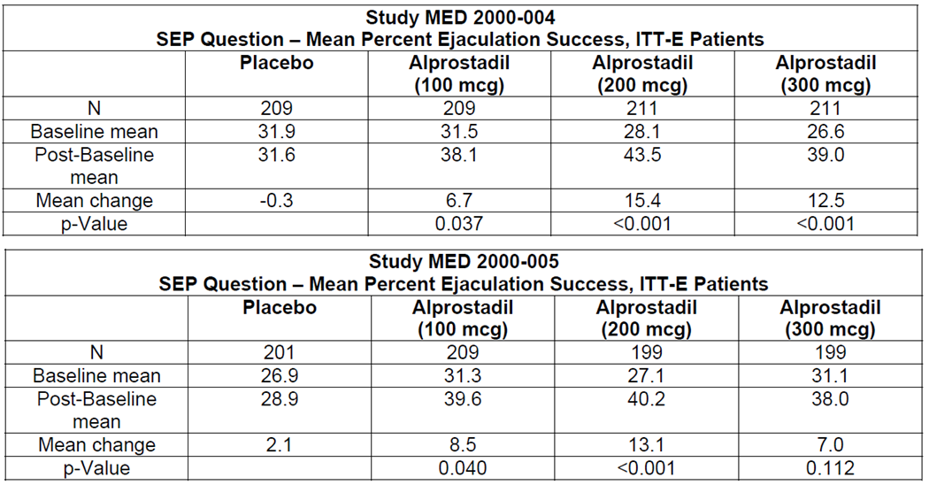

Secondary endpoints generally supported primary endpoints. For the Global Assessment Questionnaire (GAQ), 46-56% of subjects reported improvement (varying across the two studies and two higher dose groups), compared to only 20-21% of placebo subjects.

Table 11: Patient’s Global Evaluation, Studies 004 and 005 Individually (ITT-E).

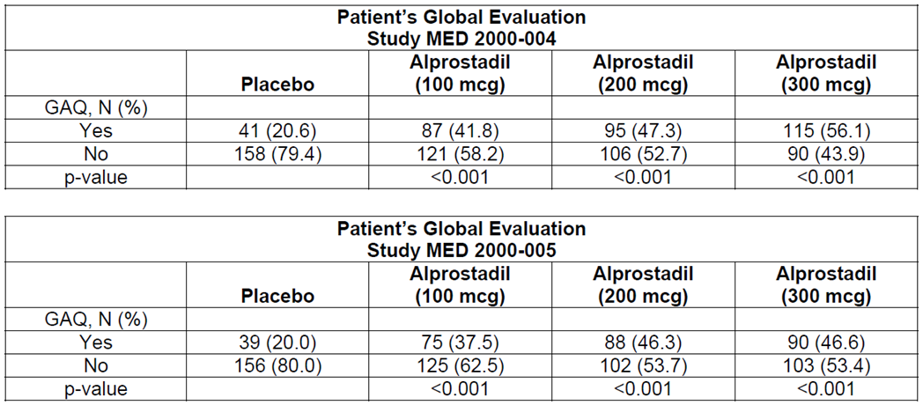

The studies appeared to be methodologically sound, but it is likely that the apparent treatment effect has been inflated by withdrawal bias and by some degree of unblinding due to tell tale side effects.

The improvements seen in the two highest dose groups are modest, only amounting to about 2.5 points from a 30 point range. The improvements are nonetheless likely to be perceived as clinically worthwhile by some patients, particularly because patients finding the treatment useful could self-select to continue treatment, whereas patients finding the treatment inconvenient, intolerable or ineffective could judge the benefit-risk balance for themselves and decide to discontinue treatment. Thus, efficacy in patients choosing to continue treatment is likely to be better than the overall mean change in scores observed in the pivotal studies. From the GAQ results, it can be estimated that one in three subjects would be expected to report an improvement in erectile function on treatment, over and above the improvements observed in the placebo group.

Subgroup analyses showed that Vitaros has broadly similar benefit in a number of subgroups, including those defined by diabetes, hypertension, and cardiac disease. Subgroup analysis according to age (≤65 years or >65 years) was attempted but it was underpowered. Subjects who had tried Viagra and failed did show a partial response to alprostadil, but the magnitude of the benefit was inferior to that achieved in the overall cohort, and statistical significance was not achieved for some endpoints.

One subgroup analysis of the pivotal efficacy data raises concerns about the use of Vitaros in men with mild ED. As shown in Table 12, the mean changes in Erectile Function (EF) scores in this subgroup were negative in all treatment groups, and improvements in the mild-to-moderate group were marginal.

Table 12: Response in subgroups by severity, Studies 004 and 005, Pooled.

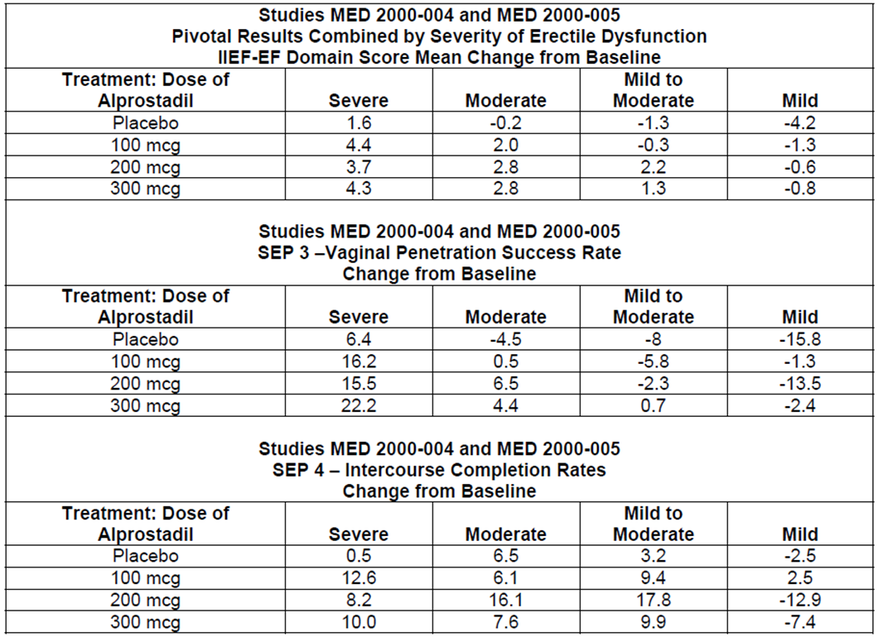

Taken at face value, the negative scores in the mild subgroup indicate that the overall effect of Vitaros may be negative in men with mild ED. Although the deterioration in scores was worse in the placebo arm of the mild subgroup, so that the active groups fared better than placebo, this does not necessarily mean that treatment produced a net benefit – placebo subjects did not necessarily exhibit results equivalent to the natural, untreated history of the condition because they had to undergo a somewhat intrusive treatment with the administration of placebo cream via a dispenser. It is quite possible that the use of a topical cream and a dispenser removes some spontaneity from the sexual act, has other negative psychological effects on sexual function, or produces local side effects that interfere with sexual function. The results shown suggest that, in mild cases, this negative effect is not completely overcome by the pharmacological benefits of treatment. At present, this negative effect is an unconfirmed post hoc observation, about which there is still uncertainty (the results were not presented with comparative statistics but were likely to have been underpowered); it is nonetheless clear that **there is no evidence in the pivotal studies of a positive effect in this subgroup**. Limited evidence from the Phase II study program is partially reassuring, because positive results were obtained in the mild-to-moderate study, but it is noteworthy that the Phase II program also showed discordant results in subjects with mild versus severe disease.

Only two Phase II studies of Vitaros contributed useful efficacy data. Each focussed on a particular range of ED severity. The study in mild-to-moderate ED (MED 99-002A) showed borderline benefit by the primary analysis method (among group treatment effect on change in EF scores by ANCOVA, p = 0.051 in the ITT analysis, p = 0.050 in the sponsor’s preferred Per Protocol analysis). The pairwise comparisons did strongly favour the 200 mcg dose over placebo, however (p = 0.007), and the test for a linear dose trend was also statistically significant (p = 0.015). Benefit for the 50 µg and 100 µg doses over placebo was not significant. (This study did not employ the main proposed 300 µg dose group, but in other studies 200 µg and 300 µg produced similar efficacy.) Some issues were noted in the reporting of this study in the sponsor’s clinical overview, where the less favourable ITT results were de-emphasised and erroneous p-values were cited.

Table 13: Results for primary endpoint, Intention to Treat (ITT) population, Study MED 99-002A.

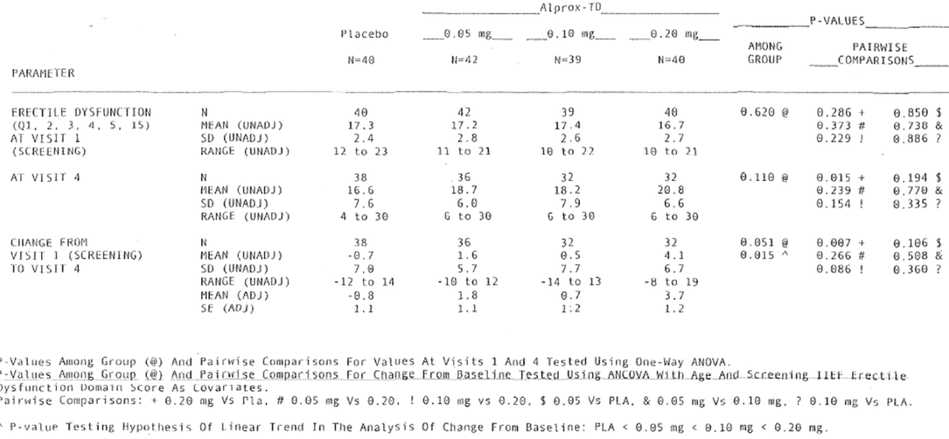

The sponsor did not perform any subgroup analysis of these results, so it is unclear whether subjects with mild ED (as compared to the broader cohort of mild-to-moderate ED) experienced any benefit from treatment.

The study in severe ED (MED 2000-002A) assessed doses of 100 µg, 200 µg and 300 µg, and it showed marked benefit relative to placebo in the highest dose group (an improvement of 9.44 points, compared to 2.67 with placebo, from a 30 point scoring system). Improvements in the EF score were intermediate for lower doses, and did not achieve statistical significance. Results in the GAQ, a secondary endpoint, also showed that active treatment was thought to lead to improvement in a higher proportion of subjects than achieved with placebo. (With alprostadil 300 µg, 83% of subjects felt that there had been at least some improvement, compared to only 26% in the placebo group.) This study therefore provides strong support for the overall pivotal study results, but only in subjects with more severe ED.

Table 14: Changes in EF Domain score (ITT-E), Study MED 2000-002A.

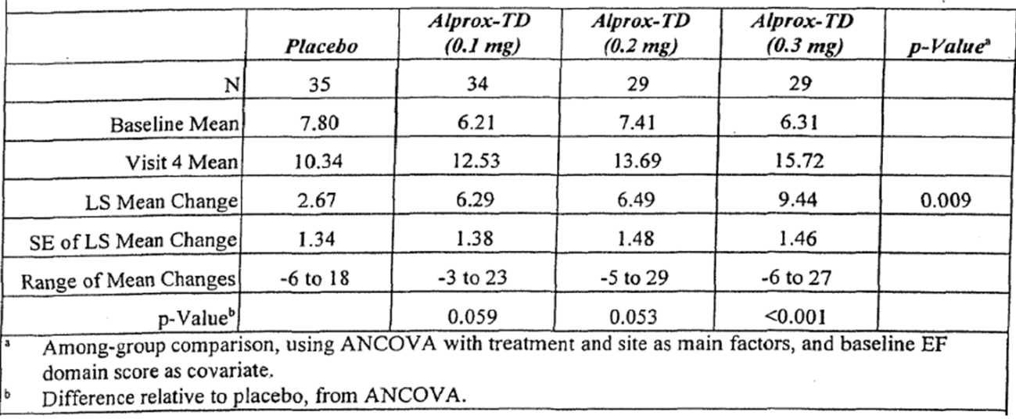

The other Phase II studies produced no useful efficacy data: one high dose study (MED 99-001) was abandoned because of poor tolerance; and, in an instrumental crossover study (MED 2000-007), the recording procedure appeared to be technically inadequate.

A long term Phase III extension study produced results that were of little value because treatment was open label and non-randomised and because the study was terminated prematurely.

Considering all of the submitted efficacy studies, there does not appear to be any good evidence establishing that alprostadil 300 µg has greater efficacy than 200 µg. In fact, in one of the submitted documents, a drug monograph intended for Canada the following statement occurs, at complete odds with the proposed Australian dosing recommendations:

*It is preferable that patients be initiated with the lower 220 µg Vitaros dose.*

One of the biggest deficiencies in the submitted efficacy data was a failure to defend, in any Phase III study, the need to include DDAIP 2.5% in the Vitaros formulation. Some Phase II Chinese studies of non-Vitaros alprostadil treatment suggested that DDAIP concentrations of ≥0.05 % improved the efficacy of alprostadil, but no consistent benefit was seen across ascending doses above this (Figure 2).

Figure 2: Effect of DDAIP on Response Rate (“Percent Efficacy”) in 3 pooled Chinese studies.

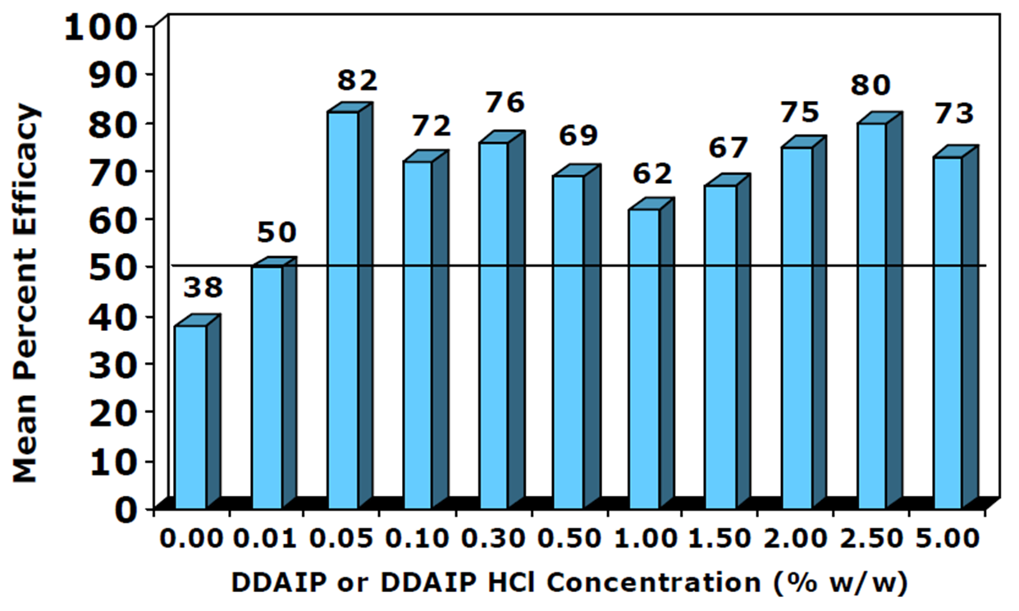

In conclusion, there is reasonably good evidence that Vitaros produces benefit in men with ED, but the magnitude of the benefit is modest, the optimal starting dose is unclear, and the benefit in subjects with mild ED may be particularly weak. The rationale for using DDAIP 2.5% instead of a lower DDAIP concentration is also weak.

### Safety

#### Studies providing safety data

The sponsor’s Integrated Summary of Safety was primarily based on ten studies performed with Vitaros in the US, with the majority of the data coming from two Phase III pivotal studies (MED 2000-004 and MED 200-005) and one Phase III open label extension study (MED 200-006). In the Vitaros studies of men with ED, a total of 3,338 patients were exposed to Vitaros.

All of the Phase III studies assessed the proposed doses (200 µg and 300 µg) and proposed formulation of Vitaros, in addition to the lower dose of 100 µg. The value of the placebo control data was limited by the fact that the placebo cream appeared to contain DDAIP (though this was not clearly described in the study reports). The use of a DDAIP containing placebo means that there is no Phase III DDAIP free control data and it is therefore impossible to gauge the incidence of AEs attributable to DDAIP itself.

The value of the open label extension study, MED 2000-006, was compromised by its premature termination at about six months. This study also lacked a placebo control group, making it difficult to put the observed AEs into context. Finally, it should be recalled that the cohort for this extension study largely consisted of subjects who had already demonstrated tolerance in one of the previous Phase III studies, and the extension study provided relatively few new exposures to active treatment.

In all of the Phase III studies, including the pivotal efficacy studies, the following safety data were collected:

* General AEs were assessed by interviewing subjects and their partners at each follow-up visit.
* AEs related to the site of application, such as local irritation, were also assessed by meatal examinations.
* Haemodynamic responses to alprostadil were assessed by giving each patient a test dose in the clinic at the start of each study, then measuring sitting and standing blood pressure and pulse rate. Patients with local intolerance (penile discomfort) or haemodynamic intolerance (a decrease in systolic blood pressure ≥ 30 mm Hg, a decrease in diastolic blood pressure ≥ 20 mm Hg, or an increase in pulse rate ≥ 30 bpm) were excluded from further treatment; this means that the population studied was not entirely representative of a typical clinical population who would not ordinarily receive a screening test dose at treatment initiation.
* Laboratory tests, including biochemical and haematological monitoring, were performed at baseline and study exit.
* Serious adverse events (SAEs) were collected whenever a subject had an unplanned clinic visit or hospital admission.
* AEs and SAEs occurring in partners were also collected and tabulated, given the potential for transfer of the medication during coitus.

Additional data came from four Phase II Vitaros studies, which similarly involved the tabulation of AEs. Only two of these studies (Med 99-002A and MED 2000-002A) assessed multiple doses of Vitaros at the proposed doses. One of the Phase II studies (MED 2000-007) was a single dose laboratory study. Another study (MED 99-001) assessed doses of 500 µg, 1000 µg or 1500 µg in 250 mg of topical cream, which are higher than that proposed, and this study was terminated prematurely because of poor tolerability.

The final three studies of Vitaros were small, single dose Phase I studies (NM-AP-001, a mixed gender tolerability study, MED 2000-003, a PK study, and NEXSCIN 2001-001, a radiolabelled cream study). AEs were assessed by post treatment interviews and tabulated, but the design of these studies meant that they were only able to detect short term tolerability issues.

The sponsor also submitted several Phase I tolerability studies assessing formulations different to that proposed for marketing, as well as 18 Phase II studies performed in China: the topical cream in those studies variously contained no DDAIP, varying strengths or chemical forms of DDAIP, or varying alprostadil doses.

The irritation studies provided good insight into the irritation potential of alprostadil and DDAIP, but they involved relatively low patient numbers, and the potential for rare idiosyncratic skin reactions or chronic skin reactions was not well characterised with this approach

In general, the safety reports for the Chinese Phase II studies were very brief, but AEs were listed for each study and the overall distribution of AEs resembled that seen in the larger pivotal studies. The information from these minor studies was not integrated into the overall safety database, and this information is of limited value anyway given that the formulations differed from that proposed for marketing and treatment was generally continued for a very short duration, ranging from a single dose to four weeks. In most cases, AEs in the minor studies were limited to local urogenital discomfort.

Additional safety information has come from studies of Femprox, a topical cream being developed to treat sexual dysfunction in women, which is identical to Vitaros but administered at higher doses (500-900 µg). These studies involve 618 female patients treated with alprostadil cream containing up to 0.4% alprostadil and either 5% DDAIP, or 0.5% DDAIP HCl or 2.5% DDAIP HCl.

Some indirect information about the safety of DDAIP also comes from studies of the treatment of fungal toe infections (onychomycosis), where DDAIP was used to improve permeation of the antifungal agent, terbinafine; these studies involved 140 patients treated with 10% terbinafine HCl nail lacquer, containing 0.5% DDAIP HCl (a much lower DDAIP concentration than Vitaros). Systemic absorption via nail lacquer is unlikely to be similar to systemic absorption via a cream applied to a mucosal surface such as the urethra, so these studies are of minimal value and were only included for completion.

Finally, the sponsor described the post marketing experience with Befar (a DDAIP free topical alprostadil cream used to treat ED in China); this exposure amounts to 188,838 doses prescribed and would be equivalent to approximately 517 patient-years of exposure if the product were used once a day (or even more patient-years if the average dosing frequency were less than once per day, as seems almost certain). Unfortunately, details about this post marketing experience were not provided by the Sponsor, merely assurances that it raised no safety concerns.

Overall, the tolerability of Vitaros has been well established. The major deficiency in the submitted information is the lack of long term clinical safety data. It is not possible to rule out, for instance, that DDAIP could be associated with carcinogenesis when used long term.

#### Patient exposure

##### Exposure by study

There were 1,732 patients in the pivotal Phase III studies, MED 2000-004 and MED 2000-005, and 1,161 patients in the long term study, MED 2000-006. Of the subjects in the long-term study, 737 subjects had already received alprostadil in the pivotal. The total number of subjects exposed to alprostadil in the submitted studies was 2,079 and the total number exposed to DDAIP was 3,500.

##### Exposure by duration

Exposure to alprostadil and DDAIP by time is summarised in the tables below. Exposure in the two pivotal studies was intended to be for 12 weeks and most subjects achieved this. Exposure in the extension study was intended to be for 12 months, but in most cases was <4 months because of premature study closure (median follow-up was just over 3 months). A very small number of patients (n = 4) achieved more than 12 months exposure to Vitaros because they were enrolled into a pivotal study early and/or had relatively long follow-up in the extension study before it was closed.

Table 15: Total Phase III exposure to Vitaros (including exposures to 100 µg dose).



Table 16: Total Phase III exposure to DDAIP (including drug and placebo exposures).



Table 17: Phase III duration in study (includes placebo exposures).

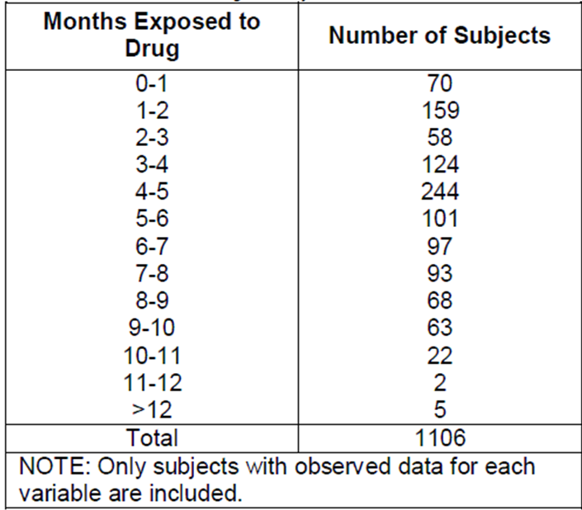

Table 18: Cumulative subject-months of exposure, MED 2000-006.

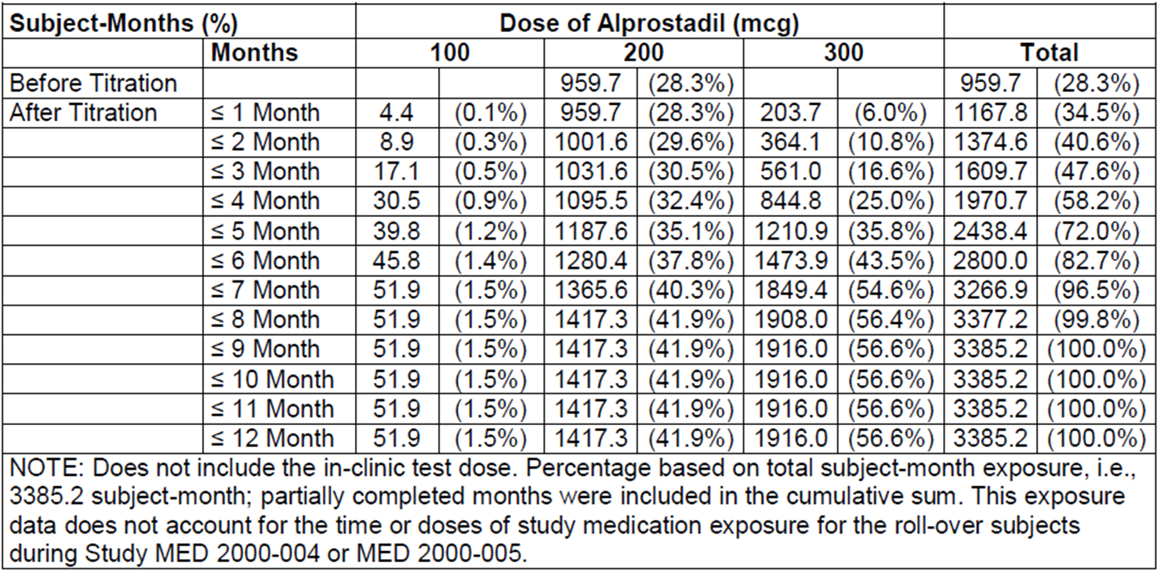

##### Exposure by dose

Exposure to the proposed doses of 200 µg and 300 µg in pivotal controlled studies is summarised below, and consists of 532 subjects who received 200 µg and 495 who received 300 µg. In the long term extension study, MED 2000-006, subjects were up-titrated to 300 µg if efficacy was inadequate, so the database for the 300 µg dose is increased if this study is considered, but this additional exposure to 300 µg represents uncontrolled, open label exposure without a suitable comparator group. Also, in Study MED 2000-006, all patients began at 200 µg and patients who were intolerant of 200 µg were down-titrated to 100 µg, so the cohort receiving 300 µg in Study MED 2000-006 was triply enriched for high tolerance: first, by passing through a screening test dose at the start of the pivotal study; second, by agreeing to enter a continuation study; and third, by down-titration of intolerant subjects before any patient was assigned the 300 µg dose. Tolerability in this dose group is therefore not likely to be truly representative of tolerability in a naïve, unselected cohort.

Table 19: Phase II and III patients treated by dose.

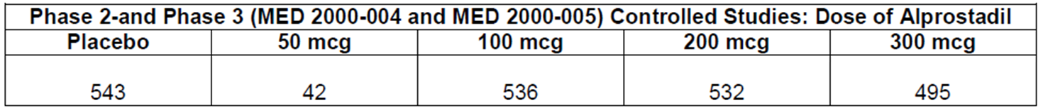

Table 20: Patients in MED 2000-006 treated by dose.

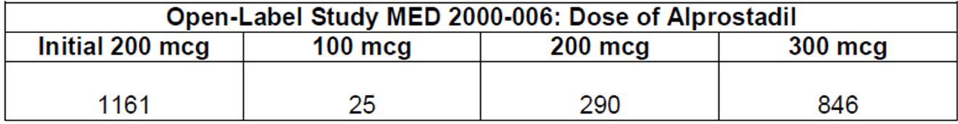

#### Safety issues with the potential for major regulatory impact

##### Liver toxicity

There is no evidence that topical alprostadil has any clinically significant effect on liver function, particularly because systemic absorption of alprostadil and its metabolites is very limited. No patients in any study had a severe disturbance of liver function.

##### Haematological toxicity

No subjects suffered from haematological reactions that appeared to be related to study drug, and the overall incidence of haematological AEs was similar in the active and placebo groups of the pivotal studies.

##### Serious skin reactions

Several subjects had local reactions to Vitaros, and irritations studies suggest that alprostadil and DDAIP both contribute to local irritation. In most cases, the local irritation resolved within 24 h.

Severe widespread skin reactions were not reported with Vitaros in the pivotal studies.

##### Cardiovascular safety

Alprostadil can cause hypotension, and some subjects may be at risk of pre syncope or syncope at the proposed doses of Vitaros. In the pivotal studies, no major changes in vital signs were observed with Vitaros, but vital signs were generally not assessed close to the time of dosing, which was performed at home pre coitus. Test doses in the clinic were occasionally associated with pre syncope, and this was most marked in the high dose study, using doses of 500 µg to 1500 µg, where 7 of 21 subjects had intolerance that was related, in part, to dizziness or hypotension. Three of these cases occurred in subjects who received 500 µg, which is less than double the proposed dose of 300 µg, indicating that the therapeutic window for Vitaros is narrow. Furthermore, subjects with orthostatic hypotension at screening were excluded from the Phase II and III studies. (This was determined by comparing sitting and standing blood pressure (BP) and pulse rate, and it was defined as a decrease in systolic BP ≥ 30 millimetres of mercury (mm Hg) relative to the sitting value, a diastolic BP decrease ≥ 20 mm Hg, or a pulse increase ≥ 30 beats/minute.) In the pivotal studies, this exclusion applied to two patients (2/1732, 0.1%), but one of these subjects received placebo.

It would be expected that, if alprostadil were administered to subjects with pre-existing orthostatic hypotension, they would experience a greater incidence of syncope than demonstrated in the pivotal studies. The proposed PI does not recommend a screening assessment of orthostatic blood pressure changes, but it does list known orthostatic hypotension as a contraindication to treatment.

A very slight excess of myocardial infarction was observed in the 300 μg dose group in the pivotal studies. Myocardial infarction was reported in 4 (0.9%) subjects receiving alprostadil 300 μg, and in 1 (0.2%) recipient of alprostadil 200 µg, but not in any recipients of alprostadil 100 μg or placebo. There was no clear temporal relation with treatment and investigators did not believe that study treatment played a causal role in any individual case. Importantly, subjects with a recent myocardial infarction were excluded from the pivotal studies, so the subjects with the highest cardiovascular risk were not assessed.

The proposed PI lists the following contraindication to Vitaros:

*Underlying disorders such as orthostatic hypotension and myocardial infarction.*

The reason for the contraindication of myocardial infarction was not discussed by the sponsor but, in view of the safety findings of the pivotal studies, it seems appropriate.

Overall, the submission does not provide clear evidence that topical alprostadil produces a significant risk of cardiovascular toxicity, but it remains a possibility, and this risk should be further assessed in post marketing surveillance.

##### Unwanted immunological events

AEs consisting of significant unwanted immunological events were not reported in the pivotal studies or in the long term extension study.

#### Post marketing data

The Integrated Safety Summary provided only a brief description of the post marketing experience obtained with Befar (a non DDAIP alprostadil cream), and no description of the post marketing experience obtained with Vitaros in Canada and the EU.

The sponsor’s comments in relation to Befar are reproduced below. No details are provided about the incidence of AEs or SAEs, and it is merely asserted that no “new” SAEs occurred. Even if there had been a high incidence of, say, myocardial infarction, it would be correct but unhelpful to say that no new SAEs occurred (because myocardial infarction had already been reported in the pivotal studies, it would not count as “new”).

The sponsor should be asked to extend these comments with sufficient detail that the post marketing experience can be evaluated for safety:

*Befar (0.4% alprostadil in a dose strength of 1000 μg alprostadil/250 mg of cream and 400 µg alprostadil/100 mg cream) is a topical cream approved in China and Hong Kong for the treatment of ED in men. Befar was approved for marketing by the State Drug Administration (SDA) in China on February 2, 2001.63 Befar was launched as a 250 mg cream dose in China in July 2001 and as a 100 mg cream dose strength in 2003. Befar was subsequently approved for marketing in Hong Kong in April 2002. The number of units of Befar sold in China and Hong Kong (Asia) in 2001, 2002, 2003, 2004, 2005, and as of June 30, 2006 were 21,000; 88,130; 17,399; 25,398; 25,764; and 11,147 unit doses, respectively. During this same period the cumulative human exposure to Befar in Asia in 2001, 2002, 2003, 2004, 2005, and as of June 30, 2006 was 21,000; 109,130; 126,529; 151,927; 177,691; and 188,838 unit doses, respectively. This represents 517 patient-years of exposure assuming daily dosing. However, this product is used less frequently and intermittently, and thus, if dosed every 2, 3, 4, 5, 6, 7 (once a week) or 14 (once every 2 weeks) days, this represents 1035, 1552, 2069, 2587, 3104, and 3622, and 7243 patient years of exposure, respectively.* ***During this same period (2001 through June 30, 2006), there were no new serious adverse drug reactions (SAEs) reported to NexMed Asia and no ADRs reported to the SDA, nor to the Hong Kong regulatory body.*** *Although the prescribing data is not available to determine if the product was used once or more by patients, it is expected based on the high compliance of continued use and low discontinuation rate from the Phase III studies of Vitaros in the US that the Asia exposure data represents multiple use by the majority of patients.*

#### Evaluator’s conclusions on safety

The **tolerability** of Vitaros has been well defined, and the main issues identified consist of urogenital discomfort and occasional instances of hypotension. The two pivotal studies, pooled for safety analysis, provided the best assessment of tolerability, and the AEs in each pivotal dose group are summarised below. Urogenital AEs were reported in 42-43% of subjects at the proposed doses, and mostly consisted of urogenital discomfort.

Table 21: Summary of Most Common Patient Adverse Events (AEs that occurred in >1% of Patients) (Intent-To-Treat Safety Population): MED 2000-004 and MED 2000-005.

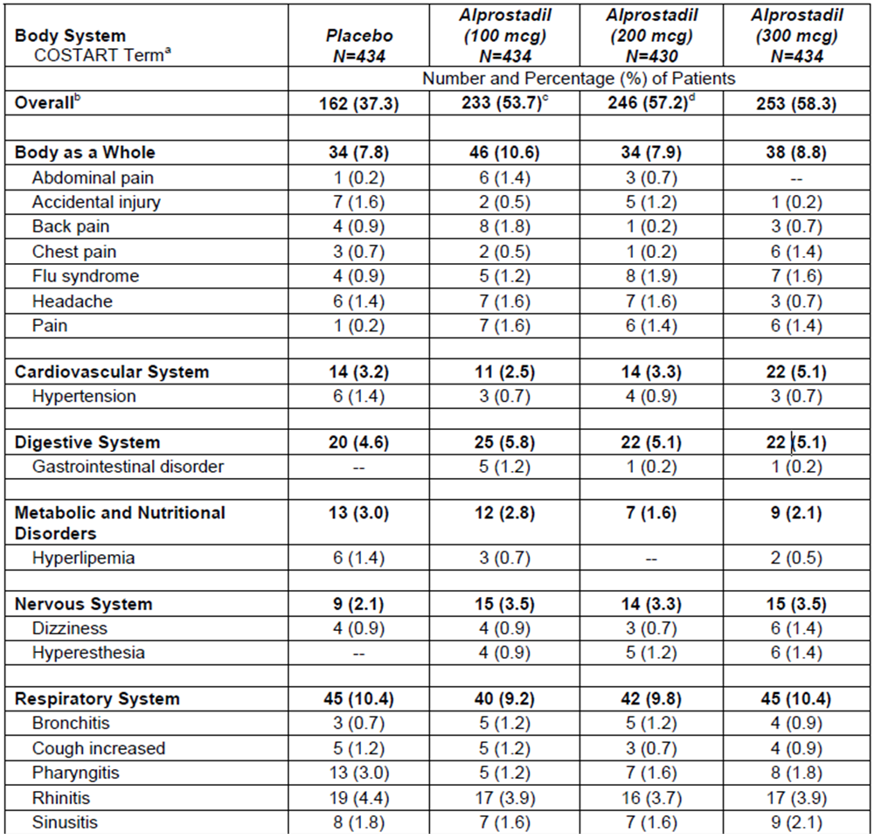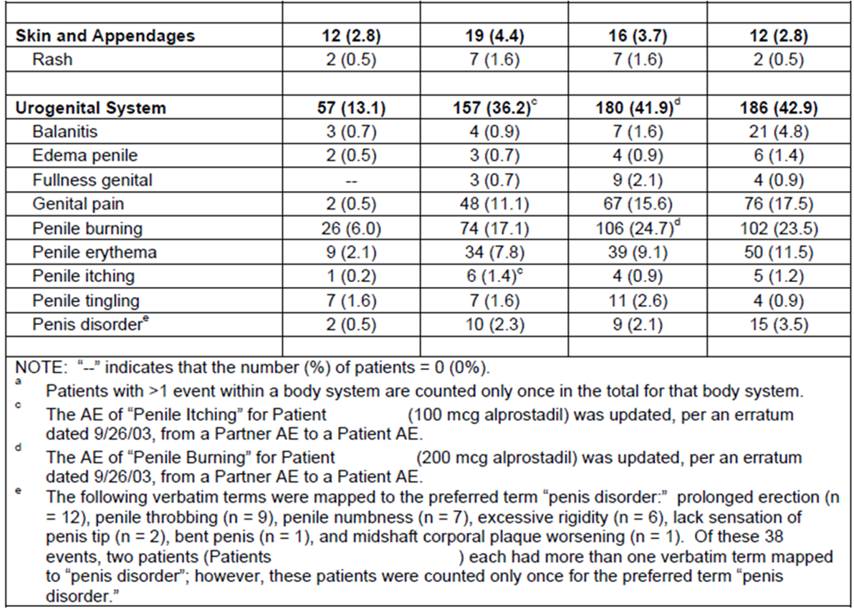

Hypotension in response to individual doses was only assessed with the first test dose, and subjects who were intolerant were subsequently excluded, but the overall incidence of hypotension appeared to be low when Vitaros was used at the proposed dose. In a high dose Phase II study, the incidence of haemodynamic intolerance was much higher, reported in 7 of 21 subjects receiving active treatment.

Priapism appears to be a rare complication of treatment, and subjects at increased risk of priapism should avoid Vitaros. The PI carries appropriate warnings about this issue.

Partners of men using Vitaros appear to be at increased risk of vulvovaginal discomfort, but some of this could be due to coitus and vaginal penetration itself.

More serious **safety** concerns were less well defined. No overall excess of SAEs was seen with active treatment, and the only death in a pivotal study occurred in a placebo recipient. This is somewhat reassuring, but it is insufficient to prove that the long term safety is acceptable. It should be recalled that only 4 patients in Phase III studies have received alprostadil for ≥12 months, and median follow-up in the “long term” safety study, MED 2000-006, **was only about 3 months**.

There was an excess of myocardial infarctions with active treatment, but this was an uncommon event overall; no statistical analysis was performed and any statistical comparison of infarct rates between groups would be underpowered. Myocardial infarction was reported in 4 (0.9%) subjects receiving alprostadil 300 µg, and in 1 (0.2%) recipient of alprostadil 200 µg, but not in any recipients of alprostadil 100 µg or placebo. Investigators did not feel that there was a causal relation to treatment in any individual case, but information about the time interval between administration and the infarct was not submitted. Subjects with recent myocardial infarction were excluded from the pivotal studies, so the risk could be higher in an unselected population. The proposed PI lists myocardial infarction as a contraindication to treatment, which is appropriate, but the rationale for this exclusion was not discussed. Post marketing risk management should include monitoring for an increased risk of myocardial infarction.

Of considerable concern, the submitted studies were too brief to allow any meaningful assessment of the potential for Vitaros to promote carcinogenesis. A preclinical study raised the possibility of carcinogenesis, and one of the reasons Vitaros was rejected by the FDA was that the clinical significance of this finding had not been adequately characterised. This still appears to be the case. Subjects responding to Vitaros are likely to use it for many years, and could be at risk of local penile cancers if alprostadil or any of its excipients, such as DDAIP, has a carcinogenic potential. Partners of men using Vitaros could also be at risk, though their exposure would be expected to be much lower.

It is unclear if Vitaros has any effect on the risk of transferring sexually transmitted diseases. This concern was raised by the FDA, but it was not discussed in the Australian submission.

Vitaros is embryotoxic, and although the PI recommends using it in men whose partners are pregnant, it is inevitable that it will occasionally be used in early pregnancy, before pregnancy is recognised.

The post marketing experience with Vitaros was not reported in this submission, even though the drug has already been approved in Europe and Canada. Post marketing experience in China with the DDAIP free alprostadil treatment, Befar, was reported in inadequate detail.

### First round benefit-risk assessment

#### First round assessment of benefits

The benefits of Vitaros in the proposed usage are:

* A mean improvement in erectile function amounting to about 10% of the available points on the IIEF scale.
* A response rate (consisting of any improvement in a GAQ) that is 47-52%, compared to a placebo response rate of 20%.
* More convenient administration than existing alprostadil formulations (such as Caverject, which requires intra penile injection).

The benefit in subjects with mild ED has not been well characterised, but the overall effect of Vitaros may be negative in this subgroup (mean scores in this subgroup showed a negative change in the pivotal studies). Given that subjects will be able to judge the efficacy of treatment for themselves, this is not a major concern.

The dose response relationship for Vitaros has not been clearly defined, but the benefit for the 200 µg and the 300 µg doses appears to be similar.

#### First round assessment of risks

The risks of Vitaros in the proposed usage are not well defined, but potentially consist of the following:

* Local, reversible urogenital irritation is likely to occur in up to 43% of subjects and up to 9% of partners. Given that such irritation will be evident to subjects, who will be free to decide whether to continue treatment, this is not a major concern unless it promotes transmission of infection.
* Subjects at risk of orthostatic hypotension may respond to alprostadil with presyncope or syncope. This problem was rare in the pivotal studies (dizziness occurred in 1.4% of subjects at 300 µg, and a single subject did not tolerate the test dose), and the risk is appropriately highlighted in the proposed PI.
* Based on preclinical studies, Vitaros may be spermatotoxic, and it caused changes in the seminiferous tubules of rabbits. This risk is not mentioned in the proposed PI and it has not been quantified in any human studies.
* Based on one of three preclinical studies, DDAIP may be carcinogenic. The clinical study program was too brief to assess this risk in humans.
* Vitaros may be embryotoxic, and is likely to be used by couples who are not yet aware that the female partner is pregnant.
* The DDAIP concentration proposed for marketing (2.5%) may not be the lowest effective concentration, with some formulation studies suggesting that a much lower concentration (0.05%) produces a similar benefit. The proposed strength has not been based on any PK studies, and the limited efficacy data provide no specific support for the proposed strength.
* There was a very low incidence of myocardial infarction in the pivotal studies, but all cases occurred in active groups. Individual cases did not suggest a causal relation to treatment, but this risk remains poorly defined.
* It is unknown if Vitaros modifies the risk of sexually transmitted diseases, but it is at least plausible that irritated mucosal surfaces might be more susceptible to transmission of pathogens. This risk has not been assessed in any studies, and the pivotal studies were restricted to couples in a stable heterosexual relationship, so they were not suitable for assessing this risk.
* Other long term safety issues could have been missed given that the sponsor’s only “long term” Phase III study had a median follow-up of about 3 months.

For all of these risks, there is currently inadequate clinical data. Although the available clinical studies have not shown definite concerning safety signals, they have not excluded the potential for harm or adequately explored issues raised in the preclinical program. Given that the drug is not being proposed for use of a life threatening condition, and could be used for many years by otherwise healthy men, it would be inappropriate to expose such men to a poorly defined risk of carcinogenesis, spermatotoxicity, or enhanced transmission of infection, and it would be inappropriate to expose women to an agent that may be embryotoxic. These risks need to be characterised more completely before patients and clinicians can make informed choices about what risks can be considered acceptable.

#### First round assessment of benefit-risk balance

The benefit-risk balance of Vitaros might be favourable, but it has not been characterised with sufficient detail.

The fact that the clinical benefit is only modest and might not be substantial in mild cases is offset by the fact that subjects can directly observe the response to treatment themselves and decide whether the treatment is worthwhile for them. The AEs that have occurred with treatment largely consisted of local urogenital discomfort, and subjects can decide for themselves if this discomfort is a problem for them.

The problem is that the potential for more serious safety issues has not been adequately explored. If it were known with confidence that Vitaros was not carcinogenic or spermatotoxic, and Vitaros did not have any other safety concerns, the benefit-risk balance would be positive, but these risks are not well defined and long term safety data is minimal. Many subjects would decline treatment if they thought Vitaros posed a significant risk of causing carcinogenesis or spermatotoxicity. These risks are not currently highlighted in the proposed PI, so patients and doctors reading the PI would not be in a position to make an informed judgement about those risks.

Overall, until the residual safety issues have been explored in more detail, it would be premature to approve alprostadil. It could become appropriate to approve the drug after satisfactory responses to the Clinical Questions listed, and after appropriate revision of the PI, but only if the weight of expert opinion was that carcinogenesis and spermatotoxicity were not likely to be clinically significant.

### First round recommendation regarding authorisation

The application to register Vitaros should be rejected.

The main objections to registration at this time are:

* No adequate long term safety study has been performed.
* The post marketing experience with Vitaros and Befar has not been adequately characterised in the Australian submission.
* A preclinical study in transgenic mice has raised the possibility of DDAIP promoting carcinogenesis, and the clinical relevance of this study remains poorly characterised.
* A preclinical study in rabbits has shown that Vitaros has adverse effects on seminiferous tubules, but this issue has not been studied in humans.
* Vitaros causes local urogenital irritation, which could promote the transfer of sexually transmitted diseases, but this issue has not been adequately addressed in human studies.
* The strength of DDAIP proposed for Vitaros (2.5%) is potentially much higher than the lowest effective strength (0.05%) required for permeation enhancement, which is of particular concern given the unknown carcinogenic potential of DDAIP.

Expert opinions should be obtained about:

* the risk of carcinogenesis posed by the inclusion of DDAIP in the Vitaros formulation;
* the clinical relevance of preclinical studies suggesting spermatotoxicity;
* the risk of Vitaros enhancing transmission of sexually transmitted diseases.

The sponsor should address the issues outlined above, answer the questions raised, revise the PI along the lines discussed, and then resubmit.

### Clinical questions

#### Additional expert input

Expert opinions should be sought on three issues:

* The capacity for DDAIP to promote carcinogenesis in humans, in relation to the preclinical mouse study of transgenic mice that showed an increased incidence of papillomas when mice were exposed to DDAIP.
* The risk of spermatotoxicity in humans, in relation to the pre-clinical study in rabbits showing changes in the seminiferous tubules.
* The capacity for the local irritation produced by Vitaros to promote transfer of sexually transmitted diseases.

None of these issues was addressed in sufficient detail in the clinical study program to allow an assessment of the actual risk in human users of Vitaros.

For the first two of these issues, the preclinical evaluator may have sufficient expertise.

For the third issue, an expert in sexually transmitted diseases should be consulted. Preferably this expert would have experience in both animal studies and human sexually transmitted diseases.[9]

#### Dose and formulation

##### Question 1

In a drug monograph intended for other countries, the doses used in the pivotal studies and proposed for use were referred to as 220 μg and 330 μg instead of 200 μg and 300 μg. Could you please explain the discrepancy?

##### Question 2

In the same monograph, it was suggested that alprostadil dosing should begin at 220 μg and that 330 μg should be reserved for subjects who need up-titration, whereas the proposed Australian PI suggests starting at 300 μg and down-titrating if side effects occur. Please explain this discrepancy. Given that efficacy in the pivotal studies was similar for 200 μg and 300 μg, why is 300 μg recommended as the starting dose for Australian users?

##### Question 3

The Chinese formulation studies suggested that DDAIP at concentrations of ≥0.05% enhanced the efficacy of alprostadil. Why was a DDAIP strength of 2.5% selected for Vitaros if a similar benefit could be obtained with lower strengths of DDAIP?

#### Pharmacokinetics

##### Question 4

What underlying PK model was used in the PK study, MED 2000-003?

##### Question 5

What PK evidence is available to support the assertion that DDAIP increases absorption of alprostadil, and is there any PK evidence that specifically supports adoption of the proposed DDAIP strength of 2.5%? Given that 15-keto-PGE0 can be used as a surrogate PK marker for alprostadil absorption, and that concerns have been raised about the carcinogenicity of DDAIP, why were no PK studies submitted that justified the proposed DDAIP strength?

#### Pharmacodynamics

See Q25.

#### Efficacy

##### Question 6

Please confirm that all of the US Phase III Vitaros studies used the same formulation as that proposed for marketing, including the same strength of DDAIP, and indicate whether the placebo formulation also contained DDAIP at the proposed strength of 2.5%.

##### Question 7

The GAQ is described as a 7-point scale in some parts of the submission, and as a yes-no question in other parts of the submission. What form of the question as used in the pivotal studies? If a 7-point scale was used and then converted to a yes-no binary response, what was the distribution of the responses before this conversion?

##### Question 8

In the pivotal studies, a weighting procedure for Q3 and Q4 of the Sexual Encounter Profile (SEP)[10] is mentioned but not well characterised. What weighting procedure was applied to Q3 and Q4 of the SEP, and did this procedure mean that subjects contributed unequally to the final analysis?

##### Question 9

In the pivotal studies, 3 doses were assessed against 3 endpoints, giving 9 dose-endpoint pairings. Why was there no plan in place to correct the statistical analyses for multiplicity?

##### Question 10

In the pivotal studies, was any attempt made to assess unblinding? If not, why not?

##### Question 11

In the pivotal studies, was any attempt made to assess the potential impact of withdrawal bias? If not, why not?

##### Question 12

In the pivotal studies, the overall effect of Vitaros appeared to be negative in subjects with mild ED. A Phase II study in mild-to-moderate ED (MED 99-002A) produced a positive result in the overall cohort, but a subgroup analysis of those with mild ED was not presented. What were the efficacy results in subjects from MED 99-002A with mild ED, and what evidence exists that shows Vitaros to be useful in this section of the target population?

##### Question 13

For the high dose Phase II study, MED 99-001, please present the main efficacy variables from this study in terms of means and mean changes in each treatment group, with standard deviations.

##### Question 14

The Chinese Study NM-AP-38 was only presented as a synopsis, and the efficacy results were not explained in adequate detail. This sentence was particularly unclear:

*The efficacy evaluated by the number of successful intercourse attempts per total intercourse attempts revealed an efficacy rate of 89.5%, 65.0% and 48.9% for mild, moderate and severe ED patients in PGE1 group versus 31.3%, 27.4% and 6.1% in placebo group.*

Please explain what is meant by the “efficacy rate” and how the main endpoints were evaluated and then present the results in tabular format.

##### Question 15

The Chinese Study NM AP-28-OL/DB was not presented in adequate detail. For the double blind portion of this study, please indicate how active treatment compared to placebo treatment.

#### Safety

##### Question 16

What was the median follow-up in the “long-term” safety study, MED 2000-006?

##### Question 17

What is the clinical significance of the positive mouse carcinogenicity study? What evidence or arguments were provided to Canadian and European authorities to allay concerns about this issue?

##### Question 18

What is known about the effects of Vitaros on the transfer of sexually transmitted disease?

##### Question 19

What is known about the potential for Vitaros to produce spermatotoxicity in humans?

##### Question 20

Given that prostaglandins inhibit platelet function, what is known about the clinical effects of alprostadil on bleeding risk?

##### Question 21

Please provide details of the post-marketing experience observed with the related product, Befar, including a discussion of which AEs have been reported.

##### Question 22

Please provide details of the post marketing experience observed with Vitaros in the EU and Canada, including a discussion of which AEs have been reported.

##### Question 23

Does the use of Vitaros by homosexual men or heterosexual couples engaged in anal intercourse raise any specific safety issues? What is known about the safety of Vitaros in this context?

##### Question 24

In the Chinese study NM-AP-42C, the safety section of the study summary reads as follows:

*A total of 70 patients completed the study. Thirty-eight (25.71%) patients experienced adverse events. The investigators confirmed that all adverse events were related to study medication. 76.32% of the AEs were mild and 23.86% of them were moderate. All of the AEs happened in urogenital system and were transient as well. No medical treatment was required. The average duration for adverse events was 25 minutes and the longest duration was 45 minutes.*

Please explain the source of the figure “25.71%”. If 38 subjects from a total of 70 had AEs, which represents 54.3%.

### Second round evaluation

The details of the sponsor’s responses to the clinical questions and the evaluator’s comments on these responses are detailed in Attachment 1.

#### Second round benefit-risk assessment

The sponsor’s responses clarify some aspects of the benefit-risk assessment. There was no substantial new evidence provided in relation to efficacy. For a number of safety issues, the sponsor’s responses clarified the risks.

##### Efficacy in subjects with mild ED

No new evidence was submitted that substantially clarifies the benefits of alprostadil in subjects with mild ED, but the sponsor submitted a new post hoc analysis of the pivotal studies, assessing response rates in subjects according to baseline severity. This analysis suggested that, for this non-primary endpoint, active treatment was significantly superior to placebo in subjects with mild ED. This does not offset the overall negative results for the primary endpoints in subjects with mild ED, already discussed on the first round clinical evaluation report.

The sponsor was asked to perform a subgroup analysis of the major Phase II study in subjects with mild-to-moderate ED, but they did not perform the requested analysis.

In summary, there is some inconsistent evidence that alprostadil might be better than placebo in subjects with mild ED, but no convincing evidence that it is better than no treatment at all. On balance, it appears that there is little or no overall benefit in this clinical group, but individual patients with mild ED may find Vitaros useful. Given that subjects will be able to observe the efficacy of the drug for themselves, and make a decision about whether it is worth continuing, the borderline efficacy in this group is not a barrier for registration.

##### Safety issues conceded by the sponsor

The sponsor has conceded that the following risks exist, and that they are not yet characterised in humans:

* Vitaros may be spermatotoxic;
* Vitaros may induce irritation that enhances the spread of sexually transmitted diseases.

The PI requires modification to acknowledge these risks. The sponsor has proposed some modifications that represent improvements over the initially proposed PI, but the risks should be acknowledged more explicitly and the PI therefore requires further modification.

##### Safety issues for which the sponsor’s response suggests lower risk

The sponsor has argued that the risk of carcinogenesis is minimal, and cites the conclusions of the nonclinical evaluator and other regulatory agencies in support of this claim. On balance, it appears that there is general agreement that the two year dermal study in mice and rats was reassuring with respect to carcinogenic risk and that this overrides the results of the Tg.AC mouse study. A full analysis of this nonclinical material is beyond the scope of the clinical evaluation report, but there are no clinical grounds on which to suspect a significant carcinogenic risk.

##### Unresolved issues

There is a risk that the proposed DDAIP concentration is in substantial excess of the minimum concentration required for a clinically relevant effect on permeation. The sponsor concedes that there is no direct clinical evidence in support of the proposed concentration of 2.5%, and instead the sponsor has suggested that the DDAIP concentration is justified by nonclinical data, but the nonclinical evaluator and clinical evaluator agree that the clinical studies are more important in predicting actual effects in humans.

The sponsor also makes the claim that clinical studies in China supported a concentration of 0.5%, when in fact the evidence from Chinese studies supports a concentration as low as 0.05%. The sponsor’s response on this matter was inadequate and contained an unsupported assertion that 0.5% was required, despite the fact that Clinical Question 3 proposed that ≥ 0.05% was adequate and asked for clarification.

It should be noted that the sponsor has not answered many of the clinical questions posed in the first round clinical evaluation report.

### Second round recommendation regarding authorisation

The sponsor’s application to register Vitaros should be rejected.

The main reasons for rejecting the application are:

* there is no clinical evidence justifying the proposed 2.5% concentration of DDAIP;
* the spermatotoxicity of DDAIP has not been well defined in humans;
* the weighting procedure for the pivotal endpoints based on the SEP was not adequately explained, so it remains unclear if it was appropriate.

The combination of the first two of these problems makes each more important: if DDAIP were to be used in substantial excess of the minimum effective dose, and if it proved to be spermatotoxic in humans, then subjects would be exposed to unnecessary spermatotoxicity. However, even if DDAIP were found not to be spermatotoxic, it would still be inappropriate to register a product potentially containing a substantial excess of DDAIP, given the lack of overall experience in using this compound in humans, and the prolonged mucosal exposure anticipated in subjects who could use Vitaros for many years.

The third problem listed could potentially be addressed by the sponsor if they provided an adequate answer to Clinical Question 8.

The sponsor has also implied that DDAIP degrades by up to 80% during the shelf life of the product (see response). This issue is beyond the scope of the clinical evaluation, but might represent a barrier to registration depending on the nonclinical evaluation of this issue. The nonclinical evaluator should be asked to comment on whether the sponsor has adequately characterised the identity, carcinogenicity, spermatotoxicity, and likely mucosal irritability of these degradation products. **If the degradation products are compounds for which there is limited experience in humans, further toxicity and irritability studies should be undertaken with shelf aged Vitaros formulations.**

If registration of Vitaros proceeded, the PI would need to be modified to reflect the risks acknowledged by the sponsor, including:

* spermatotoxicity;
* potentially enhanced transmission of sexually transmitted diseases.

Other necessary changes to the PI are listed.

## V. Pharmacovigilance findings

### Risk management plan

The sponsor submitted a EU Risk Management Plan (RMP) (version 2.0, dated 27 April 2012, data lock point 31 March 2012) with an Australian Specific Annex (ASA) (dated December 2014), which was reviewed by the RMP evaluator in the Office of Product Review (OPR).

#### Safety specification

The sponsor provided a summary of ongoing safety concerns which are shown at Table 22.

Table 22: Ongoing safety concerns.

|  |  |
| --- | --- |
| Important identified risks | Spermatoxicity  Hypotension; Dizziness; Syncope  Priapism  Carcinogenicity |
| Important potential risks | Embryotoxicity  Use in patients with cardiovascular or unstable cerebrovascular conditions  Possible interaction with sildenafil or penile implants  Urinary tract infection |
| Important missing information | Long term safety data for alprostadil  Patients with a history of  Myocardial infarction  Neurological disease (stroke)  Spinal injury  Renal insufficiency  Pulmonary disease |

##### RMP reviewer comment

It is unclear why the identified risk ‘carcinogenicity’ is not itemised in the *Details of important identified and potential risks* section of the EU-RMP. A justification for this omission should be provided.

The important potential risk ‘possible interaction with sildenafil or penile implants’ should be amended to ‘possible interaction with other ED therapies (including PDE5 inhibitors and penile implants)’.

The summary of safety concerns does not appear to acknowledge safety concerns as they may apply to the sexual partner. As a topical product, even if a barrier method is employed it is possible that the partner may be inadvertently exposed to this medicine and moreover the partner may potentially be unaware of the exposure. In the clinical studies presented as part of the safety specification, particular AEs were reported in up to 7% of partners which is not insignificant. The summary of safety concerns should reflect safety concerns as they apply to partners.

Local adverse effects may increase the potential for transmission of sexually transmitted infections and this should be considered a safety concern in the context of the RMP.

The safety of the product has only been investigated for the purposes of facilitating vaginal intercourse. The possibility of adverse effects relating to anal or oral sex has not been studied and should be included as a safety concern in the RMP.

Exposure of a pregnant woman to alprostadil, a prostaglandin, may facilitate cervical dilatation. The topical application of this product theoretically increases the risk of direct cervical exposure. Inadvertent pregnancy/cervical exposure to alprostadil should be added as an important potential risk.

For the additional risks above the RMP should include appropriate consideration of the pharmacovigilance and risk minimisation plan for each.

#### Pharmacovigilance plan

##### Proposed pharmacovigilance activities

Routine pharmacovigilance is proposed for all safety concerns. A post authorisation safety study is proposed as an additional pharmacovigilance activity for the identified risk ‘spermatoxicity’. Very limited detail regarding this activity is provided in the EU-RMP/ASA.

##### RMP reviewer comment

It is expected that all specified safety concerns will be considered separately in the Periodic Safety Update Reports (PSURs). This is considered an essential element of routine pharmacovigilance.

Very limited detail is given regarding the post authorisation safety study. Given the study is mentioned in the EU-RMP (with a 2012 data lock point) it is unclear why the protocol is still “under development” as stated in the ASA (dated December 2014). The sponsor should provide an update of the status of the activity, including provision of the protocol and study milestones as they relate to Australia.

In March 2015, the UK Medicines and Healthcare Products Regulatory Agency (MHRA) issued a recall notice for Vitaros 3 mg/g cream due to distribution of a quarantined batch. The sponsor should provide an update of the outcome of this recall action and the steps in place to ensure such a situation will not occur in Australia.

A pharmacovigilance plan should be considered for the additional risks listed.

#### Risk minimisation activities

The sponsor has concluded that routine risk minimisation only is required to mitigate the risks associated with alprostadil cream. No additional risk minimisation activities are proposed.

##### RMP reviewer comment

Routine risk minimisation activities may be sufficient if the recommendations in this report are adopted in their entirety.

#### Reconciliation of issues outlined in the RMP report

The following section summarises the OPR’s first round evaluation of the RMP, the sponsor’s responses to issues raised by the OPR, and the OPR’s evaluation of the sponsor’s responses.

##### Recommendation #1 in RMP evaluation report

Safety considerations may be raised by the nonclinical and clinical evaluators through the consolidated section 31 request and/or the nonclinical and clinical evaluation reports, respectively. It is important to ensure that the information provided in response to these includes a consideration of the relevance for the RMP, and any specific information needed to address this issue in the RMP. For any safety considerations so raised, the sponsor should provide information that is relevant and necessary to address the issue in the RMP.

##### Sponsor response

The applicant provides an assurance that any additional safety considerations arising from matters raised by the nonclinical and clinical evaluators will be assessed for their relevance to the RMP. Any relevant items that meet the threshold for inclusion will be incorporated into the RMP/ASA as appropriate.

##### Evaluator’s comment

The sponsor’s response is noted.

##### Recommendation #2 in RMP evaluation report

The RMP is dated 2012. The sponsor should confirm the existence of a later version of the document, preferably in the new EU format. If this is available it should be provided with the s31 response.

##### Sponsor response

The EU RMP has been updated and is also in the new EU format. RMP Version 3.0, dated 26 March 2015 with a data lock cut-off of 31 January 2015 and updated ASA are provided in this response. The revised RMP has recently been approved by the health authority (in a letter dated 01 August 2015).

##### Evaluator’s comment

The provision of an updated RMP is noted. The updated ASA referred to in this response could not be located. The sponsor should provide an updated ASA taking into account the recommendations of the original RMP evaluation and this RMP advice.

##### Recommendation #3 in RMP evaluation report

It is unclear why the identified risk ‘carcinogenicity’ is not itemised in the EU-RMP *Details of important identified and potential risks*. A justification for this omission should be provided.

##### Sponsor response

The revised RMP in the new EU format categorises carcinogenicity as an identified risk in the designated “identified risk” sections of the new format. Please note the revised RMP is under active health authority review. Recent comments received from the health authority indicate the carcinogenicity should be listed as a “potential risk” instead of an “identified risk” to align with EU PVG Module V definitions. There is a lack of clinical data to support this risk and therefore the event should be classified as a “potential risk” only. Dialogue with the health authority is ongoing and the RMP will be revised accordingly once the submission review is complete.

##### Evaluator’s comment

This is acceptable from an RMP perspective. There is no definite objection to reclassifying carcinogenicity to a potential risk, as long as it remains a separate safety concern in the RMP.

##### Recommendation #4 in RMP evaluation report

The important potential risk ‘possible interaction with sildenafil or penile implants’ should be amended to ‘possible interaction with other ED therapies (including PDE5 inhibitors and penile implants)’.

##### Sponsor response

The revised RMP in the new EU format has been updated to include a more comprehensive listing of available ED therapies (that is, “PDE-5 inhibitors or sildenafil, tadalafil, avanafil and vardenafil”). Please see the revised RMP for additional information. Information regarding the *Potential Interaction: Penile Implants* is also well described in the revised RMP.

##### Evaluator’s comment

This is acceptable from an RMP perspective.

##### Recommendation #5 in RMP evaluation report

The summary of safety concerns does not appear to acknowledge safety concerns as they may apply to the sexual partner. As a topical product, even if a barrier method is employed it is possible that the partner may be inadvertently exposed to this medicine and moreover the partner may potentially be unaware of the exposure. In the clinical studies presented as part of the safety specification, particular AEs were reported in up to 7% of partners which is not insignificant. The summary of safety concerns should reflect safety concerns as they apply to partners.

##### Sponsor response

In the alprostadil topical cream development program partner AEs were reported by 4.8% in the placebo group, 5.8% in the 100 μg , 9.5% in the 200 μg, and 7.6% in the 300 μg group. The most commonly reported events were local vaginal reactions (vaginal burning and vaginitis), were mild to moderate in intensity and transient in nature. Based on these findings the EU health authorities assessed the partner AE profile as “acceptable with no apparent safety issues.”

In an effort to ensure partners are made aware of the potential adverse events the EU health authorities requested inclusion of the following language within the Vitaros Summary of Product Characteristics (SPC) and Patient Information Leaflet (PIL):

***SPC***

*Health care professionals should encourage their patients to inform their sexual partners that they are using Vitaros. Partners of Vitaros users can experience adverse events, most commonly vaginal irritation. A condom barrier is therefore recommended.*

***PIL***

***Possible side effects***

*Common side effects (may affect more than 1 in 10 patients)****:***

***Your partner:*** *Mild vaginal burning or itching, vaginitis*

*This effect may be due to the drug or to the act of vaginal penetration. Using a water based lubricant can help to make vaginal penetration easier.*

*Uncommon but potentially serious side effects (may affect up to 1 in 100 patients):*

***Your partner****: Vulvovaginal pruritus*

*The revised label language was deemed sufficient to address potential partner adverse events with no additional action warranted. Based on this information and the available data the sponsor proposes a similar approach to address the TGA request, that is, inclusion of text similar to that included in the European SPC.*

##### Evaluator’s comment

The proposed additional wording in the Consumer Medicines Information (CMI) is subject to final determination by the Delegate.

The Advisory Committee on the Safety of Medicines (ACSOM) recommended a separate partner information document could be developed.

Notwithstanding the changes proposed and the possible development of partner specific information, it is acknowledged that patients with ED may not wish to disclose the use of this medication to their partner, which is problematic, given inadvertent exposure is likely, especially as condom use may be undesirable in the target population.

##### Recommendation #6 in RMP evaluation report

Local adverse effects may increase the potential for transmission of sexually transmitted infections and this should be considered a safety concern in the context of the RMP.

##### Sponsor response

The EU health authorities requested the following information in the Vitaros SPC and PIL documents to address concerns regarding sexually transmitted disease:

***SPC***

*General Precautions: Patients should be informed that Vitaros offers no protection from the transmission of sexually transmitted diseases (STDs). Patients and partners who use Vitaros need to be counselled about the protective measures that are necessary to guard against the spread of sexually transmitted agents, including the human immunodeficiency virus (HIV). Health care professionals should encourage their patients to inform their sexual partners that they are using Vitaros. Partners of Vitaros users can experience adverse events, most commonly vaginal irritation. A condom barrier is therefore recommended.*

*PIL*

***Warnings and precautions***

*A condom should be used in the following situations:*

* + - *Your partner is pregnant or breastfeeding*
    - *Your partner is of childbearing potential*
    - *To prevent sexually transmitted diseases*
    - *During oral sex and anal sex*

*The sponsor proposes a similar approach for the Australian PI. Additionally, there are no available data to validate a potential increased risk of STDs associated with Vitaros use.*

##### Evaluator’s comment

The changes proposed do not address the possibility that local adverse reactions may increase the risk of sexually transmitted infections (STIs).

According to the sponsor, there are no available data regarding this risk therefore inclusion of the following safety concern is maintained:

*Potential for increased risk of STI transmission due to local adverse effects.*

##### Recommendation #7 in RMP evaluation report

The safety of the product has only been investigated for the purposes of facilitating vaginal intercourse. The possibility of adverse effects relating to anal or oral sex has not been studied and should be included as a safety concern in the RMP.

##### Sponsor response

The EU health authorities requested the following information in the Vitaros SPC and PIL documents to address potential adverse effects related to anal or oral sex:

***SPC***

*The effects of Vitaros on the oral or anal mucosa has not been studied. A condom barrier should be used for oral sex (fellatio) or anal sex.*

***PIL***

*A condom should be used in the following situations:*

* + - *During oral sex and anal sex*

*The same text has also been included in the Australian PI and inclusion in the EU RMP or ASA is not proposed.*

##### Evaluator’s comment

This recommendation is maintained. Adverse effects relating to anal or oral sex have not been studied, remain a possibility, and therefore should be included in the RMP or ASA as an item of missing information.

Changes to the PI are subject to final determination by the Delegate.

##### Recommendation #8 in RMP evaluation report

Exposure of a pregnant woman to alprostadil, a prostaglandin, may facilitate cervical dilatation. The topical application of this product theoretically increases the risk of direct cervical exposure. Inadvertent pregnancy/cervical exposure to alprostadil should be added as an important potential risk.

##### Sponsor response

The European SPC and PIL documents contain multiple sections warning against product exposure to pregnant women:

***SPC***

***Contraindications:*** *Vitaros should not be used for sexual intercourse with a woman with child-bearing potential unless the couple uses a condom barrier.*

***General Precautions:*** *There is no information on the effects on early pregnancy of alprostadil at the levels received by the female partners. A condom barrier should be used for sexual intercourse with women of childbearing age, pregnant or lactating women.*

***Fertility, Pregnancy and lactation***

***Pregnancy:*** *There are no data on the use of Vitaros in pregnant women. The indirect exposure to alprostadil in women is likely to be low. Animal data on higher doses of alprostadil show reproductive toxicity (see section 5.3). Pregnant women should not be exposed to Vitaros.*

***PIL***

***What you need to know before you use Vitaros Do not use Vitaros:*** *if your partner is pregnant, breast feeding or of childbearing potential unless you use a condom barrier.*

***Warnings and Precautions:*** *A condom should be used in the following situations: - Your partner is pregnant or breastfeeding*

* + - *Your partner is of childbearing potential*

***Pregnancy and breast-feeding and fertility:*** *There are no data on the use of Vitaros in pregnant women. Pregnant women should not be exposed to Vitaros.*

Additionally, the ‘Potential Risk of Embryotoxicity’ is well described in the existing and revised RMP. The sponsor believes the collective information provided in the product labelling and RMP is sufficient advice on risk of product exposure in pregnant women. The sponsor is agreeable to considering similar additional text in the Australian PI with no further changes to the RMP.

##### Evaluator’s comment

The PI/CMI advice regarding use with a pregnant partner is inconsistent – ranging from “not advisable” to “there are no data on the use of (alprostadil cream) in pregnant women” to “a condom barrier should be used for sexual intercourse with…pregnant or lactating women” to “pregnant women should not be exposed to Vitaros”.

It is recommended to the Delegate that use with a pregnant partner should be not advisable, with or without a condom barrier, given the lack of data on its safe use and the potential for alprostadil to cause cervical dilatation. Such information should be consistently communicated in the PI and CMI.

The recommendation to include ‘inadvertent partner exposure (including pregnant partner exposure)’ as an important potential risk in the RMP/ASA is maintained.

##### Recommendation #9 in RMP evaluation report

For the additional risks above the RMP should include appropriate consideration of the pharmacovigilance and risk minimisation plan for each.

##### Sponsor response

Please see responses provided above.

##### Evaluator’s comment

The evaluator maintains the inclusion of the additional safety concerns outlined in the RMP evaluation report. A pharmacovigilance and risk minimisation plan for each concern should be outlined in an amendment to the ASA (see above recommendations).

##### Recommendation #10 in RMP evaluation report

Very limited detail is given regarding the post authorisation safety study. Given the study is mentioned in the EU‐RMP (with a 2012 data lock point), it is unclear why the protocol is still “under development” as stated in the ASA (dated December 2014). The sponsor should provide an update of the status of the activity, including provision of the protocol and study milestones as they relate to Australia.

##### Sponsor response

The sponsor is engaging with the EU health authorities to optimise the post authorisation safety study (PASS) design prior to study initiation. The objective of the proposed PASS is to evaluate potential sperm toxicity and spermicidal effects from repeated administration of alprostadil topical cream. The sponsor is fully committed to conducting a study to address these objectives and is seeking EU health authority endorsement of the draft protocol prior to execution.

The sponsor will continue to update the TGA on the progress of the PASS program.

##### Evaluator’s comment

As sufficient detail has not been provided the evaluator is unable to make an assessment of the suitability of this activity as additional pharmacovigilance for a specified risk. In principle, this activity is necessary to further characterise this risk.

##### Recommendation #11 in RMP evaluation report

In March 2015, the MHRA issued a recall notice for Vitaros 3 mg/g cream due to distribution of a quarantined batch. The sponsor should provide an update of the outcome of this recall action and the steps in place to ensure such a situation will not occur in Australia.

##### Sponsor response

The MHRA notification was a result of an unanticipated recall by Vitaros licensee Takeda, UK Ltd. Takeda had quarantined a single batch of product due to an ongoing product stability investigation. The product wholesale distributor mistakenly released some of the quarantined batch which triggered the notification to the MHRA. All quarantined product was recovered prior to commercial distribution. Takeda has taken corrective action to mitigate any future issues or potential release of quarantined materials. The sponsor will ensure similar measures are in place for the Australian market supply chain to minimise risk of unauthorised product distribution.

##### Evaluator’s comment

This is acceptable from an RMP perspective.

##### Recommendation #12 in RMP evaluation report

A pharmacovigilance plan should be considered for the additional risks listed.

##### Sponsor response

See responses to each question above.

##### Evaluator’s comment

The evaluator maintains the inclusion of the additional safety concerns outlined in the RMP evaluation report. A pharmacovigilance and risk minimisation plan for each concern should be outlined in an amendment to the ASA (see above recommendations).

##### Recommendation #13 in RMP evaluation report

Given the topical dosage form is approved in Europe the sponsor should provide an update regarding post marketing reports of medication errors and this information should also be incorporated into the EU‐RMP when it is next updated.

##### Sponsor response

The revised RMP in the new EU format has a module specific for Medication Errors. Please see revised RMP for additional information.

##### Evaluator’s comment

The updated RMP refers to a “patient support program” undertaken in the UK. As limited detail is provided, it is unclear whether this is an additional pharmacovigilance or risk minimisation activity undertaken overseas to minimise the risk of medication error. It would seem that such a program is not proposed for Australia.

##### Recommendation #14 in RMP evaluation report

The ASA states that “the proposed Australian PI is fully aligned with the EU SPC, with no differences in the safety information”. However, the following disparities have been noted and these (and others) should be corrected or a justification should be provided for their omission.

##### Sponsor response

The PI will be updated to include relevant safety information in line with recommendations. A revised PI, tracked with proposed changes is included with this response. These modifications will be formalised following the receipt of ACPM advice.

##### Evaluator’s comment

PI amendments are subject to final determination by the Delegate.

#### Summary of recommendations

It is considered that the sponsor’s response to the TGA Section 31 request has not adequately addressed all of the issues identified in the RMP evaluation report.

There are outstanding issues.

There are additional recommendations.

##### Outstanding issues

###### Issues in relation to the RMP

The following recommendations are made to the Delegate upon consideration of the sponsor’s response to the RMP evaluation report and the ratified ACSOM advice.

###### Safety specification

* ‘Penile irritation and burning’ should be added as an important identified risk (new recommendation based on ACSOM advice).
* Depending on the assessment of the safety data associated with DDAIP HCl, risks specific to this ingredient may need to be added to the summary of safety concerns (new recommendation based on ACSOM advice).
* ‘Potential for increased risk of STI transmission due to local adverse effects’ should be added as an important potential risk (maintained recommendation).
* ‘Adverse effects relating to oral or anal sex’ have not been studied, remain a possibility, and should be added as an item of missing information (maintained recommendation).
* ‘Inadvertent partner exposure (including pregnant partner exposure)’ should be added as an important potential risk (maintained recommendation).
* The RMP documentation should be revised to incorporate the above risks including a pharmacovigilance and risk minimisation plan for each.

###### Pharmacovigilance plan

* The ACSOM noted that routine pharmacovigilance is likely to underestimate the risk of adverse events due to DDAIP HCl. If further safety information is required (subject to the nonclinical assessment) then the Delegate may wish to apply additional pharmacovigilance to investigate safety issues relating to DDAIP HCl (new recommendation based on ACSOM advice)
* As sufficient details are not available for the post-authorisation spermatoxicity study, the evaluator is unable to make an assessment of the suitability of this activity as additional pharmacovigilance for the identified risk. In principle, this activity is considered to be necessary to further characterise this risk (maintained recommendation).

###### Risk minimisation plan

* Despite warnings to use a condom barrier to minimise partner exposure, the ACSOM considered that there were likely to be issues with adherence to such advice given the age demographic of likely users and the acknowledged difficulties with condom use in older men and/or those with ED. The evaluator considers that from a risk minimisation perspective it is almost inevitable that there will be inadvertent partner exposure (possibly without the partner’s knowledge), despite precautions. Therefore in an effort to improve risk minimisation the sponsor should create a separate “partner information document” which, alongside the CMI will outline the possible risks to the partner associated with alprostadil (new recommendation based on ACSOM advice).
* The CMI document should include comments on the effect on fertility of males, or females inadvertently exposed (new recommendation based on ACSOM advice).
* The committee advised that referring to alprostadil as “natural” in the CMI may mislead patients that the medicine is natural and so patients may overestimate the safety of the medicine. Consideration should be made for removal of such statements from the CMI (new recommendation based on ACSOM advice).
* The PI/CMI statements regarding alprostadil use with a pregnant partner should be carefully revised to ensure that such information is presented consistently throughout. It is recommended to the Delegate that use with a pregnant partner is not advisable, with or without a condom barrier, given the lack of data on its safe use and the potential for alprostadil to cause cervical dilatation. Such warnings should also outline why inadvertent exposure to a pregnant women could be problematic (new recommendation based on ACSOM advice for an outline of inconsistencies).
* The ACSOM advised there is potential for off-label use of alprostadil cream in males without ED and in females for ‘female sexual arousal disorder’ or to induce termination of a pregnancy. There are no specific PI warnings against use of alprostadil for these off-label indications which should be considered as part of the risk minimisation plan.
* The updated RMP refers to a “patient support program” undertaken in the UK. As limited detail is provided it is unclear whether this is an additional pharmacovigilance or risk minimisation activity undertaken overseas to minimise the risk of medication error. It would seem that such a program is not proposed for Australia (new recommendation).
* The newly included PI statement regarding maximum frequency of use should be repositioned near the top of the dosage and administration section of the PI to maximise its impact as risk minimisation (new recommendation).
* It is noted that draft PI states “Only latex material based condoms have been investigated together with use of TRADE NAME and other materials may not exclude possible risk for occurrence of damage to the condom”. This statement is considered to be confusing and should be revised to align with information now included in the CMI regarding non-latex condoms (new recommendation).
* Changes to the PI/CMI agreed to by the sponsor in response to recommendations are subject to final determination by the Delegate.

###### ASA

* The sponsor has not submitted an updated ASA, and should do so having regard to the changes made to the revised EU-RMP and amendments as recommended in this evaluation.

##### Comments on the safety specification of the RMP

###### Clinical evaluation report

The following comments regarding the clinical aspects of the RMP safety specification appears in the clinical evaluation report (see full clinical evaluation report for appropriate references and context):

*The sponsor submitted the EU-RMP as well as an ASA. The ASA did not propose any new approach in the Australian context, but instead stated: “All of the concerns identified in the EU-RMP are relevant for patients in Australia. The risk minimisation activities proposed in the EU-RMP will be implemented in Australia if relevant.” The following comments are therefore based on the European RMP.*

*The Safety Specification in the draft RMP attempted to discuss the safety issues in a reasonably balanced manner, but the Sponsor’s stance on a couple of safety issues was ultimately unconvincing, as discussed in the sections below.*

**References to >6 month study**

The RMP repeatedly refers to the “long term” Study MED 2000-006 as a >6 month study. The RMP thus implies that there is more comprehensive long term follow-up than the evidence supports. Although some patients were followed for more than 6 months, the median follow-up was about 3 months.

**Spermatotoxicity**

The RMP proposes that spermatotoxicity should be assessed in a new, post marketing study. This issue should be resolved prior to marketing.

The current proposed PI does not acknowledge that this is an unresolved concern, so there is currently an inconsistency between the proposed PI and RMP.

**Carcinogenicity**

The RMP argues that the preclinical study raising concerns about carcinogenesis has no major relevance to humans. As noted previously, at least one of the arguments raised in dismissal of this study appears spurious, because it considers the dose of DDAIP as though the drug were diluted systemically. This issue was one of the reasons the drug was rejected by the FDA, and it is not clear that any new evidence has provided further reassurance since that rejection.

The RMP concludes that the risk of carcinogenesis is low, as shown in Table 23, but it is unclear that the risk has been adequately characterised.

Table 23: Ongoing safety concerns.

|  |  |
| --- | --- |
| Safety concern | Carcinogenicity |
| Action(s) proposed | Passive surveillance / routine pharmacovigilance activities |
| Objective of proposed action(s) | Monitor to see if this is indeed an issue |
| Rationale for proposed action(s) | The risk is low |
| Detail further measures which may be adopted on the basis of the results of this action and the decision criteria for initiating such measures | If the incidence is found to be more than extremely rare, then warnings may need to be added to the Summary of Product Characteristics (SPC) and Patient Information Leaflet (PIL) |
| Milestones for evaluation and reporting including justification for choice of milestones | At each PSUR reporting cycle and safety monitoring / signal detection activity; normally 6 monthly from first authorisation until 2 years after first marketing in the EEA, annually for 2 years, then 3 yearly thereafter |
| Title of protocols | Not applicable |

The clinical studies do not provide any reassurance about carcinogenic potential, because they were too brief. The issue of the carcinogenic potential of Vitaros should therefore be submitted to an appropriate expert for further assessment with the RMP modified accordingly (this expert could potentially be the preclinical evaluator).

**Interactions with PDE5 inhibitors**

The sponsor acknowledges that there may be potential synergistic interactions if Vitaros is combined with other treatments for ED, such as orally active vasodilators. This could cause hypotension in some subjects. The sponsor proposes post-marketing surveillance. Overall, the proposed Safety Specifications on this issue appeared reasonable, and the risk is already mentioned in the proposed PI.

**Other safety issues discussed in the RMP**

A few other issues were discussed in the RMP, including the potential for Vitaros to produce embryotoxicity, hypotension, and priapism. The discussion of these issues appeared reasonable. The proposed PI already carries appropriate warnings on these issues.

**RMP evaluator comment**

The RMP supports the clinical evaluator comments and notes that many of the issues raised are also addressed in the outstanding RMP issues listed in this advice.

###### Nonclinical evaluation report

Results and conclusions drawn from the nonclinical program for Vitaros detailed in the sponsor’s draft RMP are in general concordance with those of the nonclinical evaluator. The risk of spermatoxicity (identified in nonclinical studies) warrants the proposed post authorization study. No post authorisation studies are proposed to elucidate the potential relevance of the papilloma findings to humans.

##### Key changes to the updated RMP

EU RMP (version 2.0, dated 27 April 2012, DLP 31 March 2012) has been superseded by EU RMP (version 3.0, dated 26 March 2015, DLP 31 January 2015) (Table 24).

Table 24: Summary of key changes between EU RMP version 2.0 and EU RMP version 3.0.

|  |  |
| --- | --- |
| Summary of key changes between EU RMP version 2.0 and EU RMP version 3.0 | |
| Safety specification | The important potential risk ‘possible interaction with sildenafil or penile implants’ has been expanded to ‘Possible interaction with PDE-5 inhibitors, penile implants, smooth muscle relaxants, sympathomimetics, decongestants and appetite suppressants, antihypertensives and vasodilators, anticoagulants and platelet aggregation inhibitors”.  ‘Patients with history of hepatic impairment’ has been added as an item of missing information. |
| Pharmacovigilance activities | No significant material changes. |
| Risk minimisation activities | No significant material changes. |
| ASA | An updated ASA is yet to be received. |

###### RMP evaluator comment

The sponsor has not submitted an updated ASA, and should do so, having regard to the changes made to the EU RMP and amendments as recommended in this evaluation.

##### Suggested wording for conditions of registration

###### RMP

Any changes to which the sponsor agreed become part of the risk management system, whether they are included in the currently available version of the RMP document, or not included, inadvertently or otherwise. Wording regarding the RMP condition of registration cannot be provided until the issues outlined in this report are satisfactorily addressed. This includes provision of a revised ASA.

## VI. Overall conclusion and risk/benefit assessment

The submission was summarised in the following Delegate’s overview and recommendations:

### Quality

The chemistry evaluator has recommended approval based on the chemistry, manufacturing and quality aspects of the submission. Proshaeos has the active substance alprostadil, an active isomer of prostaglandin E1. It is freely soluble in alcohol, soluble in acetone and practically insoluble in water. It is synthesised by usual manufacturing processes. Alprostadil cream is presented in a single use container of 200 μg alprostadil in 100 mg (0.2%w/w) or 300 µg in 100 mg (0.3% w/w). It is not manufactured as a sterile product.

The formulation contains a novel excipient DDAIP HCl; it is a surfactant that should promote the absorption of alprostadil after application. The main development studies concerned the DDAIP HCl. The evaluator considered adequate characterisation of DDAIP HCl had been provided. Stability data showed the product in the proposed packaging is not stable. The concentration of DDAIP decreases due to adsorption by the plastic packaging and the stability data only supported a shelf life of 6 months.

The dose of alprostadil cream is delivered by an AccuDose dispenser. The evaluator considered the accuracy was adequately controlled.

### Nonclinical

The nonclinical evaluator had no objections to the registration of alprostadil cream. The evaluator also noted the novel excipient DDAIP to be included in the formulation at a concentration of 2.5%. The major focus of the nonclinical evaluation was of the DDAIP.

DDAIP has been developed as a permeation enhancing agent to improve the efficacy of alprostadil when applied topically. It is an ester of N,N-dimethyalanine and dodecanol. It acts by temporarily changing the permeation dynamics of the lipid bilayer and opens the tight junctions between skin cells so active drug molecules can be rapidly absorbed through the skin into the systemic circulation. It is primarily metabolised by esterases on cell surfaces in two steps to its components that are further metabolised to alanine and lauric acid.

DDAIP had a very low acute toxicity as an oral or intravenous preparation in mice rats and rabbits, but vaginal irritation was observed after local exposure. Very low levels of both DDAIP and alprostadil were measurable after topical exposure. Up to 18% of the DDAIP administered to the patient may potentially be transferred to their partner, the likely consequence of which is local irritation. The metabolism of DDAIP is predominantly by carboxylesterases.

The formulation caused local application site irritation (skin, penile skin, vagina and eye) in a number of animal models and is likely to be an irritant to the patient. An increase in the incidence of papillomas was observed in transgenic mice, but not in long term rodent studies with non-transgenic mice. The outcomes of a mouse study were cited as reasons for the US application rejection. The nonclinical evaluator considered that the mechanistic pathway by which the papillomas formed in the transgenic mice exposed to DDAIP were not likely to be relevant to humans because these mice form papillomas to proliferative and pro-inflammatory stimuli. Prolonged exposure resulted in local skin erythema and /or epidermal hyperplasia in mice and rats exposed to ≥ 0.5% DDAIP for 2 years.

DDAIP may be spermatotoxic. A reduction in testicular weight and degeneration of the seminiferous tubules was observed with topical (penile) application in rabbits and unilateral degeneration in mice receiving topical DDAIP. The nonclinical evaluator considered the risk warrants the proposed post authorisation study proposed by the sponsor in the PI. A solution of 0.4% alprostadil and 5% DDAIP inhibited sperm motility after 30 minutes incubation.

Because alprostadil is embryotoxic in rats and PGE1 can be used vaginally to induce labour the nonclinical evaluator advised patients should wear a condom when having sexual contact with women of reproductive age. In standard studies, DDAIP did not appear to be genotoxic. At high doses, DDAIP was embryotoxic in rats.

DDAIP did not affect the viral barrier integrity of condoms but may be weakened while retaining an acceptable strength. Approximately 0.4% of the DDAIP dose and none of the alprostadil in the dose are expected to be transferred through condom use.

The nonclinical evaluator did not require a pregnancy category determination because the indication is for use in men only.

### Clinical

The clinical evaluator has recommended rejection of the submission for alprostadil cream because of three main outstanding issues:

* There was no clinical evidence justifying the proposed 2.5% concentration of DDAIP
* The spermatotoxicity of DDAIP has not been well defined in humans
* The weighting procedure for the pivotal endpoints based on the SEP was not adequately explained, so it remained unclear if it was appropriate.

The clinical dossier included the following data:

* 1 pharmacology study
* 6 Phase I safety studies (evaluated local irritation, sensitisation and photoallergy)
* 4 Phase II studies (99-001, 99-002A, MED 2000-002A, MED 200-007)
* 3 Phase III studies (MED 2000-004, Med 2000-005, Med 200-006)
* 18 additional studies, of which 4 (NM-AP-40B-CH, NM-AP-40C-CH, NM-AP-40F-CH, NM-AP-38) were considered by the clinical evaluator evaluable and of relevance to the indication

#### Pharmacology

One pharmacology study was provided in support of this submission.

##### Pharmacokinetics

After local administration, alprostadil is understood to be rapidly absorbed in to the corpus spongeosum and corpus cavernosum through collateral vessels, and from there passes into the pelvic venous circulation.

Alprostadil levels after the maximum proposed dose were undetectable. Systemic absorption was measured by the detectable metabolite 15-keto-PGE0 which peaked at between 36 and 60 minutes after application, followed by elimination (t1/2 = 3 to 6 h). Systemic hypotension was demonstrated in patients in the alprostadil arms of Phase II and III studies suggesting some systemic absorption. There is no distribution information for this alprostadil formulation.

There were low levels of detectable DDAIP (most subjects in the PK study had undetectable levels).

Dose proportionality for Cmax for the 15-ket-PGE0 metabolite from the proposed preparations has not been demonstrated. Cmax for the 100 μg dose [202 (229) pg/mL] was higher than that for the 200 μg dose [120 (103) pg/mL]. AUC for the 100 μg/200 mcg/300 μg.

Patients with lung disease may have lower clearance (mean 67% reduction) (Caverject PI).

Age and gender do not appear to impact metabolism significantly.

No drug interaction studies were submitted, but the sponsor proposes to include a warning about potential additive adverse cardiovascular effects with concomitant PGE5 use.

##### Pharmacodynamics

No new PD information was provided in support of the submission.

The known PD of PGE1 analogues is summarised in the background of this overview. The systemic absorption of alprostadil is low in the proposed formulation and route of administration. The effects on platelet aggregation and gut smooth muscle are unlikely to be of clinical importance because of the low level of systemic absorption.

The sponsor provided supportive studies investigating the difference in efficacy resulting from various strengths of DDAIP in alprostadil cream. These are discussed in the efficacy section.

##### Efficacy

The dosing in the initial Phase II studies was based on a Chinese product Befar that does not contain DDAIP. Doses of 500 μg, 1000 μg and 1500 μg in formulations containing 2.5% DDAIP were not pursued because of intolerable adverse effects (Study 99-001). Doses were reduced to 50 μg, 100 μg, 200 μg and 300 μg, and the 100 to 300 μg dose range chosen for the pivotal trials.

###### Pivotal studies

###### MED 2000-004 and MED2000-005

These Phase III randomised, double blind, placebo controlled parallel group studies compared 12 weeks of at home use of alprostadil cream as Alprox-TD at 3 different doses (100 μg, 200 μg and 300 μg) with placebo for the treatment of ED. Each was conducted in the US and had the same study design. The studies were of a similar size (Study MED 2000-004 enrolled 878 patients [850 evaluable] and MED 2000-005 enrolled 854 [n = 810]). Eligible patients were men aged ≥21 years, in a stable monogamous relationship with a consenting female partner, ED (inability to attain and maintain an erection of the penis sufficient to permit satisfactory sexual intercourse) of ≥ 3 months duration, EF domain score of ≤ 25 at randomisation, and successful completion of screening procedures (diary completion indicating ≥ 4 attempts at intercourse). Underlying endocrine disorders (except diabetes), orthostatic hypotension/syncope/presyncope or myocardial infarction within the previous 6 months, major neurological problem and significant hepatic or renal disease were among the numerous exclusion criteria. Overall, 81% of patients completed the studies, with the major reasons for discontinuation withdrawal of consent (overall 9.3%) and AEs (overall 4.8%). More patients withdrew consent in the placebo group and more AEs led to discontinuation in the 300 μg group. Major protocol deviations occurred in 1.4% of patients. Baseline demographics, medical conditions and history of ED were similar across the dosage groups. Across both study the mean age was 60.7 years (range 23-87), most were white (86%). Medical conditions included diabetes (22%), cardiac disorders (29%), prostatectomy (13%), and hypertension (45%). Viagra failure was reported in 19%.

In the combined analyses there are 3 primary endpoints and 3 active doses creating 9 dose endpoint pairings. The sponsor did not pre-specify a method of dealing with multiple comparisons. Analyses for the primary endpoint were undertaken using a two way ANCOVA to conduct pairwise comparisons. Missing on-treatment total scores were replaced with Last Observation Carried Forward (LOCF). Patients with no post dose efficacy results were excluded from analysis.

For each of the studies the sponsor estimated 185 patients per treatment group provided ≥ 97% power with a type 1 error of 0.05. The studies would be adequately powered if up to dropouts left 160 patients per group.

The primary efficacy outcome was for three co-primary endpoints

* Change in score for the EF Domain of the IIEF
* Change in percentage success for vaginal penetration (SEP Question 3)
* Change in percentage success for maintaining erection to ejaculation (SEP Question 4)

The primary efficacy outcomes for the pooled results from Studies MED 2000-004 and MED 2000-005 are summarised in Table 25, below.

Table 25: Pooled Efficacy Results, Pivotal Studies MED 2000-004 and -005.

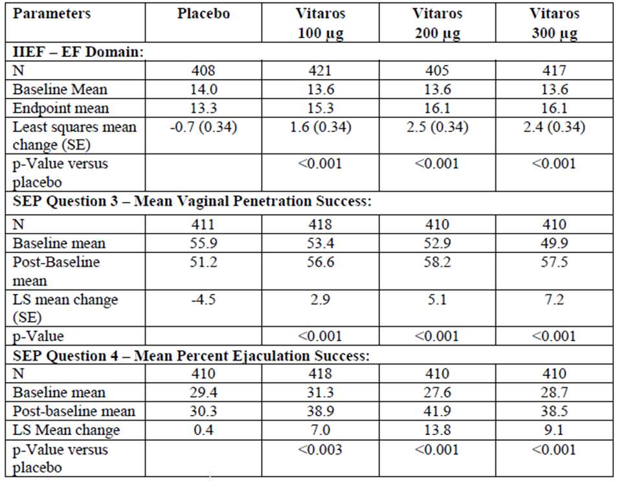

The individual study scores for the primary endpoints are included. EF Domain scores were consistently statistically significantly different from placebo in all active treatment groups in both studies. SEP Q3 and Q4 were less consistent. The 100 μg groups in study MED 2000-005 did not achieve a statistically significant improvement in Q3 score whereas the higher doses in that study and in all dose groups in MED 2000-004 did. The Q4 results were more variable. Statistically significant improvement was not demonstrated in the MED 2000-005 300 μg group. Because of the effect size in Study MED 2000-004, the pooled efficacy for this endpoint is statistically significant.

Subgroups analyses based on co-morbidities showed favourable results for the 200mcg and 300 μg dosage groups for all except Viagra failure. Overall, the most favourable results for the 3 co-primary endpoints were for patients with severe disease. In the analysis of age ≤ 65 years or > 65 years, favourable results for all doses were reported for both age groups in the MED 2000-004 study and ≤ 65 years group in the MED 2000-005 study. For the >65 year group in the MED 2000-005 study, only the 200 μg dose result was favourable.

The secondary endpoints included the response on the GAQ. Improvement was reported in:

* Placebo: 21% (MED 2000-004), 20% (MED 2000-005)
* 100 µg: 42% (MED 2000-004), 38% (MED 2000-005); p<0.001 versus placebo
* 200 µg: 47% (MED 2000-004), 46% (MED 2000-005); p<0.001 versus placebo
* 300 µg: 56% (MED 2000-004), 47% (MED 2000-005); p<0.001 versus placebo

Other domains of the IIEF (Orgasmic Function, Sexual Desire, Intercourse Satisfaction, Overall Satisfaction) were also analysed as secondary variables. All the active treatment groups showed a significant improvement relative to the placebo group with the exception of Sexual Desire but, a priori, this is not expected to respond to topical PGE1 therapy. The remaining questions of the SEP were also analysed as secondary endpoints. Among groups comparisons were significant for the questions reporting satisfaction with erection and overall satisfaction. SEP Q1 and Q2 (number of attempts and able to achieve some erection) did not achieve statistical significant for these comparisons.

###### Supportive efficacy studies

###### MED 2000-006

This was a Phase III open label, parallel design, study of alprostadil in 1162 patients with a IIEF domain score of ≤ 25 in stable monogamous relationships and a consenting female partner. Patients were excluded if they were at high risk of serious adverse effects or had ED that could be better managed by other means. Most (n = 998) continued from previous studies. All patients commenced with 200 μg alprostadil doses and titrated up to 300 mcg or down to 100 mcg according to tolerability and response. The study was terminated prematurely by the FDA because of the concern over possible human carcinogenicity based on the transgenic mouse study. Most patients reached the day 30 visit (86%) at which time the dose could be changed and 73% were up-titrated to 300 μg dosing. About half (52%) reached the 60 day visit, only about 12% reached the 180 visit (including only 2 patients from the 100 μg group and 20 from the 200 μg group) and no patient reached the final study visit. There were differences in the duration of treatment and follow-up between the treatment groups. Most of the 15 patients with major protocol violations were in the 300 μg group. Baseline characteristics were similar except for the preponderance of more severe disease in the 300 μg group; however, the final treatment groups were not based on random allocation.

The primary efficacy endpoint was the change in EF domain score from baseline the final visit (Day 360) but the protocol allowed for the inclusion of 180 day results. All groups had a numerical mean improvement from baseline in EF score for those that reached visit 5 with mean scores improving by approximately 13 points in the 100 μg and 200 μg groups and 10 in the 300 μg group. Those with scores recorded at early termination all had similar or worse scores than baseline. Secondary endpoints were non-EF domain scores of the IIEF, GAQ responses, SEP responses, and Patient Self Assessment of Erection rating scale (PSAE) responses. Most were difficult to interpret because of the low number. From the GAQ, 91-100% reached the 180 day visit, and 26-43% that terminated early had erection improvement.

###### 99-002A

This was a Phase II randomised, placebo controlled, double blind, parallel group study to compare the efficacy of 6 weeks treatment of alprostadil at three doses (50 μg, 100 μg and 200 μg) to placebo, in men aged 21 to ≤ 65 years with ≥ 3 months ED and IIEF EF domain score of 14 to 21. Underlying endocrine disorders (except diabetes), previous myocardial infraction, major neurological problem and significant hepatic or renal disease were among the numerous exclusion criteria. EF ≥ 4.5 placebo adjusted difference from baseline was considered clinically important and a sample size of 32 per treatment group was calculated to have a 95% power to detect a difference in effect. Primary efficacy was reported for the Per Protocol (PP) populations (tolerated the test dose and used ≥ 3 doses at home), rather than the Intention to Treat ITT population. About 89%/71%/64%/68% completed the study in the placebo/50 μg/100 μg/200 μg groups, respectively, with the majority of withdrawals because of AEs. Protocol violations were reported for 16 patients, distributed across the treatment groups. Almost half were for continuation despite not tolerating the first study dose, and the remainder were for EF domain score outside the inclusion criteria (mostly lower). Baseline characteristics were similar.

The primary endpoint was EF domain score form baseline to final visit. The only group to achieve a mean clinically meaningful improvement from baseline in EF score (4.5 ± 6.2) was the 200 mcg dose.

Penetration success SEP Q3 score/Q1 score was a key secondary endpoint. Based on the PP population, the mean success was 83% in the 200 μg group and 55% in the placebo group. About 54% reported 100% success in the 200 μg group (and 22% in the placebo group). The results for the ITT population showed no significant across group or pairwise improvement. The remainder of the IIEF scores were inconclusive, although intercourse satisfaction improved across the groups. The PSAE showed a similar discordance between the ITT and PP populations. All active treatment groups in the PP population had a significant improvement over placebo. The GAQ showed improvement in both the ITT and PP populations for the 50 μg and 200 μg groups.

###### MED 2000-002A

This Phase II double blind, placebo controlled study evaluated 104 patients aged 21 to ≤ 70 years with ≥ severe ED (EF < 14 for the EF domain of the IIEF) compared alprostadil 100 μg, 200 μg and 300 μg administered in 100 mg topical cream with placebo over 6 weeks of treatment. Patients using at least 1 dose and had 1 post treatment efficacy evaluation were included for the primary efficacy endpoint of change in EF score. The increase in EF score with 300 μg (least squares mean EF change from baseline 9.44) was >3 times the increase with placebo (2.67). In the PP population (≥ 3 doses used at home), the least squares mean EF change from baseline was 10.42 (range -6 to 22)/7.55 (range -5 to 29)/8.02 (range -3 to 23) for the 300 μg/200 μg/100 μg dosage groups, respectively. The other efficacy outcomes of non-erectile domains of the IIEF, SEP, penetration success, PSAE, and the GAQ had mixed results. Orgasmic function and intercourse satisfaction score were statistically significant for the 300 μg dose only; Q5 (satisfaction) of the 6 SEP questions was the only one to reach a significant difference across the dose groups; a small but significant difference in PSAE in the highest dose group; and a numerical (and possibly clinically relevant) increase of 15.2% over placebo for Q3 (successful penetration) with the 300 μg dose (p = 0.553).

###### MED 99-001 (High dose study)

This Phase II multicentre, randomised double blind, placebo controlled study was designed to compare 500 μg, 100 μg or 1500 μg in 250 mg of topical cream. The study was terminated early after 9 of 21 patients failed to tolerate the test dose.

###### MED 2000-007 (Instrumentation study)

This Phase II randomised, double blind, placebo controlled crossover study measured tumescence/rigidity in a clinic setting in 27 men ≥ 21 years with ED watching sexually explicit videos, and compared placebo, 100 μg, 200 μg and 300 μg alprostadil in 100 mg cream. The best results were achieved with placebo, and there was no direct correlation between alprostadil dose and response.

###### Phase II formulation studies

Eighteen additional studies performed in China assessed the efficacy of alprostadil creams containing various concentrations of DDAIP. Most, because of the study design or lack of detail did not allow critical appraisal by the clinical evaluator. Safety information from these studies was included in the integrated safety set. Three studies were considered evaluable (NM-AP-40B-CH, NM-AP-40C-CH and NM-AP-40F-CH).

###### NM-AP-40B-CH

This 3 month, multi dose, randomised, double blind, placebo controlled study of 60 men (15 per treatment group) with ED compared alprostadil 300 μg cream with four concentrations of DDAIP (0%, 0.5%, 1.0%, 2.0%). The primary endpoint was the sum of Q3 (penetration) and Q4 (maintenance of erection to ejaculation) from the standard IIEF questionnaire. The endpoint was achieved by an increase in Q3 +Q4 score of ≥2. Compared with 0% DDAIP all other formulations resulted in improved scores, but there was no clear relationship between concentration of DDAIP and response (improvement in 1.0% DDAIP <0.5% DDAIP<2.0% DDAIP).

###### NM-AP-40C-CH

This 3 month, randomised, double-blind, parallel group study in 105 men (15 per group) with ED had the same design as study NM-AP-40B-CH but compared concentrations of DDAIP hydrochloride in concentrations of 0%, 0.5%, 1.0%,1.5%, 2.0%, 2.5% and 5.0%. All groups had a mean increase in score for Q3 and Q4 compared with baseline, and all DDAIP groups had a significant increase compared with the 0% group. Statistically significant improvements for Q3 + Q4 were seen using 0.5%, 2.0%, 2.5% and 5.0% DDAIP HCl formulations containing alprostadil 300 μg.

###### NM-AP-40F-CH

This 3 month, randomised, double blind, parallel group study in 280 men (40 per group) with ED had the same design as the studies above but compared 0%, 0.01%, 0.05%, 0.1%, 0.3%, 0.5% and 2.0% DDAIP HCL formulations containing alprostadil 300 mcg. Concentrations of DDAIP ≥ 0.05% had significant results for the sum of Q3 + Q4 and Q3 and Q4 individually compared with 0%.

###### Chinese formulation

###### NM-AP-3

Chinese formulation (Befar versus Placebo): The Phase II randomised, double blind, placebo controlled study of 157 patients compared alprostadil 300 μg cream (without DDAIP)with placebo over 4 weeks of use was provided as a synopsis only. The primary endpoint was Q3 + Q4 of the IIEF, and the secondary endpoints were the reminder of the IIEF and the GAQ. The effective rate was 67.5% for the active and 13.0% for the placebo treatments, for the primary endpoint, and improvement of GAQ in 75.3% for the active and 19.5% for the placebo groups. Men with mild ED improved the most in the active and placebo groups.

##### Safety

A total of 2079 patients were exposed to alprostadil with DDAIP, including 1352 for the 300 mcg dose, 827 for the 200 μg dose and 566 for the 100 μg dose. An additional 1438 patients were exposed to alprostadil in different formulations from the one proposed. About 83% of the patients were exposed for 5 months or less. Patients ranged in age from 21 to 87, and included patients with co-morbidities including hypertension, cardiac disease, and diabetes.

In the pivotal studies, the proportions of patients with at least one AE were 37.3%/53.7%/57.2%/58.3% for the placebo/100 μg/200 μg/300 μg groups respectively and of those, 3.2%/3.7%/5.6%/8.1% were considered severe. Urogenital AEs were the mostly commonly reported AEs, and the proportions of patients report these events were 13.1%/36.2%/41.9%/42.9% in the placebo/100 μg/200 μg/300 μg groups respectively. Penile burning (6.0%/17.1%/24.7%/23.5% in the placebo/100 μg/200 μg/300 μg groups), genital pain (0.5%/11.1%/15.6%/17.5% in the placebo/100 μg/200 μg/300 μg groups) and penile erythema (2.1%/7.8%9.1%/11.5% in the placebo/100 μg/200 μg/300 μg groups) were the most commonly reported of these. Genital pain was reported as severe in 0%/0.7%/0.7%/2.5% of the placebo/100 μg/200 μg/300 μg groups and penile burning was reported as severe in 0%/1.2%/1.9%1.6%. Respiratory system disorders occurred in 9.2-10.4%, cardiovascular disorders (mostly hypertension) in 2.5-5.1% (the highest proportion in the 300 μg group) and nervous system disorders in 2.1-3.5% (mostly dizziness and hyperesthesia).

In the open label study, 23.4% had treatment emergent adverse events (TEAEs) before dose titration, and 34-42% had TEAEs after dose titration (slightly lower in the 300 μg dose). Most events were local urogenital events or rhinitis.

In the high dose Phase II study (doses of ≥ 500 μg), 43% did not tolerate the first test dose and of those 78% reported hypotension or dizziness and 89% had local discomfort. The largest proportion of patients with events was in the highest dosage group (100% had local discomfort). In the remainder of the Phase II studies, local urogenital symptoms were reported in 22% and 63% patients taking 300 μg dose groups and 30% and 78% in the 200 mcg dose groups.

In the Chinese Premature Ejaculation Studies, almost 60% of patients reported penile or urethral pain. A study of approximately 400 women with sexual dysfunction given alprostadil vaginally reported local symptoms (up to 31% in the 900 mcg group)

Partners reported AEs in 4.8%/5.7%/9.5%/7.6% of the placebo/100 mcg/200 mcg/300 μg groups respectively, and mostly consisted of urogenital symptoms such as vaginitis and vaginal burning. In the open label study, 2.0% of partners had TEAEs and 1.6 to 4% after titration, with the highest percentage of events and the only SAEs (0.2%) in the 300 μg dose group. Most were vulvovaginal disorders. One SAE was reported in a partner in the 300 μg dose group.

In the pivotal studies, the proportions of patients with at least one TRAE were 11.8%/34.1%/41.4%/41.9% for the placebo/100 μg/200 μg/300 μg groups, respectively. Local urogenital symptoms were most commonly attributed to the study drug. Headache or dizziness occurred in < 1% of patients across the treatment groups. In the open label study, 13.7% patients had events before titration and 16-32% had events after dose titration. Severe TRAEs were reported for 1.2% before titration and 3-4% after titration.

In the pivotal studies the proportions of patients withdrawn due to AEs were 0.9%/1.8%/4.0%7.6% from the placebo/100 μg/200 μg/300 μg groups respectively, and 0.7%/0.2%/0.5%/1.4% were withdrawn from the studies because of SAEs.

Seven partners discontinued in the pivotal studies; 3 with vaginal burning, 2 vaginal itching, 1 vaginal moniliasis, 1 allergic reaction and one rash (groin and abdomen).

In the pivotal studies, 2.3%/1.6%/2.3%/3.5% patients reported SAEs in the placebo/100 μg/200 μg/300 μg groups respectively. Of those, 4 (0.9%) patients in the 300 μg group and 1 (0.2%) in the 200 μg group reported myocardial infarctions. None of the SAEs were considered related to treatment by the investigators. In the open label study SAEs were reported for 0.6% before titration and 0.8 to 1.9% after titration, in total 2.2%. Most were considered unrelated but 1 patient each with sinus bradycardia, abnormal electrocardiogram (ECG), and hypotension and dizziness resulting in discontinuation, were considered possibly related to the test dose of the study drug.

SAEs in partners occurred in 5 patients across the 2 pivotal studies and included 3 events of allergic reactions in one patient a gastrointestinal disorder, cholelithiasis, pneumonia and accidental injury. One patient in a pivotal study in the placebo treatment arm died of an unwitnessed cardiac arrest 7 days after his last treatment. In the open label study one death each occurred among patients and partners, both from chronic obstructive pulmonary disease (COPD). No deaths were considered to be related to the study medication.

No QT study was conducted, but an analysis of ECG changes in the pivotal and open label extension studies did not reveal a safety signal for ECG changes. Hepatic, renal, and serious skin toxicity were not demonstrated in the clinical trials. Apart from with the test dose, l signs were not measured at the time of use so transient changes at the time of absorption would not have been captured, although dizziness was reported and may have included patients with hypotension. Priapism (erection ≥ 4 h duration) was reported for 1 patient in the pivotal studies and 4 patients (0.5%) of the open label study (4 in the 200 μg group and 1 in the 300 μg group).

STIs were not specifically reported but undiagnosed infections could have contributed to the numbers of patients with urogenital discomfort and the trial populations were at low risk.

Misuse of the device was reported, with some patients inserting the dispenser into the urethral meatus rather than allowing the cream to drip from the dispenser. The adverse effects were similar to those experienced by patients using the device correctly.

##### Sponsor’s response to the clinical evaluation report

The sponsor has provided a response to Round 2 clinical evaluation report and has addressed some of the issues the clinical evaluator had found to be lacking from the S31 responses. A brief summary of the responses to the questions with outstanding issues is provided here.

* Question 4: A single compartment PK model was used
* Question 8: In the pivotal studies weighting for the Q3 and Q4 of the SEP was conducted by averaging the number of ‘yes’ responses to Q3 and Q4 for each patient and dividing by the number of ‘yes’ answers to Q1
* Question 9: Regarding multiplicity, no a priori control for multiple comparisons was included in the analysis plan. The interpretability of the pairwise comparisons was limited to only those parameters demonstrating an overall difference among the groups (not a method to control for multiplicity). In answer to the question, the sponsor applied Bonferroni adjustment to the 9 comparisons (3 treatment arms x 3 primary endpoints) giving an α of 0.0056, the sponsor states all p values (for the pooled data) are <0.0056 and all doses are significantly different for the three efficacy endpoint measures.
* Question 10: As the pivotal studies did not have a crossover design, the patients were unlikely to detect the treatment arm to which they belonged, and be unintentionally unblinded.
* Question 11: The sponsor disagrees that the approach of LOCF for imputed data would introduce favourable bias for alprostadil.
* Question 16: The median follow-up of the study MED 2000-0006 was 212./9.7/19.2 weeks for the 100 μg/200 μg/300 μg doses, respectively, with the mean being 16.7 weeks. The proportion of patients attending the 6 months visit were 32%/18.6%/34.5% of the 100 μg/200 μg/300 μg groups, respectively.

### Risk management plan

The Pharmacovigilance and Special Access Branch (PSAB) has reviewed the EU-RMP (version 2.0, dated 27 April 2012, data lock point 31 March 2012) with an ASA (dated December 2014). The PSAB has sought the advice of the ACSOM regarding the safety of alprostadil.

The RMP evaluator has identified a number of outstanding issues that are yet to be resolved, and a summary is included below. The following issues should be addressed with the RMP evaluator and in the pre ACPM response. An ASA should be submitted.

Regarding the Safety Specifications:

* Add ‘Penile irritation and burning’ an Important Identified Risk
* Add safety associated with DDAIP HCl, risks specific to this ingredient to be added to the Summary of Safety Concerns
* Add ‘Potential for increased risk of STI transmission due to local adverse effects’ as an Important Potential Risk
* Add ‘Adverse effects relating to oral or anal sex’ as Important Missing Information
* Add ‘Inadvertent partner exposure (including pregnant partner exposure)’ as an Important Potential Risk

Regarding the pharmacovigilance plan:

* Provide details sufficient for evaluation of the post authorisation spermatoxicity study.

Regarding the risk minimisation activities:

* Create a separate “partner information document” which, alongside the CMI will outline the possible risks to the partner associated with alprostadil
* Include comments on the effect on fertility of males, or females inadvertently exposed in the CMI
* Remove the reference to Proshaeos as “natural” in the CMI.
* Revise the PI/CMI statements regarding alprostadil use with a pregnant partner should be carefully revised to ensure consistent information is presented throughout. Warnings should also outline why inadvertent exposure to a pregnant women could be problematic
* The PI statement regarding maximum frequency of use should be repositioned near the top of the dosage and administration section of the PI to maximise its impact
* The draft PI states:

*Only latex material based condoms have been investigated together with use of TRADE NAME and other materials may not exclude possible risk for occurrence of damage to the condom.*

This statement should be revised to align with information in the CMI regarding non latex condoms.

### Risk-benefit analysis

#### Delegate’s considerations

##### Quality

The formulation contains a novel excipient for which the safety has not previously been established. Local irritation has been confirmed in animal studies and there are unresolved concerns about possible spermatotoxicity that the sponsor is planning to address in a post market safety study. The chemistry evaluator has recommended a shelf life of 6 months stored at 2 to 8°C, based on the stability data. No data were submitted to indicate the stability at temperatures outside that range.

##### Efficacy

The proposed formulation offers an alternative route of administration of a medication for ED. The efficacy of the proposed alprostadil formulation has been demonstrated using pooled results from two well conducted similarly designed studies of men with mild to severe ED and three endpoints:

* erectile function
* successful vaginal penetration
* ejaculation success

Patients were mostly white men, with a mean age of around 61 years, and with co-morbidities representative of the likely target population, including 19% with Viagra failure. When comparing the pooled pivotal study data, statistically significant improvements in all three endpoints were achieved for the 200 μg and 300 μg groups. In the subgroup analysis by baseline severity patients with severe ED derived most improvement from baseline with the three tested doses for all three endpoints. Those with moderate disease derived some benefit across the 3 endpoints with the 200 μg and 300 μg doses. The results were even less robust for patients with mild to moderate disease and patients with mild disease did not improve on any of the 3 co-primary endpoints with either of the proposed doses. In Study 99-002A, an EF ≥ 4.5 was considered clinically important when discussing the sample size. If this were applied to the pooled and individual study results in Studies MED 200-004 and MED 200-005, the observed improvements for the EF score in these studies appear quite modest.

The GAQ score improved in all active treatment groups versus placebo, with the highest percentage of positive responses in the 300 μg group. The major criticism of the studies is the lack of a priori adjustment for multiple comparisons. The sponsor has proposed to describe the limits of the pairwise comparisons performed on the data for these two studies, including a lack of adjustment for multiple comparisons in the PI. The sponsor in response to a question has also applied a Bonferroni correction and has concluded that the responses for all the pooled primary endpoints are statistically significant. However, the individual study endpoint the primary endpoints of SEP Q3 responses for all active treatments in study 2000-005, and SEP Q4 responses for the 100 μg dose groups in both pivotal studies are not significant if the Bonferroni correction is applied. The open label study while providing some supportive data was terminated early and most patients did not reach the primary endpoint evaluation visit. There is the potential for withdrawal bias in a positive direction, due to withdrawals because of lack of efficacy or intolerable adverse effects. Overall, the Phase II studies are supportive of the use of alprostadil. Not all studies used the same formulation (for example, Chinese studies), so extrapolating to this formulation is required. The Phase II studies in general exposed patients to 6 weeks active therapy. Study 99-002A, however, provides some support for the use of alprostadil in patients with mild ED.

##### Safety and RMP

There are several considerations for the safety of this formulation of alprostadil cream. The safety of alprostadil alone has been described in a study using the Chinese formulation Befar. Alprostadil alone is a local irritant, and local irritant effects have also been described with the use of injectable alprostadil. As stated in the Caverject PI, alprostadil is an abortifacient and stimulates uterine smooth muscle.

The novel excipient DDAIP has been included in the formulation to improve permeation of alprostadil locally. Phase II efficacy studies conducted with Chinese alprostadil products (without DDAIP) were presented to demonstrate the improved efficacy in formulations with DDAIP compared to those without, however the consistency of production of the Chinese formulations is unknown. The local irritant properties of DDAIP have been demonstrated by the results of studies in transgenic mice. The nonclinical evaluator was satisfied there was no evidence of carcinogenicity in humans, but long term clinical data are lacking and there has been limited post market exposure to the formulation internationally. Systemic exposure to DDAIP or alprostadil are low with the proposed use, any potential for carcinogenicity with this formulation is likely to be manifested locally. There remains a question based on animal studies about effects on spermatogenesis. The sponsor has provided Chinese studies that investigated the concentration of DDAIP that would be required to sufficiently enhance the absorption of alprostadil. There was no consistent concentration-absorption relationship for increasing concentration for the formulation of DDAIP beyond 0.05%. The reasons for the chosen concentrations of DDAIP remain unclear. It is noted from the sponsor’s responses to chemistry questions that no patients in the pivotal studies received doses of test medication in the first three months after manufacture. The sponsor also provided stability data for three batches of its alprostadil cream. This suggests no patients received medication within 3 months of manufacture, and based on the stability data the mean theoretical % DDAIP at 3 months for the 200 μg cream and the 300 μg cream were 825 and 86%, respectively, it is not certain that any patient received investigational product with DDAIP of 2.5%. While it could be argued a delay from manufacture through the distribution chain to the consumer of three months is likely, it remains that the safety data has likely been collected in patients exposed to lower concentrations of DDAIP, and the effects of 2.5% are limited to very small studies and/or different formulations.

In the clinical studies, urogenital effects were most common. The irritant effect on skin and mucosal raises the possibility of increased susceptibility to STIs, the symptoms of which may be mistaken for those from the alprostadil formulation alone and lead to delays in diagnosis and treatment. With wider use, this poses a risk to both the patients and potential partners. The sponsor relies heavily on the use of condoms to mitigate the risk to partners. The studies only investigated the use of alprostadil for vaginal intercourse so there remains uncertainty about the risks for partners with anal and oral sex. It is expected that similar or greater local reactions in the anal and buccal mucosa from partner exposure to this alprostadil cream. Although the sponsor has recommended the use of condoms patient compliance is not guaranteed. Partners are likely to be exposed to smaller doses of alprostadil, however, the effect of small doses of this formulation with the enhanced permeation from DDAIP on the cervix has not known, as is the effect on the human foetus. Animal studies have demonstrated embryotoxicity. The sponsor has included instructions in the PI that condom barriers should be used with pregnant partners, but inadvertent exposure in early pregnancy is possible. The ACSOM recommended alprostadil should not be used if the female partner is of reproductive age.

In the safety analyses, there were 4 myocardial infarctions in the 300 μg group and 1 in the 200 μg group (none in the 100 μg group). The numbers are very small and similar to the background rate for the population. There is no clear signal for myocardial infarction.

Priapism has been noted in a small proportion of patients, particularly in the open label extension study and use is contraindicated in patients with predisposing conditions.

There are a number of unresolved RMP issues, and the sponsor is encouraged to actively engage with the RMP team to resolve these matters.

##### Conclusion

Proshaeos offers an alternative route of delivery of a medication for ED. The clinical benefits, which appear modest, favoured patients with more severe disease, however the sponsor has proposed the broad indication of ED in adult males. The benefits are balanced against the risks of the use of locally acting alprostadil and the not yet fully characterised risks of the novel excipient DDAIP. The risks are for both patients and partner. Local irritation has been established, and the risk of STIs mentioned in the PI. However, the risks of spermatotoxicity and the consequences of long term exposure of transitional epithelium to DDAIP, have not been well characterised at this time, and the risks of exposure of other epithelial types (for example, with oral or anal sex) are unknown. The main risk minimisation strategy of condom use may be difficult for patients and compliance is likely to be inconsistent. Overall, at this time, the benefits do not appear to outweigh the risks and uncertainties for the proposed indication.

##### Dose

No clear instructions are provided for the starting dose, which is left to the prescriber. The sponsor has proposed a starting dose of 300 μg with severe ED, with down-titration based on tolerability. Based on the clinical efficacy results, it is reasonable to commence with this dose in patients with severe ED.

##### Data deficiencies

No human clinical data have been provided that clarify uncertainty about spermatotoxicity. Animal data points to a potential concern. The lack of certainty has been expressed in a statement in the PI. There is not sufficient certainty to rely on the use of alprostadil cream as a method of contraception. Only heterosexual men having vaginal intercourse were included. The safety and efficacy of alprostadil cream and different doses of the cream has not been tested for use for oral and anal sex. Post market data of direct relevance to the proposed formulation were not provided.

##### Conditions of registration

The following are proposed as conditions of registration.

* There will be a specific condition of registration requiring the implementation of an EU-RMP with ASA once these have been approved by the PSAB.
* The provision of the spermatotoxicity study proposed by the sponsor in the RMP to evaluate the effects on sperm with repeated administration on completion.

##### Questions for the sponsor

1. The clinical evaluator has noted that Chinese formulation studies suggested that DDAIP at concentrations of ≥ 0.05% enhanced the efficacy of alprostadil. Please explain why the concentration of the DDAIP in the proposed formulation needs to be 2.5%?
2. The sponsor has proposed a shelf life of 6 months for its 200 μg product. The chemistry evaluator has recommended a shelf life of 6 months for both strengths of Proshaeos. Please comment on the impact of this on patients.
3. Were studies MED 200-004 and MED 200-005 designed to be analysed together? If not, why should the pooled data of the primary endpoints be considered rather than the individual study results?
4. Please provide an analysis of the primary and key secondary endpoints for patients from Studies MED 2000-004 and MED 2000-005 that had Viagra failure as a baseline characteristic.
5. The cited paper by Rosen et al.[11] discusses the minimum clinically important difference for the EF domain of the IIEF score. Please comment on how the conclusions of Rosen’s analysis impact the findings of the Phase III studies.
6. The sponsor has not studied the safety and efficacy of this alprostadil formulation in patients having oral and anal sex. Does the sponsor have plans to conduct further studies to address this deficiency?
7. The sponsor has proposed use 2 to 3 times per week. What was the basis of the recommendation? What are the likely consequences of more frequent use of alprostadil?
8. The sponsor has proposed that patients should wear condoms when using this product, for partner safety and to avoid the potential increased risk of STIs. How will this message be delivered to patients to ensure compliance? How does the sponsor plan to measure the success of this risk minimisation strategy?
9. The data lock point for the first PSUR was to be 31 January 2014. However, the clinical evaluator has noted that minimal post market data has been provided. Please provide the latest PSUR for review.
10. The ACSOM has considered the safety of the use of the proposed alprostadil formulation. A summary of the meeting minutes has been provided in the RMP Round 2 report. Please comment on the issues raised by the committee as addressed in the pre ACPM response.

#### Summary of issues

The issues of concern are:

* The stability of the product resulting in a 6 month shelf life for the finished product
* The novel excipient DDAIP, and its safety and tolerability profile, including possible spermatotoxicity and carcinogenicity
* The clinical data shows modest efficacy outcomes
* Sparse long term safety data
* No data in patients having oral or anal sex
* Partner safety
* Condom use as the main risk minimisation strategy

#### Proposed action

The Delegate is not in a position to say, at this time, that the application for alprostadil cream should be approved for registration.

#### Request for ACPM advice

The committee is requested to provide advice on the following specific issues:

* Has the efficacy of alprostadil formulation been provided to support the use in all patients? Should the indication be restricted to patients with severe ED?
* Is the data sufficient to support long term use of alprostadil cream?
* DDAIP is a novel excipient.
  + Has the sponsor sufficiently demonstrated the safety concerns with this new ingredient?
  + Have the concerns about carcinogenicity been adequately resolved?
  + Should the question of spermatotoxicity be resolved prior to general use, or is as the sponsor’s proposal to investigate this potential concern in the post-market setting acceptable?
* Irritation and disruption of skin and vaginal mucosa resulting from the use of this formulation have been shown. Does the committee agree with the evaluators about the risk of STIs as a result?
* Does the committee consider the advice about condom use proposed by the sponsor sufficient to mitigate the risks of the alprostadil cream for the partner and the patient? Is condom use sufficient to mitigate the risk of exposure to pregnant patients?

The committee is (also) requested to provide advice on any other issues that it thinks may be relevant to a decision on whether or not to approve this application.

#### Response from sponsor

* ***Question 1: The clinical evaluator has noted that Chinese formulation studies suggested that DDAIP at concentration of ≥ 0.05% enhanced the efficacy of alprostadil. Please explain why the concentration of the DDAIP in the proposed formulation needs to be 2.5%?***

The following information is provided in addition to the sponsor’s response to the similar item raised in the clinical evaluation report (summary of second round recommendations).

##### Efficacy

The data noted by the clinical evaluator to show enhancement of the efficacy of alprostadil was based on three studies:

* NM-AP-40B-CH
* NM-AP-40C-CH
* NM-AP-40F-CH

As described in the pharmaceutical development section of the dossier, these studies were performed with various levels of DDAIP (base or salt) and alprostadil, as follows.

Table 26: Clinical Studies and Formulations – DDAIP Concentration Effect.1

|  |  |  |
| --- | --- | --- |
| Study | DDAIP or DDAIP HCl Formulations | Alprostadil Cream |
| NM-AP-40B-CH | Placebo group  Group A: 0.5% DDAIP base  Group B: 1.0% DDAIP base  Group C: 2.0% DDAIP base | 0.3% w/w (300 µg) alprostadil in 100 µg cream |
| NM-AP-40C-CH | Group A: Placebo  Group B: 5.0% DDAIP base  Group C: 0.5% DDAIP base  Group D: 1.5% DDAIP base  Group E: 2.0% DDAIP base  Group F: 2.5% DDAIP base  Group G: 1.0% DDAIP base | 0.3% w/w (300 µg) alprostadil in 100 µg cream |
| NM-AP-40F-CH | Group A: Placebo  Group B: 0.01% DDAIP base  Group C: 0.05% DDAIP base  Group D: 0.1% DDAIP base  Group E: 0.3% DDAIP base  Group F: 0.5% DDAIP base  Group G: 2.0% DDAIP base | 0.4% w/w (300 µg) alprostadil in 75 µg cream |

1. TR-291 “The Clinical Efficacy and Safety of Alprostadil Topical Cream Containing Various Concentrations of the Novel Excipient, Dodecyl2-(N,N-dimethylamino)-propionate (DDAIP Base or HCl Salt).

From the table above, Studies 40B and 40C evaluated 0.3% alprostadil with varying levels of DDAIP (base or salt) while 40F evaluated 0.4% alprostadil. It should be noted that this submission is seeking approval for alprostadil concentrations of 0.2% and 0.3% w/w. It is known that concentration of the active can increase permeation, therefore, there may be an effect on efficacy of the higher concentration of alprostadil (0.4%) in 40F, as noted in the efficacy table below in the formulas with DDAIP concentrations < 0.5%. The 0.3% alprostadil formulations were studied down to a DDAIP concentration of 0.5% so a direct comparison of the two alprostadil concentrations at DDAIP levels < 0.5% cannot be made.

Table 27: Integrated Primary Efficacy Results – DDAIP Concentration Effect.

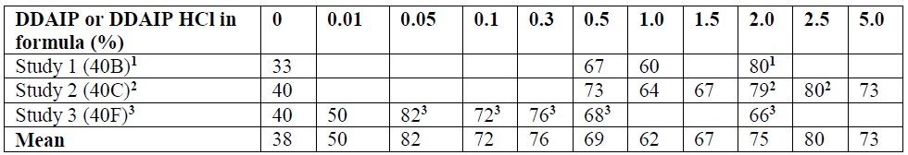

1. Chi Square, p<0.05 compared to placebo in study 40B, contained DDAIP base

2. Chi Square, p<0.05 compared to placebo in study 40C, contained DDAIP HCl

3. Chi Square, p<0.05 compared to placebo in study 40F, contained DDAIP HCl

DDAIP is a functional excipient and the efficacy data shows a clinical effect over a range of concentrations. As discussed in the dossier, excipients are commonly added in an excess in order to provide functionality over the shelf life of the product, with preservatives being added at an excess a prime example. In this case, DDAIP is added at a level to provide an effective range over the life of the product, since it is known that the permeation enhancing effects of DDAIP also promote partitioning into the plastic primary packaging, thus reducing the amount available in the formula when dosed by a patient but not reducing the products efficacy.

##### Safety

The AEs related to the study medication are presented in the Table 28 for each of the three studies (also from TR-291). A total of 432 patients were evaluable for safety in the three studies. A total of 138 patients or 32% of the patients reported AEs related to the study medication. The most common AEs were: urinary tract pain, penile burning at the application site, and a sensation of penile fullness; all consistent with the topical application of a potent vasodilator.

Table 28: Summary of AEs (Studies NM-AP-40B, NM-AP-40C-CH, NM-AP-40F-CH).

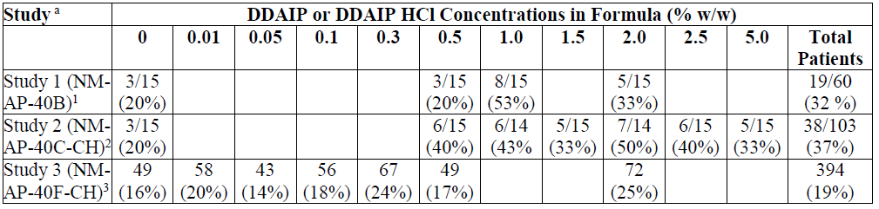

1. Study 1 tested formulas with DDAIP and Studies 2 and 3 tested formulas with DDAIP HCl.

2. Rates were calculated on a per patient basis.

3. Rates were calculated on an incidence per group basis. The total AEs in study 40F calculated on a per patient basis was 81/269 (30%).

All AEs in each study due to the study medication were mild to moderate in intensity and were transient and all resolved within approximately 60 minutes. The average duration was approximately 20 minutes. The most common urogenital AEs were: urinary tract pain, penile burning, and a sensation of penile fullness.

A review of the AEs from each study, whether calculated on a per patient basis or on an incidence per group basis shows that there was no trend for increasing AEs with increasing concentrations of DDAIP HCl or DDAIP base and the AEs were consistent with the expected effect of the potent vasodilator alprostadil.

##### Summary

DDAIP is added at a level to provide efficacy at the proposed clinical dose over the anticipated shelf life of the product, therefore the concentration (w/w) of 2.5% DDAIP was selected. There was no trend for increasing AE’s with increasing concentrations of DDAIP.

* ***Question 2: The sponsor has proposed a shelf life of 6 months for its 200 μg product. The chemistry evaluator has recommended a shelf life of 6 months for both strengths of Proshaeos. Please comment on the impact of this on patients.***

In response to this item it is important to consider the demonstrated safety and efficacy of Proshaeos together with the practicalities for the patients who will use this product.

The 6 month shelf life, as recommended by the chemistry evaluator, is not consistent with the assessments made by both the clinical and nonclinical delegates. The efficacy of Proshaeos has been demonstrated over the DDAIP concentration range of 0.5% to 2.5% (corresponding to specification limits of 20 to 100% of nominal content). The clinical Delegate is in agreement that efficacy has been demonstrated in several studies at the lower end of this range. Further, the sponsor has provided evidence indicating that there are no clinically significant safety concerns for Proshaeos when used as directed. This view has been supported by the nonclinical assessor. Any residual safety concerns have been addressed in the risk minimisation strategy.

The sponsor therefore does not believe that increasing the lower specification limit for the DDAIP concentration from 50% of nominal content to 60% (as recommended by the chemistry evaluator) would result in a meaningful difference in the safety or efficacy of the product. Stability over a 12 month period has been demonstrated for the 300 μg strength presentation in combination with a lower limit for the DDAIP concentration of 50%. Consequently, the sponsor requests that the proposed lower limit for the DDAIP concentration of 50% be accepted by the TGA on this basis.

With regard to the impact of a 6 month shelf life on patients, it is necessary to consider how long it will take for the product to reach the patient, and how the patient will want to use the product. Logistically, the time required for product release and distribution from international suppliers could be a minimum of 2-3 months, which would leave around 3 months of active shelf life in the market. The sponsor does not believe this will be a practical option for the wholesaler, pharmacy or patient and would not be commercially viable.

Proshaeos is available in cartons containing four single unit dose dispensers and the proposed dosage regimen is 2-3 doses per week. The nature of this product and the condition being treated would necessitate patients holding several unit doses in their homes to use as required. Imposing a 6 month shelf life is likely to restrict the patient’s ability to use this product as necessary, and therefore meet the intended treatment objectives.

Quality control limits are intended to ensure the product is manufactured to achieve the intended efficacy and safety objectives. In this case, a limit of 50-120% of the nominal content of DDAIP would not compromise the efficacy or safety of the product and a more stringent lower limit of 60% only achieves a commercially unviable restriction to the shelf life and therefore availability and access to the medicine.

* ***Question 3: Were studies MED 200-004 and MED 200-005 designed to be analysed together? If not, why should the pooled data of the primary endpoints be considered, rather than the individual study results?***

These studies were both designed as randomised, double-blind, placebo-controlled parallel arm studies with identical visit intervals, study duration, patient populations, dose levels and endpoint measures. They were run in parallel, recruiting men > 21 years old with the same entry criteria for erectile function. This was done to allow them to be pooled and analysed as was done. Individual study analysis was conducted and reported statistically significant results on multiple endpoints. In the pooled sample, all endpoints demonstrated statistical significance with the higher powering facilitated by the larger sample size.

* ***Question 4: Please provide an analysis of the primary and key secondary endpoints for patients from studies MED 2000-004 and MED 2000-005 that had Viagra failure as a baseline characteristic.***

An analysis from the primary and secondary endpoints from the integrated studies with Viagra failure as a baseline characteristic is provided (note that these analyses were provided in the original registration application dossier, Study-15 MED-2000-004 and MED-2000-005). The results from the subpopulation analyses including patients who had failed previous therapy with Viagra were consistent with those found in the overall population.

* ***Question 5: The cited paper by Rosen et al.[12] discusses the minimum clinically important difference for the EF domain of the IIEF score. Please comment on how the conclusions of Rosen’s analysis impact the findings of the Phase 3 studies.***

The Rosen paper[13] describes a process whereby the minimally clinically important difference (MCID) is calculated for the IIEF-EF domain score, by severity of baseline ED. Across all severity levels, the MCID for IIEF-EF is 4, which varies by baseline severity, with MCID in patients with mild ED being 2, and MCID being 5 and 7, respectively, for moderate or severe ED at baseline. The data provided below shows the rates (%) of individuals achieving these MCID thresholds compared to placebo, from the pooled MED-2000-004 and MED-2000-005 studies. This demonstrates clinically (achieving MCID threshold) and statistically (achieving a p value <0.05) significant differences in all severity categories for the 200 and 300 μg doses.

Table 29: IIEF-EF Change by Baseline Severity (MED 2000-004/005).

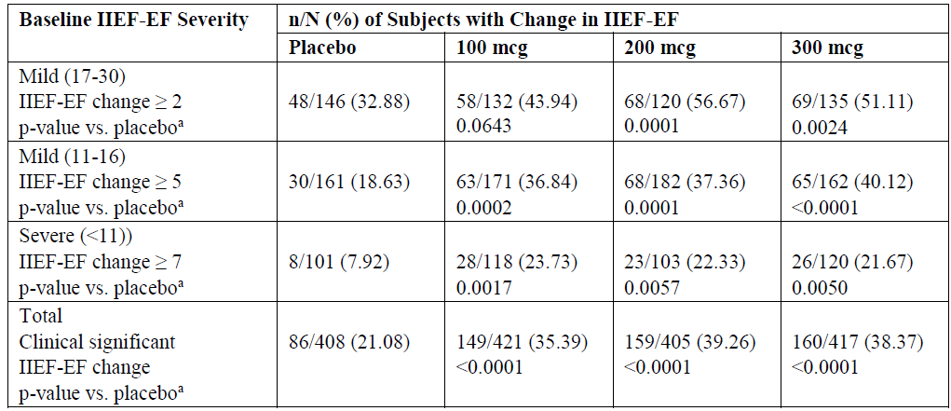

a. From Fisher’s exact test to test differences in percent of subjects meeting change criterion.

mcg = μg

* ***Question 6: The sponsor has not studied the safety and efficacy of this alprostadil formulation in patients having oral and anal sex. Does the sponsor have plans to conduct further studies to address this deficiency?***

The sponsor is not planning to conduct further studies in patients having oral and anal sex. The proposed PI includes a statement indicating that the effects of Proshaeos on the oral or anal mucosa have not been studied, and consequently it is recommended that a condom barrier should be used in these situations.

* ***Question 7: The sponsor has proposed use 2 to 3 times per week. What was the basis of the recommendation? What are the likely consequences of more frequent use of alprostadil?***

The safety profile and recommended dosing frequency for Proshaeos is well supported by clinical and nonclinical data. In the MED-004 and MED-005 pivotal studies a total of 25 doses of blinded study medication were available for each patient, including the test dose administered in the clinic at Visit 3, and an additional eight doses dispensed to the patient at each of Visits 3, 4, and 5 for at-home use. Patients who received study medication for at-home use were instructed to attempt vaginal sexual intercourse after application of the test article on eight separate occasions (no more than once a day) during the 4 week intervals that followed Visits 3, 4 and 5 (12 week total treatment period).

Additionally, daily intrameatal administration was assessed in two 28 day nonclinical dermal irritation safety studies (Studies 818-010 and 818-012). These studies evaluated a maximum dose of 250 mg administered intrameatally in dogs twice daily (500mg/day). None of the test subjects exhibited testicular pathology. The resulting safety margin calculated for this intrameatal administration is (at least) a factor of 12 for both alprostadil and DDAIP-HCl.

These combined data support the recommended “2 to 3 times per week” dosing frequency and demonstrate a low risk of additional consequence with more frequent use.

* ***Question 8: The sponsor has proposed that patients should wear condoms when using this product, for partner safety and to avoid the potential increased risk of STIs. How will this message be delivered to patients to ensure compliance? How does the sponsor plan to measure the success of this risk minimisation strategy?***

The sponsor has included detailed instructions in the PI and CMI regarding the need to use a condom with this product to minimise the potential for partner adverse events and to reduce the potential for STIs. A separate section has been included in the CMI that is specifically for the partner, together with the rationale, and a directive to the patient to share this information with their partner.

The incidence of STIs was monitored and reported in the integrated study report for the pivotal studies (004 and 005). The average age range for patients included in these pivotal studies was 60.0 to 61.0 years in the four treatment groups, with 37.5% of patients being ≥ 65 years of age.

The incidence of each of the major STIs varies according to sex and age, with an increased incidence observed in the younger population (18 to 29 years). According to the Australian Bureau of Statistics, the incidence rates for reportable STIs (chlamydia, gonorrhea, syphilis, etc.) decreases with age, with a larger decrease with increasing age.[14]

With expected variation, the age of the partner is also likely to be in the higher age bracket (≥ 40 years of age), which would potentially decrease the actual risk based on prevalence in the relevant partner/patient population.

The sponsor will continue to monitor the incidence of STIs reported by patients using Proshaeos in the post market setting.

* ***Question 9: The data lock point for the first PSUR was to be 31 January 2014. However, the clinical evaluator has noted that minimal post market data has been provided. Please provide the latest PSUR for review.***

The PSUR covering 1 February 2015 to 31 July 2015 is provided.

* ***Question 10: The ACSOM has considered the safety of the use of the proposed alprostadil formulation. A summary of the meeting minutes has been provided in the RMP Round 2 report. Please comment on the issues raised by the committee as addressed in the pre ACPM response.***

A separate response has been prepared and submitted to the TGA’s PSAB for the matters raised in the RMP Round 2 report. A copy of this response is provided.

#### Advisory committee considerations

The ACPM, taking into account the submitted evidence of pharmaceutical quality, safety and efficacy agreed with the delegate that Proshaeos cream containing 0.2% w/w (200 µg) and 0.3% w/w (300 µg) of alprostadil has an overall negative benefit-risk profile for the proposed indication.

In making this recommendation, the ACPM:

* Advised that there is marginal evidence to support use of alprostadil cream except in those with severe ED.
* Stated that the issue regarding spermatotoxicity and potential carcinogenicity should be resolved prior to general use.
* Was of the view that there was insufficient evidence that condom use would mitigate adverse events in partners.
* Was concerned about compliance with condom use and the associated safety issues if not used.

##### Specific advice

The ACPM advised the following in response to the Delegate’s specific questions on this submission:

* *Has the efficacy of alprostadil formulation been provided to support the use in all patients? Should the indication be restricted to patients with severe ED?*

The ACPM advised that efficacy was marginal except in those with severe ED. The group who would most likely use the alprostadil formulation are those who cannot tolerate sildenafil (due to allergies, cardiac issues, etcetera). Therefore, the ACPM advised that if the application was recommended for registration, the indication should be restricted to patients with severe ED.

* *Is the data sufficient to support long term use of alprostadil cream?*

The ACPM advised that the data currently provided, which is use for up to 6 months, are not sufficient to support long term use of alprostadil cream.

* *DDAIP is a novel excipient.*
  + *Has the sponsor sufficiently demonstrated the safety concerns with this new ingredient?*

The ACPM noted that the nonclinical evaluator did not consider this an obstacle to registration. However, very low levels of DDAIP are measurable after topical exposure and the main toxicity is local irritation. The ACPM noted that DDAIP may be spermatotoxic and is embryotoxic in high doses in animal studies. The ACPM was concerned that use of condoms may not mitigate the side effects seen with this product and there might be compliance issues with condom use. No data had been provided on this issue.

* + *Have the concerns about carcinogenicity been adequately resolved?*

The ACPM noted that the nonclinical evaluator was satisfied there was no evidence of carcinogenicity in humans, but long term clinical data are lacking and there is limited post-market exposure. Systemic exposure to DDAIP or alprostadil are low with the proposed use, so any potential for carcinogenicity with this formulation is likely to be manifested locally. However, the ACPM noted that one of the reasons the FDA rejected the application was the findings of a transgenic mouse carcinogenicity study that identified DDAIP HCl as a potential carcinogen at concentrations of 1.0% and 2.5%. The FDA also identified that the potential carcinogenic risk posed by DDAIP in male users of the product and their partners was not adequately characterised. The ACPM was concerned that the sponsor had not fully addressed the potential for carcinogenicity and advised that the data presented did not mitigate the potential risks.

* + *Should the question of spermatotoxicity be resolved prior to general use, or is as the sponsor’s proposal to investigate this potential concern in the post-market setting acceptable?*

The ACPM stated that the question of spermatotoxicity should be resolved prior to general use. In addition, there is a lack of evidence that condom use adequately mitigates any potential risk.

* *Irritation and disruption of skin and vaginal mucosa resulting from the use of this formulation have been shown. Does the committee agree with the evaluators about the risk of STIs as a result?*

The ACPM agreed with the evaluators that condom use would be required to lower the risk of STIs resulting from the use of this formulation.

* *Does the committee consider the advice about condom use proposed by the sponsor sufficient to mitigate the risks of the alprostadil cream for the partner and the patient? Is condom use sufficient to mitigate the risk of exposure to pregnant patients?*

The ACPM considered that this question was difficult to answer without any data about condom use but suggested there might be a need to recommend that alprostadil be contraindicated if the partner is pregnant, as condoms may not be sufficient to mitigate the risk. In addition, the ACPM noted the ACSOM had recommended that alprostadil cream should not be used by partners of individuals of reproductive age due to the potential risk.

### Outcome

On 12 January 2016, the sponsor wrote to the TGA requesting withdrawal of the application to register Proshaeos.

## Attachment 1. Extract from the Clinical Evaluation Report

|  |
| --- |
| Therapeutic Goods Administration |
| PO Box 100 Woden ACT 2606 Australia  Email: [info@tga.gov.au](mailto:info@tga.gov.au) Phone: 1800 020 653 Fax: 02 6232 8605  [**https://www.tga.gov.au**](https://www.tga.gov.au) |

1. Also referred to as “Vitaros” in this report.
2. Rahman H, et al. Comparative evaluation of 50 microgram oral misoprostol and 25 microgram intravaginal misoprostol for induction of labour at term: a randomized trial. *J Obstet Gynaecol Can.* 35: 408-16 (2013).
3. Lynch D, et al. Mouse skin models for carcinogenic hazard identification: utilities and challenges. *Toxicol Pathol.* 35: 853-864 (2007).
4. Sistare FD, et al. Evaluation of the Tg.AC transgenic mouse assay for testing the human carcinogenic potential of pharmaceuticals–practical pointers, mechanistic clues, and new questions. *Int J Toxicol.* 21: 65-79 (2002).
5. Nylander-French LA, French JE. Tripropylene glycol diacrylate but not ethyl acrylate induces skin tumors in a twenty-week short-term tumorigenesis study in Tg.AC (v-Ha-ras) mice. *Toxicol Pathol.* 26: 476-83 (1998).
6. Sistare FD, et al. Evaluation of the Tg.AC transgenic mouse assay for testing the human carcinogenic potential of pharmaceuticals–practical pointers, mechanistic clues, and new questions. *Int J Toxicol.* 21: 65-79 (2002).
7. Spalding JW, et al. Responses of transgenic mouse lines p53+/- and Tg.AC to agents tested in conventional carcinogenicity bioassays. *Toxicol Sci.* 53: 213-223 (2000).
8. Weitzman SA, Gordon L. Inflammation and cancer role of phagocyte-generated oxidants in carcinogenesis. *Blood* 76: 655-663 (1990); Rosin MP, et al. Inflammation, chromosomal instability, and cancer: the schistosomiasis model. *Cancer Res.* 54: 1929s-1933s (1994).
9. In the Sponsor’s Section 31 response, this risk was conceded, so additional expert input is no longer required.
10. The initial version of this question initially used the abbreviation IIEF, in error, instead of SEP.
11. Rosen RC, et al. Minimal clinically important differences in the erectile function domain of the International Index of Erectile Function scale. *Eur Urol.* 60: 1010-1016 (2011).
12. Rosen RC, et al. Minimal clinically important differences in the erectile function domain of the International Index of Erectile Function scale. *Eur Urol.* 60: 1010-1016 (2011).
13. Rosen RC, et al. Minimal clinically important differences in the erectile function domain of the International Index of Erectile Function scale. *Eur Urol.* 60: 1010-1016 (2011).
14. Australian Bureau of Statistics, Australian Social Trends, Jun 2012, 4102.0.