|  |
| --- |
| **First round 27 October 2015**  **Second round 31 March 2016** |

|  |
| --- |
| AusPAR Attachment 2 |
| Extract from the Clinical Evaluation Report for: American house dust mite extract / European house dust mite extract |
| Proprietary Product Name: Acarizax |
| Sponsor: Seqirus Pty Ltd |

About the Therapeutic Goods Administration (TGA)

* The Therapeutic Goods Administration (TGA) is part of the Australian Government Department of Health, and is responsible for regulating medicines and medical devices.
* The TGA administers the *Therapeutic Goods Act 1989* (the Act), applying a risk management approach designed to ensure therapeutic goods supplied in Australia meet acceptable standards of quality, safety and efficacy (performance), when necessary.
* The work of the TGA is based on applying scientific and clinical expertise to decision-making, to ensure that the benefits to consumers outweigh any risks associated with the use of medicines and medical devices.
* The TGA relies on the public, healthcare professionals and industry to report problems with medicines or medical devices. TGA investigates reports received by it to determine any necessary regulatory action.
* To report a problem with a medicine or medical device, please see the information on the TGA website < <https://www.tga.gov.au>>.

About the Extract from the Clinical Evaluation Report

* This document provides a more detailed evaluation of the clinical findings, extracted from the Clinical Evaluation Report (CER) prepared by the TGA. This extract does not include sections from the CER regarding product documentation or post market activities.
* The words [Information redacted], where they appear in this document, indicate that confidential information has been deleted.
* For the most recent Product Information (PI), please refer to the TGA website < <https://www.tga.gov.au/product-information-pi>> .

Copyright

© Commonwealth of Australia 2017  
This work is copyright. You may reproduce the whole or part of this work in unaltered form for your own personal use or, if you are part of an organisation, for internal use within your organisation, but only if you or your organisation do not use the reproduction for any commercial purpose and retain this copyright notice and all disclaimer notices as part of that reproduction. Apart from rights to use as permitted by the *Copyright Act 1968* or allowed by this copyright notice, all other rights are reserved and you are not allowed to reproduce the whole or any part of this work in any way (electronic or otherwise) without first being given specific written permission from the Commonwealth to do so. Requests and inquiries concerning reproduction and rights are to be sent to the TGA Copyright Officer, Therapeutic Goods Administration, PO Box 100, Woden ACT 2606 or emailed to < [tga.copyright@tga.gov.au](mailto:tga.copyright@tga.gov.au)> .

Contents

List of abbreviations 5

1. Introduction 8

2. Clinical rationale 8

2.1. Overview 8

2.2. Sponsor rationale for use of IMP in AR and AA 9

2.3. Formulation 10

3. Contents of the clinical dossier 11

3.1. Scope of the clinical dossier 11

3.2. Paediatric data 11

3.3. Good clinical practice 12

4. Pharmacokinetics 12

4.1. Studies providing pharmacokinetic data 12

4.2. Summary of pharmacokinetics 12

4.3. Evaluator’s overall conclusions on pharmacokinetics 12

5. Pharmacodynamics 13

5.1. Studies providing pharmacodynamic data 13

5.2. Summary of pharmacodynamics 14

5.3. Evaluator’s overall conclusions on pharmacodynamics 15

6. Dosage selection for the pivotal studies 16

7. Clinical efficacy 16

7.1. Pivotal efficacy studies; HDM-asthma 16

7.2. Clinical efficacy; HDM allergic rhinitis 26

8. Clinical safety 36

8.1. Studies providing evaluable safety data 36

8.2. Pivotal studies that assessed safety as a primary outcome 37

8.3. Dose-response and non-pivotal efficacy studies 37

8.4. Other studies evaluable for safety only 38

8.5. Pivotal studies that assessed safety as a primary outcome 39

8.6. Patient exposure 39

8.7. Adverse events 42

8.8. Deaths and other serious adverse events 50

8.9. Laboratory tests 53

8.10. Post-marketing experience 55

8.11. Safety issues with the potential for major regulatory impact 55

8.12. Other safety issues 56

8.13. Evaluator’s overall conclusions on clinical safety 56

9. First round benefit-risk assessment 56

9.1. First round assessment of benefits 56

9.2. First round assessment of risks 57

9.3. First round assessment of benefit-risk balance 57

10. First round recommendation regarding authorisation 57

11. Clinical questions 57

11.1. Safety 57

12. Second round evaluation of clinical data submitted in response to questions 57

12.1. Question 1 58

12.2. Question 2 59

13. Second round benefit-risk assessment 61

13.1. Second round assessment of benefits 61

13.2. Second round assessment of risks 61

13.3. Second round assessment of benefit-risk balance 62

14. Second round recommendation regarding authorisation 62

15. References 63

## List of abbreviations

| Abbreviation | Meaning |
| --- | --- |
| AA | Allergic Asthma |
| AE | Adverse Event; AEs are recorded from when the subjects sign the informed consent and until the last follow-up visit. |
| ALK | Abbreviated term used throughout the document for ALK-Abelló A/S |
| ALT | Alanine Aminotransferase |
| ANOVA | Analysis of variance |
| AR | Allergic Rhinitis |
| ARIA | Allergic Rhinitis and its Impact on Asthma |
| AST | Aspartate Aminotransferase |
| ATS | American Thoracic Society |
| CI | Confidence Interval |
| CRF | Case Report Form |
| *D. farinae* | *Dermatophagoides farinae* |
| *D. pteronyssinus* | *Dermatophagoides pteronyssinus* |
| DMS | Daily Medication Score |
| DSS | Daily Symptom Score |
| DU | Development Unit; during development, the strength of the HDM allergy immunotherapy tablet and hence the dose is defined in development units that are based on a standardised amount of allergen from each of the 2 species |
| ECG | Electrocardiogram |
| EMA | European Medicines Agency |
| ESI | Event of Special Interest |
| FAS | Full Analysis Set |
| FAS-MI | Full Analysis Set with Multiple Imputation |
| FEV1 | Forced Expiratory Volume in one second |
| GCP | Good Clinical Practice |
| HDM | House Dust Mite |
| HDM SLIT-tablet | House Dust Mite sublingual immunotherapy Tablet |
| HR | Heart Rate |
| ICH | International Conference on Harmonisation |
| ICS | Inhaled Corticosteroid |
| Ig | Immunoglobulin |
| IgE | Immunoglobulin E |
| I.M. | Intramuscular Injection |
| IMP | Investigational Medicinal Product |
| ISO | International Organisation for Standardisation |
| IT | Immunotherapy |
| GINA | Global Initiative for Asthma |
| GMP | Good Manufacturing Practice |
| GP | General Practitioner |
| GPV | Global Pharmacovigilance, ALK |
| LDH | Lactate dehydrogenase |
| LFT | Liver Function Tests |
| LME | Linear Mixed Effect model |
| LOCF | Last Observation Carried Forward |
| LSD | Least Significant Difference |
| MedDRA | Medical Dictionary for Regulatory Activities |
| PEF | Peak Expiratory Flow |
| P.O. | Per Oral |
| PP | Per Protocol set |
| PT | Preferred Term |
| RQLQ | Rhinitis Quality of Life Questionnaire |
| SABA | Short-Acting Beta-Agonist |
| SAE | Serious Adverse Event |
| SAP | Statistical Analysis Plan |
| SAS | Statistical software package from SAS Institute |
| SD | Standard Deviation |
| SE | Standard Error |
| SLIT | Sublingual Immunotherapy |
| SOC | System Organ Class |
| SS | Safety Set |
| TCRS | Total Combined Rhinitis Score; the sum of the DSS and the DMS averaged over the last 8 weeks of treatment |
| TSQM II | Treatment Satisfaction Questionnaire for Medication |
| VAS | Visual Analogue Scale |
| WHO | World Health Organisation |

## Introduction

This is a submission to register a new biological entity.

An allergen extract for the purpose of sublingual immunotherapy.

Acarizax is indicated in adults diagnosed with house dust mite sensitisation with at least one of the following conditions:

*Persistent moderate to severe HDM allergic rhinitis despite use of symptom-relieving medication*

*HDM allergic asthma not well controlled by inhaled corticosteroids.*

Acarizax oral lyophilisate tablets contain 12 SQ-HDM standardised allergen extract from the house dust mites (HDM) *Dermatophagoides pteronyssinus* (*D. pteronyssinus* ) and *Dermatophagoides farina (D. farinae*).

The submission proposes registration of the following dosage form and strength: once daily sublingual, oral lyophilisate tablet of 12 SQ-HDM (equivalent to 12 DU).

The potency units were been established by standard allergen techniques and were based on group 1 major allergen content, group 2 major allergen content and total allergenic activity. Onset of the clinical effect is to be expected 8 to 14 weeks after initiation. International treatment guidelines refer to a treatment period of 3 years for allergy immunotherapy to achieve disease modification. Efficacy data is available for > 13 months of treatment with Acarizax. If no improvement is observed during the first year of treatment with Acarizax there is no indication for continuing treatment.

## Clinical rationale

### Overview

The current application is for add on treatment for adult subjects with allergy to HDM where it is associated with allergic asthma and/or AR, not well controlled with standard therapy. The step wise approach to pharmacotherapy in patients with asthma is recommended by the Global Initiative for Asthma (GINA)(1), ATS(2) and locally by National Asthma Council of Australia (NAS)(3) and involves addition of therapy with the goal of achieving symptom control. Thus, use of add on therapy for moderate or severe persistent disease not well controlled by ICS is consistent with current guidelines.

Both allergic asthma and AR are significant health burdens in Australia, and current symptomatic therapy is often insufficient to adequately treat symptoms in individuals with moderate or severe disease. In several westernized countries, asthma is reported to affect over 20% of children and 10% of adults. Approximately 15% of Australians have allergic rhinitis(4), and approximately 10% have current asthma (5).

Asthma is a complex chronic disease with a pathogenesis that is incompletely understood. There is underlying immunological dysregulation in asthma, which can be identified in situ within the lung, adjacent lymph nodes and also in the circulating lymphocyte compartment. A significant proportion of subjects with asthma have associated atopic predisposition and susceptibility to production of IgE (allergy) antibodies to non-pathogenic ubiquitous environmental allergens, particularly those found in the air and inhaled (aeroallergens). Allergen recognition, production of IgE, and release of mast cell and basophil mediators on allergen recognition signalled through IgE does not directly contribute to all the clinical or histological manifestations of asthma (reviewed in (6)).

Allergic rhinitis (AR) is the clinical manifestation of allergic disease in the nose. It can be acute and seasonal, or chronic and perennial, depending upon the allergen/s to which the individual is sensitised. It is characterised by a cluster of symptoms, chiefly rhinorrhoea, sneezing, nasal blockage and itch and histologically by mucosal oedema and tissue infiltration with eosinophils, lymphocytes and to a lesser extent neutrophils. Many of the clinical symptoms of AR can be directly attributed to an abnormal immunological response to allergen/s and to the release of mast cell and basophil mediators. AR and asthma often co-exist, and there is some evidence of a naso-pulmonary axis, by which control of AR symptoms leads to clinical improvement in asthma (7). AR often co-exists with allergic conjunctivitis (which is a not a disease indication in the current application).

House dust mite is probably the most prevalent aeroallergen in the Australian context associated with respiratory allergy, although good population based prevalence data is lacking. There is evidence from meta-analysis that IT directed at relevant aeroallergens, can improve symptom control in both AR (8, 9) and in asthma (10) where relevant aeroallergen sensitisation has been demonstrated. However, a recent Cochrane review of SLIT for the treatment of asthma, found high heterogeneity of IMP and outcomes measures and poor quality studies, and were unable to recommend SLIT for mild or moderate asthma on the basis of the 52 studies reviewed. There were too few studies in severe asthma to make any recommendations (11).

### Sponsor rationale for use of IMP in AR and AA

Burden of disease:

The sponsor states that the overall estimated prevalence of AR in adult subjects in Europe is 22%. They state that a large proportion of patients with Asthma and AR are inadequately controlled by pharmacotherapy (Canonica 2007[1] (Chivato et al. 2012[2]; Ibero et al.[3]) The sponsor states that although use of ICS have greatly improved asthma control, studies suggest that the more than half of asthma patients did not achieve control of their asthma with standard of care (Partridge et al. 2006[4]). More than half of all AR patients have moderate/severe AR, and for a substantial proportion, their disease is persistent (Bousquet et al. 2006[5]; Canonica 20071).

The stated frequency of HDM sensitisation in individuals from Europe with asthma is approximately 50%. An Australian study specifically investigated the link between HDM AR and bronchial symptoms, showing occurrence of bronchial symptoms in 34% of the patients with HDM AR compared with 9% in the control group (Downie et al. 2004a[6]).

Mechanism of action: The sponsors state that IT is a treatment option for allergy that is complementary to pharmacotherapy and with a distinct mechanism of action. IT is performed by repeated subcutaneous or sublingual administration of specific allergens to an allergic person in order to gradually induce immunological tolerance towards the allergens. They state that considerations for initiating IT include disease severity, lack of efficacy of pharmacotherapy, side effects of pharmacotherapy, patient preference and the presence of more than one manifestation of the underlying allergic disease. They state that IT can modulate the basic immunologic mechanism of the allergic disease and is the only known treatment option with the potential to provide long-term, post-treatment benefits and alter the natural course of allergic disease (Bousquet et al. 2008[7]).

Delivery: The sponsor’s rationale for delivery of HDM-IT via the sublingual (SL) route in tablet form is convenience, ability for home self-medication, safety and efficacy. Their stated aim of oromucosal administration of allergens is to reduce the risk of systemic reactions. The sublingual route is therefore proposed over subcutaneous injections to provide a product with a safety profile allowing for at-home administration, thereby improving the quality of life for patients.

**Comment:** The sponsor stated clinical rationale for the IMP is reasonable and consistent with the literature regarding disease burden, relevance and prevalence of HDM as a disease-exacerbating factor in AR and asthma, in those patients with demonstrated relevant HDM sensitization. There is a clinical need for safe, convenient and effective methods of desensitisation for HDM in subjects with HDM driven AR and asthma. Efficacy of SLIT in HDM driven respiratory disease using other forms of sublingual administration (liquid) and using subcutaneous delivery has been previously demonstrated in the literature.

### Formulation

#### Formulation development

There were no significant changes to the formulation over the development programme as outlined in the dossier. The formulation used in the 2 pivotal clinical efficacy studies is the same as that which is proposed for marketing in Australia.

The ALK HDM AIT drug product is a 1:1 mixture of allergen extracts derived from 2 species of cultivated HDM (*D. pteronyssinus* and *D. farinae* ). The allergen extracts are filtrated, concentrated and stabilized. The biological potency of the 2 drug substances is given in DU. In the efficacy studies, but not marketing these are referred to as SQ-HDM, where DU=SQ-HDM. The strength is determined based on group 1 major allergen content, group 2 major allergen content and total allergenic activity. The quantitative measurements of major allergens and total allergenic activity are supplemented by evaluation of qualitative tests such as antigen/allergen profiles. This is a relatively common method used for quantifying the allergenic strength of allergen extracts, and is widely used within the industry. The Total Allergenic Activity by TACA methodology is outlined by the sponsor in module 2.3, page 25.

The tablet is designed to be rapidly dissolving following sublingual administration, and is designed to be held under the tongue for 1 minute prior to swallow. The matrix used in ALK HDM tablet is identical to the one used in the ALK grass SLIT-tablet, Grazax, that has obtained a marketing authorisation throughout the European Union (EU), Switzerland and latest in the US (Grastek, Merck Sharp and Dohme Corp 2014). The same pharmaceutical formulation is used for a ragweed SLIT-tablet approved in the US (Ragwitek, Merck Sharp & Dohme Corp 2014a).

**Comment:** There seem no significant problems with the formulation proposed for the Australian market.

## Contents of the clinical dossier

### Scope of the clinical dossier

The dossier documents a clinical development programme of pharmacodynamics, tolerability, dose finding, safety and efficacy. It does not contain traditional pharmacology studies due to the nature of immunotherapy, consistent with the EMA guidelines on the clinical development of products for specific immunotherapy for the treatment of allergic diseases. It contains 2 pivotal studies, which relate to each of the proposed indications, HDM driven asthma and allergic rhinitis.

The submission contained the following clinical information:

* No clinical pharmacology studies
* 1 human study for bio-analytical methods (for determination of in house reference).
* 2 pivotal efficacy studies.
* 2 tolerability/safety dose-finding studies.
* 4 other efficacy/safety studies.
* Synopsis (only) of ongoing 2 studies in Japan and US to meet regulatory requirement for product registration in other regions.
* Literature references
* Overall Quality Summary

The submission also contained; Non-clinical Overview, Non-clinical Summary, Clinical Overview, Clinical Summary (Biopharmaceutical Studies and analytical methods, Clinical Efficacy, Clinical Safety, Synopsis of individual studies, notes to evaluators and Literature references.

**Comment:** The development programme has followed EMA guidelines on development of IT, therapy for AR and for asthma.

The submission was well presented and thorough. All documents were clearly legible and clearly numbered and ordered appropriately.

The rationale for not providing traditional pharmacokinetic and dynamic studies is reasonable and valid and consistent with EMA guidelines on what is possible to provide for IT studies, based upon their known mechanism of action and primary route of uptake. The sponsor’s additional rationale for not providing these studies- on the basis that no allergen what so-ever is systemically absorbed is not accepted as reasonable or supported by evidence provided and not generally supported by the literature. This impacts on some statements made by the sponsor in the proposed in the CMI and PI[8].

### Paediatric data

The submission included some paediatric efficacy and safety data; however the current proposed indications are for adults only. The paediatric data represents only a small proportion of the total subjects exposed to the IMP. The sponsor has in place a paediatric development programme (albeit with a very long current time line). The spectrum and prevalence of HDM disease in the paediatric population is such that there would be likely significant value in this IMP for the paediatric population with HDM driven asthma and allergic rhinitis.

### Good clinical practice

The clinical studies in the submission are all compliant with the CPMP/ICH/135/95 guidelines on Good Clinical Practice.

## Pharmacokinetics

### Studies providing pharmacokinetic data

There are no pharmacokinetic studies.

### Summary of pharmacokinetics

There is no information to be synthesized from traditional pharmacokinetics. The sponsor has provided a note to evaluators to this effect, with the rational that the effect of IT is not mediated via systemic uptake of the allergen, but local uptake in the oral and sublingual mucosa by resident antigen presenting cells. This is consistent with the EMA guidelines on ‘The clinical development of products for specific immunotherapy for the treatment of allergic diseases’ (2009).

#### Physicochemical characteristics of the active substance

The following information is derived from the Sponsor’s summaries.

The HDM tablet contains two DSs: Allergen extract from the HDM-species *D. pteronyssinus* and allergen extract from the HDM species *D. farinae* . The potency of the HDM tablet is defined in development units (DU). The DU is based on a standardised amount of allergens from each species. 1 DU in the HDM tablet is the sum of 0.5 DU of *D. pteronyssinus* and 0.5 DU of

*D. farinae.* The allergen extracts are complex mixtures of proteins extracted from the source materials (SMs) of cultivated HDM.

The DS is freely soluble within the range of the pH of saliva. The allergens have been shown to be stable in the formulation as a freeze dried tablet. The materials and process are controlled to assure acceptable microbiological quality.

### Evaluator’s overall conclusions on pharmacokinetics

Overall the absence of pharmacokinetic data to support this application is acceptable and within the EMA guidelines for IT. There is however insufficient evidence supplied that supports the sponsors and external reviewer’s statement that no intact allergen is absorbed systemically. The studies presented to support this are with purified single component allergen only, and not whole allergen extract. In addition only one supplied reference used HDM, the remainder used plant based aeroallergen (paretaria), which have very different physical properties to HDM allergen. The study provides to support the sponsors view, even though it is only single purified Derp1 and not whole extract does show systemic absorption of allergoid and of peptides. Given the allergenic properties of HDM are primarily mediated via recognition of its peptides (both linear and conformational); it is quite possible that systemic absorption in the GIT of relevant immunogenic HDM peptides does occur. Indeed, that would be the obvious explanation for the uncommon but reported cases of systemic allergic reactions and systemic anaphylaxis to HDM sublingual IT (in drop formulation) and to the tablet SLIT AE in the synopsis studies. A class effect with similar reports (post marketing) has been noted for the grass pollen tablet Grazax.

Therefore complete lack of systemic absorption should not be the stated reason for not supplying pharmacological studies in the dossier and should be substantiated, or removed.

## Pharmacodynamics

### Studies providing pharmacodynamic data

Summaries of the pharmacodynamic studies were provided. Table 1, below outlines the studies relating to each pharmacodynamic topic.

Table 1: Submitted pharmacodynamic studies

| PD Topic | Subtopic | Study ID |
| --- | --- | --- |
| Primary Pharmacology | Effect on HDM-specific IgG4 | MT-02§‡  P-003§  MT-04§  MT-06§ |
| Effect on HDM-specific IgE | MT-01§  TO-203§  MT-03 |
|  | MT-02§‡ |
|  | P-003§  MT-04§ |
|  | MT-06§ |
| Secondary Pharmacology | Effect on HDM IgE blocking (IgE inhibition assay) | MT-01  TO-203  MT-03 |
| Gender other genetic and Age-Related Differences in PD Response | Effect of gender | TO-203 (adult male) |
| Effect of ethnicity | No Studies |
| Effect of age | MT-03 (children only) |
| PD Interactions |  | N/A |
| Population PD and PK-PD analyses | Healthy subjects | No studies |
| Target population | MT-01 (some of subjects)  TO-203 (some of subjects)  MT-02 (some of subjects)  P-003  MT-04  MT-06 |

* Indicates the primary aim of the study. § Subjects who would be eligible to receive the drug if approved for the proposed indication. ‡ And adolescents if applicable.

**Comment:** None of the pharmacodynamic studies had significant deficiencies that excluded their results from consideration.

### Summary of pharmacodynamics

The information in the following summary is derived from non-conventional pharmacodynamic studies in humans as traditional pharmacodynamics do not readily apply to immunotherapeutic allergen products. As IT targets the immune system, the sponsor has provided results of immunological effects of the IMP as pharmacodynamics, which is in accordance with EMA guidance (EMEA 2008b).[9] As the immunomodulatory effects are a class effect, the AA and AR studies are considered together for the purposes of this section.

#### Mechanism of action

Although immunotherapy by a variety of routes has been used successfully in clinical practice for many years, its exact mechanism of action is still not well understood. Route of delivery of IT may influence mechanism of action. It is postulated that in the case of SLIT, allergen is taken up locally by mucosal resident antigen presenting cells (dendritic cells) and presented to T cells in nearby lymph nodes. Successful IT with routes of administration including subcutaneous and sublingual has been previously correlated with induction of a transient rise and then fall in serum specific allergen IgE (and in allergen SPT wheal size) and a sustained rise in allergen serum specific IgG4. Several mechanistic studies have shown induction in T-regulatory cells, with changes in in vitro cytokine production in allergen-stimulated environments. Most efficacy and mechanistic studies have demonstrated a need for sustained exposure to the relevant allergen for a considerable period of time; in the case of SLIT and SCIT, usually at least 2 to 3 years, before IT can be discontinued with a persistence of tolerance to the allergen (reviewed in (12).

#### Pharmacodynamic effects

##### Primary pharmacodynamic effects

Consistent with EMA guidelines on specific Immunotherapy for treatment of Allergic disease (EMEA 2008b)-9, the studies presented have used serum antibody levels at different time points as measures of the immunological response to IT. Whilst it is unclear whether changes in allergen specific IgG4 lead directly to the efficacy of IT, they are a useful biomarker and have been consistently correlated with clinical efficacy in numerous published studies (reviewed (12)). Allergen specific IgE levels are generally expected to rise on initiation of IT (regardless of route of administration) and then decline over time. They represent immune recognition and activation of allergen specific responses, and increased production of allergen specific IgE from plasma cells, and are not of themselves likely to be directly mechanistically linked to efficacy. Over long periods of IT (2 to 3 years) allergen specific IgE is generally reported to decline below baseline levels.

The longer duration (12 months +) and pivot AR and AA studies contained in this dossier provide good evidence of a immunomodulatory effect of the HDM-SLIT Tablet, with consistent elevation of both species HDM-IgG4, particularly at the 6 and 12 SQ-HDM dose. The two pivotal efficacy studies (MT-04 (AA) and MT-06 (AR)) provide evidence that the 12 SQ-HDM dose was superior to the 6 SQ-HDM dose in terms of magnitude of increase in IgG4 from baseline. It is mechanistically unclear whether a higher HDM-IgG4 would automatically increase efficacy of the therapy, and whether there is a threshold level. The other dose finding and safety and efficacy studies are consistent with these studies, however those of very short duration show little immunological effect.

HDM-IgE levels were consistently elevated at doses of 1 SQ-HDM and greater than across all studies provided with duration longer than 4 weeks. No consistent effects were observed in studies of less duration. Elevation of HDM-IgE was generally maximal at around 4 to 8 weeks in the larger studies with longer follow-up, but remained significantly elevated compared with baseline, and compared with placebo throughout the 12 to 18 months of therapy in the three studies of this duration (MT-04, MT-06, and MT-02).

##### Secondary pharmacodynamic effects

IgE- inhibition IgE assays were performed in several of the smaller tolerability, dose finding, and safety studies but not in the larger pivotal studies. Two different reporting systems were utilized to present these results across these studies- an IgE-blocking factor assay or a ratio. Findings across the studies were inconsistent, particularly in the shorter duration studies. A significant and sustained serum IgE blocking effect was observed in MT-02 for 1,3 and 6 DU at 6 and 12 month time points, however only a sub-cohort of the study was analysed.

#### Time course of pharmacodynamic effects

As above.

#### Genetic, gender and age related differences in pharmacodynamic response

This is inadequately assessed in the studies provided. One study is confined to adult males (TO-302) with a short time course, so it is not possible to assess gender effects. One short duration study (28 days) is confined to children < 14 years (MT-03) and does observe consistent elevation in HDM-IgE but not IgE inhibition. Children are not included in the current application indication.

There is scant data on immunological responses in non-Caucasian populations. TO-302 was based in Japan, but was not of sufficient duration to demonstrate meaningful immunological changes or induction.

### Evaluator’s overall conclusions on pharmacodynamics

The nature of the IMP precludes the use of traditional pharmacodynamic or pharmacokinetic studies and the dossier contains a rationale for not undertaking or providing these studies, and this rational is consistent with the relevant EMA guidelines. This guideline recommends the use of immune system markers such as specific IgG levels, T cell responses and/or cytokine production. The current studies under consideration provide HDM specific IgG4 and IgE responses.

Overall the studies support the contention that the IMP at the dose of 12 SQ-HDM daily, when taken for periods longer than a month’s duration have significant immunomodulatory effects which are sustained across the 12 to 18 month treatment period.

## Dosage selection for the pivotal studies

The pivotal studies (MT-04 AA and MT-06 AR) both used two doses of HDM-SLIT tablet: 6 and 12 DU once daily. The current application is for the higher dose- 12 SQ-HDM/DU.

Classic Phase I tolerability and dose studies were not possible due to the nature of allergen immunotherapy, such that an individual must be sensitised to the allergen in order for tolerability and safety to be assessed.

Initial tolerability and dose finding was therefore carried out on HDM allergic individuals with mild to moderate asthma with or without AR (MT-001). Doses in the range of 1 to 32 SQ-HDM were tested. 16 SQ-HDM was concluded to be the maximum tolerable dose, but the number of IMP related AEs was considerably higher than at the lower doses. The 32 SQ-HDM dose group were discontinued after only 2 doses, as a single subject suffered immediate symptoms (vomiting) following administration of the 32 SQ-HDM/DU dose. As AE were higher in 16 SQ-HDM compared to lower doses, this dose was also evaluated to have a tolerability profile that could potentially impair compliance in a setting of daily and was not pursued as a possible dose in further efficacy and safety Phase II and III studies.

Phase II safety, dose finding and tolerability studies used dosages ranging from 1-12 SQ-HDM. In MT-02 (with a AA primary endpoint) the highest dose used was 6 SQ-HDM and this was evaluated as being associated with higher efficacy (endpoint- lowest dose of ICS after 1 year of HDM-SLIT tablet) than the lower two doses (1 and 3). Based upon this result, investigators pursued 6 and 12 as the doses of interest for maximum efficacy and reasonable tolerability and safety for the two pivotal studies.

Secondary endpoint immunological data from the Phase II studies also suggested that a higher does (6 SQ-HDM or above) was associated with greater immunomodulation.

**Comment:** Based upon the data and studies provided, the two doses for the two pivotal studies, 6 and 12 SQ-HDM appear to be a reasonable choice.

## Clinical efficacy

### Pivotal efficacy studies; HDM-asthma

#### MITRA Study MT-04

MT-04: MITRA trial. Efficacy of ALK house dust mite allergy immunotherapy tablet in subjects with house dust mite induced asthma.

##### Study design, objectives, locations and dates

MT-04 was a Phase III, multicentre (109 sites in 13 European countries), randomised, parallel group, double blind, placebo controlled. It was conducted August 2011 to April 2013.

It was designed to determine whether, after a period of stabilization of asthma on a single ICS and SABA, treatment for 7 to 12 months on HDM-TAB would improve the time to first moderate or severe asthma exacerbation, once ICS were withdrawn in adults with asthma not well controlled on appropriate ICS therapy. SABA and HDM SLIT-tablet were continued during this withdrawal period.

##### Inclusion and exclusion criteria

Subjects were recruited from each investigator’s own pool of patients, by referral, and through public advertisements. It is not clear from the report what portion were derived primarily from tertiary clinics.[10]

Major inclusion criteria consisted of age > 18 years, clinical evidence of HDM driven asthma (for at least one year) AND HDM AR, Sensitization to *D. pteronyssinus* and/or *D. farinae* by both positive SPT and ssIgE (> 0.70 kU/L). Use of an appropriate amount of inhaled corticosteroid (ICS) (including combination products) in accordance with the GINA Guideline step 2 to 4 for the control of the asthma symptoms for a period of at least 6 months within the past year and dose of budesonide at randomization in the range 400 to 1200 µg. Documented reversible airway obstruction, FEV1≥ 70% of the predicted value and electronic diary compliance rate ≥ 80% at randomization visit.

Major exclusion criteria included: No clinical history of intermittent allergic asthma or allergic rhinitis if the seasonal allergen caused symptoms in the period of the year corresponding to the ICS reduction period, No previous treatment with immunotherapy with HDM, no history of chronic sinusitis (> 3 months, no hospitalisations (> 12 hour stay) due to an asthma exacerbation within the last 3 months, no current or previous use of any listed immunosuppressive, no inflammatory conditions in the oral cavity with severe symptoms (oral lichen planus with ulcerations or severe oral mycosis at randomisation, no history of systemic allergic reaction with cardiorespiratory symptoms (for example food allergy, drugs or an idiopathic reaction), and no relevant chronic disease.

A full list of the inclusion and exclusion criteria was provided.

**Comment:** The inclusion and exclusion criteria are criteria consistent with WHO guideline on IT for asthma (13) and the EMA guidelines for clinical investigation of medicinal products in the treatment of asthma. The exclusion of individuals who have had systemic allergic reactions to foods or drugs limits the generalizability of the study’s findings, as it is reasonably likely that subjects with asthma may have had a history of food allergy, and may have suffered from cardiorespiratory systemic symptoms. The inclusion criteria for moderate persistent asthma match the current proposed indication for the IMP of moderate to severe asthma not well controlled on appropriate therapy. Some medications, which were part of the exclusion criteria, are not contraindicated in the proposed PI, but this related predominantly to potential interference with efficacy measures.

Although the study was concerned with HDM driven asthma, the subjects were all required to have symptoms consistent with HDM AR, so as to ensure that the sensitization to HDM was symptom provoking and clinically relevant. Whilst that is a reasonable design strategy, it does mean that the efficacy of this therapy for patients with asthma only, without HDM associated /driven AR has not been specifically assessed. There is no requirement in the current prosed indication for patients with asthma to have HDM-AR, but they must have HDM as a clinically relevant allergen.

##### Study treatments

The study had three parallel groups; two doses of HDM SLIT-tablets and one placebo. The study treatment was daily HDM SLIT-tablets 6 SQ-HDM and HDM SLIT-tablet 12SQ-HDM, or placebo. Tablets were self-administered on a daily basis through two treatment periods, period 1 (7 to 12 months) and treatment period 2 (whilst ICS were being withdrawn); see Figure 1 below. The first dose at randomization visit was given under observation, for a period of at least 30 minutes. The variability of the first treatment period (period 1) relates to the requirement for the ICS withdrawal phase to be outside the grass pollen season, so as to reduce the possibility of increased exacerbations related to this variable in subjects with concomitant grass pollen sensitization.

**Comment:** The inclusion of a control/placebo group is appropriate for this study question. There was no dose titration of the IMP and the subjects and investigators were unaware of which dose the subjects were allocated throughout the study duration. The dosages of 6 and 12 SQ-HDM were based the previous Phase I and II safety and efficacy studies, which demonstrated a high rate of minor AEs at all doses, but increasing AE with higher dose (particularly 16 and 32 SQ-HDM), and higher efficacy (for a reduction in asthma medication use) at higher dose (6 SQ_HDM). SABA were allowed during the entire study. Oral prednisolone was used as rescue for acute severe exacerbations.

Figure 1: Treatment plan MT-04 (as per integrated clinical trial report, MT-04)

Figure 1: Treatment plan MT-04 (as per integrated clinical trial report, MT-04)
n = 834 screening period 1 5-7 weeks. Period 2 treatment maintenance 7-12 months where ricipients were given either HDM 12 DU , HDM 6 DU or pacebo. Period 3 was ICS reduction for 6 months first 3 months ICS 50% and second 3 months ICS 100% withdrawal

##### Efficacy variables and outcomes

The main efficacy variables were:

* Asthma exacerbations - time to first exacerbation, moderate and severe exacerbations (as defined below)
* change in asthma control (measured by asthma control questionnaire- ACQ)
* change in AQLQ(S).

The ACQ consists of 7 questions referring to the previous Week. 5 questions are related to symptoms (nocturnal wakening, morning symptoms, activity limitation, short of breath, wheeze), 1 question is about β2-agonist use (SABA), and the last question is about lung function (percentage of predicted FEV1). Each question is scored on a 7 point scale from 0 to 6 (the higher the worse). The overall ACQ score is the average of the 7 scores of the individual questions. The range of the overall ACQ score is 0 to 6. A change of 0.5 (scale 0 to 6, baseline 1.5) was considered clinically important. The ACQ has been validated against quality of life and physician global assessments, with a generally accepted minimal important difference (MID) of 0.5 (111).

The level of asthma control at Visit 3 (randomisation) was classified by GINA 2010 levels of control (From the Global Strategy for Asthma Management and Prevention 2010) by transforming the ACQ data according to a pre-set algorithm.

The AQLQ(S) consisted of 32 questions in 4 domains, referring to the last two weeks. Each question was scored on a 7 point scale from 1 to 7 (worse to better). The 4 domains were symptoms (12questions), activity limitation (11 questions), emotional function (5 questions) and environmental stimuli (4 questions). Overall AQLQ(S) score is the average of all items and domain score is the average of items within each domain.

Electronic diaries were used for symptom score capture, and participants were required to show compliance with this system in the run in period, prior to randomisation. EMA and ATS asthma trial guidelines recommend the use of electronic diaries over paper diaries for patient data entry and collection. During the last approximately 4 weeks of period 2, the subjects started filling in the electronic dairy and recorded asthma symptoms, medication use and lung function twice daily.

The primary efficacy outcome was difference in time to first moderate or severe asthma exacerbation during Period 3 (ICS reduction/withdrawal), after a period of 7 to 12 months of study treatment, between subjects on HDM SLIT-tablet (6 SQ_HDM and 12 SQ-HDM) and those on placebo. The sponsor obtained scientific advice from the EMA prior to trial initiation. The scientific advice from EMA (EMA/CHMP/SAWP/97494/2011) considered the primary endpoint acceptable, provided that data on lung function and symptom score supported it, and that MI was used to mitigate possible unbalanced discontinuations.

Moderate and severe asthma exacerbations were defined as;

* Moderate exacerbation
  1. Nocturnal awakening(s) due to asthma requiring SABA use for at least 2 consecutive nights or an increase of a minimum 0.75 in daily symptom score from the individuals baseline value on at least 2 consecutive days
  2. An increase from the baseline value in occasions of SABA use on at least 2 consecutive days (a minimum increase of 4 puffs per day)
  3. ≥ 20% decrease in peak expiratory flow (PEF) from baseline value on at least 2 consecutive mornings or evenings or a ≥ 20% decrease in FEV1 from baseline value
  4. Visit to the emergency room or unscheduled visit to the trial centre for asthma treatment not requiring systemic corticosteroids.
* Severe exacerbation
  1. Need of systemic corticosteroids for the treatment of asthma symptoms for at least 3 days
  2. Emergency room visit because of asthma, requiring systemic corticosteroids or hospitalisation for more than 12 hours because of asthma.

Other efficacy outcomes included:

* time to first asthma exacerbation with increased use of SABA
* specific IgG4/IgE against HDM allergens
* lung function (average morning and evening PEF, change in baseline FEV1
* increase medication use (SABA, systemic steroids)
* Pharmaco-economics assessments.

**Comment:** EMEA guidelines on clinical investigation of medicinal products for asthma treatment recommend the use of asthma symptom endpoints, and for moderate and severe persistent asthma therapy, they state that frequency of exacerbations and assessment of asthma control are important relevant primary end points. The efficacy endpoints and collection methods are consistent with ATS statement on standardizing endpoints for clinical asthma trials (2). The sponsor sought EMA guidance on the use of the primary efficacy endpoint prior to trial initiation.

##### Randomisation and blinding methods

The study was double blind and the sublingual placebo tablets were stated by the sponsor to be identical in appearance to the active (HDM containing) tablets. The randomisation list was generated by a trial independent statistician, it is unclear which particular randomisation tables or software package was used, however the complete listing of subject allocation has been provided by the sponsor. Provisional was made for unblinding in event of SAE likely related to the IMP at each site, accessible to authorised investigators at each site. 2 complete sets of sealed code envelopes containing coding details for each randomised subject. 1 set was kept by ALK, and 1 set was distributed to the trial sites. At the end of the trial all code envelopes were collected and reconciliation was performed between the opened code envelopes and notified code breaks. Two subjects had randomisation codes broken during the study.

Randomisation was in permuted block of 6; 2 sets of placebo, 2 sets of 6 SQ-HDM and 2 sets of 12 SQ-HDM treatments in random order. For each country and study site, the lowest available randomisation numbers were allocated.

**Comment:** Blinding was performed as well as possible, however it is likely that due to the local oral side effects of the active tablet (itch, minor swelling, throat irritation), which were noted to be at a much higher rate than the placebo, some participants on the active arms were likely to have assumed they were receiving active IMP. The sponsors performed sensitivity analysis on previous efficacy/safety Phase II studies to determine that results were similar if subjects with these oral symptoms were excludes from the analysis in support of the study design.

##### Analysis populations

The primary efficacy analysis was conducted based on the FAS-MI, following ITT principals. The primary efficacy outcome was also assessed in the FAS and the PP analysis set.

The following analysis sets were predefined and used:

* Total analysis set; all subjects who entered the trial, including screening failures.
* Full-analysis set (FAS); all randomised subjects in accordance with the ICH intent-to-treat principle. FAS were the primary set for all efficacy analyses and used for all baseline/demography tables, efficacy tables, safety tables and subject listings.
* FAS with multiple imputation (FAS-MI); all randomised subjects who discontinued from the trial during the intervention and before ICS withdrawal were included in analysis set as if they were following the outcome (first asthma exacerbation); of the observed placebo group during the efficacy assessment period.
* Per-protocol (PP) analysis set; all subjects in the FAS with no major protocol violations, which may influence the primary endpoint. The PP analysis set was a supplementary set for the primary efficacy analysis. Compliance was defined as > 80% by tablet count at each visit.
* Safety analysis set; identical to the FAS.

**Comment:** The analysis populations were correctly and adequately defined and used appropriately. The method of MI for the FAS for the primary efficacy analysis is consistent with EMA guidelines, however by multiple imputation of all missing primary endpoint data as following the same distribution as the observed outcomes for the placebo group, this doesn't take into account the possibility that the IMP could have made the asthma worse than placebo for those with missing data in the intervention group.

##### Sample size

The trial was planned to include 800 subjects. The power calculation was based on the assumption that 65% of subjects in the placebo group would experience an asthma exacerbation. A clinically relevant effect was considered to be a reduction in the hazard rate for time to first asthma exacerbation of approximately 30%. The study was not designed or powered for subgroup analysis.

It was estimated that 240 subjects per treatment group would provide at least 80% power to detect a difference between HDM tablet and placebo of 0.70 in HR for asthma exacerbations at the 5% significance level. With an expected drop out of about 10%, 266 subjects should have been randomised per treatment arm (that is a total of 798 subjects).

**Comment:** Although the ATS and EMA guidelines recommend the use of asthma exacerbations for primary outcome measures in asthma RCT, and define moderate and severe asthma exacerbations, consistent with the definitions the sponsors have used in this study, they do not suggest or specify what the clinically important effect size of a reduction in exacerbations should be. Given this the sponsor’s use of effect sizes in previous published RCTs using asthma exacerbation rates seems reasonable.

##### Statistical methods

Statistical methodology, full analysis plan and hierarchy testing order were set out in a predetermined protocol. Testing was as superiority compared with placebo. No interim analysis was performed.

As per the Integrated Clinical Trial Report, MT-04: The primary efficacy analysis was conducted based on the FAS-MI, following ITT principals. The primary efficacy outcome was also assessed in the FAS and the PP analysis set. Multiplicity for the primary endpoint and key secondary endpoints were controlled for by the pre-determined hierarchy hypothesis testing. Other secondary endpoints and analyses were not controlled for multiplicity. For the two key secondary endpoints 'proportion of subjects with MID change in ACQ/AQLQ(s) controlled for ICS’ last observation was carried forward. No other imputation of data was carried out for missing data.

Significance was set at a 5% significance level (two sided), with two sided 95% confidence intervals. Sensitivity analysis and model control was conducted to assess the model assumption of non-informative discontinuation during Period 3, and proportional hazards. Exploratory post‑hoc analysis of other secondary endpoints was undertaken.

The primary efficacy analysis of the primary endpoint was performed with a Cox proportional hazards regression analysis. The model was stratified for country and included treatment group as a factor. The first hypothesis to be tested was the hypothesis of no difference between the 3 groups: placebo, 6 SQ-HDM and 12 SQ-HDM.

In the primary analysis, subjects who withdrew between Visit 9 (ICS reduction) and Visit 13 (end of trial), the time to asthma exacerbation was right censored at the date of withdrawal.

Statistical approach for analysis of the secondary endpoints was provided.

**Comment:** Missing data for the primary endpoint is replaced by multiple imputations in the primary analysis. This approach follows the EMA guideline on missing data. However the missing data was relatively minimal, and the sensitivity analysis and FAS all support the efficacy observed data and so there is unlikely to be a significant skewing related to missing data.

##### Participant flow

The trial was planned to include 800 subjects. 1,262 subjects were screened with 428 screening failures. A total of 834 were randomised (1:1:1) to placebo, 6 DU or 12 DU; with group distribution: Placebo (N=277), 6 DU (N=275), 12 DU (N=282). The participant breakdown obtained from the study report is shown Table 2.

Table 2: MT-04 Participant flow

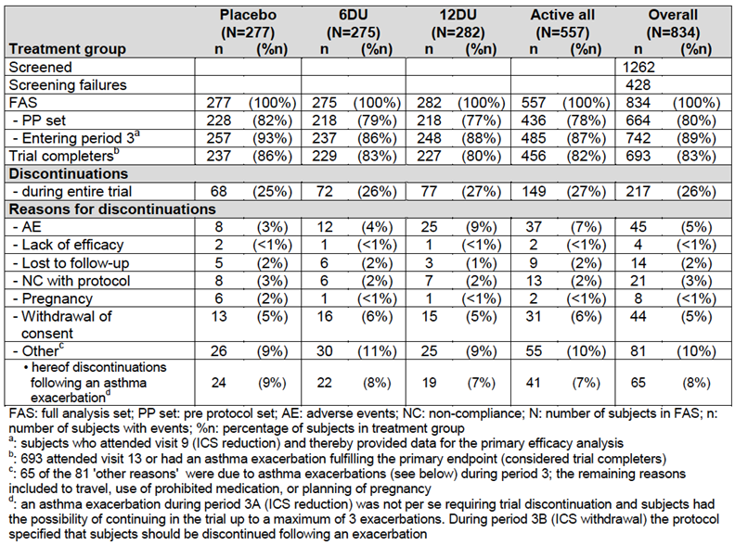

The study was not terminated early. Discontinuations were in accordance with pre-specified criteria.

A total of 26% of participants withdrew/discontinued during the course of the study, and this was evenly distributed across the three groups with a total of 693/834 subjects completing the trial. Withdrawal due to AE was higher in the 12 DU group (25) than in the 6 DU group (12) or placebo (8). Rates of protocol violations, loss to follow-up and withdrawal of consent were similar across the three groups.

**Comment:** There was a relatively high rate of participants discontinuing throughout the study, with withdrawal due to AE higher in the highest dose intervention group (12 DU; the listed application dose) than the other two groups. Given that MI was used for missing values for the primary efficacy endpoint, and assumed that both intervention groups missing data was in a distribution similar to the control group, this is unlikely to have significantly impacted on the validity of the results.

##### Major protocol violations/deviations

The listing and disclosure of all protocol violations is thorough. There were no significant major violations, which impacted on the primary efficacy endpoint. Prior to unbinding, all 31 subjects from a single site (Site-509) were excluded from secondary immunological analysis as it was considered likely that there had been labelling errors with the blood samples.

##### Baseline data

All patients had HDM driven asthma, of a median 10 years duration and HDM associated-AR. Approximately 1/3 of subjects were mono-sensitised to HDM, and the remainder were poly-sensitised. This is likely to be relatively representative of the general population of atopic asthmatics.

The study population was almost exclusively Caucasian (98%),, which is not representative of the Australian population of asthmatics the median age was 31, with an equal distribution of males and females. ICS dose, FEV1, and asthma control scores (AQS) were very similar across the three groups at baselines (control, 6 and 12 SQ-HDMSLIT- tablet). All were requiring between 200 to 1200 mg of ICS per day for asthma control, indicating they had at least moderate asthma. Approximately 70% had partially controlled and 30% uncontrolled asthma, by GINA definition at randomisation, with no difference between groups. Median duration of asthma at study entry was 11 years, and similar across groups.

**Comment:** Baseline data was similar across the three study groups; however the participants were almost exclusively Caucasian, with a relatively low median age of 31 years. Any differential effect on asthma by ethnicity is not possible to determine in this study. The inclusion of individuals who are poly-sensitized (to seasonal allergens) is useful for generalizability, as aeroallergen poly sensitization is common in asthmatic individuals. All had AR (as per inclusion criteria). Therefore the study participants are not wholly representative of the patients who will receive this drug under the current proposed indication.

##### Results for the primary efficacy outcome

The hazard ratio for time to moderate or severe asthma exacerbation after a fixed treatment period with 12 or 6 SQ-HDM over the study period compared with placebo was 0.69 (95% CI-0.50-0.96) and 0.72 (95% CI 0.52-0.99] respectively. This is a positive clinical effect, just within predefined study criteria for clinically effectiveness with a 30% reduction in time to first asthma exacerbation. Results based upon FAS-IM are shown below, FAS-observed analysis were consistent with this effect of IMP, as shown in Table 3. PP analysis was not significant (HR-12 SQ-HDM versus placebo, 0.73 (p=0.0867), HR- 6 SQ-HDM versus placebo, 0.70 (p=0.0547).

Table 3: Analysis- MT-04; Overview

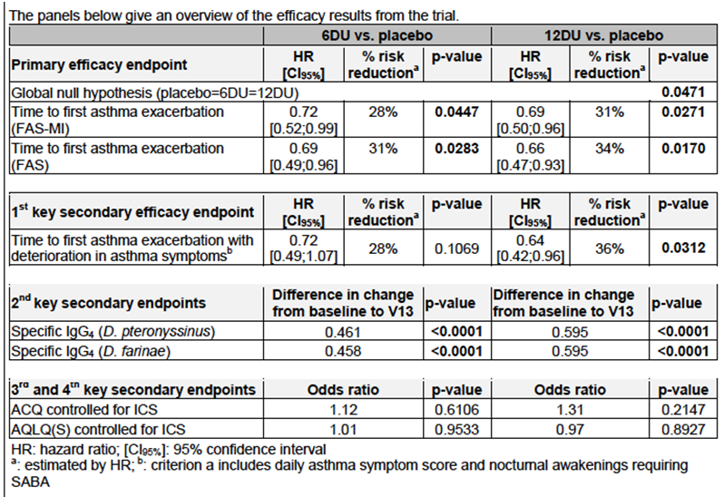

Figure 2: MT-04 primary efficacy endpoint FAS-MI

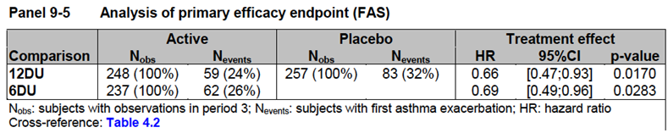

**Comment:** It is likely that this effect is clinically meaningful, with some evidence for a larger effect with the 12 DU dose.

##### Results for other efficacy outcomes

The stated key secondary endpoint results are summarised in Table 3. Secondary outcomes were analysed in the FAS with observed data and no imputation was carried out except for as described in 7.1.1.1.8 (statistical methods), where last observation carried forward was used.

In terms of stated key secondary clinical efficacy outcomes:

1. Time to first asthma exacerbation with deterioration in asthma symptoms; there was a significantly reduced risk of having an asthma exacerbation with deterioration in asthma symptoms in the HDM-Tab 12 DU (HR=0.64, p=0.0312) but not 6 DU group compared with placebo.
2. Proportion of subjects with MID change in ACQ (controlled for change in ICS); there were no significant differences between the groups in the proportion of subjects with improvement, although more subjects in the active groups (46% for 6 DU and 50% for 12 DU) had a MID improvement in ACQ score than in placebo (43%) at study end.
3. Proportion of subjects with MID change in AQLQ(S) (controlled for change in ICS); there were no significant differences between the groups in the proportion of subjects with improvement, although more subjects in the active groups (55% for 6 DU and 55% for 12 DU) had a MID improvement in AQLQ(S) score than in placebo (47%) at study end.

Table4: Other important secondary endpoint results

|  |  |  |
| --- | --- | --- |
| Variable | 12 DU versus Placebo (95% CI) | p value |
| Time to first asthma exacerbation with increased use of SABA | HR 0.52 (0.29-0.94) | 0.029 |
| Time to first asthma exacerbation with deterioration in lung function | HR 0.58 (0.36-0.93) | 0.022 |
| Time to first severe asthma exacerbation | HR 0.49 (0.23-1.08) | NS |
| Total number of asthma exacerbations during ICS withdrawal | NS |  |
| Total asthma daytime symptom score -last 4 weeks of maintenance treatment | Mean-1.28, (0.01;0.41) | 0.045 |
| Nocturnal awakenings during end of maintenance period and the first asthma exacerbation free period of ICS withdrawal | OR-1.46 (1.02; 2.09) | 0.041 |
| Proportions of symptom free days, nights and 24-hour periods | NS |  |
| Lung function | NS |  |
| Mean ACQ and AQLQ | NS |  |

**Comment:** Only 2 of the 4 key secondary clinical efficacy outcomes were significant. There was no significant effect on symptom scores or quality of life when ICS at baseline was adjusted for. Post hoc analysis suggested that in the 4 weeks prior to ICS withdrawal subjects receiving the IMP at 12 DU were less symptomatic during the day. Changes in ACQ and AQLQ are reported to be difficult to demonstrate in add on studies where ICS therapy is permitted. In general the results of the secondary analysis are consistent with the primary efficacy results, particularly related to asthma exacerbations.

No other pivotal asthma study is provided

#### Other efficacy studies

##### Study MT-02

Summary: This was a Phase II efficacy and safety study of three doses of HDM-TAB in adolescents and adults ≥ 14 years of age, mild-to-moderate HDM AA and mild-to-severe HDM AR. It was multicentre (European sites) randomised, parallel group, double blind, placebo controlled, multi-centre trial with 3 doses of active treatment (1,3 and 6 DU) conducted from 2006 to 2008. Randomisation of a total of 800 subjects was planned, 1:1:1:1, with participants to receive either one of the three active dosages or placebo.

The study included subjects with mild to moderate persistent asthma, and mild to severe AR (HDM associated), with asthma requiring < 800 µg of budesonide on randomisation. Exclusions were similar to the pivotal study (MT-04). The primary efficacy endpoint was predefined as reduction in ICS use at study end (approximately one year of therapy). There was a 4 week run in period for switching all subjects to budesonide and titrating to lowest required dose.

A total of 1,063 subjects were screened, 459 of which were screening failures. This left 604 subjects to be randomized, forming the Full Analysis Set (FAS). Out of these, 532 (88%) completed the trial. The withdrawal rate was slightly higher in the 3 DU group (16%) than in the other treatment groups (10 to 12%). A total of 387 subjects (64%) fulfilled the per protocol (PP) criteria, evenly distributed between treatment groups.

In terms of baseline characteristics; there were equal numbers of males and female, with an almost entirely Caucasian population (98%). The median age was 29. 6% were less than 17 years of age.

The subject had a median duration of asthma at randomisation of 12 years. 83% were poly‑sensitised to other aeroallergens.

The primary efficacy study endpoint outcome was significant with ICS reduction of 81.4 µg/day observed for the 6 DU group compared with the placebo group (95% confidence interval, 26.7 to 136.1 µg/day; p = 0.0036). No significant reduction was observed for the lower two doses (1 and 3 DU).

The AE and the immunological data arising from the study are discussed elsewhere in the report.

#### Analyses performed across trials (pooled analyses and meta-analyses)

No pooled analysis or meta-analysis was presented in the dossier.

#### Evaluator’s conclusions on clinical efficacy for asthma

One pivotal Phase III and one Phase II study were provided by the sponsor for evaluation. The design and conduct of the two studies is adequate for the proposed purpose of IMP registration, and the trials were conducted in accordance with international and TGA relevant guidelines, with appropriate primary efficacy end points.

The pre-determined primary efficacy endpoints for both studies were met, and a likely clinically significant difference between the 12 SQ-HDM SLIT-tablet and placebo was shown in both studies. Overall these studies suggest that HDM-TAB is efficacious as an add-on therapy for adults with moderate to severe asthma, which is not well controlled on current optimised ICS, where a clinical history of sensitization and exacerbation of asthma on exposure to HDM, and evidence of HDM IgE sensitization is demonstrated.

### Clinical efficacy; HDM allergic rhinitis

#### Pivotal efficacy studies

##### Study MT-06

###### Study design, objectives, locations and dates

This was a Phase III randomized, parallel group, double blind, placebo controlled, multi-national, multi-site trial in Europe to assess the efficacy and safety of HDM SLIT-tablet in the treatment of HDM-AR in adults with inadequately controlled AR symptoms on standard treatment. It involved 100 study sites. The study was conducted from October 2011 to April 2013.

The study involved 12 months of therapy, with daily home daily administration of the sublingual tablet. It was designed as a superiority add-on trial, with 2 doses of active treatment and placebo (1:1:1) with a run-in period for subjects with inadequately controlled symptoms on current medication. Study was commenced out of grass and birch pollen season to avoid potential confounders. Subjects were required to have pre-existing HDM-AR symptoms for more than one year and not be controlled on current therapy.

Figure 3: MT-06 Trial design

Figure 3: MT-06 Trial design
Period 1 baseline  (daily diary recordings (15 days) 
randomisation at visit 2\Period 2 treatment maintenance (weekly diary recordings) for 10 months patient recieved either 12 DU, 6 DU or placebo.
Period 3 efficacy assessmnet for 2 months (daily diary recordings) and this included visit 7 and 8.

**Comment:** The design of the MT-06 trial is appropriate for the assessment of efficacy of an-add on therapy to AR. It is consistent with EMA CHMP guideline on the clinical development of products for allergy immunotherapy for the treatment of allergic diseases. As this therapy was being assessed as add on therapy- it may have been better for the run in period to have been conducted with the subject on the same “standard therapy” medication that were allowed throughout the study, rather than their usual medications. However the randomization and placebo nature of the study design should allow for differences in symptoms on this basis alone. This would have allowed for a standardized medication baseline score. This was not possible in the study as at baseline patients were not using a standardized set of medications, as these were only supplied after the randomization visits, which was the end of the baseline symptom-recording period. Dust samples for HDM levels were taken but unfortunately not measured or presented as part of the study results.

###### Inclusion and exclusion criteria

The major inclusion criteria were subjects between 18 to 65 years of age, with a clinical history consistent with moderate to severe persistent HDM allergic rhinitis (with or without asthma) for at least one year prior to trial entry, with allergic rhinitis symptoms despite symptomatic treatment. They were required to have both positive skin prick test response (wheal diameter ≥ 3 mm) to *D. pteronyssinus* and/or *D. farinae* and specific IgE against *D. pteronyssinus* and/or *D. farinae* ≥ 0.70 kU/L.

During the baseline period they were required to have a daily total rhinitis symptom score of at least 6 or a score of at least 5 with one symptom being severe, during at least 8 days of the 15 days baseline period and at least one of Sleep disturbance, Impairment of daily activities, leisure and/or sport or Impairment of school or work (based upon ARIA QoL (13)). They were required to have used symptomatic medication for treatment of HDM allergic rhinitis during at least 8 days of the 15 days baseline period.

Major exclusion included moderate to severe asthma; defined as a requirement of more than 400 µg of budesonide for any co-existing asthma, and an FEV1 of < 70% predicted on adequate treatment and any uncontrolled asthma within 3 months of screening. Potential participants were excluded if there was history of symptomatic seasonal allergic rhinoconjunctivitis and/or asthma caused by an allergen to which the subject is regularly exposed within the 8 week efficacy evaluation period or to AR due to animal hair/dander or mould to which they were regularly exposed.

A complete list of inclusion and exclusion criteria were provided.

The population was gathered from a large range of European centres, however how many of these patients were from tertiary clinics within these countries rather than general population is unclear.

**Comment:** Exclusion of patients with moderate to severe asthma, and those with cardiorespiratory (presumed either/or not both) reactions to food allergens. These could be relative common co-morbidities in patients with moderate severe AR. This limits somewhat the generalizability of the study’s findings.

###### Study treatments

The study treatment consisted of daily sublingual self-administered HDM-TAB at 12 SQ-HDM, 6 SQ-HDM or placebo. Dose selection for the MT-06 trial was based on the results from the completed trials with the HDM allergy immunotherapy tablet (MT-01, MT-02 and MT-03), where only the highest dose of 6 DU had shown significant reduction in symptom scores. There was no dose titration. The first does was administered under medical supervision with a 30 minute observation period. Standard AR and ARC therapy was provided to all subjects at randomization to be used throughput the study period as standard treatment in order to standardize all patients’ treatment: Oral antihistamine tablets (desloratadine tablets, 5 mg), Nasal corticosteroid spray (budesonide 64 µg/dose), Eye drops-(azelastine 0.05%; except Serbia and Croatia). Instructions were provided to participants on frequency and dosage of above medications. Concomitant treatments and medications were avoided where possible and recorded at study visits.

The treatment was started at randomization visit and was dispensed at Visit 4 and 6, during the maintenance period. The total duration of treatment was 12 months.

Compliance was measured by tablet count at all visits, where subjects were instructed to bring all residual IMP, empty blister units/cards and packages and recorded on the IMP accountability form.

Treatment was interrupted or ceased for oral surgery, severe oral ulceration and could be interrupted during URTI (for a period of one week).

**Comment:** The study treatment dosages and additional treatment allowed during the study were appropriate.

###### Efficacy variables and outcomes

The main efficacy variables were:

Combined AR symptom score and medication score (by electronic diary)

Diary: All subjects included in the trial were issued with an electronic subject diary, which was filled in each day during the 15 days baseline period to capture information on rhinitis symptoms, use of symptomatic medications, and impact of rhinitis on daily life. Compliance with the diary during the run in period was part of inclusion/exclusion criteria. All randomized subjects were instructed to fill in the electronic diary 7 days after each visit during the treatment maintenance period (Visits 3 to 6) and each day during the 8 weeks efficacy assessment period at the end of the treatment period. Subjects were instructed by the investigator on diary use at all study visits except end of study.

The total combined score used for primary efficacy outcome score was the sum of the rhinitis DSS and DMS. The DSS (daily symptom score) was based upon the addition of scores for 6 allergic symptoms, (4 rhinitis symptoms and 2 conjunctivitis symptoms) which were measured on a scale from 0 to 3, as in Table 5 below. This provided a rhinitis DSS and a conjunctivitis DSS.

Table 5: Scale for measurement of rhinitis and conjunctivitis symptoms

|  |  |
| --- | --- |
| Scale for measurement of rhinitis and conjunctivitis symptoms | |
| 0 | No symptoms |
| 1 | Mild symptoms (that is sign/symptom clearly present, but minimal awareness; easily tolerated) |
| 2 | Moderate symptoms (that is definite awareness of symptom that is bothersome but tolerable) |
| 3 | Severe symptoms (that is symptom that is hard to tolerate; causes interference with activities of daily living and/or sleeping) |

Medication score

Medication score was derived from the use of medication to relieve symptoms as described in Table 6.

Table 6: Use of medication to relieve symptoms

| Symptomatic medication | Score/dose unit* | Maximum daily dose | Maximum daily score |
| --- | --- | --- | --- |
| Rhinitis medication score (RMS) | | | |
| Desloratadine tablets#, 5 mg | 4 per tablet | 1 tablet | 4 |
| Budesonide nasal spray, 64 µg/dose | 2 per puff | 2 puffs per nostril | 8 |
| Maximum daily rhinitis medication score¤ | | | 12 |
| Conjunctivitis medication score | | | |
| Desloratadine tablets#, 5 mg | 2 per tablet | 1 tablet | 2 |
| Azelastine eye drops, 0.05% | 1.5 per drop | 2 drops per eye | 6 |
| Maximum daily conjunctivitis medication score | | | 8 |
| Maximum total allergic rhinoconjunctivitis score | | | 20 |

**Comment:** The symptom scores used has not been formally validated, however it’s constructed as recommended in the EMA guideline (EMEA 2008c) and similar to the score system used in the GRAZAX trials with slight modification related to change in use of oral steroid scoring.

* Quality of life

The disease specific quality of life was assessed by the RQLQ(S), a validated quality of life questionnaire using the electronic diary.

* + Symptom score
  + Medication score
  + Conjunctivitis score (not part of this indication- only allergic rhinitis not allergic rhinoconjunctivitis).

The primary efficacy outcome was the average total combined rhinitis score (TCRS) during the last 8 weeks of treatment. The TCRS was the sum of the allergic rhinitis daily symptom score (DSS) and the allergic rhinitis daily medication score (DMS) averaged over the last 8 weeks of treatment.

**Comment:** A combined symptom score and medication score is this is an acceptable primary endpoint as per EMA and ARIA guidelines. The appropriate domains were included in the AR scoring; runny nose, blocked nose, sneezing and itchy nose according to EMA guidelines. No single methodology of combining symptom scores and mediation scores has been validated; however the system used in this pivotal trial is very similar to that used for the published studies involving the grass SLIT–tablet.

The endpoints were appropriately predefined. Optimal length of most IT, including SLIT is considered to be 2 to 3 years, so this 12 month endpoint does not reflect the general clinical current use endpoint. According to guidelines (EMA, ARIA), electronic diary is the optimal method for data collection of symptom score endpoints. Quality of life is an acceptable secondary outcome and has been measured using a standardised, validated allergic rhinitis specific questionnaire (14).

The TCRS was not standardised at baseline, as the medications allowed for symptom control over the study period were only commenced at randomisation. This does not allow direct correction of the TCRS for baseline values, only use of the symptom scores.

Other efficacy outcomes included:

* The average total allergic rhinitis DSS during the efficacy evaluation period.
* The average total allergic rhinitis DMS during the efficacy evaluation period.
* Frequency (number/percentage) of symptom free days.
* The average total combined allergic rhinoconjunctivitis score during the efficacy evaluation period.
* The average overall Rhinoconjunctivitis Quality of Life Questionnaire RQLQ(S) score during the efficacy evaluation period.
* Days with rhinitis exacerbations (post hoc).

###### Randomisation and blinding methods

The randomisation list was generated by a trial independent statistician. The randomisation list was divided in blocks of 6, each block comprising 2 sets of each of the 3 different treatments (that is placebo, 6 DU or 12 DU). In some cases, the blocks were split when distributed within countries.

The exact method of generation of randomisation tables/sequence is not specified. 2 complete sets of randomisation code envelopes were generated, with one set retained by ALK and one set distributed to the trial sites. There was provision for emergency code breaking in the event of SAE with likely relationship to IM, but this was not required for any subject during the study.

Blinding was adequate, with tablets packaged and identical in appearance and (apparently) taste (although not substantiated). Local adverse reactions are known to occur with similar products and this constitutes a possible risk for compromising the blinding. In previous trials with similar products there were no differences between the results for the full analysis set and those obtained when excluding subjects with the most common local adverse reactions from the analysis. Hence, it was deemed unnecessary by the sponsor to take any further precautions to maintain the blinding.

Randomisation codes were confidential, accessible only to authorised persons until the time of un-blinding. During, and at the end of the trial, the occurrence of any break of the randomisation code was determined by checking the code break envelopes.

###### Analysis populations

The following analysis sets were predefined in the study protocol and analysis plan:

* Total-analysis set: All subjects who entered the trial (that is signed an informed consent). This analysis set includes screening failures. The total population was used for listing reasons for screening failures and AEs before randomisation.
* FAS: All randomised subjects in accordance with the ICH intent-to-treat principle. This analysis set was primary set for all efficacy analyses. The FAS was used for all baseline/demography tables, efficacy tables, safety tables and subject listings.
* FAS-MI: a multiple imputation strategy of Rubin was applied for missing data.
* PP: All subjects with major protocol deviations that would affect the primary endpoint were excluded from this group.
* Safety Set: same as FAS.

The primary efficacy outcome end points were analysed by FAS-MI.

**Comment:** The analysis population plan was consistent with EMA guidelines.

###### Sample size

The study was planned to include a total of 900 subjects (600; active treatment (6 DU or 12 DU) and 300 placebo). The assumptions that were used to estimate sample size were: 10% discontinuation rate and a mean TCRS value for placebo of 4.10 (based on results ALK MT-02 trial). The study was designed to be able to detect a difference of 1 TCRS between placebo and active therapy with 90% power. An absolute reduction of 1 in the TCRS was considered the minimal clinically relevant difference for this trial. The rationale provided for this reduction was that World Allergy Organization task force recommendations for the minimal clinical relevant difference between active and placebo for the primary endpoint are 20%, and that a reduction in TCRS of 1 corresponded to 20% reduction in similar TCRS in trials with the corresponding grass tablet (Grazax). Thus, a relative difference of 20% to 25% was used in the power calculations which corresponded to a requirement for an absolute difference of 0.82 and 1.03 in TCRS.

There was no sample size adjustment made for any interim analysis or for multiple comparisons or sub group analysis.

**Comment:** The rationale for the effect size used for determining the required sample size appears reasonable.

###### Statistical methods

Statistical tests were performed with a 5% significance level with two sided CIs (95%). Multiplicity was adjusted for by hierarchy testing for the primary end point and the two ‘key’ secondary outcomes (DSS, DMS). There was no additional correction for multiplicity for any other analysis.

For the primary analysis of the primary endpoint and for the 2 key secondary endpoints “average total allergic rhinitis DSS during the efficacy evaluation period” and “average total allergic rhinitis DMS during the efficacy evaluation period”, a multiple imputation strategy was used for missing data. Missing data in all treatment groups were sampled from the observed data in the placebo group using the method of unrestricted random sampling with replacement. A sensitivity analysis using LOCF for missing primary efficacy data was undertaken.

The primary efficacy analysis was based on a linear mixed effect (LME) model and performed on the FAS- MI. The response variable in the LME was the square root of the TCRS and covariates included the average rhinitis DSS at baseline and country. The primary outcome was the pairwise comparison between all 3 treatment groups using a t-test in the LME model.

For assessment of the PP set; subjects were instructed to bring all residual IMP, all empty blister units/cards and packages to every visit. Compliance was then assessed by tablet counts. No interim analysis was performed.

**Comment:** Medications were not standardised at baseline, so a standardized TCRS at baseline was not available for a direct comparison with the end point TCRS. This direct comparison may have been preferable to the more complex calculation, which has been used. The effect size to calculate the sample size seems reasonable and consistent with guidelines and previous similar studies.

###### Participant flow

See Figure 4 MT-06 AR consort diagram participant flow and analysis sets.

Figure 4: Study MT-06 AR Subject disposition. Participant flow and analysis set

Figure 4: Study MT-06 AR Subject disposition. Participant flow and analysis set
1425 were screened, 433 were screening fialures
992 were randomised
338 recieved placebo of these 296 completed
336 recieved 6 DU of these 297 completed
318 recieved 12 DU of these 284 completed

Overall 1,425 subjects were screened, and 992 were randomised. There was 88% retention to the study end, with total FAS of 879. The randomised/completed for each group were; placebo (338, 296), 6 SQ-HDM (336,297), 12 SQ-HDM (318, 284), respectively.

30 subjects withdrew due to AE, of which 23 were in the active IMP arms and 7 in the placebo group. The PP data set was 805.

The study was not terminated early. All protocol deviations are listed and described in the study report.

###### Major protocol violations/deviations

There were no major protocol deviations or violations reported.

###### Baseline data

Baseline characteristics between active and placebo groups were not significantly different. There were an appropriate mix of mono and poly aeroallergen sensitized patients (approx. 1:2). There were roughly equal numbers of males and females, with a median age of 30 years, 46% had HDM-asthma. Median length of HDM-AR at screening was 7 years. Grass, cat and birch sensitisation were the most common other aeroallergen sensitizations. The study subjects were overwhelmingly Caucasian (98%).

Overall median baseline rhinitis score was 7.9, and was not different between the three groups. Similarly, other baseline efficacy variables including rhinitis, conjunctivitis and rhino-conjunctivitis scores, and QoL were similar across all groups at baseline. Baseline use of medications for AR was similar, although the placebo group had used on average 3 days/month of intranasal CS whereas the active groups 4 days/month leading up to randomisation. Use of antihistamine was same. Details of potencies of medications were not provided, or standardised for the baseline assessment.

**Comment:** Overall the subjects had a rate of polysenstisation to other aeroallergens, and asthma which is likely to reflect the patient group consistent with the current indication and application under review. Asthma was by the exclusion criteria, not moderate to severe, however the asthma pivotal study did include such subjects, who also had HDM-AR. The subjects did not reflect a diverse ethnic background and were on average quite young. They had on average had a lengthy history (median 7 years) of symptoms related to AR.

###### Results for the primary efficacy outcome

The primary outcome was the difference in average TCSR between placebo and 6 and 12 DU HDM-tab over the 12 month study period. Table 7 outlines the findings in the different study populations. In the FAS-MI data set there was an absolute difference of 1.09 (95% CI; 0.35 to 1.84) in the adjusted mean TCRS between placebo and the 12 DU HDM-tab group, and an absolute difference of 1.09 (95% CI 0.34 to 1.80) between the placebo and 6 DU group. Both were significant differences at p < 0.004. This is likely to be a clinically detectable difference.

The analysis of the primary outcome in the FAS-with observations and the PP set were consistent with the findings of the FAS-MI.

Table 7: Primary efficacy outcome MT-06

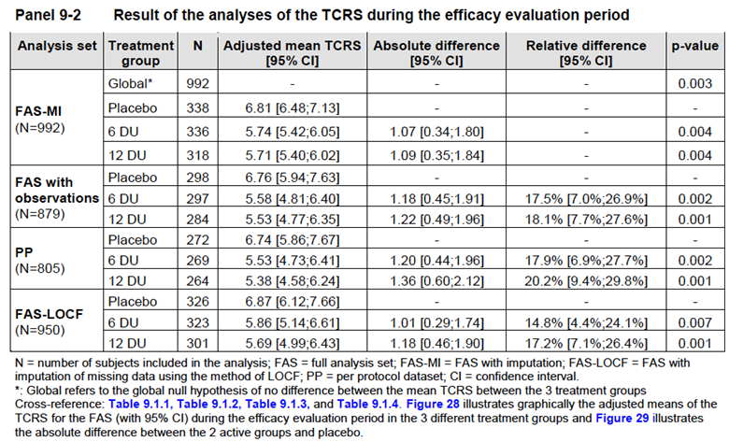

**Comment:** There was a significance difference in the adjusted mean total rhinitis score (which included symptoms and medication use) between the placebo and both HDM-tab (6 and 12 SQ-HDM) groups over the last 8 weeks of the 12 month study. This is likely to be a clinically detectable and meaningful effect.

###### Results for other efficacy outcomes

Overall, some but not all of the secondary efficacy outcomes were significantly different between the IMP and placebo groups. In general positive effects were observed for rhinitis but not for conjunctivitis or combined rhino-conjunctivitis. Except for mean rhinitis DSS and mean rhinitis DMS analysis was carried out of the FAS with observations population.

The mean rhinitis DSS was statistically significantly more reduced in the efficacy evaluation period in the 6 DU and 12 DU group compared to placebo with absolute reductions of 0.38 (p = 0.042) and 0.47 (p = 0.01) for the 6 DU and 12 DU group.

An effect of the IMP was observed from Week 14 of the study period, with TCRS between IMP and placebo groups significantly different from this time point.

The mean IMP compliance in the overall trial population was 94% with no overall difference between the 3 treatment groups. Electronic diary compliance over the primary endpoint time period was similar across all groups and mean of 86% (median 92%).

TCRS between the 2 active groups and placebo together with 95% CI is illustrated in Table 7.

The study was not powered for subgroup analysis and no differences in results were found for subjects < 30 years, for females or those with HDM-asthma.

Post-hoc analysis, examined days of rhinitis exacerbation and found a significant effect for IMP, but this was more apparent in the 12 DU group, with OR of 0.45 compared with placebo for rhinitis exacerbations during 8 week assessment period.

**Comment:** Some outcomes were generally consistent with the primary outcome; however there was no significant effect on measures of conjunctivitis alone at either dose, but this is not the indication under examination for this dossier. Although most analysis revealed effects for both the 12 and 6 DU dosages, there was only a significant effect on overall quality of life for the 12 DU dose.

No other pivotal AR study is provided.

##### Other efficacy studies

###### Study P-003

This was a Phase II, randomised, placebo controlled, parallel group, double blind, single site efficacy, dose ranging and safety study assessing of two doses of HDM-tab (6, 12 DU) in adult subjects with moderate to severe AR (with or without asthma) in an environmental exposure chamber.

A total of 124 subjects were randomized in a 1:1:1 ratio to receive HDM-TAB (6 or 12 DU) or placebo 24 weeks. Most subjects did not have asthma, and had a mean age of 27 (range 18 to 58). They were largely poly-sensitised to aeroallergens (86%). Subjects had to qualify for the trial by scoring at least 6 out of 12 for the total nasal symptoms score (TNSS) during the screening EEC session (off medication), suggesting they did have clinically problematic moderate to severe AR. Fifteen percent of the randomized participants discontinued over the 24 weeks, equally distributed among the three groups.

The primary efficacy end point was nasal symptoms (average total NSS over 4 hours) at the end of the study in an environmental exposure chamber where subjects were exposed to standardized amounts and duration of aerosolised allergen (HDM). There was a significant reduction in the mean adjusted TNSS in both 6 DU (5.47 (95% CI; 4.55, 6.39) and 12 DU (3.83 (95% CI-2.94, 4.72) HDM-tab groups compared with the placebo group 7.45 (95% CI; 6.57, 8.33). Similar measures were performed at Weeks 8 and 16 of the study, where significant reduction in TNSS was observed in both dose groups at 16 weeks, and only in 12 DU group compared with placebo at 8 weeks of IMP.

**Comment:** Environmental exposure chambers provide proof of principal type efficacy information, but not real life efficacy information. It is not clear what reduction in TNSS in an exposure chamber would be required to translate into a clinically meaningful effect in normal environmental exposure condition. The 12 DU overall appeared superior to the 6 DU dosage in this study and was relatively well tolerated (see safety and AE section for further details).

###### Study MT-02

This study was an asthma efficacy study; however a post-hoc analysis was performed on subjects with a clinical history of HDM induced AR.

Analysis of subjects with AR symptoms at baseline was not in the original SAP, and when the group were analysed by FAS-observed for secondary rhinitis outcomes, no statistically significant difference between active and placebo was detected for the rhino-conjunctivitis symptoms or medication score. Post-hoc analysis was performed on 489 of 604 randomised subjects who reported rhinitis symptoms and/or rhinitis medication use during baseline. In this subgroup a significant difference between 6 SQ-HDM and placebo at the end of treatment of 0.78 for the TCRS, and of 0.24 for RQLQ, was observed. No difference in the lower doses was observed, and it should be noted that this effect is less than a 1 absolute TCRS score, so its clinical meaningfulness, especially given the post hoc subgroup nature of the analysis is questionable.

#### Analyses performed across trials (pooled analyses and meta-analyses)

There was no pooled or meta-analysis performed.

#### Evaluator’s conclusions on clinical efficacy for HDM allergic rhinitis

One pivotal Phase III study, one Phase II study with predetermined SAP and one Phase II study subject to post-hoc analysis of a subgroup with AR symptoms at baseline were available for review.

Overall, the studies with pre-determined study endpoints all met their predetermined primary efficacy endpoints. The endpoints chosen were in line with EMA and ARIA guidelines for primary efficacy endpoints in AR studies, and are likely to represent clinically relevant effects. This suggests that adults with moderate to severe AR not well controlled on existing therapy may benefit from treatment with Acarizax, where the clinical history is consistent with HDM driven AR and evidence of IgE sensitisation to HDM is demonstrated.

## Clinical safety

### Studies providing evaluable safety data

#### Pivotal efficacy studies (asthma and allergic rhinitis)

The following studies provided evaluable safety data: MT-06 (pivotal AR study) and MT-04 (pivotal asthma study). As the type and methodology for collecting and assessing safety data was very similar for the two indications and between the two studies, the indications will be considered together for this section.

In the pivotal efficacy studies, the following safety data were collected:

* General adverse events (AEs)

In the two pivotal efficacy studies MT-04, and MT-06, AEs were either observed by the investigator or reported and recorded by the subjects. Where AEs were recorded the investigator assessed the intensity of the AE and its relationship to the IMP. In addition, the subject was asked at each visit, starting at baseline, whether he/she had had any AEs (including any changes in concomitant illnesses or new illnesses) since the last visit.

Clinically significant abnormal values from relevant tests, such as clinical safety laboratory test, vital signs and ECGs were also recorded as AEs. The investigator was required by the study protocols to report SAEs to ALK within 24 hours and forward the completed AE form, within 5 calendar days.

* AEs of particular interest were assessed by direct observation and by report. They were:
  + MT-06: Asthma and acute asthma related events (including chest tightness, bronchospasm, dyspnoea, hoarseness and related symptoms). Systemic allergic reactions (including events with any circulatory reaction, drop in blood pressure, tachycardia and cardiac dysrhythmia) and AEs leading to discontinuation.
  + MT-04: Any serious systemic allergic reaction (treated with epinephrine, facial oedema involving periorbital swelling occurred, fainting or hypotension, rapidly progressive cutaneous reaction (urticaria, pruritus), objective swelling in the oro-pharynx with hoarseness or stridor) or AE leading to study discontinuations.
* Laboratory tests

Laboratory tests, including FBC, serum biochemistry, LFT’s and urine analysis, and pregnancy tests were performed at screening visit and end of trial and any unscheduled visits.

Pulmonary function (FEV1, PEF) and physical examination, blood pressure (BP) and heart rate (HR) were assessed using standard equipment. They were assessed at all face to face visits, and PEF was assessed at home during assessment periods.

**Comment**: AEs of special interest should have included any emerging EoE and any use of adrenaline during the study period.[11]

### Pivotal studies that assessed safety as a primary outcome

No pivotal studies assessed safety as a primary outcome.

### Dose-response and non-pivotal efficacy studies

The dose-response and non-pivotal efficacy studies provided safety data, as follows:

#### Study MT-02

This Phase II study involved 604 subjects > 14 years with mild to moderate asthma and associated AR. Duration of study was approximately 12 months.

It reported AEs, AEs leading to premature discontinuation, asthma exacerbations, FEV1, clinical safety laboratory tests, vital signs, ECGs and physical examinations as safety outcomes. Safety outcomes were collected at:

* Bloods, urinalysis, ECG; at baseline and study completion (Week 52)
* PE; at baseline, Week 4 and Week 52
* spirometry and AE assessment; at baseline, and Weeks 4, 8, 16, 24, 32, 40 and 52
* PEF; daily from Weeks 40 to 52.

#### Study P003

This phase RDBPC, parallel group, single site, 3 arm, dose ranging environmental exposure chamber (EEC) trial assessed the efficacy and safety of two doses of the HDM SLIT-tablet in HDM allergic adults. The duration of study was approximately 24 weeks.

It reported AEs, IMP related AEs, SAEs, serious IMP related AEs, and AEs leading to premature discontinuation, vital signs, oral examinations, physical examinations, spirometry, and safety laboratory assessments. Spirometry was performed Day 1, Week 6, Week 16, Week 24, and blood tests/urinalysis was performed at baseline and at study completion (24 weeks). Physical examination and assessment of AE were performed at Day 1, Weeks 4, 8, 16, 20, 24 and 26.

In addition, the sponsor has provided interim data from some ongoing Phase II/III Japan and US based studies, for which efficacy data has not been presented.

#### Studies TO-203 AR and TO-203 AA

These are RDBPC, parallel group, multi-site trials assessing the efficacy and safety of two doses of the HDM SLIT-tablet in HDM allergic subjects with asthma and AR respectively. Both studies are of 12 months duration and both have collected outcome data on AEs, AE discontinuations, SAEs, symptoms and signs, physiological examinations (blood pressure and heart rate), laboratory tests (haematology and blood chemistry). Both studies include an up-dosing arm, in comparison to placebo and single dose arm.

#### Studies P001 (AR) and P009 (AR)

Study P001 is a RDBPC, parallel group, multi-national trial assessing the efficacy and safety of the HDM SLIT-tablet in HDM allergic subjects with moderate to severe persistent AR. Its duration is 7 months.

Study P009 is a RDBPC, unbalanced, multi-site trial in subjects with HDM AR/ARC which is assessing the impact of the HDM SLIT-tablet on immunological biomarkers. Safety outcomes being collected are AEs.

### Other studies evaluable for safety only

#### Study MT-01

This was a Phase I, randomised, multiple dose, dose escalation, double blind, placebo controlled, single site, study to investigate the safety of HDM-TAB in adult subjects with house dust mite induced asthma (with/without rhino-conjunctivitis). It was conducted in Denmark, August to November 2005. Participants were aged 18 to 65 years of age and had the mild to moderate asthma symptoms (in accordance with the GINA guidelines) for the 3 months prior to screening. They had evidence of SPT and ssIgE to HDM.

The 71 participants were randomised into groups, and received either placebo or daily doses of HDM Tab, administered sublingually at 1, 2, 4, 8, 16 or 32 SQ-HDM/day for 28 days.

Adverse events, vital signs (BP and HR), oral examination including PEF, FEV1 were performed daily from Day 1 to 6 and then on Days 7, 14, 21, and 28. ECG was performed at baseline, Day 1, Day 2 and Day 28.

Haematology, urinalysis and biochemistry were performed at baseline and at 28 days (study end). On all other non-visit study days, participants recorded AE in their diary and performed and recorded PEF. Daily phone call to participants to record AEs and progress was made.

Clinical safety laboratory data were summarised by shift tables and by percentages and numbers. Adverse events were summarised by treatment according to standard MedDRA classification and reported in percentages, severity, seriousness, outcome, and IMP relationship. SAE were also described narratively.

#### Study MT-03

This was a randomised, double blind, placebo controlled Phase I study investigating the safety of ALK HDM tablet in children with HDM asthma. Children are not the subjects of the current application.

The total study duration was 28 days, and each group of children received one daily dose of placebo tablet or 0.5, 1, 3, 6, 9, or 12 SQ-HDM. A safety committee reviewed the initial safety data of the previous dose/s, and only by their approval did the trial enter the next (higher) level of dose. 72 children were enrolled, and there were no study discontinuations, with all 72 completed all days of the study.

Safety parameters included AE, clinical safety laboratory tests, vital signs, weight, oral examinations, spirometry, peak expiratory flow and physical examinations. All parameters were assessed at baseline and at end of study (Day 29). PEF and AE were recorded daily at home by written diary on Days 3 to 7, 9 to 14, 16 to 21, and 23 to 28 and by investigators on study Days 1, 2, 8, 15 and 22, where oral examination was also performed.

Clinical safety laboratory data were summarised by shift tables and by percentages and numbers. Adverse events were summarised by treatment according to standard MedDRA classification and reported in percentages, severity, seriousness, outcome, and IMP relationship. SAE were also described narratively.

#### Study P008

This was a Phase I randomized, placebo controlled, parallel group, multi-site, double blind study to assess safety and tolerability of HDM-tab in adolescents aged 12 to 17 years with HDM-AR. Adolescents < 18 years are not the subjects of the current application.

It was designed with a primary outcome to assess the proportion of subjects with any AEs in adolescents receiving placebo compared with daily 6 and 12 DU/SQ -HDM Tab. It was also designed with a key secondary outcome of assessing duration of pre specified AE related to IMP on first observed exposure.

A planned total of 195 subjects were randomized in a 1:1:1 ratio to receive 12 DU, 6 DU, or placebo sublingually once daily for 28 days. There were three study visits: Screening, Randomization (with first dose) and end of study treatment. Telephone call on Days 2 to 3, weekly and after study completion.

Pulmonary function tests, oral examination and vital signs were performed on Day 1 and end of study and any unscheduled visits. Laboratory tests were only performed at baseline, and did not form data for the safety assessment in this study.

#### TO-203-ph1

This was a Phase I randomized, double blind, single site placebo controlled trial of HDM-induced allergic asthma in adult males 20 to 49 years of age. It was designed to assess safety of the IMP in adults with asthma, with or without associated HDM AR. Duration of treatment was 14 days.

Forty-eight subjects were randomized to 5 groups: exposure to placebo, 3, 6, or 12 SQ-HDM tablet daily, and in one group, escalation over the 14 days from 3 to 12 SQ-HDM. The study provided safety data on AE, physical examination (BP, HR), ECG, and haematology and blood chemistry.

The subjects were assessed at Days 1 to 7 and 14 by direct observation and examination and by patient report for other days. AEs and PEF were recorded for all study days, oral examination and vital signs on Days 1 to 7, and 14, and ECG, spirometry, haematology and biochemistry at baseline and study end.

**Comment:** AEs were collected and recorded in alignment with standard ICH Harmonised Tripartite Guideline, in all studies presented. These safety studies were all short term (14 to 28 days), so no long-term reassurances can be gathered by the Phase I studies.

### Pivotal studies that assessed safety as a primary outcome

Not applicable; there were no such studies

### Patient exposure

Table 8: Exposure to HDM SLIT tablet and clinical studies

| Study type/Indication/ duration | Controlled studies (n) | | Uncontrolled studies | Total HDMSLITTablet exposure |
| --- | --- | --- | --- | --- |
| HDM SLITTablet | Placebo | HDM |
| **Clinical pharmacology** | | | | |
| **ASTHMA** |  |  | NA |  |
| Pivotal (MT-04) | 557 | 277 |  | 557 |
| Phase II (MT-02) | 461 | 143 |  | 461 |
| Phase I (MT-01, MT-03, TO-203) | 54  54  36 | 17  18  12 |  |  |
| **Subtotal Indication 1** | 1162 | 467 |  | 1162 |
| **AR** |  |  | NA |  |
| Pivotal (MT-06) | 654 | 338 |  | 654 |
| Phase II (P003) | 83 | 41 |  | 83 |
| Phase I (P008) | 130 | 65 |  | 130 |
| **Subtotal Indication 2** | 867 | 444 |  | 867 |
| **TOTAL** | **2029** | **972** |  | **2029** |

Exposure to SQ-HDM SLIT tablet in clinical studies according to dose and duration.

There is only one proposed dose for this current application: 12 SQ-HDM.

Table 9: Exposure by duration to 12 SQ-HDM across all studies

| Study type/  Indication | Proposed maximum dose: 12 SQ-HDM daily | | | | |
| --- | --- | --- | --- | --- | --- |
| < 4 weeks. | 4 -12 weeks | 12-24 weeks | > 24 weeks | Unknown |
| **Clinical pharmacology** | | | | | |
| **Asthma** | | | | | |
| Placebo-controlled | 18 | 12  65 |  | 282 |  |
| Subtotal Indication 1 | 18 | 77 | 0 | 282 |  |
| **Allergic Rhinitis** | | | | | |
| Placebo-controlled |  |  | 42 | 318 |  |
| Subtotal Indication 2 | 0 | 0 | 42 | 318 |  |
| **TOTAL** | 18 | 77 | 42 | 600 | 12 |

Table 10: Exposure by dose and duration; all doses

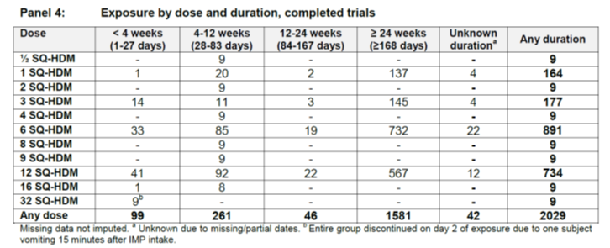

**Comment:** The overall exposure in adults at the dose 12 SQ-HDM (current application dose) is quite small. There majority of these subjects supply safety data for periods of between 24 weeks and 12 months, however there is very little safety data on treatment for periods longer than 12 months at this dose, or at any other dose. The relatively low number of subjects with IMP exposure at the 12 SQ-HDM suggests that low frequency, but important AE and SAE related to IMP may not have been able to be detected. These data also have included safety data available for children and adolescents.

### Adverse events

#### All adverse events (irrespective of relationship to study treatment)

##### Pivotal studies

Table 11: Summary of adverse events for the pivotal studies

|  |  |  |  |  |  |  |  |  |
| --- | --- | --- | --- | --- | --- | --- | --- | --- |
|  | All AE n/events | % AE placebo group | % AE 6 SQ_HDM** group | % AE 12 SQ-HDM** group | Severe AE n/events | SAE n/events | Study DIS. *** Placebo/6/12 SQ-HDM (n) | Not recovered (n) |
| MT-04 n=834 | 599/2084 | 63% | 74% | 79% | 45/57 | 28/32 | 8/12/25 | 68 |
| MT-06 n=992 | 579/1686 | 46% | 63% | 67% | *28/30 | 12/12 | 7/10/13 | 33 |

*- one of the AEs was not classified by the investigators or sponsors as severe, but on reading the details provided, this has been misclassified in the reviewers opinion and added to the numbers. **Both pivotal studies used both 6 and 12 DU doses of daily HDM-tab. *** study discontinuation due to AE

**Comment:** For both pivotal studies, more participants in the 6 or 12 SQ-HDM groups than placebo groups reported any AE, and more discontinued the study due to AEs. The majority of all AEs were mild (67 to 74%) or moderate (24 to 31%), however the number of subjects with mild and moderate AEs was higher in the active groups. The average number of AEs per subject in a treatment group was dose-related, and for 12 SQ‑HDM the average frequency was 2.61 compared with 1.39 for placebo, when data from adult Phase II and III studies was combined.

###### AE by System Organ Class (SOC) and most frequent AEs

The sponsor has provided safety summary tables and figures, which combine the two pivotal studies with the two Phase II efficacy studies conducted in adults (MT-02 and P003) for a combined overview of AE by SOC across the relevant Phase II/III studies. The larger of these studies were of one year duration, but only used 6 DU as the highest dose and the smaller study (124) used the same doses as the pivotal studies, but was of 24 weeks duration.

Figure 5: Phase II and III SOC combined data

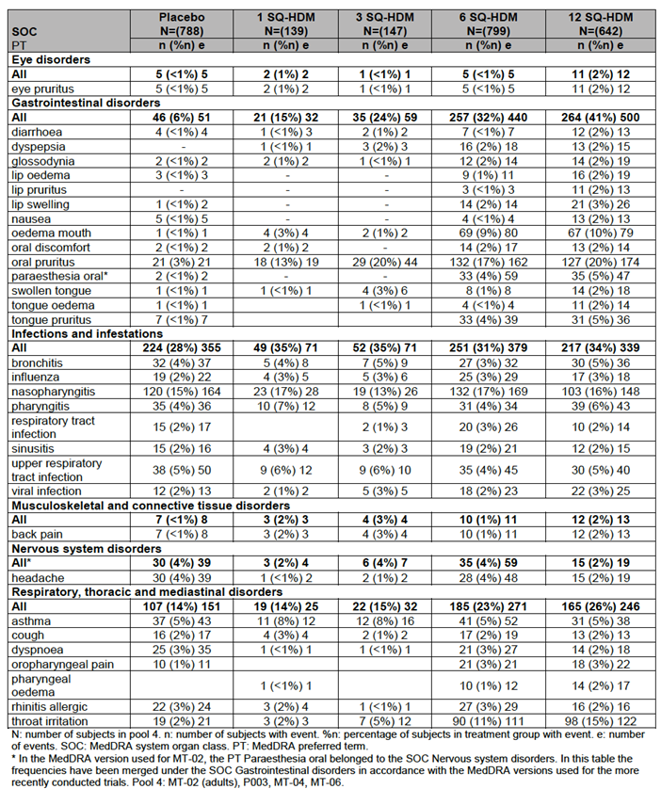

Table 12 (below) AE pivotal studies, shows combined data extracted from MT-04 and MT-06 and combines the two pivotal studies alone. It shows that the most frequent AE across all groups were in the SOC categories infectious, gastrointestinal and respiratory.

A dose dependence was seen for the following AEs: dyspepsia, ear pruritus, glossodynia, lip oedema, lip pruritus, lip swelling, nausea, oedema mouth, oral discomfort, oral pruritus, oropharyngeal pain, paraesthesia oral, pharyngeal oedema, throat irritation, tongue oedema and tongue pruritus.

Combining Phase II and III adult based studies, the most frequent AEs are displayed below in Figure 6. This summary is consistent with the frequencies of AE reported in the individual pivotal studies, which make up the majority of the events in this group of Phase II and III studies.

Figure 6: Overview of frequent AEs a graphical overview of the frequencies of the most frequent events with dose dependence as listed above is shown for placebo and the two efficacious active doses, 6 and 12 SQ-HDM

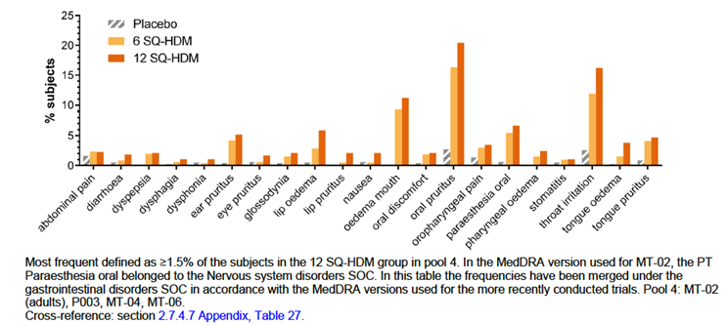

Table 12: AE pivotal studies by SOC

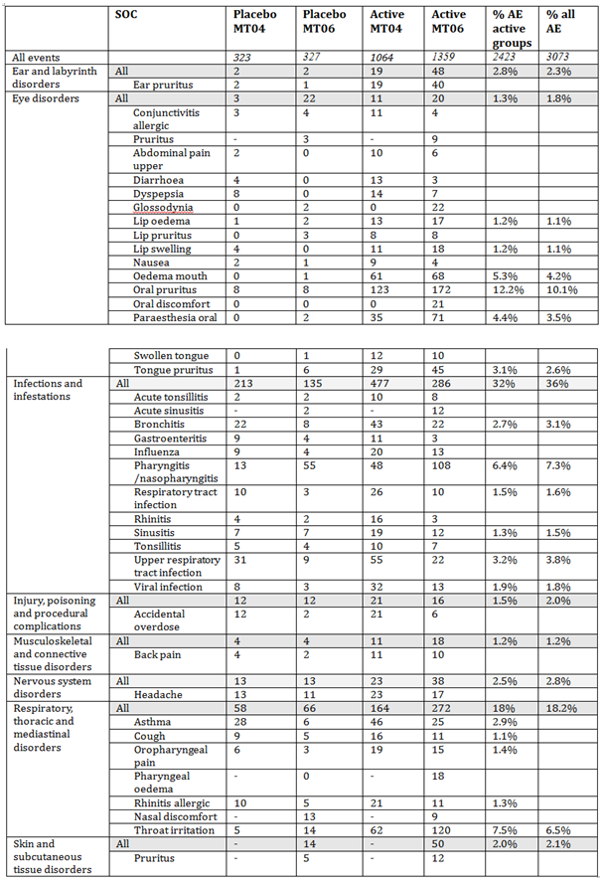

##### Other studies

###### Study MT-01

Sixty-six subjects had 1,425AEs during this study. This included a severe allergic reaction in one subject in the 32 DU group at Day 2 which led to no further doses being given to this group. In general, more AEs were reported with higher doses and almost all actively treated subjects reported AEs. 5 subjects had worsening of asthma (4 active, 1 placebo).

###### Study P003

Eighty-five percent of subjects had at least one AE during the trial. The occurrence of AEs was similar between the 12 DU and 6 DU and lower in the placebo group. The AEs reported most frequently were throat irritation, nasopharyngitis, and dyspnoea; throat irritation and nasopharyngitis each occurred at a greater frequency in the active treatment groups than in the placebo group.

###### Study TO-203

There were a total of 221 AEs reported by 26 subjects in the IMP groups and 206 AEs reported by 27 subjects in the placebo groups over 14 study days. Most were mild or moderate. The most common AEs were throat irritation, oral paraesthesia, oral oedema, oral pruritus, or oro‑pharyngeal discomfort and ear and lip pruritus. No SAEs were reported.

#### Treatment related adverse events (adverse drug reactions)

##### Pivotal studies

Table 13: Possible and probable (PP) IMP related AEs

|  |  |  |  |  |  |
| --- | --- | --- | --- | --- | --- |
|  | AE n, E | Placebo N, E, %* | 6 SQ-HDM  n, E, %* | 12 SQ-HDM n, E, %* | Severe AE n |
| MT-04 (834) | 285, 667 | 48/69/14% | 107/247/33% | 130/351/42% | 5 |
| MT-06 (992) | 378/954 | 50/96/15% | 161/401/48% | 167/457/53% | 9[12] |

*- % of participants in that group reporting possible or probable IMP related AE E = events

Most of the AEs reported in the active groups for the pivotal study MT-06 were assessed as IMP related with 59% and 67% of the AEs assessed as possible related to the treatment in the 6 DU and 12 DU groups, and 29% in the placebo group. In contrast, the majority of the AEs reported in MT-04 were assessed as unlikely to be related to IMP, with 33%, 42% and 14% of events assessed a possibly related to 6 D, 12 DU and placebo groups respectively.

**Comment:** This may reflect more vigilant non-IMP AE collection practices between the different centres involved in the asthma, compared with AR study, or it may reflect true differences between AE reported across those two different populations, however there is a significant clinical overlap between the asthma and AR study populations, and they are relatively similar in terms of baseline demographics.

Of all subjects across the 4 Phase II/III studies, 51%, 44% and 15% of participants exposed to 12 DU, 6 DU or placebo HDM-tab, respectively, had at least one IMP related AE reported. There was evidence of a dose effect in both pivotal studies, with subjects in the placebo group reporting fewer IMP related AEs, compared with the 6 DU group, and fewer in this group than in the 12 DU groups.

The majority of AEs were mild (71 to 85% of events) or moderate (14 to 25% of events) in severity. There were more AEs considered severe in the 12 SQ-HDM group than in 6 SQ-HDM or placebo in both pivotal studies; There were a total of 10 severe IMP related AEs in MT-06 (9 assessed by investigators, one assessed as severe and added by reviewer), of which 3 were in the 6 DU group, 7 were in the 12 DU group, and none were receiving placebo. In MT-04 there were 7, 2 and 3 from the 12, 6 and placebo groups respectively. The vast majority of the IMP related AEs did not require any treatment in either pivotal study.

**Comment:** The clinical evaluator recommends that the IMP related AE’s (severe) in MT-06 should include the case of laryngeal oedema treated with adrenaline (case # [information redacted]). Dysphonia, cough and throat irritation is not a mild symptom, and not having hypoxia does not make this a mild reaction. V/Q mismatch at the level of the upper airway obstruction does not occur gradually. Clearly the treating physicians believe this to be serious enough to use adrenaline, steroids and oral antihistamine.

##### Common IMP related AEs

The most frequent IMP related AEs were reasonably consistent across the two pivotal studies, and the other two-Phase II studies. See Figure 7 and 8. They are also similar to IMP related AEs reported for sublingual immunotherapy where delivered by droplet, rather than by stabilized tablet, and for the tablet sublingual immunotherapy Grazax, which replaces the HDM allergen for grass pollen allergen (15, 16).

They are predominantly related to local effects of IMP application at the site (mouth) and throat, with oral itch, throat irritation and mouth oedema much more frequent than any other IMP related AE, and with a clear dose effect, with higher frequency of adverse events in the 12 DU compared with 6 DU or placebo groups. Figures 7 and 8 show the most frequently reported IMP related AEs in PIVOTAL studies MT-04, MT-06.

Figure 7: Study MT-04 Most frequently reported IMP-related AEs (occurring in ≥ 2% of subjects)

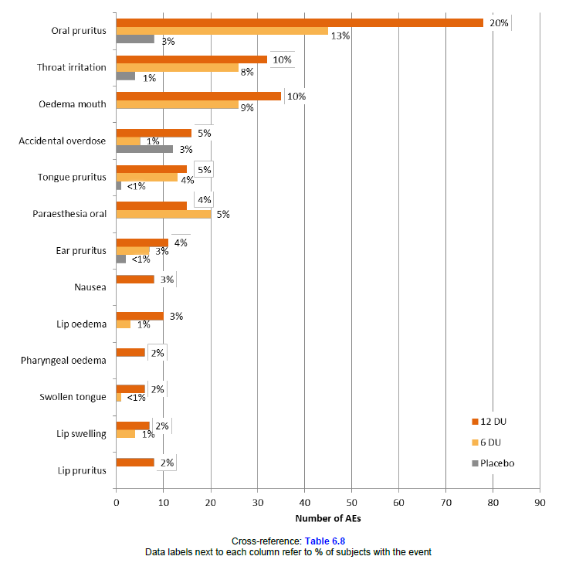

Figure 8: Study MT-06 most frequently reported AEs (≥ 2% of the subjects in any active group)

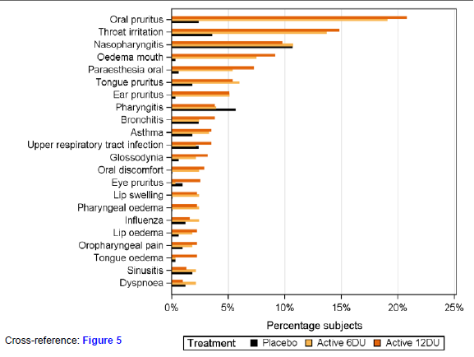

Table 14: SOC/MedDRA most common IMP related AEs from Phase II/III studies

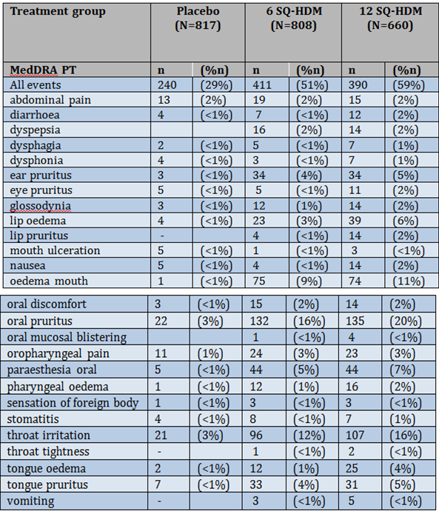

##### Overall prevalence of IMP related AEs across the 12 month treatment period

MT-06 and MT-04 reported AEs related to the application site (mouth and throat symptoms) were relatively common and constant over the first 4 weeks of daily. This tapered from Week 16 of the study in all groups, to be less than 5% in both 12 and 6 DU by study end and zero by Week 40 in the placebo group. There was a large range (5 to 95th) for many AEs listed, suggesting that onset to first symptom could occur throughout the treatment period. This is also illustrated in Figures 4 and 9 of the Summary safety report, where new onset AEs were reported right through to the last weeks of the study.

**Comment:** Overall AEs were most frequent in the first days and first month of IMP exposure, however AEs and new onset AEs did occur right throughout the study period in both pivotal studies.

##### Onset and duration of common AEs

The majority of the most frequent AEs in MT-04 started within 20 minutes following the first intake of IMP. For the 3 most common AEs, the overall median onset in minutes was 1 minute for oral pruritus, 1 minute for throat irritation, and 2 minutes for oedema mouth However, onset of the most common AEs pertinent symptoms which could require treatment , ranged from 0 to > 300 minutes.[13]

**Comment:** The longest maximum duration for tongue swelling, a potentially serious side effect was 80 minutes (mean, 28 minutes); the recommended duration for in office observation at first dose of 30 minutes in the PI. Whilst this is consistent with current recommendations for other SLIT treatment and indeed SCIT, and the current recommendations for SLIT tablet based IT, which are already registered within the EU, is not clear that this recommendation is really evidenced based. Certainly patients need to be made aware that serious AEs can occur after this period, and do not always occur on the first dose.[14]

##### Other studies

The IMP related AEs in the two Phase II studies has been discussed above. These two studies (MT-02 and P003) were similar in the reported frequency and type of AE to the two pivotal studies. The Phase I studies which involved adults also included safety assessments. They were much smaller and had much shorter duration (generally less than 6 weeks), and generally do not add any significant insights.

On the basis of a single reaction (immediate vomiting) by a participant on 32 DU on Day 2 of MT-01, it was considered that the maximum tolerable dose had been established and no further subjects in any of the subsequent studies within the dossier have been exposed to greater than 12 DU as a consequence.

There appears to be a trend to high higher reporting of IMP related AEs in the earlier Phase I studies, even from the participants receiving at lower doses than the current pivotal studies. This may be due to increased vigilance of investigators or lower thresholds for reporting AEs in safety and dose finding studies. For example; 1,235 AE were assessed as IMP related in only 71 participants over a 28 day period in MT-01. The types of AEs (oral pruritus (277 events), throat irritation (234 events), stomatitis (195 events), ear pruritus (150 events) and paraesthesia oral (103 events), mouth/tongue oedema) were very consistent with the pivotal studies, but the overall rate of AEs per participant was much higher, even at doses < 16 DU.[15]

Study protocol summaries and study discontinuation data and SAE were provided for three additional studies, being conducted in Japan (TO-203 AA and AR) and US.

**Comment:** The numbers of events of AE per study subject varies dramatically over the Phase I and II studies, which is not well explained fully by dose or study design or by subject. Assuming that the batches of HDM-tab were equivalent in allergen dosage and excipient, perhaps the collection of AEs varied according to trial site based upon the assiduousness of investigators?15

### Deaths and other serious adverse events

##### Pivotal studies

There were no deaths across the pivotal studies.

Rate of SAE were low (1 to 3% of study population) and did not appear to differ between groups.

MT-06 (AR); reported 12 SAEs, with one case of ITP assessed as possibly related to the IMP.[16]

MT-04 (asthma); reported 28 SAE’s in 11 subjects from the placebo group, 10 subjects from the 6 DU group, and 7 subjects from the 12 DU. There was 1 event of laryngeal oedema, 1 event of arthralgia in 6 DU and 1 event of asthma in 12 DU, which were possible IMP related.

There were no reports of systemic anaphylaxis requiring adrenaline; however adrenaline was required for 2 IMP related episodes of laryngeal oedema.

There was one event of erosive esophagitis in the placebo group, which raises the possibility that the excipient could be a rare trigger for esophagitis, unrelated to the HDM. Post market surveillance should keep track of this possibility.

**Comment:** No deaths were reported. This is consistent with the general published safety profile of SLIT to date. IMP related SAEs were rare and should be continued to be monitored in post marketing surveillance.

##### Other studies

In the Phase II, MT-02 study, 2 subjects were assessed as having experienced IMP related SAEs. One subject with precipitation of migraine, and one subject with persistent dizziness. There were no IMP related SAEs in Study P003.

In Phase I studies, which examined adults (MT-01 and TO-203), no SAE’s were reported.

In other Phase studies which involved children and adolescents (not the subject of this application), MT-03 and P008, no IMP related SAE’s were reported.

In ongoing studies, not provided in full in the dossier, but presented in protocol and interim safety report form TO-203 AA, AR, there have been further SAEs reported. Of these considered possibly related to IMP, there is a case of autoimmune hepatitis, and severe asthma exacerbations. This is discussed further below.

#### Discontinuation due to adverse events

##### Pivotal studies

There was a clear dose response to study discontinuation due to AE in the pivotal studies. In MT-04, 30 subjects (4%) discontinued due to 57 IMP related AEs, where 4 were from the placebo, 9 from the 6 DU and 17 from the 12 DU groups respectively. In MT-06, 30 subjects (3%) discontinued the trial due to 50 AEs, where 1, 9, and 12 subjects from placebo, 6 and 12 DU groups, respectively, discontinued due to IMP related AEs.

**Comment:** Overall, the pivotal study with subjects being treated for asthma had higher rates of SAEs and higher IMP related study discontinuations (6%) than those in MT-06(4%); where the target disease was AR, and the asthma severity of the cohort was lower than MT-06. This suggest that subjects who received the IMP for indication 1 (persistent asthma) may be more likely to suffer AEs and not complete a therapeutic course than those being prescribed the IMP for propped indication 2 (persistent AR).

##### Other studies

In the Phase II study MT-02, there were 15 withdrawals (2.5%) due to IMP related EAs, of which 14 subjects were receiving HDM-TAB and one was receiving placebo. In P003, there were no reports of discontinuation due to IMP related AEs.

Reporting of discontinuations from ongoing studies in Japan and US/Canada were provided by the sponsor. These studies are briefly summarised in Table 15.

They report a number of possible/probable IMP related study discontinuations including 3 significant episodes of anaphylaxis requiring adrenaline, one case of oesophagitis, 21 case of asthma exacerbation, 4 cases of elevated liver enzymes during treatment and 1 case of Meniere’s disease.

**Comment:** The interim reporting for study discontinuations from the Japan/US/Canada studies are concerning in the possible safety signal for Meniere’s disease (not previously reported in current studied contained in the dossier) and 16 cases of asthma exacerbation resulting in study discontinuation. However they are reasonably large studies (planned 1500, 900 and 900). They highlight the need for post marketing surveillance for these particular AEs.

Table 15: Summary of protocols - Studies P001, TO-203-AA, TO-203-AR

|  |  |  |  |  |  |  |  |
| --- | --- | --- | --- | --- | --- | --- | --- |
| Study ID  Phase | Design | Planned no. | Age (yrs) | Subjects | Dose | Duration | Primary efficacy endpoint |
| POO1  Phase III | randomized, double-blind, placebo controlled, multicentre | 1500 | >12 years | HDM-AR/ Rhinoconjunctivitis | Placebo  12 SQ-HDM | 52 weeks | mean TCRS in the final 8 weeks of study |
| TO-203 AA  Phase II/III | randomized, multicentre, placebo-controlled, double-blind, and intergroup comparison | 900 | 18-65 | HDM-asthma with  fluticasone  requirement 200-400ug/day | Placebo,  2, 6 12 DU | 19 months | Time to first moderate or severe worsening of asthma in the ICS dose-tapering period. |
| TO-203 AR  Phase II/III | randomized, multicentre, placebo-controlled, double-blind, intergroup comparison | 900 | 12-65 | Moderate-severe persistent HDM-AR | Placebo,  2, 6 12 DU | 52 weeks | mean TCRS in the final 8 weeks of study |

### Laboratory tests

#### Liver function

##### Pivotal studies

Neither pivotal study MT-06 (AR), nor MT-06 (asthma) reported LFT abnormalities above that of the baseline placebo rate over the 12 month study in either 12 or 6 DU group.

##### Other studies

No Phase I or II studies provided by the sponsor reported any significant LFT abnormalities.

In contrast, the study for which only discontinuation data is available; P001, TO-203 AA, TO‑203-AR, reported 4 study IMP related discontinuations due to elevated liver enzymes during treatment.

**Comment:** Liver function abnormalities should be monitored in post marketing surveillance. There is currently no recommendation to actively review any laboratory parameter during treatment.[17]

#### Kidney function

##### Pivotal studies

Neither pivotal study MT-06 (AR) nor MT-06 (asthma) reported elevation in creatinine or urine analysis abnormalities above that of the baseline placebo rate at 12 month study end point in either 12 or 6 DU group.

##### Other studies

No Phase I or II studies provided by the sponsor reported any significant abnormalities in kidney function during the studies.

#### Other clinical chemistry

##### Pivotal studies

Neither pivotal study MT-06 (AR), nor MT-06 (asthma) reported serum chemistry abnormalities above that of the placebo rate at 12 month end point of study in either 12 or 6 DU group.

##### Other studies

No Phase I or II studies provided by the sponsor reported any significant serum chemistry abnormalities.

#### Haematology

##### Pivotal studies

There were minor changes reported in MT-06 (AR), where 10 subjects had low WCC at study endpoint in treatment groups and only 2 in placebo group. One report of ITP from a subject in MT-06 was also made. No similar haematological findings were reported from MT-04.

##### Other studies

No Phase I or II studies provided by the sponsor reported any significant haematological changes.

#### Electrocardiograph

##### Pivotal studies

Neither pivotal study MT-06 (AR), nor MT-06 (asthma) reported any ECG changes during the studies.

##### Other studies

There was one report of a participant in the Phase II study MT-02, receiving the 3 DU HDM-tab having an abnormal ECG. It is unclear whether this was treatment related, but seems an isolated report.

#### Vital signs

##### Pivotal studies

No vital sign changes in those individuals not suffering from AEs (which might cause transient increases in HR and BP) were reported.

##### Other studies

No vital sign changes in those individuals not suffering from AEs (which might cause transient increases in HR and BP) were reported.

#### Asthma exacerbations related to IMP

##### Pivotal studies

Asthma exacerbations related to IMP were an AE of special interest in both pivotal studies. Given that many of the participants had asthma of varying degrees in both pivotal studies, it is difficult to always attribute IMP administration to asthma exacerbations in this group. The severity and degree control of asthma was different between the two pivotal studies, with the asthma study (MT-04) having subjects at higher risk of asthma exacerbation on the basis of higher disease acuity.

Overall, in MT-04; 38 subjects (14%) in placebo, 33 subjects (12%) in 6 DU and 28 subjects (10%) in 12 DU groups reported AEs that could be considered related to asthma. The majority of these events were considered unlikely to be related to the IMP. The numbers of IMP related ‘asthma/respiratory AEs’ were similar between groups (5 subjects, 6 events in placebo; 7 subjects, 7 events in 6 DU; and 5 subjects, 5 events in 12 DU). In MT-04 there were two study discontinuations due to severe asthma exacerbations considered likely to be related to IMP.

In MT-06 analysis of those individuals who had FEV1 < 70% at any point during the study, or who satisfied the GINA criteria for uncontrolled asthma were assessed for evidence of increased risk of asthma exacerbations compared with the reminder of the cohort. There was no difference reported, however the uncontrolled asthma cohort only comprised of 232 subjects, and there may have been inadequate power to detect a difference.

**Comment:** There is likely to be a small risk of asthma exacerbation related to IMP, based upon the two study discontinuations reported in MT-04. It must be noted that entry into the pivotal studies required an FEV1 > 70% and no severe exacerbations within 3 months, and so for those patients, no safety data can be extracted from these pivotal studies, and they remain a population with missing data. Thus it is consistent with the proposed PI that IMP is contraindicated in subjects with severe asthma exacerbations within the past 3 months or with current FEV1 < 70%.

##### Other studies

Neither of the Phase II studies reported a difference in asthma exacerbation rate between those participants receiving placebo and IMP.

#### Eosinophilic oesophagitis (EoE)

##### Pivotal studies

Onset of EoE during MT-06 was observed in one participant receiving IMP. This did not result in study discontinuation; however the subject continued to have evidence of EoE and was considered not resolved at end of study. Development of EoE on a SLIT study would normally be an indication for discontinuation. It is impossible to assess the true incidence of EoE as an AE and SAE in these studies presented, as it was not specified as an AE of special interest, and there is no easy biomarker for onset or presence of EoE. Moreover, EoE may be asymptomatic, particularly in pre stricture stages. The reports of dysphagia (around 1% of IMP related AE’s in the Phase II and II studies), particularly the prolonged episodes, may reflect undiagnosed EoE.

Moreover EoE was also as a reason for study discontinuation in the ongoing Japanese studies, and has been reported with Grazax.[18]

Moreover EoE was also as a reason for study discontinuation in the ongoing Japanese studies, and has been reported with Grazax.

**Comment:** The sponsor may have underestimated the importance of the IMP as a trigger for onset or exacerbation of EoE. Both are documented in the literature, and a recognized uncommon class effect of SLIT. The sponsor contends that EoE is due solely to food allergy, however reports of EoE primarily related to aeroallergens, and EoE with combined food and aeroallergen triggers are published. As this was neither a targeted AE of special interest, nor a group of special interest- I believe that this is an area of missing data. It is not possible to propose HDM-SLIT tablet can be safely administered to subjects with known EoE, as no safety data for this population has been provided.[19]

### Post-marketing experience

NA

### Safety issues with the potential for major regulatory impact

#### Liver toxicity

No cases of severe liver toxicity were reported during the Phase I,II or III studies, however there were 4 study IMP related discontinuations due to elevated liver enzymes during treatment from the ongoing studies for which only SAEs and study discontinuations were provided (P001, TO‑203 AA, TO-203-AR).

#### Haematological toxicity

One case of ITP was reported. It is unclear if this was IMP related, as it is difficult to mechanistically understand how this might have occurred. No cases of other forms of severe bone marrow suppression were reported.

#### Serious skin reactions

No cases of serious skin reactions were reported.

#### Cardiovascular safety

One abnormality in an ECG was reported.

#### Unwanted immunological events

A class effect of immunotherapy is a risk of systemic allergic reactions/anaphylaxis to the product. There were no cases of death from anaphylaxis. Severe allergic reactions requiring adrenaline were rare, but did occur.

### Other safety issues

#### Safety in special populations

No specific risk identified in any population, including those with < FEV1 and moderate asthma. Any effect of ethnicity was not able to be determined as the studies were overwhelmingly Caucasian population based.

#### Safety related to drug-drug interactions and other interactions

A past history of cardiorespiratory allergic reactions to any allergen was an exclusion to study entry in the pivotal studies, so it is unclear whether this poses a special risk? Likewise patients on medications which might interfere with efficacy markers or response to adrenaline were excluded in the pivotal studies, but not CI in the PI, so safety in these populations is not clear.

#### Longer term safety

Courses of IT for aeroallergen desensitisation are generally recommended to be of 3 or more years duration. The recommended duration of this IMP is not clear, but is assumed to be of this duration. Although there are no specific concerns about safety beyond the first year of therapy for this IMP the current dossier does not provide any information on which to make any recommendations on longer-term safety of this IMP beyond 12 to 14 months.

### Evaluator’s overall conclusions on clinical safety

AEs related to IMP were common. The overall rate of subjects experiencing AEs was dose-dependent, with highest rates of AEs and highest rates of study discontinuation related to the 12 DU/SQ dose. Rates of SAEs were low, and did not appear to be dose related. Most AEs recovered without any treatment. IMP did not appear to significantly contribute to overall rates of asthma exacerbations, although a few cases of severe asthma exacerbation did appear IMP related. Adrenaline was required to treat one IMP related AEs in the pivotal studies and a further 3 cases outlined in the ongoing studies. In additional study discontinuation reports from these ongoing studies does provide some worrying safety signals for a possible association with Meniere’s disease, with 10 cases reported and 7 cases of study discontinuation due to elevated liver enzymes. One case of EoE was reported from the pivotal studies and a further case from the ongoing studies.

## First round benefit-risk assessment

### First round assessment of benefits

The benefits of Acarizax in the proposed usage are:

* Reduced risk of moderate to severe asthma exacerbation after at least 7 months of daily IMP by 31%. Based upon an absolute risk reduction of moderate to severe exacerbation from 30% in placebo to 21% in 12 DU group, this equates to NNT = 11.1
* At least a 1.09 reduction in overall symptom and medication score for AR from 14 weeks of therapy.
* A 50% reduction in the risk of having an allergic rhinitis exacerbation and twice the probability of having days without more than minimal awareness of AR symptoms.

### First round assessment of risks

The risks of Acarizax in the proposed usage of 12 SQ daily are:

* There were 42% and 52% of participants in the two pivotal studies with possible or probable IMP related AEs, compared with 14% and 15% in the placebo group’s respectively. On an event basis, the number needed to harm (NNH) overall for an AE was 2.5.
* The majority of these AEs were mild to moderate and self-resolving and related to local AEs at the site of IMP application (mouth and throat).
* The risk of SAEs was low and no deaths were reported.

### First round assessment of benefit-risk balance

The benefit-risk balance of Acarizax, given the proposed usage, is favourable.

## First round recommendation regarding authorisation

The recommendation is to approve the submission subject to changes to the PI and CMI and specific post marketing surveillance requirements.

## Clinical questions

### Safety

1. Given the high rate of mild to moderate IMP related AEs, especially local AEs, and rates of study discontinuation related to these AEs, it would be useful to understand why no dose escalation regime was trailed in the presented Phase II and III studies in the dossier. It appears that both ongoing TO-203 AR and AA studies include dose escalation arms, presumably for the aim of reducing early local AEs, and improving overall IMP tolerability.
2. The safety signals appearing from the ongoing TO-203 AR and AA and the P-001 study discontinuations which are considered possibly IMP related are Meniere’s disease and liver function abnormalities. These are somewhat concerning, and differ from the result presented for the Phase II and III studies which comprise this dossier. What are the plans for interrogating these possible safety concerns?

## Second round evaluation of clinical data submitted in response to questions

No additional clinical data has been submitted by the sponsor in response to questions.

Response to questions and comments (items) are listed below.

### Question 1

*Given the high rate of mild to moderate IMP related AEs, especially local AEs, and rates of study discontinuation related to these AEs, it would be useful to understand why no dose escalation regime was trailed in the presented Phase II and III studies in the dossier. It appears that both ongoing TO- 203 AR and AA studies include dose escalation arms, presumably for the aim of reducing early local AEs, and improving overall IMP tolerability.*

***Sponsor response:***

The safety profile of a dose escalation regimen as compared to treatment with fixed doses of the HDM SLIT-tablet was investigated in TO-203-1-1, a randomised, multiple dose, dose escalation, double blind, placebo controlled Phase I safety trial performed in Japan. The trial evaluated 3 active doses (3, 6, and 12 SQ-HDM) and 1 dose escalation regimen (3 → 6 → 12 SQ-HDM); as presented in Table 16. Forty-eight adult male subjects with HDM induced asthma with or without rhinitis were randomised (3:1) to active or placebo. The treatment period was 14 days and all subjects completed the trial.

Table 16: Dose escalation regimen

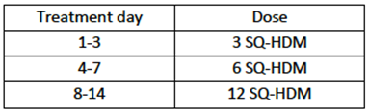

Treatment related AEs were observed in 17%, 56%, 89%, 67%, and 89% of subjects receiving placebo, 3, 6, 12 SQ-HDM, and the dose escalation regimen, respectively. The incidence rate of adverse events in the fixed dose groups did not appear to be dose related and no significant differences between the incidence rates in the fixed dose groups and the dose escalation group were observed. Furthermore, there was no pattern in the onset time of treatment-related AEs and no difference in the onset time between the fixed dose groups and the dose escalation group.

With the exception of Japan, given that no significant differences between the fixed doses and the dose escalation regimen were observed, dose escalation regimens were not trialled in further studies. In Japan, the decision to include dose escalation regimens in both Phase III trials (TO-203- AA and TO-203-AR) was based on local traditions rather than any documented improvement in safety profile provided by a dose escalation regimen.

***Evaluation of response:***

In Australia to majority of SLIT is currently delivered via liquid drops and via escalation of doses, with an up-dosing regimen, therefore the justification about local traditions in Japan would equally apply to current Australian practice regarding SLIT. There is currently only one single dose SLIT tablet on the market in Australia, which is not widely used in many regions, as its allergen composition is not suitable for many patients, given its northern hemisphere grass composition. In addition the single dose liquid SLIT formulation was withdrawn from the market in Australia, and is not in current use in the region, although it is unclear to the reviewer as to the reasons for this.

The TO-203-1-1 study escalated doses every 3 days, and it would be not expected that such a short duration between up-dosing would have any significant effect on local EAs and tolerability, which is indeed what they demonstrated. This is not convincing evidence that a more appropriate up-dosing schedule, with weekly to two weekly up-dosing would have not improved tolerability and therefore compliance.

### Question 2

*The safety signals appearing from the ongoing TO-203 AR and AA and the P-001 study discontinuations which are considered possibly IMP related are Meniere’s disease and liver function abnormalities. These are somewhat concerning, and differ from the result presented for the Phase II and III studies which comprise this dossier. What are the plans for interrogating these possible safety concerns?*

***Sponsor response:***

*Meniere's disease*

Cumulatively, only one event of Meniere's disease has been reported in clinical trials investigating the HDM SLIT-tablet. The event was reported in a subject enrolled in the TO‑203 AA trial. A list of AEs leading to discontinuation in ongoing trials was provided in documentation of the registration application. In the lists from the TO-203 AR and AA trials included, detailed information on all types of AE treatment was provided. One line was subsequently included per AE treatment in the list displaying AEs leading to discontinuation, meaning that several lines were included for the same event in subjects treated with several medications (for example case # [information redacted] representing the single case of Meniere’s disease is presented as 10 lines; one line per treatment given). This may have led to misinterpretation that several events of Meniere's disease were reported in the trial.

Further details regarding the single event of Meniere's disease reported cumulatively are provided in Table 17 below.

Table 17: Events of Meniere’s disease leading to discontinuation in TO-203 AA

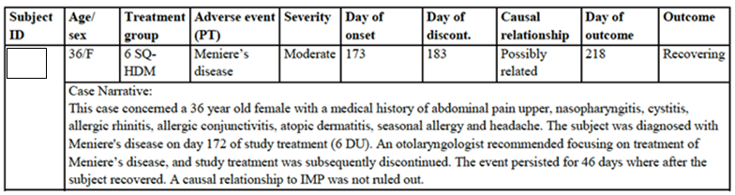

ALK Abelló (ALK) evaluates that the single case of Meniere's disease reported in relation to treatment with the HDM SLIT-tablet does not represent a safety signal. Should additional events be reported in clinical trials or post-marketing, these will be evaluated as part of the ongoing signal detection and management activities. If signals are identified, these will be described in Periodic Safety Update Reports (PSURs) and actioned accordingly.

In conclusion, Meniere's disease is not considered a safety concern for the HDM SLIT-tablet, and no additional pharmacovigilance or risk mitigation activities are deemed relevant for this type of event.

*Liver function abnormalities*

A total of 4 cases concerning liver function abnormalities leading to trial discontinuation were reported in TO-203 AR, TO-203 AA and the P001 trials. All cases were reported in the TO‑203 AA trial. Further details regarding the events reported are provided in Table 18 below. Of the 4 cases reported, 2 were reported in subjects treated with placebo, and 2 were reported in subjects treated with active treatment (6 and 12 SQ-HDM respectively) (Table 18). Importantly, all events reported in subjects treated with active treatment were assessed as not related to investigational medicinal product (IMP) by the investigators.

Table 18: Events of liver function abnormalities leading to discontinuation in TO-203-AA

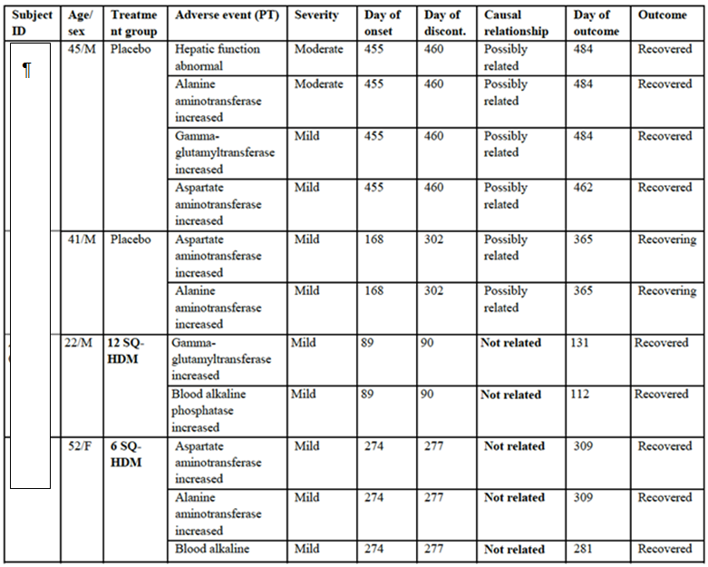

***Evaluation of response:***

Regarding Meniere’s disease, the assessor accepts that there is confusing presentation of EAs and that representing the single case of Meniere’s disease is presented as 10 lines. The sponsors have clarified that this represents a single case, and have provided a more detailed description of that case. The assessor is satisfied that one case does not represent a safety signal, and that the sponsors have identified an appropriate mechanism if further cases are reported either in ongoing trials or post marketing.

Regarding liver function abnormalities, the assessor has re-reviewed the SAEs and discontinuation data provided by the sponsor. The presentation of the data is somewhat confusing. It appears that at least 3 subjects on active treatment from the one study T-203-3-1 had SAE and or study discontinuation related to liver dysfunction, with an equal number of SAEs/study discontinuations in the subjects receiving placebo. This appears to add up to 6 cases.

It appears to the evaluator that 3 subjects with SAEs related to liver function are identified in the first section; “SAEs; being subjects from TO-203-3-1- study numbers [information redacted] (on 12 DU), [information redacted] (Treatment allocation? active) and [information redacted] (treatment allocation? placebo). There is no narrative paragraph, which further describes these subjects in details, and whether an alternative cause was found for their liver dysfunction. There is no justification for why the site investigators deemed these discontinuations and SAEs not related to the intervention? Moreover, these do not appear to completely align with the 4 subjects the sponsors identified above in Table 18. Further patients are identified as having liver dysfunction in the same document in the section entitled; discontinuations TO-203-3-1. These are subjects [information redacted] (receiving placebo), [information redacted] (receiving placebo) and [information redacted] (receiving 6 DU), as identified in the table above. This appears to add up to 6 cases (not 7 as originally suggested), of which it is not completely clear to the assessor whether the two other subjects listed as discontinuing study due to liver dysfunction subjects-[information redacted] and [information redacted] were receiving placebo or active treatment? It appears that at least one of these subjects ([information redacted]) was receiving active treatment. It is unclear as to how the cases of liver function abnormalities in subjects on active treatment were assessed as unrelated to treatment. Was another cause for the liver dysfunction found by the investigators? The data provided by the sponsor does not detail any suggested alternative aetiology?

Overall, given the lack of clarity around the data from the ongoing studies including how many were receiving placebo and what the underlying cause of the liver dysfunction was, it is hard to completely dismiss this as a possible safety signal, without further clarification of these cases- even though the other study sites did not identify issues with liver dysfunction and as the sponsor points out, this has not appeared to be an issue for other SLIT trials. On balance, taking into account known biological plausibility, it is an unlikely safety signal- but more convincing data on the identified case would be helpful.

## Second round benefit-risk assessment

### Second round assessment of benefits

The second round benefit risk assessment is not significantly altered from the first round.

* The overall benefits of Acarizax in the proposed usage at 12 DU daily are:
* Reduced risk of moderate –severe asthma exacerbation after at least 7 months of daily IMP by 31%. Based upon an absolute risk reduction of moderate to severe exacerbation from 30% in placebo to 21% in 12 DU group, this equates to NNT = 11.1
* At least a 1.09 reduction in overall symptom and medication score for AR from -14 weeks of therapy.
* A 50% reduction in the risk of having an allergic rhinitis exacerbation and twice the probability of having days without more than minimal awareness of AR symptoms.

### Second round assessment of risks

The second round benefit risk assessment is not significantly altered from the first round. Clarification of the safety signal for Meniere’s disease [20]and inclusion by the sponsor of some precautions around the use and surveillance for emerging EoE with the SLIT-HDM tablet use makes the overall risk lower than the first round assessment.

Overall the risks of Acarizax in the proposed usage of 12 SQ daily are:

* There were 42% and 52% of participants in the two pivotal studies with possible or probable IMP related AEs, compared with 14 and 15% in the placebo group’s respectively. On an event basis, the number needed to harm (NNH) overall for an AE was 2.5.
* The majority of these AEs were mild to moderate and self-resolving and related to local AEs at the site of IMP application (mouth and throat).
* The risk of SAEs was low and no deaths were reported.

### Second round assessment of benefit-risk balance

The overall risk benefit analysis for Acarizax, given the proposed usage, is favourable.

## Second round recommendation regarding authorisation

The recommendation is to approve the submission subject to the additional changes to PI and CMI as outlined below and clarification of whether any safety signal exists for liver dysfunction and use of Acarizax, which would require additional monitoring or specification in the RMP.[21]

## References

1. Reddel HK, Bateman ED, Becker A, Boulet LP, Cruz AA, Drazen JM, et al. A summary of the new GINA strategy: a roadmap to asthma control. Eur Respir J. 2015;46(3):622 to 39. doi: 10.1183/13993003.00853-2015. Epub 2015 Jul 23.
2. Reddel HK, Taylor DR, Bateman ED, Boulet LP, Boushey HA, Busse WW, et al. An official American Thoracic Society/European Respiratory Society statement: asthma control and exacerbations: standardizing endpoints for clinical asthma trials and clinical practice. Am J Respir Crit Care Med. 2009;180(1):59-99. doi: 10.1164/rccm.200801-060ST.
3. Australia NACo. Australian Asthma Handbook 2015. Available from: http://www.nationalasthma.org.au/handbook
4. Welfare. AIoHa. Allergic rhinitis (‘hay fever’) in Australia. In: AIHW;, editor. Canberra:2011.
5. Monitoring. ACfA. Asthma in Australia 2011: with a focus chapter on chronic obstructive pulmonary disease. In: AIHW;, editor. AIHW Asthma Series Canberra: 2011.
6. Fahy JV. Type 2 inflammation in asthma--present in most, absent in many. Nat Rev Immunol. 2015;15(1):57-65. doi: 10.1038/nri3786.
7. Wheatley LM, Togias A. Clinical practice. Allergic rhinitis. N Engl J Med. 2015;372(5):456-63. doi: 10.1056/NEJMcp1412282.
8. Compalati E, Passalacqua G, Bonini M, Canonica GW. The efficacy of sublingual immunotherapy for house dust mites respiratory allergy: results of a GA2LEN meta-analysis. Allergy. 2009;64(11):1570-9. doi: 10.111/j.398-9995.2009.02129.x. Epub 2009 Sep 30.
9. Wilson DR, Torres LI, Durham SR. Sublingual immunotherapy for allergic rhinitis. Cochrane Database Syst Rev. 2003(2):CD002893.
10. Tao L, Shi B, Shi G, Wan H. Efficacy of sublingual immunotherapy for allergic asthma: retrospective meta-analysis of randomized, double blind and placebo controlled trials. Clin Respir J. 2014;8(2):192-205. doi: 10.1111/crj.12058. Epub 2014 Mar 5.
11. Normansell R, Kew KM, Bridgman AL. Sublingual immunotherapy for asthma. Cochrane Database Syst Rev. 2015;8:CD011293.(doi):10.1002/14651858.CD011293.pub2
12. Moingeon P. Update on immune mechanisms associated with sublingual immunotherapy: practical implications for the clinician. J Allergy Clin Immunol Pract. 2013;1(3):228-41. doi: 10.1016/j.jaip.2013.03.013. Epub Apr 29.
13. Bousquet J, Khaltaev N, Cruz AA, Denburg J, Fokkens WJ, Togias A, et al. Allergic Rhinitis and its Impact on Asthma (ARIA) 2008 update (in collaboration with the World Health Organization, GA(2)LEN and AllerGen). Allergy. 2008;63(Suppl 86):8-160. doi: 10.1111/j.398-9995.2007.01620.x.
14. Juniper EF, Riis B, Juniper BA. Development and validation of an electronic version of the Rhinoconjunctivitis Quality of Life Questionnaire. Allergy. 2007;62(9):1091-3. Epub 2007 May 22.
15. Aasbjerg K, Dalhoff KP, Backer V. Adverse Events During Immunotherapy Against Grass Pollen-Induced Allergic Rhinitis - Differences Between Subcutaneous and Sublingual Treatment. Basic Clin Pharmacol Toxicol. 2015;117(2):73-84. doi: 10.1111/bcpt.12416. Epub 2015 Jun 3.
16. Armentia A, Carballada F, Carretero P, de Paz S, Lobera T, Marcos C, et al. Postmarketing study for assessment of tolerability of a grass allergen immunotherapy tablet (GRAZAX) in patients with rhinitis or rhinoconjunctivitis. J Investig Allergol Clin Immunol. 2012;22(7):485-90.
17. Bagnasco M, Passalacqua G, Villa G, Augeri C, Flamigni G, Borini E, et al. Pharmacokinetics of an allergen and a monomeric allergoid for oromucosal immunotherapy in allergic volunteers. Clin Exp Allergy. 2001;31(1):54-60.
18. Passalacqua G, Altrinetti V, Mariani G, Falagiani P, Mistrello G, Brizzolara R, et al. Pharmacokinetics of radiolabelled Par j 1 administered intranasally to allergic and healthy subjects. Clin Exp Allergy. 2005;35(7):880-3.
19. Bagnasco M, Mariani G, Passalacqua G, Motta C, Bartolomei M, Falagiani P, et al. Absorption and distribution kinetics of the major Parietaria judaica allergen (Par j 1) administered by noninjectable routes in healthy human beings. J Allergy Clin Immunol. 1997;100(1):122-9.
20. Allergy ASoCIa. ASCIA- action plan for anaphylaxis 2015 [cited 2015 25.10.15]. Available from: http://www.allergy.org.au/health-professionals/anaphylaxis-resources/ascia-action-plan-for-anaphylaxis.

|  |
| --- |
| Therapeutic Goods Administration |
| PO Box 100 Woden ACT 2606 Australia  Email: [info@tga.gov.au](mailto:info@tga.gov.au) Phone: 1800 020 653 Fax: 02 6232 8605  [**https://www.tga.gov.au**](https://www.tga.gov.au) |

1. Canonica G W et al A survey of the burden of allergic rhinitis in Europe. *Allergy* 2007; 62: 17-25
2. Chivato T et al Allergy, Living and Learning: Diagnosis and Treatment of Allergic Respiratory Diseases in *Europe J Investig Allergol Clin Immunol* 2012; 22: 168-179.
3. Ibero M et al. Diagnosis and treatment of allergic rhinitis in children: Results of the PETRA study. *Allergol Immunopathol (Madr)*. 2012; 40: 138-143
4. Partridge M R et al. Attitudes and actions of asthma patients on regular maintenance therapy: the INSPIRE study*. BMC Pulmonary Medicine* 2006; 6: 13
5. Bousquet J et al. Severity and impairment of allergic rhinitis in patients consulting in primary care *J Allergy Clin Immunol* 2006; 117: 158-162.
6. Downie S. R. et al. Association between nasal and bronchial symptoms in subjects with persistent allergic rhinitis*. Allergy* 2004: 59: 320-326.
7. Bousquet J et al. Allergic Rhinitis and its Impact on Asthma (ARIA) 2008 Update (in collaboration with the World Health Organization, GA2LEN* and AllerGen**). *Allergy* 2008; 63: 8–160.
8. Upon consideration of the evaluator’s comments, the PI was amended
9. CHMP/EWP/18504/2006 (20 November 2008) Guideline on the clinical development of products for specific immunotherapy for the treatment of allergic diseases.
10. all investigators were required to have experience in treatment of allergies, and all participants were required to fulfil the same inclusion criteria within each trial.
11. Clarification: AEs were defined based on potential class effect of SLIT products when the pivotal trials were designed and conducted.
12. The number reported in the clinical trial report is 8 however the evaluator considered that there was an additional Severe AE (as stated in Table 11 above)
13. Clarification; no AEs in study MT-04 required treatment with adrenaline.
14. Clarification; based on the evaluator’s comments, the sponsor amended the PI to address the query
15. Clarification: The differences in numbers of AEs per trial participant between phase I and phase II, are due to differences in the collection of AEs recurring on consecutive days. In the phase I trials, recurring events were reported as one AE each day of reoccurrence, while in the phase II/III trials recurring AEs were reported as one adverse event with recurrence/duration as the number of days to resolution.
16. Clarification: MT-06 (AR); reported 12 SAEs in the trial, 8 subjects from the placebo group and 4 subjects from the 6 SQ-HDM group. No SAEs were reported in the 12 SQ-HDM group. All SAE’s were assessed as unlikely related to the treatment.
17. Clarification; Post ACPM the Delegate was satisfied that liver function abnormalities were not of concern.
18. Correction: text should read ‘Moreover EoE has been reported with Grazax’
19. This has been addressed by including EoE as a potential safety concern in the RMP and including a precautionary statement within the PI.
20. Clarification; the second round clinical evaluator accepts the single case of Meniere’s disease does not represent a safety signal
21. Information was provided as a part of the sponsor’s post ACPM response which satisfied the Delegate that the 3 cases of liver abnormalities were not a safety signal.