|  |
| --- |
| **Date of CER: 19 June 2012** |

|  |
| --- |
| AusPAR Attachment 2 |
| Extract from the Clinical Evaluation Report for Amino acids, Lipids and Glucose, with and without Electrolytes |
| Proprietary Product Name: PeriOlimel N4-600E, Olimel N5-860E, Olimel N7-960, Olimel N7-960E, Olimel N9-840, Olimel N9‑840E |
| Sponsor: Baxter Healthcare Pty Ltd |

About the Therapeutic Goods Administration (TGA)

* The Therapeutic Goods Administration (TGA) is part of the Australian Government Department of Health, and is responsible for regulating medicines and medical devices.
* The TGA administers the *Therapeutic Goods Act 1989* (the Act), applying a risk management approach designed to ensure therapeutic goods supplied in Australia meet acceptable standards of quality, safety and efficacy (performance), when necessary.
* The work of the TGA is based on applying scientific and clinical expertise to decision-making, to ensure that the benefits to consumers outweigh any risks associated with the use of medicines and medical devices.
* The TGA relies on the public, healthcare professionals and industry to report problems with medicines or medical devices. TGA investigates reports received by it to determine any necessary regulatory action.
* To report a problem with a medicine or medical device, please see the information on the TGA website <<http://www.tga.gov.au>>.

About the Extract from the Clinical Evaluation Report

* This document provides a more detailed evaluation of the clinical findings, extracted from the Clinical Evaluation Report (CER) prepared by the TGA. This extract does not include sections from the CER regarding product documentation or post market activities.
* The words [Information redacted], where they appear in this document, indicate that confidential information has been deleted.
* For the most recent Product Information (PI), please refer to the TGA website <<http://www.tga.gov.au/hp/information-medicines-pi.htm>>.

Copyright

© Commonwealth of Australia 2013  
This work is copyright. You may reproduce the whole or part of this work in unaltered form for your own personal use or, if you are part of an organisation, for internal use within your organisation, but only if you or your organisation do not use the reproduction for any commercial purpose and retain this copyright notice and all disclaimer notices as part of that reproduction. Apart from rights to use as permitted by the *Copyright Act 1968* or allowed by this copyright notice, all other rights are reserved and you are not allowed to reproduce the whole or any part of this work in any way (electronic or otherwise) without first being given specific written permission from the Commonwealth to do so. Requests and inquiries concerning reproduction and rights are to be sent to the TGA Copyright Officer, Therapeutic Goods Administration, PO Box 100, Woden ACT 2606 or emailed to <[tga.copyright@tga.gov.au](mailto:tga.copyright@tga.gov.au)>.

Contents

List of abbreviations 4

1.1. Definitions and terminology 4

2. Introduction 6

3. Clinical rationale 6

3.1. Formulation 6

4. Contents of the clinical dossier 6

4.1. Scope of the clinical dossier 6

4.2. Paediatric data 8

4.3. Good clinical practice 8

5. Pharmacokinetics 9

5.1. Evaluator’s overall conclusions on pharmacokinetics 9

6. Pharmacodynamics 9

7. Dosage selection for the pivotal studies 9

8. Clinical efficacy 9

8.1. Efficacy as the combined product 10

8.2. Efficacy of individual components 15

8.3. Evaluator’s conclusions on clinical efficacy 19

9. Clinical safety 19

9.1. Combined product - study ICS1063B/P01/03/Mu.F 19

9.2. Safety of individual components 23

9.3. Post-marketing experience 24

9.4. Evaluator’s overall conclusions on clinical safety 26

10. First round benefit-risk assessment 27

10.1. First round assessment of benefits 27

10.2. First round assessment of risks 28

10.3. First round assessment of benefit-risk balance 28

11. First round recommendation regarding authorisation 28

12. Clinical questions 28

## List of abbreviations

| Abbreviation | Meaning |
| --- | --- |
| AE / SAE | Adverse Event / Serious Adverse Event |
| ALAT / ASAT | ALanine Amino Transferase / Aspartate Amino Transferase |
| BMI | Body Mass Index |
| bpm | beat per minute |
| BUN | Blood Urea Nitrogen |
| °C | Degree Celsius |
| CRF | Case Report Form |
| CDDS | Company Core Data Sheet |
| D 0 (Baseline) | Day on which the first infusion starts |
| D+4 | Day on which the 5th infusion starts |
| D+5 | Day on which the last infusion ends |
| DBP | Diastolic Blood Pressure |
| EC | Ethics Committee |
| EFA | Essential Fatty Acids |
| GCP | Good Clinical Practices |
| GGT | Gamma Glutamyl Transferase |
| GLM | General Linear Model |
| ICH | International Conference of Harmonisation |
| ICU | Intensive Care Unit |
| IEC/IRB | Independent Ethics Committee / Investigational Review Board |
| ITT | Intention To Treat |
| IU | International Unit |
| IV | Intra Venous |
| LFT | Liver Function Tests |
| MedDRA | Medical Dictionary for Regulatory Activities |
| N=n | Number of patients |
| NEC | Not Elsewhere Classified |
| Pt.# | Center + Patient Identification Number + Patient initials |
| PN | Parenteral Nutrition |
| PP | Per Protocol |
| PT | Prothrombin Time |
| RBC | Red Blood Cells or Erythrocytes |
| RTU | Ready To Use |
| SBP | Systolic Blood Pressure |
| SD | Standard Deviation |
| SOC / PT | System Organ Class / Preferred Term (MedDRA Code System) |
| TPN | Total Parenteral Nutrition |
| WBC | White Blood Cells or Leukocytes |

### Definitions and terminology

* Transthyretin, also known as prealbumin, is one of the plasma proteins that may be used to assess nutritional status. Transthyretin is preferred because of its shorter half-life (2-3 days). Normal levels are generally 15.7-29.6 mg/dL (normal), 12‑15 mg/dL (mild malnutrition), 8‑10 mg/dL (moderate malnutrition) and <8 mg/dL (severe malnutrition).

Prealbumin is a transport protein for vitamin A and thyroxin, which circulates as a complex with vitamin A and retinol-binding protein. It is synthesized by the liver and is partially catabolised by the kidneys. Prealbumin levels may be depressed in inflammatory states independent of host nutritional status. Hence, Prealbumin is often drawn in concert with C-reactive protein (CRP) because CRP is a marker of inflammation.[1]

* OliClinomel = glucose + ClinOleic (lipid) + Synthamin (10% amino acids). All of these products, OliClinomel, ClinOleic and Synthamin, as well as OliClinomel, are registered as distinct products in Australia.
* Olimel (proposed product) = glucose + ClinOleic (lipid) + Clinisol (15% amino acids). As noted above, ClinOleic (the lipid component) is registered in Australia. The amino acids component, Clinisol, is not registered in Australia.
* **Note:** OliClinisol (used throughout the report) was the previous (working) name for Olimel.

## Introduction

OLIMEL/PeriOLIMEL is 3-compartment bag containing a glucose solution (with/without calcium), a lipid emulsion (ClinOleic) and a 15% amino acid solution (not registered; with/without electrolytes). There are no registered 15% amino acid solutions; the maximum concentration registered is 10%.

The proposed indication is:

*OLIMEL/PeriOLIMEL is indicated for parenteral nutrition for adults and children above 2 years of age when oral or enteral nutrition is impossible, insufficient or contraindicated.*

## Clinical rationale

The sponsor appears to claim the combined preparations are similar to registered products that are the result of combinations made immediately prior to administration of currently registered products. The sponsor also appears to have considered them as a fixed combination used for up to 9 days after mixing (from the proposed PI):

*After reconstitution:*

*It is recommended that the product is used immediately after the non-permanent seals between the 3 compartments have been opened. However, the stability of the reconstituted emulsion has been demonstrated for 7 days (between 2°C and 8°C) followed by 48 hours at temperature not exceeding 25°C.*

### Formulation

Table 1. Olimel: Concentrations of the triple chamber bag.

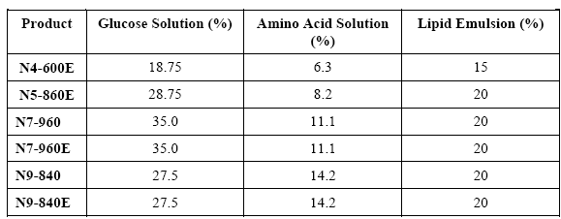

The rationale for development of the formulation is unclear. The sponsor argues on the one hand that the formulations have been developed to meet the nutritional requirements for a wide range of clinical conditions and patients, yet at the same time says these formulations are similar to OliClinomel formulations which are currently registered in Australia.

## Contents of the clinical dossier

### Scope of the clinical dossier

The submission contained the following clinical information:

* Module 1
  + Application letter, application form, draft Australian PI and CMI, Canadian Product Monograph, European Summary of Product Characteristics.
* Module 2
  + Clinical Overview, Summary of Clinical Efficacy, Summary of Clinical Safety and literature references.
* Module 5 contained only
  + Study ICS1063B/P01/03/Mu. F Efficacy and safety of Oliclinisol (Olimel) N9-840 vs. Oliclinomel N8-800, carried out over five days in parallel groups in patients requiring parenteral nutrition.
  + Olimel/PeriOlimel PSURs:
    - 21 Jul 2008 – 31 Jan 2009
    - 1 Feb 2009 – 31 Jul 2009
    - 1 Aug 2009 – 31 Jan 2010
    - 1 Feb 2010 – 31 Jul 2010
    - 1 Aug 2010 – 31 Jan 2011
    - 1 Feb 2011 – 31 Jan 2012
  + 11 literature references for amino acids(from 1985 to 1992, out of 94 submitted references)
  + Reference to studies on lipids not previously submitted and **not** included [in this evaluation]:
    - CT 2402/P15/94/G; Report C9802E Phase 111 Prospective, Randomized, Multicenter Study of the Safety and Efficacy of ClinOleic 20% IV Fat Emulsion in Premature Infant
    - C88 CSW6/3 01F, 05F, 06F; Reports C9118, C9202, C9203 (Combined analysis) Short-term Safety and Efficacy Evaluation of ClinOleic Emulsion in Adult Patients under Exclusive Parenteral Nutrition
    - CT 2402/P24/03/C Efficacy and safety profile of ClinOleic 20% at a dose of 1 g/kg/day in patients requiring parenteral nutrition. A multicentre, randomized, double-blinded, non-inferiority study versus Intralipid 20%, carried out in parallel groups
  + Reference to studies on lipids previously submitted and therefore **not** included [in this evaluation]:
    - C88 CSW6/3 04F; Report C9119 Clinical Trial in Healthy Volunteers under Exclusive Parenteral Feeding
    - Report B9208E Clearance of Intravenously Administered Olive Oil and Soya Bean Oil Emulsions in Healthy Volunteers
    - C91 CSW6/3 12F; Report C9403 Effect of lntravenous Administration of ClinOleic and Intralipid Emulsions on Biliary Secretion in Man
    - C88 CSW6/3 02F; Report C9114 Short-term Safety and Efficacy Evaluation of ClinOleic Emulsion in Adult Patients under Exclusive Parenteral Nutrition
    - C91 CSW6/3 13F; Report C9407 Safety Evaluation of ClinOleic in Adult Patients under Short-term Total Parenteral Nutrition
    - CT 2402/P19/96/G; Report C0103E Short-term Efficacy and Safety Evaluation of ClinOleic 20% versus Salvilipid 20% in Non-septic Patients in Post-operative Period
    - CT 2402/P21/96/S; Report C0104E Short-term Efficacy and Safety Evaluation of ClinOleic 20% versus MCT/LCT 20% (Lipofundina) in Bum Patients on Exclusive Parenteral Nutrition
    - C89 CSW6/3 08F; Report C9409E Efficacy and Safety Evaluation in Patients Treated for over 15 Days by Exclusive Parenteral Nutrition
    - C90 CSW6/3 11F; Report C9207 A Long-term Efficacy and Safety Study on ClinOleic Emulsion during Exclusive Parenteral Nutrition in Adult Patients
    - C89 CSW6/3 10F; Report C9408E A Long-term Safety Evaluation of ClinOleic in Adults or Children in Non-exclusive Parenteral Nutrition
    - CT 2402/P18/95/F; Report C9904E Comparative Study of the Effect on Cell Immunity and the Safety of Two Lipid Emulsions in Adults with Intestinal Failure on Prolonged Horne Parenteral Nutrition
    - CT 2402/P20/96/1; Report C9907E A Two Month Safety Evaluation of ClinOleic 20% versus Ivelip20% in 16 Adult Patients Requiring Horne Parenteral Nutrition for Short Bowel Disease
    - CT 2402/P22/00/F; Report COI05E Anti-oxidant and Nutritional Efficacy and Safety of ClinOleic 20% vs. Ivelip 20% in Patients with Chronic Renal Failure Treated by Chronic Dialysis
    - C88 CSW6/3 03F; Report C9201 Tolerability and Efficacy of ClinOleic in Children receiving Total Parenteral Nutrition
    - CT 2402/P14/93/F; Report C9801E Long-term Efficacy and Safety of ClinOleic compared to Intralipid in Children and Teenagers under Parenteral Nutrition
    - CT 2402/P17/95/UK, Report C9903E Long-term Safety Evaluation of ClinOleic in Patients on Parenteral Nutrition
  + Reference to studies on OliClinomel previously submitted and therefore **not** included [in this evaluation]:
    - Study BX-OCNM4-301 Phase III Clinical Study for the Evaluation of the Ease of Use, the Safety and the Nutritional Efficiency of OliClinomel (N4550E)
    - Study BX-OCNM7-301 Phase III Clinical Study for the Evaluation of the Ease of Use, the Safety and the Nutritional Efficiency of OliClinomel (N71000E
    - Study BX-OCNM4-301 Phase III Clinical Study for the Evaluation of the Ease of Use, the Safety and the Nutritional Efficiency of OliClinomel (N4550E)
    - Study BX-OCNM7-301 Phase III Clinical Study for the Evaluation of the Ease of Use, the Safety and the Nutritional Efficiency of OliClinomel (N71000E)

### Paediatric data

The submission included no relevant paediatric data. The studies were outside the proposed age limit or did not use 15% amino acids.

### Good clinical practice

Study ICS1063B/P01/03/Mu was conducted according to GCP guidelines (ICH E6).

## Pharmacokinetics

Studies on the absorption, distribution, metabolism, excretion and pharmacokinetic drug interactions of the final product (admixture) in container-closure system administered to the patient have not been conducted.

The sponsor provided general information on the individual compartment components.

### Evaluator’s overall conclusions on pharmacokinetics

The evaluator finds little to comment on despite the submission including an unregistered component (Clinisol).

## Pharmacodynamics

Again there was little to comment on. The sponsor did claim (in the clinical overview):

Clinisol represents an advance over Synthamin, the amino acid source in the marketed product OliClinomel, through the addition of glutamic acid and aspartic acid. Glutamic acid is an important amino acid whose supply may be limited during states of critical illness. Glutamic acid is an intermediate for amino acid interconversions. It is a precursor for proline (required for wound healing), ornithine, glutamine, arginine (required for synthesis of creatine, nitric oxide and many other functions), polyamines (cell growth factors), and neurotransmitters (i.e. gamma amino butyric acid). Aspartate is important for synthesis of urea, pyrimidines and neurotransmitters. It is also an important gluconeogenic precursor.

This suggests the amino acid products are not as similar as claimed.

## Dosage selection for the pivotal studies

The dose administered was depending on patient oral intakes, metabolic and energy requirements, and patient’s clinical condition, the PN being considered in some cases as a complementary PN to oral/enteral intakes on patient for which this way was not contraindicated but for which intakes were not sufficient.

## Clinical efficacy

The sponsor repeatedly refers to the similarity of the combined product and the individual components to registered products. It is thus unclear what the sponsor considers is being registered.

The combined product relies for proof of efficacy on comparison with a combined product not registered in Australia. Of the individual components the glucose and lipid components are registered while the 15% amino acid component (Clinisol) is not. Evidence of the efficacy of Clinisol relies on a literature report in which a 15% solution (similar to but not Clinisol) is compared to a 10% amino acids solution. The components of the 15% solution could not be determined from the report and were sought elsewhere. No evidence of a literature search was submitted. The sponsor’s clinical overview states:

The efficacy data for OliClinisol are largely based on studies performed with existing products that are similar to or the same as the individual components of OliClinisol. Studies are therefore presented on Synthamin, an amino acid solution that contains all the amino acids in OliClinisol except two (aspartic acid and glutamic acid), and ClinOleic, the lipid emulsion component of OliClinisol.

In addition, two non-comparative studies are presented that have been performed with OliClinomel to support the efficacy and safety data obtained with similar premixes. A double-blind comparative study comparing OliClinisol to the currently marketed product OliClinomel is also reported.

The Synthamin studies are taken from published literature and the Good Clinical Practice (GCP) status is unknown, but the publications are in reputable journals and appear to be of appropriate quality. For the clinical study reports, early studies were performed before the implementation of GCP guidelines, but the studies were carried out in accordance with the guidance in place at the time, and provide supporting data.

### Efficacy as the combined product

#### Pivotal efficacy study ICS1063B/P01/03/Mu.F

Only the study report was submitted with none of the usual appendices.

The study notification file was not submitted to the Spanish Competent Authority after EC approval. So, in absence of any authorisation from Spanish Health Authorities to use the data from the Spanish centre, the report analysis did not take into account the 10 patients from Spain.

This study compared the proposed combined preparation Olimel (Oliclinisol) containing an unregistered 15% amino acid preparation (Clinisol) with a combined preparation not registered in Australia that contained a 10% amino acid preparation Synthamin. From the study report:

Oliclinomel N8-800 was chosen as the ready to use (RTU) ternary admixture reference because it has a similar composition, except regarding the amino acid (AA) solution and lipido-glucidic ratio.

##### Study design, objectives, locations and dates

A multicenter, prospective, randomized, double-blind, parallel group study in hospitalized adults of the Efficacy and safety of Oliclinisol (Olimel) N9-840 versus Oliclinomel N8-800 in parenteral nutrition carried out over five days. In 7 centres in France and Germany and one in Spain from 24/01/2005 to 20/12/2005.

The **Primary objective** was to provide clinical information on safety of Oliclinisol N9-840 in a practical therapeutic use after 5 consecutive days of PN.

**Secondary objective**: No difference in clinical outcomes or lab-tests was expected from the differences in product composition; nevertheless, transthyretin as nutritional lab marker was collected as efficacy parameter.

##### Inclusion criteria

Included:

* Hospitalized Patients aged from 18 – 85 years,
* With any pathology requiring balanced parenteral nutrition, representing at least 50% of the daily non-protein energy requirements during five days.

##### Exclusion criteria

Included:

* Patient with life expectancy shorter than 6 days,
* Severe illness with foreseeable intercurrent events jeopardizing patient’s participation by leading to drop out,
* Lipids infusion for nutrition purpose the previous day,
* Patient with unstable conditions (for example, following severe post-traumatic conditions, uncompensated diabetes mellitus, acute phase of circulatory shock, acute myocardial infarction, severe metabolic acidosis, severe sepsis and hyperosmolar coma) usually contraindicating intravenous infusion,
* Severe cardiac insufficiency,
* Congenital abnormalities of amino acid metabolism,
* Severe renal insufficiency without the possibility of haemofiltration or dialysis,
* Hyperglycaemia, which requires more than 6 units insulin/h,
* Severe dyslipidaemia,
* Severe liver disease with cytolysis characterized by ASAT > 3N or severe cholestasis characterized by conjugated bilirubin > 2N,
* Severe blood coagulation disorders not explained by Anti Vitamin K or heparin intakes.

##### Study treatments

The dose administered was depending on patient oral intakes, metabolic and energy requirements, and patient’s clinical condition, the PN being considered in some cases as a complementary PN to oral/enteral intakes on patient for which this way was not contraindicated but for which intakes were not sufficient.

From D0 to D+4, the patient received a balanced parenteral nutrition representing at least 50% of the daily needs. The energy calculation during these 5 days (D0 to D+4) was based on the medical expertise of the Investigator.

Patients also received additional glucose than that in the combined preparations: This resulted in more lipids and less glucose intakes respectively, with also less complementary glucose administered besides the bag.

##### Efficacy variables and outcomes

The sponsor did not submit the statistical analysis plan. The H0 appeared to be that there was a difference between the two treatment groups as assessed by the change in transthyretin level between day 0 & day 5. The alternative appeared to be that there was no difference. No non-inferiority or equivalence margins appear to have been set.

Transthyretin as nutritional efficacy parameter was evaluated at D0 before first infusion and at D+5 or D-end after last infusion.

##### Randomisation and blinding methods

The quality assurance manager generated a list using a confidential seed from a randomization program prepared by the sponsor-assigned statistician.

Blindness was maintained by using the same primary and secondary packaging for both products and by peel seals activation by the pharmacist prior transfer to the ward.

##### Analysis populations

Per Protocol Population recruited patients who completed all specified phases of the study according to protocol.

Intention To Treat Population recruited patients with at least one day of treatment and a second efficacy evaluation, with possible protocol violation that may affect analysis interpretation.

##### Sample size

Being a study in therapeutic use versus a similar active comparator, sample size determination was not inferred from statistical calculation on a dedicated primary criterion. i.e. there was no calculation of sample size.

##### Statistical methods

A general linear model (GLM) was employed. The model included Treatment effect. Baseline value was used as a covariate. A two-sided approach with alpha = 5% was used.

No data transformation (log) was retained to improve/increase power analysis and no imputation of missing data was done.

##### Participant flow

Number of patients enrolled in PP

* Oliclinisol: n = 24
* Oliclinomel: n = 23

Number of patients enrolled in ITT

* Oliclinisol: n = 24
* Oliclinomel: n = 26

Number of patients enrolled in Safety

* Oliclinisol: n = 28
* Oliclinomel: n = 28

Table 2. Number of evaluable Patients per infusion day.

| Per day | Oliclinisol (n) | Oliclinomel (n) | All (n) |
| --- | --- | --- | --- |
| D+1 | 28 | 28 | 56 |
| D+2 | 28 | 28 | 56 |
| D+3 | 27 | 26 | 53 |
| D+4 | 26 | 25 | 51 |
| D+5 | 25 | 24 | 49 |

##### Major protocol violations/deviations

Protocol deviations leading to removal from the study population were:

**Main protocol deviations: Oliclinisol group.**

* Premature termination for AE (Catheter infection): No transthyretin value at D+5/End
* Premature termination for AEs (Cramps, Hypertension, Tachycardia): No transthyretin value at D+5/End
* Premature termination for SAE (septic shock leading to death): No transthyretin value at D+5/End
* No transthyretin value at D+5/End

**Main Protocol deviations: Oliclinomel group.**

* Premature termination for SAE (Allergic reaction): No transthyretin value at D+5/End
* Premature termination for SAE (Acute pulmonary oedema): No transthyretin value at D+5/End
* Premature termination upon investigator request for AE (Hyperthermia)
* Transthyretin value at Baseline assessed after first day of bag infusion
* Premature termination for Patient status improved

##### Baseline data

Table 3. Demography ITT population

|  | Oliclinisol | | Oliclinomel | |  |
| --- | --- | --- | --- | --- | --- |
| Parameter | n | Mean ± sd (min-max) | n | Mean ± sd (min-max) | Treat. Pra |
| Age (y.) | 24 | 56.0 ± 15.1 (21-76) | 26 | 52.0 ± 21.1 (18-84) | F: 0.4477 |

a P-value: Two-sided, based on a GLM (General Linear Model) model including treatment main effect for comparing Oliclinisol (Olimel) and Oliclinomel

Table 4. Gender

|  | Oliclinisol | | | | Oliclinomel | | | |  |  |
| --- | --- | --- | --- | --- | --- | --- | --- | --- | --- | --- |
|  | M | | F | | M | | F | |  |  |
|  | N | % | N | % | N | % | N | % | Test | Value |
| Sex | 17 | 70.8 | 7 | 29.2 | 16 | 61.5 | 10 | 38.8 | Chi2 | 0.488 |

Table 5. Patient Severity Status at Baseline - ITT Population.

|  | Oliclinisol | | Oliclinomel | |  |
| --- | --- | --- | --- | --- | --- |
| Parameters | n | Mean ± sd (min-max) | n | Mean ± sd (min-max) | Treat. Pra |
| SAPS II | 20 | 30.0 ± 14.8 (6-72) | 22 | 29.8 ± 17.4 (7-74) | W: 0.6796 |
| ISS | 5 | 38.4 ± 17.2 (25-63) | 6 | 33.7 ± 9.6 (25-50) | W: 0.9271 |

a: P-value: Two-sided, based on a GLM (General Linear Model) model including treatment main effect for comparing Oliclinisol (Olimel) and Oliclinomel

##### Results

The total lipid and total glucose were statistically significantly different between groups, but not the Nitrogen intake. Clearly the combined preparations are not as similar as the sponsor claims or the study numbers are too small to rely on the statistics (the population numbers were not statistically justified). The study report favours the former explanation:

The administered macronutrients reflect the differences in composition between Oliclinisol and Oliclinomel: similar nitrogen and total energy intakes were achieved with nearly 10% less volume (26.56 vs. 29.00 ml/kg/d, not statistically significant) but a very similar energy intake (28.4 vs. 29 kcal/kg/d). This resulted in more lipids and less glucose intakes respectively, with also less complementary glucose administered besides the bag.

There was a marked difference in the enteral feeding between the groups and the total oral energy intake was a considerable amount (max 24.2 & 25.3 kcal/kg/day) for some patients the means have little relevance given that 14/24 & 16/24 were not receiving any enteral feeding.

Table 6. Mean Parenteral and Oral/Enteral intakes under treatment – ITT population

Table 6. Mean Parenteral and Oral/Enteral intakes under treatment – ITT population

a: P-value: Two-sided, based on a GLM (General Linear Model) model including treatment main effect for comparing Oliclinisol and Oliclinomel.

Table 7. Enteral nutrition amounts during the treatment period grouped by kcal/day– ITT population

Table 7. Enteral nutrition amounts during the treatment period grouped by kcal/day– ITT population

The different lipid/glucose ratio between Olimel and Oliclinimel should have an effect on nitrogen utilisation according to a submitted reference,[2] however no difference could be shown in transthyretin levels, suggesting the numbers in the study were too small to detect a difference.

Table 8. Transthyretin (g/L) evolution during treatment period

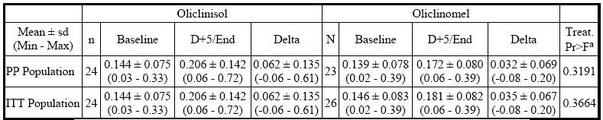

a Model: Two-sided, based on a GLM (General Linear Model) model including treatment main effect and baseline value as covariate for comparing Oliclinisol and Oliclinomel.

While the sponsor argues Efficacy analysis on PP and ITT populations shows no difference, the small population numbers were not justified statistically, the power of the study was not indicated, the significance of the p value in relation to similarity of outcomes is uncertain.

### Efficacy of individual components

#### 15% Amino acid component (Clinisol)

There were no studies of the use of Clinisol submitted. Instead an apparently unjustified[3] selection of literature trial reports was submitted. It included only one study with 15% amino acids while it also included some studies outside the age group proposed. One literature study used Synthamin 17 and together with the sponsor the authors described it as it as 17%[4]. The product on the ARTG and the sponsor’s website is 10% amino acids.

##### Study Broyles JE et al.

Fluid Balance in Fluid-restricted Patients Receiving 10% Amino acids or 15% Amino acids as Part of Parenteral Nutrition. *Hosp Pharm*, 24: 995-998; 1989.

###### Design, objectives, locations and dates

This study compared the use of a 15% amino acid solution to a 10% amino acid solution as part of parenteral Nutrition in fluid-restricted patients.

Randomised, parallel groups study for 7-14 days in fluid-restricted ICU patients. Conducted over 9 months in 2 centres in US, study dates not given.

###### Inclusion criteria

All ICU patients receiving PN during a 9 month period were considered.

Patients were to be judged to be in need of fluid restriction by:

1. they had a condition in which fluid restriction was an accepted treatment (e.g. SIADH, ARDS, or CHF);
2. they had elevated central venous pressure or pulmonary capillary wedge pressure; or they were receiving a volume of intravenous antibiotics, pressor agents, blood products, or other fluids which would make the administration of optimal PN improbable.

###### Exclusion criteria

Patients were excluded from the study if they were suffering from acute oliguric renal failure or severe liver failure.

###### Study treatments

Patients were assigned to one of two PN formulations:

* 500mL of 70% dextrose and 500mL of 10% amino acids, or
* 500mL of 70% dextrose and 335mL of 15% amino acids.

These formulas were isonitrogeoous and isocaloric; however, they differed in volume.

PN was initiated at 25-50 mL/hour and advanced as tolerated to a protein goal of 1.0gram/kg/day and an energy goal of 30kcal/kg/day.

PN intake was then adjusted based on the patient's volume status and urine urea nitrogen excretion. Electrolytes were added to the PN solutions to maintain normal serum concentrations. Vitamins and trace elements were given daily as recommended by the Nutrition Advisory Group of the American Medical Association.

Intravenous fat emulsions were given either:

* two times weekly to prevent essential fatty acid deficiency, or
* continuously as a caloric source, depending on the clinical condition of the patient.

Patients were studied for a minimum of 7 days and a maximum of 14days.

Table 9. Amino Acid Preparations comparison of Proposed (Clinisol) and Study (Novamine) preparations (per 1L)

|  | Novamine | 15% Clinisol |
| --- | --- | --- |
| **Essential Amino Acids** | | |
| Lysine | 11.80g | 11.8g |
| Leucine | 10.40g | 10.4g |
| Phenylalanine | 10.40g | 10.4g |
| Valine | 9.60g | 9.60g |
| Histidine | 8.94g | 8.94g |
| Isoleucine | 7.49g | 7.49g |
| Methionine | 7.49g | 7.49g |
| Threonine | 7.49g | 7.49g |
| Tryptophan | 2.50g | 2.50g |
| **Nonessential Amino Acids** | | |
| Alanine | 21.70g | 21.7g |
| Arginine | 14.70g | 14.7g |
| Glycine | 10.40g | 10.4g |
| Proline | 8.94g | 8.94g |
| Glutamic Acid | 7.49g | 7.49g |
| Serine | 5.92g | 5.92g |
| Aspartic Acid | 4.34g | 4.34g |
| Tyrosine | 0.39g | 0.39g |
| Ornithine |  |  |
| Cysteine |  |  |
| Taurine |  |  |
| **Total** | 149.9g | 149.9g |

###### Efficacy variables and outcomes

The main efficacy variables were:

* To compare delivery of PN solutions and fluid balance in fluid-restricted ICU patients.
* Fluid balances during each 24 hour period of PN administration were calculated by the difference between fluid intake and output.
  + Fluid input included PN solutions, other intravenous solutions, enteral or oral feedings and blood products.
  + Fluid output included all urine excretion and fluids lost from nasogastric suction, ostomies, or drains. Stool was not calculated in the output, unless the patient had a rectal tube placed for severe diarrhoea.
* Total volume of PN infused/day.
* Percentage of total fluid Input as PN fluid.
* Non-protein calories/kg/day, and grams of protein/kg/day were calculated and recorded for each patient.

###### Randomisation and blinding methods

Randomisation was by a table of random numbers. There was no blinding described.

###### Sample size

No calculation of sample size was indicated.

###### Statistical methods

Analysis of variance and Duncan's new multiple range test were used to determine statistical significance between the two groups.

###### Participant flow

23 entered 20 completed (10 in each group).

Table 10. Diagnoses

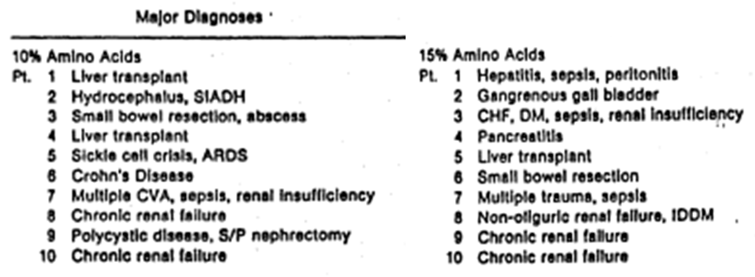

Table 11. Patient Demographics

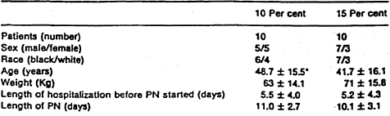

* Mean ± S.D

###### Major protocol violations/deviations

Two in the 15% amino acid group and one in 10% amino acid group were excluded because they received less than 7 days of PN.

Each group included two patients with Chronic Renal Failure who had no urine output and were receiving peritoneal dialysis. Fluid lost from peritoneal dialysis was not routinely measured and recorded in the hospitals, so output by this method was not available for the four patients.

###### Results for the primary efficacy outcome

Total fluid volume from PN was 1059 ± 308 mL/day in the 15% amino acid group, and 1246 ± 355 mL/day in the 10% amino acid group (p = 0.002).

Fluid input from PN in the 15% amino acid group represented 40.9% of the total fluid input/day, while PN in the 10% amino acid group contributed 48.4% of this total (p =0.01).

There was no statistical difference in Total fluid balance.

Table 12. Fluid Balance and Parenteral Nutrition Intake

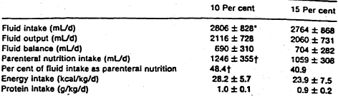

* Mean ± SD. † p <0.05 between groups.

Table 13. Laboratory Measurements of the Two Groups at Study Entry and End

Table 13. Laboratory Measurements of the Two Groups at Study Entry and End 

BUN = blood urea nitrogen (mg/dL) Cr = 11 creatinine (mg/dL) Alb = albumin (g/dL) Source:

**Comment:** Albumin has 20 day half life and is not considered a sensitive marker except in chronic malnutrition. The amount of enteral fluid and nutrition could not be determined from the report. Assessment of the effects of the 15% solution on Total Fluid balance showed no significant difference in discussion the authors point out that the saving of 187mL of fluid per day “could be easily negated by fluid challenges, a single administration of blood product, or administration of a new antibiotic.” That is the clinical significance of the saving is doubtful.

#### Lipid component (Clinoleic)

This component is a relatively recently registered product (19/02/2004). Reference is made to the previous TGA evaluation reports and discussions.

#### Glucose (Component)

This is an historically registered product.

### Evaluator’s conclusions on clinical efficacy

#### Evaluator’s conclusions on clinical efficacy of combined product

The evidence for efficacy rests in a single study on 24 patients some of whom had a considerable enteral intake as well.

* The study lasted only 5days.
* The comparator was a preparation not registered in Australia.
* Although the products had differing lipid/glucose ratios effects on glucose or triglycerides were not specifically considered except in discussion,[5] possibly because of the use of additional glucose infusions.
* This evaluator believes this is insufficient information to establish efficacy to the level required.

#### Evaluator’s conclusions on clinical efficacy of separate components

The glucose and lipid components are registered and their efficacy is accepted.

The 15% amino acid preparation (Clinisol) is not registered and the single literature trial in 10 patients for 7days failed to achieve a clinically significant difference in its primary endpoint and evidence of nutritional efficacy was lacking.

This evaluator believes this is insufficient information to establish efficacy.

## Clinical safety

### Combined product - study ICS1063B/P01/03/Mu.F

This study was the only source of safety data for the combined product other than post marketing.

#### All adverse events (irrespective of relationship to study treatment)

A total of 53 Adverse Events occurred under treatment, 29 in Oliclinisol group vs. 24 in Oliclinomel group. Only 7 were estimated to be related to Oliclinisol and only 8 were estimated to be related to Oliclinomel.

Table 14. Adverse Events

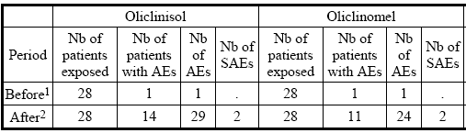

1 Started after obtaining informed consent signature but before 1st infusion initiation

2 Started after 1st infusion initiation: Corresponds to “Treatment Emergent Signs and Symptoms” (TESS: those not seen at baseline and those worsened even if present at baseline)

Table 15. Number of AEs observed in Oliclinisol(Olimel) groupa after start of 1st infusion

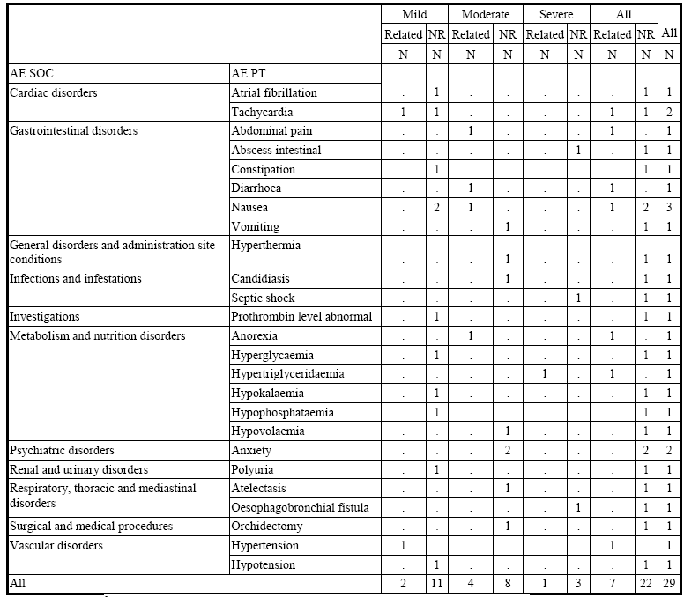

a If any follow-up was available, last relationship from follow-up was considered.

Table 16. Incidence and rate of AEs per System Organ Class and Preferred Term occurred after start of 1st infusion

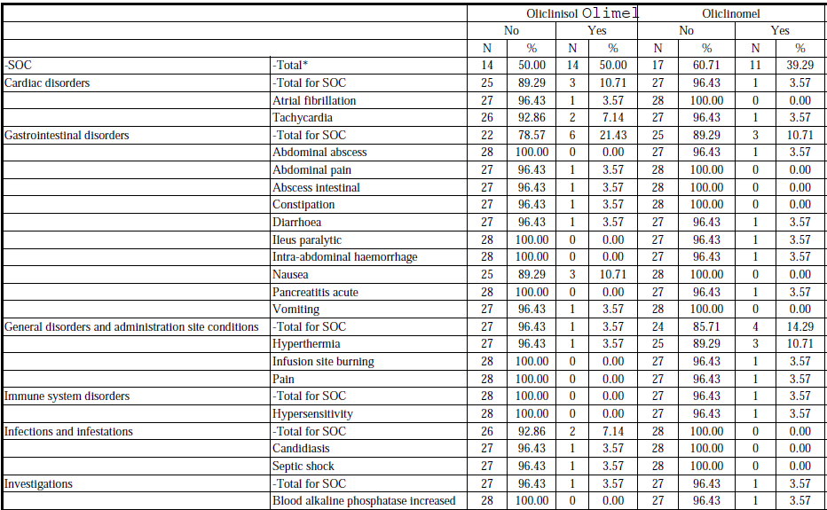

Table 16 continued. Incidence and rate of AEs per System Organ Class and Preferred Term occurred after start of 1st infusion

Table 16 continued. Incidence and rate of AEs per System Organ Class and Preferred Term occurred after start of 1st infusion

* Total SOC= Number of patients with at least one AE.

#### Deaths and other serious adverse events

1 death on Olimel due to septic shock not felt related.

Table 17. Other SAEs occurred in the study.

|  |  |  |  |
| --- | --- | --- | --- |
| Treatment | SAE PT | Relationship to treatment | Time frame between first infusion Onset time and AE Onset time |
| Oliclinisol | Oesophagobronchial fistula | None | 5 days |
| Oliclinomel | Hypersensitivity | Certain | 1 day 14 hours 0 min |
| Oliclinomel | Acute pulmonary oedema | None | 2 days 1 hour 0 min |

3 Other SAEs were reported: 1 in Oliclinisol (Olimel) group and 2 in Oliclinomel group, all after 1st infusion initiation – no other information provided.

#### Discontinuation due to adverse events

Discontinuations for AEs were:

**Oliclinisol group:**

* Premature termination for AE (Catheter infection)
* Premature termination for AEs (Cramps, Hypertension, Tachycardia):
* Premature termination for SAE (septic shock leading to death)

**Oliclinomel group:**

* Premature termination for SAE (Allergic reaction)
* Premature termination for SAE (Acute pulmonary oedema)
* Premature termination upon investigator request for AE (Hyperthermia)

#### Laboratory tests

Shift tables for the following were noted:

* Glucose
* ASAT
* ALAT
* Alkaline phosphatise
* GGT
* Triglycerides

### Safety of individual components

#### 15% Amino acids Study Broyles JE *et al*

This Study had no safety information.

#### Lipid (Clinoleic)

Reference was made to the TGA Delegate’s overview for a previous application.

[**Information has been redacted from this report**]

#### Glucose with/without calcium

The safety of a higher concentration of calcium (0.52 vs. 0.3g/L) was not discussed.

### Post-marketing experience

The submitted Summary of Clinical Safety did not consider the PSURs for Olimel/Oliclinomel.

#### PSURs

First launch March 2009. PSURS to 31 January 2012 submitted.

**1. PSUR 01 Feb 2009 through 31 Jul 2009** creation of a new Reference Safety Information (CCDS) On 31 Mar 2009. Modifications were made to the safety sections compared to the previous RSI.

**2.PSUR 01 Aug 2009 through 31 Jan 2010** nil of note.

**3.PSUR 0l Feb 2010 through 3I Jul 2010** one unrelated death reported.

**4.PSUR 01 Aug 2010 to 31 Jan 2011** 28 AEs reported; 16 serious unlisted ( including 14 deaths - 13 possibly associated) and 12 were non-serious.

**5.PSUR 01 Feb 2011 to 31 Jan 2012** No changes to CCDS. In the previous PSUR (01 Aug 2010 – 31 Jan 2011) it was concluded that the RSI would be updated to add pyrexia and chills. In addition, the following statement will be removed, “There are no postmarketing data available for PeriOlimel/Olimel.”

There was no summary of total exposure, nor could this evaluator calculate it from the PSURs submitted as two of the PSUR summary tables were labelled for the same period. Information was provided on worldwide sales of Olimel/PeriOlimel/Triomel over 1 February 2011 and 31 January 2012.

No clinical safety studies were reported to 31 January 2012.

23 serious AEs, of which 22 were unlisted, and 30 were non-serious. 7 deaths, 5 possibly related, 2 unlikely related.

Table 18. Tabulation of Individual Cases SOC by Seriousness/Listedness for Case List '06982C' and 'OLIMEL’ medically confirmed, cumulative to 31 Jan12

|  | Serious | | Non-Serious | | Total |
| --- | --- | --- | --- | --- | --- |
| System Organ Class/ADR Term | Unlisted | Listed | Unlisted | Listed |
| **Infections and infestations** | | | | | |
| Catheter site infection | 0 | 0 | 1 | 0 | 1 |
| Device related infection | 0 | 1 | 0 | 0 | 1 |
| Infection | 0 | 0 | 6 | 0 | 6 |
| Sub-Total Number of Reactions | 0 | 1 | 7 | 0 | 8 |
| **Blood and lymphatic system disorders** | | | | | |
| Thrombocytopenia | 1 | 0 | 0 | 0 | 1 |
| Sub-Total Number of Reactions | 1 | 0 | 0 | 0 | 1 |
| **Metabolism and Nutrition disorder** | | | | | |
| Decreased appetite | 1 | 0 | 1 | 0 | 2 |
| Gout | 0 | 0 | 1 | 0 | 1 |
| Hyperkalaemia | 1 | 0 | 0 | 0 | 1 |
| Sub-Total Number of Reactions | 2 | 0 | 1 | 0 | 4 |
| **Psychiatric disorders** | | | | | |
| Restlessness | 0 | 0 | 1 | 0 | 1 |
| Sleep attacks | 0 | 0 | 1 | 0 | 1 |
| Sub-Total Number of Reactions | 0 | 0 | 2 | 0 | 2 |
| **Nervous system disorders** | | | | | |
| Cerebrovascular accident | 1 | 0 | 0 | 0 | 1 |
| Coordination abnormal | 0 | 0 | 1 | 0 | 1 |
| Dizziness | 0 | 0 | 1 | 0 | 1 |
| Headache | 0 | 0 | 1 | 2 | 3 |
| Paraesthesia | 0 | 0 | 1 | 0 | 1 |
| Status epilepticus | 1 | 0 | 0 | 0 | 1 |
| Sub-Total Number of Reactions | 2 | 0 | 6 | 2 | 10 |
| **Respiratory, thoracic and mediastinal disorders** | | | | | |
| Dyspnoea | 0 | 0 | 1 | 0 | 1 |
| Sub-Total Number of Reactions | 0 | 0 | 1 | 0 | 1 |
| **Gastrointestinal disorders** | | | | | |
| Abdominal distension | 2 | 0 | 3 | 0 | 5 |
| Abdominal pain | 1 | 1 | 0 | 3 | 5 |
| Diarrhoea | 0 | 0 | 0 | 2 | 2 |
| Nausea | 0 | 1 | 0 | 8 | 9 |
| Vomiting | 0 | 0 | 4 | 0 | 4 |
| Sub-Total Number of Reactions | 3 | 2 | 7 | 13 | 25 |
| **Hepatobiliary disorders** | | | | | |
| Hepatic pain | 0 | 0 | 1 | 0 | 1 |
| Sub-Total Number of Reactions | 0 | 0 | 1 | 0 | 1 |
| **Skin and subcutaneous tissue disorders** | | | | | |
| Blister | 1 | 0 | 1 | 0 | 2 |
| Erythema | 1 | 0 | 0 | 0 | 1 |
| Hyperhidrosis | 0 | 0 | 2 | 0 | 2 |
| Night sweats | 0 | 0 | 1 | 0 | 1 |
| Peau d'orange | 0 | 0 | 1 | 0 | 1 |
| Pruritus | 0 | 0 | 2 | 0 | 2 |
| Pruritus generalised | 0 | 0 | 1 | 0 | 1 |
| Rash | 0 | 0 | 1 | 0 | 1 |
| Scar | 1 | 0 | 0 | 0 | 1 |
| Skin irritation | 0 | 0 | 1 | 0 | 1 |
| Skin necrosis | 1 | 0 | 0 | 0 | 1 |
| Skin tightness | 1 | 0 | 0 | 0 | 1 |
| Sub-Total Number of Reactions | 5 | 0 | 10 | 0 | 15 |
| **Musculoskeletal and connective tissue disorders** | | | | | |
| Back pain | 0 | 0 | 2 | 0 | 2 |
| Muscle contracture | 0 | 0 | 1 | 0 | 1 |
| Muscle spasms | 0 | 0 | 1 | 0 | 1 |
| Sub-Total Number of Reactions | 0 | 0 | 4 | 0 | 4 |
| **Renal and urinary disorders** | | | | | |
| Renal failure | 2 | 0 | 0 | 0 | 2 |
| Sub-Total Number of Reactions | 2 | 0 | 0 | 0 | 2 |
| **Reproductive system and breast disorders** | | | | | |
| Breast enlargement | 0 | 0 | 1 | 0 | 1 |
| Breast swelling | 0 | 0 | 1 | 0 | 1 |
| Retracted nipple | 0 | 0 | 1 | 0 | 1 |
| Sub-Total Number of Reactions | 0 | 0 | 3 | 0 | 3 |
| **General disorders and administration site conditions** | | | | | |
| Catheter site inflammation | 0 | 0 | 1 | 0 | 1 |
| Catheter site pain | 0 | 0 | 1 | 0 | 1 |
| Chills | 0 | 0 | 7 | 0 | 7 |
| Condition aggravated | 1 | 0 | 0 | 0 | 1 |
| Death | 22 | 0 | 0 | 0 | 22 |
| Device connection issue | 0 | 0 | 1 | 0 | 1 |
| Device occlusion | 0 | 0 | 1 | 0 | 1 |
| Drug intolerance | 0 | 0 | 4 | 0 | 4 |
| Extravasation | 4 | 0 | 10 | 0 | 14 |
| Fatigue | 0 | 0 | 1 | 0 | 1 |
| General physical health deterioration | 1 | 0 | 1 | 0 | 2 |
| Influenza like illness | 0 | 0 | 1 | 0 | 1 |
| Infusion site erythema | 1 | 0 | 0 | 0 | 1 |
| Infusion site pain | 0 | 0 | 1 | 0 | 1 |
| Infusion site swelling | 1 | 0 | 0 | 0 | 1 |
| Infusion site warmth | 1 | 0 | 0 | 0 | 1 |
| Injection site erythema | 0 | 0 | 1 | 0 | 1 |
| Injection site swelling | 0 | 0 | 1 | 0 | 1 |
| Local swelling | 1 | 0 | 0 | 0 | 1 |
| Oedema | 0 | 0 | 2 | 0 | 2 |
| Pain | 0 | 0 | 3 | 0 | 3 |
| Pyrexia | 5 | 0 | 11 | 0 | 16 |
| Swelling | 0 | 0 | 2 | 0 | 2 |
| Sub-Total Number of Reactions | 37 | 0 | 49 | 0 | 86 |
| **Investigations** | | | | | |
| Blood glucose increased | 0 | 0 | 1 | 0 | 1 |
| Glycosylated haemoglobin increased | 0 | 0 | 1 | 0 | 1 |
| Weight decreased | 0 | 0 | 1 | 0 | 1 |
| Sub-Total Number of Reactions | 0 | 0 | 3 | 0 | 3 |
| **Injury, poisoning and procedural complications** | | | | | |
| Drug administration error | 0 | 0 | 1 | 0 | 1 |
| Incorrect drug administration rate | 0 | 0 | 1 | 0 | 1 |
| Incorrect route of drug administration | 0 | 0 | 1 | 0 | 1 |
| Overdose | 0 | 0 | 1 | 0 | 1 |
| Procedural complication | 0 | 0 | 1 | 0 | 1 |
| Wrong drug administered | 0 | 0 | 1 | 0 | 1 |
| Sub-Total Number of Reactions | 0 | 0 | 6 | 0 | 6 |
| **Total Number of Reactions** | 52 | 3 | 101 | 15 | 171 |

### Evaluator’s overall conclusions on clinical safety

The Summary of Clinical Safety repeatedly makes reference to Synthamin and Oliclinomel which are not components of these proposed preparations.

#### Safety of the combination

The Safety of Olimel rests on only 28 patients in a clinical trial, supplemented by only 3 years of PSURs since first marketed. (Both reviewed above).

This is inadequate for a combination including an unregistered product.

#### Safety of the individual components

##### Amino acids (Clinisol)

The only data submission in relation to 15% amino acid solution is a published study (Broyles JE et al) that contains no safety data. The sponsor repeatedly refers to data for Synthamin, only a 10% amino acid solution that is already registered and which has different composition from Clinisol.

The data provided is insufficient to register Clinisol either as a component or separately.

##### Lipid (Clinoleic)

The product is already registered, having been evaluated and reviewed Post Marketing.

##### Glucose with/without calcium

The product is already registered, but the added calcium concentration is higher (0.52 vs. 0.3 g/L). It is noted that the PSUR 01 Feb 2009 through 31 Jul 2009 advised of changes to the CCDS relating to calcium.[6]

## First round benefit-risk assessment

### First round assessment of benefits

In the Letter of Application the sponsor discussed the benefits of Olimel/PeriOlimel in the proposed usage:

* increased physiochemical shelf-life, since the components are not mixed until just prior to use
* reduced risk of contamination during preparation, and
* reduction in the number of steps required to prepare a parenteral nutrition product.

The first statement makes no sense, the shelf life is the same whether they are 3 separate components or 3-in-1 bag components until the components are mixed. There are already 2 preparations Oliclinomel and SmofKabiven that are 3-in-one nutrition preparations that are registered in Australia and offer the same latter two advantages as claimed above.

For other advantages Raper *et al.*[7] (published online in 2008) discuss the benefits of the using the separate components vs. the 3-in-one system. But when they make reference to “the additional delivery and waste costs” of the individual components and “the additional pharmacy cost for storage and dispensing” without further clarification this evaluator has concerns. The practice at those author’s hospital is for pharmacy to mix the individual components prior to use (Big bag) Thus the pharmacy would need to stock only 4 preparations for nutrition, some in 2 volumes - this submission is for 5 preparations in 3 volumes.

Other advantages claimed relate principally to the amino acid component[8]

* The use of an amino acid solution already registered in the USA (Clinisol) that contains two additional amino acids as compared to Synthamin (15 amino acid solution in OliClinomel): aspartic acid and glutamic acid,
* A higher nitrogen concentration.

These both relate to the inclusion of a 15% amino acid preparation not registered in Australia. The only evidence for this preparation was a literature study report that failed to show clinically relevant improvement in the primary endpoint.

* Updated glucose calorie /lipid calorie ratio.

In comparison with an unregistered formulation of Oliclinomel the sponsor did not show any advantage, possibly because of the small numbers 24 vs. 23 involved.

This evaluator believes the data provided are inadequate for registration.

**Comment:** [Information redacted]

[The marketing data] suggests that the reason for prescribing Olimel is the higher (than 10% Synthamin) amino acid concentration rather than the additional 2 amino acids from the unregistered Clinisol.

### First round assessment of risks

The risks of Olimel in the proposed usage are reliant on a trial with 28 patients for 5 days supplemented by only 3 years of PSURs since first marketed.

Further of the individual components there was no safety data for a 15% amino acid preparation.

This evaluator finds the data available for assessment of risk is inadequate.

### First round assessment of benefit-risk balance

The benefit-risk balance of Olimel, given the proposed usage, is unfavourable.

## First round recommendation regarding authorisation

It is **not** recommended that approval be given for the registration of PeriOLIMEL N4600E, OLIMEL N5-860E, OLIMEL N7-960, OLIMEL N7-960E, OLIMEL N9-840 or OLIMEL N9-840E.

Should the delegate decide to approve registration of these products the clinical aspects of the draft Product Information are not entirely satisfactory and should be revised, having regard to the comments below.[9]

***Indications***

The sponsor proposes to insert: *OLIMEL/PeriOLIMEL is indicated for parenteral nutrition for adults and children above 2 years of age when oral or enteral nutrition is impossible, insufficient or contraindicated.*

The proposed PI itself states: *There have been no studies performed in the paediatric population.*

Further the CCDS only gives Indications for adults.

It is recommended that should the preparations be approved it only be for adults.

## Clinical questions

Nil.

1. Robinson MK, Trujillo EB, Mogensen KM, Rounds J, McManus K, Jacobs DO. Improving nutritional screening of hospitalized patients: the role of prealbumin. *J Parenter Enteral Nutr* 2003; 27: 389-395
2. Bouletreau P, Chassard D, Allaouchiche B, Dumont JC, Auboyer C, Bertin-Maghit M, Bricard H, Ecochard R, Rangaraj J, Chambrier C, Schneid C, Cynober L. Glucose-lipid ratio is a determinant of nitrogen balance during total parenteral nutrition in critically ill patients: a prospective randomized multicenter blind trial with intention to treat analysis. *Int Care Med* 2005; 31: 1394-1400
3. There was no evidence submitted of a literature search.
4. The 17 refers to g/L of Nitrogen not g/100mL - Clinical Overview
5. This did not influence overall lipid tolerance nor blood glucose results, but on a nutritional point of view, this follows the trends to limit glucose intakes and risks of hyperglycaemia in this critically ill population exposed to inflammatory syndrome and insulin resistance [Study Report]
6. 4.4 Special Warnings and Precautions for Use: - addition of warning regarding excess addition of calcium and phosphorus that may result in formation of precipitates of calcium phosphate that could lead to vascular occlusion; 4.5 Interactions with Other Medicinal Products and Other Forms of Interaction: - addition of wording mentioning that ceftriaxone must not be coadministered with calcium containing IV solutions.
7. Raper *et al*. The cost of multi-compartment ‘big bag’ parenteral nutrition in an ICU. Anaesthesia; Volume 57, Issue 1, pages 96-97, January 2002
8. Clinical Overview - Product Development Rationale
9. The sections in the CER dealing with the PI are not included in this Extract.