|  |
| --- |
| **First Round CER report: 19 June 2014**  **Second round CER report: 17 December 2014** |

|  |
| --- |
| AusPAR Attachment 2 |
| Extract from the Clinical Evaluation Report for anakinra |
| Proprietary Product Name: Kineret |
| Sponsor: A Menarini Australia Pty Ltd |

About the Therapeutic Goods Administration (TGA)

* The Therapeutic Goods Administration (TGA) is part of the Australian Government Department of Health, and is responsible for regulating medicines and medical devices.
* The TGA administers the *Therapeutic Goods Act 1989* (the Act), applying a risk management approach designed to ensure therapeutic goods supplied in Australia meet acceptable standards of quality, safety and efficacy (performance), when necessary.
* The work of the TGA is based on applying scientific and clinical expertise to decision-making, to ensure that the benefits to consumers outweigh any risks associated with the use of medicines and medical devices.
* The TGA relies on the public, healthcare professionals and industry to report problems with medicines or medical devices. TGA investigates reports received by it to determine any necessary regulatory action.
* To report a problem with a medicine or medical device, please see the information on the TGA website <<https://www.tga.gov.au>>.

About the Extract from the Clinical Evaluation Report

* This document provides a more detailed evaluation of the clinical findings, extracted from the Clinical Evaluation Report (CER) prepared by the TGA. This extract does not include sections from the CER regarding product documentation or post market activities.
* The words (Information redacted), where they appear in this document, indicate that confidential information has been deleted.
* For the most recent Product Information (PI), please refer to the TGA website <<https://www.tga.gov.au/product-information-pi>>.

Copyright

© Commonwealth of Australia 2015  
This work is copyright. You may reproduce the whole or part of this work in unaltered form for your own personal use or, if you are part of an organisation, for internal use within your organisation, but only if you or your organisation do not use the reproduction for any commercial purpose and retain this copyright notice and all disclaimer notices as part of that reproduction. Apart from rights to use as permitted by the *Copyright Act 1968* or allowed by this copyright notice, all other rights are reserved and you are not allowed to reproduce the whole or any part of this work in any way (electronic or otherwise) without first being given specific written permission from the Commonwealth to do so. Requests and inquiries concerning reproduction and rights are to be sent to the TGA Copyright Officer, Therapeutic Goods Administration, PO Box 100, Woden ACT 2606 or emailed to <[tga.copyright@tga.gov.au](mailto:tga.copyright@tga.gov.au)>.

Contents

List of abbreviations 5

1. Introduction 7

2. Clinical rationale 7

3. Contents of the clinical dossier 8

3.1. Scope of the clinical dossier 8

3.2. Paediatric data 9

3.3. Good clinical practice 9

4. Pharmacokinetics 9

4.1. Studies providing pharmacokinetic data 9

4.2. Summary of pharmacokinetics 9

4.3. Pharmacokinetics in healthy subjects 9

4.4. Pharmacokinetics in the target population 10

4.5. Pharmacokinetics in other special populations 11

4.6. Pharmacokinetic interactions 11

4.7. Evaluator’s overall conclusions on pharmacokinetics 11

5. Pharmacodynamics 11

5.1. Studies providing pharmacodynamic data 11

5.2. Summary of pharmacodynamics 12

5.3. Evaluator’s overall conclusions on pharmacodynamics 12

6. Dosage selection for the pivotal studies 12

7. Clinical efficacy 12

7.1. Pivotal efficacy studies 12

8. Clinical safety 21

8.1. Studies providing evaluable safety data 21

8.2. Pivotal studies that assessed safety as a primary outcome 24

8.3. Patient exposure in clinical trials 24

8.4. Adverse events 24

8.5. Laboratory tests 26

8.6. Post-marketing experience 26

8.7. Safety issues with the potential for major regulatory impact 27

8.8. Evaluator’s overall conclusions on clinical safety 29

9. First round benefit-risk assessment 29

9.1. First round assessment of benefits 29

9.2. First round assessment of risks 30

9.3. First round assessment of benefit-risk balance 31

10. First round recommendation regarding authorisation 31

11. Clinical questions 31

11.1. Pharmacokinetics 31

11.2. Pharmacodynamics 31

11.3. Efficacy 31

11.4. Safety 32

12. Second round evaluation of clinical data submitted in response to questions 32

12.1. Additional data submitted by the sponsor 32

12.2. Sponsor’s responses to clinical questions 36

12.3. Sponsor’s responses to other comments in the round 1 report 40

13. Second round benefit-risk assessment 41

13.1. Second round assessment of benefits 41

13.2. Second round assessment of risks 42

13.3. Second round assessment of benefit-risk balance 42

14. Second round recommendation regarding authorisation 42

15. References 43

## List of abbreviations

| Abbreviation | Meaning |
| --- | --- |
| ACR | American College of Rheumatology |
| AE | Adverse event |
| ALT | Alanine aminotransferase |
| AST | Aspartate aminotransferase |
| CINCA | Chronic Infantile Neurological, Cutaneous and Articular syndrome |
| CAPS | Cryopyrin-associated periodic syndromes |
| CRP | C-reactive protein |
| CSR | Clinical study report |
| DAE | Adverse event leading to discontinuation |
| DMARD | Disease modifying anti rheumatic drug |
| ESR | Erythrocyte sedimentation rate |
| IL-1 | Interleukin-1 |
| IL-1Ra | Interleukin-1 receptor antagonist |
| ILAR | International League of Associations for Rheumatology |
| JCA | Juvenile Chronic Arthritis |
| JIA | Juvenile idiopathic arthritis |
| JRA | Juvenile rheumatoid arthritis |
| MTX | Methotrexate |
| NOMID | Neonatal Onset Multi-system Inflammatory Disease |
| NSAID | Non-steroidal anti-inflammatory drug |
| PBMC | Peripheral blood mononuclear cells |
| PK | Pharmacokinetics |
| PSUR | Periodic Safety Update Report |
| RA | Rheumatoid arthritis |
| SAA | Serum amyloid A |
| SAE | Serious adverse event |
| SC | Subcutaneous |
| SJIA | Systemic-onset juvenile idiopathic arthritis |
| TEAE | Treatment emergent adverse event |
| TNF | Tumour necrosis factor |

## 

## Introduction

This is an application to extend the indications of Kineret (anakinra 100 mg/0.67 mL solution for injection prefilled syringe) to include the treatment of active Systemic Juvenile Idiopathic Arthritis (SJIA).

Kineret is a recombinant, non glycosylated form of the human interleukin-1 receptor antagonist (IL-1Ra). It is produced by recombinant DNA technology using an E. coli bacterial expression system.

The currently approved indication is:[1]

*Kineret (anakinra) is indicated for the treatment of active adult rheumatoid arthritis (RA) in patients who have had inadequate response to one or more other Disease Modifying Anti Rheumatic Drugs (DMARDs). Kineret should be given in combination with methotrexate.*

The proposed additional indication is:

*Kineret (anakinra) is indicated for the treatment of active Systemic Juvenile Idiopathic Arthritis (SJIA). Kineret may be used alone or in combination with other DMARDs.*

The recommended starting dose for SJIA is 1 to 2 mg/kg by daily SC injection. Dose adjustments should be based on clinical outcome and will thus be individualised based on the response and the severity of the disease. Dose adjustments are performed in steps of 0.5 to 1 mg/kg. Patients with inadequate response may require a maintenance dose of up to 4 mg/kg/day.

## Clinical rationale

Juvenile idiopathic arthritis is a term that encompasses all forms of arthritis that begin before a patient is aged 16 years that persist for more than 6 weeks and are of unknown origin (Prakken B et al (2011)). Systemic juvenile idiopathic arthritis (SJIA) is a subgroup characterised by prominent systemic features, such as fever, rash, and serositis, and is much like adult onset Still’s disease. SJIA can be further stratified into at least two subgroups on the basis of responsiveness to inhibition of, and therefore possible pathogenic relevance of, inteleukin-1. SJIA accounts for 10 to 20% of JIA and affects males and females equally. The peak onset of SJIA, is between the ages of 18 months and 2 years, but the condition commonly persists as a chronic rheumatic condition.

SJIA is also known as known as juvenile rheumatoid arthritis (JRA), which is an older term for the same disease. The condition has also been previously known as Still’s disease. The term Juvenile Chronic Arthritis (JCA) is broader than the terms JIA or JRA as it encompasses all chronic arthritides of childhood, but the term Systemic Juvenile Chronic Arthritis (SJCA) refers to the same condition as SJIA. In order to avoid confusion in this report the term SJIA will be used to refer to the condition.

The following paragraph has been extracted from the clinical overview and summarises the clinical rationale:

‘*Anakinra is routinely used off label by clinicians to treat paediatric patients with SJIA, and the Chair of the Paediatric Medicines Advisory Group has requested Menarini to make anakinra available for the treatment of SJIA. The practical advantage of anakinra is that it is administered by subcutaneous injection whereas tocilizumab, an IL-6 antagonist approved for the treatment of SJIA in Australia, must be infused intravenously for one hour every two weeks. Because of the risks of anaphylaxis, tocilizumab should be infused in a hospital or a dedicated infusion centre and this can be very disruptive and inconvenient for both child and family.*’

## Contents of the clinical dossier

### Scope of the clinical dossier

The submission comprised a combination of sponsor initiated studies and literature based studies. The hierarchy of evidence is summarised in Table 1.

Table 1. Hierarchy of Evidence.

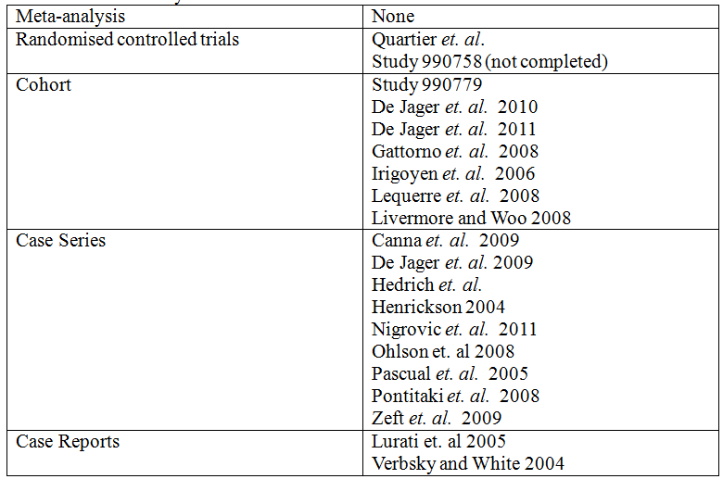

The submission contained the following clinical information:

* One pivotal literature based study: Quartier et. al.
* Two company sponsored studies of efficacy and safety: Study 990758 (conducted in subjects with polyarticular juvenile rheumatoid arthritis) and its extension Study 990779. Limited PK data was also available from Study 990758.
* Two other literature reports in support of efficacy and safety, one of which described the company sponsored studies.
* 17 literature reports in support of safety. These reports were all of poor quality, but some safety data were extractable and are commented on in the relevant sections.
* One PSUR that covered the time period 14 May 2010 to 1 May 2013.

The literature search strategy was applied to the following databases: Cochrane Library, Embase, Medline, Medline Daily and PreMedline. The search strategy was provided in the submission and was appropriate for identifying studies of anakinra in subjects with systemic onset juvenile rheumatoid arthritis. Studies of PK/PD, efficacy and safety were included in the literature based submission.

### Paediatric data

The submission included paediatric pharmacokinetic, efficacy and safety data relating to the proposed new indication.

### Good clinical practice

The company sponsored studies appeared to adhere to GCP, but the literature based studies did not appear to adhere to GCP.

## Pharmacokinetics

### Studies providing pharmacokinetic data

Limited PK data were provided from Study 990758 (Table 2).

Table 2. A synopsis of Study 990758.

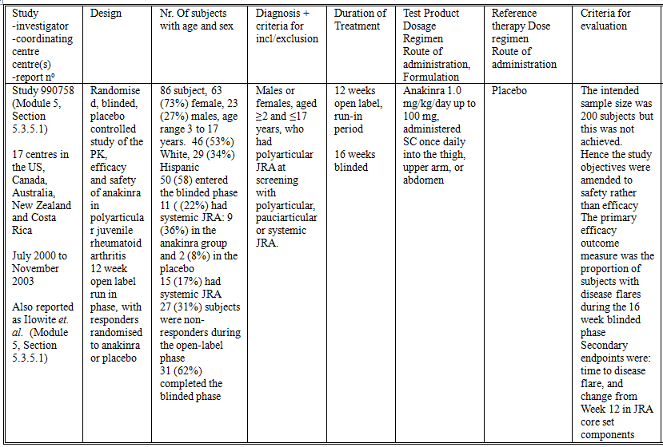

### Summary of pharmacokinetics

The information in the following summary is derived from conventional pharmacokinetic studies unless otherwise stated.

### Pharmacokinetics in healthy subjects

There were no new data regarding PK in healthy subjects.

### Pharmacokinetics in the target population

In Study 990758 PK data were available for 80 subjects aged 3 to 17 years with JIA. There was a high degree of variability in plasma concentrations (Table 3 and Figure 1). The mean plasma concentrations by age grouping suggest decreased exposure in the younger age groups (Figure 2).

Table 3. Summary Statistics of Plasma Anakinra Concentrations (ng/mL) in Adult RA (0560) and JRA Subjects Normalised to a 1 mg/kg Daily SC Dose.

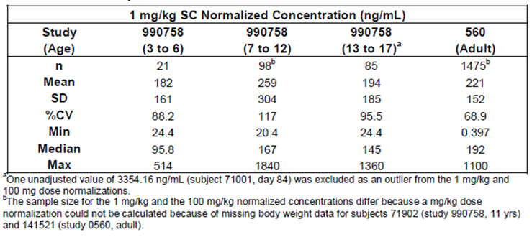

Figure 1. Anakinra Plasma Concentration-Time Data in Subjects with JRA.

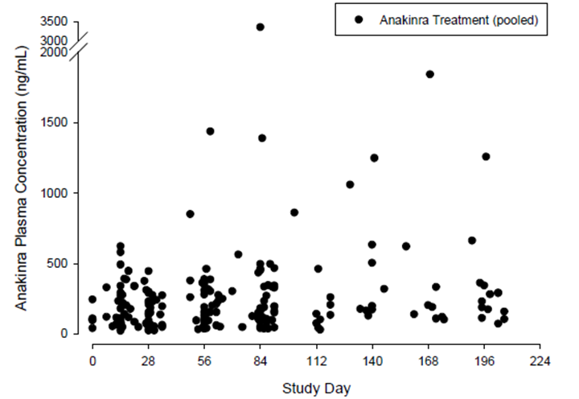

Figure 2. Age-Stratified Plasma Anakinra Concentrations (ng/mL) in Adult RA (0560) and JRA Subjects Normalised to a 1 mg/kg Daily SC Dose.

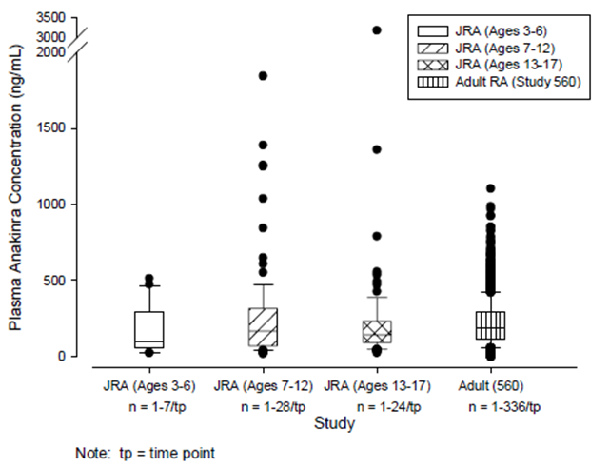

### Pharmacokinetics in other special populations

There were no additional data with regard to PK in other special populations.

### Pharmacokinetic interactions

There were no new data with regard to PK interactions.

### Evaluator’s overall conclusions on pharmacokinetics

The analysis of the plasma concentration data from Study 990758 was inadequate. The data appear to be suitable for use in a population PK analysis which would have enabled assessment of covariate data such as age, weight, gender, renal function and disease severity. This analysis should use all the available PK data. The structural model could be informed by PK data from adult studies. The error model could be informed by the data. The covariate model should explore allometric scaling models for weight on the PK parameters clearance and volume of distribution. Using simulations, a dosing strategy could be developed to produce similar exposure to anakinra, represented by AUC, for children by age groupings and adults.

There were no PK data available from the Pivotal study: Quartier et. al.

The data as presented are insufficient to be used to support the proposed dosing regimen.

## Pharmacodynamics

### Studies providing pharmacodynamic data

No PD data were included in the submission.

### Summary of pharmacodynamics

No new PD data were included in the submission.

### Evaluator’s overall conclusions on pharmacodynamics

The analysis of the plasma concentration data from Study 990758 in combination with response data from the same study appear to be suitable for analysis in a population PKPD model. As there is a discrepancy between the proposed dosing regimen and that used in the pivotal study, a population PKPD study would be important in informing the dosing regimen.

The population PKPD model could use the final population PK model, as proposed to generate individual estimates of the PK parameters (for example, AUC, Cmax and Cmin). These could then be used in a logistic regression model to examine the relationship between the PK variables and disease flare. Time to disease flare could be examined using a proportional hazards model.

## Dosage selection for the pivotal studies

It is not stated how the dose regimen used in the pivotal study was selected. This is an important omission because the proposed dosing regimen differs from that used in the pivotal study.

## Clinical efficacy

This section analyses the clinical efficacy for SJIA.

### Pivotal efficacy studies

#### Quartier et. al.

##### Study design, objectives, locations and dates

Quartier et. al. was an Investigator sponsored, multicentre, randomised, double blind, placebo controlled study of anakinra in subjects with SJIA (Table 4). The study had a 1 month double blind phase, and an 11 month open label phase. The study was conducted at six centres prior to November 2010.

Table 4. Synopsis of Study published by Quartier et. al

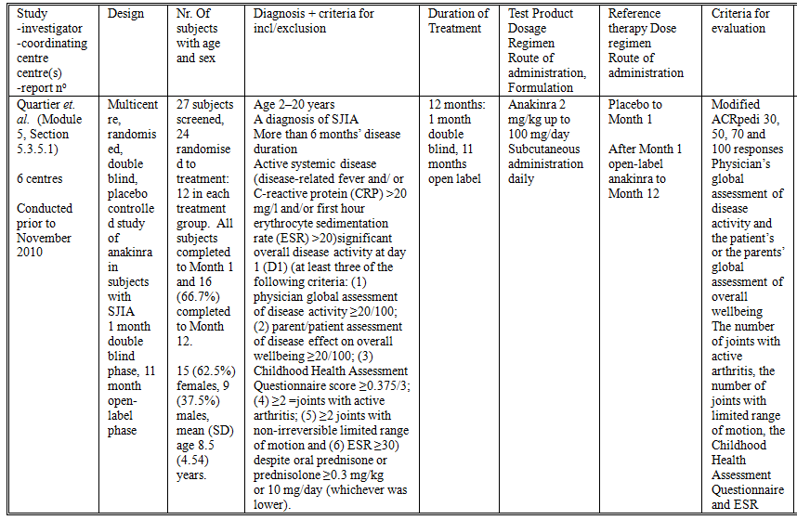

##### Inclusion and exclusion criteria

Inclusion criteria were:

* Age 2 to 20 years
* A diagnosis of SJIA
* More than 6 months disease duration
* Active systemic disease (disease related fever and/ or C reactive protein (CRP) > 20 mg/L and/or first hour erythrocyte sedimentation rate (ESR) > 20), and significant overall disease activity at Day 1 (including at least three of the following criteria: (1) physician global assessment of disease activity ≥ 20/100; (2) parent/patient assessment of disease effect on overall wellbeing ≥ 20/100; (3) Childhood Health Assessment Questionnaire score ≥ 0.375/3; (4) ≥ 2 joints with active arthritis; (5) ≥ 2 joints with non-irreversible limited range of motion and (6) ESR ≥ 30) despite oral prednisone or prednisolone ≥ 0.3 mg/kg or 10 mg/day (whichever was lower)
* Female subjects entering the study were to be either prepubescent, sexually inactive or using effective contraception (effective contraception was not defined in the report).

The exclusion criteria included:

* Previous treatment with an IL-1 inhibitor
* Any condition contraindicating immunosuppressive treatment
* Intravenous or intra articular steroids, immunosuppressive drugs and disease modifying antirheumatic drugs (DMARDs) had to be stopped at least 1 month before study onset or for longer periods of time depending on their half-life.

##### Study treatments

The study treatments were either:

1. Anakinra 2 mg/kg subcutaneously daily, to a maximum total daily dose of 100 mg, or
2. Placebo

These study treatments were administered for 1 month. After Month 1 all subjects received open-label anakinra. The treatments were administered daily, subcutaneously.

##### Efficacy variables and outcomes

The primary efficacy outcome measure was the proportion of responders. To be classified as responders subjects had to fulfil the three following conditions: (1) modified American College of Rheumatology Pediatric (ACRpedi) 30 score; (2) absence of disease related fever (body temperature < 38°C over the past 8 days) and (3) 50% decrease compared with Day 1 or normalisation of both CRP and ESR values.

The secondary efficacy outcome measures were:

* Modified ACRpedi 30, 50, 70 and 100 responses, assessed throughout the study, included an improvement of 30%, 50%, 70% or more and 100% respectively, in at least three of the six core criteria for juvenile rheumatoid arthritis and a worsening of 30 or more in no more than one of the criteria
* Physician’s global assessment of disease activity and the patient’s or the parents’ global assessment of overall wellbeing
* The number of joints with active arthritis, the number of joints with limited range of motion, the Childhood Health Assessment Questionnaire and ESR
* A disease flare was defined as either (1) a reoccurrence of disease-related fever or any systemic symptom, or (2) an increase by two-fold of either the ESR or CRP value, or (3) a worsening of ≥ 30% in at least three of the six ACRpedi core criteria and an improvement of ≥ 30% in no more than one of the criteria. If the number of joints with active arthritis was used as a criterion of flare and the patient initially had no active joints or only one active joint, an increase in the number of joints with active arthritis to at least two was required
* The number of patients who reached Month 6 with inactive disease, under a daily dose of prednisone or prednisolone < 0.3 mg/kg or 10 mg, whichever was lower
* Patients who were naive for anti-pneumococcal immunization received Pneumo23 immunisation at Day 1 in order to assess at Month 1 and Month 12 the effect of anakinra treatment on anti-pneumococcal antibody response to five capsular polysaccharides.

There were also some exploratory variables, principally gene expression. These exploratory outcome measures were not measures of efficacy or safety.

Study design is summarised in Figure 3.

Figure 3. Study design (from, Quartier et. al.)

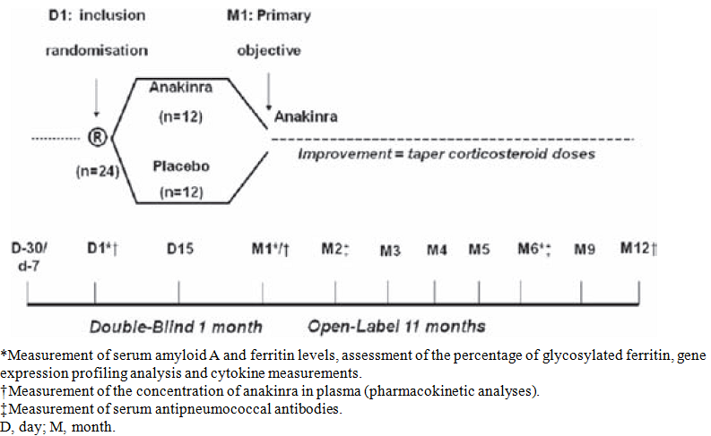

##### Randomisation and blinding methods

Randomisation was stratified by centre and was balanced across treatments and centres. Investigators, other caregivers, the patients and their parents remained blinded to the assigned treatment.

##### Analysis populations

The analysis was stated to be intention to treat.

##### Sample size

The sample size calculation was based on a 60% difference in the percentage of patients obtaining improvement in the anakinra treated group compared to the placebo group; a response rate of 10% in the placebo group, a power of 80% and a level of significance of 0.05. This calculation gave a sample size of 12 subjects in each treatment group.

##### Statistical methods

Qualitative and quantitative data were compared using Wilcoxon test and Fisher exact test, respectively.

##### Participant flow

There were 27 subjects screened and 24 randomised to treatment: 12 in each treatment group (Figure 4). All subjects completed to Month 1 and 16 (66.7%) completed to Month 12.

Figure 4. Patients’ disposition.

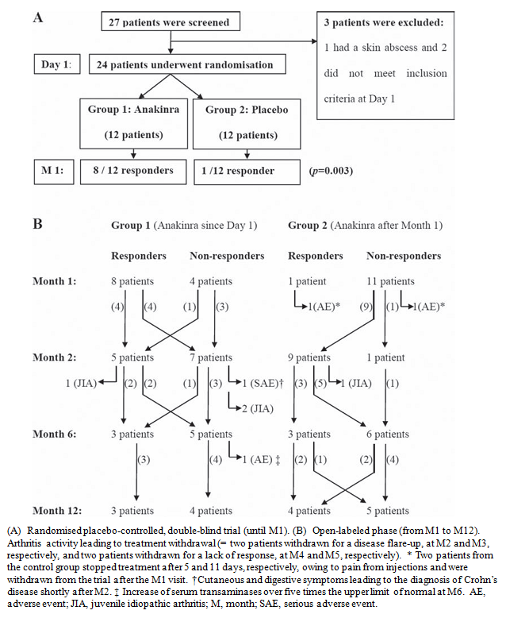

##### Major protocol violations/deviations

Not reported.

##### Baseline data

There were 15 (62.5%) females, nine (37.5%) males and the mean (SD) age was 8.5 (4.54) years. The treatment groups were similar in demographic and disease characteristics (Table 5).

Table 5. Pivotal Study: Patients characteristics at study treatment onset (from Quartier et. al.)

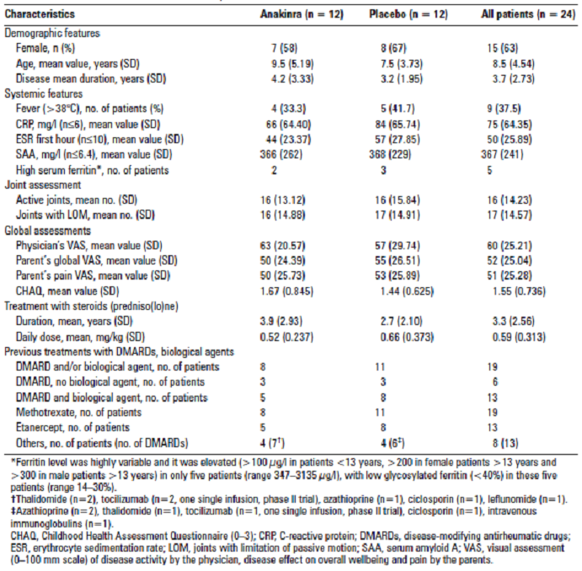

###### Results for the primary efficacy outcome

There were eight (67%) responders in the anakinra group and one (8%) in the placebo (p = 0.003) (Table 6).

Table 6. Pivotal Study: Responses at Month 1 (from Quartier et. al.)

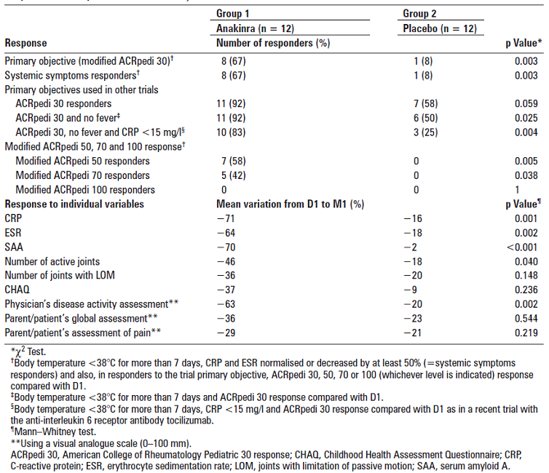

###### Results for other efficacy outcomes

There were more ACRpedi 50 and 70 responders in the anakinra group than in the placebo (Table 6). There were seven (58%) modified ACRpedi50 responders in the anakinra group and none in the placebo (p = 0.005). There were five (42%) modified ACRpedi 70 responders in the anakinra group and none in the placebo (p = 0.038). There were no modified ACRpedi 100 responders in either group.

ESR and CRP decreased to a greater extent in the anakinra group. Physicians disease activity assessment improved to a greater extent in the anakinra group. However, although there were greater improvements in the anakinra group for most of the remaining efficacy outcome measures, these were not statistically significant. This may be a consequence of the small sample size.

At Month 2, of the 11 subjects in the placebo group that entered the open label study, nine responded (Table 6). Two of these subjects maintained response to Month 12. Of the eight subjects in the anakinra group that responded at Month 1, two maintained response to Month 12. Of the seven responders at Month 7, six had ceased corticosteroid treatment and five had inactive disease. Although subjects initially appeared to respond to anakinra there was loss of response at subsequent visits, and by the end of Month 12, of the remaining 16 subjects still in the study there were seven responders and nine non responders. There was considerable crossover between response and non response throughout the study. At Month 6, for example, of the seventeen subjects still in the study there were six responders and eleven non-responders. It is not clear from the data presentation whether response at different visits may have been modulated by concurrent DMARDs, NSAIDs or corticosteroids.

There was no difference in pneumococcal antibody response reported between the study groups. The exploratory analysis of gene expression found a significant up regulation of the purinergic receptor P2RX7, an ATP gated ion channel involved in IL-1β processing and secretion, 17 HLA class II genes, the proteasome activator PSME2 and transcripts involved in interferon (IFN) signaling (SOCS1, STAT1 and STAT2). IL-1B was among the most significantly down regulated transcripts.

#### Other efficacy studies

##### Study 990758

Study 990758 was a randomised, blinded, placebo-controlled study of the PK, efficacy and safety of anakinra in polyarticular juvenile rheumatoid arthritis (Table 2). The data were also published in report Ilowite et. al.. The study included a 12 week open label run in phase, with responders subsequently randomised to anakinra or placebo for the blinded phase. There was also an open label follow on study (Study 990779). The study was conducted at 17 centres in the US, Canada, Australia, New Zealand and Costa Rica from July 2000 to November 2003. The overall study design is summarised in Figure 5. The study included males or females, aged ≥ 2 and ≤ 17 years, who had polyarticular JIA at screening with polyarticular, pauciarticular or SJIA. However, SJIA was not clearly defined in the methods section of the study report.

Figure 5. Study design. Patients switched treatment arms if they elected to continue (from, Ilowite et. al.).

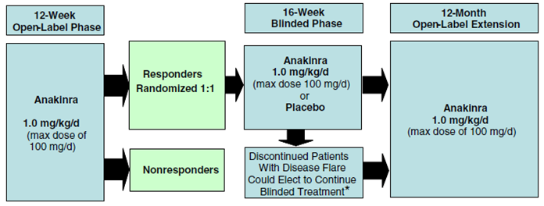

The study treatments were: anakinra 1.0 mg/kg/day up to 100 mg, or placebo, administered SC once daily into the thigh, upper arm, or abdomen. The open label run in phase was of 12 weeks duration and the blinded phase was of 16 weeks duration. The intended sample size was 200 subjects but this was not achieved. Hence the study objectives were amended to safety rather than efficacy. The primary efficacy outcome measure was the proportion of subjects with disease flares during the 16 week blinded phase. Secondary endpoints were: time to disease flare, and change from Week 12 in JRA core set components. In the run in phase there were 86 subjects: 63 (73%) female, 23 (27%) males, with an age range of 3 to 17 years, and 15 (17%) had SJIA. There were 46 (53%) White subjects and 29 (34%) were Hispanic. There were 50 (58) subjects entered into the blinded phase (Figure 6.). Eleven (22%) had SJIA: nine (36%) in the anakinra group and two (8%) in the placebo. A total of 27 (31%) subjects were non responders during the open label phase and 31 (62%) completed the blinded phase. There was no significant difference between the treatment groups. However four (16%) subjects in the anakinra and nine (36%) in the placebo had disease flares. ESR decreased in the anakinra group by mean (SD) ‑3.70 (11.23) and increased in the placebo 13.73 (22.52). Limited efficacy data were available for subjects with SJIA: in the study report blinded phase data were reported for one subject in each treatment group. Hence, efficacy data were available for only one subject with SJIA treated with anakinra. This subject had an increase in affected joints of 2 during the blinded treatment phase. However, in the published report (Ilowite *et. al.*) disease flares were reported in two of nine subjects with SJIA in the anakinra group and one of two with SJIA in the placebo group.

Efficacy was not evaluated in the extension study (Study 990779).

Figure 6. Patient disposition (from Ilowite *et. al*.).

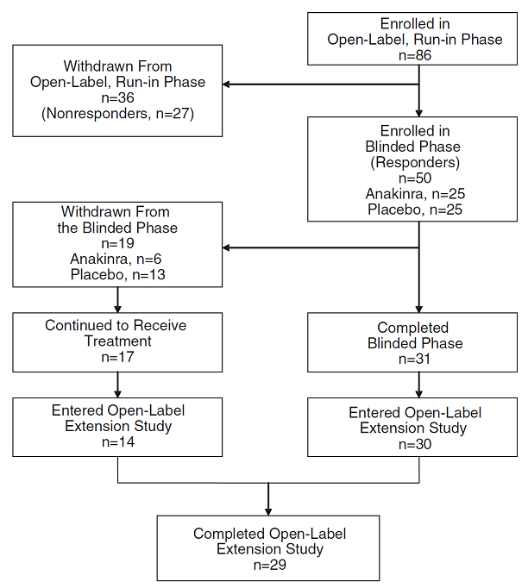

#### Analyses performed across trials (pooled analyses and meta-analyses)

No pooled analyses were provided in the submission.

#### Evaluator’s conclusions on clinical efficacy for systemic onset JRA

The efficacy conclusions are based on the results of a single pivotal study of anakinra as monotherapy. This study was performed in 24 subjects, 12 of whom were treated with anakinra. To conclude efficacy from a single pivotal study the results would need to be both clinically and statistically compelling.

In the pivotal study the response rate was clinically significant, and highly statistically significant. There were eight (67%) responders in the anakinra group and one (8%) in the placebo (p = 0.003). However, the initial response was not maintained long term. The data presentation indicated considerable crossover between response and non-response and it was not possible to account for concurrent treatments that may have modulated response.

In addition to the primary efficacy outcome variable, the secondary efficacy outcome variables were supportive of efficacy. There were more ACRpedi 50 and 70 responders in the anakinra group than in the placebo. There were greater improvements in the anakinra group for most of the remaining efficacy outcome measures, although these were not statistically significant.

The age range, and distribution of ages, for the study subjects included in Quartier *et. al*. was not provided. Hence it is not possible to determine whether the age range represented by the proposed indication was studied in the pivotal study. Other than this, it appears that the population studied in the pivotal study were similar to those intended in the proposed indication, noting that the efficacy data relate only to active disease.

The data from the pivotal study were pertinent to the indication of SJIA as opposed to other types of JIA/JCA/JRA. The study appears to have been well conducted and is reported in sufficient detail to be acceptable for evaluation. The Pivotal study appears to be in accordance with the CHMP Guideline On Clinical Investigation Of Medicinal Products For The Treatment Of Juvenile Idiopathic Arthritis.

However, there are a number of deficiencies in the clinical efficacy data. These are:

* The dose regimen used in the pivotal study is different to that proposed by the sponsor. In the opinion of the evaluator, the regimen used in the pivotal study is supported to a greater extent by the data and should replace that proposed by the sponsor.
* The efficacy data are primarily literature based and are not reported in detail.
* There were insufficient data to support a maximum dose, specifically a maximum dose of 4 mg/kg/day.
* There were insufficient data to support efficacy as combination therapy.
* There were inadequate data to support an independent evaluation of combination therapy with DMARDs as a group or as individual agents.
* There were insufficient data to support sustained efficacy over the long term (that is 6 months or longer).

The intended indication is rare and Orphan Drug Designation applies to the paediatric age groups (but not to the adult). Recruitment for clinical trials for this condition is difficult and would require collaboration between many large centres for paediatric rheumatology.

## Clinical safety

### Studies providing evaluable safety data

The following studies provided evaluable safety data;

* Pivotal efficacy study. In the pivotal efficacy study, the following safety data were collected: adverse events.
* Dose response and non-pivotal efficacy studies. The non-pivotal safety study reported AEs and laboratory tests.
* Other studies evaluable for safety only; Study 990779.

#### Study 990779

Study 990779 was an open label extension study to Study 990758 (Table 7). The study was conducted at 12 centres in the US, Canada, Australia, New Zealand and Costa Rica from February 2001 to February 2004. The study included subjects that entered into Study 990758, including non-responders during the run in phase. The subjects received anakinra 1 mg/kg/day up to a maximum dose of 100 mg/day for up to one year. Efficacy was not assessed. There were 47 subjects enrolled, and 44 entered the open label phase. There were 31 (70%) females, 13 (30%) males, the age range was 4 to 18 years, 25 (57%) subjects were White, and 16 (36%) were Hispanic. A total of 29 (66%) subjects completed the study.

Table 7. Synopsis of Study 990779.

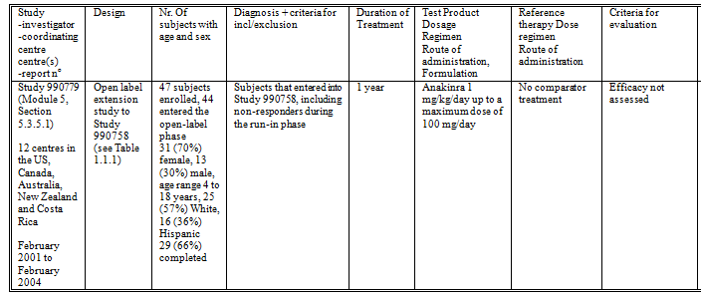

#### Additional studies from literature

The following studies were identified from the literature search performed by the sponsor. Although these studies were of poor quality, some safety data were extractable and have been commented on in the appropriate sections below.

* Canna *et. al.* 2009 reports a case series of three children who developed hepatitis attributed to anakinra.
* The following three reports were all co-authored by De Jager and each of them may be describing the same set of subjects as in the other two:
  + De Jager et. al. 2009 is a conference abstract describing a case series of eight subjects with newly diagnosed systemic onset JRA, who had not been treated with steroids, who were treated with anakinra for up to 4 months. The dose of anakinra was not reported. The authors reported that fever, exanthema and arthritis resolved after 3 days and two subjects had flare over the 4 months follow up. There was a rapid decrease in ESR, CRP, ferritin and sIL-2. There were no safety data reported and the efficacy data were not sufficiently reported to be evaluable.
  + De Jager et. al. 2010 briefly describes a cohort of 13 subjects with systemic onset JRA. There was ‘*a fast response in all patients*’ and 75% are described as having achieved a pACR90 response after 3 weeks. After 1 year 6 subjects were in remission off treatment, four were in remission on anakinra and three required the addition of steroids. There were no safety data reported and the efficacy data were not sufficiently reported to be evaluable.
  + De Jager et. al*.* 2011 briefly describes a cohort of 16 subjects with systemic onset JRA. Fourteen of the subjects are described as having a ‘*good clinical response*’ and 75% are described as having achieved a pACR90 response after 3 weeks. There were no safety data reported and the efficacy data were not sufficiently reported to be evaluable.
* Gattorno et. al. 2008 describes a cohort of 22 subjects with systemic onset JRA who were treated with anakinra. Ten subjects were complete responders, eleven had incomplete response or no response and one could not be classified. The age range was 0.9 to 18.7 years. Eleven (50%) subjects were male and eleven (50%) were female. The dose of anakinra was 1 mg/kg up to 100 mg administered subcutaneously daily. There were ‘*variable skin reactions at the injection site*’. Two subjects had MAS on Day 13. One of these subjects was subsequently retreated with anakinra 6 months later without reactivation of MAS.
* Hedrich et. al. reported a retrospective case series of four subjects with systemic onset JRA treated with anakinra (dose range 1.5 to 4 mg/kg, duration range 3 to 18 months). Two subjects responded to anakinra alone and two required the addition of corticosteroids. Three subjects were reported with local inflammation and pruritus at the injections site.
* Henrickson 2004 reports a case series of four subjects with refractory ‘*systemic arthritis*’ who were corticosteroid dependent and failing multiple cytotoxic or DMARDs. The age range was 6.6 to 16.8 years, three were male and one was female. These subjects were treated with anakinra and all four achieved ACR30 response at 1 month and 2 months. One subject had persistent mild urticaria at the injection sites. One minor infection was reported: paronychitis.
* Irigoyen et. al. 2006 describes a multicentre, retrospective cohort study of 14 subjects with systemic onset JRA treated with anakinra. The study used data from five centres. Anakinra resulted in complete resolution of extra articular symptoms in all subjects with active systemic features within 3 months. All subjects had improvement in their arthritis and ten had complete resolution of arthritis. Normalisation of laboratory values was seen in all patients. Dose was not reported. There were no safety data reported and the efficacy data were not sufficiently reported to be evaluable.
* Lequerre et. al. 2008 reports a cohort of 35 subjects with systemic onset JRA, 20 with juvenile and 15 with adult forms. Of the 20 subjects with the juvenile form, 12 (60%) were female and eight (40%) were male, and the age range was 3 to 23 years. Five (25%) of the juvenile form subjects achieved ACR50 response. Ten subjects had a reduction in steroid dose. One child developed visceral Leishmaniasis. There was also one case of varicella, two cases of rhinopharyngitis and one case of non extensive labial herpes. All but two subjects reported pain during injections.
* Livermore and Woo 2008 is a conference abstract that reports a cohort of ten subjects aged 3 to 17 years with systemic onset JRA who were treated with anakinra 2 mg/kg/day subcutaneously for 12 weeks. Eight completed the 12 weeks treatment and four responded to treatment. Safety outcome measures were not reported. There were no safety data reported and the efficacy data were not sufficiently reported to be evaluable.
* Lurati et. al 2005 described a case report of an 18 year old subject with longstanding systemic onset JRA, who developed MAS following anakinra 100 mg/day subcutaneously.
* Nigrovic et. al. 2011 described a case series of 46 subjects with systemic JRA treated with anakinra at 11 centres in 4 countries. The data were extracted using chart review and a ‘*standard data collection form in accordance with a detailed manual of operations (both available upon request from the corresponding author)*’. Ten (22%) subjects received anakinra as monotherapy, 67% received corticosteroids and 33% received additional DMARDs. Approximately 60% of subjects attained a complete response. The median (range) starting dose was 1.5 (0.93 to 11.2) mg/kg/day. Duration of follow up was, median (range), 14.5 (7.5 to 26) months. The quality of the data was variable: only 29 subjects had detailed clinical assessments recorded within the first week of therapy. A total of 11 MAS episodes were reported, six prior to anakinra treatment and five during anakinra treatment. Injection site reactions were reported in 44% of the 45 subjects with ‘*evaluable data’*. There were three serious infections: pneumococcal bacteraemia, infected gastric feeding tube site and pneumonia. Eosinophilic hepatitis led to discontinuation in one subject and there were elevated transminases in another two subjects. One subject developed neutropenia.
* Ohlson et. al 2008 was a letter describing a case series of seven subjects with systemic onset JRA treated with anakinra at three centres. Six subjects responded. Five were treated with 1 mg/kg/day and two (one non responder) with 2 mg/kg/day. There were three serious infections, including one case of gastroenteritis with pre-renal failure and one varicella pneumonitis.
* Pascual et. al.2005 describes nine subjects with systemic JRA treated with anakinra, seven of whom responded to treatment. There were insufficient data regarding efficacy or safety for the report to be evaluable.
* Pontitaki et. al. 2008 is a conference abstract that describes 16 subjects with systemic JCA treated with anakinra. Eleven (69%) subjects were responders. Five (31%) ceased treatment because of AEs or lack of efficacy. The most important AE was injection site pain. There was one severe cutaneous reaction. There were insufficient data regarding efficacy or safety for the report to be evaluable.
* Verbsky and White 2004 reports two subjects with longstanding systemic JRA who responded dramatically to anakinra. There were insufficient data regarding efficacy or safety for the report to be evaluable.
* Zeft et. al.2009 report a case series of 33 subjects with systemic JRA treated with anakinra. There was one case of MAS and one of EBV infection. One subject developed injection site sterile abscesses. Seventeen subjects reported either exaggerated localised pain or swelling at their injection site. In seven subjects these symptoms led to discontinuation.

### Pivotal studies that assessed safety as a primary outcome

There were no pivotal studies that assessed safety as a primary outcome.

### Patient exposure in clinical trials

In Study 990758, summarised in Table 2, a total of 80 subjects aged 3 to 17 years with JRA were treated with anakinra 100 mg/kg, up to 100 mg, daily for up to 28 weeks. During the open label phase 86 subjects were treated for a median (range) of 84 (2 to 106) days. During the blinded phase, 25 subjects were treated for a median (range) of 112 (9 to 126) days. There were 15 subjects with systemic JCA.

In Study 990779, summarised in Table 7, there were 44 subjects exposed to anakinra for up to 363 days, mean (SD) duration of treatment 162.68 (54.48) days.

In Quartier et. al. there were 24 subjects with systemic onset JRA treated with anakinra 2 mg/kg (up to 100 mg) with nine treated for 11 months, and seven treated for 12 months.

### Adverse events

#### All adverse events (irrespective of relationship to study treatment)

##### Pivotal studies

In Quartier et. al.during the double blind phase, 14 TEAEs were reported in the anakinra group and 13 in the placebo. There were 89 TEAEs reported during open label phase, giving a rate of 5.71 events per patient-year (Table 8).

Table 8. Pivotal Study: Adverse events (AEs).

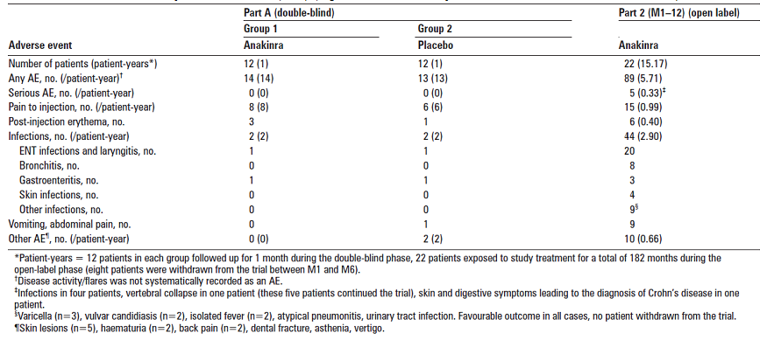

##### Other studies

In Study 990758 during the open label phase 80 (93%) subjects reported TEAEs and in 64 (74.4%) subjects there were injection site reactions. During the double blind phase TEAEs were reported in 17 (68%) subjects in the anakinra group and 18 (72%) in the placebo. The commonest TEAEs were: headache (6 (24%) in the anakinra group versus 1 (4%) in the placebo), upper respiratory tract infection (4 (16%) versus 5 (20%)), fever (3 (12%) versus 2 (8.0%)), abdominal pain (3 (12%) versus 2 (8%)), injury (3 (12%) versus none) and diarrhoea (3 (12%) versus none). Arthralgia was more common in the placebo group (4 (16%) in the placebo group versus 1 (4.0%) in the anakinra) as was limb pain (4 (16%) versus 3 (12.0%)). The injuries were not described in detail.

In Study 990779 TEAEs were reported in 30 (68.2%) subjects. The most commonly reported TEAEs were: arthralgia in ten (22.7%), fever in nine (20.5%), abdominal pain in seven (15.9%), and headache in six (13.6%).

#### Treatment-related adverse events (adverse drug reactions)

Treatment related AEs were not identifiable from the pivotal study.

#### Deaths and other serious adverse events

##### Pivotal studies

In Quartier *et. al.* no deaths were reported. There were no SAEs during the double blind phase but six were reported during the open-label phase: four infections, one vertebral collapse and one Crohn’s disease.

##### Other studies

In Study 990758 there were no deaths. There were three subjects with SAEs during the open label phase (fracture, synovitis and dysuria) and none during the blinded phase.

In Study 990779 there were no deaths. There were three SAEs reported in two (4.5%) subjects: hepatitis, infection viral and nephrosis.

#### Discontinuation due to adverse events

##### Pivotal studies

In Quartier et. al.there were four discontinuations due to AEs: injection pain in two subjects, Crohn’s disease in one and elevated transaminases in one.

##### Other studies

In Study 990758 in the open label phase there were seven AEs leading to withdrawal in four (4.7%) subjects: two subjects with injection site pain, and in one subject each with injection site pain, injection site pruritus, injection site rash, synovitis and dysuria. There were no DAEs during the blinded phase.

In Study 990779 there were three (6.8%) subjects that withdrew due to TEAEs: arthritis rheumatoid for two (4.5%), and nephrosis for one (2.3%).

### Laboratory tests

#### Liver function

##### Pivotal studies

In Quartier et. al one subject discontinued because of elevated transaminases.

##### Other studies

In Study 990758 one subject was reported with elevated ALT.

In Nigrovic et. al.2011 eosinophilic hepatitis led to discontinuation in one subject and there were elevated transaminases in another two subjects.

#### Kidney function

No abnormalities in renal function were reported.

#### Other clinical chemistry

No abnormalities in other clinical chemistry were reported.

#### Haematology

##### Pivotal studies

No haematological abnormalities were reported in the pivotal study.

##### Other studies

In Study 990758 one subject was reported with transient neutropenia.

In Nigrovic et. al. 2011 one subject developed neutropenia.

#### Immunogenicity

##### Pivotal studies

Immunogenicity data were not reported from the pivotal study.

##### Other studies

In Study 990758 during the open label phase 48 (75%) subjects were positive for antibodies, and four (6%) subjects were positive for neutralizing antibodies. During the blinded phase: 13 (72%) of anakinra treated subjects were positive for antibodies, and none for neutralizing antibodies.

In Study 990779 36 (82%) subjects were positive for antibodies, but none were neutralizing.

### Post-marketing experience

#### Post-marketing data

Post-marketing data were provided from one PSUR that covered the time period 14 May 2010 to 1 May 2013. The recommended starting dose over that time period was 1 to 2 mg/kg day up to 8 mg/kg/day in patients with NOMID/CINCA. Clinical exposure in company sponsored clinical trials was estimated at 6404 subject-years. Cumulative post marketing exposure was estimated to be 63,748 patient-years since first registration, in November 2001. The sponsor has identified an investigator sponsored clinical trial where doses up to 20,900 mg/24 hours were administered intravenously in 13 subjects with no reported SAEs.

The sponsor identified extensive off label use of anakinra. In the US the indications for treatment with anakinra were systemic onset JRA for 21% of the patients treated. In a Sweden the most common indication for anakinra use in children was systemic onset JRA.

There were no new safety concerns identified in the PSUR.

#### Risk management plan

The important identified risks are:

* Injection site reactions
* Immunogenicity
* Serious infections
* Neutropenia
* Allergic conditions
* Hepatic disorders
* Interactions with TNF antagonists.

Important potential risks are:

* Malignancies
* Macrophage activation syndrome (MAS) (not applicable for RA or CAPS)
* Medication errors including re-use of syringe
* Safety in off-label use.

Important missing information is:

* Pregnant women
* Lactating women
* Patients with cardiac impairment
* Use in patients with chronic infections
* Use in patients with pre-existing cancers
* Interaction with living vaccines.

### Safety issues with the potential for major regulatory impact

#### Infections

In Study 990758 during the open label phase, infections were reported in 35 (41%) subjects. During the blinded phase infections were reported in 9 (36%) subjects in the anakinra group and 8 (32%) in the placebo Table 9.

Table 9. Study 990758: Subject Incidence of Infectious Episodes by Body System and Preferred Term (Blinded Phase).

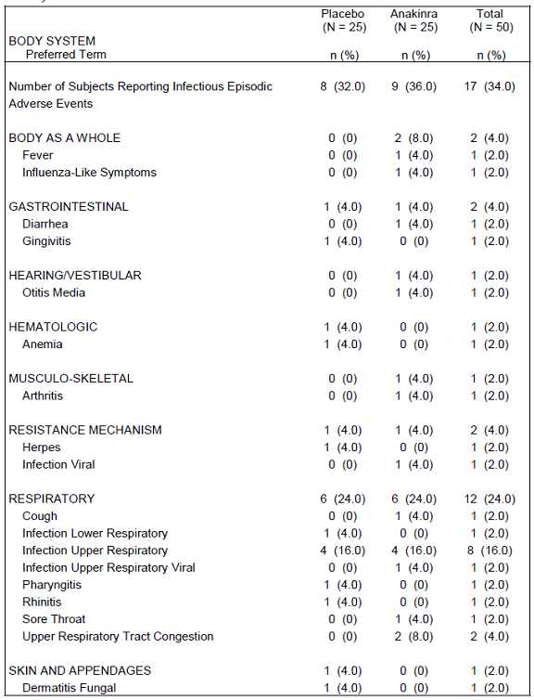

In Study 990779 infectious TEAEs were reported in 16 (36.4%) subjects. There was one serious infectious TEAE: hepatitis/infection viral. One subject was also recorded as having herpes zoster as a SAE during blinded treatment.

In Quartier et. al. the rate of infections was 3.90 per patient-year.

In Nigrovic et. al. 2011 there were three serious infections: pneumococcal bacteraemia, infected gastric feeding tube site and pneumonia.

In Ohlson et. al. 2008 there were three serious infections, including one case of gastroenteritis with pre renal failure and one varicella pneumonitis.

Zeft et. al. 2009 reported one subject with EBV infection.

#### Liver toxicity

Canna et. al. 2009 reports a case series of three children who developed hepatitis during treatment with anakinra that resolved after the treatment was discontinued. In each case the hepatitis was not considered to be due to sJIA flare, infection, macrophage activation syndrome (MAS), malignancy, or other drugs. All three subjects had liver biopsies. These were considered to be indicative of an exogenous cause for the hepatitis. One of the biopsies had an eosinophilic infiltrate.

In Nigrovic et. al. 2011 eosinophilic hepatitis led to discontinuation in one subject and there were elevated transaminases in another two subjects.

#### Macrophage activation syndrome

Gattorno et. al. 2008 describes a cohort of 22 subjects with systemic onset JRA who were treated with anakinra. Two subjects had MAS on Day 13. One of these subjects was subsequently retreated with anakinra 6 months later without reactivation of MAS.

Lurati et. al. 2005 described a case report of an 18 year old subject with longstanding systemic onset JRA, who developed MAS attributed to anakinra 100 mg/day subcutaneously.

In Nigrovic et. al. 2011 a total of 11 MAS episodes were reported, six prior to anakinra treatment and five during anakinra treatment.

Zeft et. al.2009 reported one case of MAS.

### Evaluator’s overall conclusions on clinical safety

The safety data presented in the submission reflected the known safety profile of anakinra and were consistent with the safety specification stated in the RMP. Injection site AEs were common but were of minor severity and are to be expected with the subcutaneous route of administration. Serious infections were reported but it was not possible from the data to determine whether the risk was increased by anakinra or reflected the background risk in the treated population. Similarly, MAS was also reported in subjects treated with anakinra. Liver toxicity was also reported in subjects treated with anakinra. The data did not identify any specific issue with regard to neutralising antibodies. There do not appear to be any additional monitoring requirements, other than those normally required for patients with systemic JCA.

There is clearly an extensive off label usage of anakinra in subjects with systemic onset JIA and the post marketing reports of MAS, serious infections and liver toxicity should be interpreted in this context. These events are also associated with the population of patients with systemic onset JIA and may reflect the underlying condition and the medicines used to treat it.

However, there were inadequate data with regard to growth and development in the paediatric population.

## First round benefit-risk assessment

### First round assessment of benefits

The efficacy conclusions are based on the results of a single pivotal study of anakinra as monotherapy. This study was performed in 24 subjects, 12 of whom were treated with anakinra. To conclude efficacy from a single pivotal study the results would need to be both clinically and statistically compelling.

In the pivotal study the response rate was clinically significant, and highly statistically significant. There were eight (67%) responders in the anakinra group and one (8%) in the placebo (p = 0.003). However, the initial response was not maintained long term. The data presentation indicated considerable crossover between response and non-response and it was not possible to account for concurrent treatments that may have modulated response.

In addition to the primary efficacy outcome variable, the secondary efficacy outcome variables were supportive of efficacy. There were more ACRpedi 50 and 70 responders in the anakinra group than in the placebo. There were greater improvements in the anakinra group for most of the remaining efficacy outcome measures, although these were not statistically significant.

The age range, and distribution of ages, for the study subjects included in Quartier et. al. was not provided. Hence it is not possible to determine whether the age range represented by the proposed indication was studied in the pivotal study. Other than this, it appears that the population studied in the pivotal study were similar to those intended in the proposed indication, noting that the efficacy data relate only to active disease.

The data from the pivotal study were pertinent to the indication of SJIA as opposed to other types of JIA/JCA/JRA. The study appears to have been well conducted and is reported in sufficient detail to be acceptable for evaluation. The Pivotal study appears to be in accordance with the CHMP Guideline On Clinical Investigation Of Medicinal Products For The Treatment Of Juvenile Idiopathic Arthritis.

However, there are a number of deficiencies in the clinical efficacy data. These are:

* The dose regimen used in the pivotal study is different to that proposed by the sponsor. In the opinion of the evaluator, the regimen used in the pivotal study is supported by the data and should replace that proposed by the sponsor.
* The efficacy data are primarily literature based and are not reported in detail.
* There were insufficient data to support a maximum dose, specifically a maximum dose of 4 mg/kg/day.
* There were insufficient data to support efficacy as combination therapy.
* There were inadequate data to support an independent evaluation of combination therapy with DMARDs as a group or as individual agents.
* There were insufficient data to support sustained efficacy over the long term (that is 6 months or longer).

The intended indication is rare and Orphan Drug Designation applies to the paediatric age groups (but not to the adult). Recruitment for clinical trials for this condition is difficult and would require collaboration between many large centres for paediatric rheumatology.

As stated above, the dose regimen used in the pivotal study is different to that proposed by the sponsor, and in the opinion of the evaluator, the regimen used in the pivotal study is supported by the data and should replace that proposed by the sponsor. However, the PK data available to the sponsor could be explored using population PKPD methods in order to support a dosing regimen.

### First round assessment of risks

The safety data presented in the submission reflected the known safety profile of anakinra and were consistent with the safety specification stated in the RMP. Injection site AEs were common but were of minor severity and are to be expected with the subcutaneous route of administration. Serious infections were reported but it was not possible from the data to determine whether the risk was increased by anakinra or reflected the background risk in the treated population. Similarly, MAS was also reported in subjects treated with anakinra. Hence, anakinra did not appear to protect subjects from MAS.

Liver toxicity was also reported in subjects treated with anakinra. The data did not identify any specific issue with regard to neutralising antibodies. There do not appear to be any additional monitoring requirements, other than those normally required for patients with systemic JCA.

There is clearly an extensive off label usage of anakinra in subjects with systemic onset JRA and the post marketing reports of MAS, serious infections and liver toxicity should be interpreted in this context. These events are also associated with the population of patients with systemic onset JCA and may reflect the underlying condition and the medicines used to treat it.

However there were inadequate data with regard to growth and development in the paediatric population.

### First round assessment of benefit-risk balance

The benefit-risk balance of anakinra is unfavourable given the proposed usage, because of insufficient data supporting sustained efficacy.

## First round recommendation regarding authorisation

The Evaluator recommends rejection of the application for the extension of indications for Kineret (anakinra) to:

*Kineret (anakinra) is indicated for the treatment of active Systemic Juvenile Idiopathic Arthritis (SJIA). Kineret may be used alone or in combination with other DMARDs.*

The reasons for recommending rejection of the application are:

* In the opinion of the evaluator the pivotal study only relates to the efficacy of anakinra in systemic JIA as monotherapy and not in combination with other DMARDs.
* The age distribution of the subjects studied in the pivotal study is not presented in sufficient detail to demonstrate efficacy across the age range sought in the application.
* There is no compelling evidence of sustained long term benefit.
* The size of the population studied in the pivotal study was small (24 subjects).
* In the opinion of the evaluator there is inconsistency between the dose recommended by the sponsor and that used in the pivotal study. In addition, there has been inadequate analysis of the PK and PD data available to the sponsor. In the opinion of the evaluator the sponsor should conduct further analysis of these data using a population PKPD approach, and reconsider the dosing regimen using all the data available.

## Clinical questions

### Pharmacokinetics

1. Does the sponsor have results from a population PK study using the PK data from the paediatric subjects?

### Pharmacodynamics

1. Does the sponsor have results from a population PKPD study using the PK and outcome data from the paediatric subjects?

### Efficacy

1. What is the justification for the 1 mg/kg/day starting dose proposed by the sponsor, given that the starting dose in the pivotal study was 2 mg/kg/day?
2. In the report pivotal study, Quartier et. al., the age range of the subjects at baseline was not reported. The sponsor should provide a tabulation of the number of subjects for each year of age that were included in the study.
3. What was the definition of SJIA that was used in the inclusion criteria for Study 990758?

### Safety

1. In Study 990779 how many of the subjects included in the study had been diagnosed with SJIA? What was the outcome for these subjects (efficacy and safety)?
2. Does the sponsor have any additional information about the trial described in the PSUR that used doses up to 20,900 mg/24 hours? What was the indication studied?
3. Of the subjects treated with anakinra who developed MAS, did their SJIA initially respond to anakinra?

## Second round evaluation of clinical data submitted in response to questions

### Additional data submitted by the sponsor

The sponsor has submitted a detailed response to the clinical questions. The response also includes three new references (two of which are recent publications) which provide substantial additional data. In summary these references are:

* Singh et al 2014 describes a double blind, randomised controlled trial of high dose anakinra as a neuroprotective agent in adult subjects with aneurysmal subarachnoid haemorrhage. Anakinra was delivered as a 500 mg bolus, followed by 10 mg/kg/hour for 24 hours. The study was under-recruited as only 13 of 32 intended subjects were recruited, and the study is only suitable for evaluation of safety. Six subjects received anakinra and seven received placebo. There were three males and ten females. There were eight AEs in three subjects in the anakinra group and ten AEs in 5 subjects in the placebo group (Table 10). None of the AEs were attributed to anakinra by the investigators.

Table 10. Adverse events reported in Singh et. al*.* 2014 (from Singh et. al. 2014).

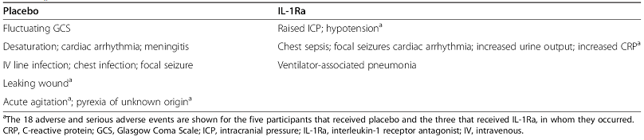

* Urien et al 2013 is a report of a population pharmacokinetic/pharmacodynamic analysis of anakinra conducted in children and adolescents with SJIA and auto-inflammatory syndromes. The study included data from 87 subjects aged 8 months to 21 years. There were 22 subjects with SJIA with an age range of 2.26 to 16.8 years. Anakinra was administered in the dose range 2mg/kg to 10 mg/kg, up to 100 mg daily. Plasma samples appear to have been collected at random times. The data were modelled in Monolix V3.2. The base model was one compartment with first order absorption and elimination. The only covariate effects were for weight on CL/F and V/F. The typical value for CL/F was 6.24 L/hour/70 kg and for V/F was 65.2 L. The pharmacodynamic outcome measure was CRP and the pharmacodynamic model was an indirect effect model. The maximal effect was at a Css of 0.4 mg/L. The model supported a dose of 3 mg/kg/day at body weight < 10 kg and 2 mg/kg/day up to 100 mg/day at body weight ≥ 10 kg. The simulations of dose effect did not display the 5th or 95th centiles for each plasma concentration that was simulated Figure 7. These simulations only used the typical values of the parameter estimates, and did not use the estimates for inter individual and residual error displayed in Tables 11 and 12). Hence there may be considerable variability between subjects in the dose required to produce a steady state plasma concentration of 0.4 mg/L. There may also be considerable variation in the effect at 0.4 mg/L.

Figure 7. Simulations of CRP response by plasma anakinra steady state concentration (from Urien *et al* 2013)

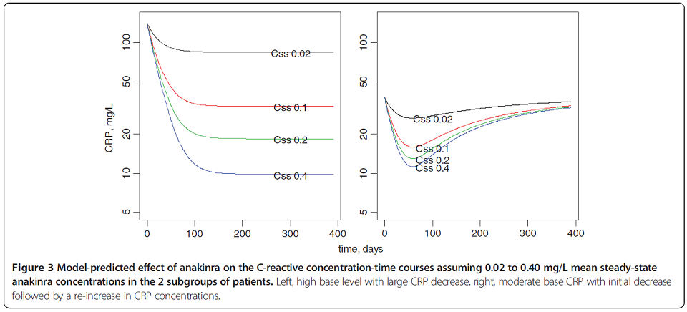

Table 11 Parameter estimates of the final anakinra population pharmacokinetic model in 87 pediatric patients (from Urien et. al. 2013).

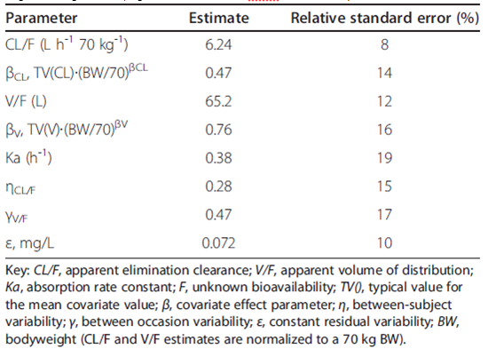

Table 12. Parameter estimates of the anakinra effect on c-reactive protein concentrations in 22 SJIA patients (RESP = responders and RESI = patients with onset of “resistance” to treatment) (from Urien et. al. 2013).

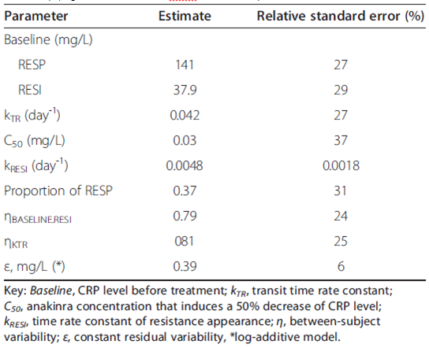

* Vastert et. al. 2014 is a report of a prospective cohort study of recombinant IL-1Ra (anakinra) in treatment naïve subjects (except for indomethacin) with sJIA. The definition for sJIA used was that of the International League of Associations for Rheumatology. The treatment was commenced as anakinra 2 mg/kg/day. The treatment was tapered if the subject had inactive disease after 3 months of treatment by giving anakinra every second day for a month then ceasing treatment. Response to treatment was assessed using the adapted ACR Pediatric 30 (Pedi 30), Pedi 50, Pedi 70 and Pedi 90. Clinical remission was defined as inactive disease for at least 6 months. Twenty subjects were treated: 13 (65%) males, 7 (35%) females, with an age range of 1.1 to 15.3 years. After 1 year 11 subjects had inactive disease off treatment (following monotherapy), two had inactive disease with ongoing monotherapy, one had inactive disease off treatment following combined therapy with anakinra and MTX and/or corticosteroids, one had inactive disease with ongoing combined therapy with anakinra and MTX and/or corticosteroids, and five had varying response on concomitant treatment with MTX and/or corticosteroids (Figure 8). Over a 3 year follow-up period 90% of subjects had sustained ACR Pedi 70 and 80% had sustained Pedi 90 (Figure 9). There were 60% of subjects with sustained Pedi 90 on monotherapy. One subject died of MAS and pulmonary hypertension 2 years after being included in the study. No ‘serious side effects’ were reported. There were local skin reactions in 13 (65%) subjects. No serious invasive infection was reported. Reactivation of herpes simplex virus type 1 infection was reported in several subjects.

Figure 8. Subject disposition for Vastert et. al. 2014 (from Vastert et. al. 2014).

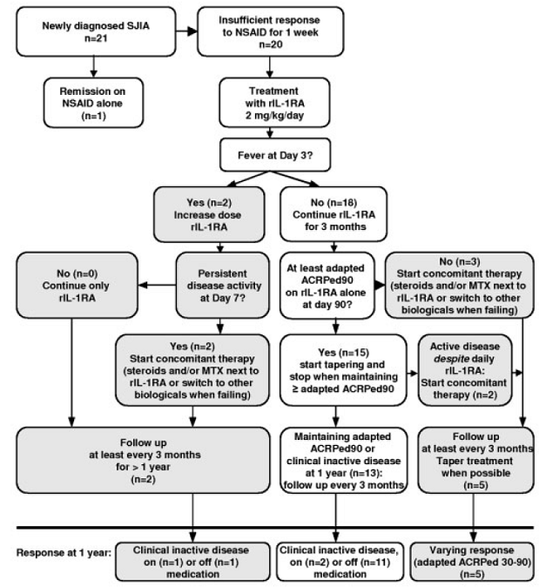

Figure 9. Subject disposition for Vastert et. al. 2014 (from Vastert et. al. 2014).

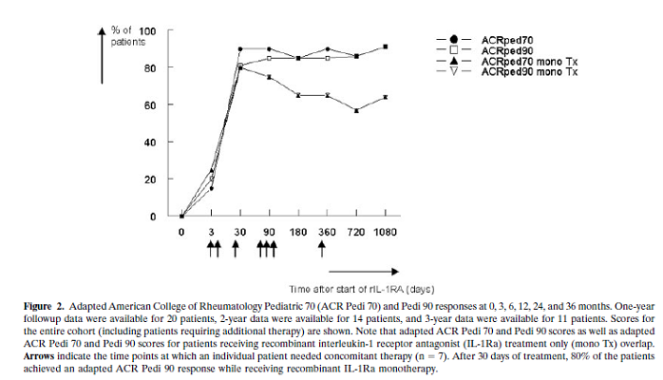

### Sponsor’s responses to clinical questions

#### Question 1; pharmacodynamics

Does the sponsor have results from a population PK study using the PK data from the paediatric subjects?

*Sponsor’s response:*

The sponsor has provided a literature report of a population PKPD study that included children treated with anakinra for sJIA: Urien et al 2013. The study supports a dose of 3 mg/kg/day at body weight < 10 kg and 2 mg/kg/day up to 100 mg/day at body weight ≥ 10 kg.

*Evaluator’s comments*:

The sponsor’s response is acceptable and has helped clarify the dosing regimen.

#### Question 2; pharmacodynamics

Does the sponsor have results from a population PKPD study using the PK and outcome data from the paediatric subjects?

*Sponsor’s response:*

The sponsor has provided a literature report of a population PKPD study that included children treated with anakinra for sJIA: Urien et al 2013. The study supports a dose of 3 mg/kg/day at body weight < 10 kg and 2 mg/kg/day up to 100 mg/day at body weight ≥ 10 kg.

*Evaluator’s comments:*

The sponsor’s response is acceptable and has helped clarify the dosing regimen.

#### Question 3; efficacy

What is the justification for the 1 mg/kg/day starting dose proposed by the sponsor, given that the starting dose in the pivotal study was 2 mg/kg/day?

*Sponsor’s response:*

The sponsor has provided the following explanation for the selection of the proposed starting dose: ‘*The recommended 1 mg/kg/day was based on the observation that the starting dose used for anakinra treatment of SJIA in the publications included in this submission varied between 1 and 2 mg/kg/day’*.

Following review of the newly available literature based data, and further review of the Pivotal study, Quartier et. al., the sponsor has amended the proposed dosing regimen to: ‘*The recommended starting dose is 2 mg/kg/day up to 100 mg/day by SC injection. Dose adjustments should be based on clinical outcome and will thus be individualised based on the response and the severity of the disease. Dose adjustments are performed in steps of 0.5 to 1 mg/kg. Patients with inadequate response may require a maintenance dose of up to 4 mg/kg/day*’.

*Evaluator’s comments:*

The sponsor’s response is acceptable and has improved the dosing regimen. However, in the opinion of the evaluator the upper dose limit is low in comparison with doses used in the data presented in the submission.

#### Question 4; efficacy

In the report pivotal study, Quartier et. al., the age range of the subjects at baseline was not reported. The sponsor should provide a tabulation of the number of subjects for each year of age that were included in the study.

*Sponsor’s response:*

The sponsor has provided a tabulation of the number of subjects for each year of age that were included in Quartier et. al. (Table 13). The tabulation indicates a uniform distribution across the age range studied, although there is a mode at 7 years. This indicates adequate representation of both younger and older children in the study population.

*Evaluator’s comments:*

The sponsor’s response is acceptable and has demonstrated adequate representation of both younger and older children in the pivotal study.

Table 13. Age distribution at the time of the randomization in the study by Quartier et al 2011.

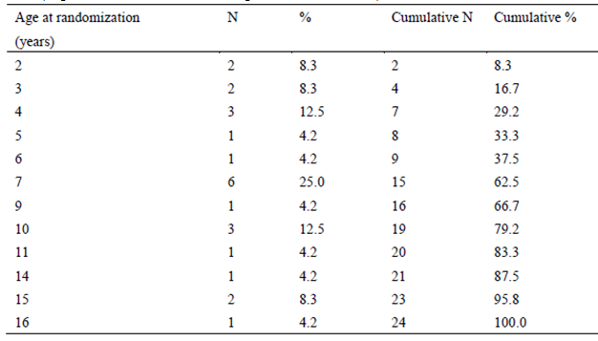

#### Question; 5 efficacy

What was the definition of SJIA that was used in the inclusion criteria for Study 990758?

*Sponsor’s response:*

The sponsor states the inclusion criteria for Study 990758 to be: ‘*Active polyarticular-course JRA with at least 5 swollen joints due to active arthritis (not bony overgrowth) and 3 joints with limitation of motion (LOM) at screening and the day 1 visit*’. The categorisation as polyarticular, pauciarticular or systemic disease onset was based on the Investigators’ clinical judgement.

*Evaluator’s comments:*

The sponsor’s response is acceptable in that it has clarified the inclusion criteria for Study 990758. However, in the opinion of the evaluator this definition of SJIA is not sufficiently robust for any analysis of the SJIA subgroup to be valid. Hence the efficacy and safety data from the study are supportive only.

#### Question 6; safety

In Study 990779 how many of the subjects included in the study had been diagnosed with SJIA? What was the outcome for these subjects (efficacy and safety)?

*Sponsor’s response:*

The sponsor has provided the following response: ‘*In total 11 patients with SJIA were included in Study 990779. Two (2) of these entered via the blinded phase of Study 990779 where of 1 continued into the open label phase. Nine (9) patients entered the open-label phase directly. Accordingly, a total of 10 SJIA patients entered the open label phase of Study 990779, where all patients received anakinra*’. Hence, the sponsor has supplied the numbers of subjects in the different phases of Study 990779.

Efficacy outcomes were not reported for Study 990779, and the sponsor has referred to the efficacy outcomes for Study 990758, which has previously been evaluated.

With regard safety, the sponsor states there were no deaths or DAEs. There were two SAEs in the same subject (severe and serious hepatitis due to cytomegalovirus infection; severe and serious viral infection). There were 8 episodes of fever in 6 subjects. Although the sponsor does not specifically state the population referred to, the data appears to be specific to the SJIA population.

*Evaluator’s comments:*

The sponsor’s response is acceptable. In the opinion of the evaluator the subjects with SJIA included in Study 009779 have contributed useful data that is supportive to the application.

#### Question 7; safety

Does the sponsor have any additional information about the trial described in the PSUR that used doses up to 20,900 mg/24 hours? What was the indication studied?

*Sponsor’s response:*

The sponsor has provided a description of this study in Singh et. al. 2014. The indication studied was aneurysmal subarachnoid haemorrhage requiring external ventricular drainage within 72 hours of onset. In addition to the data from Singh et. al. 2104 the sponsor has provided some additional descriptive data for the subjects treated with anakinra who developed SAEs (Table 14).

*Evaluator’s comments:*

The sponsor’s response is acceptable. The data indicate that much higher doses of anakinra than those proposed in the proposed dosing regimen have been used with no apparent dose-related AEs.

Table 14. Reported SAEs in patients receiving Kineret.

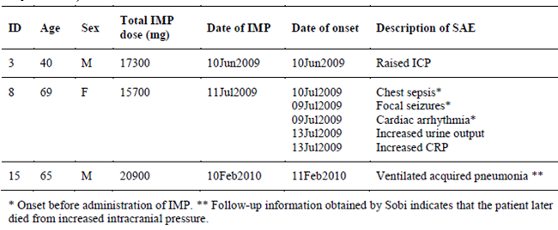

#### Question 8; safety

Of the subjects treated with anakinra who developed MAS, did their SJIA initially respond to anakinra?

*Sponsor’s response:*

The sponsor has provided further data with regard to subjects who developed MAS (Table 15). These data do not suggest an association between anakinra and the development of MAS. It appears that the majority of subjects who developed MAS also responded to anakinra.

*Evaluator’s comments:*

The sponsor’s response is acceptable.

Table 15. MAS in studies/reports included in the application.

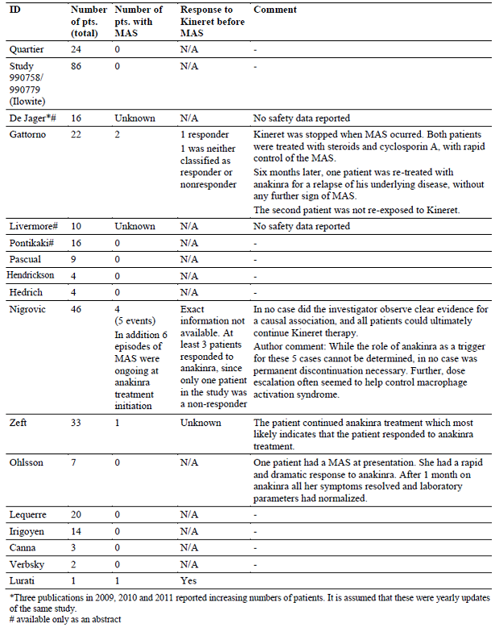

### Sponsor’s responses to other comments in the round 1 report

#### There were insufficient data to support a maximum dose, specifically a maximum dose of 4 mg/kg/day.

*Sponsor’s response:*

The sponsor bases the maximum dose of anakinra on clinical trial data (specifically Urien et. al. 2013) and the Consensus Treatment Plans for New-Onset Systemic Juvenile Idiopathic Arthritis by the Childhood Arthritis and Rheumatology Research Alliance (CARRA) (Dewitt et al 2012).

*Evaluator’s comments:*

The sponsor’s response is acceptable. However, in the opinion of the evaluator, Urien et. al. 2013 studied doses up to 10 mg/kg; and as a population PKPD study deals primarily with the mean rather than the extremes. The study describes how the average patient will respond, but this also means that 50% of patients would need a higher dose to respond. Hence there may be some subjects who need higher doses than those recommended as the starting dose by Urien et. al. 2013. There should be a clear recommendation as to the starting dose but there should also be leeway to use higher doses, such as up to 10 mg/kg in subjects who do not respond to the starting dose. In the opinion of the evaluator, 10 mg/kg is a more appropriate maximum dose than 4 mg/kg.

#### There were insufficient data to support efficacy as combination therapy. There were inadequate data to support an independent evaluation of combination therapy with DMARDs as a group or as individual agents. In the opinion of the Evaluator the Pivotal study only relate to the efficacy of anakinra in systemic JIA as monotherapy and not in combination with other DMARDs.

*Sponsor’s response*:

The sponsor acknowledges this by amending the proposed indication to:

*Kineret (anakinra) is indicated for the treatment of active Systemic Juvenile Idiopathic Arthritis (SJIA).*

*Evaluator’s comments:*

The sponsor’s response is acceptable.

#### There were insufficient data to support sustained efficacy over the long-term (that is 6 months or longer)/ There is no compelling evidence of sustained long term benefit.

*Sponsor’s response:*

The sponsor has provided additional data that support long term benefit. Vastert et. al. 2014 provides support for sustained efficacy for up to 3 years.

*Evaluator’s comments:*

The sponsor’s response is acceptable.

#### The age distribution of the subjects studied in the pivotal study is not presented in sufficient detail to demonstrate efficacy across the age range sought in the application.

*Sponsor’s response:*

This issue has been satisfactorily addressed by the sponsor (see response to Question 4).

*Evaluator’s comments:*

The sponsor’s response is acceptable.

#### The size of the population studied in the Pivotal study was small (24 subjects).

*Sponsor’s response:*

The sponsor defends the study as being adequately powered to demonstrate a statistically and clinically significant benefit for anakinra in SJIA, and also argues the additional supportive data provide sufficient evidence of efficacy and safety.

*Evaluator’s comments:*

The sponsor’s response is acceptable. In the opinion of the evaluator, the additional data provided by the sponsor, when combined with the original data supplied in the submission, provided sufficient evidence in support of safety and efficacy for the proposed indication.

## Second round benefit-risk assessment

### Second round assessment of benefits

The sponsor has provided additional data that have satisfactorily addressed the following concerns:

* The dose regimen used in the pivotal study is different to that proposed by the sponsor. In the opinion of the Evaluator, the regimen used in the pivotal study is supported by the data and should replace that proposed by the sponsor.
* The efficacy data are primarily literature based and are not reported in detail.
* There were insufficient data to support efficacy as combination therapy.
* There were inadequate data to support an independent evaluation of combination therapy with DMARDs as a group or as individual agents.
* There were insufficient data to support sustained efficacy over the long-term (that is 6 months or longer).

Specifically, the sponsor has provided data from a population PKPD study; a long term efficacy study and further detail from studies included in the original application, as discussed above.

However, despite having sourced a population PKPD study that provides dosing recommendations, the sponsor has not adopted those recommendations. Urien et al 2013, discussed in Section 12.1, supports a dose of 3 mg/kg/day at body weight < 10 kg and 2 mg/kg/day up to 100 mg/day at body weight ≥ 10 kg. In addition, there are insufficient data to support a maximum dose of 4 mg/kg/day, particularly when a maximum dose of 10 mg/kg/day has been used in this population and there does not appear to be dose dependent toxicity for anakinra.

As discussed in Section 12.1, the simulations of dose effect reported in Urien *et. al* 2013 did not display the 5th or 95th centiles for each plasma concentration that was simulated (Figure 7). The simulations only used the typical values of the parameter estimates, and did not use the estimates for inter-individual and residual error displayed in Table 11 and Table12. Hence there may be considerable variability between subjects in the dose required to produce a steady state plasma concentration of 0.4 mg/L. There may also be considerable variation in the effect at 0.4 mg/L.

Hence, in the opinion of the evaluator, the dosing recommendations should not preclude dosing up to 10 mg/kg/day, a dose that appears to be tolerated by subjects in the data submitted.

### Second round assessment of risks

After consideration of the responses to clinical questions, the risks of anakinra in the proposed usage are unchanged from those identified in Section 9.2.

### Second round assessment of benefit-risk balance

The benefit-risk balance of anakinra, given the proposed usage, is favourable.

## Second round recommendation regarding authorisation

The Evaluator has no objection to the authorisation of Kineret (anakinra) for the following indication:

*Kineret (anakinra) is indicated:*

* *for the treatment of active Systemic Juvenile Idiopathic Arthritis (SJIA)*

The reasons for the change in recommendation from that in Section 10 (first round evaluation) are:

* The sponsor has amended the proposed indication by removing the sentence: *Kineret may be used alone or in combination with other DMARDs.*
* The sponsor has clarified the age distribution of the subjects studied in the pivotal study in sufficient detail to justify the age range sought in the application.
* The sponsor has provided support for sustained long-term benefit (Vastert *et. al.* 2014, as discussed in Section 13.1).
* The sponsor has provided data from an additional 20 subjects (Vastert *et. al.* 2014, as discussed in Section 13.1). Although the size of the population studied in the Pivotal study was small (24 subjects), and the population studied in Vastert *et. al.* 2014 is also small (20 subjects), SJIA is an uncommon condition and there would be difficulties in recruiting a larger sample of subjects in any clinical trial for this condition. Consistent with this, Kineret has been designated an Orphan Drug for the indication: *for the treatment of active systemic onset juvenile idiopathic arthritis (SoJIA) in children*. The populations included in the studies included in the submission are predominantly children.
* The sponsor has provided further analysis using a population PKPD approach, which provides support for a rational dosing regimen.

However, the dosing regimen proposed by the sponsor is not consistent with the data presented in the application. Urien et al 2013, discussed in Section 13.1, supports a dose of 3 mg/kg/day at body weight < 10 kg and 2 mg/kg/day up to 100 mg/day at body weight ≥ 10 kg. In the opinion of the Evaluator this dosing regimen should be adopted as the starting dose.

As discussed in Section 13.1, the simulations of dose-effect reported in Urien *et. al* 2013 did not display the 5th or 95th centiles for each plasma concentration that was simulated (Figure 7). The simulations only used the typical values of the parameter estimates, and did not use the estimates for inter-individual and residual variability displayed in Table 11 and Table 12. Hence there may be considerable variability between subjects in the dose required to produce a steady state plasma concentration of 0.4 mg/L. There may also be considerable variation in the effect at 0.4 mg/L.

Hence, in the opinion of the Evaluator, the dosing recommendations should not preclude dosing up to 10 mg/kg/day, a dose that appears to be tolerated by subjects in the data submitted. In those patients who do not respond to the starting dose, the recommendation with regard to maximum dose should include the dose range studied in this population, and which was not associated with an increase in adverse effects, that is up to 10 mg/kg/day. In the opinion of the Evaluator the maximum dose should be increased from 4 mg/kg/day up to 10 mg/kg/day.

## References

Canna, S., J. Frankovich, et al. (2009). Acute hepatitis in three patients with systemic juvenile idiopathic arthritis taking interleukin-1 receptor antagonist. *Pediatr Rheumatol*. 7:21.

de Jager, W., S. J. Vasterd , et al. (2009). Early treatment of newly diagnosed systemic onset juvenile idiopathic arthritis patients with anakinra restores the IL-18 response of NK cells. *10th Annual Congress of the European League Against Rheumatism.* {10th-EULAR-2009}. Copenhagen OP-0208.

de Jager, W., S. J. Vastert, et al. (2010). Anakinra treatment prior to steroids in newly diagnosed systemic onset JIA: Changing the biology? Ann Rheum Dis 69(Suppl 3): 624.

de Jager, W., S. J. Vastert, et al. (2011). Anakinra restores the defective IL-18 NK cell axis in steroid naïve systemic onset JIA patients. *Pediatr Rheumatol* 9(Suppl 1): O33.

Dewitt EM et al. Consensus treatment plans for new-onset systemic juvenile idiopathic arthritis. *Arthritis Care Res* (Hoboken). 2012.

Gattorno, M., A. Piccini, et al. (2008). The pattern of response to anti-interleukin-1 treatment distinguishes two subsets of patients with systemic-onset juvenile idiopathic arthritis. *Arthritis Rheum* 58(5): 1505-15.

Hayem F (2009). Is Still’s disease an auto inflammatory syndrome? Joint Bone Spine 76: 7-9.

Hedrich, C. M., N. Bruck, et al. (2011). Anakinra: A safe and effective first-line treatment in systemic onset juvenile idiopathic arthritis (SoJIA). Rheumatol Int: 32:3525–3530.

Henrickson M. (2004). Efficacy of anakinra in refractory systemic arthritis. *Arthritis & Rheumatism* 50(supp 4): S438.

Ilowite, N., O. Porras, et al. (2009). Anakinra in the treatment of polyarticular-course juvenile rheumatoid arthritis: safety and preliminary efficacy results of a randomised multicenter study. *Clin Rheumatol* 28(2): 129-37.

Irigoyen, P., J. Olson, et al. (2006). Treatment of systemic onset juvenile idiopathic arthritis with anakinra - Case series. Pediatr Rheumatol Online J.

Lequerré, T., P. Quartier, et al. (2008). Interleukin-1 receptor antagonist (anakinra) treatment in patients with systemic-onset juvenile idiopathic arthritis or adult onset Still disease: preliminary experience in France. *Ann Rheum Dis* 67(3): 302-8.

Livermore, P. and P. Woo (2008). Experience of one UK site presenting a closer examination of safety and efficacy of Anakinra (Kineret) in systemic juvenile idiopathic arthritis. *Pediatr Rheumatol* 6(Suppl I): P32.

Lurati, A., B. Teruzzi et al (2005). Macrophage activation syndrome (MAS) during anti-IL1 receptor therapy (anakinra) in a patient affected by systemic onset idiopathic juvenile arthritis (soJIA): A report and review of the literature. *Pediatric Rheumatology Online Journal* 2005, 3(2):79-85.

Nigrovic, P. A., M. Mannion, et al. (2011). Anakinra as first-line disease-modifying therapy in systemic juvenile idiopathic arthritis: report of forty-six patients from an international multicenter series. *Arthritis Rheum* 63(2): 545-55.

Ohlsson, V., E. Baildam, et al. (2008). Anakinra treatment for systemic onset juvenile idiopathic arthritis (SOJIA). *Rheumatology* (Oxford) 47(4): 555-6.

Pascual, V., F. Allantaz, et al. (2005). Role of interleukin-1 (IL-1) in the pathogenesis of systemic onset juvenile idiopathic arthritis and clinical response to IL-1 blockade. *J Exp Med* 201(9): 1479-86.

Pontikaki, I., V. Gerloni, et al. (2008). Anakinra in systemic juvenile idiopathic arthritis (soJIA) non responsive to antiTNF. *Pediatr Rheumatol* 6(Suppl I): P30.

Prakken B, Albani S, Martini A. Juvenile Idiopathic Arthritis. *Lancet* 2011; 377: 2138-49.

Quartier, P., F. Allantaz, et al. (2011). A multicentre, randomised, double-blind, placebocontrolled trial with the interleukin-1 receptor antagonist anakinra in patients with systemiconset juvenile idiopathic arthritis (ANAJIS trial). *Ann Rheum Dis* 70(5): 747-54.

Reiff A. (2005) The use of anakinra in juvenile arthritis *CurrRheumatol Rep*. 7:434-40

Singh N et al 2014. The effect of intravenous interleukin-1 receptor antagonist on inflammatory mediators in cerebrospinal fluid after subarachnoid haemorrhage: a phase II randomised controlled trial. *J Neuroinflammation* 2014;11 (doi: 10.1186/1742-2094-11-1).

Urien S et al. Anakinra pharmacokinetics in children and adolescents with systemic-onset juvenile idiopathic arthritis and autoinflammatory syndromes. *BMC Pharmacology and Toxicology* 2013, 14:40.

Vastert S et al. Effectiveness of First-Line Treatment with Recombinant Interleukin-1 Receptor Antagonist in Steroid-Naive Patients with New-Onset Systemic Juvenile Idiopathic Arthritis Results of a Prospective Cohort Study. *Arthritis & rheumatology* 2014; 66: 1034–1043.

Verbsky JW, White AJ. (2004). Effective use of the recombinant interleukin 1 receptor antagonist anakinra in therapy resistant systemic onset juvenile rheumatoid arthritis. *J Rheumatol*. 31(10):2071-5.

Zeft, A., R. Hollister, et al. (2009). Anakinra for systemic juvenile arthritis: the Rocky Mountain experience. *J Clin Rheumatol* 15**(4**): 161-4.

|  |
| --- |
| Therapeutic Goods Administration |
| PO Box 100 Woden ACT 2606 Australia  Email: [info@tga.gov.au](mailto:info@tga.gov.au) Phone: 1800 020 653 Fax: 02 6232 8605  [**https://www.tga.gov.au**](https://www.tga.gov.au) |

1. During the time of this submission, an additional indication was approved (on 9 September 2014) for:

   *Kinaret (anakinra) is indicated in adult and paediatric patients aged 8 months and older with a body weight of 10 kg or above for the treatment of Cryopyrin-Associated Periodic Syndromes (CAPS) including Neonatal-Onset Multisystem Inflammatory Disease (NOMID) I Chronic Infantile Neurological, Cutaneous, Articular Syndrome ICINCA), Muckle-Wells Syndrome (MWS), and Familial Cold Autoinfiammatory Syndrome (FCAS).*