October 2015

Australian Public Assessment Report for Apremilast
  - Proprietary Product Name: Otezla
  - Sponsor: Celgene Pty Ltd

About the Therapeutic Goods Administration (TGA)
- The Therapeutic Goods Administration (TGA) is part of the Australian Government Department of Health and is responsible for regulating medicines and medical devices.
- The TGA administers the Therapeutic Goods Act 1989 (the Act), applying a risk management approach designed to ensure therapeutic goods supplied in Australia meet acceptable standards of quality, safety and efficacy (performance), when necessary.
- The work of the TGA is based on applying scientific and clinical expertise to decision-making, to ensure that the benefits to consumers outweigh any risks associated with the use of medicines and medical devices.
- The TGA relies on the public, healthcare professionals and industry to report problems with medicines or medical devices. TGA investigates reports received by it to determine any necessary regulatory action.
- To report a problem with a medicine or medical device, please see the information on the TGA website <https://www.tga.gov.au>.
About AusPARs
- An Australian Public Assessment Report (AusPAR) provides information about the evaluation of a prescription medicine and the considerations that led the TGA to approve or not approve a prescription medicine submission.
- AusPARs are prepared and published by the TGA.
- An AusPAR is prepared for submissions that relate to new chemical entities, generic medicines, major variations, and extensions of indications.
- An AusPAR is a static document, in that it will provide information that relates to a submission at a particular point in time.
- A new AusPAR will be developed to reflect changes to indications and/or major variations to a prescription medicine subject to evaluation by the TGA.
Copyright
© Commonwealth of Australia 2015
This work is copyright. You may reproduce the whole or part of this work in unaltered form for your own personal use or, if you are part of an organisation, for internal use within your organisation, but only if you or your organisation do not use the reproduction for any commercial purpose and retain this copyright notice and all disclaimer notices as part of that reproduction. Apart from rights to use as permitted by the Copyright Act 1968 or allowed by this copyright notice, all other rights are reserved and you are not allowed to reproduce the whole or any part of this work in any way (electronic or otherwise) without first being given specific written permission from the Commonwealth to do so. Requests and inquiries concerning reproduction and rights are to be sent to the TGA Copyright Officer, Therapeutic Goods Administration, PO Box 100, Woden ACT 2606 or emailed to <tga.copyright@tga.gov.au>.

Contents
List of abbreviations 5
I. Introduction to product submission 7
Submission details 7
Product background 7
Regulatory status 8
Product Information 9
II. Quality findings 9
Introduction 9
Drug substance (active ingredient) 10
Drug product 10
Quality summary and conclusions 11
III. Nonclinical findings 13
Introduction 13
Pharmacology 13
Pharmacokinetics 16
Toxicology 18
Nonclinical summary and conclusions 24
IV. Clinical findings 27
Introduction 27
Pharmacokinetics 31
Pharmacodynamics 32
Dosage selection for the pivotal studies 33
Efficacy 34
Safety 38
First round benefit-risk assessment 45
First round recommendation regarding authorisation 47
Clinical questions 47
Population pharmacokinetics 48
First round benefit-risk assessment 50
First round recommendation regarding authorisation 51
Clinical questions 51
Second round benefit-risk assessment 52
Second round recommendation regarding authorisation 52
V. Pharmacovigilance findings 52
Risk management plan 52
VI. Overall conclusion and risk/benefit assessment 70
Quality 70
Nonclinical 70
Clinical 70
Risk management plan 82
Proposed regulatory action and indication 82
Outcome 92
Attachment 1. Product Information 93
Attachment 2. Extract from the Clinical Evaluation Report 93

List of abbreviations
Abbreviation | Meaning
ACPM | Advisory Committee on Prescription Medicines
AE | adverse event
AMP | adenosine monophosphate
APR | apremilast
ASA | Australian Specific Annex
AUC | area under the plasma concentration-time curve
BID | twice daily
BMI | body mass index
BSA | Body Surface Area
cAMP | cyclic adenosine monophosphate
Cmax | maximum plasma drug concentration
Cmin | minimum plasma drug concentration
CrCL | creatinine clearance
CRF | Case Report Form
CsA | cyclosporine
DMARD | disease modifying anti rheumatic drug
EAIR | Exposure Adjusted Incidence Rate
EMA | European Medicines Agency
FDA | US Food and Drug Administration
GCP | Good Clinical Practice
HAQ-DI | Health Assessment Questionnaire Disability Index
IC50 | half maximal inhibitory concentration
IL | interleukin
IV | intravenous
LEF | leflunomide
MACE | Major Adverse Cardiac Events
MTX | methotrexate
NSAID | non steroidal anti inflammatory drug
PASI | Psoriasis Area Severity Index
PBO | placebo
PDE4 | phosphodiesterase 4
PI | Product Information
PO | per os (oral)
PsA | psoriatic arthritis
PSOR | psoriasis
PBO | placebo
QOL | quality of life
QTC | corrected QT interval
RA | rheumatoid arthritis
RMP | Risk Management Plan
SAE | serious adverse event
SSZ | sulfasalazine
t1/2 | elimination half life
TEAE | treatment emergent adverse event
Tmax | time to reach maximum plasma concentration following drug administration
TNF | tumour necrosis factor
TNF-α | tumour necrosis factor alpha
TNF | tumour necrosis factor
URTI | upper respiratory tract infection

I. Introduction to product submission

Submission details
Type of submission: | New chemical entity
Decision: | Approved
Date of decision: | 12 March 2015

Active ingredient(s): | Apremilast
Product name(s): | Otezla
Sponsor’s name and address: | Celgene Pty Ltd  Level 7, 607 St Kilda Road  Melbourne VIC 3004
Dose form(s): | Film coated tablets, unscored
Strength(s): | 10, 20 and 30 mg
Container(s): | Blister pack
Pack size(s): | 56 x 30 mg tablet  168 x 30 mg tablets  ‘Titration pack’: 4 x 10 mg + 4 x 20 mg + 19 x 30 mg tablets
Approved therapeutic use: | Otezla is indicated for:  - The treatment of signs and symptoms of active psoriatic arthritis in adult patients.  - The treatment of adult patients with moderate to severe plaque psoriasis who are candidates for phototherapy or systemic therapy.
Route(s) of administration: | Oral
Dosage: | 30 mg twice daily (recommended)
ARTG number (s): | 220423 (30 mg film coated tablet blister pack)  220424 (titration pack)

Product background
This AusPAR describes the application by Celgene Pty Ltd to register a new chemical entity, apremilast (APR) (trade name: Otezla), which is indicated for the treatment of adult patients with active psoriatic arthritis (PsA) or for those with moderate to severe plaque psoriasis (PSOR) who are candidates for phototherapy or systemic therapy.
APR belongs to the class of small molecule phosphodiesterase 4 (PDE4) inhibitors which act intracellularly to prevent the degradation of cyclic adenosine monophosphate (cAMP) to inactive AMP, thereby increasing the intracellular concentration of cAMP.
PDE4 inhibitors have a wide range of clinical applications consistent with differing functional activity across cell types. In the context of PSOR and PsA, the intended activity is targeted towards the suppression of the PDE4 mediated pro inflammatory cascade originating from inflammatory cells and synovium, implicated in both conditions.
PDE4 is expressed in a wide variety of human tissue, with PDE4 inhibitors having indications in chronic obstructive pulmonary disease (Roflumilast: US Food and Drug Administration [FDA] and European Medicines Agency [EMA] registered, but not currently registered in Australia), asthma (Ibudilast: experimental product only) and anxiolysis and sedation (diazepam).
The submission proposes registration of the following dosage forms and strengths: 10 mg (pink), 20 mg (brown) and 30 mg (beige) tablets. The tablets are presented in 3 pack types. There is an initial 2 week titration pack containing 4 x 10 mg tablets, 4 x 20 mg tablets and 5 x 30 mg tablets for the first week of treatment followed by 14 x 30 mg tablets for the second week of therapy. The other proposed pack sizes of 30 mg tablets are 56 (4 weeks) and 168 (12 weeks).
For both proposed treatment indications, the recommended dose of APR is 30 mg twice daily, taken orally approximately 12 h apart. An initial titration scheduled as outlined in Table 1 is recommended. No re-titration is required after initial titration. APR tablets should be swallowed whole, either with or without food. No dose adjustment is required in older patients, those with hepatic impairment or patients with mild or moderate renal impairment. The maintenance dose of APR should be reduced to 30mg once daily in patients with severe renal impairment (creatinine clearance [CrCL] <30 mL/min). For initial dose titration in this patient group, it is recommended that APR be taken using the AM (morning) schedule only, and the PM doses should be omitted.
Table 1: Initial dose regimen.
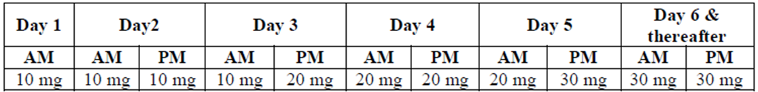

Regulatory status
APR has not been submitted previously to the TGA for evaluation. At the time of this submission to TGA, it had been submitted in a number of other jurisdictions (Table 2). The dosage registered in each jurisdiction is the same as that proposed in this submission.
Table 2: International regulatory status of Otezla.
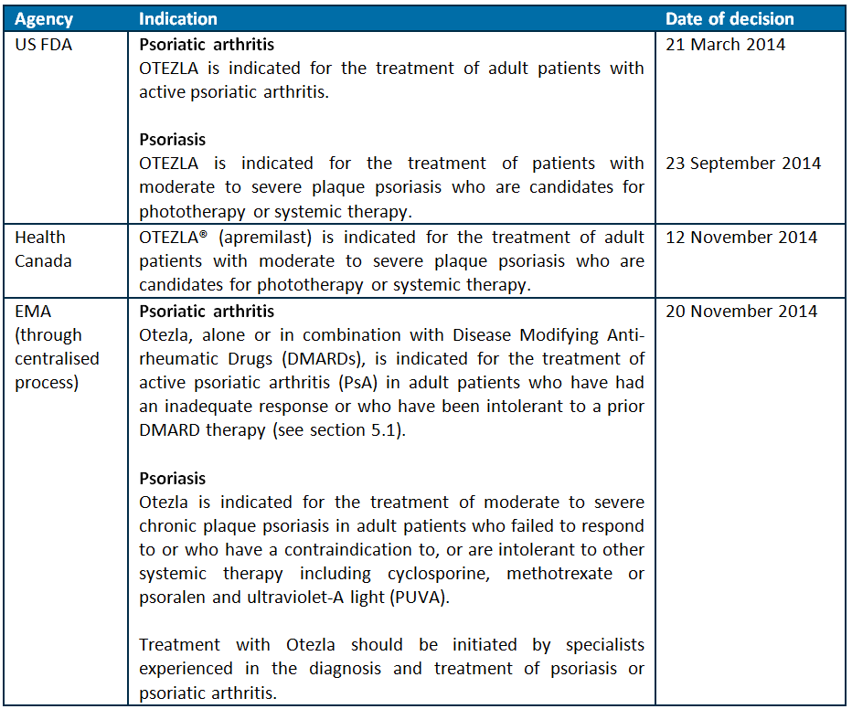

Product Information
The approved Product Information (PI) current at the time this AusPAR was prepared can be found as Attachment 1. For the most recent PI, please refer to the TGA website at <https://www.tga.gov.au/product-information-pi>.

II. Quality findings

Introduction
APR (Figure 1) is a new chemical entity proposed for use in PsA and plaque PSOR. It is an inhibitor of PDE4. Celgene Pty Ltd has applied to register Otezla APR 30 mg tablets (as well as a ‘titration pack’ also containing 10 mg and 20 mg tablets). The recommended dose is 30 mg twice daily, taken orally approximately 12 h apart (after initial titration) either with or without food.
Figure 1: Chemical structure of APR.
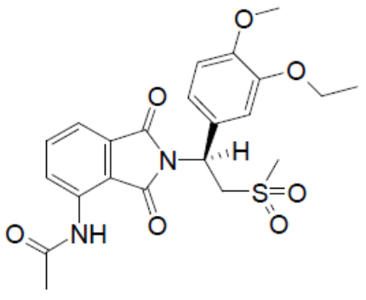
APR is synthetic. It is the S-enantiomer of N-[2-[1-(3-ethoxy-4-methoxy-phenyl)-2-(methylsulfonyl)ethyl]-2,3-dihydro-1,3-dioxo-1H-isoindol-4-yl]acetamide. It is enantiomerically pure (albeit this is not made clear in the draft PI chemical). It is not acidic or basic. APR is structurally somewhat related to pomalidomide.

Drug substance (active ingredient)
APR is a white to pale yellow crystalline powder. It is the S-enantiomer of N-[2-[1-(3-ethoxy-4-methoxy-phenyl)-2-(methylsulfonyl)ethyl]-2,3-dihydro-1,3-dioxo-1H-isoindol-4-yl]acetamide.
The aqueous solubility is low, essentially independent of pH across the physiologically relevant range at 25°C. Other data indicate little temperature dependence.
The highest dose taken at any one time (30 mg) would dissolve in ~2100-2800 mL fluid.

Drug product
Three different finished product substance manufacturers are proposed. It is stated that “all proposed manufacturing details for the three drug product manufacturers are identical.”
Film-coated, unscored, immediate release 10 mg, 20 mg and 30 mg APR tablets are proposed. The tablets contain 9.6% drug (w/w). The tablet core formulations are conventional; cores are directly scaled.
The three strengths are distinguished by colour and tablet markings:
- Otezla 10 mg tablets: pink, diamond shaped 10 mg film coated tablet with “APR” engraved on one side and “10” on the opposite side.
- Otezla 20 mg tablets: brown, diamond shaped 20 mg film coated tablet with “APR” engraved on one side and “20” on the opposite side.
- Otezla 30 mg tablets: beige, diamond shaped 30 mg film coated tablet with “APR” engraved on one side and “30” on the opposite side.
Doses are ‘titrated’. The initial dose regimen is shown in Table 1.
After initial ‘titration’, the recommended dose is 30 mg twice daily (taken approximately 12 h apart, either with or without food). The only dose adjustment then recommended is to skip evening doses in patients with severe renal impairment. “The tablets should not be crushed, split or chewed.”
The carton labels include:
Directions for Use:
The recommended dose is a 30 mg tablet taken orally twice daily, approximately 12 hours apart, with or without food.
Three different packs are proposed. The tablets are presented in PVC blisters with a push-through foil lid. Only the 30 mg tablets will be directly available (proposed as packs of 56 tablets [‘four week’] or 168 tablets [‘twelve week’]). The lower strengths are only included in a two week ‘titration’ pack (4 x 10 mg + 4 x 20 mg + 5 x 30 mg for the first week for dose titration and 14 x 30 mg tablets for the second week). The 10 mg (pink) and 20 mg (brown) tablets are for dose titration; 30 mg (beige) tablets are for ongoing administration. Such a pack containing tablets which are not separately supplied will be registered with its own ARTG number. (The 10 and 20 mg tablets will not be separately registered.)
Celgene has identified potential impurities. It is stated that the only RC6 has been seen in batches at levels above 0.15%.
Levels of the R-enantiomer are controlled by limiting the chiral purity of the aminosulfone precursor. Levels of RC8 are controlled by limiting ‘RC9’ in the aminosulfone precursor. Spiking studies are described to justify proposed limits for impurities in the starting materials.
Impurity RC6 is stated to be the only impurity with a genotoxic structural alert (note aniline), but it is stated that toxicological data shows that it is not genotoxic.
Celgene proposes a shelf life of 36 months when APR tablets are stored below 30°C. The application form includes:
“Storage Conditions: Store in Original Container.”
The PI directs:
“Store below 30°C. Store in the original package.”
The carton labels just state:
“Store below 30°C.”
It remains unclear whether impurity RC6 is being consistently reported (see comments regarding test method). It remains unclear whether the ultra performance liquid chromatographic (UPLC) method detects degradation products. There are concerns about the accuracy of the dissolution assay. The submitted dissolution data suggest differences in tablets from different manufacturing sites and the stability data indicate a decline in dissolution on storage. The setting of identical release and expiry dissolution limits is not appropriate. The proposed extrapolated shelf life is not supported.

Quality summary and conclusions
Registration is not recommended with respect to chemistry and quality control aspects. The following issues should be addressed:
- As the 10 and 20 mg tablets are not being separately supplied, they do not need direct registration, the distinct therapeutic good is the titration pack itself, which needs a single, separate AUSTR number.
- Please explain why the text “The tablets should not be crushed, split or chewed” is included in the PI. Please state whether it is intended to include the PI as a carton insert. Please review the PI in light of comments in the chemistry evaluation.
- The labelled storage directions should be consistent with the PI directions.
- It is not clear to me whether drug substance manufacturing Process B and Process C are currently used at the different manufacturing sites: Please clarify. Please give details of the yields. Please provide details of the preparation of the nominal starting materials.
- No relevant controls or manufacturing validation with respect to ensuring consistent particle size in crystallisation at the two sites could be located. Please clarify.
- The structural characterisation of APR includes a poorly detailed X-ray crystallography study. It is not clear whether this included anomalous dispersion analysis allowing absolute configuration analysis? Please provide more details including R-factors. If the X-ray analysis does not reliably define the absolute configuration, please provide data or literature evidence establishing the absolute stereochemistry.
- Please revise the test method for impurities in the Active Pharmaceutical Ingredient (API) to include the cited Relative Response Factors (RRFs) used in calculations.
- The method used for chiral purity has a resolution test, yet does not use a CC-10007 (enantiomer) standard, although batch analyses report levels up to 100.0%. Please clarify.
- Please clarify the use of a precision test for the tetrahydrofuran peaks in the method used for residual solvents.
- Batch data include analyses of palladium. Please explain why.
- Please state nominal tablet dimensions.
- No compendial excipient specifications were detailed. Please justify the apparent lack of control of functionality related characteristics. Manufacturing development studies show a clear effect of lactose particle size compressed into tablets. The “vendor specifications” for particle size should at least be disclosed and included in the Celgene specifications.
- Please comment on the unusual plateauing of dissolution at less than 100% for some batches. Please identify whether the dissolution method provides sink conditions. Dissolution results in stability studies show a clear correlation with date of testing, casting doubt on the method accuracy. Please comment.
- The relative bioavailability Study CC-10004-BA-001 showed in vivo differences in the profiles of capsules produced with APR with different particle size distributions. Please give details of the in vitro dissolution for these capsule batches.
- The specification explicitly precludes quantification of two impurities, RC6 and RC8. RC8 is clearly a synthetic impurity, notwithstanding it nominally increasing in some drug substance stress stability studies. RC6, however, is a conceivable hydrolysis product and should be limited in the finished product specifications.
- Microbial controls should be formally included in expiry specifications even if not regularly tested during stability.
- The components in the PVC film “laminated structure” should be defined.
- Alternative primary packaging sites are proposed, but bulk tablet packaging and stability information could not be located. Please cite or submit.
- Bioavailability aspects are reviewed separately. For Study CC-10004-CP-022:
  - Please provide the batch number, formulation details and the Certificate of Analyses for the tablets used in the study.
  - Please clarify the subjects’ posture and physical activity during the dosage and sampling periods.
  - Please provide results of matrix effect investigations conducted in accordance with published guidelines regarding evaluation of the Internal Standard (IS) normalised Matrix Factor (MF) and determinations at low and high concentrations. Furthermore, matrix effect investigations should also be determined on haemolysed and hyperlipidaemic plasma samples.
  - Please comment on why incurred sample analyses were not performed.

III. Nonclinical findings

Introduction
In support of the efficacy and safety of APR, a comprehensive dossier of high quality studies has been submitted. The pivotal toxicological studies were performed to Good Laboratory Practice (GLP) standard and were conducted by reputable laboratories. Except for some studies and portions of studies examining investigational PDE4 inhibitors and thalidomide analogues, all the submitted work was evaluated.

Pharmacology

Primary pharmacology
PSOR is a common, chronic autoimmune inflammatory skin disorder characterised by epidermal hyperproliferation of keratinocytes and endothelial cells, and accumulation of inflammatory cells such as activated T cells. Although the aetiology of the disease is unclear, tumour necrosis factor alpha (TNF-α) appears to be a key mediator in the disease process. TNF-α is secreted by both T cells and antigen presenting cells within psoriatic lesions leading to elevated local and systemic levels of this pro-inflammatory cytokine. This has led to the use of TNF-α antagonists (antibodies and receptors for TNF-α), such as infliximab, etanercept, and adalimumab, in the treatment of PSOR.
PDE4 inhibitors have been shown to suppress TNF-α release from monocytes/macrophages induced by various inflammatory stimuli and are potentially useful drugs for the treatment of chronic inflammatory diseases such as PSOR. APR contains a pharmacophore, a dialkoxyphenyl moiety, known to be held tightly in the active site of PDE4, and was shown to inhibit a range of human PDE4A, 4B, 4C, and 4D isoforms with inhibitory concentration 50% (IC50) values ranging from 14 to 118 nM. Compared with other PDE4 inhibitors, APR was more potent than rolipram, of similar potency to cilomilast, and less potent than roflumilast.
The effects of PDE4 inhibition by APR on gene expression in in vitro cultures of lipopolysaccharide (LPS) stimulated human peripheral blood mononuclear cell (PBMC) or monocytes were quantified using Affymetrix genechips and real-time PCR (RT-PCR). Genes showing increased expression included amphiregulin, a ligand of the epidermal growth factor receptor, bone morphogenetic protein 6, involved in bone growth and repair, and epithelial-derived neutrophil-activating protein 78 (CXCL-5), a CXC chemokine expressed by epithelial cells of the gut and airway mucosa which acts as a neutrophil chemoattractant. Genes showing decreased expression included the pro-inflammatory chemokine CCL-18 (MIP-4), the chemokine receptor macrophage inflammatory protein 1-alpha receptor (CCR-1; MIP-1aR), and the pro-inflammatory cytokines interferon gamma and TNF-α. Hence, in contrast to the biologic TNF-α antagonists, APR inhibits TNF-α production at the level of gene expression. APR was shown to inhibit TNF-α release by human PBMC following exposure to LPS (IC50 = 77 nM) or other pro-inflammatory stimuli. APR also inhibited the release of leukotriene B4 (chemoattractant and inducer of adhesion to endothelium) (IC50 = 2.5 nM) from activated neutrophils, and inhibited the release of the pro-inflammatory cytokines IL-5 (IC50 = 0.03 µM), IL-13 (IC50 = 0.28 µM), and IL-17 (IC50 = 0.09 µM) from stimulated human T cells.
The in vivo anti-inflammatory activity of APR was tested in several animal models. Measurements of rat paw oedema after carrageenan injection showed inhibition by APR in one study, but not in another. APR failed to show anti-inflammatory activity when an irritant was introduced into an air pouch or the peritoneum of mice. APR showed anti-inflammatory activity in a mouse model of inflammatory bowel disease and in models of allergen-induced bronchospasm. Importantly, APR showed activity in a model of PSOR using immunocompromised mice that had received human skin grafts and been injected with activated natural killer (NK) cells derived from psoriatic patient blood. Subsequent dosing with APR produced significant decreases in epidermal thickness and keratinocyte proliferation and decreased expression of inflammation markers.
The pathogenesis of PSOR has been associated with a pro-angiogenic environment reflecting elevated levels of vascular endothelial growth factor (VEGF) in the circulation and skin. APR showed potent anti-angiogenic activity, comparable with thalidomide, in the human umbilical cord vessel ring assay (IC50 values of 0.14 and 0.17 µM for APR and thalidomide, respectively).
A feature of PsA is aggressive bone erosions that are associated with large numbers of tartrate resistant acid phosphatase (TRAP) positive osteoclasts. In studies of its potential for anti-arthritic activity, APR was shown to inhibit TNF-α production by samples of rheumatoid arthritis synovial membrane (IC50 ~100 nM), whilst having little or no effect on production of IL-6 (pro-inflammatory cytokine and stimulator of osteoclast formation) and IL-10 (anti-inflammatory). APR was shown to inhibit production of IL-7 (potent osteoclastogenic factor) production by normal human chondrocytes and also inhibited production of soluble receptor activator of NF-κB ligand (sRANKL, required for osteoclastogenesis) by both osteoblasts and osteoclasts. Such effects were likely responsible for APR’s ability to decrease numbers of TRAP positive osteoclasts under in vitro culture conditions. In vivo testing of the anti-arthritic activity of APR used a mouse model of collagen induced arthritis. Overall the results were equivocal. In some studies, APR showed anti-arthritic activity; whilst in others it showed little or no activity.
The sponsor’s studies support the proposed mechanism of action for APR and they support its potential usefulness for the proposed indications.

Secondary pharmacodynamics and safety pharmacology
APR (10 µM) showed little or no inhibition of various PDE families (1, 2, 3, 5, 6, 7, and 11) other than PDE4.
APR at 10 µM showed no significant activity in large scale screens for inhibitory activity towards kinases, various other enzymes, and cell surface receptors. However, Study 8611 suggested that APR is a potent inhibitor of the hERG potassium current (51.3% inhibition at 1 µM APR). Given a maximum plasma drug concentration (Cmax) of 0.95 µM (average of values from Clinical Studies CC-10004- PSA-002-PK and CC-10004- PSOR-005-PK) for PSOR patients receiving the recommended dose (30 mg, BID), such a finding was of concern. However, another study (031206.DFN) reported an IC50 of 184 µM for inhibition of the hERG current by APR. The FDA report on APR notes these concerns and states:
The sponsor believes that the results of study 03126.DFN (sic) are more reliable since it was conducted with multiple doses and was a GLP compliant study: FDA’s pharmacology review for APR (application number: 205437Orig1s000).
The sponsor’s comments are reasonable and it would appear that hERG inhibition is not a concern.
APR was derived from efforts to produce a thalidomide analogue with enhanced TNF-α inhibitory activity. Thalidomide and analogues, such as lenalidomide and pomalidomide, are used clinically in the treatment of multiple myeloma. Their anti-myeloma (and teratogenic) activity is attributed to binding of cereblon resulting in the inhibition of cereblon associated E3 ubiquitin ligase and blockage of the degradation of unidentified proteins. Downstream consequences of this inhibition of protein degradation can include decrease in the synthesis of TNF-α. However, it is significant to note that the binding of thalidomide to cereblon is mediated by its glutarimide and not by its phthalimide moiety. The former moiety is absent from APR. Nevertheless, various studies were performed to confirm that APR lacks thalidomide like activity. These studies demonstrated: comparison of the effects on gene expression (using Affymetrix gene chips representing ~13,000 human genes) of treatment of human monocytes with APR, other PDE4 inhibitors, or thalidomide analogues showed that the gene modulation pattern for APR was most similar to other PDE4 inhibitors rather than to thalidomide analogues; in a competition type assay, APR at up to 100 µM had no effect on the level of cereblon binding to thalidomide coupled affinity beads; APR was ineffective at inhibiting the proliferation of a non-Hodgkin’s lymphoma B cell line that was inhibited by thalidomide analogues; APR increased PGE2 production from LPS or phytohaemagglutinin (PHA) stimulated human PBMC, whereas thalidomide and analogues had little or no effect. It can reasonably be concluded that, although both drugs can inhibit TNF-α synthesis, the mechanisms by which this is achieved are dissimilar.
Mice dosed orally with APR at 500 mg/kg (Cmax ~19 µM) showed no effects on general activity and behaviour and doses up to 1000 mg/kg had no effect on gastrointestinal (GI) motility. Anaesthetised beagle dogs given ascending doses of APR from 0.5 (Cmax ~1.4 µM) to 5 mg/kg (Cmax ~11 µM) by intravenous (IV) infusion showed no effects on respiratory parameters but moderate, dose related increases in dP/dTmax and heart rate. This tachycardia was reflected in decreases in the inter beat (RR) and QT intervals; however, the corrected QT interval (QTC) was not noticeably affected. This effect was not considered of toxicological concern. Furthermore, cynomolgus monkeys given a daily oral dose of APR for 1 year at relative exposures up to 5.6 (males) and 3.6 (females) showed no treatment related abnormalities in electrocardiogram parameters or heart rate.

Pharmacokinetics

Absorption
The plasma kinetics of APR following single oral dosing of mice, rats, monkeys, and humans are shown in Table 3. Plasma kinetics were also determined in conjunction with repeat-dose toxicity studies using mice, rats, and monkeys and with reproduction studies using mice and monkeys.
Table 3: Species comparison of mean plasma pharmacokinetic parameters after a single dose of APR.
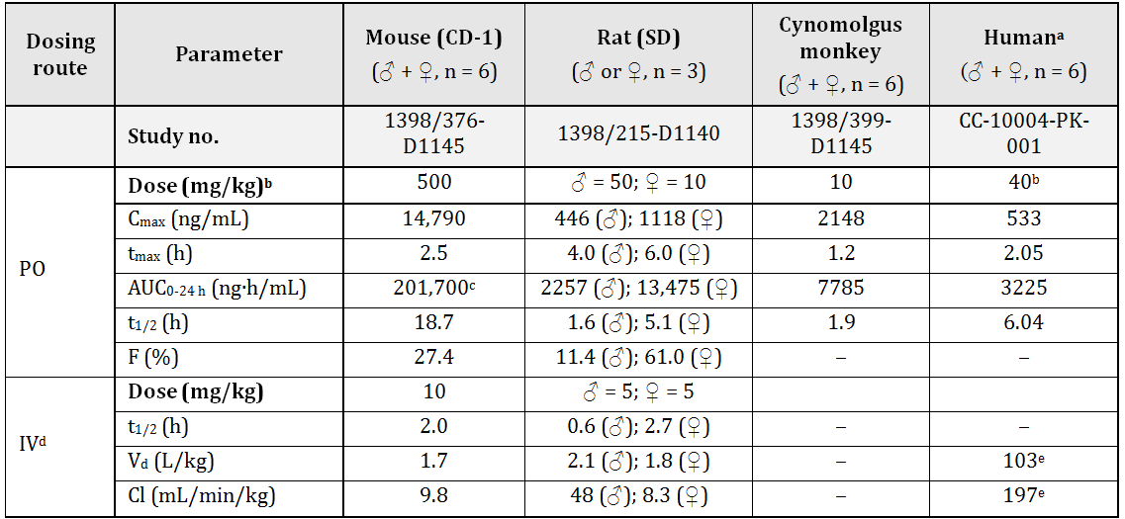
ª Healthy male and female subjects (18-55 yrs), results on Day 1 of dosing; ^{b} dose as mg/kg for animals and mg/subject for humans; ^{c} value for mouse is AUC_{0-48 h}; ^{d} excluding human data; ^{e} values for PO dosing and not normalised for body weight.
APR pharmacokinetics following a single oral dose were reasonably similar across the species examined. The time to reach maximum plasma concentration following drug administration (Tmax) for mice, monkeys, and humans was at ~2 h, indicating quite rapid absorption, but was somewhat later for rats. Elimination from plasma was relatively rapid for male rats and for monkeys (t1/2 = 1.6 and 1.9 h, respectively), but was slower for female rats and humans (t1/2 = 5.1 and 6.0 h, respectively). Such a difference in drug metabolism between male and female rats is common and is often attributable to gender-dependent expression of CYP enzymes in the liver. The t1/2 value for mice of 18.7 h is anomalously high and presumably reflects saturation of metabolism at the high dose used. By comparison, APR was cleared with a t1/2 of 2.0 h by mice given a much lower IV dose (see Table 3). Bioavailability was low for male rats (11.4%), moderate for mice (27.4%), and high for female rats (61.0%). The volume of distribution for APR in rodents and humans was ~1-2 L/kg, suggesting a moderate degree of binding to plasma proteins.
Repeat dose studies were performed with mice, rats, and monkeys of both sexes. At the relatively high doses used in many of these studies, plasma AUC and Cmax values for APR increased less than proportionally with dose and there was often a modest level of drug accumulation following an extended dosing period. At lower doses (<20 mg/kg), plasma AUC and Cmax values for APR increased proportionally with dose and there was no evidence for drug accumulation during the dosing period. Similar to the animal studies, clinical studies using healthy subjects dosed at up to 100 mg of APR/day demonstrated approximately linear increases for both Cmax and AUC values, with only modest drug accumulation at the higher doses (CC-10004-PK-001).

Distribution
APR showed moderate binding to plasma protein from the species used for toxicity studies: ~90% for mouse and rat and ~85% for cynomolgus monkey. By comparison, binding to human plasma protein was ~68%. For all the species tested, there was little effect of concentration (over the range 0.25-2.5 µg/mL [~0.5‒5 µM]) on the extent of plasma protein binding. Following oral dosing, radiolabelled APR showed an extensive tissue distribution in mice. Most tissues contained higher levels of radioactivity than blood at 2 h post dose. Tissues with high levels of radioactivity included liver, gall bladder, kidney, and GI mucosa. Tissues with lower levels of radioactivity than blood included bone marrow, testis, spinal cord, and brain. This suggests that there is only a low level of transport of APR and its metabolites across the blood-brain barrier in mice. Comparison of tissue levels of radioactivity in albino and pigmented mice suggested binding of APR and/or its metabolites to melanin. However, such binding appeared reversible as all radioactivity was eliminated from mice by day 7 post dose.

Metabolism
APR was subject to enzyme catalysed deethylation and/or demethylation reactions that could be followed by glucuronidation. The drug could also undergo spontaneous hydrolysis followed by the aforementioned enzymic reactions. There was no chiral inversion of APR to its less potent R-enantiomer in repeat dose toxicity study plasma samples from mice, rats, rabbits, and monkeys. Glucuronide conjugate of demethyl APR was the major metabolite produced under in vitro culture conditions by rat, rabbit, monkey, and human hepatocytes. This metabolite, and to a lesser extent its precursor, demethyl APR, was also prominent in plasma samples from mouse and monkey repeat-dose studies. After a year of daily dosing of monkeys at 60-600 mg/kg of APR, exposure to glucuronide conjugate of demethyl APR was about double that for APR. Glucuronide conjugate of demethyl APR was also shown to be a major circulating and excreted species in humans. The metabolites of APR generally showed little or no inhibition of human PDE4: IC50 values were 0.047, 8.3, and >100 µM for APR, demethyl APR, and glucuronide conjugate of demethyl APR, respectively.
In vitro incubation of APR with individual human CYP isozymes showed that demethyl APR was only produced by CYP3A4. That enzyme was also the most active generator of deethyl APR, although CYP2A6 and (to lesser extents) CYP1A2 and CYP2C8 could also contribute to deethyl APR production. Given that CYP1A2 and CYP2A6 activities in human liver microsomes are about 1% and 26%, respectively, of CYP3A4 activity, it is likely that, under in vivo conditions, both demethyl and deethyl APR are predominantly produced by CYP3A4 activity.

Excretion
The major route of excretion for APR and its metabolites was fecal in mice, rats, and monkeys. Studies with bile duct cannulated mice showed that excretion was primarily via bile (~55% of recovered dose). Consistent with the animal results, human studies showed that urinary excretion of APR was very low (Clinical study CC-10004-PK-001).

Conclusion
The pharmacokinetic profiles of the laboratory animal species used in the pivotal repeat dose toxicity studies showed reasonable overlap with human data, supporting the use of these animals as models for human drug toxicity. In addition, the APR metabolites produced in humans were found in one or more of the animal species used for toxicity studies. There were no unique human metabolites.

Pharmacokinetic drug interactions
Studies using human liver microsomes showed that APR, at concentrations up to 100 µM, produced modest to no inhibition of the major CYP enzyme activities (CYP1A2, CYP2C9, CYP2C19, CYP2D6, CYP2E1, and CYP3A4) and showed no evidence for time-dependent effects. Exposure of human hepatocyte cultures to APR concentrations up to 100 µM on three consecutive days produced no significant induction of various CYP enzymes, except for a 3.7 fold increase in CYP3A4 activity after exposure to 100 μM APR. However, such a response is unlikely to be clinically relevant because it occurred at an APR concentration ~100-fold higher than the Cmax for humans given the recommended clinical dose. Hence, APR is unlikely to produce drug interactions via CYP inhibition or induction.
In vitro experiments using monolayers produced by human P-gp-expressing LLC-PK1 cells (a porcine kidney proximal tubule cell line) suggested that APR is a low affinity P-gp substrate (Km likely to be >50 µM). The P-gp inhibitor ketoconazole was able to effectively (>90%) inhibit net efflux of APR from LLC-PK1 cells. APR was a weak inhibitor of the efflux of the prototypic P-gp substrate digoxin with an IC50 value of >50 μM. These results suggest that the potential of APR to affect the tissue efflux of other P-gp substrates is low.
The affinity of other transporter proteins for APR was tested by measuring transport across cell monolayers expressing the transporter in the absence and presence of an inhibitor for the transporter. No changes in transport were found and it was concluded that APR is not a substrate of the efflux transporter BCRP or of the uptake transporters OAT1, OAT3, OATP1B1, OATP1B3, and OCT2. Consistent with that conclusion, APR showed little or no inhibition of the transport of known substrates of these transporters. Hence, APR is unlikely to interact with drugs that are substrates of these transporters.

Toxicology

Acute toxicity
Single dose toxicity studies were performed with mice (CD-1) and rats (Wistar) and used both IV and per os (PO) dosing. The maximum non-lethal doses of PO administered APR were ≥2000 and 1500 (♂)/300 (♀) mg/kg and for the IV route were 120 (♂)/150 (♀) and 100 (♂)/60 (♀) mg/kg for mice and rats, respectively. This suggests that APR, when delivered via the clinical route, has low to moderate toxicity in rodents. Clinical signs in both species included tachypnoea.

Repeat-dose toxicity
Pivotal studies were performed with mice, rats, and monkeys at durations of up to ~2 years (mouse and rat carcinogenicity studies) and 1 year (monkey toxicity study). The studies generally used once daily, oral dosing, which is similar to the mode and frequency of clinical dosing (that is, oral, BID). The scope and design of the studies were consistent with the relevant EMA guideline.

Relative exposure
Relative exposure in repeat dose toxicity and carcinogenicity studies is shown in Table 4.
Table 4: Relative exposure in repeat-dose toxicity and carcinogenicity studies.ª
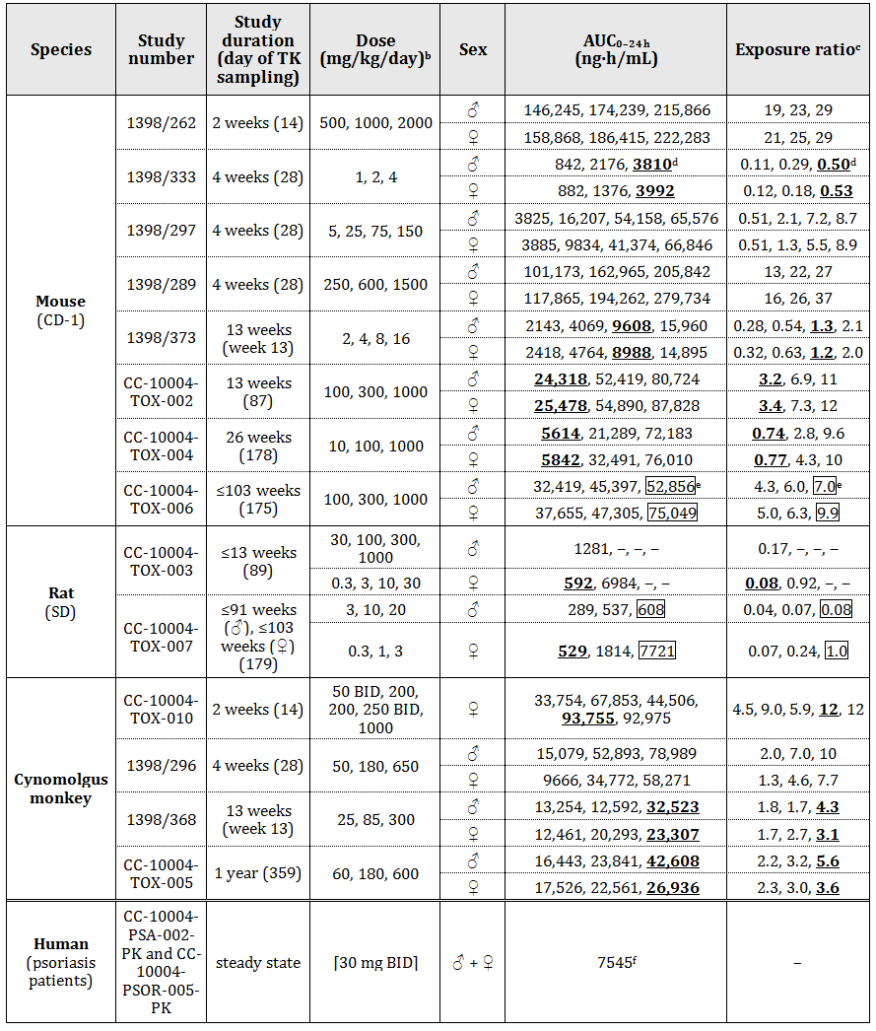
ª All listed studies are GLP compliant; ^{b} doses given PO (gavage); ^{c} animal:human plasma AUC_{0–24 h}; ^{d} values at NOAEL dose are bolded and underlined (where no value is so indicated, NOAEL was not identified in the study); ^{e} values at NOEL for carcinogenicity are boxed; ^{f} average of values from the two studies.
AUC derived relative exposures to APR at the no observed adverse effect level (NOAEL) were low in the pivotal mouse and rat repeat dose studies: <1 for 6 months dosing of mice and <0.1 for 2 years dosing of rats (see Table 2). Cynomolgus monkeys, however, were less sensitive to induction of toxic effects and showed relative exposures of ~5 at the NOAEL for 1 year of APR dosing.

Major toxicities
The feature of the repeat dose toxicity studies was the difference in response between rodents and monkeys. Both mice and rats demonstrated sensitivity to an APR induced pro-inflammatory response, whilst monkeys did not. This inter specific difference in in vivo response was correlated with the in vitro response of monocytes from these species to activation by LPS in the presence of APR. Whereas APR showed little effect or modest inhibition of IL-6 (mediator of acute phase response) production by LPS stimulated human or monkey blood, APR elevated IL-6 production in mouse and rat blood.
The pro-inflammatory response in rodents was manifested by lymphopaenia and by increases in circulating levels of neutrophils and of the acute phase proteins haptoglobin and C-reactive protein. The targets for APR induced inflammation included vasculature, heart, GI tract, lung, mesentery, and thymus. Hepatocellular hypertrophy, an adaptive response to xenobiotic dosing, was also a common finding. The inflammatory responses seen in these tissues were often associated with arteritis/perivascular inflammation involving acute inflammatory cell infiltrate in all layers of the vessel wall, perivascular oedema and haemorrhage, disruption of the internal elastic lamina, occasional minor areas of necrosis, and areas of fibrosis.
Necropsy of mice from the 2 year carcinogenicity study (relative exposures were in the range 4-10) indicated findings in skeletal muscle and heart. The lesions at both sites were attributed to APR-induced vascular changes (arteriopathy). Skeletal muscle haemorrhage (typically in the hind limb) was a common cause of mouse death within the first 12 months of dosing. Changes in the heart included fibrosis and arteriopathy. The fibrosis tended to be of the epicardium at the base of the heart or along the left ventricle and often surrounded the intra and/or extramural coronary vessels in these areas. The arteriopathy predominantly affected vessels at or near the base of the heart and the condition appeared to begin as a minimal to moderate chronic active arteritis with subintimal proliferation of spindle cells as well as an overall thickening of the vessel wall that characterised the chronic condition. These changes tended to increase in incidence and severity with dose.
In the rat 2 year carcinogenicity study (high dose [HD] gave relative exposure of 1), the GI tract was the most common site of APR induced lesions in premature decedents. Distention of the GI tract was noted at different incidence in the stomach, duodenum, jejunum, ileum, cecum, and colon. Various other changes were also commonly noted in the GI tract (for example, discolouration, altered contents, red areas). The ileum and stomach tended to be the most commonly and most severely affected of the GI tract tissues. The ileum also showed evidence of goblet cell hyperplasia. Ulceration was common in the stomach and was often correlated with the finding of dark-red areas from gross pathology. The inflammation of Peyer’s patches was often associated with acute inflammation of the ileum.
Several mouse studies indicated that APR dosing was associated with an increase in mean body weight that correlated with higher food consumption. A possible explanation came from a rat study suggesting that APR dosing lead to a decrease in plasma leptin (“satiety” hormone) levels.
Clinical signs from the monkey studies included occasional instances of vomiting and an apparent increased incidence of a red vaginal discharge. These signs were not considered toxicologically significant. Results from the pivotal 1 year toxicity study (relative exposures up to 5.6) showed some evidence for the induction of an inflammatory response: increased neutrophil counts, decreased lymphocyte counts, and increased haptoglobin values. However, there was no evidence for APR induced inflammation at the histological level.
The most common adverse events associated with APR dosing of PSOR patients were diarrhoea, nausea, headache, and upper respiratory tract infection (Summary of Clinical Safety: sponsor’s dossier). At least the first two of these events are consistent with the findings from laboratory animal studies.

Genotoxicity
APR was not mutagenic at up to 5 mg/plate (toxic concentration) in both the presence and absence of metabolic activation in standard Salmonella typhimurium strains. Tests of in vitro (human lymphocytes) and in vivo (mouse bone marrow micronucleus test) clastogenicity were also negative. The assays used and the conditions employed were consistent with the relevant EMA guideline.
The impurity RC6, which gave a structural alert for mutagenicity based on computer analysis, showed no activity towards standard Salmonella typhimurium strains, in both the presence and absence of metabolic activation, when tested (in the presence of APR) at levels of up to 250 µg/plate.

Carcinogenicity
These studies used mice (CD-1) and rats (SD) of both sexes given daily oral doses of APR for up to approximately two years. The design of these studies was consistent with the EMA guideline on evaluation of carcinogenic potential.
Dosing of all mouse groups, except low dose (LD) males, was ceased prior to the scheduled termination at two years in order to allow the survival of useful numbers of animals. HD males received 1000 mg/kg/day (relative exposure = 7.0) until week 73, and were then maintained drug free until necropsy in week 103. While HD females received 1000 mg/kg/day (relative exposure = 9.9) until week 73 and were then maintained drug free until necropsy in week 103. There were no neoplastic findings in male or female mouse groups that could be attributed to dosing with APR.
Dosing of all male rat groups and of mid dose (MD) and HD female groups was also ceased prior to the scheduled termination in order to allow the survival of useful numbers of animals. HD males received 20 mg/kg/day (relative exposure = 0.08) until week 66, and were then maintained drug-free until necropsy in week 95. While HD females received 3 mg/kg/day (relative exposure = 1.0) until week 94 and were then maintained drug-free until necropsy in week 104. There were no neoplastic findings in male or female rat groups that could be attributed to dosing with APR.
APR showed no signals for oncogenic potential in both rats and mice, consistent with its lack of activity in genotoxicity assays. However, relative exposure levels in the rat study were similar to (females) or much lower (males) than clinical exposure at the recommended dose.

Reproductive toxicity
APR was assessed for effects on fertility (both sexes), embryofoetal and pre/postnatal development, and juvenile animals in mice (CD-1), and for effects on embryofoetal development in cynomolgus monkeys. The choice of mice and monkeys was reasonable given that (of the more usually used species) rats were very sensitive to APR induced toxicity and first-pass metabolism of APR in rabbits was so extensive that adequate systemic exposure would not have been achieved with oral administration in that species. The scope and design of the studies were appropriate and consistent with the relevant EMA guideline. All pivotal studies were performed to GLP standards.

Relative exposure
As shown in Table 5, relative exposures to APR at NOAEL for general/reproductive toxicity in mouse and monkey studies were similar to clinical exposure based on AUC.
Table 5: Relative exposure in reproductive toxicity studies.ª
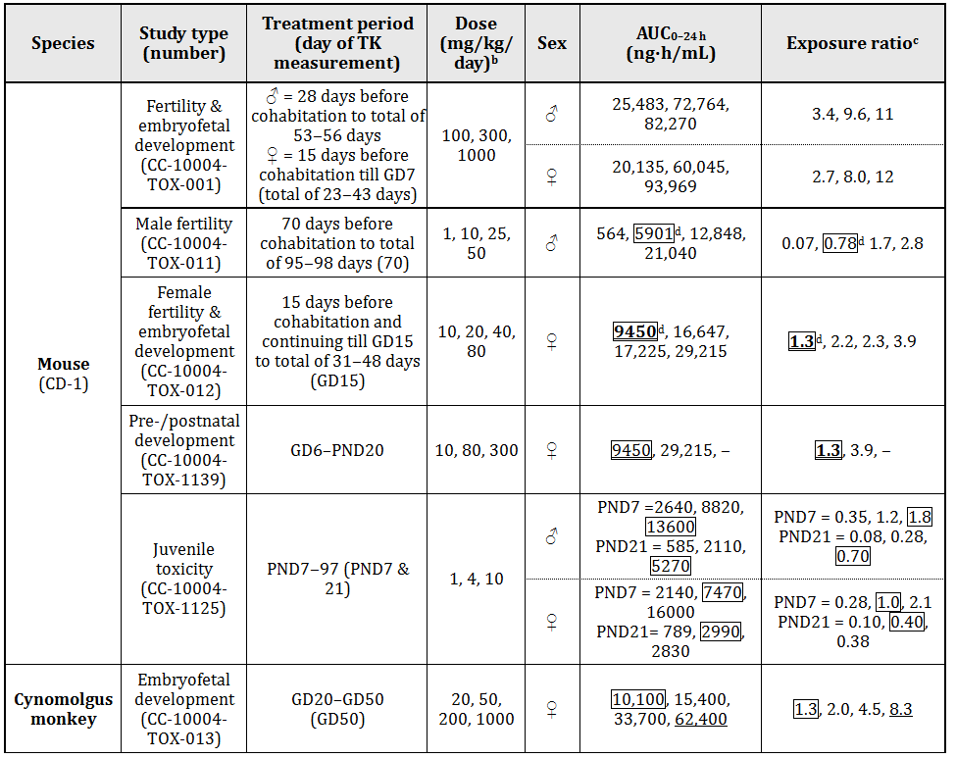
ª All listed studies are GLP compliant; ^{b} doses given po (gavage); ^{c} animal:human plasma AUC_{0–24 h} based on human value for 30 mg BID of 7545; ^{d} values at NOAEL dose for male or female general toxicity (including juveniles) are boxed, for male or female fertility are bolded, and values at NOAEL dose for embryofoetal or pre-/postnatal development toxicity are underlined (in Study CC-10004-TOX-001, the NOAEL for male and female fertility was <LD; Study CC-10004-TOX-001 did not include TK measurements and so the corresponding AUC values for Day 28 of study CC-10004-TOX-002 have been used; in Study CC-10004-TOX-011, the NOAEL for male fertility was >HD; Study CC-10004-TOX-1139 did not include TK measurements and so the AUC values for 10 and 80 mg/kg/day have been taken from Study CC-10004-TOX-012).
Results from oral dosing of pregnant mice and monkeys showed that APR crossed the placenta. The foetal to maternal plasma concentration ratio of APR at 5 h after dosing of monkeys was in the range 0.3-0.4. Following oral dosing of lactating mice with APR, the drug was present in milk by 1 h post dose at levels about 50% higher than those in plasma. APR was undetectable in mouse plasma and milk by 24 h post dose.
Dosing of female mice at relative exposures of around 2 and above produced a lengthening of the oestrus cycle and a decrease in mating activity. There were no effects of APR in mice on mean numbers of corpora lutea, implantations, or pre-implantation loss. Male mice treated at similar relative exposures showed an increase in testis weight, although this increase was not correlated with changes in testis histology or changes in sperm values.
APR treatment did not cause malformations in mice or monkeys up to approximately 4 and 8 times clinical exposure (based on AUC). However, embryolethal effects were noted in both species at low relative exposure levels (~2 based on AUC).
Increased embryofoetal loss, reduced foetal weight and delayed ossification were observed in a combined female mouse fertility and embryofoetal developmental toxicity study at just over twice clinical exposure (AUC). The maternal and developmental NOEL was 10 mg/kg/day (1.3 fold clinical exposure based on AUC).
A dose related increase in prenatal loss (abortions) was observed following oral APR treatment in a monkey embryofoetal developmental toxicity study at close to twice clinical exposure. The NOEL was 20 mg/kg/day (1.3 fold clinical exposure based on AUC).
In a pre and postnatal study in mice, APR was administered orally to pregnant female mice at doses of 10, 80 or 300 mg/kg/day from Day 6 of gestation to Day 20 of lactation, with weaning on Day 21. Dystocia, reduced viability, and reduced birth weights occurred at ≥ 80 mg/kg/day (≥ 4.0 fold clinical exposure based on AUC). The NOEL for maternal toxicity and the F1 generation was 10 mg/kg/day (1.3 fold clinical AUC). In the absence of a cross fostering study it cannot be determined whether the decreased viability was the result of exposure in utero, ingestion of APR via the milk during lactation, or a combination of the two.

Australian pregnancy classification and contraindication in pregnancy and lactation
Both the European Summary of Product Characteristics and the Canadian product monographs note that APR is contraindicated in pregnancy while the US FDA label does not include pregnancy as a contraindication. The sponsor was requested to comment on whether APR should be contraindicated in pregnancy or not. The Sponsor suggested that the embryofoetal lethality findings do not warrant contraindication in pregnancy, noting the following:
- The mechanism by which PDE4 inhibitors induce such an effect is not well understood.
- Human studies suggest that Th1-Th2 cytokine balance is important in the survival of the foetus in the maternal uterus, with a Th-2 bias (IL-6, IL-10) and Th-1 bias (TNF-α) being associated with successful and unsuccessful pregnancies, respectively.
- The mechanisms that lead to abortion in mice seem to be different from those in humans. PDE4 inhibitors have been shown to increase IL-6 production in LPS stimulated whole blood from mouse and rat but not in monkey and human. Therefore, the observation of increased embryofoetal loss may be the result of elevation of IL-6 in this species.
At best, the sponsor’s arguments potentially explain the embryolethal effects in mice. However, the embryolethal effect in monkeys at low relative exposure levels is still concerning, and the sponsor admits that “the mechanisms of abortion in monkeys is less well understood” and that “the presence of complicated cytokine networks and overlapping biological activities make a clear understanding of mechanisms in pregnancy maintenance very difficult.”
Overall, taking into consideration the relevant EMA guideline and the evidence for placental transfer and excretion of APR into milk, embryolethality in two species at similar to anticipated human exposure in embryofoetal development studies, and the decreased viability in the pre-postnatal study in mice, it is recommended that APR be contraindicated in both pregnancy and lactation (as is the case in both Canada and the EU). This is also consistent with what is already noted in the Risk Management Plan Version 3.0. An Australian Pregnancy Category of B3 is recommended:
“Drugs which have been taken by only a limited number of pregnant women and women of childbearing age, without an increase in the frequency of malformation or other direct or indirect harmful effects on the human foetus having been observed. Studies in animals have shown evidence of an increased occurrence of foetal damage, the significance of which is considered uncertain in humans.”
The uncertainty of the clinical relevance of the animal findings is being addressed by Pregnancy Exposure Registries being established in the US and Canada (RMP, Version 3.0).

Local tolerance
Rabbits given one topical application of APR onto shaved skin showed no signs of irritation. Results after multiple rounds of exposure of guinea pig skin suggested that APR is a weak sensitiser to irritation in that system.

Phototoxicity
APR showed no ability to increase the toxicity of ultraviolet light towards mouse 3T3 fibroblasts. This suggests that APR is not a photosensitiser.

Impurities
The proposed acceptance criteria for impurities in the drug substance are below the ICH qualification threshold. One of these impurities gave a negative response in bacterial mutagenicity testing. According to the sponsor, no degradation products have been found in APR tablets.

Paediatric use
APR is not proposed for paediatric use. Nevertheless, the response of juvenile mice to dosing with APR from postnatal day (PND) 7-97 was examined. Deaths of female mice, which were attributed to APR dosing, occurred mostly in the first week of dosing and at relative exposures of around two (see Table 5). This suggests that juveniles may be particularly sensitive to APR induced effects.

Nonclinical summary and conclusions

Summary
- The nonclinical studies were comprehensive and of high quality, and the pivotal toxicological studies were performed to GLP standards.
- APR inhibited a range of human PDE4A, 4B, 4C, and 4D isoforms with IC50 values ranging from 14 to 118 nM. Compared with other PDE4 inhibitors, it was more potent than rolipram, of similar potency to cilomilast, and less potent than roflumilast. In vitro studies showed that APR inhibited release of TNF-α and other pro-inflammatory proteins by human PBMC or monocytes following exposure to LPS (IC50 = 77 nM for TNF-α), and also had potent anti-angiogenic activity (IC50 of 0.14 µM in the human umbilical cord vessel ring assay) and anti-osteoclast activity. Both activities are potentially significant for the proposed indications for APR. In vivo studies showed that APR had activity in a model of PSOR using immunocompromised mice that had received human skin grafts and been injected with activated NK cells derived from psoriatic patient blood; although results in models of arthritis were equivocal.
- In large scale screens for inhibitory activity, APR showed no significant inhibitory activity towards other PDE families, kinases, various other enzymes, and cell surface receptors. In one study, APR showed inhibition of the hERG potassium current, however, in a more comprehensive investigation that result was not confirmed. APR lacks the pharmacophore responsible for the binding of thalidomide to cereblon, and various systems confirmed the different properties and mechanisms of action for the two drugs in inhibiting TNF-α synthesis.
- The results from safety pharmacology studies (including investigation of QT prolongation potential) were generally unremarkable and did not raise any issues of clinical concern.
- Pharmacokinetic studies in mice, rats, monkeys, and humans demonstrated relatively rapid absorption and plasma elimination kinetics. AUC and Cmax values for orally administered APR increased approximately proportionally with dose, although the increases were less than dose proportional at the higher doses used in many of the animal studies. APR showed a moderate value for volume of distribution in rodents and humans (~1-2 L/kg). It was concluded that the animal species used provided reasonable models for studying the effects of human dosing with APR.
- For all animal species examined, excretion was predominantly via the faeces, and in mice it was shown that bile was the major route.
- APR showed a moderate level of binding to human plasma proteins (~68% unbound), with little effect of concentration (over the range ~0.5-5 µM) on the extent of binding. Following oral dosing, radiolabelled APR showed an extensive tissue distribution in mice. Most tissues contained higher levels of radioactivity than blood at 2 h post dose. Tissues with high levels of radioactivity included liver, gall bladder, kidney, and GI mucosa. Tissues with lower levels of radioactivity than blood included bone marrow, testis, spinal cord, and brain. This suggests that there is only a low level of transport of APR and its metabolites across the blood-brain barrier in mice.
- APR underwent a significant level of metabolism in the species examined. APR was subject to enzyme catalysed deethylation and/or demethylation reactions that could be followed by glucuronidation. The drug could also undergo spontaneous hydrolysis followed by the aforementioned enzymic reactions. Glucuronide conjugate of demethyl APR was the major metabolite produced under in vitro culture conditions by rat, rabbit, monkey, and human hepatocytes. This metabolite, and to a lesser extent its precursor, demethyl APR, was also prominent in plasma samples from mouse and monkey studies. The APR metabolites identified in humans were also found in one or more animal species. In vitro studies with human CYP enzymes showed that demethyl APR was only produced by CYP3A4. That enzyme was also the most active generator of deethyl APR, although CYP2A6 and (to lesser extents) CYP1A2 and CYP2C8 could also contribute to deethyl APR production. Given that CYP1A2 and CYP2A6 activities in human liver microsomes are about 1% and 26%, respectively, of CYP3A4 activity, it is likely that, under in vivo conditions, both demethyl and deethyl APR are predominantly produced by CYP3A4 activity.
- APR was not an inhibitor of various CYP isoforms and showed only weak induction of CYP3A4 activity at high concentrations. It was concluded that APR is unlikely to produce drug interactions via CYP inhibition or induction.
- APR is a low affinity P-gp substrate and a weak P-gp inhibitor. The results suggested that APR has low potential to affect the tissue efflux of other P-gp substrates. APR was not a substrate of the efflux transporter BCRP or of the uptake transporters OAT1, OAT3, OATP1B1, OATP1B3, and OCT2.
- The feature of the repeat-dose toxicity studies was the difference in response between rodents and monkeys. Both mice and rats demonstrated sensitivity to an APR induced pro-inflammatory response, whilst monkeys did not. Targets for APR induced inflammation in rodents included vasculature, heart, GI tract, lung, mesentery, and thymus. This interspecific difference in in vivo response was correlated with the in vitro response of monocytes from these species to activation by LPS in the presence of APR. Whereas APR showed little effect or modest inhibition of IL-6 (mediator of acute phase response) production by LPS stimulated human or monkey blood, APR elevated IL-6 production in mouse and rat blood. Hence, rodents may be a poor model for APR induced toxicity in humans.
- APR showed no evidence for induction of mutations in standard bacterial reverse mutation assays. APR also showed no evidence for clastogenicity in both in vitro (human peripheral blood lymphocytes) and in vivo (mouse bone marrow micronucleus) assays. Consistent with its lack of genotoxic activity, APR showed no evidence for induction of tumours in mice or rats of both sexes.
- Following oral dosing, APR was shown to cross the placenta in mice and monkeys and was found in mouse milk. Embryofoetal development studies with APR showed no malformations in either mice (up to 3.9 times clinical exposure; AUC) or monkeys (up to 8.3 times clinical exposure; AUC). However, dosing of female mice at relative exposures of around 2 and above produced increases in the incidence of early resorptions and decreases in the mean number of live foetuses per litter, and dosing of cynomolgus monkeys at relative exposures of around 2 and above also produced increases in embryofetal loss. There were no effects of APR in mice on mean numbers of corpora lutea, implantations, or pre-implantation loss. Dystocia, reduced viability, and reduced birth weights were observed in a mouse pre- and postnatal study at ≥ 4.0 fold clinical exposure (based on AUC), with a NOEL for maternal toxicity and F1 generation established at 1.3 fold clinical AUC.
- In vitro studies using the mouse 3T3 cell line demonstrated no increase in ultraviolet radiation induced cytotoxicity following incubation with APR, suggesting that the test article is not a photosensitiser.

Conclusions and recommendation
- The nonclinical studies presented were comprehensive and had no major deficiencies.
- The results of the primary pharmacology studies support the use of APR for the treatment of moderate to severe plaque PSOR. In vivo studies in support of its use for PsA were equivocal.
- Secondary pharmacodynamics and safety pharmacology studies did not identify any unexpected clinical hazards.
- CYP3A4 is the major enzyme in the metabolism of APR; thus plasma APR levels could be affected by drugs that inhibit or induce CYP3A4. APR is a substrate of P-gp, and P-gp inhibitors could increase plasma APR levels.
- In rodent repeat dose studies, APR induced inflammation in tissues such as vasculature, heart, GI tract, lung, mesentery, and thymus. This inflammatory response was not induced in monkeys. PDE4 inhibitors, including APR, have been demonstrated to induce inflammatory perivascular changes on histopathology consistent with vasculitis in animal studies. The sponsor’s Clinical Expert Report notes that no patients in the Phase III studies (PsA or PSOR) were identified as experiencing vasculitis.
- The evidence presented suggested that APR does not pose a genotoxic or carcinogenic risk.
- While no increases in malformations were noted, it is recommended that APR be contraindicated in pregnancy (similar to Canada and EU) based on the embryolethal effects observed in two species at only 2 fold clinical exposure (based on AUC). An Australian Pregnancy Category of B3 is recommended.
- It is recommended that APR also be contraindicated in lactation (similar to Canada and EU) based on the detection of APR in the milk of lactating mice and the increased peri/postnatal pup mortality and reduced pup body weights observed during the first week of lactation.
- There are no nonclinical objections to the registration of APR.

IV. Clinical findings

Introduction
The submission contains 5 clinical efficacy/safety studies for the requested indication of PsA. This includes a supporting Phase II trial (Study PSA-001), 3 replicate pivotal Phase III controlled trials in subjects with active PsA despite conventional and/or biologic disease modifying anti rheumatic drugs (DMARDs) (Studies PSA-002, PSA-003 and PSA-004), and another pivotal Phase III trial in adult patients with active PsA who were DMARD naïve (Study PSA-005). Studies PSA-002, PSA-003 and PSA-004 evaluated APR as a monotherapy or in combination with conventional DMARDs and were designed with similar schema, eligibility criteria, as well as doses and regimens of therapy. Study PSA-005 evaluated APR as monotherapy. The submission included data collected up to 52 weeks for Studies PSA-002, PSA-003 and PSA-004, and up to 24 weeks in Study PSA-005 (although the planned duration of treatment follow-up is 52 weeks in this trial). The studies were designed to evaluate the effect of APR on PsA signs and symptoms, physical functioning and health related quality of life (QOL).
For the indication of PSOR, the submission contained 6 clinical studies: 2 open label Phase II trials (Studies PSOR-001 and PSOR-004), 2 randomised Phase 2 trials (Studies PSOR-003 and PSOR-005) and 2 pivotal Phase III trials (Studies PSOR-008 and PSOR-009). In this submission, the 2 pivotal Phase III studies collected data up to 52 weeks and the primary efficacy endpoint for evaluating improvement in PSOR was the proportion of subjects achieving Psoriasis Area Severity Index (PASI) 50 or PASI 70 response at week 16. In addition, subjects were secondarily evaluated for dermatology related QOL outcomes.
In support of the submission, the pharmacology of APR has been characterised in 16 clinical pharmacology studies, with pharmacokinetic features additionally examined in the Phase III clinical trial program in both PsA and PSOR.

Clinical rationale
PsA is a chronic inflammatory arthritis associated with skin PSOR which typically onsets between the ages of 30 and 55 years, and affects men and women equally. Skin PSOR has prevalence in the general population of 2-3%, and it is estimated that approximately 30% of patients with skin PSOR develop PsA. PsA is a multifaceted and heterogeneous disease, which affects the joints, soft tissues (enthesitis and dactylitis) and skin. All of the disease manifestations may impact upon functional capacity and QOL. There is also increased mortality with persistent, severely active PsA. Peripheral joint involvement with PsA may be polyarticular (35-40%) or oligoarticular (20-35%), and axial involvement (spondylitis) has been reported in 10-25% of patients. Current approved treatment options in Australia for moderately to severely active PsA include non steroidal anti inflammatory drugs (NSAIDs); conventional non biological DMARDs such as methotrexate (MTX), sulfasalazine (SSZ), leflunomide (LEF) and cyclosporine (CsA); as well as several anti-TNF drugs. Recent literature suggests that conventional DMARDs have modest efficacy in treating the signs and symptoms of PsA. In addition, while anti TNF drugs have been shown to demonstrate significant efficacy in treating active PsA, a substantial proportion of patients are not achieving meaningful American College of Rheumatology (ACR) responses. Based on the current literature for anti TNF therapies, ACR20 response rates range from 50-60% and ACR50 response rates are approximately 30-40%. As such, there is an unmet need for additional therapies for active, treatment refractory PsA.
PSOR is a common, inflammatory and proliferative skin disease with a genetic determinant. Although PSOR may occur at any age, two age peaks of onset are identified: second decade of life (early onset) and fifth decade (late onset). Chronic stable plaque PSOR (PSOR vulgaris) is the most common form of the disease, accounting for 85-90% of all cases. While the majority of patients have mild PSOR, studies have found that 25% of patients reported their disease as moderate, and 10% as severe. PSOR can be disabling, affecting the physical, social and psychological wellbeing of patients. Plaque PSOR manifests as thickened, well demarcated, erythematous patches of skin covered with silvery scales. The lesions often arise in predisposed areas such as the extensor aspects of the knees and elbows, but can be generalised. Other sites affected by PSOR include the nails, scalp, palms, soles and intertriginous areas. The skin lesions frequently cause symptoms of pruritus and discomfort. Topical agents such as salicylic acid, corticosteroids (CS) and vitamin D analogues are often used as a first line therapy, particularly if the PSOR is localised. Phototherapy with UVB or psoralen + UVA is often used as a first line treatment for widespread PSOR, or as a second line treatment if topical therapy is insufficient. Systemic treatment with oral retinoids, MTX and CsA are indicated in severe forms of PSOR. All of the systemic treatments have demonstrated efficacy but their long-term use is limited by potential risks and toxicities. Biologic therapies such as anti-TNF drugs and ustekinumab have been demonstrated to be highly effective in the treatment of moderate to severe PSOR but their use is limited by the risk of significant adverse events (AEs) such as serious infection and malignancy potential. Despite the variety of treatment options available in PSOR, patients are often dissatisfied (>70% prevalence) with current therapy options due to lack of sustained efficacy, adverse events and/or treatment inconvenience. Hence, there is an unmet need for additional therapies for moderate to severe PSOR, which is refractory to topical treatment.
APR is a novel, oral, small molecule inhibitor of PDE4 that works intracellularly to modulate a network of pro- and anti-inflammatory mediators, and has a different mechanism of action to conventional DMARDs, systemic therapies and biologic drugs. PDE4 is a cAMP specific PDE and the dominant PDE in inflammatory cells. Inhibition of PDE4 elevates intracellular cAMP levels, which in turn down-regulates the inflammatory response by modulating the expression of Tumour Necrosis Factor (TNF), IL-23, IL-17, and other pro-inflammatory cytokines. Elevation of cAMP also increases anti-inflammatory cytokines. These pro- and anti-inflammatory mediators have been implicated in PSOR and PsA. IL-23 induces the T-helper 17 (Th17) pathway and promotes the secretion of various other pro-inflammatory cytokines such as IL-17, IL-21 and IL-22. IL-23 is highly expressed in the synovium and entheses of patients with PsA, and patients with PSOR over-express these cytokines in plaques. Overall, APR appears to have robust biological plausibility in being able to treat both PSOR and PsA through inhibition of the TNF, IL-23 and Th17 cytokine pathways, which are central to the pathology of the diseases.

Guidance
This submission was consistent with the pre-submission planning advice given to the sponsor by the TGA. There are two regulatory guidelines relevant to the requested indications, one for each of the proposed treatment indications. For the PsA indication, the TGA has adopted the EU guideline “Guideline on Clinical Investigation for Medicinal Products for the Treatment of Psoriatic Arthritis”. For the PSOR indication, the TGA has adopted the EU guideline “Guideline on Clinical Investigation for Medicinal Products for the Treatment of Psoriasis”.
For the proposed treatment indication of active PsA, the sponsor has submitted 4 pivotal studies (PSA-002, PSA-003, PSA-004 and PSA-005), which are supported by a single Phase II trial (PSA-001). Three of the 4 pivotal trials have provided study reports for up to 52 weeks of therapy for efficacy and safety evaluation. In this submission, the 24 week report has been provided for the other pivotal Phase III studies (PSA-005), but the trial is ongoing with the 52 week data not yet available for consideration. PsA is a chronic disease and therefore symptomatic treatment is expected to be maintained in the long term. The regulatory guideline relating to the assessment of a drug treatment in PsA states that clinical efficacy can be demonstrated over 12-24 weeks of therapy in a controlled trial, but maintenance of treatment effect requires longer duration studies (for example, 1 year). The guideline also recommends for the provision of an adequate safety database that a minimum of 300 to 600 patients should be exposed to the proposed marketing dose for 6 months, and at least 100 patients be exposed for a minimum of 12 months.
In PsA subjects, there are 5 main domains to assess efficacy (each with recommended instruments):
- Improvement of symptoms and signs of peripheral arthritis (for example, using ACR clinical criteria),
- Improvement of physical function (for example, using Health Assessment Questionnaire Disability Index [HAQ-DI]),
- Improvement of symptoms and physical function related to axial disease (for example, using Bath Ankylosing Spondylitis Disease Activity Index [BASDAI]),
- Slowing or prevention of structural damage (for example, using modified Sharp score), and
- Prevention of disability.
For the proposed treatment indication of active PSOR, the sponsor has submitted 2 pivotal studies (PSOR-008 and PSOR-009) involving a total of 1275 subjects, which are supported by 4 Phase 2 trials (2 of whom were randomised). The 2 pivotal trials have study reports up to 52 weeks of therapy for efficacy and safety evaluation. PSOR is a chronic relapsing disease and 1 year of intermittent or prolonged treatment (as appropriate) is recommended in the regulatory guideline. Although treatment duration of 8-12 weeks is generally sufficient to demonstrate short term efficacy, the guideline states that the aim of trials should be to get a good estimate of the time to initial and maximal response, the duration of efficacy after cessation of therapy, as well as the potential for rebound phenomena. A second course of treatment in relapsing patients should also be evaluated. For this purpose, evaluation for efficacy at the end of short term treatment (8-12 weeks) and during a follow-up of 3-6 months after cessation of therapy is needed. There is no accepted “gold standard” for systemic treatment of severe PSOR, and the choice of comparator should be done in relation to the investigational therapy. Rebound is defined as worsening of PSOR over baseline value (for example, PASI score >125%) or new pustular, erythrodermic or more inflammatory PSOR occurring within 2 months of stopping therapy. A worsening of PSOR beyond 2 months of treatment may represent the natural course of PSOR, and is arbitrarily defined as relapse rather than rebound on theoretical grounds.
In PSOR, the guideline recommends 5 investigator assessed ways to assess response to treatment:
- Visual assessment of index lesions using variables such as erythema, scale and elevation,
- BSA (Body Surface Area) measurement (palm of hand is approximately 1% BSA),
- Clinical signs score (sum of signs [redness, scale and elevation] and symptoms [pruritus]),
- Physician’s Global Assessment (PhGA) of improvement, and
- PASI.
Patient assessed measures are also important in PSOR studies to support the investigator assessments. These included health related QOL outcomes as well as symptom improvement, tolerability of the investigational product and Patient’s Global Assessment (PtGA) of change.

Contents of the clinical dossier
The submission contained the following clinical information:
- 16 clinical pharmacology studies, including 15 that provided pharmacokinetic data and 1 that provided pharmacodynamic data.
- 5 population pharmacokinetic analyses using datasets collected in Studies PSA-001, PSA-002, PSOR-005, PSOR-008 and RA-002.
- 6 pivotal efficacy/safety studies: 4 relating to the PsA indication (Studies PSA-002, PSA-003, PSA-004 and PSA-005) and 2 for the PSOR indication (PSOR-008 and PSOR-009).
- 2 dose finding studies: 1 in PsA (Study PSA-001) and 1 in PSOR (Study PSOR-005).
- 3 other efficacy/safety studies conducted in adult subjects with PSOR (Studies PSOR-001, PSOR-004 and PSOR-003). In addition, the submission contained 3 clinical studies in different patient groups as supporting safety and PK data. These studies were ASTH-001 (mild asthma), BCT-001 (Behcet’s Disease) and RA-002 (Rheumatoid Arthritis).
- No pooled analyses or meta-analyses were part of this submission; however, the sponsor provided a comparison and analysis of the results across the similarly designed and conducted Phase III trials in each of the proposed treatment indications.

Paediatric data
The submission did not include paediatric data.

Good clinical practice
All of the studies in the APR clinical development program for the treatment and prevention of PsA and PSOR were conducted in accordance with the principles of Good Clinical Practice (GCP) and compliance with ethical requirements were met.

Pharmacokinetics

Studies providing pharmacokinetic data
A total of 16 clinical pharmacology studies in humans have been conducted with APR, 13 of which were in healthy subjects (n = 422) and 3 trials were in non-healthy subjects (n = 39). The non-healthy subjects comprise 15 subjects with PsA or rheumatoid arthritis (RA), 8 subjects with severe renal impairment and 16 subjects with hepatic impairment. In the non-crossover studies, 108 subjects received a single dose of APR and 75 subjects received multiple doses of APR. In the crossover trials, 143 subjects received single doses and 110 subjects received multiple doses of APR.
All of the clinical pharmacology studies have been completed. Table 6 shows the studies relating to each pharmacokinetic topic and the location of each study summary. None of the pharmacokinetic studies had deficiencies that excluded their results from consideration.
Table 6: Submitted pharmacokinetic studies for APR.
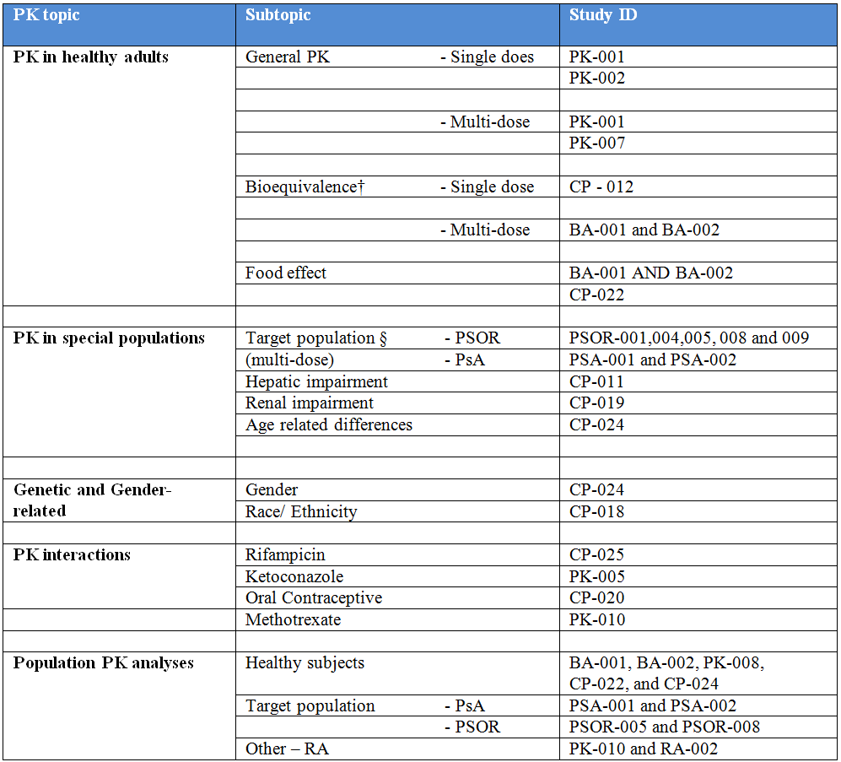
† Bioequivalence of different formulations.
§ Subjects who would be eligible to receive APR if approved for the proposed treatment indications.
Of the 16 clinical pharmacology studies:
- Nine were single dose studies in healthy subjects that evaluated the pharmacokinetics, bioavailability, food effect, drug interaction with ketoconazole and rifampicin, and the effects of age, gender, and ethnicity (Japanese/Chinese/Caucasian) on pharmacokinetics.
- Two were single dose trials in non healthy subjects that evaluated the effect of hepatic or renal impairment on the pharmacokinetics of APR.
- Four were multiple dose studies in healthy subjects that evaluated pharmacokinetics, drug interaction with oral contraceptives (OC), and 1 trial was a thorough assessment of the effect of APR on the QT interval corrected (QTc). The QTc interval study (PK-008) will be covered in the pharmacodynamic section of this report.
- One was a multiple dose study in non-healthy (special population) subjects that evaluated the pharmacokinetic interaction with MTX in subjects with PsA or RA.
In addition, the pharmacokinetics of APR was also evaluated in 9 of the Phase II or III studies in subjects with PsA, PSOR, asthma and RA.

Evaluator’s conclusions on pharmacokinetics
APR is well absorbed after oral administration with an absolute oral bioavailability of 73%, and a T_{max} of 2.5 h. APR demonstrates linear pharmacokinetics with a dose proportional increase in systemic exposure over the dose range of 10-100 mg daily. There is minimal accumulation of the drug when APR is administered twice daily versus once daily. Co-administration of food does not alter bioavailability.
Human plasma protein binding of APR is approximately 68%. The mean apparent volume of distribution is 87 L, which is consistent with extravascular distribution. APR is extensively metabolised through hepatic cytochrome oxidative metabolism with subsequent glucuronidation, and non CYP mediated hydrolysis. The primary pathway of metabolism is by CYP3A4 with a minor contribution from CYP1A2 and CYP2A6. APR does not inhibit or induce CYP enzymes in vitro, suggesting that it is unlikely to have clinically significant drug-drug interactions with medicines metabolized by the CYP enzymes. Co-administration of the strong CYP3A4 inducer rifampicin resulted in a 72% reduction of APR exposure (AUC). The proposed PI recommends avoiding the concomitant use of strong CYP450 inducers with APR. In vitro data suggests that APR is a substrate and a weak inhibitor of p-glycoprotein, however in vivo data indicates that APR is unlikely to have drug-drug interactions with medicines that are inhibitors of p-glycoprotein. APR has no effect upon other drug transporter systems.
APR has an elimination half-life of 5-7 h. No formal studies have been conducted in patients with mild to moderate renal impairment. However, patients with severe renal impairment are recommended to receive a reduced dose of 30 mg once daily based on data in 8 subjects given a single 30 mg dose of APR which resulted in the AUC and C_{max} of APR increasing by 89% and 42%, respectively. No dose adjustments are recommended for patients with hepatic impairment. There is no significant impact of age and gender on APR exposure. However, subject weight (>100 kg) may result in faster clearance and a larger volume of distribution for APR.

Pharmacodynamics

Studies providing pharmacodynamic data
The pharmacodynamics of APR has been studied in 3 PSOR trials (PSOR-001, PSOR-004 and PSOR-009), 1 PsA study (PSA-002), and 1 specific QT trial (Study PK-008). None of the pharmacodynamic studies had deficiencies that excluded their results from consideration.

Evaluator’s conclusions on pharmacodynamics
In both the PsA and PSOR trial programs, the biomarker analysis was exploratory in nature and designed to assess the effect of 2 doses of APR (20 mg and 30 mg twice daily) on a panel of 47 biomarkers associated with systemic inflammation. The pharmacodynamic sub-study of PSA-002 indicates that APR therapy (particularly, the 30 mg twice daily regimen) may affect the plasma concentrations of several cytokines relevant to PsA, but the clinical relevance of this observation is unclear. Similarly, the pharmacodynamic sub-study of PSOR-009 indicates that APR therapy may affect the plasma concentrations of several cytokines relevant to PSOR, but the clinical relevance of this observation is not established.
In Studies PSOR-001 and PSOR-004, treatment with APR was associated with a decrease in dendritic cells and T cells infiltrating skin lesions, within the epidermis and dermis. Both studies also showed a significant decrease in inducible Nitric Oxide Synthase (iNOS) gene expression in skin lesion biopsies taken 2, 4 or 12 weeks after treatment initiation. In Study PSOR-001, decreased whole blood TNF expression (ex vivo) in response to endotoxin was observed 2 h after dosing with APR. In Study PSOR-004, APR reduced lesion epidermal thickness and expression of pro-inflammatory genes and cytokines, including iNOS, IL-12/IL-23p40, IL-17A, IL-22 and IL-8. The pharmacodynamic results of these 2 earlier phase PSOR trials support the biological activity of APR in treating PSOR.
A well conducted QT study (PK-008) has been performed for APR and the findings indicate no significant QTc prolongation effect was detected at the doses tested (up to 100 mg daily).

Dosage selection for the pivotal studies
The effects of APR 20 mg twice daily and APR 30 mg twice daily compared with placebo (PBO) were studied in the Phase III program to assess the benefit-risk of APR in both PsA and PSOR. These doses of APR were chosen for investigation in the Phase III program based on the nonclinical and clinical pharmacology data, as well as two Phase II trials: one in PsA (Study PSA-001) and one in PSOR (PSOR-005). In vitro data and the results from early phase clinical studies (PSA-001 and PSOR-005) indicated that both the APR 20 mg and 30 mg twice daily doses maintained the level of APR above the IC50 for inhibiting the production of TNF-α, IL-2, IL-8, IL-12, interferon-gamma (IFN-γ), and MCP-1, which are key cytokines in the pathophysiology of both PsA and PSOR. In addition, the 2 treatment indications have a common and overlapping target clinical population.
The Phase II Study (PSA-001) evaluated the efficacy and safety of 2 dose regimens of APR (20 mg twice daily and 40 mg once daily) compared with PBO over 12 weeks of treatment in adult subjects with active PsA. Separation of the modified ACR20 response rates between the active and PBO arms was seen as early as week 4 after initiation of study treatment. A statistically greater proportion of subjects in the APR 20 mg twice daily treatment group versus the PBO arm achieved ACR20 (43.5% versus 11.8%, respectively; p <0.001) and ACR50 responses at Week 12 (17.4% versus 2.9%, respectively; p = 0.012). The APR 40 mg once daily treatment group also achieved statistical superiority compared with PBO for the rate of ACR20 response at Week 12 (35.8% versus 11.8%, respectively; p = 0.002), but not for the proportion of subjects achieving ACR50 response (13.4% versus 2.9%, respectively; p = 0.056). The safety and tolerability profile of APR was comparable between the 2 dosing groups, although the once daily regimen had more AEs leading to treatment discontinuation than the twice daily posology. Because this study showed numerically higher ACR response rates and comparable safety, twice daily dosing of APR was selected over once daily dosing for evaluation in the Phase III PsA program.
Efficacy and safety data from the Phase II study in subjects with moderate to severe PSOR (Study PSOR-005) demonstrated a clear dose-response relationship for the studied doses (APR 10 mg, 20 mg and 30 mg – all given as twice daily regimens). The primary endpoint of the trial was the proportion of subjects achieving a PASI 75 response at Week 16. This was achieved in a statistically greater proportion of subjects in the APR 20 mg and APR 30 mg treatment groups (28.7% and 40.9%, respectively) versus 5.7% in the PBO arm (p <0.0001 for both pair-wise comparisons). However, the APR 10 mg twice daily treatment group did not record a statistically greater rate of PASI 75 response at 16 weeks compared with control (11.2%; p = 0.1846 for comparison versus PBO). Separation of the PASI 75 response rate between the active and PBO arms was seen at Week 4 in the APR 30 mg group and at Week 8 in the APR 20 mg arm. The safety and tolerability of APR was acceptable and comparable in both the APR 20 mg and 30 mg treatment groups, with no clinically significant safety signals observed at either of these doses. In addition, the APR 20 mg and 30 mg treatment groups displayed Cmin concentrations that exceeded the IC50 for inhibiting the production of multiple PDE4 dependant cytokines in Study PSOR-005.
Overall, given the similar pathophysiology (as well as genetic and immunologic associations) between PSOR and PsA, the sponsor has reasonably justified why it examined APR at doses of 20 mg and 30 mg twice daily in the Phase III study program for both treatment indications. The results of Study PSA-001 supported a twice daily (versus once daily) dosing strategy with APR (both arms received a total of APR 40 mg/day). The results of Study PSOR-005 demonstrated a clear dose-response relationship for APR 20 mg and 30 mg (both given as twice daily regimens, that is, a total daily APR dose of 40-60 mg).
In addition, the incidence and doses of background treatment with conventional DMARDs (mainly, MTX), CS and NSAID when used by patients in the pivotal PsA studies were appropriate, and consistent with contemporary clinical practice in Australia. Similarly, in the pivotal PSOR studies, background treatment with topical, systemic therapies and phototherapy was appropriate.

Efficacy

Evaluator’s conclusions on clinical efficacy for indication 1: Treatment of active PsA in adult patients
The primary dataset used for assessing the efficacy of APR in adult subjects with active PsA involved 4 Phase III studies. In this submission, 3 of the Phase III studies (PSA-002, PSA-003 and PSA-004) submitted a 52 week efficacy report, and Study PSA-005 submitted a 24 week efficacy report. Studies PSA-002, PSA-003 and PSA-004 were highly similar in design and conduct except that Study PSA-004 enrolled subjects with PSOR at baseline and additionally assessed skin response as a secondary endpoint. Study PSA-005 evaluated APR as a monotherapy, whereas the 3 other Phase III trials assessed APR as either monotherapy or in combination with conventional DMARDs. All of the studies were designed as 24 week, randomised, PBO controlled, double blind, parallel group, multicentre studies conducted in patients 18 years of age or older with active PsA (defined as 3 or more tender and swollen joints at baseline in accordance with ClASsification criteria for Psoriatic ARthritis [CASPAR] criteria). In all 4 Phase III studies, subjects in the PBO arm were allowed to enter early escape to active treatment with APR in a blinded manner if failing to sufficiently respond by Week 16; hence, the true PBO controlled study periods were 16 weeks in duration. In each of the 4 Phase III trials, subjects were randomised in a 1:1:1 ratio to receive oral treatment with APR 20 mg twice daily, APR 30 mg twice daily, or matching PBO tablets. In 3 of the 4 pivotal studies, treatment assignments were stratified based on conventional DMARD use, and the enrolment of patients with a documented treatment failure to anti TNF drugs was limited to ≤10% of all subjects. The sponsor is only seeking approval of the APR 30 mg twice daily posology.
The primary efficacy endpoint used by all 4 Phase III studies was the proportion of subjects achieving a ≥20% improvement of the ACR response criteria at Week 16. The ACR20 endpoint was modified for PsA by the addition of the DIP joints of the toes and carpometacarpal joints to the total joint counts (78 tender joints and 76 swollen joints). The major secondary endpoint for all 4 studies was the assessment of APR on physical function as measured by the least squares (LS) mean change from baseline in the HAQ-DI score at Week 16. Both of these endpoints have been validated and used in previous approvals of other drugs indicated for patients with active PsA, and are accepted by relevant international specialist groups. The ACR criteria for assessing disease activity includes several subjective assessments susceptible to bias, but in all of the trials appropriate blinding of investigators and subjects were undertaken. This submission is seeking an indication in active PsA, and in general is consistent with the TGA adopted regulatory guideline pertaining to the requested extension of indication. In the Phase III trials, the choice of clinical (joints and skin), physical functioning and QOL endpoints, as well as the statistical analysis were appropriately performed.
The baseline demographic and disease related characteristics of patients in each of the 4 studies are similar to those in the anticipated Australian patient cohort, and therefore generalisation of these results to the Australian context is expected. However, there are some caveats to the generalisability of the treatment population. For example, all of the trials excluded patients who were at a significant risk of infection, or who had various abnormal laboratory results at baseline (for example, abnormal haematology or liver function tests).
Analysis of the primary endpoint for Studies PSA-002, PSA-003 and PSA-004 demonstrated a statistically greater proportion of APR 30mg (32.1-40.7%; p ≤ 0.0060 for all comparisons) and APR 20 mg (28.4-37.4%; p ≤ 0.0295 for all comparisons) treated subjects achieved a modified ACR20 response at Week 16 compared to PBO treated subjects (18.3-19.0%). Results for the ACR50 and ACR70 response rate at Week 16 were consistent with the ACR20 data. Efficacy results generally supported a greater numerical advantage for the APR 30 mg twice daily regimen compared to the APR 20 mg twice daily posology, but there were limited statistically significant analyses to support the conclusion that APR 30 mg twice daily was superior to APR 20 mg twice daily. Study PSA-004 demonstrated statistical superiority for 30 mg versus 20 mg twice daily for the rate of ACR20 response at Week 16, and Study PSA-003 showed the 20 mg dose regimen was numerically better than the 30 mg regimen, but this latter observation was not statistically confirmed.
APR treatment (both dose regimens) was also associated with an improvement in the HAQ-DI score from baseline, and the majority of pairwise comparisons between APR and PBO reached statistical significance. The treatment effect size for APR 30 mg twice daily for the LS mean change in HAQ-DI from baseline to week 16 ranged from -0.19 to -0.24 versus -0.05 to -0.09 for PBO treated subjects. For the APR 20 mg twice daily treated subjects, the LS mean change in HAQ-DI from baseline to Week 16 was from -0.13 to -0.20. Several other secondary efficacy measures examining other clinical outcomes (for example, Psoriatic Arthritis Response Criteria (PsARC) response; as well as PASI response in Study PSA-004) and health related QOL endpoints (physical function domain scores of SF-36 and mean change from baseline in FACIT-F score) also demonstrated improvements with APR. However, in most of the Phase III studies APR 30 mg twice daily produced numerically greater improvements in enthesitis and dactylitis scores, but often the difference did not achieve statistical superiority compared with PBO. In the pivotal Phase III studies, clinical response was maintained for up to 52 weeks of treatment but observations taken after 24 weeks were not PBO controlled.
Although the Phase III studies were not designed to compare the efficacy of concomitant DMARD, or that of anti TNF experienced versus anti TNF naïve groups, APR demonstrated superior efficacy compared to PBO regardless of concurrent DMARD use and, importantly among the majority of anti TNF experienced patients.
Study PSA-005 was different from the other 3 Phase III trials in that it enrolled subjects who were DMARD naïve, and concomitant DMARD therapy was prohibited during the study. The results of this trial showed a similar rate of ACR20 response at Weeks 16 (28.0-30.7%) and 24 (24.4-29.1%) with both doses of APR, but the 30 mg twice daily regimen demonstrated a greater treatment effect compared with APR 20 mg twice daily for the LS mean change from baseline in HAQ-DI score at Weeks 16 and 24 (-0.156 versus -0.207).
The supporting Study PSA-001 supported the observation that APR therapy (20 mg twice daily and 40 mg once daily) results in clinically meaningful improvements in joint disease activity. It assessed the primary efficacy outcome at 12 weeks (rate of ACR20 response) but continued collecting data in an extension phase. At Week 12, both APR treatment arms had a significantly greater proportion of subjects achieving an ACR20 response: 35.8% (24/67) of subjects in APR 40 mg once daily group and 43.5% (30/69) of subjects in the APR 20mg twice daily arm compared to 11.8% (8/68) of patients in the PBO group (p = 0.002 and p < 0.001, respectively). Separation of the ACR20 response rates between the active APR and PBO arms was seen as early as Week 4 and continued through to Week 12.
Overall, the data in this submission supports the efficacy of APR 30 mg twice daily in the treatment of established active PsA in adult patients from a clinical perspective (that is, in beneficially treating the symptoms and signs, as well as improving physical functioning) in those with moderately to severely active disease at baseline, with or without concurrent DMARD and/or NSAID. There were numerical and statistically significant improvements with APR versus PBO in terms of clinical response, physical function and some aspects of health related QOL. However, the magnitude of the treatment effect size with APR was modest and smaller than reported for other targeted DMARD therapies, including anti-TNF drugs. Of the 2 APR doses examined in the Phase III PsA program, the 30 mg twice daily regimen (versus the 20 mg twice daily posology) produced higher numerical responses in most settings.

Evaluator’s conclusions on clinical efficacy for indication 2: Treatment of adult patients with moderate to severe plaque PSOR who are candidates for phototherapy or systemic therapy
This submission contains 2 pivotal Phase III studies (PSOR-008 and PSOR-009) involving a total of 1275 subjects, and 4 non pivotal Phase II trials (including a randomised, dose ranging Study PS0R-005) to support the proposed treatment indication of moderate to severe plaque PSOR in adult subjects. The 2 pivotal studies were of similar design and both consisted of a 16 week randomised, double blind, PBO controlled phase followed by a 20 week, randomised, double blind treatment withdrawal period. In this submission, both Phase III PSOR studies submitted a 52 week efficacy report. Both Phase III studies recruited adult patients with moderately to severely active PSOR (well defined and adhered to) of at least 12 months duration prior to screening. Eligible subjects were also required to be candidates for systemic or phototherapy, which is consistent with the requested treatment indication. In both of the Phase III studies, the primary efficacy endpoint was the rate of PASI 75 response assessed at 16 weeks, which is a clinically meaningful outcome. The main supporting Phase II study (PSOR-005) also assessed the primary efficacy outcome of PASI 75 response at 16 weeks but continued collecting data beyond 52 weeks.
This submission is seeking an indication in active PSOR, and in general is consistent with the TGA adopted regulatory guideline pertaining to the requested indication. In the Phase II and III trials, the choice of clinical and QOL endpoints was satisfactory, and the statistical analyses were appropriately performed.
The baseline demographic and disease related characteristics of patients in each of the Phase II and III Studies are similar to those in the anticipated Australian patient cohort, and therefore generalisation of these results to the Australian context is expected. However, there are some caveats to the generalisability of the treatment population. For example, all of the trials excluded patients who were at a significant risk of infection, history of major illness including past history of cancer or who had various abnormal laboratory results at baseline (for example, abnormal haematology or liver function tests, as well as haemoglobin A1c >9.0%).
The pivotal trials enrolled patients with moderately-severely active PSOR, and demonstrated that APR is an effective treatment in those who are candidates for systemic or phototherapy. The majority of patients (>90%) had received treatment with at least 1 therapy, of which dermatological agents (>85%) such as topical corticosteroids was the most common. In addition, approximately two-thirds of all patients in the Phase III studies had previously received either systemic therapy (mainly, MTX or CsA) or phototherapy, and about 30% had prior biologic treatment exposure (mainly, anti TNF drugs). The primary efficacy endpoint of both Phase III studies was the proportion of subjects who achieved a PASI 75 response at 16 weeks, and this was achieved in both trials. In the PSOR-008 Study, more patients treated with APR 30 mg twice daily (33.1%; 186/562) achieved this outcome versus 5.3% (15/282) of patients in the PBO group. In the PSOR-009 Study, the PASI 75 response rates showed a similar benefit in favour of APR (28.8% [79/274] with APR 30 mg twice daily versus 5.8% [8/137] in the PBO group). The PBO response rates were low in both studies, which is what should be expected in well conducted PSOR studies using PASI 75 response rate as the primary efficacy outcome. Many secondary efficacy measures examining other clinical outcomes (such as significant improvements in static Physician Global Assessment (sPGA) scores, PSOR affected %BSA and mean change from baseline in PASI score) as well as QOL endpoints (such as the mean changes from baseline in Dermatology Life Quality Index [DLQI] and SF-36 MCS scores) also demonstrated clinically significant changes with APR. Additionally, improvements in measures of disease activity affecting the nails and scalp (NAPSI scores and scPGA change) were also attained with APR therapy. In both Phase III PSOR studies, an important secondary endpoint was the rate and time to loss of treatment effect upon APR withdrawal. Both trials showed that continuation of APR was superior to treatment withdrawal in maintaining clinically significant improvements beyond an initial treatment course. Similarly, the time to loss of treatment effect was much shorter in patients who were withdrawn from APR versus continued therapy. In Study PSOR-008, the median time to first loss of PASI 75 response was 5.1 weeks for PBO (n=64 of 77) and 17.7 weeks for APR 30mg twice daily (n = 40 of 77; p < 0.0001). In Study PSOR-009, the PASI 50 responders who were re-randomised to PBO at Week 32 lost 50% of their improvement at a median time of 12.4 weeks for PBO (n = 35 of 62) compared with 21.9 weeks for continued APR 30 mg twice daily (n = 7 of 61; p < 0.0001).
In the dose-ranging Phase II Study PSOR-005, there was a clear dose response relationship for APR over the studied dose range of 10 mg twice daily, 20 mg twice daily and 30 mg twice daily. A statistically greater proportion of subjects treated with APR 20 mg and APR 30 mg twice daily in Study PSOR-005 achieved a PASI 75 response at Week 16 (28.7% [25/87] and 40.9% [36/88], respectively) compared with PBO treated subjects (5.7%; 5/88). However, the proportion of subjects reaching PASI 75 response at Week 16 was not statistically different in the APR 10 mg twice daily group (11.2%; 10/89) compared to PBO (p = 0.1846). The majority of secondary efficacy endpoints supported the observation that APR 10 mg twice daily was of no significant benefit compared with PBO, but APR doses of 20 mg and 30 mg twice daily demonstrated a consistent dose-response relationship. In addition, for subjects who continued in that trial, clinical response was maintained for up to 52 weeks of treatment. The 3 other Phase II studies (2 of which were open label, and 1 randomised) supported the observation that APR therapy results in clinically meaningful improvements in PSOR disease activity. Clinical response to APR appears to onset after 4 weeks of therapy, and peaks 16 weeks after treatment initiation.
Overall, the data in this submission supports the efficacy of APR in the treatment of active PSOR from a clinical perspective (that is, in beneficially treating the symptoms [pruritus] and signs of PSOR [PASI scores and % BSA affected]) in those with moderate-severely active disease at baseline, who are candidates for systemic or phototherapy. Subgroup analyses across multiple demographic and disease characteristics were performed and there was no clear association between PSOR severity, prior systemic treatment and subject BMI at baseline in predicting response to APR but this may require a larger number of subjects in each subgroup to be elucidated.

Safety

Studies providing safety data
The following studies provided evaluable safety data:

Pivotal efficacy studies
In the pivotal efficacy studies, the following safety data were collected:
- General AEs were assessed by completion of the AE Case Report Form (CRF) and physical examination at baseline; Weeks 4, 16, 24 and 28 weeks; and every 12 weeks thereafter.
- AEs of particular interest, including hypersensitivity, infections (serious and opportunistic), major adverse cardiovascular events, psychiatric disorders and malignancies were assessed by CRF and physical examination as per the schedule for general AE evaluation.
- Laboratory tests, including haematology, biochemistry and urinalysis were performed at baseline and every 4 weeks until Week 28, and then every 12 weeks thereafter.
- Vital signs such as blood pressure, heart rate, weight and temperature were performed at each scheduled study visit.
For the Phase III PsA dataset (Studies PSA-002, -003, -004 and -005), safety analyses were provided for 4 analysis periods: Weeks 0-16, Weeks 0-24, Weeks 0-52 and the total APR exposure period. For the Phase III PSOR dataset (PSOR-008 and PSOR-009), safety analyses were provided for 3 analysis periods: Weeks 0-16, Weeks 0 to 52 and the total APR exposure period. The APR exposure period encompassed all safety data from the first dose of APR up to Week 52 (that is, data from weeks 0 to 52 for all subjects initially randomised to APR, data from Weeks 16 to 52 [up to 36 weeks exposure] for PBO treated subjects who entered Early Escape (EE) at Week 16, and data from Weeks 24 to 52 [up to 28 weeks exposure] for PBO treated subjects who were re-randomised to APR at week 24). The analyses of AEs and markedly abnormal clinical laboratory values were conducted using subject incidence, as well as using the Exposure-Adjusted Incidence Rate (EAIR) expressed as the number of events occurring per 100 patient years (PY).
Blinded independent adjudication of treatment emergent AEs of Major Adverse Cardiac Events (MACE), malignancies and serious infections (including opportunistic infection) recorded in any subject enrolled in any of the Phase II or III studies was also performed.

Pivotal studies that assessed safety as a primary outcome
No studies in either the PsA or PSOR program were pivotal studies that assessed safety as a primary outcome.

Dose response and non pivotal efficacy studies
The dose response and non pivotal efficacy studies that provided safety data were as follows:
- For the treatment indication of PSOR there were 2 open label Phase II trials (Studies PSOR-001 and PSOR-004) and 2 randomised Phase II trials (Studies PSOR-003 and PSOR-005).
- For the treatment indication of PsA, Study PSA-001, which was a Phase II dose ranging trial, provided safety data on APR as per the same assessments as the Phase III PsA program.

Other studies evaluable for safety only
In all of the other treatment indication studies (BCT-001, ASTH-001 and RA-002), APR was well tolerated in general with gastrointestinal AEs (such as nausea, diarrhoea and vomiting) occurring more frequently in subjects receiving APR than those taking PBO. Most of the AEs were mild-to-moderate in severity. Few subjects discontinued APR to AEs, and most discontinuations were due to disease flare or insufficient efficacy. The types of AEs observed in these 3 studies were consistent with the safety profile of APR. Furthermore, the frequency of AEs reported between PBO and APR treated subjects had a similar fold increase to that observed in the PsA and PSOR trials. There were no unusual or unexpected safety findings in these 3 studies.

Study BCT-001
This was a Phase II, multicentre, randomised, PBO controlled, double blind, parallel group study of APR in the treatment of Behçet’s disease. The study included a 12 week PBO controlled treatment phase and a 12 week blinded extension period. A total of 56 subjects were randomised to PBO and 55 subjects were randomised to APR 30 mg twice daily. The mean duration of follow-up in the treatment phase was 10.65 weeks in the PBO group and 11.43 weeks in the APR arm. In the 12 week extension phase, subjects who had received PBO during the initial treatment phase were switched to APR 30 mg twice daily. Subjects who were randomised to APR continued to receive the same dose of APR. Mean exposure to APR in the extension phase was 12.1 weeks in the PBO to APR switch group and 22.0 weeks in the continued APR treatment group.

Study ASTH-001
Study ASTH-001 was a Phase II, multicentre, randomised, PBO controlled, parallel group, exercise challenge study comparing 2 oral doses of APR with PBO administered for 29 days in subjects with mild asthma. A total of 73 subjects were enrolled and randomised to treatment: 26 subjects received APR 20 mg once daily, 23 subjects received APR 20 mg twice daily and 24 subjects received PBO. The mean duration of treatment was 28.2 days, 27.7 days, and 28.5 days for the APR 20 mg once daily, APR 20 mg twice daily and PBO groups, respectively.

Study RA-002
Study RA-002 was a Phase II, multicentre (43 sites in 3 countries), randomised, PBO controlled, double blind, parallel group study designed to assess the efficacy and safety of 2 doses of APR compared to PBO in the treatment of active RA receiving concomitant stable doses of MTX. The study included a 24 week PBO controlled treatment phase (with provision for early escape at Week 16 in non responding subjects) followed by another 24 week, double blind active treatment phase. A total of 79 subjects were randomised to PBO, 82 subjects were randomised to APR 20 mg twice daily and 76 subjects were randomised to APR 30 mg twice daily. The trial failed to demonstrate that APR (either dose) versus PBO could produce a statistically significant reduction in the signs and symptoms of RA (using ACR response criteria) and functional improvement (using HAQ-DI score changes) at 16-24 weeks of treatment follow-up. The study was halted at Week 24 due to the lack of treatment efficacy. Of the 237 subjects randomised at baseline, 198 (83.5%) completed the PBO controlled phase (Week 24 visit), including 88.6% of patients in the PBO group, 81.7% of subjects in the APR 20 mg arm and 80.3% of patients in the APR 30 mg group.

Clinical pharmacology studies
The clinical pharmacology program consisted of 16 studies that enrolled 422 healthy subjects, 15 patients with either PsA or RA, 8 subjects with severe renal impairment and 16 subjects with hepatic impairment. In the clinical pharmacology studies, 251 subjects received either a single dose or single doses of APR separated by a washout period, and 104 subjects received between 2-7 days of APR dosing, 35 subjects took APR for 8-13 days and 44 subjects received ≥ 14 days of therapy. The clinical pharmacology studies will be presented as a dataset in this report.

Patient exposure
This submission contained a total of 14 Phase II or III studies (5 in PsA, 6 in PSOR, 1 in RA, 1 in Behçet’s disease and 1 in asthma) as the primary supporting database for clinical safety. In these trials, the following APR dosage regimens were evaluated: 10mg twice daily, 20 mg once daily, 20 mg twice daily, 40 mg once daily and 30mg twice daily. The safety cut-off dates for inclusion of safety information were 1 March 2013 for the PsA dataset and 11 January 2013 for the PSOR dataset.
A summary of the total exposure to APR, which includes subjects initially randomised to APR in all studies as well as PBO treated subjects who switched to APR, is presented in Table 7. A total of 4089 subjects have received at least 1 dose of APR. A total of 3049 (74.6%) subjects have received APR for at least 24 weeks, including 1024 (70.6%) subjects who received APR 20 mg twice daily and 1930 (81.9%) subjects who received APR 30 mg twice daily. A total of 1631 (39.9%) subjects have been exposed to APR for at least 52 weeks in completed and ongoing studies, including 510 (35.2%) subjects treated with APR 20 mg twice daily and 1107 (47.0%) subjects treated with APR 30mg twice daily (as of the cut-off dates for this submission).
Table 7: Summary of Total Patient Exposure to APR.
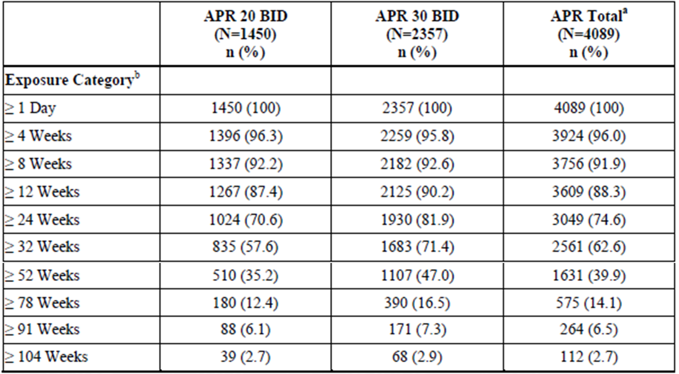
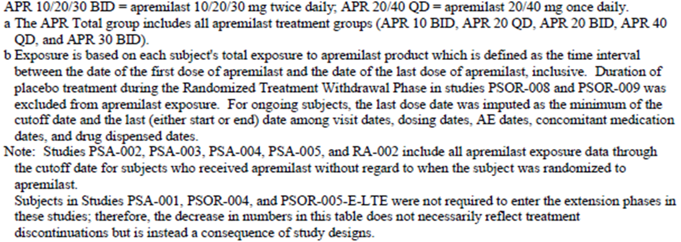

PsA Phase III data pool
A total of 1945 subjects are included in the treated Phase III PsA dataset, including 972 subjects who have received APR 20 mg twice daily and 973 subjects who have received APR 30 mg twice daily. Overall, 1607 (82.6%) subjects have received APR for at least 24 weeks, including 790 (81.3%) subjects who have received APR 20 mg twice daily and 817 (84.0%) subjects who have received APR 30 mg twice daily. A total of 962 (49.5%) subjects were exposed to APR for at least 52 weeks, including 467 (48.0%) subjects in the APR 20 mg twice daily group and 495 (50.9%) subjects in the APR 30mg twice daily cohort. A summary of the total exposure to APR in the Phase III PsA dataset, which includes subjects initially randomised to APR, as well as PBO patients who switched to APR, is presented in Table 8. In the Phase III PsA dataset, a total of 648 subjects received APR with concomitant DMARD therapy (including 329 subjects treated with APR 20 mg twice daily and 319 subjects treated with APR 30 mg twice daily). A total of 700 subjects received APR without concomitant DMARD treatment.
Table 8: Summary of Total Patient Exposure to APR in Phase III PsA Dataset.
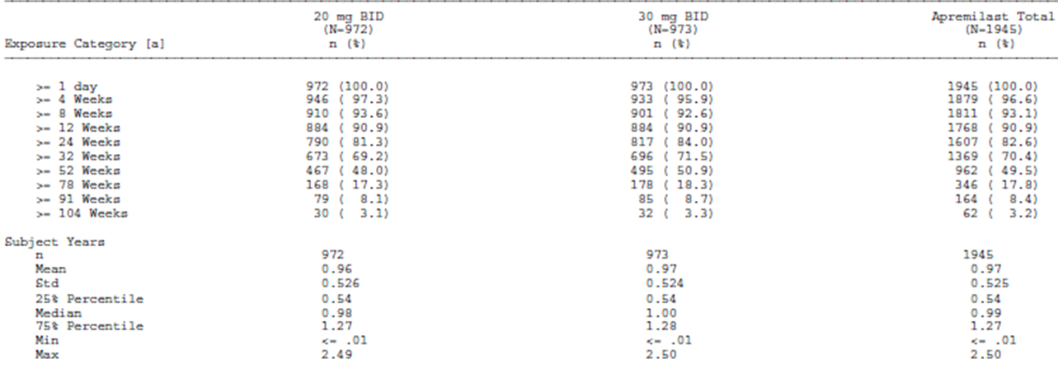

PSOR Phase III data pool
A total of 1184 subjects in the Phase III PSOR dataset received APR 30 mg twice daily, which includes subjects initially randomised to APR, as well as PBO subjects who were switched to receive APR. Overall, 968 (81.8%) subjects with PSOR have received APR 30 mg twice daily for at least 24 weeks, and a total of 564 (47.6%) subjects had been exposed to the same dose of APR for at least 52 weeks. A summary of exposure to APR in the Phase III PSOR dataset is provided in Table 9.
Table 9: Summary of Total Patient Exposure to APR in Phase 3 PSOR Dataset.
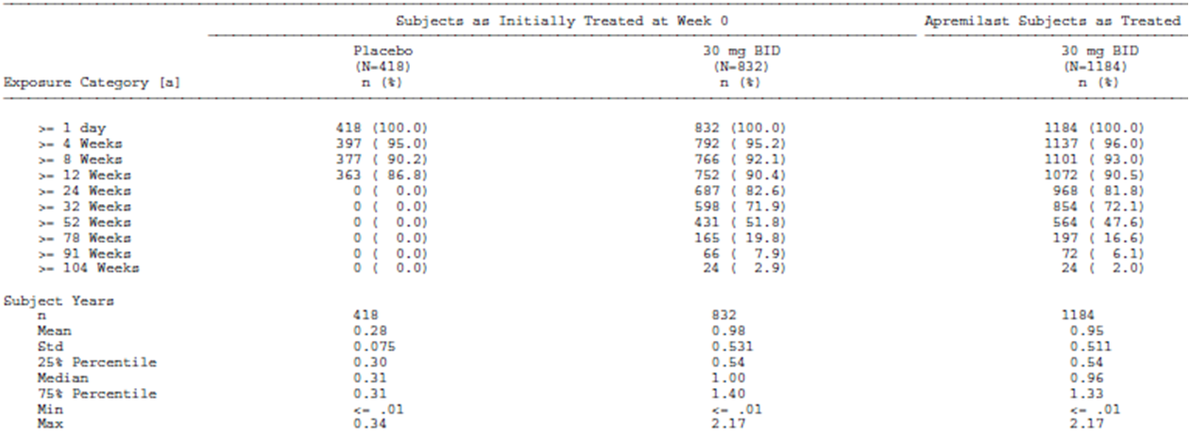

Safety issues with the potential for major regulatory impact

Psychiatric disorders
In the Phase III PsA trials, treatment with APR was associated with increased rates of reported AEs of depression. Between Weeks 0 and 16 (PBO controlled periods), 1.0% (10/998) of patients treated with APR reported depression or depressed mood compared with 0.8% (4/495) treated with PBO. Further, during the clinical trials, 0.3% (4/1441) of patients treated with APR discontinued due to depression or depressed mood versus no PBO treated subjects (0/495). Between Weeks 0 and 16 in the Phase III PsA studies, serious depression was recorded in 2/1945 (0.1%) of patients treated with APR (1 subject receiving 20 mg twice daily and the other subject was treated with 30 mg twice daily), and serious anxiety in 1/1945 (0.1%). No PBO treated subject experienced serious depression or anxiety. The event rate for depression and anxiety did not increase over time with continued APR therapy. In the Phase III PSOR studies, only 1 patient (0.1% of 1184) developed serious depression. This patient withdrew from the trial because of this AE.
In the total APR dataset (including all Phase II and III studies), 7 patients have experienced serious self injury (2 had suicidal ideation, 3 attempted suicide, and 2 had a completed suicide). In these 5 cases, 3 received treatment with APR 30 mg twice daily, 2 took APR 20 mg twice daily and 1 subject was receiving PBO. Based on epidemiological data, the incidence of suicidal ideation and attempt lies within the expected range for matched subjects.

Weight loss
Between weeks 0 and 16 in the Phase III PsA studies, weight loss of 5-10% was recorded in 35/972 (4.0%) of patients treated with APR 20 mg twice daily and 35/973 (4.1%) of subjects treated with APR 30mg twice daily. Weight loss >10% was experienced by 6 (0.7%) and 7 (0.8%) of patients in the APR 20mg twice daily and APR 30 mg twice daily groups, respectively. In the APR exposure period, weight loss of 5-10% was recorded in 98/972 (10.4%) of patients receiving APR 20 mg twice daily and 120/973 (12.7%) of patients taking APR 30 mg twice daily. Weight loss >10% was experienced by 42 (4.5%) and 36 (3.8%) of patients in the APR 20 mg twice daily and APR 30 mg twice daily groups, respectively.
In the Phase III PSOR studies, a total of 132/1184 (11.7%) of patients treated with APR recorded weight loss of 5-10% between Weeks 0 and 16, and 22 (0.2%) of subjects experienced >10% weight reduction. In the APR exposure period, a total of 162 subjects (14.3% of 1184) recorded weight loss of 5-10% and 65 (5.7%) recorded >10% weight loss.

Hypersensitivity reactions
Between Weeks 0 and 16 in the Phase III PsA studies, hypersensitivity reactions were reported for 3/1945 (0.2%) of APR treated subjects and no PBO patients. In the APR exposure period, hypersensitivity was recorded in 4/1945 (0.4%) of patients receiving APR. One patient who took APR 40 mg once daily in Study PSA-001 discontinued due to recurrent hypersensitivity reactions. The first reaction occurred on Study Day 27 and involved throat tightness, pruritus and urticaria. This AE resolved within 2 days but recurred twice upon rechallenge with APR.
In the Phase III PSOR studies, a total of 4/1184 (0.3%) of patients treated with APR 30 mg twice daily reported hypersensitivity AEs between Weeks 0 and 16. In the APR exposure period, a total of 8 subjects (0.7% of 1184) reported hypersensitivity reactions, including 1 case of anaphylaxis in patient taking APR 10 mg twice daily (Study Day 136).

Unwanted immunological events
APR is not a biologic DMARD and the issue of anti drug antibodies is not applicable to this drug.
PDE4-inhibitors, including APR, have been demonstrated to induce inflammatory perivascular changes on histopathology consistent with vasculitis in animal studies. Consequently, investigators were instructed to monitor for any clinical signs and symptoms of vasculitis during the APR clinical program. No patients in the Phase 3 studies (PsA or PSOR) were identified as experiencing vasculitis. Two subjects involved in a RA trial were reported to have vasculitis. However, 1 of those subjects (given APR 30mg twice daily) was diagnosed with rheumatoid vasculitis, which resulted in discontinuation from the study. The second subject with RA (randomised to PBO) was diagnosed with cutaneous vasculitis, which subsequently resolved. As vasculitis is known to occur in patients with RA, the data does not support an association between APR and vasculitis.

Post marketing data
Not applicable as APR at the time of this submission had not received registration anywhere in the world for the treatment of PsA or PSOR.

Evaluator’s conclusions on safety
A total of 2401 subjects have received APR in Phase II and III clinical studies for the treatment of PsA, PSOR and RA in doses ranging from 10 mg twice daily to 30 mg twice daily. A total of 672 subjects in the overall APR exposure dataset have received APR 30 mg twice daily (the proposed registration dose) for at least 24 weeks, and 269 subjects have received APR 30 mg twice daily for at least 48 weeks. Overall, there is a sufficient volume of data to make a meaningful assessment of APR safety for up to 52 weeks of treatment in the newly proposed treatment indications of active PsA and PSOR.
In general, the study populations had baseline characteristics (demographic, disease-related and co-morbidity) indicative of the intended target population for the claimed indications. The studies enrolled almost equal proportions of male and female subjects who were mainly Caucasian (>90%) and middle aged (median age of 51 years). However, the pivotal studies excluded patients with a high baseline risk of infection. In addition, there is no or very limited experience in certain patient subgroups of relevance including subjects with renal or hepatic impairment, pregnant or lactating women, and those with a low body weight (<50 kg).
The overall frequency of all AEs were higher in the APR treatment groups versus PBO, and generally had a slightly higher incidence in the APR 30mg twice daily groups compared with APR 20 mg twice daily treatment arms. The most frequently reported AEs were gastrointestinal disorders (mainly, diarrhoea and nausea) and headache, both of which occurred at a higher frequency in the APR treatment groups in a dose dependant manner. The majority (>95%) of AEs were reported as mild to moderate in severity. The highest incidence of diarrhoea, nausea and headache events occurred with the first 14 days of initiating APR therapy and reduced after 30 days. Upper respiratory tract infections were also reported in >5% of subjects and occurred more frequently in subjects receiving APR than in those receiving PBO. Most of these infections were mild to moderate in severity, and self limiting. No serious adverse events (SAEs) due to upper respiratory tract infections (URTIs) were reported. Diarrhoea, nausea, headache, URTI, vomiting and dyspepsia are included in the PI as potential adverse drug reactions. In the Phase III studies for both indications, serious adverse events occurred in approximately equal frequencies between PBO and APR treated subjects. Safety analyses did not suggest a clinically important difference in the type of SAEs between APR treated subjects and those treated with PBO.
A total of 7 deaths have been reported in the broader APR development program. One death occurred in the PsA studies (subject received APR 20 mg twice daily), 5 deaths were reported during the PSOR studies (2 given PBO, 2 received APR, and 1 initially received APR but then was re-randomised to PBO during the randomised withdrawal phase), and 1 additional death was possibly related to APR therapy occurred in patient with RA. Two of the deaths were apparent suicides, which is concerning since the PDE4 inhibitor roflumilast has a warning included in its PI about the potential for increased psychiatric events, including depression and suicidal behaviour. A review of the psychiatric AEs in the APR program has been performed. Review of the data concluded that the current data submitted in this application do not suggest an increased risk of suicidal behaviour in patients treated with APR. However, in the Phase III PsA studies patients treated with APR were observed to have a slightly higher incidence of depression or depressed mood, and greater discontinuations due to these AEs compared to PBO treated subjects.
A treatment dependant decrease in body weight was observed in the PsA and PSOR studies. A greater proportion of APR treated subjects experienced a >5% weight loss compared to PBO treated subjects. No subject had a weight decrease of >20% and 1 subject discontinued due to weight decrease during the APR exposure period. The potential for significant weight loss is included in the PI and is an issue requiring ongoing pharmacovigilance. Analyses of adjudicated events for serious infections, major adverse cardiovascular events and malignancies did not indicate any imbalance between APR and PBO treated subjects. Additional analyses evaluating the incidence of tuberculosis, psychiatric events and vasculitis were performed and no safety signal with APR therapy was identified.
Markedly abnormal laboratory test results were infrequent and transient. In general, analyses of mild and moderate laboratory abnormalities did not show an increased risk between either APR 20 mg twice daily or APR 30 mg twice daily treatment groups. The vast majority of laboratory abnormalities were transient and did not lead to study drug discontinuation. No cases of hepatic failure, or liver function test (LFT) elevations meeting Hy’s Law criteria, were reported. Myelosuppression was not observed based on routine laboratory testing.
APR has demonstrated an acceptable safety profile when used alone or in combination with DMARD therapy including MTX, SSZ and LEF.
In summary, the data evaluated in this submission are sufficient to assess the overall safety of APR in adult patients with active PsA and/or PSOR. The most commonly occurring AEs associated with APR were diarrhoea, nausea, vomiting, headache and URTI. These AEs typically occurred in the first 14 days after starting APR, were usually mild or moderate in severity, and generally resolved within 30 days while subjects continued receiving APR. Treatment with APR was also associated with weight loss, with approximately 10% of APR treated subjects losing between 5-10% of their body weight over 52 weeks. Except for the AEs of diarrhoea, nausea, vomiting, headache and URTI, no imbalance was observed for adverse events of special interest including adjudicated events of serious infections, major adverse cardiovascular events and malignancies. However, there are limited long-term safety data in the current submission (beyond 52 weeks of treatment follow-up) to assess the risk of some types of AEs such as malignancy and cardiovascular AEs, which will require much greater duration of follow up.

First round benefit-risk assessment

First round assessment of benefits
The benefits of APR in the proposed usage are:
- Clinically meaningful improvements in the signs and symptoms of PsA (that is, ACR response criteria), as well as physical functioning (i.e. change from baseline in HAQ-DI score) when given to patients with active established PsA, many of whom have failed to respond to conventional treatment (DMARD [mainly MTX] and NSAID).
- Clinically meaningful improvements in the signs and symptoms of PSOR (that is, PASI score changes), as well as health related QOL (for example, DLQI scores) when given to patients with moderately to severely active PSOR who are candidates for systemic or phototherapy.
- Provides an alternative therapy (different mechanism of action) to current drugs in patients with active PsA or PSOR who have failed to respond to conventional treatment.
- Convenient dosing schedule (every 12 h) using a convenient mode of administration (oral therapy).

First round assessment of risks
The risks of APR in the proposed usage are:
- Higher incidence of gastrointestinal adverse events such as nausea, vomiting and diarrhoea, which increase in a dose dependent manner with APR. These were a common cause of drug discontinuation and typically occurred in the first 14 days after starting treatment.
- APR is associated with weight loss in a dose independent manner with approximately 10% of patients losing between 5-10% of their baseline body weight.
- Slightly increased incidence of depression or depressed mood compared to PBO treated subjects, which may result in treatment discontinuations.
- Possible signal of adverse effects on liver function tests with a higher frequency of APR treated subjects developing increases in serum transaminases compared with PBO.

First round assessment of benefit-risk balance
The benefit-risk balance of APR for up to 52 weeks of treatment follow-up in the target populations of adult subjects with active PsA and PSOR is favourable.

PsA indication
The overall benefit-risk assessment supports approval of APR for the treatment of active PsA in adult patients. The submitted data demonstrated consistent efficacy in favour of APR versus PBO in PsA. Of the 2 APR doses examined, the 30 mg twice daily regimen provided higher numerical responses compared with the 20 mg twice daily posology. The overall magnitude of the treatment effect size was modest compared to biologic therapies. The major safety findings identified in the program were gastrointestinal AEs and weight loss. Given the nature of the safety findings and the lack of a clear dose related AE profile (apart from gastrointestinal AEs), the 30 mg twice daily dose of APR is acceptable as the proposed dose regimen. Appropriately, the registration proposes an upward titration of APR during the first week of treatment, which was undertaken during the Phase III studies and appears to lessen the incidence of gastrointestinal AEs.

PSOR indication
The overall benefit-risk assessment supports approval of APR for the treatment of active PSOR in adult patients. The submitted data demonstrated consistent efficacy in a dose related manner for APR versus PBO. The overall magnitude of the treatment effect size was similar to other conventional systemic therapies. The major safety findings (type and incidence) recorded in patients with PSOR were similar to that observed in PsA subjects (mainly, gastrointestinal AEs and weight loss).

First round recommendation regarding authorisation

PsA indication
The evaluator recommends acceptance of the sponsor’s proposed registration of APR for the treatment indication of active PsA in adult patients. Approximately half of all subjects in the Phase III PsA studies took MTX concurrently with APR, and the beneficial clinical responses in those not taking concomitant DMARD (usually MTX) were similar. The sponsor has not proposed in the treatment indication the use of APR in patients with PsA with or without DMARD. Most of the Phase III studies recruited subjects with active PsA who had failed to adequately respond to conventional treatment (DMARD [mainly MTX] and/or NSAID), but did include a subset of patients with prior biologic therapy exposure (mainly, anti TNF medicines). Regarding posology, efficacy results from the Phase III program generally supported a greater numerical advantage for the APR 30 mg twice daily regimen compared to the APR 20 mg twice daily posology, but there were limited statistically significant analyses to support the conclusion that APR 30 mg twice daily was superior to APR 20 mg twice daily. Apart from gastrointestinal AEs (usually of mild-moderate severity and seen at the commencement of therapy), safety was similar in both APR treatment regimens. As such, the evaluator recommends acceptance of the sponsor’s proposed registration of the 30 mg twice daily regimen for adult patients with active PsA.

PSOR indication
The evaluator also recommends acceptance of the sponsor’s proposed registration of APR for the treatment indication of active PSOR in adult patients. The proposed wording of treatment indication in patients with PSOR has an additional element relating to potential patients being candidates for systemic or phototherapy. The current submission provides robust evidence of improving the symptoms and signs of active PSOR, as well as health related QOL. Regarding posology in PSOR, only the 30 mg twice daily dose of APR was investigated in the Phase III program. In addition, the dose finding trial (Study PSOR-005) demonstrated a clear dose response relationship for APR, which supported the advantage of the 30 mg twice daily regimen compared to the APR 20 mg twice daily dose in treating adult patients with active PSOR.

Both indications
Should approval of the sponsor’s proposed registration of treatment indications be granted, the evaluator also recommends that approval be subject to:
- Satisfactory response to the questions below;
- Regular periodic safety update reports; and
- When available, the sponsor provides the TGA with the final clinical study reports for the extension phases of each study, as well as the Week 52 report for Study PSA-005.

Clinical questions
Below are the questions from the clinical evaluator. For details of the sponsor’s responses and the evaluator’s comments on the sponsor’s responses, see Attachment 2 of this AusPAR.

Pharmacokinetics
- APR is primarily eliminated as metabolites formed by cytochrome P450 (CYP) mediated oxidative metabolism via CYP3A4, 1A2 and 2A6 enzymes. Could the sponsor comment on whether there has been any evaluation of the consequences of genetic polymorphism in these CYP enzymes, and if not, are there any potential clinical consequences?
- None of the clinical pharmacology studies in this submission appear to have evaluated the effect of administration timing on the bioavailability and pharmacokinetic parameters of APR. Could the sponsor comment on whether diurnal variation in APR pharmacokinetic parameters has been examined and any potential impact?
- Could the sponsor provide a summary assessment of the intra-subject and inter-subject variability for the pharmacokinetics of APR, and comment on whether or not such variability may be clinically relevant?
- Could the sponsor justify how the pre specified, clinically relevant 90% CI bioequivalence margin of 50% to 200% for pharmacokinetic parameters in Study CP-025 was determined as this appears to be overly generous?

Pharmacodynamics
Nil

Efficacy
- Subjects with a body weight of ≥ 100 kg appear to have a higher clearance and larger volume of distribution for APR, and the clinical pharmacology studies suggested that this may not be of clinical significance. However, in the subgroup analyses of Study PSA-005 for the primary efficacy endpoint, APR did not appear to result in a significant treatment related effect for patients weighing ≥ 100 kg. Could the sponsor comment on the impact of subject obesity upon clinical efficacy with APR?
- In Study PSOR-005, the majority of subjects who entered the first extension phase completed follow-up to Week 52 (74.6%; 156/209). However, only a small number of patients (n = 33) entered the long term extension phase (beyond Week 52), 28 of which are still continuing at Week 88. Could the sponsor comment as to why participating patient numbers decreased significantly after Week 52. Was the reduced participation beyond 52 weeks due to waning efficacy, adverse events or some other reason?

Safety
- As APR is known to affect various cytokines in the inflammatory response, has the sponsor performed any vaccine sub-studies in patients with PsA or PSOR to determine the effect of Otezla on protective immune status?
- For the adjudicated safety concerns of special interest (MACE, serious infection and malignancy) in the completed Phase II and III studies (for any treatment indication), could the sponsor provide the relative risks and upper limit of the 95% confidence limit for relative risk, in addition to the point estimates (EAIR) which have currently been provided for APR versus PBO?

Population pharmacokinetics
Table 10 shows studies providing pharmacokinetic/pharmacodynamic (PK/PD) data.
Table 10: Studies providing PK/PD data.
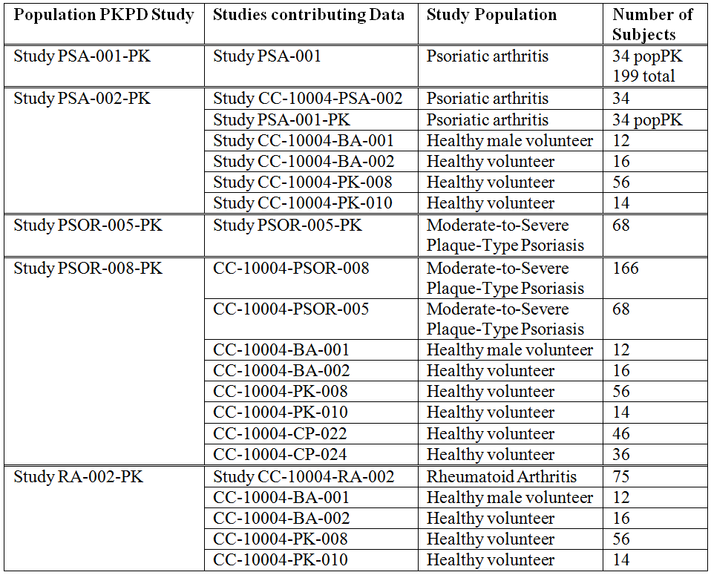

Evaluator’s overall conclusions on the population pharmacokinetic analysis
The modelling processes were conducted and reported in accordance with published guidelines. However, in the opinion of the evaluator, within this guideline there is considerable latitude in methodology and in interpretation of results.
The base structural model was similar for all five studies and was confirmed by the external validations. The error model used by the sponsor differed from the external validations in that the sponsor did not estimate Between Subject Variability (BSV) for Lag time of absorption (LAG). The evaluator considers a BSV for LAG to be appropriate because of all the parameters it appeared to be the one with the greatest variability.
Goodness-of-fit plots were provided for all of the models and indicated an appropriate specification for the models. However, Visual Predictive Checks (VPCs) were not provided for all of the models. The best model, as judged by VPC, of all the studies was RA-002.
The covariate models were developed using all the available covariate data. The covariate model building process used by the sponsor was less rigorous than that believed to be appropriate by the evaluator. The p-values used in the covariate modelling by the sponsor were overly generous given the large quantity of data available.
It is not clear how gender would influence the apparent clearance (CL/F) of apremilast, which questions the plausibility of the models. This concept does not appear to be supported by the known disposition of apremilast. Apremilast has multiple pathways of elimination and it is not clear whether sex would influence any of these pathways. Hence, in the opinion of the evaluator, sex may be a confounder for the effect of body weight. The known pharmacology of apremilast does not provide a plausible explanation as to why gender should have an observable effect on CL/F, other than the difference in body size between the genders.
No dosing regimens were simulated from the models. In the opinion of the evaluator, the models would not be appropriate for simulating dosing strategies in other populations (for example, paediatric).
The modelling process does not appear to have influenced the proposed dosing regimen for apremilast. This dosing regimen appears to be based upon the Phase II and Phase III studies rather than upon modelling and simulation. Hence, although the pharmacodynamic models were (in the opinion of the evaluator) flawed, they did not influence the dosing strategy.
The results of the population PK/PD models do not appear to have informed the sections of the PI document relating to pharmacokinetics or pharmacodynamics. The models do indicate that CL/F is significantly reduced in disease states and this information should be included. However, as the dosing strategy is based on the actual clinical trial data, there is no need to advise dosing adjustment because of disease state. There were no other findings from the studies that might be used to inform the PI document (for example, use in special populations).

First round benefit-risk assessment

First round assessment of benefits
The population PK/PD modelling suggested a concentration-response relationship exists for apremilast for all the three indications studied: active psoriatic arthritis in adult patients, adult patients with moderate to severe plaque psoriasis, and adult patients with RA who had an inadequate response to MTX. The studies did not successfully identify the nature of these concentration response relationships because of limitations in the data and in the modelling approach. Overall, the studies did not indicate that dosing modification was required on the basis of physical or demographic characteristics.
The pharmacokinetics of apremilast are affected by disease state for each of the three study populations (active psoriatic arthritis in adult patients; adult patients with moderate to severe plaque psoriasis, and adult patients with RA who had an inadequate response to MTX). Clearance is decreased compared to healthy volunteers for all three populations. However, the dosing regimens for each indication have been based on clinical trial data and do not require modification on the basis of the pharmacokinetic studies. The sponsor did not simulate any alternative dosing strategies from the population PK/PD models.
The Summary of Clinical Pharmacology states that clearance is reduced by 30% in females compared to males. However, the population pharmacokinetic studies are not sufficiently robust to justify this statement. The known pharmacology of apremilast does not provide a plausible explanation as to why gender should have an observable effect on CL/F, other than the difference in body size between the genders. The statement regarding clearance and gender has not been included in the PI document.

First round assessment of risks
The population PK/PD studies did not indicate a concentration-response relationship between apremilast and adverse effects. However, the analyses were limited by the paucity of AE data and there were insufficient data to be able to identify such relationships.

First round assessment of benefit-risk balance
The results of the population PK/PD studies do not appear to alter the benefit-risk balance.

First round recommendation regarding authorisation
The evaluator does not have any objections arising from the population PK/PD studies to the approval of apremilast for the indications of active psoriatic arthritis in adult patients, adult patients with moderate to severe plaque psoriasis, and adult patients with RA who had an inadequate response to MTX.

Clinical questions
- What are the proposed mechanisms by which sex would influence the CL/F of apremilast?

Pharmaceutical sub-committee, section 31 questions
- Please justify the choice of a one compartment pharmacokinetic model given that a 2 compartment pharmacokinetic model was found in some of the studies (for example, PSA‐001 and PSA-002) to be the model which provided the best fit to the concentration‐time data.
- Please justify the choices made in the covariate model building process. The Pharmaceutical Sub-Committee noted that the decrease in clearance (CL) between patients with disease and healthy subjects may reflect a difference in age. Provide an analysis of the effects of each of the covariates: sex, body weight (lean and total), age, and disease state on the PK of apremilast to distinguish these.
- The Pharmaceutical Sub-Committee noted that modelling showed a decrease in clearance in females compared with males, and a decrease in clearance in patients when compared with healthy volunteers. Noting that the patient population was on average older and heavier than the healthy population, the sponsor is asked to clarify whether the decrease in CL between males and females reflects a difference in lean body weight.
- Given the apparent finding that CL is approximately 30% lower in females than in males, the PSC is of the view that if this relationship is confirmed then a dose reduction may be recommended for females. The sponsor is requested to address this issue including performing simulations from the model in regards to their impact on dose recommendations.
- Please amend the proposed Australian PI to state the pharmacokinetic parameters (including CL values) in patients and to include relevant findings of covariate re-analysis. The following information should be included in the PI and, where relevant, in the Consumer Medicines Information (CMI).
  - PSA-002 found a different CL for patients with PsA
  - PSOR-005 only found Lean Body Weight (LBW) to be a factor, not disease
  - PSOR-008 found CL was reduced 20% in patients with psoriasis
  - RA-002-PK found reduced CL by 30% (not 11.2L/h, but 7.6 L/h) for patients with RA, an effect of weight and gender on CL, and of weight on volume of distribution (V).
- As part of its response concerning dose, the sponsor should provide analyses using clinical trial data that explore the apparent differences in efficacy and safety of the doses investigated (20 mg and 30 mg) and the benefit-risk profile at each dose level.

Second round benefit-risk assessment

Second round assessment of benefits
After consideration of the responses to clinical questions, the benefits of apremilast in the proposed usage are unchanged from those identified in the first round.

Second round assessment of risks
After consideration of the responses to clinical questions, the risks of apremilast in the proposed usage are unchanged from those identified in the first round.

Second round assessment of benefit-risk balance
The benefit-risk balance is unchanged from that identified in the first round.

Second round recommendation regarding authorisation
The evaluator does not have any objections arising from the population PK/PD studies to the approval of apremilast for the indications of active PsA in adult patients, adult patients with moderate to severe plaque psoriasis, and adult patients with RA who had an inadequate response to MTX.

V. Pharmacovigilance findings

Risk management plan
The sponsor submitted a Risk Management Plan (RMP) Version in EU-RMP format Version 3.0 (dated 10 October 2014, Data Lock Point [DLP] 1 March 2013 [PsA] and DLP 11 January 2013 [PSOR]) and Australian Specific Annex (ASA) Version 2.0 (dated October 2014) which was reviewed by the TGA’s Office of Product Review (OPR).

Safety specification
The sponsor provided a summary of ongoing safety concerns which are shown at Table 11.
Table 11: Ongoing safety concerns.
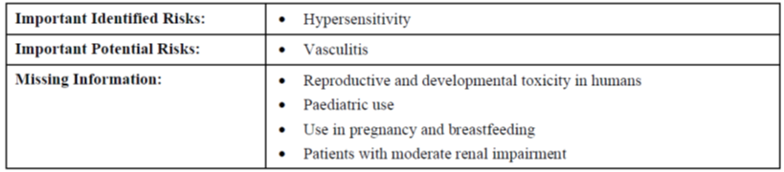

Pharmacovigilance plan
The sponsor proposes routine and additional pharmacovigilance activities as summarised in Table 12.
Table 12: Additional pharmacovigilance activities (planned or ongoing).
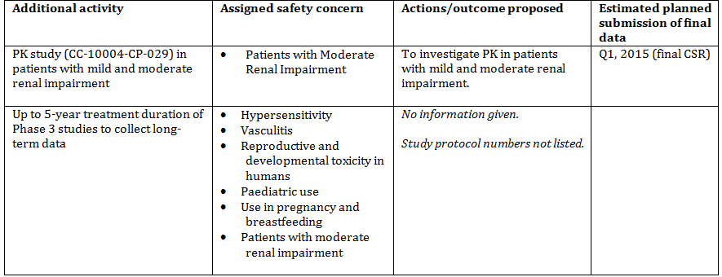

Risk minimisation activities
In part VI of the submitted RMP, the sponsor states the following with regard to additional risk minimisation activities:
This medicine has no additional risk minimisation measures.

Reconciliation of issues outlined in the RMP report

Recommendation #1 in RMP evaluation report
Safety considerations may be raised by the nonclinical and clinical evaluators through the consolidated Section 31 request and/or the nonclinical and clinical evaluation reports respectively. It is important to ensure that the information provided in response to these includes a consideration of the relevance for the RMP, and any specific information needed to address this issue in the RMP. For any safety considerations so raised, please provide information that is relevant and necessary to address the issue in the RMP.

Sponsor response
EU RMP version 01 and the corresponding ASA version 01 were submitted with the Category 1 submission to register Otezla in Australia. Since the submission of this application (full submission made to the TGA on 7 March 2014), the EU RMP has been updated to version 03.
Some of the issues raised in the RMP Evaluation Report Round 1 for this application, have been addressed in the EU RMP version 03. The updated version of the EU RMP is included with this response.
A draft ASA version 02 is also submitted with this response. Upon approval of the Otezla application by the TGA, the ASA will be further updated per the relevant approved details.

OPR evaluator’s comment
This is considered acceptable in the context of this application.

Recommendation #2 in RMP evaluation report
The sponsor has not provided study protocols or protocol synopses for all studies referenced in the pharmacovigilance plan, that is, the Phase III studies to collect long term data. The sponsor should provide the missing study protocols or protocol synopses, as soon as they become available.

Sponsor response
The sponsor has provided the available protocol summaries, including Phase III, in the updated RMP (version 3.0). The protocol summaries are:
- Apremilast Disease Registry in the EU
  - British Society for Rheumatology Biologics Register (BSRBR) for PsA
  - PsoBest Registry Study
- Apremilast Pregnancy Exposure Registry OTIS Autoimmune Diseases in Pregnancy
- CC-10004-PSA-002
- CC-10004-PSA-003
- CC-10004-PSA-004
- CC-10004-PSA-005
- CC-10004-PSOR-008
- CC-10004-PSOR-009.

OPR evaluator’s comment
This is considered acceptable in the context of this application.

Recommendation #3 in RMP evaluation report
The following should be added as ongoing safety concerns and become part of the pharmacovigilance plan:
- Gastrointestinal effects (including, but not limited to diarrhoea)

Sponsor response
The sponsor respectfully does not agree with the proposal to place GI effects (including, but not limited to diarrhoea) with the important identified risks in the RMP. The sponsor has conducted a systematic analysis of the GI treatment emergent adverse events (TEAEs) including severity, seriousness and discontinuation from the clinical studies and no TEAEs lead to overt clinical consequences. GI events, including diarrhoea, nausea and abdominal pain, are reported as commonly associated with the use of other PDE4 inhibitors. During the APR clinical trials, diarrhoea and nausea were the most frequently reported GI TEAEs (Tables 13-14), however, the majority of these events were mild or moderate in severity and infrequently (< 2% of subjects) led to discontinuation. Few TEAEs were reported as serious, with no apparent treatment or dose related effects. Importantly, these events (predominately diarrhoea and nausea) occurred more frequently during the first two weeks and resolved within four weeks of treatment. The majority of subjects who reported diarrhoea in the PSOR Phase III studies did not require treatment, while 10% were treated with an anti diarrhoea product (15/148). Tables 13 and 14 show the overview of TEAEs of diarrhoea and nausea for both indications (PSA and PSOR).
Table 13: Overview of TEAEs of diarrhoea during the treatment duration period Weeks 0 to 16 (subjects as treated).*
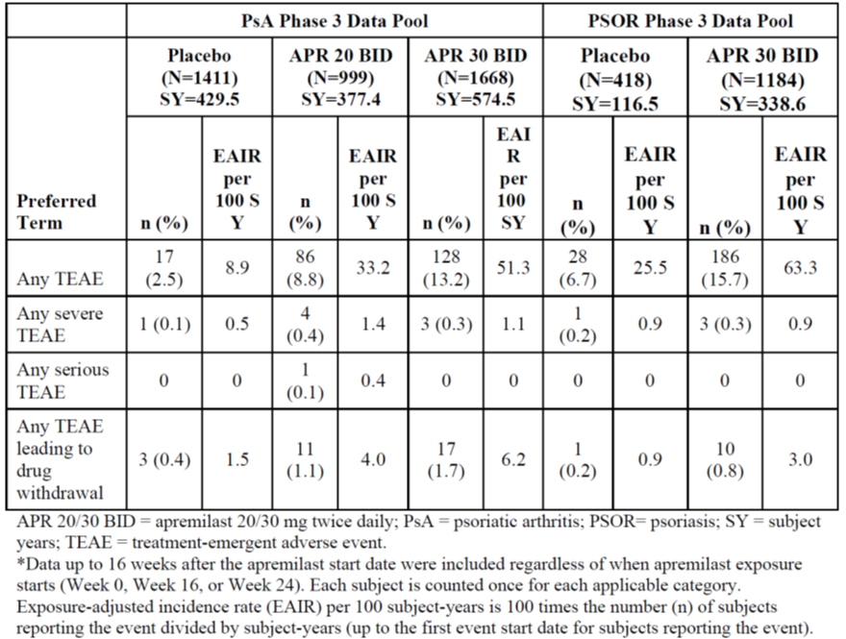
Table 14: Overview of TEAEs of nausea during the treatment duration period Weeks 0 to 16 (subjects as treated).*
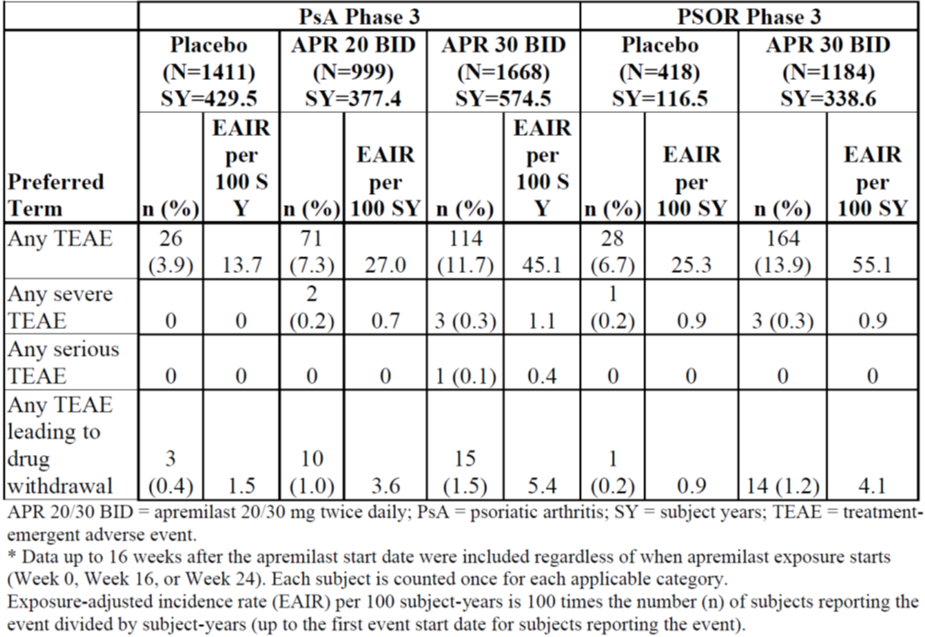
The sponsor acknowledges the concern may not be related to only diarrhoea and nausea, but all GI effects. When reviewing GI disorders in the PSA and PSOR Phase III studies, the incidence of serious GI disorders was low and of interest, more subjects receiving PBO reported serious TEAE than those treated with APR (0.4% versus 0.2%) (Table 15). The incidence of serious GI disorders did not increase with the continued use of APR.
Table 15: APR data pool: TEAE of GI disorders SOC during the PBO-controlled period.
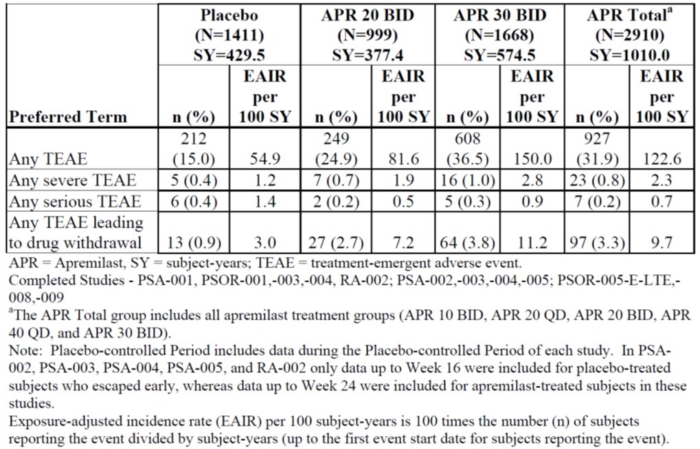
The analyses revealed the majority of GI events were non-serious and mild to moderate in severity. Diarrhoea, nausea, vomiting and upper abdominal pain are listed as adverse drug reactions in product labelling. Serious diarrhoea is assessed in the RMP under Part II/SVIII, Section 5.1: important pharmacological class effects, and therefore, will be monitored for changes in nature or severity by the sponsor via routine pharmacovigilance. The sponsor respectfully does not agree with the proposal to reclassify GI effects with the important identified risks in the RMP.

OPR evaluator’s comment
In the Section 31 response, the sponsor recognises that GI AEs were the most frequently reported TEAEs.
Furthermore, it is noted that 10% of the patients reporting diarrhoea required antidiarrheal treatment. The OPR evaluator considers this to be an overt clinical consequence.
Treatment discontinuation or interruption is likely to be increased outside a clinical trial setting.
The relevant EMA guidance document in ‘Part II: Module SVII - Identified and potential risks’ states the following:
“In addition, risks, which whilst not normally serious enough to require specific warnings or precautions, but which occur in a significant proportion of the treated population, affect the quality of the treated person’s life, and which could lead to serious consequences if untreated, should also be considered for inclusion, e.g. severe nausea and vomiting with chemotherapy.”
To ensure appropriate reporting ‘Gastrointestinal effects (including, but not limited to diarrhoea)’ should be added as Important Identified Risk.
The recommendation remains.

Recommendation #4 in RMP evaluation report
The following should be added as ongoing safety concerns and become part of the pharmacovigilance plan:
- Infections (including, but not limited to URTIs)

Sponsor response
The sponsor respectfully does not agree with the proposal to add Infections (including, but not limited to URTIs) as an important identified risk. An extensive evaluation, including the adjudication of serious infections (including opportunistic infections), was performed. Based on the adjudicator’s assessment, no imbalance was observed when comparing the EAIR between subjects who received PBO and subjects who received APR. The analysis of upper respiratory tract infections in the pooled data sets revealed that only one of the TEAs was reported as serious. This event was chronic tonsillitis (for example, pre-existing) in a patient who received APR 20 mg BID for treatment of PsA. URTI is listed as an adverse drug reaction in product labelling.
Overall, the incidence of infections did not increase with longer exposure to APR. The majority were non-serious and most subjects recovered within two weeks. It has been proposed that because APR can decrease the effects in the pro-inflammatory mediators, the response of the body to different microorganisms may be compromised. Therefore, at the request of other regulatory authorities, the sponsor has agreed to include serious infections as an important potential risk in the RMP.

OPR evaluator’s comment
This is considered acceptable in the context of this application.
However, this does not constitute a regulatory precedent for this or other medicinal products.

Recommendation #5 in RMP evaluation report
The following should be added as ongoing safety concerns and become part of the pharmacovigilance plan:
- Weight loss

Sponsor response
The sponsor agrees to reclassify weight loss in version 3 of the RMP. As weight decrease has been reported with other PDE4 inhibitors, the sponsor conducted a systematic analysis of TEAEs of weight decrease and changes in measurements of weight.
Some studies of PSOR and PsA have reported mean BMI of 27 to 29 kg/m² in PsA and PSOR patients. The population studied with roflumilast had a lower BMI (approximately 26 kg/m²) than in the APR studies (mean BMI for Phase III studies combined was 30.28 kg/m²). Patients with COPD are at a higher risk of clinical consequences due to weight loss. The analysis of TEAEs of weight decrease revealed a higher incidence in subjects treated with APR, but the overall incidence was low (<2%) and none were serious. Although more subjects treated with APR had a measured weight loss of >5%, no obvious clinical consequences were observed.
Although studies have shown the intended treatment population for APR has a mean BMI of 27 kg/m² to 29 kg/m², the sponsor agrees there may be an increased risk of clinical consequences for patients starting APR with a low BMI (<20 kg/m²) than those with BMI of > 20 kg/m². Therefore, as proposed by another regulatory authority, the sponsor has placed weight decrease in patients with BMI <20 kg/m² with the important identified risks.

OPR evaluator’s comment
This is considered acceptable in the context of this application.

Recommendation #6 in RMP evaluation report
The following should be added as ongoing safety concerns and become part of the pharmacovigilance plan:
- Neuropsychiatric adverse reactions (including, but not limited to depression)

Sponsor response
Since version 1 of the RMP (which was submitted to the TGA), at the request of other regulatory authorities, the sponsor has reclassified depression as an important identified risk. In addition, the events of nervousness and anxiety have been included as important potential risks in the current version (3.0) of the RMP.

OPR evaluator’s comment
This is considered acceptable in the context of this application.

Recommendation #7 in RMP evaluation report
The following should be added as ongoing safety concerns and become part of the pharmacovigilance plan:
- Cardiac adverse reactions

Sponsor response
The sponsor has added MACE (major adverse cardiac events) and tachyarrhythmia to the RMP as an important potential risk.

OPR evaluator’s comment
This is considered acceptable in the context of this application.

Recommendation #8 in RMP evaluation report
The following should be added as ongoing safety concerns and become part of the pharmacovigilance plan:
- Pancreatitis

Sponsor response
The sponsor respectfully does not agree with the proposal to add Pancreatitis as an important potential risk. Based on the results of the TEAE analysis, there is no evidence that APR at doses of 20 mg BID and 30 mg BID increases the risk of pancreatitis.
In animal studies, no treatment related finding of pancreatitis was observed in mice and monkeys with treatment durations of up to 6 and 9 months, respectively. In the Apremilast Data Pool, there were 2 subjects with TEAE of acute pancreatitis during the PBO controlled Period, 2 (0.1%) subjects in the PBO group, and none in the APR groups (Table 16). During the APR exposure period, there was 1 subject (<0.1%, EAIR <0.1 per 100 subject years) with TEAE of acute pancreatitis in APR 30 mg BID group. Additionally, there was 1 subject (0.1%, EAIR 0.1 per 100 subject years) with TEAE of pancreatitis in APR 20 mg BID group (Table 17).
Table 16: APR data pool: TEAE of pancreatitis during the PBO controlled period.
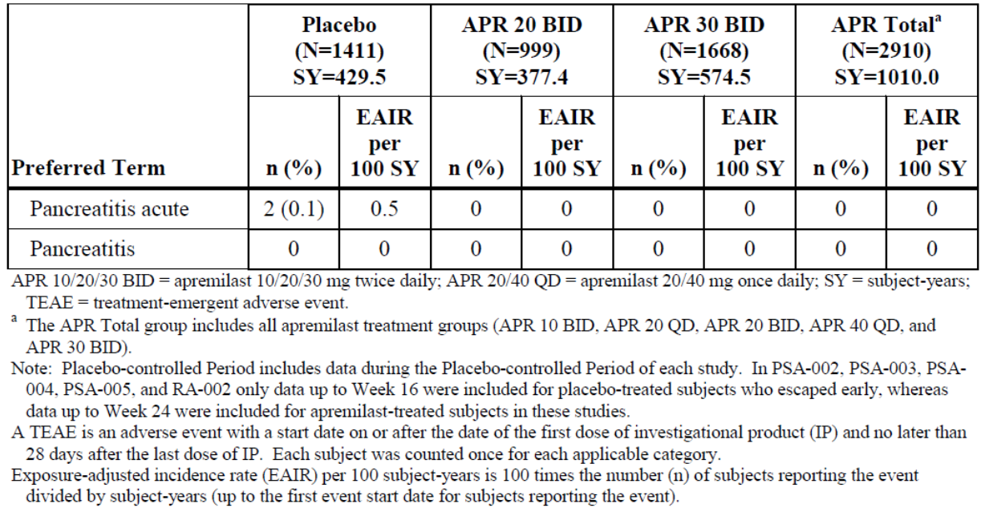
Table 17: APR data pool: TEAE of pancreatitis during the APR exposure.
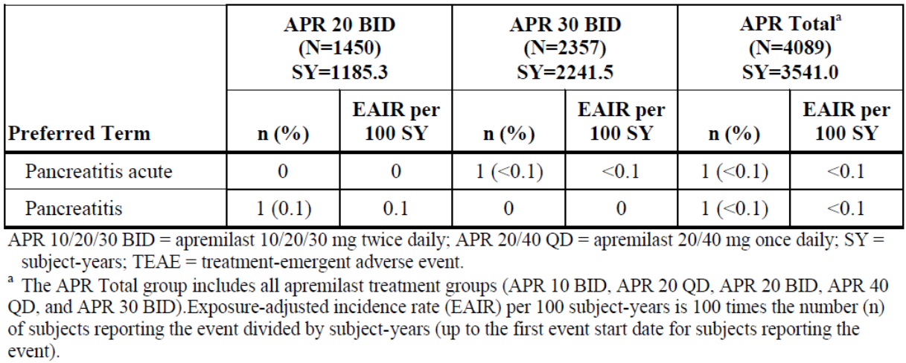
Based on the lack of finding of changes in the pancreas in the preclinical toxicology studies and the review of the clinical data, there is no evidence of association of pancreatitis and APR. The sponsor respectfully does not agree with the proposal to add Pancreatitis as an important potential risk.

OPR evaluator’s comment
This is considered acceptable in the context of this application.
However, this does not constitute a regulatory precedent for this or other medicinal products.

Recommendation #9 in RMP evaluation report
The following should be added as ongoing safety concerns and become part of the pharmacovigilance plan:
- Off label use (including, but not limited to, Chronic Obstructive Pulmonary Disease [COPD], rheumatoid arthritis, Behçet disease, ankylosing spondylitis, weight loss)

Sponsor response
The sponsor respectfully does not agree with the proposal to reclassify off label use as an important potential risk. The potential for off label use (including, but not limited to COPD, rheumatoid arthritis, Behçet disease, ankylosing spondylitis, and weight loss) is adequately described in RMP module SVI, section 5: Potential for off label use. The risks for a patient who is prescribed APR for an authorised indication versus an unauthorised indication are the same. Off label use is not an adverse reaction to a medicinal product and is considered a special situation. The inclusion criteria for the important identified risks or the important potential risks are: adverse reactions; identified and potential interactions with other medicinal products, foods and other substances; and important pharmacological class effects. The sponsor commits to monitor off label use through routine pharmacovigilance.

OPR evaluator’s comment
This is not considered acceptable.
The description of a risk in a RMP is not a sufficient reason for non-inclusion as a Safety Concern.
If the sponsor’s contention were applied to all Safety Concerns, none would have to be included in the RMP, if they were described in the RMP.
The sponsor states:
The risks for a patient who is prescribed apremilast for an authorised indication versus an unauthorised indication are the same.
This is incorrect and a potentially dangerous misconception. There are different risks for different indications due to a variety of factors (for example, different co-morbidities or different population characteristics). Further, the risks are potentially more significant for an unapproved indication, as they are partly unknown, as the medicinal product has not been tested in the unapproved indication.
The sponsor seems to imply that ‘off label use’ cannot be a Safety Concern. The sponsor states:
The inclusion criteria for the important identified risks or the important potential risks are: adverse reactions; identified and potential interactions with other medicinal products, foods and other substances; and important pharmacological class effects.
The relevant EMA guideline in ‘Part II: Module SVII - Identified and potential risks’ states the following:
What constitutes an important risk will depend upon several factors including the impact on the individual patient, the seriousness of the risk and the impact on public health. Normally, any risk which is clinically important and which is/is likely to be included in the contraindications, or warnings and precautions section of the summary of product characteristics (SmPC) should be included here. In addition, risks, which whilst not normally serious enough to require specific warnings or precautions, but which occur in a significant proportion of the treated population, affect the quality of the treated person’s life, and which could lead to serious consequences if untreated, should also be considered for inclusion, e.g. severe nausea and vomiting with chemotherapy.
The sponsor appears to imply that only the examples as stated by the sponsor above can be Safety Concerns. This is not the case. The inclusion of ‘off label use’ as a Safety Concern is accepted practice and commonly used.
The Advisory Committee on the Safety of Medicines (ACSOM) advised that:
off label use will more than likely occur, however the extent to which this will happen is unclear. The committee agreed that apremilast could be used for less severe forms of disease and for other inflammatory disease such as rheumatoid arthritis, Behçet disease, ankylosing spondylitis, chronic obstructive pulmonary disease, Alzheimers, multiple sclerosis and paediatric use.
In the interest of safety and regulatory consistency, off label use needs to be included as an Important Potential Risk.

Recommendation #10 in RMP evaluation report
The following should be added as ongoing safety concerns and become part of the pharmacovigilance plan:
- Asian patients

Sponsor response
The sponsor agrees to add this to the missing safety information. The sponsor evaluated the Phase III data by race (including the Asian population) and ethnicity. Less than 4% of subjects enrolled in the Phase III studies were Asian and the majority were Caucasian. The safety profile among Asian subjects was similar to the Caucasian subjects. The sponsor has clarified that the Asian population was not adequately represented in the Phase III studies as well as other non-Caucasian populations; therefore, use in patients of different racial origin, for example, non-Caucasian, is included as missing information in the RMP.

OPR evaluator’s comment
This is considered acceptable in the context of this application.

Recommendation #11 in RMP evaluation report
The following should be added as ongoing safety concerns and become part of the pharmacovigilance plan:
- Effects in overdose

Sponsor response
The Sponsor agrees with the proposal and has added potential for harm from overdose as missing safety information in the RMP. In Phase III APR studies, the definition of overdose was not specified. However, the investigators reported events of overdose based on their clinical judgment which were recorded as adverse events. In addition, when a subject’s medication count was reconciled at the study visit and the subject had taken more than expected, this was also recorded as an event overdose.
A total of 40 AEs of overdose in 24 subjects has been reported in the APR Phase II and III (PSOR, PsA, RA) studies. In most of the reports, the amount of tablets taken was not provided. All events of overdose were reported as accidental or unintentional and none of the overdoses were associated with an AE. These events of overdose were study administration errors and not indicative of an overdose with intent to self harm.
In dose escalation studies, some healthy adults were exposed to a maximum dose of up to 50 mg BID for up to 4.5 days (Studies CC-10004-PK-001 and CC-10004-PK-008) without evidence of dose limiting toxicities.
No clinical or safety issues were identified from the overdoses reported in the APR clinical program, and no adverse events were reported in association with an overdose. As these reports were unintentional medication errors not resulting in a significant increase in exposure to APR, the sponsor agrees with the proposal and has added potential for harm from overdose as missing safety information in the RMP. In the event of overdose, supportive care is advised.

OPR evaluator’s comment
This is considered acceptable in the context of this application.

Recommendation #12 in RMP evaluation report
The following Ongoing Safety Concerns or Missing Information items require additional pharmacovigilance activities in the pharmacovigilance plan:
- Neuropsychiatric adverse reactions;
- Vasculitis;
- Cardiac adverse reactions;
- Asian patients; and
- Use in pregnancy and breastfeeding.

Sponsor response
To address the remaining concerns and all important identified and potential risks, in addition to routine pharmacovigilance, the sponsor plans to access data from existing disease registries. The sponsor has performed an assessment of available PSOR and PsA disease registries across Europe and has explored the feasibility to liaise with selected European registries to collect ‘real life’ use data.
The sponsor has identified two registries (synopses provided) One of these (PsoBest) is a well-established registry in patients with PSOR that is associated with the European Network of PSOR registries and already includes existing patient cohorts, primarily receiving biologic therapies. A second registry (British Society for Rheumatology Biologics Register [BSRBR] - PsA) is a specific PsA registry that is in the process of being set up and it is estimated to start by the end of 2015.
The objective of the APR cohort within the registries will be to describe the pattern of use of APR in the routine clinical treatment of patients with PSOR or PsA. These registries will collect adverse events and serious adverse events. The Sponsor proposes to analyse these events to further identify and characterise safety risks in patients exposed to APR. Analyses will be conducted at Years 1, 3, and a final analysis at 5 years from the date of the first exposed patient’s entry into the registry. These selected time periods take into consideration that APR must be available and accessible to patients to reflect ‘real-life’ use. These intervals of reports ensure that sufficient market penetration is achieved prior to analysis of data, such that the analyses will provide significant and meaningful data.
The sponsor also proposes to analyse data from the United Kingdom (UK) Clinical Practice Research Datalink (CPRD; an ongoing longitudinal database that collects data from over 6 million patients in the UK) to further characterise the safety profile of APR in a ‘real life’ setting. This will be a retrospective cohort study using population based datasets conducted at Years 1, 3, and 5 starting from the date of first commercial availability in UK. An appropriate control population will be selected from the database to estimate risk measures for events mentioned in the APR RMP.
In addition to the above proposed assessments, and also included in the updated RMP, the PsA and PSOR Phase III clinical studies (CC-10004-PSA-002, -003, -004, -005 and CC-10004- PSOR- 008, -009) are ongoing in the long term extension phase. Patients in these studies will be followed for up to five years while on treatment: these data will provide additional information on long term safety of APR.
To address the missing information related to use in pregnancy, the Sponsor is participating in a pregnancy registry. The Apremilast Pregnancy Exposure Registry is a US registry designed to monitor planned or unplanned pregnancies in patients exposed to APR when used to treat an approved indication in accordance with the current approved prescribing information, who reside in the US or Canada. The registry fulfils a post marketing commitment to the FDA. The goal of the Registry is to conduct an observational, controlled, prospective, cohort study that will involve follow-up of live born infants to one year of age. The study population includes pregnant women who reside in the US or Canada who has or have not used APR for any length of time for an approved indication. The cohort study target sample size is 100 pregnant women in each of three groups:
- 100 women who have been exposed to APR in pregnancy for an approved indication.
- 100 women with the same condition for which APR is approved but who have not been exposed to APR at any time in pregnancy (primary comparison group).
- 100 healthy women who do not have a condition for which APR is approved nor other chronic illness and have not taken APR in pregnancy.
The primary objective of the Registry is to evaluate any potential increase in the risk of major birth defects, specifically a pattern of anomalies, in APR exposed pregnancies compared to the primary comparison group of disease matched unexposed pregnancies. Secondary objectives are to evaluate the potential effect of exposure relative to the secondary comparison group of healthy pregnant women, and the effect of exposure on other adverse pregnancy outcomes including spontaneous abortion or stillbirth, preterm delivery, reduced infant birth size, a pattern of minor malformations, postnatal growth of live born children to one year of age, and incidence of serious or opportunistic infections or malignancies in live born children up to one year of age.
The sponsor believes in addition to the routine pharmacovigilance activities and long term safety from the ongoing clinical studies, these registries will provide additional information regarding the safety profile of APR (including important identified and potential risks and missing information noted in the RMP) in order to further characterise the safety profile of APR.

OPR evaluator’s comment
There is no definite objection to the proposed pharmacovigilance plan.

Recommendation #13 in RMP evaluation report
With regard to the Phase III studies to collect long term data referenced by the pharmacovigilance plan, the sponsor should clarify which studies are meant, and list each of these studies separately in the pharmacovigilance plan and provide study protocols or protocol synopses for those.

Sponsor response
The sponsor has provided the list of studies and protocol synopses/summaries of these studies in the updated RMP.

OPR evaluator’s comment
This is considered acceptable in the context of this application.

Recommendation #14 in RMP evaluation report
The Ongoing Safety Concerns and Missing Information item identified above by the OPR evaluator should be definitely assigned to existing ongoing or planned, or new planned additional pharmacovigilance activities, and the pharmacovigilance plan updated accordingly.

Sponsor response
Per the response above, EU RMP (version 03) and a draft ASA version 02 are included with this response. Upon approval of the Otezla application by the TGA, the ASA will be further updated per the relevant approved details.

OPR evaluator’s comment
It is noted that the sponsor has made changes to the pharmacovigilance plan.
But ‘Gastrointestinal effects’ and ‘off label use’ need to be assigned to the appropriate existing additional pharmacovigilance activities.

Summary of recommendations
It is considered that the sponsor’s response to the TGA Section 31 request has adequately addressed most of the issues identified in the RMP evaluation report. However, there are outstanding issues. Additional recommendations have been made.

Outstanding issues
It is considered that the sponsor’s response to the TGA Section 31 request has adequately addressed most of the issues identified in the RMP evaluation report. There are outstanding issues. Additional recommendations have been made based on advice given by the ACSOM.

Summary of outstanding issues (including additional recommendations)

Recommendations in regard to safety concerns
- To ensure appropriate reporting ‘Gastrointestinal effects (including, but not limited to diarrhoea)’ should be added as Important Identified Risk
- In the interest of safety and regulatory consistency, off-label use needs to be included as an Important Potential Risk

Recommendations in regard to the pharmacovigilance plan
- ‘Gastrointestinal effects’ and ‘off-label use’ should be assigned to the appropriate existing additional pharmacovigilance activities
- The sponsor should assign all identified Safety Concerns to the EU Disease Registry

Recommendations in regard to risk minimisation activities
- In the ‘Precautions’ section, under a separate heading, the PI should contain a precautionary statement on depression and a statement on patients with depression
- In the ‘Precautions’ section, under a separate heading, the PI should contain a precautionary statement on patients with a HIV co-infection. This should contain a statement that the safety of APR in HIV patients has not been established.
- In the ‘Precautions’ section, under a separate heading, the PI should contain a precautionary statement on patients with clinically significant bacterial, viral or fungal infections. This should contain a statement that APR may decrease the effects in the pro-inflammatory mediators, the response of the body to different microorganisms may be compromised.
- It is recommended to the Delegate the precautionary statement on weight loss additionally contain information on the type of weight loss, and predictors and risk factors of weight loss in patients taking APR. Furthermore, it is recommended to the Delegate to include a statement that weight loss is associated with poorer health outcomes in COPD patients to discourage off label use in this population or to warn practitioners if used off label.
- It is recommended to the Delegate that, until meaningful data are available, APR should be contraindicated in pregnancy and lactation and appropriate updates made to the proposed PI document.
- The Delegate may wish to consider recommending a maintenance dose lower than the currently recommended 30 mg BID, where patients show an adequate response to a lower dose.

Additional recommendations

Pregnancy and lactation recommendation
The ACSOM provided the following advice:
As the risk in pregnancy is unknown at this point, the PI should include a warning to stop using APR before conception or if pregnant. The committee also noted that the US FDA is requiring a controlled registry for monitoring in pregnancy. The committee also advised that the identified risks could possibly be further mitigated by the consideration of an appropriate initiation dosage.
The nonclinical evaluation report provides the following summary comment with regard to pregnancy and lactation:
While no increases in malformations were noted, it is recommended that APR be contraindicated in pregnancy (similar to Canada and the EMA) based on the embryolethal effects observed in two species at only two-fold clinical exposure (based on AUC). An Australian Pregnancy Category of B3 is recommended.
It is recommended that APR also be contraindicated in lactation (similar to Canada and the EMA) based on the detection of APR in the milk of lactating mice and the increased peri- and postnatal pup mortality and reduced pup body weights observed during the first week of lactation.
The OPR evaluator agrees with the advice provided by the ACSOM and the nonclinical evaluation report and provides the following additional recommendation:
It is recommended to the Delegate that, until meaningful data is available, APR should be contraindicated in pregnancy and lactation and appropriate updates made to the proposed PI document.

Maintenance dose recommendation to the Delegate
The ACSOM provided the following advice:
The committee also noted a safety study on [APR], where 3,129 patients with PsA or psoriasis were treated with 20 mg BD dose and 30 mg BD dose. The most common adverse events observed were diarrhoea, nausea, headache, URTI and weight loss. There were no effects on liver function tests but a possible effect on renal function. A member advised that starting at a lower dose, such as 20 mg BD, may be beneficial to determine if patients respond to lower doses and that this may also minimise the onset of adverse events. The TGA advised this suggestion would be referred to the delegate in the Office of Medicines Authorisation (OMA) for further consideration.

Additional recommendation
The Delegate may wish to consider recommending a maintenance dose lower than the currently recommended 30 mg BID, where patients show an adequate response to a lower dose.

Assignment of safety concerns to the EU disease registry
It is noted that not all Safety Concerns and Missing Information items have been assigned the EU Disease Registry additional pharmacovigilance activity. Given the nature of a registry, all Safety Concerns and Missing Information items should be able to be assigned to it.

Additional recommendation
The sponsor should assign all identified Safety Concerns and Missing Information items to the EU Disease Registry.

Advice from the Advisory Committee on the Safety of Medicines (ACSOM)
The ACSOM advice has been reviewed by the OPR Evaluator and relevant parts are incorporated in the reconciliation table and in the outstanding issues section.

Comments on the safety specification of the RMP

Clinical evaluation report
The clinical evaluator made the following first round summary comment in regard to safety specifications in the draft RMP:
Module 1 of the submission contained a European Union RMP (RMP-version 1.0; dated 13 November 2013) as well as an ASA (ASA-version 1.0; dated January 2014) relating to the treatment indications of PsA and PSOR. The Safety Specifications in the draft RMPs are satisfactory in content. The RMPs for Australia outline all of the identified and potential safety concerns with APR therapy, and are consistent with the adverse event profiles reported in the current submission. The sole identified risk is hypersensitivity reactions. The potential risks include infections (including tuberculosis and opportunistic infections), serious diarrhoea, major adverse cardiovascular disorders, vasculitis, decreased weight, psychiatric disorders (depression, anxiety, insomnia and the risk of triggering suicide), gynaecomastia and malignancy (particularly, non-melanoma skin cancers). All of the identified and potential safety concerns with APR are included in the proposed PI.
There is no second round clinical evaluation report.

Nonclinical evaluation report
The nonclinical evaluator made the following comment in regard to safety specifications in the draft RMP.

Nonclinical part of the safety specification
Results and conclusions drawn from the nonclinical program for APR detailed in the sponsor’s draft Risk Management Plan (v3.0, updated 10 October 2014) are in general concordance with those of the Nonclinical Evaluator. However, minor amendments (strikethrough = delete; underline = insert) to some of the text in Part II, SII, Table 7 and in Table 35 in Section 3.2.7 in Part II, SVII are recommended as follows:
Table 7, Part II, SII (pages 37 and 38)
Repeat Dose Toxicity-Relevance to Human Usage
The following statement should be deleted as the appropriate microscopic pathological analysis has not been routinely performed:
“Centrilobular hepatocellular hypertrophy has not been reported in the apremilast clinical programme”.
Reproductive and Developmental Toxicity Safety Concern (from nonclinical):
“Reproductive and developmental effects of apremilast included prolongation of oestrous cycles in mice, prenatal embryo-foetal loss in mice and monkeys (about twice clinical AUC), and delayed foetal development (reduced ossification and foetal weight) in mice. The NOAEL for male fertility in mice was > 50 mg/kg/day (2.9-fold clinical AUC)., and the Nno observed functional effects on level (NOEL) for female fertility were observed in mice was 10 at up to 80 mg/kg/day (14.0-fold clinical AUC). In the embryo-foetal development studies, the maternal and developmental NOEL in mice and monkeys were 10 and 20 mg/kg/day (1.3- and 1.4-fold clinical AUC), respectively. In a pre and postnatal study in mice, a low incidence of maternal clinical signs (in one animal/group) associated with delivering pups, and increased peri- and postnatal pup mortality and reduced pup body weights through Day 7 of lactation were observed at 80 and 300 mg/kg/day; the NOEL for maternal toxicity and F1 generation was 10 mg/kg/day (1.3-fold clinical AUC). Apremilast was detected in the milk of lactating mice. A detailed discussion of the reproductive toxicity profile is provided in the nonclinical overview.”

Reproductive and Developmental Toxicity - Relevance to Human Usage
“Effects of apremilast on pregnancy included embryofetal loss in mice and monkeys, and reduced foetal weights and delayed ossification in mice at doses higher than the currently recommended highest human dose. There are no adequate and well-controlled studies of apremilast in pregnant women. It is not known whether apremilast, or its metabolites, are excreted in human milk.
Apremilast is contraindicated in pregnancy. Information concerning the use of apremilast in pregnancy and breastfeeding is provided in the product label.
Prenatal embryo-foetal loss and delayed foetal development (reduced ossification and foetal weight) in pregnant women exposed to apremilast is included as an important potential risk in the RMP (Section 3.2.7). Data from the Pregnancy Exposure Registry (within US and Canadian patients) will be used to evaluate whether there is any increase in the risk of birth defects (specifically, a pattern of anomalies) in exposed pregnancies.”
Table 35 in Section 3.2.7 in Part II, SVII (page 100)
Prenatal Embryo-foetal Loss and Delayed Foetal Development (Reduced Ossification and Foetal Weight) in Pregnant Women Exposed to Apremilast - Potential Mechanisms
“Studies in monkeys showed that there is an increased risk of miscarriage or death of the unborn baby in animals at given approximately 4 or more times clinical AUC) than the dose of apremilast that would be taken by patients.”

OPR evaluator comment
The OPR Evaluator agrees with the recommendations made in the nonclinical evaluation report.

Key changes to the updated RMP
- RMP Version in EU-RMP format Version 1.0 (dated 13 November 2013, DLP 1 March 2013 (PsA) and DLP 11 January 2013 (PSOR)) and ASA Version 1.0 (dated November 2013)
has been superseded by:
- RMP Version in EU-RMP format Version 3.0 (dated 10 October 2014, DLP 1 March 2013 (PsA) and DLP 11 January 2013 (PSOR)) and ASA Version 2.0 (dated October 2014).
Summary of key changes between EU RMP Version 1.0 and EU RMP Version 3.0 is shown in Table 18.
Table 18: Summary of key changes between EU RMP Version 1.0 and EU RMP Version 3.0.
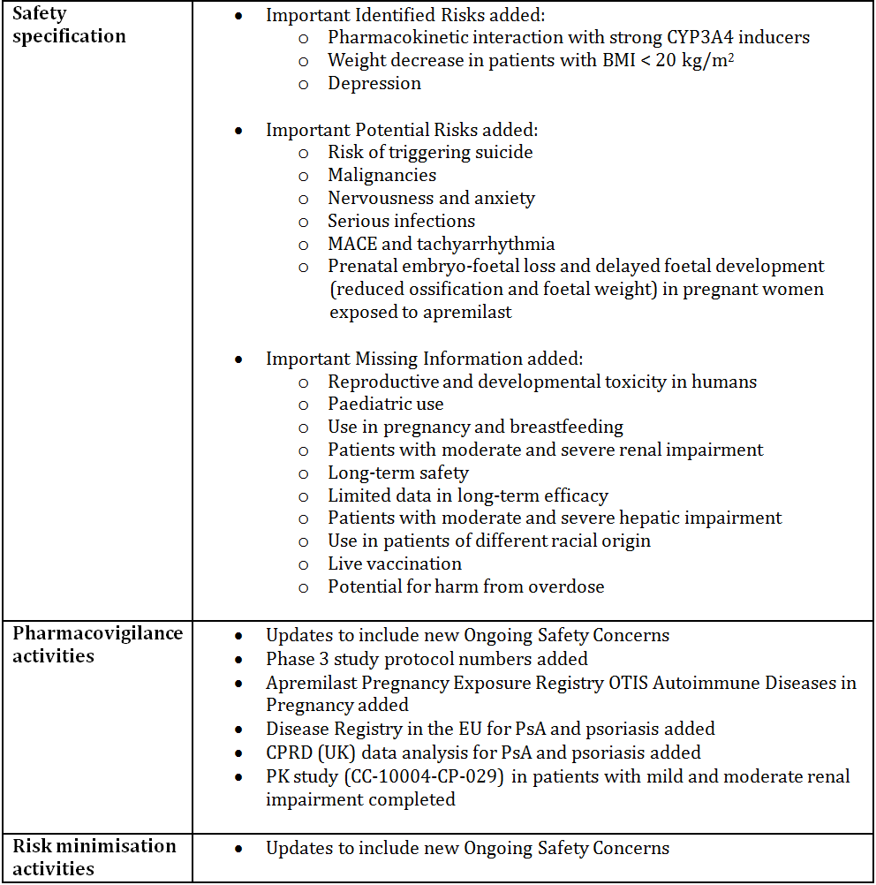
The sponsor has provided an updated table with a summary of safety concerns (Table 19).
Table 19: Updated table of safety concerns.
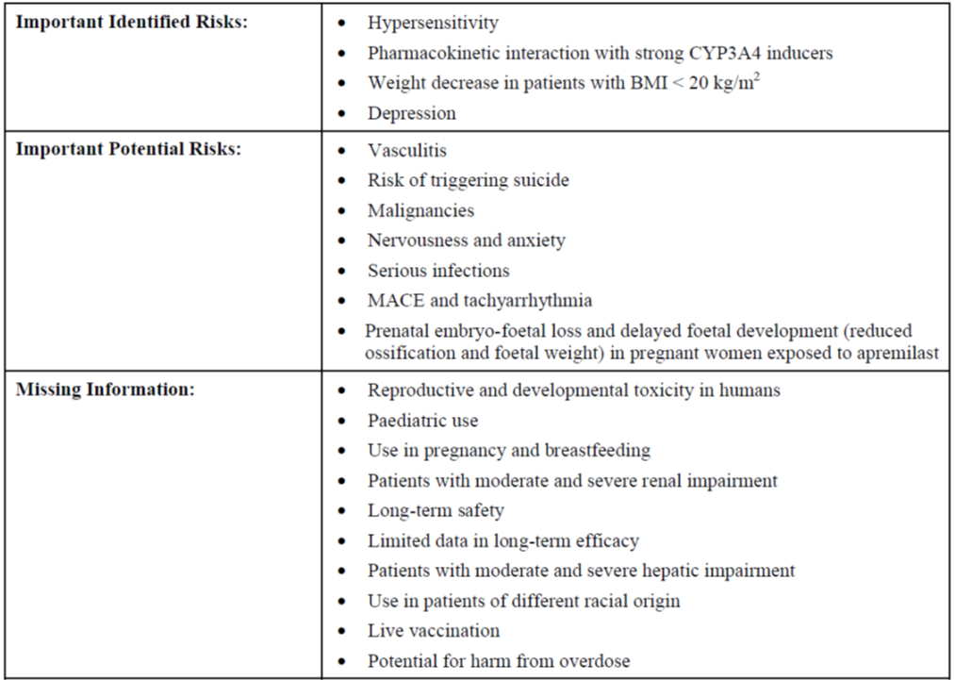
Table 20 contains an updated version of the proposed additional pharmacovigilance activities.
Table 20: Updated version of proposed additional pharmacovigilance activities.
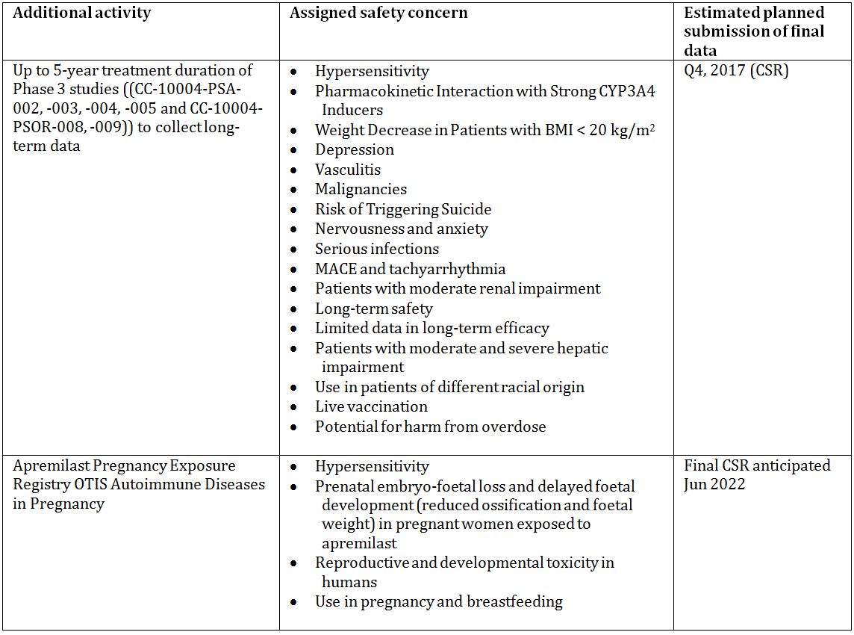
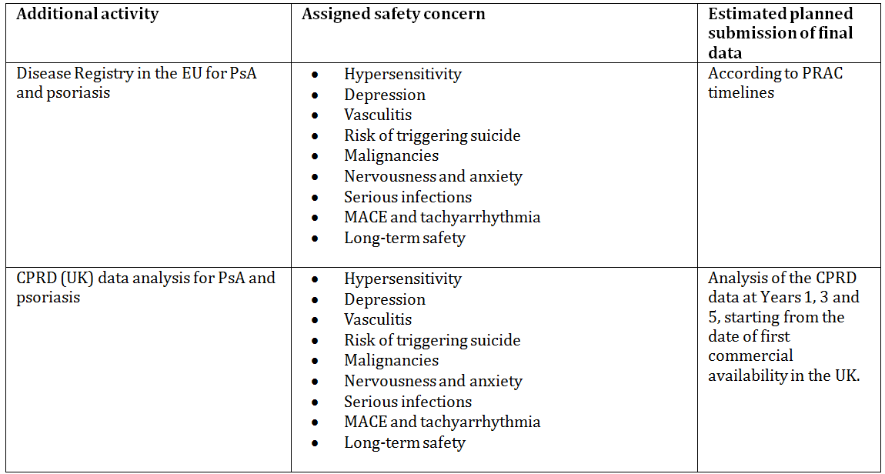

Suggested wording for conditions of registration

RMP
Any changes to which the sponsor agreed become part of the risk management system, whether they are included in the currently available version of the RMP document, or not included, inadvertently or otherwise.
The suggested wording is:
Implement RMP in EU-RMP format Version 3.0 (dated 10 October 2014, DLP 1 March 2013 [PsA] and DLP 11 January 2013 [PSOR]) and ASA Version 2.0 (dated October 2014) and any future updates as agreed with the TGA as a condition of registration.

VI. Overall conclusion and risk/benefit assessment
The submission was summarised in the following Delegate’s overview and recommendations:

Quality
The pharmaceutical chemistry evaluator did not recommend registration at round 1. The round 2 report was not finalised at the time of completion of this overview.

Nonclinical
The submitted pre-clinical studies were comprehensive with no major deficiencies.
The primary pharmacology studies support the use of APR in the proposed indication for severe plaque PSOR. However the nonclinical evaluator stated “in vivo studies in support of its use for PsA were equivocal”.
No unexpected clinical hazards were identified from secondary pharmacodynamic & safety studies.
The primary mechanism of APR metabolism was confirmed to be via CYP34A. APR is a substrate of P-gp, and P-gp inhibitors could increase plasma APR levels.
Pre-clinical studies in rodents demonstrated vasculitis like changes in the vasculature, heart, GI tract, lung, mesentery and thymus. These changes were not demonstrated in monkeys, nor have these findings been observed to date in the limited human exposure.
APR does not pose a genotoxic or carcinogenic risk.
The evaluator recommended that APR be contraindicated in pregnancy based on embryolethal effects observed at two-fold exposure. Pregnancy category B3 is recommended. The Delegate concurs with this advice.
It was recommended that APR be contraindicated in lactation. The Delegate concurs with this advice.

Clinical
The clinical evaluator recommended approval of both of the sponsor proposed indications.
The clinical evaluator has reviewed the submitted data and it was evaluated using TGA adopted EU guidelines.

Pharmacology

Summary of PK data
APR has an absolute bioavailability of ~73% with Cmax occurring at a median of ~2.5 hours post dose.
There is no significant influence of food on the absorption of APR.
Exposure of APR is dose proportional across doses of 10 mg/day to 80 mg/day (multiple dosing).
Bioavailability was consistent in multiple dosing studies.
Plasma protein binding is approximately 68%. The mean apparent volume of distribution is 87L (approximately extravascular space).
APR is extensively metabolised by cytochrome oxidative metabolism and subsequent glucuronidation. There are no active metabolites of APR.
Plasma clearance is approximately 10 L/h in healthy subjects; terminal elimination half-life is approximately 6-9 h. Elimination of radiolabelled APR represented 3% and 7% in urine and faeces, respectively. Females were observed to have 30% lower clearance than males.
The population pharmacokinetics analysis was based on separate study data rather than pooled data for eligible subjects.

Summary of pharmacodynamic data
Pharmacodynamic effects were assessed in Studies PSOR-001, PSOR-004 & PSOR-009, PSA-002 plus a dedicated QT assessment PK-008.
At the proposed APR dose, statistically significant reduction was observed in seven inflammatory mediators: IL-1α, IL-1β, IL-6, IL-8, TNF, and ferritin, whereas an increase in Von Willebrand factor observed, as compared to PBO. Changes were measurable within 4 weeks of treatment initiation. There was a reported difference in the mediators affected over the treatment exposure period – the sponsor states “the clinical relevance of these findings is unclear”.
In PSOR subjects, skin thickness, epidermal hyperplasia and keratin mRNA expression, presence of inflammatory dendritic cells and inducible nitric oxide synthase expression were improved in APR exposed subjects. However, for Study PSOR-009 “there was no significant association between changes in plasma biomarkers and clinical response”.
The QT study did not demonstrate a significant increase in QTc with APR (at therapeutic and supra-therapeutic dosing up to 50 mg BD) in comparison to moxifloxacin control.

Special populations
Studies of APR in healthy Japanese, Chinese and Caucasian subjects did not reveal any statistically significant differences in either Tmax, CL/F, or t1/2 between groups.

Pharmaceutical Sub-Committee (PSC) meeting 159 – summary
The PSC observed that the data was analysed from separate studies and not pooled. The minutes re-iterated that pooled data, when available, should be used for population pharmacokinetic analyses in preference to studies being analysed separately.
The PSC advised the data indicate that females have up to 30% lower clearance of APR and as a consequence are at risk of increased AEs, particularly if the highest dose studied, 30 mg BD, is registered.
The TGA population pharmacokinetic evaluator considered the second round population pharmacokinetic response from the sponsor was sufficient to not warrant a separate dosing schedule for males and females.
However, the PSC advised that the adverse effect data should be split and analysed separately for males and females to ensure that there is no increase in events for females. The Delegate concurs with this advice.
These issues are discussed under “Proposed regulatory action” below.

Efficacy

Dose selection
The doses selected for the pivotal studies in both indications derived from Phase II efficacy data. In PsA, 20 mg BD and 40 mg BD were compared, with the latter regimen associated with increased AEs and treatment discontinuation.
In PSOR, 10 mg BD, 20 mg BD and 30 mg BD were compared. The 30 mg BD regimen demonstrated increased efficacy, and “safety & tolerability of APR was acceptable and comparable”. The 10 mg BD dose did not demonstrate efficacy.

Efficacy in PsA
Four studies were submitted for evaluation (Table 21).
Table 21: Efficacy studies.
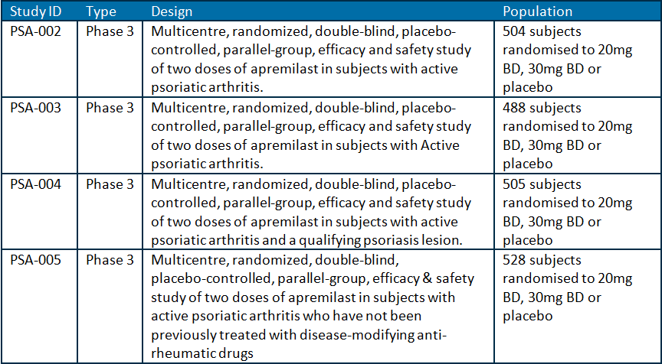
Studies PSA-002, PSA-003 and PSA-004 had an essentially common design, randomising eligible subjects to APR, at either 20 mg BD or 30 mg BD, or PBO in a 1:1:1 ratio as shown below, with each study following the proposed initial up-titration schedule (Figure 2). For Study PSA-005, only the 24 week study report was available for evaluation.
Figure 2: Common study design of PSA-002, PSA-003, PSA-004 & PSA-005.
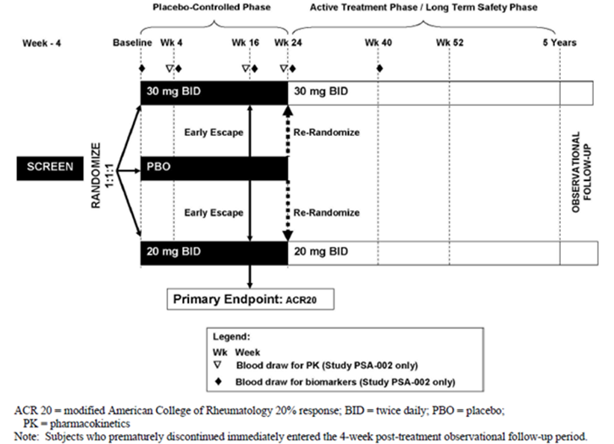
A comparison of salient features of the trial designs for the PsA studies is shown in Table 22.
Table 22: Comparison of study design in PsA studies.
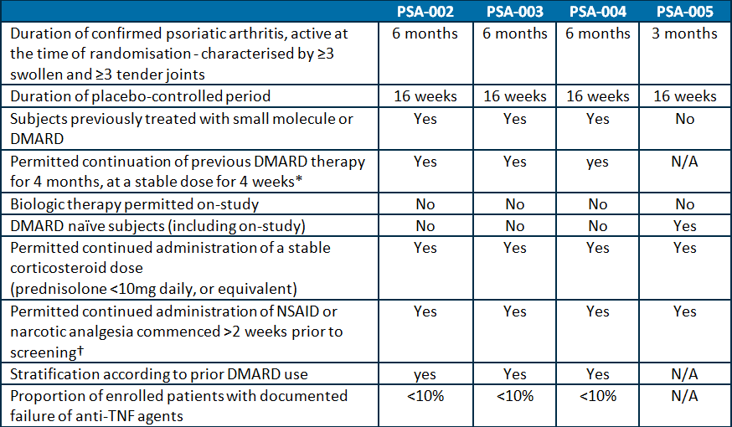
* Subjects receiving at least 4 months DMARD prior to randomisation, with 4 weeks unchanged dose, could continue on that regimen with MTX (up to 25 mg/week; oral or parenteral), lenflunomide (up to 20 mg/day), and/or sulphasalazine (2 g/day).
† Changes to NSAIDs due to toxicity were permitted between Weeks 24 and 52 of study.
Subjects who had previously failed treatment with >3 agents for PsA (the sum of conventional and/or biologic DMARDs) or >1 anti TNF drug were excluded from all of the efficacy trials. Furthermore, all of the trials excluded patients who were at a ‘significant risk of infection’, or who had various abnormal laboratory results at baseline (for example, abnormal haematology or liver function tests).
In all four trials, the maximum period of PBO control was 16 weeks, as subjects initially randomised to PBO could crossover to APR therapy then.
This submission is seeking an indication in active PsA, and in general is consistent with the TGA adopted regulatory guideline pertaining to the requested extension of indication. In the Phase III trials, the choice of clinical (joints and skin), physical functioning and QOL endpoints, as well as the statistical analysis were appropriately performed.

Primary objective
The primary objective of the three studies (PSA-002, PSA-003 and PSA-004) was to assess the effect of APR on the signs and symptoms of active PsA after 16 weeks on-study as assessed by the modified ACR20 response rate. The modification of the assessment tool was the addition of the DIP joints of the toes and carpometacarpal joints to the total joint counts (78 tender joints and 76 swollen joints), consistent with the clinical signs of PsA.
A protocol amendment prior to database lock and unblinding reduced the assessment time-point from 24 weeks to 16 weeks of treatment. Secondary efficacy assessments were: blinded physical functioning indices, health related QOL and clinical disease activity, as assessed at 16, 24 and 52 weeks of treatment follow-up.

PsA efficacy results
The primary objective of the pivotal studies was met. APR regimens of 20 mg BD and 30 mg BD each demonstrated a statistically significant increase in the proportion of subjects achieving a modified ACR 20 response at Week 16 of treatment as compared to PBO (Table 23).
Table 23: Proportion of Subjects Achieving Modified ACR20/50/70 Response at 16 Weeks in Studies PSA-002, PSA-003 and PSA-004.
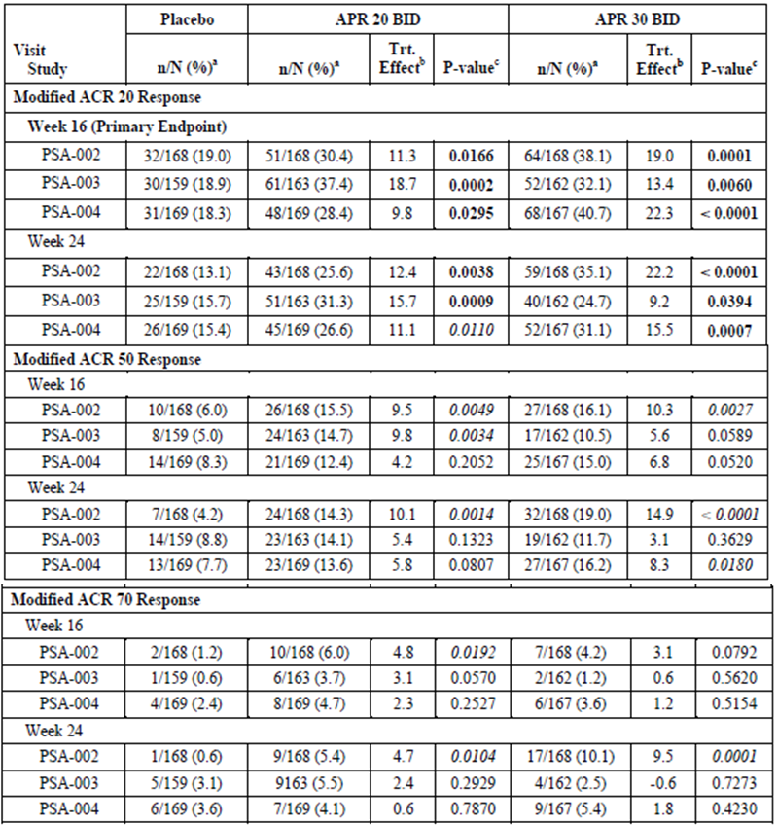
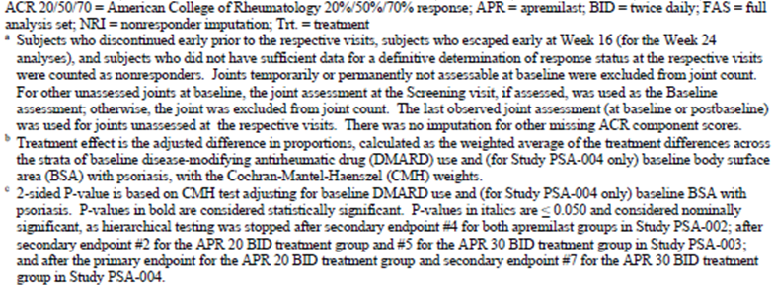
Results for the proportion achieving an ACR50 with 30 mg BD APR was statistically significantly greater in Studies PSA-002 and PSA-004, but not in PSA-003. The proportion achieving an ACR70 response was statistically significantly higher for the 30mg BD group in Study PSA-002 only. In the pivotal Phase III studies, clinical response was maintained for up to 52 weeks of treatment but observations taken after 24 weeks were not PBO controlled.
The Delegate concurs with the evaluator statement “efficacy results generally supported a greater numerical advantage for the APR 30 mg twice daily regimen compared to the APR 20 mg twice daily posology, but there were limited statistically significant analyses to support the conclusion that APR 30mg twice daily was superior to APR 20 mg twice daily”. Although the primary outcome of the efficacy studies was the ACR20 response, some trial entrants were also seen to have responses fulfilling the criteria for ACR50 and ACR70.
The efficacy outcomes do not suggest a synergistic effect between APR and existing systemic therapies, including anti TNF agents. DMARD naïve subjects achieved a similar modified ACR20 response at 16 weeks as compared to those previously/concurrently receiving DMARD, reflecting the novel mechanism of action of APR.
APR was also associated with an improvement in the HAQ-DI score from baseline, and the majority of pairwise comparisons between APR and PBO reached statistical significance (Table 24).
Table 24: Table Changes from Baseline in HAQ-DI Score at 16 Weeks in Studies PSA-002, PSA-003 and PSA-004.
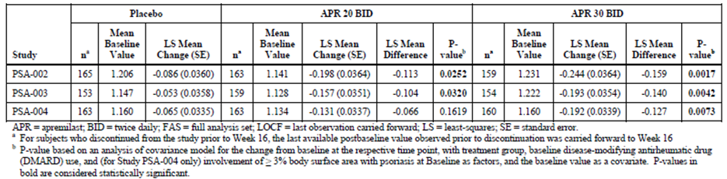
Secondary efficacy measures examining other clinical outcomes (for example, PsARC response; as well as PASI response in Study PSA-004) and health related QOL endpoints. Physical function domain scores of SF-36 and mean change from baseline in FACIT-F score also demonstrated improvements with APR.
In the studies in PsA, the evaluator states as an overall conclusion that “in most of the Phase III studies APR 30 mg twice daily produced numerically greater improvements in enthesitis and dactylitis scores, but often the difference did not achieve statistical superiority compared with PBO”.
The supporting Study PSA-001 assessed the ACR20 response at 12 weeks and supported the observation that APR (at either 20 mg twice daily or 40 mg once daily) results in clinically meaningful improvements in joint disease activity. Both APR treatment arms had a significantly greater proportion of subjects achieving an ACR20 response: 35.8% (24/67) of subjects in APR 40 mg once daily group and 43.5% (30/69) of subjects in the APR 20 mg twice daily arm compared to 11.8% (8/68) of patients in the PBO group (p = 0.002 and p <0.001, respectively).

Efficacy in PSOR
The following efficacy studies were presented for evaluation for the PSOR indication (Table 25).
Table 25: Studies submitted for efficacy in PSOR indication.
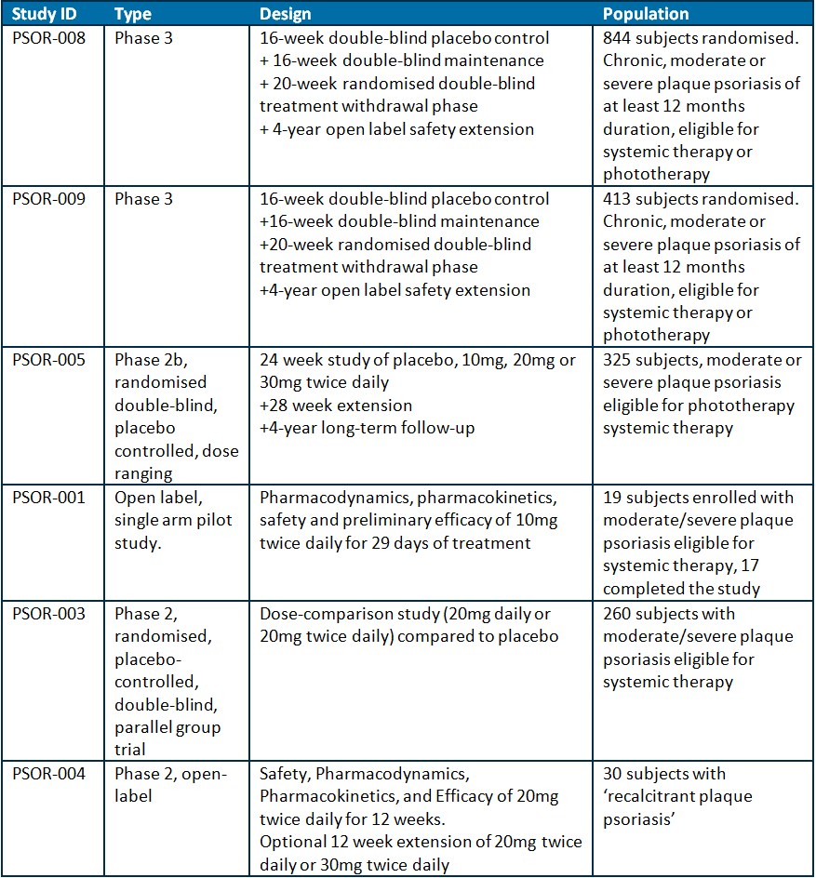
The efficacy of APR in the treatment of PSOR was determined from the two international pivotal Phase III studies, with supportive efficacy from the Phase I and II efficacy studies.
The pivotal studies recruited subjects with an appropriate severity of disease – requiring systemic therapy or phototherapy – consistent with the proposed indication, and they had to have ceased topical treatment two weeks prior to study entry. Both pivotal studies had an initial treatment phase, maintenance phase, a randomised withdrawal phase, and a long term safety extension. Subjects were randomised in a 2:1 ratio to APR and PBO, respectively.
Subjects with active or incompletely treated tuberculosis, or with previous malignancy (excepting basal or squamous cell skin cancers or cervical carcinoma in situ), were precluded from study entry.
Overall, the proportion of subjects who discontinued Studies 008 and 009 during the randomised period of 1 year was higher in the APR arm (41.3% and 46.4% respectively) as compared the PBO arm (39.4% and 39.1%, respectively).
Discontinuations were more commonly due to AE in the APR arm and lack of efficacy in the PBO arm.
The primary outcome of Studies PSOR-008 and PSOR-009 was the proportion of subjects treated with APR or PBO who achieved a PASI 75 response at Week 16. In the assessment of efficacy, missing values at the Week 16 primary assessment point were imputed using the last observation carried forward.
Subjects achieving a response at Week 16 were randomised to PBO or 30 mg twice daily to assess the effect of treatment withdrawal. The threshold for treatment response, and re-randomisation to the withdrawal phase, was different for the two pivotal studies namely a 75% and 50% reduction in the PSOR area and severity score for the 008 and 009 studies respectively.

PSOR efficacy results
The primary outcome of both pivotal studies was met, demonstrating a higher proportion of subjects achieving a PASI75 response from 30 mg BD APR as compared to PBO (Table 26).
Table 26: PASI75 response at Week 16 of treatment.
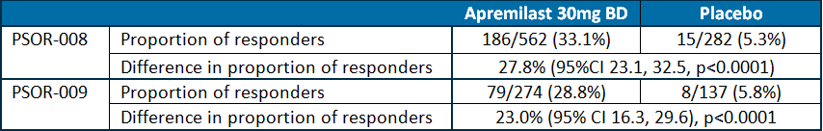
In both pivotal studies, sub-group analyses did not establish any factors which were associated with a difference in treatment effect.
Secondary efficacy assessments obtained in both studies were consistent with the primary outcome, in demonstrating a benefit to APR over PBO.

Safety
Safety data was reported for the 4089 subjects who have received at least one dose of APR, with 2357 of those having received at least one dose at that proposed of 30 mg BD. Overall, 3049 (74.6%) received at least 24 weeks on-treatment, with 1930 having received the proposed dose of 30 mg BD for that duration.
The safety populations for PsA and PSOR have been reported separately, and with regard to the PBO controlled phase for each indication.
TEAEs occurred more commonly according to standardised treatment exposure duration.
A similar pattern of adverse events were reported for both indications, with diarrhoea, nausea, headache, upper respiratory tract infection, nasopharyngitis and dyspepsia being the most common in both groups. Hypertension was reported for the PsA subjects; however, the incidence was similar in the PBO and APR exposed subjects.
In non-randomised studies, the AE profile was similar to that reported in the randomised studies.

Deaths
Four deaths were reported across the safety population.
One death was reported in the PsA Study PSA-002 with the cause of death being vitamin B12 and folate deficiency secondary to MTX. The effect of APR in this death was not attributed or established.

Serious adverse events
SAEs were reported for each indication rather than as a whole.

Serious adverse events of special interest

Infections
In the adjudicated analysis, there was no association with incidence of serious infection and APR exposure. No events of new TB infection or reactivation were reported.

Major cardiac events
APR exposure was neither associated with an increase in major cardiac events, nor was a dose-dependent effect observed.

Malignancies
APR exposure was not associated with an increase in second malignancies. Non melanoma skin cancers were the commonest occurring events, but without a temporal or dose response relationship with exposure.

Discontinuations
The incidence of discontinuation was higher in subjects receiving APR as compared to PBO, occurring more commonly in the first 16 weeks of therapy. The most common reasons for discontinuation were nausea, diarrhoea, headache, vomiting, fatigue and dizziness.

Depression
Patients with PsA or PSOR may be at increased risk of depression. In regard to the risk of depression, a warning is contained in the US and Health Canada product label for APR use, but not proposed for the Australian PI:
FDA product label:
“Depression: Advise patients, their caregivers, and families to be alert for the emergence or worsening of depression, suicidal thoughts or other mood changes and if such changes occur to contact their healthcare provider.
Carefully weigh risks and benefits of treatment with OTEZLA in patients with a history of depression and/or suicidal thoughts or behavior.”
Health Canada product monograph:
“Psychiatric
Depression: In Phase 3 PSOR studies, treatment with OTEZLA was associated with an increase in adverse reactions of depression during the PBO-controlled period. The incidence of depression or depressed mood was 1.44% for OTEZLA 30 mg BID and 0.48% for PBO. In Phase 2/3 studies with OTEZLA, the incidence of serious events of depression or of suicidal ideation was uncommon in patients treated with OTEZLA 30 mg BID.
Before using OTEZLA in patients with a history of depression and/or suicidal thoughts or behavior, prescribers should carefully weigh the risks and benefits of treatment with OTEZLA in such patients. Physicians should discuss psychiatric adverse events with their patients and/or caregivers. Patients and/or caregivers should be instructed to notify the physician if these events do occur.”
The sponsor provided more information in the Section 31 response, with a justification for not including this risk in the Australian PI.
In the data presented, for both PSOR and PsA indications, there was no demonstrated dose dependent effect on the incidence of depression. The incidence of depression in the 16 week PBO controlled period was similar between PBO and APR exposed subjects.
No increase in the incidence of depression, depressed mood or drug withdrawal (either active or PBO), was observed in APR exposed subjects within the initial 16 week PBO controlled period as compared to those with continued APR exposure beyond.
The sponsor states that “Small numerical differences in the incidence of depression were observed during the PBO controlled periods of the Phase III studies and there was no evidence of an increased risk longer APR treatment based on the EAIR.”
Thus, the data contained in the Section 31 response contradicts the statement in the Canadian monograph.
The statement in the FDA product label does not contain an implication of causality between APR use and onset or worsening of depression, suicidal thoughts or other mood changes, but it is a prudent warning for prescribers and patient advocates to be aware of potential psychiatric morbidity. Given the small proportion of subjects exposed to APR who developed depression in the clinical development program, it is incorrect to categorically exclude a causal relationship between APR and psychiatric morbidity. Data do not exist to rule this in or out.
The Delegate considers the FDA warning to be a prudent statement pertaining to a risk, which should also be included in the Australian PI.

Immunisation
The sponsor was asked to comment on the effect of APR on protective immune status, given the immunosuppressing mechanism of action (Section 31 response). The response lists the vaccinations received across the PBO-controlled and continuation phases. Vaccine specific antibody levels were not assayed in subjects receiving APR. However, the sponsor states “these subjects did not develop the infection for which the vaccine was used”
The effect of APR on immunity for vaccines received prior to APR exposure has not been studied.
The effects of APR on live vaccination have not been studied, but the sponsor has committed to monitoring post marketing adverse reactions associated with live vaccines.

Electrocardiograph (ECG) changes
Despite the controlled QT study failing to demonstrate an effect of APR on QT interval, the Phase III studies reported: 9 subjects treated with APR having a prolonged QT interval, one had an AE of shortened QT interval and abnormal T wave and two subjects had non-specific ECG abnormalities with associated palpitations.

Haematology
Lymphopenia was the commonest occurring AE in both indications. One case of neutropenia was reported in PsA studies, and none in the PSOR studies.

Change in body weight
In studies of PsA, PSOR and chronic obstructive pulmonary disease, with one year of APR exposure, the was a reported net decrease in weight of 1.68 kg, 1.99 kg and 2.0 kg in each population, respectively. These figures do not reflect the magnitude of weight loss of up to 20% from baseline among PsA and PSOR subjects as compared to PBO (Tables 27 and 28).
Table 27: Weight change among subjects in the PsA data pool.
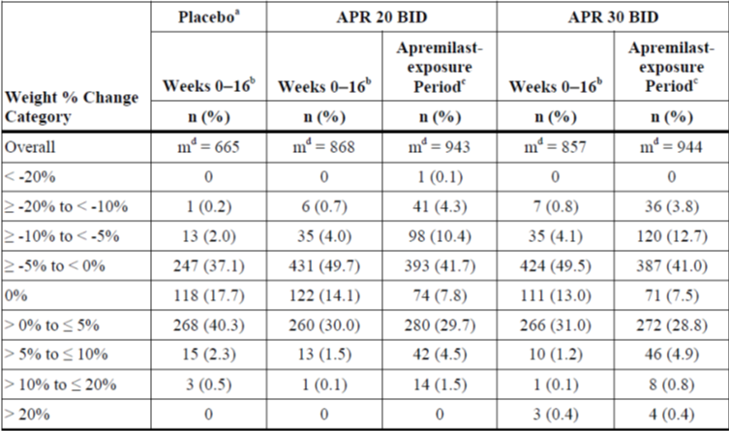
n = number of subjects, % = percentage of subjects among the overall study population
Table 28: Weight change among subjects in the PSOR data pool.
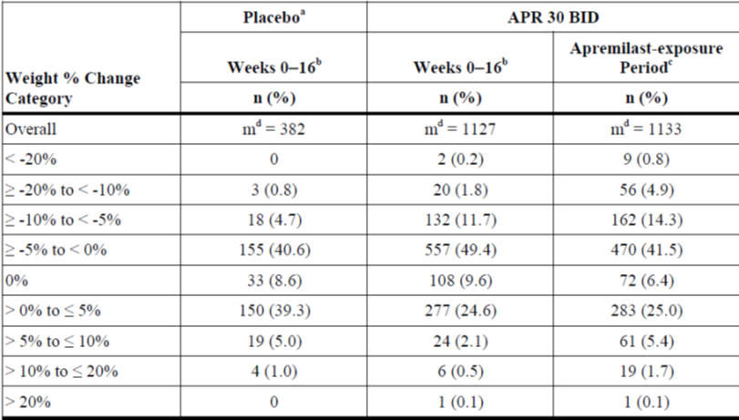
n = number of subjects, % = percentage of subjects among the overall study population
In subjects in the combined PsA and PSOR APR data pool (treated in controlled and uncontrolled periods), the following weight loss was reported in the summary of clinical safety (Table 29).
Table 29: Weight loss in the summary of clinical safety.
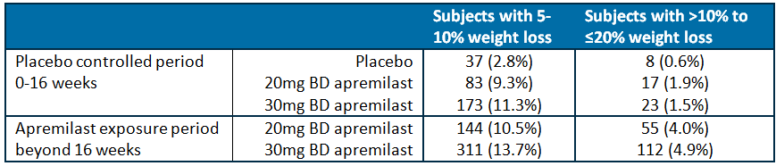
No subjects were reported to have experienced weight loss >20% from baseline.
Weight loss in both the controlled and uncontrolled periods occurs in a dose dependent manner. The sponsor proposes a precaution for weight loss in the PI.

Risk management plan
The RMP evaluator has tabulated the differences between the original EU-RMP, Version 1.0, and the updated version 3.0 RMP, plus the summary of safety concerns (important identified risks, important potential risks and missing information) (Table 30).
Table 30: Differences between the original EU-RMP and the updated version RMP, plus the summary of safety concerns.
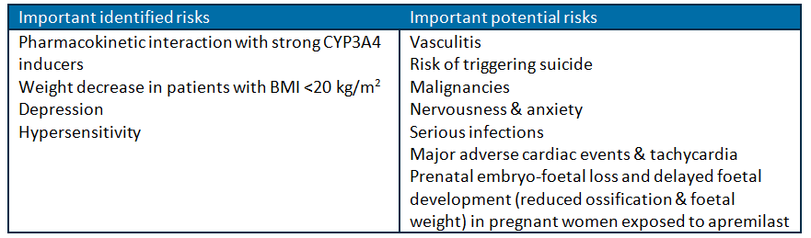
The EMA has mandated a disease registry for both PSOR and PsA in their pharmacovigilance activity in order to monitor the safety concerns of hypersensitivity, depression, vasculitis and risk of triggering suicide. The sponsor should justify why Australian patients should not be included in such a registry.

Interaction with strong CYP3A4 inhibitors
In the PI section on “Pharmacokinetic interaction with strong CYP3A4 inducers”, the sponsor has suggested including the examples: rifampicin, phenobarbital, carbamazepine and St. John’s wort. The Delegate concurs with this proposal.

Weight change
The sponsor has identified the risk of ‘off-label’ use of APR solely for weight loss purposes, which they state will be minimised by the medicine being prescription only.
In the RMP, the sponsor has reported data from the controlled Phase III trials and not from the overall APR data pool. The former contains a much smaller incidence of weight loss than the latter, and as such have appeared to have minimised the apparent risk form APR. The controlled period in the Phase III trials reports the relative difference in weight loss between PBO and APR subjects, whereas the pooled data represents the total APR experience, which is more likely to represent use if the medicine is registered.
The sponsor proposes to include the following wording in the PI:
“Patients who are underweight at the start of treatment should have their body weight monitored regularly. In the event of unexplained and clinically significant weight loss, these patients should be evaluated by a medical practitioner and discontinuation of treatment should be considered.”
This proposed entry is discussed in the section on the product information below.

Risk of vasculitis
Vasculitis was observed in the pre-clinical studies and has been included in the routine risk minimisation measures.

Proposed regulatory action and indication
- The Delegate considers that the efficacy data contained in the dossier support the registration of APR for the treatment of PSOR and PsA.
- Following the PSC meeting, the sponsor provided an unsolicited response to the issue of lower clearance in females and the potential risk of increased adverse events in this patient group. This document re-iterates that efficacy was demonstrated in PsA patients with both 20 mg and 30 mg BD dosing as compared to PBO, in previously treated and treatment-naïve subjects, but that the effect was greater in those receiving 30 mg.
The sponsor presented the pooled proportion of subjects achieving a modified ACR20 response and Weeks 16 and 24 for Studies PSA-002, PSA-003 and PSA 004 (Table 31).
Table 31: Pooled proportion of subjects achieving a modified ACR20 response and Weeks 16 and 24 for Studies PSA-002, PSA-003 and PSA 004.
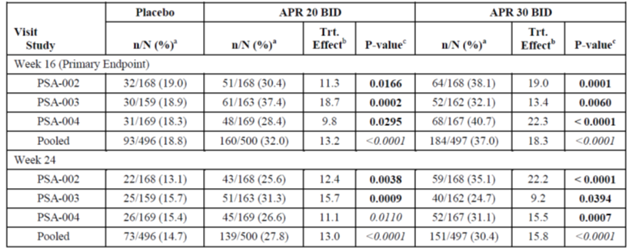
The sponsor reported a nominally statistically significant difference between the 20mg or 30 mg dosing groups and the PBO group for the pooled data.
However, using these results, the difference in proportion of responders is not statistically significant between the 20 mg and 30 mg pooled dosing groups at either time point. Furthermore, the difference in proportions of subjects achieving an ACR20 response was not consistently better for the 30 mg BD subjects as compared to those receiving 20 mg BD across all studies.
The clinical evaluator reported that there were more discontinuations in the APR-exposed subjects in the first 16 weeks of treatment. The sponsor has stated that the increase in adverse events of headache and gastrointestinal events, including diarrhoea, nausea and vomiting were higher with the 30 mg twice daily than with 20 mg twice daily. Further, it is stated that “the majority of these events were mild to moderate in severity, and the number of subjects with serious events was low and comparable between the two doses”.
In addressing the concerns of the PSC regarding the optimal dose for female patients, the Delegate considers that the sponsor should provide the top-line safety data split according to sex.
The 20 mg tablet will be manufactured but will only be supplied in a starter pack for initial up-titration purposes. This situation is less than satisfactory as it precludes patients experiencing intolerable adverse effects while receiving 30md BD from being able to reduce the dose to 20 mg BD, which was also demonstrated to be superior to PBO for efficacy but with less risk of AEs.
There is a potential to dose-reduce to 30 mg once daily, but efficacy at this dose has not been demonstrated.
The sponsor should consider the supply of the 20 mg tablet separate from the starter pack for the purposes of improving tolerance to, and continuation with, APR.
- The Delegate considers that the product information for APR contain a precautionary warning, similar to that in the FDA product label, concerning the potential risk of emergent, or worsening of, symptoms of depression, mood change or suicidal ideation while taking APR. This advice would be consistent with the information contained in overseas product information documents.
- There is a common risk of substantial weight loss while taking APR, which may warrant treatment discontinuation in affected individuals, for which a warning is included in the PI. In addition, this adverse effect may be manipulated in off label use of APR.

Data deficiencies/limitations
Although the primary efficacy end points of the PSOR studies were met, a limitation of the data is that for the enrolled subjects who had moderate or severe PSOR, eligible for systemic therapy or phototherapy, none of the efficacy studies provide any evidence of comparative efficacy between these alternative treatment options and APR. This deficiency should be included in the clinical trials section of the product information.

Questions for the sponsor
- What were the proportions of subjects that had missing data at the primary efficacy assessment point and required the last observation to be carried forward for the primary efficacy outcome in PsA and PSOR studies, in the PBO, 20 mg BD and 30 mg BD exposure groups?
- The sponsor is kindly requested to present the top-line adverse event data for females and males separately in their pre Advisory Committee on Prescription Medicines (ACPM) response.

Conditions of registration
- The sponsor should commit to presenting the final CSR for Study CC-10004-CP-029, investigating the pharmacokinetics of APR in patients with mild or moderate renal impairment, to the TGA.
- The Delegate considers that prescribing should be restricted to specialist physicians experienced in the treatment of PSOR or PsA.
- The sponsor should include female Australian patients exposed to APR while pregnant, or attempting to become pregnant in the patient registry, and include the relevant contact details in the product information.
- In their post marketing reports the sponsor should document the incidence AEs for males and females separately.

Summary of issues

Efficacy
- Efficacy has only been satisfactorily demonstrated against PBO in PSOR and PsA indications. APR has not been studied in combination with, or compared to, other systemic (conventional or biological) therapies or phototherapy. The observed efficacy of APR appears independent of prior therapy.
- Efficacy of 30 mg BD (proposed dose) and 20 mg BD APR were each demonstrated to be superior to PBO.
- Clearance of APR is 30% lower in women, potentially requiring routine dose reduction (to 20 mg BD). This dosing recommendation has not been mandated in other jurisdictions.

Safety
- Weight loss is a common AE and necessitates regular monitoring. Weight loss may result in off label prescribing. A restriction to prescribing by specialist physicians should be mandated.
- There is a risk of depression/suicide/mood disorder in association with APR use.
- Interactions with strong CYP3A4 inhibitors are warned for.
- The effect on pharmacokinetics of mild or moderate renal impairment is not yet characterised. In severe renal impairment, the dose should be halved.
- No dose reduction is required in moderate or severe hepatic impairment

Advice sought
The ACPM is requested to provide advice on the following specific issues:
- What is the opinion of the ACPM regarding the sponsor’s position that a warning for depression/depressed mood is not required for the Australian PI?
- What is the opinion of the ACPM regarding the inclusion of dose reduction guidelines in the PI pertaining to adverse events which may be related to increased exposure?
- What is the opinion of the ACPM regarding the restriction of APR to specialist physicians only?
The ACPM is also requested to provide advice on any other issues that it thinks may be relevant to a decision on whether or not to approve this application.

Response from sponsor
This document addresses certain concerns or questions raised in the Delegate’s overview (DO). All enumerated comments and requests in the DO that are not listed in this response have been addressed/incorporated as requested.

1. Question for sponsor
- What were the proportions of subjects that had missing data at the primary efficacy assessment point and required the last observation to be carried forward for the primary efficacy outcome in PsA and PSOR studies, in the PBO, 20 mg BD and 30 mg BD exposure groups?

Response
The number of subjects in Studies PSOR-008 and PSOR-009 who had missing PASI-75 response data at Week 16 and required the last observation to be carried forward is summarised for each study. Sensitivity analyses were conducted to assess the impact of missing data in the Full Analysis Set (FAS) population, which included treating subjects with missing values as non-responders (non-responder imputation). All of the sensitivity analyses demonstrated similar results as the primary analysis (FAS, LOCF) (PSOR SCE).
In the PsA studies, the primary endpoint (ACR 20 response at Week 16) was analysed using non-responder imputation (NRI), whereby subjects with missing data (that is, those who discontinued prior to Week 16, or who did not have sufficient data for a definitive determination of response status at Week 16) were counted as non-responders. Therefore, there was no carrying forward of the last observation in the primary efficacy assessment. One of the sensitivity analyses of the primary endpoint in the PsA studies did use the last-observation-carried-forward (LOCF) method to account for missing data, the results of which were consistent with the findings from the primary analysis. The number of subjects who had missing ACR20 response data at Week 16, and required the last observation to be carried forward in this sensitivity analysis, is summarised.

2. Question for sponsor
- The sponsor is kindly requested to present the top line AE data for females and males separately in their pre ACPM response.

Response
An overview of the TEAEs by sex occurring during the APR exposure Period in the APR Data Pool for the Subjects as Treated Population is presented in the Summary of Clinical Safety (SCS). There was no notable effect of sex on the incidence of subjects who reported TEAEs. A higher incidence of serious TEAEs and TEAEs leading to drug withdrawal was observed among female subjects compared with male subjects across all treatment groups.
A summary of TEAEs reported by at least 5% of subjects by sex during the APR exposure Period in the APR Data Pool for the APR Subjects as Treated Population are presented. In general, a higher incidence of diarrhoea, nausea, and headache was reported among female subjects compared with male subjects, with a more pronounced difference between males and females in the APR treatment groups. There was no consistent effect of sex on URTI, nasopharyngitis, or tension headache. Results of the analysis of TEAEs by sex during the PBO controlled Period in the APR Data Pool are provided (all TEAEs, TEAEs leading to drug withdrawal, and serious TEAEs).
The overall safety profile in males and females is acceptable.

3. Conditions of registration
- The Delegate considers that prescribing should be restricted to specialist physicians experienced in the treatment of PSOR or PsA.

Response
The PI has been updated with the addition of the following wording at the start of the Dosage and Administration section of the PI:
Treatment with Otezla should be initiated by specialists experienced in the diagnosis and treatment of PSOR or PsA.

4a. Conditions of registration
- The sponsor should include female Australian patients exposed to APR while pregnant, or attempting to become pregnant in the patient registry, and include the relevant contact details in the PI.

4b. Review of the PI
- The Delegate notes that the current version of the PI does not contain details of the Patient Register to monitor adverse events in pregnancy as contained in the European and US PI. The Australian PI should also contain this information.

Response
The Organisation of Teratology Information Specialists (OTIS) Pregnancy Exposure Registry is open only to patients who reside in the US or Canada. Although the findings of the study also satisfy the requests of other regulatory agencies (for example, EMA), the registry remains a US/Canadian registry. As a consequence it would not be possible to include Australian patients within this registry or be appropriate to include the registry information in the Australian PI.
The TGA will be notified of significant observations and the PI updated as required.

5. RMP evaluation
- The EMA has mandated a disease registry for both PSOR and PsA in their pharmacovigilance activity in order to monitor the safety concerns of hypersensitivity, depression, vasculitis, and risk of triggering suicide. The sponsor should justify why Australian patients should not be included in such a registry.

Response
In response to the EMA, the sponsor has identified two disease based registries that will provide real life experience with APR in both PSOR and PsA: PsoBest and British Society for Rheumatology Biologics Register in Psoriatic Arthritis (BSRBR-PsA). PsoBest recruits only PSOR patients who reside in Germany, and BSRBR-PsA only patients residing within the UK.
Given the country specific location and recruitment of both PsoBest and BSRBR-PsA, it is not possible to include Australian sites in their recruitment. However, the demographics of the recruited population are likely to be closely aligned with that which would be recruited in Australia.
Further, the RMP evaluator has raised no specific objection to the pharmacovigilance plan, including these registries and consequently, the sponsor believes that the PsoBest and BSRBR-PsA registries will be adequate to inform on APR in a real world clinical setting that is directly applicable for the Australian population. The sponsor therefore proposes that these registries form part of the pharmacovigilance plan for APR in Australia. The TGA will be notified of significant observations and the PI updated as required.

6. Delegate’s comments
- Although the primary efficacy end points of the PSOR studies were met, a limitation of the data is that for the enrolled subjects who had moderate or severe PSOR, eligible for systemic therapy or phototherapy, none of the efficacy studies provide any evidence of comparative efficacy between these alternative treatment options and APR. This deficiency should be included in the clinical trials section of the product information.

Response
The PI has been updated accordingly.

7. Review of the PI
- The PI should document the observed reduction in clearance in female subjects.

Response
The PI has been updated accordingly.

8. Review of the PI
- The sponsor should present the ‘proportion of responders’ at each time point, with the 95% confidence interval, not the standard error.

Response
The PI has been updated accordingly.

9. Review of the PI
- In the sentence beginning “Response to Otezla was rapid”, the use of the term ‘rapid’ is not appropriate as the speed (or rate) of response was not formally assessed. Similarly, the sentence:
“Clinically significant improvements in signs and symptoms, including pruritus, and skin discomfort/pain, were observed as early as Week 2”
is promotional and not permissible to remain in the PI as efficacy was not formally assessed at this time point.

Response
The Delegate’s concerns have been addressed via the following modifications to the text:
Response to Otezla was rapid, with s Significantly greater improvements compared to placebo in signs and symptoms of psoriasis, including mean % change in PASI from baseline, skin discomfort/pain and pruritus were observed at Week 2. In general, PASI responses were achieved by Week 16 and were sustained through Week 32. Clinically significant improvements in signs and symptoms, including pruritus, and skin discomfort/pain, were observed as early as Week 2.

10. Review of the PI
- Contraindications: the Delegate notes that the use of APR in pregnancy and in nursing women is contraindicated in the European PI. This advice should be contained in the Australian PI.

Response
The PI has been updated accordingly.

11. Review of the PI
- Precautions, points 1, 2 and 3

Response
The PI has been updated as requested by the Delegate.

12. Review of the PI
- Precautions, point 4 and 5: The PI should contain a statement in regard to: (i) the recommendation to regularly monitor body weight in all subjects, and (ii) assessment of renal function prior to commencement of APR. The PI should contain information regarding weight loss in the PBO controlled period worded similarly to that contained in the European PI, not simply the TEAE incidence as is currently stated.

Response
The PI has been updated accordingly with the following text:
Weight decrease
Weight decreases of greater than 5% of baseline body weight during the placebo-controlled period (16 weeks) were reported in 5.0% of patients treated with placebo compared to 13.3% of patients treated with Otezla 30 mg BID. Weight decreases of greater than 5% of baseline body weight following 52 weeks of treatment were reported in 19.2% of patients treated with Otezla 30 mg BID, including decreases of greater than 10% reported in 5.7% of patients. Weight decreases of greater than 5% of baseline body weight were observed more frequently in women than in men. Patients treated with Otezla should have their weight monitored regularly. If unexplained or clinically significant weight loss occurs, weight loss should be evaluated, and discontinuation of Otezla should be considered.
Renal function
Assessment of renal function is recommended prior to initiation of Otezla.

13. Review of the PI
- AEs, point 1: the current statement in the PI regarding weight loss is not sufficiently descriptive of the risk of weight loss observed in the clinical studies. The statement should be amended to reflect the magnitude of weight loss observed, with wording similar to that in the US product label.

Response
The PI has been updated accordingly with the following text:
The mean observed weight loss in patients treated for up to 52 weeks with APR was 1.99 kg. A total of 14.3% of patients receiving APR had observed weight loss between 5-10% while 5.7% of the patients receiving APR had observed weight loss greater than 10%. None of these patients had overt clinical consequences resulting from weight loss. A total of 0.1% of patients treated with APR discontinued due to adverse reaction of weight decreased.

14. Review of the PI
- AEs, point 2: The PI should contain a statement regarding the risk of mood change, suicidal ideation and depression, similar to the US and European PI.

Response
The PI has been updated accordingly, as follows:
Depression
Psoriatic arthritis: During the 0 to 16 week placebo-controlled period of the 3 controlled clinical trials, 0.9% (18/1945) of subjects treated with OTEZLA reported depression or depressed mood compared to 0.7% (5/671) treated with placebo. During the clinical trials, 0.2% (4/1945) of subjects treated with OTEZLA discontinued treatment due to depression or depressed mood compared with none in placebo treated subjects (0/671). Depression was reported as serious in 0.2% (3/1945) of subjects exposed to OTEZLA, compared to none in placebo-treated subjects (0/671). Instances of suicidal ideation and behavior have been observed in 0.2% (3/1945) of subjects while receiving OTEZLA, compared to none in placebo-treated subjects (0/671).
Psoriasis: During the 0 to 16 week placebo-controlled period of the 2 controlled clinical trials, 1.2% (14/1184) of subjects treated with OTEZLA reported depression compared to 0.5% (2/418) treated with placebo. During the clinical trials, 0.1% (1/1184) of subjects treated with OTEZLA discontinued treatment due to depression compared with none in placebo treated subjects (0/418). Depression was reported as serious in 0.1% (1/1184) of subjects exposed to OTEZLA, compared to none in placebo-treated subjects (0/418). Instances of suicidal behavior have been observed in 0.1% (1/1184) of subjects while receiving OTEZLA, compared to 0.2% (1/418) in placebo-treated subjects. In the clinical trials, one who received placebo committed suicide; there were no completed suicides reported in subject receiving OTEZLA.

15. Review of the PI
- AEs, point 3: The PI should contain a recommendation for APR dose reduction from 30 mg BD to 30 mg OD in the event of intolerable AEs.

Response
The sponsor respectfully disagrees with a recommendation for APR dose reduction, as no dose reduction schedule has been evaluated.

16. Review of the PI
- AEs, point 4: The PI should contain a statement regarding the observed risk of tachyarrythmia observed in the clinical studies, similar to that in the Canadian Monograph (correction from “the European product information” in the DO).

Response
The sponsor does not believe that there is any evidence that APR treatment increases the risk of tachyarrhythmias. It should be noted that tachyarrhythmia does not appear in either the US PI or the agreed EU SmPC.
An analysis of treatment emergent tachyarrhythmia was conducted based on an analysis of Specialised MedDRA Query (SMQ) terms. The majority of subjects (16 of 26) with non-extrasystole tachyarrhythmia events had relevant medical history or other risk factors and most tachyarrhythmia events were non-serious and did not lead to drug withdrawal. Ten subjects had no relevant medical history (6 subjects with broad SMQ terms). Of these 10 subjects, no subject discontinued APR and 2 subjects reported serious tachyarrhythmia TEAEs (broad terms of supraventricular tachycardia and sinus tachycardia). All of these subjects continued their APR treatment, and the events of tachyarrhythmias were generally transient and did not recur with continuation of APR treatment.
Based on these clinical findings, as well as supportive data from nonclinical studies and the thorough QTc study, the sponsor believes that there was no evidence that APR treatment increases the risk of tachyarrhythmia. Details of these findings are provided.

17. Review of the PI
- Interactions with Other Drugs: The PI should contain a statement documenting the absence of experience in the concomitant use of APR and immunosuppressants or biological therapies, with a warning to prescribers not to co-administer APR.

Response
APR has been studied in combination with small molecule immunosuppressants and demonstrated an acceptable safety profile when used alone or in combination with small-molecule DMARDs. The following statement has been added to “Interaction with other medicines” of the proposed label:
Otezla has not been studied in combination with biologic therapies.

18a. Points of clarification: Delegate’s comments
- In Table 2, the duration of the PBO-controlled period is indicated to be 16 weeks: “In all four trials, the maximum period of PBO control was 16 weeks, as subjects initially randomised to PBO could cross-over to APR therapy then.”

Response
The sponsor wishes to clarify that the duration of the PBO controlled period is not 16 weeks per se, as the PBO controlled period includes data from Weeks 0-16 for subjects randomised to PBO who entered early escape at Week 16, and data from Weeks 0-24 for all other subjects.
Therefore, the second paragraph below Table 2 should read:
The maximum period of PBO control was 16 24 weeks, as although subjects initially randomized to PBO could cross-over to apremilast therapy then at Week 16.

18b. Points of clarification: Delegate’s comments
- “The Delegate concurs with the evaluator statement [that] … there were limited statistically significant analyses to support the conclusion that APR 30 mg twice daily was superior to APR 20 mg twice daily.”

Response
Celgene recognises the specificity of this statement for the PSOR arthritis indication, as only APR 30 mg BID was investigated in comparison to PBO in the Phase III PSOR clinical trials. In the Phase III PsA clinical trials, the primary endpoint was the proportion of subjects in each APR treatment group (APR 20 BID and APR 30 BID), compared with PBO, who achieved a modified ACR20 response after 16 weeks of therapy. There were no formal comparisons of efficacy between the APR 20 mg BID and APR 30 mg BID treatment groups.

Advisory committee considerations
The ACPM, taking into account the submitted evidence of efficacy, safety and quality, agreed with the Delegate and considered Otezla tablets containing APR 10 mg (pink) and 20 mg (brown) tablets for dose titration and 30 mg (beige) tablets for ongoing administration to have an overall positive benefit-risk profile for the amended indication;
Otezla is indicated for:
    - The treatment of the signs and symptoms of active PsA in adult patients
    - The treatment of adult patients with moderate to severe plaque PSOR who are candidates for phototherapy or systemic therapy
In making this recommendation the ACPM:
- Noted the sponsor’s reluctance to market the 20 mg dose separately despite:
  - good evidence of efficacy at 20 mg twice daily in randomised controlled trials
  - evidence that clearance is substantially lower in women
  - the potential for higher rates of AEs with increased exposure which will impact on the benefit-risk profile
  - there is an absence of evidence for the efficacy of the proposed dose reduction, in the event of AEs, to 30 mg once daily from randomised trials
  - the reduction in flexibility of treatment in patients experiencing AEs.
- Was of the view that a black box was unnecessary at this point but was strongly of the view that the warning for depression/depressed mood should not just be listed in the Adverse Events section but also appear in the Precautions section, with a statement similar to that in the Canadian PI.
- Noted the pivotal studies excluded patients with a high baseline risk of infection, thus the trial safety data may not fully reflect the risk of infection in the wider treatment population post marketing.
- Noted there is no or very limited experience in certain patient subgroups of relevance including: subjects with renal or hepatic impairment, pregnant or lactating women, and those with a low body weight (<50 kg) or the concomitant use of cyclosporin and APR.
- Noted the potential for ‘off label’ use of APR for weight loss.

Proposed conditions of registration
The ACPM agreed with the delegate on the proposed conditions of registration and specifically advised on the inclusion of the following:
- Subject to the sponsor supplying the 20 mg dose separately for dose titration, reduction or management of AEs.
- Negotiation of PI and Consumer Medicines Information (CMI) to the satisfaction of the TGA.

PI/CMI amendments
The ACPM agreed with the Delegate to the proposed amendments to the PI and CMI and specifically advised on the following:
- The lack of radiographic efficacy data in PsA patients should be reflected in the clinical trials section of the PI;
- The PI should contain a statement regarding the lack of clinical data on the concomitant use of cyclosporin and APR; and
- The CMI should include a list of medications which are contraindicated with APR use.

Specific advice
The ACPM advised the following in response to the delegate’s specific questions on this submission:
- What is the opinion of the ACPM regarding the sponsor’s position that a warning for depression/depressed mood is not required for the Australian PI?
The ACPM advised that while the sponsor has agreed to put a warning for depression/depressed mood in the Adverse Effects section the warning should be more expansive, such as that in the Canadian PI and it should also be in Precautions section.
- What is the opinion of the ACPM regarding the inclusion of dose reduction guidelines in the PI pertaining to AEs which may be related to increased exposure?
The ACPM was of the view that this proposal was entirely reasonable, but conceded there are little specific data to support it. However, separate provision of the 20 mg tablet for use in PsA for which there is demonstrated efficacy in pivotal trials would facilitate this substantially; while the lack of this dose hinders good clinical management of some patients.
- What is the opinion of the ACPM regarding the restriction of APR to specialist physicians only?
The ACPM agreed with the proposed PI statement in the Dosage and Administration section:
Treatment with Otezla should be initiated by specialists experienced in the diagnosis and treatment of PSOR or PsA.
The ACPM advised that implementation by the sponsor of the recommendations outlined above to the satisfaction of the TGA, in addition to the evidence of efficacy and safety provided would support the safe and effective use of these products.

Outcome
Based on a review of quality, safety and efficacy, TGA approved the registration of
- Otezla apremilast 30 mg film coated tablet blister pack; and
- Otezla Titration Pack apremilast tablet blister pack
indicated for:
- The treatment of signs and symptoms of active psoriatic arthritis in adult patients.
- The treatment of adult patients with moderate to severe plaque psoriasis who are candidates for phototherapy or systemic therapy.

Specific conditions of registration applying to these goods
- The Apremilast EU-RMP Version 3.0 (dated 10 October 2014, DLP 1 March 2013 [PsA] and DLP 11 January 2013 [PSOR]) and ASA 2.0 (dated October 2014), and any subsequent revisions, as agreed with the TGA will be implemented in Australia.

Attachment 1. Product Information
The PI approved for Otezla at the time this AusPAR was published is at Attachment 1. For the most recent PI, please refer to the TGA website at <https://www.tga.gov.au/product-information-pi>.

Attachment 2. Extract from the Clinical Evaluation Report

Therapeutic Goods Administration
PO Box 100 Woden ACT 2606 Australia
Email: info@tga.gov.au Phone: 1800 020 653 Fax: 02 6232 8605
https://www.tga.gov.au

European Medicines Agency, “Guideline on bioanalytical method validation (EMEA/CHMP/EWP/192217/2009)”, 21 July 2011.
Yost J, Gudjonsson JE. (2009) The role of TNF inhibitors in psoriasis therapy: new implications for associated comorbidities. F1000 Med Rep. 1: 30.
Souness JE, Aldous D, Sargent C. (2000) Immunosuppressive and anti-inflammatory effects of cyclic AMP phosphodiesterase (PDE) type 4 inhibitors. Immunopharmacology 47: 127-62.
Card GL, et al. (2004) Structural basis for the activity of drugs that inhibit phosphodiesterases. Structure 12: 2233-47.
Yamamoto T. (2013) Angiogenic and inflammatory properties of psoriatic arthritis. ISRN Dermatol. 2013: 630620.
Ritchlin CT, Haas-Smith SA, Li P, Hicks DG, Schwarz EM. (2003) Mechanisms of TNF-alpha- and RANKL-mediated osteoclastogenesis and bone resorption in psoriatic arthritis. J Clin Invest. 111: 821-31.
http://www.accessdata.fda.gov/drugsatfda_docs/nda/2014/205437Orig1s000PharmR.pdf
Muller GW, et al. (1996) Structural modifications of thalidomide produce analogs with enhanced tumor necrosis factor inhibitory activity. J Med Chem. 39: 3238-40.
Ito T, et al. (2010) Identification of a primary target of thalidomide teratogenicity. Science 327: 1345-50; Zhu YX, et al. (2013) Molecular mechanism of action of immune-modulatory drugs thalidomide, lenalidomide and pomalidomide in multiple myeloma. Leukemia & Lymphoma 54: 683-7.
Ito T, et al. (2010) Identification of a primary target of thalidomide teratogenicity. Science 327: 1345-50.
European Medicines Agency, “Guideline on repeated dose toxicity (CPMP/SWP/1042/99”), 18 March 2010.
European Medicines Agency, “ICH Topic S 2 A, Genotoxicity: Specific Aspects of Regulatory Genotoxicity Tests for Pharmaceuticals (CPMP/ICH/141/95)”, April 1996.
European Medicines Agency, “Note for guidance on carcinogenic potential (CPMP/SWP/2877/00)”, 25 July 2002.
European Medicines Agency, “ICH Topic S 5 (R2) Detection of Toxicity to Reproduction for Medicinal Products & Toxicity to Male Fertility (CPMP/ICH/386/95)”, March 1994.
European Medicines Agency, “Guideline on Risk Assessment of Medicinal Products on Human Reproduction and Lactation: from Data to Labelling (EMEA/CHMP/203927/2005)”, 24 July 2008.
The Australian PI states that “the safety and effectiveness of Otezla has not been established in patients under the age of 18 years.”
Mease PJ. (2011) Psoriatic Arthritis: update on pathophysiology, assessment and management. Ann Rheum Dis. 70: i77-i84.
Schett G, et al. (2013) How Cytokine Networks Fuel Inflammation: Toward a cytokine-based disease taxonomy. Nat Med. 19: 822-4.
European Medicines Agency, “Guideline on Clinical Investigation for Medicinal Products for the Treatment of Psoriatic Arthritis (CPMP/EWP/438/04)”, 14 December 2006.
European Medicines Agency, “Guideline on Clinical Investigation for Medicinal Products for the Treatment of Psoriasis (CHMP/EWP/2454/02)”, 14 December 2006.
For the PSOR program, only a dose of 30 mg twice daily was studied. For the PsA program, both 20 mg twice daily and 30 mg twice daily were studied.
Schafer PH, et al. (2010) Apremilast, a cAMP phosphodiesterase-4 inhibitor, demonstrates anti-inflammatory activity in vitro and in a model of psoriasis. Br J Pharmacol. 159: 842-55.
European Medicines Agency, “Guideline on Clinical Investigation for Medicinal Products for the Treatment of Psoriatic Arthritis (CPMP/EWP/438/04)”, 14 December 2006.
European Medicines Agency, “Guideline on Clinical Investigation for Medicinal Products for the Treatment of Psoriasis (CHMP/EWP/2454/02)”, 14 December 2006.
One subject completed suicide, while a second subject was considered as a completed suicide by the FDA. Both subjects were on placebo.
One subject completed suicide, while a second subject was considered as a completed suicide by the FDA. Both subjects were on placebo.
European Medicines Agency, “Guideline on Reporting the Results of Population Pharmacokinetic Analyses (CHMP/EWP/185990/06)”, 21 June 2007.
This is from EU-RMP Version 1.0.
European Medicines Agency, “Guidance on format of the risk management plan (RMP) in the EU – in integrated format (EMA/465932/2013)”, 25 July 2013.
Armstrong AW, et al. (2012) Coronary artery disease in patients with psoriasis referred for coronary angiography. Am J Cardiol. 109: 976-80; Husted JA, et al. (2011) Cardiovascular and other comorbidities in patients with psoriatic arthritis: a comparison with patients with psoriasis. Arthritis Care Res (Hoboken) 63: 1729-35.
European Medicines Agency, “Guidance on format of the risk management plan (RMP) in the EU – in integrated format (EMA/465932/2013)”, 25 July 2013.
European Medicines Agency, “Guideline on Clinical Investigation for Medicinal Products for the Treatment of Psoriatic Arthritis (CPMP/EWP/438/04)”, 14 December 2006; European Medicines Agency, “Guideline on Clinical Investigation for Medicinal Products for the Treatment of Psoriasis (CHMP/EWP/2454/02)”, 18 November 2004.
European Medicines Agency, “Guideline on Clinical Investigation for Medicinal Products for the Treatment of Psoriatic Arthritis (CPMP/EWP/438/04)”, 14 December 2006.

