|  |
| --- |
| **First Round CER report: 4 December 2014**  **Second Round CER report: 26 April 2015** |

|  |
| --- |
| AusPAR Attachment 2 |
| Extract from the Clinical Evaluation Report for Armodafinil |
| Proprietary Product Name: Nuvigil |
| Sponsor: Teva Pharmaceuticals Australia Pty Ltd |

About the Therapeutic Goods Administration (TGA)

* The Therapeutic Goods Administration (TGA) is part of the Australian Government Department of Health, and is responsible for regulating medicines and medical devices.
* The TGA administers the *Therapeutic Goods Act 1989* (the Act), applying a risk management approach designed to ensure therapeutic goods supplied in Australia meet acceptable standards of quality, safety and efficacy (performance), when necessary.
* The work of the TGA is based on applying scientific and clinical expertise to decision-making, to ensure that the benefits to consumers outweigh any risks associated with the use of medicines and medical devices.
* The TGA relies on the public, healthcare professionals and industry to report problems with medicines or medical devices. TGA investigates reports received by it to determine any necessary regulatory action.
* To report a problem with a medicine or medical device, please see the information on the TGA website <<https://www.tga.gov.au>>.

About the Extract from the Clinical Evaluation Report

* This document provides a more detailed evaluation of the clinical findings, extracted from the Clinical Evaluation Report (CER) prepared by the TGA. This extract does not include sections from the CER regarding product documentation or post market activities.
* The words [Information redacted], where they appear in this document, indicate that confidential information has been deleted.
* For the most recent Product Information (PI), please refer to the TGA website <<https://www.tga.gov.au/product-information-pi>>.

Copyright

© Commonwealth of Australia 2016  
This work is copyright. You may reproduce the whole or part of this work in unaltered form for your own personal use or, if you are part of an organisation, for internal use within your organisation, but only if you or your organisation do not use the reproduction for any commercial purpose and retain this copyright notice and all disclaimer notices as part of that reproduction. Apart from rights to use as permitted by the *Copyright Act 1968* or allowed by this copyright notice, all other rights are reserved and you are not allowed to reproduce the whole or any part of this work in any way (electronic or otherwise) without first being given specific written permission from the Commonwealth to do so. Requests and inquiries concerning reproduction and rights are to be sent to the TGA Copyright Officer, Therapeutic Goods Administration, PO Box 100, Woden ACT 2606 or emailed to <[tga.copyright@tga.gov.au](mailto:tga.copyright@tga.gov.au)>.

Contents

List of abbreviations 5

1. Introduction 8

1.1. Submission type 8

1.2. Drug class and therapeutic indication 8

1.3. Dosage forms and strengths 8

1.4. Dosage and administration 8

2. Clinical rationale 9

3. Contents of the clinical dossier 10

3.1. Scope of the clinical dossier 10

3.2. Paediatric data 10

3.3. Good clinical practice 10

4. Pharmacokinetics 11

4.1. Studies providing pharmacokinetic data 11

4.2. Summary of pharmacokinetics 12

4.3. Evaluator's overall conclusions on pharmacokinetics 36

5. Pharmacodynamics 39

5.1. Study 103 - Healthy young men undergoing acute sleep deprivation 39

5.2. PK/PD modelling and simulations - Report Cephalon CP-05-001 41

5.3. Evaluator's overall conclusions on pharmacodynamics 41

6. Dosage selection for the pivotal studies 42

7. Clinical efficacy 42

7.1. Overview of the studies 42

7.2. OSAHS 44

7.3. Narcolepsy 64

7.4. Shift Work Sleep Disorder (SWSD) 74

7.5. Evaluator's conclusions on efficacy 100

8. Clinical safety 107

8.1. Studies providing evaluable safety data 107

8.2. Overall extent of exposure 108

8.3. Adverse events 109

8.4. Laboratory tests 115

8.5. Electrocardiography 118

8.6. Vital signs 119

8.7. Polysomnography 121

8.8. Other safety issues 122

8.9. Post marketing experience 123

8.10. Evaluator's overall conclusions on clinical safety 124

9. First round benefit-risk assessment 128

9.1. OSAHS 128

9.2. Narcolepsy 130

9.3. SWSD 132

9.4. First round assessment of risks 133

9.5. First round assessment of benefit-risk balance 135

10. First round recommendation regarding authorisation 136

11. Clinical questions 136

11.1. Pharmacokinetics 136

11.2. Safety 137

12. Second round evaluation of clinical data 137

12.1. Pharmacokinetics 137

12.2. Safety 146

13. Second round benefit-risk assessment 152

13.1. Second round assessment of benefits 152

13.2. Second round assessment of risks 152

13.3. Second round assessment of benefit-risk balance 152

14. Second round recommendation regarding authorisation 152

## List of abbreviations

| Abbreviation | Meaning |
| --- | --- |
| ALT | alanine aminotransferase (SGPT) |
| ANC | absolute neutrophil count |
| ANCOVA | analysis of covariance |
| ANOVA | analysis of variance |
| AST | aspartate aminotransferase (SGOT) |
| BFI | Brief Fatigue Inventory |
| BMI | body mass index |
| BP | blood pressure |
| bpm | beats per minute |
| BUN | blood urea nitrogen |
| CDR | Cognitive Drug Research (system) |
| CFR | Code of Federal Regulations |
| CGI-C | Clinical Global Impression of Change |
| CGI-S | Clinical Global Impression of Severity of Illness |
| Cmax | maximum observed plasma concentration |
| Ctrough | plasma trough concentration |
| CMH | Cochran-Mantel-Haenzel |
| CRF | case report form |
| CRO | contract research organization |
| DSM-IV | Diagnostic and Statistical Manual of Mental Disorders, 4th Edition |
| ECG | electrocardiography, electrocardiogram |
| ESS | Epworth Sleepiness Scale |
| FDA | Food and Drug Administration |
| GCP | Good Clinical Practice |
| GGT | gamma-glutamyl transpeptidase |
| HEENT | head, eyes, ears, nose, and throat |
| ICH | International Conference on Harmonisation |
| ICSD | International Classification of Sleep Disorders |
| IEC | Independent Ethics Committee |
| IRB | Institutional Review Board |
| LLN | lower limit of normal range |
| LS | least square |
| max | maximum |
| MedDRA | Medical Dictionary for Regulatory Activities |
| min | minimum |
| MSLT | Multiple Sleep Latency Test |
| MWT | Maintenance of Wakefulness Test |
| OSAHS | obstructive sleep apnea/hypopnea syndrome |
| OTC | over-the-counter |
| PSG | polysomnography |
| RBC | red blood cell |
| REM | rapid eye movement |
| SD | standard deviation |
| SE | standard error |
| SOP | standard operating procedure |
| SSRI | selective serotonin reuptake inhibitor |
| SWSD | shift work sleep disorder |
| ULN | upper limit of the normal range |
| WBC | white blood cell |
| WHO | World Health Organization |

## Introduction

### Submission type

This is an application from Teva Pharmaceuticals Australia P/L (the sponsor) to register a new chemical entity, armodafinil, with the trade name Nuvigil.

### Drug class and therapeutic indication

Armodafinil is a wakefulness-promoting agent for oral administration. Armodafinil is the R-enantiomer of the racemate modafinil, which is currently registered in Australia with the trade name Modavigil.

The proposed indications for Nuvigil are:

* to improve wakefulness in patients with excessive daytime sleepiness associated with narcolepsy;
* to treat excessive sleepiness associated with moderate to severe chronic shift work sleep disorder where nonpharmacological interventions are unsuccessful or inappropriate;
* as an adjunct to continuous positive airways pressure (CPAP) in obstructive sleep apnoea/hypopnoea syndrome in order to improve wakefulness.

The proposed indications for Nuvigil are identical to the currently approved indications for Modavigil.

### Dosage forms and strengths

The submission proposes registration of the following dosage forms and strengths: 50 mg, 150 mg and 250 mg tablets.

### Dosage and administration

The following is from the Dosage and Administration section of the proposed Product Information (PI):

*NUVIGIL should be used only in patients who have had a complete evaluation of their excessive sleepiness, and in whom a diagnosis of the underlying disorder of narcolepsy, OSAHS, or SWSD has been made in accordance with ICSD or DSM diagnostic criteria. Such an evaluation usually consists of a complete history and physical examination, and it may be supplemented with testing in a laboratory setting. Some patients may have more than one sleep disorder contributing to their excessive sleepiness (e.g., OSAHS and SWSD coincident in the same patient).*

*Treatment with NUVIGIL should be initiated and supervised by physicians with appropriate experience in the treatment of sleep disorders who have access to sleep laboratory diagnostic facilities.*

#### Narcolepsy

The recommended dose of NUVIGIL for patients with narcolepsy is 150 mg or 250 mg given once daily in the morning.

#### Obstructive Sleep Apnoea/Hypopnoea Syndrome (OSAHS)

In OSAHS, NUVIGIL is not indicated as treatment for the underlying obstruction. If continuous positive airway pressure (CPAP) is the treatment of choice for a patient, a maximal effort to treat with CPAP for an adequate period of time should be made prior to initiating NUVIGIL for excessive sleepiness. If NUVIGIL is used adjunctively with CPAP, the encouragement of and periodic assessment of CPAP compliance is necessary. There was a slight trend for reduced CPAP use over time (mean reduction of 18 minutes for patients treated with NUVIGIL and a 6-minute reduction for placebo-treated patients from a mean baseline use of 6.9 hours per night) in NUVIGIL trials.

The recommended dose of NUVIGIL for patients with OSAHS is 150 mg or 250 mg given once daily in the morning. In patients with OSAHS, doses up to 250 mg/day, given as a single dose, have been well tolerated, but there is no consistent evidence that these doses confer additional benefit beyond that of the 150 mg/day dose (See CLINICAL TRIALS).

#### Shift Work Sleep Disorder (SWSD)

The recommended dose of NUVIGIL for patients with SWSD is 150 mg given daily approximately 1 hour prior to the start of their work shift.

#### Dosing in Special Populations

The dose of NUVIGIL should be reduced in patients with severe hepatic impairment, with or without cirrhosis (See SPECIAL POPULATIONS).

There is inadequate information to determine safety and efficacy of dosing in patients with severe renal impairment (See SPECIAL POPULATIONS).

In elderly patients, elimination of armodafinil and its metabolites may be reduced as a consequence of aging. Therefore, consideration should be given to the use of lower doses in this population (See SPECIAL POPULATIONS).

## Clinical rationale

In the letter of application, the sponsor stated that the R- and S-enantiomers of modafinil appear to be identical with respect to the mechanism or action, with armodafinil having the longer half-life of the 2 enantiomers. Therefore, armodafinil was developed on the basis that a new formulation consisting solely of the R-enantiomer, although not significantly different from the racemic mixture with respect to safety or efficacy, would provide an improved plasma concentration profile and thus greater clinical benefit to patients.

In the Clinical Overview the sponsor stated that pharmacokinetic (PK) studies demonstrated that systemic exposure to armodafinil following multiple daily doses of 150 mg or 250 mg was comparable to systemic exposure to modafinil following multiple daily doses of 200 mg or 400 mg. The sponsor goes on to state that, despite similar overall systemic exposure, armodafinil and racemic modafinil have distinct plasma concentration-time profiles due to different rates of clearance of the R- and S- enantiomers. Compared to modafinil, armodafinil exhibits a lower peak plasma concentration (Cmax), which is offset by a higher plasma concentration at subsequent time points. Therefore, based on the PKs of the two drugs the sponsor theorized that, compared to modafinil, armodafinil may have a better tolerability due to its lower Cmax and a more sustained effect due to its higher plasma concentrations subsequent to the Cmax. In addition, the sponsor speculates that lower peak concentrations of armodafinil compared to modafinil might reduce the potential for drug-drug interactions. In view of the PK findings, the sponsor conducted a clinical program to assess the efficacy and safety of armodafinil for the treatment of patients with excessive sleepiness associated with OSAHS, SWSD, or narcolepsy.

*Comment: The sponsor's rational for the armodafinil clinical development program is acceptable.*

## Contents of the clinical dossier

### Scope of the clinical dossier

The submission contained the following clinical information:

* 11 Phase I clinical pharmacology studies, including pharmacokinetic data with or without pharmacodynamic data (9 in healthy subjects, 1 in patients with schizophrenia, and 1 in patients with OSAHS).
* 1 population pharmacokinetic report, 1 pharmacokinetic/pharmacodynamic modelling and simulation report.
* 4 pivotal Phase III, double-blind, placebo controlled studies (2 in patients with OSAHS, 1 in patients with narcolepsy, 1 in patients with SWSD).
* 2 Phase III, open-label studies each including patients with narcolepsy, OSAHS or SWSD.
* 2 Phase IIIb studies (1 double-blind, placebo-controlled study in patients with SWSD, 1 open-label study in patients with OSAHS or narcolepsy).
* 4 in vitro bioanalytical reports; 2 human biomaterial reports.
* Literature references.

### Paediatric data

The sponsor has not applied to the European Union for a waiver relating to the submission of paediatric studies for the treatment of OSAHS, narcolepsy or SWSD.

The FDA (USA) has granted a waiver for paediatric studies in patients from birth to 17 years of age in OSAHS "on the basis that studies are highly impractical because the number of patients is so small or non-existent", and in SWSD "on the basis that very few, if any, paediatric patients experience excessive sleepiness associated with" this condition. The FDA granted a partial waiver for the paediatric study requirement for patients aged less than 6 years with narcolepsy "on the basis that studies are highly impractical because the number of patients is so small or non-existent". However, the FDA deferred the paediatric study requirement for patients aged 6 to 17 years with narcolepsy until November 2017 "on the basis that the other paediatric groups are subject to a waiver request".

### Good clinical practice

The sponsor states that the clinical studies were undertaken in compliance with the principles of Good Clinical Practice.

## Pharmacokinetics

### Studies providing pharmacokinetic data

#### Clinical pharmacology studies providing PK (± PD) data for armodafinil

The submission included 11 Phase I clinical pharmacology studies evaluating the pharmacokinetics of armodafinil in 383 healthy subjects, 38 patients with schizophrenia, and 42 patients with OSAHS.

Table : Phase I clinical pharmacology studies containing PK and PD data for armodafinil.

|  |  |  |  |  |  |  |
| --- | --- | --- | --- | --- | --- | --- |
| Study | Objective | | Design | Armodafinil Dose | | N* |
| **Healthy subjects** | | | | | | |
| 1023 | Bioequivalence | | Open-label, 2-way cross-over | SD x 250 mg | 25 | |
| 1036 | Bioequivalence | | Open-label, 3-way cross-over | SD x 250 mg | 28 | |
| 101 | PK: Food effect | | Double-blind, placebo-controlled | SD x 50-400 mg | 40 | |
| 102 | PK: Multiple dose | | Double-blind, placebo-controlled | MD x 14 days x 50-400 mg | 49 | |
| 103 | PK, PD sleep deprivation | | Double-blind, placebo- and active-controlled | SD x 100-300 mg | 107 | |
| 1021 | DDI with CYP2C19 probe | | Open-label, 2-way cross-over, omeprazole | SD x 400 mg | 24 | |
| 1022 | DDI with CYP3A4 probe | | Open-label, midazolam (iv and po) | MD x 31 days x 250 mg | 17 | |
| 1025 | DDI with CYP1A2 probe | | Open-label, caffeine | MD x 29 days x 250 mg | 24 | |
| 1051 | PK: Effect of age | | Open-label | MD x 10 days x 50-150 mg | 50 | |
| **Schizophrenia** | | | | | | |
| 1056 | | DDI with quetiapine | Open-label, quetiapine (CYP3A4 substrate) | MD x 39 days 100-250 mg | | 25 |
| **OSAHS** | |  |  |  | |  |
| 1064 | | PK: Comparative | Open-label, randomised, cross-over armodafinil vs modafinil | MD x 32-38 days x 200 mg | | 38 |

N* = number of subjects in the PK analysis sets; SD = single-dose; MD = multiple-dose.

#### Population pharmacokinetic (PPK) modelling and simulation studies

The submission included population pharmacokinetic (PPK) and pharmacokinetic/ pharmacodynamic (PK/PD) modelling and simulation analyses (report CP-05-001). The analyses were undertaken in order to assist in the design and dosage regimen selection for the armodafinil Phase III studies. The PPK and PK/PD analyses included data from modafinil (Provigil) and armodafinil studies. These analyses have been reviewed and the results discussed.

#### Pivotal Phase III armodafinil sleep disorder studies with PK data.

Trough armodafinil plasma concentrations were determined from baseline through week 12 in the pivotal Phase III studies in patients with OSAHS and narcolepsy (studies 3020, 3021, 3025).

#### Studies providing PK data for racemic modafinil

The submission included summary data from three, Phase I studies investigating the pharmacokinetics of modafinil following single- and multiple-dose administration to healthy volunteers (C1538a/103/PK/US, C1538a/106/MD/US, and CEP-2101). The submission included comparative analyses of the pharmacokinetics of modafinil and armodafinil, and these analyses have been reviewed and the results discussed. Summaries of the three modafinil studies were provided by the sponsor in the Summary of Clinical Pharmacology (SCP), but complete study reports were not included. The three modafinil PK studies appear to have been previously evaluated by the TGA.

#### Analytical methods for calculation of pharmacokinetic parameters

PK parameters from the individual studies were calculated using standard non-compartmental methods. PPK and PK/PD analyses were performed using standard statistical methods and computer software (i.e., Nonlinear Mixed Effect Modeling (NONMEM) Version 5 Level 1.1 and SPlus 6.1 Professional Release 1).

#### Plasma concentration analytical methods

The data included six in vitro reports validating the analytical methods used to measure plasma concentrations of the analytes investigated in the PK studies (i.e., armodafinil, modafinil, R-modafinil acid, modafinil sulfone and quetiapine.). In the armodafinil studies, plasma samples were analysed for R-modafinil and its two major circulating metabolites (R-modafinil acid and modafinil sulfone) using validated high-performance liquid chromatography (HPLC) with ultraviolet (UV) detection methods (Reports DP-04-032, DP-2009-022, DP-2009-023). In each of the reports, the quantifiable range of the three analytes was stated to be 0.200 µg/mL through 50.0 μg/mL. In DP-04-006, DP-2009-023), modafinil, modafinil acid and modafinil sulfone plasma concentrations were also measured using a validated HPLC-UV method, with a quantifiable range for the analytes reported to be 0.200 µg/mL through 50 µg/mL. In the modafinil studies, plasma samples were analysed for R-modafinil and S-modafinil using an enantioselective HPLC-UV method, with the quantifiable range for the enantiomers reported be from 0.100 µg/mL to 15.0 µg/mL (report DP-95-003). In the DDI studies, quetiapine was measured in human plasma using a validated HPLC-tandem mass spectrometric method with the quantifiable range reported to be 0.500 ng/mL to 1000 ng/mL (DP-2009-47, DP-2009-022).

### Summary of pharmacokinetics

#### Pharmacokinetics in healthy subjects

##### Overview

* In healthy subjects, the pharmacokinetics of armodafinil have been examined after single-doses up to 400 mg (n = 93), multiple-doses up to 400 mg/day for 7 days (n = 34) and multiple-doses up to 300 mg/day for up to 14 days (n = 30). Dose-normalized armodafinil PK parameters following single-dose armodafinil from a pooled analysis (studies 1023, 101, and 102) and following multiple-dose armodafinil from study 102 are summarised.
* In healthy subjects, two circulating metabolites of armodafinil were identified (R-modafinil acid and [achiral] modafinil sulfone). Dose-normalized PK parameters for the metabolites following single-dose armodafinil from a pooled analysis (studies 1023, 101, and 102) and following multiple-dose armodafinil from study 102 are summarised.

##### R-modafinil and racemic modafinil - pharmacokinetic profiles

###### Comparative exposure of R-modafinil and S-modafinil following racemic modafinil

Modafinil is a racemic mixture of l-modafinil and d-modafinil, in which the absolute configurations corresponding to d- and l-modafinil have been determined to be S- and R-, respectively. In this CER, the d- and l-modafinil enantiomers are referred to as S-modafinil and R-modafinil, respectively. The Modavigil PI indicates that the enantiomers of modafinil have different PK properties (e.g., the half-life of R-modafinil [15 hours] is approximately three times that of S-modafinil humans [4 hours]). At steady-state, total exposure to R-modafinil is approximately three times that of S-modafinil. The trough concentration (Cmin.ss) of circulating modafinil after once daily dosing consists of 90% R-modafinil and 10% S-modafinil. The data indicate that R-modafinil is the predominant enantiomer following administration of the racemate. The enantiomers do not interconvert. The data in the Modavigil PI appear to be based on study PROVIGIL-2101.

Figure 1: Mean steady state plasma concentration profiles of R-modafinil and S-modafinil compared to racemic modafinil after multiple-dose administration (400 mg once daily in 6 healthy males); PROVIGIL-2101.

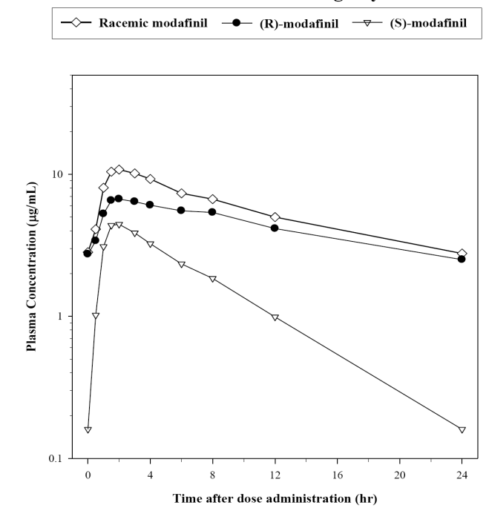

###### Exposure to R-modafinil following armodafinil and racemic modafinil - single-dose

The submission included a comparison of the mean plasma concentration profiles of R-modafinil following single-doses of armodafinil (50 mg) and racemic modafinil (100 mg) in healthy subjects (Summary of Clinical Pharmacology). The data for armodafinil were obtained by averaging the mean plasma concentration (dose-normalized to 50 mg) for all dose groups in armodafinil studies 101, 102, and 103, while the data for racemic modafinil were obtained from study PROVIGIL-103 by averaging the mean plasma concentrations (dose-normalized to 50 mg) dose groups for young men and women (i.e., excluded elderly volunteers). The R-modafinil concentration vs time profiles are presented below.

Figure 2: Mean plasma concentration vs time profiles of R-modafinil following a single-doses of armodafinil (50 mg) or racemic modafinil (100 mg); doses normalized to 50 mg.

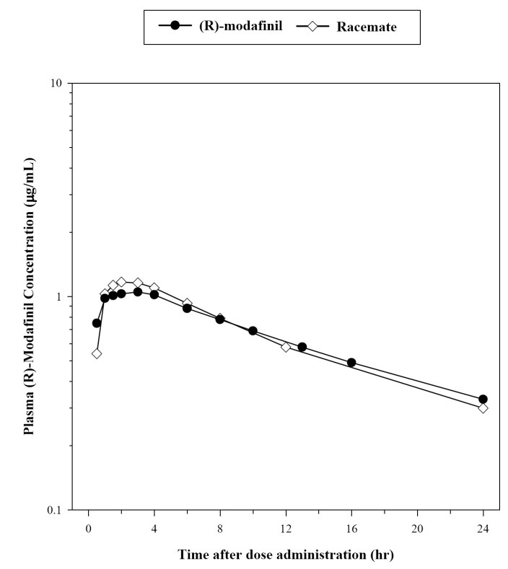

*Comment: The R-armodafinil concentration vs time profiles were nearly superimposable following single-dose armodafinil 50 mg and single-dose racemic modafinil 100 mg (50% of the dose represents the R-modafinil enantiomer). This indicates that PK profile of R-modafinil is the same whether administered as the racemate (modafinil) or the pure enantiomer (armodafinil). The sponsor states that this finding justifies the use of R-modafinil PK data from the modafinil (Provigil) studies to support the PK data for armodafinil provided in the submission. This is considered to be a reasonable conclusion.*

###### Exposure to armodafinil and racemic modafinil - multiple-dose

The submission included a comparison of the mean plasma concentration profiles of R-modafinil following multiple-doses of armodafinil and racemic modafinil in healthy subjects (Summary of Clinical Pharmacology). The R-modafinil plasma concentration data were obtained from study 102 provided in the current submission (150 mg and 250 mg doses of armodafinil), and the racemic modafinil plasma concentration data were obtained from study PROVIGIL-2101 (200 mg and 400 mg of racemic modafinil). The plasma concentration vs time profiles for armodafinil 150 mg vs modafinil 200 mg and armodafinil 250 mg vs modafinil 400 mg are summarised below.

Figure 3: Mean plasma concentration vs time profiles of R-armodafinil and racemic modafinil following multiple dose administration of armodafinil and racemic modafinil (Provigil), respectively.

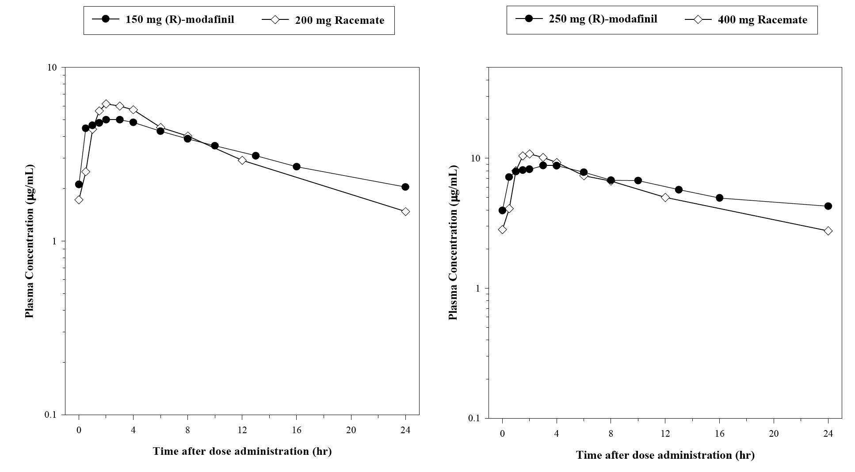

The comparative data showed that the Cmax values were lower for armodafinil compared to racemic modafinil while AUC values were approximately equal for the two analytes.

Table 2: R-modafinil Cmax and AUC values following multiple doses of armodafinil and racemic modafinil from studies 102 and PROVIGIL-2101.

|  |  |  |  |  |
| --- | --- | --- | --- | --- |
| Study | Treatment | Dose | Cmax R-modafinil | AUC R-modafinil |
| 102 | Armodafinil | 150 mg/day | ~ 5 µg/mL | ~ 80 µg•h/mL |
| PROVIGIL-2101 | Racemic modafinil | 200 mg/day | ~ 6 µg/mL | ~ 80 µg•h/mL |
| 102 | Armodafinil | 250 mg/day | ~ 9 µg/mL | ~ 140 µg•h/mL |
| PROVIGIL-2101 | Racemic modafinil | 400 mg/day | ~ 11 µg/mL | ~ 140 µg•/mL |

The sponsor comments that the difference in peak plasma R-modafinil concentration between the two drugs is offset by higher plasma concentrations of R-modafinil later in the time course due to the difference in the pharmacokinetic properties of the two drugs. The decline from peak concentration of armodafinil was monoexponential compared to biexponential for racemic modafinil, and the terminal half-life of armodafinil was longer than the terminal half-life of racemic modafinil. The sponsor comments that the biexponential decline following administration of racemic modafinil is the result of the differential rate of clearance of the R- and S- enantiomers (i.e., clearance 3-fold higher for the S- compared to the R-enantiomer).

*Comment: The multiple-dose data from armodafinil study 102 and PROVIGIL study 2101 appear to relate to the Day 7 data from both studies. This should be confirmed by the sponsor. In addition, the description of the comparison between the two studies provided in the Summary of Clinical Pharmacology refers to a 150 mg dose of armodafinil from study 102, but no actual 150 mg dose of armodafinil was administered in this study. The data for the 150 mg dose appear to be an estimate based on the data from actual doses used in this study. The source of the data for armodafinil 150 mg referred to in the Summary of Clinical Pharmacology should be clarified by the sponsor. It is noted that PK data from armodafinil study 102 were obtained following fasting on sample collection days, while the PK data from PROVIGIL study 2101 were obtained 1 hour after a light breakfast on collection days. The sponsor should comment on the validity of comparing relative exposure between the two studies, given the different relationship between dose and meals on the collection days.*

##### Absorption

###### Sites and mechanisms of absorption

* The median Tmax of armodafinil was approximately 2 hours following single-dose armodafinil 100 mg administration in the fasted state in healthy subjects (study 101).
* In an in vitro study using MDR-MDCK cell monolayers (DP-2006-055), it was reported that armodafinil is a P-glycoprotein (Pgp) substrate, but is not an inhibitor of Pgp. There were no data on whether armodafinil is an inducer of Pgp.

##### Bioavailability

###### Absolute bioavailability

No absolute oral bioavailability study was submitted. The sponsor stated that the absolute oral bioavailability was not determined due to the aqueous insolubility of armodafinil, which precludes intravenous (iv) administration. However, it is noted that an iv formulation was used in nonclinical studies in rats and beagle dogs.

###### Bioavailability relative to an oral solution or micronised suspension

No relative bioavailability study comparing the proposed tablet formulations to an oral solution was submitted.

###### Bioequivalence of clinical trial and market formulation

Study 1023 - 1 x 250 mg tablet (commercial use) vs 5 x 50 mg tablets (Phase III)

This was a Phase I, single-centre (USA), single-dose, randomised, open-label, 2-way crossover PK and safety study to determine if 1 x 250 mg uncoated tablet of armodafinil developed for commercial use was bioequivalent to 5 x 50 mg film-coated tablets used in the Phase III clinical studies. The two treatments were administered following an overnight fast with a 7-day washout between treatments. Blood samples for PK analysis were collected before each dose and for up to 72 hours after each dose. A total of 30 healthy subjects (18 men and 12 women, aged 18 to 44 years) were enrolled in the study with 27 subjects completing both periods. Pre-treatment drug levels (> 5% of Cmax) were observed in 2 subjects who completed both periods, and PK data from these 2 subjects were excluded from the statistical analysis. The results are summarised below and the mean plasma armodafinil vs time profile provided.

Table 3: Study 1023 - PK parameters for armodafinil following treatment A (5 x 50 mg tablets) and Treatment B (1x 250 mg tablet) in healthy subjects (n = 25).

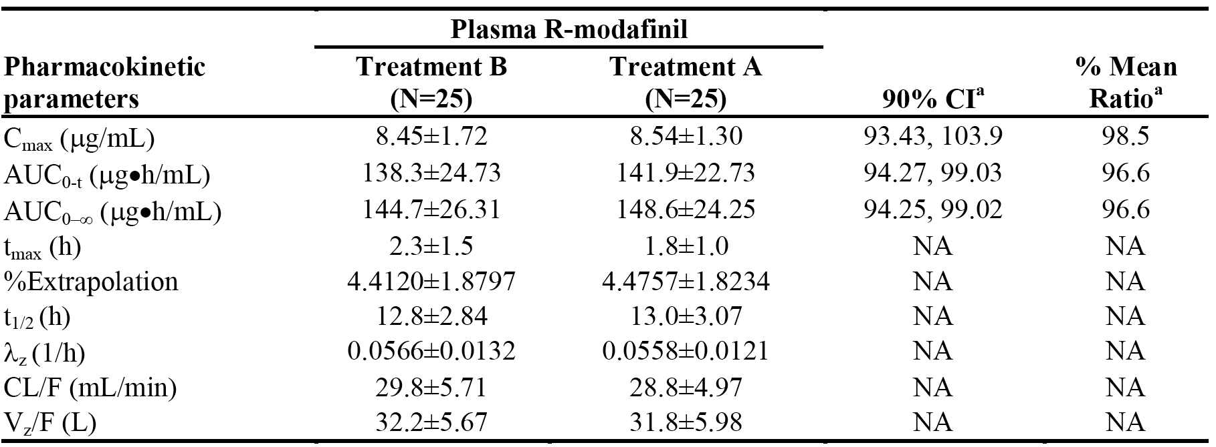

Note: a = % Mean Ratio and 90% CI based on ln-transformed data. Mean Cmax was determined by calculating the average maximum plasma concentration for each individual subject.

The PK parameters for plasma R-modafinil acid and plasma modafinil sulfone are summarised and the mean plasma vs time curves for the two metabolites are provided (plasma R-modafinil acid and plasma modafinil sulfone).

*Comment: The study showed that single-dose armodafinil 1 x 250 mg tablet developed for commercial use was bioequivalent to single-dose armodafinil 5 x 50 mg tablets used in the clinical Phase III studies in healthy fasted subjects, based on the Cmax, AUC(0-t) and AUCinf of armodafinil. The 90% CI for each of the parameters was entirely enclosed within the standard bioequivalence interval of 80% to 125%. In addition, other calculated PK parameters for armodafinil were similar for the two treatments. The mean plasma armodafinil concentration vs time curves for the two treatments were virtually superimposable. The study also showed that the pharmacokinetics of the metabolite R-modafinil acid were similar for the two treatments, as were the pharmacokinetics of the metabolite modafinil sulfone. Additional information provided by the sponsor for study 1023 indicates that the 250 mg tablet formulation (packaged lot number 040925Ka) is identical to the 250 mg tablet formulation proposed for registration.*

###### Bioequivalence of market formulation manufactured at different sites

Study 1036 - 250 mg tablets manufactured at different sites

This was a Phase I, single-centre (USA), randomised, open-label, three-way crossover study designed to assess the bioequivalence of each of two 250 mg armodafinil tablets manufactured at two different facilities in scale-up batches, and a reference 250 mg armodafinil tablet (same as used in study 1023) manufactured at a different site. Information provided by the sponsor indicates that each of the 250 mg tablets used in this study are proposed for registration. The three treatments are: Treatment A (reference) manufactured at PMRS and packaged by Cardinal (lot number 05K029A804); Treatment B (test) manufactured at PMRS and packaged by CTS (lot number 05K030A804); and Treatment C (test) manufactured at Patheon and packaged by Patheon (lot number 05K032A804).

After a screening period of up to 14 days prior to treatment, eligible subjects were randomised to 1 of 6 treatment sequences: ABC, ACB, BAC, BCA, CAB, or CBA. Subjects were given a single tablet in each treatment period, and blood samples were collected immediately before study drug administration and at specified time points up to 72 hours after study drug administration in each treatment period. Each treatment was separated by a minimum 7-day washout.

A total of 30 healthy subjects (16 men and 14 women, aged 19 to 45 years) were enrolled and randomised. One (1) of the 30 subjects (a female, subject 1005) withdrew from the study due to syncope at the time of pre-treatment blood sampling before receiving any study drug. The remaining 29 subjects received all 3 doses of study drug. Data from 28 evaluable subjects were available for PK analysis. The bioequivalence results are summarised.

Table 4: Study 1036 - Bioequivalence between treatments B and A (upper panel) and treatments C and A (lower panel) assessed by armodafinil PK parameters.

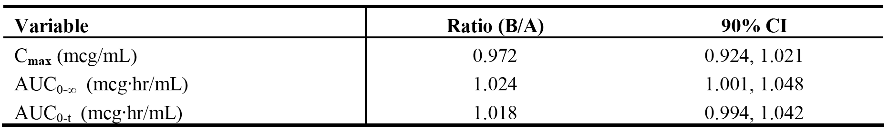

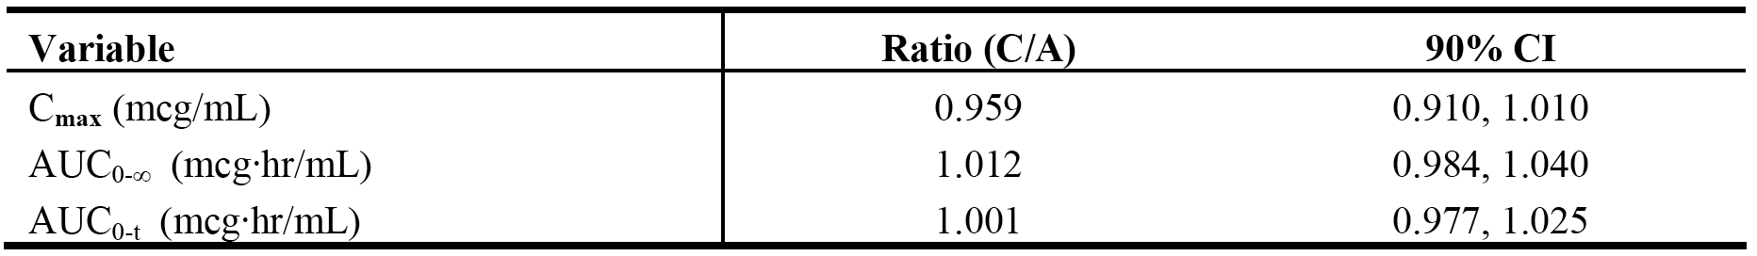

The armodafinil PK parameters for the three 250 mg tablet treatments are summarised.

The log plasma armodafinil concentration vs time profiles for the three 250 mg tablet treatments are provided along with the corresponding profiles for armodafinil acid and modafinil sulfone.

*Comment: The study showed that Treatment B (250 mg tablet test) was bioequivalent to Treatment A (250 mg tablet reference), and Treatment C (250 mg tablet reference) was bioequivalent to Treatment A (250 mg tablet reference). The 90% CIs for the Cmax and AUCinf primary comparisons for armodafinil for Treatments B and A and for Treatments B and C met the criteria for bioequivalence (i.e., within the interval 0.80 to 1.25). The PK parameters for armodafinil were similar for the three 250 mg tablet treatments, and the mean log plasma armodafinil concentration vs time profiles were virtually superimposable for the three treatments. The PK parameters of the metabolite armodafinil acid were similar for the three treatments, as were the PK profiles of the metabolite modafinil sulfone. The mean log plasma armodafinil acid concentration vs time profiles were virtually superimposable for the three treatments, as were the corresponding profiles for modafinil sulfone.*

###### Bioequivalence of different dosage forms and strengths

The sponsor is proposing registration of three tablet strengths (50 mg, 150 mg, and 250 mg). No clinical study investigating the bioavailability of the three dose strengths was submitted. No formal justification for not submitting such a study could be identified in the submitted data package.

###### Influence of food

Study 101

The influence of food on the pharmacokinetics of armodafinil was evaluated as part of a single-centre (UK), randomised, double-blind, placebo-controlled, parallel-group, single-dose escalating study in healthy young men (study 101). In a cross-over design, the 6 subjects in the 100 mg dose group received armodafinil (2 x 50 mg capsules) in the fasted state followed approximately 12 days later in the fed state (standard fatty meal, breakfast). Blood samples for PK analysis were collected before and for up to 96 hours after study drug administration. The PK characteristics of armodafinil in the fed and fasted state are summarised below.

Table 5: Study 101 - PK parameters (mean ± SD) of armodafinil in healthy males (n=6) following single oral 100 mg dose of armodafinil in the fasted and fed state.

|  |  |  |  |  |  |  |
| --- | --- | --- | --- | --- | --- | --- |
| Dose | Cmax (µg/mL) | tmax a (h) | AUCinf (µg•hr/mL) | CL/F (mL/min) | V/F (L) | t1/2 b (h) |
| Fasted 100 mg | 2.44 ± 0.38 | 2.3 [0.5-4.0] | 40.6 ± 7.4 | 42.4 ± 8.7 | 42.0 ± 3.0 | 11.5 |
| Fed 100 mg | 2.17 ± 0.09 | 6.0 [3.0-6.0] | 43.8 ± 8.2 | 39.2 ± 7.2 | 40.3 ± 3.7 | 11.9 |

Notes: a = median [range]; b = harmonic mean.

Figure 4: Study 101 - Mean plasma concentration vs time profiles of armodafinil in healthy males (n = 6) following a single oral 100 mg dose of modafinil administered in the fasted and fed state.

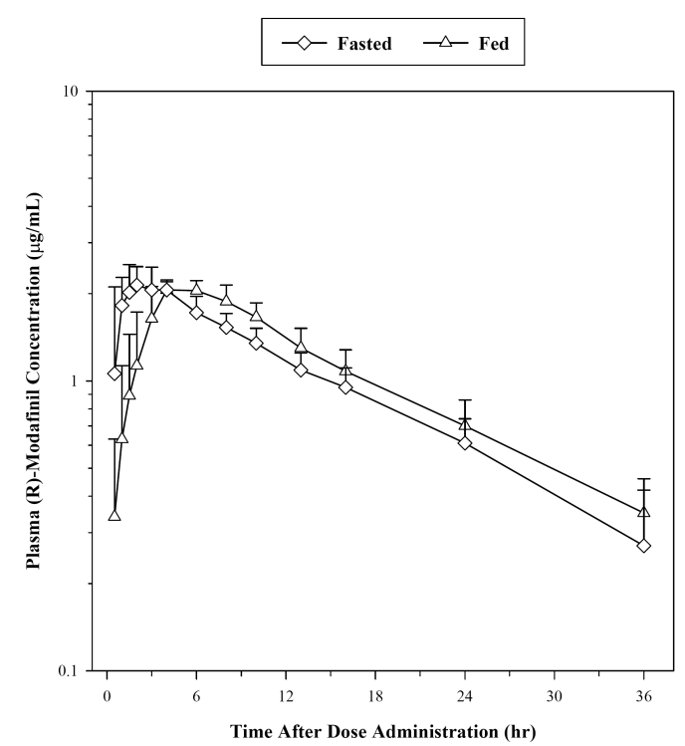

*Comment: The armodafinil dose tested was not the highest dose being proposed for registration (i.e., 250 mg tablet strength). In addition, the 100 mg dose of armodafinil administered in this study consisted of 2 x 50 mg proto-type capsules (i.e., not the tablet formulation proposed for registration). Furthermore, it is noted that the relevant TGA adopted EU guidelines relating to the investigation of bioequivalence states that the number of evaluable subjects in bioequivalence studies should be not less than 12 (CPMP/EWP/QWP.1401/98/Rev.1/Corr**). However, the food effect part of this study included only 6 healthy young men. No comparison between fasted and fed administration using standard bioequivalence methods was provided (i.e., Cmax and AUCinf ratios with 90% CIs). The most notable effect of administration with food was a longer median Tmax in the fed compared to the fasted state (6.0 vs 2.3 hours). The mean Cmax was approximately 11% lower in the fed compared to the fasted state and the mean AUC(0-inf) was approximately 8% higher in the fed compared to the fasted state. The other PK parameters (CL/F, VF, and t1/2) were similar in the fed and fasted states. The plasma concentration vs time profiles showed that plasma armodafinil concentrations from approximately 6 hours through 36 hours were higher in the fed than in the fasted state. However, the difference in plasma concentration from 6 through 36 hours is unlikely to result in clinically meaningful differences. Overall, the study suggests that administration of armodafinil with food might delay its onset of action (i.e., delays Tmax). The PI has no specific instructions relating to administration of armodafinil with or without food.*

###### Dose proportionality

The pharmacokinetics of armodafinil were essentially linear over the dose range 50 mg to 400 mg, based on the Cmax and AUC values from study 102. The results for study 102 are reviewed below.

###### Bioavailability - multiple dosing

Study 102

Study was a Phase I, single-centre (UK), randomised, double-blind, placebo-controlled, parallel-group study conducted in 49 healthy young men. The primary study objective was to determine the PK profile of ascending multiple oral doses of armodafinil. Each subject was randomised to receive 1 of 5 armodafinil doses studied sequentially (50, 100, 200, 300, or 400 mg) or matching placebo capsules once daily in the fasted state for 14 days. The armodafinil:placebo ratio was 6:2 subjects per dosage group, except for a 7:2 ratio in the 50 mg group. Subjects in the 400 mg dose group were discontinued on day 7 due to poor tolerability to this dose, with all subjects reporting AEs and 2 discontinuing due to AEs; 1 with multiple events including headache, abdominal pain, pharyngitis, hypertonia, vasodilatation, nausea, insomnia, anorexia, conjunctivitis, anxiety, emotional lability, confusion, asthenia, and 1 with mild nausea and moderate amblyopia of the right eye.

The maximum tolerated dose (MTD) of armodafinil was determined to be 300 mg per day, and the protocol was amended to add an intermediate dose of 250 mg per day for 6 additional subjects. PK profiling of armodafinil and its 2 major circulating metabolites (R-armodafinil acid and modafinil sulfone) were undertaken over 24 hours following treatment on days 1 and 7, and over 96 hours following treatment on day 14. The PK results are summarised. The plasma log-concentration vs time profiles at days 7 and 14 are also summarised.

Table 6: Study 102 - Armodafinil mean ± SD PK parameters in healthy young men on the days 1, 7, and 14 following oral administration of armodafinil for up to 14 consecutive days.

|  |
| --- |
| Day 1 |
| Table 6: Study 102 - Armodafinil mean ± SD PK parameters in healthy young men on the days 1, 7, and 14 following oral administration of armodafinil for up to 14 consecutive days. |
| **Day 7** |
| Table 6 (continued): Study 102 - Armodafinil mean ± SD PK parameters in healthy young men on the days 1, 7, and 14 following oral administration of armodafinil for up to 14 consecutive days. |
| **Day 14** |
| Table 6 (continued): Study 102 - Armodafinil mean ± SD PK parameters in healthy young men on the days 1, 7, and 14 following oral administration of armodafinil for up to 14 consecutive days. |

Note: Tmax = median [range]; t1/2 = harmonic mean [range]; patients receiving the 400 mg dose were discontinued on day 7 for safety reasons.

The PK results following multiple oral dosing of armodafinil for the metabolites R-modafinil acid and modafinil sulfone are summarised.

*Comment: The pharmacokinetics of armodafinil were essentially linear over the dose range 50 mg to 400 mg, based on the Cmax and AUC values following single and multiple doses. Apparent oral clearance values were similar on days 7 and 14 and were marginally lower than the corresponding values on day 1, while the half-life values were generally longer on day 14 compared to Day 1. Tmax values were consistent following single and multiple dosing. The mean accumulation factor (R), based on AUC values, was approximately 1.5 to 2.0 on days 7 and 14 for each of the doses tested. Trough (pre-dose) armodafinil concentrations were provided for each dose on days 5, 6, 7, 8, 12, 13, 14, and 15, and examination of the data showed that steady state appeared to be reached by about 7 days.*

*Detectable levels of R-modafinil acid and modafinil sulfone were observed in the plasma of subjects treated with armodafinil at multiple doses greater than or equal to 100 mg. The concentrations of both metabolites were lower than those observed for the parent compound. The concentrations of the two metabolites were generally dose-related over the dose range evaluated, and were higher after multiple doses than after a single dose. This was particularly true of modafinil sulfone for which the mean Cmax and AUC values on day 14 were approximately 10-fold higher than those on day 1. The sponsor comments that this result was "unsurprising", based on the half-life of approximately 30 to 40 hours estimated for modafinil sulfone and the dosing interval of 24 hours. The apparent terminal half-life of R-modafinil acid was similar to that obtained for armodafinil (approximately 15 to 20 hours), leading the sponsor to suggest that elimination of R-modafinil acid may be formation rate limited.*

##### Distribution

###### Volume of distribution

* The mean ± SD apparent volume of distribution (V/F) of armodafinil following a single-dose (normalized to 50 mg) was 42.4 ± 12.54 L, based on pooled data from healthy subjects (n=93) from studies 1023, 101, and 102. Following multiple dosing of armodafinil (normalized to 50 mg), the mean ± SD V/F was 47.4 ± 8.66 L on day 14 in 30 healthy subjects (study 102). Based on a body weight of 70 kg, the V/F is estimated to be approximately 0.6 L/kg. The V/F values indicate that armodafinil is well distributed to the extravascular tissues following oral administration, given that the total volume of body water of a 70 kg man is approximately 42 L.
* There were no data on plasma protein binding, erythrocyte distribution or tissue distribution (human) of armodafinil.

##### Metabolism

* The metabolic pathways of armodafinil have not been specifically characterized in clinical studies, but R-modafinil acid and modafinil sulfone have been consistently identified as metabolites of armodafinil in the PK studies. There was no clinical mass balance and metabolism study submitted for armodafinil. The sponsor comments that results of a clinical mass balance and metabolism study of racemic modafinil suggest that the drug is nearly exclusively metabolized in the liver, with less than 10% of the parent compound excreted in the urine.
* The sponsor reports that in vitro and in vivo data show that R-modafinil and S-modafinil undergo qualitatively similar metabolic transformations (i.e., hydrolytic deamidation, S-oxidation, and aromatic ring hydroxylation, with subsequent glucuronide conjugation of the hydroxylated products). The sponsor states that amide hydrolysis is the single most prominent metabolic pathway (to R-modafinil acid), with sulfone formation by CYP3A4/5 (into modafinil sulfone) being next in importance. The sponsor comments that other oxidative products are formed too slowly in vitro to enable identification of the enzyme(s) responsible.
* R-modafinil acid represents approximately 11% and 7% of parent drug exposure (based on AUC values), respectively, following single- and multiple-dose administration of armodafinil. There is relatively little accumulation of R-modafinil acid following multiple-dose modafinil. Modafinil sulfone represents approximately 33% and 56% of parent drug exposure (based on AUC values), respectively, following single- and multiple-dose administration of armodafinil. The data indicates that modafinil sulfone accumulates following multiple-dose armodafinil.
* The sponsor reports that studies with inhibitors and inducers of oxidative metabolic enzymes in rats and dogs suggest that one or more CYP450 enzymes are involved in the oxidative metabolism of modafinil. The sponsor states that in vitro data suggests that armodafinil has the potential to induce CYP3A. However, following multiple dosing of armodafinil for up to 14 days, there was no indication of auto-induction (i.e., Rss = 1.2). In addition, trough plasma concentration data obtained following multiple-dose administration of armodafinil for up to 12 weeks in the pivotal Phase III studies showed no sign of auto-induction (studies 3020, 3021, 3025).
* The mean ± SD apparent clearance (CL/F) of armodafinil following single-dose armodafinil (normalized to 50 mg) was 38.6 ± 9.86 mL/min, based on pooled data from healthy subjects (n = 93) (studies 1023, 101, 102). Following multiple dosing of armodafinil (normalized to 50 mg), the mean ± SD CL/F was 32.4 ± 8.72 mL/min on day 7 (n= 34) and 32.7 ± 5.16 mL/min on day 14 (n = 30) (study 102).

##### Excretion

* There were no clinical data on the routes of excretion for armodafinil, nor were there clinical data on the renal clearance of the drug. The sponsor states that racemic modafinil is nearly exclusively metabolized in the liver, with less than 10% of an orally administered dose being excreted unchanged in the liver.
* The armodafinil plasma concentration vs time profiles for healthy subjects from the PK studies show an apparent monoexponential decline from peak plasma concentrations following single and multiple dose. Elimination is slow with a mean apparent terminal half-life of approximately 16 hours at steady-state. The mean apparent clearance at steady-state was estimated to be approximately 33 mL/min.

##### Intra- and inter-subject variability of pharmacokinetics

The inter-subject variability in PK parameters based on the coefficients of variation ranged from moderate to high depending on the individual parameters. There were no data on intra-subject variability in the PK parameters.

#### Pharmacokinetics in the target population

##### Study 1064 - Systemic exposure following armodafinil and modafinil in OSAHS

The submission included one Phase I, randomised, cross-over study designed to compare exposure following administration of multiple doses of armodafinil and racemic modafinil in patients with excessive sleepiness associated with OSAHS who were currently using continuous nasal positive airway pressure (nCPAP) therapy. In this study, patients were randomised to one of two treatment sequences (ABCD or BADC). The treatments were: A = single-dose of armodafinil 200 mg; B = single-dose of racemic modafinil 200 mg; C = multiple daily doses of armodafinil 200 mg (100 mg on days 1 and 2, 200 mg on days 3 through 10); D = multiple daily doses of racemic modafinil 200 mg (100 mg on days 1 and 3, 200 mg on days 3 through 10).

The study consisted of 4 administration periods:

* In Period 1, patients received a single-dose of armodafinil (treatment A) or racemic modafinil (treatment B). Blood was collected prior to treatment and at specified time-points through 72 hours after treatment.
* In Period 2, patients crossed-over and received a single-dose of the alternate regimen to that received in period 1 (i.e., A→B; B→A) following a 7-day washout. Blood was collected prior to treatment and at specified time-points through 72 hours after treatment.
* In Period 3, multiple-dose administration of armodafinil (treatment C) or racemic modafinil (treatment D) began immediately after the collection of the 72-hour sample in period 2. Blood sampled were collected prior to treatment on days 8, 9, and 10, and at specified time-points through 24 hours after treatment.
* In Period 4, patients crossed-over and received multiple-dose administration of the alternate regimen to that received in period 3 (i.e., C→D; D→C). Blood samples were collected prior to treatment on days 8, 9, and 10, and at specified time-points through 24 hours after treatment on day 10. There was an optional 7-day washout between periods 3 and 4. Administration period 4 could have begun immediately after collection of the 24 blood sample in period 3. Alternatively, patients could have been discharged from the clinical study centre following the 24 hour blood sample in period 3 and returned to the study centre for period 4 within 7 days.

The primary PK parameters were the AUC(0-τ) and Cmax of armodafinil and modafinil following administration of multiple doses; the dosing interval (τ) was approximately 24 hours. The primary PK parameters were to be determined, if possible, from plasma concentrations obtained prior to and following the final dose of the 10-day multiple-dose administration period (3 and 4). The hypothesis was that the mean values of the two parameters for the treatments would be equal, and the alternate hypothesis was that the mean values of the two parameters for the two treatments would not be equal. Testing used an ANOVA model with treatment and period as factors and significance level of 0.05. A 95% CI for the geometric mean ratio between the 2 treatments was constructed. The results for the primary analysis are summarised and the plasma concentration vs time profiles for the two multiple-dose treatments are provided.

Table 7: Study 1064 - Geometric mean comparison of exposure between armodafinil 200 mg/day and racemic modafinil 200 mg/day; PK analysis set.

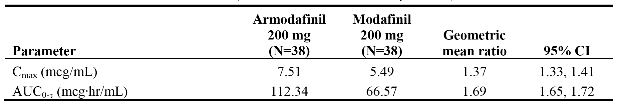

The median tmax was the same for both treatments following multiple-dose administration (2 hours, with a range of 1 to 4 hours). The mean ± SD steady-state accumulation ratio (Rss = AUC(0-τ) multiple-dose / AUCinf single dose) was similar for armodafinil and racemic modafinil, and both values were approximately equal to unity indicating time-independent pharmacokinetics for both drugs (1.1 ± 0.12 and 1.0 ± 0.11, respectively).

The PK parameters for both treatments following single 200 mg dose are summarised below in Table 9. The mean armodafinil Cmax was approximately 12% higher than the mean racemic modafinil Cmax, while mean armodafinil AUCinf was approximately 64% higher than the mean racemic modafinil AUCinf.

Table 8: Study 1064 - Mean ± SD PK parameters following single-dose (200 mg) administration; PK analysis set.

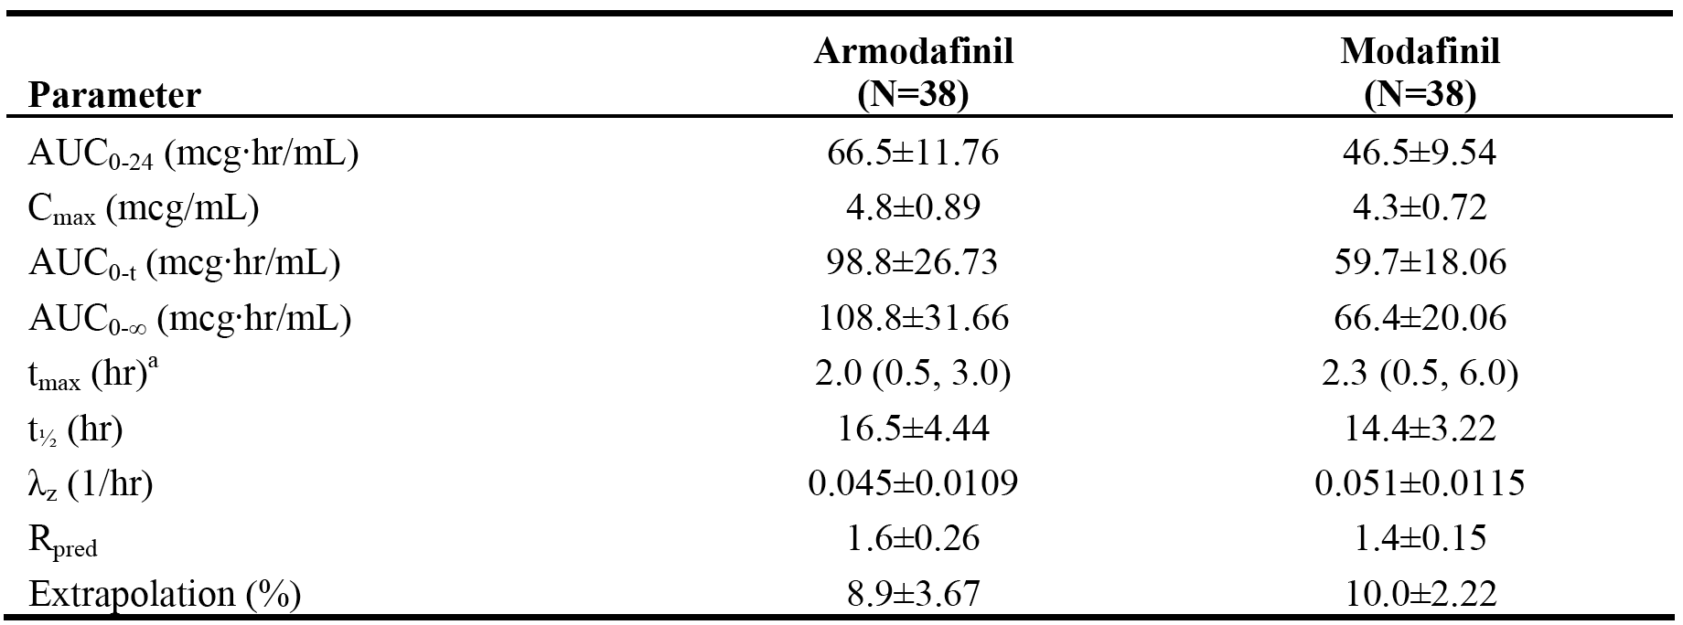

Notes: Extrapolation (%) = [AUCinf - AUC(0-t)/AUCinf] x 100; Rpred = predicted accumulation ratio calculated as AUCinf/AUC(0-24h).

*Comment: Exposure to armodafinil following multiple-dose armodafinil (200 mg/day) was significantly greater than exposure to racemic modafinil following multiple-dose modafinil (200 mg/day), based on the geometric mean values for both AUC(0-τ) and Cmax. The geometric mean Cmax was 37% higher for armodafinil than for racemic modafinil and the AUC(0-τ) was 69% higher. The plasma-concentration time profile of armodafinil was higher than the plasma-concentration time profile of racemic modafinil at all time points, and separation between the two profiles increased from 4 to 6 hours onwards. The sponsor notes that, given the differences in the plasma concentration vs time profiles of armodafinil and racemic modafinil, equivalent exposures cannot be achieved through simple dose adjustment. For example, if doses were selected to achieve comparable Cmax values, armodafinil concentrations would be higher at later time points than those for racemic modafinil. Likewise, if doses were selected to achieve comparable exposure later in the profile, the maximum plasma concentration of racemic modafinil would be higher than that for armodafinil.*

##### Armodafinil trough plasma concentrations - studies 3020, 3021, and 3205

Trough plasma concentrations of R-modafinil were determined in three, 12-week, Phase III efficacy and safety studies of armodafinil (3020, 3021, and 3025). In these studies, blood samples for trough plasma concentrations of armodafinil, R-modafinil acid, and modafinil sulfone were obtained at the baseline visit, and before study drug administration at weeks 4, 8, and 12. The assessments of plasma trough concentrations were stated by the sponsor to have been performed primarily to assess study treatment compliance. The trough plasma concentrations for armodafinil, R-armodafinil acid, and modafinil sulfone reported in the three studies in all patients with data at any of the three time points are summarised below.

Table 9: Armodafinil - mean ± SD trough plasma concentrations (µg/mL) from three Phase III clinical efficacy and safety studies.

|  |  |  |  |  |
| --- | --- | --- | --- | --- |
|  | All patients with data | Week 4 | Week 8 | Week 12 |
| 3020 | 150 mg/day | 1.71 ± 0.95 (n=54) | 1.48 ± 0.79 (n=48) | 1.46 ± 0.82 (n=39) |
|  | 250 mg/day | 2.79 ± 1.70 (n=58) | 2.99 ± 1.87 (n=54) | 2.83 ± 1.60 (n=48) |
| 3021 | 150 mg/day | 2.09 ± 1.26 (n=122) | 1.85 ± 0.79 (n=115) | 1.82 ± 0.74 (n=109) |
|  | 250 mg/day | 3.23 ± 1.36 (n=116) | 2.83 ± 1.29 (n=108) | 2.70 ± 1.27 (n=106) |
| 3025 | 150 mg/day | 2.11 ± 1.05 (n=116) | 2.14 ± 1.09 (n=116) | 1.92 ± 1.04 (n=109) |

Table 10: R-armodafinil acid - mean ± SD trough plasma concentrations (µg/mL) from three Phase III clinical efficacy and safety studies.

|  |  |  |  |  |
| --- | --- | --- | --- | --- |
|  | All patients with data | Week 4 | Week 8 | Week 12 |
| 3020 | 150 mg/day | 0.21 ± 0.13 (n=54) | 0.21 ± 0.16 (n=48) | 0.21 ± 0.12 (n=39) |
|  | 250 mg/day | 0.35 ± 0.23 (n=58) | 0.34 ± 0.20 (n=54) | 0.35 ± 0.20 (n=48) |
| 3021 | 150 mg/day | 0.21 ± 0.17 (n=122) | BLQ (< 20 µg/mL) (n=115) | 0.21 ± 0.18 (n=109) |
|  | 250 mg/day | 0.47 ± 0.21 (n=116) | 0.42 ± 0.20 (n=108) | 0.41 ± 0.22 (n=106) |
| 3025 | 150 mg/day | 0.29 ± 0.30 (n=116) | 0.35 ± 0.45 (n=116) | 0.25 ± 0.28 (n=109) |

Table 11: Modafinil sulfone - mean ± SD trough plasma concentrations (µg/mL) from three Phase III clinical efficacy and safety studies.

|  |  |  |  |  |
| --- | --- | --- | --- | --- |
|  | All patients with data | Week 4 | Week 8 | Week 12 |
| 3020 | 150 mg/day | 0.75 ± 0.50 (n=54) | 0.75 ± 0.67 (n=48) | 0.67 ± 0.59 (n=39) |
|  | 250 mg/day | 2.42 ± 2.06 (n=58) | 2.20 ± 1.94 (n=54) | 1.95 ± 1.42 (n=48) |
| 3021 | 150 mg/day | 0.88 ± 1.27 (n=122) | 0.87 ± 1.25 (n=115) | 0.77 ± 1.03 (n=109) |
|  | 250 mg/day | 1.41 ± 0.85 (n=116) | 1.22 ± 0.73 (n=108) | 1.15 ± 0.65 (n=106) |
| 3025 | 150 mg/day | 1.04 ± 1.60 (n=116) | 0.93 ± 1.47 (n=116) | 0.83 ± 0.82 (n=109) |

*Comment: There were no consistent changes observed for R-armodafinil or for R-armodafinil acid mean plasma trough concentrations from Week 4 through to Week 12, but there was a consistent decrease in modafinil sulfone mean trough concentrations from week 4 through to week 12. The intersubject variability in trough plasma concentrations generally ranged from moderate to high (i.e., coefficients of variation ranging from 50% to 100%).*

#### Pharmacokinetics in other special populations

##### Pharmacokinetics in subjects with hepatic impairment

The sponsor states that no studies investigating the effects of hepatic impairment on the pharmacokinetics of armodafinil have been conducted. The sponsor submitted a justification for not submitting such a study (Summary of Clinical Pharmacology). This justification is considered to be acceptable.

*Comment: The Modavigil PI states that the dose should be reduced by half in patients with severe hepatic impairment. Based on the similarity of the pharmacokinetics of R-modafinil following administration of armodafinil and racemic modafinil, and the predominance of the R-enantiomer compared to the S-enantiomer following administration of racemic modafinil, it can be reasonably inferred that hepatic impairment will affect the pharmacokinetics of armodafinil in a similar manner to racemic modafinil. The Nuvigil PI proposes that the dose should be reduced in patients with severe hepatic impairment, but provides no specific guidance on the actual amount of dose reduction. It is considered that the Precautions and the Dosage and Administration sections of the PI should specify that the dose of armodafinil be reduced by half in patients with severe hepatic impairment.*

##### Pharmacokinetics in subjects with renal impairment

The sponsor states that no studies investigating the effects of renal impairment on the pharmacokinetics of armodafinil have been conducted. The sponsor submitted a justification for not submitting such a study (Summary of Clinical Pharmacology). This justification is considered to be acceptable.

*Comment: The sponsor notes that modafinil is almost exclusively metabolized in the liver with less than 10% of the administered dose being excreted unchanged in the urine. The Modavigil PI states that severe chronic renal failure (creatinine clearance ≤ 20 mL/min) did not significantly affect the pharmacokinetics of modafinil following a single 200 mg dose, but exposure to modafinil acid (an inactive metabolite) was increased 9-fold. Based on the similarity of the pharmacokinetics of R-modafinil following administration of armodafinil and racemic modafinil, and the predominance of the R-enantiomer compared to the S-enantiomer following administration of racemic modafinil, it can be reasonably inferred that renal impairment will affect the pharmacokinetics of armodafinil in a similar manner to racemic modafinil. The sponsor considered that the outcomes observed in patients with severe chronic renal failure conducted with modafinil can be extrapolated to armodafinil.*

##### Pharmacokinetics according to age

###### Study 1051

The effects of age on the pharmacokinetics of armodafinil were investigated in one, Phase I, open-label, multiple-dose, parallel-group study in healthy male subjects. The primary objective of the study was to evaluate the effect of age on systemic exposure to armodafinil and its two metabolites (R-modafinil acid and modafinil sulfone) using Cmax and AUC(0-τ) values. The affect of age (18-45 years vs ≥ 65 years) on the PK parameters was analysed using a 2-sample t-test on the log-transformed values, and 95% CIs were provided for the ratio of the geometric means of Cmax and AUC(0-τ) for the two age groups of interest. Secondary objectives were comparison of the pharmacokinetics of armodafinil and its two metabolites in the two age groups and assessment of the safety and tolerability of armodafinil. Subjects received armodafinil 50 mg (1 x 50 mg tablet) on day 1, 100 mg (2 x 50 mg tablets) on day 2, and 150 mg (3 x 50 mg tablets) on days 3 through 7. On the evenings of days 4 and 5, subjects were required to fast overnight until after administration of armodafinil on the following day. On the evening of day 6, subjects were required to fast overnight and until at least 4 hours after administration of armodafinil on the following day. On day 7, blood samples were collected through 72 hours after administration of armodafinil for PK analysis (days 7 through 10). Trough plasma concentrations were also determined on Days 5 and 6 in order to ensure that steady state for armodafinil was achieved prior to administration on Day 7.

The geometric mean Cmax was 15% higher in the older age group (≥ 65 years) compared to the younger age group (18-45 years) (ratio = 1.15 [95% CI: 1.08, 1.24], p=0.0002), and the geometric mean AUC(0-τ) was 14% higher in the older compared to the younger age group (ratio = 1.14 [95%: CI 1.03, 1.25], p=0.0086). The mean apparent clearance was approximately 12% lower in the older age group (≥ 65 years) compared to the younger age group (18-45 years), while the terminal half-life was approximately 2 hours longer in the older compared to the younger age group. The PK results for subjects aged 18-45 years and ≥ 65 years are summarised below and the plasma concentration vs time profiles for the two age groups are provided.

Table 12: Study 1051 - Mean (SD) values for plasma pharmacokinetic parameters of armodafinil in healthy subjects by age group; PK analysis set.

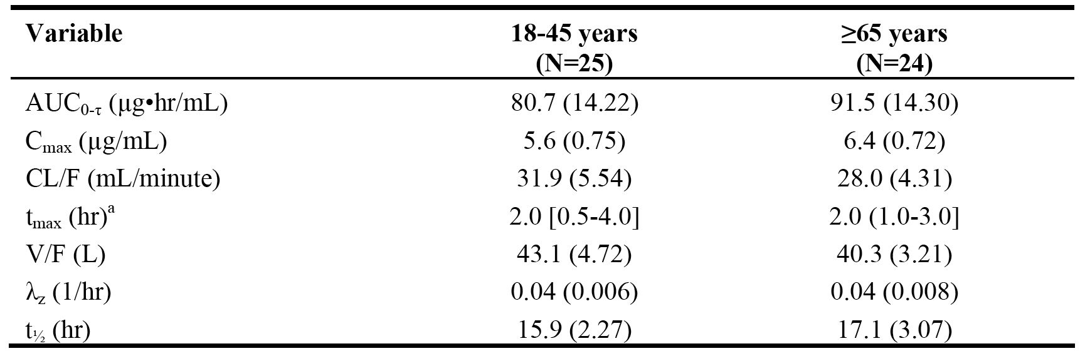

PK data were also presented for a small number of patients aged ≥ 75 years (n = 7). Comparison of the three subgroups 18 - 45 years, 65 - 74 years and ≥ 75 years showed that plasma concentrations of armodafinil increased with increasing age.

Table 13: Study 1051 - Mean (SD) values for plasma pharmacokinetic parameters of armodafinil in healthy subjects by age group; PK analysis set.

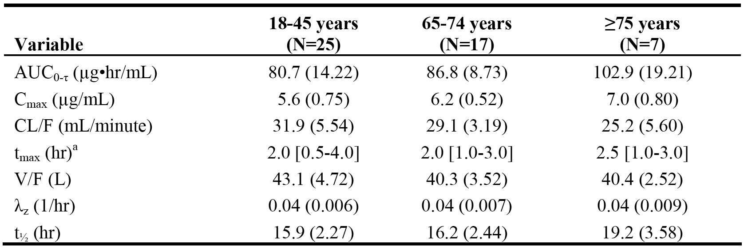

Compared to the youngest age group (18 - 45 years), mean Cmax values were approximately 11% and 25% higher in the 65 - 74 year group and ≥ 75 years group, respectively, and the mean AUC(0-τ) values for the two older age groups were approximately 8% and 28% higher, respectively, compared to the youngest age group. Compared to the youngest age group (18 - 45 years), the mean apparent clearance was approximately 9% and 21% lower in the 65 - 74 years group and ≥ 75 years group, respectively.

The study also reported the results for the metabolites R-modafinil acid and modafinil sulfone. The geometric mean Cmax for R-modafinil acid was 61% higher in the older age group (≥ 65 years) compared to the younger age group (18 - 45 years), and the geometric mean AUC(0-τ) for R-modafinil was 73% higher in the older compared to the younger age group. The geometric mean Cmax for modafinil sulfone was 16% lower in the older age group (≥ 65 years) compared to the younger age group (18 - 45 years), and the geometric mean AUC(0-τ) for modafinil sulfone was 15% lower in the older compared to the younger age group.

The sponsor comments that the lower plasma levels of modafinil sulfone in elderly subjects is suggestive of a reduction in CYP3A4 mediated metabolism of armodafinil and is consistent with the observed increase in armodafinil exposure in these subjects. The sponsor also comments that the increased plasma concentrations of R-modafinil acid in the elderly subjects compared to younger subjects was somewhat unexpected and postulated that it may be due to a decrease in the activities of the enzymes involved in the subsequent (downstream) metabolism of R-modafinil acid.

*Comment: The steady state plasma concentration vs time profiles for armodafinil were virtually superimposable for subjects aged 18 - 45 years and subjects aged ≥ 65 years. However, based on both Cmax and AUC(0-τ) values, exposure to armodafinil increased with age with the most marked increase being observed in subjects aged ≥ 75 years. Based on the results of this study, consideration should be given to reducing the dose of armodafinil in patients aged ≥ 65 years, particularly in patients aged ≥ 75 years. There were no PK studies with armodafinil in children and adolescents aged < 18 years of age. The Modavigil PI states that the pharmacokinetics of modafinil have not been studies in children.*

##### Other special populations

No studies were conducted assessing the effects of sex or race on the pharmacokinetics of armodafinil. The Modavigil PI indicates that the pharmacokinetics of racemic modafinil were not affected by gender, while the influence of race on the pharmacokinetics of racemic modafinil have not been studied.

#### Pharmacokinetic interactions

##### Study 1025 - investigation of the effect of armodafinil on CYP1A2 induction

The potential for armodafinil to induce CYP1A2 activity was evaluated in a Phase I, single-centre (USA), open-label, non-randomised study in 29 healthy men and women (study 1025). The primary objective of the study was to evaluate the effect of armodafinil on CYP1A2 activity in healthy subjects. The secondary objectives were to assess the pharmacokinetics of armodafinil and its two metabolites (R-armodafinil acid and modafinil sulfone), and caffeine and its metabolite (paraxanthine), and to assess the safety and tolerability of armodafinil.

After a screening period, all eligible subjects were given a fasting oral dose of caffeine 200 mg on Day 1, followed 48 hours later (Day 3) by armodafinil 100 mg (2 x 50 mg tablets) QD titrated upwards in 50 mg increments every 2 days until 250 mg (5 x 250 mg tablets) was reached (Day 9), followed by 250 mg QD through Day 32. On Day 31, fasting treatment with oral caffeine 200 mg was co-administered with armodafinil 250 mg. On Day 1 and 31, blood samples were collected pre-treatment and then for 48 hours after administration for PK analyses of caffeine and paraxanthine. In addition, blood samples were collected for armodafinil trough plasma concentrations on Days 28 through 30. The results for the primary PK parameters of caffeine with and without co-administered armodafinil are summarised below in Table 15.

Table 14: Study 1025 - Mean ± SD primary PK parameters of caffeine in healthy subjects; PK analysis set.

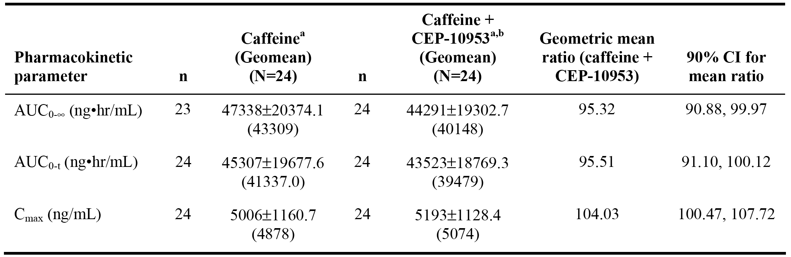

Note: a = mean ± SD; b = following repeated administration of armodafinil.

The data for the secondary PK parameters of caffeine have been examined. No clinically significant differences were observed between the secondary PK parameters of caffeine following administration of caffeine alone and co-administration of caffeine with armodafinil. The data for the secondary PK parameters of paraxanthine have been examined. Following co-administration of caffeine and armodafinil, systemic exposure to paraxanthine was reduced compared to caffeine alone (i.e., AUCinf reduced by approximately 20% and Cmax reduced by approximately 15%). The median Tmax for paraxanthine was also reduced from 9 hours to 6 hours following co-administration of caffeine and armodafinil compared to caffeine alone, while terminal half-life values remained relatively constant at 6.8 and 6.4 hours, respectively.

Armodafinil mean trough plasma concentrations were similar at Days 28, 29 and 30 (2.7, 2.8, and 2.6 µg/mL, respectively), indicating that armodafinil was at steady-state when co-administered with caffeine on Day 31. The steady state PK profiles of armodafinil, R-modafinil and modafinil sulfone when armodafinil was co-administered with caffeine on Day 31 were generally consistent with the known PK profiles of the three products.

*Comment: In vitro, R-modafinil has been reported to be a marginally more potent inducer of CYP1A2 activity in primary cultures of human hepatocytes than S-modafinil or racemic modafinil. The results of study 1025 indicate that armodafinil is not an inducer of CYP1A2 in humans. The 90% CIs for the geometric ratios of AUCinf and Cmax were within the pre-specified "no interaction" margin of 80% to 120%. Co-administration of caffeine and armodafinil reduced systemic exposure to paraxanthine compared to caffeine administered alone, while the terminal half-life was relatively unaffected. The reason for reduction in paraxanthine exposure following co-administration is unknown, but is not indicative of CYP1A2 induction. This conclusion is supported by the observation that co-administration of caffeine and armodafinil did not alter the median paraxanthine/caffeine ratio 3 hours post-dose compared to caffeine when administered alone (4.2 [range: 1.9, 9.6] and 4.0 [range: 2.0, 9.7]), respectively.*

##### Study 1021 - investigation of the effect of armodafinil on inhibition of CYP2C19

In vitro data are reported to show that racemic modafinil is an inhibitor of CYP2C19 activity. Consequently, study 1021, a Phase I, single-centre (USA), 2-way, cross-over, single-dose study was designed to assess the effect of armodafinil on the pharmacokinetics of omeprazole, a CYP2C19 probe substrate. It was planned that 24 healthy men and women would be enrolled, with a minimum of 18 subjects completing the study. After screening, eligible subjects were randomised 1:1 to single-dose omeprazole 40 mg (Treatment A) or single-dose armodafinil 400 mg (8 x 50 mg tablets) followed 2 hours later by single-dose omeprazole 40 mg (Treatment B). After a 7-day washout, subjects received the alternate treatment. Plasma PK data for omeprazole and its 5'-hydroxy metabolite were collected for 24 hours after administration of treatment A and B on days 1 and 8, respectively, and plasma PK data for armodafinil were collected for 24 hours after administration of treatment B on day 8. The PK analysis set included all 24 enrolled subjects (16 males, 8 females), and all subjects were extensive CYP2C19 extensive metabolisers.

The primary PK parameters were the AUCinf, AUC(0-t) and Cmax for omeprazole. The geometric mean ratio (treatment B to treatment A) with 90% CI was calculated for each primary PK parameter using standard methods. If the 90% CIs were enclosed within the limits of 0.80 to 1.25, then this was taken as evidence of no PK interaction between armodafinil and omeprazole. The results for the primary parameters are summarised below.

Table 15: Study 1021 - Mean ± SD primary PK parameters of omeprazole in healthy subjects; PK analysis set

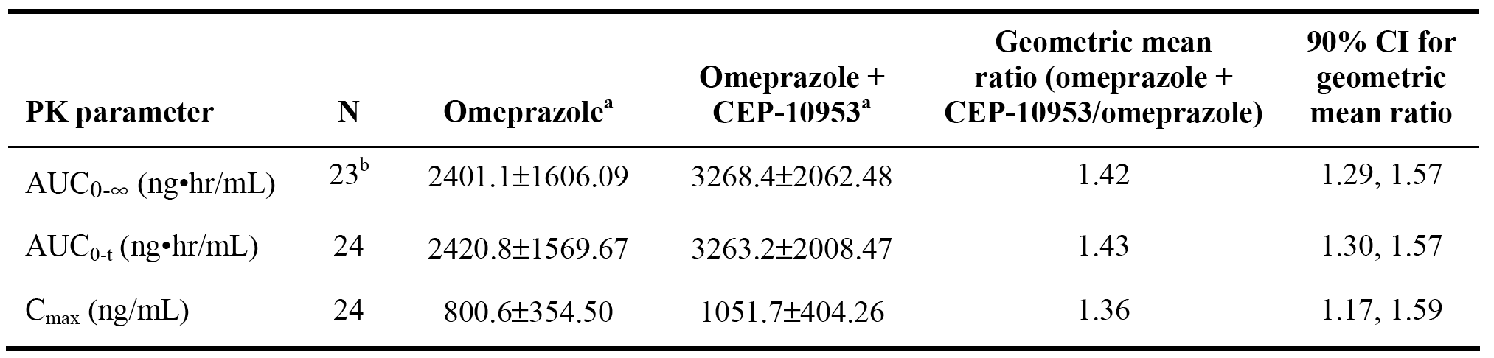

Note: a = mean ± SD; b = the elimination rate for 1 subject could not be calculated for omeprazole alone

Examination of the PK results for 5'-hydroxyomeprazole showed that the mean AUCinf decreased by approximately 6% with treatment B compared to treatment A (1134 and 1208 ng•hr/mL, respectively), and the mean Cmax decreased by approximately 15% with treatment B compared to treatment A (311 and 366 ng/mL, respectively). The median tmax values for the metabolite remained constant for both treatments (1.5 hours) as did the mean t1/2 (2 hours). The mean parent/metabolite ratio, assessed by the AUC(0-8h), was 42% greater following treatment B compared to treatment A (3.0 vs 2.1, respectively).

Examination of the secondary PK parameters for omeprazole showed that the median Tmax remained at 1.5 hours following co-administration, while the mean apparent volume of distribution decreased (54.8 → 39.0 L) as did the apparent clearance rate (26.4 → 16.7 L/hr). The mean terminal half-life for omeprazole remained relatively constant irrespective of whether the drug was administered alone or with armodafinil (1.7 and 1.9 hours, respectively).

*Comment: Systemic exposure to omeprazole increased significantly when the drug was co-administered with armodafinil. The 90% CIs for each of the primary PK parameters for omeprazole were not enclosed within the pre-specified "no interaction" margin of 0.80 to 1.25. In addition, the omeprazole to 5'hydroxyomeprazole ratio was increased by 42% following co-administration with omeprazole. Overall, the results indicate that armodafinil is a clinically significant inhibitor of CYP2C19.*

##### Study 1022 - investigation of the effect of armodafinil on CYP3A4 induction

Racemic modafinil has been demonstrated to induce CYP3A4 activity in humans in vivo after repeated daily administration of 400 mg. The induction appeared to be primarily intestinal in nature, but the design of the DDI study investigating the effect of racemic modafinil on CYP3A4 activity could not clearly differentiate between intestinal and hepatic enzyme activity.

Study 1022, a single-centre (USA), Phase I, open-label, non-randomised study in healthy subjects of both sexes, was designed to assess the effect of armodafinil on intestinal and hepatic CYP3A4 activity using the probe substrate midazolam administered by both the iv and oral route. PK profiling after both iv and oral administration in each subject allowed assessment of the relative effects on CYP3A4 activity at the two metabolic sites (i.e., intestinal and hepatic).

The primary objective of the study was to evaluate the effect of armodafinil on CYP3A4 activity following iv and oral administration before and after 4 weeks of armodafinil administration. The secondary objectives were to assess the relative contributions of intestinal and hepatic CYP3A4 induction to the interaction between midazolam and armodafinil, and to assess the safety of the administered treatments.

The study planned to enrol 30 healthy subjects in order to obtain 24 evaluable subjects. After screening, all eligible subjects received a single iv dose of midazolam 2 mg on day 1, followed by a single oral dose of midazolam 5 mg on day 4. Twenty-four (24) hours later on 5, all subjects received modafinil 100 mg (2 x 50 mg tablets) titrated in 50 mg increments every 2 days to reach 250 mg/day (5 x 50 mg tablets) on day 11 and continued at this dose through day 36. On days 33 and 36, treatment with iv and oral midazolam, respectively, was repeated as for days 1 and 4 and subjects continued armodafinil 250 mg/day.

Following treatment with iv and oral midazolam, blood samples for PK analyses of midazolam and its metabolite 1'-hydroxymidazolam were collected pre-treatment and for 24 hours following treatment. PK samples were also obtained on Day 33 and Day 36 for armodafinil and its metabolites (R-armodafinil acid and modafinil sulfone). In addition, blood samples for armodafinil trough plasma concentrations were collected on days 31 through 36. Subjects fasted overnight before each administration of midazolam.

The primary assessment of the effect of armodafinil on midazolam was the change in AUCinf, AUC(0-t) and Cmax of midazolam (separately for oral and iv administration) before and after repeated administration of armodafinil. The geometric mean ratios (with/without armodafinil) 90% CI were calculated for each primary PK parameter using standard methods. If the 90% CIs were enclosed within the limits of 0.80 to 1.25, then this was taken as evidence of no PK interaction between armodafinil and midazolam. The results for the primary parameters are summarised below.

Table 16: Study 1022 - Primary PK parameters of midazolam in healthy subjects; PK analysis set.

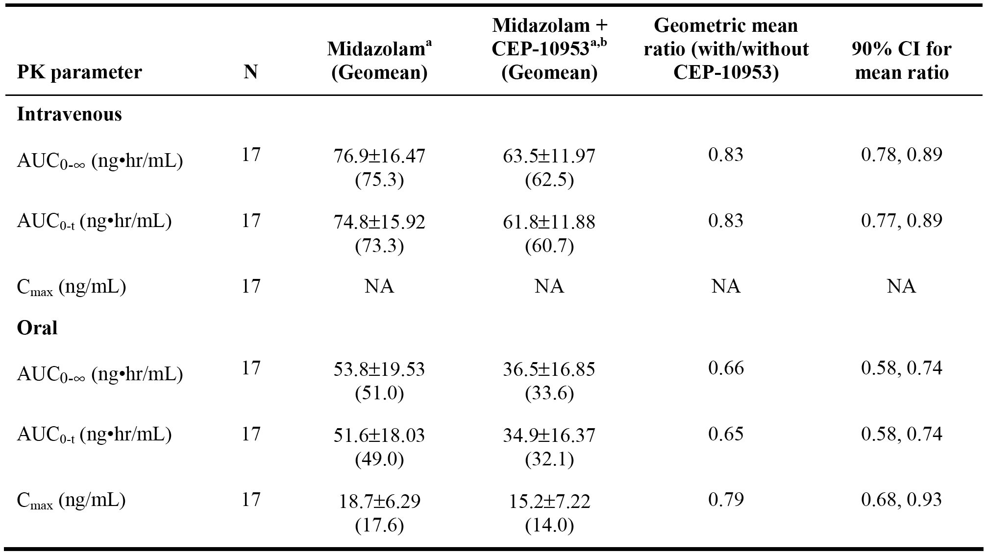

Notes: a = mean ± SD; b = following repeated administration of armodafinil.

*Comment: The results of this study showed that armodafinil is an inducer of both gastrointestinal and hepatic CYP3A4 activity. Pre-treatment with repeated administration of armodafinil resulted in 17% and 34% reductions in total systemic exposure to midazolam, following iv and oral administration of midazolam, respectively, based on the geometric means of the AUCinf. The larger decrease after the oral dose of midazolam is attributed to the effects of induction of both gastrointestinal and hepatic CYP3A, while the effects after an iv dose of midazolam reflect only hepatic induction. Consistent with armodafinil mediated induction of CYP3A activity, approximately 40% and 50% increases in systemic exposure to 1’-hydroxymidazolam were observed following iv and oral administration of midazolam, respectively, based on mean AUCinf values. The sponsor considers that armodafinil is a modest inducer of CYP3A4 activity compared to rifampicin (a potent inducer), which has been reported to reduce the AUC of oral midazolam by 96%.*

##### Study 1056 - effect of armodafinil on CYP3A4 induction

The submission included a Phase I, open-label, study in patients aged 18 to 50 years with schizophrenia designed to investigate the effect of repeat dose armodafinil (250 mg/day) on the pharmacokinetics of a quetiapine (dose normalized to 300 mg/day), a CYP3A4 substrate (study 1056). This study appears to have been undertaken as part of a clinical development program evaluating armodafinil as adjunctive therapy for the treatment of the negative symptoms of schizophrenia.

The primary objective of the study was evaluate the effect of armodafinil on the Cmax and AUC(0 - 24h) of quetiapine following repeated daily administration of a stable dose of quetiapine (≥ 300 mg administered once daily in the evening) alone and in combination with repeated daily administration of armodafinil 250 mg. The secondary objectives included evaluation of co-administration on selected PK parameters of armodafinil, characterization of selected PK parameters of armodafinil, evaluation of the effect of co-administration on negative symptoms of schizophrenia, and evaluation of safety.

Armodafinil was administered for approximately 4 weeks to allow time for hepatic induction of CYP3A4 to occur. Armodafinil was titrated to a dose of 250 mg QD from day 7 through 11, followed by 250 mg QD from day 12 through 39. Quetiapine was administered at the prescribed dose (≥ 300 mg QD) each evening on days 1 through 39. In the evening of days 5 and 38, patients were required to fast (no food or fluids) for a minimum of 2 hours before and a minimum of 2 hours after administration of quetiapine. On the evening of day 37, patients were required to fast overnight until a minimum of 4 hours after administration of armodafinil on the following day.

In order to ensure steady-state plasma concentrations of quetiapine had been reached, blood samples were collected prior to administration of quetiapine on the evenings of days 2 through 4 and days 35 through 37. In order to ensure steady-state plasma concentrations of armodafinil had been reached, blood samples were collected prior to administration of armodafinil on the mornings of days 35 through 37. In addition, plasma concentrations of quetiapine were measured at discharge (or early termination of participation in the study).

In order to calculate the plasma PK parameters of quetiapine, blood samples were collected prior to and at regular intervals through 24 hours after administration of quetiapine in the evening of days 5 and 38. In addition, in order to calculate the plasma PK parameters of armodafinil (and metabolites), blood samples were collected prior to and at regular intervals through 24 hours after administration of armodafinil in the morning on day 28. The primary PK parameters were the Cmax and AUC(0-24h) for quetiapine, following administration of quetiapine with and without armodafinil. The results are summarised below.

Table 17: Study 1056 - Geometric mean Cmax and AUC(0-24) values for quetiapine, dose-normalized to 300 mg, with geometric mean ratios (with/without armodafinil); PK analysis set (n = 25).

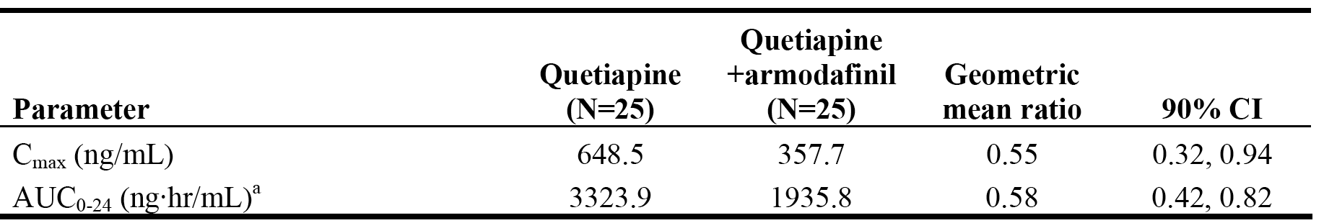

Notes: a = AUC(0-24h) is representative of the AUC over 1 dosing interval.

*Comment: Co-administration of the two drugs reduced the geometric mean Cmax of quetiapine by 45% relative to quetiapine alone, and the geometric AUC(0-24h) by 42%. The results indicate that armodafinil increases the metabolism of quetiapine in patients with schizophrenia by inducing CYP3A4 activity. The degree of induction was more marked than that observed in study 1022. In study 1056, 3 patients with schizophrenia had unexpectedly low steady-state quetiapine plasma concentrations on day 38 following co-administration. The reason for the low quetiapine concentrations on day 38 is unknown. However, the report states that the data suggest that these patients either failed to ingest their quetiapine dose on the evening of day 38 as specified in the protocol or they received the dose later than scheduled. The analysis was repeated excluding data from the 3 patients with low steady-state plasma concentrations on day 38 and found that co-administration of armodafinil reduced quetiapine Cmax and AUC(0-24h) by 11% and 29%, respectively. The sponsor comments that the result for the AUC(0-24h) from the re-analysis is consistent with the result for the AUCinf following a single oral dose of midazolam observed in study 1022 (i.e., reductions of 29% and 34%, respectively).*

#### Population Pharmacokinetics (PPK)

In order to guide the selection of treatment regimens and optimize the study design for the armodafinil Phase III studies, PPK and PK/PD modelling and simulation were performed. The results of these analyses were provided in Cephalon Report CP-05-001 dated 16 March 2005, undertaken by Pharsight (USA). The PPK data will be reviewed in this section of the CER, while PK/PD modelling & simulation data will be reviewed in the Pharmacodynamics section of this CER.

The objectives of the PPK modelling and simulation were to: (a) characterize the PK profile of R- and S-modafinil in adults; (b) to identify relevant demographic factors having a significant effect on the PK profiles of R- and S-modafinil in adults; (c) to validate the PPK model using an expanded dataset; and (d) to enable the simulation of concentration-time profiles using different treatment regimens of Provigil and armodafinil for use in PK/PD modelling & simulation.

PopPK modelling and simulation was performed using data from the Phase I armodafinil studies 101, 102, and 103 and the Provigil studies 103, 106 and 2101 conducted in healthy subjects. Only Provigil studies in which stereo-selective PK analysis was performed were included. A working dataset was created consisting of R-modafinil drug concentrations (3771 observations) from 190 subjects (91% males, 9% females) receiving either armodafinil or Provigil. Following completion of the Phase I studies and corresponding study reports, an expanded dataset was created consisting of 6139 observations from 227 subjects (93% male, 7% female) receiving either armodafinil or Provigil. The expanded dataset was used for validation of the PPK model.

PK modelling was performed using a maximum likelihood approach to nonlinear mixed effects regression. The PPK report was extensively documented and complied with the relevant TGA adopted EU guidelines (CHMP/EWP/185990/06). The results of the popPK modelling and simulation are summarised below:

* R- and S-modafinil pharmacokinetics were adequately described by a linear 1-compartment model with first-order absorption.
* The absorption rate constant was similar for R- and S-modafinil as was the apparent volume of distribution (0.50 and 0.42 L/kg, respectively), while the apparent clearance of S-modafinil was 3-fold higher than R-modafinil (6.6 vs 2.6 L/h).
* Model parameters derived from the multiple-dose data were similar to those derived from the single-dose data.
* No effect of age or gender on clearance, volume of distribution, or absorption rate constant, and no effect of body weight on clearance or absorption rate constant were observed. However, the effect of age may not have been fully characterized in these analyses due to the limited age range in the studied population.
* The PPK model enabled the simulation of concentration time profiles for different treatment regimens of armodafinil and Provigil for use in the PK/PD model. As previously discussed, the armodafinil and Provigil have different drug concentration vs time profiles. The terminal elimination phase of armodafinil is characterized by a monoexponential decline from peak concentration, while the terminal elimination phase of Provigil is characterized by a biexponential decline from peak concentration due to the rapid elimination of S-modafinil. The difference between the PK elimination profiles of armodafinil and Provigil may result in a corresponding difference in the pharmacodynamics of the 2 drugs. Based on the difference, armodafinil has the potential to produce a more sustained pharmacological effect later in the dosing interval and to exhibit better tolerability (because of the lower Cmax) relative to Provigil. The predicted mean total plasma concentration vs time profiles based on simulated data following multiple doses of armodafinil (100, 125, 150, 175, 200 mg) and Provigil (200 mg) are summarised below.

Figure 5: CP-05-001 - Predicted mean total drug concentration vs time profiles following multiple doses of armodafinil and Provigil.

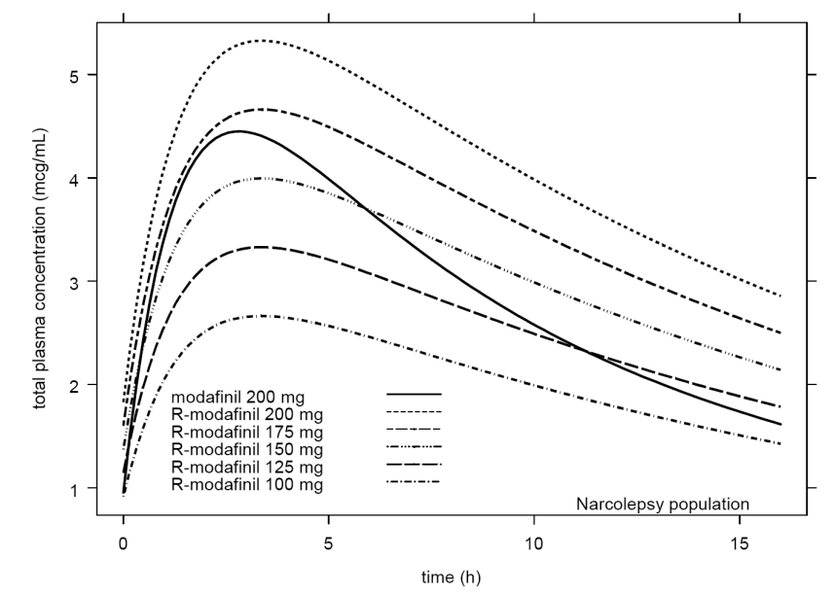

*Comment: The results of PPK modelling and simulation were consistent with the PK data from the individual studies provided in the submission.*

### Evaluator's overall conclusions on pharmacokinetics

* The pharmacokinetics of armodafinil have been reasonably well characterized in healthy subjects following single- and multiple-dose administration. In addition, the PK data for armodafinil in patients with the conditions of interest are consistent with the PK data for healthy volunteers.
* There were deficiencies in the submitted PK data including: (a) no absolute bioavailability study; (b) no comparative bioequivalence study for the three proposed armodafinil tablet strengths 50, 150 and 250 mg; and (c) no mass balance study investigating elimination and metabolic pathways for armodafinil.
* In addition, there were no clinical DDI studies investigating the following interactions of potential clinical significance: (a) co-administration of armodafinil with Pgp inducers and inhibitors, armodafinil is reported to be a Pgp substrate in vitro; (b) co-administration of armodafinil with a CYP2B6 probe substrate, armodafinil is reported to induce CYP2B6 activity in vitro; (c) co-administration of armodafinil with a CYP2C9 probe substrate, armodafinil is reported to inhibit CYP2C9 in vitro; and (d) co-administration of armodafinil with CYP3A4 inducers and inhibitors, given that the formation of modafinil sulfone from R-modafinil is reported to be metabolized by CYP3A4/5.
* The submission included comparisons between the pharmacokinetics of armodafinil and modafinil in both healthy subjects and patients. The mean plasma concentration vs time profiles for R-armodafinil in healthy subjects were virtually superimposable following single-dose armodafinil (50 mg) and modafinil (100 mg) in a dose-normalized to 50 mg analysis. The sponsor states that this finding justifies the use of R-modafinil PK data from the modafinil (Provigil) studies to support the PK data for armodafinil provided in the submission. This is considered to be a reasonable inference.
* In a multiple-dose analysis of PK data from healthy subjects (studies 102 and PROVIGIL-2101), systemic exposures to R-modafinil and modafinil were compared, based on Cmax and AUC values. The analyses included comparisons between armodafinil 150 mg/day vs modafinil 200 mg/day and armodafinil 250 mg vs modafinil 400 mg/day. The comparisons showed that Cmax values were lower for armodafinil compared to modafinil, while AUC values for the two analytes were similar. However, the plasma concentration vs time profiles for armodafinil and modafinil were significantly different. The decline from peak concentration of armodafinil was monoexponential, with a longer terminal half-life relative to a biexponential decline from peak concentration following administration of modafinil, with a shorter terminal half-life. The sponsor comments that the biexponential decline following administration of modafinil is the result of the differential rate of clearance of the R- and S- enantiomers (i.e., clearance rate 3-fold higher for the S-compared to the R-enantiomer).
* Consistent with the data from the individual studies, the PPK analysis (CP-05-001) also indicated that the plasma concentration vs time profile for armodafinil notably differs from that for modafinil. The sponsor commented that the difference between the two drugs was expected to result in a more sustained effect (higher concentration later in the profile) and better tolerability (lower Cmax) for armodafinil compared to modafinil. The difference between the two plasma concentration vs time profiles mean that equivalent exposures to armodafinil and modafinil cannot be achieved through dose adjustment. For example, if doses were selected to achieve comparable Cmax values then the plasma concentrations of armodafinil would be higher than modafinil at later time points, while if doses were selected to achieve comparable plasma concentrations at later time points then the Cmax value for armodafinil would be lower than for modafinil.
* The PK data showed that the median Tmax of armodafinil was approximately 2 hours following administration in the fasted state (study 101). In an in vitro study using MDR-MDCK cell monolayers it was reported that armodafinil is a P-glycoprotein (Pgp) substrate, but is not an inhibitor of Pgp (study DP-2006-055).
* The sponsor states that the absolute bioavailability of armodafinil was not determined due to aqueous insolubility of armodafinil, which precluded iv administration. However, and iv preparation was used in the nonclinical intact animal studies.
* The effect of food on the bioavailability of armodafinil was studied following a single 100 mg dose (2 x 50 mg tablets) in the fasted and fed state in 6 healthy young males (study 101). The mean Cmax and AUC(0-inf) for R-modafinil were ~ 11% lower and ~ 8% higher, respectively, in the fed compared to the fasted state. Apart from the median Tmax, which was approximately 4 hours longer in the fed compared to the fasted state (6.0 vs 2.3 hours, respectively), other PK secondary parameters (i.e., CL/F, VF, and t1/2) were similar in the fed and fasted states. The results suggest that the onset of action following administration might be longer when administered with food compared to fasting administration. This might be of clinical relevance where a rapid onset of action is required. There were no steady-state data on the effect of food on the bioavailability of armodafinil, but based on similar single-dose and steady-state pharmacokinetics of the drug it can be predicted that the effect will be similar to that following single-dose.
* In fasted healthy subjects, the single-dose armodafinil 250 mg tablet proposed for registration was demonstrated to be bioequivalent to single-dose armodafinil 5 x 50 mg tablets used in the clinical Phase III studies (study 1023). Three armodafinil 250 mg tablets proposed for approval manufactured at different facilities in scale-up batches were found to be bioequivalent following single-dose administration to healthy subjects (study 1036). There was no comparative bioequivalence study comparing the three strengths of the armodafinil tablets being proposed for registration (50, 150, 250 mg). However, based on Cmax and AUC values the pharmacokinetics of armodafinil were essentially linear over the dose range 50 mg to 400 mg following single-dose and multiple-dose over 7 and 14 days, and the apparent clearance was relatively constant over the dose range tested (study 102).
* The mean apparent volume of distribution (V/F) of armodafinil following a single-dose (dose normalized to 50 mg) was 42.4 L, based on pooled data from healthy subjects (n=93) from studies 1023, 101, and 102. Following multiple dosing of armodafinil (dose normalized to 50 mg), the mean V/F was 47.4 L on day 14 in 30 healthy subjects (study 102). The V/F indicates that armodafinil is well distributed. There were no data for armodafinil relating to protein binding, erythrocyte distribution, or tissue distribution in humans.
* The metabolic pathways for R-modafinil have not been specifically characterized in studies in humans. The sponsor states that a clinical mass balance and metabolism study of racemic modafinil suggests that the drug is nearly exclusively metabolized in the liver with less than 10% of the parent compound being excreted in the urine. The sponsor reports that interconversion of the R and S enantiomers of racemic modafinil have not been observed in vitro or in vivo.
* Two circulating metabolites of armodafinil were identified in the PK studies (R-modafinil acid and [achiral] modafinil sulfone). R-modafinil acid represents approximately 11% and 7% of parent drug exposure (based on AUC values), following single- and multiple-dose administration of armodafinil, respectively. These data indicate that there is relatively little accumulation of R-modafinil acid following multiple-dose treatment with armodafinil. Modafinil sulfone represents approximately 33% and 56% of parent drug exposure (based on AUC values), following single- and multiple-dose administration of armodafinil, respectively. The data indicate that modafinil sulfone accumulates following multiple-dose armodafinil. The sponsor reports that armodafinil is metabolized to modafinil sulfone via CYP3A4/5, indicating that this enzyme is responsible, at least in part, for the metabolism of armodafinil.
* After reaching peak plasma concentration following oral administration, the elimination of armodafinil appears to be monoexponential with a relatively long apparent half-life of approximately 15 hours. The apparent mean terminal half-lives of R-modafinil acid and modafinil sulfone are approximately 15 and 38 hours, respectively, following single-dose administration of armodafinil (dose-normalized to 50 mg) from pooled data (studies 1023, 101, and 102). The mean apparent clearance (CL/F) of armodafinil following a single-dose (dose-normalized to 50 mg) was 38.6 mL/min, based on pooled data from healthy subjects (n=93) from studies 1023, 101, and 102. Following multiple-dose administration of armodafinil (dose-normalized to 50 mg) in study 102, the mean CL/ was 32.4 ± 8.72 mL/min on day 7 (n=34) and 32.7 mL/min on day 14 (n=30).
* The pharmacokinetics of armodafinil following single and multiple dose administration are similar, suggesting that the pharmacokinetics of the drug are time-independent. In the multiple-dose study (102), steady-state appeared to have been reached after 7 days of administration, which is consistent with a half-life of approximately 15 hours. The steady state accumulation ratio (Rss) for armodafinil (dose-normalized to 50 mg) was 1.2 on both days 7 and 14.
* In patients with OSAHS being treated with nCPAP (study 1064), a multiple-dose, 2-way cross-over comparison between armodafinil 200 mg/day and modafinil 200 mg/day showed that the geometric Cmax and AUC(0-τ) values for R-armodafinil were 37% and 69% higher relative to modafinil, while median Tmax values were similar for the two products (i.e., 2 hours). The plasma concentration vs time profile of R-armodafinil was higher at all time points than that for modafinil, with the difference between the profiles being greater in the later part of the 24 hour dosing interval than in the earlier part. The mean steady-state accumulation ratio approximated unity for both R-armodafinil and modafinil, indicating time-independent pharmacokinetics for both drugs.
* In a study investigating the effect of age on the pharmacokinetics of armodafinil in healthy volunteers (study 1051), exposure to R-armodafinil following multiple-dose armodafinil (150 mg/day) increased with age, particularly in subjects aged ≥ 75 years. Based on these data, dosage adjustment in patients aged ≥ 65 years should be considered, particularly in patients aged ≥ 75 years. In the PPK analysis (CP-05-001), no effect of age on clearance, volume of distribution or absorption constant were observed. However, the effect of age in the PPK analyses may not have been fully characterized due to the limited number of patients aged ≥ 65 years in the analyses. The majority of patients in the PPK analysis were between 18 and 40 years of age.
* There were no specific studies on the effect of gender, weight, or race on the pharmacokinetics of armodafinil. However, in the PPK analysis (CP-05-001) no effect of gender on R-armodafinil on clearance, volume of distribution, or absorption rate was observed, and no effect of body weight on R-armodafinil clearance or absorption rate constant was observed, but the volume of distribution increased linearly with weight.
* In vitro data are reported to show that armodafinil has weak, but concentration-related inductive effects on CYP1A2, CYP2B6, and CYP3A4/5 activities (Nonclinical Pharmacokinetics Written Summary). Clinical DDI studies have been undertaken investigating the effect of co-administration of armodafinil on CYP3A4 and CYP1A2 probe substrates, but not on CYP2B6 probe substrates.
* In vitro data are reported to show that armodafinil has a strong concentration-related inhibitory effect on CYP2C9 activity and is an inhibitor of CYP2C19 activity (Nonclinical Pharmacokinetics Written Summary). A clinical DDI study has been undertaken investigating the effects of co-administration of armodafinil on a CYP2C19 probe substrate, but not on a CYP2C9 probe substrate.
* The sponsor reports that, in vitro, armodafinil is a weak, concentration-dependent inducer of CYP3A4 activity. In two DDI interaction studies with CYP3A4 substrates, multiple-dose armodafinil (200 mg QD) reduced exposure to single iv and oral dose midazolam in healthy subjects and to steady-state quetiapine in patients with schizophrenia. The results suggest that armodafinil is at least a moderate inducer of CYP3A4 activity and should be administered cautiously in patients being treated with drugs known to be CYP3A4 substrates. Upwards dose adjustment of CYP3A4 substrates co-administered with armodafinil might be required.
* The sponsor reports that, in vitro, armodafinil is a weak, concentration dependent inducer of CYP1A2 activity. However, in a clinical study in healthy subjects armodafinil administered at 250 mg QD for 4 weeks had no significant effect on exposure to caffeine (a CYP1A2 substrate) administered as a single 200 mg dose on days 1 and 31 (study 1025). The sponsor reports than, in vitro, armodafinil is an inhibitor of CYP2C19 activity. This was confirmed in study 1021, which showed that single-dose armodafinil 400 mg significantly increased exposure to single-dose omeprazole 40 mg (a CYP2C19 substrate) in healthy subjects who were extensive CYP2C19 metabolizers. Consequently, co-administration of armodafinil and drugs known to be metabolized by CYP2C19 should be undertaken cautiously, and downwards dose adjustment of CYP2C19 substrates might be required.

## Pharmacodynamics

### Study 103 - Healthy young men undergoing acute sleep deprivation

#### Objectives and design

The primary objective this Phase I, double-blind, randomised, active-controlled (Provigil 200 mg) and placebo-controlled study was to evaluate the pharmacodynamic (PD) profile over time of single doses of armodafinil (100, 150, 200, or 300 mg) in healthy young men undergoing acute sleep deprivation. The Provigil 200 mg (modafinil) group was included to assess study design sensitivity. The PD profile was measured using the Maintenance of Wakefulness Test (MWT). The study planned to enroll 108 subjects aged between 18 and 40 years, who were randomly assigned to 1 of 6 treatment groups (18 subjects/group), with randomization assigned separately for each centre (1 in France and 1 in the UK).

#### Methods

Subjects were admitted to the study centre on day -1 and slept from 2300 hours on day -1 until 0700 hours on day 1. On day 1, subjects began Karolinska Sleepiness Scale (KSS) testing at 1 hour intervals, and testing for attention and working memory using the Cognitive Drug Research (CDR) system and Psychomotor Vigilance Task (PVT) at 2 hour intervals. After randomization to one of the six treatment groups, a single dose of study drug was administered at 1925 hours, immediately followed by a standardized dinner. Blood samples were collected before study drug administration, 30 minutes after administration, and then at 1 hour intervals for up to 14 hours. During the night of day 1 (sleep deprivation period), KSS, CDR system, and PVT testing continued, and the MWT was conducted at 2 hour intervals, starting at 2200 hours.

On day 2, MWT, KSS, CDR system testing, PVT testing and blood collection for pharmacokinetics continued at specified intervals until 1100 hours. Subjects then underwent a sleep period that started at 1100 hours, with polysomnography (PSG) until 1900 hours. Subjects were awakened at 1900 hours and underwent final assessments and end-of-study procedures between 2055 and 2130 hours, after which they were discharged from the clinic. Follow-up telephone contact occurred 7 days after discharge from the clinic. The total duration of subject participation in the study was approximately 3 weeks.

Blood samples for drug plasma concentrations and PK profiling were collected prior to administration at 1925 hours and after administration at times of 1955, 2025, 2125, 2225, and 2325 hours on day 1, and at times of 0025, 0125, 0225, 0325, 0425, 0525, 0625, 0725, 0825, and 0925 hours on day 2.

The armodafinil treatments were provided using 50 mg capsules, Provigil treatment was provided using 100 mg tablets, and placebo treatment was provided using matching armodafinil capsules or matching Provigil tablets. In order to maintain the double-blind, each subject received 6 capsules and 2 tablets with the content depending on the randomised treatment group.

#### Primary assessment of the PD profile and statistical methods

For the primary assessment of the PD profile over time the MWT was performed every 2 hours between 2200 and 0800 hours of the second night in the clinic (evening of day 1 to morning of day 2, during a sleep deprivation period). The MWT is an objective assessment of sleepiness that measures the ability of a subject to remain awake. Subjects were instructed to try to remain awake in a darkened room while in a semi-reclined position. Long sleep latencies are indicative of ability to remain awake. MWT sleep latency (minutes) (i.e., time to 3 epochs of stage 1 sleep or 1 epoch of stages 2, 3, 4 or REM sleep) and latency to 10 seconds of sleep were analysed at 2 hour intervals from 2200 hours on day 1 to 0800 hours on day 2. Each MWT session ended at 20 minutes if no sleep occurred and was counted as sleep latency of 20 minutes.

The MWT (and all other PD variables) were analysed at each time point. The null hypothesis was that the mean results for all treatments at all time points were equal. The alternate hypothesis was that at least two of the treatment means were not equal. The null hypothesis was to be rejected if α = 0.05, pairwise treatment comparisons were also performed (Fisher's protective test). The testing was done using an ANOVA with treatment and centres as factors. In addition, tests for linear trends and non-linear trends (quadratic trend test) using the placebo and armodafinil dose groups were performed. No adjustment for multiple comparisons was deemed necessary by the sponsor, as this was a Phase I PK/PD study in healthy normal subjects who were sleep deprived. Sample size was not based on statistical considerations. It was expected that a total sample size of 108 subjects with 18 subjects in each treatment group would provide sufficient information to test the null hypothesis.

#### Results for pharmacodynamic endpoints

Statistically significant results favouring single-dose Provigil 200 mg compared to placebo were observed at most time points for MWT, PVT and CDR system testing. These results indicate that the test was sensitive enough to detect a PD effect of armodafinil over the dose range tested (100, 150, 200, 300 mg). The observed results for single-dose armodafinil were similar to those observed for Provigil 200 mg. For MWT, PVT and CDR system testing, statistically significant differences favouring armodafinil (all doses) compared to placebo were observed at most time points over the testing period. All doses of armodafinil were observed to promote wakefulness (increased MWT) from 2000 to 0800 hours. However, the two higher doses of armodafinil (200 mg and 300 mg), appeared to improve wakefulness (increased MWT) in the early morning (0600 and 0800 hours) to a greater extent than Provigil 200 mg. The results for the primary PD endpoint of MWT, sleep latency and latency to 10 seconds of sleep, are summarised.

#### Results for the pharmacokinetic/pharmacodynamic (PK/PD) relationship

The study included PK/PD analyses. To evaluate the relationship between drug concentration and PD effect, plots of the mean values for the relevant PD measures for MWT, PVT, and CDR system tests overlaid with the mean plasma drug concentrations over time were generated for each treatment group. Statistically significant correlations between plasma concentration and PD outcome were observed for the Provigil 200 mg group for all PD variables tested. However, no statistically significant correlations were observed between plasma concentrations and PD outcomes for all PD variables tested for any of the armodafinil groups. The results for the correlation between the PD variables and the corresponding plasma drug concentration by treatment group are summarised.

### PK/PD modelling and simulations - Report Cephalon CP-05-001

* The submission included PK/PD modelling and simulation data undertaken to select the armodafinil doses for the Phase III program in patients with the sleep disorders of interest. The main objectives of the analysis were to select armodafinil doses that would produce similar or superior responses compared to Provigil doses known to be efficacious, without increasing the potential for sleep disturbance. Modelling was carried out using the computer program NONMEM, Version 5 level 1.1. Figures were generated using Splus 6.1. Simulations were performed with Splus and TS2. Data preparation was performed in Splus or SAS. The analytical methodology underlying the PK/PD modelling and simulations was extensively described in the study report.
* The PD variables tested were MWT (MSLT in SWSD) and two markers for sleep disturbance (PSG-wake after sleep onset [WASO] and PSG-sleep efficiency [SE]). Repeated MWT data were taken from the results at 2-hour intervals from 2200 to 0800 hours. MWT was censored at 20 minutes (i.e., the duration of the MWT test). Plasma concentrations were simulated using PPK models in subject populations of interest.
* A multicomponent PK/PD model combining the effect of time of day and the effect of plasma concentration on MWT was developed for healthy subjects with acute sleep deprivation. The model produced nearly identical EC50 estimates for R- and S-modafinil (~ 0.6 mcg/mL), supporting the hypothesis that the 2 enantiomers are equipotent. PK/PD simulation predicted that a 150 mg armodafinil dose should achieve comparable MWT to a 200 mg (near maximal effect) dose of PROVIGIL at early times in the concentration-time profile with a potentially superior MWT at later times without causing sleep disturbance. WASO and SE (markers for sleep disturbance) were adequately described by simple regression models and changed as a function of the baseline value and drug concentration.
* Similar multiple-component models were developed for patients and these models adequately described MWT in patients with OSAHS or narcolepsy treated with Provigil 200 mg and 400 mg, and MSLT in the patients with SWSD treated with Provigil 200 mg. PK/PD simulation predicted that a dosage of 150 mg/day of armodafinil was the lowest dosage that would achieve MWT/MSLT sleep latency values comparable to a dosage of 200 mg/day of modafinil early in the concentration-time profile, and potentially superior MWT/MSLT sleep latency values at later times in the concentration-time profile (representing a longer sustained effect), without an increased risk for sleep disturbance. In contrast to healthy subjects with acute sleep deprivation, no treatment effect on WASO or SE (markers for potential sleep disturbance) was detected in patients with excessive sleepiness associated with OSAHS, SWSD, or narcolepsy.

### Evaluator's overall conclusions on pharmacodynamics

* Armodafinil at single doses of 100, 150, 200, and 300 mg appears to have a positive PD effect on promoting wakefulness, attention, and working memory in acutely sleep deprived healthy young men (study 103). The duration of the PD effects appear to be longer with higher doses of armodafinil (200 mg and 300 mg) compared to lower doses of armodafinil (100 mg and 150 mg) and Provigil 200 mg.
* There were no statistically significant correlations between armodafinil plasma concentrations and any of the PD variables tested (MWT, PVT, CDR system test) following single dose armodafinil 100, 150, 200, and 300 mg in acutely sleep deprived healthy young men (study 103). However, statistically significant correlations were observed between modafinil plasma concentrations and the PD variables tested (MWT, PVT, CDR system test) following single-dose Provigil 200 mg.
* The results of PK/PD modelling and simulation reported in CP-05-001 predict that a dose of armodafinil 150 mg should achieve comparable MWT (OSAHS/narcolepsy) or MSLT (SWSD) to modafinil 200 mg at early times after administration, with superior MST/MSLT at later times.

## Dosage selection for the pivotal studies

In the pivotal Phase III studies in patients with OSAHS (study 3021) and narcolepsy (study 3020), the armodafinil dosages of 150 mg/day and 250 mg/day were selected on the basis of single-dose PK study 101, multiple-dose PK study 102 and single-dose PK/PD study 103. In study 102, the maximum tolerated dosage following multiple-dose administration was 300 mg/day. The sponsor stated that armodafinil doses of 150 mg/day and 250 mg/day were selected for the Phase III studies in patients with OSAHS and narcolepsy because these doses were shown to be effective in study 103 and were anticipated to provide a balance between efficacy and tolerability.

The same Phase I PK and PK/PD studies used to select the doses (150 mg/day, 250 mg/day) for the pivotal Phase III studies for patients with OSAHS and narcolepsy were used to select the dose (150 mg/day) for the pivotal Phase III study for patients with SWSD (study 3025). The sponsor stated that a dose of 150 mg/day of armodafinil was selected for the Phase III study in patients with SWSD because it was shown to be effective in study 103, with low potential to disrupt daytime sleep.

*Comment: The sponsor's rationale for selecting the armodafinil doses for the pivotal Phase III studies is acceptable.*

## Clinical efficacy

### Overview of the studies

#### Pivotal Phase 3 efficacy studies

The submission included 4, pivotal, multi-national, Phase 3, double-blind, placebo-controlled, parallel-group efficacy and safety studies of 12 weeks duration. The 4 pivotal studies included 2 studies in patients with OSAHS (C10953/3021/AP/MN and C10953/3025/AP/MN), 1 study in patients with SWSD (C10953/3022/CM/MN), and 1 study in patients with narcolepsy C10953/3020/NA/MN); the 4 studies are referred to in this CER as 3021, 3025, 3022 and 3020, respectively. The 4 pivotal studies are shown below.

Table 18: Pivotal Phase 3 efficacy and safety studies.

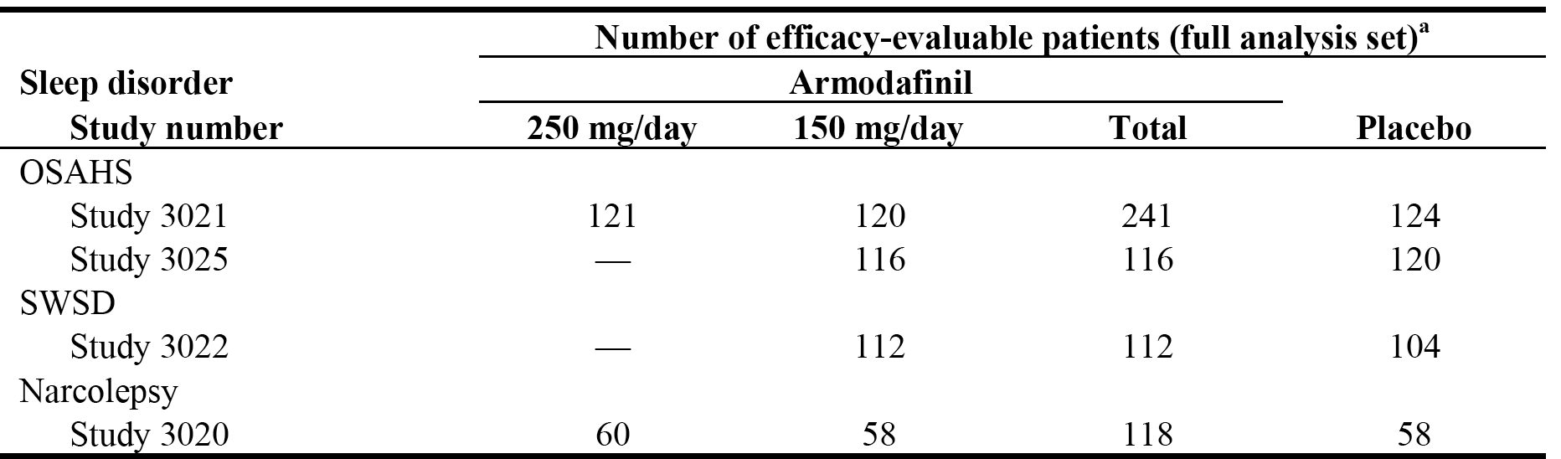

a = The full analysis set included patients who received at least 1 dose of study drug, had a baseline and at least 1 post-baseline Maintenance of Wakefulness Test assessment (narcolepsy and OSAHS) or Multiple Sleep Latency Test assessment (SWSD), and at least 1 post-baseline Clinical Global Impression of Change assessment.

#### Supportive efficacy studies

The submission also included 2, Phase 3, long-term, open-label safety and tolerability studies, including supportive efficacy data (C10953/3023/ES/MN and C10953/3024/ES/MN); the studies are referred to in this CER as 3023 and 3024, respectively. The patients who participated in study 3023 had excessive sleepiness associated with OSAHS, SWSD, or narcolepsy and had not participated in another study with armodafinil. The patients who participated in study 3024 had completed one of the 4 pivotal, double-blind, placebo-controlled studies. The submission also included 2, Phase 3b studies providing supportive efficacy data (C10953/3045/CM/US, a double-blind, placebo-controlled study in patients with SWSD; and C10953/3046/ES/US, an open-label study in patients with narcolepsy or OSAHS); the studies are referred to in this CER as 3045 and 3046, respectively. The 4 studies providing supportive efficacy data are summarised below in Tables 19-20.

Table 19: Supportive efficacy studies: Phase III, open label studies.

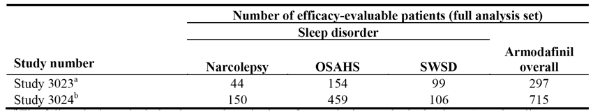

a = The full analysis set (FAS) includes those patients in the safety analysis set who had at least 1 post-baseline efficacy assessment. b = The FAS included those patients in the safety analysis set who had at least 1 efficacy assessment during the open-label extension study.

Table 20: Supportive efficacy studies: Phase IIIb studies.

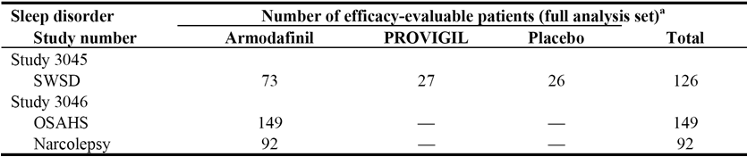

a = FAS includes those patients in the safety analysis set who had at least 1 post-baseline efficacy assessment.

#### Calculating sleep latency from MWT data - issues

##### Sponsor error in calculation of MWT

In the three studies in which sleep latency calculated from the Maintenance of Wakefulness (MWT) was the primary efficacy variable (3021 and 3025 [OSAHS]; 3020 [narcolepsy]), the sponsor states that an error in the computer program that derives the primary efficacy variable from the raw scores of sleep stages for the MWT was discovered after unblinding of the data. The algorithm incorrectly calculated sleep latency from the MWT as the time to 6 consecutive epochs of sleep stage 1, 2, 3, or 4 or REM sleep, rather than protocol defined sleep latency calculated from the MWT as the time to onset of the first of 3 consecutive 30 second epochs of stage 1 sleep or to epoch 1 of stage 2, 3, or 4 or REM sleep. Consequently, the sponsor corrected the sleep latency algorithm to reflect the protocol specified definition, and the derived datasets were updated with corrected sleep latency values. The sponsor stated that this decision was deemed appropriate since the file containing the blinded raw scoring of sleep stages remained intact throughout the process, and these scores were not affected by the correction to the computer program. The correct sleep latencies from the MWT were analysed and presented in the relevant CSRs.

##### "Flawed" nap issue

The "flawed" nap issue relates to the discrepancy identified by the FDA between assessment of sleep stage by local sleep technicians at the study sites and by central readers. For verification purposes, the FDA statistical reviewer of the Nuvigil new drug application (NDA) requested the raw score MWT data from 30 randomly selected patients. The FDA statistical reviewer identified some serious findings in the provided raw score data. In essence, sleep technicians who conducted the MWT in study centres were instructed to wake up patients and disconnect equipment when the patients were considered to have fallen asleep. The MWT tracings were then sent to a central laboratory for reading and calculation of sleep latency. The FDA statistical reviewer comments that this creates a problem between clinical judgement from sleep technicians and the reading from central readers. In particular, a patient can be disconnected by a local technician before the session ends and yet the central reader might not find the protocol-defined sleep pattern in the "pruned" tracing. When this happened, the central reader assigned full session length to that patient, indicating that the patient did not fall asleep in that session. This artificially prolongs sleep latency as some sessions were interrupted within a few minutes.

From the raw score data from 30 randomly selected patients, the FDA statistical reviewer found that 20 patients had at least one session affected by the discrepancy, and 7 patients had critical visits (baseline or last visit) affected. Consequently, the FDA statistical reviewer stated that "due to substantial changes to the observed data, the original analyses and results on the submitted data cannot be used for the regulatory decision". The FDA reviewer then requested the sponsor to undertake several ad hoc analyses to "understand the impact of this problem". The results of these ad hoc analyses were included in the FDA statistical review provided by sponsor, and taken into account by the FDA medical reviewer in undertaking her clinical evaluation. In this CER, the results of the sponsor's ad hoc analyses of the sleep latency based on the MWT have been discussed in the relevant sections of the report.

### OSAHS

#### Pivotal study 3021 (OSAHS)

##### Study design, objectives, locations and dates

Study 3021 was a randomised, double-blind, placebo-controlled, parallel-group Phase 3 study of 12 weeks duration designed to evaluate the efficacy and safety of armodafinil (150 mg/day and 250 mg/day) for the treatment of residual excessive sleepiness associated with obstructive sleep apnoea/hypopnoea syndrome (OSAHS) in adults. The study was sponsored by Cephalon and was conducted at 37 centres in the USA and Canada. The study was undertaken between 19 February 2004 and 6 November 2004, and the CSR was dated 9 March 2005.

The primary objective was to determine whether treatment with armodafinil is more effective than placebo for patients with residual excessive sleepiness associated with OSAHS by measuring sleep latency from the Maintenance of Wakefulness Test (MWT) (30 minute version) (average of 4 naps at 0900, 1100, 1300, and 1500 hours), and by Clinical Global Impression of Change (CGI-C) ratings (as related to general condition) at week 12 or the last post-baseline observation. There were a number of secondary efficacy objectives and these are listed.

Patients with a current diagnosis of OSAHS were randomised 1:1:1 to 12 weeks treatment with once daily armodafinil 150 mg, armodafinil 250 mg or placebo. Following preliminary screening, including CGI-S scale, patients underwent assessment of nCPAP therapy over a 2 week period using the Respironics REMstar auto CPAP system. Following this assessment, patients returned for additional screening including the Epworth Sleepiness Scale (ESS) and nocturnal polysomnography (PSG), which recorded the apnoea-hypopnoea index (AHI) for nCPAP assessment. Nocturnal PSG started at lights out within 30 minutes before or after habitual bedtime, but no earlier than 2130 hours. Before any screening assessments were undertaken, washout from medications prohibited by the protocol occurred.

Patients meeting the inclusion/exclusion criteria and the assessment criteria returned to the clinic the evening before baseline assessments. Baseline assessments included MWT administered 6 times at 2 hour intervals from 0900 hours through 1900 hours (inclusive), CDR system testing administered between MWT naps, and the Brief Fatigue Inventory (BFI) administered prior to the first MWT. Patients were discharged from the clinic the morning after baseline assessments.

For each subsequent visit, patients arrived in the clinic in the evening, stayed over night, and were administered the study drug within 15 minutes of 0700 the next day and at about 30 minutes before breakfast. The MWT was administered 6 times at 2 hour intervals from 0900 to 1900 hours (inclusive) at weeks 4, 8, and 12. The CGI-C, the ESS and the BFI were administered before the first MWT and CDR system testing (between MWT naps) sessions at weeks 4, 8 and 12. In order to assess night-time sleep, the week 12 visit or the last post-baseline observation visit also included a nocturnal PSG.

Study days were numbered relative to the first day of drug administration. Efficacy and safety data were assigned to study windows. The visit windows were: baseline, nominal day 1, window ≤ 1 day; week 4, nominal day 28, visit window 2 to 42 days; week 8, nominal day 56, visit window 43 to 70 days; week 12, nominal day 84, visit window ≥ 71 days; endpoint, visit window ≤ 1 day. If multiple data fell in the same visit window then the value closest to the nominal day in the visit window was used for the analysis. If multiple data in the same visit window were equally distant from the nominal day, then the last value in the visit window was used for the analysis. The study schedule is provided.

*Comment: The study was well designed and provides pivotal short-term efficacy and safety data. There was one amendment to the protocol (dated 3 March 2004) after 58 patients had been enrolled. The changes to the protocol provided in the amendment have been examined and are considered not to significantly impact on the safety or efficacy assessments of patients already enrolled in the study. Furthermore, the amendment is considered not to have invalidated the efficacy assessments.*

##### Inclusion and exclusion criteria

Approximately 360 men and women aged 18 to 65 years (inclusive) with a diagnosis of OSAHS, according to International Classification of Sleep Disorders (ICSD) criteria were scheduled for inclusion in order to obtain 324 evaluable patients (i.e., patients with at least 1 post-baseline assessment of MWT). The inclusion criteria required that patients had residual excessive sleepiness despite effective and regular nCPAP therapy. In addition, patients were required to have a baseline CGI-S rating score of 4 or more (i.e., 1=normal [shows no signs of illness]; 2=borderline ill; 3=mildly [slightly] ill; 4=moderately ill; 5=markedly ill; 6=severely ill; 7=among the most extremely ill patients), and an Epworth Sleepiness Scale (ESS) Score of 10 or more. A patient was enrolled in the study only if all inclusion criteria and none of the exclusion criteria were fulfilled. The inclusion criteria and exclusion criteria are summarised. In addition to the inclusion and exclusion criteria, the study also included standard criteria relating to withdrawal of patients from the study or from assessments. The study also specified that efforts were to be made to identify the reasons for withdrawal and to follow-up of patients withdrawing due to adverse events.

##### Study treatments

During the 12-week, double-blind, treatment period, patients were instructed to take study medications once daily before 0800 hours and about 30 minutes before breakfast. The exceptions from the dosage regimen took place at weeks 4, 8, and 12 visit days when the study drug was taken in the clinic within 15 minutes of 0700 hours and about 30 minutes before breakfast. The sponsor stated that armodafinil was administered in the fasted state (defined as 30 minutes before breakfast) in order to avoid potential food effects. Armodafinil dosage was titrated as follows: 50 mg on the first day and then an additional 50 mg for two consecutive days until the target dose of 150 mg/day or 250 mg/day was reached. The daily armodafinil dose was given using 50 mg tablets. In order to maintain the double-blind, 5 tablets were taken daily with the mixture of placebo and/or armodafinil being determined by the randomization group and the titration day.

Investigators were responsible for monitoring patient compliance using completion of study drug accountability records, reviews of patient diaries, and verification of source documents. One patient in the armodafinil group was withdrawn from the study due to lack of study drug compliance.

Any prior and concomitant medication given to a patient within 30 days before and up to the end of the study, including all medication given before, during, and after study drug administration, was recorded on the CRF. Generic or trade name, indication, and dosage were recorded. The sponsor encoded all therapy and medication according to the World Health Organization (WHO) drug dictionary (WHO Drug).

Any medication that would make the patient feel sleepy was not to be used during the study. The following medications were not allowed during the study: modafinil, melatonin, sodium oxybate, lithium, St. John’s Wort, methylphenidate, amphetamines, pemoline, antipsychotic agents, benzodiazepines, zolpidem, monoamine oxidase inhibitors, anticoagulants, anticonvulsants (unless used for other than seizure disorders), and barbiturates. Patients were not to have used prohibited medications for at least 7 days prior to the second screening visit. In some cases, the investigator could elect to extend the screening period to accomplish this goal.

Selective serotonin reuptake inhibitors (SSRIs) were permitted if the patient did not have a history of sedation caused by these drugs and if the patient was on a stable dosage (at least 3 months for fluoxetine or 1 month for other SSRIs) before the screening visit.

Women participating in the study were allowed to use steroidal contraceptives only if taken in conjunction with the use of a barrier contraceptive method.

At each clinic visit after the screening visit, the investigator asked the patient whether any medications (other than study drug), including OTC medications and herbal preparations, had been taken since the previous visit.

##### Efficacy variables and outcomes

###### Primary efficacy variables

The primary efficacy variables were:

* mean change from baseline to endpoint in the MWT mean sleep latency (average of 4 naps at 0900, 0110, 1300 and 1500 hours); and
* the proportion of patients with at least minimal improvement in the CGI-C ratings (related to general condition) as assessed at the last post-baseline observation.

The MWT is a validated objective assessment of sleepiness that measures the ability of a subject to remain awake. Patients were instructed to try to remain awake in a darkened room during a series of 30 minute periods while in a semi-reclined position. Long latencies to sleep are indicative of the ability to remain awake. Sleep latency was defined as the time to onset of 3 consecutive epochs (i.e., epoch = 30 second segment) of stage 1 sleep, or the time to onset of any epoch of stages 2, 3, 4 or rapid eye movement sleep (REM). Each sleep epoch is scored for both stage of sleep and any abnormalities occurring within that epoch. In order to score an epoch as belonging to a certain stage of sleep or any abnormality, more than half of the epoch is required to have the observed finding (i.e., epochs individually scored using the 50% [16-second] rule). If a patient fell asleep during a 30 minute period, then the patient was immediately awakened and was prevented from falling asleep for the remainder of that period, but could remain in bed. If a patient did not fall asleep during the 30 minute MWT, then a sleep latency value of 30 minutes was assigned. The sponsor states that the method used to assess sleep latency for MWT is the accepted standard and was used in the Provigil narcolepsy and OSAHS studies, in which MWT was also one of the co-primary efficacy endpoints. The electronic files of the tracings were sent to a central laboratory and the tracings were scored by central readers.

The CGI-C is a subjective measure of the patient's global health made by the clinician based on assessment of improvement in response to treatment compared to baseline. The CGI-C uses the following categories and scoring assignments: 1=very much improved; 2=much improved; 3=minimally improved; 4=no change; 5=minimally worse; 6=much worse; and 7=very much worse. The CGI-C reflects the clinician's subjective assessment of the effect of treatment on the residual daytime sleepiness resulting from OSAHS.

###### Secondary efficacy variables

The key secondary efficacy variable was defined as the change from baseline in mean quality of episodic secondary memory from the tests of memory from the CDR system (average of 4 tests at 0930, 1130, 1330, and 1530 hours) at endpoint. There were a large number of other secondary efficacy variables and these are summarised.

The CDR system is a computerized assessment system that can detect alterations in cognitive function (i.e., attention and memory). The CDR battery of cognitive tests took approximately 25 minutes to complete, and during this time patients completed 3 attention tests and 5 memory tests. Attention tasks included simple reaction time, digit vigilance, and choice reaction time. The working memory task included numeric working memory. Episodic secondary memory tasks included immediate word recall, delayed word recall, word recognition, and picture recognition. The results of the tests are combined to create derived measures of power of attention, continuity of attention, speed of memory, and quality of episodic memory.

The ESS measures subjective evaluation of excessive daytime sleepiness. The ESS score is based on response to 8 everyday situations and is derived from the sum of the values for the 8 situations. The ESS scores range from 0 to 24, with a higher score indicating greater daytime sleepiness. The test is self-administered.

The BFI measures the effects of the study drug on daytime sleepiness, with simple numeric rating scales from 0 to 10 being used, with 0 indicating no fatigue and 10 indicating fatigue that completely interferes with functioning.

##### Randomization and blinding methods

Patients were randomised in blocks of three (1:1:1) to one of the three treatment groups using country (USA or Canada) as the stratum (or blocking factor). Individual study centres were not used as the blocking factor because of the large number of centres. An Interactive Voice Recognition System (IVRS) was used to maintain the overall balance among treatment groups within each country. The study was double-blinded, with patients and investigators remaining blinded to treatment assignment during the study. In addition, the sponsor's personnel involved in data management/analysis were also blinded to the identity of the study drug until the database was locked for analysis and the treatment was unblinded. The blind could be broken by the sponsor in the event of serious and unexpected adverse events, but the investigator and medical monitor remained blinded to treatment.

##### Analysis populations

The randomised set included all patients who were randomised to treatment, regardless of whether or not the study drug was received.

The safety analysis set included all patients in the randomised set who received 1 or more doses of the study drug.

The full analysis set (FAS) included all patients in the safety set who had a baseline and at least 1 post-baseline MWT assessment, and at least 1 post-baseline CGI-C assessment.

Baseline was the last observed data prior to the first dose of study drug.

Endpoint for efficacy analyses and summaries was the last observed post-baseline data, using the last observation carried forward approach.

##### Sample size

Sample size estimates were based on the PK/PD data derived from the armodafinil Phase 1 clinical pharmacology studies in healthy volunteers and the modafinil clinical trials in patients with sleep disorders, under the assumption that both primary treatment comparisons (i.e., MWT and CGI-C) would be with a 2-sided test at an alpha level of 0.05. On this basis, a sample size of 108 patients per group would provide at least 90% power to detect a 2.5 minute difference in the mean sleep latency from the MWT (tests at 0900, 1100, 1300, and 1500), between the combined armodafinil and placebo groups, assuming a common standard deviation of 6.5 minutes. This sample size would also have a 90% power to detect a difference of 25% between the combined armodafinil and placebo groups in the proportion of patients reporting at least minimal improvement in CGI-C ratings, assuming a 36% rate in the placebo group. In addition, for the key secondary efficacy variable memory (quality of episodic secondary memory from test of memory in the CDR system battery), this sample size would also provide at least 80% power to detect a 14-unit difference between armodafinil and placebo, assuming a common standard deviation of 42.

*Comment: Approximately 360 patients were planned to be included in this study in order to obtain 324 evaluable patients (i.e., patients with at least 1 post-baseline assessment of MWT). The study actually recruited 395 patients and 365 patients were evaluable for efficacy (FAS). The number of evaluable patients in each of the three treatment groups was > 108. Therefore, the study was adequately powered to test the two primary treatment comparisons, based on the assumptions on which the sample size calculations were based.*

##### Statistical methods

###### Primary efficacy outcomes

Mean wakefulness test (MWT)

The objective of the study was to determine whether treatment with armodafinil was more effective than placebo for the treatment of residual sleepiness in patients with OSAHS who were being effectively and regularly treated with nCPAP. This was tested objectively using the change from baseline to endpoint (last post-baseline observation) in the mean sleep latency from the MWT (average of 4 tests at 0900, 1100, 1300, and 1500 hours). It was pre-specified that an ANOVA model with country and treatment as factors would be the primary analytical method, if the ANCOVA model with country and treatment as factors, and baseline sleep latency from the MWT as a covariate showed a statistically significant interaction between treatment and baseline sleep latency from the MWT. The ANCOVA model demonstrated a significant interaction between treatment and baseline sleep latency from the MWT and, consequently, the pre-specified ANOVA model was selected as the primary method of analysis.

Examination of the ANOVA model residuals for the MWT showed evidence of non-normality (i.e., Shapiro-Wilk test, p = 0.0002). Consequently, as pre-specified, the non-parametric Wilcoxon rank-sum test was used to compare the combined armodafinil dose group to the placebo group in order to assess the robustness of the findings. The result showed that the inferences from the parametric test (ANOVA) and the non-parametric test (Wilcoxon rank-sum) were in the same direction (i.e., p ≤ 0.05). Consequently, as pre-specified, the ANOVA model with treatment and country as factors was used to analyze all continuous efficacy variables in the study.

Actual values and changes from baseline to endpoint in the mean sleep latency from the MWT were summarised using descriptive statistics. Ninety-five percent confidence intervals (95% CIs) for the treatment differences (using LS means) were also presented.

Clinical Global Impression of Change (CGI-C)

The objective of the study was to determine if treatment with armodafinil was more effective than placebo for the treatment of residual sleepiness in patients with OSAHS who were being effectively and regularly treated with nCPAP. This objective was tested subjectively using the proportion of patients with at least minimal improvement in the CGI-C rating (as related to general condition) at endpoint. The comparison between treatment groups was tested using the CMH chi-square test adjusted for country. The proportion of patients with at least minimal improvement in the CGI-C rating at endpoint was summarised using descriptive statistics.

*Comment: The primary comparison of both efficacy outcomes was between the combined armodafinil group and placebo. If the primary comparison was statistically significant at α = 0.05 using a two-tailed test (i.e., the null hypothesis of no difference between treatment groups was rejected), then each armodafinil dosage group was separately compared with placebo. The sponsor described the sequential testing procedure as being a closed method. There was no statistical adjustment for multiplicity arising from having two primary efficacy endpoints. If the most conservative position is adopted of requiring both endpoints to be statistically significant in order for the study to be deemed "positive", then it is considered that for each of the two primary comparisons the α should be 0.025 (i.e., adjusted for multiplicity using the Bonferroni correction).*

*The primary efficacy variables were assessed at endpoint, last post-baseline observation using the LOCF approach. In order to assess the effect of LOCF methodology on the analyses, the primary efficacy variables were also analysed using the observed week 12 results for patients who had completed the study.*

###### Secondary efficacy outcomes

The continuous secondary efficacy variables were analysed using an ANOVA model with country and treatment as factors. Secondary efficacy variables based on CGI-C ratings were analysed using a CMH chi-square test adjusted for country. All statistical testing for other secondary variables was at α=0.05 (using a two-tailed test) and followed the closed testing methodology used for the primary efficacy analyses. Treatment differences (using LS means) with 95% CIs were also presented. There was no statistical adjustment for multiplicity of secondary efficacy outcome testing.

##### Participant flow

Of the 638 patients screened for entry into the study, 395 (62%) met the entry criteria and were enrolled in the study. Of the 243 patients screened but not enrolled, 137 failed to meet the inclusion criteria, 60 had an exclusion criteria, 21 withdrew consent, 10 were not enrolled for "other" reasons (7 due to enrolment/study closed), 6 were lost to follow-up, 6 were not enrolled for unspecified reasons, 2 were protocol violators, and 1 had an adverse event. Of the 395 randomised patients, 353 (89%) were treated in centres in the USA and 42 (11%) were treated in centres in Canada. The patient disposition is summarised below.

Table 21: Study 3021 - Disposition of all patients.

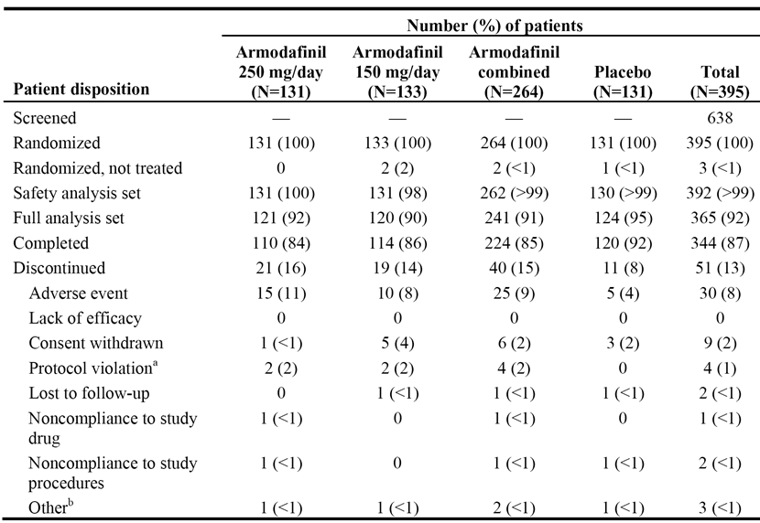

Note: a = includes one patient in each of the armodafinil groups who withdrew due to protocol violations; b = other includes 1 patient in the 250 mg/day group not meeting inclusion criteria, 1 patient in the 150 mg/day due to investigator decision, 1 patient in the placebo group moved location.

*Comment: The patient disposition profiles were generally similar for the armodafinil combined and placebo groups. However, discontinuations due to adverse events were 2-fold higher in the armodafinil combined group than in the placebo group.*

##### Major protocol violations/deviations

There were 13 patients with one or more protocol deviations, including 5 in each armodafinil treatment group and 3 in the placebo group. Of these 13 patients, 2 had exclusion criteria present, 5 did not meet inclusion criteria, 1 did not meet inclusion criteria and had exclusion criteria present, 4 did not meet GCP guidelines, and 1 did not meet primary endpoint criteria. Two patients with protocol violations were withdrawn from the study: 1 in the armodafinil 250 mg/day group with insomnia; 1 in the armodafinil 150 mg/day group had an uncontrolled medical condition.

*Comment: Protocol deviations are considered not to have invalidated the efficacy analyses.*

##### Baseline data

The baseline demographic data are summarised. The mean age of the total population was 49.5 years (range: 26, 67 years), with the majority of patients being aged 41-55 years (52%, n=202). The majority of the patients in the total population were male (70%), with females accounting for 30%. The majority of patients in the total population were white (85%) with most of the other patients being black (10%). The mean weight in the total population was 110.8 kg (range: 55, 220 kg) and the mean BMI was 36.7 kg/m2 (range: 20.9, 80.7 kg/m2). The preponderance of males and the high mean weight and BMI values are consistent with an OSAHS patient group. Overall, the baseline demographic characteristics were well balanced between the combined armodafinil and placebo groups, and between the two armodafinil dosage groups.

All patients in the study were required to have OSAHS and be experiencing residual daytime sleepiness despite the use of effective and regular nCPAP. Patients were required to have ESS scores ≥ 10, and mean baseline ESS scores for the three patient groups armodafinil 150 mg/day, 250 mg/day and placebo were 15.4 (range: 10, 24), 15.3 (range: 5, 23) and 15.9 (range: 10, 24), respectively. The baseline CGI-S ratings were similar for the two armodafinil dosage groups and the placebo group (see Table 22, below).

Table 22: Study 3021 - CGI-S ratings at baseline; safety analysis set.

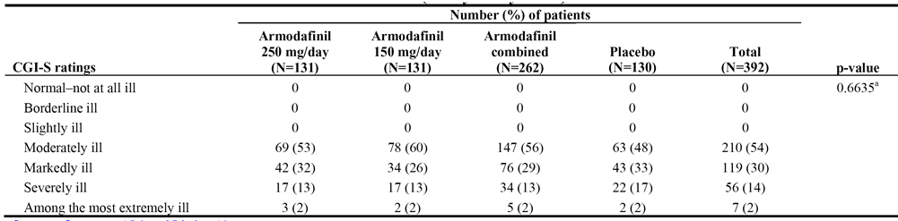

Medical history was similar for the two armodafinil dosage groups and the placebo group. The most commonly reported medical conditions (apart from OSAHS) in the total patient population occurring in ≥ 50% of patients were related to the head, ears, eyes, nose and throat (HEENT) (59%), the cardiovascular system (58%) and the musculoskeletal system (56%). Of note, 42% of the patients in the total patient group had hypertension. The medical history results are summarised.

Prior medications had been taken by nearly all patients (92% in the total patient population). Prior medications reported in the total patient population in ≥ 20% of patients were non-opioid analgesics/anti-inflammatory (45%), vitamins/nutritional supplements (42%), anti-hypertensives (37%), metabolic/endocrine agents (32%), anti-lipaemic agents (27%), gastrointestinal agents (24%), anti-histamines (21%), blood modifiers (21%), anti-depressives (20%). There were some differences in the prior medication profiles of the treatment groups, but these differences are unlikely have affected the validity of the efficacy and safety analyses. The prior medication results are summarised.

##### Results for the primary efficacy outcome

###### Maintenance of Wakefulness Test (MWT) - mean sleep latency

The primary objective efficacy variable was the change from baseline to endpoint in sleep latency from the 30-minute MWT (average of 4 naps at 0900, 1100, 1300, and 1500 hours) assessed at the last post-baseline observation (i.e., endpoint). Mean MWT sleep latency increased 1.9 minutes from baseline to endpoint in the combined armodafinil group and decreased by 1.7 minutes from baseline to endpoint in the placebo group; the difference between the two groups of 3.6 minutes, statistically significantly favoured the combined armodafinil group, p< 0.0001. The difference in mean sleep latency also statistically significantly favoured each of the armodafinil dose groups compared to placebo. The results are summarised below.

Table 23: Study 3021 - Actual values and changes from baseline to endpoint (last post-baseline observation) in mean sleep latency (minutes) from the MWT; FAS.

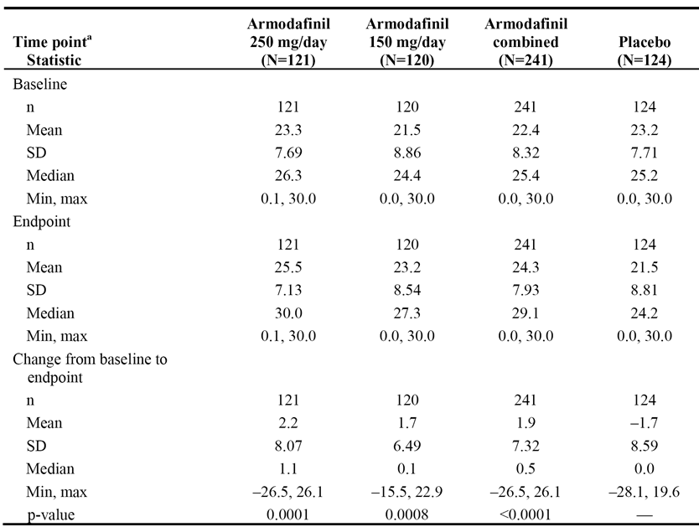

The LS means of the change from baseline in the armodafinil 250 mg/day, armodafinil 150 mg/day, combined armodafinil and placebo groups were 2.7, 2.2, 2.4, and -1.2 minutes, respectively. The 95% CIs for the difference in LS means were 1.92 to 5.83 for armodafinil 250 mg/day vs placebo, 1.40 to 5.32 for armodafinil 150 mg/day vs placebo, and 1.93 vs 5.31 for combined armodafinil vs placebo. The 95% CI for each pairwise comparison of the LS mean change from baseline excluded unity (i.e., 1), indicating that the results were statistically significant.

*Comment: The study was powered on demonstrating a 2.5 minute difference in mean sleep latency from the MWT between the combined armodafinil group and the placebo group. The difference between the two groups was 3.6 minutes in favour of armodafinil which is a clinically meaningful difference based on the assumptions used to calculate the sample size. Therefore, it can be concluded that the observed difference mean sleep latency from the MWT between the combined armodafinil group and placebo group is both clinically meaningful and statistically significant.*

*The sponsor's ad hoc analyses of the mean sleep latency times from the MWT, based on the FDA's request for additional analyses, are summarised. The majority of the ad hoc analyses showed a statistically significant difference in favour of the combined armodafinil group compared to the placebo group, with the exceptions being the worst case analyses. It is noted that Analysis 1, which used the latency to sleep as determined by the local site, was similar to the analysis undertaken by central reading. Overall, it is considered that the data have satisfactorily established that armodafinil (combined and each separate dosage group) significantly increases mean sleep latency time, based on the MWT, compared to placebo.*

###### Clinical Global Impression of Change (CGI-C)

The primary subjective efficacy variable, the proportion of patients with at least minimal improvement in the CGI-C rating (as related to general condition), was assessed at week 12 or the last post-baseline observation. The primary analysis of the CGI-C used a CMH chi-square test adjusted for country. The proportion of patients with at least minimal improvement in the CGI-C rating from baseline to endpoint was statistically significant for the primary comparison between the combined armodafinil and placebo groups; 72% vs 37%, respectively, p < 0.0001. In addition, the separate comparisons between each of the two armodafinil groups and placebo both statistically significantly favoured armodafinil. The results are summarised below in Table 24.

Table 24: Study 3021 - Proportion of patients with at least minimal improvement in CGI-C rating at endpoint (last post-baseline observation); FAS.

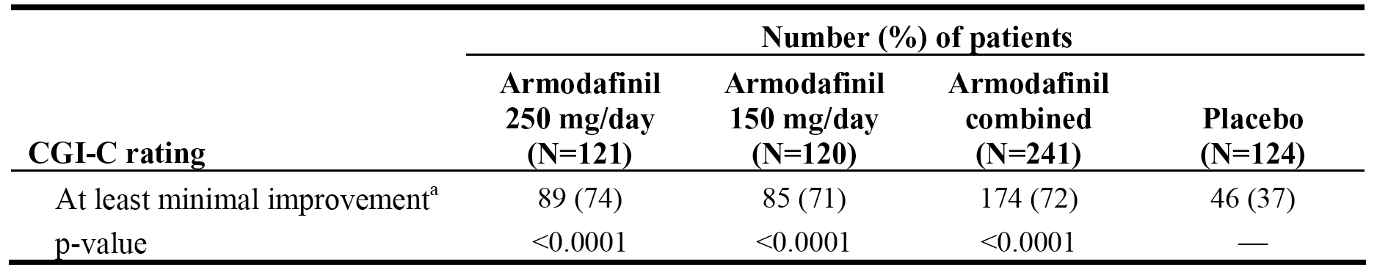

The proportion of patients in the combined armodafinil group who very much or much improved compared was greater than the corresponding proportion of patients in the placebo group (i.e., 56% vs 23%, respectively). The results are summarised below in Table 25.

Table 25: Study 3021 - CGI-C ratings at endpoint (last post-baseline observation); FAS.

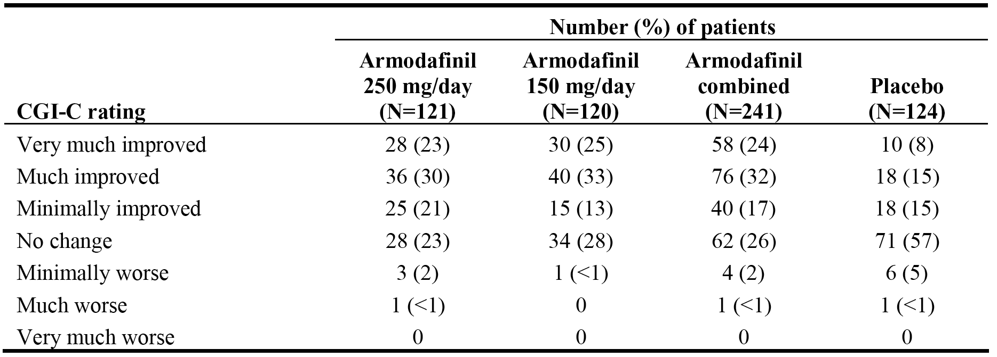

*Comment: The study was powered on demonstrating a 25% difference in the proportion of patients with at least minimal improvement in CGI-C rating between the combined armodafinil group and the placebo group, assuming a 36% rate in the placebo group. The difference between the two groups was 35% in favour of the combined armodafinil group, and the rate in the placebo group was 37%. Therefore, it can be concluded that the observed difference in the proportion of patients with at least minimal improvement in CGI-ratings between the combined armodafinil group and the placebo group is both clinically meaningful, based on the assumptions used to calculate the sample size, and statistically significant.*

##### Results for other efficacy outcomes

###### Key secondary efficacy endpoint - quality of episodic secondary memory

The key secondary efficacy endpoint was defined as the effect of armodafinil on the quality of episodic secondary memory from the CDR system (average of 4 tests at 0930, 1130, 1330, and 1530 hours) at endpoint. The results showed no statistically significant difference between the combined armodafinil and placebo groups, with the respective mean (± SD) changes from baseline to endpoint in the FAS being 11.4 ± 32.22 and 5.4 ­± 48.36, p=0.1147. The difference in the mean change from baseline to Week 4 and Week 8 between the combined armodafinil and placebo groups was statistically significant at both time-points (p=0.0064 and p=0.0085, respectively), but not at Week 12 (p=0.0910). The results are summarised.

###### MWT secondary efficacy endpoints

* The mean ± SD change from baseline in MWT sleep latency (average of 4 naps at 0900, 1100, 1300, and 1500 hours) statistically significantly favoured the combined armodafinil group compared to placebo (respectively) at Weeks 4, 8, and 12,: 2.3 ± 6.51 vs -0.0 ± 8.33 minutes, week 4, p=0.0047; 1.7 ± 7.59 vs -0.1 ± 7.18 minutes, week 8, p=0.0344; and 1.8 ± 7.28 vs -1.3 ± 8.56 minutes, week 12, p=0.0004. In addition, the difference in mean sleep latency for change from baseline at weeks 4, 8, and 12 statistically significantly favoured armodafinil 250 mg/day compared to placebo, and armodafinil 150 mg/day compared to placebo at weeks 4 and 12.
* The mean ± SD change from baseline in MWT sleep latency at later time points (average of 3 naps at 1500, 1700 and 1900 hours) statistically significantly favoured the combined armodafinil group compared to placebo at Week 4 (p=0.0150), but not at weeks 8 and 12.
* Sleep latency for individual naps from the MWT (0900, 1100, 1300, 1500, 1700, 1900 hours) was assessed at weeks 4, 8, and 12 and endpoint. Descriptive results showed that at each visit and endpoint, there were numerical differences in favour of the compared armodafinil group compared to placebo at all time points apart from 1900 hours.

###### CGI-C at weeks 4, 8, and 12

* The proportion of patients in the armodafinil combined group with at least minimal improvement in the CGI-C at weeks 4, 8, and 12 was statistically significantly greater compared to placebo. The results (combined armodafinil vs placebo) were: 72% vs 39%, p<0.0001, week 4; 77% vs 41%, p<0.0001, week 8; and 75% vs 38%, p<0.0001, week 12. Similar results were observed for each armodafinil dosage group.

###### Tests of memory from the CDR system

* For mean quality of episodic memory at later time-points (average of 3 tests at 1530, 1730, and 1930), there was a statistically significant difference between the combined armodafinil and placebo groups for change from baseline to week 8, but not for week 4, week 12 and endpoint.
* The results for change from baseline to endpoint in speed of memory (average of 4 tests administered at 0930, 1130, 1330, and 1530 hours) did not indicate a statistically significant difference between the combined armodafinil and placebo groups (p=0.5320).

###### Test for attention from the CDR system

* The difference in change from baseline to endpoint in the mean power of attention (average of 4 tests administered at 0930, 1130, 1330, and 1530 hours) between the combined armodafinil and placebo groups was not statistically significant (p=0.4170).
* The difference in change from baseline to endpoint in the mean continuity of attention power of memory (average of 4 tests administered at 0930, 1130, 1330, and 1530 hours) between the combined armodafinil and placebo groups was not statistically significant (p=0.2875).

###### Epworth Sleepiness Scale (ESS)

* All patients were required to have an ESS score of ≥ 10 to enrol in the study. At baseline, the mean ESS score was 15.3 in the combined armodafinil group and 15.9 in the placebo group. The mean ± SD change from baseline to weeks 4, 8, and 12 and endpoint in the total ESS score was statistically significantly in favour of the combined armodafinil group compared to the placebo group: -5.2 ± 4.88 vs -2.7 ± 4.33, p<0.0001, week 4; -5.7 ± 5.01 vs -3.2 ± 4.56, p<0.0001, week 8; -5.7 ± 5.15 vs -3.3 ± 4.77, p<0.0001, week 12; and -5.5 ± 5.03 vs -3.3 ± 4.72, p< 0.0001, endpoint. Similarly, the difference favoured each armodafinil dosage group compared to placebo at weeks 4, 8, and 12 and endpoint. The mean ± SD ESS at endpoint was 9.9 ± 5.02, 9.9 ± 5.13, and 9.9 ± 5.06 for armodafinil groups 250 mg/day, 150 mg/day, and combined, respectively, and 12.5 ± 4.79 for the placebo group.

###### Brief fatigue inventory (BFI)

* The mean ± SD change from baseline to endpoint in the average fatigue in the score from the BFI was statistically significantly lower in the armodafinil combined group compared with the placebo group (-1.2 ± 2.23 vs -0.6 ± 1.99; p=0.0059). Similarly, the difference statistically favoured each armodafinil group compared to placebo. The mean ± SD baseline and endpoint scores armodafinil 250 mg/day, 150 mg/day and combined groups were 5.2 ± 1.92 → 3.9 ± 2.23, 4.6 ± 1.82 → 3.4 ± 2.10, and 4.9 ± 1.89 → 3.6 ± 2.18, respectively, and the corresponding results for the placebo group were 4.9 ± 1.78 → 4.4 ± 2.26.
* The difference in the mean change from baseline to endpoint in the worst fatigue score from the BFI between the combined armodafinil and placebo-controlled groups was not statistically significant.

###### Daytime sleepiness from diaries

* The mean percentage reduction from baseline to post-baseline in unintended sleep episodes was 55.5% in the combined armodafinil group (i.e., mean number 1.1 → 0.4) and 18.9% in the placebo group (i.e., mean number 1.0 → 0.80). Similar results were observed for each armodafinil dosage group compared to placebo. The results were presented descriptively.
* The mean percentage reduction from baseline to post-baseline in the number of naps was 34.4% in the combined armodafinil group (i.e., mean number 0.4 → 0.2) and 3.5% in the placebo group (i.e., mean number 0.4 → 0.3). Similar results were observed for each armodafinil dosage group compared to placebo. The results were presented descriptively.

###### Caffeine usage

Caffeine usage, measured by the mean number of caffeinated drinks consumed each day, decreased from baseline in all treatment groups, and was similar across groups: armodafinil 250 mg/day (2.3 → 1.8; ∆ = -0.5); armodafinil 150 mg/day (2.6 → 2.4, ∆ = -0.1); armodafinil combined (2.4 → 2.1, ∆ = -0.3); placebo (2.2 → 2.1, ∆ = -0.1).

#### Pivotal study 3025 (OSAHS)

##### Study design, objectives, location, dates

Study 3025 was a randomised, double-blind, placebo-controlled, parallel-group Phase 3 study of 12 weeks duration designed to evaluate the efficacy and safety of armodafinil (150 mg/day) for the treatment of residual excessive sleepiness associated with obstructive apnoea/hypopnoea syndrome (OSAHS) in adults. In this study, patients with a current diagnosis of OSAHS were randomised 1:1 to 12 weeks treatment with once daily armodafinil 150 mg or placebo. The study was sponsored by Cephalon and was conducted at 36 centres in the USA, France, Germany, Russia and Australia. The study was undertaken between 26 March 2004 and 23 October 2004, and the CSR was dated 9 March 2005.

The primary and secondary objectives of study 3025 were consistent with those described for study 3021. The study methodology was similar that described for study 3021, as was the study schedule.

*Comment: The study was well designed and provided pivotal short-term efficacy and safety data. There was one amendment made to the protocol (dated 3 March 2004), issued before any patients were enrolled.*

##### Inclusion and exclusion criteria

The inclusion and exclusion were identical to those described above for study 3021. In addition, the criteria for withdrawal from the study and requirement for follow-up of patients withdrawing from the study due to adverse events were consistent with those described above for study 3021.

##### Study treatments

The study treatment for patients randomised to armodafinil 150 mg/day or placebo was consistent with those described above for study 3021. Compliance with treatment checks was identical to those in study 3021. No patients were withdrawn from study 3025 due to lack of compliance with study drug treatment. Restrictions relating to the use of prior and concomitant medications were identical to those specified for study 3021.

##### Efficacy variables and outcomes

###### Primary efficacy variables

The primary efficacy variables were identical to those described for study 3021, namely:

* mean change from the baseline to endpoint in MWT mean sleep latency (average of 4 naps at 0900, 1100, 1300, and 1500 hours); and
* the proportion of patients with at least minimal improvement in the CGI-S ratings as assessed by week 12 or the last post-baseline observation.

###### Secondary efficacy variables

The secondary efficacy variables were identical to those described for study 3021.

##### Randomization and blinding methods

The randomization and blinding methods were consistent with those described for study 3021.

##### Analysis populations

The analysis populations were identical to those described for study 3021.

##### Sample size

Sample size considerations and power calculations based on the two primary efficacy endpoints were consistent with those described above for study 3021. The calculations provided for 108 patients in each of the armodafinil 150 mg/day and placebo groups. However, the key secondary efficacy endpoint in this study was attention (power of attention in the CDR system battery), and a sample size of 108 patients would provide at least 80% power to detect a 70 msec difference between the two treatment groups, assuming a common standard deviation of 160 msec.

*Comment: Approximately 240 patients were scheduled to be included in the study in order to obtain 216 evaluable patients (i.e., who have at least 1 post-baseline MWT assessment). The study actually enrolled 263 patients and 236 patients were evaluable for efficacy (FAS). The number of evaluable patients in each of the two treatment groups was > 108. Therefore, the study was adequately powered to test the two primary treatment comparisons, based on the assumptions on which the sample size calculations were based.*

##### Statistical methods

###### Primary efficacy variables - methods

Mean Wakefulness Test (MWT)

The statistical methods used to test the primary efficacy variable comparison of sleep latency from MWT between armodafinil 150 mg/day and placebo were identical to those described above for study 3021. The SAP provided for the primary efficacy variable to be analysed using an ANCOVA model with country and treatment as factors and baseline sleep latency from MWT as a covariate. However, as for study 3021, a statistically significant interaction between treatment and baseline sleep latency from MWT was demonstrated (p=0.0002). Therefore, as specified in the SAP, an ANCOVA model with country and treatment as factors was used to analyse the MWT and all other continuous efficacy variables.

Examination of the ANOVA model-residuals for the MWT analysis showed evidence of non-normality (i.e., Shapiro-Wilk test, p<0.0001). Therefore, in accordance with the SAP, a Wilcoxon rank-sum test was performed to test the robustness of results derived from the ANOVA model. The inferences from both the parametric (ANOVA) and non-parametric (Wilcoxon rank-sum test) tests were consistent for the comparison between armodafinil and placebo (i.e., p<0.05 for both tests). Therefore, in accordance with the SAP, all efficacy results for continuous variables presented in the CSR were based on ANOVA methods.

Clinical Global Impression of Change (CGI-C)

The statistical methods used to test the primary efficacy variable comparison of minimal improvement in CGI-C rating between armodafinil and 150 mg/day and placebo were identical to those described above for study 3021.

###### Secondary efficacy endpoints - methods

Key secondary efficacy variable - power of attention

The key secondary variable of change from baseline in the mean power of attention from the tests of attention from the CDR system (average of 4 tests at 0930, 1130, 1330, and 1530) at endpoint. This key secondary efficacy variable differed from that in study 3021, which was episodic secondary memory from the tests of memory from the CDR system. The pairwise comparisons were analysed using an ANOVA model with treatment and country as factors.

Other secondary efficacy variable analyses

The analyses of the numerous other secondary efficacy variables were consistent with the analyses for the primary endpoints, and depended on whether the variables were continuous or categorical.

##### Participant flow

Of the 466 patients screened for entry into the study, 263 (56%) met the entrance criteria and were enrolled and 203 (44%) did not meet the entrance criteria. Of the 203 patients not enrolled in the study, 69 failed to meet the inclusion criteria, 31 had an exclusion criteria, 24 withdrew consent, 4 were lost to follow-up, 1 had an adverse event, 1 had a protocol violation, 4 had unknown reasons for not enrolling, and 69 had "other" reasons for not enrolling (including 63 in which the other reason was enrolment/study closed). Of the 263 patients from 36 centres randomised into the study, 198 were from 25 centres in the USA, 41 were from 6 centres in Australia, 19 were from 2 centres in Russia, 4 were from 2 centres in Germany, and 1 was from 1 centre in France. The patient disposition is summarised below in Table 26.

Table 26: Study 3025 - Disposition of all patients.

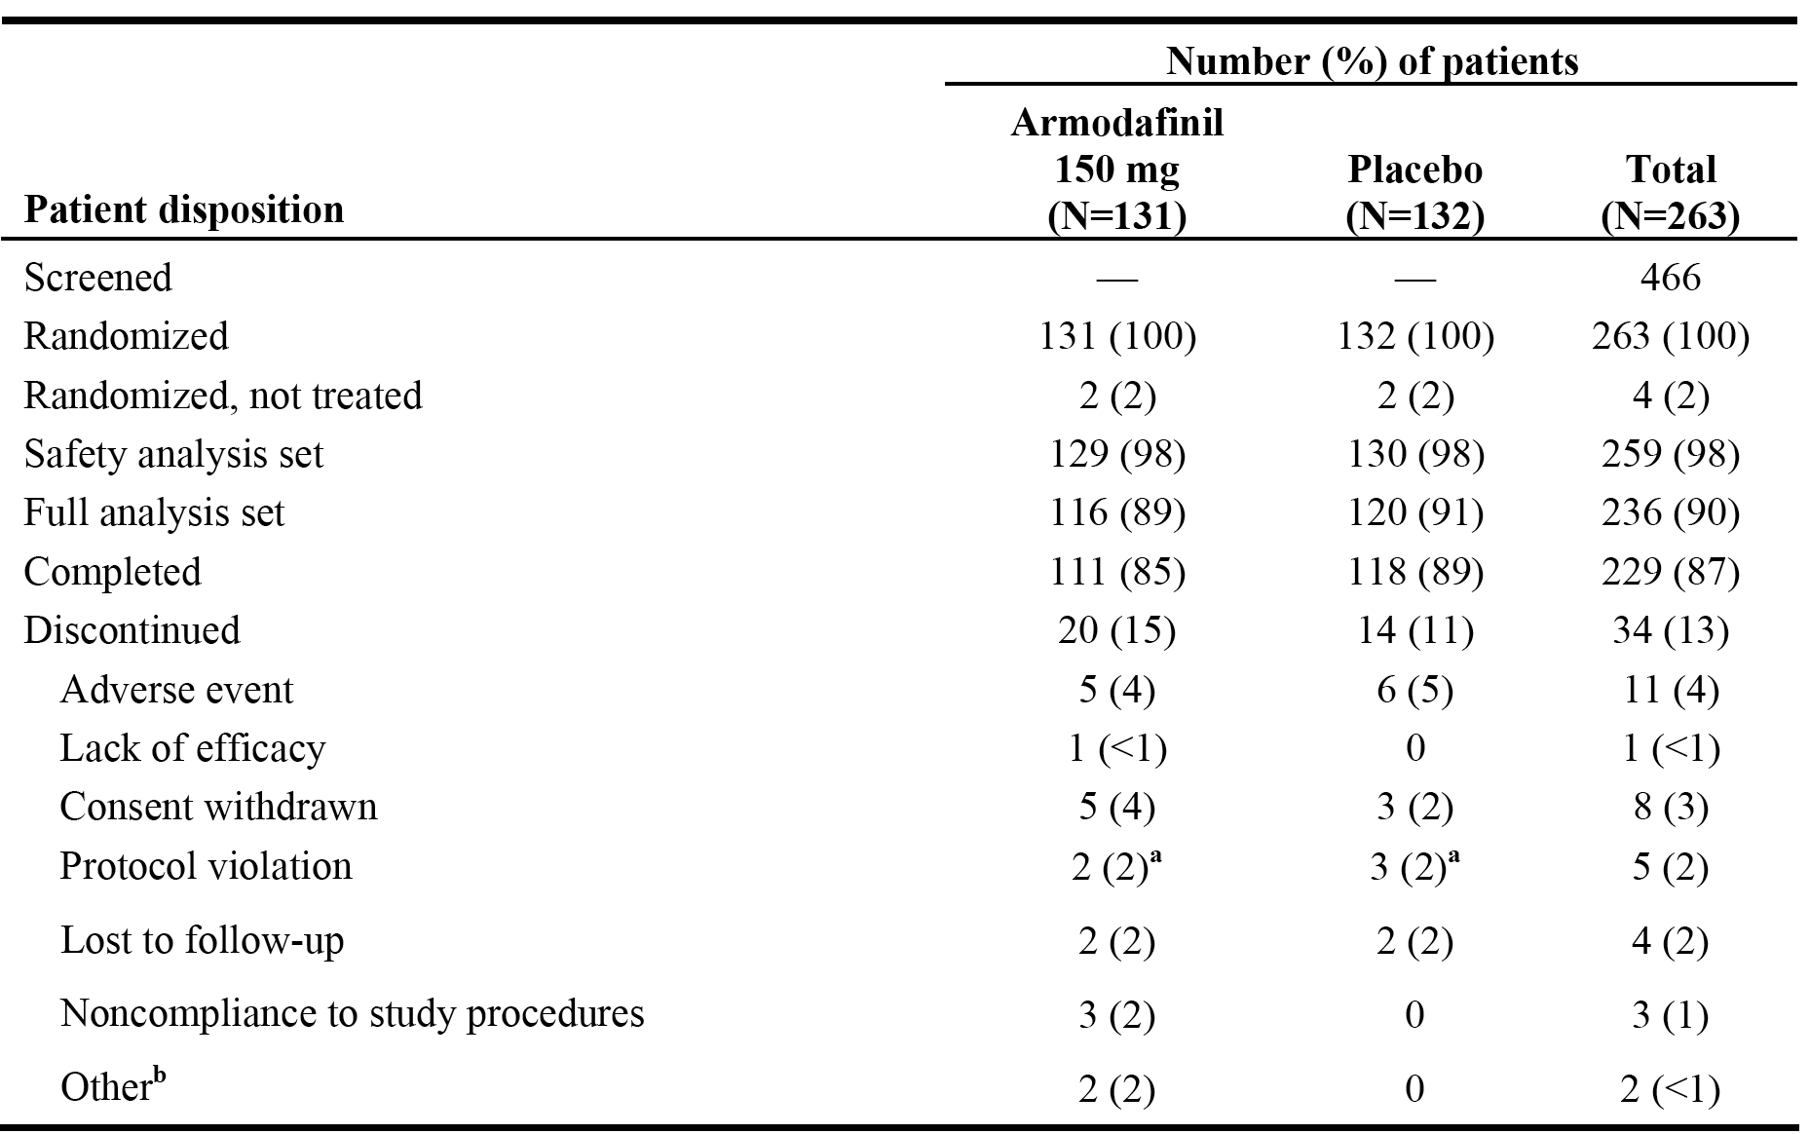

Note: a = provides patient identification numbers; b = 1 patient discontinued because work schedule prevented compliance with overnight visit, 1 patient discontinued due to study finishing prior to completion of final visit.

*Comment: The patient disposition profiles were similar for the two treatment groups.*

##### Major protocol violations/deviations

Protocol violations (non-adherence to inclusion/exclusion criteria, primary endpoint criteria, and/or GCP guidelines) were reported for 26 patients (12 [9%] in the armodafinil group, 14 [11%] in the placebo group). Four (4) patients with protocol violations were withdrawn from the study: 1 patient who received armodafinil did not have an ESS performed before randomization; 1 patient who received armodafinil was enrolled in another clinical trial; 1 patient who received placebo did not meet nCPAP therapy requirements; and 1 patient who received placebo was found to have an AHI index > 10. The protocol violations are summarised.

*Comment: The protocol violations/deviations are considered not to have invalidated the efficacy or safety analyses.*

##### Baseline data

The baseline demographic data are summarised. The mean age of the total population was 50.7 years (range: 25, 69 years), with the majority of patients being aged 41-55 years (51%). The majority of the total population were male (73%), with females accounting for 27%. The majority of the patients in the total population were white (84%), with most of the other patients being black (7%) or "other" race (7%). The mean weight of the total population was 110.6 kg (range: 63.5, 181.9 kg), and the mean BMI was 36.5 kg/m2 (range: 18.1, 68.4 kg/m2). The preponderance of males and the high mean weight and BMI values are consistent with an OSAHS patient group. Overall, the baseline demographic characteristics were well balanced between the armodafinil and placebo groups, and were consistent with the baseline demographic characteristics of patients in study 3021.

All patients in the study had OSAHS with residual daytime sleepiness despite the use of regular and effective nCPAP. The mean baseline ESS scores for the armodafinil and placebo groups were 15.6 (range: 10, 24) and 16.0 (range: 10, 24), respectively. The baseline CGI-S ratings were similar for armodafinil and placebo groups, with the proportion of moderately ill patients being 56% (72/129) and 58% (75/130), respectively, and the proportion of markedly, severely, or extremely ill patients being 44% (57/129) and 42% (55/130), respectively. The disease characteristics were similar for the two treatment groups, and were consistent with those observed in study 3021.

The medical history profiles were similar for the two treatment groups. The most commonly reported medical conditions (apart from OSAHS) in the total patient population in ≥ 50% of patients were muscular skeletal conditions (64%) and respiratory conditions (50%). Of note, 39% of the total population had a medical history of hypertension. The results are summarised.

Prior medications had been taken by nearly all patients (92% of patients in the total patient population). Prior medications reported in the total population in ≥ 20% of patients were non-opioid analgesics/anti-inflammatory medications (42%), vitamins/nutritional supplements (37%), anti-hypertensive agents (35%), and metabolic/endocrine agents (32%), anti-lipaemic agents (26%), and gastrointestinal agents (25%). Overall, the prior medication profiles of the two treatment groups were similar.

##### Results for the primary efficacy outcome

###### Maintenance of Wakefulness Test (MWT) - mean sleep latency

The primary objective efficacy variable was the change from baseline to endpoint in sleep latency from the 30-minute MWT (average of 4 naps at 0900, 1100, 1300, and 1500) assessed at the last post-baseline observation (i.e., endpoint). Mean MWT sleep latency increased 2.3 minutes from baseline to endpoint in the armodafinil group and decreased 1.3 minutes from baseline to endpoint in the placebo group; the difference of 3.6 minutes between the treatment groups was statistically significant in favour of armodafinil, p=0.0003. The results are summarised below in Table 27.

Table 27: Study 3025 - Actual values and changes from baseline to endpoint (last post-baseline visit) in mean sleep latency (minutes) from the MWT; FAS.

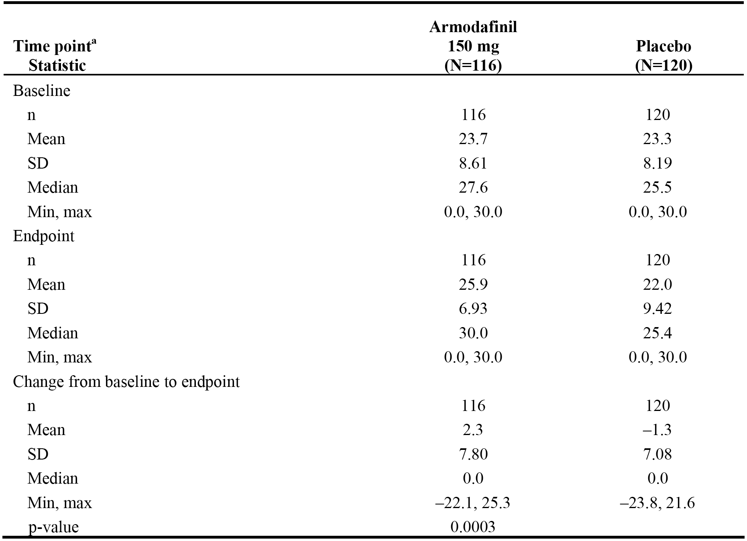

Note: p-value for the treatment comparison is from an ANOVA with treatment and companies as factors.

The LS means of the change from baseline in the armodafinil 150 mg/day and placebo groups were 1.7 and -1.8 minutes, respectively, and the 95% CI for the difference was 1.67 to 5.46. The 95% CI excluded unity (i.e., 1), indicating that the difference in the LS means between the two treatment groups were statistically significant.

*Comment: The study was powered on demonstrating a 2.5 minute difference in mean sleep latency from the MWT between the armodafinil 150 mg/day group and the placebo group. The difference between the two groups was 3.6 minutes in favour of armodafinil, which is a clinically meaningful difference based on the assumptions used to calculate the sample size. Therefore, it can be concluded that the observed difference mean sleep latency from the MWT between the armodafinil 150 mg/day group and the placebo group is both clinically meaningful and statistically significant.*

*The sponsor's ad hoc analyses of the mean sleep latency times from the MWT, based on the FDA's request for additional analyses, are summarised. The majority of the ad hoc analyses showed a statistically significant difference in favour of the armodafinil group compared to the placebo group, with the exceptions being the worst case analyses. It is noted that the results from Analysis 1, which used the latency to sleep as determined by the local site, were similar to the results of the analysis undertaken by central reading. Overall, it is considered that the data have satisfactorily established that armodafinil significantly increases mean sleep latency time, based on the MWT, compared to placebo.*

###### Clinical Global Impression of Change (CGI-C)

The primary subjective efficacy variable, the proportion of patients with at least minimal improvement in the CGI-C rating (as related to general condition), was assessed at week 12 or the last post-baseline observation. The primary analysis of the CGI-C used a CMH chi-square test adjusted for country. The proportion of patients who had at least minimal improvement in CGI-C from baseline to endpoint was statistically significantly greater in the armodafinil group compared to placebo (71% [82/116] vs 53% [64/12], respectively, p=0.0069). More patients in the armodafinil group were very much improved or much improved compared to the placebo group (47% vs 28%, respective); see Table 28 below.

Table 28: Study 3025 - CGI-C ratings at endpoint (last post-baseline observation); FAS.

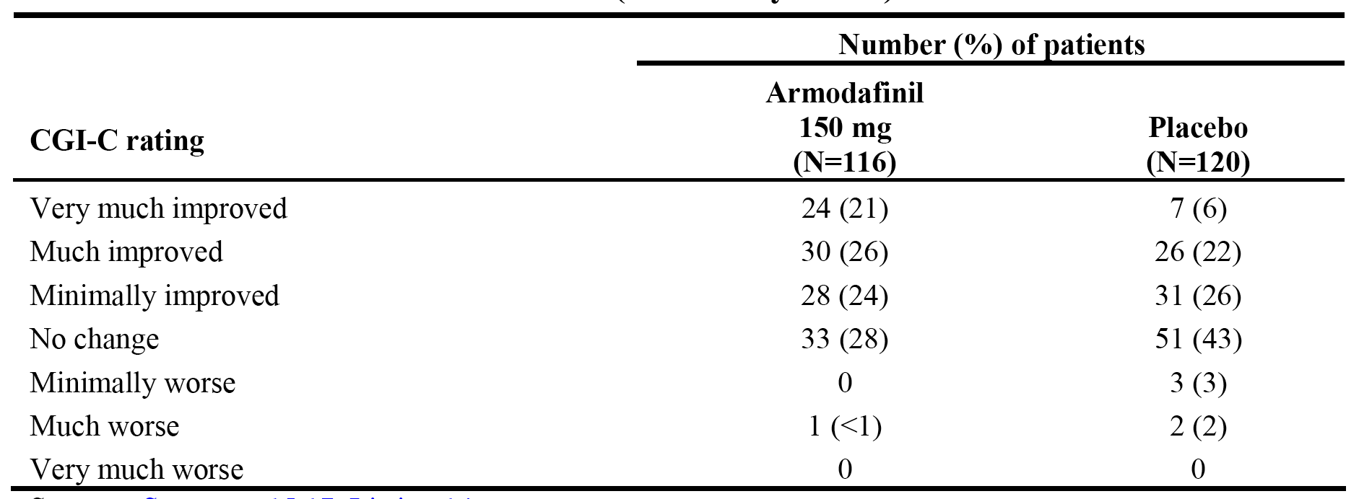

*Comment: The study was powered on demonstrating a 25% difference in the proportion of patients with at least minimal improvement in CGI-C rating between the armodafinil 150 mg/day group and the placebo group, assuming a 36% rate in the placebo group. The difference between the two groups was 18% in favour of the combined armodafinil group, and the rate in the placebo group was 53%. The rate in the placebo group was notably higher than the assumed rate, and consequently the difference in rated between the two armodafinil and placebo groups was lower than assumed. Therefore, although the difference in the rates was statistically significant there is some uncertainty about the clinical significance due to the high placebo response rate.*

##### Results for other efficacy outcomes

###### Key secondary efficacy endpoint - power of attention

The key secondary efficacy endpoint was change from baseline to endpoint in the mean power of attention from the tests of attention from the CDR system (average of 4 tests at 0930, 1130, 1330, and 1530 hours). The results for the analysis of this endpoint showed no statistically significant difference for change from baseline to endpoint between the armodafinil 150 mg/day group (1251.0 → 1300.4 msec, ∆ = 48.6 msec) and the placebo group (1308.9 → 1352.5 msec, ∆ = 43.6 msec); p=0.8181. However, the change from baseline to weeks 4, 8, and 12 in the mean power of attention from the tests of attention from the CDR (average of 4 tests at 0930, 1130, 1330, and 1530 hours) was statistically significant for each time-point. The results are summarised.

###### MWT secondary efficacy endpoints

* The mean (± SD) change from baseline in sleep latency from the 30-minute MWT (average of 4 naps at 0900, 1100, 1300 and 1500 hours) statistically significantly favoured armodafinil 150 mg/day compared to placebo at weeks 4, 8, and 12: 1.9 ± 6.63 vs -1.1 ± 7.34 minutes, week 4, p=0.0014; 2.5 ± 7.12 vs -0.3 ± 6.62 minutes, week 8, p=0.0039; 2.6 ± 8.23 vs -1.6 ± 7.28 minutes, week 12, p<0.0001.
* The mean (± SD) change from baseline in sleep latency at later times from the 30-minute MWT (average of 3 naps at 1500, 1700, and 1900 hours) statistically significantly favoured armodafinil 150 mg/day compared to placebo at week 12 (1.8 ± 9.56 vs -0.5 ± 6.27 minutes, respectively, p=0.0435), but the between group comparisons were not statistically significant at weeks 4 and 8 and endpoint.
* Mean sleep latency for individual naps from the MWT (0900, 1100, 1300, 1500, 1700, 1900 hours) was assessed at weeks 4, 8, and 12, and endpoint. At endpoint, the descriptive analysis showed numerical differences in favour of armodafinil 150 mg/day at 0900, 1100, 1300, 1500 and 1700, but not at 1900 hours.

###### CGI-C at weeks 4, 8, and 12,

CGI-C (as related to general condition) was assessed at weeks 4, 8, and 12. The proportion of patients with at least minimal improvement (i.e., very much improved, much improved or minimally improved) was statistically significantly greater in the armodafinil 150 mg/day group than in the placebo group at weeks 4, 8, and 12: 77% vs 47%, p<0.0001, at week 4; 74% vs 52%, p=0.0008, at week 8; 69% vs 55%, p=0.0282, at week 12. At every time point, the proportion of patients who were much improved or very much improved was greater in the armodafinil 150 mg/day group than in the placebo group.

###### Tests of attention from the CDR system

* There was no statistically significant difference between the two treatment groups for the change from baseline to endpoint in the mean continuity of attention from the CDR system (average of 4 tests at 0930, 1130, 1330 and 1530 hours).
* There was no statistically significant difference between the two treatment groups for the change from baseline to endpoint in either the mean power of attention or the mean continuity of attention from the CDR system at later time points (average of 3 tests at 1530, 1730 and 1930 hours).

###### Tests of memory from the CDR system

* The mean (± SD) change from baseline to endpoint in quality of episodic secondary memory from the CDR system (average of 4 tests at 0930, 1130, 1330, and 1530 hours) was statistically significantly greater in the armodafinil 150 mg/day group (172.4 ± 40.30 → 180.1 ± 42.72, ∆ = 7.6 ± 30.66) compared to the placebo group (161.9 ± 44.10 → 154.9 ± 56.46, ∆ = -7.0 ­­± 52.58); p=0.0102.
* There was no statistically significant difference in the mean change in speed of memory (msec) from the CDR system (average of 4 tests at 0930, 1130, 1330 and 1530 hours) from baseline to endpoint between the armodafinil 150 mg/day and placebo groups; p=0.8686.

###### Epworth Sleepiness Scale (ESS) Scores

* The mean reduction from baseline to endpoint in the total ESS score statistically significantly favoured the armodafinil 150 mg/day group compared to the placebo group (15.6 → 10.3 [∆ = -5.3 vs 16.0] → 13.0 [∆ = -3.0], respectively, p=0.0001). The mean reduction from baseline in the total ESS score was statistically significantly greater at weeks 4, 8, and 12 in the armodafinil 150 mg/day group compared to the placebo group: -4.6 vs -3.0, p=0.0068, week 4; -5.3 vs -3.0 ­, p=0.0002, week 8; -5.2 vs -2.9, p=0.0004, week 12.

###### Brief fatigue inventory (BFI)

* The mean reduction from baseline to endpoint in the average score from the BFI statistically significantly favoured the armodafinil 150 mg/day group compared to the placebo group (4.7 → 3.5 [∆ = -1.3] vs 4.9 → 4.3 [∆ = -0.6], p=0.0183). Mean average scores for patients in the armodafinil 150 mg/day group were 4.7 at baseline, 3.5 at week 4, 3.6 at week 8, 3.5 at week 12, and 3.5 at endpoint, and the corresponding mean average scores for patients in the placebo group were 4.9, 4.2, 4.0, 4.3, and 4.3, respectively.
* The mean reduction from baseline to endpoint in the worst fatigue score from the BFI statistically significantly favoured the armodafinil 150 mg/day group compared to the placebo group (7.0 → 5.6 [∆ = -1.5] vs 7.1 → 6.5 [∆ = -0.5], p=0.0079).

###### Daytime sleepiness from diaries

* The mean percentage reduction from baseline to post-baseline in unintended sleep episodes from diary records was greater in the armodafinil group compared to the placebo group (54.7% [mean number 1.0 → 0.4] vs 37.1% [mean number 1.2 → 0.7]). The results were presented descriptively.
* The mean percentage reduction from baseline to post-baseline in number of naps from diary records was greater in the armodafinil group compared to the placebo group (35.7% [mean number 0.5 → 0.3] vs 17.0% [mean number 0.5 → 0.4]. The results were presented descriptively.
* The number of patients reporting mistakes, accidents, or near misses post-baseline according to data from patient diaries was smaller for patients receiving armodafinil (90 [78%] of 116 patients) than for patients receiving a placebo (99 [83%] of 120 patients).

###### Caffeine usage

Caffeine usage, measured by number of caffeinated drinks consumed each day, decreased slightly from baseline to post-baseline equally in both treatment groups (mean change 0.2 cups per day). The results were presented descriptively.

#### Integrated analysis of studies 3021 and 3025

##### Background

The Summary of Clinical Efficacy included an integrated analysis of the efficacy data from studies 3021 and 3025 in OSAHS. The sponsor states that an integrated analysis of the efficacy data was undertaken in order to provide more precise estimates of the treatment effect and to serve as a basis for demographic subgroup analyses. The integrated analysis appears to be an *ad hoc* analysis as no mention of formally combining the efficacy results from the two studies could be identified in the respective protocols for studies 3021 or 3025.

The sponsor undertook formal statistical analyses of the two primary efficacy outcomes from the two studies in order to determine with the efficacy data could be validly integrated. The analyses suggested that the results for sleep latency from MWT from the two studies could be validly combined, but not the results from the CGI-S. The difference between the two studies in the CGI-S results relates to the notably higher proportion of patients with a placebo response in study 3025 compared to study 3021 (i.e., 53% and 37%, respectively), while responder rates for the armodafinil groups in the two studies were similar.

##### Results from the primary efficacy analysis - sleep latency from the MWT

The primary efficacy analysis was the mean change from baseline to endpoint in the sleep latency from the MWT (average of 4 naps at 0900, 1100, 1300 and 1500 hours). The mean change in average sleep latency from baseline to weeks 4, 8 and 12 and endpoint was statistically significantly greater in the armodafinil groups than in the placebo group at each time-point. The results are summarised below in Table 29.

Table 29: OSAHS (integrated analysis) - Average sleep latency (minutes) from the MWT and change from baseline at each visit and endpoint, FAS.

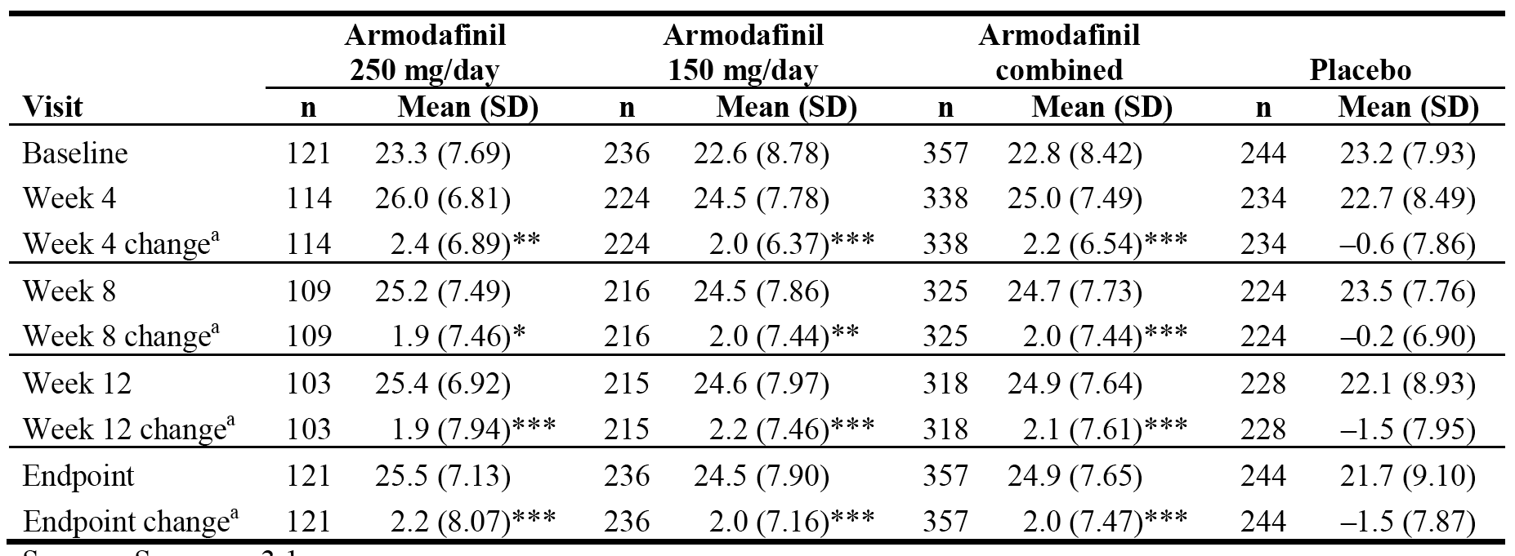

a = The p-values for the treatment comparisons are from an ANOVA with treatment and study as factors: * p<0.05 for individual treatment group comparison to placebo. ** p<0.01 for individual treatment group comparison to placebo. *** p<0.001 for individual treatment group comparison to placebo.

##### Results from the secondary efficacy analyses

* Mean sleep latency from the MWT for the later time-points (average of 3 naps at 1500, 1700 and 1900 hours) demonstrated statistically significant differences in favour of the combined armodafinil group compared with placebo at week 4 (p=0.0081) and endpoint (p=0.0491). The results for the combined armodafinil group were driven by the results for the armodafinil 150 mg/day group in which the mean changes were statistically significantly greater than placebo at week 4 (p=0.0017) and endpoint (p=0.0295). There were no statistically significant differences between armodafinil 250 mg/day and placebo at weeks 4, 8, 12, and endpoint.
* The mean change from baseline to endpoint in the quality of episodic secondary memory from the CDR system (average of four naps at 0930, 1130, 1330, and 1530) was statistically significantly greater in the combined armodafinil group compared to placebo (p=0.0078) and in the armodafinil 150 mg/day group compared to placebo (p=0.0028), but not in the armodafinil 250 mg/day group compared to placebo (p=0.1039). The mean change from baseline to weeks 4, 8 and 12, statistically significantly favoured both the combined armodafinil group and the armodafinil 150 mg/day group compared to placebo, and the armodafinil 250 mg/day group compared to placebo at weeks 4 and 8, but not at week 12.
* No statistically significant difference was observed at later time-points between armodafinil and the placebo in the mean change from baseline to endpoint in the quality of episodic secondary memory from the CDR system (average of three tests at 1530, 1730, and 1930 hours).
* No statistically significant differences were observed between armodafinil and placebo for the power of attention, the continuity of attention and the speed of memory from the relevant tests from the CDR system at both earlier time-points (average of 4 tests at 0930, 1130, 1330, and 1530 hours) and later time-points (average of 3 tests at 1530, 1730 and 1930 hours)
* The mean changes from baseline to weeks 4, 8, 12, and endpoint in the total ESS scores were statistically significantly greater in the armodafinil combined, 150 mg/day and 250 mg/day groups compared to placebo (p<0.0001, for each pairwise comparison).
* The mean change from baseline to endpoint in average BFI score statistically significantly favoured the combined armodafinil group compared to placebo (p<0.05). The results for the combined armodafinil group were driven by the results for the armodafinil 150 mg/day group (p<0.01 vs placebo). The difference between the armodafinil 250 mg/day group and placebo was not statistically significant. The mean change from baseline to endpoint in worst fatigue score from the BFI statistically significantly favoured the combined armodafinil group compared to placebo (p<0.0158). The results for the combined armodafinil group were driven by the results for the armodafinil 150 mg/day group (p<0.0044 vs placebo). The difference between the armodafinil 250 mg/day group and placebo was not statistically significant.

##### Results or the subpopulation analyses of the primary efficacy variables

The integrated analysis included a descriptive assessment of treatment on the two primary efficacy outcomes from studies 3021 and 3025. The results for sleep latency from the MWT (average of 4 tests at 0900, 1100, 1300, and 1900) showed no marked effects of sex or race. The effect of armodafinil on increasing sleep latency (i.e., reducing sleepiness) was more marked in patients who were markedly, severely, or extremely ill at baseline compared to patients who were moderately ill, with the difference from placebo being 4.4 seconds and 2.9 seconds, respectively. The effect of armodafinil on increasing sleep latency (i.e., reducing sleepiness) varied with age, with difference between armodafinil and placebo favouring armodafinil in each age group: 7 seconds, 19-29 years; 1.5 seconds, 30-40 years; 3.4 seconds, 41-55 years; and 4.2 seconds, > 55 years. However, the superior results for the youngest age group (18-29 years) compared to the older age groups should be interpreted cautiously due to the small number of patients in this age group (n=13). There were no marked effects of sex, race, age, or CGI-S group on the proportion of patients showing at a least minimal improvement in CGI-S rating at endpoint.

### Narcolepsy

#### Pivotal study 3020 (narcolepsy)

##### Study design, objectives, locations and dates

Study 3020 was a randomised, double-blind, placebo-controlled, parallel-group Phase 3 study of 12 weeks duration designed to evaluate the efficacy and safety of armodafinil (150 mg/day and 250 mg/day) in adult patients with excessive sleepiness due to narcolepsy. The study was sponsored by Cephalon and was conducted at 47 centres in the USA, Canada, France, Australia, Germany and Russia. The study was undertaken between 23 March 2004 and 10 January 2005, and the CSR was dated 9 March 2005.

The primary objective of the study was to determine whether treatment with armodafinil was more effective than placebo for patients with excessive sleepiness associated with narcolepsy by measuring sleep latency from the Maintenance of Wakefulness Test (MWT) (20-minute version) (average of 4 naps at 0900, 1100, 1300, and 1500 hours), and by Clinical Global Impression of Change (CGI-C) ratings (as related to general condition) at week 12 (or the last post-baseline observation). There were a number of secondary efficacy objectives and these are listed. The efficacy objectives of the narcolepsy study were consistent with the efficacy objectives of the two OSAHS studies.

Patients with excessive sleepiness due to narcolepsy were randomised 1:1:1 to 12 weeks treatment with armodafinil 150 mg/day, 250 mg/day or placebo. Potential patients came to the clinic for preliminary screening assessments (after a washout period from medications excluded by the protocol), including administration of the CGI-S scale. If these criteria were met, patients returned to the clinic for additional screening assessments, including ESS and Multiple Sleep Latency Test (MSLT). Patients who met the inclusion/exclusion and screening criteria returned to the clinic the evening before the baseline visit, with baseline assessments commencing the next morning. Baseline outcome assessments included the MWT administered 6 times (naps at 0900, 1100, 1300, 1500, 1700, and 1900 hours), CDR system testing (tests of attention and memory) administered between MWT naps, and the BFI assessed prior to the first MWT nap. Nocturnal PSG started (i.e., lights out) within 30 minutes of the patient's habitual bedtime (as determined by sleep history), but no earlier than 2130 hours and after other procedures/assessments were performed. Patients were discharged the following morning.

For each remaining clinic visit, patients arrived at the clinic the evening before, stayed overnight, and were administered study drug at 0700 (± 15 minutes) the next day, about 30 minutes before breakfast. The MWT was administered 6 times (naps at 0900, 1100, 1300, 1500, 1700, and 1900 hours) at weeks 4, 8, and 12. The CGI-C (as related to general condition), the ESS, and the BFI were administered before the first MWT and CDR system testing session at weeks 4, 8, and 12. Between MWT naps, CDR system testing was administered at weeks 4, 8, and 12. Data from diaries on the effect on daytime sleepiness, night-time sleep, and cataplexy were reviewed at weeks 4, 8, and 12. For the purposes of assessing the effect on night-time sleep, the week-12 visit or the last post-baseline observation also included a nocturnal PSG (conducted overnight after other procedures and assessment were performed). Numbering of study days and allocation of visit windows and nominal visit days (with ranges) was the same as for the two OSAHS studies. The study schedule is provided.

*Comment: The study was well designed and provided pivotal short-term efficacy and safety data. There were two amendments to the study protocol. Amendment 1 (dated 9 March 2004) was issued before any patients were enrolled in the study. Amendment 2 (dated 21 October 2004) was issued after 196 had been enrolled. The changes made in Amendment 2 have been examined and are considered to have no negative impacts of the safety or efficacy assessments of patients enrolled prior to the amendment.*

##### Inclusion and exclusion criteria

The study enrolled patients aged 18 to 65 years (inclusive) with a current diagnosis of narcolepsy according to ICSD criteria. Patients were required to have a mean sleep latency of 6 minutes or less as determined by the MSLT (performed at 0900, 1100, 1300 and 1500 hours) and a CGI-S rating of 4 or more (assessed after washout of medication disallowed by the protocol). A patient was enrolled only if all inclusion criteria and none of the exclusion criteria were fulfilled at the time of randomisation. The inclusion and exclusion criteria are summarised. In addition to the inclusion and exclusion criteria, the study also included standard criteria relating to withdrawal of patients from the study. It was also specified that efforts were to be made to identify the reasons for withdrawal and to follow-up patients withdrawing due to adverse events.

##### Study treatments

The dosage instructions for armodafinil and placebo were the same as those for OSAHS study 3021, which used the same armodafinil dosages. Compliance with treatment checks was identical to the two OSAHS studies. Restrictions relating to the use of prior and concomitant medications were consistent with the two OSAHS studies. However, in this narcolepsy study anticataplectic medications, with the exception of sodium oxybate, were permitted during the study if they did not contribute to the patient's sleepiness. A patient's current dosage of anticataplectic medication had to be stable for at least 1 month before the second screening visit, with no change in dosage anticipated over the duration of the study.

##### Efficacy variables and outcomes

###### Primary efficacy variables

The primary efficacy variables were:

* the mean change from the baseline assessment in MWT (20-minute version) mean sleep latency (average of 4 naps at 0900, 1100, 1300, and 1500 hours), to the last post-baseline assessment; and
* the proportion of patients with at least minimal improvement in the CGI-C ratings (as related to general condition), assessed at the last post-baseline observation.

The MWT was administered in an identical fashion to the two OSAHS studies (3021, 3025), except the narcolepsy study used 20-minute sessions while the two OSAHS studies used 30-minute sessions. The CGI-C ratings were identical those used in the two OSAHS studies.

###### Secondary efficacy variables

The secondary efficacy variables were identical to the secondary efficacy variables in the two OSAHS studies, except the sleep latency variables from the MWT used 20-minute sessions in the narcolepsy study while the two OSAHS studies used 30-minute sessions.

##### Randomization and blinding methods

The randomization and blinding methods used in this study were the same as those used for the two OSAHS studies.

##### Analysis populations

The analysis populations were identical to those described for the two OSAHS studies.

##### Sample size

Sample size estimates were made on the basis of the results of PK/PD modelling and clinical trial simulation applied to data from the Phase 1 clinical studies with armodafinil and from clinical trials in sleep disorders with PROVIGIL, under the assumption that both primary treatment comparisons would be with a 2-sided test at an alpha level of 0.05.

On this basis, a sample size of 64 per group would provide 80% power to detect a 2.5 minute difference in the mean sleep latency from the MWT (naps at 0900, 1100, 1300, and 1500 hours) between either dose of armodafinil and placebo, assuming a common standard deviation of 5.0 minutes. This sample size would also have at least 80% power to detect a difference of 25% between either dose of armodafinil and placebo in the proportion of patients reporting at least minimal improvement in CGI-C ratings, assuming a 37% rate in the placebo-treated group.

*Comment: Approximately 210 patients were planned to be enrolled in order to obtain 192 evaluable patients (i.e., patients with at least 1 post-baseline MWT assessment and 1 post-baseline CGI-C assessment). The study enrolled a total of 196 patients, and the number of patients in each group in the FAS was < 64, suggesting that the study might not have been adequately powered to have detected a difference in the primary efficacy outcomes between either dose of armodafinil and placebo, based on the assumptions used to calculate the sample size.*

##### Statistical methods

###### Primary efficacy variables

Mean wakefulness test (MWT)

The objective of the study was to determine whether treatment with armodafinil was more effective than placebo for patients with excessive sleepiness associated with narcolepsy. This was tested objectively using the change from baseline to endpoint (last post-baseline observation) in the mean sleep latency from the MWT (average of 4 tests at 0900, 1100, 1300, and 1500 hours). The comparison between treatment groups was analysed using an ANCOVA model with country and treatment as factors, and baseline sleep latency from MWT as a covariate. This analytical method was pre-specified and chosen because two separate ANCOVA analyses found that there was no interaction between treatment and country and treatment, or between treatment and baseline sleep latency from MWT.

Examination of the ANCOVA model residuals showed evidence of non-normality (i.e., Shapiro-Wilk test, p ≤ 0.0012). Consequently, as pre-specified, the non-parametric Wilcoxon rank-sum test was used to compare the results of the combined armodafinil dose group to the results of the placebo group in order to assess the robustness of the findings. The result showed that the inferences from the parametric test (ANCOVA) and the non-parametric test (Wilcoxon rank-sum) were in the same direction (i.e., p ≤ 0.05). Consequently, as pre-specified, an ANCOVA model with treatment and country as factors, and relevant baseline covariate was used to analyze all continuous efficacy variables in the study.

Actual values and changes from baseline to endpoint in the mean sleep latency from the MWT were summarised using descriptive statistics. Ninety-five percent confidence intervals for the treatment differences (using LS means) were also presented.

Clinical Global Impression of Change (CGI-C)

The objective of the study was to determine whether treatment with armodafinil was more effective than placebo for patients with excessive sleepiness associated with narcolepsy. This objective was tested subjectively using the proportion of patients with at least minimal improvement in the CGI-C rating (as related to general condition) at endpoint. The comparison between treatment groups was tested using the CMH chi-square test adjusted for country. The proportion of patients with at least minimal improvement in the CGI-C rating at endpoint was summarised using descriptive statistics.

*Comment: The primary comparison of both efficacy outcomes was between the combined armodafinil group and placebo. If the primary comparison was statistically significant at α = 0.05 using a two-tailed test (i.e., the null hypothesis of no difference between treatment groups was rejected), then each armodafinil dosage group was separately compared with placebo. The sponsor described the sequential testing procedure as being a closed method. There was no statistical adjustment for multiplicity arising from having two primary efficacy endpoints. If the most conservation position is adopted of requiring both endpoints to be statistically significant in order for the study to be deemed "positive", then it is considered that for each of the two primary comparisons (combined armodafinil group vs placebo) the α should be 0.025 (i.e., adjusted for multiplicity using the Bonferroni correction).*

###### Secondary efficacy variables

The continuous secondary efficacy variables were analysed using an ANCOVA model with country and treatment as factors, as the corresponding baseline value as a covariate. No separate treatment by covariate interaction was tested for any of the secondary variables analysed using an ANCOVA model. Secondary efficacy variables based on CGI-C ratings were analysed using a CMH chi-square test adjusted for country. All statistical testing for other secondary variables was at α=0.05 (using a two-tailed test) and followed the closed testing methodology that was used for the primary efficacy analyses. Ninety-five percent confidence intervals for the treatment differences (using LS means) were also presented. There was no statistical adjustment for multiplicity.

##### Participant flow

A total of 326 patients were screened, and 196 (60%) met entrance criteria and were enrolled. Patients were not enrolled in the study for the following reasons: inclusion criteria not met (n=60); exclusion criteria present (n=27); consent withdrawn (n=27); other reasons (n=10); lost to follow-up (n=3); reason not specified (n=2); and adverse event (n=1). Reasons categorized as "other" included enrolment closed (n=4), unwillingness to participate (n=3), administrative (n=1), insufficient MSLT data (n=1), and unable to schedule visit within the allowed time (n=1)

Of the 196 patients randomised, 194 (99%) patients received at least 1 dose of study drug and were evaluated for safety in the study; 2 randomised patients did not receive study drug (1 in the armodafinil 150 mg/day group and 1 in the placebo group). The population evaluable for efficacy comprised 176 (90%) patients who received at least 1 dose of study drug and had a baseline MWT assessment and at least 1 post-baseline MWT and CGI-C assessment. A total of 160 (82%) patients completed the study, 105 (80%) patients receiving armodafinil and 55 (86%) patients receiving placebo. Patient disposition was similar in the armodafinil and placebo groups. The all patient disposition is summarised below in Table 30.

Table 30: ****Study 3020 - Disposition of all patients.****

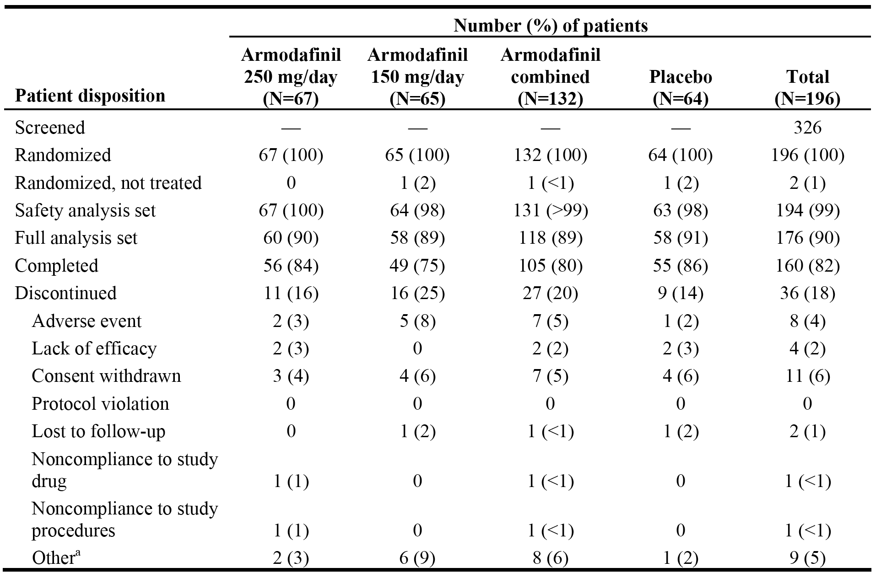

a = "Other" was the reason for discontinuation for 9 patients: 1 x 250 mg/day, administrative reason; 1x 250 mg/day, study termination; 1x 150 mg/day, positive pregnancy test, subsequently had an elective abortion; 1x 150 mg/day, moved out of state; 2 x 150 mg/day, administrative reason); 2 x 150 mg/day, study termination; 1 x placebo, administrative reason.

##### Major protocol deviations

Protocol violations (non-adherence to exclusion criteria or primary endpoint criteria) were acknowledged by the sponsor for 6 patients: 2 x primary endpoint criteria violations in the armodafinil 250 mg/day group (1 x CGI not dose at visit 3; 1 x last MWT and CDR not performed at visit 3); 1 x exclusion criteria violation in the armodafinil 150 mg/day group (reduced washout period); and 3 x primary endpoint criteria violations (1 x CGI-C not done at visit 4; 1 x MWT not done at visit 3; 1 x CGI-S not done after washout and before randomization). No patient was withdrawn from the study due to a protocol violation.

*Comment: The protocol violations/deviations are considered not to have invalidated the efficacy of safety analyses.*

##### Baseline data

The baseline demographic data for the safety population (n=194) are summarised. The mean age of the total population safety population was 38. 1 years (range: 18, 67 years), and the age distribution in the total population was 32% aged 18-29 years, 26% aged 30-40 years, 31% aged 41-50 years, and 10% > 55 years. The majority of patients were female (56%), with males accounting for 44% of the total patient population. The majority of patients in the total patient population were white (73%), with most of the remaining patients being black (16%). There were some differences in the baseline demographic characteristics of the patient groups (e.g., mean age, age distribution profile), but it is considered that these are unlikely to have invalidated the efficacy or safety analyses.

Baseline characteristics of narcolepsy were generally similar among patients in each treatment group. Mean (± SD) baseline sleep latencies as determined by the MSLT performed at 0900, 1100, 1300, and 1500 hours for patients in the 3 treatment groups 250 mg/day of armodafinil, 150 mg/day of armodafinil, and placebo were 2.6 ± 1.61, 2.5 ­± 1.72, and 2.6 ± 1.55 minutes, respectively, well below the maximum of 6 minutes allowed for study entry. CGI-S ratings at baseline were similar among patients in each treatment group, with 87 (66%) patients in the armodafinil treatment groups and 45 (71%) patients in the placebo treatment group being markedly, severely, or extremely ill. The baseline characteristics of narcolepsy are summarised.

The most frequently reported medical history abnormalities (other than narcolepsy) reported in ≥ 20% of patients in the total population were neurological system (59%), allergy/drug sensitivity (37%), musculoskeletal system (36%), head, eyes, ears, nose, and throat (HEENT) (29%), gastrointestinal/digestive (27%), dermatological (22%), genitourinary (21%), and psychiatric (21%). Of the total population, 16% had a medical history of cardiovascular disease (7% hypertension, 1 % arrhythmias, 1% chest pain, and 9% other cardiovascular conditions).

The only medical conditions for which the difference in incidence between the combined armodafinil and placebo groups was ≥ 10% of patients were respiratory disease (18% vs 6%, respectively) and allergy drug sensitivity (34% vs 44%, respectively). A history of cardiovascular disease was reported in 2 (3%) patients in the armodafinil 250 mg/day group, 14 (22%) patients in the armodafinil 150 mg/day group, and 15 (24%) patients in the placebo group. A history of hypertension was reported in 1 (1%) patient in the armodafinil 250 mg/day group, 9 (14%) patients in the armodafinil 150 mg/day group, and 4 (6%) patients in the placebo group.

Prior medications had been taken by 80% of patients in the total patient population. Prior medications taken by ≥ 10% of patients in the total patient population were psychostimulants (42%), non-opioid analgesics/anti-inflammatory (30%), metabolic/endocrine agents (21%), vitamins/nutritional supplements (21%), CNS (18%), anti-depressive (12%), gastrointestinal agents (11%), and respiratory agents (10%). The prior medication profiles was similar across the treatment groups, and the only prior medications reported for which the difference in incidence between the combined armodafinil and placebo groups was ≥ 5% of patients were respiratory agents (13% vs 3%, respectively) and gastrointestinal agents (9% and 14%, respectively).

##### Results for the primary efficacy outcomes

###### Maintenance of Wakefulness Test (MWT) - sleep latency

The primary objective efficacy outcome was the change from baseline in sleep latency from the 20-minute MWT (average of 4 naps at 0900, 1100, 1300, and 1500) assessed at endpoint. The treatment comparisons were undertaken using an ANCOVA model with treatment and country as factors and the baseline sleep latency value from the MWT as a covariate. The change from baseline to endpoint was statistically significantly greater in each of the armodafinil groups compared to placebo. The results are summarised below in Table 31.

Table 31: Study 3020 - Actual values and mean change from baseline to endpoint (last post-baseline observation) in mean sleep latency (minutes) from the MWT; FAS

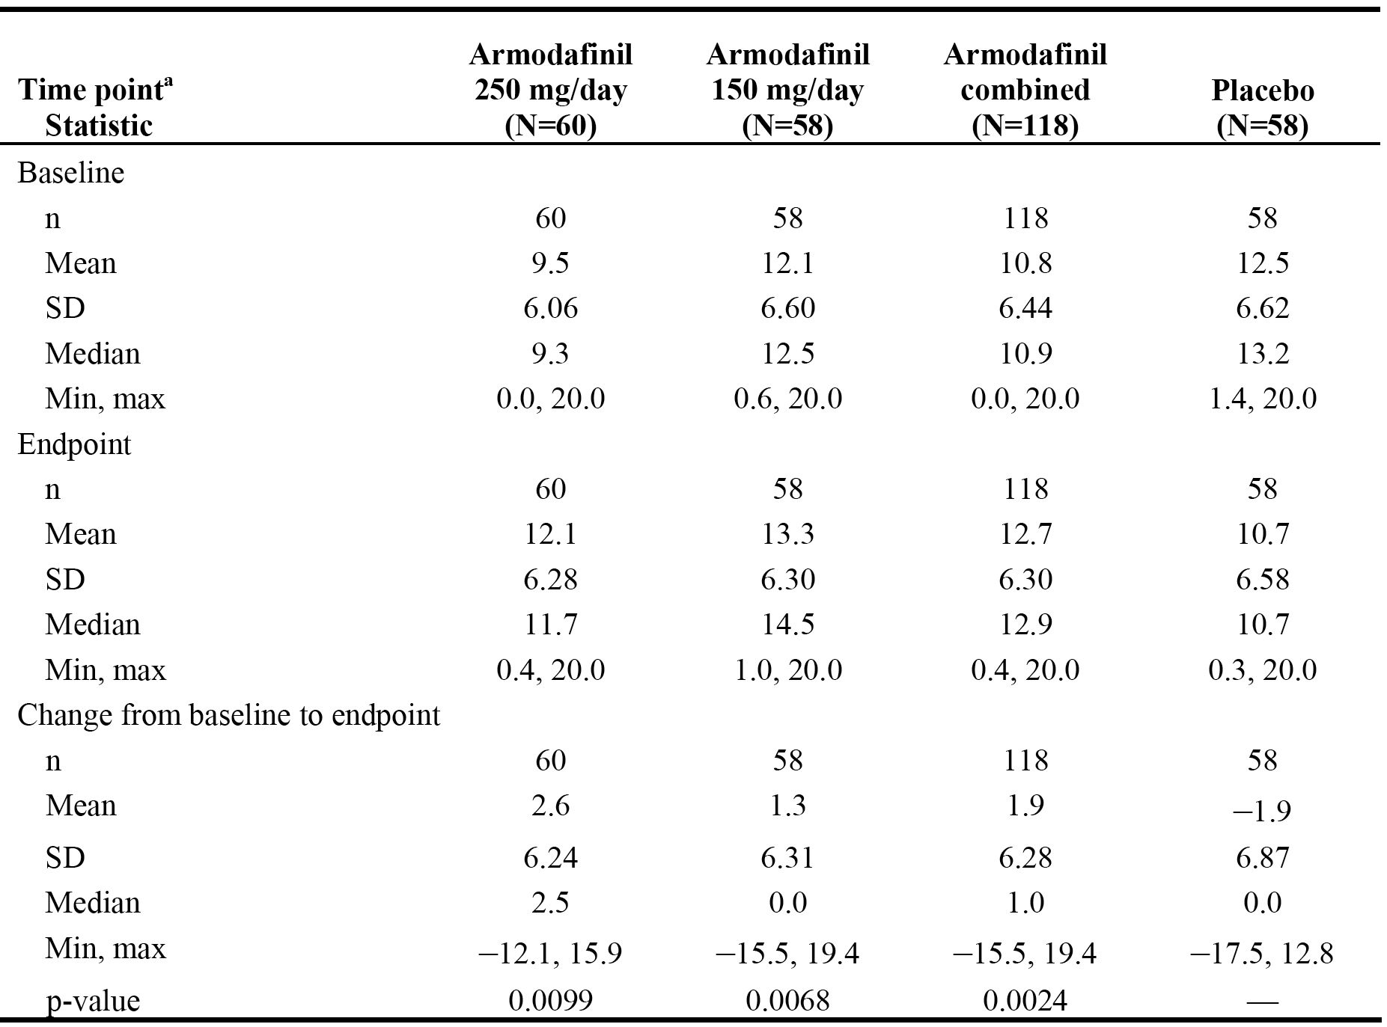

The LS means of the change from baseline in the armodafinil 250 mg/day, armodafinil 150 mg/day, combined armodafinil and placebo groups were 1.5, 1.6, 1.6 and -1.2 minutes, respectively. The 95% CIs for the difference in LS means were 0.67 to 4.86 for armodafinil 250 mg/day vs placebo, 0.80 to 4.94 for armodafinil 150 mg/day vs placebo, and 1.02 to 4.61 for combined armodafinil vs placebo. Only the 95% CI for the difference in LS mean change between the combined armodafinil and placebo group excluded unity (i.e., 1), indicating that the result was statistically significant. The results for the two pairwise comparisons between armodafinil 250 mg/day and placebo, and armodafinil 150 mg/day and placebo are not statistically significant based on the results for the LS means,

*Comment: Based on the assumptions used to calculate the sample size, a difference of 2.5 minutes in the mean change from baseline to endpoint in sleep latency from the MWT between the armodafinil and placebo groups can be considered to be clinically significant. Based on this values, it can be concluded that the differences between the combined armodafinil and placebo groups (∆ = 3.8 minutes), armodafinil 150 mg/day and placebo groups (∆ = 3.2 minutes), and armodafinil 250 mg/day and placebo groups (∆ = 4.5 minutes), are clinically meaningful and statistically significant. However, it should be noted that, based on the 95% CI for LS mean change from baseline to endpoint analyses, only the pairwise comparison between the combined armodafinil group and placebo was statistically significant (i.e., 95% CI excluded unity). There was an imbalance in baseline sleep latency from the MWT across the treatment groups, with mean sleep latency in the armodafinil 250 mg/day group being lower than in the 150 mg/day group (9.5 vs 12.5 minutes, respectively). However, the differences in mean baseline sleep latency from the MWT were accounted for in the ANCOVA model due to this variable being included as a covariate term.*

*The sponsor's ad hoc analyses of the mean sleep latency times from the MWT, based on the FDA's request, are summarised. The majority of the ad hoc analyses showed a statistically significant difference in favour of the combined armodafinil group compared to the placebo group, with the exceptions being the worst case analyses. It is noted that Analysis 1, which used the latency to sleep as determined by the local site, was similar to the analysis undertaken by central reading. Overall, it is considered that the data have satisfactorily established that armodafinil compared to placebo significantly increases mean sleep latency time from the MWT.*

##### Clinical Global Impression of Change (CGI-C)

The primary subjective efficacy measure, the proportion of patients with at least minimal improvement in the CGI-C (as related to general condition), was assessed at endpoint. The primary analysis of the CGI-C used a CMH chi-square test adjusted for country. The proportion of patients who had at least minimal improvement in CGI-C from baseline to endpoint was statistically significantly greater in the armodafinil groups compared to placebo. The results are summarised below in Table 32.

Table 32: Study 3020 - Proportion of patients with at least minimal improvement in the CGI-C rating at endpoint; FAS.

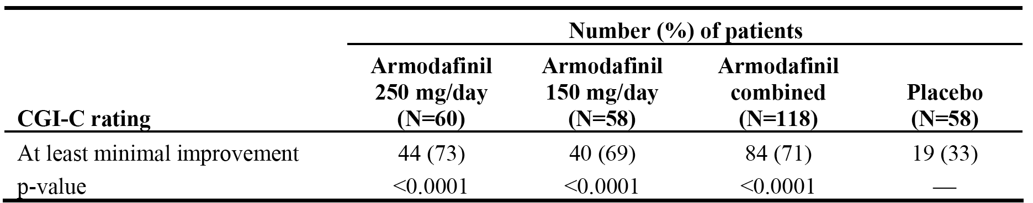

Greater percentages of patients receiving armodafinil compared to patients receiving placebo were very much improved (17% vs 3%, respectively) or much improved (34% vs 12%, respectively) on the basis of CGI-C ratings at endpoint. In addition, the percentage of armodafinil treated patients who showed no improvement was smaller than the percentage of placebo treated patients showing no improvement (23% vs 50%, respectively). The results are summarised below in Table 33.

Table 33: Study 3020 - CGI-C ratings at endpoint (last post-baseline observation); FAS.

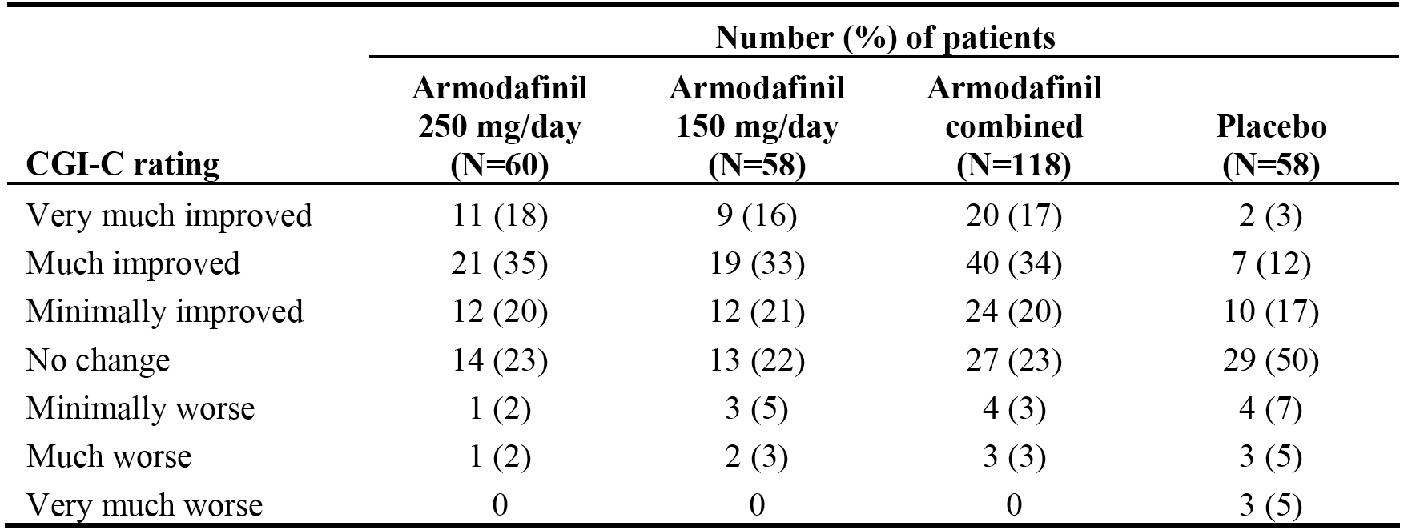

*Comment: Based on the assumptions used to calculate the sample size, a difference of 25% between the armodafinil and placebo groups, assuming a 37% rate in the placebo group, can be considered to be clinically meaningful. In this study, the rate in the placebo group was 33%. Therefore, based on the assumptions used to calculate the sample size it can be concluded that the difference in the proportion of patients with minimal improvement in the CGI-C rating between the combined armodafinil and the placebo groups (∆ = 38%), the armodafinil 150 mg/day and the placebo groups (∆ = 36%) and the armodafinil 250 mg/day and placebo groups (∆ = 40%), are clinically meaningful and statistically significant.*

##### Results for other efficacy endpoints

###### Key secondary efficacy endpoint - quality of episodic secondary memory

The key secondary variable was change from baseline to endpoint in the mean quality of episodic secondary memory from the tests of memory from the CDR system (average of 4 tests at 0930, 1130, 1330, and 1530 hours). The mean change from baseline to endpoint for this variable statistically significantly favoured the combined armodafinil group compared to placebo (18.6 vs 1.0, respectively, p=0.0032), the armodafinil 150 mg/day group compared to placebo (20.7 vs 1.0, respectively, p=0.0062), and the armodafinil 250 mg/day group compared to placebo (16.5 vs 1.0, respectively, p=0.0168). The results are summarised.

###### Other secondary efficacy endpoints

* Change from baseline in sleep latency from the MWT for the following comparisons:
  + Mean sleep latency from the MWT (average of 4 tests at 0900, 1100, 1300, and 1500) at weeks 4, 8, and 12. The results for this variable statistically significantly favoured the combined armodafinil group compared to placebo at week 4 (2.1 vs -1.1 minutes, p=0.0054), week 8 (1.7 vs -1.2 minutes, p=0.0481), and week 12 (1.8 vs -1.7 minutes, p=0.0264). In addition, the comparison statistically significantly favoured armodafinil 150 mg/day compared to placebo at weeks 4, 8, and 12, and armodafinil 250 mg/day compared to placebo at week 4.
  + Mean sleep latency from the MWT for the later time points (average of 3 tests at 1500, 1700, and 1900) at weeks 4, 8, and 12 and endpoint. At endpoint, the results for this variable statistically significantly favoured the combined armodafinil group vs placebo (1.6 vs -1.2 minutes, p=0.0358) and the armodafinil 150 mg/day group vs placebo (1.5 vs -1.2 minutes, p=0.0286), but not the armodafinil 250 mg/day group vs placebo (1.6 vs -1.2 minutes, p=0.1450). There were no statistically significant differences between that combined armodafinil groups and the placebo group for this variable at weeks 4, 8, and 12.
  + Sleep latency for the individual tests from the MWT (at 0900, 1100, 1300, 1500, 1700, and 1900) at weeks 4, 8, and 12 and endpoint. The descriptive results showed that at weeks 4, 8, and 12, and endpoint there were numerical differences in favour of the combined armodafinil group compared to placebo.
* The proportion of patients with at least minimal improvement in the CGI-C ratings at weeks 4, 8, and 12. The results for this variable statistically significantly favoured the combined armodafinil group compared to placebo at week 4 (73% vs 39%, p<0.0001), week 8 (69% vs 38%, p=0.0001), and week 12 (72% vs 30%, p<0.0001). In addition, the comparison statistically significantly favoured both armodafinil dosage groups (150 mg/day and 250 mg/day) compared to placebo at weeks 4, 8 and 12.
* CGI-C ratings at weeks 4, 8, and 12 and endpoint. At weeks 4, 8, 12 and endpoint, a greater proportion of patients in the combined armodafinil group were very much improved or much improved compared to placebo: 43% vs 9%, week 4; 53% vs 13%, week 8; 53% vs 12%, week 12; and 51% vs 15%, endpoint.
* Change from baseline for the following variables from tests of attention from the CDR system:
  + Mean power of attention (average of 4 tests at 0930, 1130, 1330, and 1530) at weeks 4, 8, and 12 and endpoint. The mean change from baseline to endpoint for this variable statistically significantly favoured the combined armodafinil group compared to placebo (-41.5 vs 158.0 msec, p=0.0498) and the armodafinil 150 mg/day group compared to placebo (-80.1 vs 158.0 msec, p=0.0389), but not the armodafinil 250 mg/day group compared to placebo (-3.5 vs 158.0 msec, p=0.1776). There were no statistically significant differences between the combined armodafinil group and placebo at weeks 4, 8, and 12.
  + Mean power of attention for the later time points (average of 3 tests at 1530, 1730, and 1930) at weeks 4, 8, and 12 and endpoint. The mean change from baseline to endpoint for this variable statistically significantly favoured the combined armodafinil group compared to placebo (3.5 vs 32.2 msec, p=0.0413) and the armodafinil 250 mg/day group compared to placebo (16.8 vs 32.2, p=0.0480). In addition, there was a statistically significant difference from baseline to week 12 in favour of the combined armodafinil group compared to placebo (-9.8 vs 173.9 msec, p=0.0311). There were no statistically significant differences for this variable between any of the armodafinil groups and placebo at weeks 4 and 8.
  + The continuity of attention (average of 4 tests at 0930, 1130, 1330, and 1530) at weeks 4, 8, and 12 and endpoint. There were no statistically significant differences between the combined armodafinil group and placebo for this variable at weeks 4, 8, and 12, and endpoint.
  + Mean continuity of attention for the later time points (average of 3 tests at 1530,1730, and 1930) at weeks 4, 8, and 12 and endpoint. There were no statistically significant differences between the combined armodafinil group and placebo for this variable at weeks 4, 8, and 12, and endpoint.
* the change from baseline for the following variables from tests of memory from the CDR system:
  + Mean speed of memory (average of 4 tests at 0930, 1130, 1330, and 1530) at weeks 4, 8, and 12 and endpoint. The mean change from baseline to endpoint for this variable statistically significantly favoured the combined armodafinil group compared to placebo (-199.7 vs -6.3 msec, p=0.0178) and the armodafinil 250 mg/day group compared to placebo (-233.2 vs -6.3 msec, p=0.0072). In addition, the mean change for this variable statistically significantly favoured the combined armodafinil group and both armodafinil dosage groups compared to placebo at weeks 4, and the combined armodafinil group and the armodafinil 250 mg/day group compared to placebo at week 12.
  + Mean speed of memory for the later time points (average of 3 tests at 1530, 1730, and 1930) at weeks 4, 8, and 12 and endpoint. There were no statistically significant differences between the combined armodafinil group and placebo for this variable at weeks 4, 8, and 12 and endpoint.
  + Mean quality of episodic secondary memory (average of 4 tests at 0930, 1130, 1330, and 1530) at weeks 4, 8, and 12. There were statistically significant differences favouring the combined armodafinil group compared to placebo at week 4 (14.2 vs -2.2, p=0.0071), week 8 (19.4 vs -1.3, p=0.0005) and week 12 (18.1 vs 2.9, p=0.0362). In addition, there were statistically significant differences favouring both armodafinil dosage groups separately compared to placebo at weeks 4 and 8, but not week 12.
  + Mean quality of episodic secondary memory for the later time points (average of 3 tests at 1530, 1730, and 1930) at weeks 4, 8, and 12 and endpoint. There were statistically significant differences favouring the combined armodafinil compared to placebo at week 12 (7.4 vs -8.8, p=0.0344) and endpoint (8.5 vs -4.4 msec, p=0.0256), but not at weeks 4 or 8. In addition, there were statistically significant differences favouring both armodafinil dosage groups separately compared to placebo at endpoint, and for the armodafinil 250 mg/day compared to placebo at week 12.
* The change from baseline for the following:
  + Total score from the ESS at weeks 4, 8, and 12 and endpoint. The were statistically significant differences in changes from baseline in mean total score in favour of the combined armodafinil group compared to placebo at week 4 (-3.3 vs -2.2, p=0.0282), week 8 (-3.2 vs -1.4, p=0.0014), week 12 (-4.1 vs -1.4, p=0.0002), and endpoint (-3.9 vs -1.9, p=0.0006). In addition, there were statistically significant differences favouring the armodafinil 250 mg/day group compared to the placebo group at weeks 4, 8, and 12 and endpoint, and the armodafinil 150 mg/day group compared to the placebo group at weeks 8 and 12 and endpoint. The results for the ESS total scores are summarised.
  + Worst fatigue score from the BFI scale at weeks 4, 8, and 12 and endpoint. There were no statistically significant differences between the combined armodafinil group and mean change from baseline to weeks 4 and 8 and endpoint. There was a statistically significant change in favour of the combined armodafinil group compared to placebo at week 12 (-0.9 vs -0.1, p=0.0179). In addition, there was a statistically significant change in favour of the armodafinil 150 mg/day dosage group compared to placebo at week 12, but not in the armodafinil 250 mg/day dosage group compared to placebo.
  + Average score from the BFI scale at weeks 4, 8, and 12 and endpoint. There were statistically significant differences from baseline in mean change in average score from the BFI scale in favour of the combined armodafinil group compared to placebo at week 4 (-1.4 vs -0.2, p<0.0001), week 8 (-1.5 vs -0.6, p=0.0058), week 12 (-1.5 vs -0.1, p<0.0001), and endpoint (-1.4 vs -0.3, p=0.0002). In addition, there were statistically significant differences favouring both armodafinil dosage groups (150 mg/day, 250 mg/day) compared to placebo at weeks 4, 8, and 12, and baseline.
* The number of unintended daytime sleep episodes recorded in patient diaries decreased to a greater extent in the combined armodafinil group, the 150 mg/day group and the 250 mg/day group compared to placebo, with the mean reductions from baseline to post-baseline being 38.7%, 32.8% 44.3% and 10.2%, respectively. The number of daily naps recorded in patient diaries decreased to a greater extent in the combined armodafinil group, the 150 mg/day group and the 250 mg/day group compared to placebo, with the mean reductions from baseline to post-baseline being 42.5%, 41.1%, 43.8% and 26.3%, respectively. The percentage of patients who reported mistakes, accidents, or near misses post-baseline was the same for patients receiving armodafinil (86% [102 patients], combined treatment group) and for patients receiving placebo (86% [50 patients]).
* The change from baseline to post-baseline in the mean number of caffeinated drinks consumed each day was similar in the combined armodafinil group, the 150 mg/day group the 250 mg/day group, and the placebo group, with the values being -1.6, -0.7, -1.1, and 0.6.

### Shift Work Sleep Disorder (SWSD)

#### Pivotal study 3022

##### Study design, objectives, locations, and dates

Study 3022 was a randomised, double-blind, placebo-controlled, parallel-group Phase 3 study designed to evaluate the efficacy and safety of armodafinil (150 mg/day) for the treatment of excessive sleepiness associated with chronic shift work sleep disorder (SWSD). The study was sponsored by Cephalon and was conducted at 37 centres in the USA and 5 centres in Canada. The study was undertaken between 2 April 2004 (first patient enrolled) and 23 December 2004 (last patient completed), and the CSR approval date was 9 March 2005.

The primary objective of the study was to determine whether treatment with armodafinil was more effective than placebo for patients with excessive sleepiness associated with chronic SWSD by measuring mean sleep latency from the 20-minute Multiple Sleep Latency Test (MSLT) (average of 4 naps at 0200, 0400, 0600, and 0800 hours), and by Clinical Global Impression of Change (CGI-C) ratings (for sleepiness during night shifts including the commute to and from work) at week 12 or the last post-baseline observation. There were a number of secondary objectives and these are listed.

In this study, 254 patients were randomised (1:1) to armodafinil 150 mg/day (n=127) or placebo (n=274) to be taken 30 minutes to 1 hour before the start of a night shift, but no later than 2300 hours and only on nights worked. The duration of the double-blind treatment period was 10 to 12 weeks. Depending on the shift work schedule, a patient could be considered to have completed the study after 10 weeks of double-blind treatment. It was recommended that patients refrain from eating/drinking (except bottled water) at least 2 hours before taking study drug.

Potential patients came to the clinic for preliminary screening assessments, including administration of the CGI-S. If the CGI-S criteria were met (i.e., CGI-S rating of at least 4), patients returned to the clinic (at approximately 1900) for additional screening/baseline assessments, including the MSLT and 8-hour daytime PSG. There had to be at least 7 days between the preliminary screening visit and the study drug dispensing visit (visit 3) in order to collect 7 days of diary data. If a patient was taking medication excluded by the protocol, there had to be a washout period before collection of baseline diary data and before the screening/baseline assessments of CGI-S, MSLT, and 8-hour daytime PSG.

Patients who met the inclusion/exclusion and screening criteria were dispensed study drug at a subsequent visit. With the exception of the initial screening visit and the dispensing visit, all visits included an overnight stay in the clinic, which took place immediately following the last night worked for the night shift work period (i.e., at least 3 consecutive night shifts). For each overnight clinic visit, with the exception of the screening/baseline visit, patients refrained from eating/drinking (except bottled water) after 1900. Study drug was administered within 30 minutes of 2200 hours, followed by a meal. Outcome assessments included the MSLT administered 5 times (at 2400, 0200, 0400, 0600, and 0800 hours), the BFI was assessed before the first MSLT nap, the Karolinska Sleepiness Scale (KSS) was administered before each MSLT nap, CDR system testing was administered after MSLT naps, and the CGI-C was assessed after the last CDR system testing session.

Data from electronic diaries, on the effect on sleepiness and its consequences during the night shift and the commute home and the effect on daytime sleep, were reviewed at weeks 4, 8, and 12. Patients made daily diary entries, including after overnight testing in the clinic and after daytime PSG. For the purposes of assessing effect on daytime sleep, the week 12 visit or the last post-baseline observation also included an 8 hour daytime PSG after the last overnight visit (beginning at 1015 hours after other procedures/assessments were performed), with the patient discharged following the testing and a meal.

Patients who completed the study (10 to 12 weeks of treatment) and patients who discontinued from the study at any time before the completion of the study had final procedures performed and assessments made. The study schedule is provided.

*Comment: The study was well designed and provided pivotal short-term efficacy and safety data. There were two amendments to the protocol, the first was issued prior to the enrollment of any patients into the study (2 March 2004) and the second was made after all patients had been enrolled in the study (21 October 2004). The changes made in Amendment 2 have been examined and are considered not to have negatively impacted on the safety and efficacy analyses based on data from the enrolled patients.*

##### Inclusion and exclusion criteria

The study enrolled adult patients aged 18 to 65 years (inclusive) with a diagnosis of SWSD according to ICSD criteria. Patients were required to have had excessive sleepiness during the night shifts for at least 3 months, and to have worked at least 5 nights shifts per month (of which at least 3 shifts were consecutive) and planned to maintain this schedule. In addition, patients were required to have had no more than 87.5% sleep efficiency (i.e., sleep duration/time in bed x 100%) as determined by 8 hour daytime PSG. Furthermore, patients were required to have a mean sleep latency of 6 minutes or less from the MSLT (performed at 0200, 0400, 0600 and 0800 hours ± 30 minutes), and a CGI-S rating of 4 or more relating to sleepiness during night shifts including the commute to and from work. The inclusion and exclusion criteria are summarised.

In addition to the comprehensive inclusion and exclusion criteria, the study also included standard criteria relating to withdrawal of patients from the study. The study also specified that efforts were to be made to complete evaluations and report observations up to the time of withdrawal as thoroughly as possible, and to monitor until outcome adverse events that had resulted in withdrawal.

*Comment: The inclusion and exclusion criteria are satisfactory. The criteria are considered to be sufficient to capture only patients with severe morbidity arising from the condition.*

##### Study treatments

During the double-blind treatment period, patients were instructed to take a single dose of armodafinil 150 mg or placebo 30 minutes to 1 hour before the start of the night shift on nights worked, but no later than 2300 hours. It was recommended that patients refrain from eating/drinking (except bottled water) for at least 2 hours before taking study drug.

Study drug was administered in the clinic within 30 minutes of 2200 hours, followed by a meal. For the overnight clinic visits during the treatment period, patients were to refrain from eating or drinking (except bottled water) after arrival at the clinic (1900 hours).

Armodafinil treatment was titrated as follows (only on nights worked): the first dose was 50 mg, the second and third doses were 100 mg, and the fourth and subsequent doses were 150 mg. Each dose of armodafinil was administered using 50 mg tablets.

Investigators were responsible for monitoring patient compliance. Patients could be withdrawn from the study at any time if the investigator or the sponsor determined that the patient was not compliant with the study protocol. Compliance checks involved reviews of electronic patient diaries and work schedules, counts of total tablets dispensed and totals returned, and verification of source documents.

Any prior and concomitant medication given to a patient within 30 days before and up to the end of the study, including all medication given before, during, and after study drug administration, was recorded on the CRF. Prohibited concomitant medications were consistent with those from the previously described OSAHS and narcolepsy studies. Patients who were smokers were allowed to use a low-dosage (7 mg/24 hr) nicotine patch during the overnight clinic visits. At each clinic visit after the screening visit, the investigator asked the patient whether any medications (other than study drug), including OTC medications and herbal preparations, had been taken since the previous visit.

##### Efficacy variables and outcomes

###### Primary efficacy variables

The primary efficacy variables were:

* the mean change from the baseline to endpoint assessment in MSLT mean sleep latency (average of 4 naps at 0200, 0400, 0600, and 0800 hours); and
* the proportion of patients with at least minimal improvement in the CGI-C ratings (for sleepiness during night shifts including the commute to and from work) as assessed at week 12 or the last post-baseline observation. The CGI-C rating used in this study was identical to that used in the pivotal OSAHS and narcolepsy studies.

The MSLT is a validated objective assessment of sleepiness that measures the likelihood of falling asleep, rather than the ability to stay awake for a defined period of time as objectively measured by the MWT used in the pivotal OSAHS and narcolepsy studies. The MSLT is based on the premise that the degree of sleepiness is reflected by sleep latency. The MSLT involved five 20-minute (maximum) naps performed at 2 hour intervals at scheduled visits (2400, 0200, 0400, 0600, and 0800 hours). The patient was dressed in non-constricting clothes and was instructed to lie quietly and attempt to sleep. Each MSLT nap continued until (a) 3 consecutive 30-second epochs of stage 1 sleep were reached, or (b) any single, 30-second episode of stage 2, 3, 4 or REM sleep was reached. Sleep latency for each nap and average sleep latency for the 4 naps were tabulated. According to the clinical protocol for the MSLT, each nap was terminated after 20 minutes if no sleep occurred. Sleep latency was measured as the elapsed time from lights-out to the first epoch scored as sleep. With a 30-second scoring epoch, this criterion was reached when sleep occupied at least 16 seconds of any epoch. If a patient fell asleep, he or she was awakened and kept awake but remained in bed.

###### Secondary efficacy variables

* The key secondary variable was the change from baseline to endpoint in the mean quality of episodic secondary memory derived from the tests of memory from the CDR system (average of 4 tests at 0230, 0430, 0630, and 0830 hours).
* There were a number of other secondary efficacy variables. These are summarised.

##### Randomization and blinding methods

Due to the large number of centres participating in this study, patients were randomised using country as the stratum (or blocking factor) rather than centre. An IVRS was used to maintain the overall balance among treatment groups within each country. Patients were randomised in blocks of 2 (1:1) within each country to receive armodafinil 150 mg or placebo. Patients and investigators remained blinded to treatment assignment during the study. In addition, Cephalon personnel involved in data management and/or analysis were also blinded to the study drug identity until the database was locked for analysis and the treatment assignment unblinded.

##### Analysis populations

The set of randomised patients included all patients who were randomised to a treatment group, regardless of whether or not a patient received any study drug.

The safety analysis set included those patients in the set of randomised patients who received 1 or more doses of study drug.

The full analysis set (FAS) included those patients in the safety analysis set who have a baseline and at least 1 post-baseline MSLT assessment, and at least 1 post-baseline CGI-C assessment. The FAS was used for all efficacy analyses.

##### Sample size

Sample size estimates were made on the basis of the results of PK/PD modelling and simulation applied to data from the Phase 1 clinical studies with armodafinil and from clinical trials in sleep disorders with PROVIGIL, under the assumption that both primary treatment comparisons would be with a 2-sided test at an alpha level of 0.05.

On this basis, a sample of size 108 per treatment group would provide 85% power to detect a 1.5-minute difference in the mean sleep latency from the MSLT between armodafinil and placebo, assuming a common standard deviation of 3.65 minutes. This sample size would also have at least 90% power to detect a difference of 25% between armodafinil and placebo in the proportion of patients reporting at least minimal improvement in CGI-C ratings, assuming a 37% rate in the placebo group. In addition, for the key secondary variable of memory (defined as the quality of episodic secondary memory from tests of memory in the CDR system battery), this sample size would provide at least 68% power to detect a 14-unit difference between armodafinil and placebo, assuming a common standard deviation of 42.

*Comment: Approximately 250 patients were planned to be enrolled in this study in order to obtain 216 evaluable patients (i.e., who have at least 1 post-baseline MSLT assessment). The study actually enrolled 254 patients and 216 were evaluable for efficacy (FAS). There were 112 patients evaluable for efficacy in the armodafinil 150 mg/day group and 104 patients evaluable for efficacy in the placebo group. Therefore, the number of patients in each treatment group was similar to the number of patients in each treatment group on which the study was powered.*

##### Statistical methods

###### Primary efficacy variables

Multiple Sleep Latency Test (MSLT)

The change from baseline in the mean sleep latency from the MSLT (average of 4 naps at 0200, 0400, 0600, and 0800) was analysed at weeks 4, 8, and 12 and endpoint using an ANOVA with treatment and country as a factor. The test was 2-tailed using α = 0.05

The protocol specified that the primary efficacy variable was to be analysed using an ANCOVA model with treatment and country as factors and baseline sleep latency from the MSLT as a covariate. However, as there was evidence of an interaction between treatment and baseline MSLT sleep latency (p<0.011) the covariate was dropped, and the primary efficacy variable was analysed as pre-specified using an ANOVA model with treatment and country as factors. Consequently, as pre-specified all continuous efficacy variables in the study were analysed using this ANOVA model. This change in the analytical methods was specified in the SAP approved before unblinding of the data.

Examination of the ANOVA model residuals showed evidence of non-normality (i.e., Shapiro-Wilt test, p<0.0001). Consequently, as pre-specified, the non-parametric Wilcoxon rank-sum test was used to compare the results of the primary efficacy endpoint outcomes between armodafinil 150 mg and placebo. The results showed that the inferences from the parametric test (ANOVA) and the non-parametric test (Wilcoxon rank-sum) were in the same direction (i.e., p≤0.05). Consequently, as pre-specified, only p-values from the parametric procedure was reported for the primary efficacy outcome comparison, and the parametric procedure was applied to the secondary continuous efficacy variables.

Clinical Global Impression of Change (CGI-C)

The comparison between the proportion of patients in the armodafinil 150 mg and placebo groups with at least minimal improvement in the CGI-C ratings (for sleepiness during night shifts including the commute to and from work) as assessed at week 12 or the last post-baseline observation was tested using a CMH chi-square test adjusted for country. This statistical test was 2-tailed using α=0.05.

*Comment: All efficacy assessments were analysed at weeks 4, 8, and 12 using observed cases, while efficacy assessments at endpoint were analysed using the last observation carried forward (LOCF) method. Actual values and changes from baseline at each visit were summarised using standard descriptive statistics. Both primary endpoints were tested separately at α=0.05, with no adjustment for multiplicity. If the most conservative position is adopted of requiring both endpoints to be statistically significant in order for the study to be deemed "positive", then it is considered that each of the two endpoints should have been tested at α=0.25 (i.e., adjusted for multiplicity using the Bonferroni correction).*

###### Secondary efficacy variables

The key secondary variable was the change from baseline to endpoint in the mean quality of episodic secondary memory derived from the tests of memory from the CDR system (average of 4 tests at 0230, 0430, 0630, and 0830 hours). This efficacy variable was analysed with an ANOVA model with treatment and country as factors (2-tailed test using α=0.05).

There were a number of other secondary efficacy variables. The continuous efficacy variables were analysed using an ANOVA model with treatment and country as factors (2-tailed test using α=0.05). CGI-C ratings were analysed using a CMH chi-square test adjusted for country (2-tailed using α=0.05).

*Comment: No statistical adjustment for multiplicity was made for the numerous pairwise comparisons between armodafinil 150 mg and placebo with all secondary efficacy endpoints being tested at separately at α=0.05.*

##### Participant flow

A total of 747 patients were screened for the study, and 254 (34%) met the entrance criteria and were enrolled in the study. Patients were not enrolled in the study for the following reasons: inclusion criteria not met (n=225); exclusion criteria present (n=67); consent withdrawn (n=106); other reasons (55); lost to follow-up (n=36); reason unspecified (n=2); and adverse event (n=2). Of the 55 patients not enrolled for reasons categorized as "other", the reason included closure of study enrollment for the majority of patients (n=39).

Of the 254 randomised patients at 42 centres in 2 countries, 234 were from USA centres (234 patients) and 20 were from Canadian centres. Of the 254 randomised patients, 245 (96%) patients received at least 1 dose of study drug and were evaluated for safety, and 9 patients did not receive study drug (4 patients randomised to armodafinil and 5 patients randomised to placebo). A total of 216 (85%) patients received at least 1 dose of study drug and had a baseline assessment and at least 1 post-baseline assessment for both MSLT and CGI-C and were evaluable for efficacy (FAS). A total of 186 (73%) patients completed the study, 97 (76%) patients receiving armodafinil and 89 (70%) patients receiving placebo. Patient disposition (all patients) is summarised below in Table 34.

Table 34: Study 3022 - Disposition (all patients).

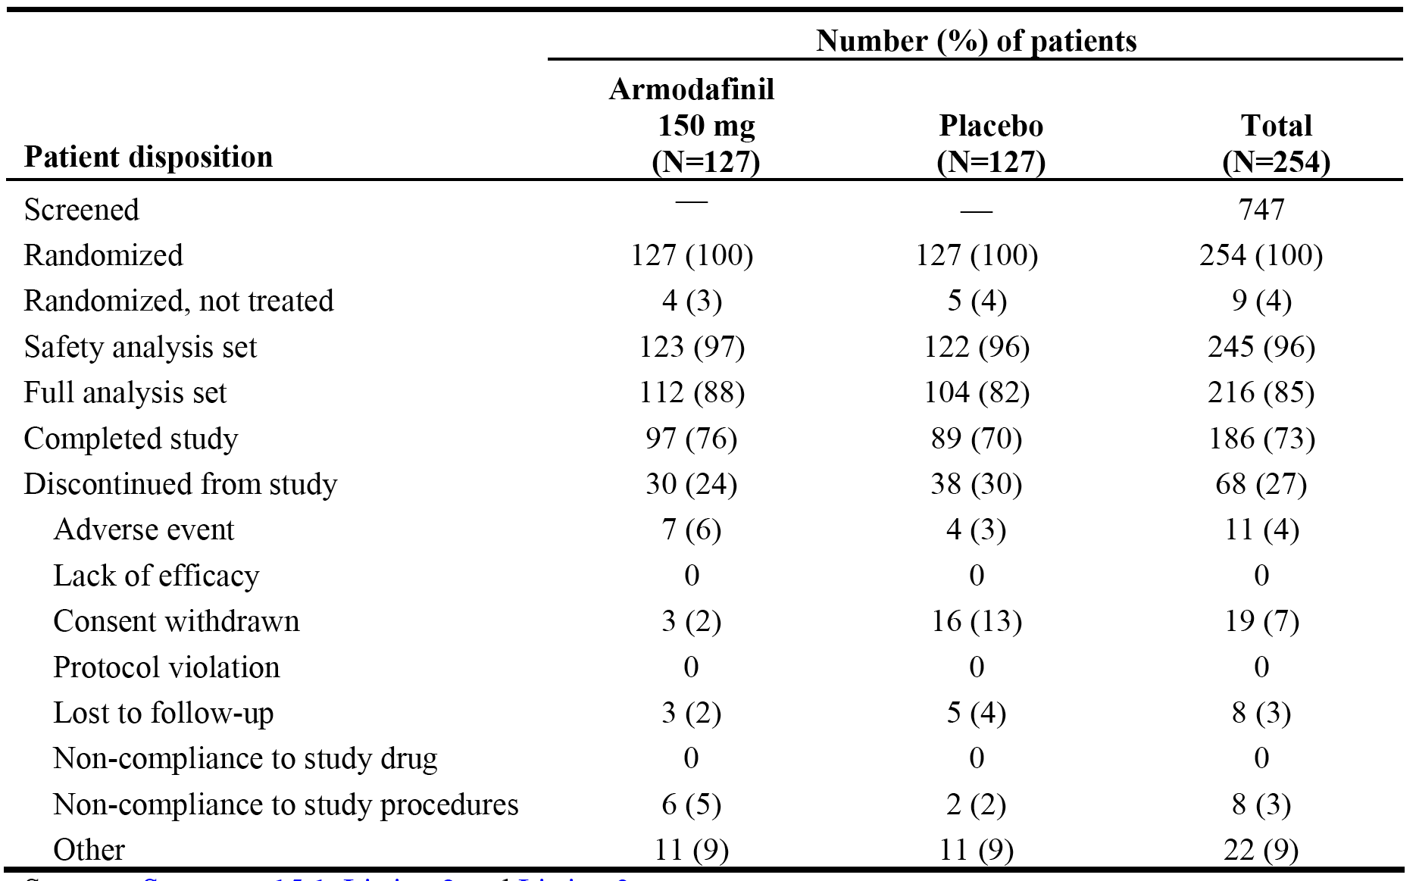

NOTE : Other = change in shift work status (7 patients); administrative reasons (4 patients); closure of study enrollment (3 patients); and pregnancy, elevated blood pressure, panic attack, family reasons, excluded medication, patient had to leave the country, did not meet inclusion criteria, and unspecified (1 patient each).

##### Major protocol deviations

Protocol violations (non-adherence to inclusion and/or exclusion criteria, primary endpoint criteria, and/or GCP guidelines) were acknowledged for 12 patients. Three patients (2 randomised to armodafinil and 1 to placebo) had exclusion criteria present; 1 patient (randomised to armodafinil) had an inclusion criterion present; 5 patients (3 randomised to armodafinil and 2 to placebo) had a violation related to primary endpoint criteria; and 3 patients (2 randomised to armodafinil and 1 to placebo) had a violation related to GCP guidelines. No patient was withdrawn from the study due to a protocol violation.

*Comment: The protocol violations/deviations are considered not to have invalidated the efficacy or safety analyses.*

##### Baseline data

The baseline demographic data are summarised. The armodafinil 150 mg and placebo treatment groups, respectively, were generally well matched in regard to age (mean 38.9 and 40.3 years), sex (54% and 52% men), body weight (mean 85.5 and 88.7 kg), height (mean 171.5 cm in both groups), and mean BMI (29.1 and 30.2 kg/m2). The armodafinil treatment group had fewer white patients (74 [60%]) than the placebo treatment group (86 [70%] patients).

Baseline CGI-S ratings were similar between the armodafinil 150 mg and placebo groups, with 90% and 91% of patients, respectively, being moderately or markedly ill. The majority of patients in both the armodafinil 150 mg and placebo group were permanent shift workers (87% and 86%, respectively), and the most frequently occurring shift worker occupation in both groups was "health care social assistance" (41% and 39%, respectively). Baseline CGI-S and shift worker occupation data are summarised.

Patients in both treatment groups had similar medical histories. Medical histories (other than SWSD) reported in ≥ 20% of patients in the total patient group (safety analysis set) were musculoskeletal conditions (39%), allergy/drug hypersensitivity, neurological conditions (34%), HEENT disorders (28%), gastrointestinal/digestive conditions (24%), genitourinary conditions (22%) and cardiovascular disease (22%). Most of the patients with cardiovascular disease had hypertension or elevated lipids. Medical histories reported in ≥ 5% more patients in one treatment group compared to the other (armodafinil vs placebo, respectively) were genitourinary conditions (19% vs 25%), allergy/drug sensitivity (34% vs 39%), HEENT conditions (24% vs 32%), and cardiovascular disease (18% vs 26%).

Prior medication use was similar for patients in both treatment groups (67% in the armodafinil 150 mg group and 68% in the placebo group). Prior medication reported in ≥ 10% of patients in the total patient group (safety analysis set) were non-opioid analgesics/anti-inflammatory (38%), vitamins/nutritional supplements (31%), metabolic/endocrine agents (17%), antihistamine (11%). Prior medications reported in ≥ 5% more patients in one treatment group compared to the other (armodafinil vs placebo, respectively) were antihistamine (8% vs 14%), non-opioid analgesics/anti-inflammatory (35% vs 41%), and vitamins/nutritional supplements (27% vs 35%). Modafinil had previously been taken by 3 patients, 2 randomised to armodafinil and 1 to placebo.

##### Results for the primary efficacy outcome

###### Multiple Sleep Latency Test (MSLT) - sleep latency

Mean MSLT sleep latency (average of 4 naps at 0200, 0400, 0600 and 0800 hours) increased 3.1 minutes from baseline to endpoint in the armodafinil 150 mg group (i.e., from 2.3 to 5.3 minutes) and 0.4 minutes in the placebo group (i.e., 2.4 to 2.8 minutes), with the difference between the two groups being 2.7 minutes, p<0.0001. The results are summarised below in Table 35.

Table 35: Study 3022 - Actual values and mean changes from baseline to endpoint in mean sleep latency (minutes) from the MSLT; FAS.

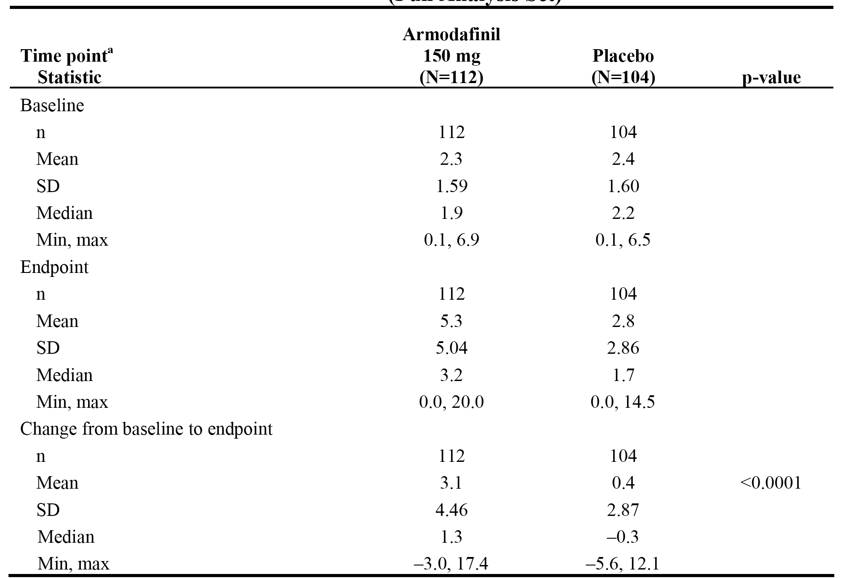

Note: The p-value for the treatment comparison is from an ANOVA with treatment and country as factors.

The LS means of the change from baseline to endpoint in the armodafinil 150 mg/day and placebo groups were 3.6 and 1.0 minutes, respectively, and the 95% CI for the difference was 1.67 to 3.69 The 95% CI excluded unity (i.e., 1), indicating that the difference in the LS means between the two treatment groups was statistically significant.

*Comment: Based on the assumptions used to power the study, a difference in mean change from baseline to endpoint in the MSLT between the two treatment groups of 1.5 minutes can be considered to be clinically meaningful. Based on this value, it can be concluded that difference between the armodafinil 150 mg/day and placebo groups (∆ = 2.7 minutes) is clinically meaningful and statistically significant.*

*The number of "flawed" sessions in this study identified by the FDA statistical reviewer was markedly less than in the OSAHS and narcolepsy studies. The methodology used to assess sleep latency from the MSLT used in this study was less prone to result in discrepancies between site sleep technicians and central readers than the MWT method used in the OSAHS and narcolepsy studies. The ad hoc analyses of the primary efficacy outcome undertaken by the sponsor at the request of the FDA are summarised. No worst case analyses were undertaken due to the small number of flawed sessions in this study. Overall, the results of the sponsor's ad hoc analyses are consistent with the original analysis provided in the CSR.*

###### Clinical Global Impression of Change (CGI-C)

The proportion of patients who had at least minimal improvement in CGI-C rating from baseline to endpoint statistically significantly favoured armodafinil 150 mg compared to placebo (see Table 36, below).

Table 36: Study 3022 - Proportion of patients with at least minimal improvement in the CGI-C rating at endpoint; FAS.

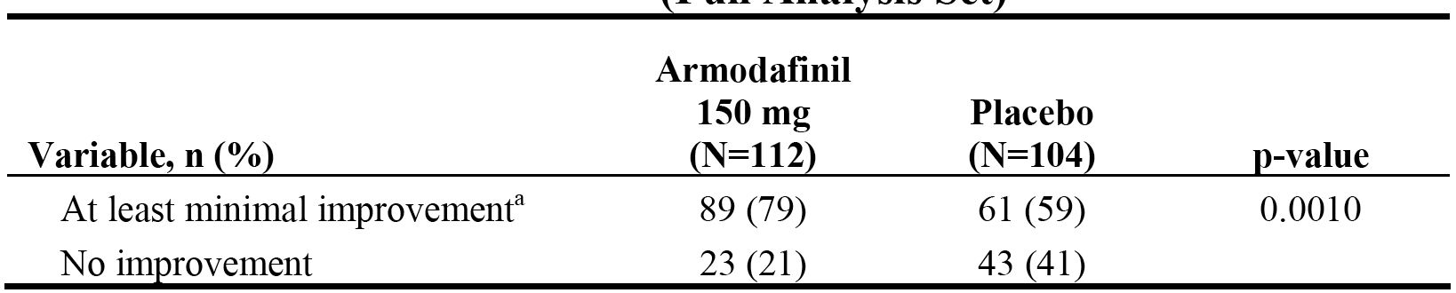

Note: The p-value for the comparison is from a CMH-chi square test adjusted for country.

More patients in the armodafinil 150 mg group were very much or much improved than patients in the placebo group (57% vs 36%, respectively); see Table 37, below.

Table 37: Study 3022 - CGI-C ratings at endpoint (last post-baseline observation).

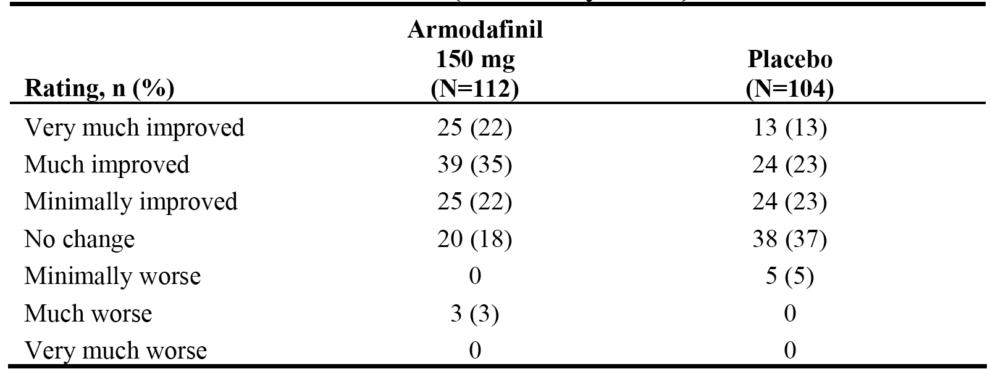

*Comment: The difference between the proportion of patients with at least minimal improvement in CGI rating at endpoint was 20% in favour of armodafinil, with a placebo response rate of 59%. Based on the assumptions used to power this study of difference between groups of 25%, assuming a placebo response rate of 37%, the observed difference between the two treatment groups is of doubtful clinical significance, due to the high placebo response rate.*

##### Results for other efficacy outcomes

###### Key secondary efficacy endpoint - quality of episodic secondary memory

The difference in the mean change from baseline to endpoint in the quality of episodic secondary memory (average of 4 tests at 0230, 0430, 0630, and 0830) from the CDR system was statistically significantly in favour of armodafinil 150 mg compared to placebo (18.4 vs -3.3, respectively, p<0.0001). In addition, the mean change from baseline to weeks 4, 8, and 12 statistically significantly favoured armodafinil 150 mg/day compared to placebo at each time-point. The results are summarised.

###### Other selected secondary efficacy variables

Sleep latency from MSLT

* Mean sleep latency from the MSLT (average of 4 naps at 0200, 0400, 0600, and 0800 hours) at weeks 4, 8, and 12 statistically significantly favoured armodafinil 150 mg/day compared to placebo at each visit. The results are summarised.
* Sleep latency for individual naps from the MSLT (2400, 0200, 0400, 0600, and 0800 hours) at weeks 4, 8, and 12 and endpoint. In general, descriptive results numerically favoured armodafinil 150 mg/day compared to placebo for all individual naps at each time-point for weeks 4, 8, 12, and endpoint.
* The profile of the change from baseline in mean sleep latency (minutes) from the MSLT over the duration of the study was evaluated by a repeated measures analysis of ANOVA with treatment, country, visit, and treatment-by-visit as factors. For the summary statistics, the values for the change from baseline in mean sleep latency for each patient at each time point (weeks 4, 8, and 12, excluding the early termination visit) were averaged by patient, and those results were averaged for all patients by treatment group. The result of this analysis showed that the mean sleep latency profile over the duration statistically significantly favoured armodafinil 150 mg/day compared to placebo (3.2 minutes vs 0.4 minutes, respectively, p<0.0001).

CGI-C ratings

The proportion of patients with at least minimal improvement in CGI-C ratings from baseline to weeks 4, 8, and 12 statistically significantly favoured the armodafinil 150 mg/day group compared to placebo at each visit. The results are summarised.

Tests of memory from CDR system

* Mean quality of episodic secondary memory (average of 4 tests at 0230, 0430, 0630, and 0830 hours) at weeks 4, 8, and 12. The quality of episodic secondary memory showed improvement in the armodafinil 150 mg/day group compared to placebo at week 4 (∆ = 16.4, p=0.0002), week 8 (∆ = 21.7, p=0.0002), and week 12 (∆ = 20.0, p=0.0016).
* The change in mean speed of memory (average of 4 tests at 0230, 0430, 0630, and 0830 hours) from baseline statistically significantly favoured armodafinil 150 mg/day compared to placebo at week 8 (∆ = 194.4 msec, p=0.0148) and week 12 (∆ = 192.5 msec, p=0.0098). The difference numerically (but not statistically significantly) favoured armodafinil 150 mg compared to placebo at week 4 (∆ = 60.3 msec, p=0.3720) and endpoint (∆ = 116.8, p=0.0928).

Tests of attention from CDR system

* Mean power of attention (average of 4 tests at 0230, 0430, 0630, and 0830 hours) improved from baseline to endpoint in the armodafinil 150 mg/day group (mean decrease of 88.3 msec [i.e., increase in power]) and deteriorated in the placebo group (mean increase of 88.1 msec [i.e., decrease in power]); ∆ = 176.4 msec in favour of armodafinil, p=0.0011. In addition, mean change from baseline in power of attention showed statistically significant improvement in the armodafinil 150 mg/day group compared to placebo at week 4 (∆ = 145.7 msec, p=0.0049), week 8 (∆ = 158.0 msec, p=0.0062) and week 12 (∆ = 169.9 msec, p=0.0045).
* Mean change in continuity of attention (average of 4 tests at 0230, 0430, 0630, and 0830 hours) statistically favoured armodafinil 150 mg/day compared to placebo at endpoint (2.9 vs 0.2, p=0.0005), week 8 (2.2 vs -0.2, p=0.0279) and week 12 (2.5 vs 0, p=0.0017), but not at week 4 (2.7 vs 1.4, p=0.0766).

Karolinska Sleepiness Scale (KSS) scores

Mean KSS score (average of the 4 tests associated with the MSLT tests at 0200,0400, 0600, and 0800) hours at weeks 4, 8, and 12 and endpoint. The KSS is a validated patient-rated instrument for measuring sleepiness, based on a scale from 1 to 9 (with 1 indicating very alert and 9 indicating very sleepy, great effort to stay awake, fighting sleep). The difference of 0.8 between the two treatment groups in the mean KSS scores at endpoint was statistically significant (p=0.0008) in favour of armodafinil. In addition, the change from baseline to endpoint in mean KSS scores was statistically significant at each visit in favour of armodafinil treatment, with the difference being 1.0 at both week 4 (p=0.0001) and week 8 (p<0.0001), and 0.8 (p=0.0034) at week 12.

Brief Fatigue Inventory (BFI) scores

The mean changes from baseline to endpoint at weeks 4, 8, and 12 in the average fatigue score and the worst fatigue score from the BFI scale were not statistically significantly different between the two treatment groups.

Patient diary assessments of sleepiness

The mean number of unintended sleep episodes during the night shift decreased from baseline to post-baseline by 71.8% in the armodafinil 150 mg/day group (from 1.2 to 0.4) and by 42.2% in the placebo group (from 1.1 to 0.7). The mean number of naps during the night shift decreased by 35.8% in the armodafinil 150 mg/day group (from 0.7 to 0.3) and by 13.2% in the placebo group (from 0.6 to 0.4). The number of patients with post-baseline mistakes, accidents, or near misses from the patient diaries for the effect on sleepiness during the night shift was 65% in both treatment groups and during the commute home was 50% in both treatment groups.

The mean maximum level of sleepiness during the night shift according to the KSS scores from patient diaries decreased from baseline to post-baseline by 2.0 (from 7.5 to 5.6) in the armodafinil 150 mg/day group and 1.1 in the placebo group (from 7.5 to 6.4). The mean level of sleepiness during the commute home according to the KSS scores from patient diaries decreased from baseline to post-baseline by 1.2 (from 5.9 to 4.8) in the armodafinil 150 mg/day group and by 0.6 in the placebo group (from 5.9 to 5.3).

Caffeine usage

Caffeine usage, measured by the number of caffeinated drinks consumed each day, decreased from baseline to post-baseline by a mean of 0.4 drinks in the armodafinil 150 mg group (from 1.3 to 0.9) and was unchanged in the placebo group (1.8).

#### Other studies

##### Phase 3, open-label, long-term studies

###### Study 3023

Overview

Study 3023 was a Phase 3, open-label, study designed to evaluate the safety and tolerability (primary objective) and the long-term efficacy (secondary objective) of a flexible armodafinil dosage regimen (100 to 250 mg/day) administered for up to 12 months or more for the treatment of excessive sleepiness associated with a current diagnosis of narcolepsy, OSAHS (with regular use of nCPAP) or chronic SWSD. The study was conducted at 34 centres in the USA and 7 centres in Russia, but after 12 months the study was conducted only at centres in the USA. The study period was from 30 January 2004 to 19 July 2006, and the approval date for the CSR was 11 January 2008.

The primary objective was to evaluate the safety and tolerability of armodafinil administered on a flexible-dosage regimen of 100 to 250 mg/day for up to 12 months or more to patients with excessive sleepiness associated with a current diagnosis of narcolepsy, OSAHS (regular users of nCPAP therapy), or chronic SWSD.

The secondary objective was to evaluate long-term efficacy by using CGI-C ratings for all patients, and the ESS at baseline evaluations and at months 1, 3, 6, 9, and 12, and every 3 months thereafter (or at the early termination visit) for patients with narcolepsy or OSAHS. For patients with narcolepsy or OSAHS, CGI-C was evaluated to assess general clinical condition. For patients with SWSD, CGI-C was evaluated to assess sleepiness during night shifts, including the commute to and from work.

The inclusion and exclusion criteria have been examined and are consistent with those for the pivotal Phase 3 studies for each of the three conditions. All patients in the study were required to have a CGI-S rating of 4. Patients with chronic SWSD were required to have had excessive sleepiness during night shifts for at least 3 months, worked a minimum of 5 night shifts per month that included at least 6 hours between 2200 and 0800 hours and were no longer than 12 hours in duration, and planned to continue to work night shifts throughout the study.

The study included a screening period where the eligibility of potential patients for inclusion was assessed. No more than 6 weeks after the initial screening visit, eligible patients returned to the clinic for baseline evaluations, and study drug was dispensed. During the treatment period, patients with a current diagnosis of either narcolepsy or OSAHS (on-going nCPAP treatment) were instructed to take their dose of armodafinil every day in the morning at approximately 0800, or if awaking after 0800, immediately on arising. The starting dose of armodafinil was 100 mg/day titrated to 150 mg/day on day 4. Increases in 50 mg increments could then be made on days 8 and 10 to a maximum of 250 mg/day. Patients with a diagnosis of chronic SWSD were instructed to take their dose 30 minutes to 1 hour before the start of the night shift, but no later than 2300, only on nights worked. Patients with SWSD took armodafinil on the same titration schedule as patients with narcolepsy or OSAHS, but titration occurred only when the drug was taken (i.e., before working night shifts) instead of daily. The maximum armodafinil dose in this study was 250 mg/day, determined by tolerability. For all patients, the dose could be decreased to a minimum of 100 mg/day. The armodafinil doses in this study used 50 mg tablets.

Patient disposition

Patient disposition is summarised below in Table 38. The distribution of enrolled patients among the three groups was approximately 1:2:3 for narcolepsy (n=50), SWSD (n=108), and OSAHS (n=170). The percentage of patients completing the study was similar for the narcolepsy, SWSD and OSAHS groups (46%, 42% and 49%, respectively). Discontinuations due to AEs were notably lower in the SWSD group (7%) compared with the narcolepsy and OSAHS groups (16% in each group). This is likely to be due to the intermittent treatment with armodafinil in the SWSD group compared to continuous treatment in the other two groups. In addition, discontinuations due to lack of efficacy were notably higher in the narcolepsy group (14%) than in both the OSAHS group (7%) and the SWSD group (<1%).

Table 38: Study 3023 - disposition (all patients).

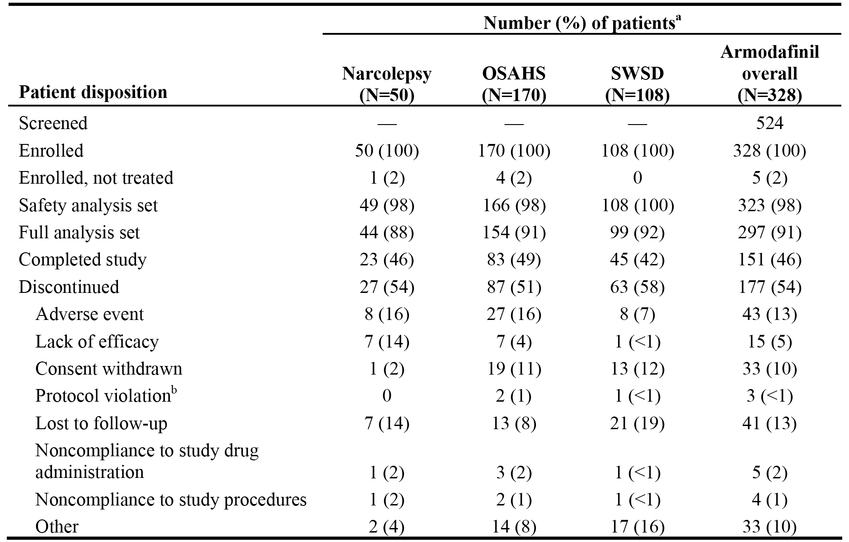

Armodafinil dosage and exposure

Of the 328 patients enrolled in this study, 323 patients received at least 1 dose of armodafinil. The modal (most commonly used) dosage results are summarised below in Table 39. The most commonly used dose of armodafinil was 250 mg/day (46% [148/323] of patients). Of the total number of patients in the safety set (n=323), 67% (n=217) received armodafinil daily or intermittently for 6 months and 26% (n=83) of patients received armodafinil for more than 12 months.

Table 39: Study 3023 - Modal dosage; safety analysis set.

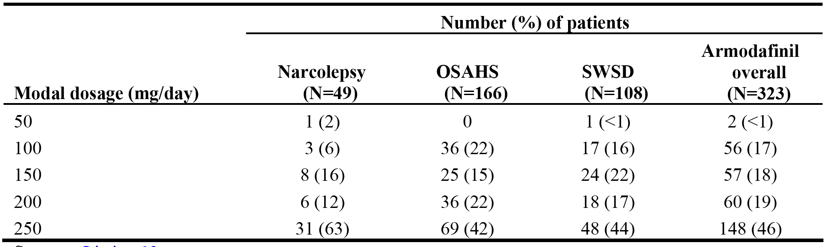

A total of 31 (63%) patients with narcolepsy received more than 6 months of treatment with armodafinil, including 17 (34%) patients who had more than 12 months of exposure. The mean ± SD duration of exposure for patients with narcolepsy was 311.5 ± 220.29 days.

A total of 118 (71%) patients with OSAHS received more than 6 months of treatment with armodafinil, including 43 (26%) patients who had more than 12 months of exposure. The mean ± SD duration of exposure for patients with OSAHS was 309.3 ± 206.60 days.

A total of 68 (63%) patients with SWSD participated in the study for more than 6 months, including 23 (22%) patients who participated for more than 12 months. The mean ± SD duration of participation in the study was 261.8 ­­± 163.32 days. Patients with SWSD received armodafinil only on the nights they worked a night shift.

Patient characteristics

The mean ± SD age at baseline in the safety analysis set was 44.8 ± 14.5 years (range: 20, 70 years) in the narcolepsy group, 48.9 ± 8.68 years (range: 12, 65 years) in the OSAHS group and 45.2 ± 11.27 years (range: 19, 70 years) in the SWSD group. The majority of patients in the narcolepsy, OSAHS, and SWSD groups were aged ≥ 41 years (66%, 79%, and 51%, respectively). More patients in the SWSD were aged 18-40 years in the SWSD group (48%) than in the narcolepsy (34%) and OSAHS (21%) groups. A greater percentage of patients in the OSAHS group were male (72%) than in the narcolepsy (49%) and SWSD (64%) groups. Most of the patients in the three groups were white, with a similar proportion in each of the three groups compared to the total patient population (85%).

The mean ± SD weight of patients in the narcolepsy group was lower than patients in the OSAHS and SWSD groups (80.9 ± 19.60 kg, 108.3 ± 24.53 kg, and 90.5 ± 21.65 kg, respectively), as was the mean ± SD BMI (27.7 ± 5.38 kg/m2, 35.8 ± 7.61 kg/m2, and 30.2 ± 6.84 kg/m2, respectively). The higher weight and BMI in patients with OSAHS is not unexpected. The mean ± SD height of the three groups was similar to the mean ± SD height in the total patient population (173 ± 9.37 cm).

The CGI-S rating at baseline in the three groups is summarised below in Table 40. The majority of patients in each of the three groups were moderately or markedly ill. A greater percentage of patients were severely ill in the narcolepsy and OSAHS groups compared to the SWSD group (14%, 10% and 4%, respectively). No patients in the study were CGI-S rated as normal, borderline, or slightly ill, suggesting that all patients in the study had significant morbidity arising from the condition.

Table 40: Study 3023 - CGI-S rating at baseline; safety analysis set.

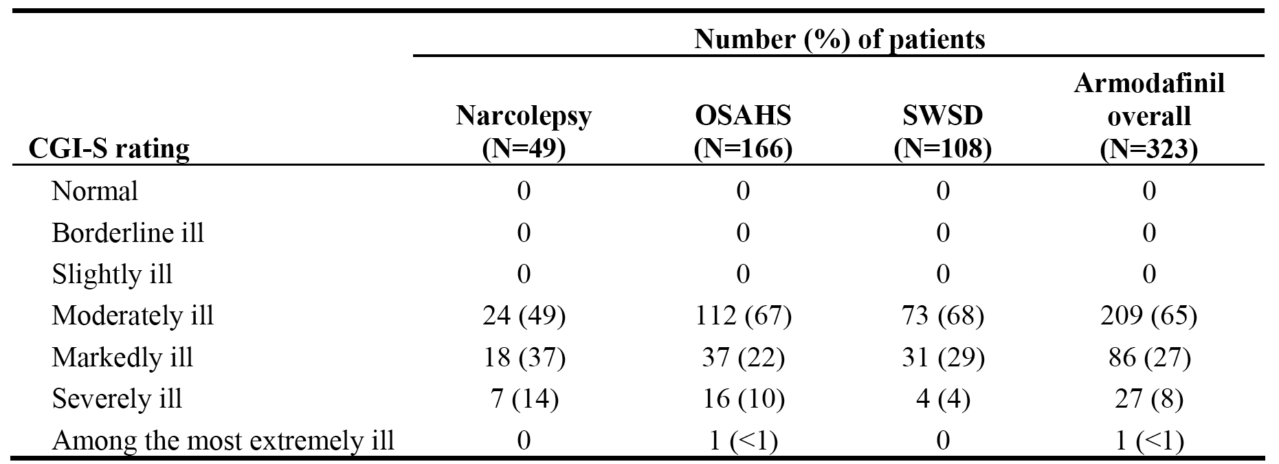

Efficacy outcome, statistical methods, and results

The evaluation of long-term efficacy was defined as a secondary objective for this study. The FAS was used for all efficacy analyses. The FAS included patients in the safety set (enrolled patients who took 1 or more doses of study drug) who had at least 1 post-baseline efficacy assessment. The endpoint data relating to the CGI-C and the ESS were summarised using standard descriptive statistics. Since this was an open-label study without a control group no statistical inference procedures were applied to the data and no formal sample size and power calculations were undertaken. The study planned to enrol approximately 300 patients.

Analysis of the Clinical Global Impression of Change (CGI-C)

The proportion of patients with at least minimal improvement in the CGI-C rating at each visit and endpoint is summarised below in Table 41.

Table 41: Study 3023 - Proportion of patients with at least minimal improvement in the CGI-C rating at visits through Month 12 and at endpoint; FAS.

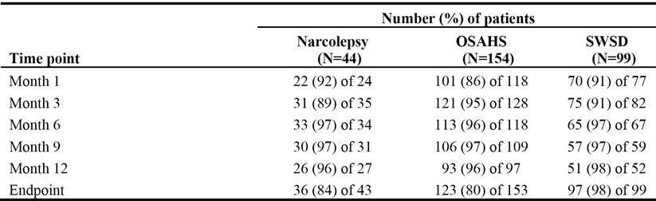

Note: The number of patients at each visit includes only patients with a CGI-C rating at that visit. Endpoint is the last-post baseline observation.

The proportion of patients reporting very much improved or much improved at each visit and endpoint is summarised below in Table 42.

Table 42: Study 3023 - Proportion of patients very much improved or much improved based on the CGI-C rating at visits through Month 12 and at endpoint; FAS.

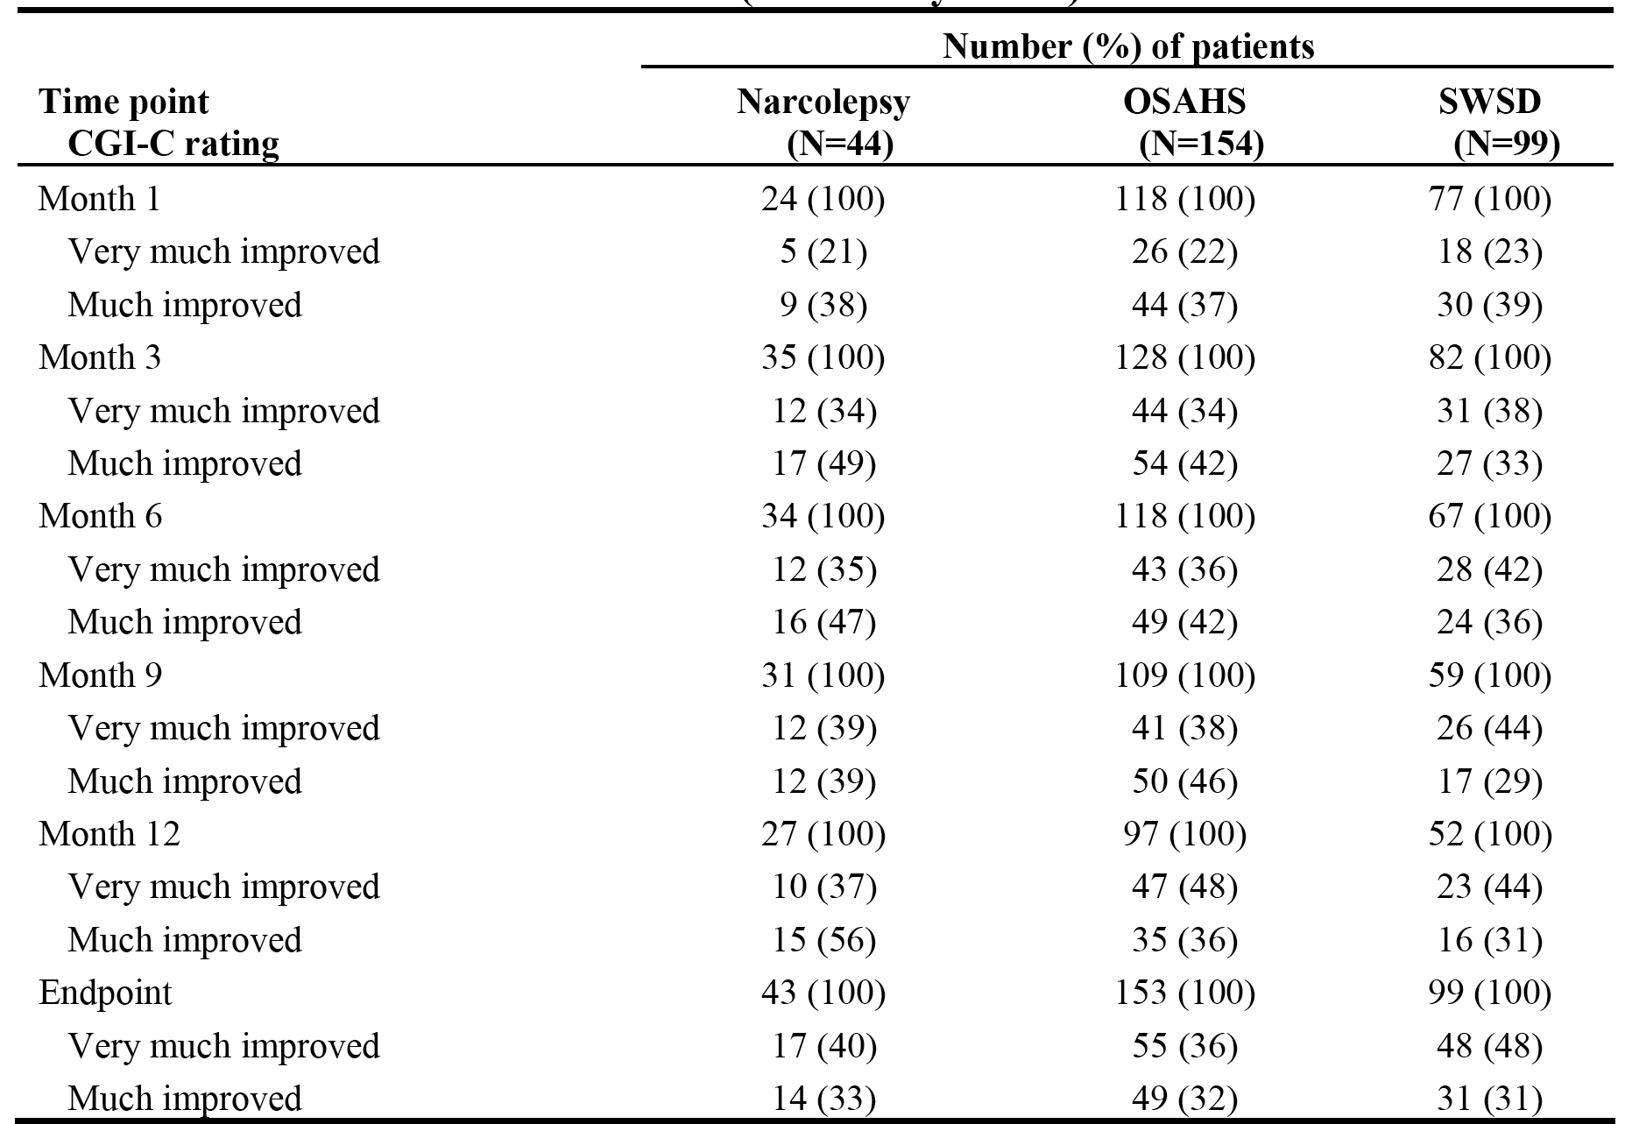

Note: The number of patients at each visit includes only patients with a CGI-C rating at that visit. Endpoint is the last-post baseline observation.

*Comment: At endpoint, the proportion of patients with at least minimal improvement in the CGI-C rating was 84% in the narcolepsy group, 80% in the OSAHS group and 98% in the SWSD group. The proportion of patients in each group reporting very much improved or much improved indicate that treatment with armodafinil was effective and that the effect was maintained or increased through month 12 (i.e., 58% to 62% at month 1, 71% to 83% at month 3, 75% to 93% at month 12, and 68% to 80% at endpoint).*

Analysis of Epworth Sleepiness Scale (ESS)

The patient’s subjective evaluation of excessive daytime sleepiness was assessed using the ESS at months 1, 3, 6, 9, 12, every 3 months thereafter, and at endpoint, only for patients with narcolepsy or OSAHS.

In patients with narcolepsy, the mean baseline (n=22) score was 16.3 and the mean reductions from the baseline score were 5.5 at month 1 (n=20), 5.3 at month 6 (n=15), 5.5 at month 12 (n=12), and 4.7 at endpoint (n=21). The mean scores were 10.4 (n=24) at month 1, 10.0 (n=34) at month 6, 11.2 at month 12, and 10.6 at endpoint (n=43).

In patients with OSAHS, the mean baseline (n=112) score was 14.1 and the mean reductions from the baseline score were 5.4 at month 1 (n=100), 7.4 at month 6 (n=87), 9.2 at month 12 (n=70), and 7.3 at endpoint (n=111). The mean scores were 8.9 ± 4.21 (n=119) at month 1, 6.7 at month 6 (n=117), 5.8 at month 12 (n=97), and 7.4 at endpoint (n=153).

*Comment: The sponsor comments that ESS scores ≥ 10 units out of a possible score of 24 units indicate excessive sleepiness. The mean decrease in ESS score of approximately 5 units at month 1 was maintained in patients with narcolepsy through to endpoint. The ESS mean score of approximately 5 units at 1 month in patients with OSAHS continued to decrease through to endpoint. The sponsor comments that a reduction in ESS score of 5 units (out of a possible score of 24 units) represents a clinically significant effect. However, it should be noted that in patients with narcolepsy mean ESS scores at months 1, 6, and 12 and at endpoint were ≥ 10 units, indicating excessive sleepiness based on the sponsor's criterion. Therefore, the clinical significance of the reduction in excessive sleepiness based on mean ESS scores for patients with narcolepsy is not convincing. In contrast, in patients with OSAHS mean scores were < 10 units at months 1, 6, and 12 and endpoint indicating significant clinical improvement in excessive sleepiness from baseline with continuous armodafinil treatment.*

###### Study 3024

Overview

Study 3024 was a Phase 3, multinational, multi-centre, open-label, study designed to evaluate the safety and tolerability (primary objective) and the long-term efficacy (secondary objective) of a flexible armodafinil dosage regimen (100 to 250 mg/day) administered for up to 12 months or more for the treatment of excessive sleepiness associated with a current diagnosis of narcolepsy, OSAHS (with regular use of nCPAP) or chronic SWSD.

All patients in this study had completed one of the 4 pivotal Phase 3 studies (i.e., study 3020 [narcolepsy], study 3021 [OSAHS], study 3022 [SWSD], or study 3025 [OSAHS]). Patients who had completed one these studies, met inclusion/exclusion criteria and were recommended by the investigator to participate in the study were eligible to enrol in study 3024.

The study was conducted at 74 centres in the USA, 8 in Canada, 4 in France, 4 in Germany, 4 in Russia, and 5 in Australia. Open-label treatment was conducted at all centres for the first 12 months, and thereafter only at centres in the USA and Canada. The study period was from 15 May 2004 to 19 July 2006, and the approval date for the CSR was 8 June 2008.

The primary objective was to evaluate the safety and tolerability of armodafinil administered on a flexible-dosage regimen of 100 to 250 mg/day for up to 12 months or more in patients with excessive sleepiness associated with a current diagnosis of narcolepsy, OSAHS (regular users of nCPAP therapy), or chronic SWSD.

The secondary objectives were to evaluate long-term efficacy by assessing the following outcomes at months 1, 3, 6, 9, and 12, and every 3 months thereafter (or at the early termination visit): CGI-C ratings (with respect to general condition for patients with narcolepsy or OSAHS [regular users of nCPAP therapy], or to sleepiness during night shifts, including the commute to and from work, for patients with chronic SWSD); BFI scores; and ESS scores for patients with narcolepsy or OSAHS.

The inclusion and exclusion criteria have been examined and are consistent with those for the pivotal Phase 3 studies for each of the three conditions. Patients with chronic SWSD were required to have had excessive sleepiness during night shifts for at least 3 months, worked a minimum of 5 night shifts per month that included at least 6 hours between 2200 and 0800 hours and were no longer than 12 hours in duration.

In study 3024, the first visit corresponded to the final visit of the individual double-blind studies from which patients were recruited. Some of the procedures and/or assessments performed at this visit were done as part of the final visit of the double-blind studies, unless more than 7 days had elapsed between the final visit of the double-blind study and visit 1 of this study. At the first visit, informed consent was obtained, inclusion and exclusion criteria were reviewed, and safety and efficacy assessments were made.

During the treatment period, patients with a diagnosis of either narcolepsy or OSAHS were instructed to take their daily dose of armodafinil in the morning at approximately 0800, or if awaking after 0800, immediately upon arising. For patients with narcolepsy or OSAHS, armodafinil was titrated from a starting dosage of 100 mg/day to 150 mg/day on day 4, and increases in increments of 50 mg could then be made on days 8 and 10 to a maximum dosage of 250 mg/day. In patients with chronic SWSD, armodafinil was to be taken only on nights worked and was titrated as follows: the first dose was 50 mg, the second and third doses were 100 mg, the fourth and fifth doses were 150 mg, the sixth and seventh doses were 200 mg, and the eighth and subsequent doses were 250 mg. SWSD patients were instructed to take their dose 30 minutes to 1 hour (but no later than 2300 hours) before beginning each night shift. The maximum armodafinil dose in this study was 250 mg/day, determined by tolerability. For all patients, the dose could be decreased to a minimum of 100 mg/day. The armodafinil doses in this study used 50 mg tablets.

Patients had clinic visits for study procedures and assessments (including safety and long-term efficacy) at the end of 1, 3, 6, 9 and 12 months, every 3 months thereafter, and at the final visit. In addition, patients were contacted by telephone after 2 weeks and at 2, 4, 5, 7, 8, 10, and 11 months. For patients in the extension treatment period (i.e., after 12 months), telephone contacts were made monthly between clinic visits. At every telephone contact, information regarding concomitant medications, adverse events, disorder-specific criteria, and study drug usage was reviewed.

Patient disposition

Patient disposition is summarised below in Table 43. Of the 743 enrolled patients, 474 (64%) had OSAHS, 156 (21%) had narcolepsy and 113 (15%) had SWSD. Of the 743 enrolled patients, 94% to 97% of patients in each of the three groups were in the FAS (i.e., evaluable for efficacy) and 38% to 47% completed the study. Adverse events resulting in discontinuation were reported more frequently in the OSAHS group (18%), with similar frequencies in the narcolepsy (10%) and SWSD (11%) groups. Discontinuations due to lack of efficacy were notably higher in the narcolepsy group (11%) compared with the OSAHS (3%) and SWSD (<1%) groups. At the time the sponsor terminated the study, 47% (n=420) of the enrolled patients had completed a least the initial 12-month study period.

Table 43: Study 3024 - Patient disposition; all.

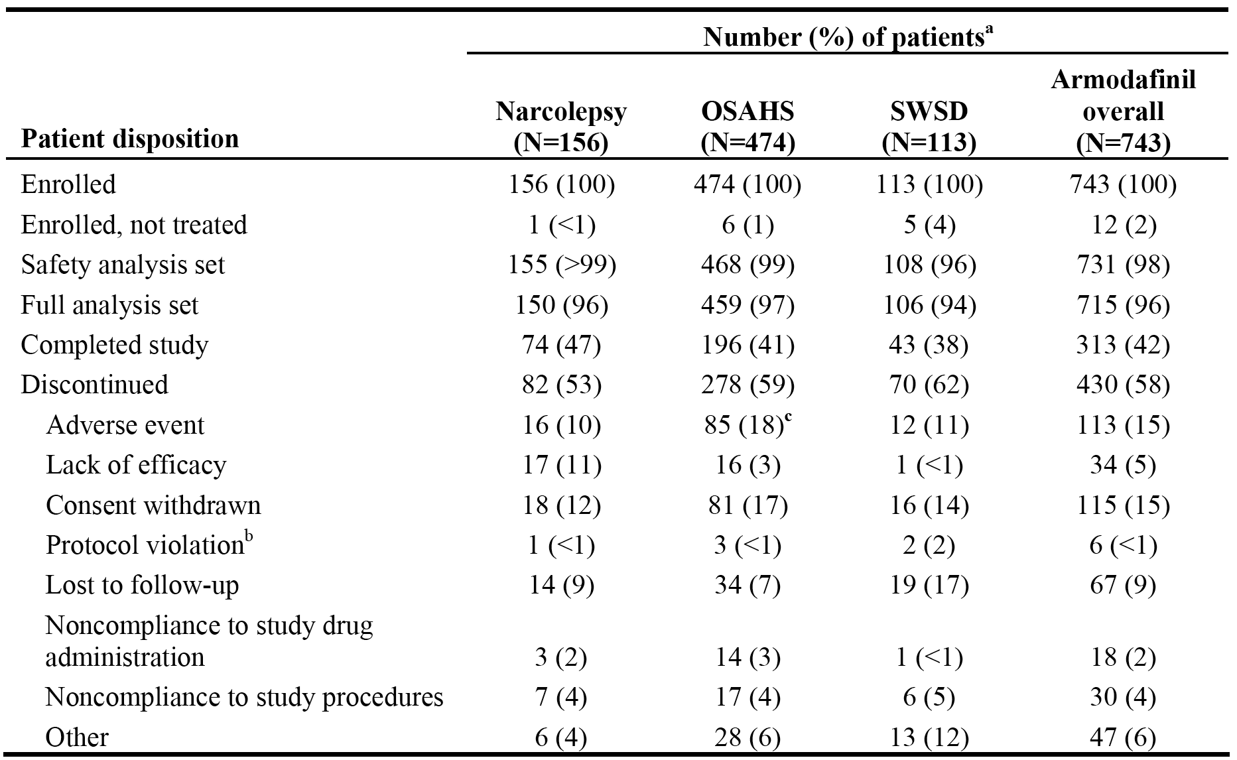

Armodafinil dosage and exposure

Of the 743 patients enrolled in this study, 731 patients received at least 1 dose of armodafinil. Modal dosages (most commonly used dosage) of armodafinil for the overall population were as follows: 250 mg for 67% of patients, 200 mg for 10%, 150 mg for 14%, 100 mg for 8%, and 50 mg for less than 1% of patients. The sponsor reported that similar patterns were observed for each of the three sleep disorder populations.

A total of 71 (46%) patients with narcolepsy received more than 12 months of treatment with armodafinil, including 44 (28%) patients who had more than 18 months of exposure. The mean ± SD duration of exposure for patients with narcolepsy was 346.2 ± 222.05 days.

A total of 254 (54%) patients with OSAHS received more than 12 months of treatment with armodafinil, including 190 (41%) who had more than 18 months of exposure. The mean ± SD duration of exposure for patients with OSAHS was 387.9 ± 249.91 days.

A total of 53 (49%) patients with SWSD participated in the study for more than 12 months, including 33 (31%) who participated for more than 18 months. The mean ± SD duration of participation in the study was 342.1 ± 226.33 days.

Baseline patient characteristics

The mean ± SD age at baseline in the safety analysis set was 38.9 ± 12.55 years (range: 18, 67 years) in the narcolepsy group, 50.2 ± 8.80 years (range: 25, 69 years) in the OSAHS group and 42.7 ± 10.97 years (range: 19, 63 years) in the SWSD group. A greater percentage of patients in the OSAHS group were male (73%) compared to the narcolepsy (45%) and SWSD (56%) groups. Most of the patients in the three groups were white, 74% in the narcolepsy group, 86% in the OSAHS group and 74% in the SWSD group. The mean ± SD weight of patients in the OSAHS group was higher than in patients in the narcolepsy and SWSD groups (111.0 ± 24.46 kg, 84.0 ± 20.55 kg, and 86.7 ± 21.50 kg, respectively) as was the mean ± SD BMI (36.9 ± 8.00 kg/m2, 29.1 ± 6.47 kg/m2, and 29.3 ± 6.97 kg/m2, respectively). The mean height of patients in each of the three groups was similar to the mean height in the total patient population (173.0 cm).

The CGI-S rating at baseline in the three groups is summarised below in Table 44. All patients enrolled in the study were required to have excessive sleepiness associated with narcolepsy, OSAHS, or SWSD and to have a CGI-S rating of 4 or more (i.e., at least moderately ill) at baseline for the double-blind study. The majority of patients in each of the three groups were moderately or markedly ill. A greater percentage of patients with narcolepsy (67%) were considered markedly, severely, or extremely ill compared to patients with OSAHS (46%) or SWSD (49%). No patients in the groups were CGI-S rated as normal, borderline, or slightly ill, suggesting that all patients in the study had significant morbidity arising from the condition.

Table 44: Study 3024 - CGI-S rating at baseline; safety analysis set.

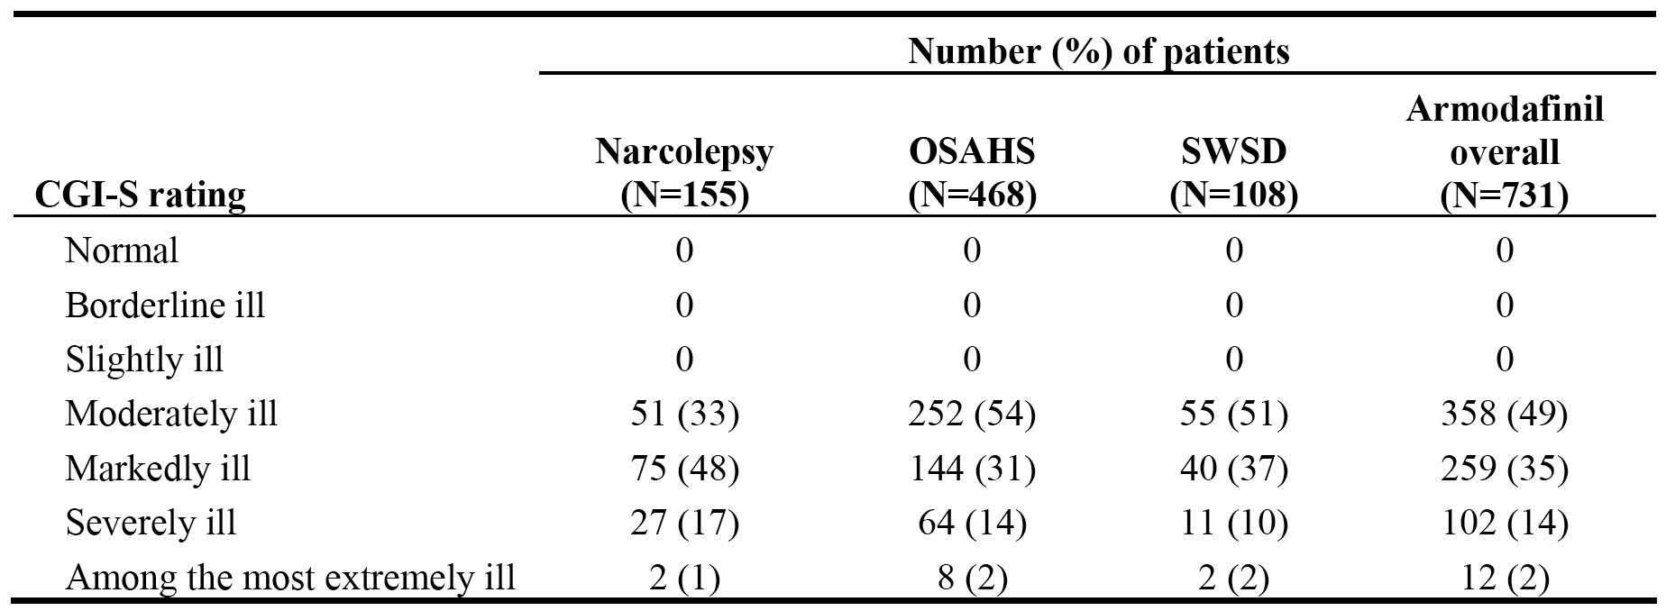

Efficacy outcome, statistical methods, and results

The study was primarily a safety study, but the continued efficacy of armodafinil treatment was evaluated during the study using the efficacy measures of CGI-C, the ESS, and the BFI. The efficacy variables were analysed using descriptive statistics. Because this was an open-label study without a control group, no statistical inference procedures were applied to the data and the determination of sample size was not based on statistical considerations. The number of patients in this study was determined by the number of interested and eligible patients from the double-blind studies. Enrolment of up to 1000 patients was anticipated. Baseline values for each patient were the baseline values from the previous double-blind study in which the patient received armodafinil or placebo for 12 weeks before entering this open-label extension study. The full analysis set was used for all efficacy analyses. The FAS included patients in the safety set (enrolled patients who took 1 or more doses of study drug) who had at least 1 post-baseline efficacy assessment.

Analysis of Clinical Global Impression of Change (CGI-C)

The results are summarised below in Table 45. The majority of patients in each sleep disorder group showed at least minimal improvement at month 1 (range 87% to 94% of patients), which persisted through month 18 (range 93% to 100% of patients). At endpoint, 113 (75%) patients with narcolepsy, 364 (80%) patients with OSAHS, and 97 (92%) patients with SWSD showed at least minimal improvement.

Table 45: Study 3024 - Proportion of patients with at least minimal improvement in the CGI-C rating at visits through Month 18 and at endpoint; FAS.

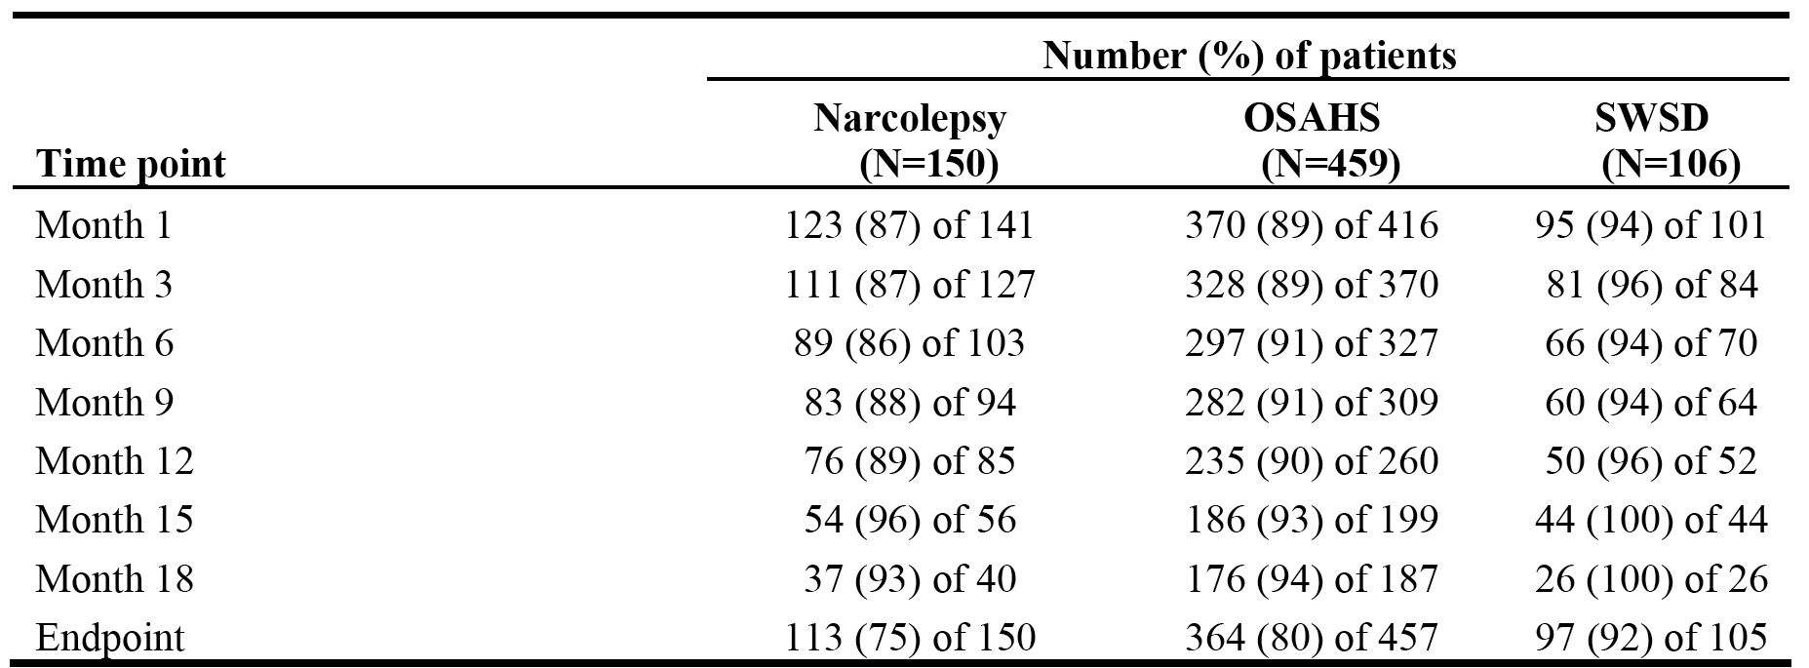

NOTE: The number of patients at each visit includes only patients with a CGI-I rating at that visit.

The CGI-C ratings of very much improved and much improved at month 1, 6, 12 and visits and at endpoint are summarised below in Table 46. The majority of patients in each of the three groups had very much improved or very much improved CGI-C ratings at each visit through to endpoint. The proportion of patients who were much improved or very much improved remained relatively constant from the month 1 visit through to the month 18 visit. At endpoint, 62% of patients with narcolepsy, 65% of patients with OSAHS, and 88% of patients with SWSD were very much or much improved. The proportion of patients who were very much improved was greater at each visit in the SWSD group at each visit compared to the other two groups.

Table 46: Study 3024 - CGI-C change ratings of very much improved and much improved at month 1, 6, 12, and 18 visits and at endpoint.

|  |
| --- |
| Table 46: Study 3024 - CGI-C change ratings of very much improved and much improved at month 1, 6, 12, and 18 visits and at endpoint.  Table 46: Study 3024 - CGI-C change ratings of very much improved and much improved at month 1, 6, 12, and 18 visits and at endpoint.  Table 46: Study 3024 - CGI-C change ratings of very much improved and much improved at month 1, 6, 12, and 18 visits and at endpoint.  Table 46: Study 3024 - CGI-C change ratings of very much improved and much improved at month 1, 6, 12, and 18 visits and at endpoint. |

Epworth Sleepiness Scale (ESS)

The patient’s subjective evaluation of excessive daytime sleepiness was assessed using the ESS at months 1, 3, 6, 9, 12, every 3 months thereafter, and at endpoint, only for patients with narcolepsy or OSAHS. The result at selected time points are summarised below in Table 47.

Table 47: Study 3024 - Change from baseline at selected time points in ESS scores; FAS.

|  |  |  |  |  |  |
| --- | --- | --- | --- | --- | --- |
|  |  | **Narcolepsy** | **n=150** | **OSAHS** | **n=459** |
| Baseline | mean ­± SD | 16.9 ± 4.12 | n=147 | 15.8 ­± 3.52 | n=454 |
| Month 1 | mean ± SD | 11.5 ± 5.12 | n=142 | 8.3 ± 4.44 | n=417 |
| ∆ | mean ± SD | -5.3 ± 5.14 | n=140 | -7.4 ± 5.05 | n=412 |
| Month 12 | mean ± SD | 12.5 ± 5,59 | n=86 | 8.8 ± 4.75 | n=259 |
| ∆ | mean ­± SD | -4.2 ± 5.18 | n=84 | -7.0 ± 5.27 | n=259 |
| Month 18 | mean ± SD | 12.6 ± 5.25 | n=40 | 8.5 ± 4.65 | n=187 |
| ∆ | mean ± SD | -4.4 ± 5.32 | n=39 | -7.4 ± 5.10 | n=187 |
| Endpoint | mean ± SD | 12.6 ± 5.44 | n=149 | 9.4 ± 5.14 | n=459 |
| ∆ | mean | -4.3 ± 5.27 | n=147 | -6.4 ± 5.22 | n=454 |

NOTE: ∆ = mean change from baseline to time-point in ESS score.

*Comment: In the narcolepsy group, the mean ESS score at each visit (month 1 through 18) was ≥ 10 units, indicating excessive sleepiness based on the sponsor's criterion. The change from baseline in the mean ESS score at the month 18 visit and endpoint was < 5 units, indicating a clinically significant improvement from baseline in excessive sleepiness based on the sponsor's criterion. Overall, the results in the narcolepsy group show an equivocal clinically significant improvement in excessive sleepiness over 18 months of treatment with armodafinil, based on ESS scores. In the OSAHS group, the mean ESS score at each visit (month 1 through 18) was ≤ 10 units, indicating an improvement in excessive sleepiness from the mean baseline score of 15.8 units. The change from baseline in the mean ESS score at each visit and at endpoint was ≥ 5 units, indicating clinically significant improvement based on the sponsor's criterion. Overall, the results in the OSAHS group show a clinically significant improvement in excessive sleepiness over 18 months of treatment with armodafinil, based on ESS scores.*

Brief Fatigue Inventory (BFI)

The results for the change from baseline to endpoint in average BFI scores are summarised below in Table 48. The results indicate that fatigue was reduced in each of the three groups with long-term armodafinil treatment, and a greater reduction in fatigue was observed in the SWSD group compared to the narcolepsy and OSAHS groups.

Table 48: Study 3024 - Change from baseline to endpoint in average BFI score; FAS.

|  |  |  |  |  |  |  |  |
| --- | --- | --- | --- | --- | --- | --- | --- |
|  |  | **Narcolepsy** | **n=150** | **OSAHS** | **n=459** | **SWSD** | **n=106** |
| Baseline | mean ­± SD | 5.7 ± 1.98 | 148 | 4.9 ± 1.85 | 453 | 5.1 ± 1.71 | 106 |
| Endpoint | mean ± SD | 3.9 ± 2.42 | 148 | 3.2 ± 2.28 | 459 | 2.8 ± 1.81 | 106 |
| ∆ | mean ± SD | -1.7 ± 2.39 | 148 | -1.7 ± 2.43 | 453 | -2.3 ± 2.29 | 106 |

NOTE: ∆ = mean change from baseline to time-point in average BFI score.

The results for the change from baseline to endpoint in the worst fatigue score from the BFI are summarised below in Table 49. The results indicate that the worst fatigue score was reduced in each of the three groups with long-term armodafinil treatment of excessive sleepiness, and a greater reduction in the worst fatigue score was observed in the SWSD group compared to the narcolepsy and OSAHS groups.

Table 49: Study 3024 - Change from baseline to endpoint in worst fatigue score from the BFI; FAS.

|  |  |  |  |  |  |  |  |
| --- | --- | --- | --- | --- | --- | --- | --- |
|  |  | **Narcolepsy** | **n=150** | **OSAHS** | **n=459** | **SWSD** | **n=106** |
| Baseline | mean ­± SD | 7.8 ± 2.25 | 146 | 7.2 ± 2.02 | 453 | 7.8 ± 2.01 | 106 |
| Endpoint | mean ± SD | 6.3 ­± 2.75 | 148 | 5.3 ± 2.80 | 459 | 5.3 ± 2.01 | 106 |
| ∆ | mean ± SD | -1.5 ± 2.82 | 146 | -1.8 ± 3.02 | 453 | -2.4 ± 3.20 | 106 |

NOTE: ∆ = mean change from baseline to time-point in average BFI score.

###### Study 3046

Overview

Study 3046 was a single-country (USA), multi-centre (40 centres), Phase 3b, open-label study of 8 weeks initial treatment followed by a long-term term treatment period designed to assess the effect of a flexible armodafinil dosage regimen (150 to 250 mg/day) for the treatment of excessive sleepiness in patients with narcolepsy or OSAHS. The study was undertaken from 5 October 2005 to 27 July 2006, and the date of the approval date of the CSR was 8 October 2008. The sponsor terminated the study after receiving notification from the FDA that armodafinil was approved to improve wakefulness in patients with excessive sleepiness associated with narcolepsy, OSAHS, and SWSD.

The study included men and women aged 18 through 65 years (inclusive) with excessive sleepiness associated with a diagnosis of narcolepsy or OSAHS, with a CGI-S rating at baseline of 4 or more (i.e., at least moderately ill). In addition, patients with OSAHS were required to be regular users of effective nCPAP (at least 4 hours/might on at least 70% of nights), with treatment being stable for at least 4 weeks prior to study entry. The inclusion and exclusion criteria have been examined and are considered to be consistent with the criteria for the pivotal Phase 3 studies.

The study included a number of objectives, but none were defined as being primary or secondary. The objectives of the study related to the effects of treatment on improving excessive sleepiness and improving activities associated with daily living. Treatment outcome measures included the patient global impression of change (PGI-C) and the CGI-S to assess severity of illness in terms of excessive sleepiness; categorical scales to assess overall patient satisfaction with armodafinil treatment and with the ability to engage in life activities (daily or work activities, and family and/or social activities); the BFI to assess the impact of fatigue on daily functioning; and the global attainment scale (GAS) to assess the patient’s change in functioning with regard to fatigue in terms of 3 predetermined factors from the BFI. The CGI-S was used at week 8 and at a final visit (or last post-baseline observation), and the other scales were used at weeks 4, 8, and 12, at 3-month intervals thereafter, and at a final visit.

Prospective patients gave written informed consent and underwent screening procedures and assessments within 14 days before beginning treatment with armodafinil. Patients taking medication for excessive sleepiness were required to undergo a washout period of at least 7 days before their baseline visit. At baseline, patients had to have a CGI-S score of 4 or more with regard to excessive sleepiness and to meet the other inclusion and exclusion criteria. At the baseline visit, each patient rated the severity of excessive sleepiness associated with their sleep disorder by using the PGI-S scale and completed the BFI to assess the severity and impact of fatigue on aspects of daily functioning. Following the completion of the BFI, for purposes of using the GAS at post-treatment visits, patients were asked to select from the BFI the 3 aspects of daily living most affected by fatigue and to answer a series of questions regarding those factors.

On the day following the baseline visit, patients began taking armodafinil once daily in the morning. All patients began treatment with armodafinil at a dosage of 50 mg on day 1, increased to 100 mg for days 2 and 3, and then increased to 150 mg starting on day 4. At the discretion of the investigator, increases in 50 mg increments were permitted every third day from day 8 through day 14, up to a maximum dosage of 250 mg/day. Patients were contacted by telephone on days 8 and 14, when tolerability to their dosages was evaluated. If a patient was unable to tolerate the current dosage of armodafinil, the dosage could be decreased by 50 mg/day until adequate tolerability was achieved, but dosage was not to be reduced below 150 mg/day.

In addition to the clinic visits during the study, patients were contacted by telephone on days 8 and 14 to review concomitant medications, adverse events, armodafinil usage, and for dose adjustments (if necessary). Patients were considered to have completed the study if they completed the short-term evaluation period and did not enter the long-term evaluation period or if they completed both evaluation periods. Patients who completed all scheduled visits and patients who withdrew from the study at any time before the completion of the study had final procedures and assessments performed at a final visit.

Patient disposition

Patient disposition is summarised below in Table 50. Of the 247 enrolled patients, 98% (n=241) were included in the FAS and were evaluable for efficacy (97% [92/95] in the narcolepsy group and 98% [149/152] in the OSAHS group). Of the total number of enrolled patients, 176 (71%) patients completed the study, including 26 patients who completed the short-term period and 150 patients who completed both the short and long-term periods. In the two treatment groups, 69% of enrolled patients in the narcolepsy group completed the study compared to 72% in the OSAHS group. In the two treatment groups, treatment withdrawal was reported in 31% of enrolled patients in the narcolepsy group compared to 72% of patients in the OSAHS group. The proportion of patients withdrawing due to adverse events was higher in the OSAHS group (14%) compared to the narcolepsy group (9%), while the proportion of patients withdrawing due to lack of efficacy was higher in the narcolepsy group (9%) compared to the OSAHS group (3%).

Table 50: Study 3046 - Disposition of patients in the short- and long-term evaluation periods, enrolled patients.

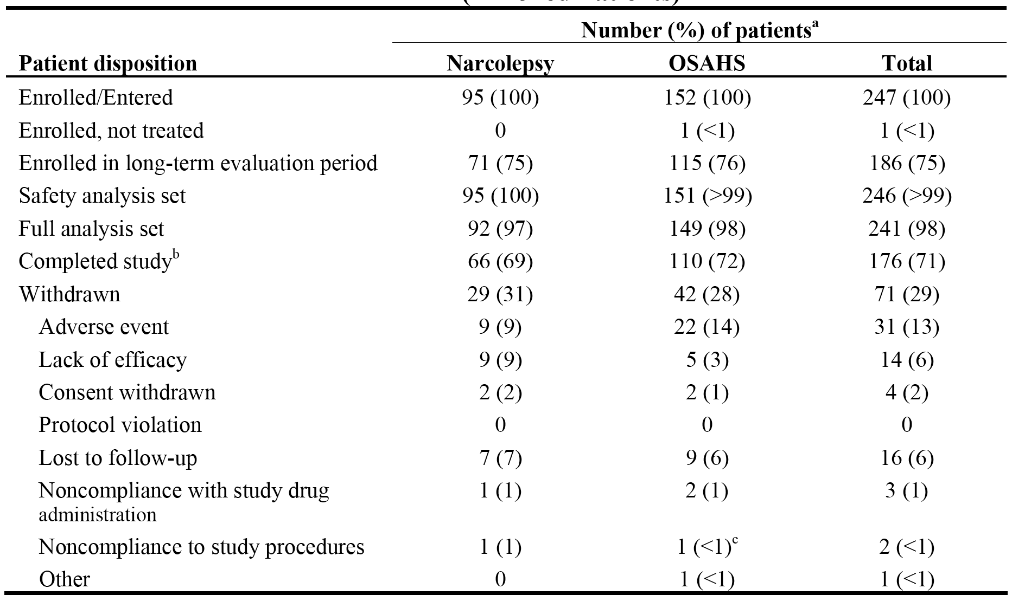

Exposure

The mean ± SD modal dosage (dosage with the longest exposure) was 217.4 ± 41.75 mg/day in the narcolepsy group (n=92) and 201.0 ± 49.49 mg/day in the OSAHS group. Of the 247 patients enrolled in this study, 246 patients received at least 1 dose of armodafinil (95 with narcolepsy, 151 with OSAHS). In the narcolepsy group (n=95), the mean ± SD armodafinil dose was 147.0 ± 77.00 mg/day, with 79 (83%) patients being exposed for more than 8 weeks, 64 (67%) for more than 12 weeks, 39 (41%) for more than 6 months and no patients for more than 9 months. In the OSAHS group (n=151), the mean ± SD armodafinil dose was 146.7 ± 81.55 mg/day, with 121 (81%) patients being exposed for more than 8 weeks, 105 (69%) for more than 12 weeks, 55 (36%) for more than 6 months, and 2 (1%) for more than 9 months.

Baseline patient characteristics

The mean ± SD age at baseline in the safety analysis set was 40.1 ± 13.87 years (range: 18, 64 years) in the narcolepsy group and 50.6 ± 9.62 years (range: 24, 67 years) in the OSAHS group. A greater percentage of patients in the OSAHS group were male (66%) compared to the narcolepsy group (39%). Most patients were white, 89% in the narcolepsy group and 85% in the OSAHS group. The mean ± SD weight of patients in the narcolepsy group was lower than patients in the OSAHS (82.5 ± 18.88 kg and 104.2 ± 22.35, respectively), as was the mean ± SD BMI (28.5 ± 6.11 kg/m2 and 34.7 ± 7.18 kg/m2, respectively). The mean ± SD height of patients in the narcolepsy group was 170.2 ± 10.69 cm compared to 173.4 ± 9.32 cm in the OSAHS group.

The baseline CGI-S, PGI-S and GAS ratings in the two groups are summarised below in Table 51. All patients enrolled in the study were required to have excessive sleepiness associated with narcolepsy or OSAHS, and to have a CGI-S rating of 4 or more (i.e., at least moderately ill) at baseline. Overall, CGI-S ratings at baseline indicated that 115 (47%) of the patients in the study were moderately ill, and 130 (53%) were markedly, severely, or among the most extremely ill. A greater proportion of patients with narcolepsy (60%) were considered markedly, severely, or extremely ill compared to patients with OSAHS (48%). In general, subjective ratings of severity of illness at baseline (PGI-S) by patients were similar to the baseline ratings (CGI-S) by investigators , although 15% of patients considered themselves normal, borderline, or slightly ill, while investigators considered all but 1 patient to be at least moderately ill.

Table 51: Study 3046 - Baseline disease characteristics; safety analysis set.

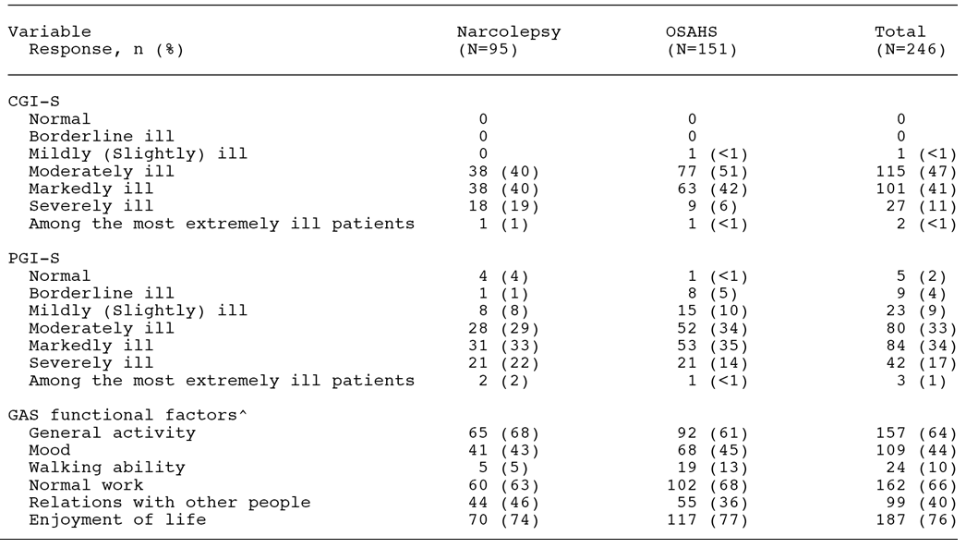

At baseline, each patient identified the 3 areas from the BFI functional factors that were most important to them. The areas identified by the majority of patients were enjoyment of life (76%, 187 patients), normal work (66%, 162 patients), and general activity (64%, 157 patients).

Results

All outcome variables were analysed using descriptive statistics. No inferential statistical were used to analyze the data from this open-label study without a control group and the determination of sample size was not based on statistical considerations. It was planned to enrol 300 patients. For the short-term evaluation period, the outcome was the last post-baseline observation up to and including week 8. For the long-term evaluation period, the outcomes were the last post-baseline observations, regardless of the duration of the evaluation period.

Patient Global Impression of Change (PGI-C)

Selected PGI-C results are summarised below in Table 52. Responders were defined as patients with at least minimal improvement in the PGI-C rating, including responses of very much improved, much improved, and minimally improved. The results showed that the overall endpoint responder rate based on the PGI-C was 77% in the narcolepsy group and 87% in the OSAHS group. The majority of patients in each sleep disorder group showed very much or much improvement for PGI-C ratings at each visit compared to pre-treatment PGI-S evaluation At endpoint for the short-term evaluation period, 58 (63%) patients with narcolepsy and 102 (68%) patients with OSAHS were very much or much improved. Improvement was maintained through the long-term evaluation period. At the overall endpoint, 55 (60%) patients with narcolepsy and 103 (69%) patients with OSAHS were very much or much improved.

Table 52: Study 3024 - Proportion of responders for the PGI-C ratings at selected time-points; FAS.

|  |  |  |  |  |  |  |  |
| --- | --- | --- | --- | --- | --- | --- | --- |
|  | **Narcolepsy (n=92)** | | | **OSAHS (n=149)** | | | |
|  | **Responders** | **95% CI** | **n** | **Responders** | | **95% CI** | **n** |
| Week 8 | 88% | 81, 95 | 75/85 | 90% | 85, 93 | | 120/133 |
| End-point short-term | 84% | 76, 91 | 77/92 | 88% | 83,93 | | 131/149 |
| Month 9 | 79% | 57, 100 | 11/14 | 100% | 100, 100 | | 32/32 |
| **End-point overall** | **77%** | **69, 86** | **71/92** | **87%** | **82, 93** | | **130/149** |

NOTE: A responder was defined as a patient with at least minimal improvement in the PGI-C rating, including responses of very much improved, much improved, and minimally improved.

Patient satisfaction with treatment

The majority of patients at each visit (69% to 83%) were moderately, very, or completely satisfied with armodafinil treatment. At the endpoint of the short-term evaluation period, 70 (76%) patients with narcolepsy and 110 (75%) patients with OSAHS were at least moderately satisfied. At the overall endpoint, 62 (67%) patients with narcolepsy and 101 (69%) patients with OSAHS were at least moderately satisfied with armodafinil treatment.

Patient assessment of ability to engage in life activities

The majority (range 72% to 87%) of patients at each visit felt that armodafinil treatment helped them moderately, a great deal, or tremendously with regard to engaging in daily/work activities and in family and/or social activities. At the endpoint of the short-term evaluation period, 70 (76%) patients with narcolepsy and 111 (76%) patients with OSAHS were at least moderately helped with regard to daily and/or work activities, and 65 (71%) patients with narcolepsy and 108 (74%) patients with OSAHS were at least moderately helped with regard to family and/or social activities. Similarly, at the overall endpoint 67 (73%) patients with narcolepsy and 103 (70%) patients with OSAHS were at least moderately helped with regard to daily and/or work activities, and 60 (65%) patients with narcolepsy and 100 (68%) patients with OSAHS were at least moderately helped with regard to family and/or social activities.

Brief fatigue Inventory (BFI)

The results for the global scores from the BFI at baseline and at short-term and overall endpoints are summarised below in Table 53. In both the narcolepsy and OSAHS groups similar improvements in fatigue from baseline were observed at the short-term and overall endpoints.

Table 53: Study 3046 - Change from baseline (∆) to short-term and overall endpoints in the global score from the BFI; FAS.

|  |  |  |  |  |  |  |  |
| --- | --- | --- | --- | --- | --- | --- | --- |
|  | **Narcolepsy (n=92)** | | | **OSAHS (n=149)** | | | |
| Baseline | Mean ± SD | 6.1 ± 1.80 | n=76 | mean ­± SD | 6.1 ± 1.73 | n=114 |
| Short-term End-point | Mean ± SD | 3.8 ± 2.17 | n=92 | mean ± SD | 3.0 ± 2.25 | n=149 |
|  | ∆ Mean ± SD | -2.3 ± 2.35 | n=76 | ∆ Mean ± SD | -3.1 ± 2.51 | n=114 |
| Overall End-point | Mean ± SD | 3.39 ± 2.60 | n=92 | Mean ± SD | 3.2 ± 2.46 | n=149 |
|  | ∆ Mean ± SD | -2.3 ± 2.69 | n=76 | ∆ Mean ± SD | -2.7 ± 2.81 | n=114 |

The results for the worst fatigue score at baseline and at short-term and overall endpoints are summarised below in Table 54. In both the narcolepsy and OSAHS groups similar improvements in the mean change from worst fatigue score observed at the short-term and overall endpoints were observed.

Table 54: Study 3046 - Change from baseline (∆) to short-term and overall endpoints in the worst fatigue score from the BFI; FAS.

|  |  |  |  |  |  |  |  |
| --- | --- | --- | --- | --- | --- | --- | --- |
|  | **Narcolepsy (n=92)** | | | **OSAHS (n=149)** | | | |
| Baseline | Mean ± SD | 8.3 ± 1.48 | n=76 | mean ­± SD | 7.8 ± 1.72 | n=114 |
| Short-term End-point | Mean ± SD | 6.3 ± 2.50 | n=92 | mean ± SD | 4.6 ± 2.71 | n=149 |
|  | ∆ Mean ± SD | -2.2 ± 2.60 | n=76 | ∆ Mean ± SD | -3.1 ± 2.97 | n=114 |
| Overall End-point | Mean ± SD | 6.0 ± 2.87 | n=92 | Mean ± SD | 4.7 ± 2.88 | n=149 |
|  | ∆ Mean ± SD | -2.6 ± 3.00 | n=76 | ∆ Mean ± SD | -3.0 ± 3.13 | n=114 |

### Evaluator's conclusions on efficacy

#### OSAHS

The submission included 2 pivotal Phase III studies of similar design in patients with OSAHS (meeting ICSD criteria for sleep disorders) with residual daytime sleepiness despite regular and effective therapy with nCPAP (Studies 3021 and 3025). In Study 3021 (n = 395), patients were randomised to treatment with armodafinil 250 mg/day (n = 131), armodafinil 150 mg/day (n = 133) or placebo (n = 131). The mean age of the total patient population was 49.5 years (range: 26, 67 years), and the majority of patients were male (70%), and white (85%). In study 3025 (n = 263), patients were randomised to treatment with armodafinil 150 mg/day (n = 131) or placebo (n = 132). The mean age of the total patient population was 50.7 years (range: 25, 69 years), and the majority of patients were male (73%), and white (84%). In both studies, the majority of patients were white and both the mean weight and BMI were high, which is consistent for patients with OSAHS.

In both studies the duration of treatment was 12 weeks, and parallel group treatment was administered double-blind. The two primary efficacy variables in both studies were identical: an objective endpoint of change from baseline to endpoint (that is, last post baseline observation) in sleep latency from the 30 minute MWT (average of 4 naps at 0900, 1100, 1300, and 1500 h), tested in the FAS using an ANOVA model with treatment and country as factors; and a subjective endpoint of the proportion of patients with at least minimal improvement in the pre-treatment CGI-C rating (as related to the general condition) assessed at endpoint (that is, last post baseline observation), tested in the FAS using a CMH chi-square test adjusted for country.

Both studies included two primary efficacy variables, but no statistical adjustment was made in either study for multiplicity. In Study 3021, a closed testing method was used, with pairwise statistical comparisons between the two armodafinil dosage groups and placebo proceeding only if the initial pairwise statistical comparison between the combined armodafinil group and placebo was significant. The sponsor stated that due to the closed testing method, no adjustments due to multiple comparisons were deemed necessary. This is debatable. However, the statistical comparison for each pairwise comparison in both studies was robust and indicated that the comparisons would have remained significant irrespective of the method used to adjust for multiplicity, if one had been applied.

In Study 3021, mean sleep latency from the MWT increased from baseline to endpoint by 1.9 minutes in the combined armodafinil group (n = 241) and decreased by -1.7 minutes in the placebo group (n = 124); difference of 3.6 minutes statistically significantly in favour of combined armodafinil group, p<0.0001. In the armodafinil 150 mg/day group (n = 120), mean sleep latency from the MWT increased from baseline to endpoint by 1.7 minutes, and was 3.4 minutes longer than placebo (p = 0.0008). In the armodafinil 250 mg/day group (n = 121), mean sleep latency from the MWT increased from baseline by 2.2 minutes, and was 3.9 minutes longer than placebo (p = 0.0001). In Study 3025, mean sleep latency from the MWT increased from baseline to endpoint by 2.3 minutes in the armodafinil 150 mg/day group (n = 116) and decreased by -1.3 minutes in the placebo group (n = 120); difference of 3.6 minutes statistically significantly in favour of combined armodafinil group, p = 0.0003.

In Study 3021, the proportion of patients with a least minimal improvement in CGI-C rating from pre-treatment to endpoint in the combined armodafinil group was 72% (174/241) compared to 37% (46/124) in the placebo group; p<0.0001. The proportion of patients with a least minimal improvement in CGI-C rating from pre-treatment to endpoint was 71% (85/120) in the armodafinil 150 mg/day group and 74% (89/121) in the armodafinil 250 mg/day group, and in both groups the difference compared to placebo was statistically significant (p<0.0001, both comparisons). The results for the combined armodafinil group and both of the armodafinil dosage groups are considered to be clinically meaningful. In study 3025, the proportion of patients with a least minimal improvement in CGI-C rating from pre-treatment to endpoint in the armodafinil 150 mg/day group was 71% (82/116) compared to 53% (64/120) in the placebo group; p<0.0069. The placebo response rate in this study was high, resulting in the difference between the two treatment groups being of doubtful clinical significance.

Both studies included a large number of secondary efficacy endpoints and the results of the endpoint analyses consistently numerically favoured the armodafinil compared to placebo group, and many of the pairwise comparisons were statistically significant. However, there was no statistically adjustment for multiplicity. In both studies, the sponsor nominated a key secondary efficacy outcome, with the nominated endpoint being different in the two studies. In both studies, no statistically significant difference between armodafinil and placebo were observed in the nominated key secondary efficacy endpoints.

In study 3021, the key secondary efficacy outcome was change from baseline to endpoint in the mean quality of episodic secondary memory from the CDR system (average of 4 tests at 0930, 1130, 1330, and 1530 h). There was no statistically significant difference between the combined armodafinil group and placebo in this outcome (mean change: 11.4 versus 5.4 units, p=0.1147). In Study 3025, the key secondary efficacy outcome was the change from baseline to endpoint in the mean power of attention from the tests of attention from the CDR system (average of 4 tests at 0930, 1130, 1330, and 1530 h). There was no statistically significant difference between armodafinil 150 mg/day and placebo in this outcome (mean change: 48.6 versus 43.6 msec, p = 0.8181).

Both studies included a number of other secondary efficacy outcomes including assessment of sleep latency from the MWT at later times in the day and at each visit, assessment of cognitive functioning including tests of memory and attention from the CDR system, assessment of sleepiness using the Epworth Sleepiness Scale (ESS) and additional CGI-C measures, assessment of fatigue on daily functioning using the Brief Fatigue Inventory (BFI), and assessment of the impact of sleepiness through the use of patient completed diaries and caffeine consumption. In general, the secondary efficacy endpoints numerically favoured armodafinil compared to placebo in both studies. The majority of the pairwise comparisons were analysed statistically, but no adjustment was made for multiplicity in either study. The results of the secondary efficacy outcomes are summarised below.

* In both studies, the mean change in sleep latency from MWT (average of 4 naps at 0900, 1100, 1300, and 1500 h) from baseline to Weeks 4, 8 and 12 statistically significantly favoured all armodafinil groups compared to placebo.
* Mean sleep latency from the MWT for later time points (average of 3 naps at 1500, 1700, and 1900 h) was tested at weeks 4, 8, and 12 and endpoint. In both studies, no statistically significant difference in mean change from baseline to endpoint was demonstrated for armodafinil and placebo.
* Descriptive results for mean change from baseline to endpoint in sleep latency from individual naps from the MWT (0900, 1100, 1300, 1500, 1700 and 1900 h) showed numerical differences in favour of the combined armodafinil group compared with placebo at all individual time points (apart from 1900 h) in both studies.
* In both studies, the proportion of patients with at least minimal improvement in the CGI-C rating at Weeks 4, 8 and 12 statistically significantly favoured all armodafinil groups compared to placebo.
* The mean change from baseline in the quality of episodic secondary memory from the CDR system (average of 4 tests at 0930, 1130, 1330, and 1530) was tested at Weeks 4, 8 and 12 and endpoint. In Study 3021, the mean change from baseline in this outcome statistically significantly favoured the combined armodafinil group compared to placebo at Week 4 (p = 0.0064) and Week 8 (p = 0.0085), but not at Week 12 (p = 0.0910) or endpoint (p = 0.1147). In Study 3025, the mean change from baseline in this outcome statistically significantly favoured the armodafinil 150 mg/day group at Week 12 (p = 0.0055), and endpoint (p = 0.0102), but not at Week 4 (p = 0.5932) or Week 8 (p = 0.1697).
* The mean change from baseline in the power of attention from the tests of attention from the CDR system (average of 4 tests at 0930, 1130, 1330, and 1530) was tested at Weeks 4, 8 and 12, and endpoint. In both studies, there were no statistically significant differences between armodafinil groups and placebo in this outcome at Weeks 4, 8 and 12 and endpoint.
* In both studies, no statistically significant differences were observed between the armodafinil and placebo groups in the mean change from baseline to endpoint in the quality of episodic secondary memory and power of attention at later time points (average of 3 tests at 1530, 1730, and 1930 h) from the CDR system.
* In both studies, no statistically significant differences were observed between armodafinil and placebo groups in mean change from baseline to endpoint in continuity of attention or speed of memory based on the relevant tests from the CDR system at earlier time points (average of 4 tests at 0930, 1130, 1330 and 1530 h) or later time points (average of 3 tests at 1530, 1730, and 1530 h).
* In both studies, the mean change from baseline to endpoint in the ESS scores statistically significantly favoured armodafinil compared with placebo.
* In both studies, mean change from baseline in the average BFI scores statistically significantly favoured armodafinil compared with placebo. In Study 3021, there was no statistically significant difference between armodafinil and placebo in mean change from baseline to endpoint in the worst fatigue score from the BFI. However, in Study 3025 there was a statistically significant difference between armodafinil 150 mg/day and placebo in mean change from baseline in the worst fatigue score from the BFI in favour of armodafinil.
* In both studies, descriptive data from the diaries showed that the number of daytime unintended sleep episodes and the number of naps decreased from baseline to endpoint to a greater extent in the armodafinil groups compared to placebo. In addition, in both groups the proportion of patients reporting mistakes, accidents or near misses post baseline was smaller in the armodafinil groups compared with placebo.
* In both studies, descriptive data relating to the number of caffeine drinks consumed each data decreased slightly by a similar amount in both the armodafinil and placebo group.

#### Narcolepsy

The submission included one pivotal Phase III study in patients with excessive sleepiness associated with narcolepsy comparing treatment with armodafinil and placebo over 12 weeks (Study 3020). In this study, a total of 196 patients were randomised to armodafinil 150 mg/day (n = 65), armodafinil 250 mg/day (n = 67) or placebo (n = 64). The study design was similar to that for the two OSAHS studies (3021, 3025).

The mean age of the 194 patients in the safety set was 38.1 years (range: 18, 67 years), with the majority of patients (57%) being aged between 30 and 55 years. The study included a notable number of young patients aged from 18 to 29 years (32%, n = 63). The majority of patients were female (56%), with males accounting for 44% of the total population. The majority of patients were white (73%), with most of the remaining patients being black (16%). The distribution of the baseline Clinical Global Impression of Severity (CGI-S) ratings in the total safety population was 32% moderately ill, 49% markedly ill, 18% severely ill, 2% among the most extremely ill and no patients less than or equal to slightly ill. The baseline sleep latency from the MSLT in the FAS was similar for the armodafinil 250 mg/day group, armodafinil 150 mg/day group, combined armodafinil group, and placebo group (2.6, 2.5, 2.5, 2.6 minutes, respectively).

There were two primary efficacy variables, and for each variable the primary comparison was between the combined armodafinil group and the placebo group. The statistical analysis of each of the two armodafinil dosage groups compared to the placebo group only if the primary analysis was statistically significant (p = 0.05, two-tailed test). There was no statistical adjustment for multiplicity of the primary efficacy variables. However, if the most conservative option is adopted of both endpoints needing to be statistically significant for the primary comparison between the combined armodafinil group and the placebo group in order for the study to be deemed "positive", then the α should be 0.025 (two-tailed test) based on the Bonferroni correction. As described below, the primary efficacy comparison for both primary efficacy endpoint was ≤ 0.025.

The objective primary efficacy endpoint was the mean change from baseline to endpoint (last post baseline observation) in mean sleep latency from the 20 minute MWT (average of 4 naps at 0900, 1100, 1300, and 1500 h). The comparison between the treatment groups was tested in the FAS using an ANCOVA model with country and treatment as factors, and baseline sleep latency from the MWT as a covariate (α = 0.05, two tailed test). The mean sleep latency from the MWT increased by 1.9 minutes from baseline to endpoint in the combined armodafinil group (n = 118) and decreased by 1.9 minutes from baseline in the placebo group (n = 58), with the difference between groups being 3.8 minutes (p = 0.0024). In addition, the mean change in sleep latency from the MWT was statistically significantly greater in the armodafinil 150 mg/day (n=58) group compared to placebo (1.3 versus -1.9 minutes, ∆ = 3.2 minutes, p = 0.0068), and in the armodafinil 250 mg/day group (n = 60) compared to placebo (2.6 versus -1.9 minutes, ∆ = 4.5 minutes, p = 0.0099). The observed differences between each of the three armodafinil groups and the placebo group are considered to be clinically meaningful.

The subjective primary efficacy endpoint was the proportion of patients with at least minimal improvement in the CGI-C (as related to general condition) from baseline assessed at endpoint. The comparison was tested in the FAS using a CMH chi-square test adjusted for country. The proportion of patients meeting the endpoint was statistically significantly greater in the armodafinil combined group (n = 118) compared the placebo group (n = 58); 71% versus 33%, respectively, p<0.0001. In addition, the proportion of patients meeting the endpoint was statistically significantly greater in the armodafinil 150 mg/day group (n = 58) compared to placebo (69% versus 33%, respectively) and in the armodafinil 250 mg/day group (n = 60) compared to placebo (73% versus 33%, respectively, p <0.001). The observed differences between each of the three armodafinil groups and the placebo group are considered to be clinically meaningful.

There were a large number of secondary efficacy endpoints and the results of the endpoint analyses consistently numerically favoured the combined armodafinil group compared to the placebo group, and many of the pairwise comparisons were statistically significant. However, there was no statistically adjustment for multiplicity.

The key secondary efficacy endpoint was the change from baseline to endpoint in the mean quality of episodic secondary memory from the tests of memory from the CDR system (average of 4 tests at 0930, 1130, 1330, and 1530 h). The mean change from baseline to endpoint for this variable statistically significantly favoured the combined armodafinil group compared to placebo group (18.6 versus 1.0, respectively, p = 0.0032), the armodafinil 150 mg/day group compared to placebo group (20.7 versus 1.0, respectively, p = 0.0062), and the armodafinil 250 mg/day group compared to placebo group (16.5 versus 1.0, respectively, p = 0.0168).

Other secondary efficacy endpoints which statistically significantly favoured the combined armodafinil group compared to versus the placebo group were a:

* mean sleep latency from the MWT (average of 4 tests at 0900, 1100, 1300, and 1500 h), change from baseline to Week 4 (2.1 versus -1.1 minutes, p = 0.0054), Week 8 (1.7 versus -1.2 minutes, p = 0.0481), and Week 12 (1.8 versus -1.7 minutes , p = 0.0264);
* mean sleep latency from the MWT for later time points (average of 3 tests at 1500, 1700, and 1900 h), change from baseline at endpoint (1.5 versus -1.2 minutes, p=0.0286);
* proportion of patients with at least minimal improvement in the CGI-C ratings at Week 4 (73% versus 39%, p<0.0001), Week 8 (69% versus 38%, p=0.0001), and Week 12 (72% versus 30%, p<0.0001);
* mean power of attention (average of 4 tests at 0930, 1130, 1330, and 1530), change from baseline to endpoint (-41.5 versus 158.0 msec, p = 0.0498);
* mean power of attention for the later time points (average of 3 tests at 1530, 1730, and 1930), change from baseline to Week 12 (-9.8 versus 173.9 msec, p = 0.0219), and endpoint (3.5 versus 32.2 msec, p = 0.0413);
* mean speed of memory (average of 4 tests at 0930, 1130, 1330, and 1530), change from baseline to Week 4 (-144.8 versus 1.8 msec, p = 0.0141), Week 12 (-190.7 versus 92.7 msec, p = 0.0360), and endpoint (-199.7 versus -6.3 msec, p = 0.0178);
* mean quality of episodic secondary memory (average of 4 tests at 0930, 1130, 1330, and 1530 h), change from baseline to Week 4 (14.2 versus -2.2, p = 0.0071), Week 8 (19.4 versus -1.3, p = 0.0005) and Week 12 (18.1 versus 2.9, p = 0.0362);
* mean quality of episodic secondary memory for the later time points (average of 3 tests at 1530, 1730, and 1930), mean change from baseline at Week 12 (7.4 versus -8.8, p = 0.0344) and endpoint (8.5 versus -4.4 msec, p = 0.0256);
* mean change in total ESS score at Week 4 (-3.3 versus -2.2, p = 0.0282), Week 8 (-3.2 versus -1.4, p = 0.0014), Week 12 (-4.1 versus -1.4, p = 0.0002), and endpoint (-3.9 versus -1.9, p = 0.0006);
* mean change in worst fatigue score from the BFI scale from baseline to Week 12 (-0.9 versus -0.1, p = 0.0179); and
* a mean change in average fatigue score from the BFI scale from baseline to Week 4 (-1.4 versus -0.2, p <0.0001), Week 8 (-1.5 versus -0.6, p = 0.0058), Week 12 (-1.5 versus -0.1, p <0.0001), and endpoint (-1.4 versus -0.3, p = 0.0002).

#### Shift Workers Sleep Disorder (SWSD)

The submission included one pivotal Phase III study in patients with excessive sleepiness associated with chronic SWSD designed to determine whether armodafinil 150 mg/day was more effective than placebo for treatment of this disorder (study 3022). In this study, a total of 254 patients were randomised to treatment with armodafinil 150 mg/day (n = 127) or placebo (n = 127) to be taken 30 minutes to 1 h before a night shift (but no later than 2200 h) on the nights worked.

The mean age of the total population in the safety analysis set (n = 245) was 39.6 years (range: 18, 63 years), with the age distribution being 23% aged 18-29 years, 27% age 30-50 years, 44% aged 41-55 years and 7% aged > 55 years. The majority of patients were male (53%), with females accounting for 47% of the total population. Of the total population, 65% were white and 26% were black. Of note, 87% of the total population were permanent shift workers and 40% of the total population worked in "health care and social assistance". The distribution of the baseline CGI-S ratings in the total safety population was 56% moderately ill, 35% markedly ill, 8% severely ill, less than 1% among the most extremely ill and no patients less than or equal to slightly ill.

The objective primary efficacy endpoint was the mean change from baseline to endpoint in mean sleep latency from a 20 minute MSLT (average of 4 naps at 0200, 0400, 0600 and 0800 h). The comparison between the treatment groups was tested in the FAS using an ANOVA with treatment and country as factors. The mean ± SD baseline sleep latency from the MSLT was 2.3 ± 1.59 minutes in the armodafinil 150 mg/day group (n = 112) and 2.4 ± 1.60 minutes in the placebo group (n = 104). The mean ± SD change in sleep latency from the MSLT from baseline to endpoint was 3.1 ± 4.46 minutes in the armodafinil 150 mg group and 0.4 ± 2.87 minutes in the placebo group, with the 2.7 minutes difference between the two groups being statistically significantly in favour of armodafinil (p <0.0001). In addition, the difference of 2.7 minutes is considered to be clinically meaningful.

The subjective primary efficacy endpoint was the proportion of patients with at least minimal improvement in the CGI-C from baseline to endpoint. The comparison between treatments was tested in the FAS using a CMH chi-square test adjusted for country. The proportion of subjects with at least minimal improvement in the CGI-rating at endpoint was 79% (89/112) in the armodafinil 150 mg/day group and 59% (61/104) in the placebo group, with the difference between the two groups statistically significantly favouring armodafinil (p = 0.0010). The placebo response rate was unexpectedly high, resulting in the treatment difference between armodafinil 150 mg/day and placebo being of doubtful clinical significance.

No statistical adjustment was made for multiplicity of the two primary efficacy variables, with a separate α of 0.05 being tested for each pairwise comparison. Therefore, in order to be deemed "positive" it is considered that the both primary endpoints should be significant at an α of 0.025 (two tailed test), based on the Bonferroni correction for multiplicity. As can be seen above, the p values of both pairwise comparisons were ≤0.025.

There were a large number of secondary efficacy outcomes and the results of the endpoint analyses consistently numerically favoured the armodafinil 150 mg/day group compared to placebo. The pairwise comparisons for continuous efficacy variables used an ANOVA with treatment and country as factors, and the pairwise comparisons for the categorical CGI-C variables used CMH chi-square test adjusted for country. There was no statistically adjustment for multiplicity. Where pairwise comparisons were not tested using inferential statistics, the results were summarised using standard descriptive methods.

The key secondary efficacy endpoint was the mean change from baseline to endpoint in the mean quality of episodic secondary memory from the tests of memory from the CDR system (average of 4 tests at 0230, 0430, 0630 and 0830 h). The mean change from baseline to endpoint for this variable statistically significantly favoured the armodafinil 150 mg/day group compared to the placebo group (18.4 versus -3.3, respectively, p <0.0001). The difference between the two treatments was 21.7 units, which is notably higher than the 14 unit difference used in the power calculation. This suggests that the difference between the two treatments in the quality of episodic memory favouring armodafinil 150 mg/day can be considered to be clinically meaningful.

Other secondary efficacy endpoints of note which statistically significantly favoured armodafinil 150 mg/day compared to placebo group (p ≤0.05) were a:

* mean sleep latency from the MSLT (average of 4 naps at 0200, 0400, 0600, and 0800) from baseline to Weeks 4, 8, and 12;
* proportion of patients with at least minimal improvement in CGI-C ratings from baseline to Weeks 4, 8, and 12;
* mean quality of episodic secondary memory (average of 4 tests at 0230, 0430, 0630, and 0830) from the CDR system from baseline to Weeks 4, 8, and 12 ;
* mean change in speed of memory (average of 4 tests at 0230, 0430, 0630, and 0830) from the CDR system from baseline to Weeks 8 and 12;
* mean change in power of attention (average of 4 tests at 0230, 0430, 0630, and 0830) from the CDR system from baseline to Weeks 4, 8, and 12; and
* a mean change in KSS score (average of the 4 tests associated with the MSLT tests at 0200,0400, 0600, and 0800) from baseline to Weeks 4, 8, 12.

Other secondary efficacy outcomes compared descriptively and favouring armodafinil 150 mg/day compared to placebo from baseline to post baseline were:

* unintended sleep episodes during the night shift, and mean number of night naps during the night shift recorded by patient diaries; and
* observations of sleepiness during the night shift based on KSS scores from patient diaries.

#### Long term efficacy and maintenance of effect

The submission included long term, open label efficacy data relating to the use of flexible armodafinil dosage regimens (100 to 250 mg/day) for the treatment of excessive sleepiness in patients with narcolepsy, OSAHS or SWSD (Studies 3023 and 3024). The results from the two studies with long-term data suggest that armodafinil (100 to 250 mg/day) can maintain satisfactory efficacy in the three patient groups. However, the conclusions from the studies should be interpreted cautiously due to the lack of a control group. There were no controlled data in the submission assessing the effect of armodafinil treatment for longer than 12 weeks.

In study 3023, of the 323 enrolled patients with narcolepsy, OSAHS or SWSD, 217 (67%) were treated with armodafinil for > 6 months, 83 (26%) for > 12 months and 31 (10%) for > 18 months. The mean ± SD duration of exposure or participation in the study for the narcolepsy, OSAHS and SWSD groups was 311 ­± 220, 309 ± 207, and 262 ± 163 days, respectively. The majority of patients in each sleep disorder group showed at least minimal improvement in the CGI-C rating beginning at Month 1 (range 86% to 92% of patients), which was maintained through to Month 12 (range 96% to 98% of patients). At endpoint, 84% (36/43) of patients with narcolepsy, 80% (123/153) of patients with OSAHS and 98% (97/99) of patients with SWSD showed at least minimal improvement in the CGI-rating. In addition, in the narcolepsy and OSAHS groups, improvements in mean ESS scores were seen at month 1 (3.5 and 4.5 units, respectively), and were sustained through month 12 (3.5 and 10 units, respectively) and at endpoint (4.7 and 7.3 units, respectively).

In Study 3024, of the 731 enrolled patients, 508 (70%) were treated with armodafinil for >6 months, 378 (52%) were treated for >12 months, and 267 (37%) were treated for > 18 months. The mean ± SD duration of exposure or participation in the study for the narcolepsy, OSAHS and SWSD groups was 346 ± 222, 388 ± 250, and 342 ± 226 days, respectively. The majority of patients in each sleep disorder group showed at least minimal improvement in the CGI-C rating beginning at month 1 (87% to 94% of patients), which was maintained through to month 18 (range 93% to 100% of patients). At endpoint, 75% (113/150) of patients with narcolepsy, 80% (364/457) of patients with OSAHS and 92% (97/105) of patients with SWSD showed at least minimal improvement in the CGI-C rating. In addition, in the narcolepsy and OSAHS groups, improvements in mean ESS scores were seen at month 1 (5.0 and 8.0 units, respectively) and were sustained through to month 18 (4.0 and 8.0 units, respectively) and at endpoint (4.0 and 6.0 units, respectively). In the narcolepsy, OSAHS, and SWSD groups, fatigue improved from baseline to endpoint as assessed by the mean decrease from baseline in the average fatigue score (1.7, 1.7, and 2.3 units respectively), and the worst fatigue scores (1.5, 1.8, and 2.4 units, respectively) using the BFI.

In the open label study 3046, patient and clinician rated outcomes demonstrated that treatment with a flexible armodafinil dosage regimen (100 to 150 mg/day) reduced excessive sleepiness from baseline at week 8 in patients with narcolepsy or OSAHS, and that the observed improvement could be maintained through to Month 9. In addition, at each visit the majority of patients reported being at least moderately satisfied with armodafinil treatment and felt that armodafinil treatment helped them with regard to engaging in life activities. Furthermore, patients showed improvement in the global and worst fatigue scores from the BFI, while assessment of BFI functional factors using the GAS also indicated improvement in the impact of fatigue on daily functioning.

## Clinical safety

### Studies providing evaluable safety data

The submission included safety data from 19 studies:11 Phase 1 clinical pharmacology studies (9 in healthy subjects, 1 in patients with schizophrenia, 1 in patients with OSAHS); 4 Phase 3, double-blind, placebo-controlled studies (2 in patients with OSAHS and 1 each in patients with narcolepsy or SWSD); 2 Phase 3 uncontrolled studies in patients with OSAHS, narcolepsy or SWSD; 1 Phase 3b, double-blind, placebo-controlled PK/PD study in patients with OSAHS; and 1 Phase 3b, open-label stud in patients with OSAHS or narcolepsy.

The Summary of Clinical Safety (SCS) included an integrated summary of the safety data from the 4 Phase 3, double-blind, placebo-controlled studies (3020, 3021, 3022, 3025). In addition, the SCS included a separate integrated summary of the safety data from 7 completed clinical studies including the 4, pivotal, Phase 3, double-blind, placebo-controlled studies (3020, 3021, 3022, 3025), in addition to 2 Phase 3, open-label studies (3023, 3024), and 1 Phase 3b, open-label study (3046). In these studies, patients with OSAHS or narcolepsy were scheduled to receive armodafinil continuously, and patients with SWSD were scheduled to receive armodafinil intermittently. In the 4 Phase 3, double-blind, placebo-controlled studies the duration of armodafinil treatment was 12 weeks, while in the open-label studies the duration of treatment was 12 months or more.

The SCS focused primarily on the combined safety data from the 4 Phase 3, placebo-controlled, double-blind studies, supplemented by the integrated safety data from all completed 7 clinical studies. The key safety data are considered to be from the 4 Phase 3, double-blind, placebo-controlled studies. These studies, although relatively short-term, allow an unbiased assessment of the safety of armodafinil due to presence of a randomised, double-blinded placebo-control. The safety data beyond 12 weeks were uncontrolled, which introduces a degree of uncertainty into the interpretation of the data. The submission also included approximately 6 years of extensive post-marketing safety data for armodafinil consisting primarily of spontaneous reports and collected almost exclusively from patients treated in the USA.

Safety was assessed by adverse events (including deaths, serious adverse events, and withdrawals), results of clinical laboratory tests (serum chemistry, haematology, and urinalysis), vital signs (blood pressure and pulse), ECGs, physical examinations, and concomitant medication usage. In addition, for the purposes of assessing the effect of armodafinil on night-time sleep and cataplexy, nocturnal PSG (including sleep efficiency, time awake after sleep onset, sleep latency, time spread in stages 1-4, and REM sleep) was conducted at week 12 or the last post-baseline observation, and data from diaries were reviewed at weeks 4, 8, and 12 or the last post-baseline observation. For each safety variable, all findings (whether normal or abnormal) were recorded in the CRF. The investigator categorized the clinical severity of the AE data and its relationship to the study drug.

### Overall extent of exposure

#### Overview

The exposure data in the SCS was summarised using modal armodafinil dose (≤ 100 mg, 150 mg, 150 mg, 200 mg or 250 mg). The modal dose for each patient was defined as the armodafinil dose received most frequently during both the double-blind and open-label periods. If a patient received 2 doses with the same frequency, the higher dose was defined as the modal dose. A frequency distribution of the duration of armodafinil by modal dose was also provided. Exposure to study drug was also summarised in patient-years, which were calculated as (mean treatment duration [days] x number of patients)/362.25 days.

#### Double-blind, placebo controlled studies

The combined safety data from the 4 Phase 3, double-blind, placebo-controlled studies of 12 weeks duration included data on 198 patients exposed to 150 mg/day, 447 patients exposed to 150 mg/day, and 445 patients exposed to placebo. Of the total number of patients (n=1090), 645 were exposed to armodafinil (150 or 250 mg/day) and 445 were exposed to placebo. The mean ± SD duration of exposure in the 4, pivotal, Phase 3 studies is summarised.

Table 55: Mean ± SD duration of exposure in the 4 Phase 3 double-blind, placebo controlled studies; safety analysis sets.

|  |  |  |  |  |  |
| --- | --- | --- | --- | --- | --- |
| **Study** | **Condition** | **ARM 250 mg/day** | **ARM 150 mg/day** | **ARM Combined** | **Placebo** |
| 3020 | Narcolepsy | 74.8 ± 20.32 days (n= 67) | 72.5 ± 21.72 days (n=64) | 73.7 ± 20.97 days (n=131) | 74.5 ± 19.86 days (n=63) |
| 3021 | OSAHS | 75.9 ± 22.57 days (n=131) | 79.3 ± 16.92 days (n=131) | 77.6 ± 19.98 days (n=262) | 82.2 ± 15.18 days (n=130) |
| 3025 | OSAHS | - | 79.9 ± 18.47 days (n=129) | - | 82.2 ± 14.28 days (n=130) |
| 3022 | SWSD | - | 78.6 ± 19.90 days (n=123) | - | 77.3 ± 20.95 days (n=133 |

#### All 7 clinical studies

The integrated safety data from the 7 completed clinical studies included data on 1516 patients who received at least 1 dose of armodafinil, including 861 (57%) with at least 6 months of exposure, 696 (46%) with at least 9 months of exposure, 531 (35%) with at least 12 months of exposure, and 97 (6%) with at least 24 months of exposure. The total exposure (all patients) was 1243.0 patient-treatment years. Armodafinil exposure by sleep disorder in the 7 clinical studies combined is summarised below in Table 56.

Table 56: Armodafinil exposure by sleep disorder in the 7 clinical studies combined; safety analysis set.

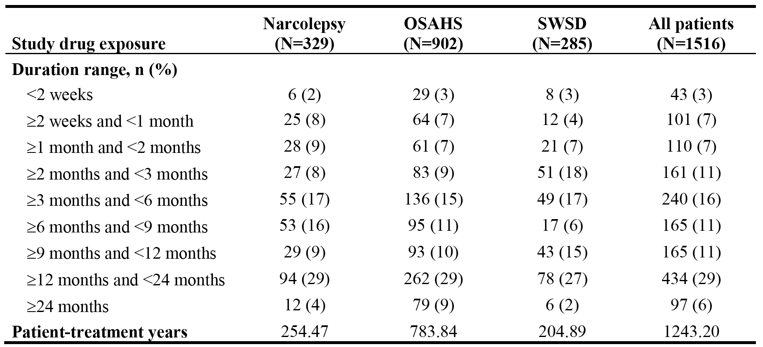

In all sleep disorder studies combined, the most common dose of armodafinil was 250 mg, received by 52% (786/1516) of patients, with a total exposure of 792.01 patient-treatment years (daily or intermittent administration). The next most common dose of armodafinil was 150 mg, received by 28% (417/1516) of patients, with a total exposure of 214.32 patient-treatment years (daily or intermittent administration).

In patients with narcolepsy in all studies combined, the most common dose was of armodafinil 250 mg, received by 63% (208/329) of patients, with a total exposure of 180.69 patient-treatment years. The next most common dose of armodafinil was 150 mg, received by 18% (58/329) of patients, with a total exposure of 31.72 patient-treatment years.

In patients with OSAHS in all studies combined, the most common dose of armodafinil was 250 mg, received by 52% (469/902) of patients, with a total exposure of 507.21 patient-treatment years. The next most common dose of armodafinil was 150 mg, received by 26% (236/902) of patients, with a total exposure of 124.27 patient-treatment years.

In patients with SWSD in all studies combined, the most common dose of armodafinil was 150 mg, received by 43% (123/285) of patients, with a total exposure of 58.33 patient-treatment years. The next most common dose was of armodafinil was 250 mg, received by 38% (109/285) of patients, with a total exposure of 104.11 patient-treatment years.

### Adverse events

#### Overview

All adverse events were coded using the Medical Dictionary for Regulatory Activities (MedDRA). In the Phase 3, double-blind, placebo-controlled studies for the purposes of AE recording the study period was defined as the time from initiation of any study procedures to the final study visit (i.e., day 85 ± 2 days [study 3020], day 98 ± 2 days [studies 3021, 3025], and day 91 ­± 2 weeks [study 3022]).

The overall safety profiles of armodafinil and placebo based on the combined data from the Phase 3, double-blind, placebo-controlled studies and the safety profile of armodafinil based on the integrated data from all 7 clinical studies are summarised below in Table 57. The combined safety data from the Phase 3, double-blind, placebo-controlled studies showed that the incidence of patients with at least one AE was greater in the armodafinil group compared to the placebo group (63% vs 48%, respectively), as was the incidence of treatment related AEs (38% vs 21%, respectively). Serious AEs were reported in < 1% of patients in both the armodafinil and placebo groups, while no deaths were reported in either of the two treatment groups. Withdrawals due to AEs were reported more commonly in the armodafinil group than in the placebo group (7% vs 4%, respectively).

Table 57: SCS - Overview of adverse events; safety analysis set.

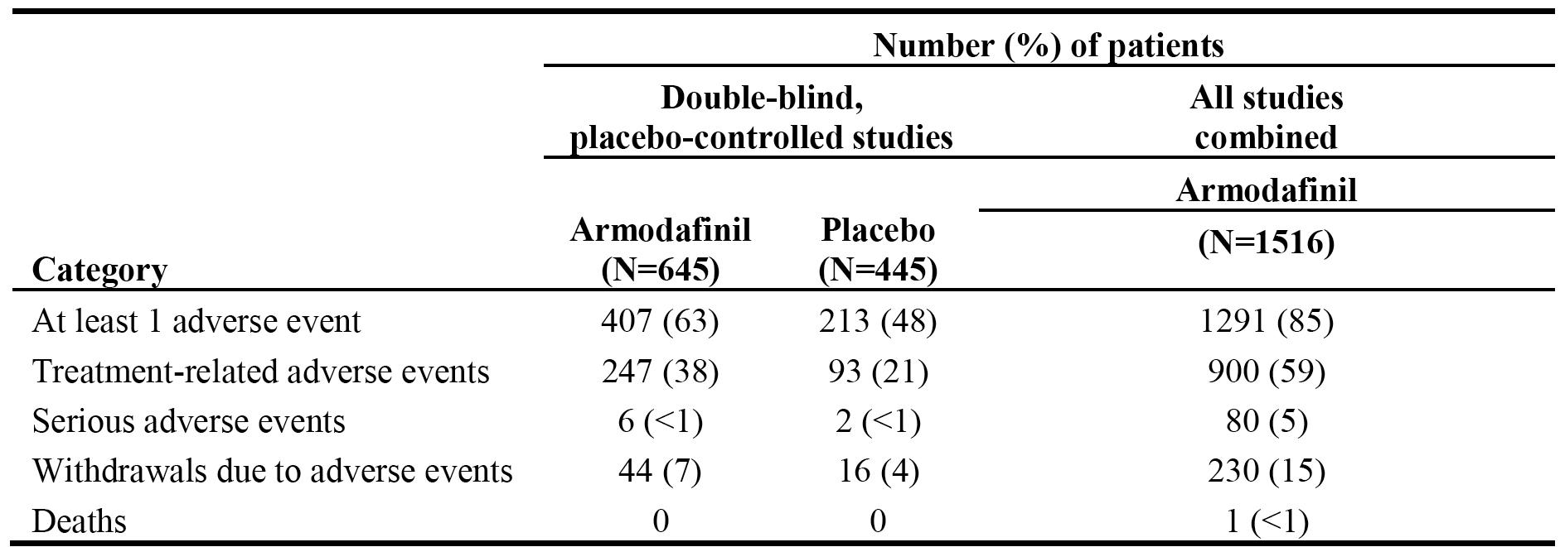

#### Incidence of adverse events

##### Phase 3, placebo-controlled, double-blind studies

AEs occurred more commonly in armodafinil treated patients than in placebo treated patients in each of the three sleep disorders. The greatest difference (∆) between armodafinil and placebo in the incidence of patients with at least one AE was observed in narcolepsy (69% vs 46%, ∆ = 23%), followed by SWSD (54% vs 40%, ∆ = 14%) and OSAHS (64% vs 52%, ∆ = 12%). The only AEs reported in ≥ 10% patients in the armodafinil group in at least one of the three sleep disorders were headache (22% [narcolepsy], 17% [OSAHS], 12% [SWSD]), and nausea (11% [narcolepsy], 7% [SWSD], 6% [OSAHS]). AEs occurring in ≥ 2% more armodafinil treated patients, and more frequently in armodafinil treated patients compared to placebo treated patients in any of the three sleep disorders are summarised.

In narcolepsy patients, AEs in the armodafinil group reported with an incidence of ≥ 5% (vs placebo) were headache (22% vs 11%), nausea (11% vs 0%), decreased appetite (5% vs 0%), and dizziness (5% vs 0%). In OSAHS patients, AEs reported with an incidence of ≥ 5% (vs placebo) were headache (17% vs 8%), insomnia (6% vs 1%), nausea (6% vs 4%), anxiety (5% vs <1%), and dizziness (5% vs 2%). In SWSD patients, AEs reported with an incidence of ≥ 5% (vs placebo) were headache (12% vs 10%), nausea (7% vs 3%), nasopharyngitis (6% vs 3%), and anxiety (5% vs 2%).

AEs were reported more commonly in patients exposed to 250 mg/day than 150 mg/day (69% vs 60%), and more commonly in both dose groups compared to placebo (48% for each comparison). AEs reported in ≥ 2% more patients in the 250 mg/day dose group compared to the 150 mg/day dose group were headache (23% vs 14%, ∆ = 9%), dry mouth (7% vs 2%, ∆ = 5%), nausea (9% vs 6%, ∆ = 3%), rash (4% vs 1%, ∆ = 3%), insomnia (6% vs 4%, ∆ = 2%), depression (3% vs 1%, ∆ = 2%), anorexia (3% vs < 1%, ∆ = 2%), decreased appetite (3% vs < 1%, ∆ = 2%), and pyrexia (2% vs 0%, ∆ = 2%). The only AE reported in ≥ 2% more patients in the 150 mg/dose group compared to the 250 mg/day dose group was dyspepsia (3% vs 1%, ∆ = 2%). The results for AEs occurring in ≥ 2% of armodafinil treated patients and more commonly than in the placebo group, by dose are summarised.

##### All 7 clinical studies

The most frequently reported AEs reported in ≥ 5% of armodafinil treated patients in all 7 clinical studies combined (n=1516) were headache (24%, n=362), nasopharyngitis (12%, n=187), insomnia (12%, n=181), nausea (11%, n=161), upper respiratory tract infection (9%, n=137), anxiety (8%, n=115), dizziness (7%, n=113), sinusitis (7%, n=99), dry mouth (6%, n=92), diarrhoea (6%, n=86), back pain (5%, N=82), arthralgia (5%, N=77), influenza (5%, n=72), and hypertension (5%, n=71). The incidence of patients with at least one AE was highest in OSAHS (89% [804/902]), followed by narcolepsy (82% [270/329]) and SWSD (76% [217/285]). Among the AEs that occurred in ≥ 10% of patients in the combined data set, the incidence of headache, nasopharyngitis, and nausea was higher in patients with narcolepsy (30%, 16%, and 15%, respectively) than in patients with OSAHS (23%, 12%, and 10%, respectively) or SWSD (19%, 10%, and 7%, respectively), while the incidence of insomnia was higher in patients with OSAHS (14%) than in patients with narcolepsy or SWSD (7% and 11%, respectively).

#### Severity of adverse events

##### Phase 3, placebo-controlled, double-blind studies

Of the total number of patients in the combined armodafinil (n=645) and combined placebo (n=445) groups, mild AEs were reported in 31% (n=198) and 23% (n=102) of patients, respectively, moderate AEs were reported in 26% (n=169) and 22% (n=97) of patients, respectively, and severe AEs were reported in 6% (n=40) and 3% (n=14) of patients, respectively.

Of the total number of patients in the combined armodafinil group reporting at least one severe AE (n=40, 6%), events reported in more than 1 patient were nausea and diarrhoea (4 patients each), back pain (3 patients), and upper abdominal pain, chest pain, and insomnia (2 patients each). Of the total number of patients in the combined placebo group reporting at least one severe AE (n=14, 3%), no events were reported in more than 1 patient.

##### All 7 clinical studies

Of the 1516 armodafinil treated patients in all 7 clinical studies combined, 30% (n=450) had at least one mild AE, 42% (n=643) had at least one moderate AE, and 13% (n=198) had at least one severe AE.

#### Treatment-related adverse events

##### Phase 3, placebo-controlled, double-blind studies

Treatment-related AEs were classified by investigators as definitely, probably, or possibly related to treatment with the study drug. In the combined population, treatment-related AEs were reported in 46% (91/198) of patients in the armodafinil 250 mg/day group, 35% (156/447) of patients in the armodafinil 150 mg/day group, and 21% (93/445) of patients in the placebo group.

Treatment-related AEs were reported in 38% (247/645) of all armodafinil treated patients compared to 21% (93/445) of all placebo treated patients. Treatment-related AEs reported in ≥ 2% of patients in the combined armodafinil group (vs combined placebo group) were headache (14% vs 7%), nausea (6% vs 2%), insomnia (4% vs < 1%), dry mouth (4% vs < 1%), anxiety (3% vs < 1%), dizziness (3% vs < 1%), diarrhoea (2% vs < 1%), dyspepsia (2% vs < 1%), flatulence (2% vs 2%), and palpitations (2% vs < 1%).

##### All 7 clinical studies

In all 7 clinical studies combined, 59% (900/1516) of armodafinil treated patients experienced at least one treatment-related AE. The proportion of patients in the narcolepsy, OSAHS and SWSD groups reporting at least one treatment-related AE was 56% (185/329), 62% (562/902), and 54% (153/285), respectively.

In the total population (n=1516), treatment-related AEs reported in ≥ 2% of armodafinil treated patients were headache (19%), insomnia (10%), nausea (7%), anxiety (6%), dizziness (5%), dry mouth (5%), palpitations (3%), diarrhoea (3%), hypertension (3%), somnolence (2%), dyspepsia (2%), flatulence (2%), feeling jittery (2%), fatigue (2%), GGT increased (2%), heart rate increased (2%), decreased appetite (2%), nervousness (2%), irritability (2%), and tremor (2%).

##### Adverse events by time of onset

The SCS included a summary of the cumulative incidence of AEs occurring in ≥ 2% of armodafinil treated patients in all 7 clinical studies combined (n=1516) by time of onset over 24 months of treatment. The majority of patients reporting AEs did so within the first 3 months of treatment, after which time the overall proportion of patients reporting at least one AE through to 24 months increased only marginally compared to the overall proportion of patients reporting at least one AE at 3 months. Of the 1516 armodafinil treated patients, 47% reported at least one AE during the first 2 weeks of treatment, 72% reported at least one AE during the first 3 months of treatment, and 85% reported at least one AE during the first 24 months of treatment. The proportion of patients reporting at least one AE in the examined time intervals is summarised below in Table 58.

Table 58: Cumulative incidence of AEs occurring in ≥ 2% of armodafinil treated patients overall by duration of treatment in all 7 studies combined safety analysis set.

|  |
| --- |
| Table 58: Cumulative incidence of AEs occurring in ≥ 2% of armodafinil treated patients overall by duration of treatment in all 7 studies combined safety analysis set. |

AEs reported in the first 2 weeks of treatment in ≥ 2% of patients were headache (12%), nausea (5%), dry mouth (4%), insomnia (4%), anxiety (4%), dizziness (3%), diarrhoea (2%), and nasopharyngitis (2%). Of the most common AEs occurring in at least 5% of patients in the combined armodafinil treated group, headache, insomnia, nausea, dry mouth, anxiety, dizziness and back pain were most likely to occur during the first three months of treatment, while the incidence of arthralgia, nasopharyngitis, sinusitis, influenza and upper respiratory tract infection increased gradually throughout treatment.

Of the AEs of headache reported by 362 (23.9%) patients, 50% occurred in the first 10 days and 75% occurred in the first 37 days. For 50% of the reported AEs of headache, the longest duration was 7 days; 75% resolved within 25 days. A total of 64 events were continuing at last report; of those that resolved, 97% resolved with no residual effect.

Of the AEs of insomnia (including initial insomnia and middle insomnia) reported by 204 (13.5%) patients, 50% occurred in the first 25 days and 75% occurred in the first 95 days. For 50% of the reported AEs of insomnia, the longest duration was 17 days; 75% resolved within 38 days. A total of 44 events were continuing at last report; of those that resolved, 99% resolved with no residual effect.

Of the AEs of nausea reported by 161 (10.6%) patients, 50% occurred in the first 11 days and 75% occurred in the first 44 days. For 50% of the reported AEs of nausea, the longest duration was 7 days; 75% resolved within 19 days. A total of 20 events were continuing at last report; of those that resolved, 99% resolved with no residual effect.

Of the AEs of dizziness reported by 113 (7.5%) patients, 50% occurred in the first 21 days and 75% occurred in the first 58 days. For 50% of the reported AEs of dizziness, the longest duration was 6 days; 75% resolved within 14 days. A total of 18 events were continuing at last report; of those that resolved, 98% resolved with no residual effect.

Of the AEs of rash (including rash macular and rash papular) reported by 52 (3.4%) patients, 50% occurred in the first 76 days, 75% occurred in the first 184 days, and 90% occurred in the first 277 days. For 50% of the reported AEs of rash, the longest duration was 13 days; 75% resolved within 37 days; and 90% resolved within 62 days. A total of 21 events were continuing at last report; of those that resolved, 96% resolved with no residual effect.

Of the AEs of tachycardia (including heart rate increased) reported by 41 (2.7%) patients, 50% occurred in the first 12 days, 75% occurred in the first 51 days, and 90% occurred in the first 246 days. For 50% of the reported AEs of tachycardia, the longest duration was 4 days; 75% resolved within 20 days; and 90% resolved within 41 days. A total of 4 events were continuing at last report; of those that resolved, 98% resolved with no residual effect.

Of the AEs of increased blood pressure reported by 29 (1.9%) patients, 50% occurred in the first 47 days, and 75% occurred in the first 101 days. For 50% of the reported AEs of increased blood pressure, the longest duration was 10 days; 75% resolved within 43 days. A total of 12 events were continuing at last report; of those that resolved, 87% resolved with no residual effect.

Of the AEs of hypertension reported by 72 (4.7%) patients, 50% occurred in the first 129 days, and 75% occurred in the first 345 days. For 50% of the reported AEs of hypertension, the longest duration was 29 days; 75% resolved within 68 days. A total of 38 events were continuing at last report; of those that resolved, 85% resolved with no residual effect.

Of the AEs of chest pain (including chest discomfort) reported by 57 (3.8%) patients, 50% occurred in the first 33 days, and 75% occurred in the first 129 days. For 50% of the reported AEs of chest pain, the longest duration was 4 days; 75% resolved within 25 days. A total of 9 events were continuing at last report; of those that resolved, 97% resolved with no residual effect.

Of the AEs of palpitations reported by 46 (3.0%) patients, 50% occurred in the first 25 days, and 75% occurred in the first 51 days. For 50% of the reported AEs of palpitations, the longest duration was 6 days; 75% resolved within 27 days. A total of 6 events were continuing at last report; all (100%) resolved with no residual effect.

#### Death and other serious adverse events

##### Deaths

No patients in the Phase 3, placebo-controlled, double-blind studies died during treatment with armodafinil. In all 7 clinical studies combines, 1 patient in open-label study 3024 died during treatment with armodafinil 250 mg/day. This patient, a 59-year-old white male with OSAHS, died on day 17 of treatment due to atherosclerotic cardiovascular disease. The investigator considered the AE unlikely to be related to armodafinil treatment. Of note, the case narrative provided by the sponsor indicates that the patient had a significant medical history of arthritis and at study entry was taking naproxen sodium, acetylsalicylic acid, azelastine hydrochloride, a herbal preparation, cyclobenzaprine hydrochloride, and rofecoxib. There was no mention of how long the patient had been taking NSAIDs. This patient appears not have had a pre-existing medical history of cardiovascular disease.

##### Other serious adverse events

###### Phase 3, placebo-controlled, double-blind studies

There were 6 (1%) patients in the combined armodafinil group with at least one SAE compared to 2 (0.5%) patients in the combined placebo group. In the narcolepsy population, SAEs were reported in 1 (0.8%) patient in the armodafinil group (angioneurotic oedema) and no patients in the placebo group. In the OSAHS population, SAEs were reported in 4 (1%) patients in the armodafinil group (1 x ulcerative colitis, 1 x duodenal haemorrhage, 1 x migraine, 1 x affective disorder, 1 x personality disorder) and 1 (0.4%) patient in the placebo group (1x GORD). In the SWSD population, SAES were reported in 1 (0.8%) patient in the armodafinil group (1x suicidal depression) and 1 (0.8%) patient in the placebo group (1 x viral meningitis).

Of the 6 armodafinil treated patients with at least one SAE, 1 patient (1x ulcerative colitis) was being treated with armodafinil 250 mg/day and the other 5 patients were being treated with armodafinil 150 mg/day. One of the SAEs reported in 1 patient being treated with armodafinil 150 mg/day (1x suicidal depression) was considered to be possibly related to the study drug, while all other SAEs reported in the armodafinil and placebo groups were considered to be either not related or unlikely to be related to the study drug.

###### All 7 clinical studies

In all 7 clinical studies combined, SAEs were reported in 80 (5%) armodafinil treated patients, including 8 (2%) patients with narcolepsy, 62 (7%) patients with OSAHS, and 10 (4%) patients with SWSD.

SAEs reported by more than 1 patient each were: chest pain (7 patients [0.8%] with OSAHS and 1 [0.4%] patient with SWSD); nephrolithiasis (4 patients [0.4%] with OSAHS, 1 [0.4%] patient with SWSD); myocardial infarction (5 patients [0.6%] with OSAHS); cellulitis (3 [0.3%] patients with OSAHS); coronary artery disease (1 [0.1%] patient with OSAHS, 1 [0.3%] patient with narcolepsy), haemorrhoidal haemorrhage (1 [0.1%] patient with OSAHS; 1 [0.3%] patient with narcolepsy); pneumonia (2 [0.2%] patients with OSAHS); prostate cancer (2 [0.2%] patients with OSAHS); pulmonary embolism (2 [0.2%] patients with OSAHS); and hypertension (1 [0.1%] patient with OSAHS; 1 [0.3%] patient with narcolepsy).

The following SAEs were considered by investigators to related to armodafinil: pulmonary embolism (2x), chest pain (2x) and 1x each for myocardial infarction, ventricular tachycardia, headache, transient ischaemic attack, depression, suicidal depression, asthma, hypertension, and thrombosis. All other SAEs were considered to be either not related or unlikely to be related to armodafinil.

#### Adverse events resulting in discontinuation from the study

##### Phase 3, double-blind, placebo-controlled studies

AEs leading to discontinuation were reported in 7% (44/645) of patients in the combined armodafinil group, including 9% (17/198) in the 250 mg/day group, 6% (27/447) in the 150 mg/day group and 4% (16/445) in the placebo group. AEs reported in more than 2 armodafinil treated patients leading to discontinuation were: headache (8 patients [1%]); nausea, anxiety, and depression (4 patients each [0.6%]); and palpitations, diarrhoea, ALT increased, GGT increased, agitation, and insomnia (3 patients each [0.5%]). No AEs leading to discontinuation were reported in more than 2 placebo treated patients.

In patients with narcolepsy (study 3020), 8 patients withdrew from the study due to AEs, including 2 (3.0%) in the armodafinil 250 mg/day group, 5 (7.8%) in the armodafinil 150 mg/day group, and 1 (1.6%) in the placebo group. Of the AEs leading to withdrawal, the majority were considered to be possibly or probably related to treatment with the study drug. With the exception of angioneurotic oedema (SAE, severe) in one patient in the armodafinil 150 mg/day group, all AEs leading to withdrawal were non-serious and mild or moderate in severity

In patients with SWSD (3022), 11 patients withdrew from the study due to AEs, including 7 (6%) in the armodafinil 150 mg/day group and 4 (3%) in the placebo group. Of the AEs leading to withdrawal, the majority of events were considered to be possibly or probably related to treatment with the study drug. With the exception of severe anxiety in one patient in the armodafinil 150 mg/day group, all AEs leading to withdrawal were mild or moderate in severity.

In the two OSAHS studies combined, at least one AE leading to discontinuation was reported in 11% (15/131) of patients in the 250 mg/day group, 6% (15/260) of patients in the 150 mg/day group, and 4% (11/260) of patients in the placebo group. A dose related increase in AEs leading to discontinuation was observed.

In patients with OSAHS (study 3021), 30 patients withdrew from the study due to AEs, including 15 (11.5%) in the armodafinil 250 mg/day group, 10 (7.6%) in the armodafinil 150 mg/day group, and 5 (3.8%) in the placebo group. The most common AEs leading to withdrawal in armodafinil treated patients were headache in 5 (2%) patients (all in 250 mg/day group) and nausea in 4 (2%) patients (3 in the 250 mg/day group, 1 in the 150 mg/day group). No patients in the placebo group withdrew due to these AEs. The majority of AEs leading to withdrawal were considered to be possibly or probably related to the study drug. The majority of AEs leading to withdrawal were considered to be mild or moderate in severity, while two were SAEs (duodenal ulcer haemorrhage in 1 patient, migraine in 1 patient).

In patients with OSAHS (study 3025), 11 patients withdrew from the study due to AEs, including 5 (3.9%) in the armodafinil 150 mg/day group and 6 (4.6%) in the placebo group. The most frequent AE leading to withdrawal was rash (2 patients in the armodafinil group; 1 patient in the placebo group). All other AEs leading to withdrawal in patients treated with armodafinil occurred in 1 patient each. The majority of AEs leading to withdrawal were considered to be mild or moderate in severity, with 5 being considered to be severe (dysphoria, diarrhoea, mania in 2 patients, worsening depression in 1 patient, and exacerbation of back pain in 1 patient).

##### All 7 clinical studies

In all 7 clinical studies combined, at least one AE leading to withdrawal was reported in 15% (230/1516) of armodafinil treated patients, including 12% (40/329) in the narcolepsy group, 18% (163/902) in the OSAHS group, and 9% (27/285) in the SWSD group. The most frequently reported (≥ 1% of patients) AEs leading to discontinuation in armodafinil treated patients were headache (34 patients, 2%), anxiety (22 patients, 1%), and nausea (16 patients, 1%).

In general, AEs leading to discontinuation were similar in the three sleep disorders. In narcolepsy, the most frequent AEs leading to discontinuation (≥ 1% of patients) were headache (9 patients, 3%) and anxiety (4 patients, 1%). In OSAHS, the most frequent AEs leading to discontinuation (≥ 1% of patients) were headache (19 patients, 2%), anxiety (15 patients, 2%), nausea (11 patients, 1%), and insomnia (10 patients, 1%). In SWSD, the most frequent AEs leading to discontinuation (≥ 1% of patients) were headache (6 patients, 2%), anxiety (3 patients, 1%), and insomnia (3 patients, 1%). In all armodafinil treated patients, treatment-related AEs leading to discontinuation were reported in 175 (11.5%) patients.

### Laboratory tests

#### Liver function

In the Phase 3, double-blind, placebo-controlled studies there were no significant differences between armodafinil and placebo in mean change from baseline to endpoint in AST, ALT, or total bilirubin levels in patients in each of the three sleep disorder populations. While the mean change from baseline to endpoint levels was marginally higher for serum alkaline phosphatase (SAP) and GGT in armodafinil treated patients compared to placebo, mean levels at endpoint for both variables were within the reference ranges. The mean change from baseline to endpoint levels in the armodafinil and placebo treatment groups in each of the sleep disorder populations for SAP, GGT, ALT, AST and total bilirubin are summarised below. In the safety data from all 7 clinical studies combined, the changes from baseline to month 24 in SAP and GGT levels in armodafinil treated patients were consistent with the changes observed in armodafinil treated patients in the Phase 3, double-blind, placebo controlled studies.

Table 59: Mean change from baseline to endpoint in liver function variables, pivotal Phase 3 studies.

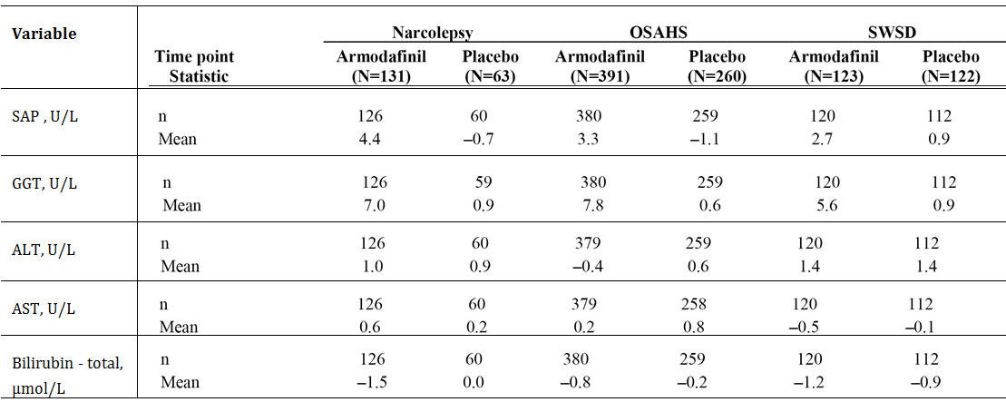

In the Phase 3, double-blind, placebo-controlled studies, shifts in clinical chemistry variables over the course of the studies relative to the reference range occurred with comparable frequency in the armodafinil and placebo treatment groups. Shifts relative to the reference range in clinical chemistry variables generally occurred with comparable frequency in the three sleep disorder populations. The incidence of shifts from normal glucose and GGT values at baseline to values above the reference range during treatment was higher for patients with OSAHS than for patients with narcolepsy or SWSD. Shifts from normal uric acid and ALT values at baseline to values above the reference range during treatment were observed more frequently in patients with OSAHS or SWSD than in patients with narcolepsy. Overall, the only shifts in clinical chemistry variables that occurred in ≥ 10% of patients were shifts in glucose values, but there were no consistent trends above or below the reference range.

Clinically significant abnormal values in liver function variables in the Phase 3, double-blind, placebo-controlled studies are summarised below in Table 60. No meaningful differences in clinical significant abnormal liver function variables were observed between armodafinil and placebo treated patients. The results from the safety data from all 7 clinical studies combined in armodafinil treated patients were consistent with the results from the Phase 3, double-blind, placebo-controlled studies in armodafinil treated patients.

Table 60: Clinically significant abnormal clinical chemistry values in the Phase 3, double-blind, placebo-controlled studies; safety analysis set.

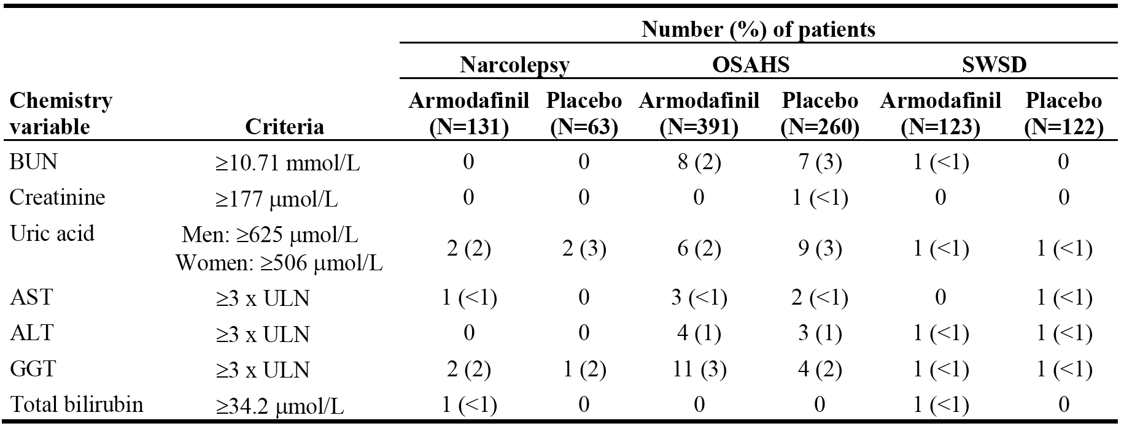

#### Kidney function

In the Phase 3, double-blind, placebo-controlled studies there were no significant differences between armodafinil and placebo in mean change from baseline to endpoint in the creatinine levels in patients in each of the three sleep disorder populations. In patients with narcolepsy, the mean change in creatinine level from baseline to endpoint was -1.9 µmol/L in the armodafinil group and -1.6 µmol/L in the placebo group. In patients with OSAHS, the mean change in creatinine level from baseline to endpoint was -1.6 µmol/L in the armodafinil group and 0.9 µmol/L in the placebo group. In patients with SWSD, the mean change in creatinine level from baseline to endpoint was -2.2 µmol/L in the armodafinil group and -3.2 µmol/L in the placebo group. There was one placebo treated patient with a clinically significant abnormal increase in creatinine level.

#### Other clinical chemistry

Apart from the outcomes described above under liver and kidney function, the only other clinically significant clinical chemistry results from the Phase 3, double-blind, placebo-controlled studies related to increased uric acid levels. However, observed differences between armodafinil and placebo treated patients relating to changes in uric acid levels are considered to be clinically insignificant.

#### Haematology

There were no significant differences in mean change from baseline to endpoint in the haematology variables tested in the Phase 3, double-blind, placebo-controlled studies.

Table 61: Mean change from baseline to endpoint in liver function parameters, pivotal Phase 3 studies.

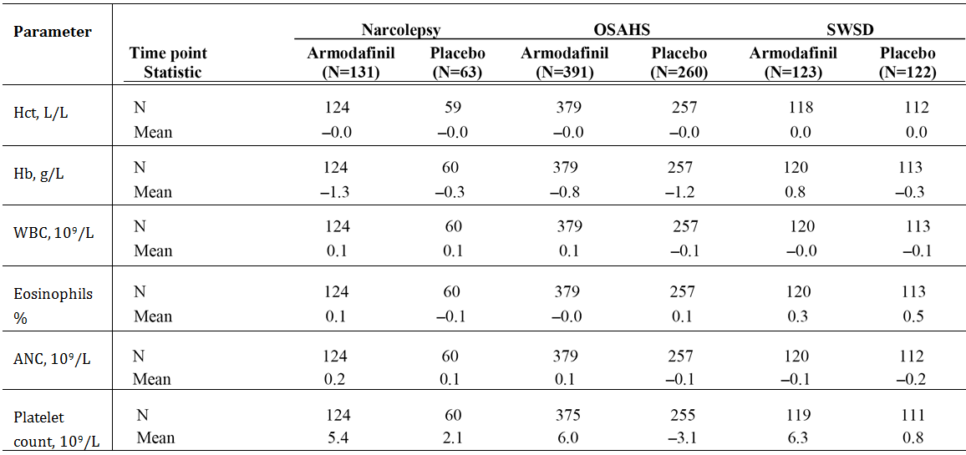

In the double-blind, placebo-controlled studies, shifts over the course of the study relative to the reference range in haematology variables occurred with comparable frequency in the armodafinil and placebo treatment groups. Clinically significant haematology abnormalities from the Phase 3, double-blind, placebo-controlled studies are summarised below in Table 62. The results from all 7 clinical studies combines for the haematology variables were consistent with the results from the Phase 3, double-blind, placebo-controlled studies.

Table 62: Clinically significant abnormal haematology values in the Phase 3, double-blind, placebo-controlled studies; safety analysis set.

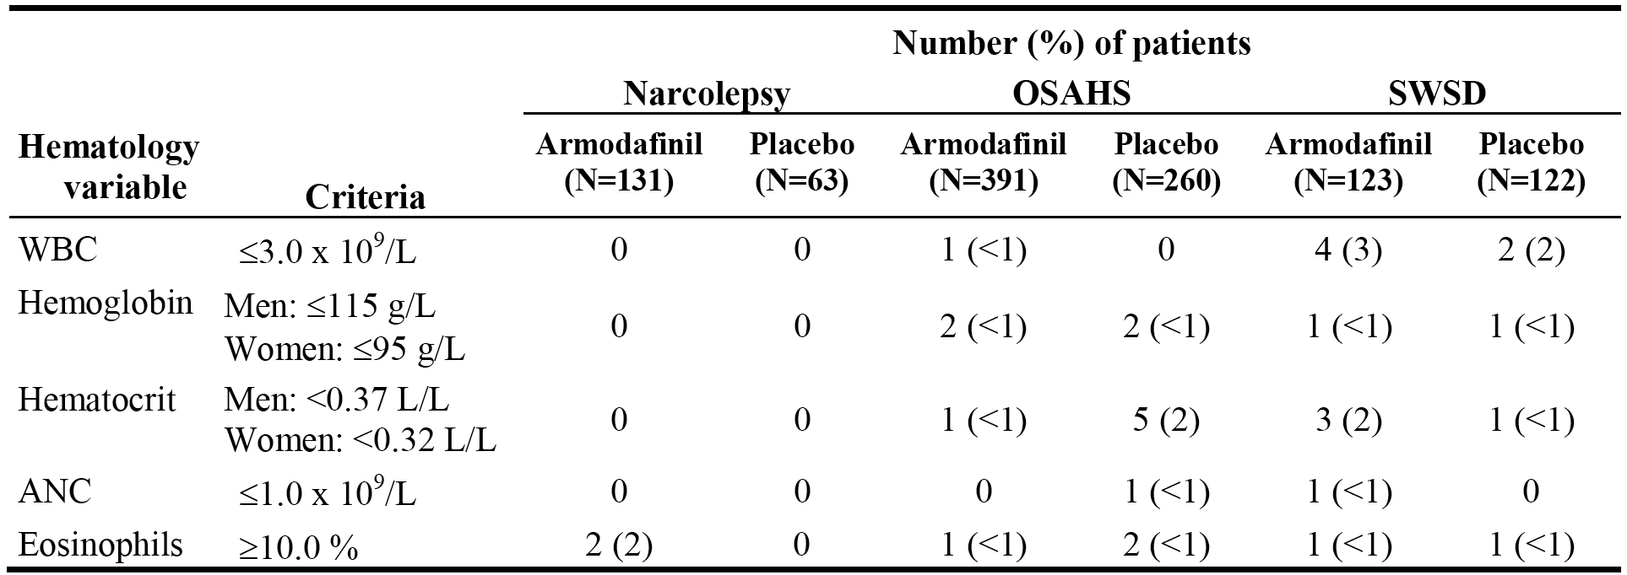

#### Urinalysis

Urine was analysed by dipstick qualitatively for protein, glucose, ketones, and blood (haemoglobin), and quantitatively for pH and specific gravity. In addition, microscopy was conducted for bacteria, casts, crystals, RBCs, and WBCs. Clinically significant changes from baseline to endpoint (increase ≥ 2 units) in patients in the Phase 3, double-blind, placebo-controlled studies based on dipstick testing are summarised below. In the Phase 3, double-blind, placebo-controlled studies, there were minimal changes from baseline to endpoint in urine pH and specific gravity in both armodafinil and placebo treated patients. The urinalysis results from safety data from all 7 clinical studies combined were consistent with the results from the Phase 3, double-blind, placebo-controlled studies.

Table 63: Patients with clinically significant changes from baseline to endpoint (≥ 2 units) in qualitative urine dipstick results in the Phase 3, double-blind, placebo-controlled studies; safety analysis set.

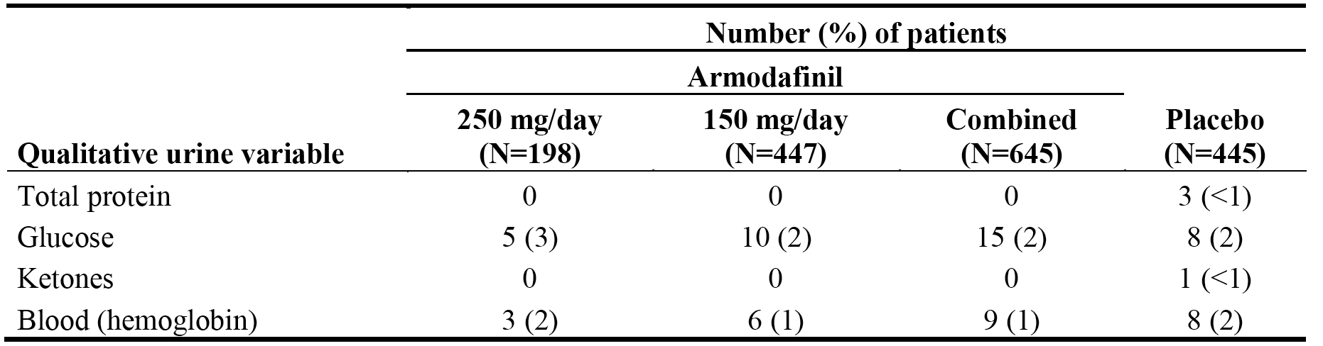

### Electrocardiography

#### Phase 3, double-blind, placebo-controlled studies

* The observed differences between the armodafinil groups and the placebo groups for the change from baseline to endpoint in the ECG for each of the three sleep disorders are considered unlikely to be clinically significant. The range of mean change from baseline in the armodafinil vs the placebo group across the sleep disorders for the ECG findings were: ventricular rate bpm (2.7 to 3.9 vs 1.1 to 1.6); PR interval msec (-3.4 to -2.4 vs -0.8 to 2.0); QRS interval (-0.3 to 1.2 vs 0.0 to 0.2); QT interval msec (-10.9 to -7.5 vs -3.6 to -2.1); QTcB msec (-2.8 to 4.3 vs -0.5 to 2.6); QTcF msec (-5.6 to 0.2 vs -1.6 to 1.0); and RR interval msec (118.05 to 137.93 vs 104.56 to 129.07). The maximum mean change in QTcF and QTcB from baseline to endpoint in armodafinil vs placebo treated patients was 59 vs 101 msec and 72 vs 96.0 msec, respectively.
* Clinically relevant changes in the QTcF (Fridericia correction) were infrequent in both the armodafinil and placebo groups in each of the sleep disorder populations (see Table 64, below). One armodafinil treated patient in the combined group had an absolute QTcF value > 500 msec (1 [0.2%] out of 645 patients), compared with no placebo treated patients in the combined group (0 out of 445 patients). Change from baseline in QTcF > 60 msec was observed in 13 (2.0%) armodafinil treated patients in the combined group and 6 (1.3%) placebo treated patients in the combined group. The sponsor is requested to repeat the QTcF analysis using the QTcB (i.e., Bazett correction).

Table 64: Categorical changes from baseline in QTcF in the Phase 3, double-blind, placebo-controlled studies.

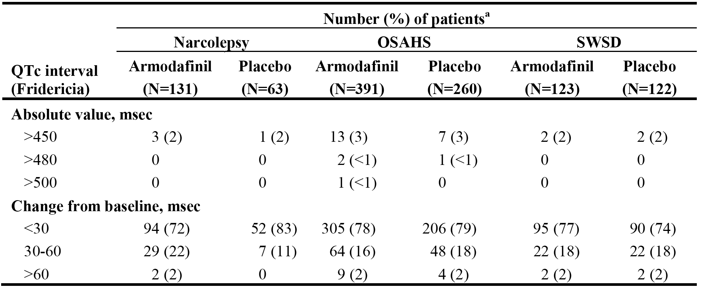

* There was no difference among sleep disorder populations with respect to the incidence of newly diagnosed ECG abnormalities. New ECG abnormalities were observed in the following proportion of patients in the armodafinil vs placebo groups in each of the sleep disorder populations: 26% vs 25%, narcolepsy; 22% vs 23%, OSAHS; and 24% vs 25%, SWSD.

#### All 7 clinical studies

* ECG changes were similar in all 7 clinical studies combined to the ECG changes in the Phase 3, double-blind, placebo-controlled studies combines. In all 7 clinical studies combined (n=1516), 61 (4.0%) patients had a QTcF interval ≥ 450 msec and ≤ 500 msec, and 5 (0.3%) patients had at least one QTcF interval > 500 msec.
* In all armodafinil treated patients, 28% (413/1457) of patients with a post-baseline ECG reading had newly diagnosed ECG abnormalities (30% of patients with narcolepsy, 28% of patients with OSAHS, and 27% of patients with SWSD). The most commonly reported newly diagnosed ECG abnormalities included low T-waves/non-specific T-wave abnormality (122 of 413 [30%] patients with ECG abnormality), sinus bradycardia (87 of 413 [21%] patients with ECG abnormality), broad QRS intraventricular block (74 of 413 [18%] patients with ECG abnormality), and ST depression nonspecific ST abnormality (63 of 413 [15%] patients with ECG abnormality).

### Vital signs

##### Phase 3, double-blind, placebo-controlled studies

Changes from baseline to endpoint in vital signs (pulse, systolic and diastolic blood pressure) were obtained approximately 2 to 3 hours after study drug administration (to coincide with maximum plasma concentration). Clinically significant abnormal pulse and blood pressure values in these studies based on WHO criteria are summarised below in Table 65. These were the pre-defined criteria applied in the individual pivotal Phase 3 studies. In the combined safety data from these studies, newly diagnosed or worsening hypertension was reported in 3% (19/645) of armodafinil treated patients and 2% (8/445) of placebo treated patients based on the WHO criteria.

Table 65: Clinically significant abnormal vital signs in the Phase 3, double-blind, placebo-controlled studies.

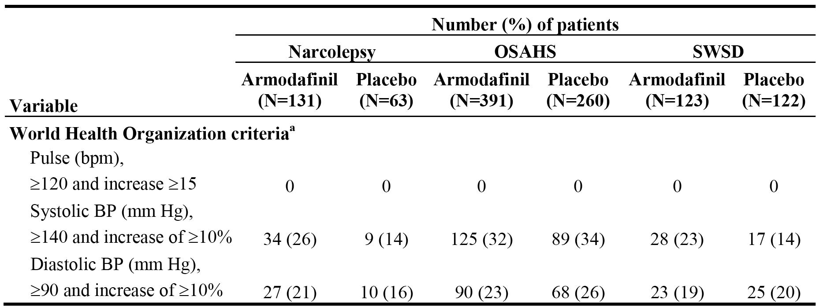

*Comment: The main difference between the two treatment groups relates to the notably higher incidence of systolic hypertension in patients in the armodafinil group compared to the placebo group in patients with narcolepsy and SWSD. The incidence of clinically significant diastolic blood pressure was similar in both the armodafinil and placebo groups in each of the three sleep disorder populations.*

The results for clinically significant increases in blood pressure in patients in the Phase 3, double-blind, placebo-controlled studies were also summarised ad hoc by the sponsor using the Division of Neuropharmacological Drug Products (US FDA) criteria (see Table 66, below).

Table 66: Clinically significant increases in blood pressure (Division of Neuropharmacological Drug Products [US FDA] criteria) in the double-blind, placebo-controlled studies.

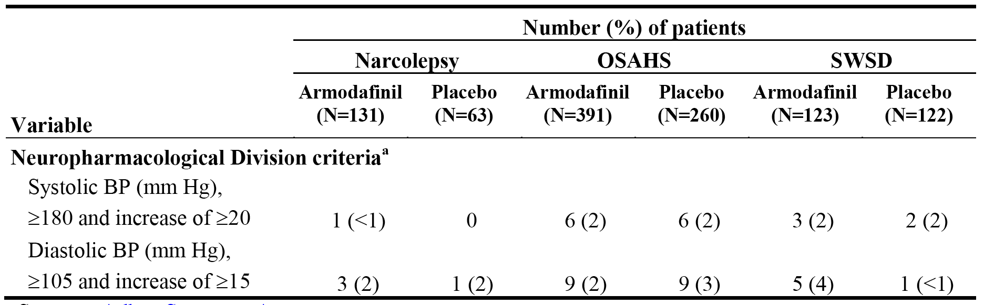

*Comment: The number of patients with hypertension in the ad hoc analysis using the FDA criteria is notably smaller in all treatment groups compared with the pre-defined WHO criteria.*

* The distribution of maximum increases from baseline in systolic and diastolic blood pressure are summarised below in Table 67.

Table 67: Maximum increase from baseline in blood pressure for those patients with baseline and post-baseline values in the Phase 3, double-blind, placebo-controlled studies.

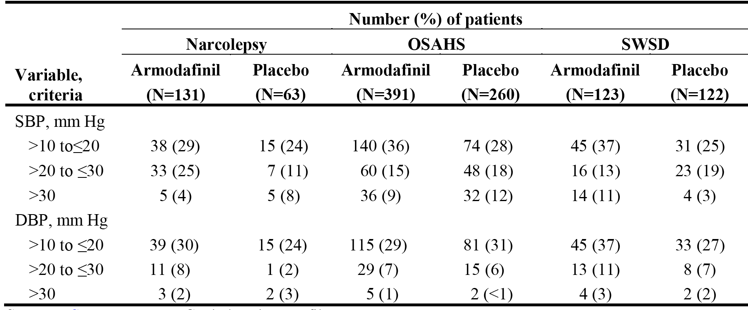

*Comment: The most notable difference between the two treatment groups was the higher incidence of SBP increases > 20 to ≤ 30 mmHg in the armodafinil group compared to the placebo group in narcolepsy patients.*

##### All 7 clinical studies

The vital sign results from all 7 clinical studies combined using the WHO and the US FDA criteria are summarised below in Table 68.

Table 68: Clinically significant increases in pulse rate and blood pressure in all 7 clinical studies combined.

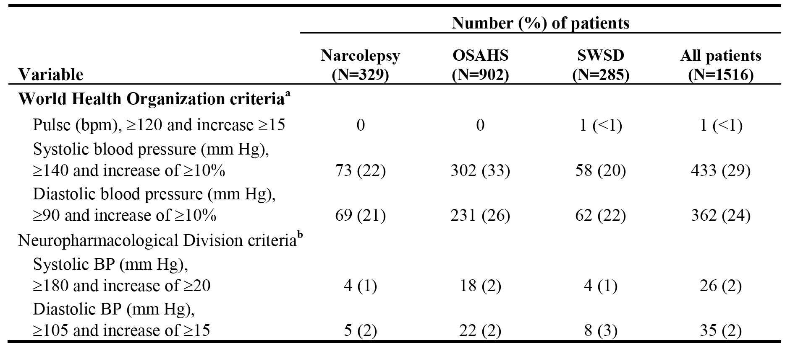

*Comment: The incidence of systolic hypertension (WHO criteria) in armodafinil treated patients was higher in patients in the OSAHS group compared to the narcolepsy and SWSD groups.*

### Polysomnography

In the Phase 3, double-blind, placebo-controlled studies, quality of sleep was assessed by either night-time (for OSAHS and narcolepsy) or daytime (for SWSD) polysomnography (PSG). Across sleep disorder populations, there were no clinically meaningful changes from baseline to endpoint in sleep variables measured by PSG either in armodafinil treated or placebo treated patients. Overall, the results indicate that sleep was not adversely affected by armodafinil treatment.

In the 2, Phase 3, double-blind, placebo-controlled studies in patients with OSAHS, there was no differences between armodafinil and placebo treated patients in the mean change from baseline to endpoint in the apnoea-hypopnea index (AHI) assessed by night-time PSG.

### Other safety issues

#### Safety in special populations

##### Gender

In the Phase 3, double-blind, placebo-controlled studies, the overall incidence of AEs was higher in women compared to men in both the armodafinil (67% vs 61%) and placebo (51% vs 46%) treatment groups. In particular, the incidence of nausea was higher in women (12% vs placebo 7%) compared to men (4% compared to placebo 0.7%). Other AEs occurring in ≥ 2% more women than men, and more frequently than placebo in both genders were: headache (18% [vs placebo 11%] vs 16% [vs placebo 8%], respectively); diarrhoea (5% vs [placebo 3%] vs 3% [vs placebo 1%], respectively); dry mouth (5% [vs placebo 0.6%] vs 3% [vs placebo 0.4%], respectively); and palpitations (3% [vs placebo 0.6%] vs 1% [vs placebo 1%], respectively).

In all 7 clinical studies combined, in armodafinil treated patients AEs were reported more frequently in women than in men (88% [497/563] vs 83% [794/953]). AEs reported ≥ 2% more commonly in women vs men, in decreasing order of frequency in women were: headache (27% vs 22%); nausea (16% vs 8%); insomnia (13% vs 11%); upper respiratory tract infection (10% vs 8%); anxiety (9% vs 7%); sinusitis (8% vs 6%); dry mouth (8% vs 5%); bronchitis (7% vs 2%); diarrhoea (7% vs 5%); rash (5% vs 2%); urinary tract infection (5% vs 0.1%); palpitations (4% vs 2%); abdominal pain (4% vs 1%); chest pain (4% vs 2%); vomiting (3% vs 1%); and decreased appetite (3% vs 1%). No AEs were reported in ≥ 2% more men than in women.

##### Age group

In the Phase 3, double-blind, placebo-controlled studies, AEs were compared across four age groups (18-29, 30-40, 41-55, and > 55 years). In the four age groups from youngest to oldest, respectively, AEs were reported in the following proportions of armodafinil vs placebo treated patients, 67% vs 44% (∆ = 23%), 64% vs 51% (∆ = 13%), 62% vs 45% (∆ = 17%), and 61% vs 54% (∆ = 7%). The greatest difference in AEs between armodafinil and placebo treated patients was observed in the 18-29 years group. The only AEs reported in ≥ 10% of patients treated with armodafinil in at least one of the four age groups were headache and nausea. In the four age groups 18-29, 30-40, 41-55, and > 55 years, in armodafinil treated patients vs placebo treated patients headache was reported in 25% vs 10%, 16% vs 12%, 16% vs 7%, and 15% vs 9% of patients, respectively, and nausea was reported in 13% vs 2%, 6% vs 6%, 6% vs 3%, and 5% vs <1% of patients, respectively. The AE profile in each of the age groups for events occurring in ≥2% of armodafinil patients overall and more frequently than in placebo treated patients is summarised.

In all 7 clinical studies combined, AEs in armodafinil treated patients were reported in 77% (140/181) of patients in the 18-29 years age group, 82% (237/289) of patients in the 30-40 years age group, 87% (602/691) of patients in the 41-55 years age group, and 88% (312/355) of patients in the > 55 years age group. In patients aged ≤ 40 years, the incidence of AEs was 80% compared to 87% in patients aged > 40 years. There were no marked differences in among the age groups for most of the system organ class groupings of AEs. Musculoskeletal and connective tissue disorders occurred less frequently in patients in the 18 to 29 years age group than in the older age groups (13% vs 22% [30 to 40 years], 21% [41 to 55 years], and 23% [> 55 years]). The incidences of the most commonly reported AEs (at least 5% in each sleep disorder group) of headache, dizziness, insomnia, nasopharyngitis, nausea, anxiety, and upper respiratory tract infection were comparable across age groups.

##### Race

In the Phase 3, double-blind, placebo-controlled studies, the overall incidence of AEs was similar for non-white patients and white patients in both the combined armodafinil group (66% [97/147] vs 62% [308/493], respectively) and the combined placebo groups (55% [44/82] vs 46% [165/139], respectively). The AEs reported in ≥ 2% of patients in the combined armodafinil group and more frequently than in patients in the combined placebo group were similar in both racial groups. AEs meeting these criteria and occurring in ≥ 5% of patients in the combined armodafinil group in both white patients and non-white patients were headache (16% vs 18%, respectively), and nausea (6% vs 9%, respectively).

In all 7 clinical studies combined, the overall incidence of AEs in patients treated with armodafinil was greater in white patients compared to non-white patients (86% [1067/1237] vs 80% [217/270]). AEs reported in ≥ 2% more white patients compared to non-white patients were upper respiratory tract infection (10% vs 6%), bronchitis (4% vs 2%), anxiety (8% vs 6%), depression (4% vs 2%), cough (4% vs 2%), and hypertension (5% vs 3%). No AEs were reported in ≥ 2% more non-white patients compared to white patients.

##### nCPAP usage in patients with OSAHS

In the 2 Phase 3, double-blind, placebo-controlled studies in patients with OSAHS, nCPAP usage was monitored throughout the study and assessed at week 12 or the last post-baseline observation. The decrease in mean ± SD duration of nCPAP use per night from baseline to last post-baseline observation per night (n=371) was 18 ± 40 minutes in the combined armodafinil group, 24 ± 39 minutes in the armodafinil 250 mg/day group (n=125), 18 ± 40 minutes in the 150 mg/day group (n=260), and 6 ± 37 minutes in the placebo group (n=252). The sponsor stated that the decrease of 18 minutes per night observed in the combined armodafinil group was not clinically meaningful.

### Post marketing experience

The sponsor submitted Periodic Adverse Drug Experience Reports (PADERS) relating to armodafinil covering the period from 15 June 2007 (date of first approval in the USA), though 31 May 2014. The sponsor stated that it has submitted PADERs to the FDA quarterly for the first 3 years following the US approval and annually thereafter. The sponsor submitted a copy of the most recent annual PADER covering the period from 01 June 2013 through 31 May 2014. In addition, the SCS included a summary of the post-marketing data covering the period from the date of approval through 31 October 2013. The calculated post-marketing exposure from June 2009 through 31 October 2013 based on US sales is summarised below in Table 69.

Table 69: Estimated post-marketing armodafinil use in the USA; June 2009 through 31 October 2013.

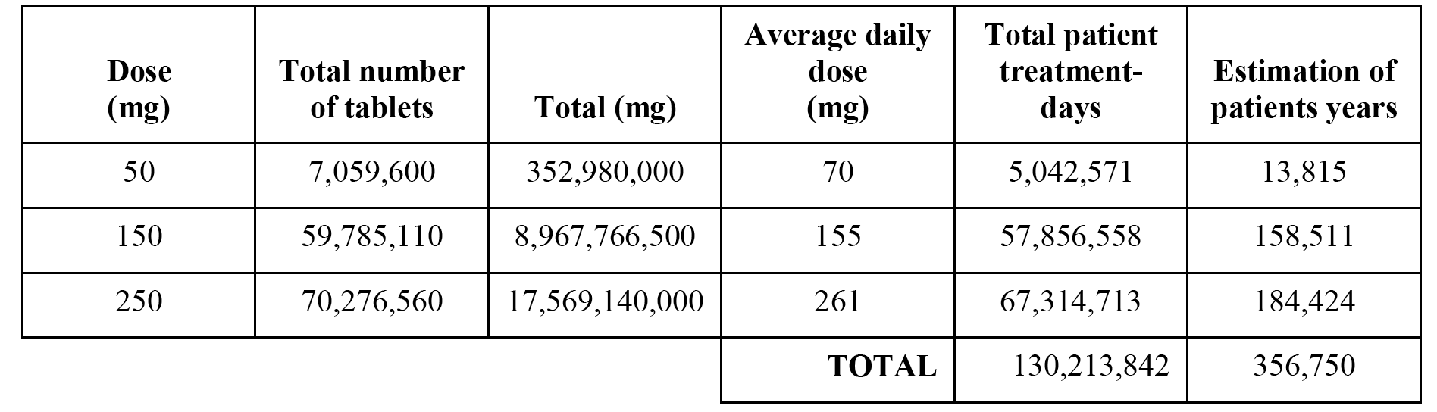

The post-marketing data identify serious skin reactions as being of particular concern with armodafinil treatment. There have been post-marketing reports of Steven-Johnson Syndrome (SJS), dermatitis bullous, exfoliative rash, toxic epidermal necrolysis, erythema multiforme and drug reaction with eosinophilia and systemic symptoms (DRESS syndrome). Furthermore, there appears to have been at least one death associated with SJS and one death associated with the DRESS syndrome. It is noted that the USA prescribing information for armodafinil was updated in 2010 to include a warning relating to post-marketing reports of serious rash including SJS. In response to a request from the FDA, the sponsor submitted an epidemiological study to the FDA in May 2011 further assessing the risk of serious rash and hypersensitivity reactions associated with Provigil and Nuvigil.

From the date of approval through 31 October 2013, skin reactions accounted for 198 (20%) out of a total or 987 post-marketing reports received by the sponsor (spontaneous [n=926], solicited [n=61]). Of the total number of skin reaction reports, SJS accounted for 12.6% (25/198), and other skin reactions reported at least 10 times were rash (49 reports), skin exfoliation (12 reports), angioedema (12 reports), blister (11 reports), rash erythematous (11 reports), pruritus (10 reports), toxic epidermal necrolysis (10 reports), and urticaria (10 reports).

Other post-marketing adverse drug reactions of concern reported from the approval date through 31 October 2013 included: psychiatric disorders (accounting for 160 [16.2%] of the reported 987 events), in particular suicidal ideation (24 reports), depression (14 reports), and mania (10 reports); and immune system disorders (accounting for 23 [2.3%] of the reported 1987 events), in particular hypersensitivity (11 reports), anaphylactic reaction (9 reports) and anaphylactic shock (1 report).

Preferred-term post-marketing adverse drug reactions each accounting for ≥ 1% of the total reports from the date of approval through 31 October 2013 were, in decreasing order of frequency: rash (49 reports); dyspnoea (27 reports); SJS (25 reports); convulsion (15 reports); suicidal ideation (14 reports); swollen tongue (15 reports); exposure during pregnancy (15 reports); depression (14 reports); death (13 reports); pharyngeal oedema (12 reports); skin exfoliation (12 reports); angioedema (12 reports); blister (11 reports); rash erythematous (11 reports); hypersensitivity (11 reports); mania (10 reports); pruritus (10 reports); urticaria (10 reports); toxic epidermal necrolysis (10 reports); and drug prescribing error (10 reports).

In the post-marketing period from the date of approval through 31 October, there were 13 reports of death and 1 report each of brain death and sudden death. The most recent PADER summarizing post-marketing data from the date approval through 31 May 2014 identifies 6 further deaths associated with armodafinil (1x DRESS syndrome with possible causal association with armodafinil; 1x metastatic lung cancer considered unrelated to armodafinil; 1x metastatic prostate cancer considered unrelated to armodafinil; 1x cardio-respiratory arrest due to underlying condition including COPD; 2x death due to unknown cause). The sponsor is requested to provide a tabulated summary of all post-marketing deaths reported from the date of approval through 31 May 2014, and narratives for each death.

Overall, the general pattern of reported adverse drug reactions in the most recent PADER is consistent with the reactions reported from date of approval through 31 October 2013. No revision to the USA prescribing information was proposed by the sponsor based on the most recent PADER.

### Evaluator's overall conclusions on clinical safety

The safety profile of armodafinil has been well characterized in the clinical trial program for armodafinil for the treatment of the three sleep disorders of interest (narcolepsy, OSAHS and SWSD), and in the post marketing data collected on the drug from first approval (USA) in June 2009 through 31 May 2014.

The limitations of the armodafinil safety data for the proposed population include: no placebo controlled or active controlled data for treatment longer than 12 weeks; no safety data in patients aged > 65 years; no safety data on disease rebound following discontinuation of treatment; and no safety data on the abuse potential of the drug including drug dependence.

The key clinical trial safety data relating to the use of the armodafinil for treatment of the proposed indications are provided by the 4, pivotal Phase III double blind, placebo controlled studies of 12 weeks duration for the three sleep disorders of interest (studies 3020, 3021, 3022, 3025). In these studies, 645 patients were exposed to armodafinil (150 mg/day [n = 447], 250 mg/day [n = 198]) and 445 patients were exposed to placebo. Based on the "rule of threes", the safety set of 645 patients exposed to armodafinil for 12 weeks in the pivotal Phase III studies is sufficient to detect adverse drug reactions occurring with an incidence of ≥ 0.5% with 95% certainty.

Supporting safety data are provided from the combined safety data from all 7 clinical studies for 1516 armodafinil treated patients (narcolepsy [n = 329], OSAHS [n = 902], SWSD [n = 285]). In all 7 clinical studies combined, the most common dose was 250 mg/day received by 52% (786/1516) of patients with a total exposure of 792 patient-treatment years, followed by 150 mg/day received by 28% (417/1516) of patients with a total exposure of 214 patient treatment years, 100 mg/day received by 13% (196/1516) of patients with a total exposure of 166 patient treatment years, and ≤ 100 mg/day received by 8% (117/1516) of patients with a total exposure of 71 patient treatment years. Based on the "rule of threes", the safety set of 1516 patients exposed to armodafinil in all 7 clinical studies combined is sufficient to detect adverse drug reactions occurring with an incidence of ≥ 0.2% with 95% certainty.

In addition to the key and supporting safety data from the clinical studies with armodafinil, the submission also included important post marketing safety data from 987 adverse drug reaction reports collected by the sponsor from the date of first approval of armodafinil in June 2009 through 31 October 2013 (926 spontaneous reports, 61 solicited reports). Based on US sales data from approval date through 31 October 2013, the estimated total patient treatment days for armodafinil is 130,213,842 and the estimated total patient treatment years of treatment is 356,750.

The post marketing data raise concerns relating to the association between armodafinil treatment and serious and potentially fatal skin conditions including SJS and DRESS syndrome. Both of these conditions have each been associated with at least one death in armodafinil treated patients. Other serious skin conditions reported in association with armodafinil treatment include dermatitis bullous, exfoliative rash, toxic epidermal necrolysis, erythema multiforme. Other safety concerns related to armodafinil treatment arising from the post- marketing data include psychiatric disorders, in particular, suicidal ideation, depression and mania, and immune system disorders, in particular, hypersensitivity disorders, anaphylactic reactions, and anaphylactic shock.

In the combined safety data from the pivotal Phase III studies, at least one AE was reported in 63% of patients in the armodafinil group and 48% of patients in the placebo group. AEs occurred more commonly in armodafinil treated patients than in placebo treated patients in each of the three sleep disorder populations. The greatest difference (∆) between armodafinil and placebo in the incidence of patients with at least one AE was observed in narcolepsy patients (69% versus 46%, ∆ = 23%), followed by SWSD patients (54% versus 40%, ∆ = 14%) and OSAHS patients (64% versus 52%, ∆ = 12%). The only AEs reported in ≥ 10% of armodafinil treated patients in at least one of the three sleep disorder populations were headache (22% [narcolepsy], 17% [OSAHS], 12% [SWSD]), and nausea (11% [narcolepsy], 7% [SWSD], 6% [OSAHS]).

In the narcolepsy group, AEs reported in ≥ 5% more armodafinil treated patients compared to placebo treated patients were headache (22% versus 11%), nausea (11% versus 0%), decreased appetite (5% versus 0%), and dizziness (5% versus 0%). In the OSAHS group, AEs reported in ≥ 5% more armodafinil treated patients compared to placebo treated patients were headache (17% versus 8%), insomnia (6% versus 1%), nausea (6% versus 4%), anxiety (5% versus <1%), and dizziness (5% versus 2%). In the SWSD group, AEs reported in ≥ 5% more armodafinil treated patients compared to placebo treated patients were headache (12% versus 10%), nausea (7% versus 3%), nasopharyngitis (6% versus 3%), and anxiety (5% versus 2%).

In the pivotal Phase III studies (combined safety data), AEs were reported more commonly in patients treated with 250 mg/day compared to patients treated with 150 mg/day (69% versus 60%), and more commonly in both dose groups compared to placebo (48% for each of the comparisons). AEs reported in ≥ 2% more patients in the 250 mg/day dose group compared to the 150 mg/day dose group were headache (23% versus 14%, ∆ = 9%), dry mouth (7% versus 2%, ∆ = 5%), nausea (9% versus 6%, ∆ = 3%), rash (4% versus 1%, ∆ = 3%), insomnia (6% versus 4%, ∆ = 2%), depression (3% versus 1%, ∆ = 2%), anorexia (3% versus < 1%, ∆ = 2%), decreased appetite (3% versus < 1%, ∆ = 2%), and pyrexia (2% versus 0%, ∆ = 2%). The only AE reported in ≥ 2% more patients in the 150 mg/dose group compared to the 250 mg/day dose group was dyspepsia (3% versus 1%, ∆ = 2%). The results demonstrate a dose response relationship between armodafinil and the incidence of commonly reported AEs.

In all 7 clinical studies combined (n = 1516), AEs reported in ≥ 5% of armodafinil treated patients were headache (24%), insomnia and nasopharyngitis (12% each), nausea (11%), upper respiratory tract infection (9%), anxiety (8%), dizziness and sinusitis (7% each), diarrhoea and dry mouth (6% each), and influenza, back pain, arthralgia, and hypertension (5% each). The incidence of patients with at least one AE was highest in the OSAHS group (89% [804/902]), followed by the narcolepsy (82% [270/329]) and SWSD (76% [217/285]) groups. Of the three AEs reported in ≥ 10% of armodafinil treated patients, headache, nasopharyngitis, and nausea were all reported more frequently in patients with narcolepsy (30%, 16%, and 15%, respectively) than in patients with OSAHS (23%, 12%, and 10%, respectively) or SWSD (19%, 10%, and 7%, respectively), while insomnia was reported more frequently in patients with OSAHS (14%) than in patients with narcolepsy or SWSD (7% and 11%, respectively).

In the pivotal Phase III studies (combined safety data), treatment-related AEs were reported in 38% of armodafinil treated patients compared to 21% of placebo treated patients. Treatment related AEs reported in ≥ 2% of patients in the combined armodafinil group (versus combined placebo group) were headache (14% versus 7%), nausea (6% versus 2%), insomnia (4% versus < 1%), dry mouth (4% versus < 1%), anxiety (3% versus < 1%), dizziness (3% versus < 1%), diarrhoea (2% versus < 1%), dyspepsia (2% versus < 1%), flatulence (2% versus 2%), and palpitations (2% versus < 1%). In all 7 clinical studies combined, treatment-related AEs reported in ≥ 2% of armodafinil treated patients were headache (19%), insomnia (10%), nausea (7%), anxiety (6%), dizziness (5%), dry mouth (5%), palpitations (3%), diarrhoea (3%), hypertension (3%), somnolence (2%), dyspepsia (2%), flatulence (2%), feeling jittery (2%), fatigue (2%), GGT increased (2%), heart rate increased (2%), decreased appetite (2%), nervousness (2%), irritability (2%), and tremor (2%).

In all 7 clinical studies combined, cumulative AE data from month 0 through month 24 showed that the majority of AEs were reported in first 3 months of treatment with armodafinil. Of the 1516 armodafinil treated patients, 47% reported at least one AE during the first 2 weeks of treatment, 72% reported at least one AE during the first 3 months of treatment, and 85% reported at least one AE during the first 24 months of treatment.

No patients in the pivotal Phase III studies died during treatment with armodafinil, and in all 7 clinical studies combined there was 1 death (0.1%) due to atherosclerotic cardiovascular disease considered by the investigator to be unrelated to treatment with armodafinil

In the pivotal Phase III studies (combined safety data), there were 6 (1%) armodafinil treated patients with SAEs compared to 2 (0.5%) placebo treated patients. In the narcolepsy population, SAEs were reported in 1 (0.8%) patient in the armodafinil group (angioneurotic oedema) and no patients in the placebo group. In the OSAHS population, SAEs were reported in 4 (1%) patients in the armodafinil group (1 x ulcerative colitis, 1 x duodenal haemorrhage, 1 x migraine, 1 x affective disorder, 1 x personality disorder) and 1 (0.4%) patient in the placebo group (1x GORD). In the SWSD population, SAES were reported in 1 (0.8%) patient in the armodafinil group (1x suicidal depression) and 1 (0.8%) patient in the placebo group (1 x viral meningitis). Of the reported SAEs, suicidal depression was considered to be related to treatment with armodafinil.

In all 7 clinical studies combined), SAEs were reported in 80 (5%) armodafinil treated patients, including 8 (2%) patients with narcolepsy, 62 (7%) patients with OSAHS, and 10 (4%) patients with SWSD. The following SAEs were considered by investigators to be related to treatment with armodafinil: pulmonary embolism (2x), chest pain (2x) and 1x each for myocardial infarction, ventricular tachycardia, headache, transient ischemic attack, depression, suicidal depression, asthma, hypertension, and thrombosis. All other SAEs were considered to be either not related or unlikely to be related to treatment with armodafinil.

In the pivotal Phase III studies (combined safety data), AEs leading to discontinuation were reported in 7% (44/645) of armodafinil treated and 4% (16/445) of placebo treated patients. In armodafinil treated patients, AEs reported in more than 2 patients leading to discontinuation were: headache (8 patients [1%]); nausea, anxiety, and depression (4 patients each [0.6%]); and palpitations, diarrhoea, alanine transaminase (ALT) increased, gamma glutamyltransferase (GGT) increased, agitation, and insomnia (3 patients each [0.5%]). No AEs leading to discontinuation were reported in more than 2 patients in the combined placebo group. AEs leading to discontinuation (armodafinil versus placebo) were reported in 5% versus 2% of patients, respectively, in the narcolepsy group, 8% versus 4% of patients, respectively, in the OSAHS group, and 6% versus 3% of patients, respectively, in the SWSD group. In general, the types of AEs leading to discontinuation were similar for the 3 sleep disorder populations.

In all 7 clinical studies combined, at least one AE leading to withdrawal in armodafinil treated patients was reported in 12% of patients with narcolepsy, 18% of patients with OSAHS, and 9% of patients with SWSD. The most frequently reported AEs leading to discontinuation (≥ 1% of patients) in armodafinil treated patients were headache (2%), anxiety (1%), and nausea (1%).

In the pivotal Phase 3studies, no clinically meaningful differences in clinical chemistry variables, haematological variables, or urinalysis results were observed between armodafinil and placebo. In particular, there was no evidence indicating that armodafinil is associated with haematological, hepatic or renal toxicity. In all 7 clinical studies combined, there was no evidence that armodafinil detrimentally affected the ECG (including QTc prolongation) or the PSG.

In the pivotal Phase III studies, based on pre specified criteria clinically significant elevated systolic and diastolic blood pressure were observed more frequently in patients treated with armodafinil (26% and 21%, respectively) compared to placebo (14% and 16%, respectively). In patients with narcolepsy, based of pre specified criteria clinically significant elevated systolic blood pressure was reported more frequently in patients in the armodafinil group compared to the placebo group (26% versus 14%, respectively), as was clinically significant elevated diastolic blood pressure (21% and 16%, respectively). In patients with SWSD, based on pre specified criteria clinically significant elevated systolic blood pressure was observed more frequently in armodafinil treated patients compared to placebo treated patients (23% versus 14%, respectively), while clinically significant elevated diastolic blood pressure was observed in a similar proportion of patients in both treatment groups (19% and 20%, respectively). In patients with OSAHS, based on pre specified criteria clinically significant elevated systolic blood pressure occurred in a similar proportion of armodafinil and placebo treated patients (32% and 34%, respectively), as did clinically significant elevated diastolic blood pressure (23% and 26%, respectively). No clinically significant increase in pulse rate was observed in either treatment group in the pivotal Phase III studies.

In the pivotal Phase III studies (combined safety data), AEs were reported more frequently in females compared to males in both armodafinil treated patients (67% versus 61%) and placebo treated patients (51% versus 46%). In particular, the incidence of nausea was higher in women (12% versus placebo 7%) compared to men (4% compared to placebo 0.7%). Other AEs occurring in ≥ 2% more women than men, and more frequently than placebo in both genders were: headache (18% [versus placebo 11%] versus 16% [versus placebo 8%], respectively); diarrhoea (5% versus [placebo 3%] versus 3% [versus placebo 1%], respectively); dry mouth (5% [versus placebo 0.6%] versus 3% [versus placebo 0.4%], respectively); and palpitations (3% [versus placebo 0.6%] versus 1% [versus placebo 1%], respectively).

In the pivotal Phase III studies (combined safety data), AEs were compared across four age groups (18-29, 30-40, 41-55, and > 55 years). In the four age groups from youngest to oldest, respectively, AEs were reported in the following proportions of armodafinil versus placebo treated patients, 67% versus 44% (∆ = 23%), 64% versus 51% (∆ = 13%), 62% versus 45% (∆ = 17%), and 61% versus 54% (∆ = 7%). The greatest difference in AEs between armodafinil and placebo treated patients was observed in the 18-29 years group. The only AEs reported in ≥ 10% of patients treated with armodafinil in at least one of the age groups were headache and nausea.

In pivotal Phase III studies (combined safety data), AEs were reported in a similar proportion of non-white and white patients in both armodafinil treated patients (66% versus 62% respectively) and placebo treated patients (55% versus 46%, respectively).

## First round benefit-risk assessment

### OSAHS

* The benefits of armodafinil for significantly improving wakefulness in patients with residual sleepiness associated with OSAHS have been satisfactorily demonstrated in two pivotal studies (3021, 3025). The available data suggests that the benefits of armodafinil treatment of this condition are similar to the benefits of modafinil.
* In both pivotal studies (3021, 3025), armodafinil compared to placebo significantly increased mean sleep latency time based on the 30 minute MWT (average of 4 tests at 0900, 1100, 1300 and 1500 h) from baseline to endpoint, and significantly increased the proportion of patients with at least minimal improvement in CGI-C rating at endpoint.
* In the armodafinil 150 mg/day group (Study 3021), mean sleep latency increased from baseline to endpoint by 1.7 minutes, and was 3.4 minutes longer than placebo (p = 0.0008). In the armodafinil 150 mg/day group (Study 3025), mean sleep latency increased from baseline to endpoint by 2.3 minutes, and was 3.6 minutes longer than placebo (p = 0.0003). In the armodafinil 250 mg/day group (Study 3021), mean sleep latency increased from baseline to endpoint by 2.2 minutes, and was 3.9 minutes longer than placebo (p = 0.0001). The increased sleep latency observed in each of the armodafinil groups compared to placebo is considered to be clinically meaningful.
* The increase in sleep latency observed for armodafinil compared to placebo in the two studies (3.4 to 3.9 minutes) was consistent with the increase in sleep latency observed for Modavigil 200 mg/day compared to placebo (2.7 minutes) and Modavigil 400 mg/day compared to placebo (2.6 minutes) reported in the Modavigil PI. The results suggest that the benefits of armodafinil 150 mg/day and 250 mg/day on increasing sleep latency in patients with OSAHS are similar to those reported for Modavigil 200 mg/day and 400 mg/day.
* The benefits of armodafinil in increasing sleep latency appear to be limited to earlier h following dosing rather than later h. In both studies, no statistically significant differences between armodafinil and placebo were observed in mean change from baseline to endpoint in sleep latency at later time points (average of 3 naps at 1500, 1700 and 1900 h).
* In Study 3021, the proportion of patients with a least minimal improvement in CGI-C rating from pre treatment to endpoint was 71% in the armodafinil 150 mg/day group, 74% in the armodafinil 250 mg/day group and 37% in the placebo group, and in both groups the difference compared to placebo was statistically significant (p<0.0001, both comparisons). The increased response rate in each of the armodafinil groups compared to placebo is considered to be clinically meaningful. Furthermore, the CGI-C results for the armodafinil versus placebo comparisons in study 3021 were comparable with the results for the comparisons between Modavigil 200 mg/day versus placebo (61% versus 37%, respectively) and Modavigil 400 mg/day versus placebo (68% versus 37%) reported in the Modavigil PI.
* In Study 3025, the proportion of patients with a least minimal improvement in CGI-C rating from baseline to endpoint in the armodafinil 150 mg/day group was 71% compared to 53% in the placebo group; p = 0.0069. The placebo response rate for patients reporting at least minimal improvement in CGI-C rating from baseline to endpoint in study 3025 was unexpectedly high. This results in the difference in the CGI-C rating from baseline to endpoint between armodafinil 150 mg/day and placebo in Study 3025 being of doubtful clinical significance. The placebo response rate in this study was notably higher than the placebo response rate reported in the Modavigil PI for patients with OSAHS (that is, 37%). However, the response rate for armodafinil 150 mg/day in study 3025 was comparable to the response rates for Modavigil 200 mg/day and 400 mg/day reported in the PI (that is, 71%, 61% and 68%, respectively).
* The effect of armodafinil in improving the quality of secondary episodic memory was equivocal. In study 3021, no statistically significant difference was observed from baseline to endpoint between the combined armodafinil group (150 mg/day and 250 mg/day) and placebo for the change in mean quality of secondary episodic memory from the CDR system (average of 4 tests at 0930, 1130, 1330 and 1530 h). In study 3021, this was a key secondary efficacy endpoint. However, in study 3025, there was a statistically significant improvement in this endpoint in the armodafinil 150 mg/day group compared to placebo.
* There was no evidence from the two studies that armodafinil improves the power of attention. In Study 3025, no statistically significance difference was observed between armodafinil 150 mg/day and placebo for the key secondary efficacy outcome of change in mean power of attention from the CDR system (average of 4 tests at 0930, 1130, 1330 and 1530 h) from baseline to endpoint. Similarly, in study 3021 no statistically significant difference was observed in this endpoint for the comparison between the combined armodafinil group and placebo. In addition, there was no evidence from the two studies that armodafinil improves continuity of attention or speed of memory.
* Armodafinil improves wakefulness, based on the ESS score. In study 3021, the change from baseline to endpoint in the mean total ESS score was statistically significantly greater in the armodafinil 150 mg/day group compared to placebo (-5.5 versus -3.3, p = 0.0005) and in the 250 mg/day group compared to placebo (-5.5 versus -3.3, p = 0.0007). In Study 3025, the change from baseline to endpoint in the mean total ESS score was statistically significantly greater in the armodafinil 150 mg/day group compared to placebo (-5.3 versus -3.0, p = 0.0001). The difference in the ESS total score for the armodafinil versus placebo comparisons were consistent with the results for the comparisons between Modavigil 200 mg/day (∆ = 2.7) and Modavigil 400 mg/day (∆ = 2.7) reported in the Modavigil PI. The results suggest that the benefits of armodafinil 150 mg/day and 250 mg/day in improving wakefulness, based on the ESS total score, are similar to those of Modavigil 200 mg/day and 400 mg/day in patients with OSAHS,
* There was evidence from both studies that armodafinil improves fatigue, based on the average BFI score. However, improvement in worst fatigue scores with armodafinil treatment was equivocal. Descriptive subjective evidence from patient diaries shows that armodafinil reduces the number of daytime unintended sleep episodes, the number of daytime naps, and the number of mistakes, accidents or near misses. There is no evidence that armodafinil has a benefit greater than that observed with placebo on reducing the number of caffeine beverages consumed in a day.
* The benefits of armodafinil in patients with OSAHS appear to be maintained over the long term. In 2 open label studies, a flexible dosage regimen of armodafinil (100 to 250 mg/day) in patients with OSAHS, narcolepsy or SWSD decreased excessive sleepiness from baseline through to Month 12 (Study 3023) and through to Month 18 (Study 3024), with reductions in fatigue from baseline through to 18 months also being observed in Study 3024. In an open label study in patients with OSAHS or narcolepsy, improvements in excessive sleepiness, fatigue, and daily functioning observed at Week 8 were maintained through to Month 9 (Study 3046) with a flexible dosage regimen of armodafinil (100 to 250 mg/day.

### Narcolepsy

* The benefits of armodafinil for significantly improving wakefulness in patients with excessive sleepiness due to narcolepsy have been satisfactorily demonstrated in one pivotal study (3020). The available data suggests that benefits of armodafinil treatment of this condition are similar to the benefits of modafinil.
* In the pivotal study (3020), armodafinil compared to placebo significantly increased mean sleep latency time based on the 20 minute MWT (average of 4 naps at 0900, 1100, 1300, and 1900) from baseline to endpoint, and significantly increased the proportion of patients with at least minimal improvement in CGI-C rating from baseline to endpoint.
* In the armodafinil 150 mg/day group, mean sleep latency increased from baseline to endpoint by 1.3 minutes, and was 3.2 minutes longer than placebo (p = 0.0068). In the armodafinil 250 mg/day group, mean sleep latency increased by 2.6 minutes, and was 4.5 minutes longer than placebo (p = 0.0099). The increase in sleep latency in both armodafinil groups compared to placebo is considered to be clinically meaningful.
* Furthermore, the increase in sleep latency observed for the two armodafinil dosage groups compared to placebo is consistent with the increase in sleep latency observed for Modavigil 200 mg/day compared to placebo from two studies (∆ = 3.1 minutes, ∆ = 2.9 minutes) and for Modavigil 400 mg/day compared to placebo for two studies (∆ = 3.8 minutes, ∆ = 3.6 minutes) reported in the Modavigil PI for patients with narcolepsy. The results suggest that the benefits of armodafinil 150 mg/day and 250 mg/day on improving wakefulness in patients with narcolepsy are similar to those reported for Modavigil 200 mg/day and 400 mg/day.
* Statistically significant benefits for armodafinil 150 mg/day on increasing mean sleep latency compared to placebo were observed at Week 4 and maintained at the Weeks 8 and 12. While a statistically significant benefit for armodafinil 250 mg/day on increasing mean sleep latency compared to placebo was observed at week 4, the differences at Week 8 and 12 were not statistically significant but were numerically superior. However, the difference from placebo in mean sleep latency was numerically greater in the armodafinil 250 mg/group compared to the 150 mg/day group at week 4 (3.3 versus 3.0 minutes), week 8 (3.2 versus 2.5 minutes) and week 12 (4.1 versus 2.8 minutes),
* A statistically significant benefit was observed for armodafinil 150 mg/day for increasing sleep latency at later time points (average of 3 naps at 1500, 1700 and 1900 h), with the mean increase from baseline to endpoint being 1.5 minutes compared with a decrease of 1.2 minutes in the placebo group (difference of 2.7 minutes, p = 0.0286). The difference between armodafinil 250 mg/day and placebo for this outcome was 2.8 minutes in favour of armodafinil, but was not statistically significant.
* The proportion of patients with a least minimal improvement in CGI-C rating from baseline to endpoint was 69% in the armodafinil 150 mg/day group, 73% in the armodafinil 250 mg/day group and 33% in the placebo group (p <0.0001 for both armodafinil versus placebo comparisons). The higher response rate in both armodafinil dosage groups compared to placebo are considered to be clinically meaningful. Furthermore, the results were consistent with those reported in the Modavigil PI for patients with narcolepsy for Modavigil 200 mg/day compared to placebo (64% versus 37%; 58% versus 38%) and for Modavigil 400 mg/day compared to placebo (72% versus 37%; 60% versus 38%). The results for the subjective CGI-C ratings suggest that the benefits of modafinil 150 mg/day and 250 mg/day on decreasing excessive sleepiness in patients with narcolepsy are consistent with those reported for Modavigil 200 mg/day and 400 mg/day.
* The proportion of patients with at least minimal improvement in CGI-C rating from baseline to endpoint statistically significantly favoured both armodafinil 150 mg/day and 250 mg/day groups compared to placebo at Weeks 4, 8, and 12.
* Both armodafinil dosage groups compared to placebo had a statistically significant beneficial effect on improving the quality of secondary episodic from the tests of memory from CDR system testing (average of 4 tests at 0930, 1130, 1330, and 1530 h) based on mean change from baseline to endpoint. This was the key secondary efficacy variable in Study 3020. In addition, the armodafinil 250 mg/day group also had a statistically significant beneficial effect on improving the quality of secondary episodic from the tests of memory from CDR system testing at later time points (average of 3 tests at 1530, 1730, and 1930 h) based on mean change from baseline to endpoint.
* The armodafinil 250 mg/day group (but not the 150 mg/day group) had a statistically significant beneficial effect on improving the speed of memory from CDR system testing (average of 4 tests at 0930, 1130, 1330, and 1530 h) based on mean change from baseline to endpoint compared to placebo. However, the benefit on the speed of memory was not observed at later time points.
* The armodafinil 150 mg/day group (but not the 250 mg/day group) had a statistically significant beneficial effect on improving the power of attention from CDR system testing (average of 4 tests at 0930, 1130, 1330, and 1530 h) based on mean change from baseline to endpoint compared to placebo. The armodafinil 250 mg/day group (but not the 150 mg/day group) had a statistically significant beneficial effect on improving the power of attention from CDR system testing at later time-points (average of 3 tests at 1530, 1730 and 1930 h) based on mean change from baseline to endpoint compared to placebo. Neither armodafinil dosage group had a beneficial effect on the continuity of attention from CDR system testing from baseline to endpoint at earlier or later time points compared to placebo.
* Both armodafinil dosage groups compared to placebo had a statistically beneficial effect on reducing excessive sleepiness as assessed by change in the mean ESS from baseline to endpoint. Both armodafinil dosage groups had a statistically significant beneficial effect on reducing fatigue based on the mean change in the average score from the BFI baseline to endpoint. The number of unintended sleep episodes and daily naps summarised from patient daily diaries were numerically lower post-baseline compared to baseline for both armodafinil dosage groups compared to placebo.
* The benefits of armodafinil in patients with narcolepsy appear to be maintained over the long term. In 2 open label studies, a flexible dosage regimen of armodafinil (100 to 250 mg/day) in patients with OSAHS, narcolepsy or SWSD decreased excessive sleepiness from baseline through to Month 12 (Study 3023) and through to month 18 (Study 3024), with reductions in fatigue from baseline through to 18 months also being observed in Study 3024. In an open label study in patients with OSAHS or narcolepsy, improvements in excessive sleepiness, fatigue, and daily functioning observed at Week 8 were maintained through to Month 9 (Study 3046) with a flexible dosage regimen of armodafinil (100 to 250 mg/day).

### SWSD

* The benefits of armodafinil for significantly improving wakefulness in patients with excessive sleepiness associated with chronic SWSD have been satisfactorily demonstrated in one pivotal study (3022). The available data suggests that benefits of armodafinil and modafinil for the treatment of this condition are likely to be similar.
* In the pivotal study (3022), armodafinil 150 mg/day compared to placebo significantly increased the objective primary efficacy endpoint of mean sleep latency time based on the 20 minute MSLT (average of 4 naps at 0200, 0400, 0600 and 0800 h) from baseline to endpoint, and significantly increased the subjective primary efficacy endpoint of the proportion of patients with at least minimal improvement in CGI-C rating from baseline to endpoint.
* In the armodafinil 150 mg/day group, mean sleep latency increased from baseline to endpoint by 3.1 minutes, and was 2.7 minutes longer than placebo (p <0.0001). The increased in sleep latency is considered to be clinically meaningful. The difference in the mean change from baseline to endpoint in sleep latency of 2.7 minutes is greater than the corresponding difference reported in the Modavigil PI of 1.36 minutes for modafinil 200 mg. The results suggest that the benefit of armodafinil 150 mg/day on increasing sleep latency is at least as great as the benefits of modafinil 200 mg/day in patients with SWSD.
* The proportion of patients with a least minimal improvement in the CGI-C rating from baseline to endpoint was 79% in the armodafinil 150 mg/day group and 59% in the placebo group (p = 0.0010). The placebo response rate was unexpectedly high, resulting in the difference in response rate between the two treatments being of doubtful clinical significance. However, the response rate for the armodafinil 150 mg/day group for at least minimal improvement in the CGI-C rating from baseline to endpoint was similar to that reported in the Modavigil PI for Modavigil 200 mg/day for patients with SWSD (that is, 79% and 74%, respectively). The response rate for the comparator placebo control group for armodafinil 150 mg/day was notably higher than for the comparator placebo control group for Modavigil 200 mg/day (that is, 59% and 36%, respectively).
* Statistically significant benefits for armodafinil 150 mg/day compared to placebo were observed for both mean sleep latency and the proportion of patients with minimal improvement in the CGI-C rating from baseline to Weeks 4, 8 and 12.
* Armodafinil 150 mg/day compared to placebo statistically significantly improved the key secondary efficacy endpoint of change from baseline to endpoint in the mean quality of episodic secondary memory from the tests of memory from the CDR system (average of 4 tests at 0230, 0430, 0630, and 0830 h). In addition the mean change from baseline to Weeks 4, 8 and 12 in this outcome also statistically significantly favoured armodafinil 150 mg/day compared to placebo.
* Armodafinil 150 mg/day compared to placebo statistically significantly improved the mean change in the speed of memory (average of 4 tests at 0230, 0430, 0630, and 0830) from the CDR system from baseline to weeks 8 and 12, and the mean change in the power of attention (average of 4 tests at 0230, 0430, 0630, and 0830) from the CDR system from baseline to Weeks 4, 8, and 12.
* Armodafinil 150 mg/day compared to placebo statistically significantly reduced sleepiness based on the mean KSS from baseline to Weeks 4, 8, and 12. Patient reported outcomes from personal diaries numerically favouring armodafinil 150 mg/day compared to placebo included unintended sleep episodes during the night shift, mean number of night naps during the night shift, and sleepiness during the night shift based on KSS scores.
* The benefits of armodafinil in patients with SWSD appear to be maintained over the long term In 2 open label studies, a flexible dosage regimen of armodafinil (100 to 250 mg/day) in patients with OSAHS, narcolepsy or SWSD decreased excessive sleepiness from baseline through to Month 12 (Study 3023) and through to Month 18 (study 3024), with reductions in fatigue from baseline through to 18 months also being observed inS 3024.

### First round assessment of risks

* The risks of treatment with armodafinil for the proposed indications have been adequately characterised based on the data from the clinical study program for the three sleep disorders of interest, and the post marketing data based on approximately 6 years of use relating to the drug. The safety profile of armodafinil for the proposed indications appears to be similar to the safety profile of modafinil for the same indications. While the use of armodafinil is not without risk, the safety profile of the drug for treatment of the proposed indications is considered to be satisfactory.
* The most commonly reported risks of note in the armodafinil clinical trial program for the sleep disorders of interest included AEs of headache, nausea, insomnia, dizziness, anxiety, and decreased appetite; all occurring in ≥ 5% more armodafinil treated patients compared to placebo treated patients in at least one of the pivotal Phase III sleep disorder studies. In addition, systolic and diastolic hypertension, based on pre-specified criteria and detected by pre-specified blood pressure monitoring, were reported more frequently in armodafinil treated patients compared to placebo treated patients in the pivotal Phase III sleep disorder studies. Serious AEs were reported infrequently in armodafinil treated patients in the pivotal Phase III studies, as were discontinuations due to AEs.
* Adverse drug reactions of particular concern identified from the post marketing data include serious and potentially fatal skin condition (SJS, DRESS syndrome, dermatitis bullous, exfoliative rash, toxic epidermal necrolysis, and erythema multiforme), psychiatric disorders (suicidal ideation, depression, and mania), and immune system disorders (drug hypersensitivity reactions, anaphylactic reactions, and anaphylactic shock). Based on post marketing exposure the incidence of serious and potentially fatal skin reactions, serious psychiatric reactions and serious immune system disorders associated with armodafinil treatment appears to be rare and/or very rare.
* No patients in the pivotal Phase III studies died during treatment with armodafinil. There was 1 death (0.1%) due to atherosclerotic cardiovascular disease considered by the investigator to be unrelated to treatment with armodafinil in the safety data from all 7 clinical studies combined. In the post marketing data, it is estimated that there have been 21 fatal adverse drug reactions since armodafinil was first approved on 15 June 2009 through 31 May 2013, including at least one death each associated with SJS and DRESS syndrome.
* In the combined safety data from the pivotal Phase III studies, at least one AE during the 12 weeks of the study were reported in 63% of patients in the armodafinil group and 48% of patients in the placebo group. The risk of experiencing at least one AE with armodafinil treatment, relative to placebo, was greater in patients with narcolepsy (69% versus 46% [placebo]), while the risk of experiencing at least one AE with armodafinil treatment, relative to placebo, was similar in patients with OSAHS (64% versus 52% [placebo]) and SWSD (54% versus 40% [placebo]).
* The most frequently occurring risks of treatment in the pivotal Phase III studies, reported in ≥ 10% of patients in at least one of the three sleep disorders of interest, were headache (22% [narcolepsy], 17% [OSAHS], 12% [SWSD]), and nausea (11% [narcolepsy], 7% [SWSD], 6% [OSAHS]). In the narcolepsy group, AEs reported in ≥ 5% more armodafinil treated patients compared to placebo treated patients were headache (22% versus 11%), nausea (11% versus 0%), decreased appetite (5% versus 0%), and dizziness (5% versus 0%). In the OSAHS group, AEs reported in ≥ 5% more armodafinil treated patients compared to placebo treated patients were headache (17% versus 8%), insomnia (6% versus 1%), nausea (6% versus 4%), anxiety (5% versus <1%), and dizziness (5% versus 2%). In the SWSD group, AEs reported in ≥ 5% more armodafinil treated patients compared to placebo treated patients were headache (12% versus 10%), nausea (7% versus 3%), nasopharyngitis (6% versus 3%), and anxiety (5% versus 2%).
* In the pivotal Phase III studies, the risk of experiencing at least one AE was greater in patients in the 250 mg/day group compared to the 150 mg/day group. AEs reported in ≥ 2% more patients in the 250 mg/day dose group compared to the 150 mg/day dose group were headache, dry mouth, nausea, rash, insomnia, depression, anorexia, decreased appetite, and pyrexia.
* In all 7 clinical studies combined (n = 1516), AEs reported in ≥ 5% of armodafinil treated patients were headache (24%), insomnia (12%), nasopharyngitis (12%), nausea (11%), upper respiratory tract infection (9%), anxiety (8%), dizziness (7%), sinusitis (7%), diarrhoea (6%), dry mouth (6%), influenza (5%), back pain (5%), arthralgia (5%), and hypertension (5%). In all 7 clinical studies combined, cumulative AE data from month 0 through month 24 showed that the majority of AEs were reported in first 3 months of armodafinil treatment. Of the 1516 armodafinil treated patients, 47% reported at least one AE during the first 2 weeks of treatment, 72% reported at least one AE during the first 3 months of treatment, and 85% reported at least one AE during the first 24 months of treatment.
* In the pivotal Phase III studies, treatment related AEs reported in ≥ 2 % of patients (versus placebo) were headache (14% versus 7%), nausea (6% versus 2%), insomnia (4% versus < 1%), dry mouth (4% versus < 1%), anxiety (3% versus < 1%), dizziness (3% versus < 1%), diarrhoea (2% versus < 1%), dyspepsia (2% versus < 1%), flatulence (2% versus 2%), and palpitations (2% versus < 1%). In all 7 clinical studies combined, treatment-related AEs reported in ≥ 5% of armodafinil treated patients were headache (19%), insomnia (10%), nausea (7%), anxiety (6%), dizziness (5%), and dry mouth (5%).
* In the pivotal Phase III studies, SAEs were reported in 6 (1%) armodafinil treated patients compared to 2 (0.5%) placebo treated patients. In the narcolepsy population, SAEs were reported in 1 (0.8%) patient in the armodafinil group (angioneurotic oedema) and no patients in the placebo group. In the OSAHS population, SAEs were reported in 4 (1%) patients in the armodafinil group (1 x ulcerative colitis, 1 x duodenal haemorrhage, 1 x migraine, 1 x affective disorder, 1 x personality disorder) and 1 (0.4%) patient in the placebo group (1x GORD). In the SWSD population, SAEs were reported in 1 (0.8%) patient in the armodafinil group (1x suicidal depression) and 1 (0.8%) patient in the placebo group (1 x viral meningitis). One of the reported SAEs (suicidal depression) was considered by the investigator to be related to treatment with armodafinil.
* In all 7 clinical studies combined, SAEs were reported in 80 (5%) armodafinil treated patients, including 8 (2%) patients with narcolepsy, 62 (7%) patients with OSAHS, and 10 (4%) patients with SWSD. The following SAEs were considered by investigators to be related to treatment with armodafinil: pulmonary embolism (2x), chest pain (2x) and 1x each for myocardial infarction, ventricular tachycardia, headache, transient ischaemic attack, depression, suicidal depression, asthma, hypertension, and thrombosis. All other SAEs were considered to be either not related or unlikely to be related to treatment with armodafinil.
* In the pivotal Phase III studies, AEs leading to discontinuation were reported in 7% of armodafinil treated and 4% of placebo treated patients. In armodafinil treated patients, AEs reported in more than 2 patients leading to discontinuation were: headache (8 patients [1%]); nausea, anxiety, and depression (4 patients each [0.6%]); and palpitations, diarrhoea, ALT increased, GGT increased, agitation, and insomnia (3 patients each [0.5%]). No AEs leading to discontinuation were reported in more than 2 patients in the combined placebo group. AEs leading to discontinuation (armodafinil versus placebo) were reported in 5% versus 2% of patients, respectively, in the narcolepsy group, 8% versus 4% of patients, respectively, in the OSAHS group, and 6% and 3% of patients, respectively, in the SWSD group. In general, the types of AEs leading to discontinuation were similar for the 3 sleep disorder populations.
* In all 7 clinical studies combined, at least one AE leading to withdrawal in armodafinil treated patients was reported in 12% of patients with narcolepsy, 18% of patients with OSAHS, and 9% of patients with SWSD. The most frequently reported AEs leading to discontinuation in all armodafinil treated patients (≥ 1 % of patients) were headache (2%), anxiety (1%), and nausea (1%).
* The clinical laboratory data suggest that armodafinil is not associated with clinically significant haematological, hepatic or renal toxicity. The vital sign data suggest that there is a risk or clinically significant elevations in both systolic and diastolic blood pressure with armodafinil. The ECG data suggest that armodafinil is not associated with clinically meaningful QTc prolongation.
* The risks of treatment with armodafinil are greater in female patients compared to male patients. The risks of treatment with armodafinil treatment appear to be similar for patients over the age range 18 to ≤ 65 years, but there are no data in patients aged ≥ 65 years.
* There are no data on the risks of armodafinil treatment in patients with cardiovascular disorders, but due to the risk of hypertension associated with armodafinil the drug should be used cautiously in patients with a history of myocardial infarction or unstable angina. There were no data on the risks of armodafinil treatment in patients with psychiatric disorders, but treatment of patients with significant psychiatric conditions such as mania, depression or psychosis should be avoided due to the potential risk of exacerbation of these conditions. There are no data on the risks of treatment with armodafinil in patients with hepatic or renal impairment.

### First round assessment of benefit-risk balance

The benefit-risk benefit of armodafinil, given the proposed usage, is favourable.

The benefit-risk balance of armodafinil for the proposed indications appears to be comparable to that of modafinil. The European Medicines Agency (EMA) reviewed the safety and effectiveness of modafinil for the treatment of excessive sleepiness in patients with narcolepsy, OSAHS, and SWSD, and the Committee for Medicinal Products for Human Use (CHMP) concluded in January 2011 that treatment should be restricted to patients with narcolepsy. In view of this decision, the TGA requested the Advisory Committee on the Safety of Medicines (ACSOM) to advise on the whether the benefit-risk evaluation of modafinil was adequate, due to safety concerns associated with the drug. Following review of the data, the ACSOM concluded that the benefit-risk balance for modafinil remained favourable, although the benefit appeared to be greater in narcolepsy than OSAHS or SWSD.

## First round recommendation regarding authorisation

It is recommended that armodafinil (Nuvigil) be approved:

* to improve wakefulness in patients with excessive daytime sleepiness associated with narcolepsy;
* to treat excessive sleepiness associated with moderate to severe chronic shift work sleep disorder where nonpharmacological interventions are unsuccessful or inappropriate;
* as an adjunct to continuous positive airways pressure (CPAP) in obstructive sleep apnoea/hypopnoea syndrome in order to improve wakefulness.

## Clinical questions

### Pharmacokinetics

Q1. Please provide a formal justification for not submitting an absolute oral bioavailability study for armodafinil. It is noted that an IV solution was used in nonclinical studies in rats and dogs. Why was this IV solution not suitable for use in human studies?

Q2. Please provide a formal justification for not submitting a bioequivalence study comparing the three proposed tablet strengths of armodafinil (that is, 50, 150 and 250 mg).

Q3. Please provide a formal justification for not submitting a mass balance and metabolism study for armodafinil in humans.

Q4. Please provide the Cmax and AUCinf ratios (fed:fasted) for armodafinil, with 90% Confidence Intervals (CIs), using standard bioequivalence methodology for the 6 subjects who received single dose armodafinil (100 mg) in the fasted and fed state in Study 101.

Q5. The Summary of Clinical Pharmacology included relative exposure data for R-armodafinil versus racemic modafinil following multiple doses of armodafinil and Provigil, respectively.

(i) Please confirm that the data in the summary were based on the Day 7 results for subjects from armodafinil Study 102 and Provigil Study 2101.

(ii) The summary refers to a 150 mg dose of armodafinil from Study 102. However, this study did not include an actual 150 mg dose of armodafinil. The data for the 150 mg dose provided in the Summary appears to be based on dose normalised to 150 mg data. Please clarify the source of the data for the 150 mg dose of armodafinil reported in the Summary

(iii) The PK data from armodafinil Study 102 referred to in the summary were obtained following fasting on sample collection days, while the PK data from Provigil Study 2101 were obtained 1 h after a light breakfast on collection days. Given the different relationship between dose and meals on data collection days for the two studies, please comment on the validity of the relative exposure data for R-modafinil and racemic modafinil provided in the Summary.

Q6. In vitro data are reported to show that armodafinil has weak, but concentration-related inductive effects on CYP1A2, CYP2B6, and CYP3A4/5 activities. Clinical DDI studies have been undertaken investigating the effect of co-administration of armodafinil on CYP3A4 substrates (midazolam and quetiapine) and a CYP1A2 substrate (caffeine), but not a CYP2B6 substrate. Please justify not undertaking a clinical DDI study assessing the effect of co-administration of armodafinil on a CYP2B6 substrate.

Q7. In vitro data are reported to show that armodafinil has inhibitory effects on CYP2C19 and CYP2C9. A clinical DDI studies has been undertaken investigating the effect of co-administration of armodafinil on a CYP2C19 substrate (omeprazole), but not a CYP2C9 substrate. Please justify not undertaking a clinical DDI study assessing the effect of co-administration of armodafinil on a CYP2C9 substrate.

Q8. In an in vitro study using MDR-MDCK cell monolayers it was reported that armodafinil is a P-glycoprotein (Pgp) substrate, but is not an inhibitor of Pgp (Study DP-2006-055). There were no clinical DDI studies investigating the effect of Pgp inhibitors or inducers on the bioavailability of armodafinil. The sponsor is requested to justify not submitting such studies. Does the sponsor have any data on whether armodafinil is an inducer of Pgp?

Q9. The sponsor states that the metabolic pathways of armodafinil have not been specifically characterised in the clinical studies, but reports that the formation of modafinil sulfone from R-modafinil is metabolised by CYP3A4/5. At steady state, modafinil sulfone represents approximately 56% of parent drug exposure. Therefore, in view of the involvement of CYP3A4/5 in at least part of the metabolism of armodafinil the sponsor should provide a justification for not submitting clinical DDI studies investigating the effects of CYP3A4 inhibition and CYP3A4 induction on systemic exposure to armodafinil.

Q10. Achiral modafinil sulfone was identified as a metabolite of R-modafinil. This suggests that R-modafinil sulfone resulting from the metabolism of R-modafinil undergoes interconversion with S-modafinil sulfone. Please provide the data supporting interconversion of the enantiomers of S-modafinil sulfone.

### Safety

Q11. The Summary of Safety included an analysis of QTc changes in the 4 Phase III, double blind, placebo controlled studies using QTcF (that is, Fridericia correction) (Table 43). Please repeat the analysis using QTcB (that is, Bazett correction). Please comment on the significance of any observed differences between the two analyses.

Q12. In the post marketing period from the date of approval through 31 October, there were 13 reports of death and 1 report each of brain death and sudden death. The most recent PADER summarising post marketing data from the date approval through 31 May 2014 identifies 6 further deaths associated with armodafinil. Please provide a tabulated summary of all reported post marketing deaths and narratives for each of the post marketing deaths.

## Second round evaluation of clinical data

### Pharmacokinetics

#### Question 1

* Please provide a formal justification for not submitting an absolute oral bioavailability study for armodafinil. It is noted that an IV solution was used in nonclinical studies in rats and dogs. Why was this IV solution not suitable for use in human studies?

##### Sponsor's response

As described in Question 52 (Biopharmaceutical section), data generated with modafinil was considered adequate to characterise the degree of absorption of armodafinil.

##### Clinical evaluator's comment

The sponsor's response is not entirely satisfactory. The sponsor justifies its decision not to undertake an absolute bioavailability study with armodafinil based on clinical data relating to Provigil from a mass balance study (C1538a/111/PK/US) and a relative bioavailability study (C1538a/110/BE/UK). The sponsor states that the data relating to Provigil are adequate to characterise the absorption of armodafinil. In the original submission, the sponsor stated that the absolute oral bioavailability was not determined in humans due to the aqueous insolubility of armodafinil, which precluded IV administration. However, an IV formulation was used in rats and dogs. It is not clear from the sponsor's response whether the use of an IV formulation would have been problematic in humans.

In the sponsor’s response to Question 52 (Biopharmaceutical section) it was stated that:

*Neither an absolute bioavailability study to compare Nuvigil tables to an IV solution, nor a relative bioavailability study to compare Nuvigil tables to an oral suspension as requested … were deemed necessary in view of the data generated with the racemic mixture. In the Provigil program, a mass balance study (C1538a/111/PK/US) conducted in 6 subjects receiving a single 200 mg dose of 14C-modafinil showed approximately 80% and [approximately] 1% of the total dose being recovered in the 11-days period [in] urine and feces, respectively, suggesting nearly complete absorption. In a relative bioavailability study comparing two 100 mg modafinil tablets and one 200 mg caplet versus an oral suspension (C1538a/110/BE/UK), the relative oral bioavailabilities were close to 100%. These results, together [support] armodafinil being considered [a] BCS Class I compound ... [and] demonstrate that high bioavailability of armodafinil following Nuvigil administration can be inferred without the need of an absolute or relative bioavailability study.*

It would have been preferable for a formal absolute bioavailability in humans to have been undertaken, unless precluded due to IV formulation issues, rather than infer the degree of absorption based on Provigil data. However, it is considered that the absence of an absolute bioavailability study in humans should not preclude approval of armodafinil. The totality of the clinical data submitted by the sponsor relating to the PK of armodafinil and the efficacy and safety of the drug for the proposed usage is considered to be adequate.

#### Question 2

* Please provide a formal justification for not submitting a bioequivalence study comparing the three proposed tablet strengths of armodafinil (that is, 50, 150 and 250 mg).

##### Sponsor's response

Bioequivalence was demonstrated between the 5 x 50mg film coated tablets employed in the Phase III clinical trials with the 1 x 250 mg uncoated to-be-marketed (TBM) tablet (Study C10953/1023/BE/US). Teva considers that an in vivo BE study was not necessary for the lower strengths of the TBM tablets on the following basis:

* The same uncoated tablet dosage form for all TBM strengths.
* Active and inactive ingredients are in the same proportion between different strengths.
* Bioequivalence was established via an in vivo BE study between the 5 x 50 mg clinical trial formulation and the 1 x 250 mg TBM formulations.
* Similar dissolution profiles of all strengths of TBM tablets in multiple pH media.

##### Clinical evaluator's comment

The Australian Regulatory Guidelines for Prescription Medicines (ARGPM) state that bioequivalence among the different strengths of a new chemical entity are required, unless a justification can be provided for not submitting such data. The sponsor’s justification provided in the response did not address the following clinical issues identified in the ARGPM:

* the PK characteristics of the drug substance(s), such as permeability (or absolute bioavailability), linearity, first pass effect (if any) and its significance;
* the clinical consequences of any potential differences in bioavailabilities of the products under consideration (for example, increased dose leading to toxicity or decreased dose leading to lack of efficacy); and
* the margin between the minimum effective and minimum toxic plasma concentration.

However, it is considered that the absence of clinical bioequivalence data for the different strengths of armodafinil should not preclude approval of the drug. The totality of the clinical data submitted by the sponsor relating to the PK of armodafinil and the efficacy and safety of the drug for the proposed usage is considered to be adequate.

#### Question 3

* Please provide a formal justification for not submitting a mass balance and metabolism study for armodafinil in humans.

##### Sponsor's response

A mass balance study was conducted in Provigil program (C1538a/111/PK/US). The similarities in metabolism between modafinil and armodafinil suggest that the modafinil disposition data would be adequate to describe the armodafinil disposition, and that exposing healthy subjects to a dose of a radiolabeled compound would be unnecessary. The results of a modafinil mass balance study suggest that the compound is nearly exclusively metabolised in the liver. Less than 10% of the parent compound and majority of the metabolites were excreted in the urine.

##### Clinical evaluator's comment

The sponsor's response is satisfactory.

#### Question 4

* Please provide the Cmax and AUCinf ratios (fed:fasted) for armodafinil, with 90% CIs, using standard bioequivalence methodology for the 6 subjects who received single‐dose armodafinil (100 mg) in the fasted and fed state in Study 101.

##### Sponsor's response

As requested by TGA, assessment of bioequivalence for study Cmax and AUCinf ratios (fed:fasted) for armodafinil, with 90% CIs, using standard bioequivalence methodology for the 6 subjects who received single dose armodafinil (100 mg) in the fasted and fed state in Study 101 are provided in Table 70.

Table 70: Comparison of C10953 100 mg fed to C10953 100 mg fasted: R-Modafinil PK analysis set.

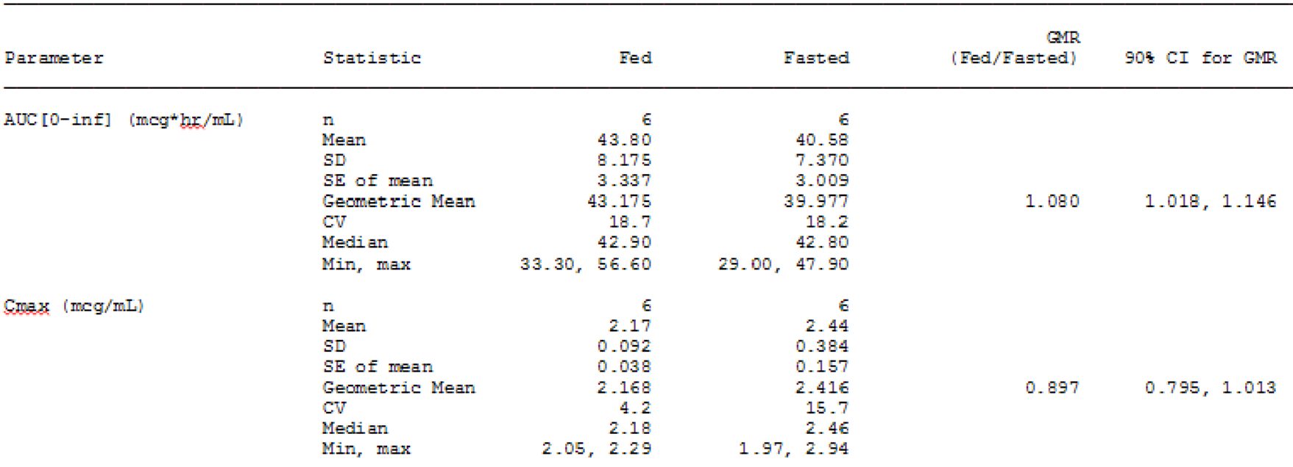

##### Clinical evaluator's comment

The provided data indicate that the geometric mean AUCinf of armodafinil is 8% higher in the fed state compared to the fasted state, with the 90% CI of the geometric mean ratio (GMR) (1.018, 1.146) not being enclosed completely within the standard bioequivalence interval of 0.80 to 1.25. The geometric Cmax of armodafinil is 10% lower in the fed state compared to the fasted state, with the 90% CI of the GMR (0.795, 1.013) not being enclosed completely within the standard bioequivalence interval of 0.80 to 1.25. The results indicate that armodafinil is not bioequivalent when administered in the fed and fasted states. However, the data should be interpreted cautiously as only 6 subjects were included in the fed versus fasted analysis. The recommended number of subjects for formal bioequivalence studies is stated to be not less than 12.[1]

Overall, the difference in bioavailability between armodafinil in the fasted state and fed state (based on the Cmax and AUCinf) is unlikely to be clinically significant. However, the median Tmax was notably shorter in the fasted state compared to the fed state (2.3 versus 6 h, respectively). This is of potential clinical significance as the onset of effect might be delayed when the drug is administered in the fed state. The *Dosage and Administration* section of the proposed PI has no specific recommendation relating to the administration of armodafinil with or without food. The *Pharmacokinetics* section of the PI comments that the effect of food on overall bioavailability is minimal, but notes that the Tmax may be delayed by approximately 2 to 4 h in the fed state. This section of the PI also states that

*[s]ince the delay in tmax is also associated with elevated plasma concentrations later in time, food can potentially affect the onset and time course*

of the pharmacological action of armodafinil. Information on the potential effect of food on the time course of action of armodafinil should be included in the *Dosage and Administration* section of the PI. It would be reasonable to include a statement in the *Dosage and Administration* section indicating that, while armodafinil can be taken with or without food, administration with food may delay the onset of action and prolong the effect of the drug.

#### Question 5

* The Summary of Clinical Pharmacology included relative exposure data for R-armodafinil versus racemic modafinil following multiple doses of armodafinil and Provigil, respectively.
  + Please confirm that the data in the summary were based on the Day 7 results for subjects from armodafinil Study 102 and Provigil Study 2101.
  + The summary refers to a 150 mg dose of armodafinil from Study 102. However, this study did not include an actual 150 mg dose of armodafinil. The data for the 150 mg dose provided in the Summary appears to be based on dose normalised to 150 mg data. Please clarify the source of the data for the 150 mg dose of armodafinil reported in the Summary
  + The PK data from armodafinil Study 102 referred to in the summary were obtained following fasting on sample collection days, while the PK data from Provigil Study 2101 were obtained 1 h after a light breakfast on collection days. Given the different relationship between dose and meals on data collection days for the two studies, please comment on the validity of the relative exposure data for R-modafinil and racemic modafinil provided in the Summary.

##### Sponsor's response

* The sponsor confirms that the data in the summary were based on the Day 7 results for subjects from armodafinil Study 102 and Provigil Study 2101.
* The armodafinil values are based on data from the pooled analysis (dose normalised to 50 mg) that is presented below in Table 71 from the Summary of Clinical Pharmacology provided to the FDA. This methodology was considered adequate based on the lack of deviation from dose linearity, and was intended to increase the dataset on which the PK parameters were calculated. The corresponding values for 150 and 250 mg/day were calculated by multiplying the values in the table below by factors of 3 and 5, respectively.

Table 71: Mean PK parameters of R-modafinil following single and multiple doses of armodafinil in healthy subjects (dose dependent parameters normalised to a 50 mg dose armodafinil).

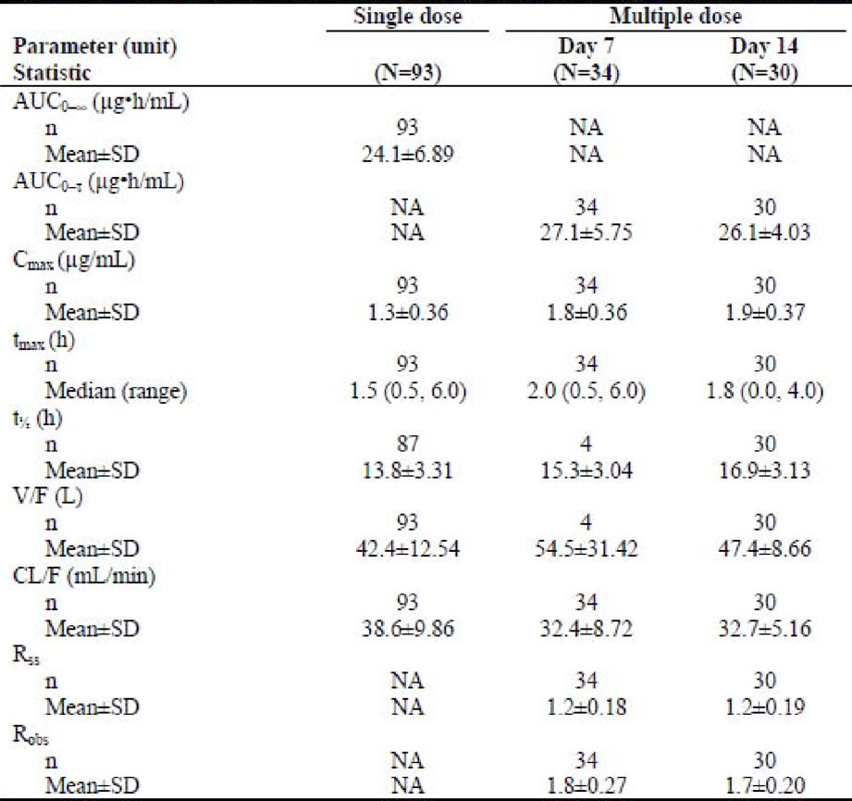

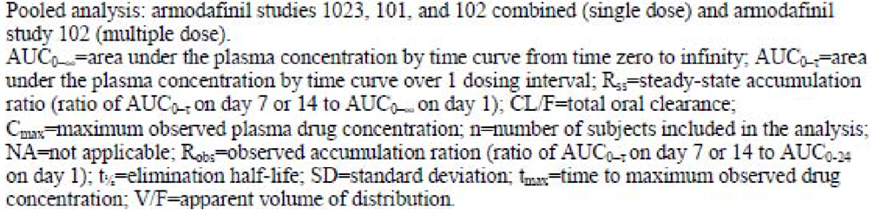

* The sponsor acknowledges that a direct comparison between fed or fasted states is ideal, but these data are the most appropriate available for comparison. The PK data from armodafinil Study 102 referred to in the summary were obtained following fasting on sample collection days, while the PK data from Provigil Study 2101 were obtained 1 h after a light breakfast on collection days. Food has been shown to be significantly related to the rate, but not the extent of absorption of modafinil. Therefore, a light meal is expected to have minimal effect on exposure (Cmax and AUC) of these 2101 modafinil data.

##### Clinical evaluator's comment

The sponsor's response is satisfactory.

#### Question 6

* In vitro data are reported to show that armodafinil has weak, but concentration-related inductive effects on CYP1A2, CYP2B6, and CYP3A4/5 activities. Clinical DDI studies have been undertaken investigating the effect of co-administration of armodafinil on CYP3A4 substrates (midazolam and quetiapine) and a CYP1A2 substrate (caffeine), but not a CYP2B6 substrate. Please justify not undertaking a clinical DDI study assessing the effect of co-administration of armodafinil on a CYP2B6 substrate.

##### Sponsor's response

Modafinil and armodafinil produces modest, but concentration dependent, induction of CYP3A4, CYP1A2 and CYP2B6 activity in primary human hepatocytes in vitro. The observation that CYP2B6 activity is increased under the same conditions as CYP3A4 was not surprising given the high correlation in the responses of the two enzymes to CYP3A4 inducers.[2] CYP3A4, however, is the more important CYP enzyme due to its high levels in liver and its wide range of substrates. Several armodafinil DDI studies were conducted in healthy subjects to investigate the potential of armodafinil to induce the activity of CYP1A2 (using caffeine as a probe substrate); the potential of armodafinil to induce activity of gastrointestinal and hepatic CYP3A4 activity (using IV and oral midazolam as the probe substrate); and the potential for repeated doses of armodafinil to induce activity of CYP3A4 using quetiapine, carbamazepine, ziprasidone, aripiprazole, and risperidone as substrates. While induction of CYP1A2 was ruled out in vivo, treatment with armodafinil caused moderate induction of CYP3A activity in vivo and consequently reduced systemic exposures to co-medications that are substrates for CYP3A. Quantitatively, CYP2B6 is a less important CYP enzyme, and therefore no formal DDI study was undertaken.

##### Clinical evaluator’s comment

The sponsor’s response is unsatisfactory. No quantitative in vitro data were presented in the response to Question 6 supporting the decision not to undertake a clinical DDI investigating the potential PK effects of co-administration of armodafinil and a CYP2B6 substrate. It is recommended that the nonclinical evaluator review the in vitro data provided in the original submission and specifically comment on the interaction between armodafinil and the CYP2B6 substrate probe. In particular, the nonclinical evaluator should compare the in vitro interaction results between armodafinil and a CYP2B6 substrate probe and armodafinil and a CYP3A4/5 substrate probe. If in vitro induction of CYP2B6 and CYP3A4/5 by armodafinil is quantitatively similar then the sponsor should be requested to undertake a clinical DDI study between armodafinil and a CYP2B6 substrate. The PI should include a statement on the potential of armodafinil to induce CYP2B6 activity, unless it can be satisfactorily determined from the in vitro data that a clinically significant interaction is unlikely.

#### Question 7

* In vitro data are reported to show that armodafinil has inhibitory effects on CYP2C19 and CYP2C9. A clinical DDI studies has been undertaken investigating the effect of co-administration of armodafinil on a CYP2C19 substrate (omeprazole), but not a CYP2C9 substrate. Please justify not undertaking a clinical DDI study assessing the effect of co-administration of armodafinil on a CYP2C9 substrate.

##### Sponsor's response

Racemic modafinil was shown to suppress CYP2C9 activity in vitro in human hepatocytes but armodafinil did not. In a subsequent in vivo clinical DDI study (Study C1538a/410/PK/US), there was no significant effect of repeated administration of 400 mg racemic modafinil on the PK of S-warfarin (a CYP2C9 substrate) following a single dose of racemic warfarin.

##### Clinical evaluator's comment

The sponsor's response is satisfactory. The proposed PI (Interactions with other drugs) includes the following statement:

*Concomitant administration of modafinil with warfarin did not produce significant changes in the pharmacokinetic profiles of (R)- and (S)-warfarin. However, since only a single dose of warfarin was tested in this study, an interaction cannot be ruled out. Therefore, more frequent monitoring of prothrombin times/INR should be considered whenever Nuvigil is co-administered with warfarin.*

#### Question 8

* In an in vitro study using MDR-MDCK cell monolayers it was reported that armodafinil is a P-glycoprotein (Pgp) substrate, but is not an inhibitor of Pgp (Study DP-2006-055). There were no clinical DDI studies investigating the effect of Pgp inhibitors or inducers on the bioavailability of armodafinil. The sponsor is requested to justify not submitting such studies. Does the sponsor have any data on whether armodafinil is an inducer of Pgp?

##### Sponsor's response

There are no Pgp induction data available for armodafinil. At the request of the FDA, a comprehensive literature search was performed for:

* information on the Pgp induction potential of modafinil in vivo; and
* for any in vivo Pgp drug-drug interaction information as an alternative to conducting an in vivo study with a Pgp inhibitor.

These searches provided no suggestion of effects of modafinil or armodafinil on the PK or safety/efficacy of concomitant medications in vivo through modulation of the activity of the Pgp transporter system. A more recent search of transporter queries using the University of Washington Drug Interaction Database provided no additional literature references.

##### Clinical evaluator's comment

The sponsor's response is adequate. The proposed PI (Interaction with P-Glycoprotein) includes the following statement:

*An in vitro study demonstrated that armodafinil is a substrate, but not inhibitor, of P-glycoprotein.*

However, the proposed PI submitted with the Section 31 response deleted the following statement:

*The impact of inhibition of P glycoprotein is not known.*

This statement was included in the PI provided with the original submission and is found in the US prescribing information. It is considered that this statement be amended to read:

*The clinical impact of inhibition of P-glycoprotein on the bioavailability of armodafinil is not known.*

#### Question 9

* The sponsor states that the metabolic pathways of armodafinil have not been specifically characterised in the clinical studies, but reports that the formation of modafinil sulfone from R-modafinil is metabolised by CYP3A4/5. At steady state, modafinil sulfone represents approximately 56% of parent drug exposure. Therefore, in view of the involvement of CYP3A4/5 in at least part of the metabolism of armodafinil the sponsor should provide a justification for not submitting clinical DDI studies investigating the effects of CYP3A4 inhibition and CYP3A4 induction on systemic exposure to armodafinil

##### Sponsor's response

Armodafinil is indeed a substrate for cytochrome P450 3A4/5 (CYP3A4/5), however the existence of multiple pathways for metabolism and the fact that a non CYP450 related pathway is the most rapid in metabolising armodafinil suggest a low probability that concomitant medications that inhibit CYP450 will significantly affect the overall PK profile of armodafinil. The impact of CYP3A4/5 inducers on armodafinil was investigated from January to May of 2011 in a study entitled “An Open Label, Parallel Group Study to Evaluate the Effect of Multiple Dose Administration of Armodafinil (250 mg/day) on the Pharmacokinetics of Carbamazepine (200 mg) and the Effect of Multiple-Dose Administration of Carbamazepine (400 mg/day) on the Pharmacokinetics of Armodafinil (250 mg) in Healthy Male Subjects”. The details of this study are published.[3] At steady state, carbamazepine caused a decrease in systemic exposure to armodafinil. Armodafinil Cmax is approximately 11% lower and armodafinil AUC is approximately 37% lower when administered in combination with carbamazepine as compared to when administered alone. Dose adjustment for armodafinil may be required when co-administered with CYP3A4/5 inducers as carbamazepine.

##### Clinical evaluator's comment

The published study referred to in the sponsor’s response has been reviewed. The study was not provided by the sponsor, but was obtained independently by the evaluator. The study was a single site (USA), open label, parallel group study designed to evaluate the potential PK interaction between armodafinil and extended release carbamazepine. Carbamazepine is a substrate for CYP3A4 and a potent inducer of this enzyme. The study was conducted in accordance with relevant ICH and FDA guidelines and the Declaration of Helsinki. The study protocol and informed consent form were reviewed and approved by an IRB. The study was sponsored by Teva Pharmaceuticals, Inc.

The study included 81 healthy adult men aged 18 to 45 years inclusive, of whom 79 were evaluable for PK (group 1 = 40; group 2 = 41), and 80 were evaluable for safety (40 in each group). Subjects were assigned (not randomised) to study group 1 (effect of pre-treatment with armodafinil on the single dose PK of carbamazepine) or study group 2 (effect of pre-treatment with carbamazepine on the single dose PK of armodafinil). In both groups, sampling for PK analysis was undertaken following single dose carbamazepine (group 1) or single-dose armodafinil (group 2). The PK sampling following single dose carbamazepine (8 days) was approximately 5 half-lives of the drug (that is, average half-life following single dose of 36 h [carbamazepine PI]). The PK sampling following single dose armodafinil (3 days) was approximately 5 half-lives of the drug (that is, half-life of 15 h). Therefore, the sampling time was sufficient to characterise the elimination phase of each drug following single dose administration. In addition, the mean extrapolation percentage (that is, percentage of AUCinf that was extrapolated from the time of the last measurable plasma concentration to infinite time) was < 10% for carbamazepine (alone and in combination with armodafinil) and for armodafinil (alone and in combination with carbamazepine) confirming the adequacy of the sampling schedule for the two drugs.

PK parameters of armodafinil and carbamazepine were estimated using non-compartmental methods. The parameters included Cmax, AUC, AUCinf, AUC0-t, AUC0-τ, Tmax, λz, and t1/2. These parameters were also calculated as appropriate and where possible for the metabolites of armodafinil and carbamazepine.

The results for armodafinil and its two metabolites are summarised below in Table 72. The geometric mean for armodafinil Cmax was 11% lower when armodafinil was co-administered with carbamazepine compared to armodafinil alone, with the 90% CI of the GMR being enclosed entirely within the bioequivalence interval of 0.80 to 1.25. The geometric mean for armodafinil AUCinf was 37% lower when armodafinil was co-administered with carbamazepine compared to armodafinil alone, with the 90% CI for the GMR being completely outside the bioequivalence interval of 0.80 to 1.25. The results suggest that the efficacy of armodafinil might be reduced when the drug is co-administered with CYP3A4/5 inducers.

Table 72: PK parameters for armodafinil, R-modafinil, and modafinil sulfone after administration of 250 mg armodafinil alone and pre-treatment with carbamazepine 400 mg/day.

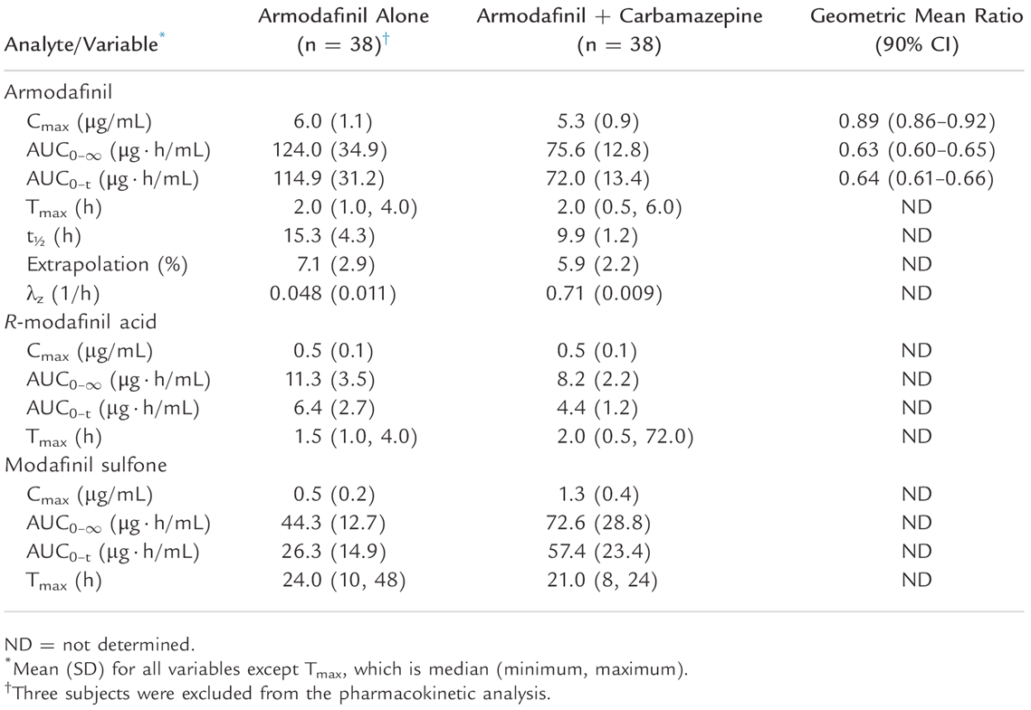

The GMR for carbamazepine Cmax was 0.88 (90% CI: 0.83, 0.92) when co-administered with armodafinil compared with carbamazepine alone. The GMR for carbamazepine AUCinf was 0.75 (90% CI: 0.71, 0.80) when co-administered with armodafinil compared with carbamazepine alone. The results indicate that armodafinil is an inducer of CYP4A4.

The sponsor’s justification for not submitting a PK study investigation co-administration of armodafinil with a CYP3A4 inhibitor is unsatisfactory. It is recommended that the nonclinical evaluator review the in vitro data relating to a co-administration of armodafinil and a CYP3A4 inhibitor. If the data predict a potentially significant DDI, then the sponsor should be requested to undertake a formal clinical PK interaction study investigating co-administration of armodafinil and a CYP3A4 inhibitor.

#### Question 10

* Achiral modafinil sulfone was identified as a metabolite of R-modafinil. This suggests that R-modafinil sulfone resulting from the metabolism of R-modafinil undergoes interconversion with S-modafinil sulfone. Please provide the data supporting interconversion of the enantiomers of S-modafinil sulfone.

##### Sponsor’s response

Modafinil sulfone is an achiral molecule. Once armodafinil (or S-modafinil) undergoes oxidation on the chiral sulfur atom to form modafinil sulfone, the molecule loses its chirality.

##### Clinical evaluator’s comment

The sponsor's response is satisfactory.

### Safety

#### Question 11

* The Summary of Safety included an analysis of QTc changes in the 4 Phase III, double blind, placebo controlled studies using QTcF (that is, Fridericia correction) (Table 43). Please repeat the analysis using QTcB (that is, Bazett correction). Please comment on the significance of any observed differences between the two analyses.

##### Sponsor's response

An analysis of QTc changes in the 4 Phase III, double blind, placebo controlled studies using QTcB (that is, Bazett correction) has been performed (Table 73). Values of QTc more than 450 msec were observed with similar frequency for the armodafinil and placebo treatment groups across sleep disorder populations. Five patients with OSAHS (4 armodafinil treated, 1 placebo treated) and one patient with Narcolepsy (armodafinil treated) had QTc values more than 480 msec. Only 2 armodafinil treated patients (with OSAHS) had a QTc value more than 500 msec. Changes from baseline of more than 60 msec were observed in no more than 4% of patients in any treatment group.

Table 73: Categorical changes from baseline in QTc interval (Bazett) by sleep disorder and treatment group in double blind, placebo controlled studies.

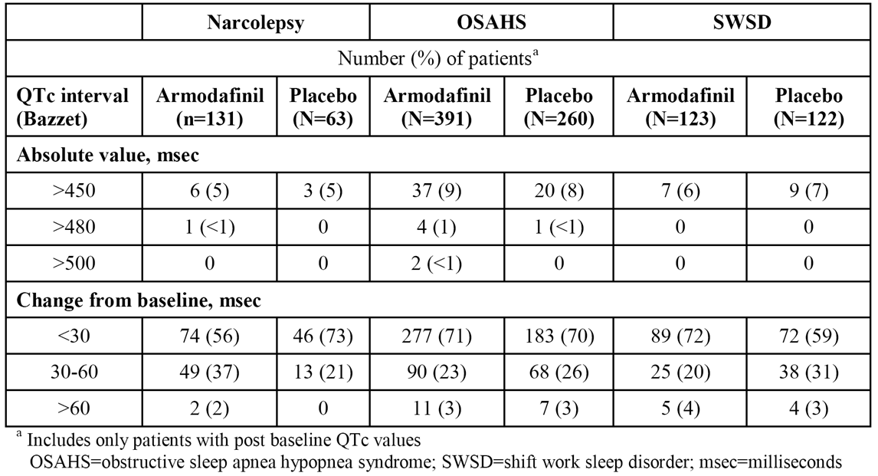

In the double blind, placebo controlled studies, there were no clinically meaningful changes from baseline to endpoint and no marked differences between the armodafinil and placebo treatment groups in mean ventricular rate or in mean PR, QRS, QT, QTc (Bazett or Fridericia), or RR intervals across the sleep disorder populations.

In all sleep disorder studies combined, small mean increases in ventricular rate and decreases in uncorrected QT interval and RR interval were observed over time. These changes were consistent with the mean increase in pulse over time. Mean changes in corrected QT interval did not indicate any clinically meaningful trends at any time point.

##### Clinical evaluator's comment

The sponsor’s response is satisfactory. Overall, the number of patients in both armodafinil and placebo groups with categorical increases in QTcB from baseline was greater than the corresponding number of patients with categorical increases in QTcF from baseline. In general:

*Bazett’s correction overcorrects at elevated heart rates and under corrects at heart rates below 60 bpm and hence is not an ideal correction. Fridericia’s correction is more accurate than Bazett’s correction in subjects with such altered heart rates.[4]*

#### Question 12

* In the post marketing period from the date of approval through 31 October, there were 13 reports of death and 1 report each of brain death and sudden death. The most recent PADER summarising post marketing data from the date approval through 31 May 2014 identifies 6 further deaths associated with armodafinil. Please provide a tabulated summary of all reported post marketing deaths and narratives for each of the post marketing deaths.

##### Sponsor’s response

A search was conducted in Teva’s Pharmacovigilance global database (MedDRA version 17.1) using the following criteria:

* Preferred Product description – armodafinil
* Initial received date – Cumulative data through 27 February 2015
* Cases with Fatal outcome
* All sources excluding Clinical trials

Since the following search includes all fatal cases from all sources regardless of the relatedness of the death to armodafinil, the overall number of cases is different from PADER’s count which takes into consideration only related cases (48 cases versus 21 cases, respectively).

In 2012, Teva’s Pharmacovigilance global database was merged with the Cephalon pharmacovigilance database.

###### Search outcome

A total of 48 armodafinil fatal cases reported post marketing were retrieved in the search. There were a total of 53 reported AEs with a fatal outcome. The results are summarised by source in Table 74 and by System Organ Class (SOC) of the reported fatal AEs in Table 175.

Table 74: A summary of death cases of patients taking armodafinil defined by the source of reporting.

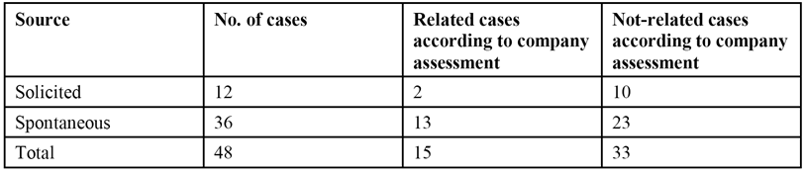

Table 75: A summary of total death cases according to SOC of the reported fatal PT.

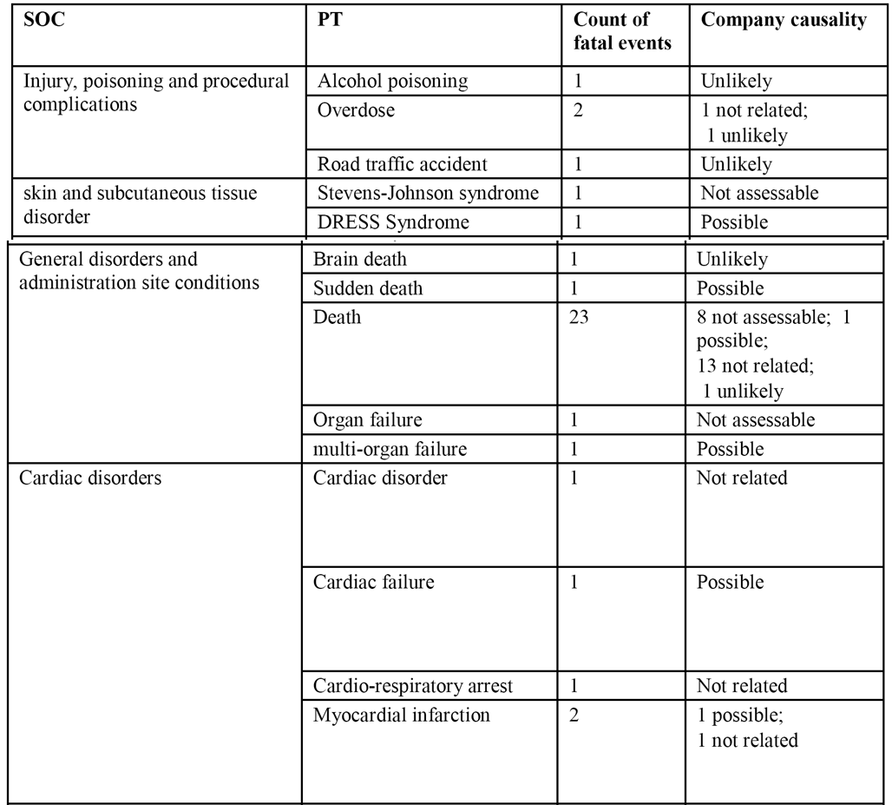

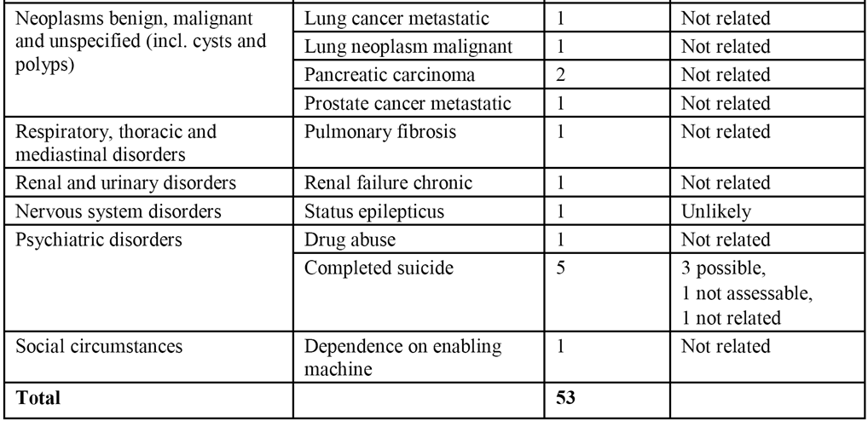

Twelve cases were received from solicited sources such as AccessMed, a part of the Cephalon CARES Patient Assistant Program, and the Teva Patient Assistance Program. It has often been observed that solicited sources, in which patients are closely monitored, generate much higher reporting rates than are generally received from spontaneous sources. In addition, the Teva Patient Assistance Program treated disadvantaged patients who could not otherwise afford their medications. A contribution of the social circumstances of this patient population to death outcomes from unknown reasons cannot be excluded.

In order to further analyse the causes of death in the 48 reported death cases the cases are summarised below based on the System Organ Class (SOC) of the reported fatal adverse events. There were a total of 53 reported PTs with a fatal outcome.

###### Review of death cases

**Injury, poisoning and procedural complications.** SOC includes a total of 4 cases: 1 case of alcohol poisoning, 2 cases of overdose and 1 case of a road accident. The patient who died from alcohol poisoning also had previous history of medication abuse and bipolar disorder. Reporter suggested causality between armodafinil use and the death and company assessed the causality as unlikely. One of the patients who died from overdose had an underlying history of depression and use of concomitant medications that may have contributed to the event. It was later confirmed that the patient had died from acute fentanyl intoxication. In the second overdose case the patient had a history of depression, anxiety and accidental overdose of dilaudid and eventually died from methamphetamine overdose. The company’s causality was assessed as not related to armodafinil in both cases. The car driver who died in a fatal road accident was assessed originally as possibly related to armodafinil use. Further information revealed changed the company causality to unlikely related to armodafinil. The patient's underlying medical history of uterine and ovarian cancer and unspecified pain medications provided an alternate etiology for the event.

**Skin and subcutaneous tissue disorders.** SOC includes 1 case of SJS and 1 case of DRESS syndrome. Serious skin reactions including SJS have been identified as risks of armodafinil and are highly monitored by Teva. The patient took armodafinil for shift work disorder. Due to lack of further information causality was not assessable by the company. A case from the literature described a patient who was taking armodafinil for fatigue related to methadone. The patient eventually died of DRESS syndrome accompanied by fatal multi organ failure and a cardiac function failure. Both reporter and the company assessed the death as possibly related.

**General disorders and administration site conditions.** SOC contains 27 reports in total; 23 of these cases list no specific cause of death. Of the reported deaths, 13 were assessed by company as not related to armodafinil, 1 was assessed as possible; and 8 could not be assessed due to insufficient information, and 1 was assessed as unlikely. A review of the narrative of the death cases with unspecified cause did not reveal any special circumstances or cumulative findings to connect the cases. Most cases had a sudden unexplained death in which patients did not have any medical history thought to contribute to the death. In these cases, armodafinil was assessed as not causally related to the deaths. In three cases the death was later explained as a result of chronic renal failure, cardiomegaly and AIDS.

**Cardiac disorders.** SOC includes 5 cases including 2 cases of myocardial infarction. One of the cardiac cases has been described above; that is, DRESS syndrome. In a second case a patient was using a CPAP machine and had a cardiac arrest while away from the machine. The case was assessed by the company as not related. In a third case the patient had a medical history of heart condition and coronary artery bypass graft among other conditions which led to his death. The case was assessed by the company as not related. Two patients died due to myocardial infarction. One patient with multiple sclerosis took armodafinil and later felt palpitations, chest pain, and developed asystole. A relationship to armodafinil could not be excluded due to the proximity of treatment to the events. In another case a patient known to suffer from cardiac illness died of a massive myocardial infarction. He was not receiving armodafinil at the time of his death and causality was assessed as not related.

**Neoplasms benign, malignant and unspecified (including cysts and polyps).** SOC includes 5 cases. In two cases of lung cancer metastatic, patients died from terminal or metastatic lung cancer. There is no further information on whether the cancer preceded armodafinil use however both cases were assessed by the company as not related. In 1 case of pancreatic carcinoma cancer was diagnosed shortly after starting armodafinil and both the reporter and the company concluded there were no relationship between armodafinil and the cause of death. In the second case pancreatic cancer predated armodafinil treatment and patient died of disease progression. The case was assessed by the company as not related to armodafinil. In a report of prostate cancer metastatic, the disease began a few years prior to armodafinil therapy. Armodafinil was taken in order to fight fatigue and difficulty staying awake. The case was assessed by the company as not related to the drug armodafinil.

**Respiratory, thoracic and mediastinal disorders.** SOC included 1 case of pulmonary fibrosis. In this case the patient suffered from obstructive sleep apnea and died of intercurrent illness of severe end stage pulmonary fibrosis. Death was assessed as not related to use of armodafinil by both the reporter and the company.

**Renal and urinary disorders**. SOC included one case of chronic renal failure. The patient suffered from renal failure prior to her treatment with armodafinil. Her death was assessed by both the reporter and the company as the result of complications of her chronic renal failure and as not related to armodafinil.

**Nervous system disorders.** SOC includes one case of status epilepticus with secondary brain death event. Both fatal events occurred 4 months after starting treatment. The patient had a medical history of depression, post traumatic stress disorder (PTSD), tremor and familial migraines. Multiple conditions such as respiratory failure, serotonin syndrome, anaemia, altered mental status and renal and liver failures were reported as adverse events. The reporter and the company could not rule out a temporal relation to armodafinil however follow-up information on both patient's history and negative lab results contribute to a change in assessment to unlikely.

**Psychiatric disorders.** SOC includes one case of drug abuse and 5 cases of completed suicide. In the first case the patient died of methamphetamine drug abuse and overdose as was previously discussed. The 5 cases of successful suicide are listed below:

* One patient suffered from mental illness and severe fatigue. They discontinued armodafinil after 3 days of therapy. As there is no medication start date and no further information on their death, causality was assessed as related by both the reporter and the company.
* Another patient was taking armodafinil as an only drug. As no further information is available, causality could not be determined.
* A third patient suffered from hallucinations, massive mood swings, episodes of confusion and abnormal behaviour on the morning prior to the suicide. Therapy with armodafinil was discontinued but it was not clear whether it stopped prior to the suicide or not. As no further information was available, the company assessed the death as possibly related.
* A fourth patient suffered from drug addiction. They were also taking buprenorphine HCl and naloxone HCl. The company assessed the case as not related.
* A fifth patient had a long history of suicidality (beginning 2 years pre armodafinil use), depression and anxiety. Armodafinil was taken to treat depression. In April 2011, the patient discontinued armodafinil due to insurance issue and committed suicide in June 2011. Although the physician ruled out a relationship between the suicide and armodafinil, both reporter and the company assessed causality as possible.

Narratives of all cases with fatal outcome presented in the analysis were provided in the sponsor’s response.

###### Conclusions

The majority of patients who died while on armodafinil had previously existing conditions which deteriorated thus contributing to the cause of death. All of these patients were on armodafinil doses within the recommended range.

##### Clinical evaluator’s comment

The sponsor's response is satisfactory. The case narratives have been examined.

## Second round benefit-risk assessment

### Second round assessment of benefits

After consideration of the responses to the clinical questions, the benefits of armodafinil (Nuvigil) for the proposed usages are unchanged from those identified in the first round.

### Second round assessment of risks

After consideration of the responses to the clinical questions, the risks of armodafinil (Nuvigil) for the proposed usages are unchanged from those identified in the first round.

### Second round assessment of benefit-risk balance

After consideration of the responses to the clinical questions, the benefit-risk balance of armodafinil (Nuvigil) for the proposed usages remains favourable and is unchanged from that discussed in the first round.

## Second round recommendation regarding authorisation

It is recommended that armodafinil (Nuvigil) be approved:

* to improve wakefulness in patients with excessive daytime sleepiness associated with narcolepsy;
* to treat excessive sleepiness associated with moderate to severe chronic shift work sleep disorder where nonpharmacological interventions are unsuccessful or inappropriate; and
* use as an adjunct to continuous positive airways pressure (CPAP) in obstructive sleep apnoea/hypopnoea syndrome in order to improve wakefulness.

|  |
| --- |
| Therapeutic Goods Administration |
| PO Box 100 Woden ACT 2606 Australia  Email: [info@tga.gov.au](mailto:info@tga.gov.au) Phone: 1800 020 653 Fax: 02 6232 8605  [**https://www.tga.gov.au**](https://www.tga.gov.au) |

1. European Medicines Agency, Committee for Medicinal Products for Human Use, “Guideline on the investigation of bioequivalence (CPMP/EWP/QWP/1401/98 Rev. 1/ Corr **)”, 20 January 2010.
2. Faucette SR, et al. Regulation of CYP2B6 in primary human hepatocytes by prototypical inducers. *Drug Metab Dispos.* 32: 348-358 (2004).
3. Darwish M, et al. Evaluation of the potential for pharmacokinetic drug-drug interaction between armodafinil and carbamazepine in healthy adults. *Clin Ther.* 37: 325-337 (2015).
4. European Medicines Agency, Committee for Medicinal Products for Human Use, “ICH note for guidance on the clinical evaluation of QT/QTc interval prolongation and proarrhythmic potential for non-antiarrhythmic drugs (ICH E14) (CHMP/ICH/2/04)”, November 2005.