|  |
| --- |
| **8 January 2013** |

|  |
| --- |
| AusPAR Attachment 2 |
| Extract from the Clinical Evaluation Report for Atazanavir |
| Proprietary Product Name: Reyataz |
| Sponsor: Bristol-Myers Squibb Australian Pty Ltd |

About the Therapeutic Goods Administration (TGA)

* The Therapeutic Goods Administration (TGA) is part of the Australian Government Department of Health and is responsible for regulating medicines and medical devices.
* The TGA administers the *Therapeutic Goods Act 1989* (the Act), applying a risk management approach designed to ensure therapeutic goods supplied in Australia meet acceptable standards of quality, safety and efficacy (performance), when necessary.
* The work of the TGA is based on applying scientific and clinical expertise to decision-making, to ensure that the benefits to consumers outweigh any risks associated with the use of medicines and medical devices.
* The TGA relies on the public, healthcare professionals and industry to report problems with medicines or medical devices. TGA investigates reports received by it to determine any necessary regulatory action.
* To report a problem with a medicine or medical device, please see the information on the TGA website <<http://www.tga.gov.au>>.

About the Extract from the Clinical Evaluation Report

* This document provides a more detailed evaluation of the clinical findings, extracted from the Clinical Evaluation Report (CER) prepared by the TGA. This extract does not include sections from the CER regarding product documentation or post market activities.
* The words [Information redacted], where they appear in this document, indicate that confidential information has been deleted.
* For the most recent Product Information (PI), please refer to the TGA website <<http://www.tga.gov.au/hp/information-medicines-pi.htm>>.

Copyright

© Commonwealth of Australia 2013  
This work is copyright. You may reproduce the whole or part of this work in unaltered form for your own personal use or, if you are part of an organisation, for internal use within your organisation, but only if you or your organisation do not use the reproduction for any commercial purpose and retain this copyright notice and all disclaimer notices as part of that reproduction. Apart from rights to use as permitted by the *Copyright Act 1968* or allowed by this copyright notice, all other rights are reserved and you are not allowed to reproduce the whole or any part of this work in any way (electronic or otherwise) without first being given specific written permission from the Commonwealth to do so. Requests and inquiries concerning reproduction and rights are to be sent to the TGA Copyright Officer, Therapeutic Goods Administration, PO Box 100, Woden ACT 2606 or emailed to <[tga.copyright@tga.gov.au](mailto:tga.copyright@tga.gov.au)>.

Contents

List of abbreviations 4

1. Clinical rationale 7

2. Contents of the clinical dossier 8

2.1. Scope of the clinical dossier 8

2.2. Paediatric data 8

2.3. Good clinical practice 10

3. Pharmacokinetics 10

3.1. Population pharmacokinetic analysis 10

3.2. Data set 11

3.3. Covariates 14

3.4. Pharmacokinetic modelling 14

3.5. Determination of atazanavir/ritonavir dose 24

3.6. Study AI424020 Clinical Pharmacology 29

4. Pharmacodynamics 37

5. Clinical efficacy 37

5.1. Study AI424020 37

6. Clinical safety 44

6.1. Study AI424020 44

7. Clinical questions 52

7.1. Pharmacokinetics 52

7.2. Pharmacodynamics 61

7.3. Efficacy 61

8. Summary and discussion 65

8.1. Study AI424020 efficacy 65

8.2. Study AI424020 safety 66

8.3. Population pharmacokinetic modelling 66

8.4. Study AI424020 pharmacokinetics 69

9. Benefit-risk assessment 69

9.1. Benefits 69

9.2. Risks 70

9.3. Balance 70

10. Conclusions 70

10.1. Recommendation regarding authorisation 71

11. References 71

## List of abbreviations

| Abbreviation | Meaning |
| --- | --- |
| AIC | Akaike’s information criteria |
| ALB | Albumin |
| ALBn | Normalised albumin |
| ALP | Alkaline phosphatase |
| ALPn | Normalised alkaline phosphatase |
| ALT | Alanine amino transferase |
| ART | Anti-retroviral treatment |
| AST | Aspartate amino transferase |
| ATV | Atazanavir |
| AUC | Area Under the Concentration-time curve |
| BIC | Bayesian Information Criteria |
| BILI | Total bilirubin |
| BLQ | Below the limit of quantification |
| BWT | Birth weight |
| C0 | Plasma concentration at time 0 |
| C24 | Plasma concentration at 24 hours |
| CI | Confidence Interval |
| CL | Clearance |
| CLCR | Creatinine Clearance |
| Cmax | Maximum plasma concentration (concentration at the end of infusion) |
| Cmin | Minimum plasma concentration (trough) |
| COMD | co-medication |
| CSR | Clinical Study Report |
| Ctrough | Concentration of free drug at the end of the first cycle |
| CV | Coefficient of variation |
| CWRES | Weighted Residuals evaluated at individual conditional estimates |
| DV | Dependent variable |
| EC50 | Plasma concentration at 50% maximal effect |
| ELISA | Enzyme Linked ImmunoSorbent Assay |
| Emax | Maximum effect |
| ETA | Random effect describing the deviation of the individual empirical Bayes estimate of the parameter from the typical population parameter estimate |
| F | Bioavailability |
| Frel | Relative bioavailability |
| FOCE | First order conditional estimation |
| FORM | Formulation |
| GCP | Good clinical research practice |
| GOF | Goodness of fit plots |
| HT | Height |
| HIV | Human immunodeficiency virus |
| i.v. | Intravenous |
| IIV | Inter-Individual variability |
| INTER | Interaction |
| IOV | Inter-occasion variability |
| IPRED | Model predictions for the individual subject |
| IRES | Residuals based on individual prediction |
| IWRES | Weighted residuals based on individual prediction |
| kel | Elimination rate constant |
| kint | Bound drug internalization rate constant |
| Ki | Inhibitory rate constant |
| km | Concentration of drug corresponding to half of maximum binding capacity |
| kpt | Plasma to tissue rate constant |
| ktp | Tissue to plasma rate constant |
| LLOQ | Lower limit of quantification |
| LOCF | last observation carried frowards |
| LOQ | Limit of quantification |
| NM-TRAN | NONMEM translator |
| NONMEM | Nonlinear mixed effects model |
| NPDE | Normalized Prediction Distribution Errors |
| PK | Pharmacokinetics |
| PK/PD | Pharmacokinetics/pharmacodynamics |
| PRED | Predicted Data based on population parameter estimates |
| PREDPP | Prediction for population pharmacokinetics |
| Q | Inter-compartmental clearance |
| QQ | Quantile-quantile |
| REGN | Region |
| RES | Residuals based on population prediction |
| RSE | Relative standard error |
| RTV | Ritonavir |
| SAEM | Stochastic Approximation Expectation Maximization |
| TAD | Time After Dose |
| t1/2λ1 | Distribution half-life for free drug |
| t1/2λz | Terminal half-life for free drug |
| tmax | Time to reach maximum concentration (end of infusion) |
| TP | Total protein |
| TPn | Normalised total protein |
| VEGF | Vascular Endothelial Growth Factor |
| V1 | Distribution volume for central compartment of free drug |
| V2 | Distribution volume for peripheral compartment of free drug |
| V3 | Distribution volume of bound drug (Vb) |
| Vb | Volume of distribution of bound drug |
| Vmax | Maximum binding capacity |
| Vp | Central volume of distribution of free drug (L), |
| Vt | Peripheral volume of distribution of free drug |
| Vs | Versus |
| VSS | Steady state volume of distribution |
| WAM | Wald’s approximation method |
| WRES | Weighted residuals |
| WT | Weight |
| ε | Residual random effect |
| η | Inter-individual random effect |
| θ | Population mean value of the parameter |
| κ | Inter-occasion random effect |
| σ2 | Variance of ε |
| φ2 | Variance of κ |

## Clinical rationale

Bristol-Myers Squibb (BMS) Australia Pty Ltd wishes to vary the dosing recommendations for the use of Reyataz (atazanavir) in HIV-infected paediatric patients. In essence the proposal is:

* To lower the age range from 8 years to 6 years
* For patients in the weight range 15 to 20 kg, to add the new dose of atazanavir/ritonavir (ATV/RTV) 150/100 mg
* For patients in the weight range 20 to < 25 kg to delete current dose of ATV/RTV 150/80 mg and substitute the higher dose of ATV/RTV of 200/100 mg
* For patients in the weight range 25 to < 32 there is no proposed change to the currently recommended dose of ATV/RTV 200/100 mg
* For patients in the weight range 32 to < 40 kg, to deleted the current dose of ATV 250 mg and substitute the lower dose of ATV 200 mg. There is no proposal to change the dose of RTV 100 mg.
* For patients in the weight range ≥ 40 kg, there is no proposed change to the current recommendation of ATV/RTV 300/100 mg

BMS also proposes to update safety, efficacy and pharmacokinetic data from paediatric Study A1424020 to 96 weeks.

The revised dosage recommendations are based on population pharmacokinetic modelling and simulations analysis of data from adult and paediatric studies.

There was no proposal to amend the currently in Australia approved indication:

*Reyataz is indicated for the treatment of HIV 1 infection, in combination with other antiretroviral agents.*

*This indication is based on analyses of plasma HIV-1 RNA levels and CD4 cell counts from controlled studies (see Clinical Trials).*

## Contents of the clinical dossier

### Scope of the clinical dossier

The submission included:

* One population pharmacokinetic analyses.
* Summary reports of four clinical studies that provided data for the population pharmacokinetic analysis

Table 1 below summarises the scope of the sponsor’s clinical submission.

### Paediatric data

The population pharmacokinetic analysis included paediatric data. See Table 1 below.

Table 1. Tabular listing of clinical studies submitted.

Table 1. Tabular listing of clinical studies submitted.

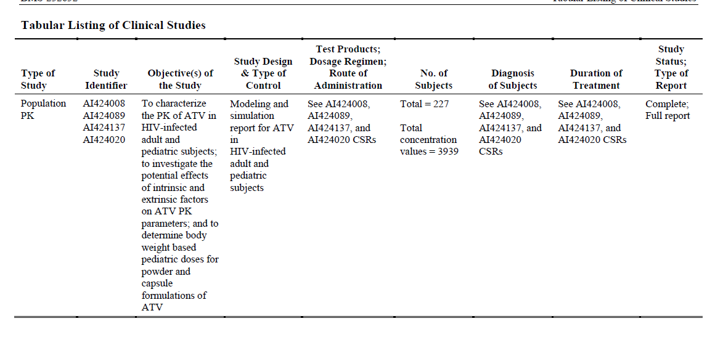

### Good clinical practice

Assurance was given that paediatric Study AI424020 study was conducted in accordance with the ethical principles originating in the Declaration of Helsinki and according to Good Clinical Practice as defined by the International Conference on Harmonization, and in accordance with the ethical principles underlying European Union Directive 2001/20/EC and the US Code of Federal Regulations, Title 21, Part 50 (21CFR50), while adhering to the laws and regulatory requirements of all participating countries. The protocol, amendments, and the informed consent forms were approved by the relevant Institutional Review Board/Institutional Ethics Committees prior to initiation of study at the site.

## Pharmacokinetics

### Population pharmacokinetic analysis

Atazanavir is an azapeptide HIV-1 protease inhibitor with pharmacokinetic parameters supporting once daily dosing. Atazanavir demonstrates nonlinear pharmacokinetics with greater than dose proportional increases in area under the concentration time curve (AUC) and peak plasma concentration (Cmax) values over the dose range of 200-800 mg once daily. Steady-state is achieved between Days 4 and 8.

Currently there are four approved paediatric, weight-determined, dosage bands converted from body surface area-based dosing: 20 to < 25 kg, 25 to < 32 kg, 32 to < 39 kg and ≥ 39 kg. The application proposes three bands: 15 to < 20 kg, 20 to < 40 kg and ≥ 40 kg. Due to limitation of formulations, the children in the current, somewhat unusual, weight range 32 to < 39 kg with dosage recommendation of 250/100 mg ATV/RTV are required to take 2 different strength capsules of ATV which adds pill load and may increase the possibility of dosage errors or non-compliance.

Steady-state ATV pharmacokinetic data from three adult studies, A1424008, AI424089 and AI424137 and one paediatric study AI424020 were pooled for inclusion in the Population Pharmacokinetic model.

Study AI424008 was a Phase II/III safety and efficacy study in adult HIV patients receiving ATV 400 or ATV 600 mg once daily or nelfinavir 1,250 mg twice daily each in combination with lamivudine and stavudine twice daily. A sub-study determined full 24-hour pharmacokinetic profiles. The steady-state (Day 29) ATV pharmacokinetic data from 13 sub-study patients receiving 400 mg once daily ATV were included in the population pharmacokinetic pooled analysis.

Study AI424089 was a Phase IV open-label study in adult HIV patients receiving once daily ATV400 mg or ATV/RTV 300 mg/100 mg, each in combination with lamivudine and stavudine. Full 24 hour pharmacokinetic profiles were determined for 27 patients receiving ATV alone (15) or ATV/RTV (12). Day 29, steady state ATV pharmacokinetic data from these patients were included in the population pharmacokinetic pooled analysis.

Study AI424137 was a Phase I, open-label study in adult HIV patients primarily investigating the effects of nevirapine on ATV exposure. A cohort of 11 patients received ATV/RTV 300/100 mg once daily and two non-nucleoside reverse transcriptase inhibitors excluding tenofovir. Full 24 hour steady-state pharmacokinetic profiles were determined on Day 10 and pharmacokinetic data from the 11 patients in this cohort were included in this pooled analysis.

Study AI424020 is an ongoing Phase I/II open-label, pharmacokinetic and safety study designed to evaluate use of ATV alone or in combination with RTV in antiretroviral treatment-naïve and treatment-experienced HIV-infected infants, children and adolescents. Pharmacokinetic data from 176 patients were available. Full 24-hour pharmacokinetic profiles were determined at the end of Week 1 and Week 56 and two weeks following any dose adjustment based on the pre- specified ATV exposure criteria. This study was evaluated at the time of registration of paediatric dose recommendations.

A C0-delinked one-compartment model with first-order absorption was developed in this investigation to characterise the ATV exposures in paediatric and adult patients infected by HIV. This model is stated to reduce bias in the pharmacokinetic estimates when patients miss doses.

The model development included investigation of the effects of the intrinsic covariates: body weight, age, sex, race and antiretroviral treatment-naive or experience, plus the extrinsic covariates, formulation, RTV co-medication and study region. The simulation was employed in conjunction with a bridging strategy to determine weight-based dosing recommendations on the assumption that efficacy can be extrapolated from adults to paediatric patients using the pharmacokinetic data alone.

### Data set

The population pharmacokinetic analysis dataset included all 277 participants for whom usable pharmacokinetic data were available. (Table 2) Overall, 3,939 observations were included in the analysis (Table 3).

Table 2. Summary of participants included in population pharmacokinetic analysis

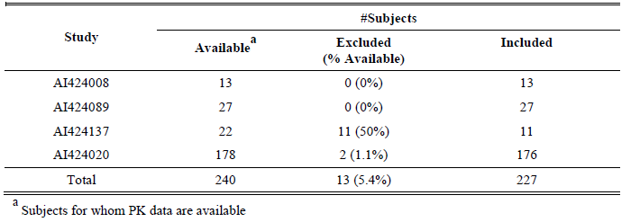

Table 3. Summary of Pharmacokinetic Observations Included in population pharmacokinetic Analysis

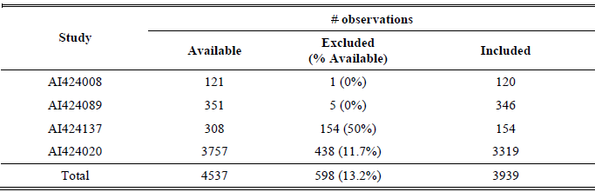

Table 4 summarises exclusions for which three main reasons were:

1. Observations were below the lower limit of quantitation (LLOQ): 141/4537 (3.1%).
2. Observations were associated with tenofovir co-medication.
3. Observations flagged by FDA inspectors due to quality concerns. The 298 (6.6%) observations excluded were all from the paediatric study.

Table 4. Summary of Pharmacokinetic Observations Excluded from population pharmacokinetic Analysis

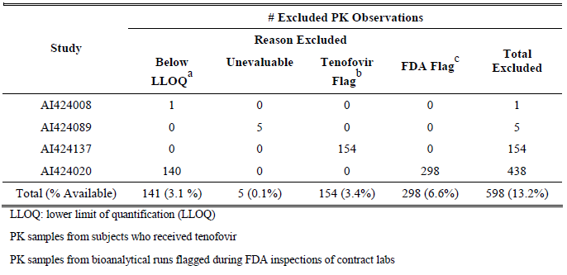

The majority of observations for ATV/RTV were for doses between 150 mg and 400 mg.

No pharmacokinetic observations were flagged as outliers. Missing body weight value for one patient was imputed using last observation carried forward. All other missing covariate data were resolved by the information provided in the dataset, for example, missing surface area values were calculated from the observed body heights and weights.

Figure 1 shows plots of the ATV concentration-time data by study for the adults. Considerable inter-individual variation is noted, less evident for ATV/RTV but masked to a degree by use small intervals on the y-axis and use of log scale.

Figure 1. ATV Concentration-Time Profiles by Study for ATV Alone or in Combination with RTV for Adult HIV Patients

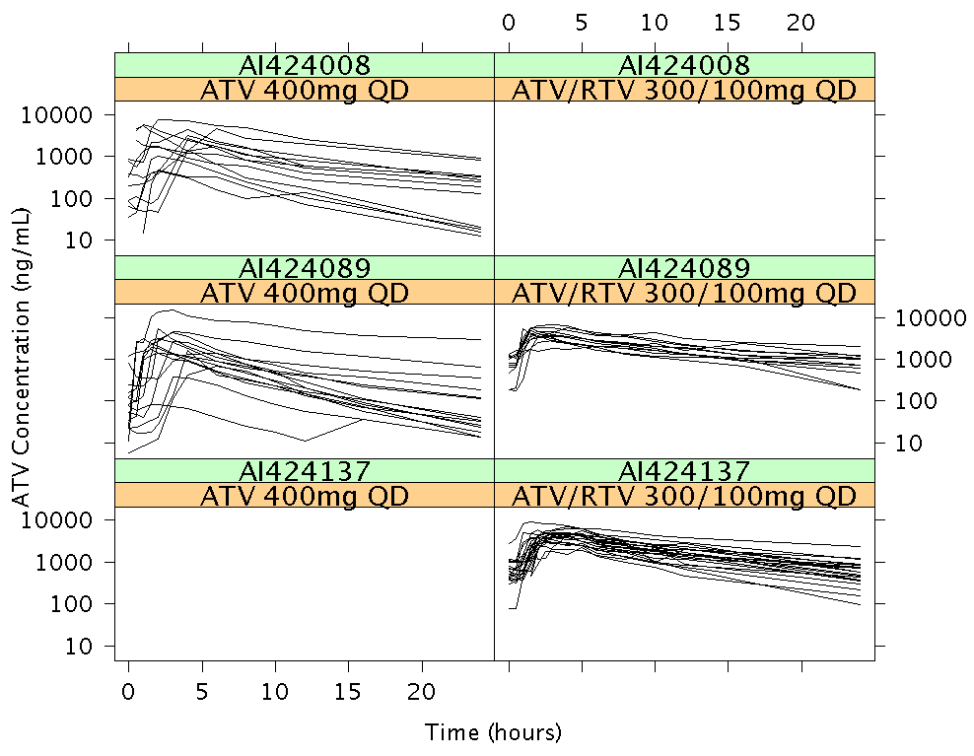

Figure 2 plots ATV concentration-time data by age, RTV co-medication, and formulation groupings for the paediatric HIV patients at the Week 1 and Week 56 visits. The ATV concentration-time data for the paediatric participants who received dose adjustment at visits other than Weeks 1 and 56 are not shown. Again, marked inter-individual variation is evident.

Figure 2. ATV Concentration-Time Profiles by Study Groupings for Paediatric HIV Patients from Study AI424020

Week 1 Week 56

|  |  |
| --- | --- |
| Figure 2. ATV Concentration-Time Profiles by Study Groupings for Paediatric HIV Patients from Study AI424020  Week 1 | Figure 2. ATV Concentration-Time Profiles by Study Groupings for Paediatric HIV Patients from Study AI424020  Week 56 |

### Covariates

Baseline continuous covariates and baseline patient characteristics were summarised in the study report. The youngest participant was approximately 4 months of age.

### Pharmacokinetic modelling

#### Objectives

* To characterise the pharmacokinetics of atazanavir in HIV-infected adult and paediatric patients.
* Investigate the potential effects of intrinsic and extrinsic factors on ATV pharmacokinetics.
* Determine bodyweight based paediatric doses which with ATV exposures similar to target adult exposures.

#### Methods

The analysis used first-order conditional estimation analysis and was performed using NONMEM software (Version V)20 installed using NMQual (Version 6.2.0) and g77 (Version 3.4.5) Fortran compiler. SAS software (Version 9) was used in the model-based simulation.

A nonlinear mixed-effects compartmental model was developed in 3 steps.

* The base model consisted of structural, random effects, and residual error models.
* A full model incorporated the covariate effects of the intrinsic and extrinsic covariates.
* The final model used Wald’s Approximation Method in conjunction with forward selection followed by backward elimination of covariate-parameter relationships. Model evaluation was conducted by a posterior predictive check of the following measures of steady-state ATV exposure: 24 hr postdose concentration (C24), peak concentration (Cmax), and area under the concentration-time curve (AUC). (Figure 3).

The final model was used to simulate steady-state ATV concentration-time profiles for 10,000 hypothetical paediatric participants for each dosing scenario. Similarity of paediatric ATV exposures following ATV and ATV/RTV dosing regimens with the corresponding target adult exposures was determined according to the criteria summarised in Figure 4 which accepted that bioequivalence in terms of C24 with conventional limits 80% to 125% was not going to be possible.

The key covariate parameters in the final model guiding the dose recommendations included

* Age effect on first order absorption rate constant (ka),
* Body weight effect on apparent volume of distribution (V/F),
* Body weight and RTV co-medication effects on apparent clearance (CL/F) and
* Formulation and RTV co-medication effects on bioavailability (Frel) relative to ATV alone, capsule formulation.

Two other covariates, region and sex effects on CL/F were not considered clinically relevant (+14.5% and -11.5% respectively) and were not included in the simulations. (Figures 5 and 6) The final population pharmacokinetic model does not predict differences in ATV exposures between antiretroviral treatment-naïve and experienced patients receiving a given dosing regimen.

Figure 3. Schematic Diagram of ATV Key Model Development

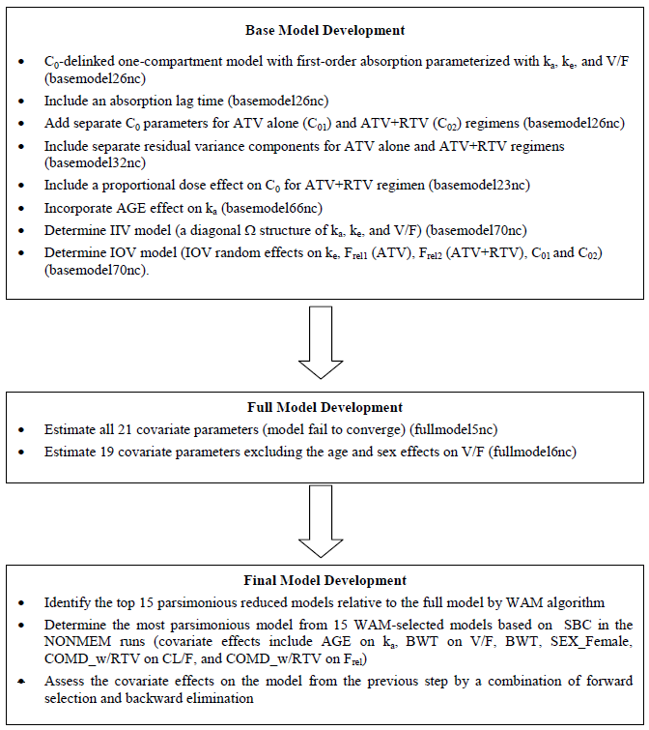

Figure 4. Exposure similarity criteria for ATV/RTV

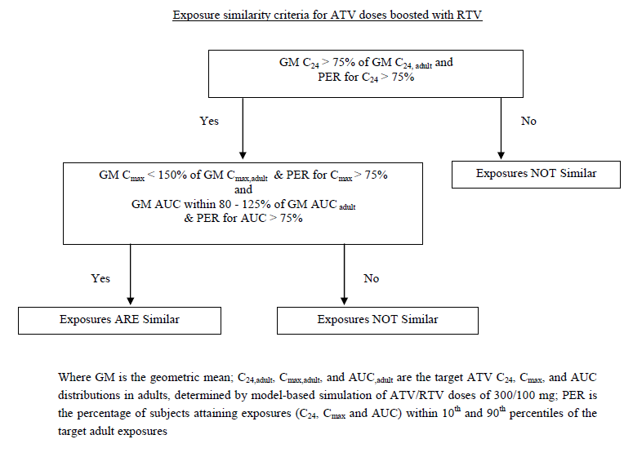

The effects of covariates are illustrated in Figure 5 and 6. For the continuous covariates, the open and solid circles show the estimated covariate effects at 5th and 95th percentiles of the covariate values. The 95% confidence intervals of these estimated effects are represented by the error bars. All the covariate effects have the effect magnitude falling outside ± 20% reference value, suggesting these covariate effects may be clinically relevant.

Figure 5. Effect of Categorical Covariates on Apparent Clearance (CL/F) and Relative Bioavailability (Frel)

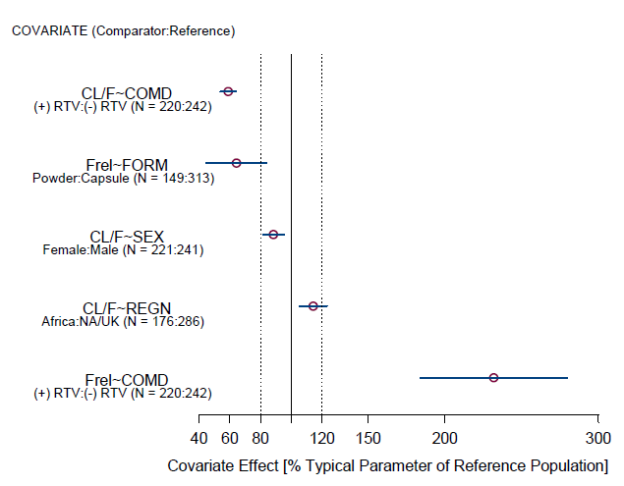

The 95% confidence intervals of these estimated effects are represented by the error bars.

Figure 6. Effect of Continuous Covariates on Apparent Clearance (CL/F), Apparent Volume of Distribution (V/F), and the Absorption Rate Constant (Ka)

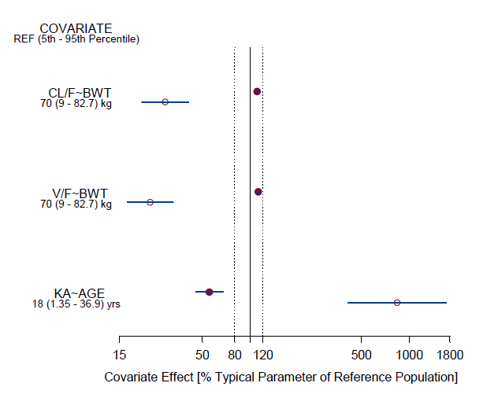

The open and solid circles show the estimated covariate effects at 5th and 95th percentiles of the covariate values. The 95% confidence intervals of these estimated effects are represented by the error bars.

The final model fit for adults is illustrated in Figure 7 and for paediatric patients for Week 1, Figure 8 and for Week 56 in Figure 9. The spread of observed measurements is particularly wide in Figure 9 for the age group > 2 to 13 years receiving ATV/RTV.

Figure 7. Final Model Fit-Adult Studies

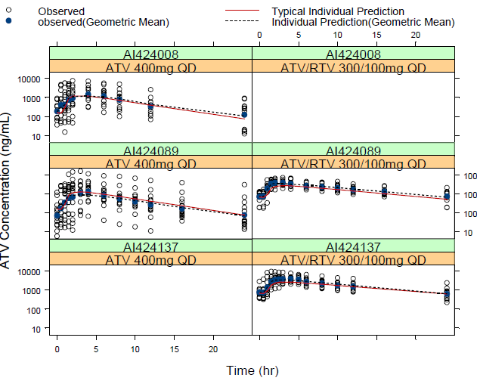

Figure 8. Final Model Fit-Paediatric Study (Week 1)

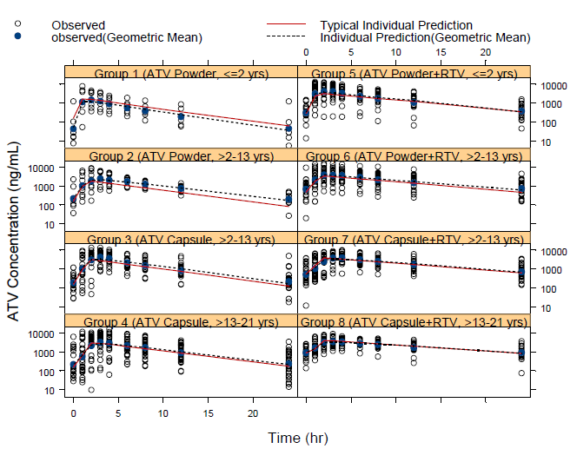

Figure 9. Final Model Fit-Paediatric Study (Week 56)

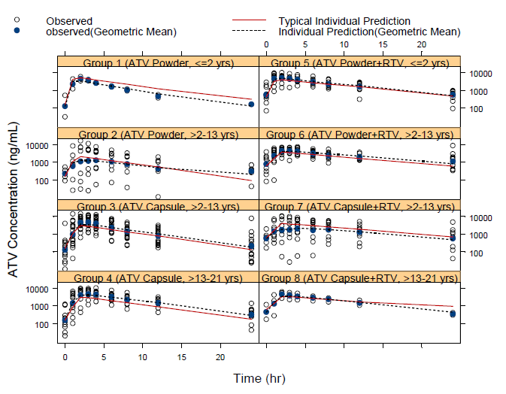

Figured 10 and 11 show the final model predictive distributions of the geometric mean for C24 with the observed geometric mean overlaid for Weeks 1 and 56 for the paediatric study. The age ranges shown do not correspond with those proposed for the Product Information, although the age range 13 to 18 years probably largely correlates with weight ≥ 40 kg. There was good agreement in C24 for Week 1 results for children and adults as shown below.

Figure 10. Observed and Predictive Distribution of Geometric Mean *C24*: Paediatric (*Week 1*) and Adult Patients

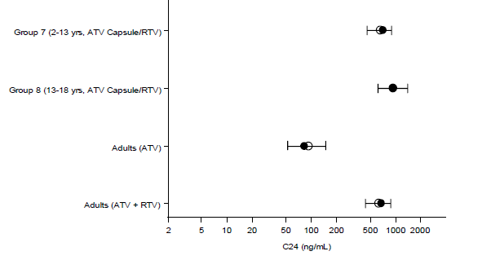

Median with 5th-95th Percentile Range Bars • Observed ο Predicted

The largest discrepancy in Week 56, C24 results shown in Figure 11 below, was seen in the age range 13-18 years with some discrepancy seen in the 2 - 13 age range. In both instances the observed values was less than predicted. The range 2 - 13 years in particular, spans an age group in which considerable variation in drug handling ability may occur. Also within that age range different formulations have been used.

Figure 11. Observed and Predictive Distribution-Geometric Mean *C24*: Paediatric (*Week 56*) and Adult Patients

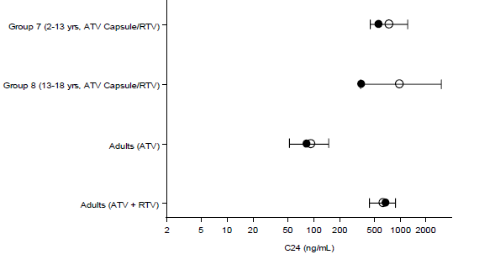

Median with 5th-95th Percentile Range Bars • Observed ο Predicted

Figures 12 and 13 show plots for Cmax. The observed value abutted the 5th percentile for Week 1 Cmax for children in the age range 13–18 years. The observed value for Cmax at Week 56 for children aged 2–13 years appears to lie below the 5% percentile.

Figure 12. Observed (•) and Predictive Distribution of Geometric Mean *Cmax*: Paediatric (*Week 1*) and Adult

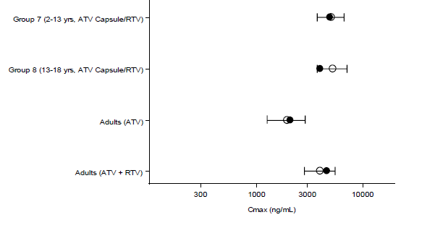

Median with 5th-95th Percentile Range Bars • Observed ο Predicted

Figure 13. Observed and Predictive Distribution of Geometric Mean *Cmax* in Paediatric (*Week 56*) and Adults

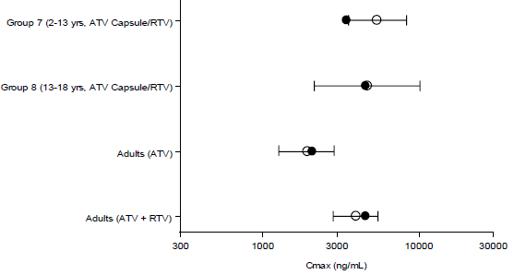

Median with 5th-95th Percentile Range Bars • Observed ο Predicted

Figures 14 and 15 show plots for AUC. Results appear similar for Week 1 geometric mean AUC as seen in below. The geometric mean AUC result at Week 56 for children aged 2–13 years appears to lie below the 5th percentile and there is some discrepancy in results for the age group 13-18 years.

Figure 14. Comparison of the Observed (•) and Predictive Distribution (Median with 5th-95th Percentile Range Bars) of the Geometric Mean *AUC* in Paediatric (*Week 1*) and Adult Patients

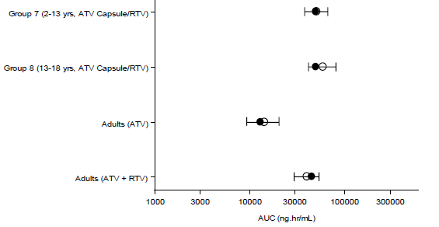

Median with 5th-95th Percentile Range Bars • Observed ο Predicted

Figure 15. Comparison of the Observed (•) and Predictive Distribution (Median with 5th-95th Percentile Range Bars) of the Geometric Mean *AUC* in Paediatric (*Week 56*) and Adult Patients

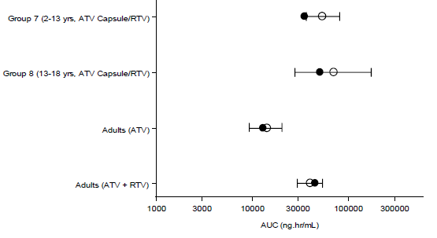

Median with 5th-95th Percentile Range Bars • Observed ο Predicted

The final model predicts that younger children and infants have an increased apparent rate of absorption resulting in a higher Cmax compared to adolescents and adults (Figure 16). The analyst stated that Cmax sharply increases for paediatric patients less than 10 years of age. The model also predicts increases in apparent volume of distribution and apparent clearance with increasing body weight. The ritonavir co-medication effect on clearance and bioavailability predicts substantially higher ATV exposures for patients receiving ATV in combination with RTV compared to ATV alone which is consistent with previous reports of the drug-drug interaction effect between atazanavir and ritonavir.

Figure 16 below, shows a plot of the relationship between baseline age and body weight that suggests an approximate linear relationship in the log-log scale. A simple linear regression of log(age) versus log(body weight) and transforming back to the original scale resulted in an equation[1] which was used to simulate the age of each patient based on each patient’s simulated body weight. Based on these assumptions, a series of ad hoc simulations were conducted to evaluate comprehensive dosing scenarios for HIV-infected paediatric patients weighing 5 kg to 70 kg.

Figure 16. Dose-Normalised Observed Cmax versus Age at Week 1 for Pediatric Patients in Study AI424020

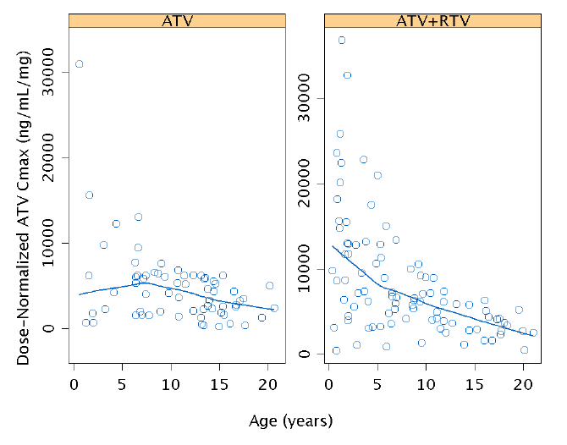

Figure 17. Relationship between Baseline Age and Body Weight for Paediatric Patients in Study AI424020

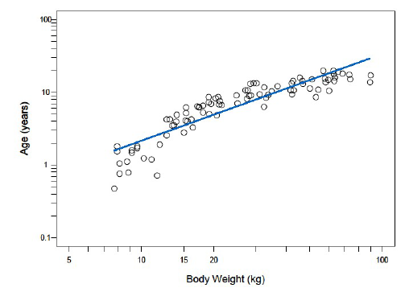

The linearity demonstrated in Figure 17appears to hold true for those individuals weighing 15‑60 kg. The slope of the line appears to have been influenced by the results for those weighting less than 15 kg and more than 60 and would have been slightly different if those individuals had not been factored in. Most of the values in the 25 kg to 30 kg year range, which approximate the age range 6 to 8 years, lie above the line.[2] It is questioned that it is totally acceptable to accept weight a surrogate for age when each affects different PK parameters.

### Determination of atazanavir/ritonavir dose

Table 5 presents the exposure values for all the ATV capsule dosing scenarios evaluated by model-based simulation for paediatric patients weighing 15 to 70 kg.

For patients in the weight range 15 to < 20 kg the dose of ATV/RTV 150/100 mg was predicted to result in the following geometric mean (GM) ATV concentrations:

* C24 of 504 ng/mL (coefficient of variation of 99.5%) attained by 76.8% of patients.
* Cmax of 4,213 ng/mL (CV 78.7%) attained by 81.4% of patients.
* AUC of 42,902 ng.h/mL (CV 77.0%) achieved by 82% of patients

For patients weighing between 20 to < 40 kg the dose of ATV/RTV 200/100 mg was predicted to result in the following ATV GM concentrations:

* Cmin[3]519-615 ng/mL for 77.5% -78.6% of patients (CV 98%-99.8% )
* Cmax 4,233-5,887 ng/mL for 78.7%-82.1% of patients, with CV 79.2%-81.5%
* AUC 37,701-49,699 ng.h/mL for 80.7%-82% of patients, with CV between 77% and 78.4%.

The dosing scenarios in the table below meeting adult exposure similarity criteria are highlighted in grey.

Table 5. Summary of Simulated ATV Exposure Measures (Boosted Capsule Doses)

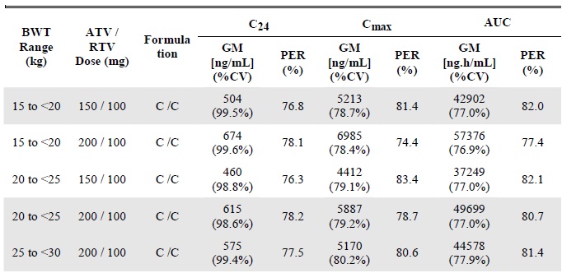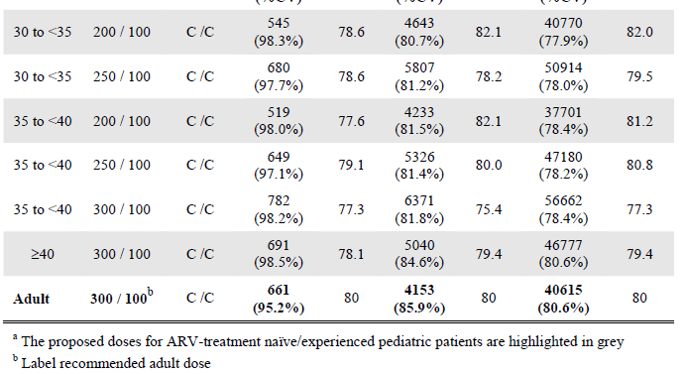

It is noted that for those 15 to < 20 kg and 30 to < 40 ranges, alternative doses would appear to be equally applicable. A dose of 200 mg would also have suited the smallest patients for whom the simulated Cmin was below the target. The chosen dose for those 30 to < 40 resulted in an AUC right at the lower limit of the target value while the dose of 250 mg would have been suitable. These comments are relevant to future discussion of observed pharmacokinetic results.

The distribution of the individual pharmacokinetic values for the 10,000 simulated participants for each proposed paediatric dose and weight range are shown for C24 in Figure 18 below, for Cmax in Figure 19 and for AUC in Figure 20.

These results indicate the difficulty in identifying paediatric capsule doses for boosted ATV that results in exposure distributions identical to that of adults.

Figure 18. Distribution of Simulated Individual C24 at Proposed Capsule Doses for Children Receiving ATV/RTV

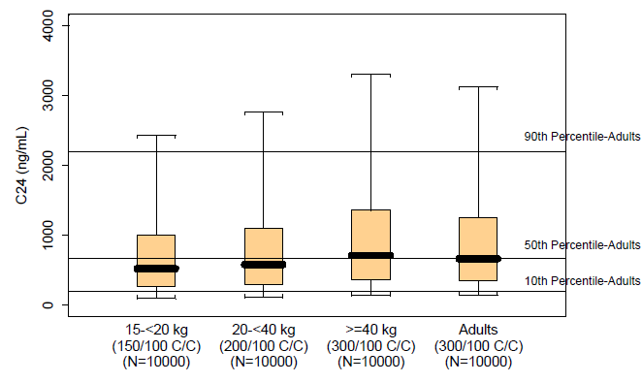

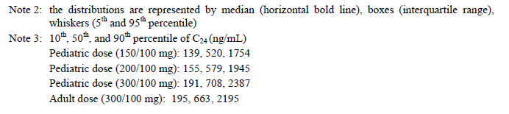

Figure 19. Distribution of Simulated Individual Cmax at Proposed Capsules Dose for Paediatric Patients Receiving ATV/RTV

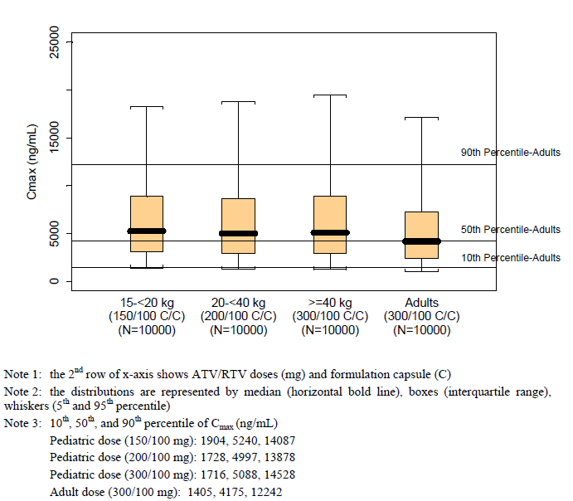

Figure 20. Distribution of Simulated Individual AUCs at the Proposed Capsules Doses for Pediatric Patients Receiving ATV in Combination with RTV

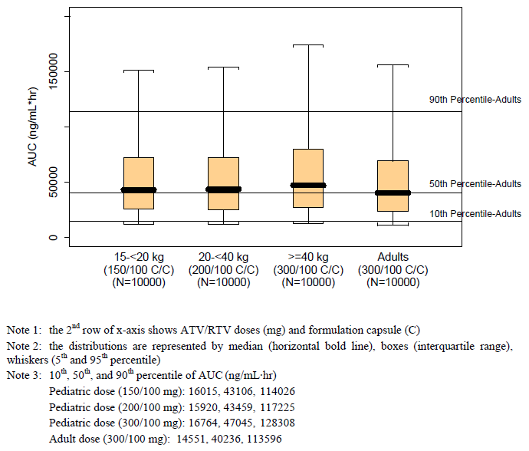

Figure 21 illustrates the deviation of the paediatric distributions at the proposed doses from the observed adult exposures. The results are truncated at the 10th and 90th percentiles. The deviation of the simulated Cmin values tend to be greater than the adult values at the lower percentiles of the Cmin distributions, whereas the simulated Cmax distributions tend be greater than the corresponding observed adult distributions. The difficult balance between ensuring adequate exposure whilst controlling excessive exposure is illustrated by the simulated AUC values, these tend to be lower than the observed adult values at the lower percentiles of the distribution and higher than the observed adult values at the higher percentiles.

Figure 21. Deviation of Simulated Paediatric Capsule ATV/RTV exposure from Observed Adult Exposures

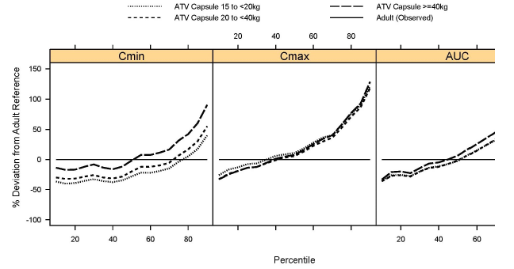

#### Ritonavir dose evaluation

The final model included RTV co-medication as a dichotomous effect not taking into consideration the actual dose of RTV. To support the proposed RTV doses, graphical and regression analyses were performed to investigate the relationship between the individual (post-hoc) predictions of the parameters versus RTV dose for those parameters that included the RTV co-medication effect in the final model, namely, C0, bioavailability relative to ATV alone with capsule formulation(Frel) and CL/F. Plots of the individual predictions versus RTV dose showed no apparent RTV dose trends for the C0 and Frel parameters (Figures 22 and 23).

An apparent trend between RTV dose and CL/F is claimed (Figure 24). As the RTV dose was based on body surface area (BSA) and there is a body weight effect on CL/F, it was unclear if the apparent RTV dose trend observed in Figure 24 could be fully explained by the correlation between RTV dose and body weight. However, the applicant considers that since the RTV dose administered in the paediatric study did not appear to explain additional variation in ATV exposure beyond the simple dichotomous effect, the RTV dose recommendations were chosen on the basis of the clinical judgment consistent with the ATV/RTV dose ratios studied in the paediatric Study AI424020.

The evaluator considers that the chosen dose based on the clinical judgment mentioned above appears to be pragmatic in that it is the smallest dose available in capsule form and the capsule formulation is considered more palatable. The adverse effect profile of the much higher dose/body weight of, for example, a child weighing 15 kg compared to an adult, is a matter which has not addressed.

Figure 22. Individual Predictions of ATV C0 versus RTV Dose in Paediatric Patients Receiving ATV/RTV

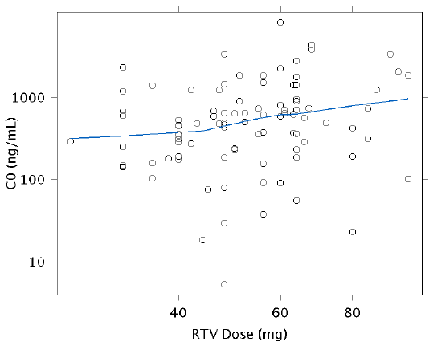

Figure 23. Individual Predictions of ATV Frel versus RTV Dose in Paediatric Patients Receiving ATV/RTV

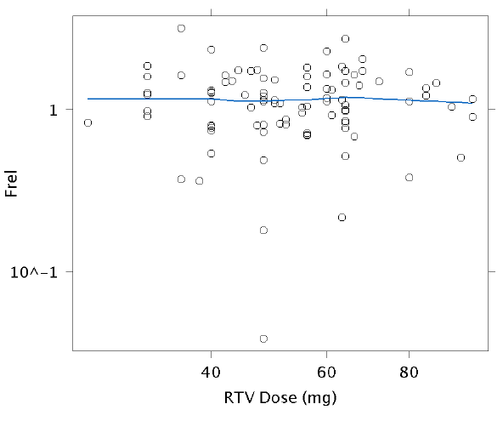

Figure 24. Individual Predictions of ATV CL/F versus RTV Dose in Paediatric Patients Receiving ATV/RTV

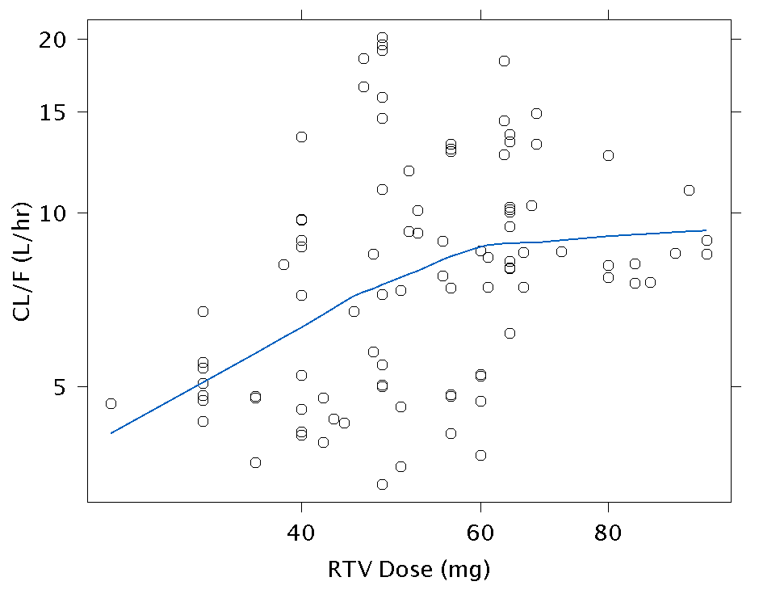

### Study AI424020 Clinical Pharmacology

For this application, individual pharmacokinetic data were included for the 7 participants who received the proposed, revised dose or higher are presented. Full 24 hour pharmacokinetic profiles were determined at the end of Week 1 and Week 56 as well as two weeks following any dose adjustment based on the prespecified ATV exposure criteria. The pharmacokinetic parameters assessed were maximum observed plasma concentration (Cmax), time to reach Cmax in plasma (Tmax), area under the plasma concentration-time curve during 1 dosing interval of TAU, (AUCτ), plasma concentration 24 hours post-dose (Cmin), and apparent clearance of drug from plasma at steady state.

Actual sampling times were used for pharmacokinetic calculations and nominal times were used for generation of mean plasma concentration-time plots and summaries. Predose concentrations and concentrations prior to the first quantifiable concentration that were below the lower limit of quantitation (LLOQ) were set to “zero” for the purpose of calculating pharmacokinetic parameters but were treated as “missing” for the calculation of summary statistics.

Only participants who met all of the following criteria, (the Capsule Recommended Dose Cohort) were considered of primary interest for the submitted Clinical Study Report:

* Children weighing 15 kg to < 20 kg treated with ATV at a dose of 150 mg once daily or higher (capsule formulation) boosted with RTV 100 mg once daily for ≥ 24 weeks
* Children weighing 20 kg to < 25 kg treated with ATV at a dose of 150 mg once daily or higher (capsule formulation) boosted with RTV 100 mg once daily for ≥ 24 weeks

Analyses of atazanavir and ritonavir in plasma were by liquid chromatography-mass spectrometry at MDS, Tandem, and the University of Colorado and were performed using validated methods during the period of known analyte stability.

Atazanavir parameters of Cmax, AUCτ, and Cmin for ATV/RTV Capsule Recommended Dose Cohort, for > 24 weeks, are provided below in Table 6. For comparison, the ranges for Cmax, AUCτ and Cmin in adult HIV infected patients treated with ATV/RTV 300/100 mg once daily were reported as follows:

* Treatment-experienced: Cmax: 1694-9950 ng/mL, AUC(τ): 23,152-141,825 ng.h/mL), Cmin: 158-3,081 ng/mL
* Treatment-naive adults: Cmax: 2,426-6,792 ng/mL and AUC(τ): 26,113-83,210 ng.h/mL, Cmin 184-2,064 ng/mL

Table 6. Atazanavir and Ritonavir Pharmacokinetic Parameters in Individual Participants Weighing 15 kg to Less than 20 kg and 20 kg to Less Than 25 kg Treated with ATV Capsules Boosted with RTV for at Least 24 Weeks

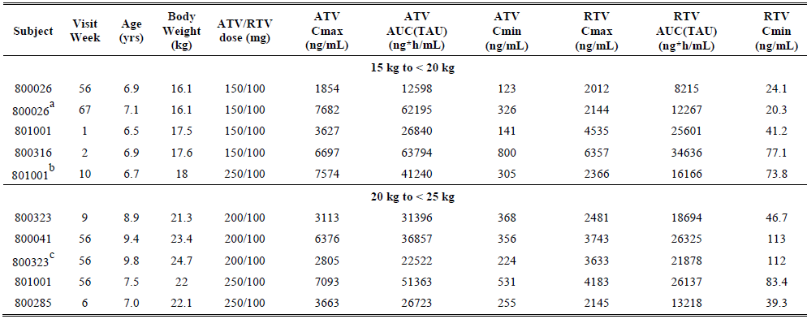

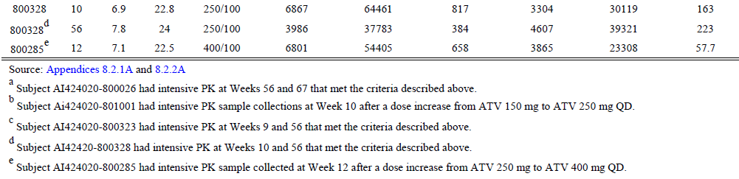

It was noted that in comparing the paediatric results in the table above, doses of 250/100 mg were administered to some of the patients and one patient received the dose of 400/100 mg. Only three patients 15 to < 20 kg were sampled at least once while taking the dose 150/100 mg and three 20 to < 25 kg taking the 200/100 mg dose.

Three participants in the 15 kg to < 20 kg weight band received ATV/RTV 150/100 mg once daily or higher for ≥ 24 weeks with the ATV capsule formulation and yielded a total of 4 valid observations.

* One participant had 2 intensive pharmacokinetic sampling visits at Weeks 56 and 67 that fit these criteria; this participant received ATV/RTV 150/100 mg at both visits. Despite the same dosing regimen of ATV/RTV, exposures at Week 56 were markedly lower than exposures at Week 67. Suboptimal adherence has been noted for this participant and the pre-dose concentration of ATV at Week 56 was < LLOQ, suggesting the result was not at steady state at Week 56; therefore, the child returned to the clinical site at Week 67 to repeat the intensive pharmacokinetic sample collection while on the same regimen of ATV/RTV. The Week 67 ATV exposures were then within the protocol-defined target range.
* Another participant had 2 intensive pharmacokinetic sampling visits at Weeks 1 and 10. At Week 1, this participant received ATV 150 mg, while at Week 10 the ATV dose had been increased to 250 mg. Both records for this participant were included in the listing and displays, yielding 4 valid observations for this weight band.

Five participants in the 20 kg to < 25 kg weight band received ATV/RTV ≥ 200/100 mg capsule formulation once daily for ≥ 24 weeks. All records were included in the listing and displays, yielding 8 observations for this weight band. It was noted that only two of these participants were treated with the proposed dose, ATV/RTV 200/100 mg.

* One participant had 2 intensive pharmacokinetic sampling visits at Weeks 9 and 56 at the same regimen of ATV/RTV 200/100 mg.
* Another participant sampled intensively once was treated with 200/100
* A third participant had 2 intensive pharmacokinetic sampling visits at Weeks 6 and 12. At Week 6, this participant received ATV/RTV 250/100 mg, while the ATV dose had been increased to 400 mg by Week 12.
* A fourth participant had 2 intensive pharmacokinetic sampling visits at Weeks 10 and 56 also at the same regimen of ATV/RTV 250/100 mg.
* A fifth participant (same patient as in 2nd bullet point just above) sampled intensively once in this weight band was treated with ATV/RTV 250/100. It was noted that this child had previously been intensively sampled twice before in the weight band 15 to < 20 kg.

Figures 25-27 compare the observed results for Cmax, AUCτ and Cmin respectively with the results based on modelling and simulation. In addition, scatter plots of ATV Cmax, AUCτ, and Cmin for participants who received ATV capsule at 150 mg or higher (15 kg to < 20 kg) or 200 mg or higher (20 kg to < 25 kg) boosted with RTV for ≥ 24 weeks as well as historical data in HIV-infected treatment-experienced and antiretroviral-naive adults are presented in Figures 28-30.

Figure 25. Comparisons of ATV Cmax from Participants Who Received the Newly Proposed ATV/RTV Doses or Higher in Study AI424020 for at Least 24 Weeks Relative to the Projected Cmax by Modelling and Simulation

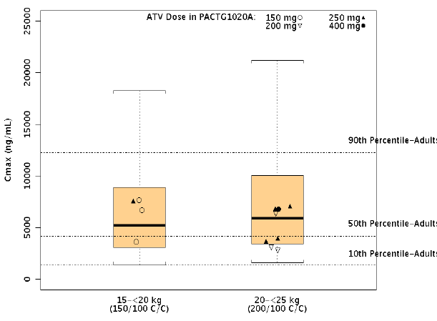

Figure 26. Comparisons of ATV AUC from Participants Who Received the Newly Proposed ATV/RTV Doses or Higher in Study AI424020 for at Least 24 Weeks Relative to the Projected AUCτ by Modelling and Simulation

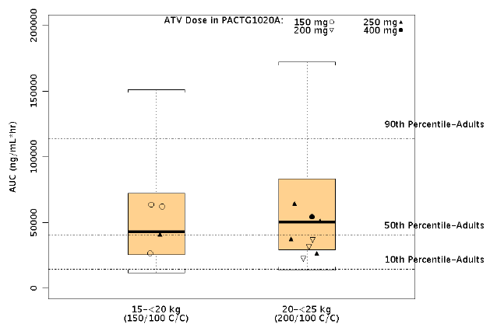

Figure 27. Comparisons of ATV Cmin (C24) from Participants Who Received the Newly Proposed ATV/RTV Doses or Higher in Study AI424020 for at Least 24 Weeks Relative to the Projected C24 by Modelling and Simulation

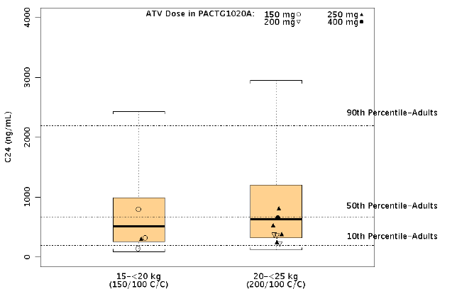

Figure 28. Scatter Plot of RTV boosted ATV capsule Cmax for weights 15 kg to < 20 kg and 20 kg to< 25 kg

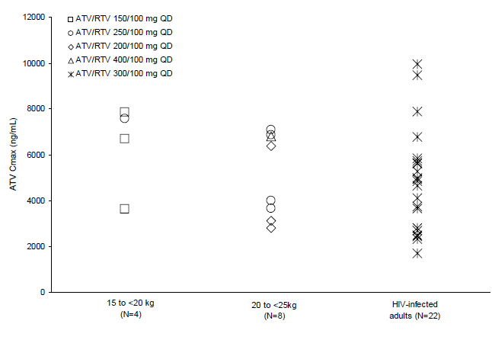

Week 56 exposures are excluded from the scatter plots for one participant.

Figure 29. Scatter Plot of RTV boosted ATV capsule AUCτ for weights 15 kg to < 20 kg and 20 kg to < 25 kg

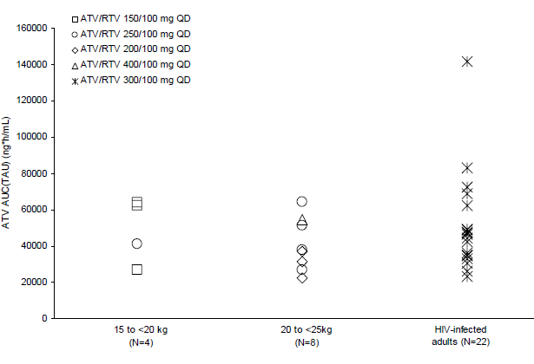

Week 56 exposures are excluded from the scatter plots for one participant.

Figure 30. Scatter Plot of RTV boosted ATV capsule Cmin for weights 15 kg to < 20 kg and 20 kg to <25 kg

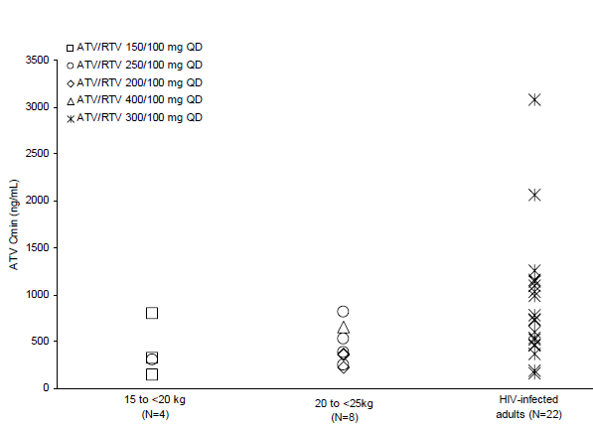

Week 56 exposures are excluded from the scatter plots for one participant.

#### Ritonavir

Scatter plots of RTV Cmax, AUCτ, and Cmin for participants who received ATV capsule at 150 mg or higher (15 kg to < 20 kg) or 200 mg or higher (20 kg to < 25 kg) boosted with RTV for ≥ 24 weeks as well as historical data in HIV-infected treatment-experienced and antiretroviral-naive adults are presented in Figures 31-33, respectively. Compared to adults, the results for children in selected weight categories were notably higher for Cmax and AUCτ but tended to be lower for Cmin suggesting to the evaluator that similar developmental metabolic processes may be at play for ritonavir as for atazanavir, though paucity of paediatric data may be influential.

Figure 31. Scatter Plot of Ritonavir Cmax in Participants Weighing 15 kg to Less than 20 kg and 20 kg to Less Than 25 kg Treated with Atazanavir Capsule Boosted with Ritonavir for at Least 24 Weeks

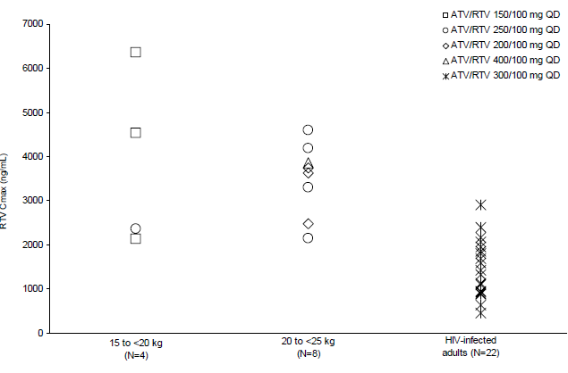

Figure 32. Scatter Plot of Ritonavir AUCτ in Participants Weighing 15 kg to Less than 20 kg and 20 kg to Less Than 25 kg Treated with Atazanavir Capsule Boosted with Ritonavir for at Least 24 Weeks

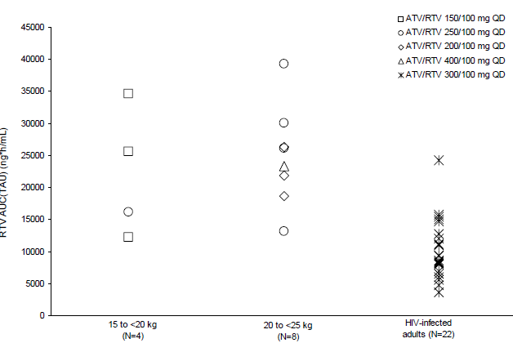

Figure 33. Scatter Plot of Ritonavir Cmin in Participants Weighing 15 kg to Less than 20 kg and 20 kg to Less Than 25 kg Treated with Atazanavir Capsule Boosted with Ritonavir for at Least 24 Weeks

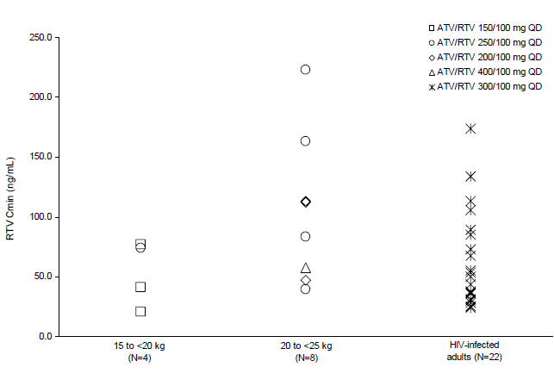

Applicant comment: Regarding atazanavir, the applicant considers that for participants weighing 15 kg to < 20 kg (≥ ATV 150 mg) or 20 kg to < 25 kg (≥ ATV 200 mg) who received ATV capsule boosted with RTV resultant ATV Cmax, AUCτ, and Cmin levels generally within the range observed in both antiretroviral-experienced and antiretroviral-naive HIV-infected adults patients receiving ATV/RTV 300/100 mg once daily, despite some paediatric participants receiving an ATV dose that was higher than the proposed dose.

With respect to ritonavir, the applicant stated that while ritonavir Cmin values in paediatric participants in these 2 weight bands were similar compared to adults treated with ATV/RTV 300/100 mg, RTV Cmax and AUCτ in these participants appeared generally higher than those seen in adults taking 100 mg RTV once daily. Nevertheless, these exposures are within the range reported in the literature when paediatric or adult patients took twice daily RTV at 100 mg or higher and are consistent with the safety observations in the study.

Evaluator Comment***:*** Regarding atazanavir, the doses proposed for inclusion in the Product Information resulted in actual Cmin results which were relatively low in comparison to adult results. And one patient in the range 15 to < 20 kg group required ATV/RTV 250/100 mg while one participant in the 20 to < 25 kg group required ATV/RTV 400/100 mg to register pharmacokinetic values comparable to those of the other participants in the weight bands. One participant in the weight band 15 to < 20 kg recorded a Cmin below the ASHM recommended trough concentration of 150 ng/mL.[4] While the recorded trough level may still be therapeutic, there is less margin of certainty for efficacy if compliance is not strict with consequent increased chance failure of treatment and of development of resistance which is undesirable at any age, but particularly at such a young age.

The proposed doses for the 20 to < 25 kg group resulted in relatively low Cmin results and the proposed dosage in the PI is actually for 20 to < 40 kg. Efficacy for the lower dose has not been established in this weight range, particularly in treatment-experienced patients who did not fare particularly well over the course of 96 weeks. While accepting the proposed new dosage regimen, it is recommended that the dose of 250/100 mg remains as an option. For patients with lower pharmacokinetic results, particularly Cmin, compliance with treatment becomes particularly important. Therapeutic drug monitoring may be particularly important for treatment- experienced patients in which the relationship between Cmin and efficacy may be more critical.

The Product Information for ritonavir (Norvir) states that safety of ritonavir in children below the age of 12 has not been established. The Product Information of ritonavir mentions that prolongation of the PR interval has been noted in a study of healthy adults. It is possible that the relatively high Cmax and AUC of ritonavir in comparison to the adults in addition to the ATV has contributed to the electrocardiogram (ECG) PR interval[5] changes noted in this study . However, it appears that the RTV levels obtained for children are less than those for adults on therapeutic doses of ritonavir in which at steady state at dose of 600 mg twice daily, observed Cmax and Ctrough values were 11.2 and 3.7 µg/mL respectively. External validity of the study with respect to cardiac safety is considered limited in view of the extensive list of exclusion criteria including pre-existing cardiac disease, ECG abnormalities and family history of cardiac conduction conditions or ventricular dysplasia.

With respect to the approved Product Information, the current *Precautions/Use in Children*, it is considered that cautionary advice regarding age related ATV absorption and clearance characteristics and the higher RTV levels should be included.

In addition, raised unconjugated serum bilirubin (SBR) levels are said to be dose dependent and young children tend to have higher Cmax and AUC values than adults. At the unconjugated SBR levels reported in this study it is not likely that neurodevelopmental, cognitive or hearing problems will result from protracted elevation of SBR However, HIV related changes in the blood brain barrier have been reported[6], and neurotoxicity has not been systematically studied in HIV infected children.

## Pharmacodynamics

No data submitted.

## Clinical efficacy

### Study AI424020

Study AI424020 is an ongoing paediatric, multicenter, open-label, uncontrolled study to determine the safety, pharmacokinetic, and optimal dose of atazanavir powder and capsules, administered with or without ritonavir. Participants were HIV-infected patients aged between 19 days and 21 years who were assigned to treatment groups stratified by age, ATV formulation and concomitant administration of RTV. The study was conducted in the US (34 sites) and South Africa (2 sites) and commenced on 16 November 2000. Results of dose ranging, safety, tolerability and efficacy to 24 weeks were evaluated at the time of registration of the current paediatric dosage and administration recommendations. Database lock for analyses for the submitted Clinical Study Report (CSR) was 21 September 2010.

The current submission focused on safety, efficacy and pharmacokinetic results for those patients from 6 to 18 years of age treated with the capsule formulation of ATV, with or without RTV (ATV Capsule Cohort) and examined the subset of seven participants in the weight categories relevant to the proposed change to the *Dosage and Administration* section of the Product Information, that is, children in the range 15 to < 20 kg treated with ≥ 150 mg of ATV and ≤ 100 mg of RTV, and in the range 20 to 25 kg treated with ≥ 200 mg of ATV plus ≥ 100 mg RTV for at least 24 weeks (Capsule Recommended Dose Cohort). All seven of these participants were treatment naive. There was no information presented for the children 32 to 40 kg in which the lower dose of 200 mg is proposed.

#### Inclusion criteria

* Males and female patients with confirmed diagnosis of HIV infection.
* Qualifying plasma HIV RNA ≥ 5000 c/mL.
* Antiretroviral treatment-naïve or treatment experienced participants who were able to add 2 new nucleoside reverse transcriptase inhibitors to the therapeutic regime or who showed genotypic evidence of sensitivity to 2 nucleoside reverse transcriptase inhibitors.
* Phenotypic sensitivity to atazanavir (resistance index ratio of < 10) despite failing 2 or more courses of a protease inhibitor containing regimen after at least 12 weeks of therapy.

#### Exclusion criteria

* Active hepatitis
* Acute serious and invasive infection requiring therapy at the time of study enrolment.
* Documented history of cardiac conduction abnormality or significant cardiac dysfunction, or a history of undefined syncope for which a cause of cardiac conduction abnormalities could not be ruled out.
* Family history of QTc interval[7] syndrome, Brugada syndrome, or right ventricular dysplasia or with a corrected QTc interval at screening of > 440 ms.
* Prolonged PR interval of > 200 ms for candidates 13 years of age or older or a PR interval 98th percentile for candidates < 13 years of age at screening ECG.
* One of the following cardiac rhythm abnormalities documented on the screening ECG: type I second degree atrioventricular (AV) block while awake; type II second degree AV block at any time; complete AV block at any time; age-adjusted heart rate < 2nd percentile.

#### Therapy

Atazanavir, with or without ritonavir was administered in combination with 2 nucleoside reverse transcriptase inhibitors excluding abacavir sulfate and tenofovir disoproxil fumarate. Nucleoside backbone therapy was determined on the basis of the genotypic and phenotypic resistance profile and/or treatment history.

There were eight dosing groups in the study as shown below.

| ATV | ATV/RTV | Formulation | Age Ranges |
| --- | --- | --- | --- |
| Group 1 | Group 5 | Powder | Infants 3 months to ≤ 2 years |
| Group 2 | Group 6 | Powder | Children > 2 to ≤ 13 years |
| Group 3 | Group 7 | Capsules | Children > 2 to ≤ 13 years |
| Group 4 | Group 8 | Capsules | Adolescents > 13 to ≤ 21 years |

Following stages of initial dose finding, an atazanavir dose of 310 mg/m2 once daily was established.

Efficacy criteria for evaluation for this report included the percentage of participants who achieved virologic response (VR) or virologic response-observed cases (VR-OC) with HIV RNA <50 or < 400 c/mL at Week 96, as well as CD4 counts and changes from baseline through Week 96. For VR-OC analysis, the denominator was based on participants with available viral load measurements.

#### Efficacy results

##### Disposition

In the ATV Capsule Cohort, at the time of reporting the majority of patients had discontinued therapy, the most common reasons being protocol non-compliance, completion of treatment, and toxicity. In the ATV/RTV Capsule Recommended Dose Cohort, 2 of 7 participants (29%) discontinued therapy, both due to protocol non-compliance. Disposition for the ATV Capsule Cohort is summarised in Table 7. The number discontinuing prior to or at Week 96 was 44/105 (42%).

Table 7. Study AI424020 Disposition for participants treated with the ATV capsule formulation ± ritonavir

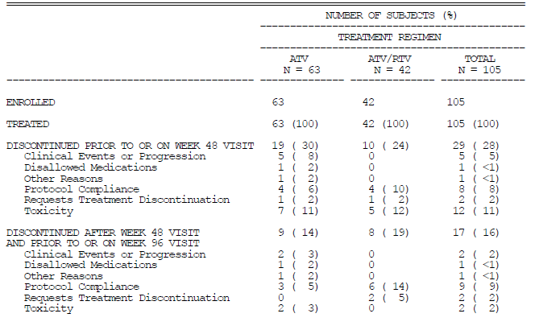

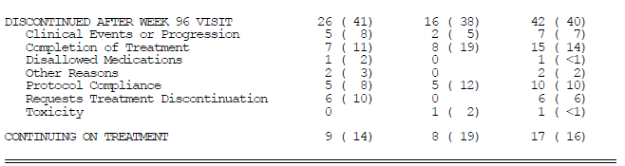

##### Demographic and baseline characteristic

In the ATV Capsule Cohort overall, 65% of participants were Black/mixed race, approximately 23% were White and 52% were female. Of the 105 patients in the ATV Capsule Cohort, 72 (69%) were treated at sites in the US and 33 (31%) were treated at sites in South Africa. In the ATV/RTV Capsule Recommended Dose Cohort, 6 patients were Black/mixed race and all seven were treated at sites in South Africa. See Tables 8 and 9 below.

Table 8. Study AI424020 Demographics and baseline characteristics

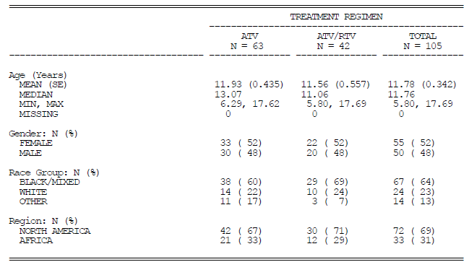

Table 9. Demography at Baseline-ATV/RTV Capsule Recommended Dose Cohort

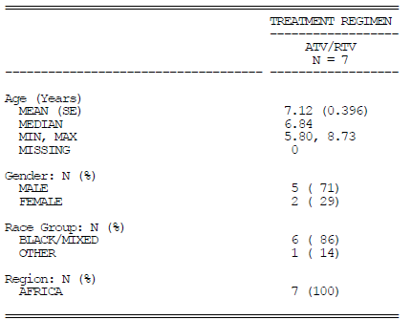

##### Baseline characteristics

* The median weight was 37 kg (range: 14-121 kg); the median height was 140 cm (range: 101-180 cm)
* The median baseline HIV RNA plasma level was 4.49 log10 c/mL. Half of the participants had baseline HIV RNA levels < 30,000 c/mL.
* The median baseline CD4 cell count was 401 cells/mm3.
* Fifty-nine percent (59%) of participants had received prior antiretroviral therapy. The median time on any prior antiretroviral therapy or any nucleoside reverse transcriptase inhibitor therapy was 454.1 weeks (range: 26.0-891.3 weeks). The median time on any prior protease inhibitor therapy was 209.0 weeks (range: 4.0-415.6 weeks) and the median time on any prior non-nucleoside reverse transcriptase inhibitor therapy was 138.9 weeks (range: 1.4-406.1 weeks). None of the 7 participants in the ATV/RTV Capsule Recommended Dose Cohort had received prior antiretroviral therapy.
* The majority of participants had normal haematology or no more than a Grade 1 abnormality. Grade 2 haematology abnormalities included low neutrophils (3) and low platelets (1). In the ATV/RTV Capsule Recommended Dose Cohort, the only haematology abnormality was Grade 1 haemoglobin in 1 participant.
* The majority of participants had normal liver function tests or no more than a Grade 1 abnormality. Grade 2 liver function test abnormalities included alanine aminotransferase (ALT/SGPT) (2) and aspartate aminotransferase (AST/SGOT) (1). In the ATV/RTV Capsule Recommended Dose Cohort, no liver function test abnormalities were reported.
* The majority of participants had normal serum chemistry or no more than a Grade 1 abnormality. Grade 2 serum chemistry abnormalities included creatinine (3) and albumin (2). In the ATV/RTV Capsule Recommended Dose Cohort, Grade 1 and 2 albumin level abnormalities were reported for 1 participant each.
* The majority of participants had normal lipids and glucose or no more than a Grade 1 abnormality. Grade 2 abnormalities included hyperglycaemia, hypoglycaemia and total cholesterol (3 each). None of the participants in the ATV/RTV Capsule Recommended Dose Cohort had lipid or glucose abnormalities.

##### Time on study therapy

In the ATV Capsule Cohort, the median time on study therapy was 135.7 weeks. The ATV/RTV group started later than the ATV group hence had a shorter exposure to study therapy (Table 10). In the ATV/RTV Capsule Recommended Dose Cohort, the median time on study therapy was 209.3 weeks (range: 175.3-224.0 weeks) (Table 11).

Table 10. Time on Study Therapy-ATV Capsule Cohort

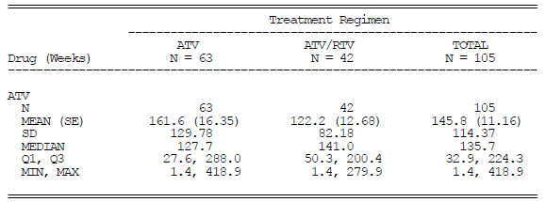

Table 11. ATV/RTV Capsule Recommended Dose Cohort While on the Newly Proposed Recommended Dose

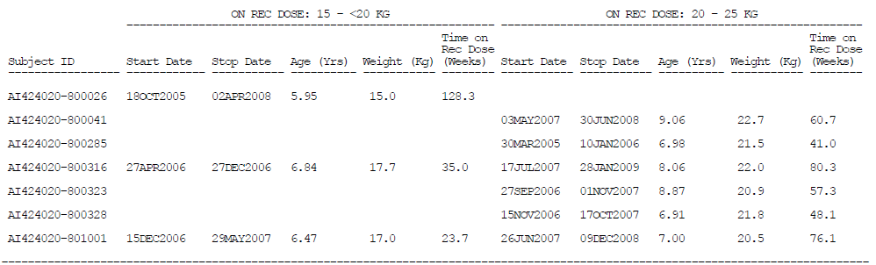

##### Concomitant therapy

Reporting of concomitant therapy was not always accurate and inaccuracies were not corrected prior to database lock for this Clinical Study Report.

##### Efficacy

Overall, 105 participants in the ATV Capsule Cohort were treated with the ATV capsule formulation, with or without RTV. In the ATV Capsule Cohort, the virologic response rate was greater for antiretroviral-naive participants than antiretroviral-experienced participants. The percentage of participants who achieved VR or VR-OC was greater in the ATV/RTV group than in the ATV alone group whether the participants were antiretroviral-naive or experienced but the numbers were small.

###### Virologic response

For patients treated with either ATV or ATV/RTV, the overall proportions of antiretroviral naive and experienced participants with HIV RNA < 400 copies/mL at Week 96 were 21/43 (49%) and 21/62 (34%), respectively. The overall proportions of treatment naive and experienced participants with HIV RNA < 50 copies/mL at Week 96 were 20/43 (47%) and 15/62 (24%), respectively (Table 12)

###### Virologic response observed cases

For patients treated with either ATV or ATV/RTV, the overall proportions of antiretroviral-naive and experienced participants with HIV RNA < 400 copies/mL at Week 96 were 78% (21/27) and 66% (21/32), respectively. The overall proportions of treatment-naive and experienced participants with HIV RNA < 50 copies/mL at Week 96 were 74% (20/27) and 47% (15/32), respectively. (Table 12)

The 24% response for treatment experience patients at Week 48 was lower than that reported in adults while the response of 32 % at Week 96 was roughly the same, acknowledging that numbers in the paediatric study were small and study designs different.

Table 12. Study AI424020 Virologic response at Weeks 48 and 96-ATV Capsule Cohort

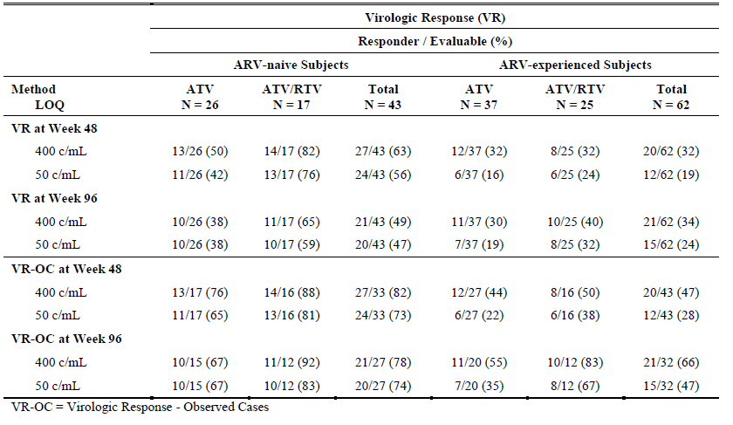

With respect to efficacy in the seven patients in the ATV Recommended Dose Cohort, the results were biased since all seven were treatment naive and in order to be included in the cohort, the participants had to have reached 24 weeks or longer in the study. All participants except one had an HIV RNA < 50 c/mL as the last HIV RNA measurement at the time of database lock. One participant suppressed during the study, rebounded, reached < 50 c/mL again but ultimately remained above 50 c/mL with the last HIV RNA measurement of 77,600 c/mL.

###### CD4 cell counts

The median increase from baseline in absolute CD4 count at 96 weeks of therapy was 335 cells/mm3 for treatment naive participants and 220 cells/mm3 for treatment experienced patients (Table 13).

All except one patient had an overall increase in CD4 count from baseline, with the last CD4 measurements at the time of database lock being > 600 cells/mm3. Another participant had CD4 increases during the study but as the participant rebounded virologically, the CD4 cell count decreased, with the final measurement of 331 cells/mm3 at the time of database lock for this Clinical Study Report.

Table 13. CD4 Cell Count at Weeks 48 and 96-ATV Capsule Cohort

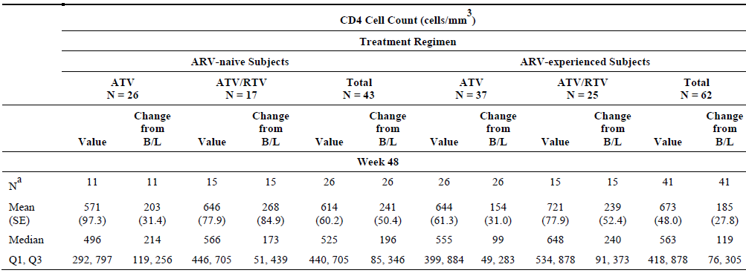Week 96

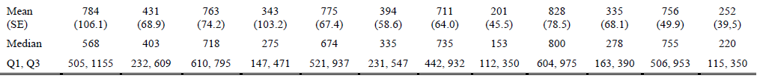

Table 13. CD4 Cell Count at Weeks 48 and 96-ATV Capsule Cohort

## Clinical safety

### Study AI424020

Safety variables for this interim analysis included adverse events (AEs) all grades and Grade 2-4, serious adverse events (SAEs), deaths, discontinuations due to adverse events, laboratory abnormalities, cardiac disorders, electrocardiogram evaluations (abnormalities, individual parameters and changes from baseline at Weeks 1 and 56) and the frequency of acquired immunodeficiency syndrome-related events.

In both the ATV Capsule Cohort and ATV/RTV Capsule Recommended Dose Cohort, all participants reported adverse events, the most common of which were related to laboratory abnormalities (blood bilirubin increased, blood bilirubin unconjugated increased, AST and ALT increased, bilirubin unconjugated increased, blood glucose decreased and blood sodium decreased). Other common adverse events were cough, rash and pyrexia in the ATV Capsule Cohort, and cough, lymphadenopathy, conjunctivitis and skin disorders in the ATV/RTV Capsule Recommended Dose Cohort (Table 14).

In the ATV Capsule Cohort, the most common Grade 2–4 adverse events were blood bilirubin unconjugated increased (79%), blood bilirubin increased (67%), bilirubin conjugated increased (23%), and cough (21%). Asymptomatic second-degree AV block was reported in 2% of participants. The most common Grade 3–4 laboratory abnormalities were elevation of total bilirubin ≥3.2 mg/dL (58%), neutropenia (9%), and hypoglycaemia (4%). All other Grade 3–4 laboratory abnormalities occurred with a frequency of < 3%.

In the ATV/RTV Capsule Recommended Dose Cohort, the most common Grade 2–4 adverse events were blood bilirubin unconjugated increased and blood sodium increased (7), blood bilirubin increased (5), and haemoglobin decreased (3). Four participants with normal total bilirubin at baseline had Grade 3-4 total bilirubin on study.

#### Deaths

Two deaths occurred at less than 48 weeks, both treated with ATV alone. They occurred after discontinuation of study therapy and both were considered unrelated to study therapy (acute respiratory distress syndrome plus sepsis for 1 participant and cardiomyopathy plus congestive cardiac failure for the other participant who had a prior history of HIV cardiomyopathy.

#### Serious adverse events

Serious adverse events (SAEs) were reported based on definitions in the US Division of AIDS Serious Adverse Experience Reporting Manual.13. All Grade 3 and 4 laboratory abnormalities suspected to be an adverse drug reaction were mandated by the protocol to be reported as serious adverse events. Therefore, under the protocol definition, asymptomatic Grade 3 and Grade 4 bilirubin elevations (3.0-7.5 x ULN and > 7.5 x ULN respectively) were required to be reported as serious adverse events. Some investigators also chose to report Grade 1 and Grade 2 increased bilirubin levels as serious adverse events.

In the ATV Capsule Cohort, 65% of participants experienced serious adverse events. Most were related to hyperbilirubinemia. Other liver function test abnormalities remained infrequent. Cardiac disorders were reported as SAEs by 8% of participants (Table 16).

In the ATV/RTV Capsule Recommended Dose Cohort, 6 of 7 participants reported serious adverse events and 4 of these participants had SAEs reported while the participants were on the newly proposed recommended dose. The preferred term for the SAE for one participant was miscoded as a cardiac “conduction disorder;” the investigator term was “conduct disorder traits,” which should have been coded to the preferred term “attention deficit/hyperactivity disorder.”

Table 14. Adverse Events (All Grades) ≥ 10%ATV Capsule Cohort Occurring 56 Days after Last Dose of Drug

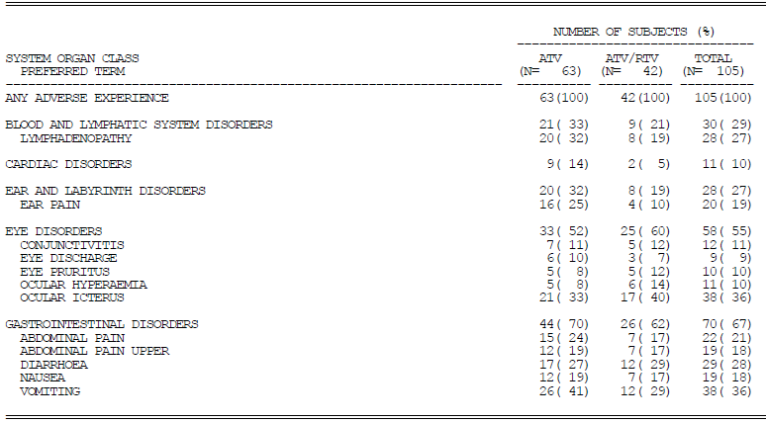

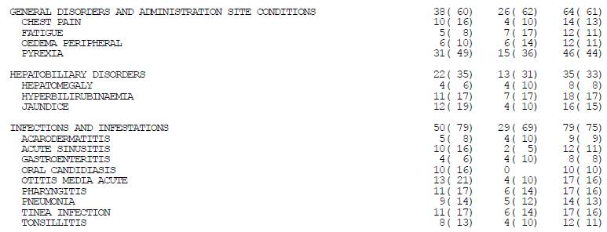

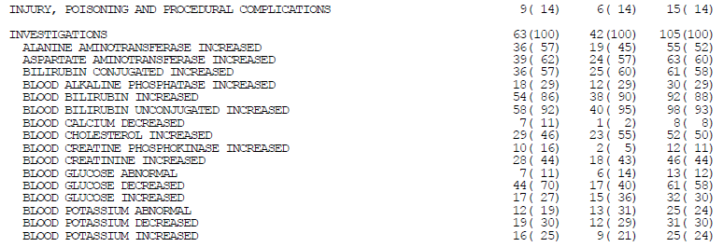

Table continued on the next page.

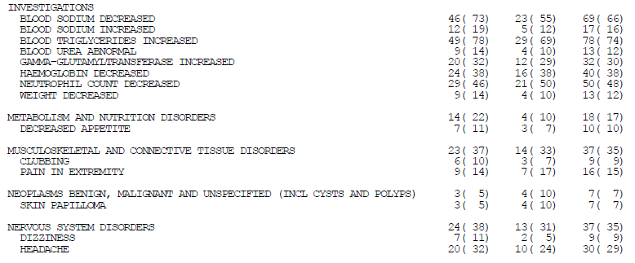

Table 15. Adverse Events (All Grades) ≥ 10%ATV Capsule Cohort Occurring 56 Days after Last Dose of Drug continued

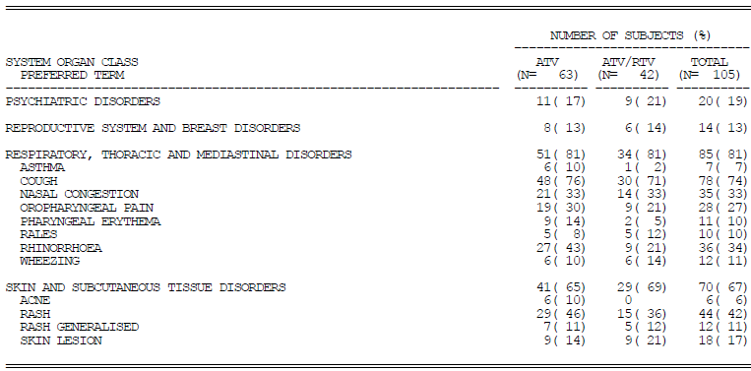

Table 16. Serious Adverse Events-ATV Capsule Cohort Occurring up to 56 Days after Last Dose of Drug

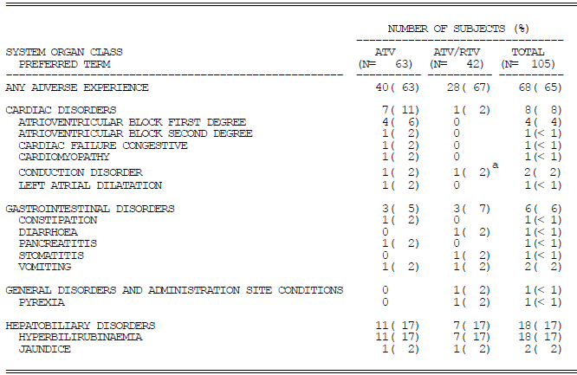

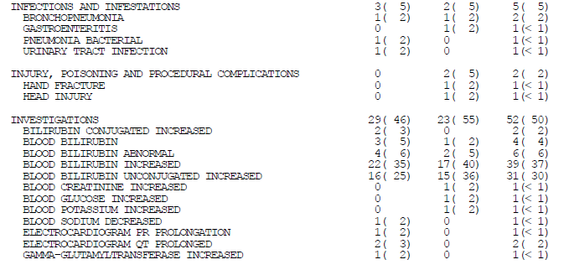

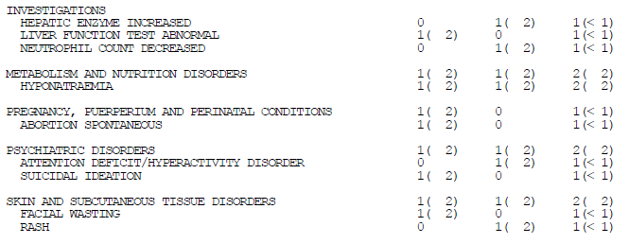

Table 16. Serious Adverse Events-ATV Capsule Cohort Occurring up to 56 Days After Last Dose of Drug

Table 17. Serious Adverse Events-ATV/RTV Capsule Recommended Dose Cohort Occurring up to 56 Days after Last Dose of Drug

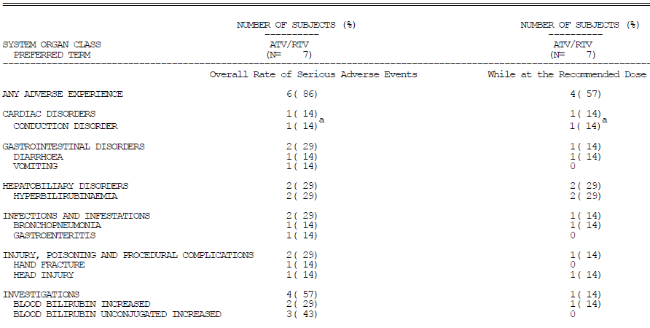

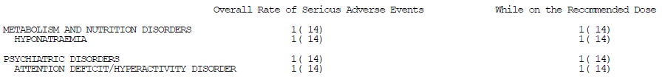

Table 17. Serious Adverse Events-ATV/RTV Capsule Recommended Dose Cohort Occurring up to 56 Days After Last Dose of Drug

#### Discontinuations

In the ATV Capsule Cohort, 18 of 105 participants (17%) discontinued study therapy due to AEs; the most common reasons related to unconjugated hyperbilirubinemia (7 participants), cardiac related events (6 participants) and rash (2 participants). No participant in the ATV/RTV recommended dose cohort discontinued study therapy due to AEs.

##### Discontinuations due to cardiac disorders

All participants listed below were treated with high dose unboosted ATV:

* A 17 year old girl treated with ATV 1,000 mg had episodes of Mobitz type 1 and Mobitz type II AV block considered related to study medication.
* A 16 year old male child treated with ATV 700 mg reduced to 600 mg developed mildly elevated first degree atrioventricular block considered related to study medication.
* A 14 year old female child treated with ATV 800 mg had HIV cardiomyopathy considered unrelated to study medication.
* A 6.3 year old girl treated with up to 900 mg daily developed asymptomatic prolonged QTc-B interval of 485 ms considered to be related to study medication.
* This 6 year old boy treated with up to 700 mg ATV developed heart rates between 54 and 149 beats/minute, isolated ventricular ectopic beats and first degree atrioventricular block with prolonged PR interval considered related to study drug.
* A 13 year old girl with interstitial lung disease, cor pulmonale and congestive cardiac failure treated with up to 700 mg ATV developed prolonged QT interval possibly related to study medication and worsening cardiac condition considered unrelated to study drug.

##### Discontinuations due to hyperbilirubinaemia

The following patients were treated with high dose unboosted ATV:

* A 6 year old girl treated with up to 800 mg had maximum reported unconjugated SBR level of 3.3 mg/dL considered possibly related.
* A17 year old girl treated with 800 mg ATV recorded unconjugated SBR 5.3 mg/dL considered related to study drug.
* This 14 year old girl treated with ATV 900 mg had maximum unconjugated SBR of 7.0 mg/dL.
* A 17 year old girl treated with 1000 mg ATV had maximum unconjugated SBR reported of 6.2 mg/dL considered study drug related.

The following patients were treated with ATV boosted with ritonavir:

* A 13 year old girl with prior history of hepatitis a and thalassemia minor treated with ATV 300 mg and ritonavir 100 mg had unconjugated SBR maximum of 6.7 mg/dL considered study drug related and erythema multiforme with no comment regarding relationship.
* A girl aged 9.6 years treated with 300 mg ATV and 100 mg ritonavir had maximum unconjugated SBR 8.7 mg/dL considered related to study drug.
* This 15 year old girl treated with 300 mg ATV and 100 mg ritonavir reduced to ATV 200 mg had maximum unconjugated SBR 7.2 mg/dL considered related to study drug.

##### Discontinuation due to rash

* A 10 year old boy treated with ATV 400 mg and ritonavir 100 mg developed unspecified rash relationship to study drug not reported.
* A 12 year old girl treated with 250 mg/m2 and ritonavir 100 mg developed erythema multiforme-like rash with angioedema and stomatitis considered possibly related to study drug.

#### Other significant adverse events

##### Hyperbilirubinemia, jaundice and ocular icterus

In the ATV Capsule Cohort, the majority of participants, including all patients on the recommended dose had Grade 2-4 adverse events of hyperbilirubinemia. Fifteen percent of participants had Grade 2-4 AEs of jaundice and/or ocular icterus. The highest reported drug related unconjugated SBR was 9.9 mg/dL. The nine year old male patient who started treatment with ATV/RTV 250/100 mg had study therapy interrupted, the dose of ATV was then lowered to 200 mg and then to 100 mg/day after which the available results ranged between 4.0 to 1.1 mg/dL.

##### Liver function abnormalities

In the ATV Capsule Cohort, 5 participants (5%) had Grade 2-4 liver function test adverse events including increased (5), AST increased (2) and liver function test abnormal (1). In the Capsule Recommended Dose Cohort, 1 participant had a Grade 2-4 AE of ALT increased while on the proposed recommended dose.

##### Cardiac disorder adverse events

In the ATV Capsule Cohort, 5 participants had Grade 2-4 Cardiac Disorders including 2 participants with first degree AV block, one each with second degree AV block, bradycardia, congestive cardiac failure and cardiomyopathy.

##### Electrocardiogram abnormalities

ECGs were not mandated by the protocol at the beginning of the study (16 November 2000); they were required with the implementation of the clarification memo to the protocol #4 (26 July 2001). In the ATV Capsule Cohort, the majority of participants had ECG abnormalities on study (Table 18). The most common abnormalities were first degree AV blocks and other ST/T morphological abnormalities. One participant had a QTcB prolongation > 480 ms; however, this participant had a prolonged QTcB interval at Screening (Table 14).

Table 18. ECG Abnormalities on Study-ATV Capsule Cohort

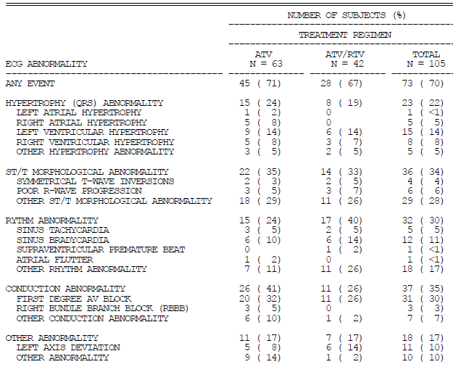

Table 19. Categories of ECG Parameters-ATV Capsule Cohort

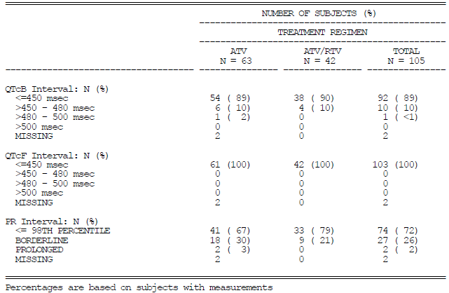

##### Rash

In the ATV Capsule Cohort, 15 participants had Grade 2-4 AEs of rash (Table 20).

Table 20. Rash (Grade 2-4)-ATV Capsule Cohort Occurring Up To 56 Days After Last Dose of Drug

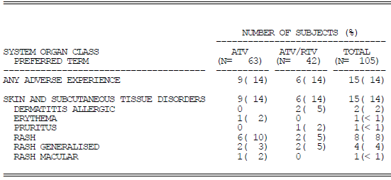

##### AIDS-related adverse events

In the ATV Capsule Cohort, the most common AIDS-related AE was oral candidiasis reported by 10 patients (Table 21).

Table 21. AIDS-related Adverse Events-ATV Capsule Cohort Occurring up to 56 Days after Last Dose of Drug

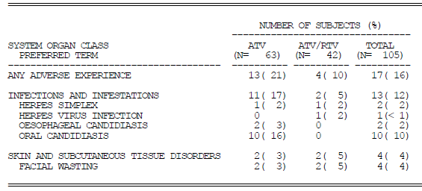

##### Pregnancy

Two pregnancies were reported. One child was aged 14 years when she gave birth at 30 weeks gestation to a baby girl with no congenital anomalies or birth defect, and at the time of database lock for the Week 48 CSR she was reported to be a healthy 2.5 year-old girl. The other child was 13 years old when noted to have a positive pregnancy test. Spontaneous abortion occurred and was reported as an SAE possibly related to study medication.

## Clinical questions

### Pharmacokinetics

#### Population pharmacokinetics

1. *Regarding CER Figures 10-15. It was requested that the applicant supply figures illustrating information for age ranges 6 to <8 years, 8 to < 13 years and 13 to 18 years. It is also requested that the applicant supplies the numerical values for the medians, 5th and 95th percentile ranges for these figures.*

Applicant response: The tables, medians and percentile ranges have not been provided for the additional requested subsets by age. At Week 1, there were only 2 individuals who were <6 years of age with observed ATV C24, Cmax and AUC; a majority of the subjects in Group 7 (2 to < 3 years of age) were between the ages of 6 and 13 years. Sub-setting into smaller age groups results in a limited number of observations for subjects 6 to < 8 years of age, which may not allow for meaningful PPC assessment. For children 6 to < 8 years of age, ≤ 6 individuals had observed ATV C24, Cmax, or AUC at Week 1, while the number of observations for subjects 8 to 13 years of age was considerably larger (N = 18 to 20 at Week 1), resulting in an unbalanced comparison of these two age group subsets.

As requested, Tables 22-27 provide the observed and predicted medians, as well as and 5th and 95th percentile ranges for Group 7 (2 to < 13 years), Group 8 (13-18 years).

Table 22. Observed and Predictive Distribution of the Geometric Mean C24 (ng/mL) in Paediatric (Week 1) and Adult Patients

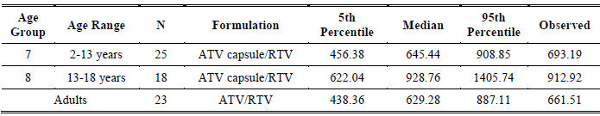

Table 23. Observed and Predictive Distribution of the Geometric Mean C24 (ng/mL) in Paediatric (Week 56) and Adult Patients

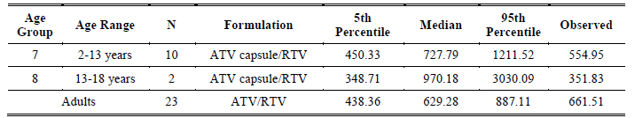

Table 24. Observed and Predictive Distribution of the Geometric Mean Cmax (ng/mL) in Paediatric (Week 1) and Adult Patients

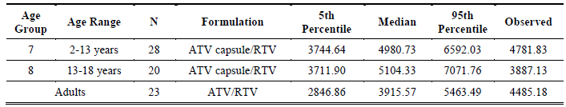

Table 25. Observed and Predictive Distribution of the Geometric Mean Cmax (ng/mL) in Paediatric (Week 56) and Adult Patients

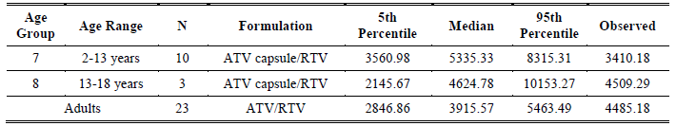

Table 26. Observed and Predictive Distribution of the Geometric Mean AUC (ng.hr/mL) in Paediatric (Week 1) and Adult Patients

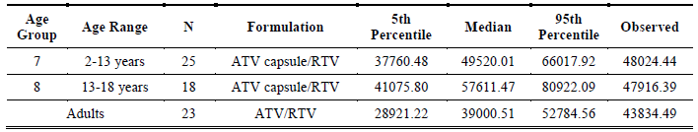

Table 27. Observed and Predictive Distribution of the Geometric Mean AUC (ng.hr/mL) in Paediatric (Week 56) and Adult Patients

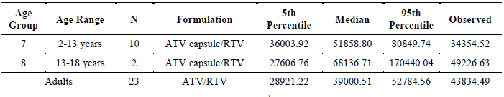

Evaluator comment: The tables compare Week 1 and Week 56 results for children with Day 29 results for adults. The paediatric age range depicted does not correspond to age ranges included in the PI. Children less than six years of age were treated with a different formulation than the older children.

There were some discrepancies between observed and predicted median results. The observed Cmin of 351.83 ng/mL at Week 56 for patients aged 13 to 18 years was just on the predicted 5th percentile and was well below 500 ng/mL. The observed Cmax at Week 1 for those aged 13 to 18 years was close to the predicted 5th percentile. The observed Cmax at Week 56 for those aged 2 to 13 years was below the predicted 5th percentile. The observed AUC at Week 56 for those age 2 to 13 years was below the predicted 5th percentile.

It is uncertain why participants dropped out of the PK component of the study. The large numbers of drop-outs may have biased results. As the numbers participating was small, particularly so for the Week 56 results for the age group 13 to 18, it is hard to generalise about the relevance of post-hoc exploratory analysis to the real population for any individual being treated, and therein lies a problem with external validity.

1. *Regarding Figure 17, it was requested that the y-axis intervals are increased to spread the data and that there are regular interval markings included on both the x- and y-axes. It is requested that the added markings on the x-axis specifically include 15 kg and 20 kg. The applicant is requested to comment on the possibility that correlation of age and weight may not be so reliable in the study population in the weight range 15 to 20 kg, and that this may potentially be problematic when using the 15 – 20 kg range in formulating dosage recommendations for the age group 6 to 8 years.*

Applicant’s response: the observed relationship between age and body weight for patients weighing 15 to < 20 kg fits well with the linear regression.

Figure 34. Relationship between Baseline Age and Body Weight for Pediatric Patients in Study AI424020

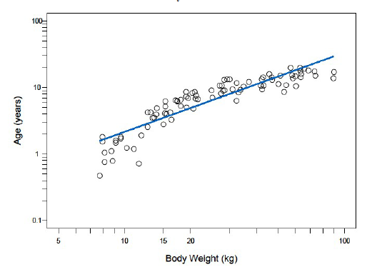

Evaluator comment: The applicant’s conclusion is agreed. The linear relationship appears to hold from about 15–60 kg, the weight range applicable to the application but is less obvious below 15 kg and above 60 kg and the slope may have been different if the results had not been included.

1. *The previous evaluator considered that the clearance by age and weight below the age of 8 became too unpredictable to warrant approval of dosage instructions for children of that age as illustrated in Figure 35 below. Can the applicant state with certainty the time point at which age becomes less of a determinant of PK results?*

Figure 35. Oral clearance per kilogram vs. Age for ATV capsule with RTV

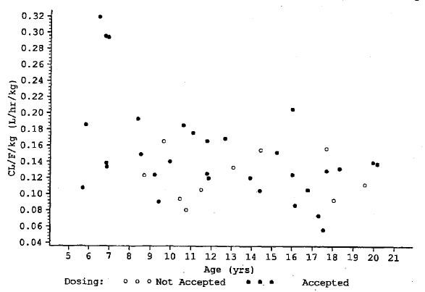

***Applicant’s response***: There was no response.

***Evaluator comment****:* The response was not satisfactory. Subsequent numbering in the sponsor’s responses versus the TGA question document reflects the absence of the applicant’s mention of this question.[8]

1. *Figures 18-20. Please give actual values for the medians, interquartile range and 5th and 95% percentiles and for adults, the 10th, 50th and 90th percentiles and indicate whether the adult parameters are based on observations or simulation.*

Applicant response: Simulation results ATV C24, Cmax, and AUCs are provided in Tables 28-30. These tables correspond to Figures 18-20, respectively. Adult exposures described below are simulated as well; however, a posterior predictive check that was performed using the final PPK model demonstrated that predicted adult exposures treated with ATV/RTV agreed very well with observed ATV exposures.

Table 28. Simulation Results for ATV C24 (ng/mL) at the Proposed Capsule Doses for Pediatric Patients Receiving ATV/RTV

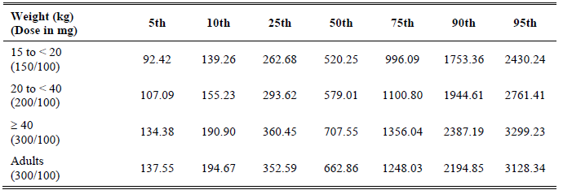

Table 29. Simulation Results for ATV Cmax (ng/mL) at the Proposed Capsule Doses for Paediatric Patients Receiving ATV/RTV

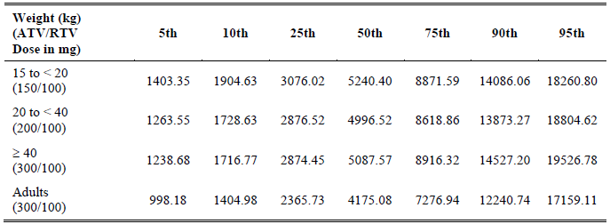

Table 30. Simulation Results for ATV AUCs (ng/mL.h) at the Proposed Capsule Doses for Paediatric Patients Receiving ATV/RTV

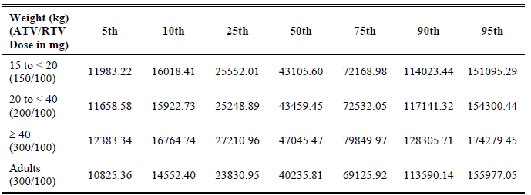

**Evaluator comment**: In the sponsor’s submission it is stated that the “refined weight band separation allows patients in both weight bands to achieve ATV geometric mean C24 levels > 500 ng/mL, and thus can be recommended for both treatment-naive and -experienced paediatric patients.” For children less than 15 kg to < 20, the 10th percentile is less than the minimum suggested target trough concentration of 150 ng/mL according to the Guidelines for the Use of Antiretroviral Agents in Pediatric HIV Infection[9]. For children 20 to < 40 kg, the 10th percentile is just on this value. As Cmin is considered and important efficacy parameter, these predicted values are considered to be a potential problem for some children even in the absence of non-compliance. The simulated Cmax values for the paediatric patients are higher than for the adults with potential for toxicity at highest percentiles.

1. *Figure 21 is hard to see and prints poorly. The sponsor is requested to supply the figure in a form in which a printed, black and white version is clear and in which there are bigger intervals on the y-axis which only needs to include values to about 150%.*

Evaluator comment:The revised figure provided is included in the CER above (Figure 21).

1. *Figures 23 and 24. It is requested that similar figures are provided with the RTV dose of 100 mg included to the y-axis. An explanation is requested as to why are there so few values for what appears to be in proximity to the 100 mg dose. Can the applicant state with certainty that the results for 100 mg are not biased by lack of data at the proposed dose of 100 mg?*

Applicant’s response: There are few values at RTV dose of 100 mg in the figures, because a majority of these subjects had a body surface area (BSA) < 1, resulting in a RTV dose < 100 mg. The revised figures showing the 100 mg dose are included in Figures 36-38.

There were no apparent trends observed for the ATV C0 and Frel parameters with regard to RTV dose. However, there does appear to be a trend between RTV dose and ATV CL/F. Upon further investigation of this relationship, the final CL/F sub-model was expanded to include RTV dose effect. The results suggest that RTV dose explains little of the RTV co medication effect after adjusting for the other covariate effects, such as body weight and dichotomous RTV co medication effect (that is, presence or absence of RTV). Taken together, the dose of RTV does not impact exposure to ATV.

Figure 36. Individual Predictions of ATV C0 versus RTV Dose in Pediatric Patients Receiving ATV/RTV

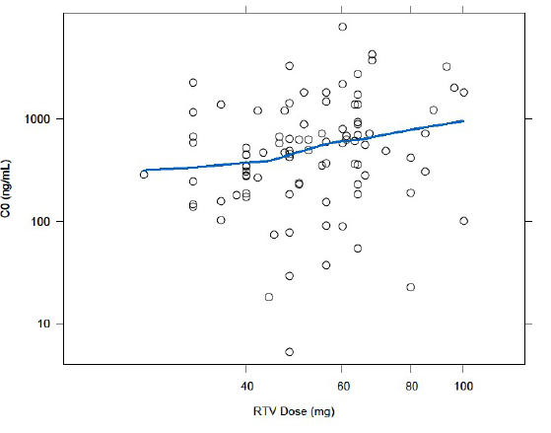

Figure 37. Individual Predictions of ATV Frel versus RTV Dose in Pediatric Patients Receiving ATV/RTV

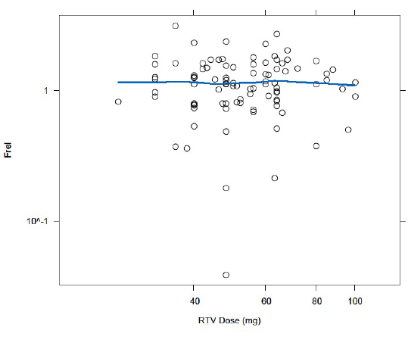

Figure 38. Individual Predictions of ATV CL/F versus RTV Dose in Pediatric Patients Receiving ATV/RTV

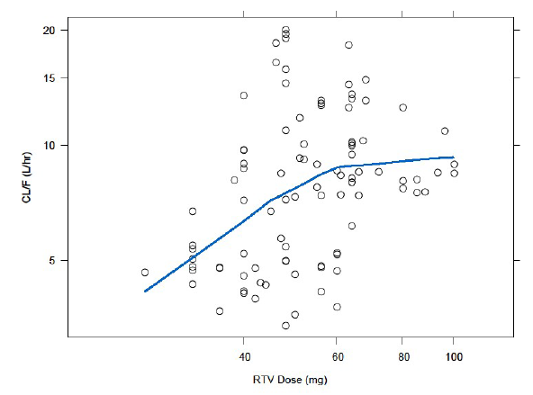

Evaluator comment: The argument is accepted as being relevant to the data analysed. The data for 100 mg is very limited. The majority of results are for doses less than 80 mg. The data analysed are not particularly relevant to the proposed dosage which will be a uniform 100 mg for children weighing as little as 15 kg. It cannot be considered certain that if patients had actually been treated with RTV 100 mg, the dichotomous effect would have been the same. Figures 31-33 inform the reader that the doses of RTV were 100 mg. This appears not be to so.

#### Pharmacokinetics study AI424020

*7. Please provide Cmax, Cmin and AUC data for patients weighing 32-40 kg administered the proposed ATV/RTV dose of 200/100 mg, including figures similar to Figures 27-28.*

Applicant’s response: ATV PK parameters (Cmax, AUC, and C24) for patients weighing ≥ 32 to <40 kg that received ATV/RTV of 200/100 mg or higher are provided in Table 31. A comparison of ATV C24 from subjects who received ATV/RTV 200/100 mg or higher for at least 24 weeks relative to the projected C24 is provided in Figure 39. Figure 40 depicts a scatter plot of ATV Cmax in subjects with body weights 32 kg to < 40 kg treated with ATV/RTV 200/100 or higher for at least 24 weeks.

Table 31. Atazanavir PK Parameters for Subjects 32 to < 40 kg that Received ATV/RTV 200/100 mg or Higher

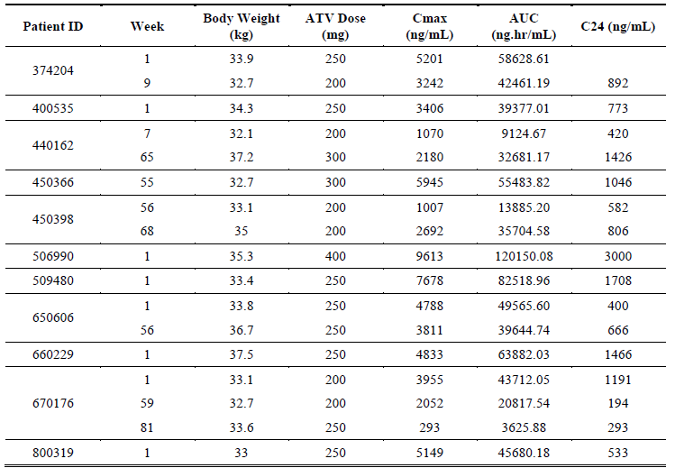

Figure 39. ATV C24 from Subjects on ATV/RTV ≥200/100 mg for ≥t 24 Weeks Relative to the Projected C24

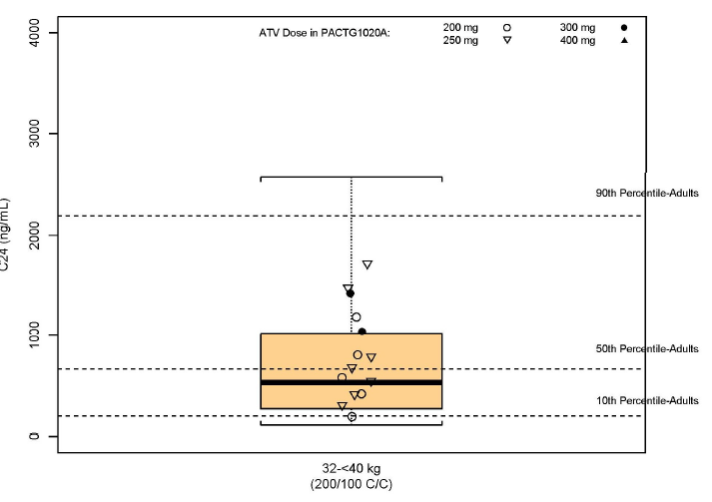

Figure 40. ATV Cmax for participants 32 kg to <40 kg Treated with ATV/RTV 200/100 for at Least 24 Weeks

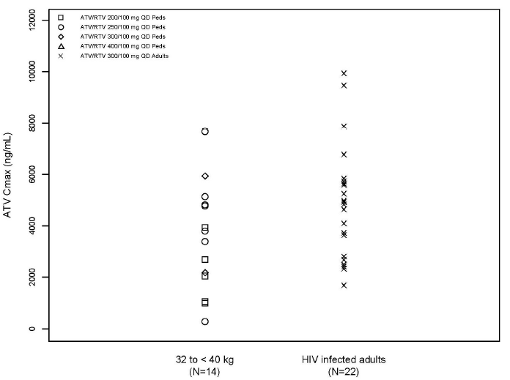

Evaluator comment:The results for the proposed dose were requested, that is, 200 mg and not greater than 200 mg. From Table 31 it is evident that only 2 of the 11 participants appeared to have PK levels on dose 200 mg that were acceptable to the investigators. The other participants needed higher doses while remaining in the same weight category. Looking at Figure 39 and Figure 40, the results appear lower than for adults and these results are preponderantly for participants on doses higher than the proposed dose. However, PK results for children weighing 25 to < 32 kg may be higher than those depicted for the range 32 to 40 kg. The results support the proposition that children between 32 and 40 kg may require ATV doses higher than 200 mg.

### Pharmacodynamics

No questions listed.

### Efficacy

#### Efficacy study AI424020

1. *What is the definition of “completion of treatment” as used in Table 7? Was there a protocol defined time at which treatment was considered complete?*

Applicant’s response: The table referenced is a disposition table that was based upon the reason for discontinuation reported by the study investigator on the case report form (CRF). The protocol specifies that the treatment duration is intended to be up to 96 weeks after the last subject is enrolled. However, since the reporting of ‘completed treatment’ was determined by the study investigator, it is possible that a study investigator may have chosen ‘completed treatment,’ as long as the individual subject reached 96 weeks.

In the US, per protocol version 6, Section 6.41, once the last accrued subject reached 96 weeks of treatment in Step I, all subjects successfully remaining on study were considered to have completed treatment, if they were taking the ATV capsule, and then came off study. If they were taking ATV powder, which is not yet available off study, then they continued on study and did not complete treatment. Additionally, and as allowed per protocol, eligible subjects in the US who switched from powder to capsule formulation after reaching at least 96 weeks of treatment were also considered as completed treatment and came off study.

Subjects in South Africa did not complete treatment per protocol and continued on study, since ATV was not yet available outside of study treatment in South Africa.

Evaluator comment: Response accepted.

1. *With respect to Table 12: Why was the VR greater at Week 96 than at Week 48 for ATV/RTV treated ARV-experienced patients? Was this likely to have been because of change of background therapy with resultant possibility of confounding?*

Applicant response: Any changes in NRTI use would not have likely contributed to any differences in efficacy. Protocol Section 5.1.2 states: “*Subjects will remain on the chosen NRTIs for the duration of the study, with the exception of NRTI-related toxicity. If a subject is experiencing toxicity believed to be related to one of the NRTIs, but not the study drug, and has completed at least 52 weeks on study, and is virologically suppressed, the site may contact the team about substituting an alternative NRTI.*”

The protocol specified that subjects who met the criteria for treatment failure could have remained in the study if the protocol chairperson, investigator, and subject (or parent/legal guardian) agreed that it was in the subject’s best interest to remain on his/her current treatment. This approach allowed patients experiencing viral rebounds due to adherence issues to stay on study while the investigator worked on improving the patient adherence issue.

According to the US Department of Health and Human Services 2011 guidelines, inadequate adherence is the most common cause of antiretroviral treatment (ART) failure. Not all instances of treatment failure require an immediate change in therapy; careful assessment, especially of adherence, is required to evaluate the aetiology of the treatment failure and determine an appropriate management strategy. If poor adherence was the cause of treatment failure and circumstances leading to poor adherence have not been adequately addressed, changing the ARV regimen may not be advisable.

Many subjects in this study had considerable prior treatment experience and compromised NRTI activity leading to slower decay in HIV RNA and increased potential for viral blips, as seen at Week 48. All subjects who were not suppressed at Week 48 but showed viral suppression at Week 96 had been virologically suppressed before Week 48 and subsequently experienced a virologic blip or rebound around Week 48 followed by re-suppression:

For ATV/RTV treated ARV-experienced subjects regarding:

###### VL < 400 c/mL:

* Eight had HIV RNA < 400 c/mL at Week 48; all of them had HIV RNA < 400 c/mL at Week 96.
* In addition, 2 more subjects had HIV RNA > 400 c/mL at Week 48 but suppressed to < 400 c/mL at Week 96.
* One was suppressed < 50 c/mL at Day 294 and had a blip (1,446 c/mL) at Week 48, followed by VL < 50 c/mL at the next visit.
* One was suppressed < 50 c/mL at Day 111 and experienced a rebound at Day 295 (203 c/mL); the subject re-suppressed to < 400 c/mL at Day 449 (85 c/mL) and to < 50 c/mL at Day 505.
* None of the 10 subjects had background therapy changes.

###### < 50 c/mL:

* Six subjects had HIV RNA < 50 c/mL at Week 48, 5 of them were also < 50 c/mL at Week 96 was no longer < 50 c/mL at Week 96.
* In addition, 3 subjects who were not < 50 c/mL at Week 48 became < 50 c/mL at Week 96, which results in 8 subjects who suppressed to < 50 c/mL at Week 96.
  + One was suppressed < 50 c/mL at Day 57 and experienced blips to 1,801 c/mL at Day 301 and 134 c/mL at Week 48; he re-suppressed to < 50 c/mL at the next visit.
  + One was suppressed < 50 c/mL at Day 113 and experienced a rebound at Day 225 (132 c/mL). His viral load at Week 48 was 327 c/mL. He re-suppressed to < 50 c/mL at Day 503.
  + One participant was suppressed < 50 c/mL at Day 111 and experienced a rebound at Day 295 (203 c/mL); the subject re-suppressed to < 400 c/mL at Day 449 (85 c/mL) and to < 50 c/mL at Day 505.
* None of the subjects had background therapy change.

Evaluator comment: Response accepted.

1. *To what extent did the lack of accurate recording of concomitant therapy affect the assessment of confounding?*

Applicant response: The statement in the CSR regarding concomitant therapy was only meant to explain that, in some cases, ARV medications that were part of the backbone therapy or were used as prior therapy (that is, not taken on study) were recorded in the concomitant therapy section erroneously. It was determined that these were errors but they could not be corrected in time for the database lock for the CSR. However, it was confirmed with the PACTG (IMPAACT) at the time, that the ARVs reported as concomitant medications should have been deleted from that part of the CRF. All other concomitant medications were required to be, and to the best of the sponsor’s knowledge were, recorded in the CRF, and are included in the CSR. An analysis of an individual subject’s efficacy results versus concomitant medications was not performed, and is not typically performed. However, the majority of concomitant medications reported to be taken most often during the study were medications that were allowed by protocol and those that do not have an interaction with ARVs (such as antibiotics) such that efficacy would be impacted. Therefore, the efficacy assessment is not considered to have been confounded in any way by the concomitant therapies.

Evaluator comment: Response accepted

1. *To what extent were efficacy results dependent on dose modification following intensive and random PK assessments over the course of 96 weeks of treatment? Does the applicant consider that PK results leading to alteration in dosage may have maximised efficacy in the study population? Would external validity be limited if therapeutic drug monitoring is not undertaken in the non-study population, particularly in view of the documented large CV% results?*

Applicant response***:*** Study AI424020 was a PK dose-finding and safety study. The sample size was not calculated statistically for an efficacy endpoint, so the efficacy results are descriptive only. The efficacy results were not at all dependent on dose modification. Instead, efficacy is correlated with exposure. The dose was individually adjusted for each subject until the subject achieved ATV exposures within the range of targeted exposures with the overall goal of maintaining the target exposure. An individual dose would not subsequently be adjusted randomly throughout the trial or due to PK variability but instead would only be modified again if, for example, a subject’s increase in BSA was enough to warrant a modification. The overall goal of the study was to find the optimal dose for use in the broader population so that individual dose adjustments would not be necessary.

This study was started prior to the knowledge that ATV required RTV ‘boosting’ when used in treatment-experienced patients. The original PK targets (for Groups 1 through 4) were based on observed PK data of unboosted ATV in adults, which are lower than those achieved with ATV boosted with RTV. The study was modified before the completion of enrolment of Groups 1-4 and before the inclusion of the boosted Groups 5-8 to raise the PK targets to those more comparable to ATV/RTV in adults.

Therefore, the efficacy data are not considered to be maximised by the individual dose modifications either due to missing the PK target or due to a change in BSA. Again, in the study, once a subject achieved the target PK, the dose was maintained until a BSA change so that the target PK exposures were sustained.

It is also important to note that the study actually included the use of unboosted ATV in treatment experienced subjects and enrolled a more treatment experienced patient population than patients who would be currently indicated for ATV/RTV treatment. For example, treatment experienced patients may have virologically failed multiple protease inhibitor regimens prior to entering the study. In current practice, boosted Reyataz is commonly used in treatment naive patients and those with less treatment experience than in the past. Thus, exposures are usually adequate with little or no need for individual drug level monitoring.

The use of therapeutic drug monitoring (TDM) in the broader population is not feasible, and is unnecessary, particularly in this patient population, for the reasons already described. The dose-finding study, along with very robust modelling and simulation analyses, provide recommended doses by weight bands to ensure that the exposures expected would be those in the range that have already demonstrated efficacy in adults.

Evaluator comment: It is understood that efficacy is related to exposure. Exposure is related to dose and the dose in the dose finding study was tailored to result in exposure in the range expected to be therapeutic based on adult studies. It is not accepted that the efficacy data are not unequivocally maximised by the individual dose modification.

TDM is feasible for the paediatric patients in Australia. The ultimate purpose of registration of a drug product is of treatment of individuals avoiding under dosing and excessive dosing. Mean PK results and the results of exploratory analysis such as modelling based on sparse data, may not apply to an individual, especially in the presence of large PK coefficients of variation. The data presented for evaluation is considered to confirm that it is not possible to find the optimal uniform dose for use in the broader population.

While it may not be necessary to have the advice to undertake TDM included in the PI; such advice is included in ARV Guidelines which reference Guidelines for Use of Antiretroviral Agents in Pediatric HIV infection and it is recommended that the reader of the PI is referred to the ARV guidelines in both the *Precautions* section and the *Dosage and Administration* section.

#### Safety

1. *In the Safety Narratives for Deaths, SAEs and AEs Leading to Study Discontinuation, why were the following events considered “life threatening”?*
   * 410179 unconjugated SBR maximum SBR 6.6 mg/dL
   * 450366 unconjugated SBR maximum SBR 8.7 mg/dL
   * 450377 unconjugated SBR maximum SBR 7.6 mg/dL
   * 502836 unconjugated SBR maximum SBR 8.3 mg/dL

Applicant response:The intensity of these events was either reported based on the grade of the laboratory abnormality or at the discretion of the investigator. All 4 of these subjects with indirect hyperbilirubinemia reported by the investigator as either ‘very severe/life-threatening’ or ‘life-threatening’ were either dose adjusted and/or had medications interrupted. None of these subjects were hospitalised, discontinued due to the event, nor had any sequelae from the indirect hyperbilirubinemia.

Evaluator comment: Response accepted.

## Summary and discussion

Bristol-Myers Squibb Australia Pty Ltd has applied to vary the dosing recommendations for the use of Reyataz (atazanavir) in HIV-infected paediatric patients, to lower the age limit from 8 years to 6 years, to lower weight restriction from 20 kg to 15 kg, and to revise dosage recommendations for children weighing between 20 and 40 kg. In addition, revision of the PI to include 96 week data from paediatric Study AI424020 is proposed.

Study AI424020 is an ongoing paediatric multicenter, open-label, uncontrolled study to determine the safety, pharmacokinetics, and optimal dose of atazanavir powder and capsules, with or without ritonavir. HIV-infected patients aged between 19 days and 21 years were assigned to treatment groups stratified by age, atazanavir formulation and co-administration of ritonavir. The study was conducted in the US and South Africa and commenced in November 2000.

The current submission focused on results for those patients from 6 to 18 years treated with the capsule formulation of atazanavir with or without ritonavir (the ATV Capsule Cohort). Treatment naive and treatment experienced patients were included. Participants had protocol mandated qualifying plasma HIV RNA of ≥ 5000 c/mL. Of the 150 patients, 52% were female and 64% were Black/Mixed and 23% were White.

A subset of seven participant in the weight categories relevant to the proposed change to the dosage and administration section of the PI, was examined, that is, children in the range 15 to <20 kg treated with ATV/RTV ≥150/ 100 mg, and in the range 20 to 25 kg treated with ATV/RTV ≥ 200/100 mg for at least 24 weeks (Capsule Recommended Dose Cohort). All seven of these participants were treatment naive, black South African children.

### Study AI424020 efficacy

The number discontinuing prior to or at Week 96 was 44/105 (42%), the most common reasons being protocol non-compliance, completion of treatment or toxicity.

In accordance with results of adult studies, virologic response at Week 96 was greater in the treatment-naive patients than the treatment-experienced patients. For patients treated with ATV with or without RTV, the overall proportions of antiretroviral naive and experienced participants with HIV RNA < 400 copies/mL at Week 96 were 21/43 (49%) and 21/62 (34%), respectively. The overall proportions with HIV RNA < 50 copies/mL at Week 96 were 20/43 (47%) and 15/62 (24%), respectively.

A similar pattern but better results were seen for virologic response-observed cases as would be expected with the smaller denominators. Proportions with HIV RNA < 400 copies/mL at Week 96 were 78% (21/27) and 66% (21/32), respectively. The overall proportions with HIV RNA < 50 copies/mL at Week 96 were 74% (20/27) and 47% (15/32), respectively. The response for treatment experience patients of 24% at Week 48 was lower than that reported in adults while the response of 32 % at Week 96 was roughly the same, acknowledging that numbers in the paediatric study were small and study designs were different.

The median increases from baseline in absolute CD4 count at 96 weeks of therapy were 335 cells/mm3 in treatment naive participants and 220 cells/mm3 in the treatment experienced patients.

### Study AI424020 safety

Adverse events were reported by all participants. The most common related to raised unconjugated bilirubin/jaundice, cough, rash and pyrexia. Two patients died before Week 48; neither death was attributed to study drug. Serious adverse events were reported by 65% of participants, the majority of which were related to hyperbilirubinaemia. The highest reported unconjugated SBR was 9.9 mg/dL (169 µmol/L). Cardiac disorders were reported as SAEs by 8% of participants. Discontinuation due to adverse event was reported for 17% of participants, the most common reasons being unconjugated hyperbilirubinaemia, cardiac related events and rash. The six participants discontinuing due to cardiac related event were all treated with high dose unboosted ATV. AIDS related events were reported by 17 (16%) of patients, the most common being oral candidiasis.

ECG abnormalities were reported for the majority of participants. The most common being first degree AV blocks and other ST/T morphological abnormalities. The only patient noted to have QTcB prolongation > 480 ms had a prolonged QTcB interval at screening which was a protocol deviation.

The pattern of adverse events appears similar to that of the adult treated population although frequency of hyperbilirubinemia and ECG changes appears greater. High ritonavir Cmax and AUC in comparison to adults treated with 100 mg ritonavir may theoretically increase the incidence of ECG PR interval prolongations. The external validity with respect to cardiac safety may have been limited by the extensive list of protocol mandated exclusions relating to pre existing cardiac disorders.

The highest reported unconjugated SBR was 9.9 mg/dL, (NR 0.1 – 1.1 mg/dL). Unconjugated SBR is neurotoxic. Human immunodeficiency virus type 1 (HIV) invades the CNS early after primary infection and disruption of blood brain barrier integrity has been reported.[10] The level of bilirubin, duration of exposure, respiratory acidosis, and metabolic acidosis, infection, drug displacement of bilirubin from binding to albumin for example, with sulphonamides, down regulation of P-glycoprotein which can result from drug use, hyperosmolality, hypoxia, ethnic and genetic variability may all act to increase the likelihood of bilirubin toxicity.[11] Each of these factors may act singly or together in a child with HIV infection. Despite the fact that many factors that might enhance neurotoxicity of unconjugated bilirubin may be relevant at times for a child with HIV, the levels reported in this study are well below those documented to cause kernicterus in full term newborns.

### Population pharmacokinetic modelling

The revised dosage recommendations are based on population pharmacokinetic modelling and simulations analysis of data from three adult studies and one paediatric Study AI424020. The paediatric study included data from 176 patients.

Adult data included full 24 hour pharmacokinetic steady-state results from 13 patients receiving 400 mg once daily ATV plus lamivudine and stavudine (Study AI424008), 27 patients receiving ATV 400 mg (15) or ATV/RTV 300/100 mg (12) in combination with lamivudine and stavudine (Study AI424089) and 11 patients treated with ATV/RTV 300/100 mg and two nucleoside reverse transcriptase inhibitors (Study AI4241374). The overall dataset included 277 participants with usable pharmacokinetic data.

A nonlinear mixed-effects compartmental model was developed to characterise the pharmacokinetics of ATV and investigate the covariate effects on ATV steady state C24, Cmax and AUC. The intrinsic covariates: body weight, age, sex, race and antiretroviral treatment naive or experience, plus the extrinsic covariates, formulation, RTV co-medication and study region were investigated. A bridging strategy was employed to determine weight-based dosing recommendations on the assumption that efficacy can be extrapolated from adults to paediatric patients using the pharmacokinetic data alone.

The model included 620 observations from adult studies and 3,319 observations from the paediatric study. Overall, 13.2% of available observations were excluded including 11.7% of the paediatric observations. The applicant considered that the exclusions would not bias the results. No observations were flagged as outliers.

In the final model, the following covariate effects were considered clinically relevant: body weight of V/F and CL/F, RTV co-medication on CL/F and Frel and formulation on Frel. Region, sex and treatment experience were not considered to have clinically significant effects.

Age effect was an important determinant for ka with increasing ka in younger patients resulting in a higher Cmax with decreasing age. Cmax appeared to sharply increase for patients less than 10 years of age. The relationship between baseline age and body weight was found to be linear in the weight range relevant to this submission.

Discrepancy in agreement between observed and predicted values was noted for the group aged 2 – 13 years for Cmax and AUC at Week 56. Discrepancy in agreement for the group aged 13–18 years for Cmax at Week 1 and Cmin at Week 56 was also noted. While these age groupings are in keeping with those suggested in the TGA adopted European Union Note for Guidance on Clinical Investigation of Medicinal Products in the Paediatric Population[12], it seems possible that the age range 2–13 year encompasses a time at which ATV and RTV metabolic handling transitions from immature to mature and it is unclear just when that may happen.

Bioequivalence in terms of C24 with conventional limits 80% to 125% was not possible. Exposures were considered similar if, for more than 75% of children, the geometric mean (GM) C24 was greater than 75% of geometric mean of adult C24 (500 ng/mL) and if, contingent on meeting the C24 criteria, the GM Cmax was < 150% of adult Cmax and paediatric AUC was within 80%–125% of adult AUC for > 75% of paediatric patients. The dosing scenarios meeting these adult similarity criteria are those proposed for the PI; however it is noted that the previously approved dose of 250 mg fitted the scenario well for children between 30 to 40 kg.

The applicant stated that based on the model predictions, at ATV doses with geometric mean C24 levels > 500 ng/mL (75% adult geometric mean C24), > 90% of patients taking the proposed doses are predicted to be able to achieve C24 > 130 ng/mL. This concentration is higher than the lower bound of C24 seen in both the lowest exposure quartile in Study AI424138, where 87% of participants achieved HIV RNA < 50 c/mL; and the second exposure quartile in Study AI424089, where 91% of patients achieved a HIV RNA < 400 c/mL and 75% achieved HIV RNA < 50 c/mL

Evaluation of ritonavir dose in the population pharmacokinetic report was summary. The final model included RTV as a simple dichotomous effect, not taking into account the actual dose. An apparent trend between ATV clearance versus RTV dose was shown, although it was not possible to tell whether the trend was fully explained by correlation between RTV dose and body weight as dosage had been based on body surface area.

The population pharmacokinetic report included clearly stated objectives, hypothesis and assumptions and the steps taken, the sequence of models tested including validation. However, population pharmacokinetic is by nature, post-hoc and exploratory, and the results are predictions or forecasts. If for some reason, the sample population results are biased, predictions may be unreliable, and in view of the small numbers of patients included in sampling, (inadvertent) bias cannot necessarily be excluded. In addition, as accepted bioequivalence levels were not possible, the applicant unilaterally revised criteria.

The reliability of the analysis results was checked by examination of predicted versus observed results and there have been discrepancies as illustrated in Figures 11-13 and Figure 15.

The importance of including covariate effects in influencing ATV exposure and informing the weight-based dose recommendations is agreed. It was determined that while age impacted clearance and distribution, weight impacted absorption. The age at which ka transitions from being a clinically relevant covariate has not been discussed but is felt to be important in view of the proposal to include children 6 to 8 years in the *Dosage and Administration* section of the PI. While age and weight correlated linearly in the sample population between 15 and 60 kg, it was noted that age 6 to 8 correlated best with weight 20 to 25 kg and weight 15 kg appeared to correlate with age 5 years in that specific population.

In the situation where a Cmin is relatively low, while a Cmax is relatively high, the proposition that administration of a lower dose, more often may be beneficial bears contemplation. The belief that once daily administration improves compliance; however this is not necessarily true as reported in a systematic review showing no significant difference between once and twice daily dosing.[13] As atazanavir has established dose related adverse effects, and the result of under dosing, particularly, with respect to Cmin, may result in lack of efficacy, it is suggested that twice daily dosing would lead to better clinical outcomes for young children and that complicated post-hoc manipulation of data, to provide rational dosing, does not necessarily result in the safest and most efficacious dosage recommendations. It appears that the problems inherent with the current dose recommendations are due to current formulation strengths.

Variability in pharmacodynamics or pharmacokinetics is considered a threat to successful drug treatment and variability is decidedly a feature of the reported pharmacokinetic results. The limited number of children contributing to observed data is considered to impede dosage verification.

The applicant has not comprehensively addressed the specific age range 6 to < 8 years, the ages not currently represented in the *Dosage and Administration* section of the PI. Concern was raised previously about the apparently unpredictable clearance/kg by age demonstrated in children less than 8 years of age. The evaluator at that time concluded that the dosage recommendation based on body weight for these young children is unlikely to result in a predictable plasma level, a matter considered potentially hazardous in view of both the non-linear kinetics and the possibility of ineffective Cmin values due to the high peak to trough ratios. The information included in the submission does not appear to support a differing opinion.

With respect to ritonavir, the chosen dose based on the clinical judgment mentioned in the application appears to be pragmatic in that 100 mg is the smallest dose available in capsule form and the capsule formulation is considered more palatable.

### Study AI424020 pharmacokinetics

The pharmacokinetic component of Study AI424020 presented in the clinical study report included individual intensive pharmacokinetic data for the 7 participants who received the proposed, revised dose or higher. Two patients provided one set of results, four patients provided 2 sets and one patient provided 3 sets of intensive pharmacokinetic sampling results.

Five patients weighing 15–25 kg on the proposed weight based regime provided data. No individual data was presented for the proposed lower dose for the weight range 25 kg to < 39 kg. Three patients aged between 6.5 to 7.1 years, weighing between 16.1 and 17.5 kg provided 4 sets of results while on the proposed dose of for children between 15 and 20 kg of ATV/RTV 150/100. One participant aged 6.7 years, weighing 18 kg was treated with ATV/RTV 250/100 after dose adjustment. The Cmin results for these children ranged between 141 ng/mL and 800 ng/mL.

In the 20 to < 25 kg weight range, two patients aged 8.9 and 9.8 years, weighing between 21.3 kg and 24.7 kg provided three sets of data while taking the proposed dose of ATV/RTV 200/100 mg, three patients between 6.9 and 7.8 years, weighing between 22 kg and 24 kg treated with previously approved dose of ATV/RTV 250/100 mg provided four sets of data and one patient aged 7.1 years weighing 22.5 kg provided one set of data while on ATV/RTV 400/100 mg with resultant Cmin 658 ng/mL; this patient had previously contributed data while on ATV/RTV 250/100 mg at which time the Cmin was 255 ng/mL.

The results presented for ritonavir in the group of seven patients demonstrated a tendency to achieve lower Cmin, higher Cmax and AUC results with Cmin than seen in adults. Although the results were presented for weight they suggest the possibility that aged based metabolic processes similar to atazanavir may be in play.

The evaluator considers that the PI should inform readers that failure of treatment may be due to insufficient dosage, not necessarily due to non-compliance, and that the high degree of PK variability has been demonstrated in clinical studies.

## Benefit-risk assessment

### Benefits

Before the advent of antiretroviral treatment, HIV infection was almost invariably fatal and disease progression causes marked suffering. The need for registration of suitable antiretroviral agents for use in children is without doubt.

Atazanavir has been studied in adults and efficacy has been shown to be related to pharmacokinetic parameters, in particular, Cmin. It is accepted that, in the presence of pharmacokinetic parameters in the accepted adult ranges efficacy would most likely be similar in children and adults.

Atazanavir has pharmacokinetic profile in adults consistent with once daily dosage which may theoretically improve compliance.

The simplified dosage regimen removing a dose change at 32 kg is considered to be easier to manage in clinical practice.

Removal of the requirement to use two different tablet strengths for the 250 mg dose may make administration errors less likely. However, no administration errors relating were reported in the Periodic Safety Update Report (PSUR) for the period 20 June 2011 to 19 June 2012.

Atazanavir has a well studied safety profile in adults.

### Risks

Atazanavir exhibits non-linear kinetics and considerable pharmacokinetic variability. Age and weight have been shown to be clinically relevant covariates; younger children tend to have lower Cmin and higher Cmax and AUCs than older children and adults. It is not clear to the evaluator just when the metabolic process becomes less sensitive to age. The numbers studied between 6 and 8 years are very limited, however, the data presented appear to suggest that maturity occurs later than the proposed 6 years.

As Cmin results tend to be lower in young children than adults, for any individual child it is not possible to guarantee adequate blood levels on the proposed doses as demonstrated by observed values for the seven patients included in the submitted CSR. Along with the risk of sub therapeutic dosing, there is a theoretical increased risk of development of viral resistance early in the child’s life if sufficient levels are not maintained. In addition, because there was no data provided for children between 32 and 40 kg on the proposed lower dose there was no confirmation that the predictions were reliable and it is considered that under dosing is a distinct possibility in that weight range.

As Cmax and AUC values tend to be higher in young children than in adults, and as adverse events such as hyperbilirubinemia and cardiac effects on PR interval are linked to higher pharmacokinetic values, young children are at potentially at greater risk. The study protocol specifically excluded children with pre existing ECG abnormalities affecting external validity of cardiac safety.

Ritonavir levels in young children appear to follow similar patterns to ATV, with a tendency to lower Cmin and much higher Cmax and AUC than for adults. RTV also has potential effect on ECG PR interval and combined with ATV the effect theoretically may be compounded.

### Balance

The risk/benefit balance for atazanavir overall was considered to remain on the side of benefit providing therapeutic levels of the drug are assured.

## Conclusions

While the results of population pharmacokinetic evaluation are in keeping with generally adequate blood levels in the proposed weight categories, the results from actual patients have not proved conclusively supportive. The metabolic handling of atazanavir in the age range 6–8 years has not been sufficiently argued to allow revision of the previous opinion regarding this age group. The revised lower dose in the weight range 32–39 kg range has also not been supported with results from actual patients, and for this group, roughly corresponding to age 8 to 14 years, under dosing is seen as a possibility, particularly for the older patients.

The proposed increase in ritonavir dose for patients from 15 to 25 kg has also not been persuasively argued. For a child weighing 15 kg, on a mg/kg basis, the proposed dose approaches the therapeutic dose of 600 mg for an adult weighing 70 kg.

The revised doses cannot be recommended unless it is made clear in the *Precautions* and *Dosage and Administration* sections of the PI that young children have wide variability in metabolic handling of both atazanavir and ritonavir, and that they are at particular risk of lower Cmin and higher Cmax. To this effect it is recommended that at the minimum, the advice is included in the PI to refer to Australian Commentary to the [USA Guidelines for the use of Antiretroviral Agents in HIV-1 Infected Adults and Adolescents](http://aidsinfo.nih.gov/Guidelines/GuidelineDetail.aspx?MenuItem=Guidelines&Search=Off&GuidelineID=7&ClassID=1) which in turn, links to Guidelines for the Use of Antiretroviral Agents in Pediatric HIV Infection. The most appropriate advice, however, is considered to be to instigate treatment with the aid of therapeutic dose monitoring and to repeat TDM at each dose change. This is highly recommended as HIV infection is potentially life threatening, and because young children will have to manage this disease life-long. Thus, it is essential to maximise compliance by limiting side effects and maximise efficacy and reduce resistance by ensuring adequate exposure.

### Recommendation regarding authorisation

The proposed changes were recommended with qualifications regarding the results included in the draft PI.

## References

Nil listed.

1. AGE = 0.138 × BWT1.19
2. Based on the Australasian Paediatric Endocrine Group growth charts for the local population. <<http://www.apeg.org.au/ClinicalResourcesLinks/GrowthGrowthCharts/tabid/101/Default.aspx>>
3. Cmin= plasma concentration 24 hours post-dose
4. <<http://arv.ashm.org.au/arv-guidelines/management-of-the-treatment-experienced-patient/exposure-response-relationship-and-therapeutic-drug-monitoring-tdm-for-antiretroviral-agents>>
5. The following schematic diagram shows the cardiac action potential from an ECG recording and the various intervals (including PR) measured. 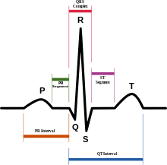
6. EA Eugenin et al. Human Immunodeficiency Virus Infection of Human Astrocytes Disrupts Blood-Brain Barrier Integrity by a Gap Junction-Dependent Mechanism. The Journal of Neuroscience, June 29, 2011 • 31(26):9456 -9465
7. QTc: The QT interval is a measure of the time between the start of the Q wave and the end of the T wave in the heart's electrical cycle. A prolonged QT interval is a risk factor for ventricular tachyarrhythmias and sudden death. It is dependent on the [heart rate](http://www.answers.com/topic/heart-rate) (the faster the heart rate, the shorter the QT interval). To correct for changes in heart rate and thereby improve the detection of patients at increased risk of ventricular arrhythmia, a heart rate-corrected QT interval *QTc* is often calculated.
8. Sponsor comment: ”A response to this question was provided in the sponsor’s response to the TGA’s *Question 2 Population Pharmacokinetics*.”
9. <<http://aidsinfo.nih.gov/guidelines/html/2/pediatric-treatment-guidelines/108/role-of-therapeutic-drug-monitoring-in-management-of-treatment-failure>>
10. Eugenin EA, Clements JE, Zink MC and Berman JW. Human immunodeficiency virus infection of human astrocytes disrupts blood-brain barrier integrity by a gap Junction-dependent mechanism. The Journal of Neuroscience, June 29, 2011; 31(26): 9456 - 9465
11. Hansen TWR. Mechanisms of bilirubin toxicity; clinical implications. Clin Perinatol 29 (2002) 765 - 778
12. CPMP/ICH/2711-99: <<http://www.tga.gov.au/pdf/euguide/ich271199en.pdf>>
13. [Claxton AJ](http://www.ncbi.nlm.nih.gov/pubmed?term=Claxton%20AJ%5BAuthor%5D&cauthor=true&cauthor_uid=11558866), [Cramer J](http://www.ncbi.nlm.nih.gov/pubmed?term=Cramer%20J%5BAuthor%5D&cauthor=true&cauthor_uid=11558866), [Pierce C](http://www.ncbi.nlm.nih.gov/pubmed?term=Pierce%20C%5BAuthor%5D&cauthor=true&cauthor_uid=11558866). A systematic review of the associations between dose regimens and medication compliance. [Clin Ther.](http://www.ncbi.nlm.nih.gov/pubmed/11558866) 2001 Aug;23(8):1296-310