January 2019

Australian Public Assessment Report for Avelumab
  - Proprietary Product Name: Bavencio
  - Sponsor: Merck Serono Australia Pty Ltd

About the Therapeutic Goods Administration (TGA)
- The Therapeutic Goods Administration (TGA) is part of the Australian Government Department of Health and is responsible for regulating medicines and medical devices.
- The TGA administers the Therapeutic Goods Act 1989 (the Act), applying a risk management approach designed to ensure therapeutic goods supplied in Australia meet acceptable standards of quality, safety and efficacy (performance) when necessary.
- The work of the TGA is based on applying scientific and clinical expertise to decision-making, to ensure that the benefits to consumers outweigh any risks associated with the use of medicines and medical devices.
- The TGA relies on the public, healthcare professionals and industry to report problems with medicines or medical devices. TGA investigates reports received by it to determine any necessary regulatory action.
- To report a problem with a medicine or medical device, please see the information on the TGA website <https://www.tga.gov.au>.
About AusPARs
- An Australian Public Assessment Report (AusPAR) provides information about the evaluation of a prescription medicine and the considerations that led the TGA to approve or not approve a prescription medicine submission.
- AusPARs are prepared and published by the TGA.
- An AusPAR is prepared for submissions that relate to new chemical entities, generic medicines, major variations and extensions of indications.
- An AusPAR is a static document; it provides information that relates to a submission at a particular point in time.
- A new AusPAR will be developed to reflect changes to indications and/or major variations to a prescription medicine subject to evaluation by the TGA.
Copyright
© Commonwealth of Australia 2019
This work is copyright. You may reproduce the whole or part of this work in unaltered form for your own personal use or, if you are part of an organisation, for internal use within your organisation, but only if you or your organisation do not use the reproduction for any commercial purpose and retain this copyright notice and all disclaimer notices as part of that reproduction. Apart from rights to use as permitted by the Copyright Act 1968 or allowed by this copyright notice, all other rights are reserved and you are not allowed to reproduce the whole or any part of this work in any way (electronic or otherwise) without first being given specific written permission from the Commonwealth to do so. Requests and inquiries concerning reproduction and rights are to be sent to the TGA Copyright Officer, Therapeutic Goods Administration, PO Box 100, Woden ACT 2606 or emailed to < tga.copyright@tga.gov.au> .

Contents
Common abbreviations 5
I. Introduction to product submission 8
Submission details 8
Product background 9
Regulatory status 9
Product Information 10
II. Registration time line 10
III. Quality findings 11
Introduction 11
Drug substance (active ingredient) 11
Drug product 13
Biopharmaceutics 13
Quality summary and conclusions 13
IV. Nonclinical findings 14
Introduction 14
Pharmacology 14
Pharmacokinetics 16
Toxicology 17
Nonclinical summary and conclusions 20
V. Clinical findings 20
Introduction 20
Pharmacokinetics 24
Pharmacodynamics 25
Dosage selection for the pivotal studies 25
Efficacy 26
Safety 28
First round benefit-risk assessment 37
First round recommendation regarding authorisation 38
Clinical questions 39
Second round evaluation 39
Second round benefit-risk assessment 40
VI. Pharmacovigilance findings 40
Risk management plan 40
VII. Overall conclusion and risk/benefit assessment 42
Background 42
Clinical 43
Risk management plan 47
Risk-benefit analysis 48
Outcome 52
Attachment 1. Product Information 53

Common abbreviations
Abbreviation | Meaning
~ | Approximately
AE | Adverse Event
ADCC | Antibody dependent cell mediated cytotoxicity
AJCC | American Joint Committee on Cancer
ALT | Alanine Transaminase
APCs | Antigen presenting cells
AST | Aspartate Transaminase
AUC | Area under the curve
BMI | Body mass index
BOR | Best overall response
CHO | Chinese hamster ovary
CI | Confidence interval
C_{max} | Maximum concentration
DOR | Duration of response
ECG | Electrocardiograph
ECOG | Eastern Cooperative Oncology Group
EMA | European Medicines Agency
ESMO | European Society for Medical Oncology
FDA | Food and Drug Administration
GLP | Good Laboratory Practice
HAHA | Human anti-human antibodies (that is anti-avelumab antibodies)
IL 6 | Interleukin 6
irAEs | Immune related adverse events
IRR | Infusion-related reactions
IV | Intravenous
KM | Kaplan Meier
L | Litre(s)
LFTs | Liver function tests
MCC | Merkel cell carcinoma
MCV | Merkel cell polyomavirus
mMCC | Metastatic Merkel cell carcinoma
NK | Natural killer
ORR | Objective response rate
OS | Overall survival
PBMC | Peripheral blood mononuclear cells
PD-1 | Programmed death-1
PD-L1 | Programmed cell death ligand 1
PFS | Progression free survival
PI | Product Information
PK | Pharmacokinetics
PR | Partial response
QoL | Quality of life
RECIST | Response evaluation criteria in solid tumours
SAE | Serious adverse event
SCLC | Small cell lung cancer
SD | Stable Disease
T4 | Thyroxine
TGA | Therapeutic Goods Administration
TNF-α | Tumour necrosis factor-alpha
TSH | Thyroid stimulating hormone
TTP | Time to progression
ULN | Upper limit of normal

I. Introduction to product submission

Submission details
Type of submission: | New biological entity
Decision: | Approved
Date of decision: | 2 January 2018
Date of entry onto ARTG: | 3 January 2018
ARTG number: | 282729
Black Triangle Scheme | Yes  This product will remain in the scheme for 5 years, starting on the date the product is first supplied in Australia.

Active ingredient: | Avelumab
Product name: | Bavencio
Sponsor’s name and address: | Merck Serono Australia Pty Ltd  Units 3-4/ 25 Frenchs Forest Road East  Frenchs Forest  NSW 2086
Dose form: | Injection, concentrated
Strength: | 200 mg/ 10 mL
Container: | Vial
Pack size: | 1
Approved therapeutic use: | Bavencio is indicated for the treatment of adults and paediatric patients 12 years and older with metastatic Merkel Cell Carcinoma (mMCC).  This indication is approved based on tumour response rate, duration of response in a single arm study.
Route of administration: | Intravenous infusion
Dosage:
  The dose is 10 mg/kg body weight administered intravenously (IV) over 60 minutes once every 2 weeks. Treatment is to continue until disease progression or unacceptable toxicity occurs.

Product background
This AusPAR describes the application by Merck Serono Australia Pty Ltd (the sponsor) to register Bavencio for the following indication:
Bavencio is indicated for the treatment of patients with metastatic Merkel Cell Carcinoma (mMCC) whose disease has progressed after receiving at least one prior therapy.
Merkel cell carcinoma (MCC) is a skin malignancy, believed to originate in the Merkel cell, a neuroendocrine cell located in the basal layer of the epidermis. Known causative factors for MCC are the Merkel cell polyomavirus (MCV) and exposure to ultra violet (UV) radiation. Approximately 80% of MCC tumours are positive for clonally integrated MCV. Immunosuppressed subjects are at an increased risk of developing the disease and incidence is increased in men compared to women, in white subjects and in the elderly. The prognosis for patients with metastatic disease is poor with an estimated 5 year survival of only 13.5%.¹
There are no established or approved therapies for the treatment of metastatic MCC. The current guidelines suggest the use of cisplatin or carboplatin with or without etoposide. Alternative recommended treatments include topotecan or combination therapy with cyclophosphamide, doxorubicin and vincristine (CAV).
Avelumab (Bavencio) is a monoclonal antibody directed against the programmed cell death ligand 1 (PD-L1).) PD-L1 is a transmembrane protein that functions to suppress T cell activation through engagement of the PD-1 (programmed death 1) receptor present on the surface of activated T cells. The overexpression of PD-L1 in tumours and in the tumour microenvironment has been shown to correlate with disease progression, invasiveness, and poor prognosis in cancer patients. By binding PD-L1, avelumab is intended to block the ligand’s interaction with PD-1, removing the suppressive effect, and restoring cytotoxic/anti-tumour T cell responses.

Regulatory status
The product received initial registration on the Australian Register of Therapeutic Goods (ARTG) on 3 January 2018.
At the time the TGA considered this application; a similar application had been approved or was under consideration in the countries as detailed in Table 1.
Table 1: International regulatory status
Country | Submission date and status | Indications
USA | BLA 23 September 2016  Approved 23 March 2017  Accelerated approval with a confirmatory trial requirement | Indicated for the treatment of adults and pediatric patients 12 years and older with metastatic Merkel cell carcinoma (MCC).  This indication is approved under accelerated approval based on tumor response and duration of response. Continued approval for this indication may be contingent upon verification and description of clinical benefit in confirmatory trials
Switzerland | 30 November 2016  Approved 5 September 2017 | Indicated for the treatment of patients with metastatic Merkel Cell Carcinoma (metastatic MCC) whose disease has progressed after receiving at least one prior chemotherapy regimen.
EU centralised procedure | 6 October 2016  Approved 18 September 2017 | Indicated as monotherapy for the treatment of adult patients with metastatic Merkel cell carcinoma (MCC).
Japan | 7 March 2017  Approved 27 September 2017 | Curatively unresectable Merkel cell carcinoma
Canada | 23 March 2017  Under consideration | Indicated for the treatment of metastatic Merkel Cell Carcinoma (MCC) in previously treated adults.

Product Information
The Product Information (PI) approved with the submission which is described in this AusPAR can be found as Attachment 1. For the most recent PI, please refer to the TGA website at <https://www.tga.gov.au/product-information-pi>.

II. Registration time line
The following table captures the key steps and dates for this application and which are detailed and discussed in this AusPAR and Attachment 2.
Table 2: Timeline for Submission PM-2016-03575-1-4
Description | Date
Submission dossier accepted and first round evaluation commenced | 3 January 2017
First round evaluation completed | 15 June 2017
Sponsor provides responses on questions raised in first round evaluation | 16 August 2017
Second round evaluation completed | 15 September 2017
Delegate’s Overall benefit-risk assessment | 27 October 2017
Sponsor’s response | 10 November 2017
Advisory Committee meeting | Submission was not taken to ACM
Registration decision (Outcome) | 2 January 2018
Completion of administrative activities and registration on ARTG | 3 January 2018
Number of working days from submission dossier acceptance to registration decision* | 218
*Statutory timeframe for standard applications is 255 working days
Evaluations included under Quality findings and Nonclinical findings incorporate both the first and second round evaluations.

III. Quality findings

Introduction
Avelumab (rch) is a fully human IgG1 monoclonal antibody produced from Chinese hamster ovary (CHO) cells directed against programmed death ligand 1 (PD-L1). Avelumab is proposed for the treatment of patients with metastatic MCC whose disease has progressed after receiving at least one prior therapy.

Drug substance (active ingredient)

Structure
Avelumab is a fully humanised monoclonal antibody produced in CHO cells. It is based on a human IgG₁ framework consisting of two heavy chains of 450 amino acid residues each and two light chains of 216 amino acid residues each with typical IgG₁ inter and intra chain disulfide bonds. The molecular mass of intact avelumab calculated based on the amino acid composition and predicted disulfide bonds without glycans is 143,832 Daltons (Da), the mass including glycans is approximately 147,000 Da. The avelumab light and heavy chain, showing the intra chain disulfide bonds, is represented in Figure 1, respectively. The molecular formula is for the light chain single subunit (C₉₉₃H₁₅₄₇N₂₆₉O₃₃₅S₆) and for the heavy chain (C₂₁₉₄H₃₄₁₈N₅₇₈O₆₇₀S₁₆). The total molecular formula for the heterodimer with disulfide bonds is C6374+H9898+N1694+O2010+S44.
Figure 1: Schematic representation of the structure of avelumab (a) and schematic representation of the higher order structure of avelumab (b)
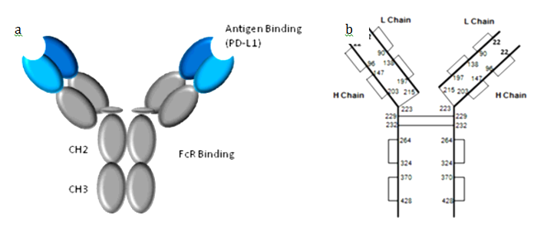
Avelumab has primarily a β-sheet structure, consistent with the structure of an IgG₁ antibody. The intra chain and inter chain disulfide bonds have also been confirmed (as shown in Figure 1b). The molecule contains one N-glycosylation site on Asn-300 of the heavy chain. The main N-glycan structures identified are complex, biantennary type core fucosylated oligosaccarides with zero, one, or two galactose residues.

Biological properties
Avelumab inhibits the interaction between PD-L1 and its receptors PD-1 and B7.1. This interaction removes the suppressive effects of PD-L1 on anti-tumour CD8+ T cells, resulting in the restoration of cytotoxic T cell response.
Biological activity is evaluated through:
- A cell based assay able to measure its capability to bind the PD-L1 receptor over-expressed on the recombinant HEK-293 (hPD-L1) cell line.
- The antibody dependent cell mediated cytotoxicity (ADCC); which confirmed the action of avelumab by in vitro testing using whole peripheral blood mononuclear cell (PBMC) or natural killer (NK) cells as effectors.

Manufacture
Avelumab is produced in a fed-batch mode using a CHO cell line. The starting material is the working cell bank, which is derived from the master cell bank. The cell culture process consists of two major steps: a cell expansion step and a production bioreactor step. The standard procedure is to process one batch of harvested cell culture fluid to produce a single batch of avelumab drug substance in one purification process. One purification run is defined as one drug substance batch.
The avelumab purification process consists of three chromatography steps and two additional steps for removal and inactivation of potential adventitious viral contaminants. There are no materials of animal origin used in the avelumab purification process.
All manufacturing steps are validated.
All outstanding GMP clearances will need to be issued before Delegate’s decision.

Drug product
Avelumab drug product is a sterilised, clear concentrate for solution for infusion presented at the concentration of 20 mg/mL. Vials are filled with 10.4 mL of Drug Product solution in order to allow an extractable volume of 10 mL.
The initial formulation of avelumab DP was formulated at a protein concentration of 10 mg/mL with a filling volume of 8 mL This formulation at 80 mg/vial was used throughout the early development program, for example, nonclinical studies, Phase I/II clinical trials such as Study EMR100070-001, and the part A of the Phase II metastatic MCC study (Study EMR100070-003).
To support clinical development and commercial use, an optimized formulation of avelumab at higher concentration (20 mg/mL) was designed. This formulation (current composition) is used in all Phase III clinical trials as well as in the expansion cohorts of Phase I trial (Study EMR100070-001) and part B of the Phase II metastatic MCC study (Study EMR100070-003); it is identical to the proposed marketed formulation.
The drug substance specification is applicable both at release and end of shelf-life.
All analytical procedures are validated.

Stability
The proposed shelf life is 2 years when stored at 2°C to 8°C and protected from light.
The PI indicates that ‘Bavencio does not contain a preservative. The diluted solution should be infused immediately, unless dilution has taken place in controlled and validated aseptic conditions.
If Bavencio is not used immediately, store the diluted solution of Bavencio, either:
- At room temperature and room light for up to 8 hours. This includes room temperature storage of the infusion in the infusion bag and the duration of infusion.
- At 2˚C to 8˚C (Refrigerate. Do not freeze) for up to 24 hours at the time of dilution. If refrigerated, allow the diluted solution to come to room temperature prior to administration.’
The sponsor has not submitted data to support temperature excursion.

Other quality aspects
There are no objections to the registration of this product from sterility; endotoxin, container safety and viral safety related aspects.

Biopharmaceutics
This product is administered intravenously therefore there are no biopharmaceutics data.

Quality summary and conclusions
There are no outstanding issues for quality aspects. The issues raised post the second round assessment on amino acid misincorporation and drug substance/drug product stability have been resolved. All outstanding GMP clearances will need to be issued before Delegate’s decision.
There are no objections on quality grounds to the approval of Bavencio avelumab (rch) 200 mg/10 mL concentrated solution for intravenous infusion vial.

Proposed conditions of registration
Batch release testing and compliance with Certified Product Details (CPD)
It is a condition of registration that all batches of Bavencio (avelumab) imported into/manufactured in Australia must comply with the product details and specifications approved during evaluation and detailed in the Certified Product Details (CPD).

IV. Nonclinical findings

Introduction
Merck Serono Australia Pty Ltd has applied to register a new biological entity, avelumab (Bavencio), a monoclonal antibody (IgG1) against PD-L1 (programmed death ligand 1). The product is proposed to be used for the treatment of patients with metastatic MCC whose disease has progressed after receiving at least one prior therapy. Treatment involves intravenous (IV) administration at 10 mg/kg once every two weeks, continuing until disease progression or unacceptable toxicity is encountered.

General comments
The scope of nonclinical studies conducted met the relevant TGA adopted guidelines for products of this type; and all pivotal safety related studies were good laboratory practice (GLP) compliant.
Only one nonclinical study, dealing with cytokine release, used drug material manufactured using the proposed commercial process (‘Process B’). The pivotal repeat dose toxicity study employed drug material manufactured using an earlier process (‘Process A’). Pharmacology studies were conducted with material manufactured using Process A or another earlier small scale manufacturing process. The quality evaluator advises that Process A and Process B material are not considered to be fully comparable, with differences in glycosylation, methionine oxidation and amino acid misincorporation profiles noted. The differences are not considered so major as to critically affect the validity of the extrapolation of the animal findings to humans. The use of drug material not fully representative of the proposed commercial product does mean, though, that certain aspects of safety and efficacy that are potentially affected by the manufacturing differences have not been examined in the nonclinical program; clinical studies using Process B material can cover this.

Pharmacology

Primary pharmacology
PD-L1, the target for avelumab, is a transmembrane protein that functions to suppress T cell activation through engagement of the PD-1 (programmed death 1) receptor present on the surface of activated T cells. The PD-L1/PD-1 interaction sends a strong inhibitory signal to T cells resulting in the loss of cytotoxic effector functions. The PD-1 pathway is normally involved in promoting peripheral tolerance, but may be usurped in tumours to overcome active T cell immune surveillance. The overexpression of PD-L1 in tumours and in the tumour microenvironment has been shown to correlate with disease progression, invasiveness, and poor prognosis in cancer patients. By binding PD-L1, avelumab is intended to block the ligand’s interaction with PD-1, removing the suppressive effect, and restoring cytotoxic/anti-tumour T cell responses. Avelumab was also envisaged to have anti-tumour activity through antibody dependent cell mediated cytotoxicity (ADCC); involving engagement of Fc receptors on natural killer cells and macrophages.
Avelumab was shown to bind to human PD-L1 with sub-nanomolar affinity (K_{d}, 0.7 nM). It displayed comparable affinity for the mouse and cynomolgus monkey forms of PD-L1 compared with human (K_{d} values, 0.9 and 1.1 nM, respectively), while its recognition of PD-L1 from other laboratory animal species was much poorer (its affinity for dog, rat and rabbit PD-L1 being approximately 6.5, 100 and 150 fold weaker compared with human).
In vitro in human whole blood, 50% occupancy of PD-L1 on CD3⁺ T cells was observed with avelumab at 0.122 µg/mL and > 95% occupancy at 1 µg/mL. These concentrations compare favourably with the trough concentration in patients at the proposed clinical dose (that is, 21.3 µg/mL measured 14 days after the first 10 mg/kg dose in clinical Study EMR 100070-001). Binding of PD-L1 on a variety of human tumour cell lines and HEK293 cells transfected with human, mouse and monkey PD-L1 was demonstrated. Avelumab was also shown to competitively inhibit the interaction between PD-L1 and PD-1 and between PD-L1 and its other receptor, B7.1, in cell based experiments.
In vitro in functional experiments, avelumab enhanced the activation of human and mouse primary T cells in a dose dependent manner (EC₅₀ value for human cells, 0.08 nM), and induced ADCC (but not complement mediated cytotoxicity) against two PD-L1 expressing human tumour cell lines.
Avelumab inhibited the growth of MC38 tumours (murine colon adenocarcinoma; highly expressing PD-L1) in vivo in mice, with a 70% reduction in tumour volume compared with controls observed with treatment at ~ 20 mg/kg, given IV three times over one week. Anti-tumour activity was associated with modulation of T cell phenotypes (including increased levels of splenic CD8⁺/PD-1⁺ T cells and CD8⁺ effector memory cells), and was shown to be completely dependent on CD8⁺ lymphocytes (that is, abolished with CD8⁺ T cell depletion), and also to involve ADCC (that is, significantly reduced with NK cell depletion or deglycosylation to generate an ADCC incompetent form of the antibody).
Enhanced anti-tumour activity and/or survival was demonstrated with avelumab in combination with radiation therapy, and 5-fluorouracil + oxaliplatin, in mice bearing MC38 tumours; and in combination with gemcitabine in mice bearing Panc02 tumours (murine pancreatic adenocarcinoma).
No nonclinical pharmacology study using MCC derived cells has been conducted, but efficacy against this tumour type to support the proposed indication is rationalised by the known expression of PD-L1 in MCC specimens from patients.

Secondary pharmacodynamics and cross reactivity
Supporting specificity, a precursor antibody of avelumab; containing identical variable regions to avelumab, did not bind to other members of the B7 family of immunoregulatory ligands to which PD-L1 belongs. Avelumab did not induce ADCC against PD-L1⁺ immune cells in vitro (compared with tumour cells with higher PD-L1 expression), and did not produce detectable killing of immune cell subsets (including of CD8⁺ cytotoxic T cells, crucial for efficacy) in vivo in treated monkeys.
Cytokine release studies, conducted in vitro using human and monkey whole blood and peripheral blood mononuclear cells, showed multi fold induction of various pro-inflammatory cytokines (most prominently tumour necrosis factor-alpha (TNF-α) and interleukin 6 (IL-6)), indicating the potential for a mostly mild acute phase response after dosing with avelumab. A comparative study with Process A and Process B drug material showed mostly similar results for the two drug lots, and where differences were observed, it was mostly material manufactured with the non-commercial process (A) that produced a greater cytokine response.
Immunohistochemical studies examining cross reactivity; involving a suitably comprehensive panel of tissues revealed widespread binding by avelumab across human and monkey tissues. This is mostly in accordance with the wide expression pattern known for PD-L1, but binding to mesothelium, ovarian granulosa cells, testicular interstitial cells, megakaryocytes as well as thyroid parafollicular cells in the human tissue panel is not accounted for by known PD-L1 expression. Staining of these tissue elements by avelumab may represent previously unrecognised sites of PD-L1 expression or unexpected tissue cross reactivity with another epitope(s) closely related to PD-L1.
While the tissue binding pattern for avelumab was mostly highly similar in humans and monkeys, staining of adipocytes, megakaryocytes, ovarian granulosa cells and testicular interstitial cells, seen with avelumab in human tissues, was not observed in monkey tissues. As such, the repeat dose toxicity studies conducted in monkeys may have limited capacity to identify potential toxic effects involving these particular cells/tissues.

Safety pharmacology
In lieu of dedicated studies, safety pharmacology endpoints covering the core battery of systems were examined as part of the general repeat dose toxicity studies conducted in cynomolgus monkeys. Avelumab had no significant effects on cardiovascular, respiratory and central nervous system function after single and weekly dosing at 140 mg/kg IV, yielding peak serum concentrations in monkeys at the time of monitoring 12 to 15 times higher than the clinical maximum concentration (C_{max}).

Pharmacokinetics
Exposure to avelumab after IV administration was generally dose-proportional in laboratory animal species (mice, rats and cynomolgus monkeys) and humans. Greater than dose-proportional exposure was observed at doses < 20 mg/kg in mice and monkeys, and < 3 mg/kg in humans, consistent with target occupancy not being saturated at these lower doses. Weekly dosing was associated with moderate accumulation in the 13 week monkey study; accumulation was not observed in 4 week studies in mice, rats or monkeys. The plasma/serum half-life for avelumab was long, and similar across species (~ 2.6 days in mice, ~ 4.9 days in rats, ~ 2.6 days in monkeys and ~ 4 to 6 days in humans at the clinical dose).
No distribution, metabolism, excretion or pharmacokinetic interaction studies were submitted; this is acceptable given the protein nature of the drug in accordance with ICH S6 (R1). As expected for an IgG antibody, volumes of distribution in animals were low (~ 80 mL/kg in rodents and ~ 50 mL/kg in monkeys), consistent with minimal extravascular distribution. Avelumab will be eliminated by normal protein degradation pathways for IgG molecules.

Toxicology

Acute toxicity
No single dose toxicity studies were submitted, which is considered acceptable, with relevant information on acute toxicity obtainable from other studies. The package of repeat dose studies with avelumab demonstrate a low order of acute toxicity for the drug, with no mortality or other signs of overt toxicity observed in rats and monkeys, or initially in mice, following IV administration of avelumab up to the highest dose level tested (140 mg/kg in all species).

Repeat-dose toxicity
The pivotal repeat dose toxicity study was conducted in cynomolgus monkeys and was of 13 weeks duration. Other studies were of 4 weeks duration, performed in mice, rats and monkeys. For all studies, administration was by the clinical route (IV), with dosing more frequent than proposed for humans (once weekly in animals compared with fortnightly for patients).
The cynomolgus monkey is an appropriate model for avelumab toxicity from a pharmacodynamic and pharmacokinetic perspective, and the 3 month duration of the pivotal study is consistent with the recommendation contained in ICH S9 for a pharmaceutical intended for the treatment of patients with advanced cancer.³ Rodents were not able to be used for the pivotal repeat dose toxicity study as longer dosing was found not to be feasible in mice and the rat is not an appropriate model on pharmacodynamic grounds (that is, avelumab poorly recognises the rat form of PD-L1).

Relative exposure
Animal:human exposure multiples are calculated below based on comparison of serum area under the curve (AUC) values for avelumab, adjusted for differences in dosing frequency (that is, animal values are multiplied by 2 to account for weekly compared with fortnightly dosing). The highest dose levels tested were appropriate, associated with substantial exposure multiples and/or expected saturation of pharmacology, in line with recommendations in ICH S6 (R1).³
Table 3: Relative exposure in repeat dose toxicity studies
Species | Study duration [Study no.] | Dose (mg/kg IV) | Dosing frequency | AUC_{0–t} (µg∙h/mL) | Exposure ratio#
Mouse (CD-1) | 4 weeks [RF2740] | 20 | Q7D | 21650 | 1.7
Mouse (CD-1) | 4 weeks [RF2740] | 40 | Q7D | 34300 | 2.6
Mouse (CD-1) | 4 weeks [RF2740] | 140 | Q7D | 114000 | 9
Rat (Wistar) | 4 weeks [RF3310] | 20 | Q7D | 45723 | 3.5
Rat (Wistar) | 4 weeks [RF3310] | 40 | Q7D | 95174 | 7
Rat (Wistar) | 4 weeks [RF3310] | 140 | Q7D | 304051 | 23
Monkey (Cynomolgus) | 4 weeks [R2710] | 20 | Q7D | 26400 | 2.0
Monkey (Cynomolgus) | 4 weeks [R2710] | 60 | Q7D | 115000 | 9
Monkey (Cynomolgus) | 4 weeks [R2710] | 140 | Q7D | 227000 | 17
Monkey (Cynomolgus) | 13 weeks [pivotal; RF4990] | 20 | Q7D | 33883 | 2.6
Monkey (Cynomolgus) | 13 weeks [pivotal; RF4990] | 60 | Q7D | 125674 | 10
Monkey (Cynomolgus) | 13 weeks [pivotal; RF4990] | 140 | Q7D | 330088 | 25
Human (patients) | Population PK analysis | 10 | Q14D | 26214 | –
^ = animal data are for the sexes combined, measured at the last sampling occasion; # = animal:human serum AUC_{0–t} x animal:human dosing frequency PK: pharmacokinetics
Anti-avelumab antibodies developed in some animals in the 4 week studies in mice, rats and monkeys, but were not detected in any monkey in the pivotal 13 week study (although this might reflect interference by free avelumab in the immunogenicity assay). In any case, adequate exposure was maintained.

Major findings
Treatment with avelumab was well tolerated in monkeys, with no deaths, clinical signs or effects on body weight observed up to the highest dose tested (140 mg/kg/week; relative exposure, 25). Histopathological examination revealed increased mononuclear cell infiltration across a variety of systemic tissues at all dose levels, but the effect was slight and reversed within 8 weeks. This finding is consistent with avelumab inducing a mild pro-inflammatory state, in line with the pharmacology of the drug and the physiological role of PD-L1.
In contrast to monkeys, avelumab produced mortality and clinical signs in treated mice. The timing (soon after the third or later weekly dose) and nature of these indicate they were anaphylactic reactions to foreign (that is, human) protein, supported by microscopic findings consistent with vascular immunocomplex deposition. Findings of antibody formation and anaphylaxis with avelumab in animals are not predictive of immunogenicity or hypersensitivity in humans.

Genotoxicity
No genotoxicity studies have been conducted, in accordance with ICH S6 (R1).³ As a high molecular weight protein, avelumab is not expected to interact directly with DNA or other chromosomal material.

Carcinogenicity
No carcinogenicity studies have been conducted with avelumab. This is acceptable for a protein drug to be used to treat patients with advanced cancer, in accordance with the guidelines.^{3,,}

Reproductive toxicity
No reproductive or developmental toxicity studies were submitted. The absence of studies on fertility, early embryonic development and pre/postnatal development is acceptable for a pharmaceutical intended for the treatment of patients with advanced cancer, and the drug’s potential for adverse effects on embryofetal development is able to be considered from the literature instead.
With regard to potential effects on fertility, male and female reproductive tissues were not identified as target organs for toxicity in the general repeat dose toxicity studies with avelumab. While avelumab was found not to bind to monkey ovarian granulosa cells (critical for normal follicular development) or testicular interstitial cells (Leydig cells; playing a key hormonal role to support spermatogenesis) as it did in the human tissue panel, the antibody did bind to other cell types in these organs in the monkey (that is, the testis germinal epithelium; oocytes and stromal cells, epithelium and mesothelium in the ovary).
PD-L1 is recognised to have a critical role in maintaining immune tolerance to the fetal allograft. The PD-L1 molecule is expressed at the uteroplacental interface and protects the concepti from maternal T cell mediated immunity. Blockade of the PD-L1/PD-1 pathway in mice has been shown to abrogate fetomaternal tolerance, resulting in increased fetal resorption and abortion., In a murine model of allogeneic pregnancy (CBA x B6 strains mated), maternal treatment with an antibody against mouse PD-L1 increased the incidence of fetal resorption from a spontaneous rate of 18% to 86% (doses administered from shortly after implantation up to approximately halfway through the period of organogenesis). In further experiments involving pregnant B-cell deficient mice (conducted to confirm the role of T cells in mediating these effects), the mouse anti-PD-L1 antibody caused fetal rejection in 100% of animals. Accordingly, based on its mechanism of action, avelumab can be reasonably expected to cause embryofetal lethality in pregnant patients.

Pregnancy classification
The sponsor has proposed Pregnancy Category D. This is considered appropriate given the significant risk for embryofetal lethality.

Local tolerance
Avelumab was well tolerated locally following IV administration in the general repeat dose toxicity studies. The highest strengths tested in mice and monkeys (10 and 9.33 mg/mL) are more than 3-times higher than the strength that will be administered to a 70 kg patient.

Paediatric use
Bavencio is not proposed for paediatric use. No specific juvenile animal studies were submitted. The general repeat dose toxicity program, conducted in young adult animals, showed that developing systems are not a target for toxicity by avelumab.

Comments on the nonclinical safety specification of the risk management plan
Results and conclusions drawn from the nonclinical program for avelumab detailed in the sponsor’s draft Risk Management Plan are in general concordance with those of the nonclinical evaluator.

Nonclinical summary and conclusions
- The nonclinical module contained an adequate set of studies investigating pharmacology, pharmacokinetics and toxicity, conducted in accordance with TGA-adopted guidelines applicable to biotechnology-derived pharmaceuticals;³ and to anticancer pharmaceuticals.⁷ The overall quality of the nonclinical package was high. All pivotal safety related studies were GLP compliant.
- In vitro studies established that avelumab binds to human PD-L1 with sub-nanomolar affinity, and similarly recognises the mouse and cynomolgus monkey forms of the protein. By blocking the interaction of PD-L1 with its receptors (PD-1 and B7.1), avelumab enhances T cell immune responses. Avelumab also induces ADCC, shown in vitro against two PD-L1-expressing human tumour cell lines. Anti-tumour activity, associated with T cell activation and also involving ADCC, was shown with the drug in vivo in syngeneic mouse tumour models (mouse colon adenocarcinoma and pancreatic adenocarcinoma). The primary pharmacology studies, coupled with the known expression of PD-L1 in Merkel cell carcinoma cells in humans, offer support for efficacy in the proposed patient population.
- Investigations pertaining to secondary pharmacodynamics (including the potential for ADCC against PD-L1⁺ immune cells) and safety pharmacology (covering the central nervous, cardiovascular and respiratory systems) identified no relevant concerns.
- Pharmacokinetic studies revealed a similarly long serum half-life in laboratory animal species and humans. The volume of distribution was consistent with limited extravascular distribution.
- Avelumab was seen to have a low order of acute toxicity in laboratory animal species.
- Repeat dose toxicity studies by the IV route were conducted in mice (4 weeks), rats (4 weeks) and cynomolgus monkeys (up to 13 weeks). The pivotal 3 month monkey study revealed that avelumab was well tolerated, and with findings of increased mononuclear cell infiltration across a variety of systemic tissues showing that avelumab induces a mild pro-inflammatory state.
- Consistent with relevant ICH guidelines, no genotoxicity, carcinogenicity or reproductive/ developmental toxicity studies were conducted with avelumab. Published literature identifies a critical role for PD-L1 in maternofetal tolerance; accordingly, avelumab is considered to pose a significant risk for abortion and stillbirths in a pregnant patient. Pregnancy Category D, as the sponsor proposes, is supported.¹¹ Contraceptive use during and after therapy is required.
- There are no nonclinical objections to the registration of Bavencio for the proposed indication.
The nonclinical evaluator made comments regarding the draft PI document but this is beyond the scope of the AusPAR.

V. Clinical findings
A summary of the clinical findings is presented in this section.

Introduction
Avelumab is a monoclonal antibody directed against PD-L1. The proposed indication is:
for the treatment of patients with metastatic Merkel Cell Carcinoma (metastatic MCC) whose disease has progressed after receiving at least one prior therapy.
The dose form proposed for registration is a concentrated solution for intravenous (IV) infusion containing 200 mg of avelumab in 10 mL. The concentrated solution is to be diluted in 0.9% or 0.45% sodium chloride solution prior to infusion.
The proposed dose is 10 mg/kg body weight administered IV over 60 minutes once every 2 weeks. Treatment is to continue until disease progression or unacceptable toxicity occurs.

Clinical rationale

Information on the condition being treated
Merkel cell carcinoma (MCC) is a skin malignancy, believed to originate in the Merkel cell, a neuroendocrine cell located in the basal layer of the epidermis. The function of Merkel cells has not been defined but is thought to have a role in tactile sensation.
Known causative factors for MCC are the Merkel cell polyomavirus (MCV) and exposure to ultra-violet (UV) radiation. Approximately 80% of MCC tumours are positive for clonally integrated MCV. Immunosuppressed subjects are at an increased risk of developing the disease and incidence is increased in men compared to women, in white subjects and in the elderly.¹
The primary skin lesion usually presents as a firm, painless, rapidly enlarging nodule with a red to violet colour. These lesions are most commonly located on sun exposed areas. The tumour is aggressive with metastases usually occurring in draining lymph nodes, distant skin, lung, central nervous system, bone and liver. The prognosis for patients with metastatic disease is poor with an estimated 5 year survival of only 13.5%.¹ In a retrospective study of 62 patients with metastatic MCC, median survival from the time of diagnosis of metastatic disease was 13 months.
Extent of disease is staged using the American Joint Committee on Cancer (AJCC) staging system. The most recently published AJCC system (8th edition, 2016) is summarised in Table 4, shown below. In the current application, the sponsor is only seeking approval for use of avelumab in metastatic (M1 or Stage IV) disease.
MCC is a rare disease, although as with other skin cancers, Australia has a comparatively high incidence. Between 1993 and 2010 the incidence of MCC in Queensland was estimated to be 1.6 per 100,000 of population; and between 1993 and 2007 the incidence of MCC in Western Australia was estimated to be 0.82 per 100,000 of population. Extrapolated to the entire Australian population these figures suggest an annual national incidence of approximately 200 to 400 cases.
Table 4: AJCC staging system for MCC
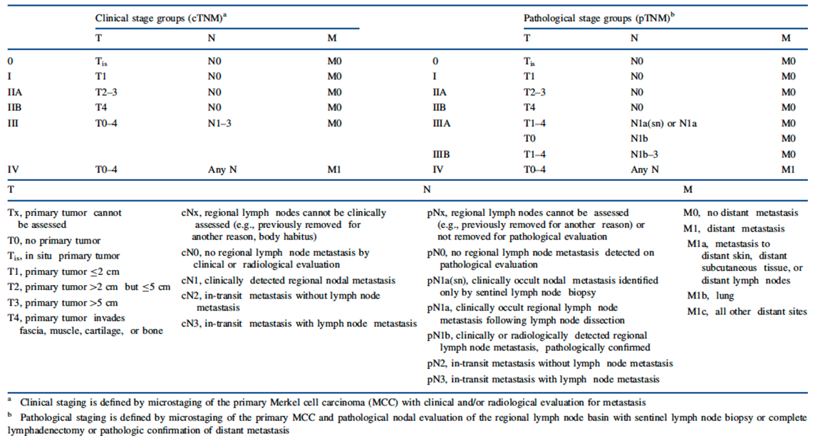

Current treatment options
For non-metastatic MCC, current clinical guidelines;, recommend the use of surgical excision and radiotherapy. There are no established or approved therapies for the treatment of metastatic MCC. The current guidelines suggest the use of cisplatin or carboplatin with or without etoposide. Alternative recommended treatments include topotecan or combination therapy with cyclophosphamide, doxorubicin and vincristine (CAV). The guidelines recommend that patients with metastatic MCC be enrolled in clinical trials.
Although cytotoxic chemotherapy can produce significant tumour responses, these tend to be of short duration. For example, in a retrospective study of 62 patients with metastatic MCC, overall response rate with first line chemotherapy was 55% but median progression free survival (PFS) was only 3 months. With second line chemotherapy, overall response rate was 23% and median PFS only 2 months.¹³

Clinical rationale
The programmed death 1 (PD-1) receptor (also known as CD279) is expressed on activated T lymphocytes. Stimulation of the PD-1 receptor results in an inhibitory effect on T cell function, and the normal function of the receptor is to limit or ‘check’ overstimulation of immune responses. Up-regulation of the PD-L1 receptor is necessary to terminate the normal immune response.
There are two known normal ligands for PD-1: PD-L1 (also known as CD274 or B7-H1) and PD-L2 (also known as CD273 or B7-DC). The PD-L1 ligand is normally expressed on antigen presenting cells (APCs) and a wide range of non- haematopoietic cells, whereas PD-L2 is expressed on dendritic cells and macrophages.¹⁹
PD-L1 is often expressed on MCC cells, or on infiltrating immune cells in the tumour microenvironment. Such expression of PD-L1 may result in inhibition of T cell mediated anti-tumour effects via the PD-1 receptor. The clinical rationale for blockade of PD-L1 with avelumab is to remove such inhibition.
Interruption of the PD-L1/PD-1 pathway with pembrolizumab, a monoclonal antibody directed against PD-1, has recently been demonstrated to be associated with a high response rate in metastatic MCC.

Guidance
The following European Medicines Agency (EMA) guidelines which have been adopted by the TGA, are considered relevant to the current submission:
- European Medicines Agency. Guideline on the evaluation of anticancer medicinal products in man. EMA/CHMP/205/95/Rev.4; (2012);
- Points to consider on application with 1. Meta-analyses; 2. One pivotal study. CPMP/EWP/2330/99 (2001).

Contents of the clinical dossier
The dossier included data from three clinical studies conducted with avelumab. These studies provided data on the pharmacokinetics, pharmacodynamics, efficacy and safety of the drug.
The following studies were submitted
- Study EMR100070-001 (‘Study 001’). This was a Phase I/IIb trial conducted in subjects with advanced solid tumours. It consisted of two phases:
  - a dose escalation phase intended to define a dose for further investigation; and
  - an expansion phase, in which subjects with advanced malignancies were enrolled in 16 separate single arm cohorts.
- Study EMR100070-002 (‘Study 002’). This was a Phase I trial conducted in Japanese subjects with advanced solid tumours. It consisted of two phases:
  - a dose escalation phase intended to define a dose for further investigation; and
  - an expansion phase, in which subjects with advanced gastric cancer were enrolled in a single arm cohort.
- Study EMR100070-003 (‘Study 003’). This was a Phase II single arm trial conducted in subjects with metastatic MCC. It was the pivotal efficacy study.
The clinical module also included the following:
- Study 100070-Obs001 which was a retrospective analysis of efficacy outcomes in subjects receiving cytotoxic chemotherapy for the treatment of metastatic MCC;
- 1 population pharmacokinetics (PopPK) analysis;
- 4 exposure-response analyses;
- Literature references.

Paediatric data
No paediatric data were included in the submission. All submitted studies excluded subjects below the age of 18 years. The sponsor has received a waiver from having to submit paediatric data from both the Food and Drug Administration (FDA) and the EMA.

Good clinical practice
For each of the clinical studies in the submission an assurance was provided that the study was conducted in accordance with the ICH guidelines for Good Clinical Practice (GCP), and the ethical principles of the World Medical Association’s Declaration of Helsinki, 2008.

Pharmacokinetics
The submission included three clinical trials of avelumab. Pharmacokinetic (PK) data were collected in all three studies, as shown in Table 5 below. The sponsor also submitted a population PK analysis combining PK data from all three studies, and a series of exposure response analyses.
Table 5: Submitted pharmacokinetic studies
PK topic | Subtopic | Study ID | *
PK in subjects with various solid tumours | General PK - Single dose and Multi-dose | Study 001 | *
PK in subjects with various solid tumours | General PK - Single dose and Multi-dose (Japanese subjects) | Study 002 | *
PK in subjects with MCC | General PK - Single dose and Multi-dose | Study 003 | *
Population PK analyses | Subjects with various solid tumours including MCC | - | *
Exposure-response analyses | Relationship between PK exposure and efficacy – overall response | - | *
Exposure-response analyses | Relationship between PK exposure and efficacy – PFS and OS | - | *
Exposure-response analyses | Relationship between PK exposure and safety – adverse events | - | *
Exposure-response analyses | Relationship between PK exposure and safety – QT interval | - | *
* Indicates the primary PK aim of the study. OS: Overall Survival
No studies were excluded from consideration in this report.

Evaluator’s conclusions on pharmacokinetics
The PK of avelumab have been adequately defined. PK parameters were generally typical of those seen with a monoclonal antibody, with a small volume of distribution and slow clearance. The half-life of avelumab (4 to 6 days) was shorter than that typically observed for monoclonal antibodies. The effects of moderate or severe hepatic impairment or severe renal impairment have not been adequately studied.

Pharmacodynamics

Studies providing pharmacodynamic data
Studies 001 and 002 generated limited pharmacodynamic data, as shown in Table 6.
Table 6: Submitted pharmacodynamic studies
PD Topic | Subtopic | Study ID
Primary Pharmacology | Effect on serum cytokines/chemokines | Study 001  Study 002
Primary Pharmacology | Effect on PD-L1 target occupancy | Study 001
None of the pharmacodynamic studies were excluded from consideration.

Evaluator’s conclusions on pharmacodynamics

Primary pharmacodynamic effects

Effect on serum cytokines/chemokines
In Studies 001 and 002, avelumab administration was associated with increases in some serum cytokines/chemokines. Generally, these increases were not marked (less than 2 fold) and were not dose dependent. In Study 002, IFN-γ and IL-6 increased approxinately 3 fold in the 10 mg/kg dose group.

Target occupancy
In Study 001, levels of PD-L1 receptor occupancy on circulating CD3+ T cells were measured. The median target occupancy at trough (prior to dosing on day 15) was 86.3% (1 mg/kg), 93.5% (3 mg/kg) 92.9% (10 mg/kg) and 89.1% (20 mg/kg). The sponsor concluded that a 3 mg/kg dose given every 14 days would be sufficient to achieve high target occupancy throughout the entire dosing period.
Target occupancy on tumour cells was not assessed. The sponsor stated that target occupancy in the tumour could be lower than that observed on peripheral cells, and that a 10 mg/kg dose would be expected to achieve higher tumour cell target occupancy.

Dosage selection for the pivotal studies
According to the protocol for the pivotal study, in vitro studies had demonstrated that target occupancy on peripheral blood CD3+ cells was at least 95% in all tested blood samples when avelumab concentrations were 1 μg/mL. In Study 001, trough concentrations were sufficient to achieve full target occupancy throughout the entire dosing interval in all of the subjects receiving the 10 mg/kg dose. After the 3 mg/kg dose, trough values were insufficient in 3 of the 13 subjects to assure full target occupancy. Therefore, the dose of 10 mg/kg every two weeks was selected as the dose for further investigation in subsequent clinical studies.

Evaluator’s conclusions on dose finding for the pivotal studies
The choice of the 10 mg/kg dose for the pivotal study was acceptable.

Efficacy

Studies providing efficacy data
There was only one study in the submission that assessed the efficacy of avelumab in metastatic MCC; Study 003. The sponsor also submitted a retrospective analysis of the efficacy of chemotherapy in metastatic MCC (Study 100070-Obs001).

Evaluator’s conclusions on efficacy
Evidence to support the efficacy of avelumab in the treatment of metastatic MCC comes from one Phase II, open, single arm trial (Study 003). The design and execution of the study was acceptable and complied with recommendations of the EMA anticancer medicines guideline;²² regarding Phase II studies.
The entry criteria for the study were generally appropriate. However, the study specifically excluded subjects with immunosuppression. Immunosuppressed patients are at increased risk of developing MCC, and approximately 8 to 10% of MCC subjects are severely immunosuppressed.¹ Given its mechanism of action, it is possible that avelumab may be ineffective in such patients. Subjects with a history of organ transplantation were also excluded, presumably due to concerns regarding an increased risk of organ rejection. It would be appropriate to include precautionary statements in the PI regarding these two populations. It should also be noted that the trial only enrolled subjects with good performance status (Eastern Cooperative Oncology Group (ECOG) PS 0 or 1) and hence efficacy has not been tested in subjects with poor performance status.
In the pivotal study, avelumab was diluted with 0.9% sodium chloride. The volume used was not stated and the sponsor should be asked to clarify. The proposed PI states that either 0.45% or 0.9% saline may be used. The use of 0.45% saline was not discussed in the clinical data of this submission but may be justifiable on pharmaceutical chemistry grounds.
The primary and secondary efficacy endpoints used in Study 003 were standard for Phase II oncology studies. The study was designed to establish a response rate of at least 20% for avelumab in metastatic MCC. Given the lack of established treatments for MCC, even in the first line setting, this aspect of the study design is considered acceptable.
The study enrolled a total of 88 subjects. Apart from the lack of immunosuppressed subjects, the study population was representative of the population of metastatic MCC subjects likely to be encountered in clinical practice in Australia.
The study demonstrated that avelumab results in an overall response rate of 31.8%. This response rate is not markedly higher than response rates observed with 2nd line chemotherapy. In Part A of Study 100070-Obs001 the estimated response rate was 28.6% and in a recently published retrospective analysis by Iyer et al, response rate was 23.3%.¹³ However, the available data from Study 003 suggest that responses produced by avelumab in metastatic MCC are longer-lasting. In Study 100070-Obs001 median duration of response was less than 2 months. In the retrospective analysis by Iyer et al., median duration of response was 3.3 months (101 days).¹³
In Study 003, the median duration of response had not been reached, however the minimum duration of response observed was 2.8 months and the lower 95% confidence interval (CI) for the median was estimated to be 8.3 months. 27 of the 28 responses were still ongoing 6 months after the commencement of treatment. At the time of data cut-off, 19 of the 28 responses had lasted for at least 6 months. Although cross-trial comparisons may be unreliable, it is reasonable to conclude that avelumab is associated with more durable responses than second line chemotherapy. The primary analysis of Study 003 was conducted after all subjects had completed at least 6 months of follow-up. A further analysis was to occur after all subjects had completed 12 months of follow-up. The results of this analysis should be sought from the sponsor.
Responses only occurred in approximately one third of treated subjects. Subgroup analyses indicated that response rates were higher (~ 50%) in subjects with PD-L1 expression on tumour cells (Table 7). Restriction of avelumab to subjects with tumours that express PD-L1 might enhance the overall efficacy profile of the drug. However, it appears that PD-L1 expression in Study 003 was determined using an assay that is not commercially available, and it cannot be assumed that commercially available immunohistochemistry (IHC) assays would produce the same results. In addition, a response rate of approximately 20% was observed in subjects with PD-L1 negative tumours. In a condition with no established therapies and a life expectancy of less than 6 months, this level of efficacy is still clinically meaningful.
Table 7: Study 003. Objective response rate (ORR) in PD-L1 expression subgroups
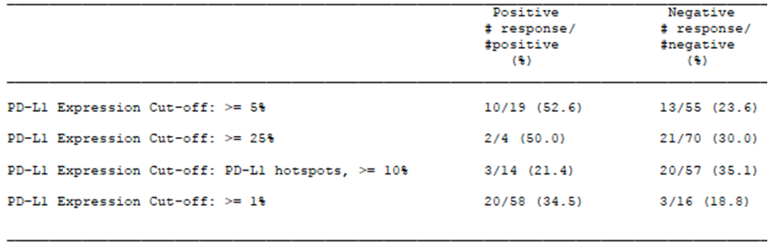
Quality of life (QoL) measures were used as exploratory endpoints in the study. The overall results suggest that avelumab has no clinically significant effect on these measures.
The EMA guideline on anticancer agents;²² generally requires randomised, comparative Phase III studies for regulatory approval of new anticancer drugs. As an attachment to the covering letter for the submission the sponsor included a justification basing the submission on a single arm non-comparative study. The arguments put forward were the following:
- metastatic MCC is a very rare condition;
- metastatic MCC is a serious, life threatening condition;
- there are no approved therapies for the treatment of metastatic MCC. Although the disease has been shown to be sensitive to cytotoxic chemotherapy, responses are generally of short duration and chemotherapy has not been shown to produce improvements in overall survival. There is therefore an unmet medical need for treatments for the condition;
- Study 003 establishes a favourable benefit-risk balance for avelumab in the treatment of metastatic MCC (this claim is assessed in the benefit risk assessment section below); and
- comparable regulatory authorities (US Food and Drug Administration (FDA), EMA) have advised the sponsor that approval on the basis of Study 003 is possible, provided that the efficacy data were convincing and a favourable benefit-risk balance is established.
The sponsor’s arguments for basing regulatory approval on Phase II, non-comparative data are acceptable in principle. It is noted that the TGA has in the past approved other agents on the basis of Phase II, non-comparative data in situations where a life threatening disease is rare and/or established treatments are not available.
The submission is based on a single pivotal study and the TGA has adopted an EMA guideline that deals with this situation.²² This guideline sets out certain ‘prerequisites’ that must be met for approval of such a submission. These are:
- The study must have internal validity, with no indications of potential bias
- The study must have external validity, with the population studied being suitable to allow extrapolation of data to the population to be treated
- The size of the efficacy benefit must be large enough to be considered clinically valuable
- The degree of statistical significance should be ‘considerably stronger’ than p < 0.05, and confidence intervals should be narrow
- The data should be of acceptable quality
- There should be internal consistency, with similar effects in sub-populations and important endpoints showing similar findings
- Results should not differ notably between study centres
- The hypothesis being tested should be plausible.
Overall it is considered that these prerequisites have been met.

Safety

Studies providing safety data
As indicated above, three clinical trials were included in the submission. Evaluable safety data were available as follows:
- Study 003; 88 subjects with metastatic MCC
- Study 001 (dose escalation phase); 53 subjects with various solid tumours
- Study 001 (expansion phase); 1,437 subjects with various solid tumours
- Study 002 (dose escalation phase); 17 Japanese subjects with various solid tumours
- Study 002 (expansion phase); 34 Japanese subjects with gastric cancer.
The sponsor presented an integrated analysis of safety data on a total of 1,540 subjects from the following studies:
- Study 003; 88 subjects
- Study 001 (dose escalation phase); 15 subjects who were treated with 10 mg/kg
- Study 001 (expansion phase); 1,437 subjects.
All subjects included in the pooled analysis had been treated with 10 mg/kg every 2 weeks. Review of the safety data for this evaluation will focus on the pooled analysis.

Patient exposure
A total of 1,629 subjects were treated with at least one dose of avelumab in the submitted studies, as shown in Table 8.
Table 8: Exposure to avelumab in clinical studies
Study | Study phase | Total; Avelumab
Study 001 | Dose escalation phase | 53
Study 001 | Expansion phase | 1437
Study 002 | Dose escalation phase | 17
Study 002 | Expansion phase | 34
Study 003 | - | 88
TOTAL |  | 1629

Safety issues with the potential for major regulatory impact

Liver function and liver toxicity

Integrated safety analysis
A total of four cases of auto-immune hepatitis were reported, two of which were fatal.
Abnormalities of liver function tests were common, as summarised in Table 9.
Table 9: Integrated safety analysis; Abnormal liver function tests (LFT)
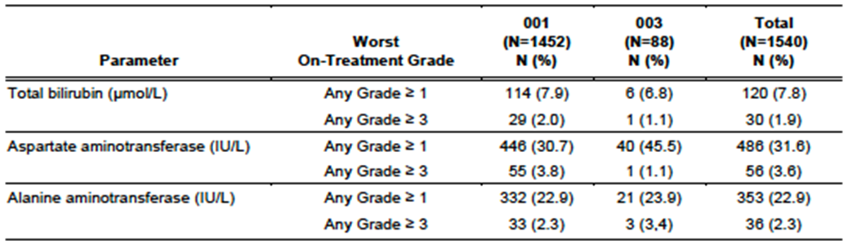
Two subjects met the criteria for potential Hy’s Law cases (concurrent elevation in transaminases and bilirubin (total bilirubin ≥ 2 x upper limit of normal (ULN) and alanine transaminase (ALT)/ aspartate transaminase (AST) ≥ 3 x ULN without concomitant elevated alkaline phosphatase, defined as alkaline phosphatase ≤ 2 x ULN)). However, both subjects had metastatic breast cancer with hepatic metastases. Neither of these subjects were diagnosed with autoimmune hepatitis.

Study 002
One subject in Study 002 (in the expansion phase) met the criteria for a potential Hy’s Law case. However, this subject was found to have biliary obstruction due to a stone. There were no cases of autoimmune hepatitis.

Renal function and renal toxicity

Integrated safety analysis
Elevations of serum creatinine were common, as summarised in Table 10. However, Grade ≥ 3 elevations were uncommon.
Table 10: Integrated safety analysis; Abnormal serum creatinine
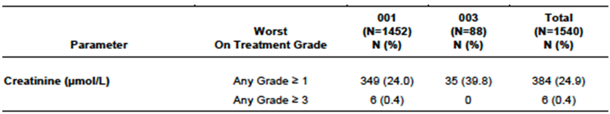
Serious renal events were reported in 1.6% of subjects with the most common being acute kidney injury (1.0%) and renal failure (0.2%).

Study 002
There were no shifts to Grade 3 or 4 serum creatinine in the dose escalation phase. Two subjects (5.9%) developed Grade 3 creatinine elevations in the expansion phase.

Amylase and lipase

Integrated safety analysis
Elevations of amylase or lipase were common, as summarised in Table 11.
Table 11: Integrated safety analysis; Abnormalities in amylase and lipase
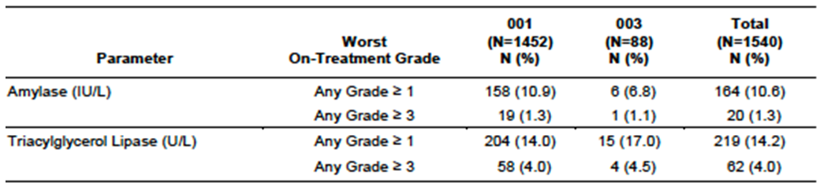
There were no reports of pancreatitis.

Study 002
In the dose escalation phase, Grade ≥ 3 elevations of amylase and lipase did not occur.
In the expansion phase Grade ≥ 3 elevations of amylase and lipase were reported in 8.8% and 20.6% of subjects respectively.

Other clinical chemistry

Integrated safety analysis
In Study 003, Grade 3 or 4 elevations in other biochemistry parameters were not common. Seven subjects (8.0%) developed Grade ≥ 3 elevations in blood glucose.
In Study 001, blood chemistry abnormalities Grade ≥ 3 reported for ≥ 5% of subjects were:
- Hyperglycaemia: Grade 3 for 72 subjects (5.0%) and Grade 4 for 4 subjects (0.3%)
- Hyponatraemia: Grade 3 for 132 subjects (9.2%) and Grade 4 for 8 subjects (0.6%)

Study 002
Results of other biochemistry testing in Study 002 were unremarkable.

Haematology and haematological toxicity

Integrated safety analysis
The incidence of haematological abnormalities is summarised in Table 12. Decreases in haemoglobin and lymphocyte count were common.
Table 12: Integrated safety analysis; Abnormalities in haematology parameters
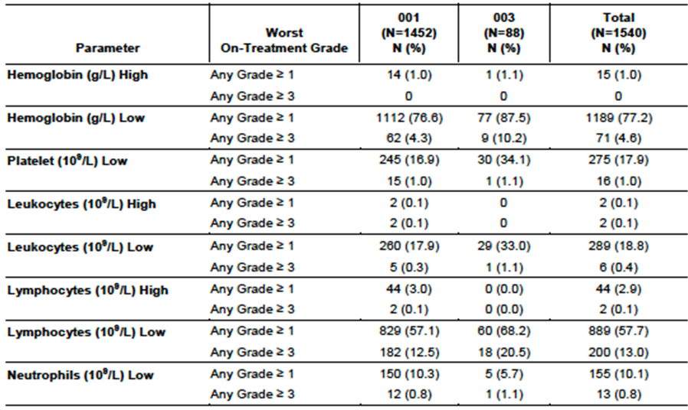

Study 002
In the dose escalation phase, 1 subject developed a Grade 3 decrease in lymphocyte count. There were no other Grade 3 or 4 haematological abnormalities.
In the expansion phase, 3 subjects (8.8%) developed a Grade 3 decrease in lymphocyte count and 9 subjects (26.5%) developed a Grade 3 decrease in haemoglobin. There were no other Grade 3 or 4 haematological abnormalities.

Thyroid function tests

Integrated safety analysis
In Study 003, average values for free thyroxine (T4) and thyroid stimulating hormone (TSH) did not change significantly over time. An analysis of individuals who developed abnormalities was not presented.
In Study 001:
- Of 748 subjects who had normal free T4 levels at Baseline, 7.9% had at least one value below normal, and 9.4% had at least one value above normal, while on treatment;
- Of 781 subjects who had normal TSH levels at Baseline, 7.9% had at least one value below normal, and 16.4% had at least one value above normal, while on treatment.

Study 002
An analysis of changes in thyroid function tests was not presented for Study 002.

Electrocardiograph findings and cardiovascular safety
The submission included an exposure-response analysis examining effects of avelumab on the QT interval, and a pooled analysis of potentially clinically significant electrocardiograph (ECG) abnormalities. No clinically significant effect of avelumab on the QT interval was detected. The incidence of other clinically significant ECG abnormalities was low.
Avelumab was not clearly associated with significant cardiovascular toxicity. For example, in the expansion phase of Study 001 (n = 1,437), the overall incidence of serious cardiac disorders was 2.2%, with the most common events being atrial fibrillation (0.6%) and cardiac tamponade (0.3%). The overall incidence of serious vascular events was 2.0%, with the most common events being hypotension (0.6%) and deep venous thrombosis (0.4%). Such events are not unexpected in a population of elderly subjects with advanced cancer.

Vital signs and clinical examination findings

Integrated safety analysis
Mean changes in systolic and diastolic blood pressure over time were small and not clinically significant.
The incidences of potentially clinically significant changes in vital signs in the expansion phase of Study 001 are summarised in Table 13 below. Increases and decreases in blood pressure occurred with comparable frequency.
Table 13: Study 001 (Expansion phase); potentially clinical significant changes in vital signs
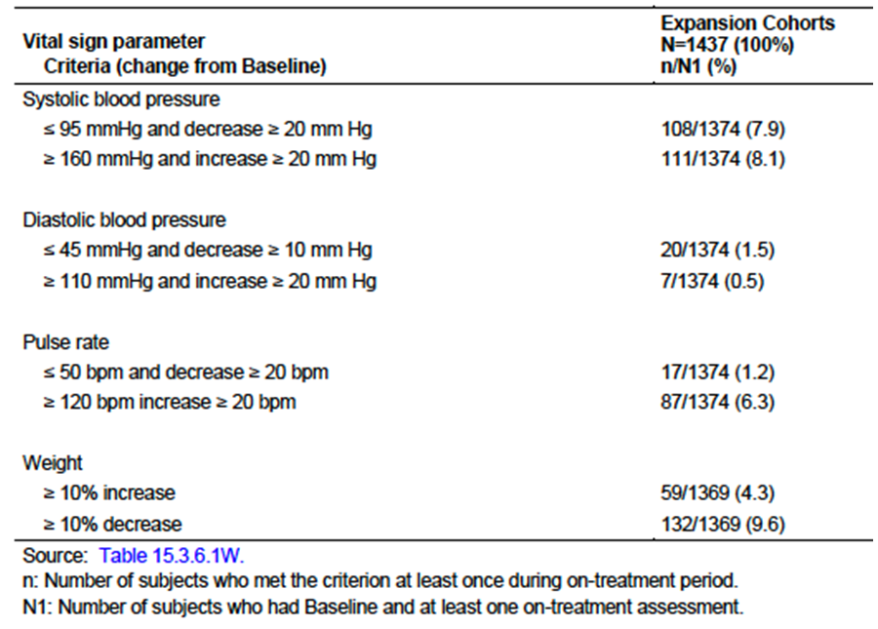

Immunogenicity and immunological events
Immune related adverse events (AEs) were summarised in the clinical evaluation report. Infusion-related reactions were summarised in the clinical evaluation report.
Blood samples were collected at intervals during each of the clinical studies for detection of human anti-human antibodies (HAHA); that is anti-avelumab antibodies. Serum samples were analysed by a validated electrochemiluminescence immunoassay to detect the presence of anti-avelumab antibodies. Samples that screened positive were subsequently tested in a confirmatory assay.

Integrated safety analysis
Results of testing are summarised in Table 14. 3.5% of subjects developed antibodies during treatment.
Table14: Integrated safety analysis; anti-avelumab antibodies
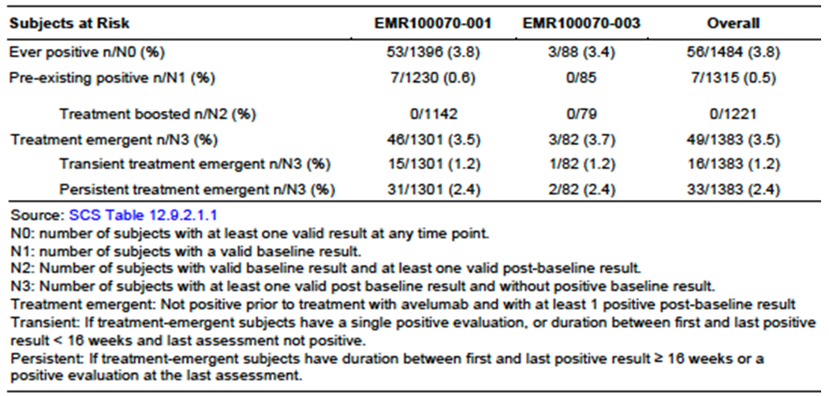
A total of 56 subjects were antibody-positive at some time. Compared to antibody-negative subjects, this group had a numerically higher incidence of infusion-related reactions (IRRs); 33.9% versus 24.1%), as well as AEs leading to discontinuation (19.6% versus 12.7%) and serious AEs (53.6% versus 39.5%), see Table 15.
The sponsor argued that antibody positivity was unlikely to represent a true increased risk of IRRs for the following reasons:
- Most of the IRRs observed in this group occurred with the first or second avelumab infusion, prior to the onset of seropositivity;
- Antibody positive subjects did not have a higher prevalence of anti-avelumab IgE antibodies.

Study 002
In the dose escalation phase, 1 of 17 subjects (5.9%) developed anti-avelumab antibodies. In the expansion phase, 11 of 31 tested subjects (6.5%) developed anti-avelumab antibodies.
Table 15: Integrated safety analysis; AEs according to immunogenicity status
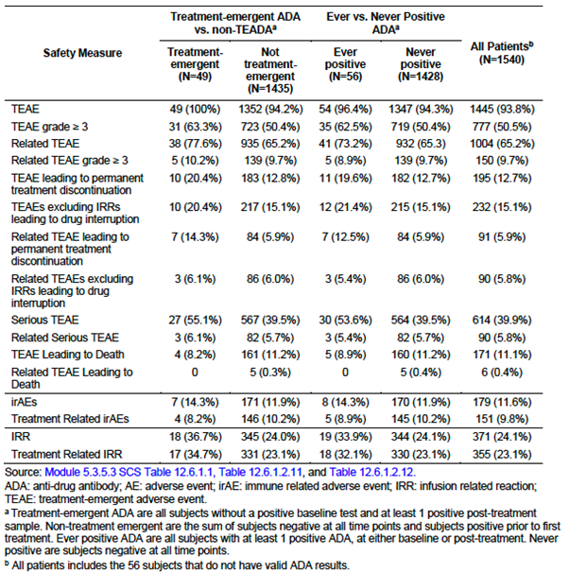

Serious skin reactions
Immune related AEs affecting the skin were common (see Table 16). However, serious dermatological AEs were uncommon. For example, in the expansion phase of Study 001 (n = 1437) serious skin reactions occurred in only 3 subjects (0.2%).
One case of erythema multiforme occurred in the expansion phase of Study 001. The case was assessed as Grade 2 and non-serious.
Table 16: Integrated safety analysis; Immune related AEs (irAEs)
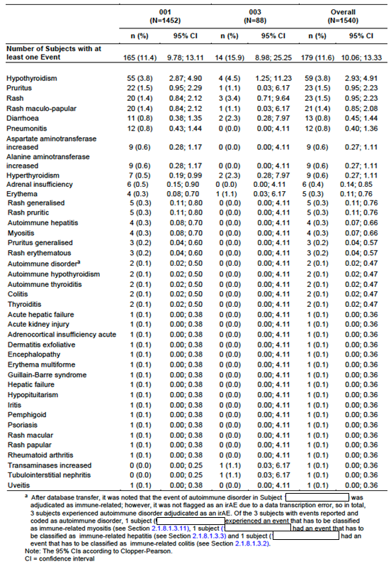

Other safety issues

Safety in special populations
In the Summary of Clinical Safety of the submission the sponsor presented analyses of adverse event data in various subgroups of patients, based on the integrated safety analysis (n = 1,540). Findings of these analyses included the following:
- Increasing age was not associated with an increased risk of AEs
- The incidence of AEs was similar among male and female subjects
- The incidence of AEs did not vary noticeably between races
- Subjects with high body mass index (BMI) (≥ 25 kg/m²) had a modestly increased risk of Grade ≥ 3 AEs and AEs leading to discontinuation
- AEs were more common in subjects with an ECOG PS of 1, compared to subjects with an ECOG PS of 0
- The incidence of AEs did not appear to be increased in subjects with hepatic or renal impairment
- AEs were less frequent in subjects treated with avelumab manufactured by process B, compared to process A. However, this may have been confounded due to longer treatment duration in subjects treated with process A product.

Ongoing studies
In the Summary of Clinical Safety, the sponsor included details of serious adverse events (SAE) reported from ongoing studies of avelumab (up to 30 April 2016). The SAEs reported were generally consistent with those reported in the 3 studies included in this submission. There were two fatal SAEs which were assessed as being related to avelumab; 1 case of fatal pneumonitis and 1 case of fatal myocarditis.

Post-marketing data
There were no post-marketing data included in the submission.

Evaluator’s conclusions on safety
All three studies included in the submission were single arm, non-comparative studies. An accurate assessment of the toxicity of avelumab based on such studies is difficult, as many of the reported adverse events may have been caused by the subjects’ disease rather than avelumab. All three studies enrolled subjects with advanced cancer and disease related events would be expected to be common in such populations. The sponsor is currently undertaking several randomised controlled trials in other oncology indications, and the toxicity profile of the drug will become clearer when the results of these studies are available.
In the early dose escalation Studies 001 and 002 a maximum tolerated dose was not reached, after studying doses up to 20 mg/kg every 14 days. A relationship between increased dose and increased toxicity was not apparent in these studies.
Despite the lack of comparative studies, the toxicity of avelumab appears qualitatively similar to that of other agents which interrupt the PD-1/PD-L1 pathway (for example pembrolizumab, nivolumab), with various autoimmune phenomena (immune related AEs) having been observed in the submitted studies. These include autoimmune hepatitis, colitis, pneumonitis, acute kidney injury, thyroid dysfunction, hypopituitarism, iritis and various skin disorders. Such events may be life-threatening with fatal cases of auto-immune hepatitis and pneumonitis having been observed in the submitted studies.
Infusion reactions were also commonly observed, occurring in 24.1% of subjects. However, most of these were mild or moderate in severity
Other events which occurred commonly in avelumab treated subjects, and were assessed by investigators as being treatment-related, included fatigue and asthenia, nausea and vomiting, constipation, decreased appetite, arthralgia, myalgia and headache.
Overall avelumab appeared to be associated with significant toxicity, 50.5% of subjects experiencing Grade ≥ 3 AEs, and 39.9% experiencing serious AEs. However, according to the investigators, Grade ≥ 3 AEs that were treatment related only occurred in 9.7% of subjects and serious AEs that were treatment-related only occurred in 5.8% of subjects. Overall the toxicity of avelumab appears manageable as only 12.7% of subjects had to discontinue treatment due to an AE.
Approximately 3.5% of subjects develop antibodies to avelumab during treatment. The development of antibodies was not associated with clinically significant changes in avelumab pharmacokinetics. However, there is some evidence that subjects who develop antibodies have a higher incidence of AEs.
In all, the submitted studies provided safety data on approximately 1,600 subjects. Although most of these subjects had malignancies other than metastatic MCC, the extent of safety data is considered adequate, especially as avelumab is an orphan drug.
Metastatic MCC is a life-threatening condition and subjects have a very limited life expectancy. There are currently no established treatments for those patients who have failed chemotherapy. In such circumstances, the toxicity profile of avelumab as described above is considered acceptable.

First round benefit-risk assessment
Table 17: First round assessment of benefits
Benefits | Strengths and Uncertainties
Avelumab treatment of subjects with metastatic MCC resulted in objective tumour responses in 31.8% of subjects (95%CI: 21.9 to 43.1)  Responses were durable with an estimated 92% of subjects remaining in response after 6 months. Based on comparison with historical data, responses are more durable than those obtained with second line chemotherapy  Complete responses were achieved by 9.1% of subjects. | Strengths  The pivotal study was well designed and executed. The trial design complied with EMA guidelines adopted by the TGA.  Responses were observed in a wide variety of subgroups.  Uncertainties  It is uncertain whether the observed benefits in terms of tumour response will translate into improvements in overall survival.  Efficacy has not been established in immunosuppressed subjects or those with poor performance status or significant organ dysfunction.
Table 18: First round assessment of risks
Risks | Strengths and Uncertainties
Immune mediated adverse drug reactions such as pneumonitis, colitis, thyroid dysfunction, skin disorders, hepatitis etcetera. Some such events may be fatal  Infusion reactions  A variety of other adverse events such as fatigue, nausea, vomiting, constipation, decreased appetite, arthralgia, myalgia and headache  Anti-avelumab antibodies develop in 3.5% of treated subjects. There is some evidence to suggest that they may be associated with an increased risk of AEs. | Strengths  The majority of AEs were mild or moderate in severity;  Only 12.7% of subjects discontinued treatment due to AEs;  Anti-avelumab antibodies were not associated with any effects on the pharmacokinetics of the drug.  Uncertainties  The study excluded subjects with immunosuppression, organ transplant, ECOG PS > 1 and those with significant organ dysfunction. Safety in these subjects has not been established.  All studies in the submission were non-comparative. Characterisation of the toxicity profile of avelumab may have been imprecise.

First round assessment of benefit-risk balance
Metastatic MCC is a life threatening condition, and patients have a very limited life-expectancy. There are currently no established treatments for those in whom first line chemotherapy has failed. Although evidence for the efficacy of avelumab is limited to one study, with response rate as the primary endpoint, the efficacy results (particularly those for duration of response) are considered convincing.
Given the seriousness of metastatic MCC, the toxicity profile of avelumab is considered acceptable.
Overall it is considered that the benefits of avelumab outweigh its risks, and the benefit-risk balance is positive.

First round recommendation regarding authorisation
It is recommended that the application be approved.
The indication proposed is as follows:
‘... for the treatment of patients with metastatic Merkel Cell Carcinoma (metastatic MCC) whose disease has progressed after receiving at least one prior therapy.’
If the application is approved it is recommended that the indication be amended (change in bold) as follows to accurately reflect the population of subjects enrolled in Study 003:
‘... for the treatment of patients with metastatic Merkel Cell Carcinoma (metastatic MCC) whose disease has progressed after receiving first line chemotherapy.’

Clinical questions

Efficacy
- The protocol for the pivotal study indicated that avelumab should be diluted in 0.9% saline prior to infusion. Please provide details of the instructions given to investigators regarding the volume of 0.9% saline to be used.
- In the pivotal study, 18 subjects were excluded from the per-protocol population because they did not have at least one post-baseline tumour assessment by the time of data cut-off, leaving 70 subjects who did have an assessment. Table 16 of the study report indicates that 74 subjects had ≥ 1 post-baseline assessment. Please clarify.
- In the pivotal study, tumour PD-L1 expression was assessed in formalin fixed, paraffin embedded biopsy samples using an immunohistochemistry assay with an anti-PD-L1 antibody (clone 7310). Please advise whether it is planned to make this assay commercially available.
- For the pivotal study, please provide the results of the exploratory efficacy analysis that was to be conducted 12 months after the accrual of the last subject.

Second round evaluation
Question 1: clarified by sponsor; response acceptable.
Question 2: clarified by sponsor; response acceptable.
Question 3: clarified by sponsor; response acceptable.
Question4:
‘For the pivotal study, please provide the results of the exploratory efficacy analysis that was to be conducted 12 months after the accrual of the last subject.’
Evaluation of response: Updated data with a minimum of 18 months follow-up were provided by the sponsor. A summary is given below.
- Minimum follow-up of 18 months for all patients
- Best overall response, n (%), N = 88
Table 19: Summary of updated efficacy analysis for the pivotal study
Efficacy endpoint
Complete response | 10 (11%)
Partial response | 19 (22%)
Stable disease | 9 (10%)
Progressive disease | 32 (36%)
Not assessable | 18 (21%)
- Objective response: n = 29; 33%, 95% CI: 23%, 44%
- Duration of response:
  - Based on Kaplan Meier (KM) estimates, of the 29 patients who had a response, 93% had a response of at least 6 months; 71% had a response of at least 12 months.
  - At the time of data cut-off, duration of response ranged from 2.8 months to at least 24.9 months.
- Median duration of response was not reached, 95% CI (8.3 months, not estimable).
- Median PFS: 2.7 months; 95% CI (1.4, 6.9)
- PFS % at 12 months: 29%, 95% CI (19, 39)
- Median overall survival (OS): 12.6 months; 95% CI (7.5, 19.0)
- OS% at 12 months: 51% 95% CI (40, 61)

Second round benefit-risk assessment
The benefit-risk assessment is unchanged from that in the first round. The comments from the sponsor on the indication have been carefully noted and referred to the Delegate.

VI. Pharmacovigilance findings

Risk management plan

Summary of RMP evaluation
- The sponsor has submitted EU-RMP version 1.0 (date 30 September 2016; data lock point (DLP) 30 April 2016) and Australian specific annex (ASA) version 1.0 (date 18 November 2016) in support of this application.
- The sponsor did not submit an updated RMP or ASA with responses but, proposed to revise the summary of safety concerns to align with the updated EU RMP version 1.2.
- During the post-second round phase, the sponsor provided an updated EU RMP version 1.6 (date 20 July 2017; DLP 9 June 2016) and an ASA version 1.1 (date 27 November 2017).
- The Summary of Safety Concerns and their associated risk monitoring and mitigation strategies (as described in EU-RMP version 1.6 and ASA version 1.1) are summarised below in Table 20.
Table 20: Summary of Safety Concerns and their associated risk monitoring and mitigation strategies
Summary of safety concerns |  | Pharmacovigilance |  | Risk Minimisation
 |  | Routine | Additional | Routine | Additional
Important identified risks | Immune related pneumonitis
Important identified risks | Immune related colitis
Important identified risks | Immune related hepatitis
Important identified risks | Immune related endocrinopathies (thyroid disorders, adrenal insufficiency, type 1 diabetes mellitus, pituitary disorders)
Important identified risks | Other Immune related events (myositis, myocarditis, Guillain-Barre Syndrome, uveitis)
Important identified risks | Immune related nephritis and renal dysfunction
Important identified risks | Severe infusion-related reactions (Grade ≥ 3)
Important potential risks | Severe cutaneous reactions |  | – |  | –
Important potential risks | Other Immune related events (encephalitis, myasthenic syndrome, pancreatitis) |  |  |  | –
Important potential risks | Embryofetal toxicity |  | – |  | –
Important potential risks | Immunogenicity |  |  |  | –
Missing information | Safety in patients with:
Missing information | Autoimmune disease |  | – |  | –
Missing information | HIV, Hepatitis B or C infections |  | – |  | –
Missing information | Organ transplants |  | – |  | –
Missing information | Use during Lactation |  | – |  | –
Missing information | Long-term treatment |  | – | – | –
Missing information | Safety and efficacy in immune compromised patients |  |  |  | –
- Additional pharmacovigilance activities comprise of clinical trials.
- The additional risk minimisation activities include a Health Care Professional (HCP) Frequently Asked Questions (FAQ) brochure, Patient Information brochure and a Patient Alert Card.

New and outstanding recommendations from second round evaluation
The summary of safety concerns in the ASA has been revised to align with the safety summary of the EU RMP version 1.6 (date 20 July 2017, DLP 9 June 2016). Additional risk minimisation measures in the form of HCP and patient education have been proposed for Australia. The ASA has been updated (version 1.1, date 27 November 2017) and the educational materials have been appended to the ASA.
It is expected that the ASA will be updated when the results of the studies relevant to Australia become available.
There are no major outstanding RMP recommendations. It is noted that this product is included in the Black Triangle Scheme, and that the sponsor has included the symbol and relevant accompanying text in the additional risk minimisation activities. The sponsor is recommended to ensure that adverse events reports also collect information on the management of the adverse event, and that this information is used to inform the effectiveness of these additional risk minimisation activities.

Proposed wording for conditions of registration
Any changes to which the sponsor has agreed should be included in a revised RMP and ASA. However, irrespective of whether or not they are included in the currently available version of the RMP document, the agreed changes become part of the risk management system.
The suggested wording is:
Implement EU-RMP (version 1.6, date 20 July 2017, data lock point 9 June 2016), with Australian Specific Annex (version 1.1, date 27 November 2017) and any future updates as a condition of registration.

VII. Overall conclusion and risk/benefit assessment
The submission was summarised in the following Delegate’s overview and recommendations:

Background
Avelumab is a human anti–PD-L1 IgG1 monoclonal antibody that inhibits the interaction between PD-L1 and PD-1.

Merkel cell carcinoma
Merkel cell carcinoma (MCC) is a rare, often aggressive, neuroendocrine skin cancer. It is distinguished from other skin cancers by its expression of cytokeratin 20 (CK20) and an association with the Merkel cell polyomavirus (MCpV).
About 200 to 400 cases are diagnosed annually in Australia each year. It mainly occurs on sun-damaged skin of patients older than 70 years (median ~ 75 years); perhaps 10% of patients are younger than 65 years. Risk factors include UV exposure, infection with MCpV, and immunosuppression (perhaps 10% of patients with MCC are immunosuppressed).
Localised disease can be cured with surgical resection. However, about one-third of patients develop metastases to draining lymph nodes, distant skin, lung, central nervous system, bone, and liver (5% to 10% of patients present with metastatic, rather than localised disease). Median overall survival from diagnosis of metastases is about 12 months; various estimates of five-year survival after diagnosis of metastases (from various studies) range from 0% to 18%.

Treatment algorithm for metastatic Merkel cell carcinoma
There are currently no medicines on the ARTG for metastatic MCC). Current guidelines suggest: off-label cisplatin or carboplatin +/- etoposide, single agent topotecan, or combination therapy with cyclophosphamide, doxorubicin, and vincristine (CAV). These are similar to chemotherapy regimens for small cell lung cancer (SCLC); and, in some ways, metastatic MCC behaves like SCLC.
Metastatic MCC is usually chemo-sensitive with response rates between 50 to 60% for patients with newly diagnosed metastatic Merkel cell carcinoma; however, responses are not durable (median duration < 3months), and chemotherapy has not been shown to improve OS in patients with metastatic disease. Also, the toxicity of chemotherapy includes serious and sometimes fatal adverse reactions, particularly in older patients, who typically have comorbidities.
That is, metastatic MCC is currently incurable and does not have an approved, on-label medicine. There is high unmet medical need.

Orphan designation
Avelumab was designated as an orphan drug by the TGA in July 2016; indication: ’… for the treatment of Merkel cell carcinoma’.

Overseas registration status
Please see Table 1 (above) for a description of the overseas registration status.
Comments on overseas indications: The pivotal Study-003 was in adult patients who were having second or subsequent line treatment after chemotherapy (that is, previously treated with chemotherapy).
The FDA extrapolated the indication to:
- First line treatment (that is, untreated).
- Children/adolescents 12+ years.
The EMA have extrapolated the indication to:
- First line treatment. But not: children/adolescents 12+ years.

Clinical
The TGA clinical evaluator recommended approval.

Pharmacokinetics
PK parameters were generally typical of those seen with a monoclonal antibody, with a small volume of distribution and slow clearance. The half-life of avelumab (4 to 6 days) was shorter than that typically observed for monoclonal antibodies. The effects of moderate or severe hepatic impairment or severe renal impairment have not been adequately studied.

Efficacy
The submitted efficacy data for avelumab were from a single arm, Phase II trial, with the surrogate endpoint of objective response, based on RECIST criteria; n = 88 (Study 003, Part A).
Part B of Study 003 is first line and completion is a FDA post-marketing requirement. The sponsor provided the TGA with a poster reporting early results from Part-B (presented September 2017, at European Society for Medical Oncology (ESMO)). The objective response rate (ORR) was 62%: 18/29.
Study 003 also contributed safety data.
Also submitted was Study Obs001. This was a review of electronic medical records obtained in community and academic centres that collected information on the outcomes of untreated (first line) and previously treated (second line) patients with metastatic MCC (that is, historical, external controls). Indirect comparisons were made between Studies 003 and Obs001.

NCT02155647 (Study 003)
This study has been published. The results in this publication were for a median follow-up of 10.4 months. During the evaluation the sponsor provided data for 18 month minimum follow-up; and these are the results that are presented below.

Design
Study 003 was a multicentre, international, prospective, single group, open label, Phase II trial across 35 treatment centres in North America, Europe, Australia, Asia. Enrolment was from 2014 to 2015.
Table 21: Brief synopsis of NCT02155647 (Study 003)
Description | Parameters
Patients | N = 88  18+ years  Chemotherapy refractory  ECOG PS = 0 or 1  Selected exclusions (standard for immunotherapy):  - autoimmune disease  - medical conditions requiring immunosuppression  - prior organ or allogeneic stem cell transplantation  - prior treatment with PD-1, PD-L1, CTLA-4 antibodies  - CNS metastases (these are not common in metastatic MCC)  - Infection with HIV, Hep-B, Hep-C
Intervention | Avelumab IV 10 mg/kg every 2 weeks, over 60 minutes, until disease progression or unacceptable toxicity.
Comparator | Nil, single arm
Endpoint | Primary  Best overall response (complete or partial response; stable, progressive disease)  RECIST 1.1, blinded independent review committee
Median number of doses of avelumab: 7; median duration of treatment: 17 weeks.

Baseline characteristics
N = 88; baseline characteristics are displayed in Table 22 (see below).
Table 22: Baseline characteristics Study NCT02155647 (Study 003)
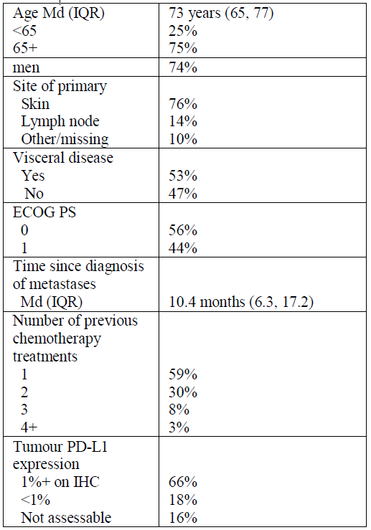

Results
Minimum follow-up of 18 months for all patients.

Best overall response
Best overall response, n (%), N = 88 is displayed in Table 23, below.
Table 23: Response rates for NCT02155647 (Study 003)
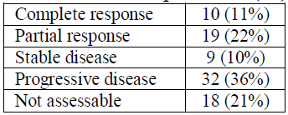
Objective response: n = 29; 33%, 95% CI: 23%, 44%; median time to response: 6 weeks.

Duration of response
- Durable response rate: Of the N = 88 study participants; percentage with a response lasting at least 6 months: 30.6%, 95% CI: 21%, 40.3%.
- Based on KM estimates (to allow for censoring: patients not followed-up for the full 6 months or 12 months), of the 29 patients who had a response, 93% had a response of at least 6 months; 71% had a response of at least 12 months.
- At the time of data cut-off, duration of response ranged from 2.8 months to at least 24.9 months.
- Median duration of response was not reached, 95% CI (18 months, not estimable).

Other endpoints
- Median PFS: 2.7 months; 95% CI (1.4, 6.9)
- PFS % at 12 months: 29%, 95% CI (19, 39)
- Median OS: 12.6 months; 95% CI (7.5, 19.0)
- OS% at 12 months: 51% 95% CI (40, 61)
Post hoc, exploratory, sub group analyses did not show any particular pattern. Results for PD-L1 expression and Merkel cell polyomavirus large T antigen expression are given in Table 24.
PD-L1 expression was assessed with a proprietary research-use-only assay (Dako, Carpinteria, CA, USA) based on an anti-PD-L1 rabbit monoclonal antibody clone (clone 73-10; Merck KGaA, Darmstadt, Germany), and PD-L1 positivity was defined in this study as a threshold level of 1% positive tumour cells of any intensity.
Table 24: Results for PD-L1 expression and Merkel cell polyomavirus large T antigen expression
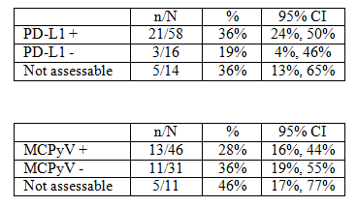

Study 100070-Obs001
From a registry/database of hundreds of patients (for example, n > 600 in Part A) with MCC, the sponsor identified patients who matched the inclusion criteria for the pivotal Study 003; for example, previously treated metastatic disease (that is, at least first line chemotherapy between 2004 and 2015), no concomitant autoimmune disease, immune-competent.
Part A (n = 14) was in the US; part B (n = 29) was in Germany, Austria, and Switzerland.
Table 25: Results from Study 100070-Obs001
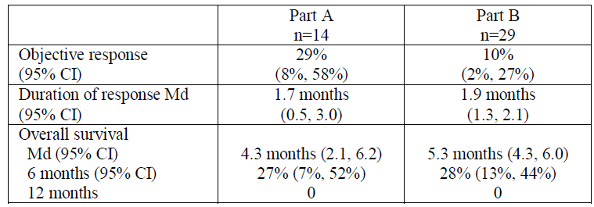
The pivotal Study 003 does not have contemporaneous controls (that is, it is single arm). Given MCC is a rare disease, it would be difficult to conduct a randomised study with contemporaneous controls. Study 100070-Obs001 suggests longer duration of response with avelumab versus chemotherapy, but this is an indirect comparison.

Safety
The integrated safety data set consisted of:
- Study 003 (Part A): 88 patients
- Study 001 (dose escalation phase): 15 patients treated with 10 mg/kg
- Study 001 (expansion phase): 1437 patients.
Despite the lack of comparative data, the safety profile of avelumab was qualitatively consistent with other anti-PD-L1/PD-1 antibodies used in other tumour types. Rarely, Immune related events with anti-PD-L1/PD-1 antibodies can be fatal.
13% of patients discontinued treatment due to AEs.
A point of difference between avelumab and other anti-PD-L1/PD-1 antibodies was that infusion reactions were more common at 24%; most were mild to moderate in severity.

Risk management plan
Summary of safety concerns are as detailed in Table 20 in RMP section, shown above.
The pharmacovigilance plan includes further follow-up and results from the studies; JAVELIN solid tumour (Study EMR 100070-011, Phase I/IIb) and JAVELIN Merkel (Study EMR 100070-003, Phase I/II).
Risk mitigation includes routine measures (statements in the PI) and additional measures (HCP education, patient card).

Risk-benefit analysis
The response rate of 33% was not markedly higher than with chemotherapy. For example, in Part A of Study 100070-Obs001 (an observational study of chemotherapy), the estimated response rate with chemotherapy was 28.6%; and in a recently published retrospective analysis by Iyer et al, response rate with chemotherapy was 23.3%.¹³
However, the available data suggest that responses produced by avelumab are longer-lasting than those produced by chemotherapy:
- Most durations of response were at least 6 months; based on the KM analysis, the 6 month estimate of durability was 93%; 12 months: 71%.
- In contrast in Study 100070-Obs001 median duration of response with chemotherapy was less than 2 months. In the retrospective analysis by Iyer et al, median duration of response was 3.3 months (101 days).
In the context of a rare disease with high unmet clinical need, durable objective response rate is a reasonable surrogate and is likely to predict clinical benefit (that is, improvement in survival, or how patients function or feel). Also, the treatment effect size for avelumab on ORR and duration of response (DOR) represents substantial improvement over use of salvage chemotherapy in this setting.
Obviously there are uncertainties associated with efficacy results from a single arm study. However, given the rarity of metastatic MCC, a study with contemporaneous controls is not feasible.
Safety data are available on about 1,500 patients. Based on the available data, the safety profile of avelumab is similar to that of other checkpoint inhibitors. Infusion reactions are a point of difference; but, based on the available data, these are mostly mild and manageable.
As with all immunotherapies used in oncology, immune-mediated adverse events are a concern. However, in spite of this, for most patients (especially the elderly with comorbid conditions), avelumab is probably more tolerable than platinum based chemotherapy.

Extrapolation from the second line adult patients in the pivotal trial to the indication

Second line in the pivotal trial extrapolated to line agnostic in the indication
Although the pivotal trial was in the second line setting, the FDA and EMA have approved an indication that covers first line use (that is, is line agnostic). The reasoning was that treated and untreated adults with metastatic MCC appear to have similar disease biology. Since there’s no approved first line chemotherapy, there is no reason to suspect that avelumab treatment would be any less efficacious in the first line setting.
The sponsor provided the TGA with a poster reporting early results from Part-B (1L patients) (presented September 2017, at ESMO). The ORR was 62.1%: 18/29.

Adults in the pivotal trial extrapolated to 12+ years in the indication
Although the pivotal trial was in adults, the FDA (but not the EMA) has approved the indication in paediatric patients 12 years and older. The reasoning was that there are no significant differences in this disease and its natural history between adults and children. The extreme rarity of this disease in children makes a clinical trial of avelumab in paediatric patients infeasible. Given the very poor prognosis for adolescents with Merkel cell tumour, and the similar physiology and pharmacokinetics between adolescents and adults, the benefits clearly outweighed the risks for the adolescent population.
Population PK modelling provided in the application included simulation of PK exposure at steady state after repeat intravenous dosing of avelumab 10 mg/kg every 2 weeks for patients with body weights of 30 kg to 90 kg, which are equivalent to weights of adolescents. The PK data were obtained from patients aged 20 to 91 years who were treated with avelumab in Study 001, Study 003, and Study EMR 1000070-002 (Study 002). The results of this analysis demonstrate comparable PK between patients with body weights of 30 to 90 kg and adults. Also demonstrated were no differences in PK based on age. In addition, based on data from the population PK modelling simulating minimum concentration (C_{min}) and the data from an in vitro target occupancy study provided by the sponsor, high target occupancy was predicted for paediatric patients 12 years and older during the entire dose interval at 10 mg/kg every 2 weeks.

Indications
The indications should match the FDA-approved indications:
Bavencio is indicated for the treatment of adults and paediatric patients 12 years and older with metastatic Merkel cell carcinoma (MCC).
If approved, the registration would be based on a single arm study. The indications should therefore include the following note:
This indication is approved based on tumour response rate and duration of response in a single arm study. Continued approval for this indication may be contingent upon verification and description of clinical benefit in confirmatory trials.

Post marketing requirements
The sponsor should submit the results of the following post-marketing studies to the TGAas a new application:
- First line study in patients with metastatic MCC that will enrol at least 100 patients followed for a minimum of 12 months, to establish the objective response rate and characterise the durability of response. All patients will be followed for overall survival until at least 70% of patients have died in order to characterise effects on survival. An analysis of overall survival compared to historical control data will be provided. Trial completion: June 2026; final report submission: December 2026 (this is Part B of the JAVELIN trial).
- A trial in a sufficient number of paediatric patients ages 12 to 18 to adequately characterise baseline risk factors, safety outcomes, and clinical responses following exposure to avelumab. Trial completion: October 2022; final report submission: June 2023.

Delegate’s considerations
There are currently no medicines on the ARTG for metastatic MCC, which is a rare, aggressive, and incurable neuroendocrine tumour of the skin.
There is high unmet clinical need.
- Chemotherapy is used off-label (for example, cisplatin or carboplatin in combination with etoposide), but the responses are not durable.
- Most patients are older than 70 years (often have concomitant illnesses) and usually find (off-label) platinum-based chemotherapy challenging.
Avelumab showed durable responses: In a single arm study (n = 88), in the second line setting or later (2L+) setting, 33% of patients had a response and the response lasted at least 6 months in 93% of responders; at least 12 months in 71% of responders (KM estimates).
Although the pivotal trial was in the second line (2L+) setting, the FDA and EMA have approved an indication that covers first line use. Reasoning: treated and untreated adults with metastatic MCC appear to have similar disease biology; there is no reason to suspect that avelumab treatment would be any less efficacious in the first line setting.
The sponsor provided the TGA with a poster reporting early results from Part B (1L patients) of the JAVELIN trial (presented September 2017, at ESMO). The ORR was 62%: 18/29.
Although the pivotal trial was in adults, the FDA (but not the EMA) have approved the indication in paediatric patients 12 years and older. The reasoning was that there are no significant differences in this disease and its natural history between adults and adolescents > 12 years. The extreme rarity of this disease in adolescents makes a clinical trial of avelumab in these patients infeasible. Given the very poor prognosis for adolescents with Merkel cell tumour, and the similar physiology and pharmacokinetics between adolescents and adults, the extrapolation is reasonable.

Proposed action
The Delegate had no reason to say, at this time, that Bavencio should not be approved for registration.

Request for ACM advice
The Delegate did not refer this application to the Advisory Committee on Medicines (ACM) for advice.

Response from sponsor

Introduction
Merck Serono Australia Ltd (the sponsor) welcomes the opportunity to respond to the Delegate’s Overview (dated 27 October 2017) concerning our application to register Bavencio (avelumab) as a new biological entity for the treatment of patients with metastatic MCC.
Enclosed are our comments regarding the Delegate’s Overview.
The sponsor accepts the Delegate’s proposal for the following indication:
Bavencio is indicated for the treatment of adults and paediatric patients 12 years and older with metastatic Merkel cell carcinoma (mMCC).
This indication is approved based on tumour response rate and duration of response in a single arm study. Continued approval for this indication may be contingent upon verification and description of clinical benefit in confirmatory trials.

Background
MCC is a rare and aggressive skin cancer that typically presents as painless growths that are clinically unremarkable in appearance and are usually found on sun exposed areas, such as the head and neck. However, these tumours grow rapidly and tend to metastasise early and frequently to local regions of the body, leading to a poor prognosis.
MCC typically occurs in the older population (> 70 years) and the mortality rate of patients with MCC is greater than that of other skin cancers, including melanoma. However, given the rarity of MCC, its greater aggressiveness and mortality relative to melanoma remain unrecognised in the public eye and media. Australia has the highest incidence worldwide of MCC (1.6 per 100,000) and, whilst rare, it is becoming more common. The estimated prevalence of metastatic MCC is 1,865 cases in Australia. Due to the rarity of this disease, an orphan designation was granted in July 2016.
There is no evidence based standard therapeutic regimen and no approved therapy in Australia for metastatic MCC. Treatment is generally limited to off-label systemic chemotherapy such as carboplatin or cisplatin, with or without etoposide or topotecan, which are associated with high toxicity. Consequently, consideration needs to be given as to whether chemotherapy is appropriate in the elderly population.

Comments from the Delegate
- Proposal for the Australian indication to match the approved FDA indication for metastatic Merkel cell carcinoma (mMCC)
Although MCC is generally considered to be a chemo sensitive tumour, off-label use of chemotherapies provide short lived responses with serious toxicities and without proven survival benefit. Since MCC is aggressive relative to other skin cancers and is associated with poor survival in the metastatic setting, this lack of durability means that treatment of metastatic MCC has remained an area of high unmet medical need.
In contrast to chemotherapy, long durable responses with avelumab were reported in a prospective single arm study in this metastatic disease population, with an objective response rate (ORR) of 33.0% (95% CI: 23.3, 43.8) and a Kaplan Meier estimate of 93% for 6 month durability among responses in subjects whose disease had progressed after at least 1 prior line of chemotherapy in the metastatic setting (Study EMR100070-003, Part A). In addition to continued durable response (both overall and among the various subgroups evaluated), the observed progression-free survival (PFS) curve with plateau and reported overall survival (now with a median exceeding a year) in Study EMR100070-003 Part A, support meaningful clinical benefit for avelumab in subjects with metastatic MCC.
The high ORR reported of 62.1% (95% CI: 42.3, 79.3) in the per protocol specified interim analysis of Part B (Study EMR 100070-003,Part B confirmatory trial cohort) with avelumab in first line treatment is consistent with the results of the subgroup analysis by number of prior treatment lines in Part A with a response rate of 40.4% in subjects with one prior line of systemic therapy, versus 22.2% in subjects with 2 or more prior lines of systemic therapy.
There is early evidence in Part B of durability of responses in first line treatment, given the high estimated proportion of responses with at least 3 months duration (93%) and the presence of continuing responses with at least 6 months of duration (n = 5).
In summary, the data from the available interim analysis of Study EMR100070-003 Part B further support the expected increased clinical benefit of more subjects achieving a response with avelumab treatment earlier in the metastatic setting (that is, fewer prior lines of therapy). The data demonstrated continuing responses with avelumab in first line treatment. These data further support avelumab treatment regardless of line of therapy in the metastatic setting for MCC.
Furthermore, the sponsor is fully supportive of the Delegate’s recommendation to include adolescent patients > 12 years. Given the very poor prognosis for adolescents, the use of Bavencio in this age group was supported by evidence from adequate and well-controlled studies of Bavencio in adults with additional population pharmacokinetic data demonstrating that age and body weight had no clinically meaningful effect on the steady state exposure of avelumab. Drug exposure is generally similar between adults and paediatric patient’s aged 12 years and older for monoclonal antibodies, and that the course of MCC is sufficiently similar in adults and paediatric patients to allow extrapolation of data in adults to paediatric patients.
The indication and precaution sections of the PI have been revised accordingly to reflect the indication proposed by the Delegate.

Post marketing requirements
The sponsor confirms the submission of the following post-marketing studies to the TGA as new applications when the final results are made available:
- Protocol for Study EMR100070-003 Part B (JAVELIN Merkel 200 trial). Final report submission by December 2026
- Paediatric patients study in patients between 12 to 18 years old. Final report submission June 2023.

Conclusion
In summary, the substantial response rate and continuing durable responses with avelumab are clinically meaningful, based on a confirmed ORR of 33.0%, the KM estimate of 93% for 6 month durability among responses, the 30% 12 month and 15 month PFS rates with observed plateau of the PFS KM curve, and favourable OS now with a median exceeding a year. In addition, data from an early interim analysis from Study EMR100070-003 Part B, with avelumab as 1L treatment, demonstrate a high ORR of 62.5% reported for avelumab as 1L treatment. Combined with the fact that metastatic MCC is a rare disease of high unmet medical need, the clinical results with avelumab demonstrates the opportunity to provide clinically meaningful benefit to patients with metastatic MCC.

Advisory committee considerations
The Delegate did not refer this application to the Advisory Committee on Medicines (ACM) for advice.

Outcome
Based on a review of quality, safety and efficacy, TGA approved the registration of Bavencio avelumab (rch) 200 mg/10 mL concentrated solution for intravenous infusion vial indicated for:
Bavencio is indicated for the treatment of adults and paediatric patients 12 years and older with metastatic Merkel Cell Carcinoma (MCC).
This indication is approved based on tumour response rate, duration of response in a single arm study.

Specific conditions of registration applying to these goods
- Any changes to which the sponsor has agreed should be included in a revised RMP and ASA. However, irrespective of whether or not they are included in the currently available version of the RMP document, the agreed changes become part of the risk management system.
- The Bavencio avelumab EU Risk Management Plan (RMP), version 1.6, dated 20 July 2017 (data lock point 9 June 2016), with Australian Specific Annex, version 1.1, dated 27 November 2017, and any subsequent revisions, as agreed with the TGA will be implemented in Australia.
- Provide the interim analysis (data cut off 26 Sept 2017) of efficacy outcomes from Part A and Part B of Study 003 to the TGA when they become available (expected Q1 2018). (This does not need to be provided as a Category 1 application, unless the sponsor is proposing to update the PI.)
- Submit a Category 1 application reporting the results of the 1L study in patients with metastatic MCC that will enrol at least 100 patients followed for a minimum of 12 months, to establish the objective response rate and characterise the durability of response. The expected trial completion date is June 2026. The expected final report submission date is December 2026.
- Submit a Category 1 application reporting the results of a trial in a sufficient number of paediatric patients ages 12-18 to adequately characterise baseline risk factors, safety outcomes, and clinical responses following exposure to avelumab. The expected trial completion date is October 2022. The expected final report submission date is June 2023.
- Batch release testing and compliance with Certified Product Details (CPD) (as detailed in the approval letter).

Attachment 1. Product Information
The PI for Bavencio approved with the submission which is described in this AusPAR is at Attachment 1. For the most recent PI, please refer to the TGA website at <https://www.tga.gov.au/product-information-pi>.

Therapeutic Goods Administration
PO Box 100 Woden ACT 2606 Australia
Email: info@tga.gov.au Phone: 1800 020 653 Fax: 02 6232 8605
https://www.tga.gov.au

Schadendorf D, et al. Merkel cell carcinoma: Epidemiology, prognosis, therapy and unmet medical needs. Eur J Cancer. 2017; 71: 53-69
B7 is a type of peripheral membrane protein found on activated antigen presenting cells
ICH S6 (R1): Preclinical Safety Evaluation of Biotechnology-Derived Pharmaceuticals; ICH S9: Nonclinical Evaluation for Anticancer Pharmaceuticals.
TGA quality evaluation reports
Lipson E.J., et al. (2013) PD-L1 expression in the Merkel cell carcinoma microenvironment: association with inflammation, Merkel cell polyomavirus and overall survival. Cancer Immunol. Res. 1: 54–63.
EMA/CHMP/BWP/532517/2008: Guideline on development, production, characterisation and specification for monoclonal antibodies and related products.
ICH S9 ICH harmonised tripartite guideline. Nonclinical evaluation for anticancer pharmaceuticals.
ICH S1A — Note for Guidance on The Need for Carcinogenicity Studies of Pharmaceuticals.
Guleria I., et al. (2005) A critical role for the programmed death ligand 1 in fetomaternal tolerance. J. Exp. Med. 202: 231–237.
Wafula P.O., et al. (2009) PD-1 but not CTLA-4 blockage abrogates the protective effect of regulatory T cells in a pregnancy murine model. Am. J. Reprod. Immunol. 62: 283–292.
Pregnancy Category D is classified as Drugs which have caused, are suspected to have caused or may be expected to cause, an increased incidence of human fetal malformations or irreversible damage. These drugs may also have adverse pharmacological effects. Accompanying texts should be consulted for further details.
Murphy GF, et al. Pathological Basis of Disease. 7th ed. Philadelphia: Elsevier Saunders; 2005. Chapter 25, The Skin; 1227-1271
Iyer JG, et al. Response rates and durability of chemotherapy among 62 patients with metastatic Merkel cell carcinoma. Cancer Med. 2016; 5: 2294-2301.
Harms KL, et al. Analysis of prognostic factors from 9387 Merkel cell carcinoma cases forms the basis of the new 8th Edition AJCC Staging System. Ann Surg Oncol 2016; DOI 10.1245/s10434-016-5266-4
Youlden DR, et al. Incidence and survival for Merkel cell carcinoma in Queensland, Australia, 1993-2010. JAMA Dermatol. 2014; 150: 864-872
Girschik J, et al. Merkel cell carcinoma in Western Australia: a population-based study of incidence and survival. Br J Dermatol. 2011; 165: 1051-1057
National Comprehensive Cancer Network (NCCN). NCCN Clinical Practice Guidelines in Oncology – Merkel Cell Carcinoma. Version 1.2017. 2016.
Lebbe C, et al. Diagnosis and treatment of Merkel Cell Carcinoma. European consensus-based interdisciplinary guideline. Eur J Cancer. 2015; 51: 2396-2403
Boussiotis VA. Molecular and Biochemical Aspects of the PD-1 Checkpoint Pathway. N Engl J Med 2016; 375:1767-1778
Lipson EJ, et al. PD-L1 expression in the Merkel cell carcinoma microenvironment: association with inflammation, Merkel cell polyomavirus and overall survival. Cancer Immunol Res. 2013; 1: 54-63
Nghiem PT, et al. PD-1 Blockade with Pembrolizumab in Advanced Merkel-Cell Carcinoma. N Engl J Med. 2016; 374: 2542-2552
European Medicines Agency. Guideline on the evaluation of anticancer medicinal products in man. EMA/CHMP/205/95/Rev.4; (2012). Available from: http://www.tga.gov.au/clinical-efficacy-and-safety-guidelines.
European Medicines Agency. Points to consider on application with 1. Meta-analyses; 2. One pivotal study; CPMP/EWP/2330/99 (2001). Available from: http://www.tga.gov.au/clinical-efficacy-and-safety-guidelines.
Routine risk minimisation activities may be limited to ensuring that suitable warnings are included in the product information or by careful use of labelling and packaging. Routine pharmacovigilance practices involve the following activities: - All suspected adverse reactions that are reported to the personnel of the company are collected and collated in an accessible manner; - Reporting to regulatory authorities; - Continuous monitoring of the safety profiles of approved products including signal detection and updating of labeling; - Submission of PSURs; - Meeting other local regulatory agency requirements.
RECIST: Response evaluation criteria in solid tumours
Kaufman HL et al Avelumab in patients with chemotherapy-refractory metastatic Merkel cell carcinoma: a multicentre, single-group, open-label, Phase II trial. Lancet Oncol 2016; 17: 1374–1385.
The ACM provides independent medical and scientific advice to the Minister for Health and the Therapeutic Goods Administration (TGA) on issues relating to the safety, quality and efficacy of medicines supplied in Australia including issues relating to pre-market and post-market functions for medicines. The Committee is established under Regulation 35 of the Therapeutic Goods Regulations 1990. Members are appointed by the Minister. The ACM was established in January 2017 replacing Advisory Committee on Prescription Medicines (ACPM) which was formed in January 2010. ACM encompass pre and post-market advice for medicines, following the consolidation of the previous functions of the Advisory Committee on Prescription Medicines (ACPM), the Advisory Committee on the Safety of Medicines (ACSOM) and the Advisory Committee on Non-Prescription Medicines (ACNM). Membership comprises of professionals with specific scientific, medical or clinical expertise, as well as appropriate consumer health issues relating to medicines.

