|  |
| --- |
| **Date of CER: 13 June 2012** |

|  |
| --- |
| AusPAR Attachment 2 |
| Extract from the Clinical Evaluation Report for azacitidine |
| Proprietary Product Name: Vidaza |
| Sponsor: Celgene Pty Ltd |

About the Therapeutic Goods Administration (TGA)

* The Therapeutic Goods Administration (TGA) is part of the Australian Government Department of Health and Ageing, and is responsible for regulating medicines and medical devices.
* The TGA administers the *Therapeutic Goods Act 1989* (the Act), applying a risk management approach designed to ensure therapeutic goods supplied in Australia meet acceptable standards of quality, safety and efficacy (performance), when necessary.
* The work of the TGA is based on applying scientific and clinical expertise to decision-making, to ensure that the benefits to consumers outweigh any risks associated with the use of medicines and medical devices.
* The TGA relies on the public, healthcare professionals and industry to report problems with medicines or medical devices. TGA investigates reports received by it to determine any necessary regulatory action.
* To report a problem with a medicine or medical device, please see the information on the TGA website <<http://www.tga.gov.au>>.

About the Extract from the Clinical Evaluation Report

* This document provides a more detailed evaluation of the clinical findings, extracted from the Clinical Evaluation Report (CER) prepared by the TGA. This extract does not include sections from the CER regarding product documentation or post market activities.
* The words [Information redacted], where they appear in this document, indicate that confidential information has been deleted.
* For the most recent Product Information (PI), please refer to the TGA website <<http://www.tga.gov.au/hp/information-medicines-pi.htm>>.

**Copyright**

© Commonwealth of Australia 2013  
This work is copyright. You may reproduce the whole or part of this work in unaltered form for your own personal use or, if you are part of an organisation, for internal use within your organisation, but only if you or your organisation do not use the reproduction for any commercial purpose and retain this copyright notice and all disclaimer notices as part of that reproduction. Apart from rights to use as permitted by the *Copyright Act 1968* or allowed by this copyright notice, all other rights are reserved and you are not allowed to reproduce the whole or any part of this work in any way (electronic or otherwise) without first being given specific written permission from the Commonwealth to do so. Requests and inquiries concerning reproduction and rights are to be sent to the TGA Copyright Officer, Therapeutic Goods Administration, PO Box 100, Woden ACT 2606 or emailed to <[tga.copyright@tga.gov.au](mailto:tga.copyright@tga.gov.au)>.

Contents

List of abbreviations 4

1. Clinical rationale 6

2. Contents of the clinical dossier 6

2.1. Scope of the clinical dossier 6

2.2. Paediatric data 6

2.3. Good clinical practice 6

3. Pharmacokinetics 7

3.1. Studies providing pharmacokinetic data 7

3.2. Summary of pharmacokinetics 7

3.3. Evaluator’s overall conclusions on pharmacokinetics 8

4. Pharmacodynamics 8

5. Dosage selection for the pivotal studies 8

6. Clinical efficacy 9

6.1. Efficacy in MDS 9

7. Clinical safety 11

7.1. Studies providing evaluable safety data 11

7.2. Patient exposure 12

7.3. Adverse events 12

7.4. Laboratory tests 15

7.5. Post-marketing experience 15

7.6. Evaluator’s overall conclusions on clinical safety 15

8. First round benefit-risk assessment 16

8.1. First round assessment of benefits 16

8.2. First round assessment of risks 16

8.3. First round assessment of benefit-risk balance 16

9. First round recommendation regarding authorisation 16

10. Clinical questions 16

10.1. Safety 16

11. References 16

## List of abbreviations

|  |  |
| --- | --- |
| **Abbreviation** | **Meaning** |
| AE | Adverse event |
| AML | Acute myelogenous leukaemia |
| BSA | Body surface area |
| CER | Clinical evaluation report |
| CER1 | CER relating to the initial submission |
| CER2 | CER relating to the second submission |
| CR | Complete response |
| CSR | Clinical study report |
| ECOG | Eastern Cooperative Oncology Group |
| FAS | Full analysis set |
| GCP | Good clinical (research) practice |
| HPLC-MS/MS | High performance liquid chromatography/tandem mass spectrometry |
| IPSS | International prognostic scoring system |
| IV | Intravenous |
| LLQ | Lower limit of quantification |
| LS mean | Least squares mean |
| MDS | Myelodysplastic syndrome(s) |
| PK | Pharmacokinetic |
| PR | Partial response |
| RAEB | Refractory anaemia with excess blasts |
| RAEB-T | Refractory anaemia with excess blasts in transformation |
| SC | Subcutaneous |
| SOC | System organ class |
| TEAE | Treatment emergent adverse event |

## Clinical rationale

The rationale offered in the Letter of Application is as follows:

*Celgene believes that physicians may be administering Vidaza by IV infusion off-label without adequate knowledge of the stability profile of the reconstituted Vidaza in infusion solutions and the IV administration technique. Celgene believes that it is important for healthcare professionals to have access to the most recent and accurate IV administration details for Vidaza.*

## Contents of the clinical dossier

### Scope of the clinical dossier

The submission contained the following clinical information:

* 0 new clinical studies.
* 1 CSR relating to clinical Study CALGB 8421. That study was submitted with the initial application for registration and evaluated in the first round evaluation.
* 1 population pharmacokinetic analysis, based on data from Study AZA-2002-BA-002. That study was submitted with the initial application for registration and evaluated in the first round evaluation.
* Literature references. These comprised a subset of the references cited in: (a) the pharmacokinetic modelling report, (b) a report identified as Azacitidine-DMPK-002 (relating to an in vitro study) and (c) the CSR on Study CALGB 8421. None contributed any new clinical data supporting the application.

### Paediatric data

The submission did not include paediatric data.

### Good clinical practice

For Study CALGB 8421, compliance with GCP was asserted in the following terms:

*"This study was conducted in accordance with Cancer and Leukemia Group B (CALGB) standard operating procedures for clinical investigations, which ensured compliance with Office of Human Research Protections (OHRP), Department of Health and Human Services (DHHS), and Food and Drug Administration (FDA) Good Clinical Practice (GCP) regulations governing research in human subjects. This study was initiated prior to implementation of International Conference on Harmonization (ICH) GCP Guidelines."*

The *Pharmacokinetic Modelling Report* relating to Study AZA-2002-BA-002 also included a form of GCP certification, although the report clearly relates specifically to a mathematical analysis of data, conducted years after the clinical study. The GCP certification may well have been appropriate for the clinical report of the original clinical study, but seems out of place in the modelling report, in implying that some sort of recognised standard was followed in connection with the model development, analysis, interpretation and documentation (which was presumably not the case).

## Pharmacokinetics

### Studies providing pharmacokinetic data

Table 1 shows the studies relating to each pharmacokinetic topic and the location of each study summary.

Table 1: Submitted pharmacokinetic studies.

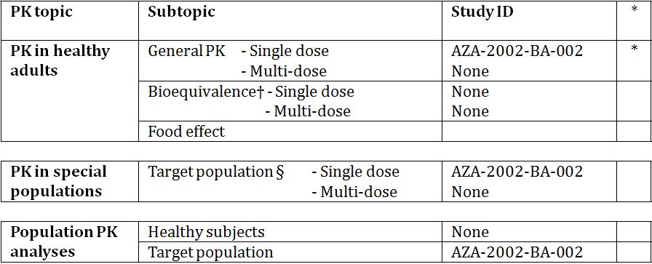

* Indicates the primary aim of the study.

† Bioequivalence of different formulations.

§ Subjects who would be eligible to receive the drug if approved for the proposed indication.

None of the pharmacokinetic studies had deficiencies that excluded their results from consideration.

### Summary of pharmacokinetics

The information in the following summary is derived from conventional pharmacokinetic studies unless otherwise stated.

#### Pharmacokinetics in the target population

##### Study AZA-2002-BA-002 (also designated AZA-CSR-004)

This study comparing some features of the pharmacokinetics of subcutaneous and intravenous azacitidine in patients with MDS was submitted with the initial application for Vidaza and has been evaluated previously (see *CER1*). The evaluator had access to a synopsis of the *CSR*, and to *CER1* (which contained some photocopied extracts from the *CSR*). A summary of the study, extracted from these sources, is at Tables 2-3.

Table 2: Study AZA-2002-BA-002: values of pharmacokinetic parameters, derived from non-compartmental analysis.

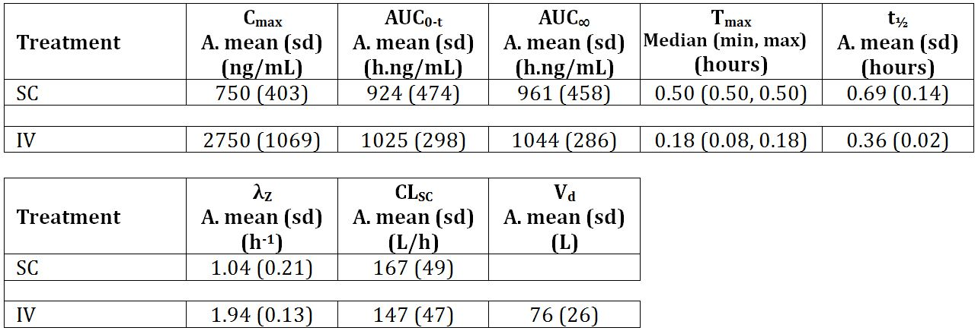

Table 3: Individual estimates of Cmax and AUC0-∞ following SC and IV administration.

##### 01

##### Population PK modelling relating to Study AZA-2002-BA-002

###### Presentational flaws in the PK modelling report

The report section headed "Statistical Methods", which included explanation of PK model development, could not be followed in detail, because of gross production or other problems which affected both the paper and the electronic versions. As well as rendering the mathematical explanation opaque, this fault calls into question the sponsor's procedures for document tracking and authentication, and raises the question of what document the signatories actually approved and signed.

### Evaluator’s overall conclusions on pharmacokinetics

In the evaluator’s opinion, due to

* the paucity of data used in developing the population pharmacokinetic model;
* the fact that individual patient characteristics were not taken into account; and
* the lack of validation

the population pharmacokinetic modelling is of little utility. The evaluator doubts that the sponsor has anything to gain, for the purposes of the present application, by correcting the presentational flaws, in view of these other problems. At best, the results of the modelling suggest IV regimens which might be studied in a further clinical pharmacokinetic comparison.

## Pharmacodynamics

No data.

## Dosage selection for the pivotal studies

No pivotal studies included in the submission.

## Clinical efficacy

### Efficacy in MDS

#### Pivotal efficacy studies

No pivotal studies included in submission.

Other efficacy studies: Study CALGB 8421 re-analysis

##### Study design, objectives, locations and dates

This CSR was a 2003 reanalysis of a Phase I-II open, uncontrolled, multicentre pilot study conducted at 17 US locations, 20 June 1985 to 31 May 1994. The title of the original study was "5-azacytidine to induce differentiation in myelodysplastic syndromes. A phase I-II pilot study".

Data from the original clinical study were retrospectively re-collected for this 2003 analysis.

The original study objectives were as follows, and were not altered for the re-analysis:

* To test the effect of azacitidine given in repeated continuous low dose infusions on the differentiation of myelodysplastic syndromes.
* To determine an appropriate dose and regimen of azacitidine as a feasibility pilot for eventual application.
* To determine those myelodysplastic syndromes that respond optimally to differentiation treatment.
* To determine if azacitidine would affect the natural history and outcome of myelodysplastic syndromes.

##### Inclusion and exclusion criteria

Inclusion criteria included: age > 15 years old; diagnosis of the subtypes of MDS RAEB or RAEB-T as defined by the French-American-British (FAB) classification; performance status of 0-3 and life expectancy of at least 2 months; total bilirubin ≤ 25.7 μmol/L, AST and ALT < 150 U/L, serum creatinine < 176.8 μmol/L, and serum CO2 ≥ 19 mmol/L.

Exclusion criteria included: > 30% blasts in bone marrow; prior cytotoxic therapy for MDS other than low dose cytosine arabinoside; uncontrolled or severe congestive heart failure; radiation or chemotherapy within 6 months prior to study entry.

##### Study treatments

The Protocol stipulated (under the heading ‘Treatment’):

*"Patients are to receive 5-azacytidine 75 mg/m2 daily for 7 days as a continuous IV infusion. The drug will be mixed fresh every 4 hours, and placed in a solution of Ringer's lactate"*

and (under the heading ‘Toxicity’):

*"The dose should be dissolved in 50 cc of Ringer's lactate after reconstitution. New bottles should be prepared every 4 hours. The infusion should begin immediately after reconstitution and should be administered over a 4 hour period."*

Dosage was to be adjusted in accordance with predefined haematology and renal laboratory results.

The 7-day dosing was repeated every 28 days. Subjects continued on therapy until they met criteria for removal from the study:

* achieved a complete response and received 3 more cycles of treatment;
* failed to demonstrate complete or partial response or improvement after 16 weeks; relapsed; diagnosed with AML;
* development of life threatening infection or haemorrhage;
* withdrew due to constraints imposed by the study.

The protocol instructions relating to preparation and administration of drug seem to the evaluator rather odd. In Listing 16.2.6.1 (Study medication administration), where start and stop dates for each infusion are documented, time of day is not stated, but infusions frequently start on one day and end on the next. It seems unlikely that a 4-hour infusion would routinely be given around midnight. For some infusions, the stop date is several days after the start date – a phenomenon which is unexplained. One of the "Study Chairs" was the author of multiple journal articles and abstracts relating to the study, including the following which are listed at CSR Appendix 16.1.11 (Publications Based on the Study). None of these mentions that infusions took place over 4 hours.

##### Efficacy variables and outcomes

These were not made explicit in the original study. For the purpose of the re-analysis, the primary efficacy variable was defined as overall response rate (CR + PR). The best response attained during the study was used to categorise each subject.

##### Analysis populations

49 patients were enrolled, of whom 48 received at least 1 dose of azacitidine and were evaluated for efficacy and safety (designated in the re-analysis as the FAS population).

##### Sample size

The original plan envisaged 20 patients. The protocol was later revised to read as follows:

*13.0 STATISTICAL CONSIDERATIONS*

*Early results on this protocol have been very promising. Of the first 13 patients evaluable for response, five (38%) have had partial responses to therapy. All five patients were last reported alive and continuing in response.*

*Based on these results, the Leukemia Committee voted to extend accrual beyond the original goal of 20 patients to a total accrual of 45 patients. This sample size ensures that a 95% confidence interval for the proportion of patients responding will be no wider than ± 15% and provides enough patients to assess response duration.*

##### Participant disposition

See Table 4.

Table 4: Study CALBG 8421 – patient disposition and completion status.

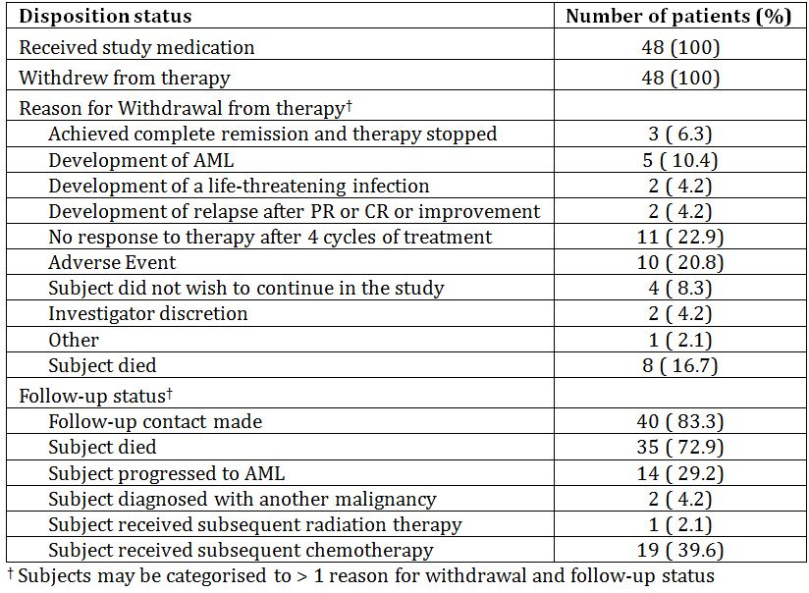

##### Major protocol violations/deviations

At re-analysis, major protocol deviations were identified in 3/48 patients. Although this listing includes hundreds of minor deviations, the evaluator could find no mention of any deviation relating to infusion rate.

##### Baseline data

There were 31 males and 17 females in the FAS population, all white. Mean age was 63.1 years (range: 35-81). Baseline diagnoses were: 23 RAEB, 24 RAEB-T, and 1 AML.

#### Evaluator’s conclusions on clinical efficacy for this indication

In assessing a different mode of administration, consideration must be given to the possibility that the peaks associated with IV administration may be associated with AEs, or that the profile of the concentration versus time curve may be important to efficacy.

##### Study CALGB 8421 re-analysis

The efficacy results from this small, open, uncontrolled pilot study could only ever have been useful as a pointer to further research, and the retrospective re-definition of the primary endpoint further calls the results into question. As the rate of IV administration used in the study was not as now proposed, and there is some doubt about what rate was actually used in the study, I consider that its efficacy data provide no support to the present application.

##### Study AZA-2002-BA-002 PK modelling report

In the absence of clinical evidence justifying the precise infusion times proposed, it is necessary to demonstrate that the proposed IV infusion results in a profile similar to that resulting from SC administration: at least, similar Cmax and AUC. This cannot be concluded with confidence from the modelling report submitted.

## Clinical safety

### Studies providing evaluable safety data

The following studies provided evaluable safety data:

#### Dose-response and non-pivotal efficacy studies

The dose-response and non-pivotal efficacy studies provided safety data, as follows:

* Study CALGB 8421 provided data on AEs.

#### Other studies evaluable for safety only

Clinical pharmacology studies

* Study AZA-2002-BA-002.

### Patient exposure

Exposure in Study AZA-2002-BA-002, on which the population PK analysis is based, was: 6 patients, each of whom received a 75 mg/m2 dose of azacitidine on 2 occasions: IV over 10 minutes, and SC.

In Study CALGB 8421, 48 patients were exposed on multiple occasions to 75 mg/m2 doses of azacitidine, each administered over a period of 4 hours (or possibly longer). The number of cycles for the 48 patients who received azacitidine ranged from 1-15, with the exception of 1 patient who remained in the study for 51 cycles. Further details of exposure are given in Table 5.

Table 5: Study CALGB 8421 – exposure.

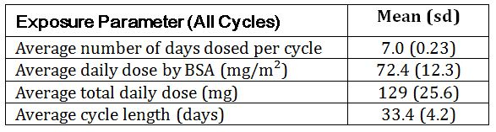

### Adverse events

#### All adverse events (irrespective of relationship to study treatment)

##### Study AZA-2002-BA-002

The only information available is that in Table 2.

##### Study CALGB 8421

The draft PI recommends use of IV solution within 1 hour of preparation, followed by infusion over a maximum of 40 minutes, whereas the protocol for this study allowed infusion over 4 hours. Thus the potency of the preparation used in this study may have been significantly inferior to label.

##### Tabulation across studies

In the *Clinical Overview*, the sponsor exhibits, *inter alia*, tabulations of TEAEs across the studies CALGB 8421, CALGB 8921 and CALGB 9221 (all of which were evaluated in *CER1*). Table 10 (*Most Frequently Observed TEAEs in the CALGB Studies*) from the *Clinical Overview* is copied as Table 6 (below), and Table 11 (*TEAEs Observed in ≥ 10% of the 8421 IV Azacitidine Group With a 2-Fold Difference in Number of Subjects With Events per Subject-Year of Exposure Between the 8421 IV Azacitidine Group and the 8921/9221 SC All Azacitidine Group*) from the *Clinical Overview* is copied as Table 7 (below). The sponsor concludes:

*"With the exception of injection site reactions that were observed with SC administration only and infusion/catheter site reactions that were observed more frequently with IV administration, the adverse event profile was generally similar between the IV and SC studies (Table 11)."*

Table 6: Most frequentlya observed TEAEs in the CALGB studies.

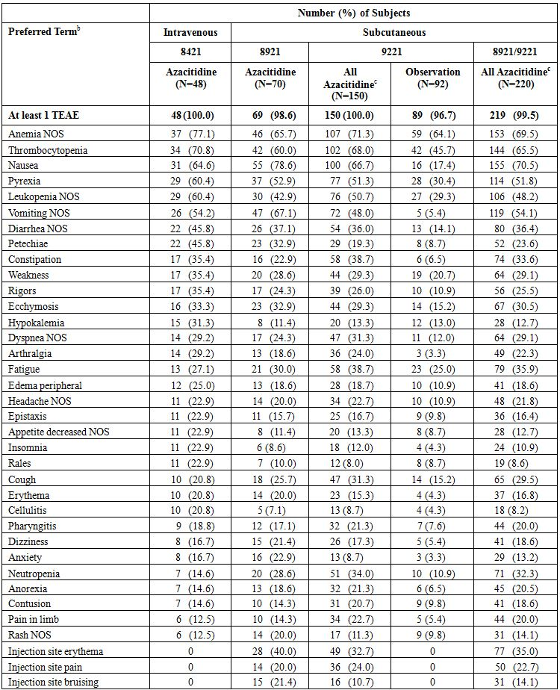

Sorted by decreasing frequency in the 8421 IV azacitidine group.

KEY: NOS=not otherwise specified, TEAE=treatment-emergent adverse event, MedDRA=Medical Dictionary for Regulatory Activities

a. ≥ 20.0% frequency in any treatment group from the 3 CALGB studies.

b. Multiple reports of the same preferred term for a subject are only counted once within each treatment group. Adverse events were coded using MedDRA Version 5.0.

c. Includes all subjects exposed to azacitidine, including 9221 subjects after crossing over from observation.

Table 7: TEAEs observed in ≥ 10% of the 8421 IV azacitidine group with a 2-fold difference in number of subjects with events per subject-year of exposure between the 8421 IV azacitidine group and the 8921/9221 SC all azacitidine group.

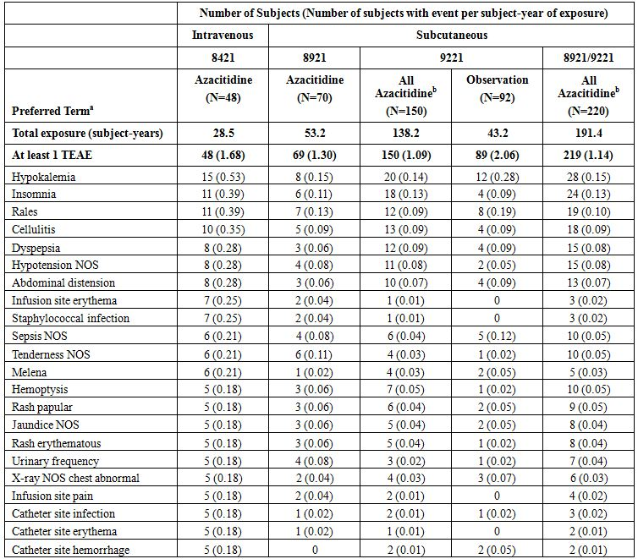

Sorted by decreasing frequency in the 8421 IV azacitidine group.

KEY: NOS=not otherwise specified, TEAE=treatment-emergent adverse event

a. Multiple reports of the same preferred term for a subject are only counted once within each treatment group.

b. Includes all subjects exposed to azacitidine, including 9221 subjects after crossing over from observation.

#### Treatment-related adverse events (adverse drug reactions)

##### Study AZA-2002-BA-002

See Section 7.3.1 (above).

##### Study CALGB 8421

The *CSR* states:

*"Treatment-related TEAEs were most frequently reported (> 50%) from the following SOCs: blood and lymphatic system disorders (89.6%), gastrointestinal disorders (87.5%), general disorders and administration site conditions (72.9%), and skin and subcutaneous tissue disorders (56.3%). The incidence of treatment-related TEAEs from the eye disorders (18.8%), cardiac disorders (12.5%), hepatobiliary disorders (12.5%), renal and urinary disorders (6.3%), psychiatric disorders (10.4%), and injury, poisoning, and procedural complications (10.4%) SOCs, which were all observed at > 20% in the all TEAE presentation, fell below 20% when the causality assessment was applied. The incidence of treatment-related TEAEs from the nervous system disorders (27.1%) and musculoskeletal and connective tissue disorders (20.8%) SOCs, which were both observed at > 50% in the all TEAE presentation, fell below 30% when the causality assessment was applied."*

The most commonly observed (≥ 20%) treatment-related TEAEs are summarised in Table 8.

Table 8: Study CALGB 8421 – common treatment-related TEAEs.

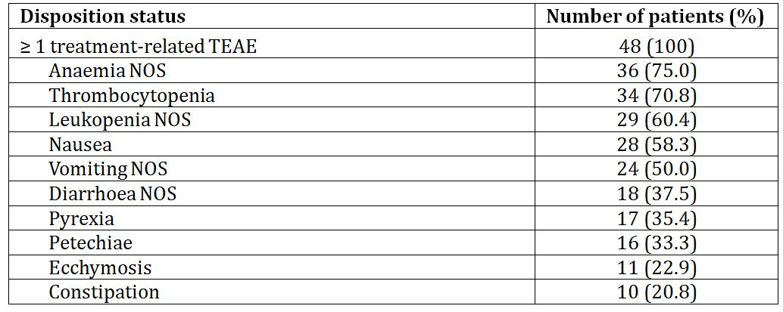

#### Deaths and other serious adverse events

##### Study AZA-2002-BA-002

None.

##### Study CALGB 8421

These are detailed in *CER1*.

#### Discontinuation due to adverse events

##### Study AZA-2002-BA-002

None.

##### Study CALGB 8421

These are detailed in *CER1*.

### Laboratory tests

##### Study AZA-2002-BA-002

See Section 7.3.1 (above).

##### Study CALGB 8421

These are detailed in *CER1*.

### Post-marketing experience

None reported. This is surprising, in view of the fact that IV use of the drug was approved in the US over 5 years ago. The evaluator expects that properly assembled data accruing from experience with IV administration following such approval would provide a far better basis for assessment than the material contained in the present dossier.

### Evaluator’s overall conclusions on clinical safety

In my opinion, no valid conclusion can be drawn from the data reproduced in Tables 6 and 7 regarding the relative safety or tolerability of the approved SC mode of administration and the proposed IV mode, for the following reasons:

* the studies involved different designs and populations, with Study 8421 (for example) including higher risk patients;
* the duration of IV administration in Study 8421 was not similar to that now proposed; and
* Study 8421 was small.

The only available clinical data relating to safety and tolerability of the proposed 10-40 min IV infusion are from Study AZA-2002-BA-002, in which 6 patients were each treated once IV over 10 minutes. This is not, in my opinion, an adequate basis for assessment, but the Cmax values (which were on average over 3 times higher with the IV than with SC administration) raise concern.

## First round benefit-risk assessment

### First round assessment of benefits

The benefits of the proposed method of administration cannot be assessed from the available information.

### First round assessment of risks

The risks of the proposed method of administration cannot be assessed from the available information.

### First round assessment of benefit-risk balance

The benefit-risk balance cannot be assessed.

## First round recommendation regarding authorisation

The evaluator recommends that the application for approval of the specified IV administration should be refused.

## Clinical questions

### Safety

The evaluator does not consider it worthwhile to pursue further the results of Study CALGB 8421. If this opinion is not accepted, the sponsor might be asked to obtain further information relating to the preparation and administration of azacitidine in Study CALGB 8421, specifically relating to whether the solution may have been further diluted and infused over a period > 4 h.

## References

European Medicines Agency (EMA). 2007. *Guideline on Reporting the Results of Population Pharmacokinetic Analyses.* Document CPMP/EWP/ 185990/06.

FDA. 1999. *Guidance for Industry. Population Pharmacokinetics.*

Silverman L et al (1989). 5-Azacytidine (AZ) as a low dose continuous infusion is an effective therapy for patients with myelodysplastic syndromes (MDS). *Proc Am Soc Clin Oncol* 8(769):198.

Silverman LR et al (1990). Low dose continuous infusion azacytidine an effective therapy for patients with myelodysplastic syndromes a study of the Cancer and Leukemia Group B. *J Cancer Res Clin Oncol* 16(Suppl, Pt. 2):816.

Silverman LR et al (1993). Effects of treatment with 5-azacytidine on the in vivo and in vitro hematopoiesis in patients with myelodysplastic syndromes. *Leukemia* 7(Suppl 1):21-9.

Silverman LR et al (1993a). Azacytidine (Aza C) in myelodysplastic syndromes (MDS). *Cancer Invest* 11(Suppl): 52, Abstract 42.

Silverman LR et al (1994). Azacytidine (Aza C) in myelodysplastic syndromes (MDS), CALGB studies 8421 and 8921. *Ann Hematol* 68(2):A12, Abstract 46.

Silverman L (2000). The role of azacitidine in the treatment of the myelodysplastic syndrome. [abstract]. ASH meeting.

Silverman L (2001). The role of azacitidine in the treatment of the myelodysplastic syndrome [abstract Or36]. *Leukemia Res* 25(Suppl 1):S14.