|  |
| --- |
| **August 2013** |

|  |
| --- |
| Australian Public Assessment Report for azacitidine |
| Proprietary Product Name: Vidaza |
| Sponsor: Celgene Pty Ltd |

About the Therapeutic Goods Administration (TGA)

* The Therapeutic Goods Administration (TGA) is part of the Australian Government Department of Health and Ageing, and is responsible for regulating medicines and medical devices.
* The TGA administers the *Therapeutic Goods Act 1989* (the Act), applying a risk management approach designed to ensure therapeutic goods supplied in Australia meet acceptable standards of quality, safety and efficacy (performance), when necessary.
* The work of the TGA is based on applying scientific and clinical expertise to decision-making, to ensure that the benefits to consumers outweigh any risks associated with the use of medicines and medical devices.
* The TGA relies on the public, healthcare professionals and industry to report problems with medicines or medical devices. TGA investigates reports received by it to determine any necessary regulatory action.
* To report a problem with a medicine or medical device, please see the information on the TGA website <[http://www.tga.gov.au](http://www.tga.gov.au/)>.

About AusPARs

* An Australian Public Assessment Record (AusPAR) provides information about the evaluation of a prescription medicine and the considerations that led the TGA to approve or not approve a prescription medicine submission.
* AusPARs are prepared and published by the TGA.
* An AusPAR is prepared for submissions that relate to new chemical entities, generic medicines, major variations, and extensions of indications.
* An AusPAR is a static document, in that it will provide information that relates to a submission at a particular point in time.
* A new AusPAR will be developed to reflect changes to indications and/or major variations to a prescription medicine subject to evaluation by the TGA.

**Copyright**

© Commonwealth of Australia 2013

This work is copyright. You may reproduce the whole or part of this work in unaltered form for your own personal use or, if you are part of an organisation, for internal use within your organisation, but only if you or your organisation do not use the reproduction for any commercial purpose and retain this copyright notice and all disclaimer notices as part of that reproduction. Apart from rights to use as permitted by the *Copyright Act 1968* or allowed by this copyright notice, all other rights are reserved and you are not allowed to reproduce the whole or any part of this work in any way (electronic or otherwise) without first being given specific written permission from the Commonwealth to do so. Requests and inquiries concerning reproduction and rights are to be sent to the TGA Copyright Officer, Therapeutic Goods Administration, PO Box 100, Woden ACT 2606 or emailed to <[tga.copyright@tga.gov.au](mailto:tga.copyright@tga.gov.au)>.

Contents

I. Introduction to product submission 4

Submission details 4

Product background 4

Regulatory status 5

Product Information 5

II. Quality findings 6

Drug substance (active ingredient) 6

Drug product 6

Biopharmaceutics 7

Quality summary and conclusions 8

III. Nonclinical findings 9

Introduction 9

Pharmacology 9

Pharmacokinetics 10

Toxicology 10

Nonclinical summary and conclusions 11

IV. Clinical findings 12

Introduction 12

Pharmacokinetics 12

Pharmacodynamics 12

Efficacy 12

Safety 13

List of questions 13

Clinical summary and conclusions 13

V. Pharmacovigilance findings 14

Risk management plan 14

VI. Overall conclusion and risk/benefit assessment 19

Quality 19

Nonclinical 19

Clinical 19

Risk management plan 23

Risk-benefit analysis 23

Outcome 29

Attachment 1. Product Information 30

Attachment 2. Extract from the Clinical Evaluation Report 30

## I. Introduction to product submission

### Submission details

|  |  |
| --- | --- |
| *Type of Submission* | Major variation (route of administration) |
| *Decision*: | Approved |
| *Date of Decision:* | 11 April 2013 |

|  |  |
| --- | --- |
| *Active ingredient(s):* | Azacitidine |
| *Product Name(s):* | Vidaza |
| *Sponsor’s Name and Address:* | Celgene Pty Ltd  Level 7, 607 St Kilda Road  Melbourne VIC 3004 |
| *Dose form(s):* | Powder for injection |
| *Strength(s):* | 100 mg |
| *Approved Therapeutic use:* | Vidaza is indicated for the treatment of patients with:   * Intermediate-2 and High-risk Myelodysplastic Syndromes (MDS) according to the International Prognostic Scoring System (IPSS), * Chronic Myelomonocytic Leukemia (CMMoL (10%-29% marrow blasts without Myeloproliferative Disorder)), * Acute Myeloid Leukemia (AML) with 20-30% blasts and multi-lineage dysplasia, according to World Health Organisation Classification (WHO),   in whom allogenic stem cell transplantation is not indicated. |
| *Route(s) of administration:* | Intravenous (IV) |
| *ARTG Number (s)* | 153080 |

### Product background

This AusPAR describes an application by the sponsor, Celgene Pty Ltd, to extend the route of administration for azacitidine (Vidaza) by adding IV infusion as an alternative to the approved subcutaneous (SC) route of administration. It is proposed that the daily dose be infused over a period of 10-40 min.

Azacitidine is an analogue of cytidine and an anti neoplastic agent. Vidaza is presented in a vial as 100 mg azacitidine powder, requiring reconstitution. Vidaza has the following indications:

*Treatment of patients with:*

* + - *Intermediate-2 and High-risk Myelodysplastic Syndromes (MDS) according to the International Prognostic Scoring System (IPSS),*
    - *Chronic Myelomonocytic Leukemia (CMMoL [10%-29% marrow blasts without Myeloproliferative Disorder]),*
    - *Acute Myeloid Leukemia (AML) with 20-30% blasts and multi lineage dysplasia, according to World Health Organisation Classification (WHO),*

*in whom allogenic stem cell transplantation is not indicated.*

The rationale for proposing this new route of administration is that the sponsor believes physicians may be administering Vidaza by IV infusion off label without adequate knowledge of the stability profile or administration technique.

The US Label allows use by IV infusion or SC administration. The US instructions for IV use are as follows:

*Vidaza solution is administered intravenously. Administer the total dose over a period of 10-40 min. The administration must be completed within 1 hour of reconstitution of the Vidaza vial.*

The EU Summary of Product Characteristics (SmPC) recommends only SC use.

The current submission also proposes amendments to the Product Information (PI) regarding interaction with P450 isoenzymes and regarding adverse effects.

### Regulatory status

Vidaza was designated an orphan drug by the TGA on 17 June 2008. It was registered in Australia in 2009.

Vidaza has been approved for use by IV infusion in a number of countries worldwide including the US (26 January 2007), Argentina (9 November 2007), Philippines (25 June 2008), Lebanon (8 August 2008), Hong Kong (15 August 2008), Macau (December 2008), Thailand (9 March 2009), Israel (22 March 2009), Japan (21 January 2011), South Korea (21 May 2012), and Taiwan (3 September 2012). The approved indication in the US for SC and IV administration of Vidaza is:

*Vidaza is indicated for treatment of patients with the following French-American-British (FAB) myelodysplastic syndrome subtypes: refractory anaemia (RA) or refractory anaemia with ringed sideroblasts (if accompanied by neutropenia or thrombocytopenia or requiring transfusions), refractory anaemia with excess blasts (RAEB), refractory anaemia with excess blasts in transformation (RAEB-T), and chronic myelomonocytic leukaemia (CMMoL).*

### Product Information

The approved Product Information (PI) current at the time this AusPAR was prepared can be found as Attachment 1.

## II. Quality findings

### Drug substance (active ingredient)

The finished product is sterile and is supplied in glass (type I) vials containing 100 mg azacitidine and 100 mg mannitol. The maximum single and maximum daily dose recommended in the PI is 75 mg/m2 body surface area.

The drug substance is a white/off white solid that is sparingly soluble in water (13.8 mg/mL) and normal saline.

There are currently no British Pharmacopoeia (BP) or US Pharmacopoeia (USP) monographs available for the drug substance or drug product.

### Drug product

The PI instructions for IV administration indicate that the vial contents are dissolved in 10 mL of sterile water for injections and that the reconstituted solution is stable for 1 h at room temperature.

The required amount of the product is then injected into a 50-100 mL infusion bag of either 0.9% sodium chloride or lactated Ringer’s Injection. Administration must be complete within 1 h of reconstitution.

Studies conducted previously[1] indicate that assay decreases by about 10% when solutions (0.2 mg/mL and 2.0 mg/mL) of the drug substance were stored at room temperature for about 2 h in either Lactated Ringer’s or normal saline solution. In 5% dextrose solution, the same concentrations of the drug substance degraded by 10% within 1 h.

These studies have now been supplemented with a company sponsored study, designed to evaluate drug product compatibility and stability with both normal saline and Lactated Ringer’s IV fluids at concentrations of 1 mg/mL and 4 mg/mL.

In the 1 mg/mL experiments, the drug product was taken up in 10 mL of sterile water for injections and the vial contents were transferred to an IV bag containing either normal saline (100 mL) or Lactated Ringer’s solution (100 mL).

For the 4 mg/mL dilution, two individual vials of the drug product were taken up in 2 x 20 mL of sterile water for injection. The vial contents were transferred to IV bags containing either normal saline (30 mL) or Lactated Ringer’s solution (30 mL).

Control samples were prepared in which the reconstituted drug product (10 mg/mL) was stored in volumetric flasks with each of the IV fluids.

The experimental period entailed a 30 min hold period followed by a 30 min infusion period. During the hold period, the IV bags were held undisturbed. The drug product solution was then pushed through the IV line using a volumetric infusion pump over 30 min. Sample analysis (using the approved high performance liquid chromatography [HPLC] conditions) occurred after 0, 30, 45 and 60 min.

The assay results were variable and were quoted against the initial azacitidine measurement (after the product had been reconstituted and diluted with an appropriate IV solution). Under all conditions there was a clear decrease in assay however this was not easily quantified as assay results for the initial reconstituted solution were not provided.

Nevertheless, it appears that for the product (especially when mixed with normal saline) may not meet the currently approved acceptance criteria limit for assay after 1 h. Given the results it would seem appropriate that the instruction in the PI should be changed from ‘Administration must be complete within 1 h of reconstitution’ to ‘Administration must be complete within 30 min of reconstitution’. *The sponsor will be asked to comment on this suggestion and also to provide a mass balance analysis and an analysis of the degradants formed in the compatibility studies.*

### Biopharmaceutics

In the original application to register Vidaza by SC injection, a two period crossover study (Study AZA-2002-BA-002) was conducted to assess the bioavailability of AC and IV azacitidine in subjects with MDS. The pharmacokinetics of azacitidine were studied following single 75 mg/m2 SC and IV doses in 6 subjects.

The study revealed that azacitidine was rapidly absorbed following SC administration, with maximum plasma concentrations occurring at the first postdose sampling time (30 min) in all 6 subjects. Following IV infusion, the maximum plasma drug concentration (Cmax) was observed 5 min into the 10 min infusion in 2 of 6 subjects, and at the end of saline flush (11 min) in the remaining 4 subjects. The mean maximum azacitidine plasma concentration following IV infusion was 2580 ng/mL, almost 4 fold higher than those observed following SC administration (687 ng/mL [geometric least squares mean; arithmetic mean = 750 ng/mL]). The differences in Cmax are consistent with higher maximum exposure expected following IV versus extravascular drug administration. Azacitidine was also rapidly eliminated: the mean half life after IV administration was 0.36 h (approximately 22 ± 1 min), while that after SC administration was slightly longer (0.69 h; approximately 41 ± 8 min). The apparent (SC) clearance was 167.48 L/h and the systemic (IV) clearance was 146.70 L/h.

In the current submission, results were provided from pharmacokinetic modelling and simulation of data from Study AZA-2002-BA-002 in order to develop a population PK model. The objective of this modelling and simulation was to characterise the expected systemic exposure resulting from a longer azacitidine IV infusion and to compare to that observed upon 10 min IV infusion or SC injection. This study has not been assessed; rather, the results from it are quoted below.

The average azacitidine systemic exposure that would be expected following IV infusion of 75 mg/m2 over longer time periods was simulated using a two compartment model. The total azacitidine dose was set at 142.5 mg, which corresponds to a dose of 75 mg/m2 in a typical subject with body surface area of 1.9 m2.

Figure 1 presents the simulated mean IV profiles following a 20, 30, and 40 min infusion. For comparison, the observed mean IV profile following a 10 min infusion and the observed mean SC profile has been overlaid on the simulated IV profiles. Predicted azacitidine concentrations following 10 min IV infusion were generally consistent with observed concentrations.

Figure 1: Mean azacitidine pharmacokinetic profiles following administration of 75 mg/m2 via IV infusion or SC injection.

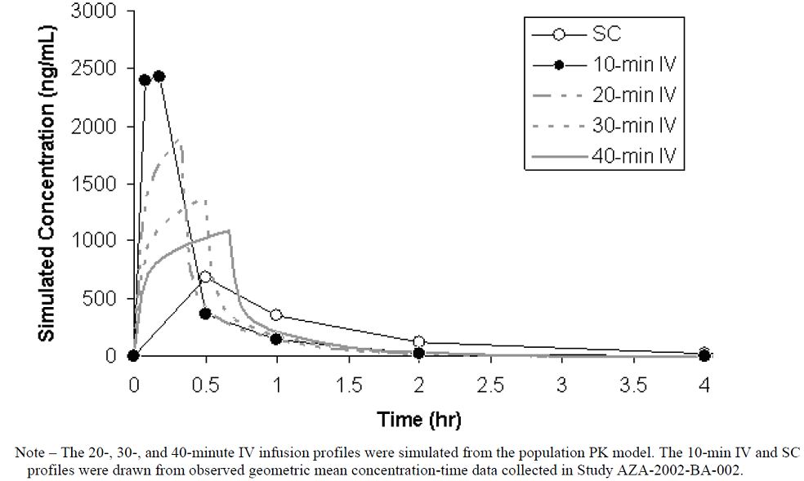

Population estimates of azacitidine exposure following each simulated IV infusion are presented in Table 1. For reference, the average exposure parameters observed after SC injection of 75 mg/m2 are also reported, along with the ratio of IV to SC mean exposure parameters: Cmax and AUC (area under the plasma concentration-time curve).

Table 1: Simulated mean exposure parameters following IV infusion of 75 mg/m2 over 20, 30 and 40 min.

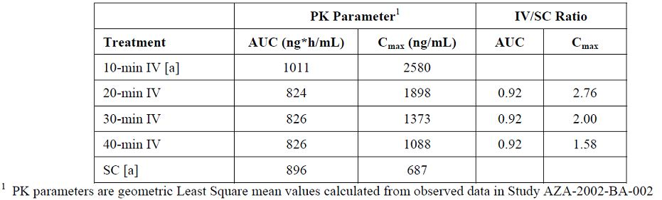

The information presented in the PK studies is consistent with the information in the PI.

### Quality summary and conclusions

The application and the supporting data relating to the composition, development, manufacture, quality control, stability and bioavailability of the product have been assessed and checked for compliance, as applicable, with Australian legislation and requirements for new medicines and in accordance with pharmacopoeial standards and the technical guidelines adopted by the TGA. These data are complete and satisfactory except for the issues listed below.

#### Drug product

* Please provide an assurance that no changes have been made to the manufacturing aspects of the drug product and that the only changes to the quality aspects are those regarding the drug product specification.
* The results from the compatibility study are quoted as a percentage of the initial azacitidine concentration in the IV fluid diluent. No consideration seems to have been given to degradation of the drug substance prior to mixture with the IV fluid. It is not clear from the results that the product would meet the assay expiry limit after 60 min of storage. Therefore, it appears that the instruction in the PI of ‘Administration must be complete within 1 h of reconstitution’ should be changed to ‘Administration must be complete within 30 min of reconstitution’.

Please comment on these observations and also provide an analysis of the degradants formed in the compatibility studies.

## III. Nonclinical findings

### Introduction

Vidaza (azacitidine) is a pyrimidine analogue currently approved as an SC treatment for patients with:

* Intermediate-2 and High-risk Myelodysplastic Syndromes (MDS) according to the International Prognostic Scoring System (IPSS);
* Chronic Myelomonocytic Leukaemia (CMMoL (10%-29% marrow blasts without Myeloproliferative Disorder));
* Acute Myeloid Leukaemia (AML) with 20-30% blasts and multi lineage dysplasia, according to World Health Organisation Classification (WHO), in whom allogeneic stem cell transplantation is not indicated.

The current submission seeks approval for a new route of administration (IV infusion over 10 to 40 min). No changes are proposed to the formulation, dose or dosage regimen; however, a number of proposed changes to the PI document require nonclinical comment.

No new data were provided to the nonclinical evaluator to support the new route of administration. Previously evaluated studies (Studies ADL-NCI-72-35 and ADL-NCI-72-38; SN 2008-1751-4) were submitted to address local tolerance and toxicity issues associated with IV administration. A study (Study DMP-002) examining the effects of azacitidine on a series of CYP450 enzymes was submitted. In response to a Section 31 request, the sponsor provided four new cardiovascular safety pharmacology studies.

### Pharmacology

Dogs that received ≥2 mg/kg IV azacitidine had marked tachycardia while hypotension was evident at ≥4 mg/kg IV. An increase in the QTc interval was also seen at ≥2 mg/kg IV. A decrease in PR interval was seen at these doses but this was likely associated with the increase in heart rate. An increase in creatine kinase fraction 2 (CK-MB) on Day 1 suggested some damage to cardiac muscles.[2] *In vitro* studies were conducted in an attempt to understand the *in vivo* findings. A decrease in the spontaneous beating rate was seen in guinea pig atrial preparations at ≥10 µM (approximately equivalent to the clinical Cmax from a 10 min IV infusion) and a small decrease in heart rate was seen in isolated guinea pig heart preparations at ≥20 µM (~2 times the clinical Cmax from a 10 min IV infusion), suggesting a negative chronotropic effect rather than the positive effect seen *in vivo*. There was no evidence of a vasodilatory effect in isolated rat aorta preparations at ≤40 µM (3.8 times the clinical Cmax from a 10 min IV infusion). No *in vitro* studies have been conducted to assess effects on QTc interval. Nonetheless, findings in the *in vitro* studies with azacitidine (decreased heart rate and a lack of a vasodilatory effect) did not correlate with those seen in the *in vivo* study in dogs. However, the cardiovascular changes in dogs occurred at least 2 h after administration, far later than the time to reach maximum plasma concentration (Tmax) for azacitidine (0.17 h), suggesting it may not be associated directly with azacitidine. Association with an azacitidine metabolite cannot be ruled out. As the effects in dogs occurred at plasma levels of azacitidine similar to that anticipated clinically from a 10 min IV infusion of Vidaza, adverse cardiovascular effects may be seen clinically with the proposed new route of administration (for further details, see Section VI of this AusPAR).

### Pharmacokinetics

Table 2 has a comparison of exposure (AUC and Cmax) following SC administration and IV infusion in human subjects. The data following SC administration and the 10 min IV infusion were presented in the clinical Study AZA-2002-BA-002, while data for the 40 min IV infusion were simulated based on data from this clinical study. The adequacy of the simulated data is not discussed in this report. The data indicate greater exposure, in particular Cmax, following IV infusion compared with SC administration.

Table 2: Mean exposure parameters following IV infusion or SC administration of 75 mg/m2 azacitidine in patients.

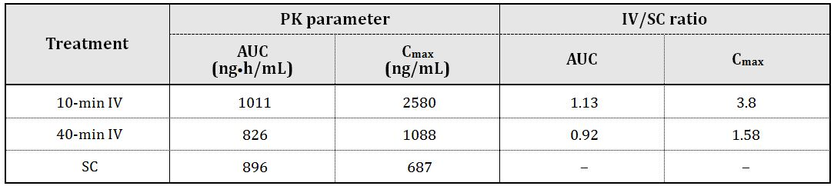

#### Pharmacokinetic drug interactions

Previously submitted data indicated low to moderate inhibition of CYP1A2 and 2E1 at 100 μM (~35 times the clinical Cmax following SC administration; ~9 times the Cmax following 10 min IV infusion). No CYP450 induction was seen in human hepatocytes with 100 μM azacitidine. Decreased activity (29-78%) of CYP1A2, 2C19 and 3A4/5 was seen with a depression of CYP450 seen *in vivo* in mice. The newly submitted study indicated azacitidine was neither a direct nor time dependent inhibitor of CYP2B6 and CYP2C8.

### Toxicology

Previously submitted toxicity studies with azacitidine consisted of IV studies in dogs and rhesus monkeys. Adverse effects were seen on the lungs, bone marrow, spleen, lymph nodes and liver. Effects were also seen on the kidneys of monkeys. These effects occurred at doses similar to, or less than, the expected clinical dose based on body surface area. Adverse effects were also seen on male fertility and embryofoetal development. Azacitidine was genotoxic and carcinogenic at subclinical doses. It was concluded that there was substantial, potentially lethal, risks in humans at the recommended SC dose.

Given the greater exposure following IV infusion more severe toxicity is expected with the new route of administration. The expected Cmax following IV infusion for 10 min is ~4 times that seen following SC administration (for further details, see Section VI of this AusPAR). There is, therefore, a greater potential for adverse CNS and cardiovascular effects following IV infusion compared with SC administration. No adequate nonclinical data were presented to assess effects on CNS activity (for further details, see Section VI of this AusPAR).

#### Local tolerance

In a skin irritation study in rabbits, azacitidine produced mild, reversible irritation but only at a concentration of 9%. Neither of the resubmitted toxicity studies used the clinical formulation of Vidaza (that is, containing the excipient mannitol). Therefore, no adequate studies have been submitted to assess local reactions following IV administration of Vidaza or effects associated with perivascular administration which may occur in the event of misadministration. In response to a Section 31 request, the sponsor cited clinical data to assess local reactions following IV infusion. These data are not assessed here.

#### Comments on the Safety Specification of the Risk Management Plan

The following comments refer to the Nonclinical Safety Specification included in the sponsor’s draft Risk Management Plan (RMP) accompanying the sponsor’s application letter (26 March 2012). Results and conclusions drawn from the nonclinical program for azacitidine are generally consistent with previous nonclinical evaluation reports cardiovascular safety pharmacology studies submitted in this application. Adequacy of the clinical cardiovascular findings cited in the nonclinical safety specification requires clinical comment.

### Nonclinical summary and conclusions

* Celgene Pty Ltd has applied for the approval of a new route of administration for Vidaza (azacitidine). Vidaza is currently approved for SC administration. The new route of administration is via IV infusion over 10 to 40 min. No changes are proposed to the formulation, dose or dosage regimen.
* Four new safety pharmacology studies were submitted. Tachycardia, hypotension and QTc prolongation was seen in dogs that received ≥2 mg/kg IV azacitidine, resulting in plasma levels of azacitidine similar to that anticipated clinically from a 10 min IV infusion of Vidaza. *In vitro* studies suggested that this is unlikely to be associated directly with azacitidine, but based on *in vivo* incidences occurring ~2 h after peak azacitidine levels, an association with a metabolite cannot be ruled out.
* A newly submitted study indicated azacitidine was neither a direct nor time-dependent inhibitor of CYP2B6 and CYP2C8 at clinically relevant concentrations.
* As there is greater systemic exposure (1.1 times the AUC and ~4 times the Cmax) with an IV infusion of 10 min compared with that achieved with the approved administration route, greater toxicity to the lungs, bone marrow, spleen, lymph nodes, liver and kidneys may be seen during clinical use. The greater Cmax with IV infusion indicates a potential increase in adverse cardiovascular events. Less risk is likely with a longer infusion time.
* No adequate local tolerance studies have been submitted.
* Nonclinical data indicate a greater risk for toxicity with the new route of administration. These risks, in particular a potential increase in adverse cardiac events, should be carefully considered when assessing the risk/benefit balance for the new route of administration.
* Should the new route of administration be approved on clinical grounds, the PI should be amended as directed.

## IV. Clinical findings

*A summary of the clinical findings is presented in this section. Further details of these clinical findings can be found in Attachment 2.*

### Introduction

The submission contained the following clinical information:

* 0 new clinical studies.
* 1 Clinical Safety Report (CSR) relating to clinical Study CALGB 8421. That study was submitted with the initial application for registration and evaluated in the first round evaluation.
* 1 population pharmacokinetic analysis, based on data from Study AZA-2002-BA-002. That study was submitted with the initial application for registration and evaluated in the first round evaluation.
* Literature references. These comprised a subset of the references cited in: (a) the pharmacokinetic modelling report, (b) a report identified as Azacitidine-DMPK-002 (relating to an *in vitro* study) and (c) the CSR on Study CALGB 8421. None contributed any new clinical data supporting the application.

### Pharmacokinetics

In the evaluator’s opinion, due to

* the paucity of data used in developing the population pharmacokinetic model;
* the fact that individual patient characteristics were not taken into account; and
* the lack of validation

the population pharmacokinetic modelling is of little utility. The evaluator doubts that the sponsor has anything to gain, for the purposes of the present application, by correcting the presentational flaws in view of these other problems. At best, the results of the modelling suggest IV regimens which might be studied in a further clinical pharmacokinetic comparison.

### Pharmacodynamics

No data.

### Efficacy

In assessing a different mode of administration, consideration must be given to the possibility that the peaks associated with IV administration may be associated with AEs, or that the profile of the concentration versus time curve may be important to efficacy.

#### Study CALGB 8421 re analysis

The efficacy results from this small, open, uncontrolled pilot study could only ever have been useful as a pointer to further research, and the retrospective redefinition of the primary endpoint further calls the results into question. As the rate of IV administration used in the study was not as now proposed, and there is some doubt about what rate was actually used in the study, the clinical evaluator considers that its efficacy data provide no support to the present application.

#### Study AZA-2002-BA-002 PK modelling report

In the absence of clinical evidence justifying the precise infusion times proposed, it is necessary to demonstrate that the proposed IV infusion results in a profile similar to that resulting from SC administration with a similar Cmax and AUC. This cannot be concluded with confidence from the modelling report submitted.

### Safety

In the evaluator’s opinion, no valid conclusion can be drawn from the data regarding the relative safety or tolerability of the approved SC mode of administration and the proposed IV mode, for the following reasons:

* the studies involved different designs and populations, with Study 8421 (for example) including higher risk patients;
* the duration of IV administration in Study 8421 was not similar to that now proposed; and
* Study 8421 was small.

The only available clinical data relating to safety and tolerability of the proposed 10-40 min IV infusion are from Study AZA-2002-BA-002, in which 6 patients were each treated once IV over 10 min. This is not, in the evaluator’s opinion, an adequate basis for assessment, but the Cmax values (which were on average over 3 times higher with the IV than with SC administration) raise concern.

### List of questions

#### Safety

The evaluator does not consider it worthwhile to pursue further the results of Study CALGB 8421. If this opinion is not accepted, the sponsor might be asked to obtain further information relating to the preparation and administration of azacitidine in Study CALGB 8421, specifically relating to whether the solution may have been further diluted and infused over a period > 4 h.

### Clinical summary and conclusions

#### First round assessment of benefits

The benefits of the proposed method of administration cannot be assessed from the available information.

#### First round assessment of risks

The risks of the proposed method of administration cannot be assessed from the available information.

#### First round assessment of benefit-risk balance

The benefit-risk balance cannot be assessed.

#### First round recommendation regarding authorisation

The evaluator recommends that the application for approval of the specified IV administration should be refused.

## V. Pharmacovigilance findings

### Risk management plan

The sponsor submitted a RMP, which was reviewed by the TGA’s Office of Product Review (OPR).

#### Safety specification

The sponsor provided a summary of ongoing safety concerns which are shown at Table 3.

Table 3: Summary of ongoing safety concerns for Vidaza.

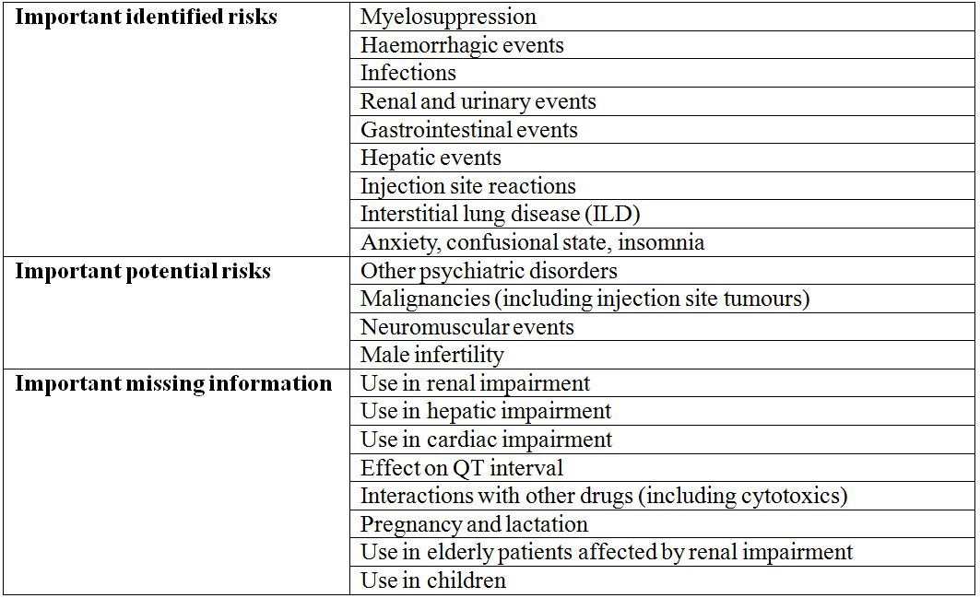

The RMP included the following additional safety concerns, which have not been formally included as ongoing safety concerns in the current RMP:

* Tumour lysis syndrome (TLS) has been reported in post marketing setting and will be included as an adverse event/adverse drug reaction (Section 1.5 of the EU RMP) in the next RMP update (version 8). TLS is listed as a post marketing adverse event in the currently approved Australian PI (25 October 2011 version).
* Cellulitis has been identified for addition in the EU SmPC by the EU Committee for Medicinal Products for Human Use (CHMP), upon its review of Periodic Safety Update Report (PSUR)-10. This has been included in the revised SmPC (24 July 2012), under Section 4.8 Undesirable effects, but has not yet been included in the draft Australian PI.

##### OPR reviewer comment:

There is no discussion provided in the EU RMP on whether there are any significant changes (if any) in the profile of the observed adverse events (that is, frequency or severity) when comparing SC and IV administrations. However, a statement is included in the draft Australian PI – Adverse effects section:

*“Adverse reactions associated with intravenously administered azacitidine were similar in frequency and severity compared with subcutaneously administered azacitidine”.*

It is recommended the sponsor provide a brief summary to demonstrate a similar profile in adverse reactions between SC and IV administrations and to discuss any limitations of the data (if any).

It is expected that TLS will be formally included as an ongoing safety concern in the future update of the EU RMP. Considering that cellulitis has also been identified as an event for specific monitoring and analyses in future PSURs, the sponsor should confirm if cellulitis is also intended for inclusion as an ongoing safety concern in the future update of the EU RMP, and if not, to provide an acceptable justification. It is also noted that acute febrile neutrophilic dermatosis (Sweet’s syndrome) has been identified as an event of special interest for specific analysis in the PSUR, and has been recently included in the approved US product label[3] as an adverse events reported in post marketing setting. It is recommended that the sponsor comments on whether acute febrile neutrophilic dermatosis will also be listed as a post marketing adverse event in the Australian PI. The above summary of ongoing safety concerns is otherwise considered acceptable, unless additional concerns are raised from the evaluation of the nonclinical and clinical aspects of the Safety Specification.

#### Pharmacovigilance plan

It is proposed that routine pharmacovigilance activities will be implemented for all ongoing safety concerns, with reporting in the PSURs. The following are proposed for specific analysis in the PSURs:

* Death
* Blood and lymphatic disorders: myelosuppression
* Cardiac disorders: cardiac failure, ventricular arrythyhmias, QT prolongation, Torsade de Pointes
* Gastrointestinal disorders: ischemic colitis
* Haemorrhagic disorders
* Hepatobiliary disorders: severe hepatic disorders
* Infections and infestations: infection and cellulitis
* Injection site reactions
* Neoplasms benign, malignant and unspecified (including cysts and polyps): neoplasms, primary second malignancy and TLS
* Neuromuscular events
* Psychiatric disorders
* Renal and urinary disorders: renal disorders
* Respiratory, thoracic and mediastinal disorders: ILD
* Skin disorders: acute febrile neutrophilic dermatosis, pyoderma gangrenosum
* Infertility
* Off label use

In addition, the following additional pharmacovigilance activities are proposed (protocols have not been reviewed for this report as these are ongoing studies):

* Study AZA PH US 2007 PK006 titled “A Phase I, Open Label, Multi Centre, Parallel Group Study to Assess the Pharmacokinetics and Safety of Subcutaneous Azacitidine in Adult Cancer Patients With and Without Impaired Renal Function”:
  + To further characterise the important identified risk ‘renal and urinary events’ and, areas of important missing information ‘use in renal impairment’ and ‘use in elderly patients affected by renal impairment’.
  + Table 56 *Outstanding Pharmacovigilance Actions* and Annex 3 of the EU RMP indicated that the anticipated dates for the clinical study reports for Part 1 (dose proportionality from 25 to 100 mg/m2 azacitidine in randomised cancer patients with normal renal function) and Part 2 of the study (comparison between cancer patients with normal versus impaired renal function) are 31 January 2012 and 31 July 2012, respectively, with the targeted number of participants of up to 24 (Part 1 of the study) and 18 (Part 2 of the study).
  + Section 2.2 *Additional Pharmacovigilance Activities and Action Plans* and Annex 3 of the EU RMP indicated that a total of 18 subjects have participated in the study as of 18 May 2011.
* Study AZA PH US 2008 CL 008 titled “A Phase I, Open Label, Dose Ranging Study to Evaluate the Pharmacokinetics and Safety of Azacitidine Administered Subcutaneously and as Different Oral Formulations in Subjects with Myelodysplastic Syndromes (MDS), Chronic Myelomonocytic Leukemia (CMML), Acute Myelogenous Leukemia (AML), Lymphoma, and Multiple Myeloma”:
  + Targeted number of 78 participants.
  + Section 2.2 *Additional Pharmacovigilance Activities and Action Plans* and Annex 3 of the EU RMP indicated that a total of 16 subjects (with 4 withdrawals due to treatment-emergent adverse events) have participated in Part 1 of the study as of 18 May 2011.
  + Table 56 *Outstanding Pharmacovigilance Actions* and Annex 3 of the EU RMP indicated that the anticipated date for this clinical study report is Q2 2013 (30 June 2013).

##### OPR reviewer’s comments:

The EU RMP reported the numbers of participants as of 18 May 2011 in both ongoing Studies AZA PH US 2007 PK006 and AZA PH US 2008 CL 008, which appeared to be lower than the targeted recruitment numbers. It is recommended that the sponsor provides a brief update on this progress. It is noted that the ongoing Study AZA PH US 2008 CL 008 is being conducted to primarily compare the pharmacokinetics between the SC versus oral azacitidine administrations (Part 1 of the study) and effects of food on oral azacitidine (Part 2 of the study). Although this study is expected to provide additional safety information, it is not specifically designed to further characterise any of the specific ongoing safety concerns identified in the EU RMP.

It is also recommended the sponsor confirms if any additional pharmacovigilance activities beyond that of routine activities will be proposed to further evaluate the risks of tumour lysis syndrome and cellulitis. The proposed routine and additional pharmacovigilance activities are otherwise considered appropriate, unless additional concerns are raised by the clinical and/or nonclinical evaluator(s).

#### Risk minimisation activities

##### Sponsor’s conclusion in regard to the need for risk minimisation activities

It is indicated in Section 4 *Risk Minimization Plan* section of the EU RMP and Section 3 *Risk Minimization Plan* of the Australian specific Annex that only routine risk minimisation activities will be required.

##### OPR reviewer’s comments:

The EU RMP has identified two new safety concerns: tumour lysis syndrome and cellulitis. It is noted that tumour lysis syndrome is listed in the Australian PI as an adverse event reported in post marketing setting but cellulitis has not been similarly included in the PI. It is recommended that the sponsor confirms if any additional risk minimisation activities beyond that of routine activities will be proposed for tumour lysis syndrome and cellulitis. The proposed use of routine risk minimisation activity is otherwise considered acceptable as Vidaza should only be used under the supervision of a physician experienced in the use of cancer chemotherapeutic agents, unless additional concerns are raised by the clinical and/or nonclinical evaluator(s).

##### Potential for medication errors

Section 3.1 *Potential for Medication Errors* of the EU RMP has indicated this risk is considered to be low. A description is provided on past experiences with queries and reports on incorrect administrations by using adaptors or spikes containing filters. In response to this, the statement

“*no filters, and no adaptors, spikes or closed systems that contain filters, should be used after reconstitution since these could remove the active substance*”

has been included in the *Instructions for Subcutaneous Administrations* section of the product labels including the Australian PI. The EU RMP also indicated that during the period of 19 November 2010 to 18 May 2011, there were 12 cases (including one follow up case) of prescription errors/medication errors reported, which were all determined to be non serious by nature. Section 1.9.3 *Potential for Misuse for Illegal Purposes* of the EU RMP indicated that there was a reported case of misuse which turned out to be incorrectly coded, as upon review it was found to be a case of administration error.

Section 1.3.3.2.10 *Knowledge About Off-Label Use* of the EU RMP indicated that use for the treatment of AML is considered off label use only when the patient is known to have >30% blast count at therapy initiation.[4] Based on this new definition, the EU RMP described a total of 34 reports of off label use received during the period of 19 November 2010 to 18 May 2011, of which only 11 (excluding one duplicated report) of these were considered to be off label use for AML.

Section 1.9.5 *Potential for Off-Label Pediatric Use* of the EU RMP indicated that off label paediatric use may be expected in children and adolescents with refractory or relapsed acute nonlymphoblastic leukemia (in combination with etoposide). Three cases of off label paediatric use were reported during the period of 19 November 2010 to 18 May 2011. Off label use will be specifically analysed as one of the events of special interest in the PSUR (Section 2.1.1 *An Analysis of ADRs of Special Interest within the Required PSURs* of the EU RMP).

##### OPR reviewer’s comments:

It is recommended the sponsor comments on whether there will be a potential risk for filter use after product reconstitution during preparation for IV administration and prior to introduction into infusion bag that may warrant the inclusion of a statement against this practice in the Australian PI, similarly to that already included in the instruction for SC administration. Otherwise, the proposed use of routine risk minimisation activity is considered acceptable as Vidaza should only be used under the supervision of a physician experienced in the use of cancer chemotherapeutic agents, unless additional concerns are raised by the clinical and/or nonclinical evaluator(s).

##### Toxicity with overdose

Section 1.9.1 *Potential for Overdose* of the EU RMP stated the following:

*“One case of overdose with azacitidine was reported during the clinical trials. A patients experienced diarrhea, nausea, and vomiting after receiving a single IV dose of approximately 290 mg/m2, almost 4 times the recommended starting dose.”*

The *Overdosage* section of the draft Australian PI stated:

*“In the event of overdosage, the patient should be monitored with appropriate blood counts and should receive supportive treatment, as necessary. There is no known specific antidote for azacitidine overdosage. In Australia, contact the Poisons Advisory Centre on 131 126 for advice on management.”*

##### OPR reviewer’s comments:

As Vidaza should only be used under the supervision of a physician experienced in the use of cancer chemotherapeutic agents, the proposed use of routine risk minimisation activity is considered acceptable, unless additional concerns are raised by the clinical and/or nonclinical evaluator(s).

#### Summary of recommendations

The OPR provides the recommendations in the context that the submitted RMP is supportive to the application with minor amendments as appropriate, under the provision that no additional safety concerns are raised by the clinical and/or nonclinical evaluator(s):

* the implementation of the EU RMP Version 7.1 (dated 25 January 2012) and the Australian specific Annex (dated March 2012), and any subsequent versions, is imposed as a condition of registration.

If this submission is approved, it is recommended the Delegate considers requesting the sponsor to incorporate the following amendments to the RMP, unless an acceptable justification has been provided by the sponsor in the response to Section 31 request for information to address these concerns:

* To include a brief summary on whether there are any significant changes (if any) in the profile of the observed adverse events (that is, frequency, severity, etcetera) when comparing SC and IV administrations.
* To include cellulitis as an ongoing safety concern in the future update of the RMP and to propose acceptable and appropriate pharmacovigilance and risk minimisation activities.
* To confirm the inclusion of tumour lysis syndrome as an ongoing safety concern in the future update of the RMP and to propose acceptable and appropriate pharmacovigilance and risk minimisation activities.
* To provide a brief update on the progress of targeted recruitment for Studies AZA PH US 2007 PK006 and AZA PH US 2008 CL 008.

## VI. Overall conclusion and risk/benefit assessment

The submission was summarised in the following Delegate’s overview and recommendations:

### Quality

There were no objections to registration although it was recommended that IV administration of the product must be complete within 45 min of reconstitution.

### Nonclinical

IV azacitidine produced marked **tachycardia** in dogs; *in vitro*, there were opposing findings. Cardiovascular changes in dogs occurred ≥2 h after administration, far later than Tmax­ for azacitidine, raising the possibility of an association with a metabolite. “As the effects in dogs occurred at plasma levels of azacitidine similar to that anticipated clinically from a 10 min IV infusion of Vidaza, adverse cardiovascular effects may be seen clinically with the proposed new route of administration”.

The sponsor claims that azacitidine is expected to undergo spontaneous hydrolysis (the major metabolic pathway for azacitidine) *in vitro* as well as *in vivo*, but this leaves the conflict between dog and *in vitro* studies unresolved. A role for minor metabolites in the dog study has not been ruled out.

After the normal evaluation phase, the sponsor has supplied several CNS/respiratory safety studies in rats. In these studies, onset of effects on CNS and respiratory function was 4 h post dose. The studies did not change the nonclinical evaluator’s basic conclusion, that the higher systemic exposure with IV use relative to SC use confers a greater risk of toxicity.

The nonclinical evaluator stated that no adequate nonclinical studies of local tolerance after IV/perivascular administration were submitted. The sponsor pointed to clinical data.

The clinical evaluator has referred evaluation of DMPK-002 (effect of azacitidine on P450 enzymes) to the nonclinical evaluator. The nonclinical evaluator concluded from this study that azacitidine was neither a direct nor time dependent inhibitor of CYP2B6 or CYP2C8.

### Clinical

The clinical evaluator recommends **rejecting** the application for IV infusion.

An overview of the data is presented in Table 4.

Table 4: Overview of data.

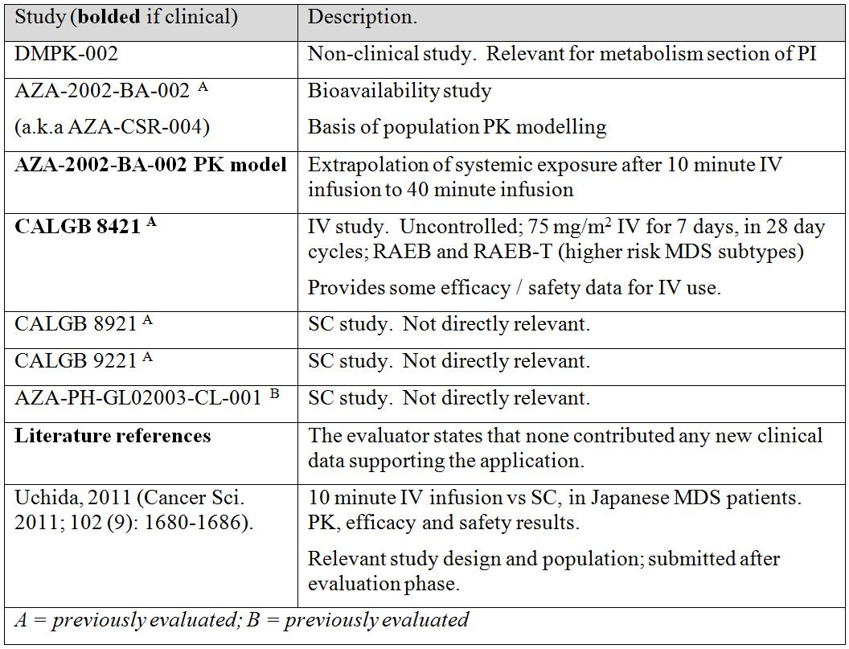

#### Pharmacokinetics (PK)

##### Study AZA-2002-BA-002

This study’s objective was to characterise the single dose PK of azacitidine after SC and IV administration. It was a randomised, open label, two period crossover study in adults with MDS. The IV dose was given over 10 min.

Only 6 patients were studied (mean age 71 years).

Since the current application is to allow IV use, it is notable that individual patient ratios for **AUC** after IV administration versus AUC after SC administration were 1.45, 0.78, 0.92, 1.22, 1.66, and 0.97. Likewise, individual patient ratios for **Cmax** (IV/SC) were 5.26, 2.84, 2.44, 4.30, 5.86, and 3.05, respectively.

The study did not address multiple dosing. The sponsor notes that no accumulation is expected following multiple daily doses.

The evaluator noted that data in Study AZA-2002-BA-002 were criticised. The principle criticisms there were that:

* only three time points were available to calculate the elimination rate constant (only two time points for two subjects after IV administration);
* one of the subjects was an outlier with much higher exposure than other subjects, suggesting anomalous drug handling; and
* there was a wide range of bioavailabilities for SC administration (relative to IV; 52-128%) despite the high mean value of 92%.

##### PK modelling report

This was a population pharmacokinetic analysis, based on data from the 6 patients in Study AZA-2002-BA-002. The analysis aimed to support IV infusion as proposed. Essentially, a model of pharmacokinetic behaviour was constructed based on results seen in Study AZA-2002-BA-002, then the model was used to **predict PK profiles following IV infusions of varying duration**. The model’s prediction was that across 10, 20, 30 and 40 min infusions, Cmax resembled more and more closely the Cmax seen with SC administration.

The evaluator noted presentation errors in the report but concluded that their correction would make no difference.

The evaluator considered that: the model was **not** adequately validated; individual patient factors such as renal function were **not** taken into account; and the number of samples used in the analysis was **inadequate**.

The evaluator concluded that it cannot be stated with confidence that the proposed IV infusion regimen results in a similar PK profile – in terms of Cmax and AUC – to that resulting from SC administration. This would seem to be the case particularly for shorter infusion periods (anything from 10-40 min is sanctioned in the proposed PI).

##### Uchida et al. (2011)[5]

A summary (only) of this paper was presented by the sponsor after the normal evaluation phase. The paper provides independent confirmation that with IV dosing, Cmax may be about 4 fold higher than with SC dosing, but that AUC is only about 10% higher after IV dosing than after SC dosing. In the Uchida study, IV infusion was over 10 min, which is the ‘worst case scenario’ regarding an altered safety profile with IV administration.

#### Pharmacodynamics (PD)

No PD data were submitted.

#### Efficacy

##### Study CALGB 8421 (reanalysis)

This was a 2003 reanalysis of a Phase II, open, uncontrolled study of IV azacitidine in MDS conducted between 1985 and 1994. Data for the reanalysis were retrospectively recollected.

In the study, 48 patients (mean age 63.1 years) received 5-azacytidine 75 mg/m2 daily for 7 days as a continuous IV infusion. The drug was mixed fresh every 4 h and placed in a solution of Ringer’s Lactate. The 7 day dosing was repeated every 28 days. The evaluator raised doubts about what infusion timing was actually used, but considered that the rate of IV infusion was not as proposed in the current submission. It seems likely that total infusion time was over a much longer period than 10-40 min: possibly 4 h, possibly longer again. It is also possible that in this study, the product’s potency diminishes over a 4 h infusion period, given the apparent instability of the reconstituted product. The evaluator noted that since the AUC can influence safety and efficacy, this study’s efficacy data provide no support for the present submission.

The evaluator concluded that there is no adequate efficacy evidence to justify the proposed IV infusion regimen.

##### Uchida et al. (2011)[6]

The sponsor subsequently presented information from a paper by Uchida et al (2011). This paper does include efficacy data to four cycles, comparing IV and SC arms. Although the study was not powered to show clinically meaningful differences across arms, and although there was some contamination of arms (that is, IV use in the SC arm and vice versa), study results supported the conclusion that efficacy was similar across arms.

#### Safety

Study CALGB 8421, Study AZA-2002-BA-002 and the Uchida paper provided safety information. In Study CALGB 8421, 48 patients were given azacitidine 75 mg/m2 IV **over 4 h or longer**, daily for 7 days, over 1-15 cycles (excluding an outlier who received 51 cycles). In Study AZA-2002-BA-002, 6 patients received a 75 mg/m2 dose of azacitidine on two occasions: once as a 10 min IV infusion, and once SC. In the study by Uchida and colleagues,[7] 27 patients received a 75 mg/m2 dose of azacitidine SC, and 26 received a 75 mg/m2 dose IV over 10 min, with patients receiving a median of 7 cycles (range 1-18), each cycle consisting of 7 treatment days and a 21 day rest period.

The evaluator’s assessment of safety rested on the sponsor’s Clinical Overview; the sponsor had concluded that the adverse events profile was similar between IV and SC studies, except for local injection site reactions (SC) and infusion/catheter site reactions (IV). This was apparently based on cross study comparison, and the one source of safety about IV infusion was a relatively small study where infusion was over many hours. The evaluator discounted this cross study comparison as a reliable source of safety information.

Regardless of this basic concern, it is worth considering details of cross study comparison. In the comparison, rigors and pyrexia were more common after IV infusion than after SC injection. (This was not borne out in the Uchida paper.) So were both petechiae and hypokalaemia, but it is not immediately obvious that these adverse events could be related to the higher Cmax observed with IV use. Many other adverse events were distinctly more common per subject year of exposure with IV infusion. These effects were not reported in the Uchida paper (although safety monitoring in that study may have been sub optimal).

In the clinical evaluation report, it is stated that the frequency of nervous system disorders in Study 8421 (IV azacitidine) was 12.5%, versus 4.3% in Study 8921 (SC) and 4.0% in Study 9221 (SC), and that the frequency of respiratory, thoracic and mediastinal disorders was 18.8% (Study 8421, IV) versus 8.6% (Study 8921, SC) and 10.0% (Study 9221, SC). There were two episodes of convulsion with IV azacitidine (2/48) versus 0/220 for SC azacitidine. It was also reported that with 150-200 mg/m2 constant infusion over 24 h for 5 days, 2/8 subjects developed central nervous system (CNS) toxicity characterised by somnolence, apathy, disorientation and agitation. The subjects recovered a normal sensorium after treatment discontinuation. The evaluator considered that CNS effects were more frequent with IV administration and that high doses produced high peak concentrations in plasma and probably cerebrospinal fluid (CSF). An early PK study with radiolabelled drug showed that radioactivity accumulated in CSF over time, such that at 24 h the concentration was similar to that in plasma at 1-5 h. The radioactivity could be parent drug or metabolite/s.

In the clinical evaluation report, it was noted that shifts to Grade 4 total bilirubin occurred in 11.5% (3/26) with IV azacitidine (Study 8421) versus 3.9% in Studies 8921 and 9221 (SC).

Finally, it was stated in the clinical evaluation report that renal tubular acidosis was reported with IV administration, reversible on stopping the drug. The Australian PI notes that renal abnormalities ranging from elevated serum creatinine to renal failure and death were reported in patients treated with intravenous azacitidine in combination with other chemotherapeutic agents. Again, there was no corroboration of worse renal outcomes with IV use than with SC use, in the Uchida paper, although azacitidine was a monotherapy.

### Risk management plan

The RMP proposed by the sponsor was considered generally acceptable by the TGA’s OPR.

The following is a proposed condition of registration:

* the implementation of the EU RMP Version 7.1 (dated 25 January 2012) and the Australian specific Annex (dated March 2012), and any subsequent versions, as agreed with the TGA’s OPR.

There will also be a condition relating to provision of PSURs.

### Risk-benefit analysis

#### Delegate considerations

Although pharmacokinetic data in had various deficiencies, the basic conclusion that Cmax is about 4 fold higher after 10 min IV infusion than after SC administration appears robust, as this was also seen in the paper by Uchida and colleagues. Likewise, AUC appears to rise by ~10% with IV administration, relative to SC administration. Inter subject variability appears relatively high. The main concern from this would be an increase in adverse events related to Cmax. Nonclinical studies raised concerns about cardiovascular, respiratory and CNS events, but these were not directly related to Tmax.

The clinical evaluator dismissed the sponsor’s assessment of azacitidine IV versus SC safety but, subsequently, the sponsor has drawn attention to the Uchida study. This provides a direct comparison of safety and efficacy in a reasonable (but not large) number of MDS patients given IV and SC azacitidine. In this study’s IV arm azacitidine was infused over 10 min, the ‘worst case scenario’ since Cmax will fall with longer infusion durations. With regard to this, the clinical evaluator does not place much weight on the population PK modelling report based on Study AZA-2002-BA-002, but it is likely that longer infusion durations (to 40 min) will produce a lower Cmax than was seen with 10 min infusions. Modelling predicted a slightly lower systemic exposure based on AUC with 20-40 min infusions compared to 10 min infusions and SC dosing, but the difference was modest.

Vidaza when administered SC may produce injection site reactions (listed in the PI), but IV administration requires cannulation and introduces risk of perivascular damage. The Uchida study bore this out, with some patients swapping from IV to SC and some from SC to IV. It seems desirable to have both IV and SC options, and the evidence supporting IV use is (just) sufficient.

#### Proposed action

The Delegate proposes to approve the application for IV use.

The advice of the Advisory Committee on Prescription Medicines (ACPM) is requested. Specifically, does the ACPM support IV infusion as a route of administration?

#### Response from Sponsor

The sponsor confirms that no changes have been made to the indication that was included in the original application.

The sponsor confirms that the following change has been made to the ‘Dosage and Administration’ information included in the original application as requested by the Evaluator of Quality and Pharmaceutic Data:

From: The IV administration must be completed within **1 h** of reconstitution of the Vidaza vial

To: The IV administration must be completed within **45 min** of reconstitution of the Vidaza vial.

##### Background to the submission

Since approval of Vidaza in Australia in November 2009, the sponsor’s Medical Information Department has received a number of unsolicited inquiries on IV administration of Vidaza. The queries were relating to the compatibility of Vidaza with diluents, stability of the IV solution, and infusion period. The sponsor believes that it would be beneficial for healthcare professionals to have easy access (for example, via TGA approved product information leaflet), to the most recent and accurate IV administration details for Vidaza, including the stability profile of the reconstituted infusion solutions and the IV administration technique.

In addition, the sponsor believes that there is medical value in offering prescribers and patients options on how Vidaza can be administered. Site reactions associated with the currently approved SC route have been reported, and may lead to premature termination of treatment with this life prolonging medicine. IV infusion as an alternative route of administration may allow continued treatment to maximise the benefit to the patient, as assessed by the clinician on an individual patient basis.

Since approval of Vidaza in the US for IV use in 2007 to present time it is estimated that in excess of 50,000 patients have been treated with Vidaza either via the SC or IV routes. The sponsor acknowledges that there is limited formal clinical data on the IV route of administration, however the extensive clinical experience in the post approval phase provides further assurance that IV administration is an acceptable alternative for patients.

The sponsor acknowledges and appreciates the Delegate’s proposal to approve the application for IV use.

The sponsor’s responses to the Delegate’s comments are provided in this document.

##### Delegate’s comment

Page 1 of Delegate’s Overview (DO), paragraph 4 from bottom of page:

*The rationale for proposing this new route of administration is that the sponsor believes physicians may be administering Vidaza by IV infusion off label, without adequate knowledge of the stability profile or administration technique.*

##### Sponsor’s response

The main objective for the proposal to register the IV route of administration in addition to the currently approved SC route is to address the clinical need for this route of administration. The sponsor has received a number of medical questions regarding IV administration of Vidaza. Due to individual patient medical conditions that may favour one or the other (IV or SC) route of administration, the sponsor believes that having access to both the IV and SC routes of administration is ultimately beneficial for patients with higher risk MDS.

It is of importance to note that the sponsor does not propose IV route of administration as the only route of administration. Rather, the sponsor proposes that IV route can be used as an alternative route of administration giving the physicians the option of using either route depending on the individual circumstances of the patients. Specifically, for those patients who are unable to tolerate the currently approved SC route of administration, offering another option of IV administration may make the difference between continuing or stopping treatment of a medicine that has demonstrated an overall survival benefit. Study AZA-001 data has demonstrated that such a survival benefit is often achieved and maintained through sustained treatment in the approved patient populations. This is a clinical decision made by the treatment specialist on an individual patient basis, and ensures that patients have the optimum access to continue treatment with the most effective agents.

##### Delegate’s comment

Page 2, DO, paragraph 3 under nonclinical data evaluation section:

*After the normal evaluation phase, the sponsor has supplied several CNS/respiratory safety studies in rats. In these studies, onset of effects on CNS and respiratory function was 4 h post dose. These studies did not change the nonclinical evaluator’s basic conclusion, that the higher systemic exposure with IV use relative to SC use confers a greater risk of toxicity.*

##### Sponsor’s response

The sponsor would like to emphasise that the data from the published paper by Uchida and colleagues[8] support the safety of IV administration of Vidaza over a 10 min infusion (the worst case scenario for the recommended infusion time of 10-40 mins). The reported incidence of adverse events was comparable between the SC and IV administration groups, with the exception of injection site reactions, which occurred more frequently following SC administration (33% versus 4%). This data demonstrates that higher systemic exposure with IV use relative to SC use does not confer an appreciable increase in the risk of toxicity. This conclusion is further supported by additional post marketing surveillance data and data collected from a Patients Registry (AVIDA) as described below.

##### Delegate’s comment

Page 4, DO, paragraph on Uchida et al (2011):[9]

*… this paper does include efficacy data for 4 cycles, comparing IV and SC arms. Although the study was not powered to show clinically meaningful differences across arms, and although there was some contamination of arms (that is, IV use in the SC arm and vice versa), study results supported the conclusion that efficacy was similar across arms.*

##### Sponsor’s response

Part II of Uchida et al. was designed to evaluate efficacy after completion of Cycle 4 and after completion of the last cycle, with results demonstrating no difference in efficacy between SC and IV administration of azactidine. In the discussion section, the author also noted that patients in the study who achieved haematologic improvement (HI) required additional treatment cycles to achieve haematologic response (HR). The HI and HR rates were higher at completion of the last cycle of azacitidine than at completion of Cycle 4. Therefore, the data demonstrates that continuous treatment with azacitidine (greater than 4 cycles) appears to be appropriate for both Western and Japanese patients with MDS, as long as the patients continue to benefit from treatment.

##### Delegate’s comment

Page 6 last paragraph under ‘Issues’:

*Vidaza when administered SC may produce injection site reactions (listed in the PI), but IV administration requires cannulation and introduce risk of perivascular damage. The Uchida study bore this out, with some patients swapping from IV to SC and some from SC to IV. It seems desirable to have both IV and SC options, and the evidence supporting IV use is (just) sufficient.*

##### Sponsor’s response

The sponsor acknowledges the limitations in the formal data collected from clinical studies for comparison of the safety profile of the IV administration of Vidaza against the SC route but believes the extensive post approval use in the US supports IV administration as an acceptable alternative for patients. In addition to the data referred to by the Delegate above (Uchida et al.), the sponsor provided the following data to further support the proposal that the IV and SC routes of administration are comparable, both from a safety and efficacy point of view.

* Data collected from a Patients registry in the United States (US), AVIDA.
* Vidaza MDS Patient History Q3 2007 – Q4 2012 for Celgene; market surveillance data for each route of administration as a percentage of Patient Visits resulting in treatment for MDS with Vidaza in the US.

##### AVIDA registry

AVIDA is a unique, longitudinal, multicentre patient registry designed to prospectively collect data from community based haematology clinics on the natural history and management of patients with MDS and other haematologic disorders, including acute myeloid leukaemia, who are treated with azacitidine. The aim of the registry is to further the understanding of current azacitidine treatment patterns in the community and to identify common concomitant care procedures and concomitant treatments. The data was collected between Oct 2006 and July 2010 at registry entry (baseline) and then quarterly using electronic data capture. The IV route of administration was approved in the US on 26 January 2007; therefore, the data from AVIDA includes both IV and SC use of azacitidine in the US within the data collection period.

The AVIDA data indicate that both SC and IV routes of administration are used almost equally (1:1 ratio mostly and may even be slightly favourable towards IV infusion) in the community based treatment of MDS patients with Vidaza.

Summaries of some of the published AVIDA data as abstracts at various meetings are listed below in Tables 5-7. A number of posters presented at such meetings are also listed[10] and electronic copies provided for reference.

Table 5: Published AVIDA data: Sekeres MA, et al, American Society of Haematology 51st Annual Meeting, December 2009.[11]

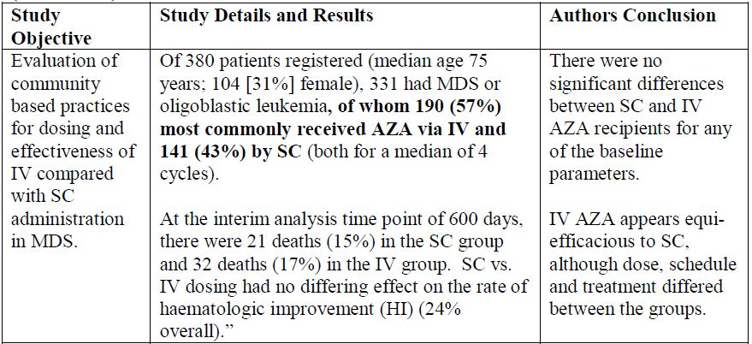

Table 6: Published AVIDA data: Grinblatt D, et al, European Haematology Association 14th Congress, June 2009.[12]

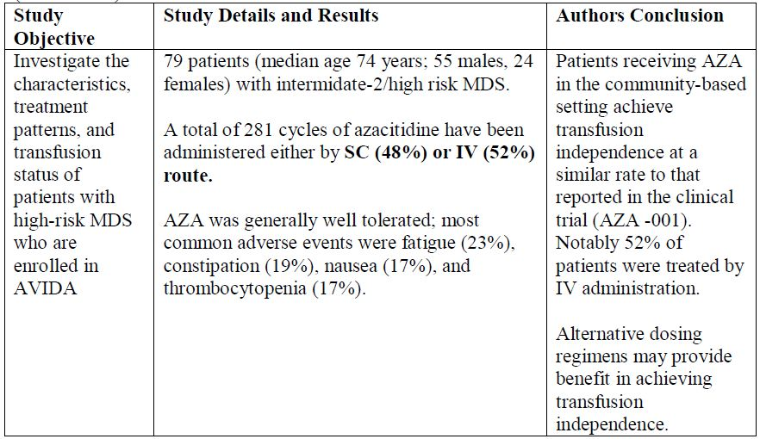

Table 7: Published AVIDA data: Grinblatt D, et al, 13th Annual International Congress of Hematologic Malignancies.[13]

##### Table 7: Published AVIDA data: Grinblatt D, et al, 13th Annual International Congress of Hematologic Malignancies.

##### Vidaza MDS Patient History Q3 2007 – Q4 2012 for Celgene

Post marketing surveillance data collected from the US market, indicates that on average 60-70% of the patients were treated with Vidaza via IV infusion, based on the number of patient visits resulting in treatment with Vidaza, from quarter Q3 2007 to Q4 2012. As adverse events from the two routes of administration are reported voluntarily from a population of uncertain size, it is not possible to reliably estimate and assign the frequency of these to a specific route of administration. However, based on extensive post marketing surveillance, no trends have been noted to suggest an emerging safety signal or a significant difference in the safety profile associated with IV route of administration of azacitidine compared to SC use. The occurrence of infusion/catheter site reactions with the IV administration does not represent a significant change in the safety profile between both routes of administrations, SC and IV.

##### Summary

The sponsor believes that there is an unmet clinical need for the IV route, as an alternative route of administration to the currently approved SC route, for Vidaza in Australia. The sponsor also believes the data from the sources below provides sufficient support for registration of the IV route in Australia.

The comparable efficacy and safety profile of azacitidine via SC and IV routes of administration are demonstrated in:

###### 1. Celgene studies

* The data from the original AZA-2002-BA-002 and the modeling data provide evidence of similar overall drug exposure to azacitidine between the SC administration at 75mg/m2 and IV infusion administered over 10-40 min.
* CALGB 8421 study demonstrates that adverse reactions were qualitatively similar between the IV and SC studies.

###### 2. Published prospective controlled study by Uchida and colleagues

The IV route of administration with comparable PK, efficacy and safety profile has provided an alternative route of administration for physicians to better manage treatment depending on patient condition with options that would enable continuing treatment with azacitidine.

###### 3. Data from the AVIDA Patients Registry

The AVIDA data indicate that both SC and IV routes of administration are used almost equally (1:1 ratio mostly and may even be slightly favourable towards IV infusion) in the community based treatment of MDS patients with Vidaza. Vidaza was generally well tolerated with no unexpected toxicities.

###### 4. Celgene’s Vidaza MDS Patient History

This data indicates that on average 60-70% of the patients were treated with Vidaza via IV infusion in the US during the period Q3 2007 to Q4 2012. In addition, based on post marketing surveillance, no trends have been noted to suggest an emerging safety signal or a significant difference in the safety profile associated with IV route of administration of azacitidine compared to SC use.

#### Advisory Committee Considerations

The ACPM, taking into account the submitted evidence of efficacy and safety, agreed with the Delegate and considered this product to have an overall positive benefit-risk profile for IV use of the registered product for the current indication.

The ACPM advised that although a reasonable case has been made for an IV option, the data package is deficient. However, there is considerable post marketing experience with the IV route of administration in other jurisdictions and no concerns appear to have emerged regarding efficacy or safety with this route of administration.

##### Proposed PI/CMI amendments:

The ACPM agreed with the Delegate to the proposed amendments to the Product Information (PI) and Consumer Medicine Information (CMI). The ACPM specifically advised on inclusion of the following:

* Reference should be made in the ‘Clinical Trials and Precautions’ sections on the lack of data on use in patients with renal insufficiency.
* CMI: The list of adverse effects in the CMI should be reformatted to conform to the Medicines Australia categorisation, that is, in terms of seriousness of the effects.

The ACPM advised that the implementation by the sponsor of the recommendations outlined above to the satisfaction of the TGA, in addition to the evidence of efficacy and safety provided would support the safe and effective use of this product.

### Outcome

Based on a review of quality, safety and efficacy, TGA approved the registration of Vidaza powder for suspension for injection containing 100mg azacitidine for the **new route of administration of intravenous (IV) infusion**.

The full indications remain as follows:

*Vidaza is indicated for the treatment of patients with:*

* + - *Intermediate-2 and High-risk Myelodysplastic Syndromes (MDS) according to the International Prognostic Scoring System (IPSS),*
    - *Chronic Myelomonocytic Leukemia (CMMoL (10%-29% marrow blasts without Myeloproliferative Disorder)),*
    - *Acute Myeloid Leukemia (AML) with 20-30% blasts and multi-lineage dysplasia, according to World Health Organisation Classification (WHO),*

*in whom allogenic stem cell transplantation is not indicated.*

##### Specific conditions of registration applying to these therapeutic goods:

1. The Vidaza RMP, version 7.1, dated 25 January 2012, included with submission PM-2012-00341-3-4, and any subsequent revisions, as agreed with the TGA and its Office of Product Review will be implemented in Australia. An obligatory component of RMPs is Routine Pharmacovigilance. Routine Pharmacovigilance includes the submission of PSURs.

Such reports are to be provided annually until the period covered by such reports is not less than three years from the date of this approval letter. No fewer than three annual reports are required. The reports are to meet the requirements for PSURs as described in the European Medicines Agency’s Guideline on Good Pharmacovigilance practices (GVP) Module VII - Periodic Safety Update Report.

Unless agreed separately between the supplier who is the recipient of the approval and the TGA's OPR, the first report must be submitted to TGA no later than 15 calendar months after the date of this approval letter. The subsequent reports must be submitted no less frequently than annually from the date of the first submitted report. The annual submission may be made up of two PSURs each covering six months. If the sponsor wishes, the six monthly reports may be submitted separately as they become available.

Submission of the report must be within the seventy calendar days of the data lock point for the report (or, where applicable, the second of the two six monthly reports), as required by the Guideline for PSURs covering intervals up to 12 months (including intervals of exactly 12 months).

You are reminded that sections 29A and 29AA of the *Therapeutic Goods Act 1989* provide for penalties where there has been failure to inform the Secretary in writing, as soon as a person has become aware, of:

(a) information that contradicts information already given by the person under this Act;

(b) information that indicates that the use of the goods in accordance with the recommendations for their use may have an unintended harmful effect;

(c) information that indicates that the goods, when used in accordance with the recommendations for their use, may not be as effective as the application for registration or listing of the goods or information already given by the person under this Act suggests;

(d) information that indicates that the quality, safety or efficacy of the goods is unacceptable.

## Attachment 1. Product Information

The Product Information approved at the time this AusPAR was published is at Attachment 1. For the most recent Product Information please refer to the TGA website at <<http://www.tga.gov.au/hp/information-medicines-pi.htm>>.

## Attachment 2. Extract from the Clinical Evaluation Report

1. Cheung YW, et al. (1984) Stability of azacitidine in infusion fluids. *Am J Hosp Pharm.* 41: 1156-1159.
2. Sponsor comment: “The interpretations of these findings are limited by concurrent severe clinical signs in dogs, for example, vomiting, flushed skin, decreased food consumption, and decreased spontaneous locomotor activity, as well as faecal changes such as watery, mucous, or loose stool.”
3. Approved US product label for Vidaza (revised January 2012); available at www.accessdata.fda.gov/drugsatfda_docs/label/2012/050794s023LBL.pdf
4. Sponsor comment: “This statement was added to the EU RMP upon request by the EMA.”
5. Uchida T, et al. (2011) Phase I and II study of azacitidine in Japanese patients with myelodysplastic syndromes. *Cancer Sci.* 102: 1680-1686.
6. Uchida T, et al. (2011) Phase I and II study of azacitidine in Japanese patients with myelodysplastic syndromes. *Cancer Sci.* 102: 1680-1686.
7. Uchida T, et al. (2011) Phase I and II study of azacitidine in Japanese patients with myelodysplastic syndromes. *Cancer Sci.* 102: 1680-1686..
8. Uchida T, et al. (2011) Phase I and II study of azacitidine in Japanese patients with myelodysplastic syndromes. *Cancer Sci.* 102: 1680-1686.
9. Uchida T, et al. (2011) Phase I and II study of azacitidine in Japanese patients with myelodysplastic syndromes. *Cancer Sci.* 102: 1680-1686.
10. Grinblatt DL, et al. “Patients with Haematologic disorders receiving azacitidine who are enrolled in AVIDA, a longitudinal patient registry, achieve transfusion independence”, Presented at the 10th international symposium on MDS, Patras, Greece, 7 May 2009; Grinblatt DL, et al. “Patients with secondary MDS who are enrolled in AVIDA, a longitudinal registry for patient receiving azacitidine”, Presented at the 45th Annual meeting of the American Society of Clinical Oncology, Orlando, Florida, 30 May 2009.
11. Sekeres MA, et al. “A study comparing dosing regimens and efficacy of subcutaneous to intravenous azacitidine (AZA) for the treatment of myelodysplastic syndromes (MDS)”, Abstract # 3797, American Society of Hematology, 51st Annual Meeting and Exposition, 5-8 December 2009, New Orleans, LA, USA.
12. Grinblatt DL, et al. “Treatment of patients with high-risk myelodysplastic syndromes receiving azacitidine who are enrolled in AVIDA, a longitudinal patient registry”, Abstract # 1345, European Hematology Association, 14th Congress, 4-7 June 2009, Berlin, Germany.
13. Grinblatt DL, et al. “AVIDA, a Longitudinal Patient Registry: Treatment of Patients with Low-Risk Myelodysplastic Syndromes Receiving Azacitidine. Physicians’ Education Resource, 13th Annual International Congress on Hematologic Malignancies: Focus on Leukemias, Lymphomas, and Myelomas”, 11-15 February 2009, Whistler, British Columbia, Canada.