First round report: November 2016
Second round report: March 2017
Additional (third) report: August 2017

AusPAR Attachment 2

Extract from the Clinical Evaluation Report for Baricitinib
  - Proprietary Product Name: Olumiant
  - Sponsor: Eli Lilly Australia Pty Ltd

About the Therapeutic Goods Administration (TGA)
- The Therapeutic Goods Administration (TGA) is part of the Australian Government Department of Health, and is responsible for regulating medicines and medical devices.
- The TGA administers the Therapeutic Goods Act 1989 (the Act), applying a risk management approach designed to ensure therapeutic goods supplied in Australia meet acceptable standards of quality, safety and efficacy (performance), when necessary.
- The work of the TGA is based on applying scientific and clinical expertise to decision-making, to ensure that the benefits to consumers outweigh any risks associated with the use of medicines and medical devices.
- The TGA relies on the public, healthcare professionals and industry to report problems with medicines or medical devices. TGA investigates reports received by it to determine any necessary regulatory action.
- To report a problem with a medicine or medical device, please see the information on the TGA website < https://www.tga.gov.au> .

About the Extract from the Clinical Evaluation Report
- This document provides a more detailed evaluation of the clinical findings, extracted from the Clinical Evaluation Report (CER) prepared by the TGA. This extract does not include sections from the CER regarding product documentation or post market activities.
- The words (Information redacted), where they appear in this document, indicate that confidential information has been deleted.
- For the most recent Product Information (PI), please refer to the TGA website < https://www.tga.gov.au/product-information-pi> .

Copyright
© Commonwealth of Australia 2019
This work is copyright. You may reproduce the whole or part of this work in unaltered form for your own personal use or, if you are part of an organisation, for internal use within your organisation, but only if you or your organisation do not use the reproduction for any commercial purpose and retain this copyright notice and all disclaimer notices as part of that reproduction. Apart from rights to use as permitted by the Copyright Act 1968 or allowed by this copyright notice, all other rights are reserved and you are not allowed to reproduce the whole or any part of this work in any way (electronic or otherwise) without first being given specific written permission from the Commonwealth to do so. Requests and inquiries concerning reproduction and rights are to be sent to the TGA Copyright Officer, Therapeutic Goods Administration, PO Box 100, Woden ACT 2606 or emailed to < tga.copyright@tga.gov.au> .

Contents
List of abbreviations 6
1. Introduction 9
1.1. Submission type 9
1.2. Drug class and therapeutic indication 9
1.3. Dosage forms and strengths 9
1.4. Dosage and administration 9
1.5. Proposed changes to the product documentation 10
1.6. Information on the condition being treated 10
1.7. Current treatment options 10
1.8. Clinical rationale 11
1.9. Formulation development 11
1.10. Guidance 11
1.11. Evaluator’s commentary on the background information 11
2. Contents of the clinical dossier 12
2.1. Scope of the clinical dossier 12
2.2. Paediatric data 13
2.3. Good clinical practice 13
2.4. Evaluator’s commentary on the clinical dossier 14
3. Pharmacokinetics 14
3.1. Studies providing pharmacokinetic information 14
3.2. Summary of pharmacokinetics 15
3.3. Evaluator’s overall conclusions on pharmacokinetics 24
4. Pharmacodynamics 26
4.1. Studies providing pharmacodynamic information 26
4.2. Summary of pharmacodynamics 26
4.3. Evaluator’s overall conclusions on pharmacodynamics 29
5. Dosage selection for the pivotal studies 30
5.1. Pharmacokinetic and pharmacodynamic studies 30
5.2. Phase II dose finding studies 30
5.3. Phase III pivotal studies investigating more than one dose regimen 30
5.4. Evaluator’s conclusions on dose finding for the pivotal studies 31
6. Clinical efficacy 32
6.1. Studies providing evaluable efficacy data 32
6.2. Pivotal or main efficacy studies 33
6.3. Other efficacy studies 57
6.4. Analyses performed across trials: pooled and meta-analyses 74
6.5. Evaluator’s conclusions on clinical efficacy 74
7. Clinical safety 77
7.1. Studies providing evaluable safety data 77
7.2. Patient exposure 79
7.3. Adverse events 79
7.4. Evaluation of issues with possible regulatory impact 94
7.5. Other safety issues 102
7.6. Post marketing experience 103
7.7. Evaluator’s overall conclusions on clinical safety 103
8. First round benefit-risk assessment 105
8.1. First round assessment of benefits 105
8.2. First round assessment of risks 106
8.3. First round assessment of benefit-risk balance 107
8.4. First round recommendation regarding authorisation 108
9. Clinical questions 109
9.1. Pharmacokinetics 109
9.2. Pharmacodynamics 109
9.3. Efficacy 109
9.4. Safety 110
9.5. Additional expert input 110
10. Second round evaluation of clinical data submitted in response to questions 110
10.1. Question 1 110
10.2. Question 2 111
10.3. Question 3 113
10.4. Question 4 115
11. Second round benefit-risk assessment 115
11.1. Second round assessment of benefits 115
11.2. Second round assessment of risks 116
11.3. Second round assessment of benefit-risk balance 116
12. Second round recommendation regarding authorisation 116
13. Additional evaluation material supplied following the second round evaluation 117
13.1. TGA request for additional information following complete response letter from the FDA 118
13.2. TGA request for response to main clinical evaluation report issues 129
13.3. Sponsor response to evaluator conclusions for PK/PD analyses 130
14. Third round benefit-risk assessment 132
14.1. Benefits 132
14.2. Risks 132
14.3. Assessment of benefit-risk balance 132
14.4. Third round recommendation regarding authorisation 133
15. References 133

List of abbreviations
Abbreviation | Meaning
ACR | American College of Rheumatology
AE | Adverse event
AUC | Area under concentration-time curve over the dosing interval
BAR | Baricitinib
BRCP | Breast cancer resistance protein
CCP | Cyclic citrullinated peptide
CDAI | Clinical Disease Activity Index
CI | Confidence interval
C_{max} | Maximum serum drug concentration
CPK | Creatine phosphokinase
CrCL | Creatinine clearance
CRP | C-reactive protein
CS | Corticosteroids
CV | Coefficient of variation
DAS | Disease Activity Score
DMARD | Disease modifying anti-rheumatic drug
EAIR | Exposure adjusted incidence rate
ELISA | Enzyme-Linked Immunosorbent Assay
ES | Erosion Score
ESR | Erythrocyte sedimentation ratio
EULAR | European League Against Rheumatism
FAS | Full analysis set
HAQ-DI | Health Assessment Questionnaire – Disability Index
HCQ | Hydroxychloroquine
IL | Interleukin
Ig | Immunoglobulin
JAK | Janus kinase
JSN | Joint space narrowing
LEF | Leflunomide
LEP | Linear extrapolation
LS | Least squares
LTE | Long term extension
MATE2-K | Multidrug and toxin extrusion protein 2-K
mITT | Modified Intention-To-Treat
mTSS | Modified Total Sharp Score
MTX | Methotrexate
NK | Natural killer
NRI | Non Responder Imputation
NSAID | Non-steroidal anti-inflammatory drug
OAT | Organic anion transporter
PBO | Placebo
PD | Pharmacodynamic(s)
Pgp | P-glycoprotein
PK | Pharmacokinetic(s)
Pop PK | Population pharmacokinetic(s)
PP | Per Protocol
PT | Preferred Term
PY | Patient-Years
RA | Rheumatoid arthritis
RF | Rheumatoid factor
SAE | Serious adverse event
SD | Standard deviation
SDAI | Simplified Disease Activity Index
SOC | System Organ Class
SSZ | Sulfasalazine
STAT | Signal transducer and activator of transcription
TB | Tuberculosis
TNF | Tumour necrosis factor
TPO | Thrombopoietin
ULN | Upper limit of normal
VAS | Visual Analogue Scale
WPAI | Work Productivity and Activity Impairment

Introduction

Submission type
This is a full submission requesting registration of a new chemical entity, baricitinib (BAR), for the treatment indication of active rheumatoid arthritis (RA) in adult patients. The proposed treatment indication has 3 sub-claims of benefit in treating RA: reduction in the signs and symptoms of the disease, improvements in physical function and inhibition of structural joint damage as measured by sequential plain X-rays. Each of these sub-claims will be considered individually, as well as collectively in the evaluation of the submitted dataset.
The sponsor application letter is dated 16 June 2016.

Drug class and therapeutic indication
BAR is an immunosuppressant medication (ATC code: L04AA37). It is a selective and reversible inhibitor of the Janus Kinase (JAK) family of kinases.
The proposed treatment indication as presented in the Product Information (PI) and letter of application is:
Olumiant is indicated for the treatment of moderate to severe active rheumatoid arthritis (RA) in adult patients.
Olumiant has been shown to improve physical function, reduce the signs and symptoms of RA and inhibit the rate of progression of joint damage.
The PI and application letter regarding the proposed treatment indication for BAR make no specification about 2 issues, which will require clarification (although the Clinical Overview in Module 2 does make specific comment on these issues):
- Whether or not BAR can be used as monotherapy and/or in combination with non-biologic DMARD, and
- Line of treatment where BAR can be initiated for example, first line (in DMARD treatment naïve subjects) or second or subsequent lines of therapy (for example, after an inadequate response to or intolerance of conventional and/or biologic DMARD therapy).

Dosage forms and strengths
BAR will be presented as debossed, film coated, immediate release tablets available in 2 strengths containing 2 mg (light pink in colour and oblong shaped) and 4 mg (medium pink in colour and round shaped) of BAR as the active ingredient.

Dosage and administration
The recommended dose of BAR is 4 mg once daily administered orally, with or without food. The proposed dosing recommendations state that BAR can be used alone or in combination with conventional DMARD therapy however, this information is not included in the proposed treatment indication, which is typical for DMARD therapies used in RA.
The proposed dosing recommendations also state that for some patients, such as those with an inadequate response to conventional synthetic DMARD drugs who have moderate disease severity, limited risk for progressive joint damage and a low urgency to rapidly regain physical function, a BAR dose of 2 mg once daily may be acceptable. Furthermore, the dose of BAR should be reduced to 2 mg once daily in subjects with moderate renal impairment (creatinine clearance 30 to 60 mL/min), as well as in those receiving drugs that are potent inhibitors of the organic anion transporter (OAT3) system such as probenecid. BAR should be avoided in patients with severe renal impairment (creatinine clearance < 30 mL/min).

Proposed changes to the product documentation
Not applicable as BAR is a new chemical entity application in Australia.

Information on the condition being treated
Rheumatoid arthritis (RA) is a chronic inflammatory autoimmune disease characterised by polyarticular inflammation of predominately small to medium sized joints in a symmetric pattern. The condition affects approximately 1% of the Australian population and its prevalence increases with age. The primary lesion is synovitis whereby immune cells invade the normally acellular synovium leading to the formation of inflammatory pannus. This hyperplastic invasive tissue causes cartilage breakdown, bony erosion and ultimately loss of function of the affected joints. Systemic involvement may also occur, and there is an increased risk of atherosclerosis, infection and lymphoma over time, particularly if the condition is insufficiently controlled. The over-production of various pro-inflammatory cytokines such as tumour necrosis factor (TNF) and Interleukins (IL) in the joints and sera of patients with RA are important mediators in the disease pathogenesis primarily via activation of T-lymphocytes, but also through effects on B-lymphocytes.

Current treatment options
RA is a heterogeneous condition in terms of clinical presentation, natural history and drug responsiveness. Published evidence and current guidelines for the treatment of RA emphasise the importance of achieving clinical remission, or at least low disease activity, as both of these states are associated with a favourable long term prognosis. In addition to treating the signs and symptoms of RA, an impact on inhibiting the structural bone damage of the condition is highly desirable as this is associated with better long-term patient outcomes, particularly regarding maintenance of physical function and quality of life. Conventional synthetic DMARDs (in particular, methotrexate (MTX)), alone or in combination with each other, are the initial recommended treatments for RA. Observational studies and meta-analyses of DMARD treatment efficacy and tolerability demonstrate highly variable outcomes to single and combination DMARD therapy over time. In 10 year follow-up studies, 25% of patients with RA had to discontinue conventional DMARD treatment due to insufficient therapeutic benefit and 20% discontinued treatment due to adverse effects. Biological DMARDs, either as add-on or single drug therapy, is the next recommended line of therapy in active RA after conventional synthetic DMARD failure or intolerability. While anti-TNF drugs and cytokine modulators such as abatacept and tocilizumab have been shown to demonstrate significant efficacy in treating active RA, a substantial proportion of patients are not achieving meaningful American College of Rheumatology (ACR) responses. Based on the current literature for biological therapies, ACR20 response rates range from 50 to 65% and ACR50 response rates are 35 to 50%. So despite the availability of many therapies with various modes of action for the treatment of RA, a significant proportion of individuals either fail to initially respond to treatment, do not tolerate therapy or lose response over time. As such, there is a need for additional therapies for active, treatment refractory RA.

Clinical rationale
BAR is a selective inhibitor of the Janus kinase (JAK) family of kinases, with greater affinity for the JAK1 and JAK2 systems, and less potency for JAK3 and tyrosine kinase 2. The JAK system is an intracellular pathway regulatory system that affects the release of cytokines and amplification of the inflammatory response. The JAKs phosphorylate their associated signal transducers and activators of transcription (STATs) resulting in STAT activation, which in turn leads to the expression of several genes important for cell activation, survival and proliferation. BAR modulates the JAK-STAT pathway by transiently occupying the ATP binding pocket of the JAK, thereby preventing the kinase from phosphorylating other JAKs or STATs. Inhibition of either monomer of the JAK dimer blocks the production and signalling of several pro-inflammatory cytokines such as IL-6, as well as interferon. In combination, these effects decrease lymphocyte activation, proliferation and function, which are key immune response targets in successfully treating active RA.

Formulation development
Capsule formulations using the phosphate salt form of BAR were initially developed for use in the early clinical studies. Those formulations contained drug substance blended with excipients and filled into gelatine capsules. The drug loads and capsule fill weights were varied to provide multiple strengths (ranging from 0.5 mg to 8 mg) required for Phase I and early Phase II clinical studies. The phosphate salt form of BAR was not subsequently chosen for the commercial tablet development because of moderate hygroscopicity, rapid disproportionation in water and drug product manufacturability concerns. The free base form of BAR was used for commercialisation due to its improved chemical and physical properties relative to the various salt forms.
Immediate release tablet formulations containing BAR as a free base were developed and used in the later stage Phases II and III clinical studies. BAR tablets are manufactured on a commercial scale by a conventional dry granulation process. No changes have been made to the commercial tablet formulation during or after the Phase III studies.

Guidance
The sponsor states that this submission is consistent with the TGA pre-submission planning process. Consideration of the relevant regulatory guidelines in assessing this submission includes one specific and relevant EU regulatory guideline pertaining to the requested indication in RA: CPMP/EWP/556/95 rev 1/Final ‘Points to Consider on Clinical Investigation of Medicinal Products other than NSAIDs for the Treatment of Rheumatoid Arthritis’ (effective 29 January 2007). In this submission, the final clinical study reports for 3 pivotal Phase III RA Studies JADZ, JADV and JADX, which assessed the rate of joint damage progression by plain X-ray at 24 and 52 weeks of therapy, have been submitted. However, the TGA adopted EU regulatory guideline (CPMP/EWP/556/95 rev 1/Final) states that to make a claim of radiographic benefit in RA, X-rays should be taken at fixed and pre-defined time points at least 1 year apart for a minimum of 2 years, the first year of which should have blinded data acquisition.

Evaluator’s commentary on the background information
BAR is the second in class (JAK inhibitor) drug proposed for registration of RA treatment with tofacitinib being currently approved in Australia for the treatment of active RA in adult patients. BAR is available as an oral formulation and exerts an immunomodulatory effect via a novel mechanism of action. There is an unmet need for additional effective therapies in RA as response rates to current available treatment options (including several conventional and biological DMARDs) are sub-optimal in a significant proportion of patients (that is, at least one third of affected individuals with moderately to severely active disease). Through intracellular inhibition of JAK pathways and subsequent modification of the inflammatory response, BAR demonstrates biological plausibility for producing a beneficial treatment effect in RA.
In recent years, published evidence has supported a significant clinical practice change in treating RA whereby tight and sustained control of disease activity is the desired outcome. In addition to controlling the signs and symptoms of RA, it is recognised that inhibition of structural X-ray progression is a very important outcome as achievement of this outcome correlates with minimisation of joint deformity and physical functioning. Hence, the sponsor has stated a valid and accepted rationale for the relevance of claiming structural X-ray inhibition in this submission.
In general, the sponsor has adhered to the TGA adopted EU regulatory guideline of relevance in this submission (CPMP/EWP/556/95 rev 1/Final ‘Points to Consider on Clinical Investigation of Medicinal Products other than NSAIDs for the Treatment of Rheumatoid Arthritis’; effective 29 January 2007). Moreover, the sponsor has provided current information of the overseas regulatory status of BAR (that is, pending registration application sin several contemporary jurisdictions).
As outlined in the regulatory history background of this report, the TGA had initially rejected the registration of tofacitinib (another JAK inhibitor) for the treatment of RA because of significant and unresolved concerns about the overall safety of tofacitinib, particularly regarding the risk and type of serious infections and other serious adverse effects such as malignancy, gastrointestinal perforation, liver damage and increased blood lipid levels. In addition, the EMA were uncertain if these safety risks with tofacitinib could be successfully managed. Regarding the efficacy data, the EMA decided that tofacitinib had evidence that it improves the symptoms and signs of RA as well as physical functioning of patients, but there was insufficient evidence that it consistently reduced disease activity and joint structural damage at all requested dose regimens. No previous submission for BAR (for any treatment indication) has been received in Australia.
The sponsor has appropriately justified the formulation development program for BAR. No changes have been made to the commercial tablet formulation during or after the Phase III studies.

Contents of the clinical dossier

Scope of the clinical dossier
The submission contained the following clinical information:
- 19 specific clinical pharmacology studies have conducted (18 in healthy volunteers and 1 in adult subjects with RA) plus pharmacokinetic (PK) data was collected all 7 of the Phase II and III clinical studies (listed below).
- 2 combined population PK and PK/PD analyses of pooled data obtained from the Phase I studies in healthy subjects (known as the Phase I/IIa dataset) and data from the 7 Phase II/III trials (known as the primary Phase II/III Pop PK analysis).
- 4 pivotal, Phase III efficacy/safety studies (Studies JADZ, JADV, JADX and JADW).
- 3 supporting Phase II, dose-finding studies (Studies JADC, JADA and JADN) and a long-term extension study (Study JADY).
- Safety data from 26 Phase I to III trials as listed above plus information regarding the safety of BAR in the treatment of 2 other conditions (skin psoriasis (Study JADP) and diabetic nephropathy (Study JADB)).
- Clinical Overview, Summary of Clinical Efficacy, Summary of Clinical Safety, Summary of Biopharmaceutical Studies and associated Analytical Methods, Summary of Clinical Pharmacology Studies and literature references.
This submission includes 26 completed clinical studies comprising 19 clinical pharmacology studies, 3 Phase II studies (Studies JADC, JADA and JADN) and 4 Phase III studies in RA patients (Studies JADZ, JADV, JADX and JADW). In addition, data from an ongoing long-term extension study (Study JADY) was also included. An additional Phase III randomised, placebo-controlled study (JAGS) to support registration in China is currently ongoing and is not presented in this application.
As of 10 August 2015, a total of 513 subjects were exposed to BAR in the completed clinical pharmacology trials and a total of 3822 patients were exposed to BAR in the completed Phase I to III RA studies as well as an additional 358 subjects involved 2 Phase II studies in other potential treatment indications (skin psoriasis and diabetic nephropathy). Thus, the extent of exposure of the safety database meets the expectations of ICH guidance ‘The extent of population exposure to assess clinical safety for drugs intended for long-term treatment of non-life-threatening conditions’
The submission contained 3 completed, placebo-controlled Phase II studies, which enrolled a total of 571 adult patients with moderately to severely active RA who had an inadequate response to conventional DMARD and in a minority of patients to biologic DMARD. Doses of BAR investigated the Phase II program ranged between 1 mg once daily to 10 mg once daily. Twice daily dosing was also assessed in a limited number of patients.
The 4 completed Phase III studies were designed to investigate the efficacy and safety of BAR in different populations (MTX naive, conventional DMARD inadequate responders and biologic DMARD inadequate responders) at 2 dose levels (2 mg and 4 mg once daily) and compared to 2 common and established active comparators (weekly low dose oral MTX and adalimumab). In response to CHMP comments, 2 studies were conducted in the conventional DMARD inadequate responder population, of which 1 study required patients to receive concomitant MTX as background therapy. This approach assured a homogeneous patient population with inadequate response, thus mitigating concerns about heterogeneity between patients with intolerance and inadequate response to prior treatment.
Persistence of clinical response to BAR (that is, improvement in the signs and symptoms of RA) is provided in this submission by the 2-year clinical trial report for Study JADY (which is ongoing) and this trial followed patients receiving BAR 2 and 4 mg once daily therapy.

Paediatric data
The US Food and Drug Administration have granted a waiver for the treatment of chronic juvenile idiopathic arthritis for children from birth to less than 2 years of age as the conditions for which BAR is intended rarely occur in this age group. However, a paediatric investigation plan for the treatment of juvenile idiopathic arthritis for children aged from 2 to 18 years has been agreed with the EMA and received deferral status with the FDA. The clinical data for BAR use in juvenile idiopathic arthritis is expected to be submitted to the EMA in 2023 and to the FDA in 2024.

Good clinical practice
The studies presented in this submission are stated to have been conducted according to GCP standards, and the study reports are consistent with adherence to GCP.

Evaluator’s commentary on the clinical dossier
The sponsor designed the BAR RA clinical development program to demonstrate safety and tolerability; as well as efficacy in reducing the signs and symptoms of RA, inhibiting the progression of structural damage and improving physical function. The submission includes 4 randomised, multi-centre, double-blind, parallel group Phase III studies evaluating the efficacy and safety of BAR in a variety of RA population settings (first, second and third line of RA treatment). The predominant treatment algorithm in the clinical development program was the addition of BAR to inadequately effective conventional synthetic DMARDs (mainly, prior MTX therapy): Studies JADV and JADX. Additional studies were conducted to assess BAR efficacy as monotherapy in DMARD naïve subjects with recent onset disease, replacing MTX rather than adding to a previous DMARD (Study JADZ); and in subjects who had an inadequate response to a biologic DMARD (Study JADW).
In this application, interim data from the ongoing, long-term extension Study JADY was provided to inform about the long-term safety and persistence of clinical efficacy with BAR in treating RA. Clinical study reports were provided for each trial in Module 5, and the safety data was presented by individual study and as integrated datasets. Overall, the data was well presented. For safety events of special interest (for example, risk of serious infection), the sponsor provided integrated data from all of the controlled RA (Phase I, II and III) studies.

Pharmacokinetics

Studies providing pharmacokinetic information
The submission contained a total of 19 clinical pharmacology studies, which enrolled 513 healthy adult subjects and 53 patients with RA. Special population studies included 36 subjects with renal impairment (Study JADL) and 8 subjects with hepatic impairment (Study JAGC). Two of the clinical pharmacology studies (JADM and JAGO) were conducted exclusively in 50 healthy Japanese subjects. Intrinsic and extrinsic factors that could affect the pharmacokinetic (PK) profile of BAR, as well as the potential effect of BAR on the PK of commonly co-administered medications such as MTX and statin therapy were evaluated in specific individual trials. Across the clinical pharmacology studies, the PK of BAR was assessed for single doses over a range of 1 to 40 mg; and for multiple doses up to 20 mg once daily for 10 days, up to 10 mg daily for 28 days (given as either 10 mg once daily or 5 mg twice daily) and up to 15 mg once daily for 28 days. Table 1 shows the studies relating to each PK topic, and the location of each trial summary. None of the PK studies had major deficiencies that excluded their results from consideration.

Table 1: Submitted pharmacokinetic studies for baricitinib
PK topic | Subtopic | Study ID | *
PK in healthy adults | General PK (single dose) | JADF
PK in healthy adults | General PK (multi-dose) | JADE | *
PK in healthy adults | Bioequivalence (Single dose) | Relative: JADH + JAGO  Absolute: JAGM | *  *
PK in healthy adults | Food effect | JADF  JADH + JAGO | *
PK in special populations | Target population - Single dose | Nil
PK in special populations | - Multi-dose | JADB
PK in special populations | Hepatic impairment | JAGC | *
PK in special populations | Renal impairment | JADL | *
PK in special populations | Japanese Subjects | JADM | *
PK in special populations | Age (particularly, elderly patients) | Phase II/III Pop PK
PK in special populations | Other special population – Subject Body Weight | Phase II/III Pop PK
Genetic or Gender related PK | Males versus females | Phase II/III Pop PK
Genetic or Gender related PK | Other genetic variable – Race/Ethnicity | Phase II/III Pop PK
PK interactions | Omeprazole (effect of gastric pH) | JAGF | *
PK interactions | Effect of other drugs on BAR | JAGJ, JAGK, JAGH, JAGG, JADB | *
PK interactions | Effect of BAR on other drugs | JAGI, JAGD, JAGL, JADB | *
Population PK analyses | Healthy subjects | Phase I/IIa Pop PK | *
Population PK analyses | Target population | Phase II/III Pop PK | *
* Indicates the primary PK aim of the study.

Summary of pharmacokinetics
The information in the following summary is derived from conventional PK studies in humans, unless otherwise stated.

Physicochemical characteristics of the active substance
The active substance is a new chemical entity designated as {1-(ethylsulfonyl)-3-(4-(7H-pyrrolo (2, 3-d) pyrimidin-4-yl)-1H-pyrazol-1-yl) azetidin-3-yl} acetonitrile. BAR is a JAK inhibitor with a molecular weight of 371.42 Daltons. In vitro tests demonstrate the proposed commercial tablet formulation has a weakly basic pKa of 4.0 and a weakly acidic pKa of 12.6. BAR meets the criterion for a highly soluble compound (that is, the highest dose strength is soluble in less than 250 mL water over a pH range of 1 to 7.5) across the range of doses that have been investigated.

Pharmacokinetics in healthy subjects

Absorption
The effect of increased gastric pH upon the absorption of BAR was assessed in Study JAGF. This was a single centre, open label, 2 period fixed sequence trial that enrolled 30 healthy men and women between the ages of 18 and 65 years. Each subject received 10 mg of BAR on 2 occasions (Days 1 and 10) and 40 mg/day of omeprazole for 8 days (from Day 3 through to and including Day 10). The commercial tablet formulation of BAR was used in this study and the 10 mg dose was supplied as 2 x 4 mg tablets and 1 x 2 mg tablet.
Study JAGF showed that there was no statistically significant difference in the AUC_{0-∞} of BAR administered in the presence or absence of omeprazole, with the 90% CI of the ratio of geometric LS means falling within the no-effect boundary of 0.8 to 1.25. However, the geometric LS mean C_{max} of BAR was 23% lower when co-administered (with the 90% CI of the ratio of geometric LS means not contained within the 0.8 to 1.25 boundary) and the T_{max} of BAR was 0.75 hours longer when administered with omeprazole (the difference was also statistically significant; p < 0.001).

Bioavailability

Absolute bioavailability
Study JAGM was a single centre, open label, Phase I trial conducted in 8 healthy volunteers (7 male) in the USA with the primary objective of estimating the absolute bioavailability of BAR using the intravenous (IV) tracer method. Subjects were admitted to a research unit and given a single oral dose of BAR 4 mg (administered as 1 x 4 mg tablet) on day 1 with an IV infusion of approximately 4 µg BAR solution (¹³C4D3¹⁵N) at a rate of 10.7 mL/hour over approximately 1.5 hours on day 1, starting at the approximate time of the oral dose. Blood samples were collected before, and at 0.5, 1, 1.25, 1.5, 1.75, 2, 2.5, 3, 4, 6, 8, 12, 16, 24, 36, 48 and 72 hours after dosing for the assessment of BAR and (¹³C4D3¹⁵N)-BAR PK. During the infusion of (¹³C4D3¹⁵N)-BAR and for at least 4 hours post infusion, the PK blood samples were taken from the arm contra-lateral to the infusion site. Labelled and non-labelled drug assessments were conducted on the same sample at each time point.
The plasma concentration versus time profile for orally administered BAR was characterised by a rapid absorption phase with a median T_{max} of 1 hour (range 0.5 to 2 hours). For oral BAR, plasma concentrations declined in a biphasic manner after T_{max} and the resulting geometric mean T_{1/2} based on the terminal elimination phase was 8.6 hours. For IV BAR, the geometric mean T_{1/2} of BAR was shorter (4.1 hours) as the terminal elimination phase was not fully defined because concentrations were only quantifiable up to 24 hours post-dose. The geometric LS mean (90% CI) absolute bioavailability of BAR after oral administration, based on AUC (0-∞), was 0.789 (0.769, 0.810). For individual subjects, absolute bioavailability of oral BAR ranged from 0.73 to 0.84.

Bioequivalence of clinical trial and market formulations
Two relative bioavailability studies (JADH and JAGO) have been conducted in the BAR clinical development program which bridge the formulations used in the early clinical trials to the proposed commercial tablet formulation. The capsule formulation containing the phosphate salt of BAR and the Phase II tablet formulation containing BAR free base were bridged in a relative bioavailability study (Study JADH).
Study JADH was a single centre, open label, 4 period 4 sequence randomised crossover trial involving 15 healthy volunteers aged between 21 and 65 years. The primary aim of the study was to evaluate the effect of 2 different target particle sizes (20 µm and 50 µm) of BAR (free base) on bioavailability and showed there was no statistically significant difference in exposure to BAR based on AUC and C_{max}, between the 8 mg free base tablet (2 formulations with particle sizes of 20 and 50 µm) and two 4 mg phosphate salt capsules.
The Phase II tablets and the commercial tablet formulation showed comparable dissolution in the second relative bioavailability study (Study JAGO), which was conducted using the 4 mg strength tablets of each tablet formulation. Study JAGO was a single centre, open label, 5 period, 4 sequence, randomised crossover study in 16 healthy male Japanese subjects. The primary objective was to evaluate the relative bioavailability of two 4 mg BAR commercial tablets compared with one 8 mg BAR Phase II tablet. There were no differences in systemic exposure between one 4 mg BAR commercial tablet compared with one 4 mg Phase II tablet as assessed by AUC_{0-tlast}, AUC_{0-∞} and C_{max}. The 90% CIs for each parameter fell within the traditional bioequivalence boundaries of 0.8 to 1.25 and there was no difference in Tmax between the 2 formulations in the fasted state.

Bioequivalence of different dosage forms and strengths
Two strengths of the commercial tablet formulation (2 mg and 4 mg) were developed and used in all of the Phase III clinical trials. The bioequivalence of the 2 mg versus 4 mg commercial tablets was not tested in the BAR development program.

Influence of food
In all of the Phase II and III 3 clinical studies, BAR was administered without regard to the timing of meals. The effect of food on the PK of BAR was examined in 3 clinical pharmacology studies that used the Phase I/II capsules administered with a high-fat meal (Study JADF), the Phase II tablets administered with a high-fat meal (Study JADH) and the commercial tablet formulation given with a low-fat meal (Study JAGO). Study JADH is considered the definitive food effect study because the Phase II tablets tested in this trial and the commercial tablet formulation have similar unit formulas, use the same roller compaction manufacturing platform, have similar in vitro dissolution and have been shown in a relative bioavailability trial (Study JAGO) to provide comparable exposures to BAR.
Study JADF was a randomised, double blind, 2 way crossover phase that examined the effect of food ingestion on the PK of BAR. It was conducted in 26 healthy volunteers (24 male) at a single centre in the USA. Subjects were randomly assigned to 1 of 2 treatment sequences to receive a single 5 mg dose of BAR, once immediately following a standardised high-fat, high calorie meal, and once in the fasted state. Each dosing occasion was separated by a washout period of at least 7 days. Blood samples were collected before and at 0.25, 0.5, 1, 1.5, 2, 3, 4, 6, 8, 12, 16, 24, 36 and 48 hours after dosing to assess BAR PK. When BAR was administered with food, the geometric mean relative bioavailability based on AUC_{0-∞} was 99.7%. The mean BAR t_{max} was prolonged by 2.6 hours and the geometric mean C_{max} was decreased by approximately 28%; refer to Table 2. These results indicated that food has no significant effect on BAR exposure, as measured by AUC_{0-∞}. The reduction observed in C_{max} due to food is contained within the PK variability of BAR and the efficacy of BAR is considered to be mainly driven by total drug exposure (AUC) rather than peak concentration, so the change in C_{max} and T_{max} was not considered to be clinically relevant.

Table 2: Study JADF PK parameters of 5 mg BAR after single dose in fed and fasted states
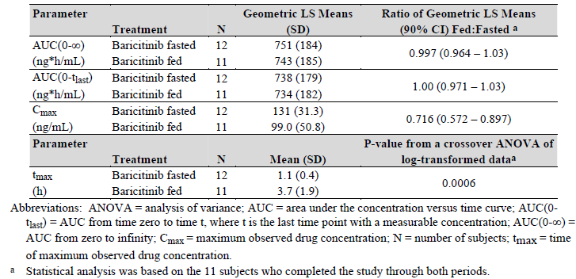
A secondary objective of Study JADH was to assess the effect of food upon the relative bioavailability of the Phase II tablets containing drug substance with 50 µm particle size. In this part of the trial a total of 15 subjects (14 male) received single oral doses of 8 mg BAR on 2 occasions, each separated by a washout period of 5-7 days. All subjects received the free base tablet with a particle size of 50 µm in the fasted state and then fed state (that is, following a high-fat, high calorie meal). Blood samples were taken before and at 0.25, 0.5, 0.75, 1, 1.5, 2, 3, 4, 6, 9, 12, 24, 36 and 48 hours after dosing for the assessment of BAR PK. The ratio (of fed: fasted) of the least squares geometric mean AUC_{0-∞} and C_{max} were 0.888 (0.827, 0.953) and 0.820 (0.727, 0.925), respectively, and median T_{max} was delayed by 0.5 hours when BAR was administered with a high-fat meal. The magnitude of these effects of food on BAR exposure were not considered to be clinically meaningful because the change in AUC was within the traditional limits of 0.8 to 1.25 and the 18% decrease in the C_{max} was also contained within the variability in the PK of BAR.
Study JAGO also had a secondary objective of examining the effect of food (low fat meal) upon the relative bioavailability of the Phase II tablets compared to the commercial BAR 4 mg tablet formulation. In 16 healthy male Japanese subjects, systemic exposure to the 4 mg BAR commercial tablet as assessed by AUC_{0-tlast}, AUC_{0-∞} and C_{max} was found to be 15%, 14%, and 11% lower, respectively, when dosed with a low-fat meal compared to the fasted state; however, the 90% CIs for each parameter fell completely within the 0.8 to 1.25 limits for bioequivalence. Although the median T_{max} occurred slightly later in the fed state compared to the fasted state, the difference (0.13 hours) was not statistically significant.

Dose proportionality
The PK of BAR is dose proportional over the single dose range of 1 to 30 mg in healthy subjects. In 3 of the Phase I Studies JADF, JADE and JADO, the mean BAR C_{max} and AUC_{0-∞} values proportionally increased with dose. The ratios (and 90% CI) for dose normalised C_{max} and AUC_{0-∞} were 1.02 (0.89, 1.18) and 1.13 (1.07, 1.20), respectively; refer to Figure 1.
Figure 1: Dose proportionality plots for AUC and C_{max} after single doses of BAR
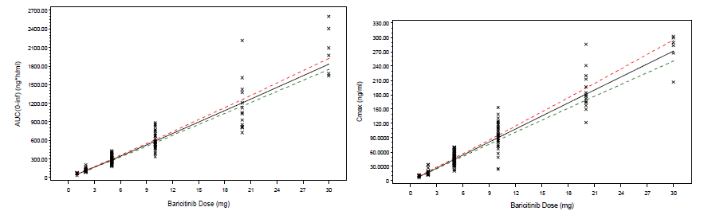
Following multiple once daily dosing over the range of 2 to 20 mg, the ratios (and 90% CI) for C_{max} and AUC were 0.93 (0.73, 1.19) and 0.84 (0.71, 0.99), respectively, suggesting that drug exposure at steady state increases slightly less than proportionally with BAR dose (Study JADE); refer to Figure 2. The sponsor does not believe that the small observed deviation from dose proportionality across a wide dose range to be clinically relevant.
Figure 2: Dose proportionality plots for AUC and Cmax after multiple doses of BAR
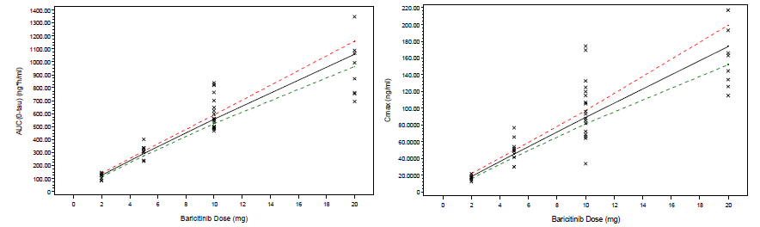
Study JADE was a Phase I, single USA centre, randomised, double-blind, placebo-controlled, sequential, multiple-dose, dose-escalation trial designed to evaluate the safety, tolerability and PK of oral BAR in 93 healthy adult subjects (aged 18-55 years; 79 subjects completed the study). Four cohorts (Cohorts A, B, C and E) consisting of 12 subjects each (9 randomised to receive active treatment with BAR 2, 5 or 10 mg once daily or 5 mg twice daily; and 3 randomised to receive placebo (once- or twice-daily dosing)) were enrolled in the study. Subjects in the first 3 cohorts were dosed every 24 hours for 9 consecutive days with a single dose on day 10. Subjects in the fourth cohort were dosed every 12 hours for 9 consecutive days with a single dose on day 10. An additional cohort (Cohort D) consisting of 32 subjects was enrolled (24 randomised to receive active and 8 to receive placebo) with 16 subjects receiving BAR 10 mg or placebo once daily, and 16 receiving BAR 5 mg or placebo twice daily for 28 days. An additional cohort (Cohort F) received BAR 20 mg or placebo once daily. In order to obtain single dose PK, subjects were administered a single dose of BAR 20 mg or placebo on day 1 followed by a washout period of 1 week. Dosing then resumed with the same dose for an additional 10 days to quantify multi-dose or steady-state PK. The major PK results are summarised above in Figures 1 and 2.

Effect of administration timing
Study JADE found that evening administration of BAR (as part of a twice daily dosing regimen) resulted in slight decreases in C_{max} and a minor delay in T_{max} when compared to morning dose ingestion, however, the total exposure (AUC) to BAR was similar.

Distribution

Volume of distribution
The mean volume of distribution following IV infusion of BAR in Study JAGM was 75.7 L (21% CV) which suggests distribution of BAR into tissues.

Plasma protein binding
In vitro and ex vivo animal studies suggested that BAR is moderately bound to protein and binding percentages were generally independent of drug concentration. In the pre-clinical study (DMB-08-14-1) the protein binding of BAR in plasma was 49% at 10 μM and 50% at 1 μM, with an overall mean fraction unbound of 50 ± 2% in plasma. The protein binding of BAR in serum was 53% at 10 μM, 55% at 3 μM and 57% at 1 μM, with an overall mean fraction unbound of 55±3% in serum.

Metabolism
In the Phase I Study JADE, BAR was minimally metabolised and this finding was confirmed in the radiolabel Study JADG. No drug metabolites are quantifiable in plasma. Metabolism represented less than 10% of the clearance of (¹⁴C)-BAR. Three minor oxidative metabolites (M22, M3 and M10) were identified in the urine; together accounting for approximately 5% of the dose and 1 minor oxidative metabolite (M12) was identified in faeces, accounting for approximately 1% of the dose. All of the BAR-related metabolites identified in urine and faeces from humans were also identified in at least one of the animal toxicology species that has been investigated in the pre-clinical program.
Study JADG was a single USA centre, open-label Phase I trial to determine the disposition of radioactivity and BAR in 6 healthy young male subjects after administration of a single 10 mg oral dose of BAR containing approximately 100 µCi of ¹⁴C-BAR. The studied examined plasma, whole blood, urine, faeces and expired air samples for BAR and BAR metabolites.

Excretion
BAR is primarily cleared from the body by renal excretion. In the human Study JADG, about 95% of a (¹⁴C)-BAR dose was recovered after oral administration with approximately 75% of the BAR dose excreted in the urine and approximately 20% of the BAR dose excreted in the faeces.

Intra and inter individual variability of pharmacokinetics
The primary Phase I/IIa Pop PK analysis data showed that the C_{max} and AUC of BAR exhibited low to moderate intra- and inter-subject variability.

Pharmacokinetics in the target population
In the primary Phase II/III Pop PK analysis, the mean apparent volume of distribution following oral dosing was 108 L in patients with RA and between-subject variability was moderate at 19.3% for this parameter. The mean apparent volumes of distribution estimates were slightly lower in patients with RA compared to healthy subjects.
The mean apparent drug clearance was estimated to be 9.42 L/hours in RA patients (using the Primary Phase II/III Pop PK Analysis) with moderate between-subject variability at 34.3%. The mean apparent BAR clearance in RA patients is about 46% lower than that calculated in healthy subjects. Moreover, the estimated mean T_{1/2} in patients with RA is 12.5 hours, which is approximately 25% longer than the T_{1/2} estimate in healthy subjects (10.0 hours).
The Phase II/III Pop PK analysis data showed that at steady state after multiple 4 mg once daily dosing in patients with RA, the C_{max} of BAR was 53.4 ng/mL with 21.8% coefficient of variation (CV) and the mean AUC-time curve at a dosing interval at steady state (AUC_{t,ss}) was 477.6 ng*hr/mL with 40.7% CV.

Pharmacokinetics in special populations

Pharmacokinetics in subjects with impaired hepatic function
Study JAGC was an open-label, single dose, parallel-group trial with the primary objectives of comparing the PK/PD and safety of BAR 4 mg tablets in otherwise healthy subjects with moderate hepatic impairment for at least 6 months to subjects with normal hepatic function. A total of 16 subjects (14 male; 15 Caucasian) between the ages of 47 and 68 years of age (mean of 58.5 years) with a mean weight of 84.5 kg (range: 64 to 113 kg) were enrolled into 2 hepatic function groups (balanced for gender, weight and age) based on the Child-Pugh classification of hepatic function at screening: normal hepatic function (n = 8) or moderately impaired (Child-Pugh B; n = 8). The study was conducted at 2 investigator sites in the USA. Subjects were admitted to a study confinement facility for 48 to72 hours after drug ingestion.
The extent of total plasma exposure to BAR was higher in subjects with moderate hepatic impairment (geometric LS mean BAR C_{max} values 8% higher and geometric LS mean AUC_{0-∞} values 20% greater), but the differences were not statistically significant. The median BAR T_{max} values for subjects with normal hepatic function (0.75 hours) were similar to those in subjects with moderate (1.25 hours) hepatic impairment, with the 90% CI for the difference crossing zero, indicating that there was no statistically significant difference in T_{max} between the groups. The T_{1/2} also appeared similar between the hepatic function groups (9.02 hours in those with normal hepatic function and 8.26 hours in subjects with moderate hepatic impairment. The sponsor proposes that the data in this trial supports the recommendation that no dose adjustment with BAR is required for patients with mild or moderate hepatic impairment. This is an acceptable opinion but a significant limitation to this study is that the Child-Pugh has not been developed or validated for predicting drug elimination. The Child-Pugh classification system was developed for categorising the severity of hepatic impairment.

Pharmacokinetics in subjects with impaired renal function
Study JADL was an open-label, single-dose trial conducted in 2 USA centres with the primary objectives of evaluating the PK/PD and safety of BAR 5 and 10 mg capsules in otherwise healthy subjects aged 18-79 years with varying degrees of renal impairment and subjects with normal renal function. A BAR dose of 10 mg was given to healthy subjects and those with mild-moderate renal impairment and the 5 mg dose was investigated in subjects with severe renal impairment. An additional 8 Subjects with end stage renal disease receiving haemodialysis received 2 single doses of BAR 5 mg on days 1 (immediately following dialysis) and 15 (pre-dialysis).
A total of 46 subjects (24 female) between the ages of 19 and 77 years of age (mean 51.8 years) with a mean weight of 79.7 kg (range: 54 to 123 kg) were enrolled into 5 different renal function groups based on their creatinine clearance (CrCl) results (categorised by the MDRD-GFR formula) at screening: normal renal function (CrCl > 90 mL/min; n = 10), mild renal impairment (CrCl 60 to 89 mL/min; n = 10), moderate renal impairment (CrCl 30 to 59 mL/min; n = 10), severe renal impairment (CrCl 15-29 mL/min; n = 8) and dialysis dependent end stage renal disease (ESRD; n = 8). The method of study confinement, PK parameters of interest and statistical analysis was the same as Study JAGC. Blood samples for determination of BAR PK were obtained prior to dosing and up to 72 hours post-dose. The ESRD group had arterial and venous line blood samples collected for PK assessments at 3 (start of haemodialysis), 4, 5, 6 and 7 (or end of haemodialysis) hours post-dose. Urine samples were collected from 0 to12, 12 to 24, 24 to 48, and 48 to 72 hours post-dose for PK assessments with creatinine quantified in the 24 to 48 hour post-dose collection.
Table 3 shows the ratios of dose-normalised geometric means for AUC_{0-∞} and C_{max} for subjects with renal impairment compared with subjects with normal renal function in Study JADL. The PK of BAR was affected by renal function with increasing AUC with increasingly severe renal impairment and C_{max} was relatively unaffected. Unchanged BAR recovered in urine as a percent of dose administered progressively decreased with declining renal function, from 67.5% in the healthy group to 27.2% in the severe group (excluding the ESRD group). A 4 hour haemodialysis procedure removed approximately 17% of the administered BAR dose. The results of Study JADL indicate that renal impairment significantly affects exposure to BAR with significantly increased drug exposure with declining renal function. BAR does appear to be dialyzable to some extent.

Table 3: Pharmacokinetic parameters of baricitinib in Study JADL
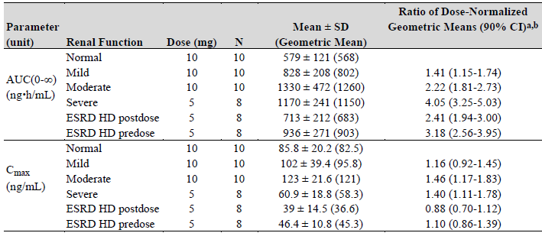
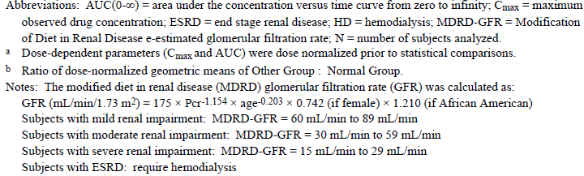

Pharmacokinetics according to age
The primary Phase II/III Pop PK analysis does not reveal age (across the range of 19 to 83 years) to significantly impact upon the PK of BAR in patients with RA.

Pharmacokinetics related to genetic factors
Study JADM was a single centre 4 cohort single and multi-dose trial conducted in 34 healthy Japanese subjects (22 male) aged between 20 and 65 years. Most subjects (n = 31) completed the study. Cohorts 1 and 2 participated in a single dose period only; and Cohorts 3 and 4 participated in a single and multi-dose period. BAR was administered as single doses of 2, 5, 10 and 14 mg in the single dose period; and as once daily doses of 10 and 14 mg for 10 days during the multi-dose period. Study JADM confirmed that the PK of BAR in healthy Japanese subjects is highly similar to that observed in the Phase I, USA based population trials. In Study JADM, BAR was rapidly absorbed following oral administration with median T_{max} of 1 hour over the single dose range of 2 to 14 mg as well as the multiple dose range of 10 to 14 mg. Following C_{max}, plasma concentrations of BAR appeared to decline in a monophasic manner with the mean T_{1/2} of BAR being 5-9 hours across all of the single and multiple dose levels. Plasma concentrations of BAR reached steady state after the second consecutive day of once daily dosing with BAR 10 or 14 mg. Minimal accumulation of BAR was observed with multiple dosing. Over the single dose range of 2 to 14 mg, systemic exposure to BAR (as measured by AUC) appeared to increase in a dose proportional manner.

Pharmacokinetics in other special populations
Gender was identified as a significant covariate on the central volume of distribution for BAR. Although statistically significant, the effect size of gender upon volume of distribution was small being 95.1 L in men and 83.3 L in women. In addition, since gender only significantly affects volume of distribution and not drug clearance, the impact of gender on the PK of BAR is mainly on C_{max} and not AUC. PK profiles simulated from the final Pop PK model showed that the 90% CI of the profiles of men and women largely overlapped with women estimated to have a 7% and 16% difference in AUC and C_{max}, respectively, compared to men after accounting for differences in renal function. Race and ethnicity had no clinically relevant effect on the PK of BAR in the primary Phase II/III Pop PK analyses.
Subject body weight (over the range of 32 to 181 kg) was identified as a significant covariate on volume of distribution and clearance in the primary Phase II/III Pop PK analysis. However, the effect size was considered to be small by the sponsor and clinically insignificant. With every 10 kg increase in body weight, volume of distribution increases by 10.0 L and clearance increases by 0.58 L/hr. There was an overall trend for C_{max} to decrease as body weight increases, but there was a large overlap in exposures between body weight groups when stratified into body weight quartiles. In addition, the model-estimated concentrations for patients at the tenth (50 kg) and ninetieth (100 kg) percentile of body weight fell largely within the 90% CI for the median weight (70 kg) of the RA population. Patients at the extremes of the body weight distribution curve of 50 and 100 kg were estimated to have less than 14% and 20% difference in AUC and C_{max}, respectively, relative to those at the median weight of 70 kg (after accounting for differences in renal function).

Population pharmacokinetics
Data from each of the 4 Phase III studies was pooled with data from the 3 Phase II studies in a combined Population PK analysis known as the primary Phase II/III Pop PK Analysis. This was mainly done to examine for covariate factors affecting the PK of BAR. In addition, a Phase I/IIa Pop PK analysis that collated data from Studies JADE, JADF, JADL, JADB and JADC assessed covariate factors affecting the PK of BAR in the healthy subject population.

Pharmacokinetic interactions
A total of 9 in vivo drug-drug interaction studies in humans have been performed with BAR. Study JAGF which examined the effect of increased gastric pH (using concurrent omeprazole) upon the bioavailability of BAR has already been discussed in the evaluation.
Four of the drug interaction studies have examined the effect of BAR on the PK of other drugs:
- Study JAGI: effect of BAR 10 mg/day on days 3-7 on the PK of simvastatin and its active metabolite (single 40 mg doses taken on Days 1 and 6) in 40 healthy UK subjects.
- Study JAGD: effect of BAR 10 mg/day for 8 days on the PK of Microgynon (single doses taken on Day 1 and 7) in 20 healthy UK women aged 18 to 65 years.
- Study JAGL: effect of BAR 10 mg/day for 9 days on the PK of digoxin 0.25 mg/day for 15 days after 2 x 0.5 mg loading doses on Day 1 in 28 healthy UK subjects 18 to 65 years.
- Study JADB: effect of BAR 10 or 15 mg once daily or 5 mg twice daily taken on Days 3 to 28 on the PK of weekly oral MTX 7.5 to 25 mg taken on days 1, 8, 15 and 22 in 53 adult subjects (USA) with RA.
The results of the above studies indicate that BAR does not have clinically significant effects on the PK of various other drugs of interest, and therefore, no precaution for BAR in the proposed PI is necessary when it is co-administered with these drugs.
Five of the drug interaction studies have examined the effect of other drugs on the PK of BAR:
- Study JAGJ: effect of ketoconazole or fluconazole (200 to 400 mg/day for 6 to 7 days) on the PK of BAR 10 mg/day on Days 1-7 in 36 healthy UK subjects.
- Study JAGK: effect of rifampicin 600 mg/day for 9 days on the PK of BAR 10 mg taken on Days 1 and 10 in 18 healthy UK subjects aged 18 to 65 years.
- Study JAGH: effect of single 600 mg dose of cyclosporine (taken on day 4) on the PK of BAR (2 single 10 mg doses taken on days 1 and 4) in 18 healthy UK subjects 18 to 65 years.
- Study JAGG: effect of probenecid 1000 mg twice daily taken on Days 3 to 7 on the PK of BAR (2 single 4 mg doses taken on days 1 and 5) in 18 healthy UK subjects 18 to 65 years.
- Study JADB: effect of BAR 10 or 15 mg once daily or 5 mg twice daily taken on Days 3-28 on the PK of weekly oral MTX 7.5-25 mg taken on days 1, 8, 15 and 22 in 53 adult subjects (USA) with RA.
The results of the above studies indicate that other drugs do not have clinically significant effects on the PK of BAR, apart from probenecid, which is a strong inhibitor of OAT3. The AUC of BAR increased 2-fold in the presence of probenecid with a decrease in the geometric mean clearance for BAR of 69% along with an increase of approximately 5 hours in T_{1/2}. The sponsor proposes a reduction in BAR dose from 4 mg once daily to 2 mg once daily in patients taking OAT3 inhibitors that have a strong inhibition potential, such as probenecid. Simulations involving NSAIDs with lower potential OAT3 inhibition (such as ibuprofen and diclofenac) found that these drugs are unlikely to increase the AUC of BAR by more than 1.25-fold. The Phase II/III PK data confirmed that simulation outcome for the co-administration of ibuprofen or diclofenac (that is, not identified as a significant covariate on the PK of BAR based on the primary Phase II/III Pop PK analysis).
MTX is a substrate for a variety of transporters, including OAT1, OAT3 and BCRP. In Study JADB, a 15 mg dose of BAR did not significantly affect the PK of MTX. The dose normalized AUC of MTX increased by approximately 5%, while the dose normalised C_{max} of MTX decreased by 3%. Co-administration of BAR caused a small increase of 13% in the dose normalised AUC of 7-OH-MTX, an active metabolite of MTX, while there was no effect on the dose normalised C_{max} of 7-OH-MTX. The small increase observed for AUC is not considered clinically important and it is not necessary to adjust the dose of MTX when it is co-administered with BAR.

Clinical implications of in vitro findings
BAR was studied in vitro across a panel of recombinant enzyme preparations of human cytochrome P450 (CYP) enzymes and in cell lines transfected with various human recombinant transporters for its potential to be a substrate for CYPs or transporters. In vitro, BAR is a substrate for CYP3A4 and for organic anion transporter 3 (OAT3), P-glycoprotein (Pgp), breast cancer resistance protein (BCRP) and multidrug and toxin extrusion protein 2-K (MATE2-K). As such, clinical studies were conducted to further evaluate the in vitro findings.

Evaluator’s overall conclusions on pharmacokinetics
In this submission, the PK properties of BAR has been assessed in 18 Phase I studies involving otherwise healthy volunteers (some with co-variables of interest such as renal or hepatic impairment), 9 drug-drug interaction studies, 1 Phase I trial (Study JADB) involving 53 adult subjects with RA taking concurrent MTX and 7 Phase II/III clinical studies contributing data to population PK and PK-PD analyses.
The key PK conclusions identified in the submission are as follows:
- Orally administered BAR is rapidly (median T_{max} of approximately 1.0 hour (range: 0.5 to 3.0 hours)) and well absorbed (absolute bioavailability of 79%) from the gastrointestinal tract.
- The proposed commercial formulation and dosage strengths of BAR to be made available in Australia are identical to the 2 mg and 4 mg tablet strengths used in the pivotal Phase III clinical trials, which have demonstrated bioequivalence when produced at a commercial scale to the preceding formulations.
- Ingestion of BAR following a high fat meal compared to drug administration under fasted conditions, results in a decrease in BAR C_{max} of 18%, a decrease in AUC of 11%, and a delay in T_{max} of 0.5 hours (Study JADH). The sponsor asserts that the administration of BAR with meals is not associated with a clinically relevant effect on drug exposure and during the Phase II/III studies BAR was taken without regard to meals.
- Steady state is reached after second and third doses of BAR (Study JADE) with minimal drug accumulation after multiple drug ingestion (accumulation ratio of 1.11 for C_{max} and 1.15 for AUC in the Pop PK analysis). Hence, multi-dose PK for BAR is largely predictable with single dose data.
- Regarding dose proportionality, exposure to BAR increases in a proportional manner in the dose range of 1 to 30 mg.
- Mean apparent volume of distribution at steady state after oral dosing with BAR 2 mg and 4 mg was 108 L with 19.3% CV (Pop PK data). Mean volume of distribution following IV administration was 75.7 L with 21% CV (Study JAGM) suggesting tissue distribution. BAR is a substrate for various drug transporter systems including Pgp, OAT3, MATE2-K and BRCP, which play a role in drug distribution.
- BAR is approximately 50% bound to human plasma proteins.
- From the human (¹⁴C) Study JADG, approximately 75% of BAR is excreted in the urine (mainly as parent drug) and 20% is excreted in faeces. There are 4 minor oxidative metabolites (3 in urine and 1 in faeces).
- The mean T_{1/2} of BAR in the plasma ranges is 10 hours for healthy adult subjects and 12.5 hours for patients with RA.
- Renal elimination is the main route of elimination for BAR through glomerular filtration and active secretion via OAT3, Pgp, BRCP and MATE2-K.
- Subjects with moderate (CrCL 30 to 60 mL/min) and severe (CrCL < 30 mL/min) renal impairment have 2-fold and 4-fold increases in BAR AUC values compared to those with normal renal function (Study JADL). However, subjects with mild renal impairment (CrCL 60 to 90 mL/min) have only small insignificant increases in AUC compared to those with normal renal function.
- The PK of BAR does not appear to be substantially affected by age, gender, ethnicity, hepatic impairment or body weight.
- The PK characteristics of BAR in relation to C_{max} and AUC demonstrate low to moderate degrees of intra-subject and inter-subject variability across the tested dose range.
- A total of 9 in vivo drug-drug interaction studies in humans have been performed. The results indicate that many frequent concomitant medications such as MTX, azole drugs, ibuprofen, diclofenac, cyclosporine, digoxin, oral contraceptive pill and simvastatin do not have clinically significant effects on the PK of BAR and vice versa. However, probenecid (strong OAT3 inhibitor) increases exposure to BAR (doubling of AUC). In addition, the concomitant ingestion of omeprazole (that is, the effect of an increased gastric pH) has shown to delay the absorption of BAR by 0.75 hour, and to cause a decrease in C_{max} of 23%, but produces no significant change in AUC (Study JAGF).

Pharmacodynamics

Studies providing pharmacodynamic information
Table 4 shows the studies relating to each pharmacodynamic (PD) topic and the location of each study summary. None of the PD studies had deficiencies that excluded its results from consideration.

Table 4: Submitted pharmacodynamic studies for baricitinib
PD Topic | Subtopic | Study ID | *
Primary Pharmacology | Effect on phosphorylated STAT formation | JADF and JADE | *
Secondary Pharmacology | Effect on QT Interval | JADO | *
Secondary Pharmacology | Effect on haematological parameters | Phase II/III Population
Factors producing differences in PD Response | Effect of Gender | Nil performed
Factors producing differences in PD Response | Effect of renal impairment | JADL | *
Factors producing differences in PD Response | Effect of ethnicity | Nil performed
Factors producing differences in PD Response | Effect of age | Nil performed
PD Interactions | Drugs and Vaccines | Nil performed
Population PD and PK-PD analyses | Healthy subjects | Nil performed
Population PD and PK-PD analyses | Target population | Phase II/III Population | *
* Indicates the primary PD aim of the study.

Summary of pharmacodynamics
The information in the following summary is derived from conventional PD studies in humans unless otherwise stated.

Mechanism of action
JAKs are enzymes that transduce intracellular signals from cell surface receptors for a number of cytokines and growth factors involved in haematopoiesis, inflammation and immune function. Within the intracellular signalling pathway, JAKs phosphorylate STATs, which activate gene expression within the cell.
BAR is a selective and reversible inhibitor of JAK1 and JAK2. In isolated enzyme assays, BAR inhibited the activities of JAK1, JAK2, TYK2 and JAK3 with IC₅₀ values of 5.9, 5.7, 53 and > 400 nM, respectively. The STAT3 transcription factor is directly phosphylorated (pSTAT3) by JAKs in response to cytokine stimulation and the sponsor developed an ex vivo assay method that measures cytokine stimulated pSTAT3 formation in human blood as a means of examining the primary PD effect of BAR.
JAK1 is preferentially expressed in T-lymphocytes and mediates the common γ chain cytokines, including IL-2, IL-4, IL-7, IL-9, IL-15 and IL-21, which are integral to lymphocyte activation, proliferation and function. The predicted side effects of JAK1 inhibition include infection, hyperlipidaemia and possible natural killer (NK) cell effects. JAK2 affects erythropoietin, thrombopoietin, interferon and GM-CSF. The predicted side effects of JAK2 inhibition include infection, anaemia, neutropaenia and thrombocytopaenia. BAR also significantly inhibits IL-6 signalling (through inhibition of both JAK1 and JAK2) and abrogates the expression of the IL-23 receptor (predominately through JAK2 inhibition), which subsequently blocks the differentiation of Th17 cells, which are important mediators in the pathogenesis of RA.

Pharmacodynamic effects

Primary pharmacodynamic effects
BAR induced inhibition of IL-6 or thrombopoietin (TPO) simulated pSTAT formation was utilised as the primary PD marker of receptor engagement in the BAR PD study program.
In Study JADF, blood samples were collected before and at 1, 2, 4, 6, 12, 16 and 24 hours after single BAR dosing (1-10 mg) to determine the changes in pSTAT3 via ex vivo stimulation with cytokines (either IL-6 or TPO). The trial revealed dose dependent inhibition in pSTAT3 and for all tested BAR doses pSTAT3 levels returned to baseline levels within 24 hours.
In Study JADE, subjects who received a single dose of BAR showed dose-dependent inhibition of cytokine-induced STAT3 phosphorylation in response to IL-6 stimulation. Maximal inhibition of pSTAT3 ranged from 40% at the lowest dose (1 mg) to 70-80% inhibition at the highest doses (10 and 20 mg). Significant pSTAT3 inhibition was observed in all groups between 2 and 16 hours (depending on the dose) and pSTAT3 levels returned to normal by 24 hours in all cohorts. Subjects who received multiple doses of BAR in Study JADE also showed dose-dependent inhibition of pSTAT3 in response to both IL-6 and TPO stimulation. Consistent with the single dose data, maximal inhibition of pSTAT3 occurred 1-2 hours post dose and ranged from 30-40% at the lowest BAR dose (2 mg/day) to 70-80% inhibition at the highest BAR dose (20 mg). The extent of inhibition observed on Day 10 was not statistically different from that observed on Day 1. Levels of pSTAT3 returned to control levels by 24 hours in all cohorts and were similar at pre-dose on Days 2, 7, 10 and 11. Comparable levels of inhibition were observed using either IL-6 or TPO as the stimulus, and in the BAR 5 mg cohorts, similar inhibition was observed at the time points examined independent of whether the drug was dosed twice or once daily.
Based on the results from Studies JADF and JADE, a PK/PD relationship was established for BAR induced inhibition of IL-6 stimulated pSTAT3 formation. The calculated IC₅₀ value was 75 nM (27.9 ng/mL) from Study JADF and 100 nM (37.1 ng/mL) from Study JADE (for a combined value of 90 nM (33.3ng/mL). These results are similar to the IC₅₀ value of 104 nM (38.6 ng/mL) estimated from in vitro data. Moreover, once daily dosing of 4 mg but not 2 mg results in a period of time when the BAR concentration in the central compartment is above the ex vivo IC₅₀ for IL-6 stimulated pSTAT3 formation. For both doses of BAR there is a relatively long period of time when the BAR concentration is well below the IC₅₀. Consequently, once daily BAR therapy may allow for recovery of the IL-6 signalling pathway towards the end of the dosing interval which may reduce the incidence of potentially undesirable PD effects that might occur with prolonged inhibition of IL-6 such as neutropaenia.
In the renal impairment Study JADL, a comparison of IL-6 stimulated mean pSTAT3 levels in healthy subjects versus those with varying degrees of renal impairment was also evaluated. The PD results mirrored the PK results with greater and more prolonged inhibition of pSTAT3 in the presence of increasingly severe renal impairment.

Secondary pharmacodynamic effects
The effect of BAR on cardiac repolarisation (as assessed by changes in the QT interval) has been evaluated in 53 healthy subjects (43 male) in Part B of the Phase I Study JADO. This trial was a randomised, placebo and positive controlled (moxifloxacin 400 mg) study with the primary objective of investigating the effect of a single supratherapeutic dose of BAR (40 mg) upon QTc. Subjects underwent continuous 12-lead digital Holter monitoring on the day before dosing and for 2 hours prior to, and up to 48 hours after dosing. Linear regression analyses were performed on QTc and the Population-corrected QT interval (QTcP) was used for the primary analysis.
Part B of Study JADO showed that a single supratherapeutic dose of 40 mg BAR did not prolong QTcP to a clinically significant degree, as the upper bound of the 2 sided 90% CI for the mean difference between treatments (placebo and BAR) was < 10 ms at all post dose time points. Similar results were obtained using Individual-corrected QT interval (QTcI) and Fridericia’s corrected QT interval (QTcF). The mean change from Baseline in QTcP was greater following administration of moxifloxacin (positive control) compared to placebo at all time points (least squares mean difference ranged from 11.0 to 12.3 ms) and therefore experimental sensitivity was established in this trial as the lower bound of the 90% CI of the difference between moxifloxacin and placebo was > 5 ms at all time points. No positive slope or correlation was observed between BAR plasma concentration and the change from Baseline QTcP interval. The maximum BAR concentration observed in Study JADO (275 ng/mL) was around 5 times the model-estimated C_{max} (53.4 ng/mL) from the primary Phase II/III Pop PK analysis in RA patients. In addition, there were no subjects with QTcI, QTcP or QTcF intervals > 480 ms or with an increase from Baseline in QTc interval of > 60 ms following single doses of BAR 40 mg.

Time course of pharmacodynamic effects
BAR produces maximal inhibition of IL-6 or thrombopoietin induced STAT3 phosphorylation in healthy adult subjects within 2 hours of administration and this recovers to baseline by 24 hours. However, as evidenced in the Phase II and III 3 clinical studies, there is a delay in any observable change in clinical efficacy endpoints (such as ACR and DAS28 response) following BAR administration, with the onset of discernible clinical effect in RA appearing at a minimum of 1-2 weeks after commencement of therapy. Changes in haemoglobin levels were detectable by 1 week after starting BAR. In the early clinical studies, decreases in absolute neutrophil counts were seen to reach a nadir at 4-12 hours after dosing and return to baseline by 24 hours post-dose.

Relationship between drug concentration and pharmacodynamic effects
The clinical pharmacology studies appear to show a direct relationship between plasma BAR concentration and change in pSTAT3 levels. Changes in pSTAT levels mirror the PK profile of BAR, with the time of maximum pSTAT3 inhibition occurring near T_{max} and pSTAT3 levels return to baseline when the drug is cleared. However, the PK/PD relationship is not direct for the clinical efficacy endpoints of ACR and DAS28 response, with a delay of 1 to 2 weeks in any discernible change in these efficacy endpoints following BAR administration in Phase II and III clinical studies. As such, the PK half-life of BAR does not translate into the efficacy PD half-life, and efficacy appears to be related to the daily drug exposure (AUC) rather than C_{max}.
The Phase II trial data as well as PK/PD modelling examined the relationship between serum concentrations of BAR and clinical outcomes (efficacy and haematological safety outcomes). In the Phase II dose ranging Study JADA, BAR dosed at 4 mg once daily resulted in the same AUC and approximately twice the C_{max} compared with BAR dosed at 2 mg twice daily, but showed similar efficacy and safety outcomes. This suggested that clinical outcomes are mainly driven by total drug exposure instead of peak concentrations achieved. The PK/PD modelling of once versus twice daily dosing substantiated that hypothesis. The simulations comparing the PK profiles between 1 mg twice daily and 2 mg once daily, as well as 2 mg twice daily versus 4 mg once daily showed that the median BAR concentrations over a 24 hour interval at steady state are essentially the same between the once and twice daily dosing regimens at the same total daily doses. The simulation results also indicated the responses for all evaluated efficacy and safety endpoints (incidence of anaemia and neutropaenia) were comparable between once and twice daily dosing, with the same total daily dose, despite the fact that C_{max} of the once daily dosing regimen is higher than that of the twice daily dosing.
In summary, the clinical efficacy and safety of BAR appear to be primarily explained by the total daily drug exposure (AUC) rather than peak concentration (C_{max}) or T_{max}.

Genetic, gender and age related differences in pharmacodynamic response
Not specifically assessed in the PD program.

Pharmacodynamic interactions
No study of BAR concurrently administered with other biologic DMARDs, including IL-6 inhibitors such as tocilizumab, have been undertaken. However, based on the mechanism of action of JAK inhibition, co-administration of BAR with other biologic DMARD therapy is not recommended. Similarly, because JAK1 inhibition significantly affects T-cell function the co-administration of BAR with any live vaccine is not recommended until specific information on this issue becomes available (for example, a trial assessing immune responses (humoral and cell mediated) following administration of zoster vaccine). No drug-drug interaction studies has been performed with BAR to examine if the drug has a clinically significant effect on the PD of concomitantly administered warfarin (that is, change in INR monitoring requirements).

Evaluator’s overall conclusions on pharmacodynamics
In this submission, the PD properties of BAR has been assessed in 3 Phase I studies, 2 of which involved healthy volunteers (Studies JADE and JADF) and 1 enrolled otherwise healthy subjects with renal impairment (Study JADL), as well as the 7 Phase II/III clinical trials involving subjects with RA plus 1 population PK-PD analysis.
Inhibition of the JAK-STAT pathway by BAR is reversible in nature. The decrease in the cytokine stimulated pSTAT3 formation in response to single and multiple doses of BAR therapy was measured in 3 clinical pharmacology studies (Studies JADE, JADF and JADL). The PD data from these 3 studies were consistent and showed a dose dependent inhibition of pSTAT3 formation in response to cytokine stimulation in the single dose range of 1 to 20 mg (Study JADF), and with multiple once daily doses of 2 to 20 mg for 10 days (Study JADE). Similar levels of inhibition were observed using either IL-6 or TPO as the stimulus. Maximal inhibition of pSTAT3 formation occurred 1-2 hours post-dose, coincident with the observed time to reach C_{max}. There is a direct relationship between plasma BAR concentration and change in pSTAT levels. The maximal inhibition of pSTAT ranged from 40% at the lowest dose of BAR (1 mg) to 70-80% inhibition at the highest dose of BAR (20 mg). The pSTAT3 levels returned to baseline levels by 24 hours for all dose groups following single and multiple doses. In the multiple dose study, the extent of inhibition observed on day 10 was not statistically different from that observed on day 1, and pSTAT3 returned to baseline levels in a similar manner to that after single dose ingestion. Thus, there is no evidence for a cumulative effect on cytokine stimulated pSTAT3 formation with repeated dosing of BAR. Although changes in pSTAT levels mirror the PK profile of BAR, the PK/PD relationship is not direct for the clinical efficacy endpoints such as ACR and DAS28 response, where there is a delay in any observable change. Therefore, the PK half-life does not translate into the efficacy PD half-life, and efficacy is more likely to relate to the daily average exposure (or AUC) to BAR. Finally, Study JADO identified that BAR in doses up to 40 mg does not cause any significant effects on cardiac repolarisation such as prolongation of the QT interval in normal healthy subjects.

Dosage selection for the pivotal studies

Pharmacokinetic and pharmacodynamic studies
The Phase I clinical pharmacology studies assessed BAR in the dose range of 1 mg to 20 mg once daily (including 5 mg and 10 mg twice daily regimens). Doses of BAR up to 10 mg once daily were generally safe and well tolerated in healthy volunteers (Study JADE) and in patients with RA (Study JADB) for up to 28 days of continuous therapy. Maximum inhibition of IL-6 stimulated pSTAT3 formation (70% to 80% of baseline) was observed with the BAR 10 and 20 mg dose. Therefore, BAR doses of 4 mg, 7 mg and 10 mg once daily were selected for further investigation in the initial Phase IIa, proof-of-concept Study JADC.

Phase II dose finding studies
Three Phase II studies provided dose-response data across a range of BAR doses:
- Study JADC was a proof-of concept study involving 145 subjects who tested BAR doses of 4 mg, 7 mg and 10 mg once daily.
- Study JADA (n = 301 subjects) evaluated BAR doses of 1 mg, 2 mg, 4 mg and 8 mg once daily plus a BAR dose of 2 mg twice daily was also examined.
- Study JADN was conducted in 145 Japanese patients and tested BAR doses of 1 mg, 2 mg, 4 mg and 8 mg once daily.
All 3 of the Phase II studies assessed the proportion of patients who achieved ACR20 response at 12 weeks as the primary efficacy endpoint. Studies JADA and JADN included open-label, extension phases - 1 year of single blind extension in Study JADN and 2 years of open label extension in Study JADA. Patients completing Study JADA were also eligible to enrol in the long term extension Study JADY. The clinical response data for each of these studies is provided in detail in section 7 of this report.
In Study JADC, the proportion of patients achieving the primary efficacy endpoint (ACR20 response at 12 weeks) was similar across the BAR 4 mg, 7 mg and 10 mg once daily regimens, suggesting that all 3 doses reside on the plateau of the dose response curve for BAR in RA. Lower doses of BAR 1 and 2 mg once daily were added to Study JADA to identify the minimum efficacious dose and to characterise the initial linear part of the dose response curve. The dose of 4 mg once daily was retained in Study JADA due to the robust efficacy response observed and a dose of 8 mg once daily was chosen as the highest BAR dose to further confirm its maximum efficacy. The twice-daily dose arm in Part B of Study JADA was intended to evaluate any differences in the overall clinical profile when the same total daily dose was given twice daily versus once daily. The Japanese Phase II Study JADN examined the same doses of BAR as Part A of the Phase IIb Study JADA (that is, BAR 1, 2, 4 and 8 mg once daily). The choice to examine similar doses of BAR in this trial as Study JADN and Study JADA was based on observations from the global (Studies JADF and JADE) and Japanese (Study JADM) Phase I studies which suggested that there were no PK differences due to ethnicity between global and Japanese patients.

Phase III pivotal studies investigating more than one dose regimen
The dose selection of BAR for testing in the Phase III trials was based on the results of 2 of the Phase II Studies JADC and JADA, as well as PK/PD models of efficacy and safety. The results of the third Phase II trial (Study JADN) were not available at the time of dose selection for the Phase III study program. BAR 4 mg once daily appeared to reside on the plateau of the efficacy dose response curve for all domains of efficacy and higher doses did not increase the observed or modelled treatment benefit. Both the 1 mg and 2 mg doses of BAR appeared to be biologically active, but the observed and modelled treatment benefits were not considered compelling in the context of available therapies for RA. BAR was well tolerated at each dose level investigated. However, there was a higher incidence of non-serious adverse events and declines in mean haemoglobin concentrations compared to PBO and lower doses of BAR with the 10 mg daily regime. The tolerability and safety profile of the 4 mg once daily dose was similar to that observed for the lower doses of BAR and PBO. Twice daily dosing did not improve efficacy and was associated with more laboratory abnormalities. The same observation was observed in studies of BAR in patients with diabetic nephropathy (Study JAGQ). Despite the modest efficacy observed with the 2 mg once daily dose of BAR in Study JADA and the significant overlap in the AUC between the 2 mg and 4 mg doses, the 2 mg once daily dose was investigated in 2 PBO-controlled Phase III studies to further characterise the relative efficacy/safety. However, the 2 mg once daily dose of BAR was not predicted to perform well versus active comparators and, therefore, was not included in the active-controlled Phase III studies.

Evaluator’s conclusions on dose finding for the pivotal studies
The totality of data from the Phase I and II studies and the Population PK/PD models support the once daily administration of BAR 4 mg as the recommended dose given the clinically relevant rates of important outcome measures and no apparent concentration relationship for the 2 and 4 mg dose levels on the safety endpoints of anaemia or neutropaenia. Additionally, drug exposure associated with the BAR 2 mg dose in some patients were on the plateau of the exposure response curve indicating that the 2 mg dose will be effective in some patients. The sponsor has thoroughly investigated the effect of food on the PK of BAR and appropriately recommended that it can be given orally with or without food in the pivotal Phase III studies. Study JADL and Pop PK analyses have revealed the need for dose modification in patients with significant renal impairment. In the Phase III studies, the recommended dose of BAR in patients with CrCL 30 tot 60 mL/min was 2 mg once daily and patients with CrCL of < 30 mL/min were excluded from these trials. No drug interaction with MTX was identified in the Phase I/II studies so 3 of the pivotal Phase III studies allowed the use of BAR in combination with weekly low dose MTX.
Comments regarding the appropriateness and adequacy of concurrent and/or comparator therapies in the Phase III studies are also pertinent to the interpretation of the reported outcomes. Study JADZ was a comparison between MTX and BAR and the other Phase III trials had background concurrent conventional DMARD therapy. The mean and median doses of concomitant background treatment with conventional DMARD therapy (predominately MTX) was consistent with contemporary clinical practice in Australia. However, recent expert opinion concludes that such prior therapy reflects sub-optimal practice before the commencement of biologic therapy in patients with active RA (Duran et al, 2016). In particular, the maximal concurrent dose of MTX should be used in the comparator arm of all biologic therapy trials (up to 25 mg/week, by the SC route if dose > 15 mg/week for MTX) as sub-optimal MTX dose in the comparator arm may bias efficacy results in favour of biological agents. Moreover, low dose oral corticosteroid (prednisone ≥ 10 mg/day) and NSAID use was recorded in more than half of all patients (equally dispersed among the treatment arms) in the 4 pivotal BAR studies, which reflects appropriate concomitant drug use in individuals with active RA, and is consistent with prescribing patterns in Australia.

Clinical efficacy

Studies providing evaluable efficacy data
The efficacy of BAR in patients with moderately to severely active RA has been evaluated in 4 completed Phase III studies (JADZ, JADV, JADX and JADW); as well as 3 completed Phase II studies (JADA, JADC and JADN) and 1 ongoing, long-term extension (LTE) trial (Study JADY). Study JAGS is another Phase III trial, but has not been included in this submission. Each of the completed Phase III studies investigated diverse range of RA patient populations, spanning the treatment continuum from DMARD naive patients (Study JADZ), to patients with an inadequate response to conventional DMARD (Studies JADV and JADX) and patients with an inadequate response to biologic DMARD (Study JADW). In settings where study drug was added to stable background conventional DMARD therapy, the efficacy of BAR was compared to PBO (Studies JADV, JADX, and JADW) and to adalimumab (Study JADV). In the setting where patients had no prior or background conventional DMARD therapy (Study JADZ), BAR was used alone or in combination with MTX, and was compared to MTX monotherapy. The BAR 4 mg once daily dose was included in all Phase III studies and the 2 mg once daily dose was only included in 2 Phase III studies that incorporated PBO control. The BAR 2 mg once daily dose was not included in studies that had active comparators because the results of the Phase II studies suggested a low probability that BAR 2 mg/day would demonstrate satisfactory efficacy. Table 5 provides a summary of the patient populations and design characteristics of the Phase II and III controlled studies in support of the registration of BAR. The 4 pivotal Phase III studies will be considered together in this report as their design, inclusion criteria and statistical analyses were similar, and this report will highlight the differences between the studies.

Table 5: Features of Phase II and III studies in the bar clinical development program
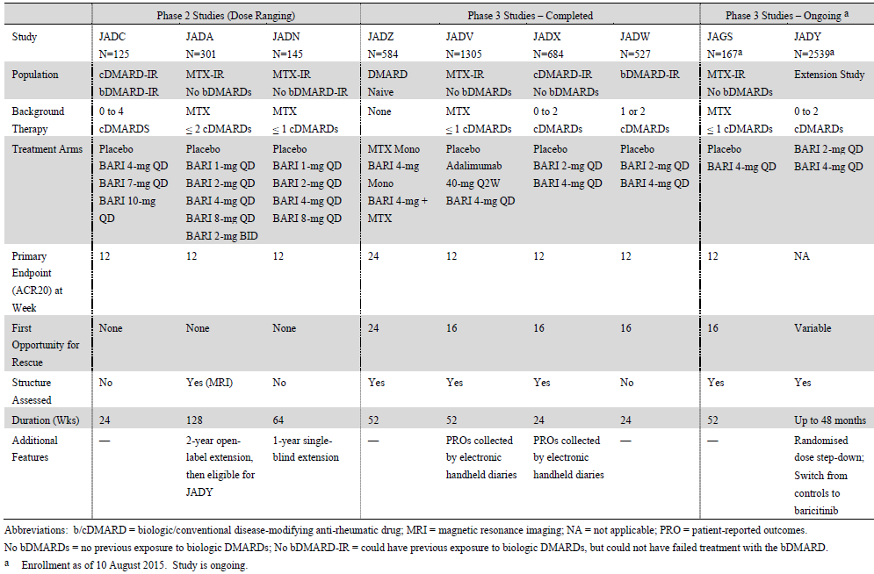

Pivotal or main efficacy studies

Studies JADZ, JADV, JADX and JADW

Study design, objectives, locations and dates
All 4 of the Phase III studies included in this submission were randomised, double-blind, active and/or PBO controlled trials conducted in adult subjects (in the outpatient or ambulatory care setting) with moderately to severely active RA at Baseline.

Study JADZ (DMARD naïve population)
Study JADZ was conducted in subjects with active RA who had limited or no treatment experience with MTX, and who were naïve to other conventional or biologic DMARD therapy. The trial was of 52 weeks duration and the primary efficacy endpoint (ACR20 response rate) was assessed at Week 24. In addition to evaluating the effect of BAR on the symptoms and signs of RA and physical function, the study also assessed the effect of therapy on the radiographic progression of structural joint damage. There were 3 treatment groups in this study: BAR 4 mg/day as monotherapy, MTX monotherapy (escalated to a maximum dose of 20 mg/week) and BAR 4 mg/day in combination with MTX (up to 20 mg/week). Study JADZ consisted of 3 parts: a screening period lasting between 3 and 42 days followed by a double-blind, active controlled treatment period of 52 weeks and a post-treatment follow-up phase of 28 days. The primary objective of the trial was to demonstrate that BAR monotherapy was non-inferior to MTX monotherapy for the percentage of patients achieving an ACR20 response at 24 weeks of active treatment. Inadequate responders could be rescued at Week 24 or later.
Study JADZ was conducted at 198 study centres in 18 countries. The first patient was enrolled in January 2013 and the last subject completed study involvement in August 2015. There were 4 protocol amendments to the original trial protocol, none of which had the potential to impact significantly upon the findings.

Study JADV (MTX inadequate response but biologic DMARD naïve population)
Study JADV was conducted in subjects with active RA who had failed to respond to MTX, but who were naïve to biologic DMARD therapy. The trial was of 52 weeks duration and the primary efficacy endpoint (ACR20 response rate) was assessed at Week 12. In addition to evaluating the effect of BAR on the symptoms and signs of RA and physical function, the study also assessed the effect of therapy on the radiographic progression of structural joint damage. There were 3 treatment groups in this study: BAR 4 mg/day, PBO and adalimumab 40 mg/fortnight given by SC injection. All patients continued stable background doses of MTX during this trial. Study JADV consisted of 4 parts: a screening period lasting between 3 and 42 days followed by a double-blind, PBO and active controlled treatment period of 24 weeks (Part A), then a double-blind, active controlled treatment period of 24 weeks (Part B) and a post-treatment follow-up phase of 28 days. At Week 24, all patients randomised to the PBO arm were switched to BAR. Treatment comparisons between BAR and adalimumab were extended through to Week 52. The primary objective of the trial was to demonstrate that BAR 4 mg/day + continued MTX was superior to PBO + MTX for the percentage of patients achieving an ACR20 response at 12 weeks. Inadequate responders could be rescued at Week 16 or later.
Study JADV was conducted at 281 study centres in 26 countries. The first patient was enrolled in October 2012 and the last subject completed study involvement in September 2015. The protocol for Study JADV was amended on 3 occasions, none of which contained changes that would have impacted upon the integrity of the trial findings.

Study JADX (inadequate response to conventional DMARD but biologic naïve population)
Study JADX was conducted in subjects with active RA who had failed to respond to a range of conventional DMARDs including low dose weekly MTX, but who were naïve to biologic DMARD therapy. The trial was of 24 weeks duration and the primary efficacy endpoint (ACR20 response rate) was assessed at Week 12. In addition to evaluating the effect of BAR on the symptoms and signs of RA and physical function, the study also assessed the effect of therapy on the radiographic progression of structural joint damage. There were 3 treatment groups in this study: BAR 4 mg/day, BAR 2 mg/day and PBO. All patients continued stable background doses of conventional DMARD therapy during this trial. Study JADX consisted of 3 parts: a screening period lasting between 3 and 42 days followed by a double-blind, PBO controlled treatment period of 24 weeks and a post-treatment follow-up phase of 28 days. The primary objective of the trial was to demonstrate that BAR 4 mg/day + continued conventional DMARD was superior to PBO + continued conventional DMARD for the percentage of patients achieving an ACR20 response at 12 weeks. Inadequate responders could be rescued at Week 16 or later.
Study JADZ was conducted at 182 study centres in 22 countries. The first patient was enrolled in January 2013 and the last subject completed study involvement in December 2014. The protocol for Study JADX was amended twice, neither of which contained changes that would have impacted upon the integrity of the trial findings.

Study JADW (inadequate response to biologic DMARD population)
Study JADW was conducted in subjects with active RA who had failed to respond to at least 1 biologic DMARD, including at least 1 anti-TNF therapy. The trial was of 24 weeks duration and the primary efficacy endpoint (ACR20 response rate) was assessed at Week 12. Radiographic progression was not specifically assessed in this study. There were 3 treatment groups in this trial: BAR 4 mg/day, BAR 2 mg/day and PBO. All patients continued stable background doses of conventional DMARD therapy during this trial. Study JADW consisted of 3 parts: a screening period lasting between 3 and 42 days followed by a double-blind, PBO controlled treatment period of 24 weeks and a post-treatment follow-up phase of 28 days. The primary objective of the trial was to demonstrate that BAR 4 mg/day + continued conventional DMARD was superior to PBO + continued conventional DMARD for the percentage of patients achieving an ACR20 response at 12 weeks. Inadequate responders could be rescued at Week 16 or later.
Study JADW was conducted at 140 study centres in 20 countries. The first patient was enrolled in January 2013 and the last subject completed study involvement in September 2014. The protocol for Study JADW was amended twice. The first amendment was implemented prior to patient enrolment and clarified the inclusion/exclusion criteria, added a minimum duration of treatment with prior anti-TNF therapy to 3 months and lengthened the time from previous treatment with rituximab to 6 months because of the long half-life of the drug. The second amendment made several minor clarifications about baseline laboratory testing and further clarified inclusion/exclusion criteria.

Inclusion and exclusion criteria
Patients were eligible for inclusion in the Phase III studies if they were adults with a diagnosis of adult-onset RA as defined by the American College of Rheumatology/European League Against Rheumatism (ACR/EULAR) 2010 Criteria for Classification of RA and had at least 6 tender and swollen joints (of 68/66 joints examined) plus a high-sensitivity C-reactive protein (hsCRP) measurement ≥ 1.2 times the upper limit of normal (ULN). For Study JADW, the qualifying hsCRP value only needed to be > ULN.
In general, patients were excluded from participation in the Phase III studies if they met in any criteria in 4 broad categories of exclusions:
- Receipt of prohibited therapies for RA (study specific);
- Risk of infection such as any current or recent (30 days prior to study entry) infection including active tuberculosis (TB) or untreated latent TB or other serious infections, symptomatic herpes zoster infection within 12 weeks, herpes zoster vaccination within 30 days of randomisation (other live vaccines within 12 weeks), and immunocompromised for any reason;
- Significant laboratory abnormalities at screening including serum transaminases (AST and ALT) > 1.5 x ULN, total serum bilirubin ≥ 1.5 x ULN, CrCL < 40 mL/min, total white blood cell count < 2.5 x 10⁹/L, neutrophil count < 1.2 x 10⁹/L, lymphocyte count < 0.75 x 10⁹/L, platelet count < 100 x 10⁹/L and haemoglobin < 10.0 g/dL; and
- Co-morbidities that increased the patient’s risk when taking study drug such as any current or prior history of lymphoproliferative disease, clinically significant malignancy that has not been in remission for < 5 years, pregnancy and lactation, and Felty’s syndrome.
In all 4 Phase III studies, subjects were routinely screened for Hepatitis B and C, HIV as well as latent TB at Baseline. The screening for latent TB involved either skin testing with PPD or QuantiFERON TB-Gold testing. Subjects with active TB were excluded, but those with latent TB could be included after treatment according to local country guidelines was initiated (usually a minimum of 4 weeks treatment prior to commencing study medication).
In all 4 of the Phase III studies, the concomitant use of oral corticosteroids (CS) was permitted for subjects taking stable doses (prednisone (or equivalent) < 10 mg/day) for at least 6 weeks prior to randomisation. The dose of CS was to remain stable up to Week 24 of each study. Concomitant NSAID was also permitted during the trials, provided subjects were on a stable dose for at least 6 weeks prior to randomisation.

Study JADZ
Patients may have received up to 3 weeks of MTX therapy (administered as a single dose each week) and still be eligible for inclusion in this study. However, a history of exposure to any other conventional DMARD or biologic therapy was an exclusion criterion.

Study JADV
To be eligible for inclusion in Study JADV, patients had to have received MTX for at least 12 weeks prior to study entry and at a stable dose for at least 8 weeks. The weekly dose of MTX must have been between 7.5 and 25 mg. MTX doses of < 15 mg/week were permitted if there was documentation of a clinical rationale for this provision. Patients were required to have at least 3 joint erosions in the hand, wrist, or foot joints based on radiographs; or have at least 1 joint erosion on the hand, wrist, or foot joints X-rays and be seropositive (RF or anti-CCP antibody positive).

Study JADX
Patients were required to have taken conventional DMARD therapy for at least 12 weeks prior to baseline with a continuous, stable dose for at least 8 weeks prior to study entry. For patients receiving MTX, a stable, unchanging dose of 7.5-25 mg/week was required for at least 8 weeks prior to entry into the trial. Subjects may also have been taking concomitant DMARD treatment with hydroxychloroquine (HCQ – up to 400 mg/day), sulfasalazine (SSZ: up to 3000 mg/day), leflunomide (LEF: up to 20 mg/day) and/or azathioprine (up to 150 mg/day or 2 mg/kg/day), if the patient had received a stable dose for at least 8 weeks prior to trial entry.

Study JADW
An additional inclusion criteria for Study JADW was that patients were receiving stable doses of background conventional DMARD therapy and had failed treatment (that is, experienced insufficient efficacy for a trial period of at least 3 months) or were intolerant to treatment (could be < 3 months in duration) with at least 1 anti-TNF drug at an approved dose. Biologic treatments had to be ceased at least 28 days prior to randomisation into Study JADW (or 6 months for previous rituximab exposure).

Study treatments

Study JADZ
This study involved a comparison of BAR 4 mg administered orally once daily as monotherapy or in combination with MTX compared to MTX monotherapy. Patients who received MTX started at a dose of 10 mg per week (per oral), and escalated the dose by 5 mg every 4 weeks to a maximum of 20 mg/week (that is, 15 mg/week for the second 4 weeks, and then 20 mg/week), which continued for up to 44 weeks. Patients with a clinical reason to receive a lower dose of MTX started at 7.5 mg once weekly and escalated the dose by 2.5 mg every 4 weeks to a maximum of 12.5 mg/week. MTX was supplied as 2.5 and 5 mg capsules. Folic acid was supplied to all patients and the dose of folic acid was to be at least 1 mg daily or as per the local standard of care. Patients with CrCL < 60 mL/min received BAR 2 mg once daily rather than 4 mg/day. If taking such therapies at Baseline patients remained on stable background doses of NSAID, analgesic medications and/or low dose oral CS throughout the study.
Patients in Study JADZ were eligible for rescue therapy starting at Week 24. Patients who were determined to be non-responders to their original assigned treatment were re-assigned to treatment with BAR 4 mg/day + MTX at Week 24 or thereafter. Patients originally assigned to
BAR monotherapy were rescued to the same dose of BAR and started on MTX (using the same titration regimen). Patients originally assigned to MTX monotherapy who did not respond, continued MTX and had BAR 4 mg daily added as rescue therapy. Patients originally assigned to BAR + MTX were rescued to the same combination therapy to maintain the study blind. Patients not experiencing improvement in signs and symptoms following at least 4 weeks of rescue therapy were discontinued from Study JADZ, although the MTX titration was 8 weeks in duration and the full benefit of MTX may not have been evident in 4 weeks. Patients could be rescued only once.

Study JADV
This study involved a comparison of BAR 4 mg administered orally once daily, matching PBO tablets administered orally once daily and adalimumab 40 mg administered by SC injection biweekly. Patients continued to take their same background weekly MTX therapy during the course of the study. Patients with CrCL < 60 mL/min received BAR 2 mg once daily rather than 4 mg/day. Subjects with CrCl< 40 mL/min were excluded from participation. If taking such therapies at Baseline patients remained on stable background doses of NSAID, analgesic medications and/or low dose oral CS throughout the study.
All patients in Study JADV were offered rescue therapy starting at Week 16 if they were determined to be non-responders. At Week 16, all PBO randomised patients who were non-responders were rescued with BAR 4 mg/day. To maintain study integrity and blinding, patients who were originally randomised to BAR continued to receive BAR. Non-responder patients randomised to adalimumab were re-assigned to BAR as rescue therapy. Non-response at Week 16 was defined as a lack of improvement of at least 20% in both the tender and swollen joint counts at both Week 14 and 16 compared to baseline. After Week 16, rescue therapy was offered to patients at the discretion of the investigator based on tender and swollen joint counts. After a patient had been rescued, new NSAID therapy, CS and/or analgesics could have been added or doses of ongoing concomitant treatment. A patient could only be rescued once. If a patient continued to meet the non-response criteria for 4 weeks after rescue, or at any time point thereafter, that patient should have been discontinued from the trial.

Study JADX
This study involved a comparison of BAR 4 mg and 2 mg administered orally once daily with matching PBO tablets administered orally once daily. Patients with CrCL between 40 and 60 mL/min received BAR 2 mg once daily (through randomisation). Patients on 1 or more conventional DMARDs were to continue taking their background therapy during the course of the study as well as stable pre-existing doses of NSAID, low dose CS and analgesics.
Patients in Study JADX were eligible for rescue therapy starting at Week 16 if they were determined to be non-responders (defined as lack of improvement of at least 20% in both tender and swollen joint counts at both Weeks 14 and 16 compared to baseline). At Week 20, rescue therapy was offered to patients at the discretion of the investigator based on tender and swollen joint count assessments. Non-responding patients who were randomised to PBO or BAR 2 mg/day were rescued with BAR 4 mg/day therapy. To maintain blinding, patients who were non-responders and who were originally randomised to BAR 4 mg/day continued to receive the same therapy.

Study JADW
This trial involved a comparison between BAR 4 mg, BAR 2 mg and matching PBO tablets, all of which were administered orally once daily. All enrolled patients received 2 tablets once daily. Patients with CrCL between 40 and 60 mL/min received BAR 2 mg once daily (through randomisation). Subjects continued to take their background conventional DMARD therapy as well as stable pre-existing doses of NSAID, low dose CS and analgesics during the course of the study.
Patients in Study JADX were eligible for rescue therapy starting at Week 16 if they were determined to be non-responders (defined as lack of improvement of at least 20% in both tender and swollen joint counts at both Weeks 14 and 16 compared to baseline). At Week 20, rescue therapy was offered to patients at the discretion of the investigator based on tender and swollen joint count assessments. Non-responding patients who were randomised to PBO or BAR 2 mg/day were rescued with BAR 4 mg/day therapy. To maintain blinding, patients who were non-responders and who were originally randomised to BAR 4 mg/day continued to receive the same therapy.

Efficacy variables and outcomes
The primary efficacy outcome in all of the Phase III studies was the rate of achieving a 20% improvement in American College of Rheumatology (ACR) response criteria (ACR20 response). In 3 of the Phase III studies (JADV, JADX and JADW), the primary ACR20 response rate was assessed at 12 weeks and for the Phase III trial that recruited DMARD naïve subjects (Study JADZ), the primary efficacy outcome was evaluated at 24 weeks. The ACR20 response rate is a validated composite endpoint recommended in the guideline ‘Points to Consider on Clinical Investigation of Medicinal Products other than NSAIDs for treatment of Rheumatoid Arthritis’ (CPMP/EWP/556/95 rev 1/Final). The ACR20 response is considered to be the minimal clinically important threshold for determining response to an intervention in adult patients with RA. A patient is defined as achieving an ACR20 response if the following is fulfilled:
- A decrease of at least 20% in the number of tender joints (n = 68),
- A decrease of at least 20% in the number of swollen joints (n = 66), and
- At least a 20% improvement in 3 of the following 5 criteria: patient assessment of pain on 100mm VAS; patient global assessment of disease status (100 mm VAS); physician global assessment of disease status (100 mm VAS); Health Assessment Questionnaire –Disability Index (HAQ-DI) and serum inflammatory concentration (ESR or CRP).
Major secondary efficacy measures in the Phase III studies included:
- Change from Baseline in the Health Assessment Questionnaire–Disability Index (HAQ-DI),
- Change from Baseline in van der Heijde modified Total Sharp Score (mTSS),
- Change from Baseline in the Disease Activity Score (modified to include the 28 diarthrodial joint count and high-sensitivity CRP (DAS28-CRP) score), and
- Rates of remission according to the Simplified Disease Activity Index (SDAI).
The HAQ-DI is a patient reported questionnaire used to provide an assessment of the impact of the disease and its treatment on physical function. It is a validated method for measuring disability in inflammatory arthritis with a range of 0-3 (with a higher score indicating more functional impairment). The tool assesses the degree of difficulty experienced by the individual in 8 domains of daily living activities using 20 questions. The domains include dressing and grooming, arising, eating, walking, hygiene, reach, grip and common daily activities, with each domain (activity) consisting of 2 or 3 items. For each question, the level of difficulty is scored from 0 to 3 with 0 = ‘without any difficulty’, 1 = ‘with some difficulty’, 2 = ‘with much difficulty’ and 3 = ‘unable to do’. If the maximum score equals 0 or 1, but a device related to that activity was used or help from another person was provided for the activity, then the activity score is increased to 2. However, if the activity score was already 2 and a device related to that activity was used or help from another person was provided, the score for that activity remains 2. A total score of between 0 and 3 is obtained from the mean of each activity. A change from Baseline in the HAQ-DI of at least -0.22 units has been specifically defined for RA in peer-reviewed literature to be the smallest measurable reduction that is clinically significant.
The mTSS (assessed using the van der Heijde 1999 modification of the Total Sharp Scoring system) is a validated composite X-ray scoring system used to quantify structural joint damage due to RA. The mTSS is the sum of the joint space narrowing (JSN) score plus the erosion score (ES) and has a range of 0-448. A higher score represents greater structural damage. The JSN score has a range of 0-168 and is derived from evaluating 30 joints in the hands and 12 joints in the feet, each of which are scored from 0 (no damage) to 4. The ES has a range of 0-280 and is derived from assessing 32 hand joints and 12 joints in the feet. Each joint is scored 0 (no damage) to 5, except the metatarsophalangeal joints of the feet, which are scored 0-10.
All enrolled subjects in Studies JADZ, JADV and JADX were required to have plain X-rays taken of both hands and both feet (a single postero-anterior view of each hand, and a single dorso-plantar view of each foot) at Baseline, Week 24 and the end-of-study visit (that is, Week 52 or upon early withdrawal). There was to be a window of at least 3 months between X-ray assessments. X-ray images of both hands and feet were obtained using a standardised technique, digitised and assessed by 2 experienced central readers, who were blinded to the treatment group, X-ray sequence and clinical status of the subject. The statistical analysis used the mean score from the 2 readers for all analyses. Although the mTSS is the appropriate radiological scoring method, the minimum time point in which it is assessed is crucial to deciding the validity of a drug’s claim to inhibition of the rate of structural progression of RA. The relevant EU regulatory guideline states that for agents claiming to prevent structural joint damage, it is recommended to demonstrate radiological differences of the hands and forefeet on the basis of before and after treatment comparisons taken not less than 1 year apart, but ideally 2 years, using full randomization and pre-agreed criteria.
The DAS28 score is a complex mathematical calculation of the 28 joint tender and swollen joint counts, ESR or CRP, and an optional general health assessment (100 mm VAS). The DAS28 score is a validated continuous scale ranging from 0-9.4. The level of RA disease activity can be interpreted as low if the DAS28 score is ≤3.2, moderate if between 3.2 and 5.1, or high if > 5.1. A DAS28 score of < 2.6 corresponds to clinical remission.
The SDAI is another composite disease activity score in RA, which incorporates patient, physician and laboratory values using 5 variables. It derives a single score on a continuous scale ranging from 0 to 86. It is the sum of the 28 swollen joint count (0-28), 28 tender joint count (0-28), patient and investigator global assessments of disease activity on a 10 cm VAS (each variable 0-10) and CRP in mg/dL (0.1-10). A lower score indicates lower disease activity. The ACR/EULAR definition of remission is an SDAI score of ≤ 3.3 and low disease activity is a score of ≤ 11.0. The Clinical Disease Activity Index (CDAI) is a modification of the SDAI without the laboratory parameter of CRP to allow for immediate clinical assessment (that is, 4 variables in total). It has a score range of 0 to 76. Remission is defined as a CDAI score of ≤ 2.8 and low disease activity is defined as a CDAI score of ≤ 10.0.
Additional secondary efficacy measures in the Phase III BAR studies included ACR50 and ACR70 response rates, individual components of the ACR clinical response criteria, individual components of the mTSS (bone erosion score (ES) and joint space narrowing (JSN) score) and various patient-reported outcomes relating to quality of life outcomes such as the Functional Assessment of Chronic Illness Therapy–Fatigue (FACIT-F), Short Form Health Survey version 2 (SF-36v2) and Work Productivity and Activity Impairment–Rheumatoid Arthritis (WPAI-RA).
The ACR50 and ACR70 response criteria use the same data components as the ACR20, but at a corresponding higher level of response.
The SF-36 questionnaire (version 2) consists of 36 questions relating to QOL grouped into 8 subscales (physical function, role-physical, bodily pain, general health, vitality, social functioning, role-emotional, and mental health). Each scale is directly transformed into a 0-100 scale with a lower score indicating greater impairment or disability. The 8 subscales can also be used to derive 2 component summary measures (both with a range of 0-100): physical component summary (PCS) and mental component summary (MCS).
The Functional Assessment of Chronic Illness Therapy (FACIT) – Fatigue scale is a 13-item instrument designed to assess fatigue and tiredness, and their impact on daily activities and functioning. It was originally developed to measure fatigue in adult patients with cancer, but its content has demonstrated good reliability and validity in numerous chronic health conditions including RA. The instrument includes items (7-day recall period) such as tiredness, weakness, listlessness, lack of energy, and the impact of these feelings on daily functioning (for example, sleeping and social activities). Each of 13 questions is rated on a 4-point Likert scale.
The Work Productivity and Activity Impairment (WPAI) scale is a 6-item questionnaire which measures the percent of work time missed, percent of impairment while working, overall percent of work impairment and the percent activity impairment due to RA. The scale expresses an impairment percentage with higher numbers indicating greater impairment and decreased productivity.

Randomisation and blinding methods
Randomisation schemes for each of the Phase III studies were driven by the sample sizes in each trial required to provide acceptable statistical power for the respective comparisons between treatment arms. In each of the studies, assignment to treatment groups was determined by a computer generated, random sequence that used an interactive voice response system.
For Studies JADZ and JADX, randomisation was stratified by region and the presence of joint erosions at Baseline (yes/no). For Study JADV, randomisation was stratified by region and joint erosion status (1-2 joint erosions at Baseline plus seropositivity versus at least 3 joint erosions). For Study JADW, randomisation was stratified by region and number of prior biologic DMARDs experienced at screening (< 3 different previous biologic therapies versus ≥3 different previous biologic DMARD).
To protect the double-blind design of each Phase III study, BAR and PBO tablets were supplied in matching presentations in identical kits. In Study JADV, adalimumab was administered by SC injection, so the other treatment arms in this trial received matching PBO injections SC every fortnight. Independent joint evaluators not involved with any other aspects of the studies quantified joint disease involvement. For the 3 trials which evaluated radiographic outcomes, X-rays were scored by readers who were blinded to subject treatment and X-ray film sequence.

Analysis populations
For all of the Phase III studies, all primary and secondary efficacy endpoints were primarily analysed used the modified Intention-to-Treat (mITT) population. The mITT population included all randomised patients who received at least 1 dose of the study drug. Patients were analysed according to the study drug to which they were assigned per protocol. The primary and major secondary analyses in each of the Phase III trials were repeated using the Per-Protocol (PP) population, which included all mITT patients who were not deemed non-compliant with treatment, who did not have significant protocol deviations and whose investigator site did not have significant GCP issues that required a report to regulatory agencies. Significant protocol deviations that resulted in exclusion from the PP subsets were determined while the study remained blinded, prior to data lock.

Sample size

Study JADZ
For Study JADZ, the 4:3:4 randomisation ratio (4 BAR + MTX, 3 BAR monotherapy and 4 MTX alone) was driven by the total estimated sample size of approximately 550 subjects (200 patients each in the combination treatment and MTX monotherapy arms, and 150 patients in the BAR alone group). This sample size provided ~90% power for the non-inferiority analysis based on an non-inferiority margin of 12% for the rate of ACR20 response at Week 24 between BAR monotherapy and MTX monotherapy, assuming a 60% ACR20 response in the BAR alone arm and 55% for MTX monotherapy (1-sided significance level of 0.025).
The sample size was also estimated to provide ~80% power to test the superiority of BAR + MTX versus MTX alone for the 24 week ACR20 response rate (2-sided chi-square test at a significance level of 0.05). The ACR20 response rate at Week 24 for BAR + MTX was estimated to be 68.5%.

Study JADV
For Study JADV, the 3:3:2 randomisation ratio (3 BAR, 3 PBO and 2 adalimumab) was driven by the total estimated sample size of approximately 1280 subjects (480 patients each in the BAR and PBO arms, and 320 patients in the adalimumab group). This sample size provided > 95% power to detect a difference between the BAR and PBO treatment groups for the rate of ACR20 response at Week 12 (assumed as 60% versus 35%) based on a chi-square test at a significance level of 0.05.
The sample size was also estimated to provide 94% power to detect an effect size difference of 0.25 (that is, difference in means divided by the common standard deviation based on 2-sided, t-test at a significance level of 0.04) between the BAR and PBO treatment groups for the mTSS at Week 24 (assuming 90% of randomised patients had available X-ray data). The effect size was based on the results of another JAK inhibitor (tofacitinib 10 mg twice daily) versus PBO, which showed a difference of 0.21 in mTSS at 24 weeks. If the effect size in Study JADV was 0.21, then the sample size would provide at least 85% power for the mTSS analysis. The same sample size also provides 93% power for the non-inferiority analysis between BAR and adalimumab for the ACR20 response rate at Week 12 (1-sided significance level of 0.025). The pre-specified, non-inferiority margin was 12% assuming the 12 week ACR20 response rates are 60% for both active therapies.

Study JADX
For Study JADX, the 1:1:1 randomisation ratio was driven by the total estimated sample size of approximately 660 subjects (220 patients in each treatment group: BAR 2 mg/day, BAR 4 mg/day and PBO). This sample size provided > 95% power to detect a difference between the BAR 4 mg/day and PBO treatment groups for the rate of ACR20 response at Week 12 (assumed as 60% versus 35%) based on a chi-square test at a significance level of 0.05. The same sample size also provided > 90% power to detect a difference between the BAR 2 mg/day and PBO treatment groups for the rate of ACR20 response at Week 12 (assumed as 51-55% versus 35%) based on a chi-square test at a significance level of 0.05.

Study JADW
For Study JADW, the 1:1:1 randomisation ratio was driven by the total estimated sample size of approximately 525 subjects (175 patients in each treatment group: BAR 2 mg/day, BAR 4 mg/day and PBO). This sample size provided 97% power to detect a difference between the BAR 4 mg/day and PBO treatment groups for the rate of ACR20 response at Week 12 (assumed as 45% versus 25%) based on a chi-square test at a significance level of 0.05. The same sample size also provided 80% power to detect a difference between the BAR 2 mg/day and PBO treatment groups for the rate of ACR20 response at Week 12 (assumed as 39% versus 25%) based on a chi-square test at a significance level of 0.05.

Statistical methods
For the 4 completed Phase III studies, all efficacy analyses for the comparison between control treatment and BAR (any dose regimen) were conducted using the modified Intention-to-Treat (mITT) population, which was defined as all randomised subjects who received at least 1 dose of study medication. Patients were analysed according to their assigned treatment.
For all 4 Phase III studies, categorical endpoints such as the proportion of patients achieving ACR20 and SDAI ≤ 3.3 responses were analysed using logistic regression with Non-Responder Imputation (NRI) for handling of missing data. For 3 of the Phase III Studies (JADZ, JADV and JADX), the logistic regression model including treatment, region and baseline joint erosion status as factors was used to determine if a true treatment related difference was observed for the primary efficacy endpoint. For Study JADW (which enrolled subjects with an inadequate prior response to biologic DMARD), the logistic regression model included treatment, region and history of biologic DMARD at screening (< 3 versus ≥ 3 previous biologic DMARDs) to test for a treatment related difference.
In each study, treatment rescued patients were defined as non-responders in categorical analyses at all time points following treatment rescue. Major (gated) continuous endpoints such as the mean change from Baseline in HAQ-DI and DAS28 score were assessed using Analysis of Covariance (ANCOVA) with modified Baseline Observation Carried Forward (mBOCF) imputation. However, for other continuous outcomes, mLOCF (modified Last Observation Carried Forward) was used as the main method for imputation of missing data. For subjects with missing data or who had received rescue treatment, mBOCF (major continuous variables) or mLOCF (all other secondary continuous outcomes) was applied.
In each of the Phase III studies, the primary and key secondary efficacy endpoints were tested using multiple testing procedures that controlled for Type I error. The multiple testing procedures used sequential hypothesis testing processes such as Bonferroni tests. All of the studies utilised procedures that followed closed testing principles
For Study JADZ (monotherapy trial of DMARD naïve subjects), the primary efficacy outcome was a non-inferiority analysis based on a treatment related margin of difference of 12% for the rate of ACR20 response at Week 24 between BAR monotherapy and MTX monotherapy (that is, the lower bound of the 1-sided, 97.5% CI). In Study JADV, a major (gated) secondary endpoint was an analysis of the Week 12 ACR20 response rate between BAR and adalimumab treatment with a pre-specified, non-inferiority margin of 12%. The 12% non-inferiority margin was justified on the basis of its use in previous head-to-head RA trials (Jones et al, 2010 and Weinblatt et al 2013) as well as a Bayesian meta-analysis of PBO controlled trials involving similar RA cohorts, which determined that a margin of 12% would be consistent with the natural variability in recorded ACR20 responses. In the statistical analysis plan for multiple comparisons, if non-inferiority was shown, then the superiority of BAR versus adalimumab would be evaluated.
A linear extrapolation approach was the primary means used to impute missing X-ray data in the 3 Phase III studies (JADZ, JADV and JADX) that examined radiographic outcomes after 24 and 52 weeks of study treatment.

Participant flow

Study JADZ
A total of 1180 subjects were screened for involvement in Study JADZ and just over half of all subjects (50.2%; 592/1180) were recorded as screen failures. The most common reason for screen failure was failing to meet the entry criteria (44.6%; 526/1180). A total of 588 patients were randomly assigned to 1 of 3 treatment groups including 213 subjects to the MTX monotherapy group, 160 patients to the BAR monotherapy arm and 215 subjects to the MTX + BAR group. Of the 588 randomised subjects, 4 patients (3 randomised to MTX monotherapy and 1 to BAR monotherapy) did not receive any study treatment and therefore were excluded from the mITT population analysis. Figure 3 presents the flow of patients through Study JADZ.
Figure 3: Participant Flow in Study JADZ
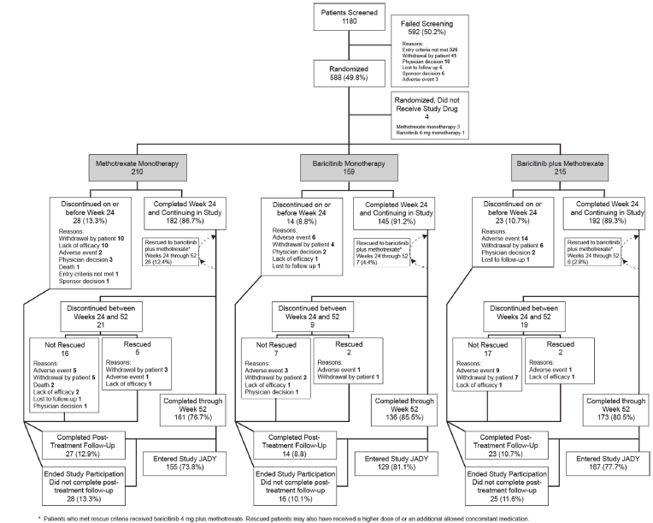
The primary efficacy endpoint was evaluated at Week 24 although Study JADZ had an active treatment period of 52 weeks. The proportion of subjects who completed through to Week 24 was 86.7% (182/210) in the MTX alone group, 91.2% (145/159) in the BAR monotherapy arm and 89.3% (192/215) in the BAR + MTX group. The primary reason for discontinuation before Week 24 was patient withdrawal affecting 4.8% (10/210) of subjects in the MTX group, 2.5% (4/159) of patients in the BAR arm and 2.8% (6/215) of subjects in the combination treatment arm. An additional 4.8% (10/210) of subjects in the MTX monotherapy group discontinued study medication between baseline and Week 24 because of lack of efficacy compared with only 1 subject (0.6% of 159) in the BAR monotherapy arm.
Up to Week 52, 73.8% (155/210) of subjects in the MTX monotherapy group, 81.1% (129/159) of patients in the BAR monotherapy arm and 77.7% (167/215) of subjects in the combination treatment group completed treatment. Between Weeks 24 and 52, 26 subjects (12.4% of 210) randomised to MTX alone at Baseline received rescue therapy compared to 7 patients (4.4% of 159) initially treated with BAR monotherapy and 6 subjects (2.8% of 215) in the combination treatment group. The majority of rescued subjects continued treatment up to Week 52.

Study JADV
A total of 2949 subjects were screened for involvement in Study JADV and more than half of all subjects (55.7%; 1642/2949) were recorded as screen failures. The most common reason for screen failure was failing to meet the entry criteria (51.6%; 1522/2949). A total of 1307 patients were randomly assigned to 1 of 3 treatment groups including 488 subjects to the PBO group, 487 patients to the BAR 4 mg/day arm and 330 subjects to the adalimumab group. Of the 1307 randomised subjects, 2 patients (1 each in the PBO and BAR groups) did not receive any study treatment and therefore were excluded from the mITT population analysis. In addition, 4 patients in the PBO group completed to Week 24, but discontinued before being switched to active treatment for Part B. Figure 4 presents the flow of patients through Study JADV.
Figure 4: Participant Flow in Study JADV
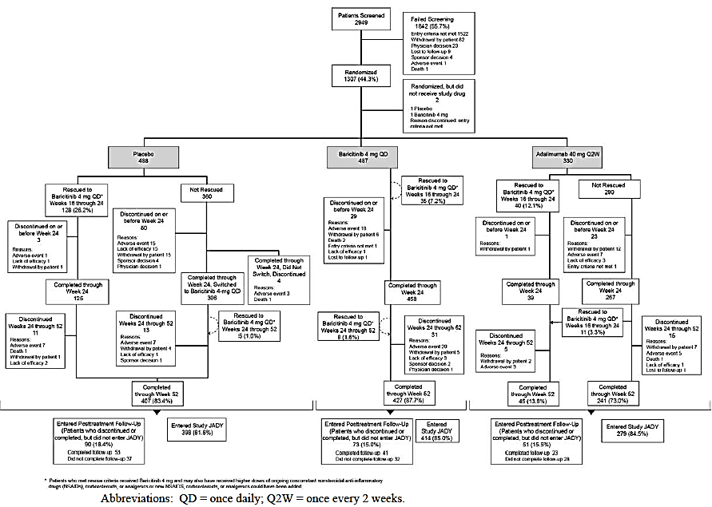
The primary efficacy endpoint was evaluated at Week 12 and Study JADV had an active treatment period of 52 weeks in 2 parts. The proportion of subjects who completed through to Week 24 (end of Part A) was 89.1% (435/488) in the PBO group, 94.0% (458/487) in the BAR arm and 92.7% (306/330) in the adalimumab group. The primary reason for discontinuation before Week 24 was adverse events affecting 3.3% (16/488) of subjects in the PBO group, 3.7% (18/487) of patients in the BAR arm and 2.1% (7/330) of subjects in the adalimumab group. The next most common reason for discontinuation before Week 24 was patient withdrawal affecting 3.3% (16/488) of subjects in the PBO group, 1.2% (6/487) of patients in the BAR arm and 3.9% (13/330) of subjects in the adalimumab group. An additional 3.3% (16/488) of subjects in the PBO group discontinued study medication between baseline and Week 24 because of lack of efficacy compared with only 1 subject (0.2% of 487) in the BAR arm and 3 patients (0.9% of 330) in the adalimumab group.
Up to Week 52, 83.4% (407/488) of subjects in the randomised PBO group, 87.7% (427/487) of patients in the BAR arm and 86.7% (286/330) of subjects in the adalimumab group completed treatment. Up to Week 24 rescue therapy was provided to 25.6% (125/488) of subjects randomised to PBO, 7.0% (34/487) of patients initially treated with BAR and 11.8% (39/330) of subjects in the adalimumab treatment group. An additional small number of subjects in each treatment group received rescue treatment between Weeks 24 and 52 (0.8% (4/488) in the PBO group, 1.6% (8/487) in the BAR arm and 3.0% (10/330) in the adalimumab group).

Study JADX
A total of 1241 subjects were screened for involvement in Study JADX and just less than half of all subjects (44.9%; 557/1241) were recorded as screen failures. The most common reason for screen failure was failing to meet the entry criteria (40.3%; 500/1241). A total of 684 patients were randomly assigned to 1 of 3 treatment groups including 228 subjects to the PBO group, 229 patients to the BAR 2 mg/day arm and 227 subjects to the BAR 4 mg/day group. All randomised subjects received at least 1 dose of study treatment and therefore were included in the mITT population analysis. Figure 5 presents the flow of patients through Study JADX.
Figure 5: Participant flow in Study JADX
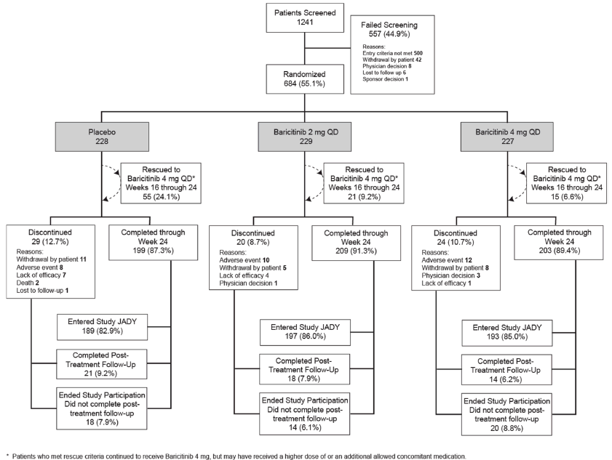
The primary efficacy endpoint was evaluated at Week 12, but Study JADX had an active treatment period of 24 weeks. The proportion of subjects who completed through to Week 24 was 87.3% (199/228) in the PBO group, 91.3% (209/229) in the BAR 2 mg arm and 89.4% (203/227) in the BAR 4 mg group. The 2 most common reasons for discontinuation before Week 24 were adverse events (4.4%; 30/684) and patient withdrawal (3.5%; 24/684). Subjects in the PBO group had a higher discontinuation rate because of patient withdrawal and lack of efficacy versus the 2 BAR treatment arms; and patients treated with BAR (either dose) had a higher incidence of discontinuation from adverse events. Between Weeks 16 and 24, a higher proportion of subjects in the PBO group received rescue therapy (24.1%; 55/228) compared to subjects randomised to BAR (9.2% (21/229) for BAR 2 mg and 6.6% (15/227) for BAR 4 mg).

Study JADW
A total of 959 subjects were screened for involvement in Study JADW and just less than half of all subjects (45.0%; 432/959) were recorded as screen failures. The most common reason for screen failure was failing to meet the entry criteria (40.9%; 392/959). A total of 527 patients were randomly assigned to 1 of 3 treatment groups including 176 subjects to the PBO group, 174 patients to the BAR 2 mg/day arm and 177 subjects to the BAR 4 mg/day group. All randomised subjects received at least 1 dose of study treatment and therefore were included in the mITT population analysis. Figure 6 presents the flow of patients through Study JADW.
Figure 6: Participant flow in Study JADW
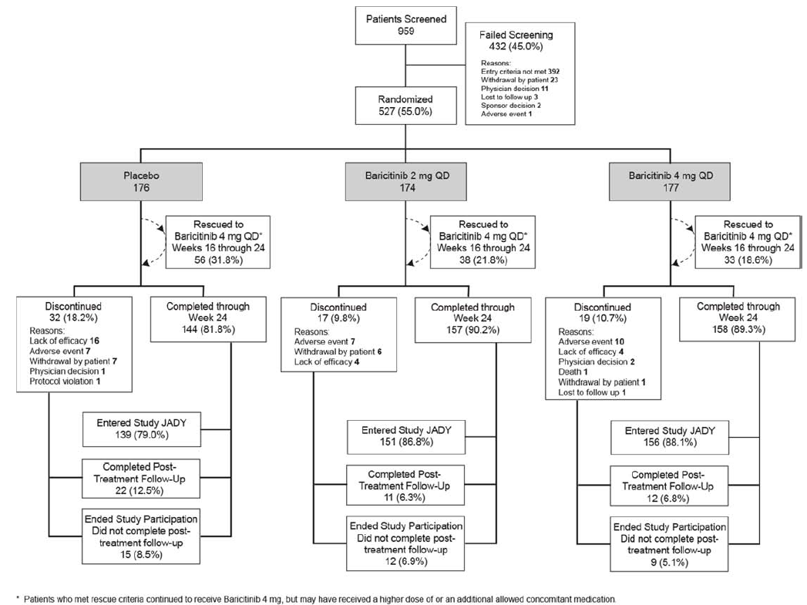
The primary efficacy endpoint was evaluated at Week 12, but Study JADW had an active treatment period of 24 weeks. The proportion of subjects who completed through to Week 24 was 81.8% (144/176) in the PBO group, 90.2% (157/174) in the BAR 2 mg arm and 89.3% (158/177) in the BAR 4 mg group. The 2 most common reasons for discontinuation before Week 24 were adverse events (4.6%; 24/527) and lack of efficacy (4.6%; 24/527). Subjects in the PBO group had a higher discontinuation rate because of lack of efficacy. Between Weeks 16 and 24, a higher proportion of subjects in the PBO group received rescue therapy (31.8%; 56/176) compared to subjects randomised to BAR (21.8% (38/174) for BAR 2 mg and 18.6% (33/177) for BAR 4 mg).

Major protocol violations/deviations

Study JADZ
Subjects excluded from the PP population due to recording at least 1 significant protocol violation included 24 patients (11.4% of 210) in the MTX treatment group, 14 (8.8% of 159) subjects in the BAR monotherapy arm and 24 subjects (11.2% of 215) in the BAR + MTX group. The 2 most common types of important protocol deviations resulting in exclusion from the mITT cohort were the use of prohibited concomitant medications (mainly, new or change in CS dose) affecting 37 subjects (6.3% of 584) and treatment compliance < 80% (4.3% of 584). No significant between-group differences were observed for the 2 most common types of protocol deviation.

Study JADV
A total of 84 subjects (6.4% of 1304) were excluded from the PP population due to at least 1 significant protocol violation including 31 patients (6.4% of 488) in the PBO group, 34 (7.0% of 487) subjects in the BAR arm and 19 subjects (5.8% of 330) in the adalimumab group. The 2 most common types of important protocol deviations resulting in exclusion from the mITT cohort were insufficient treatment compliance (3.6%; 47/1305) and the use of prohibited concomitant medications (mainly, new or change in CS dose) affecting 20 subjects (1.5% of 1305). No significant between-group differences were observed for the 2 most common types of protocol deviation. Eight patients (6 in the PBO group and 2 in the BAR arm) were recorded as having significant protocol issues with GCP compliance that were not further specified.

Study JADX
A total of 23 subjects (3.4% of 684) were excluded from the PP population due to at least 1 significant protocol violation including 9 patients (3.9% of 228) in the PBO group, 6 (2.6% of 229) subjects in the BAR 2 mg arm and 8 subjects (3.5% of 227) in the BAR 4 mg group. The 3 most common types of important protocol deviations resulting in exclusion from the mITT cohort were insufficient treatment compliance (1.8%; 12/684) followed by a prohibited change in CS therapy (1.0%; 7/684) and change in conventional DMARD treatment in the absence of a safety concern (0.7%; 5/684). No significant between-group differences were observed for the 3 most common types of protocol deviation.

Study JADW
Subjects excluded from the PP population due to recording at least 1 significant protocol violation included 14 patients (8.0% of 176) in the PBO treatment group, 11 (6.3% of 174) subjects in the BAR 2 mg arm and 7 subjects (4.0% of 177) in the BAR 4 mg group. The 2 most common types of important protocol deviations resulting in exclusion from the mITT cohort were insufficient treatment compliance (3.4%; 18/527) and change in concomitant DMARD in the absence of a safety concern (1.9%; 10/527). No significant between-group differences were observed for the 2 most common types of significant protocol deviation.

Baseline data

Study JADZ
The 3 treatment groups were balanced with respect to demographic features. The randomised population of 584 patients had a mean age of 49.9 years (median of 52.0 years; range: 18-80 years) and 14.2% (83/584) of all subjects were aged 65 years or older at Baseline. The majority of patients were female (72.8%; 425/584) and either Caucasian (59.8%; 349/584) or Asian (28.3%; 165/584). The overall median weight for enrolled patients was 67.3 kg (range: 35.1-151.3 kg). By geographic region, the majority of patients came from Central and South America (28.9%; 169/584) followed by the USA and Canada (20.7%; 121/584).
The treatment groups were similar with respect to baseline RA disease characteristics. The mean duration of RA diagnosis for all subjects was 1.4 years (median 0.2 years, range: 0.02-37.4 years), which reflects a cohort with recent onset disease. Because of the recent disease onset and diagnostic criteria, the rates of seropositivity for RA at Baseline were comparatively high in Study JADZ. Overall, 88.7% (517/584) of subjects tested positive for both RF and anti-CCP antibodies at Baseline.
In terms of RA disease activity at Baseline, the mean numbers of tender (ranging from 14.9 to 15.9) and swollen joints (ranging from 11.4 to 11.6) based on the 28 joint count assessment were similar across the 3 treatment groups. All 3-treatment groups recorded mean DAS28-CRP scores that were very high at Baseline (5.86-5.91) and the majority of subjects (79.7%; 464/584) had DAS28-CRP scores > 5.1 at Baseline. The mean HAQ-DI scores ranged from 1.58 to 1.67. The mean CRP values for each treatment group ranged from 22.34 to 24.27 mg/L. Overall, the measures of baseline disease activity recorded in Study JADZ are consistent with severely active RA. The mean baseline mTSS was 11.82 in the MTX group (n = 192 of 210), 13.32 in the BAR monotherapy arm (n = 154 of 159) and 11.39 in the combination treatment group (n = 200 of 215). The median baseline mTSS was 3.0-4.0 sharp units in each of the 3 treatment groups. Given the enrolled cohort had recent onset RA, the mean baseline ES was approximately 8 sharp units (median of 3.5 sharp units) in each of the 3 treatment groups and mean baseline JSN scores were very low at approximately 4 sharp units (median of 0 sharp units). The majority of subjects (65.2%; 380/583) had joint erosions on plain X-ray at Baseline, at a similar incidence among the 3 treatment groups.
Less than 10% of all subjects (8.7%; 51/584) had a history of prior conventional DMARD therapy for RA (single DMARD exposure only: 7.6% (44/584) of which was low dose MTX). About one third of all subjects (35.3%; 206/584) were taking low dose oral CS at Baseline at mean daily dose of 6.5 mg (median of 5.0 mg/day).
Of the 210 subjects randomised to the MTX monotherapy arm (Weeks 0 to 24), 158 subjects in the full dose subgroup took a mean weekly MTX dose of 19 mg (median of 20 mg/week) and the other 52 subjects in the low dose subset took a mean weekly MTX dose of 11.8 mg (median of 12.5 mg/week). Of the 215 subjects randomised to the MTX + BAR combination treatment arm (weeks 0-24), 167 subjects in the full dose subgroup took a mean weekly MTX dose of 19.6 mg (median of 20 mg/week) and the other 48 subjects in the low dose subset took a mean weekly MTX dose of 11.4 mg (median of 12.5 mg/week). Non-compliance with study treatment (taken ≤ 80% of prescribed study medication) during the first 52 weeks of Study JADZ was low in all 3 treatment groups at ≤ 2.5% incidence.

Study JADV
The 3 treatment groups were balanced with respect to demographic features. The randomised population of 1305 patients had a mean age of 53.3 years (median of 55.0 years; range: 19-86 years) and 18.5% (241/1305) of all subjects were aged 65 years or older at Baseline. The majority of patients were female (77.2%; 1008/1305) and either Caucasian (62.7%; 818/1305) or Asian (30.1%; 392/1305). The overall mean weight for enrolled patients was 70 kg (range: 32.4-144.3 kg). By geographic region, the majority of patients came from Central and South America (29.1%; 380/1305) followed by Japan (19.1%; 249/1305) and North America (17.6%; 230/1305).
The treatment groups were similar with respect to baseline RA disease characteristics. The mean duration of RA diagnosis for all subjects was 8.7 years (median 6.3 years, range: 0.03-56.4 years), which reflects a cohort with established disease. The majority of enrolled patients (84.4%; 1102/1305) were seropositive for both RF and anti-CCP antibodies at Baseline.
In terms of RA disease activity at Baseline, the mean numbers of tender (ranging from 13.9 to 14.0) and swollen joints (ranging from 11.1 to 11.2) based on the 28 joint count assessment were similar across the 3 treatment groups. All 3-treatment groups recorded mean DAS28-CRP scores that were very high at Baseline (5.69-5.76) and three quarters of all subjects (74.3%; 968/1305) had DAS28-CRP scores > 5.1 at Baseline. The mean HAQ-DI scores ranged from 1.55 to 1.59. The mean CRP values for each treatment group ranged from 20.83 to 22.85 mg/L. Overall, the measures of baseline disease activity recorded in Study JADV are consistent with severely active RA. The mean baseline mTSS was 45.05 in the PBO group (n = 458 of 488), 42.46 in the BAR 4 mg/day arm (n = 473 of 487) and 44.36 in the adalimumab group (n = 313 of 330). The median baseline mTSS ranged from 21.5-25.5 sharp units in each of the 3 treatment groups. Given the enrolled cohort had established RA, the mean baseline ES was 28.5 sharp units (median of 15 sharp units) in each of the 3 treatment groups and mean baseline JSN scores were increased at approximately 18 sharp units (median of 8 sharp units). The majority of subjects (76.0%; 987/1305) had 3 or more joint erosions on plain X-ray at Baseline, at a highly similar incidence among the 3 treatment groups.
As per protocol, all but 1 subject (randomised to the PBO arm) had a history of conventional DMARD therapy exposure. Regarding past DMARD exposure, 46.0% (600/1305) of subjects had been exposed to 1 prior DMARD, 31.6% (412/1305) of patients had received 2 prior DMARDs and 22.4% (292/1305) had received 3 or more prior DMARDs. At study baseline, the majority of subjects (83.4%; 1088/1305) were taking 1 conventional DMARD (all of which was low dose weekly MTX monotherapy) and 16.5% (215/1305) were taking 2 conventional DMARDs (MTX plus another DMARD). Across the 3 treatment groups, the mean weekly doses of MTX at Baseline ranged from 14.6 mg to 14.8 mg (median weekly dose of 15 mg in each treatment group). More than half of all subjects (58.7%; 766/1305) were taking low dose oral CS at Baseline at mean daily dose of 6.0 mg (median of 5.0 mg/day). Non-compliance with study treatment (defined as ≤ 80% of prescribed study medication being taken) during the first 52 weeks of Study JADV was low in all 3-treatment groups at ≤ 1.0% incidence.

Study JADX
The 3 treatment groups were balanced with respect to demographic features. The randomised population of 684 patients had a mean age of 51.8 years (median of 53.0 years; range: 20-82 years) and 14.2% (97/684) of all subjects were aged 65 years or older at Baseline. The majority of patients were female (81.9%; 560/684) and either Caucasian (66.9%; 457/684) or Asian (26.4%; 180/684). The overall mean weight for enrolled patients was 76 kg (range: 31.6-181.5 kg). By geographic region, the majority of patients came from North America (29.8%; 204/684) followed by Asia (15.5%; 120/684) and Eastern Europe (15.6%; 107/684).
The treatment groups were similar with respect to baseline RA disease characteristics. The mean duration of RA diagnosis for all subjects was 6.3 years (median 3.5 years, range: 0.07-52.8 years), which reflects a cohort with established disease. About two thirds of enrolled patients (68.7%; 470/684) were seropositive for both RF and anti-CCP antibodies at Baseline.
In terms of RA disease activity at Baseline, the mean numbers of tender (ranging from 13.7 to 14.0) and swollen joints (ranging from 9.6 to 10.0) based on the 28 joint count assessment were similar across the 3 treatment groups. All 3-treatment groups recorded mean DAS28-CRP scores that were very high at Baseline (5.53-5.57) and two thirds of all subjects (67.8%; 461/684) had DAS28-CRP scores > 5.1 at Baseline. The mean HAQ-DI scores ranged from 1.50 to 1.55. The mean CRP values for each treatment group ranged from 14.2 to 18.2 mg/L. Overall, the measures of baseline disease activity recorded in Study JADX are consistent with severely active RA. The mean baseline mTSS was lower in the PBO group at 18.54 (n = 197 of 228) compared with 25.78 in the BAR 2 mg/day arm (n = 212 of 229) and 23.71 in the BAR 4 mg group (n = 202 of 227). The median baseline mTSS ranged from 6.0-8.5 sharp units in each of the 3 treatment groups. Given the enrolled cohort had established RA, the mean baseline ES was approximately 14 sharp units (median of 5 sharp units) in each of the 3 treatment groups and mean baseline JSN scores were approximately 9 sharp units (median of 1 sharp unit). The majority of subjects (73.8%; 502/684) had at least 1 joint erosion on plain X-ray at Baseline, at a highly similar incidence among the 3 treatment groups.
As per protocol, all but 5 subjects (3 randomised to the BAR 2 mg arm and 1 patient in each of the 2 treatment groups) had a history of conventional DMARD exposure. Regarding past DMARD exposure, 43.6% (298/684) of subjects had been exposed to 1 prior DMARD, 30.7% (210/684) of patients had received 2 prior DMARDs and 25.0% (171/684) had received 3 or more prior DMARDs. At study baseline, the majority of subjects (65.2%; 446/684) were taking 1 conventional DMARD, 24.9% (170/684) were taking 2 conventional DMARDs, 7.0% (48/684) were taking no current DMARD and 2.9% (20/684) were taking 3 or more conventional DMARDs. The most common conventional DMARD treatment being taken at Baseline across the 3 treatment groups was MTX monotherapy (48.8%; 334/684) followed by MTX with 1 other conventional DMARD (22.5%; 154/684). Less than one fifth of all subjects (18.7%; 128/684) were taking 1 or more conventional DMARDs other than MTX. For MTX users (approximately three quarters of subjects in each treatment group at Baseline), the mean weekly dose of MTX ranged from 16.0 mg to 16.4 mg (median weekly dose of 15 mg in each treatment group). About half of all subjects (50.6%; 346/684) were taking low dose oral CS at Baseline at mean daily dose of 6.2 mg (median of 5.0 mg/day). Non-compliance with study treatment (that is, taken ≤ 80% of prescribed study medication) during the 24 weeks of active treatment in Study JADX was low in all 3-treatment groups at ≤ 2.2% incidence.

Study JADW
The 3 treatment groups were balanced with respect to demographic features. The randomised population of 527 patients had a mean age of 55.7 years (median of 57.0 years; range: 21-82 years) and 22.0% (116/527) of all subjects were aged 65 years or older at Baseline. The majority of patients were female (81.8%; 431/527) and Caucasian (83.0%; 435/527). The overall mean weight for enrolled patients was 81.9 kg (range: 66-175 kg). By geographic region, the majority of patients came from North America (44.4%; 234/527) followed by Europe (29.8%; 157/527).
The treatment groups were similar with respect to baseline RA disease characteristics. The mean duration of RA diagnosis for all subjects was 14.0 years (median 12.1 years, range: 0.88-50.7 years), which reflects a cohort with established, treatment refractory disease. About two thirds of enrolled patients (64.8%; 341/527) were seropositive for both RF and anti-CCP antibodies at Baseline.
In terms of RA disease activity at Baseline, the mean numbers of tender (ranging from 15.4 to 16.8) and swollen joints (ranging from 11.6 to 12.4) based on the 28 joint count assessment were similar across the 3 treatment groups. All 3-treatment groups recorded mean DAS28-CRP scores that were very high at Baseline (5.87-6.03) and most subjects (82.1%; 431/527) had DAS28-CRP scores > 5.1 at Baseline. The mean HAQ-DI scores ranged from 1.71 to 1.78. The mean CRP values for each treatment group ranged from 19.8 to 20.6 mg/L. Overall, the measures of baseline disease activity recorded in Study JADW are consistent with severely active RA.
As per protocol, all but 4 subjects (3 randomised to the BAR 4 mg arm and 1 patient in the PBO group) had a history of biologic DMARD exposure. Regarding past biologic DMARD exposure, 41.9% (221/527) of subjects had been exposed to 1 prior biologic, 30.4% (160/527) of patients had received 2 prior biologic drugs and 26.9% (142/527) had received 3 or more prior biologic DMARDs. In descending order of exposure, the most frequent prior biologic DMARD therapies recorded in the overall cohort were etanercept (56.4%; 297/527), adalimumab (44.4%; 234/527), infliximab (28.7%; 151/527), abatacept (20.3%; 107/527), tocilizumab (19.4%; 102/527), rituximab (17.1%; 90/527), golimumab (11.0%; 58/527), certolizumab (10.1%; 53/527) and anakinra (1.3%; 7/527).
At study baseline, the majority of subjects (88.6%; 467/527) were taking 1 conventional DMARD, 10.4% (55/527) were taking 2 conventional DMARDs, 0.4% (2/527) was taking no current DMARD and 0.6% (3/527) was taking 3 or more conventional DMARDs. The most common conventional DMARD treatment being taken at Baseline across the 3 treatment groups was MTX monotherapy (73.1%; 385/527) followed by 1 conventional DMARD other than MTX (15.6%; 82/527) and MTX with 1 other conventional DMARD (8.7%; 46/527). For MTX users (approximately three quarters of subjects in each treatment group at Baseline), the mean weekly dose of MTX ranged from 15.9 mg to 17.0 mg (median weekly dose of 15 mg in each treatment group). Just over half of all subjects (57.7%; 304/527) were taking low dose oral CS at Baseline at mean daily dose of 6.5 mg (median of 5.0 mg/day). Non-compliance with study treatment (that is, taken ≤ 80% of prescribed study medication) during the 24 weeks of active treatment in Study JADW was low in all 3 treatment groups at ≤ 4.5% incidence.

Results for the primary efficacy outcome

Study JADZ
The primary objective of this trial was met as the lower bound of the 95% CI for the 24 week ACR20 response for BAR monotherapy versus MTX monotherapy was ≥ 12% (the pre-specified non-inferiority margin). The rate of ACR20 response at 24 weeks was 76.7% (122/159) for BAR 4 mg/day monotherapy versus 61.9% (130/210) for the MTX monotherapy, which was also a statistically superior treatment comparison in favour of BAR (p = 0.003). The difference in treatment response for BAR 4 mg/day monotherapy versus MTX monotherapy was 14.8% (95% CI 5.5%, 24.1%). The ACR20 response rate at 24 weeks for BAR + MTX was 78.1% (168/215). The treatment related difference for combination therapy versus MTX monotherapy was 16.2% (95% CI 7.7%, 24.8%), which was statistically significant (p = 0.001). The treatment related difference for combination therapy versus BAR monotherapy was 1.4% (95% CI -7.2%, 10.0%), which was not statistically significant (p = 0.746).

Study JADV
At 12 weeks, the ACR20 response rate was statistically greater in the BAR 4 mg/day group (69.6%; 339/487) compared with PBO (40.2% (196/488); p = 0.001). The difference in treatment response for BAR 4 mg/day versus PBO was 29.4% (95% CI 23.5%, 35.4%). The ACR20 response rate at 12 weeks for adalimumab therapy was 61.2% (202/330). The treatment related difference for adalimumab versus PBO was 21.0% (95% CI 14.2%, 27.9%), which was also statistically significant (p = 0.001). Non-inferiority for the treatment related difference between adalimumab and BAR was also observed as the result lied within the pre-specified non-inferiority margin of 12%. The treatment related difference between BAR and adalimumab for Week 12 ACR20 response was 8.4% (95% CI 1.7%, 15.1%). In addition, since the lower bound of the 95% CI for the response rate difference between BAR and adalimumab was > 0% (pre-specified limit of superiority), it may be concluded that treatment response with BAR for this outcome was superior to adalimumab.

Study JADX
At 12 weeks, the ACR20 response rate was statistically greater in the BAR 4 mg/day group (61.7%; 151/229) compared with PBO (39.5% (90/228); p = 0.001). The difference in treatment response for BAR 4 mg/day versus PBO was 22.2% (95% CI 13.2%, 31.2%). The ACR20 response rate at 12 weeks for BAR 2 mg/day therapy was 65.9% (151/229). The treatment related difference for BAR 2 mg versus PBO was 26.5% (95% CI 17.6%, 35.3%), which was also statistically significant (p = 0.001).

Study JADW
At 12 weeks, the ACR20 response rate was statistically greater in the BAR 4 mg/day group (55.4%; 98/177) compared with PBO (27.3% (48/176); p = 0.001). The difference in treatment response for BAR 4 mg/day versus PBO was 28.1% (95% CI 18.2%, 37.9%). The ACR20 response rate at 12 weeks for BAR 2 mg/day therapy was 48.9% (85/174). The treatment related difference for BAR 2 mg versus PBO was 21.6% (95% CI 11.7%, 31.5%), which was also statistically significant (p = 0.001).

Results for other efficacy outcomes

Study JADZ
The major secondary efficacy endpoints (included in the statistical gatekeeping strategy) for Study JADZ were the ACR20 response rates (using NRI) up to and including Week 24, change from Baseline in HAQ-DI scores (using mBOCF) up to and including Week 24, change from Baseline in DAS28-hsCRP scores (using mBOCF) up to and including Week 24, SDAI remission response rates up to and including Week 24 and the change from Baseline in mTSS (using linear extrapolation) at Week 24. Table 6 provides a summary of the primary and gated key secondary endpoints in Study JADZ.

Table 6: Primary and gated key secondary efficacy results at 24 weeks in Study JADZ
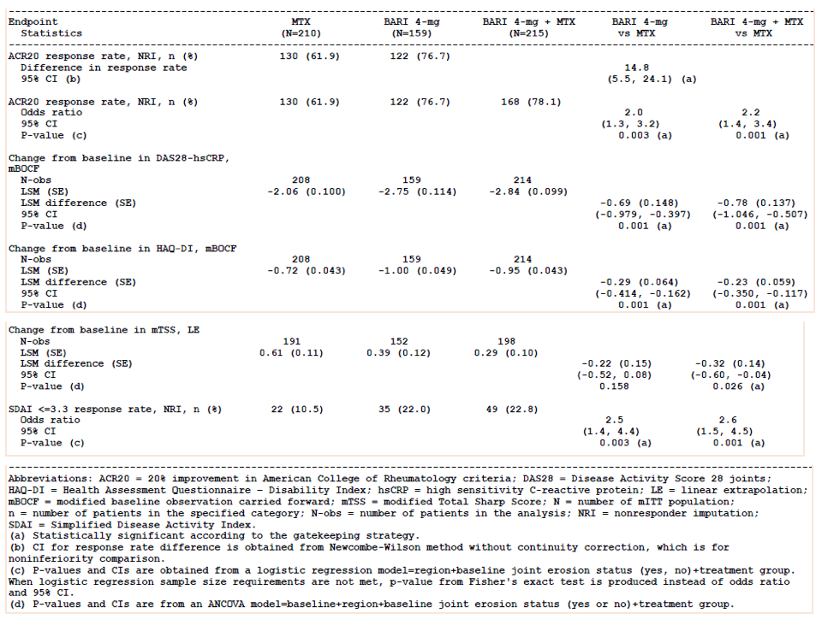
Compared to MTX monotherapy, statistically significant improvements in ACR20 response rates were observed at Week 24 for BAR monotherapy and BAR + MTX. Compared to MTX alone therapy, a statistically significant improvement was observed as early as Week 1 for the rate of ACR20 response and this observation was maintained through to Week 24 for both BAR monotherapy and BAR + MTX.
Compared to MTX monotherapy (-0.72), statistically significant improvements (p = 0.001) from Baseline in the Least Squares (LS) mean HAQ-DI scores were observed at Week 24 for BAR monotherapy (-1.0) and BAR + MTX (-0.95). A treatment related difference for both BAR groups was seen as early as Week 1. Compared to MTX monotherapy (-2.06), statistically significant improvements (p = 0.001) from Baseline in the LS mean DAS28-hsCRP scores were observed at Week 24 for BAR monotherapy (-2.75) and BAR + MTX (-2.84).
Compared to MTX monotherapy (10.5%; 22/210), statistically significant improvements (p ≤ 0.003) in the rate of SDAI remission were observed at Week 24 for BAR monotherapy (22.0%; 35/159) and BAR + MTX (22.8%; 49/215). A treatment related difference was observed as early as Week 4 for both BAR treatment groups and was maintained through to Week 24 for the combination treatment group only.
Compared to MTX monotherapy (+0.61 sharp unit increase from Baseline), a statistically lower increase in the LS mean mTSS was observed at Week 24 for the BAR + MTX group (+0.29 sharp units; p = 0.29 versus MTX), but this was not seen for the BAR monotherapy regimen (+0.39 sharp units; p = 0.158 versus MTX).
Other secondary outcomes of note included the rates of ACR response and SDAI remission at Week 52, as well as the LS mean change from Baseline in mTSS and other X-ray outcomes. Compared to MTX monotherapy, statistically significant improvements in ACR20, ACR50 and ACR70 response rates were observed at Week 52 for the BAR monotherapy and BAR + MTX groups. At 52 weeks, the ACR20 response rate (using NRI) was statistically greater (p = 0.001) at 73.0% (116/159) in the BAR monotherapy arm and 72.6% (156/215) in the BAR + MTX group versus 55.7% (117/210) in the MTX group. The ACR50 response rate at 52 weeks was also statistically greater (p = 0.001) at 57.2% (91/159) in the BAR monotherapy arm and 61.9% (133/215) in the BAR + MTX group versus 37.6% (79/210) in the MTX group. The ACR70 response rate at 52 weeks was also statistically greater (p = 0.001) at 42.1% (67/159) in the BAR monotherapy arm and 46.0% (99/215) in the BAR + MTX group versus 25.2% (53/210) in the MTX group. The rate of SDAI remission at 52 weeks was also statistically greater (p< 0.01) at 24.5% (39/159) in the BAR monotherapy arm and 30.2% (65/215) in the BAR + MTX group versus 13.3% (28/210) in the MTX group.
At 52 weeks, the combination treatment group showed a statistically lower LS mean increase from Baseline in mTSS (+0.40 sharp units) compared with MTX alone therapy (+1.02 sharp units; p = 0.004). The BAR monotherapy group recorded a +0.80 sharp unit increase from Baseline to Week 52, which was not statistically significant versus MTX monotherapy (p = 0.324). The main difference in mTSS with BAR + MTX therapy was accounted for by a statistically lower change from Baseline in ES versus MTX monotherapy. A supporting analysis of the main X-ray endpoint was the proportion of subjects in each treatment group who did not show an increase from Baseline in sharp units over time. At 52 weeks, the combination treatment group showed a statistically lower proportion of subjects with no X-ray progression (79.9%; 159/215) compared with MTX alone therapy (66.1% (127/192); p = 0.002). The BAR monotherapy group recorded 68.8% of subjects (106/154) with no X-ray progression at Week 52, which was not statistically greater than MTX monotherapy (p = 0.165).

Study JADV
The major secondary efficacy endpoints (included in the statistical gatekeeping strategy) for Study JADV were the ACR20 response rates (using NRI) at Week 12, mean change from Baseline in mTSS (using linear extrapolation) at Week 24, mean change from Baseline in HAQ-DI scores (using mBOCF) at Week 12, mean change from Baseline in DAS28-hsCRP scores (using mBOCF) at Week 12, SDAI remission response rates at Week 12 and various patient reported outcomes (using e-diaries) at Week 12 such as the mean duration of morning stiffness, mean worst tiredness and mean worst joint pain. Table 7 provides a summary of the primary and gated key secondary endpoints in Study JADV.
Compared to PBO (-0.34), statistically significant improvements (p = 0.001) from Baseline in the LS mean HAQ-DI scores were observed at Week 12 for BAR (-0.65) and adalimumab (-0.55). A treatment related difference for both BAR and adalimumab versus PBO was seen as early as Week 1. Compared to PBO (-0.96), statistically significant improvements (p = 0.001) from Baseline in the LS mean DAS28-hsCRP scores were observed at Week 12 for BAR (-2.19) and adalimumab (-1.91). Compared to PBO (1.8%; 9/488), statistically significant improvements (p = 0.001) in the rate of SDAI remission were observed at Week 12 for BAR (8.4%; 41/487) and adalimumab (7.3%; 24/330). A treatment related difference was observed as early as Week 4 for both BAR treatment groups and was maintained through to Week 24 for the combination treatment group only. BAR was also statistically superior to PBO therapy at 12 weeks for several patient reported outcomes such as the mean duration of morning stiffness, severity of joint pain and mean worst joint pain (the last endpoint is not shown in Table 7).

Table 7: Primary and Gated Key Secondary Efficacy Results at 12 and 24 Weeks in Study JADV
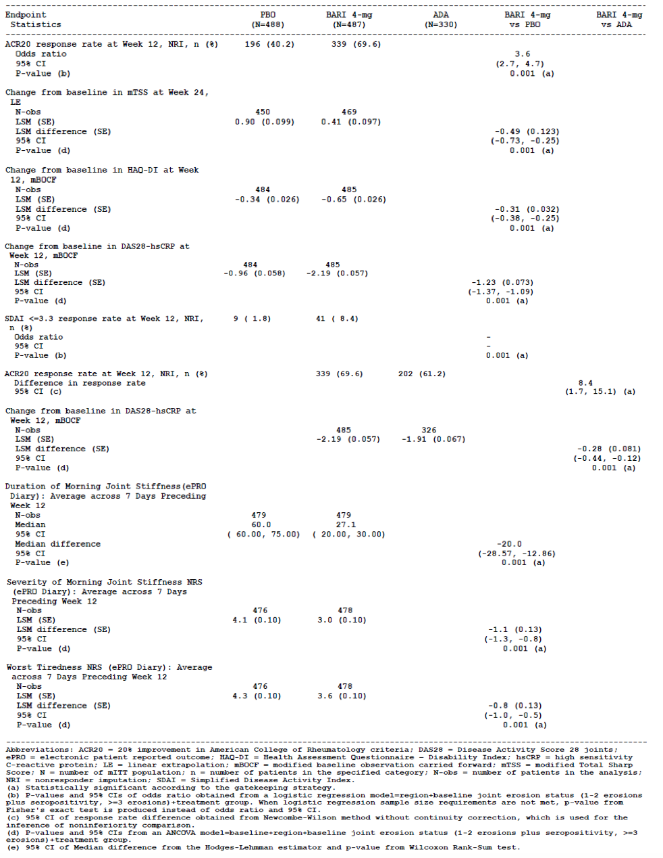
Table 8 shows the LS mean change from Baseline in mTSS (using linear extrapolation with data up to rescue or switch therapy) at Weeks 24 and 52 for the mITT population. The pre-specified main X-ray outcome of interest in Study JADV was the comparison between the BAR and PBO treatment groups at Week 24, and supportive analyses included the comparison between BAR and adalimumab therapies at Weeks 24 and 52. Compared to PBO (+0.84 sharp unit increase from Baseline mean of 44.64), a statistically significant lower increase in mTSS progression (meaning less structural X-ray progression) was observed at Week 24 for BAR (+0.29 sharp unit increase from Baseline mean of 42.46; p = 0.001). Compared to BAR, the adalimumab treatment group showed a numerically similar increase from Baseline to Week 24 (+0.33 sharp unit increase from Baseline mean of 44.35). At 52 weeks, there was a continued small increase in the LS mean mTSS for both BAR (+0.71 sharp unit) and adalimumab (+0.60 sharp unit), which was not statistically different in the pair-wise active treatment comparison (p = 0.69).

Table 8: Change from Baseline to Weeks 24 and 52 in mTSS in Study JADV
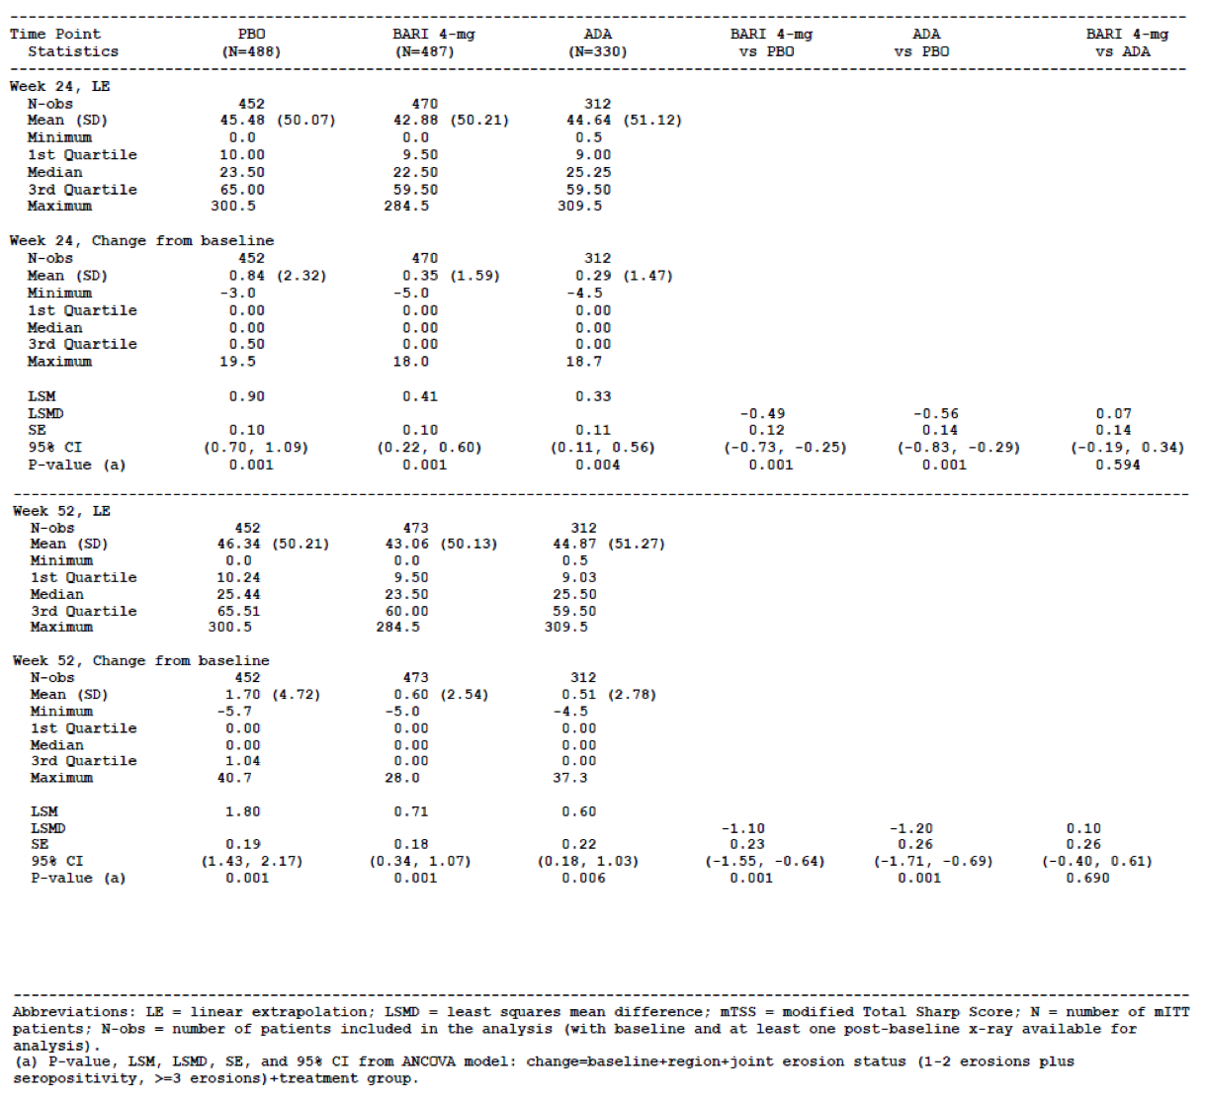
Compared to PBO, statistically significant improvements in ACR20, ACR50 and ACR70 response rates were observed at Week 24 for the BAR and adalimumab treatment groups. At 24 weeks, the ACR20 response rate (using NRI) was statistically greater (p = 0.001) at 73.9% (360/487) in the BAR arm and 66.4% (219/330) in the adalimumab group versus 36.7% (179/488) in the PBO group. At 52 weeks, the ACR20 response rate (using NRI) was 71.3% (347/487) in the BAR arm and 61.5% (203/330) in the adalimumab group.
The ACR50 response rate at 24 weeks was also statistically greater (p = 0.001) at 45.0% (219/487) in the BAR arm and 34.8% (115/330) in the adalimumab group versus 16.8% (82/488) in the PBO group. At 52 weeks, the ACR50 response rate was 55.9% (272/487) in the BAR arm and 47.0% (155/330) in the adalimumab group. The ACR70 response rate at 24 weeks was also statistically greater (p = 0.001) at 29.8% (145/487) in the BAR arm and 21.8% (72/330) in the adalimumab group versus 8.0% (39/488) in the PBO group. At 52 weeks, the ACR70 response rate was 37.2% (181/487) in the BAR arm and 30.6% (101/330) in the adalimumab group.
When comparing the efficacy outcomes observed for BAR versus adalimumab in Study JADV, most of the major clinical outcomes assessed at Week 12 (ACR20/50/70 response rates plus mean change from Baseline in DAS28-CRP score) were statistically in favour of BAR therapy (p ≤ 0.05), except for the rates of SDAI and CDAI based remission and the proportion of subjects achieving HAQ-DI responder status (that is, a decrease in their baseline HAQ-DI score of ≥ 0.30). At Week 24, BAR was statistically superior to adalimumab for the rate of ACR20 and ACR70 response, but not for ACR50 response or any other clinical response measure. At Week 52, BAR was statistically superior to adalimumab for the rate of ACR20 and ACR50 response as well as DAS28-CRP scores, but not any other clinical endpoints. Radiographic outcomes at 24 and 52 weeks were numerically lower (better) with adalimumab versus BAR, but did not reach statistical significance.

Study JADX
The major secondary efficacy endpoints (included in the statistical gatekeeping strategy) for Study JADX were the ACR20 response rates (using NRI) at Week 12, mean change from Baseline in HAQ-DI scores (using mBOCF) at Week 12, mean change from Baseline in DAS28-hsCRP scores (using mBOCF) at Week 12, SDAI remission response rates at Week 12 and various patient reported outcomes (using e-diaries) at Week 12 such as the mean duration of morning stiffness and mean worst tiredness.
Compared to PBO (-0.34), statistically significant improvements (p = 0.001) from Baseline in the LS mean HAQ-DI scores were observed at Week 12 for both doses of BAR (-0.54 for 2 mg/day and -0.53 for 4 mg/day). Compared to PBO (-1.08), statistically significant improvements (p = 0.001) from Baseline in the LS mean DAS28-hsCRP scores were observed at Week 12 for both doses of BAR (-1.83 for 2 mg/day and -1.92 for 4 mg/day). Compared to PBO (0.9%; 2/228), statistically significant improvements (p = 0.001) in the rate of SDAI remission were observed at Week 12 for both doses of BAR (9.2% (21/229) for 2 mg/day and 8.8% (20/227) for 4 mg/day). Both doses of BAR were also statistically superior to PBO therapy at 12 weeks for several patient reported outcomes such as the mean duration of morning stiffness and severity of joint pain.
Compared to PBO, statistically significant improvements in ACR20, ACR50 and ACR70 response rates were observed at Week 24 for both doses of BAR. At 24 weeks, the ACR20 response rate (using NRI) was statistically greater (p = 0.001) at 61.1% (140/229) in the BAR 2 mg arm and 65.2% (148/227) in the BAR 4 mg group versus 42.1% (96/228) in the PBO group. The ACR50 response rate at 24 weeks was also statistically greater (p = 0.001) at 41.5% (95/229) in the BAR 2 mg arm and 44.1% (100/227) in the BAR 4 mg group versus 21.5% (49/228) in the PBO group. The ACR70 response rate at 24 weeks was also statistically greater (p = 0.001) at 25.3% (58/227) in the BAR 2 mg arm and 24.2% (55/227) in the BAR 4 mg group versus 7.9% (18/228) in the PBO group.
Regarding the exploratory X-ray progression outcome, a statistically lower rate of structural progression in the LS mean change from Baseline in mTSS was observed at Week 24 for the BAR 4 mg group (+0.15 sharp unit increase from Baseline) versus PBO (+0.70 sharp unit increase), as well as the pair-wise comparison between PBO and BAR 2 mg/day (+0.33 sharp unit increase from Baseline) – as summarised in Table 9. Similar results were seen in the mTSS analyses for the BAR 4 mg versus PBO group using LOCF as randomised as the method of imputation for missing data (compared with LEP (linear extrapolation) as the primary means of dealing with missing X-ray data). However, in the mTSS sensitivity analysis using LOCF as randomised, the BAR 2 mg versus PBO group comparison did not reach statistical significance.

Table 9: Change from Baseline to Week 24 in mTSS in Study JADX (using LEP)
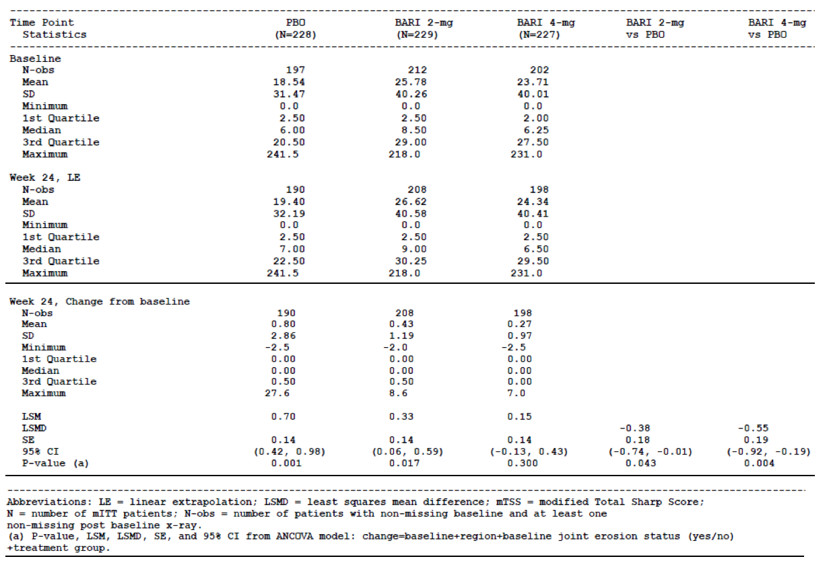
Compared to PBO (73.2%; 142/192), a larger proportion of patients had no progression in mTSS (change from Baseline ≤ 0) at Week 24 for the BAR 4 mg group (80.5%; 161/200), but the difference was not statistically significant (p = 0.063). The rate of no X-ray progression at 24 weeks in the BAR 2 mg arm was 71.3% (149/209), which was numerically lower than PBO.

Study JADW
The major secondary efficacy endpoints (included in the statistical gate-keeping strategy) for Study JADW were the mean change from Baseline in HAQ-DI scores (using mBOCF) at Week 12, mean change from Baseline in DAS28-hsCRP scores (using mBOCF) at Week 12 and SDAI remission response rates at Week 12. Compared to PBO (-0.17), statistically significant improvements (p = 0.001) from Baseline in the LS mean HAQ-DI scores were observed at Week 12 for both doses of BAR (-0.37 for 2 mg/day and -0.40 for 4 mg/day). Compared to PBO (-0.83), statistically significant improvements (p = 0.001) from Baseline in the LS mean DAS28-hsCRP scores were observed at Week 12 for both doses of BAR (-1.49 for 2 mg/day and -1.79 for 4 mg/day). However, the rates of SDAI remission at 12 weeks were not statistically higher (p > 0.05) for both doses of BAR (2.3% (4/174) for 2 mg/day and 5.1% (9/177) for 4 mg/day) compared to PBO (1.7%; 3/178).
Compared to PBO, statistically significant improvements in ACR20, ACR50 and ACR70 response rates were observed at Week 24 for both doses of BAR. At 24 weeks, the ACR20 response rate (using NRI) was statistically greater (p = 0.001) at 44.8% (78/174) in the BAR 2 mg arm and 46.3% (82/177) in the BAR 4 mg group versus 27.3% (48/176) in the PBO group. The ACR50 response rate at 24 weeks was also statistically greater (p ≤ 0.015) at 23.0% (40/174) in the BAR 2 mg arm and 29.4% (52/177) in the BAR 4 mg group versus 13.1% (23/176) in the PBO group. The ACR70 response rate at 24 weeks was also statistically greater (p = 0.001) at 13.2% (23/174) in the BAR 2 mg arm and 16.9% (30/177) in the BAR 4 mg group versus 3.4% (6/176) in the PBO group.

Evaluator commentary
Data from 4 completed Phase III RA studies of 24 to 52 weeks duration have demonstrated the clinical benefit of BAR 4 mg once daily in adult patients with moderately to severely active RA in terms of improving the symptoms and signs of the disease (via ACR response criteria), achieving reasonably high (and comparable to other active therapies) rates of low disease activity and clinical remission, improving physical function (via changes from Baseline in HAQ-DI score) and various patient reported outcomes such as duration of morning stiffness and tiredness.
Three of the 4 Phase III studies have examined for radiographic progression of structural joint damage and there is preliminary short term data that BAR may also improve this endpoint but the results across the trials are not consistently (and statistically supported) with the current dataset. The efficacy of BAR 4 mg daily was compared to 2 common and approved therapies including low dose weekly MTX in Study JADZ and adalimumab in Study JADV (where it was also compared to PBO). In both of these studies, BAR 4 mg/day (used alone or in combination with MTX in Study JADZ and used with background MTX in Study JADV) was superior (or at least non-inferior) to each active comparator across established and relevant domains of clinical efficacy including composite disease activity and response instruments, individual components of those instruments, physical functioning and patient reported outcomes. The improvements seen with BAR over PBO or MTX were seen within several weeks of commencing treatment and were sustained over time. In both of these studies, BAR 4 mg/day in combination with MTX resulted in less progression of radiographic joint damage with the magnitude of treatment effect being statistically superior to MTX monotherapy and comparable to adalimumab.
Studies JADX and JADW supported the superiority of BAR 4 mg daily versus PBO across all of the measured efficacy outcomes of interest. In both of these studies, a BAR 2 mg daily dose was included and this regimen also demonstrated efficacy compared to PBO, but with less rapidity, consistency and magnitude of effect than the BAR 4 mg dose.

Other efficacy studies

Study JADC

Study design, objectives, locations, dates and treatments
Study JADC was a randomised, double-blind, PBO-controlled, dose ranging, parallel group Phase II trial in 127 subjects with active RA who had an inadequate response to any DMARD therapy (including biologic). Screening evaluations were performed within 28 days of randomisation followed by a study treatment period of 3 months with an optional 3-month active treatment extension phase. A final study visit was performed 4 weeks following the final dose of study medication.
Subjects were randomly assigned in an equal ratio to receive either PBO tablets once daily, BAR 4 mg once daily, BAR 7 mg once daily or BAR 10 mg once daily. All study treatments were taken without regard to food intake. Subjects who received PBO for the first 12 weeks were re-randomised to BAR 7 mg or 10 mg once daily for the 3-month extension phase. Subjects were to be maintained on pre-existing stable doses of NSAID, MTX 7.5-25 mg/week, LEF 10-20 mg/day, SSZ up to 3 g daily, HCQ and low dose CS during the study. All other DMARD use, including biologic therapies, was prohibited during the trial.
Clinical efficacy evaluations were scheduled at 2, 4, 8 and 12 weeks of therapy. The 2 primary objectives of Study JADC were to demonstrate that BAR when added to conventional DMARD therapy was effective for the reduction of symptoms and signs of active RA at 12 weeks, and to assess the safety and tolerability of BAR. Study JADC was conducted at 35 investigator sites in the USA and 6 centres in the Czech Republic. The first patient was enrolled in May 2009 and the last patient completed follow-up in July 2010.

Eligibility criteria
To be eligible for inclusion, patients had to be at least 18 years of age with a diagnosis of RA (based on the 1987 ACR criteria). Subjects had to have active disease at Baseline as evidenced by ≥ 6 tender joints (based on a 28 joint assessment), ≥4 swollen joints (based on a 28 joint assessment) and have at least 1 raised serum inflammatory reading (ESR ≥ 28 mm/hr and/or CRP ≥ 7 mg/L) despite treatment with at least 1 DMARD (conventional or biologic) for at least 6 months. A history of substance abuse, recent or current infection (within 30 days of screening), unstable cardiovascular disease or uncontrolled hypertension within 6 months of screening, and a history of infected joint prosthesis were exclusion criteria. Subjects were screened for Hepatitis B and C, HIV as well as TB at Baseline, and were excluded if they tested positive to any of these infections. A history of malignancy within 10 years (except for excised basal and squamous cell skin cancers) was also an exclusion criterion. Subjects who were obese (BMI > 38 kg/m²) or asthenic (BMI < 18 kg/m²) were excluded. Subjects with any significant laboratory abnormalities at screening were also excluded such as serum ALT > 1.5 x ULN, creatinine clearance < 60 mL/minute, total white blood cell count < 3.0 x 10⁹/L, neutrophil cell count < 2.0 x 10⁹/L, platelet count < 140 x 10⁹/L and haemoglobin < 10.0 g/dL.

Efficacy variables and statistical considerations
All efficacy analyses were conducted using the mITT population, which was defined as all enrolled subjects who took at least 1 dose of study medication, and who had both baseline and at least 1 post-baseline assessment before Week 12. The primary efficacy endpoint was the proportion of patients in each treatment arm who achieved ACR20 response at Week 12. The primary analysis compared each BAR dose group to PBO using a Cochrane Armitage trend test, without the need for correction for multiplicity. All tests were 2-sided at the alpha level of 0.05. The primary efficacy endpoint was also analysed using the PP population.
Descriptive statistics were used for analysing the secondary efficacy endpoints such as the various rates of ACR response at other time points. No adjustments were used for the secondary analyses or endpoints. The sample size estimation for Study JADC was based on testing a trend using the Cochran-Armitage Trend Test with 80% power at the 2-sided 0.05 level. Based on data from similar studies, the ACR20 response rates for PBO, BAR 4 mg, BAR 7 mg and BAR 10 mg were estimated or predicted to be 30%, 30%, 60% and 65%, respectively. With 22 subjects per group, the Cochran-Armitage Trend Test provided 80% power at the 2-sided 0.05 significance level. Assuming a 10% drop out rate, 25 subjects per group were enrolled.

Participant flow and significant protocol deviations
A total of 236 subjects were screened for involvement in Study JADC and 109 patients (46.2%) were recorded as screen failures. The reasons for screen failure were not provided in the clinical study report in module 5. A total of 127 patients were randomly assigned to 1 of 4 treatment groups including 31 subjects to the PBO group and 32 patients to each of the BAR treatment arms. Of the 127 randomised subjects, 2 patients (1 randomised to the BAR 4 mg group (withdrew consent) and the other to the BAR 10 mg arm (corrected QT interval > 460 ms at Baseline)) did not receive study treatment. Another subject (randomised to BAR 10 mg therapy) withdrew from the study on day 7 due to a protocol deviation and was not included in the mITT cohort (n = 124 subjects in total – 31 subjects in the PBO and BAR 4 mg groups, 32 patients in the BAR 7 mg arm and 30 subjects in the BAR 10 mg group).
Up to Week 12, 90.6% (115/127) of all randomised subjects completed treatment. The percentage of subjects who discontinued study medication between baseline and Week 12 was higher in the BAR 10 mg group (5 subjects, 15.6% of 32) compared with the BAR 7 mg arm (2 subjects, 6.3% of 32), BAR 4 mg group (3 subjects, 9.4% of 32) and PBO group (2 subjects, 6.5% of 31). The primary reason for discontinuation before Week 12 was adverse events affecting 3.9% (5/127) of subjects, including 2 in the BAR 10 mg group and 1 subject in each of the other 3 treatment arms. Up to Week 24, 84.3% (107/127) of subjects completed treatment. More subjects in the BAR 10 mg group (8 subjects, 25% of 32) discontinued treatment before Week 24 compared with the 3 other treatment groups (4 subjects in the PBO arm (12.9% of 31), 5 patients in the BAR 4 mg arm (15.6% of 32) and 3 subjects in the BAR 7 mg group (9.4% of 32)). For the subjects who were randomised to PBO at Baseline and then who crossed over to active treatment with BAR after Week 12, more subjects in the BAR 10 mg crossover group (2 subjects, 13.3% of 15) discontinued treatment by Week 24 compared with the BAR 7 mg crossover group (0 of 14 subjects).
Three patients (2 in the BAR 10 mg treatment group and 1 in the BAR 7 mg arm) were withdrawn from the study due to major protocol violations. The PP population included 104 patients (81.9% of the randomised set). Of these 104 patients, 28 were in the PBO treatment group, 29 were in the BAR 4 mg arm, 25 were in the BAR 7 mg group and 22 subjects were in the BAR 10 mg arm.

Baseline patient data
The 4 treatment groups were balanced with respect to demographic features. The randomised population of 127 patients had a mean age of 55.8 years (median of 55.0 years; range: 20-80 years). The majority of patients were female (80.3%; 102/127) and Caucasian (89.8%; 114/127). The overall median BMI for enrolled patients was 28.7 kg/m² (range: 19.1-38.1 kg/m²). By geographic region, the majority of patients came from the USA (73.6%; 92/127) versus Czech Republic (26.4%; 33/127).
The treatment groups were similar with respect to baseline RA disease characteristics. The mean duration of RA for all subjects was 8.25 years (median 6.21 years, range: 0.4-39.3 years). The clinical study report did not contain information about the rates of seropositivity for RA at Baseline.
In terms of RA disease activity at Baseline, the mean numbers of tender (ranging from 14.4 to 15.9) and swollen joints (ranging from 10.6 to 12.9) were similar across the 4 treatment groups. All 4-treatment groups recorded mean DAS28-CRP scores that were very high at Baseline (5.64-5.76) and the mean HAQ-DI scores ranged from 1.50 to 1.67. The mean CRP values for each treatment group ranged from 7.52 to 15.64 mg/L. Overall, the measures of baseline disease activity recorded in Study JADC are consistent with moderately to severely active RA.
Approximately one third of all subjects (33.6%; 42/125) had a history of prior biologic therapy for RA, which was higher in the BAR 4 mg group (48.4%; 15/31) than the other 3 treatment groups (29.0% (9/31) in the PBO group, 34.4% (11/32) in the BAR 7 mg arm and 22.6% (7/31) in the BAR 10 mg group). Almost one fifth of subjects in the BAR 4 mg group (19.4%; 6/31) had received at least 2 or more prior biologic therapies for at least 8 weeks versus ~10% in the 2 other BAR treatment groups (4 subjects in each BAR arm) and 1 patient in the PBO group (3.2% of 31). The 3 most commonly used biologic DMARD therapies were adalimumab (16.0%; 20/125), etanercept (15.2%; 19/125) and infliximab (11.2%; 14/125).
The vast majority of subjects (87.2%; 109/125) had taken MTX in the past and 75.2% (94/125) were still taking MTX at Baseline, at equal proportions across the 4 treatment groups. In addition, 16.0% of subjects (20/125) were taking LEF at Baseline, 8.0% (10/125) were taking SSZ and 8.0% (10/125) were taking HCQ. The clinical study report did not report the dose of concurrent DMARD, in particular MTX, taken during the trial nor the preceding doses to assess the adequacy of prior or concurrent conventional DMARD treatment. Surprisingly, only 36.0% (45/125) of subjects were taking concurrent folic acid during Study JADC despite the much higher frequency of MTX use. CS use at Baseline was recorded in approximately 40% of patients in each of the 4 treatment groups and more than half of all subjects were taking NSAID (mainly, ibuprofen, celecoxib or meloxicam).

Primary efficacy results
At Week 12, the proportion of subjects in the mITT population who recorded an ACR20 response was 51.6% (16/31) in the BAR 4 mg group, 59.4% (19/32) in the BAR 7 mg arm and 53.3% (16/30) in the BAR 10 mg group compared with 32.3% (10/31) in the control arm. The result for the Cochran-Armitage test of trend at Week 12 for the mITT analysis of ACR20 response of BAR versus control therapy was not statistically significant (p = 0.0619). However, the comparison of the proportion of ACR20 responders at Week 12 between the PBO group (32.3%) and the BAR 7 mg group (59.4%) was statistically significant (p = 0.0437 using Fisher’s Exact test). At Week 4, a statistically significant difference between the BAR 10 mg and PBO groups in the proportion of subjects who had an ACR20 response was observed (p = 0.0098); refer to Table 10. At Week 8, each of the comparisons between BAR and PBO in the proportion of ACR20 responders was statistically significant (p ≤ 0.001). However, between weeks 8 and 12, an additional 6 subjects in the PBO group achieved an ACR20 response, which impacted the Week 12 efficacy results.
Subgroup analyses of the ACR20 response rate at Week 12 according to prior biologic exposure (yes/no), concurrent MTX use versus other conventional DMARD therapy, and geographic region (USA versus Czech Republic) did not reveal any significant treatment response trends. In particular, the ACR20 response was similar between biologic experienced versus naïve subjects for each treatment group.

Table 10: ACR20 Response Rates Up to Week 12 in the mITT Population of Study JADC
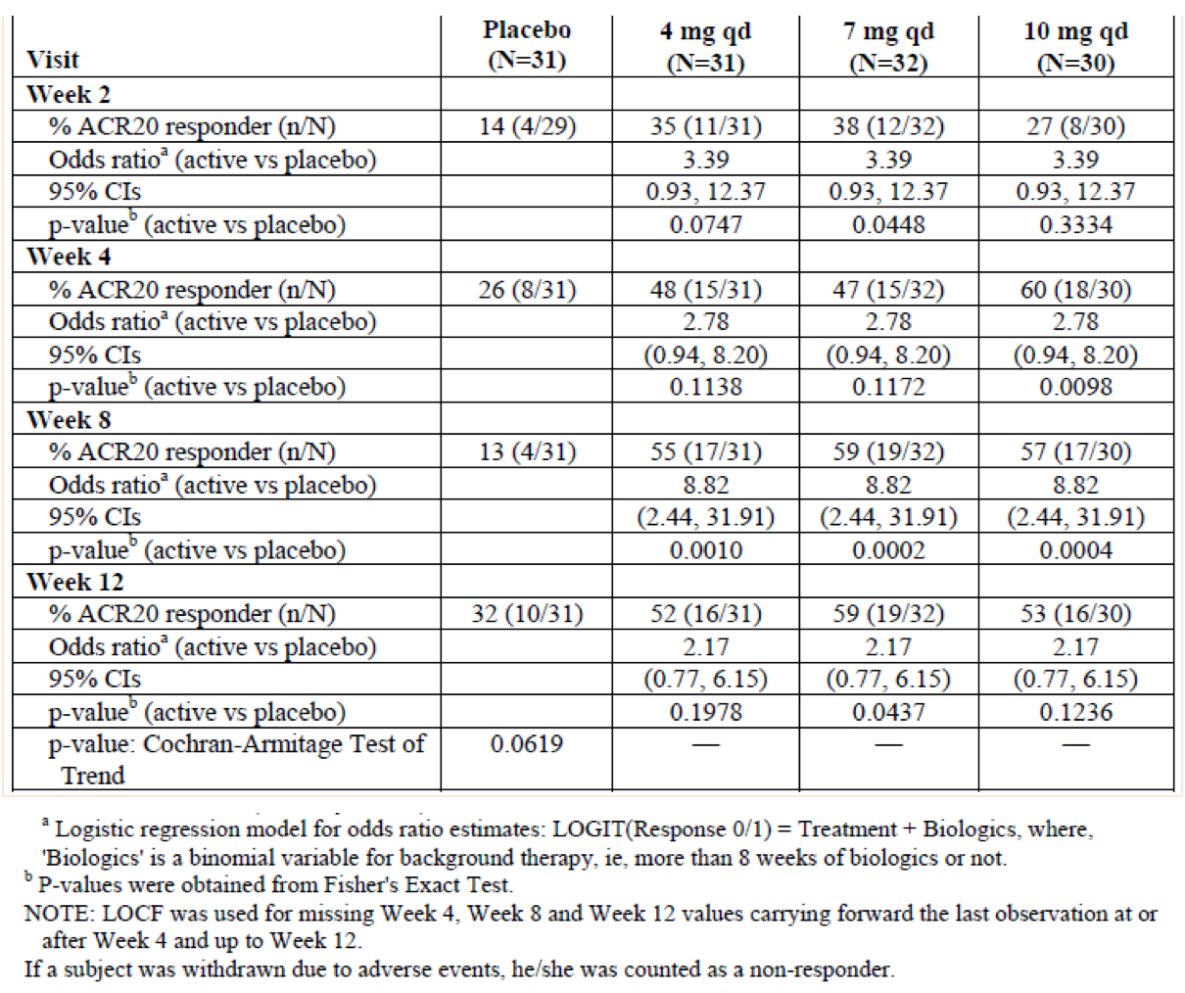
The PP population analysis of the rate of ACR20 response at Week 12 using the LOCF method to handle missing data showed a statistically better efficacy result for the BAR 7 mg (68.0% (17/25); p = 0.0135) and 10 mg doses (63.6% (14/22); p = 0.0448) versus PBO (32.1%; 9/28). However, the ACR20 response rate at Week 12 using the PP population was not statistically better with BAR 4 mg therapy (55.2% (16/29); p = 0.1108) versus PBO.

Secondary efficacy results
At Week 12, the proportion of subjects in the mITT population who achieved an ACR50 response was 35.5% (11/31) in the BAR 4 mg group, 31.3% (10/32) in the BAR 7 mg arm and 30.0% (9/30) in the BAR 10 mg group compared with 12.9% (4/31) in the PBO arm. The result for the Cochran-Armitage test of trend at Week 12 for the mITT analysis of ACR50 response was not statistically significant (p = 0.1497). However, the comparisons for the proportion of ACR50 responders at week 8 between the PBO (6.5%; 2/31) and BAR 4 mg group (35.5%; 11/31), and PBO (6.5%; 2/31) versus BAR 10 mg (30%; 9/30) were statistically significant (p = 0.0106 and p = 0.0217, respectively).
The proportion of patients who achieved ACR70 response at Week 12 was 16.1% (5/31) in the BAR 4 mg group, 9.4% (3/32) in the BAR 7 mg arm and 10% (3/30) in the BAR 10 mg group compared to 3.2% (1/31) in the control arm. Again, the Cochran-Armitage test of trend at Week 12 for the mITT analysis of ACR70 response was not statistically significant (p = 0.4936).
At weeks 8 and 12, mean decreases (improvement) from Baseline in the DAS28 (CRP) scores ranged from 1.6 to 1.9 among the 3 BAR treatment groups versus 0.65-1.01 for the control arm.
Mean improvements from Baseline in DAS28 (CRP) scores at Week 12 for all 3 BAR treatment groups were statistically significant compared with PBO (p< 0.001 for each pair-wise comparison between BAR and PBO). At 12 weeks, low disease activity (that is, DAS28 (CRP) score < 3.2) was achieved by a greater proportion of subjects in the BAR 4 mg group (45.2%; 14/31) compared with the other treatment groups (34.4% (11/32) in the BAR 7 mg group, 33.3% (10/30) in the BAR 10 mg arm and 25.8% (8/31) in the PBO group). None of the Week 12 comparisons of BAR treatment versus PBO were statistically significant for the percentage of subjects achieving low disease activity. At Week 12, remission rates (that is, DAS28 (CRP) score < 2.6) were achieved by a numerically more subjects treated with BAR 7 mg (25%; 8/32) compared with the 3 other treatment groups (22.6% (7/31) in the BAR 4 mg group, 16.7% (5/30) in the BAR 10 mg arm and 16.1% (5/31) in the PBO group). None of the Week 12 comparisons between BAR and PBO treatments for the proportion of subjects reaching clinical remission were statistically significant.
At each visit between baseline and Week 12, greater mean changes (improvements) from Baseline in HAQ-DI scores were observed for all BAR treatment groups compared with PBO. At Week 12, the mean decreases from Baseline in HAQ-DI scores were statistically significant for all BAR treatment groups (4 mg (-0.38, p = 0.0009); 7 mg (-0.48, p = 0.0002); 10 mg (-0.33, p = 0.002)) compared to PBO (-0.20 change).
Individual components of the ACR endpoint such as the patient global assessment of disease status and pain showed improvement after 2 weeks of BAR therapy (any dose), which was maintained and continued to improve up to 24 weeks of treatment. Between Weeks 12 and 24, efficacy appears to be maintained or possibly improved over time with up to 72% of patients achieving an ACR20 response (BAR 10 mg group), 44% obtaining an ACR50 response (BAR 10 mg group) and 30% recording an ACR70 response (BAR 7 mg group). Expectedly, the proportions of subjects who were ACR responders decreased between Weeks 24 (drug ceased) and 28 (safety follow-up visit off drug) due to the short-half-life of BAR.

Study JADA

Study design, objectives, locations, dates and treatments
Study JADA was a randomised, double-blind, PBO-controlled, dose ranging, parallel group Phase II trial in 301 subjects with active RA who had an inadequate response to MTX. This study consisted of a screening period of up to 28 days followed by a blinded, PBO-controlled treatment period of 12 weeks (Part A), then another 12-week blinded treatment phase (Part B), an optional 52-week open-label extension phase (Part C) and additional optional 52-week open label extension period (Part D). A final study visit was performed 4 weeks following the final dose of study medication.
In Part A, subjects were randomly assigned at a ratio of 2:1:1:1:1 to receive either PBO tablets once daily (without regard to food intake), BAR 1 mg once daily, BAR 2 mg once daily, BAR 4 mg once daily or BAR 8 mg once daily (given as 2 x 4 mg capsules). In Part B, subjects who received PBO and BAR 1 mg daily for the first 12 weeks were re-randomised 1:1 to BAR 2 mg twice daily therapy or 4 mg once daily. The patients assigned to BAR 2 mg, 4 mg and 8 mg daily in Part A remained on the same therapy in Part B. Participation in Part C was optional, but completion of Parts A and B was mandatory for eligibility. In Part C, patients who had received BAR 2 mg daily were re-assigned at Week 24 to BAR 4 mg once daily in Part C. Patients receiving BAR 4 mg once daily in Part B continued on the same therapy in Part C, but were evaluated at both Weeks 28 and 32 to determine if they may require escalation to BAR 8 mg once daily if exhibiting insufficient clinical response. Subjects treated with BAR 8 mg daily in Part B maintained their treatment in Part C. Participation in Part D was also optional, but completion of involvement in Part C was mandatory. All subjects received BAR 4 mg once daily in Part D regardless of their BAR dose in Parts B and C. Throughout all phases of Study JADA, subjects continued to take stable pre-randomisation doses of MTX, NSAIDs and low dose CS (stable for at least 6 weeks prior to randomisation).
Clinical efficacy evaluations were scheduled at Weeks 2, 4 and every 4 weeks thereafter in Study JADA. The primary objective of Study JADA was to evaluate the efficacy of BAR when added to MTX for the reduction of symptoms and signs of active RA at 12 weeks, as measured by the rate of ACR20 response. Study JADA was conducted at 69 investigator sites in 9 countries. The first patient was enrolled in November 2008 and the last patient completed follow-up in March 2014.

Eligibility criteria
To be eligible for inclusion, patients had to be between 18 and 75 years of age with a diagnosis of RA (based on the 1987 ACR criteria) of at least 6 months duration, but no longer than 15 years prior to screening. Subjects had to have active disease at Baseline as evidenced by at least 8 tender and swollen joints (based on the 68/66 joint assessment, respectively) and have at least 1 raised serum inflammatory value (ESR > ULN and/or CRP > 1.2 x ULN) despite treatment with MTX for at least 12 weeks, and at a stable dose of 10-25 mg/week for at least 8 weeks prior to screening.
There were numerous exclusion criteria for Study JADA including a history of any prior biologic DMARD use for RA, recent or current infection (within 30 days of screening), serious or opportunistic infection within 6 months of screening, history of disseminated or complicated herpes zoster infection, unstable cardiovascular disease or uncontrolled hypertension within 6 months of screening, Felty’s syndrome, active vasculitis and a potential need for joint surgery were to be excluded. Subjects were screened for Hepatitis B and C, HIV as well as TB at Baseline, and were excluded if they tested positive to any of these infections. A history of malignancy within 5 years (except for excised basal and squamous cell skin cancers with no recurrence within 3 years) was also an exclusion criterion. Subjects with any significant laboratory abnormalities at screening were also excluded such as serum ALT > 3 x ULN, serum total bilirubin > 1.5 x ULN, creatinine clearance < 50 mL/minute, total white blood cell count < 2.5 x 10⁹/L, neutrophil cell count < 1.2 x 10⁹/L, platelet count < 100 x 10⁹/L, lymphocyte count < 0.75 x 10⁹/L and haemoglobin < 10.0 g/dL.

Efficacy variables and statistical considerations
The primary efficacy endpoint of Study JADA was to compare the rates of ACR20 response in the combined 4 mg and 8 mg BAR treatment groups to PBO at Week 12 (end of Part A). This analysis was performed using a 1-sided, 0.10 level Wald test from a logistic regression model that included treatment group (BAR versus PBO) and baseline DAS28-CRP scores as a continuous covariate. Subjects who withdrew prior to Week 12 were recorded as non-responders for the primary analysis and those with missing components of the ACR response criteria at Week 12 had those measures imputed by LOCF.
The key secondary efficacy outcome of Study JADA was to develop a Bayesian dose-response model estimating the ACR20 response rate at Week 12 for each treatment group and to compare each BAR dose to PBO. From the final Bayesian model, posterior probabilities were derived for each BAR dose group versus PBO (testing for the superiority of BAR versus PBO).
All efficacy analyses were conducted using the Full Analysis Set (FAS), which was defined as all enrolled subjects who took at least 1 dose of study medication and who had at least 1 post-baseline assessment. For categorical efficacy responder variables such as ACR20 response, DAS28< 2.6 and SDAI ≤3.3, every patient meeting this criteria was included in the analysis, because if a patient had no post-baseline data, the patient was deemed to be a non-responder. The primary analysis was the comparison of the combined BAR 4 mg and 8 mg dose groups versus PBO for the ACR20 response rate at 12 weeks, conducted using a 1-sided alpha level of 0.10. All other tests of treatment effects were conducted at a 2-sided alpha level of 0.10. No adjustments were made for multiplicity in the statistical analysis plan. Statistical tests conducted on data from Part A compared each BAR treatment group with PBO. Statistical tests in Part B compared the BAR 2 mg twice daily treatment group with the BAR 4 mg once daily arm for the subset of patients who were re-randomised at the beginning of Part B. Summary statistics were presented for the original 2 mg, 4 mg and 8 mg once daily BAR treatment groups beyond Week 12 to Week 24. Summary statistics for Part C were presented for patients treated exclusively with BAR 4 mg once daily, patients receiving initial treatment with BAR 4 mg and then escalated to 8 mg in Part C, and patients treated exclusively with BAR 8 mg daily in Part C. The summary of these same treatment groups continued through Part D.
The sample size calculations were based on a comparison between the combined BAR 4 mg and 8 mg dose groups versus PBO (estimated 35% response rate) for the rate of ACR20 response at 12 weeks. The planned sample size of 90 patients in the control group and 45 subjects for each of the 4 BAR dose arms was estimated to provide 92% power to detect a 20% treatment related difference (that is, 55% ACR20 response rate in the combined BAR group) and 98% power for a 25% treatment related difference (that is, 60% ACR20 response rate in the combined BAR arm).

Participant flow and significant protocol deviations
A total of 454 subjects were screened for involvement in Study JADA and 153 patients (33.7%) were recorded as screen failures. The main reason for screen failure was failure to meet the study entry criteria (86.9%; 133/153). A total of 301 patients were randomly assigned to 1 of 5 treatment groups: PBO (98 subjects), BAR 1 mg daily (49 patients), BAR 2 mg daily (52 subjects), BAR 4 mg daily (52 patients) and BAR 8 mg daily (50 patients).
Of the 301 patients randomised to treatment in Study JADA, 276 (91.7%) completed Part A (Week 12). There were also few patient discontinuations after Week 12, with 259 of the 276 patients (93.8%) who entered Part B completing to Week 24. Of the 126 patients who received either PBO or BAR 1 mg/day in Part A, 63 patients were re-randomised to treatment with BAR 4 mg/day and BAR 2 mg/day in Part B.
A total of 201 patients entered and were treated in Part C of Study JADA. Of these, 108 patients were treated throughout Part C with BAR 4 mg daily therapy, 61 patients who were initially treated with BAR 4 mg were dose escalated to BAR 8 mg daily and 32 patients received BAR 8 mg/day throughout Part C. A total of 169 patients (84.1% of 201) completed Part C in Week 76. Of these, 144 patients subsequently entered Part D of the trial (25 patients discontinued at the end of Part C). Of the 144 patients who entered Part D, 79 patients continued treatment with BAR 4 mg daily throughout the entire trial, 47 subjects dose escalated from 4 mg to 8 mg of BAR and 18 patients reduced from BAR 8 mg to 4 mg daily. Overall, 133 patients (92.4% of 144) completed Part D of Study JADA.

Baseline patient data
The 5 treatment groups were balanced with respect to demographic features. The randomised population of 301 patients had a mean age of 51.2 years (median of 52.0 years; range: 19 to 76 years). The majority of patients were female (82.7%; 249/301) and Caucasian (74.4%; 224/301). The overall median BMI was 27 kg/m² (range: 15 to 57 kg/m²). By geographic region, the largest percentage of patients came from Eastern Europe (39%) followed by USA (32%), Mexico (16%) and India (14%). Almost one quarter of all subjects (23.6%; 71/301) was active smokers at Baseline and 7.6% (23/301) were diabetic.
The treatment groups were similar with respect to baseline RA disease characteristics. The mean duration of RA for all subjects was 5.62 years (median 4.7 years, range: 0.5-17.4 years). Just more than half of all patients were positive for anti-CCP antibodies at Baseline (57.8%; 174/301) and two thirds were RF positive (64.8%; 195/301).
In terms of RA disease activity at Baseline, the mean numbers of tender (ranging from 13.1 to 15.7) and swollen joints (ranging from 11.2 to 12.1) based on the 28 joint count assessment were similar across the 5 treatment groups. All 5-treatment groups recorded mean DAS28-CRP scores that were high at Baseline (5.30 to 5.78) and the mean HAQ-DI score across the enrolled population was 1.16. The mean CRP for recruited subjects was high at 12.81 mg/L (median of 5.93 mg/L). Overall, the measures of baseline disease activity are consistent with active RA.
All but 1 subject was taking MTX at Baseline at a mean weekly dose of 16.3 mg (median weekly dose of 15 mg). In addition to MTX, 13.0% of subjects (39/301) had previously taken SSZ and 18.6% of subjects (56/301) had previously taken HCQ. Current oral CS use at Baseline was recorded in almost half of all patients (49.2%; 148/301).

Primary efficacy results
For the primary efficacy outcome in Study JADA, a statistically higher rate of ACR20 response at Week 12 (end of Part A) was demonstrated in the combined BAR 4 and 8 mg group (76.5%; 78/102) compared to PBO (40.8% (40/98); p-value < 0.001).

Key secondary efficacy results
A Bayesian dose response model was used to estimate ACR20, ACR50, and ACR-N response rates for each treatment group and to compare each BAR dose group to PBO. This analysis determines the Bayesian posterior probability of the dose group’s true response rate exceeding the placebo group’s true response rate, with ≥ 85% probability pre-specified as representing evidence for a ‘significant’ treatment difference. All 4 BAR treatment groups demonstrated evidence for significantly higher response rates than PBO for ACR20, ACR50, and ACR-N. There was > 95% probability that BAR 4 mg and 8 mg treatment produce ACR20 response rates that exceed the PBO group’s response rate by at least 20 percentage points, whereas there is < 20% probability that the BAR 1 mg and 2 mg treatment groups have such effects relative to PBO. Similarly, there were > 85% probability that the BAR 4 mg and 8 mg treatment groups have ACR50 response rates that exceed the PBO group’s response rate by 15 percentage points, whereas there was < 50% probability that the BAR 1 mg and 2 mg treatment groups have such effects relative to PBO. The results of this analysis show that treatment with BAR 4 mg and 8 mg once daily produced similar clinical responses and that treatment with BAR 1 mg and 2 mg once daily provided minimal clinical effectiveness compared to PBO at Week 12 (as measured by the rate of ACR20 response).
Table 11 summarises the rates of clinical response (ACR20, ACR50 and ACR-N) by treatment group at Week 12 (end of Part A) in Study JADA.

Table 11: Clinical response rates at Week 12 by treatment group in Study JADA
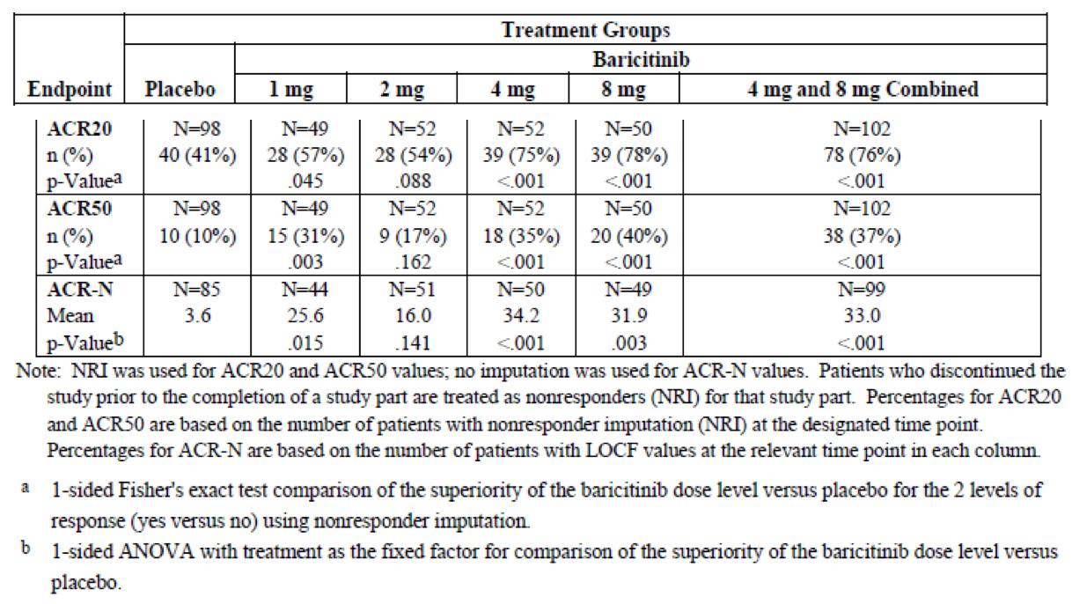
After 12 weeks in Study JADA, all patients initially assigned to PBO or BAR 1 mg daily were re-randomised to either BAR 2 mg twice daily or BAR 4 mg once daily for an additional 12 weeks, while all other patients remained on their assigned dose through to 24 weeks (end of Part B). No consistent efficacy response differences were found between those re-randomised to BAR 2 mg twice daily and BAR 4 mg once daily. In general, by Week 24, mean values for the groups that were re-randomised at Week 12 were comparable to the mean values achieved by the original BAR 4 mg and 8 mg once daily treatment groups at Weeks 12 and 24. For example, the ACR20 response rates were 81% and 80% for the BAR 4 mg and 8 mg groups, respectively, at Week 24.
In the open-label extension phases of Study JADA (Parts C and D), the proportions of patients achieving ACR20, ACR50, or ACR70 response at Week 24 (double-blind period) were maintained through to week 76 (Part C) and Week 128 (Part D).

Study JADN

Study design, objectives, locations, dates and treatments
Study JADN was a randomised, double-blind, PBO-controlled, dose ranging, parallel group Phase II trial in 145 Japanese subjects with active RA who had an inadequate response to MTX 6 to 16 mg/week for at least 12 weeks (stable dose for at least 8 weeks prior to baseline visit). Screening evaluations were performed within 28 days of randomisation followed by a study treatment period of 12 weeks (Part A) followed by an optional 52 week single blind extension phase (Part B; Weeks 12 to 64). A final study visit was performed 4 weeks following the final dose of study medication. In Part A, subjects were randomly assigned in a ratio of 1:1:1:1:2 to receive either BAR 1 mg, 2 mg, 4 mg or 8 mg therapy or PBO tablets once daily (without regard to food intake) with continued stable doses of background MTX (6 to 16 mg/week). For Part B, all subjects received either BAR 4 mg or 8 mg once daily. Patients who received PBO or BAR 1 mg or 2 mg during Part A were re-randomised 1:1 into Part B to receive either BAR 4 mg or 8 mg once daily. Patients assigned to BAR 4 mg or 8 mg in Part A continued to receive the same dose of BAR when they entered Part B. However, following a protocol amendment in September 2012 (10 months after the first patient was enrolled), all patients assigned to BAR 8 mg daily in Part B were switched to BAR 4 mg/day.
During Part A of Study JADN, subjects were to be maintained on pre-existing, stable doses (for at least 4-6 weeks prior to baseline) of NSAIDs and low dose CS (up to 10 mg/day of prednisone or equivalent). Low dose weekly MTX and SSZ up to 3 g/day could be continued in Study JADN. All other DMARD use, including biologic therapies, was prohibited during Part A of the trial. Dose adjustments of conventional DMARD and oral CS use (new, and dose adjustments up and down) were permitted during Part B.
Clinical efficacy evaluations were scheduled at 2, 4, 8 and 12 weeks of therapy in Part A. In Part B, efficacy assessments were performed at Week 14, 16, 28, 40, 52 and 64.
The primary objective of Study JADN was to demonstrate that BAR 4 mg and 8 mg once daily when added to MTX was effective for the reduction of symptoms and signs of active RA at 12 weeks in Japanese subjects. Study JADN was conducted at 25 investigator sites in Japan. The first patient was enrolled in November 2011 and the last patient completed follow-up in December 2013.

Eligibility criteria
To be eligible for inclusion, patients had to be 20 to 75 years of age with a diagnosis of RA (based on the 2010 ACR/EULAR classification criteria). Subjects had to have active disease at Baseline as evidenced by ≥ 6 tender and swollen joints (based on the 66/68 joint count assessment) and have at least 1 raised serum inflammatory reading (ESR > 28 mm/hr and/or CRP > 5 mg/L) despite treatment with MTX 6 to 16 mg/week for at least 12 weeks (including a stable dose for at least 8 weeks prior to baseline).
Patients with evidence of active vasculitis, Felty’s syndrome or fibromyalgia at screening were to be excluded. Subjects with a positive QuantiFERON-TB Gold test at Baseline were excluded. Subjects with any significant laboratory abnormalities at screening were also excluded such as total white blood cell count < 2.5 x 10⁹/L, neutrophil cell count < 1.2 x 10⁹/L, lymphocyte count < 0.75 x 10⁹/L, platelet count < 100 x 10⁹/L and haemoglobin < 10.0 g/dL.

Efficacy variables and statistical considerations
All efficacy analyses in Parts A and B were conducted using the FAS (Full Analysis Set) population, which was defined as all randomised subjects who took at least 1 dose of study medication by their assigned treatment.
The primary efficacy endpoint of Study JADN was the proportion of patients in the combined BAR 4 mg and 8 mg treatment population versus the PBO group who achieved ACR20 response at Week 12 (using a 1-sided 0.05 level test from a logistic regression model). For missing data at or prior to Week 12, NRI was used in the analysis.
The key secondary objective of Study JADN was to characterise the dose response relationship of BAR upon ACR20 and ACR50 response rates at 12 weeks. A Bayesian dose response model was used to estimate and compare the ACR20 and ACR50 response rates for each BAR dose group to PBO, using a dynamic linear model to estimate the dose response curve. Dose response was also investigated using the Cochrane Armitage trend test for ACR20 and ACR50 response at 12 weeks. Assessment of all other key secondary efficacy endpoints such as the rates of DAS28 (< 2.6) and SDAI remission (≤ 3.3) were conducted using a 1-sided Fisher Exact test or an ANCOVA model.
Descriptive statistics were used for analysing the efficacy endpoints of Part B such as the rates of ACR response up to week 64. A sample size of 24 patients in each BAR treatment group and 48 subjects in the PBO arm was estimated to provide 80% power to detect a 25% difference between the combined BAR 4 mg and 8 mg group versus PBO (assuming an ACR20 response rate of 30% in the control arm) for the primary efficacy analysis.

Participant flow and significant protocol deviations
A total of 199 subjects were screened for involvement in Study JADN and 54 patients (27.1%) failed screening. Of the screen failure cases, 53 subjects did not meet the entry criteria. A total of 145 patients were randomly assigned to treatment in Part A including 49 subjects to the PBO group and 24 patients to each of the BAR treatment arms (1 mg, 2 mg, 4 mg and 8 mg once daily). Up to Week 12, 97.9% (142/145) of subjects completed treatment. The 3 subjects who prematurely discontinued between baseline and Week 12 were single cases in the PBO (ceased due to AE), BAR 2 mg (withdrew due to AE) and BAR 4 mg groups (withdrew consent).
Following completion of Part A, 142 patients were re-randomised to either BAR 4 mg or 8 mg once daily (71 subjects in each group) in Part B. Of the 71 patients re-randomised to BAR 4 mg in Part B, 24 received PBO during Part A, 12 received BAR 1 mg, 12 received BAR 2 mg and 23 received BAR 4 mg. Of the 71 patients re-randomised to BAR 8 mg in Part B, 24 received PBO during Part A, 11 received BAR 1 mg, 12 received BAR 2 mg and 24 received BAR 8 mg. The majority of subjects (75.2%; 109/145) completed Parts A and B of the study (55 in the BAR 4 mg group and 54 subjects in the BAR 8 mg arm). As per the significant protocol amendment, all subjects receiving BAR 8 mg/day in Part B were subsequently switched to 4 mg/day therapy, most of which occurred between Weeks 16 and 32 of Part B. A total of 109 patients (75.2% of 145) completed Parts A and B of Study JADN. Of the 32 patients who discontinued prior to week 64, 27 discontinued due to an AE and 5 withdrew consent. One additional subject randomised to BAR 4 mg/day in Part B withdrew consent in the crossover period between Parts A and B.
A total of 6 patients (2 each in the BAR 2 mg and 8 mg treatment groups, 1 in the BAR 1 mg arm and 1 in the PBO group) recorded major protocol violations in Part A, and 4 patients (3 in the BAR 8 mg arm and 1 in the BAR 4 mg group) recorded major protocol violations in Part B. The most common type of significant protocol deviation in both parts was receipt of prohibited concomitant therapy. However, because the protocol deviations were small in number they are not likely to have impacted the overall conclusions of the trial.

Baseline patient data
The treatment groups in Part A were balanced with respect to demographic features. The randomised population of 145 patients had a mean age of 53.6 years (median of 55.0 years; range: 23 to 75 years). More than one sixth of all patients (17.2%; 25/145) were aged 65 years or older at Baseline in Study JADN. The majority of patients were female (81.4%; 118/145). Almost one fifth of enrolled subjects (18.6%; 27/145) were current smokers and 29.7% (43/145) had past tobacco use. Forty-one percent of patients (59/145) had normal renal function at Baseline (CrCL ≥ 90 mL/min), 53.8% (78/145) had mild renal impairment (CrCL ≥ 60 mL/min to < 90 mL/min) and 5.5% of patients (8/145) had moderate renal impairment (CrCL ≥ 30 mL/min to < 60 mL/min) at Baseline.
The treatment groups were also similar with respect to baseline RA disease characteristics. The mean duration of RA for all subjects was 5.67 years (median 4.84 years, range: 0.5-14.9 years). The majority of patients (80.7%; 118/145) were seropositive for RA at Baseline (using anti-CCP antibody testing). In terms of RA disease activity at Baseline, the mean numbers of tender (ranging from 10.2 to 15.5) and swollen joints (ranging from 8.6 to 11.1) were similar across the treatment groups. The treatment groups recorded mean DAS28-CRP scores that were moderately elevated at Baseline (4.60 to 4.96) and the mean HAQ-DI scores ranged from 0.86 to 1.01 in all treatment groups except the BAR 8 mg arm which had a significantly lower mean HAQ-DI score of 0.63. The mean CRP values for each treatment group ranged from 8.8 to 12.5 mg/L. Overall, the measures of baseline disease activity recorded in Study JADN are consistent with moderately active RA.
All subjects were taking MTX at Baseline in Study JADN at a mean weekly dose of 8.7 mg (median of 8 mg/week; range of 6 to 16 mg/week). Oral CS use at Baseline was recorded in 58.6% of patients (85/145) at a mean weekly dose of 30 mg. With regards to prior DMARD exposure, 3.4% of subjects (5/145) had been exposed to SSZ and no subjects had previously received HCQ.
The baseline characteristics of the treatment population which enrolled in Part B of Study JADN is highly similar to that reported for Part A. Most BAR treated patients (77.1%; 74/96) did not miss any dose of study medication and 21% only missed 1-3 doses of study drug during Part A. During Part B, patients were nearly 100% compliant (99.5%) with study medication. There were no notable differences in compliance rates during Parts A and B.

Efficacy results
At Week 12, the proportion of subjects in the combined BAR 4 mg and 8 mg population who recorded an ACR20 response was 77.1% (37/48) compared with 30.6% (15/49) in the control arm. The result for the primary efficacy endpoint was statistically significant (p < 0.001).
At Week 12, the ACR20 response rates in all BAR treatment groups were statistically superior to PBO (ranging from 67-88% for BAR versus 31% for PBO); refer to Table 12. In addition, at Week 12, the BAR 2 mg, 4 mg and 8 mg doses demonstrated similar numerical improvements compared to PBO for the percentages of responding subjects achieving several other efficacy outcomes of interest such as the rates of ACR50 response, DAS28-CRP and SDAI remission, and MCID in HAQ-DI score.
In addition, the ACR20 response rates at Week 12 revealed a dose dependent relationship for BAR according to both the Bayesian model fitted and Cochran-Armitage dose response analyses. The Bayesian dose-response model analysis determined the posterior probability of each BAR dose’s true response rate exceeding the PBO group’s true response rate, with an 85% or greater probability defined a priori as representing evidence for a significant treatment difference. The Bayesian data indicated a dose response across all BAR treatment groups with an apparent plateau in response in the BAR 2 mg, 4 mg and 8 mg groups. The data also indicated ≥ 95% probability that the BAR 2 mg, 4 mg and 8 mg doses had ACR20 response rates (at Week 12) that exceeded the PBO response rate by > 15%. Dose response analysis based on PK/PD modelling indicated that the BAR 4 mg once daily dose reached the plateau area of the dose response curve for both the ACR response and DAS28 endpoints.

Table 12: Proportion of patients achieving efficacy response at Week 12 in Study JADN
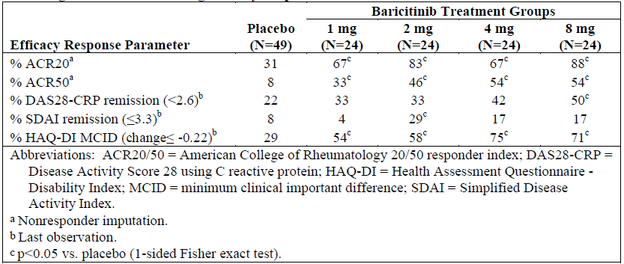
At 64 weeks of follow-up (or last observation in Part B), the measures of clinical response (changes from Baseline and the proportion of responding subjects) were well maintained for both doses of BAR (4 mg and 8 mg once daily) with no significant overall differences between the 2 dose regimens. The rates of ACR20/50/70 (using NRI) in the combined BAR 4 mg group at 64 weeks were 66% (47/71), 54% (38/71) and 37% (26/71), respectively. The rates of ACR20/50/70 (using NRI) in the combined BAR 8 mg group at last observation in Part B were 73% (51/70), 61% (43/70) and 34% (24/70), respectively. At the last observation in Part B of Study JADN, the rates of DAS28-CRP remission were 66% in each BAR treatment group and the rates of SDAI remission were 39% in each of the BAR treatment arm. For both doses of BAR, the maximal rates of ACR20/50/70 response were reached around Week 16, and then plateaued (that is, maintained) at all time points thereafter up to week 64. Patients receiving BAR 4 mg/day in Part B had received various preceding treatments in part B including PBO and BAR 1 mg, 2 mg and 4 mg daily. At 64 weeks, the rates of ACR20/50/70 response in the BAR 4 mg cohort were similar regardless of pre-existing treatment option in Part A apart from lower response rates (for example, up to 20% lower for ACR20 response) in those who switched from PBO to BAR 4 mg/day.

Study JADY (Long term extension trial)

Study design, objectives, locations, dates and treatments
Study JADY was a long-term extension (LTE) trial, which enrolled patients who had completed participation in the Phase II Study JADA or any of the 4 Phase III Studies JADZ, JADV, JADX or JADW. Long term safety and tolerability is the primary objective of Study JADY, but a limited number of efficacy analyses have also been reported in an interim report provided in this submission. In Study JADY, patients remained blinded to their treatment randomisation in the original trial. This allowed assessment of efficacy upon switching from active control (adalimumab, MTX monotherapy or BAR plus MTX) to BAR in the LTE trial.
Study JADY is being conducted at 398 investigator sites in 37 countries. The first patient was enrolled into Study JADY in June 2013 and the date of data cut-off for the interim report is 10 August 2015. This ongoing study consists of a screening period that occurred during the last visit of the originating study, an active treatment phase of up to 48 months and a post-treatment, follow-up period of 28 days after the last dose of BAR. Assessments for clinical efficacy outcomes in Study JADY are scheduled every 3 months in Study JADY.
In Study JADV, patients are able to continue receiving background, non-investigational, open-label treatment with conventional DMARD, NSAIDs, low dose CS and analgesics that they were receiving at the completion of the originating trial. However, patients with an estimated CrCL of < 60 mL/min were only eligible for dosing with BAR 2 mg once daily in Study JADV. Because the originating studies were of different durations, subjects entered into Study JADY with differing prior exposure to BAR: 6 months if enrolled from Studies JADX and JADW, 52 weeks if completing Studies JADZ (monotherapy trial) and JADV, and up to 32 months of treatment with BAR 4 mg/day if recruited from Study JADA.
At the start of Study JADY, all subjects recruited from Studies JADZ, JADV and JADA received BAR 4 mg once daily therapy. For subjects enrolled from Studies JADX and JADW, they continued to receive the same BAR treatment in Study JADY (either BAR 2 mg or 4 mg daily) that they were receiving at the end of the originating study.
An additional objective of Study JADY was to evaluate the effectiveness of a reduced dose of BAR (that is, a step-down from 4 mg once daily to 2 mg once daily) in the subgroup of patients who achieved a sustained (at least 3 months in Study JADY) low disease activity level (defined as CDAI score ≤ 10 for patients originating in Studies JADV, JADX and JADW) or a sustained remission (CDAI score ≤ 2.8 for patients originating in Study JADZ). Patients achieving these disease activity criteria were randomised 1:1 to continue receiving BAR 4 mg once daily or BAR 2 mg once daily dose in a blinded fashion. Patients eligible for randomisation to step-down must have received at least 15 months of treatment with BAR 4 mg once daily, including participation time in the originating study and had not received rescue therapy in the originating study or in Study JADY. Patients from Study JADA were not eligible for participation in the step-down dosing program. If a patient experienced worsening of disease symptoms following BAR step-down, a change in analgesic or NSAID dose, or the addition of analgesics or NSAID was considered to manage transient flares. If the patient failed to maintain low disease activity or clinical remission, they could return to BAR 4 mg once daily therapy and/or receive an alteration in conventional DMARD or CS therapy. Patients were eligible for step-down dosing only once in Study JADY.

Efficacy variables and statistical considerations
The main efficacy outcomes collected in Study JADY were the mean change from Baseline over time (up to Week 48 of additional BAR treatment) in CDAI and SDAI scores, as well the rates of categorical clinical response over time for CDAI, SDAI, ACR20, ACR50 and ACR70.
For the step down treatment analysis, the mean change from Baseline in CDAI 12 weeks after re-randomisation was the primary efficacy outcome in this treatment subgroup. Supporting efficacy measures in the step down treatment population was the proportion of subjects maintaining low disease activity (CDAI ≤ 10) and remission (CDAI ≤ 2.8) 12 weeks after a potential treatment step down, as well as the mean change from Baseline to 12 weeks in SDAI, DAS28 score and components of the ACR criteria.
Efficacy outcomes were assessed using the mITT population. For categorical outcomes measures, NRI without considering the need for rescue therapy was used in the efficacy analyses. For continuous outcome variables, LOCF without considering the need for rescue or step down therapy in Study JADY was applied to the dataset. It was estimated that 80% of patients completing the preceding studies would enrol in Study JADY and as such the planned enrolment for Study JADY was 2400 to 3500 patients.

Participant flow
Of the patients who completed 1 of the originating studies, the majority (89.3%) had chosen to enrol into this LTE trial. At the data cut-off date of 10 August 2015, a total of 2539 adult subjects with RA had enrolled in Study JADY, but no patient had yet completed 48 months of follow-up in Study JADY. At the data cut-off date, 9.8% of subjects (249/2539) had prematurely discontinued from Study JADY. Among all patients receiving BAR 2 mg/day at the beginning of Study JADY (that is, patients randomised to 2 mg therapy and not rescued in Studies JADX and JADW), 49% of subjects (145/297) had received rescue therapy in Study JADY. Among all patients receiving BAR 4 mg/day at the beginning of Study JADY, and who were not stepped down to BAR 2 mg/day during the study, 28% (551/1998) received rescue therapy in Study JADY. Among patients who were re-randomised in the step-down program of Study JADY, rescue rates were 4% (9/247) in those who continued to receive BAR 4 mg/day, and 9% (23/244) in subjects who were stepped down to BAR 2 mg/day. Figure 7 provides a summary of patient disposition in Study JADY as of the data cut-off date.
Figure 7: Patient disposition for all enrolled patients in Study JADY
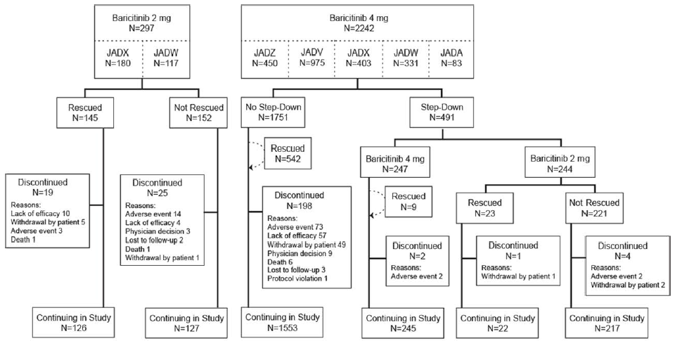

Baseline characteristics
The mITT population of 2534 subjects had a mean age of 53.4 years (median of 54.5 years; range: 19 to 87 years) with almost one fifth of all subjects (18.8%; 476/2534) being 65 years or older at Baseline in Study JADY. The majority of patients were female (78.3%; 1983/2534) and white (69.4%; 1754/2534). By geographic region, enrolled subjects came from the Europe (25.0%; 633/2534), Central and South America (22.8%; 579/2534), USA and Canada (20.9%; 529/2534), Japan (12.4%; 313/2534), Asia excluding Japan (6.7%; 171/2534) and the rest of the world (12.2%; 309/2534). The subgroup of subjects involved in the step down experiment had similar demographic characteristics to the overall mITT population and no significant differences between the 2 BAR dose groups were recorded.

Efficacy results
In the long-term maintenance treatment population, efficacy analyses in Study JADY were described by treatment group from each originating study for subjects who had not received rescue therapy in the forerunner trial. Among subjects who were randomised to BAR 2 mg or 4 mg/day in any originating study, effectiveness (as determined by mean changes in CDAI and SDAI, as well as the rates of CDAI and SDAI categorical response plus ACR20/50/70 response rates) was sustained over 48 weeks of additional treatment in Study JADY. Table 13 provides a summary of the clinical response data recorded at 48 weeks of treatment follow-up in Study JADY and compares the outcome with results observed at Week 12 in the originating trial.

Table 13: Efficacy responses at Week 12 of originating study and after 48 Weeks in Study JADY
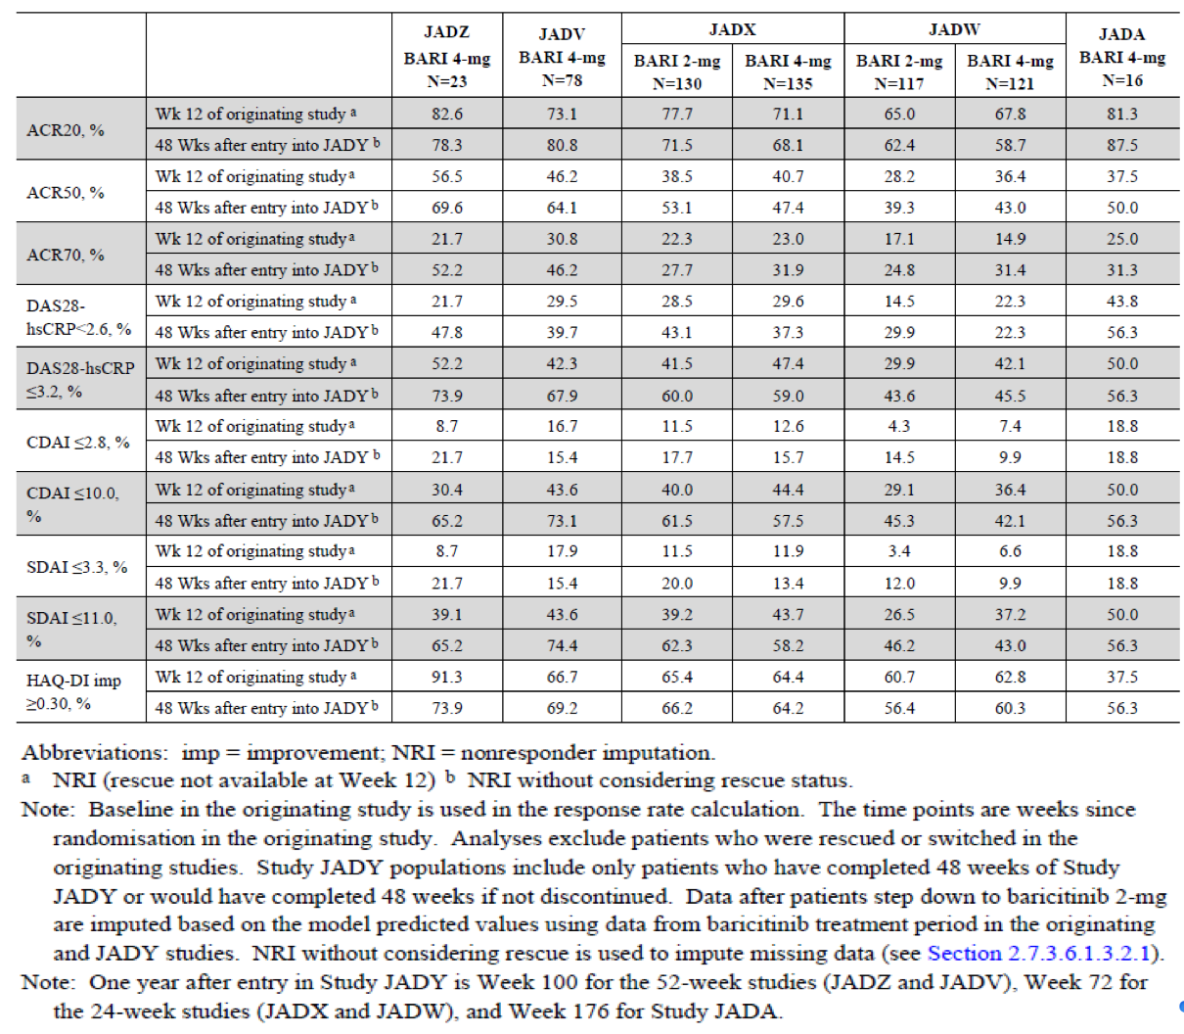
For patients who had been randomised to a different treatment in any of the originator studies, switching to BAR (with or without concurrent MTX) produced clinical efficacy responses over 48 weeks in Study JADY comparable to subjects who had received BAR 2 mg or 4 mg/day from original randomisation.
For the treatment step down subgroup analysis, subjects who switched from BAR 4 mg/day to 2 mg/day showed a small but statistically significant increase in RA disease activity at the treatment switch assessment 12 weeks later. The mean change from Baseline to 12 weeks in the CDAI was approximately 2 units for down titrated subjects (BAR 2 mg/day) versus 0.6 units for patients maintaining BAR 4 mg/day (baseline mean CDAI score of 3.8 to 3.9 for both BAR subgroups). However, the majority of subjects in this subgroup analysis maintained the state of low disease activity or remission at 12 weeks of follow-up; refer to Table 14. For patients down titrated to BAR 2 mg/day, the proportion of subjects with CDAI ≤ 10 and CDAI ≤ 2.8 at 12 weeks was 84.2% and 37.0%, respectively. For patients who continued with BAR 4 mg/day therapy, the proportion of subjects with CDAI ≤ 10 and CDAI ≤ 2.8 at 12 weeks was numerically higher at 92.5% and 38.8%, respectively. The percentage difference between BAR 2 mg/day and 4 mg/day therapy for the proportion of subjects with CDAI ≤ 10 response at 12 weeks following re-randomisation was statistically significant (p = 0.030), but this was not observed for the treatment comparison for the proportion of CDAI ≤ 2.8 responders at 12 weeks (p = 0.810).

Table 14: CDAI response rates at Week 12 after step down, re-randomisation in Study JADY
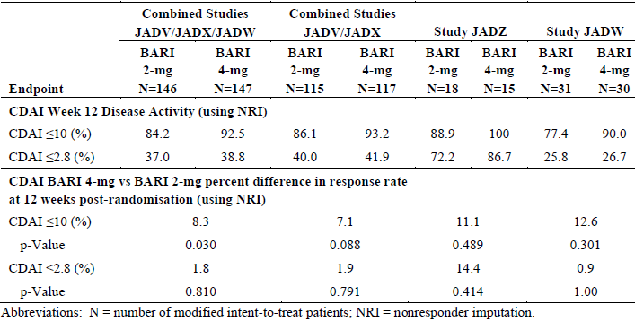
Several secondary efficacy outcomes such as the mean DAS28 (ESR or CRP) score, mean SDAI score and components of the ACR clinical assessment criteria (for example, mean tender and swollen joint counts) also showed small but statistically significant differences in favour of continued BAR 4 mg/day therapy at 12 weeks versus the step down treatment approach of BAR 2 mg/day.

Evaluator commentary regarding other efficacy studies
Three Phase II studies (Studies JADC, JADA and JADN) have provided dose response data across a broad range of BAR doses (from 1 mg/day to 10 mg/day; including an analysis of 2 mg twice daily dosing) and showed that BAR 4 mg once daily is the lowest, most clinically effective posology in a diverse profile of adult patients with active RA. All of the Phase II trials assessed the proportion of patients who achieved an ACR20 response at 12 weeks as the primary clinical efficacy endpoint. Study JADA achieved its primary efficacy objective in showing that the combined BAR 4 mg and 8 mg group had an ACR20 response rate at 12 weeks that was statistically better than PBO (76.5% versus 40.8%; p < 0.001). In addition, the Bayesian dose response model generated by data from Study JADA showed BAR 4 mg and 8 mg once daily produced similar clinical responses and that the BAR 1 mg and 2 mg daily doses were clinically superior to PBO as the minimum effective doses. Study JADN (Japanese subjects only) also met its primary clinical efficacy objective in demonstrating that the combined BAR 4 mg and 8 mg group had an ACR20 response rate at 12 weeks that was statistically better than PBO (77.1% versus 30.6%; p < 0.001). The Bayesian dose response mode from Study JADN showed a dose response relationship for BAR across the doses of 2 mg, 4 mg and 8 mg once daily. Study JADC did not achieve its primary efficacy objective, which was selected to show a dose dependent increase in efficacy for BAR. This trial showed that the BAR 4 mg, 7 mg and 10 mg once daily doses were clinically equivalent, with ACR20 response rates at week ranging from 52-59% (versus 32% in the PBO group).
Study JADY is an ongoing (as of 10 August 2015) LTE trial that has already enrolled 2534 subjects who participated in one of 5 preceding studies. It was included in this submission to support the persistence of clinical efficacy in treating RA with continued BAR. In the Study JADY, various endpoints such as the rates of ACR, DAS28 and SDAI response, demonstrated that for patients who had received 24 to 128 weeks of BAR treatment in an originating study, clinical effectiveness was sustained with an additional 48 weeks of treatment. In Study JADY, approximately 70% of subjects who received up to 100 weeks of BAR 4 mg/day were consistently achieving an ACR20 response, just less than 20% were demonstrating SDAI remission and two thirds of subjects showed a persistence of 0.3 unit mean improvement from Baseline in HAQ-DI score, which is a measure of physical function. Patients who had received other active study therapies (including MTX, adalimumab or BAR + MTX) in an originating study and switched to BAR upon entering Study JADY, did not experience loss of RA control over 48 weeks of BAR treatment in Study JADY. Among the subset of patients who had achieved satisfactory and sustained RA control after at least 15 months of treatment with BAR 4 mg/day and who dose reduced to 2 mg/day in a randomised, double-blind manner statistically significant increases in RA activity at a subsequent 12 week evaluation were observed compared to subjects who continued BAR 4 mg/day in Study JADY. However, the majority of subjects in both BAR treatment groups in the step down analysis maintained significant levels clinical response (low disease activity or clinical remission) that led to their re-randomisation. In summary, Study JADY demonstrated that BAR 4 mg once daily demonstrated maintenance of clinical efficacy in patients who were responding and tolerating the medicine (that is, significant patient selection bias).
Collectively, the 3 Phase II studies and the LTE trial (JADY) support the sponsor proposed posology for BAR in the PI. The recommended dose of BAR is 4 mg once daily for a broad range of adult patients with active RA as this has the highest likelihood of achieving ideal treatment targets (that is, high levels of clinical response in a timely manner). A dose of 2 mg daily is also proposed for a subset of patients. This dosing strategy is supported by the Phase II studies and the step down investigation undertaken in Study JADY.

Analyses performed across trials: pooled and meta-analyses
The submission does not contain a pooled analysis or meta-analysis of the efficacy data, but the sponsor has provided an integrated subgroup analysis of the conventional DMARD inadequate response study population with respect to efficacy outcomes across the Phase II/III studies. For the subgroup analysis, key outcome measures at their primary time point (12 to 24 weeks) reflecting improvements in the symptoms and signs of RA (ACR20 and ACR50 response), disease activity state (DAS28-CRP ≤ 3.2), physical function (change from Baseline in HAQ-DI) and radiographic progression of structural joint damage (change in mTSS) were selected for evaluation. The following baseline characteristics were examined: gender, age, weight, BMI, race, ethnicity, geographic region, renal function, time since diagnosis of RA, prior conventional DMARD therapy, RF/CCP autoantibody status, radiographic progression of structural joint damage, disease activity, concomitant CS use and concomitant conventional DMARD therapy. The integrated analysis had 2 data sets. Set 1 was used to evaluate potential subgroup interactions for BAR 4 mg once daily versus PBO (Studies JADV, JADX, JADN, JADA, and JADC), and Set 2 was used to evaluate potential subgroup interactions for BAR 2 mg once daily versus PBO (Studies JADA, JADN and JADX). Consistent with results in the individual studies, the point estimate for each tested efficacy endpoint was consistently in favour of BAR 2 or 4 mg once daily versus PBO across all patient subgroups. There was no evidence indicating an absent or unfavourable treatment effect with BAR 2 or 4 mg/daily versus PBO in any subgroup.

Evaluator’s conclusions on clinical efficacy
In support of the registration of BAR for the treatment of active RA, this submission contains 4 completed Phase III Studies JADZ, JADY, JADX and JADW, all of which were nominated as pivotal by the sponsor. The submission also included efficacy data from 3 completed Phase II Studies JADC, JADA and JADN and 1 ongoing, LTE trial (Study JADY) for supporting data purposes. The overall clinical development program for BAR provides a dataset that appropriately reflects the clinical RA population in Australia. The Phase II/III studies enrolled a spectrum of patients with active RA, including patients who have never received prior DMARD therapy (Study JADZ), patients who have an inadequate response to MTX (the most commonly used treatment for RA – Study JADV) and patients who are refractory to treatment with conventional DMARDs (Study JADX) and/or biologic therapies (Study JADW). Based upon the evaluation of efficacy data from the completed Phase III clinical studies through to the primary time point (24 weeks in JADZ and 12 weeks in Studies JADV, JADX, and JADW), treatment with BAR 4 mg once daily in adult patients with moderately to severely active RA yielded consistent and robust results for statistically and clinically improving the signs and symptoms of the disease as well as improving physical function. Compared to all comparators (PBO, MTX and adalimumab), statistically significant and durable improvements were observed from the initial weeks of treatment across a diverse range of efficacy measures for BAR, including the primary endpoint of ACR20 response. Consistent improvements with BAR 4 mg/day were also seen across composite scores of disease activity such as the CDAI and DAS28-CRP response. Many subjects achieved low disease activity or clinical remission which is highly desired outcome of treatment supported by the literature. BAR 4 mg once daily also produced rapid and sustained improvements in several patient reported outcomes of relevance such as the duration of morning joint stiffness and its severity, severity of worst tiredness and joint pain.
All of the Phase III studies were randomised, double-blinded and parallel group controlled in design and enrolled adult patients with a confirmed diagnosis of RA. Subjects were required to have moderate-severe disease activity at Baseline with ≥ 6 tender and swollen joints and have raised serum inflammatory markers (CRP x 1 to 1.2 ULN) and/or joint erosions or positive autoantibody tests at Baseline. The baseline demographic and disease related characteristics of patients in the Phase III trials are diverse but similar to those in the anticipated Australian patient cohort, and therefore generalisation of these results to the Australian context is expected. The majority of patients were female, of Caucasian ethnicity, and within the expected age range of 45 to 65 years. However, there are some caveats to the generalisability of the treatment population. For example, all of the studies excluded patients who were at a significant risk of infection or malignancy, or who had various abnormal laboratory results at Baseline (for example, abnormal haematology or liver function tests).
The clinical efficacy data available up to 24 months in Study JADY indicated that the majority of responding patients appear to maintain their treatment related benefit with continued BAR treatment. In addition, for PBO patients who switched to BAR at 3 to 6 months, the rates of ACR response observed 12 weeks later were similar to those achieved in the originally treated BAR cohort.

Dose recommendations
The efficacy of BAR 2 mg once daily was also assessed in 2 of the Phase III Studies JADX and JADW and demonstrated that when used in combination with MTX, BAR 2 mg once daily produces improvement in the signs and symptoms of RA (as measured by ACR criteria) and physical function (as measured by HAQ-DI) compared to PBO. However, the BAR 4 mg dose consistently provided more rapid onset and a numerically higher response compared to PBO than the BAR 2 mg dose. Treatment with BAR 2 mg/day resulted in lower clinical response rates than treatment with BAR 4 mg/day.
BAR was administered as 4 mg/day monotherapy in Study JADZ and the results indicated that it was superior to MTX monotherapy for clinical outcomes in DMARD naïve patients with early disease. In this trial, when BAR was combined with MTX, only a modest additional clinical benefit was observed for less structural joint damage, but not with respect to symptoms and function.

Radiographic claim
Three of the Phase III studies (JADZ, JADV and JADX) were designed to evaluate the claim of inhibition of structural damage. In all 3 studies, the primary X-ray endpoint was the LS mean change from Baseline to 24 weeks in mTSS. In 2 of the Phase III trials (JADZ and JADV), plain X-rays were also evaluated at 52 weeks of treatment as a supporting analysis. In Study JADZ (DMARD naïve, early disease population), a statistically lower increase in the LS mean mTSS was observed at Week 24 for BAR + MTX (+0.29 sharp unit increase from Baseline) versus MTX monotherapy (+0.61 sharp unit increase), but this was not demonstrated for BAR monotherapy (+0.39 sharp unit increase) versus MTX alone. At 52 weeks in Study JADZ, the combination treatment group showed a statistically lower LS mean increase from Baseline in mTSS (+0.40 sharp units) compared with MTX alone therapy (+1.02 sharp units; p = 0.004). The BAR monotherapy group recorded a +0.80 sharp unit increase from Baseline to Week 52, which was not statistically significant versus MTX monotherapy (p = 0.324). A supporting analysis of the main X-ray endpoint was the proportion of subjects in each treatment group who did not show an increase from Baseline in sharp units over time. At 52 weeks in Study JADZ, the combination treatment group of BAR + MTX showed a statistically lower proportion of subjects with no X-ray progression (79.9%; 159/215) compared with MTX alone therapy (66.1% (127/192); p = 0.002). The BAR monotherapy group recorded 68.8% of subjects (106/154) with no X-ray progression at Week 52, which was not statistically greater than MTX monotherapy (p = 0.165).
The pre-specified main X-ray outcome of interest in Study JADV was the comparison between the BAR and PBO treatment groups at Week 24, and supportive analyses included the comparison between BAR and adalimumab therapies at Weeks 24 and 52. Compared to PBO (+0.84 sharp unit increase from Baseline mean of 44.64), a statistically significant lower increase in mTSS progression (meaning less structural X-ray progression) was observed at Week 24 for BAR (+0.29 sharp unit increase from Baseline mean of 42.46; p = 0.001). Compared to BAR, the adalimumab treatment group showed a numerically similar increase from Baseline to Week 24 (+0.33 sharp unit increase from Baseline mean of 44.35). At 52 weeks, there was a continued small increase in the LS mean mTSS for both BAR (+0.71 sharp unit) and adalimumab (+0.60 sharp unit), which was not statistically different in the pair-wise active treatment comparison (p = 0.69). In Study JADX, a statistically lower rate of structural progression in the LS mean change from Baseline in mTSS was observed at Week 24 for the BAR 4 mg group (+0.16 sharp unit increase from Baseline) versus PBO (+0.58 sharp unit increase), but the pair-wise comparison between PBO and BAR 2 mg/day (+0.30 sharp unit increase from Baseline) for this outcome did not reach statistical significance. Compared to PBO (73.2%; 142/192), a larger proportion of patients had no progression in mTSS (change from Baseline ≤ 0) at Week 24 for the BAR 4 mg group (80.5%; 161/200), but the difference was not statistically significant. The rate of no X-ray progression at 24 weeks in the BAR 2 mg arm was 71.3% (149/209), which was numerically lower than PBO.
In conclusion, the limited X-ray data thus far with BAR 4 mg/day (alone or in combination with MTX or other conventional DMARDs) does not demonstrate a consistent and robust benefit in terms of inhibition of joint structural progression to support this sub-claim in the proposed treatment indication for BAR. In addition, the TGA adopted EU regulatory guideline (CPMP/EWP/556/95 rev 1/Final) states that to make a claim of radiographic benefit in RA, X-rays should be taken at fixed and pre-defined time points at least 1 year apart for a minimum of 2 years, so it is premature to consider a sub-claim of X-ray benefit with BAR using the current submission dataset. An explanation for why BAR did not convincingly show X-ray benefit across all treatment populations is that the predicted mean rates of X-ray progression for subjects receiving background MTX would be expected to be 2.6 to 2.8 sharp units per year (based on published data in MTX-inadequate response populations) and in all of the Phase III studies, the control group progression rates were < 1 sharp unit per year and the percentage of subjects with X-ray progression (change in mTSS at 1 year of > 0 unit) at 52 weeks was low at ≤ 30%. Because the magnitude of progression in the control groups were substantially less than expected, the ability to demonstrate treatment related differences (BAR versus control) was limited. One of the strengths of the radiographic dataset is the inclusion of an active comparator arm (MTX and/or adalimumab) over an extended period of follow-up, which has assisted in determining the potential magnitude of X-ray benefit.

Clinical safety

Studies providing evaluable safety data

Pivotal studies that assessed safety as the sole primary outcome
Not applicable as none of the studies in the BAR clinical development program assessed safety as the sole primary outcome.

Pivotal and/or main efficacy studies
The safety and tolerability of BAR in patients with moderately to severely active RA has been principally evaluated in 4 completed Phase III studies (JADZ, JADV, JADX and JADW) and 1 ongoing, LTE trial (Study JADY). Each of the completed Phase III studies investigated a diverse range of RA patient populations, spanning the treatment continuum from DMARD naive patients (Study JADZ), to patients with an inadequate response to conventional DMARD (Studies JADV and JADX) and patients with an inadequate response to biologic DMARD (Study JADW). In settings where study drug was added to stable background conventional DMARD therapy, the safety of BAR was compared to PBO (Studies JADV, JADX, and JADW) and to adalimumab (Study JADV). In the setting where patients had no prior or background conventional DMARD therapy (Study JADZ), BAR was used alone or in combination with MTX, and was compared to MTX monotherapy. The BAR 4 mg once daily dose was included in all Phase III studies and the 2 mg once daily dose was only included in 2 Phase III studies that incorporated PBO control.
The following safety data was collected in the 4 pivotal Phase III studies (as well as the LTE Study JADY):
- Adverse Events (AEs) in general were assessed by completion of the AE Case Report Form (CRF) and physical examination performed every 1 to 4 weeks until Week 24, and then every 8 to 12 weeks thereafter (or upon early withdrawal).
- AEs of particular interest, including infections (overall, serious and opportunistic, including tuberculosis and herpes zoster infection), gastrointestinal perforation, malignancy and Major Adverse Cardiovascular Events (MACE) were assessed by CRF and physical examination as per the schedule for general AE evaluation.
- Laboratory tests, including haematology, clinical chemistry, urinalysis and urine pregnancy testing (in female subjects) were performed at Baseline, every 1-4 weeks until Week 24 and then every 8-12 weeks thereafter. A fasting lipid profile was collected at Baseline and Weeks 12, 24 and 52. Haematological abnormalities (including anaemia, neutropaenia, lymphopaenia and thrombocytosis), changes in lipid parameters, impairment of renal function, increased blood creatine phosphokinase (CPK) levels and abnormalities of liver enzymes (particularly, elevated serum transaminases) were laboratory AEs of special interest with BAR.
- Screening tests for tuberculosis (Chest X-ray and QuantiFERON Gold testing; or PPD skin testing in countries without QuantiFeron Gold testing) were taken at Baseline, but not routinely collected thereafter.
- Vital signs such as blood pressure, heart rate and subject weight were performed at each scheduled study visit.
- ECG was taken at Baseline and at Week 24-52 (depending on the study).
- AEs were summarised by the MedDRA classification using the System Organ Class (SOC) and Preferred Term (PT) nomenclature.

Other studies

Other efficacy studies
The safety and tolerability of BAR in patients with moderately to severely active RA has been supported by data collected in 3 completed Phase II studies (Studies JADA, JADC and JADN). The Phase II trials collected similar types of safety data but with increased intensity/surveillance compared to the Phase III studies.
The submission also contained a synopsis only of Study JAGS. This trial is ongoing and remains blinded. No efficacy or safety data by treatment group was available in this submission. As of 10 August 2015, study drug had been given to 167 patients with moderately to severely active RA who recorded a previous inadequate response to MTX therapy in China (108 patients), Argentina (43 patients) and Brazil (16 patients). No deaths have been reported up to 10 August 2015. There have been 4 SAEs reported in patients who have received study medication: intervertebral disc protrusion, gastric perforation, anaemia and pneumonia. Pneumonia was the only SAE considered by the investigator to be related to study drug. This event occurred 157 days after the beginning of blinded study drug and the patient recovered without sequelae.

Studies with evaluable safety data: clinical pharmacology studies
A total of 19 clinical pharmacology studies were included in this submission, 18 of which were conducted in 557 healthy volunteers and there was 1 Phase I trial in 53 adult subjects with RA (Study JADB). The majority of the clinical pharmacology studies were single dose BAR studies but some of trials involved multiple dosing with the collection of safety and tolerability for up to 28 days.

Studies evaluable for safety only
Study JADP in skin psoriasis and Study JAGQ in diabetic kidney disease have also been included in this submission to provide additional safety data. Study JADP was a randomised, double-blind, PBO controlled, dose ranging Phase II trial evaluating the use of BAR 2 mg, 4 mg, 8 mg and 10 mg once daily in 271 patients with moderate to severe plaque psoriasis. Study JAGQ was a 24 week, randomised, double-blind, PBO controlled, dose ranging Phase II trial evaluating the safety and renal efficacy of BAR 0.75 mg daily, 0.75 mg twice daily, 1.5 mg daily and 4 mg daily in 130 patients with impaired renal function (CrCL 25 to 70 mL/min) and albuminuria due to type 2 diabetes mellitus despite treatment with angiotensin-converting enzyme inhibitor or an angiotensin II receptor blocker.

Presentation of safety data
The safety data in this report will be presented in 3 analysis sets: integrated safety analyses (primary and secondary), the all exposure BAR population and information specific for BAR 4 mg/day versus 2 active comparators (MTX in Study JADZ and adalimumab in Study JADV).
There were 2 main integrated safety analyses in this submission. The primary integrated safety analysis compared BAR 4 mg/day therapy with PBO (known as the BARI 4 mg RA PC in the submission) and included data from 3 Phase III studies (that is, it excluded data from Study JADZ) and all 3 of the Phase II studies. The secondary integrated safety analysis compared BAR 2 mg/day with BAR 4 mg/day (known as the BARI 2 mg versus 4 mg RA set in the submission) and included data from 2 of the Phase II trials (Studies JADA and JADN) as well as 2 Phase III studies (Studies JADW and JADX) plus the LTE Trial JADY. The secondary integrated safety set will be considered over time frames: up to Week 16 (PBO controlled period) and over the extended treatment period (that is, from randomisation through to last available observation: 52 to 64 weeks in general).
In addition to evaluating the integrated safety datasets, 2 Phase III studies used alternative DMARD therapies as active comparators for up to 52 weeks of therapy and will have their safety data reported separately. Study JADZ in DMARD naïve subjects with early disease compared BAR 4 mg/day (alone or in combination with MTX) to MTX monotherapy. Study JADV compared BAR 4 mg/day + MTX with adalimumab + MTX. Safety data from these 2 specific treatment comparisons will be presented separately under the sub-heading of ‘pivotal and/or main efficacy studies’ in this report.
The all exposure BAR population includes safety information from all of the Phase I to III RA studies in this submission as well as data from 2 completed trials in non-RA treatment populations (Study JADP in skin psoriasis and Study JAGQ in diabetic kidney disease) for clinical safety outcomes.

Patient exposure
In this submission, a total of 3822 subjects have received BAR at any dose and for any treatment indication, including 3464 patients with RA representing a total exposure of 4214.1 patient years (PY). For subjects with RA, 2166 patients (62.5% overall) have received BAR treatment for at least 1 year and 467 subjects (13.5% overall) have received BAR for at least 2 years. Table 15 provides a summary of the total exposure to BAR and PBO therapies in the Phase I to III clinical studies (for all treatment indications).

Table 15: Summary of exposure to baricitinib in clinical studies
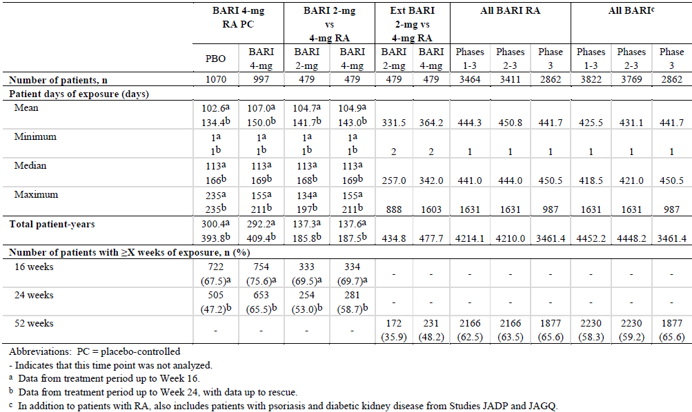

Adverse events

All adverse events (irrespective of relationship to study treatment)

Integrated safety analyses

Primary (PBO versus BAR 4 mg)
Overall, AEs were recorded in a similar proportion of BAR and PBO treated subjects. Up to Week 16 (that is, the true PBO controlled period), a total of 14 common (≥ 2% incidence) treatment emergent AEs by PT were recorded in the primary integrated safety analysis; refer to Table 16. Ten of the 14 most common AEs were reported by a numerically larger proportion of patients who received BAR 4 mg versus PBO including nasopharyngitis, URTI, headache, urinary tract infection, bronchitis, nausea, pharyngitis and hypertension. Of these, a statistically greater proportion of subjects treated with BAR 4 mg had the AEs of increased blood CPK (12.0% versus 2.0%) and hypercholesterolaemia (9.6% versus 5.7%) compared to PBO. Nausea was also commonly reported at a higher incidence with BAR 4 mg versus PBO and it was not frequently associated with reports of gastrointestinal AEs. Approximately half of all nausea AEs was recorded in the first 2 weeks of BAR treatment indicating an initial tolerability issue. Four of the most common types of AEs (back pain, RA flare, anaemia and diarrhoea) were reported by a numerically smaller proportion of patients treated with BAR 4 mg versus PBO.

Table 16: Common AEs up to Week 16 in the primary integrated safety set
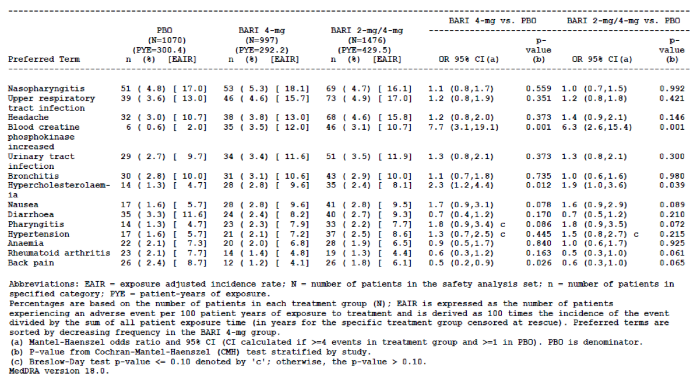
The majority of commonly reported AEs were anticipated side effects in the RA population receiving immunosuppressant drugs (such as various types of minor infection) or abnormal laboratory results consistent with JAK inhibition (such as increases in CPK and lipid levels). However, 2 other AEs (listed in the proposed PI) were also identified as occurring more frequently with BAR 4 mg/day than PBO, but neither reached the most common frequency threshold of at least 2% incidence. Up to Week 16, various PTs describing acne were reported by a statistically greater proportion of subjects treated with BAR 4 mg than PBO (0.8% versus 0). The majority of patients who developed acne were not taking CS (known risk factor) and none ceased treatment due to this AE. Up to Week 24, a greater proportion of subjects treated with BAR 4 mg (1.8% (18/997); EAIR of 4.3) than PBO (0.4% (4/1070); EAIR of 1.0) developed herpes zoster infection.

Secondary (BAR 2 mg versus BAR 4 mg)
The main objective of this analysis set was to assess for a potential dose relationship for AEs. Up to Week 16 (that is, the true PBO controlled period), a total of 21 common (≥ 2% incidence) treatment emergent AEs by PT were recorded in the secondary integrated safety analysis; refer to Table 17. Thirteen of the 21 most common AEs were reported by a numerically larger proportion of patients treated with BAR 4 mg/day compared to BAR 2 mg/day. Of note, a statistically greater proportion of patients treated with BAR 4 mg/day had the AE of increased blood CPK (5.0% versus 2.3%) and increased AST value (2.1% versus 0.4%) compared to BAR 2 mg. For 2 additional types of AE, the difference between BAR 4 mg and BAR 2 mg had an odds ratio ≥ 2.0 (with BAR 2 mg as the denominator): hypercholesterolemia (11.6% with BAR 4 mg versus 5.1% with BAR 2 mg) and RA (7.3% with BAR 4 mg versus 3.6% with BAR 2 mg).

Table 17: Common AEs up to Week 16 in the secondary integrated safety set
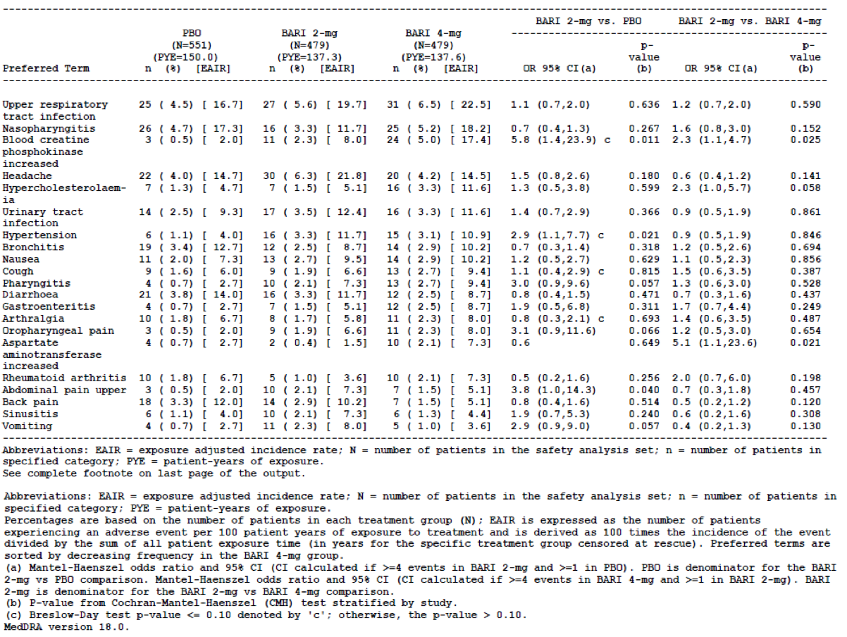
In the extended BAR 2 mg versus 4 mg RA analysis set, treatment emergent AEs were reported in 77.2% (370/476; EAIR 85.1) of patients treated with BAR 2 mg and 84.8% (406/479; EAIR 84.8) of subjects in the BAR 4 mg cohort. The type and pattern of the most common AEs recorded in the extended treatment dataset was highly similar to that observed in the PBO controlled period. By SOC, the 3 most common types of AEs were infections (approximately half of all patients) followed by gastrointestinal and musculoskeletal disorders (approximately one quarter of all patients in each SOC). Three AEs were reported in a numerically and statistically greater proportion of patients in the BAR 4 mg compared to the BAR 2 mg group: increased blood CPK level (7.7% (37/479) at EAIR of 7.7 for 4 mg versus 4.4% (21/479) at EAIR of 4.8 for 2 mg therapy), increased serum AST (2.9% (14/479) at EAIR of 2.9 for 4 mg versus 0.8% (4/479) at EAIR of 0.9 for 2 mg therapy) and hypercholesterolemia (5.0% (24/479) at EAIR of 5.0 for 4 mg versus 2.5% (12/479) at EAIR of 2.8 for 2 mg therapy). For 2 additional AEs in this analysis set, the difference between BAR 4 mg and 2 mg had an odds ratio > 2.0: falls and alopecia. The data concerning falls with BAR was inconsistent across analysis sets suggesting that this AE is not clearly related to BAR therapy. Activation of the JAK-STAT pathway through cytokine signalling has been shown to modulate hair follicle stem cells in aging mice, contributing to their increased numbers, decreased function and inability to tolerate stress. Alopecia was reported by a larger proportion of patients treated with BAR 4 mg (n = 13) than BAR 2 mg (n = 3) in the extended treatment set (odds ratio of 2.8). The majority of alopecia AEs were reported in the first 12 weeks of treatment, and up to 16 weeks was numerically higher with BAR 4 mg versus 2 mg (9 cases versus 0). However, 2 common AEs (abdominal pain and rhinitis) were reported by a statistically smaller proportion of patients in the BAR 4 mg arm compared to BAR 2 mg therapy. In the extended treatment set, the incidence of herpes zoster infection was 2.9% (14/479; EAIR of 3.2) with BAR 2 mg and 3.8% (18/479; EAIR of 3.8) with BAR 4 mg. In addition, the incidence of herpes simplex infection and oral herpes infection combined was 2.3% (11/479) with BAR 2 mg and 2.7% (13/479) with BAR 4 mg.

All exposure BAR RA population
The integrated safety datasets identified all of the common types of AEs with BAR therapy, and the all exposure RA population identified 2 additional potential safety concerns that have been included in the proposed PI. In the all exposure BAR RA population, the incidence of nausea was 4.1% (142/3464) with an EAIR of 3.4 AEs per 100 PY of exposure. None of these cases were deemed to be serious and very few resulted in treatment discontinuation (6 cases of temporary BAR cessation and 1 permanent treatment discontinuation). Acne was recorded as an AE in 1.1% (38/3464) of BAR treated subjects in this cohort at an EAIR of 0.9 AEs per 100 PY of exposure. None of the acne AEs resulted in treatment discontinuation. The AE of peripheral neuropathy was reported by 14 patients (0.4% of 3464) in the all exposure BAR RA analysis set (0.3 AEs per 100 PY). All of these AEs were non-serious. Identical proportions of patients in each treatment group reported peripheral neuropathy in the primary integrated safety analysis (2 in each group, 0.2%). In the BAR 2 mg versus 4 mg analysis set, a smaller proportion of patients reported peripheral neuropathy in the BAR 2 mg group (0 AEs) than in the BAR 4 mg or PBO arms (1 (0.2%) and 2 (0.4%), respectively). In the extended safety set, a statistically lower proportion of patients reported peripheral neuropathy with BAR 2 mg versus BAR 4 mg therapy (0 and 5 subjects (1.0%), respectively). Of the 14 BAR treated patients reporting peripheral neuropathy, 5 subjects had local nerve entrapment syndromes of the upper limb (cubital, ulnar or carpal tunnel).
The most common types of AEs (> 5% incidence) identified in the all exposure BAR RA population were nasopharyngitis (9.8% (341/3464); EAIR of 8.1), URTI (8.1% (279/3464); EAIR of 6.6), bronchitis (7.5% (258/3464); EAIR of 6.1), urinary tract infection (7.2% (251/3464); EAIR of 5.9) and increased blood CPK value (5.0% (172/3464); EAIR of 4.1).

Pivotal and/or main efficacy studies

Study JADZ
Up to Week 52, similar proportions of patients in each of the 3 treatment groups experienced an AE: 71.9% (151/210) in the MTX monotherapy group, 71.1% (113/159) in the BAR 4 mg alone arm and 77.7% (167/215) in the combination treatment group. For all treatment groups, the majority of patients who reported AEs did so during the first 24 weeks (approximately 90% of all AEs) with relatively few additional patients reporting new AEs between Weeks 24 and 52. Most AEs were rated as mild or moderate in severity, but 5.7 to 10.2% of all AEs in each treatment group were rated as severe (10.2% in the combination treatment arm). The 3 most commonly occurring AEs were in the SOC of infection, gastrointestinal disorders and abnormal investigations. All of these SOCs were reported at a higher incidence in the BAR + MTX treatment group compared to MTX alone. Compared to MTX monotherapy (38.1% (80/210); EAIR of 46.9), a larger proportion of patients treated with BAR experienced an AE in the SOC of infection (43.4% (69/159) at an EAIR of 48 for BAR alone and 50.2% (108/215) at EAIR of 57.3 for BAR + MTX). No specific type of infection by PT was significantly more common with BAR apart from vulvovaginal candidiasis (6 cases with BAR + MTX, 1 case with MTX alone and 0 reports with BAR monotherapy). There was also numerically more blood and lymphatic system disorder SOCs with BAR + MTX (9.3% (20/215); EAIR 10.61) versus MTX monotherapy (3.8% (8/210); EAIR 4.69). This was mainly explained by a higher incidence of anaemia with combination treatment (2.8% (6/215) versus 1.0% (2/210) with MTX alone and 1.3% (2/159) with BAR monotherapy). Abnormal investigation results were also statistically higher with BAR + MTX (18.1%; 39/215) versus MTX alone (10.0% (21/210); p = 0.007). This was mainly explained by a higher incidence of increased blood CPK levels (4.7% (10/215) versus 1.0% (5/210)) as well as increased serum ALT values (6.0% (13/215) versus 2.4% (5/210)). Dyslipidaemia and hyperlipidaemia were also more common with combination therapy (2.8 to 3.7% with BAR + MTX versus 0.5 to 1.0% with MTX alone). Gastrointestinal disorders such as nausea and dyspepsia were also more common with BAR + MTX (9.3% and 3.7%, respectively) versus MTX alone (6.2% and 0.5%, respectively). The PT of hypertension was also more common with combination BAR + MTX (6.0% (13/215); EAIR 6.9) than MTX alone (3.3% (7/210); EAIR 4.10) or BAR alone (1.3% (2/159); EAIR 1.39).
Compared to MTX monotherapy through to Week 52, there was a statistically significant increase in the PT of thrombocytosis for the BAR monotherapy group 2.5% (4/159) versus 0 cases with MTX alone).
Alopecia is a common, known side effect of MTX. In Study JADZ, alopecia was reported as an AE up to Week 52, less frequently with BAR 4 mg monotherapy than with MTX monotherapy or BAR + MTX (EAIR of 0.70, 2.93 and 3.18 per 100 PY, respectively). Although none of the between group comparisons for alopecia were statistically significant, the data from Study JADZ suggests that BAR monotherapy is not associated with increased rates of hair loss, and that the data from the integrated set is confounded by background and concomitant MTX.
Up to Week 52, herpes zoster infection was reported in a higher proportion of BAR treated subjects (2.5% (4/159) with monotherapy and 2.3% (5/215) with combination treatment) compared to MTX monotherapy (1.0%; 2/210).

Study JADV
Up to Week 24, a statistically higher proportion of patients in the 2 active treatment groups of Study JADV experienced an AE (71.3% (347/487) at an EAIR of 161.4 in the BAR group and 67.9% (224/330) at an EAIR of 157.8 in the adalimumab arm) compared to 60.5% (295/488; EAIR 149.2) in the PBO group. The pair-wise comparison between BAR and adalimumab for the percentage of subjects affected by any AE was not statistically significant (p = 0.314). For both active treatment groups, the majority of patients who reported AEs did so during the first 24 weeks (around 80% of all AEs over 52 weeks) with relatively few additional patients reporting new AEs between Weeks 24 and 52. Most AEs were rated as mild or moderate in severity, but around 5% of all AEs in each treatment group were rated as severe.
Up to Week 24, the most commonly occurring AEs for all treatment groups were in the SOC of infections (27.5 to 36.1%) and gastrointestinal disorders (12.7 to 16.4%). Compared to PBO (27.5%; 134/488), statistically significant larger proportions of patients experienced infectious AEs up to Week 24 in the BAR (36.1%; 176/487) and adalimumab groups (33.3%; 110/330). The 3 most common types of infection by PT were nasopharyngitis (7.2 to 10.3%), urinary tract infection (3.5 to 4.3%) and bronchitis (2.4 to 3.9%). In addition, a statistically greater percentage of subjects in the BAR group (2.5%; 12/487) recorded the PT of influenza versus PBO (0.8%; 4/488).
Table 18 shows the most common AEs by PT within their SOC up to Week 24. Compared to PBO, there was a statistically significant increase in the PTs of increased blood CPK (0.6% versus 2.7%) and hyperlipidaemia (0.4% versus 2.1%) with BAR; and an increase in the PTs of gastritis and abnormal hepatic function with adalimumab. Compared to adalimumab, there was a statistically significant increase in the PTs of increased blood CPK (0.6% versus 2.7%), hyperlipidaemia (0.9% versus 2.1%) and anaemia (1.2% versus 3.7%) with BAR up to 24 weeks.

Table 18: Most common adverse events by PT/SOC Up to 24 weeks in Study JADV
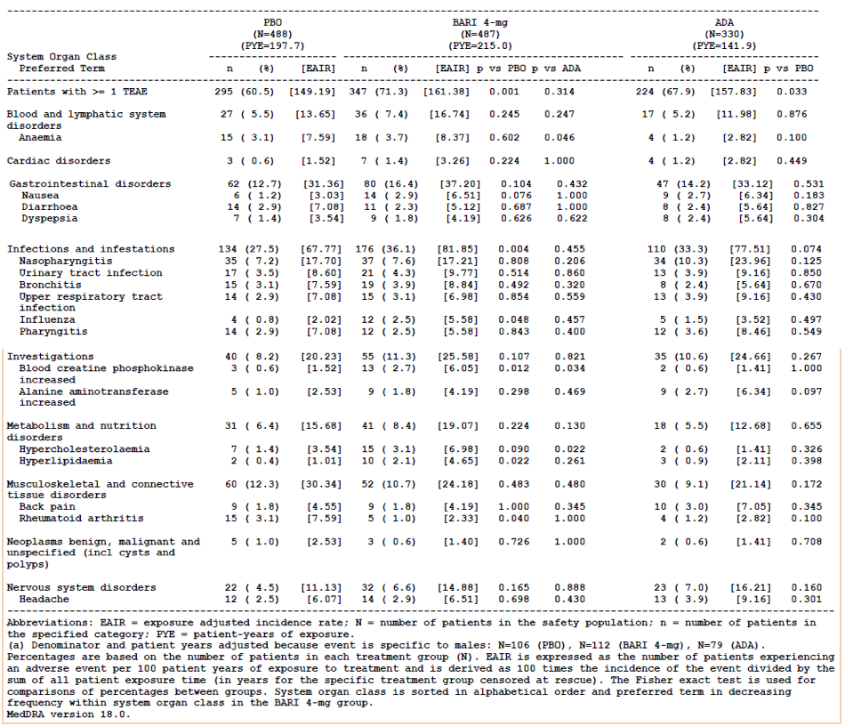
Up to Week 52, a similar proportion of patients in the BAR and adalimumab treatment groups experienced an AE: 78.9% (384/487; EAIR 89.16) in the BAR group and 76.7% (253/330; EAIR 92.02) in the adalimumab arm. Table 19 displays the most common types of AEs (affecting 7 or more patients in either active treatment group up to rescue) recorded up to Week 52 in Study JADV. The pattern of AEs over the extended treatment follow-up period of 52 weeks was similar to that reported for the initial 24 weeks of PBO controlled treatment. In particular, various types of minor infection including nasopharyngitis, urinary tract infection, bronchitis and URTI were the 4 most common AEs by PT. There was statistically higher incidence of influenza recorded in the BAR versus adalimumab group (4.5% versus 1.8%; p = 0.049). Anaemia (3.9% versus 1.2%) and hypercholesterolaemia (3.9% versus 1.2%) were also statistically more common in the BAR versus adalimumab treated cohort. Abnormalities of liver function (in particular, raised serum transaminases) were recorded at a similar frequency between the 2 treatment groups. There was a numerically higher incidence of increased blood CPK values with BAR (2.7% versus 1.2%), but this did reach statistical significance for the pair-wise comparison (p = 0.213). Lymphopaenia (1.6% versus 0.3%) and neutropaenia (1.4% versus 0.6%) were also more common with BAR versus adalimumab, but neither of these AEs were statistically more common in the BAR treatment group. Up to 52 weeks, herpes zoster infection occurred at a similar incidence in the 2 active treatment groups (1.5 to 2.3%).

Table 19: Most common adverse events by PT up to 52 weeks in Study JADV
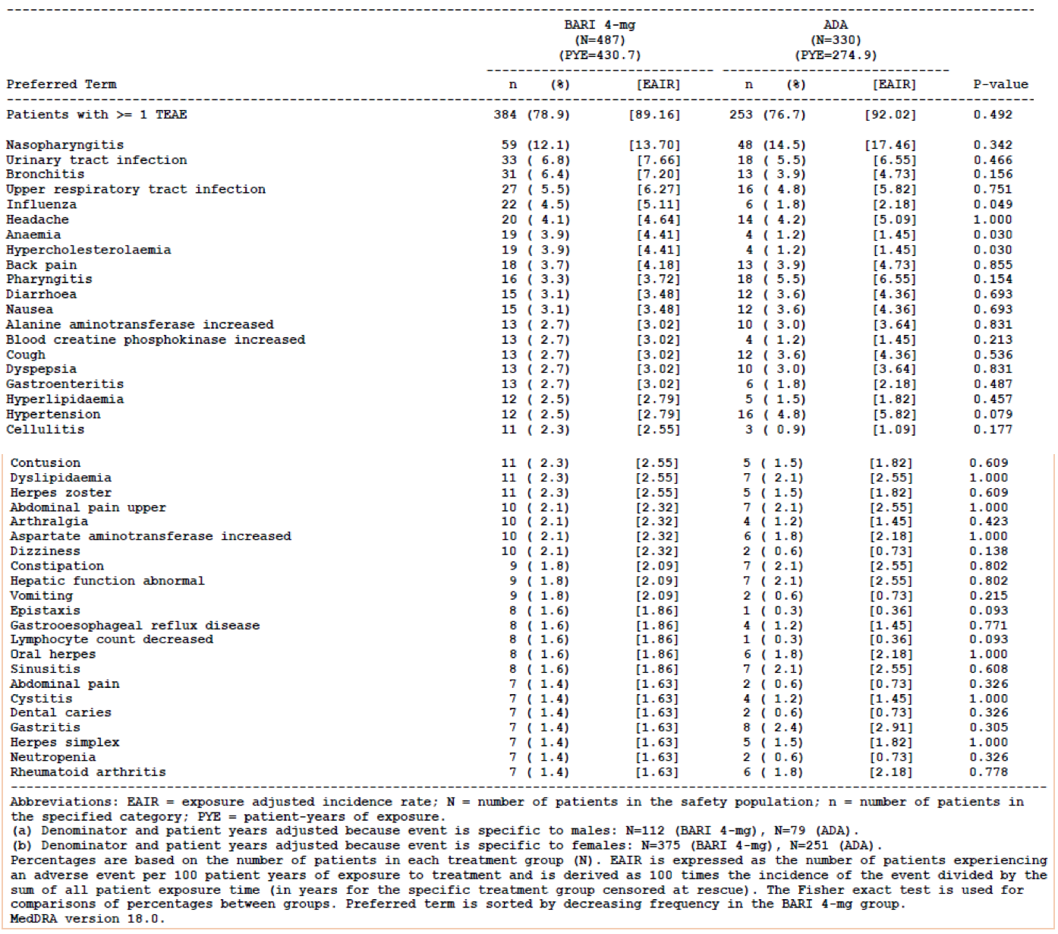

Treatment related adverse events (adverse drug reactions)

Integrated safety analyses
Data from the integrated safety analysis sets were screened for potential causal associations between BAR treatment and AEs based on biological plausibility, disease state, background incidence of the AE and confounding factors where applicable. Pre-defined numeric screening criteria were used to assist in identification of potential adverse drug reactions. From this review process, all potential adverse drug reactions are noted in Table 20. The laboratory related AEs will be considered in Section 7.4 of this report.
A statistically larger proportion of patients treated with BAR 4 mg/day versus PBO reported herpes zoster infection (1.4% versus 0.4%) in the primary integrated analysis set (2 to 5 weeks duration). However, there was no statistically significant difference between BAR 2 mg and 4 mg daily in the secondary integrated analysis set. Of 141 reported cases of herpes zoster, complicated or disseminated AEs (that is, nerve palsy or dissemination beyond the primary or adjacent dermatomes) were reported in a total of 5 cases (2 associated with facial palsy and 3 considered disseminated based on the dermatomal pattern of involvement). A statistically larger proportion of patients treated with BAR 4 mg versus PBO reported herpes simplex infection (1 to 3 weeks duration) in the primary integrated safety analysis set, but similar proportions of patients treated with BAR 2 and 4 mg/day recorded herpes simplex in the secondary analysis set.

Table 20: Potential adverse drug reactions with BAR identified in integrated safety sets
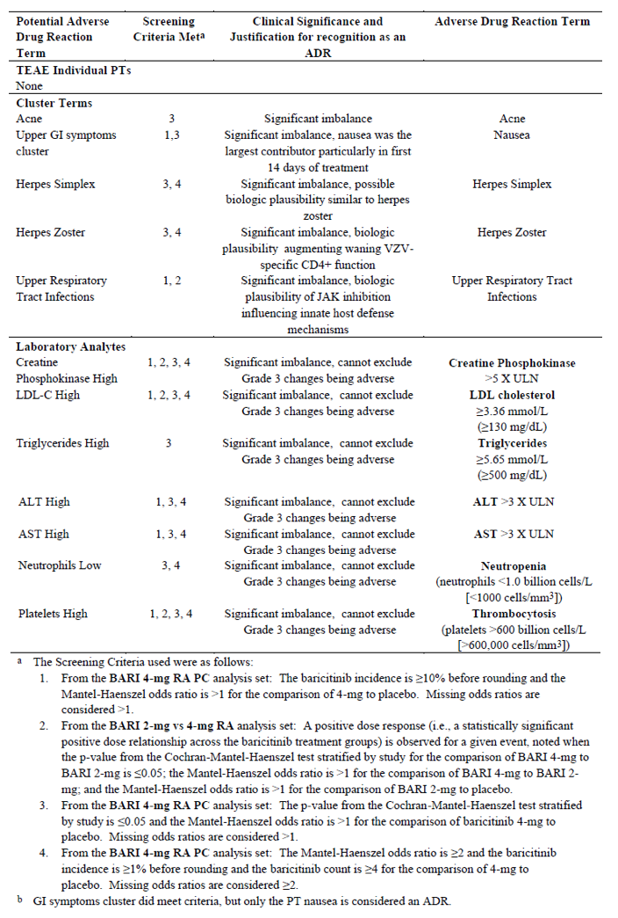

All exposure BAR population
The all exposure BAR population was specifically reviewed to identify any uncommon AEs that may be drug related (that is, absence of an obvious alternative cause) and identified pancytopaenia and hepatitis or hepatic failure (refer to Section 7.4 of this report) as potential safety concerns with BAR. Six AEs of pancytopaenia were reported in the all exposure BAR cohort. One occurred in a patient in Study JAGQ with a pre-existing medical condition that did not change in severity during treatment with BAR. A patient treated with adalimumab had stable pre-existing pancytopaenia after 11 months of treatment in Study JADV. The remaining 4 cases occurred in RA patients taking BAR. Two of those 4 cases occurred in the Phase II studies, including 1 case in a patient with CrCL 59 mL/min who received high dose BAR (8 mg daily; that is, no dose reduction for renal insufficiency), and the other subject received BAR 2 mg increased to 4 mg/day (baseline CrCL 73 mL/min). In the remaining 2 patients, 1 had confounding medical conditions and medications with low lymphocytes upon study entry, and the other patient was not taking folic acid with MTX in the 2 weeks prior to the pancytopaenia. All BAR treated patients who recorded treatment emergent pancytopaenia were receiving MTX as a concomitant medication and 2 were receiving NSAIDs.

Pivotal and/or main efficacy studies

Study JADZ
Up to Week 52, treatment related AEs statistically affected more patients in the BAR + MTX group (45.6% (98/215); EAIR 52.0) than either of the 2 monotherapy treatment groups (35.2% (74/210) with EAIR of 43.35 in the MTX monotherapy group and 32.1% (51/159) with EAIR of 35.45 in the BAR 4 mg alone arm; p < 0.04 for both monotherapy versus combination treatment comparison). The pattern of treatment related AEs was highly similar to that observed for overall AEs. There was a higher incidence of AEs affecting combination treatment group versus monotherapy (either BAR or MTX) in the SOCs of blood and lymphatic disorders (mainly explained by a higher percentage of anaemia cases), gastrointestinal disorders (mainly explained by nausea, diarrhoea and abdominal discomfort), infections (no specific AE by PT) and abnormal investigation results (principally due to a higher frequency of raised serum ALT and increased CPK values (for MTX alone)). Three cases of hypertension reported in the combination treatment group were considered to be possibly related to study medication versus no cases in either of the 2 monotherapy arms.

Study JADV
Through to Week 24 (with data up to rescue), treatment related AEs statistically affected more patients in the active 2 treatment groups (32.0% (156/487) at an EAIR of 72.55 with BAR; and 27.9% (92/330) at an EAIR of 64.82 with adalimumab) than in those in the PBO arm (20.9% (102/488) with EAIR of 51.6). The pattern of treatment related AEs was similar to that observed for overall AEs. Treatment related infections (no specific AE by PT) affected a higher percentage of BAR treated subjects (14.2% (69/487) at EAIR of 32.1) compared with adalimumab (10.0% (33/330) at EAIR of 23.25) and PBO (9.4% (46/488) at EAIR of 23.26). Herpes zoster infection affected 0.4% of PBO treated subjects versus 1.2 to 1.4% of subjects in the 2 active therapy groups. Oral herpes affected 0.8-0.9% of subjects in each of the 3 treatment groups and herpes simplex infection was recorded in 0.6 to 1.0% of actively treated patients versus no cases in the control arm. Abnormal investigation results (principally due to a higher frequency of raised serum ALT/AST for both active treatment groups, and increased CPK values for BAR therapy) were observed with BAR (6.8% (33/487) at EAIR of 15.35) and adalimumab (6.4% (21/330) at EAIR of 14.8) compared to PBO (3.7% (18/488) at EAIR of 9.1). There was a numerically higher incidence of AEs affecting BAR treated subjects in the SOC of blood and lymphatic disorders (3.1% with BAR versus 1.8% with adalimumab and 1.6% with PBO). Treatment related gastrointestinal disorders occurred at a similar frequency among the 3 treatment groups (2.7% for both BAR and adalimumab versus 3.1% with PBO). Skin and subcutaneous AEs were more commonly reported with adalimumab (4.8%; 16/330; mainly rash and pruritus) than in the other 2 treatment groups (1.6% (8/487) with BAR and 1.2% (6/488) with PBO).
Up to Week 52 (including data after rescue or switch), treatment related AEs were reported in 31.6% (307/972) of subjects exposed to BAR and the types of AEs experienced did not significantly alter over time. The 2 SOCs with the highest proportion of treatment related AEs with BAR up to Week 52 were infections and gastrointestinal disorders.

Deaths and other serious adverse events

Integrated safety analyses

Primary (PBO versus BAR 4 mg)
No statistically significant differences in the proportion of patients recording an SAE between PBO (3.7%; 40/1070) and BAR 4 mg (3.9%; 39/997) was observed for the primary integrated safety set. The EAIR of SAEs was 13.3 per 100 PY in both treatment groups. Table 21 lists the type of SAEs by PT occurring in at least 2 patients up to Week 16. Moreover, there was no statistically significant difference between the 2 groups for any SAE by PT nomenclature. Compared to PBO, there was no statistically significant difference in the proportion of patients with ≥ 1 serious infection for PBO (1.5%; 16/1070) versus BAR 4 mg therapy (1.4%; 14/997).
Up to Week 24, there were a statistically significant smaller proportion of patients with renal/urinary SAEs in BAR 4 mg (no cases) compared to PBO (6 patients). In this SOC, the SAEs occurring in PBO were comprised predominantly of patients with acute kidney injury (n = 1), renal failure (n = 2) and renal impairment (n = 1). Up to Week 24, none of the SAEs by SOC or PT occurred in a statistically significantly larger proportion of patients treated with BAR 4 mg compared to PBO. Of note, there were 3 cases of herpes zoster infection with BAR 4 mg (0.3% (3/997); EAIR of 1.0 per 100 PY) compared with 1 case in the PBO cohort (0.1% of 1070; EAIR of 0.3 per 100 PY). The 3-fold increase in the incidence of herpes zoster with BAR 4 mg versus PBO was not statistically significant (p = 0.318 from CMH test).

Table 21: SAEs by Preferred Term occurring in at least 2 patients in any group up to Week 16 in the BARI 4 mg RA PC safety set
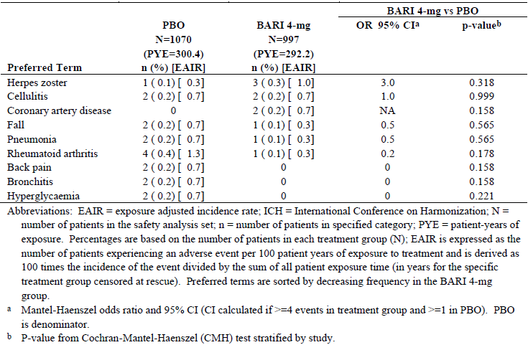

Secondary (BAR 2 mg versus BAR 4 mg)
Up to Week 16, there was a numerically lower but not statistically significant difference in the proportion of patients experiencing an SAE with BAR 2 mg (3.1% (15/479); EAIR of 10.9) compared to BAR 4 mg (4.6% (22/479); EAIR of 16.0). In the PBO group, 4.0% of subjects (22/551) reported an SAE up to Week 16 at an EAIR of 14.7. There was a similar incidence of subjects with 1 or more serious infections with BAR 2 mg therapy (1.0% (5/479); EAIR 3.6) compared to BAR 4 mg (1.5% (7/479); EAIR 5.1). In the PBO group, 1.3% of subjects (7/551) reported an infectious SAE up to Week 16 at an EAIR of 4.7.
In the extended dataset, there were a statistically significantly larger proportion of patients with an SAE in the BAR 4 mg group (14.0% (67/476); EAIR of 14.0) compared to BAR 2 mg (9.2% (44/479); EAIR of 10.1). The numerical differences between the 2 patient groups were seen with several SOC types such as serious infection (23 and 15, respectively), neoplasms (6 and 1, respectively) and nervous system disorders (8 and 2, respectively). The types of infections did not appear to differ between BAR 2 mg and 4 mg other than a larger number of patients with urinary tract infection in BAR 4 mg cohort (4 and 0, respectively). For the SAEs in the SOC of nervous system disorders, 2 events of syncope and 1 event of pre-syncope were reported in the BAR 4 mg cohort versus none recorded with BAR 2 mg.
There was also a numerically lower but not statistically significant difference in the proportion of subjects with 1 or more infections requiring antimicrobial treatment with BAR 2 mg therapy (17.7% (85/479); EAIR 61.9) compared to BAR 4 mg (18.6% (89/479); EAIR 64.7). In the PBO group, 13.2% of subjects (73/551) reported an SAE up to Week 16 at an EAIR of 48.7. Regarding types of infections of special interest, up to 16 weeks there was a higher incidence of herpes zoster with BAR which was dose dependent: 1.9% (9/479; EAIR of 6.5) of subjects treated with BAR 4 mg, 1.0% (5/479; EAIR of 3.6) of subjects treated with BAR 2 mg and 0.4% (2/551; EAIR of 1.3) of subjects in the PBO group.

All exposure BAR population

Deaths
Up until 30 November 2015, a total of 31 deaths have been recorded in the all exposure BAR population including 2 subjects from the Phase I studies (Studies JADB and JADL), 2 patients from the Phase II psoriasis study (Study JADP), 18 patients from Phase II and III RA studies, 8 patients from the ongoing RA LTE Study JADY and 1 death from the expanded access program (Protocol JAGA). Two male patients in the Phase I trials died of acute myocardial infarction 26 to 41 days after receiving their last dose of BAR. Both subjects had multiple risk factors for cardiovascular disease. In Study JADP, 1 subject treated with BAR 8 mg/day for 38 days had an unwitnessed death and autopsy revealed evidence of a remote myocardial infarction and hypertensive cardiovascular disease with cardiomegaly. The other subject in Study JADP died of oesophageal adenocarcinoma after brief exposure to BAR (45 days of 4 mg/day). In the Phase II/III RA studies, 2 patients died during the screening period of Studies JADC and JADV of acute myocardial infarction (that is, unrelated to study medication). During the PBO and active-controlled periods of the Phase II/III studies (up to rescue or switch to BAR), there were 7 deaths in the combined PBO, MTX monotherapy and adalimumab arms compared to 3 deaths in the combined BAR arms; refer to Table 22. The frequency of deaths appeared similar across treatment groups. There were a total of 5 deaths related to infection (including 2 each in the PBO and BAR ≥ 4 mg/day group, and 1 in an adalimumab treated subject). Across all treatment groups, patients recording major adverse cardiovascular events (MACE) leading to death on study treatment had pre-existing risk factors for and/or a significant prior history of MACE.

Table 22: Cause of death (as assessed by sponsor) by treatment group in RA patients (Studies JADC, JADA, JADN, JADZ, JADV, JADX and JADW, JADY up to 10 August 2015)
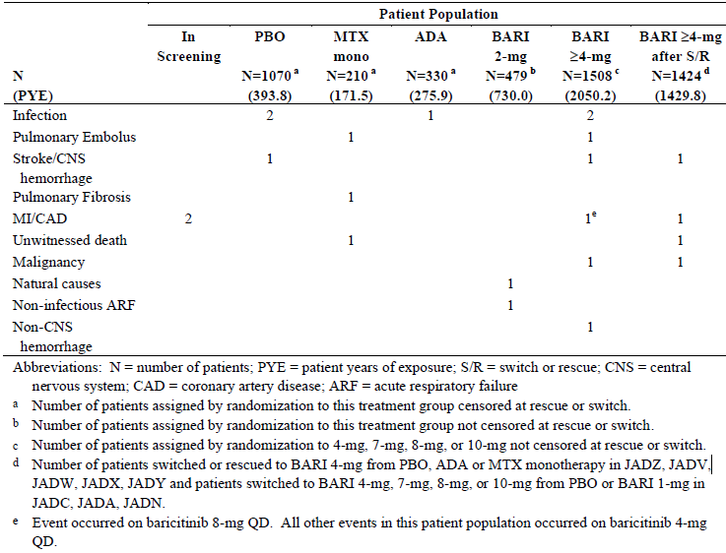
Up to 30 November 2015, 5 additional deaths were reported to the sponsor after the data cut-off date of 10 August 2015. Two deaths occurred in Study JADY while patients were receiving BAR 4 mg/day (1 case each of breast cancer, and severe coagulopathy in a patient taking vitamin K antagonist therapy for atrial fibrillation). Another 2 deaths occurred long after participation in Study JADY (1 of unknown cause and the other due to renal cell carcinoma). One death (possible opportunistic infection in setting of major haematological abnormalities) occurred in the expanded compassionate access program (Study JAGA), which involves the treatment of auto-inflammatory syndromes.
In the all exposure BAR population, all SAEs reported in 4 or more BAR treated patients were reviewed. The most common type of SAE by SOC was infection, which occurred in 3.6% of patients. Within this SOC, pneumonia and herpes zoster infection were the most frequently reported infectious SAE by PT (occurring in 0.6% of patients each). A total of 14 SAEs consistent with thrombotic events (9 cases of pulmonary embolism (0.3%) and 5 cases of deep vein thrombosis (0.1%)) were recorded including 2 subjects who reported concurrent PE and DVT. In addition, 1 patient with RA treated with MTX monotherapy in Study JADZ reported a fatal PE and a subject with psoriasis receiving BAR 10 mg/day in Study JADP also reported a PE preceded in the prior month by multiple episodes of prolonged sitting during travel. A total of 38 patients (1.0% of 3723 patients) in the safety population had a prior history of DVT and/or PE. Of these 38 patients, 3 experienced treatment-emergent DVT or PE. Overall, treatment-emergent DVT/PE events occurred in 20 (0.58%) patients in the all exposure BAR population with incidence rate of 0.46 per 100 PY. The incidence rate of DVT/PE in the MTX monotherapy group was 0.59 per 100 PY. No treatment-emergent DVT/PE events were reported in the adalimumab or PBO groups of the BAR clinical trial program. In the all exposure BAR population, 5 cases of syncope and 3 cases of pre-syncope requiring hospitalisation were reported as SAEs. All but 1 of the vignettes was associated with an illness that could have contributed directly to the SAE such as pneumonia, diarrhoea and vomiting. Treatment with BAR was not temporarily interrupted or discontinued. None of the syncopal or pre-syncopal SAEs resulted from a primary cardiovascular or neurologic cause. The SAEs resolved without injury or sequelae and review of these SAEs does not suggest a direct causal relationship between BAR and syncope or pre-syncope.
Two confirmed reports of gastrointestinal perforation (EAIR of 0.05 per 100 PY) were reported in the all exposure BAR RA population. Both occurred in subjects treated with BAR in Study JADY. One case was a ruptured appendix and the other case was a perforated diverticulum. Both subjects were taking concomitant NSAID and low dose oral CS, which are known risk factors for gastrointestinal perforation. During the controlled trial periods, 2 cases of miliary tuberculosis (TB) infection were reported in Korean subjects: 1 with BAR 4 mg therapy in Study JADX and 1 with adalimumab in Study JADV. In the uncontrolled period (when all patients received BAR), 6 additional cases of TB (3 unconfirmed by microbiology) were recorded. All 6 of the subjects were receiving BAR 4 mg/day treatment and all cases occurred in countries where TB is highly prevalent (South Africa, Asia, Russia and Argentina). All of affected patients were screen negative for TB at Baseline. Two of the 6 cases involved the thoracolumbar spine, 3 involved the chest and 1 case affected supraclavicular lymph nodes. The latent period between commencement of BAR therapy and detection of TB ranged from 218 to 617 days. The sponsor asserts that the EAIR for TB with BAR is in keeping with the expected background rates of TB in RA patients in these countries and overall it does not indicate TB as an identified risk for BAR. Consistent with contemporary standards of care in RA, the sponsor has proposed labelling with a warning that BAR should not be administered to patients with active TB and recommends prescribers to consider anti-TB therapy prior to initiation of BAR in patients with previously untreated latent TB, which is appropriate.

Pivotal and/or main efficacy studies

Study JADZ
Up to Week 52, there were no statistically significant differences in the proportion of patients recording at least 1 SAE between MTX monotherapy (11.0% (23/210); EAIR 13.47), BAR 4 mg monotherapy (10.7% (17/159); EAIR 11.82) and BAR + MTX (16.3% (35/215); EAIR 18.57). Combination treatment was numerically higher in percentage of affected subjects and EAIR than either monotherapy treatment group. The proportion of patients with 1 or more serious infections was similar for MTX monotherapy (4.3% (9/210); EAIR 5.27), BAR alone (5.0% (8/159); EAIR 5.56) and BAR + MTX (4.7% (10/215); EAIR 5.30). Regarding infections of special interest, 2 patients in the MTX monotherapy group experienced an SAE of herpes zoster infection (EAIR 1.17) compared to 4 patients in BAR monotherapy arm (EAIR 2.78) and 5 patients in the BAR + MTX (EAIR 2.65). There were 2 other significant infectious SAEs in Study JADZ which were recorded in the BAR + MTX group: 1 case of Pneumocystis jirovecii pneumonia and 1 case of acute hepatitis B viral infection. An additional patient in the BAR + MTX arm recorded a non-serious opportunistic infection (oesophageal candidiasis) and 3 Japanese subjects had detectable hepatitis B viral DNA (by central laboratory testing) during the study. No clinically overt cases of TB were identified during the study. There were 4 cases of malignancy reported in the combination treatment group (malignant melanoma, basal cell carcinoma of skin, adrenocortical carcinoma and gall bladder carcinoma) versus 1 case each in the other 2 treatment groups (gastrointestinal carcinoid tumour for MTX monotherapy and cervical carcinoma for BAR alone). No patient experienced spontaneous gastrointestinal perforation. Three patients died during the trial, all in the MTX monotherapy arm (as recorded in Table 23).

Table 23: Potential adverse drug reactions with BAR identified in Integrated Safety Sets
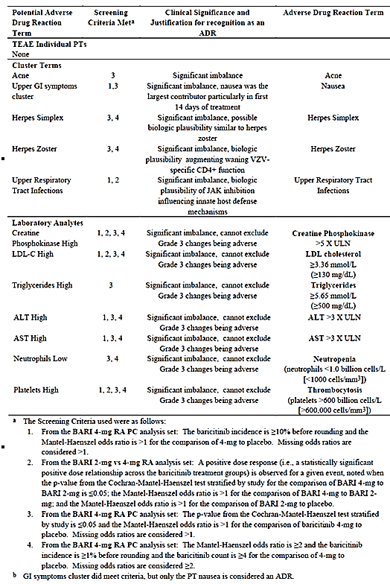

Study JADV
Up to Week 52, there was a numerically greater proportion of patients recording at least 1 SAE (by ICH or protocol definition) in the BAR group (11.5% (56/487); EAIR 13.0) compared with adalimumab arm (7.6% (25/330); EAIR 9.1). The difference was statistically significant if just the SAEs by ICH criteria were applied (7.8% (38/487) and EAIR 8.82 for BAR versus 3.9% (13/330) and EAIR 4.73 for adalimumab; p = 0.027). No single SOC appeared to account for the increase, as there were generally more SAEs in each SOC for BAR compared to adalimumab. More patients treated with BAR (2.1% (10/487); EAIR 2.32) experienced at least 1 serious infection (as per ICH criteria) compared to adalimumab (1.5% (5/330); EAIR 1.82), but this difference was not statistically significant. No specific type of infection accounted for the difference between the groups. In both groups, the most common type of infectious SAE was herpes zoster experienced by 9 patients in the BAR group (1.8%; EAIR 2.09) and 5 patients in the adalimumab arm (1.5%; EAIR 1.82). There was 1 case of disseminated TB occurring in an Asian patient treated with adalimumab. Two patients treated with BAR reported a non-serious opportunistic infection of oesophageal candidiasis. A small number of patients in China and Japan had anti-HBV antibodies at Baseline and had a transient low level of HBV DNA detected by central laboratory testing during the trial (on either active treatment: BAR and adalimumab) without any associated increase in serum transaminases or bilirubin. Seven patients developed malignancy during the study including 3 cases in the PBO group (squamous cell carcinoma of the skin, breast cancer and ovarian cancer) and 4 patients in the BAR treatment arm (basal cell carcinoma of the skin, breast cancer, renal cell carcinoma and squamous cell carcinoma of the lung). One patient in the adalimumab treatment arm recorded lymphoproliferative malignancy 22 days after commencing drug in the trial. Another subject also recorded an SAE of lymphoproliferative disorder 309 days after being initially treated with adalimumab and 112 days after being rescued to BAR. No patient experienced spontaneous gastrointestinal perforation. Five patients died during the trial, including 1 subject each in the PBO and adalimumab arms plus 3 deaths in the BAR treatment group (including 1 case each of hospital acquired pneumonia complicating coronary artery bypass surgery, duodenal ulcer haemorrhage and respiratory failure in association with infected knee prosthesis).

Discontinuations due to adverse events

Integrated safety analyses

Primary (PBO versus BAR 4 mg)
Up to Week 16, there was a numerically higher rate of AEs leading to permanent treatment discontinuation with BAR 4 mg (3.7% (37/997); EAIR 12.7) compared to PBO (2.8% (30/1070); EAIR 10.0), but the difference was not statistically significant. The only type of AE by PT that was statistically more common with BAR (versus PBO) affecting at least 2 patients was herpes zoster infection (1.0% (10/997) at EAIR of 3.4 for BAR versus 0.3% (3/1070) at EAIR of 1.0 for PBO; p = 0.052). Herpes zoster infection has been identified as an AE associated with BAR and subjects in the Phase III studies were required to discontinue study drug if herpes zoster infection was reported.

Secondary (BAR 2 mg versus BAR 4 mg)
Up to Week 16, there was a numerically higher but not statistically significant difference in the proportion of patients experiencing AEs resulting in permanent treatment discontinuation with BAR 4 mg (4.6% (22/479); EAIR of 16.0) compared to BAR 2 mg (3.5% (17/479); EAIR of 12.4). In the PBO group, 3.1% of subjects (17/551) reported an AE leading to treatment cessation up to Week 16 at an EAIR of 11.3. The above result was mainly explained by a slightly higher incidence of overall infection with BAR 4 mg therapy (1.9% (9/479); EAIR 6.5) compared to BAR 2 mg (1.3% (6/479); EAIR 4.4), which involved a variety of infections by PT other than herpes zoster and pneumonia, which occurred at a similar rate. In the PBO group, 0.4% of subjects (2/551) reported infectious AEs (both herpes zoster) leading to discontinuation up to Week 16 at an EAIR of 1.3.
In the extended dataset, there were there were only 3 AEs by PT that resulted in 1 or more patients discontinuing treatment, herpes zoster infection (6 cases in the BAR 2 mg arm and 8 in the BAR 4 mg group), anaemia (3 cases in the BAR 2 mg arm and 2 in the BAR 4 mg group) and decreased glomerular filtration rate (1 case in the BAR 2 mg arm and 2 in the BAR 4 mg group).

All exposure BAR population
The data from the all exposure BAR population with RA (Phase I to III studies) showed an overall permanent treatment discontinuation frequency of 7.4% (255/3464) at an EAIR of 6.1. The types of AEs (by SOC and PT) leading to permanent cessation of BAR in the all exposure BAR population were similar to the other integrated analyses and Phase III trial data. The 3 most common types of AEs resulting in permanent treatment discontinuation were infections (2.9% (99/3464); EAIR 2.3), abnormal investigation results (0.9% (30/3464); EAIR 0.7) and blood and lymphatic disorders (0.8% (28/3464); EAIR 0.7). The most common type of infection resulting in treatment cessation was herpes zoster (1.7% (58/3464); EAIR 1.4).

Pivotal and/or main efficacy studies

Study JADZ
Up to Week 52, there was a statistically higher proportion of patients permanently ceasing treatment due to an AE with MTX + BAR (7.0% (15/215); EAIR 16.1) compared to MTX monotherapy (2.4% (5/210); EAIR 5.59; p = 0.038). The BAR 4 mg monotherapy (3.8% (6/159); EAIR 8.37) had a numerically higher percentage of subjects discontinuing than MTX alone treatment, but this did not reach statistical significance (p = 0.257). Compared to MTX alone, the 3 most common types of AEs by SOC contributing to the difference between BAR (+/- MTX) were infections (2.8-3.1% versus 1.9% for MTX; and mainly the PT of herpes zoster infection (1.9-2.5% versus 1.0% for MTX)), neoplasms of any type (1.9% (4/215) with combination treatment and 0.6% (1/159) with BAR alone versus 0 with MTX monotherapy) and abnormal investigation results (1.4% (3/215) with BAR + MTX versus 0 in the 2 monotherapy groups). Most AEs resulting in permanent treatment discontinuations were rates as only mild or moderate in severity.

Study JADV
Up to Week 24, a statistically greater proportion of patients treated with BAR (5.1% (25/487); EAIR 11.63) compared to PBO (3.5% (17/488); EAIR 8.60) permanently discontinued treatment due to AEs (p = 0.042). However, the incidence of treatment discontinuations by 24 weeks due to AEs in the adalimumab treatment group was numerically lower than PBO at 2.1% (7/330); EAIR 4.93). The difference between PBO and BAR was mainly explained by a higher frequency of infections (1.8% (9/487) at EAIR of 4.2 for BAR versus 0.8% (4/488) at EAIR 2.02 for PBO and 1.2% (4/330) at EAIR of 2.82 for adalimumab). Other noteworthy differences between BAR and adalimumab for the types of AEs leading to treatment cessation included an increased number and percentage of abnormal investigation results (0.6% (3/487) for BAR versus 0.3% (1/330) for adalimumab), neoplasms (0.6% (3/487) for BAR versus 0.3% (1/330) for adalimumab) and gastrointestinal disorders (0.2% (1/487) for BAR versus 0 for adalimumab).
At 52 weeks, AEs leading to permanent discontinuation of medication continued to be higher in the BAR group (7.4% (36/487); EAIR 8.36) than that seen with adalimumab (3.9% (13/330); EAIR 4.73; p = 0.051). The pattern of AEs leading to permanent treatment discontinuation through to Week 52 was consistent with that observed up to Week 24 with the SOC of infection being the most common type of AE.

Evaluation of issues with possible regulatory impact
Extensive routine monitoring and evaluation of laboratory analytes of special interest were part of the BAR clinical trial program. This section will consider the various laboratory abnormalities associated with BAR and Table 24 provides an overview of clinical laboratory abnormalities recorded in the BAR RA studies.

Table 24: Clinically relevant laboratory abnormalities of interest in BAR RA studies
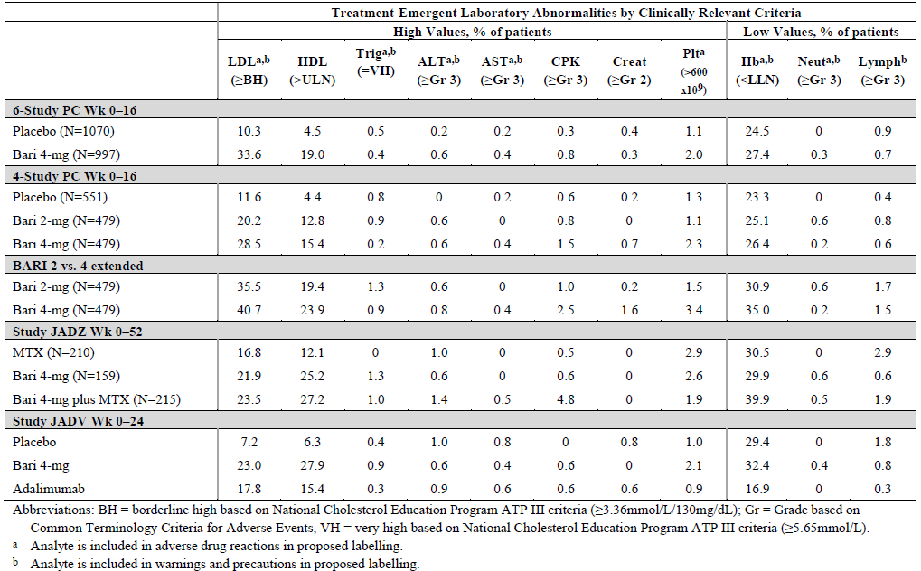

Liver function and liver toxicity

Integrated safety analyses
Increases in serum transaminases (ALT and AST) have been noted with other JAK inhibitors (tofacitinib and ruxolitinib) as well as with commonly used DMARDs such as MTX and LEF, plus in RA patients in general. However, up to 16 weeks of treatment with BAR 4 mg versus PBO in the primary integrated safety set, a similar proportion of patients experienced up to 3-fold, 5-fold and 10-fold increases above the ULN for serum ALT and AST values. In the secondary integrated safety set, similar proportions of patients treated with BAR 2 mg and 4 mg therapy recorded significant increases in serum transaminases, which remained consistent and stable over extended treatment follow-up.

All Exposure BAR RA population
No patient in the all exposure BAR population met Hy’s law criteria for abnormalities of liver function tests. Among patients in the all exposure BAR RA population, 2.9% (98/3406) of subjects had an increase in serum ALT of 3 x ULN, 0.9% (29/3406) had an increase of up to 5 x ULN and 0.2% (7/3406; 2 cases were not treatment-emergent) had an increase to ≥ 10 x ULN. None of the cases with ≥ 10 fold ALT increases were considered to be probably related to BAR following blinded sponsor review. Approximately 80% of individuals with significantly increased (≥ 3 x ULN) serum transaminases had resolution or improvement in their results with short term follow-up.

Pivotal and/or main efficacy studies

Study JADZ
Abnormal liver function tests (mainly, increased serum transaminases) are a recognised concern with MTX therapy in patients with RA. In Study JADZ, treatment with BAR in combination with MTX did not result in a significantly greater risk of abnormal liver function tests than MTX monotherapy. A small, statistically significant increase in mean ALT values with combination treatment versus MTX alone was observed at 24 weeks, but this observation was not clinically relevant in the trial.

Study JADV
Changes in serum transaminases (mean change from Baseline, as well as the proportion of subjects recording > ULN abnormalities) were low and similar for both BAR 4 mg/day and adalimumab therapies in Study JADV.

Renal function and renal toxicity

Integrated safety analyses
Treatment with JAK inhibitors including BAR is associated with small, reversible and dose-dependent increases in serum creatinine and blood urea nitrogen levels through an unknown mechanism. In the Phase III studies, BAR was associated with rapid, small dose-dependent increases in mean serum creatinine values, which plateaued after 8-12 weeks of treatment. The change reflected clinically insignificant increases from Baseline in serum creatinine values (< 5 µmol/L) in the majority of BAR treated patients, but in some subjects large, clinically relevant increases in serum creatinine were recorded. Up to Week 16 in the primary integrated safety set, treatment emergent increases in serum creatinine values were recorded in 2.4% (23/951) of BAR 4 mg patients and 1.9% (19/989) of PBO treated subjects, with no statistically significant difference between treatment groups. Up to Week 16 in the secondary integrated safety set, increases in serum creatinine values were recorded in 2.5% (11/444) of BAR 2 mg patients and 3.6% (16/441) of BAR 4 mg treated subjects, with no statistically significant difference between treatment groups. In the extended secondary integrated safety set, increases in serum creatinine values were recorded in 4.0% (18/445) of BAR 2 mg patients and 6.8% (30/441) of BAR 4 mg treated subjects.

All Exposure BAR population
In the all exposure BAR RA population, CTCAE grade increases in renal function from < 1 to ≥1 were common (4.9%; 156/3166), however, the large majority of patients increased to a maximum of Grade 1 (146 of 156 patients). Treatment-emergent CTCAE Grade increases in serum creatinine from < 2 to ≥ 2 and from < 3 to ≥ 3 were uncommon (0.3% (12/3211) and 0.1% (4/3211), respectively). In almost all instances of CTCAE Grade ≥ 2 increases, a direct causal relationship to BAR could not be concluded due to either confounding patient factors (for example, pre-existing renal disease and concomitant illnesses) or because the increase in serum creatinine was transient and resolved with either no interruption of BAR or a temporary interruption with a subsequent negative re-challenge and continuation of treatment.

Pivotal and/or main efficacy studies
Small mean increases from Baseline in serum creatinine were also observed with adalimumab and MTX monotherapy, though the magnitude was smaller than those seen with BAR. Up to 24 weeks of treatment in Study JADV, 2.1 to 2.3% of patients in each of the 3 treatment groups recorded CTCAE Grade 1 or higher increases in serum creatinine. Up to 52 weeks of treatment in Study JADZ, 2.9% (6/206) of patients in the MTX monotherapy group, 5.7% (9/159) of subjects treated with BAR 4 mg and 2.8% (6/212) of patients in the BAR plus MTX group experienced a treatment-emergent CTCAE Grade 1 increase in serum creatinine. No CTCAE Grade 2 increases in serum creatinine values were observed in any of the 3 treatment groups in Study JADZ.

Other clinical chemistry: Increased serum CPK values

Integrated safety analyses
Increases in serum CPK values have been described with JAK inhibitors. Up to Week 16 in the primary integrated safety set, a statistically greater number of patients treated with BAR 4 mg/day (31.0%; 279/893) recorded increases in serum CPK values compared to PBO (7.5%; 72/594). In addition, Grade 3 or higher increases in serum CPK values were recorded in a numerically greater number of BAR treated subjects (0.7%; 7/950) versus PBO (0.2%; 2/1021).
Up to Week 16 in the secondary integrated safety set, increases in serum CPK values were recorded in 18.4% (83/451) of BAR 2 mg patients and 31.1% (136/438) of BAR 4 mg treated subjects, with a statistically significant difference between the treatment groups being observed. In the extended secondary integrated safety set, increases in serum creatinine values were recorded in 26.2% (118/451) of BAR 2 mg patients and 37.7% (165/438) of BAR 4 mg treated subjects (p < 0.05). Grade 3 or higher increases in serum CPK values were uncommon but recorded in a numerically greater number of BAR 4 mg versus 2 mg treated subjects (1.5 to 2.5% versus 0.8 to 1.0% of subjects).

All exposure BAR population
In the all exposure BAR population, treatment with BAR was rarely associated with a rapid (within 1 week) increase in CPK values that plateaued after 8 to 12 weeks of treatment (median increase from Baseline of 50 U/L). CPK values rapidly returned to normal following cessation of BAR (Studies JAGQ, JADP, and JADN). In patients with RA, increases in CPK were largely asymptomatic and were not associated with AEs. Treatment with BAR versus PBO was associated with a higher proportion of patients with treatment-emergent CTCAE grade shifts in CPK values. The large majority of these shifts was observed at a single visit and did not lead to interruption or discontinuation of BAR. No subjects developed renal or other organ injury in association with Grade 3/4 CPK increases. Discontinuation of BAR due to an increased CPK level or muscle symptom AE was uncommon (0.2% overall; 8/3464). The sponsor has included in the proposed PI a warning for prescribers to be aware of the occurrence of elevated CPK levels with BAR treatment.

Pivotal and/or main efficacy studies

Study JADZ
In Study JADZ, baseline increases in serum CPK values were common (5.8% for Grade 1 abnormality; and 0.3% for Grade 2 and Grade 3 values). Compared to MTX monotherapy (11.9%), treatment emergent CTCAE grade shifts from normal to ≥ Grade 1 occurred more frequently in BAR 4 mg (49.0%) and BAR + MTX (36.9%) through to 52 weeks. The majority of the CTCAE grade shifts in BAR treated subjects were from normal to Grade 1, although 4% of combination treatment patients and 1% of monotherapy subjects had Grade 3 or higher increases in CPK values.

Study JADV
In Study JADV, baseline CTCAE Grade 1 values were also common (4.8% for Grade 1; and 0.3% for Grade 2). Up to 52 weeks, the majority of the CTCAE grade shifts in BAR 4 mg were from normal to Grade 1 and overall occurred more frequently in BAR 4 mg group compared to adalimumab (38.8% versus 13.6%). Shifts from normal at Baseline to ≥Grade 2 were also more frequent with BAR 4 mg versus adalimumab (6.2% versus 1.2%).

Haematology and haematological toxicity

Integrated safety analyses
The haematologic growth promoters erythropoietin, G-CSF, GM-CSF and thrombopoietin signal via the JAK-STAT pathway. Excessive inhibition of these signalling pathways could impair the body’s ability to produce erythrocytes, leucocytes or platelets. Myelosuppression has been reported to varying degrees with other JAK inhibitors such as ruxolitinib and tofacitinib. Given that erythropoietin signals through JAK2 and that haemoglobin decreases have been seen with doses of BAR exceeding 4 mg/day in the Phase II studies, the sponsor has proposed in the PI that BAR should be avoided in patients with haemoglobin < 80 g/L.
Up to Week 16 in the primary integrated safety set, a small but numerically higher number of subjects treated with BAR 4 mg (27.4%) recorded a decrease in haemoglobin level below the lower limit of normal compared to PBO (24.5%). The rates of lymphopaenia were similar between the 2 groups (0.7 to 0.9%). In the secondary integrated safety set, there was a numerically proportion of subjects treated with BAR 4 mg (26.4%) who recorded a decrease in haemoglobin level below the lower limit of normal compared to BAR 2 mg (25.1%), but this observation was not statistically significant. In the extended cohort, the rates of anaemia were slightly higher with BAR 4 mg versus 2 mg therapy (35.0% versus 30.9%, respectively).
In the Phase III clinical studies, neutrophil counts decreased during the first month of treatment with BAR (2 and 4 mg) compared to PBO with a statistically significant decrease in neutrophil counts with BAR 4 mg/day compared to PBO. Neutrophil counts then remained stable over time after 1 month. Up to Week 16 in the primary integrated safety set, more patients treated with BAR 4 mg/day developed CTCAE Grade 3 or 4 neutropaenia compared to PBO (0.3% versus 0, respectively). Up to Week 16 in the secondary integrated safety set, more subjects treated with BAR 2 mg versus 4 mg developed CTCAE Grade 3 or 4 neutropaenia (0.6% versus 0.2%), which persisted in the extended follow-up period. After stopping BAR treatment, neutrophil counts returned toward pre-treatment values for the majority of subjects.
Administration of BAR was also associated with an increase in platelet count which peaked about 2 weeks after starting treatment, and then generally returned towards baseline and remained stable thereafter. The proportion of patients experiencing a shift in platelet count from ≤ 600 to > 600 x 10⁹/L was higher for BAR 4 mg compared to PBO in the primary integrated set (2.0% versus 1.1%, respectively) as well as for BAR 4 mg versus 2 mg in the secondary integrated safety set (2.3% versus 1.1%, respectively). A review of cases with treatment emergent platelet counts > 700 x 10⁹/L indicated that these values were not associated with clinical thrombotic AEs and permanent discontinuation of BAR for thrombocytosis was rare (0.1%).

All exposure BAR RA population
Treatment-emergent haemoglobin values of < 80.0 g/L were recorded in 0.5% of patients (16/3407) in the all exposure BAR RA population and permanent discontinuations due to anaemia were rare (< 0.3 per 100 PY of exposure), most of which occurred in patients who were anaemic at Baseline and/or who developed a possible or known source of bleeding. However, up to one third of all patients (33.8%; 829/2451) developed at least 1 low haemoglobin level in this dataset suggesting the occurrence of at least mild anaemia is common but potentially confounded by RA and other treatments. In the all exposure BAR RA population, the incidences of other haematologic abnormalities remained consistent with the controlled data observations. In particular, the incidence of Grade 3 to 4 lymphopaenia was 1.9% (66/3403), Grade 3/4 neutropaenia was 0.7% (23/2386) and thrombocytosis was 2.4% (80/3380). Haematological abnormalities resulted in < 1% of all subjects permanently discontinuing BAR but was a common cause for temporary dose interruptions.

Pivotal and/or main efficacy studies

Study JADZ
Up to Week 52, a numerically similar number of subjects treated with BAR 4 mg monotherapy (29.9%) and MTX monotherapy (30.5%) recorded a decrease in haemoglobin level below the lower limit of normal, but this percentage was higher in the combination treatment group (39.9%). However, the rates of lymphopaenia were higher in the 2 groups receiving MTX (1.9 to 2.9%) compared to BAR monotherapy (0.6%). Up to Week 52 in Study JADZ, cases of CTCAE Grade 3 or 4 neutropaenia occurred more frequently with BAR (0.6% for monotherapy and 0.5% for combination treatment with MTX) than with MTX monotherapy (no cases). However, up to Week 52, the proportion of patients experiencing thrombocytosis was similar for BAR 4 mg monotherapy (2.6%), BAR + MTX (1.9%) and MTX monotherapy (2.9%).

Study JADV
Up to Week 24 in Study JADV, a numerically higher number of subjects treated with BAR 4 mg (32.4%) and PBO (29.4%) recorded a decrease in haemoglobin level below the lower limit of normal compared to adalimumab (16.9%). However, the rates of lymphopaenia were similar between the 2 active treatment groups (0.3 to 0.8%). Up to Week 24 in Study JADV, cases of CTCAE Grade 3 or 4 neutropaenia were observed in 0.4% of BAR 4 mg treated subjects versus no such cases with adalimumab. Also, a higher proportion of patients treated with BAR 4 mg/day experienced a shift in platelet count from ≤ 600 to > 600 x 10⁹/L compared to adalimumab (2.1% versus 0.9%, respectively) up to Week 24.

Lipid profiles

Integrated safety analyses
Treatment with BAR was associated with statistically significant increases in serum total cholesterol, low-density lipoprotein cholesterol (LDL cholesterol) and high-density lipoprotein cholesterol (HDL cholesterol) with no change in the overall LDL/HDL ratio as well as triglycerides and apolipoprotein B. Lipid levels reached a plateau at Week 12 and in patients for whom statin therapy was initiated, LDL cholesterol usually returned to normal or baseline levels.
Compared to PBO in the primary integrated safety set, BAR 4 mg/day treatment at 16 weeks resulted in statistically more patients exhibiting abnormally high lipid readings such as 33.6% versus 10.3% having LDL cholesterol ≥ 3.36 mmol/L. The secondary integrated safety set supported the observation that BAR therapy was associated with inducing lipid profile abnormalities compared to PBO, but also indicated a BAR dose effect relationship for this safety concern. For example, the Week 16 incidence of LDL cholesterol being ≥ 3.36 mmol/L was 28.5% for BAR 4 mg/day therapy versus 20.2% for BAR 2 mg/day (and 11.6% for PBO).

All exposure BAR RA population
In the all exposure BAR RA population, the pattern and incidence of increases in serum LDL cholesterol and triglycerides with prolonged exposure remained consistent with observations in the controlled study periods. The proportion of patients with categorical increases in lipid parameters based on the National Cholesterol Education Program ATP III criteria were 19.8% (365/1842) for serum total cholesterol (from < 5.17 mmol/L to ≥ 6.21 mmol/L), 13.7% (242/1768) for LDL cholesterol (from < 3.36 mmol/L to ≥ 4.14 mmol/L) and 12.9% (298/2309) for triglycerides (from < 1.69 mmol/L to ≥ 2.26 mmol/L). Increases in HDL cholesterol from low values (< 1.03 mmol/L) to normal or high values (≥ 1.03 mmol/L) were recorded in 43.2% (96/222) of subjects.

Pivotal and/or main efficacy studies

Study JADZ
Compared to MTX monotherapy, a statistically larger proportion of patients treated with BAR (monotherapy and in combination with MTX) developed abnormally high total serum cholesterol (8.7 to 11.0% versus 3.8%), LDL cholesterol (44.2 to 46.2% versus 25.9%), triglyceride (10.7 to 12.0% versus 7.3%) and HDL cholesterol values (25.2 to 27.2% versus 12.1%) up to Week 52.

Study JADV
Up to Week 24, lipid abnormalities affected a statistically larger proportion of patients treated with BAR 4 mg/day compared to adalimumab: abnormally high total serum cholesterol (8.9% versus 2.3%), LDL cholesterol (46.1% versus 27.4%), triglyceride (9.3% versus 2.7%) and HDL cholesterol values (27.9% versus 15.4%).

Electrocardiograph findings and cardiovascular safety

Integrated safety analyses
Up to Week 16 in the integrated safety analyses (primary and secondary), very few patients developed treatment emergent prolongation in the QT interval on routine ECG monitoring, up 0.5% of subjects in the PBO arms and 1 subject each (0.1 to 0.2%) treated with BAR 2 mg and 4 mg/day. Syncope was rare in all treatment groups (PBO as well as BAR 2 and 4/mg) and did not appear to be treatment related.

All exposure BAR population
In the all exposure BAR population, 3 subjects (0.1%) developed treatment emergent QT interval prolongation and 1 patient was identified as having ventricular tachycardia. Syncope was rare and affected 0.4% (17/3822) of patients at an EAIR of 0.38 in the all exposure BAR population.
The Phase I Study JADO (specific QT interval trial) investigated the effects of BAR upon ECG parameters in healthy subjects and found no evidence that BAR prolongs the QT interval to a clinically significant degree.

Pivotal and/or main efficacy studies
No additional information except a sub-study of Study JADX investigated the effects of BAR upon ECG parameters over 12 weeks compared to PBO in patients with RA. The results of this sub-study showed no clinically significant difference observed between BAR 4 mg/day and PBO for any of the parameters that were evaluated including heart rate, PR interval and QT interval.

Vital signs and clinical examination findings

Weight gain
In the integrated safety analysis sets, a statistically greater proportion of patients treated with BAR 2 mg or 4 mg (approximately 7%) compared to PBO (approximately 2%) experienced weight gain of ≥ 7% from Baseline to Week 16. The proportion of patients reporting weight gain of ≥ 7% was numerically greater with BAR versus PBO for patients in all size strata, but weight gain was largest for patients with baseline body weight < 60 kg. An analysis of the percentage change from Baseline to Week 24 in waist circumference followed the same trend. The differences from Baseline in weight, BMI and waist circumference between BAR 4 mg/day and PBO indicate that treatment with BAR is leading to an increase in weight. Weight gain has been described in association with effective control of RA using a variety of approved DMARDs including MTX, TNF inhibitors and tofacitinib. Consistent with these prior findings, statistically significant weight increases were also observed for MTX treated subjects in Study JADZ, and for adalimumab treated patients compared to PBO in Study JADV. It has been postulated that these changes largely reflect improvements in disease activity, improved nutrition and reversal of RA related cachexia.

Hypertension
Hypertension AEs were reported by a numerically larger proportion of patients treated with BAR 2 mg (3.3%) and 4 mg (2.6 to 3.1%) compared to PBO (1.1 to 1.8%) in both of the integrated safety datasets. However, this observation was not consistently observed across all of the Phase II and III studies in subjects with active RA.

Immunogenicity and immunological events
Because BAR is an oral targeted synthetic DMARD (in contrast to biologic DMARD therapy administered by intravenous infusion or subcutaneous injection) it is not expected nor observed to produce immunogenicity reactions. In the all exposure BAR population, 5 possible anaphylactic reactions have been reported (including 1 occurring prior to BAR treatment and 2 cases long after treatment cessation), but none were confirmed upon review of case details. Three patients reported angioedema and in all of the cases the cause was specified as a concomitant medication (antibiotic or ACE inhibitor). There is no data to suggest a causal relationship between BAR and hypersensitivity AEs.

Serious skin reactions
Because BAR is an oral targeted synthetic DMARD (in contrast to biologic DMARD therapy administered by intravenous infusion or subcutaneous injection) it is not expected to produce an increased incidence of allergic or photosensitive skin reactions. In the all BAR exposure population, serious skin reactions were not observed at an increased incidence or severity in those exposed to BAR. Treatment emergent skin exfoliation was reported as an AE by 5 patients in the all exposure BAR population. The AEs were all rated as mild or moderate in severity, and no action was taken for any event. In 4 of the patients, the AEs followed hospitalisation for other confounding reasons. The temporal relationship to hospitalisation in most cases suggests that intercurrent illness, its treatment or in-hospital environmental contact may have contributed to the AEs.

Major adverse cardiovascular events (MACE)
Patients with RA are at an increased risk of Major Adverse Cardiovascular Events (MACE) and the level of risk is also related to disease activity over time. During the Phase III trial program, an independent committee adjudicated on potential MACE. Overall, no significant differences in the rates of MACE between BAR and PBO, between BAR and active comparators (adalimumab and MTX) and between the doses of BAR (2 to 4 mg/day) were seen during short and medium term drug exposure; refer to Figure 8. A total of 16 BAR treated patients in the Phase III studies had at least 1 positively adjudicated MACE at 0.46 MACE per 100 PY. Another 25 BAR treated patients in the Phase III studies had at least 1 positively adjudicated cardiovascular AEs (for example, heart failure and coronary revascularisation) excluding MACE (0.72 AEs per 100 PY). The current dataset is limited by the relatively small number of subjects who have received prolonged treatment with BAR and the small number of MACE episodes in each analysis set. Given the uncertainty surrounding the long term clinical implications of atherogenic lipid changes seen with BAR with respect to MACE outcomes in RA, the sponsor has included MACE in the RMP as an important potential risk with BAR. However, the currently available data does not support the recognition of MACE as an important identified risk with BAR therapy.
Figure 8: Positively adjudicated MACE in baricitinib RA program
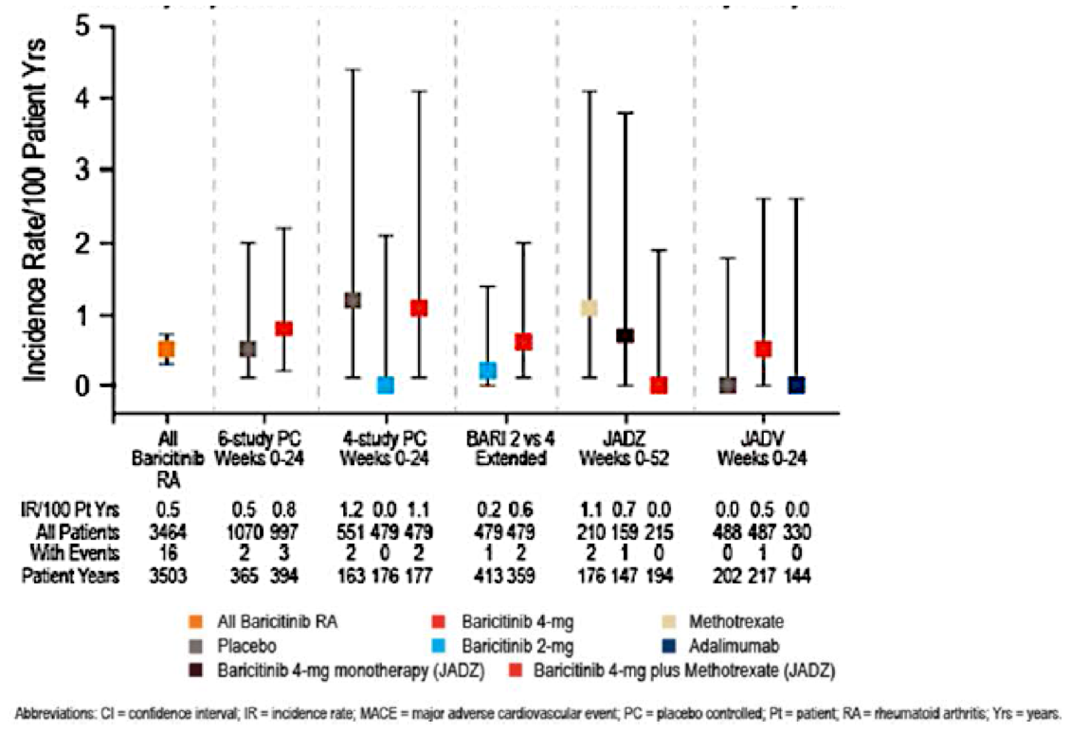
In addition, the rates of MACE did not appear to increase over time with continued BAR treatment (that is, up to 96 weeks of continuous therapy); refer to Figure 9.
Figure 9: Positively adjudicated MACE over time in baricitinib RA program
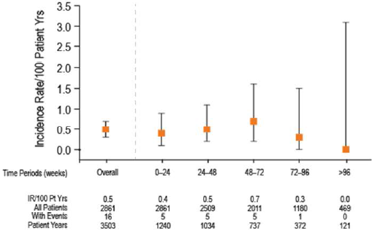

Other safety issues

Safety in special populations

Pregnancy and lactation
The effects of BAR on human fetal development are unknown. The JAK/STAT pathway has been shown to be involved in early embryonic development, particularly in relation to skeletal development. As of 10 August 2015, 15 women had become pregnant during their study participation including 12 exposed to BAR during their first trimester of pregnancy, 2 women received adalimumab only and 1 patient received PBO only. Pregnancy outcome information is available for 10 of the 12 pregnancies, and the other 2 pregnancies had pending outcomes. Of the 12 women exposed to BAR, 5 delivered healthy infants (either full-term or premature) and 5 had either spontaneous (n = 4) or elective abortions (n = 1). There was also 1 pregnancy in the partner of a male patient exposed to BAR. This pregnancy was carried to term and the infant had no evidence of foetal malformation. After the data cut-off date of 10 August 2015, 4 additional pregnancies in study participants and 1 additional pregnancy in the partner of a male patient have been reported (all occurred in Study JADY in patients taking BAR 4 mg/day). Two pregnancies resulted in elective termination, 1 resulted in a premature birth with no evidence of adverse fetal outcome and 1 pregnancy was ongoing. The pregnancy exposure via the treated male partner is also ongoing. It is unknown whether BAR is excreted into human milk by lactating women.

Patient subgroups
The sponsor has also conducted an analysis of the safety data according to various subgroups based on demographic and co-morbid factors. The subgroup analyses included age (for example, < 65 years, ≥ 65 years and ≥ 75 years), gender, race, subject weight (< 60 kg, 60 to 100 kg and > 100 kg) and impaired renal function at Baseline. Some of the subgroups were too small in number to make reliable data interpretations; however, none of the factors appeared to significantly influence the exposure adjusted incidence rate or type of AEs, apart from older subjects being associated with a higher incidence of SAEs and discontinuations due to AEs, which was primarily explained by myelosuppressive AEs and vascular disorders. There was no analysis of concomitant use of oral CS on the incidence or type of AEs.

Safety related to drug-drug interactions and other interactions
Clinical pharmacology studies have been conducted to examine the potential for other drugs to affect the PK of BAR. Among inhibitors and inducers of CYP3A (ketoconazole/fluconazole and rifampicin, respectively) and inhibitors of the OAT3 transporter (probenecid) examined in clinical pharmacology studies, only probenecid had a clinically meaningful effect on the PK of BAR. Concomitant administration of probenecid doubled the exposure (AUC) to BAR and as such a BAR dose of 2 mg once daily is recommended if OAT3 inhibitors with a strong inhibition potential, such as probenecid, are administered concomitantly. Other OAT3 inhibitors that are common co-medications in RA patients, such as ibuprofen and diclofenac, have less inhibition potential than probenecid and were predicted using PK modelling to not interact significantly with BAR. Clinical pharmacology studies have also been conducted to examine the potential of BAR to inhibit or induce CYPs and drug transporters and, therefore potentially affect the PK of co-administered drugs. BAR does not appear to have a clinically significant effect on the PK of any of the probe substrates studied (simvastatin, ethinyl estradiol/levonorgestrel, digoxin and MTX). Studies of BAR therapy co-administered with vaccines, biologic DMARDs and with other JAK inhibitors have not been conducted.

Post marketing experience
Not applicable as BAR has not received marketing authorisation anywhere in the world at the time of this submission.

Evaluator’s overall conclusions on clinical safety
In this submission, the clinical safety dataset for the use of BAR in adult patients with active RA consists of 4214 PY of drug exposure involving 3464 patients enrolled in 1 Phase I drug interaction trial (Study JADB), 7 completed Phase II/III studies and 1 ongoing LTE trials (Study JADY). The overall safety database for BAR therapy consists of 3822 patients (4452 PY of drug exposure) treated with any dose of BAR as this cohort includes data from 2 completed Phase II trials in psoriasis (Study JADP) and diabetic nephropathy (Study JAGQ). For adult subjects with active RA at Baseline, 2166 patients have received treatment for at least 1 year and 467 subjects have received BAR therapy for at least 2 years. In terms of the BAR doses being requested for approval in this submission, > 1000 patients have received 4 mg once daily therapy and 479 patients have received 2 mg once daily treatment in the PBO-controlled population. The majority of BAR treated patients in the all exposure RA dataset received concurrent MTX, with more than half taking concomitant NSAIDs and/or concurrent low dose oral CS. Overall, there is a sufficient volume of data to make a meaningful assessment of BAR safety for up to 2 years of treatment in the newly proposed treatment indication of active RA.
Compared to PBO, a numerically higher incidence of serious AEs and AEs resulting in permanent treatment discontinuation were observed with BAR treatment, with some of the AE types (mainly, various laboratory abnormalities including increased serum CPK and lipid levels) occurring at a higher incidence in the higher dose BAR treatment cohort (4 mg once daily versus 2 mg once daily). Infection was the most common AE recognised with BAR and these occurred at a higher frequency with BAR 2 and 4 mg once daily treatment versus control therapy during the true PBO-controlled treatment periods (first 16 to 24 weeks for the pivotal Phase III trials). The majority of infections were mild in severity, self-limiting, and were predominately URTI, urinary tract infection or nasopharyngitis. The use of concurrent MTX did not appear to increase the overall risk of AEs, including infection related AEs (Study JADZ). Nausea (often in the absence of other gastrointestinal symptoms) was more commonly reported with BAR 4 mg/day therapy versus PBO, and approximately half of all cases occurred within 2 weeks of commencing treatment. Acne and alopecia have also been reported in < 2% of patients treated with BAR.
In the integrated safety dataset populations, there was an increased incidence of overall but not serious infection with BAR versus PBO and active comparators, which is surprising for the PBO controlled comparison. Although there was no clear signal of increase risk of opportunistic infection with BAR, in the long-term safety population 3 cases of Pneumocystis pneumonia (all in Japanese subjects) and 5 non-serious cases of oesophageal candidiasis have been recorded. During the controlled trial periods, 2 patients developed overt tuberculosis infection in the BAR clinical study program (1 treated with BAR 4 mg/day and the other received adalimumab). In the uncontrolled LTE period, 6 additional cases of TB (3 unconfirmed by microbiology) have been reported with BAR. All observed TB cases occurred in countries where TB is prevalent and the sponsor has included a warning about the risk of TB and screening pre-treatment in the proposed PI. In the long-term exposure population, 16 subjects (all in Asia) have recorded detectable HBV DNA after receiving BAR, including 8 cases in the controlled periods of the trials. However, there was a clear increased risk of herpes zoster and oral herpes viral infections with BAR versus PBO. This finding may be expected given the effects of JAK inhibition. A BAR dose effect was observed for the risk of herpes zoster infection. The majority of herpetic infections were rated as mild or moderate in severity, and responded to standard treatment.
Permanent discontinuations from treatment due to AEs up to 24 weeks occurred at a higher frequency with BAR 4 mg/day (EAIR of 11.5-13.9 per 100 PY) versus PBO (EAIR of 8.6-11.1 per 100 PY), MTX (EAIR of 6.4) and adalimumab (EAIR of 4.9). Compared to MTX and PBO, the main reason for more patients ceasing BAR 4 mg/day was an increased incidence of herpes zoster infection. Compared to adalimumab, the main explanation for the increased incidence of treatment discontinuation with BAR 4 mg/day was the 2-fold increased EAIR of infection. Cessation of BAR 2 mg/day up to 24 weeks occurred at a similar incidence to PBO (10.8% versus 11.1%, respectively, in the secondary integrated safety set).
A total of 36 deaths (27 in BAR treated subjects) have been reported in the all exposure BAR population up to 30 November 2015, including 5 MACE and 4 cancer related deaths in BAR treated subjects. Mortality rates and the causes of death were similar between BAR and PBO or comparator therapies (MTX and adalimumab) in relatively short term treatment follow-up (up to 2 years). The rate of MACE in the RA dataset is within expectations for the treatment population and the types of MACE observed did not identify any specific safety signals with BAR. However, longer periods of treatment follow-up are required to inform about these 2 potential safety concerns.
Increases in serum CPK values and lipid levels are recognised safety concerns with JAK inhibition and were observed with BAR in the RA treatment studies. Up to 24 weeks, the overall incidence of LDL-cholesterol values ≥ 3.36 mmol/L were x 2-3 fold higher with BAR 4 mg/day treatment (≥ 40%) compared with PBO (13.5-17.0%) and were also numerically greater compared to active comparator therapies (29% with MTX monotherapy and adalimumab). The long-term clinical consequences of increased rate of atherogenic lipid profiles associated with BAR remains unknown. BAR 2 mg/day treatment had a slightly lower frequency of inducing elevated lipid profiles (approximately one third) compared to BAR 4 mg/day. Small increases in serum CPK values were frequent with BAR therapy but the percentage of patients who recorded Grade 3 or higher elevations in CPK were 0.8-1.5% (slightly higher incidence with BAR 4 mg versus 2 mg). There was also a slightly higher incidence of anaemia and Grade 3 or 4 neutropaenia and lymphopaenia observed with both doses compared to PBO as well active comparator treatment with MTX and adalimumab. There was also a slightly higher incidence of thrombocytosis (platelet count > 600 x 109/L) observed in patients treated with BAR.
In summary, the safety data indicates that BAR has an acceptable overall safety profile up to 2 years of therapy in the treatment of adult patients with moderately to severely active RA. There is limited long-term safety data in the current submission to assess the risk of some types of AEs such as malignancy and MACE, which will require additional longitudinal safety follow-up. From my assessment of the safety dataset, there are some significant safety concerns with BAR therapy including the risk of infection, opportunistic infection (mainly, oral herpes and zoster infection), increased serum CPK values, anaemia, neutropaenia, thrombocytosis, abnormal liver function tests (raised serum transaminases) and dyslipidaemia. These safety concerns are consistent with the known profile of JAK inhibitor therapy in adult patients with RA. Significant pharmacovigilance will be required if approval is granted for registration of BAR for the treatment of RA. This would include vigilance for serious and opportunistic infections, MACE and malignancy (particularly, non-melanoma skin cancers).

First round benefit-risk assessment

First round assessment of benefits

Table 25: First round assessment of benefits
Indication: Treatment of active Rheumatoid Arthritis in adult patients
Benefits | Strengths and Uncertainties
BAR produces improvements in the symptoms and signs of active RA (as per the ACR clinical response criteria) that are superior to PBO and MTX and non-inferior to adalimumab. | Consistently observed in Phase III trials.
BAR results in improved physical function in patients with active RA (as per HAQ-DI responses) that are superior to PBO and MTX and non-inferior to adalimumab. | Consistently observed in Phase III trials.
BAR results in improvements in several patient reported outcomes such as duration and severity of morning stiffness in patients with active RA that are superior to PBO and MTX and non-inferior to adalimumab. | Consistently observed in Phase III trials.
BAR may result in statistically lower rates of structural disease progression at 24 and 52 weeks compared to PBOI and MTX alone, but the magnitude of that effect is of unclear clinical significance. | Preliminary data only – not consistent across the 3 pivotal trials. Regulatory guideline of relevance recommends at least 2 years of data in assessing X-ray claim.
Persistence of clinical response for up to 2 years in the subgroup of patients who are tolerating and responding to BAR 4 mg/day. | Supported by the efficacy outcomes reported in the interim report for the LTE Study JADY.
Significant clinical response to BAR 4 mg/day monotherapy versus MTX alone, which is not different to that seen with BAR + MTX. This supports the request for registration of the BAR monotherapy treatment option. | Supporting BAR monotherapy data largely restricted to the observations of 1 pivotal study (JADZ) which enrolled DMARD naïve subjects with early disease (limited population generalisability).
Convenient mode of administration (oral ingestion) with an acceptable dosing schedule (once daily without regard to food). | Supported by PK data for BAR. Alternative DMARD therapy with biologic requires IV or SC drug administration.
Clinical efficacy response with BAR therapy observed across a diverse patient spectrum and in all patient subgroups. | Supported by the Phase II/III clinical study program and the integrated efficacy analysis sets.

First round assessment of risks

Table 26: First round assessment of risks
Risks | Strengths and Uncertainties
Increased incidence of infection with BAR versus PBO | Phase III studies.
Increased incidence of nausea with BAR versus PBO | Phase III studies.
Increased incidence of permanent treatment discontinuations due to AEs with BAR versus PBO and adalimumab. | This was consistently observed in the Phase II and III clinical studies.
Increased incidence of herpes zoster infection with BAR versus PBO and adalimumab. | Observed in Phase III trials.
Increased incidence of haematologic abnormalities such as anaemia and grade 3-4 neutropaenia and lymphopaenia with BAR versus PBO and adalimumab. | Observed in Phase III trials.
Increased rates of raised atherogenic lipid profiles with BAR versus PBO and active comparator, however, no increased rate of MACE has been recorded in medium term follow-up. | This was consistently observed in the Phase II and III clinical studies. In the integrated safety dataset, the incidence and type of MACE was not increased with BAR but follow-up is limited to 2 years at present.
Increased rates of raised serum CPK values with BAR versus PBO and active comparator as well. | This was consistently observed in the Phase II and III clinical studies.
Live vaccines and biological DMARD therapies cannot be given concurrently with BAR. | The sponsor has not provided any studies examining for these outcomes.
Potential for drug-drug interactions, of which, probenecid is currently identified to be the main one of concern requiring BAR dose reduction. | The sponsor has conducted a thorough clinical pharmacology development program that has assessed this risk.
BAR has not been studied in patients < 18 years of age, in subjects with significant organ dysfunction, those at risk of reactivated TB, and in pregnant/lactating women. | The population with inadequate data regarding BAR therapy are identified in the current RMP.

First round assessment of benefit-risk balance
The overall benefit-risk balance of BAR, with or without combination non-biologic DMARD (mainly, weekly low dose oral MTX) in adult patients with moderately to severely active RA, who have had an inadequate response to or intolerant of at least 1 DMARD, with respect to reducing the symptoms and signs of RA as well as improving physical function is favourable. Data from the recent disease onset, DMARD naïve population of Study JADZ reveals an unclear benefit-risk balance with BAR (that is, better clinical efficacy but at the cost of increased side-effects compared to the current standard of care: weekly low dose MTX). The claim of radiographic benefit with BAR in RA is an add-on claim to an overall treatment indication, which has not been demonstrated with 4 mg/day monotherapy in a DMARD naïve population (Study JADZ, Week 24 and 52 X-ray results) and the overall radiographic dataset has not reached sufficient maturity to meet the TGA adopted regulatory guideline of relevance, whereby robust X-ray evidence of benefit over 2 years in RA is required.
BAR is a small molecule drug that selectively inhibits JAK1 and JAK2, thereby blocking the effects of various pro-inflammatory cytokines. In this submission, BAR has been evaluated in a large clinical program, which complied with CHMP guidelines for evaluation of treatment in RA. The clinical studies have evaluated an adequate number of subjects over a sufficient time frame in the target patient population and demonstrated that BAR 2 and 4 mg once daily is an effective option in reducing the clinical manifestations of active RA. The complete radiographic dataset (up to 52 weeks thus far) suggests superior inhibition of X-ray progression in a second line of treatment RA population (that is, after an adequate trial of conventional DMARDs), and possible superiority in a first line treatment population when used in combination with MTX.
The short and medium term safety profile of BAR observed in the clinical safety dataset included in this submission is largely consistent with expectations. The majority of commonly reported AEs were anticipated side effects in the RA population receiving immunosuppressant drugs (such as various types of mild severity infection) or abnormal laboratory results consistent with JAK inhibition (such as increases in CPK and lipid levels). The risk profile of BAR is based on a total of 2862 BAR-treated patients with RA involved in the Phase III studies, as well as additional safety information collected from 3822 patients treated with any dose of BAR in the all exposure population (including 3464 subjects with RA).
In the RA trials, there was an increased incidence of overall infection with BAR compared to PBO. The majority of reported infections were of mild or moderate severity, and involved either the upper respiratory or urinary tracts. Herpes related infections (zoster and oral) were also more frequent with BAR compared to PBO. However, very serious opportunistic infections like TB were reported with BAR.
Raised CPK levels were more frequently observed with BAR than PBO, but most cases were of mild or moderate severity and reversible. There was also an increased incidence of mild-moderate hepatic transaminase elevations and dyslipidaemia with BAR versus PBO. The clinical consequences of an increased incidence of atherogenic lipid abnormalities with BAR was not seen in the dataset thus far but required multi-year follow-up (5 to 10 years of reporting). Cases of anaemia and thrombocytosis were also observed with BAR. Significant changes in laboratory parameters associated with BAR were generally managed by dose interruptions or cessation.
Malignancy represents a theoretical risk with any immunosuppressive therapy, but there is no clear evidence that BAR confers an increased risk for certain types of malignancy such as non-melanoma skin cancers and lymphoma in the current dataset.

First round recommendation regarding authorisation
The evaluator recommends acceptance of the sponsor’s request for the registration of BAR (monotherapy or in combination with conventional DMARD) for the treatment of moderately to severely active RA in adult patients who have failed to respond to or are intolerant of at least 1 conventional DMARD with respect to reducing the symptoms and signs of RA, as well as improving physical function. The evaluator does not recommend acceptance of the sponsor request to include the add-on claim of radiographic benefit with BAR at this stage (based on the dataset in the current submission).
Apart from abatacept, all other approved DMARD therapies for RA do not specifically include a sub-claim of improving physical functioning in the treatment indication wording, yet all of those therapies have demonstrated such an effect with the supporting trial data included in the Clinical Trials section of their PI. For consistency across the DMARD options (excluding abatacept), the evaluator recommends the sub-claim of improving physical functioning be removed from the treatment indication wording for BAR, and the supporting information for this sub-claim (mainly, improvements from Baseline in HAQ-DI scores) remain included in the Clinical Trials section of the PI. Another JAK inhibitor (tofacitinib) approved for use in patients with RA has a specific wording in the treatment indication that it should only be initiated and monitored by a rheumatologist or specialist physician with expertise in the management of RA. The evaluator recommends that same wording also be included in the BAR treatment indication wording, as BAR has a potential benefit and side effect profile that requires familiarity with the therapeutic impact of BAR in a special patient population, which is beyond the scope of non-specialised medical practice.
In addition, the evaluator recommends the treatment indication specifically state that BAR should only be used in a second line treatment population as the benefit: risk assessment in a DMARD naïve population, with predominantly recent onset disease, is unclear. There is only 1 pivotal Phase III trial in the current dataset (Study JADZ), which has examined for efficacy and safety in the DMARD naïve, early disease treatment population. Data from this study reveals an unclear benefit-risk balance with BAR (that is, better clinical efficacy but at the cost of increased side-effects compared to the current standard of care: weekly low dose MTX).
Based on the benefit: risk evaluation, the proposed standard dose of BAR 4 mg once daily is justified, with labelling recommending a lower dose of 2 mg/day for a selected subgroup of patients. The data also indicates that BAR can be used as monotherapy or in combination with conventional DMARD therapy.
Taking all of the above statements into consideration, the recommended treatment indication wording is:
Olumiant is indicated for the treatment of moderate to severe active rheumatoid arthritis (RA) in adult patients when the response to 1 or more disease modifying anti-rheumatic drugs (DMARDs) has been inadequate. Olumiant can be given as monotherapy or in combination with methotrexate. Therapy with Olumiant should be initiated and monitored by a rheumatologist or specialist physician with expertise in the management of RA.
No significant inaccuracies of information have been included in the proposed PI, however, the PI contains insufficient information regarding 2 important safety aspects: 1) insufficient advice with respect to the use of BAR when significant laboratory abnormalities occur; and 2) minimum time frame between receipt of live vaccination and commencement of BAR.
Should approval of the sponsor’s proposed registration of BAR in the treatment indication of active RA is granted, the evaluator recommends that approval be subject to:
- satisfactory response to the questions in Section 10 of this report;
- satisfactory response to inadequate safety recommendations in the proposed PI;
- regular periodic safety update reports; and
- when available, the sponsor provides the TGA with the final clinical study reports for the LTE Study JADY and Study JAGS.

Clinical questions

Pharmacokinetics
No questions.

Pharmacodynamics
No questions.

Efficacy
- In the pivotal Phase III Study JADZ, the control treatment arm was assigned weekly low dose methotrexate 10-20 mg. Recent expert opinion has identified suboptimal methotrexate therapy (dose and route of administration) as a source of biasing findings in favour of biologic therapies in RA clinical trials. Could the sponsor comment on the adequacy of therapy in the control arm of Study JADZ as a potential source of efficacy bias?
(Ref: Duran J, Bockorny M, Dalal D, et al. Methotrexate dosage as a source of bias in biological trials in rheumatoid arthritis: a systematic review. Ann Rheum Dis 2016; doi: 10.1136/annrheumdis-2016-209383)
- Could the sponsor clarify the line of RA treatment (first or subsequent) in which it is proposing that baricitinib can be initiated? If the sponsor is proposing the initiation of baricitinib in DMARD naïve patients with relatively recent onset RA based on the findings of Study JADZ, please provide a detailed benefit: risk justification for initiation of baricitinib in this RA population, including numbers needed to treat and harm versus active comparator therapy.
- Could the sponsor comment on the clinical relevance of the magnitude of treatment related X-ray differences between baricitinib and control therapy in the 3 pivotal studies included in this submission? In particular, can the sponsor provide scientific validation of the relationship between radiographic progression and clinical outcomes, and what is the minimal clinically important treatment related difference in X-ray scores over time?

Safety
- Could the sponsor provide an analysis of adverse events (incidence and type) based on the use of concomitant oral glucocorticoid use with baricitinib and comparator therapies in the Phase III clinical studies?

Additional expert input
The evaluator recommends the TGA consider obtaining additional expert input for the evaluation of the population PK analyses included in this submission.

Second round evaluation of clinical data submitted in response to questions
The sponsor’s post-first round response dated 1 March 1 2017 addresses 7 questions [4 clinical and 3 PI based questions beyond the scope of this document] that were raised in the first round clinical assessment.

Question 1
In the pivotal Phase III Study JADZ, the control treatment arm was assigned weekly low dose methotrexate. Recent expert opinion has identified suboptimal methotrexate therapy (dose and route of administration) as a source of biasing findings in favour of biologic therapies in RA clinical trials. Could the sponsor comment on the adequacy of therapy in the control arm of Study JADZ as a potential source of efficacy bias?
(Ref: Duran J, Bockorny M, Dalal D, et al. Methotrexate dosage as a source of bias in biological trials in rheumatoid arthritis: a systematic review. Ann Rheum Dis 2016)

Sponsor’s response
In the sponsor’s response, the sponsor states that the dosing strategy used in the MTX control arm of Study JADZ was consistent with published data from the biologic DMARD and tofacitinib trials, ACR clinical guidelines for the management of RA (that is, weekly MTX up to 25 mg) and the approved posology for Methoblastin in Australia. In Study JADZ, almost one quarter of subjects (52/210) enrolled in the MTX treatment group were dosed with low dose weekly oral MTX (at a mean dose of 11.8 mg/week), and approximately three quarters of subjects in the comparator arm (158/210) received full dose weekly MTX (at a mean weekly dose of 19 mg). The majority of patients prescribed the lower dose MTX regimen were recruited from Asian countries (91%), mostly Japan (78%), where the use of lower dose weekly MTX for RA therapy is commonplace. The sponsor also asserts that the use of MTX in patients with RA is a balance between achieving efficacy (ideally, disease remission) with acceptable tolerability. The sponsor states that the recent publication by Curtis et al (2016) found that patients taking MTX doses ≥ 20 mg/week had significantly more side effects than patients taking lower MTX doses.
In the sponsor’s response, the sponsor has provided an exploratory sensitivity analysis of the relevant clinical outcomes of ACR20, ACR50 and DAS28-CRP ≤ 3.2 response at Weeks 24 and 52 according to low and full dose MTX use in each of the 3 treatment arms. The sensitivity analysis showed that no significant heterogeneity in treatment effect based on MTX dose was observed in any of the 3 treatment groups in Study JADZ.
The sponsor has not made any comment on the use of an injectable MTX comparator versus oral therapy with BAR, as per the literature reference supplied with the evaluator question.

Evaluator’s comment
According to the sponsor quoted literature, approximately one quarter of patients in the MTX control arm of Study JADZ were receiving sub-optimal comparator treatment (that is, < 17.5 mg/week of MTX), yet the 3 nominated clinical endpoints in the sensitivity analysis did not reveal any detrimental impact of such an approach on the overall trial findings. However, this data limits the external validity (generalisability) of Study JADZ with respect to the Australian clinical practice setting, whereby a weekly MTX dose of at least 20 mg is an expected practice (as part of PBS prescribing criteria for initiation of a biologic DMARD or tofacitinib) unless major toxicity or tolerability issues with MTX have been recorded. Furthermore, the most recent published EULAR recommendations for the management of RA with synthetic and conventional DMARDs (2013 update – Smolen et al, 2014) state that MTX should be part of the first treatment strategy in patients with active RA (Recommendation 4). In addition, recommendation 6 states that in DMARD naïve subjects, irrespective of the addition of CS, conventional synthetic DMARDs (alone or in combination) should be used. Contemporary Australian rheumatology practice for the management of patients with active RA is highly consistent with the above EULAR recommendations. The evaluator concurs with the sponsor that the results of Study JADZ demonstrate that BAR (alone or with MTX) was statistically and clinically superior to MTX monotherapy for clinical efficacy outcomes, in largely DMARD naive subjects (91.3% of all enrolled subjects), but patients with the baseline characteristics of those enrolled in Study JADZ (mainly, significant disease activity with physical function impairment at Baseline) are unlikely to just receive MTX monotherapy in contemporary practice (that is, the comparator treatment investigated in Study JADZ has limited correlation to practice standards).

Question 2
Could the sponsor clarify the line of RA treatment (first or subsequent) in which it is proposing that baricitinib can be initiated? If the sponsor is proposing the initiation of baricitinib in DMARD naïve patients with relatively recent onset RA based on the findings of Study JADZ, please provide a detailed benefit: risk justification for initiation of baricitinib in this RA population, including numbers needed to treat and harm versus active comparator therapy.

Sponsor’s response
In the sponsor’s response, the sponsor has clarified that is seeking authorisation for BAR to be used in 2 RA treatment populations. Firstly, it is proposing that BAR be initiated as a second or subsequent line of therapy in those who have inadequately responded to, or who are intolerant of, 1 or more DMARD options. The sponsor has noted in the S31 response that the clinical evaluator supports the proposed use of BAR in this patient setting on a basis of an overall favourable benefit: risk analysis. The sponsor also proposes that BAR can initiated as first line therapy in adult patients with moderately to severely active RA with poor prognostic factors (that is, seropositive disease with high levels of systemic inflammation (CRP)). In the sponsor’s response, the sponsor has noted that the first round clinical evaluation report does not recommend use in this setting due to an unclear benefit: risk assessment in this treatment population scenario. The sponsor’s response has focussed on addressing the case for BAR use in the second patient setting (DMARD naïve subjects with active RA and poor prognostic factors). The sponsor asserts that there is a significant unmet need for treatment options in DMARD naïve patients with active RA and poor prognostic factors based on the magnitude and rapidity of benefits seen with BAR (alone or in combination with MTX) in the clinical trial program. The sponsor also states that tocilizumab has an approved first line treatment indication in Australia for the treatment of active RA in adult patients with poor prognostic factors. Using an indirect data comparison, the sponsor states that tocilizumab (as observed in the FUNCTION study, Burmester et al, 2015) and BAR (as per Study JADZ) have similar overall efficacy and safety profiles in this patient population. The sponsor acknowledges that MTX is an established and widely used standard of care DMARD in the first line treatment setting, but has issues with intolerability affecting up to 40% of treated individuals. Furthermore, the sponsor states that the 2014 EULAR guidelines comment that the maximum effect of MTX may take up to 4 to 6 months, and in recognition of the slow onset of MTX bridging CS therapy may be required.
In the sponsor’s response, the sponsor has re-presented the primary and key secondary efficacy endpoints observed in Study JADZ, which enrolled the target population as per the proposed treatment indication wording. BAR 4 mg daily (with or without concurrent MTX) showed statistically and clinically relevant benefits compared to MTX monotherapy at 24 and 52 weeks for a variety of clinical outcome measures (including ACR20/50/70 response rates) as well as the main physical functioning endpoint (that is, mean change from Baseline in the HAQ-DI score). In addition, the BAR + MTX treatment group showed statistically significant benefits over MTX monotherapy for X-ray endpoints at 52 weeks (such as the mean change from Baseline in mTSS, and the proportion of subjects with no X-ray progression), but this was not recorded for the BAR monotherapy versus MTX alone comparison. The sponsor’s response contains the calculated numbers needed to treat (NNT) for BAR (either alone or in combination with MTX) versus MTX alone, and they range from 5 to 13 for the various clinical outcome measures assessed at 24 weeks. Of note, the NNTs for ACR/EULAR Boolean based remission (which is one of the most stringent measures of clinical response in RA) at 24 weeks were 10 for BAR monotherapy and 13 for BAR + MTX versus MTX alone. The NNTs for X-ray non-progression (defined by mTSS ≤ 0) at 52 weeks were 38 for BAR monotherapy and 8 for BAR + MTX versus MTX monotherapy.
In sponsor’s response, the sponsor has provided a selective assessment of the safety risks of BAR (alone or in combination with MTX) versus MTX monotherapy in Study JADZ, and concludes that ‘the risk profile seen for BAR in DMARD naïve patients is in many respects comparable to that of MTX. Many of the risks are common across DMARD classes approved as first line therapy. Compared to MTX, BAR offers some safety advantages (for example, in liver chemistry) and some findings that were more pronounced (for example, lipid increases).’ In the S31 response, the sponsor acknowledges that the rates of elevated LDL cholesterol (≥ 3.36 mmol/L) are higher with BAR (alone or in combination with MTX) versus MTX alone with the calculated numbers needed to harm (NNH) being 5 to 6 for this outcome at 52 weeks of follow-up. However, the sponsor states that the clinical significance of this hyperlipidaemia observation with respect to cardiovascular risk in RA patients is unclear. The sponsor is also aware of an increased risk of herpes zoster infection with BAR versus MTX with the calculated NNHs over 52 weeks being 62 to 66. The EAIRs of serious infection overall, death, malignancy, MACE and AEs of gastrointestinal perforation were not more common in BAR treated subjects versus in those treated with MTX monotherapy in Study JADZ. In conclusion, the sponsor asserts that BAR 4 mg/day (alone or in combination with MTX) has a favourable benefit: risk analysis in DMARD naïve subjects with active RA and poor prognostic factors.

Evaluator’s comment
The focus of response will be on the sponsor request for obtaining a treatment indication in DMARD naïve subjects with active RA and risk factors for significant disease progression (that is, mainly seropositivity and high CRP levels at Baseline) as this is the main area of difference in opinion. Firstly, the evaluator disagrees with the sponsor that there is a significant unmet medical need for treatment options in this population. In Australia (and globally), there are already many approved treatment options (including conventional and biologic DMARDs) for treatment naïve patients with active RA and poor prognostic factors. The main problem with knowing how to manage this patient group is that there is insufficient evidence to support one single treatment strategy over alternative approaches. In addition, the most recent EULAR guidelines (2013) state that MTX should be part of the first treatment strategy in patients with active RA (Recommendation 4). In adult patients with recently diagnosed, active RA, it is internationally accepted that conventional synthetic DMARD therapy (alone or in combination) should be used in DMARD naïve patients (EULAR recommendation 6). Although Study JADZ shows efficacy benefits with BAR versus MTX monotherapy, the choice of comparator is sub-optimal and has limited external validity. In Study JADZ, the comparator treatment arm received MTX monotherapy for up to 52 weeks and approximately one quarter of those MTX treated subjects received sub-optimal doses of MTX (< 17.5 mg/week) over that extended period of time. In clinical practice and according to treatment guidelines (for example, EULAR), those high risk patients should be treated with higher doses of MTX (20-25 mg/week), often in combination with other conventional DMARD therapies if insufficient clinical response cannot be achieved with MTX monotherapy. These features of Study JADZ limit the external validity of its findings. In addition, the screen failure rate for Study JADZ was 50.2%, which limits the trial findings generalisability.
The comparative side effects of BAR versus MTX were also somewhat different in their clinical magnitude. In particular, 2 patients in the MTX monotherapy group of Study JADZ experienced an SAE of herpes zoster infection (EAIR 1.17) compared to 4 patients in BAR monotherapy arm (EAIR 2.78) and 5 patients in the BAR + MTX (EAIR 2.65). There were 2 other significant infectious SAEs in Study JADZ which were recorded in the BAR + MTX group: 1 case of Pneumocystis jirovecii pneumonia and 1 case of acute hepatitis B viral infection. An additional patient in the BAR + MTX arm recorded a non-serious opportunistic infection (oesophageal candidiasis) and 3 Japanese subjects had detectable hepatitis B viral DNA (by central laboratory testing) during the study. The data showing significantly higher numbers of patients treated with BAR versus MTX displaying increases in atherogenic serum lipids (LDL in particular) is also of concern, although the clinical consequences of this observation is unclear.
Overall, the evaluator continues to believe that the benefit-risk of BAR therapy in DMARD naïve patients with active RA and poor prognostic factors remains unclear at this stage, and there are several approved alternative treatment options available to such patients with pathways of treatment escalation in a time efficient manner also available in Australia for insufficiently responding (or medication intolerant) patients.

Question 3
Could the sponsor comment on the clinical relevance of the magnitude of treatment related X-ray differences between baricitinib and control therapy in the 3 pivotal studies included in this submission? In particular, can the sponsor provide scientific validation of the relationship between radiographic progression and clinical outcomes, and what is the minimal clinically important treatment related difference in X-ray scores over time?

Sponsor’s response
In the sponsor’s response, the sponsor has identified 2 broad issues. Firstly, the sponsor acknowledges that there is a paucity of published data defining the minimally clinically important difference in X-ray changes for individuals with RA. The sponsor also states that the scientific community in recent years has focussed on recommending that responder analyses of subjects without X-ray progression (defined in various ways: change from Baseline in mTSS of ≤ 0, ≤ 0.5 and ≤ smallest detectable change) in RA trials be considered as evidence of clinically relevant treatment response for X-ray outcomes. In Studies JADV, BAR 4 mg therapy demonstrated significantly improved rates of no X-ray progression (consistently across the 3 thresholds) compared to PBO. Similarly, when BAR 4 mg/day was combined with MTX in Study JADZ, significantly improved rates of non-progression were seen at 6 and 12 months compared to MTX monotherapy. The second issue identified by the sponsor in the S31 response is the limited amount of published data supporting the relationship between X-ray progression and clinical outcomes despite draft EMA RA treatment guidelines (2015) recommending prevention of radiographic progression as a desirable goal. Additionally, there is some data to justify a correlation between mTSS and HAQ-DI scores, which is mainly validated in RA patients with established disease (> 5 years duration), older patients (age > 55 years) and with greater X-ray damage at Baseline.

Evaluator’s comment
The evaluator concurs with the sponsor that there is a paucity of quality data defining the minimally clinically important difference in X-ray scores over time. In my opinion, the most relevant publications on this topic are those by Bruynesteyn et al (2001 and 2002) as well as the publication by Welsing et al (2006), which estimated the threshold for minimal clinically important X-ray progression of joint damage using its longitudinal relation with functional disability. The analysis by Welsing et al concluded that for a typical patient in their cohort (age at diagnosis of 55 years, some baseline X-ray damage and an expected disease duration of 30 years), a constant progression of 6 sharp points per year led to an increase of about 0.2 on the HAQ-DI score, solely related to damage, over the disease course. At 6 and 12 months in Studies JADZ and JADV, smaller LS mean increases from Baseline in the mTSS were observed in subjects treated with BAR 4 mg daily than in patients treated with PBO or MTX monotherapy. The observed differences between BAR 4 mg and PBO/MTX were statistically significant (p-value < 0.05), however, the clinical relevance of those mean changes in mTSS are unknown but appear to be of insignificant in the context of the above publications. Statistical significance is not the same as clinical relevance. The publication by Bruynesteyn et al (2001) examined the lower mTSS threshold of 0.5 sharp units as a means to define non-progression (with a sensitivity of 80% and an apparent specificity of 83%). The primary objective of the study was to determine the minimally clinically important difference in X-ray changes by comparing progression using 2 scoring methods in 4 different clinical settings. The conclusion stated ‘The threshold value with the highest accuracy was subsequently chosen as the score representing the MCID. Five Sharp/van der Heijde units and 2 Larsen/Scott units were the best cut-off values. The accompanying sensitivities ranged from 77% to 100% for the Sharp/van der Heijde method and from 73% to 84% for the Larsen/Scott method for the 4 clinical settings. The specificities were between 78% and 84% for the Sharp/van der Heijde method and between 74% and 94% for the Larsen/Scott method. The smallest progression score that can be detected apart from inter-observer measurement error, the smallest detectable difference (SDD), was equal to or larger than the calculated MCID, 5 Sharp/van der Heijde units and 6 Larsen/Scott units in our study, if the mean progression scores of the same 2 observers were used. The SDD is a conservative estimate of the MCID and our panel rated progression at or below this level as clinically significant.’ Sharp et al (1991) reported the annual rate of X-ray progression in adult patients with active RA to be approximately 4 units per year (maximum possible Sharp score of 314) over the first 25 years after disease onset with more X-ray progression earlier in the disease compared with later (established) RA. Later publications (Bruynestein et al 2002, and Welsing et al 2006) identified a similar level of X-ray progression (that is, approximately 5.0 sharp units) to define the minimally clinically important difference in mTSS. The sensitivity and specificity of the proposed 5.0 sharp unit cut-off in subjects with established RA and high disease activity (which is similar baseline characteristics to the population enrolled in Study JADV) was determined to be 76% and 84%, respectively. In addition, there is no published (non-draft) evidence to support the sponsor proposal that the proportion of subjects with no X-ray progression is the most clinically relevant outcome in assessing a claim of X-ray benefit in RA. The evaluator also concurs with the sponsor that there is no clear relationship between structural X-ray progression and clinical outcomes apart from a correlation between mTSS and the HAQ-DI score in subgroups of patients with RA.

Question 4
Could the sponsor provide an analysis of adverse events (incidence and type) based on the use of concomitant oral glucocorticoid use with baricitinib and comparator therapies in the Phase III clinical studies?

Sponsor’s response
In the sponsor’s response, the sponsor has provided new analyses of the safety dataset exploring the relationship between study treatment and concomitant CS therapy with respect to treatment emergent AEs and SAEs reported in the Phase II and III controlled trials (up to 24 weeks in 5 of the included studies and up to 52 weeks in Study JADZ). In all treatment groups (BAR, MTX, adalimumab and PBO) there was a higher incidence of SAEs and serious infections in patients who received concomitant oral CS than in those who did not receive CS, but all treatment groups were similarly affected indicating no significant treatment interaction by CS use or not observation. The analysis of treatment emergent AEs was conducted for overall events as well as a particular focus on infections and hepatobiliary AEs. In general, the EAIRs of overall treatment emergent AEs and infections were similar among the various treatment groups, regardless of concurrent CS use, in all 3 analysis datasets. However, use of concomitant CS was associated with a significantly higher frequency of hepatobiliary AEs for BAR 4 mg/day (EAIR increased from 3.2 to 8.3 with use of CS) versus PBO and adalimumab in Study JADV (EAIR decreased for PBO and only increased by 0.6 for adalimumab).

Evaluator’s comment
The evaluator concurs with the sponsor overall assessment on the issue of concomitant CS use by treatment option in the Phase II and III BAR studies. Overall, no concerning treatment by subgroup interaction (that is, concurrent use of oral CS – yes/no) was observed for BAR versus comparator treatment options. Consistent with the known safety profile of several DMARD therapies (conventional and biologic), the concurrent use of oral CS (at dose equivalent of prednisone ≤ 10 mg/day) is frequently associated with increased risk of serious infection. This observation is also seen with BAR at a similar incidence and pattern of events.

Second round benefit-risk assessment

Second round assessment of benefits
After consideration of the responses to the clinical questions (mainly, Questions 1 to 3), the benefits of BAR 4 mg daily therapy for the treatment of adult patients with active RA in the proposed usage are unchanged to those identified in Section 9 of this report. The supporting dataset for BAR use in a DMARD naïve population with poor prognostic factors is limited to the single pivotal, Phase III Study JADZ which was a well conducted trial in general, but had significant limitations with respect to the generalisability of that data to clinical practice. In particular, the comparator treatment arm for up to 52 weeks was MTX monotherapy with approximately one quarter of subjects receiving sub-optimal doses of MTX (< 17.5 mg/week) over that extended period of time. In clinical practice and according to treatment guidelines (for example, EULAR), those high risk patients should be treated with higher doses of MTX (20 to 25 mg/week), often in combination with other conventional DMARD therapies if insufficient clinical response cannot be achieved with MTX monotherapy. These features of Study JADZ limit the external validity of its findings. In addition, the screen failure rate for Study JADZ was 50.2% and with approximately one quarter of MTX monotherapy treated subjects receiving an insufficient dose of MTX for unclear reasons (other than they were recruited from Asian countries), there is considerable uncertainty about the trial external validity. The sponsor needs to explain the rationale for that justification and reflect on how those features (for example, the lack of a combination conventional DMARD treatment strategy in the comparator arm) affect the external validity of the trial findings to the Australian treatment setting.

Second round assessment of risks
After consideration of the responses to the clinical questions (principally, Question 4), the risks of BAR are unchanged from those identified in Section 9 of this report. The increased rate of infection and nausea with BAR therapy versus PBO; and the higher incidence of permanent treatment discontinuation due to AEs, raised atherogenic lipid profiles, cytopaenias and herpes zoster infection with BAR versus PBO and adalimumab remains a consistent safety signal. Other clinically significant AEs such as the risk of MACE, death and malignancy remain within expectations for the RA population cohort, but the current dataset for examining these major safety concerns is of limited duration at present, and such AEs typically require many years of treatment follow-up for adequate assessment.

Second round assessment of benefit-risk balance
After consideration of the responses to the clinical questions, there is no change to the opinion expressed in Section 9. The overall benefit-risk balance of BAR treatment (with or without combination non-biologic DMARD, mainly MTX) in the proposed treatment indication claim of second line therapy is favourable. However, the risk-benefit assessment in the proposed treatment indication of BAR use in DMARD naive subjects with active RA and poor prognostic factors as well as the sub-claim of benefit for slowing the progression of structural damage remains unclear. Clinically relevant efficacy has been observed with BAR therapy in the second and first line treatment RA population, but the external validity of the comparator treatment group in Study JADZ has limited external validity to contemporary Australian practice and internationally accepted guidelines (EULAR). Furthermore, the comparison between BAR and adalimumab in Study JADV with respect to their overall benefit-risk balance needs additional scrutiny as this information impacts upon the presentation of data in the proposed PI. The major risks with BAR therapy (versus PBO) include an increased risk of infection, raised serum transaminases, atherogenic lipid profiles, neutropaenia and lymphopaenia.

Second round recommendation regarding authorisation
The evaluator recommends acceptance of the sponsor’s request for the registration of BAR (monotherapy or in combination with conventional DMARD) for the treatment of moderately to severely active RA in adult patients who have failed to respond to, or are intolerant of, at least 1 DMARD with respect to reducing the symptoms and signs of RA, as well as improving physical function. The evaluator does not recommend registration of the sponsor proposal of a treatment indication for BAR in a DMARD naïve population with poor prognostic features as the benefit: risk assessment in this patient population remains unclear. There is only 1 pivotal Phase III trial in the current dataset (Study JADZ), which has examined for efficacy and safety in the DMARD naïve, early disease treatment population. Data from this study reveals an unclear benefit-risk balance with BAR (that is, better clinical efficacy but at the cost of increased side-effects compared to the current standard of care, weekly low dose MTX). The sponsor has already accepted the removal of the add-on claim of radiographic benefit with BAR at this stage (based on the dataset in the current submission), which is appropriate.
Based on the benefit: risk evaluation, the proposed standard dose of BAR 4 mg once daily is justified, with a lower dose of 2 mg/day recommended for a selected subgroup of patients (for example, those with significant renal impairment). The data also indicates that BAR can be used as monotherapy or in combination with conventional DMARD therapy. The sponsor has agreed to add specific wording to the Dosage and Administration section of the PI (but not the treatment indication wording) that BAR should only be initiated and monitored by a rheumatologist or specialist physician with expertise in the management of RA. This is a non-critical issue to the registration of BAR.
Apart from abatacept, all other approved DMARD therapies for RA do not specifically include a sub-claim of improving physical functioning in the treatment indication wording, yet all of those therapies have demonstrated such an effect with the supporting trial data included in the Clinical Trials section of their PI. For consistency across the DMARD options (excluding abatacept), the evaluator continues to recommend the sub-claim of improving physical functioning be removed from the treatment indication wording for BAR, and the supporting information for this sub-claim (mainly, improvements from Baseline in HAQ-DI scores) should remain included in the Clinical Trials section of the PI. The sponsor has disagreed with this recommendation and maintained the specific wording of ‘Olumiant has been shown to improve physical function and reduce the signs and symptoms of RA.’ This is an ongoing, non-critical issue to BAR registration.
Taking all of the above statements into consideration, the recommended treatment indication wording for BAR is:
Olumiant is indicated for the treatment of moderate to severe active rheumatoid arthritis (RA) in adult patients when the response to 1 or more disease modifying anti-rheumatic drugs (DMARDs) has been inadequate. Olumiant can be given as monotherapy or in combination with methotrexate. Therapy with Olumiant should be initiated and monitored by a rheumatologist or specialist physician with expertise in the management of RA.
No significant inaccuracies of information have been included in the newly proposed PI, however, the PI contains insufficient information regarding the comparative safety of BAR and adalimumab as observed in Study JADV.
The evaluator recommends the continued registration of BAR for the treatment of active RA is subject to regular periodic safety update reports and when available, the sponsor provides the TGA with the final clinical study report for the long-term Study JADY.

Additional evaluation material supplied following the second round evaluation
The additional evaluation material (that is, following second round evaluation) contained 3 areas of documents and sponsor responses, which will be considered in turn and include the following:
- TGA Request (dated 27 April 2017) for additional information following the issue of a complete response letter (CRL; dated 12 April 2017) from the FDA for BAR
- TGA Request (dated 28 April 17) for response to the main second round clinical evaluation report issues
- Sponsor response (dated 13 March 2017) to evaluator conclusions for PK/PD (dated 15 February 2017) that may have clinical implications
In addition to the above material, the sponsor has provided its response (dated 27 April 2017) to the CHMP rapporteur questions on the potential thrombosis related risk with BAR (dated 19 April 2017). The data provided in this response supplements the sponsor response to the main FDA safety concern of risk of thromboembolic disease and will be considered in the TGA request for additional information following the FDA complete response letter section of this report. In the European Union, where BAR 2 mg and 4 mg once daily therapy have been approved since February 2017, the CHMP recently agreed with the sponsor to update the drug label with a precaution for patients who have risk factors for DVT and PE. In Japan, where BAR was also recently approved, the label includes a similar precaution.

TGA request for additional information following complete response letter from the FDA
The sponsor response dated 26 May 2017 addresses 10 questions that were raised by the TGA Delegate with respect to thrombosis related data and dose justification for BAR.

Question 1
Please comment on the high incidence of venous thromboembolic events and the risk of harm. During the 0 to 16 week controlled period of the completed Phase III studies (JADV, JADX, JADW and JADZ), the incidence rate of VTE (per 100 patient years) was 1, 0, and 0, for the baricitinib 4 mg, baricitinib 2 mg, and placebo groups, respectively.

Sponsor response
Due to the overall low number of thromboembolic events occurring in the PBO controlled periods (first 16 weeks of therapy) of the Phase III BAR studies in patients with RA, the sponsor reports that a data safety signal with BAR is difficult to interpret for this type of AE. Moreover, the sponsor asserts that the observed rate of VTE (thromboembolism) is consistent with the expected background rate in RA subjects. In the additional evaluation material, the sponsor has updated data to the most recent database lock point for the long-term extension Study JADY (as of 1 September 2016 now), which provides a further 12 months of exposure to the initial submission. With regards to comparator therapies, there is no new data and the number of VTEs remains unchanged compared to the initial application. No treatment emergent VTE were reported in the PBO or adalimumab groups. However, 1 PE was reported in the MTX monotherapy arm of Study JADZ during Week 33 (at an incidence rate of 0.58 per 100 PY of exposure). The sponsor provided Table 27 as an updated summary of the incidence rate of PE and DVT in the BAR trial dataset (as of 1 September 2016). A total of 31 BAR treated RA patients (in the All BAR RA exposed cohort) have reported VTE. The 31 cases also includes BAR treated subjects who have recorded DVT or PE during the post-treatment follow-up period. The dataset does not indicate a dose response effect for BAR (2 versus 4 mg) in the risk of VTE (as per Study JADX-DMARD IR population).
The sponsor also reports an additional 7 SAEs of DVT or PE from ongoing BAR studies between 1 September 2016 and 19 April 2017, including 5 additional cases reported in Study JADY over a period of approximately 7.5 months. The sponsor estimates the incidence rate of serious VTE in Study JADY to be ~0.33 per 100 PY given the additional drug exposure up to 19 April 2017.

Table 27: Overall number and incidence rates of DVT and PE in the BAR study program
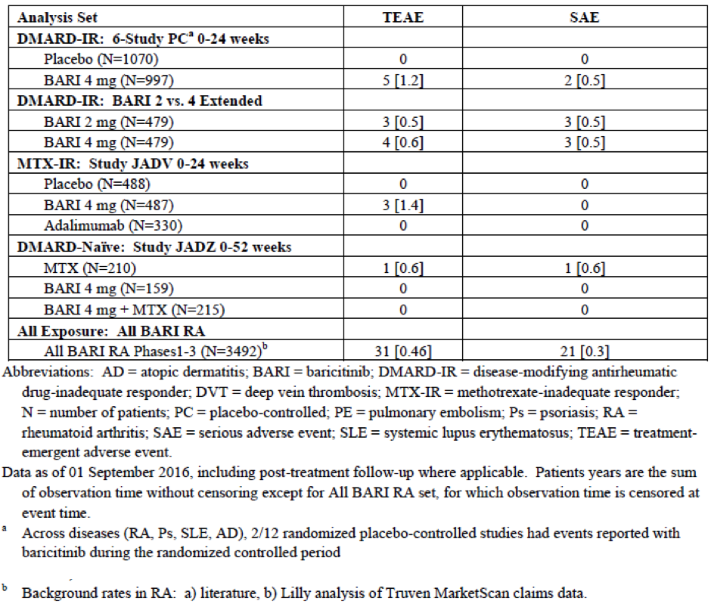
The sponsor also provided an analysis of the incidence rate of VTE over time (using successive 24 week periods of follow-up) in BAR treated subjects with up to 120 weeks of drug exposure. There was no pattern of increased or decreased risk in any given 24 week time period over time; refer to Table 28 (provided in the sponsor’s new additional evaluation material). The overall EAIR of VTE in the all BAR treated population was 0.46 per 100 PY, which is consistent with the reported range in RA subjects (0.29 To 0.74 per 100 PY).
In summary, the sponsor asserts that while the incidence rate of DVT and PE appeared to be high in the initial 16 week PBO controlled periods of the clinical trials, the overall rate does not appear to exceed the expected background rate in patients with RA and remained stable over time up to 120 weeks of treatment follow-up.

Table 28: Incidence rates of VTE by 24 week time periods in the All BAR RA population
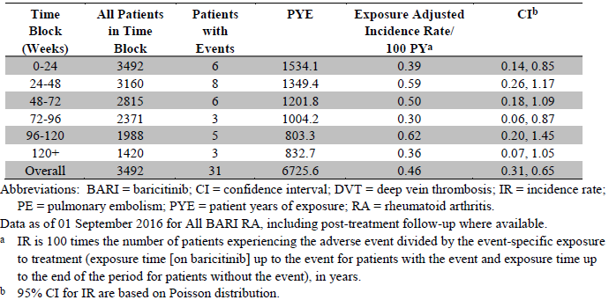

Evaluator’s response
Although there appears to be a numerically high VTE risk with BAR 4 mg once daily treatment in the first 24 weeks of therapy (5 recorded events in the PBO controlled portions of 6 studies), the exposure adjusted incidence rates are within expectation limits and probably reflect the natural variability in the occurrence of relatively uncommon safety events in clinical trials. Unfortunately, the sponsor response does not contain a specific analysis or comment in the incidence rate of VTE in the first 16 weeks of therapy, which is true PBO controlled period in the trials as many patients were rescued to BAR or withdrew prior to Week 24. There is a theoretical concern with BAR that by increasing the platelet count in the first 2 to 4 weeks of therapy, there may be a relative hypercoagulable state induced with treatment initiation that subsides over time. The sponsor has directly answered this question in its response. Nonetheless, the risk of VTE does not appear to increase or decrease over time in the extended treatment dataset (up to 120 weeks of continuous treatment; measured by 24 week blocks for analysis) which is somewhat reassuring.

Question 2
Introduction: Clarification regarding VTE events from the controlled portions of the clinical studies and during the extension studies.

Part 1
The clinical evaluation report (CER) notes the incidence of serious adverse events consistent with thrombotic events as 14 from the all baricitinib population (p93 of the CER) and the sponsor’s response from 25 April 2017 indicates in the controlled portions of the 6 completed randomized placebo controlled Phase II and III 3 studies in RA (up to 24 weeks (JADC, JADA, JADN, JADV, JADX, JADW)), events of deep vein thrombosis (2) and pulmonary embolism (2) were reported in 4 patients from 2 studies during treatment with baricitinib 4 mg, but not with placebo or baricitinib 2 mg.

Sponsor’s response
At the time of submission, a total of 15 serious cases of DVT/PE were reported in the All exposure BAR RA patient population (not 14 cases as described in the CER). Of these, in the controlled portions of the Phase II/III RA studies, 2 events of DVT and 2 events of PE were reported in 4 patients receiving BAR 4 mg therapy (no cases were reported in either the PBO or BAR 2 mg groups).

Part 2
The number, severity and seriousness of VTE events across each study.

Sponsor’s response
In the latest response, the sponsor has updated the incidence rates of DVT and PE, including SAEs and AEs leading to temporary and permanent treatment discontinuation; refer to Table 29. In the original submission, no post-treatment VTE episodes were included. During the randomised controlled portion of Study JADX, 1 patient experienced VTE about 1 month after discontinuing BAR treatment. Therefore, analyses that include solely on-treatment AEs show 4 VTEs as having occurred in the randomised controlled portions of the Phase II/III RA studies and 30 patients having experienced VTE in the All exposure BAR RA dataset. However, analyses that include events that have occurred both on-treatment as well as post-treatment show a total of 5 VTE as having occurred in the randomised controlled portion of the Phase II/III RA studies and 31 patients who experienced VTE in the All exposure BAR RA dataset.

Table 29: Number and exposure adjusted incidence rates of DVT and PE
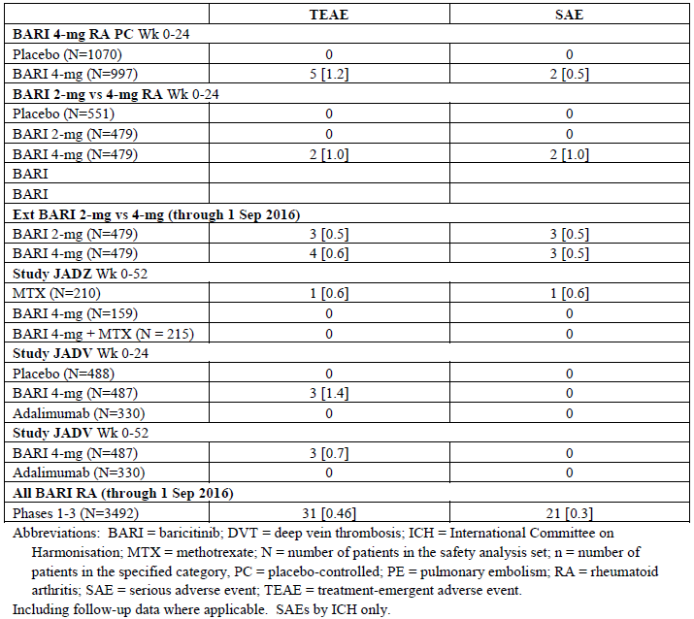
Note: 2 patients with DVT/PE post-study were not included in the table. Data is as of 1 September 2016, including post-treatment follow up where applicable. PY are the sum of observation time without censoring except for All BARI RA set for which observation time is censored at event.
At the most recent database lock point for the ongoing extension Study JADY of 1 September 2016, a total of 30 BAR treated patients reported a total of 35 DVT or PE episodes (as per Table 29; 1 fatal PE occurred in a MTX treated subject of Study JADZ). Including patients who reported DVT/PE during post-treatment follow-up, 31 patients reported a total of 38 DVT/PE events (11 were regarded as non-serious and 28 were judged to be SAEs). The majority of affected patients recovered from the DVT/PE and continued treatment with BAR (7 patients had no change in BAR treatment associated with the AE, while 12 patients had their treatment interrupted then re-started. Seven additional patients reported SAEs of DVT/PE from ongoing BAR studies from 1 September 2016 through to 19 April 2017. One case was reported in the ongoing, blinded Phase II Study JAHH (patients with systemic lupus erythematosus). One case was reported from Study I4V-MC-E001, a non-sponsor sponsored trial for patients with chronic graft-versus-host-disease after allogeneic haemopoietic stem cell transplantation. The remaining 5 cases were reported from the ongoing RA extension Study JADY (2 were judged as serious and 3 were deemed non-serious). Although another database lock has not occurred, and an estimate of the updated exposure and EAIR was calculated. The 5 additional SAE cases of DVT/PE in Study JADY was reported during a period of 7.5 months. The sponsor estimates that the corresponding additional BAR drug exposure is about 1500 PY, for an estimated incidence rate of serious DVT or PE of approximately 0.33 per 100 PY.

Part 3
Pre-disposing factors or other explanations for the VTE events.

Sponsor’s response
The sponsor has provided a multivariate analysis (new information) to assess the association of multiple risk factors for VTE with the occurrence of such events in the BAR clinical trial program. The examined risk factors in the final analysis included age, BMI, duration of RA, baseline physical function and prior history of VTE as all of these factors were significant predictors of VTE in a preceding univariate analysis. Treatment (study drug) was not included as a covariate in the model as the analysis was conducted using the All exposure BAR RA set. The final multivariate logistic regression model was built using a backward stepwise method with line of therapy as a forced covariate. The final model shows that older age, high BMI and past medical history of VTE independently predicted the incidence of VTE in this clinical trial population (as depicted by a hazard ratio > 1 in the multivariate risk factor analysis plot). Prior RA treatment (DMARD naïve, and conventional or biologic DMARD inadequate response) as well as RA disease activity at Baseline and with treatment, were not identified as independent predictors of VTE. Table 30 shows that within the All exposure BAR RA population (through to 1 September 2016), those who recorded VTE were more likely to have typical risk factors for VTE than subjects who did not experience VTE. In particular, obesity (55% of patients with VTE were severely obese with BMI ≥35 kg/m² compared to 13% of patients who did not develop VTE), age ≥ 60 years, prior VTE and prior malignancy were more common in the group of patients who developed VTE. Moreover, in patients who developed VTE, 42% had experienced prior trauma, surgery, or immobility, all of which are significant risk factors for VTE. In contrast, the number of patients with elevated platelet count at Baseline or post-baseline was similar between the 2 cohorts.
For the 5 patients treated with BAR 4 mg therapy who developed VTE during the randomised controlled portion of the Phase III RA studies (including 1 patient with post-treatment VTE), all had 1 or more typical risk factors for developing VTE. One patient had a past history of VTE prior to entering the study. All 5 patients were severely obese with BMI ranging from 36 to 52 kg/m². Three of those 5 patients were ≥ 60 years of age and 4 were on concomitant steroids. In those subjects, changes in platelet counts did not appear to be a risk factor for VTE. Three of the 5 patients had platelet counts ≤ 400 x 10⁹/L throughout the course of the trial. One patient had a platelet count ≥ 600 x 10⁹/L prior to developing ‘mild’ DVT but their baseline platelet count was also significantly elevated at 589 x 10⁹/L. One patient had a count of 431 x 10⁹/L, which dropped to ≤ 400 x 10⁹/L prior to a PE of moderate severity with a baseline value of 318 x 109/L. In addition, the sponsor also reports that there were almost twice as many elderly patients (aged ≥75 years) randomised to BAR 4 mg therapy (3.1%) versus the PBO group (1.8%) in the trials. The ≥65 year age group also showed an imbalance between the BAR 4 mg group (20.0%) and the PBO arm (16.2%). Older age is a well-established risk factor for VTE and the sponsor believes this may have contributed to the small, though numerically, higher number of VTE occurrences in the BAR compared to the PBO group.

Table 30: Characteristics of patients who reported VTE versus no VTE in All BAR RA dataset
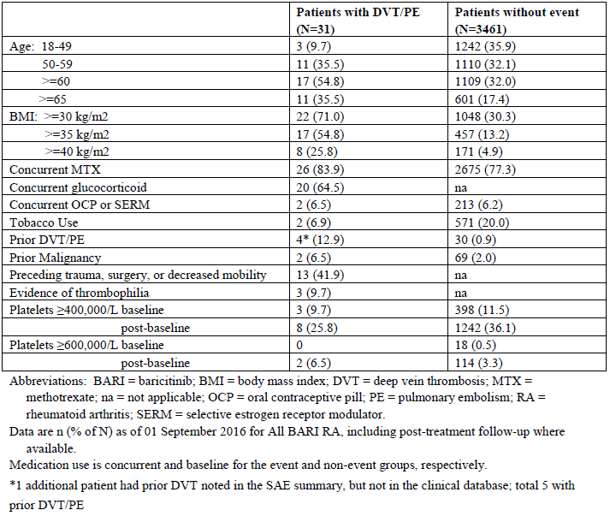

Part 4
Were any VTE events not considered a serious adverse event?

Sponsor response
Of the 31 patients exposed to BAR who recorded a total of 38 DVT or PE events, 11 of those events were deemed to be non-serious AEs. This included 3 of 5 VTE episodes reported in the randomised controlled phase of the RA program (including post-treatment follow-up). The reporting of an event as serious or non-serious was at the discretion of the site investigator. The sponsor conducted a review of the VTE events which shows that they did vary in clinical severity. For example, non-serious occurrences in the randomised controlled portion of the studies included one occurrence of DVT described as mild with no anticoagulant treatment reported, method of diagnosis unknown, and the patient continued to be treated throughout and is still part of Study JADY. Another occurrence of DVT was described as being of moderate severity, anticoagulant treatment was provided for 3 months, no method of diagnosis was reported, and the patient continued to be treated throughout and is still part of Study JADY. Half of the cases reported as non-serious did not have a method of diagnosis specified and in at least 1 case; the diagnosis of DVT was not confirmed on ultrasound. Episodes of VTE were not adjudicated by an external or central committee. The diagnosis method varied by case according to local clinical practice.

Part 5
An analysis of VTE events in relation to dose and time (for example, is there an early peak and does it occur more often in a higher dose?)

Sponsor response
No dose response effect was observed for BAR (2 mg versus 4 mg) during the PBO controlled (4 study, Week 0 to 24 analysis), initial reported long term extension period, as well as for the updated safety database. With longer-term treatment (latest update), a similar incidence rate of DVT (0.4 per 100 PY for the 2 mg dose and 0.3 per 100 PY for the 4 mg dose) and PE (0.2 per 100 PY for both BAR doses). Furthermore, the incidence rates of DVT and PE remained stable during a reporting period that included more than 120 weeks of exposure to BAR with no pattern of increased or decreased risk in any given 24-week time period, in particular, there was no early or late peak in occurrence of DVT/PE.

Part 6
The outcome from the VTE events, for example, death, hospitalisation.

Sponsor’s response
Of the 31 patients exposed to BAR who reported a DVT/PE, 7 patients continued treatment with BAR throughout the AE; 12 patients had their treatment interrupted, but then resumed it; and 12 subjects permanently discontinued BAR treatment. Therefore, 19 patients had exposure to BAR after the DVT or PE (range: 7 days to 30 months; 13 with at least 6 months exposure) either with (n = 12) or without (n = 7) continuous anticoagulation. Among these, 2 patients reported an additional VTE at a substantial interval (1 to 2 years) after the first occurrence and had recent risk factors. One of those 2 recurrent patients reported a second PE 5 weeks following hip arthroplasty with BAR having been with-held prior to surgery. The other patient with recurrent VTE had significant obesity and had recently discontinued warfarin prescribed for the management of the first PE.
Of the 31 patients, 20 were hospitalised due to VTE and 2 patients died (1 death was attributed to PE a patient with multiple thrombotic risk factors and the other death was due to malignancy; pancreatic adenocarcinoma). One MTX-treated patient in Study JADZ was hospitalised and died following a PE on study day 234.

Evaluator’s response to Q2 (all parts)
In the new (additional) evaluation material the sponsor has provided further insight via additional analyses, and potential alternative explanations into the observed finding of an apparent increased number of VTE events (at least in the first 16 to 24 weeks of therapy) in BAR 4 mg once daily treated subjects compared to PBO and active comparator therapies. The majority of patients who experienced VTE in the BAR clinical trial program had 1 or more significant risk factors for developing VTE, in particular, older age, significant obesity, recent immobility and/or a past history of VTE or malignancy. There is some imbalance between the treatment groups at Baseline in the PBO controlled periods of Phase II/III trials (namely a higher incidence of older aged subjects randomised to BAR 4 mg therapy), which may alternatively explain the increased incidence of VTE with BAR 4 mg daily treatment in the first 16-24 weeks. There was no correlation between VTE occurrence and increased platelet counts, which may have been a previous, biologically plausible link between BAR and VTE. In the extended safety dataset, there was no correlation between the dose of BAR (2 mg versus 4 mg) and the risk of VTE. Furthermore, the risk of VTE did not appear to accumulate over time (up to 120 weeks of follow-up) or have an early discernible peak incidence. Moreover, the severity and outcomes reported in those who experienced VTE are consistent with expectations for VTE. However, one significant deficiency of the sponsor response is that it did not include a time to event (VTE) analysis using methods such as a Kaplan-Meier estimate, which may have been more informative of risk over time than the submitted analysis of VTE events over time using successive 24 week block periods.

Question 3
Information on any other thrombotic events across the entire baricitinib exposed populations.

Sponsor’s response
In October 2016, the sponsor assessed the risk of all thrombotic events with BAR, including arterial thrombotic events, in response to a request from the FDA. In the TGA response, the sponsor has updated this analysis to include data up to the latest data lock point of 1 September 2016. Arterial thrombosis events include positively adjudicated myocardial infarction and ischemic stroke events as well as MedDRA preferred terms indicative of other acute thrombotic events. In the PBO controlled portion of the BAR studies (that is, up to Week 24), similar numbers of arterial thrombotic events were reported for the BAR 4 mg and PBO groups. Moreover, the EAIR for arterial thrombotic events was similar between BAR 2 mg and 4 mg dose groups in the updated extended analysis set. A total of 32 arterial thrombotic events (at an incidence rate of 0.5 per 100 PY) have been reported in the All BAR RA population including 14 cases of myocardial infarction and 8 cases of ischaemic stroke. The incidence rate and pattern of arterial thrombotic events is within expectations for treatment population.

Evaluator’s response
The evaluator concurs with the sponsor that the extended safety dataset does not indicate an increased risk of arterial thrombotic events with BAR, and this is no BAR dose dependent relationship (2 mg versus 4 mg once daily) for this type of AE.

Question 4
The mechanism for the VTE events and whether there is information from non-clinical data.

Sponsor’s response
The sponsor is unable to provide a plausible biological mechanism for an association between BAR and increased risk of VTE. No other JAK inhibitor therapy has been associated with increased risk of VTE and inhibition of the JAK2-STAT pathway has been proposed as a potential target for antithrombotic therapy. The sponsor believes that RA itself has many features that predispose to an increased risk of VTE including chronic inflammation, abnormalities of blood flow (stasis), endothelial dysfunction and hypercoagulability. Three of the 31 BAR treated patients who recorded VTE had evidence of thrombophilia and many had other significant risk factors including obesity, prior VTE or malignancy and the use of oral contraceptive medications.

Evaluator’s response
There is no plausible biologic mechanism as to why BAR may be causing a higher incidence of VTE and the non-clinical data is also unhelpful in trying to explain the association. BAR treated patients often develop an early mild increase in platelet count following initiation of therapy, but a temporal association between increased platelet count and the occurrence of VTE is not observed. Moreover, the pathogenesis of VTE is explained by multiple risk factors, which are frequently present in RA patients (higher incidence than in age matched control subjects).

Question 5
The relationship between platelet elevations and VTE which have both been reported for baricitinib.

Sponsor’s response
The sponsor agrees that treatment with BAR is associated with an increase in platelet count in the first 2 weeks, which returns towards baseline value and remains stable on continued treatment. The sponsor provided plots of the mean (SD) platelet counts over time for those who did not develop VTE and for subjects who reported VTE using the all BAR RA population up to 1 September 2016. The pattern over time was similar in both groups. Moreover, any observed changes in platelet counts did not appear to be a risk factor for VTE. The proportion of patients with abnormally high platelet counts who never recorded VTE was higher than in the group who developed VTE: 26% (n = 8) of the 31 patients who experienced VTE had a post-baseline platelet count ≥ 400,000/μL at some point after randomisation compared to 36% of patients in the group who did not report VTE. Most patients who experienced VTE in the all BAR RA population (23/31, 74%) had platelet counts that remained within the normal range of ≤ 400,000 μ/L. A total of 5 patients had VTE during the randomised controlled portion of the BAR studies, and 3 of those 5 patients had platelet counts ≤ 400 x 10⁹/L throughout the course of the study. One patient had a platelet count ≥ 600 x 10⁹/L prior to experiencing DVT, but that subjects had a baseline platelet count of 589 x 10⁹/L. One patient had a platelet count of 431 x 10⁹/L, which dropped to ≤ 400×10⁹/L prior to a PE of moderate severity, with a baseline value of 318 x 10⁹/L.

Evaluator’s response
The evaluator concurs with the sponsor that treatment with BAR results in a modest early increase in platelet count that for some reason returns towards baseline with continued treatment. In addition, there is no association between increases in platelet count and the occurrence of VTE in the All BAR RA population. There are likely to multiple other risk factors of greater magnitude (such as obesity and older age) contributing to the development of VTE in RA patients, which highly confound the data interpretation.

Question 6
Whether other JAK inhibitors have reported VTE events and platelet elevations.

Sponsor’s response
VTE has been reported with 2 other approved JAK inhibitors, however, neither has been associated with an increased risk of thrombotic events. Ruxolitinib, a selective inhibitor of JAK1 and JAK 2, approved for use in myelofibrosis and polycythaemia vera has been associated with a reduced risk of VTE in a population associated with a high risk of DVT and PE. Tofacitinib (approved for RA), an inhibitor of JAK1, JAK2, JAK3 and to a lesser extent tyrosine kinase 2, has reported cases of VTE in its Phase III clinical studies but there is no safety signal of increased risk.
BAR is a predominant JAK1/JAK2 inhibitor and JAK2 is key contributor to platelet production and maturation as thrombopoietin (TPO) signals through JAK2. There is evidence that BAR therapy results in modest increases in platelet counts. Ruxolitinib has also been studied in healthy volunteers and patients with RA (Phase II study) and showed an increase in platelet counts peaking at 2 weeks of therapy which returned towards baseline thereafter. The sponsor has proposed several potential biologic mechanisms for increased platelet counts with JAK2 inhibition, but the pathogenesis is not clearly understood. The sponsor also states that such small increases in platelet numbers on average would not be expected to be associated with thrombotic events.

Evaluator’s response
The evaluator concurs with the sponsor that the published data does not indicate an increased risk of VTE with JAK inhibitors as a drug class (predominately observed with tofacitinib and ruxolitinib). No other predominant JAK2 inhibiting drug has been extensively studied in RA patients to indicate whether or not the drug sub-class may interact with the disease state (RA) to potentially result in an increased risk of VTE. This is an unanswerable question at this point in time. Small increases in platelet counts have been observed for some JAK inhibitor drugs. Nonetheless, the evaluator concurs with the sponsor that small platelet count increases are likely to be of insufficient magnitude to result in an increased risk of clinical VTE.

Question 7
The concern raised by the FDA that the risk assessment for the 2 mg dose could not be conducted due to the low overall and long-term exposures at this dose.

Sponsor’s response
The sponsor accepts that exposure to the 2 mg daily dose is lower than the proposed 4 mg once daily regimen in the BAR clinical development program. However, the dataset characterising the safety profile of BAR (including the updated safety information through to 1 September 2016) provides sufficient data on the comparative safety profiles of BAR 2 mg and 4 mg once daily therapy. The updated safety database contains 3492 RA patients with a total exposure of 6636.7 PY exposed to any dose of BAR (All BAR RA population). Of these, 2723 (78%) were treated for at least 52 weeks and 1867 subjects (53.5%) were treated for at least 104 weeks. Patients with RA treated with BAR 2 mg had a total exposure of 554.5 PY and those treated with BAR 4 mg had a total exposure of 604.1 PY. While the exposure in the 2 mg dose group is smaller than that in the 4 mg dose cohort, there were 254 patients who received 24 weeks of treatment with BAR 2 mg and 172 patients who received 52 weeks of treatment, which represents a total exposure of 482 PY. The overall size of the safety database for the BAR 2 mg once daily cohort is sufficient to adequately characterise its safety profile.
Despite the increased safety database for both BAR doses included in the additional evaluation material, the overall safety profile of BAR remains the same as the original submission. Moreover, there is a lack of dose dependency observed with respect to key clinical safety measures (that is, excluding the higher incidence of laboratory abnormalities such as increased serum AST and CPK as well as hypercholesteraemia with BAR 4 mg versus 2 mg). In particular, there are no statistically significant differences between the BAR 4 mg and 2 mg groups with respect to EAIRs of SAEs, permanent discontinuation due to AE, death, temporary interruption of drug due to AE, or serious infection. In conclusion, the safety profiles of the BAR 2 mg and 4 mg once daily regimens are highly similar over extended periods of treatment follow-up.

Evaluator’s response
The evaluator concurs with the sponsor that the clinical safety profiles of the BAR 2 mg and 4 mg once daily regimens appear to be highly similar apart from a higher incidence with selected laboratory abnormalities (increased serum CPK, AST and total cholesterol) with the higher dose posology. The safety database is of sufficient size and duration of follow-up to adequately characterise the overall and relative safety profiles of each dose regimen except for uncommon AEs with long latency period (for example, incidence of MACE and malignancy). The comparative safety profiles of BAR 2 mg versus 4 mg once daily treatment is similar and does not represent a clinically meaningful difference that should impact upon the approved dose for registration.

Question 8
The efficacy advantage of the 4 mg dose over the 2 mg dose.

Sponsor’s response
In the sponsor response to the FDA in March 2017, the sponsor provided a detailed assessment of the benefits of BAR 4 mg daily versus 2 mg daily. The sponsor asserts that responses observed with BAR 4 mg daily were consistently higher compared to BAR 2 mg daily on a numerical basis, particularly with respect to the more stringent measures of response such as the rates of SDAI remission and slowing of X-ray progression. In Study JADW (that is, biologic DMARD inadequate response cohort), the rates of SDAI remission at 12 weeks were lower with BAR 2 mg daily (2.3% versus 5.1% with BAR 4 mg daily). A similar dose related observation for achieving low disease activity was observed in this treatment refractory RA population. At 24 weeks in Study JADX (that is, conventional DMARD inadequate response cohort), a lower response in slowing X-ray progression was observed with BAR 2 mg versus 4 mg therapy (LS mean change from Baseline in mTSS using LEP was 0.33 for 2 mg and 0.15 for 4 mg, lower score indicating less progression). Moreover, the sponsor states that BAR 4 mg therapy has consistently demonstrated a more rapid onset of treatment effect than the 2 mg dose and showed greater efficacy than the 2 mg dose across populations and endpoints in a large randomised withdrawal study. A subgroup of patients in Study JADY who dose reduced to BAR 2 mg/day after 15 months of satisfactory and sustained RA control on BAR 4 mg/day demonstrated statistically significant increases in RA activity at 12 weeks after the down-titration compared to subjects who continued with BAR 4 mg daily. In the sponsor’s response to the FDA, the sponsor provided the opinions of 6 internationally recognised rheumatologists who all considered the BAR dataset to support 4 mg daily as the standard posology.

Evaluator’s response
The efficacy of BAR 2 mg once daily was assessed in 2 of the Phase III studies (Studies JADX and JADW) and demonstrated that when used in combination with MTX, BAR 2 mg once daily produces improvement in the signs and symptoms of RA (as measured by ACR criteria) and physical function (as measured by HAQ-DI) compared to PBO. However, the BAR 4 mg dose consistently provided more rapid onset and a numerically higher response compared to PBO than the BAR 2 mg dose. In general, treatment with BAR 2 mg/day resulted in lower clinical response rates than treatment with BAR 4 mg/day. The claim that BAR 4 mg/day results in better retardation of structural joint damage (using plain X-rays) compared to BAR 2 mg daily is highly contentious as the treatment related difference is very small numerically and of unknown and unquantifiable additional clinical benefit. Among the subset of patients who had achieved satisfactory and sustained RA control after at least 15 months of treatment with BAR 4 mg/day and who dose reduced to 2 mg/day in a randomised, double-blind manner in the long-term extension Study JADY, a statistically significant increase in RA activity at a subsequent 12 week evaluation was observed compared to subjects who continued BAR 4 mg/day. This is a significant observation in support of the sponsor request to have BAR 4 mg daily as the typical posology. However, the majority of subjects in both BAR treatment groups in the step down analysis maintained significant levels of clinical response (low disease activity or clinical remission) that led to their re-randomisation. In summary, the totality of the clinical trial data with BAR supports the sponsor request to have BAR 4 mg once daily therapy as the typical posology as this dose has consistently demonstrated induction and maintenance of clinical efficacy in patients who were responding and tolerating the medicine.

Question 9
Information on the outcome of the post-action review meeting between the sponsor and the FDA.

Sponsor’s response
The sponsor reports that the timing of the post-action review meeting has not yet been determined.

Evaluator’s response
In a media release by the sponsor (dated 25 July 2017) the company reports that a re-submission to the FDA of BAR for a new drug application ‘will be delayed beyond 2017.’ The statement also reports that the FDA has requested a new clinical study be performed to further characterise the benefit-risk of BAR across doses in light of the observed imbalance in VTE that occurred during the PBO controlled periods of the RA clinical program.

Question 10
Any specific analyses submitted to the FDA and EMA on these outstanding issues.

Sponsor’s response
The sponsor has provided a copy to the TGA on 28 April 2017 of its responses to the EU rapporteur regarding thrombosis related data (dated 19 April 2017). The questions and responses in this response contain highly similar information and data used in the sponsor’s response to the TGA delegate request for additional information. Following assessment of these additional analyses, the EU rapporteur concluded that the benefit-risk balance for the use of BAR in patients with RA remained positive and the sponsor was asked to submit a Type II variation to include VTE as a potential risk with BAR and to include a precaution/warning in the Summary of Product Characteristics.
The relevant FDA questions and responses on the topics of thrombosis and dose justification have also been provided to the TGA in separate documents.

Evaluator’s response
The evaluator concurs with the sponsor that the TGA has received a copy of the sponsor’s response to the EMA and FDA, including any new data analyses, on the outstanding issues of thrombosis related risk and justification of the BAR dose (2 mg versus 4 mg once daily) for efficacy purposes. The information contained in those responses is highly similar to that reported in the sponsor response to the TGA request for additional material.

TGA request for response to main clinical evaluation report issues
The sponsor response dated 2 June 2017 addresses 3 main questions that were raised in the second round clinical evaluation assessment.

Question 1
Justification for including MTX naïve patients with poor prognostic features in the BAR indication as the clinical evaluator did not recommend registration of BAR in this subgroup population because of an unclear benefit: risk assessment.

Sponsor’s response
The sponsor disagrees with this assessment, but agrees to no longer pursuing this indication for BAR.

Evaluator’s comment
It is noted that the sponsor has voluntarily withdrawn from seeking an indication in the subgroup of DMARD naïve patients with poor prognostic features. The newly proposed PI has made the appropriate amendment.

Question 2
Justification for inclusion of the sub-claim of improving physical functioning in the indication wording as the clinical evaluator recommended its withdrawal. The sub-claim of improving physical functioning in the indication wording is only present for abatacept, yet many DMARD therapies have demonstrated such an effect with the supporting trial data included in the Clinical Trials section of their PI.

Sponsor’s response
The sponsor disagrees with the exclusion of the sub-claim of improving physical functioning with BAR as such an endpoint is of important clinical benefit to patients with moderate to severe RA. The trial data demonstrate that a significant proportion of BAR treated subjects achieved the minimal clinically improvement in HAQ-DI score ≥ 0.30 and sustained this response for up to 52 weeks when treated with BAR. Exclusion of the physical function sub-claim based on maintaining consistency in wording with most drugs in the therapeutic class is insufficient reason to justify non-recommendation.

Evaluator comment
The evaluator concurs with the sponsor that the BAR clinical trial program in RA shows a consistent effect with BAR therapy in improving physical functioning in patients with active RA. However, to include the sub-claim indication wording is of limited clinical relevance when the summarised source data is included in the Clinical Trials section of the PI. Overall, this is a non-critical issue to registration of BAR in Australia.

Question 3
Sponsor response to the adequacy of comparator treatment (MTX monotherapy; with one quarter of subjects receiving a potentially sub-optimal weekly dose of < 17.5 mg) versus BAR in the Phase III Study JADZ (DMARD naïve cohort with poor prognostic factors) and how that may affect the validity of the trial findings to Australian clinical practice.

Sponsor’s response
The sponsor acknowledges the comment regarding the generalisability of efficacy outcome data observed in Study JADZ to the Australian context where such high-risk patients with active disease would typically be treated with higher weekly MTX doses (20 to 30 mg, as per the Australian Rheumatology Association CMI for MTX) and/or in combination with another conventional DMARD. However, because the sponsor has withdrawn the proposed indication in DMARD naïve patients with poor prognostic factors, the sponsor asserts that the MTX monotherapy comparator arm in Study JADZ remains valid for the proposed indication of treating RA patients whose response to previous DMARD (including MTX) is inadequate or not tolerated. Furthermore, the sponsor states that no evidence of heterogeneity was observed in the effect of MTX dose groups (low or high) on the treatment effect with BAR (monotherapy or combination) versus MTX monotherapy when assessed across clinical outcomes of interest.

Evaluator’s response
The evaluator agrees with the sponsor that the comparator treatment arm in Study JADZ (MTX monotherapy; at sub-optimal weekly doses in up to one quarter of subjects) provides supportive data on the relative effect of BAR in DMARD naive patients with poor prognostic factors. However, there is limited extrapolation of that dataset to other patient treatment cohorts (that is, those with an inadequate response to, or intolerant of, prior conventional DMARD, including MTX). Nonetheless, the sponsor has withdrawn the indication wording in the DMARD naïve sub-population, which is appropriate for several reasons including the use of a potential sub-optimal comparator in the single pivotal trial supporting such indication wording.

Sponsor response to evaluator conclusions for PK/PD analyses
There were 2 issues raised in the evaluation report relating to the population PK and population PK/PD analyses that the sponsor disagrees with, and therefore has not included relevant information in the proposed PI. The first issue is the effect of body weight on response to BAR. The second issue relates to the potential influence of previous DMARD therapies and body weight on ACR and DAS28-hsCRP responses to BAR.

Concern 1
Body weight appears to impact both ACR and DAS28-hsCRP response. The ACR and DAS28-hsCRP response to BAR in subjects who weigh > 100 kg may be 10 to 30% lower compared to subjects who weigh < 60 kg.

Sponsor’s response
The sponsor concurs that the clinical response to BAR appears to be smaller in higher body weight/BMI subjects versus lower body weight/BMI patients, but this is a consistent observation seen with all DMARDs according to the published literature. The sponsor provided 3 factors that explain this observation. In the final population PK analysis, heavier subjects generally had smaller predicted responses (even accounting for differences in BAR exposure as determined by AUC) than lighter patients. In addition, higher weight subjects also recorded more difficult to control pain and subjective outcome measures on treatment, and had higher levels of hsCRP and serum inflammatory cytokines. Overall, the BAR studies showed an expected and consistent effect (reduced clinical response) with BAR in heavier treated subjects.

Evaluator’s response
The evaluator agrees with the sponsor explanation of the above observation. The literature reports a consistently lower rate of clinical response in obese treated subjects with active RA, which is due to several factors (as described above). Moreover, the population PK modelling with BAR did not show that the influence of higher body weight upon clinical response could be compensated for by increasing the dose of BAR, which suggests an independent influence on RA response unrelated to the AUC of BAR. As such, the evaluator concurs with the sponsor that a specific statement regarding the observation is not recommended for inclusion in the PI.

Concern 2
ACR and DAS28-hsCRP response are significantly influenced by previous exposure to biologic and conventional DMARDs, including previous exposure to MTX. The ACR and DAS28-hsCRP response to BAR in subjects who have had an inadequate response to biologic DMARD was substantially lower overall than subjects who were MTX naïve or who have had an inadequate response to conventional DMARDs. No explanation was provided for this observation.

Sponsor’s response
The sponsor concurs that previous treatment was identified as a significant covariate on ACR and DAS28-hsCRP response in the BAR population PK/PD modelling. This is a consistent observation in the literature for all advanced (that is, second or later line) DMARDs, and is particularly seen in the biologic DMARD inadequate responder patient population. Duration of RA and advancement through the conventional DMARD treatment paradigm are associated with incrementally reduced clinical responses. The efficacy of BAR was assessed in 4 separate Phase III clinical studies in distinct and diverse RA populations (ranging from DMARD naïve to anti-TNF inadequate responder subjects) and showed a consistent efficacy benefit with BAR compared to PBO and/or the standard of care. While the results of the individual BAR studies reflect lower clinical response rates in the more treatment refractory patient settings, the beneficial effect of BAR was seen in each trial and this observation supports the assertion that BAR is an effective DMARD across the spectrum of patients with RA.

Evaluator’s comment
The evaluator concurs with the sponsor opinion on this issue. Clinical responses to any DMARD are significantly impacted by the duration of RA, which has a window of opportunity (typically within 3 to 6 months) to successfully intervene to optimise long-term patient outcomes (response). The greater the number of prior DMARD exposures that a subject has experienced reflects a more treatment refractory condition, which shows incrementally diminished responses to subsequent DMARD choices, regardless of the drug class.

Third round benefit-risk assessment

Benefits
After consideration of the sponsor responses in the latest (additional) evaluation material, the benefits of BAR 4 mg daily therapy for the treatment of adult patients with active RA in the proposed usage are unchanged to those identified in Sections 9 and 13 of this report. The sponsor has appropriately withdrawn seeking an indication in DMARD naïve subjects with poor prognostic factors. The only other efficacy related issue raised in the latest evaluation material is concern by the FDA that the sponsor has not adequately justified a clear dose related benefit with BAR 4 mg once daily versus BAR 2 mg once daily. The evaluator believes the totality of the submission data supports that BAR 4 mg once daily should be the typical dose of treatment. In particular, the more stringent clinical endpoints of clinical remission are consistently, numerically higher with the BAR 4 mg daily regimen (versus 2 mg daily) in the 2 Phase III studies that examined for dose response. In addition, among the subset of patients who had achieved satisfactory and sustained RA control after at least 15 months of treatment with BAR 4 mg/day and who dose reduced to 2 mg/day in a randomised, double blind manner in the long-term extension Study JADY, a statistically significant increase in RA activity at a subsequent 12 week evaluation was observed compared to subjects who continued BAR 4 mg/day. Overall, the evaluator interprets the data to demonstrate a scientifically robust, additional clinical benefit with BAR 4 mg versus 2 mg daily therapy, which should be registered as the typical posology.

Risks
After consideration of the sponsor responses in the latest (additional) evaluation material, the risks of BAR therapy for the treatment of adult patients with active RA in the proposed usage are unchanged to those identified in Sections 9 and 13 of this report. The main safety related issue raised in the latest evaluation material is the potential for an increased risk of VTE with BAR. However, the sponsor has provided additional (new) analyses to explain that this observation may be explained by alternative reasons such as a higher frequency of traditional VTE risk factors in BAR 4 mg treated subjects. The risk of VTE did not accumulate over time (up to 120 weeks of follow-up) and there was no dose response effect with BAR in the extended safety dataset. In addition, there was no association between increases in platelet count (often observed with initiation with BAR therapy) and VTE episodes to make that a plausible biologic link.

Assessment of benefit-risk balance
After consideration of the additional evaluation material, there is no change to the opinion expressed in Sections 9 and 13 of this report. The overall benefit-risk balance of BAR 4 mg once daily treatment (with or without combination non-biologic DMARD, mainly MTX) in the proposed treatment indication of second line therapy is favourable. The sponsor has withdrawn from seeking a treatment indication listing in DMARD naive subjects with active RA and poor prognostic factors. The sponsor has made several significant changes to proposed PI which are considered appropriate and supported by evidence in the submission.

Third round recommendation regarding authorisation
The evaluator recommends acceptance of the sponsor’s request for the registration of BAR (monotherapy or in combination with conventional DMARD) for the treatment of moderately to severely active RA in adult patients who have failed to respond to, or are intolerant of, at least 1 DMARD with respect to reducing the symptoms and signs of RA, as well as improving physical function. The sponsor has accepted the removal of the indication claim in the DMARD naïve population with poor prognostic features. The sponsor has provided a sufficient response with new analyses to address the potential concerns raised by the TGA and major overseas regulators (FDA and EMA). Based on a benefit: risk assessment of the latest (updated) evaluation material, the proposed standard dose of BAR 4 mg once daily is justified, with a lower dose of 2 mg/day recommended for a selected subgroup of patients (for example, those with significant renal impairment).
The sponsor has agreed to add specific wording to the PI regarding the potential risk of venous thromboembolism and this aptly addresses the main ongoing potential safety concern with BAR. A specific black box warning (or an equivalent strict label warning in Australia) is not recommended with BAR as this is appropriate when there is reasonable evidence of an association of a serious hazard with the drug. The current level of evidence between BAR and the risk of VTE does not meet that threshold of probability regarding causation for such a stringent label warning. In addition, the sponsor has also responded to the majority of other relevant issues in the latest version of the PI. If BAR is granted registration, this should be subject to provision of an updated RMP and ASA.
Taking into consideration all of the above statements, the recommended treatment indication wording for BAR is:
Olumiant is indicated for the treatment of moderate to severe active rheumatoid arthritis (RA) in adult patients when the response to 1 or more disease modifying anti-rheumatic drugs (DMARDs) has been inadequate. Olumiant has been shown to reduce the symptoms and signs of RA and to improve physical function. Olumiant can be given as monotherapy or in combination with methotrexate. Therapy with Olumiant should be initiated and monitored by a rheumatologist or specialist physician with expertise in the management of RA.

References
Aletaha D and Smolen J. The Simplified Disease Activity Index (SDAI) and the Clinical Disease Activity Index (CDAI): a review of their usefulness and validity in rheumatoid arthritis. Clin Exp Rheumatol. 2005; 23(suppl 39): S100-S108.
Aletaha D, Neogi T, Silman AJ, et al. 2010 Rheumatoid Arthritis classification criteria: an American College of Rheumatology/European League Against Rheumatism collaborative initiative. Ann Rheum Dis. 2010; 69: 1580–1588.
Bombardier C, Barbieri M, Parthan A, et al. The relationship between joint damage and functional disability in rheumatoid arthritis: a systematic review. Ann Rheum Dis 2012; 71: 836-44.
Bruynesteyn K1, van der Heijde D, Boers M, et al. Minimal clinically important difference in radiological progression of joint damage over 1 year in rheumatoid arthritis: preliminary results of a validation study with clinical experts. J Rheumatol 2001; 28: 904-910.
Burmester GR, Rigby WF, van Vollenhoven RF, et al. Tocilizumab in early progressive rheumatoid arthritis: FUNCTION, a randomised controlled trial. Ann Rheum Dis; published online first: 28 October 2015; doi: 10.1136/annrheumdis-2015-207628
Duran J, Bockorny M, Dalal D, et al. Methotrexate dosage as a source of bias in biological trials in rheumatoid arthritis: a systematic review. Ann Rheum Dis 2016; doi: 10.1136/annrheumdis-2016-209383.
Durant L, Watford WT, Ramos HL, et al. Diverse targets of the transcription factor STAT3 contribute to T cell pathogenicity and homeostasis. Immunity 2010; 32: 605-615.
Hunter CA and Jones SA. IL-6 as a keystone cytokine in health and disease. Nat Immunol 2015; 16: 448-457.
Jones G, Sebba A, Gu J, et al. Comparison of tocilizumab monotherapy versus methotrexate monotherapy in patients with moderate to severe rheumatoid arthritis: the AMBITION study. Ann Rheum Dis 2010; 69: 88-96.
Scott IA. Non-inferiority trials: determining whether alternative treatments are good enough. Med J Aust 2009; 190: 326-330.
Smolen JS, Breedveld FC, Burmester GR, et al. Treating rheumatoid arthritis to target: 2014 update of the recommendations of an international task force. Ann Rheum Dis. 2016; 75: 3–15.
Smolen JS, Landeww R, Breedveld FC, et al. EULAR recommendations for the management of rheumatoid arthritis with synthetic and biological disease-modifying antirheumatic drugs: 2013 update. Ann Rheum Dis 2014; 73: 492-509.
van der Heijde D, Simon L, Smolen J, et al. How to report radiographic data in randomized clinical trials in rheumatoid arthritis: guidelines from a roundtable discussion. Arthritis Rheum 2002; 47: 215-8.
Weinblatt ME, Schiff M, Valente R, et al. Head-to-head comparison of subcutaneous abatacept versus adalimumab for rheumatoid arthritis: findings of a phase IIIb, multinational, prospective, randomized study. Arthritis Rheum 2013; 65: 28-38.
Welsing PM, Borm GF and van Riel P. Minimal clinically important difference in radiological progression of joint damage. A definition based on patient perspective. J Rheumatol 2006; 33:501-507.

Therapeutic Goods Administration
PO Box 100 Woden ACT 2606 Australia
Email: info@tga.gov.au Phone: 1800 020 653 Fax: 02 6232 8605
https://www.tga.gov.au

