November 2014

Australian Public Assessment Report for Bevacizumab
  - Proprietary Product Name: Avastin
  - Sponsor: Roche Products Australia Pty Ltd

About the Therapeutic Goods Administration (TGA)
- The Therapeutic Goods Administration (TGA) is part of the Australian Government Department of Health and is responsible for regulating medicines and medical devices.
- The TGA administers the Therapeutic Goods Act 1989 (the Act), applying a risk management approach designed to ensure therapeutic goods supplied in Australia meet acceptable standards of quality, safety and efficacy (performance), when necessary.
- The work of the TGA is based on applying scientific and clinical expertise to decision-making, to ensure that the benefits to consumers outweigh any risks associated with the use of medicines and medical devices.
- The TGA relies on the public, healthcare professionals and industry to report problems with medicines or medical devices. TGA investigates reports received by it to determine any necessary regulatory action.
- To report a problem with a medicine or medical device, please see the information on the TGA website <http://www.tga.gov.au>.
About AusPARs
- An Australian Public Assessment Record (AusPAR) provides information about the evaluation of a prescription medicine and the considerations that led the TGA to approve or not approve a prescription medicine submission.
- AusPARs are prepared and published by the TGA.
- An AusPAR is prepared for submissions that relate to new chemical entities, generic medicines, major variations, and extensions of indications.
- An AusPAR is a static document, in that it will provide information that relates to a submission at a particular point in time.
- A new AusPAR will be developed to reflect changes to indications and/or major variations to a prescription medicine subject to evaluation by the TGA.
Copyright
© Commonwealth of Australia 2014
This work is copyright. You may reproduce the whole or part of this work in unaltered form for your own personal use or, if you are part of an organisation, for internal use within your organisation, but only if you or your organisation do not use the reproduction for any commercial purpose and retain this copyright notice and all disclaimer notices as part of that reproduction. Apart from rights to use as permitted by the Copyright Act 1968 or allowed by this copyright notice, all other rights are reserved and you are not allowed to reproduce the whole or any part of this work in any way (electronic or otherwise) without first being given specific written permission from the Commonwealth to do so. Requests and inquiries concerning reproduction and rights are to be sent to the TGA Copyright Officer, Therapeutic Goods Administration, PO Box 100, Woden ACT 2606 or emailed to <tga.copyright@tga.gov.au>.

Contents
List of commonly used abbreviations 4
I. Introduction to product submission 5
Submission details 5
Product background 5
Regulatory status 7
II. Quality findings 7
III. Nonclinical findings 7
IV. Clinical findings 7
Introduction 7
Pharmacokinetics 9
Pharmacodynamics 10
Dosage selection for the pivotal studies 11
Efficacy 11
Safety 11
First round benefit-risk assessment 13
First round recommendation regarding authorisation 14
Clinical questions 14
V. Pharmacovigilance findings 14
Risk management plan 14
VI. Overall conclusion and risk/benefit assessment 25
Quality 25
Nonclinical 25
Clinical 25
Risk management plan 35
Risk-benefit analysis 35
Initial outcome 48
Final outcome 49
Attachment 1. Extract from the Clinical Evaluation Report 58

List of commonly used abbreviations
Abbreviation | Meaning
AE | Adverse Event
AESI | Adverse events of special interest
AUC | Area under plasma concentration versus time curve
C_{max} | Peak plasma concentration
DDI | Drug to drug interaction
GBM | Glioblastoma multiforme
IV | Intravenous
PFS | Progression-free survival
PPK | Population pharmacokinetics
PsPD | Pseudo progression
RT | Radiotherapy
T_{max} | Time to peak plasma concentration
TMZ | Temozolomide
VEGF | Vascular endothelial growth factor

I. Introduction to product submission

Submission details
Type of submission: | Major variation (new indications)
Decision: | Rejected
Date of initial TGA decision: | 29 April 2014
Date of final TGA decision: | 17 September 2014
Active ingredient: | Bevacizumab
Product name: | Avastin
Sponsor’s name and address: | Roche Products Pty Ltd  PO Box 255  Dee Why NSW 2099
Dose form: | Solution for infusion
Strengths: | 100 mg in 4 mL and 400 mg in 16 mL (each 25 mg/mL)
Container: | Glass vials
Pack sizes: | 100 mg pack containing one 4 mL single-dose vial  400 mg pack containing one 16 mL single-dose vial
Approved therapeutic use: | Not applicable
Route of administration: | Intravenous (IV) infusion
Dosage: | Not applicable
ARTG number: | Not applicable

Product background
This AusPAR describes the application by the sponsor, Roche products Pty Ltd, to extend the indications for Avastin (bevacizumab) in combination with radiotherapy (RT) and temozolomide (TMZ) as follows:
Avastin (bevacizumab) in combination with radiotherapy and temozolomide is indicated for the treatment of adult patients with newly diagnosed glioblastoma.
Bevacizumab has already been approved for therapeutic use in Australia for the treatment of several malignancies including colorectal cancer, non-small cell lung cancer, breast cancer and previously treated glioblastoma.
Bevacizumab is currently available in 100 mg and 400 mg single dose vials containing 4 mL and 16 mL respectively of bevacizumab (25 mg/mL). No new dosage forms or strengths are proposed in this current submission.
The proposed dosage regimen for the current study involves the induction phase of six weeks duration which would involve either placebo or bevacizumab in a dose of 10 mg/kg every two weeks in conjunction with radiotherapy and TMZ a dose of 75 mg/m² orally. The maintenance phase which consisted of six 28 day cycles of either placebo or bevacizumab in a dose of 10 mg/kg every two weeks and TMZ 150 to 200 mg/m² orally in the first five days of each cycle followed by a monotherapy phase of placebo or bevacizumab in a dose of 15 mg/kg every two weeks until disease progression.
Bevacizumab is a recombinant humanised monoclonal antibody that selectively binds to and neutralises the biologic activity of human vascular endothelial growth factor (VEGF). Bevacizumab inhibits the binding of VEGF to its receptors Flt-1 and KDR on the surface of endothelial cells, thereby neutralising the biological activity of VEGF. This reduces the vascularisation of tumours and limits tumour growth.
Glioblastoma (GBM) is the most commonly occurring primary brain tumour in adults. The outcome for patients with glioblastoma is poor, with most patients dying within two years of diagnosis.
The current standard of care is maximal safe surgical resection followed by adjuvant radiotherapy plus temozolomide, shown to result in an improvement in progression-free survival and overall survival, compared to radiotherapy alone. Since 2004 it has been shown that methylguanine methyl-transferase (MGMT) promoter status determines the response of a patient to temozolomide and also the pattern of, and time to, GBM recurrence.^{1,,}
MGMT status is a demonstrated effect modifier of outcomes in newly diagnosed or inoperable glioblastoma, treated with temozolomide and radiotherapy; methylated MGMT (‘positive’) status confers the benefit. The differential effect of MGMT methylation status on progression-free survival (PFS) is in the order of 5 months for primary disease and 2 months for recurrent disease (Table 1).
Table 1. Effect of MGMT methylation status on outcomes in patients with GBM treated with radiotherapy and temozolomide
Study author | Disease | Outcome | MGMT methylated | MGMT non-methylated
Hegi² | Newly diagnosed GBM | Median PFS | 10.3 months | 5.3 months*
Niyazi⁵ | Newly diagnosed GBM | Median PFS  1year survival  2 year survival | 642 days  93%  78% | 231 days**  65%  7%
Thon⁶ | Recurrent GBM | Median PFS  Median Overall survival | 56 weeks  104 weeks | 20 weeks†  28 weeks‡
*PFS Hazard ratio 0.62 (95% confidence interval (CI) 0.42, 0.92) **p<0.0001, †PFS Hazard ratio 0.15 (95% CI 0.07, 0.33), p<0.0001, ‡OS Hazard ratio 0.18 (95% CI 0.08, 0.38), P<0.0001
In the current National Comprehensive Cancer Network (NCCN) guideline for newly diagnosed glioblastoma, temozolomide is indicated, in conjunction with radiotherapy, for all patients with good performance status (Karnofsky Performance Status (KPS) > 70) (NCCN guideline-Anaplastic glioma/glioblastoma version 2.2013). In patients over 70 years of age, temozolomide is only indicated in those with positive MGMT methylation status. The currently approved PI for temozolomide has a precaution to co-administer Pneumocystis carinii pneumonia (PCP) prophylaxis during combination treatment with radiotherapy due to a risk of lymphopaenia.
Temozolomide has been available in Australia since 2005 for the treatment of glioblastoma.
The sponsor proposed rationale for bevacizumab use in glioblastoma is: ‘In glioblastomas (WHO Grade IV malignant glioma) and other tumors with a significant component of necrosis, VEGF mRNA was found to be highly expressed in ischemic tumor cells that are juxtaposed to areas of necrosis, indicating that local hypoxia is a major inducer of VEGF expression in the microenvironment of the tumor’.

Regulatory status
Bevacizumab was provided with orphan drug status for the treatment of malignant glioma in Australia on the 15 January 2009.
The product received initial registration on the Australian Register of Therapeutic Goods (ARTG) in February 2005.
At the time the TGA considered this application, a similar application had been approved in Japan (June 2013).

II. Quality findings
There was no requirement for a quality evaluation in a submission of this type.

III. Nonclinical findings
There was no requirement for a nonclinical evaluation in a submission of this type.

IV. Clinical findings
A summary of the clinical findings is presented in this section. Further details of these clinical findings can be found in Attachment 1.

Introduction
Following determination of activity for bevacizumab in several tumour types, studies were undertaken in recurrent or relapsed glioblastoma which include evaluation of Bevacizumab either alone or in combination with Irinotecan which revealed encouraging results. Subsequently further large safety studies were undertaken which ultimately resulted in approval in Australia, United States and forty countries total for the use of bevacizumab as a single agent for the treatment of patients with Grade IV glioma after relapse or disease progression following standard therapy including chemotherapy.
Further studies are now being conducted and the present submission involves presentation of a pivotal study in newly diagnosed GBM which is a Phase III randomised double blind placebo controlled multicentre study (BO21990).

Clinical rationale
It is worth noting that around the same time as Study BO21990 started the National Cancer Institute (NCI) sponsored an inter-group Phase III multicentre study in the USA and Canada which was a randomised placebo controlled study in which patients with newly diagnosed GBM investigated the efficacy and safety of bevacizumab at a dose of 10 mg/kg every two weeks with the standard radiotherapy and TMZ. This is an ongoing study.

Contents of the clinical dossier

Scope of the clinical dossier
The clinical submission contained data on four population pharmacokinetic (PPK) studies:
- Population pharmacokinetic report BO17704 which determines the population pharmacokinetics of bevacizumab in non-small cell lung cancer patients compared to population pharmacokinetics previously described in an oncology patient population with different types of cancer.
- Population pharmacokinetics report BO17706 which assessed the pharmacokinetics in metastatic pancreatic cancer patients and compared these to pharmacokinetics previously characterised for bevacizumab in oncology patient populations with different types of cancer.
- A Genentech report involving population pharmacokinetics of bevacizumab report no. 03-0324-1751.
- A final analysis report on the population pharmacokinetic analyses of bevacizumab.
- A pivotal efficacy and safety Study BO21990, a randomised double-blind placebo controlled multicentre Phase III trial of bevacizumab-placebo with TMZ and radiotherapy followed by bevacizumab-placebo and TMZ in patients with newly diagnosed glioblastoma.
Full study reports together with tabular and written summaries were provided for all these studies.

Paediatric data
Not applicable to this submission.

Good clinical practice
All aspects of good clinical practice were observed in this submission.

Pharmacokinetics

Studies providing pharmacokinetic (PK) data
The clinical submission contained data on four PPK studies (for details see above and in Attachment 1).

Evaluator’s conclusions on pharmacokinetics
A total of 20 patients participated in the drug to drug interaction (DDI) sub-study and had serum samples collected for bevacizumab concentration measurements. Of these 20 patients 14 were in the bevacizumab treatment arm and six in the control arm.
The observed serum bevacizumab concentrations for patients in the DDI sub-study relative to predictions for the median and fifth and ninety-fifth percentiles for bevacizumab concentrations derived from PPK simulations using the bevacizumab dosage regimen in Study BO21990 is indicated in Figure 1.
Figure 1. Study BO21990 DDI Substudy: Observed serum BVZ concentrations and visual predictive check
Observed serum BVZ concentrations compared with 90% prediction interval based on nominal dosing and collection times.
As indicated the observed pre-dose and post-dose bevacizumab concentrations during Cycles 1-3 of the maintenance phase DDI sub-study had similar medians and fell within the 90% prediction interval based on simulations from the bevacizumab reference PPK model. Therefore the PK of bevacizumab in patients with newly diagnosed glioblastoma are considered to be similar to the PK of bevacizumab in patients with different types of cancer contained in the reference bevacizumab PPK model and bevacizumab exposure did not appear to be influenced by the presence of TMZ.
In evaluating the TMZ pharmacokinetics, 13 patients were considered evaluable for this analysis. Of the 13 patients evaluated for TMZ PK, six were in the control arm and seven in the treatment arm. The mean plus or minus standard deviation (SD) plasma TMZ concentration/time profiles for patients in the placebo and bevacizumab arms of the sub-study is indicated in Figure 2.
Figure 2. Study BO21990 DDI Substudy: Mean ± SD plasma temozolomide concentration time profiles by treatment arm
TMZ PK parameter estimates for patients in the placebo and BVZ arms are summarised in Attachment 1.
The mean TMZ exposure (AUC_{all}) in the bevacizumab arm appears to be moderately increased by approximately 23% compared with the TMZ exposure in the placebo arm. T_{max} was slightly delayed by 30 minutes and the maximum concentrations C_{max} were similar. However owing to the limited number of patients in each treatment arm the evaluation of the effect of bevacizumab on TMZ pharmacokinetics must be observed with caution. These data are similar to that already published for TMZ PK. In the TMZ concentrations observed in patients in the two treatment cohorts are within the expected variability predicted from a TMZ PPK model.
Comment: Accepting the fact that the number of patients in this sub-study were relatively small the moderate difference in TMZ exposure observed between the treatment groups is probably not clinically significant. It is to be noted that TMZ and bevacizumab do not share the same clearance pathways and therefore are not expected to have potential interactions with one another.

Population pharmacokinetics
Comprehensive PPK analyses have been conducted over the years. See Attachment 1 for details.
The data from the various population PK studies together with the PK drug to drug interaction sub-study for the pivotal trial showed that for bevacizumab given in combination with various chemotherapy agents across tumour types showed no obvious potential for PK drug to drug interaction between the various chemotherapy agents and bevacizumab. This also indicates that there appears to be no requirement for dose modification for other chemotherapeutic agents used in combination with bevacizumab.

Pharmacodynamics
There were no new pharmacodynamic data submitted.

Dosage selection for the pivotal studies
No formal dose finding study was performed to determine the optimal dose of bevacizumab for the proposed indication. However previous clinical studies undertaken with doses ranging from 1 to 20 mg/kg every 1 to 3 weeks have revealed a positive benefit/risk ratio of bevacizumab given the same weekly dose equivalent of 5 mg/kg per week as proposed for the pivotal Study BO21990. Furthermore in the relapsed GBM setting this dose schedule has been utilised demonstrating clinical activity and acceptable safety. It is also to be noted that a controlled assessment of benefit from the continuation of bevacizumab until disease progression including as a single agent after stopping maintenance TMZ as planned in Study BO21990 had not been addressed in the newly diagnosed GBM development program. It is however considered that as every effort should be undertaken to prolong progression free survival after discontinuation of TMZ that this approach is justified. It is not expected that there would be cumulative toxic risks associated with prolonged usage of bevacizumab in the maintenance situation.

Efficacy

Studies providing efficacy data
A pivotal efficacy and safety study (BO21990) was submitted; a randomised double-blind placebo controlled multicentre Phase III trial of bevacizumab-placebo with TMZ and radiotherapy followed by bevacizumab-placebo and TMZ in patients with newly diagnosed glioblastoma.

Evaluator’s conclusions on efficacy
This quite large and well conducted study has demonstrated that for the primary endpoint of PFS the addition of bevacizumab to the combination of radiotherapy and TMZ for patients with newly diagnosed GBM results in a statistically significant benefit with a 36% reduction by investigator assessed PFS event to the time of data cut-off and a 39% reduction in the risk by Independent review facility (IRF) assessed PFS events. This is associated with a median PFS of 10.6 months for the bevacizumab arm and 6.2 months for the placebo arm. Similar benefits were apparent in relation to the various secondary efficacy parameters and were consistent across all sub-groups. It was also noted that in relation to health-related quality of life (HRQoL) that a significant benefit favoured the bevacizumab arm of therapy. The one area of uncertainty remains in relation to the co-primary endpoint of overall survival. While there was an 11% reduction in risk of death to data cut-off for the bevacizumab patients, this is not translated to statistical significance with a p value 0.2135. It is noted that the expected final analysis of overall survival would occur later in 2013. Review of this data at that time will be pertinent.

Safety

Studies providing safety data
Evaluation of safety in this submission comes from the pivotal Study BO21990 summarised in Table 2.
Table 2. Summary of studies contributing to safety evaluation

Patient exposure
The safety analysis population comprised all randomised patients who received at least one dose of study treatment involving 464 patients from the bevacizumab arm and 447 patients on the placebo arm.
In relation to exposure to bevacizumab, it is noted in the three phases of the study bevacizumab was administered at a dose of 10 mg/kg every two weeks during the concurrent and maintenance phases and 15 mg/kg every three weeks during the monotherapy phase. A total of 464 patients in the bevacizumab arm received at least one dose of bevacizumab following randomisation and by the time of the clinical cut-off date on the 31 March 2012 the median total number of bevacizumab doses across all phases of study was 18.5 and a maximum number of doses in any one patient was 45.
In relation to exposure to radiotherapy which was delivered during the concurrent phase of the study definitive exposure to radiotherapy was similar for both treatment arms.
In relation to exposure to TMZ which was given during the concurrent phase of therapy at 75 mg/m² every day and for the first five days of each 28 day cycle during the six cycles of the maintenance phase: In cycle two of the maintenance phase a starting dose of 150 mg/m² was increased to 200 mg/m² providing there was no excessive toxicity. The majority of patients in both treatment arms received the planned dose and duration of TMZ treatment during the concurrent phase.
In the maintenance phase a higher proportion of patients in the bevacizumab arm completed the six cycles of TMZ than the placebo arm, 64% versus 37% respectively. These data confirm that the addition of bevacizumab does not appear to influence tolerance to TMZ.
In relation to duration of safety follow up the median duration of safety follow up was approximately 3.8 months longer in the bevacizumab arm compared to the placebo arm at 12.3 months versus 8.5 months respectively.

Postmarketing data
There was no postmarketing data in relation to the current proposed indication.
Bevacizumab in combination with intravenous 5-FU based chemotherapy for the first line treatment of patients with metastatic carcinoma of the colon-rectum has been marketed since 2004 and subsequently for several other indications including glioblastoma in patients with progressive disease following prior therapy. The postmarketing experience of bevacizumab on the basis of safety data contained in the nine previously scheduled periodic safety updated reports (PSUR) was summarised.
Adverse event data with a clinical cut-off of the 25 February 2012 were summarised. Overall the incidence of patients reporting adverse events, the proportion of adverse events considered serious and the incidence of adverse events leading to death has remained stable over this period. The most frequent adverse events reported have been Gastrointestinal (GI) disorders in 19%, General disorders and Administration site disorders in 10.5% and Infections and infestations in 9.2%.

Evaluator’s conclusions on safety
This safety data has essentially indicated the toxicity profiles recognised for the agents utilised in the combined regimen, namely radiotherapy, TMZ and bevacizumab. The addition of bevacizumab to the RT and TMZ have produced additional adverse effects but not had any apparent increase in previously recognised adverse effects for RT plus TMZ. Similarly the extent of adverse effects associated with the bevacizumab administration is comparable to those for other indications and well recognised in the Product Information. Accordingly, while the addition of bevacizumab to the combination has increased the toxicity profile in general these remain manageable with appropriate surveillance and intervention.

First round benefit-risk assessment

First round assessment of benefits
The pivotal Study BO21990 has demonstrated the addition of bevacizumab to RT plus TMZ therapy in patients with newly diagnosed GBM resulted in a statistically significant improvement in the duration of PFS with a 36% risk of reduction of PFS accompanied by stable or improved HRQoL another measure of clinical benefit during the progression free time. These PFS results are relatively mature with 80% of the randomised patients having had a PFS event.
It is worth commenting that the clinical benefit associated with the prolonged PFS was demonstrated by the stable or improved HRQoL during this period together with symptomatic stabilisation and reduction in requirements for corticosteroids. All of which represents a worthwhile clinical benefit for patients.
The uncertainty remains however that overall survival was influenced in a significant manner. The interim analysis of overall survival produced an 11% reduction in the addition of bevacizumab to the RT plus TMZ which was not statistically significant. This represents the second interim analysis in which 56% of randomised patients had died and the final analysis would not be available till later in 2013. The reasons for the lack of statistical significance for overall survival from this quite large and robust study remain uncertain, although it is possible that second-line therapies subsequent to disease progression had an influence. Nevertheless the final analysis of overall survival will provide further relevant information together with that potentially provided from other studies being conducted.

First round assessment of risks
The safety data provided from the pivotal study essentially indicated the known toxicity profiles of the agents utilised in the combination of RT plus TMZ together with bevacizumab. This certainly has resulted in an additional mode of toxicities for this patient population but has not resulted in any additive or synergistic adverse effects between the three agents. In general these adverse effects could be adequately managed with appropriate surveillance and early intervention and accordingly the addition of bevacizumab to the combination cannot be considered to have resulted in unacceptable toxicity for this patient population.

First round assessment of benefit-risk balance
The data from the pivotal Study BO21990 has certainly indicated a significant and clinically worthwhile improvement in PFS for this population of newly diagnosed GBM patients with the addition of bevacizumab to the recognised combination of RT plus TMZ. This has been reinforced by the evidence of stable or improved quality of life measures and symptomatic measures as well as corticosteroid use. The adverse effect profile is acceptable in the context for the addition of those toxicities associated with bevacizumab to those already accepted for RT plus TMZ.
The area of ongoing concern remains with as yet an indeterminate outcome for overall survival with only a minor benefit presently observed. Final analysis of overall survival would be particularly pertinent in this regard as well as results from other studies. Nevertheless at the present time it is reasonable to say that in view of the improvement in PFS and its associated qualitative influence, the clinical evaluator was generally supportive of the application.

First round recommendation regarding authorisation
On the basis of the favourable outcome for progression free survival from this robust pivotal study together with the qualitative benefits obtained and acceptable safety profile, the clinical evaluator felt that on balance a recommendation in favour of the proposed indication of Avastin in combination with radiotherapy and temozolomide is indicated for the treatment of adult patients with newly diagnosed glioblastoma is appropriate and supported.

Clinical questions
- It would be desirable to determine results of the final analysis of overall survival for Study BO21990 to become available later in 2013.
- Results from other similar studies, currently ongoing or in the phase of completion would be desirable.

V. Pharmacovigilance findings

Risk management plan
The sponsor submitted a Risk Management Plan European Union (EU)-RMP Version 13.0 (data-lock point 15 February 2013) with Australian Specific Annex (ASA) Version 3.0 dated May 2013 which was reviewed by the TGA’s Office of Product Review (OPR).

Safety specification
The sponsor provided a summary of ongoing safety concerns which are shown at Table 3.
Table 3. Ongoing Safety Concerns.
Important identified risks | Bleeding/haemorrhage
Important identified risks | Pulmonary haemorrhage
Important identified risks | Arterial thromboembolic events (ATE)
Important identified risks | Hypertension
Important identified risks | Proteinuria
Important identified risks | Congestive heart failure (CHF)
Important identified risks | Wound healing complications
Important identified risks | Gastrointestinal perforations
Important identified risks | Posterior reversible leukencephalopathy syndrome (PRES)
Important identified risks | Neutropenia
Important identified risks | Venous thromboembolic events (VTE)
Important identified risks | Fistula (other than gastrointestinal)
Important identified risks | Thrombotic microangiopathy (TMA)
Important identified risks | Pulmonary hypertension
Important identified risks | Ovarian failure
Important identified risks | Hypersensitivity/infusion reactions
Important identified risks | Gall bladder perforation*
Important identified risks | Peripheral sensory neuropathy**
Important identified risks | Cardiac disorders (excluding CHF and ATE)**
Important identified risks | Osteonecrosis of the jaw (ONJ)**
Important potential risks | Embro-foetal development disturbances
Important potential risks | Physeal dysplasia
Important missing information | Safety profile of the different treatment combinations in patients with non-squamous NSCLC
Important missing information | Long-term effects of bevacizumab when used in the paediatric population
Important missing information | Safety and efficacy in patients with renal impairment
Important missing information | Safety and efficacy in patients with hepatic impairment
*New important identified risk
**Previously classified in the EU RMP Version 10.0 as important potential risks
The above summary of the ongoing safety concerns was considered acceptable.

Pharmacovigilance plan
The sponsor proposes routine pharmacovigilance activities to monitor all specified ongoing safety concerns.
The sponsor proposes additional pharmacovigilance for the following safety concerns (see Table 4):
- Bleeding/haemorrhage
- Congestive heart failure
- Wound healing complications
- Physeal dysplasia
- Long-term effects of bevacizumab when used in the paediatric population
Table 4. Additional pharmacovigilance activities
Additional activity | Assigned safety concern | Actions/outcome proposed | Planned submission of final data
Study E1505  (ongoing) | Bleeding/haemorrhage: Effect of concomitant anti-coagulation medication | Evaluation of the effect of anticoagulation (note: NOT a specific objective of the study). | Final data collection date for primary outcomes measure July 2015  Final report due July 2016
Safety monitoring plan implemented in ongoing/planned breast cancer studies sequential regular left ventricular ejection fraction (LVEF) monitoring in breast cancer studies cardiology expert in DSMBs guided questionnaire. | Congestive heart failure | Not specified by sponsor. | Unclear milestones
Study MO18725  (OLIVIA)  (completed)  monitoring by DSMBs | Wound healing complications | To assess safety and respectability in patients treated with bevacizumavb who have primarily unresectable liver metastases secondary to colorectal cancer and who are scheduled for standard, first line chemotherapy. | Completed, CSR expected first quarter 2014
Study B021990  (AVAglio)  (ongoing) | Wound healing complications | To investigate the efficacy and safety of bevacizumab, temozolomide and radiotherapy followed by 6 cycles maintenance with bevacizumab and temozolomide as compared to placebo, temozolomide, and radiotherapy followed by 6 cycles maintenance with placebo and temozolomide. | CSR March 2013 (Submitted as part of this filing)
Study NSABP C-08  (ongoing) | Wound healing complications  (Note: the pharmacovigilance plan does not assign other safety concerns to this study, however the RMP does assign other risks to this study. | Study title: Fluorouracil, Leucovorin, and Oxaliplatin With or Without Bevacizumab in Treating Patients Who Have Undergone Surgery for Colon Cancer.  Objectives: to characterise the comparative incidence of delayed vascular events in bevacizumabtreated patients following the discontinuation of bevacizumab and in concurrently enrolled control patients. | Estimated study end 2014. Final report due 2015.
BO20924  BERNIE)  (ongoing) | Physeal dysokasia: Clinical significance in paediatric patients  Long-term effects of bevacizumab when used in the paediatric population. | open-label, multi-centre, randomised Phase II trial in children and adolescents with metastatic rhabdomyosarcoma and non-rhabdomyosarcoma soft tissue sarcoma to assess addition of bevacizumab to chemotherapy | CSR expected first quarter 2016.  Final report due first quarter 2017
CSR=company study report; DSMBs=Data and Safety Monitoring Board

Risk minimisation activities
Routine risk minimisation activities are proposed for all safety concerns except for one area of missing information ‘safety profile of the different treatment combination in patients with non-squamous NSCLC’.
It is recommended that the ASA be revised to comply with the standard format specified in the TGA RMP Questions and Answers. This includes information on Australian specific epidemiological data. Furthermore, the sponsor should include the following within the ASA:
- The studies referenced in the pharmacovigilance plan will generate safety data that will simply support the known safety profile of the medicine, while others will generate data that will provoke applications to amend the Australian registration details. To this end, it is suggested that the sponsor should provide an attachment to the ASA setting out all the forthcoming studies and the anticipated dates for their submission in Australia.
- The sponsor should amend Table 2 in the ASA to include the areas of important missing information.
- The sponsor should detail within the ASA the wording by which risk minimisation is exercised in the Australian PI.

Reconciliation of issues outlined in the RMP report
Table 5 summarises the OPR’s first round evaluation of the RMP, the sponsor’s responses to issues raised by the OPR and the OPR’s evaluation of the sponsor’s responses.
Table 5. Reconciliation of issues outlined in the RMP report
Recommendation in RMP evaluation report | Sponsor’s response | OPR evaluator’s comment
- Although the sponsor has stated that the above ‘additional information’ has been added to the EU-RMP Version 13.0, the sponsor should clarify if any deletions or other changes were made to the EU-RMP. | In addition to the ‘additional information’ added to the EU-RMP Version 13.0, from EU-RMP Version 10.0 (the previous EU-RMP submitted to TGA); conversion to the new EU RMP template lead to addition of the following new content:  - Overview of EU RMP versions approved by the CHMP or under evaluation.  - Addition of new section entitled ‘Potential Harm from Overdose’.  - A summary of the EU RMP written in lay language.  - Addition of details on the post-efficacy development plan for Avastin.  - A rationale for the impact of the study exclusion criteria on the content of the EU SmPC for Avastin.  - Addition of nonclinical data that did not suggest a new safety concern.  - Categorization of studies in the PV Plan as imposed, specific obligations, required or stated activity.  - Worldwide marketing status by country appended.  - Purpose of medicinal product.  - Brief Overview of Development.  - Unknowns related to treatment benefit.  - Overview of efficacy in proposed indication.  - More detailed information on cases involving medication error.  The conversion to the new EU RMP template also lead to deletion of the following text:  - Potential for Overdose.  - Epidemiology of the target population unexposed to the product.  - Epidemiology of safety concerns in target population.  - Table of study exclusion criteria.  - Projection post-authorisation usage.  - Update to the RMP | This is acceptable
- For the safety concern of ‘congestive heart failure’ the sponsor makes the following statement regarding additional pharmacovigilance: ‘Safety monitoring plan implemented in ongoing/planned breast cancer studies sequential regular LVEF monitoring in breast cancer studies cardiology expert in DSMBs guided questionnaire’. It is recommended that the sponsor clarify exactly what studies they are referring to, the study titles, milestones and submit protocols for any planned studies to the TGA for review. | The list of breast cancer studies with sequential regular LVEF monitoring, cardiology expert in DSMB and CHF guided questionnaires are listed below. Protocols for these studies have been enclosed in module 2.7.6.  BO20289 (BEATRICE) study:  Title: An international multi-centre open-label 2-arm Phase III trial of adjuvant bevacizumab in ‘triple negative’ breast cancer.  Milestone: Primary analysis completed July 2012, patients on follow up for OS analysis  BO20906/AVF4285s (BETH) study:  Title: A Multicenter Phase III Randomized Trial of Adjuvant Therapy for Patients with HER2-Positive Node-Positive or High Risk Node-Negative Breast Cancer Comparing Chemotherapy Plus Trastuzumab with Chemotherapy Plus Trastuzumab Plus Bevacizumab  Milestone: Ongoing – Primary analysis planned Q4 2013  BO20231 (AVEREL) study:  Title: A randomized, open-label, 2-arm, multicentre, Phase III study to evaluate the efficacy and safety of bevacizumab in combination with trastuzumab/docetaxel compared with trastuzumab/docetaxel alone as first line treatment for patients with HER2 positive locally recurrent or metastatic breast cancer.  Milestone: Primary analysis completed October 2011, end of study planned first quarter 2014 | This is acceptable. It is recommended that the sponsor include the titles of these studies within the pharmacovigilance plan in the RMP and ASA.
- The sponsor mentions 2 planned studies in Part 3 of the EU-RMP. While the protocols for the original studies (currently ongoing) are listed in Annex 6 of the EU-RMP, the protocols for the proposed extension studies have not been submitted. It is recommended that these protocols be submitted to the TGA for review, along with appropriate estimates of study milestones. These are:  * An extension of BO21990 (AVAglio). Aims to investigate the efficacy of long term treatment.  * An extension of BO20924 (BERNIE). Aims to obtain long term follow up information from studies in the paediatric population after patients complete their 5.5 years of follow up in study. Protocol submission due fourth quarter 2013. | Extension of BO20924 (BERNIE)  The end of the 5.5 years follow-up of study BO20924 is currently projected to take place in 2019 and therefore the proposed extension study is not expected to start before 2019.  In order to prevent potential protocol amendments due to changes in the scientific and technical landscape within this time frame, Roche is currently in discussion with European medicines Agency (EMA) to extend the due date for submission of the extension study protocol from fourth quarter 2013 to fourth quarter 2017.  Extension of BO21990 (AVAglio)  The AVAglio study was included in the Post-Authorization Efficacy Plan because the study was still on-going at the time version 13 of the EU RMP was submitted. The efficacy objective was overall survival (not efficacy of long term treatment). The protocol was amended (Protocol C) to allow continued bevacizumab treatment for existing study participants and the reporting of serious adverse events from these patients. This amendment was mistakenly reported in the RMP as the AVAglio extension study.  The AVAglio study is now considered to be completed in the Post-Authorization Efficacy Plan. The overall survival data is available as the clinical study report has been updated and submitted in the EU. The final OS clinical study report, included with this submission in response to clinical question 1, contains Protocol C (Report #1056094). A copy of the Post-Authorization Efficacy Plan table, including milestones, which has been updated following these amendments (changes indicated in red text) has been included. These amendments have been included with EU-RMP version 14, which will be submitted with Australian Specific Addendum (ASA) 4.0 to TGA on 7 November 2013. | This is acceptable.
- The following study reports are pending and should be submitted with the PSURs when available:  * AVF3991n (ARIES)  * AVF4349n (VIRGO)  * AVF4095g, CSR due by end 2013  * MO19286 (AVEX) final report second quarter 2013  * BO17707 due 31 December 2013 (imposed activities considered key to the benefit risk of the product)  * ML21823 final report due 31 October 2013  * BO2541 | Full CSRs are usually not included in the PSUR. A summary of the CSR for the above studies, including pharmacovigilance outcomes, will be outlined in future PSURs. As AVF3991n (ARIES) is a registry study, no CSR will be produced, however a summary of the safety outcomes will be provided in a future PSUR. | This is acceptable.
- Table SVI.4.4 in Section 7.5 of the EU-RMP shows medication errors for the period 26 February 2011 to 25 February 2012. It is recommended however that the sponsor provide the cumulative post marketing data on medication errors since 2004. | Cumulative post-marketing data on medication errors was presented in a table attached to this response. This represents cumulative data from 26 February 2004 (international date of birth) up to 05 August 2013. Cumulative post marketing data is included with EU-RMP version 13.1, and will be included with future versions of the EU-RMP. Please note: EU-RMP version 14.0, to be submitted to TGA on 7 November 2013 with ASA version 4.0, does not contain the cumulative data, as EU-RMP version 14.0 was published before version 13.1. | This is acceptable.
- The sponsor should correct the following statement in regards to potential for off-label use: ‘Please refer to Section 5.4, SV.4. Post-authorization off-label use, for examples of known off-label use, including pediatric.’ This should refer to Section 6.4. | Roche acknowledges the error, which will be corrected with Version 15 of the Avastin EU-RMP. Please note, version 4.0 of the ASA will be submitted to TGA on 7 November 2013. This version contains version 14.0 of the EU-RMP, which does not have the above correction. | This is acceptable.
- In regards to the proposed routine risk minimisation, the Delegate may wish to consider the following additions to the proposed Australian PI:  A) Under ‘use in pregnancy’ or ‘paediatric use’: The specific term ‘Physeal Dysplasia’ should be added.  B) Under ‘Paediatric Use : a statement to the effect of ‘Avastin should not be used in children aged 3 years to less than 18 years with recurrent or progressive high-grade glioma because of efficacy concerns (see section 5.1 for results of paediatric trials).’ | Roche acknowledge the recommendation. | Deferred to the Delegate.
7. D) Under ‘Dosage and Administration’: ‘Avastin must be administered under the supervision of a physician experienced in the use of antineoplastic medicinal products’. This is in line with the EU Summary of product Characteristics (SmPC) and will enhance the safe use of bevacizumab. | Roche acknowledge and accept with the recommendation. The above sentence has been added to the proposed PI under Dosage and Administration. | This is acceptable.
7. E) Under ‘Severe Eye Infections Following Compounding for Unapproved Intravitreal Use’ : a statement should be added regarding the increased risk of haemorrhagic stroke, overall mortality and serious systemic adverse events observed in patients following unapproved bevacizumab use for wet age related macular degeneration. | Roche acknowledge the recommendation. | Deferred to the Delegate.
7. F) Under ‘Precautions – wound healing’: a statement should be added to the effect of ‘Serious wound healing complications, including anastomotic complications, have been reported, some of which had a fatal outcome.’ | Roche acknowledge the recommendation. | Deferred to the Delegate.
7. G) In May 2013, the sponsor provided a ‘Dear Healthcare Professional’ letter in Australia regarding the risk of necrotizing fasciitis. This letter states changes to the product information regarding this risk. The proposed PI submitted with the current application however does not contain this statement. The sponsor should update the proposed PI accordingly. | The statement regarding the risk of necrotizing fasciitis was included with a previous application approved 9 May 2013. This update has been included in the revised draft PI provided with this response. | This is acceptable.
- In regard to the proposed routine risk minimisation activities, it is recommended to the Delegate that the draft consumer medicine information document be revised to reflect any changes made to the proposed Australian PI. | Roche acknowledge that the draft consumer medicine information be revised to reflect any changes made to the proposed Australian PI. | This is acceptable.
- In regards to the ASA:  a) It is recommended that the ASA be revised to comply with the standard format specified in the TGA RMP Q&A’s. | ASA Version 4.0, November 2013, has been revised to comply with the standard format specified in the TGA RMP Q&A’s. ASA Version 4.0 will be submitted to TGA on 7 November 2013. | This is acceptable.
9. b) The studies referenced in the pharmacovigilance plan will generate safety data that will simply support the known safety profile of the medicine, while others will generate data that will provoke applications to amend the Australian registration details. To this end, it is suggested that the sponsor should provide an attachment to the ASA setting out all the forthcoming studies and the anticipated dates for their submission in Australia. | Roche acknowledge the recommendation. Following assessment of the data generated from studies referenced in the pharmacovigilance plan, the company Core Data Sheet and Australian PI will be revised accordingly. | This recommendation refers to the ASA and not to the Core Data Sheet or the Australian PI.  To clarify, It is recommended that the next update of the ASA contain a table stating all ongoing and planned studies with milestones and the anticipated dates for their submission in Australia.
9. c) The sponsor should amend Table 2 in the ASA to include the areas of important missing information. | Table 2 in the ASA has been revised with ASA Version 4.0, November 2013, to include the areas of important missing information. ASA Version 4.0 will be submitted to TGA on 7 November 2013. | This is acceptable.
9. d) The sponsor should detail within the ASA the wording by which risk minimisation is exercised in the Australian PI. | The wording by which risk minimisation is exercised in the Australian PI has been included with ASA Version 4.0. ASA Version 4.0 will be submitted to TGA on 7 November 2013. | This is acceptable.

Summary of recommendations
It is considered that the sponsor’s response to the TGA request for further information has adequately addressed all of the issues identified in the RMP evaluation report, except in regards to recommendation 9b (see below for Outstanding issues).

Outstanding issues

Issues in relation to the RMP
- Recommendation 7: In regards to the proposed routine risk minimisation, the Delegate may wish to consider the recommendations regarding the proposed Australian PI as shown in the table above.
- Recommendation 9b: It is recommended that the next update of the ASA contain a table stating all ongoing and planned studies with milestones and the anticipated dates for their submission in Australia.

Suggested wording for conditions of registration

RMP
Implement EU-RMP Version 13.0 (data-lock point 15 February 2013) with Australian Specific Annex Version 3.0 dated May 2013, including all updates as stated in the s31 responses dated 31 October 2013.

VI. Overall conclusion and risk/benefit assessment
The submission was summarised in the following Delegate’s overview and recommendations:

Quality
There was no requirement for a quality evaluation in a submission of this type.

Nonclinical
There was no requirement for a nonclinical evaluation in a submission of this type.

Clinical
The dossier contains a pivotal trial (BO201990) of efficacy and safety data, population pharmacokinetic studies and a report from a separate company that performed the MGMT analysis.

Pharmacokinetics (PK) and Drug-drug interactions (DDI)
The pharmacokinetic profile of bevacizumab was extensively discussed in the original Marketing Authorisation Application.
A sub-study of pivotal trial BO21990 observed concentrations from newly diagnosed GBM patients, showing median peak and trough concentrations within 90% of the predicted intervals from population PK simulations. Evidence of a DDI between bevacizumab and TMZ was not found.

Efficacy

Pivotal study BO201990
The pivotal study was a randomised controlled Phase III trial of bevacizumab versus placebo added to the regimen of temozolomide and radiotherapy following glioblastoma biopsy/resection described by Stupp et al. The doses of radiation and temozolomide in the pivotal study are identical to those described. In the study by Stupp, it was documented that subjects exposed to temozolomide were also administered PCP prophylaxis, according to the precaution in the product information for that drug. The trial protocol for the pivotal study was discussed with the European Medicines Agency (EMA) in 2008.
The pivotal trial treatment schedule is shown in Figure 3.
Figure 3. Pivotal Study BO21990 treatment schedule
All patients were required to have confirmation of glioblastoma by a local pathology service. Secondary confirmation of the diagnosis and MGMT status was performed by central pathology:
‘3.7.1 Central Pathology Review and MGMT Status Assessment
A local pathology report constituted adequate documentation of the histological diagnosis for study inclusion. In addition, the tumor material used for diagnosis of GBM was to be sent for central pathology review and MGMT assessment. The availability of these samples was mandatory for randomization into the study.’
No formal dose finding study was performed for the proposed indication. The dosages selected for bevacizumab in the phases of the pivotal trial are consistent with regimens previously approved for other malignancies.
The co-primary end-points were progression-free survival and overall survival (investigator assessment). The trial was determined to be demonstrate an beneficial effect of bevacizumab if any of the following criteria were met: if, at the time of the Overall Survival (OS) interim analysis/final PFS analysis, there was a statistically significant difference between treatment arms in PFS in favour of bevacizumab with a Hazard ratio (HR) <0.769 and a non-detrimental effect on OS (HR <1.0); or if, at the time of the OS interim analysis or final OS analysis, there was a statistically significant difference between the two treatment arms for OS, in favour of bevacizumab.
Secondary end-points: independent PFS assessment, 1 and 2 year survival rates and health-related quality of life assessment.
Tumour response criteria for the pivotal trial ‘adaptations to the Macdonald criteria’ are shown in Table 6. The sponsor states ‘The adapted Macdonald criteria used in Study BO21990 were developed before availability of the RANO guideline for GBM developed by the RANO working group, but are in line with these RANO criteria’.
Table 6. Response criteria for pivotal trial

Patient disposition
In the intention to treat population, there were 463 subjects in the bevacizumab arm and 458 in the placebo arm. There was an equal balance of patient demographics. Subjects with primary/secondary disease and degree of tumour resection were balanced between the two study arms. There were 104 subjects that had a biopsy diagnosis; 10% of the placebo group and 13% of the bevacizumab group.
Despite the mandatory availability of histology samples prior to randomisation, due to the quantity and/or quality of histology tissue available, central confirmation of the diagnosis was only achieved in 95% (the remaining were ‘not confirmed’ or ‘missing’) and MGMT status assessment was obtained for 76% of the 921 subjects (Tables 7 and 8).
Table 7. Subject demographics
Table 8. Baseline disease characteristics

Trial protocol violations and deviations
A substantial number of pivotal trial entrants, 208 (22.6%), where reported to have had either a major protocol violation leading to exclusion from the per-protocol population, major inclusion criteria violation, major exclusion criteria violation or major violation during study conduct.

Co-primary end-points
Final outcome report is based on clinical cut-off date of February 2013. The co-primary endpoint of improved progression-free survival met the criterion for the trial to demonstrate a benefit of bevacizumab, but overall survival was not (Tables 9 and 10).
Table 9. Progression-free survival
 |  | Placebo radiotherapy temozolomide | Bevacizumab radiotherapy temozolomide
ITT population | Median PFS. Months | 6.2 (n=463) | 10.6 (n=458)
ITT population | Median PFS. Months | HR 0.64 (0.55, 0.74), p<0.0001
Per-protocol population | Median PFS, months | 6.2 (n=370) | 10.5 (n=335)
Per-protocol population | Median PFS, months | HR 0.64 (0.55, 0.75), <0.001
Table 10. Summary of overall survival
 |  | Placebo radiotherapy temozolomide | Bevacizumab radiotherapy temozolomide
ITT population | Median OS. Months | 16.7 (n=463) | 16.8 (n=458)
ITT population | Median OS. Months | HR 0.88 (0.76, 1.02) p=0.1
Per-protocol population | Median OS, months | 16.9 (n=331) | 16.8 (n=313)
Per-protocol population | Median OS, months | HR 0.88 (0.75, 1.02), p=0.1
At disease progression, in subjects that crossed over from the placebo to bevacizumab group, the time from disease progression to death was not different to those that had not crossed-over: HR 0.81 (0.63, 1.04), p=0.1.
The CSR report states MGMT status was confirmed in 698 (76%) trial subjects.
Analysis by multiple Cox regression confirms a significant effect according to the MGMT methylation status on progression-free survival from ‘positive’ status (in those that had known status)- HR 0.47 (0.39, 0.57), p<0.0001, that is, the effect is greater than that observed from bevacizumab treatment. A survival benefit for MGMT methylation positive status was also seen HR 0.37 (95% CI 0.30, 0.46), p<0.0001, whereas none was seen for bevacizumab. These analyses have only been reported for the ‘Intent to Treat’ population and not the per-protocol population.
PFS according to degree of surgical resection was reported for the categories of biopsy and the combined group of complete/partial resection. For subjects with biopsy only, the PFS HR was 0.81 (95% CI 0.76, 1.04) whereas that for the complete/partial resection was 0.62 (95% CI 0.54, 0.73).
Overall survival in the intention to treat analysis was not different between those subjects that had biopsy only or partial resection or complete resection.

Assessment of quality of life in the pivotal trial
Three methods were used to assess quality of life throughout the trial.
- Health-related quality of life
Changes in HRQoL were assessed by the European Organization for Research and Treatment of Cancer (EORTC) quality of life questionnaire (QLQ)-C30 and supplemented by a brain cancer specific module EORTC BN20. The subscales pre-selected for the primary analyses of HRQoL as being those ‘considered of most relevance to the GBM study population based on clinical experience’ were:
  - QLQ-C30 Global health status/QoL, Physical functioning and Social functioning
  - BN20 Motor dysfunction and Communication deficit
- Clinical neurological assessment
- Neurocognitive function and Mini mental state examination (MMSE)
The neurocognitive function sub-study employed in the trial was not available for all trial entrants. This was solely for those that were in countries for which a valid translation of the assessment tool was available. Only 67 trial entrants (7% of the total) were recruited into this study and therefore the results are not representative of the randomised population and not discussed further.
MMSE remained stable, or improved, in a similar proportion of each treatment arm until disease progression. Neurological examination findings worsened at the time of disease progression in each treatment arm.
Baseline HRQoL scores were similar between the two study arm and: ‘There was no statistically significant difference between treatment arms over time’. Neurocognitive decline was seen at disease progression in both treatment arms (Figure 4).
Figure 4. Mean change from baseline in Global Health Status Score at the time of disease progression compared to prior assessments (ITT population).
Furthermore, the change in Karnofsky performance score between baseline and time of disease progression, and post disease progression was similar between treatment groups, indicating bevacizumab did not slow the rate of decline (Figure 5).
Figure 5. Mean Karnofsky Performance Score at disease progression and post-disease progression compared to prior assessments (ITT population).

Safety
The safety population is described in Table 11.
Table 11. Updated safety population with data corrections from Section 31 report.
 |  | Placebo  +  radiotherapy  &  temozolomide | Bevacizumab  +  Radiotherapy  &  temozolomide
ITT population | Patients who did not receive any treatment  Patients treated | 4  459 | 6  452
Primary CSR* | Patients receiving incorrect treatment  Safety Population | 12  447 | 6  464
OS-update CSR† | Patients receiving incorrect treatment  Safety population | 9  450 | 6  461
* March 31, 2012 (primary PFS analysis); † February 28, 2013 (final OS analysis).

Exposure profile
The duration of the concurrent and maintenance phases were similar for the two treatment arms. Despite a smaller proportion of subjects receiving ≥1 dose of study drug in the monotherapy phase, the median duration of treatment until disease progression was higher in the placebo arm (Tables 12, 13 and 14).
Table 12. Exposure to bevacizumab/placebo
Table 13. Exposure to radiotherapy
Table 14. Exposure to temozolomide
Adverse events excluded from the safety report were:
- Recurrence, progression or deterioration of GBM, including new metastases or death due to disease progression.
- Signs and symptoms of GBM.
- Laboratory abnormalities not requiring active management.
Adverse events (AEs) were categorised according to the NCI Common Terminology Criteria for Adverse Events (CTCAE) version 3.
Given the established adverse event profile of bevacizumab, AEs of special interest were pre-defined, the results presented in Table 15.
Table 15. Adverse events of special interest (safety population)
 | Placebo arm | Bevacizumab arm
‘Stroke events’ (cerebrovascular accident, cerebral ischaemia and cerebral infarction) | 1.6% | 5.9%
Serious grades of venous thromboembolism | 53% | 74%
Congestive heart failure grade 3/4/5 | 0 | 0.4%
Proteinuria | 4.2% | 15.6%
Haemorrhage – cerebral grade 3/4/5  Haemorrhage – ‘other’ grade 3/4/5 | 0.9%  0.9% | 2%  1.3%
Wound healing complications grade 3/4/5 | 1.6% | 3.3%
Hypertension | 2.2% | 11.3%
Abscesses and fistulae | 0.7% | 0.4%
Gastrointestinal perforation | 0.2% | 1.1%
PRES | 0 | 0
The proportion of deaths due to disease progression was similar between the treatment arms (6.3% placebo versus 5.4% bevacizumab). Deaths not caused by disease progression were more common in the bevacizumab arm (22 versus 12).

SAEs
The incidence of SAEs occurring in ≥1% of the safety population was more common in the bevacizumab arm (36.6% versus 25.7%).

AEs leading to withdrawal of trial treatment
The proportion of patients experiencing AEs requiring withdrawal from study treatment was higher in the bevacizumab arm (24.6% bevacizumab versus 13.2% placebo).

Deaths
The majority of deaths in the study were due to progression of underlying disease (68% placebo versus 66% bevacizumab). The most common causes of death not due to disease progression were ‘Infections and infestations’ (3.1% placebo versus 2.2% bevacizumab), with very small numbers of individuals in other individual categories in both treatment arms.

Concurrent temozolomide and PCP prophylaxis
PCP prophylaxis is mandated, according to the current PI, during patient exposure to temozolomide and radiotherapy due to the incidence of severe lymphopaenia. The sponsor has stated that the administration of PCP prophylaxis ‘was left to investigator discretion, as per their own practice’. As a result, the proportion of pivotal trial subjects that received PCP prophylaxis was not reported.

Deaths
One patient died during the pivotal trial as a result of Pneumocystis jirovecii pneumonia, presenting on Day 95, 13 days after last dose of temozolomide. It is not described in the dossier if this patient had received adequate PCP prophylaxis.
One patient died during the pivotal trial as a result of respiratory syncitial virus pneumonia and ‘Pneumocystis pneumonia’. This subject was not included in the category of Pneumocystis Jiroveci in the summary of deaths in the safety population. It is not described in the dossier if this patient had received adequate PCP prophylaxis.

Risk management plan
The RMP proposed by the sponsor was considered generally acceptable by the TGA’s Office of Product Review (OPR).
The RMP evaluator recommended a number of PI changes, additional to the proposed new indication, which were deferred to the Delegate for a decision (the details of these are shown above under Pharmacovigilance findings).
The Delegate agreed that each of these PI changes should be implemented and the sponsor should provide an updated PI with appropriate amendments for approval.

Risk-benefit analysis

Delegate’s considerations

Efficacy

Effect of MGMT status
There are contradictory statements in the CSR regarding the requirement for MGMT methylation status to be known before patients were randomised to a treatment arm.
The fourth pivotal trial entry criterion is ambiguously worded:
4 ‘Patient must have had at least 1 formalin fixed paraffin embedded tumor tissue block representative of GBM available for pathology central review and analysis of MGMT status. If tumor block was not available or not of adequate quality, sufficient pathology material, representative of GBM, was to be available for central review’.
These two sentences are contradictory - in mandating the availability of tissue for MGMT status assessment, yet also obviating the need for it.
MGMT methylation assessment was performed by a separate company, MDx Health, their report is contained in the final CSR. Despite the mandatory nature of having tissue available for evaluation prior to randomisation described in the trial summary above, MDx Health only received tissue from 892 individuals (97%). This report describes 699 samples as giving an interpretable result, not 698 as reported in the CSR. Their report states that ‘The non-evaluable (invalid) rate for this set of specimens was very high due to the large amount of biopsy samples included...’. The MDx Health report also describes the evidence from Hegi demonstrating a survival benefit to individuals that are MGMT methylation positive.
At the time of the discussion between the sponsor and EMA regarding the design of the pivotal trial, (February/March 2008) the significant effect of MGMT status on GBM outcome was published in peer reviewed journals and could therefore not be considered exploratory in this pivotal study.⁸, Thus, by not determining MGMT methylation status in all subjects, and randomising accordingly, the pivotal trial precludes the demonstration of an independent effect of bevacizumab separate from that of MGMT status.
In a response to emailed questions (11 December 2013), the sponsor has written that ‘The final number of samples eligible for MGMT assessment (n=698 (of 921)) in BO21990 represents a large cohort well balanced between treatment arms’. The Delegate agrees that for the proportion of subjects with known MGMT status, there was balance between the two treatment arms. However, subjects in the pivotal trial were not randomised according to MGMT status; therefore, it cannot be assumed that in the 24% of subjects where the status is unknown there is equal balance between the treatment arms. In the pivotal trial, positive MGMT methylation status is confirmed as an effect-modifier of PFS and therefore effect-modification of the co-primary outcomes is entirely plausible. That the intention-to-treat analysis and per-protocol analysis yield a similar result for PFS does not provide evidence for overall balance of MGMT methylation status between treatment arms.
In the CSR the sponsor states ‘there was a greater exposure to Temozolomide therapy in the Bevacizumab + Radiotherapy/Temozolomide arm compared to the Placebo + Radiotherapy/Temozolomide arm, 64% vs. 37% of patients completed 6 cycles of TMZ in the Maintenance Phase, and more patients in the Bevacizumab + Radiotherapy/Temozolomide arm escalated the dose of TMZ’. This finding may also be explained by an imbalance of overall MGMT status, favouring greater methylated status in the bevacizumab arm.
In the monotherapy phase of the trial, once temozolomide was ceased in all subjects, the median time to disease progression was longer in the placebo arm.
In the sponsor’s response to the TGA’s request for further information, a brief opinion-based summary of the publically available information on the US NCI Study RTOG-0825 (conducted by the Radiation Therapy Oncology Group) was presented (not formally submitted for evaluation). This study had a similar treatment regimen to the pivotal study, but utilising a split concurrent phase, of 3 weeks rather than 6 weeks, of bevacizumab/placebo with radiotherapy and temozolomide. Stratification in Study RTOG-0825 was performed according to MGMT status and ‘tumour molecular profile’. The magnitude of change in co-primary outcomes of PFS and OS did not meet the pre-specified level of significance to demonstrate a benefit from bevacizumab.
However, analysis of overall survival in RTOG-0525, according to MGMT methylation status, did reveal a significant difference in hazard ratio. This evidence was reportedly presented to the ASCO conference in June 2011; it is not reported whether this data has been published in a peer-reviewed Journal. The median OS for methylated patients was 23.2 months versus 16 months for unmethylated patients.

Generalisability of disease scoring assessment method
Comparison of assessing glioblastoma response using Macdonald, RECIST, RANO and RECIST+F (RECIST plus Flaire /TS imaging has been reported. The modified Macdonald criteria employed in the pivotal trial have not been peer-reviewed and are not therefore neither directly comparable to currently described assessment methods nor generalisable into routine clinical practice. The criteria in the pivotal trial for: a complete response, partial response or stable disease is less stringent than either the original Macdonald or RANO criteria and therefore biased in favour of a smaller treatment effect. The Macdonald & RANO group criteria include all lesions in the assessment of complete response and partial response, whereas the pivotal study criteria differentiates between the response of the ‘index lesion’ and ‘non-index’ lesions(s).

In summary
In the pivotal trial, given that:
- MGMT methylation status of 24% of the pivotal trial population is not known.
- subjects were not randomised according to MGMT status.
- MGMT status is known to be an effect-modifier, and was shown by the pivotal trial to have a significant effect on PFS and OS in newly diagnosed GBM in those whose MGMT status was confirmed.
- the reported independent effect of MGMT methylation status on PFS in the pivotal trial is greater than that for bevacizumab treatment.
- the assessment method employed in the pivotal trial is biased towards demonstrating a positive effect of bevacizumab from a potentially smaller treatment effect, as compared to established assessment methods used in clinical practice.
- there was no benefit demonstrated in continuing bevacizumab following disease progression.
it is not possible to conclude that the reported overall improvement in PFS, and increased exposure to temozolomide seen in the bevacizumab arm, is only due to an independent effect of bevacizumab and not as a result of differential MGMT methylation status between the two treatment arms. Furthermore, if the co-primary outcomes are confounded, the assessment of secondary outcomes reported in the pivotal study will be similarly confounded and are therefore cannot be categorically interpreted in favour of bevacizumab.

Safety
- Overall, the Avastin arm had significant adverse toxicity including haematological, cardiovascular, proteinuria and gastrointestinal (including Grades 3, 4 and 5 perforations).
- The overall incidence of serious AEs, Grade ≥ 3 AEs, Grades 3, 4 and 5 AEs, and AEs leading to discontinuation of any component of treatment was higher in the bevacizumab treatment arm.
- Causes of death were similar between study arms.

Indications

(1) Current
Metastatic Colorectal Cancer bevacizumab in combination with fluoropyrimidine-based chemotherapy is indicated for the treatment of patients with metastatic colorectal cancer.
Locally recurrent or metastatic Breast Cancer bevacizumab in combination with paclitaxel is indicated for the first-line treatment of metastatic breast cancer in patients in whom an anthracycline-based therapy is contraindicated.
Advanced, metastatic or recurrent non-squamous Non-Small Cell Lung Cancer (NSCLC) bevacizumab, in combination with carboplatin and paclitaxel, is indicated for first-line treatment of patients with unresectable advanced, metastatic or recurrent, non-squamous, non-small cell lung cancer.
Advanced and/or metastatic Renal Cell Cancer bevacizumab in combination with interferon alfa-2a is indicated for treatment of patients with advanced and/or metastatic renal cell cancer.
Grade IV Glioma bevacizumab as a single-agent, is indicated for the treatment of patients with Grade IV glioma after relapse or disease progression after standard therapy, including chemotherapy.
Epithelial Ovarian, Fallopian Tube or Primary Peritoneal Cancer bevacizumab in combination with carboplatin and paclitaxel, is indicated for first-line treatment of patients with advanced (FIGO stages IIIB, IIIC and IV) epithelial ovarian, fallopian tube, or primary peritoneal cancer.
Recurrent Epithelial Ovarian, Fallopian Tube or Primary Peritoneal Cancer bevacizumab, in combination with carboplatin and gemcitabine, is indicated for the treatment of patients with recurrent, platinum-sensitive, epithelial ovarian, fallopian tube, or primary peritoneal cancer who have not received prior bevacizumab or other VEGF-targeted angiogenesis inhibitors.

(2) Initially proposed by sponsor in this submission
Avastin (bevacizumab) in combination with radiotherapy and temozolomide is indicated for the treatment of adult patients with newly diagnosed glioblastoma.

Overall risk-benefit
The pivotal trial has not satisfactorily demonstrated the efficacy of bevacizumab in the proposed indication of newly diagnosed glioblastoma. Furthermore, the pivotal trial demonstrates an adverse safety profile in those subjects exposed to bevacizumab as compared to placebo. Therefore, the overall risk-benefit is unfavourable.

Summary of Delegate’s issues
- Progression-free survival but not overall survival was improved with the addition of bevacizumab.
- MGMT methylation status causes effect-modification in GBM. This was not a randomisation factor in the pivotal trial which yields uncertainty of the primary and secondary efficacy outcomes.
- No benefit demonstrated from continued bevacizumab use following disease progression.
- Sponsor assigned method of assessing disease status is non-standard

Delegate’s proposed action
The Delegate was not in a position to say, at this time, that the application for bevacizumab should be approved for registration.
Should registration be approved, the changes to the PI not pertaining to the GBM indication identified by the RMP evaluator should still be submitted for approval.
The advice of the Advisory Committee on prescription medicines (ACPM) was requested.

Delegate’s Request for ACPM advice
The committee is requested to provide advice on the following specific issues:
- What is the opinion of the committee regarding the ability of the pivotal study to demonstrate a benefit from bevacizumab exposure in patients with glioblastoma given 24% of subjects had unknown MGMT methylation status?
- What is the opinion of the committee regarding the ability of the pivotal study to demonstrate a benefit from bevacizumab exposure given that subjects were not randomised according to MGMT status?
- What is the opinion of the committee regarding the ability of the pivotal trial to demonstrate a positive effect from bevacizumab exposure given the reported effect of MGMT status to be greater than that of bevacizumab?
- What is the opinion of the committee regarding the ability of the pivotal study to demonstrate a benefit from bevacizumab exposure given that the assessment method of disease progression is not one used in standard clinical practice?
- What is the opinion of the committee of the risk/benefit ratio of bevacizumab use for the proposed indication?
The committee was also requested to provide advice on any other issues that it thinks may be relevant to a decision on whether or not to approve this application.

Response from sponsor

Comment on the Delegate’s proposed action
The sponsor does not concur with the Delegate’s recommendation to reject Avastin (bevacizumab) 100 mg/4 mL and 400 mg/16 mL injection vials for the indication:
Avastin (bevacizumab) in combination with radiotherapy and temozolomide is indicated for the treatment of adult patients with newly diagnosed glioblastoma.

Comments on the issues raised in the Delegate’s overview
The sponsor wishes to comment on the issues raised in the Delegate’s preliminary assessment that Avastin (bevacizumab) should not be approved for the treatment of newly diagnosed glioblastoma.
The Delegate has raised several concerns about the pivotal Study BO21990 (the AVAglio study), including the role of the O-6-methylguanine DNA methyltransferase (MGMT) gene promoter methylation status of patients in the study.
BO21990 was a large, well-designed, robust Phase III trial. The sponsor considers the results to be a reliable, independent analysis of the effect of bevacizumab. The sponsor considers the positive efficacy outcomes in terms of improvement of PFS and maintenance of HRQoL to be of significant benefit to patients and outweigh the toxicity associated with bevacizumab.
Consequently the sponsor considers the benefit/risk assessment of bevacizumab in the studied population to be positive.
The clinical evaluator considered BO21990 to be a robust study with qualitative benefits and an acceptable safety profile. The evaluator commented that the clinical benefit associated with prolonged PFS was demonstrated by the stable or improved HRQoL observed during the PFS period along with symptomatic stabilisation and reduction in requirements for corticosteroids ‘All of which represents a worthwhile clinical benefit for patients’.
The Delegate also refers to Study RTOG-0825, publicly available information about which was supplied to the TGA in response to a request for further information from the sponsor. RTOG-0825 was a NCI funded Radiation Therapy Oncology Group (RTOG) trial. It was not sponsored by Roche/Genentech as suggested in the Delegate’s Overview. The involvement of Roche/Genentech was limited to the provision of bevacizumab.
In response Question 2 the sponsor provided a comparison between BO21990 and RTOG- 0825 in terms of study design and outcomes. Roche has no access to the RTOG-0825 data and so the information provided for RTOG-0825 was sourced from the data available in the public domain. RTOG- 0825 should be evaluated and interpreted in the context of the larger BO21990 study, and with the risks and uncertainties associated with inter-study comparisons.
The sponsor also wishes to clarify that the Delegate has drawn erroneous conclusions concerning MGMT methylation status and Study RTOG-0825. The Kaplan-Meier (KM) curve in the Delegate’s Overview and the paragraph of the Delegate’s Overview commencing ‘However, analysis of overall survival…’ describing cross-referenced results from the CSR, report RTOG results regarding MGMT methylation status results from Study RTOG-0525 and not from RTOG-0825.
The RTOG-0525 study compared a dose-intense temozolomide (T) regimen versus standard of care and did not include bevacizumab as part of the study treatment. Results of RTOG-0525 were presented at ASCO 2011 which is the date referred to in the Delegate’s Overview. The results of MGMT methylation status specific to RTOG-0825 were presented at ASCO 2013 and showed median overall survival (OS) of 23.2 months for patients with tumours with methylated MGMT (both arms merged) and 14.3 months for patients with tumours with non-methylated MGMT (both arms merged).

MGMT methylation status
The Delegate considers the fourth pivotal trial entry criterion to be ambiguously worded but the sponsor does not consider this to be the case. As previously described in Roche’s letter to the Delegate of 11 December 2013 the main aim of the inclusion criterion was to ensure the availability of tissue from the maximum number of patients, so that the Central Pathology Review confirming the local histological diagnosis of GBM could be performed. Knowing the reluctance of sites to share tumour samples, the inclusion criterion were written in such a way to try and increase the number of tissue samples provided by the sites.
Once the Central Pathology Review of the GBM diagnosis had been carried out, the assessment of MGMT status was performed on the remaining patients’ samples of sufficient quality. At this level, the quantity as well as the quality of the tissue provided prevented the assessment of the MGMT status for 24% of the patients.
The MGMT methylation status was determined in 76% of the patients in BO21990 and of these patients, the overall ratio of patients with non-methylated versus methylated MGMT status was approximately 2:1 (see Appendix 1). This is in agreement with the relative proportions of patients with non-methylated vs. methylated MGMT status in the study reported by Brandes et al. 2008, in those patients in whom MGMT methylation status was assessable (approximately half of the total number of patients). In the BO21990 study, treatment groups were balanced with regards to MGMT status. The percentages of patients with methylated, non-methylated or missing MGMT status at baseline were almost identical in the placebo (Pl) + radiotherapy (RT)/T and bevacizumab + RT/TMZ arms (methylated 26% vs. 26%; non-methylated 51% vs. 49%; missing 23% vs. 25%, respectively; Table 16).
Table 16. Summary of MGMT status by trial treatment
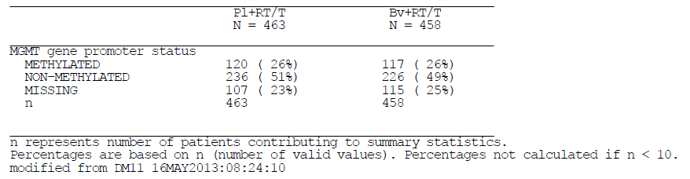
No imbalance in the unknown underlying methylation status is expected from patients with missing MGMT status. To illustrate this, the results of a subgroup analysis of PFS as assessed by the Investigator based on data collected up to the final OS cut-off (28 February 2013) showed that the median PFS for patients with missing MGMT status is similar to the median PFS for patients with non-methylated MGMT, for the Pl + RT/TMZ arm as well as the bevacizumab + RT/TMZ arm (see Table 17).
Table 17. Summary of progression free survival as assessed by the investigator by MGMT status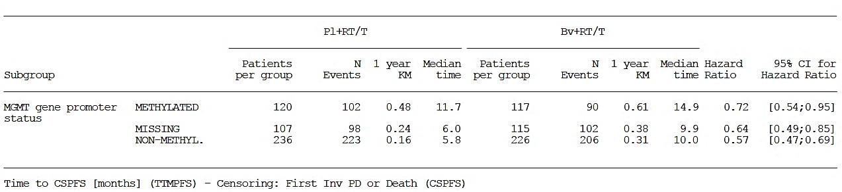
If all patients in the bevacizumab + RT/TMZ arm had methylated MGMT (in which case the PFS results could have been biased in favour of the bevacizumab + RT/TMZ arm), the median PFS would have been longer for those patients. In addition, a sensitivity analysis of PFS excluding patients with missing MGMT status was performed. The results showed that the magnitude of benefit is comparable to the intent to treat population, which supports the lack of impact of the missing MGMT status population on the overall PFS results (see Table 18).
Table 18. Summary of progression free survival as assessed by the investigator by patient with non-missing MGMT status
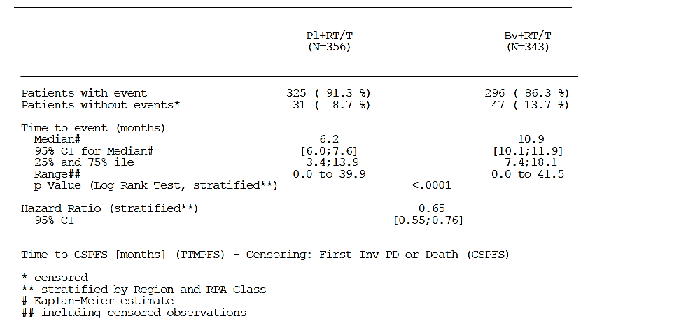
Figure 6. Kaplan-Meier plot of progression free survival as assessed by the investigator for patients with non-missing MGMT status
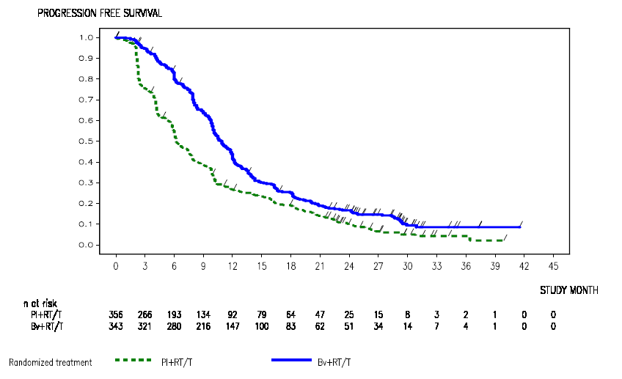
Thus, the ability of the pivotal study to demonstrate a benefit for bevacizumab exposure in patients with GBM is not affected by the 24% of subjects in whom MGMT methylation status could not be determined.

Randomisation by MGMT status
The purpose of stratification during randomisation is to ensure all stratification factors are balanced in treatment groups. As discussed above, the treatment groups in BO21990 were well balanced with regards to MGMT gene promoter methylation status (taking into account also the patients with missing MGMT status), despite not having been stratified by MGMT status.
At the time BO21990 was designed in 2008, there was no recognised validated method for assessing the methylation status of the MGMT gene promoter, thus precluding MGMT status as a reliable stratification factor. Since that time the methodology for assessment, as well as the definition of a clear threshold for MGMT methylation has evolved. However, an accepted standard has not yet been established.
A subgroup analysis of investigator assessed PFS by MGMT methylation status performed on the data collected up to the final OS cut-off (28 February 2013) demonstrated a clinically significant reduction in the risk of disease progression or death in the bevacizumab + RT/TMZ arm compared with the Pl + RT/TMZ arm for patients with both non-methylated MGMT status (hazard ratio [HR] 0.57, 95% CI [0.47; 0.69]) and methylated MGMT status (HR 0.72, 95% CI [0.54; 0.95]) (see Table 19). Furthermore, in the group of patients with missing MGMT status at baseline, the PFS results showed a clinically significant reduction in the risk of disease progression or death in the bevacizumab + RT/TMZarm compared with the Pl + RT/TMZarm (HR 0.64, 95% CI [0.49; 0.85]). The OS results at the final OS analysis were similar to the overall population for patients with tumours with both non-methylated MGMT status (HR 0.91, 95% CI [0.74; 1.11]) and methylated MGMT status (HR 0.93, 95% CI [0.65; 1.32]; see table 5). These results indicate a benefit on PFS and an absence of a detrimental effect on OS by adding bevacizumab to RT/TMZ, irrespective of MGMT methylation status.
Table 19. Summary of overall survival by MGMT status
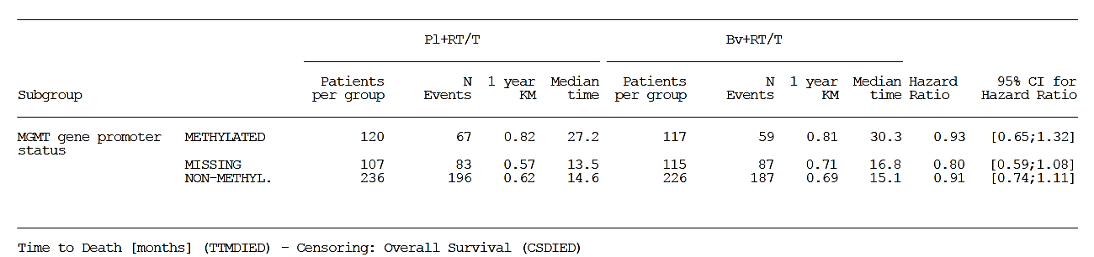
Consequently the integrity of the study, and with it the ability to demonstrate a benefit from bevacizumab exposure, is not affected by the fact that subjects were not randomised according to MGMT methylation status.

MGMT status does not mask the effect of bevacizumab
Multiple and univariate Cox regression analyses have been performed for PFS with data collected up to the cut-off for the final OS snapshot of 28 February 2013. An univariate Cox regression analysis only including MGMT methylation status as a factor in the model provided a HR of 0.53 (95% CI [0.44; 0.63]), indicating a significant PFS benefit for patients with methylated MGMT status as compared to patients with non-methylated MGMT status, regardless of the trial treatment received (Table 20). The treatment effect changed only slightly when adjusted for MGMT methylation status (from HR 0.65 overall unadjusted to 0.62).
Table 20. Summary of Cox regression for progression free survival (as assessed by the investigator)
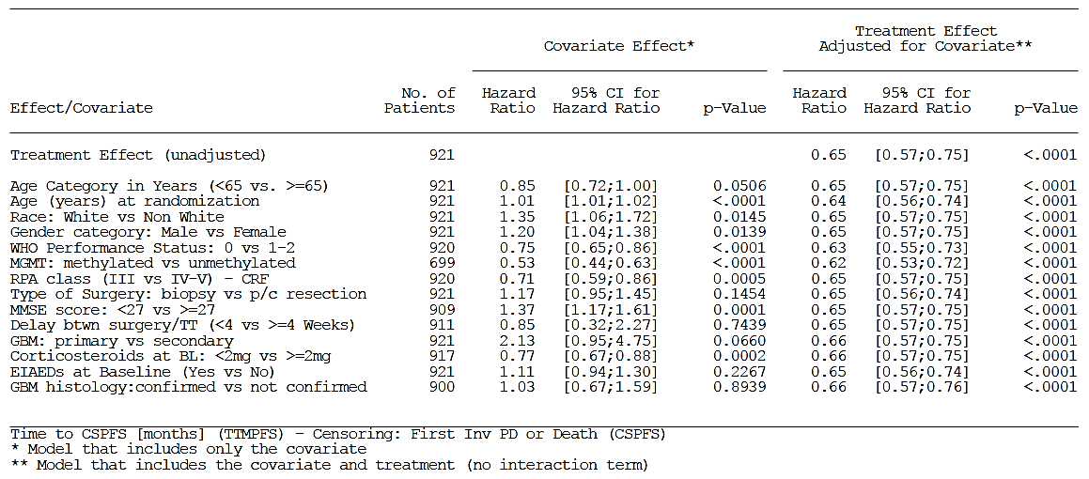
The multiple Cox models (one with all selected baseline covariates and one with only the significant ones included) confirm these results (see Tables 21 and 22).
Table 21. Summary of multiple Cox regression for progression free survival (as assessed by the investigator-all variables)
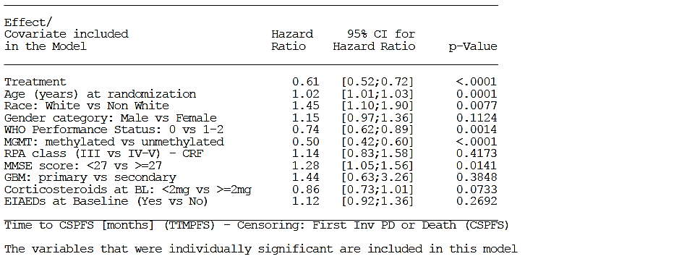
Table 22. Summary of multiple Cox regression for progression free survival (as assessed by the investigator-significant variables)
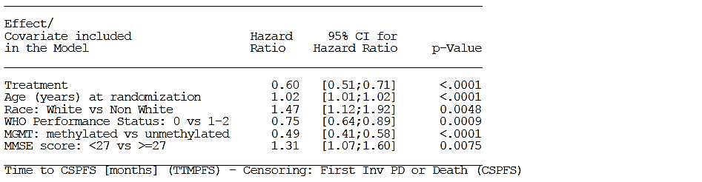
A Cox regression analysis including trial treatment, MGMT methylation status as well as the interaction term of MGMT and trial treatment has also been performed and resulted in a non-significant p-value for the interaction term (see Table 23) confirming that bevacizumab treatment effect is independent of MGMT methylation status.
Table 23. Testing for MGMT and trial treatment interaction for progression free survival
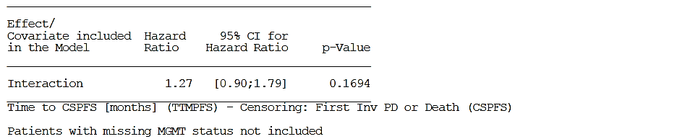
These analyses confirm the prognostic value of MGMT methylation and demonstrate the absence of a predictive value of MGMT for bevacizumab, that is, the benefit of bevacizumab treatment is similar for methylated and nonmethylated patients as can be seen by the overlapping 95% CI for the HRs of the two subgroups.
The ability of the pivotal study to demonstrate a positive effect from bevacizumab exposure is therefore not masked by the significant impact that MGMT status has on the PFS outcome.

Assessment method for disease progression
At the time the BO21990 study was initiated in 2009 the Macdonald criteria, which takes into account bidimensional diagnostic radiological imaging, the neurological status of the patient and the use of corticosteroids was the reference for standardised disease assessment of GBM. From the 1990s onwards the advances in magnetic resonance imaging (MRI) technologies, the introduction of new biological therapeutic agents and a better understanding of GBM tumour biology revealed some limitations of the Macdonald criteria. The original Macdonald criteria did not consider non-enhancing areas of the tumour which can cause clinical deterioration despite stable or decreasing enhancing tumour portions and did not provide guidance to assess multifocal tumours, diffuse tumour dissemination and new phenomena such as pseudoprogression (PsPD).
Concurrent with the writing of the BO21990 protocol, ongoing discussions by an international panel of experts of the Response Assessment in Neuro-Oncology (RANO) Working Group aimed to propose recommendations for updating response criteria for high grade gliomas. Several of the criteria subsequently recommended by the RANO group were incorporated into BO21990 study protocol at the time that the adapted Macdonald criteria were being defined. As a result, the adapted Macdonald and RANO criteria are similar and integrate the latest advances in the field. The key features of both criteria included the need to consider the non-enhancing component of the tumour by T2/FLAIR image sequences when assessing response, in alignment with current clinical practice to assess brain tumours (Table 24). In addition a specific guideline to distinguish PsPD was prospectively defined in BO21990.
Table 24. Comparison of Tumour Assessment Criteria for Disease Progression in Glioblastomaª
Adapted Macdonald (BO21990) RANO
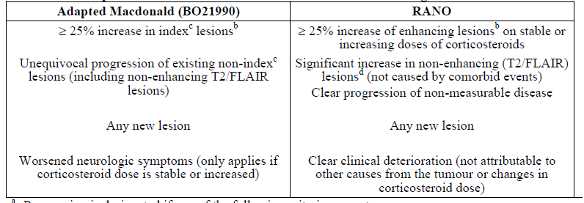
ª Progression is designated if any of the following criteria are met.
^{b} Measured by sum of the products of perpendicular diameters.
^{c} Index lesions are measurable lesions (contrast-enhancing lesions on post-gadolinium MRI sequences) with both diameters ≥ 10 mm. Non-index lesions are lesions evident on radiographic examination that cannot be accurately measured or do not meet the criteria of index lesions.
^{d} On stable or increasing doses of corticosteroids.
In conclusion, given the known limitations of the original Macdonald criteria and the maturity of work by the RANO group on re-defining the criteria for response assessment in GBM, modification of the original Macdonald criteria in BO21990 was considered necessary. The incorporation of specific operational elements allowed for more consistent and rigorous application of the response assessment criteria required across investigator sites in a large multi-centre clinical trial. Importantly, the application of the adapted Macdonald criteria in the BO21990 study showed not only their robustness and reproducibility but also demonstrated that integration of T2/FLAIR as part of the radiological assessment was feasible in a large Phase III study and allowed improved monitoring of tumour evolution. Additionally, both the Macdonald and RANO criteria are utilised in Australia and so the adapted Macdonald criteria are generalisable into routine clinical practice in Australia.

Benefit/risk conclusions
The outcome for most patients with GBM remains extremely poor despite recent advances in surgical and radio-therapeutic techniques as well as the development of TMZ. Even with the current standard of care (RT/TMZ), the median OS remains short at 14.6 months for newly diagnosed GBM with 2 and 5 year survival rates of 27% and 10%, respectively., Following progression of newly diagnosed GBM, only approximately 50% of relapsed patients are able to receive salvage therapies. Tumour progression or recurrence is typically accompanied by new or worsening neurologic signs and symptoms, emphasising the clinical importance of disease control to maintain HRQoL. Hence a high medical need for new therapies exists in this disease setting, with the primary objectives of therapy being to prolong the progression-free period in order to reduce morbidity, restore or preserve neurologic functions and maintain the capacity to perform daily activities as long as possible.
Based on the results from Study BO21990, the sponsor considers the benefit/risk profile of the bevacizumab + RT/TMZ regimen for patients with newly diagnosed GBM to be positive. A comprehensive discussion of the benefit/risk profile was provided in response to Clinical question 3 and a copy of the response to Question 3 was also included with this pre-ACPM response.
Addition of bevacizumab to standard of care resulted in a statistically significant and clinically meaningful prolongation in PFS time of 4.4 months (HR 0.64; 95% CI [0.55; 0.74]; KM estimated median 6.2 months for the Pl + RT/TMZ arm versus 10.6 months for the bevacizumab + RT/TMZ arm) coupled with the following additional clinical benefits for the patient: maintenance in high baseline HRQoL scores and a longer time to definitive deterioration in HRQoL (a patient reported outcome), maintenance in functional independence (KPS ≥ 70) and neurocognitive function (a clinician reported outcome) and a reduced requirement for corticosteroids (an objective measure of a concomitant medication that is a surrogate for disease symptoms and a source of morbidity). There was no difference, either improvement or detriment, in OS (HR 0.88, 95% CI [0.76; 1.02]; KM estimated median 16.7 months in the Pl + RT/TMZ arm versus 16.8 months in the bevacizumab + RT/TMZ arm). The safety of the bevacizumab + RT/TMZ regimen is consistent with the safety profile of RT/TMZ with the addition of the established safety profile of bevacizumab. No new AEs were observed in the trial. The number of deaths unrelated to disease progression (non-PD) was balanced between the arms. During the early study phase, numerically more non-PD deaths were reported in the bevacizumab + RT/TMZ arm (7) than the Pl + RT/TMZMZ arm (4).
However medical review did not identify any risk factors or common features for predictive risk mitigation. A higher number of arterial thromboembolic events (ATE) were reported in the bevacizumab + RT/TMZ arm, however an imbalance of potential co-morbidities and of baseline risk factors in this arm most likely account for the higher incidence of Grade ≥ 3 ATEs. In general, most of the ATEs occurred late in the course of treatment and the majority of cases in the bevacizumab + RT/TMZ arm resolved. The higher incidence of AEs leading to withdrawal in the bevacizumab + RT/TMZ arm was mainly accounted for by AEs known to be associated with bevacizumab use as well as more infections, fatigue, pyrexia and events in the Cardiac disorders System Order Class.
The results of BO21990 demonstrate that addition of bevacizumab to standard of care translates into a longer period of disease control and maintenance in well-being during the progression-free time in a disease which retains a high unmet medical need characterised by continuous and relentless tumour progression.
Assessment of progression is a critical event for all patients. Tumour growth is often associated with new or worsening neurologic symptoms and a decline in HRQoL. Even clinically silent progression seen only on imaging typically heralds a change in therapeutic strategy. This is not a trivial consideration considering the limited therapies for the management of recurrent GBM (re-operation, Bv, nitrosoureas, or clinical trial participation) and the expectation that all will fail, and the patient will progress on average within 2 to 3 months. Indeed, as previously mentioned, in clinical practice up to half of all patients are unable to receive additional treatment at the time of tumour progression. In this regard, an exploratory analysis of the patients in BO21990 who did not receive any subsequent treatment after progression showed a difference in OS in favour of the Bv + RT/T arm over the Pl + RT/T arm; (HR 0.67, median 11.6 vs. 8.0 months).
Based on the considerations above, the prolongation by 4.4 months of PFS observed for the Bv + RT/RT arm in BO21990 is clinically meaningful for the newly diagnosed patient with GBM, allowing the patient to maintain the benefit of initial therapy for as long as possible. The risks of the Bv + RT/T regimen discussed above have been adequately identified and are appropriately addressed and managed by the proposed Product Information and Risk Management Plan.
The sponsor therefore considers the benefit-risk profile of the Bv + RT/T regimen to be positive in patients with newly diagnosed GBM.

Advisory committee considerations
The Advisory Committee on Prescription Medicines (ACPM), having considered the evaluations and the Delegate’s overview, as well as the sponsor’s response to these documents, advised the following:
The ACPM, taking into account the submitted evidence of efficacy, safety and quality, agreed with the delegate and considered Avastin concentrated injection containing 100 mg/4 mL and 400 mg/16 mL of bevacizumab to have an overall positive benefit–risk profile for the indication;
Avastin (bevacizumab) in combination with radiotherapy and temozolomide is indicated for the treatment of adult patients with newly diagnosed glioblastoma.

Proposed PI/Consumer Medicine Information (CMI) amendments
The ACPM agreed with the Delegate to the proposed amendments to the Product Information (PI) and Consumer Medicine Information (CMI).

Specific advice
The ACPM provided the following specific advice in response to the Delegate’s questions on this submission:
- What is the opinion of the committee regarding the ability of the pivotal study to demonstrate a benefit from bevacizumab exposure in patients with glioblastoma given 24% of subjects had unknown MGMT methylation status?
The ACPM advised this was a definite flaw in the study but when these patients with unknown status are removed from the study analysis an improvement in PFS is still evident. The lack of improvement in OS was noted. The additional analysis in the sponsor’s pre-ACPM response confirmed this.
- What is the opinion of the committee regarding the ability of the pivotal study to demonstrate a benefit from bevacizumab exposure given that subjects were not randomised according to MGMT status?
The ACPM advised that, if patients with unknown methylation status were removed then those with known status are reasonably equitably distributed and with little change to the results, thus suggesting that uneven distribution of those with favourable methylation status had little impact of the study outcomes.
- What is the opinion of the Committee regarding the ability of the pivotal trial to demonstrate a positive effect from bevacizumab exposure given the reported effect of MGMT status to be greater than that of bevacizumab?
The ACPM advised that the outcomes of the trials did not materially change when patients with unknown methylation status were removed from analysis and although methylation status is known to affect PFS or OS the lack of randomisation according to methylation status is unlikely to have significantly affected the results in the pivotal study. Regardless of methylation status, a treatment benefit on PFS occurred with bevacizumab.
- What is the opinion of the committee regarding the ability of the pivotal study to demonstrate a benefit from bevacizumab exposure given that the assessment method of disease progression is not one used in standard clinical practice?
Despite non-standard criteria (Macdonald criteria) used to assess tumour response these criteria were similar to the subsequently established standard RANO criteria. The ACPM noted the sponsor confirmed the RANO criteria were in development when the trial was being conducted.
- What is the opinion of the committee of the benefit:risk ratio of bevacizumab use for the proposed indication?
The ACPM was of the view that extended progression-free survival and delayed deterioration in QOL can be attributed to addition of bevacizumab to standard therapy and agreed with the clinical evaluator that a marginally positive benefit-risk profile can be inferred from the data, even though no increase in OS has been demonstrated.
The ACPM advised that the implementation by the sponsor of the recommendations outlined above to the satisfaction of the TGA, in addition to the evidence of efficacy and safety provided would support the safe and effective use of these products.

Initial outcome
Based on a review of quality, safety and efficacy, TGA decided not to register Avastin (bevacizumab) injection solution in the first-line treatment of newly diagnosed glioblastoma multiforme on the grounds that the efficacy and safety of the product have not been satisfactorily established for the purposes for which it is to be used.

Reasons for Delegate’s decision
- Efficacy has not been satisfactorily established for the purpose for which bevacizumab is to be used, for the following reasons:
  - A state of uncertainty remains of the true effect of bevacizumab on: health-related quality of life, symptom burden and neurological functioning in patients with newly diagnosed glioblastoma.
  - In the absence of improvement in overall survival, the longer duration of progression-free survival seen with bevacizumab from Studies BO21990 and RTOG-0825 is not solely sufficient to demonstrate a clinically meaningful outcome. Reference: The Guideline on the evaluation of anticancer medicinal products in man ‘the objective should be to demonstrate OS and/or improved symptom control or HRQoL’.
  - Despite the methodological differences between RTOG-0825 and BO21990, the sponsor acknowledges that ‘definite conclusions cannot be drawn on account of the health-related quality of life results of both studies’. Thus, the sponsor has not satisfactorily demonstrated that differences in study methodology for RTOG-0825 and BO21990 are sufficient to either categorically refute the health-related quality of life, symptom burden and neurological functioning outcomes and recommendations of RTOG-0825 or only support the health-related quality of life, symptom burden and neurological functioning outcomes and recommendations from BO21990. The effect of this uncertainty is contrary to the requirement of a single pivotal study to demonstrate ‘exceptionally compelling’ evidence.
  - There can be no assumption that the quality of life of patients who did complete quality of life assessments is representative of those that did not complete them in either BO21990 or RTOG-0825.
  - In relation to the TGA adopted Guideline on Points to Consider for a Single Pivotal Study, for subjects in BO21990, there is a progressively large proportion of subjects not completing quality of life questionnaires. The reasons for non-compliance with quality of life assessments have not been satisfactorily established. The effect of missing quality of life data has not been established, which is a source of bias and contrary to the requirement of a single pivotal study to demonstrate ‘exceptionally compelling’ evidence.
  - The external validity and generalisability of the selection of five pre-specified elements from QCQ-30 and QLQ-BN20 is uncertain given they have only been reported as an outcome measure from the single study population of BO21990.
  - Study RTOG-0825 has not been submitted for formal evaluation by the TGA.
- The safety of Avastin (bevacizumab) in the indication has not been satisfactorily established for the following reasons:
  - In Study BO21990, the safety significantly favoured the placebo group with regards to combined treatment-emergent Grades 3-5 adverse events, serious adverse events, Grade 3-5 hypertension, Grade 3-5 infections and infestations and Grade 3-5 proteinuria. The point estimates for cerebral haemorrhage and intestinal perforation both favoured the placebo arm.
  - The safety profile of bevacizumab in BO21990 has not been reported for patients that did not complete quality of life assessments separately from those that did. It is therefore uncertain whether adverse events had a negative impact on both quality of life and compliance with completion of quality of life assessments.

Final outcome
Following the initial decision described above, the sponsor sought a review under the provisions of Section 60 of the Therapeutics Goods Act. The Delegate of the Minister for the review noted that paragraph 25(1)(d) of the Therapeutic Goods Act, which requires the goods to be evaluated with regard to whether the quality, safety and efficacy of the goods for the purposes for which they are to be used have been satisfactorily established, is of particular relevance.
The following is an excerpt from the Delegate of the Minister’s report.
The Delegate of the Minister decided to confirm the initial decision not to approve the application on the basis that the efficacy and safety of the product for the proposed extension of indication have not been satisfactorily established.

Findings of fact

Delegate’s reasons for rejection
The Delegate of the Minister, in making the initial decision, found that efficacy was not satisfactorily established because:
- There is uncertainty around the true effect of bevacizumab on quality-of-life data, symptom burden and neurological functioning.
- Given no improvement in overall survival and uncertainty around quality-of-life, the gain in progression-free survival was not sufficient on its own to demonstrate a clinically meaningful outcome.
- There was much missing data for quality-of-life, and it cannot be assumed that the patients who had completed assessments for quality-of-life were representative of those who did not.
The Delegate of the Minister also found that safety was not satisfactorily established because:
- In Study B021990, the safety significantly favoured the placebo group with regards to combined treatment-emergent grades 3-5 adverse events, serious adverse events, grade 3-511ypertension, grade 3-5 infections and infestations and grade 3- 5 proteinuria. The point estimates for cerebral haemorrhage and intestinal perforation both favoured the placebo arm.
- The safety profile of bevacizumab in B021990 has not been reported for patients that did not complete quality of life assessments separately from those that did. It is therefore uncertain whether adverse events had a negative impact on both quality of life and compliance with completion of quality of life assessments.

Abridged chronology
At the 12 to 13 February 2014 meeting, the ACPM recommended approval of the extension of indication to newly diagnosed glioblastoma. This recommendation to the Delegate was based primarily on the sponsor's pivotal Phase III trial B021990.
At that point in time, the Delegate and the ACPM were aware of an independent (non-sponsor) Phase III trial with similar inclusion/exclusion criteria and design: RTOG-0825, and some of the results (for example, based on information presented in abstract format together with oral and poster presentations at the 2013 American Society of Clinical Oncology annual congress and summarised in the sponsor's above).
The sponsor provided a summary of the publicly available preliminary findings form the RTOG-0825 study in response to clinical evaluation questions. The Delegate became aware of the full results from RTOG-0825 when they were published in the New England Journal of Medicine in February 2014 (370:699-708), after the ACPM meeting, prior to the decision date.
RTOG-0825 was not the sponsor's trial. It was funded primarily by the National Cancer Institute (in the United States); although the report in the NEJM also mentions an unrestricted educational grant from Genentech. The Delegate accepts that the sponsor also only had access to the publicly-available results for RTOG-0825.
The information from RTOG-0825 which became newly available in the public domain, including to the Delegate from the NEJM publication raised concerns post-ACPM that quality of life deteriorated on bevacizumab in contrast to the results form B021990 which showed maintenance of quality of life. The results for progression-free survival and overall survival were similar in the two trials (see below).
The sponsor was asked to comment on RTOG-0825 and responded on 21 March 2014 (see below for further detail on the sponsor's response).
After taking into account the sponsor's response, the Delegate rejected the sponsor's application for extension-of-indication.
Further findings of fact are organised below, according to the three important endpoints in the two Phase III trials quality-of-life, progression-free survival, overall survival) and safety; after the subsection that summarises the trial results (immediately below).

Summary of results from two Phase III trials
The results for the two Phase III trials were similar for progression-free survival (4 month improvement) and overall survival (no improvement) but different for quality-of-life maintenance versus deterioration).
Delegate of the Minister summarise the findings in relation to the results of the Phase III trials below in Table 25.
Table 25. Results from Phase III trials
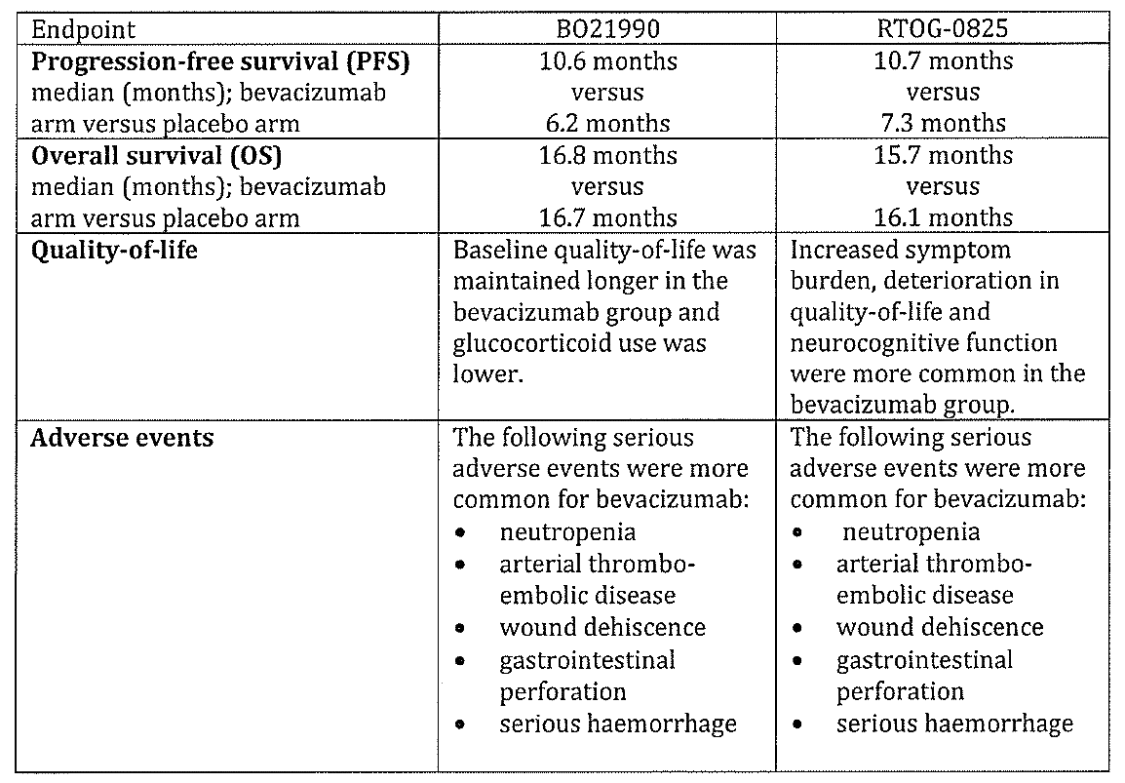

Quality-of-life
Post-ACPM, and before a decision was made, the Delegate provided the sponsor with an opportunity to respond to two questions arising from the publication of the results from RTOG-8025 (not available at the time of the ACPM meeting). The questions were around the substantial amounts of missing data for quality-of-life from both trials and the discordant results (B021990: maintenance of quality-of-life; RTOG-0825: deterioration in quality-of-life).
The sponsor provided a 23 page response to the two questions. In short, the sponsor argued that the quality-of-life measurements in B021990 were more valid than those in RTOG-0825 and that direct comparison of the results for quality-of-life from the two trials could not be made because of differences in, inter alia, study design, collection of data and analysis.
This did not reassure the Delegate that efficacy and safety had been satisfactorily established and the Delegate decided to reject the application for the extension of indication.
In the decision letter (notifying the sponsor of the decision to reject the application) the Delegate noted the large percentage of missing data on quality-of-life in B021990. At the time of disease progression, 2031358 (56.7%) of the placebo arm and 1631322 (50.6%) of the bevacizumab arm completed a quality-of-life questionnaire.
The publicly available information on missing data from RTOG-0825 was not presented in the same way. What was reported was the percentage of missing data for the quality-of-life and neurocognitive questionnaires, at various time points, for patients for whom a questionnaire was ‘expected’ (primarily, patients who had not progressed). These ranged from 10% to 30%, depending on the time point and the questionnaire. If calculated in the same way as B021990, then the percentage of ‘missing’ quality-of-life data for RTOG-0825 would likely be similar or higher (that is, 40% to 60%) to that in B029910.
In the 48 page letter requesting a section 60 review by the TGA, the sponsor re-stated their argument that the quality-of-life measurements in B021990 were more valid than those in RTOG-0825 and that direct comparison of the results for quality-of-life from the two trials could not be made because of various differences between the trials.
During the section 60 review, the Delegate of the Minister also noted the comments of Howard Fine in the Editorial in New England Journal of Medicine (2014;370(8), 64-765). He stated that the difference in results for quality-of-life and neuro-cognitive function remains an ‘enigma’ (possibly related to differences in data analysis, loss to follow-up, or surgical resection), but is ‘neither trivial nor academic’. He went on to recommend that the investigators of the RTOG 0825 and B021990 trials should share their raw data with each other and with independent investigators (including regulators) to try to resolve the question of the true effects of bevacizumab on quality-of-life (in the setting of newly-diagnosed glioblastoma).
To give this issue due consideration, Delegate of the Minister obtained advice from two experienced, Australian neuro-oncologists, during the section 60 review.
One neuro-oncologist advised that the methods used in B021990 and RTOG-0825 were different. Specifically, quality-of-life assessments in RTOG-0825 were restricted to patients who had not progressed, which could be biased against bevacizumab if there was radiologically undetected progression (see sub-section on Progression-free survival, below). The expert also pointed out the large amounts of missing data in RTOG- 0825.
The other neuro-oncologist echoed the Fine Editorial in New England journal of Medicine (2014; 370(8) :764-765) around concerns about inconsistencies in the results for quality-of-life between the two trials, and, in particular, the deterioration in quality-of-life in RTOG-0825.
The sponsor provided a 78 page response (28 August 2014) to the neuro-oncologists' advice on quality of life and other issues (for example, Progression-free survival, Overall survival; see below). The sponsor restated the case that the quality-of-life measurements in B021990 were more valid than those in RTOG-0825.

Progression free survival
Measurement of progression-free survival relies on imaging. Although imaging can accurately identify progression for many cancers (for example, colorectal cancer), imaging might not accurately identify progression for glioblastoma; especially in patients treated with bevacizumab. More specifically, there have been concerns for some time that much of the response seen on imaging is due to vascular stabilization (bevacizumab is an angiogenesis inhibitor) rather than a true antitumor effect (for example, this issue is discussed in the Howard fine Editorial.
Both of the experienced, Australian neuro-oncologists acknowledged the difficulties in measuring progression on imaging for glioblastoma. For example, one of the neuro-oncologists stated that, ‘It can be difficult to distinguish extent of disease, response to treatment, and to distinguish true progressive disease from pseudo-progression ...’ in glioblastoma patients.
In their response (28 August 2014), the sponsor re-stated their view that B021990 included several strategies to minimise the possibility of incorrectly interpreting the imaging. This view had been previously provided in the section 31 response, the pre-ACPM response and the section 60 appeal letter. Briefly, the sponsor's Study B021990 included assessment of non-enhancing tumour components and the progression endpoint included glucocorticoid use. RTOG-0825 used the McDonald criteria.
The Delegate of the Minister also noted the comments of Howard Fine. He stated, ‘new and robust imaging and clinical end points need to be identified and incorporated into future clinical trials of gliomas, given the complex effects of anti-VEGF agents on the images obtained with the use of routine MRI and the questionable usefulness of our current patient-reported outcomes, as exemplified by the RTOG-0825 and AVAglio (ie. B0219901) trials’.

Overall survival
Both B021990 and RTOG-0825 allowed patients in the placebo arm to switch to bevacizumab on progression. This has become relatively common-place in Phase III trials for rapidly-progressing cancers.
In both B021990 and RTOG-0825, some patients (approximately 50%) chose not to have any further treatment or were too sick to switch to bevacizumab. Nevertheless, such trials, with switching, represent a pragmatic, real-world comparison of the strategy of treating newly diagnosed patients with bevacizumab versus the strategy of waiting and offering bevacizumab to patients on relapse or progression (the currently registered indication); in the knowledge that not all patients, by the time they progress, will be suitable for bevacizumab or will decide to have bevacizumab. The sponsor's contention that either of the trials was designed to assess whether bevacizumab should be given early or late (sponsor's response of 28 August 2014) has been noted.
Both trials showed no benefit for overall survival: the difference-in-median overall survival for study B021900 was 0.1 months and RTOG-0825 was -0.4 months (see table, above).
The sponsor's post hoc subgroup analysis of overall survival for patients who did not switch (included with the section 60 appeal letter) has been noted. On evidence-rating scales (such as GRADE) this would be considered very low quality evidence in support of efficacy, given that, in such analyses, the benefits of randomisation (to ensure internal validity) are lost.

Safety
The safety problems associated with bevacizumab are well-known after many years of use in other cancers and also use in relapsed/progressed glioblastoma. These include increased risk of neutropenia, serious haemorrhage, wound dehiscence and gastrointestinal perforation. In terms of safety, there were no unexpected results from B029910 or RTOG-0825 (see table, above).

Delegate’s reasons
Glioblastoma is one of the most rapidly fatal cancers and better treatments are desperately needed. The Phase III trials, B021990 and RTOG-0825, were both conducted by competent research groups and according to recognised standards for trials of patients with such rapidly fatal cancers. Delegate of the Minister have noted the sponsor's arguments that their trial, B021990, has advantages in terms of design and methods over RTOG-0825. However, in the Delegate of the Minister’s view, any advantages are in terms of internal validity are unproven and Delegate of the Minister considers that both research groups are competent and experienced.
The Delegate of the Minister decided to confirm the initial decision not to approve the application because the results for progression-free survival, quality-of-life and overall survival, from the two trials, do not satisfactorily establish efficacy. Further, the lack of established efficacy and the well-known safety concerns with bevacizumab means that safety has not been satisfactorily established for the particular indication of newly-diagnosed glioblastoma.
A summary of the Delegate’s concerns about the currently available evidence is given in the table below.
Table 26. Summary of Delegate’s concerns
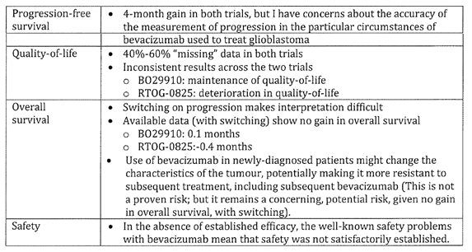
More details on Delegate of the Minister’s reasons for deciding to confirm the initial decision not to approve the application are given below.

Sponsor’s over-analysis of methodological differences between the trials
The sponsor has provided the TGA with voluminous responses, in an attempt to justify their position that B021990 is more internally valid than RTOG-0825; and why the data from B021990 on quality-of-life and progression-free survival satisfactorily establish efficacy. The Delegate of the Minister found these responses to be an over-analysis/over-interpretation of the available data and an over-statement of what is known/proven about the potential effect of methodological differences on the differences in the results for quality-of-life. Delegate of the Minister also notes that the sponsor is arguing that the methods used in B021990 to measure progression free survival are more valid than those in RTOG-8025, yet the results from the two trials for progression-free survival are the same (this is discussed further in the subsection on ‘Progression-free survival’, below).
For quality-of-life, the Delegate of the Minister has independently formed the view that the methodological differences between the trials are not a satisfactory explanation as to why there was a deterioration in quality-of-life in RTOG-0825.
The Delegate of the Minister notes, in passing, that Howard Fine in an Editorial in the New England journal of Medicine was of the same view. He stated that the difference in results for quality-of-life and neuro-cognitive function remains an ‘enigma’. He went on to recommend that the investigators of the RTOG 0825 and B021990 trials should share their raw data with each other and with independent investigators including regulators) to try to resolve the question of the true effects of bevacizumab on quality-of-life (in the setting of newly-diagnosed glioblastoma).
Further, both trials, including B021990, had significant amounts of missing data for quality-of-life. This is discussed further in the subsection ‘Quality-of-life’, below.

Progression/free survival
It is possible that the methods used in B021990 (for example, assessment of non-enhancing tumour components and glucocorticoid use) are more accurate than the McDonald criteria used in RTOG-0825, but there are no convincing data to prove this. That is, the Delegate of the Minister does not accept the sponsor's argument that there is evidence to satisfactorily establish that the investigators on trial B021990 have solved this long-standing measurement problem.
The Delegate of the Minister also notes that both trials produced the same result for progression-free survival: a four month gain. It is difficult to sustain an argument that one trial had more accurate measurements, when both trials produced the same result.
One of the neuro-oncologists advised that not all of the gain in progression-free survival could be explained by inaccurate measurement; however, the other neuro-onocologist advised the all of the gain could be explained by inaccurate measurements. Both of the neuro-oncologists acknowledged the problems in measuring progression in patients with glioblastoma. In the face of these established concerns about the inaccuracy of measuring progression in both trials, the Delegate of the Minister is of the view that the results for progression would need to be confirmed by the results for quality-of-life. However, the results for quality of life were inconsistent across the trials and there was much missing data (see table, above; and subsection on ‘Quality-of-life’, below).
In short, the Delegate of the Minister has independently formed the view that the progression-free survival data from B021990 and RTOG-0825, taken on their own, do not satisfactorily establish the efficacy of bevacizumab for the extension-of-indication to newly-diagnosed glioblastoma.
The Delegate of the Minister notes, in passing, that the comments in Fine Editorial are consistent with this view. He stated that, ‘new and robust imaging and clinical end points need to be identified and incorporated into future clinical trials of gliomas ...’.
The Delegate of the Minister also notes, in passing, that the EMA has formed a view along the same lines. Specifically, one of the reasons the EMA has given for rejecting the application for registration of bevacizumab for newly-diagnosed glioblastoma in the EU is: ‘the improvement in progression free survival was not considered clinically relevant because limitations in the methods available to measure the size of brain tumours’.

Quality of life
As discussed above, the Delegate of the Minister is not satisfied that the data on progression-free survival, on their own, can be used to satisfactorily establish the efficacy of bevacizumab for newly diagnosed glioblastoma. However, in theory, efficacy might be established if the trials consistently showed maintenance or improvement in quality-of-life. However, this was not the case because the trials produced inconsistent results: B021990 showed maintenance of quality-of-life, while RTOG-0825 showed a deterioration in quality-of-life.
The sponsor has made the argument that the measurements of quality-of-life were more valid in B021990 than in RTOG-0825. The Delegate of the Minister’s findings on that issue are discussed in the subsection ‘Sponsor's over-analysis of methodological differences between the trials’, above).
Further, in both trials there were large amounts of missing data (40%-60%; depending on the endpoint, the time point, and how ‘missing ness’ is defined). The Delegate of the Minister accepts that in trials that recruit patients with rapidly-progressing cancer it is not unusual to have significant amounts of missing data for quality-of-life. However, the key problem is that patients with missing data are unlikely to be a random sample of all patients in a trial. When approximately 50% of data are missing this leads to significant uncertainty in the quality-of-life results from both B021990 and RTOG-0825.
The Delegate of the Minister has therefore independently formed the view that the quality-of-life data, either on their own or when considered in combination with the progression-free survival data, do not satisfactorily establish the efficacy of bevacizumab for the extension-of-indication to newly-diagnosed glioblastoma.

Overall survival
Switching on disease progression has become an increasingly common design feature of trials that recruit patients with rapidly progressing and fatal cancer (to increase participation and for ethical reasons). The contamination that occurs across treatment arms (as a result of switching) means that the results for overall survival are not a valid comparison of bevacizumab versus no-bevacizumab.
Nevertheless, given the lack of established benefit for progression-free survival and quality-of-life, it would have been reassuring if there had been an improvement in overall survival. However, the difference-in-median overall survival in B02199O was 0.1 months and in RTOG-0825 it was -0.4 months.
Given the lack of established benefit for progression-free survival and quality-of-life, the Delegate of the Minister independently formed the view that the data for overall survival are not sufficient to satisfactorily establish efficacy.
The Delegate of the Minister notes, in passing, that the EMA is of the same view: ‘The panel was also unhappy that there was no improvement in overall survival (OS), concluding that on balance the benefits of the drug did not outweigh its risks in this form of brain cancer, which constitutes 15 per cent of all nervous system tumours and commonly occurs in adults 45 to 70 years’.
The Delegate of the Minister is also concerned that the results for overall survival from the two trials leave open the possibility that bevacizumab for newly-diagnosed glioblastoma could change the characteristics of the tumour, making it more resistant to further treatment, including further treatment with bevacizumab.
The Delegate of the Minister further notes that one of the neuro-oncologists was concerned that there might be a group of patients for whom early bevacizumab precludes reoperation. This is problematic because patients who are able to undergo subsequent debulking of tumour (that is, re-operation) may have a chance of improved survival, which could be precluded by the use of bevacizumab when the tumour is newly diagnosed. The sponsor's response of 28 August 2014, on this issue, has been noted.
This effect of bevacizumab (for newly-diagnosed glioblastoma) on the efficacy of subsequent treatments (for example, subsequent bevacizumab, further surgery) is not a proven risk, but in the absence of established benefit for overall survival with switching) it remains a potential and concerning risk.

Safety
If safety and efficacy were to be assessed in isolation, then any product with the potential to cause harm to a patient could not be considered to be safe. Therefore, no medicinal product would meet the criteria for registration. It is only in the context of a prospect of a real benefit from treatment in a patient that the safety profile could be considered acceptable.
For this particular application, if efficacy could be satisfactorily established using the results from one or more of the endpoints of quality-of-life, progression-free survival or overall survival, then the well-established safety problems with bevacizumab (for example, increased risk of neutropenia, serious haemorrhage, wound dehiscence, gastrointestinal perforation) might be acceptable. However, in the absence of established efficacy, the well-established safety problems with bevacizumab mean that safety was not satisfactorily established.

Synthesis of results for progression free survival, overall survival, quality-of-life
For this particular application there is material uncertainty in the results from both of the Phase III trials (B021990 and RTOB-0825) for all three efficacy endpoints quality-of-life (much missing data; inconsistent results between the two trials), progression-free survival (concerns about accuracy of measuring progression), and overall survival (contamination caused by switching). Accordingly, the Delegate of the Minister finds that efficacy has not been satisfactorily established.
The advice from the two Australian neuro-oncologists is that bevacizumab is of benefit to patients with relapsed/progressed disease (one of the currently registered indications).
However, neither of the neuro-oncologists could reassure the Delegate of the Minister that there are benefits for typical patients with newly-diagnosed glioblastoma.
One important factor in the Delegate of the Minister’s decision to confirm the initial decision not to approve the extension-of-indication is the similar, separate responses of the two Australian neuro-oncologists to the following question:
Given the currently available evidence-base, coupled with your clinical experience in treating these patients, what do you advise newly-diagnosed patients about the use of bevacizumab in the management of their glioblastoma?
Both neuro-oncologists separately and independently stated that in the setting of newly diagnosed glioblastoma they would advise patients against using bevacizumab. Briefly, one neuro-oncologist wrote, ‘I do not believe there is a current clinical indication that supports the addition of bevacizumab to their surgery, radiation and temozolomide therapies. ‘ The other wrote, ‘I discuss the data with particular reference to the lack of overall survival benefit, and my concerns that early use of bevacizumab may preclude further surgery. I provide reassurance that bevacizumab will be considered and discussed at the time of progression.‘
The sponsor's response of 28 August 2014 to the neuro-oncologists' advice on this question has been noted.
The Delegate of the Minister has given weight to the neuro-oncologists' advice because of their ability to integrate the results from the trials with their extensive clinical experience in treating patients with newly-diagnosed glioblastoma in Australia.

Delegate of the Minister’s conclusion
For the reasons detailed above, the Delegate of the Minister decided to confirm the initial decision not to register bevacizumab for newly diagnosed metastatic glioblastoma because the efficacy and safety of the goods for the purpose for which they are to be used have not been satisfactorily established.
Subject to the Administrative Appeals Tribunal Act 1975, the sponsor can at this point make an application to the Administrative Appeals Tribunal for a review of this decision.

Attachment 1. Extract from the Clinical Evaluation Report

Therapeutic Goods Administration
PO Box 100 Woden ACT 2606 Australia
Email: info@tga.gov.au Phone: 1800 020 653 Fax: 02 6232 8605
http://www.tga.gov.au

Clinical Trial Substantiates the Predictive Value of O-6-Methylguanine-DNA Methyltransferase Promoter Methylation in Glioblastoma Patients Treated with Temozolomide. Hegi, M. et al. Clinical Cancer Research 2004; 10: 1871-1874
MGMT Gene Silencing and Benefit from Temozolomide in Glioblastoma. Hegi, M. et al. New England Journal of Medicine 2005;352: 997-1003
Recurrence pattern after temozolomide concomitant with and adjuvant to radiotherapy in newly diagnosed patients with glioblastoma: correlation with MGMT promoter methylation status. Brandes et al. Journal of Clinical oncology 2009;27(8): 1275-1279
A standard way of measuring the ability of cancer patients to perform ordinary tasks. The Karnofsky Performance Status scores range from 0 to 100. A higher score means the patient is better able to carry out daily activities. Karnofsky Performance Status may be used to determine a patient's prognosis, to measure changes in a patient’s ability to function, or to decide if a patient could be included in a clinical trial. Also called KPS.
Health-related quality of life (HRQoL) is an assessment of how the individual's well-being may be affected over time by a disease, disability, or disorder
Radiotherapy plus concomitant and adjuvant temozolomide for glioblastoma. Stupp et al. New England Journal of Medicine 2005;352:987-96
The EORTC QLQ-C30 is a questionnaire developed to assess the quality of life of cancer patients.It is supplemented by disease-specific modules for e.g. Breast, Lung, Head & Neck, Oesophageal, Ovarian, Gastric, Cervical cancer, Multiple Myeloma, Oesophago-Gastric, Prostate, Colorectal Liver Metastases, Colorectal and Brain cancer which are distributed by the EORTC Quality of Life Department.
Recurrence pattern after temozolomide concomitant with and adjuvant to radiotherapy in newly diagnosed patients with glioblastoma: correlation with MGMT promoter methylation status. Brandes et. Al. Journal of Clinical oncology 2009;27(8): 1275-1279
MGMT Gene Silencing and Benefit from Temozolomide in Glioblastoma. Hegi, M. et al. New England Journal of Medicine 2005;352: 997-1003
Response assessment in recurrent glioblastoma treated with irinotecan-bevacizumab: comparative analysis of the Macdonald, RECIST, RANO, and RECIST+F criteria. Gallego Perez-Larraya et al. Neuro-oncology 2012; 14(5):667-673
Gilbert MR et al. RTOG 0825: Phase III double-blind placebo-controlled trial evaluating bevacizumab (Bev) in patients (Pts) with newly diagnosed glioblastoma (GBM). J Clin Oncol 31, 2013 (suppl; abstr 1)
Brandes AA et al. MGMT Promoter methylation status can predict the incidence and outcome of pseudoprogression after concomitant radiochemotherapy in newly diagnosed glioblastoma patients. J Clin Oncol, 2008; 26:2192-2197.
Hegi ME et al. MGMT gene silencing and benefit from temozolomide in glioblastoma. N Engl J Med 2005; 352:997-1003
Håvik AB et al. MGMT promoter methylation in gliomas assessment by pyrosequencing and quantitative methylation-specific PCR. Journal of Translational Medicine 2012, 10:36
Macdonald DR et al. Response criteria for phase II studies of supratentorial malignant glioma. J Clin Oncol 1990; 8:1277-1280
Wen PY et al. Updated response assessment criteria for high-grade gliomas: response assessment in neuro-oncology working group. J Clin Oncol 2010; 28:1963-1972
Chinot OL et al. Response assessment criteria for glioblastoma: practical adaptation and implementation in clinical trials of antiangiogenic therapy. Curr Neurol Neurosci Rep 2013; 13:347
Stupp R et al. Radiotherapy plus concomitant and adjuvant temozolomide for glioblastoma. N Engl J Med 2005; 352:987-96
Stupp R et al. Effects of radiotherapy with concomitant and adjuvant temozolomide versus radiotherapy alone on survival in glioblastoma in a randomised phase III study: 5-year analysis of the EORTC-NCIC trial. Lancet Oncol 2009; 10: 459–66
Gilbert et al. NEjM 2014;370(8):699-708
New England Journal of Medicine 2014;370(8), 764-765
Editorial in New England journal of Medicine 2014;370(8):764-765
EMA. Refusal of a change to the marketing for Avastin (bevacizumab). EMA/H/C/00582/II/0059, 27 June 2014
EMA. Refusal of a change to the marketing for Avastin (bevacizumab). EMA/293851/2014. Rev l, EMEA/H/C/O00582/II/0059, 27 Iune 2014

