|  |
| --- |
| **September 2018** |

|  |
| --- |
| Australian Public Assessment Report for Bezlotoxumab |
| Proprietary Product Name: Zinplava |
| Sponsor: Merck Sharp and Dohme Australia |

About the Therapeutic Goods Administration (TGA)

* The Therapeutic Goods Administration (TGA) is part of the Australian Government Department of Health and is responsible for regulating medicines and medical devices.
* The TGA administers the *Therapeutic Goods Act 1989* (the Act), applying a risk management approach designed to ensure therapeutic goods supplied in Australia meet acceptable standards of quality, safety and efficacy (performance) when necessary.
* The work of the TGA is based on applying scientific and clinical expertise to decision-making, to ensure that the benefits to consumers outweigh any risks associated with the use of medicines and medical devices.
* The TGA relies on the public, healthcare professionals and industry to report problems with medicines or medical devices. TGA investigates reports received by it to determine any necessary regulatory action.
* To report a problem with a medicine or medical device, please see the information on the TGA website <<https://www.tga.gov.au>>.

About AusPARs

* An Australian Public Assessment Report (AusPAR) provides information about the evaluation of a prescription medicine and the considerations that led the TGA to approve or not approve a prescription medicine submission.
* AusPARs are prepared and published by the TGA.
* An AusPAR is prepared for submissions that relate to new chemical entities, generic medicines, major variations and extensions of indications.
* An AusPAR is a static document; it provides information that relates to a submission at a particular point in time.
* A new AusPAR will be developed to reflect changes to indications and/or major variations to a prescription medicine subject to evaluation by the TGA.

Copyright

© Commonwealth of Australia 2018  
This work is copyright. You may reproduce the whole or part of this work in unaltered form for your own personal use or, if you are part of an organisation, for internal use within your organisation, but only if you or your organisation do not use the reproduction for any commercial purpose and retain this copyright notice and all disclaimer notices as part of that reproduction. Apart from rights to use as permitted by the *Copyright Act 1968* or allowed by this copyright notice, all other rights are reserved and you are not allowed to reproduce the whole or any part of this work in any way (electronic or otherwise) without first being given specific written permission from the Commonwealth to do so. Requests and inquiries concerning reproduction and rights are to be sent to the TGA Copyright Officer, Therapeutic Goods Administration, PO Box 100, Woden ACT 2606 or emailed to <[tga.copyright@tga.gov.au](mailto:tga.copyright@tga.gov.au)>.

Contents

Common abbreviations 5

I. Introduction to product submission 8

Submission details 8

Product background 9

Regulatory status 9

Product Information 10

II. Registration time line 10

III. Quality findings 11

Introduction 11

Drug substance (active ingredient) 11

Drug product 12

Quality summary and conclusions 13

IV. Nonclinical findings 14

Introduction 14

Pharmacology 14

Pharmacokinetics 16

Toxicology 17

Nonclinical summary and conclusions 18

V. Clinical findings 19

Introduction 19

Pharmacokinetics 24

Pharmacodynamics 24

Dosage selection for the pivotal studies 25

Efficacy 25

Safety 26

First round benefit-risk assessment 31

First round recommendation regarding authorisation 32

Second round evaluation 32

VI. Pharmacovigilance findings 33

Risk management plan 33

VII. Overall conclusion and risk/benefit assessment 34

Introduction 34

Quality 36

Nonclinical 36

Clinical 37

Risk management plan 45

Risk-benefit analysis 46

Outcome 50

Attachment 1. Product Information 51

Attachment 2. Extract from the Clinical Evaluation Report 51

## Common abbreviations

|  |  |
| --- | --- |
| Abbreviation | Meaning |
| ADA | Anti-drug antibody(ies) |
| AE | Adverse event |
| ASA | Australian-specific annex |
| AUC0-inf | Area Under the Curve from zero to infinity |
| CDC | Centers for Disease Control and Prevention |
| CDI | *Clostridium difficile* infection |
| CDT | *Clostridium difficile* toxin |
| CCF | Congestive cardiac failure |
| CHF | Congestive heart failure |
| CHMP | Committee for Medicinal Products for Human Use |
| CI | Confidence Interval |
| Cmax | Maximum concentration |
| DILI | Drug-induced liver injury |
| DP | Drug product |
| DS | Drug substance |
| EC50 | Half maximal effective concentration |
| ECG | Electrocardiograph |
| EMA | European Medicines Agency |
| EU | European Union |
| FAS | Full analysis set |
| FDA | Food and Drug Administration |
| FMT | Faecal microbiota for transplantation |
| GCP | Good Clinical Practice |
| GI | Gastro intestinal |
| ICH | International Conference on Harmonization |
| Ig | Immunoglobulin |
| IP | Intra peritoneal |
| ITT | Intention to treat |
| IV | Intravenous |
| KD | Dissociation constant |
| kg | Kilogram |
| mAb | Monoclonal Antibody |
| μg | Microgram |
| mL | millilitres |
| NAP | North American Pulsed-Field |
| PCR | Polymerase Chain Reaction |
| PD | Pharmacodynamics |
| PI | Prescribing Information |
| PK | pharmacokinetics |
| PP | Per protocol |
| QT | The QT Interval |
| QTc- | Corrected QT interval |
| QTc-f | Frederica’s correction for QT interval |
| REA | Restriction Endonuclease Analysis |
| RMP | Risk Management Plan |
| SAE | Serious Adverse Event |
| SoC | Standard of Care |
| TcdA | *Clostridium difficile* toxin A |
| TcdB | *Clostridium difficile* toxin B |
| TGA | Therapeutic Goods Administration |
| US | United States |

## I. Introduction to product submission

### Submission details

|  |  |
| --- | --- |
| *Type of submission:* | New biological entity |
| *Decision*: | Approved |
| *Date of decision:* | 8 November 2017 |
| *Date of entry onto ARTG:* | 13 November 2017 |
| *ARTG number:* | 281878 |
| *Active ingredient:* | Bezlotoxumab |
| *Product name:* | Zinplava |
| *Sponsor’s name and address:* | Merck Sharp and Dohme (Australia) Pty Ltd  North Ryde Post Business Centre  Locked Bag 2234  North Ryde BC NSW 1670 |
| *Dose form:* | Concentrated injection |
| *Strength:* | 1000 mg/ 40 mL |
| *Container:* | vial |
| *Pack size:* | 1 |
| *Approved therapeutic use:* | *Zinplava (bezlotoxumab) is indicated for the prevention of recurrence of Clostridium difficile infection (CDI) in adult patients 18 years or older at high risk for recurrence of CDI who are receiving antibiotic therapy for CDI (see clinical trials).*  *Zinplava is not indicated for the treatment of CDI. Zinplava is not an antibacterial drug.*  *Zinplava should only be used in conjunction with antibacterial drug treatment of CDI.*  *The safety and efficacy of repeat administration of Zinplava in patients with CDI have not been studied.* |
| *Route of administration:* | Intravenous infusion |
| *Dosage:* | The recommended dose of Zinplava is 10 mg/kg based on patient body weight administered as an intravenous (IV) infusion over 60 minutes as a single dose. |

### Product background

This AusPAR describes the application by Merck Sharp and Dohme (Australia) Pty Ltd (the sponsor) to register Zinplava bezlotoxumab 1000 mg/ 40 mL concentrated injection vial for intravenous infusion for the following indication:

*Zinplava (bezlotoxumab) is indicated for the prevention of Clostridium difficile infection (CDI) recurrence in patients 18 years or older receiving antibiotic therapy for CDI.*

Disruption of the normal gastrointestinal flora, for instance due to antibiotic therapy, can be followed by overgrowth with toxin producing *Clostridium difficile* strains inducing potentially fatal diarrhoea. The two toxins, toxin A and toxin B, are major virulence factors for this pathogen and are likely to be the primary agents in the physiological events that occur in *C. difficile* related pseudomembranous colitis. In addition to their cytopathic/cytotoxic effects on cells, the toxins cause the release of pro-inflammatory mediators leading to the recruitment of neutrophils and other immune cells to the site of infection, which contributes to the persistence of tissue damage that underlies the symptoms of *Clostridium difficile* infection (CDI).

CDI is generally treated with antibiotic therapy to kill the growing *C. difficile* bacteria that are expressing the toxins. Recurrence of CDI occurs due to persistent or newly-acquired *C. difficile* spores, whose outgrowth is facilitated by the gut dysbiosis caused by antibiotics. In patients, endogenous antibody titres against *C. difficile* toxins have been reported to correlate with reduced recurrence of *C. difficile* infection.

A novel approach to the prevention of recurrent CDI is the use of monoclonal antibodies (mAb) directed against the toxins produced by *C. difficile* as a form of passive immunity in patients receiving antibiotic therapy for CDI. Zinplava (bezlotoxumab) is an antitoxin antibody that binds with high affinity to *C. difficile* toxin B and neutralises its activity by preventing it from binding to host cells.

### Regulatory status

The product received initial registration on the Australian Register of Therapeutic Goods (ARTG) on 13 November 2017.

At the time the TGA considered this application, a similar application had been approved in the country/regions as outlined in Table 1 below.

Table 1: International approval status

|  |  |  |
| --- | --- | --- |
| Country/Region | Submission /approval date | Indications |
| USA | 23 November 2015/  21 October 2016 | Zinplava is indicated to reduce recurrence of *Clostridium difficile* infection (CDI) in patients 18 years of age or older who are receiving antibacterial drug treatment of CDI and are at high risk for CDI recurrence.  Limitation of use:  Zinplava is not indicated for the treatment of CDI. Zinplava is not an antibacterial drug. Zinplava should only be used in conjunction with antibacterial drug treatment of CDI. |
| European Union (EU) centralised procedure | 17 November 2015 /  18 January 2017 | Zinplava is indicated for the prevention of recurrence of *Clostridium difficile* infection (CDI) in adults who are at high risk for recurrence of CDI. |

### Product Information

The Product Information (PI) approved with the submission which is described in this AusPAR can be found as Attachment 1. For the most recent PI, please refer to the TGA website at <<https://www.tga.gov.au/product-information-pi>>.

## II. Registration time line

The following table captures the key steps and dates for this application and which are detailed and discussed in this AusPAR and Attachment 2.

Table 2: Registration timeline for Submission PM-2016-03738-1-2

|  |  |
| --- | --- |
| Description | Date |
| Submission dossier accepted and first round evaluation commenced | 30 November 2016 |
| First round evaluation completed | 28 April 2017 |
| Sponsor provides responses on questions raised in first round evaluation | 28 June 2017 |
| Second round evaluation completed | 8 August 2017 |
| Delegate’s Overall benefit-risk assessment and request for Advisory Committee advice | 31 August 2017 |
| Sponsor’s pre-Advisory Committee response | 15 September 2017 |
| Advisory Committee meeting | 6 October 2017 |
| Registration decision (Outcome) | 8 November 2017 |
| Completion of administrative activities and registration on ARTG | 13 November 2017 |
| Number of working days from submission dossier acceptance to registration decision* | 192 |

*Statutory timeframe for applications is 255 working days

## III. Quality findings

### Introduction

Bezlotoxumab (MK-6072) is a fully human monoclonal antibody (mAb) of the Immunoglobulin (Ig) IgG1/kappa isotype subclass that binds with high affinity to *C. difficile* toxin B. Bezlotoxumab prevents binding of toxin B to its target cells, blocking the cellular intoxication cascade at its first step, and averting the damage and inflammation that lead to the symptoms of CDI. Bezlotoxumab is produced in Chinese hamster ovary cells by recombinant DNA technology.

### Drug substance (active ingredient)

#### Structure

MK-6072 is designed to bind to and block the action of *C. difficile* toxin B. MK-6072 belongs to the IgG1/kappa isotype subclass. The theoretical molecular weights of the heavy and light chains derived from the amino acid sequences are 49.4 kDa and 23.4 kDa, respectively.

The antibody is heterogeneously glycosylated at Asn299 within the Fc domain of each heavy chain. MK-6072 is an IgG1 monoclonal antibody and contains 32 cysteine residues. A correctly folded antibody molecule contains 16 intra and inter disulfide bonds.

A diagrammatic representation of MK-6072 indicating the disulfide bond structure is provided in the Figure 1. The figure provides an overview of other key characteristics, including the locations of complementarity-determining regions, the glycosylation site (Asn299), and C-terminal heterogeneity.

Figure 1: Representation of MK-6072, indicating key characteristics such as disulfide bond structure and post-translational modifications

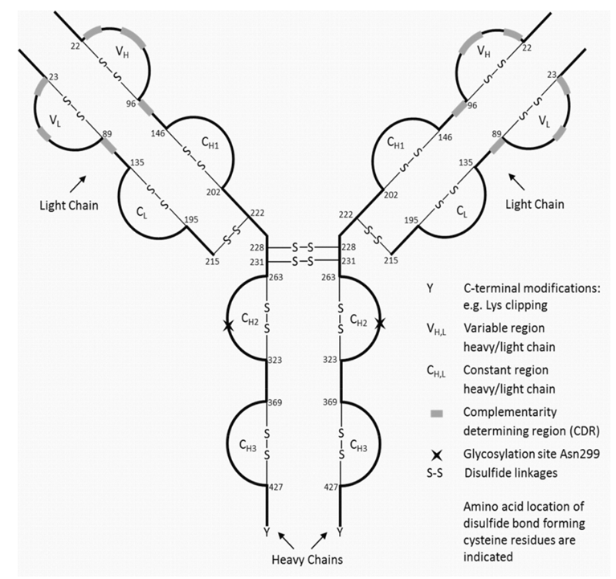

The manufacture of MK-6072 drug substance (DS) is achieved in two main parts:

* the upstream process, which produces the antibody
* the downstream process, which purifies the antibody

The manufacture of the drug product (DP) was provided.

### Drug product

All manufacturing steps are validated.

Prior to decision, all GMP clearances are required for the manufacturing information.

All analytical procedures are validated.

#### Stability

Stability data have been generated under stressed and real time conditions to characterise the stability profile of the product. Photo-stability data show that the product is not photo-stable.

The proposed shelf life is 24 months when stored at 2 °C to 8 °C and protected from light.

In-use stability data have also been submitted. The proposed shelf life and storage conditions for the reconstituted product are 16 hours when stored at room temperature and for up to 24 hours at 2 °C to 8 °C.

The sponsor has proposed the following temperature excursions: Excursions for up to 4 days at 0 to 2 °C.

Stability studies have been conducted in accordance with International Conference on Harmonization guidelines.[1]

Relevant stability indicating parameters, including potency assays were provided.

With respect to quality matters, the PI, CMI and labels as detailed are acceptable.

### Quality summary and conclusions

There are objections on quality grounds to the approval of Zinplava (bezlotoxumab) 1000 mg/40 mL concentrated injection vial.

#### Manufacturers

The sponsor was asked to provide updated tables listing manufacturer’s details.

*Sponsor’s response:*

The sponsor has provided updated tables providing information on the DS and DP manufacturing sites. However it is noted that several of the manufacturers still have GMP clearance under review.

*Evaluator’s comments:*

All GMP clearances are required for the manufacturing information before registration decision.

#### Stability

Due to the trends observed in drug substance (DS) and drug product (DP) stability studies, the storage conditions of the DS and DP (2 °C to 8 °C), and the proposed cumulative shelf life of 5 years (to be extended to 6 years post approval via a Category 3 application), the evaluator recommends the following condition of registration:

The sponsor commits to place at least one full batch of Zinplava DP manufactured from DS stored for the full proposed DS shelf life of 3 years on stability studies through to the full DP shelf life period of 2 years (extended to 3 years on submission of the Cat 3 post-approval). Alternatively, due to the similarities in DS and DP, the sponsor may wish as a minimum to place at least one full batch of Zinplava DS on stability studies for the full cumulative shelf life of 5 years (extended to 6 years on submission of the Cat 3 post-approval).

Once completed, the results of this stability study should be submitted as a Category 3 application.

Proposed conditions of registration

* It is a condition of registration that the sponsor commit to place at least one full batch of Zinplava DP manufactured from DS stored for the full proposed DS shelf life of 3 years on stability studies through to the full DP shelf life period of 2 years. Alternatively, the sponsor may choose to place at least one full batch of Zinplava DS on stability studies for the full cumulative shelf life (DS + DP) of 5 years.
* Should the shelf life for DS and DP be extended via a Category 3 application post-approval, the cumulative shelf life study should also be extended to take into account the new cumulative shelf life.
* Batch Release Testing and Compliance with Certified Product Details (CPD)

It is a condition of registration that all batches of Zinplava (bezlotoxumab) 1000 mg/40 mL concentrated injection vial imported into/manufactured in Australia must comply with the product details and specifications approved during evaluation and detailed in the Certified Product Details (CPD).

It is a condition of registration that each batch of Zinplava (bezlotoxumab) 1000 mg/40 mL concentrated injection vial imported into/manufactured in Australia is not released for sale until samples and/or the manufacturer’s release data have been assessed and endorsed for release by the TGA Laboratories Branch.

## IV. Nonclinical findings

### Introduction

The submitted nonclinical dossier was generally acceptable. The set of safety studies was small, but given the target of bezlotoxumab (a bacterial protein), it is considered adequate and in line with the applicable guideline.[2]

### Pharmacology

#### Primary pharmacology

##### Rationale and mechanism of action

Disruption of the normal gastrointestinal flora, for instance due to antibiotic therapy, can be followed by overgrowth with toxin producing *C. difficile* strains inducing potentially fatal diarrhoea. The two toxins, toxin A (TcdA) and toxin B (TcdB), are major virulence factors for this pathogen with TcdA and TcdB likely the primary agents in the physiological events that occur in *C. difficile* related pseudomembranous colitis[3]. TcdA and TcdB are expressed during the late log and stationary phases of growth. These toxins enter the cell through receptor mediated endocytosis. Both TcdA and TcdB are glucosyltransferases which inactivate Rho, Rac and Cdc42[4] within target cells leading to a disruption of vital cell signalling pathways and ultrastructure maintenance with cell rounding and cell death occurring. TcdB is more cytotoxic than TcdA. Binding to TcdB by bezlotoxumab, a monoclonal antibody raised against the TcdB from *C. difficile* strain VPI10463 (ribotype 087), blocks the interaction of TcdB with target cells, reducing the virulence of *C. difficile* infection.

###### In vitro

Bezlotoxumab bound to TcdB from *C. difficile* ribotype 087 with high affinity (dissociation constant (KD) 0.05 nM). Bezlotoxumab had no detectable affinity for TcdA. The epitope for bezlotoxumab is in the receptor binding domain of TcdB, a relatively conserved segment of this toxin. Bezlotoxumab neutralised the ability of TcdB to bind to epithelial cells and neutralised the cytotoxic activity of this toxin.

The binding and neutralisation activity of bezlotoxumab was assessed across a large number of *C. difficile* ribotypes, including clinical isolates (001, 002, 003, 012, 014, 017, 018, 023, 027, 036, 053, 063, 077, 078, 081, 087, 106, 198, and 369). Reduced binding/efficacy was seen against ribotypes 027, 036, 078 and 198 (ribotypes known to be or related to hypervirulent ribotypes[5]; half maximal effective concentration (EC50) ≥ 130 ng/mL L compared with EC50 < 35 ng/mL for the other ribotypes) though maximal inhibition was observed with all ribotypes. Of the ribotypes tested, ribotypes 027 and 036 have the most divergent epitopes from that seen in ribotype 087 (the ribotype used to select bezlotoxumab), thus providing a possible explanation for the reduced efficacy against these strains. Nonetheless, the dissociation constant (KD) or EC50 values across all ribotypes are well below the clinical maximum concentration (Cmax) of 185 μg/mL.

According to published literature[6],[7],[8] ribotypes common in Australia include 002, 005, 014/020, 018, 054, 056, 070 and 244. Ribotypes 014, 002 and 018 were assessed in the submitted studies and bezlotoxumab was shown to have efficacy against these ribotypes. The epitope region in ribotype 056 is identical to that in ribotype 087 and, therefore, a similar affinity to that seen with ribotype 087 may be expected with ribotype 056. Phylogenetic analysis based on the sequence of multiple loci revealed ribotype 070 lies in a clade with ribotype 002, and ribotype 054 lies in the same lineage as a number of ribotypes which were susceptible to bezlotoxumab5. However, actual efficacy remains to be tested. Ribotype 244 belongs to the same clade as the epidemic ribotype 0276 and may be expected to have a similar efficacy as this ribotype. The toxin B gene of ribotype 005 is similar to the gene found in ribotypes 014 and 001[9]. Bezlotoxumab had efficacy against ribotypes 014 and 001 and, by extrapolation, may be expected to have activity against ribotype 005.

As to whether the binding/in vitro efficacy data correlate with in vivo efficacy is unknown.

###### In vivo

When a bezlotoxumab/actoxumab combination was administered systemically to mice, hamsters and gnotobiotic piglets prior to a *C. difficile* (bacteria, spores or toxins) gastric challenge, prolonged animal survival and decreased intestinal damage and inflammation was observed. In a murine ileal loop model, there was no evidence of inflammation or intestinal damage in animals that had been treated with actoxumab/bezlotoxumab. All of these models are considered appropriate CDI models. Efficacy was shown against ribotypes 087, 027 and 012. The binding of actoxumab and bezlotoxumab to Fc receptors did not appear to be necessary for efficacy, suggesting these antibodies must enter the gastro intestinal (GI) tract (the location of TcdA and TcdB) via an Fc independent mechanism.

In both mice and hamsters, the combination of bezlotoxumab with actoxumab was necessary for efficacy, whereas bezlotoxumab alone was as efficacious as the combination in piglets. The latter also appears to be the case in human subjects, suggesting species differences in the pathogenesis of *C. difficile* infection.[10] In mice, prophylactic treatment appeared to be more efficacious than therapeutic treatment, but this was not as obvious in hamsters. In a murine recurrent CDI model, actoxumab/bezlotoxumab protected against body weight loss and death. Serum samples from treated animals were devoid of cell rounding activity. The efficacious dose, 2 mg/kg intra peritoneal (IP), is 20% of the proposed clinical dose on a mg/kg basis, thus supporting the proposed dose, taking into account strain differences in the potency of bezlotoxumab.

The combined in vivo data support the proposed use of bezlotoxumab for the proposed indication, provided clinical data confirm the bezlotoxumab/actoxumab combination provides no additional benefit to bezlotoxumab alone.

##### Secondary pharmacodynamics and safety pharmacology

When tested against an extensive panel of tissues, bezlotoxumab did not cross-react with any human or mouse tissues. No off-targets were identified in human tissues.

No dedicated safety pharmacology studies were submitted. Bezlotoxumab is a monoclonal antibody and unlikely to inhibit hERG channels. [11],[12] Due to its size and the presence of an Fc domain, bezlotoxumab is unlikely to cross the blood-brain barrier or be present in the brain in an appreciable amount.[13] There was no evidence of an effect on the central nervous or respiratory systems in the submitted toxicity studies at high doses (resulting in a Cmax 14 times the clinical Cmax). Bezlotoxumab is not expected to affect the cardiovascular, respiratory or central nervous systems during clinical use.

### Pharmacokinetics

The pharmacokinetics of bezlotoxumab was examined in mice. Exposures appeared to be dose proportional. There were no obvious sex differences in any of the parameters. Consistent with the protein nature of the compound, the elimination half-life was very long (14 to 17 hours in mice and approximately 19 days in human subjects) and the volume of distribution was less than total body water in humans suggesting limited extravascular distribution.

Bezlotoxumab is administered intravenously, but TcdB is largely restricted to the GI tract. In vitro and in vivo studies demonstrated that TcdB facilitated the transport of bezlotoxumab across an epithelial cell layer, concurrently with a reduction in cell layer integrity, and distribution into the GI tract contents. Distribution across an epithelial cell monolayer occurred to a similar extent with the Fab fragment of bezlotoxumab. The combined information suggests the Fc receptor is not involved in the transport of bezlotoxumab into the GI tract and TcdB associated damage may facilitate this transport.

No metabolism, excretion or pharmacokinetic interaction studies were submitted (in accordance with the guideline). 15

From a pharmacokinetic perspective, mice are considered an acceptable animal model for toxicity studies.

### Toxicology

#### Acute toxicity

No single dose toxicity studies were conducted. This is considered acceptable, given that adequate information can be gained from the submitted repeat dose toxicity studies. Based on findings in these repeat dose toxicity studies, bezlotoxumab is considered to have a low order of acute toxicity.

#### Repeat dose toxicity

Repeat dose toxicity studies of up to 21 days were conducted in mice. The duration of the studies is considered acceptable, given that Zinplava is only intended to be used as a single dose.[14] Normally, the use of two species should be considered to assess the toxicity of the test item. The use of a single species is considered acceptable in this case, given the target of bezlotoxumab is not expressed in animal species and there was a similar cross reactivity profile between mouse and human tissues. The clinical route intravenous (IV) was used in all studies. Three studies assessed the toxicity of bezlotoxumab alone and the combination of bezlotoxumab with actoxumab, while one study assessed the toxicity of actoxumab alone. Only findings with bezlotoxumab alone are discussed below. Exposures achieved were moderate.

No drug related toxicities were observed in any of the studies. No anti-bezlotoxumab antibodies were detected in treated animals.

Table 3: Relative exposure in repeat dose toxicity studies

|  |  |  |  |  |
| --- | --- | --- | --- | --- |
| Species | Study duration (Study no.) | Dose (mg/kg IV) | AUC0–336 h^ (mg∙h/mL) | Exposure ratio# |
| Mouse (CD‑1) | 21 days (Study TT151015FIN) | 125 | 190 | 4 |
| 21 days (Study TT151079FIN) | 125 | 191 | 4 |
| Human | Population PK | 10 mg/kg | 53 | – |

##### Genotoxicity and carcinogenicity

No studies were submitted. Given the protein nature of the drug and the proposed indication,[15] this is considered acceptable.

##### Reproductive toxicity

No reproductive toxicity studies were submitted. Reproductive organs were unaffected in the submitted toxicity studies. Effects on fertility are not expected. The effects on a developing fetus are unknown; however, it should be taken into consideration that the target of bezlotoxumab is not expressed in humans.

###### Pregnancy classification

The sponsor has proposed Pregnancy Category B2[16]. Given the absence of embryofetal development toxicity studies, this is considered appropriate.

##### Local tolerance

There was no evidence of any injection site reactions in the submitted toxicity studies.

##### Paediatric use

Bezlotoxumab is not proposed for paediatric use and no specific studies in juvenile animals were submitted.

##### Comments on the Nonclinical Safety Specification of the Risk Management Plan

Results and conclusions drawn from the nonclinical program for bezlotoxumab detailed in the sponsor’s draft Risk Management Plan (RMP) (Nonclinical Safety Specification) are in general concordance with those of the nonclinical evaluator.

### Nonclinical summary and conclusions

* *In vitro*, bezlotoxumab had nanomolar affinity for TcdB. Binding and neutralisation activity was demonstrated across a large number of *C. difficile* ribotypes. When a bezlotoxumab/actoxumab combination was administered systemically to mice, hamsters and gnotobiotic piglets prior to a *C. difficile* (bacteria, spores or toxins) gastric challenge, prolonged animal survival and decreased intestinal damage and inflammation were observed. The combined pharmacology data support the proposed use of bezlotoxumab for the proposed indication, provided clinical data confirm the bezlotoxumab/actoxumab combination provides no additional benefit to bezlotoxumab alone.
* No off-target sites were identified in a panel of human tissues.
* No dedicated safety pharmacology studies were submitted. Given the molecular nature and pharmacological action of bezlotoxumab and the absence of an overt effect on behaviour and respiratory function in the submitted toxicity studies, bezlotoxumab is not expected to affect the cardiovascular, respiratory or central nervous systems during clinical use.
* The pharmacokinetics of bezlotoxumab in mice and human subjects was generally consistent with the protein nature of the drug: long half-lives and limited extravascular distribution. Submitted data indicated that TcdB damage of the epithelial layer of the GI tract may facilitate systemically administered bezlotoxumab access to the GI tract.
* Repeat-dose toxicity studies of up to 21 days were conducted in mice. Exposures achieved were moderate. No drug related toxicities were observed in any of the studies.
* No genotoxicity or carcinogenicity studies were submitted. Given the protein nature of the drug and the proposed indication, this is considered acceptable.
* No reproductive toxicity studies were submitted. Based on an absence of effects on the reproductive organs in the submitted toxicity studies, effects on fertility are not predicted. The effects on a developing fetus are unknown; however, the target of bezlotoxumab is not expressed in humans.
* There are no objections on nonclinical grounds to the registration of Zinplava for the proposed indication.

The nonclinical evaluator also made recommendations for amendment of the draft PI however this is beyond the scope of the AusPAR.

## V. Clinical findings

A summary of the clinical findings is presented in this section. Further details of these clinical findings can be found in Attachment 2.

### Introduction

#### Background information

*C. difficile*, an anaerobic, spore forming, gram positive bacillus, produces two exotoxins, toxins A and B, which cause the symptoms of CDI.[17] [18] These toxins target gut epithelium, causing cellular morphological changes, depolarisation of the cells, leading to cell death, and disruption of the intestinal barrier function essential for normal gut function.17, [19] Additionally the toxins cause epithelial cells to release pro-inflammatory mediators such as IL-8, which attract neutrophils and monocytes, further exacerbating gut damage.[20] [21]

*C. difficile* colonises the colon without causing symptoms in approximately 1 to 3% of adults in the United States (US); the proportion is higher in patients in hospitals or chronic care settings.[22] [23] [24] Colonisation with *C. difficile* can cause disease when the integrity of the gut flora is disturbed, such as during exposure to antibiotics, during which the alterations in the normal microbiota in the gut allow *C. difficile* overgrowth. Presentation varies from mild symptoms including watery diarrhoea and mild abdominal cramping or tenderness, to severe symptoms necessitating hospitalisation.[25] [26] CDI symptoms can be exacerbated in the elderly and patients with co-morbidities.[27] 26 26

CDI is one of the most commonly recognised causes of nosocomial diarrhoea in adults in the US and Europe.[28] [29] Based on data from the US National Hospital Discharge Survey, the incidence of reported CDI in acute care hospitals nearly tripled between 1996 and 2005, from 31 per 100,000 population in 1996 to 84 per 100,000 population in 2005. [30] [31] Consistent findings have been reported using data from the US Nationwide Inpatient Sample; the rate of CDI discharges more than tripled between 1993 (2.61 cases per 1,000 discharged patients) and 2008 (8.75 cases/1,000 discharged patients) though the rate began to plateau in 2009 with 8.53 cases/1,000 discharged patients in that year.[32] In a 2015 publication, Centres for Disease Control and Prevention (CDC) reported the estimated number of CDI cases in the US was 453,000 and the corresponding incidence rate was 147.2 per 100,000 persons. Of these cases, an estimated 293,000 cases were healthcare-associated (107,000 had hospital onset CDI, 104,400 had nursing home onset CDI and 81,300 had community onset, healthcare associated CDI), and there were an estimated 29,300 deaths.[33] In Canada, the incidence in 2007 was 5.35 per 1000 admissions; the estimated number of cases in Canada was 38,000. In the UK, the annual incidence in 2014/2015 was 26.3 per 100,000 people, corresponding to 14,165 cases.[34] In 2011 in Italy, the incidence of CDI was 2.3 per 10,000 patient-days.[35] In Australia the incidence of CDI in 2012 was 4.03 per 10,000 patient-days.[36] In the early 2000’s, a new strain of *C. difficile* was identified. This new strain, referred to as BI/NAP1/027 based on the 3 most common typing methods for *C. difficile* strains (Restriction Endonuclease Analysis (REA) type BI, North American Pulsed-Field (NAP) type 1, and Polymerase Chain Reaction (PCR) Ribotype 027), has been responsible for several notable outbreaks of disease in the US, Canada, and Europe.[37] [38][39] This strain is thought to be more virulent than other strains and is also resistant to some antibiotics.39, 39 The increasing incidence of CDI is partially attributed to this new strain, [40] [41] 38 38 [42] and this new strain has been associated with recurrent CDI.

#### Current treatment options

Historically, treatment options for CDI were limited to two antimicrobials, metronidazole and oral vancomycin. In the treatment guideline authored jointly by the Society for Health Epidemiology of America and the Infectious Diseases Society of America in 2011, and in the 2014 European Society of Clinical Microbiology and Infectious Diseases treatment guidelines[43] [44] metronidazole is recommended as the first line agent for initial CDI in mild or moderate cases. Vancomycin is recommended as the first line agent for severe CDI and as treatment for recurrent CDI. Fidaxomicin, a narrow spectrum macrocyclic antibiotic, [45] available since 2010, is recommended in the updated European guidelines as treatment for severe CDI, for recurrent CDI, and in patients at risk for recurrent disease. While most cases of CDI resolve after withdrawal of the offending systemic antibiotic and treatment with vancomycin, metronidazole, or fidaxomicin, approximately 15% to 35% of adult patients will experience a recurrent episode of CDI after completing initial therapy.[46] 30 [47] 45 The severity of disease and associated complications increase dramatically for adult patients who have relapsed once, and these patients have a 50 to 60% chance of experiencing repeated CDI episodes that may continue over a period of years.[48] [49] Clinical risk factors for recurrent CDI include advanced age, severity of the underlying condition, and additional systemic antibiotic use after stopping initial CDI antibiotic therapy.[50] [51] [52] [53] Patients with inadequate immune responses to toxins A and/or B at the time of their initial CDI diagnosis are more likely to develop recurrence. [54] [55] [56] [57] Data from a hospital based study in the US suggests that patients with recurrent CDI had 33% higher rate of death at 180 days compared with patients without recurrent CDI when adjusting for patient demographics, comorbidities and medications received during their index CDI hospitalisation.[58] In the US, the most recent estimated incidence of recurrent community-acquired CDI was 7.0 per 100,000 persons with 21,600 cases of recurrent community-acquired CDI.33 The estimated incidence of recurrent hospital acquired CDI in the US was 19.9 per 100,000 persons with an approximately 61,400 cases.33 Estimates of community-acquired CDI and healthcare acquired CDI recurrence were higher for older patients. Of the total estimated CDI cases, 18% (83,000) were recurrent cases. In 2011, there were an estimated 29,000 deaths, and the majority of these were in healthcare-acquired CDI cases and in patients ≥ 65 years of age.33 European studies report estimates of CDI recurrence consistent with the US that is 18%.[59] There is a significant economic burden associated with CDI. In 2006, costs of managing CDI in Europe, was approximately € 300 million.39 Recurrent CDI tends to have longer hospital stays than primary cases, and associated costs are even higher.[60]

Approaches to treatment of recurrent CDI include repeat courses of oral vancomycin or metronidazole, vancomycin followed by rifaximin, IV immunoglobulin, and therapy with other microorganisms including faecal microbiota for transplantation (FMT).30 Large, randomised, controlled clinical trials are lacking for these therapies. Currently, there is no consistently effective and safe treatment approved for prevention of recurrent CDI, and the management of these patients often poses a difficult challenge.

#### Clinical rationale

Passive or active immunisation against these *C. difficile* toxins A and B protects against CDI in animals challenged with pathogenic strains of *C. difficile.[61]* [62] [63] [64] [65] Neutralisation of both toxins appears necessary for full maximal protection in hamsters and mice, but neutralisation of toxin B alone appears sufficient in gnotobiotic piglets.65 Kyne and co-workers showed that antitoxin mediated protection extends to clinical disease by demonstrating that a correlation exists between circulating neutralizing antibodies against toxin A and a lower rate of primary and recurrent CDI;22 56 this observation was subsequently extended to anti-toxin B antibodies.[66] The concept that toxin neutralisation is protective against CDI recurrence offers a novel approach with important advantages over the antibiotic-based approach alone. An advantage of toxin neutralisation is there is no disruption of normal microbiota, it is not likely to be subject to the emergence of resistance and unlike FMT, anti-toxin antibodies can be administered to immunocompromised patients or who require continued antibiotics for other infections.

Actoxumab (also known as MK-3415, GS-CDA1, or CDA1) and bezlotoxumab (also known as MK-6072, MDX-1388, or CDB1) are fully human mAbs (IgG1/kappa isotype subclass) which bind with high affinity to *C. difficile* toxins A and B respectively and prevents toxin binding to host cells. MK-3415A is the combination of actoxumab and bezlotoxumab. The clinical development program included clinical trials evaluating each individual mAb (actoxumab or bezlotoxumab) or the combination of both mAbs for the prevention of CDI recurrence in subjects receiving oral standard of care (SoC) antibiotics for a primary or recurrent episode of CDI. Both actoxumab and bezlotoxumab neutralise the cytotoxic activities of toxins from a broad range of clinical isolates of *C. difficile* (ribotypes 001, 002, 003, 012, 014, 017, 018, 023, 027, 053, 063, 077, 078, 081, 087, 106, 198, and 369). Given that low titres of neutralising antibodies against toxins A and B are a significant risk factor for developing a recurrent infection in humans, it was hypothesised that administration of actoxumab + bezlotoxumab would reduce the risk for CDI recurrence by providing passive immunity against the toxins and prevent the toxins from damaging the gut epithelium. The preclinical data support a model wherein bezlotoxumab crosses the gut wall through paracellular transport, enhanced by toxin induced disruption of the gut epithelium, to reach the site of infection in the lumen of the gut. Consistent with this concept, bezlotoxumab was detected in the stool samples from bezlotoxumab treated patients in Study P002. In addition, toxin may leak into the sub-epithelial space of the gut wall through the same mechanism. Thus, neutralization of the toxin by bezlotoxumab may occur both on the luminal and systemic sides of the intestinal wall.

#### Contents of the clinical dossier

The submission contained the following clinical information:

Four Phase I (two additional trials P018 and 19 of actoxumab only, were provided for background information only, not discussed further) trials characterising the safety, PK, and immunogenicity of bezlotoxumab and actoxumab, each administered alone or in combination.

Population PK and exposure response analyses using pooled data from three Phase I trials (P004, P005 and P006) and the two Phase III trials (P001 and P002).

Efficacy and safety of bezlotoxumab administered alone or in combination with actoxumab has been evaluated in one Phase II trial (P017) and two pivotal Phase III trials (P001 and P002).

#### Paediatric data

Not applicable.

#### Good clinical practice

Approvals to undertake the clinical studies were obtained from appropriately constituted institutional ethics committees/independent research boards, in accordance with the relevant national guidelines and regulations applicable. The studies presented in this application were conducted in accordance with good clinical practice (GCP).

### Pharmacokinetics

#### Studies providing pharmacokinetic data

Table 4: Submitted pharmacokinetic studies

|  |  |  |
| --- | --- | --- |
| PK topic | Subtopic | Study ID |
| PK in healthy adults | General PK  Single dose | MK-3415A-005  MK-3415A-020 |
| Multi-dose | MK-3415A-004 |
| PK in special populations | Target population § - Single dose | MK-3415A-017 |
| Other special population  (Japanese ethnicity) | MK-3415A-006 |
| Population PK analyses | Healthy subjects | population PK analysis based on the data three Phase I (P004, P005, P006) and two Phase III (P001, P002) trials |
| Target population |

§ Subjects who would be eligible to receive the drug if approved for the proposed indication.

#### Evaluator’s conclusions on pharmacokinetics

The findings are consistent with that expected for a fully human monoclonal antibody and the ADME of bezlotoxumab are similar to other IV administered mAbs. Subgroup analyses in the Phase III programme do not suggest any impact on efficacy and/or safety of the product based on intrinsic factors. The potential for drug-drug interactions is low, as this is a therapeutic protein. The rationale for the following studies not being conducted that is in vitro-in vivo correlation studies, plasma protein binding studies, extrinsic factor trials, hepatic metabolism and drug interaction trials, bioavailability trials, comparative bioavailability and bioequivalence trials, is justified by the nature of the product.

### Pharmacodynamics

#### Studies providing pharmacodynamic data

No pharmacodynamic measures were evaluated in Phase I. Thus, the efficacy exposure response analysis was based on CDI recurrence and pharmacokinetic data from the two pivotal Phase III trials (P001, P002) and one Phase II Study, P017.

Table 5: Submitted pharmacodynamic studies

|  |  |  |
| --- | --- | --- |
| PD Topic | Subtopic | Study ID |
| Primary Pharmacology | Effect on PD parameter A |  |
| Secondary Pharmacology | Effect on PD parameter C | development of ADA assessed in all studies of bezlotoxumab in healthy subjects and the target population |
| Population PD and PK-PD analyses | Target population | P017, P001 and P002 |

PD: pharmacodynamics, PK: pharmacokinetics

#### Evaluator’s conclusions on pharmacodynamics

No dedicated studies of pharmacodynamic effects in patients were conducted. Bezlotoxumab is a highly specific mAb to *C. difficile* toxin B and biochemical or physiological effects are not anticipated. The efficacy exposure response analysis was based on CDI recurrence and pharmacokinetic data from the two pivotal Phase III trials (P001, P002) and one Phase II trial, P017.

### Dosage selection for the pivotal studies

The 10 mg/kg dose corresponded to approximately equivalent median serum levels of the two mAbs to those following doses of 50 mg/kg/day in hamsters, suggesting that at least 50% of human subjects would have serum concentrations exceeding those protective from CDI in the hamster model. Hence, a dose of 10 mg/kg was selected for evaluation in patients as part of the Phase II program. A single infusion of actoxumab + bezlotoxumab at 10 mg/kg each was evaluated in P017, and as this dose demonstrated a robust reduction of CDI recurrence and was generally well tolerated, this was the dose taken forward into Phase III as a single infusion.

### Efficacy

#### Studies providing efficacy data

Two Phase III Studies; P001 and P002, and one Phase II (Study P017) were provided.

For the full details of the evaluation of efficacy please see Attachment 2.

#### Evaluator’s conclusions on efficacy

Both Phase III studies showed, that in subjects receiving SoC antibiotics for CDI predominantly metronidazole or oral vancomycin (very low use of fidaxomicin): a single IV infusion of weight based dosing (10 mg/kg) of bezlotoxumab is superior to placebo in the prevention of CDI recurrence through 12 weeks of follow-up. CDI recurrence rate differences between bezlotoxumab and placebo were consistent across both studies: P001: ‑10.1 (95% confidence interval (CI) ‑15.9, ‑4.3), p = 0.0003; P002: ‑9.9 (95% CI ‑15.5, ‑4.3), p = 0.0003; P001+P002 (integrated): ‑10.0 (95% CI ‑14.0, ‑6.0), p< 0.0001. Bezlotoxumab is efficacious in key subpopulations at high risk for CDI recurrence and/or CDI related adverse outcomes. These high risk subpopulations are patients aged ≥ 65 years; a history of ≥ 1 CDI episodes in the past 6 months; immunocompromised; clinically severe CDI at study entry; infected with a hyper-virulent strain; infected with the BI/NAP1/027 strain. Bezlotoxumab is superior to placebo with respect to the secondary endpoint of global cure. But, bezlotoxumab was not superior to placebo with respect to the clinical cure endpoint; clinical cure rates were comparable for the bezlotoxumab and placebo groups in the Phase III trials. In the primary analysis of CDI recurrence, subjects must first reach clinical cure before they are at risk for a recurrence. As clinical cure is a post randomisation event in the design of P001 and P002, differential clinical cure rates may impact on the primary analysis of CDI recurrence. Propensity score analyses were conducted to assess whether observed differences in clinical cure rates between the treatment groups had an impact on the interpretation of the CDI recurrence results.

Differential clinical cure rates between the treatment groups may be caused by an imbalance of baseline factors associated with the likelihood of achieving clinical cure. The propensity score is a model based estimate of the likelihood for achieving clinical cure derived from baseline factors predictive of clinical cure. The propensity of clinical cure was calculated from a logistic regression model predicting clinical cure from important baseline factors among all patients included in the full analysis set (FAS) for each study. In P001, The bezlotoxumab treatment group had the highest percent of subjects (41.9%) in the low propensity score category and the placebo group had the lowest percentage (32.7%). CDI recurrence rates were lowest in the low propensity score category across all treatment groups, as expected given that subjects with a low propensity for clinical cure are those who will not achieve clinical cure and, by convention, are not in the risk set for recurrence. CDI recurrence rates in the bezlotoxumab and actoxumab + bezlotoxumab treatment groups were notably lower than in the placebo group for all three categories of propensity score. In P002, the actoxumab + bezlotoxumab treatment group had the highest percent of subjects (31.5%) in the low propensity score category and the placebo group had the lowest percent (25.4%). CDI recurrence rates were lowest in the low propensity score category for the bezlotoxumab and placebo treatment groups. CDI recurrence rates in the bezlotoxumab and actoxumab + bezlotoxumab treatment groups were notably lower than those in the placebo group for all three categories of propensity score. The results from this sensitivity analysis adjusting for the propensity of achieving clinical cure (low, medium, high) for P001 and P002, respectively are consistent with the primary analysis for CDI recurrence and demonstrate that the observed difference in clinical cure rates did not overly influence the primary study results for CDI recurrence. The combination of mAbs targeting CD toxin A and B that is, actoxumab and bezlotoxumab respectively, did not provide a meaningful efficacy benefit over bezlotoxumab alone.

### Safety

#### Studies providing safety data

##### Pivotal and/or main efficacy studies

The integrated Phase III population (P001 and P002) includes 786 bezlotoxumab treated subjects, 777 actoxumab + bezlotoxumab treated subjects, and 781 treated with placebo.

##### Other studies

###### Other efficacy studies

P017 included 101 actoxumab + bezlotoxumab treated and 99 placebo treated subjects.

###### Studies with evaluable safety data: dose finding and pharmacology

The integrated Phase I trial population (P020, P005, P006, and P004) includes 30 bezlotoxumab treated with, 96 actoxumab + bezlotoxumab treated, and 12 placebo treated subjects.

#### Patient exposure

Includes data from 1,790 subjects exposed to bezlotoxumab alone or in combination with actoxumab and includes data from 126 healthy subjects (of which 54 received a 2 hour IV infusion, and 72 subjects received a 1 hour infusion), and 1,664 subjects with CDI. Phase II Study P017: Among the 200 enrolled, the drug product was infused over 2 hours in 84.5%.

Phase III studies (P001+P002); see Table 6.

Table 6: Treatment exposure in P001 + P002 Integrated APaT population

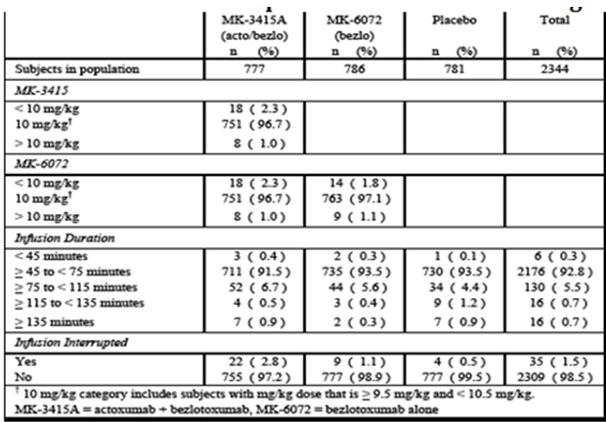

#### Safety issues with the potential for major regulatory impact

##### Liver function and liver toxicity

In the Phase III studies, 8 subjects identified with liver function laboratory values meeting ≥ 1 of the potential drug induced liver injury (DILI) criteria at some point during the trial, including at the time of enrolment. Of these, 4, 1 and 3 received actoxumab + bezlotoxumab, bezlotoxumab, and placebo respectively. Based upon medical review of each of the 8 cases, none was considered suggestive of DILI.

##### Renal function and renal toxicity

###### Pivotal and/or main efficacy studies

Table 7: Subjects with chemistry labs findings that met predetermined criteria Phase III studies (P001 + P002 Integrated) APaT population

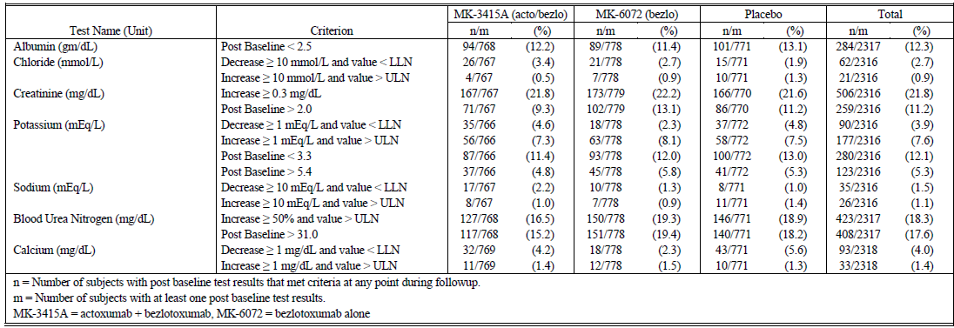

##### Other clinical chemistry

###### Pivotal and/or main efficacy studies

See Table 7 above. No safety signal revealed.

##### Haematology and haematological toxicity

###### Pivotal and/or main efficacy studies

Table 8: Subjects with haematology labs findings that met predetermined criteria Phase III studies (P001 + P002 Integrated) APaT population

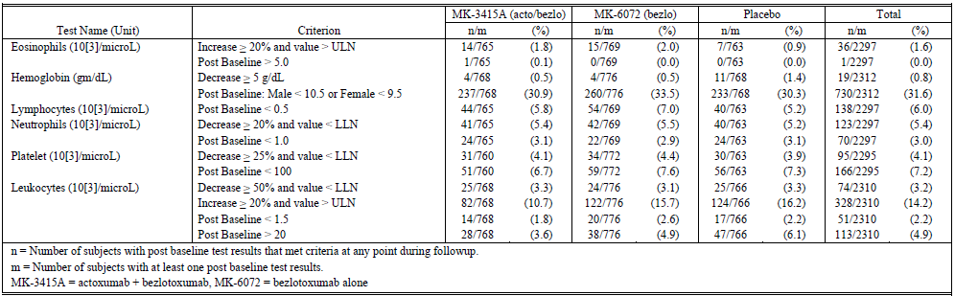

##### Electrocardiograph findings and cardiovascular safety

###### Pivotal and/or main efficacy studies

Per International Conference on Harmonization (ICH) guidelines, a clinical study of the effect of monoclonal antibodies on the QT interva[67]l is not required. Electrocardiograph (ECG) (pre-infusion and within 120 mins post-infusion) were collected in P001, P002. The majority (93.7%) of subjects across all treatment groups had no increase in Frederica’s correction for QT interval (QTc-f) or had a clinically insignificant QTc-f increase of ≤ 30 ms. Between 4 to 5.3% of the subjects in the three treatment groups experienced a QTc-f increase of > 30 and ≤ 60 ms from baseline and between 1.2% and 1.9% of subjects within the various treatment groups had a QTc-f increase of > 60 ms. The percentage of subjects with increases exceeding 30 ms was generally comparable across all treatment groups. An analysis of bezlotoxumab serum concentrations and QTc-f interval in subjects revealed no trends for QTc prolongation with increasing bezlotoxumab concentration.

##### Vital signs and clinical examination findings

###### Pivotal and/or main efficacy studies

In P001, P002, vital sign measurements were taken prior to infusion, at 30 minutes after the start of the study infusion, and at the end of the study infusion on Day 1. Additionally, vital sign measurements were taken at post infusion study visits Day 4 (± 1 day), Day 11 (± 2days), Day 29 (± 3 days), Day 57 (± 7 days), and Day 85 (± 5 days). There were no clinically meaningful changes in either diastolic or systolic blood pressure, heart rate, or respiratory rate between subjects who received active treatment and those who received placebo.

##### Immunogenicity and immunological events; Anti-drug antibodies (ADA)

###### Integrated safety analyses Phase I

Information was provided.

###### Pivotal and/or main efficacy studies

1,414 subjects were evaluable for the immunogenicity analysis. Following dosing with bezlotoxumab alone, there were 710 subjects evaluable for the immunogenicity analysis. No bezlotoxumab treatment emergent positive subjects were observed. However, 9 of 1,414 subjects (0.6%) had non-treatment emergent positive sample(s) (positive at baseline only), and 1 of these 9 was subsequently shown to be positive for neutralising anti-drug antibody (Nab).

###### Other studies

Information was provided.

##### Serious skin reactions

There were none in any of the clinical studies.

##### Other safety parameters; hypersensitivity

###### Integrated safety analyses

None detected.

###### Pivotal and/or main efficacy studies

Subjects were evaluated during the infusion and for 24 hours post for infusion specific reactions. The proportion of infusion specific adverse events (AEs) was similar for the active groups and placebo with the exception of hypertension which occurred more frequently in the bezlotoxumab group (n/N = 5/786, 0.6%) versus placebo (n/N = 0/781, difference 0.6%, 95% CI (0.1, 1.5)). It was generally mild to moderate and did not lead to treatment interruption. All episodes of hypertension resolved within 2 days (36 minutes to 2 days). Hypertension was also reported in 2 (0.3%) subjects in the actoxumab + bezlotoxumab treatment group.

#### Post marketing data

Not applicable.

#### Evaluator’s conclusions on safety

The data presented in this summary of clinical safety demonstrate that a single IV 10 mg/kg dose of bezlotoxumab given alone or in combination with actoxumab has a favourable safety profile in adults’ ≥ 18 years receiving antibiotic therapy for CDI. Bezlotoxumab was generally well tolerated in all trials, and the safety profile was consistent and similar to placebo across all studies. Safety data were integrated across P001 and P002, as the trials were nearly identical in design. In the Phase III program, 786 received bezlotoxumab, 777 received actoxumab + bezlotoxumab, and 781 received placebo. AEs were generally as expected considering underlying disease severity, baseline comorbidities, and age of the population studied. The overall incidence of AEs in the bezlotoxumab and actoxumab + bezlotoxumab groups was comparable to the placebo group. This was also true for subgroups based on intrinsic factors of interest (for example, age, gender, race, etcetera) and on extrinsic factors of interest (for example, region, choice of SoC antibiotics). All of the few serious adverse events (SAEs) assessed by the investigator as related to study medication were reported in the first 5 weeks. One additional subject in the bezlotoxumab group had an SAE (osteoporotic fracture) considered to be drug related during the P002 extension phase.

The overall incidence of AEs most frequently reported (≥ 5% in one or more treatment groups in P001, P002, or integrated data) during the 4 weeks post-infusion were: diarrhoea, nausea, abdominal pain, CDI, pyrexia, headache, vomiting. The incidence of these events was generally similar across treatment groups including the placebo group. Diarrhoea, nausea, pyrexia, and headache were the most common AEs associated in the bezlotoxumab group (incidence ≥ 4% in the bezlotoxumab group and at a higher rate than the placebo group). No association was detected between changes in haematology and chemistry laboratory values, vital signs, or QTc intervals. There were no reports of anaphylaxis/anaphylactoid AEs in any of the active treatment groups. The proportion of subjects in either the bezlotoxumab group or the actoxumab + bezlotoxumab group who reported one or more infusion-specific AEs was similar to placebo. The proportion of infusion specific AEs was similar for the active groups and placebo with the exception of hypertension (mild/moderate and short lived) which occurred more frequently in the bezlotoxumab group (0.6%) compared to placebo (n/N = 0/781, difference 0.6%, 95% CI (0.1, 1.5)). There was no trend for higher incidence of AEs in subjects receiving a higher dose of antibody due to greater body weight. As described (in Section 8.6.1.6 of Attachment 2), the Food and Drug Administration (FDA) raised concerns re SAEs of cardiac failure including more fatal outcomes in those with an underlying history of cardiac failure. On reviewing these data, there is evidence of a marginal increased risk with the study drug, but this risk has to be taken into context that is the drug appears beneficial in the group with the greatest risk of poor outcome from CDI (aged 65 years and older) and it is this same group who also have the greatest risk for underlying cardiac conditions because of age alone.

### First round benefit-risk assessment

#### First round assessment of benefits

Table 9: First round assessment of benefits

| **Benefits** | **Strengths and Uncertainties** |
| --- | --- |
| 1. Zinplava is an efficacious adjunctive (to SoC antibiotics) bacterial toxin targeted passive immunotherapy for the prevention of CDI recurrence; 2. There is no evidence that this adjunctive therapy comprises the activity of the SoC antibiotics for treatment; 3. Single infusion administration is an advantage compared to repeat dosing, has the potential to be given in an outpatient setting; 4. Safety profile which was generally similar to placebo did not result in the development of anti-bezlotoxumab antibodies in post-Baseline serum samples. 5. Bezlotoxumab is efficacious in key subpopulations at high risk for CDI recurrence and/or CDI-related adverse outcomes, the greatest benefit is seen in those who are deemed at higher risk purely because of being aged ≥ 65 years; 6. Bezlotoxumab is superior to placebo with respect to the global cure endpoint (secondary endpoint). | 1. Evidenced by the significantly lower CDI recurrence rate was in patients receiving bezlotoxumab with SoC antibiotics compared to placebo with SoC antibiotics in each of the Phase III trials (difference in rate relative to placebo shown):    * P001: -10.1 (95% CI -15.9, -4.3), p = 0.0003    * P002: -9.9 (95% CI -15.5, -4.3), p = 0.0003 2. Uncertainty, although the findings were stratified by SoC antibiotics that is, oral vancomycin versus metronidazole versus fidaxomicin, the use of the latter antibiotic was very small in the phase 3 programme for bezlotoxumab, and very small in the subgroup analyses of patients at higher risk of poorer outcomes from CDI. Louie et al (2011) showed that significantly fewer patients in the fidaxomicin group than in the vancomycin group had a recurrence of CDI, in both the modified intention to treat (ITT) analysis (15.4% versus 25.3%, P = 0.005) and the per-protocol analysis (13.3% versus 24.0%, P = 0.004).It will be important to obtain more data on the efficacy of bezlotoxumab when given as adjunct with fidaxomicin for prevention of CDI recurrence.2.No uncertainty, supported by the data from the Phase II and Phase III programme 3. A definite strength in terms of its potential utility in clinical practice 4. Well tolerated as evidenced by the integrated safety analyses of the Phase I programme and the integrated safety analyses in the Phase III programme 5. No uncertainty, supported by the data in the Phase III programme 6. No uncertainty, supported by the data in the Phase III programme |

#### First round assessment of risks

Table 10: first round assessment of risks

| **Risks** | **Strengths and Uncertainties** |
| --- | --- |
| 1. Low risk, well tolerated single infusion therapy; 2. Paucity of data in those of non-White ethnicity, but analyses of the Phase III programme indicated no safety signals of concern; 3. No data for repeat dosing within a shorter time frame that 12 weeks apart, uncertain if repeated dosing within a shorter time frame would be efficacious and well tolerated and whether there would be an increased risk of developing ADA; 4. Marginal signal for increased risk of cardiac failure with the study drug, high percentage of enrolees (approximately 40%) have underlying cardiac conditions, most SAEs including fatal ones were not considered study drug related by the Investigator. | 1. Strengths, evidenced by the integrated safety analyses in the Phase I and 3 programmes; 2. Very few patients of Black ethnicity enrolled, insufficient numbers in the Phase III programme to compare safety in those of White versus Asian versus Black ethnicity; 3. Possible that in clinical practice, patients might be given repeat dosing if they develop CDI recurrence or new CDI; 4. Uncertain if the study drug contributed to small excess of cardiac failure, no evidence from pre-clinical studies or the purported mechanism of action that this fully human monoclonal antibody has any direct cardiac toxicity, it seems unlikely. |

#### First round assessment of benefit-risk balance

Benefits of Zinplava given as proposed for prevention of CDI recurrence outweigh risks (which are low). The evaluator noted that the FDA has authorised the drug for use in high risk populations only, however, on the basis of the efficacy and safety data, the evaluator believed that the benefit-risk balance is favourable for all patients aged 18 years and older to prevent recurrence of CDI. The reason the evaluator did not place any restriction on this being for ‘high risk populations only’ is that the evaluator did not think that there are safety concerns sufficient to restrict this to just ‘high risk’ individuals. The evaluator thought it is reasonable to put a caution around patients with underlying history of congestive cardiac failure (CCF), this would include ensuring that the clinician feels it is safe for the patient to receive the infusion over the recommended time of 1 hour.

### First round recommendation regarding authorisation

Favourable.

The evaluator favoured that the drug be approved as follows:

*to reduce recurrence of Clostridium difficile infection in patients 18 years of age or older who are receiving antibacterial drug treatment for CDI.*

### Second round evaluation

There was no second round clinical evaluation.

## VI. Pharmacovigilance findings

### Risk management plan

* Merck Sharp and Dohme Australia has submitted EU-RMP version 1.0 dated 29 October 2015 (DLP 25 October 2015) and Australian-specific annex (ASA) version 1.0 dated 18 January 2016 in support of this application. With its S31 response, the sponsor has submitted the updated EU-RMP version 1.5 dated 22 November 2016 with ASA version 2.0; dated 31 May 2017.
* The proposed Summary of Safety Concerns and their associated risk monitoring and mitigation strategies are summarised below in Table 11.

Table 11: Proposed summary of safety concerns and their associated risk monitoring and mitigation strategies

|  |  |  |  |  |  |
| --- | --- | --- | --- | --- | --- |
| Summary of safety concerns | | Pharmacovigilance | | Risk Minimisation | |
| Routine | Additional | Routine | Additional |
| **Important identified risks** | None | – | – | – | – |
| **Important potential risks** | Infusion-related Reactions Including Hypersensitivity and Anaphylactic  Reactions | ✓ | – | ✓ | – |
| Potential for immunogenicity | ✓ | ✓1 | ✓ | – |
| Potential lack of efficacy if bezlotoxumab is administered off-label as monotherapy2 | ✓ | – | ✓ | – |
| **Missing information** | Exposure in pregnancy/lactation | ✓ | – | ✓ | – |
| Medication errors related to not administering standard of care antibiotic therapy for CDI concomitantly with bezlotoxumab | ✓ | – | ✓ | – |
| Long-term safety2 | ✓ | – | – | – |
| Repeated administration3 | ✓ | – | ✓ | – |
| Exposure in patients < 18 years | ✓ | ✓1 | ✓ | – |

1Stated activities - phase III clinical trials in paediatric population 2Safety concerns added in the updated EU-RMP as required by the EMA 3Safety concern added in the updated RMP as required by the TGA

#### Summary of RMP evaluation[68]

* Routine pharmacovigilance has been proposed for all the safety concerns. Two Phase III trials on paediatric patients have been proposed for monitoring ‘potential for immunogenicity’ and ‘exposure in patients < 18 years’. No Australia-specific study is proposed.
* Routine risk minimisation has been proposed for all the safety concerns. No additional risk minimisation is considered necessary by the sponsor.

##### Round 2 RMP evaluator comments

The evaluator has noted the sponsor’s justification to why it considers that the studies in paediatric population can generate applicable results for adults, the proposed patient population, to monitor the risk of immunogenicity. From the perspective of the RMP, the studies are not considered additional pharmacovigilance for the specific safety concern, but stated activities. In the next ASA update, the sponsor should remove ‘potential for immunogenicity’ from ‘Assigned safety concerns or missing information’ in Table 2 of the ASA. There is no need to submit the final study reports for the two paediatric studies as RMP updates. However, the sponsor should update the RMP/ASA with a summary of safety findings from the studies and submit as RMP updates.

#### Wording for conditions of registration

Any changes to which the sponsor has agreed should be included in a revised RMP and ASA. However, irrespective of whether or not they are included in the currently available version of the RMP document, the agreed changes become part of the risk management system.

The suggested wording is: Implement EU-RMP version 1.5 dated 22 November 2016 with Australian Specific Annex version 2.0; dated 31 May 2017 and any future updates as a condition of registration.

## VII. Overall conclusion and risk/benefit assessment

The submission was summarised in the following Delegate’s overview and recommendations:

### Introduction

Bezlotoxumab (Zinplava) is a recombinant, fully human, monoclonal antibody (mAb) produced in Chinese Hamster Ovary (CHO) cell line and is directed against *Clostridium difficile* toxin B (TcdB). It belongs to IgG1κ isotype subclass of IgG and has high affinity (Kd < 1 x 10-9 M) to TcdB. It neutralises the activity of TcdB by preventing it from binding to host cells.

Zinplava is presented in a glass vial which contains sterile concentrated solution (1000 mg bezlotoxumab in 40 mL, that is, 25mg/mL concentration). The product does not contain any preservative. It is intended for single use and requires dilution with 0.9% saline or 5% dextrose prior to administration. The indication proposed initially at the time of dossier submission was as follows:

*Zinplava (Bezlotoxumab) is indicated for the prevention of Clostridium difficile infection (CDI) recurrence in patients 18 years or older receiving antibiotic therapy for CDI.*

Subsequent to the evaluation of data and based on recommendations of the clinical evaluator, the sponsor has agreed to the indication along the lines approved in the USA as follows:

*Zinplava (Bezlotoxumab) is indicated for the prevention of Clostridium difficile infection (CDI) recurrence in patients 18 years or older receiving antibiotic therapy for CDI.*

*Zinplava is not indicated for the treatment of CDI. Zinplava is not an antibacterial drug. Zinplava should only be used in conjunction with antibacterial drug treatment of CDI.*

*The safety and efficacy of repeat administration of Zinplava in patients with CDI have not been studied.*

The recommended dose of bezlotoxumab is 10 mg/kg body weight administered over 60 minutes as a single intravenous infusion (IVI).

#### Background information

Bezlotoxumab was raised against TcdB from *Clostridium difficile* strain VPI10463 (ribotype 087). The recombinant antibody produced in CHO cells is heterogeneously glycosylated at Asn299 within the Fc domain of each heavy chain.

Initially, the proposed product for clinical use was to contain both bezlotoxumab and another mAb actoxumab directed against *C. difficile* VPI10463 toxin A. In rodent models, both appeared to be required for efficacy. However, subsequent human efficacy trials failed to show additional benefit of bezlotoxumab/actoxumab combination over bezlotoxumab alone. Actoxumab alone was also not efficacious and was discontinued prematurely during course of the first of the 2 pivotal efficacy trials included in this dossier.

*C. difficile* is an anaerobic, spore forming, gram-positive bacillus which expresses two exotoxins (A and B). The bacterium is prevalent in the environment and can colonise and infect large intestine. CDI occurs due to persisting or newly acquired spores whose outgrowth is facilitated by factors such as use of antibiotics for a concurrent infection, especially but not exclusively in hospital settings. The exotoxins are responsible for clinical manifestation of disease ranging from mild diarrhoea to toxic megacolon, sepsis and death. Most cases of CDI resolve after withdrawal of the offending antibiotic, supportive care and treatment of CDI with vancomycin, metronidazole, or fidaxomicin. An important sequel is recurrence of CDI after successful cure of primary episode. Patients with inadequate immune responses to toxins A and/or B (low titres of neutralising antibodies) at the time of initial episode of CDI are at higher risk of developing recurrence. The relative biological importance of TcdA and TcdB in CDI is not clear and appears species dependent. Bezlotoxumab does not bind to TcdA.

In Australia the incidence of CDI in 2012 was reported to be 4.03 per 10,000 patient-days. About 15 to 35% adult patients experience recurrent CDI after successful cure of the primary episode. Some clinical risk factors for recurrent CDI include advanced age, severity of the underlying condition, and additional systemic antibiotic use after stopping initial CDI antibiotic therapy.

In Australia, there is currently no registered antibody against *C. difficile* toxins. There are no approved therapies for prevention of CDI or prevention of recurrence of CDI. Clinical guidelines by the Australasian Society for Infectious Diseases for the diagnosis and treatment of *C. difficile* infection were updated in 2016 and are based on recommendations for treatment using metronidazole, vancomycin and fidaxomicin.

#### Overseas approval status

Bezlotoxumab has been approved for marketing in the USA and the EU for prevention of recurrence of CDI. Both jurisdictions restrict the approved use in patients who are at (high) risk of developing a recurrence of CDI in the context of a current episode of CDI which is being treated with SoC antibiotics for CDI.

### Quality

Bezlotoxumab (MK-6072) finished drug product (DP) is a sterile, aqueous, preservative free solution aseptically filled into vials for single use. Vials contain a target deliverable dose of 25 mg/mL bezlotoxumab to a total of 1000 mg per vial which requires dilution with a compatible diluent prior to slow administration as intravenous infusion.

Materials of bovine origin are used during cell development stage but are not associated with the final product. No human or animal ingredients are used as excipients in the manufacture of the drug product.

GMP clearances are pending. All other quality issues, including sterility and infectious disease safety, have been resolved.

The proposed shelf life is 24 months when stored at 4 °C and protected from light. The proposed shelf-life and storage conditions for the reconstituted product are 16 hours when stored at room temperature and for up to 24 hours at 2 °C to 8 °C. Post approval commitments as conditions of registration have been provided with respect to further stability data.

### Nonclinical

Overall the submitted nonclinical dossier was considered acceptable. The set of safety studies was small but was considered adequate and consistent with the applicable guidelines in view of the target site of bezlotoxumab (bacterial exotoxin TcdB).

No off-target sites were identified in a panel of human tissues. Bezlotoxumab is administered intravenously, but TcdB is largely restricted to the GI tract.

In vitro and in vivo studies demonstrated that TcdB facilitated the transport of bezlotoxumab across an epithelial cell layer into the GI tract.

No single dose toxicity studies were conducted. Repeat dose toxicity studies of up to 21 days were conducted in mice. Bezlotoxumab exposures achieved were moderate. No drug related toxicities were observed in any of the studies. No anti-bezlotoxumab antibodies were detected in treated animals. The clinical route (IV) was used in all studies. The use of a single species is considered acceptable in this case. There was no evidence of injection site reactions in the submitted toxicity studies. Bezlotoxumab is not proposed for paediatric use and no specific studies in juvenile animals were submitted. No genotoxicity or carcinogenicity studies were submitted. No reproductive toxicity studies were submitted.

There are no objections on nonclinical grounds to the registration of Zinplava for the proposed indication. The sponsor has proposed Pregnancy Category B215 which is considered appropriate in the absence of embryofetal toxicity studies. Recommendations for PI were provided by the Toxicology evaluators and have been accepted by the sponsor.

### Clinical

The clinical data supporting this submission is comprised of four Phase I studies in healthy adult volunteers (studies P020, P004, P005 and P006), one Phase II study (Study P017) in adult CDI patients and two Phase III trials (studies P001 and P002) in adult CDI patients. All studies complied with the GCP and applicable ethics requirements.

Population pharmacokinetics and exposure response analyses using pooled data from the three Phase I studies and the two Phase III trials were also included.

A Phase I study (P019) and a Phase II Study (P018) were carried out exclusively with actoxumab and are not relevant to this submission.

#### Pharmacokinetics

Absorption, distribution, metabolism, and excretion of bezlotoxumab are similar to other intravenously administered monoclonal antibodies, that is, 100% bioavailability with degradation and elimination by protein catabolism. Area Under the Curve from zero to infinity (AUC0-inf) and Cmax of bezlotoxumab in healthy subjects increase in dose proportional manner in 0.3 to 20 mg/kg dose range. Overall, the pharmacokinetic studies were considered sufficient for this type of product.

Bezlotoxumab population pharmacokinetics in healthy subjects are as follows in Table 12.

Table 12: Summary of bezlotoxumab PK parameter values in heathy subjects (n = 65) following administration of a single IV dose of 10 mg/kg of bezlotoxumab or 10 mg/kg Actoxumab + bezlotoxumab based on population PK analysis

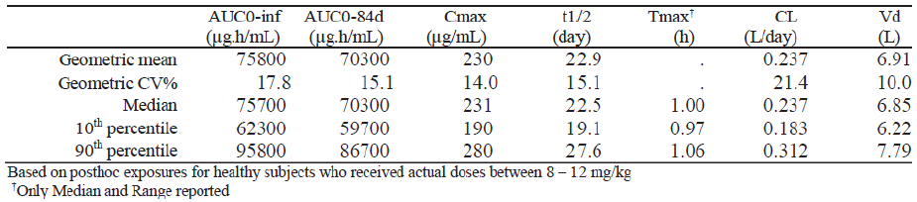

Bezlotoxumab population pharmacokinetics in adult CDI patients are as follows in Table 13.

Table 13: Summary of Bezlotoxumab PK parameter values in the patient population (n = 1504) following administration of a single IV dose of 10 mg/Kg of bezlotoxumab or 10 mg/kg actoxumab + bezlotoxumab based on population PK analysis

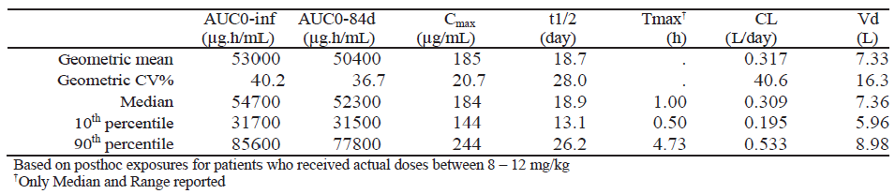

Drug interaction studies were not required. Subgroup analyses in the Phase III program did not suggest significant impact on efficacy and/or safety of the product based on patient intrinsic factors. Effect on concomitantly administered antibiotics for CDI and/or proton inhibitors was assessed in the efficacy trials.

Bezlotoxumab was detected in the stool of patients with CDI indicating that it reaches the site of infection in the gut.

#### Pharmacodynamics

No dedicated PD studies in CDI patients were conducted. Bezlotoxumab is a highly specific monoclonal antibody to *C. difficile* toxin B. Therefore other biochemical or physiological effects are not anticipated.

No dose ranging trials were performed. The 10 mg/kg dose corresponded to equivalent median serum levels of the two monoclonal antibodies to doses of 50 mg/kg/day in hamsters. The 10 mg/kg dose was well tolerated in the Phase I human trials. An efficacy exposure response analysis was conducted using the Phase III data to investigate the relationship between systemic bezlotoxumab exposure and CDI recurrence and to support the suitability of the 10 mg/kg dose from efficacy standpoint. The range of exposures in the Phase III dataset (10th to 90th percentiles) correlated with median bezlotoxumab AUC 0-inf values for doses of approximately 6 to 16 mg/kg.

No anti-drug (bezlotoxumab) antibodies (ADA) positive subjects (n = 96) were observed in studies P004 and P006. In Phase III trials, no patients were treatment emergent ADA positive. Nine patients were positive at baseline (non-treatment emergent ADA positive) but no effect on systemic bezlotoxumab exposure was shown.

#### Efficacy

##### Dose selection

In Phase II Study P017 (7396 patients screened; 484 eligible; 200 randomised), clinical efficacy (recurrence of CDI) of a single infusion of actoxumab/bezlotoxumab combination (10 mg/kg each) was evaluated against placebo. The results were as shown in Table 14.

Table 14: Analysis of the proportion of subjects with CDI recurrence (P017) (ITT and PP populations)

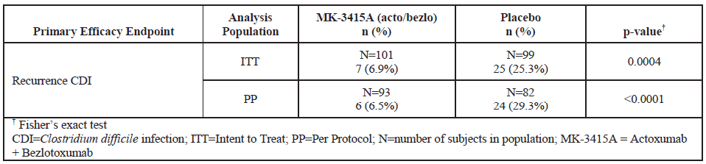

The protocol did not specify a timeframe for the actoxumab/bezlotoxumab infusion relative to the initiation of standard of care (SoC) antibiotics. This dose (10 mg/kg) was subsequently taken forward to Phase III for both monoclonal antibodies.

While the Phase III trials evaluated 10 mg/kg bezlotoxumab, a higher dose (20 mg/kg) was also administered in some of the Phase I trials to a limited number of healthy subjects. No dose-related toxicities were observed through the 20 mg/kg dose in healthy subjects, with exposures approximately double those achieved at 10 mg/kg in healthy subjects.

##### Pivotal Phase III trials

Please see the Attachment 2 for details.

The Phase III clinical development program for bezlotoxumab consisted of two clinical trials, P001 (Modify 1) and P002 (Modify 2) with identical designs.

Both trials were randomised, double blind, placebo controlled, multinational trials. The trial population was adults receiving SoC antibiotics for treatment of a current episode of confirmed CDI (primary or recurrent). The study drugs were single IV dose (10 mg/kg body weight) of bezlotoxumab alone or actoxumab alone (P001 only) or bezlotoxumab/actoxumab combined (each at 10 mg/kg dose) or placebo.

Confirmed CDI was defined as 3 or more loose stools in the preceding 24 hours and a positive stool test for toxigenic *C. difficil*e from a sample collected no more than 7 days before administration of the study drug. Diarrhoea was not required to be present on the day of infusion.

Randomisation was stratified by oral SoC antibiotic (metronidazole, vancomycin or fidaxomicin) and hospitalisation status (inpatient or outpatient) at baseline. Protocol defined subgroups of interest were patients with history of CDI in past 6 months, strain 027, epidemic strain (ribotypes 027, 014, 002, 001, 106 or 020), severe CDI, age 65 years and above and compromised immunity. Randomised patients were as shown in Table 15.

Table 15: Number of subjects in Phase III trial populations (by treatment group and trial)

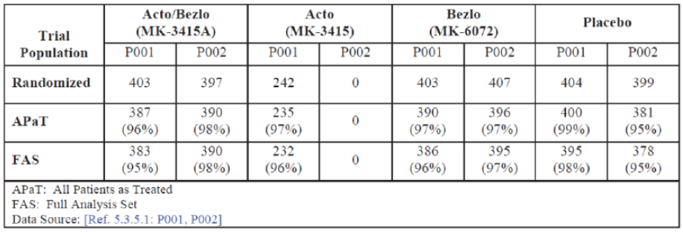

Note that after failure of actoxumab alone to show comparative efficacy/safety (low efficacy and an observed increase in the number of deaths and SAEs versus placebo) at the interim analysis stage in the Study P001, further recruitment in this treatment arm was stopped and this treatment arm was not included in the Study P002.

The eligibility criteria required that the patients must be receiving or planning to receive a 10 to 14 day course of SoC antibiotics for CDI. A patient who was planned to initiate SoC on the same day as the study drug infusion was eligible. The first dose SoC must have been administered prior to or within a few hours following the study infusion.

The primary efficacy endpoint was recurrence of CDI at 12 weeks follow-up time point (Day 85 ± 5 days) following administration of the study drug using Full Analysis Set (FAS) that is randomised patients excluding those who did not receive study medication or patients without positive local stool test for toxigenic *C. difficile* or patients who failed to start SoC within a one day window (protocol amendment) of the study infusion.

SoC antibiotics for CDI were oral metronidazole, oral vancomycin, oral fidaxomicin, oral vancomycin with IV metronidazole or oral fidaxomicin with IV metronidazole given in protocol-defined doses.

The FAS population was very close to intention to treat (ITT) population in all cases. In Study P002, an extended follow-up of 9 months was conducted in a subset of patients to assess CDI recurrence through to Month 12.

Recurrence of CDI was defined as a new episode of diarrhoea (3 or more loose stools in 24 hours) associated with a positive local or central laboratory stood test for toxigenic *C. difficile* following clinical cure of the baseline episode.

Clinical Cure was defined as receipt of ≤ 14 days of SoC antibiotics for the baseline CDI episode and no diarrhoea (≤ 2 loose stools per 24 hours) for 2 consecutive days following completion of SoC.

Global Cure was defined as Clinical Cure of the baseline episode and no CDI recurrence.

The efficacy endpoints were derived as shown in Figure 2:

Figure 2: Phase III efficacy endpoints

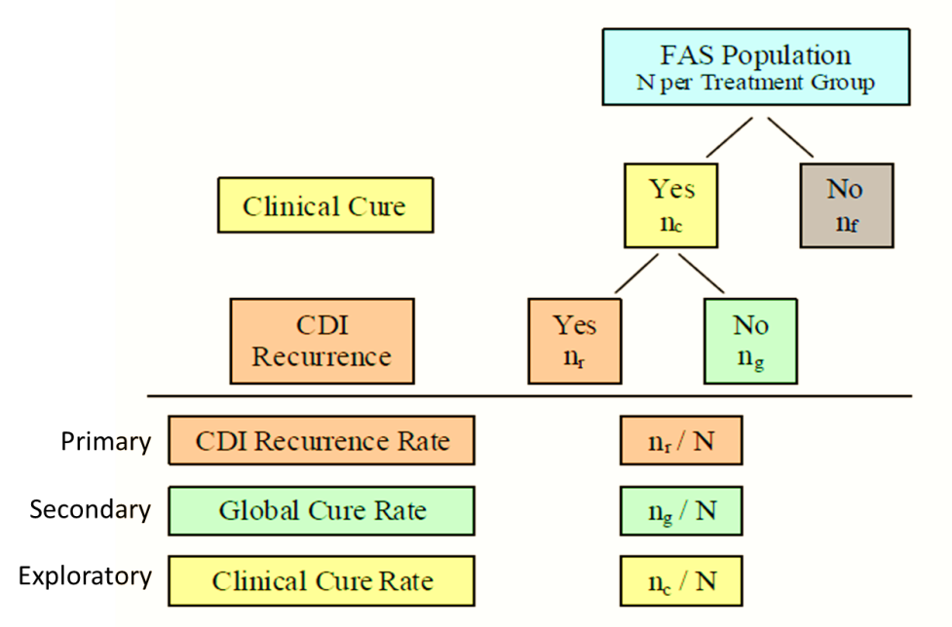

The overall participating patient population in the pooled P001 + P002 dataset (n = 2327 comprising 3 treatment groups including placebo but excluding actoxumab only group in P001) consisted of males (44%), females (56%), mean age 64 ± 17 years, median age 67 years (range 18 to 98), age ≥ 65 years (53%), age ≥ 75 years (30%), history of CDI in past 6 months (27%), prior history of CDI ever (32%), clinically severe CDI Zar score ≥ 2 (17%), ribotype 027 (11%), epidemic strains (29%), hypervirulent strains (13%), compromised immunity (20%), Horn’s index in moderate and major categories (73%), Charlson comorbidity index ≥ 3 (41%), serum creatinine ≥ 1.5 mg/dL (14%), hepatic impairment (6%), prior systemic antibiotic use (55%), prior proton pump inhibitor use (49%) and prior nasogastric tube use (4%).

Metronidazole and vancomycin were the predominant SoC antibiotics (approximately 48% each). Fidaxomicin was in use in only a small proportion of patients (3 to 4%). About 66 to 69% patients were inpatients (hospitalised). The geographical distribution of patients was Europe (38%), North America (47%), Asia-Pacific (10%), Latin America (4%) and Africa (0.4%) including 7 Australia sites (52 patients) in Study P001. The treatment groups were generally comparable with respect to the baseline prognostic characteristics.

The results at 12 weeks were as shown in Table 16.

Table 16: results at 12 weeks for Studies P001 and P002

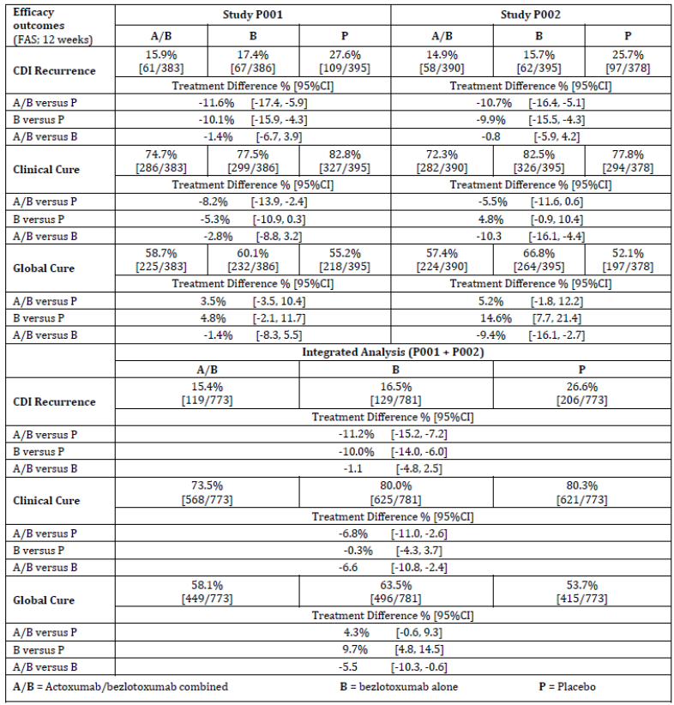

The Kaplan Meier curve for Time to CDI recurrence (integrated P001+P002 data) was indicative of early separation from placebo and the difference at 4 weeks maintained to 12 weeks is shown in Figure 3.

Figure 3: Time to CDI recurrence Phase III studies (P001 + P002) Full analysis set population

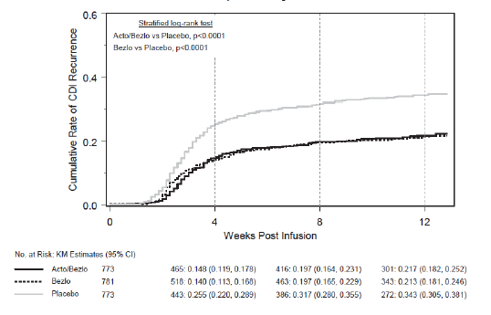

The results (CDI recurrence shown) in baseline subgroups of interest (integrated P001+P002 data) were consistent with the overall population, shown in Figure 4.

Figure 4: CDI recurrence in subpopulations: risk factors for CDI recurrence Phase III studies (P001 + P002 Integrated) full analysis set population

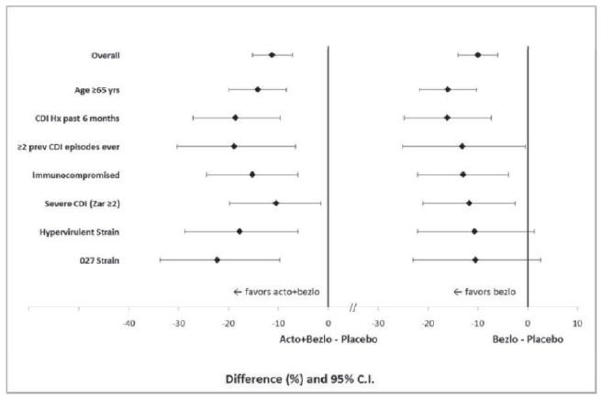

Results based on Per Protocol set were consistent with the primary FAS analysis. A number of sensitivity analyses including using propensity scores were indicative of robust findings in the primary analysis. A total of 293 patients from Study P002 entered into a 9 month extension study to a total of 12 months observation period after administration of study drugs as shown in Table 17.

Table 17: Length of time in study extension full analysis set population

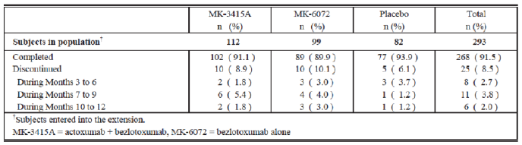

Over 12 months, the cumulative CDI recurrence (Extension cohort) was highest in Placebo group and lowest in bezlotoxumab group (MK-6072) as shown in Table 18.

Table 18: CDI Recurrence through 12 months following a single infusion of study medication (full analysis set extension cohort)

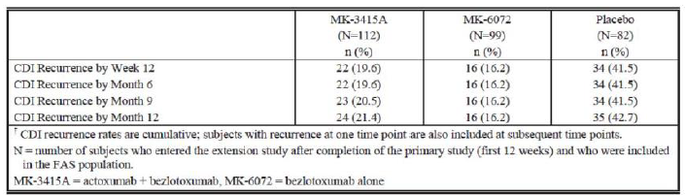

The *C. difficile* colonisation status at 12 months (Extension Cohort) was also lowest in the bezlotoxumab group as shown in Table VV.

Table 19: Colonization status at the month 12 extension visit (full analysis set cohort)

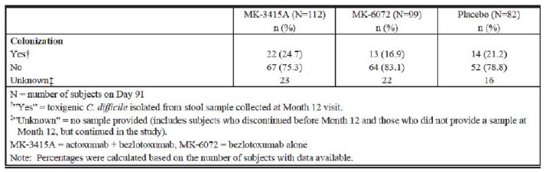

#### Safety

The overall safety dataset is based on 1,790 subjects exposed to bezlotoxumab alone or in combination with actoxumab and includes data from 126 healthy subjects (of which 54 received a 2 hour IV infusion, and 72 subjects received a 1 hour infusion), and 1,664 patients with CDI. In Phase II study (P017), among the 200 enrolled patients, the drug product (A/B) was infused over 2 hours in 84.5%. In P004, 29 subjects were administered a 2nd infusion.

The exposure to the study drugs in the integrated (P001 + P002) analysis was as shown in Table 20.

Table 20: Clinical trial exposure to bezlotoxumab by dose Phase III studies (PN001 + PN002 Integrated APaT population)

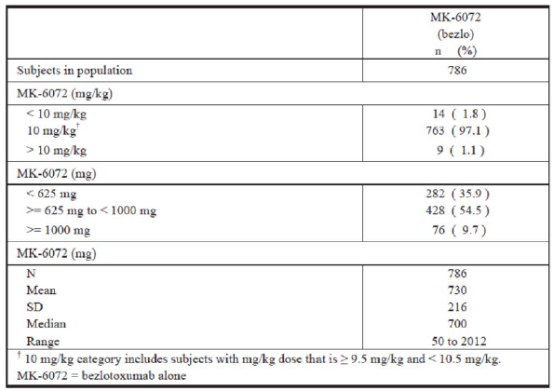

The overall incidence of AEs in both active monoclonal antibody groups was similar to the reported incidence of AEs in placebo group. The reporting of AEs was also similarly comparable in subpopulations of patients based on gender and age.

There was no apparent trend for a higher incidence of AEs in patients who received a higher mg/kg body weight dose of antibody. No treatment emergent anti-bezlotoxumab antibodies were report in 1,414 evaluable adult patients in the two Phase III trials. Analysis of bezlotoxumab serum levels did not reveal trends for QTc prolongation with increasing serum concentration.

An overall summary of adverse events, including SAEs and deaths, in first 4 weeks following administration of study drugs, using the integrated P001 + P002 set, is presented below in Table 21.

Table 21: Adverse event summary during 4 weeks following infusion Phase III studies (P001 + P002 Integrated) APaT population

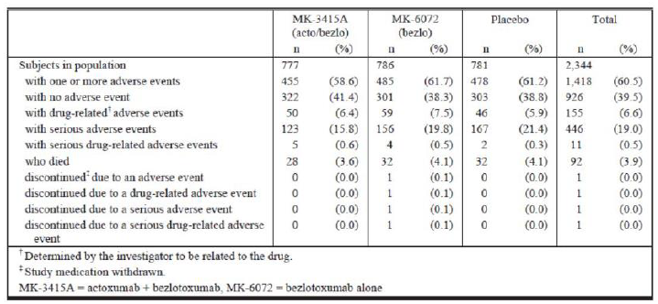

For the 12 week period, the proportions of subjects reporting at least 1 AE, at least 1 SAE or deaths were slightly higher compared to the first 4 weeks. This was largely due to new SAEs and deaths during Week 5 through Week 12. During the 12 weeks post infusion, 29.8% experienced an SAE, and 7.1% patients died compared to 19.0% and 3.9% respectively in the first 4 weeks post infusion.

During the 12 week post infusion period, a total of 166 patients had fatal outcome comprising of 51 patients in A/B group, 56 patients in B alone group and 59 patients in placebo group. Of these, 92 deaths occurred during the first 4 weeks as noted in the Table 21 above. The Week 12 Kaplan Meier mortality rate estimates were 6.5% for A/B group, 7.1% for B group and 7.9% for placebo group. In the extended follow up of the Extension cohort in Study P002, 9 patients died during the 9 months extension phase (2 A/B patients, 5 B alone patients and 2 placebo patients).

Heart failure (HF) was reported (n = 41) more commonly in bezlotoxumab treated patients compared to placebo treated patients in the 2 pivotal efficacy trials (2.2% versus 0.9%). HF occurred primarily in patients with history of congestive heart failure (CHF). In patients with a history of CHF, 12.7% (15/118) bezlotoxumab treated patients and 4.8% (5/104) placebo treated patients were reported with heart failure during the 12 week study period.

Additionally, in patients with a history of CHF, there were more deaths in bezlotoxumab treated patients (19.5% (23/118)) than in placebo treated patients (12.5% (13/104)) during the 12 week study period. The causes of deaths included cardiac failure, infections and respiratory failure. In placebo group, 5 of 7 patients experienced HF before Week 4, while in bezlotoxumab and A/B groups, the majority of HF events occurred after Week 4.

A series of analyses were performed in patients with SAE of HF indicating that this adverse outcome was often associated with concurrent conditions known to exacerbate CHF. These patients were older, most were inpatients, had a higher prevalence of comorbid conditions and had a higher prevalence of severe CDI.

### Risk management plan

The submission is subject to EU-RMP version 1.5 dated 22 November 2016 with Australian Specific Annex version 2.0; dated 31 May 2017 and any future updates as a condition of registration.

### Risk-benefit analysis

#### Delegates summary

Some Quality issues are pending clearance from the relevant TGA area and will need to be resolved prior to finalisation of this submission.

Toxicology dossier complied with the requirements for intravenous monoclonal antibodies. There are no outstanding requirements preventing approval.

Pharmacokinetic and pharmacodynamic dataset are considered adequate. The kinetics/dynamics are simple based on single dose IV administration, no off target effects and elimination by body’s protein catabolism pathway.

Clinical efficacy of a single 10 mg/kg IV dose of bezlotoxumab in preventing the recurrence of CDI in adult patients who were concurrently on standard of care antibiotics for the treatment of CDI was demonstrated in 2 similarly designed randomised, double blind, placebo controlled, parallel treatment groups, adequately powered trials. The period of risk (observation) examined in the study was 12 weeks post infusion.

*CDI recurrence:*

In Study P001, 17.4% (67/386) patients developed CDI recurrence in bezlotoxumab group compared to 27.6% (109/395) in placebo group. The placebo corrected treatment difference was ‑10.1% (95%CI ‑15.9%, ‑4.3%) indicating superior absolute efficacy of bezlotoxumab. The relative treatment difference from the other active comparator (actoxumab/bezlotoxumab minus bezlotoxumab) was not significant (‑1.4%; 95%CI ‑6.7%, 3.9%) indicating no advantage of adding actoxumab (*C. difficile* toxin Aantibody) to bezlotoxumab (*C. difficile* toxin B antibody).

In Study P002, 15.7% (62/395) patients developed CDI recurrence in bezlotoxumab group compared to 25.7% (97/378) in placebo group. The placebo corrected treatment difference was ‑9.9% (95%CI ‑15.5%, ‑4.3%) indicating superior efficacy of bezlotoxumab. The treatment difference from the other active comparator (actoxumab/bezlotoxumab minus bezlotoxumab) was not significant (‑0.8%; 95%CI ‑5.9%, 4.2%) confirming lack of any advantage of adding actoxumab to bezlotoxumab.

In pooled P001 + P002 data, 16.5% (129/781) patients developed CDI recurrence in bezlotoxumab group compared to 26.6% (206/773) in placebo group. The placebo corrected treatment difference was ‑10.0% (95%CI ‑14.0%, ‑6.0%) indicating superior efficacy of bezlotoxumab. The treatment difference from the other active comparator (actoxumab/bezlotoxumab minus bezlotoxumab) was not significant (‑1.1%; 95%CI ‑4.8%, 2.5%) indicating no advantage of adding actoxumab to bezlotoxumab consistent with the results in the individual studies.

*Clinical Cure:*

In Study P001, 77.5% (299/386) patients achieved Clinical Cure in bezlotoxumab group compared to 82.8% (327/397) in placebo group. The placebo corrected treatment difference was ‑5.3% (95%CI ‑10.9%, 0.3%) which may be interpreted as marginally better Clinical Cure rates with SoC antibiotics in the absence of bezlotoxumab that is in placebo group. The treatment difference from the other active comparator (actoxumab/bezlotoxumab minus bezlotoxumab) was not significant (‑2.8%; 95%CI ‑8.8%, 3.2%).

In Study P002, 82.5% (326/395) patients achieved Clinical Cure in bezlotoxumab group compared to 77.8% (294/378) in placebo group. The placebo corrected treatment difference was 4.8% (95%CI ‑0.9%, 10.4%) indicative of some discordance with the Clinical Cure rates reported in P001. Higher Clinical Cure rate for bezlotoxumab and lower rates for actoxumab/bezlotoxumab also led to a statistically significant treatment difference from actoxumab/bezlotoxumab combined group in favour of bezlotoxumab alone group (‑10.3%; 95%CI ‑16.1%, ‑4.4%).

In pooled P001 + P002 data, 80.0% (625/781) patients achieved Clinical Cure in bezlotoxumab group compared to 80.3% (621/773) in placebo group. The placebo corrected treatment difference was ‑0.3% (95%CI ‑4.3%, 3.7%), whereas actoxumab/bezlotoxumab minus bezlotoxumab treatment difference favoured bezlotoxumab (‑6.6%; 95%CI ‑10.8%, ‑2.4%).

Overall, it is reasonable to conclude that bezlotoxumab treatment did not adversely affect the efficacy of concurrent antibiotics for the treatment of CDI.

*Global Cure:*

In Study P001, 60.1% (232/386) patients achieved Global Cure in bezlotoxumab group compared to 55.2% (218/395) in placebo group. The placebo corrected treatment difference was statistically not significant (4.8% (95%CI ‑2.1%, 11.7%). The actoxumab/bezlotoxumab minus bezlotoxumab treatment difference was also not significant (‑1.4%; 95%CI ‑8.3%, 5.5%).

In Study P002, 66.8% (264/395) patients achieved Global Cure in bezlotoxumab group compared to 52.1% (197/378) in placebo group. The placebo corrected treatment difference was statistically significant in favour of bezlotoxumab (14.6% (95%CI 7.7%, 21.4%). Global Cure was defined as Clinical Cure and No CDI Recurrence and was described as indicative of durability of effect. However, it appears to be only a converse of the primary variable CDI Recurrence and does not provide any additional information. The actoxumab/bezlotoxumab minus bezlotoxumab treatment difference for Global Cure also favoured bezlotoxumab (‑9.4%; 95%CI ‑16.1%, ‑2.7%).

In pooled P001 + P002 data, 63.5% (496/781) patients achieved Global Cure in bezlotoxumab group compared to 53.7% (415/773) in placebo group. The placebo corrected treatment difference was statistically significant in favour of bezlotoxumab (9.7% (95%CI 4.8%, 14.5%). The actoxumab/bezlotoxumab minus bezlotoxumab treatment difference was also significant in favour of bezlotoxumab (‑5.5%; 95%CI ‑10.3%, ‑0.6%).

Sensitivity analyses supported the robustness of the primary analysis. There was no evidence of heterogeneous effect across the examined subgroups.

The adverse effects profile during first 4 weeks and over the 12 week observation period is considered acceptable relative to the expected benefit. High but non‑differential mortality was observed in the efficacy trials, consistent with the patient population, condition under treatment and coexisting morbidities. Differential heart failure rate was observed in bezlotoxumab group compared to placebo. Although cardiotoxicity or conduction effects are not expected of bezlotoxumab, the analysis of confounding factors does not adequately explain the differential reporting rate from the placebo control. Therefore an advisory statement in relation to risk/benefit in patients with history of congestive heart failure and a caution towards fluid overload with the infusion are recommended for inclusion in the PI.

A post-approval RMP is applicable to this submission. No objections to approval have been made.

Overall, the clinical efficacy (prevention of CDI during the risk period of a current CDI which is being treated with standard antibiotics) was modest (lower limit of 95%CI was ‑ 6% in pooled dataset) but consistent and is considered clinically meaningful in a serious and life threatening condition in which such therapeutic option is currently not available.

It may be noted that protocol-defined timing of bezlotoxumab infusion in relation to ongoing SoC antibiotics allowed for large variation in these trials. It is possible that a better defined treatment window for administering bezlotoxumab in post-market clinical usage may be able to optimise the efficacy of bezlotoxumab.

#### Delegate’s considerations

Pending advice from ACM, the Delegate supports approval of bezlotoxumab (Zinplava) for prevention of recurrence of CDI in adult CDI patients during course of antibacterial therapy for CDI.

Although the treatment effect was homogeneous across subpopulations, the Delegate was of the opinion that therapeutic indication should restrict use in patients at risk of developing recurrence of CDI to more closely reflect the participating patient population in the clinical trials. The risk factors should be noted in the clinical trials section of the PI and the therapeutic indication should be cross referenced to the clinical trials section.

Other additions to the therapeutic indication proposed by the clinical evaluator and agreed by the sponsor are acceptable.

#### Proposed action

The Delegate had no reason to say, at this time, that the application for Zinplava should not be approved for registration.

#### Request for ACPM advice

The ACPM is requested to provide advice on the following specific issues:

1. Should the therapeutic indication restrict use in ‘at risk patients’?

The committee is also requested to provide advice on any other issues that it thinks may be relevant to a decision on whether or not to approve this application.

#### Response from sponsor

Merck Sharp and Dohme (Australia) Pty Limited (MSD) welcomes the Delegate’s recommendation to approve the application for Zinplava (bezlotoxumab) for prevention of recurrence of CDI in adult CDI patients during course of antibacterial therapy for CDI.

The Delegate is of the opinion that the therapeutic indication should restrict use in patients at risk of developing recurrence of CDI to more closely reflect the participating population in the clinical trials. The Delegate has sought the advice of ACM on this issue.

MSD concurs with the Delegate, and proposes the following modified indication for Zinplava:

*“Zinplava (bezlotoxumab) is indicated for the prevention of recurrence of Clostridium difficile infection (CDI) in adults at high risk for recurrence of CDI (see CLINICAL TRIALS).*

*Zinplava is not indicated for the treatment of CDI. Zinplava is not an antibacterial drug. Zinplava should only be used in conjunction with antibacterial drug treatment of CDI.*

*The safety and efficacy of repeat administration of Zinplava in patients with CDI have not been studied.”*

As recommended by the Delegate, the risk factors are noted in the clinical trials section of the Zinplava PI and the proposed indication has been cross referenced to the clinical trials section.

The sponsor provided a modified Zinplava PI which includes the proposed modified indication.

MSD also noted the following comment made by the Delegate in the Request for ACM Advice:

“It may be noted that protocol defined timing of bezlotoxumab infusion in relation to ongoing Standard of Care antibiotics allowed for large variation in these trials. It is possible that a better defined treatment window for administering bezlotoxumab in post-market clinical usage may be able to optimise the efficacy of bezlotoxumab.”

The results of a post-hoc analysis of the MODIFY I/II Phase III trials evaluating the efficacy of bezlotoxumab in participants stratified by timing of infusion relative to the start of antibacterial drug treatment was presented at the American Society for Microbiology 2017.[69]

Bezlotoxumab did not impact clinical cure, and the reduction in recurrence of CDI rates were similar regardless of bezlotoxumab administration in relation to onset of antibacterial drug treatment for CDI, supporting flexibility in bezlotoxumab dose timing.

Bezlotoxumab should be administered any time before ending antibacterial drug treatment for CDI so it is in the systemic circulation at onset of the recurrence of CDI risk period, which begins immediately after antibacterial drug treatment ends.

Conclusion:

The sponsor trust the Committee will concur with the Delegate and recommend approval for Zinplava (bezlotoxumab) concentrated injection 1000 mg/40 mL for the proposed modified indication.

#### Advisory Committee Considerations[70]

The Advisory Committee on Medicines (ACM), having considered the evaluations and the Delegate’s overview, as well as the sponsor’s response to these documents, advised the following:

The ACM taking into account the submitted evidence of efficacy, safety and quality, agreed with the Delegate and considered Zinplava concentrated injection 1000 mg/40 mL containing of bezlotoxumab to have an overall positive benefit-risk profile for the proposed indication;

*Zinplava (bezlotoxumab) is indicated for the prevention of recurrence of Clostridium difficile infection (CDI) in adult patients 18 years or older at high risk of recurrence of CDI who are receiving antibiotic therapy for CDI (see CLINICAL TRIALS).*

*Zinplava is not indicated for the treatment of CDI. Zinplava is not an antibacterial drug. Zinplava should only be used in conjunction with antibacterial drug treatment of CDI.*

In making this recommendation the ACM considered the use of bezlotoxumab in any patients with CDI or restriction of use in CDI patients at high risk of recurrence.

The ACM agreed with the Delegate on the proposed conditions of registration and advised on the inclusion of the following:

* Subject to satisfactory implementation of the Risk Management Plan most recently negotiated by the TGA
* Negotiation of the Product Information and Consumer Medicine Information to the satisfaction of the TGA.

##### Specific Advice

The ACM advised the following in response to the Delegate’s specific questions on the submission:

1. ***Should the therapeutic indication restrict use in ‘at risk patients’?***

ACM agreed that the therapeutic indication restrict use in ‘at high risk patients’ and noted that the sponsor also agrees. ACM also noted that this restriction is used in the European Union and United States.

ACM were of the opinion that though the clinical trials did not specifically select for high risk patients nor was there a clear definition of what higher risk patients were, a high proportion of participants in trials were elderly patients, those who are immunocompromised, had recurrent CDI, and/or infection with hyper virulent strains. ACM noted that Zinplava seems to be effective in all clinically relevant patient subgroups. A key uncertainty is whether Zinplava provides any additional benefit in patients treated with fidaxomicin.

##### Other comments

ACM commented on Zinplava being only used in conjunction with an antibiotic and that it may be given at any time before the end of the antibiotic course.

ACM agreed with the Delegate’s requested changes to the PI.

The ACM advised that implementation by the sponsor of the recommendations outlined above to the satisfaction of the TGA.

### Outcome

Based on a review of quality, safety and efficacy, TGA approved the registration of Zinplava bezlotoxumab 1000 mg/ 40 mL concentrated injection vial, indicated for:

*Zinplava (bezlotoxumab) is indicated for the prevention of recurrence of Clostridium difficile infection (CDI) in adult patients 18 years or older at high risk for recurrence of CDI who are receiving antibiotic therapy for CDI (see CLINICAL TRIALS).*

*Zinplava is not indicated for the treatment of CDI. Zinplava is not an antibacterial drug.*

*Zinplava should only be used in conjunction with antibacterial drug treatment of CDI.*

*The safety and efficacy of repeat administration of Zinplava in patients with CDI have not been studied.*

#### Specific conditions of registration applying to these goods

* EU-RMP version 1.5 dated 22 November 2016 with Australian Specific Annex version 2.0; dated 31 May 2017 and any future updates, as agreed with the TGA will be implemented in Australia.
* Batch Release Testing & Compliance with Certified Product Details (CPD):
  + It is a condition of registration that all batches of Zinplava (bezlotoxumab) 1000 mg/40 mL concentrated injection vial imported into/manufactured in Australia must comply with the product details and specifications approved during evaluation and detailed in the Certified Product Details (CPD).
  + It is a condition of registration that each batch of Zinplava (bezlotoxumab) 1000 mg/40 mL concentrated injection vial imported into/manufactured in Australia is not released for sale until samples and/or the manufacturer’s release data have been assessed and endorsed for release by the TGA Laboratories Branch.
  + The Certified Product Details (CPD), as described in Guidance 7: Certified Product Details of the Australian Regulatory Guidelines for Prescription Medicines (ARGPM) [http://www.tga.gov.au/industry/pm-argpm-guidance-7.htm), in PDF format, for the above products should be provided upon registration of these therapeutic goods. In addition, an updated CPD should be provided when changes to finished product specifications and test methods are approved in a Category 3 application or notified through a self-assessable change.

## Attachment 1. Product Information

The PI for Zinplava approved with the submission which is described in this AusPAR is at Attachment 1. For the most recent PI, please refer to the TGA website at <<https://www.tga.gov.au/product-information-pi>>.

## Attachment 2. Extract from the Clinical Evaluation Report

|  |
| --- |
| Therapeutic Goods Administration |
| PO Box 100 Woden ACT 2606 Australia  Email: [info@tga.gov.au](mailto:info@tga.gov.au) Phone: 1800 020 653 Fax: 02 6232 8605  [**https://www.tga.gov.au**](https://www.tga.gov.au) |

1. ICH Q5C Quality of biotechnological products: stability testing of biotechnological/biological products
2. ICH S6[R1]; Preclinical safety evaluation of biotechnology-derived pharmaceuticals
3. Voth, D.E. and J.D. Ballard. (2005) *Clostridium difficile* toxins: mechanism of action and role in disease. *Clin. Microbiol. Rev.* **18:** 247—263.
4. Rho, Rac and Cdc42 are three Ras related GTP binding proteins that control the assembly and disassembly of the actin cytoskeleton and play a role in cell motility.
5. Knetsch, C.W. et al. (2012) Comparative analysis of an expanded Clostridium difficile reference strain collection reveals genetic diversity and evolution through six lineages. *Infect Genet Evol.* 2012; 12: 1577-1585.
6. Cheng, A.C. et al (2016) Laboratory-based surveillance of Clostridium difficile circulating in Australia, September - November 2010. *Pathol*. 48: 257-260.
7. Eyre, D.W. et al. (2015) Emergence and spread of predominantly community-onset Clostridium difficile PCR ribotype 244 infection in Australia, 2010 to 2012
8. Furuya-Kanamori, L. et al. (2016) A comparison of Clostridium difficile ribotypes circulating in Australian hospitals and communities*. J Clin Microbiol*. 2016;Nov 2. pii: JCM.01779-16.
9. Kurka, H. et al .(2014) Sequence similarity of Clostridium difficile strains by analysis of conserved genes and genome content is reflected by their ribotype affiliation. PLOS ONE 9: e86535.
10. Keel, M.K. and J.G. Songer. (2006) The comparative pathology of Clostridium difficile-associated disease. *Vet Pathol*. 2006; 43: 225-240.
11. hERG (the human Ether-à-go-go-Related Gene) is a gene (KCNH2) that codes for a protein known as Kv11.1, the alpha subunit of a potassium ion channel.
12. Vargas, H.M. et al. (2008) Scientific review and recommendations on preclinical cardiovascular safety evaluation of biologics. *J. Pharmacol. Toxicol. Methods* 2008; 58: 72-76
13. Zhang, Y.and W.M. Pardridge. (2001) Mediated efflux of IgG molecules from brain to blood across the blood-brain barrier*. J. Neuroimmunol*. 2001; 114: 168-172
14. ICH S6(R1): Preclinical safety evaluation of biotechnology-derived pharmaceuticals
15. ICH S6(R1): *Preclinical Safety Evaluation of Biotechnology-Derived Pharmaceuticals*.
16. Pregnancy Category B2; Drugs which have been taken by only a limited number of pregnant women and women of childbearing age, without an increase in the frequency of malformation or other direct or indirect harmful effects on the human fetus having been observed.

    Studies in animals are inadequate or may be lacking, but available data show no evidence of an increased occurrence of fetal damage.
17. Carter GP, et al. 2012 The role of toxin A and toxin B in the virulence of Clostridium difficile. *Trends Microbiol.* 2012; 20: 21-29.
18. Voth DE, Ballard JD. 2005Clostridium difficile toxins: mechanism of action and role in disease. *Clin Microbiol Rev* 2005; 18: 247-263
19. Rupnik M, et al. 2009 Clostridium difficile infection: New developments in epidemiology and pathogenesis. *Nat Rev Micro* 2009; 7: 526-536
20. Madan R, Petri WA Jr. 2012 Immune responses to Clostridium difficile infection. Trends Mol Med. 2012 Nov;18(11):658-66; Shen A. Clostridium difficile toxins: mediators of inflammation. *J Innate Immun.* 2012; 4:149-158
21. Shen A 2012 Clostridium difficile toxins: mediators of inflammation. *J Innate Immun*. 2012; 4: 149-158
22. Kyne L, et al. 2000 Asymptomatic carriage of Clostridium difficile and serum levels of IgG antibody against toxin A. *N Engl J Med* 2000; 342: 390-397.
23. McFarland LV, et al. 1989 Nosocomial acquisition of Clostridium difficile infection. *NEJM* 1989; 320: 204-210
24. Samore MH, et al. 1994 Clostridium difficile colonization and diarrhea at a tertiary care hospital. *Clin Infect Dis.* 1994; 18: 181-187.
25. Jin J. 2014. JAMA patient page. Clostridium difficile infection. *JAMA*. 2014; 312:1818.
26. CDC 2012 Centers for Disease Control and Prevention (CDC). Frequently asked questions about Clostridium difficile for healthcare providers. Atlanta, GA: CDC; 2012. 6
27. Leffler DA, Lamont JT. 2015 Clostridium difficile infection. *N Engl J Med*. 2015; 372: 1539-1548
28. Aguayo C, et al. 2015Rapid spread of Clostridium difficile NAP1/027/ST1 in Chile confirms the emergence of the epidemic strain in *Latin America. Epidemiol Infect.* 2015: 1-5. [Epub ahead of print).
29. Crobach MJ, et al. 2009 European Society of Clinical Microbiology and Infectious Diseases (ESCMID): data review and recommendations for diagnosing CDI. *Clin Microbiol Infect*. 2009; 15: 1053-1066
30. Kelly CP, LaMont JT. 2008 Clostridium difficile -- More difficult than ever. *N Engl J Med* 2008; 359: 1932-1940.
31. McDonald LC, et al. 2006Clostridium difficile infection in patients discharged from US short-stay hospitals, 1996- 2003. *Emerg Infect Dis* 2006; 12: 409-415.
32. Lessa FC, et al. 2012 A current status of clostridium difficile infection epidemiology. *Clin Infect Dis* 2012; 55(S2):S65- S70.
33. Lessa FC, et al. 2015 Burden of Clostridium difficile infection in the United States. *NEJM*. 2015; 372:825-834.
34. Gerver S, et al. 2015Annual epidemiological commentary: mandatory MRSA, MSSA and E. coli bacteraemia and *C. difficile* infection data, 2014/15 [Internet]. London: Public Health England; 2015. Available from: https://www.gov.uk/government/uploads/system/uploads/attachment_ data/file/442952/Annual_Epidemiological_Commentary_FY_2014_2 015.pdf
35. Di Bella S, et al. 2013Clostridium difficile infection in Italian urban hospitals: data from 2006 through 2011. *BMC Infect Dis*. 2013; 13: 146
36. Slimings C, et al. 2014 Increasing incidence of Clostridium difficile infection, Australia, 2011-2012. *Med J Aust.* 2014; 200: 272-276
37. Loo VG, et al. 2005A predominantly clonal multi-institutional outbreak of clostridium difficile-associated diarrhea with high morbidity and mortality. *NEJM* 2005; 353: 2442-2449
38. McDonald LC, et al. 2005An epidemic, toxin gene-variant strain of Clostridium difficile. *NEJM* 2005; 353: 2433-2441
39. Kuijper EJ, et al. 2006 Emergence of Clostridium difficile associated disease in North America and Europe*. Clin Microbiol Infect* 2006; 12(Suppl 6):2-18
40. Goorhuis A, et al. 2008Emergence of Clostridium difficile infection due to a new hypervirulent strain, polymerase chain reaction ribotype 078. *Clin Infect Dis* 2008; 47:1162-1170.
41. Gravel D, et al. 2009 Health Care-associated Clostridium difficile infection in adults admitted to acute care hospitals in Canada: A Canadian nosocomial infection surveillance program study. *Clin Infect Dis* 2009; 48: 568-576.
42. Pepin J, et al. 2005 Increasing risk of relapse after treatment of Clostridium difficile colitis in Quebec, Canada. *Clin Infect Dis* 2005; 40: 1591-1597
43. Cohen SH, et al. 2010 Clinical practice guidelines for Clostridium difficile infection in adults: 2010 update by the Society for Healthcare Epidemiology of America (SHEA) and the Infectious Diseases Society of America (IDSA). *Infect Control Hosp Epidemiol* 2010; 31: 431-455.
44. Debast SB, et al. 2014European Society of Clinical Microbiology and Infectious Diseases: update of the treatment guidance document for Clostridium difficile infection. *Clin Microbiol Infect*. 2014; 20 Suppl 2:1-26
45. Louie TJ, et al. 2011 Fidaxomicin versus vancomycin for clostridium difficile infection. *NEJM* 2011; 364: 422-431.
46. Aslam S, et al. 2005 Treatment of CDAD: old therapies and new strategies. *Lancet Infect Dis* 2005; 5: 549-557.
47. Zar FA, et al. 2007 A comparison of vancomycin and metronidazole for the treatment of Clostridium difficile-associated diarrhea, stratified by disease severity. *Clin Infect Dis* 2007; 45: 302-307
48. McFarland LV, et al. 2002 Breaking the cycle: treatment strategies for 163 cases of recurrent Clostridium difficile disease. *Am J Gastroenterol* 2002; 97: 1769-1775
49. McFarland LV. 2009 Renewed interest in a difficult disease: Clostridium difficile infections-epidemiology and current treatment strategies. *Curr Opin Gastroenterology*. 2009; 25: 24-35
50. Blossom DB, McDonald LC. 2007 Emerging infections: The challenges posed by reemerging Clostridium difficile infection. *Clin Infect Dis* 2007; 45: 222-227.
51. McDonald L-C, et al. 2007 Recommendations for surveillance of Clostridium difficile associated disease. *Infect Control Hosp Epidemiol* 2007; 28: 140-145.
52. Hu MY, et al. 2009 Prospective derivation and validation of a clinical prediction rule for recurrent Clostridium difficile infection. *Gastroenterology* 2009; 136: 1206-1214
53. Kyne L et al 2005 Clostridium difficile toxoid vaccine in recurrent C. difficile-associated diarrhea. [*Gastroenterology*.](https://www.ncbi.nlm.nih.gov/pubmed/15765411) 2005; 128: 764-770.
54. Aronsson B, et al. 1985 Serum antibody response to clostridium difficile toxins in patients with clostridium difficile diarrhoea. *Infection* 1985; 13: 97-101
55. Katchar K, et al. 2007 Association between IgG2 and IgG3 subclass responses to toxin A and recurrent clostridium difficile-associated disease*. Clin Gastroenterol Hepatol* 2007; 5: 707-713.
56. Kyne L, et al. 2001Association between antibody response to toxin A and protection against recurrent Clostridium difficile diarrhoea. *Lancet* 2001; 357: 189-193. and; Kyne L, Kelly CP. Recurrent Clostridium difficile diarrhoea. *Gut* 2001; 49: 152-153
57. Warny M, et al. 1994 Human antibody response to Clostridium difficle toxin A in relation to clinical course of infection. *Infect Immun* 1994; 62: 384-389
58. Olsen MA, et al. 2015Recurrent Clostridium difficile infection is associated with increased mortality. *Clin Microbiol Infect*. 2015; 21: 164-170
59. Bauer MP, et al. 2011 Clostridium difficile infection in Europe: a hospital-based survey. Lancet 2011;377:63-73
60. Wiegand PN, et al. 2012Clinical and economic burden of clostridium difficile infection in Europe: a systematic review of healthcare-facility acquired infection. *J Hosp Infect* 2012; 81: 1-14
61. Libby JM, et al. 1982 Effects of the two toxins of Clostridium difficile in antibiotic-associated cecitis in hamsters. *Infect Immun* 1982; 36: 822-829
62. Torres JF, et al. 1995 Evaluation of formalin inactivated Clostridium difficile vaccines administered by parenteral and mucosal routes of immunization in hamsters. *Infect Immun* 1995; 63: 4619-4627.
63. Kink JA, Williams JA. 1998 Antibodies to recombinant Clostridium difficile toxins A and B are an effective treatment and prevent relapse of C. difficile-associated disease in a hamster model of infection. *Infect Immun* 1998; 6: 2018-2025.
64. Babcock GJ, et al. 2006 Human monoclonal antibodies directed against toxins A and B prevent Clostridium difficile-Induced mortality in hamsters. *Infect Immun* 2006; 74: 6339-4637
65. Steele J, et al. 2013 Antibody against TcdB, but not TcdA, prevents development of gastrointestinal and systemic clostridium difficile disease. *J Infect Dis* 2013; 207: 323-330
66. Leav BA, et al. 2010 Serum anti-toxin B antibody correlates with protection from recurrent Clostridium difficile infection (CDI). *Vaccine* 2010; 28:965-969.
67. The QT interval is the time from the start of the Q wave to the end of the T wave. It represents the time taken for ventricular depolarisation and repolarisation, effectively the period of ventricular systole from ventricular isovolumetric contraction to isovolumetric relaxation. The QT shortens at faster heart rates. An abnormally prolonged QT is associated with an increased risk of ventricular arrhythmias, especially Torsades de Pointes. The recently described congenital short QT syndrome has been found to be associated with an increased risk of paroxysmal atrial and ventricular fibrillation and sudden cardiac death.
68. *Routine risk minimisation* activities may be limited to ensuring that suitable warnings are included in the product information or by careful use of labelling and packaging.

    *Routine pharmacovigilance* practices involve the following activities:

    All suspected adverse reactions that are reported to the personnel of the company are collected and collated in an accessible manner;

    Reporting to regulatory authorities;

    Continuous monitoring of the safety profiles of approved products including signal detection and updating of labelling;

    Submission of PSURs;

    Meeting other local regulatory agency requirements.
69. Golan Y, et al. Efficacy of bezlotoxumab based on timing of administration relative to start of antibacterial therapy for *C. difficile* infection (CDI) [poster no. Saturday-213]. In: ASM Microbe Meeting; 2017.
70. The ACM provides independent medical and scientific advice to the Minister for Health and the Therapeutic Goods Administration (TGA) on issues relating to the safety, quality and efficacy of medicines supplied in Australia including issues relating to pre-market and post-market functions for medicines.

    The Committee is established under Regulation 35 of the Therapeutic Goods Regulations 1990. Members are appointed by the Minister. The ACM was established in January 2017 replacing Advisory Committee on Prescription Medicines (ACPM) which was formed in January 2010. ACM encompass pre and post-market advice for medicines, following the consolidation of the previous functions of the Advisory Committee on Prescription Medicines (ACPM), the Advisory Committee on the Safety of Medicines (ACSOM) and the Advisory Committee on Non-Prescription Medicines (ACNM). Membership comprises of professionals with specific scientific, medical or clinical expertise, as well as appropriate consumer health issues relating to medicines.