August 2019

Australian Public Assessment Report for Bictegravir / Emtricitabine / Tenofovir alafenamide
  - Proprietary Product Name: Biktarvy
  - Sponsor: Gilead Sciences

About the Therapeutic Goods Administration (TGA)
- The Therapeutic Goods Administration (TGA) is part of the Australian Government Department of Health and is responsible for regulating medicines and medical devices.
- The TGA administers the Therapeutic Goods Act 1989 (the Act), applying a risk management approach designed to ensure therapeutic goods supplied in Australia meet acceptable standards of quality, safety and efficacy (performance) when necessary.
- The work of the TGA is based on applying scientific and clinical expertise to decision-making, to ensure that the benefits to consumers outweigh any risks associated with the use of medicines and medical devices.
- The TGA relies on the public, healthcare professionals and industry to report problems with medicines or medical devices. TGA investigates reports received by it to determine any necessary regulatory action.
- To report a problem with a medicine or medical device, please see the information on the TGA website < https://www.tga.gov.au>.
About AusPARs
- An Australian Public Assessment Report (AusPAR) provides information about the evaluation of a prescription medicine and the considerations that led the TGA to approve or not approve a prescription medicine submission.
- AusPARs are prepared and published by the TGA.
- An AusPAR is prepared for submissions that relate to new chemical entities, generic medicines, major variations and extensions of indications.
- An AusPAR is a static document; it provides information that relates to a submission at a particular point in time.
- A new AusPAR will be developed to reflect changes to indications and/or major variations to a prescription medicine subject to evaluation by the TGA.
Copyright
© Commonwealth of Australia 2019
This work is copyright. You may reproduce the whole or part of this work in unaltered form for your own personal use or, if you are part of an organisation, for internal use within your organisation, but only if you or your organisation do not use the reproduction for any commercial purpose and retain this copyright notice and all disclaimer notices as part of that reproduction. Apart from rights to use as permitted by the Copyright Act 1968 or allowed by this copyright notice, all other rights are reserved and you are not allowed to reproduce the whole or any part of this work in any way (electronic or otherwise) without first being given specific written permission from the Commonwealth to do so. Requests and inquiries concerning reproduction and rights are to be sent to the TGA Copyright Officer, Therapeutic Goods Administration, PO Box 100, Woden ACT 2606 or emailed to < tga.copyright@tga.gov.au> .

Contents
Common abbreviations 5
I. Introduction to product submission 10
Submission details 10
Product background 11
Regulatory status 11
Product Information 12
II. Registration time line 12
III. Quality findings 13
Introduction 13
Drug substances (active ingredients) 13
Drug product 15
Biopharmaceutics 15
Quality summary and conclusions 16
IV. Nonclinical findings 17
Introduction 17
Pharmacology 17
Pharmacokinetics 20
Toxicology 22
Nonclinical summary and conclusions 26
V. Clinical findings 28
Introduction 28
Pharmacokinetics 33
Pharmacodynamics 38
Dosage selection for the pivotal studies 39
Efficacy 40
Safety 41
First round benefit-risk assessment 56
First round recommendation regarding authorisation 58
Clinical questions and second round evaluation 58
Second round benefit-risk assessment 60
VI. Pharmacovigilance findings 60
Risk management plan 60
VII. Overall conclusion and risk/benefit assessment 62
Introduction 62
Quality 63
Nonclinical 63
Clinical 64
Risk management plan 78
Risk-benefit analysis 78
Outcome 87
Attachment 1. Product Information 87

Common abbreviations
Abbreviation | Meaning
(¹⁴C) | Carbon-14
3TC | Lamivudine
ABC | Abacavir
ADME | Absorption, distribution, metabolism and excretion
ADR | Adverse drug reaction
AE | Adverse event
AIDS | Acquired immunodeficiency syndrome
ALT | Alanine aminotransferase
ART | Antiretroviral therapy
ARV | Antiretroviral
AST | Aspartate aminotransferase
ATV | Atazanavir
AUC_{inf} | Area under the plasma concentration versus time curve extrapolated to infinite time
AUC_{last} | Area under the plasma concentration versus time curve from time zero to the last quantifiable concentration
B/F/TAF | Fixed dose combination of bictegravir 50 mg (B)/emtricitabine 200 mg (F)/tenofovir alafenamide 25 mg (TAF)
BCRP | Breast cancer resistance protein
BCS | Biopharmaceutics Classification System
BIC | Bictegravir (GS-9883)
CD4 | Cluster determinant 4
CHMP | Committee for Medicinal Products for Human Use
CI | Confidence interval
CL/F | Apparent oral clearance after administration of the drug
C_{max} | Maximum observed concentration of drug
COBI | Cobicistat
C_{tau} | Observed drug concentration at the end of the dosing interval
CV | Coefficient of variation
CYP | Cytochrome P450
D1 | Duration of the depot compartment
DAVG₁₁ | Time-weighted average change from baseline to study Day 11
DB | Double-blind (treatment period)
DDI | Drug-drug interaction
DILI | Drug induced liver injury
DNA | Deoxyribonucleic acid
DRV | Darunavir
DTG | Dolutegravir
DVY | Emtricitabine/Tenofovir alafenamide (Descovy)
E/C/F/TAF | elvitegravir/cobicistat/emtricitabine/tenofovir alafenamide (coformulated; Genvoya)
EC₅₀ | Half-maximal effective concentration
ECG | Electrocardiogram
eGFR | Estimated glomerular filtration rate
eGFR_{CG} | Estimated glomerular filtration rate calculated using the Cockcroft-Gault equation
F/TAF | Emtricitabine/tenofovir alafenamide (Descovy)
FDA | Food and Drug Administration
FDC | Fixed dose combination
FTC | Emtricitabine (Emtriva)
GCP | Good Clinical Practice
GFR | Glomerular filtration rate
GGT | Gamma glutamyl transferase
GI | Gastrointestinal
GLP | Good Laboratory Practice
GLP-1 | Glucagon-like peptide 1
GLSM | Geometric least squares mean
HBV | Hepatitis B virus
HCV | Hepatitis C virus
HIV | Human immunodeficiency virus
HIV-1 | Human immunodeficiency virus type 1
ICH | International Conference on Harmonisation
INSTI | Integrase strand-transfer inhibitor
IR | Immediate release
IV | Intravenous
Ka | Absorption rate
LDV | Ledipasvir
MAD | Multiple-ascending doses
MATE1 | Multi-drug and toxin extrusion protein 1
MDZ | Midazolam
MedDRA | Medical Dictionary of Regulatory Activities
mRNA | Messenger RNA
NNRTI | Non-nucleoside reverse transcriptase inhibitor
NRTI | Nucleoside reverse transcriptase inhibitor
OATP | Organic-anion-transporting polypeptide
OCT | Organic cation transporter
OL | Open-label (treatment period)
PBMC | Peripheral blood mononuclear cells
PD | Pharmacodynamic(s)
P-gp | P-glycoprotein
PI | Product information
PK | Pharmacokinetic(s)
PO | Per oral
PP | Per protocol
PR | Protease
PRI | Protease inhibitor
PrEP | Pre-exposure prophylaxis
Q/F | Inter compartmental clearance
QD | Once daily
QT | Electrocardiographic interval between the beginning of the Q wave and termination of the T wave, representing the time for both ventricular depolarisation and repolarisation to occur
QTc | QT interval corrected for heart rate
RBT | Rifabutin
RIF | Rifampin
RNA | Ribonucleic acid
RT | Reverse transcriptase
SAD | Single-ascending doses
SAE | Serious adverse event
SBR | RTV or COBI-boosted ATV or DRV + either FTC/TDF or ABC/3TC
SOF | Sofosbuvir
SS | Steady state
t_{1/2} | Estimated terminal elimination half-life of the drug in plasma
TAF | Tenofovir alafenamide
TDF | Tenofovir disoproxil fumarate (Viread)
TFV | Tenofovir
T_{max} | Time (observed time point) of C_{max}
UGT | Uridine diphosphate glucuronosyltransferase
ULN | Upper limit of normal
URTI | Upper respiratory tract infection
US | United States
Vc/F | Apparent volume of central compartment
VEL | Velpatasvir
VORI | Voriconazole
VOX | Voxilaprevir
Vss | Steady state volume of distribution
Vz/F | Apparent volume of distribution of the drug

I. Introduction to product submission

Submission details
Type of submission: | New fixed dose combination including a new chemical entity (bictegravir) and two active ingredients that are already on the ARTG (emtricitabine and tenofovir alafenamide).
Decision: | Approved
Date of decision: | 10 July 2018
Date of entry onto ARTG: | 12 July 2018
ARTG number: | 291923
Black Triangle Scheme | Yes  This product will remain in the scheme for 5 years, starting on the date the product is first supplied in Australia.
Active ingredients: | Bictegravir (as sodium) / Emtricitabine / Tenofovir alafenamide (as fumarate)
Product name: | Biktarvy
Sponsor’s name and address: | Gilead Sciences  Level 6, 417 St Kilda Road  Melbourne VIC 3004
Dose form: | Fixed dose combination film coated tablets
Strength: | Bictegravir 50 mg/Emtricitabine 200mg/Tenofovir alafenamide 25 mg
Container: | 100 mL high-density polyethylene (HDPE) bottle with child resistant screw cap
Pack size: | 30 tablets per bottle
Approved therapeutic use: | Biktarvy is indicated for the treatment of HIV-1 infection in adults who are antiretroviral therapy (ART)-naïve or to replace the current antiretroviral regimen in those who are virologically-suppressed (HIV-1 RNA < 50 copies per mL) on a stable antiretroviral regimen at the start of therapy with no history of treatment failure, and no known substitutions associated with resistance to the individual components of Biktarvy
Route of administration: | Oral
Dosage: | One tablet daily with or without food

Product background
This AusPAR describes the application by the sponsor to register the new fixed dose combination; Biktarvy containing three active ingredients (bictegravir, a new chemical entity, and two active ingredients that are already on the Australian Register of Therapeutic Goods (ARTG), emtricitabine and tenofovir alafenamide) for the following indication:
Biktarvy is indicated for the treatment of adults infected with human immunodeficiency virus-1 (HIV-1) without any known mutations associated with resistance to the individual components of Biktarvy. Biktarvy is also indicated for the treatment of chronic hepatitis B in adults co-infected with HIV-1 and hepatitis B.
Biktarvy is a fixed dose combination (FDC) tablet comprising bictegravir (BIC), emtricitabine (FTC), and tenofovir alafenamide (TAF). Bictegravir is a novel integrase strand-transfer inhibitor (INSTI) for the treatment of Human immunodeficiency virus type 1 (HIV-1) infection. Emtricitabine and tenofovir alafenamide are nucleoside analogue reverse transcriptase inhibitors (NRTI), recommended as backbone therapy for use in patients with HIV-1 infection who are HIV-1 antiretroviral therapy (ART) naïve.
Drug treatment for HIV is directed at adults and children with known infections to suppress viral replication; to allow CD4 cell counts to increase; and to prevent disease progression. Prophylaxis is also used in high risk groups, in particular for the prevention of mother to child transmission.
The recommended initial regimen for most patients is dual NRTIs plus an INSTI. Other regimens include dual NRTIs with a non-nucleoside reverse transcriptase inhibitor (NNRTI) or a boosted PI. Simpler regimens are recommended in special circumstances such as pregnancy or pre-exposure prophylaxis (PrEP) in high risk populations. Many ART options are available and selection depends on factors including ease of administration, adverse events, drug interactions, and resistance.
Because acquired immunodeficiency syndrome (AIDS) related mortality and morbidity are now uncommon, optimal ART therapy is now directed towards tolerability, long-term safety, simple treatment regimens to enhance compliance, improve lower occurrence of drug resistance, and non-AIDS-related comorbidities. Biktarvy has been developed to comply with accepted treatment guidelines, with the expectation of high rates of virologic suppression, low rates of treatment emergent resistance, and good tolerability. One FDC tablet taken once daily offers optimal treatment compliance.

Regulatory status
The product received initial registration on the Australian Register of Therapeutic Goods (ARTG) on 12 July 2018.
This is a new application for a FDC product containing bictegravir, a new drug substance and FTC and TAF which are already registered in multiple human immunodeficiency virus (HIV) combination products. Emtricitabine was first approved in Australia in December 2004 as Emtriva. Tenofovir alafenamide was approved in Australia as part of the FDC product Genvoya in January 2016. At a pre-submission meeting on 26 April 2017, the TGA confirmed that baseline information relating to FTC and TAF would not need to be evaluated or cross-referenced.
At the time the TGA considered this application, similar applications were under consideration or approved in the countries detailed in Table 1. The Australian submission is based on the same studies and data contained in the US and EU submissions.
Table 1: International regulatory status
Country | Date(s) | Approved indications
USA | Submitted 16 June 2017, Approved 7 February 2018 | Biktarvy is indicated as a complete regimen for the treatment of human immunodeficiency virus type 1 (HIV-1) infection in adults who have no antiretroviral treatment history or to replace the current antiretroviral regimen in those who are virologically-suppressed (HIV-1 RNA less than 50 copies per mL) on a stable antiretroviral regimen for at least 3 months with no history of treatment failure and no known substitutions associated with resistance to the individual components of Biktarvy.
European Union (Centralised Procedure) | 21 June 2017 | Approval pending
Canada | 20 July 2017 | Approval pending

Product Information
The Product Information (PI) approved with the submission which is described in this AusPAR can be found as Attachment 1. For the most recent PI, please refer to the TGA website at < https://www.tga.gov.au/product-information-pi>.

II. Registration time line
The following table (Table 2) captures the key steps and dates for this application and which are detailed and discussed in this AusPAR.
Table 2: Timeline for submission PM-2017-02454-1-2
Description | Date
Submission dossier accepted and first round evaluation commenced | 31 August 2017
First round evaluation completed | 27 February 2018
Sponsor provides responses on questions raised in first round evaluation | 20 April 2018
Second round evaluation completed | 27 April 2018
Delegate’s Overall benefit-risk assessment and request for Advisory Committee advice | 30 April 2018
Sponsor’s pre-Advisory Committee response | 15 May 2018
Advisory Committee meeting | 1 June 2018
Registration decision (Outcome) | 10 July 2018
Completion of administrative activities and registration on ARTG | 12 July 2018
Number of working days from submission dossier acceptance to registration decision* | 195
*Statutory timeframe for standard applications is 255 working days
Evaluations included under Quality findings and Nonclinical findings incorporate both the first and second round evaluations.

III. Quality findings

Introduction
This is an application to register Biktarvy, a tablet containing the equivalent of 50 mg bictegravir (BIC), 200 mg emtricitabine (FTC) and 25 mg tenofovir alafenamide (TAF). The sponsor is proposing to register a new immediate release, fixed dose combination tablet, Biktarvy comprising of the new chemical entity bictegravir (as the sodium salt), together with two active ingredients previously approved by the TGA, emtricitabine and tenofovir alafenamide.
The proposed Biktarvy tablets contain bictegravir (50 mg, as sodium salt), emtricitabine (200 mg) and tenofovir alafenamide (25 mg, as fumarate salt) and are packaged in HDPE bottles containing 30 tablets.

Drug substances (active ingredients)
Emtricitabine and tenofovir alafenamide fumarate are approved for use in several currently registered products on the ARTG, including together in fixed dose combination formulations in the same proportions (200 mg / 25 mg) in products registered by the sponsor (Odefsey, ARTG 260634 and Descovy, ARTG 246092).
Emtricitabine (FTC) is a nucleoside analogue of 2’-deoxycytidine. FTC is phosphorylated by cellular enzymes to form FTC triphosphate. FTC triphosphate inhibits HIV replication through incorporation into viral DNA by the HIV reverse transcriptase, which results in DNA chain termination.
Tenofovir alafenamide (TAF) is a phosphonamidate prodrug of tenofovir (2’-deoxyadenosine monophosphate analogue). TAF is permeable into cells and due to increased plasma stability and intracellular activation through hydrolysis by cathepsin A, TAF is more efficient than tenofovir disoproxil fumarate (TDF) in loading tenofovir into peripheral blood mononuclear cells (PBMC), including lymphocytes and macrophages. Intracellular tenofovir is subsequently phosphorylated to the pharmacologically active metabolite tenofovir diphosphate. Tenofovir diphosphate inhibits HIV replication through incorporation into viral DNA by the HIV reverse transcriptase, which results in DNA chain termination.
The following figure (Figure 1) describes the chemical structures of tenofovir alafenamide fumarate and emtricitabine.
Figure 1: Structural formula of tenofovir alafenamide fumarate (TAF) and emtricitabine (FTC)
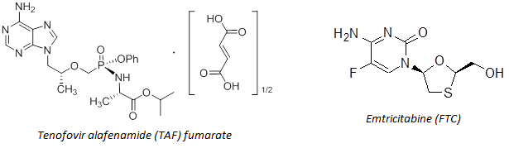
Emtricitabine (FTC) and tenofovir alafenamide fumarate (TAF) used in Biktarvy are the same as used in Emtriva (ARTG 96426) and Descovy (ARTG 246093 (200 mg/10 mg) and ARTG 246092 (200 mg/25 mg)). Their manufacture, quality control and stability have been assessed and approved by TGA previously, and no assessment of these has been undertaken in the current chemistry evaluation.
Bictegravir is a new chemical entity. Bictegravir is an INSTI that binds to the integrase active site and blocks the strand transfer step of retroviral DNA integration which is essential for the HIV replication cycle.
The International Union of Pure and Applied Chemistry (IUPAC) name of bictegravir sodium is Sodium (2R,5S,13aR)-7,9-dioxo-10-[(2,4,6-trifluorobenzyl)carbamoyl]-2,3,4,5,7,9,13,13a-octahydro-2,5-methanopyrido[1',2':4,5]pyrazino[2,1-b][1,3]oxazepin-8-olate and the CAS name is 2,5-Methanopyrido(1’,2’:4,5) pyrazino(2,1-b)(1,3)oxazepine-10-carboxamide, 2,3,4,5,7,9,13,13a-octahydro-8-hydroxy-7,9-dioxo-N-((2,4,6-trifluorophenyl)methyl)-, sodium salt.
The following figure (Figure 2) describes the chemical structures of bictegravir (sodium salt).
Figure 2: Structural formula of bictegravir (sodium salt)
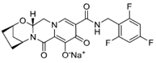
C₂₁H₁₇F₃N₃NaO₅ Formula Weight 471.4 g/mol
Bictegravir sodium is an off white to yellow, slightly hygroscopic solid. It is practically insoluble to very slightly soluble in aqueous media across the physiological pH range (pH 1.8 to 8.8). It contains three chiral centres. Only one crystalline form of bictegravir sodium has been identified.
Potential impurities are adequately controlled. The enantiomeric purity of the drug substance is adequately controlled and particle size is controlled. The influence of bictegravir sodium particle size on drug product solubility has been examined.
Bictegravir shows good solid state stability and adequate stability data have been provided to support a retest period for the drug substance of 24 months when stored under 30°C.

Drug product
Bictegravir/emtricitabine/tenofovir alafenamide (B/F/TAF) tablets are capsule shaped, film coated purplish brown, debossed with ‘GSI’ on one side of the tablet and ‘9883’ on the other side of the tablet. Tablets are not scored. Tablets are approximately 15 mm in length and 8 mm in width, and packaged in 100 mL HDPE bottles containing 30 tablets. Each bottle contains 3 grams of desiccant and a polyester coil, and is capped with a white, continuous thread, child resistant polypropylene screw cap lined with an induction sealed aluminium foil liner.
Each tablet contains bictegravir (50 mg, as sodium salt), emtricitabine (200 mg) and tenofovir alafenamide (25 mg, as fumarate salt).
The tablets are bilayer: one layer contains bictegravir sodium and the other contains FTC and TAF. The manufacture of the product is conventional for bilayer tablets, that is, preparation of powder blends, compression and film coating.
TAF is susceptible to hydrolysis. Moisture is controlled during tablet manufacture through use of a dry granulation process, and the bottle contains desiccant to control moisture during use. Finished product specifications also include an appropriate limit for water content. TAF-related impurities increase slightly on storage; however, no significant changes were observed during the stability trials.
The quality of the tablets is controlled by specifications that include appropriate tests and limits for assay (bictegravir sodium, emtricitabine and tenofovir alafenamide fumarate), impurities, water content, uniformity of dosage units and dissolution. The company has been requested to tighten the proposed limit for the impurity PMPA anhydride to not more than (NMT 2.5% in accordance with TGA nonclinical advice.
Stability data have been generated under stressed, accelerated and real time conditions. These data support the proposed shelf life of 24 months, when stored below 30°C.
Provided the following issues are addressed, registration is recommended from a pharmaceutical chemistry perspective.
- The finished product specification for the impurity PMPA anhydride should be tightened to NMT 2.5% in accordance with TGA toxicology advice.
- The toxicology evaluation has now been completed. The proposed limit for GS-713179 is not toxicologically qualified and should be tightened to the International Conference on Harmonisation (ICH) limit (that is, to NMT 0.15%).
The proposed limits for the other impurities, GS-713180 and GS-709293 are qualified.
Addendum 30 April 2018:
Previously identified issues with impurities PMPA anhydride, GS-713179, GS-709293 and GS-713180 have been resolved and proposed limits are qualified. Follow up advice and review clarified that the proposed limits are acceptable and do not require tightening.

Biopharmaceutics

Absolute bioavailability
No absolute bioavailability studies were submitted. In accordance with TGA Guidance 15; Biopharmaceutic Studies, justification for not submitting an absolute bioavailability study was provided and clinical advice on its acceptability has been sought.

Bioequivalence of market and clinical trial formulations
No Phase I studies examined the bioequivalence between the original FDC formulation, as used in some Phase I and Phase III studies, and the to-be-marketed formulation of Biktarvy. However, the difference between the two formulations was minor as it represented a reduction in magnesium stearate content in the FTC/TAF layer from 1.5% w/w in the original to 1.0% w/w and dissolution studies undertaken by the sponsor indicate that the dissolution profiles of the two formulations were comparable.
The pharmacokinetics of single dose BIC 75 mg as a single agent, as used in the Phase II Safety and Efficacy Study GS-US-141-1475, co-administered with FTC/TAF 200/25 mg tablets was compared with the pharmacokinetics of the FDC tablet containing B/F/TAF (50/200/25 mg) that was used in the initial Phase III studies in healthy subjects under fasted conditions in Study GS-US-141-1233. The results indicated that the geometric least square mean (GLSM) ratios and their 90% confidence intervals (Cis) comparing the primary pharmacokinetic parameters for BIC, FTC, and TAF between the 50 mg B/F/TAF FDC and BIC 75 mg + FTC/TAF under fasted conditions were within the protocol defined boundaries of equivalence (70% to 143%), with the exception of TAF C_{max}, for which the GLSM ratio (90% CI) was 84.17% (67.59%, 104.81%). The difference in TAF C_{max} identified between the two regimens is unlikely to be of clinical significance.

Effect of food
The effects of food on the pharmacokinetics of the original FDC tablet formulation containing B/F/TAF (50/200/25 mg) were assessed in Study GS-US-141-1233:
- BIC AUC_{inf} and C_{max} were approximately 24% and 13% higher, respectively, following a high fat meal than they were under fasted conditions.
- A moderate fat meal increased BIC AUC_{inf} and C_{max} by 24% and 20%, respectively.
- A high fat meal increased TAF AUC_{last} by 63% compared to fasted conditions, whereas, a moderate fat meal increased TAF AUC_{last} by 48%.
- By contrast, food had little to no meaningful effect on TAF C_{max} or the AUC of FTC. However, a small decrease (14%) in FTC C_{max} was observed following administration with a high fat meal.
The study supports the PI statement regarding dosing with or without food.

Quality summary and conclusions
The applicant has been requested to tighten the specification for one impurity in the drug product specifications in line with advice from TGA toxicology section. (This issue was resolved prior to the decision phase).
Approval is recommended from a chemistry and quality perspective.

IV. Nonclinical findings

Introduction
The sponsor has applied to register a new oral fixed dose combination tablet containing bictegravir, emtricitabine and tenofovir alafenamide (50/200/25 mg/day per oral (PO); Biktarvy) for the treatment of human immunodeficiency virus-1 (HIV-1) infection and the treatment of chronic hepatitis B in adults co-infected with HIV-1. Bictegravir is a new chemical entity whereas emtricitabine and tenofovir alafenamide have been previously evaluated. Accordingly, the focus of this evaluation is on bictegravir.
The sponsor has provided a high quality dossier of studies focused on bictegravir. Except where stated below triple drug combination studies were not supplied. Full carcinogenicity studies were also not supplied; however, as per the Guideline; the submission of full carcinogenicity studies can be deferred on the basis of a post-approval commitment. No combination toxicology bridging studies have been supplied. An acceptable waiving statement based on the lack of overlapping toxicity in animals was supplied. The mode of action of bictegravir (INSTI) does not overlap with the modes of action of the combination drugs (NRTI plus NRTI). Bictegravir acts synergistically with the other drugs in a combination antiviral assay (discussed below). There is also substantial nonclinical experience with the safety properties of the FTC/TAF drug combination.

Pharmacology

Nonclinical virology
Bictegravir is a second generation HIV INSTI. Other members of this drug class include dolutegravir. Most of the submitted studies were evaluations of antiviral activities of bictegravir compared with dolutegravir and the first generation INSTIs, raltegravir and elvitegravir using HIV-1. No studies on hepatitis B/HIV-1 co-infection were supplied.

Mechanism of action
The second generation INSTIs were developed to overcome the low barrier to resistance and cross resistance with the first generation INSTIs (such as raltegravir and elvitegravir). Compared with the first generation INSTIs, the second generation drugs generally have tighter binding to the integrase inhibitor binding pocket. This partly explains their pharmacological advantages.
Bictegravir inhibited HIV strand transfer (half-maximal inhibitory concentration (IC₅₀) 7.5 nM; similar to dolutegravir and elvitegravir) and the 3’-end processing activities of recombinant HIV-1 integrase (IC₅₀ 241 nM; similar to dolutegravir but ~ 2 times lower than elvitegravir) in vitro. Polymerase chain reaction (PCR) measurement of abortive circular viral DNA 1-LTR and 2-LTR levels demonstrated that bictegravir (test concentration 28 nM) inhibited viral DNA integration in a human T cell line in vitro (equivalent to dolutegravir).
Based on its in vitro integrase DNA dissociation t_{½} (38 hours with wild type integrase and 2.5 hours with G140S+Q148H mutant), bictegravir formed relatively more stable drug-HIV-1 integrase-HIV-1 LTR DNA complexes (t_{½} 2 to 4 times longer than dolutegravir and 7 to 25 times longer than the first generation INSTIs). Long dissociation t_{½} correlates with improved antiretroviral activity and a higher barrier to resistance (consistent with bictegravir’s in vitro antiviral activity) compared with the first generation INSTIs.

Antiviral activity in cell culture
Bictegravir and dolutegravir displayed similar potency against a diverse range of HIV-1 strains (including clinical isolates) covering group M subtypes A through G, and groups O and N (including clinical isolates) cultured in primary T cells, T cell lines, PBMC and primary macrophages. Bictegravir half-maximal effective concentration (EC₅₀) was in the nanomolar range, < 0.05 to 6.6 nM, and generally slightly (≤ ~ 2 times) higher than dolutegravir EC₅₀. At 30 times multiplicity of infection, bictegravir’s EC₅₀ increased by ~ 6 times. Bictegravir had lower EC₅₀ values compared with the first generation INSTIs raltegravir and elvitegravir, and the NRTIs zidovudine and tenofovir. Bictegravir’s EC₅₀ for HIV-1 BaL was ~ 2 times higher than that of the NNRTI, efavirenz. Bictegravir (EC₅₀ 1.1 nM) was 2 times more potent against HIV-2 than dolutegravir and 4 times more potent than zidovudine.

Effect of serum and serum components on bictegravir potency
Bictegravir is highly protein bound. Equilibrium dialysis of bictegravir between human plasma against the cell culture medium containing 10% foetal bovine serum (FBS) showed a 43.6 fold higher concentration of bictegravir in human plasma than in the culture medium, indicating ~ 44 fold higher protein binding in human plasma than in 10% FBS. In an in vitro antiviral test, bictegravir’s EC₅₀ increased by ~ 20 times in the presence of physiological concentrations of human serum albumin and alpha-1-acid glycoprotein based on its in vitro effects on HIV-1 LAI-RLuc. In 100% human serum, the EC₅₀ of bictegravir (linear extrapolation from EC₅₀ from 10 to 50% human serum) increased 74 fold compared with cell culture medium. Correcting for a 74 fold shift in potency in the presence of human serum, the EC₅₀ values for bictegravir in cell cultures (< 0.05 to 8 nM) would correspond to human plasma concentrations of up to 592 nM, which are below the clinical plasma bictegravir concentrations (C_{tau} 5.8 µM, C_{max} 13.7 µM). In an antiviral assay in MT-4 cells, the protein binding adjusted EC₉₅ was 361 nM, which is below the clinical C_{max} or C_{tau}.

Cytotoxicity and mitochondrial toxicity
Cytotoxicity of bictegravir was determined in the antiviral assays. The cytotoxicity concentration (CC₅₀) of bictegravir to T cells or resting and mitogen activated PBMC ranged from 1.5 µM to 9 µM, giving selectivity indices (CC₅₀/EC₅₀) of ~ 1500 to 8500. Bictegravir’s selectivity index was generally lower than that of dolutegravir (by 6 times in MT-2 cells and 4 times in PBMCs) except in MT-4 cells (2 times higher than dolutegravir).
Bictegravir’s cytotoxicity to non-target cells was evaluated in primary human hepatocytes, human hepatoma cells, human prostate cancer cells and human fibroblasts in vitro. CC₅₀ values were > 30 µM (> 100 µM in hepatocyte toxicity), with essentially equivalent cytotoxicity to dolutegravir.
No specific mitochondrial toxicity studies were conducted. Since bictegravir is not an NRTI, it is not expected to cause mitochondrial toxicity. The lack of significant cytotoxicity in hepatocytes (discussed above) also indicates low mitochondrial toxicity.

Combination antiviral activity
In the in vitro triple drug combination studies, bictegravir acted synergistically with emtricitabine and tenofovir alafenamide. The level of synergism was approximately the same as dolutegravir. In double combination studies, bictegravir behaved synergistically with tenofovir alafenamide, emtricitabine, and the protease inhibitor (PRI) darunavir. Bictegravir behaved additively with the first generation INSTIs.

Resistance and cross resistance
Bictegravir retained antiviral activity against most INSTI, NRTI, NNRTI and PRI resistant HIV-1 strains (with mutations identified in clinical isolates) in vitro (EC₅₀ increased by ~ ≤ 2 times with similar activity to dolutegravir). In susceptibility studies with INSTI resistant clinical HIV-1 isolates, nearly all isolates were susceptible to bictegravir. Only one isolate with three mutations E138K+G140S+Q148K displayed resistance to bictegravir (19 fold increase in EC₅₀ compared with wild type isolate EC₅₀ 1.94 nM). Six isolates displayed a 5- to 10 fold reduction in susceptibility (compared with wild type) and these mutants contain G140A/C/S and Q148H/K/R mutations (with two also carrying an E138A/K mutation). Other isolates with a 2 to 5 fold reduction in susceptibility also carry double or triple mutations at G140, Q148 and/or E138. Bictegravir generally had a similar resistance profile compared with dolutegravir against the integrase mutants. Site directed mutants with G118R and T97A+G118R had < 5 fold reduced susceptibility to BIC.
Based on multi-passage resistance selection of HIV-1 IIIb, HIV-1 BaL or HIV-1 xxLAI, bictegravir displayed a higher in vitro barrier to resistance compared with elvitegravir and emtricitabine. Bictegravir’s barrier to resistance was similar to that of dolutegravir. Bictegravir resistance selection was associated with two integrase mutations R263K and M50I. Both mutations are natural polymorphisms associated with INSTI resistance. Raltegravir and elvitegravir also selected R263K mutation, which occurs in about 0.4% patients sub-optimally treated with dolutegravir. The susceptibility of this mutant to bictegravir was comparable to that of dolutegravir. Strains with this mutation are replication incompetent. , This data have been used to support the hypothesis that resistance against dolutegravir may not develop via the raltegravir/elvitegravir resistance pathways. Bictegravir also selected S153F, and dolutegravir selected S153Y. The bictegravir selected mutant conferred cross resistance to dolutegravir, raltegravir and elvitegravir. The two second generation NRTIs showed very similar antiviral and resistance profiles.
For bictegravir, the most important clinically relevant resistance mutations appear to be at E138, G140 and Q148. A triple mutant (T66I+E138K+Q148K) selected by elvitegravir in vitro (Study PC-141-2056), which also occurs in patients, displayed high cross resistance to bictegravir (44 fold increase in EC₅₀) as well as dolutegravir (26 fold increase in EC₅₀). As discussed above, a patient-derived isolate with triple mutations E138K+G140A+Q148K was resistant to bictegravir (19 fold increase in EC₅₀) and isolates with double mutations at G140, Q148 and/or E138 (and also another triple mutant E138K+G140S+Q148H) increased bictegravir EC₅₀ by 2 to 8 fold (Study PC-141-2051). In another study (Study PC-141-2040), a double mutant (E139K+Q148K) resistant to raltegravir and elvitegravir showed relatively high resistance to bictegravir and dolutegravir (9 to 10 times increase in EC₅₀) and a G140S+Q148R mutant also had some resistance to the two second generation INSTIs (2 and 5 fold increase in EC₅₀, respectively). Consistent with the findings with dolutegravir multiple mutations are required to produce > 10 times increase in EC₅₀.
Bictegravir selected HIV-1 mutants remained fully sensitive to the NNRTI efavirenz. Bictegravir selected mutants had cross resistance to dolutegravir and slightly low cross resistance to raltegravir but high cross resistance to elvitegravir.

Secondary pharmacodynamics and safety pharmacology
In radioligand screening assays, no biologically relevant interactions occurred between bictegravir (10 μM; ~ 70 times the clinical C_{max unbound} 0.137 µM based on 99% plasma protein binding) and neurotransmitter, hormone, ion channel and transporter systems covering the adenosine, sympathetic, parasympathetic, bradykinin, calcium channels, dopamine, endothelin, epidermal growth factor (EGF), estrogen, Gamma aminobutyric acid (GABA), glucocorticoid, glutamate, histamine, imidazole, IL1, leukotriene, melatonin, neuropeptide, opiate, phorbol ester, platelet activating factor (PAF), potassium channel, prostanoid, purinergic, rolipram, serotonin, sodium channel, tachykinin, and thyroid hormone, systems. GABA transporters were inhibited by 47% in the presence of 10 μM bictegravir. This is likely to be clinically irrelevant.
Bictegravir has no activity against hepatitis B and C viruses, influenza A virus, human rhinovirus and respiratory syncytial virus.
Safety pharmacology studies (all Good Laboratory Practice (GLP) compliant) investigated neurobehavioral (in rats), hERG channel, cardiovascular (in primates) and respiratory (in rats) effects. No adverse effects on neurobehaviour, cardiovascular function or respiration were detected at doses ≤ 300 mg/kg (~ 55 times human dose based on surface area comparison). Bictegravir displayed no meaningful inhibition of hERG current in vitro (10% inhibition at ~ 7.1μM, ~ 50 times the clinical free fraction C_{max}).

Pharmacokinetics
Pharmacokinetic profiles of bictegravir were investigated in animal species which are used in pharmacology and toxicity studies. Pharmacokinetics in animals approximated human pharmacokinetics. There were no clinically relevant human specific metabolites.
Absorption and plasma pharmacokinetics were evaluated in single dose PO and/or intravenous (IV) studies in mice, rats, rabbits, dogs, and two species of monkeys. Oral bioavailability was ~ 42 to 50% in dogs and rats, and ~ 74% in cynomolgus monkeys (consistent with the > 60% predicted PO bioavailability in humans). PO absorption was rapid with T_{max} ~ 1 hour in dogs, 4 hours in rats, and 1 to 5 hours in monkeys. In rats, dogs and two species of monkeys, the steady state volume of distribution (Vss) was less than the total body water (0.09 to 0.22 L/kg) and plasma clearance ranged from ~ 0.005 to ~ 0.03 L/kg/h (~ 0.1 to 1.3% of hepatic blood flow). Plasma t_{½} was 3 to 5 hours in dogs and primates and considerably longer in rats (26 to 32 hours).
Bictegravir is highly plasma protein bound in rats, dogs, monkeys and humans (> 99% except for dogs 98.8%). The human fraction unbound (fu) is 0.25%. Bictegravir had minimal erythrocyte binding (blood:plasma ratio ~ 0.6 to .7 in rat, monkey and human blood).
In pigmented and non-pigmented rats bictegravir-derived radioactivity was rapidly (by 0.25 hours post dose) and widely distributed following PO dosing. Tissue concentrations remained below blood levels over the 168 hours observation period. Initially, radioactivity was concentrated in the upper digestive tract and bile, reflecting the routes of administration and elimination. There was no evidence of concentration in pigmented skin; however, radioactivity levels were higher in the uveal tract of pigmented compared with albino rats. Brain radioactivity levels remained below 4% relative to blood. Radioactivity was concentrated in the liver and bile over the 0.25 to168 hours post dose observation period, reflecting the major pathway of biliary excretion. Lower levels of radioactivity were detected in the kidney and urinary bladder, likely reflecting urinary excretion. Concentration of radioactivity in the adrenal glands, bone marrow and brown fat was also observed.
Bictegravir is mainly metabolised by cytochrome P450 (CYP) CYP3A and uridine diphosphate glucuronosyltransferase (UGT) UGT1A1, with minor contribution by UGTs 1A3, 1A8 and 1A9. However, the major drug related moiety in human and animal plasma is the parent drug (~ 68% in human and ~ 80% in rat and monkey plasma), consistent with in vitro studies with hepatic microsomal preparations and hepatocytes. In hepatic microsomal preparations, bictegravir is highly stable, with predicted hepatic extraction of 13% in humans, 29% in Sprague-Dawley rats, 16% in dogs, and 27% in cynomolgus monkeys and 18% in rhesus monkeys. In Wister rat and human hepatocytes, 92 to 94% remained intact after 4 hours, compared with 79% and 52% in dog and cynomolgus monkey hepatocytes.
Bictegravir undergoes oxidation (for example, hydroxylation), defluorination and conjugation (glucuronidation, sulfation, cysteinylation) in all species. Hydroxy bictegravir sulfate (M20, 20%) and bictegravir glucuronide (M15, 8.6%) are two major metabolites in human plasma. M20 was also detected in rat plasma (~ 11%) and to a smaller extent, monkey plasma (~ 1%), and M15 was present in animal plasma at low levels, but at high levels in excreta (~ 13% of dose in rat bile, 4 to 6% of dose in monkey urine and bile). Desfluoro hydroxyl bictegravir cysteine conjugate (M9) was a major metabolite in human faeces (13% of dose), and was also found in rat bile (1.2% of dose) and monkey bile (11% of dose). Other major human metabolites M11/M22 (not separated by the analytical method; 8% of dose) detected in faeces were also detected in rat faeces (8% of dose) and monkey bile (6% of dose).
Across all evaluated species the majority of drug associated radioactivity was excreted in faeces (> 40% of dose) mainly as unchanged drug and with smaller amounts in urine (< 21% of dose) mainly as metabolites. Bile duct cannulation studies demonstrated biliary excretion in rats and monkeys of 34 to 40% of drug derived radioactivity, with evidence of conversion of metabolites to bictegravir in the intestinal tract in rats, but not in monkeys.

Pharmacokinetic drug interactions
Bictegravir is predominantly metabolised by CYP3A and UGT1A1. Co-administration with medicinal products that induce CYP3A and/or UGT1A1 may decrease bictegravir plasma concentrations. Co-administration of bictegravir with medicinal products that inhibit CYP3A and/or UGT1A1 may increase plasma concentrations of bictegravir.
In vitro studies showed that bictegravir is not an inhibitor or only causes weak inhibition of CYP1A, CYP1A2, CYP2B6, CYP2C8, CYP2C9, CYP2C19, or CYP2D6, and thus bictegravir is unlikely to cause clinically relevant drug interactions with agents, which are metabolised by these enzymes. Bictegravir is a weak metabolism dependent inhibitor of CYP3A with an IC₅₀ 64.3 µM, which is > 450 times the unbound clinical C_{max}, and also an inducer of CYP3A (EC₅₀ 19 µM for CYP3A messenger RNA (mRNA) induction and low induction of enzyme activity, up to 37% of the response to the positive control rifampicin). The potential for clinically relevant interactions with CYP3A substrates is low.
In vitro studies with human hepatocytes demonstrated that bictegravir is not an inducer of CYP1A2 and a weak inducer of CYP2B6. Clinically relevant drug-drug interactions through the induction of CYP2B6 are not expected to occur. Bictegravir also showed some potential of inducing UGT1A1 (up to 16 fold increase in mRNA expression at 30 to 60 µM and minimal induction at 10 µM; activity not determined), but the potential for clinical drug-drug interactions is considered low.
Bictegravir is a substrate of P-glycoprotein (P-gp) and breast cancer resistance protein (BCRP). Bictegravir is a weak inhibitor of P-gp (20% at 80 µM) and not an inhibitor of BCRP in vitro, and thus it is unlikely to affect the absorption and excretion of P-gp and BCRP substrates in vivo.
Bictegravir is not a substrate or inhibitor of OATP1B1 or OATP1B3 and not an inhibitor of OAT1, OAT3 and OCT1.
Bictegravir dose dependently inhibits multi-drug and toxin extrusion protein 1 (MATE1) (IC₅₀ 8.0 μM) and OCT2 (IC₅₀ 0.42 μM) and may compete with creatinine for active excretion into renal tubules and inhibit the excretion of drugs that are substrates of these transporters. The sponsor has noted that bictegravir treatment of humans resulted in increased serum creatinine in the absence of changes to glomerular filtration rate (GFR). This effect was not detected in the repeat dose animal studies.

Toxicology

Acute toxicity
No formal single dose toxicity studies (including no combination toxicity studies) were conducted. However, no overt acute toxicity was detected at doses exceeding the saturation of absorption in rats and mice and up to 1000 mg/kg (the ICH limit dose) in monkeys.

Repeat dose toxicity
All pivotal studies were GLP compliant, were consistent with current guidelines, used an aqueous vehicle and used the proposed clinical route of administration. Oral toxicity was evaluated in transgenic mice, rats, and monkeys for treatment periods of 2 to 39 weeks. The maximum doses in the mouse and rat studies were based on the saturation of absorption doses observed in the single PO dose toxicokinetic studies and resulted in exposures 23 times and 32 times the clinical exposure, respectively. The maximum dose in the monkey studies was the ICH M3 (R2) limit dose, with exposures 16 times the clinical exposure.

Relative exposure
The following table (Table 3) describes the relative exposures in animals versus humans.
Table 3: Relative exposure in repeat dose toxicity and carcinogenicity studies
Species | Study duration (Study no.) | Dose (mg/kg/day) | AUC_{0–24 h}^ (μg∙h/mL) | Exposure ratio#
Mouse ((Wild Type) RasH2) | 4 weeks (TX-141-2042) | 30 | 629 | 6
Mouse ((Wild Type) RasH2) | 4 weeks (TX-141-2042) | 100 | 1180 | 12
Mouse ((Wild Type) RasH2) | 4 weeks (TX-141-2042) | 1000 | 2330 | 23
Mouse (RasH2) | 26 weeks (TX-141-2047) | 5/10 (male/female) | 190/341 | 2/3
Mouse (RasH2) | 26 weeks (TX-141-2047) | 15/30 (male/female) | 526/861 | 5/8
Mouse (RasH2) | 26 weeks (TX-141-2047) | 100/300 (male/female) | 1560/2340 | 15/23
Rat (Wistar) | 2 weeks (TX-141-2029) | 10 | 1160 | 11
Rat (Wistar) | 2 weeks (TX-141-2029) | 30 | 1790 | 18
Rat (Wistar) | 2 weeks (TX-141-2029) | 100 | 2555 | 25
Rat (Wistar) | 2 weeks (TX-141-2029) | 300 | 2970 | 29
Rat (Wistar) | 26 week (TX-141-2031) | 5 | 873 | 9
Rat (Wistar) | 26 week (TX-141-2031) | 30 | 1960 | 19
Rat (Wistar) | 26 week (TX-141-2031) | 300 | 3250 | 32
Rat (Wistar) | 104 week (TX-141-2040) | 2 | 594 | 6
Rat (Wistar) | 104 week (TX-141-2040) | 10 | 1360 | 13
Rat (Wistar) | 104 week (TX-141-2040) | 300 | 3180 | 31
Monkey (Cynomolgus) | 2 weeks (TX-141-2031) | 30 | 212 | 2
Monkey (Cynomolgus) | 2 weeks (TX-141-2031) | 100 | 324 | 3
Monkey (Cynomolgus) | 2 weeks (TX-141-2031) | 1000 | 1090 | 11
Monkey (Cynomolgus) | 39 weeks (TX-141-2032) | 30 | 251 | 2
Monkey (Cynomolgus) | 39 weeks (TX-141-2032) | 200 | 709 | 7
Monkey (Cynomolgus) | 39 weeks (TX-141-2032) | 1000 | 1600 | 16
Human (Population PK) | (QP-2017-1010) | 50 mg/day | 102 | –
# = animal:human plasma AUC0–24 h; ^ = data are for the sexes combined at the last sampling occasion except as indicated. PK = Pharmacokinetics

Major toxicities
Overall bictegravir displayed minimal toxicity. Adverse effects (hepatotoxicity) were only present at the highest dose 1000 mg/kg/day in monkeys after 39 weeks of dosing (16 times the clinical exposure based on AUC), and were not observed at 200 mg/kg/day (7 times the clinical exposure) or in mice or rats despite the higher AUC_{0-24h} in rodents than in monkeys. There were differences in metabolism between species with more M9 (defluoro hydroxy bictegravir cysterine conjugate) in monkey bile and human faeces than in rodent bile and faeces and M42 (hydroxy bictegravir) only in monkey plasma (not in rodent or human plasma). Hepatotoxicity may occur in patients.
Hepatotoxicity in monkeys was manifested as mild to moderate hepatocyte hypertrophy, minimal hepatocyte regenerative hyperplasia and minimal to marked hepatic bile duct hyperplasia with accumulation of bile pigment, associated with increased serum alanine aminotransferase (ALT) and gamma glutamyl transferase (GGT). Minimal granulocytic inflammation was present. These effects were partially reversible by 4 weeks post-dosing. There was no serum chemistry evidence of cholestasis (that is, no increase in serum alkaline phosphatase or bilirubin).
Minimal to slight centrilobular hepatocyte glycogen depletion was observed in male mice at 1000 mg/kg/day in the 4-week repeat dose study. This finding was possibly associated with decreased body weight gain compared with the control group, without a decrease in food consumption; however, the overall clinical relevance of this finding is uncertain.
A specific rat neuropathology study was also performed. Bictegravir dosing at up to 300 mg/kg/day PO for 2 weeks did not induce microscopic pathology in the central nervous system or clinical signs of neurotoxicity.

Genotoxicity
Bictegravir was not genotoxic in an adequately conducted ICH compliant genotoxicity screening battery including gene mutation in bacteria mutation, chromosome aberration in human lymphocytes in vitro and in vivo bone marrow cell micronucleus test in rats.

Carcinogenicity
Carcinogenicity studies were conducted in transgenic mice and rats. There were no treatment related tumours in a short-term 26 week oral gavage carcinogenicity study of bictegravir in hemizygous rasH2 transgenic mice at up to 100 mg/kg/day in males and 300 mg/kg/day in females with exposures 15 times and 23 times the clinical exposure, respectively. The study was validated by the use of a positive control group.
There were also no treatment related tumours in a long term 104 week carcinogenicity study in Han Wistar rats using doses up to 300 mg/kg/day with exposure up to 31 times the clinical exposure. The study incorporated negative and vehicle only control groups.

Reproductive toxicity
A standard reproductive toxicity screening package consisting of studies of fertility, embryofetal development and pre-postnatal development in rats and an embryofetal development study in rabbits was supplied.

Relative exposure
The following table describes the relative exposures in animals versus humans (Table 4).
Table 4: Relative exposure in the pivotal reproductive toxicity studies
Species | Study (Study no.) | Dose (mg/kg/day) | AUC_{0-24 h} (μg.h/mL) | Exposure ratio#
Rat (SD) | Fertility (TX-141-2039) | 5 | 580* | 6
Rat (SD) | Fertility (TX-141-2039) | 30 | 1790* | 25
Rat (SD) | Fertility (TX-141-2039) | 300 | 2970* | 29
Rat (SD) | Embryofetal development (TX-141-2036) | 5 | 1630 | 16
Rat (SD) | Embryofetal development (TX-141-2036) | 30 | 3080 | 30
Rat (SD) | Embryofetal development (TX-141-2036) | 300 | 3650 | 36
Rat (SD) | Pre-postnatal development (TX-141-2045) | 2 | 335 | 3
Rat (SD) | Pre-postnatal development (TX-141-2045) | 10 | 1170 | 11
Rat (SD) | Pre-postnatal development (TX-141-2045) | 300 | 3100 | 30
Rabbit (NZW) | Embryofetal development (Pivotal TX-141-2037) | 100 | 39 | 0.4
Rabbit (NZW) | Embryofetal development (Pivotal TX-141-2037) | 300 | 60 | 0.6
Rabbit (NZW) | Embryofetal development (Pivotal TX-141-2037) | 1000 | 138 | 1.4
* Based on toxicokinetic data in the 2-week repeat dose toxicity Study TX-141-2029; # = AUC_{0-24h} comparisons
High, supratherapeutic exposures (over 30 times the clinical exposure) were achieved in rats. Much lower systemic exposure was achievable in rabbits despite dosing up to 1000 mg/kg/day. Maternal toxicity (decreased food consumption and body weight gain, abortions and poor body condition) was observed rabbits at this dose.
No adverse effects on maternal health, fertility and embryofetal and postnatal development in rats were noted at the highest dose tested (300 mg/kg/day). The only embryofetal effect in rabbits was low foetal weights, which was probably secondary to maternal toxicity.

Pharmacokinetics in pregnancy and lactation
No specific studies on placental transfer were supplied. The plasma exposure of bictegravir in nursing pups was determined in a prenatal and postnatal development study in rats. Bictegravir was detected in the plasma of neonates on lactation Day 10. Bictegravir exposure in maternal rats was approximately similar to pups at the 2 mg/kg/day dose level, slightly higher (~ 1.5 times) in maternal rats than in pups at the 10 mg/kg/day dose level, and ~ 2.8 times higher in maternal rats than in pups at the 300 mg/kg/day dose level. These data imply trans-mammary exposure to bictegravir.

Pregnancy classification
The sponsor has proposed Pregnancy Category B3 for Biktarvy. This is consistent with the classification for currently registered products containing emtricitabine and tenofovir alafenamide. For bictegravir as a stand-alone substance, a pregnancy category of B1; is regarded as appropriate by the evaluator based on the embryofetal development studies in rats and rabbits.

Local tolerance
Combination studies were not supplied. Based on appropriately validated in vitro skin corrosion assays using epidermal reconstructs bictegravir is noncorrosive. Bictegravir had an in vitro irritation score of ~ 28 (moderate eye irritant) in an appropriately validated bovine corneal opacity and permeability assay. Bictegravir displayed acceptable local tolerance properties to the gastrointestinal tract in the repeat dose toxicology studies.

Immunotoxicity
In a validated mouse local lymph node assay bictegravir was neither irritant nor a sensitiser at concentrations ≤ 50% w/w (in propylene glycol).

Phototoxicity
Based on a validated in vitro neutral red uptake phototoxicity assay, bictegravir was determined to have phototoxic potential following ultraviolet A/ultraviolet B radiation (UVA/UVB) exposure. In a validated higher tier in vivo study using pigmented Long-Evans rats dosed at up to 300 mg/kg/day PO (absorption limit) for 3 days, there was no evidence of bictegravir associated UVA/UVB cutaneous or ocular phototoxicity.

Paediatric use
Bictegravir is not intended for paediatric use. No specific studies in juvenile animals were submitted.

Nonclinical summary and conclusions

Summary
- Except where noted, no bictegravir + FTC +TAF combination studies and no HIV-1 + hepatitis B co-infection studies were supplied. The submitted nonclinical dossier was guideline compatible except for the lack of drug combination toxicology bridging studies (acceptable waiving statement supplied). Bictegravir is not intended for paediatric use and no studies in juvenile animals were supplied. Where required, all pivotal studies were GLP compliant and appropriately controlled.
- Bictegravir was active against all HIV-1 subtypes (including NRTI, NNRTI, PR, and first generation INSTI resistant strains) and HIV-2 in vitro. Overall, its antiviral properties resemble those of dolutegravir (an approved second generation INSTI) and were generally superior to those of the first generation INSTIs. Bictegravir acts synergistically with FTC, TAF (comparable with dolutegravir) and protease inhibitors. Bictegravir’s resistance characteristics resemble those of dolutegravir. Many of the 2nd generation INSTI selected mutations are also associated with compromised viral replicative fitness i.e. likely of lower clinical relevance. The likely most clinically important resistance mechanism is the integrase Q148 mutation (particularly in combination with the bictegravir selected E138 and G140 and/or the T66I+E138K+Q148K triple mutation). Multiple mutations are required for high resistance. Bictegravir selected HIV-1 mutants were sensitive to efavirenz and had lower cross-resistance to raltegravir but high cross-resistance to elvitegravir.
- Secondary and safety pharmacology studies did not identify adverse off targets or effects on cardiovascular, respiratory or central nervous functions. Overlapping/interactional secondary and safety pharmacology effects for the Biktarvy drug combination are not expected.
- Bictegravir’s pharmacokinetic profile in animals was qualitatively similar to that of humans. Oral bioavailability in rodents and dogs was modest but higher in monkeys (comparable with humans). Absorption was rapid, V_{SS} was less than the total body water and estimated hepatic extraction was low. Systemic exposure following PO dosing was sub-dose proportional and displayed absorption saturation. Bictegravir is highly protein bound. Following PO dosing, drug associated radioactivity was rapidly and widely distributed with tissue levels below blood levels. High tissue concentrations reflected the routes of administration and excretion with concentration in the adrenal glands, bone marrow and brown fat. Brain levels were < 4% of blood levels. In all species, bictegravir was poorly metabolised and was the major circulating drug form. In non-primates bictegravir was N-dealkylated, glucuronidated and hydroxylised via CYP3A4 and/or UGT1A1. Monkeys were more extensive metabolisers cf. humans whereas rat metabolism more closely resembled the human situation. There were no clinically relevant human specific metabolites. Excretion was predominantly hepatobiliary.
- Bictegravir is unlikely to cause clinically relevant drug interactions via CYP1A2, CYP2B6, CYP2C8, CYP2C9, CYP2C19, CYP2D6, OAT1, OAT3, OCT1, OATP1B1 and OATP1B3. Bictegravir may cause drug interactions associated with CYP3A induction and OCT2 (and possibly weak interactions via intestinal P-gp and hepatic/renal BCRP). Co-administration with potent inducers of CYP3A and/or UGT1A1 may decrease bictegravir plasma concentrations, reducing bictegravir’s therapeutic effect and increasing the risk of resistance. Co-administration with inhibitors of CYP3A and/or UGT1A1 may increase plasma concentrations of bictegravir. Bictegravir is a substrate of P-gp and BCRP. Bictegravir dose-dependently inhibits MATE1 and OCT1 possibly reducing active renal tubular excretion of creatine and other MATE1 and OCT1 substrates.
- Bictegravir likely has a low order of acute oral toxicity.
- The effects of repeated daily PO dosing were evaluated in transgenic mice, rats, and monkeys for 2 to 39 weeks. The maximum doses in the mouse and rat studies were based on the saturation of absorption doses. The maximum dose in the monkey studies was the ICH M3 (R2) limit dose (1000 mg/kg/d). High systemic exposures (relative to the proposed human dose) were achieved. Hepatobiliary toxicity was the only adverse effect and was only detected in monkeys chronically dosed at 1000 mg/kg/d PO (animal/human exposure ratio 16), with no effects at 200 mg/kg/day (exposure ratio 7). Monkeys may be more sensitive to bictegravir hepatotoxicity compared with humans due to metabolic differences. Emesis occurred in some monkeys chronically doses at 1000 mg/kg/d PO.
- Based on the results of an adequate screening package bictegravir is not genotoxic.
- Bictegravir was not carcinogenic in an abbreviated 26 week oral gavage carcinogenicity study in hemizygous rasH2 transgenic mice nor was it carcinogenic in a 104 week study in Wistar rats.
- Bictegravir, in the absence of maternotoxicity, did not affect fertility, embryofetal development or reproduction/survival in rats and/or rabbits. Maternotoxic dosing of rabbits resulted in abortions and reduced fetal weight. Pregnancy category of B1 is appropriate for bictegravir. Pregnancy category B3 is appropriate Biktarvy and is consistent with other combination products containing FTC and TAF.
- Bictegravir had acceptable gastrointestinal (GI) local tolerance, is not a contact sensitiser, and is not phototoxic in vivo.
- All specified impurities are toxicologically qualified.

Conclusions and recommendation
- Microbiology studies demonstrated activity of bictegravir and the combination of bictegravir, emtricitabine and tenofovir alafenamide against HIV-1 and HIV-2.
- The only toxicity finding in repeat dose toxicity studies was hepatotoxicity in monkeys at high exposures (16 times the clinical exposure).
- Reproductive toxicity studies revealed no effects on fertility or embryofetal and postnatal development.
- There are no nonclinical objections to the approval of Biktarvy.

V. Clinical findings
A summary of the clinical findings is presented in this section.

Introduction

Background
HIV-1 infection is a global public health challenge with over 37 million patients infected worldwide, with the highest incidence in non-developed countries in Africa and Asia. In Australia, an estimated 25,313 people were living with HIV in 2015, and about 10% were unaware of their infection. Infection rates are relatively stable with approximately 1,000 new HIV diagnoses each year. Most infections in Australia occur among men who have sex with men (68%), and following heterosexual intercourse (20%). HIV prevalence in homosexual and bisexual men is 7.2%, but it is significantly lower in IV drug users (1.7%), and female sex workers (0.1%). In 2015, approximately 84% of people were receiving antiretroviral therapy (ART), of whom 92% were estimated to have an undetectable viral load. AIDS deaths and AIDS related disease are now uncommon in people receiving treatment.

Current treatment options
Drug treatment is directed at adults and children with known infections to suppress viral replication; to allow CD4 counts to increase; and to prevent disease progression. Prophylaxis is also used in high risk groups, in particular for the prevention of mother to child transmission. With rare exceptions, the current treatment recommendation is that all patients with detectable HIV-1 viraemia should begin ART as soon as possible after diagnosis, irrespective of CD4 count, to prevent disease progression and limit transmission. Three large, randomised clinical trials have demonstrated a significant benefit for immediate treatment compared with deferred treatment.,,
Table 5: Clinical trials comparing immediate versus deferred ART (from Gunthard, 2016) ²²
The recommended initial regimen for most patients is dual NRTIs plus an INSTI. Other regimens include dual NRTIs with a NNRTI or a boosted protease inhibitor Simpler regimens are recommended in special circumstances such as pregnancy or PrEP in high risk populations. Many ART options are available and selection depends on factors including ease of administration, adverse events, drug interactions, and resistance. A summary of recommended regimens is shown in Table 6. Optimal INSTI-based regimens for initial ART include dolutegravir/abacavir/lamivudine; dolutegravir + FTC/TAF; elvitegravir/cobicistat/TAF/FTC and raltegravir + TAF/FTC.
Table 6: Recommendations for initial ART regimens (from Günthard, 2016)²²
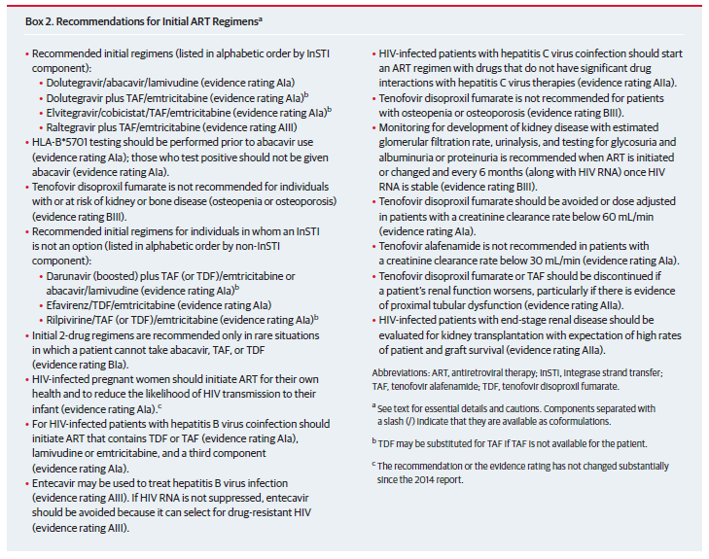

Clinical rationale
Because AIDS related mortality and morbidity are now uncommon, optimal ART therapy is now directed towards tolerability, long term safety, and simple treatment regimens to enhance compliance, drug resistance, and non-AIDS related co-morbidities. Biktarvy has been developed to comply with accepted treatment guidelines, with the expectation of high rates of virologic suppression, low rates of treatment emergent resistance, and good tolerability. One FDC tablet taken once daily offers optimal treatment compliance.

Formulation

Formulation development
According to the Biopharmaceutics Classification System (BCS), BIC is a low solubility, high permeability (BCS class 2) compound. FTC is a high solubility, high permeability (BCS 1) compound. TAF is a high solubility, low permeability (BCS 3) compound.
The proposed commercial drug product is an immediate release (IR), FDC tablet, which contains 50 mg BIC, 200 mg FTC and 25 mg TAF (B/F/TAF). BIC is incorporated into the drug product as BIC sodium, and TAF is incorporated into the drug product as the hemifumarate form (referred to as TAF fumarate). The B/F/TAF tablet is a bilayer tablet with one layer containing BIC and the other layer containing FTC and TAF. BIC sodium is dry granulated with intra-granular excipients to produce BIC granules, which are subsequently blended with extra-granular excipients to produce the BIC final powder blend. FTC and TAF fumarate are co-dry granulated with intra-granular excipients and lubricated with extra-granular magnesium stearate to produce the FTC/TAF final powder blend.
BIC single agent tablet strengths of 5 mg, 25 mg, and 100 mg were initially developed and manufactured to support Phase I studies. Based on the results of these studies, a BIC dose of 75 mg was chosen for Phase II studies.
The BIC single agent tablet formulation was subsequently modified to incorporate FTC and TAF fumarate. The resulting BIC/FTC/TAF 75/200/25 mg FDC tablets containing 75 mg of BIC were compared to BIC 75 mg single agent co-administered with FTC/TAF 200/25 mg tablets in a relative bioavailability Study GS-US-141-1233. Based on higher than expected BIC exposures when administered as the BIC/FTC/TAF 75/200/25 mg FDC, the dose of BIC was reduced from 75 mg to 50 mg and a new B/F/TAF 50/200/25 mg FDC tablet was developed. When B/F/TAF tablets containing 50 mg of BIC were then administered in Study GS-US-141-1233, similar exposures of BIC, FTC and TAF were observed, as compared with subjects that received co-administered BIC 75 mg single agent and FTC/TAF 200/25 mg tablets. As such, the B/F/TAF 50/200/25 mg tablets were used to initiate Phase III studies.
The B/F/TAF 50/200/25 mg tablet formulation was then modified during Phase III studies to improve tablet properties and compression process performance by reducing the magnesium stearate content in the FTC/TAF layer from 1.5% to 1.0% w/w. This formulation was then used in all ensuing clinical, and stability studies, and is identical to the designated commercial tablet formulation.
A tabular overview of the development of the BIC single agent and the B/F/TAF FDC tablets is summarised in Table 7.
Table 7: Formulation summary for key studies with BIC single-agent tablets and BIC/FTC/TAF FDC tablets used in clinical studies
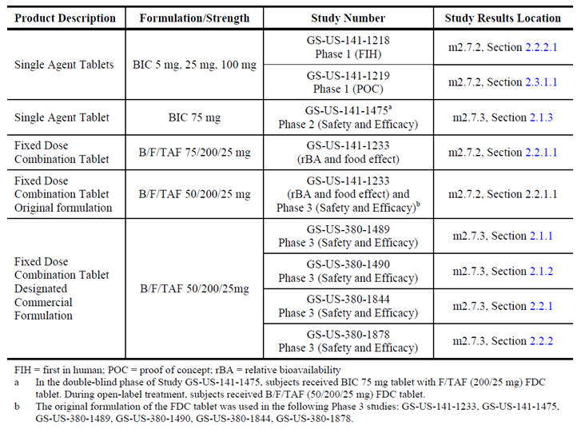

Dissolution profile
The dissolution profile for the drug product Lot EN1503B, which was used in the relative bioavailability Study GS-US-141-1233 was compared to the dissolution profiles of drug product Lots EN1610B and EN1612B, which are representative of the designated commercial tablet manufacturing process at each of the two proposed commercial manufacturing sites. The results indicated that dissolution was comparable between all three tablet lots, and not less than 90% of BIC, FTC and TAF were dissolved by 30 minutes, which is consistent with the dissolution profile expected for an immediate release formulation.

Excipients
Each tablet contains 50 mg of BIC, as free acid (equivalent to 52.5 mg of bictegravir sodium), 200 mg of FTC, and 25 mg of TAF, as free base (equivalent to 28 mg tenofovir alafenamide fumarate) and the following inactive ingredients: croscarmellose sodium, magnesium stearate, and microcrystalline cellulose. The tablets are film-coated with a coating material containing iron oxide black, iron oxide red, polyethylene glycol, polyvinyl alcohol, talc, and titanium dioxide.

Guidance
The Phase III study designs and durations were based on the applicable US and EU regulatory guidance documents., The clinical endpoints were based on guidance documents from the US Department of Health and Human Services Food and Drug Administration Center for Drug Evaluation and Research (CDER); and the Center for Biologics Evaluation and Research (CBER 2002). Overall advice was sought from the US Food and Drug Administration (FDA), including an end of Phase II meeting held in October 2015. Advice on non-clinical aspects was sought from the CHMP.

Contents of the clinical dossier
The current submission contains:
- 15 pharmacokinetic (PK)/pharmacodynamic (PD) studies, all of which contain PK data, whereas, five studies contained PD data.
- Two population PK studies were also included in the evaluation materials, which examined the population PKs of BIC and TAF, respectively, in combined populations of healthy subjects and HIV infected patients. A final analysis was provided that represented a quantitative analysis and prediction of BIC drug-drug interactions (DDIs).
- One Phase II Study (GS-US-141-1475).
- Four Phase III studies (GS-US-380-1489; GS-US-380-1490; GS-US-380-1844; GS-US-380-1878).

Paediatric data
No data submitted.

Good clinical practice
All studies were conducted according to the principles of ICH Good Clinical Practice (GCP).

Evaluator’s commentary on the clinical dossier
The contents of the clinical dossier are satisfactory.

Pharmacokinetics

Studies providing pharmacokinetic data
A list of the studies that provided pharmacokinetic information is given in Table 8 below.
Table 8: Submitted pharmacokinetic studies
PK topic | Subtopic | Study ID | *
PK in healthy adults | Relative Bioavailability | GS-US-141-1233 | Relative bioavailability of the FDC and free combination and food effect
PK in healthy adults | Single and Multi-ascending doses | GS-US-141-1218 | PKs of BIC following single- and multiple-ascending oral doses of BIC and DDI potential between BIC and FTC/TAF
PK in healthy adults | Thorough QT | GS-US-141-1480 | Effect of BIC on the QT/QTc interval and PKs of therapeutic and supra-therapeutic doses
PK in healthy adults | Mass balance | GS-US-141-1481 | Mass balance of BIC following administration of a single, oral dose of radiolabelled (¹⁴C)-BIC
PK in special populations | Target population§ | GS-US-141-1219 | Safety, PKs and antiviral activity of BIC in HIV-1 infected subjects
PK in special populations | Hepatic impairment | GS-US-141-1478 | PK profile of a single oral dose of 75 mg BIC in subjects with moderate hepatic impairment relative to matched, healthy controls
PK in special populations | Renal impairment | GS-US-141-1479 | BIC PKs following a single, oral, 75 mg dose in subjects with severe renal impairment and matched, healthy controls
PK in special populations | Other special population | GS-US-380-1991 | PKs of BIC, FTC, TAF and TFV to healthy Japanese and Caucasian subjects
PK interactions | ATV, COBI, RIF, VORI, DRV | GS-US-141-1485 | Effect of mixed UGT1A1/CYP3A4 inhibition on BIC PKs
PK interactions | MDZ | GS-US-380-4270 | Effect of B/F/TAF FDC on the PKs of the CYP3A probe, MDZ
PK interactions | LDV/SOFC | GS-US-380-1761 | Interaction between B/F/TAF and LDV/SOF
PK interactions | SOF/VEL/VOX | GS-US-380-1999 | PKs of steady state BIC, FTC, TAF and TFV following administration with SOF/VEL/VOX
PK interactions | Metformin | GS-US-380-3908 | PKs of metformin following the steady state co-administration of B/F/TAF FDC
PK interactions | Antacid, calcium, or iron supplements | GS-US-380-3909 | Effect of simultaneous administration of antacid, calcium, or iron supplements with B/F/TAF FDC
Population PK analyses | Healthy subjects and target population | QP-2017-1010 BIC Population PK | Population PKs of BIC using the data collected from eight clinical studies
Population PK analyses | Healthy subjects and target population | QP-2017-1012 TAF PopPK | Population PK of TAF based on the results of 12 clinical studies
Population PK analyses | Other | QP 2015-1001 DDI | Quantitative analysis and prediction of BIC drug-drug interactions
* Indicates the primary PK aim of the study. † Bioequivalence of different formulations. § Subjects who would be eligible to receive the drug if approved for the proposed indication. ATV = Atazanavir; COBI = Cobicistat; DRV = Darunavir; LDV = Ledipasvir; MDZ = Midazolam; QT = Electrocardiographic interval between the beginning of the Q wave and termination of the T wave, representing the time for both ventricular depolarisation and repolarisation to occur; QTc = QT interval corrected for heart rate; RIF = rifampin; SOF = Sofosbuvir; TFV = Tenofovir; VEL = Velpatasvir; VORI = Voriconazole; VOX = Voxilaprevir

Evaluator’s conclusions on pharmacokinetics
Overall, the conduct of the clinical pharmacology trials for Biktarvy was satisfactory, the data analyses undertaken were appropriate and the analytical methods used to measure exposure levels were validated.

Absorption, distribution, metabolism and excretion
Biktarvy is an immediate release (IR) FDC tablet that is intended for once daily oral dosing.
Following a single dose of the FDC tablet under fasted conditions the median T_{max} values for BIC, FTV and TAF occurred 2.00 hours, 1.50 hours and 0.5 hours after dosing, respectively, and the mean t_{½} values were 18.9 hours, 19.1 hours and 0.33 hours, respectively.
The PKs of a single dose of BIC 75 mg single agent co-administered with FTC/TAF 200/25 mg tablets was bioequivalent with the FDC tablet containing BIC/FTC/TAF (50/200/25 mg), with the exception of TAF C_{max}, for which the GLSM ratio (90% CI) was 84.17% (67.59%, 104.81%).
BIC AUC_{inf} and C_{max} for the FDC were approximately 24% and 13% higher, respectively, following a high fat meal than they were under fasted conditions, whereas, a moderate fat meal increased BIC AUC_{inf} and C_{max} for the BIC/FTC/TAF FDC by 24% and 20%, respectively. A high fat meal increased TAF AUC_{last} by 63% compared to fasted conditions, whereas, a moderate fat meal increased TAF AUC_{last} by 48%. In contrast, food had no meaningful effect on TAF C_{max} or FTC AUC. However, a small decrease (14%) in FTC C_{max} was observed following administration with a high fat meal.
Following single ascending doses of BIC (5, 25, 50, 100, 300, or 600 mg) under fasted conditions, BIC exposures were approximately dose proportional over the dose range of 25 to 100 mg, whereas at lower doses (5 mg to 25 mg) and higher doses (100 mg to 600 mg) increases in exposure were less than dose proportional.
Following therapeutic (75 mg) and supra-therapeutic doses (300 mg) of BIC under fed conditions BIC exposure was slightly less than dose proportional and GLSM ratios for dose normalised C_{max} and AUC_{inf} were approximately 86% (using the 75 mg dose as a reference).
Following multiple doses of 25 to 100 mg BIC, BIC AUC_{tau} and C_{max} values increased in a less than dose proportional manner. Steady state levels of BIC were achieved following 4 to 6 days of dosing and the accumulation ratios for all doses were approximately 1.6 fold.
Following a single dose of the FDC tablet under fasted conditions, the Vz/F values for the BIC, FTC, TAF components were 12.3 L, 543.2 L and 80.4 L, respectively.
In vitro studies indicate that BIC is highly bound to human plasma proteins (> 99%).
The blood to plasma ratio for BIC was approximately 0.51, indicating that BIC was predominantly distributed to plasma rather than the cellular components of blood.
The major metabolic pathways for BIC were direct glucuronidation, hydroxylation, defluorination, dehydrogenation, and Phase II conjugation of oxidised metabolites. In vitro studies indicate that metabolism is primarily mediated via CYP3A and UGT1A1.
A total of 20 metabolites of BIC were identified following a single dose of 100 mg (¹⁴C)-BIC. In human plasma, BIC was the major circulating component and M20 (sulphate of hydroxy-BIC) and M15 (glucuronide of BIC) were the major metabolites, accounting for approximately 67.9%, 20.1%, and 8.6%, respectively. M15, which co-eluted with M58 were the major metabolites (21.4% of dose) identified in urine. In faeces, the major components were BIC (31% to 34% of dose), the cysteine conjugate of desfluoro-hydroxy-BIC (10% to 13% of dose), hydroxy-BIC co-eluted with desfluoro-hydroxy-GS 9883 (7% to 8% of dose for the co eluted peak), and minor oxidation products.
Following a single oral dose of 100 mg (¹⁴C)-BIC to healthy males, 95.3% of the (¹⁴C)-BIC dose was recovered, with 60.3% of the dose recovered in faeces and 35.0% of the dose from urine.

Intra and inter individual variability of PKs
For subjects administered BIC the inter-subject variability on CL/F, Vz/F and Ka were 27.4%, 11.1% and 124%, respectively, and the intra-subject variability (residual error) was 29.2%. For TAF the inter-subject variability on CL/F, Vc/F and D1 were 38.8%, 138%, and 53.4%, respectively, and the intra-subject variability in HIV infected patients was 84.0%.

Pharmacokinetics in target population
The median T_{max} values following administration of single doses of BIC (5, 25, 50, and 100 mg) ranged between 1.00 and 1.83 hours post-dose. Mean BIC AUC_{0-24h} and C_{max} were approximately dose proportional following single dose administration of 5 to 50 mg dose administration, with decreasing dose proportionality at the 100 mg dose. Following multiple daily doses of BIC (5, 25, 50, and 100 mg), the median T_{max} values for the BIC treatment groups were between 1.25 and 2.74 hours post-dose. Plasma concentrations of BIC reached steady state by Day 10 and dose proportionality was observed in AUC_{tau}, C_{max} and C_{tau} over the dose range of 5 to 100 mg using the 50 mg dose as a reference.

Pharmacokinetics in special populations
BIC exposure was lower in subjects with moderate hepatic impairment than in normal matched controls and the GLSM ratios for BIC AUC_{inf} and C_{max} were 58.71% and 63.50%, respectively.
Mean AUC_{inf}, AUC_{last} and C_{max} values for total BIC were slightly lower in the severe renal impairment group relative to the normal renal function group, with GLSM ratios of 72.63%, 72.43%, and 80.32%, respectively.
The GLSM ratios (90% CIs) for the comparisons of plasma PK parameters between Japanese and Caucasian subjects were within the predefined no-effect boundaries of 70% and 143% for all analytes tested (that is, BIC, FTC, TAF, and TFV).

Population pharmacokinetics
Population pharmacokinetics analysis indicated that the plasma PKs of BIC were best described a by a one compartment model with first order absorption, a lag time, and first order elimination from the central compartment. Body weight was identified as statistically significant covariates on BIC CL/F and Vc /F, health status on Vc/F, and baseline PPI status on Ka. Healthy subjects exhibited 7.3% lower Vc/F compared to HIV-infected subjects. Subjects corresponding to the 5th and 95th percentile of body weight (58 kg and 113 kg, respectively) demonstrated a –15.1% and 19.2% difference in CL/F, respectively, and a –21.5% and 29.7% difference in Vc/F, respectively, as compared to the typical 80 kg subject. Subjects with PPI usage exhibited 56.2% lower Ka compared to subjects without PPI usage.
Population PK analysis indicated that the plasma PKs of TAF were best described by a two compartment model with sequential zero order then first order absorption with first order elimination from the central compartment and redistribution from the peripheral compartment. Health status was identified as a statistically significant covariate on TAF CL/F and D1, and sex on CL/F. Female HIV-infected subjects exhibited 14.6% lower CL/F compared to male HIV-infected subjects. Male healthy volunteers exhibited 19.8% lower CL/F compared to male HIV-infected subjects. Female healthy volunteers exhibited 31.5% lower CL/F compared to male HIV-infected subjects. The estimated D1 values were 0.393 and 1.132 for HIV-infected subjects and healthy volunteers, respectively.
The following covariates: age, gender, race, baseline creatinine clearance, concomitant medications, fasting status, prior treatment experience, and baseline hepatitis B virus (HBV)/hepatitis C virus (HCV) co-infection; did not significantly impact the PKs of BIC or TAF.
The estimated components of BIC metabolism attributable to CYP3A and UGT1A1 were 39 % and 43 %, respectively, and a maximum of a 5.55 fold increase in BIC exposure is expected upon complete inhibition of both CYP3A and UGT1A1.

Drug-drug interactions
Following the administration of BIC single agent with FTC/TAF, the GLSM ratios (90% CIs) for each primary BIC PK parameter were within the predefined equivalence boundaries of 70% to 143%. Similarly, the exposure of FTC and TFV were not notably affected by BIC. By contrast, the C_{max} and AUC_{last} of TAF following BIC+FTC/TAF were 37% and 30% higher respectively than those following FTC/TAF treatment alone.
Co-administration of a single dose of 75 mg BIC with a UGT1A1/CYP3A4/P-gp inhibitor (300 mg atazanavir (ATV)+ 150 mg cobicistat (COBI) once daily (QD)) under fed conditions resulted in increases in BIC AUC_{inf}, C_{max} and t_{½} of 306%, 31% and 222%, respectively, relative to those for a single dose of BIC alone.
Co-administration of a single dose of BIC with a UGT1A1/CYP3A4 inhibitor (ATV alone) under fed conditions resulted in increases of 315% in AUC_{inf}, 28% in C_{max}, and 225% in median t_{½}.
Co-administration of a single dose of BIC with an inhibitor of CYP3A4 only (VORI) under fasted conditions resulted in increases of 61% and 60% in BIC AUC_{inf} and t_{½}, respectively, whereas, C_{max} was unchanged.
Co-administration of multiple doses of BIC QD with a CYP3A4 inhibitor (DRV/COBI) under fed conditions resulted in increases in BIC AUC_{tau}, C_{max} and C_{tau} of 74%, 52% and 111%, respectively.
Co-administration of a single dose of BIC with a CYP3A4/UGT1A1/P-gp inducer (RIF) under fed conditions resulted in decreases in BIC AUC_{inf}, C_{max} and t_{½} of 75%, 28% and 69%, respectively.
Co-administration of multiple doses of BIC once daily with a CYP3A4/P-gp inducer (rifabutin (RBT)) under fasted conditions resulted in decreases in BIC AUC_{tau}, C_{max} and C_{tau} of 38%, 20% and 56%, respectively.
B/F/TAF (50/200/25 mg) FDC QD co-administration had no effect on the plasma PKs of the CYP3A substrate, MDZ or LDV/SOF under fed conditions.
Co-administration of LDV/SOF and B/F/TAF had no effect on PKs of BIC, FTC, or TAF, whereas TFV AUC_{tau}, C_{max} and C_{tau} increased by 67%, 43%, and 81%, respectively.
Co-administration of SOF/VEL/VOX+VOX with B/F/TAF had no effect on BIC and FTC PKs, whereas, TAF AUC_{tau}, AUC_{last}, and C_{max} values were 57.3%, 58.0%, and 28.1% higher, respectively and TFV AUC_{tau}, C_{max}, and C_{tau} were 67.4%, 51.4%, and 73.6% higher, respectively.
Steady state co-administration of B/F/TAF (50/200/25 mg) FDC QD with metformin had little effect on metformin C_{max}, whereas, metformin AUC_{tau} was increased by 39% and tubular secretion of metformin was reduced by approximately 39%.
Comment: BIC exposure was reduced following simultaneous administration of BIC/FTC/TAF with maximum strength antacid, calcium carbonate, or ferrous fumarate under fasted conditions with the largest reduction in BIC AUC_{inf} (approximately 79% lower versus B/FTC/TAF alone under fasted conditions) occurring following simultaneous administration with maximum strength antacid. These effects could be in part offset by staggering dosage or by a moderate fat meal, as described in Tables 1 and 4 of the proposed PI. However, the PI should possibly identify that even under these modified dosing conditions BIC exposure may be decreased by up to 50%.

Limitations
The bioavailability of BIC was not examined.
The PKs and functional activity of the BIC metabolites have not been examined.
PKs of BIC were not evaluated in HBV or HCV co-infected patients.

Pharmacodynamics

Studies providing pharmacodynamic data
All but a single PD study are included in Table 8 as they also contained PK results, which have been described in the preceding section of this report. Table 9 shows the single PD study not previously referred to in Table 6.
Table 9: Submitted pharmacodynamic studies
PD Topic | Subtopic | Study ID | *
Secondary Pharmacology | Effect on GFR | GS-US-141-1487 | Effect of BIC on renal function as assessed by markers of glomerular filtration rate
* Indicates the primary PD aim of the study.

Evaluator’s conclusions on pharmacodynamics

Mechanism of action
BIC is an INSTI, which blocks the strand transfer step of retroviral DNA integration which is essential for the HIV replication cycle. FTC is a nucleoside analogue of 2’-deoxycytidine, which is phosphorylated to form FTC triphosphate, which in turn inhibits HIV replication through incorporation into viral DNA by the HIV reverse transcriptase, resulting in DNA chain termination. TAF is a phosphonamidate prodrug of tenofovir, which is in turn phosphorylated to form tenofovir diphosphate, which inhibits HIV replication through incorporation into viral DNA by the HIV reverse transcriptase, which results in DNA chain termination.

Antiviral activity
In HIV-1 infected subjects, administration of BIC led to a dose dependent decrease in viral load. With increasing doses of BIC, the reduction of DAVG₁₁ in plasma HIV-1 RNA; the maximum reduction of HIV-1 RNA from baseline and the reduction of plasma HIV-1 RNA at Day 11 from baseline all increased. In addition, the slope of viral decay steepened as BIC dose increased.

Secondary pharmacodynamic effects
BIC had no demonstrable effect on QTc elongation or renal function. In addition, no correlation between BIC plasma exposure and hepatic function was identified.
Following treatment with BIC, no mutations were identified in the integrase portion of the pol gene that conferred resistance to BIC.

Interactions
BIC had no effect on the ability of metformin to decrease glucose levels or increase active glucagon-like peptide 1 (GLP-1) and lactate levels.

Dosage selection for the pivotal studies

Pharmacokinetics and pharmacodynamics: dose finding studies
The BIC 50 mg dose was based on data from the first time in human Study GS-US-141-1218, and the dose ranging proof of concept Phase Ib Study 1219.
Regarding BIC, a single study, Study GS-US-141-1219 examined the PKs and antiviral activity of a range of single and multiple doses (5 mg, 25 mg, 50 mg and 100 mg) of BIC in HIV-1 infected subjects under fasted conditions. The results indicated that there were dose dependent statistically significant differences compared to placebo in DAVG₁₁ in plasma HIV-1 RNA, maximum reduction from baseline in plasma HIV-1 RNA, viral decay slope, and change from baseline at Day 11 in plasma HIV-1 RNA for all doses (Table 10). In addition, the results indicated that the antiviral effects plateaued and were similar at the 25 mg and 50 mg doses of BIC; whereas, at the 100 mg dose these effects were slightly potentiated. Therefore, given that a dose of 75 mg BIC was initially considered for incorporation in the FDC tablet and that Study GS-US-141-1233 indicated that exposure to BIC was equivalent following administration of a single tablet of 75 mg BIC and a FDC tablet containing BIC 50 mg/FTC 200 mg/TAF 25 mg then the choice of the BIC dose appears to appropriate when given as part of the proposed FDC.
Table 10: Study GS-US-141-1219 Efficacy endpoints following administration of a range of BIC doses or placebo
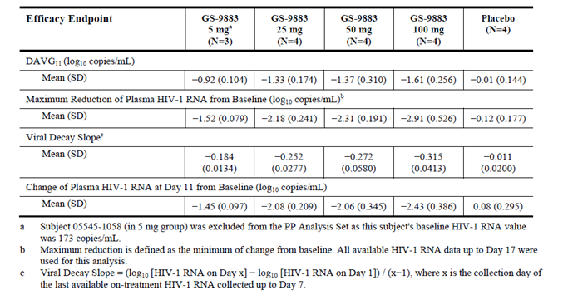

Phase II dose finding studies
Dose selection for the Phase III studies was based on data from the bioavailability Study GS-US-141-1233; and the Phase II Study 1475. Study 1475 was exploratory but the study results convincingly supported the BIC containing regimen proposed for the Phase III trial program.

Evaluator’s conclusions on dose finding for the pivotal studies
The dose finding studies were satisfactory. The FTC 200 mg and TAF 25 mg doses are the approved doses for the treatment of HIV-1 infection in adults and children. The BIC 50 mg dose was based on pre-clinical data, two Phase I studies and two Phase II studies.

Efficacy

Studies providing efficacy data

Pivotal Phase III
- GS-US-380-1489 (also referred to as Study 1489); a randomised, double-blind study of B/F/TAF versus ABC /DTG/3TC.
- GS-US-380-1490 (also referred to as Study 1490); a randomised, double-blind study of B/F/TAF versus DTG + F/TAF.
- GS-US-380-1844 (also referred to as Study 1844); a randomised, double-blind study to evaluate continuing ABC/DTG/3TC versus switching to B/F/TAF.
- GS-US-380-1878 (also referred to as Study 1878); a randomised, open-label study to evaluate continuing boosted ATV or DRV plus either FTC/TDF or ABC/3TC versus switching to B/F/TAF.

Other studies (Phase II)
- GS-US-141-1475 (also referred to as Study 1475); a randomised, double-blind study of BIC + FTC/TAF versus DTG + FTC/TAF.

Evaluator’s conclusions on efficacy
Combination ART is recommended in all relevant guidelines to suppress viral replication, increase CD4 cell counts and prevent disease progression. For ART naïve adults, a combination of two NRTIs given with an INSTI, NNRTI, or boosted PI is recommended for most cases of HIV-1 infection, irrespective of CD4 cell count. In virologically suppressed patients, switching therapy to a comparable therapy may be recommended for safety or tolerability concerns, or to simplify treatment. Bictegravir is a potent INSTI with a long half-life permitting once daily dosage, and the B/F/TAF combination is in line with current treatment guidelines for ART naïve and experienced patients with HIV-1 infection.
Four pivotal, randomised, active-controlled, Phase III studies were conducted in ART naïve patients (Studies 1489 and1490); and in virologically suppressed patients (Studies 1844 and 1878) with HIV-1 infection. The study designs, active comparators and endpoints were in line with treatment guidelines and regulatory guidance. Dose selection was appropriate. The combination of FTC/TAF (200 mg/25 mg) is approved for use in adults with HIV-1 in combination with other antiretroviral (ARV) agents. The bictegravir 50 mg dose was based on Phase I studies and the dose ranging Study 1219.
In ART naïve patients, B/F/TAF was non-inferior to two standard of care comparator regimens. For the primary efficacy endpoint, the percentages of patients with HIV-1 RNA < 50 copies/mL at Week 48 were comparable in each treatment group. HIV-1 RNA < 50 copies/mL was achieved by 90.9% of the pooled B/F/TAF group, compared with 93.0% of the ABC/DTG/3TC group, and 92.9% of the DTG + FTC/TAF group. The respective treatment differences were –2.1% (95% CI: –5.9, 1.6) and –1.9% (95% CI: –5.6, 1.8), each well within the pre-specified –12% non-inferiority margin. In the per protocol (PP) analyses, virologic suppression in the B/F/TAF groups was achieved in 99.3% and 98.9% of patients in Studies 1489 and 1490, respectively. Failure to achieve virologic suppression was associated with discontinuations or missing data, and no cases of virologic failure due to resistance were reported during the 48 week double blind (DB) treatment periods. The secondary objectives were also achieved with non-inferiority demonstrated for HIV-1 RNA < 20 copies/mL, and increased CD4 cell counts from baseline. The effects of missing data were tested by two imputation methods, and multiplicity was controlled by adjusting confidence intervals. Subgroup analyses were performed based on age, gender, race, region, and study drug adherence, and similar virologic responses were seen in all subgroups.
In virologically suppressed patients, switching to B/F/TAF was non-inferior to two standard of care, comparator regimens. For the primary endpoint, the percentages of patients with HIV-1 RNA ≥ 50 copies/mL at Week 48 were comparable in each treatment group. In Study 1844, HIV-1 RNA ≥ 50 copies/mL was reported in 1.1% and 0.4% of the B/F/TAF and ABC/DTG/3TC groups, respectively. The treatment difference was 0.7% (95.002% CI: –1.0, 2.8), well within the pre-specified 4% non-inferiority margin. In Study 1878, HIV-1 RNA ≥ 50 copies/mL was reported in 1.7% and 1.7% of the B/F/TAF and SBR groups, respectively. The treatment difference was 0.0% (95.002% CI: –2.5, 2.5), also well within the pre-specified 4% non-inferiority margin. In the PP analyses, loss of virologic suppression in the B/F/TAF groups was reported in 0.4% and 1.1% of patients in Studies 1844 and 1878, respectively. As in ART naïve patients, failure to maintain virologic suppression was associated with discontinuations or missing data, and no cases of virologic failure due to resistance were reported during the 48-week DB treatment periods. The secondary objectives were achieved with non-inferiority demonstrated for HIV-1 RNA < 50 copies/mL, and sustained CD4 cell counts from baseline. The effects of missing data were tested by two imputation methods, and multiplicity was controlled by adjusting confidence intervals. Subgroup analyses were performed based on age, gender, race, region and study drug adherence, and similar virologic responses were seen in all subgroups.
The fixed dose combination of B/F/TAF has been shown to effectively decrease HIV-1 RNA load and increase CD4 cell counts in adult ART naïve patients with HIV-1 infection, and to maintain virologic suppression in virologically suppressed patients. Comparable efficacy in patients with HIV/HBV co-infection was demonstrated although patient numbers were low.

Safety

Studies providing safety data

Pivotal studies that assessed safety as the sole primary outcome
None submitted.

Pivotal and/or main efficacy studies
The safety of B/F/TAF in ART naïve patients was assessed in the pivotal Phase III Studies 1489 and 1490. Safety in virologically suppressed patients was assessed in the pivotal Phase III Studies 1844 and 1878.

Other efficacy studies
The safety of B/F/TAF was assessed in the Phase II Study 1475.

Studies with evaluable safety data: dose finding and pharmacology
Safety was evaluated in 15 PK/PD studies and the results are presented above. One of these studies, GS-US-141-1219, examined the safety of BIC following 10 days administration of BIC doses ranging from 5 to 100 mg QD in HIV-1 infected subjects. No deaths, serious adverse events (SAEs), or pregnancies were reported for this study and most laboratory abnormalities were Grade 1 or Grade 2 in severity. No other clinical abnormalities were identified.

Studies that assessed safety as the sole primary outcome
No studies submitted.

Patient exposure
In the Phase II and III studies, a total of 1511 patients were exposed to at least one dose of B/F/TAF (Table 11). A total of 215 patients were treated in the extension studies; and 254 subjects received at least one dose of B/F/TAF in the Phase I studies. In ART naïve patients in the Phase III studies, 634 patients were treated with B/F/TAF for a median duration of 49.2 weeks. In virologically suppressed patients, the median duration of treatment with B/F/TAF was 49.9 weeks in Study 1844, and 46.7 weeks in Study 1878. Exposure to B/F/TAF was ≥ 48 weeks in 370 ART naïve patients (58.4%). In virologically suppressed patients, exposure to B/F/TAF was ≥ 48 weeks in 169 patients (59.9%) in Study 1844 and in 98 patients (33.8%) in Study 1878.
Table 11: Patient exposure to study drug
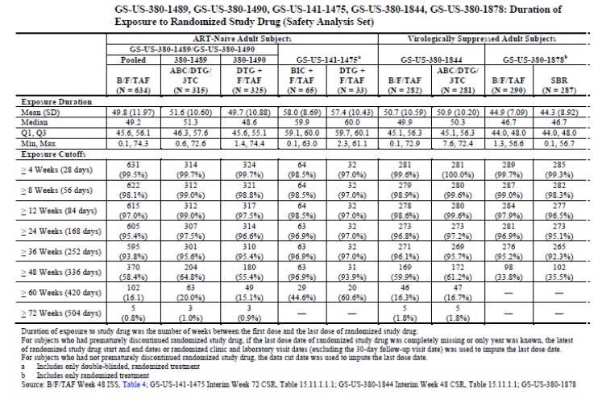

Safety issues with the potential for major regulatory impact

Liver function and liver toxicity
No issues related to liver function or toxicity were identified.

Pooled ART naïve patients
There were no meaningful median changes from baseline for any hepatic laboratory parameter in any treatment group (Table 12). The incidence of ALT abnormalities was comparable in each group (11.3%, 14.0% and 12.0% of patients in the pooled B/F/TAF, ABC/DTG/3TC and DTG + F/TAF groups, respectively). Grade 3 or 4 ALT abnormalities were reported in 1.4%, 1.3% and 0.9% of patients in the pooled B/F/TAF, ABC/DTG/3TC and DTG + F/TAF groups, respectively. Aspartate aminotransferase (AST) abnormalities were comparable. Total bilirubin abnormalities were reported more frequently in the B/F/TAF group compared with the ABC/DTG/3TC and DTG + F/TAF groups. Total bilirubin abnormalities were reported in 11.6%, 4.1% and 5.8% of patients in the pooled B/F/TAF, ABC/DTG/3TC and DTG + F/TAF groups, respectively. Nearly all total bilirubin abnormalities were Grade 1 or 2 in severity. Grade 3 abnormalities were reported in 0.3%, 0.3% and 0% of patients in the respective groups and there were no Grade 4 abnormalities.
Table 12: Studies 1489 and 1490 Changes from Baseline in hepatic laboratory parameters
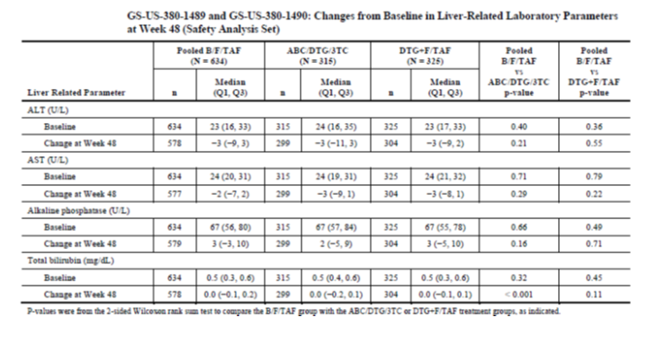
The incidence of hepatic adverse events (AEs) was low and comparable in each group (1.4%, 1.9% and 3.1% of patients in the pooled B/F/TAF, ABC/DTG/3TC and DTG + F/TAF groups, respectively. All hepatic AEs were considered unrelated to study treatment except for three events. In the B/F/TAF group, there was one case each of Grade 1 hyperbilirubinaemia and Grade 1 liver function test (LFT) increased. In the DTG + F/TAF group, there was one case of Grade 1 increased ALT/AST. One SAE of increased international normalised ratio (INR) in the ABC/DTG/3TC group was ascribed to warfarin therapy; and one SAE of acute hepatic failure in the B/F/TAF group was ascribed to a paracetamol overdose.

Study 1475
There were no meaningful median changes from baseline for any hepatic laboratory parameter in the BIC + F/TAF or DTG + F/TAF treatment groups. Grade 3 ALT and AST abnormalities were reported in 3.1% and 4.7% of patients in the BIC + F/TAF group, compared with none in the DTG + F/TAF group. Hepatic AEs were reported in two patients in the BIC + F/TAF group. One patient with a history of intermittent jaundice experienced a Grade 2 adverse drug reaction (ADR) of hyperbilirubinaemia without changes in ALT/AST. On Grade 2 AE of raised transaminases was considered unrelated to study treatment.

Virologically suppressed patients

Study 1844
There were small, statistically significant differences between treatment groups for ALT, AST and total bilirubin at Week 48, although the differences were not clinically meaningful (Table 13). ALT abnormalities were reported more frequently in the B/F/TAF group (18.4%) compared with the ABC/DTG/3TC group (9.6%). Grade 3 or 4 ALT abnormalities were reported in 2.1% of patients in the B/F/TAF group, compared with 0% in the ABC/DTG/3TC group. All patients with Grade 3 or 4 abnormalities had medical histories associated with ALT abnormalities. AST abnormalities were comparable.
Table 13: Study 1844 changes from Baseline in hepatic laboratory parameters
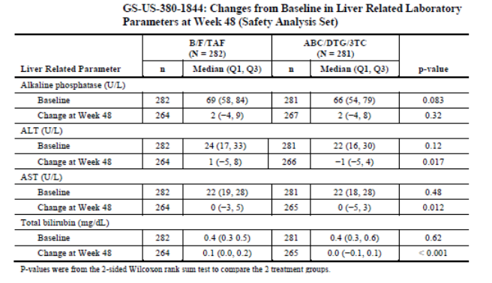
Total bilirubin abnormalities were reported more frequently in the B/F/TAF group compared with the ABC/DTG/3TC group. Total bilirubin abnormalities were reported in 7.4% and 3.6% of the respective groups. The majority of total bilirubin abnormalities were Grade 1 or 2 in severity. Grade 3 abnormalities were reported in two patients in the B/F/TAF group. One patient had a previous history of hyperbilirubinaemia and the other was receiving numerous concomitant medications. There were no Grade 4 abnormalities.

Study 1878
There were statistically significant differences between the treatment groups for Alkaline phosphatase (ALP), ALT, AST and total bilirubin at Week 48. However, there were no meaningful median changes from baseline for any hepatic laboratory parameter in any treatment group (Table 14). Five patients had liver function abnormalities with a potential cause of drug induced liver injury (DILI) (ALT or AST > 3 x upper limit of normal (ULN) and total bilirubin > 2 x ULN, with ALP < 2 x ULN). However, they did not meet Hy’s Law criteria as alternative plausible explanations were present in each case. Two patients in the B/F/TAF group had SAEs of hepatitis A. Three patients in the SBR group had an SAE of acute HCV, chronic non-alcoholic liver disease at baseline and Grade 1 acute HCV.
Table 14: Study 1878 changes from Baseline in hepatic laboratory parameters
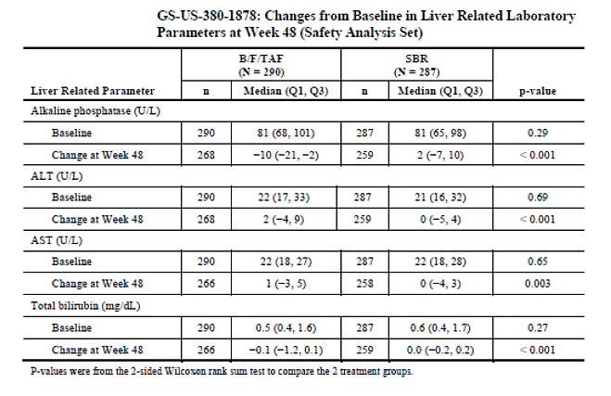
The incidence of ALT abnormalities was higher in the B/F/TAF group (23.4%) compared with SBR group (10.5%). The majority of abnormalities were Grade 1 or 2 in severity. Grade 3 or 4 ALT abnormalities were reported in 2.1% of patients in the B/F/TAF group, compared with 1.4% in the SBR group. AST abnormalities were comparable. Total bilirubin abnormalities were reported more frequently in the B/F/TAF group compared with the ABC/DTG/3TC and DTG + F/TAF groups. Total bilirubin abnormalities were reported in fewer patients in the B/F/TAF group (5.5%), compared with the SBR group (33.7%) (hyperbilirubinaemia is a known association with ATV therapy).

Integrated analysis
An integrated analysis of hepatic abnormalities in the B/F/TAF Phase III studies concluded:
- No patients treated with B/F/TAF met Hy’s Law criteria for DILI
- The percentage of patients with significant transaminase elevations was no higher in the in the B/F/TAF group compared with the comparator treatment groups
- In the B/F/TAF group, total bilirubin elevations > 2 x ULN were explained by alternative aetiologies
- In the B/F/TAF group, patients with total bilirubin elevations of any grade generally did not have concurrent elevations in transaminases

Renal function and renal toxicity
No issues related to renal function or toxicity were reported.

Pooled ART naïve patients
There were minor increases in serum creatinine in each treatment group at Week 4 and the increase was maintained through Week 48. Abnormalities of serum creatinine were reported in 3.2%, 2.2% and 4.6% of the in the pooled B/F/TAF, ABC/DTG/3TC and DTG + F/TAF groups, respectively. Grade 3 or 4 abnormalities were reported in 0.3%, 0.3% and 0% of the respective groups. Reciprocal changes in estimated glomerular filtration rate (eGFR) were observed in each treatment group. The median decreases in eGRF from baseline to Week 48 were –8.8 mL/min, -10.8 mL/min and –10.8 mL/min in the respective groups. Four patients had renal SAEs which were not considered drug related and each resolved while drug treatment was continued.

Study 1475
During the DB period, there were similar modest increases in serum creatinine in the BIC + F/TAF and DTG + F/TAF treatment groups. Reciprocal reductions in eGFR were reported.

Virologically suppressed patients

Study 1844
No change from baseline in serum creatinine was observed in the B/F/TAF group, compared with a minor increase in the ABC/DTG/3TC group at Weeks 4 and 48. Median changes from baseline were –0.07 mg/dL and 0.02 mg/dL in the respective groups.
Abnormalities in serum creatinine were reported in 7.4% and 5.0% of the respective groups. No Grade 3 or 4 abnormalities were reported in either group. Reciprocal changes in eGFR were observed in each treatment group. The median changes from baseline in eGRF to Week 48 were 1.0 mL/min and -1.8 mL/min in the respective groups.

Study 1878
There was a mean change from baseline in serum creatinine in the B/F/TAF group, compared with no change in the SBR at Weeks 4 and 48. Median changes from baseline were 0.06 mg/dL and 0.00 mg/dL in the respective groups. Abnormalities for serum creatinine were reported in 2.8% and 1.8% of the respective groups. All abnormalities were Grade 1 in severity. Reciprocal changes in eGFR were observed in each treatment group. The median changes in eGRF from baseline to Week 48 were –4.3 mL/min and 0.2 mL/min in the respective groups (p < 0.001).
In all Phase II and III studies, no issues related to proteinuria or proximal tubular toxicity were identified.

Other clinical chemistry

Pooled ART naïve patients
The incidence of laboratory abnormalities was broadly comparable in each treatment group (B/F/TAF 87.7%, ABC/DTG/3TC 87.3% and DTG + F/TAF 83.1%). Most abnormalities were Grade 1 or 2 in severity. The incidence of Grade 3 or 4 abnormalities was comparable in each treatment group (B/F/TAF 15.6%, ABC/DTG/3TC 14.6% and DTG + F/TAF 13.2%) (Table 15).
Table 15: Studies 1489 and 1490 Grade 3 or 4 laboratory abnormalities
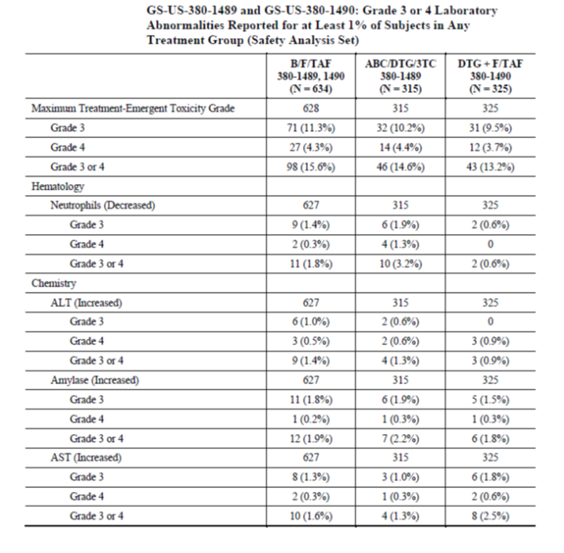
Table 15 (continued): Studies 1489 and 1490 Grade 3 or 4 laboratory abnormalities
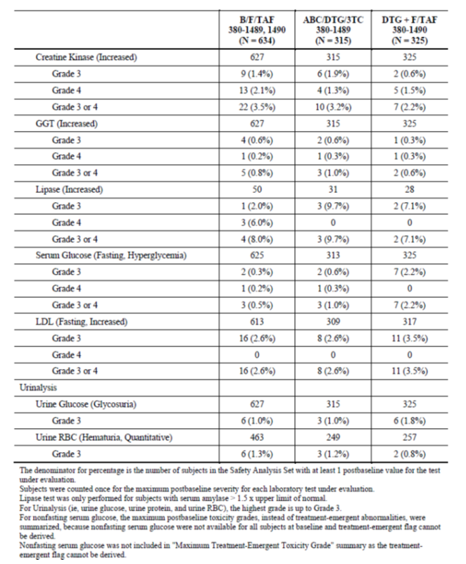

Study 1475
There were no meaningful changes from baseline in median laboratory values, or differences between treatment groups.

Virologically suppressed patients

Study 1844
The incidence of laboratory abnormalities was similar in each treatment group (B/F/TAF 85.1%, ABC/DTG/3TC 85.8%). Most abnormalities were Grade 1 or 2 in severity. The incidence of Grade 3 or 4 abnormalities was comparable in each treatment group (B/F/TAF 16.7%, ABC/DTG/3TC 11.4%) (Table 16).
Table 16: Study 1844 Laboratory abnormalities
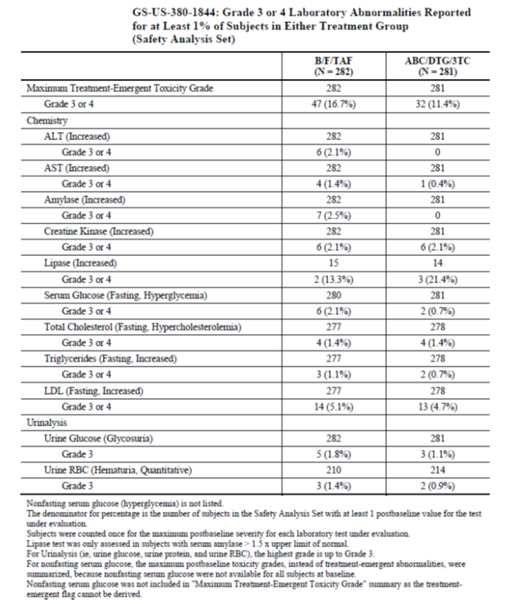

Study 1878
The incidence of laboratory abnormalities was similar in each treatment group (B/F/TAF 84.8%, SBR 90.9%). Most abnormalities were Grade 1 or 2 in severity. The incidence of Grade 3 or 4 abnormalities was less in the B/F/TAF group compared with the SBR group (B/F/TAF 15.5%, SBR 29.1%), due mainly to a higher incidence of total bilirubin elevations in the SBR group (Table 17).
Table 17: Study 1878 Laboratory abnormalities
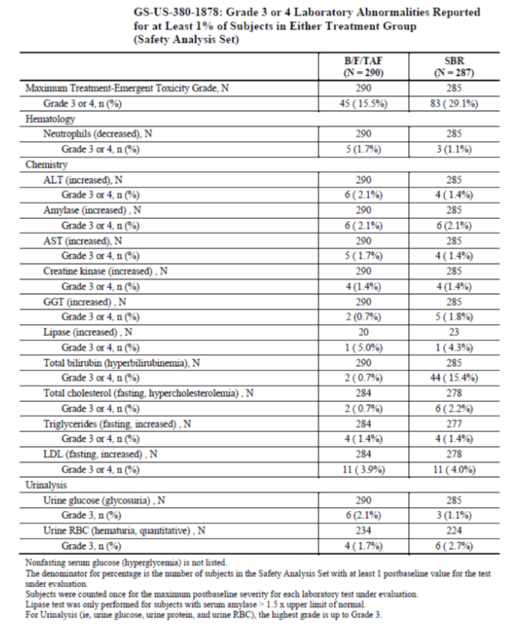

Haematology and haematological toxicity
In the Phase II and III studies, there were no clinically relevant changes from baseline within any treatment group, or differences between groups, in median values for any haematology parameter.

Electrocardiograph findings and cardiovascular safety

ART naïve patients
In Study 1489, three patients in the B/F/TAF group had electrocardiogram (ECG) abnormalities reported as AEs compared with two patients in the ABC/DTG/3TC group. All of the events were non-serious and only one event was considered to be drug related (in the ABC/DTG/3TC group). In Study 1490, there were two AEs related to ECG abnormalities, both in the DTG + F/TAF group.

Study 1475
No AEs relating to ECG abnormalities were reported.

Virologically suppressed patients

Study 1844
Four patients had ECG findings reported as AEs (3 B/F/TAF; 3 ABC/DTG/3TC). All were considered unrelated to study drug and none lead to treatment discontinuation.

Study 1878
Six patients had ECG findings reported as AEs (three in the B/F/TAF and SBR groups). All were considered unrelated to study drug and none lead to treatment discontinuation.

Vital signs and clinical examination findings
In the Phase II and III studies, there were no clinically relevant changes from baseline within any treatment group, or differences between groups, in values for systolic blood pressure, diastolic blood pressure, pulse, respiration rate, body temperature or body weight.

Immunogenicity and immunological events
No hypersensitivity reactions were reported in patients given B/F/TAF.

Serious skin reactions
There were no SAEs related to skin reactions reported by system organ class or preferred term in any of the Phase II or III studies.

Other safety parameters
Bone safety was assessed in Study 1489. The percentage changes from baseline in bone mineral density at the hip and spine (measured by dual energy X-ray absorptiometry) were similar in each treatment group (Table 18). The mean percentage changes from baseline at Week 48 were:
- Hip: B/F/TAF –0.783%; ABC/DTG/3TC –1.021%
- Spine: B/F/TAF –0.831%; ABC/DTG/3TC –0.596%
Table 18: Study 1489 Changes in bone mineral density
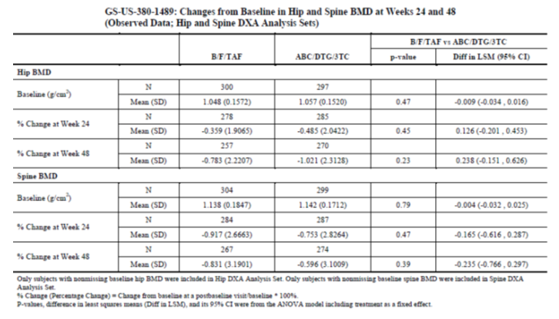
Cardiovascular and cerebrovascular AEs were analysed independently in Study 1489. The incidence of AEs was low and comparable in each treatment group (B/F/TAF 0.6%; ABC/DTG/3TC 0.3%).
Eye disorders were assessed in the Phase III studies (Table 19). The incidence of ocular disorders was low and comparable in each treatment group. All AEs were Grade 1 or 2 in severity. There were four SAEs (one in a patient receiving B/F/TAF) but none were considered drug related. There were no cases of posterior uveitis.
Table19: Pooled Phase III studies ocular disorders
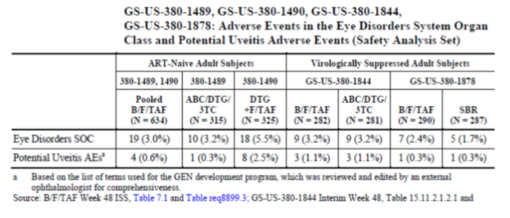Suicide ideation and suicide attempts were reported infrequently (Table 20). Most AEs were reported in patients with a history of depression or mental illness.
Table 20: Pooled Phase III studies suicide events
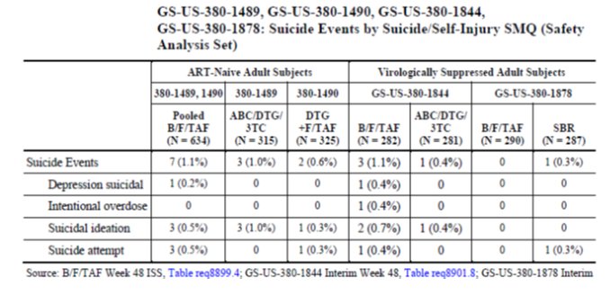
No other analyses related to safety were evaluated in any other study.

Safety in special populations

HIV/HBV co-infection
Enrolment for patients with HIV/HBV co-infection was permitted in studies 1490 and 1878. In Study 1490, 14 patients (2.2%) had co-infection with no prior treatment for HIV or HBV (B/F/TAF 2.5% and ABC/DTG/3TC 1.9%). The incidence and pattern of AEs were comparable to the overall population. One patient in the B/F/TAF group had a Grade 4 ALT flare with ALT 1477 U/L and AST 551 U/L at Week 12. Both parameters had returned to normal at Week 24. One other patient in the B/F/TAF group had a Grade 3 flare (ALT 316 U/L) at Week 8 which normalised by Week 24. In Study 1878, 14 patients (2.4%) had HIV/HBV co-infection (B/F/TAF 2.8% and SBR 2.1%). No patients had hepatic AE, Grade 3 or 4 events, or hepatic flares.
Comment: There were two reports of hepatic flares in patients receiving B/F/TAF (see Clinical Questions, below).

HIV/HCV co-infection
In Study 1489, four patients (1.3%) of patients in the ABC/DTG/3TC group had HIV/HCV co-infection at baseline and the hepatic AE profile was consistent with the underlying HCV infection. No patients in the B/F/TAF group had co-infection. In Study 1490, HIV/HCV co-infection at baseline was present in 1.6% of the B/F/TAF group and 1.5% of the DTG + F/TAF group (five patients in each group). The incidence and pattern of AEs were comparable to the overall population. No patients had hepatic AEs during the study and only one patient had a Grade 3 ALT/AST abnormality. In Study 1844, HIV/HCV co-infection was present in only one patient in the ABC/DTG/3TC group. The hepatic AE profile was consistent with the underlying HCV infection. No patients in the B/F/TAF group had co-infection. In Study1878, HIV/HCV co-infection at baseline was present in 1.7% of the B/F/TAF group and 1.7% of the SBR group (five patients in each group). The incidence and pattern of AEs were comparable to the overall population. No patients had hepatic AEs during the study and only two patients had Grade 3 or 4 ALT/AST abnormalities.

Age
Age did not influence safety in the pooled studies 1489 and 1490. The incidence of AEs in the B/F/TAF group was 83.3% in patients aged < 50 years and 84.4% in patients aged ≥ 50 years. In patients aged ≥ 65 years in the four Phase III studies, 30 patients in the B/F/TAF group had a similar safety profile to 25 patients in the comparator groups. In Study 1844, the incidence of AEs in the B/F/TAF group was 79.7% in patients aged < 50 years and 79.8% in patients aged ≥ 50 years. In Study 1878, the incidence of AEs in the B/F/TAF group was 84.1% in patients aged < 50 years and 75.4% in patients aged ≥ 50 years.

Gender
Gender did not influence safety in the pooled studies 1489 and 1490. The incidence of AEs in the B/F/TAF group was 83.4% in male patients and 84.1% in female patients. In Study 1844, the incidence of AEs in the B/F/TAF group was 80.2% in male patients and 77.1% in female patients. In Study 1878, the incidence of AEs in the B/F/TAF group was 79.4% in male patients and 85.1% in female patients.

Race
The influence of race was assessed in Black and non-Black populations. Race did not influence safety in the pooled studies 1489 and 1490. The incidence of AEs in the B/F/TAF group was 82.9% in Black patients and 83.8% in non-Black patients. In Study 1844, the incidence of AEs in the B/F/TAF group was 76.3% in Black patients and 80.7% in non-Black patients. In Study 1878, the incidence of AEs in the B/F/TAF group was 74.7% in Black patients and 82.5% in non-Black patients.

Baseline HIV-1 RNA
Baseline HIV-1 RNA did not influence safety in the pooled studies 1489 and 1490 in ART naïve patients. In the B/F/TAF group, the incidence of AEs was 82.9% in patients with ≤ 100,000 copies/mL and 85.7% in patients with > 100,000 copies/mL.

Baseline CD4 cell count
Baseline CD4 cell count did not influence safety in the pooled studies 1489 and 1490 in ART naïve patients. In the B/F/TAF group, the incidence of AEs was 87.5% in patients with < 200 cells/µL and 82.9% in patients with ≥ 200 cells/µL.

Renal impairment
Patients in the Phase II and III studies were required to have adequate renal function (eGFR ≥ 50 mL/min). The Phase I Study, GS-US-141-1479, which compared BIC PKs following a single, oral, 75 mg dose to subjects with severe renal impairment and matched, healthy controls, indicated that the mean AUC_{inf}, AUC_{last} and C_{max} values for total BIC were slightly lower in the severe renal impairment group relative to the normal renal function group, with GLSM ratios of 72.63%, 72.43% and 80.32%, respectively (Table 21).
Table 21: Study GS-US-141-1479 Plasma PK parameters for BIC and statistical comparisons
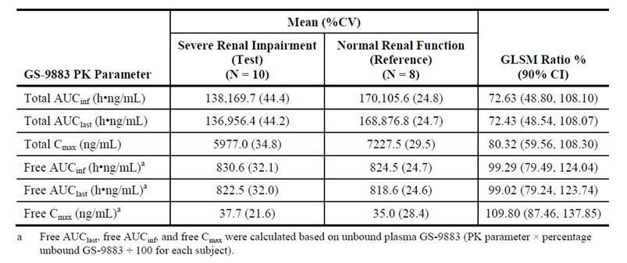

Hepatic impairment
Significant transaminase abnormalities was an exclusion criterion in the Phase II and III studies (ALT/AST ≤ 5 x ULN). The Phase I Study, GS-US-141-1478, which examined the PK profile of a single oral dose of 75 mg BIC in subjects with moderate hepatic impairment relative to matched, healthy controls, indicated that BIC exposure was significantly lower in subjects with moderate hepatic impairment than in normal matched controls and the GLSM ratios for BIC AUC_{inf} and C_{max} of 58.71% and 63.50%, respectively (Table 22).
Table 22: Study GS-US-141-1478 the plasma PK parameters for BIC and statistical comparisons
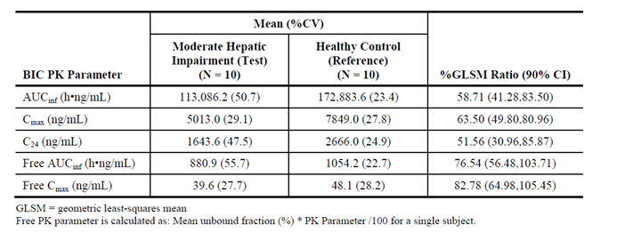

Safety related to drug-drug interactions and other interactions
BIC is a substrate of UGT1A1 and CYP3A. Potent inhibition of both CYP3A and UGT1A1 results in a substantial increase in BIC exposure and co-administration of BIC with potent dual inhibitors of CYP3A and UGT1A1 is not recommended.
TAF is a substrate of P-gp and BCRP and although co-administration of BIC/FTC/TAF with potent inhibitors of P-gp and/or BCRP will result in increases in the plasma concentrations of TAF. These increases in TAF exposure are unlikely to be clinically relevant however, given the safety profiles for TAF and TDF.
Drugs that are potent inducers of CYP3A, UGT1A1 and/or P-gp may result in lower plasma exposures of BIC and TAF and lead to reduced therapeutic effect of BIC/FTC/TAF; co-administration with potent inducers is not recommended.
Co-administration of BIC/FTC/TAF with medications or oral supplements containing polyvalent cations under fasted conditions, for example: magnesium, aluminium, calcium and iron, under fasted conditions will result in a significant decrease in BIC exposure. Therefore, medications or oral supplements containing polyvalent cations should be separated from the fasted administration of BIC/FTC/TAF by at least 2 hours. Alternatively, these medications or oral supplements can be taken simultaneously with BIC/FTC/TAF together with food. It should be noted however, that even under these adapted conditions BIC exposure may be decreased by up to 50%.
BIC, TAF and FTC are not clinically relevant inhibitors or inducers of major human drug metabolising enzymes and transporters. As such, there is low potential for BIC/FTC/TAF to be perpetrators of DDIs through human drug metabolising enzymes or drug transporters, including with the OCT2/MATE1 substrate metformin.

Post marketing data
Not applicable.

Evaluator’s conclusions on safety
In the randomised phases of the four pivotal Phase III studies, 1206 patients received B/F/TAF for a median period of 49.2 weeks in ART naïve patients. Median exposure in virologically suppressed patients was 49.9 weeks in Study 1844 and 46.7 weeks in Study 1878. The open-label (OL) extension studies are ongoing and will provide long-term safety data.
The AE profiles were comparable in ART naïve and virologically suppressed patients and similar to the profiles of the active comparator groups. All treatments were well tolerated. Most AEs were mild to moderate in severity, and there were with comparable rates of severe AEs, SAEs, drug related SAEs and AEs leading to drug discontinuation. Seven deaths were reported (four in patients receiving B/F/TAF), but none were considered related to treatment. In ART naïve patients treated with B/F/TAF, the most commonly reported AEs by preferred term were diarrhoea, headache and nausea. In virologically suppressed patients who switched to B/F/TAF, the most commonly reported AEs were upper respiratory tract infection (URTI), diarrhoea, nasopharyngitis and headache. Nausea was reported as an ADR most frequently in patients treated with ABC/DTG/3TC (17.5%). However, with this exception, the pattern of ADRs was comparable in each treatment group.
No issues related to hepatic toxicity were identified and no cases meeting Hy’s law criteria were reported. No clinically meaningful changes from baseline were reported for ALT, AST, or total bilirubin in patients treated with B/F/TAF in any of the Phase III studies. The incidence of Grade 3 or 4 hepatic AEs was comparable between treatment groups. Two cases of hepatic flare were reported in patients with HIV/HBV co-infection (see Clinical questions below). BIC and DTG have inhibitory effects on the renal transporters OCT2 and MATE1 but no clinically significant effects on serum creatinine or eGFR were identified. There were no clinically meaningful differences between treatment groups related to other laboratory abnormalities. Products containing TAF were considered by the CHMP to have a potential risk of renal tubulopathy, loss of bone mineral density and posterior uveitis. However, no issues related to these events were identified in 1734 patients who received F/TAF in the Phase II/III studies. The AE profile of patients who received B/F/TAF was not influenced by gender, age, race, region, HIV-1 RNA level, or CD4 cell count.
The B/F/TAF fixed dose combination was generally well tolerated with a safety profile similar to the active comparator regimens.

First round benefit-risk assessment
Table 23: First round assessment of benefits
Benefits | Strengths and Uncertainties
B/F/TAF is a triple combination of a novel INSTI with an NRTI and an NtRTI, a typical guideline recommended regimen.  The FDC permits once daily oral dosing. Increased adherence improves clinical and virologic outcomes.  Bictegravir is active against mutant viruses with resistance to NRTIs, NNRTIs and PIs.  B/F/TAF has a low potential for virologic resistance. There were no cases of treatment emergent virologic resistance in the Phase II and III studies.  No booster required (COBI or RTV).  In the pooled Phase III studies in ART naïve adult patients, B/F/TAF was non-inferior to guideline recommended comparator combinations with 92.6% of patients achieving virologic control. Treatment failures were associated with factors other than virologic resistance.  No loss of efficacy when virologically suppressed patients are switched to B/F/TAF.  Effective in subgroups defined by age, gender, race, baseline HIV-1 RNA and baseline CD4 cell count. | Solid evidence with few uncertainties for all benefits except where stated.
Well tolerated in ART naïve and virologically suppressed patients. Few SAEs and AEs leading to discontinuation.  No bone or renal toxicity.  No dose adjustment required in patients with eGFR ≥ 30 mL/min, or in patients with moderate hepatic impairment. | No placebo-controlled data but safety profile similar to standard of care comparators.  Based on PK studies. Not tested in large patient populations.
Well tolerated and effective in patients with HIV/HBV and HIV/HCV co-infection. | Only small patient numbers studied.

First round assessment of risks
Table 24: First round assessment of risks
Risks | Strengths and Uncertainties
B/F/TAF is well tolerated but class effects of NRTIs may still be expected (lactic acidosis, hepatomegaly with steatosis and HBV flares).  The most frequent ADRs were diarrhoea and headache, most commonly mild to moderate in severity.  Long-term ADRs related to bictegravir cannot be excluded.  Drug-drug interactions, immune reconstitution syndrome, hepatic flare in patients with HIV/HBV co-infection, dangers in pregnancy and while breast feeding.  Stopping therapy has the potential to precipitate severe HBV exacerbations in patients with HIV/HBV co-infection. | Noted in PI.  Noted in PI.

First round assessment of benefit-risk balance
The benefit-risk balance is strongly positive. The B/F/TAF FDC is highly effective and no cases of virologic resistance were reported in Phase II and III studies in ART naïve and virologically suppressed patients. B/F/TAF was well tolerated with a safety profile similar to comparator treatments. Efficacy and safety were demonstrated in all patient populations, including those based on gender, age, race, baseline CD4 count and baseline viral load. Simple, once daily treatment will enhance adherence for optimal virological control. There was no evidence of increased risk with the use of bictegravir in combination with F/TAF.
The benefit-risk balance in patients with HIV/HBV co-infection has not been established. HIV-1 RNA < 50 copies/mL was achieved by all eight patients with co-infection treated with B/F/TAF. However, the risks associated with hepatic flares in patients on treatment, or in those stopping treatment, have not been quantified.

First round recommendation regarding authorisation
Authorisation is not recommended for the proposed indication:
‘Biktarvy is for the treatment of HIV-1 infection in adults without any known mutations associated with resistance to the individual components of Biktarvy.
Biktarvy is also indicated for the treatment of chronic hepatitis B in adults co-infected with HIV-1’.
Authorisation for use in patients with HIV/HBV co-infection is not recommended based on inadequate efficacy and safety data. Only eight ART naïve patients with HIV/HBV co-infection were treated with B/F/TAF (in Study 1490). Furthermore, the pharmacokinetics of BIC, FTC and TAF have not been characterised in patients with HIV/HBV co-infection.
However, due to overwhelming evidence of efficacy and safety in patients who are ART naïve or virologically suppressed, authorisation is recommended for the following modified indication:
‘Biktarvy is for the treatment of HIV-1 infection in adults who are ART naïve or virologically suppressed without any known mutations associated with resistance to the individual components of Biktarvy’.
The suggested indication more accurately describes the clinical trial patient populations for whom data are available. Data are not available in ART-experienced patients who are not virologically suppressed. However, approval for the above modified indication is also subject to satisfactory responses to clinical questions as well as incorporation of recommended changes to the proposed PI and CMI.
The combination of F/TAF is a guideline recommended regimen for the treatment of HBV (ASHM, 2016,¹ WHO, 2011). Only eight patients with HIV/HBV co-infection were treated with B/F/TAF. The data do not support/justify approval of an independent indication but may be suitably included in the clinical trials description in the PI with precise details. However, the safety profile of B/F/TAF in patients with co-infection has not been sufficiently categorised, particularly in patients with low CD4 cell counts. A study in larger patient numbers should be conducted to justify a treatment indication. Alternative treatments for patients with HIV/HBV co-infection are available in the interim.

Clinical questions and second round evaluation

Efficacy

Question 1
In Study 1490, the virologic and clinical outcomes in patients with HIV/HCV co-infection do not appear to have been reported (although safety issues are addressed). Please provide the efficacy data or identify the reference in the CSR.

Sponsor’s response:
Biktarvy was safe and well tolerated in 1.6% of patients with HIV/HCV co-infection at baseline. Efficacy outcomes in this patient population are shown in Table 25.
Table 25: Study GS-US-380-1490. Week 48 efficacy outcomes in patients with HIV/HCV co-infection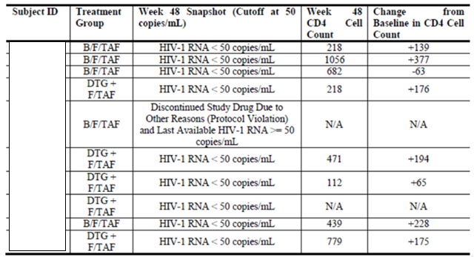
All but one patient was classified as HIV-1 RNA < 50 copies/mL at Week 48. The remaining patient did not return for any post-baseline visits and was discontinued from the study due to protocol violations.

Evaluation of response
The sponsor’s response is satisfactory.

Question 2
In the RMP, it is stated that no further efficacy studies are proposed. Please discuss the merits of conducting an efficacy study of B/F/TAF in treatment-experienced patients with virologic failure.

Sponsor’s response
The sponsor is considering a study of Biktarvy in this population. However, the sponsor has other investigational agents, some with potential use in treatment-experienced patients with virologic failure. The role of Biktarvy in this patient population is partially addressed in the Phase III Study GS-US-380-4030 which is fully enrolled. This study assesses the efficacy and safety of switching to Biktarvy from a regimen of dolutegravir and either F/TAF or F/TDF who are virologically suppressed. The study permits enrolment of patients with prior virologic failure and documented ARV resistance.

Evaluation of response:
The sponsor’s response is satisfactory.

Safety

Question 3
In Study 1490, eight ART naïve patients with HIV/HBV co-infection were treated with B/F/TAF. Of these, two patients (25%) had significant hepatic flares (1 Grade 4; 1 Grade 3), possibly due to immune reconstitution. Please provide:
- The baseline demographics and disease characteristics (including CD4 cell counts) of all patients with HIV/HBV co-infection.
- Treatment emergent changes in LFTs for each patient
Please comment on the results of the analysis?

Sponsor’s response
The sponsor has provided tables summarising the demographics and baseline characteristics in patients with HIV/HBV co-infection (data not shown). These are comparable to the overall demographics and disease characteristics seen in the study.

Evaluation of response
The sponsor’s response is satisfactory. Hepatic safety is addressed in the information provided.

Second round benefit-risk assessment

Second round assessment of benefits
After consideration to the responses to clinical questions, the benefits of Biktarvy in the proposed usage are unchanged from those identified in the first round assessment of benefits.

Second round assessment of risks
After consideration to the responses to clinical questions, the risks of Biktarvy in the proposed usage are unchanged from those identified in the first round assessment of risks.

Second round assessment of benefit-risk balance
The benefit risk balance of Biktarvy given the proposed usage is a favourable.

VI. Pharmacovigilance findings

Risk management plan

Summary of RMP evaluation
The sponsor has submitted EU-RMP version 0.1 (dated 19 June 2017; DLP 11 May 2017) and ASA version 0.1 (dated June 2017) in support of this application. At Round 2, the sponsor submitted an updated ASA, version 0.2 (dated February 2018).
The proposed Summary of Safety Concerns and their associated risk monitoring and mitigation strategies are summarised in Table 26.
Table 26: Summary of safety concerns and risk monitoring and mitigation strategies
Summary of safety concerns |  | Pharmacovigilance |  | Risk Minimisation
 |  | Routine | Additional | Routine | Additional
Important identified risks | None | – | – | – | –
Important potential risks | Suicidal ideation/suicide attempt in patients with a pre-existing history of depression or psychiatric illness |  | – | – | –
Missing information | Long term safety information |  |  | – | –
Missing information | Safety in pregnancy and lactation |  |  |  | –
Additional pharmacovigilance activities consist of:
- Studies GS-US-380-1489 and GS-US-380-1490, to be finalised in Q2 2020, to evaluate the efficacy, safety, and tolerability of B/F/TAF through to 144 weeks against different comparator regimens. Study GS-US-380-1490 includes Australian subjects. This is acceptable.
- Antiretroviral pregnancy registry, to collect information on the risk of birth defects with antiretroviral drugs, including B/F/TAF, to which pregnant women are exposed. Reporting will be in PSURs. This is acceptable.
Routine risk minimisation activities have been proposed. This is acceptable.

New and outstanding recommendations from second round evaluation
- The recommendations made in the first round evaluation, along with consideration of the sponsor’s response, was provided [not included in this AusPAR] (recommendations 1 to 10).
- There are no outstanding RMP issues.

Proposed wording for conditions of registration
Any changes to which the sponsor has agreed should be included in a revised RMP and ASA. However, irrespective of whether or not they are included in the currently available version of the RMP document, the agreed changes become part of the risk management system.
The suggested wording is:
The Biktarvy EU-Risk Management Plan (RMP) (version 0.1, dated 10 June 2017, data lock point 11 May 2017), with Australian Specific Annex (version 0.2, dated February 2018), included with submission PM-2017-02454-1-2, and any subsequent revisions, as agreed with the TGA will be implemented in Australia.
The following wording is recommended for the PSUR requirement:
An obligatory component of risk management plans is routine pharmacovigilance. Routine pharmacovigilance includes the submission of Periodic Safety Update Reports (PSURs).
Unless agreed separately between the supplier who is the recipient of the approval and the TGA, the first report must be submitted to TGA no later than 15 calendar months after the date of this approval letter. The subsequent reports must be submitted no less frequently than annually from the date of the first submitted report until the period covered by such reports is not less than three years from the date of this approval letter. The annual submission may be made up of two PSURs each covering six months. If the sponsor wishes, the six monthly reports may be submitted separately as they become available.
The reports are to at least meet the requirements for PSURs as described in the European Medicines Agency’s Guideline on good pharmacovigilance practices (GVP) Module VII-Periodic Safety Update Report (Rev 1), Part VII.B Structures and processes. Note that submission of a PSUR does not constitute an application to vary the registration. Each report must have been prepared within ninety calendar days of the data lock point for that report.
As Biktarvy contains a new chemical entity it should be included in the Black Triangle Scheme as a condition of registration. The following wording is recommended for the condition of registration:
‘Biktarvy (bictegravir / emtricitabine / tenofovir alafenamide fumarate) is to be included in the Black Triangle Scheme. The PI and CMI for Biktarvy must include the black triangle symbol and mandatory accompanying text for five years, which starts from the date that the sponsor notifies the TGA of supply of the product.

VII. Overall conclusion and risk/benefit assessment
The submission was summarised in the following Delegate’s overview and recommendations.

Introduction
This is a submission to register a fixed dose combination (FDC) product Biktarvy as an oral tablet containing 3 active ingredients that is, bictegravir (BIC or B or GS-9883) which is a new chemical entity and 2 active ingredients that are already on the ARTG that is, emtricitabine (FTC or F) and tenofovir alafenamide (TAF or T).
Bictegravir is a novel INSTI. Emtricitabine and tenofovir alafenamide are nucleoside analogue reverse transcriptase inhibitors (NRTI) that are commonly used as backbone in combination antiretroviral therapy (ART) in treatment-naïve HIV-1 patients.
The indications proposed by the sponsor at the time of submission were as follows:
Biktarvy is for the treatment of HIV-1 infection in adults without any known mutations associated with resistance to the individual components of Biktarvy
Biktarvy is also indicated for the treatment of chronic hepatitis B in adults co-infected with HIV-1
Following review of data, the revised indication agreed by the sponsor at the end of the second round evaluation, is as follows:
Biktarvy is for the treatment of HIV-1 infection in adults who are ART naïve or virologically suppressed without any known mutations associated with resistance to the individual components of Biktarvy.
The proposed dose is one tablet (B/F/TAF 50/200/25 mg) daily with or without food. It is not recommended in patients with creatinine clearance below 3 0mL/min and in patients with severe hepatic impairment (Child-Pugh class C).
Note: FTC/TAF combination is marketed by the sponsor as Descovy (200/25 mg and 200/10 mg). TAF alone (Vemlidy 25 mg) is marketed for the treatment of chronic HBV infection only by the same sponsor. TAF is second generation to the earlier tenofovir disoproxil fumarate (TDF) and is also a component in the registered products Genvoya (FTC/elvitegravir/cobicistat/TAF 200/150/150/10 mg) and Odefsey (FTC/rilpivirine/TAF 200/25/25 mg).

Quality
The Phase III clinical trial formulation was not used in any pharmaceutical study, although the 50/200/25 mg co-formulation developed in the Study GS-US-141-1233 was considered to be bioequivalent to BIC+FTC/TAF 75 + 200/25 mg (used in the Phase II Study GS-US-141-1475 in which it was compared with DTG+F/TAF for initial assessment of treatment effect in HIV patients). The BIC/FTC/TAF 50/200/25 mg formulation was subsequently used in all four confirmatory Phase III clinical trials. The tablet formulation was further modified during Phase III studies with decrease in magnesium stearate content from 1.5% to 1.0% in the FTC/TAF layer. Magnesium stearate is hydrophobic and may retard the dissolution of a drug from a solid dosage form. However, the dissolution profiles with lower and higher magnesium content were shown to be similar. The quality evaluators advise that ‘In this instance, the decrease in magnesium stearate content from 1.5% to 1.0% in the FTC/TAF layer is not expected to significantly affect the bioavailability of the active ingredients in the BIC/FTC/TAF 50/200/25 mg FDC tablet.’
Overall, there are no objections to the registration of Biktarvy from pharmaceutical chemistry point of view. Some matters have been deferred to the clinical delegate. These include lack of absolute bioavailability data for bictegravir and the clinical significance of food effect (24% and 13% higher AUC and C_{max} respectively for BIC, 4% and 14% lower AUC and C_{max} respectively for FTC and 63% higher and 8% lower AUC and C_{max} respectively for TAF were reported in Study GS-US-141-1233). Recent outstanding issues, that is, specifications for some impurities and pending Good Manufacturing Practice (GMP) clearance have now been resolved.

Nonclinical
Note the focus is on bictegravir as the other 2 components (FTC and TAF) have previously been evaluated.
Bictegravir was shown to be active against all HIV-1 subtypes (including NRTI, NNRTI, PRI, and first generation INSTI resistant strains) and HIV-2 in vitro. The likely clinically important resistance mechanism is integrase Q148 mutation (particularly in combination with bictegravir selected E138 and G140 and/or T66I+E138K+Q148K triple mutation). Bictegravir selected HIV-1 mutants were sensitive to efavirenz and had lower cross resistance to raltegravir but high cross resistance to elvitegravir.
Secondary pharmacology studies did not identify adverse off targets effects on cardiovascular, respiratory or central nervous functions. Overlapping secondary pharmacological effects for the Biktarvy combination are not expected.
Bictegravir was poorly metabolised and was the major circulating drug form in all tested animal species. In non-primates bictegravir was N-dealkylated, glucuronidated and hydroxylised via CYP3A4 and/or UGT1A1. Monkeys were more extensive metabolisers compared to humans, while rat metabolism more closely resembled the human situation. There were no clinically relevant human specific metabolites.
Bictegravir is unlikely to cause clinically relevant drug interactions via CYP- 1A2, 2B6, 2C8, 2C9, 2C19, 2D6, OAT1, OAT3, OCT1, OATP1B1 and OATP1B3. Bictegravir may cause drug interactions associated with CYP3A induction and OCT2. Co-administration with potent inducers of CYP3A and/or UGT1A1 may decrease bictegravir plasma concentration. Similarly co-administration with inhibitors of CYP3A and/or UGT1A1 may increase plasma concentration of bictegravir. Bictegravir is a substrate of P-gp and BCRP. Bictegravir inhibits MATE1 and OCT1 in a dose dependent manner, possibly reducing active renal tubular excretion of creatinine and other MATE1 and OCT1 substrates.
No formal single dose toxicity studies (including no combination toxicity studies) were conducted. The only toxicity finding in repeat dose toxicity studies was hepatotoxicity in monkeys at high exposures (16 x clinical exposure).
Based on the results of screening package bictegravir was not genotoxic. Bictegravir was not carcinogenic in an abbreviated 26 week oral gavage carcinogenicity study in hemizygous rasH2 transgenic mice and was not carcinogenic in a 104 week study in Wistar rats.
Reproductive toxicity studies did not indicate effect on fertility or on embryofoetal and postnatal development. The sponsor proposes Pregnancy Category B3 for Biktarvy combination product (B1 in considered appropriate for bictegravir as single agent).^{18,19} This is consistent with existing products containing FTC/TAF and is supported.
All drug substance/product impurities are reported to be toxicologically qualified. Overall, there are no nonclinical objections to the approval of Biktarvy.
Detailed recommendations have been provided for the PI and are supported for inclusion in the PI.

Clinical
The dossier contains the following clinical studies specific to this submission listed in Table 27, below. The submission was cross referenced to data previously evaluated for FTC, TAF, FTC/TAF in multiple submissions.
Table 27: Clinical studies specific to this submission
Study number | Main aim of study
GS-US-141-1481 | (radiolabelled (¹⁴C)BIC mass balance study)
GS-US-141-1218 | (PK: SAD, MAD; DDI:BIC-FTC/TAF)
GS-US-141-1219 | (PK; PK/PD)
GS-US-141-1233 | (75 mg vs 50 mg BIC/FTC/TAF; food effect)
QP-2017-1010 | (BIC PoP)
QP-2017-1012 | (TAF PoP)
QP-2015-1001 | (prediction of DDI potential of BIC)
GS-US-141-1478 | (moderate hepatic impairment)
GS-US-141-1479 | (severe renal impairment)
GS-US-141-1487 | (GFR study)
GS-US-141-1480 | (QT interval)
GS-US-380-1991 | (Japanese vs Caucasians)
GS-US-141-1485 | (DDI: ATV/COBI, RIF, VORI, DRV)
GS-US-380-1761 | (DDI: LDV/SOF)
GS-US-380-1999 | (DDI: SOF/VEL/VOX)
GS-US-380-3908 | (PD: metformin)
GS-US-380-3909 | (DDI: antacids)
GS-US-380-4270 | (DDI: MDZ)
GS-US-141-1475 | (Phase II: BIC (75 mg) + F/TAF vs DTG + F/TAF)
GS-US-380-1489 | (Phase III: Biktarvy vs ABC/DTG/3TC, naïve patients)
GS-US-380-1490 | (Phase III: Biktarvy vs DTG + F/TAF, naïve patients)
GS-US-380-1844 | (Phase III: switching to Biktarvy from DTG + ABC/3TC or ABC/DTG/3TC vs continued treatment.
GS-US-380-1878 | (Phase III: switching to Biktarvy from boosted atazanavir or darunavir + FTC/TDF or ABC/3TC vs continued treatment.

Pharmacology

Pharmacokinetics
In vitro studies indicated that metabolism is primarily mediated via CYP3A and UGT1A1. The estimated components of BIC metabolism attributable to CYP3A and UGT1A1 were 39% and 43% respectively. A maximum of 5.6 fold increase in BIC exposure is expected on complete inhibition of both CYP3A and UGT1A1. The major metabolic pathways for BIC were direct glucuronidation, hydroxylation, defluorination, dehydrogenation, and conjugation of oxidised metabolites.
Following a single oral dose of 100 mg (¹⁴C)-BIC in healthy males, a total of 95% of dose was recovered with 60% in faeces and 35% in urine. Twenty metabolites of BIC have been identified. In human plasma, (¹⁴C)-BIC was the major circulating radioactive component and M-20 (sulphate of hydroxy-BIC) and M-15 (glucuronide of BIC) were the major metabolites, accounting for approximately 68%, 20%, and 9% of total radioactivity respectively. The functional activity of metabolites has not been examined.
Based on BIC studies in the current dossier and known knowledge of FTC and TAF, the pharmacokinetic features of the 3 active ingredients are summarised in the table below (source: FDA drug label; the information is consistent with the submitted dossier and that also intended for the Australian PI):
Table 28: Pharmacokinetic properties of the components of Biktarvy
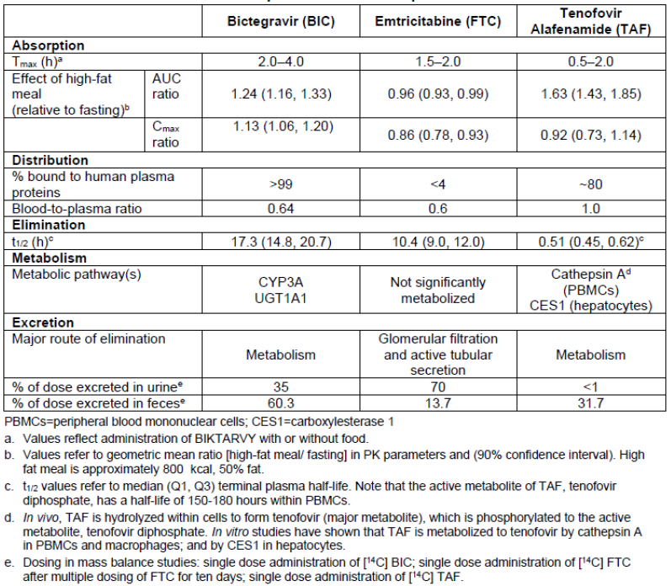
The results of single ascending doses (SAD) of BIC administered in Study GS-US-141-1218 were indicative of roughly linear behaviour (AUCinf) of BIC at 25, 50 and 100 mg doses with clearance (CL/F) of 725, 675 and 656 mL/hour respectively as shown in Table 29.
Table 29: Study GS-US-141-1218; GS-9883 Plasma pharmacokinetic parameters by treatment following single-dose administration of GS-9883 (Analysis Set: GS-9883 PK Part A: Single-Dose)
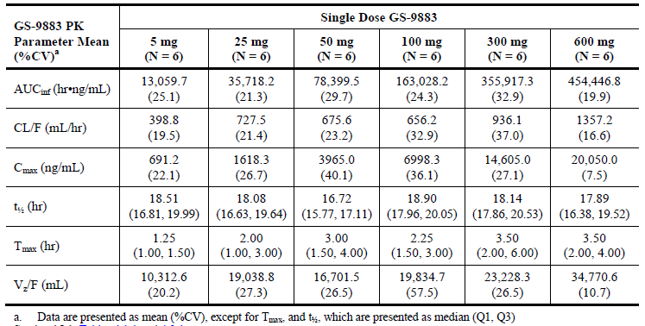
The results of multiple ascending doses (MAD) of BIC administered in the same study were indicative of accumulation by a factor of 1.6 from Day 1 to Day 7 with steady state reached between Day 4 to Day 6 as shown in Table 30.
Table 30: Study GS-US-141-1218; GS-9883 Plasma pharmacokinetic parameters by GS-9883 dose following multiple-dose administration of GS-9883 (Analysis Set: GS-9883 PK Part B: Multiple Dose)
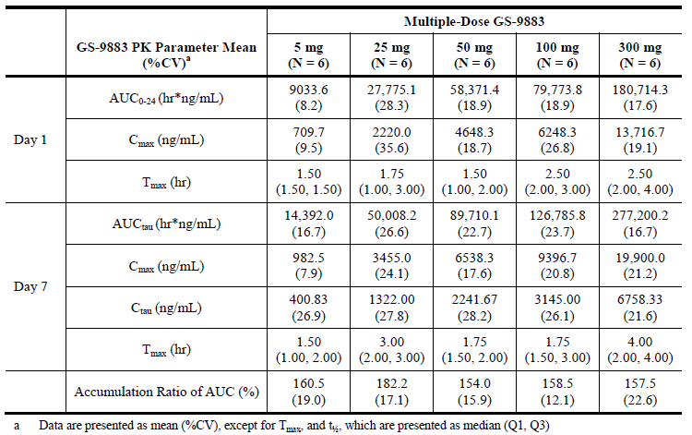

Pharmacodynamics
Please see the toxicology and clinical evaluation reports [extracts of these are included in the relevant sections of this AusPAR, above]. No clinically relevant effect on QT interval was shown in Study GS-US-141-1480.

Clinical efficacy
Clinical efficacy/safety is based on one Phase II study and four Phase III studies as follows:
Table 31: Primary studies supporting the clinical efficacy and safety of B/F/TAF
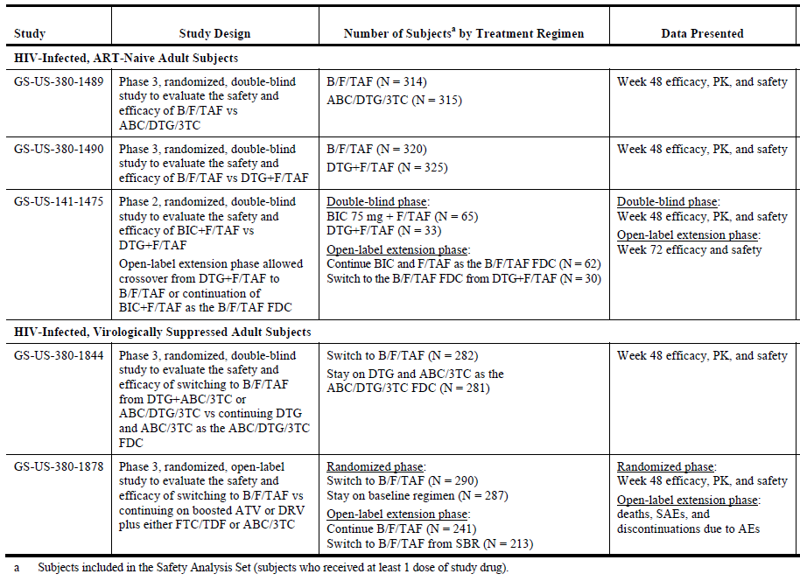

Dose selection
The Phase II Study GS-US-141-1475 in adult HIV-1 patients used 75 mg dose of BIC (+FTC/TAF 200/25 mg) for early investigation of treatment effect. This dose was selected based on a small dose ranging, proof of concept Study GS-US-141-1219 which examined the pharmacokinetics and antiviral activity of a range of single and multiple doses of BIC (5, 25, 50 and 100 mg) demonstrating a dose dependent decrease in HIV viral load compared to placebo. The antiviral effect of BIC plateaued at 25 mg and 50 mg doses and was slightly potentiated at the highest 100 mg BIC dose.
Table 32: Antiviral efficacy of BIC at different dose levels
The subsequent Phase II Study GS-US-141-1475 therefore examined BIC (75 mg) given with the established clinical dose of FTC/TAF (200/25 mg) and compared it with dolutegravir (DTG 50 mg) + FTC/TAF (200/25) in HIV patients. No other dose level of BIC was examined in the Phase II study. The results were as shown in Table 33.
Table 33: Study GS-US-141-1475. An overall summary of the different US FDA-defined snapshot algorithm analyses
A co-formulated fixed dose combination was not used in the Phase II study. A subsequent PK Study GS-US-141-1233 was undertaken to establish bioequivalence of a B/F/TAF (75/200/25) co-formulation versus the administration of BIC+FTC/TAF (75+200/25). The results, under fasting conditions, were as shown in Table 34.
Table 34: Study GS-US-141-1233 Plasma PK parameters for BIC, FTC, and TAF and statistical comparisons for relative bioavailability between the 75 mg B/F/TAF FDC and BIC 75 mg + F/TAF, each administered in the fasted state
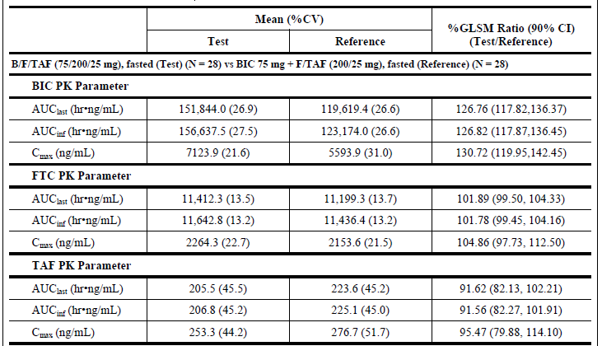
These results appear to have been interpreted as indicative of a lack of bioequivalence so that a new lower dose co-formulation of B/F/TAF (50/200/25) was developed for comparison with BIC + FTC/TAF (75 + 200/25 mg). The results, under fasting conditions, were as shown in Table 35.
Table 35: Plasma PK parameters for BIC, FTC, and TAF and statistical comparisons for relative bioavailability between the 50 mg B/F/TAF FDC and BIC 75 mg + F/TAF, each administered in the fasted state
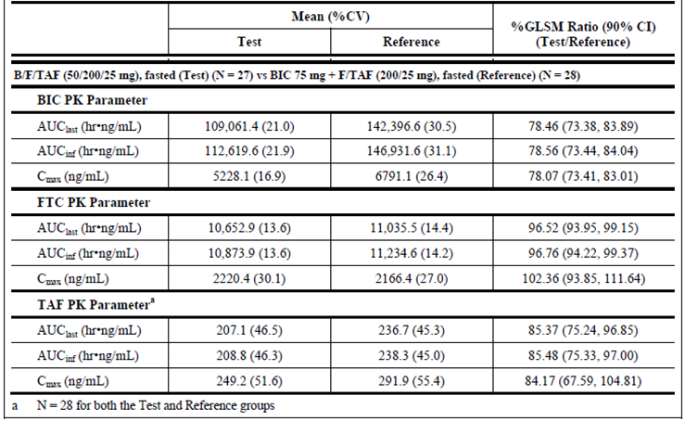
Based on these results, it was argued that 50/200/25 mg was (more) bioequivalent to 75+200/25 mg than 75/200/25 mg. Henceforth, B/F/TAF (50/200/25 mg) was used in all 4 confirmatory Phase III trials (without regard for food). No other dosing regimen was examined in Phase III.

Efficacy
All four Phase III trials were carried out in adult HIV-1 patients and were randomised, placebo-controlled, that is, double blinded against relevant active comparator regimens.

Treatment naïve population
Studies GS-US-380-1489 and GS-US-380-1490: The primary efficacy results at Week 48 were as shown in Table 36.
Table 36: Studies GS-US-380-1489 and GS-US-380-1490: Virologic outcome at Week 48 using the US FDA-defined snapshot algorithm and HIV-1 RNA < 50 copies/mL; Individual Studies (Full Analysis Set)
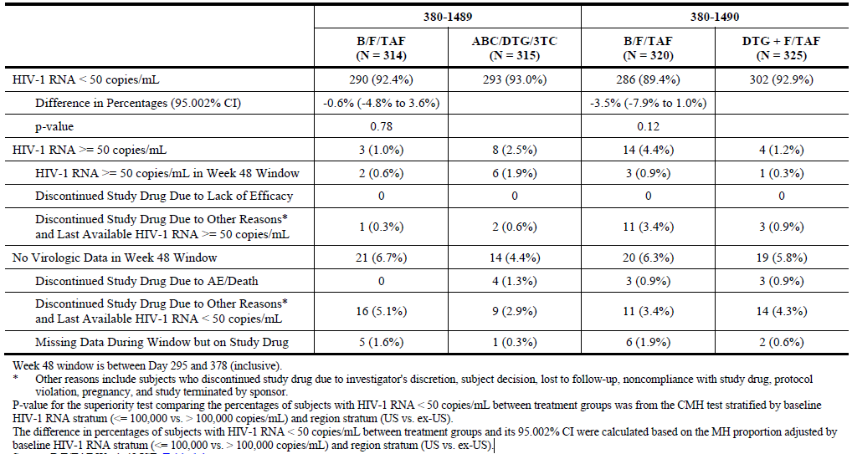
The response rate (HIV-1 RNA viral copies < 50/mL at 48 weeks) was very high (> 90%) both studies in all groups, numerically slightly lower with Biktarvy (B/F/TAF 50/200/25 mg) but statistically equivalent to the comparable comparator regimens (abacavir (ABC)/dolutegravir (DTG)/lamivudine (3TC) (600/50/300 mg) in Study 1489 and dolutegravir (DTG 50 mg) + F/TAF (200/25 mg) in Study 1490). Non-inferiority objective was satisfactorily met.
The progression of CD4 cell count from baseline overtime in the Study 1489 was as shown in Figure 3.
Figure 3: GS-US-380-1489: Mean and 95% CI of change form Baseline in CD4 cell count (cells/µL) by visit (Full analysis set)
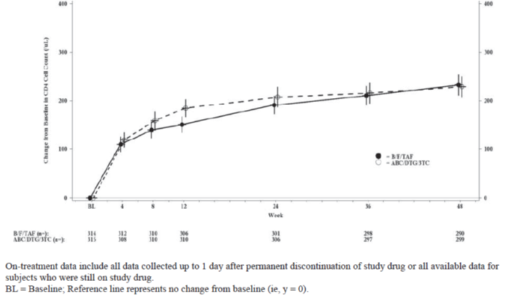
The progression of CD4 cell count from baseline overtime in the Study 1490 was as shown in Figure 4.
Figure 4: Study GS-US-380-1490: Mean and 95% CI of change form Baseline in CD4 cell count (cells/µL) by visit (Full analysis set)
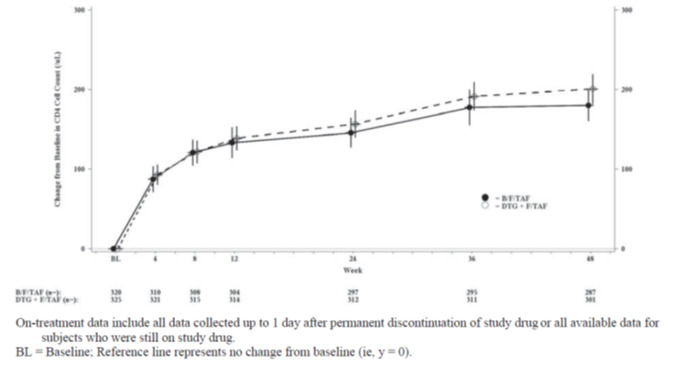
The treatment effect was generally homogenous across various subgroups. The results for baseline viral load and baseline CD4 count are shown below, noting a relatively lower HIV-1 RNA < 50 copies/mL response with B/F/TAF compared to current ART regimen in patient group with baseline viral load > 100,000 copies per mL (lower limit of 95%CI to 13.9% in pooled data) as shown in Table 37.
Table 37: Studies GS-US-380-1489 and GS-US-380-1490: Treatment difference in HIV-RNA < 50 copies/mL by subgroup at Week 48 using the US FDA defined snapshot algorithm; individual studies and pooled
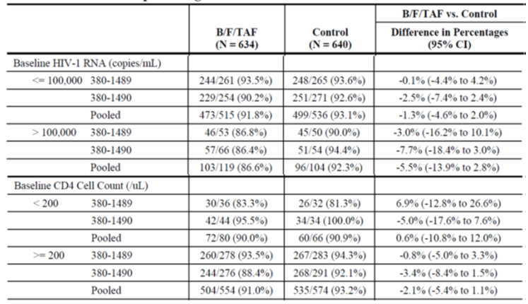
The Study 1490 included 14 HIV/HBV co-infected patients.

Resistance development
In Study 1489, the prevalence of baseline Resistance Associated Mutations (RAMs) and HIV-1 subtypes were comparable between B/F/TAF and ABC/DTG/3TC treatment groups. Of the 629 treated patients in both groups, the Resistance Analysis Population (RAP) included 5 patients who experienced virologic failure (VF) during first 48 weeks of the study comprising of 1/314 (0.3%) patient from B/F/TAF group and 4/315 (1.3%) patients from ABC/DTG/3TC group. Out of these 5 patients, 2 patients from ABC/DTG/3TC group remained on study drugs and subsequently achieved HIV-1 RNA < 50 copies/mL. The final RAP included 3 patients comprised of 1 from B/F/TAF group and 2 from ABC/DTG/3TC group. No patient in either group developed treatment emergent resistance to the study drugs.
In Study 1490, the prevalence of baseline RAMs and HIV-1 subtypes were comparable across B/F/TAF and DTG + FTC/TAF treatment groups. Of the 645 treated patients in both groups, RAP included 12 patients who experienced VF during first 48 weeks of the study comprising of 7/320 (2.2%) patients from B/F/TAF group and 5/325 (1.5%) patients from DTG + FTC/TAF group. Out of these 12 patients, 2 patients from DTG + FTC/TAF group remained on study drugs and subsequently achieved HIV-1 RNA < 50 copies per mL. The final RAP included 10 patients comprised of 7 patients from B/F/TAF group and 3 patients from DTG + FTC/TAF group. No patient in either group developed treatment emergent resistance to the study drugs.
Virologically suppressed population (Studies GS-US-380-1844 and GS-US-380-1878)

Study 1844
The primary efficacy results at Week 48 were as shown in Table 38.
Table 38: Study GS-US-380-1844; virologic outcome at Week 48 using the US FDA defined snapshot algorithm and HIV-1 RNA cut-off at 50 copies/mL
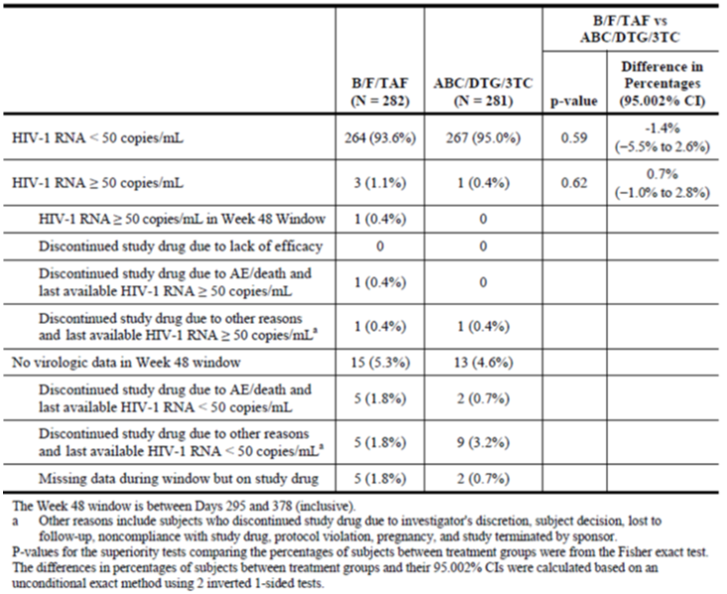
The response rate (HIV-1 RNA viral copies < 50/mL at 48 weeks) was maintained at > 90% in both groups and was statistically equivalent between Biktarvy (patients switching to B/F/TAF 50/200/25 mg from the current DTG + ABC/3TC or ABC/DTG/3TC) group versus the continued treatment (ABC/DTG/3TC 600/50/300 mg) group. Non-inferiority objective was met. Treatment effect (viral load < 50 copies/mL at Week 48) was similarly maintained across the demographic subgroups as shown in Table 39.
Table 39: Study GS-US-380-1844. Treatment Difference in HIV-1 RNA < 50 copies/mL at Week 48 (Snapshot Algorithm) by Subgroup Full Analysis Set
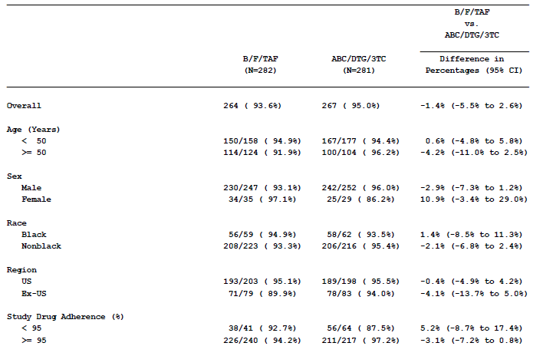
The changes in CD4 cell count from baseline overtime were as show in in Figure 5.
Figure 5: Mean (95% CI) Change from Baseline in CD4 Cell Count (/uL) by Visit while on treatment (Observed Data) Full Analysis Set
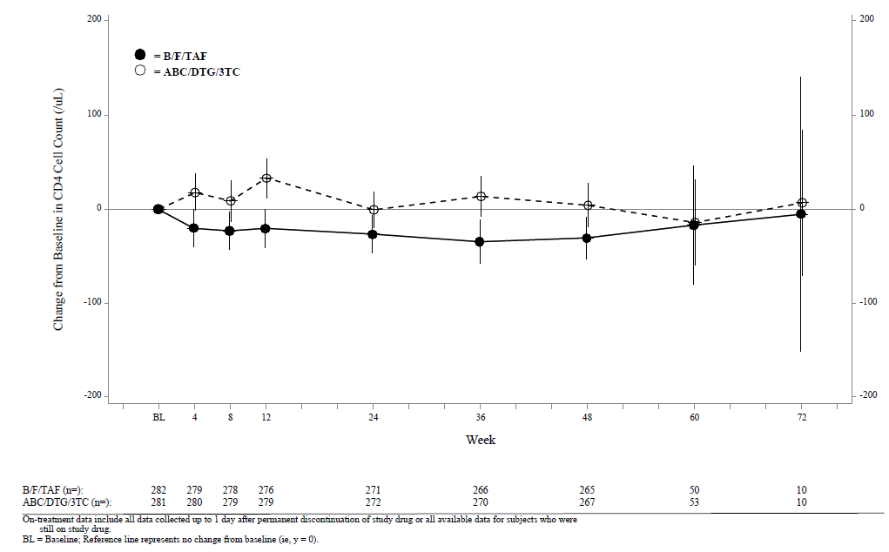

Resistance development
The prevalence of baseline RAMs and HIV-1 subtypes were comparable across B/F/TAF and ABC/DTG/3TC treatment groups. The RAP included 5 patients who experienced VF during first 48 weeks of the study comprising 3/282 (1.1%) patients from B/F/TAF group and 2/281 (0.7%) patients from ABC/DTG/3TC group. Two patients (one from each group) who met VF and RAP criteria remained on study drugs and subsequently achieved HIV-1 RNA < 50 copies per mL. The final RAP included 3 patients comprised of 2 from B/F/TAF group and 1 from ABC/DTG/3TC group. No patient in either group developed treatment emergent drug resistance.

Study 1878
The primary efficacy results at Week 48 were as follows. The study included 14 HIV/HBV co-infected patients.
Table 40: GS-US-380-1878: Virologic Outcome at Week 48 Using the US FDA-Defined Snapshot Algorithm and HIV-1 RNA cut-off at 50 copies/mL (Full analysis set)
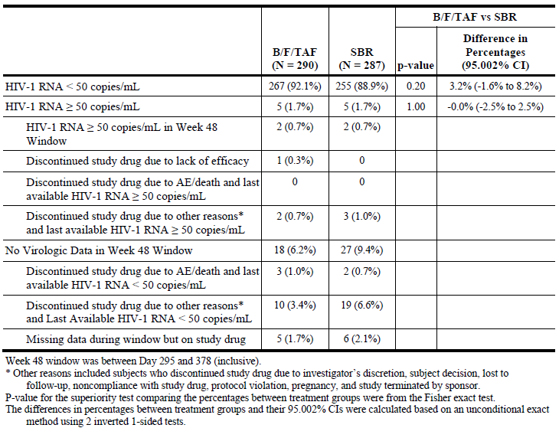
The response rate (HIV-1 RNA viral copies < 50/mL at 48 weeks) was maintained (> 88%) in both groups and was statistically equivalent between BIKATARVY (patients switching to B/F/TAF 50/200/25 mg from ritonavir (RTV) or cobicistat (COBI) boosted atazanavir (ATV) or darunavir (DRV) + either FTC/TDF or ABC/3TC) group versus the continued treatment (SBR – Stay on Baseline Regimen that is, RTV or COBI boosted ATV or DRV + either FTC/TDF or ABC/3TC ) group. Non-inferiority objective was met. Treatment effect (viral load < 50 copies/mL at Week 48) was similarly maintained across the demographic subgroups as shown in Table 40.
Table 41: Study GS-US-380-1878. Treatment difference in HIV-1 RNA < 50 copies/mL at Week 48 (Snapshot Algorithm) by Subgroup Full Analysis Set
The changes in CD4 cell count from baseline overtime were as shown in Figure 6.
Figure 6: Mean (95% CI) Change from Baseline in CD4 Cell Count (/µL) by Visit while on treatment (Observed Data) Full Analysis Set
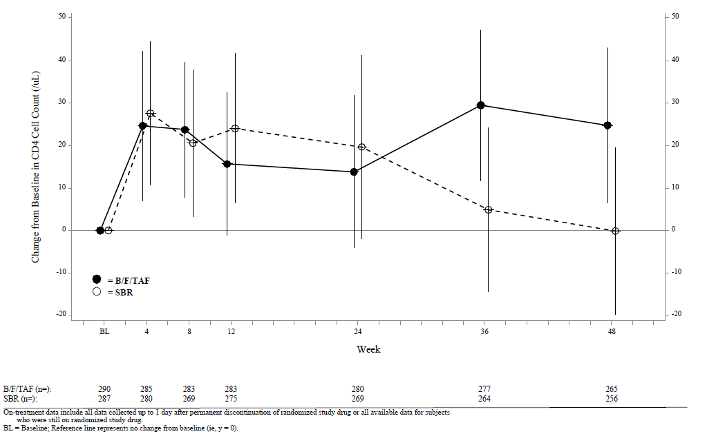

Resistance development
The prevalence of baseline RAMs and HIV-1 subtypes were comparable across B/F/TAF and SBR groups. The RAP included 7 patients who experienced VF during first 48 weeks of the study comprising 2/290 (0.7%) patients from B/F/TAF group and 5/287 (1.7%) patients from SBR group. Three patients (1 from B/F/TAF group and 2 SBR group) who met VF criteria remained on study drugs and subsequently achieved HIV-1 RNA < 50 copies/mL. The final RAP included 4 patients comprised of 1 patient from B/F/TAF group and 3 patients from SBR group. No patient in B/F/TAF group developed treatment emergent drug resistance in reverse transcriptase (RT) or IN. One patient in SBR group developed a treatment emergent ABC resistance mutation in RT, L74V as a mixture with wild type at Week 4.

Clinical Safety
A total of 1,511 adult HIV patients have received at least one dose of B/F/TAF in five Phase II and Phase III studies. In the randomised phases of the four Phase III clinical trials, a total of 1,206 patients have received B/F/TAF (50/200/25). Overall, 25 patients with HIV/HCV coinfection (B/F/TAF 10; comparator groups 15) have been exposed to the study drugs in Biktarvy studies. Twenty eight patients with HIV/HBV coinfection were included in Phase III clinical trials. No pregnancies were reported in Phase I or Phase II studies. Eleven pregnancies were reported in the Phase III B/F/TAF studies.
The median exposure in treatment naïve patients was 49.2 weeks. The median exposure in virologically suppressed patients was 49.9 weeks in Study 1844 and 46.7 weeks in Study 1878. The open label extensions of these studies are ongoing.
Overall summary of adverse effects is as follows as shown in Table 42.
Table 42: Overall summary of adverse events in ART naïve and virologically suppressed (adult) subjects
The adverse effects (AE) profiles were comparable in treatment-naïve and virologically-suppressed patients and were also similar to the active comparator groups.
Discontinuation rates due to AEs were small and similar in all groups.
In treatment-naïve patients treated with B/F/TAF, the most commonly reported AE were diarrhoea, headache and nausea.
In virologically-suppressed patients switching to B/F/TAF, the most commonly reported AE were URTI, diarrhoea, nasopharyngitis and headache.
The rate of serious adverse effects (SAEs) ranged from 5.3% to 9.1% across various groups. A total of 7 deaths were reported including four in patients receiving B/F/TAF.
No cases meeting Hy’s law criteria were reported.
In Study 1490, eight treatment-naïve patients with HIV/HBV co-infection were treated with B/F/TAF. Of these, two patients developed significant hepatic flare (1 Grade 4; 1 Grade 3).
The changes from baseline in alkaline phosphatase, ALT, AST or total bilirubin in patients treated with B/F/TAF were not clinically meaningful in any of the Phase III studies as seen in Table 43.
Table 43: Studies GS-US-380-1489, GS-US-380-1490, GS-US-380-1444, GS-US-380-1878: Grade 3 and 4 liver related laboratory abnormalities (Safety Analysis Set)
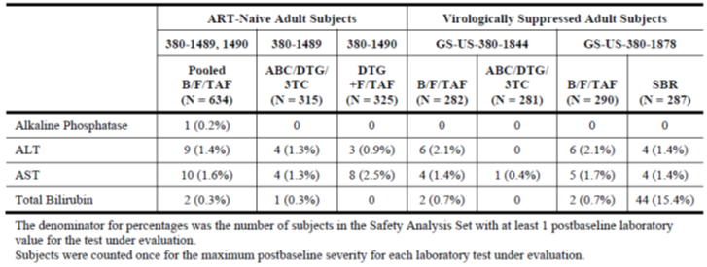
There were no clinically meaningful differences between treatment groups related to other laboratory changes
Overall no new safety signal was reported but the safety dataset is very small and of limited duration including with respect to assessment of risk of resistance development.
No post-market safety data is available at present.

Clinical evaluator’s recommendation (if applicable)
The clinical evaluator is supportive of approval with the revised indication during Round 2.

Risk management plan
Routing pharmacovigilance is recommended. There are no outstanding issues.
Implementation of Biktarvy EU-Risk Management Plan version 0.1 (dated 10 June 2017) with the Australian Specific Annex version 0.2 (dated February 2018) included with submission and any subsequent revisions in agreement with the TGA will be a condition of registration. Inclusion in the Black Triangle Scheme is also recommended. This is supported.

Risk-benefit analysis

Delegate’s considerations
The dossier represents the full clinical development program for Biktarvy (BIC/FTC/TAF 50/200/25 mg).
All outstanding issues in quality assessment including toxicological qualification of a number of drug impurities and a pending GMP certificate have been resolved. Approval is recommended by the quality area.
There are also no outstanding issues in relation to nonclinical and RMP areas. Both areas support approval.
Overall the clinical dataset is adequate with regards to pharmacokinetics, pharmacodynamics and clinical efficacy but quite limited in relation to clinical safety. The RMP area has recommended inclusion of Biktarvy in the black triangle scheme as a condition of registration. This is supported.
Lack of absolute bioavailability study for BIC is considered acceptable given the overall information from clinical studies and availability of Phase III data. The food effect is modest and not likely to impact on clinical effect. The recommendation is for administration of Biktarvy without regard for food.
The proposed clinical dose of BIC/FTC/TAF 50/200/25 mg was not particularly well chosen but remains the only choice as only one dose level was examined in Phase III (or Phase II). After obtaining dose response data in Study 1219, the choice of BIC+FTC/TAF 75+200/25 mg in the Phase II Study 1475 was appropriate but was limited due to lack of another dose level. Subsequently, two co-formulated fixed dose formulations (BIB/FTC/TAF 75/200/25 mg and 50/200/25 mg) were tested for bioequivalence to 75+200/25 mg in the Study 1233. The results have been reproduced above. BIC/FTC/TAF 50/200/25 mg was considered bioequivalent to the Phase II combination 75+200/25 mg. A conclusion of relatively lower bioavailability of 50/200/75 mg than 75/200/25 mg against the Phase II combination of 75+200/25 mg would have been more consistent with the reported results. Thus there is a disconnect between Study 1219 (dose response), Study 1475 (Phase II) and the four Phase III studies.
However, in view of the dose response observed in Study 1219, BIC/FTC/TAF 50/200/25 mgis also a reasonable, but not optimal, choice. The Phase III clinical trials data in both ART treatment-naïve and treatment-experienced (virologically-suppressed on stable treatment) patient population are indicative of statistically non-inferior efficacy, but no additional advantage, against the comparator standard treatment regimens currently in clinical use. Somewhat lower response in patients with baseline viral load > 100,000 copies/mL in naïve population is noted
Other issues worth noting are pharmacokinetic interaction with concomitant strong antacid and a 41% reduction (lower limit of 90%CI) in BIC exposure (AUC_{inf}) in moderate hepatic impairment compared to healthy subjects (normal hepatic function) based on a single dose BIC 75 mg in Study GS-US-141-1478 as shown in Table 44.
Table 44: Study GS-US-141-1478 BIC PK parameters after a single dose BIC 75mg
This is noted given the proposed recommendation that no change in dose is recommended in moderate hepatic dysfunction. Note Biktarvy is not recommended for use in severe renal impairment based on a single dose BIC 75 mg Study GS-US-141-1479 in which 48% lower limit of 90%CI for BIC AUC_{inf} was obtained (compared to normal renal function) as shown in Table 45.
Table 45: Study GS-US-141-1479. Plasma PK parameters for GS-9883 and statistical comparisons for renal impairment
No unexpected adverse effects or safety signals were reported within the limited dataset. Post-market data is not yet available.

Proposed action
The Delegate was of the view that Biktarvy (BIC/FTC/TAF 50/200/25 mg) dossier has sufficient data to allow approval of the proposed use in the treatment of HIV-1 infection in adults.
There were too few HIV/HBV co-infected patients so that the sponsor has agreed to withdraw the initially proposed separate indication in HIV/HBV co-infected population.
In the second round, the sponsor has agreed to a modified indication recommended by the clinical evaluator.
It is proposed that the indication should more accurately reflect the clinical trials experience. The following indication is recommended:
Biktarvy is indicated for the treatment of HIV-1 infection in adults who are antiretroviral therapy (ART)-naïve or to replace the current antiretroviral regimen in those who are virologically-suppressed (HIV-1 RNA < 50 copies per mL) on a stable antiretroviral regimen for at least 3 months with no history of treatment failure, and no known substitutions associated with resistance to the individual components of Biktarvy

Request for ACM advice
The Committee is requested to provide advice on the following specific issues:
- The ACM is requested to comment on dose selection for the Phase III studies and on the optimal wording of the indication.
- The ACM is requested advice on the suitability of proposed recommendations in moderate hepatic impairment (no change in dose required) and in severe renal impairment (do not use).
The ACM is also requested to provide advice on any other issues that it thinks may be relevant to a decision on whether or not to approve this application.

Response from sponsor

Summary
Given the success of potent and well-tolerated antiretroviral therapy (ART), morbidity and mortality in HIV infected patients is increasingly driven by non-AIDS-associated comorbidities. Clinical attention has become more focused on optimising ART tolerability, long-term safety, and adherence. There remains a significant medical need for new, effective therapies that take into consideration the non-HIV comorbidities, demographics of the aging HIV-infected population, ART resistance, and regimen simplification.
Bictegravir (BIC) is a potent integrase strand-transfer inhibitor (INSTI) that is being evaluated for the treatment of HIV-1 infection and has demonstrated a terminal half-life suitable for once-daily administration without a boosting agent. When BIC is co-administered with the guideline-recommended N(t)RTI backbone, FTC and TAF, BIC demonstrated high ARV activity, with no virologic failures due to resistance, and the treatment was safe and well tolerated.
FTC and TAF form a guideline-recommended N(t)RTI backbone for ART-naïve HIV-infected patients. In clinical trials, FTC and TAF have demonstrated potent and sustained efficacy, with excellent tolerability and minimal long-term toxicity in HIV-infected subjects.
Biktarvy has the potential to offer the Australian HIV community the benefits of an optimised treatment in the context of an aging cohort of HIV infected individuals with a life-expectancy close to that observed in the general population who are exposed to ART for the long-term.

Advice sought by the TGA Delegate
The Delegates’ comments on are presented in bold italics, and are followed by the sponsor’s response.

Question 1
The ACM is requested to comment on dose selection for the Phase III studies and on the optimal wording of the indication.

Dose selection for the Phase III studies
Based on higher than expected BIC exposures when administered as fixed dose combination (FDC), the dose of BIC was able to be reduced from 75 mg to 50 mg in Biktarvy. Similar exposures of BIC, FTC, and TAF were observed in patients that received Biktarvy (50 mg BIC) as compared with subjects that received co-administered BIC 75 mg as a single agent and F/TAF 200/25 mg tablets. All the pivotal safety and efficacy data to support registration of Biktarvy is from the 4 pivotal Phase III studies which were conducted with the 50/200/25 mg tablets. The conduct of the Phase III studies allowed for factors that represent ‘real world’ conditions of administration, including those that could result in lower BIC exposure, such as administration without food and/or drug-drug interactions such as those observed with weak or moderate cytochrome P450 (CYP)3A/UGT1A1 inducers.
The 50 mg dose of BIC was selected for the B/F/TAF FDC based on the totality of data from the BIC first in human single- and multiple-ascending dose, BIC+F/TAF drug interaction Study GS-US-141-1218), the dose ranging proof of concept Study GS-US-141-1219, the safety and efficacy Study GS-US-141-1475; single agent BIC 75 mg co-administered with F/TAF (200/25 mg)), and a relative bioavailability Study GS-US-141--1233, which evaluated 2 FDC tablet formulations (a 50 mg BIC B/F/TAF (50/200/25 mg) FDC and a 75 mg BIC B/F/TAF (75/200/25 mg) FDC) compared with BIC 75 mg + F/TAF (200/25 mg).
The BIC 75 mg dose was selected as a single agent for Phase II development based on its predicted protein adjusted 95% inhibitory quotient (paIQ95) value. Considering the C_{tau} values achieved in Study GS-US-141-1219 and an in vitro protein adjusted 95% effective concentration (paEC95) of 162 ng/mL for wild type HIV-1 (Study PC-141-2032), median (range) paIQ95 values of 4.9 (4.4 to 11.7), 13.4 (5.3 to 18.6), and 25.9 (23.0 to 36.9) were estimated for BIC 25, 50, and 100 mg doses, respectively. Based on the linear PK of BIC in this dose range and predicted PK/PD response curve, single agent BIC 75 mg was predicted to provide near maximal virologic response with a paIQ95 value of approximately 20.
B/F/TAF 75/200/25 mg FDC tablets containing 75 mg of BIC were compared to BIC 75 mg single agent co-administered with F/TAF 200/25 mg tablets in a relative bioavailability Study GS-US-141-1233. Based on higher than expected BIC exposures when administered as the B/F/TAF 75/200/25 mg FDC, the dose of BIC was reduced from 75 mg to 50 mg, and a new B/F/TAF 50/200/25 mg FDC tablet was developed. When B/F/TAF tablets containing 50 mg of BIC were then administered in Study GS-US-141-1233, similar exposures of BIC, FTC, and TAF were observed as compared with subjects that received co-administered BIC 75 mg single agent and F/TAF 200/25 mg tablets. As such, the B/F/TAF 50/200/25 mg tablets were used to initiate Phase III studies.
In the Phase III B/F/TAF studies, exposure/efficacy relationships at BIC and TAF exposures (AUC_{tau} and C_{max}) above or below population median, as well as across quartiles for individual agents versus the primary efficacy endpoint (HIV-1 RNA < 50 copies/mL using the US FDA-defined snapshot algorithm), were examined. All analyses consistently revealed high percentages of subjects with HIV-1 RNA < 50 copies/mL across all groups with no trends in exposure response relationships. Importantly, for BIC, in particular, all subjects had trough concentrations (C_{tau}) above the paEC95 with no loss of efficacy at lower IQ. The lowest IQ value among these subjects was 12.1. For the subjects with BIC exposures at or below this level, all had HIV-1 RNA < 50 copies/mL at Week 48.
These data support the conclusion that the 50 mg B/F/TAF FDC provides appropriate BIC exposures across a wide spectrum of patients and administration conditions, including in patients with moderate hepatic impairment or upon co-administration with polyvalent cation containing antacids.

Optimal wording for the indication
The sponsor has noted the Delegate’s comments that the proposed indication should accurately reflect the clinical trials experience.
However, the sponsor believes it would be more relevant to align the Australian Biktarvy indication for consistency with the indications approved in Australia for the other TAF-based HIV-1 treatments, for example Genvoya (AUST R 233398). Therefore the sponsor is proposing the following modified indication for Biktarvy as this adequately captures the Delegate’s comments:
Biktarvy is indicated for the treatment of HIV-1 infection in adults who are antiretroviral therapy (ART)-naive or to replace the current antiretroviral regimen in those who are virologically-suppressed (HIV-1 RNA < 50 copies per mL) on a stable antiretroviral regimen at the start of therapy with no history of treatment failure and no known substitutions associated with resistance to the individual components of Biktarvy.

Question 2
The ACM is requested to advise on the suitability of proposed recommendations in moderate hepatic impairment (no change in dose required) and in severe renal impairment (do not use).

Hepatic impairment
The sponsor maintains the current recommendation provided for patients with moderate hepatic impairment is accurate. Although an approximately 41% decrease in total BIC exposure was observed in subjects with moderate hepatic impairment versus control subjects with normal hepatic function, the free BIC exposure (accounting for unbound plasma fraction) was comparable between the two groups. In the hepatic impairment Study GS-US-141-1478, the mean (% coefficient of variation (CV)) percentage unbound plasma fraction of BIC was higher in subjects with moderate hepatic impairment (0.809% (21.4%)) than in normal matched control subjects (0.610% (6.2%)). After accounting for this difference in unbound plasma fraction, free BIC exposure (AUC) was comparable in subjects with moderate hepatic impairment relative to normal matched control subjects (GLSM ratio for free AUC_{inf}: 76.54%). This approximately 23% difference in free BIC exposure is not clinically relevant and not expected to result in reduced efficacy based on the therapeutic window of Biktarvy. The BIC therapeutic window was established based on the totality of the PK, efficacy, and safety data from the B/F/TAF 50/200/25 mg FDC development program and supports that virologic suppression and safety is maintained within BIC exposures at 48% and 200% of the median from the Phase III clinical studies, respectively. These data support the conclusion that the 50 mg B/F/TAF FDC provides appropriate BIC exposures across a wide spectrum of patients, including those with moderate hepatic impairment. The recommendation for use of Biktarvy in patients with moderate hepatic impairment is also consistent with the approved Biktarvy USPI recommendation.

Severe renal impairment
The proposed Biktarvy PI currently states in Section 4.2 that: Initiation of Biktarvy is not recommended in patients with estimated creatinine clearance below 30 mL per minute as there are insufficient data available regarding the use of Biktarvy in this population.
This advice is consistent with the advice for renal impairment in the current approved TAF-based products Genvoya PI (EVG/COBI/FTC/TAF) AUST R 233398; Descovy PI (FTC/TAF) AUST R 246093, and 246092; and Odefsey PI (FTC/RPV/TAF) AUST R 260634.
Clinically significant exposure changes of the TAF metabolite, TFV, and FTC were not observed in HIV infected subjects with mild or moderate renal impairment relative to the subjects with normal renal function in Phase III clinical studies. Therefore, F/TAF-containing products are indicated for use in renally impaired, HIV infected subjects with eGFR_{CG} ≥ 30 mL/min. Consistent with the known ADME profile of BIC, severe renal impairment did not result in clinically relevant changes in BIC exposure. The recommendation for use of Biktarvy in subjects with renal impairment is guided by the most conservative dosing recommendation for affected components in the setting of renal impairment (that is, FTC). In addition, this recommendation in the Biktarvy PI is aligned with that of the other F/TAF-containing product PIs in Australia. Therefore the recommendation for Biktarvy is it may be administered without dose adjustment in subjects with eGFRCG ≥ 30 mL/min.

Other issues/comment
The ACM is also requested to provide advice on any other issues that it thinks may be relevant to a decision on whether or not to approve this application.
Based on the totality of the Biktarvy development program, the sponsor believes that there is sufficient data to support the approval of the application for the registration of Biktarvy. Biktarvy will provide the Australian community with a long term treatment option for people living with HIV. In Addition, Biktarvy was approved by the US FDA on 7 February 2018 for the treatment of HIV-1 infection and recently received a positive CHMP opinion in the EU on 27 April 2018.

Comments on Delegate’s proposed action
It is proposed that the indication should be more accurately reflect the clinical trials experience. The following is recommended:
Biktarvy is indicated for the treatment of HIV-1 infection in adults who are ART-naive or to replace the current antiretroviral regimen in those who are virologically-suppressed (HIV-1 RNA < 50 copies per mL) on a stable antiretroviral regimen for at least 3 months with no history of treatment failure and no known substitutions associated with resistance to the individual components of Biktarvy.
The sponsor has noted the Delegate’s comments that the proposed indication should accurately reflect the clinical trials experience. However, the sponsor believes it would be more relevant to align the Australian Biktarvy indication for consistency with the indications approved in Australia for the other TAF-based HIV-1 treatments, for example Genvoya (AUST R 233398). Therefore the sponsor is proposing the following modified indication for Biktarvy as this adequately captures the Delegate’s comments:
Biktarvy is indicated for the treatment of HIV-1 infection in adults who are antiretroviral treatment (ART)-naive or to replace the current antiretroviral regimen in those who are virologically-suppressed (HIV-1 RNA < 50 copies per mL) on a stable antiretroviral regimen at the start of therapy with no history of treatment failure and no known substitutions associated with resistance to the individual components of Biktarvy.

Conclusion
Biktarvy has demonstrated both potent antiviral efficacy and a safety and tolerability profile that offer advantages over existing recommended ARV regimens, with a high barrier to resistance, no evidence of bone or renal toxicity, no risk of hypersensitivity reactions, a low potential for drug-drug interactions, flexibility to dose without regard to food, and a smaller tablet size. Biktarvy represents a favourable new therapeutic once daily option for HIV infected adults, without any known mutations associated with resistance to the individual components of Biktarvy.

Advisory Committee Considerations
The Advisory Committee on Medicines (ACM), having considered the evaluations and the Delegate’s overview, as well as the sponsor’s response to these documents, advised the following:
The ACM taking into account the submitted evidence of efficacy, safety and quality, agreed with the delegate and considered Biktarvy oral tablet containing bictegravir 50 mg / emtricitabine 200 mg / tenofovir alafenamide 25 mg to have an overall positive benefit-risk profile for the Delegate’s amended indication:
Biktarvy is indicated for the treatment of HIV-1 infection in adults who are ART naïve or to replace the current antiretroviral regimen in those who are virologically-suppressed (HIV-1 RNA < 50 copies/ml) on a stable antiretroviral regimen for at least 3 months with no history of treatment failure, and with no known substitutions associated with resistance to the individual components of Biktarvy.
In providing this advice the ACM noted that:
- The focus of antiretroviral treatments for HIV infection is increasingly on improved toxicity profiles and adherence.
- Emtricitabine (FTC) and tenofovir alafenamide (TAF) have previously been approved and are in wide use in Australia.
- Biktarvy is approved in the US (February 2018) as a complete treatment regimen for HIV-1 infection in adults who are treatment naïve or as an alternative for those currently taking a fully suppressive regimen. It is currently under review in the EU and Canada.
- The sponsor withdrew the HBV coinfection indication due to small numbers of patients.
- The arguments made by the sponsor to support the 50 mg dose selection for Phase III studies are not entirely convincing given that the optimal dose of bictegravir (BIC) tablet was found to be 75 mg in early studies.
- Data in the dossier suggests that higher doses of BIC may be required in the presence of moderate hepatic impairment.
- Biktarvy should not be used in patients with severe renal impairment.
- Biktarvy interacts with strong antacids.
- Bictegravir is pregnancy category B1 but Biktarvy is B3 consistent with other FTC/TAF combinations.
- Two of eight HIV/HBV co-infected patients in Study 1490 had hepatic flares.
The Committee was of the view that the sponsor should submit a dossier based on the findings of the ongoing open label non-randomised study in children and adolescents as early as possible after primary completion in December 2018.

Proposed conditions of registration
The ACM agreed with the delegate on the proposed conditions of registration and advised on the inclusion of the following:
- Subject to satisfactory implementation of the Risk Management Plan most recently negotiated by the TGA including inclusion in the Black Triangle Scheme,
- Negotiation of the Product Information and Consumer Medicine Information to the satisfaction of the TGA.

Proposed Product Information (PI)/ Consumer Medicine Information (CMI) amendments
The ACM agreed with the delegate to the proposed amendments to the Product Information (PI) and Consumer Medicine information (CMI) and specifically advised on the inclusion of the following:
- A strong statement warning of possible disease flares in hepatitis B/HIV co-infected patients.
- A strong statement regarding the interaction with strong antacids.

Specific Advice
The ACM advised the following in response to the delegate’s specific questions on the submission:
- The ACM is requested to comment on dose selection for the Phase III studies and on the optimal wording of the indication.
The Committee noted that the decision to include the 50 mg dose of BIC in the FDC is suboptimal and that a 75 mg dose would have been preferable. However, they agree that the 50 mg dose is acceptable based on efficacy outcomes.
The Committee agreed with the revised wording of the indication proposed by the Delegate. The Committee also noted the sponsor’s Pre-ACM response and considered it acceptable.
- The ACM is requested to advise on the suitability of proposed recommendations in moderate hepatic impairment (no change in dose required) and in severe renal impairment (do not use).
The Committee advised that there is no need to modify the dose in moderate hepatic impairment as the sponsor has demonstrated that free BIC levels are unaffected.
The Committee agreed with the contraindication in severe renal impairment based on the TAF component.

Sponsor response to ACM recommendations
The ACM advised the following in response to the Delegate’s specific questions on the submission:
The ACM is requested to comment on the optimal wording of the indication.
The Committee agreed with the revised wording of the indication proposed by the Delegate.
The Committee also noted the sponsor’s Pre-ACM response and considered it acceptable.
The sponsor has noted the Committees comments on the optimal wording of the proposed indication and that the Committee considered the sponsor’s Pre-ACM response acceptable. The sponsor maintains that it is more relevant to align the Australian Biktarvy indication for consistency with the approved indications in Australia for the other TAF-based HIV-1 treatments, such as Genvoya (AUST R 233398) to highlight that Biktarvy can be prescribed for virologically-suppressed patients on a stable antiretroviral regimen at the start of therapy.
Therefore the sponsor believes the proposed indication adequately addresses the concerns raised in the Delegate’s Overview.
Additional negotiations with regard to details in the PI occurred but these are beyond the scope of the AusPAR.

Outcome
Based on a review of quality, safety and efficacy, TGA approved the registration of Biktarvy bictegravir 50 mg, emtricitabine 200mg and tenofovir alafenamide 25 mg, indicated for:
Biktarvy is indicated for the treatment of HIV-1 infection in adults who are antiretroviral therapy (ART)-naïve or to replace the current antiretroviral regimen in those who are virologically-suppressed (HIV-1 RNA < 50 copies per mL) on a stable antiretroviral regimen at the start of therapy with no history of treatment failure, and no known substitutions associated with resistance to the individual components of Biktarvy.

Specific conditions of registration applying to these goods
- Biktarvy (Bictegravir/Emtricitabine/Tenofovir Alafenamide) is to be included in the Black Triangle Scheme. The PI and CMI for Biktarvy must include the black triangle symbol and mandatory accompanying text for five years, which starts from the date that the sponsor notifies the TGA of supply of the product.
- The Biktarvy EU-Risk Management Plan (RMP) (version 0.1, dated 10 June 2017, data lock point 11 May 2017), with Australian Specific Annex (version 0.2, dated February 2018), included with submission PM-2017-02454-1-2, and any subsequent revisions, as agreed with the TGA will be implemented in Australia.

Attachment 1. Product Information
The PI for Biktarvy approved with the submission which is described in this AusPAR is at Attachment 1. For the most recent PI, please refer to the TGA website at < https://www.tga.gov.au/product-information-pi>

Therapeutic Goods Administration
PO Box 100 Woden ACT 2606 Australia
Email: info@tga.gov.au Phone: 1800 020 653 Fax: 02 6232 8605
https://www.tga.gov.au

Australasian Society for HIV, Viral Hepatitis and Sexual Health Medicine (ASHM). (2016). Antiretroviral guidelines: US DHHS guidelines with Australian commentary. Accessed 9 April 2019.
C_{max} = Maximum observed concentration of drug
AUC_{inf} = Area under the plasma concentration versus time curve extrapolated to infinite time
AUC_{last} = Area under the plasma concentration versus time curve from time zero to the last quantifiable concentration
European Medicines Agency (EMEA), Committee for Proprietary Medicinal Products (CPMP), 27 July 2006. Guideline on carcinogenicity evaluation of medicinal products for the treatment of HIV infection, CPMP/SWP/194898/2006.
HIV-1 BaL an infectious molecular clone consisting of the HXB3 backbone and BaL Env and flanking sequences
C_{tau} = Observed drug concentration at the end of the dosing interval
Hargreaves IP, et al. (2016) Drug-induced mitochondrial toxicity. Drug Saf. 2016; 39: 661-674.
Cahn P, et al. (2013) Dolutegravir versus raltegravir in antiretroviral-experienced, integrase-inhibitor-naive adults with HIV: week 48 results from the randomised, double-blind, non-inferiority SAILING study. Lancet 2013; 382:700-708.
Mesplede T, et al. (2013) Viral fitness cost prevents HIV-1 from evading dolutegravir drug pressure. Retrovirology 2013; 10: 22.
Wares M, et al. The M50I polymorphic substitution in association with the R263K mutation in HIV-1 subtype B integrase increases drug resistance but does not restore viral replicative fitness. Retrovirology, 2014; 11:7.
Anstett K, et al. (2015) Dolutegravir-selected HIV-1 containing the N155H and R263K resistance substitutions does not acquire additional compensatory mutations under drug pressure that lead to higher-level resistance and increased replicative capacity. J Virol. 2015; 89: 10482-10488.
Fantauzzi A, et al. (2014) Dolutegravir: clinical efficacy and role in HIV therapy. Ther Adv Chronic Dis. 2014;5: 164-77.
hERG (human ether-a-go-go-related gene) encodes the alpha subunit of a potassium ion channel that is important for cardiac repolarisation.
T_{max} = Time (observed time point) of C_{max}
OATP = Organic-anion-transporting polypeptide; OCT = Organic cation transporter
International Conference on Harmonisation of technical requirements for registration of pharmaceuticals for human use (2009). Guidance on Nonclinical safety studies for the conduct of human clinical trials and marketing authorization for pharmaceuticals M3(R2), June 2009.
Pregnancy Category B3 is defined as: Medicines which have been taken by only a limited number of pregnant women and women of childbearing age, without an increase in the frequency of malformation or other direct or indirect harmful effects on the human foetus having been observed. Studies in animals have shown evidence of an increased occurrence of foetal damage, the significance of which is considered uncertain in humans.
Pregnancy Category B1 is defined as: Drugs which have been taken by only a limited number of pregnant women and women of childbearing age, without an increase in the frequency of malformation or other direct or indirect harmful effects on the human fetus having been observed. Studies in animals have not shown evidence of an increased occurrence of fetal damage.
Clarification: Bictegravir is not intended for paediatric use as a single agent
Australian Federation of AIDS Organisations. (2017) HIV in Australia: 2017. Accessed 9 April 2019.
Günthard HF, et al. (2016) Antiretroviral drugs for treatment and prevention of HIV infection in adults: 2016 Recommendations of the International Antiviral Society-USA Panel. JAMA 2016; 316:191-210.
Lundgren JD, et al. (2015) Initiation of antiretroviral therapy in early asymptomatic HIV infection. N Engl J Med 2015; 373:795-807.
Danel C, et al. (2015) A trial of early antiretrovirals and isoniazid preventive therapy in Africa. N Engl J Med 2015; 373:808-22.
Grinsztejn B, et al. (2014) Effects of early versus delayed initiation of antiretroviral treatment on clinical outcomes of HIV-1 infection: results from the phase III HPTN 052 randomised controlled trial. Lancet Infect Dis 2014; 14: 281-90.
Australasian Society for HIV, Viral Hepatitis and Sexual Health Medicine (ASHM). (2016). Antiretroviral guidelines: US DHHS guidelines with Australian commentary. Accessed 9 April 2019.
U. S. Department of Health and Human Services, Food and Drug Administration (FDA), Center for Drug Evaluation and Research (CDER). Human Immunodeficiency Virus-1 Infection: Developing Antiretroviral Drugs for Treatment. Guidance for Industry. Silver Spring, MD. November, 2015.
European Medicines Agency (EMEA). Committee for Medicinal Products for Human Use (CHMP), Guideline on the clinical development of medicinal products for the treatment of HIV infection. April 2016, 2016.
U.S. Department of Health and Human Services Food and Drug Administration Center for Drug Evaluation and Research (CDER); Center for Biologics Evaluation and Research (CBER). Guidance for Industry. Antiretroviral Drugs Using Plasma HIV RNA Measurements — Clinical Considerations for Accelerated and Traditional Approval Oct, 2002.
Vz/F = Apparent volume of distribution of the drug
CL/F = Apparent oral clearance after administration of the drug; D1 = Duration of the depot compartment; Ka = Absorption rate; Vc/F = Apparent volume of central compartment
DAVG₁₁ = Time-weighted average change from baseline to study Day 11
ABC = Abacavir ;3TC = Lamivudine ; DTG = Dolutegravir
SBR = RTV or COBI-boosted ATV or DRV + either FTC/TDF or ABC/3TC
WHO Regional Office for Europe. Management of hepatitis B and HIV coinfection: Clinical Protocol for the WHO European region (2011 revision)
Routine risk minimisation activities may be limited to ensuring that suitable warnings are included in the product information or by careful use of labelling and packaging. Routine pharmacovigilance practices involve the following activities: - All suspected adverse reactions that are reported to the personnel of the company are collected and collated in an accessible manner; - Reporting to regulatory authorities; - Continuous monitoring of the safety profiles of approved products including signal detection and updating of labelling; - Submission of PSURs; - Meeting other local regulatory agency requirements.
Gunthard HF, et al. Antiretroviral Drugs for Treatment and Prevention of HIV Infection in Adults: 2016 Recommendation of the International Antiviral Society-USA Panel. JAMA. 2016; 316: 191-210
Descovy, Gilead Sciences Inc. (emtricitabine and tenofovir alafenamide) tablets, for oral use. U. S. Prescribing Information. Foster City, CA. Revised April. 2017
eGFR_{CG} = Estimated glomerular filtration rate calculated using the Cockcroft-Gault equation
ADME = Absorption, distribution, metabolism and excretion
The ACM provides independent medical and scientific advice to the Minister for Health and the Therapeutic Goods Administration (TGA) on issues relating to the safety, quality and efficacy of medicines supplied in Australia including issues relating to pre-market and post-market functions for medicines. The Committee is established under Regulation 35 of the Therapeutic Goods Regulations 1990. Members are appointed by the Minister. The ACM was established in January 2017 replacing Advisory Committee on Prescription Medicines (ACPM) which was formed in January 2010. ACM encompass pre and post-market advice for medicines, following the consolidation of the previous functions of the Advisory Committee on Prescription Medicines (ACPM), the Advisory Committee on the Safety of Medicines (ACSOM) and the Advisory Committee on Non-Prescription Medicines (ACNM). Membership comprises of professionals with specific scientific, medical or clinical expertise, as well as appropriate consumer health issues relating to medicines.

