|  |
| --- |
| **22 May 2013** |

|  |
| --- |
| AusPAR Attachment 1 |
| Extract from the Clinical Evaluation Report for Bimatoprost |
| Proprietary Product Name: Latisse |
| Sponsor: Allergan Australia Pty Ltd |

About the Therapeutic Goods Administration (TGA)

* The Therapeutic Goods Administration (TGA) is part of the Australian Government Department of Health, and is responsible for regulating medicines and medical devices.
* The TGA administers the *Therapeutic Goods Act 1989* (the Act), applying a risk management approach designed to ensure therapeutic goods supplied in Australia meet acceptable standards of quality, safety and efficacy (performance), when necessary.
* The work of the TGA is based on applying scientific and clinical expertise to decision-making, to ensure that the benefits to consumers outweigh any risks associated with the use of medicines and medical devices.
* The TGA relies on the public, healthcare professionals and industry to report problems with medicines or medical devices. TGA investigates reports received by it to determine any necessary regulatory action.
* To report a problem with a medicine or medical device, please see the information on the TGA website <<http://www.tga.gov.au>>.

About the Extract from the Clinical Evaluation Report

* This document provides a more detailed evaluation of the clinical findings, extracted from the Clinical Evaluation Report (CER) prepared by the TGA. This extract does not include sections from the CER regarding product documentation or post market activities.
* The words [Information redacted], where they appear in this document, indicate that confidential information has been deleted.
* For the most recent Product Information (PI), please refer to the TGA website <<http://www.tga.gov.au/hp/information-medicines-pi.htm>>.

Copyright

© Commonwealth of Australia 2013  
This work is copyright. You may reproduce the whole or part of this work in unaltered form for your own personal use or, if you are part of an organisation, for internal use within your organisation, but only if you or your organisation do not use the reproduction for any commercial purpose and retain this copyright notice and all disclaimer notices as part of that reproduction. Apart from rights to use as permitted by the *Copyright Act 1968* or allowed by this copyright notice, all other rights are reserved and you are not allowed to reproduce the whole or any part of this work in any way (electronic or otherwise) without first being given specific written permission from the Commonwealth to do so. Requests and inquiries concerning reproduction and rights are to be sent to the TGA Copyright Officer, Therapeutic Goods Administration, PO Box 100, Woden ACT 2606 or emailed to <[tga.copyright@tga.gov.au](mailto:tga.copyright@tga.gov.au)>.

Contents

List of commonly used abbreviations 5

1. Clinical rationale 7

2. Contents of the clinical dossier 7

2.1. Scope of the clinical dossier 7

2.2. Paediatric data 7

2.3. Good clinical practice 7

3. Pharmacokinetics 8

3.1. Studies providing pharmacokinetic data 8

3.2. Summary of pharmacokinetics 8

3.3. Evaluator’s overall conclusions on pharmacokinetics 9

4. Pharmacodynamics 9

4.1. Studies providing pharmacodynamic data 9

4.2. Mechanism of action 9

4.3. Evaluator’s overall conclusions on pharmacodynamics 10

5. Dosage selection for the pivotal studies 10

6. Clinical efficacy 10

6.1. Hypotrichosis of eyelashes 10

6.2. Analyses performed across trials (pooled analyses and meta-analyses) 24

6.3. Evaluator’s conclusions on clinical efficacy for hypotrichosis of eyelashes 26

7. Clinical safety 27

7.1. Studies providing evaluable safety data 27

7.2. Pivotal studies that assessed safety as a primary outcome 28

7.3. Adverse events 30

7.4. Laboratory tests 34

7.5. Vital signs 34

7.6. Best corrected visual acuity 34

7.7. Intraocular pressure 34

7.8. Biomicroscopy and ophthalmoscopy 35

7.9. Iris hyperpigmenation 35

7.10. Postmarketing experience 35

7.11. Safety issues with the potential for major regulatory impact 36

7.12. Other safety issues 36

7.13. Safety related to drug-drug interactions and other interactions 37

7.14. Pregnancy 37

7.15. Safety of [information redacted] 37

7.16. Evaluator’s overall conclusions on clinical safety 38

8. First round benefit-risk assessment 39

8.1. First round assessment of benefits 39

8.2. First round assessment of risks 39

8.3. First round assessment of benefit-risk balance 40

9. First round recommendation regarding authorisation 42

10. Clinical questions 42

10.1. Pharmacokinetics 42

10.2. Pharmacodynamics 42

10.3. Efficacy 42

10.4. Safety 42

11. Second round evaluation of clinical data submitted in response to questions 43

11.1. Question 1 43

11.2. Question 2. Part A 44

11.3. Question 2. Part B 45

11.4. Question 3. Part A. 46

11.5. Question 3. Part B. 49

11.6. Question 3. Part C. 51

11.7. Question 4 52

12. Second round benefit-risk assessment 52

12.1. Second round assessment of benefits 52

12.2. Second round assessment of risks 52

12.3. Second round assessment of benefit-risk balance 52

13. Second round recommendation regarding authorisation 53

14. References 53

## List of commonly used abbreviations

| Abbreviation | Meaning |
| --- | --- |
| AE | Adverse Event |
| ALT | Alanine aminotransferase |
| AST | Aspartate aminotransferase |
| AOI | Area of interest: the specific region that includes all eyelashes for a given eye |
| BAK | Benzalkonium chloride |
| Bim | Bimatoprost |
| CER | Clinical evaluation report |
| CRF | Case report form |
| CSR | Clinical study report |
| DIA | Digital Image Analyses |
| ECOG | Eastern Cooperative Oncology Group |
| ESQ | Eyelash Satisfaction Questionnaire |
| FDA | Food and Drug Administration |
| GCP | Good clinical practice |
| GEA | Global eyelash assessment |
| GGT | Gamma glutamyl transpeptidase |
| hct | haematocrit |
| ICH | International Conference on Harmonisation |
| IEC | Institutional ethics committee |
| IOP | Intraocular pressure |
| IRB | Institutional Review Board |
| ITT | Intention to treat |
| IVRS | Interactive voice response system |
| IWRS | Interactive web response system |
| LDH | Lactate dehydrogenase |
| LOCF | Last observation carried forward |
| MedDRA | Medical Dictionary for Regulatory Activities |
| mm | millimetres |
| mmHg | millimetres of mercury |
| NOS | Not otherwise specified |
| OH | Ocular hypertension |
| OTC | Over the counter |
| OU | Each eye |
| Pbo | Placebo |
| PI | Product information |
| Pixel | the smallest discrete component of a digital image |
| PK | Pharmacokinetic |
| PP | Per protocol |
| PRO | Patient reported outcomes |
| PSUR | Periodic safety update report |
| QD | Daily |
| SAE | Serious Adverse Event |
| SD | Standard deviation |
| SOC | System organ class |
| SOP | Standard operating procedure |
| spline | a narrow area approximately 5 pixels wide, bisecting the AOI (area of interest) |
| TP1 | Treatment period 1 (0-6 months) |
| TP2 | Treatment period 2 (6-12 months) |
| US | United States |
| VA | Visual acuity |
| Veh | Vehicle |

## Clinical rationale

The sponsor stated that eyelashes protect the eye from particles getting into it and so help prevent pain and possible infection. This occurs because particles hitting the eyelashes result in a stimuli to produce a blink reflex. There was also a claim that eyelash prominence can have a positive psychological effect on patients which can then result in a positive effect on quality of life. Hypotrichosis of the eyelashes was defined as ‘inadequate or not enough eyelashes’. The causes of this were listed as idiopathic, post alopecia-inducing medication such as chemotherapy and secondary to systemic conditions such as hypothyroidism or alopecia areata. As there are currently no approved products for hypotrichosis of the eyelashes, the sponsor claims this is an area of unmet need.

[information redacted].

## Contents of the clinical dossier

### Scope of the clinical dossier

The submission contained the following clinical information:

* two pivotal efficacy/safety studies (192024-0386 and 12 month reports and 192024-032).
* one phase IV efficacy/safety study (192024-039).
* one dose-finding phase II study (192024-051).
* one non-treatment study evaluating the efficacy assessment scale (192024-033).
* one study using human biomaterials (BIO-10-876).
* one stability study in human blood (PK-01-024).
* one efficacy/safety study in a different indication (192024-031) and a Patient Reported Outcome dossier (eyelash satisfaction questionnaire).
* one Periodic Safety Update Report (PSUR) (March 2011 to Feb 2012).
* Literature references and tables for the Integrated Summary of Efficacy and Integrated Summary of Safety.

### Paediatric data

The submission did not include paediatric data.

### Good clinical practice

All clinical trials included in the dossier contained a statement that they were conducted according to Good Clinical Practice guidelines and local ethical and regulatory requirements.

## Pharmacokinetics

### Studies providing pharmacokinetic data

[information redacted]. No additional clinical pharmacology studies were conducted. A justification for not providing biopharmaceutic studies was included in Module 1. The sponsor’s justification was based on the following points:

* *“Latisse® is administered with an applicator used to apply bimatoprost to the eyelid margins and is designed to deliver a fraction of a 1-drop bimatoprost dose. [information redacted] “With this application method administration, absorption of bimatoprost is limited by the protective skin barrier and the small surface area upon which the dose is applied”.*
* *“After ocular administration, the systemic exposure of bimatoprost is very low with no accumulation over time.”*

Comment: this appears to the same justification as discussed in the Clinical Evaluation Report for the initial submission and the evaluator agrees with the two latter points . Data were not presented in the clinical dossier on the actual amount of one drop that is administered via the use of the applicator.

The sponsor included a stability study of bimatoprost ([information redacted]) and its metabolite AGN191522 in human blood after storage at -20°C for 12 months. [information redacted](The study found both compounds were stable, as measured by concentrations within the 80-120% stability criteria, during 12 months storage.

### Summary of pharmacokinetics

The information in the following summary is derived from the draft Product Information of Latisse [information redacted].

#### Physicochemical characteristics of the active substance

Bimatoprost (Latisse® topical solution 300 micrograms/mL) is a prostamide. Bimatoprost is a white to off-white powder and is very soluble in ethyl alcohol and methyl alcohol and slightly soluble in water. Latisse® is a clear, isotonic, colourless, sterile solution with an osmolality of approximately 290mOsmol/kg.

#### Pharmacokinetics in healthy subjects

##### Absorption

Bimatoprost penetrates the human cornea and sclera *in vitro*. After once daily ocular administration of one drop of 0.03% bimatoprost to both eyes of 15 healthy subjects for two weeks, blood concentrations peaked within 10 minutes after dosing and declined to below the lower limit of detection (0.025 ng/mL) within 1.5 hours after dosing. Mean bimatoprost peak plasma concentrations (Cmax) values were similar on Days 7 and 14 at 0.0721 and 0.0822 ng/mL respectively. The mean AUC0-24hr values were also similar on Days 7 and 14 at 0.0742 and 0.096 ng.hr/mL respectively, indicating that a steady systemic exposure to bimatoprost was reached during the first week of ocular dosing. The systemic exposure of bimatoprost is very low with no accumulation over time.

##### Distribution

Bimatoprost is moderately distributed into body tissues with a steady state systemic volume of distribution in humans of 0.67 L/kg. In human blood, bimatoprost resides mainly in the plasma. The plasma protein binding of bimatoprost is approximately 90%. Data from *in vitro* studies showed that the overall extent of melanin binding was not dependent on concentration and the binding was reversible.

##### Metabolism

Bimatoprost is the major circulating species in the blood once it reaches the systemic circulation following ocular dosing in humans. Bimatoprost then undergoes oxidation, N-deethylation and glucuronidation to form a diverse variety of metabolites.

##### Excretion

Bimatoprost is eliminated primarily by renal excretion. Up to 67% of an intravenous dose of radiolabeled bimatoprost administered to healthy volunteers was excreted in the urine, 25% of the dose was excreted via the faeces. The elimination half-life, determined after intravenous administration, was approximately 45 minutes, the total blood clearance of unchanged bimatoprost was 1.5 L/hr/kg.

#### Pharmacokinetics in the target population

After twice daily dosing, the mean AUC0-24hr value of 0.0634 ng.hr/mL for bimatoprost in the elderly (subjects 65 years or older) was statistically significantly higher than that of 0.0218 ng.hr/mL in young healthy adults, suggesting the existence of an age effect. However, this finding is not clinically relevant as systemic exposure for elderly and young subjects remained very low from ocular dosing. There was no accumulation of bimatoprost in the blood over time and the safety profile was similar in elderly and young patients.

### Evaluator’s overall conclusions on pharmacokinetics

[information redacted]The route of administration at the eyelid margin rather than to the ocular surface is expected to result in an even lower systemic exposure. This may be assisted by the use of the specific applicator which the Sponsor states delivers a dose of under one drop[information redacted] although details of this information were not provided.

## Pharmacodynamics

### Studies providing pharmacodynamic data

There was only one study submitted with the clinical data which provided pharmacodynamic data (BIO-10-876). This was a nonclinical study on the mechanism of action of bimatoprost for hair growth. No other data were submitted and in vivo drug-drug interaction studies have not been conducted due to the low systemic absorption.

### Mechanism of action

Bimatoprost is a synthetic prostamide analogue, structurally related to prostaglandin F2α (PGF2α). The mechanism of action through which bimatoprost causes eyelash growth is currently unknown.

Study BIO-10-876 examined the effect of bimatoprost on isolated scalp hair follicles and found that bimatoprost promoted hair growth and the effect was countered by the addition of a prostamide antagonist which suggested an effect via action on the prostanoid receptors in the follicles.

The sponsor also refers to a mouse model which found that bimatoprost increased the percentage of eyelash follicles in the anagen (growth) phase of the hair cycle as well as increasing the duration of the anagen phase.

### Evaluator’s overall conclusions on pharmacodynamics

Bimatoprost is a synthetic prostamide analogue, structurally related to prostaglandin F2α (PGF2α). The precise mechanism of action through which bimatoprost causes eyelash growth is currently unknown although it believed to be via a direct action on prostanoid receptors on the hair follicle.

## Dosage selection for the pivotal studies

Study **192024-051** assessed the safety and efficacy of two lower doses, bimatoprost 0.005% and bimatoprost 0.015% (Bim 0.005% and Bim 0.015%), of a new formulation [information redacted] in increasing eyelash prominence (including length, thickness/fullness, darkness, and overall prominence) after 3 months of treatment in healthy female Caucasian subjects with hypotrichosis of the eyelashes.

Results showed efficacy of all three doses on the measures of eyelash length and thickness. A significantly greater response was found with Latisse (bimatoprost 0.03% [information redacted]compared to the lowest dose of bimatoprost 0.005% [information redacted] on measures of eyelash length, thickness and prominence. Latisse was also statistically significantly better than bimatoprost 0.015% on improvement in eyelash length though not on eyelash thickening, darkness or prominence. A dose-response relationship was evident.

Comments:

* This was a phase II pilot study conducted in 2010 after the pivotal trials and so was not used to select the dose for the pivotal trials. [information redacted] The Sponsor provided no discussion on dose selection for the pivotal trials. [information redacted]The study provided retrospective evidence of a dose response with improved efficacy with Latisse over the lower doses.
* A minimum effective dose was not identified as efficacy was seen at the lowest dose.

[information redacted]

## Clinical efficacy

### Hypotrichosis of eyelashes

#### Pivotal efficacy studies

##### Study 192024-038

###### Study design, objectives, locations and dates

A Phase III, multicentre, double-masked, randomised, parallel group, 12 month study which evaluated the long term safety and efficacy of once daily administration of bimatoprost 0.03% compared to vehicle to treat eyelash hypotrichosis of varied aetiologies. The dossier contained two clinical study reports: the primary 6 month and final 12 month report. The study was conducted between August 2009 and May 2011at 32 centres in the US and 7 in Europe.

There were two 6 month treatment periods during which subjects had 9 visits (baseline, Month 1, 2, 4, 6, 7, 8, 10 and 12) and 2 telephone contacts. At each visit, subject’s eyelash prominence was assessed using the Global Eyelash Assessment (GEA) scale[1] and subjects completed the Eyelash Satisfaction Questionnaire (ESQ) which was a 23-item Patient Reported Outcome (PRO) questionnaire[2]. Visual acuity, intra ocular pressure (IOP), iris colour assessment, biomicroscopy and standardized eyelash digital photography was also conducted at baseline, Months 1, 2, 4, 6, 8 and 12. Ophthalmoscopy was conducted at baseline and Months 6 and 12.

The main objectives of the study were the evaluation of efficacy and safety of bimatoprost compared to vehicle after 4 months of treatment, to assess long term safety and efficacy and to evaluate the effect of treatment discontinuation after 6 months therapy.

###### Inclusion and exclusion criteria

Inclusion criteria were: age ≥18; GEA score 1 or 2; score of 1 (very much disagree) or 2 (disagree) on each of 3 items (16, 18, and 19) on the ESQ; best corrected visual acuity score equivalent to Snellen score 20/100 or better in each eye, using a logarithmic acuity chart for testing at 10 feet; IOP ≤20 mmHg in each eye; and not pregnant.

For post-chemotherapy subjects additional inclusion criteria were: chemotherapy induced eyelash hypotrichosis; treated solid tumour with curative intent or frontline therapy for stage 1 or 2 lymphoma; side effects related to chemotherapy were resolved (with exception of hair loss); completed chemotherapy at least 4 weeks but not more than 16 weeks prior to baseline; no metastases; and ECOG score of 0 or 1.

Exclusion criteria were: uncontrolled systemic disease; unequal right and left GEA scores; known disease or abnormality of lids, lashes, ocular surface or lacrimal ducts; alopecia areata or scarring diseases of the eyelid; trichotillomania disorder; ocular pathology which could interfere with IOP reading; contraindication to pupil dilation; active ocular disease; eye or eyelid surgery within 3 months; unable to remove contact lenses for 30 minutes for treatment application; permanent eyeliner or eyelash implants; semipermanent eyeliner or extensions within 3 months; use of OTC eyelash growth products within 6 months; treatments for hair growth within 6 months; IOP lowering eye drops; macular oedema or risk of this; any prior use of Latisse; and pregnancy or lactation.

###### Study treatments

As subjects could receive different treatment in the first 6 months (treatment period 1 – TP1) to the second 6 months (TP2), subjects were randomised at baseline to one of three groups: bimatoprost in both TP1 and TP2 (Bim/Bim); vehicle in TP1 and bimatoprost in TP2 (veh/bim); or bimatoprost in TP1 and vehicle in TP2 (bim/veh). Subjects in the idiopathic hypotrichosis subpopulation were randomised to all 3 treatment arms. Subjects in the postchemotherapy subpopulation were randomised to Bim/Bim or Veh/Bim groups (Figure 1). All subjects who received vehicle in TP1 received bimatoprost in TP2. In TP2, a group of subjects with idiopathic hyoptrichosis treated with bimatoprost in TP1 were swapped to vehicle in TP2 to assess the effect on treatment discontinuation.

Figure 1. Overall study design-Approximate distribution of subjects for treatment periods 1 and 2 for planned enrolment.

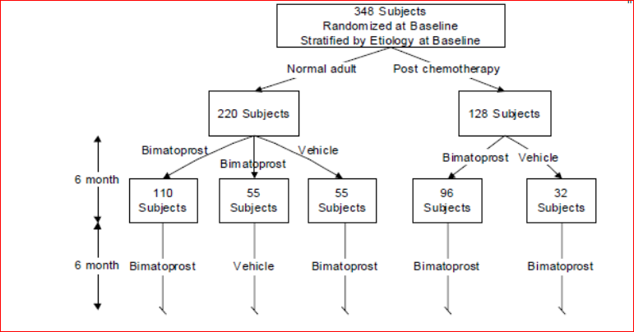

Treatment was one drop of bimatoprost or vehicle onto a sterile single-use applicator applied to the upper eyelid margin of one eye, once a day each evening. A second applicator was used for the other eye.

Prohibited medications included: other eyelash growth products, treatment that may affect hair growth (such as minoxidil, cancer therapeutic agents) and treatment with any prostaglandin or prostamide.

###### Efficacy variables and outcomes

The main efficacy variables were the GEA scale with photonumeric guide and the ESQ Domain 2[3]. The primary efficacy outcome was the proportion of responders at month 4 where responders were defined by a composite endpoint of least a 1 grade improvement from baseline in the GEA score and at least a 3 point improvement from baseline in the total score for Domain 2 of the ESQ.

Comment: Efficacy was assessed at 4 months to be in line with the earlier study 192024-032. The sponsor stated a 3 point improvement from baseline in the total score for Domain 2 of the ESQ was chosen based on the evaluation of minimal important difference (MID) of 2 points plus one point for standard error measurement of the MID.

Other efficacy outcomes included upper eyelash length (in millimeters [mm]), thickness (in mm2) and eyelash darkness (in intensity units) measured using digital image analysis. Eyelash length was reported for the full area of interest (AOI; an area that contains all the eyelashes for a given eye). The overall length was the average eyelash length of the two eyes. Eyelash thickness was reported for the areas within 3 preset rectangles of a fixed size, proximal, medial, and distal to the eyelid margin. Eyelash darkness was reported for the spline, an area approximately 5 pixels wide that bisects the AOI.

###### Randomisation and blinding methods

Subjects were stratified by their aetiology of the hypotrichosis (chemotherapy[4] or idiopathic) and randomised using an IVRS/IWRS in a 2:1:1 ratio to the bimatoprost-bimatoprost, bimatoprost-vehicle and vehicle-bimatoprost group for normal subjects while for post-chemotherapy subjects randomisation was in 3:1 ratio to the bimatoprost-bimatoprost and vehicle-bimatoprost groups.

The study was double masked with all treatment supplied in identical bottles. Unblinding was carried out for the 6 month data analysis. The sponsor stated that this information was not given to staff involved in the operational activities of the trial.

###### Analysis populations

The intent-to-treat (ITT) population was all randomised subjects, regardless of whether or not treatment was received. The per-protocol (PP) population was all subjects who had no major protocol deviations. The safety population consisted of all subjects who received one or more doses of study medication.

###### Sample size

Assuming a 15% response to vehicle (at least 1 grade improvement on GEA score and 3 point improvement on Domain 2 of the ESQ) and a two sided type I error rate of 0.05, a sample of 288 (3:1 randomisation, 216 bimatoprost and 72 vehicle) would have a 90%, 99% and 99% power to detect a treatment difference of 20%, 30% and 40%, respectively. To allow for long term safety assessment the sample was set at 348 (261 bimatoprost and 87 vehicle) subjects.

###### Statistical methods

The primary efficacy analysis was carried out on the ITT population with LOCF. Comparison of responder rates used the Cochran-Mantel-Haenszel (CMH) method, stratified by hypotrichosis aetiology. Treatment-by-hypotrichosis-aetiology interaction was tested using the Breslow-Day test with a significance level of 0.10. Between group comparisons in the change from baseline to Month 4 in eyelash characteristics (length, thickness, darkness) were assessed using the van Elteren test stratified by hypotrichosis aetiology.

There were four protocol amendments, two prior to study commencement and two during the study. The main changes during the study conduct were allowing sites to enrol subjects from both populations (idiopathic and post-chemotherapy); allowing stage 3a breast and colorectal cancers and the duration of post-chemotherapy was changed to between 4 and 16 weeks.

###### Participant flow

Subject disposition for the full 12 months is shown in Figure 2. There were 485 subjects screened and 368 randomised (275 and 93 in the bimatoprost and vehicle groups, respectively). There were 334 subjects who continued into the second 6 month treatment period and 93.7% of this group completed the study. Completion rates at 6 months were 92.7% and 91.4%, respectively, and overall at 12 months was 85.1% (82.8% and 89.2% of the idiopathic and post-chemotherapy subpopulations, respectively).

Figure 2. Subject disposition for Study 192024-038 (Intent-to-Treat population).

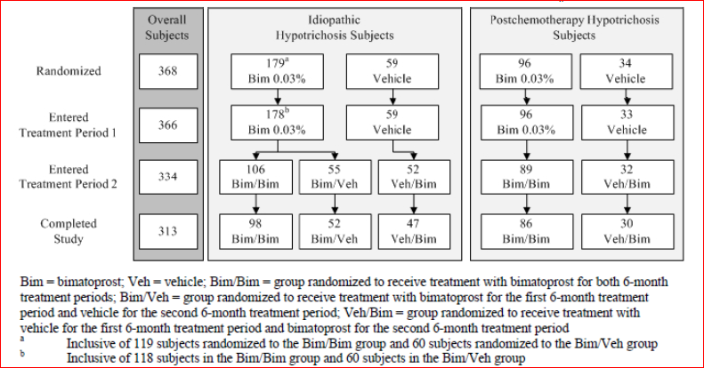

The discontinuation rate at 6 months was similar between groups (Bimatoprost versus vehicle: 7.3% versus 8.6%) with the main reasons being adverse events (2.5% versus 2.2%) and personal reasons (2.2% versus 4.3%). The overall study discontinuation rate at 12 months was 14.9% and for those treated with bimatoprost for 12 months was 14.4% (17.6% and 10.4% in the idiopathic and post-chemotherapy subpopulations, respectively).

###### Major protocol violations/deviations

In the first 6 months, significant protocol deviations occurred in 82 subjects (22%) and 37 were excluded from the PP population for a given visit (10.2% of the bimatoprost group and 9.7% of the vehicle group) and 19 excluded from the entire PP population. There were 10 subjects who reportedly missed ≥14 days of study medication and were excluded from the PP analysis.

###### Baseline data

Baseline characteristics were balanced between groups. The mean age was 49.8 years and most subjects were female (98.9%) and Caucasian (82.9%). Baseline GEA score was 1 in 39.8% and 2 in 60.2% and the mean total score on Domain 2 of the ESQ was 4.1 ±1.35 (SD). Most (n=238) subjects had idiopathic hypotrichosis (179 bimatoprost and 59 vehicle) and 130 had chemotherapy-induced hypotrichosis (96 bimatoprost and 34 vehicle). Most of the post-chemotherapy group had a history of breast cancer (96.2%). In the idiopathic subject group, most had a baseline GEA score of 2 (77.3%) and less with a score of 1 (22.7%), while in the post-chemotherapy group there were more subjects with a baseline GEA score of 1 (71.3%) than 2 (28.7%).

###### Results for the primary efficacy outcome

The rate of response at month 4 in the overall study ITT population was 39.3% in the Bimatoprost 0.03% group and 10.9% in the vehicle group (where response was at least a 1 grade improvement from baseline in the GEA score and at least a 3-point improvement from baseline in the total score for Domain 2 of the ESQ). This difference in response rate was statistically significant (p<0.001) (Figure 3). Response rates were also statistically higher with bimatoprost treatment in the healthy adults (idiopathic) subgroup (40.2% versus 6.8%, p<0.001) and in the post-chemotherapy subgroup (37.5% versus 18.2%, p=0.04) (Figure 3). The PP population analysis was in line with the ITT population.

Comment: 95% confidence intervals were not provided.

Figure 3. 192024-038 Primary composite efficacy variable. Treatment responders at the Month 4 Visit. (ITT population).

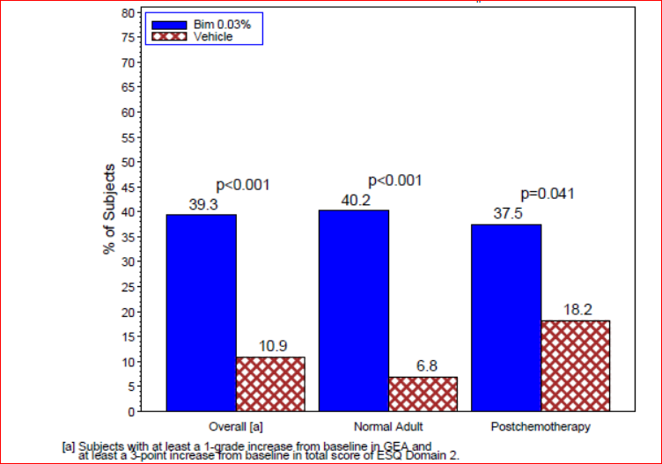

###### Results for other efficacy outcomes

Analysis of the primary endpoint at months 1, 2, and 6 found statistically significantly higher response rates with bimatoprost at months 2 and 6 for the overall population and the healthy adult subpopulation but only at month 6 for the post-chemotherapy subpopulation (Table 1). The difference in response rates with the 95% confidence intervals for the overall, healthy adult and post-chemotherapy populations over the 6 month study period is shown in Figure 4 and demonstrates the less marked response in the post-chemotherapy subjects.

Table 1. Primary composite efficacy variable. Treatment responders by Visit. (ITT population).

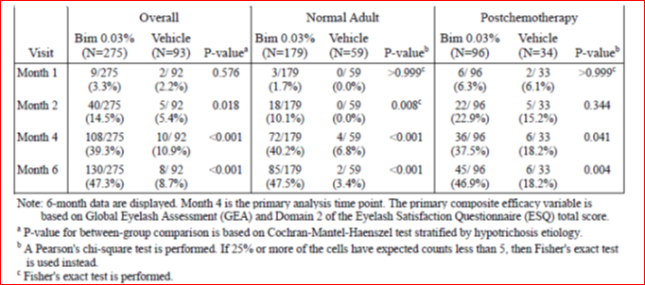

Figure 4. Difference in treatment responder rates based on primary composite efficacy end point. Bim 0.03% versus vehicle (ITT population)

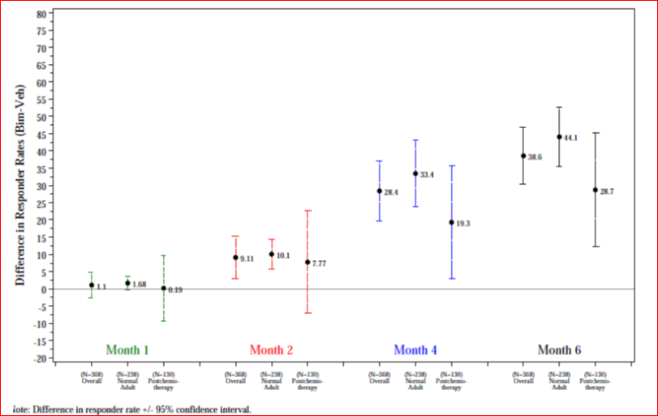

At Month 4, the proportion of subjects with a response of at least 1 grade improvement in the GEA score was significantly higher with bimatoprost than vehicle (73.8% versus 28.3%, p<0.001). This was reflected in the normal adult subpopulation. In the post-chemotherapy subpopulation, the difference at Month 4 (72.9% versus 54.5%) did not reach statistical significance (p=0.051) as the vehicle population response was notable due to presumed natural eyelash regrowth. At Month 4, the response rate for at least a 2 grade increase from baseline in the GEA score was 29.5% versus 2.2% (p<0.001) and this effect was seen in both subpopulations (Table 2).

Table 2. 192024-038 Treatment responders based on at least a 2 grade increase from baseline in GEA (ITT population)

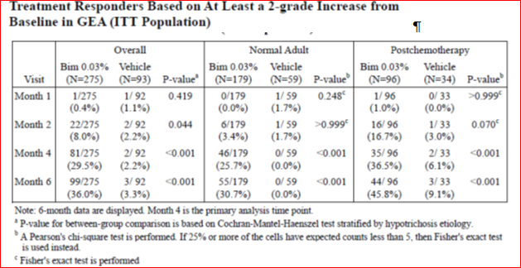

The response rate of at least 3 points improvement in Domain 2 of the ESQ was statistically significant from month 2 through to month 6 for the overall and healthy adult populations while there was no significant difference on this endpoint in the post-chemotherapy subpopulation.

Response on endpoints of eyelash length, thickness and darkness, as measured by digital image analysis, at Months 4 and 6 are summarised in Table 3 for the overall, normal and postchemotherapy populations. After adjustment for hypotrichosis aetiology, the mean percentage change from baseline in eyelash length, thickness and darkness at Month 4 and 6 was significantly greater with bimatoprost than vehicle in all populations.

Table 3. Median and mean percent change from baseline in eyelash characteristics (ITT population).

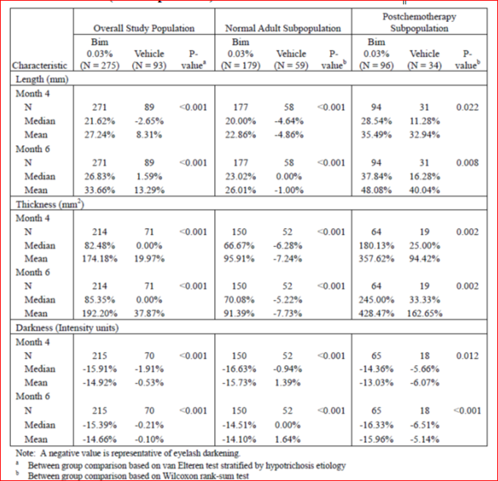

Subgroup analysis of the primary efficacy composite endpoint found results were consistent across age groups (<45, 45-65 and >65 years) and baseline GEA score (1 minimum or 2 moderate). There were too few males (n=4) and non-Caucasians to draw any meaningful conclusions.

The sponsor analysed the correlation between the efficacy variables (GEA score) and the PRO variable (ESQ items and domains). At Month 4, a statistically significant, although only moderate level, correlation was found between improvement in GEA score and overall satisfaction with eyelashes in the overall population treated with bimatoprost (correlation coefficient of 0.44, p<0.001).

**12 month data**: The proportion of responders on the primary composite endpoint from the three treatment groups (bim/bim, bim/veh, veh/bim) at 12 months is located in Table 4. This shows a maintenance of response over the 12 months in those on continual bimatoprost treatment in the overall, idiopathic and post-chemotherapy populations (Figure 5). The response rates after 12 months of bimatoprost treatment were 50.4% and 61.5% in the idiopathic and post-chemotherapy groups, respectively. For those in the idiopathic subgroup who switched to vehicle after 6 months of bimatoprost treatment, the efficacy was maintained for 2 months then declined with a response rate of 11.7% at month 12 (Figure 6). There were similar findings on the analysis of the efficacy outcomes of at least 1 grade, or at least 2 grades, improvement in the GEA score, 3 points increase in the Domain 2 score of the ESQ and eyelash length, thickness and darkness (Table 5). Overall, across the measures of efficacy the effect of bimatoprost appeared to plateau and remain stable over the second 6 months of treatment. Efficacy at 12 months was maintained across the age and GEA score subgroups.

Table 4. Number (%) of responders based on the primary composite end point (ITT population)

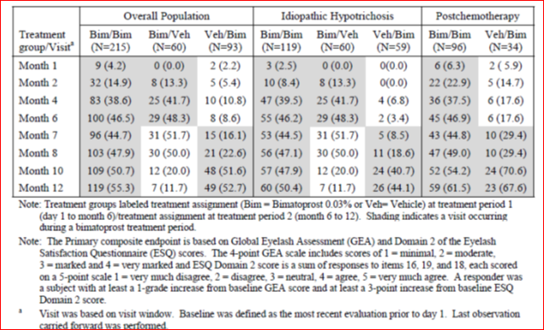

Figure 5. Postchemotherapy: treatment responders (%) based on primary composite variable by visit (ITT population)

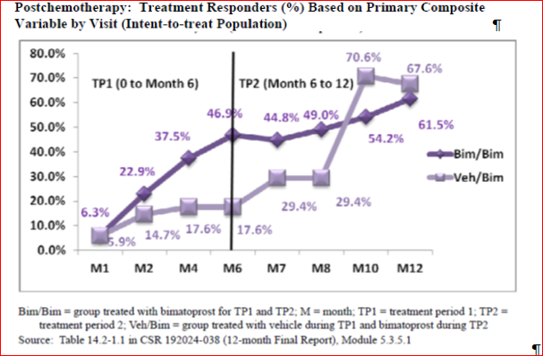

Figure 6. Idiopathic hypotrichposis: Treatment responders (%) based on primary composite variable by visit (ITT population)

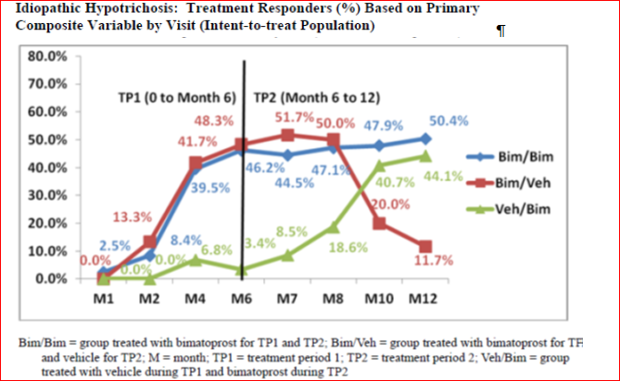

Table 5. Summary of improvement from baseline at the end of each treatment period of study 192024-38 (ITT population).

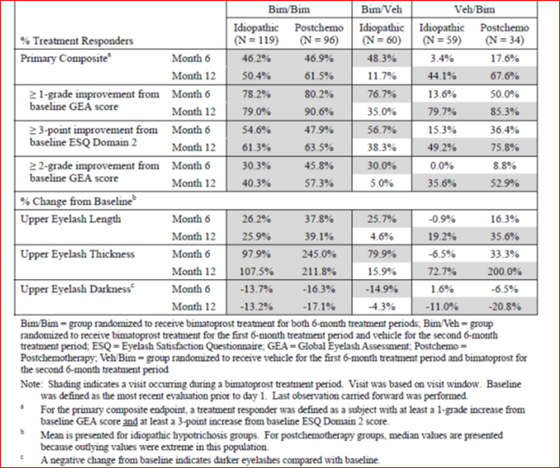

**Summary**: Study 192024-038 met its primary endpoint as after 4 months of treatment there was a statistically significant greater response rate (as measured by the composite endpoint of at least 1 grade increase from baseline GEA score and at least 3 points increase from baseline score on the ESQ Domain 2), in subjects receiving bimatoprost 0.03% compared to those treated with vehicle (39.3% versus 10.9%, p<0.001). Response was evident from Month 2 and was maintained over 12 months of treatment at similar levels to that achieved after 6 months of treatment. The findings were confirmed in the PP population, on the components of the composite endpoint and on other secondary outcome measures. A positive response was found in the healthy adults with idiopathic hypotrichosis and in the post-chemotherapy subjects although in this latter subgroup the response was lower perhaps due to natural eyelash regrowth with time. On cessation of bimatoprost treatment, the response was maintained for two months then declined notably by 6 months.

##### Study 192024-032

###### Study design, objectives, locations and dates

Study 192024-032 was a multicentre, randomised, double-masked, parallel group, vehicle-controlled study to evaluate the safety and efficacy of bimatoprost 0.03% solution to increase overall eyelash prominence following dermal application to the upper eyelid margins.

This study was evaluated as part of the original Latisse submission in 2009. It was conducted in the US between April and December 2007 and was used as the pivotal registration study in this country.

###### Inclusion and exclusion criteria

The inclusion criteria were the same as Study 192024-038 with the exception that post-chemotherapy patients were not included and there was no requirement to meet on the PRO of the ESQ (score of 1 (very much disagree) or 2 (disagree) on each of 3 items (16, 18, and 19) as was required in 192024-038. Exclusion criteria were essentially the same as 192024-038.

###### Study treatments

Study treatment was the same as in Study 192024-038. The treatment duration was shorter at 4 months.

###### Efficacy variables and outcomes

The primary outcome was the proportion of subjects with at least a one grade increase in the GEA score from baseline at month 4. This was different to the composite endpoint in 192024-038. Secondary outcomes included eyelash length, thickness and darkness as well as data from the patient-reported ESQ.

###### Randomisation and blinding methods

Subjects were randomised in a 1:1 ratio to bimatoprost or vehicle treatment groups using an IVRS/IWRS. Treatment was double masked.

###### Analysis populations

The analysis populations were the same as 192024-038. The ITT population with LOCF was used for the primary analysis.

###### Sample size

With an assumed response of 1 grade increase in GEA from baseline in the vehicle group of 20%, a type I error rate of 0.05, and a 20% difference in the response rate between treatment and vehicle, a sample of 110 subjects per group gave the study a power or 90%. Allowing for 15% dropout rate a sample of 260 subjects was planned.

###### Statistical methods

The proportion of subjects with at least 1 grade increase in GEA score was analysed using a Pearson’s chi-square test.

###### Participant flow

There were 409 subjects screened, 278 randomised with 137 and 141 to the bimatoprost and vehicle groups, respectively. The completion rate was 95.6% and 89.4% respectively and the most common reason for discontinuation was an adverse event (2.9% versus 2.8%).

###### Major protocol violations/deviations

There were only 7 protocol deviations deemed important and the ITT and PP population consisted of 278 subjects.

###### Baseline data

Treatment groups were balanced on demographics and baseline characteristics. The mean age of subjects was 49.8 years, 97.1% were female, 80.9% Caucasian and 12.2% Asian. The baseline GEA score was 1 in 20% and 2 in 80%.

###### Results for the primary efficacy outcome

At Month 4, the proportion of subjects with an increase of eyelash prominence (as measured by at least a 1 grade increase in the GEA scale) was 78.1% and 18.4% in the bimatoprost and vehicle groups, respectively, which was statistically significant (p<0.0001) (Figure 7). The mean change from baseline in GEA score was 1.13 versus 0.19 (p<0.0001). The effect was consistent across age groups and in Caucasians and Asians as well as in those with a baseline GEA score of 1 or 2.

Figure 7. Percentage of subjects with at least a 1 grade increase from baseline in GEA for treatment and post treatment periods (ITT population).

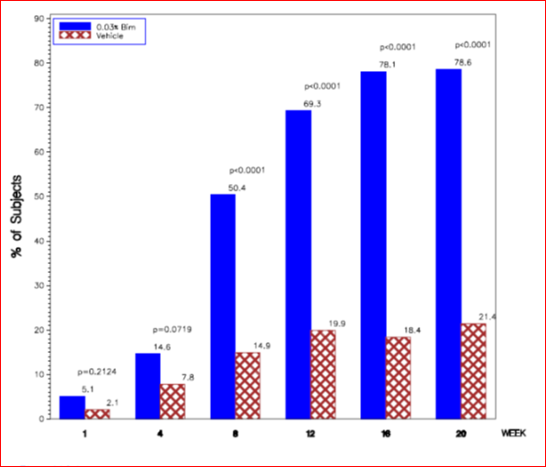

###### Results for other efficacy outcomes

The proportion of subjects with a response of at least 2 grades increase in GEA score at month 4 was 32.8% versus 1.4% which was also statistically significant (p<0.0001). A positive response was also noted on measures of eyelash length, thickness and darkness. A statistically significant improvement with bimatoprost on the three domains of the ESQ was also found.

**Summary**: In this study of 278 healthy subjects with eyelash hypotrichosis, 4 months treatment with bimatoprost resulted in a statistically significant improvement of at least 1 grade in the GEA score in 78.1% of subjects compared to 18.4% treated with vehicle.

#### Other efficacy studies

##### Study 192024-039

###### Methods

Study 192024-039 was a Phase IV, five month (four months treatment and one month follow up), double-masked, randomised, controlled, parallel group study which assessed the safety and efficacy of bimatoprost 0.03% compared to vehicle in 89 African Americans with hyotrichosis of the eyelashes. It was conducted between November 2009 and August 2010 at 5 sites in the US. The study was a post-marketing commitment with the US FDA.

For inclusion subjects were African America/Black with Fitzpatrick skin type IV to VI and a baseline GEA score of 1 or 2. There was no inclusion criteria based on the ESQ. Exclusion criteria and other elements of the study design were essentially the same as Study 192024-032. The primary endpoint was the same - the proportion of subjects at month 4 with at least a one grade improvement from baseline in the GEA score. A sample size of 80 (40 per group) gave the study a power of 90% to detect a 37% difference in response rates assuming a 20% response in the vehicle group (type I error of 0.05).

###### Results

There were 109 subjects screened and 89 randomised, 46 in the bimatoprost and 43 in the vehicle group. The study completion rate was 93.5% and 90.7% in the bimatoprost and vehicle groups, respectively. Only one subject (1.1%) (vehicle group) discontinued the study due to an adverse event. There were 78 subjects who entered the one month post-treatment period. There were 89 and 86 subjects in the ITT and PP populations, respectively. Treatment groups were balanced. The mean age was 46.5 years, 98.9% were female and baseline GEA score was 1 in 30.3% and 2 in 69.7% of subjects.

The proportion of subjects who had at least a one grade improvement on the GEA score after 4 months of treatment was 69.6%[5] in the bimatoprost group and 48.8% in the vehicle group. This result only just met statistical significance (p=0.046). These response rates were maintained to one month post treatment (68.3% versus 48.6%) although the result was not significant (p=0.078) (Figure 8). The proportion of subjects with at least a 2 grade improvement on the GEA score was not statistically significant (10.9% versus 2.3%, p=0.204). No subjects had a 3 grade improvement in GEA score. There were no statistically significant differences between treatment groups on the items of the ESQ, apart from one item on eyelash thickness/fullness.

Figure 8. Percentage of subjects with at least a 1 grade increase in global eyelash assessment treatment and post treatment periods (ITT population).

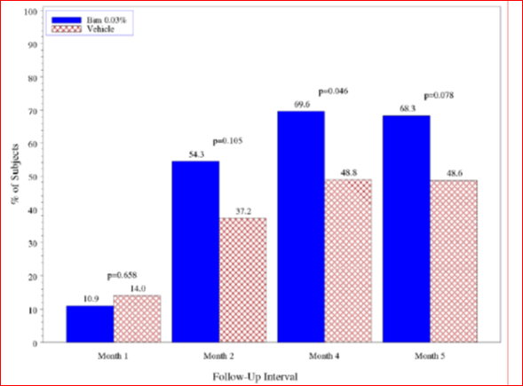

###### Summary

Study 192024-039 was a Phase IV study in 89 African American/Black subjects with eyelash hypotrichosis. It found that 4 months treatment with bimatoprost resulted in a borderline statistically significant improvement of at least 1 grade in the GEA score in 69.9% of subjects compared to 48.8% treated with vehicle (p=0.046). There was no significant differences (apart from eyelash thickness) reported by subjects on the ESQ.

Comment: The study had a higher response rate in the vehicle group than previous studies (48.8% compared to 18.4% in 192024-032. The sponsor did not provide any explanation for this and a question has been raised.

##### Study 192024-033

###### Methods

Study 192024-033 was a non-drug study designed to validate the Global Eyelash Assessment (GEA) scale. The study was evaluated in the initial Latisse submission. It was conducted in 2007 at one centre in the US and the objective was to evaluate the inter-rater (ratings of the same subjects by different raters) and intra-rater (ratings of the same subjects by the same rater at two different time points) reliability of the GEA scale with a photonumeric guide.

The Global eyelash assessment (GEA) scale comprises 4 categories: 1 (minimal), 2 (moderate), 3 (marked) and 4 (very marked), used in conjunction with a photonumeric guide to assess overall eyelash prominence. Individuals graded to have GEA scores of 1 or 2 on this 4-point scale are considered to have hypotrichosis.

There were seven raters selected on the basis of board certification in dermatology, ophthalmology or otolaryngology. Sixty-eight subjects (aiming at 15 in each GEA grade) were recruited. They were assessed by multiple raters, on 2 occasions at least 1 hour apart on the same day.

###### Results

Based on the overall weighted Kappa statistic value of 0.772, the intra-rater reliability was regarded as "substantial" (a concordance estimate between 0.6-0.8). There was one rater whose intra-rater reliability was only “moderate”. Assessment of inter-rater agreement found that Kendall statistics (coefficients of concordance) for evaluation 1, evaluation 2, and overall were 0.862, 0.852, and 0.855, respectively, and these results were statistically significant (p<0.001).

###### Summary

Study 192024-033 validated the GEA scale and results indicated it was an acceptable measure of eyelash prominence among tested raters.

##### Study 192024-031

The dossier included the three month CSR for Study 192024-031. This was a multicentre, double-masked, randomised, parallel group, active-controlled, 3 month study (plus 9 month masked extension) of the safety and efficacy of bimatoprost 0.01% and bimatoprost 0.0125% once daily compared with bimatoprost 0.03% once daily in 561 patients with glaucoma or ocular hypertension. The study was conducted between 2005 and 2006. The objective of the study was to assess if efficacy could be maintained with less ocular irritation/hyperaemia using lower doses of bimatoprost in a new formulation (higher BAK concentration).

Comment:It was not clear to the evaluator why this study of a new formulation in the different indication of glaucoma was included in this dossier. The data from this study did not contribute to the assessment of efficacy of bimatoprost in eyelash hypotrichosis.

### Analyses performed across trials (pooled analyses and meta-analyses)

Studies 192024-032 and 039 included subjects with idiopathic hypotrichosis of eyelashes as based on a GEA score of 1 or 2 and the efficacy endpoint was based solely on the GEA score. In Study 038, subjects also required a psychological impact defined by a score of 1 or 2 on the 3 items in Domain 2 of the ESQ and the efficacy endpoint was a composite of GEA and Domain 2 ESQ scores.

A comparison of the three studies based on an efficacy endpoint of GEA score response was undertaken. At Month 4, the proportion of responders with at least 1 grade, and at least 2 grades, increase in GEA score is shown in Tables 6 and 7. This shows a response rate of at least one grade increase in GEA score of 69.6% to 78.1% with bimatoprost compared to 18.4% to 54.5% with vehicle.

Data from studies 192024-032 and 039 were retrospectively analysed using the same inclusion criteria and composite endpoint as used in study 192024-038. The number of subjects in this subgroup for analysis was 214 in study 192024-032 and 50 in 192024-039. For subjects with idiopathic hypotrichosis, the proportion of responders on the composite endpoint (bimatoprost versus vehicle) was 54.6% versus 5.7% (p<0.001) in study 032, 39.1% versus 25.9% (p=0.373) in study 039 and 40.2% versus 6.8% (p<0.001) in study 038 (Table 8).

Table 6. Number (%) of subjects with at least a 1 grade increase in Global Eyelash Assessment scores from baseline at Month 4 in Studies 192024-032, -038 and -039 (ITT population).

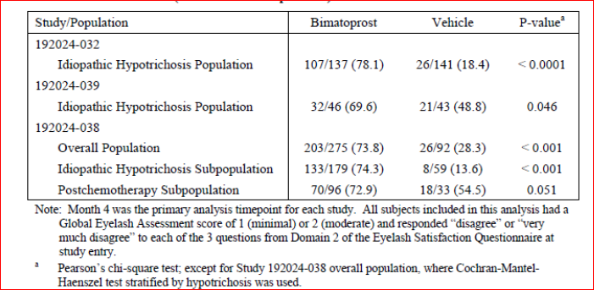

Table 7. Number (%) of subjects with at least a 2 grade increase in Global Eyelash Assessment scores from baseline at Month 4 in Studies 192024-032, -038 and -039 (ITT population).

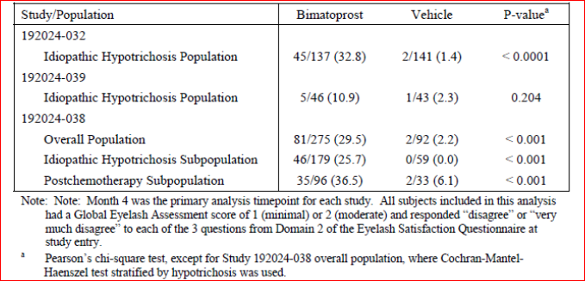

Table 8. Retrospective composite end point analysis: Number (%) of treatment responders at Month 4 based on experiencing at least a 1 grade increase in GEA score and at least a 3 point increase in ESQ domain 2 score in Studies 192024-032, -038 and -039 (ITT population).

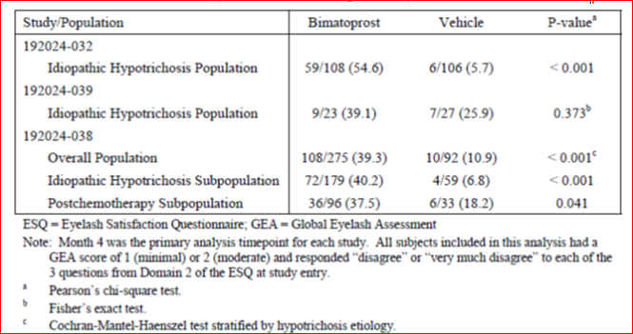

Comment: This demonstrated consistency of response to bimatoprost in the Study 032 and 038, however the response was less in Study 038 than in 032. In addition, the African American subjects had a high vehicle response rate and failed to achieve a statistically significant response.

Efficacy data were pooled from the three studies (032, 038 and 039) for subgroup analyses on GEA score in the idiopathic eyelash hypotrichosis population. The response rates for at least 1 grade increase in GEA score were statistically significant for the age groups (<45 years, 45-65 years and >65 years), females, Caucasians, non-Caucausians, blacks and those with a baseline GEA score of 1 or of 2 (Table 9). There were too few males, Asians and Hispanics to draw conclusions.

Table 9. Subgroup analysis: Number (%) of idiopathic hypotrichosis subjects achieving at least a 1 grade improvement from baseline GEA score at Month 4 in Studies 192024-032, -038 and -039 (ITT population).

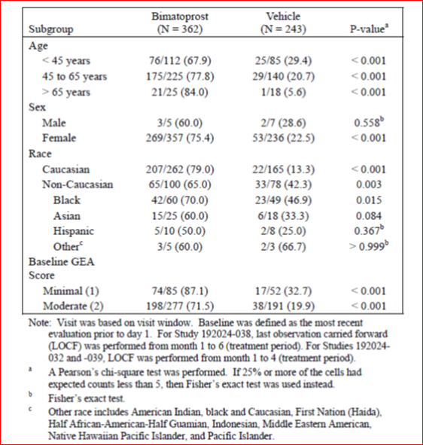

### Evaluator’s conclusions on clinical efficacy for hypotrichosis of eyelashes

Following the finding of adverse events of eyelash growth during the development of bimatoprost as an ocular hypotensive, the sponsor has undertaken a clinical development program in the indication of “eyelash hypotrichosis”. This condition has been defined as “inadequate or not enough eyelashes” and eyelash prominence was objectively measured using the Global Eyelash Assessment (GEA scale) with photonumeric guide. This was a four point scale (1=minimal, 2=moderate, 3=marked, 4=very marked) and the validity of this score was assessed in Study 192024-033. This found the agreement within raters (intra-rater reliability) and agreement between raters (inter-rater reliability) was adequate and so is considered a reliable tool to grade eyelash prominence.

The clinical development program in eyelash hypotrichosis (GEA score of 1 or 2) was largely conducted in patients with idiopathic hypotrichosis and one trial also assessed a population post-chemotherapy. The trials were conducted nearly universally in women who were predominantly Caucasian. There was a US post-approval study conducted in African Americans.

The dose chosen for the clinical development in this indication was the same as the dose used in glaucoma and ocular hypertension (one drop daily per eye of the 0.03% solution). A dose-ranging study was included in the dossier which assessed lower doses (0.005% and 0.015%) of a different formulation. The study found a dose response and some improvement in efficacy with the proposed dose (0.03%) over the lower doses.

There were two pivotal trials (192024-032 and 038). Study 032 had been evaluated in the previous submission and used the GEA score for inclusion and the primary endpoint. Study 192024-038 used both the objective GEA score and a patient reported measure (the ESQ) for inclusion and its composite primary endpoint. Both studies measured response rates after 4 months of treatment.

These two studies met their respective primary endpoints as after 4 months of treatment there was a statistically significant greater response rates with bimatoprost. In Study 038, approximately 40% of subjects with idiopathic hypotrichosis responded (as measured by the composite endpoint of at least 1 grade increase from baseline GEA score and at least 3 points increase from baseline score on the ESQ Domain 2 (which measured satisfaction with eyelash attributes relating to feelings of confidence, attractiveness, and professionalism) compared to 7% in the vehicle group. The effect difference was less marked in the post-chemotherapy group (38% versus 18%) which may be due to the more severe hypotrichosis at baseline and the natural regrowth of eyelashes in this population. Results were robust with confirmation across secondary endpoints and analysis populations. Response was evident from Month 2 and was maintained over 12 months of treatment at levels achieved after 6 months of treatment. On cessation of bimatoprost, the response declined by 6 months.

In Study 192024-032, 4 months treatment with bimatoprost in healthy subjects with eyelash hypotrichosis resulted in a statistically significant improvement of at least 1 grade in the GEA score in 78.1% of subjects compared to 18.4% treated with vehicle.

In Study 192024-039, which included 89 African American/Black subjects with eyelash hypotrichosis, it was found that after 4 months treatment with bimatoprost there was a borderline statistically significant improvement of at least 1 grade in the GEA score in 69.9%[6] of subjects compared to 48.8% treated with vehicle (p=0.046). There was no significant differences (apart from eyelash thickness) reported by subjects on the ESQ. The study had a high response rate to vehicle which was not explained by the sponsor and a question has been raised.

Data from Studies 192024-032 and 039 were retrospectively analysed using the same inclusion criteria and composite endpoint as used in Study 192024-038. The number of subjects in this subgroup for analysis was 214 in Sstudy 192024-032 and 50 in 192024-039. The proportion of responders on the composite endpoint (bimatoprost versus vehicle) was 54.6% versus 5.7% (p<0.001) in Study 032 and 39.1% versus 25.9% (p=0.373) in Study 039 compared to 40.2% versus 6.8% (p<0.001) in the idiopathic group in Study 038 (Table 8).

Efficacy data were supported by findings on eyelash length, thickness and darkness which were assessed via digital image analysis. Efficacy was consistent across age subgroups and non-Caucasians. There were, however, very limited data in other ethnic groups such as Asians.

There were no paediatric data in this indication. [information redacted]

## Clinical safety

### Studies providing evaluable safety data

The following studies provided evaluable safety data:

#### Pivotal efficacy studies

In the pivotal efficacy Studies 192024-032 and 192024-038, the following safety data were collected:

* General adverse events (AEs) were assessed by questioning at study visits. AEs of special interest included conjunctival hyperaemia, iris hyperpigmentation, skin hyperpigmentation, decreased IOP, madarosis and enophthalmos.
* Eye-related assessments included ophthalmic examination which included dilated ophthalmoscopy, biomicroscopy, intraocular pressure (IOP) measurement, iris colour assessment and best-corrected visual acuity. IOP was measured twice in each eye at each designated visit (at least months 1 and 4 as well as 6, 8 and 12 in 192024-038). A third measurement was taken if the difference was >2 mmHg between the first two measurements.
* Other assessments included physical examinations, vital signs, and urine pregnancy testing for females of childbearing potential
* Laboratory tests were not performed.

#### Pivotal studies that assessed safety as a primary outcome

There were no pivotal studies assessing safety as the primary outcome.

#### Dose-response and non-pivotal efficacy studies

The dose-response and non-pivotal efficacy studies provided safety data, as follows:

* Study 192024-051 provided data on adverse events, physical examinations, vital signs (blood pressure and pulse rate) and pregnancy testing.
* Study 192024-039 provided the same data as the pivotal studies as well as periocular dermal pigmentation examination.

Data from the three main Latisse studies (192024-032, 192024-038 and 192024-039) were pooled for the safety analysis. The treatment period was 4 months in Studies 192024-032 and 039 and 12 months in 192024-032. A primary analysis of safety data included the 4 month treatment period of Studies 192024-032 and 039 and the first 6 months of 038. A final analysis of safety data included Studies 192024-032 and 039 (4 month treatment period) and the 12 months of 038 and was used as the basis of the Summary of Clinical Safety (“pooled safety data”). Supportive safety data were derived from the 6 long term (≥1 year) studies with bimatoprost 0.03% in glaucoma.

### Pivotal studies that assessed safety as a primary outcome

Not applicable.

#### Patient exposure

There were 733 subjects in the pooled safety database, 604 with idiopathic and 129 with post-chemotherapy hypotrichosis (Table 10). Of these, 541 subjects received at least 1 dose of Latisse and 276 at least one dose of vehicle (and no prior treatment with bimatoprost). There were 413 subjects with idiopathic and 128 with post-chemotherapy hypotrichosis who were treated with bimatoprost[7].

In the overall pooled analysis population, the median treatment duration for bimatoprost was 182 days and for vehicle was 118 days due to the inclusion of data from Study 192024-038 where bimatoprost could be received for up to 12 months. For the 214 subjects in this group (Bim/Bim), the median and mean exposure was 364 days and 335 days, respectively. The number of subjects exposed to bimatoprost over time is shown in Table 11. There were 183 subjects who had at least 48 weeks treatment with bimatoprost, 97 with idiopathic and 86 with post-chemotherapy hypotrichosis. In study 192024-051, the mean treatment duration was approximately 88 days in the three bimatoprost groups.

In the safety database, the bimatoprost-treated subjects had a mean age of 49.6 years (range 22 to 77), 98.7% were females (there were only 7 males), 75.8% were Caucasian, 13.9% Black, 5.5% Asian, 3.9% Hispanic, 57.2% had light iris colour, 34.8% had a baseline GEA score of 1 (minimal) and 65.2% had a score of 2 (moderate).

Table 10. Total number of subjects in pooled analysis populations from the pooled Latisse studies

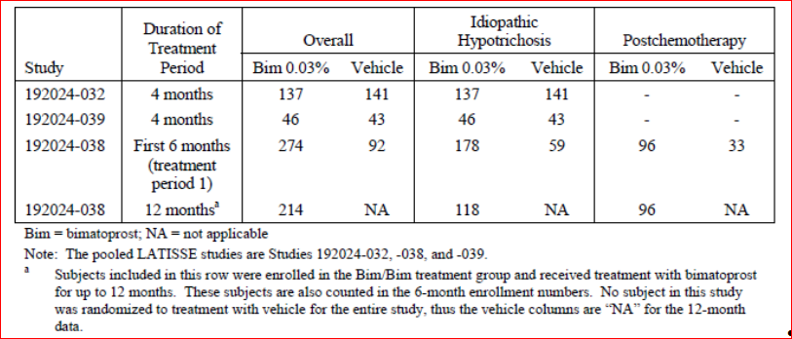

Table 11. Number (%) of subjects exposed to study treatment by cumulative time interval in the pooled Latisse studies (safety population)

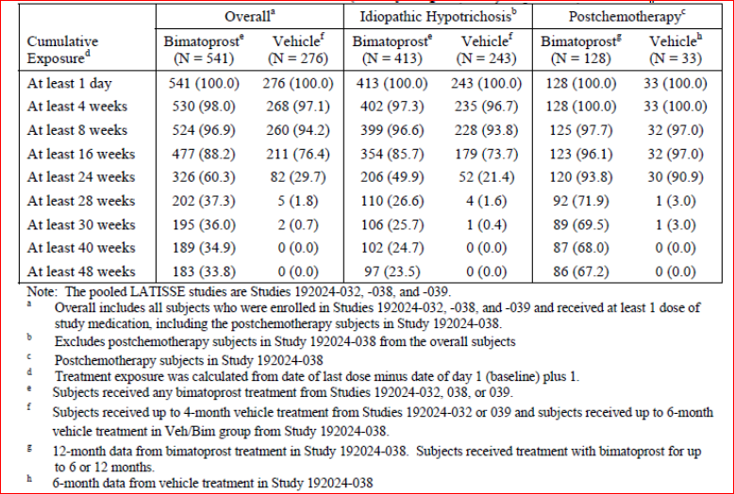

### Adverse events

#### All adverse events (irrespective of relationship to study treatment)

##### Pooled studies

In the overall pooled safety population, the frequency of adverse events (AEs) was higher with bimatoprost than vehicle (50.3% versus 32.2%). This was also the case for the idiopathic group (44.6% versus 30.5%) and the post-chemotherapy group (68.8% versus 45.5%). It is noted that the post chemotherapy group had a higher rate of AEs than the healthy adults (68.8% versus 44.6%) (Table 12).

Comment: A summary of AEs by severity (mild, moderate and severe) for the three main trials was not included and a question has been raised.

As would be expected, the most frequent System Organ Class (SOC) involved was eye disorders, with higher rates with bimatoprost than vehicle (27.9% versus 13.4%). Again the rates were higher in the post-chemotherapy group than the idiopathic group treated with bimatoprost (35.9% versus 25.4%).

Comment: The sponsor proposes that this is may be due to “enduring effects of chemotherapy”.

In the overall safety population (bimatoprost versus vehicle), the most frequent eye disorders were conjunctival hyperaemia (7.2% versus 1.4%), punctate keratitis (3.1% versus 1.8%), eyelid pruritus (3.7% versus 2.9%), eyelid erythema (3.9% versus 1.1%), eye pruritus (2.6% versus 0.7%), dry eye (2.2% versus 0.7%) and blepharitis (1.3% versus 0.4) (Table 12).

Other SOCs which had a higher rate of AEs with bimatoprost included gastrointestinal disorders (4.6% versus 1.8%), infections and infestations (12.8% versus 9.8%), general disorders and administration site conditions (3.1% versus 1.4%), injury, poisoning and procedural complications (6.1% versus 1.1%) and skin and subcutaneous tissue disorders (9.6% versus 2.2%).

Other specific AEs with a higher rate in the bimatoprost group included skin hyperpigmentation (3.9% versus 0.4%), upper respiratory tract infection (3.0% versus 2.2%), nasopharyngitis (2.2% versus 0.4%) and nausea (1.3% versus 0.4%) (Table 12).

Table 12. Number (%) of subjects reporting common (≥2%) adverse events in the completed pooled Latisse studies (Safety population).

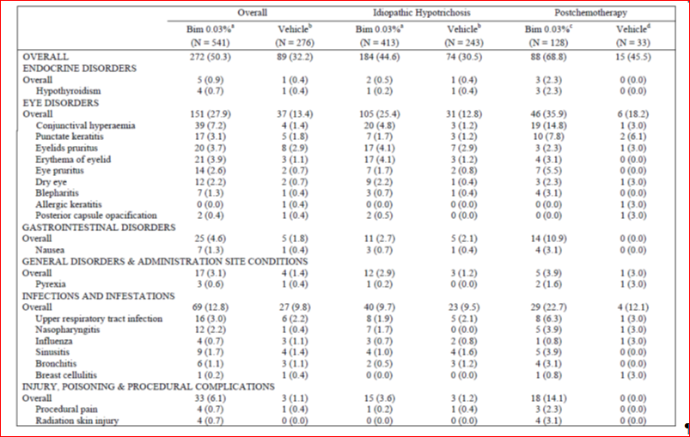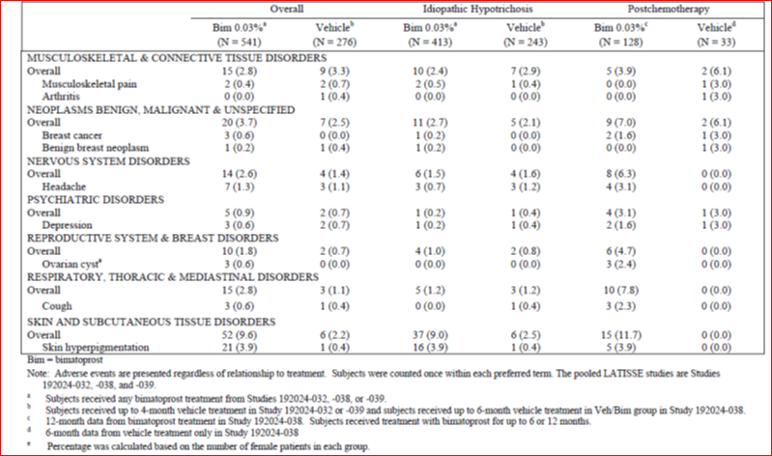

Adverse events of special interest with bimatoprost treatment are listed in Table 13 for the idiopathic and postchemotherapy populations. This shows the higher rate of conjunctival hyperaemia with bimatoprost, particularly in the post-chemotherapy group (14.8%). Madarosis (absence of eyelashes) was only reported with bimatoprost (5 cases, 4 of which were treatment-related) and had an onset range from day 8 to day 321. Skin hyperpigmentation with bimatoprost occurred in 3.9% of both subpopulations. There was one AE of iris hyperpigmentation during bimatoprost treatment as well as one case with onset two months post bimatoprost treatment. One subject discontinued due to the enophthalmos (deepened eyelid sulcus).

Table 13. Number (%) of subjects reporting adverse events of interest during bimatoprost treatment periods in the pooled Latisses studies (Safety population)

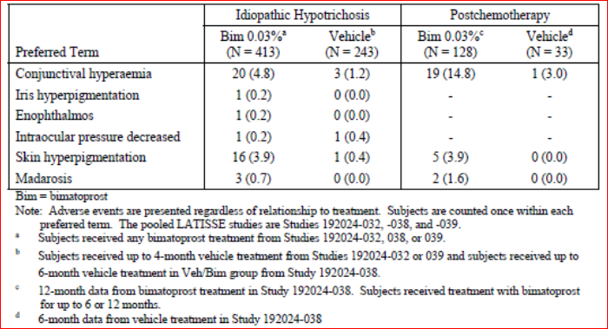

When all data were analysed up to the 6 month time point in the three main studies, the rate of AEs was 45.3% versus 31.9%, and eye disorder SOC AEs was 25.8% versus 13.4%, in the bimatoprost and vehicle groups, respectively (Table 14). During this period, the AE rate was higher in the post-chemotherapy than in the idiopathatic group (57.3% versus 42.1%). When data were analysed to the 4 month time point in the three studies, similar results for AE rate (40.3% versus 28.6%) and eye disorders (23.2% versus 12.0%) were found.

Table 14. Number (%) of subjects reporting common (≥2%) adverse events in the pooled Latisse studies (Studies 192024-032, -039 and first 6 months of 192024-38 (Safety population)).

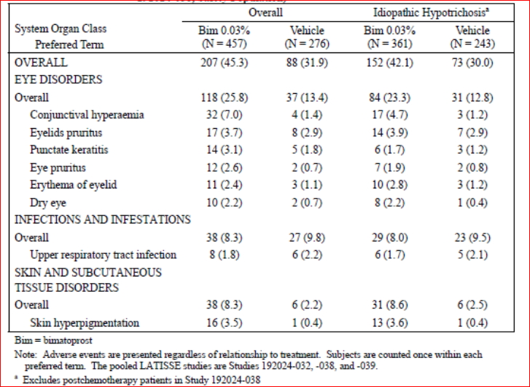

##### Other studies

For subjects treated for up to 12 months (Study 192024-038), the rate of AEs was 62.5% with the most frequent AEs being conjunctival hyperaemia (12.1%), punctuate keratitis (5.6%), eyelid pruritus (4.7%), URTI (4.2%), skin hyperpigmentation (3.3%), dry eye (3.3%) and eye pruritus (3.3%).

The rate of frequent eye disorders, apart from eyelid hyperaemia, did not generally increase in the second 6 months of treatment in either the idiopathic or post-chemotherapy groups. In the subgroup of idiopathic hypotrichosis subjects in 192024-038 who discontinued bimatoprost treated (and received vehicle for the second 6 months), the rate of AEs in this vehicle-treated period was 27.3% with the most frequent AEs being nasopharyngitis (5.5%), ear pain (3.6%) and oropharyngeal pain (3.6%).

In the dose-ranging study (192024-051) the rate of AEs was 13.9%, 29.4% and 14.7% in the bimatoprost 0.005%, bimatoprost 0.015% and bimatoprost 0.03% groups, respectively. The most frequent AE was eyelid pruritus (0.0%, 8.8% and 5.9%, respectively).

#### Treatment-related adverse events (adverse drug reactions)

##### Pooled studies

In the pooled safety population, the rate of treatment-related AEs was notably higher with bimatoprost (22.9% and 9.4%). This was also seen in the idiopathic (21.8% versus 9.9%) and post-chemotherapy groups (26.6% versus 6.1%). Treatment-related AEs were generally in the eye disorders SOC (18.7% versus 8.3%). The most frequent treatment-related AEs were conjunctival hyperaemia, eyelid pruritus, punctuate keratitis, eyelid erythema, eye pruritus and skin hyperpigmentation (Table 15). Again, the rates of these eye-related events were higher in the post-chemotherapy than idiopathic group (Table 15).

Table 15. Number (%) of subjects reporting common (≥2%) adverse events in the pooled Latisse studies (Safety population).

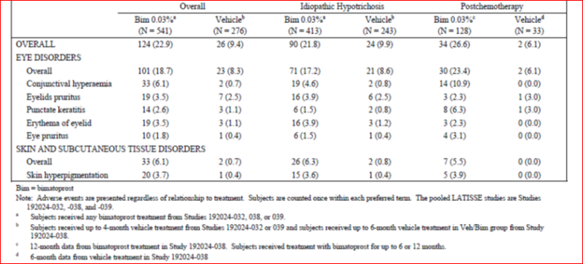

When data were analysed for the first 6 months of treatment, the rate of treatment related AEs was 22.1% with bimatoprost and 9.4% with vehicle and was similar in the idiopathic group (20.8% versus 9.9%) and higher in the post-chemotherapy group treated with bimatoprost (27.1% versus 6.1%).

##### Other studies

In subjects treated with bimatoprost for 12 months (192024-038), the rate of treatment-related AEs was 31.3%. Of these events, 6 were deemed severe (in three subjects): eye pruritus and irritation; conjunctival hyperaemia and periocular eczema; and allergic conjunctivitis and contact dermatitis.

Following discontinuation of bimatoprost, there were 3 subjects with treatment-related AEs in the 6 month vehicle-treatment period. These were eyelid erythema, intermittent conjunctivitis and iris hyperpigmentation.

In the dose-ranging study the rate of treatment-related AEs was 5.6%, 14.7% and 5.9% in the bimatoprost 0.005%, bimatoprost 0.015% and bimatoprost 0.03% groups, respectively.

#### Deaths and other serious adverse events

##### Deaths

In the four Latisse studies (192024-032, 038, 039 and 051) there was one death of a 63 year old woman in the post-chemotherapy group who was treated with bimatoprost. After 55 days of study treatment, she died the day following breast reconstructive surgery from a presumed pulmonary embolism.

##### Serious adverse events

In the pooled database there were 33 SAEs with 28 (5.2%) during bimatoprost and 5 (1.8%) during vehicle treatment. The SAE rate in the post-chemotherapy population (13.3% versus 6.1%) was notability higher than the idiopathic population (2.7% versus 1.2%). No SAE was considered treatment-related and there were no eye-related SAEs. The rate of SAEs in the 12 months of bimatoprost treatment in 192024-038 was 8.4% and there were no SAEs following discontinuation of bimatoprost in this study. There was one SAE of appendicitis in Study 192024-051.

#### Discontinuation due to adverse events

##### Pooled studies

In the pooled database, the rate of discontinuation due to an AE was 3.7% and 2.9% in the bimatoprost and vehicle groups, respectively. In the bimatoprost group, of the 20 events leading to discontinuation, 12 were eye disorders (2.2%) with the most frequent being conjunctival hyperaemia, erythema of the eyelid, dry eye and eye irritation. In Study 192024-038 there were 16 subjects in the idiopathic and 5 in the post-chemotherapy populations treated with bimatoprost who discontinued due to an AE.

##### Other studies

In the dose-ranging study, one subject treated with bimatoprost 0.015% discontinued due to eyelid pain and photophobia.

### Laboratory tests

As the systemic exposure to bimatoprost is low following ocular application, laboratory testing was not undertaken during the clinical development of Latisse.

### Vital signs

Data on vital signs (diastolic and systolic blood pressure and pulse rate) or physical examination were not pooled. There were no notable findings in the individual clinical study reports.

### Best corrected visual acuity

In the pooled population at Month 4, the rate of worsening of best-corrected visual acuity was similar between bimatoprost and vehicle groups (2.8% versus 3.0%) with the vast majority of subjects having ‘no change’ or ‘better’ visual acuity reported. After 12 months of bimatoprost treatment 96.7% of subjects were found to have no change from baseline in best-corrected visual acuity.

### Intraocular pressure

At Month 4 in the pooled data, the mean change from baseline in IOP was -1.24 and -0.55 mmHg in the bimatoprost and vehicle groups, respectively. The difference was statistically significant (p<0.001) and similar results were found in the idiopathic and post-chemotherapy populations (Table 16).

Table 16. Baseline and change from baseline in intraocular pressure (mmHg) at timepoints through Month 4 in the pooled Latisse studies (Safety population)

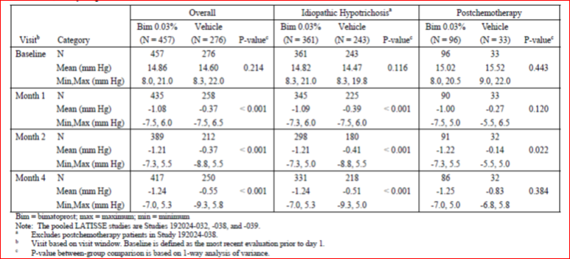

There were 2 subjects who had decreased IOP (≤ 5 mmHg) reported as an AE, one in the bimatoprost and one in the vehicle treatment groups. Both subjects discontinued treatment. No associated findings were reported.

The sponsor reviewed subjects who had an IOP measurement of ≤ 7 mmHg at any time point during the studies. There were 22 such subjects (16 bimatoprost-treated) and visit to visit variation in IOP was noted.

### Biomicroscopy and ophthalmoscopy

In the pooled database, the proportion of subjects with at least one grade increase in severity from baseline in findings on biomicroscopy or ophthalmoscopy was 22.2% and 10.9% in the bimatoprost and vehicle groups, respectively. The rate was also higher with bimatoprost for at least 2 severity grades increase (3.3% versus 1.4%). The most frequent events with 1 severity grade increase were conjunctival hyperaemia (7.9% versus 2.5%) and eyelid erythema (3.7% versus 0.4%).

### Iris hyperpigmenation

Iris colour was classified into one of 10 categories as well as into ‘light’ or ‘dark’. The scale was not validated and data were not pooled. Shift in colour on the 10 category scales occurred in 16 and 24 of the bimatoprost and vehicle-treated subjects, respectively, in Study 192024-032. There were 13 subjects with colour shift reported in 192024-038 some of which were not permanent. There were no reported colour shifts in the study in African Americans.

Comment: As the scale was not validated and the data were variable, no definitive conclusions can be drawn.

### Postmarketing experience

Marketing of Latisse commenced in January 2009 and through to December 2011 the sponsor estimates 395,307 patient-years of exposure. During this time, there have been 3346 case reports (7253 adverse event terms), 1316 of which came from health care professionals. The most frequent events are listed in Table 17. Madarosis was the second most frequent event, after ocular hyperaemia. There were 5 reports of enophthalmos. There were also 19 serious, unlisted AEs, 12 of which were medically-confirmed. These cases included keratitis, eye infections and an anaphylactic reaction.

Table 17. Most commonly reported postmarketing non serious adverse event preferred terms

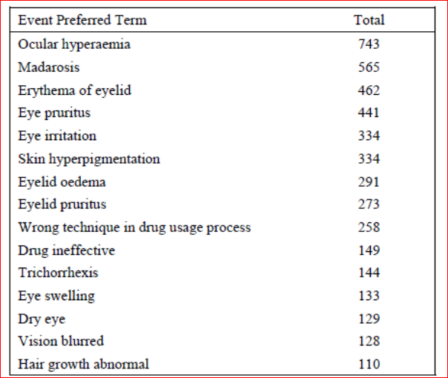

In addition a PSUR for [information redacted]Latisse ([information redacted]for the period 1 March 2011 to 29 February 2012 was included in the submission.This was the [information redacted]second for Latisse. During the period the sponsor estimated the patient exposure to Latisse was 628,930 patient years. During this period the core data sheet was updated and events of eye pain [information redacted]and enophthalmos for Latisse were added. The PSUR contained 1,028 case reports, with 2,434 adverse event terms, that were related to Latisse. Of these, 292 cases were reported from health care professionals. There were was one serious case from a health care professional of optic nerve injury and increase IOP. There was also a consumer report of bacterial infection of a premature neonate with a fatal outcome following the mother’s exposure during the first 2 weeks of pregnancy. Of the reported events, 47.6% were in the eye disorders SOC with a rate of 0.621 per 1000 units sold. The next most frequent SOC was skin and subcutaneous tissue disorders with an event reporting rate of 0.302 per 1,000 units sold. There were 197 reports of lack of efficacy and 311 cases involving misuse or medication error and 43 cases of off-label use. In cumulative analysis there have been 8 cases of enophthalmos which were considered ‘relevant’ by the Sponsor, none was serious.

### Safety issues with the potential for major regulatory impact

None of note.

### Other safety issues

#### Safety in special populations

The pooled safety database was used to assess safety in subgroups of age (<45, 45-65, >65 years), gender and race (Caucasian, non-Caucasian). There were no notable findings on the overall rate of AEs in the subgroups though there were too few males to draw conclusions. The number of Asians treated with bimatoprost was only 30 although the overall AE was comparable to the overall population (Table 18). For specific AEs it was noted that Caucasians, compared to non-Caucasians, had a higher rate of punctuate keratitis (2.6% versus 0%) and eyelid erythema (2.6% versus 0.9%) while non-Caucasians had a higher rate of conjunctival hyperaemia (7.7% versus 5.3%), eyelid pruritus (7.7% versus 2.4%0 and skin hyperpigmentation (9.4% versus 0.6%).

Table 18. Number (%) of subjects reporting adverse events in the poled Latisse studies by subgroup (safety population).

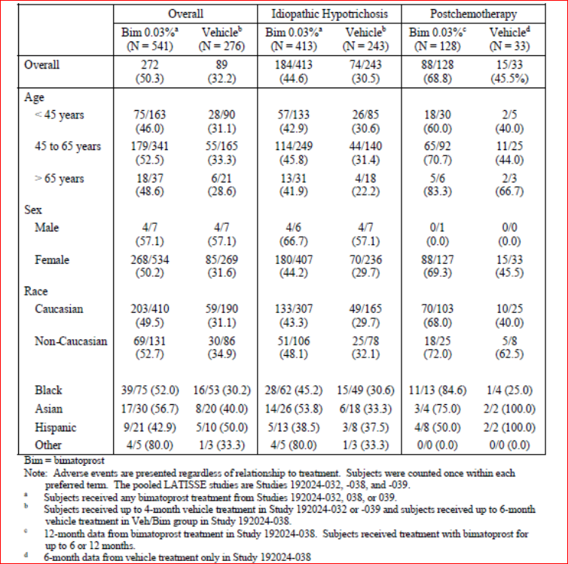

### Safety related to drug-drug interactions and other interactions

The sponsor stated that in glaucoma patients, twice daily ocular administration of bimatoprost 0.3% resulted in less IOP reduction than once daily administration. It is therefore proposed that concurrent administration of Latisse with [information redacted] may reduce the IOP lowering effect of the [information redacted].

Comment: The evaluator recommends co-administration of the two bimatoprost products is avoided.

### Pregnancy

There were three pregnancies reported in bimatoprost treated women, two of whom delivered healthy infants, details of the third were not given.

Comment: As there are no adequate data on bimatoprost use during pregnancy and treatment is not recommended.

### Safety of [information redacted]

The sponsor included in the Summary of Clinical Safety a review of safety of [information redacted] from 6 long term studies. These included 1409 subjects treated with bimatoprost 0.03%, 926 once daily and 483 twice daily. At the 12 month time point, the AE rate was 86.7% and 94.8% for once and twice daily dosing, respectively. The most frequent events were conjunctival hyperaemia, eyelash growth and eye pruritus. The rate of SAEs was 8.2% and 8.7% for the once and twice daily dosing groups, respectively. For AEs of interest in the daily and twice daily groups, the rate of skin hyperpigmentation was 6.5% and 11.8%, eyelid erythema was 4.1% and 3.7%, abnormal hair growth was 0.6% and 1.4%, madarosis was 0.1% and 0.2%, and iris hyperpigmentation was 0.9% and 1.9%.

### Evaluator’s overall conclusions on clinical safety

The pooled safety database for bimatoprost included 733 subjects from 3 randomised controlled trials. Of these, 541 subjects received at least 1 dose of Latisse and 276 at least one dose of vehicle (and no prior treatment with bimatoprost). There were 413 subjects with idiopathic and 128 with post-chemotherapy hypotrichosis who were treated with bimatoprost. The median treatment duration for bimatoprost was 182 days and for vehicle was 118 days. There were 183 subjects who had at least 48 weeks of treatment with bimatoprost, 97 of whom with idiopathic and 86 with post-chemotherapy hypotrichosis.

The AE rate was higher with bimatoprost than vehicle (50% versus 32%) as was the rate of treatment-related AEs (23% and 9%). The most frequent AEs were eye disorders (28% versus 13%) with the majority classed as treatment-related (19% versus 8%). The most common eye disorders were: conjunctival hyperaemia (7.2% versus 1.4%), punctate keratitis (3.1% versus 1.8%), eyelid pruritus (3.7% versus 2.9%), eyelid erythema (3.9% versus 1.1%), eye pruritus (2.6% versus 0.7%), dry eye (2.2% versus 0.7%) and blepharitis (1.3% versus 0.4). Skin pigmentation was the other main AE occurring at a higher rate with bimatoprost (3.9% versus 0.4%). Other AEs of note were madarosis (absence of eyelashes) (0.9% versus 0%) and enophthalmos (0.2% versus 0%).

There was one unrelated death in the clinical program from a presumed pulmonary embolism following breast reconstructive surgery. Serious AEs were more frequent with bimatoprost (5.2% versus 1.8%) particularly in the post-chemotherapy group (see below). No SAE was considered treatment-related and there were no eye-related SAEs. The discontinuation rate due to AEs was 3.7% with bimatoprost compared to 2.9% with vehicle. The most frequent AEs leading to discontinuation were eye disorders (2.2%) and in particular conjunctival hyperaemia, erythema of the eyelid, dry eye and eye irritation.

The post-chemotherapy group had a higher rate of AEs (68% versus 46%) than the healthy adults with idiopathic hypotrichosis (45% versus 31%). The rate of eye disorders was notably greater in the post chemotherapy group than the idiopathic group (36% versus 25%) and in particular conjunctival hyperaemia (14.8% versus 4.8%). In addition, this group had a higher rate of SAEs (13.3% versus 6.1% with vehicle) compared to the idiopathic group (2.7% versus 1.2%).

Comment: As none of the SAEs was an eye disorder or felt to be treatment related, it may be that the difference in SAE rates was due to the small sample size of the post-chemotherapy patients treated with vehicle (n=33).

Over 12 months of treatment the AE rate was 63% with 31% having treatment-related AEs and the rate of SAEs was 8.4%. The rate of frequent eye disorders, apart from eyelid hyperaemia, did not generally increase in the second 6 months of treatment in either the idiopathic or post-chemotherapy groups. There was not any notable rebound in events on treatment discontinuation.

There was no dose response evident on the rate of AEs in the dose-ranging study and the highest AE rate was with the middle concentration of 0.015%. As the study used different formulations with a higher level of BAK in the lower doses, this may be confounded results.

Detailed eye assessments were conducted during the studies. Intraocular pressured measurements found a small decrease in mean IOP (-1.24 versus -0.55 mmHg). This is not felt to be clinically relevant. There were 2 AEs of low IOP (≤ 5 mmHg) which resulted in study discontinuation although one was in the vehicle group. Other cases of low IOP (≤ 7 mmHg) were not persistent and variation between visits was noted. Biomicroscopy and ophthalmoscopy noted the findings of conjuctival hyperaemia, eyelid erythema. Iris hyperpigmentation was assessed via a non-validated scale and findings were inconclusive. There was no notable change in best correct visual acuity.

Laboratory assessments were not undertaken due to the low systemic absorption of bimatoprost.

Postmarketing data noted events of ocular hyperaemia, madarosis, enophthalmos and serious events of keratitis, eye infections and anaphylactic reaction. In addition, the evaluator noted events of lack of efficacy, misuse or medication error and off-label use. [information redacted].

Safety findings were consistent across the age groups but Black subjects had a higher rate of skin pigmentation. There were too few males to draw conclusions and the number of Asians were low (n=30). There is a lack of data in pregnancy and lactation and the product should be avoided in these groups, particularly due to the embryofoetal risks of bimatoprost from nonclinical studies. Safety has not been established in the paediatric population.

Co-administration of Latisse with [information redacted] is not recommended due a risk of reduced efficacy of [information redacted].

## First round benefit-risk assessment

### First round assessment of benefits

The benefits of bimatoprost 0.03% in the proposed usage are:

* In phase 3 Study 1, a response rate of 39% (compared to 11% with vehicle) after 4 months of treatment on the composite endpoint which took into account physician and patient ratings of eyelash improvement.
* Results were statistically significant and supported by secondary endpoints eyelash length, thickness/fullness and darkness. Results were also consistent with the other main controlled trial.
* Efficacy was seen in patients with idiopathic hypotrichosis and those with post-chemotherapy hypotrichosis, although the benefit was less in this latter population which may have been a result of natural regrowth with time.
* The product was generally well tolerated with a low risk of serious AEs or adverse event-related treatment discontinuation.
* There is already an established safety database due to the product’s use in ocular hypertension.

### First round assessment of risks

The risks of bimatoprost 0.03% in the proposed usage are:

* A notable risk of eye disorders (about one quarter of subjects after 4 months of treatment), in particular conjunctival hyperaemia, punctuate keratitis, eyelid and eye pruritus, eyelid erythema, dry eye and blepharitis. There were also less frequent eye disorders of enophthalmos and madarosis (loss of eyelashes).
* Eyelid skin hyperpigmentation, including an increased risk of this in Black patients and iris hyperpigmentation which may be permanent.
* Possible effects of decrease intraocular pressure, although clinically relevant reductions were not evident in the development program.
* A greater risk of adverse events, including the eye disorders of conjunctival hyperaemia and punctuate keratitis, in patients post-chemotherapy.
* The potential for misuse or off-label use such as application to the lower eyelid or eyebrows or use of an increased dose.
* No data on patients with ocular disease, in pregnancy or lactation and little data in males or Asians.

### First round assessment of benefit-risk balance

The initial Latisse submission in 2009 was supported by one clinical trial, 192024-032 together with the study validating the primary endpoint scale (192024-033). After the first round evaluation, the sponsor submitted further clinical data of bimatoprost in a glaucoma population. After the second round evaluation, the evaluator summarised a number of deficiencies which included:

* Poorly understood pharmacodynamics in relation to human eyelash growth.
* No clinical trial establishing the dose.
* A lack of data on persistence of efficacy with long-term use and the effect on treatment cessation.
* A lack of efficacy and safety data in the Asian population which would be relevant in Australia.
* Safety data not meeting guideline requirements and a failure to assess on the effect on IOP.

In this resubmission the evaluator has found that the sponsor has addressed most of these data gaps. There is now more information on pharmacodynamics, although the precise mechanism of action had not been fully elucidated. A dose-ranging study (192024-051) was submitted which gave evidence of a dose response and the proposed dose having the greatest efficacy without a compromise in safety. The study, however, did not define the minimum effective dose, used a formulation with a higher concentration of BAK in the lower doses, and was conducted subsequent to the pivotal trials and so did not inform dose selection. The resubmission also included two further randomised controlled trials (192024-038 and 039), with the former assessing long persistence of efficacy to 12 months and the effect of treatment cessation after 6 months. The studies included detailed ocular safety assessments, including IOP measurements, and the combined patient population from the three controlled trials now meets relevant guideline requirements.[8]

Efficacy in the pivotal trial was assessed by a combination of physician rating of eyelash prominence and patient rating of satisfaction with eyelashes. In addition, secondary endpoints included assessment of eyelashes by digital photography. The two main controlled trials met their primary endpoints and were supported by objective measurements of eyelash length, thickness, darkness. Given the positive response across the three assessment areas, the evaluator is satisfied that the results are reliable. As the condition may be considered cosmetic in nature rather than one which necessitates clinical intervention, it was important to see positive results on the composite endpoint which took into account both the patient’s and physician’s assessment of efficacy.

In the patients with eyelash loss post-chemotherapy, efficacy with bimatoprost was less marked in terms of difference in response rates over vehicle. This is likely due to natural regrowth of the hairs with time. These subjects did not commence treatment until chemotherapy-related symptoms (apart from hair loss) had resolved. Despite this, they were found to be more sensitive to the adverse effects of bimatoprost, particularly eye-related events. There was also a higher rate of SAEs in this population when treated with bimatoprost compared to vehicle (although these events were not eye disorders or deemed treatment-related). This may be a factor of the small sample size in the vehicle group and the sponsor has been asked to further explain the finding. As there is a good chance the hypotrichosis in this population may resolve with the passage of time, these efficacy and safety issues need to be thoroughly covered in the PI so an informed decision regarding treatment can be made for this population. Nevertheless, the evaluator does not believe the moderate increase in AE rates completely outweigh the lower comparative efficacy.

The sponsor has proposed a broad indication of

*hypotrichosis of the eyelashes by increasing their growth including length, thickness, and darkness.*

The clinical development program only assessed adult subjects with idiopathic and post-chemotherapy hypotrichosis. Subjects with hypotrichosis from other disorders, such as skin conditions, were excluded. The indication needs to be reworded to cover adults only and the two populations studied. In addition, as “hypotrichosis of the eyelashes” is not a commonly recognised medical condition, this should be defined.

Bimatoprost already has a significant safety database following 11 years of marketing and the resubmission included a moderately sized safety database with 541 subjects exposed, with 183 for at least 48 weeks. This is very relevant as the evaluator believes the proposed usage is more along the lines of a cosmetic for which a high level of safety would be expected. The dermal, compared to ocular, administration appeared to result in a lower rate of adverse events than has been seen [information redacted] and the low systemic absorption of the product following ocular administration is reassuring. The safety assessment of bimatoprost found that adverse events were largely confined to the eye, with no serious ocular events and a low treatment discontinuation rate due to adverse events. To confirm these findings, a summary of adverse events by severity and SOC has been requested as it was not found in the dossier.

The development program included very few males and this needs stating in the product information. Asian subjects were under-represented and further information has been requested. There are a lack of data in pregnancy and lactation and, given the non-critical nature of this treatment, the evaluator has proposed stronger wording in the product information regarding the avoidance of treatment in these two groups. It is noted that a paediatric study is planned, however, as there are no data in children, the indication needs to be limited to adults.

One potential risk is that there could be misuse or off-label use of the product. It is also uncertain if treating physicians will be aware of what constitutes “inadequate or not enough eyelashes”. The sponsor should define in the Risk Management Plan how these issues will be addressed and monitored.

In summary, this product is proposed in an indication which is not critical, and may in fact be felt by some to be cosmetic. In addition, despite the finding of benefit over vehicle, after four months of treatment a positive response was only found in approximately 40% of subjects. Nonetheless, efficacy over vehicle was convincingly demonstrated in the pivotal trials, the product was relatively safe, deficiencies in the initial submission have been largely addressed and it is a condition for which there are no other treatments available. Given this, the evaluator finds the benefit-risk balance of bimatoprost 0.03% in the treatment of eyelash hypotrichosis is positive. This assumes the recommendations regarding the product indication and Consumer Medicines Information (CMI) outlined above are adopted and there are satisfactory answers to the questions below.

## First round recommendation regarding authorisation

The evaluator recommends approval of authorisation of bimatoprost ophthalmic solution 0.03% in the treatment of eyelash hypotrichosis subject to:

* Satisfactory responses to questions (see below).
* Adoption of changes suggested for the product information and CMI.

Alteration of the indication to include that the product is only to be used in adults and in those patient groups in which it has been studied (idiopathic and post-chemotherapy).

## Clinical questions

### Pharmacokinetics

1. It was claimed in the clinical dossier that the applicator used to apply Latisse to the eyelid margin delivers a fraction of one drop. The evaluator could not locate data to confirm this. Can the sponsor provide evidence that the dosage of Latisse delivered by the applicator is less than one drop. Explain if patients can apply more than one drop to the applicator.

### Pharmacodynamics

Nil.

### Efficacy

1. The clinical development program included in the dossier includes relatively few Asian subjects. Discuss available efficacy data for Asian subjects and whether specific efficacy information relating to the Asian racial group should be included in the product information.
2. In Study 192024-039 there was a notably high response rate on the primary efficacy outcome in African American subjects receiving vehicle (48.8%). The comparative rate in the vehicle group in study 192024-032 was 18.4%. Explain the reasons for this finding.

### Safety

1. Present and discuss rates of mild, moderate and severe AEs in the three main efficacy/safety studies (192024-032, 038 and 039). Include rates for all AEs together with a breakdown by SOC for the overall, idiopathic and post-chemotherapy populations.
2. The clinical development program included in the dossier includes relatively few Asian subjects. In addition it was noted that African Americans had a slightly different safety profile with a higher rate of skin pigmentation which suggests there may be varying safety findings in different racial groups. What safety data are available in Asian subjects? Discuss these findings. Discuss also whether specific safety information relating to the Asian racial group should be included in the product information.
3. The rate of SAEs was notably higher in the post-chemotherapy group treated with bimatoprost (13.3% versus 6.1%) compared to the idiopathic group (2.7% versus 1.2%). While it was explained that there were no eye-related SAEs nor treatment-related SAEs in post-chemotherapy patients, this finding needs further explanation. Discuss the implication of the sample size on the finding.

## Second round evaluation of clinical data submitted in response to questions

### Question 1

#### Sponsor’s response:

Two studies were conducted evaluating this issue. In the first, 36 subjects applied one drop of Latisse vehicle to the applicator and then applied the vehicle on the eyelid margin. The applicator was weighed before and after application. The mean (standard deviation (SD)) amount of solution applied was 2.1 (1.19) µL. The standard volume of an eyedrop expelled from the [information redacted] Latisse bottle was reported at approximately 30 µL. Therefore, less than one drop is applied to the eyelid margin.

In the second study, eye drop application was compared to dermal application to the upper eyelid margin using dye. A supplied photo shows less green dye visible with the dermal application (Figure 9).

Figure 9. Comparison of exposure to solution applied as an eyedrop compared to dermal application

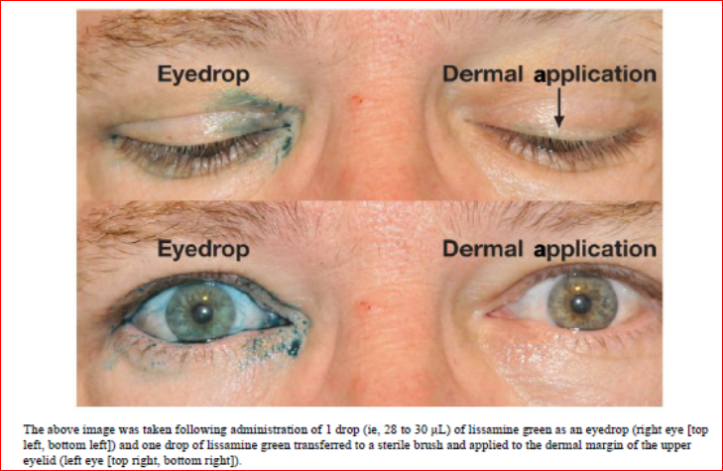

The sponsor stated that *“although it is possible for a patient to try to apply more than a single drop of Latisse® to the applicator, this practice would simply cause the product to be used faster. In the event that a patient applies too much solution to an applicator and excess solution is applied to the treatment area, the directions for use in the proposed product information (PI) and consumer medicine information (CMI) direct the patient to blot excess product after application. These directions are intended to provide for a targeted application of the appropriate dose to the treatment area.”*

#### Evaluator’s comments

From this data it is seen that less than one drop is delivered, however it is still feasible that patients may overuse the product.

### Question 2. Part A

#### Sponsor’s response:

*Because bimatoprost acts on the eyelash hair growth cycle, the efficacy of Latisse® is therefore predicted to be similar across all populations. Approvals for Latisse® have been granted in the following Asian countries without specific language in the label relating to efficacy in specific racial groups: Singapore, Korea, Hong Kong, Vietnam, Taiwan, Philippines, and Thailand.*

*Since the current submission on 28 September 2012, 2 safety and efficacy studies have been completed in Asian subjects:* The clinical study reports for these two studies were included in the response.

Studies 192024-059 and -067 were multicentre, double-masked, randomised, parallel-group, 5 month, Phase III studies which evaluated the safety and efficacy of bimatoprost solution 0.03% compared with vehicle in increasing overall eyelash prominence following once daily topical application to the upper eyelid margins of adult, Japanese subjects. Study 192024-059 enrolled 173 (88 bimatoprost and 85 vehicle) subjects with idiopathic hypotrichosis of the eyelashes; 192024-067 enrolled 36 (18 in each of the bimatoprost and vehicle groups) adult subjects with hypotrichosis of the eyelashes post-chemotherapy. Both studies had the primary endpoint of ≥1 grade increase in the GEA scale after 4 months treatment.

In Study 192024-059 at month 4, the proportion of subjects with at least 1 grade increase in the GEA score was 77.3% and 17.6% in the bimatoprost and vehicle groups, respectively (p<0.001). In the post-chemotherapy Japanese subjects in 192024-067, the proportion who had at least one grade improvement on the GEA score was 88.9% in the bimatoprost and 27.8% in the vehicle group (p<0.001). In the idiopathic group, the proportion of subjects with at least a 2 grade increase in GEA was 36.4% versus 1.2% (p<0.001) (Table 19). However, in the post chemotherapy group, the rate of at least 2 grades increase in GEA score was not significantly different (27.8% versus 5.6% p=0.177) (Table 20).

The mean (192024-059) and median (192024-067) percentage change in eyelash length, thickness and darkness was significantly better with bimatoprost than vehicle in both the idiopathic population and the post-chemotherapy groups (Tables 19 and 20).

The sponsor concluded by stating: *Although ethnically Japanese subjects may not be broadly representative of all Asian ethnicities, the mechanism of action of bimatoprost is predicted to be similar across populations and there is no reason to expect that other Asian populations would experience different efficacy or safety results. As such, Allergan does not believe there is a need to include wording within the Product Information that specifically addresses the Asian population.*

Table 19. 192024-059 Summary of primary and secondary efficacy results at the primary timepoint for efficacy analyses, Month 4 (ITT population).

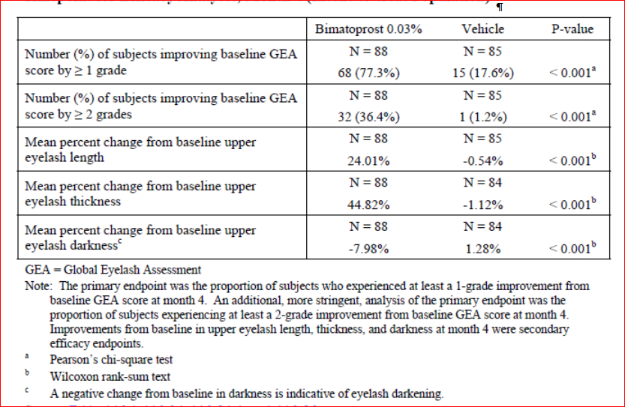

Table 20. 192024-067 Summary of primary and secondary efficacy results at the primary timepoint for efficacy analyses, Month 4 (ITT population).

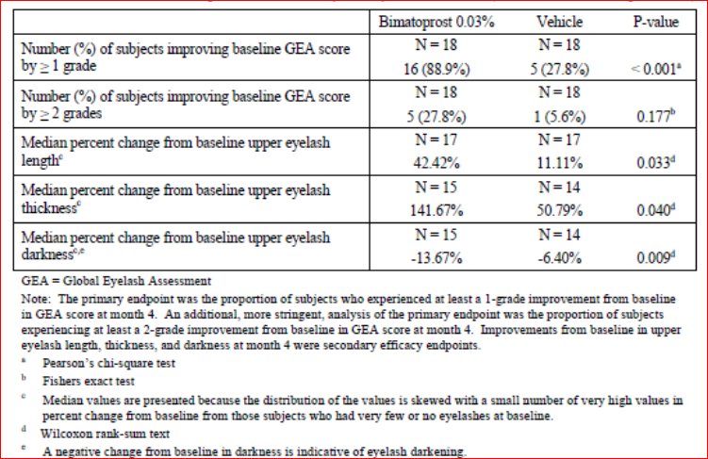

#### Evaluator’s comments:

The new data presented from the two clinical trials in Japanese subjects with idiopathic and post-chemotherapy hypotrichosis are consistent with the data evaluated in the first round. The evaluator agrees that there does not appear to be a difference in efficacy in Japanese subjects. It is agreed that specific wording in the PI for Asian subjects does not appear warranted.

### Question 2. Part B

#### Sponsor’s response:

The sponsor agreed that the vehicle response rate in Study 192024-039 was higher than in other studies but stated that this was not noted when assessing response of ≥2 grades on the GEA (Table 21). It was noted that in 2 of 5 clinical sites there was 100% vehicle response and so the Sponsor proposed that the result may have been due to investigator variability.

Table 21. Number (%) of subjects with idiopathic hypotrichosis achieving at least 1 grade and at least a 2 grade increase from baseline in GEA score at Month 4 (Studies 192024-32, -038, -039 and -059; ITT population).

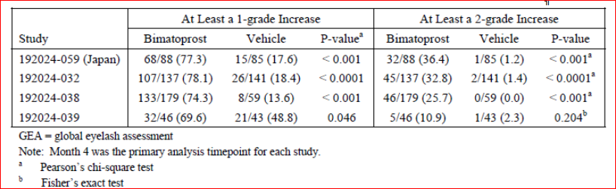

#### Evaluator’s comments:

This proposal also suggests the GEA scale may not be reliable in the African American population.

### Question 3. Part A.

#### Sponsor’s response:

In the overall study population, the rate of mild AEs was 25.9% and 15.6% in the bimatoprost and vehicle groups, respectively. The rate of moderate AEs was 17.0% versus 12.3% and severe AEs was 6.8% versus 4.3% (Table 22). In the post-chemotherapy group the rate of mild (33.6% versus 27.3%), moderate (23.4% versus 12.1%) and severe AEs (11.7% versus 6.1%) was consistently greater in those treated with bimatoprost (Table 22). The rate of moderate and severe AEs by SOC is presented in Table 23. Events in the SOC of Eye disorders and Injury/poisoning/procedural complications (both study populations) and Infections/infestations (for the post-chemotherapy population) were noted to have occurred at higher rates in the bimatoprost groups.

Table 22. Number (%) of subjects reporting adverse events by maximum severity in the integrated Latisse studies (Safety population).

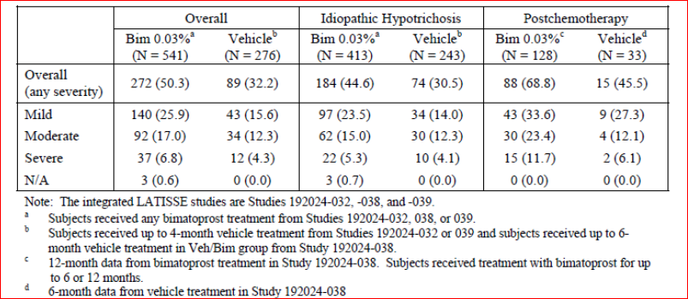

Table 23. Number (%) of subjects reporting adverse events of moderate or severe severity, by System organ Class (Studies 192024-32, -038, -039 and -059 Safety population).

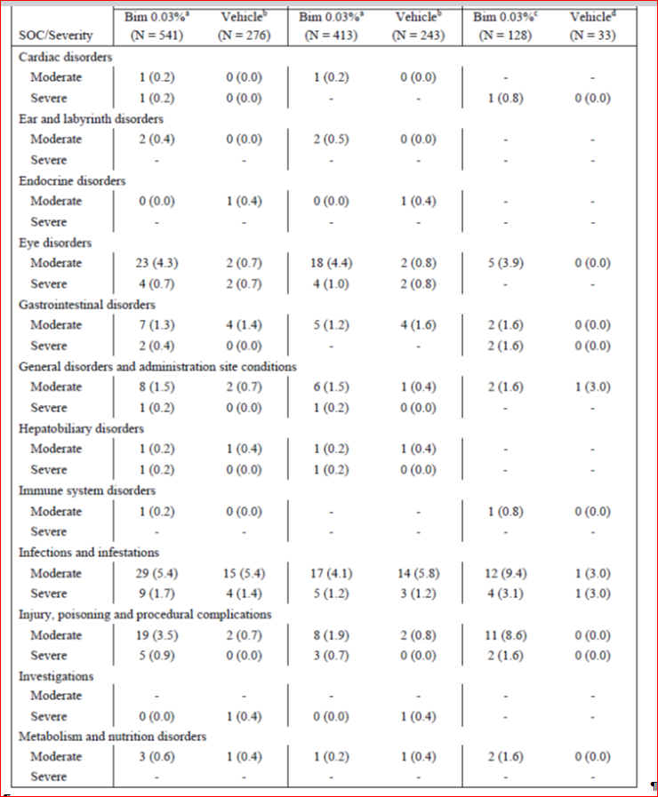

Table 23 continued. Number (%) of subjects reporting adverse events of moderate or severe severity, by System organ Class (Studies 192024-32, -038, -039 and -059 Safety population).

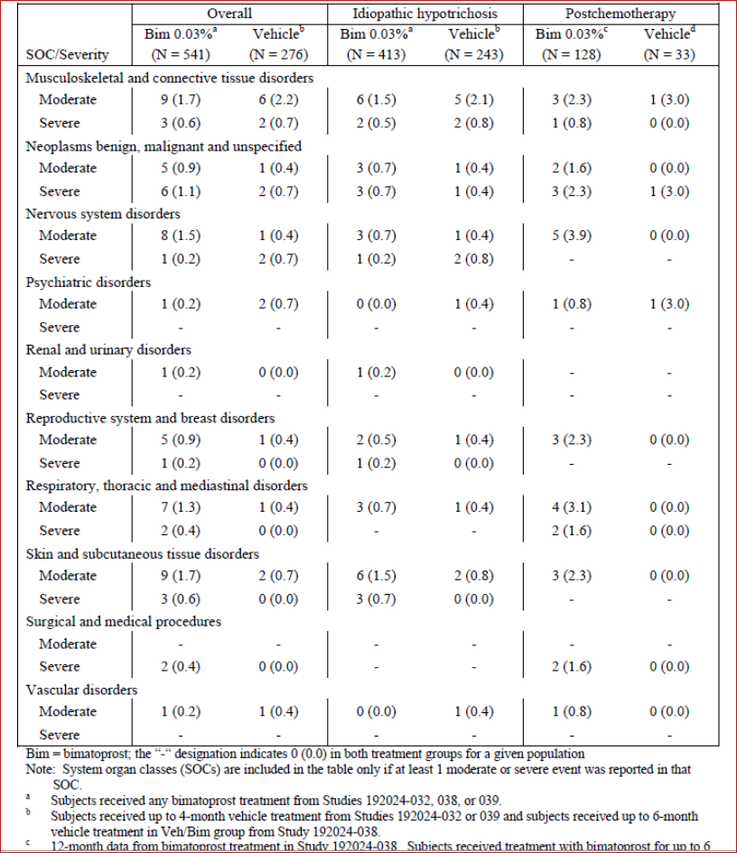

There were 4 bimatoprost-treated subjects (4/541; 0.7%) and 2 vehicle-treated subjects (2/276; 0.7%) with severe adverse events in the eye disorders SOC; all 6 subjects were in the idiopathic hypotrichosis population. For the bimatoprost-treated subjects, the severe events were: conjunctival hyperaemia, conjunctivitis allergic, and eyelid disorder and eye pruritus/eye irritation. The sponsor reported that the severe events in the post-chemotherapy population were generally related to SAEs and the only severe events that were not SAEs were: device-related infection, breast cellulitis, radiation skin injury, arthralgia and bronchospasm. It was concluded that “*the adverse events reported as severe by postchemotherapy subjects were systemic events, unrelated to the study treatment, and considered related to underlying cancer diagnosis or its treatment*.”

#### Evaluator’s comments

The data presented on mild, moderate and severe AEs did not reveal any new safety issues. The data on the higher incidence of AEs and in particular eye disorders in the post-chemotherapy population needs to be included in the PI and cover adverse events not adverse reactions (as discussed above).

### Question 3. Part B.

#### Sponsor’s response

Studies 192024-032, -038, and -039 included 47 Asian subjects (6.4% of the overall safety population) Subgroup analyses of adverse events indicated no difference in overall adverse event reporting rate in Asian subjects (Table 24). Comparing data from the two Japanese studies (192042-059 and 192024-067) to the studies conducted in the US and EU, the adverse event rate was comparable in the Japanese population with idiopathic hypotrichosis (Table 25). The AE rate was higher in the Japanese post-chemotherapy group, however in this population the vehicle treated subjects had a higher AE rate than the bimatoprost group (72% versus 61%) (Table 25). The AE profile was similar between the Japanese study and the integrated safety database for the idiopathic population (Table 26). Data were presented for the post-chemotherapy population however, the numbers are too small to draw conclusions. The sponsor concludes that “*the* *safety profile of Latisse® has been demonstrated to be similar in the populations of Studies 192024-059 (idiopathic hypotrichosis subjects) and 192024-067 (postchemotherapy subjects) (in Japan) compared with the populations of the integrated studies of Latisse® (192024-032, -038, and -039; in US and EU) presented in the current submission. Thus, Allergan believes that there is no need to include specific safety information relating to the Asian racial group in the product information.*

Table 24. Number (%) of subjects with key adverse events in the integrated Latisse studies, Overall population and Asian subpopulation (Safety population).

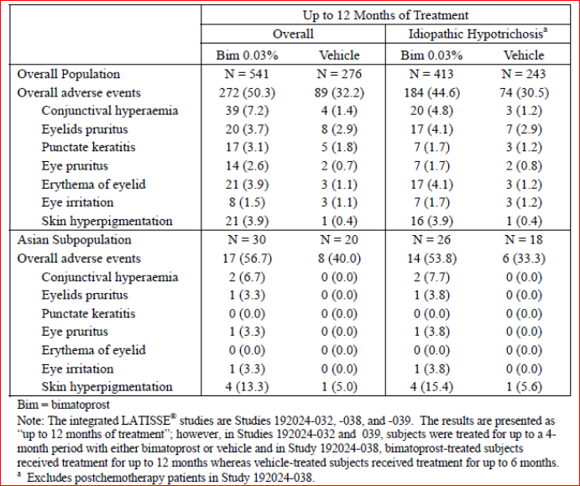

Table 25. Number (%) of subjects reporting adverse events through Month 4 of Studies 192024-021, -038, -039 (US and EU) and Studies 192024-059 and -067 (Japan) (Safety population).

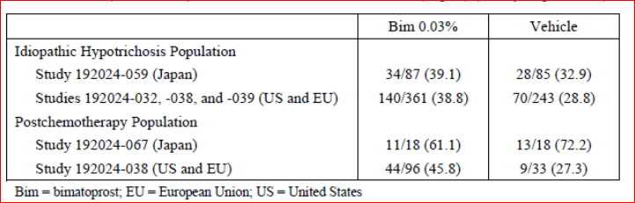

Table 26. Number of idiopathic hypotrichosis subjects in Study 192024-059 and the Integrated safety database reporting common (≥2% in either treatment group in either study/integrated database) adverse events through Month 4 of treatment (Safety population)

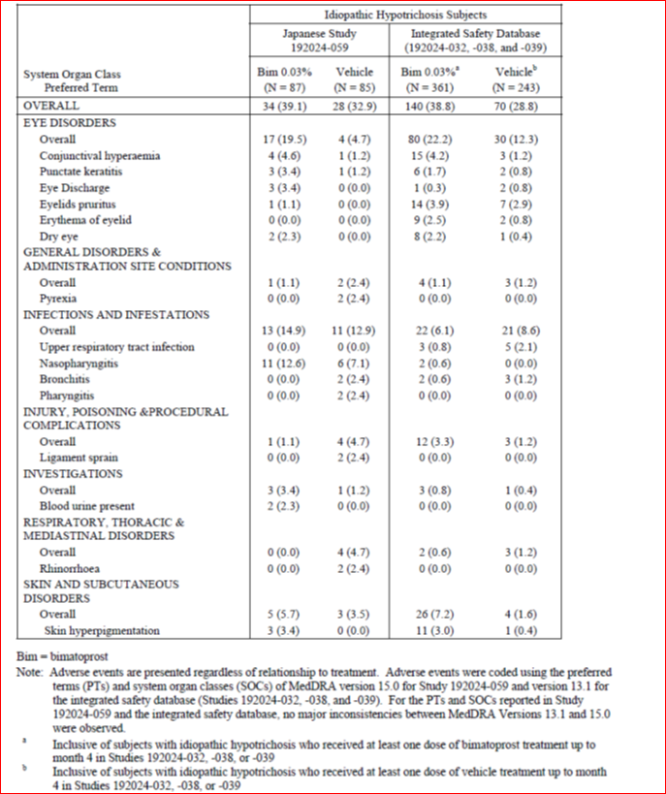

#### Evaluator’s comments

The evaluator agrees that there do not appear to be any specific safety issues in Asian subjects.

### Question 3. Part C.

#### Sponsor’s response

The sponsor states the safety profile of bimatoprost is similar across racial groups, apart from the increased rate of skin hyperpigmentation in Black subjects (Table 27). It was stated that bimatoprost results in increased melanogenesis and transfer of melanosomes to basal keratinocytes in the absence of melanocyte proliferation and atypia. This is via a direct effect on the enzyme tyrosinase. Due to the increased melanin in dark skin, a higher incidence of skin pigmentation change is expected.

*“In the Adverse Effects section of the proposed PI for LATISSE®, it is stated that “The incidence of peri-ocular skin pigmentation was higher in Black patients compared with Caucasian patients (16.0.% v. 1.0%).”*

Table 27. Number (%) of subjects with key adverse events in the integrated Latisse studies by Race (Safety population)

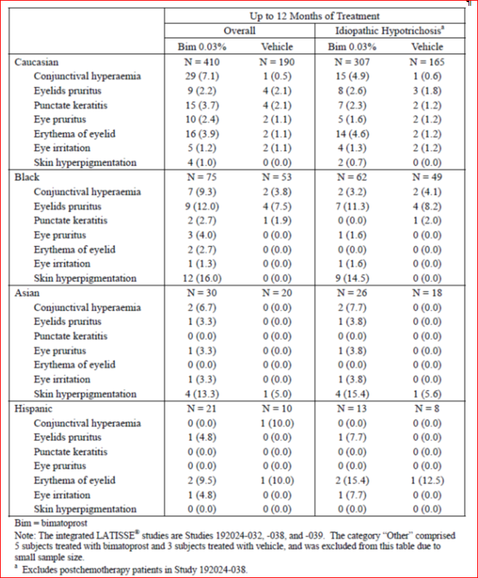

#### Evaluator’s comments

The evaluator accepts the reasoning for the skin pigmentation changes in Black subjects.

### Question 4

#### Sponsor’s response

There were 17 SAEs in bimatoprost-treated post-chemotherapy subjects, 9 attributed to underlying cancer history and 8 related to medical history. None were considered related to Latisse. In addition, in the post-chemotherapy group the rate of SAEs during the second 6 months of bimatoprost treatment was similar to the first 6 months (6.7% versus 8.6%).

The sponsor stated that *“Allergan believes that the greater serious adverse event reporting rate in the postchemotherapy population in Study 192024-038 compared with idiopathic hypotrichosis population in Studies 192024-032, -038, and -039 is related to the underlying diagnosis of cancer as well as complications from its recurrence or treatment in the postchemotherapy subjects. All of serious adverse events reported in the bimatoprost-treated postchemotherapy subjects could be either directly attributed or considered as likely to be related to cancer or complications from its treatment. When serious adverse event reporting rates are compared in the postchemotherapy population using a 6-month treatment duration in the bimatoprost and vehicle groups, the reporting rates are similar (8.6% versus 6.1%), which further supports the assessment of no causal relationship between the serious adverse events and Latisse® treatment.”*

#### Evaluator’s comments

The evaluator agrees the SAEs in this population appear related to background medical history. This apparent differential in SAE rates in the post-chemotherapy group between the bimatoprost and vehicle groups may be a factor of small sample size in the vehicle-treated subjects (n=33).

## Second round benefit-risk assessment

### Second round assessment of benefits

After consideration of the responses to clinical questions, the benefits of bimatoprost 0.03% in the proposed usage are unchanged from those identified in the First Round Evaluation.

### Second round assessment of risks

After consideration of the responses to clinical questions, the risks of bimatoprost 0.03% in the proposed usage are unchanged from those identified in the First Round Evaluation with the exception that efficacy and safety data on bimatoprost use in Japanese subjects were submitted and found to be in line with overall pivotal studies’ population.

### Second round assessment of benefit-risk balance

The second round of data included a review of AEs by severity and SOC. This did not reveal any new safety issues. The risk of eye disorders has been adequately defined in the draft PI. The severe events in the post-chemotherapy population were examined and appeared related to the underlying medical condition. The data on the higher incidence of AEs, and in particular eye disorders, in the post-chemotherapy population needs to be included in the PI.

The lack of data in Asian subjects was addressed by the submission of two clinical trials in Japanese subjects. These studies, one in the idiopathic and one in the post-chemotherapy population, found similar efficacy and no additional safety signals as compared to the EU and US populations. The evaluator agrees that no additional wording is required in the PI in relation to Asian subjects.

Comments relating to the proposed indication (*hypotrichosis of the eyelashes by increasing their growth including length, thickness, and darkness)* have not yet been addressed as outlined in the comments on the PI in first round evaluation. The evaluator still recommends that, as subjects with hypotrichosis from other disorders, such as skin conditions, were excluded from theclinical development program, the indication needs to be clear that treatment is for adult subjects with idiopathic and post-chemotherapy hypotrichosis only. This should be further covered in the specific section on Special Populations in the PI.

In addition, it is recommended that treatment should be limited to 12 months duration. This is due to clinical data being limited to 12 months, the fact that treatment is not intended to be an ongoing therapy and also to discourage potential excessive or continual use.

Taking into account these issues, the evaluator continues to find the benefit-risk balance of bimatoprost 0.03% in the treatment of eyelash hypotrichosis is positive. This assumes the recommendations outlined regarding the product information, including indication, and CMI are adopted.

## Second round recommendation regarding authorisation

The evaluator recommends approval of authorisation of bimatoprost ophthalmic solution 0.03% in the treatment of eyelash hypotrichosis subject to:

* Adoption of changes suggested for the product information and consumer medicine information.

Alteration of the indication to include that the product is only to be used in adults, in those patient groups in which it has been studied (idiopathic and post-chemotherapy) and that treatment duration be limited to 12 months.

## References

European Union (EU). The Extent of Population Exposure to Assess Clinical Safety for Medicines Intended for Long-Term Treatment of Non-Life-Threatening Conditions. 1994. Document 3CC5a.

|  |
| --- |
| Therapeutic Goods Administration |
| PO Box 100 Woden ACT 2606 Australia  Email: [info@tga.gov.au](mailto:info@tga.gov.au) Phone: 1800 020 653 Fax: 02 6232 8605  [**http://www.tga.gov.au**](http://www.tga.gov.au) |

1. The GEA scale provided the investigator’s assessment of the overall eyelash prominence of the subject’s bilateral upper eyelashes, as indicated by the physical attributes of eyelash length, thickness and darkness. It was a four point scale with a photonumeric guide which has been included in **Section 18.2** (**p73**). The four assessments were:

   1. **Minimal:** (includes everything up to minimal; i.e., includes worst possible/none). Corresponding to photoguide Grade 1 frontal views and superior views.

   2. **Moderate:** Corresponding to photoguide Grade 2 frontal views and superior view.

   3. **Marked:** Corresponding to photoguide Grade 3 frontal views and superior views.

   4. **Very Marked:** (includes very marked and above; i.e. includes best possible). Corresponding to photoguide Grade 4 frontal views and superior views.
2. The Eyelash Satisfaction Questionnaire (ESQ) was a subject self-administered questionnaire consisting of 23 items which included three domains. Domain:1 length, fullness, overall satisfaction. Domain 2: confidence, attractiveness, professionalism. Domain 3: daily routine.
3. The ESQ Domain 2 provided the subject’s assessment of eyelash satisfaction through three 3 questions that evaluated subject’s feelings of confidence (item 16), attractiveness (item 19), and professionalism (item 18). These questions were rated on a 5-point Likert scale (1 = very much disagree, 2 = disagree, 3 = neutral, 4 = agree, 5 = very much agree) to yield a total score ranging between 3 and 15, with higher scores indicating greater subject-reported satisfaction with the subjective attributes of the eyelashes.
4. Sponsor correction: post-chemotherapy
5. Sponsor correction: 69.6%
6. Sponsor correction: 69.6%
7. These data allow for the swapping of treatment in the second 6 months of study 192024-038.
8. European Union (EU). The Extent of Population Exposure to Assess Clinical Safety for Medicines Intended for Long-Term Treatment of Non-Life-Threatening Conditions. 1994. Document 3CC5a.