First round CER: 29 December 2016
Second round CER: 30 March 2017

AusPAR Attachment 2

Extract from the Clinical Evaluation Report for blinatumomab
  - Proprietary Product Name: Blincyto
  - Sponsor: Amgen Australia Pty Ltd

About the Therapeutic Goods Administration (TGA)
- The Therapeutic Goods Administration (TGA) is part of the Australian Government Department of Health, and is responsible for regulating medicines and medical devices.
- The TGA administers the Therapeutic Goods Act 1989 (the Act), applying a risk management approach designed to ensure therapeutic goods supplied in Australia meet acceptable standards of quality, safety and efficacy (performance), when necessary.
- The work of the TGA is based on applying scientific and clinical expertise to decision-making, to ensure that the benefits to consumers outweigh any risks associated with the use of medicines and medical devices.
- The TGA relies on the public, healthcare professionals and industry to report problems with medicines or medical devices. TGA investigates reports received by it to determine any necessary regulatory action.
- To report a problem with a medicine or medical device, please see the information on the TGA website <https://www.tga.gov.au>.
About the Extract from the Clinical Evaluation Report
- This document provides a more detailed evaluation of the clinical findings, extracted from the Clinical Evaluation Report (CER) prepared by the TGA. This extract does not include sections from the CER regarding product documentation or post market activities.
- The words [Information redacted], where they appear in this document, indicate that confidential information has been deleted.
- For the most recent Product Information (PI), please refer to the TGA website <https://www.tga.gov.au/product-information-pi>.
Copyright
© Commonwealth of Australia 2018
This work is copyright. You may reproduce the whole or part of this work in unaltered form for your own personal use or, if you are part of an organisation, for internal use within your organisation, but only if you or your organisation do not use the reproduction for any commercial purpose and retain this copyright notice and all disclaimer notices as part of that reproduction. Apart from rights to use as permitted by the Copyright Act 1968 or allowed by this copyright notice, all other rights are reserved and you are not allowed to reproduce the whole or any part of this work in any way (electronic or otherwise) without first being given specific written permission from the Commonwealth to do so. Requests and inquiries concerning reproduction and rights are to be sent to the TGA Copyright Officer, Therapeutic Goods Administration, PO Box 100, Woden ACT 2606 or emailed to <tga.copyright@tga.gov.au>.

Contents
List of abbreviations 5
1. Introduction 9
1.1. Drug class and therapeutic indication 9
1.2. Dosage forms and strengths 9
2. Clinical rationale 9
2.1. Background 9
2.2. Clinical rationale 14
2.3. Guidance 14
2.4. Evaluator’s commentary on the background information 15
3. Contents of the clinical dossier 15
3.1. Scope of the clinical dossier 15
3.2. Paediatric data 17
3.3. Good clinical practice 17
4. Pharmacokinetics 17
4.1. Studies providing pharmacokinetic information 17
4.2. Summary of pharmacokinetics (PK) in adults 18
4.3. PK in paediatric patients 20
4.4. Evaluator’s overall conclusions on pharmacokinetics 27
5. Pharmacodynamics 27
5.1. Studies providing pharmacodynamic information 27
5.2. Summary of pharmacodynamics (PD) in adults 28
5.3. Evaluator’s overall conclusions on pharmacodynamics 34
6. Dosage selection for the pivotal studies 35
6.1. Dose finding in Study 103205 35
6.2. Conclusions on dose finding for the pivotal studies 37
7. Clinical efficacy 38
7.1. Studies providing evaluable efficacy data 38
7.2. Pivotal or main efficacy studies 39
7.3. Other efficacy studies 67
7.4. Analyses performed across trials: pooled and meta analyses 68
7.5. Evaluator’s conclusions on clinical efficacy 84
8. Clinical safety 84
8.1. Known safety concerns with blinatumomab use in adults 84
8.2. Studies providing evaluable safety data 85
8.3. Patient exposure 86
8.4. Adverse events 87
8.5. Postmarketing experience 103
8.6. Evaluator’s overall conclusions on clinical safety 107
9. First round benefit-risk assessment 108
9.1. First round assessment of benefits 108
9.2. First round assessment of risks 109
9.3. First round assessment of benefit-risk balance 110
10. First round recommendation regarding authorisation 110
11. Clinical questions 111
11.2. Additional expert input 112
12. Second round evaluation of clinical data submitted in response to questions 112
12.1. Review of responses to clinical questions 112
13. Second round benefit-risk assessment 125
13.1. Second round assessment of benefits 125
13.2. Second round assessment of risks 125
13.3. Second round assessment of benefit-risk balance 125
14. Second round recommendation regarding authorisation 125
15. References 125

List of abbreviations
Abbreviation | Meaning
6-MP | 6-mercaptopurine
ADA | Anti-drug antibodies
AE | Adverse event
ALL | Acute lymphoblastic leukaemia
alloHSCT | Allogeneic HSCT
ALT | Alanine aminotransferase
AMG103 | Amgen identifier code for blinatumomab
ANC | Absolute neutrophil count
AST | Aspartate aminotransferase
BiTE | Bispecific T cell engager
BM | Bone marrow
CAR | Chimeric antigen receptor
CER | Clinical evaluation report
cIV | Continuous intravenous
CL | Clearance
CLS | Capillary leak syndrome
CNS | Central nervous system
COG | Children's Oncology Group
CR | Complete remission/response as defined by the Sponsor: at least one of CRc, CR* or CR3 achieved
CR* | Complete remission with partial recovery of peripheral blood counts (platelets 50 to 100 x 109/L and/or ANC 0.5 to 1.0 x 109/L)
CR3 | Complete remission without recovery of peripheral blood counts (platelets < 50 x 109/L and/or ANC < 0.5 x 109/L)
CRc | Complete remission with complete recovery of peripheral blood counts (platelets ≥ 100 x 109/L and ANC ≥ 1.0 x 109/L)
CrCL | Creatinine clearance estimated by the Cockcroft-Gault equation
CRh* | CR* as shorthanded in the pivotal Blincyto registration trial in adults
CRi | Morphological remission with incomplete blood count recovery
CRm | Molecular complete remission
CRp | Morphological remission with complete blood count recovery except for platelets < 100 x 109/L
CRS | Cytokine release syndrome
CSR | Clinical Study Report
Css | Steady state serum concentration
CTCAE | Common Terminology for the Coding of Adverse Events
CTCAE | Computed tomography
DIC | Disseminated intravascular coagulation
DLT | Dose limiting toxicity
DOR | Duration of remission
DRC | Data review committee
DSMB | Data Safety Monitoring Board
EC90 | 90% effective concentration
EEG | Electroencephalogram
EFS | Event free survival
EOI | Event of interest
EU | European Union
FAS | Full analysis set
G6PD | Glucose-6-phosphate dehydrogenase
H0 | Null hypothesis
H1 | Alternative hypothesis
HIV | Human immunodeficiency virus
HSCT | Haematopoietic stem cell transplant
ICH | International Conference on Harmonization (of Technical Requirements for Registration of Pharmaceuticals for Human Use)
Ig | Immunoglobulin
IPTW | Inverse probability of treatment weighting
ITT | Intention to treat
LLOQ | Lower limit of quantification
LOD | Limit of detection
LPS | Lansky Performance Status
M3 | ALL stage defined by > 25% blasts in bone marrow
MAD | Maximal administered dose
MEC | Minor editorial change
MRD | Minimal residual disease
MT103 | Identifier code for blinatumomab
MTD | Maximal tolerated dose
MVOF | Minimum value of objective function
N | Number in group
NCE | New Chemical Entity
OS | Overall survival
PAS | Primary analysis set in Study 20140228
PCR | Polymerase chain reaction
pcVPC | Prediction corrected visual predictive check
PD | pharmacodynamic(s)
PK | pharmacokinetic(s)
popPK | Population pharmacokinetics
PPS | Per protocol set
PScA | propensity score analysis
PT | MedDRA preferred term
R/R ALL | Relapsed/refractory ALL
RP2D | Recommended Phase II dose
RSE | Relative standard error
RSE | Risk score
SAE | Serious adverse event
SAP | Statistical analysis plan
sIPTW | Stabilised IPTW
SOC | System organ class
TACL | Therapeutic Advances in Childhood Leukemia & Lymphoma
TEAE | Treatment emergent adverse events
TLS | Tumour lysis syndrome
TRAE | Treatment related adverse event
TTR | Time to relapse
UK | United Kingdom
US, USA | United States, of America

Introduction
This is a submission to extend the indications for the registered therapeutic good blinatumomab (Blincyto) to include treatment of paediatric patients with Philadelphia chromosome negative relapsed or refractory B cell precursor acute lymphoblastic leukaemia (ALL).

Drug class and therapeutic indication
Blinatumomab is a single chain, recombinant antibody construct known as a ‘bispecific T cell engager’ (BiTE). It is a single molecule of murine derivation which includes specific binding sites for both CD19 (a hallmark B cell antigen) and the epsilon chain of the T cell receptor/CD3 complex. It has previously been referred to as AMG103 or MT103.
Blinatumomab is currently indicated for the following:
‘Blincyto is indicated for the treatment of adults with Philadelphia chromosome-negative relapsed or refractory B cell precursor acute lymphoblastic leukaemia (ALL)’.

Dosage forms and strengths
The dosage form of Blincyto is a powder for reconstitution and intravenous (IV) injection: 38.5 micrograms per vial (supplied with intravenous (IV) solution stabiliser).
Detailed dosage and administration instructions are provided in the PI. The current PI states:
‘Dosage: Blincyto is administered as a continuous intravenous infusion delivered at a constant flow rate using an infusion pump. A single cycle of treatment is 4 weeks of continuous infusion. Each cycle of treatment is separated by a 2-week treatment-free interval. Patients may receive 2 cycles of induction treatment followed by 3 additional cycles of Blincyto consolidation treatment’.
Current recommended (adult) dosing is 28 µg per day, given over 24 hours by continuous IV (cIV) infusion. In order to try and reduce first-dose effects such as cytokine release syndrome (CRS) and tumour lysis syndrome (TLS) the recommended dose for the first week of the first cycle is 9 µg/day. This regimen is referred to by the sponsor as ‘9 to 28 µg/day fixed dosing’, establishing a notation regarding dosing that will be adopted for the purposes of this review. In this notation, 2 numbers are given separated by a dash. The first number represents the lower daily dose that is given for the first week of the first cycle, and the second number represents the larger daily dose that is given on subsequent active treatment days.

Clinical rationale

Background

B-precursor acute lymphoblastic leukaemia (ALL)

Pathogenesis
Acute lymphoblastic leukaemia (ALL) is a haematological neoplastic disease in which neoplastic transformation of an immature lymphocyte leads to clonal expansion, suppressing bone marrow function, leading to a lack of normal haematological cell maturation and function, and circulation and deposition of leukaemic cells in end-organs (such as lymph nodes, spleen, liver and CNS). An immature B lymphocyte precursor is seen in around 80% of paediatric cases of ALL whilst 15% have an immature T cell precursor (mature B cell precursors are seen less frequently, in about 5% of cases). Blinatumomab targets B cell precursor ALL, because it specifically binds CD19 (which is highly conserved in B cell malignancies).

Epidemiology
ALL occurs in people of all ages, but almost 60% of cases are children under the age of 14, making it the most common form of cancer in this group., There were 356 new cases of ALL diagnosed in Australia in 2012 (an estimated incidence of 1.6 per 100,000 persons), of which 188 occurred in children under 15 years old. The incidence is higher in males, and in children between 2 and 4 years old.

Prognosis
The mortality per incidence rate of ALL in children under 15 years in 2012 in Australia was 8.51%, and the 5 year survival rate is currently estimated to be over 85% (US estimate).^{4,} Factors correlated with higher risk/poorer prognosis included:
- High initial white blood cell (WBC) count
- Older age
- Genetics:
  - Cytogenetics of extreme hypodiploidy
  - Presence of Philadelphia chromosome
  - T (4;11) MLL rearrangement (seen in 60 to 80% of infants with ALL)
  - iAMP21 amplification
- Immunologic subtype
- Rapidity of cytoreduction.

Induction therapy
The mainstay of treatment for ALL is chemotherapy. Induction therapy usually involves vincristine, steroids and asparaginase, with addition of anthracycline in high risk children.⁵ Where the Philadelphia chromosome is present, a tyrosine kinase inhibitor such as imatinib or dasatinib is added. The risks of induction therapy include tumour lysis syndrome (TLS), thrombosis, haemorrhage secondary to thrombocytopenia, infection, neuropathy, anaphylaxis and hypothalamic-pituitary axis suppression.⁵
In the great majority of paediatric cases, induction therapy achieves complete remission (CR), defined as:
‘the eradication of all detectable leukaemia cells (less than 5 percent blasts) from the bone marrow and blood and the restoration of normal haematopoiesis (> 25 percent cellularity and normal peripheral blood counts)’.

Minimal residual disease (MRD)
Prognosis after induction therapy is worse for patients who have minimal residual disease (MRD): small numbers of leukemic lymphoblasts remaining in the bone marrow, detectable only by flow cytometry or polymerase chain reaction.⁶ The inverse correlation between probability of long-term, relapse-free survival and level of residual disease (both early and late during the treatment course) has been shown in large prospective studies.^{6,}

Concurrent CNS preventive therapy
In addition to induction therapy, CNS preventive therapy is used routinely, beginning in induction and persisting throughout treatment. This has radically reduced the risk of CNS relapse, which used to be seen in 80% of children with ALL who had been in complete bone marrow remission and is now seen in around 6%.⁵ Intrathecal chemotherapy is less neurotoxic than CNS radiotherapy and is now used more frequently, however radiotherapy is still used at reduced doses (12 to 18 Gy) in some protocols or where there is thought to be higher risk of CNS relapse.⁵

Consolidation therapy and delayed intensification therapy
Once remission has been attained, consolidation (or ‘intensification’) therapy is undertaken, lasting around 4 to 8 months, to avoid the emergence of disease recurrence due to residual immature cells or resistant subclones. Drug combinations are chosen based on varying mechanisms of action, to maximise synergy and minimise the likelihood of resistance.⁵ More intense treatment can be undertaken depending on patient risk profile (including MRD status), and an ongoing study of augmented post-remission therapy for patients with MRD has shown better 5 year event free survival (EFS) although the numerical difference in 5 year overall survival (OS) was not statistically significant. Patients at higher risk of relapse can also be given delayed intensification therapy, where a further 4 to 8-week ‘pulse’ of therapy is given after the consolidation phase and this has shown to improve survival.

Haematopoietic stem cell transplant (HSCT)
Patients at high risk of relapse during delayed intensification therapy are candidates for HSTC/allogeneic HSCT (alloHSCT) during first remission as it can offer a survival advantage.⁵ These patients are:
- patients over 10 years of age with severe hypodiploidy (and without Li-Fraumeni syndrome)
- patients with high-risk T cell ALL
- patients with induction failure, and
- patients > 1 year of age with 11q23 rearrangements

Maintenance therapy
After completion of the consolidation phase of therapy, patients often receive a less intensive maintenance therapy with daily oral 6-mercaptopurine (6-MP) and weekly methotrexate, possibly in combination with oral steroids and pulse therapy vincristine.⁵ Studies regarding the optimal regimen and time intervals for vincristine pulsing are ongoing in a large Children's Oncology Group (COG) trial.⁵

Relapsed/refractory ALL (R/R ALL)
Relapsed/refractory ALL (R/R ALL) is the group in whom blinatumomab has been studied, and is defined as patients with first or later ALL relapse or with disease which did not respond to induction therapy (refractory disease). R/R ALL is therefore a heterogeneous group, as it can include patients with any number of previous treatments (including prior HSCT) and subsequent relapses. Refractory ALL occurs in less than 5% of patients, while disease that responded to treatment but later recurred (relapsed ALL) occurs in around 10 to 15% of children with ALL.⁵ Relapse occurs most commonly in the bone marrow, followed by CNS and testes.

Prognosis
R/R ALL patients are united by a poor prognosis: despite available salvage chemotherapies (with good complete response rates) and HSCT, overall survival in patients with marrow relapse within 3 years of diagnosis is less than 10% at 3 years. Failure of induction therapy is correlated with an even poorer prognosis.⁵
Prognosis can be stratified by how many relapses have occurred (each episode of relapse is associated with a gradually worse survival expectancy). In paediatric ALL, remission rates after first relapse have been reported in a retrospective study of 225 children over 9 years (1995 to 2004) to be 83% for early first marrow relapse, 93% for late first marrow relapse and 44% for second marrow relapse. However, 5 year DFS rates have been reported to be 27% in second remission and 15% in third remission. Relapsed ALL is the second most common cause of paediatric cancer-related deaths according to UpToDate (presumably a United States statistic).⁵ An Australian retrospective review found that outcomes for Australian children with ALL were similar to those enrolled in other centres of the U.S. and Canadian clinical trial cooperative, the Children’s Cancer Group. Assuming a relapse rate of 15%, the crude incidence rates in Australia in 2012 have been estimated based on B-precursor ALL making up 80% of ALL, as outlined below in Table 1.

Table 1. Estimated crude incidence of paediatric B-precursor relapsed ALL in 2012
Age group | 0 to 4 years | 5 to 9 years | 10 to 14 years | 15 to 19 years | Total under 19
Number of new cases in 2012 | 99 | 54 | 34 | 21 | 208
Estimated (80%) B-precursor cases | 79.2 | 43.2 | 27.2 | 16.8 | 166
Estimated (15%) B-precursor relapse cases | 11.88 | 6.48 | 4.08 | 2.52 | 25
Population (30 June 2012) | 1,517,235 | 1,455,071 | 1,398,608 | 1,467,054 | 5,837,968
Estimated crude incidence per 100,000 | 0.783 | 0.445 | 0.292 | 0.172 | 2
Source data: Australian Institute of Health and Welfare acute lymphoblastic lymphoma datasheet.⁴

Current treatment options for relapsed/refractory ALL
The only curative treatment currently available for R/R ALL is allogeneic HSCT, and patients must be in haematological remission to proceed to transplant. Treatment of relapsed disease, therefore, involves aggressive re-induction and re-consolidation therapy with different agents to those already used, aiming to induce and maintain remission until a donor can be found and stem cells harvested. Radiotherapy is also used, for patients with CNS or testicular relapse.⁶
However, HSCT is associated with a high risk of relapse (up to 30%); and per transplant mortality (10 to 20%), and the use of HSCT for patients with late bone marrow relapse or multiple relapses has not been firmly established to be beneficial.¹¹
A French study of treatment outcomes after first relapse in adults with ALL (n = 421) showed that 44% achieved a second complete remission with available treatments (as at 2007), with a 5 year disease free survival (DFS) rate of 12%. Of the patients referred for transplant, 19% died before one was available (median wait time is around 8 to 10 weeks; and the median overall survival in adults with current chemotherapy treatments is 3 to 5 months).¹³
Most patients with R/R ALL demonstrate a broad resistance to many currently used agents. Novel therapies currently under trial for B cell precursor disease include a nucleoside analogue (clofarabine) and a proteasome inhibitor (bortezomib) which showed promising efficacy combined with chemotherapy in early non-trial use and in a Phase II trial, respectively., Significant safety concerns in the Phase I trial (B-precursor patients, n = 20) of bortezomib included Grade 3 peripheral neuropathy (9%) and fatal infections (14%), whilst complete response was seen in 14 patients.¹⁷
There are also 2 immunotherapies for relapsed/refractory B-precursor ALL which are in early phase development. Blinatumomab is one. The other is CD19-CAR T cell therapy: a chimeric antigen receptor (CAR) therapy in which patient white cells are collected, autologous CD19 directed T cells produced from them, and the autologous cells reinfused. Phase I dose-escalation data on this therapy has been reported, stating it is ‘feasible, safe, and mediates potent anti-leukaemic activity’.¹⁸
With a 5 year DFS rate of 27% in second remission and 15% in third.¹¹ It is clear there remains an unmet need for therapeutic alternatives in relapsed or refractory paediatric ALL.

Clinical rationale
From the current Australian PI (approved for use in adults):
‘Mechanism of Action
Blinatumomab is a bispecific T cell engager (BiTE) antibody construct that binds specifically to CD19 expressed on the surface of cells of B-lineage origin and CD3 expressed on the surface of T cells. It activates endogenous T cells by connecting CD3 in the T cell receptor (TCR) complex with CD19 on benign and malignant B cells. The anti-tumour activity of blinatumomab immunotherapy is not dependent on T cells bearing a specific TCR or on peptide antigens presented by cancer cells, but is polyclonal in nature and independent of human leukocyte antigen (HLA) molecules on target cells. Blinatumomab mediates the formation of a cytolytic synapse between the T cell and the B cell, releasing proteolytic enzymes to kill both proliferating and resting target cells. Blinatumomab is associated with transient upregulation of cell adhesion molecules, production of cytolytic proteins, release of inflammatory cytokines, and proliferation of T cells, and results in elimination of CD19+ cells’.
Figure 1, shown below, is a schematic of the clinical rationale for blinatumomab’s mechanism of action. As described in the summary of clinical pharmacology included with this submission:
‘Blinatumomab is designed to transiently connect CD19+ cells with T cells; as part of this action, blinatumomab causes the formation of a cytolytic synapse between the T cell and the tumour cell (Offner et al, 2006; Figure 1), releasing the pore-forming protein perforin and the apoptosis-inducing proteolytic enzymes granzyme A and B. The subsequent serial lysis of multiple malignant cells by a single T cell closely resembles a natural cytotoxic T cell reaction. Blinatumomab-mediated T cell activation involves the transient release of inflammatory cytokines and the proliferation of T cells (Klinger et al, 2012)’.
Figure 1. Schematic of blinatumomab mechanism of action
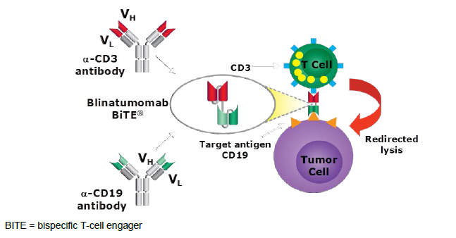

Guidance
The Australian Regulatory Guidelines for Prescription Medicines apply to this submission.
In addition, TGA has adopted the following European Union (EU) guidelines relevant to this submission:
- Guideline on the evaluation of anticancer medicinal products in man (EMA/CHMP/205/95/Rev.4). Replaces: CPMP/EWP/205/95/Rev.3/Corr. Effective: 1 April 2014.
- Appendix 4 to the guideline on the evaluation of anticancer medicinal products in man (EMA/CHMP/703715/2012). Supersedes EMA/CHMP/EWP/520088/2008, Appendix 2. Effective: 1 April 2014.
- Note for guidance on clinical investigation of medicinal products in the paediatric population (CPMP/ICH/2711/99). Effective: 19 April 2001.
- Guideline on the role of pharmacokinetics in the development of medicinal products in the paediatric population (EMEA/CHMP/EWP/147013/2004Corr). Effective: 24 August 2009.
- Guideline on Clinical Trials in Small Populations (CHMP/EWP/83561/2005). Effective: December 2006.
The following guidelines are also listed on the TGA website with regard to generating paediatric data:
- Guideline on the investigation of medicinal products in the term and preterm neonate (EMEA/536810/2008).
- Guideline on conduct of pharmacovigilance for medicines used by the paediatric population (EMEA/CHMP/PhVWP/235910/2005/rev.1).
- Reflection paper: Formulations of choice for the paediatric population (EMEA/CHMP/PEG/194810/2005).

Evaluator’s commentary on the background information
The group of patients who have relapsed/refractory ALL is heterogeneous with many possible different clinical courses, numbers of relapses, durations of previous remissions, types of relapse (extramedullary or not), previous HSCT, immunophenotype, karyotype and more. The unifying feature of this population is that their disease is not responsive to available treatments with a mortality per incidence rate of ALL in children of around 10% despite current salvage therapies. They therefore are a group with definite unmet need.

Contents of the clinical dossier

Scope of the clinical dossier
The dossier consists of the following:
Clinical study reports:
- Reports of human pharmacokinetic (PK) studies
  - Population PK study reports:
    - Study 120689: Population pharmacokinetics of blinatumomab in paediatric Subjects with relapsed/refractory acute lymphoblastic leukaemia
- Reports of human pharmacodynamic (PD) studies
  - Patient PD and PK/PD study reports:
    - Study 121483: Evaluation of exposure-efficacy and exposure-safety relationship of blinatumomab in paediatric subjects with relapsed/refractory acute lymphoblastic leukaemia.
- Reports of efficacy and safety studies
  - Study reports of controlled clinical studies pertinent to the claimed indication:
    - Study AALL 1331: Risk stratified randomised Phase II testing of blinatumomab in first relapse of childhood B lymphoblastic leukaemia (B ALL)
    - Protocol
    - Adverse safety narratives
  - Study reports of uncontrolled clinical studies
    - Study MT103205: A single arm multicentre Phase II study preceded by dose evaluation to investigate the efficacy, safety and tolerability of the BITE antibody blinatumomab (mt103) in paediatric and adolescent patients with relapsed/refractory B-precursor acute lymphoblastic leukaemia (B ALL)
    - Full Clinical Study Report (CSR)
    - Adverse event narratives (13 January 2015 to 20 August 2015)
    - Additional analyses
  - Study 20130320: An open label, multicentre, expanded access protocol of blinatumomab for the treatment of paediatric and adolescent subjects with relapsed and/or refractory B-precursor acute lymphoblastic leukaemia (ALL) (Rialto study) (interim CSR)
    - ‘Abbreviated CSR’
- Other study reports
  - Study 120521: Model based meta-analysis of haematological remission and overall survival among paediatric patients with relapsed or refractory Philadelphia negative B-precursor acute lymphoblastic leukaemia
  - Study 20140228: A retrospective cohort study of re-induction treatment outcome among paediatric patients with relapsed or refractory B cell precursor acute lymphoblastic leukaemia (ALL)
  - Propensity score analysis of overall survival and haematological complete remission among paediatric and adolescent patients with relapsed or refractory B-precursor acute lymphoblastic leukaemia
- Reports of post-marketing experience
  - Blincyto Postmarketing Safety Summary
- Literature references.
- Quality Overall Summary
- Clinical Overview
- Clinical Summary
- Summary of Clinical Pharmacology Studies
- Summary of Clinical Efficacy
- Summary of Clinical Safety
- Synopses of Individual Studies.

Paediatric data
The entire submission is specific to paediatrics.

Good clinical practice
The sponsor states in their Clinical Overview document:
‘The blinatumomab paediatric clinical program was designed with consideration of the applicable guidelines for clinical study design and report preparation, assessment of safety and efficacy, selection of endpoints, and statistical principles. All clinical studies were conducted under Good Clinical Practices as described in International Conference on Harmonisation (ICH) E6 (ICH, 1996), under the principles of the Declaration of Helsinki, and in accordance with global, local, and regional regulations and guidance, including ICH E11 Guidance for Clinical Investigation of Medicinal Products in the Paediatric Population, FDA Guidance for Industry Clinical Trial Endpoints for the Approval of Cancer Drugs, and Guideline on the Evaluation of Anticancer Medicinal Products in Man (EMA, 2012; US FDA, 2007; ICH, 2000).’

Pharmacokinetics

Studies providing pharmacokinetic information
Pharmacokinetic studies included in this submission are listed below in Table 2. A separate review of the population PK (popPK) Report 120689 was undertaken by an independent popPK expert. This CER will provide limited review of that report, and a summary of the findings of the popPK expert review are included under section [?].
Study 103205 is the pivotal trial of this submission, and consisted of Phase I (a dose finding part followed by a PK/PD expansion part) and Phase II (efficacy). A more detailed description of Study 103205 is located below in Section 7.2 including study design, methodology and efficacy outcomes. A more detailed description of the design of Phase I can be found in Section 6.1. Findings related to dose finding, pharmacodynamics and safety based on data from this trial are included under sections 5, 6 and 7 as appropriate.

Table 2. Submitted pharmacokinetic studies
PK topic | Synopsis | Study ID | *
PK in healthy adults | General PK (single dose)
PK in healthy adults | General PK (multiple dose)
PK in healthy adults | Bioequivalence (single dose)
PK in healthy adults | Bioequivalence (multiple dose)
PK in healthy adults | Food effect
PK in special populations | Target population (single dose)
PK in special populations | Target population (multiple dose)
PK in special populations | Hepatic impairment
PK in special populations | Renal impairment
PK in special populations | Neonates, infants, children, and/or adolescents | 103205 | *
PK in special populations | Elderly
PK in special populations | Other special population
Genetic/gender related PK | Males versus females
Genetic/gender related PK | Other genetic variable
PK interactions | Drug A
PK interactions | Drug B
PK interactions | Drug C
Population PK analyses | Healthy subjects
Population PK analyses | Target population | 120689 121483 | *  *
Population PK analyses | Other
* Indicates the primary PK aim of the study.

Summary of pharmacokinetics (PK) in adults
The PK of blinatumomab in adults has previously been described.¹³ No dedicated PK studies in healthy subjects were undertaken but instead, PK was studied as a parameter of the clinical trials and concentration-time profiles were pooled from adult subjects across 4 clinical studies for a population pharmacokinetics (popPK) analysis (see Study 119137 from previous NCE submission). The current TGA approved PI and the CER for the NCE blinatumomab submission have been used as references for this section.

Physicochemical properties
Molecular weight of around 54 kDa; consists of 504 amino acids.

Absorption
Dosed as a continuous IV infusion.

Distribution
Based on terminal phase, the estimated mean (SD) volume of distribution in adults was previously estimated to be 4.52 (2.89) L (per current PI). PK showed high Interindividual but low Interindividual variability with constant infusion. Per current PI:
‘The pharmacokinetics of Blincyto appear linear over a dose range from 5 to 90 micrograms/m²/day (approximately equivalent to 9 to 162 micrograms/day) in adult patients. Following continuous intravenous infusion, the steady state serum concentration (Css) was achieved within a day and remained stable over time. The increase in mean Css values was approximately proportional to the dose in the range tested’.
‘At the clinical doses of 9 micrograms/day and 28 micrograms/day for the treatment of relapsed/refractory acute lymphoblastic leukaemia (ALL), the mean (SD) Css was 211 (258) pg/mL and 621 (502) pg/mL, respectively’.

Metabolism
Per current PI:
‘The metabolic pathway of Blincyto has not been characterised. Like other protein therapeutics, Blincyto is expected to be degraded into small peptides and amino acids via catabolic pathways’.

Excretion
Per current PI:
‘The estimated mean (SD) systemic clearance with continuous intravenous infusion in patients receiving Blincyto in clinical studies was 2.92 (2.83) L/hour. The mean (SD) half-life was 2.11 (1.42) hours. Negligible amounts of Blincyto were excreted in the urine at the tested clinical doses’.

Special populations
Regarding effect of hepatic function, per current PI:
‘No formal pharmacokinetic studies using Blincyto have been conducted in patients with hepatic impairment. Baseline alanine aminotransferase (ALT) and aspartate aminotransferase (AST) levels were used to assess the effect of hepatic impairment on the clearance of Blincyto. Population pharmacokinetic analysis suggested that there was no association between ALT or AST levels and the clearance of blinatumomab’.
Regarding effect of renal impairment, per current PI:
‘No formal pharmacokinetic studies of blinatumomab have been conducted in patients with renal impairment. Pharmacokinetic analyses showed an approximately 2-fold difference in mean blinatumomab clearance values between patients with moderate renal dysfunction and normal renal function. Since high inter-subject variability was discerned (CV% up to 95.6%), and clearance values in renal impaired patients were essentially within the range observed in patients with normal renal function, no clinically meaningful impact of renal function on clinical outcomes is expected’.
In the Study 120689 CSR, the following summary regarding renal effects is given:
‘Creatinine clearance estimated by the Cockcroft-Gault equation (CrCL) was identified to be a significant factor on clearance. A 50% reduction in CrCL was associated with a 30% reduction in blinatumomab systemic CL. Majority of the subjects achieved steady-state serum concentration within the first day of a 28 days cycle, regardless of renal function. Since the magnitude of the CrCL effect on CL was relatively lower than the unexplained between subject variability in blinatumomab pharmacokinetics, with no clinically meaningful impact on efficacy and safety in adult subjects with moderate renal dysfunction, dose adjustment for subjects with mild and moderate renal impairment did not deem necessary. No other covariates were found to significantly contribute to explain the between subject variability of blinatumomab pharmacokinetic parameters’.

Interactions
The CER for blinatumomab as a NCE states:
‘A formal drug-drug interaction study was not conducted as blinatumomab is not eliminated via hepatic metabolism and blinatumomab is primarily intended to be administered as a single agent. Blinatumomab did not affect CYP450 enzyme activities and pharmacokinetic interactions between blinatumomab and drugs metabolized by CYP450 enzymes are not expected’.¹³

Population PK in adults
PopPK analysis was undertaken using data from 4 studies in adult subjects:
- Study MT103-104: subjects with relapsed non-Hodgkin’s lymphoma (n = 76)
- Study MT103-202: subjects with MRD positive B-precursor ALL (n = 21)
- Study MT103-206: subjects with R/R B-precursor ALL (n = 36)
- Study MT103-211: subjects with R/R B-precursor ALL (n = 189)
The PopPK analysis in adults made the following findings:
- Administered by continuous intravenous (cIV) infusion at doses ranging from 0.5 to 90 µg/m²/day or at a fixed dose of 9 or 28 µg/day, PK were single compartment, linear and time independent.
- V_{D} of 3.40 L (with relative standard error (RSE_ 8.35)
- Age (18 to 80 years of age), gender, weight (44 to 134 kg), and BSA (1.39 to 2.57 m²) do not influence blinatumomab PK.
- Two subpopulations of clearance (CL) were seen:
  - 90% (‘Subpopulation 1’) had a geometric mean CL of 1.36 L/hour
  - The remaining 10% had a geometric mean CL around 4-fold higher

PK in paediatric patients

PK in Study 103205

Sampling
Serum PK samples were taken from all subjects during the first 2 cycles of treatment in Phase I of Study 103205. Serum was collected at the following time points:
- Prior to infusion on Day 1
- At any time on Days 3, 8, 15, 22, and 29
- For the older 2 age groups (2 to 6 and 7 to 17 years old): 2, 4, and 8 hours after the end of infusion on Day 29.
CSF sampling was undertaken in Day 8 or Day 15 of Cycle 1 (in both Phase I and II), when lumbar puncture was performed for CNS prophylaxis.
There were 170 serum samples excluded from PK analysis: 165 due to readings lower than the lower limit of quantification (LLOQ) of the assay (50 pg/mL), and 5 due to collection at unscheduled time points. The final PK analysis set therefore included 485 serum samples from 48 subjects (8 subjects under 2 years old, 23 subjects 2 to 6 years old and 17 subjects 7 to 17 years old) and 68 CSF samples from 68 subjects.

Analysis
Blinatumomab concentrations in serum and CSF were determined by a validated bioassay. Concentration-time data were analysed by non-compartmental methods using Phoenix WinNonlin v6.4. PK analysis was conducted in a rolling fashion during the dose escalation part, and continued during the PK expansion part such that at least 6 subjects in each of the 2 older age groups (2 to 6 years and 7 to 17 years) had been analysed for PK prior to recruitment of any infants < 2 years old. Data from the dose escalation part and the PK expansion part were combined based on dose level, cycle, and age group.
Per the CSR for Study 103205:
‘The following PK parameters of blinatumomab were estimated based on individual serum blinatumomab concentrations:
- The steady state serum concentration (Css) as the observed concentrations collected after approximately 5 half-lives after the start of the IV infusion. The values were summarised by age groups, dose levels, and treatment cycles.
- The volume of distribution based on terminal phase (Vz) was calculated as Vz = CL/λz, where λz was the first-order rate constant estimated via linear regression of the terminal log-linear decay phase as determined from the noncompartmental analysis.
- Serum clearance (CL) was calculated as CL=R0/Css, where R0 is the infusion rate (µg/hr) and Css is the average Css. Both R0 and Css were dose normalised to 15 µg/m²/day for this calculation.
- Terminal half-life (t_{1/2,z}) calculated as ln(2)/λz, where λz was the first-order rate constant estimated via linear regression of the terminal log-linear decay phase.
- Ratio of steady state concentrations in CSF and serum was calculated as Css-CSF/Css-serum in subjects who had both CSF and serum concentrations collected at the same time’.

Results
Results of PK analysis for Study 103205 are shown below in Figures 2 and 3.
Figure 2. Individual serum-time profiles for subjects of Study 103205
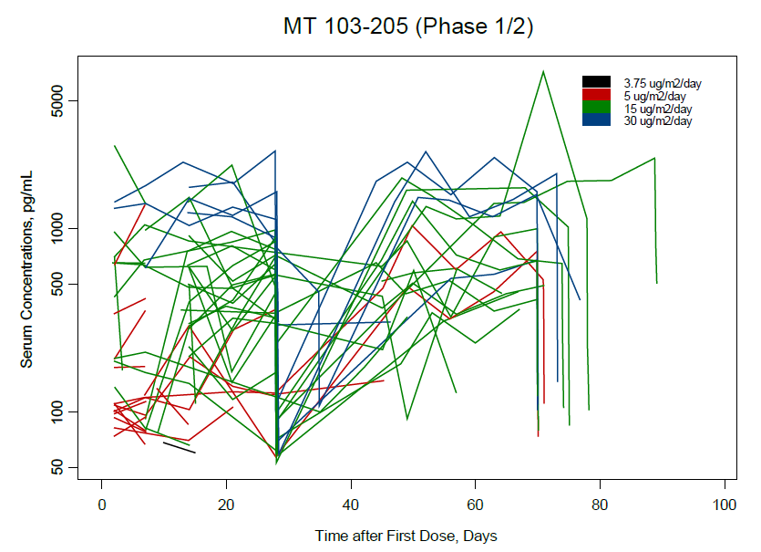
Figure 3. Prediction corrected visual predictive check for external validation
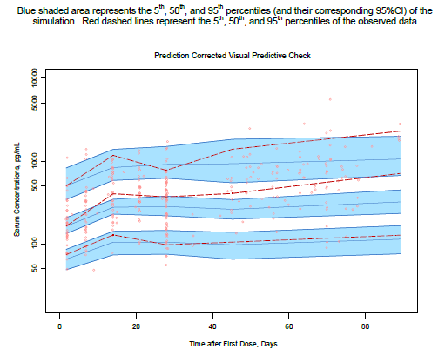
The majority of subjects did not have quantifiable CSF values (see Table 3, below).
Comment: The presence of measurable blinatumomab in the CSF in a very small proportion of subjects has been indicated but not discussed. Can the sponsor please confirm how many subjects had a detectable amount, whether this measurement has been replicated in adults and what the sponsor’s interpretation of this finding is? See Section 11, Clinical Question 1.
Table 3. Summary of blinatumomab CSF concentrations and CSF: serum concentration ratios
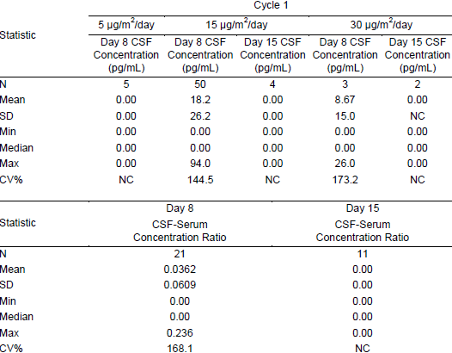
CV = coefficient of variation; Max = maximum; Min = minimum; NC = Not calculated since the number of subjects is less than 3; SD = standard deviation.
The major PK findings were stated to be:
- Css was stable over time for a given dose (see Figure 4, below).
- Mean Css increased with increasing dose in keeping with dose proportional linear PK (see Table 4, below).
- At the dose level of 15 µg/m²/day, mean Css was in a range in keeping with that seen with the same dose level in adults, and the mean was greater than the in vitro EC₉₀ value of 470 pg/mL for the suppression of B cells in relevant human malignant cell lines previously reported (see Section 5.2.2, below).
- The estimated mean (SD) Vz, CL, and t_{1/2,z} were 3.91 (3.36) L/m², 1.88 (1.90) L/hr/m², and 2.19 (1.53) hr, respectively, in the combined age group (≤ 17 years).
- The interindividual variability in PK and PK parameter estimates was large.
Figure 4. Mean (SD) serum concentration-time profiles
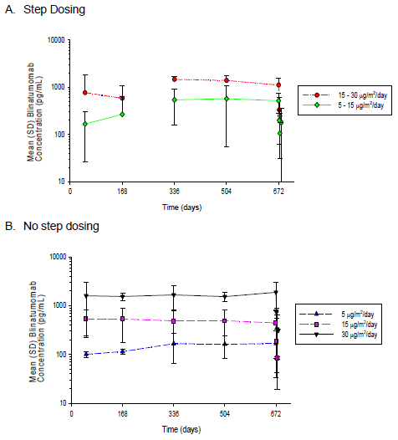

Table 4. Descriptive statistics of blinatumomab Css
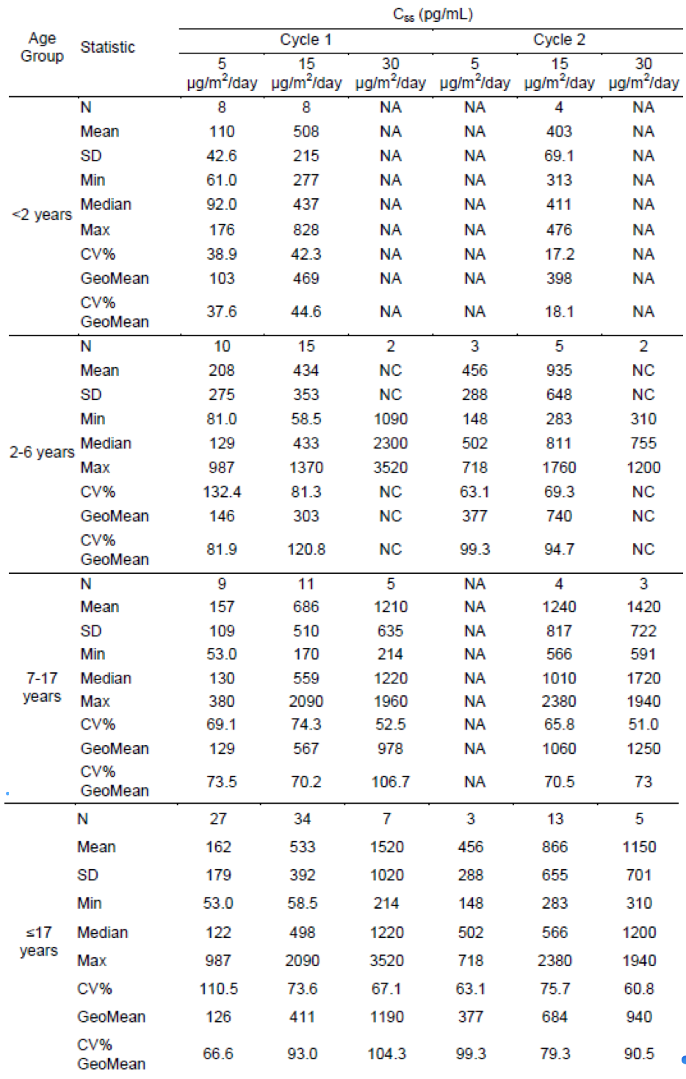
Css = concentration at steady state; CV = coefficient of variation; GeoMean = geometric mean; Max = maximum; Min = minimum; NA = not applicable; NC = not calculated since the number of subjects is less than 3; SD = standard deviation.

Table 5. Descriptive statistics of blinatumomab PK parameter estimates
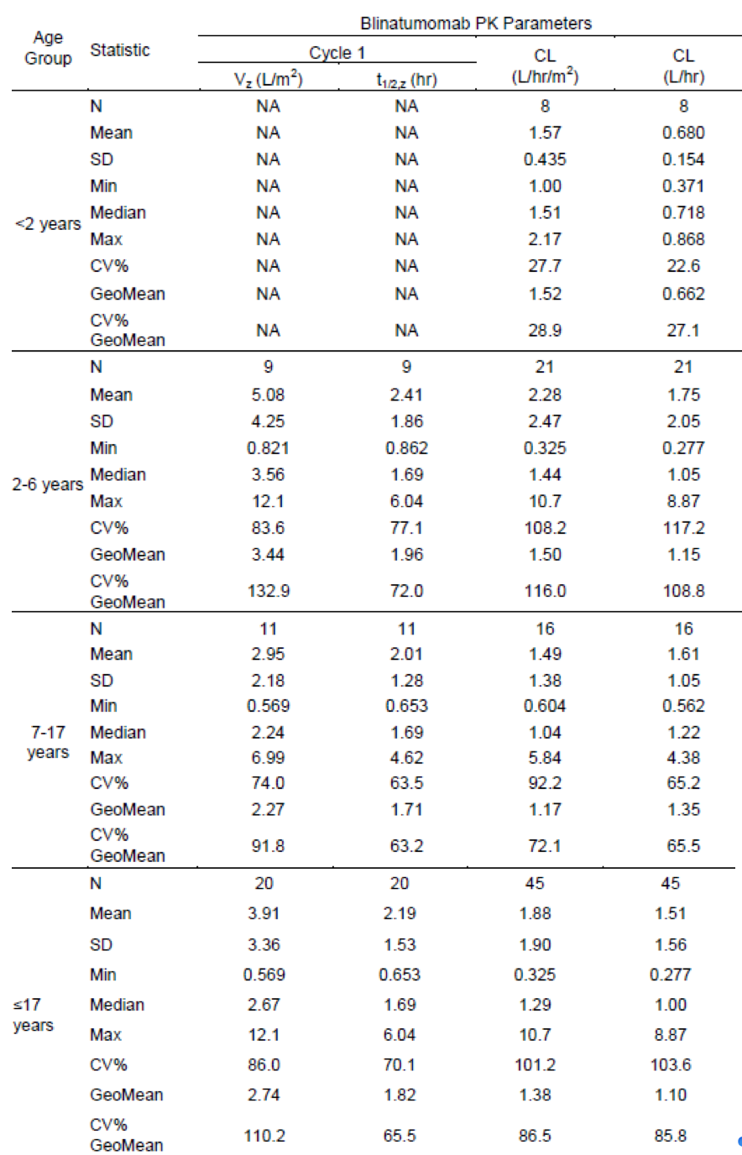
CL = clearance; CV = coefficient of variation; GeoMean = geometric mean; Max = maximum; Min = minimum; NA = Not applicable; SD = standard deviation; t_{1/2,z} = terminal elimination half-life; Vz = volume of distribution based on terminal phase.

PopPK analyses Study 120689 and Report 121483: exposure-response analysis
Paediatric PK data was sourced from 46 subjects of pivotal paediatric Study 103205 (according to the CSR for Study 120689), and analysed using popPK methods, using a previously derived PK model, developed from data in adults with haematological malignancies. Of the adults included in the model development, 215 had R/R ALL.
Overall, the sponsor’s report states that the paediatric data was consistent with the adult PK model: an open, one compartment, linear, time independent model, with paediatric doses ranging from 3.75 to 30 µg/m²/day. A mixed model matched observed CL, with 2 subpopulations, and renal function was a significant influence on CL (50% reduction in CrCL was associated with a 31% reduction in blinatumomab CL). However, no tested covariates showed significant (> 5%) correlation with the large interindividual variability in blinatumomab PK (consistent with previous analyses). Css was almost always reached within a day with cIV infusion.
A geometric mean V_{d} of 2.40 L (with RSE 16.9) was identified: lower than the adult value (3.40 L, relative standard error 8.35% according to popPK, or 4.52 L (SD 2.89), estimated based on terminal phase; see section 4.2) and the adult geometric mean fell outside the 95% CI for the parametric bootstrap of the external validation. A similar effect was seen for clearance (subpopulation 1 CL = 1.02 (RSE 11.6) and subpopulation 2 CL = 4.42 (RSE 71.9)). However, none of the tested covariates could explain this. Therefore, the effect was ascribed to chance, based on the small paediatric sample size.
Comment: A separate popPK expert analysis was undertaken on Study 120689. The evaluator notes the findings from the popPK evaluation regarding the methodology and interpretation of results.

Evaluator’s overall conclusions on pharmacokinetics
Expert review of the population PK modelling used in Study 120689 as the basis for this study found that the popPK study had major deficiencies in execution.
Expert evaluator comments included:
‘methods implemented to explore differences between adult and paediatric subjects were inadequate to explain the differences’ and
‘the model was not applied (e.g. using simulations) to provide quantitative support for dose selection. Therefore, implications for dosing selection were unable to be inferred.’ (See also Section 6.2).
Despite concluding that BSA does not affect PK, a BSA based dosing regimen has been adopted by the sponsor for the Phase II trial.
Comment: It is presumed BSA based dosing was undertaken in the paediatric trial design prior to the popPK analysis, and therefore by the time the popPK analysis had concluded no effect of BSA on PK, it was too late to change the dosing regimen, and so the dose recommendation has been made on the basis of what safety and efficacy evidence is available. Can the sponsor please justify the apparent logical fallacy between dose choice and popPK study findings regarding the effect of BSA? See also, Section 6.2 and Section 11, Clinical Question 2.

Pharmacodynamics

Studies providing pharmacodynamic information
No studies in healthy subjects or dedicated PD studies were undertaken. Instead, as for the NCE submission, pharmacodynamic data (cytokine elevation) was assessed along with safety and efficacy in the pivotal Study 103205. Study 103205 is the pivotal trial of this submission, and the study design, methodology and efficacy outcomes are outlined in Section 7.2 and Section 6.1. Findings related to dose finding, pharmacokinetics and safety based on data from this trial are included under Sections 4, 6, 8 as appropriate. Additionally, an exploratory popPK/PD analysis was undertaken, as listed below in Table 6.

Table 3. Submitted pharmacodynamic studies
PD Topic | Subtopic | Study ID | *
Primary Pharmacology | Effect on cytokines | Study 103205
Primary Pharmacology | Effect on PD parameter B
Secondary Pharmacology | Effect on PD parameter C
Secondary Pharmacology | Effect on PD parameter D
Gender, other genetic, and age related differences in PD response | Effect of gender
 | Effect of genetic characteristic
 | Effect of genetic characteristic
 | Effect of age
PD Interactions | Drug A
PD Interactions | Drug B
PD Interactions | Drug C
Population PD and PK-PD analyses | Healthy subjects
Population PD and PK-PD analyses | Target population | Study 121483 | *
* Indicates the primary PD aim of the study.

Summary of pharmacodynamics (PD) in adults
Prior to this submission, no studies in healthy subjects or dedicated PD studies were undertaken. Instead, pharmacodynamic data was assessed along with safety and efficacy in 4 clinical studies:
- Study MT103-104: subjects with relapsed non-Hodgkin’s lymphoma (n = 76)
- Study MT103-202: subjects with MRD positive B-precursor ALL (n = 21)
- Study MT103-206: subjects with R/R B-precursor ALL (n = 36)
- Study MT103-211: subjects with R/R B-precursor ALL (n = 189)
The findings relevant to these studies are outlined below.
From the CER for the NCE submission:
- Consistent with its mode of action, blinatumomab caused a complete and sustainable depletion of circulating B cells at dose level of ≥ 5 µg/m²/day.
- T cell kinetics showed characteristic redistribution after start of infusion and any increase in dose. Circulating T cells disappeared within the first 6 hours and returned to baseline during the subsequent 2 to 7 days. Although not directly engaged by blinatumomab, redistribution of NK cells and monocytes exhibited kinetics similar to those observed for T cells.
- In most subjects, cytokine levels of IL2, IL6 and IL10 increased immediately after the start of blinatumomab infusion and returned to baseline levels within 1 to 2 days. The magnitude of cytokine elevation appeared to be dose dependent. A similar observation was noted for TNFα and IFNγ in some subjects.

Mechanism of action
From the CER for the NCE submission:
‘Blinatumomab activates endogenous T cells by connecting CD3ɛ in the T cell receptor (TCR) complex with CD19 on benign and malignant B cells; including B-precursor ALL cells. The proximity induced by blinatumomab leads to the formation of a cytolytic synapse and triggers target cell specific cytotoxicity which closely resembles a natural cytotoxic T cell reaction.
Blinatumomab is associated with transient up regulation of cell adhesion molecules, production of cytolytic proteins, release of inflammatory cytokines and proliferation of T cells, and results in elimination of CD19+ cells. In clinical studies, pharmacodynamic measures included lymphocytes, lymphocyte subsets, and cytokines. Consistent pharmacodynamic profiles were observed across clinical trials in subjects with ALL or NHL following the continuous IV infusion regimen. The pharmacodynamic response to blinatumomab was characterized primarily by T cell redistribution, activation, and expansion, B cell depletion, and transient cytokine elevation.
Following initiation of blinatumomab continuous IV infusion, peripheral T cells initially declined quickly to very low levels, a phenomenon described as redistribution. After the initial decline, T cells started to increase and reached baseline levels. The time to return to baseline was variable across patients (7 to 30 days). An expansion of T cells above baseline was observed in some patients. Similar dynamic profiles were observed for CD4+ and CD8+ T cells. A high interindividual variability was observed in baseline levels of T cells (Figure 9). Individual T cell dynamic profiles from R/R ALL patients (Study MT103-206) are presented in Figure 9. T cell dynamic profiles were similar in evaluated subjects with NHL and ALL’.

Relationship between drug concentration and pharmacodynamic effects
From the CER for the NCE submission:
‘At the target efficacious dose of 28 µg/day (15 µg/m²/day) for adults, mean Css were in a range of 553 to 696 pg/mL, which was greater than the in vitro EC90 value of 470 pg/mL for the suppression of B cells in relevant human malignant cell lines’.
PD in paediatric patients
PD in Study 103205

Sampling
All subjects in Study 103205 who received any blinatumomab and had at least one sample for measurement of cytokine concentrations were included in the PD data set. Serum samples were taken from all subjects during the first 2 cycles of treatment in Phase I of the study.
Serum was collected for cytokine levels (including IL2, IL4, IL6, IL10, TNFα and IFNγ):
- Prior to infusion on Day 1, then 2 and 6 hours post treatment start
- On Day 2 and on Day 3, at the same time of the day they were taken at screening ± 15 min.
Serum for anti-drug antibody testing (ADA) was collected at screening, prior to infusion start for Cycles 2 to 5, and at the end-of-core-study visit. Serum for quantitative analysis of immunoglobulins (IgG, IgA and IgM, assessing for hypogammaglobulinaemia or immunological changes) was taken during screening, at Day 29 of each treatment cycle, at the end of core-study visit and each follow up visit.

Analysis
Cytokine levels in serum and CSF were determined by using cytometric bead assay with a LLOQ of 125 pg/mL and a limit of detection (LOD) of 20 pg/mL. In the data set, when LOD was recorded as the concentration, the LOD value divide by 2 was used for numerical calculations. Summary statistics were calculated for each cytokine measured, and stratified by dose and treatment cycles.

Results

Cytokine levels
- IL4 was not detected in any subject at any time.
- IL6, IL10, and IFNγ showed transient elevations from Baseline to levels that were on average greater than the assay LLOQ (125 pg/ml) at all dose levels in Week 1 of Cycle 1 (see Table 7 and Figure 5, below).
- For IL2 and TNFα the average elevations were smaller, and did not reach the assay LLOQ except at the 30 µg/ m2/day dose in Cycle 1, Week 1 only (see Table 7 and Figure 5, below).
- As seen with PK, interindividual variability was very high (see Table 7).
- Cytokine elevation was larger with higher initial dose (see Figure 5) and earlier cycle (see Figure 6, below).

Table 7. Serum cytokines (summary statistics) with different dose levels of blinatumomab in paediatric subjects with R/R ALL
Cytokine | Cycle, Week: Dose (N) | C_{max} (pg/mL) | C_{max} (pg/mL) | Subjects with C_{max}
Cytokine | Cycle, Week: Dose (N) | Mean ± SD | Median (Min to Max) | ≥ 20 pg/mL % | ≥ 125 pg/mL %
IL6 | C1, wk1: 5 µg/m²/day (31) | 4970 ± 17000 | 349 (10.0 to 83900) | 87.1 | 61.3
 | C2, wk1: 5 µg/m²/day (4) | 526 ± 844 | 145 (29.0 to 1790) | 100 | 50.0
 | C1, wk1: 15 µg/m²/day (13) | 1780 ± 2620 | 577 (10.0 to 8560) | 92.3 | 69.2
 | C2, wk1: 15 µg/m²/day (14) | 892 ± 2370 | 223 (10.0 to 9070) | 64.3 | 57.1
 | C1, wk1: 30 µg/m²/day (5) | 23400 ± 24100 | 12900 (2040 to 59200) | 100 | 100
 | C2, wk1: 30 µg/m²/day (5) | 40.4 ± 68.0 | 10.0 (10.0 to 162) | 20.0 | 20.0
IL10 | C1, wk1: 5 µg/m²/day (31) | 562 ± 710 | 293 (10.0 to 3220) | 96.8 | 64.5
 | C2, wk1: 5 µg/m²/day (4) | 519 ± 497 | 510 (44.0 to 1010) | 100 | 75.0
 | C1, wk1: 15 µg/m2/day (13) | 1400 ± 2030 | 595 (10.0 to 6650) | 76.9 | 53.8
 | C2, wk1: 15 µg/m²/day (14) | 432 ± 692 | 114 (10.0 to 2560) | 85.7 | 50.0
 | C1, wk1: 30 µg/m²/day (5) | 3170 ± 1720 | 2960 (740 to 5450) | 100 | 100
 | C2, wk1: 30 µg/m²/day (5) | 277 ± 308 | 119 (10.0 to 769) | 80.0 | 40.0
IFNγ | C1, wk1: 5 µg/m²/day (31) | 207 ± 516 | 43.0 (10.0 to 2280) | 64.5 | 16.1
 | C2, wk1: 5 µg/m²/day (4) | 51.8 ± 65.6 | 24.5 (10.0 to 148) | 50.0 | 25.0
 | C1, wk1: 15 µg/m2/day (13) | 539 ± 1240 | 52.0 (10.0 to 4560) | 53.8 | 38.5
 | C2, wk1: 15 µg/m²/day (14) | 47.6 ± 51.5 | 21.0 (10 to 182) | 50.0 | 7.10
 | C1, wk1: 30 µg/m²/day (5) | 2260 ± 1540 | 1870 (271 to 4200) | 100 | 100
 | C2, wk1: 30 µg/ m²/day (5) | 22.8 ± 28.6 | 10.0 (10.0 to 74) | 20.0 | 0.00
IL2 | C1, wk1: 5 µg/m²/day (31) | 22.7 ± 23 | 10.0 (10.0 to 102) | 35.5 | 0.00
 | C2, wk1: 5 µg/m²/day (4) | 10.0 ± 0.00 | 10.0 (10.0 to 10.0) | 0.00 | 0.00
 | C1, wk1: 15 µg/m²/day (13) | 93.9 ± 150 | 10.0 (10.0 to 526) | 38.5 | 30.8
 | C2, wk1: 15 µg/m2/day (14) | 14.3 ± 8.84 | 10.0 (10.0 to 34.0) | 21.4 | 0.00
 | C1, wk1: 30 µg/m²/day (5) | 900 ± 1390 | 229 (144 to 3380) | 100 | 100
 | C2, wk1: 30 µg/m²/day (5) | 10.0 ± 0.00 | 10.0 (10.0 to 10.0) | 0.00 | 0.00
TNFα | C1, wk1: 5 µg/m²/day (31) | 87.3 ± 241 | 10.0 (10.0 to 1290) | 25.8 | 12.9
 | C2, wk1: 5 µg/m²/day (4) | 10.0 ± 0.00 | 10.0 (10.0 to 10.0) | 0.00 | 0.00
 | C1, wk1: 15 µg/m²/day (13) | 60.2 ± 127 | 10.0 (10.0 to 422) | 15.4 | 15.4
 | C2, wk1: 15 µg/m²/day (14) | 10.0 ± 0.00 | 10.0 (10.0 to 10.0) | 0.00 | 0.00
 | C1, wk1: 30 µg/m²/day (5) | 285 ± 306 | 125 (10 to 722) | 80.0 | 00.0
 | C2, wk1: 30 µg/m²/day (5) | 10.0 ± 0.00 | 10.0 (10.0 to 10.0) | 0.00 | 0.00
N= number of subjects
Figure 5. Serum cytokine levels in paediatric subjects with R/R ALL during first 3 days of blinatumomab infusion: comparing 3 different dose levels
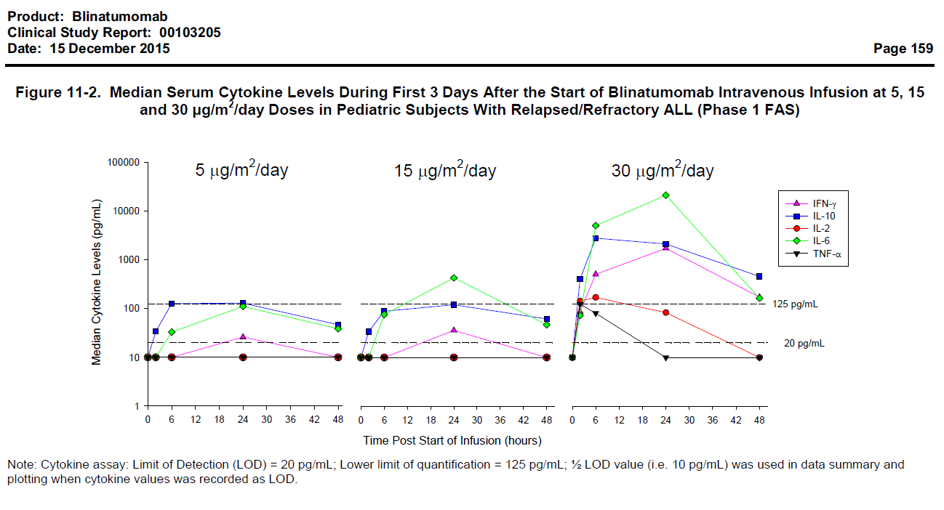
Note: Cytokine assay: Limit of Detection (LOD) = 20 pg/mL; Lower limit of quantification = 125 pg/mL; ½ LOD value (that is, 10 pg/mL) was used in data summary and plotting when cytokine values was recorded as LOD.
Figure 6. Serum cytokine levels in paediatric subjects with R/R ALL during first 3 days of blinatumomab infusion in cycle 1 of treatment (left of each graph) compared to Cycle 2 (right of each graph)
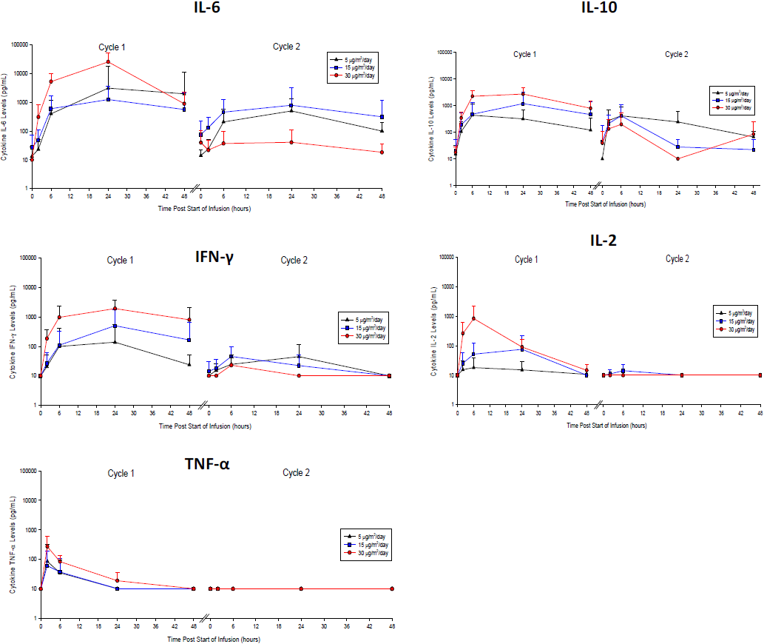

Immunogenicity (anti-drug antibodies, ADAs)
No subject of Study 103205 tested positive for anti-blinatumomab antibodies in this study.

Population Study 121483 (exposure-response) findings
No statistically significant association was seen in any analysis. However, the size of the population studied precludes meaningful inference from the results of this study.

Evaluator’s overall conclusions on pharmacodynamics
The PD findings in children regarding cytokine elevations are in keeping with findings in adults. T and B cell profiles were not reported, and no anti-blinatumomab antibodies were detected in any of the paediatric subjects studied.

Dosage selection for the pivotal studies

Dose finding in Study 103205
Study 103205 is the pivotal trial of this submission, and consisted of Phase I (dose finding phase, with a PK/PD expansion part) and Phase II (efficacy). The design of Phase I of the study is located in this section. A more detailed description of the rest of Study 103205 is located in Section 7.2 and includes dates and locations, statistical and sample size considerations, statistical methods, baseline subject characteristics, inclusion and exclusion criteria. Findings related to pharmacokinetics, pharmacodynamics, efficacy or safety based on Phase I data from this trial are included under Sections 4, 5, 6 and 7 as appropriate.
The primary outcome of Phase I of Study 103205 was maximal tolerated dose (MTD) defined by ≤ 1 of 6 subjects experiencing a dose limiting toxicity (DLT is defined below) or maximal administered dose (MAD). Secondary outcomes include safety, efficacy, and measurement of pharmacokinetic and pharmacodynamic parameters (PK was not measured in Phase II) including serum cytokine concentrations.

Study design (dose finding part of Phase I)
To identify the recommended Phase II dose (RP2D), up to 48 subjects, ages 2 to 17 years, would be recruited. A ‘rolling six’ design was undertaken; evaluating 4 pre-specified dose levels based on body surface area, with provision for alternative dose levels as described in Section 7.2 under ‘Study treatments’. A data review committee (DRC) and the sponsor monitored adverse event data throughout Phase I.
Presence of dose limiting toxicities (DLT) in 2 or more patients at a particular dose level would render that dose as exceeding the maximal tolerated dose (MTD), unless at least one of the DLTs occurred:
- during the first week of treatment
- at a dose level higher than 5 µg/m²/day; and
- was related to a high tumour load (such as cytokine release syndrome).
If the above criteria were fulfilled, a modified dosing schedule would be investigated where the dose would be at a lower level for the first week of the cycle, then put back to the level at which the DLT occurred for the remaining 3 active weeks of the treatment cycle.
The RP2D would therefore not be higher than the highest tested dose at which less than a third of subjects experienced a DLT.
DLTs were defined as:
‘any Grade ≥ 3 adverse event related to study drug, excluding fatigue, headache, insomnia, fever, hypotension, infection, laboratory parameters of Grade ≥ 3 but not considered as clinically relevant and/or responding to routine medical management, thrombocytopenia leukopenia (including neutropenia and lymphopenia), and anaemia. Additional events that were considered as DLTs included:
  - Persistent Grade 4 neutropaenia or thrombocytopaenia until Day 56 in the absence of detectable leukaemia, as it may reflect a marrow toxic effect of blinatumomab.
  - Persistent Grade ≥ 2 non-haematologic adverse events related to study drug that were deemed intolerable by the subject or the treating physician that did not respond to appropriate medical management within 5 days and lead to treatment discontinuation’.
After each dose level cohort was fully enrolled, safety and efficacy data (including toxicities that did not qualify as a DLT) were reviewed by the DRC and confirmed in writing before enrolment of the next dose level cohort could begin.

Study design (PK/PD expansion part of Phase I)
At the completion of Phase I, an interim analysis was undertaken by an independent Data Safety Monitoring Board (DSMB) in order to identify the recommended Phase II dose. After the selection of a Phase II dose, additional subjects from the older 2 age groups were enrolled in an expansion cohort such that PK/PD data was available for at least 6 subjects in each older age group before recruitment of subjects less than 2 years old began. A second meeting of the DSMB was held at the end of the expansion part of Phase I to confirm the RP2D.
Figure 7. Dose levels for testing in Phase I of Study 103205
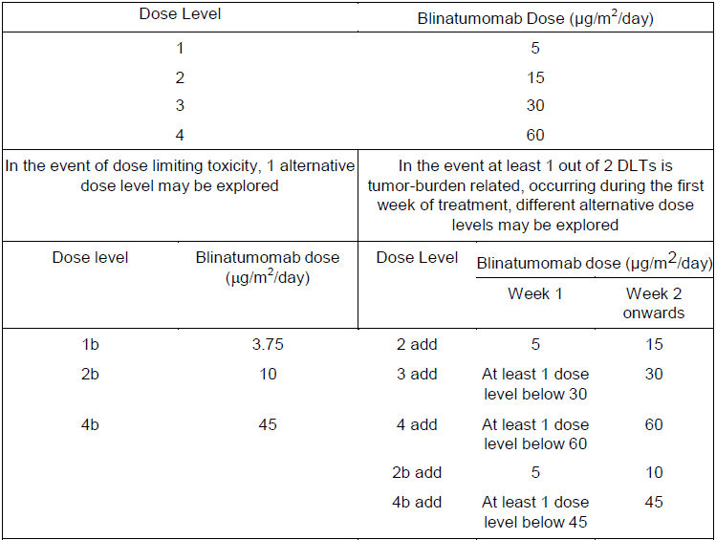

Dose finding results
Four DLT adverse events were observed during Phase I of the study:
- 1 case of Grade 4 cytokine release syndrome (CRS) at 15 µg/m²/day (n = 7) that was deemed related to a Grade 4 gastrointestinal haemorrhage
- 2 cases of Grade 4 CRS at 30 µg/m²/day (n = 5) with 1 deemed related to a Grade 5 cardiac failure; and
- 1 case of Grade 5 respiratory failure at 15 to 30 µg/m²/day (n = 6).
The MTD was defined as a dose level tested in at least 6 patients, where at least 2 of up to 6 patients in the dose level above it experienced a DLT. As 2 DLTs were seen in the 30 µg/m²/day group, this was identified as exceeding the MTD, and 15 µg/m²/day was therefore identified as the MTD.
After the MTD was reached, all Phase I safety, efficacy, PK and PD data were reviewed in a combined DRC and DSMB meeting. As the sponsor states in the CSR:
‘Based on the overall safety profile, a decision was made to start with a dose lower than the MTD of 15 µg/m²/day in the first week of treatment and then escalate the dose to the MTD for the PK expansion part of Phase I as the recommended Phase II dose. This lower initial dose of 5 µg/m²/day, below the MTD, was selected in order to prevent CRS, which was the major toxicity observed. The DSMB unanimously confirmed the final dose selected for evaluation in the Phase II part of the study as 5 µg/m²/day for the first week of treatment of the first cycle; the dose is increased to 15 µg/m²/day at the end of the first week of the first cycle. For consolidation, starting from Cycle 2, a constant dose of 15 µg/m2/day is given’.
This dosing regimen, with a lower starting dose for the first week, is notated throughout the study as ‘5 to 15 µg/m²/day’, and is indicative not of a varying dose between subjects but that each subject was commenced at the lower dose of 5 µg/m²/day and the dose was increased to 15 µg/m²/day from the end of the first week onwards.

Conclusions on dose finding for the pivotal studies
Pivotal Study 103205 was conducted between January 2012 and January 2015, and was designed to investigate 3 dose levels based on BSA (5, 15 and 30 µg/m²/day). The findings of Phase I of this study, as described above, were that the maximum tolerated dose was 15 µg/m²/day based on toxicity events at 30 µg/m²/day. The 5 to 15 µg/m²/day regimen (with the lower dose for the first week of the first cycle only) was selected as the RP2D on the basis of:
- Efficacy was observed with this dose regimen 5 to 15 µg/m²/day
- Exposures at 15 µg/m²/day in all age groups (see Table 4, above) were in keeping with the in vitro EC₉₀ (470 pg/mL) that suppressed B cells in relevant human malignant cell lines seen in preclinical studies as per the CER for blinatumomab as an NCE.
- The risk of cytokine elevation was worst at first dose (first week, first cycle), but the elevations were not as high with lower initial doses, therefore it was determined that this ‘first dose’ effect (and possible risk of CRS) might be reduced by the lower initial week dose.
Although the PK was not properly characterised, it is accepted that the mean exposures were in keeping with in vitro EC90 values.
Concurrently, between December 2011 and October 2013, the pivotal adult study on which blinatumomab registration was based in Australia was being conducted. As noted in the CER for that submission, the PK data showed ‘the pharmacokinetic profile was not affected by body size (for example, body weight or BSA)’. On this basis and the efficacy and safety data, the dose approved for adults is a fixed dose of 9 µg/day for the first week and 28 µg/day for the next 3 active weeks of treatment in the first cycle, with a fixed dose of 28 µg/day for all active weeks of subsequent cycles. A weight cut-off of 45 kg for this fixed dosing was selected as the lowest body weight in the adult cohort was 44 kg.
The popPK study submitted with this dossier suggests that the same holds for paediatric subjects (that is, that BSA does not affect clearance). On this basis, one would expect that paediatric subjects should have comparable exposure with fixed doses to adults. However, given the lack of safety experience with doses higher than 15 µg/m²/day due to the selected RP2D, higher doses can’t be supported by safety and efficacy data. Efficacy was observed to be higher in younger versus older patients who all had the same dose per BSA; however this analysis was underpowered, with overlapping confidence intervals. Even if a difference was truly present, this is not necessarily indicative of older paediatric patients requiring a higher per-BSA dose as it is confounded by prognosis of underlying disease in older versus younger paediatric patients. As stated by the sponsor in the Clinical Overview document:
‘While lower weight cut-offs for conversion to fixed dosing of 9 to 28 µg/day were considered based on the PK and efficacy assessments, the resulting administered dose would significantly exceed the MTD target dose of 15 µg/m²/day, where there is limited safety experience. The converted BSA-based dose for the 9 to 28 µg/day fixed dosing regimen would be 6 to 20 µg/m²/day (for a 45 kg paediatric patient), which is higher than the equivalent recommended paediatric dose of 5 to 15 µg/m²/day. Only 6 subjects have been treated in the paediatric population at the target dose of 30 µg/m²/day when using a step-up paradigm. Therefore, a target dose of 15 µg/m²/day in paediatric patients is considered to be the most safe and effective dose in children weighing up to 45 kg’.
Comment: The available data best supports a dose of 5 to 15 µg/m²/day in subjects up to 45kg. However, the basis of dose selection was not scientifically robust (see also Section 4.4).
Can the sponsor explain their recommendation of a BSA-based dose in Phase I, the choice to continue with BSA based dosing in Phase II, and in the context of such dosing recommendations, justify the conclusions of PK report 120689, which concludes that BSA does not affect PK? (See Section 11, Clinical Question 2).

Clinical efficacy

Studies providing evaluable efficacy data
- Study 103205 (Phase I/II efficacy data)
  - A single arm multicentre Phase II study preceded by dose evaluation to investigate the efficacy, safety and tolerability of the BiTE antibody blinatumomab (MT103) in paediatric and adolescent patients with relapsed/refractory B-precursor acute lymphoblastic leukaemia (ALL)
- Study 20130320 (interim CSR)
  - An open label, multicentre, expanded access protocol of blinatumomab for the treatment of paediatric and adolescent subjects with relapsed and/or refractory B-precursor acute lymphoblastic leukaemia (ALL) (Rialto study)
- Study AALL 1331 (interim data)
  - Risk stratified randomised Phase III testing of blinatumomab in first relapse of childhood B lymphoblastic leukaemia (B ALL)
- Study 121483 (population PK/PD/efficacy/safety study)
  - Evaluation of exposure-efficacy and exposure-safety relationship of blinatumomab in paediatric subjects with relapsed/refractory acute lymphoblastic leukaemia
- Study 120521 (model based meta-analysis)
  - Model based meta-analysis of haematological remission and overall survival among paediatric patients with relapsed or refractory Philadelphia negative B-precursor acute lymphoblastic leukaemia
- Study 20140228 (retrospective cohort study)
  - A retrospective cohort study of re-induction treatment outcome among paediatric patients with relapsed or refractory B cell precursor acute lymphoblastic leukaemia (ALL)
- Propensity Score Analysis
  - Overall survival and haematological complete remission among paediatric and adolescent patients with relapsed or refractory B-precursor acute lymphoblastic leukaemia.

Pivotal or main efficacy studies

Study 103205

Study design, objectives, locations and dates
This was a first paediatric (but not first in human) open label, single arm (non-randomised), multicentre clinical study in 2 parts (Phase I and Phase II) to investigate the PK, safety, and clinical activity of blinatumomab in paediatric and adolescent subjects with B-precursor ALL in second or later bone marrow relapse, in any marrow relapse after allogeneic HSCT, or refractory to other treatments.

Objectives
- Primary
  - Phase I: to determine the recommended Phase II dose (RP2D) of blinatumomab (see Section 6.1)
  - Phase II: to assess the efficacy of blinatumomab (current section).
- Secondary
  - Phase I:
    - To assess the safety of different dose levels of blinatumomab in different age groups (see Section 8)
    - To assess PK of different dose levels of blinatumomab in different age groups (see Section 4.3)
    - To assess the anti-leukaemia activity of blinatumomab (current section)
    - To assess the development of anti-drug antibodies (ADA) to blinatumomab (see Section 5.3)
    - To describe changes in PD markers following treatment with blinatumomab at differing dose levels (see Section 5.3).
  - Phase II:
    - To assess the safety of blinatumomab (see Section 8)
    - To assess the development of ADA to blinatumomab
- Exploratory objectives:
  - To determine the extent of anti-leukaemia activity of blinatumomab

Dates
- Study initiation (first screening visit): 31 January 2012
- Study completion: ongoing
- Primary data analysis cut-off date: 12 January 2015
- Interim analysis: 14 August 2014
- Clinical study report (CSR) date: 15 December 2014.

Location
26 centres in: Germany, France, Italy, the Netherlands, the United Kingdom (UK), and the United States of America (USA). Dose evaluation phase enrolment was restricted to centres with specialist PK certification.

Study design
The overall design of Study 103205 is shown in Figure 8. After screening, subjects entered the ‘Core Study’ (treatment period). Treatment cycles were defined as 4 weeks of blinatumomab continuous intravenous (cIV) infusion, followed by a treatment free interval of 2 weeks. Treatment would be interrupted or dose modified as a result of adverse events according to pre-specified criteria. At investigator discretion, patients could be withdrawn from study treatment to receive chemotherapy or allogeneic HSCT as early as the first cycle. Patients who achieved a complete remission (CR; see definition under efficacy variables and outcomes, below) within 2 cycles of treatment could receive up to 3 additional consolidation cycles with blinatumomab.
An End of Core Study visit was conducted either 30 days after last dose of study medication or prior to start of subsequent non-protocol therapy (if applicable), whichever came first. Efficacy and survival follow up was then undertaken for up to 24 months after treatment start. After the last treatment cycle and End of Core Study visit, all subjects were followed for efficacy and survival for up to 24 months after treatment start.
Figure 8. Overall design of Study 103205
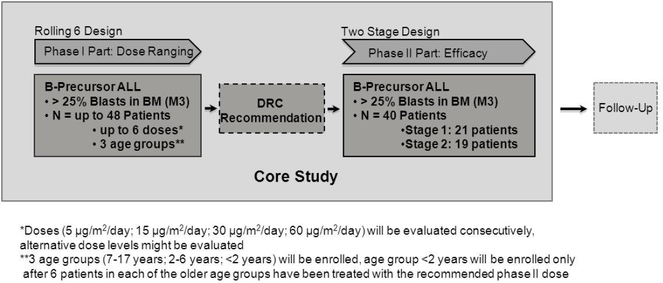DRC = data review committee; BM = bone marrow.
Three age groups (7 to 17 years, 2 to 6 years and < 2 years) were enrolled, but patients less than 2 years old were not enrolled until 6 patients in each of the older age groups had been treated with the recommended Phase II dose.
The design of Phase I (dose finding with PK/PD expansion) of this study is outlined in Section 6.1. At the completion of Phase I, an interim analysis was undertaken by an independent Data Safety Monitoring Board (DSMB) in order to identify the recommended Phase II dose.
A 2 stage design was employed for Phase II of the study. 21 subjects were enrolled in the first stage, and assessed for response. If a response was seen in more than 2 of these subjects, an additional 19 subjects were enrolled in the second stage (see sample size for statistical considerations, below). After Stage 1 of Phase II was completed, the DSMB would consider the data for the second interim analysis and recommend whether the study should continue to enrol all the planned total of 40 patients.

Inclusion and exclusion criteria

Inclusion criteria
- Morphologic and immunophenotypic evidence of B-precursor ALL with > 25% blasts in bone marrow (M3) at study enrolment.
- Age < 18 years at enrolment
- Relapsed/refractory disease:
  - Second or later bone marrow relapse
  - Any marrow relapse after allogeneic HSCT
  - Refractory to other treatments
    - Patients in first relapse must have failed to achieve a CR following at least 4 weeks of full standard re-induction chemotherapy
    - Patients who have not achieved a first remission must have failed a full standard induction regimen
- Karnofsky performance status ≥ 50% for patients ≥ 16 years and Lansky Performance Status (LPS) of ≥ 50% for patients < 16 years
- Adequate renal and hepatic function
- Consent obtained.

Exclusion criteria
- Active acute or extensive chronic GvHD or that was treated with immunosuppressive agents within 2 weeks prior to blinatumomab treatment
- Current CNS or testicular ALL involvement (unless CNS successfully treated prior to enrolment, then patient could be eligible for Phase II only)
- History of (or current) relevant CNS pathology (seizure, paresis, aphasia, cerebrovascular ischemia/haemorrhage, severe brain injuries, dementia, cerebellar disease, organic brain syndrome, psychosis, coordination or movement disorder)
- History of autoimmune disease with potential CNS involvement or current autoimmune disease
- Chemotherapy within 2 weeks prior to blinatumomab treatment
  - Except: intrathecal chemotherapy and/or low dose maintenance therapy such as vinca alkaloids, mercaptopurine, methotrexate, glucocorticoids)
- Chemotherapy related toxicities that haven’t resolved to ≤ Grade 2
- Radiotherapy within 2 weeks prior to blinatumomab treatment
- Immunotherapy (for example: rituximab, alemtuzumab) within 6 weeks prior to blinatumomab treatment
- Any investigational product within 4 weeks prior to study entry
- Previous treatment with blinatumomab
- Hypersensitivity to immune globulins, murine proteins or any other component of the study drug formulation
- Active malignancy other than ALL
- Concurrent disease or medical condition that could be exacerbated by the treatment or would seriously complicate compliance with the protocol
- Infection with human immunodeficiency virus (HIV), hepatitis B virus or hepatitis C virus
- Pregnant or nursing female adolescent patients
- Post-menarchal female adolescent patients or male adolescent patients not willing to use an effective form of contraception during treatment phase of the study and at least 3 months thereafter
- Institutionalised patients
- Any HSCT within 3 months prior to blinatumomab treatment.

Study treatments
This was a single arm study, and the only treatment studied was blinatumomab infusion. Each treatment cycle was 6 weeks long: 4 weeks of cIV infusion of blinatumomab using a pre-programmed infusion pump, followed by 2 rest weeks. Dose levels tested are described in Figure 7, above.
Uncertainty around dose delivery on the basis of possible pump inaccuracies is stated in the protocol to be ± 10%. Infusion was done through a central line unless it was not possible and patient was hospitalised in which case temporary peripheral cannula infusion was accepted.
Obligatory and recommended pre- and concomitant supportive therapies are outlined in the protocol including intrathecal chemotherapy for CNS prophylaxis during the week prior and prophylactic treatments for patients with high risk for cytokine release (BM blasts > 50%) and rasburicase in patients at risk of G6PD deficiency related severe haemolysis where indicated.
Restricted medications were:
- Allogeneic HSCT
- Any anti-tumour therapy other than the investigational product and mandatory concomitant medications (including cytotoxics, radiation and immunotherapy)
- Any other investigational agent;
- Chronic systemic high dose corticosteroid therapy (that is, > 0.25 mg/kg prednisone daily)
- Any other immunosuppressive therapies (except for transient use of corticosteroids)
- Non-steroidal anti-inflammatory drugs (NSAIDs), as they may affect the vascular system
- Acetylsalicylic acid, naproxen or ibuprofen as they may affect the platelet system.
- Tyrosine kinase inhibitors (TKIs).
The criteria for interruption/modification of treatment in case of adverse events and for restarting afterwards are defined in the protocol. CNS adverse events were treated with dexamethasone, and first dose phenomenon, including signs of disseminated intravascular coagulation (DIC), cytokine release syndrome or tumour lysis syndrome was dealt with by interruption to treatment for a week and reintroduction at a reduced dose level, as per Table 8, shown below.
Criteria for permanent discontinuation of treatment were (per protocol):
- Patients who experience adverse events requiring dose interruption at the 3.75 µg/m2/day dose
- Clinically relevant toxicities that by the investigator’s view impose an unacceptable safety risk to the patient;
- CNS related AEs:
  - that need more than one week to resolve to Grade ≤ 1
  - that are Grade 3 or 4
  - that occur after re-start of treatment
- An infusion stop or delay of more than 2 weeks due to AEs or more than 2 discontinuations per cycle due to AEs (does not apply for prolongation of the scheduled treatment free period of a cycle or for a delay because of administrative reasons for example, because of a holiday)
- Medical condition, which in the view of the investigator does not indicate a benefit of blinatumomab for the patient.

Table 4. Treatment modification schedule for first dose phenomenon
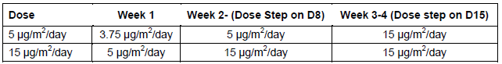

Efficacy variables and outcomes
Endpoints for both phases of Study 103205 are outlined in Table 9, below.

Table 5. Endpoints in Study 103205
Endpoint category | Phase I (dose finding with PK/PD expansion) | Phase II (efficacy)
Primary | MTD defined by ≤ 1 of 6 subjects experiencing a DLT or maximal administered dose (MAD) | Rate of CR within the first 2 cycles.
Secondary | Overall incidence and severity of adverse events  Quantification and characterisation of pharmacokinetic parameters over time  Rate of CR within the first 2 cycles  Time to haematological relapse  CR duration  Overall survival (OS)  Relapse free survival  Proportion of subjects who develop anti-drug antibodies (ADA) at any time  Quantification and characterisation of cytokine serum concentrations | Overall incidence and severity of adverse events  Proportion of subjects who undergo allogeneic HSCT after treatment with blinatumomab  Time to haematological relapse  CR duration  OS  Relapse free survival  Proportion of subjects who develop ADA at any time
Exploratory |  | Rate of MRD response  Rate of complete MRD response  Time to CR and time to M1 with full recovery of peripheral blood counts, M1 with incomplete recovery of peripheral blood counts, M1 without full or incomplete recovery of peripheral blood counts  100 day mortality after allogeneic HSCT
The primary efficacy endpoint for Phase II of the study was measured by assessment of morphology and MRD in bone marrow aspirates. Samples were taken prior to infusion start (day zero), at Day 15 and again during the rest period at infusion end. The Day 15 sample was not taken if there was evidence of persistent peripheral leukaemia. Where aspiration was not possible, biopsies with at least 2 cores and touch preparations were substituted.
Haematological responses were defined by the sponsor as follows:
- Complete Remission (CR) (including patients with incomplete recovery of peripheral blood counts)
  - No evidence of circulating blasts or extramedullary disease and
  - M1 bone marrow (< 5% blasts in BM); subclassified based on peripheral blood counts:
    - CR with complete haematologic recovery (CRc)
Platelets > 100 x 10⁹/L and
Absolute neutrophil count (ANC) > 1.0 x 10⁹/L
    - CR with incomplete haematologic recovery (CR*)
Platelets > 50 x 10⁹/L but ≤ 100 x 10⁹/L and/or
ANC > 0.5 x 10⁹/L but ≤ 1 x 10⁹/L
    - Did not qualify for haematologic recovery (CR3)
Platelets < 50 x 10⁹/L and/or
ANC < 0.5 x 10⁹/L
- MRD response
  - MRD < 10⁻⁴ measured either by PCR or flow cytometry.
- Complete MRD response:
  - No detectable signal for leukemic cells either by PCR or flow cytometry
- Partial Remission (PR):
  - Complete disappearance of circulating blasts and achievement of M2 marrow status (≥ 5% or < 25% blast cells) and appearance of normal progenitor cells
- Progressive Disease (PD):
  - An increase of at least 25%, or an absolute increase of at least 5,000 cells/µL (whichever is greater), in the number of circulating leukaemia cells, development of extramedullary disease, or other laboratory or clinical evidence of PD
- Stable Disease (SD):
  - This is present when the patient fails to qualify either for a CR, PR, or progressive disease.
- Relapse:
  - Haematological relapse (classified as CD19 positive or CD19 negative)
    - Proportion of blasts in bone marrow > 25% following documented CR.
    - Includes extramedullary relapse
  - MRD relapse
    - Increase of MRD level to above 10⁻⁴.

Randomisation and blinding methods
Not applicable. This was a single arm, open label study.

Analysis populations
Analysis populations were defined separately for Phase I and Phase II, and consisted of:
- Full analysis set (FAS): all patients who received any infusion of the investigational drug (in line with intention to treat (ITT) principles). Safety and efficacy analyses were to be conducted on the FAS.
- Per protocol set (PPS): all patients from the efficacy set who did not have any major relevant protocol violation which may have an impact on the efficacy evaluation of this patient. Exclusion criteria are outlined in the statistical analysis plan (SAP of the CSR) [not included in this document].
- Pooled analysis set: all patients who were intended to receive the RP2D (5 to 15 µg/m²/day) from the Phase I and Phase II parts of the study.
- PK/PD set: all patients who received any infusion of blinatumomab and had at least one PK sample collected, unless significant protocol deviations affected the data analysis or if key dosing, dosing interruption or sampling information was missing.
- Interim analysis set:
  - First interim analysis: all Phase I patients
  - Second interim analysis: the FAS enrolled in stage 1 of Phase II, possibly including cumulative information from Phase I.
Pre-specified subgroups for analysis were:
- Age (< 2 years, 2 to 6 years, 7 to 17 years)
- number of previous relapses
- Prior HSCT:
  - If no prior HSCT:
    - refractory disease: refractory first relapse, refractory second relapse, refractory third relapse
    - ≥ second bone marrow relapse: second relapse, third relapse, 4th relapse
  - If previous HSCT
    - relapse after HSCT: first relapse after HSCT or second relapse after HSCT, third relapse after HSCT.
In total, 93 patients were enrolled in this study. The final size of the Phase I FAS cohort was 49 subjects: 23 in the dose selection part and another 26 in the PK/PD expansion group. Of these, 46 were considered per protocol. There were 44 patients in the Phase II FAS, and 41 of these were considered per protocol. Between both phases of the trial, 70 patients received the recommended Phase II dose, and 65 of these were per protocol. Reasons for exclusion from the PPS are outlined under major protocol variations, below.

Sample size
Relapsed/refractory paediatric ALL is reasonably uncommon (estimated incidence in Australian population under 19 years old in 2012 of 2 per 100,000), and no formal sample size estimation by statistical testing was applied to Phase I for this reason. Sample size in the rolling 6 Phase I design was dependent on adverse events. As stated by the sponsor in the CSR:
‘The probability of detecting at least 1 subject with a DLT in 6 subjects receiving blinatumomab was 0.469, 0.738, and 0.882, when the unknown true incidence rates of such events are 10%, 20%, and 30%, respectively’.
A Simon like, 2 stage design was used for sample size calculation for Phase II, with a 2 sided alpha of 0.05, power or 80%, a null hypothesis (H0) proportion of 10% responders and an alternative hypothesis (H1) of a 27.5% response rate. In this design the probability of rejecting H0 after stage 1 is equal to zero, as no stop for efficacy is allowed after the first stage.
With a sample size of 40, (21 at stage 1 and 19 at stage 2), H0 would be accepted if no more than 2 patients showed a response during stage 1, and the probability of early stopping, assuming H1 is true (type 2 error rate), would be 4.6%. Conversely, H0 would be rejected at the end of Stage 2 if 9 or more subjects showed a response.
Comment: The reasoning for the chosen values for the null (10%) and alternative (27.5%) hypotheses isn’t stated explicitly. Can the sponsor please clarify why these values were chosen? See Section 11, Clinical Question 3.

Statistical methods
The statistical analysis plan (SAP) is recorded in Study 130205 CSR ‘Documentation of Statistical Methods.’ Changes in statistical analyses are recorded in the CSR.

Data analysis and endpoints
A list of planned data for collection and analysis according to the SAP is provided below in Tables 10 and 11. Descriptive statistics of demographic and baseline characteristics were to be summarised. For time to event analysis, the Kaplan Meier method was employed for estimates of quartiles with associated 2 sided 95% confidence intervals., As the secondary endpoints were considered exploratory, no adjustments for multiple analysis were made, but exploratory subgroup analyses were included in an attempt to adjust for possible confounding by baseline covariates.

Table 6. Baseline characteristics and demographics data analysis plan for Study 103205
Data and statistics type | Description
Categorical: descriptive statistics (number and percentage). | Gender  Race  Age group: 0 to < 2, 2 to 6, and 7 to 17 years  Disease evaluation (B-precursor ALL)  Number of prior relapses  Prior HSCT: number of relapses after HSCT as category, that is: 0, 1, 2, 3, 4  No prior HSCT:  Number of relapses as category, that is: 1, 2, 3, 4 or more  Refractory disease: primary refractory, refractory first relapse, refractory second relapse, and so on.  Number of previous salvage anti-tumour therapies for patients with prior allogeneic HSCT (overall and category, that is: 0, 1, 2, > 2, if applicable)  Pre-phase medication (screening visit to Day -1 inclusive)  Known cytogenetic or molecular aberrations (missing assessments will be counted as ‘no’), any cytogenetic or molecular aberration, such as t(9,22)  B-precursor ALL, subtype (for primary diagnosis) related to latest relapse  Baseline bone marrow blast category (< 10%, 10% to < 25%, 25% to < 50%, 50%)
Continuous: descriptive statistics (number, mean, SD, median, minimum and maximum). | Age  Bone marrow blast infiltration  Time since last HSCT (months)  Time since initial diagnosis (months)  Time between initial diagnosis and first relapse (months)  Time between last relapse and first dose of blinatumomab (months) Time between last HSCT and last relapse (months)

Table 11. Efficacy endpoints summary for Study 103205
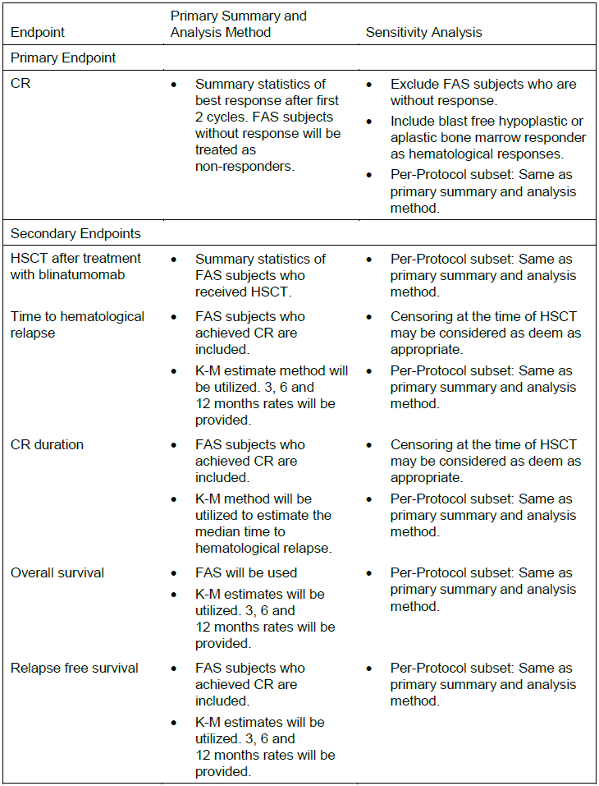
K-M = Kaplan Meier. FAS = Full Analysis Set. CR = complete remission. HSCT = haematopoietic stem cell transplant. Without response = without response assessment.
The ‘protocol and amendments’ document for Study 103205 (dated 23 September 2013) does not mention event free survival, and includes definitions for the following endpoints:
- Time to haematological relapse: will be analysed for CR (including patients with incomplete recovery of peripheral blood counts) patients only and is calculated as the time from the first detection of CR until the time of haematological relapse; The analysis will be based on Kaplan Meier estimates.
- Duration of CR: is defined only for patients with CR and will be calculated as the median time to haematological relapse from the corresponding Kaplan Meier estimates (see above).
- Relapse free survival: is defined for all patients and will be calculated from the time of remission. Those patients who did not reach CR will be considered having an event at day 1 of the analysis (Day 1 = Day 1 of remission). Those who reached CR will be considered at risk of relapse or death without relapse in the analysis. The analysis will be based on Kaplan Meier estimates. 6 months and 1 year rates of patients with relapse free survival will be presented based on the Kaplan Meier estimates.
In the CSR main report body, ‘Time to haematological relapse’ and ‘duration of CR’ are defined as one and the same.
Event free survival was then specified under ‘definitions’ in the SAP for Study 103205 (dated 25 November 2014) as follows (in keeping with what had been defined in the Protocol and Amendments document as ‘relapse free survival’:
‘The analysis of event-free survival will be carried out for all patients who started therapy with blinatumomab in this study. Event free survival will be calculated relative to the start date of blinatumomab infusion in the first treatment cycle. The date of bone marrow aspiration at which haematological relapse or progressive disease was first detected or the date of diagnosis on which the haematological or extra medullary relapse was documented or the date of start of any new therapy for ALL (excluding HSCT and any conditioning regimen for HSCT) or the date of death will be used as the event date for event-free survival, whichever is earlier. Patients who did not achieve CR during the core study will be evaluated as having an event on Day 1. Patients with CR who did not experience haematological relapse, did not show progressive disease, did not receive a new therapy for ALL (excluding HSCT and any conditioning regimen for HSCT), and did not die will be censored on the date of the last available bone marrow aspiration or on the last date of survival follow-up visit, whichever is later’.
However, event free survival is not included in the summary table of efficacy endpoints of the same document (see Table 11, above).
The CSR main report body (dated 15 December 2015) states that ‘the analysis of event free survival specified in the SAP was not conducted.’ It defines relapse free survival as follows (in keeping with what had been defined originally in protocol and amendments as ‘time to haematological relapse’, but including extramedullary relapse):
‘Relapse free survival (RFS) was assessed for subjects who achieved a CR during the core study and was measured from the time the subject first achieved remission until first documented relapse or death due to any cause. Subjects without a documented relapse (haematological or extramedullary) or who did not die were censored at the time of their last bone marrow assessment or their last survival follow up visit confirming remission’.
Comment: The definition of RFS per the core CSR document has been taken to be the one used in final data analysis as it is the most recent and is in keeping with the analysis descriptions in the CSR core report document.

Changes to protocol
Changes in study conduct and protocol are recorded in Table 12.

Table 12. Changes to study protocol for Study 103205 considered to be noteworthy by the TGA evaluator, with comments (italicised text)
Amendment 1: 17 February 2012
To implement an urgent safety measure because of a case of death due to an invasive fungal infection with fungal thrombus of the basilar artery (in Study MT103-206)
Safety related changes.
To change treatment discontinuation criteria for DLTs and for CNS events not meeting DLT criteria
Alignment of European protocol to include US discontinuation criteria.
To remove Grade 3 hypotension from definition of DLT.
This was done due to a transient case of Grade 3 hypotension reversible with fluids and occurring in association with fever early in the first few days of treatment. The CTCAE defines Grade 3 hypotension as ‘Medical intervention or hospitalization indicated’. Grade 4 is ‘Life threatening and urgent intervention indicated’. Hypotension is life threatening if not reversible within a very short period of time, so it stands to reason that Grade 3 hypotension would be quickly reversible and therefore not an adverse event for which a lifesaving therapy would be discarded if it could be managed with temporary interruption, and so on. Therefore, this change is reasonable.
Amendment 2: 11 July 2012
To change inclusion/exclusion criteria re upper age limit, previous blinatumomab treatment, subjects in institutions due to juridical or regulatory ruling, treatment free interval between radiotherapy and blinatumomab).
Changes requested by the German ethics committee.
To delete the possibility of intrasubject dose escalation and expansion of dose cohort.
Done at the request of the FDA.
To strengthen measures for the prevention of cytokine release syndrome; to clarify that DLTs lead to treatment discontinuation.
Done at the request of the Paul Ehrlich Institute and the FDA, respectively.
To add blast free but hypoplastic or aplastic bone marrow to the haematological response criteria.
This had not been included as a potential outcome and was recognised and added once it occurred.
To implement a lower starting dose during the first week of treatment if DLTs caused by tumour load occurred during the first week.
In the exploratory Phase II adult trial, a lower initial dose was shown to be sufficient to prevent clinically relevant cytokine release syndrome (CRS). This change was therefore implemented to allow a similar dosing to be used where CRS was a DLT.
To allow the possibility of retreatment for subjects suffering haematological relapse of B-precursor ALL during the follow up period.
Compassionate access: efficacy data for Phase II patients was kept separate.
To revise timing of assessment of immunogenicity.
Done at the request of the FDA.
Amendment 3: 03 June 2013
To implement changes for inclusion/exclusion criteria regarding evidence of ALL, organ functions, and severe infections.
A death in a child who had pulmonary infiltrates at enrolment resulted in this tightening of exclusion criteria.
To revise recommended, mandatory, prohibited pre- and concomitant medications.
The changes are not concerning.
To clarify definitions of treatment response (term M1 bone marrow)
The ‘protocol and amendments’ document of the submission records the following reason for changing the criteria mid study: ‘The wording was clarified in order to acknowledge the clear paediatric criteria for complete remission defined by the term M1 bone marrow. A reference was added.’
Comment: Given the biological plausibility of a tumour burden related first dose effect and that a reduced initial dose ameliorated this effect in adults, the introduction of a reduced first dose to minimise related adverse effects is a reasonable amendment to the protocol.
A change not discussed in the ‘Protocol and amendments’ document was the decision not to assess event free survival (which would have been calculated for all subjects who received any dose of blinatumomab, and those who did not achieve a CR would have been evaluated as having an event on day 1). Leaving this out is not of concern as RFS would be a subgroup of this and there would be no reason to calculate the 2 separately.
The change to response definition criteria, however, requires specific address.

Participant flow
Summary statistics of patient disposition in Study 103205 are provided below in Table 13 (as at the end of core study, prior to follow up period) and Table 14 (after follow up). A summary of screening results and numbers of screening failures could not be identified in the dossier.

Table 13. Disposition of subjects at the end of core study (5 to 15 µg/m²/day full analysis set and per protocol set)
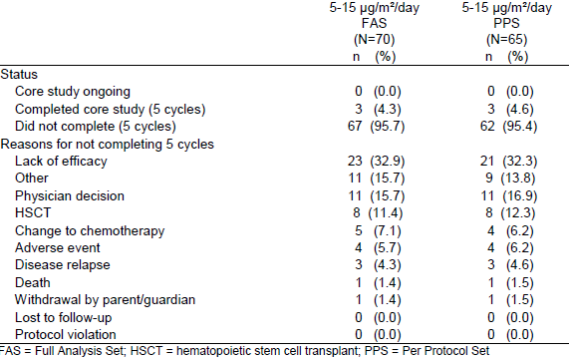

Table 14. Disposition of subjects at the end of study evaluation (5 to 15 µg/m²/day full analysis set and per protocol set)
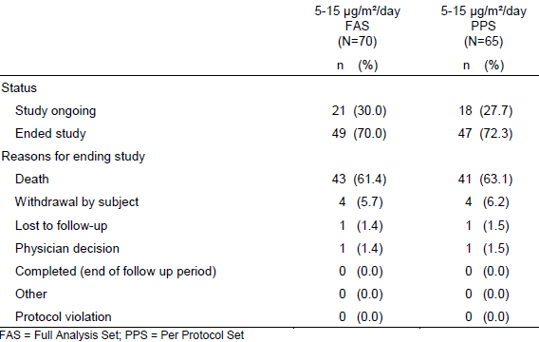

Major protocol violations/deviations leading to FAS exclusion
There were 4 subjects in total who had major protocol deviations that led to their results being excluded from the 5 to 15 µg/m²/day PPS.
- A subject was excluded from the Phase I PPS as on study Day 31 they were treated with a medicine in the category of cytotoxic and/or cytostatic drugs/immunotherapy/tyrosine kinase inhibitors (non-permitted concurrent medication). This was a 1 year old subject with a CR* response (at Day 15 of Cycle 1), who went on to have a HSCT day study Day 66 and whose relapse free survival was censored at 351 days. What the non-permitted medication was and the circumstances of use are not specified.
- Another subject was excluded from the Phase I PPS as they had ≥ 25% blasts in BM at enrolment according to local lab results (26%) and were enrolled on this basis; however centralised testing revealed blast counts ≤ 25% (18%).
- 3 further subjects were excluded from the Phase II PPS for the same reason – not meeting the bone marrow blast count inclusion criterion, due to discrepancies between local lab testing and the centralised testing:
  - Subject 1 with local lab blast count 31% and central lab blast count 14%
  - Subject 2 with local lab blast count 40% and central lab blast count 25%
  - Subject 3 with local lab blast count 37% and central lab blast count 13%.
In addition to these 5 subjects, a sixth subject, from the 15 to 30 µg/m²/day Phase I cohort was excluded from the PPC. The details of that case are discussed in Section 8.4 (Fatal adverse events) of this document, but in brief this was a 2 year old male patient who suffered fatal respiratory arrest on Day 9 of blinatumomab infusion, secondary to what appeared to be an ascending neuropathy. He was presumably therefore deemed to fit the PPS exclusion criterion of having ‘Active severe infection, any other concurrent disease or medical condition that could be exacerbated by the treatment or would seriously complicate compliance with the protocol’.
Comment: Can the sponsor please confirm the presumed reason for excluding subject [identifier redacted] is correct, and provide information on the treatment course for subject [identifier redacted], including whether the non-permitted medication is likely to have contributed to the response and the achievement of HSCT. Why are the results cited in the PI those related to the FAS rather than the PPS? See also Section 11, Clinical question 4.

Baseline data
Baseline data for the subjects of Study 103205 are outlined in brief: in the FAS there were more male than female subjects (in keeping with the epidemiology of paediatric ALL). 10 subjects (14.3%) were younger than 2 years of age, and there were 20 subjects (28.6%) in each age group 2 to 7 years old, 7 to 12 years old and 12 to 17 years old. Over half of the subjects had prior allogeneic HSCT, and the majority (89%) had had at least one salvage therapy. There were not large differences between the FAS and the PPS in terms of baseline demographics.

Results for the primary efficacy outcome
Efficacy analyses were performed on the FAS, with analysis of the PPS as a sensitivity analysis, in both the Phase II group and in a pooled analysis set of all patients who were treated at the RP2D (5 to 15 µg/m²/day).

CR rates in subjects treated at the recommended Phase II dose
Results for the rate of CR within the first 2 cycles (the primary efficacy outcome) in the primary efficacy cohort (the pooled group of patients from both phases of the study who were treated at the RP2D) are summarised below in Table 15.
The lower confidence interval bound falls below the null hypothesis response rate of 10% for all response groups other than the primary outcome of CR as defined by the sponsor (CR including CRc, CR* and CR3) in both the Phase II cohort and the pooled RP2D cohort. Whether CR being defined in this way is an appropriate surrogate marker for clinical benefit is not clear.

Table 15. Results for the primary efficacy outcome (best response during the first 2 cycles of treatment) in Phase II of Study 103205 (Pooled 5 to 15 µg/m²/day cohort)
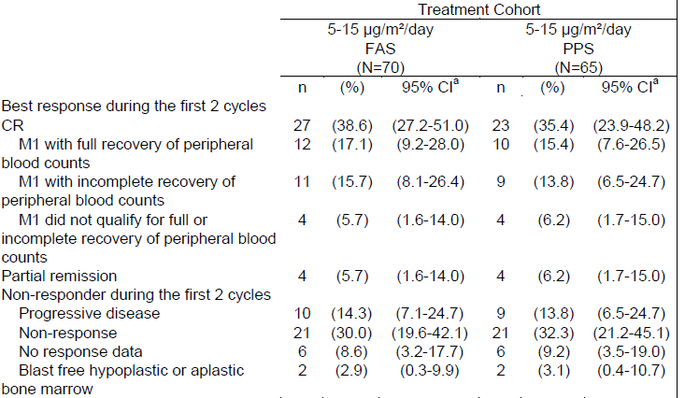
FAS = full analysis set; PPS = per protocol set; CI = confidence interval; CR = complete remission

CR rates in patients with refractory disease at study entry
The best response during the first 2 cycles for subjects who were refractory at study entry was investigated as a non-protocol specified analysis. Results in the subgroup of patients with refractory disease appeared to reflect the primary outcome, but with slightly lower rates in all response categories (see Table 16, below). As seen with the Phase II cohort and the pooled 5 to 15 µg/m2/day cohort, the only efficacy outcome with a lower 95% CI bound above 10% was that for CR as defined by the sponsor (including all of CRc, CR* and CR3).

Table 16. Exploratory analysis of the primary efficacy outcome in refractory subjects only (best response during the first 2 cycles of treatment) in Phase II of Study 103205
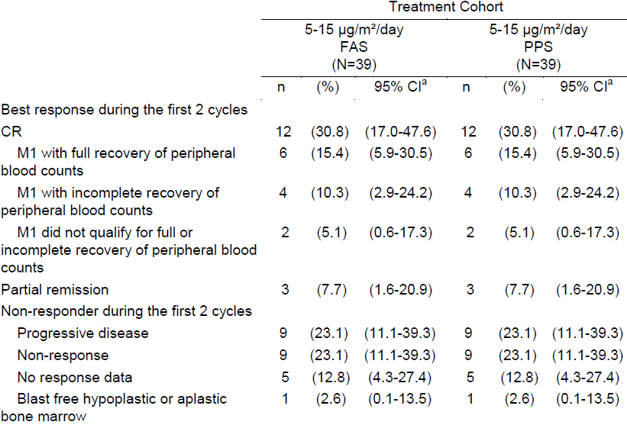
CI = confidence interval; CR = complete remission; FAS = full analysis set; PPS = per protocol set a) 95% CI: lower and upper limit of 2 sided exact 95% confidence interval for percentage of subjects within each response category.
Comment: This subgroup analysis shows that blinatumomab can lead to a CR response, with or without peripheral count recovery, in some refractory patients.

CR rates stratified by baseline bone marrow blast counts
Subjects with < 50% blasts had a better CR than those with ≥ 50% blasts (55.6% (30.8% to 78.5%) versus 32.7% (20.3% to 47.1%)).
Comment: The intersecting confidence intervals identify this as an exploratory analysis.

CR rates after the first 2 cycles versus rates at end of core study
As another non-protocol specified analysis, the rates of CR at end of core study (rather than at 2 weeks) was assessed. Response rates by unspecified CR were the same at the end of the core study as they were at the end of 2 cycles of treatment (see Table 17, below). Notably, 3 patients in the pooled 5 to 15 µg/m²/day cohort (one from Phase I and 2 from Phase II) changed from CR* to CRc later than the end of the second cycle of treatment. Thus, in this cohort (n = 70) the rate of CRc was higher (21.4%) at the end of cycle 3 of treatment than at the end of Cycle 2 (17.1%). The lower 95% CI bound at the end of core study does exceed the significance point of 10%. Subgroup analyses of CRc in the pooled 5 to 15 µg/m2/day cohort at end of core study (FAS) were performed and no subgroups had confidence intervals that didn’t include the line of no effect other than platelet level correlating to rate of CRc (confounded by definition). The sponsor notes in the CSR that the number of patients with CR* that subsequently converted to CRc may have been higher if patients with CR* hadn’t proceeded to HSCT (they may not have had sufficient time for peripheral counts to recover before they underwent HSCT).

Table 17. Efficacy in the pooled 5 to 15 µg/m²/day cohort at end of core study (Study 103205)
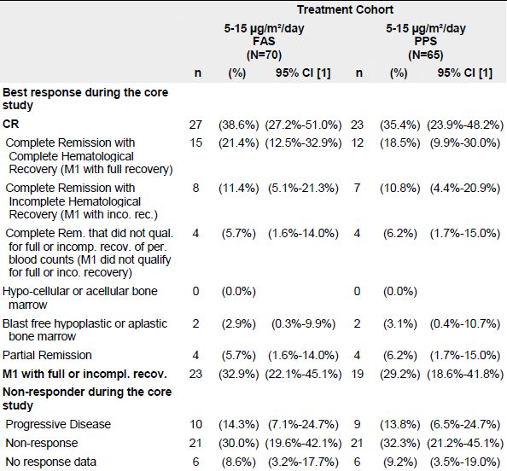
For comparison, CR rates at end of core study for paediatric subjects in Study 103205 and from the pivotal adult trials have been collated (see Table 18, below).

Table 18. Best responses after core study end in the adult pivotal registration trial versus paediatric Study 103205
Best response | Paediatric FAS (n = 70) |  |  |  |  | Adult FAS (n=189)
Best response | n | % | 95% CI |  | CI width | n | % | 95% CI |  | CI width
Responders
CR (CRc + CR* + CR3) | 27 | 39% | 27.2% | 51.0% | 23.8% | 82 | 43% | 35.7% | 50.2% | 14.5%
CRc + CR* | 23 | 33% | 22.1% | 45.1% | 23.0% | 82 | 43% | 35.7% | 50.2% | 14.5%
CRc | 15 | 21% | 12.5% | 32.9% | 20.4% | 67 | 35% | 26.7% | 40.5% | 13.8%
CR* | 8 | 11% | 5.1% | 21.3% | 16.2% | 15 | 8% | 5.7% | 14.6% | 8.9%
CR3 | 4 | 6% | 1.6% | 14.0% | 12.4% | (not a category in this study)
Blast free hypoplastic or aplastic bone marrow | 2 | 3% | 0.3% | 9.90% | 9.6% | 17 | 9% | 5.3% | 14.0% | 8.7%
PR | 4 | 6% | 1.6% | 14.0% | 12.4% | 5 | 3% | 0.9% | 6.1% | 5.2%
Non-responders
Progressive Disease | 10 | 14% | 7.1% | 24.7% | 17.6% | 28 | 15%
Non response | 21 | 30% | 19.6% | 42.1% | 22.5% | 40 | 21%
No response data | 6 | 9% | 3.2% | 17.7% | 14.5% | 17 | 9%
CR = complete remission (CR) with complete haematological recovery. CR*= CR with partial haematological recovery. CR3 = complete remission without haematological recovery. PR = partial response.
Comment: The finding of the primary efficacy analysis should be considered with care as its significance relies on the clinical significance of haematological remission without peripheral blood count recovery, which has not been conclusively validated as a surrogate endpoint for clinical benefit in this setting. However, it is a reasonable hypothesis that this is clinically significant, as there is biological plausibility that peripheral blood counts may take a longer time than to cycles to recover after blinatumomab therapy in paediatric patients. The selection of 2 cycles as the initial point for efficacy testing in paediatric patients and the cycle duration of 6 weeks were presumably chosen based on previous experience as these were the cycle duration and time of primary efficacy testing used in the pivotal registration study in adults.¹³ Recovery of peripheral counts was seen in 3 adults at end of core study who did not have CRc at the end of 2 cycles. ¹³ Adult and paediatric overall CR rate at the end of core study were similar (see CR rates after the first 2 cycles versus rates at end of core study, above). The larger adult cohort size (n = 189) gave a narrower 95% confidence interval, and the confidence intervals between adult and paediatric results intersect. Whilst this does not prove that the paediatric results are in keeping with those seen in adults, it does mean that this study has not proven paediatric response to be different from those seen in adults. The paediatric result for CRc at the end of 2 cycles of treatment had a lower 95% CI bound very close to the pre-determined clinical relevance threshold, and may have reached it if the study was more highly powered.
Endpoints are discussed further in Section 7.2.1.14.
With regard to endpoints, can the sponsor please state why:
1. They chose to use surrogate endpoint CR as the primary outcome for the study?
2. They defined CR to include CRc, CR* and CR3?
See also Section 11, Clinical Question 5.

Results for other efficacy outcomes

Relapse free survival (RFS)
Results for RFS are outlined below in Table 19. The definition for RFS changes between the SAP, the Protocol and Amendments document and the core CSR document for Study 103205 and the definition in the core report has been taken to be the one used in final data analysis:
- Relapse free survival (RFS) was assessed for subjects who achieved a CR during the core study and was measured from the time the subject first achieved remission until first documented relapse or death due to any cause. Subjects without a documented relapse (haematological or extramedullary) or who did not die were censored at the time of their last bone marrow assessment or their last survival follow up visit confirming remission.
- Ad hoc RFS subgroup analyses were performed for subjects who achieved CR and had MRD assessments. Subjects without MRD data were excluded from these analyses.

Table 19. RFS results for Study 103205
Cohort/subgroup | Group size (n) | Median (months) | 95% CI (months) | Censored/ completed study in remission (%) | Median time observed (months)
Phase I FAS | 21 | 7.9 | 3.0 to 12.4 | 4 (19%) | 23.5
Phase II FAS | 14 | 3.4 | 1.7 to 13.9 | 4 (29%) | 11.5
Phase II PPS | 12 | 3.5 | 2.1 to 13.9 | 4 (33%) | 11.5
5 to 15 µg/m²/day FAS | 27 | 4.4 | 2.3 to 12.1 | 7 (26%) | 11.5
FAS censored at HSCT |  | 3.5 | 1.9 to N.E. | 5 (19%), plus 11 had HSCT (41%) | 4.4
2 cycle CRc subset | 12 | 6.0 | 1.2 to 12.1 | 3 (25%) | 11.5
2 cycle CRc subset AND censored at HSCT |  | 6.0 | 1.2 to N.E. | 3 (25%), plus 5 had HSCT (42%) | 4.4
2 cycle CR* subset | 11 | 3.5 | 0.6 to 16.4 | 3 (27%) | 11.5
2 cycle CR* subset AND censored at HSCT |  | 1.4 | 0.6 to N.E. | 2 (18%), plus 4 had HSCT (36%) | 1.7
end of core CRc subset | 15 | 10.3 | 1.2 to 12.1 | 5 (33%) | 11.0
end of core CRc subset AND censored at HSCT |  | 6.0 | 1.2 to N.E. | 4 (27%), plus 6 had HSCT (40%) | 2.8
end of core CR* subset | 8 | 1.4 | 0.6 to 7.6 | 1 (13%) | N.E.
end of core CR* subset AND censored at HSCT |  | 1.4 | 0.6 to 1.4 | 1 (13%), plus 3 had HSCT (38%) | 1.3
5 to 15 µg/m²/day FAS, CR and MRD assessed | 27 | 4.4 | 2.3 to 12.1 | 7 (26%) | 11.5
AND CR type = CRc | 12 | 6.0 | 1.2 to 12.1 | 3 (25%) | 11.5
AND CR type = CR* | 10 | 3.5 | 0.6 to 16.4 | 3 (30%) | 11.5
MRD complete response | 14 | 12.1 | 2.7 to 16.4 | 5 (36%) | 11.5
MRD complete response AND CR type = CRc | 7 | 12.1 | 2.3 to 13.9 | 2 (29%) | N.E.
MRD complete response AND CR type = CR* | 5 | 16.4 | 3.2 to 16.4 | 2 (40%) | 11.5
MRD non-response | 12 | 1.9 | 0.8 to 6.0 | 2 (17%) | 11.5
MRD non-response AND CR type = CRc | 5 | 6.0 | 1.7 to N.E. | 1 (20%) | 11.5
MRD non-response AND CR type = CR* | 5 | 1.1 | 0.6 to 3.5 | 1 (20%) | N.E.
5 to 15 µg/m²/day PPS | 23 | 4.4 | 2.3 to 12.1 | 6 (26%) | 11.6
PPS censored at HSCT |  | 3.5 | 2.3 to N.E. | 5 (22%), plus 10 had HSCT (44%) | 4.4
2 cycle CRc subset | 10 | 10.3 | 0.5 to 12.1 | 3 (30%) | 11.5
2 cycle CRc subset AND censored at HSCT |  | N.E. | 0.5 to N.E. | 3 (30%), plus 5 had HSCT (50%) | 4.4
2 cycle CR* subset | 9 | 3.5 | 0.6 to 16.4 | 3 (22%) | N.E.
2 cycle CR* subset AND censored at HSCT |  | 1.4 | 0.6 to N.E. | 2 (22%), plus 3 had HSCT (33%) | 5.6
end of core CRc subset | 12 | 10.3 | 0.9 to 12.1 | 4 (33%) | 11.5
end of core CRc subset AND censored at HSCT |  | N.E | 0.9 to N.E. | 4 (33%), plus 5 had HSCT (42%) | 2.8
end of core CR* subset | 7 | 2.5 | 0.6 to 16.4 | 1 (14%) | N.E.
end of core CR* subset AND censored at HSCT |  | 1.4 | 0.6 to 1.4 | 1 (14%), plus 3 had HSCT (43%) | 1.3
N.E. = not estimable. CRc = complete response with peripheral blood count recovery. CR* = complete response with incomplete peripheral count recovery.
The sponsor concludes that:
‘Although the numbers are relatively small for all of these stratifications, the results show the benefit of achieving M1 without full recovery of peripheral blood counts and demonstrate that blinatumomab can induce molecular remissions resulting in durable RFS in most subjects who achieve CR’.
Comment: The median RFS values do suggest that there is better RFS with MRD negativity and that CRc and CR* both provide durable RFS. However, these analyses are not sufficiently powered and there was not separation of confidence intervals, so they can only be considered exploratory.
There were discrepancies noted in the figures cited in text and the source tables compared to the RFS source tables. Examples include the cited median RFS for 2 week best response CRc in the 5 to 15 µg/m²/day FAS in the former sources (8.1 months, 95% CI 1.9 to 13.9 months) versus the cited values in the latter source: those included in the table above for the same group. This prevents meaningful analysis of the data and calls into question the accuracy of other cited results throughout the study.
Can the sponsor please confirm which RFS results are correct, and explain these discrepancies? (see Section 11, Clinical Question 6).

Duration of remission (DOR)
For those who achieved a CR, time to relapse or death due to disease progression was measured. This was described in the CSR as time to relapse (TTR) but will be described in this review as duration of remission (DOR) and is shown below in Table 20. Subjects were censored for survival or for death not due to disease progression (as assessed by medical review). DOR was calculated only for subjects who reached CR.

Table 20. Duration of remission (DOR) results for Study 103205
Cohort/subgroup | Group size (n) | Median (months) | 95% CI (months) | Censored/ completed study in remission (%) | Median observation time (months)
Phase I FAS | 21 | 10.3 | 3.9, 16.4 | 4 (19%) | 23.5
Phase II FAS | 14 | 3.4 | 1.7, N.E. | 4 (29%) | 11.5
Phase II PPS | 12 | 3.5 | 2.1, N.E. | 4 (33%) | 11.5
5 to 15 µg/m²/day FAS | 27 | 5.2 | 2.3, 16.4 | 7 (26%) | 11.5
5 to 15 µg/m²/day PPS | 23 | 5.2 | 2.3, 16.4 | 6 (26%) | 11.5
N.E. = not estimable.
Secondary sensitivity analyses for responder status and censoring for HSCT and other subgroup analyses were performed as for RFS, all were exploratory.

Overall survival (OS)
Overall survival (OS) was measured for all subjects from the time the subject received the first treatment of blinatumomab until death due to any cause or the date of the last follow up. Subjects who did not die were censored. Results for OS are shown below in Table 21.

Table 21. Overall survival (OS) results for Study 103205
Cohort/subgroup | Group size (n) | Median (months) | 95% CI (months) | Censored/ completed study in remission (%) | Median observation time (months)
Phase I FAS | 49 | 6.5 | 3.6, 10.6 | 15 (31%) | 23.5
Phase II FAS | 44 | 8.2 | 4.0, 14.6 | 19 (43%) | 11.6
5 to 15 µg/m²/day FAS | 70 | 7.5 | 4.0, 11.8 | 27 (39%) | 11.6
FAS censored at HSCT | 70 | 6.5 | 4.0, 10.6 | 14 (20%), plus 24 had HSCT (34%) | 5.6
FAS censored at time of first CR | 70 | 4.2 | 2.9, 10.6 | 16 (23%) | 5.9
5 to 15 µg/m²/day PPS | 65 | 7.5 | 3.8, 11.2 | 24 (37%) | 11.8

Time to response (TTR)
Time to response (TTR) is shown below in Table 22.

Table 22. Time to response results for Study 103205, all for the 5 to 15 µg/m²/day FAS
Outcome (censored at end of study if outcome not achieved) | Group size (n) | Median (months) | 95% CI (months) | Not censored (%) | Median observation time (months)
Time to CR | 70 | 2.5 | 1.0, 2.8 | 27 (39%) | 1.0
Time to CRc/CR* | 70 | 2.3 | 1.2, N.E. | 23 (33%) | 1.1
Time to CRc | 70 | 2.8 | 2.3, 3.9 | 15 (21%) | 1.1
N.E. = not estimable

Table 23. Best treatment response, by cycle, for the 5 to 15 µg/m²/day FAS (N = 70) and PPS (N = 65) (excluding retreatment: n = 1)
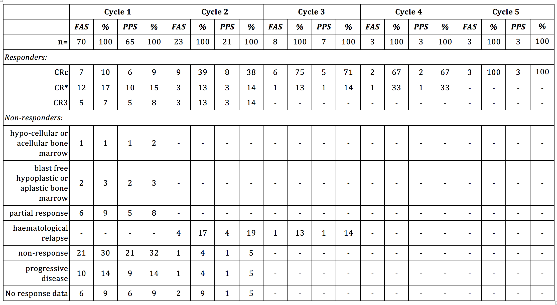
CR = complete remission (CR) with complete haematological recovery. CR* = CR with partial haematological recovery. CR3 = complete remission without haematological recovery. Rates of allogeneic HSCT, and mortality at 100 days post-transplant.

Table 24. Rates of HSCT in Study 103205
Cohort/subgroup | Group size (n) | HSCT (%) | 95% CI | HSCT with primary outcome¹ (%) | 95% CI | HSCT without primary outcome (%) | 95% CI
Phase I FAS | 49 | 22 (45%) |  | 13 (27%) |  | 9 (18%)
5 µg/m²/day | 5 | 5 (100%) | 47.8%, 100.0% | 1 (20%) | 0.5%, 71.6% | 4 (80%) | 28.4%, 99.5%
5 to 15 µg/m²/day | 26 | 11 (42%) | 23.4%, 63.1% | 8 (31%) | 14.3%, 51.8% | 3 (12%) | 2.4%, 30.2%
15 µg/m²/day | 7 | 3 (43%) | 9.9%, 81.6% | 2 (29%) | 3.7%, 71.0% | 1 (14%) | 0.4%, 57.9%
15 to 30 µg/m²/day | 6 | 1 (17%) | 0.4%, 64.1% | 1 (17%) | 0.4%, 64.1% | 0 (0%) | 0.0%, 45.9%
30 µg/m²/day | 5 | 2 (40%) | 5.3%, 85.3% | 1 (20%) | 0.5%, 71.6% | 1 (20%) | 0.5%, 71.6%
Phase II FAS | 44 | 13 (30%) | 16.8%, 45.2% | 5 (11%) | 3.8%, 24.6% | 8 (18%) | 8.2%, 32.7%
Phase II PPS | 41 | 11 (27%) | 14.2%, 42.9% | 4 (10%) | 2.7%, 23.1% | 7 (17%) | 7.2%, 32.1%
5 to 15 µg/m²/day FAS | 70 | 24 (34%) | 23.3%, 46.6% | 13 (19%) | 10.3%, 29.7% | 11 (16%) | 8.1%, 26.4%
5 to 15 µg/m²/day PPS | 65 | 21 (32%) | 21.2%, 45.1% | 11 (17%) | 8.8%, 28.3% | 10 (15%) | 7.6%, 26.5%
1) Primary outcome = CR (including CRc, CR* or CR3) after 2 cycles
Comment: The sponsor states that ‘Across dose groups, of the subjects who reached CR during the first 2 cycles of treatment, the 5 to 15 µg/m²/day cohort had the highest rate of allogeneic HSCT (30.8%; 8/26).’ However, the 95% confidence interval for all groups crossed each other, so no cohort was shown to have a higher rate of HSCT than another.

Table 25. Proportion of patients with allogeneic HSCT after treatment§, by best response during the first 2 cycles and by duration CR to HSCT (5 to 15 µg/m²/day FAS and PPS)
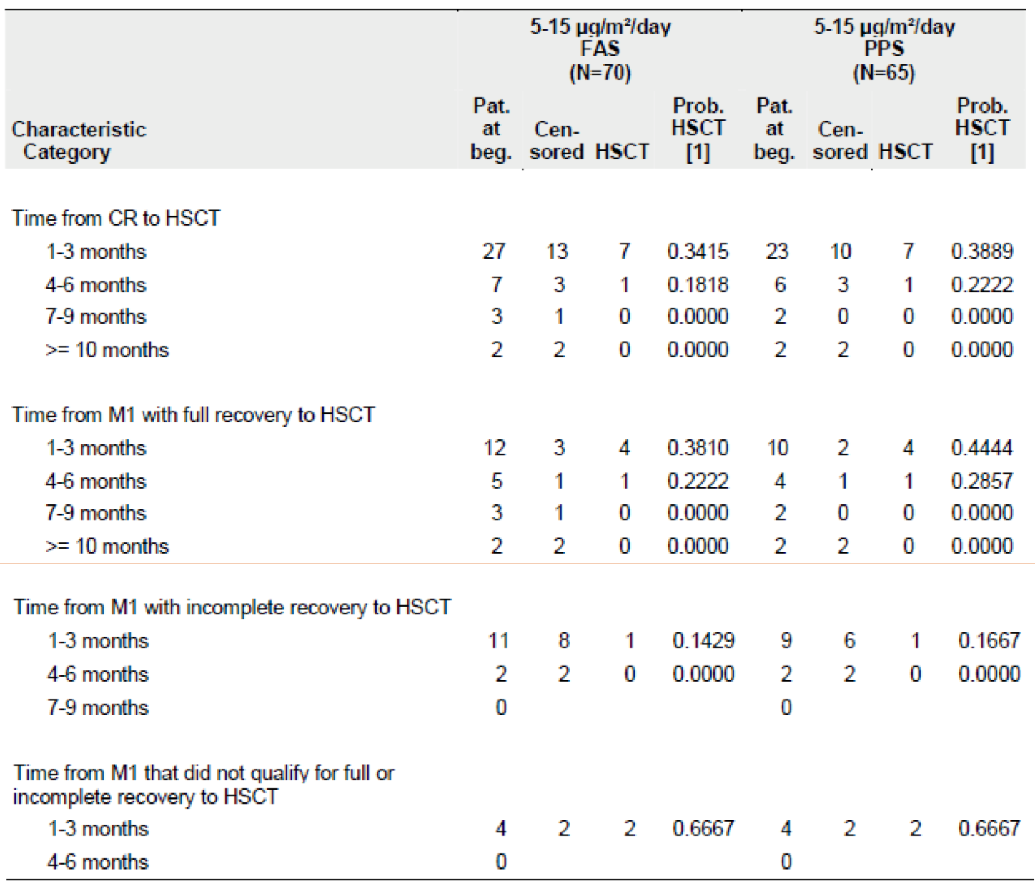
Comment: The sponsor states that the HSCT data by duration of response to HSCT show that 25% of patients still eligible to receive a transplant at 7 to 9 months did so, referencing a specific table. The data in that table does not support such a conclusion (reproduced above as Table 25).
Can the sponsor please explain this discrepancy? See Section 11, Clinical Question 7.
The 100 day mortality rate in the 8 subjects who received an allogeneic HSCT while in remission induced by blinatumomab treatment and without any other subsequent anti-leukaemic medication was 25% (95% CI: 6.9% to 68.5%).
Comment: The mortality rate post-HSCT in this group was 50% between 6 and 8 months, and 100% at 16 months. What is the rate of mortality post-HSCT in a comparable population? See also Section 11, Clinical Question 8.

Proportion of subjects who developed anti-drug antibodies (ADA)
No subject tested positive for ADA in this study.

Minimal residual disease (MRD) (exploratory)
MRD response rates are outlined below in Table 26. The sponsor concludes the following:
- All MRD responders (MRD < 10⁻⁴ measured by flow cytometry) were complete MRD responders (MRD undetectable by flow cytometry).
- For subjects who achieved CR within the first 2 cycles, MRD response rates were 51.9%.
- Among those subjects with MRD assessments available, MRD and complete MRD response rates for subjects who achieved M1 with full recovery of peripheral blood counts were similar (58.3%) to those who did not have full recovery of peripheral counts (45.5% to 50.0%).
The sponsor also states the following from the CSR:
Depending on location of the clinical site, MRD response was measured by both PCR and flow cytometry (EU) or only by flow cytometry (US). Thus, because only flow cytometry data were available from both European and US subjects, the results were published on the basis of the flow data (von Stackelberg et al, 2014; Gore et al, 2014). There were 4 cases in which the flow cytometry and the PCR results during the first 2 treatment cycles differed. 3 subjects had an MRD non-response by PCR but MRD complete response by flow cytometry. These 3 subjects were classified as having MRD complete response. 1 subject had an MRD complete response by PCR but MRD nonresponse by flow cytometry. This subject was classified as having an MRD nonresponse.
Comment: Of the 70 subjects in the 5 to 15 µg/m²/day FAS, 4 subjects (around 6%) had discordant results for MRD. Disagreement between flow cytometry and PCR assays has previously been studied, and out of 37 samples with discordant MRD results (using a sensitivity threshold of 0.01%), on retesting MRD was ‘detected by both methods’ (that is, one method had given a false negative) in 34. In another more recent study or multiple myeloma samples, PCR was shown to be a much more sensitive method of detection, finding MRD in 35% of samples where flow cytometry was negative.
Where disagreement between assay methods occurred, this should have been interpreted to be MRD nonresponses, that is, the presence of MRD. The inclusion of 3 spurious cases of complete MRD response is a significant confounder in such a small sample size.
Given that PCR is known to be a more sensitive test and can detect a lower level of MRD, this is a better measure of MRD than flow cytometry.
Can the sponsor please provide an analysis of subjects with PCR analysis for MRD response, including the rate of MRD response in this group, and their outcomes?
See Section 11, Clinical Question 9.

Table 26. MRD responses in Study 103205 exploratory analysis
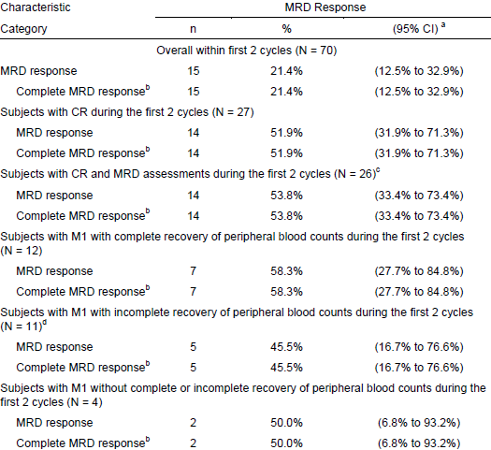
CI = confidence interval; CR = complete remission; MRD = minimal residual disease; a) 95% CI: lower limit and upper limit of the 2-sided exact 95% confidence interval are provided; b) Complete MRD response is a subset of MRD response; c) Excludes subjects with no MRD data; d) 1 subject had no MRD data. MRD response: MRD < 10⁻⁴ measured by FC. Complete MRD response: No detectable signal for leukaemic cells measured by FC. If a PCR result was available at a specific visit but no FC result, then the PCR result was taken into account.
Comment: Further exploratory analyses have not been reviewed.
      - Evaluator commentary
Firstly, the subdivision of the primary endpoint (CR) into subcategories by complete, partial or absent peripheral blood cell count recovery (contrary to the definition of CR proven to correlate with clinical outcome), requires addressing.
There are specific aspects to this surrogate endpoint that require consideration:
- The clinical relevance of peripheral cell count recovery is not clear
- The use of M1 bone marrow in the absence of peripheral count recovery (CR* or CR3) as a surrogate for clinical benefit is not established.

Clinical relevance of peripheral count recovery in determining rate of CR
The definition of ‘complete remission’ according to established medical references involves peripheral count recovery.
Published literature supports the importance of recovery of normal haematopoiesis in predicting clinical outcome in ALL post-induction treatment. An Australian and New Zealand study of myelosuppression in 227 children during induction and consolidation chemotherapy found that a low ANC was highly predictive of relapse (p = 0.001). Another study of 256 paediatric ALL patients found that low platelet counts (first quartile) on Day 33 of induction treatment are strong predictors of poor outcome and strongly associated with MRD.
Figure 9. The distribution of MRD risk by platelet count quartile at Day 33 post-induction
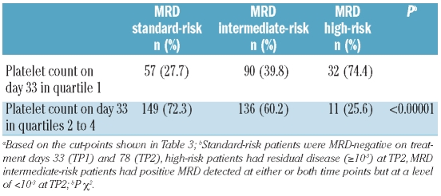
Source: Zeidler et al, 2012.
Both of these findings were confirmed by multivariate analysis for known risk factors. However, these were studies of paediatric ALL as a whole, and whether these observations would remain significant in the subset of paediatric patients who were post-relapse or had refractory disease is not clear.

Use of CR*/CR3 as a surrogate endpoint
As noted by the FDA during their pre-approval process:
CR with haematological recovery is the accepted surrogate endpoint for clinical benefit in trials of treatment of acute leukaemia, and CR with incomplete haematological recovery has not been demonstrated to be an appropriate surrogate endpoint.
A joint workshop between the FDA and the American Society of Hematology to explore issues pertinent to acute leukaemia clinical trial efficacy endpoints resulted in the 2007 publication of a review on the topic. The review specifically discusses the use of CR without complete recovery of peripheral blood counts (‘CRi’) as a surrogate end point, with particular reference to trial experience thus far using ‘CRp’ (complete remission with the exception of platelet count less than 100 x 10⁹/L). Thus far, trials in both AML and ALL have not been adequately powered to establish CRp as a surrogate, and have suggested that CRp may represent better survival likelihood than non-responders, but not as much so as CRc.
The review mentions a prior study of clofarabine use in relapsed/refractory ALL paediatric patients which applied both CR(c) and CRp as surrogate endpoints and was the basis for accelerated approval in the US. Again, a lack of power prevents conclusive interpretation but OS between the groups appeared similar, and CRp showed better OS than partial or non-responders. As stated by the authors:
‘The data from patients being treated for recurrent leukaemia seems to favour the use of CRp as a surrogate for clinical benefit in this clinical setting. Current data do not conclusively allow the extrapolation of CRp to patients receiving initial chemotherapy…’
Although they are similar, CRp by the above definition is slightly different to the sponsor’s definition of incomplete peripheral response (CR*), and so the two are not interchangeable and the above information is of limited relevance to the study at hand.

Sponsor’s supporting evidence
A supporting discussion from the sponsor is included in the Clinical Overview document in the dossier:
While OS is the universally accepted direct measure of clinical benefit and is considered as the most reliable cancer endpoint in oncology studies (US FDA, 2007), CR and RFS (as a measure of remission duration), MRD negativity, and bridge to allogeneic HSCT are reasonable endpoints to predict clinical benefit in paediatric relapsed/refractory ALL studies.
Unlike in the adult ALL setting, achievement of CR in paediatric patients does not depend on recovery of peripheral blood counts. Paediatric haematologists generally do not consider full recovery of peripheral blood counts when making treatment decisions, mainly due to situations that are not related to remission status. For example, if a patient achieves a CR, but acquires an infection that consumes the neutrophils, the patient would lose the CR status if peripheral blood counts were considered. Additionally, there are no unanimously agreed upon cut-offs for peripheral blood counts in the paediatric setting. The one exception is clofarabine, which has a selective myelotoxic effect on platelet production. For this reason, clofarabine uses CR or CRp, which fulfils all of the criteria for a CR except that platelet counts are < 100 x 109/L (Clolar PI, 2015).
While the optimal situation may be to have M1 with full recovery of peripheral blood counts, in this heavily pre-treated ALL population (which includes patients who have received conditioning agents for allogeneic HSCT), bone marrow recovery may be delayed due to previous chemotherapy and radiation. Achieving M1 bone marrow with incomplete or without full or incomplete peripheral blood count recovery is typically sufficient to proceed to allogeneic HSCT rather than waiting for full peripheral blood count recovery and risking another relapse. However, given additional time to recover, some patients may convert to M1 bone marrow with full peripheral blood count recovery after achieving M1 bone marrow with incomplete peripheral blood count recovery, as shown in blinatumomab Study MT103205.
M1 bone marrow with incomplete recovery of peripheral blood counts is similar to the definition of complete remission with partial haematologic recovery (CRh*) used in the adult relapsed/refractory ALL studies in the original marketing application (CRh* = bone marrow blasts ≤ 5%, no evidence of disease, and partial recovery of peripheral blood counts: platelets > 50,000/µL and ANC > 500/µL).
The reference to which the sponsor attributes the haematological response definitions used (‘based on the M grading system’) describes M1, M2 and M3 bone marrow categories of cytomorphological marrow response at day 15 during induction therapy, but does not describe subgroups of M1 depending on peripheral blood count recovery. It is silent on the relevance of peripheral counts, stating:
‘Complete remission (CR) was defined as M1 BM on Day 33 of induction therapy, the absence of leukemic blasts in blood and CSF, and no evidence of local disease’.
It also refers to the M1, M2 and M3 categories as ‘traditional’, so it is unclear why this article has been referenced as the primary article for the M grading system.

Conclusions
Interpretation of the efficacy findings of this study will need to involve consideration of possible differences between patients with CR with and without peripheral blood count recovery. I have been unable to identify information in the dossier or elsewhere to support that CR* directly correlates to improved outcomes in paediatric patients with ALL. As stated in the EMA Guideline on Clinical Trials in Small Populations CHMP/EWP/83561/2005):
‘Surrogate endpoints may be acceptable but need to be fully justified. Their relation to clinical efficacy must be clear so that the balance of risks and benefits can be evaluated’.
A lack of clear correlation to clinical efficacy or full justification makes the definition of CR used for the primary efficacy outcome of this trial a weaker surrogate endpoint than the more stringent definition of CR, involving recovery of peripheral counts. However, there are other indicators that CR* is a clinically relevant endpoint, including that the rate of MRD and bridge to HSCT were similar in the CRc and CR* groups (though the very small size of these groups makes this an exploratory observation).
In the setting of relapsed/refractory ALL, outcomes are very poor and remission of any kind could be clinically significant. The results from Study 103205 do suggest that efficacy significantly higher than with existing therapies could be present (as measured by a surrogate marker; CR), although limitation of study size has meant that the 95% confidence interval for these results is within the null hypothesis. It may be advisable for the TGA to seek expert paediatric haematologist advice regarding peripheral haematological recovery and its relevance to the primary outcome in terms of clinical decision making (HSCT) and prognosis. See also, Section 11.2

Other efficacy studies

Study 20130320, expanded access

Study title
An open label, multicentre, expanded access protocol of blinatumomab for the treatment of paediatric and adolescent subjects with relapsed and/or refractory B-precursor acute lymphoblastic leukaemia (ALL) (Rialto study)

Objectives
To evaluate the safety and efficacy of a target dose of 15 µg/m²/day blinatumomab in paediatric and adolescent subjects with relapsed and/or refractory B-precursor ALL in second or later bone marrow relapse, in any marrow relapse after allo-HSCT, or refractory to other treatments.

Design/methodology
This is an ongoing, single arm, open label expanded access study with essentially the same design as pivotal paediatric Study 103205 but with slightly different inclusion/exclusion criteria, allowing inclusion of subjects with baseline bone marrow blasts ≥ 5% (where the pivotal trial required ≥ 25% blasts) but excluding subjects younger than 28 days of age. Responses were measured in terms of CR as defined in Study 103205, and ‘MRD response’ (absence of MRD with a test sensitive to 10^{^-4} by PCR or flow cytometry) was also assessed.

Participants
Enrolment of 40 subjects is anticipated but the size may vary depending on demand. To the cut-off date for the study (20 August 2015), there are 20 subjects enrolled: 6 male/14 female, mean age 7.9 (range 1 to 16 years) and 80% white. 2 had primary refractory disease, 3 were refractory to re-induction therapy, 11 were in second or greater relapse, and 10 had prior allogeneic HSCT.

Results

Table 27. Results for best response during the first 2 treatment cycles in expanded access Study 20130320
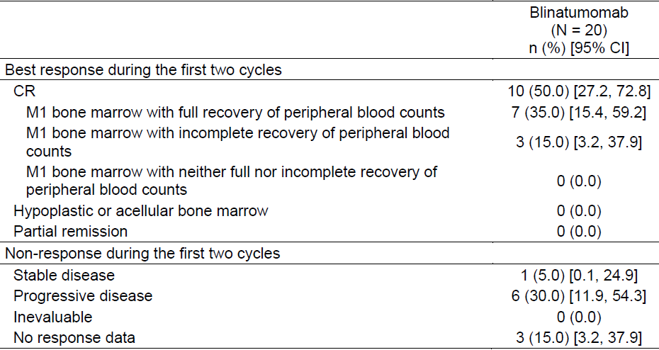
CI = confidence interval; CR = complete response; M1 = less than 5% blasts in the bone marrow.
The CR rate during the first 2 cycles was 50.0% (10 subjects):
- CRc: 7 subjects (35.0%)
- CR*: 3 subjects (15.0%)
Of 7 subjects with CR and available MRD response data, six subjects had no MRD detected (30.0%, 95% CI 11.9% to 54.3%).
13 subjects had ≥ 25% bone marrow blasts at Baseline (the threshold for inclusion in Study 103205). The CR rate in this group was 5 subjects (38.5%, 95% CI 12.0% to 64.9%) and 4 of them had an MRD response.
The time to event endpoints of OS and RFS weren’t able to be analysed at this interim stage due to immaturity of data.

Evaluator commentary: other efficacy studies
The presence of response in this very refractory expanded access population is small, but the rates of CR are similar to those seen in the pivotal trial and can be considered supportive of the surrogate based findings.

Analyses performed across trials: pooled and meta analyses

Study 120521, Model based meta-analysis (MBMA)

Title
Model based meta-analysis (MBMA) of haematological remission and overall survival among paediatric patients with relapsed or refractory Philadelphia negative (Ph-) B-precursor acute lymphoblastic leukaemia (ALL).

Objectives
- To estimate CR, EFS, and OS for existing salvage therapies in a paediatric R/R ALL population like that of Study 103205
- To estimate blinatumomab efficacy relative to existing salvage therapies in such a population using virtual clinical trial simulations.

Methodology
A systematic review was undertaken of studies looking at clinical outcome with existing salvage therapies in R/R ALL. This review provided the dataset for an MBMA, which comprised 62 studies (38 paediatric) and 12211 patients (8153 paediatric). Of the paediatric studies, 31 provided CR data (n = 3770), 6 provided EFS data (n = 644) and 25 provided OS data (n = 6465).
- Systematic review inclusion criteria:
  - English language, peer reviewed, prospective or retrospective clinical studies with indication for refractory or relapsed B-precursor ALL
  - Larger than n = 20
  - Published between January 1995 and December 2013.
- Systematic review exclusion criteria:
  - Patient population are mainly T cell or non-B cell ALL, or Philadelphia+ ALL only, or CNS relapse ALL only.
  - Intervention or comparator is vaccine, radiation, or HSCT only
  - Outcomes: Study endpoints are not CR, EFS or OS
  - Study designs: comments, editorials, letters (correspondence only), case reports or pooled analyses of results already included in the dataset.
- Data captured:
  - Aggregate endpoints (CR rate, EFS survival curves, OS survival curves)
  - Prognostic factors per patient: primarily age, sex, remission duration (time to relapse from initial diagnosis), relapse in bone marrow, and relapse in CNS.
Figure 10. Schematic of the flow of study selection for the systematic review that formed the dataset for Study 120521
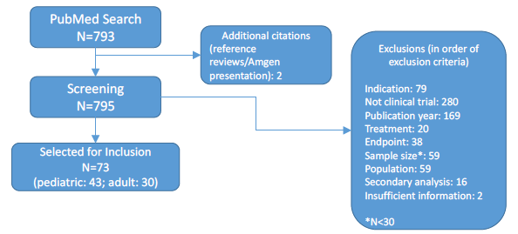
Comment: The information in the schematic of study selection taken from the CSR for Study 120521 (see Figure 10, above) differs from the information stated in the report. Can the sponsor please confirm which data is correct regarding number of studies included, how many were paediatric and the minimum study size for inclusion? See Section 11, Clinical Question 10.
A mathematical model was then developed to quantify proportion of CR, EFS, and OS across clinical studies (and associated variability), and standard regression techniques were used to analyse the effect of study-level covariates on these endpoints. Modelling was based on a published analysis of a large, unselected adult case series, and so both adult and paediatric subjects were included in modelling so that if deviations in the model parameters were attributable to differences between adult and paediatric subjects, this could be identified.
One of the covariates evaluated was a Fielding risk score (RS) given to each included study: this is a multivariate hazard ratio relative to a low risk reference youth/adult population (15 years old, male, with remission duration of > 2 years from diagnosis, relapse not in bone marrow or CNS). Two additional covariates were also introduced to account for possible paediatric prognostic changes over the last 20 years: whether the study was post-2006 or not; and the degree of relapse (by BM blast percentage). Testing for influential study confounding (by removing studies one at a time) and analyses of heterogeneity were also conducted.
Once the models were established, the proportion of CR, EFS, and OS with existing salvage therapies that would be estimated to occur in a simulated population similar to Study 103205 was projected. Using these values, and odds ratio (CR) or hazard ratio (EFS and OS) was calculated for each outcome for treatment with blinatumomab compared to existing salvage therapies.

Results
- The CR model was developed using 53 studies (6428 patients, of which 31 (3770 patients) were paediatric. Only post-2006 studies were included. The median CR with existing salvage therapies for a population similar to that in Study 103205 was projected to be 0.323 (95% CI: 0.112 to 0.620, and the simulated odds ratio was 1.27 (95% CI: 0.55 to 3.06) for existing salvage therapies compared to blinatumomab treatment.
  - Proportion of CR in a study varied with:
    - Fielding RS
    - Percentage of patients in second or later salvage
    - Study region
- The EFS model was developed using data from 13 studies (1029 patients), of which 6 (644 patients) were paediatric. It included studies from the full inclusion criteria date range as there were not many available. The median EFS with existing salvage therapies for a population similar to that in Study 103205 was projected to be 11.6 months (95% CI: 4.8 to 60 months).
- The OS model was developed using 43 studies (9729 patients), of which 25 (6465 patients) were paediatric. Only post 2006 studies were included. The median OS with existing salvage therapies for a population similar to that in Study 103205 was projected to be 4.2 months (95% CI: 1.9 to 10.5), and the simulated hazard ratio was 0.55 (95% CI: 0.35 to 0.88) for existing salvage therapies compared to blinatumomab treatment.
  - Proportion of OS varied with:
    - Fielding RS
    - Percentage of patients in second or later salvage
    - Percentage of patients with post-relapse HSCT
    - Whether the study was in adults or paediatric subjects.
- No other covariates were found to affect the CR, EFS, and OS, including the percentage of patients with prior HSCT and the percentage of patients receiving a specific salvage therapy.
The sponsor concludes that:
‘MBMA indicated poor prognosis for the relapsed/refractory ALL patients on treatment outcomes receiving existing salvage therapies. In this patient population, paediatric patients with relapsed/refractory ALL similar to those enrolled in Study MT103-205, clinical trial simulations predict treatment with blinatumomab will modestly increase proportion of CR (median odds ratio of 1.27) and significantly increase median OS (median HR (95% CI) of 0.55 (0.35 to 0.88)) compared with existing salvage therapies’.
Comment: A similar study to this was included with the dossier for registration of blinatumomab as an NCE in Australia. As noted by the clinical evaluator for that submission, the inclusion start date is twenty years ago and there are likely a number of studies included that do not reflect current clinical practice. The subgroup analysis using only post-2006 studies is appropriate.
The wide confidence intervals are noted, and given the immaturity of the time-to-event data for Study 103205, it is premature to conclude that treatment with blinatumomab should be expected to increase median OS compared to existing salvage therapies. Further, the confidence interval for the odds ratio relating to projected CR proportion crosses 1, so again this result is not meaningful.
    - Study 20140228, historical comparator study

Title
A retrospective cohort study of re-induction treatment outcome among paediatric patients with relapsed or refractory B cell precursor acute lymphoblastic leukaemia (ALL).

Objectives
This study was conducted to obtain subject level data for standard of care treatment in patients with similar characteristics to the population studied in pivotal Study 103205.
- Primary:
  - To estimate complete remission (CR) in paediatric patients with relapsed or refractory B cell precursor ALL, and to develop a weighted estimate of CR that can serve as an external comparator to the CR proportion in patients enrolled in the blinatumomab clinical trial MT103-205
    - CR, CRc and CR* were defined as for Study 103205.
- Secondary:
  - To estimate overall survival (OS), relapse-free survival (RFS), event-free survival (EFS) probabilities, molecular CR (CRm), and the receipt of hematopoietic stem cell transplantation (HSCT) in paediatric patients with relapsed or refractory B cell precursor AL
    - To develop weighted estimates of these endpoints that can serve as external comparators for the results in patients enrolled in the blinatumomab clinical trial MT103-205
  - To investigate the patient and disease characteristics that are associated with the primary and secondary endpoints (CR, OS, RFS, EFS, CRm, HSCT)

Methodology
This is a retrospective cohort study of paediatric patients treated between 2005 and 2013 for relapsed or refractory ALL at clinical sites belonging to the Therapeutic Advances in Childhood Leukemia and Lymphoma (TACL) Consortium, during calendar years 2005 to 2013.
Out of the 36 TACL consortium sites, 14 participated in the study. The sites each determined a census of eligible patients (from a variety of sources such as tumour registries, hospital billing records and internal patient databases) based on pre-determined eligibility criteria. A Primary Analysis Set (PAS) of 121 patients were identified using these criteria. Data was then collected for each subject by individual medical chart review (extracted by clinical staff and entered, de-identified, into an electronic data capture system) for 3 periods:
- Baseline period (initial diagnosis to time of meeting eligibility criteria)
  - Demographics
  - Clinical characteristics
  - Initial treatment attempted including response data
- Study period (at the time of each qualifying episode of relapsed or refractory disease)
  - Demographics
  - Clinical characteristics
  - Salvage treatment attempted including response data
- Follow up (at death or vital status at the end of 2014: to allow at least a year of follow up information after salvage treatment). Loss to follow up was censored at last known follow up date.
  - Follow up/vital status
Detailed consideration has been given to potential sources of bias, including selection bias. Regarding analysis of historical data involving multiple possible lines of treatment, the authors include the following discussion:
Patients with multiple lines of salvage therapy data available are particularly challenging to analyse in the context of comparing the historical data to the MT103-205 clinical trial. Analytical options include treating each line of therapy as an independent unit of analysis or selecting one line of therapy per patient as the primary analysis and then as a sensitivity analysis, evaluate the other line of therapy (for 3 or more lines of therapy, the first and last lines would be selected). Each option has limitations. For comparison against MT103-205 data, selecting multiple lines of therapy or just the first line will be impacted by immortal time bias, and multiple lines of therapy can be biased due to lack of statistical independence.
The study uses a conservative approach and used the first salvage therapy outcome data for the primary analysis. Secondary analysis would then be conducted using the last salvage therapy outcome data. Subsequently, a comparison of key prognostic characteristics of the Study 103205 primary outcome population (the 5 to 15 µg/m²/day group) relative to the PAS of Study 20140228 revealed that there were notable differences between the populations (see Table 28, shown below). Primarily, the proportion of patients who had relapsed after HSCT and who had relapsed within 6 months of the prior chemotherapy or HSCT was higher in Study 103205, indicating that this population was more likely to be in later progression stages of their disease.
In comparing the prognostic characteristics, the authors concluded that in terms of:
‘where in their treatment history these types of patients would in theory have entered the MT103-205 trial, it would have been most likely at the time of the later salvage therapy’ and that ‘the last salvage therapy would be the more appropriate for providing historical comparator endpoints’.

Table 28. Differences in distribution of key prognostic factors between the primary study populations of Study 103205 and Study 20140228
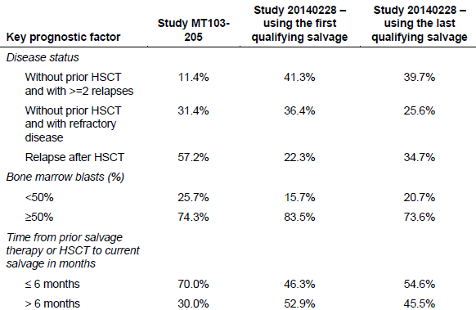
For the primary analyses, endpoints were weighted according to the prognostic characteristics of patients in the MT103-205 study. Three strata were formed according to the disease stage at the time of the qualifying salvage:
- without prior HSCT and with ≥ 2 relapses
- without prior HSCT and with refractory disease
- relapsed after HSCT.
Additional ad hoc weighted analyses were conducted using other strata, including other covariates such as blast percentage prior to qualifying salvage and time from prior salvage therapy or transplant to qualifying salvage. For the latter covariate, refractory patients were included in the < 6 months group in the ad hoc weighted analyses.
Comment: MRD status hasn’t been considered as a prognostic co-variable as there was not data available for many subjects (n = 14).
To calculate the combined weighted estimate for the primary outcome, the CR from each strata were pooled by multiplying each one by the percentage of the Study 103205 population (presumably the 5 to 15 µg/m²/day FAS) who would fit in that stratum, then adding them all together.

Results

Primary outcome
Of the PAS, there were 115 subjects included in the analysis for primary endpoint (by first qualifying salvage response) and 113 in the analysis using the last qualifying salvage response.
The primary endpoint findings are outlined in Table 29, below. The overall unweighted estimate of CR (95% CI) for the PAS was 0.33 (90.24, 0.42). After weighting, it was 0.37 (0.25, 0.49). A much smaller rate of CRc was seen (see Table 30, below) compared to the rate of CR* (see Table 31, also below).

Table 29. Strata (unweighted) and combined (weighted) estimates of CR to re-induction therapy, weighted by disease stage
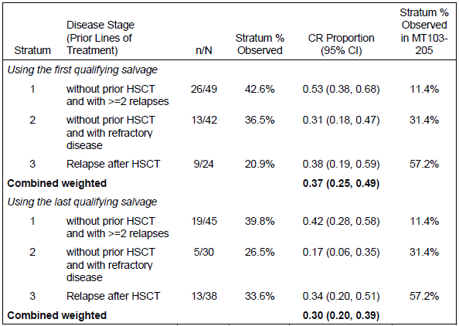

Table 30. Strata (unweighted) and combined (weighted) estimates of CRc (CR with full peripheral count recovery) to re-induction therapy, weighted by disease stage
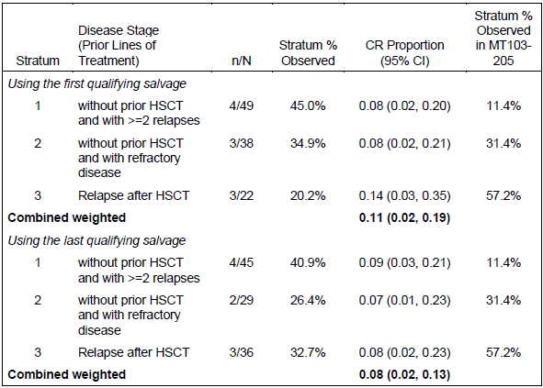

Table 31. Strata (unweighted) and combined (weighted) estimates of CR* (CR with incomplete peripheral count recovery) to re-induction therapy, weighted by disease stage
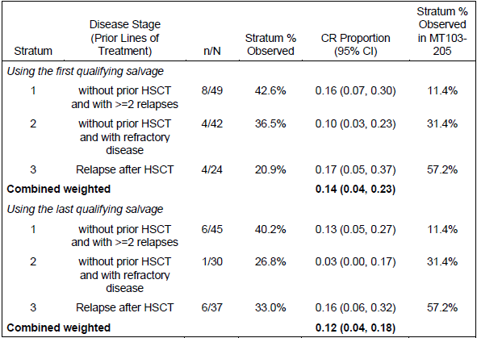
Comment: These rates are lower than those seen in Study 103205. Despite the limitations of historical comparator study design, in the absence of a control arm in the pivotal study, this information assists interpretation.
Further ad hoc analyses were undertaken using different strata: presence versus absence of prior HSCT, time to relapse since last chemotherapy or HSCT, and percentage of bone marrow blasts prior to salvage treatment. The CR rates according to these strata are outlined below in Table 32.

Table 32. Ad hoc analysis: strata (unweighted) and combined (weighted) estimates of CR to re-induction therapy, weighted by prior HSCT, bone marrow blasts and time to relapse
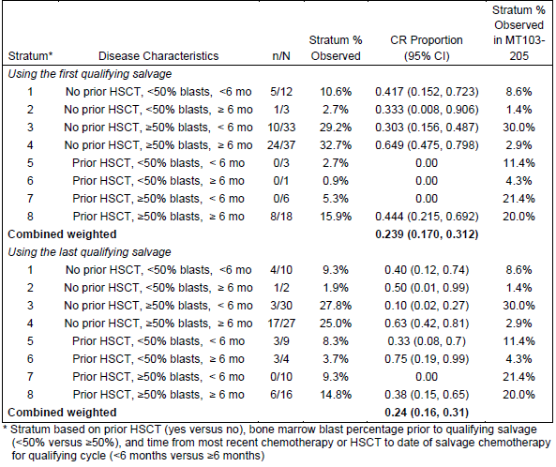
The authors state: ‘We believe these estimates reflect a more appropriate comparison to the MT103-205 clinical trial data because these ad-hoc strata also take into account the prior bone marrow blast burden, as well as the short time from prior therapy or HSCT that was observed in the MT103-205 study’.
Comment: On the basis of the differing characteristics of the populations as outlined in Table 28, above, the evaluator agrees that these ad hoc estimates are a reasonable point of comparison.

Secondary outcomes
Secondary endpoints of OS are shown below in Tables 33 to 35. RFS findings are shown in Table 36, also below. Molecular CR and allogeneic HSCT following salvage therapy could not be assessed as the data was too limited (14 and 8 patients respectively).

Table 33. Strata (unweighted) and combined (weighted) estimates of median OS after re-induction therapy, weighted by disease stage
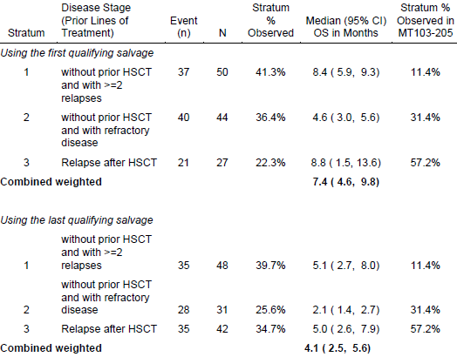

Table 34. Strata (unweighted) and combined (weighted) estimates of 12 month OS after re-induction therapy, weighted by disease stage
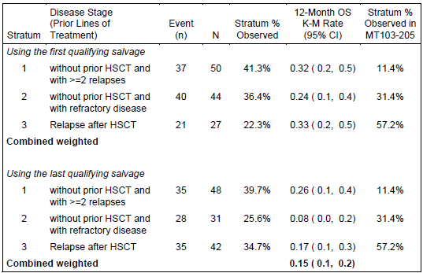

Table 35. Ad hoc analysis: strata (unweighted) and combined (weighted) estimates of median OS after re-induction therapy, weighted by prior HSCT, bone marrow blasts and time to relapse
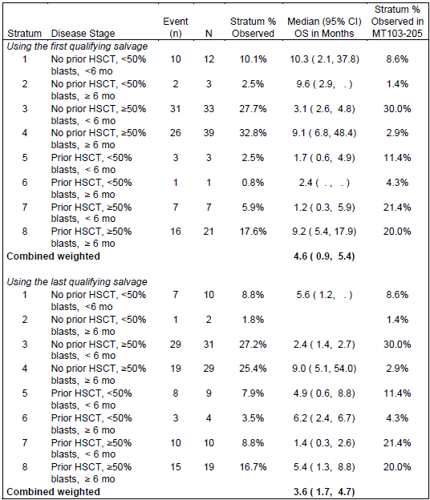

Table 36. Strata (unweighted) and combined (weighted) estimates of median RFS after re-induction therapy, weighted by disease stage
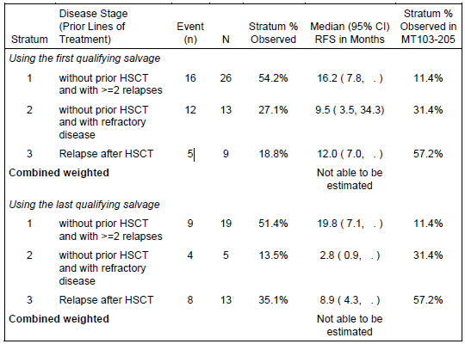
In their consideration of confounding, the sponsor notes that RFS may be confounded by the different likelihood that a progression event will be recorded prior to death for a subject under intense surveillance in a clinical study such as Study 103205 compared to a subject undergoing standard of care salvage treatment outside the clinical study setting (such as those included in Study 20140228).
The sponsor concludes: ‘The historical comparator study results were internally consistent and comparable to the published literature which evaluated the prognosis of paediatric R/R ALL patients, especially in studies of patients with 2nd or greater relapse. The prognosis was especially poor in patients who relapsed after HSCT, who have high bone marrow blast percentages prior to treatment, and who relapsed within 6 months of the previous chemotherapy or HSCT. All of these findings were consistent with clinical observations. Through the application of a weighted analysis approach, the results provide a reasonable historical comparator for key outcomes in the MT103-205 clinical study’.
Comment: The evaluator agrees with the sponsor’s conclusions.

Propensity score analysis

Title
Propensity score analysis of overall survival and haematological complete remission among paediatric and adolescent patients with relapsed or refractory B-precursor acute lymphoblastic leukaemia.

Objectives
This propensity score analysis (PScA) was conducted by the sponsor to assist with interpreting data from historical comparator Study 20140228 as it relates to the efficacy outcomes of paediatric pivotal Study 102305. Study 20140228 was a retrospective cohort study investigating rates of CR, and duration of OS and RFS in paediatric subjects similar to those enrolled in the 5 to 15 µg/m²/day PPS of Study 103205. It was undertaken due to the single arm nature of Study 103205, to provide a surrogate point of comparison based on observational data from subjects treated with current standard of care salvage therapies. The weighted analysis approach used in Study 20140228 was restricted due to sample size limitations in some groups, and so the PScA study was undertaken in order to try and control for more covariates and provide a more meaningful interpretation of the outcomes seen with standard-of-care chemotherapy regimens in Study 20140228 compared to the outcomes seen with blinatumomab use in Study 103205.

Methodology
This is a retrospective, post-hoc analysis of the propensity to be treated with blinatumomab, in order to compare OS and CR rates. The databases from Study 103205 and from to historical comparator Studies 20140228 (‘US control’) and 20120299 (‘European control’) were merged and analysed. Additional analysis was undertaken separately leaving out data from Studies 20140228 or 20120299 in order to provide sensitivity analysis for geographic region and historical data type.
The authors describe the methodology as follows:
- Candidate variables for the propensity score model were selected (covariates that were common to both the databases and thought to be important for characterising the blinatumomab treated population). Candidate variables were selected based on their prognostic potential determined through study team discussions.
- Candidate additional propensity score model covariates included the following:
- Age at time of qualifying salvage chemotherapy (years)
- Sex (male, female)
- Region (US, EU) (for models involving both Studies 228 and 299)
- Prior HSCT (yes, no)
- Number of prior lines of salvage therapy (0, 1, 2, and > 2) treated as continuous covariate, with ‘> 2’ being represented as 3
- Time since last therapy or HSCT (months) (measured from beginning of previous therapy or HSCT to start of qualifying salvage therapy)
- Bone marrow blasts prior to start of qualifying salvage therapy (< 50%, ≥ 50%)
- Refractory to previous therapy (yes, no)
- MLL translocation (yes, no, unknown/missing)
- A variable selection algorithm was run in order to choose the variables and interaction terms considered relevant for discriminating between those who were and were not treated with blinatumomab. A p-value of < 0.3 was used as the pre-specified threshold for entering and keeping covariates in the model. The final model was then used for generating each subject’s propensity score.
- The propensity score overlap between treatment groups was assessed via a box plot and the balance between treatment groups before and after propensity score (PS) adjustments assessed. ‘The overall balance was to be considered sufficient if at least 25% of the historical data overlaps with the inner ninety fifth percentile of the blinatumomab data.’
Comment: This is a way to check whether the historical comparator population has enough in common with the blinatumomab population to be compared to them at all.
- As balance was considered to be adequately achieved, the endpoint analyses were then conducted using the inverse probability of treatment weights (IPTW).
‘Inverse probability of treatment weighting (IPTW) using the propensity score uses weights based on the propensity score to create a synthetic sample in which the distribution of measured baseline covariates is independent of treatment assignment.’
So each subject in the population is given a weight, which is 1/(their propensity score). Very large weights can result in cases where a subject’s characteristics are very different to the rest of the group treated with blinatumomab but yet they were treated with it, and vice versa. Analyses can thus be skewed by a single individual. Control of this can be achieved with ‘stabilising’: ‘instead divide the baseline probability of selecting a treatment (estimated from a model with no covariates) by the probability of selecting treatment given the covariates.’ In the results, the sponsor uses ‘sIPTW’ to indicate stabilised IPTW. Another method of reducing extremes is to ignore the outer 5% percentiles (‘trimmed’).
‘Once IPTWs are obtained, treatment effects are estimated using whichever outcome model was desired (for example, a regression model), by incorporating the weights, for example, in a weighted regression. Performing this type of weighted regression on the data is conceptually identical to running an unweighted, regular regression model in the pseudo-population in which confounders and treatment are independent of each other. One complication is that the weights themselves are also estimated and thus have sampling variability.’

Results
With regard to balancing the propensity score model, the authors made the following observations:
After adjustment, none of the p-values were significant and 6 of the 9 covariates had standard differences less than 0.1. Three covariates: gender, prior HSCT, and MLL translocation had standard differences slightly greater than 0.1, but still less than 0.20. After adjustment for historical comparator versus blinatumomab populations, there were 41.2% versus 34% female, 54.5% versus 47.0% with prior HSCT, and 22.2% versus 16.4% with unknown versus no MLL translation. The imbalance in these covariates was not considered large enough to warrant inclusion of the covariates in the outcome models.
As shown below in Figure 11, the distribution of propensity scores in the subjects from Study 103205 was compared to those of the historical studies by box plot to assess whether they were balanced. The inner 95% range of blinatumomab propensity scores was from 2% to 99%. 80.4 % of the observational study propensity scores were contained within this range, suggesting there was enough overlap in underlying measured covariates to consider the populations against each other. Similar results were seen when 103205 was compared separately to ‘control EU’ (Study 20120299) and ‘control US’ (Study 20140228): 86.7% and 60.3% overlap were seen, respectively.

Table 37. Covariate balance before and after propensity score adjustments with sIPTW
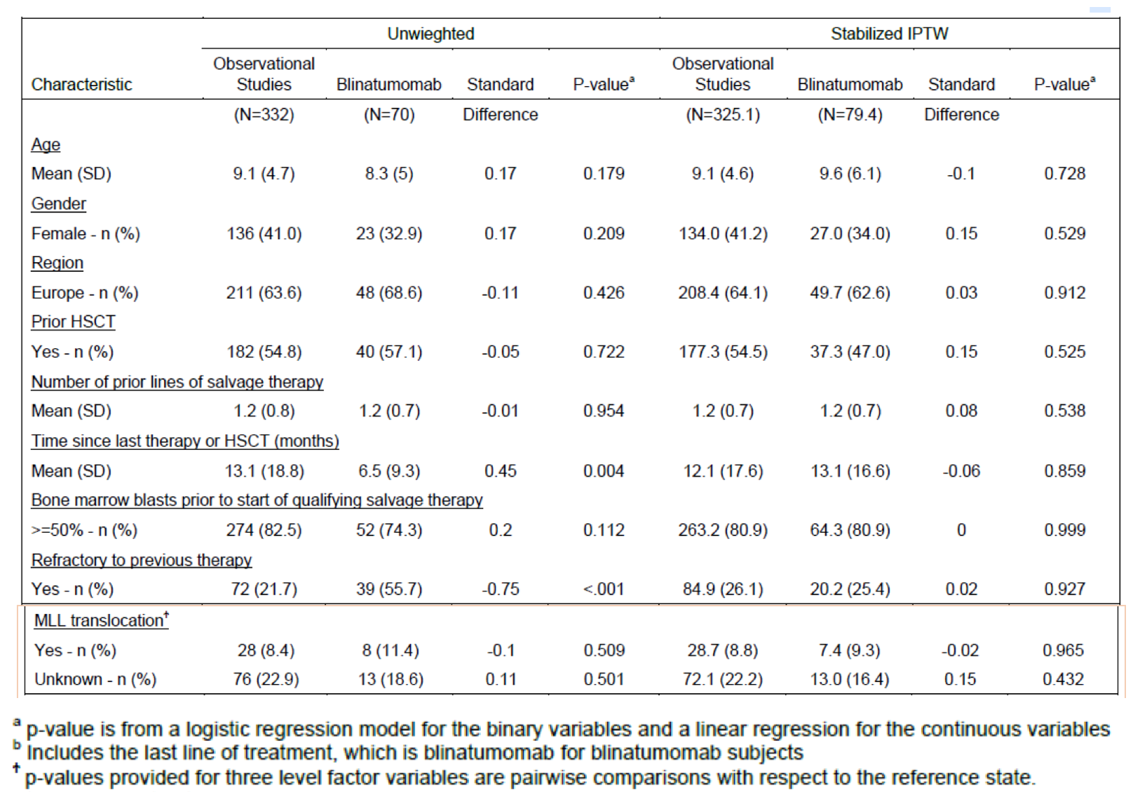
Figure 11. Box plot of propensity score distributions by study for the propensity score analysis study
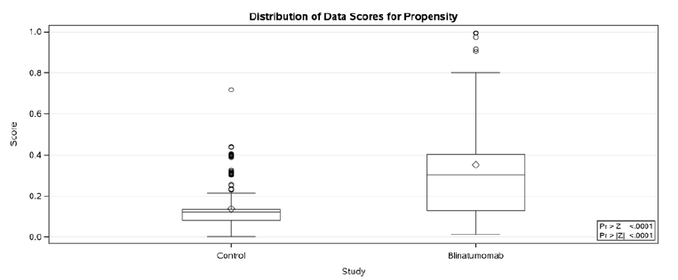
Cox model estimates using the IPTW method indicated separation of the OS curves between blinatumomab treated and control subjects, suggesting a survival benefit (see Figure 12, below).
Figure 12. Overall survival Cox model estimates by study, unadjusted and adjusted (IPTW, sIPTW, trimmed sIPTW) (Primary analysis set)
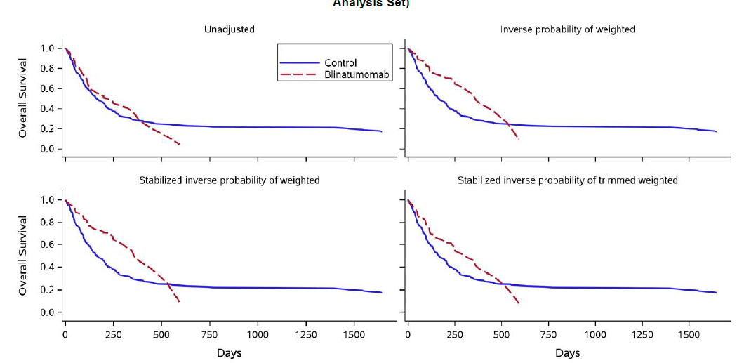
The authors conclude:
- Blinatumomab was associated with a meaningful improvement in overall survival, a direct measure of clinical benefit, compared to standard of care salvage chemotherapy in paediatric subjects with relapsed/refractory ALL.
- The evaluation of CR between blinatumomab and standard of care salvage chemotherapy was not consistent, with heterogeneity across study region and by the definition of CR. There is some indication that the rate of CR with full peripheral blood count recovery was increased in blinatumomab subjects compared with the US control. This may indicate a more robust remission among the blinatumomab group when compared to historical standard of care chemotherapy, and may partially explain why blinatumomab patients had better OS compared with historical data in the US, although other factors (for example, HSCT status) need to be considered as well.
With regard to the interpretation and limitations of the study, the authors discuss that PScA can only take into consideration chosen variables, and so does not entirely mimic randomisation as it does not take into account unmeasured and unknown covariates. Residual confounding could be present. Additionally, the use of historical control data assumes consistent standard-of-care treatment over the last decade which is clearly not the case. Limited sample size also reduces the power of such studies. P-values were not included as their interpretation ‘would be difficult in light of these limitations,’ and no adjustments were made for multiplicity of analyses.
Comment: The results of this study are noted with caution. There are a number of significant limitations to this study, as noted by the authors. In the absence of a control arm for Study 103205 this analysis provides limited support for external interpretation of the results.

Evaluator commentary on analyses performed across trials
In order to try and address some of the limitations to interpreting data from a single arm trial, the sponsor has included 3 supporting analyses aiming to provide comparator data. The MBMA looked at historical data across published studies, a retrospective cohort study was conducted using subject level standard of care data from North America, and a PScA was undertaken to adjust the comparisons between the cohort study and the pivotal trial findings for some of the covariates that differed between the 2 populations.
As stated by the sponsor, results from these studies highlight the particularly poor treatment outcomes for existing therapies and highlight the need for new therapies. Concrete conclusions comparing standard-of-care salvage therapies to blinatumomab can’t be drawn, however it is clear that unmet need exists in the target population.

Evaluator’s conclusions on clinical efficacy
Relapsed/refractory ALL in paediatric patients is a life-threatening condition with a high unmet need. Even with current treatment options, prognosis remains poor and no chemotherapeutic regimen is particularly efficacious or low risk. Blinatumomab has provided a new treatment option in adults and the data in this dossier is supportive that it is also efficacious in paediatric patients, despite the small study size and uncontrolled nature of the data. Historical comparator studies provide some insight into interpreting surrogate markers of efficacy such as the primary outcome (CR), however this is subject to the limitations of using historical controls, including lack of proper randomisation and changes in standards of treatment over time. The historical control studies submitted are of a good quality and suggest that the results of this trial are clinically significant.
In the future, additional efficacy data can be expected from ongoing Phase III Study AALL1331, as well as data from another Phase III trial that was yet to be commenced at time of submission (Study 20120215: ‘A randomised, open label, controlled, multicentre, adaptive trial of blinatumomab versus intensive consolidation after standard induction in paediatric, high risk, first relapse, B-precursor ALL’). The submission of data from these studies to the TGA when available should be a condition of registration if this extension of indication is approved. See also Section 10: First round recommendation regarding authorisation, below.

Clinical safety

Known safety concerns with blinatumomab use in adults
The current Risk Management Plan describes the known risk profile and current methodologies of risk minimisation.
The known safety concerns with blinatumomab use in adults are:
- Neurologic events
- Infections
- Cytokine release syndrome
- Infusion reactions
- Tumour lysis syndrome
- Capillary leak syndrome
- Elevated liver enzymes
- Medication errors
- Febrile neutropenia and neutropenia
- Decreased immunoglobulin
- Off-label use
- Leukoencephalopathy (including PML)
- Thromboembolic events (including disseminated intravascular coagulation)
- Immunogenicity
- Worsening of hepatic impairment in patients with hepatic impairment
- Use in patients with active or a history of CNS pathology including patients with active ALL in CNS
- Haematological disorders in newborn exposed in utero to blinatumomab (particularly B cell depletion and risk of infections with live virus vaccines)
The safety concerns related to a lack of information with blinatumomab use as per the current RMP are:
- Use in pregnancy and lactation
- Use in paediatric and adolescent patients (addressed to a limited extent by the current application)
- Use in elderly
- Use in patients with renal impairment
- Use in patients with ethnic differences
- Use in patients with active uncontrolled infections
- Use in patients with HIV positivity or chronic infection with hepatitis B virus or hepatitis C virus
- Use in patients after recent HSCT
- Recent or concomitant treatment with other anti-cancer therapies (including radiotherapy)
- Recent or concomitant treatment with other immunotherapy
- Effects on fertility
- Long term safety.

Studies providing evaluable safety data

Pivotal paediatric Study 103205
See Section 7.2.1 for study description, above.

Expanded access Study 20130320
See Section 7.3.1 for study description, above.

Phase III Study AALL1331
Study AALL1331 is on ongoing Phase III trial titled ‘Risk-stratified randomised Phase III testing of blinatumomab (IND reference: 117467; NSC reference: 765986) in first relapse of childhood B lymphoblastic leukaemia (B-ALL).’ It is described by the protocol document as a ‘group wide, risk stratified, randomised Phase III study to test whether incorporation of blinatumomab into the treatment of patients with childhood B lymphoblastic leukaemia (B-ALL) at first relapse will improve disease free survival’.
All subjects will receive an initial uniform ‘block’ of standard of care chemotherapy, then be risk stratified according to site of relapse, time to relapse and MRD status after the first block. Patients will then be randomised as follows:
- High and intermediate risk patients will be eligible for randomisation to one of the following arms, both of which will proceed to HSCT (if possible):
  - Control arm (2 additional blocks of chemotherapy)
  - Experimental arm (2 blocks of blinatumomab)
- Low risk patients will be eligible for randomisation to one of:
  - Control arm (2 additional blocks of chemotherapy followed by continuation and then maintenance chemotherapy)
  - Experimental arm (additional treatment blocks in the following order: chemotherapy, blinatumomab, continuation chemotherapy, blinatumomab, continuation chemotherapy, blinatumomab, maintenance chemotherapy).
The cut-off date for data included with the current submission is 20 August 2015 for this study, and very limited data is available from it. What data is available has been included where relevant below.
Comment: Criteria around the reporting of adverse events are described more clearly in the protocol for Study AALL1331 than in the protocol for Study 103205.

Patient exposure
Exposure data from Studies 103205 and 20130320 are summarised in Table 38, shown below. Exposure data for Study AALL1331 is not yet available, except that 37 paediatric patients have been exposed to at least one dose of blinatumomab. Overall, 149 paediatric subjects (113 in Study 103205, an additional 19 in Study 20130320 and 37 in Study AALL1331) have been exposed to at least one dose of blinatumomab in the 3 clinical trials considered in this dossier. Ninety of these are known to have been exposed at the proposed dose for registration (5 to 15 µg/m²/day). Average exposure over the 2 studies with available exposure data is between 38 and 41 days duration, and highly variable in cumulative dose, ranging from 16 micrograms to 4 mg. Treatment was interrupted in 24.3% of cases, most commonly due to technical reasons to do with the mode of administration. Adverse events that resulted in dose interruptions and discontinuations are described in detail in Section 8.4.5, below.

Table 38. Paediatric exposure to blinatumomab in clinical studies
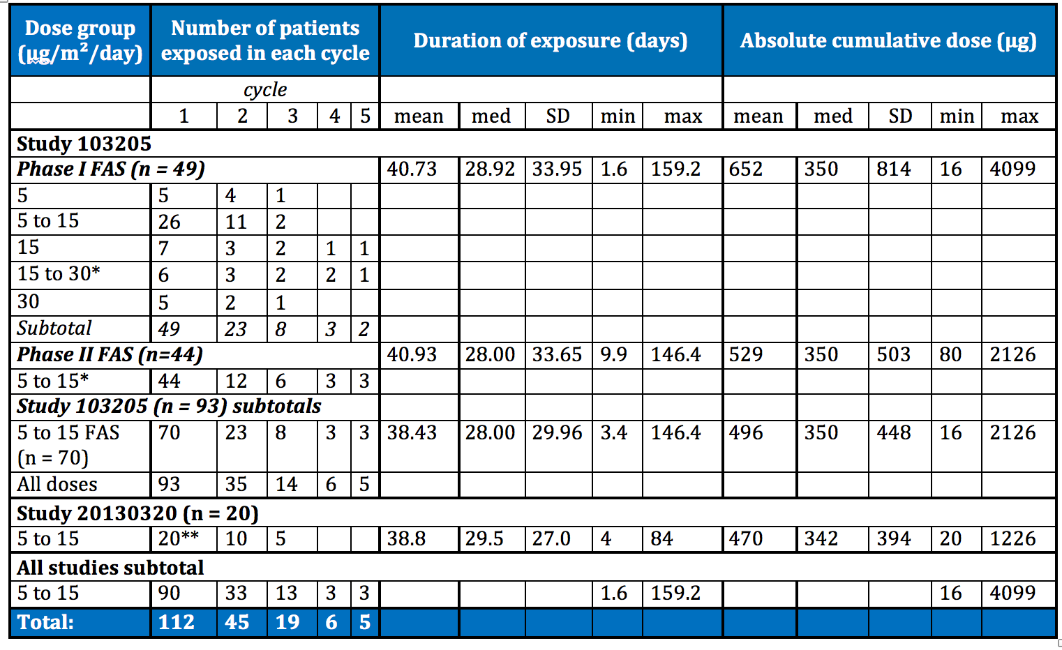
FAS= Full Analysis Set. *There was also one subject re-treated in this group. **One of these subjects was part of Study 103205 initially, which is why the overall total number of subjects exposed to blinatumomab in these 2 studies is 112 and not 113.
In the pooled adult data submitted in support of registration in Australia, the range of doses was wider (from 0.5 to 90 µg/m²/day) than in these paediatric studies.
- Study MT103-211 (n = 189):
  - Median exposure duration = 42.2 days (mean 48.1 days, range 1.2 to 150.1 days)
  - Median cumulative exposure = 655 µg (mean 1148 µg, range 11 µg to 4070 µg).
- Study MT103-206 (n = 36):
  - Median exposure duration = 55.6 days (mean 58.0 days, range 24.2 to 77.3 days)
  - Median cumulative exposure = 711.5 µg (mean 766.8 µg, range 12 µg to 3878 µg).

Adverse events

Overview of adverse events
Adverse events (AEs) in the pivotal trial were coded using MedDRA version 18.0 and severity was graded by the CTCAE version 4.,,, The sponsor has used a time-limited definition of ‘treatment-emergent’ adverse event (TEAE) in their reports, excluding adverse events that occurred more than 30 days after the last date of infusion.
Whether an event was serious or not was determined on pre-specified criteria per protocol. Whether an event was considered related to study medication was also assessed per protocol. Events of interest (EOI) were also considered separately, per the Council for International Organizations of Medical Sciences definition (‘a noteworthy event for a particular product or class of products that may warrant careful monitoring’).
Comment: It is recognised that the half-life of blinatumomab is very short (hence the requirement for dosage by continuous infusion), however it is possible that adverse effects of treatment could manifest later than 30 days after treatment has ceased.
Given the single arm design of the trial, all adverse events, regardless of how long after treatment they occurred, should be considered possibly related to treatment and assessed medically.
A summary of adverse events in Study 103205 up to a cut-off date of 12 January 2015 is provided below in Table 39.

Table 39. An overview of adverse events that occurred in pivotal paediatric Study 103205, up to cut-off date 12 January 2015
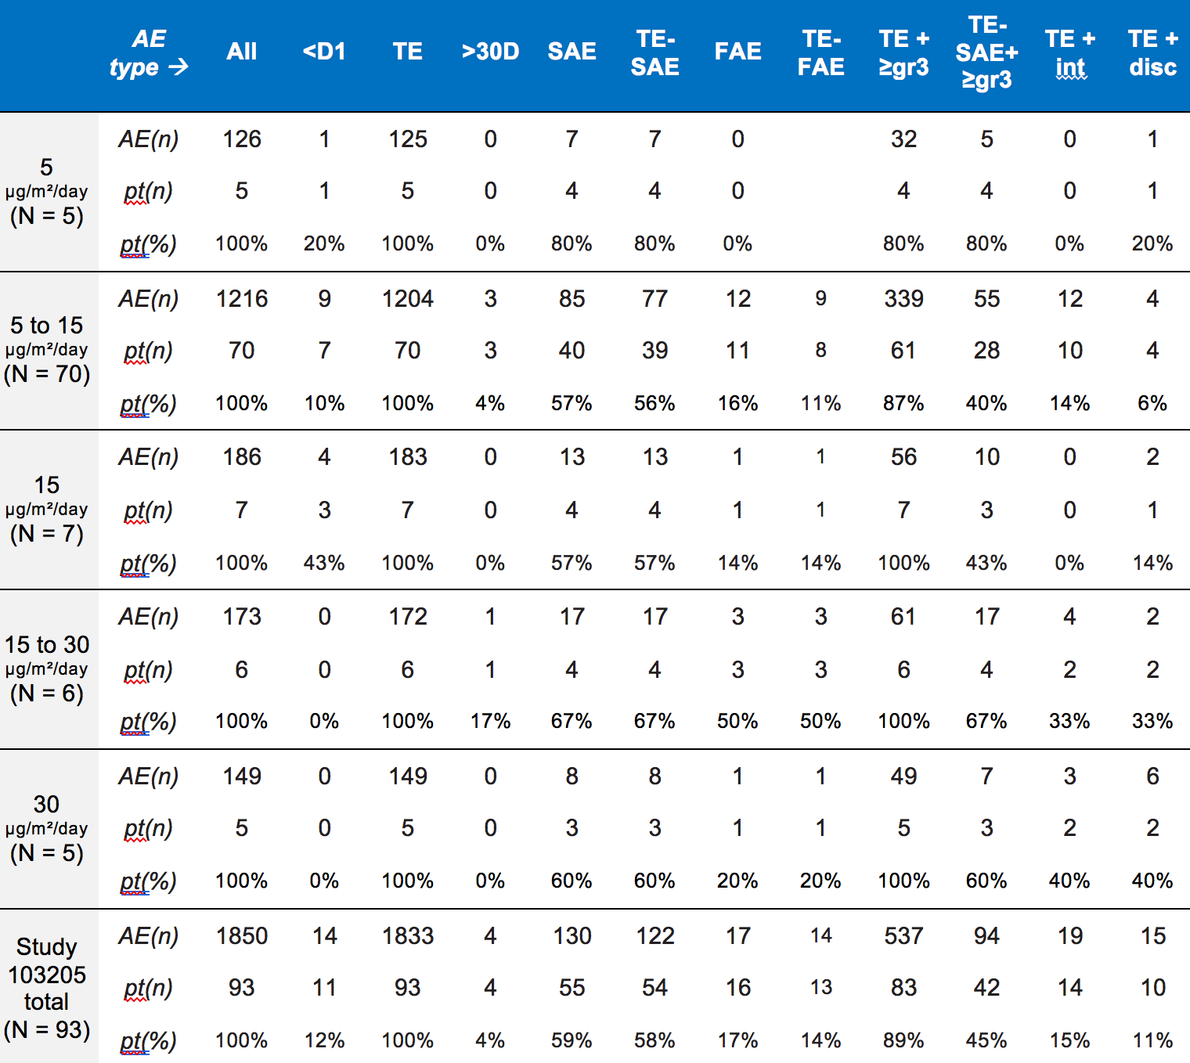
> 30D = occurring more than 30 days post last dose of blinatumomab; <D1 = occurring earlier than the first dose of blinatumomab; TE = treatment-emergent = occurred after first dose and not later than 30 days after last dose of blinatumomab, OR onset prior to first dose but worsened during blinatumomab therapy; SAE = serious adverse event; FAE = fatal adverse event; ≥gr3 = CTC grade 3 or higher; int = interruption of study medication as a result of an AE; disc = permanent discontinuation of study medication as a result of an AE.
Comment: The analyses of adverse events provided in the CSRs and safety summary are very difficult to interpret, as summary statistics for related events include only adverse events that were treatment-emergent, that is, the ‘relatedness’ of the event was only considered if the event occurred within 30 days of treatment cessation. Whether an event is considered treatment related in a single arm trial such as this should be assessed independently of this arbitrary criterion.

Deaths
A summary flowchart of treatment-emergent (occurring within 30 days of last dose) deaths in the clinical trials with relevant cut-off dates is provided by the sponsor in the Summary of Clinical Safety document and has been reproduced below as Figure 13.
Figure13. Overview of deaths in paediatric studies
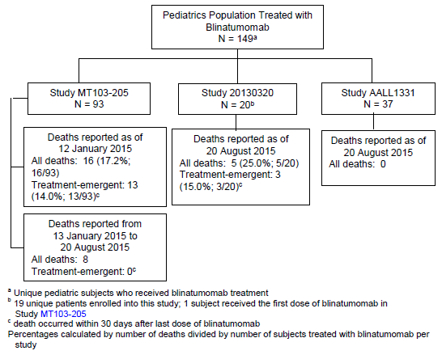
Deaths that occurred due to disease progression were not required to be reported as adverse events. From the Summary of Clinical Safety:
‘Per the protocol, disease progression (the malignant tumour disease under study or signs and symptoms associated with the disease, as well as progression or relapse of the underlying malignant tumour disease) was not to be reported as an adverse event; therefore, disease progression was not required to be reported to the sponsor as a treatment emergent adverse event or a treatment-emergent serious adverse event’.
Comment: Whether a death has been included in the summary statistics or not is reliant on 2 independent and both arbitrary factors: investigator decision as to whether to report a fatality as an adverse event, and the delineation of 30 days post last dose as the cut-off point beyond which events are not considered treatment-emergent. Whilst it is recognised that these may be standard approaches, treatment relatedness per se has not been described (only as a subset of treatment emergent events), and these summary statistics relating to deaths are essentially meaningless.
In order to assess deaths in the trial, case narratives have been manually reviewed (where provided). Narratives for fatal adverse events that occurred later than the cut-off date for the CSR but before the cut-off date for the summary of clinical safety have not been provided and therefore could not be reviewed.
In the following sections, deaths that were identified by the evaluator in which a causal or contributory relationship of blinatumomab to the death was at least as plausible as other contributing factors have been described.

Study 103205, fatal adverse events
To 12 January 2015, 43 subjects in the 5 to 15 µg/m²/day dose group had died, according to the end of study outcomes table. Narratives for deaths occurring prior to that cut-off date that were reported as being related to adverse events were reviewed, by review of the CSR. 59 such cases were identified.
Comment: In a table of the CSR, the total number of ‘AEs leading to death’ for the Phase I/II FAS is stated to be 17 events (16 patients). However, 59 adverse event cases were identified in the CSR that had a fatal outcome.
Can the sponsor please explain this discrepancy? See also Section 11, Clinical Question 11.
Where deaths were attributed to a non-specific loss of function term reported as an adverse event (examples included multi-organ failure, cardiac failure, cardio-respiratory failure, respiratory failure) in the context of disease progression, all reviewed cases were describing disease progression to be the underlying cause of systemic deterioration, and the adverse event term was selected purely on the basis of the organ failure that was considered the key organ failure leading imminently to death. These cases were considered disease progression cases.
Of the 59 cases identified:
- 38 were cases of disease progression
- 2 additional cases of disease progression were reported for specific haematological adverse events (DIC and thrombocytopaenia) that occurred in the context of disease progression.
- 6 cases were related to post-HSCT complications (cardiac failure x 2, multi-organ failure, renal failure, respiratory distress, septic shock)
- 11 were cases of infections; 4 of them occurred more than 100 days after cessation of blinatumomab:
  - 1 case of infection (‘sepsis’) was also coded for a CNS bleed (that of 1 subject): this was a 12 year old male subject, who was in third relapse and had prior HSCT, and was a non-responder in this study. The narrative provides inadequate detail to work out the prodrome or order of diagnosis but states that coughing and confusion occurred, that subarachnoid haemorrhage was diagnosed on CT, that blood culture ‘revealed enterococcus faecalis tracheal secretion’ (whether this was after intubation or not was not clear). This patient died after withdrawal of support when he failed to recover consciousness after extubation and withdrawal of sedation. It is likely that the CNS haemorrhage was related to underlying haematological malignancy and it sounds like possibly sepsis occurred subsequently, after intubation, but there is not enough detail present to really understand what the primary adverse event here is.
  - A second case of infection in a 5 year old female subject was notable as it was coded for ‘multi-organ failure’. However, the multi-organ failure was not secondary to underlying ALL but to aspergillosis pneumonia contracted in ICU where she’d been admitted for dialysis for acute renal failure suspected to have been caused by clofarabine and cyclophosphamide.
The final 2 fatal cases reviewed from Study 103205 are considered to have significant possible relationship to blinatumomab therapy, as outlined below in Table 40.

Table 40. Adverse event-related deaths of note in Study 103205
Adverse event reported term (root cause) | Demographics | Days post last dose | Dose | Additional notes
Cardiac failure (tumour lysis/ cytokine release syndrome) | 5 year old Caucasian male | 6 | 30 µg/m²/day | Developed respiratory failure 3 days post starting infusion and was admitted to ICU with tumour lysis/cytokine release syndrome. Developed cardiac failure and died. Previous therapies anthracycline and total body irradiation may have contributed to the development of cardiac failure.
Respiratory failure (ascending paralysis)  Also coded for ‘cardiac arrest’ ‘hypotonia’ and ‘muscle weakness’ | 2 year old Caucasian male | 2 | 15 µg/m²/day | The Phase I FAS subject ‘was a 2 year old male subject with relapsed ALL. He was started at a blinatumomab dose of 15 µg/m²/day. Baseline chest x-ray before treatment start of blinatumomab revealed opacities in both lungs. The subject had experienced febrile neutropenia with pneumonia before treatment start of blinatumomab. Soon after initiating the first cycle of blinatumomab therapy, the subject developed ascending weakness beginning in the lower extremities, hyponatremia, fluid overload, and ileus. Six days after the start of the events, the subject developed respiratory failure requiring ventilation. The subject’s general condition worsened; further care was withdrawn. The cause of death was respiratory failure that was a complication of hypotonia that began while he was receiving his first, and only, week of blinatumomab therapy. The presentation of the hypotonia was described as an ascending paralysis that ultimately affected his respiratory effort. Of note, prior to blinatumomab therapy, the patient had developed a significant viral illness with positive viral blood cultures. The pattern of hypotonia and antecedent infection are more consistent with the development of Guillain-Barré syndrome secondary to viral illness than with blinatumomab CNS toxicity. The investigator was not able to obtain a CSF sample for evaluation of cell count and total protein prior to subject’s deterioration and death. No autopsy was performed.’  The investigator noted possible differential diagnoses of Guillain-Barre and steroid neuropathy.

Deaths after the initial CSR cut-off date
Deaths associated with reported adverse events that occurred after the cut-off date for the CSR (12 January 2015) and before the cut-off date for the updated data described in the Summary of Clinical Safety (20 August 2015) were not all able to be reviewed as narratives were only provided for 8 such cases, which were considered ‘treatment emergent’.
Six of these described progressive disease (one was coded for ‘acute lymphocytic leukaemia’ and another specified that the progression was ‘renal relapse’ and so the reported term for the fatal adverse event was ‘renal failure’). The other 2 cases were one of chronic graft versus host disease (GVHD) post-HSCT and one of cardiac failure, as a consequence of severe CRS. This last case occurred in a subject on the higher dose of 30 µg/m²/day, and although CRS is a listed event in the PI already, the sponsor has proposed specific warning text regarding this case in the PI.
Comment: Although it is agreed that ascending paralysis may alternatively be caused by a preceding viral illness, in the setting of an uncontrolled and limited safety dataset, with a medication known to cause neurological side effects, and given the severity of the event, it is felt that this event warrants inclusion on the PI.

Study 20130320, fatal adverse events
It is not clear how many deaths in total have occurred in this study to the cut-off date of 20 August 2015. The interim CSR for Study 20130320 contains the following text and table:
‘A listing of all deaths (regardless of the end of blinatumomab treatment) is provided [see Table 41, shown below]. Up to the data cut-off date of 20 August 2015, a total of 3 subjects died (15.0%). One subject due to a fatal treatment-emergent adverse event of acute lymphocytic leukaemia. The death was not considered to be related to blinatumomab. 2 additional deaths occurred more than 30 days after treatment discontinuation. All 3 deaths were considered due to disease progression’.

Table 41. Listing of deaths occurring prior to the data cut-off date (20 August 2015, Full analysis set)
Subject ID | Study day of death | Last dose day | Cycle of last dose | Cause of death | PT (for fatal AE only) | Due to disease progression
1 | 127 | 22 | 1 | Relapsed infant leukaemia | Acute lymphocytic leukaemia, recurrent | Yes
2 | 25 | 5 | 1 | Disease progression | Acute lymphocytic leukaemia | Yes
3 | 60 | 11 | 1 | Relapsed/ refractory B-precursor ALL | N/A | Yes
PT = preferred term (MedDRA V 18.0); AE = adverse event; ALL = acute lymphoblastic leukaemia; N/A = not available.
The above events do not raise safety concerns.
Comment: Table 41 (or Table 8.5 as referred to in the interim CSR) contains a listing of 3 events. However, the evaluator is confused by the statement mid-paragraph that ‘2 additional deaths occurred more than 30 days after treatment discontinuation’, as the deaths listed in ‘Table 8-5’ all occurred within 30 days of last dose (see ‘last dose day’ column).
Can the sponsor please clarify the following:
Were there 2 additional deaths that occurred later than 30 days after last dose?
If so, why have they not been included in ‘Table 8-5’, as it is stated to be a ‘listing of all deaths (regardless of the end of blinatumomab treatment)’? See also Section 11, Clinical Question 12, below.

Study AALL1331 – fatal adverse events
As of the data cut-off date of 20 August 2015, no deaths had been reported for Study AALL1331.

Evaluator conclusions
The current PI contains a black boxed warning stating:
‘Warning:
The following have occurred in patients receiving Blincyto:
    - Cytokine Release Syndrome, which may be life-threatening or fatal
    - Neurological toxicities, which may be severe, life-threatening, or fatal
    - Reactivation of JC viral infection.’
The more detailed section of the PI (under ‘Precautions’ describes a number of neurological adverse events but an ascending hypotonia is not specified in particular. The hypotonia seen in a subject of Study 103205 is, however, strongly consistent with a diagnosis of Guillain-Barre Syndrome, given the preceding documented serious viral illness.
Tumour lysis syndrome is adequately described in the PI.
Review of fatal adverse events in the paediatric clinical trials to date has not revealed any new safety signals.

Serious and high grade adverse events

Study 103205, serious and high grade AEs

Serious TEAEs
The analyses of serious adverse events (SAEs) provided in the CER do not include all adverse events, only events that occurred within 30 days of the last dose of study medication (TEAEs as defined by the sponsor).
54 subjects (58.1%) in the Study 103205 FAS (n = 93, includes both Phase I and Phase II) reported at least one TEAE that was recorded as ‘serious’. There were 122 treatment-emergent serious adverse events in total (see Table 42, shown below). Comments are included, principally regarding those cases considered treatment related (R TEAEs).

Table 42. Serious TEAEs and serious, treatment related TEAEs in Study 103205 to 12 January 2015
MedDRA system organ class (SOC) | TEAEs (n) | R TEAEs (n) | Evaluator comments  (comments regarding TEAEs not recorded as related are in italics)
Infections and infestations | 25 | 0 | Immunocompromise and risk of infection is listed in the PI.
Neoplasms benign, malignant and unspecified (including cysts and polyps) | 1 | 0 | Disease progression.
Blood and lymphatic system disorders | 13 | 5 | 3 related cases of febrile neutropenia (known, listed)  2 related cases of haematophagic histiocytosis (known, listed)
Immune system disorders | 8 | 7 | 7 related cases of cytokine release syndrome (known, listed)  1 case of drug hypersensitivity (known, listed)
Metabolism and nutrition disorders | 2 | 1 | 1 case of hypertriglyceridaemia (occurred in context of non-responder with recurrent ALL on study day 11)  1 related case of tumour lysis syndrome (known, listed)
Psychiatric disorders | 1 | 0 | 1 case of confusional state (known, listed)
Nervous system disorders | 8 | 5 | 3 related cases of convulsion and 1 related case of atonic seizure (known, listed)  1 case of haemorrhage intracranial (presumed CNS haemorrhage in a subject w known thrombocytopaenia, developed neurological symptoms and then had a seizure and died)  1 case of headache (known, listed)  1 case of hypotonia (see Section 8.4.2.4/description of case in Table 40).  1 case of neuralgia: see below.
Cardiac disorders | 2 | 1 | 1 case of cardiac arrest (subject [information redacted] description of case in Table 40).  1 case of cardiac failure (secondary to CRS/TLS/respiratory failure)
Vascular disorders | 6 | 2 | 2 related cases of capillary leak syndrome (known, listed)  1 related case of haemorrhage (massive diffuse haemorrhage secondary to CRS - listed)  1 case of hypertension  1 related case (and 1 unrelated) of hypotension (listed)
Respiratory, thoracic and mediastinal disorders | 15 | 7 | 3 related (and 3 unrelated) cases of respiratory failure – secondary to CRS/TLS (n = 1); relapse/progression (n = 3), a pneumonia (n = 1) and hypotonia (n = 1): see Section 8.4.2.4.  2 related (and 1 unrelated) cases of hypoxia (1 secondary to fluid overload in treating TLS, one secondary to infection)  1 case of atelectasis  1 case of cough  1 related case of dyspnoea (secondary to CRS, listed)  1 related case of epistaxis (reported in conjunction with massive diffuse haemorrhage, see above)  1 related case of pleural effusion (setting of CRS, listed)  1 case of pneumonitis, infective picture but pathogen not identified
Gastrointestinal disorders | 5 | 0 | 2 cases of colitis (listed: infection)  1 case of mouth haemorrhage (due to tooth extraction)  1 case of oesophageal pain  1 case of vomiting
Hepatobiliary disorders | 1 | 0 | 1 case of hepatic failure (secondary to progressive disease)
Musculoskeletal and connective tissue disorders | 3 | 0 | 1 case of back pain  1 case of bone pain  1 case of muscular weakness
Renal and urinary disorders | 1 | 0 | 1 case of renal failure acute (secondary to infection)
Reproductive system and breast disorders | 1 | 0 | 1 case of acquired phimosis (secondary to catheter)
General disorders and administration site conditions | 19 | 8 | 7 related (and 5 unrelated) cases of pyrexia (listed)  2 cases of disease progression  2 cases of multi-organ failure  1 case of death  1 case of device malfunction  1 related case of influenza-like illness (case 1004002, in context of CRS)
Investigations | 4 | 0 | 4 positive tests for different bacteria, all from one patient (infections – listed)
Injury, poisoning and procedural complications | 6 | 2 | 2 related (and 2 unrelated) cases of overdose (known risk)  1 case of spinal compression fracture  1 case of vascular access complication
Surgical and medical procedures | 1 | 0 | 1 case of tooth extraction
Total | 122 | 54
The reported serious AEs are generally in keeping with the adverse event profile described in the existing PI, with some exceptions.
Although it was not considered related to investigational product by the investigator, the case of neuralgia warrants additional description as it is not a listed adverse event and the case did not have a clear causality. 3 weeks into treatment with blinatumomab the subject developed left leg pain, numbness and ‘difficulty controlling the leg’. It was diagnosed to be sciatic nerve pain and remained uncontrolled despite paracetamol, tramadol and gabapentin. There were no signs of infection (and CRP was normal). The pain was eventually controlled by insertion of a peridural catheter for continuous ropivocaine infusion. Blinatumomab, meanwhile was continued as planned and completed at the end of Week 4, at which time CSF and bone marrow were negative for recurrence. The paradural infusion was gradually decreased and the neuralgia symptoms resolved approximately 3 weeks after blinatumomab had been ceased.
Comment: This event should be listed in the PI, given the lack of alternative plausible explanation, and the uncontrolled and limited dataset. See evaluator conclusions, Section 8.4.3.4.

Grade 3 and higher TEAEs
In pivotal Study 103205, 83 subjects (89%) reported at least one Grade 3 or higher TEAE, and 42 subjects (45%) reported at least one Grade 3 or higher TEAE that was serious. There were 537 Grade 3 or higher TEAEs reported in total, 94 of which were serious (see Table 43, below).

Table 43. An overview of treatment related TEAEs in Study 103205 to 12 January 2015
 | AE type | R + TE | R+ TE + ≥ Gr3 | R + TE-SAE | R + TE-FAE
5 µg/m²/day (N = 5) | AE (n) | 51 | 24 | 4 | 0
5 µg/m²/day (N = 5) | Pt (n) | 5 | 4 | 3 | 0
5 µg/m²/day (N = 5) | Pt (%) | 100% | 80% | 60% | 0%
5 to 15 µg/m²/day (N = 70) | AE (n) | 424 | 149 | 17 | 0
5 to 15 µg/m²/day (N = 70) | Pt (n) | 59 | 38 | 15 | 0
5 to 15 µg/m²/day (N = 70) | Pt (%) | 84% | 54% | 21% | 0%
15 µg/m²/day (N = 7) | AE (n) | 69 | 28 | 10 | 0
15 µg/m²/day (N = 7) | Pt (n) | 6 | 5 | 2 | 0
15 µg/m²/day (N = 7) | Pt (%) | 86% | 71% | 29% | 0%
15 to 30 µg/m²/day (N = 6) | AE (n) | 71 | 26 | 4 | 1
15 to 30 µg/m²/day (N = 6) | Pt (n) | 5 | 4 | 1 | 1
15 to 30 µg/m²/day (N = 6) | Pt (%) | 83% | 67% | 17% | 17%
30 µg/m²/day (N = 5) | AE (n) | 59 | 23 | 6 | 0
30 µg/m²/day (N = 5) | Pt (n) | 5 | 5 | 2 | 0
30 µg/m²/day (N = 5) | Pt (%) | 100% | 100% | 40% | 0%
Study 103205 total (N = 93) | AE (n) | 674 | 250 | 41 | 1
Study 103205 total (N = 93) | Pt (n) | 80 | 56 | 23 | 1
Study 103205 total (N = 93) | Pt (%) | 86% | 60% | 25% | 1%
R = treatment-related; TE = treatment-emergent = occurred after first dose and not later than 30 days after last dose of blinatumomab, OR onset prior to first dose but worsened during blinatumomab therapy; FAE = fatal adverse event; SAE = serious adverse event; ≥ Gr3 = CTC Grade 3 or higher
Preferred terms for TEAEs of at least Grade 3 reported to be related to study medication were individually reviewed (using the listing in a table in the CSR), and are in keeping with the information in the current PI.
The prevalence of TEAEs of ≥ Grade 3 decreases after the first cycle of treatment. This may be an illustration of the relative prevalence of AEs related to first dose effects (such as cytokine release syndrome) and the later cycles not including those who had discontinued secondary to hypersensitivities.

Study 20130320, serious and high grade AEs

Serious TEAEs
There were 10 TEAEs reported to be ‘serious’ in Study 20130320, and 6 subjects reported at least one serious TEAE, as shown in Table 44, below.

Table 44. Serious TEAEs in Study 20130320 to 20 August 2015
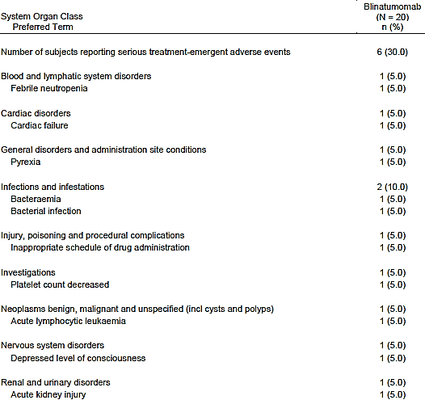
The reported terms are in keeping with the adverse event profile described in the adult PI with the exception of ‘acute kidney injury’. This event was reported for a 15 year old Caucasian male subject, whose creatinine rose from a pre-treatment baseline of 0.36 mg/dL to 1.27 mg/dL on Day 10 of his first infusion. He was also being treated with nephrotoxic medications (including TPN, vancomycin and piperacillin-tazobactam), confounding causality. These and blinatumomab were ceased, and creatinine began to recover, however, consent was withdrawn for trial participation, so blinatumomab re-challenge data is not available. 3 days after the infusion had been ceased, the patient went on to develop cardiac failure with an ejection fraction on echocardiography of 35%. This was attributed to progressive leukaemia and was recorded as a TEAE but not a treatment related event (it is therefore included in Table 45, below).

Grade 3 and higher TEAEs
There were 22 TEAEs reported to be Grade 3 or higher in Study 20130320, and 11 subjects reported at least 1 TEAE Grade 3 or higher, as shown in Table 45, below.

Table 45. Grade 3 or higher TEAEs in Study 20130320 to 20 August 2015
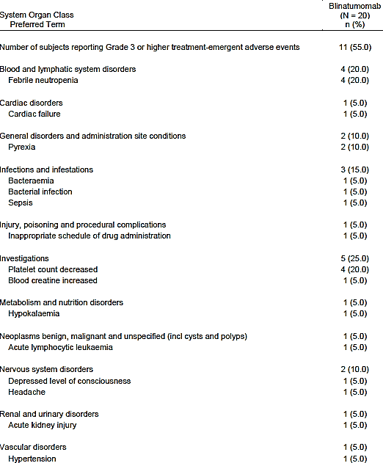
These adverse events are generally in keeping with the known safety profile of blinatumomab, with the exception of acute kidney injury and cardiac failure in one subject, as discussed above. The causality of the acute kidney injury is unclear due to confounding by concurrent nephrotoxic medications, and the cardiac failure was attributable to progressive disease.

Study AALL1331, serious and high grade AEs
The sponsor states that:
Serious adverse event data only is provided for this supplemental application using the data cut-off date of 20 August 2015. The final AALL1331 study report is expected to be submitted by December 2019.

Serious TEAEs
3 adverse event narratives were submitted with the dossier:
- A Grade 2 seizure in an 11 year old male with a negative blinatumomab rechallenge.
- A soft tissue infection (perineal cellulitis) with septicaemia and febrile neutropaenia in context of chemotherapy at least 2 months after first blinatumomab dosing (suggesting treatment failure and change to chemotherapy).
- CRS Grade 2 treated successfully with IV fluid and dexamethasone.
These cases are in keeping with the known safety profile of blinatumomab.

Grade 3 and higher TEAEs
As above.

Evaluator conclusions
Overall, reported adverse events in paediatric clinical trial subjects appear similar to those included in the PI from adult trials. Very serious and fatal cases of CRS are noted (including one resulting in heart failure), however, CRS is already included as a black box warning in the PI and given the context of the treated population these are not a barrier to registration. The sponsor has proposed in their new version of the PI some additional precautionary text under ‘Precautions: Paediatric Use’ noting this case and that it occurred at the higher than recommended dose of 30 µg/m²/day.
An isolated case of neuralgia (described in Section 8.4.3.1) was also noted. The addition of ‘neuralgia’ to the PI in the section describing neurological adverse events seen in clinical trials is recommended in the absence of a large dataset or control arm, and with no clear alternative confounder or causality.
Review of fatal adverse events in the paediatric clinical trials to date has not revealed any new safety signals.

Events of interest (EOIs)
EOI analysis was only included in the dossier for pivotal Trial 103205 and was only performed on the 5 to 15 µg/m²/day FAS.
The following were considered pre-specified EOIs:
- Neurologic events
- Cytokine release syndrome (CRS)
- Tumour lysis syndrome (TLS)
- Infections
- Infusion reactions
- Capillary leak syndrome (CLS)
- Medication errors
- Decreased immunoglobulin (Ig)
- Elevated liver enzymes
- Cytopaenia (including neutropaenia and lymphopaenia)
- Leukoencephalopathy
One or more treatment-emergent EOIs (with an onset date during the core study) occurred in 90% of the 5 to 15 µg/m²/day FAS (n = 70):
- 71% of the cohort had at least 1 treatment emergent EOI of at least Grade 3
- 49% of the cohort had at least 1 treatment emergent EOI of at least Grade 4
- 40% of the cohort had at least 1 serious treatment emergent EOI
- 4% of the cohort (3 subjects) had a fatal EOI (1 cytopaenia and 2 infections).
Comment: The EOI assessment was only done on the 5 to 15 µg/m²/day FAS and so did not include the fatal case of CRS/heart failure.

Treatment interruptions and discontinuations

Treatment interruptions in Study 103205
An overview of how many subjects discontinued (temporarily or permanently) infusion with blinatumomab in Study 103205 is provided below in Table 46. Overall in Study 103205 (n = 93), there were 6 subjects in the Phase I cohort (n = 49: 12%) and 12 subjects in the Phase II cohort (n = 44: 27%) whose infusion was interrupted for any reason.
Adverse events (other than technical/pump-related events) that were considered related to treatment (TRAEs) and that led to infusion interruptions (according to a listing of the adverse event listings document for Study 103205) are listed in Table 47, also below.
TRAEs other than technical/pump related reasons that led to permanent treatment discontinuation (according to a listing of the adverse event listings document for Study 103205) are listed in Table 48.

Table 46. Reasons (not all reported as AEs) for treatment-related interruptions and discontinuations in Study 103205 FAS
 | Number of subjects (%)
Reason for interruption | Phase I FAS (n = 49) | Phase II FAS (n = 44) | Total (n = 93)
Any | 6 (12%) | 12 (27%) | 18 (19%)
Adverse event | 2 (4%) | 2 (5%) | 4 (4%)
Technical reasons¹ | 2 (4%) | 8 (18%) | 10 (11%)
Other² | 4 (8%) | 3 (7%) | 7 (8%)
Reason for discontinuation | Phase I FAS (n = 49) | Phase II FAS (n = 44) | Total (n = 93)
Adverse event |  |  | 10 (11%)
1) such as pump issues (for example: air in the line, low battery); 2) such as bag empty, paused for blood sampling

Table 47. TRAEs leading to infusion interruption that were not specified to be pump-related
TRAE | Worst CTCAE Grade | Dose group
Atonic seizure | 2 | 5 to 15 µg/m²/day
Overdose | 2 | 5 to 15 µg/m²/day
Fever | 4 | 5 to 15 µg/m²/day
CRS | 3 | 5 to 15 µg/m²/day
Generalised seizure | 2 | 5 to 15 µg/m²/day
CRS | 3 | 5 to 15 µg/m²/day
Hypotonia | Grade 3 (at time of interruption) | 15 to 30 µg/m²/day
Fever and TLS | Both Grade 3 | 30 µg/m²/day

Table 48. TRAEs leading to permanent treatment discontinuation that were not pump-related
TRAE | Worst CTCAE Grade | Dose group
Seizure | 3 | 5 µg/m²/day
CRS with massive diffuse haemorrhage and dyspnoea | 4 | 15 µg/m²/day
TLA/CRS with respiratory failure | 4 | 30 µg/m²/day
Hypotonia and respiratory failure | 5 | 15 to 30 µg/m²/day
CRS | 4 | 5 to 15 µg/m²/day
CRS, capillary leak and macrophage activation syndromes | 4 | 30 µg/m²/day

Treatment interruption in Study 20130320
The following treatment-related interruptions to infusion occurred in Study 20130320:
- A subject (on 15 µg/m²/day) had a temporary interruption to infusion overnight due to a fever and chills. IV dexamethasone was given, blinatumomab was restarted the following day and the patient was discharged from hospital.
- A subject (on 15 µg/m²/day) had a tonic generalised seizure on Day 8 of first infusion (reported term ‘depressed level of consciousness’). Blinatumomab was interrupted then restarted 6 days later and seizure didn’t recur at that time. The same subject had another AE of depressed level of consciousness/symptoms of encephalopathy on Day 38 of study (presumably about a week into the second cycle of blinatumomab), after a short tonic episode that may also have been a short seizure. Blinatumomab was ceased permanently and the patient was discharged from hospital the following day.
- A subject (on 15 µg/m²/day) had their treatment interrupted due to acute kidney injury, as discussed in Section 8.4.3.2. Confounding nephrotoxic medications were ceased alongside blinatumomab.

Treatment interruptions in Study AALL1331
Of the 3 reported adverse event narratives, treatment was interrupted temporarily for a subject (for Grade 2 seizure), and for a subject (for Grade 2 CRS). Action taken with blinatumomab for the third event (soft tissue infection) wasn’t reported.

Postmarketing experience

Postmarketing safety summary
A post-marketing safety summary has been provided in the dossier. It states that 647 patients have been exposed to blinatumomab cumulatively worldwide since marketing approval was first obtained on 3 December 2014.

Serious post-market TEAEs
There have been 835 adverse events reported cumulatively in the post-market setting, 595 of them serious. Serious adverse event terms reported more than once are listed in the summary in the sponsor’s safety summary document, and of these, the terms considered by the evaluator to be clinically meaningful (and not related to underlying diagnosis) are:
- Events suggestive of CNS effects: (38 events)
  - Neurotoxicity (23 events)
  - Aggression (3 events)
  - Confusional state (7 events)
  - Delirium (2 events)
  - Mental status changes (2 events)
- Events suggestive of immune system effects: (53 events)
  - Cytokine release syndrome (24 events)
  - Pyrexia (10 events)
  - Febrile neutropaenia/neutropaenia (8 events altogether)
  - Pancytopaenia (2 events)
  - Events in the Infections System Organ Class (SOC) (9 events, 2 of which were appendicitis)
- Nonspecific symptoms which may be symptoms of the above categories of events or could be unrelated to treatment:
  - Dyspnoea (3 events), lung infiltration (2 events) and respiratory failure (2 events)
  - Tachycardia (3 events) and ventricular tachycardia (2 events)
  - Muscle spasms (2 events)
  - Hypotension (3 events)
  - Rash (2 events)
Individual System Organ Class (SOC) reviews of serious TEAEs have been carried out by the sponsor. No new safety concerns were identified by the sponsor.

Fatal cases and EOIs
Postmarketing adverse event EOIs were identified by the sponsor from their post-marketing database by searching for EOI related terms as was done for the clinical trial safety data. Thromboembolic events and off label use were searched for as events of interest but are not included in the current PI. A summary of their findings is tabulated in Table 49.
Case narratives for fatal post-market case reports were also included in the post-market safety summary and were individually reviewed by the evaluator.

Table 49. Summary of post-market EOIs that were reported most frequently, and category totals
EOI category | Patients | Events | Serious Events
Infusion Reactions | 110 | 133 | 79 (2 fatal)
Events with a within-category frequency of ≥ 2%:
pyrexia |  | 65 | 29
CRS |  | 28 | 28
hypotension |  | 13
rash |  | 6
increased blood pressure or hypertension |  | 6
respiratory failure |  | 3
Fatal cases in this category:
• ‘respiratory failure’ (invalid report: event predated Blincyto therapy)
• ‘acute renal failure’ (in context of ‘comfort care’, likely disease progression)
Central neuropsychiatric events due to direct neurotoxicities | 107 | 191 | 120
Events with a within-category frequency of ≥ 2%:
neurotoxicity |  | 27
confusional state |  | 20
headache |  | 13
tremor |  | 11
ataxia |  | 5
dizziness |  | 5
memory impairment |  | 5
mental status changes |  | 5
seizure |  | 5
aphasia |  | 4
depression |  | 4
dysarthria |  | 4
encephalopathy |  | 4
nervous system disorder |  | 4
Infections | 32 | 38 | 28
Events with a within-category frequency of ≥ 5%:
infection |  | 8
device-related infection |  | 4
Clostridium difficile infection |  | 3
appendicitis |  | 2
Escherichia sepsis |  | 2
Pneumocystis jirovecii pneumonia |  | 2
sepsis |  | 2
Fatal cases in this category:
‘septic shock’, ‘appendicitis’ and ‘Escherichia sepsis’
Medication Errors | 19 | 20 | 1
Events with a within-category frequency of ≥ 10%:
medication error |  | 5
incorrect dose administered |  | 4
wrong technique in drug usage process |  | 3
accidental exposure to |  | 2
product
overdose |  | 2
Thromboembolic Events | 12 | 13 | 9
Events reported in at least 2 patients:
cerebrovascular accident |  | 2
deep vein thrombosis |  | 2
device occlusion |  | 2
thrombosis |  | 2
Cytopaenias | 42 | 58 | 44
Events with a within-category frequency of ≥ 5%:
platelet count decreased |  | 15
neutropenia |  | 13
white blood cell count decreased |  | 13
febrile neutropenia |  | 6
pancytopenia |  | 4
red blood cell count decreased |  | 3
Signs and symptoms related to liver investigations | 20 | 27 | 14
All reported events:
liver function test/hepatic enzyme /transaminases increased/abnormal |  | 15
aspartate aminotransferase increased |  | 5
alanine aminotransferase increased (or abnormal) |  | 5
gamma-glutamyltransferase increased |  | 1
hyperbilirubinemia |  | 1
Off label use | 184 | 372 | 181 (14 fatal)
paediatric subtotal | 8
Events with a within-category frequency of ≥ 2%:
pyrexia |  | 25
neurotoxicity |  | 15
CRS |  | 14
confusional state |  | 11
Fatal cases in this category:
All 14 fatal cases (none paediatric) have been reviewed and were all likely related to underlying disease.
Immunogenicity | 29 | 29 | 3
There were no reports of anti-Blincyto antibody formation. Reported terms were ‘drug ineffective,’ ‘drug effect decreased,’ ‘drug effect incomplete,’ ‘no therapeutic response’, ‘treatment failure’, ‘drug ineffective for unapproved indication’ and ‘therapeutic response decreased’
Tumour lysis Syndrome | 1 | 1 | 1 (fatal)
Fatal case:
CRS and TLS leading to nephrotoxicity and respiratory failure.
Capillary leak syndrome | 1 | 1 | 1
Leukoencephalopathy | 0 | 0 | 0
Decreased immunoglobulins | 0 | 0 | 0
Comment: The postmarket serious adverse events and events of interest are in keeping with those seen in clinical trials.
The fatal case narratives were reviewed and no new safety concerns are apparent. Most were consistent with disease progression/treatment failure and infections.
An isolated case of off label use for Philadelphia-chromosome positive disease is noted.

Evaluator’s overall conclusions on clinical safety
Despite the deficiencies in the summary analyses provided and the small population studied, the result of review of the base level data is reassuring that the safety of blinatumomab in paediatric subjects is similar to that in adults.
In the future, additional safety data can be expected to accumulate from ongoing Phase III Study AALL1331, as well as data from another Phase III trial that was yet to be commenced at time of submission (Study 20120215: a randomised, open label, controlled, multicentre, adaptive trial of blinatumomab versus intensive consolidation after standard induction in paediatric, high-risk, first-relapse, B-precursor ALL). It is very important that post-market monitoring be undertaken with a high quality of reporting where possible. Although the RMP suggests an extensive post-market system is in place for Blincyto monitoring already.
The submission of data from these studies to the TGA when available should be a condition of registration if this extension of indication is to be approved (see Section 10, First round recommendation regarding authorisation, below).

First round benefit-risk assessment

First round assessment of benefits

Table 50. Benefits associated with blinatumomab use in paediatric subjects as indicated by the submitted data
Benefits | Strengths and Uncertainties
- Complete remission as defined in terms of absence of blasts in bone marrow, with subclassification according to peripheral blood count recovery at the recommended dose (see Section 7.2.1.12):  - Rate of CR (CRc + CR* + CR3) (95%CI)  - 39% in relapsed/refractory ALL (27, 51)  - 47.5% in subjects with prior HSCT (32, 64)  - 30.8% in subjects with refractory disease (17, 48)  - Rate of CRc  - 17% (9, 28)  - Rate of CR*  - 16% (8, 26) | - Small trial size = 70 FAS/65 PPS  - Not randomised or controlled; single arm, open label  - The primary endpoint (CR) is a surrogate that has not conclusively been shown to correlate with clinical benefit  - The lower 95% confidence interval bound for the proven surrogate endpoint (CRc) did not reach the pre-determined clinical significance rate of 10%  - Secondary endpoints rely on external (unrandomised and historical) comparators for interpretation  - External comparator efficacy rates of standard-of-care treatments (combined, weighted) using the same definition of CR were:  - CR = 30% (20, 39)  - CRc = 8% (2, 13)  - CR* = 12% (4, 18)
- Median OS (95% CI)  - 7.5 months (4.0, 11.8)  - Median RFS (95% CI)  - 6.0 months (1.4, 12.0) | - Due to the single-arm design, interpretation of secondary endpoints relies on external comparators: these are unrandomised and historical  - Small size of trial: wide confidence intervals  - External comparator efficacy rates of standard of care treatments (combined, weighted)  - OR = 4.1 months (2.5, 5.6)
- MRD rate within CRc/CR* (95% CI)  - Overall = 53 (31,73)  - CRc = 58 (28, 85)  - CR* = 46 (17, 77) | - Very small group (n = 23)  - However, MRD is highly predictive of clinical outcomes.  - Without a comparator arm, it’s difficult to determine accurately how much better or worse than existing salvage options blinatumomab is, but it is clear that it does have efficacy in some of the target population, who are a group with high unmet need.
- HSCT  - Rate in CR/CR* = 48% (13/27) | - Small group (n=27), uncontrolled.

First round assessment of risks

Table 51. Risks associated with blinatumomab use in paediatric subjects as indicated by the submitted data
Risks | Strengths and Uncertainties
- Known risk of serious and sometimes fatal adverse events with blinatumomab, including neurological events, CRS/TLS/infusion reactions, infections including JC virus reactivation, and haematological including neutropaenias | - Isolated adverse events that had not previously been reported were seen; however, in general the safety profile seen in paediatric clinical studies and postmarket cases appears to be in keeping with that seen in adults.  - Addition of information to the PI regarding these isolated events is warranted in the absence of randomised or controlled data, and would provide some risk management.  - The risk profile in adults is reasonably well characterised.  - Risks can generally be mitigated through dose interruption and supportive therapies.  - The use of this medicine is under close oncologist supervision.
- Inadequately defined PK, with major flaws in popPK analysis based on a previous adult model. | - From the popPK expert review: ‘the PK model failed to adequately evaluate the relative effects of age, body weight, BSA and CrCL in the paediatric subpopulation or to address collinearity of these covariates’
- Major questions around dose selection and dose modification for co-variates that hadn’t been proven not to be important in PK and therefore possibly in safety/efficacy | - From the popPK expert review: ‘It was further concluded that the covariates evaluated in the analysis, i.e., age, body weight, BSA, sex, AST, ALT, albumin, total bilirubin, LDH and haemoglobin, were not correlated > 5% with IV CL. Accordingly dose adjustments on the basis of these covariates are not warranted and a BSA based dose of 5 to 15 µg/m²/day for 28 days in paediatric patients with R/R ALL is appropriate. This concluding statement defies logic. If BSA does not influence IIV CL and dose adjustment based on BSA is not warranted, then BSA-dosing is clearly not warranted.’

First round assessment of benefit-risk balance
Although the risks are significant with this therapy, they are balanced against the risk of not treating (fatal) or the risk of treating with conventional chemotherapy regimens, all of which carry considerable risk profiles of their own and have poor efficacy in this population. This population is one which clearly presents unmet need.
Significant remaining issues requiring address are a poor quality popPK analysis and questions around dose selection. These should be addressed by the sponsor in their responses to the clinical questions.
The choice of primary efficacy outcome is not ideal for scientific rigour but is necessary, given the observation time required for time-to-event endpoints to mature and for separation of confidence intervals to be achieved. The chosen surrogate primary endpoint does not have well-established links to clinical outcomes, however the biological plausibility of benefit of haematological response and the lack of major difference in rate of conversion to HSCT between CRc and CR* groups (though underpowered) supports that CR* is at least partly relevant to clinical outcomes.
The use of blinatumomab in children for the same indication as in adults appears reasonably well supported, with dosing that has been shown to be associated with a reasonably consistent safety and efficacy profile to that seen in adults. The uncertainty around the efficacy outcomes is magnified by the small study population and the single-arm nature of the trial. However, given that further confirmatory efficacy data can be expected as the result of a controlled trial currently underway, the shortcomings of this dossier in terms of the limitations of a single arm trial are expected to be able to be addressed during the second round process and in selection of conditions of registration.

First round recommendation regarding authorisation
Approval of Blincyto (blinatumomab) is recommended ‘for the treatment of patients with Philadelphia chromosome-negative relapsed or refractory B cell precursor acute lymphoblastic leukaemia (ALL)’ subject to:
- Satisfactory responses to the clinical questions outlined in Section 11 of this evaluation report.
- An appropriate revision of the population PK or inclusion of a statement in the PI reflecting the lack of adequate description of PK in paediatric subjects.
- Modification of the PI and CMI consistent with the evaluator’s advice
- Inclusion of a note to the indication regarding the surrogate nature of the efficacy data, and a requirement that this note to the indication must accompany the indication in all reproductions and publications of any kind, including marketing or educational materials, in any format or form.
- Further modifications of the PI and CMI if required based on the responses to clinical questions.
- Subsequent submission to the TGA of data from Phase III trials to confirm overall survival benefit and clinically meaningful benefit, with recognition that failure to show overall survival benefit or clinically meaningful benefit to paediatric patients would necessitate reconsideration of the overall benefit-risk balance of the product in this group.

Clinical questions
  - Clinical questions

Question 1: CSF presence of blinatumomab
The presence of measurable blinatumomab in the CSF in a very small proportion of subjects has been indicated but not discussed. Can the sponsor please confirm exactly how many subjects had a detectable amount, whether this measurement has been replicated in adults and what the sponsor’s interpretation of this finding is?

Question 2: Justification of BSA-based dosing given popPK results
Can the sponsor please explain their recommendation of a BSA-based dose in Phase I, the choice to continue with BSA based dosing in Phase II, and in the context of such dosing recommendations, justify the conclusions of PK report 120689, which concludes that BSA does not affect PK?

Question 3: Reasoning for null and alternative hypothesis selection
The reasoning and process taken in deciding the reference population values for the null (10%) and alternative (27.5%) hypotheses isn’t stated explicitly. Can the sponsor please clarify why these values were chosen?

Question 4: Regarding FAS versus PPS in Study 103205
Can the sponsor please confirm the presumed reason for excluding subject 2302-001 is correct, and provide information on the treatment course for subject 1003-004, including whether the non-permitted medication is likely to have contributed to the response and the achievement of HSCT. Can the sponsor please explain why the PPS results are not the ones cited in the PI, and the FAS results instead are cited?

Question 5: Choice of primary endpoint
With regard to endpoints in Study 103205, can the sponsor please state why:
- they chose to use surrogate endpoint CR as the primary outcome for the study?
- they defined CR to include CRc, CR* and CR3?

Question 6: Discrepancies in RFS results between different parts of the dossier
There were discrepancies noted in the figures cited in text (of the CSR for Study 103205), a specified table and the source tables for these compared to the RFS source tables. Examples include the cited median RFS for 2 week best response CRc in the 5 to 15 µg/m²/day FAS in the former sources (8.1 months, 95% CI 1.9 to 13.9 months) versus the cited values in the latter source: those included in the table above for the same group. This prevents meaningful analysis of the data and calls into question the accuracy of other cited results throughout the study.
Can the sponsor please confirm which RFS results are correct, and explain these discrepancies?

Question 7: Accuracy of HSCT rate in patients 7-9 months post response
The sponsor states (in the Study 103205 CSR) that the HSCT data by duration of response to HSCT show that 25% of patients still eligible to receive a transplant at 7 to 9 months did so, referencing a specified table. The data in that table does not appear to support such a conclusion (see Table 25, above).
Can the sponsor please clarify this?

Question 8: Post-HSCT mortality comparator rate
The mortality rate post-HSCT in the 8 subjects who received an allogeneic HSCT while in remission induced by blinatumomab treatment and without any other subsequent anti-leukemic medication was 50% between 6 and 8 months, and 100% at 16 months. What is the rate of mortality post-HSCT in a comparable population?

Question 9: PCR MRD rates
Can the sponsor please provide an analysis of all subjects who had PCR analysis for MRD response, including the rate of MRD response in this group, and their other outcomes?

Question 10: Systematic review study selection flow
The information in the schematic of study selection taken from the CSR for Study 120521 (see Figure 13, above) differs from the information stated in the report. Can the sponsor please confirm which data is correct regarding number of studies included, how many were paediatric and the minimum study size for inclusion?

Question 11: Fatal case count discrepancy
In a specified table of the CSR the total number of ‘AEs leading to death’ for the Phase I/II FAS is stated to be 17 events (16 patients). However, 59 adverse event cases were identified in the CSR listing that had a fatal outcome. Can the sponsor please explain this discrepancy?

Question 12: Fatal case table discrepancy in Study 20130320
Table 41, as referred to in the interim CSR contains a listing of 3 events. However, the evaluator is confused by the statement mid-paragraph that ‘2 additional deaths occurred more than 30 days after treatment discontinuation’, as the deaths listed in this table all occurred within 30 days of last dose (see ‘last dose day’ column).
Can the sponsor please clarify:
- Were there 2 additional deaths that occurred later than 30 days after last dose?
- If so, why have they not been included in this table as it is stated to be a ‘listing of all deaths (regardless of the end of blinatumomab treatment)’?

Additional expert input
Paediatric oncology/haematology expert advice may be warranted as to the clinical significance of a CR* response. See Section 7.2.1.14.

Second round evaluation of clinical data submitted in response to questions

Review of responses to clinical questions

Question 1. CSF presence of blinatumomab
The presence of measurable blinatumomab in the CSF in a very small proportion of subjects has been indicated but not discussed. Can the sponsor please confirm exactly how many subjects had a detectable amount, whether this measurement has been replicated in adults and what the sponsor’s interpretation of this finding is?

Sponsor’s response
In the paediatric Study MT103-205, there were 68 subjects who had CSF samples measured. The lower level of detection (LLOD) of the CSF assay was 3 pg/mL. Among the 68 subjects, blinatumomab concentrations in the CSF samples were detected in 22 subjects. The CSF concentration range was from 14 to 94 pg/mL. The doses related to detectable CSF concentrations were 15 and 30 µg/m²/day.
MT103-205 is the first trial in which blinatumomab was measured in CSF on a routine basis. The CSF samples were obtained during continuous infusion of blinatumomab. Bone marrow and CSF were assessed on Day 15 and CSF prophylaxis was administered, in order to exclude CNS relapse during ongoing infusion. No patient had a CSF relapse or neurological toxicities at the time when CSF samples were obtained.
The data indicate that blinatumomab because of its relatively small samples size (approximately one third of the size of a conventional Ig G antibody) has the ability to enter the blood CSF barrier in some patients at small amounts. In 50 subjects CSF samples were obtained at a dose of 15 µg/m²/day. The ratio of CSF: Serum concentration in these subjects was 3.6% (please see Table 52, below). Albumin serum levels and albumin CSF levels were not provided, because these measurements were not included in the standard laboratory tests in some sites. Total protein values did not indicate a significant disruption of the blood CSF barrier before and during treatment in the paediatric patients (unpublished data).
In summary, the data indicate that blinatumomab can diffuse into the CSF in some patients. Neither significant interruption of the CSF barrier nor neurological toxicity was found.

Table 52. Concentration of blinatumomab in cerebrospinal fluid (CSF) and serum
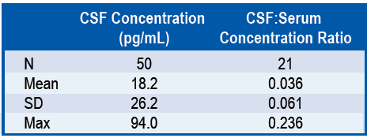
Reference: Klinger M, Zugmaier G et al.: Blood 2016, 128: 1589
In a blinatumomab study of adult subjects with relapsed non-Hodgkin lymphoma (Study MT103-104), there were 8 subjects who had CSF samples measured. The same CSF assay was used for the analysis. Among the 8 subjects, blinatumomab concentrations in the CSF samples were detected in 7 subjects. The CSF concentration range was from 10 to 75 pg/mL. 6 of the 8 subjects received 60 µg/m²/day dose; one received 15 µg/m²/day dose and one received 90 µg/m²/day dose (see Table 53, below). The doses of blinatumomab in these adults were higher or equal than the doses in the paediatric subjects.

Table 53. List of subjects with CSF samples in Trial MT103-104 in relapsed non-Hodgkin lymphoma (HHL)
Patient ID | Dose when CSF samples taken | Time at which CSF samples were taken | CSF concentration (pg/mL)
1 | 60 µg/m²/day | During infusion | 11
2 | 60 µg/m²/day | During infusion | 20
3 | 15 µg/m²/day | 2 h 15 min post infusion | 20
4 | 90 µg/m²/day | 45 min post infusion | < LLOD
5 | 60 µg/m²/day | 7 h, 25 min post infusion | 45
6 | 60 µg/m²/day | 8 h 45 min post infusion | 10
7 | 60 µg/m²/day | n/a | 20
8 | 60 µg/m²/day | During infusion | 75
In blinatumomab trials conducted in adult subjects, bone marrow aspirations and lumbar punctures on a regular basis would not have been tolerated. In most adults, these procedures are not routinely performed and only with local anaesthesia; there is a risk associated with general anaesthesia in older subjects. Lumbar punctures were conducted for measurement of blinatumomab CSF concentrations only in a few patients with neurological toxicities. Encephalopathy was observed in these patients including confusion, and disorientation.
The CSF levels measured in adult subjects with neurological toxicities were not substantially higher than those in paediatric subjects without neurological toxicities. Limitations of this comparison include different patient populations, different time points of measurement, and different doses.
In summary, the data do not indicate that presence of blinatumomab in CSF seems to be a sufficient condition for neurological toxicities.

Evaluator’s comment
The sponsor’s response is accepted.

Question 2. Justification of BSA-based dosing given popPK results
Can the sponsor please explain their recommendation of a BSA-based dose in Phase I, the choice to continue with BSA based dosing in Phase II, and in the context of such dosing recommendations, justify the conclusions of PK report 120689, which concludes that BSA does not affect PK?

Sponsor’s response
When the drug was first dosed in the first-in-man study, a conservative BSA-based dosing paradigm (common for oncology therapeutics) was tested and the approach was applied to a total of 5 studies including paediatric Study MT103-205 (see Table 54, below).

Table 54. Trials of blinatumomab by body surface area (BSA) or fixed dosing
Phase | Study Number | Patient population | Dosing Paradigm
I | MT103-104 | Adult NHL | BSA based dosing
II | MT103-202 | Adult MRD+ ALL | BSA based dosing
II | MT103-203 | Adult MRD+ ALL | BSA based dosing
II | MT103-205 | Paediatric R/R ALL | BSA based dosing
II | MT103-206 | Adult R/R ALL | BSA based dosing
II | MT103-208 | Adult DLBCL | Fixed dosing
II | MT103-211 | Adult R/R ALL | Fixed dosing
II | 20120216 | Adult Ph+ R/R ALL | Fixed dosing
III | 00103311 | Adult R/R ALL | Fixed dosing
Due to the high prevalence of ALL in children, the development of a paediatric indication for R/R ALL was started early in the blinatumomab clinical program. With parallel development pathways for adult and paediatric indications of R/R ALL, there was insufficient PK data for modelling or to inform the paediatric dosing regimen in Study MT103-205. Instead, a dose escalation phase (Phase I of Study MT103-205) was included to assess PK, efficacy, and safety in paediatric patients for selection of a dosing regimen to be further tested in the dose expansion phase (Phase II of Study MT103-205). Based on the results of Phase I of Study MT103-205, a BSA based dosing regimen of 5 to 15 µg/m²/day was selected for further evaluation in Phase II of Study MT103-205. Based on the clinical and safety results of 5 to 15 µg/m²/day dosing regimen, it was recommended for the paediatric indication.
From a clinical perspective, a BSA based regimen of 5 to 15 µg/m²/day was determined based on Phase I clinical data by a data review committee (DRC) and confirmed by the Data Safety Monitoring Board (DSMB). The MTD (when initiating at target dose) was determined to be 15 µg/m²/day. As cytokine release-related adverse events occurred mainly at beginning of treatment, the initial dose of 5 µg/m²/day in Week 1 was found to effectively minimise the magnitude of cytokine release and the risk of CRS. Based on the efficacy results observed with the 5 to 15 µg/m²/day regimen, and the safety events observed above the MTD of 15 µg/m2/day, the regimen of 5 to 15 µg/m²/day was selected for Phase II of Study MT103-205.
To confirm the appropriate dosing regimen for adult and paediatric patients, the pharmacokinetics, efficacy, and safety data from adults in Study MT103-211 and the paediatric Study MT103-205 were further evaluated. Results confirmed that body weight was not a sensitive factor affecting blinatumomab clearance while BSA had a small effect on the clearance. However, inter-subject variability in exposure was large, and clinical relevance of the BSA effect is unknown (blinatumomab US PI, 2016).
Nonetheless, to be conservative, BSA based dosing is now recommended to subjects with body weight < 45 kg in the blinatumomab United States Prescribing Information (2016).
While lower weight cut-offs for conversion to fixed dosing of 9 to 28 µg/day were considered based on the pharmacokinetic and efficacy assessments, the resulting administered dose could significantly exceed the maximum tolerated dose of 15 µg/m²/day in paediatrics, where there is limited safety experience. The converted BSA-based dose for the 9 to 28 µg/day fixed dosing regimen is 6 to 20 µg/m²/day for a 45 kg paediatric patient (assuming a BSA range of 1.4 to 1.5 m²), which is higher than the recommended paediatric dose of 5 to 15 µg/m²/day. Only 6 subjects have been treated in the paediatric population at a dose of 30 µg/m²/day when using a step-dosing paradigm. Therefore, the dosing regimen of 5 to 15 µg/m²/day in paediatric patients is considered the most safe and effective dose in children weighing < 45 kg.
The population PK analysis was conducted after the primary analysis of Study MT103-205 (Report 120689). Effect of BSA on the PK was evaluated retrospectively with the data generated from adult and paediatric trials. The results show that BSA was not a significant covariate on clearance when creatinine clearance was included as a covariate and the effect size of BSA on the drug clearance was not sufficient for a PK based dose adjustment. Therefore, BSA based dosing in paediatrics with body weight < 45 kg was mainly determined based on safety data.

Evaluator’s comment
The sponsor’s response is accepted. Essentially, BSA based dosing was investigated, and later popPK analysis suggested it did not significantly affect exposure. The adequacy of the popPK analysis, rather than the appropriateness of BSA based dosing, appears to be the issue at hand. The popPK expert is deferred to on this matter. BSA based dosing in children appears to be appropriate based principally on safety data.

Question 3. Reasoning for null and alternative hypothesis selection
The reasoning and process taken in deciding the reference population values for the null (10%) and alternative (27.5%) hypotheses isn’t stated explicitly. Can the sponsor please clarify why these values were chosen?

Sponsor’s response
At the time of protocol development (Study MT103-205 protocol), the 4 most recently published Children’s Oncology Group Phase I studies of drugs approved for other cancers in adults had not provided evidence of significant single agent anti-leukaemia activity. For example, none of 9 children with ALL responded to bortezomib (Horton, 2007a). One of 20 children treated with gemcitabine had a response (Angiolillo, 2006). A subsequent German trial showed that none of 4 children with ALL responded to gemcitabine (Wagner-Bohn, 2006). None of 10 children with ALL responded to docetaxel (Franklin, 2008). None of 8 children with ALL had a complete remission to temozolomide (Horton, 2007b) (Horton, 2007a). One of 13 children with relapsed ALL responded to alemtuzumab (Angiolillo, 2009). In relapsed paediatric ALL patients, a clofarabine trial reported a response rate of 12/61 (19.7% (10.6%, 31.8%)) (Jeha, 2006) (Pui, 2007). As described above, at the time of protocol development, previous studies of single agent anti-cancer agents in ALL by study groups in patient populations comparable to this patient population reported CR rates of less than 10%. In the Phase II clofarabine trial, 10% is below the reported 95% confidence interval for the response rate. In this clinical context, the consensus point estimate for efficacy for a single agent in second or greater relapse, relapse after allogeneic HSCT, or refractory paediatric ALL is a CR rate of 10%, which was chosen as the null hypothesis proportion for the Phase II portion of the study. For a study population of 40 patients, given a 10% null hypothesis proportion, sample size calculations indicate a true CR rate of 27.5% would have a 2 sided 95% confidence interval (14.6%, 43.9%). The 27.5% CR threshold clearly indicates an efficacy similar or higher than for clofarabine, and the study was expected to have adequate power to detect a CR rate that is decidedly better than 10%, by virtue of a lower bound to the 2 sided 95% CI that excludes 10%.

Evaluator’s comment
The sponsor’s response is accepted.
It is noted that the response rate of 20% in the clofarabine trial (Jeha et al, 2006) described above includes both CR with full peripheral count recovery and CRs with recovery of neutrophils but not platelets (‘CRp’). The variable response criteria between trials make them very difficult to compare in a meaningful way.
In that study, the rate of CR with full peripheral count recovery was 7 patients of 61 (12%).
In this context, the rate of CR with full peripheral count recovery seen in Study 103205 (17%) and the rate of CR with partial peripheral count recovery (around 33%) are favourable, despite the small sample size and large confidence intervals. The Phase III confirmatory trial should be expected to clarify the size of the benefit.

Question 4. Regarding FAS versus PPS in Study 103205
Can the sponsor please confirm the presumed reason for excluding a specified subject is correct, and provide information on the treatment course for another specified subject, including whether the non-permitted medication is likely to have contributed to the response and the achievement of HSCT. Can the sponsor please explain why the PPS results are not the ones cited in the PI, and the FAS results instead are cited?

Sponsor’s response
It is the sponsor’s convention to evaluate all patients treated in single arm trials. This analysis comes closest to an intent-to-treat analysis in a randomised trial.
The sponsor confirms that the first specified subject was excluded from the PPC as he was deemed to violate the following exclusion criterion provided in protocol version 2:
’16. Active severe infection, any other concurrent disease of medical condition that could be exacerbated by the treatment or would seriously complicate compliance with the protocol. An active infection is defined as:
- Positive blood culture within 48 hours prior to blinatumomab treatment
- Fever above 38.2 ˚C within 48 hours prior to blinatumomab treatment with clinical signs of infection’.
The subject's medical history reported by the investigator included ALL which relapsed while on therapy and the subject was admitted for pyrexia and neutropenia on 30 November 2012. Treatment with blinatumomab started on 12 December 2012.
The chest X-ray studies a couple of days before treatment and during treatment with blinatumomab are described below:
- On 7 December 2012, chest X-ray showed: interstitial prominence with bilateral airspace disease possibly related to pneumonia.
- On 13 December 2012, chest X-ray showed: left upper peripherally inserted central catheter (PICC) line to the superior vena cava (SVC), increase in left pleural effusion and stable left basilar consolidation and hazy bilateral airspace opacities.
- On 14 December 2012, chest X-ray showed: interstitial and airspace disease could represent pneumonia possibly with a component of pulmonary oedema; small left pleural effusion.
- On 16 December 2012, abdomen X-ray showed: mild gaseous distention of the bowel with persistent left basilar airspace opacity.
- On 17 December 2012, X-ray of the chest, abdomen and pelvis revealed: chest: a catheter extended from the right neck to the right heart, a PICC line extended from the left arm to the SVC, a feeding tube extended through the oesophagus to the stomach, the heart was normal in size, there was alveolar density with air bronchograms within the right upper lobe, right middle lobe and left lower lobe consistent areas of atelectasis or pneumonia, and no pleural fluid or pneumothorax was seen.
The second specified subject had an MRD negative CR at the end of Cycle 1. Because the investigator had erroneously assumed that chemotherapy was not only permitted before start of treatment but also before start of each treatment cycle he administered a single injection of vincristine 1.5 mg/m² on the 12 April 2014 between Cycle 1 and Cycle 2. The patient remained in MRD: negative CR during blinatumomab treatment and underwent a haplo identical transplantation with the father as donor after the second cycle of blinatumomab. The patient is still in remission as of today. It is unlikely that the single injection of vincristine has essentially contributed to this continuing remission, but it cannot be completely excluded.

Evaluator’s comment
The sponsor’s response is accepted.

Question 5. Choice of primary endpoint
With regard to endpoints in Study 103205, can the sponsor please state why:
  - they chose to use surrogate endpoint CR as the primary outcome for the study?
  - they defined CR to include CRc, CR* and CR3?

Sponsor’s response
  - CR was used as endpoint, because Study MT103-205 was single arm trial. For assessment of event-based trials and time-to event endpoints randomized designs are needed. Because presence of CR is a requirement for relapse free and overall survival (Oncopedia Guidelines 2012), it was considered appropriate to use CSR as primary endpoint.
  - In the paediatric ALL setting, the M grading system is used to define haematologic remissions (Lauten et al, 2012, Schrappe et al, 2012). A CR is defined as M1 bone marrow (< 5% blasts in evaluable bone marrow) with no evidence of circulating blasts or extra-medullary disease. This is the common denominator for the definition of CR accepted by all paediatric study groups. Unlike in the adult ALL setting, achievement of CR in paediatric patients does not depend on recovery of peripheral blood counts. Paediatric haematologists generally do not consider full recovery of peripheral blood counts when making treatment decisions, mainly due to situations that are not related to remission status. For example, if a patient achieves a CR, but acquires an infection that consumes the neutrophils, the patient would lose the CR status if peripheral blood counts were considered. Additionally, there are no unanimously agreed upon cut-offs for peripheral blood counts in the paediatric setting. The one exception is clofarabine, which has a selective myelotoxic effect on platelet production. For this reason, clofarabine uses CR or CRp, which fulfils all of the criteria for a CR except that platelet counts are < 100 x 109/L (Clolar PI, 2014).
In Study MT103-205, the CR rate within 2 cycles of study treatment was evaluated as the primary efficacy endpoint. A CR was defined as M1 bone marrow (< 5% blasts in evaluable bone marrow) with no evidence of circulating blasts or extramedullary disease (as described above, per Lauten et al, 2012). As supportive information, subjects with CR were subclassified based on their peripheral blood counts:
- M1 bone marrow with full recovery of peripheral blood counts: met the criteria for CR with platelets > 100 × 109/L and absolute neutrophil count (ANC) of > 1.0 x 109/L
- M1 bone marrow with incomplete recovery of peripheral blood counts: met the criteria for CR but platelets > 50 x 109/L and <100 x 109/L and ANC > 0.5 x 109/L and < 1.0 x 109/L
- M1 marrow that did not qualify for full or incomplete recovery of peripheral blood counts: met the criteria for CR without complete or incomplete recovery of peripheral blood counts.
While the optimal situation may be to have M1 with full recovery of peripheral blood counts, in this heavily pretreated ALL population (which includes patients who have received conditioning agents for allogeneic HSCT), bone marrow recovery may be delayed due to previous chemotherapy and radiation. Achieving M1 bone marrow with incomplete or without full or incomplete peripheral blood count recovery is typically sufficient to proceed to allogeneic HSCT rather than waiting for full peripheral blood count recovery and risking another relapse. However, given additional time to recover, some patients may convert to M1 bone marrow with full peripheral blood count recovery after achieving M1 bone marrow with incomplete peripheral blood count recovery, as shown in the blinatumomab Study MT103-205 below.
M1 bone marrow with full recovery of peripheral blood counts is comparable to the definition of CR with full hematologic recovery used in the adult relapsed/refractory ALL studies in the original marketing application: that is, below 5% blasts in the bone marrow, no evidence of disease, and full recovery of peripheral blood counts (platelets > 100,000/µL and absolute neutrophil counts (ANC) > 1,000/µL).
M1 bone marrow with incomplete recovery of peripheral blood counts is comparable to the definition of complete remission with partial hematologic recovery (CRh*) used in the adult relapsed/refractory ALL studies in the original marketing application: that is, ≤ 5% blasts in bone marrow, no evidence of disease, and partial recovery of peripheral blood counts (platelets > 50,000/µL and ANC > 500/µL).
RFS and OS outcomes for the 4 paediatric subjects who achieved CR, but did not attain at least a partial recovery of peripheral blood counts during the first 2 cycles, are provided in Table 55, below.

Table 55. List of subjects with M1 marrow but no partial recovery of peripheral blood counts
RFS Duration (outcome) | OS Duration (outcome) | MRD response
8.3 months (censored; relapse free at the last assessment and completed the 2-year follow-up in remission) | 11 months (alive at last follow up visit) | complete response
3.4 months | 9.3 months (death) | MRD nonresponse
2.1 months (relapse) | 3.2 months (death) | MRD complete response
0.9 months (relapse) | 5.2 months (death) | MRD nonresponse
These data show that subjects with partial or incomplete recovery of peripheral blood counts can achieve clinical benefit by blinatumomab. As shown in the table above, the data also demonstrate that molecular remission (that is, MRD complete response) is a key factor for durable remission.

Evaluator’s comment
Table 55 of the response indicates that longer term survival is correlated with MRD response, but that shorter relapse free response periods can also be seen with bone marrow response in the absence of any peripheral count recovery. In a single arm study such as this, the correlation with a clinical benefit such as improved OS is not able to be clearly derived, as the chosen endpoint has not been proven to correlate with clinical benefit in such a way.
The majority of the sponsor’s response is cut and pasted from the original submission (one sentence even references ‘as shown in blinatumomab Study MT103-205 below’) and does not add to the considerations already discussed in the first round evaluation.
In particular, no additional evidence has been provided to support the following statements:
‘Unlike in the adult ALL setting, achievement of CR in paediatric patients does not depend on recovery of peripheral blood counts.’
‘Paediatric haematologists generally do not consider full recovery of peripheral blood counts when making treatment decisions, mainly due to situations that are not related to remission status.’
‘There are no unanimously agreed upon cut-offs for peripheral blood counts in the paediatric setting.’
‘Achieving M1 bone marrow with incomplete or without full or incomplete peripheral blood count recovery is typically sufficient to proceed to allogeneic HSCT rather than waiting for full peripheral blood count recovery and risking another relapse.’
Whether these generalisations are accurate of Australian clinical practice remains unclear, however, given the usage of a similar endpoint in the Phase II study of clofarabine as a monotherapy that has been used in selection of the null hypothesis, the choice of endpoint is reasonable.
Whilst it is recognised that similar endpoints were also used in the adult study on which Blincyto registration was based, the results of that study were conclusive with regard to CR alone, without having to rely on the combined category of CR/CRh* for a response rate with lower confidence interval bound higher than 20% (the relevant null hypothesis).

Question 6. Discrepancies in RFS results between different parts of the dossier
There were discrepancies noted in the figures cited in text (of the CSR for Study 103205), a specified table and the source tables for these compared to the RFS source tables. Examples include the cited median RFS for 2 week best response CRc in the 5 to 15 µg/m²/day FAS in the former sources (8.1 months, 95% CI 1.9 to 13.9 months) versus the cited values in the latter source: those included in the table above for the same group. This prevents meaningful analysis of the data and calls into question the accuracy of other cited results throughout the study.
Can the sponsor please confirm which RFS results are correct, and explain these discrepancies?

Sponsor’s response
When broken down by response type depending on peripheral blood counts (that is, CRc and CR*), RFS can be calculated in 2 different ways. One way is to begin the response measurement from the first occurrence of any response type regardless of complete recovery of peripheral blood counts. For example, if a subject first achieves a CR* that later converts to a CRc, then the response measurement would start with the date of the CR*. The other way is to begin the response measurement from the first occurrence of CR with complete recovery of peripheral blood counts (CRc). For the latter example, the response measurement would start from the first occurrence of a CRc. The RFS numbers reported in the text of the CSR represent the former calculation and are consistent with the method used for the [specified] source tables and onwards. The RFS numbers reported in [other specified] source tables are based on the latter method. The different methods impact the RFS values for 7 out of the 12 CRc responders treated at the 5 to 15 µg/m²/day dose regimen. These are summarised in Table 56 below.

Table 56. Subjects treated at 5 to 15 µg/m²/day who achieved a CR* before a CRc
Date of first CR* Response | Date of first CRc Response | RFS Using Start of CR* | RFS Using Start of CRc
7 November 2013 | 21 November 2013 | 81 | 67
20 May 2014 | 15 July 2014 | 71 | 15
28 October 2013 | 14 November 2013 | 353 | 336
11 November 2013 | 09 January 2014 | 425 | 366
15 July 2013 | 26 August 2013 | 158 | 116
13 March 2014 | 02 April 2014 | 58 | 38
02 June 2014 | 20 June 2014 | 194 | 176
The sponsor considers that the method used to report RFS in the text of the CSR represents the most appropriate measure of RFS since it considers the start of a remission with clinical benefit (< 5 % blasts, absence of extramedullary disease, and partial recovery of platelets and neutrophils) that later evolves with continued dosing to a truly complete remission with the added benefit of full recovery of platelets and neutrophils.

Evaluator’s comment
The sponsor’s response is accepted.

Question 7. Accuracy of HSCT rate in patients 7 to 9 months post response
The sponsor states (Study 103205 CSR) that the HSCT data by duration of response to HSCT show that 25% of patients still eligible to receive a transplant at 7 to 9 months did so, referencing a specified table. The data in that Table does not appear to support such a conclusion (see Table 26, above).

Sponsor’s response
The sponsor apologises for the error in the study report. Please note the correction below. Among the 4 time intervals considered (1 to 3 months, 4 to 6 months, 7 to 9 months, and ≥ 10 months after achieving CR), the highest rate of transplantation among those eligible to receive one was during the 1 to 3 month time interval; the probability of undergoing a transplant among those still eligible to receive one during this time interval was 34%.
The probability of undergoing a transplant among those still eligible to receive one during the 4 to 6 month time interval was 18%.

Evaluator comment
The sponsor’s response is accepted.

Question 8. Post-HSCT mortality comparator rate
The mortality rate post-HSCT in the 8 subjects who received an allogeneic HSCT while in remission induced by blinatumomab treatment and without any other subsequent anti-leukemic medication was 50% between 6 and 8 months, and 100% at 16 months. What is the rate of mortality post-HSCT in a comparable population?

Sponsor’s response
8 subjects received an allogeneic HSCT while in remission induced by blinatumomab treatment without any other subsequent anti-leukaemic medication in the interval between blinatumomab treatment and allogenic HSCT. After the 2 year follow up, 1 (12.5%) of the 8 subjects was still alive. This subject had received the Interfant 6 treatment protocol as first line therapy and undergone 2 allogeneic HSCT’s prior to blinatumomab treatment. In addition, this subject had experienced an engraftment failure of the first allogenic HSCT prior to blinatumomab treatment and a relapse before engraftment of the second transplant prior to blinatumomab treatment. The allogenic HSCT after blinatumomab treatment was the third allogenic HSCT in this subject. In the 7 subjects who died within the 2 year follow up, no case of Graft versus Host Disease was observed. Three subjects died after disease progression, one after veno-occlusive disease and multi-organ failure as a complication of allogenic HSCT and 3 after complications from infections. Six of the 8 subjects had already undergone at least one allogenic HSCT before start of treatment with blinatumomab.
In addition, 6 of the 8 subjects with or without prior allogenic HSCT had been refractory to chemotherapy prior to blinatumomab. In our population for 70% of subjects the last treatment-free interval until treatment start with blinatumomab was 6 months or less.
Length of prior remission, which is comparable to last treatment-free interval, is one of the important prognostic factors for patients in first and second relapse (Chessells et al, 2003).
For the 2 remaining subjects, allogenic HSCT after blinatumomab was their third allogenic HSCT. Four of the 8 subjects had blinatumomab as third line treatment, 3 subjects had blinatumomab as 4th line treatment, and one subject had blinatumomab as fifth line treatment.
Table 57 below shows the patient characteristics in detail.

Table 57. Subjects with allogeneic HSCT while in remission induced by blinatumomab treatment and without any other subsequent anti-leukemic medication
Prior HSCT | Type of relapse | Line of treatment with blinatumomab
No | Refractory first relapse | Third line
No | Refractory second relapse | Fourth line
Yes | Relapse after 2 prior HSCTs.  Note this patient is still alive | Third line
Yes | Refractory second relapse | Fourth line
Yes | Refractory first relapse | Third line
Yes | Refractory second relapse, 2 prior HSCCTs | Fifth line
Yes | Refractory first relapse | Third line
Yes | Second relapse, 2 prior HSCTs | Fourth line
In the subjects who are refractory to prior treatment attempts with chemotherapy, the probability to achieve another remission enabling allogenic HSCT is low (Ko et al 2010). It is challenging to find published literature for the role of allogenic HSCT in a mostly refractory population. The 2 year survival at CR after 4th line treatment with multi-agent chemotherapy is 13% (Ko et al 2010), but this does not reflect the high number of subjects with refractory disease in our population.

Evaluator’s comment
The sponsor’s response is accepted.

Question 9. PCR MRD rates
Can the sponsor please provide an analysis of all subjects who had PCR analysis for MRD response, including the rate of MRD response in this group, and their other outcomes?

Sponsor’s response
The sponsor has conducted the requested analysis shown below in Table 58 using the full analysis set from Study MT103-205, including subjects from both study phases and all dose groups but restricted to only include data from 26 subjects for whom a PCR assay was used to determine MRD response.
Table 58 shows the overall MRD response rates within this subpopulation. Among the 26 subjects with PCR assay results, 16 (61.5%) achieved an MRD response, 11 of which were MRD complete responses. Among the 16 PCR based MRD responders, 9 (56.25%) received an HSCT, 6 of which were after a CR induced by blinatumomab. The median OS among these 16 PCR-based MRD responders was 17.3 months. 20 of the 26 subjects with PCR results achieved a CR. Among these twenty, 13 (65.0%) achieved a PCR-based MRD response, 9 of which were MRD complete responses.

Table 58. Overview of MRD response rates for subjects with PCR assessments (FAS)
Characteristic category | MRD Response |  | (95% CI)ª
 | n | %
Overall within first 2 cycles (N = 26)
MRD response | 16 | 61.5 | (40.6, 79.8)
Complete MRD response^{b} | 11 | 42.3 | (23.4, 63.1)
Subjects with CR during the first 2 cycles (N = 20)
MRD response | 13 | 65.0 | (40.8, 84.6)
Complete MRD response^{b} | 9 | 45.0 | (23.1-68.5)
Subjects with CR and MRD assessments during the first 2 cycles (N = 20)^{c}
MRD response | 13 | 65.0 | (40.8, 84.6)
Complete MRD response^{b} | 9 | 45.0 | (23.1, 68.5)
Subjects with M1 with complete recovery of peripheral blood counts during the first 2 cycles (N = 11)
MRD response | 7 | 63.6 | (30.8, 89.1)
Complete MRD response^{b} | 5 | 45.5 | (16.7, 76.6)
CI = confidence interval; CR = complete remission; MRD = minimal residual disease; a) 95% CI: lower limit and upper limit of the 2-sided exact 95% confidence interval are provided; b) Complete MRD response is a subset of MRD response; c) Excludes subjects with no MRD data.
Complete MRD response: No detectable signal for leukemic cells measured by FC. If a PCR result was available at a specific visit but no FC result, then the PCR result was taken into account.
MRD response: MRD < 10⁻⁴ measured by FC. If a PCR result was available at a specific visit but no FC result, then the PCR result was taken into account. Data cut-off: 12 January 2015.

Evaluator’s comment:
The sponsor’s response is accepted.

Question 10. Systematic review study selection flow
The information in the schematic of study selection taken from the CSR for Study 120521 (see Figure 13) differs from the information stated in the report. Can the sponsor please confirm which data is correct regarding number of studies included, how many were paediatric and the minimum study size for inclusion?

Sponsor’s response
The complete list of studies included in the analysis is provided in a table in the report for Study 120521. Details of which studies were excluded and reasons for exclusion are provided in a section of the report for Study 120521. The minimum study size for inclusion in the analysis was 20 subjects which was reported incorrectly as 30 subjects in a figure from Study 120521. A summary of the studies included in the analysis is provided in Table 59, below.

Table 59. Number of studies (number of paediatric and adult subjects) included in Study 120521
Population | Number of studies (number of subjects) included in Study 120521
Population | CR | EFS | OS
Paediatric | 31 (3770) | 6 (644) | 25 (6465)
Adult | 22 (2658) | 7 (385) | 18 (3264)

Evaluator’s comment
The sponsor’s response is accepted.

Question 11. Fatal case count discrepancy
In a specified table of the CSR, the total number of ‘AEs leading to death’ for the Phase I/II FAS is stated to be 17 events (16 patients). However, 59 adverse event cases were identified in a listing of the CSR that had a fatal outcome. Can the sponsor please explain this discrepancy?

Sponsor’s response
As described in the CSR for Study MT103-205, up to the data cut-off date (12 January 2015), 16 of the 93 subjects in the Phase I/II FAS died due to an adverse event.
The listing in the CSR contains all deaths that occurred up to the data cut-off date.
In addition to subjects who died due to an adverse event, this listing also includes deaths that were not required to be reported as adverse events, per the adverse event reporting requirements in the study protocol. Of the 59 subjects in the listing, 16 subjects experienced an adverse event that was reported with a fatal outcome; these 16 subjects are those with a preferred term for the fatal adverse event recorded in the listing. The remaining 43 subjects in the listing died either more than 30 days after the last blinatumomab infusion, after HSCT, or after the start of alternative anti-leukaemic therapy; therefore, these deaths were not reported as adverse events. The majority of these 43 subjects died due to progression of ALL.

Question 12. Fatal case table discrepancy in Study 20130320
‘Table 8-5’ as referred to in the interim CSR contains a listing of 3 events. However, the evaluator is confused by the statement mid-paragraph that ‘2 additional deaths occurred more than 30 days after treatment discontinuation’, as the deaths listed in ‘Table 8-5’ all occurred within 30 days of last dose (see ‘last dose day’ column).
Can the sponsor please clarify:
  - Were there 2 additional deaths that occurred later than 30 days after last dose?
  - If so, why have they not been included in ‘Table 8-5’, as it is stated to be a ‘listing of all deaths (regardless of the end of blinatumomab treatment)’?

Sponsor’s response to Question 12a and 12b
Table 41 in the interim CSR for Study 20130320 provides a listing of all deaths that occurred in the study up to the data cut-off date of 20 August 2015. Among the 3 deaths listed in Table 41, only one subject died within 30 days of the last dose of blinatumomab. Two additional deaths occurred more than 30 days after treatment discontinuation. The other 2 subjects listed in the table died 105 and 49 days after the last dose of blinatumomab, respectively. Therefore, all deaths, regardless of the end of blinatumomab treatment, are accounted for in Table 41.

Evaluator’s comment
The evaluator expresses their apologies; this had been misinterpreted as ‘Last dose day’ as meaning ‘last dose (days ago)’.
The sponsor’s response is accepted.

Second round benefit-risk assessment

Second round assessment of benefits
Unchanged by responses to Clinical Questions.
The uncertainties around efficacy benefit are adequately described in the PI.

Second round assessment of risks
There remains an under-characterised risk of BSA based dosing given the evidence presented.

Second round assessment of benefit-risk balance
The evidence of efficacy in paediatrics remains limited by the single arm nature of the trial, the small sample size and the use of a primary endpoint that has not been conclusively shown to correlate with clinical benefit. However, given the population in question have limited treatment options and is small, it is accepted that this evidence is the best likely to be available and suggests non-inferiority to other last line therapies, especially given the consistency with efficacy results seen in adults. The safety profile in paediatric patients is reasonably established by the available data, and risks of usage are outweighed by the risks of not treating, given the natural history of this condition if untreated. The benefit-risk balance of Blincyto, given the proposed usage, is therefore favourable.

Second round recommendation regarding authorisation
The approval of the changes to Blincyto registration for use in paediatrics to not be excluded from the indication is deferred to the Delegate.

References
Australian Institute of Health and Welfare (AIHW) (2016). Australian Cancer Incidence and Mortality (ACIM) books: Acute lymphoblastic leukaemia (ALL). Canberra: AIHW.
Brookmeyer, R. and Crowley, J. (1982) A Confidence Interval for the Median Survival Time, Biometrics, 38, 29-41.
Cavé H, et al. (1998). Clinical significance of minimal residual disease in childhood acute lymphoblastic leukemia. European Organization for Research and Treatment of Cancer--Childhood Leukemia Cooperative Group. N Engl J Med. 1998;339(9):591.
Chessells J. (1998) Relapsed lymphoblastic leukaemia in children: A continuing challenge. Br J Haematol 102:423–438.
Forward H, et al. (2010). Twenty-five years of treatment for childhood acute lymphoblastic leukaemia in Western Australia: how do we compare? Med J Aust 2010; 193 (10): 585-589.
Gaynon P. Childhood acute lymphoblastic leukaemia and relapse. Br J Haematol. 2005;131:579-587.
Horton T and Steuber C (2010). Overview of the treatment of acute lymphoblastic leukemia in children and adolescents. UpToDate topic: literature review current through August 2016.
Horton T and Steuber C (2016). Risk group stratification and prognosis for acute lymphoblastic leukemia in children and adolescents. UpToDate topic: literature review current through August 2016.
Kaplan E and Meier P. (1958) Nonparametric estimation from incomplete observation. J Am Stat Assoc, 53:457-481.
Ko R, et al. Outcome of patients treated for relapsed or refractory acute lymphoblastic leukemia: a Therapeutic Advances in Childhood Leukemia Consortium study. J Clin Oncol. 2010;28:648-654.
Lee D, et al. (2015) T cells expressing CD19 chimeric antigen receptors for acute lymphoblastic leukaemia in children and young adults: a phase 1 dose-escalation trial. Lancet. 2015;385(9967): 517.
Leukaemia Foundation Australia (2010). Acute Lymphoblastic Leukaemia (ALL) in children (patient booklet). Accessed 22/09/2016. Available at:
Leukaemia Foundation Australia (2016). Acute Lymphoblastic Leukaemia (ALL).
Messinger Y, et al. Therapeutic Advances in Childhood Leukemia&Lymphoma (TACL) Consortium (2012) Bortezomib with chemotherapy is highly active in advanced B-precursor acute lymphoblastic leukemia: Therapeutic Advances in Childhood Leukemia&Lymphoma (TACL) Study. Blood. 2012 Jul;120(2):285-90.
Nachman J, et al. (1998) Augmented post-induction therapy for children with high-risk acute lymphoblastic leukemia and a slow response to initial therapy. N Engl J Med. 1998;338(23):1663.
Neale G, et al. Comparative analysis of flow cytometry and polymerase chain reaction for the detection of minimal residual disease in childhood acute lymphoblastic leukemia. Leukemia. 2004 May;18(5):934-8.
O'Connor D, et al. (2011) Early UK experience in the use of clofarabine in the treatment of relapsed and refractory paediatric acute lymphoblastic leukaemia. Br J Haematol. 2011;154(4):482.
Simon R. Optimal two-stage designs for phase II clinical trials. Control Clin Trials. 1989;10:1-10.
Skolnik J, et al. 2008. Shortening the Timeline of Pediatric Phase I Trials: The Rolling Six Design. Journal of Clinical Oncology, 26, 190-195.
Steinherz P, et al. 1996 Cytoreduction and prognosis in acute lymphoblastic leukemia - the importance of early marrow response: report from the Childrens Cancer Group. Journal of Clinical Oncology 14 389-398.
Tavernier E, et al. Outcome of treatment after first relapse in adults with acute lymphoblastic leukemia initially treated by the LALA-94 trial. Leukemia. 2007;21:1907-1914.
Vora A, et al. (2014) Augmented post-remission therapy for a minimal residual disease-defined high-risk subgroup of children and young people with clinical standard-risk and intermediate-risk acute lymphoblastic leukaemia (UKALL 2003): a randomised controlled trial. Lancet Oncol. 2014 Jul;15(8):809-18.
Wang K, et al. CD19: a biomarker for B cell development, lymphoma diagnosis and therapy. Exp Hematol Oncol. 2012;1:3.

Therapeutic Goods Administration
PO Box 100 Woden ACT 2606 Australia
Email: info@tga.gov.au Phone: 1800 020 653 Fax: 02 6232 8605
https://www.tga.gov.au

Leukaemia Foundation Australia (2010). Acute Lymphoblastic Leukaemia (ALL) in children (patient booklet).
Wang K, et al. CD19: a biomarker for B cell development, lymphoma diagnosis and therapy. Exp Hematol Oncol. 2012;1:3.
Leukaemia Foundation Australia (2016). Acute Lymphoblastic Leukaemia (ALL).
Australian Institute of Health and Welfare (AIHW) (2016). Australian Cancer Incidence and Mortality (ACIM) books: Acute lymphoblastic leukaemia (ALL). Canberra: AIHW.
Horton T and Steuber CP (2010). Overview of the treatment of acute lymphoblastic leukemia in children and adolescents. UpToDate topic: literature review current through August 2016.
Horton T and Steuber C (2016). Risk group stratification and prognosis for acute lymphoblastic leukemia in children and adolescents. UpToDate topic: literature review current through August 2016.
Cavé H, et al. (1998). Clinical significance of minimal residual disease in childhood acute lymphoblastic leukemia. European Organization for Research and Treatment of Cancer, Childhood Leukemia Cooperative Group. N Engl J Med. 1998;339(9):591.
Vora A, et al. (2014) Augmented post-remission therapy for a minimal residual disease-defined high-risk subgroup of children and young people with clinical standard-risk and intermediate-risk acute lymphoblastic leukaemia (UKALL 2003): a randomised controlled trial. Lancet Oncol. 2014 Jul;15(8):809-18.
Nachman J et al. (1998) Augmented post-induction therapy for children with high-risk acute lymphoblastic leukemia and a slow response to initial therapy. N Engl J Med. 1998;338(23):1663.
Gaynon P. Childhood acute lymphoblastic leukaemia and relapse. Br J Haematol. 2005;131:579-587.
Ko R, et al. Outcome of patients treated for relapsed or refractory acute lymphoblastic leukemia: a Therapeutic Advances in Childhood Leukemia Consortium study. J Clin Oncol. 2010;28:648-654.
Forward H, et al. (2010). Twenty-five years of treatment for childhood acute lymphoblastic leukaemia in Western Australia: how do we compare? Med J Aust 2010; 193 (10): 585-589.
Attachment 2, Extract from the Clinical Evaluation Report for PM-2014-03864-1-4 Blinatumomab (Blincyto) Amgen. TGA; Canberra, Australia
Chessells J (1998) Relapsed lymphoblastic leukaemia in children: A continuing challenge. Br J Haematol 102:423–438.
Tavernier E, et al. Outcome of treatment after first relapse in adults with acute lymphoblastic leukemia initially treated by the LALA-94 trial. Leukemia. 2007;21:1907-1914.
O'Connor D, et al. (2011) Early UK experience in the use of clofarabine in the treatment of relapsed and refractory paediatric acute lymphoblastic leukaemia. Br J Haematol. 2011;154(4):482.
Messinger Y et al. Therapeutic Advances in Childhood Leukemia&Lymphoma (TACL) Consortium (2012) Bortezomib with chemotherapy is highly active in advanced B-precursor acute lymphoblastic leukemia: Therapeutic Advances in Childhood Leukemia&Lymphoma (TACL) Study. Blood. 2012 Jul;120(2):285-90.
Lee D, et al. (2015) T cells expressing CD19 chimeric antigen receptors for acute lymphoblastic leukaemia in children and young adults: a Phase I dose-escalation trial. Lancet. 2015;385(9967):517.
AusPAR for Blincyto blinatumomab Amgen Australia Pty Ltd PM-2014-03864-1-4
90% effective concentration
Kolnik J, et al. 2008. Shortening the Timeline of Pediatric Phase I Trials: The Rolling Six Design. Journal of Clinical Oncology, 26, 190-195.
This CER will use CR shorthand notation as described in the table of abbreviations: CR to indicate complete remission/complete response (bone marrow blasts <5%) as defined by the sponsor, for which a patient must achieve at least one of CRc (CR with complete haematological recovery); CR* (CR with partial platelet or ANC recovery) and CR3 (CR with either a platelet count below 50 × 10⁹/L and/or ANC below 0.5 × 10⁹/L). Patients with CR3 may be additionally described as having blast-free hypoplastic or aplastic bone marrow if they have both a platelet count below 50 × 10⁹/L and ANC below 0.5 × 10⁹/L. The sponsor notes in the documentation of statistical methods that CR3 may be counted as a PR by some centres depending on which protocol version they were using at time of recording CR status.
Steinherz P et al. (1996) Cytoreduction and prognosis in acute lymphoblastic leukemia, the importance of early marrow response: report from the Childrens Cancer Group. Journal of Clinical Oncology 14 389-398.
Where both platelets < 50 x 10⁹/L and ANC < 0.5 x 10⁹/L, can be also referred to as ‘blast-free hypoplastic or aplastic bone marrow’.
Simon R. Optimal to -stage designs for Phase II clinical trials. Control Clin Trials. 1989; 10:1-10.
Kaplan E and Meier P. (1958) Nonparametric estimation from incomplete observations, J Am Stat Assoc, 53:457-481.
Brookmeyer, R. and Crowley, J. (1982) A Confidence Interval for the Median Survival Time, Biometrics, 38, 29 - 41.
Neale G, et al. Comparative analysis of flow cytometry and polymerase chain reaction for the detection of minimal residual disease in childhood acute lymphoblastic leukemia. Leukemia. 2004 May;18(5):934-8.
Silvennoinen R, et al. Comparative analysis of minimal residual disease detection by multiparameter flow cytometry and enhanced ASO RQ-PCR in multiple myeloma.
Laughton S, et al. Early responses to chemotherapy of normal and malignant hematologic cells are prognostic in children with acute lymphoblastic leukemia. J Clin Oncol. 2005;23(10):2264–71.
Zeidler L, et al. (2012). Low platelet counts after induction therapy for childhood acute lymphoblastic leukemia are strongly associated with poor early response to treatment as measured by minimal residual disease and are prognostic for treatment outcome. Haematologica, 97(3), 402–409.
Appelbaum F, et al. (2007). End points to establish the efficacy of new agents in the treatment of acute leukemia. Blood, 109(5), 1810-1816.
Lauten M, et al. Prediction of outcome by early bone marrow response in childhood acute lymphoblastic leukemia treated in the ALL-BFM 95 trial: differential effects in precursor B cell and T cell leukemia. Haematologica. 2012;97(7):1048-1056.
The CSR for Study 120521 states that trials after March 2014 were excluded. It is not clear whether March 2014 or December 2013 was the cut off for inclusion.
Fielding A et al. Outcome of 609 adults after relapse of acute lymphoblastic leukaemia (ALL); an MRC UKALL12/ECOG 2993 study. Blood. 2007;109(3):944-950.
The authors of Study 20140228 describe the comparison group as ‘patients enrolled in the 5 to 15 µg/m²/day cohort of blinatumomab MT103-205 clinical trial’, therefore it is not clear whether the FAS or PPS were considered. The cited rates in each prognostic factor match the FAS column in another in the CSR for Study 103205, so it is assumed that the 5 to 15 µg/m²/day FAS has been used.
Austin P (2011). An Introduction to Propensity Score Methods for Reducing the Effects of Confounding in Observational Studies. Multivariate Behav Res. 2011 May; 46(3): 399–424.
Thoemmes F and Ong A. (2016) A primer on Inverse Probability of Treatment Weighting and Marginal Structure Models. Emerging Adulthood. Vol. 4(1) 40-59.
Medical Dictionary for Regulatory Activities
Common Terminology for the Coding of Adverse Events
MedDRA, the Medical Dictionary for Regulatory Activities terminology: the international medical terminology developed under the auspices of the International Conference on Harmonisation of Technical Requirements for Registration of Pharmaceuticals for Human Use (ICH). MedDRA trademark is owned by IFPMA on behalf of ICH.
National Cancer Institute Common Terminology Criteria for Adverse Events v4.0. NCI, NIH, DHHS. May 29, 2009. NIH publication # 09-7473.
The only fatal case considered treatment related was that of a single subject. This case is described in Table 27.

