Date of CER: June 2015

AusPAR Attachment 2

Extract from the Clinical Evaluation Report for Bortezomib
  - Proprietary Product Name: Velcade
  - Sponsor: Janssen-Cilag Pty Ltd

About the Therapeutic Goods Administration (TGA)
- The Therapeutic Goods Administration (TGA) is part of the Australian Government Department of Health, and is responsible for regulating medicines and medical devices.
- The TGA administers the Therapeutic Goods Act 1989 (the Act), applying a risk management approach designed to ensure therapeutic goods supplied in Australia meet acceptable standards of quality, safety and efficacy (performance), when necessary.
- The work of the TGA is based on applying scientific and clinical expertise to decision-making, to ensure that the benefits to consumers outweigh any risks associated with the use of medicines and medical devices.
- The TGA relies on the public, healthcare professionals and industry to report problems with medicines or medical devices. TGA investigates reports received by it to determine any necessary regulatory action.
- To report a problem with a medicine or medical device, please see the information on the TGA website <https://www.tga.gov.au>.
About the Extract from the Clinical Evaluation Report
- This document provides a more detailed evaluation of the clinical findings, extracted from the Clinical Evaluation Report (CER) prepared by the TGA. This extract does not include sections from the CER regarding product documentation or post market activities.
- The words [Information redacted], where they appear in this document, indicate that confidential information has been deleted.
- For the most recent Product Information (PI), please refer to the TGA website <https://www.tga.gov.au/product-information-pi>.
Copyright
© Commonwealth of Australia 2016
This work is copyright. You may reproduce the whole or part of this work in unaltered form for your own personal use or, if you are part of an organisation, for internal use within your organisation, but only if you or your organisation do not use the reproduction for any commercial purpose and retain this copyright notice and all disclaimer notices as part of that reproduction. Apart from rights to use as permitted by the Copyright Act 1968 or allowed by this copyright notice, all other rights are reserved and you are not allowed to reproduce the whole or any part of this work in any way (electronic or otherwise) without first being given specific written permission from the Commonwealth to do so. Requests and inquiries concerning reproduction and rights are to be sent to the TGA Copyright Officer, Therapeutic Goods Administration, PO Box 100, Woden ACT 2606 or emailed to <tga.copyright@tga.gov.au>.

Contents
List of abbreviations 5
1. Introduction 7
2. Clinical rationale 7
3. Contents of the clinical dossier 7
3.1. Scope of the clinical dossier 7
3.2. Paediatric data 8
3.3. Good clinical practice 8
4. Pharmacokinetics 8
4.1. Studies providing pharmacokinetic data 8
4.2. Summary of pharmacokinetics 8
4.3. Evaluator’s overall conclusions on pharmacokinetics 13
5. Pharmacodynamics 13
5.1. Studies providing pharmacodynamic data 13
5.2. Summary of pharmacodynamics 13
5.3. Evaluator’s overall conclusions on pharmacodynamics 14
6. Dosage selection for the pivotal studies 14
7. Clinical efficacy 14
7.1. Pivotal efficacy studies 14
7.2. Other efficacy studies 25
7.3. Analyses performed across trials (pooled & meta analyses) 26
7.4. Evaluator’s conclusions on clinical efficacy 26
8. Clinical safety 26
8.1. Studies providing evaluable safety data 26
8.2. Pivotal studies that assessed safety as a primary outcome 28
8.3. Patient exposure 38
8.4. Adverse events 40
8.5. Laboratory tests 42
8.6. Post marketing experience 44
8.7. Safety issues with the potential for major regulatory impact 44
8.8. Other safety issues 45
8.9. Safety in special populations 45
8.10. Evaluator’s overall conclusions on clinical safety 46
9. First round benefit-risk assessment 46
9.1. First round assessment of benefits 46
9.2. First round assessment of risks 46
9.3. First round assessment of benefit-risk balance 47
10. First round recommendation regarding authorisation 47
11. Clinical questions 47
11.1. Pharmacokinetics 47
11.2. Pharmacodynamics 47
11.3. Efficacy 48
11.4. Safety 48
12. Second round evaluation 48
13. Second round benefit-risk assessment 48
14. Second round recommendation regarding authorisation 48

List of abbreviations
Abbreviation | Meaning
ALC | absolute lymphocyte count
ALT | alanine aminotransferase
ANC | absolute neutrophil count
ASCT | autologous stem cell transplantation
AST | aspartate aminotransferase
BSA | body surface area
BR | bendamustine plus rituximab
CHOP | cyclophosphamide, doxorubicin, vincristine, and prednisone
CI | confidence interval
CR | complete response
CRu | complete response unconfirmed
CT | computed tomography
DLBCL | diffuse large B-cell lymphoma
ECOG | Eastern Cooperative Oncology Group
GCB | germinal center B-like
HDT/SCT | high dose therapy/stem cell transplant
HR | hazard ratio
HyperCVAD | cyclophosphamide, vincristine, doxorubicin, and dexamethasone alternating with methotrexate and cytarabine
IDMC | Independent Data Monitoring Committee
IPI | International Prognostic Index
IRC | Independent Radiology Review Committee
ITT | intent-to-treat
IV | intravenous
IWRC | International Workshop Response Criteria
LDH | lactate dehydrogenase
MCL | mantle cell lymphoma
MIPI | Mantle Cell Lymphoma International Prognostic Index
MIPI_{b} | Mantle Cell Lymphoma International Prognostic Index with biologic component
NCI-CTCAE | National Cancer Institute common terminology criteria for adverse events
NEC | not elsewhere classified
NF-κB | nuclear factor kappa B
NHL | non-Hodgkin lymphoma
ORR | overall response rate
OS | overall survival
PD | progressive disease
PFS | progression-free survival
PR | partial response
R-CHOP | rituximab, cyclophosphamide, doxorubicin, vincristine, and prednisone
R-FC | rituximab, fludarabine, and cyclophosphamide
SC | subcutaneous
TTP | time to progression
VcR-CAP | Velcade, rituximab, cyclophosphamide, doxorubicin, and prednisone
VDT | Velcade /dexamethasone/thalidomide WBC white blood cell

Introduction
Janssen-Cilag Pty Ltd has applied to extend the indication for Velcade (bortezomib). Bortezomib is currently registered for the treatment of multiple myeloma. The proposed indication is for combination treatment with bortezomib and rituximab, cyclophosphamide, doxorubicin and prednisone in adults with previously untreated mantle cell lymphoma (MCL).

Clinical rationale
MCL is an uncommon type of B cell non Hodgkin Lymphoma (NHL) characterised by the t(11;14) chromosomal translocation and overexpression of cyclin D1. It accounts for 2-10% of all B-NHL and occurs most often in older people (median age at diagnosis 65 years). Although the disease can follow a variable course, most patients are diagnosed with Stage III or IV disease and have both bone marrow and extranodal disease.
The treatment of MCL is generally unsatisfactory and it is generally regarded as incurable with conventional chemotherapy. MCL is responsive to a range of chemotherapy regimens but responses are generally short lived and the median survival is only 4-5 years with most deaths a direct result of disease. While R-CHOP is generally regarded as standard of care, in recent years other chemotherapy regimens, including the combination of bendamustine-rituximab (BR) and the Nordic protocol (which incorporates high dose cytarabine into the induction regimen before autologous stem cell transplant [ASCT]) have demonstrated improved complete remission (CR) rates and progression free survival (PFS).
Consequently, there is an emerging consensus that high dose chemotherapy with ASCT should be recommended for young, fit patients whose MCL has responded to induction chemotherapy.
As many patients with MCL will not be candidates for ASCT (either because of age or comorbidity) there is undoubted merit in seeking to improve outcomes through introduction of novel agents to established conventional chemotherapy.
VcR-CAP appears to improve outcomes in non ASCT eligible patients with MCL, including CR rates, CR duration, PFS, and treatment free interval.

Contents of the clinical dossier

Scope of the clinical dossier
The submission contained the following clinical information:
- 1 randomised, open label, multicentre, prospective Phase III study in patients with MCL who were ineligible or not considered for ASCT (LYM-3002)
- 1 uncontrolled single arm, 3 stage, multicentre, prospective Phase II study in patients with relapsed/refractory MCL (PINNACLE Study)
- 1 randomised, open label, multicentre, prospective Phase II study in subjects newly-diagnosed with non GCB subtype of Diffuse Large B Cell NHL (LYM-2034)
- Post marketing reports
- Literature references

Paediatric data
The submission did not include paediatric data. This is appropriate as MCL generally does not occur in children (median age at diagnosis 65 years) and the submission is seeking approval only for the use of Velcade (bortezomib) in adult patients with mantle cell lymphoma.

Good clinical practice
The clinical study reports for the submitted studies included assurances that the studies were conducted in accordance with the Declaration of Helsinki and International Conference on Harmonisation (IVH) and Good Clinical Practice (GCP).

Pharmacokinetics

Studies providing pharmacokinetic data
None of the studies included in support of the submission included pharmacokinetic data and all used established doses of Velcade currently approved for use in Australia and detailed in the PI.

Summary of pharmacokinetics
The information in the following summary is derived from conventional pharmacokinetic studies unless otherwise stated. No pharmacokinetic studies/data were submitted in support of this application for an extension to the current usage of bortezomib.

Physicochemical characteristics of the active substance
The following information is derived from the sponsor’s summaries and from the PI submitted by the sponsor.
Figure 1: Chemical structure.
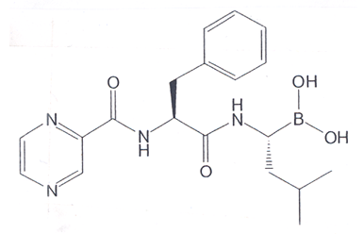
The chemical name for bortezomib, the monomeric boronic acid, is [(1R)-3-methyl-1-[[(2S)-1-oxo-3-phenyl-2-[(pyrazinylcarbonyl)amino]propyl]amino]butyl] boronic acid.

Pharmacokinetics in healthy subjects

Absorption

Sites and mechanisms of absorption
Bortezomib is administered intravenously or via subcutaneous injection. No information is available on oral administration.

Bioavailability

Absolute bioavailability
Bortezomib is only available for parenteral administration.

Bioavailability relative to an oral solution or micronised suspension
Bortezomib is only available for parenteral administration.

Bioequivalence of clinical trial and market formulations
The proposed doses and administration for bortezomib in patients with MCL are equivalent to those used in the clinical trials cited in support of this application and are also equivalent to the doses currently approved for marketing for treatment of patients with multiple myeloma.

Bioequivalence of different dosage forms and strengths
The dosage forms and strengths of bortezomib in the relevant clinical trials is equivalent to that being submitted for marketing for use in patients with MCL. Importantly, the dosages are also identical to those already approved and marketed in Australia for treatment of patients with multiple myeloma.

Bioequivalence to relevant registered products
The proposed extension of application of VELCADE uses the same dose as currently approved for use/marketing in Australia for patients with multiple myeloma. There are no other registered alternative bortezomib products.

Influence of food
Bortezomib is only available as a powder for intravenous infusion or subcutaneous injection. There is no oral formulation.

Dose proportionality
No PK/PD data is provided on dose proportionality.

Bioavailability during multiple-dosing
The existing/approved Australian PI for bortezomib reports that following intravenous bolus administration of a 1.0 mg/m² and 1.3 mg/m² dose to eleven patients with multiple myeloma, the mean first-dose maximum plasma concentrations of bortezomib were 57 and 112 ng/mL respectively. In subsequent doses, mean maximum observed plasma concentrations ranged from 67 to 106ng/mL for the 1.0mg/m² dose and 89 to 120ng/mL for the 1.3mg/m² dose. The mean elimination half-life of bortezomib upon multiple dosing ranged from 40-193 hours. Bortezomib is eliminated more rapidly following the first dose compared to subsequent doses. Mean total body clearances were 102 and 112 L/h following the first dose for doses of 1.0mg/m² and 1.3mg/m², respectively, and ranged from 15 to 32 L/h following subsequent doses of 1.0mg/m² and 1.3mg/m², respectively.
The Australian bortezomib PI also reports that PK/PD data from a Phase III myeloma study demonstrated that following an IV bolus or subcutaneous (SC) injection of a 1.3 mg/m² dose to multiple myeloma patients (n = 14 for IV, n = 17 for SC), the total systemic exposure after repeat dose administration (AUC_{last}) was equivalent (151 ng.h/mL vs 155 ng.h/mL) for SC and IV administration. The C_{max} after SC administration (20.4 ng/mL) was lower than IV (223 ng/mL). The AUC_{last} geometric mean ratio was 0.99 and 90% confidence intervals were 80.18% - 122.80%.

Effect of administration timing
No data was submitted on the effect of time of dosing.

Distribution

Volume of distribution
The mean distribution volume of bortezomib ranged from 1659 litres to 3294 litres (489 to 1884L/m²) following single- or repeat-dose IV administration of 1.0mg/m² or 1.3mg/m² to patients with multiple myeloma. This suggests that bortezomib distributes widely to peripheral tissues.

Plasma protein binding
Over a bortezomib concentration range of 10 to 1000 ng/mL, the in vitro protein binding averaged 83% in human plasma. The percent of bortezomib bound to plasma proteins was not concentration dependent.

Erythrocyte distribution
No data is available relating to erythrocyte distribution but bortezomib appears to be highly protein bound in plasma.

Tissue distribution
In patients with multiple myeloma the mean distribution volume of bortezomib ranged from 1659 litres to 3294 litres (489 to 1884L/m²) following single- or repeat-dose IV administration of 1.0mg/m² or 1.3mg/m². This suggests that bortezomib distributes widely to peripheral tissues.

Metabolism

Interconversion between enantiomers
No data was supplied.

Sites of metabolism and mechanisms / enzyme systems involved
In vitro studies with human liver microsomes and human cDNA-expressed cytochrome P450 isozymes indicate that bortezomib is primarily oxidatively metabolised via cytochrome P450 enzymes, 3A4, 2C19, 2D6, 2C9, and 1A2. The major metabolic pathway is deboronation, with the two main metabolites formed undergoing subsequent hydroxylation. One of the two main deboronated metabolites was shown to be inactive as a 26S proteasome inhibitor. Pooled plasma data from 8 patients at 10 min and 30 min after IV dosing indicate that the plasma levels of metabolites are low compared to the parent drug.

Non-renal clearance
The elimination pathways of bortezomib have not been evaluated in vivo.

Metabolites identified in humans

Active metabolites
It appears from the documentation provided that none of the identified metabolites have significant activity.

Other metabolites
It appears from the documentation provided that none of the identified metabolites have significant activity.

Pharmacokinetics of metabolites
The major metabolic pathway of bortezomib is deboronation, with the two main metabolites formed undergoing subsequent hydroxylation. One of the two main deboronated metabolites was shown to be inactive as a 26S proteasome inhibitor. Pooled plasma data from 8 patients at 10 min and 30 min after IV dosing indicate that the plasma levels of metabolites are low compared to the parent drug.

Consequences of genetic polymorphism
No data is provided on the impact of genetic polymorphisms on metabolism and excretion.

Excretion

Routes and mechanisms of excretion
The elimination pathways of bortezomib have not been evaluated in vivo.

Mass balance studies
No data is provided on mass data studies.

Renal clearance
The elimination pathways of bortezomib have not been studied in vivo.

Intra- and inter-individual variability of pharmacokinetics
No data is provided on intra and inter-individual variability of pharmacokinetics.

Pharmacokinetics in the target population
No PK/PD data is available in the target population for the proposed extension – patients with untreated MCL. PK/PD data is drawn from studies involving patients with multiple myeloma and is included in the PI.
Following intravenous bolus administration of a 1.0 mg/m2 and 1.3 mg/m2 dose to eleven patients with multiple myeloma, the mean first-dose maximum plasma concentrations of bortezomib were 57 and 112 ng/mL respectively. In subsequent doses, mean maximum observed plasma concentrations ranged from 67 to 106ng/mL for the 1.0mg/m2 dose and 89 to 120ng/mL for the 1.3mg/m2 dose. The mean elimination half-life of bortezomib upon multiple dosing ranged from 40-193 hours. Bortezomib is eliminated more rapidly following the first dose compared to subsequent doses. Mean total body clearances were 102 and 112 L/h following the first dose for doses of 1.0mg/m2 and 1.3mg/m2, respectively, and ranged from 15 to 32 L/h following subsequent doses of 1.0mg/m2 and 1.3mg/m2, respectively.
In the PK/PD substudy in Phase III trial, following an IV bolus or subcutaneous (SC) injection of a 1.3 mg/m2 dose to multiple myeloma patients (n = 14 for IV, n = 17 for SC) , the total systemic exposure after repeat dose administration (AUClast) was equivalent (151 ng.h/mL vs 155 ng.h/mL)for SC and IV administration. The Cmax after SC administration (20.4 ng/mL) was lower than IV (223 ng/mL). The AUClast geometric mean ratio was 0.99 and 90% confidence intervals were 80.18% - 122.80%.

Pharmacokinetics in other special populations

Pharmacokinetics in subjects with impaired hepatic function
Formal studies in patients with severely impaired hepatic function have not been conducted to date; consequently caution is recommended when administering bortezomib to these classes of patients.
It is recommended that patients with moderate or severe hepatic impairment are commenced on bortezomib but at a lower dose (0.7mg/m²).

Pharmacokinetics in subjects with impaired renal function
Some data is available to guide administration of bortezomib in patients with impaired renal function, ESRF and in those on dialysis.
A pharmacokinetic study was conducted in patients with various degrees of renal impairment who were classified according to their creatinine clearance values (CrCL) into the following groups: Normal (CrCL ≥60 mL/min/1.73 m², n=12), Mild (CrCL=40-59 mL/min/1.73 m², n=10), Moderate (CrCL=20-39 mL/min/1.73 m², n=9), and Severe (CrCL < 20 mL/min/1.73 m², n=3). A group of dialysis patients who were dosed after dialysis was also included in the study (n=8). Patients were administered intravenous doses of 0.7 to 1.3 mg/m² of bortezomib twice weekly. Clearance of bortezomib was comparable among all the groups. However, the number of patients with severe renal impairment was insufficient to allow reliable conclusions regarding this group.
On the basis of this data dose adjustment of bortezomib is not generally required for patients with mild or moderate renal impairment. While the effect of severe renal impairment has not been determined, bortezomib is generally used in patients with myeloma and severe renal disease – generally in combination with dexamethasone.

Pharmacokinetics according to age
Age does not appear to be an independent correlate with PK/PD of bortezomib.
Comment: It is important to note that in the LYM-3002 study rates of any serious adverse events were significantly higher in older (>65) than in younger (<65) patients in both the R-CHOP and the VcR-CAP arms. This was largely due to haematological toxicity and infection. Consequently, older patients were more likely to experience treatment discontinuation (15% vs 21% for VcR-CAP and 10% vs 14% for R-CHOP).

Pharmacokinetics related to genetic factors
No data was submitted relating to genetic polymorphisms and PK/PD in the target population.
Comment: While no data has been submitted regarding the influence on genetic polymorphisms – the data in LYM-3002 and the pooled safety analysis was examined according to race. This found that adverse events of > Grade 3 were more commonly reported in non-white than white subjects with both VcR-CAP and R-CHOP, with the trend being more evident with VcR-CAP. The only exception was with peripheral neuropathy – which was less common in non-white subjects. This raises the possibility that genetic polymorphisms linked to ethnicity may confer differential risks of toxicity with VcR-CAP.

Pharmacokinetics in other special population / according to other population characteristic
No data is available regarding PK variability in special populations relevant to its use in MCL.

Pharmacokinetic interactions

Pharmacokinetic interactions demonstrated in human studies
In vitro and animal ex vivo studies indicate that bortezomib is a weak inhibitor of cytochrome P450 (CYP) isozymes 1A2, 2C9, 2C19, 2D6, and 3A4. Based on the limited contribution (7%) of CYP2D6 to the metabolism of bortezomib, the CYP2D6 poor metaboliser phenotype is not expected to affect the overall disposition of bortezomib.
A drug-drug interaction study assessing the effect of ketoconazole (a potent CYP3A4 inhibitor) on the pharmacokinetics of IV VELCADE showed a bortezomib AUC mean increase of 35%, based on data from 12 patients. Therefore, patients should be closely monitored when given bortezomib in combination with potent CYP3A4-inhibitors (e.g ketoconazole, ritonavir).
A drug-drug interaction study assessing the effect of rifampicin, a potent CYP3A4 inducer, on the pharmacokinetics of VELCADE showed a mean bortezomib AUC reduction of 45% based on data from 6 patients. The concomitant use of VELCADE with strong CYP3A4 inducers, including rifampicin, carbamazepine, phenytoin, phenobarbital and St John’s Wort is therefore not recommended as efficacy may be reduced.
Dexamethasone, a weak CYP3A4 inducer, has not been shown to have a significant effect on bortezomib pharmacokinetics.

Clinical implications of in vitro findings
Given in vitro data from human indicating that bortezomib is a weak Cytochrome P450 inhibitor, patients who are concomitantly receiving VELCADE and drugs that are inhibitors or inducers of cytochrome P450 3A4 should be closely monitored for either toxicities or reduced efficacy.
As hypoglycaemia and hyperglycaemia were reported in diabetic patients receiving oral hypoglycaemics in clinical trials of bortezomib in myeloma, patients on oral antidiabetic agents receiving VELCADE treatment should also be advised that they should more closely monitor their blood glucose levels and may need to adjust the dose of their antidiabetic medication.
Given concerns regarding peripheral neuropathy associated with bortezomib, patients should be cautioned about the use of concomitant medications that may be associated with peripheral neuropathy (such as amiodarone, anti-virals, isoniazid, nitrofurantoin, or statins).

Evaluator’s overall conclusions on pharmacokinetics
In general, the pharmacokinetics of bortezomib appear to have been adequately investigated in previous studies in patients with multiple myeloma and, consequently, no additional PK or PD studies were conducted in support of this submission.
There is no reason to anticipate that the components of the VcR-CAP regimen would have any clinically relevant effects on the pharmacokinetics of bortezomib or vice-versa.
While all 3 studies in this submission (LYM-3002, M34103-053, LYM-2034) utilised IV administration of bortezomib, Phase 1 PK data, clinical studies in patients with multiple myeloma and post-marketing studies all provide support for SC administration of bortezomib in patients with MCL.

Pharmacodynamics

Studies providing pharmacodynamic data
None of the studies included in support of the submission included pharmcodynamic data and all used established doses of VELCADE currently approved for use in Australia and detailed in the PI.

Summary of pharmacodynamics
The information in the following summary is derived from conventional pharmacodynamic studies in humans unless otherwise stated.

Mechanism of action
Bortezomib is a reversible inhibitor of the chymotrypsin-like activity of the 26S proteasome in mammalian cells. Proteasome inhibition disrupts cell cycling leading to cycle arrest and apoptosis.

Pharmacodynamic effects

Primary pharmacodynamic effects
None of the studies included in support of the submission included pharmcodynamic data and all used established doses of VELCADE currently approved for use in Australia and detailed in the PI.

Secondary pharmacodynamic effects
None of the studies included in support of the submission included pharmcodynamic data and all used established doses of VELCADE currently approved for use in Australia and detailed in the PI.

Time course of pharmacodynamic effects
None of the studies included in support of the submission included pharmcodynamic data and all used established doses of VELCADE currently approved for use in Australia and detailed in the PI.

Relationship between drug concentration and pharmacodynamic effects
None of the studies included in support of the submission included pharmcodynamic data and all used established doses of VELCADE currently approved for use in Australia and detailed in the PI.

Genetic - gender- and age-related differences in pharmacodynamic response
None of the studies included in support of the submission included pharmcodynamic data and all used established doses of VELCADE currently approved for use in Australia and detailed in the PI.

Pharmacodynamic interactions
None of the studies included in support of the submission included pharmcodynamic data and all used established doses of VELCADE currently approved for use in Australia and detailed in the PI.

Evaluator’s overall conclusions on pharmacodynamics
None of the submitted studies provided pharmacodynamic data and no additional biopharmaceutical, PK or PD studies were conducted in support of this submission. Consequently, no updates have been made to the Summary of Clinical Pharmacology Studies and Summary of Biopharmaceutical Studies and Associated Analytical Methods.

Dosage selection for the pivotal studies
The starting dose of bortezomib of 1.3mg/m² was selected for MCL because it has been shown to demonstrate efficacy and safety in large series of patients with multiple myeloma – both as monotherapy and in combination with dexamethasone and with combination chemotherapy.
The starting doses of the chemotherapy agents that comprise the remainder of VcR-CAP (rituximab, cyclophosphamide, doxorubicin and prednisolone) were selected as they are equivalent to the standard doses of these agents in R-CHOP, which has established safety and efficacy in patients with MCL and other forms of NHL.

Clinical efficacy

Pivotal efficacy studies

Study LYM-3002

Study design, objectives, locations and dates
The LYM-3002 study was a phase 3, randomised, open-label, multicentre, prospective study in patients with newly diagnosed stage II, II or IV MCL who were judged ineligible or not considered for bone marrow transplantation. The primary objective of the study was to determine the efficacy of bortezomib when combined with combination chemotherapy in adult patients with untreated MCL.
All subjects were to be treated for 6 cycles (or 8 cycles if first response documented on the Cycle 6 assessment) and followed for progression and survival.
Subjects were randomly assigned in a 1:1 ration to either VcR-CAP (Bortezomib, Rituximab, cyclophosphamide, doxorubicin and prednisone) or R-CHOP (rituximab, viuncristine, cyclophosphamide, doxorubicin and prednisone).
The primary efficacy objective was CR rate. Secondary efficacy endpoints included ORR, rate of durable response, duration of response (CR or PR), duration of CR, PFS, TTP and OS. Disease response and progression were evaluated according to the Revised Response Criteria for Malignant Lymphoma. Safety was assessed on the basis of adverse events and clinical laboratory tests.
The study enrolled 487 subjects from 128 centres in 28 countries (including the EU, Russia, China, Ukraine, Nth America and Japan) – 244 subjects to the R-CHOP group and 243 subjects to the VcR-CAP group.
The study commenced in May 2008 with clinical cutoff in December 2013.

Inclusion and exclusion criteria
Male or female patients aged ≥18 years with a diagnosis of mantle cell lymphoma (MCL) (stage II, III, or IV), as determined by histology and either expression of cyclin D1 (in association with CD20 and CD5) or evidence of t(11;14) translocation (by cytogenetics, fluorescence in-situ hybridization, or polymerase chain reaction), were enrolled.
In all patients, a paraffin-embedded biopsy tissue block (preferably of lymph node origin) was sent to one of two central laboratories (Diagnostic Cytology Laboratories, Indianapolis, IN, USA, or PhenoPath Laboratories, Seattle, WA, USA) for confirmation of diagnosis of MCL.
Patients also had to be ineligible for stem cell transplantation according to the treating physician (e.g., due to age or comorbid conditions). Prior to a protocol amendment, this criterion was worded such that patients who were considered ineligible for transplantation for other than clinical reasons (e.g., because stem cell transplantation was not available or because the patient refused transplantation) were also considered eligible for the study.
Additional inclusion criteria for the study were: at least one site of measurable disease; no prior treatment for MCL; Eastern Cooperative Oncology Group performance status of ≤2; absolute neutrophil count ≥1500 cells per microliter; platelet count ≥100,000 cells per microliter, or ≥75,000 cells per microliter if thrombocytopenia was considered by the investigator to be secondary to MCL (e.g., due to bone marrow infiltration or sequestration from splenomegaly); alanine transaminase level ≤3 times the upper limit of normal; aspartate transaminase level ≤3 times the upper limit of normal; total bilirubin level ≤1.5 times the upper limit of normal; and calculated creatinine clearance ≥20 milliliters per minute. Female patients had to be post-menopausal for ≥1 year, surgically sterile, or practicing an effective method of birth control (as described in the protocol), and have a negative serum beta-human chorionic gonadotropin or urine pregnancy test at screening; they also had to agree to continue using birth control measures for ≥6 months after terminating treatment. Male patients had to agree to use an acceptable method of contraception for the duration of the study.
Patients were excluded from the study if they had received prior treatment with bortezomib, or any prior antineoplastic (including unconjugated therapeutic antibodies), experimental, or radiation therapy, or radio-immunoconjugates or toxin immunoconjugates to treat MCL. If doxorubicin had been used previously to treat another condition, the maximum prior dose and exposure must not have exceeded 150 mg per square meter. A short course of low-dose prednisone or equivalent steroids (maximum duration, 10 days; dose, ≤100 mg per day) was allowed to treat symptoms in patients with advanced disease prior to randomization.
Further exclusion criteria were: major surgery within 2 weeks before randomization; peripheral neuropathy or neuropathic pain of grade ≥2 (by investigator assessment); diagnosis or treatment of a malignancy other than MCL within 1 year of randomization, or previous diagnosis of another malignancy with radiographic or biochemical evidence of residual disease (except completely resected basal cell carcinoma, squamous cell carcinoma of the skin, or an in-situ malignancy); active systemic infection requiring treatment, a known diagnosis of human HIV, or active hepatitis B (hepatitis B carriers were permitted); serious pre-existing medical condition (e.g., cardiac failure [New York Heart Association Class III or IV, or left ventricular ejection fraction <50%], active peptic ulceration, uncontrolled diabetes mellitus, or acute diffuse infiltrative pulmonary disease), or psychiatric illness likely to interfere with study participation; and concurrent treatment with another investigational agent.

Study treatments
Patients were stratified according to their score on the International Prognostic Index (IPI), with risks categorised as low (a score of 0 or 1), low–intermediate (a score of 2), high–intermediate (a score of 3), or high (a score of 4 or 5), and disease stage at diagnosis (stage II, III, or IV according to the staging system for non-Hodgkin's lymphoma of the American Joint Committee on Cancer). Patients were randomly assigned in a 1:1 ratio to receive six 21-day cycles of R-CHOP or VR-CAP. Patients could receive up to eight cycles if a response was first documented at cycle 6. R-CHOP comprised rituximab (at a dose of 375 mg per square meter of body-surface area), cyclophosphamide (750 mg per square meter), doxorubicin (50 mg per square meter), and vincristine (1.4 mg per square meter, with a maximum total dose of 2 mg), all administered intravenously on day 1, plus oral prednisone (100 mg per square meter) administered on days 1 to 5. VR-CAP comprised intravenous bortezomib (1.3 mg per square meter) on days 1, 4, 8, and 11 of each cycle (administered first on day 1), followed by rituximab (administered second on day 1) and cyclophosphamide, doxorubicin, and prednisone, all as described above.
Dose adjustments for toxic effects were permitted with the use of established dose-modification guidelines per the prescribing information for each drug.

Efficacy variables and outcomes
The following pre-specified variables were analysed according to their impact on PFS:
- IPI risk
- Gender
- Race
- Region
- Age
- Disease stage at diagnosis
- Performance status (ECOG)
- LDH
- White cell count
Post-hoc analysis of PFS was also conducted according to:
- MIPI risk category
- Ki67 expression (<10% v >10%)
- MIPI with biological component (MIPIb)
The primary efficacy outcome was progression-free survival (PFS).
Other efficacy outcomes included:
- overall response rate (complete response or unconfirmed complete response and partial response),
- complete response rate (radiologic complete response or radiologic unconfirmed complete response, which both had to be verified by evidence of bone marrow clearance and normalization of the lactate dehydrogenase (LDH) level),
- time to and duration of response,
- time to progression,
- time to next antilymphoma therapy, and
- overall survival.

Randomisation and blinding methods
A permuted-block central randomization plan with a computer-generated randomization schedule (sponsor-generated) was used for randomisation of subjects.
The trial was an open-label non-blinded study.

Analysis populations
The intent-to-treat population, defined as all randomised patients, was used for analyses of all primary and secondary efficacy endpoints, with the exception of overall and complete response rates (which were assessed in the response-evaluable population) and treatment-free interval (which was assessed in the safety population). The response-evaluable population included all patients in the intent-to-treat population who had received ≥1 dose of study medication, had ≥1 measurable tumor mass (>1.5 centimeters in the longest dimension and >1.0 centimeter in the short axis) at baseline, and had ≥1 post-baseline tumor assessment by independent review committee, prior to subsequent anti-lymphoma treatment. The safety population included all randomised patients who received at least one dose of study medication.

Sample size
An independent data and safety monitoring committee oversaw the conduct of the study. It was estimated that 295 events of disease progression or death would provide a power of 80% (at a two-sided alpha level of 0.05) to detect a 40% improvement in the median progression-free survival (from 18 to 25 months) with VR-CAP, as compared with R-CHOP. Assuming a data-accrual period of 24 months and 18 months of follow-up, we determined that 486 patients (243 per study group) were required. Three pre-planned interim analyses were conducted.

Statistical methods
All primary and secondary efficacy analyses were performed in the intention-to-treat population, except for response end points (which were analyzed in the response-evaluable population) and treatment-free interval (which was analyzed in the safety population).
Kaplan–Meier methods were used to estimate time-to-event distributions, with stratified log-rank tests and Cox models used for between-group comparisons of time-to-event end points.
Pre-specified subgroup analyses of progression-free survival was conducted according to IPI risk score, sex, race, region, age, disease stage at diagnosis, performance status (according to Eastern Cooperative Oncology Group criteria), lactate dehydrogenase level, and white-cell count.
Post hoc analyses of progression-free survival according to mantle-cell lymphoma–specific IPI (MIPI) risk category, Ki-67 expression status (≤10% vs. >10%), and MIPI with biologic component (MIPIb) risk category in patients with baseline Ki-67 assessment was also performed. A stratified Cochran–Mantel–Haenszel chi-square test with IPI and disease stage as stratification factors was used to assess between-group differences in response rates.

Participant flow
A total of 487 patients underwent randomization to receive either R-CHOP (244 patients) or VR-CAP (243 patients).
The diagnosis of mantle-cell lymphoma was confirmed by central pathological review in 471 patients (97% concordance). Demographic and disease characteristics were generally well balanced in the two groups. Between group distributions according to baseline Ki-67 expression and MIPIb risk category were similar.
Overall, 406 patients (83%) in the two study groups (203 per group) received six or more cycles of a study drug (median, 6 [range, 1 to 8] in the two groups). Treatment exposure was similar in the two groups, and most patients received the planned doses of each drug. The mean relative dose intensity for drugs common to both regimens was 93% or higher. The mean relative dose intensity was 80% for vincristine in the R-CHOP group (owing to the dose capping at 2 mg) and 82% for bortezomib in the VR-CAP group.
Figure 2: Study Flowchart.
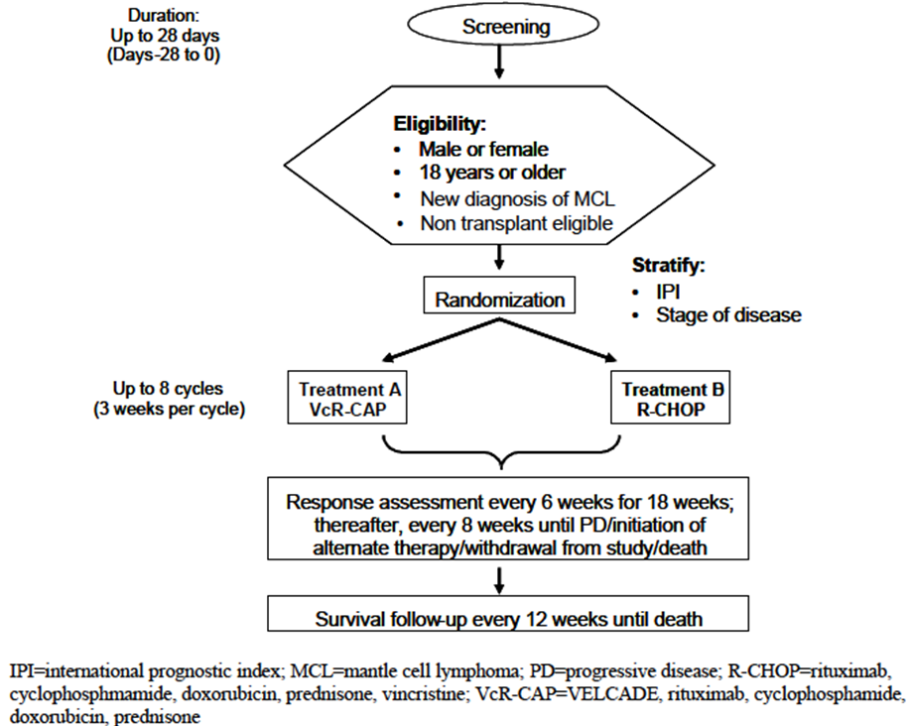

Major protocol violations/deviations
During the early stages of the study the eligibility criteria indicated that patients must be ineligible or not considered for bone marrow transplantation (as determined by their treating physician). (This enabled enrolment of patients from centres where BMT was not available and enrolment of patients who refused BMT as part of treatment schedule for newly diagnosed MCL.) Following Protocol Amendment INT-2, only patients not medically eligible for BMT were permitted to enter the study. As a consequence there were 2 different enrolment groups within Study LYM-3002:
- Subjects not eligible for transplant due to age >60), comorbidity or perceived inability to tolerate chemotherapy – 414 subjects – 206 in R-CHOp group and 208 in VcR-CAP group.
- Subjects not considered for transplant due to other reasons (as per investigator) – 73 subjects – 38 in R-CHOP group and 35 in VcR-CAP group.
Following reassessment by the Company medical monitor to assess concordance with medical criteria for transplant ineligibility across the entire cohort the final numbers were: 407 not medically eligible for transplant and 80 subjects medically eligible for transplant – but not considered for transplant by treating haematologist.
Comment: Protocol variation is unproblematic as it is consistent with ‘real-world’ decision-making by haematologists caring for patients with de-novo, untreated MCL – many of whom will not consider patients for upfront ASCT, and is consistent with differing treatment of MCL internationally – with some centres not considering ASCT for patients untreated MCL. In addition – even with variance in inclusion criteria the results for each group remain unchanged.

Baseline data
The median age of the study population was 66; most subjects were male (74%); MIPI risk category was evenly distributed (low 30%, intermediate 39%, high 31%); most patients had advanced stage disease at diagnosis (stage II 6%, stage III 19% and stage IV 76%); most subjects had bone marrow involvement (69%) and extranodal involvement (57%); most patients had reasonable performance status (ECOG 0 40% and ECOG 1 47%); and most patients had intermediate (45%) or high (40%) MIPIb.
Demographics and disease characteristics, including Ki-67 and MIPIb were well-balanced between groups although higher numbers of patients in the R-CHOP group had an ECOG score of 1 (52% v 42% in the VcR-CAP group) and lesser numbers of patients in the R-CHOP groups had an ECOG score of 0 (35% v 46% in the VcR-CAP group).
Comment: These data are consistent with the characteristics of untreated MCL in non-study populations reported in the literature. The high representation of Asian subjects (32%) and relative underrepresentation of Black or African subjects (<1%) is indicative of the participating centres but does not compromise the translation of the study results to an Australian population.

Results for the primary efficacy outcome
The results for the primary endpoint (Progression-free survival) are summarised in Table 1.
Table 1. Summary of progression-free survival: per independent review committee; intent –to-treat analysis set (Study 26866138-LYM-3002)
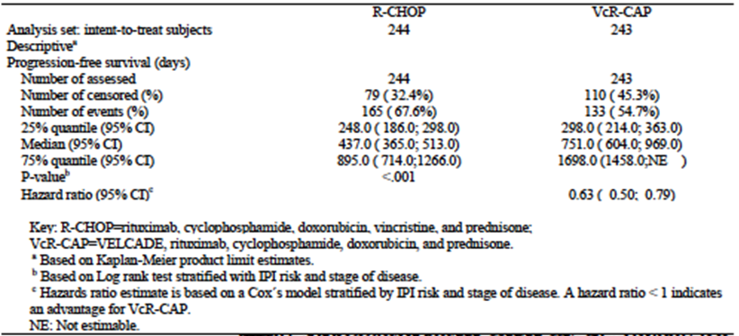
After a median follow-up of 40 months, 298 patients (61%) had disease progression or died.
The median PFS was 14.4 months in the R-CHOP group and 24.7 months in the VcR-CAP group (hazard ratio favouring the VcR-CAP group 0.63; P<0.001). This result represented a relative improvement of 59% in the VcR-CAP group – exceeding the hypothesised 40% improvement. According to the investigator assessment, 307 patients (63%) had disease progression or died, and the median progression-free survival was 16.1 months in the R-CHOP group and 30.7 months in the VcR-CAP group (hazard ratio, 0.51;P<0.001), representing a 96% improvement.
Analysis of PFS excluding the 7 R-CHOP treated subjects and the 9 VcR-CAP treated subjects who did not meet criteria for inclusion in the centrally confirmed MCl population showed a 56% improvement in PFS for VcR-CAP versus R-CHOP (HR=0.64; 95% CI: 0.50, 0.81; p<0.001). Median PFS was 14.8 months for the R-CHOP group and 24 months for the VcR-CAP group – a difference of 9.2 months.
Analysis of PFS showed a consistent treatment effect favouring VcR-CAP therapy for both the positive (>10%) and negative (<10%) Ki-67 subgroups. Within the Ki-67 positive subgroup, median PFS was 10.9 months for R-CHOP and 19.8 months for VcR-CAP (HR=0.59 [95% CI: 0.39, 0.88] and p=0.009). Within the Ki-67 negative subgroup, median PFS was 17.9 months for R-CHOP and 40.9 months for VcR-CAP (HR=0.60 [95% CI: 0.38, 0.94] and p=0.024).
Post-hoc analysis of PFS in the 327 subjects for whom MIPIb categorisation could be determined demonstrated a beneficial effect for VcR-CAP in low, intermediate and high risk MIPI subgroups.
Comment: Differences in assessments of IRC and investigators has been attributed to conservative assessments by the IRC of progression with respect to transient fluid collections or lesions in patients who subsequently had a subsequent response or stable disease. In the absence of further follow-up or review of central data it is difficult to verify this claim. Importantly, however, both assessments suggest a benefit with VcR-CAP over R-CHOP.

Results for other efficacy outcomes
Most patients had a tumour response according to the assessment of the independent review committee. Rates of complete response were significantly lower in the R-CHOP group than in the VR-CAP group (42% vs. 53%). According to the independent assessment, in the R-CHOP group, as compared with the VR-CAP group, the median time to response was 1.6 months versus 1.4 months, the median duration of overall response was 15.1 months versus 36.5 months, and the median duration of complete response was 18.0 months versus 42.1 months. Improvements in response rates and durability of response in the VR-CAP group, as compared with the R-CHOP group, were also observed for investigator-assessed responses.
For R-CHOP versus VR-CAP, the median time to progression by independent assessment was 16.1 months versus 30.5 months (hazard ratio, 0.58), the median time to the next anti-lymphoma therapy was 24.8 months versus 44.5 months (hazard ratio, 0.50), and the median treatment-free interval was 20.5 months versus 40.6 months (hazard ratio, 0.50). At the final analysis, 132 patients (54%) in the R-CHOP group and 82 patients (34%) in the VR-CAP group had received subsequent anti-lymphoma therapy; of these patients, 67 (51%) and 32 (39%), respectively, had received two or more lines of therapy. The type of subsequent therapy was generally similar in the two groups, with 25 patients (19%) in the R-CHOP group and 3 (4%) in the VR-CAP group receiving subsequent bortezomib.
Overall survival data were not mature at the time of publications of the LYM-3002 study. The median overall survival was 56.3 months in the R-CHOP group and had not been reached in the VR-CAP group (hazard ratio, 0.80; P = 0.17) (Fig. 2). There was a between-group difference in 4-year survival of 10 percentage points (54% in the R-CHOP group vs. 64% in the VRCAP group).

Study M34103-053

Study design, objectives, locations and dates
Study M34103-053 was a Phase 2, single-arm, 3-stage, international, multicentre, prospective study in subjects with relapsed or refractory MCL. Study recruitment was in 35 centres – principally in Europe, South-East Asia, the UK and USA.
Primary objective was to determine if bortezomib monotherapy increases median time to progression (TTP) compared with historical controls in patients with MCL who have relapse or progression following 1-2 prior lines of antineoplastic therapy. Study objectives included response rate [CR/unconfirmed CR (Cru) + partial response (PR)], duration of response (DOR), TTP and overall survival (OS).
Study recruitment commenced June 2005 with clinical cutoff for primary analysis in Dec 2005 and data cutoff for final analysis completed in March 2007.

Inclusion and exclusion criteria

Inclusion criteria
Each patient was to meet all of the following inclusion criteria during screening to be enrolled in the study:
- Male and female patients 18 years or older
- Pathologically confirmed MCL including expression of cyclin D1 or evidence of t(11;14), such as by cytogenetics, FISH or PCR
- Documented relapse or progression following 1 or 2 prior lines of antineoplastic therapy of which at least 1 must have included an anthracycline or mitoxantrone and at least 1 must have included rituximab. Relapse or progression since previous therapy must have been documented by new lesions or objective evidence of progression of existing lesions.
- At least 1 measurable or assessable site of disease that had not been previously irradiated, or had grown since previous irradiation
- KPS ≥50% (ECOG 0-2)
- The following laboratory values at screening (the criteria also were to be met for neutrophil and platelet counts within 48 hours prior to dosing on Day 1 of Cycle 1):
- Absolute neutrophil count (ANC) ≥1000 cells/μL
- Platelets ≥50,000 cells/μL
- Aspartate transaminase (AST) ≤3 x upper limit of normal (ULN)
- Alanine transaminase (ALT) ≤3 x ULN
- Total bilirubin ≤2 x ULN
- Creatinine ≤2 mg/dL or calculated creatinine clearance ≥50 mL/min
- Toxic effects of previous therapy or surgery resolved to Grade 2 or better
- Female patient was to be either postmenopausal or surgically sterilised or willing to use an acceptable method of birth control (ie, a hormonal contraceptive, intra-uterine device, diaphragm with spermicide, condom with spermicide, or abstinence) for the duration of the study.
- Male patients were required to agree to use an acceptable method for contraception for the duration of the study.
- Voluntary written informed consent before performance of any study-related procedure not part of normal medical care, with the understanding that consent may have been withdrawn by the patient at any time without prejudice to future medical care.).

Exclusion criteria
Patients meeting any of the following exclusion criteria were not to be enrolled in the study:
- Previous treatment with VELCADE
- Antineoplastic or experimental therapy within 3 weeks before Day 1 of Cycle 1
- Nitrosoureas within 6 weeks before Day 1 of Cycle 1
- Radioimmunoconjugates or toxin immunoconjugates such as ibritumomab tiuxetan (Zevalin) or tositumomab (Bexxar) within 10 weeks before Day 1 of Cycle 1
- Rituximab, alemtuzumab (Campath), or other unconjugated therapeutic antibody within 4 weeks before Day 1 of Cycle 1
- Radiation therapy within 3 weeks before Day 1 of Cycle 1
- Major surgery within 2 weeks before Day 1 of Cycle 1
- History of allergic reaction attributable to compounds containing boron or mannitol
- Diagnosed or treated for a malignancy other than MCL within 5 years before Day 1 of Cycle 1, with the exception of complete resection of basal cell carcinoma, squamous cell carcinoma of the skin, or in situ malignancy. Patients previously diagnosed with prostate cancer were eligible if:
(1) their disease was T1-T2a, N0, M0, with a Gleason score ≤7, and a prostate-specific antigen (PSA) ≤10 ng/mL prior to initial therapy,
(2) they had definitive curative therapy (prostatectomy or radiotherapy) ≥2 years before Cycle 1, Day 1, and
(3) at a minimum 2 years following therapy they had no clinical evidence of prostate cancer, and their PSA was undetectable if they had undergone prostatectomy, or <1 ng/mL if they had not undergone prostatectomy.
- Active systemic infection requiring treatment
- Female patient who was pregnant or breast-feeding. Confirmation that the patient was not pregnant was to be established by a negative serum β-human chorionic gonadotropin (β-hCG) pregnancy test obtained during screening. Pregnancy testing was not required for post-menopausal or surgically sterilised women.
- Serious medical or psychiatric illness likely to interfere with participation in this clinical study
- Concurrent treatment with another investigational agent. Concurrent participation in non-treatment studies was allowed, if it would not interfere with participation in this study.

Study treatments
All patients (n=155) received bortezomib 1.3mg/m² on days 1, 4, 8 and 11, every 21 days, for up to 17 cycles or four cycles beyond initial reporting of CR/Cru, or until discontinuation for progressive disease (PD), unacceptable toxicity, or patient/investigator decision.

Efficacy variables and outcomes
The main efficacy variables were:
- Refractory MCL (no response or response with TTP <6 months after last prior therapy) (n = 58, including 51 response-assessable patients)
- Prior high-intensity therapy (therapies containing high-dose cytarabine or ifosfamide/carboplatin/etoposide)) (n = 58 including 52 assessable patients)
Efficacy (disease-response parameters) was evaluated using the International Workshop Response Criteria (IWRC) using independent radiological review. Efficacy was assessed every 6 weeks (2 cycles) for 18 weeks (6 cycles), then every 12 weeks until PD or alternative antineoplastic therapy. All patients underwent long-term evaluation every 3 months.
The primary efficacy outcome was Time to Progression (TTP).
Other efficacy outcomes included:
- overall response rate (complete response or unconfirmed complete response and partial response),
- time to and duration of response,
- time to next antilymphoma therapy,
- progression-free survival, and
- overall survival.

Randomisation and blinding methods
The study was an open-label, non-randomised, single-arm study with no randomisation or blinding.

Analysis populations
A total of 155 patients received at least one dose of VELCADE and were included in the All Treated Population (ATP); data from a total of 141 patients who had measurable disease at Screening and at least 1 post-baseline tumor assessment (including measurable or assessable lesions) were analyzed for response as the Response Population-Final (RP-Final). The Per Protocol Population (PPP), which includes patients in the ATP who were confirmed to have MCL by independent pathology review and had prior therapy including rituximab, anthracycline/ mitoxantrone, and an alkylating agent (ie, previously treated with all 3 agents), comprised 126 of the 155 treated patients.

Sample size
The study included 155 subjects with documented relapsed or refractory MCL. Safety and efficacy data (with exception of response) was analysed for the All Treated Population (ATP). The Response Population for Final Analysis (RP-Final) included 141 subjects in the ATP who had measurable disease at screening and at least 1 post-baseline tumour assessment (including measurable or assessable disease).

Statistical methods
Analyses of TTP, PFS, time to next therapy (TTNT) and overall survival were conducted for all patients, by response, and by subgroup (all responders, patients achieving a CR/Cru, patients with refractory disease and patients who had received prior high-intensity therapy (therapies containing high-dose cytarabine or ifosfamide/carboplatin/etoposide)).

Participant flow
The study included 155 subjects.
The Response Population for Final Analysis (RP-Final) included 141 subjects who had measurable disease at screening and at least 1 post-baseline tumour assessment (including measurable or assessable lesions).
After a median follow-up of 26.4 months, 55 patients (35%) remained in follow-up (4 in short-term and 51 in long-term follow-up), 93 (60%) had died, 2 (1%) had withdrawn consent, and five (3%) were lost to follow-up.
Patients received a median of four treatment cycles (range 1-21) overall – responding patients received a median of 8 cycles (range 2-21).

Major protocol violations/deviations
Deviations from planned protocol procedures that occurred during the conduct of the study were, in general, relatively minor. Common protocol deviations included missed evaluations or sample collections and evaluations performed or samples collected after the scheduled time. No patient was withdrawn from the study because of protocol deviations.

Baseline data
The majority of subjects in the study were male (81%) and the median age was 65 years.
Independent central pathology review confirmed the diagnosis of MCL (t(11;14) or overexpression of cyclinD1) in 95% of subjects with data available, and in 90% of all subjects.
At the time of enrolment, 44% of patients had an International Prognostic Index score >3, 36% had LDH levels above the upper limit of normal, and 77% had stage IV MCL. Median time from diagnosis of MCL to study entry was 2.3 years with two-thirds of subjects (66%) diagnosed <3 years prior to study entry.
All subjects were reported to have progressed during or relapsed following at least 1 prior line of therapy; in 45% of subjects bortezomib was administered as 3rd or 4th line therapy. Ninety one percent of the subjects had previously received therapy with all 3 of the following classes of agents; an alkylating agent, an anthracycline (or mitoxantrone), and rituximab. More than one-third of subjects (37%) had received prior high-intensity chemotherapy, including HyperCVAD, other high-dose cytarabine-containing regimens, and stem cell transplant.

Results for the primary efficacy outcome
Median TTP was 6.7 months for the ATP. Median TTP for all responders (CR + Cru + PR) was 12.4 months. At final analysis, median TTP was not estimable for subjects who achieved a CR or Cru. Median TTP was 9.1 months, 6.9 months and 1.2 months for subjects with PR, stable disease and progressive disease respectively.

Results for other efficacy outcomes

Response to treatment
Of the 141 subjects with measurable disease at baseline and post-baseline assessments, 45 subjects (32%) achieved CR, Cru or PR. Eleven subjects (8%) experienced CR or CRu as best response to treatment, including 9 with CR and 2 with CRu, and 34 subjects (24%) experienced PR. Among the 51 subjects with refractory disease, the ORR (CR + CRu + PR) was 29%, and the complete response (CR + Cru) rate was 6%. Patients who achieved CR/Cru were aged 52-79 years and had heterogeneous disease characteristics at baseline, including some patients with bulky disease (5 of 11 had lesions >5cm on the long axis).
Of the 11 patients achieving CR/Cru, 4 had progressed by independent radiological review and 8 had received subsequent antineoplastic therapy effective against MCL.
Comment: Subsequent treatment of responding subjects contaminates analysis. Can the sponsor comment on the effect of discrepancies between investigator assessment and independent radiological assessment on efficacy analysis?

Duration of response
Median duration of response as assessed by the sponsor-derived algorithm using the IWRC was 9.2 months for all responders (CR + CRu + PR). Median DOR was 9.2 months (95% CI 5.9, 13.8) in all responders and 6.7 months (95% CI 4.9, 9.7) in patients achieving PR. At final analysis, the median duration of response was not estimable for subjects with a complete response (CR + Cru).
Comment: Given the period of time since completion of the study – it would be useful to have some data on the DOR and time-to-alternative therapy on patients who achieved a CR.

Time to alternate/anti-lymphoma therapy
Median time to alternate/anti-lymphoma therapy was 7.4 months. Subjects who achieved CR/Cru had prolonged median time to alternate therapy compared with subjects in other response categories: 23.9 months, 13.3 months, 7.0 months and 2.3 months for subjects with a best response on treatment of CR/CRu, PR, stable disease and progressive disease, respectively. Median time to alternate therapy in all responders was 14.3 months.

Progression-free survival
Median Progression-Free Survival (PFS) was 6.5 months. Median PFS was longer for complete responders (CR and CRu) than all survivors – 20.3 vs 12.4 months respectively.

Overall survival
The 1-year survival rate was 69% overall and 91% in responders. With a median duration of FUp of >26 months, median survival was 23.5 months. Median survival was 35.4 months for all responders (CR + CRu + PR) and 36 months for complete responders (CR + CRu). At final analysis 62 of 155 subjects (40%) were alive.
Comment: Given the period of time since completion of the study – it would be useful to have some data on OS on patients who achieved a CR relative to non-responders and to historically-reported data.

Other efficacy studies
Only 2 studies (LYM-3002 and M34103-053) were submitted as efficacy studies to support this application.

Analyses performed across trials (pooled & meta analyses)
There were no pooled analyses or meta-analyses of efficacy data included in the submission.

Evaluator’s conclusions on clinical efficacy
The sponsor has provided efficacy data from a pivotal randomised Phase 3, open-label, multicentre, prospective study comparing VcR-CAP and R-CHOP in subjects with newly-diagnosed MCL (LYM-3002) and 1 Phase 2 single-arm, open-label, multicentre prospective study in subjects with relapsed or refractory MCL (M34103-053). The studies used standard end-points to determination of efficacy in MCL.
For patients with newly diagnosed MCL judged to be transplant ineligible VcR-CAP resulted in a significant improvement in PFS relative to R-CHOP of 9.2-10.3 months. This benefit was shown for all patient groups including low, intermediate and high-risk groups of patients according to the MIPIb prognostic score. VcR-CAP was also associated with improvements in TTP, time to next anti-lymphoma treatment, CR rates and CR duration. Data is not mature enough to determine whether VcR-CAP improves OS.
For patients with relapsed/refractory MCL, single-agent bortezomib appears to be efficacious, with almost one-third of patients (32%) responding to treatment and some patients (8%) obtaining a CR/CRu. In responding patients - median TTP was 12.4 months, median duration of response (DOR) was 9.2 months, median time-to-next-treatment was 14.3 months and median OS was 35.4 months. These results were all higher than in non-responders and in historically-reported data in similar populations.
Overall, the data are sufficient to establish the efficacy of bortezomib in MCL. Insufficient data is available in transplant-eligible patients to determine the relative efficacy of bortezomib-containing regimens compared with induction regimens that include high-dose chemotherapy with stem cell rescue.

Clinical safety

Studies providing evaluable safety data
The following studies provided evaluable safety data: LYM-3002, LYM-2034 and M34103-053. Both individual study data and pooled safety data were included in the submission. Data from LYM-3002 and LYM-2034 are pooled by treatment group (VcR-CAP vs R-CHOP) while data from Study M34103-053 (VELCADE monotherapy) is presented as study data.
482 subjects were included in the LYM-3002 safety analysis set, 161 patients with newly diagnosed DLBCL were included in the LYM-2034 safety analysis and 155 subjects were treated with bortezomib monotherapy in Study M34103-053.
The pooled safety analysis set included 321 patients treated with R-CHOP and 322 subjects treated with VcR-CAP.

Pivotal efficacy studies (LYM-3002 and M34103-053)
In the pivotal efficacy studies, the following safety data were collected:
- General adverse events (AEs) were assessed at every visit throughout the study through history, physical examination and laboratory evaluations. AEs were graded according to WHO criteria and National Cancer Institute Common Terminology Criteria for Adverse Events (NCI CTCAE).
- AEs of particular interest, including peripheral neuropathy, which was assessed by history and physical examination, and AEs leading to dose reduction, dose delay/withholding, dose discontinuation and/or death on treatment.
- Physical examination, including measurement of vital signs, occurred at regular intervals throughout the trial.
- ECGs were performed at baseline and at regular intervals.
- Laboratory tests, including the following were performed at regular intervals:
  - Haematology: total white blood cell (WBC) count, haemoglobin, haematocrit, platelet count, absolute neutrophil count (ANC), and WBC differential.
  - Biochemistry: sodium, potassium, chloride, bicarbonate, urea, glucose, albumin, creatinine, total bilirubin, alanine aminotransferase (AST), aspartate aminotransferase (ALT), alkaline phosphatase, magnesium, phosphorus, calcium, amylase and lipase.
  - Coagulation parameters: prothrombin time and partial thromboplastin time

Pivotal studies that assessed safety as a primary outcome
Primary support for the safety profile was provided by Study LYM-3002.
Studies LYM-2034 and M34103-053 (PINNACLE), provided secondary support.

Dose-response and non-pivotal efficacy studies
There were no studies in the submission that were designed to assess dose-response. No other non-pivotal efficacy studies were included in the submission.

Other studies evaluable for safety only

Study LYM-2034
A randomiSed, open label, multicentre, prospective, Phase II study of the efficacy and safety of VcR-CAP versus R-CHOP in subjects newly diagnosed with the non GCB subtype of DLBCL.in subjects with newly diagnosed non GCB subtype DLBCL randomised to either VcR-CAP (n = 82) or R-CHOP (n = 79).

M34103-053 (PINNACLE)
A single arm, 3 stage, multicenter, prospective, Phase II study designed to evaluate the efficacy and safety of Velcade in subjects with documented relapsed or refractory MCL.
Comment: As this study provided only safety data and contributed to a pooled safety dataset – the safety data from this study will be discussed in relation to pivotal studies/pooled data.

Clinical pharmacology studies
There were no clinical pharmacology studies included in the submission.

Pooled safety analysis
In the submission, the sponsor presented analysis of safety based on pooled data from 2 studies: LYM-3002 and LYM-2034. The pooled safety analysis set included 321 subjects treated with R-CHOP and 322 subjects treated with VcR-CAP, thus enabling comparison of the safety of these 2 regimens. For these studies the safety populations included all randomised subjects who received at least 1 dose of the study drug.
Safety findings Study M34103-053 (PINNACLE), a single arm, 3 stage, multicentre, prospective, Phase II study designed to evaluate the efficacy and safety of single agent Velcade (n = 155) in subjects with documented relapsed or refractory MCL was examined to help identify the contribution of Velcade to the safety profile of the VcR-CAP regimen in an MCL population.

Pivotal studies that assessed safety as a primary outcome

Study LYM-3002

Study design, objectives, locations and dates
See above.

Inclusion and exclusion criteria
See above.

Study treatments
See above.

Safety variables and outcomes
Safety evaluations were performed at each visit and included review of adverse events (AEs), hematological and chemical laboratory parameters, physical examinations, and vital signs. Pharmacogenomic samples for PSMB1, PSMB5, and Ki-67 were collected at screening only. Patient-reported outcomes (PRO) were measured at screening, Day 1 of each cycle, and at the end of treatment.

Randomisation and blinding methods
See above.

Analysis populations
See above.

Sample size
See above.

Statistical methods
See above.

Participant flow
See above.

Major protocol violations/deviations
See above.

Baseline data
See above.

Results for the primary safety outcome
The proportions of subjects experiencing any adverse event (98% R-CHOP and 99% VcR-CAP), or treatment discontinuation due to an adverse event (7% R-CHOP and 9% VcR-CAP), were similar between groups. Grade 3 or higher adverse events were reported for a lower proportion of subjects in the R-CHOP group (85%) versus the VcR-CAP group (93%), as were serious adverse events (30% versus 38%).
The incidence of death on treatment was similar between groups; 14 subjects (6%) in the R-CHOP group and 11 subjects (5%) in the VcR-CAP group died within 30 days of the last dose of study medication.
Twelve of the 14 deaths in the R-CHOP group, and 8 of the 11 deaths in the VcR-CAP group were attributed to adverse events. Of these, 7 deaths and 5 deaths, respectively, were drug-related.
In both treatment groups, the most commonly reported AEs were hematological disorders: neutropenia (74% R-CHOP, 88% VcR-CAP); thrombocytopenia (19% R-CHOP, 72% VcR-CAP); and anemia (37% R-CHOP, 51% VcR-CAP). Hematological disorders were also the most common Grade 3 or higher AEs: neutropenia (67% R-CHOP, 85% VcR-CAP); thrombocytopenia (6% R-CHOP, 57% VcR-CAP); leukopenia (29% R-CHOP, 44% VcR-CAP).
All serious adverse events occurred at a frequency of <5% in each group, except for febrile neutropenia (8% R-CHOP, 11% VcR-CAP), neutropenia (5% in both groups), and pneumonia (3% R-CHOP, 8% VcR-CAP).
In line with the higher incidence of Grade ≥3 thrombocytopenia, subjects in the VcR-CAP group had a higher use of platelet transfusion (23%) than in the R-CHOP group (3%). However, the incidence of bleeding events was similar between groups (all grade: 6% VcR-CAP versus 5% R-CHOP; Grade ≥3: 4 subjects in the VcR-CAP group versus 3 subjects in the R-CHOP group); all but 1 subject in the R-CHOP group whose adverse event outcome was unknown, recovered without sequelae.
In line with the higher incidence of Grade 3 neutropenia, subjects in the VcR-CAP group had a higher use of colony-stimulating factors (78%) than in the R-CHOP group (61%). The incidence of Grade ≥3 infection adverse events was 21% and 14%, respectively.
Laboratory results indicated that the decreases in mean neutrophil and platelet counts were both cyclical and reversible.
The incidence of peripheral neuropathy was similar between groups (29% in the R-CHOP group and 30% in the VcR-CAP group); as were the rates of Grade 3 or higher events (4% and 8%, respectively) and events that resulted in discontinuation from treatment (<1% versus 2%, respectively). Peripheral neuropathy was reversible and completely resolved in 81% of subjects in the VcR-CAP group and 75% of subjects in the R-CHOP group, with a faster median time to resolution in the VcR-CAP group (91 days) versus 168 days in the R-CHOP group. Resolution/improvement was noted for 90% of subjects in the VcR-CAP group with a median of 46 days and for 79% of subjects in the R-CHOP group within a median of 145 days.
The incidence of herpes zoster was 3 subjects [1%] in the R-CHOP group and 16 subjects [7%] in the VcR-CAP group. In the VcR-CAP group, the rate of herpes zoster for subjects who received prophylaxis was 4% versus 11% for subjects who did not receive prophylaxis. The incidence of hepatitis B was low in both treatment groups (3 subjects [1%] in the R-CHOP group and 2 subjects [1%] in the VcR-CAP group.

Study 26866138-LYM-2034
A Randomised, Open-Label, Multicenter, Phase 2 Study of the Combination of VELCADE, Rituximab, Cyclophosphamide, Doxorubicin, and Prednisone (VcR-CAP) or Rituximab, Cyclophosphamide, Doxorubicin, Vincristine, and Prednisone (R-CHOP) in Subjects with Newly Diagnosed Non-Germinal Center B-Cell Subtype of Diffuse Large B-Cell Lymphoma

Study design, objectives, locations and dates
This was a randomised, open-label, active-control, parallel-group, multicenter, multinational, Phase 2 study of the efficacy and safety of VcR-CAP versus R-CHOP in subjects newly diagnosed with the non-GCB subtype of DLBCL
- Primary Objectives: to determine the complete response (CR) rate following treatment with VcR-CAP or standard R-CHOP therapy in subjects with newly diagnosed non-germinal center B-like (non-GCB) diffuse large B-cell lymphoma (DLBCL)
- Secondary Objectives: to determine overall response rate (ORR) (CR + partial response [PR]);determine duration of response (CR or PR); determine duration of CR; determine time to subsequent anti-lymphoma therapy; determine Kaplan-Meier estimates of 1- and 2-year progression-free survival (PFS) rates; determine Kaplan-Meier estimates of 1- and 2-year overall survival rates; determine the safety profile of the VcR-CAP regimen; correlate immunohistochemistry (IHC) and gene expression profiling (GEP) or quantitative reverse transcription polymerase chain reaction (qRT-PCR) data to identify the non-GCB subtype of DLBCL; identify RNA-based signatures that correlate with response to drug treatment; Quality of Life
One hundred and sixty-four subjects were enrolled in the study by 57 investigators in 18 countries.
First subject consented 8 January 2010; clinical data cutoff date 6 June 2012.

Inclusion and exclusion criteria

Inclusion criteria
Subjects enrolled in this study were required to meet the following key inclusion criteria:
- Histologically confirmed non-GCB, de novo DLBCL
  - The histological confirmation of non-GCB DLBCL must have been done centrally. Paraffin-embedded tissue blocks must have been sent to the central laboratory for confirmation of the non-GCB subtype by IHC prior to randomization
  - CD20+ disease
- Stage II, III, or IV disease by the American Joint Committee on Cancer, NHL staging system. Stage 1 primary mediastinal (thymic) DLBCL was also eligible.
- At least 1 measurable site of disease (see Section 3.9.2.1.2, Definitions of Measurable and Assessable Disease) based on the Revised Response Criteria for Malignant Lymphoma5
- Eastern Cooperative Oncology Group [ECOG] performance status score of 0, 1, or 2
- Laboratory values within the ranges specified in the protocol.
Additional inclusion criteria are listed in the protocol.

Exclusion criteria
Subjects were not to be enrolled into the study if it was determined upon prestudy examination that they met the following key exclusion criteria:
- History of disallowed therapies:
  - Prior treatment with VELCADE
  - Transformed lymphomas (follicular, T-cell, or Hodgkin’s lymphoma)
  - Prior extended radiotherapy for lymphoma (extended field radiotherapy such as mantle field radiation and inverted Y field radiation)
  - More than 150 mg/m2 of prior doxorubicin for any reason
  - Major surgery within 3 weeks before randomization
  - Prior chemotherapy for lymphoma
- Peripheral neuropathy or neuralgia of Grade 2 or worse
- Active central nervous system (CNS) lymphoma Additional exclusion criteria are listed in the protocol.

Study treatments
Subjects were centrally randomised to 1 of 2 treatment arms (R-CHOP or VcR-CAP) and were stratified according to International Prognostic Index (IPI) scores (low risk versus low-intermediate risk versus high-intermediate risk versus high risk). Subjects in the R-CHOP treatment arm received rituximab 375 mg/m2, cyclophosphamide 750 mg/m2, doxorubicin 50 mg/m2, and vincristine 1.4 mg/m2 (maximum total of 2 mg), all intravenously (IV) on Day 1, and prednisone 100 mg/m2 orally on Days 1 through 5 of each 21-day (3-week) cycle for up to 6 cycles. Subjects in the VcR-CAP treatment arm received rituximab 375 mg/m2, cyclophosphamide 750 mg/m2, and doxorubicin 50 mg/m2, all IV on Day 1, VELCADE 1.3 mg/m2 IV on Days 1, 4, 8, and 11, and prednisone 100 mg/m2 orally on Days 1 through 5 of each 21-day (3-week) cycle for up to 6 cycles.

Safety variables and outcomes
All subjects who received treatment were considered evaluable for safety. All adverse events, whether serious or non-serious, were reported from the time a signed and dated informed consent form was obtained until 30 days after the last dose of study drug or until the start of subsequent treatment. Grade 3 and 4 study treatment-related adverse events and adverse events leading to discontinuation were followed until resolution. Neuropathic and cardiac adverse events of Grade 2 or higher were followed until improvement to Grade 0 or 1. Serious adverse events, including those spontaneously reported to the investigator within 30 days after the last dose of study drug, were reported using the Serious Adverse Event Form.

Randomisation and blinding methods
This was an open-label, randomised study. The sponsor, investigators, study-site personnel, and subjects were not blinded to treatment. Randomization was used to minimise the risk of bias in the assignment of subjects to treatment, to increase the likelihood that known and unknown subject attributes (eg, demographics and baseline characteristics) were evenly balanced across treatment arms.
Patients who met all of the inclusion and none of the exclusion criteria were centrally randomised to 1 of 2 treatment arms (VcR-CAP or R-CHOP) based on a computer-generated randomisation schedule prepared by the sponsor before the study. The randomization was balanced by using randomly permuted blocks and was stratified by IPI scores.
Implementation of the randomization was done through a centralised system. The subject identification number was the CRF identification number assigned by the site before calling into the centralised randomisation center.

Analysis populations

Study populations
Men and women, 18 years and older with newly diagnosed, histopathology confirmed non-GCB subtype of DLBCL, were randomised to this study. Subjects must have met all of the inclusion and none of the exclusion criteria described above, respectively, to participate in the study. For all subjects who were randomly assigned to study drug, descriptive statistics are provided.

Response-evaluable population
The response-evaluable population was defined as all randomised subjects with non-GCB DLBCL who received at least 1 dose of any study drug, had at least 1 measurable lesion at baseline, and had at least 1 post-baseline response assessment. This was the primary efficacy analysis set.

Intent-to-treat (ITT) population
The ITT population was defined as all subjects who were randomised. This secondary efficacy analysis set was utilised for analyses of PFS and overall survival.

Safety population
The safety population was defined as all subjects who received at least 1 dose of any study drug. Analyses utilizing the safety population were conducted according to the treatment actually received.

Subgroup analyses
In general, the following subgroups were utilised for analyses of efficacy and safety:
- IPI (low risk [0-1 points] versus low-intermediate risk [2 points] versus high-intermediate risk [3 points] versus high risk [4-5 points])
- Age (≤65 years, >65 years)
- Race (White, Asian, Other)
- Sex (male, female)

Sample size
Assuming a CR rate of 60% for the R-CHOP arm and a CR rate of 70% for the VcR-CAP arm, and using Simon's randomised Phase II design35 with 1 pre-planned interim futility analysis, a sample size of 75 evaluable subjects per arm provided a probability of at least 85% in choosing VcR-CAP as the superior arm.

Statistical methods
Analysis Sets: The ITT population (all randomised subjects) was used for analyses of PFS, TTP, overall survival, time to subsequent anti-lymphoma therapy, and ECOG performance status score. The safety population (all subjects who received at least 1 dose of any study drug) was used for most safety analyses.
The response-evaluable population (all randomised subjects with non-GCB DLBCL who received at least 1 dose of any study drug, had at least 1 measurable lesion at baseline, and had at least 1 post-baseline response assessment) was used for analyses of CR rate, ORR, rate of durable response, duration of response, duration of CR, and time to response.

Participant flow
Shown in Figure 3.
Figure 3: Study Flow Diagram.
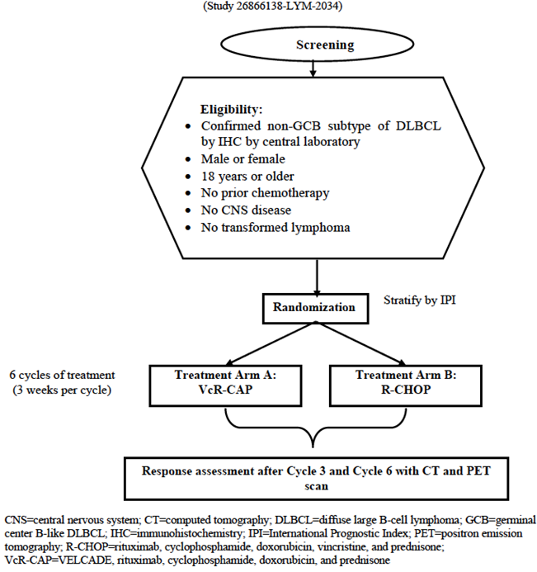

Major protocol violations/deviations
Shown in Table 2.
Table 2. Major protocol deviations (Intent-To-Treat analysis set)
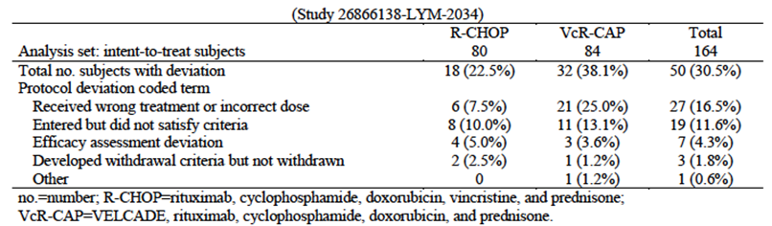

Baseline data
Shown in Tables 3 and 4.
Table 3. Demographics and baseline characteristics (Intent-To-Treat analysis set)
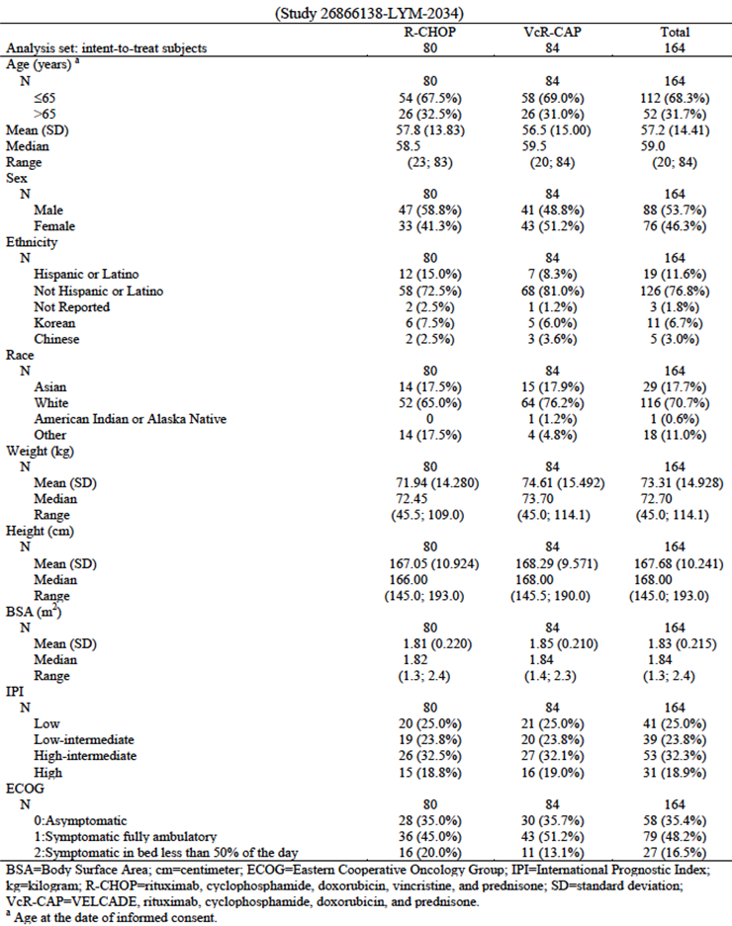
Table 4. Diagnosis (Intent-To-Treat Analysis Set)
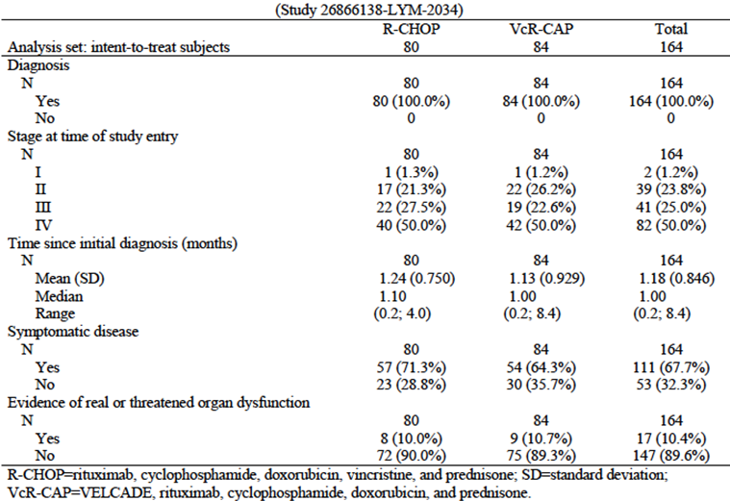

Results for the primary safety outcome
Most subjects experienced an adverse event: 100% of subjects in the R-CHOP treatment arm and 99% of subjects in the VcR-CAP treatment arm. For the R-CHOP treatment arm, the most frequently reported adverse events (preferred terms) were neutropenia (84%), constipation (32%), leukopenia (30%), nausea (25%), and pyrexia (23%). For the VcR-CAP treatment arm, the most frequently reported adverse events (preferred terms) were neutropenia (79%), thrombocytopenia (49%), diarrhea (32%), vomiting (30%), and constipation (29%).
Eighty-nine percent of subjects in the R-CHOP treatment arm and 88% of subjects in the VcR-CAP treatment arm experienced an adverse event of Grade 3 or higher. For the R-CHOP treatment arm, the most frequently reported adverse events of Grade 3 or higher (preferred terms) were neutropenia (81%), leukopenia (23%), and febrile neutropenia (20%). For the VcR-CAP treatment arm, the most frequently reported adverse events of Grade 3 or higher (preferred terms) were neutropenia (78%), thrombocytopenia (37%), and leukopenia (22%). For all remaining preferred terms, the proportions of subjects experiencing such an event were less than 10% for both treatment arms. Twelve subjects (15%) in the R-CHOP treatment arm and 8 subjects (10%) in the VcR-CAP treatment arm had died as of the clinical cutoff date of 6 June 2012. Progressive disease and adverse events were the most frequently reported causes of death. Progressive disease was reported as cause of death for 5 subjects in the R-CHOP treatment arm and 6 subjects in the VcR-CAP treatment arm. Adverse events were reported as cause of death for 5 subjects in the R-CHOP treatment arm and 2 subjects in the VcR-CAP treatment arm.
Thirty-four percent of subjects in the R-CHOP treatment arm and 38% of subjects in the VcR-CAP treatment arm experienced a serious adverse event. For the R-CHOP treatment arm, the most frequently reported serious adverse events (preferred terms) were febrile neutropenia (9%), neutropenia (6%), and pneumonia (4%). For the VcR-CAP treatment arm, the most frequently reported serious adverse events (preferred terms) were febrile neutropenia (9%), pyrexia (6%), and neutropenia and pneumonia (each in 5% of subjects). For all remaining preferred terms, the proportions of subjects experiencing such an event were less than 3% for both treatment arms.
Two subjects (3%) in the R-CHOP treatment arm and 6 subjects (7%) in the VcR-CAP treatment arm experienced adverse events which led to withdrawal from treatment. Adverse events (preferred terms) which led to withdrawal from treatment for more than 1 subject within either treatment arm included peripheral sensory neuropathy and neutropenia (2 subjects each in the VcR-CAP treatment arm).
Adverse events leading to dose reduction were experienced by 20 subjects (25%) in the R-CHOP treatment arm and 41 subjects (50%) in the VcR-CAP treatment arm. Differences in rates of ≥5% between the treatment arms were noted for the following preferred terms: neutropenia (R-CHOP: 14%; VcR-CAP: 21%), thrombocytopenia (R-CHOP: 0 subjects; VcR-CAP: 11%), peripheral sensory neuropathy (R-CHOP: 1%; VcR-CAP: 10%), and neuralgia (R-CHOP: 0 subjects; VcR-CAP: 9%). In each instance, the difference favored R-CHOP therapy.
Adverse events leading to dose withholding were experienced by 6 subjects (8%) in the R-CHOP treatment arm and 61 subjects (74%) in the VcR-CAP treatment arm. No adverse event (preferred term) led to dose withholding for more than 1 subject (1%) in the R-CHOP treatment arm. The most frequently reported adverse events (preferred terms) leading to dose withholding for the VcR-CAP treatment arm were neutropenia (59%), thrombocytopenia (23%), leukopenia (15%), peripheral sensory neuropathy (6%), and neuralgia (5%). All remaining preferred terms were reported for no more than 3 subjects (4%) each in the VcR-CAP treatment arm.
Adverse events leading to cycle delay were experienced by 24 subjects (30%) in the R-CHOP treatment arm and 30 subjects (37%) in the VcR-CAP treatment arm. In the R-CHOP treatment arm, adverse events (preferred terms) leading to cycle delay for 2 or more subjects were pneumonia (3 subjects [4%]) and leukopenia (2 subjects [3%]). In the VcR-CAP treatment arm, adverse events (preferred terms) leading to cycle delay for 2 or more subjects were neutropenia (11 subjects [13%]), thrombocytopenia and herpes zoster (3 subjects [4%] each), and pneumonia, lung infection, hepatic function abnormal, and pleural effusion (2 subjects [2%] each).
One subject (1%) in the R-CHOP treatment arm and 3 subjects (4%) in the VcR-CAP treatment arm experienced an adverse event categorised as heart failure. Seventeen subjects (22%) in the R-CHOP treatment arm and 26 subjects (32%) in the VcR-CAP treatment arm had at least 1 adverse event categorised as peripheral neuropathy not elsewhere classified (NEC). One subject receiving R-CHOP therapy died as a result of viral hepatitis; no prophylactic antivirals were recorded as concomitant medications. Two subjects in the R-CHOP treatment arm and 5 subjects in the VcR-CAP treatment arm experienced events of herpes zoster infection; none of the 7 subjects were receiving antiviral prophylaxis at the time of occurrence of the event.
Transient, cyclical decreases in platelet counts occurred in both treatment arms, however with lower nadir values in the VcR-CAP treatment arm relative to the R-CHOP treatment arm. Four percent of subjects in the R-CHOP treatment arm versus 49% of subjects in the VcR-CAP treatment arm had worst grade for platelets during treatment of Grade 3 or 4. Correspondingly, a higher rate of platelet transfusion was seen in the VcR-CAP treatment arm. Few Grade 3 or higher bleeding events were seen in either treatment arm.
Within the R-CHOP treatment arm, 12% of subjects had an improvement in ECOG performance status score from baseline to end of treatment, 49% had no change, and 39% had a worsened score. Within the VcR-CAP treatment arm, 15% of subjects had an improvement in ECOG performance status score from baseline to end of treatment, 59% had no change, and 27% had a worsened score.

Study M34103-053

Study design, objectives, locations and dates
See above.

Inclusion and exclusion criteria
See above.

Study treatments
See above.

Safety variables and outcomes
Safety evaluations included physical examinations, monitoring for adverse events (AE), clinical laboratory tests, vital signs measurements, and evaluation of concomitant medications, procedures, and supportive therapies.
Safety was assessed for the ATP and RP-Final populations.

Randomisation and blinding methods
VELCADE was administered in an open-label fashion; no method of blinding was employed in this noncomparative study.
See above.

Analysis populations
See above.

Sample size
See above.

Statistical methods
See above.

Participant flow
See above.

Major protocol violations/deviations
See above.

Baseline data
See above.

Results for the primary safety outcome
The majority of patients (152 of 155; 98%) experienced at least 1 treatment-emergent adverse event during the study. The most commonly reported treatment-emergent adverse events were asthenic conditions, including reports of fatigue, weakness, worsening fatigue, malaise, lethargy, and asthenia (112 patients; 72%). Other commonly reported adverse events in this study included peripheral neuropathies NEC (85 patients; 55%), constipation (77 patients; 50%), diarrhea (73 patients; 47%), nausea (68 patients; 44%), and appetite decreased (60 patients; 39%).
Commonly reported drug-related events included asthenic conditions (92 patients, 59%), peripheral neuropathies NEC (84 patients, 54%), diarrhea (60 patients, 39%), nausea (56 patients, 36%), and constipation (52 patients, 34%). Treatment-emergent events of ≥Grade 3 severity were reported in 108 (70%) of the 155 patients and were primarily reports of asthenic conditions (29 patients, 19%); peripheral neuropathies NEC (20 patients, 13%); thrombocytopenia (17 patients, 11%); disease progression NOS and diarrhea (11 patients each, 7%); and abdominal pain NOS and syncope (8 patients each, 5%).
As expected, VELCADE therapy was associated with peripheral neuropathy. The frequency of events under the MedDRA high level term “peripheral neuropathies NEC” was 55% in this study compared to 37% in the larger multiple myeloma experience in the phase 3 study M34101-039, and its phase 2 companion study, M34101-040. The reasons for this differences and its significance are not known; however it is possible that it reflects differences in prior therapy or inherent differences between MCL and multiple myeloma. Interestingly, prior therapy with vinca alkaloids was more common in the MCL patients treated on this study (95%, 147/155) compared to 74% and 81% in the multiple myeloma Study M34101-039 and Study M34101-040, respectively.
Overall, 12 patients died within 28 days after the last study drug dose. The cause of death was considered by the investigator to be study drug-related for 5 (3%) patients. The causes of death in these 5 patients included sepsis in 3 patients (in association with cardiac arrest in 1 patient and pulmonary alveolar hemorrhage and multi-organ failure in 1) and 1 patient each with respiratory failure and disease progression. All 5 patients had received only 1 or 2 cycles of VELCADE with the deaths occurring from 2 to 17 days post-treatment.
Serious adverse events were reported for 60 (39%) of the 155 patients. The most commonly reported SAEs were disease progression NOS and pneumonia NOS (10 patients each; 6%); syncope (7 patients; 5%); abdominal pain NOS and weakness (5 patients each; 3%); nausea, sepsis, and vomiting (4 patients each; 3%); and dehydration, dizziness, dyspnea NOS, peripheral neuropathy NEC, and pyrexia (3 patients each; 2%). The most commonly reported drug-related SAEs were abdominal pain NOS, nausea, syncope, and vomiting (4 patients each; 3%); and peripheral neuropathy NEC, pyrexia, pneumonia, and sepsis (3 patients each; 2%).
Treatment with VELCADE is known to be associated with a decline in platelet count during the dosing period with recovery observed during the rest period. As expected, a trend was seen in this study with regard to change in mean platelet count, with a progressive decrease from Day 1 to each subsequent VELCADE administration day (Days 4, 8, and 11) and recovery to pre-cycle baseline in mean platelet count during the rest period of each treatment cycle. Despite the decrease in platelet counts observed during each cycle, mean counts remained above 90 x 10⁹/L at all time points and the majority of patients had platelet counts above 50x10⁹/L.
Thrombocytopenia was reported as an adverse event in 33 (21%) of the 155 patients; Grade 3 or 4 thrombocytopenia was reported in 17 (11%) patients. Only 1 patient (<1%) discontinued VELCADE due to the occurrence of thrombocytopenia. A trend also was seen for mean ANC within most treatment cycles, with a decrease from Day 1 to each subsequent VELCADE administration day (Days 4, 8, and 11) and recovery to pre-cycle baseline in mean counts during the rest period of each treatment cycle. Mean ANC ranged from 3.0 to 4.3x10⁹/L through Cycle 8. Neutropenia was reported as an adverse event in 10 (6%) patients; with Grade 3 or 4 neutropenia reported in 6 (4%) patients. None of the patients in this study discontinued VELCADE for neutropenia. The reported incidence of febrile neutropenia was low (1 patient, <1%).
No notable changes from baseline were observed in mean electrolytes, renal function tests, liver function tests, or vital signs parameters.

Patient exposure
In the 3 submitted clinical studies, a total of 477 subjects received the study drug (bortezomib) alone (n=155) or in combination with other chemotherapy drugs (n=322).
Both for LYM-3002 and the pooled treatment groups most subjects (>80%) were able to complete treatment with either R-CHOP or VcR-CAP.
Table 5. Studies included in the Summary of Clinical Safety Analysis.
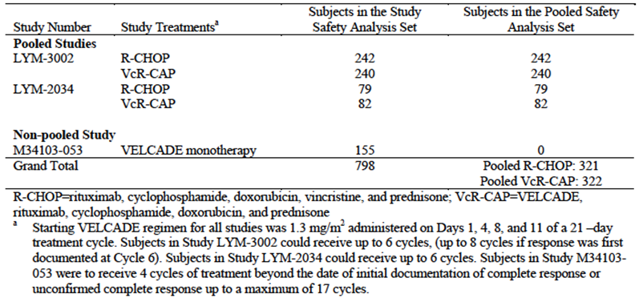
Table 6. Distribution of Number of treatment cycles; Safety Analysis Set (Studies LYM-3002, LYM-2034 and M34103-053).
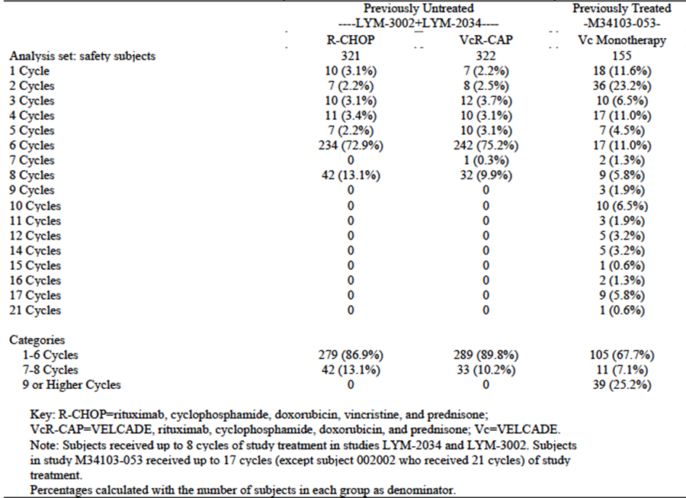
Table 7. Relative dose intensity (no less than 0.8 or 0.9) for the 4 common drugs; Safety Analysis Set (Studies LYM-3002, LYM-2034 and M34103-053).
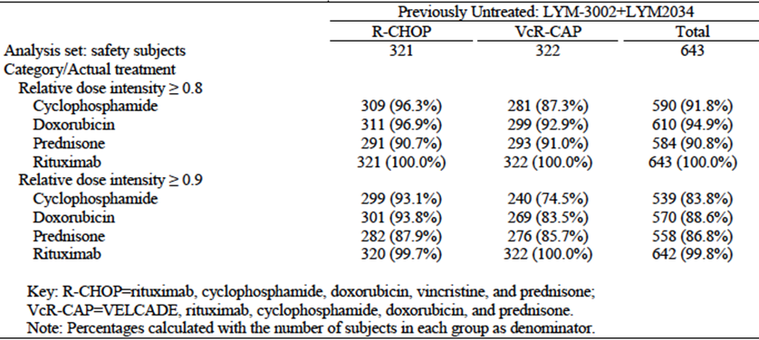

Adverse events

All adverse events (irrespective of relationship to study treatment)

Pivotal studies
In LYM-3002 the proportion of subjects experiencing any adverse event (98% v 99%) or at least 1 related AE (93% v 96%) were similar for R-CHOP and VcR-CAP. Grade 3 or higher AE were reported for a lesser proportion of subjects in the R-CHOP group than in the VcR-CAP group (85% v 93%) as were serious AEs (30% v 38%) and related serious AEs (21% v 33%).
Similarly, the pooled safety dataset analysis showed similar proportions of subjects experiencing AEs (99% v 99%), related AEs (94% v 97%), treatment discontinuations due to AEs (6% v 8%) for pooled R-CHOP and pooled VcR-CAP. Grade 3 or higher AEs (86% v 92%), serious AEs (31% v 38%) and related serious AEs (22% v 31%) were all reported for smaller numbers of subjects in the pooled R-CHOP group than the pooled VcR-CAP group.
The proportion of subjects experiencing AEs (98%) and serious AEs (39%) in the M34103-053 study was similar to that reported in the LYM-3002 study and the pooled analysis, although rates of Grade 3 or higher AEs was lower (70%).

Treatment-related adverse events (adverse drug reactions)

Pivotal studies
For LYM-3002 and the pooled analysis the most frequently reported serious AEs for both treatment groups were haematological disorders (13% R-CHOP v 17-18% VcR-CAP) followed by infections (12% R-CHOP v 17-18% VcR-CAP). In both LYM-3002 and the pooled analysis fewer than 10% experienced a serious AE within any other organ system classification.
The AEs seen at frequency >5% in either the R-CHOP or VcR-CAP treatment groups of the LYM-3002 study were: febrile neutropenia (8% v 11% respectively); neutropenia (5% and 5%); and pneumonia (3% v 8% respectively). For the pooled analysis, the only serious AEs seen at frequency >5% were: febrile neutropenia (8% v 10% respectively); neutropenia (6% v 5% respectively), pneumonia (3% v 7% respectively) and pyrexia (1% v 5% respectively).
The proportion of subjects in Study M34103-053 with serious AEs classified as Blood/Lymphatic disorders was much lower (3%) than for the pooled VcR-CAP treatment group (17%).
Table 8. Overview of treatment-emergent adverse events; Safety Analysis Set (Studies LYM-3002, LYM-2034 and M34103-053).
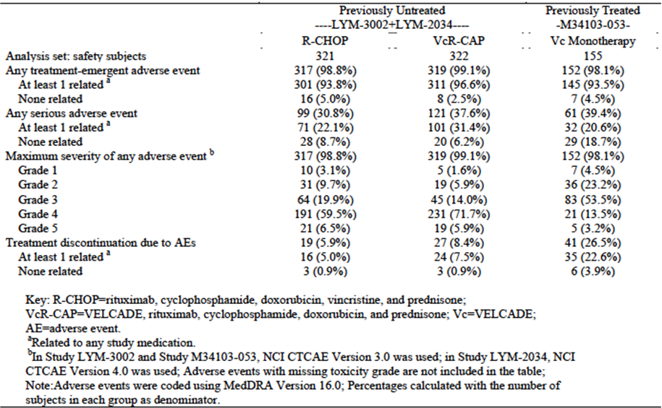

Deaths and other serious adverse events

Pivotal studies
In LYM-3002 there were no significant differences between the R-CHOP group and the VcR-CAP group in relation to deaths within 30 days, deaths within 60 days or deaths while on treatment (2% v 1%; 3% v 3%; and 6% v 5% respectively). Consistent with the later (non-significant) separation of the OS curves, a difference in the incidence of deaths at any timepoint during the study was observed between the treatment groups: 36% for R-CHOP v 29% for VcR-CAP. Similar numbers of subjects (7% R-CHOP and 6% VcR-CAP experienced a treatment-related AE leading to death. Pneumonia was the most common cause of treatment-emergent death with no pattern of deaths in either group.
The pooled safety dataset analysis also revealed similar incidence of death for both treatment groups for deaths within 30 days of first dose, deaths within 60 days of first dose and deaths while on treatment. Deaths at any timepoint during the study were lower in the VcR-CAP group (26%) compared with R-CHOP (32%).
All categories of death were seen at higher rates in the M34103-053 study however of the 93 subjects who died in this study few were related to treatment-emergent AEs (n=40 and the vast majority related to progressive disease (n=71) – which is consistent with the more advanced stage of disease in this study and the limited efficacy of any chemotherapy, including bortezomib monotherapy, in this group of patients.

Discontinuation due to adverse events

Pivotal studies

Discontinuation
Adverse event was the most frequently cited reason for treatment discontinuation, both for LYM-3002 (R-CHOP: 7%; VcR-CAP: 9%) and the pooled treatment groups (R-CHOP: 6%; VcR-CAP: 8%). For R-CHOP these were most often due to infection (2%) whereas for VcR-CAP these were most often due to neurological AEs (3%).
For Study M34103-053, treatment discontinuation was reported for 89% of subjects. This was most commonly attributed to lack of efficacy (49%) followed by adverse event (26%).

Cycle delay
In LYM-3002 33% of subjects in the R-CHOP group and 50% of subjects in the VcR-CAP group experienced an AE that led to a cycle delay. All causes of cycle delay were more common in the VcR-CAP group including infection (23% v 13%); pneumonia (6% v 2%); blood disorders (21% v 14%); neutropenia (16% v 10%) and thrombocytopenia (5% v 2%).

Discontinuation of bortezomib
Within the VcR-CAP group of the LYM-3002 study 11% of subjects experienced an AE that led to discontinuation of bortezomib only while 9% experienced an AE that led to discontinuation of bortezomib and at least 1 other drug. This was most commonly due to nervous system disorders (5%) and haematological toxicity (4%). The results of the pooled analysis echoed these findings.
Comment: Rates of discontinuation are similar for R-CHOP and VcR-CAP in patients with untreated disease. The high-rates of discontinuation of bortezomib monotherapy in M34103-053 are unsurprising given the patient population had relapsed/refractory MCL and so would either be unlikely to respond or, if responding, would be treated to the point where disease responsiveness is lost or drug toxicity occurs.

Laboratory tests

Liver function

Pivotal studies
Consistent with existing safety data on bortezomib – which demonstrates that it rarely causes significant hepatic dysfunction/failure and can be used safely in patients with even moderate liver dysfunction – there were few reports of abnormal LFTs in patients treated with VcR-CAP or with single agent bortezomib and those that did occur were mild Grade 1/2.

Kidney function

Pivotal studies
Consistent with existing safety data on bortezomib from studies in patients with multiple myeloma – renal dysfunction/failure was not increased in patients receiving VcR-CAP or single agent bortezomib.

Other clinical chemistry

Pivotal studies
In LYM-3002 biochemical abnormalities were generally mild (Grade 1 and 2) with Grade 3 and 4 biochemical abnormalities uncommon for both VcR-CAP and R-CHOP. For the R-CHOP group Grade 3 or 4 toxicity was most frequently reported for: hyperglycaemia (6%), hypokalaemia (4%) and hyponatraemia (4%). (None of this is surprising given the high-dose steroids that are included in R-CHOP). For the VcR-CAP group Grade 3 or 4 toxicity was most frequently reported for: hyponatraemia (8%), hypokalaemia (8%) and hypocalcaemia (5%).
Higher grade biochemical abnormalities were also uncommon in the pooled safety dataset and in Study M34103-053. For the pooled R-CHOP group Grade 3 or 4 toxicity was most frequently reported for hyperglycaemia (6%), hypokalaemia (3%), hyperkalaemia (3%) and hyponatraemia (3%). For the pooled VcR-CAP group, Grade 3 or 4 toxicity was most frequently reported for hypokalaemia (7%), hyponatraemia (6%), hypocalcaemia (5%) and hyperglycaemia (4%). For Study M34103-053, Grade 3 or 4 toxicity was most frequently reported for hyponatraemia (5%) and hypoalbuminaemia (3%).

Haematology

Pivotal studies
Analysis of LYM-3002 and the pooled safety dataset suggests that haematological toxicity – which is common – is largely the result of the rituximab, cyclophosphamide, doxorubicin and prednisone backbone that makes up the majority of R-CHOp and VcR-CAP. Nevertheless, the substitution of bortezomib for vincristine appears to contribute additional toxicity in terms of greater thrombocytopenia, neutropenia and lymphopenia.

Thrombocytopenia
From LYM-3002 thrombocytopenia was more common in VcR-CAP than R-CHOP – both Grade 3 (31% v 8%) and Grade 4 (35% v 3%). Depth of thrombocytopenia (<10 x 10⁹/L) was also more profound and mean nadir was also significantly lower in patients receiving VcR-CAP although platelet counts had generally recovered before the start of the next cycle in both groups.
Data from the pooled safety dataset mirrored findings from LYM-3002 with more patients receiving VcR-CAP experiencing greater Grade 3 and Grade 4 thrombocytopenia than patients receiving R-CHOP (30% v 6% and 31% v 2% respectively).

Neutropenia
During treatment Grade 3 neutropenia was not significantly different between the R-CHOP group and the VcR-CAP group – both in the LYM-3002 and the pooled safety dataset. Grade 4 neutropenia was, however, increased in patients receiving VcR-CAP compared with R-CHOP, both in the LYM-3002 study (73% v 60%) and the pooled safety dataset (71% v 64%). For both groups, however, neutropenia had generally recovered by the start of the next cycle and at the completion of treatment.

Haemoglobin
Grade 4 toxicity/anaemia is uncommon both with R-CHOP and VcR-CAP (3% each) and is of no clinical significance – with mean haemoglobin values consistently well-above the threshold for red cell transfusion.

Lymphopenia
As would be expected from chemotherapy regimens used in the treatment of lymphoma – lymphopenia is common and long-lasting – persisting beyond the completion of treatment in most patients. Grade 4 lymphopenia was more common in patients receiving VcR-CAP than R-CHOP in both the LYM-3002 and the pooled safety dataset (44% v 19% in both studies) but this does not appear to translate into greater adverse outcomes in terms of infections associated with lymphopenia which may be due to use of prophylaxis with Bactrim).
Rates of Grade 3, 4 or higher haematological toxicity were all substantially less in Study M34103-053 – suggesting that the rituximab/cyclophosphamide/doxorubicin/prednisone backbone that makes up R-CHOP and VcR-CAP is responsible for much of the severe haematological toxicity seen with these regimens.
Comment: The increased risk of thrombocytopenia and neutropenia with VcR-CAP (relative to R-CHOP) does not translate in greater mortality or (for the most part) morbidity. But this may be largely because of the greater administration of supportive care, including transfusion support and granulocyte colony stimulating factor (G-CSF) in this group – each of which carries cost and workforce implications. Post-marketing surveillance will be required to establish whether in non-trial conditions, the greater haematological toxicity associated with VcR-CAP translate into a higher risk of febrile neutropenia, serious infection and/or bleeding.

Electrocardiograph

Pivotal studies
ECG abnormalities were not significantly increased in VcR-CAP compared with R-CHOP in the LYM-3002 study. Differences in data collection precluded pooling of ECG data so no comment can be made in this regard.

Vital signs

Pivotal studies
Physical signs and ECOG data were not significantly different between the VcR-CAP and R-CHOP groups in the LYM-3002 study. Differences in data collection precluded pooling of ECOG data and physical signs so no further comment can be made in this regard.

Post marketing experience
AE reported from post-marketing sources of patients with relapsed MCL treated with bortezomib – as monotherapy or in combination with other chemotherapy – is consistent with the established safety profile of bortezomib in the treatment of patients with multiple myeloma. There is no post-marketing data on patients with previously untreated MCL.

Safety issues with the potential for major regulatory impact

Liver toxicity
The clinical studies submitted with did not suggest that the substitution of bortezomib for vincristine in the treatment of untreated MCL (VcR-CAP) would be likely to produce severe drug-induced liver injury (DILI). This is consistent with existing data on bortezomib in patients with multiple myeloma – which suggests that hepatic AEs are uncommon or rare.

Haematological toxicity
The substitution of bortezomib for vincristine contributes additional haematological toxicity to the combination of rituximab, cyclophosphamide, doxorubicin and prednisone used to treat patients with newly diagnosed, previously untreated MCL. Haematological AEs, including neutropenia, thrombocytopenia, anaemia and lymphopenia are all more common with VcR-CAP than R-CHOP. While these haematological toxicities may be associated with increased rates of infection, they are generally predictable, cyclical and self-limiting and can be appropriately managed with supportive care, judicious transfusion, antimicrobial prophylaxis and G-CSF as needed. Consequently, despite the increased haematological toxicity, deaths are not increased with VcR-CAP relative to R-CHOP and there is a trend to increased OS with VcR-CAP in patients with untreated MCL.

Serious skin reactions
While local injection site reactions can occur with subcutaneous injection of bortezomib, these studies do not report any instances of serious skin toxicity such as Stevens Johnson syndrome or toxic epidermal necrolysis.

Cardiovascular safety
The clinical studies submitted suggest that bortezomib administered as part of VcR-CAP is not associated with a higher incidence of cardiovascular toxicity when compared with R-CHOP. Cardiovascular toxicity, including arrhythmia and cardiac arrest – were uncommon in both groups.

Unwanted immunological events
Data from LYM-3002 and the pooled safety dataset suggests that serious immunological events due to bortezomib, including drug hypersensitivity, are uncommon.

Other safety issues

Peripheral Neuropathy
Both vincristine and bortezomib are well known to cause peripheral neuropathy. Perhaps siurprisingly, data from the LYM-3002 study and the pooled analysis reveal that the substitution of bortezomib was not associated with clinically significant excess peripheral neuropathy.
In the LYM-3002 study, proprtions of subjects with any peripheral neuropathy were similar for R-CHOP and VcR-CAP (29% v 30%). VcR-CAP was, however, associated more grade 2 or higher and grade 3 or higher peripheral neuropathy (10% v 5% and 8% v 4% respectively). Importantly, however, there were low rates of peripheral neuropathy SAE or SAE leading to sicontinuation in both the R-CHOp and VcR-CAP groups ((0% v 1% and <1% v 2% respectively) and almost all neuropathy fully resolved (75% of R-CHOP v 81% of VcR-CAP). Findings from the pooled analysis completely mirrored those of the LYM-3002 study.
Rates of peripheral neuropathy of all grades were much higher in the M34103-053 study, which likely reflected prior exposure to neurotoxic agents, comorbidity and duration of exposure.
Perhaps most importantly – as bortezomib was administered intravenously in all of the studies submitted in this application, it is likely that rates of peripheral neuropathy will be 30-50% lower in patients who receive bortezomib via subcutaneous administration.

Herpes zoster infection
Herpes Zoster infection occurred more commonly in subjects receiving VcR-CAP than R-CHOP in both the LYM-3002 study (7% v 1%) and the pooled analysis (7% v 2%). This is consistent with data in multiple myeloma and makes clear the importance of using antiviral prophylaxis.

Hepatitis B
Low rates of hepatitis B and death attributed to Hepatitis B were noted in both the R-CHOP and VcR-CAP groups in the LYM-3002 study (3% v 1% and 2 subjects v 1 subject respectively).

Safety in special populations

Race
Safety data from the LYM-3002 study and the pooled dataset demonstrated different AE in white and non-white (predominantly Asian) populations for both the VcR-CAP and R-CHOP combinations. Non-white subjects experienced higher rates of gastrointestinal and haematological AEs whereas white subjects had higher rates of neurological AEs and peripheral neuropathy with both VcR-CAP and R-CHOP.

Age
Both VcR-CAP and R-CHOP are better tolerated in younger (<65 years) than older (>65 years) patients. Results from the LYM-3002 and the pooled analysis by age demonstrated similar rates of Grade 3 or higher rates of AEs for both R-CHOP and VcR-CAP. Rates of Grade 4 and 5 AEs, however, were higher in patients aged >65, with Grade 4 AEs more pronounced in patients receiving R-CHOP and Grade 5 AEs more common in patients receiving VcR-CAP. In both treatment groups, higher proportions of older subjects experienced treatment discontinuation due to AEs (3% vs 10% for R-CHOP and 6% vs 12% for VcR-CAP). Rates of Grade 3 or higher AEs were much greater in older patients receiving single-agent bortezomib in the M34103-053 Study (younger: 59%; older 83%).

Safety related to drug-drug interactions and other interactions
There was no data reporting significant differences in drug-drug interactions in LYM-3002 or the pooled safety dataset.

Evaluator’s overall conclusions on clinical safety
The results of the LYM-3002 study and the pooled data for R-CHOP and VcR-CAP indicate that the majority of the AEs associated with VcR-CAP can be attributed to the rituximab, cyclophosphamide, doxorubicin, prednisolone backbone shared with R-CHOP.
The substitution of bortezomib for vincristine, however, does appear to contribute added haematological toxicity – with higher rates of thrombocytopenia and neutropenia. Greater haematological toxicity with VcR-CAP contributes to higher rates of Grade 3 or higher adverse events and serious adverse events for VcR-CAP relative to R-CHOP. For the most part, however, these toxicities are predictable, cyclical and easily manageable by tertiary haematology services with transfusion support, supportive care and appropriate dose modification and as such, did not result in significant differences in treatment-emergent deaths and treatment discontinuations – which were infrequent and similar in both the VcR-CAP and R-CHOP groups. Nevertheless, VcR-CAP appears to require greater use of G-CSF to maintain treatment intensity and avoid infective complications of neutropenia, higher rates of platelet transfusion to prevent bleeding complications of thrombocytopenia and antiviral prophylaxis to reduce the incidence of herpes zoster reactivation/infection.
Perhaps surprisingly, given the experience with bortezomib in patients with multiple myeloma, the substitution of bortezomib for vincristine contributed less neurotoxicity than would have been anticipated, with rates of peripheral neuropathy similar between the 2 treatment groups. (This may have been because vincristine is also associated with peripheral neuropathy – particularly in older patients.) Importantly – complete recovery of peripheral neuropathy was documented in most cases in both the R-CHOP and VcR-CAP groups. Given the increasing administration of bortezomib subcutaneously rather than intravenously – rates of peripheral neuropathy can be expected to be lower in target populations than in the study populations.

First round benefit-risk assessment

First round assessment of benefits
The benefits of VcR-CAP relative to R-CHOP in transplant ineligible patients with newly diagnosed MCL are:
- Improved PFS that is clinically and statistically highly significant;
- Improved time to progression, time to next anti lymphoma therapy and duration of treatment free interval, and
- Improved overall response rate and complete response rate.
While there is a trend to a survival benefit with VcR-CAP relative to R-CHOP the data is insufficient to judge whether VcR-CAP provide a survival advantage in patients with newly diagnosed MCL.

First round assessment of risks
The risks of substituting bortezomib for vincristine in the treatment of patients with newly diagnosed MCL judged unsuitable for transplantation are:
- Higher rates of peripheral neuropathy (Grade 2 or higher and Grade 3 or higher). Importantly, differences in peripheral neuropathy did not lead to greater rates of treatment discontinuation or higher rates of permanent neuropathy, with neuropathy completely resolving in the vast majority of patients.
- Higher rates of herpes zoster reactivation/infection: 1-2% for R-CHOP versus 7% for VcR-CAP (largely prevented by antiviral prophylaxis).
- Higher rates of all-grade and Grade 3 or higher thrombocytopenia, but not leading to higher rates of all-grade bleeding events, Grade 3 or higher bleeding events or higher rates of discontinuation of all study drugs. This appears to be because thrombocytopenia occurring with VcR-CAP is appropriately managed with platelet transfusion, that were more often administered in patients treated with VcR-CAP (20-23%) than in patients treated with R-CHOP (3%).
- Higher rates of all-grade and grade 3 or higher neutropenia – but not leading to higher rates of febrile neutropenia or discontinuation of study drugs – which were low and similar for R-CHOP and VcR-CAP (14-16% subjects treated with R-CHOP and 15-17% of patients treated with VcR-CAP developed febrile neutropenia). This is likely, in part, because patients treated with VcR-CAP were administered prophylactic or therapeutic G-CSF more frequently than patients treated with R-CHOP.

First round assessment of benefit-risk balance
The benefit-risk balance of bortezomib in combination with rituximab, cyclophosphamide, doxorubicin and prednisone (VcR-CAP) for the treatment of patients with newly diagnosed patients with MCL who are not eligible for transplant is favourable when compared with R-CHOP.
There is insufficient data to judge the relative efficacy and safety of VcR-CAP in patients with newly diagnosed patients with MCL who are candidates for autologous transplantation and received initial treatment that includes high dose chemotherapy with stem cell rescue. There is also insufficient data to judge the relative efficacy and safety of VcR-CAP with newly diagnosed patients with MCL treated with bendamustine containing regimens.

First round recommendation regarding authorisation
It is recommended that the application be approved, subject to provision of further information being provided as requested below.

Clinical questions

Pharmacokinetics
None

Pharmacodynamics
None

Efficacy
- Please provide an update on the LYM-3002 study, specifically in relation to PFS, duration of remission and OS. Has the trend to increased OS with VcR-CAP been realised with longer follow-up?
- Please provide any data on comparison of VcR-CAP with induction regimens containing high dose therapy with Stem Cell Rescue, for example, Nordic Protocol and comparison of VcR-CAP with BR regimen, either in untreated MCL or in patients with relapse/refractory MCL.

Safety
- Please provide any update on post marketing surveillance data on thrombocytopenia, neutropenia and related morbidity – bleeding, febrile neutropenia and infection – in non trial populations of patients with MCL in markets where bortezomib has been approved for use in MCL.

Second round evaluation
No second round evaluation

Second round benefit-risk assessment
No second round benefit-risk assessment

Second round recommendation regarding authorisation
No second round recommendation

Therapeutic Goods Administration
PO Box 100 Woden ACT 2606 Australia
Email: info@tga.gov.au Phone: 1800 020 653 Fax: 02 6232 8605
https://www.tga.gov.au

