First round report: 25 October 2016
Second round report: 3 February 2017

AusPAR Attachment 1

Extract from the Clinical Evaluation Report for Bosentan
  - Proprietary Product Name: Tracleer
  - Sponsor: Actelion Pharmaceuticals Australia Pty Ltd

About the Therapeutic Goods Administration (TGA)
- The Therapeutic Goods Administration (TGA) is part of the Australian Government Department of Health, and is responsible for regulating medicines and medical devices.
- The TGA administers the Therapeutic Goods Act 1989 (the Act), applying a risk management approach designed to ensure therapeutic goods supplied in Australia meet acceptable standards of quality, safety and efficacy (performance), when necessary.
- The work of the TGA is based on applying scientific and clinical expertise to decision-making, to ensure that the benefits to consumers outweigh any risks associated with the use of medicines and medical devices.
- The TGA relies on the public, healthcare professionals and industry to report problems with medicines or medical devices. TGA investigates reports received by it to determine any necessary regulatory action.
- To report a problem with a medicine or medical device, please see the information on the TGA website <https://www.tga.gov.au>.
About the Extract from the Clinical Evaluation Report
- This document provides a more detailed evaluation of the clinical findings, extracted from the Clinical Evaluation Report (CER) prepared by the TGA. This extract does not include sections from the CER regarding product documentation or post market activities.
- The words [Information redacted], where they appear in this document, indicate that confidential information has been deleted.
- For the most recent Product Information (PI), please refer to the TGA website <https://www.tga.gov.au/product-information-pi>.
Copyright
© Commonwealth of Australia 2018
This work is copyright. You may reproduce the whole or part of this work in unaltered form for your own personal use or, if you are part of an organisation, for internal use within your organisation, but only if you or your organisation do not use the reproduction for any commercial purpose and retain this copyright notice and all disclaimer notices as part of that reproduction. Apart from rights to use as permitted by the Copyright Act 1968 or allowed by this copyright notice, all other rights are reserved and you are not allowed to reproduce the whole or any part of this work in any way (electronic or otherwise) without first being given specific written permission from the Commonwealth to do so. Requests and inquiries concerning reproduction and rights are to be sent to the TGA Copyright Officer, Therapeutic Goods Administration, PO Box 100, Woden ACT 2606 or emailed to <tga.copyright@tga.gov.au> .

Contents
List of abbreviations 5
1. Introduction 9
1.1. Submission type 9
1.2. Drug class and therapeutic indication 9
1.3. Dosage forms and strengths 9
1.4. Dosage and administration 10
1.5. Information on the condition being treated 11
1.6. Current treatment options 11
2. Clinical rationale 12
2.1. Formulation 14
2.1. Evaluator’s commentary on the background information 14
3. Contents of the clinical dossier 15
3.1. Scope of the clinical dossier 15
Paediatric data 16
3.2. Good clinical practice 17
3.3. Evaluator’s commentary on the clinical dossier 17
4. Pharmacokinetics 18
4.1. Studies providing pharmacokinetic information 18
4.1. Summary of pharmacokinetics 19
4.2. Evaluator’s overall conclusions on pharmacokinetics 37
5. Pharmacodynamics 40
5.1. Studies providing pharmacodynamic information 40
5.2. Summary of pharmacodynamics 40
5.3. Evaluator’s overall conclusions on pharmacodynamics 40
6. Dosage selection for the pivotal studies 40
7. Clinical efficacy 40
7.1. Pivotal or main efficacy studies 41
7.2. Other efficacy studies 55
7.3. Analyses performed across trials: pooled and meta analyses 69
7.4. Evaluator’s conclusions on clinical efficacy 69
8. Clinical safety 70
8.1. Studies providing evaluable safety data 70
8.2. Studies that assessed safety as the sole primary outcome 70
8.3. Patient exposure 90
8.4. Adverse events 94
8.5. Evaluation of issues with possible regulatory impact 109
8.6. Other safety issues 119
8.7. Post marketing experience 120
8.8. Evaluator’s overall conclusions on clinical safety 124
9. First round benefit-risk assessment 124
9.1. First round assessment of benefits 124
9.2. First round assessment of risks 125
9.3. First round assessment of benefit-risk balance 126
10. First round recommendation regarding authorisation 127
11. Clinical questions 127
11.1. General 127
11.2. Pharmacokinetics 127
11.3. Efficacy 128
11.4. Safety 128
11.5. PI and CMI 128
12. Second round evaluation of clinical data submitted in response to questions 128
12.1. General 128
12.2. Pharmacokinetics 129
12.3. Efficacy 134
12.4. Safety 136
12.5. PI and CMI 138
13. Second round benefit-risk assessment 139
13.1. Second round assessment of benefits 139
13.2. Second round assessment of risks 139
13.1. Second round assessment of benefit-risk balance 141
14. Second round recommendation regarding authorisation 141

List of abbreviations
Abbreviation | Meaning
AaDO₂ | Alveolar-arterial oxygen difference
ABG | Arterial blood gas
AE | Adverse event
AI | Accumulation index
ALT | Alanine aminotransferase
ANCOVA | Analysis of covariance
ARGPM | Australian Regulatory Guidelines for Prescription Medicines
ASA | Australian Specific Annexe
AST | Aspartate aminotransferase
AUC | Area under the curve
AUC_{0-24C} | Corrected AUC
AUC_{0-24CN} | AUC dose normalised to 1 mg per day
AUC_{τ} | AUC during a dosing interval
BCS | Biopharmaceutic Classification System
BD | Twice daily
BMI | Body mass index
BP | Blood pressure
bpm | Beats per minute
CHD | Congenital heart disease
CHMP | Committee for Medicinal Products for Human Use
CI | Confidence interval
CL | Confidence limits
CL/f | Apparent total body clearance
C_{max} | Maximum observed concentration
C_{maxC} | Corrected C_{max}
CMI | Consumer Medicines Information
CPMP | Committee for Proprietary Medicinal Products
CSR | Clinical Study Report
CV | Coefficient of variation
ECG | Electrocardiogram
ECMO | Extra corporeal membrane oxygenation
EEA | European Economic Area
EMEA | European Medicines Agency
EOS | End of study
EOT | End of treatment
ET | Endothelin
ET-1 | Endothelin-1
EU | European Union
FC | Functional class
FiO₂ | Fraction of inspired oxygen
GCIS | Global clinical impression scale
GCP | Good Clinical Practice
HCPM | Health Canada Product Monograph
HR | Hazard ratio
iNO | Inhaled nitric oxide
IPAH | Idiopathic PAH
k_{a} | Absorption rate constant
k_{t} | Transfer rate constant
LLOQ | Lower limit of quantification
MAP | Mean airway pressure
mPAP | Mean pulmonary arterial pressure
NT-proBNP | N-terminal prohormone brain natriuretic peptide
OI | Oxygenation index
PaCO₂ | Partial pressure of carbon dioxide
PaO₂ | Partial pressure of oxygen
PAH | Pulmonary arterial hypertension
PAH-CHD | PAH secondary to congenital heart disease
PAH-SSc | PAH associated with systemic sclerosis
PBPK | Physiologically-based pharmacokinetics
PEEP | Positive end-expiratory pressure
PH | Pulmonary hypertension
PI | Product Information
PIP | Paediatric investigational plan
PK | Pharmacokinetics
PK1 | Pharmacokinetic assessment 1
PK2 | Pharmacokinetic assessment 2
PKWP | Pharmacokinetics Working Party
PopPK | Population pharmacokinetics
PPHN | Persistent pulmonary hypertension of the newborn
PVR | Pulmonary vascular resistance
QoL | Quality of life
RHC | Right heart catheterisation
RMP | Risk management plan
SAE | Serious adverse event
SaO₂ | Arterial oxygen saturation
SLE | Systemic lupus erythematosus
PHS | Physical summary score (for the SF-10 for Children)
PSS | Psychological summary score (for the SF-10 for Children)
SmPC | Summary of Product Characteristics
t_{½} | Half-life
TDS | Three times daily
t_{max} | Time to maximum concentration
ULN | Upper limit of normal range
US | United States
US PI | United States Prescribing Information
WHO | World Health Organization

Introduction

Submission type
This is an application to register a new oral solid dosage form and strength of bosentan for administration to the paediatric population. The new formulation is a quadrisected dispersible tablet containing 32 mg of bosentan.

Drug class and therapeutic indication
Bosentan is an oral endothelin (ET)-receptor antagonist that competes with the binding of ET-1 to both ET_{A} and ET_{B} receptors. The Health Canada Product Monograph (HCPM) provides the following summary of the mechanism of action of bosentan:
Bosentan is a dual endothelin receptor antagonist with affinity for both ET_{A} and ET_{B} receptors. Bosentan decreases both pulmonary and systemic vascular resistance, resulting in increased cardiac output without increasing heart rate.
The neurohormone endothelin is a potent vasoconstrictor with the ability to promote fibrosis, cell proliferation, and tissue remodelling. Endothelin concentrations in plasma and tissues are increased in a number of cardiovascular disorders, including pulmonary hypertension, suggesting a pathological role for endothelin in these diseases. In pulmonary arterial hypertension, endothelin plasma concentrations strongly correlate with poor prognosis.
Bosentan is specific for endothelin receptors. Bosentan competes with the binding of endothelin for both ET_{A} and ET_{B} receptors with a slightly higher affinity for ET_{A} receptors. In animal models of pulmonary hypertension, chronic oral administration of bosentan reduced pulmonary vascular resistance and reversed pulmonary vascular and right ventricular hypertrophy. In an animal model of pulmonary fibrosis, bosentan reduced collagen deposition.
In Australia, Tracleer is indicated for the treatment of:
- idiopathic pulmonary arterial hypertension
- familial pulmonary arterial hypertension
- pulmonary arterial hypertension associated with scleroderma or
- pulmonary arterial hypertension associated with congenital systemic to pulmonary shunts including Eisenmenger’s physiology
- in patients with WHO functional Class II, III or IV symptoms.
No changes to the approved indications have been proposed.

Dosage forms and strengths
This application seeks approval for a bosentan 32 mg dispersible tablet for paediatric administration. The following dosage forms and strengths are currently registered (Table 1):

Table 1: Dosage forms of Tracleer currently on the ARTG
Dosage form | ARTG number
Tracleer bosentan 62.5 mg (as monohydrate) tablet bottle | 91919
Tracleer bosentan 125 mg (as monohydrate) tablet bottle | 91920

Dosage and administration
The sponsor has proposed the following instructions for the new formulation:
The dispersible tablets should be added to a little water on a spoon, and the liquid stirred to aid dissolution, before swallowing. A little more water should be added to the spoon and swallowed by the patient, to make sure all of the medicine has been administered. If possible, a glass of water should be taken to ensure that all the medicine has been ingested. If necessary the dispersible tablet can be divided by breaking it along the lines cut into the surface.
The dispersible tablet has been studied only in paediatric patients. A pharmacokinetic comparison between the dispersible and the film coated tablet indicated slightly lower exposure to bosentan with the dispersible tablet in adult subjects (see pharmacokinetics). Thus its use in adults should be reserved for patients who cannot take the film coated tablet.
The sponsor has proposed extending the dosing instructions to include patients between one and three years of age. The following instructions for dose adjustment in children have been proposed:
For paediatric patients aged 1 year or older, the recommended starting and maintenance dose of Tracleer is 2 mg/kg morning and evening. There is only limited clinical experience in paediatric patients under 1 year of age.
These instructions would replace the current text in this section outlining the dosing instructions for children with pulmonary arterial hypertension (PAH):
There is limited experience with the use of Tracleer in children based on a pharmacokinetic study conducted in 19 children with PAH (see pharmacokinetics and clinical trials). The pharmacokinetic findings showed that systemic exposure in children with PAH was lower than in adults with PAH. Although the number of patients studied in each dose group was generally insufficient to establish the optimal dosing regimen, the following doses (Table 2) are recommended in children aged 3 years and over.

Table 2: Dosage regimen recommended for children aged 3 year and over
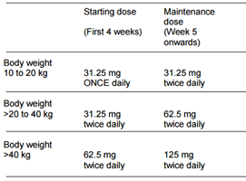

Information on the condition being treated
Pulmonary hypertension (PH) refers to elevated pulmonary arterial pressure and is defined by a mean pulmonary arterial pressure (mPAP) ≥ 25 mmHg at rest (normal mPAP is ≤ 20 mmHg). PH may be due to a primary elevation of pressure in the pulmonary arterial system or secondary elevations of pressure in the pulmonary venous and pulmonary capillary systems. The World Health Organization (WHO) classifies PH into five groups based on aetiology and mechanism. Group 1 refers to PAH which consists of sporadic idiopathic PAH (IPAH), familial PAH and PAH due to disease that localise to the small pulmonary muscular arterioles.
As outlined in the TGA adopted guidance document EMA/CHMP/213972/2010, the most common forms of paediatric PAH are IPAH and associated PAH. The guidance states that:
Although the definition of PAH is basically the same in both populations, extrapolation from adults to children is not straightforward for several reasons: 1) The prevalence of the subtypes of PAH is different among both populations for example the idiopathic form IPAH is more prevalent in adults, whilst PAH associated with congenital heart disease is more frequent in children; 2) the anticipated lifespan of children is longer and 3) before the advent of long term vasodilator/anti-proliferative therapy, the natural history remained significantly worse for children compared to adult patients. The choice of endpoints that are relevant and feasible to demonstrate efficacy in the paediatric population is also problematic.
The guidance document states that persistent pulmonary hypertension of the newborn (PPHN) is clinically classified with PAH. PPHN occurs when pulmonary vascular resistance remains abnormally elevated after birth, resulting in right to left shunting of blood through foetal circulatory pathways and hypoxaemia.

Current treatment options
Therapy for PH is usually directed at the underlying cause but there are no effective therapies for the causes of most types of Group 1 PAH. As outlined in the EU Guideline on the Clinical Investigations of Medicinal Products for the Treatment of Pulmonary Arterial Hypertension, conventional treatments for PAH include calcium channel blockers, anticoagulants, diuretics and oxygen. For more advanced cases disease specific therapeutic options include prostanoids, endothelin receptor antagonists and phosphodiesterase-5 inhibitors. Since the guideline was published, soluble guanylate cyclase stimulators have been registered as a therapy for PAH.
The management of PPHN consists of general supportive cardiorespiratory care, the use of vasodilatory agents, extracorporeal membrane oxygenation (ECMO) and specific treatments targeting the associated parenchymal lung disease.

Clinical rationale
At the time of the original marketing authorisation of Tracleer in the EU, an agreement was made with the Committee for Proprietary Medicinal Products (CPMP) that the sponsor would investigate the use of bosentan in paediatric patients with PAH, due to the need for therapy in children.
The sponsor studied the use of bosentan in children in Study AC-052-356 (BREATHE-3) using the approved tablet formulation of Tracleer. BREATHE-3 showed a lower systemic exposure in young children compared to the exposure in adults treated with 125 mg BD. Data from this study were submitted to the CHMP for inclusion in the Tracleer Summary of Product Characteristics (SmPC). The CHMP was of the opinion that data from BREATHE-3 were insufficient to support a therapeutic indication in children for two main reasons:
- The number of paediatric patients exposed was considered too small.
- The dose of bosentan used may have been suboptimal since mean plasma concentrations of bosentan obtained in children were lower than those observed in adult PAH patients.
The CHMP agreed to include the dosage information from BREATHE-3 in the SmPC.
The sponsor has developed an oral paediatric formulation of bosentan to facilitate weight appropriate dosing in children with PAH. The sponsor and the EMA reached agreement on the similarity of the disease of PAH in adults and children and on study design in order to obtain approval for the indication ‘treatment of PAH in children’ and the paediatric formulation. The agencies are reported to have agreed that the pathophysiology, evolution, and progression of idiopathic or familial PAH are similar between children and adults. Therefore, the treatment effect of bosentan could be assumed to be similar across age groups provided that similar plasma concentrations are reached. The sponsor states that a pharmacokinetic (PK) study investigating the safety and tolerability of bosentan (Study AC-052-365; or FUTURE-1) was considered adequate to obtain approval of the paediatric formulation of bosentan.
As data from BREATHE-3 indicated a lower than expected exposure to bosentan in paediatric patients (Table 3), the FUTURE programme (FUTURE-1 and Study AC-052-367 (FUTURE-2)) was designed with the following objectives:
- To increase the exposure in paediatric patients to that seen in adults.
- To increase the overall paediatric data available from bosentan studies.
FUTURE-1 was designed as a PK study, with exploratory examination of efficacy and safety. Patients with WHO functional class (FC) II or III PAH, received an initial dose of 2 mg/kg BD for 4 weeks, followed by a maintenance dose of 4 mg/kg BD up to a maximum of 120 mg BD bosentan for a total treatment period of 12 weeks. FUTURE-2 was an open label extension of the FUTURE-1 Study. Results of the FUTURE-1 Study indicated that the PK of bosentan in paediatric patients is characterised by an absorption plateau that limits exposure to bosentan, despite increasing doses (Figure 1, Table 3).
The paediatric formulation was approved in the EU in 2009 and the CHMP requested a comparison of the in vivo bioavailability of the dispersible and film coated tablet formulations as a post approval commitment. The CHMP also requested that further long term safety and clinical data should be collected in paediatric patients. Study AC-052-116 compared the PK properties of the dispersible tablet with the film coated tablet formulation in healthy adult subjects.
Study AC-052-373 (FUTURE-3) investigated if increasing the dose frequency from twice daily (BD) to three times daily (TDS) would increase the exposure in paediatric PAH patients. The study found that TDS administration in the paediatric PAH population did not increase exposure to bosentan compared to BD administration (Table 4).
Study AC-052-391 (FUTURE-4) evaluated the efficacy, safety and PK of bosentan (2 mg/kg BD) versus placebo as adjunctive treatment of PPHN in term or near term neonates whose response to inhaled nitric oxide (iNO) therapy was insufficient. Exposure achieved at steady state is reported to be similar to that observed in adult PAH patients receiving bosentan 125 mg BD. This was in contrast to the results in paediatric PAH patients aged ≥ 3 months, in which adult exposures to bosentan were not reached.

Table 3: Summary pharmacokinetics of bosentan in paediatric (BREATHE-3 and FUTURE-1) and adult (Study AC-052-357) PAH patients
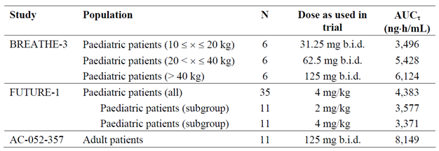
Figure 1: FUTURE-1 Arithmetic mean (± SD) plasma concentration versus time profiles of bosentan in paediatric patients with pulmonary arterial hypertension after multiple dose administration of bosentan at a dose of 2 and 4 mg/kg BD (n = 11)
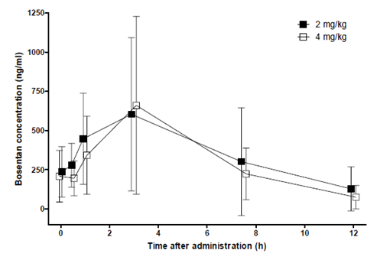

Table 4: FUTURE-3 Ratio of geometric means between treatment groups of PK parameters for bosentan (TDS/BD); overall age groups and by age group, PK set
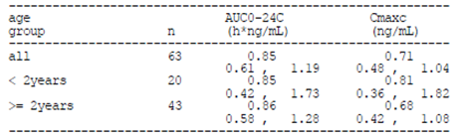

Formulation

Formulation development
Previously, the sponsor studied the use of bosentan in children in BREATHE-3 using the approved tablet formulation of Tracleer. The sponsor has since developed a paediatric formulation of bosentan in order to make bosentan available as oral treatment with a weight appropriate dose and formulation for children with PAH.
The paediatric formulation is a dispersible tablet containing 32 mg of bosentan. The tablet has quadrisecting score lines, enabling it to be divided into four parts of 8 mg bosentan each. The whole tablet, or fractions thereof, can be dispersed in water on a teaspoon or in a glass to facilitate oral administration.
In the justification for not providing biopharmaceutic data the sponsor states that no changes have been made to the quality aspects of the bosentan drug substance, the excipients fulfil the relevant quality standards and that Bosentan is classified as a Class II compound according to Biopharmaceutic Classification System (BCS) and that dissolved bosentan in vivo is immediately bioavailable. The sponsor states that no specific biopharmaceutic studies were performed to demonstrate bioequivalence for the new dispersible tablet and the approved marketed formulation.
As dissolution testing only applies to solid oral dosage forms, no analytical studies have been performed to compare dissolution profiles of the 32 mg dispersible tablets, the 62.5 mg and 125 mg tablets and the oral suspension of bosentan used in early clinical development. All dosage forms developed are stated to be immediate release forms with 90% of bosentan is dissolved within 20 to 30 minutes for 62.5 mg and 125 mg tablets, and less than 15 min for an oral suspension or dispersion of bosentan.

Excipients
The sponsor states that the new drug product excipients are commonly used in the pharmaceutical industry and fulfil all applicable quality standards.

Evaluator’s commentary on the background information
Australian Regulatory Guidelines for Prescription Medicines (ARGPM) Guidance 15 states that biopharmaceutic data is required for oral suspensions unless otherwise justified. For new dosage forms bioequivalence must be established between the new dosage form and the currently registered dosage form. The sponsor states that no specific study has been performed to demonstrate that the new dispersible tablet, used in studies FUTURE-1 and FUTURE-2, is bioequivalent to the approved marketed formulation. However it is noted that Study AC-052-116 evaluated the PK properties of a dispersible paediatric formulation and an adult formulation in healthy adult male subjects. The sponsor should be requested to confirm which studies evaluated the marketed adult formulation, the paediatric formulation intended for market and the formulation in early stages of development.
Study AC-052-106 compared the bioavailability of an oral suspension of bosentan used in early clinical development and the approved marketed formulation. The study is stated to provide additional bridging support. Study AC-052-106 is summarised and the text indicates that a copy of the final CSR has been included in the clinical dossier but the study is not included in the current submission. The sponsor states that Study AC-052-106 was provided in full as part of the original Tracleer application.
According to the ‘Guideline on the Investigation of Bioequivalence’ a BCS-based biowaiver may be applicable for immediate release drug products for BCS Class I or III drug substances under certain conditions. The justification for not providing biopharmaceutic studies indicates that bosentan is a BCS Class II compound. The guidance indicates that in ‘For dosage forms such as tablets, capsules and oral suspensions, bioequivalence studies are required unless a biowaiver is applicable’ and that in ‘cases where the test product is an oral solution which is intended to be bioequivalent to another immediate release oral dosage form, bioequivalence studies are required.’ The justification for not providing biopharmaceutic data is therefore not acceptable.
The status of the current submission in the US, Canada and New Zealand is unclear. The sponsor states that this application has not been rejected or withdrawn in the US or Canada but it is unclear whether an application to register the dispersible formulation has been made in these jurisdictions. The United States Prescribing Information (US PI) included in the submission does not describe paediatric dosing or the 32 mg dispersible tablet. The HCPM included in the submission does not mention the paediatric formulation and contains similar dosing instructions to the current Australian Tracleer PI. It is not stated whether a similar application has been made in New Zealand.

Contents of the clinical dossier
The clinical efficacy and safety of the new formulation of bosentan in the paediatric population has been extrapolated from the currently-registered products and the PK of the two formulations. Several of the submitted studies collected data on safety and efficacy in the paediatric population, as discussed in Sections 7 and 8.

Scope of the clinical dossier
The following clinical studies of relevance to the submission were provided:
- Two clinical pharmacology studies providing PK and safety pharmacology data.
- Two population PK (popPK) analyses
- Three uncontrolled studies of safety and efficacy
- Two supportive studies requested by the Delegate
- Two reports of analyses of data from more than one study (appendices to Modules 2.7.3 and 2.7.4)
- One PSUR for the period 20 November 2013 to 19 November 2014
- 61 literature references
The submission also contained the following documents of relevance to the clinical evaluation:
- Clinical Overview and addendum to support EMEA variation 39
- Clinical Overview and addendum to support EMEA variation 66
- Addendum (used to support EMEA Variation 51)
- Addendum Clinical Overview (20th PSUR nasal congestion)
- Summary of Biopharmaceutic Studies and Associated Analytical Methods
- Summary and Addendum to support variation 39
- Two documents titled ‘Summary to support EMEA variation 66’
- Three documents titled ‘Summary to support EMEA variation 39’
- Summary addendum (used to support EMEA Variation 51)
- Synopses of individual studies
- A list of literature references

Paediatric data
Seven studies with paediatric data have been included in the submission (Table 5). The paediatric development program form indicates that the sponsor is seeking approval for the preterm or term newborn infant, infant and toddler and children age ranges (less than 28 days to 11 years). The form indicates that the sponsor has an agreed PIP in Europe and an exemption from having to submit a paediatric assessment in the USA. The form states that all PIP studies have been completed.

Table 5: Paediatric studies included in the submission
PK topic | Age group | Study ID | Synopsis
Intrinsic factor PK study reports | Children | AC-052-365 FUTURE-1 | An open label, multicentre study to assess the PK, tolerability, and safety of a paediatric formulation of bosentan in children with idiopathic or familial PAH.
Population PK analyses | Infants/children | AC-052-373 FUTURE-3 | PopPK of bosentan in children with PAH
Uncontrolled clinical studies | Children | AC-052-367 FUTURE-2 | An open label, long term, safety, and tolerability extension study using the paediatric formulation of bosentan in the treatment of children with idiopathic or familial PAH who completed FUTURE-1.
 | Infants/children | AC-052-373 FUTURE-3 | An open label, randomised, multicentre, multiple dose trial to evaluate the PK, tolerability, safety and efficacy of the paediatric formulation of bosentan BD versus TDS in children from 3 months to less than 12 years of age with PAH.
 | Infants/children | AC-052-374 FUTURE-3 extension | A prospective multicentre, open label extension of Future 3 to assess the safety, tolerability and efficacy of the paediatric formulation of bosentan BD versus TDS in children with PAH.
Reports of Analyses of Data from More Than One Study | Infants/children | AC-052-367 FUTURE-2  AC-052-373 FUTURE-3  AC-052-391 FUTURE-4 | This document is a compilation of appendices referred to in the Summary of Clinical Efficacy.
 | Infants/children | AC-052-365 FUTURE-1  AC-052-367 FUTURE-2  AC-052-373 FUTURE-3  AC-052-374 FUTURE-3 Extension  AC-052-391 FUTURE-4 | This document provides an analysis of the pooled long term safety data from the FUTURE Study series 1 to 4 Extension.
PK in special populations | Neonates | AC-052-391 FUTURE-4 | Exploratory, multicentre, double blind, placebo controlled, randomised, prospective study to evaluate PK, safety and efficacy of bosentan as add-on therapy to iNO in the management of PPHN.
 | Neonates | AC-052-392 FUTURE-4 Extension | Multicentre, non-drug interventional extension study to assess long term safety and effects on growth in patients who received bosentan or placebo as adjunctive therapy to iNO for PPHN in Future 4.

Good clinical practice
Each of the Clinical Study Reports (CSRs) listed in the tabular listing of all clinical studies included has a statement indicating that research was conducted according to the principles of the ‘Declaration of Helsinki’ and with the laws and regulations of the countries in which the research was conducted. The wording regarding Good Clinical Practice (GCP) varies between studies but all studies indicate that the study was conducted in accordance with GCP.

Evaluator’s commentary on the clinical dossier
The submission is composed of three separate variations previously submitted to the EMA. Variation 39 relates to the new paediatric dosage form. Variation 51 is an update to the Undesirable effects section of the EU SmPC to include additional safety data from clinical trials and post-market safety updates. Variation 66 includes new PK data, safety and efficacy results from the FUTURE studies and safety data from post-market sources.
It is noted that whilst the FUTURE-4 Study examined the efficacy of bosentan in neonates with PPHN, PPHN is not an approved indication for bosentan in Australia and the sponsor has not requested an extension of indications to include PPHN.

Pharmacokinetics

Studies providing pharmacokinetic information
In the clinical summary the sponsor lists the following clinical pharmacology studies of relevance to the submission:
- Study AC-052-106
- Study AC-052-116
- Study AC-052-356 (BREATHE-3)
- Study AC-052-357
- Study AC-052-365 (FUTURE-1)
- Study AC-052-373 (FUTURE-3)
- Study AC-052-391 (FUTURE-4)
Full CSRs have not been included in the submission for Studies AC-052-106, AC-052-357 and BREATHE-3. A brief overview of these studies has been included in the submission which the evaluator has summarised (provided) despite the lack of a full CSR.
The sponsor states that they seek marketing authorisation for the paediatric dispersible tablet of bosentan based primarily on data from the BREATHE-3, FUTURE-1 and FUTURE-2 studies. Previous submissions indicate that BREATHE-3 hours as been evaluated by the TGA as part of PM-2005-2150-3 and it is noted that the results of this study are discussed in the current Tracleer PI. Table 6 summarises the submitted pharmacokinetic studies. A brief synopsis of referenced studies that weren’t included in the submission is provided in Table 7.

Table 6: Submitted pharmacokinetic studies
PK topic | Subtopic | Study ID | Synopsis
PK in healthy adults | Bioequivalence †  Single dose | AC-052-116 | Safety and tolerability study evaluating the relative PK properties of two different formulations of bosentan in healthy male subjects.
PK in special populations | Target population (paediatric PAH) §  Multi-dose | AC-052-365 FUTURE-1 | Assessed the PK, tolerability, and safety of a paediatric formulation of bosentan.
 | Target population (paediatric PAH) §  Multi-dose | AC-052-373 FUTURE-3 | Investigated the PK of a paediatric formulation of bosentan BD versus TDS in children with PAH.
 | Target population (PPHN) Multi-dose | AC-052-391 FUTURE-4 | Evaluated PK, safety and efficacy of bosentan as add-on therapy to iNO in the management of PPHN.
† Bioequivalence of different formulations. § Subjects who would be eligible to receive the drug if approved for the proposed indication.

Table 7: Referenced pharmacokinetic studies not included in the submission
Study ID | Subtopics | Synopsis
AC-052-106 | PK in healthy adults, bioequivalence, single dose | A single-centre, prospective, open label, randomised, 4-way crossover study comparing the bioavailability of a 125 mg bosentan tablet relative to that of an oral suspension of 125 mg bosentan, under both fasting conditions. The study also compared the bioavailability of a 125 mg bosentan tablet to two 62.5 mg tablets under fed conditions.
AC-052-357 | PK in target population (adult PAH) | A multi-centre, open label, non-comparative study designed to obtain safety data with bosentan in adult patients with PAH.
AC-052-356 (BREATHE-3) | PK in target population (paediatric PAH) | A multi-centre, prospective, open label, non-controlled study to investigate the PK of bosentan given as single and multiple oral doses in paediatric patients with PAH.
AC-052-356 (BREATHE-3) | PK in target population (paediatric PAH) | A multi-centre, prospective, open label, non-controlled study to investigate the PK of bosentan given as single and multiple oral doses in paediatric patients with PAH.

Summary of pharmacokinetics
The following summary of pharmacokinetics is presented in the Tracleer PI:
General
After oral administration, maximum plasma concentrations of bosentan found in a study of the 125 mg tablets taken as a single dose, were attained within 3.7 ± 1.7 hours and the apparent elimination half-life (t_{½}) was 5.6 ± 1.6 hours in 16 fasted subjects. The pharmacokinetics of oral bosentan have not been studied in patients with pulmonary arterial hypertension. The clearance of intravenous bosentan was significantly lower in patients with primary pulmonary hypertension (3 L/h) than in healthy volunteers (9 L/h). Exposure is also expected to be greater in patients with pulmonary arterial hypertension since increased (30 to 40%) bosentan exposure has been observed in patients with severe chronic heart failure.
Absorption and Distribution
In healthy volunteers at a dose of 600 mg, the absolute bioavailability of bosentan from an oral suspension was 41%. At a dose of 125 mg, administration of Tracleer with food did not have a significant effect on the extent of absorption but did increase the rate, leading to a 20% increase in peak plasma concentrations of bosentan. This is not expected to be clinically significant. The volume of distribution and clearance of bosentan are nonlinear and decrease as the dose increases. The mean volume of distribution of 17.8 ± 3.6 L/h and the mean clearance of 8.8 ± 1.9 L were determined after a mean IV dose of 250 mg was administered to 18 healthy male volunteers. Bosentan is highly bound (> 98%) to plasma proteins, mainly albumin. Bosentan does not penetrate into erythrocytes.
Metabolism and Elimination
Bosentan is metabolised in the liver by the cytochrome P450 enzymes, CYP 2C9 and CYP 3A4, and eliminated by biliary excretion. 94% of a radioactive oral dose was recovered in faeces (30% was unchanged). Bosentan has three metabolites, one of which is pharmacologically active and may contribute 20% of the effect of bosentan. Bosentan is an inducer of CYP2C9 and CYP3A4 and possibly also of CYP 2C19. Total clearance after a single intravenous dose is about 8 L/hr. Upon multiple dosing, plasma concentrations decrease gradually to 50 to 65% of those seen after single dose administration, probably the effect of auto-induction of the metabolising liver enzymes. Steady state is reached within 3 to 5 days. Less than 3% of an administered oral dose is recovered in urine.
Special Populations
It is not known whether bosentan pharmacokinetics are influenced by gender, body weight, race, or age.
Hepatic Function Impairment
The steady state pharmacokinetics of bosentan and metabolites were studied in 8 patients with mild hepatic impairment (Child-Pugh Class A) without pulmonary hypertension. Compared to healthy controls, bosentan C_{max}, AUC and half-life were not significantly altered; AUC of the active metabolite Ro 48-5033 was increased by 33%; trough concentrations of Ro 48-5033 and Ro 64-1056 were increased by 75% and 20%, respectively. Based on these findings, no dosage adjustment is required in patients with mild hepatic impairment (see dosage and administration).
The pharmacokinetics of bosentan have not been studied in patients with moderate to severe hepatic impairment. Tracleer is contraindicated in patients with moderate to severe hepatic abnormalities and/or baseline elevated aminotransferases > 3 x Upper Limit of Normal (ULN) (see contraindications).
Renal Impairment
In patients with severe renal impairment (creatinine clearance 15 to 30 mL/min), plasma concentrations of bosentan were essentially unchanged and plasma concentrations of the three metabolites were increased about 2 fold compared to people with normal renal function. These differences do not appear to be clinically important (see dosage and administration).
Children
The pharmacokinetics of bosentan at steady state were studied in 19 children aged 3 to 15 years with PPH or PAH secondary to congenital systemic to pulmonary communications. The number of patients studied in each dose group was insufficient to establish the optimal dosing regimen. In children weighing over 20 kg, administration of the recommended dose regimen (see dosage and administration) led to bosentan plasma concentrations which were higher than those in healthy adults taking the recommended adult dose, but similar to those expected in adults with pulmonary hypertension. In children weighing 10 to 20 kg, bosentan plasma concentrations during administration of the recommended dose were lower than in healthy adults, and thus lower than those expected in adults with pulmonary hypertension. However, the recommended dose was associated with haemodynamic improvement and should not be exceeded on safety grounds. The steady state half-life of bosentan in children averaged 5 to 6 hours.

Physicochemical characteristics of the active substance
The chemical name of bosentan is benzenesulfonamide, 4-(1,1-dimethylethyl)-N-[6-(2-hydroxyethoxy)-5-(2-methoxyphenoxy)[2,2'-bipyrimidin]-4-yl], monohydrate. The active pharmaceutical ingredient is actually a monohydrate and is designated Ro 47-0203/029.
Bosentan is achiral and the molecular formula is C27H29N506S.H20 with a relative molecular mass of 569.64. In aqueous solution, bosentan monohydrate is insoluble in water and in buffer solution of pH 1 to 5. The solubility increases at higher pH values (43 mg/100 mL at pH 7.5). In aqueous buffers, bosentan is most stable between pH 3 and 5. Bosentan monohydrate has a dissociation constant of 5.46.

Pharmacokinetics in healthy subjects
Two studies provided additional information regarding the pharmacokinetics of bosentan in the healthy adult population. The focus of these trials was the relative bioavailability of various bosentan formulations.
A full CSR for Study AC-052-106 was not included in the current submission. Study AC-052-106 compared the bioavailability of a 125 mg bosentan tablet to that of an oral suspension of 125 mg bosentan, under fasting conditions. The oral suspension formulation used in this study is stated to be one from early clinical development. The tablet formulation was the approved marketed formulation. Study AC-052-106 also compared the bioavailability of a 125 mg bosentan tablet to two 62.5 mg tablets under fed conditions.
Study AC-052-116 compared the PK properties of an adult and a paediatric formulation of bosentan after single dose administration to healthy male subjects. The adult formulation was a 62.5 mg tablet and the paediatric formulation was a dispersible 32 mg tablet. Treatment A consisted of a single dose of the 62.5 mg adult formulation and treatment B consisted of two tablets of the 32 mg paediatric formulation (64 mg).

Bioavailability

Study AC-052-106
Study AC-052-106 found that the 125 mg bosentan tablet had similar AUC_{0-∞} as the oral suspension under fasted conditions (Table 8). The study found that food had a small effect on the PK of bosentan. There was a 10% increase in bioavailability when the 125 mg tablet was given under fed conditions (Table 9). The sponsor states that this difference was not clinically relevant.
The mean plasma concentration time curves of bosentan following the four different treatments were provided. The sponsor states that Study AC-052-106 indicated that the bioavailability of the marketed adult bosentan tablet was similar to that of an oral suspension of bosentan.

Table 8: AC-052-106 Geometric mean ratios for AUC_{0-∞} and C_{max}
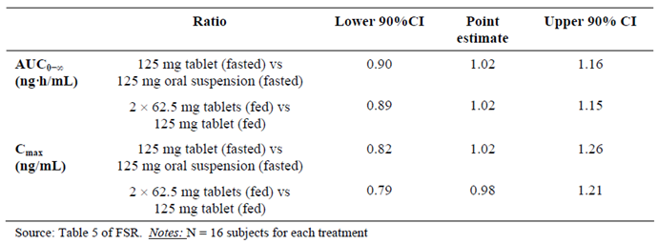

Table 9: AC-052-106 Pharmacokinetic parameters of bosentan following administration of four different 125 mg treatments
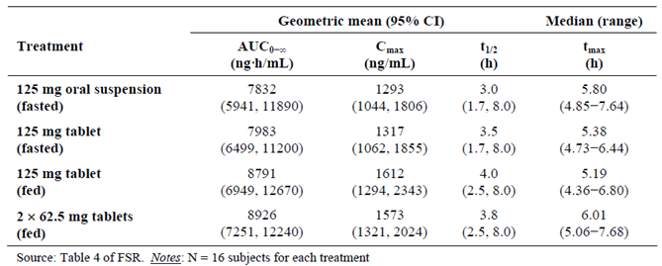

Study AC-052-116
On average, the systemic exposure to all analytes was lower in subjects treated with the paediatric formulation compared to the adult formulation. Following treatment with the paediatric formulation, the AUC_{0-t} and AUC_{0-∞} of bosentan were lower than with the adult formulation. The geometric mean ratio for AUC_{0-t} was 0.87 (90% CI: 0.78, 0.96) and 0.87 (90% CI: 0.78, 0.97) for AUC_{0-∞}. C_{max} was also lower with the paediatric formulation (geometric mean ratio 0.82 (90% CI: 0.65, 1.04)) (Table 10).
For Ro 48-5033, AUC_{0-t} was lower with the paediatric formulation (geometric mean ratio 0.82 (90% CI: 0.74, 0.90)). For AUC_{0-∞}, the geometric mean ratio was 0.91 (90% CI: 0.81, 1.01). C_{max} was also lower than with the adult formulation (geometric mean ratio 0.70 (90% CI: 0.55, 0.88)).
The sponsor states that t_{max} and t_{½} of bosentan and Ro 48-5033 were not significantly affected by the formulation. The t_{max} for bosentan was 4.0 hours for both formulations and the t_{max} for Ro 48-5033 was 5.0 hours for both formulations. The median difference and 90% CI for the t_{max} of bosentan and Ro 48-5033 was -0.3 (90% CI: -1.5, 0.5) and -2.8 (90% CI: -9.5, 2.5) respectively. The t_{½} for bosentan was 8.3 hours for the adult formulation compared to 9.3 hours for the paediatric formulation. The t_{½} for Ro 48-5033 was 10 hours for the adult formulation compared to 11 hours for the paediatric formulation. The geometric mean ratio for the t_{½} of bosentan and Ro 48-5033 was 1.12 (90% CI: 0.95, 1.33) and 1.11 (90% CI: 0.85, 1.42) respectively.
On average, the systemic exposure to all analytes was lower in subjects treated with the paediatric formulation.

Table 10: AC-052-116 Effect of the formulation on bosentan pharmacokinetics: Paediatric versus Adult formulation
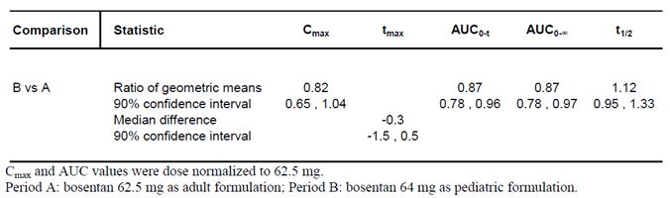

Pharmacokinetics in the target population
As outlined in Table 5 and Table 7, the following studies provided data on the PK of bosentan in the paediatric population:
- Study AC-052-356 (BREATHE-3)
- Study AC-052-365 (FUTURE-1)
- Study AC-052-373 (FUTURE-3)
- Study AC-052-391 (FUTURE-4)
The BREATHE-3 Study was not included in the current submission but a brief overview was provided (by the evaluator). The BREATHE-3 Study assessed the PK of bosentan given as single and multiple oral doses in paediatric patients with PAH. The patients were treated with the marketed adult formulation of bosentan. Patients received a single dose of bosentan on Day 1 according to body weight; on Day 2 patients began daily treatment with the initial dose for 4 weeks which was then up-titrated to twice the initial dose. The doses of bosentan used in BREATHE-3 were aimed at achieving an equivalent exposure in paediatric patients, as had been previously achieved in adults.
The FUTURE-1 Study is discussed (by the evaluator). This study assessed exposure to bosentan in children with idiopathic or familial PAH, using a paediatric formulation. The initial dose was 2 mg/kg BD for 4 weeks. After 4 weeks, the dose was to be up-titrated to the maintenance dose of 4 mg/kg BD up to the end of the study treatment at Week 12. If the maintenance dose was not well tolerated, the dose was to be down-titrated to the initial dose. Children weighing 30 kg or above were to receive the maximum initial dose of 64 mg BD, then 120 mg BD as the maintenance dose. The FUTURE-2 Study was an open label Phase III extension of the FUTURE-1 Study.
The FUTURE-3 Study compared BD and TDS dosing using the dispersible tablet formulation in children with PAH from ≥ 3 months to < 2 years. The treatments assigned in the core study were continued in the AC-052-374 FUTURE-3 extension study.
The FUTURE-4 Study assessed the efficacy of bosentan in neonates with PPHN who were in need of iNO. Secondary objectives included the evaluation of PK.

Bioavailability

Study AC-052-356 (BREATHE-3)
At Week 12, C_{max} ranged from 685 (10 to 20 kg) to 1,200 (> 40 kg) ng/mL and AUC_{τ} ranged from 3,496 (10 to 20 kg) to 6,124 (> 40 kg) ng·h/mL (Table 3). These results were compared to those from adult PAH patients where steady state C_{max} and AUC_{τ} values of 1,878 ng/mL and 8,149 ng·h/mL were observed, respectively. Paediatric systemic exposure was only about half that seen previously in adults.

Study AC-052-365 (FUTURE-1)
The primary objective of the study was not met: the geometric mean of the AUC_{τ} following treatment with the paediatric formulation of bosentan was 4,383 ng.h/ml (95% CI 3,461; 5,552) (Table 11). The ratio of the geometric means for AUC_{τ} was 0.5 (90% CI 0.4, 0.8), indicating that exposure to bosentan in adults was almost twice the exposure in children (Table 12). The confidence interval around the ratio of the geometric means of AUC_{τ} did not fall within the predefined equivalence limits of 0.66 to 1.5.
The secondary PK endpoints were C_{max} and t_{max} of bosentan and the C_{max}, t_{max} and AUC_{τ} of metabolites (Ro 47-8634, Ro 48-5033, Ro 64-1056). The geometric mean for the C_{max} of bosentan was 895 ng/ml (699, 1146). The median time to reach t_{max} of bosentan was 3 hours. The exposure to the metabolites was low compared to the exposure to bosentan, with Ro 48-5033 being the most prominent (Table 11).
In the 11 patients who underwent two PK assessments, the exposure to bosentan following both the initial dose of 2 mg/kg and the maintenance dose of 4 mg/kg was similar, that is, there was no increase in exposure to bosentan after doubling of the dose (Figure 1, Table13). The exposure to bosentan and its metabolites was similar when comparing oral doses of 2 and 4 mg/kg. No dose proportionality was observed.
No trend for an effect of age on the exposure to bosentan was discerned (Figure 2). None of the covariates (gender, WHO class, concomitant epoprostenol and previous bosentan treatment) had a discernible effect on the pharmacokinetics of bosentan (Figure 3).

Table 11: FUTURE-1 Descriptive statistics of the PK parameters of bosentan and its metabolites in paediatric patients with PAH after multiple dose administration of bosentan at a dose of 4 mg/kg BD (n = 35)
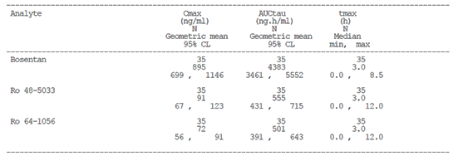

Table 12: FUTURE-1 Comparison of AUC_{τ} of bosentan in paediatric (4 mg/kg) and adult PAH patients (Study AC-052-357)
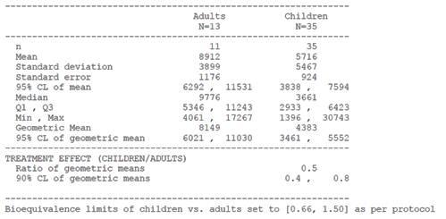

Table 13: FUTURE-1 Descriptive statistics of pharmacokinetic parameters of bosentan and its metabolites following administration of 2 and 4 mg/kg
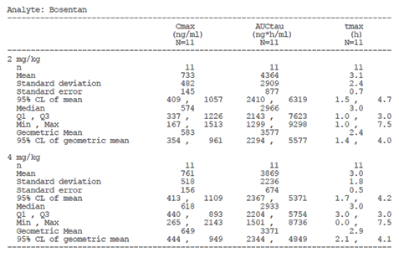
Figure 2: FUTURE-1 Effect of age on the PK of bosentan in paediatric patients with pulmonary arterial hypertension after multiple dose administration at a dose of 4 mg/kg BD
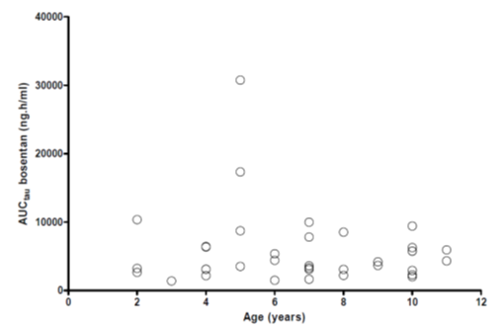
Figure 3: FUTURE-1 Effect of gender, WHO class, concomitant epoprostenol, and previous treatment with bosentan on the pharmacokinetics of bosentan in paediatric patients with pulmonary arterial hypertension after multiple-dose administration at a dose of 4 mg/kg BD
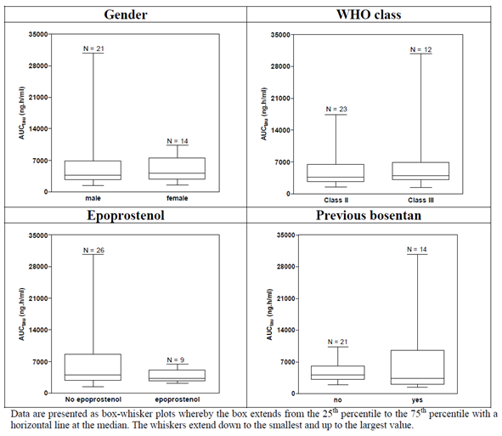

Study AC-052-373 (FUTURE-3)
The main PK endpoint was the AUC₀₋₂₄ calculated as a multiple of the exposure over a dosing interval (AUC_{τ}), 3 x AUC_{τ} and 2 x AUC_{τ} for TDS and BD regimens, respectively. Other PK endpoints were C_{max} and t_{max} of bosentan and AUC₀₋₂₄, C_{max}, t_{max} of bosentan metabolites.
The PK profiles for bosentan and its three metabolites at steady state are listed in Table 14. PK profiles of bosentan for both dosing regimens were characterised by rapid absorption, with a median t_{max} of 3 hours.
On average, the observed systemic concentrations over a dosing interval were slightly lower in patients who were dosed TDS (Figure 4). AUC_{0-24C} for the TDS (geometric mean: 7275 ng·h/mL) and BD regimens (geometric mean: 8535 ng·h/mL) were similar in the context of the high variability in exposure. The TDS dosing regimen resulted in a 15% lower geometric mean bosentan AUC_{0-24C} than in the BD dosing regimen for both the All randomised and PK sets (Table 4). The sponsor states that despite the difference in point estimates and the high inter-individual variability, the CIs around the geometric mean ratio included 1.00, suggesting that the daily exposures with the two regimens were comparable.
The C_{maxC} geometric mean for bosentan in patients who were dosed TDS (527.9 ng/mL) was lower than for patients who were dosed BD (742.8 ng/mL) (Table 14). With the TDS dosing regimen, the bosentan C_{maxC} was 29% lower compared to that with the BD dosing regimen. The effect of the dosing regimen on C_{maxC} was assessed by analysis of the geometric means ratio and its 95% CI (0.71 [95% CI: 0.48, 1.05]) (Table 4). The 95% CI showed high variability. The sponsor states that the C_{maxC} for both dosing regimens were comparable as the 95% CI included 1.00.
The exposure to the three bosentan metabolites was lower compared to bosentan exposure. Ro 48-5033 was the metabolite predominantly detected. For Ro 48-5033, Ro 64-1056, and Ro 47-8634, peak concentrations were attained at 3 hours for the BD dosing regimen, and at 3 hours, 5 hours, and 3 hours, respectively, for the TDS dosing regimen. C_{maxC} and AUC_{0-24C} for the three metabolites were lower with the TDS than with the BD dosing regimen (Table 14). The 95% CI of geometric mean ratios (TDS versus BD), for C_{maxC} were 0.85 (0.60, 1.21), 0.69 (0.46, 1.01), and 0.72 (0.51, 1.02), for Ro 47-8634, Ro 48-5033, and Ro 64-1056 respectively. The 95% CI of geometric mean ratios (TDS versus BD), for AUC_{0-24C} were 0.86 (0.57, 1.30), 0.72 (0.50, 1.03), and 0.71 (0.50, 1.00) for Ro 47-8634, Ro 48-5033, and Ro 64-1056 respectively. The sponsor states that the 95% CI of geometric mean ratios for C_{maxC} and AUC_{0-24C}, always included 1.00, indicating similarity between the two regimens.
The comparison of the metabolite to parent geometric mean ratios between the TDS dosing regimen (0.025, 0.134, and 0.101 for Ro 47-8634, Ro 48-5033, and Ro 64-1056, respectively) and BD dosing regimen (0.025, 0.159, and 0.122, respectively) indicated that the dosing regimen did not influence the metabolic pathways or the extent of metabolism of bosentan in the overall patient population (Table 15).
The PK profiles of bosentan in the BD and TDS dosing regimens by age group (Figure 5) were similar to those for the overall population. The 95% CI of geometric mean of AUC_{0-24C} and C_{maxC} largely overlapped for both dosing regimens and both age groups (Table 16). The median t_{max} was 3 hours for patients ≥ 2 years for both dose regimens. In patients < 2 years, the median t_{max} occurred later on TDS dosing (4 h) than on BD dosing (3 hours). This slight difference might be driven by two atypical bosentan profiles in patients < 2 years who were dosed TDS.
The point estimates of the geometric mean ratios of AUC_{0-24C} and C_{maxC} for bosentan and its metabolites were comparable across the age groups, and the systemic exposure to bosentan was also comparable between patients aged < 2 years and those ≥ 2 years, and this was observed for both BD and TDS dosing regimens. The geometric mean ratio of AUC_{0-24C} (TDS versus BD dosing, PK set) by age group was 0.86 [95% CI: 0.43, 1.72] for patients < 2 years and 0.85 [95% CI: 0.57,1.28] for patients ≥ 2 years. The point estimates were almost identical in both age groups. The difference between the ranges of the 95% CI are likely due to the imbalance of number of patients in the two age groups (patients < 2 years: n = 20; patients ≥ 2 years: n = 43). Figure 6 presents the PK profiles of bosentan by dosing regimen and by age group (3 months to < 2 years versus 2 to < 12 years). The PK profiles indicate that age had little or no influence on bosentan levels.
The sponsor concludes that overall, the study showed that TDS dosing in the paediatric PAH population did not increase the exposure to bosentan compared to BD dosing.

Table 14: FUTURE-3 Short summary of bosentan, Ro 47-8634, Ro 48-5033, and Ro 64-1056, PK set
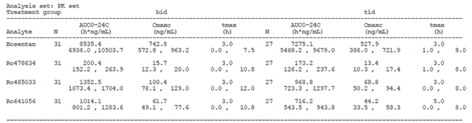
Figure 4: FUTURE-3 Arithmetic mean plasma concentration (± SD) versus time profiles of bosentan (TDS (n = 27) and BD (m = 31)) on a linear and semi-logarithmic scale, dose corrected, overall age group at Week 4, PK set
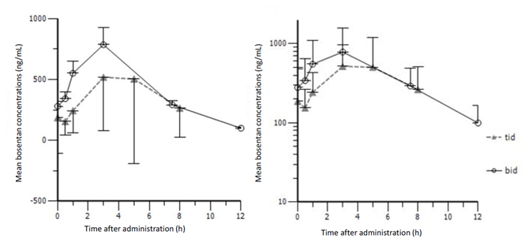

Table 15: FUTURE-3 Metabolites to bosentan exposure geometric mean ratio, PK set
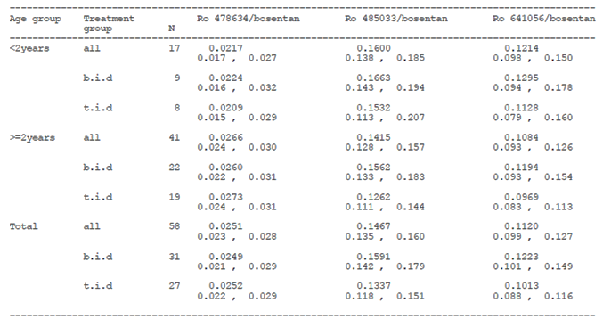
Figure 5: FUTURE-3 Arithmetic mean plasma concentration (± SD) versus time profiles of bosentan by age group and dosing regimen (on a linear scale)
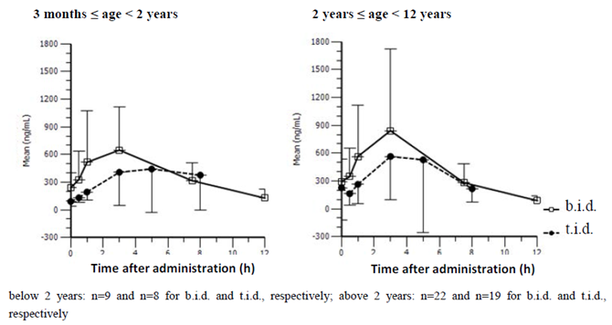

Table 16: FUTURE-3 Summary of bosentan PK parameters per treatment group; by age group, PK set
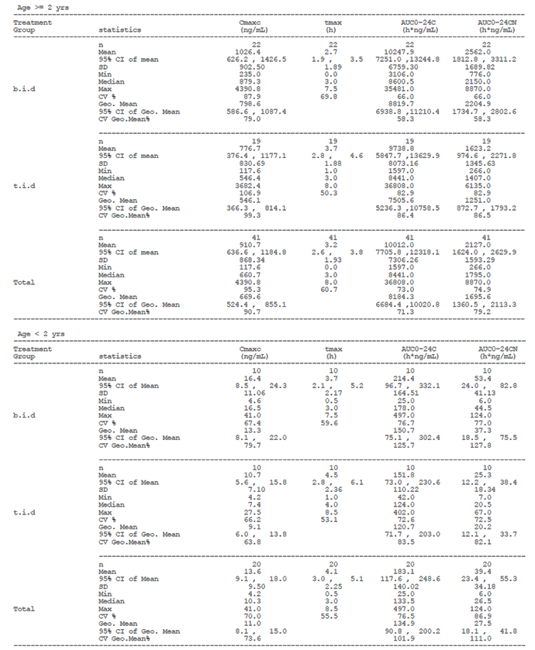
Figure 6: FUTURE-3 Arithmetic mean plasma concentration (± SD) versus time profiles of bosentan by dosing regimen and age group (on a linear scale)
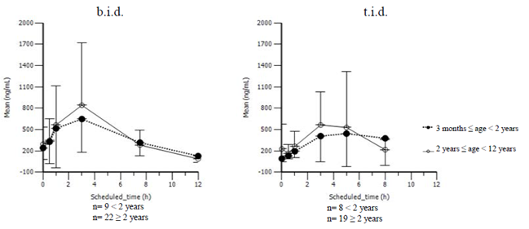

Study AC-052-391 (FUTURE-4)
Secondary objectives of the FUTURE-4 Study included the evaluation of the PK of bosentan in neonates with PPHN who were in need of continued iNO. Patients were randomised in a 2:1 ratio to bosentan 2 mg/kg BD dispersible tablet formulation or to matching placebo. Study drug was administered until 24 hours after complete weaning from iNO or until treatment failure (defined as the need for ECMO or the initiation of alternative pulmonary vasodilator), or the maximum permitted duration of treatment with study drug had been reached (14 days). The FUTURE-4 Study design is discussed in Section 7. The following PK endpoints were evaluated based on concentrations in dried blood spot samples:
- C_{max} and t_{max} (Days 1 and 5), AUC₀₋₁₂ (Day 1), AUC_{τ} (Day 5), and AUC₀₋₂₄ (Days 1 and 5) for bosentan and its metabolites (Ro 48-5033, Ro 47-8634, Ro 64-1056).
- Accumulation index (AI), defined as the ratio between AUC_{τ} (Day 5) and AUC₀₋₁₂ (Day 1) for patients who had PK assessments performed on Days 1 and 5, provided that AUC₀₋₁₂ was > 0 ng.h/mL.
After the first dose of 2 mg/kg the bosentan PK profile was characterised by a slow and continuous increase in concentration over the first dosing interval after the first study drug administration (Figure 7). Bosentan exposure was low and variable on Day 1, with a geometric mean AUC_{0-24C} (95% CI) of 287.5 ng·h/mL (15.0, 5504.7) and a geometric mean C_{max} of 30.1 ng/mL (2.4, 372.2) (Figure 8, Table 17).
On Day 5, the pre-dose mean bosentan concentration was similar to that measured at the end of the dosing interval, suggesting the attainment of steady state conditions. Median t_{max} was 7.5 hours. Bosentan exposure was markedly higher when compared to Day 1 with a geometric mean AUC_{0-24C} (95% CI) of 11530.2 ng·h/mL (4507.0, 29497.5) and geometric mean C_{max} of 880.0 ng/mL (339.2, 2282.7). Bosentan exposure remained variable on Day 5 but was similar to the exposure observed in adult PAH patients administered with 125 mg bosentan BD (Table 17).
The exposure to bosentan metabolites was limited on Day 1. At steady state, the exposures to the metabolites increased (Table 18). The sponsor states that these ratios are higher than those in paediatric PAH populations, but comparable to those observed in adult PAH patients.
The relationship between bosentan exposure and several baseline covariates was explored visually. No relationship was observed between bosentan exposure and patient age at treatment initiation, gestational age or birth weight. On Day 5, the analysis of the relationship between bosentan exposure and the severity of the disease at baseline suggested that patients with less severe disease at baseline (reflected as a low OI) had higher exposure to bosentan (Figure 9).
The small number of patients coupled with the high variability in drug concentration on Day 1 meant that it was not possible to detect any relationship between bosentan concentration and change in baseline OI and alveolar-arterial oxygen difference (AaDO₂). Analyses of the mean change in OI and in AaDO₂ versus bosentan exposure (AUC₀₋₂₄ and C_{max}) on Days 1 and 5 did not show any relationship. The time to complete weaning from iNO did not show any relationship to bosentan exposure.
The geometric mean AI for bosentan was 61.6. The individual AI values ranged from almost no accumulation (1.15 fold) to pronounced accumulation (450 fold) without taking into account the AI of one patient who had no bosentan exposure on Day 1 and for whom a low value for AUC_{0-24C} and C_{maxC} was imputed. The high AIs observed are driven by very low exposures to bosentan after the first dosing rather than high exposure on Day 5, as the overall exposure at steady state is comparable to the exposure observed in adult PAH patients administered with 125 mg bosentan BD. The geometric mean C_{maxC} for bosentan at steady state (880 ng/mL [95% CI 339.2, 2282.7]) was approximately 30 times higher than on Day 1 (30.1 ng/mL [95% CI 2.4, 372.2]) as shown in Table 17.
The metabolite to parent geometric mean ratios on Day 1 (0.0004, 0.0061, and 0.0110 for Ro 47-8634, Ro 48-5033, and Ro 64-1056, respectively) showed that on Day 1 only very small amounts of metabolites were formed. On Day 5, the metabolite to parent geometric mean ratios (0.04, 0.46, and 0.22, respectively) had increased substantially, indicating greater metabolism compared to Day 1.
Potential relationships between bosentan concentrations at 3 hours and 12 hours on Day 1, and the change from baseline in OI or AaDO₂ were investigated. The small number of patients coupled with the high variability in drug concentration on Day 1 meant that it was not possible to detect any relationship. Analyses of the mean change in OI and in AaDO₂ versus bosentan exposure (AUC₀₋₂₄ and C_{max}) on Days 1 and 5 did not show any relationship.
The time to complete weaning from iNO did not show any relationship to bosentan exposure.

Table 17: FUTURE-4 Summary of bosentan, Ro 47-8634, Ro 48-5033, and Ro 64-1056, PK analysis set
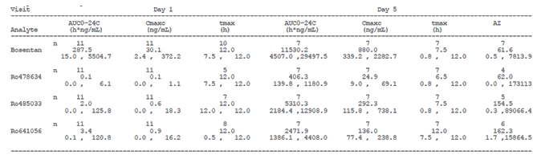

Table 18: FUTURE-4 Metabolites to bosentan exposure ratios, PK analysis set
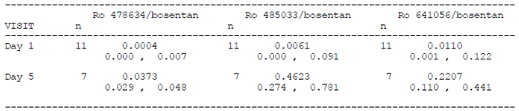
Figure 7: FUTURE-4 Arithmetic mean whole blood concentration versus time profiles of bosentan and its metabolites on Day 1 (n = 11) and Day 5 (n = 7) on a linear scale, 2 mg/kg dose-corrected concentrations; PK analysis set
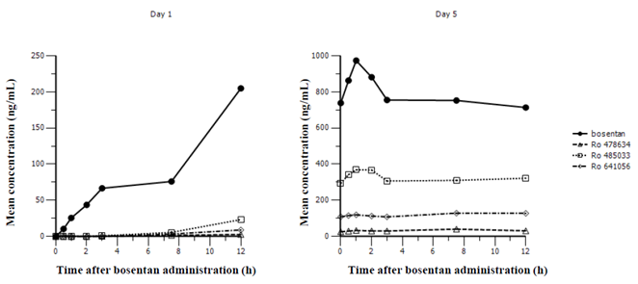
Figure 8: FUTURE-4 Mean dose-corrected (± SD) whole blood profiles for bosentan, Ro 47-8634, Ro 48-5033, and Ro 64-1056 (linear scale), PK analysis set
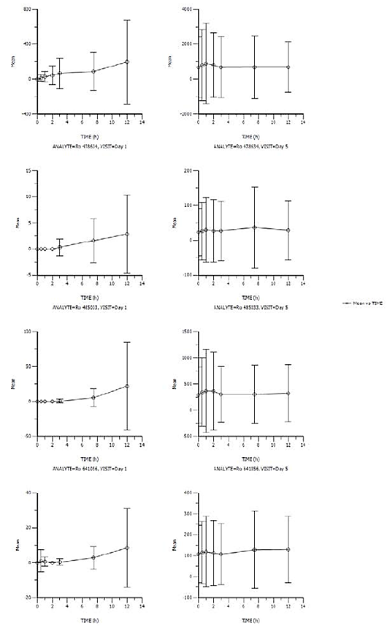
Figure 9: FUTURE-4 Relationship between severity of the disease at baseline (OI) and systemic exposure to bosentan on Day 5, PK analysis set
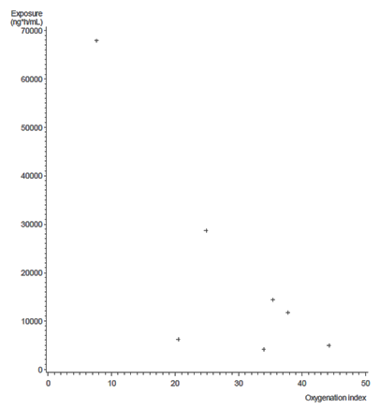

Pharmacokinetics in special populations

Pharmacokinetics according to age
The findings of lower average exposure in children compared with adults at a given mg/kg dose of bosentan made in BREATHE-3 were confirmed in FUTURE-1. The exposure to bosentan in the subgroup of patients in FUTURE-1 who underwent two PK assessments was similar for both the 2 and 4 mg/kg doses, suggesting that in paediatric patients an exposure plateau is reached at lower doses when compared to adults. The sponsor states that increasing the dose further is unlikely to increase the average exposure to that observed in adult PAH patients. The sponsor states there are no indications from the biopharmaceutical and pharmacology data to suggest that the new paediatric dispersible tablet formulation would be a limiting factor.
Figure 10 shows the individual AUC_{τ} values as measured in FUTURE-1 in comparison to those measured in Study AC-052-357 and BREATHE-3, and also includes available PK data from Study AC-052-364 (EARLY) in adult PAH patients in WHO FC II. There is a large overlap between BREATHE-3 and FUTURE-1 results, despite the different dose intensities used in the two studies. Although, on average, the exposure to bosentan was higher in adult patients when compared to paediatric patients, there is an overlap. At present, it is unknown what caused the exposure to bosentan to be much higher in one patient in FUTURE-1.
Figure 10: Individual AUC₀₋₁₂ values of bosentan for FUTURE-1, BREATHE-3, and Studies AC-052-364 EARLY and AC-052-357
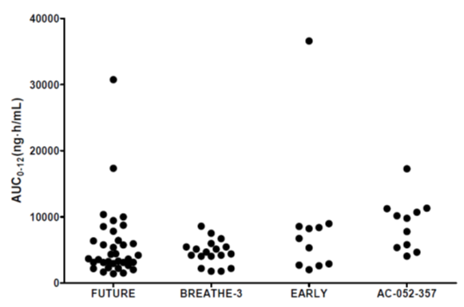

Population pharmacokinetics

AC-052-373 FUTURE-3 (PopPK analysis)
A summary of the FUTURE-3 Study was provided. The sponsor has also provided a PopPK analysis of bosentan in paediatric patients with PAH based on the data from the FUTURE-3 Study.
Dosing regimen was identified as a significant covariate on the absorption rate constant (k_{a}), apparent body clearance (CL/f), and the transfer rate constant (k_{t}) (Figure 11). The differences in bosentan concentrations between the two dosing regimens were very small with similar maximum concentrations and slightly faster elimination for the TDS dosing regimen.
Body weight was identified as a statistically significant covariate on CL/f (Figure 12). Children with higher body weight have higher total doses but also higher clearances. Body weight and age are highly correlated and both covariates alone showed significant influence on the PK of bosentan during individual covariate testing. During backward deletion, age was dropped and body weight resulted as the covariate which can better explain differences in PK in children.
Figure 11: FUTURE-3 PopPK study summary of simulations for bosentan by dose regimen (blue line = median, green lines = 10th and 90th quantile)
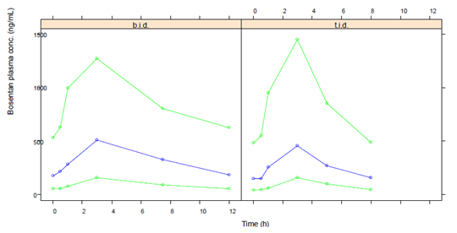
Figure 12: FUTURE-3 PopPK study summary of simulations for bosentan (2 mg/kg BD) by body weight (blue line = median, green lines = 10th and 90th quantile)
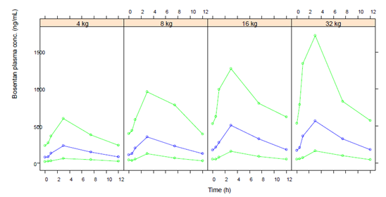

Evaluator’s overall conclusions on pharmacokinetics
Study AC-052-106 found that an oral suspension of bosentan was not bioequivalent to the tablet formulation with respect to C_{max} as the 90% CI for the ratio of geometric means fell outside the acceptance interval of 80.00 to 125.00% (Table 8). The ratio of geometric means for AUC_{0-∞} did fall within the acceptance interval. The sponsor states that this result together with the chemical characteristics of bosentan provides evidence for similar PK characteristics between the currently approved formula and oral suspensions or dispersions. In the submission the sponsor refers to bosentan as both a Class I and a Class II compound. It should be clarified with the sponsor, which studies included the paediatric formulation intended for market rather than a formulation from early clinical development. The sponsor states that since the new dispersible tablet is administered as a dispersion, and it is reasonable to assume that the absorption, distribution, metabolism, and elimination characteristics of the paediatric formulation would correspond to those of the oral suspension used in Study AC-052-106 and, also to those of the approved, film coated, immediate release tablet. The sponsor has not justified only considering AUC as the important PK parameter for establishing bioequivalence for bosentan rather than using both AUC and C_{max}. Bioequivalence has not been clearly demonstrated for an oral solution versus the approved tablet formulation of bosentan.
The comparison of formulations in healthy adult volunteers rather than children in studies AC-052-106 and AC-052-116 is considered acceptable as stated in TGA adopted guideline EMA/618604/2008 Rev. 13 – Questions and Answers: positions on specific questions addressed to the PKWP: ‘In the vast majority of cases BE studies in healthy volunteers are adequate for products intended for use in children.’
Supporting Study AC-052-116 failed to demonstrate bioequivalence of the paediatric and adult formulations and therefore bioequivalence in children cannot be assumed (Table 10). As outlined in the TGA adopted EU Guideline on the Investigation of Bioequivalence:
In studies to determine bioequivalence after a single dose, the parameters to be analysed are AUC_{(0-t)}, or, when relevant, AUC_{(0-72h)}, and C_{max}. For these parameters the 90% confidence interval for the ratio of the test and reference products should be contained within the acceptance interval of 80.00 to 125.00%.
The sponsor states that the 90% CIs of the geometric mean ratios (Paediatric/Adult) fell only slightly outside the conventional 0.8 to 1.25 equivalence range but for C_{max} the 90% CI were well outside the acceptance interval described in the guidelines.
The sponsor’s justification for not providing biopharmaceutic studies is not considered adequate as the relevant guidelines state that ‘In those cases where the test product is an oral solution which is intended to be bioequivalent to another immediate release oral dosage form, bioequivalence studies are required.’ It is noted that Study AC-052-106 was conducted to compare the bioavailability of an oral suspension of bosentan used in early clinical development and the approved marketed tablet formulations. The sponsor states that comparable PK characteristics between the oral suspension and the marketed tablet formulations support the comparability between the approved formulation and the new paediatric formulation. The evaluator notes that the AC-052-106 and AC-052-116 studies failed to establish bioequivalence between the various formulations.
From a clinical perspective, the sponsor’s rationale for not performing dissolution testing is reasonable as the dispersible tablet is intended for administration as an oral solution but the issue is referred to the quality evaluator for consideration. In addition, the sponsor’s justification regarding BCS-based biowaiver, are referred to the quality evaluator. It is noted that bosentan is stated to be a BCS-class II.
The BREATHE-3 Study found a lower exposure to bosentan in paediatric patients compared to adult patients. In BREATHE-3 patients were treated with the adult tablet formulation administered in a dosing regimen of approximating 2 mg/kg BD. FUTURE-1 examined whether a higher dose would increase exposure in paediatric patients. It was assumed that the PK of bosentan would be dose proportional up to at least 4 mg/kg BD in paediatric patients. In the 11 children who underwent PK assessments at both the 2 and 4 mg/kg doses, the exposure to bosentan was similar (Figure 1). This result may indicate an exposure plateau occurring at lower doses in paediatric patients. The ratio of geometric means and 90% CI for AUC for the 4 mg/kg dose was 0.5 (90% CI 0.4, 0.8), indicating that exposure to bosentan in adults was almost twice the exposure in children (Table 12). The sponsor states that exposure to bosentan in the FUTURE-1 Study was similar to that seen in BREATHE-3 and that in both studies the exposure for paediatric patients was lower than for adults (Table 3). Not enough information has been presented regarding the BREATHE-3 Study to determine whether the paediatric populations and the resulting PK results are comparable. It is noted that in the FUTURE-1 Study subgroup who underwent two PK assessments the AUC_{τ} is lower than that seen for the BREATHE-3 subgroup with the lowest AUC_{τ}.
The FUTURE-3 Study compared BD and TDS administration of 2 mg/kg bosentan in the paediatric population. The increased dose frequency did not increase systemic exposure to bosentan (Figure 4, Table 4). Table 16 indicates that C_{maxC} and AUC_{0-24C} were much lower in children < 2 years of age compared to those ≥ 2 years of age. This result is important to consider given the proposal to expand the dosing instructions to include patients between one and three years of age. It is unclear why 95% CI rather than 90% CI were calculated for the ratio of geometric means for various PK parameters.
The FUTURE-4 Study in neonates with PPHN found that the bosentan PK profile was characterised by a slow and continuous increase in concentration over the first dosing interval (Figure 7). On Day 5, the pre-dose mean bosentan concentration was similar to that measured at the end of the dosing interval, suggesting the attainment of steady state conditions. Bosentan exposure remained variable on Day 5 but was reported to be similar to the exposure observed in adult PAH patients administered with 125 mg bosentan BD (Table 17). The sponsor states that the high bosentan PK variability observed in PPHN patients might be explained by several factors known to affect the absorption of oral drugs in neonates such as slower gut transit time due to delayed gastric emptying and reduced motility, mucus in the stomach, and gastric pH modifications.
As outlined above the sponsor and EMA came to an agreement regarding the extrapolation of the treatment effect of bosentan from adults to children across age groups provided similar plasma concentrations are reached. The sponsor states that based on this agreement and following the ICH E11 Guideline on ‘Clinical Investigation of Medicinal Products in the Paediatric population’, the following studies were considered adequate to obtain approval for the dispersible formulation of bosentan in the EU:
- Study AC-052-365 (FUTURE-1)
- Physiologically-based pharmacokinetic modelling of bosentan with application to paediatric patients
- Study AC-052-116
- Study AC-052-373 (FUTURE-3) PopPK: Population pharmacokinetics of bosentan in children with PAH
The referenced guideline states:
The relevance of efficacy data obtained in adults for the paediatric population for systemically acting drugs depends on a number of factors such as the aetiology and course of the disease, as well as the mechanism of action of the drug in adult and paediatric patients. Provided that data from adults are considered relevant, pharmacokinetic information can be used to extrapolate efficacy to the paediatric population.
  - If similar exposure in adult and paediatric patients can be assumed to produce similar efficacy, pharmacokinetic data alone can be used to extrapolate efficacy.
  - If a similar relationship between concentration and clinical efficacy cannot be assumed, paediatric PK/PD (biomarker) data can be used to extrapolate efficacy. In this case, the predictability of the biomarker should have been documented. If this has been performed in adults only, its value for the paediatric population should be adequately justified. Evaluation of the PK-PD relationship in dose-ranging studies or multiple dose level studies is encouraged; as such information may be very valuable for dose-selection.
Assuming the features of PAH are similar in adults and children, the submitted studies have failed to demonstrate similar exposure in adult and paediatric patients. It is therefore difficult to extrapolate efficacy to the paediatric population. Based on the findings obtained at 2 mg/kg and 4 mg/kg, it is unlikely that increasing the dose of bosentan beyond 2 mg/kg in paediatric patients in a BD regimen will result in increased exposure to bosentan.
Whilst bosentan does not have a specific approved indication for the paediatric population the PI notes that there is limited experience with its use in children and provides dosage instructions for children aged three years and over. The PI notes that ‘Although the number of patients studied in each dose group was generally insufficient to establish the optimal dosing regimen’. As noted above, the bosentan exposure in the FUTURE-1 Study fell within the range seen in the BREATHE-3 Study but it is difficult to compare the patient populations based on the information provided in the submission.
It is noted that the PI states that the adult formulation of bosentan can be taken with or without food and that in healthy volunteers ‘At a dose of 125 mg, administration of Tracleer with food did not have a significant effect on the extent of absorption but did increase the rate, leading to a 20% increase in peak plasma concentrations of bosentan. This is not expected to be clinically significant.’ The guideline on bioequivalence states that:
However, for products with specific formulation characteristics (for example micro emulsions, solid dispersions), bioequivalence studies performed under both fasted and fed conditions are required unless the product must be taken only in the fasted state or only in the fed state.
This position is supported by the FDA draft guidance on bosentan which recommends two single dose, two way, crossover studies in order to establish bioequivalence. It is unclear why bioequivalence studies have not been conducted for the adult and paediatric formulations in both the fed and fasted state.

Pharmacodynamics

Studies providing pharmacodynamic information
No pharmacodynamics studies were included in the submission.

Summary of pharmacodynamics
Please refer to the Tracleer PI for a summary of pharmacodynamics properties of bosentan.

Evaluator’s overall conclusions on pharmacodynamics
No information was presented in the submission to alter the current understanding of the pharmacodynamics of bosentan.

Dosage selection for the pivotal studies
No dose selection studies were included in the submission.

Clinical efficacy
The following studies included in the submission had a primary efficacy outcome:
- Study AC-052-391 (FUTURE-4)
The following studies included in the submission had exploratory efficacy outcomes:
- Study AC-052-365 (FUTURE-1)
- Study AC-052-367 (FUTURE-2)
- Study AC-052-373 (FUTURE-3)
- Study AC-052-374 (FUTURE-3) Extension

Pivotal or main efficacy studies

AC-052-391 FUTURE-4

Study design, objectives, locations and dates
FUTURE-4 was a Phase III, exploratory, multicentre, double blind, placebo controlled, randomised, prospective study to evaluate pharmacokinetics, safety and efficacy of bosentan as add-on therapy to iNO in the management of persistent pulmonary hypertension of the newborn (PPHN).
The primary objective was to assess the efficacy of bosentan in neonates with PPHN who were in need of continued iNO after at least 4 h of continuous iNO treatment.
Secondary objectives were to evaluate the PK, tolerability, and safety of bosentan in this patient population.
Twenty five study centres were initiated and a total of 23 patients were randomised in nine centres across six countries (Czech Republic, France, South Korea, Poland, UK and USA). The study ran between 8 December 2011 and 5 December 2013.
Figure 13: FUTURE-4 Study design schematic
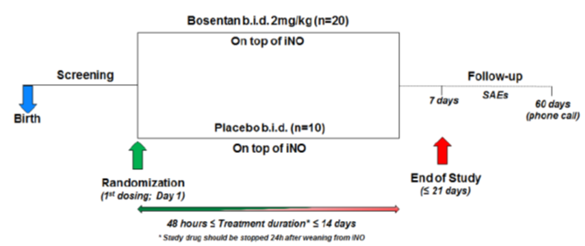

Inclusion and exclusion criteria
Eligible patients had to meet all of the following inclusion criteria during Screening:
- Term and near term newborns (gestational age > 34 weeks)
- Weight at birth ≥ 2000 g (following Protocol Amendment 2, this was changed from ≥ 2500 g to ≥ 2000 g)
- Idiopathic PPHN or PPHN due to parenchymal lung disease
- Documented diagnosis of PH confirmed by echocardiography
- Two OI values ≥ 12 taken at least 30 min apart, in the 12 hours prior to randomisation and while the patient was receiving iNO treatment (following implementation of Protocol Amendment 2, the requirement for OI values was reduced from ≥ 15 to ≥ 12)
The following inclusion criteria at applied at randomisation:
- Post-natal age ≥ 12 hours and < 7 days
- Mechanical ventilation with FiO₂ ≥ 50%
  - OI = FiO₂ (%) x MAP (cm H₂O) / PaO₂ (torr).
The following inclusion criterion needed to be met at both Screening and Randomisation:
- Need for continued iNO therapy at a dose > 10 ppm after at least 4 h of iNO treatment at Screening and at a dose ≥ 10 ppm at randomisation (implemented following Protocol Amendment 2)
The following exclusion criteria applied during the screening period (absolute requirement of not meeting any of the exclusion criteria at screening rather than randomisation was implemented following Protocol Amendment 2):
- PH associated with conditions other than PPHN
- Immediate need for cardiac resuscitation or ECMO
- Lethal congenital anomalies
- Congenital diaphragmatic hernia
- Significant structural cardiac anomalies
- Medically significant pneumothorax
- Active seizures
- Expected duration of mechanical ventilation of less than 48 h
- Mean systemic blood pressure < 35 mmHg despite therapy with volume infusions and cardiotonic support
- Hepatic failure or all conditions with ALT value > 2 x ULN
- Renal function impairment such as serum creatinine > 3 x ULN or anuria
- Known intracranial haemorrhage grade III-IV
- Either haemoglobin and/or haematocrit levels < 75% of the lower limit of normal range
- Thrombocytopenia (platelet count < 50,000 cells/μL)
- Leukopenia (white blood cells < 2500 cells/μL)
- Any condition precluding the use of a nasogastric/orogastric tube
- Administration of prohibited medication prior to randomisation

Study treatments
Study drug was bosentan at 2 mg/kg BD or matching placebo, both administered in addition to iNO. The bosentan dose was calculated according to the patient’s birth weight (rounded up to the next 0.5 kg) and did not change during study treatment.
Study drug was administered as a 1.5 mL dispersion in sterile water via a nasogastric or orogastric tube, as soon as tube placement was possible, but not within the first 12 hours of the baby’s life. The first dose was administered (any time of the day) as soon as possible after randomisation. The second dose was administered 12 hours later, immediately after the 12 hour post dose PK blood sample. Thereafter, study drug was administered approximately every 12 hours for a minimum of 2 consecutive days and may have continued for up to 14 days or until 1 day after iNO completion if less than 14 days. Study drug was administered until 24 hours after complete weaning of iNO or until treatment failure (defined as need for ECMO or initiation of alternative pulmonary vasodilator), or the maximum permitted duration of treatment with study drug for an individual patient had been reached (14 days, regardless of whether there was a need for continued iNO treatment). Weaning from iNO was performed according to a pre-defined weaning protocol. End-of-Treatment (EOT) visit was required to be performed within 24 hours after last study drug administration for all patients, including those who prematurely discontinued the study drug. End-of-study (EOS) visit for an individual patient occurred 7 days after EOT. A 60 day post treatment safety follow-up was conducted by telephone for all of the treated patients to record potential serious adverse events (SAEs).
The study drug was administered as 1.5 mL dispersion in sterile water via a nasogastric or orogastric tube, as soon as tube placement was possible, but not within the first 12 hours of the baby’s life.

Efficacy variables and outcomes

Primary efficacy endpoints
The primary efficacy endpoints were:
- Proportion of patients with treatment failure defined as:
  - Need for ECMO
  - Initiation of alternative pulmonary vasodilator
- Time to complete weaning from iNO
- Time to weaning from mechanical ventilation

Secondary efficacy endpoints
The secondary efficacy endpoints were:
- Proportion of patients requiring re-initiation of iNO therapy.
- Change from baseline to 3 hours, 5 hours, 12 hours, and 24 hours following the first drug administration; and thereafter every day until EOT for:
  - OI
  - ABG values (pH, Arterial oxygen saturation (SaO₂), PaO₂, PaCO₂)
  - Pulse oximetry (SpO₂)
  - FiO₂
  - AaDO₂
- Presence of PH (assessed by echocardiography) at 24 hours (Day 2) and at EOT
PH was reported as ‘present’ if at least one of the following criteria was met:
- Shunt through ductus arteriosus was either ‘predominant right to left’ or ‘bidirectional’
- Shunt through foramen ovale was either ‘predominant right to left’ or ‘bidirectional’
- Marked right ventricular dilation was ticked ‘present’
- Paradoxical shift of intraventricular septum was ticked ‘present’
- Right ventricular systolic pressure (mmHg) was > 2/3 of the reported systemic blood pressure (reported on the same CRF page)

Exploratory efficacy endpoints
Ventilatory support data and ventilation setting variables (other than FiO₂) were collected at 3 hours, 5 hours, 12 hours, and 24 hours following the first drug administration; and thereafter every day until EOS. These were MAP, positive end-expiratory pressure (PEEP), peak inspiratory pressure, ventilation rate, and tidal volume for patients on conventional ventilation or MAP, frequency and amplitude (ΔP) for patients on high frequency oscillatory ventilation.

Pharmacokinetic endpoints
The following PK endpoints were analysed based on concentration measurements from dried blood spot samples:
- C_{max}, C_{maxC}, t_{max} (Days 1 and 5), AUC₀₋₁₂ (Day 1), AUCτ (Day 5), AUC₀₋₂₄, and AUC_{0-24C} (Days 1 and 5) for bosentan and its metabolites (Ro 48-5033, Ro 47-8634, Ro 64-1056).
- AI defined as the ratio between AUCτ (Day 5) and AUC₀₋₁₂ (Day 1) for subjects whose PK assessments were performed on Days 1 and 5 and if AUC₀₋₁₂ is > 0 ng.h/mL.

Safety endpoints
- Treatment emergent AEs (TEAEs) and SAEs
- AEs leading to premature discontinuation of study drug
- Changes from baseline in vital signs during the treatment period
- Treatment emergent ECG abnormalities reported as AEs
- Treatment emergent laboratory abnormalities
- Incidence of treatment emergent ALT or AST > 3 x ULN
- Incidence of treatment emergent severe intracranial haemorrhage (Grade III or IV), periventricular leukomalacia, and ventriculomegaly reported as AEs.

Randomisation and blinding methods
Patients who met the eligibility criteria were randomised to receive either bosentan or matching placebo in a 2:1 ratio. Patients were randomised according to a generated code using an Interactive Voice (Web) Response System. The randomisation system assigned a number according to a predefined scheme together with the corresponding bottle number. The system provided the investigator with information on the dose to be administered, the number of tablet quarters to be dispersed, the dispersion volume and the volume to be administered for each patient. If a patient was randomised and did not receive any study drug, the unique randomisation number and patient kit was invalidated and the system did not reassign it. The randomisation code was accessible only to authorised persons who were not involved in the conduct and analysis of the study, until unblinding.
This study was double blinded and patients, caregivers, investigators, treating physicians, and any other assessors remained blinded to the individual treatment allocation until database closure. The investigational drug and its matching placebo were indistinguishable and all patient kits were packaged in the same way.
Bioanalysis was performed by [information redacted] pharmaceuticals. During the study, the analytical laboratories were unblinded; but the clinical pharmacologist performed the interim PK analyses in a blinded way. The blind was maintained as the concentrations were transferred to the clinical pharmacologist with masked identifiers. The clinical pharmacologist received the unblinded concentrations only after database closure and successful unblinding process.

Analysis populations
The screened analysis set comprised all patients entered into the database regardless of randomisation or treatment status. The all-randomised set included all patients randomised into the trial regardless of treatment status. The all-treated set included all patients who received at least one dose of study drug. For the PK analysis only bosentan treated patients were summarised. The full analysis set comprised of randomised patients who received at least one dose of study drug and had at least one post baseline efficacy assessment. The safety analysis set included all patients who received at least one dose of study drug. The PK analysis set comprised all patients included in the all treated set who were able to provide at least 5 of the 7 blood samples requested for at least one evaluable profile of PK assessment and who did not violate the protocol in a way that might affect the evaluation of PK endpoints. The PK analysis set 2 was identical to the PK analysis set except for the exclusion of the 2 hour time point.
Analysis of the efficacy endpoints were performed using the Full analysis set. For the primary endpoint analysis, EOS visits performed beyond EOT + 7 days were included in the analysis.

Sample size
A sample size of 30 evaluable patients was planned based on feasibility considerations. However, due to the unforeseen rarity of the targeted population, the study was terminated with 21 evaluable completers. It is reported that the sample size was compliant with that agreed in the PIP.

Statistical methods
The primary endpoint ‘proportion of patients with treatment failure’ was analysed using Fisher’s exact test to compare the two treatment arms. Exact 2 sided 95% CLs of the odds ratio were provided.
For time to event endpoints (time to complete weaning from iNO and time to weaning from mechanical ventilation), a graphical estimate of the survival functions for bosentan and placebo groups was obtained from the Kaplan-Meier (KM) product-limit method. KM estimates with 2 sided 95% CLs at specific time points (Day 3, 6, 9 and 12) were provided. The CLs were constructed using Greenwood’s formula for the standard error of the KM estimate. Median time to event for each treatment group was provided along with 2 sided 95% CLs calculated using Brookmeyer’s method. Treatment group comparisons were performed using the log-rank test.
For the secondary endpoint ‘proportion of patients requiring re-initiation of iNO therapy’, comparison between arms was based on the number of patients requiring iNO re-initiation divided by total number of subjects. The analysis was the same as the one conducted for the primary endpoint ‘proportion of patients with treatment failure’.
Changes from baseline in secondary endpoints related OI, ABG values, SpO₂, FiO₂, and AaDO₂ were analysed using analysis of covariance (ANCOVA) methods and were summarised using descriptive statistics for continuous variables.
The analysis of presence of PH at 24 hours (Day 2) and at EOT was conducted following the same methods as those for the primary efficacy endpoint ‘proportion of patients with treatment failure’.
Baseline demographic, disease characteristics and treatment exposure were summarised using descriptive statistics.
Analysis of PK endpoints was performed using the PK analysis set and repeated for the All-treated set. Analysis of the safety data was performed descriptively using the safety analysis set.

Participant flow
A total of 27 patients were screened and 23 patients were randomised in a 2:1 ratio to bosentan (N = 15) or placebo (N = 8). A total of 21 patients received study drug (Figure 14). Of the 15 patients randomised to bosentan, 13 were treated with bosentan and constituted the All-treated set.
Figure 14: FUTURE-4 Patient disposition
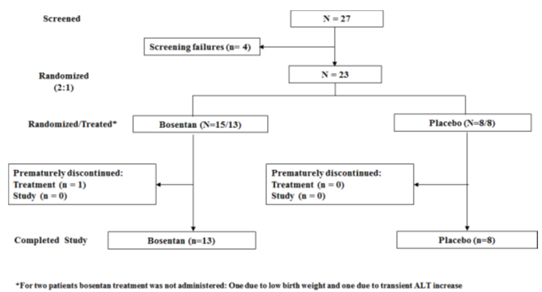

Major protocol violations/deviations
Two patients randomised to the bosentan group did not receive study treatment due to low birth weight (1 patient) and due to a transient increase in ALT (1 patient) and both were excluded from the full analysis set, the safety set and the PK set. A total of 12 patients were included in the PK analysis set. One patient was excluded from PK analysis set due to a protocol violation.
Deviations associated with the eligibility criteria prior to randomisation (6 patients), use of forbidden medication during the study treatment (1 patient), drug not administered as per protocol (1 patient) and procedure for informed consent (1 patient) were considered as major protocol deviations. None of these protocol deviations led to exclusion from any analysis set.

Baseline data
The gestational age (median, min to max) was similar for patients in the bosentan (40.0 weeks, 36.0 to 41.0 weeks) and placebo groups (38.5 weeks, 36.0 to 42.0 weeks). The median age (days, min to max) at first dosing with the study treatment was similar in the bosentan (1.4 days, 0.6 to 5.6 days) and placebo groups (1.7 days, 0.6 to 5.9 days). The length and weight at birth were similar in both groups. The majority of patients in both groups were female (69.2% bosentan, 75.0% placebo) and Caucasian (84.6% bosentan, 75.0% placebo) (Table 19).
The aetiology of PPHN was characterised predominantly by parenchymal lung disease in both groups (100% bosentan, 62.5% placebo). Idiopathic PPHN was diagnosed only for patients in the placebo group (37.5%) (Table 20). Median baseline OI (min to max) values indicated that the disease condition was more severe in patients treated with bosentan (18.3 (5.9 to 44.3) than placebo (13.2 (7.1 to 39.4)) (Table 21).
A total of 20 patients (12 bosentan, 8 placebo) completed study treatment (that is, 2 doses after successful weaning). One patient in the bosentan group discontinued study treatment prematurely due to treatment failure (need for ECMO). A total of 21 patients (13 bosentan, 8 placebo) completed the study as per protocol requirements.
With the exception of one patient in the placebo group, all patients had at least one condition recorded as medical history. Reported infections were pneumonia (5 bosentan (38.5%), 2 placebo (25.0%)) and neonatal sepsis/sepsis (2 bosentan (15.4%), 2 placebo (12.5%)).
The most frequently reported disorders were associated with the SOCs of metabolism and nutrition disorders (including hypoglycaemia, hyperglycaemia and metabolic acidosis), infections (pneumonia and neonatal sepsis/sepsis), respiratory disorders (including pneumothorax, neonatal aspiration, neonatal asphyxia and respiratory failure) and pregnancy, puerperium and perinatal conditions (including premature baby, birth trauma, neonatal hypothermia and neonatal jaundice). Blood disorders were reported for 3 patients in the bosentan group (23.1%) and 2 patients in the placebo group (25.0%); all were related to anaemia and in one case concomitant thrombocytopenia was reported (Table 22).
All 21 patients had received at least one previous treatment at baseline. Blood substitutes and perfusion solutions were the most frequently received treatments (11 bosentan, 84.6%; 6 placebo, 75.0%). Blood transfusion was performed for 3 patients in the bosentan and placebo groups (23.1% and 37.5%, respectively), one patient (bosentan) also had a platelet transfusion. Plasma transfusion was performed for 2 patients in the bosentan and placebo groups (15.4% and 25.0%, respectively). Antibacterials for systemic use were received by 9 patients in the bosentan group (69.2%) and 3 patients in the placebo group (37.5%). Cardiac therapy consisting mostly of IV vasopressors was administered to 9 (69.2%) bosentan patients and one (12.5%) placebo patient, consistent with the higher disease severity observed at baseline in the bosentan group.
Table 19: FUTURE-4 Summary of patient demographics, safety analysis set
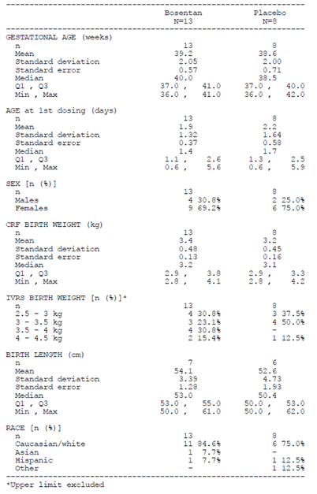

Table 20: FUTURE-4 Summary of PPHN related data (baseline), safety analysis set
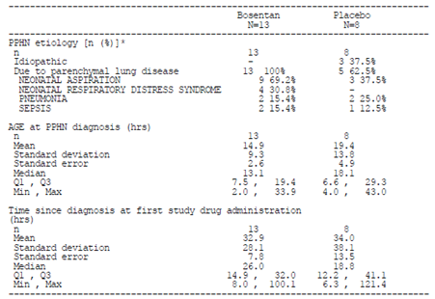

Table 21: FUTURE-4 Summary of oxygenation and pulmonary pressure related data (baseline), Safety analysis set
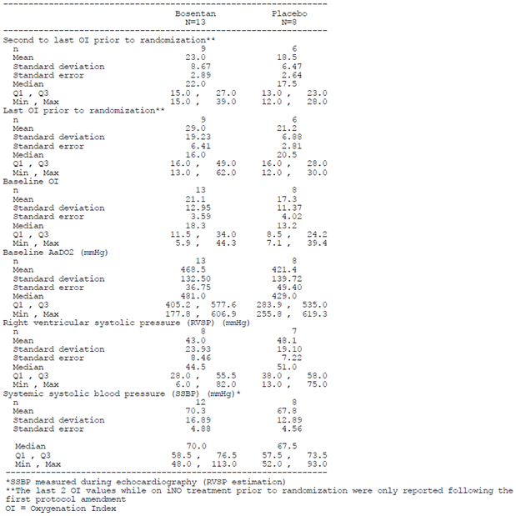

Table 22: FUTURE-4 Summary of medical history by system organ class and preferred term (baseline), Safety analysis set
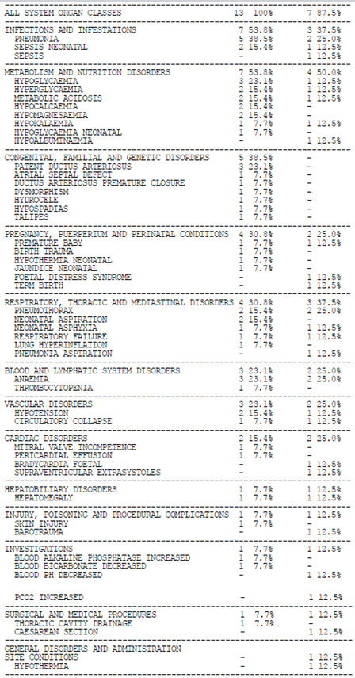

Results for the primary efficacy outcome

Proportion of patients with treatment failure
One patient in the bosentan group had treatment failure due to the need for ECMO (Table 23). This patient with PPHN due to parenchymal lung disease (neonatal aspiration) had been on iNO therapy for 8 hours at study drug start. During this period, OI decreased from 22 to 16 and reached the value of 14 before study drug start. Treatment failure was declared 9 hours after the first bosentan dose. The patient recovered within the 60 day follow-up period.

Table 23: FUTURE-4 Summary of treatment failure, full analysis set
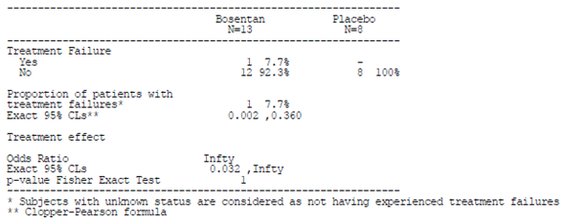

Time to complete weaning from iNO
The median time to complete weaning from iNO was 3.7 days (95% CLs 1.17, 6.95 days) on bosentan and 2.9 days (95% CLs 1.26, 4.23 days) on placebo (Figure 15).
Figure 15: FUTURE-4 Time to complete weaning from iNO, full analysis set
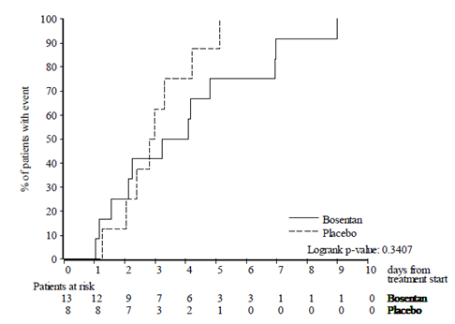

Time to weaning from mechanical ventilation
The median time to complete weaning from mechanical ventilation was 10.8 days (95% CLs 3.21, 12.21 days) on bosentan and 8.6 days (95% CLs 3.71, 9.66 days) on placebo (Figure 16). One bosentan treated patient was still on mechanical ventilation at EOS.
Figure 16: FUTURE-4 Time to complete weaning from mechanical ventilation, full analysis set
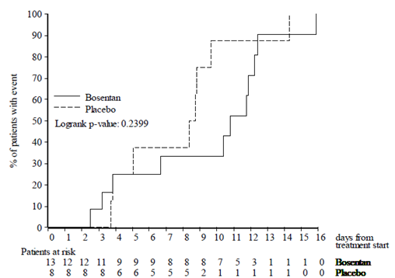

Post-hoc analyses on weaning related primary endpoints
Three patients randomised to bosentan had longer iNO and mechanical ventilation weaning times than all other patients, resulting in longer median times to weaning in the bosentan group. Additional post-hoc analyses using Cox proportional hazard models were performed to determine whether selected baseline factors influenced the results for weaning-related primary outcomes. Baseline OI was strongly related to the time to weaning from iNO (p = 0.007) and influenced the results as shown by the change in the treatment effect hazard ratio (HR) from the treatment only model (HR = 0.63) to the multivariate model containing treatment and baseline OI (HR = 1.03). High baseline OI values were more frequent in patients treated with bosentan than placebo. The sponsor states that the results suggest baseline OI had an influence on the comparison for the primary iNO weaning endpoint. No other factors examined were found to influence the treatment comparison. The same analyses were performed on the time to weaning from mechanical ventilation primary endpoint but no influence could be attributed to any of the baseline factors examined (Table 24).

Table 24: FUTURE-4 Univariate and multivariate cox proportional hazard models for time to weaning from iNO
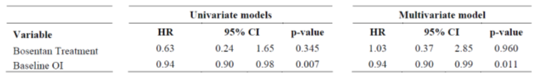

Results for other efficacy outcomes

Proportion of patients requiring re-initiation of iNO therapy
No patients had iNO re-initiated.

Change in oxygenation index
The change in OI over time was similar in the bosentan and placebo groups, with both groups decreasing to similar median values by 72 hours (Figure 17).
Figure 17: FUTURE-4 Median value and 95% CLs over time in OI up to 72 hours (Day 4), full analysis set
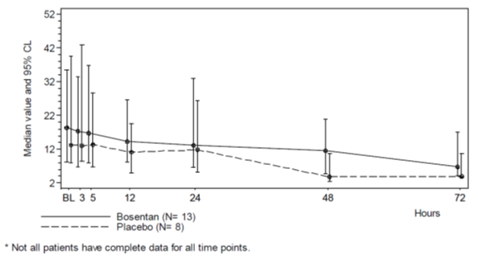

Change in arterial blood gas variables
ABG variables showed similar changes in median values from baseline over time in the bosentan and placebo groups. Both groups plateaued at 24 hours and retained almost identical median values out to 72 hours.

Change in Sp02, FiO₂ and AaDO2
The changes from baseline in SpO2, FiO₂ and AaDO2 over time up to 72 hours (Day 4) were similar in the bosentan and placebo groups.

Presence of pulmonary hypertension
The proportion of patients with PH at EOT was similar in the bosentan (41.7%) and placebo groups (37.5%) (Table 25).

Table 25: FUTURE-4 Summary of presence of PH at EOT, full analysis set
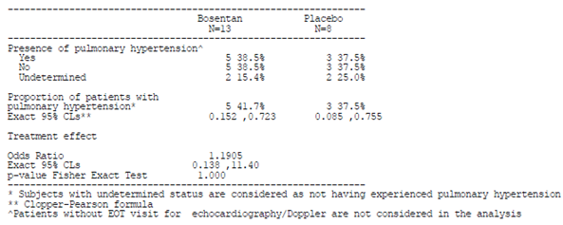

Evaluator commentary
Idiopathic PPHN was diagnosed only for patients in the placebo group (37.5%). It is noted that no patients in the placebo group had a medical history of congenital, familial or genetic disorders compared to 38% in the bosentan group.
The study did not identify a benefit in adding bosentan to iNO therapy in neonates with PPHN who had not responded adequately to iNO. The mean time to complete weaning from iNO and from mechanical ventilation was longer in the bosentan group compared to the placebo group.
As the sponsor has not requested an extension of indication in relation to this study or changes to the dosage and administration instructions to include this age group, the results of this study will be considered in relation to safety, tolerability and PK.

Other efficacy studies

AC-052-365 FUTURE-1
A summary of FUTURE-1 was provided. The exploratory efficacy and QoL endpoints for the FUTURE-1 Study were:
- Change from Baseline to Week 12 in WHO FC
- Change from Baseline to Week 12 in Global Clinical Impression scale (GCIS) assessed by the parents and the physician.
- Change from Baseline to Week 12 in QoL questionnaire (SF-10).
At Week 12, out of the 23 patients at baseline who were diagnosed class II, only one worsened to class III and two improved to class I (the remaining 20 patients were stable at class II), and out of the 12 patients at baseline who were diagnosed class III, none worsened, and three improved to class II (Table 26).
The changes from baseline to Week 12 in the Parents and Physicians GCIS found that out of the 17 patients whose condition the parents rated ‘not good or bad’ or ‘bad’ at baseline, 9 patients were considered to be doing ‘better’ or ‘significantly better’ at Week 12 (Table 27). Out of the 17 patients whose condition the parents rated ‘good’ or ‘very good’ at baseline, only 1 patient was considered to be doing ‘worse’ or ‘significantly worse’ at Week 12, with 9 patients considered being either ‘significantly better’ or ‘better’ at Week 12.
For the majority of cases, parents’ responses were consistent with, or more positive than, the physician’s assessment at each time point. Out of 11 patients whose condition the physician rated ‘not good or bad’ or ‘bad’ at baseline, 6 patients were considered to be doing ‘better’ or ‘significantly better’ by Week 12 (Table 28). Out of 24 patients whose condition the physician rated ‘good’ or ‘very good’ at baseline, only 2 patients were considered to be doing ‘worse’ or ‘significantly worse’, with the majority of responses being ‘no change’ or ‘better’, at Week 12.
The mean changes from baseline to Week 12 in the SF-10 Physical summary (PHS) and Psychological summary (PSS) scores were similar (Table 29). Favourable changes were seen in individual patients.
Subgroup analyses were specified in the statistical analysis plan and performed on the exploratory efficacy endpoints and vital signs. Patients were classified as either having had ‘previous bosentan’ intake or as ‘bosentan naïve’ prior to study treatment start. A total of 15 patients had had ‘previous bosentan’ intake and 21 patients were identified as ‘bosentan naïve’.
Greater mean improvements in SF-10 scores were observed by Week 12 in bosentan naïve patients versus patients previously treated with bosentan, primarily in the PHS. Improvement was observed in 5 bosentan naïve patients with respect to the WHO FC at Week 12. In contrast, patients previously treated with bosentan remained largely stable, with one patient worsening from class II to class III.
Post treatment improvement was observed in Parents’ Global Assessments. At Week 12, of 20 bosentan naïve patients, 12 were judged ‘better’ or ‘significantly better’, and none were considered ‘worse’ or ‘significantly worse’. Among the patients previously treated with bosentan, 6 of 14 patients were judged ‘better’ or ‘significantly better’, and 3 of 14 patients were considered ‘worse’ or ‘significantly worse’. The Parents’ Global Assessment was not available for one patient. A similar improvement was observed with respect to Physicians’ Global Assessments. At Week 12, of 21 bosentan naïve patients, 12 were judged ‘better’ or ‘significantly better’ and none were considered ‘worse’ or ‘significantly worse’. Among the patients previously treated with bosentan, 3 of 14 patients were judged ‘better’ or ‘significantly better’, and 2 of 14 were considered ‘worse’ or ‘significantly worse’. A similar improvement was observed with respect to Physicians’ Global Assessments.

Table 26: FUTURE-1 WHO FC; changes from baseline to Week 12
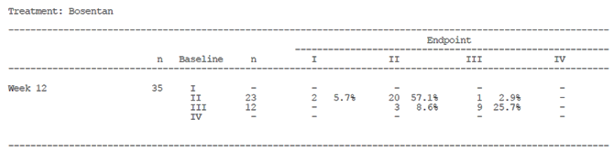

Table 27: FUTURE-1 Parents GCIS; shift to Week 12
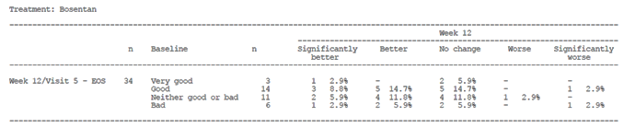

Table 28: FUTURE-1 Physicians GCIS; shift to Week 12
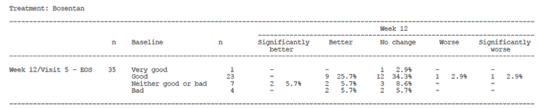

Table 29: FUTURE-1 Change from baseline to Week 12 on PHS and PSS (SF-10)
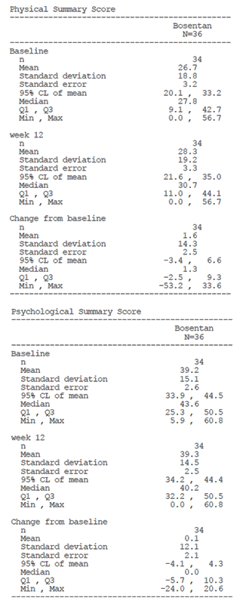

AC-052-367 FUTURE-2
The primary objective of this study was to assess the long term safety and tolerability of the paediatric formulation of bosentan in children with idiopathic or familial PAH. A summary of study design is provided in Section 8.
Secondary objectives of the FUTURE-2 Study included an exploratory evaluation of functional capacity, quality of life (QoL), physicians’ and parents’ GCIS, time to PAH worsening, time to initiation of new therapy for PAH and time to new onset or worsening of right heart failure. Another objective was to assess long term vital status. All efficacy analyses were exploratory.
Data for WHO FC at baseline and end of study (EOS) or premature discontinuation of study drug (FUTURE-1 or 2) were available for 28 patients (Table 30). From baseline of FUTURE-1 to the EOS or premature discontinuation of study drug, WHO FC had improved in 11 patients (39.3%). A worsening was observed in 2 patients (7.1%). Both of these patients discontinued after less than 6 months in FUTURE-2 due to death and disease progression, respectively.
QoL was assessed using the questionnaire SF-10 for Children. Parents/legal representatives of patients completed the questionnaire at the baseline visit of the FUTURE-1 Study, every 6 months thereafter and at the EOS or premature discontinuation. The mean SF-10 PHS improved from baseline to EOS or premature discontinuation. The mean SF-10 PSS decreased slightly (Table 31).
Parents/legal representatives and physicians assessed the overall GCIS of patients at baseline, every 6 months thereafter and at EOS or premature discontinuation of study drug. The current condition was rated in comparison with that at the initiation of FUTURE-1. In 13 (81.3%) patients, GCIS as rated by the parents improved from baseline to EOS or premature discontinuation of study drug (FUTURE-1 or 2). It remained unchanged in 2 patients, and worsened in 1 (6.3%) patient (Table 32). In 17 (65.4%) out of 26 patients with available data, GCIS as rated by the physician improved from baseline to EOS or premature discontinuation of study drug (FUTURE-1 or 2). GCIS as rated by the physician remained unchanged in 7 patients and worsened in 2 (7.7%) (Table 33).
Overall, the KM estimate of not having experienced worsening of PAH was 63.1% at 5 years (95% CI 35.3%, 81.6%) (Table 34, Figure 18). The KM estimate of not having experienced worsening of PAH, initiation of new therapy for PAH, new right heart failure or worsening of right heart failure at 5 years was 44.5% (95% CI 24.2%, 62.9%) (Table 35, Figure 19).

Table 30: FUTURE-2 WHO FC; change from baseline to EOS; All-treated set
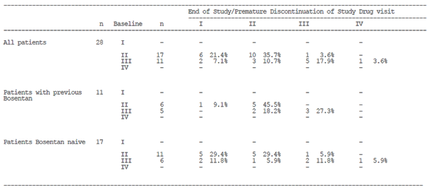

Table 31: FUTURE-2 SF-10 score; change from baseline to EOS; All-treated set
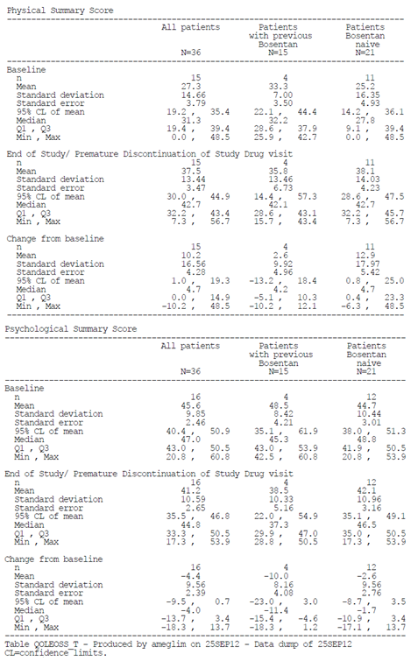

Table 32: FUTURE-2 Parents’ GCIS; change from baseline to EOS; All-treated set
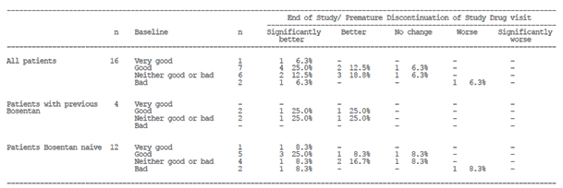

Table 33: FUTURE-2 Physicians’ GCIS; change from baseline to EOS; All-treated set
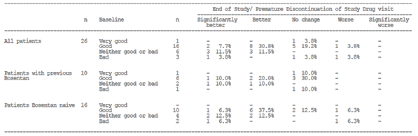

Table 34: FUTURE-2 Time to worsening of PAH (KM estimates)
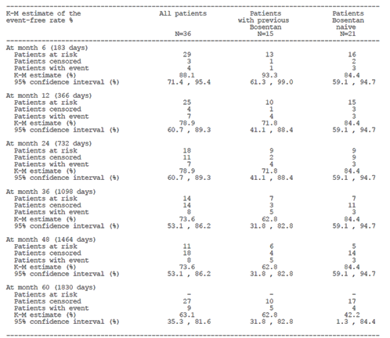
Figure 18: FUTURE-2 KM estimates for time to worsening of PAH – All-treated set
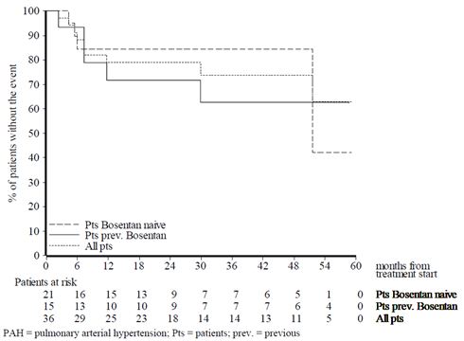

Table 35: FUTURE-2 Time to worsening of PAH or initiation of new therapy for PAH or new right heart failure or worsening of right heart failure (KM Estimate)
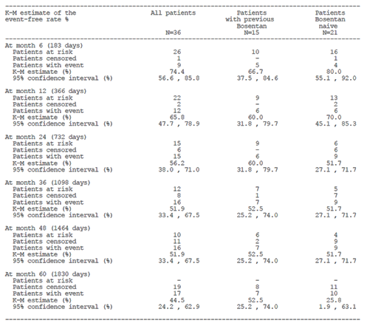
Figure 19: FUTURE-2 KM estimates for time to worsening of PAH, initiation of new therapy for PAH, new right heart failure or worsening of right heart failure; All-treated set
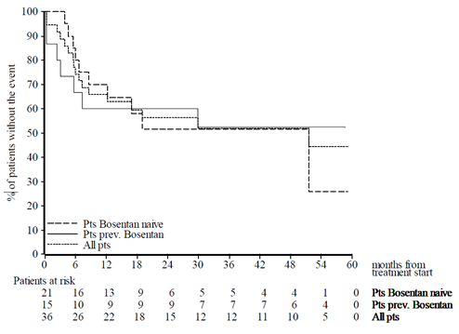

Study AC-052-373 (FUTURE-3)
The primary objective of this study related to the PK of the dispersible tablet formulation at doses of 2 mg/kg BD or TDS in children with PAH. The study design and conduct was discussed. Secondary objectives were to evaluate the efficacy, tolerability, and safety of bosentan in children with PAH from ≥ 3 months to < 2 years of age and from 2 years to < 12 years of age. All efficacy endpoints were exploratory. The efficacy analyses in this study were not statistically powered to show differences and were not stratified for influencing factors.
The haemodynamic subgroup (bosentan patients with repeated RHC) included 10 patients (2 patients < 2 years, 8 patients ≥ 2 years, all bosentan naïve). The sponsor states that changes in haemodynamic variables known to have robustness in assessment (for example pulmonary artery pressures), were consistent with the known treatment effects of bosentan (Table 36).
The changes from baseline to the last post baseline value up to EOT + 7 days for the echocardiography/Doppler variables (excluding patients with ‘PAH-CHD’) were small and similar in both BD and TDS groups (overall population and in patients < 2 years and ≥ 2 years) (Table 37). Pericardial effusion, assessed by categories of severity, remained stable during the study for the majority of patients of the echo/Doppler subgroup (45 patients), worsened in 5 patients, and improved in 4 patients.
The disease condition at baseline was more severe in patients in the BD group than in the TDS group in terms of WHO FC. The majority of patients (75.8% BD, 90.3% TDS) remained clinically stable in their WHO FC status from baseline to the last post baseline value up to EOT + 7 days. A total of 10 patients improved in WHO FC: 5 improved from WHO FC III to II (all BD), and 5 improved from WHO FC II to I (2 BD, 3 TDS). The WHO FC worsened from III to IV in 1 patient in the BD group. Of the 10 patients who had improvement in WHO FC, 4 were < 2 years of age (2 BD, 2 TDS) and 6 were ≥ 2 years (5 BD, 1 TDS). Seven of 10 patients who had improvement were bosentan naïve (4 BD, 3 TDS), and the remaining 3 were non bosentan naïve (all BD).
Events defined within the ‘PAH worsening cap’ were reported for a total of 4 patients (6.3%; 2 patients each, < 2 [9.5%] and ≥ 2 years [4.6%])(Table 38). In patients < 2 years, new/worsening right heart failure was reported for one patient each, in the BD and TDS groups, which resulted in hospitalisation and death in one patient (TDS). In patient’s ≥ 2 years, no events were reported in the TDS group. Two patients in the BD group experienced new/worsening right heart failure, which led to hospitalisation and initiation of new PAH specific therapy in one case. There were no relevant differences between the BD and TDS groups for the time to occurrence of events defined within the ‘PAH worsening cap’ (Figure 20).
The majority of patients remained stable in physicians’ (72.7% BD, 77.4% TDS (Table 39)) and parents’/legal representatives’ GCIS ratings (57.6% BD, 61.3% TDS (Table 40)). The proportions of patients rated as having an improvement were 26.9% (BD) versus 19.2% (TDS) in physicians’ GCIS, and 45.8% (BD) versus 32.0% (TDS) in parents’/legal representatives’ GCIS. Similar proportions of patients were rated as having worsened in both groups in physicians’ GCIS (6.5% BD and 6.7% TDS) and parents’/legal representatives’ GCIS (10.0% BD and 13.3% TDS). Similar results were observed in both age groups (< 2 years and ≥ 2 years).
The NT proBNP ratio of geometric means of the ‘last post baseline value up to EOT + 7 days’ to the baseline was similar in the BD (88.94%, 95% confidence limits [CLs] 62.40, 126.78) and TDS groups (83.65%, 95% CLs 57.88, 120.87) (Table 41). In terms of mean fold change from baseline, this is a 1.12 and 1.20 fold decrease in BD and TDS groups, respectively.
The results for changes in echocardiography/Doppler variables, WHO FC and NT-proBNP from baseline to Week 12 and to EOS were consistent with those from baseline to the last post baseline value up to EOT + 7 days (that is, analysis without a restriction on the upper limit of the time window of the EOS visit).
The results of all exploratory endpoints in the Per-protocol set were consistent with those in the All-randomised set for all endpoints.

Table 36: FUTURE-3 Summary of changes in haemodynamics from baseline to EOS for variables including at least 4 patients; Haemodynamics subgroup, overall age groups, All-randomised set
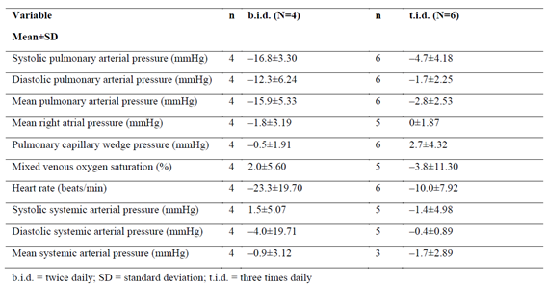

Table 37: FUTURE-3 Summary of changes in echocardiography/Doppler variables from baseline to last post baseline value up to EOT + 7 days, echo/Doppler subgroup, overall age groups, All-randomised set
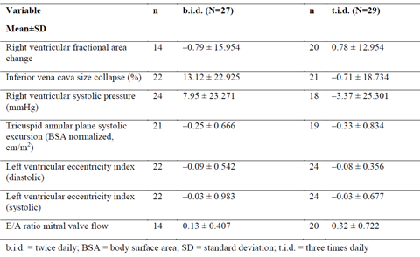

Table 38: FUTURE-3 Summary of PAH-worsening: death, lung transplantation, hospitalisation for PAH-progression, initiation of new therapy for PAH or new/worsening right heart failure up to EOS/ premature discontinuation + 7 days; overall age groups, All-randomised set
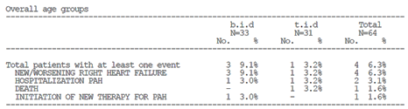
Figure 20: FUTURE-3 Time to first occurrence of death, lung transplantation, hospitalisation for PAH-progression, initiation of new therapy for PAH or new/worsening right heart failure: KM curve, All-randomised set
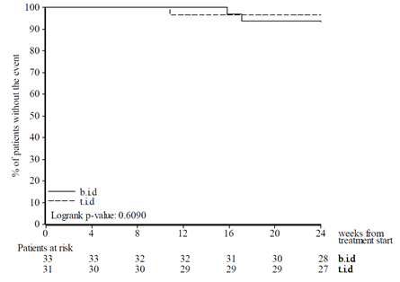

Table 39: FUTURE-3 Summary of shift in physicians’ GCIS from baseline to EOS, All-randomised set
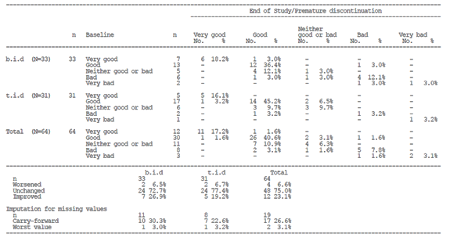

Table 40: FUTURE-3 Summary of shift in parents’ / legal representatives’ GCIS from baseline to EOS, All-randomised set
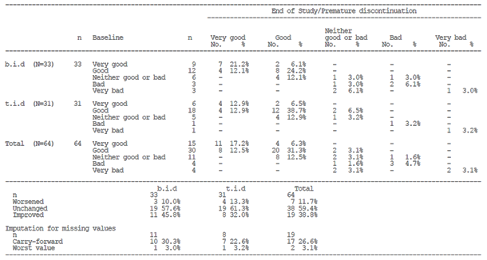

Table 41: FUTURE-3 Change in NT-pro-BNP from baseline to last post baseline value up to EOT + 7 days; overall age groups, All-randomised set
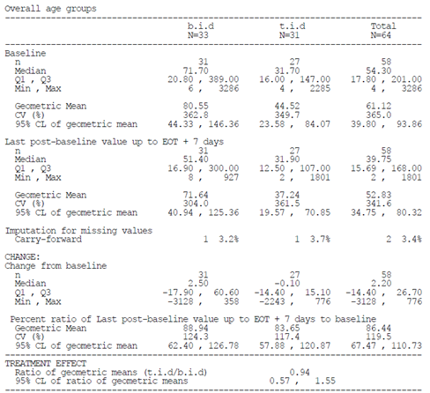

AC-052-374 FUTURE-3 Extension
The FUTURE-3 extension study was described. The objective was to evaluate the long term safety, tolerability and efficacy of the 32 mg dispersible tablet formulation of 2 mg/kg bosentan BD versus TDS in children with PAH. No primary endpoint was defined and all efficacy endpoints defined were exploratory.
Disease condition at baseline was noted to be more severe in patients in the BD group than the TDS group. The majority of patients remained clinically stable in WHO FC status (no change in WHO FC from baseline at Month 12: 73.4%, Month 18: 78.1%). WHO FC remained unchanged for 66.7% (BD) versus 80.6% (TDS) of patients, at Month 12, and 75.8% (BD) versus 80.6% (TDS) of patients at Month 18. Improvements were reported for 21.2% (BD) versus 9.7% (TDS) of patients at Month 12, and 9.1% (BD) versus 9.7% (TDS) of patients at Month 18. Worsening was reported for 12.1% (BD) versus 9.7% (TDS) of patients at Month 12, and 15.2% (BD) versus 9.7% (TDS) of patients at Month 18.
The majority of patients remained stable over time according to the Physician’s GCIS (Month 12: 62.7%, Month 18: 56.8%). At Months 12 and 18, Physician’s GCIS (BD versus TDS) was rated as improved for 35.7% versus 26.1% of patients, and 31.6% versus 27.8% of patients, respectively. The proportion of patients rated as having worsened was 7.1% (BD) versus 4.3% (TDS) of patients at Month 12 and 21.1% (BD) versus 5.6% (TDS) of patients at Month 18. The results for the parents’/legal representatives’ GCIS rating was consistent with those for the Physician’s GCIS rating. Similar results were observed across both age groups (< 2 years and ≥ 2 years).
Death, lung transplant or hospitalization due to PAH-progression was reported for a total of 13 patients (8 BD versus 5 TDS). Four cases were reported during the core study and 9 during the extension study. Overall, the KM estimates for survival was 84.7% (95% CLs: 72.6%, 91.7%) at Month 12 and 77.4% (95% CLs: 64.2%, 86.2%) at Month 18.
In the survival analysis for all deaths up to EOS, the overall KM estimates of survival was 85.7% (95% CLs: 74.3, 92.3) at Month 12 and 80.9% (95% CLs: 68.7, 88.6) at Month 18. In the analysis for on-treatment deaths, the overall KM estimates for survival were 87.9% (95% CLs: 76.2, 94.0) at Month 12 and 82.3% (95% CLs: 69.5, 90.1) at Month 18.
Initiation of new therapy for PAH or new/worsening right heart failure was reported for two patients. Inclusion of this additional component to the PAH-progression time to event endpoint resulted in a total of 15 patients (10 BD, 5 TDS) with such events (Table 42). Overall, for the PAH-progression time to event endpoint including the additional component, the KM estimates for survival were 81.4% (95% CLs: 69.0%, 89.3%) at Month 12 and 74.1% (95% CLs: 60.8%, 83.6%) at Month 18.
A post-hoc Cox proportional hazards model analyses for the time to PAH worsening and time to death up to EOT + 7 days showed that the addition of the baseline WHO FC (III versus I/II) covariate to the treatment only model resulted in a lower treatment effect HR for both endpoints. The HR for the treatment effect (BD versus TDS) for time to PAH worsening in the multivariate model was 1.17 compared to 1.44 in the univariate model (Table 43). For the time to death endpoint, the respective HRs were 1.04 and 1.33 (Table 44). For time to death up to EOS, the treatment effect HR was 1.49 in the multivariate model compared to 1.94 in the univariate model and in both cases, was in favour of the bosentan TDS group. With the addition of the covariate non death related worsening up to EOT + 7 days to the treatment only model, the HR was lower in the multivariate model at 1.08, compared to 1.94 in the univariate model. Taken together, these results indicate that the baseline imbalance in the WHO FC status influences the treatment effect on time to PAH worsening and death. Adjusting for this imbalance in these models led to a neutral treatment effect.

Table 42: FUTURE-3 Extension Summary of PAH-worsening components; All-treated/randomised set
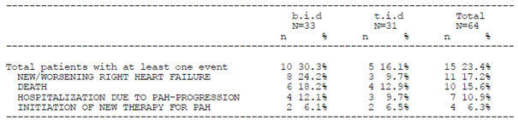

Table 43: FUTURE-3 Extension Multivariate model for Time to PAH worsening up to EOT + 7 including treatment (bid versus tid) and WHO FC (III versus I/II) factors; Analysis set: All-treated set
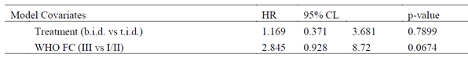
Figure 21: FUTURE-3 Extension Survival (on treatment deaths) Kaplan-Meier curves; Analysis set: All-treated set
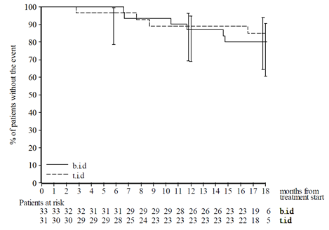

Table 44: FUTURE-3 Extension Multivariate model for Time to death up to EOT + 7 including treatment (BD versus TDS) and WHO FC (III versus I/II) factors; Analysis set: All-treated set
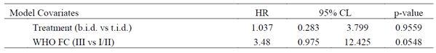

Evaluator commentary: other efficacy studies
The results of the FUTURE-1/3 studies were generally positive with respect to the efficacy outcomes but the results are limited in given the exploratory nature of the efficacy outcomes. In the FUTURE-1 Study the majority of patients remained stable with respect to baseline WHO FC. At week 12, one patient is noted to have worsened from WHO FC class II to class II. Two patients improved from class II to class I and three patients improved from class III to class II. In the FUTURE-2 analysis WHO FC had improved in 11 patients (39.3 and worsened in 2 patients (7.1%). The KM estimate of not having experienced worsening of PAH was 63.1% at 5 years (95% CI 35.3%, 81.6%).
In FUTURE-3, WHO FC at baseline was noted to be worse in patients in the BD group than in the TDS group. The majority of patients remained clinically stable in their WHO FC status. Five patients improved from WHO FC III to II (all BD), and 5 improved from WHO FC II to I (2 BD, 3 TDS). One patient experienced a worsening in WHO FC (III to IV). Of the 10 patients who had improvement in WHO FC, 4 were < 2 years of age and 6 were ≥ 2 years. During the FUTURE-3 Extension Study the majority of patients remained clinically stable in WHO FC status (no change in WHO FC from baseline at Month 12: 73.4%, Month 18: 78.1%). A higher proportion of patients experienced a worsening in WHO FC, GCIS and PAH in the BD group compared to the TDS group. Survival estimates were also lower in the BD group. This is potentially due to the higher proportion of severely unwell patients in the BD group. It is difficult to determine the contribution of bosentan to these results given the majority of patients were treated with PAH medications at study enrolment and baseline PAH therapy had to be stable for at least 3 months prior to screening. The FUTURE-3 extension study included only 18 patients < 2 years of age. The sponsor’s rationale for extending the dosage instructions to include patients between one and three years of age is unclear.

Analyses performed across trials: pooled and meta analyses
Not applicable.

Evaluator’s conclusions on clinical efficacy
FUTURE-4 did not identify a benefit in adding bosentan to iNO therapy in neonates with PPHN who had not responded adequately to iNO. The sponsor has not requested an extension of indication for PPHN or changes to the dosage and administration instructions to include this age group.
The analyses of efficacy included in this submission were otherwise exploratory. The sponsor states that overall the outcomes of the efficacy variables from the paediatric PAH studies were consistent with the known effect of bosentan in adults as:
- The majority of patients (> 90%) showed improved or stable clinical condition (WHO FC and GCIS) over a 6 month treatment period. Less than 10% showed deterioration during the same period.
- KM event-free estimates of worsening of PAH (defined as time to first occurrence of death, lung transplantation or hospitalization for PAH worsening) over the short-term period of 6 months was 88.1% (FUTURE-1 and 2) versus 96.8% (FUTURE-3). Over the long term treatment period in the FUTURE-1 and 2 Study, the KM event-free estimate of worsening of PAH was 78.9% at 2 years and 73.6% at 4 years.
The sponsor states that favourable efficacy results were found at the bosentan exposures achieved with both the adult tablet formulation and with the paediatric tablet formulation used in studies FUTURE-1 and FUTURE-2. In the FUTURE-3 studies those on BD dosing tended to have worse outcomes than those on TDS dosing. These results may due to the imbalance in disease severity at baseline. The sponsor states that there is no additional clinical benefit in increasing the frequency of bosentan dosing. The rationale for not increasing the dose frequency to TDS dosing with respect to these efficacy outcomes should be clarified.
The sponsor has proposed changing the dosage and administration instructions to include patients one year of age and over. The current dosage instructions provide advice for patients aged three years and over. The FUTURE series of studies included patients under three years of age but the total number of patients in this age group remains small. It is unclear whether the number of patients aged between one and three years of age is sufficient to recommend a change to the dosage instructions.

Clinical safety

Studies providing evaluable safety data

Pivotal studies that assessed safety as the sole primary outcome
- Study AC-052-367 (FUTURE-2)
- Study AC-052-374 (FUTURE-3) Extension
- Study AC-052-392 (FUTURE-4) Extension.

Pivotal and/or main efficacy studies
- Study AC-052-391 (FUTURE-4).

Other studies
- Study AC-052-116
- Study AC-052-365 (FUTURE-1)
- Study AC-052-373 (FUTURE-3).

Studies that assessed safety as the sole primary outcome

Study AC-052-367 (FUTURE-2)

Study design, objectives, locations and dates
Study AC-053-367 (FUTURE-2) was a multicentre, multinational, open label, non comparative, Phase III extension study of a 12 week open label, single arm study (FUTURE-1).
The primary objective was to assess the long term safety and tolerability of the paediatric formulation of bosentan in children with idiopathic or familial PAH.
Secondary objectives included an exploratory evaluation of functional capacity, QoL, physicians’ and parents’ GCIS, time to PAH worsening, time to initiation of new therapy for PAH and time to new onset or worsening of right heart failure. Another objective was to assess long term vital status.
Figure 22: Study AC-053-367 (FUTURE-2) design
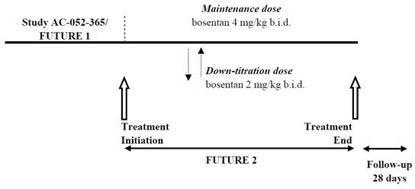

Inclusion and exclusion criteria
The inclusion and exclusion criteria for the FUTURE-1 Study were provided.

Study treatments
All patients received a paediatric oral formulation of bosentan. The study drug was to be administered orally, irrespective of meals, and dispersed in a teaspoon of water before being administered (not mixed with food). It was to be taken in the morning and approximately 12 hours later in the evening.
The treatment dose of bosentan in FUTURE-2 was to be 4 mg/kg BD until the end of the study. If this dose was not well tolerated, it could be down-titrated to 2 mg/kg BD. Patients weighing 30 kg or over were to receive a maximum dose of 120 mg BD and a maximum of 64 mg BD if down titration was necessary.

Safety variables and outcomes
The tolerability and safety endpoints were:
- TEAEs up to 1 day after permanent discontinuation of study drug
- AEs leading to premature discontinuation of study drug
- SAEs up to 28 days after permanent discontinuation of study drug
- Changes from baseline to study end in vital signs, body weight, and height
- Treatment emergent marked laboratory abnormalities
All efficacy analyses were exploratory.
- Change from baseline in FUTURE-1 to study end or premature study drug discontinuation (FUTURE-1 or FUTURE-2) in:
  - WHO FC
  - QoL questionnaire score (SF-10 for children)
  - GCIS according to the parents/legal representatives
  - GCIS according to the physician
- Time to worsening of PAH, defined as the first occurrence of death, transplantation, or hospitalisation for PAH worsening (from baseline in FUTURE-1).
- Time to first occurrence of worsening of PAH, or initiation of new therapy for PAH, or new right heart failure, or worsening of right heart failure (from baseline in FUTURE-1).

Randomisation and blinding methods
The study was an extension of the FUTURE-1 Study and had an open label design. All patients received the study drug bosentan.

Analysis populations
The statistical plan included an ‘All enrolled’ set and an ‘All treated’ set comprised of all subjects included in the equivalent sets from FUTURE-1. Patients were also classified according to the presence or absence of bosentan intake prior to the date the study drug was started in FUTURE-1 (‘previous bosentan’ and ‘bosentan naïve’ respectively).

Sample size
No formal sample size calculation was performed. As this was an extension of the FUTURE-1 Study, sample size could not exceed that of the FUTURE-1 Study. Out of the 36 patients enrolled in FUTURE-1 (15 with previous bosentan exposure, 21 bosentan naïve), 34 completed the study and 33 were enrolled in FUTURE-2.

Statistical methods
All the analyses were done considering the pooled data of FUTURE-1 and FUTURE-2. No formal hypothesis was set for this open label, single arm extension study. Summary statistics are displayed for the safety and exploratory efficacy parameters.

Participant flow
A total of 36 patients were enrolled in FUTURE-1, 15 of whom were receiving bosentan prior to study drug start and 21 of whom were bosentan naïve. These patients formed the ‘All-enrolled’ analysis set. As all received at least one dose of study drug, all were also included in the ‘All-treated’ analysis set. The same two analysis sets were used for the evaluation of FUTURE-2.
A total of 19 (52.8%) patients prematurely discontinued the study (FUTURE-1 or 2). Five patients discontinued due to disease progression, AEs, transplant or treatment failure and four patients discontinued due to death, caused by PAH or infection. This is to be expected in this population of PAH patients. The remaining ten patients prematurely discontinued due to either administrative/other reasons or withdrawal of consent, as expected for a study of this duration. One patient who prematurely discontinued due to administrative/other reasons reached an adult weight and was switched to the adult formulation of bosentan.
Two patients did not complete FUTURE-1 and therefore they did not take part in FUTURE-2. One additional patient completed FUTURE-1 but did not enrol in FUTURE-2. Overall, a total of 16 patients completed the FUTURE-2 Study.
Figure 23: FUTURE-2 Disposition of patients
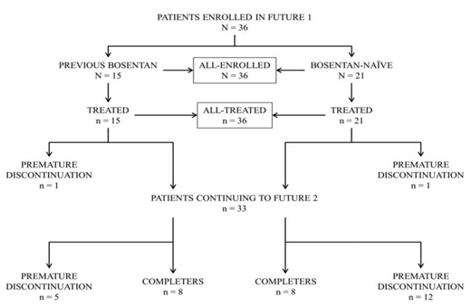

Major protocol violations/deviations
Six patients reached the age of 12 during the FUTURE-2 Study and remained in the study for a further 23 to 489 days after reaching this age. This was not unexpected due to the logistics of switching from the study drug to a commercially available PAH treatment and given there is no safety concern related to this violation. Three patients received an incorrect dose; in 10 patients, study drug was not handled according to protocol requirements. Two patients took sildenafil or other PAH-specific drugs in the absence of PAH worsening as defined in the protocol, and one patient had taken or was taking forbidden medications (fluconazole) during the FUTURE-2 Study.
The protocol violations were not considered to affect patient safety or the study results. It was decided to include all patients in all analyses, as all efficacy analyses performed in the context of this study were exploratory in nature and there was no comparator.

Baseline data
More males than females were enrolled in the study (58.3% versus 41.7%); the median age was 7 years. Almost 90% of patients were Caucasian, and the majority (86.1%) had idiopathic PAH. Of the 36 patients, 24 (66.7%) had at least one previous or concomitant disease. The most frequent types were Congenital, familial and genetic disorders; Respiratory, thoracic and mediastinal disorders; and Surgical and medical procedures. Overall, the most frequently reported diseases were ventricular or atrial septal defects and ear tube insertions (13.9%, 11.1% and 11.1%, respectively).
The overall median duration of exposure to bosentan was 119.9 weeks. The proportion of patients with at least one concomitant medication during the study was 91.7%. The most frequently used agents were paracetamol (38.9%), amoxicillin (33.3%) and epoprostenol (33.3%).
Two patients, both in the bosentan naïve subgroup, were switched from bosentan to ambrisentan on the day of study drug discontinuation. The study had been stopped but the paediatric formulation of bosentan was not approved in the US so the patients were switched to ambrisentan.

Table 45: FUTURE-2 Summary of patient demographics
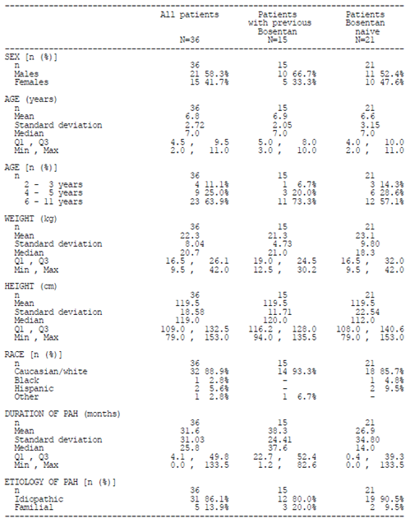

Table 46: FUTURE-2 Summary of previous and concomitant diseases at baseline by frequency
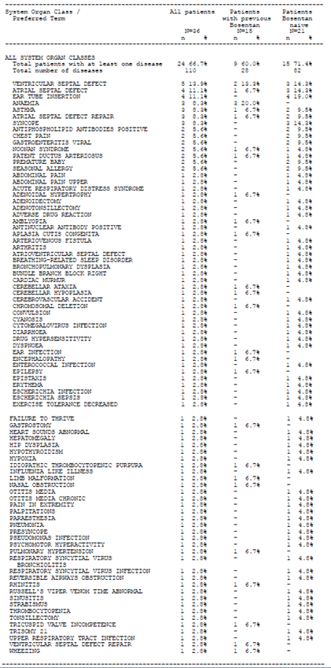

Table 47: FUTURE-2 Summary of duration of exposure to bosentan; all treated set
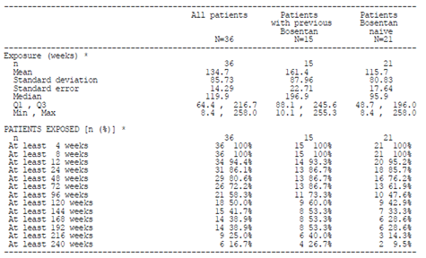

Results for the primary safety outcome
The median duration of exposure was 119.9 weeks. TEAEs occurred in 32 patients (88.9%). TEAEs were recorded as severe in 14 (38.9%) patients. Severe AEs were most frequently classified as Infections and infestations and Respiratory, thoracic and mediastinal disorders, with 6 (16.7%) patients in each class.
Bosentan related TEAEs occurred in 15 patients (41.7%), most frequently reported as gastrointestinal disorders (22.2%) and General disorders (16.7%). The most frequent TEAEs deemed to be related to study drug and occurring in more than 2 patients were abdominal pain (4 patients; 11.1%), chest pain, headache and nasal congestion (all in 3 patients each; 8.3%). One patient had a prolongation of the QRS complex. One bosentan related AE of autoimmune hepatitis was reported as both serious and severe.
Six deaths were recorded during the study (Table 48). Four deaths occurred during treatment or up to 28 days after study drug discontinuation: one due to PAH and subsequent cardiac complications, one due to cardiac failure, one due to right ventricular failure related to suspected otitis and one due to respiratory failure following pneumonia, all reported as unrelated to the study drug. Two deaths occurred more than 28 days after study drug discontinuation: one patient died due to PAH and subsequent cardiac complications 38 days after study drug discontinuation (considered by the investigator as unrelated to the study drug); one patient died during cardiac catheterisation almost 11 months after study drug discontinuation without prior PAH worsening.
SAEs occurred in 18 patients (50.0%, Table 49). The most frequent SAEs were device related infection, PAH and pulmonary hypertension, all of which occurred in 3 patients. As mentioned above, there was one SAE of autoimmune hepatitis which was deemed to be treatment related.
Nine TEAEs which led to premature discontinuation of study drug occurred in 6 (16.7%) patients (Table 50). Six of these AEs were classified as cardiac disorders or respiratory, thoracic and mediastinal disorders. Two of these AEs occurring in 2 patients were deemed to be treatment related. In 4 out of the 6 patients, the AEs leading to discontinuation of study drug were deemed to be related to PAH. For one patient, the AE was deemed to be related to both bosentan and to PAH. In 2 patients, the AEs leading to discontinuation of study drug resolved without clinical sequelae. In one patient the event was reported as unresolved at the EOS visit on the day of study drug discontinuation. In 3 patients the events were fatal. For all 3 patients, the AEs leading to discontinuation and resulting in death were deemed to be related to PAH, but unrelated to treatment.
For haematological and clinical chemistry parameters, no clinically significant mean changes from baseline were observed, apart from laboratory abnormalities that would be expected based on the known safety profile of bosentan (that is, increases in liver enzymes, decreases in haemoglobin, haematocrit, white blood cell count and platelet count) or due to relevant comorbid conditions. The most frequent marked laboratory abnormality was low haemoglobin, which was observed in 4 patients (11.1%) overall. Three patients (8.3%) had a markedly abnormal low platelet count and 2 (5.6%) had a markedly abnormal low haematocrit. Marked abnormalities related to ALT and AST increases were seen in 1 (2.8%) and 2 (5.6%) patients, respectively. Three (8.3%) patients had a marked laboratory abnormality of increased alkaline phosphatase (Table 51).
No abnormalities were observed regarding vital signs or growth in this paediatric population. Both average weight and height increased over the course of the study, reflecting growth. The mean Z-score of height for age remained constant and slightly below zero.
The estimated 5 year survival was 78.0% (95% CI 55.8%, 90.0%).

Table 48: FUTURE-2 Summary of all reported death cases by frequency
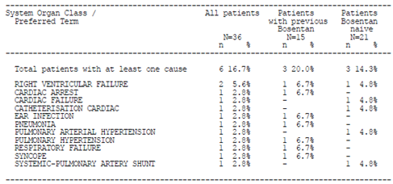

Table 49: FUTURE-2 Overall summary of TEAEs/SAEs, All-treated set
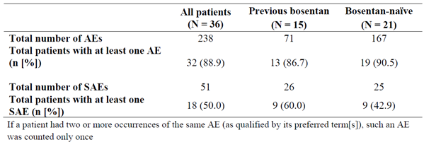

Table 50: FUTURE-2 Summary of TEAEs leading to premature discontinuation by SOC; All-treated set
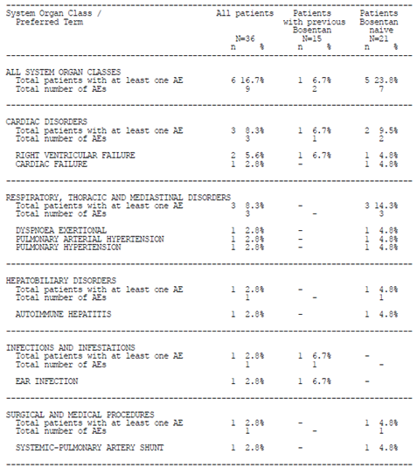

Table 51: FUTURE-2 Treatment emergent marked laboratory abnormalities; All-treated set
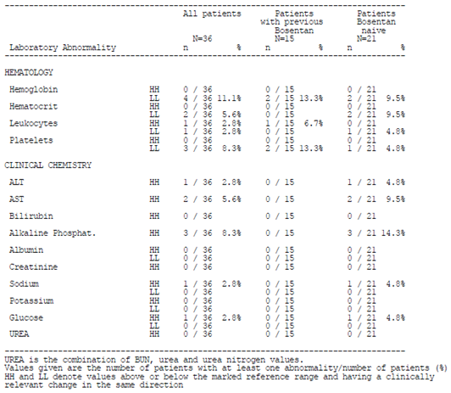
Figure 24: FUTURE-2 KM long term survival estimates; All-treated set
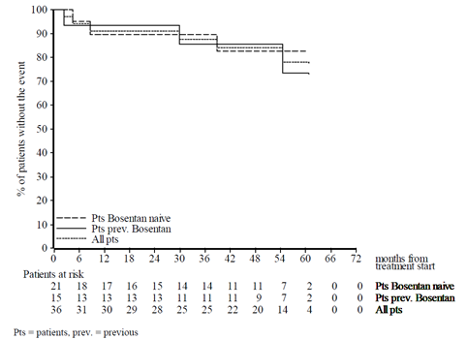

Evaluator commentary
TEAEs occurred in the majority of patients (88.9%) but bosentan related TEAEs occurred in a smaller proportion of the study population (41.7%). The AEs abdominal pain, chest pain, and headache are all described in the current Tracleer PI and the sponsor has proposed adding nasal congestion to the table of post marketing AEs. It is noted that one patient experienced autoimmune hepatitis. This AE is discussed in more detail in Section 8.

AC-052-374 FUTURE-3 Extension

Study design, objectives, locations and dates
The FUTURE-3 Extension Study was a prospective, multicentre, multinational, open label, double-arm, exploratory Phase III one-year extension to FUTURE-3 Core Study.
The patient population in this extension study included male and female paediatric patients who completed the FUTURE-3 core study, either per protocol or who prematurely discontinued study treatment due to PAH progression, and had performed relevant EOS assessments. In addition, patients were required to have tolerated treatment with the bosentan dispersible tablet formulation during the FUTURE-3 core study and were considered by the investigator to benefit from continued bosentan treatment.
Treatment groups assigned at randomisation of FUTURE-3 core study were continued in the extension study. Patients received 32 mg dispersible tablet formulation of bosentan, adjusted to their body weight at each visit (if required), according to the same dosing regimen as in the FUTURE-3 core study (that is, 2 mg/kg either BD or TDS).
The sequence of the assessment of efficacy (except haemodynamics, echocardiography and n-terminal prohormone brain natriuretic peptide (NT-proBNP)) and safety variables was applied uniformly throughout the FUTURE-3 core and FUTURE-3 extension studies.
Assessments at visits were performed at 3-monthly intervals consistently in the FUTURE-3 core and FUTURE-3 extension studies.
The extension study was planned to continue bosentan treatment for a further 12 months (48 weeks) in addition to the core study and was dependant on when the investigator decided to permanently discontinue a patient’s study treatment.
Following the EOT, there was a 60 day post treatment follow-up period for each patient.
Figure 25: FUTURE-3 Extension study design
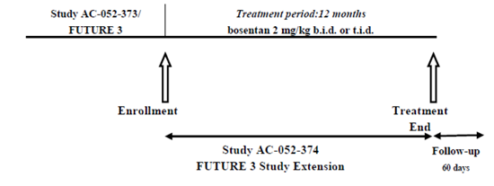

Inclusion and exclusion criteria
The following inclusion criteria were applied:
- Completed the FUTURE-3 Study or prematurely discontinued due to PAH-progression, if bosentan was not permanently discontinued.
- Tolerated bosentan 32 mg dispersible tablet formulation and for whom bosentan was considered beneficial at the end of the FUTURE-3 Study.
- Informed consent by the parents or representatives prior to any study-mandated procedure.
Eligible patients were to have met none of the following exclusion criteria:
- Known intolerance or hypersensitivity to bosentan or any of the excipients of the dispersible bosentan tablet.
- Any clinically significant laboratory abnormality that precluded continuation of bosentan therapy.
- Pregnancy.
- AST and/or ALT values > 3 x the upper limit of normal (ULN) range.
- Moderate to severe hepatic impairment.
- Premature and permanent study drug discontinuation during the FUTURE-3 core study.
- Any major violation of the FUTURE-3 core study protocol.

Study treatments
Study drug was bosentan at doses of 2 mg/kg BD and 2 mg/kg TDS, provided as a 32 mg dispersible tablet for oral administration.

Safety variables and outcomes
The following safety and tolerability endpoints were defined for this extension study:
- TEAEs and SAEs up to 7 days after permanent discontinuation of study drug.
- AEs leading to premature discontinuation of study drug.
- AEs denoting liver abnormality, enema, and anaemia/haemoglobin decrease.
- SAEs from 7 up to 60 days after permanent discontinuation of study drug.
- Changes from baseline to all assessed time points up to 7 days after permanent discontinuation of study drug in vital signs, body weight, body mass index (BMI) and height/length.
- Marked laboratory abnormalities up to 7 days after permanent discontinuation of study drug.
- Treatment emergent liver function abnormalities up to EOT +7.

Randomisation and blinding methods
Patients continued to receive study drug as per the treatment assignment in the FUTURE-3 core study. The study was open label and no blinding was performed.

Analysis populations
The Screened analysis set included all patients who were screened and received a patient number in FUTURE-3. The All-Randomised analysis set includes all patients assigned to a study treatment in FUTURE-3. The All-Treated analysis set comprised all patients in the FUTURE-3 core study who received at least one dose of the study drug. The same patients were included in the All-Randomised and the All-Treated analysis set, therefore only the All-Treated analysis set was used. The Safety set includes all patients who received at least one dose of study treatment. Patients were evaluated according to the study treatment that they received.

Sample size
There was no sample size calculation for the extension study.

Statistical methods
All analyses were performed on the pooled data of the FUTURE-3 and the extension study. No hypothesis test was performed. Comparisons between the treatment groups were descriptive and point estimates were accompanied by 95% 2 sided confidence limits (CLs).
All analyses were performed for the overall population and by age groups (< 2 years and ≥ 2 years). All efficacy analyses were performed descriptively using the ‘All Treated’ analysis set. For categorical data, the number and percentage of patients in each category were tabulated by visit for each treatment group and additionally, for WHO FC and GCIS, the number of patients who improved, did not have a change in status or worsened from baseline were tabulated by visit for each treatment group and overall. For time to event endpoints, KM estimates were presented with 2 sided 95% CLs. For PAH-worsening endpoints, the number (and percentage) of patients reporting each type of event was tabulated by treatment group and overall, for first event and for all events.
A post-hoc analysis using Cox proportional hazards model analyses was conducted to examine the potential influence of baseline demographic and other disease related factors on bosentan treatment comparison (BD versus TDS) for the time to event endpoints of worsening up to EOT + 7 days, death up to EOT + 7 days, and death up to EOS.
Safety data were analysed descriptively using the Safety analysis set, which included all randomised patients who received at least one dose of study drug.

Participant flow
Of the 64 patients (33 BD, 31 TDS) randomised in the FUTURE-3 Core Study, 58 patients (31 BD, 27 TDS) entered this extension study, 18 of whom were < 2 years of age (9 each, BD and TDS) and 40 ≥ 2 years of age (22 BD, 18 TDS). Of the 58 patients who entered the FUTURE-3 Extension Study, 13 patients prematurely discontinued study treatment, due to AEs (6 BD and 5 TDS), administrative reasons and withdrawal of consent (1 patient each, BD). A total of 45 patients (23 BD and 22 TDS) completed the treatment period.
All 64 patients who were randomised in the FUTURE-3 Core Study received at least one dose of the study drug and were included in the All-Treated and safety analysis sets.
Figure 26: FUTURE-3 extension disposition of patients
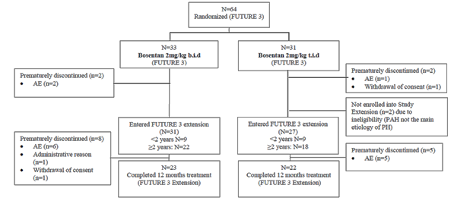

Major protocol violations/deviations
In a total of 8 patients, protocol deviations including lack of stable previous PAH therapy and lack of RHC-based PAH diagnosis, presence of a ‘disease or condition that might interfere with the study conduct or interpretation of results’ and receipt of incorrect study medication were reported. None of the protocol deviations led to the exclusion of patients from any of the analyses.

Baseline data
In the BD group, the majority of patients were female (54.5%); however, the majority of patients in the TDS group were male (67.7%). Mean age was balanced between the two treatment groups (4.5 years ± 0.58 BD, 5.2 years ± 0.68 TDS) and the majority of patients in each group were Caucasian (75.8% BD, 74.2% TDS). Mean BMI was similar across the groups.
The aetiology of PAH was mainly idiopathic PAH (46.0%) and associated PAH (38.1%). The mean time since diagnosis of PAH by RHC in the overall population was 470.4 days ± 888.74 in the BD group and 622.1 days ± 910.02 in the TDS group. On average, the disease condition at baseline was more severe in patients in the BD group (WHO FC I/II: 63.6%, III: 36.4%) than in the TDS group (WHO FC I/II: 80.6%, III: 19.4%). These findings were consistent across the < 2 years and ≥ 2 years age groups. Overall, 42 patients (65.6%) were reported to be taking at least one PAH-specific medication at baseline.

Table 52: FUTURE-3 Extension Summary of demographic characteristics; All-treated set
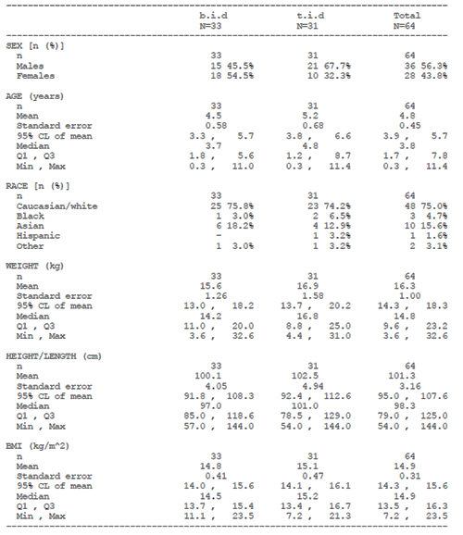

Table 53: FUTURE-3 Extension Summary of baseline characteristics; All-treated set
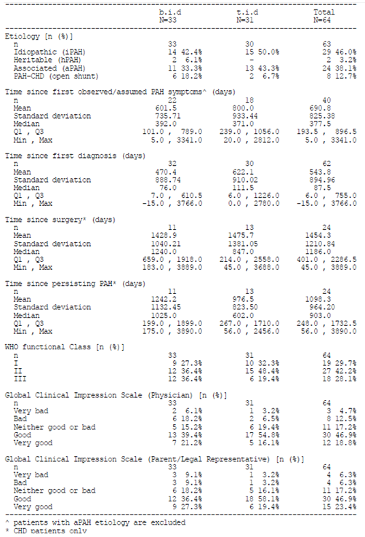

Results for the primary safety outcome
No primary efficacy or safety endpoint was defined for this study. The safety outcomes are summarised below.
The majority of patients (57.6% BD, 54.8% TDS) had at least 72 weeks of exposure to bosentan. The cumulative mean (± SD) exposure duration to bosentan was 64.1 ± 3.38 weeks in the BD group and 60.4 ± 4.20 weeks in the TDS group. The mean (± SD) exposure duration to bosentan only during the FUTURE-3 extension study was 43.2 ± 2.55 weeks in the BD group and 43.1 ± 3.11 weeks in the TDS group.
The proportion of patients in the overall population who experienced at least one TEAE were 87.9% in the BD group and 83.9% in the TDS group. The majority of AEs were mild or moderate intensity. The proportions were 80.0% (BD), 81.8% (TDS) in patients < 2 years of age, and 91.3% (BD), 85.0% (TDS) in patients ≥ 2 years of age.
The nature of AEs reported during the FUTURE-3 extension study were consistent with those reported during the FUTURE-3 core study. Upper respiratory tract infection was the most frequently reported AE (9 patients (27.3%) BD, 13 patients (41.9%) TDS group). Worsening of PAH was reported for a total of 8 patients (12.5%).
The increased incidences of AEs reported cumulatively over both studies compared to FUTURE-3 core study alone, are reported to reflect the longer observation period during the extension study.
A total of 12 deaths (18.8%) were reported (10 within and 2 beyond EOT + 7 days), 3 of which occurred during the FUTURE-3 core study and 9 occurred during the extension study. The numerical difference in deaths in the BD (8 patients 24.2%) and TDS groups (4 patients, 12.9%) reflected the difference in disease severity at baseline. Of the 12 patients who died, 4 patients were < 2 years of age and 8 patients were ≥ 2 years of age. All deaths occurred in the context of underlying disease worsening, cardiopulmonary disorders, and infections and none were a consequence of hepatobiliary events, anaemia or oedema. Cumulatively, 28 patients (43.8%) experienced SAEs, 4 of whom experienced SAEs during both the FUTURE-3 core and the extension study. Of the 28 patients with SAEs, 12 (57.1%, 4 BD, 8 TDS) were < 2 years of age and 16 (37.2%, 11 BD, 5 TDS) were ≥ 2 years of age. The vast majority of SAEs were associated with cardiopulmonary disorders and infections.
AEs led to premature discontinuation of study treatment in a total of 12 patients (18.8%). Patients prematurely discontinued study treatment mostly due to worsening of PAH (n = 4), with other reasons being cardiopulmonary failure, liver abnormalities, and pneumonia (2 patients each).
Six patients experienced marked decreases in haemoglobin values to < 100 g/L (all ≥ 2 years), which in 4 cases were reported during the FUTURE-3 Core Study and in 2 cases, during the extension study. No patients had decreases in haemoglobin to values < 80 g/L. There were no new cases in the number of patients who experienced marked decrease in Platelets (LLL, that is, < 50 x 10⁹/L) and no new cases of ALT and/or AST > 3 x ULN during the FUTURE-3 extension Study. Altogether, 2 patients experienced marked decrease in platelets and one patient experienced ALT > 5 x ULN (204 U/L, Day 169) concomitant with AST > 3 x ULN (112 U/L) that resolved after study treatment discontinuation as reported in the FUTURE-3 Core Study. Marked increases (HH, that is, > 2 x ULN) in TBIL were experienced by one patient each, during the FUTURE-3 core and the extension study. There were no cases of ALT or AST elevations > 3 x ULN with total bilirubin > 2 x ULN altogether in the cumulative reporting period. These changes in laboratory variables and incidences of peripheral oedema were reported as AEs of special interest in a total of 8 patients, which in 4 cases occurred during the FUTURE-3 Core Study.
There were no notable differences between growth curves for height/length and BMI, for males and females, or in patients with Down syndrome. The growth profile was consistent with the underlying disease condition.

Evaluator commentary
A similar proportion of patients experienced a TEAE in the FUTURE-3 and FUTURE-2 studies. With a slightly higher proportion of patients experiencing a TEAE in the BD group compared to the TDS group. A higher proportion of deaths were also observed in the BD group. These results may reflect the difference in disease severity at baseline seen in the BD group. The AEs reported in the FUTURE-3 extension study were consistent with those reported for the FUTURE-3 Study.
Upper respiratory tract infection was the most frequently reported AE and is described in the current Tracleer PI.

Study AC-052-392 (FUTURE-4) Extension

Study design, objectives, locations and dates
The Study AC-052-392 (FUTURE-4) extension was a multi-centre, non drug interventional, exploratory, Phase III, extension study, which enrolled subjects from the FUTURE-4 Study who had received at least one dose of study drug (bosentan 2 mg/kg twice a day dispersible tablet formulation or matching placebo).
The enrolment in FUTURE-4 extension study was performed after the FUTURE-4 EOS visit and within 6 months after approval of the FUTURE-4 Study extension protocol at the respective study site. The observation period for all subjects enrolled into the FUTURE-4 extension Study started from the FUTURE-4 Core EOS and lasted up to 12 months (+ 2 months’ time window) thereafter. The observation period concluded with an End-of-observation period (EoOP) assessment visit, which included collection of growth variables.
The objective of this study was to assess long term safety and effects on growth in subjects who received bosentan or placebo in the FUTURE-4 Study.
The study was conducted at all 9 centres across 6 countries in which subjects were randomised in the FUTURE-4 Study. The study ran from 14 December 2013 to 5 December 2014.

Inclusion and exclusion criteria
The study included male and female subjects who had received at least one dose of study drug (bosentan 2 mg/kg BD dispersible tablet formulation or matching placebo) in the FUTURE-4 core study (see Section 7.2.1.2 (above) for the list of inclusion and exclusion criteria). Subjects treated in the FUTURE-4 Core Study were term or near term newborns (gestational age > 34 weeks) between ≥ 12 hours and < 7 days of age with idiopathic PPHN or PPHN secondary to parenchymal lung diseases with no or insufficient response to iNO therapy.

Study treatments
No study drug was administered.

Safety variables and outcomes
The safety endpoints of the study were the following:
- SAEs occurring more than 60 days after the End-of-Treatment (EOT) in the FUTURE-4 core study and up to EoOP.
- Non-serious adverse events (AEs) occurring during the observation period (that is, from EOS of FUTURE-4 core study and up to EoOP).
- Change from baseline (birth weight and length) to EoOP in growth variables (that is, weight and length).

Randomisation and blinding methods
The randomisation and blinding methods for the FUTURE-4 Study are described above in Section 7.2.1.5.

Analysis populations
The All-randomised set comprised all subjects randomised into the FUTURE-4 Core Study regardless of treatment status. The All-enrolled set included all subjects of the All-treated set of the FUTURE-4 core study.

Sample size
No sample size was estimated for the extension study.

Statistical methods
There was no hypothesis testing and all statistical analyses were descriptive in nature.

Participant flow
In total, 15 of the 21 subjects treated in the FUTURE-4 core study entered the FUTURE-4 extension study. Six were not enrolled due to refusal or inability to participate (n = 5) or lost contact (n = 1). All 15 subjects enrolled into the FUTURE-4 extension Study completed the 12 month observation period.
Figure 27: FUTURE-4 Extension Disposition of patients
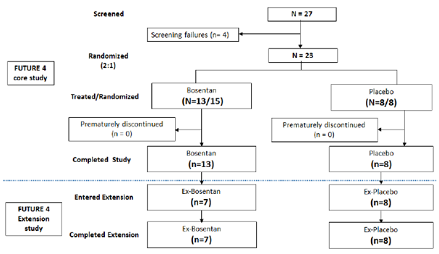

Major protocol violations/deviations
Deviations from informed consent procedure were identified for a total of 2 subjects. In one case informed consent was obtained but not documented by the investigator. In the other case an erroneous date and time was entered. At a subsequent visit the correct of the date and time of informed consent was confirmed.

Baseline data
Of the 21 subjects treated in the FUTURE-4 core study, 20 were successfully weaned from iNO at EOS. One subject was on ECMO but recovered within 60 days. Fifteen subjects entered the extension study. In these 15 subjects (7 ex-bosentan, 8 ex-placebo), median gestational age was 41 weeks (37.0 to 41.0 weeks) in the ex-bosentan group and 38.5 weeks (36.0 to 42.0 weeks) in the ex-placebo group. The median age at first dosing with the study treatment was 1.1 days (0.6 to 2.6 days) in the ex-bosentan group and 1.7 days (0.6 to 5.9 days) in the ex-placebo group.
The majority of subjects in both groups were female (57.1% ex-bosentan, 75.0% ex-placebo) and Caucasian (71.4% ex-bosentan, 75.0% ex-placebo).
The aetiology of PPHN was characterised predominantly by parenchymal lung disease in both groups (100% ex-bosentan, 62.5% ex-placebo). Idiopathic PPHN was diagnosed in 3 (37.5%) ex-placebo subjects.
Median baseline OI for the 21 subjects of the FUTURE-4 Core Study indicated that the disease condition was more severe in the bosentan group (18.3 (5.9 to 44.3)) than in the placebo group (13.2 (7.1–39.4)). In the 15 subjects who entered the extension study, median baseline OI values were similar in the ex-bosentan (14.0 (7.6, 37.8)) and ex-placebo groups (13.2 (7.1, 39.4)).

Table 54: FUTURE-4 Extension Summary of demographic and baseline disease characteristics, All-enrolled set
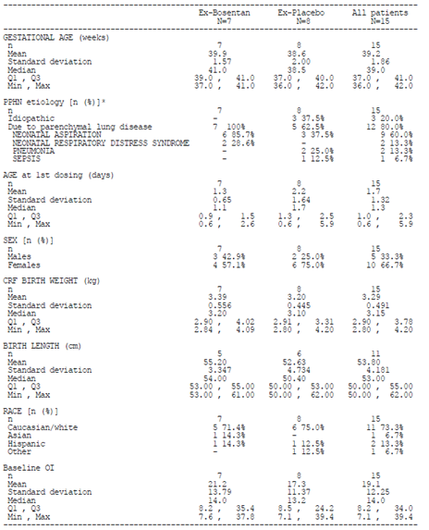

Results for the primary safety outcome
As per FUTURE-4 Extension Study protocol, 7 subjects were enrolled within the Observation Period and had both prospective and retrospective data. In 8 subjects, enrolment was after the end of the observation period and data obtained were entirely retrospective.
There were no deaths or SAEs in the study.
A total of 8 subjects (4 each, ex-bosentan and ex-placebo) experienced AEs during the 12 month (+ 2 months) observation period. In two of the four subjects in the ex-bosentan group, AE data was retrospective. In the ex-bosentan group upper respiratory tract infection was reported in two subjects. One of these subjects also experienced urinary tract infection and anaemia. Bronchitis and ear infection were reported in one subject.
Four subjects in the ex-placebo group experienced AEs. In one of the four subjects in the ex-placebo group, AE data was retrospective. One subject experienced respiratory tract infection and wheezing and also vomiting and rash. Viral gastroenteritis and tonsillitis were reported without any temporal association to the earlier infections. One subject experienced bronchitis and was reported to have constipation, seborrhoea, alopecia, bronchitis, gastro-oesophageal reflux disease and diaper dermatitis. Another subject experienced croup infection and had a scar on the right heel. One subject experienced positional plagiocephaly.
The anaemia in one subject that was assessed by the investigator as mild and unrelated to previous bosentan administration was reported 7 months after discontinuation of bosentan treatment, following repetitive infections. All AEs resolved except anaemia, scar and positional plagiocephaly.
The long term follow-up of the 15 subjects identified no safety concerns. Overall, reported AEs were of the nature that was expected in infants. No deaths or SAEs were reported. Subjects’ growth was sustained and within the expected range.
The change from baseline to end of observation in growth variables did not indicate any apparent difference between ex-bosentan and ex-placebo subjects. Overall, subjects’ growth curves remained within 5th to 95th WHO growth percentiles, which indicated sustained growth.

Evaluator commentary
Exposure to bosentan was of short duration but it is noted that no difference in growth were detected between ex-bosentan and ex-placebo subjects.

Patient exposure
The following summaries of patient exposure were provided. Patient exposure in the BREATHE-3, FUTURE-1 and FUTURE-2 studies are summarised in Table 55.
In the FUTURE-3 Study the mean (± SD) exposure duration to bosentan was similar in the BD group (23.6 ± 3.71 weeks) and TDS group (23.3 ± 5.02 weeks). The mean daily dose (± SD) was 3.6 ± 0.42 mg/kg/day in the BD group and 6.0 ± 3.78 mg/kg/day in the TDS group.
In the FUTURE-3 extension Study the majority of patients (57.6% BD, 54.8% TDS) had at least 72 weeks of exposure to bosentan. The cumulative mean (± SD) exposure duration to bosentan was 64.1 ± 3.38 weeks in the BD group and 60.4 ± 4.20 weeks in the TDS group.
In the FUTURE-4 Study the median exposure (days, min–max) was similar in the bosentan (4.5 days, 0.5 to 10.0 days) and placebo groups (4.0 days, 2.5 to 6.5 days). Approximately 60.0% of patients in both groups had at least 4 days of exposure to the study drug (Table 57).
No treatment was administered as part of the FUTURE-4 extension study.

Table 55: Summary to support EMEA Variation 39; Summary of overall bosentan exposure for paediatric studies
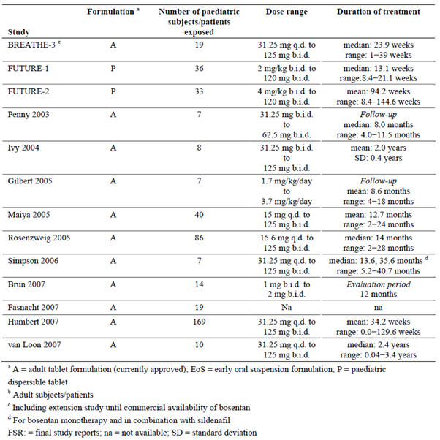

Table 56: Summary to support EMEA Variation 66; Duration of treatment exposure from treatment start in the pooled safety analysis set
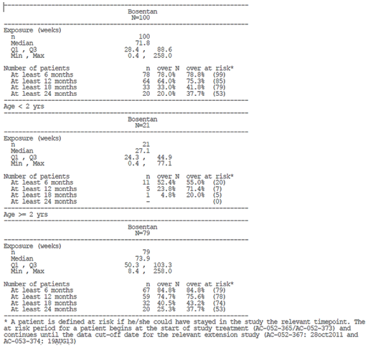

Table 57: Summary to support EMEA Variation 66; Summary of study treatment exposure, FUTURE-4 PPHN safety analysis set
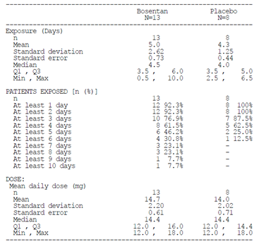

Table 58 Summary addendum to support EMEA Variation 51 Duration of exposure to study treatment in the overall pool and for the approved indications, safety set
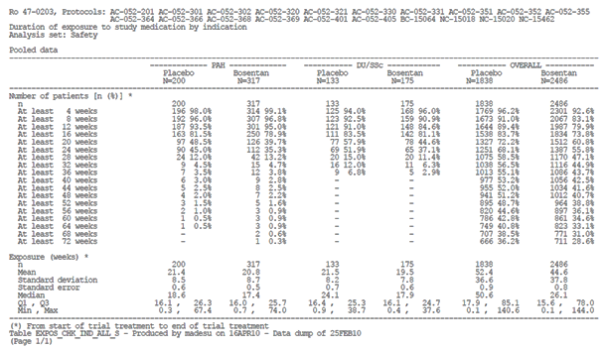

Table 58 Summary addendum to support EMEA Variation 51 Duration of exposure to study treatment in the overall pool and for the approved indications, safety set
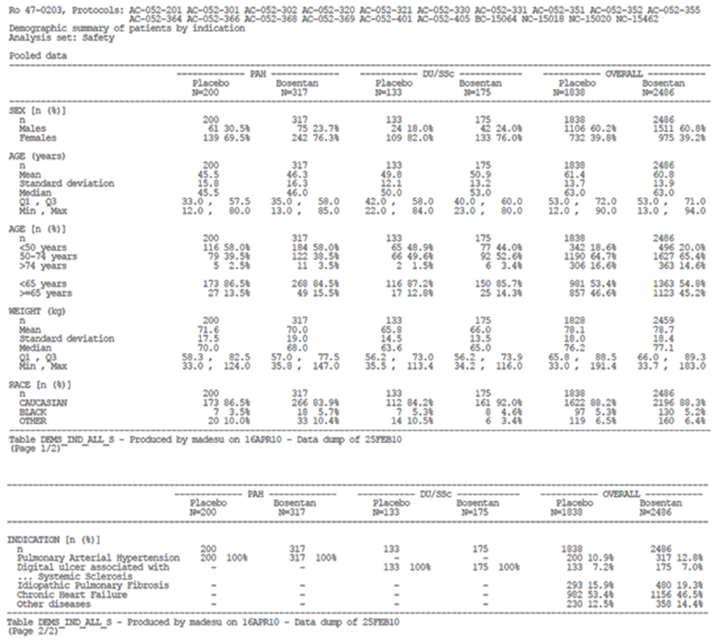

Adverse events

All adverse events (irrespective of relationship to study treatment)

Integrated safety analyses
A statistical analysis of the FUTURE-1, FUTURE-2, FUTURE-3 and FUTURE-3 extension studies has been included in the submission. The results of the analysis were provided as a series of appendices of tables, figure and case narratives. A description or summary of the results is not included. Table 60 summarises the number of patients with TEAEs, SAEs, AEs leading to discontinuation, fatal outcome AEs and related TEAEs.

Table 60: Integrated safety analysis summary of AEs analysis set: Safety
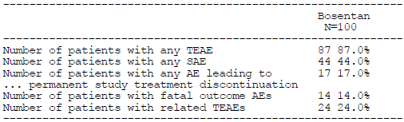

Main/pivotal studies that assessed safety as the sole primary outcome

Study FUTURE-2
Over both FUTURE-1 and FUTURE-2 Study periods (N = 36), 170 AEs were experienced by 29 (80.6%) patients; there were also 38 SAEs experienced by 15 (41.7%) patients. Most AEs were experienced by no more than a single patient, and were of mild or moderate intensity.
Most AEs were observed in one patient only. Many of the AEs would be expected in any paediatric population followed over time (upper respiratory tract infection, nasopharyngitis, bronchitis, otitis, vomiting, and diarrhoea) or were likely related to the underlying disease (chest pain, fatigue, syncope).
TEAEs were recorded as severe in 14 (38.9%) patients. Severe AEs were most frequently classified as Infections and infestations and Respiratory, thoracic and mediastinal disorders, with 6 (16.7%) patients in each of these classes experiencing at least one severe AE belonging to the corresponding class. The next most frequent SOCs were Nervous system disorders and Cardiac disorders, with 3 (8.3%) patients in each of these classes experiencing at least one severe AE belonging to the corresponding class. The most frequent treatment emergent severe AEs, occurring in 2 or more patients, were PH (3 patients; 8.3%) and PAH and device related infection (both in 2 patients each; 5.6%).

FUTURE-4 extension study
As described above, a total of 8 subjects (4 in the ex-bosentan and ex-placebo) experienced AEs during the 12 month (+ 2 months) observation period. Upper respiratory tract infection was reported in two subjects. One of these subjects also experienced urinary tract infection and anaemia. Bronchitis and ear infection was reported in one subject each.

Other studies

Study AC-052-116
During this study in healthy adult subjects, each subject received a single oral dose of 62.5 mg bosentan or a single oral dose of 64 mg bosentan. During the study two subjects reported a total of three adverse events and all were reported after treatment with the paediatric formulation.

Study AC-052-365 (FUTURE-1)
Twenty-two patients (61.1%) experienced at least one AE (Table 61). The most frequent AEs were abdominal pain (11%) and vomiting (8.3%). Most AEs were of mild or moderate intensity. Thirty-one AEs in 13 patients were considered possibly related to bosentan.

Table 61: FUTURE-1 AE summary
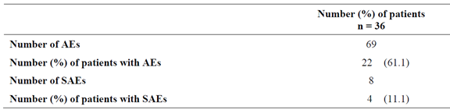

Treatment related adverse events (adverse drug reactions)

Integrated safety analyses
Table 60 shows 87% of patients in the integrated analysis experienced a TEAE. The analysis included a total of 491 AEs. The most commonly reported TEAEs by system organ class were infections and infestations (69%), respiratory, thoracic and mediastinal disorder (43%) and gastrointestinal disorders. The most commonly reported TEAEs were upper respiratory tract infection (25%), nasopharyngitis (17%) and pyrexia (14%).

Main/pivotal studies that assessed safety as the sole primary outcome

Study FUTURE-2
TEAEs and SAEs occurred in 32 patients (88.9%) and 18 patients (50.0%), respectively. Overall, the most frequently reported AEs were abdominal pain and nasopharyngitis, which were observed in 19.4% of patients each, followed by PAH and pulmonary hypertension in 16.7% of patients each (Table 62). AEs were most frequently classified as Infections and infestations, which occurred in almost two thirds of patients (63.9%), and Respiratory, thoracic and mediastinal disorders, which occurred in 58.3% of patients.
Bosentan related TEAEs occurred in 15 (41.7%) patients. Bosentan related AEs were most frequently classified as gastrointestinal disorders, with 8 (22.2%) patients experiencing at least one AE belonging to this class. The next most frequent SOC was General disorders, with 6 (16.7%) patients experiencing at least one AE belonging to this class.
The most frequent TEAEs deemed to be related to study drug and occurring in more than 2 patients were abdominal pain (4 patients; 11.1%), chest pain, headache and nasal congestion (all in 3 patients each; 8.3%). Many of the treatment related AEs have been previously observed with bosentan treatment in children, for example headache (in 3 patients; 8.3%), flushing (in 2 patients; 5.6%), ALT or AST increases, face oedema and decreased haemoglobin or haematocrit (all in one patient each; 2.8%). One patient had a prolongation of the QRS complex in the ECG. One bosentan related AE of autoimmune hepatitis was reported as both serious and severe.

Table 62: FUTURE-2 Summary of TEAEs occurring in more than one patient up to 1 day after permanent discontinuation of study by frequency; all treated set
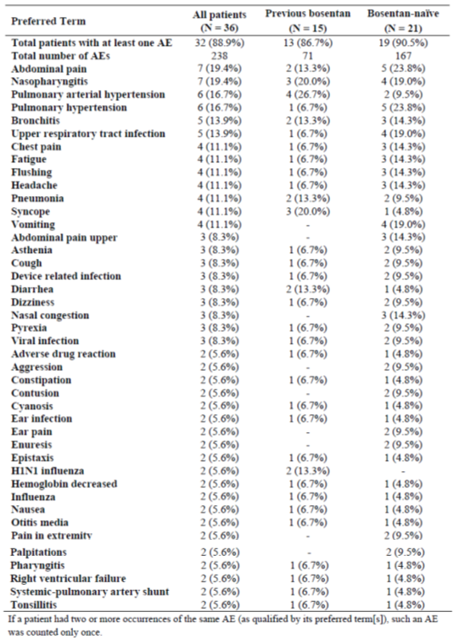

Pivotal and/or main efficacy studies

FUTURE-4 study
TEAEs were reported for 10 (76.9%) patients on bosentan compared to 4 (50.0%) patients on placebo. Anaemia (3 patients bosentan 23.1%, 1 patient placebo 12.5%) was the most frequently reported AE. Unspecified reactive hepatitis was reported in one bosentan treated patient 3 days after EOT; (ALT and AST remained < 2 x ULN). A second case of neonatal hepatitis in a bosentan treated patient was reported during the follow-up period, 8 days after EOT. Generalised oedema was reported in 3 patients on bosentan, all of whom had received multiple plasma expanders/IV fluid supplementation on days preceding the event onset. The majority of AEs were of mild or moderate intensity.

Table 63: FUTURE-4 Summary of TEAEs by preferred term, Safety analysis set
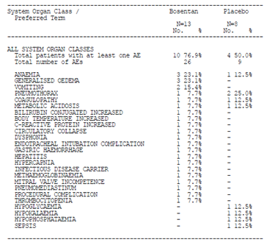

Other studies

Study AC-052-116
All TEAEs were considered as ‘unrelated’ to the study drug by the investigator. All were mild (one episode of diarrhoea) or moderate (two episodes of headache) in intensity and resolved before the end of the study.

Study AC-052-365 FUTURE-1
A total of 22 patients (61.1%) experienced AEs, including those unrelated to study drug. The SOCs most frequently involved were infections and gastrointestinal disorders (respectively 12 patients, 33.3%, and 9 patients, 25%). The most common individually reported AEs overall were abdominal pain (4 patients, 11.1%) and vomiting (3 patients, 8.3%). Respiratory infections were the most common clinical diagnoses, reported in 9 patients (25.0%, of which upper respiratory infections in 7 patients, 19.4%, and lower respiratory infections, in 3 patients, 8.3%). Abdominal pain/discomfort, nausea/vomiting, and diarrhoea occurred in 7 patients (19.4%), 3 patients (8.3%), and 1 patient (2.8%) respectively. One patient was reported to have an AE of aggressive behaviour, but it was considered unrelated to study treatment.
A total of 13 patients (36.1%) experienced TEAEs related to the study drug. The most common were gastrointestinal disorders, including abdominal pain (4 patients, 11.1%) and upper abdominal pain (2 patients, 5.6%). Several study drug related TEAEs were reported at a frequency of 5.6% (2 patients each): asthenia, chest pain, flushing, headache, nasal congestion, and vomiting. In one patient, an AE of aggressive behaviour was reported that was considered treatment related.

Study AC-052-373 (FUTURE-3)
In the overall population, the proportions of patients who experienced at least one TEAE were similar in the BD group (66.7%) and in the TDS group (67.7%). The proportions were 60% and 72.7% in the BD and TDS groups, respectively, in patients < 2 years of age; and 69.6% and 65.0% respectively, in patient’s ≥ 2 years of age.
In the overall population, upper respiratory tract infection was the most frequently reported AE (18.2% BD, 35.5% TDS) (Table 64). The sponsor’s analysis grouping the PT of upper respiratory tract infection with other PTs denoting the same medical concept, showed that, overall, patients experienced upper respiratory tract infections at similar frequencies in the BD (12 patients, 36.4%,) and TDS groups (14 patients, 45.2%). Frequencies for all respiratory tract infections (including upper and lower) were similar in the BD (15 patients, 45.5%) and TDS groups (6 patients, 51.6%). AEs associated with upper respiratory tract infections were reported in 4 (40.0%) and 6 patients (54.5%) in the BD and TDS groups, respectively, in patients < 2 years; and in 8 patients each, in the BD (34.8%) and TDS (40.0%) groups, respectively, in patients ≥ 2 years.
The incidence of GI disorders was 12.1% in the BD group (4 patients) and 25.8%in the TDS group (8 patients) (Table 64). GI disorders were reported for 2 and 3 patients in the BD and TDS groups, respectively, in patients < 2 years, and in 2 and 5 patients in the BD and TDS groups, respectively, in patients ≥ 2 years of age.
Pyrexia/increased body temperature was reported for 4 patients (12.1%) in the BD group and for 7 patients (22.6%) in the TDS group. Skin and subcutaneous tissue disorders AEs were reported for 2 patients in the BD group and 5 patients in the TDS group.
A total of 3 patients (all BD) experienced AEs related to platelet counts. Thrombocytopenia (2 patients) was reported only for patients ≥ 2 years, whereas decreased platelet count was reported in one patient < 2 years. In 2 of the 3 patients, platelet count improved or normalised on continued bosentan treatment. The third patient experienced decreased platelet count after more than 2.5 years of bosentan use (including use prior to study enrolment) and discontinued study drug the same day due to PAH progression. The patient had platelet transfusion, but no follow-up values could be obtained.
Individual patients were reported with decreased haematocrit, peripheral oedema (all BD), increased blood bilirubin, decreased haemoglobin and abnormal liver function (all TDS). These AEs are of interest due to the known safety profile of bosentan.
The isolated occurrence of peripheral oedema in one patient who had dyspnoea and elevated NT-proBNP at baseline was resolved one month after spironolactone was initiated.
The majority of AEs were of mild or moderate intensity. Severe-intensity AEs were reported for a total of 5 patients, which were associated with worsening of the underlying disease in 3 cases (2 BD, 1 TDS). Pyrexia and viral respiratory tract infection of severe intensity was reported for one patient each (both TDS).

Table 64: FUTURE-3 Summary of TEAEs reported for at least one patient in both groups by frequency; overall age groups, All-treated set
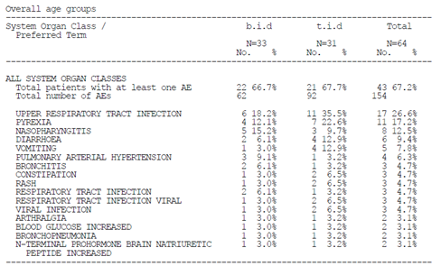

Deaths and other serious adverse events

Integrated safety analyses
There were a total of 17 deaths amongst patients included in the safety analysis (Table 65). The majority of TEAEs were classified as moderate (35%) or severe (31%) (Table 66). There were 92 AEs classified as SAEs experienced by a total of 44 patients. The most commonly reports SAEs belonged to the Infection and infestations (20%), respiratory, thoracic and mediastinal disorders (19%), cardiac disorders (8%) and general disorders and administration site conditions system organ classes. PAH (9%), pneumonia (4%), device related infection (3%) and PH (3%) were the most commonly reported SAEs.

Table 65: Integrated safety analysis deaths by cause: Safety set
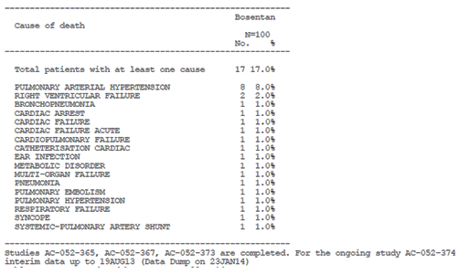

Table 66: Integrated safety analysis TEAEs by maximum severity
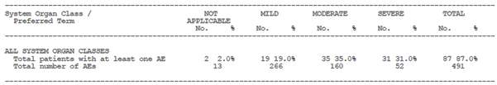

Main/pivotal studies that assessed safety as the sole primary outcome

FUTURE-2 study
Six deaths (16.7% of patients) occurred during the study. Four deaths occurred during treatment or up to 28 days after study drug discontinuation: one due to PAH and subsequent cardiac complications, one due to cardiac failure, one due to right ventricular failure related to suspected otitis, and one due to respiratory failure following pneumonia, all reported as unrelated to the study drug. Two deaths occurred more than 28 days after study drug discontinuation: one patient died due to PAH and subsequent cardiac complications 38 days after study drug discontinuation and one patient died during cardiac catheterisation almost 11 months after study drug discontinuation without prior PAH worsening. The case narratives for the cases of death are described below:
- An 8 year old female patient with idiopathic PH and a medical history of Noonan syndrome was treated with bosentan for 85 days completed the FUTURE-1 Study and then entered FUTURE-2. Ongoing concomitant medication included acenocoumarol. On Day 894, the patient experienced respiratory insufficiency due to pneumonia and was hospitalised. She presented with dyspnoea, tachypnoea and epistaxis. Acenocoumarol was stopped. The patient was treated with antibiotics. The study drug was ongoing. This event was judged unrelated to the study drug. On Day 912, while still hospitalised, the patient experienced severe haemoptysis and decreased oxygen levels. Resuscitation was performed but the patient died. The cause of death was given as respiratory insufficiency due to pneumonia. An autopsy was performed and showed necrotic arteritis and vasculitis in both lungs.
- A 7 year old male patient with idiopathic PH and a history of asthma and atrial septal defect was bosentan for 96 days, completed the FUTURE-1 Study and entered FUTURE-2. Concomitant medication included acetylsalicylic acid, fluticasone, furosemide, salmeterol and oxygen. On Day 115, the patient presented with cough and a fever of 38.5 °C and was diagnosed with viral rhinobronchitis. He was hospitalised two days later and treated with budesonide, paracetamol, hydroxyzine, and clobutinol. The patient's condition improved within 48 hours and the patient was discharged. The event resolved without sequelae on Day 123 with the study drug ongoing. This event was judged unrelated to the study drug. On Day 181, the patient was hospitalised due to worsening of PH. Abdominal echography confirmed hepatomegaly and mild splenomegaly without ascites. Laboratory tests showed normal values for liver and kidney function. The patient was treated with IV epoprostenol and a central line was inserted. Despite continued treatment, cardiac failure did not improve and the patient died on Day 265. An autopsy was not performed. The study drug was continued to the time of death. The cause of death was reported as cardiac failure as unrelated to bosentan.
- A 5 year-old male patient with familial PH was enrolled in the FUTURE-1 Study and started treatment with bosentan. The patient was treated with bosentan for 85 days, completed the FUTURE-1 Study and entered FUTURE-2. There was no ongoing concomitant medication reported. On Day 121, the patient developed right heart failure after Potts anastomosis and was hospitalised for worsening of PH on Day 131. The patient died in hospital on Day 137 of refractory right ventricular failure due to worsening of PAH. This event was reported as serious, but not related to study drug.
- This 5 year old Caucasian male patient with idiopathic PH was enrolled in FUTURE-1 and started treatment with bosentan. Medical history included amblyopia, cerebellar ataxia and cerebellar hypoplasia, rhinitis, otitis, adenoidal hypertrophy and bacterial infection secondary to adenoidectomy, gastrostomy, and thrombocytopenia. The patient was treated with bosentan for 110 days. The patient experienced blood bacterial infection, which resolved with the study drug ongoing. The patient completed the FUTURE-1 Study and entered FUTURE-2. There was no ongoing concomitant medication reported at study entry. On Day 218, the patient presented with fever and cough and was hospitalised. He was diagnosed with pulmonary infection and was treated and the event resolved without sequelae on Day 220 with the study drug ongoing and the patient was discharged on the same day. This event was judged unrelated to the study drug. On Day 290, the patient was found to have worsening of PH on routine echocardiogram. He had symptoms of fatigue and near syncope. The patient was placed on supplemental oxygen and remained in stable clinical condition. He was hospitalised from Day 358 for initiation of sildenafil therapy, the study drug was ongoing. The event did not resolve and the patient was discharged on Day 360. This event was judged unrelated to the study drug. On Day 1,428, the patient presented with symptoms of dyspnoea and cyanosis and was hospitalised. He was treated with subcutaneous treprostinil. The event resolved without sequelae on Day 1,444 with the study drug ongoing and the patient was discharged on the same day. This event was judged unrelated to the study drug. On Day 159, the patient was hospitalised due to clinical worsening with right heart failure and pericardial effusion. Treatment was changed to intravenous epoprostenol. The event resolved with sequelae on Day 1,626 with the study drug ongoing and the patient was discharged on the same day. This event was judged unrelated to the study drug. On Day 1,626, the patient's caregiver withdrew consent and the patient prematurely discontinued the study. The patient died on Day 38 after premature discontinuation of FUTURE-2. No SAEs were reported during the 28 days follow-up after FUTURE-2. The cause of death was reported as syncope related to PH followed by cardiac arrest.
- A 10 year old female patient with familial PH was enrolled in the FUTURE-1 Study and started treatment with bosentan. At study entry, she had a medical history of anaemia, Ip36 chromosomal deletion, encephalopathy, epilepsy, and patent ductus arteriosus and small ventricular septal defect, both spontaneously closed. Concomitant medication included fluindione, furosemide, spironolactone and iron. The patient had been treated with the bosentan adult formulation prior to enrolment. The study drug was initiated at the target dose of 104 mg BD, which was ongoing until death. The patient’s clinical condition during the study course was stable, as per both parents’ and physician’s assessments and WHO FC was unchanged. On Day 69 the child was seen in the paediatric Emergency Room for fever. Otitis was suspected and empirically treated with cefpodoxime. The patient was discharged home with antibiotic therapy. Two days later (Day 71) she was hospitalised in an ICU with fever, low cardiac output and right ventricular failure. She was mechanically ventilated and treated with inotropes (epinephrine, dobutamine and isoprenaline), antibiotics (cefpodoxime switched to cefotaxime) and calcium gluconate. The patient had several episodes of cardiac arrest during the night and died on the following day (Day 72). No autopsy was performed. The events and the death were assessed as unrelated to the study drug.
- A 2 year old male patient with idiopathic PH was enrolled in the FUTURE-1 Study and started treatment with bosentan. Medical history included osteoarthritis and syncope. The patient was treated with bosentan for 82 days, completed the FUTURE-1 Study and entered FUTURE-2. There was no ongoing concomitant medication reported at study entry. No AEs were reported during the FUTURE-1 and 2 Study treatment period and all the data collected indicated a stable clinical condition during the treatment with the study drug. On Day 859, the patient’s caregiver withdrew consent and the patient prematurely discontinued the study. The 3 year long term vital status check revealed that the patient died. The cause of death was reported as RHC.
A summary of SAEs by frequency is shown in Table 67. SAEs were recorded in 18 patients (50.0%). The most frequent SOCs were Respiratory, thoracic and mediastinal disorders (30.6% of patients) and Infections and infestations (22.2% of patients). The most frequent SAEs were device related infection, PAH and pulmonary hypertension, all of which occurred in 3 patients. One SAE of autoimmune hepatitis was deemed to be treatment related.
The case of autoimmune hepatitis relates to a 2 year old female patient with idiopathic PH and a history of Down’s syndrome, bronchopulmonary dysplasia, hypothyroidism, strabismus, pneumonia, sepsis and atrial septal defect. The patient was treated with bosentan, completed the FUTURE-1 Study and entered FUTURE-2. Ongoing concomitant medication included levothyroxine, furosemide and oxygen. On Day 64, the patient had a chest CT at a local hospital which showed right-sided diaphragmatic hernia. She was hospitalised on Day 138 and underwent surgery to repair the hernia. The study drug was temporarily interrupted. The event resolved without sequelae on Day 152 and the patient was discharged on the same day. This event was reported as serious, moderate in intensity and judged unrelated to the study drug. On Day 273, the patient had abnormal LFTs with markedly increased AST (51 U/L; more than 2 x ULN) and ALT (125 U/L; more than 4 x ULN). The study drug was reduced from 48 mg BD to 24 mg BD. Additional laboratory tests were positive for F-Actin antibody and anti-smooth muscle IgG antibody, both consistent with autoimmune hepatitis or chronic active hepatitis. Hepatitis panel was negative. CMV IgG was negative and Epstein-Barr virus IgG was positive. The study drug was interrupted. Follow-up laboratory tests showed improvement and the study drug was restarted. On Day 341, AST (95 U/L) and ALT (219 U/L) were increased more than 3 x ULN and 7 x ULN, respectively. The event did not resolve, therefore the study drug was stopped and the patient was prematurely discontinued from the study on the same day. Throughout the disease course changes in alkaline phosphatase values generally paralleled those of transaminases while bilirubin values remained normal. This event was reported as serious, severe in intensity and judged related to the study drug. Follow-up information confirmed that the autoimmune hepatitis resolved without sequelae.

Table 67: FUTURE-2 Summary of treatment emergent SAEs by frequency; all treated set
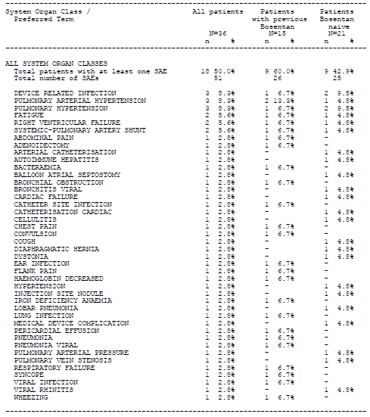

Study FUTURE-4 Extension
There were no deaths or SAEs in this study.

Pivotal and/or main efficacy studies

Study FUTURE-4
No deaths were reported in this study. A total of 5 patients experienced treatment emergent SAEs (two patients in the bosentan group and three in the placebo group), all of which were assessed by the investigator as unrelated to study drug administration.
One patient in the bosentan group experienced PPHN worsening shortly after the first dose of bosentan. This was reported as circulatory collapse, hypercapnia and metabolic acidosis by the investigator, leading to the need for ECMO. Study drug was discontinued. The patient also had a concomitant non-serious gastric haemorrhage (Days 5 to 10). PPHN worsening resolved on Day 39 without sequelae.
The other patient in the bosentan group experienced unspecified reactive hepatitis with onset on Day 8, 3 days after treatment discontinuation. The diagnosis was based on an abnormal hepatic ultrasound appearance associated with increased CRP, and was not supported by liver test results (ALT was slightly increased, AST was normal). The patient had been on bosentan treatment for 4.5 days. Ultimately, the abnormal hepatic ultrasound appearance was suspected to be associated with the umbilical line placement. The event was reported as resolved with sequelae 2 weeks later.

Table 68: FUTURE-4 Summary of SAEs by system organ class and preferred term, Safety analysis set
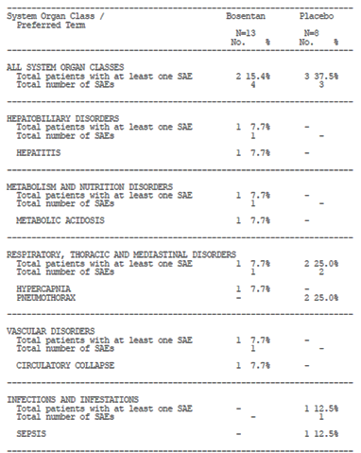

Other studies

Study AC-052-116
No SAEs were reported.

Study AC-052-365 (FUTURE-1)
There were eight SAEs in four patients. One patient experienced three SAEs (cough, fatigue, and hypertension) on Day 27 of study treatment, leading to hospitalisation for three days. These events were considered of mild intensity and unrelated to study drug.
Another patient experienced two SAEs, ear infection (suspected otitis) triggering right ventricular failure. These SAEs were considered unrelated to study treatment.
A third patient, with prior history of adenoid hypertrophy, experienced two SAEs (adenoidectomy planned before the study and bacterial infection). The infection was rated serious, of moderate intensity and unrelated to study treatment.
The remaining one SAE of worsening of PAH was considered severe and related to study treatment. After study treatment completion (Day 90), the patient continued therapy with the commercial, adult bosentan formulation at a dose of 31.25 mg BD (started one day after the study drug discontinuation). As fluctuations in the clinical response to the paediatric and adult bosentan formulation were observed in this patient, a batch control of the paediatric formulation was performed by the sponsor. It was found to be of the standard quality. According to the investigator, a potential non-compliance with the paediatric formulation intake might have been a contributing factor, but not the main reason for the changing clinical response.
One patient died during the study (Day 72 from start of treatment) with right ventricular failure following development of an ear infection. The ear infection was of mild to moderate severity (but of severe intensity) and was suspected by the investigator to have triggered rapid progression of heart failure leading to death. No autopsy was performed. The events and the death were assessed as unrelated to study medication (treatment discontinuation, Day 71).

Study AC-052-373 (FUTURE-3)
A total of 2 patients died during the study. One patient (TDS, < 2 years) experienced worsening of PAH and bronchopneumonia 77 days after treatment start, and died on Day 84. Another patient (BD, < 2 years), experienced worsening heart failure in the context of infection, multi-organ failure and metabolic disorder on Day 28, which led to discontinuation of bosentan treatment on Day 42. The condition of the patient worsened, and the patient died due to restrictive cardiomyopathy on Day 131.
One patient in the BD group (≥ 2 years) experienced worsening of PAH and thrombocytopenia on Day 112 and discontinued study drug on the same day. The patient died 3 months later due to worsening of PAH (whilst taking commercial bosentan).
One patient died during the screening period following protocol mandated RHC.
A total of 11 patients (17.2%) experienced SAEs (Table 70), 7 of whom were < 2 years and 4 ≥ 2 years of age. All SAEs were assessed by the investigator as unrelated to study drug administration.

Table 69: FUTURE-3 Summary of all treatment emergent deaths up to EOT + 7 days; overall age groups, All-treated set
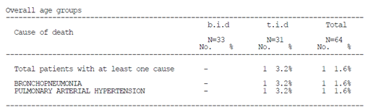

Table 70: FUTURE-3 Summary of treatment emergent SAEs by frequency up to EOT + 7 days; overall age groups, All-treated set
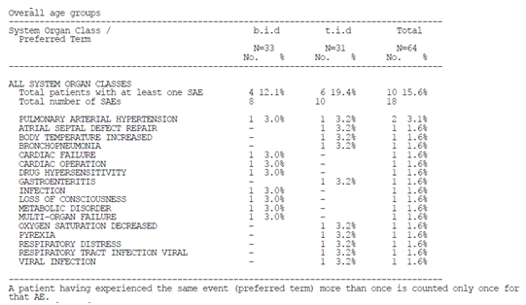

Discontinuations due to adverse events

Integrated safety analyses
Table 71 lists the TEAEs leading to premature study drug discontinuation.

Table 71: Integrated safety analysis TEAEs leading to premature study drug discontinuation by frequency: Safety set
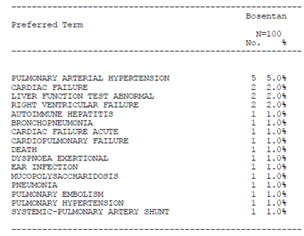

Main/pivotal studies that assessed safety as the sole primary outcome

Study FUTURE-2
A total of 9 TEAEs which led to premature discontinuation of study drug occurred in 6 (16.7%) patients. Six of these AEs were classified as cardiac disorders or respiratory, thoracic and mediastinal disorders. Right ventricular failure was observed in two (5.6%) patients; the other AEs leading to discontinuation occurred in only one patient. One patient experienced an SAE of autoimmune hepatitis that was deemed related to bosentan and which resolved after bosentan discontinuation.
In 2 out of the 6 patients, the TEAEs which led to premature discontinuation of study drug were deemed to be treatment related. In 4 out of the 6 patients, the AEs leading to discontinuation of study drug were deemed to be related to PAH. For one patient, the AE was deemed to be related to both bosentan and to PAH.
In 2 patients, the AEs leading to discontinuation of study drug resolved without clinical sequelae (after 4 to 6 months in both patients). In one patient the event was reported as unresolved at the EOS visit on the day of study drug discontinuation (26 days after the AE began). In 3 patients the events were fatal. For all 3 patients, the AEs leading to discontinuation and resulting in death were deemed to be related to PAH, but unrelated to treatment.

Table 72: FUTURE-2 Summary of TEAEs leading to premature discontinuation of study drug by frequency
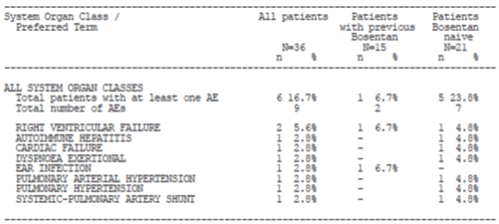

Pivotal and/or main efficacy studies

Study FUTURE-4
One patient experienced worsening of PPHN reported as SAEs circulatory collapse, hypercapnia and metabolic acidosis leading to the need for ECMO and discontinuation of study treatment as per protocol.

Other studies

Study AC-052-116
No subjects were prematurely discontinued from this study.

Study AC-052-365 (FUTURE-1)
One patient had an AE leading to permanent discontinuation of study treatment. The patient experienced ear infection and right ventricular failure and later died. The case narrative is summarised above in Section 8.4.3.4.

Study AC-052-373 (FUTURE-3)
A total of 3 patients (2 BD, 1 TDS), study treatment was permanently discontinued due to worsening of PAH (Table 73). All AEs that led to study treatment discontinuation were SAEs.

Table 73: FUTURE-3 Summary of adverse events leading to premature discontinuation of study drug by frequency up to EOT + 7 days; overall age groups, All-treated set
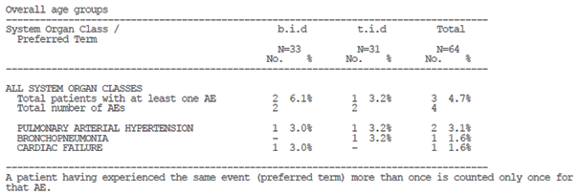

Evaluation of issues with possible regulatory impact

Liver function and liver toxicity

Integrated safety analyses
Two patients in the integrated analysis experienced the AE ALT or AST ≥ 3 x ULN and two patients experienced ALT or AST ≥ 5 x ULN. The patients appear to have all been over 2 years of age.

Main/pivotal studies that assessed safety as the sole primary outcome

FUTURE-2 study
Marked abnormalities related to ALT and AST increases were seen in 1 (2.8%) and 2 (5.6%) patients, respectively. Three (8.3%) patients had a marked laboratory abnormality of increased alkaline phosphatase.

Table 74: FUTURE-2 Incidence of TEAE liver function abnormalities
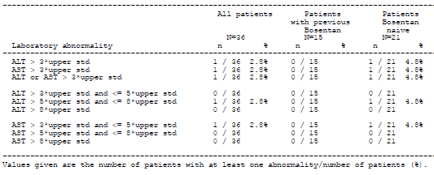

Table 75: FUTURE-2 Summary of change from baseline up to one day after EOS treatment in clinical chemistry parameters; All treated set
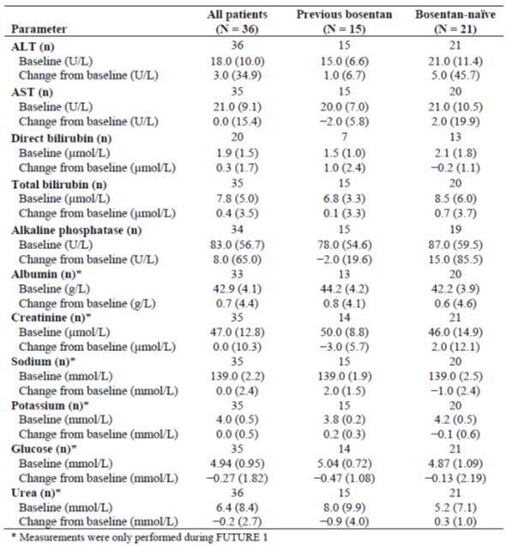
No evaluation of laboratory variables was performed in the study.

Pivotal and/or main efficacy studies

FUTURE-4 study
No AEs of aminotransferase elevations (ALT and AST) were reported. In 3 patients (1 bosentan, 2 placebo), total bilirubin increased from within the reference range at baseline to values above ULN, all remained < 2 x ULN, and none were associated with elevation in ALT.

Other studies

Study AC-052-116
During the study, the majority of subjects had one or more values for clinical chemistry variables outside the normal range. These observations were incidental, no treatment related pattern was detected, and they were judged to be of no clinical relevance by the investigator.

Study AC-052-365 (FUTURE-1)
The changes from baseline in the mean haematology and clinical chemistry parameters showed no clinically significant trends or changes up to 1 day after study treatment end, including by subgroup (Table 76). There were no clinically relevant elevations in liver enzymes.

Table 76: FUTURE-1 Summary of change from baseline up to 1 day after the EOS treatment in laboratory parameters; by subgroup
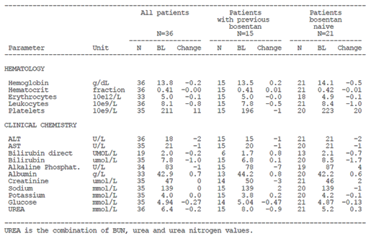

Study AC-052-373 (FUTURE-3)
Elevations in ALT and/or AST > 3 x ULN were reported for two patients in the TDS group. There were no cases of ALT or AST elevations > 3 x ULN with concomitant total bilirubin > 2 x ULN and Alkaline phosphatase ≤ 2 x ULN.

Renal function and renal toxicity

Integrated safety analyses
An analysis of the change in clinical chemistry parameters relating to renal function was not included in the integrated safety analysis.

Main/pivotal studies that assessed safety as the sole primary outcome

FUTURE-4 extension study
No evaluation of laboratory variables was performed in this study.

Pivotal and/or main efficacy studies

FUTURE-4 study
The CSR does not discuss patients with laboratory values outside the reference range on renal function tests.

Other studies

Study AC-052-116
During the study, the majority of subjects had one or more values for clinical chemistry variables outside the normal range. These observations were incidental, no treatment related pattern was detected, and they were judged to be of no clinical relevance by the investigator.

AC-052-365 FUTURE-1
The changes from baseline in clinical chemistry parameters showed no clinically significant trends or changes up to 1 day after study treatment end, including by subgroup (Table 76).

Other clinical chemistry

Integrated safety analyses
An analysis of the other clinical chemistry parameters was not included in the integrated safety analysis.

Main/pivotal studies that assessed safety as the sole primary outcome

FUTURE-4 extension study
No evaluation of laboratory variables was performed in the study.

FUTURE-2 study
No clinically significant mean changes from baseline up to one day after end of study drug were observed for any parameter (Table 75).

Pivotal and/or main efficacy studies

Other studies

Study AC-052-116
During the study, the majority of subjects had one or more values for clinical chemistry variables outside the normal range. These observations were incidental, no treatment related pattern was detected, and they were judged to be of no clinical relevance by the investigator.

Haematology and haematological toxicity

Integrated safety analyses
Ten patients in the integrated safety analysis had an abnormal haemoglobin value ≤ 10 g/dL (10.1%). No patient had a haemoglobin value ≤ 8 g/dL. In all cases the patient was ≥ 2 years of age.

Main/pivotal studies that assessed safety as the sole primary outcome

FUTURE-2 study
No clinically significant mean changes from baseline up to one day after end of study drug were observed for any parameter. The most frequent marked laboratory abnormality was low haemoglobin, which was observed in 4 patients (11.1%) overall. Three patients (8.3%) had a markedly abnormal low platelet count and 2 (5.6%) had a markedly abnormal low haematocrit.

Table 77: FUTURE-2 Summary of mean (SD) change from baseline in haematology variables up to one day after end of study treatment; All patient set
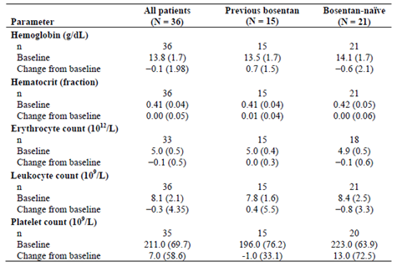

FUTURE-4 extension study
No evaluation of laboratory variables was performed in the study.

Pivotal and/or main efficacy studies

FUTURE-4 study
Shifts from within the reference range at baseline to worst post baseline values below LLN were reported in 7 patients (6 bosentan 46.2%, 1 placebo 12.5%) for haemoglobin. Two patients on bosentan experienced a decrease in platelet count from within the reference range at baseline to a worst post baseline value below LLN.

Other studies

Study AC-052-116
Seven out of 16 subjects had one or more values for haematology variables outside the normal range. These observations were incidental, no treatment related pattern was detected, and they were judged to be of no clinical relevance by the investigator.

Study AC-052-365 (FUTURE-1)
The changes from baseline in the mean haematology parameters showed no clinically significant trends or changes up to 1 day after study treatment end, including by subgroup (Table 76). There were no clinically relevant haemoglobin level reductions. Low platelet count was the highest incident marked laboratory abnormality (5.6%, in two patients). All abnormalities resolved spontaneously during/after EOS without sequelae.

Study AC-052-373 (FUTURE-3)
Shifts from within the reference range to values below the lower limit of normal were reported in 11 patients (8 BD, 3 TDS) for haemoglobin and in 9 patients (6 BD, 3 TDS) for haematocrit. In total, 4 patients (3 BD, 1 TDS) experienced marked decreases in haemoglobin, which were concomitant with marked decreases in haematocrit in 3 cases. No patients had decreases in haemoglobin to values below 80 g/L. There was no dose change in bosentan due to haemoglobin or haematocrit decreases in any of these patients. In 3 patients, haemoglobin values were above ULN at baseline, decreased to a notable extent but remained within the reference range during the treatment period.

Other laboratory tests

Integrated safety analyses
No analysis of the other laboratory tests was included in the integrated safety analysis.

Main/pivotal studies that assessed safety as the sole primary outcome

FUTURE-4 extension study
No evaluation of laboratory variables was performed in the study.

Other studies

Study AC-052-116
Urinalysis was performed at screening and D-1. All values were normal or slightly out-of-range but without clinical significance.

Electrocardiograph findings and cardiovascular safety

Integrated safety analyses
No analysis of ECG parameters was included in the integrated safety analysis.

Main/pivotal studies that assessed safety as the sole primary outcome

FUTURE-4 extension study
No evaluation of ECGs was performed in the study.

Pivotal and/or main efficacy studies

FUTURE-4 study
No cases of treatment emergent ECG abnormalities were reported.

Other studies

Study AC-052-116
No clinically relevant changes from baseline values were detected for heart rate, PR, QRS, QT, QTcB, and QTcF intervals. Seven subjects reported eight abnormalities, judged not clinically significant by the investigator:
- Atrioventricular block first degree (1 episode in Period B),
- Incomplete right bundle branch block (1 episode in Period A),
- Sinus arrhythmia (3 episodes, 1 in Period A and 2 in Period B),
- Sinus bradycardia (3 episodes, 1 in Period A and 2 in Period B).

Study AC-052-365 FUTURE-1
There were no clinically relevant changes related to study treatment. A small mean increase, consistent with the evolution and related complications of the right ventricular hypertrophy, was observed for the QRS and the QTc duration. There were also no individual clinically relevant QTc changes. At baseline, right ventricular hypertrophy was common in approximately half of the patients, indicating advanced underlying disease. Few new ECG abnormalities emerged during treatment, and these also reflected right ventricular hypertrophy. One patient developed right bundle branch block.

Study AC-052-373 (FUTURE-3)
Mean changes in heart rate and PR interval from baseline to Weeks 12 and 24 were similar in the BD and TDS groups in the overall population and age groups. These changes were considered to be not clinically relevant. In the BD and TDS groups, mean changes in QT interval (ms) from baseline were -1.4 ms and –6.0 ms, respectively, at Week 12 and –4.9 ms and 8.3 ms, respectively, at Week 24. None of the reported mean changes from baseline in QTcB and QTcF were considered to be of clinical relevance. QTcF prolongation to > 450 ms occurred for 2 patients in the BD group and 3 patients in the TDS group. QTcF prolongation to > 480 ms was reported for 2 patients in the BD group and 1 patient in the TDS group. QTcF prolongation to > 500 ms was reported for one patient in the BD group. Increases in QTcF of > 30 ms that resulted in values > 450 ms were reported for 2 patients each in the BD and TDS groups (all ≥ 2 years). No clinically relevant mean changes from baseline for the QRS interval were observed in either group.
The proportions of patients with treatment emergent ECG abnormalities were 69.7% and 54.8% in the BD and TDS groups, respectively (Table 78). No patient discontinued study drug due to any of these ECG abnormalities, and none were reported as AEs. The proportion of patients with ECG abnormalities was similar in the BD and TDS groups across both age groups: 62.8% in patients ≥ 2 years and 61.9% in patients < 2 years.

Table 78: FUTURE-3 Summary of treatment emergent ECG abnormalities (from findings) by frequency; overall age groups, All-treated set
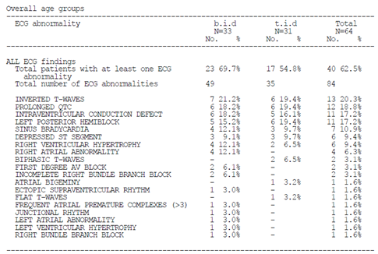

Vital signs and clinical examination findings

Integrated safety analyses
No analysis of vital signs was included in the integrated safety analysis. An analysis of patient height over age and change from baseline in post-treatment height Z-scores was included (Figure 28). The median change from baseline in height z score at each visit between 6 months and 5 years ranged from -0.17 to 0.28.
Figure 28: Integrated safety analysis Growth Curves: Height patient profiles over age, excluding Down syndrome subjects
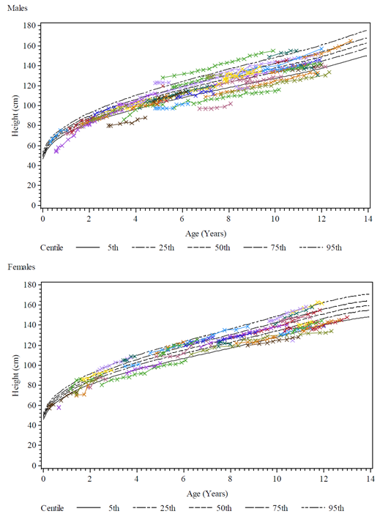

Pivotal studies that assessed safety as the sole primary outcome

FUTURE-4 extension study
No evaluation of vital signs was performed in the study. The change from baseline to EoOP in growth variables did not indicate any apparent difference between ex-bosentan and ex-placebo subjects.

FUTURE-2 study
BP and pulse rate were measured at each study visit. The pulse rate was within the expected range for children < 12 years of age. It decreased slightly from baseline to EOS or premature discontinuation of study drug, possibly reflecting the fact that patients were getting older and therefore approaching an adult pulse rate.
Both systolic and diastolic BP were within the expected ranges. A minimal mean (SD) decrease from baseline to EOS or premature discontinuation of study drug (FUTURE-1 or 2) was observed: −0.4 (15.38) and −1.7 (11.51) mmHg for systolic and diastolic BP, respectively. The maximal decreases were −4.5 mmHg at 36 months for systolic BP and −3.3 mmHg at 12 months for diastolic BP, respectively. These decreases are in line with those previously reported in paediatric patients receiving bosentan, and no symptomatic hypotension was recorded.
Weight and height were recorded at each study visit; height for age values were calculated by Z-score transformation and expressed in SD deviation from standard. Both average weight and height increased over the course of the study, reflecting growth. The mean Z-score of height for age remained constant and slightly below zero. Mean height for age Z-scores were slightly below 0 both at baseline and EOS/premature discontinuation of study drug, indicating a somewhat lower height than expected at a given age; however, individual values spanned a wide range, from −3.32 to 3.72 at baseline and from −3.52 to 2.78 at study end. Out of the 36 patients, 8 had Z-score values of < −2.0 at some point during the study; 2 patients had Z-score values of 2.0 and over at any time point.
Figure 29 illustrates the change in height for age Z-score from baseline to 36 months in all patients as well as in the two subgroups.
K-M estimates for 5 year survival were 78.0% (95% CI 55.8%, 90.0%)(Table 80).

Table 79: FUTURE-2 Change from baseline to EOS in height for age; All-treated set
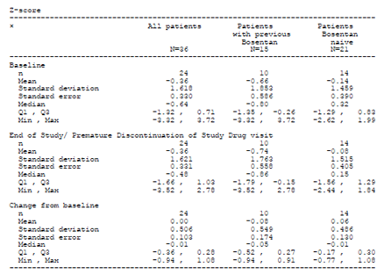
Figure 29: FUTURE-2 Change in height for age from baseline to 36 months – All-treated set
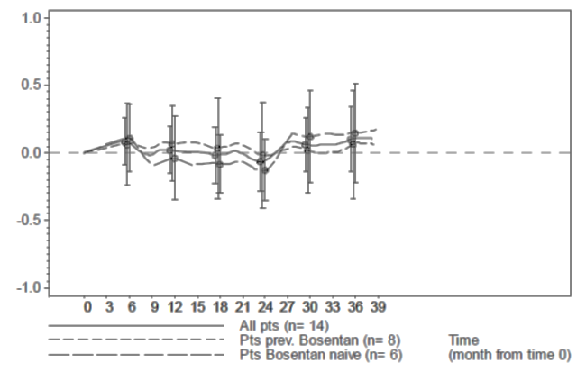

Table 80: FUTURE-2 KM long term survival estimates; All treated set
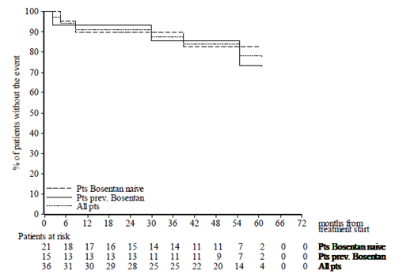

Pivotal and/or main efficacy studies

FUTURE-4 study
The median changes in mean arterial BP over time did not show clinically relevant differences between bosentan and placebo treatment groups.

Other studies

Study AC-052-116
No treatment related pattern was detected that indicated an effect of a single dose of bosentan, in its adult or paediatric formulation, on blood pressures and heart rate. No treatment related pattern was detected that indicated an effect of bosentan on body weight. The physical examination did not reveal any abnormalities for any subject.

Study AC-052-365 (FUTURE-1)
There were no clinically relevant changes related to study treatment in vital signs from baseline to the end of the treatment period. The mean changes from baseline to the EOT period in pulse rate, diastolic BP, weight, and BMI were small in both bosentan naïve patients and in patients with previous bosentan (–4.2 bpm, –4.1 mmHg, 1.5 kg, and 1.0 kg/m² versus –0.4 bpm, 1.7 mmHg, 0.6 kg, and 0.5 kg/m², respectively). Minor differences were observed in vital signs between the two subgroups. However, a greater mean change in systolic BP was observed in patients with previous bosentan (−6.8 mmHg previous bosentan versus −0.3 mmHg bosentan naïve). The differences were considered not clinically relevant.

Table 81: FUTURE-1 Change from baseline up to EOT period in vital signs
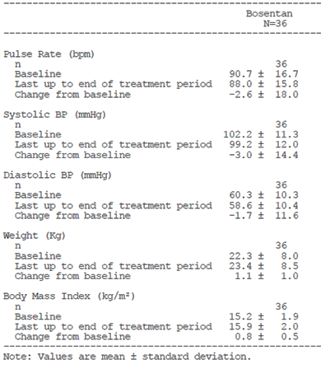

Study AC-052-373 (FUTURE-3)
Mean changes in BP and pulse rate from baseline to Weeks 12 and 24 were small and of no clinical relevance.
Mean changes in growth variables (height, weight and BMI) from baseline to Weeks 12 and 24 were small and similar in the BD and TDS groups in the overall population and age groups. The majority of patients’ height/length at baseline was well dispersed among the different WHO standard growth centiles. Some abnormally low values below the 5th centile (8 males and 8 females) were observed. Compared to the baseline centile, the profiles in patients ≥ 2 years of age, remained mostly within their baseline centile during the study, whereas in those < 2 years of age, the profiles showed a shift to a higher or a lower centile. There were no noticeable differences from this pattern amongst males and females or in patients with Down syndrome.

Other safety issues
No other safety issues were raised in the CSRs.

Post marketing experience
The 20th PSUR for bosentan has been included in the submission as a report of post-marketing experience. The report summarises the safety data during the reporting period between 20 November 2013 to 19 November 2014 and cumulatively. The international birthdate (IBD) for bosentan is 20 November 2001.
[Information redacted] Table 82 lists the important safety concerns outlined in the EU RMP at the beginning of the reporting period. As part of a Type II variation to include in the EU Product Information the data generated in the paediatric studies with bosentan, an updated version of Tracleer’s EU SmPC and bosentan’s RMP received CHMP Positive Opinion on 20 November 2014, after the data lock point of this PSUR. Important missing information ‘Use in children’ was removed, and the important concerns outlined in Table 83 were added to the list of safety concerns.
Following review of the 19th PSUR for bosentan the PRAC Rapporteur requested cumulative safety reviews of:
- ascites (with a particular emphasis of cases associated with liver disorders),
- nasal congestion
- the risk of fall which may be due to hypotension and syncope with a particular emphasis in cases resulting in injury,
- autoimmune hepatitis (AIH)
The sponsor was requested to provide a cumulative safety review of all signals considered ongoing further to the finalisation of this PSUR assessment procedure (that is, DRESS and other severe cutaneous reactions, concomitant administration of bosentan and methotrexate and hepatotoxicity, hepatocellular carcinoma, cardiac disorders without PAH, blurred vision, arthralgia/myalgia and pain, menstrual disorders/vaginal haemorrhage).
Based on the cumulative reviews requested by the PRAC Rapporteur, the sponsor proposes to update the adverse drug reaction (ADR) table of the SmPC to state (new text underlined): ‘Aminotransferase elevations associated with hepatitis including possible exacerbation of underlying AIH in patients with autoimmune diseases and/or jaundice”. In addition ‘nasal congestion’ is to be added as a ‘common’ event under the ‘Respiratory, thoracic and mediastinal disorders’ system organ class (SOC). In addition, ‘symptomatic hypotension’ will be added as an important potential risk to the RMP.
The nature and severity of the reported events from all sources reflect the known safety profile of bosentan and the high morbidity and/or mortality of the underlying PAH and connective tissue disease. The events described in this report are not believed to present an increased risk to patients. A risk minimisation programme focusing on risk communication and education to prescribers remains in place for bosentan through controlled distribution, as per local requirements, including in the EEA and US.
The report states that given the efficacy data, which are consistent between clinical studies and marketed use, and the well-characterised safety profile, the benefit-risk profile of bosentan remains unchanged, and is favourable for its use in accordance with the approved product information.

Table 82: PSUR 20 Summary of safety concerns at the beginning of the PSUR reporting period
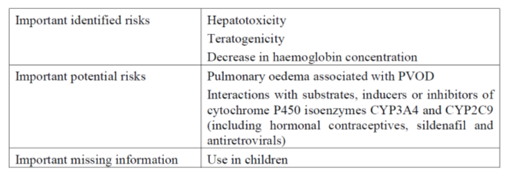

Table 83: PSUR 20 New important identified and potential risks added to the RMP after the data lock point
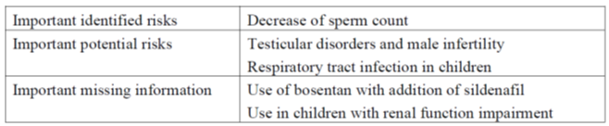

Ascites
Cumulatively, during the 13 years of post-marketing experience, the estimated reporting rate of ascites was low (0.3%). In most cases, including those containing an hepatobiliary event/investigation, ascites occurred in the context of progressive PAH disease and associated comorbidities, including RHF, fluid retention, and autoimmune rheumatoid diseases. In a few cases with complex medical history, multiple co-morbidities and therapies, a contribution of bosentan to the underlying hepatic event was difficult to establish. The current CCDS describes ‘uncommon’ hepatitis and/or jaundice, and rare cases of unexplained hepatic cirrhosis or liver failure.
Considering the above, the absence of a non-clinical signal, and the observed similar incidence of ascites in placebo and bosentan treated patients in the 20 placebo controlled studies in various indications, a causal relationship between bosentan and ascites was deemed unlikely.

Nasal congestion
The pooled safety data from 20 placebo controlled clinical studies with bosentan were analysed. The overall incidence of nasal congestion (PT) was 1.7% (43 out of 2486) in patients on bosentan and 1.2% (22 out of 1838) in patients on placebo.
The safety database held seven SAE cases that included the PT ‘nasal congestion’ have been received from clinical studies, including 2 cases pertaining to patients receiving placebo. Of the 5 cases reported on bosentan, none was assessed as related to study medication; none resulted in changes in medication, and all resolved. Two cases were reported for paediatric patients with PAH, an 8 year old girl who had been switched from bosentan to ambrisentan 2.5 weeks before onset of lobar pneumonia and concomitant nasal congestion and a 1-year old boy with trisomy 21 in a context of adenoviral upper respiratory infection.
Cumulatively, since IBD, 1255 cases were retrieved with an event of nasal congestion. Bosentan was withdrawn or interrupted in 184 cases and the dose was reduced in 14 cases (not necessarily related to the event of nasal congestion). The outcome of nasal congestion was reported in 58 of these 198 cases, being resolved or improved in 48 and not resolved in 10 cases. Outcome was not reported /unknown in the remaining 140 cases. In 1,001 cases it was reported that bosentan was maintained unchanged, and 123 of these cases had an outcome reported for nasal congestion: resolved or improved in 80 cases, not resolved in 43, and worsened in 2 cases. Outcome was not reported /unknown in the remaining 876 cases. Dose was increased in 2 cases (outcome not reported/ unknown), and action taken was unknown in 54 cases with outcome resolved or improved in 12 cases, not resolved in 2, and not reported/ unknown in the remaining 40 cases. A positive rechallenge including nasal congestion was reported for 4 cases. In 10 other cases with ‘positive rechallenge’ indicated in Argus, rechallenge referred to different events reported within the same case.
Based on the above evaluation, ‘nasal congestion’ was identified as a signal, which was closed during the current review period and classified as an ADR. The sponsor proposes to add ‘nasal congestion’ to the ADR table in the SmPC, as a ‘common’ event under the ‘Respiratory, thoracic and mediastinal disorders’ SOC. The CCDS will be updated accordingly.

Fall
In the 20 integrated placebo controlled trials hypotension was reported at a lower incidence in bosentan treated patients (5.8%) than in placebo-treated patients (6.5%). In the PAH subset, the incidence on bosentan (3.2%) was similar to that on placebo (3.0%). Syncope was reported at a lower incidence in bosentan treated patients (2.3%) than in placebo-treated patients (3.1%). In the PAH subset, the incidence of syncope on bosentan (4.1%) and placebo (4.0%) was similar. The incidence of syncope reported as a SAE was 1.0% on bosentan and 1.6% on placebo in the overall pool. A few patients discontinued treatment due to syncope (4 patients (0.2%) on bosentan and 2 patients (0.1%) on placebo). The distribution of events of fall and injuries is shown in Table 84.

Table 84: PSUR 20 Summary of selected TEAEs potentially associated with fall and events of injury in the overall pool and for the approved indications
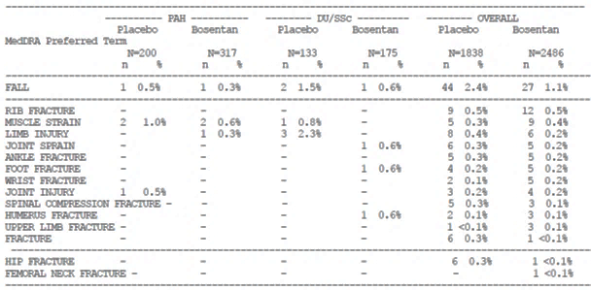
Falls were reported at a lower incidence in bosentan treated patients (1.1%) than in placebo-treated patients (2.4%). In the PAH and DU/SSc subsets, the observed incidence of falls in patients treated with bosentan was 0.3% and 0.6%, respectively, and in the placebo-treated patients 0.5% and 1.5%, respectively. Rib fracture was the most commonly reported injury event, reported in 0.5% of bosentan and placebo treated patients, followed by muscle strain and limb fracture.
The safety database contained 42 case reports containing an event of fall (2 case reports pertained to 1 patient) in bosentan treated patients from completed or ongoing clinical trials.
There were 1486 post-market case reports pertaining to 1365 patients containing an event of fall were received, giving an estimated reporting rate of 1%. The majority of the cases (91.7%) were solicited through observational (non-interventional) post-marketing surveillance (PMS) programmes. The majority of cases (81.9%) with an event of fall pertained to female patients; 70.9% of the cases pertained to the elderly, and 28.3% to adults. A total of 230 cases (pertaining to 224 patients) contained an event of fall and events denoting hypotension and/or syncope, representing an estimated reporting rate of 0.2% (230 cases / 147,197 exposed patients). In cases with events of fall and events denoting hypotension or syncope there were 90 cases with 120 events of injury. The most commonly reported events of injury included head/face injury and lower limb injury/fracture. There were 140 cases with events of fall, events denoting hypotension and/or syncope and without events of injury were retrieved from the safety database.
There were 1256 cases (pertaining to 1172 patients) contained an event of fall without events denoting hypotension and/or syncope and 573 of the 1256 cases contained events of fall and injury. In the 573 cases, 703 events of injury were reported. The most commonly reported events of injury were lower limb fracture, mainly hip fracture (100), followed by head/face injury and upper limb fracture.
The latency of fall occurrence varied from less than 1 month following treatment initiation to up to more than 5 years. The date of fall occurrence and the date of bosentan initiation were available only in 314 of the 1486 cases, including 44 cases with events of hypotension/syncope. Of the 314 cases the latency was shorter than 1 year in 129 cases (including 23 cases with a latency of up to 1 month) and longer than 1 year in 185 cases. The sponsor considers the long latency (> 1 year) in about 58.9% of cases with the available information to suggest that the occurrence of falls might be due to the underlying PAH disease and associated comorbidities and the age, gender, and the physical, cognitive and effective capacities of the patients.
The estimated reporting rate of fall is reported to be within the expected rate of fall for the general population and also the PAH patient population. The sponsor proposes updating the RMP to include symptomatic hypotension as an important potential risk.

Autoimmune hepatitis
Cumulatively, 51 cases containing an event of AIH have been reported from Development IBD (28 September 1993) up to the cut-off date for this PSUR. Four cases originated from clinical trials and 47 cases were reported from post-marketing sources (Figure 30). Of the clinical trial reports, one case was from a placebo controlled study and the other three cases were reported from non-controlled open label studies with bosentan. One case involved a paediatric patient and is described in section 8.4.3.2.
A total of 47 cases of AIH were received from post-marketing sources. Since IBD, an estimated 147,197 patients have been exposed to commercial bosentan, giving an estimated reporting rate of AIH of 0.03%. The age ranged from 7 years to 83 years. 28 patients were adult and 18 were elderly (aged 65 years or more). One case pertained to a 7-year-old female patient.
Figure 30: PSUR 20 Cases of autoimmune hepatitis
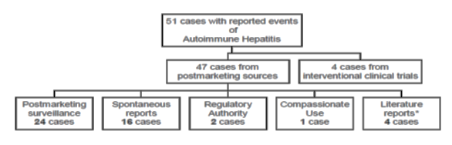

Evaluator’s overall conclusions on clinical safety
The sponsor has not requested an extension of indications to include neonates with PPHN and benefit was not demonstrated in this population. The results of the FUTURE-4 extension study did not identify concerns regarding patient growth at 12 months follow-up. It should be noted that the median duration of exposure was limited at 4.5 days (range 0.5 to 10.0 days).
The integrated analysis indicates that the majority of patients experienced TEAEs (87%) with a large proportion leading to a discontinuation of study treatment (17%). AEs resulted in a fatal outcome in 14% of study participants. The most commonly reported TEAEs are described in the current Tracleer PI. The sponsor states that AE rates in PAH populations are generally high due to the severity of the condition, and ranged from approximately 60 to 90% in sponsored studies. AEs of specific interest to bosentan, such as elevated liver enzymes, decreased blood haemoglobin, and fluid retention, were stated to be reported at lower incidences in paediatric patients compared with adult patients.
The sponsor has stated they intend to add symptomatic hypotension to the list of important potential risks in the RMP. The RMP included in the submission does not include this important potential risk.
The sponsor has added nasal congestion to the PI as a common post market AE. As outlined above, PSUR 20 states that the sponsor intends to update the ADR table of the EU SmPC and the CCDS to include autoimmune hepatitis. Similar changes have not been proposed for the Australian PI with this submission.

First round benefit-risk assessment

First round assessment of benefits
Indication:
- idiopathic pulmonary arterial hypertension
- familial pulmonary arterial hypertension
- pulmonary arterial hypertension associated with scleroderma or
- pulmonary arterial hypertension associated with congenital systemic to pulmonary shunts including Eisenmenger’s physiology
in patients with WHO functional Class II, III or IV symptoms.

Table 85: First round assessment of benefits, strengths and uncertainties
Benefits | Strengths and Uncertainties
The availability of a paediatric weight-based formulation of bosentan. | The new formulation would allow for more precise weight-based dosing of bosentan in the paediatric population. The tablet can be broken into 8mg quadrants for administration.
A dispersible tablet formulation would allow for easier administration in the paediatric population. | The availability of a dispersible tablet would provide an easy to prepare and administer formulation. The product could potentially reduce reliance on compounded products or other measures used to make the adult formulation palatable for the paediatric population.
A dispersible tablet formulation could potentially be used in any PAH patient unable to take the adult formulation (for example swallowing difficulties). | The dispersible tablet formulation could potentially be used in adult or adolescent patients. Bioequivalence has not been established between the two formulations and the PI notes that ‘A pharmacokinetic comparison between the dispersible and the film coated tablet indicated slightly lower exposure to bosentan with the dispersible tablet in adult subjects’. The PI recommends the dispersible tablet formulation be reserved for patients who cannot take the film coated tablet.
Improved quality | The availability of a registered product that can be prepared as an oral solution may reduce reliance on compounded products and provide a better assurance of quality.

First round assessment of risks

Table 86: First round assessment of risks
Risks | Strengths and Uncertainties
Bioequivalence between the adult and paediatric formulations has not been demonstrated. | The submission relies on the bioequivalence of the adult and paediatric formulations in order to infer efficacy for the paediatric formulation. Study 052-116 did not demonstrate bioequivalence with respect to either of the PK parameters AUC or C_{max}. The adult formulation of bosentan is currently available for use in the paediatric population in Australia. It has not been established that the two formulations are bioequivalent therefore efficacy cannot be inferred. In addition, the effect of the fed state on bioequivalence has not been investigated and the bioequivalence of an oral solution to the adult formulation has not been established.
Efficacy has not been established for the dispersible tablet formulation in the paediatric population. | The dispersible tablet formulation has been studied in the paediatric PAH population but the efficacy endpoints were exploratory. Efficacy has been established in adult patients with the adult tablet formulation. The EMA came to an agreement with the sponsor that the PAH condition is similar between adults and children and efficacy could be inferred if similar PK properties were established. However, bosentan exposure in the paediatric population was about half that seen in adults. In addition bioequivalence with the approved formulation has not been established. These factors make it difficult to infer in the paediatric population.
The optimal dosage regimen for paediatric patients with PAH has not been established. | A plateau in systemic exposure suggests that increasing the dose beyond 2 mg/kg or the frequency of dosing beyond twice daily will not increase exposure to bosentan. It is noted that the safety and efficacy of the 2 mg/kg dose for the paediatric population has not been established. Whilst it is anticipated that no additional benefit will be gained from doses above 2 mg/kg it is unclear whether this is the optimal dose with respect to safety and efficacy in the paediatric population.
The efficacy of bosentan for children aged between one and three years of age has not been established. | Exposure to bosentan is lower in the paediatric PAH population compared to adults with PAH. The FUTURE-3 study found that C_{maxc} and AUC_{0-24C} were lower in children < 2 years old compared to those ≥ 2 years old. It is unclear whether there is enough data to support changing the dosing instructions to include patients aged between one and three years of age.

First round assessment of benefit-risk balance
Study AC-052-116 failed to demonstrate bioequivalence of the dispersible tablet formulations and the approved marketed formulation in the healthy adult population and therefore bioequivalence in children cannot be assumed.
The BREATHE-3 and FUTURE-1 studies Study found a lower exposure to bosentan in paediatric patients compared to adult patients. This result may indicate an exposure plateau occurring at lower doses in paediatric patients. The FUTURE-3 Study found that TDS administration of 2 mg/kg bosentan did not increase systemic exposure to bosentan in the paediatric population. Therefore, it is difficult to extrapolate efficacy data from adults with PAH to the paediatric PAH population.

First round recommendation regarding authorisation
Approval of the dispersible tablet formulation of bosentan is not recommended for:
- idiopathic pulmonary arterial hypertension
- familial pulmonary arterial hypertension
- pulmonary arterial hypertension associated with scleroderma or
- pulmonary arterial hypertension associated with congenital systemic to pulmonary shunts including Eisenmenger’s physiology
in patients with WHO functional Class II, III or IV symptoms.
Approval cannot be recommended at this time as the bioequivalence of the new formulation to the approved formulation has not been established and the similar exposure was not demonstrated in the adult and paediatric populations making the extrapolation of efficacy data difficult.

Clinical questions

General
- Has the sponsor submitted an application to register the dispersible formulation of bosentan in the US, Canada or New Zealand? If so, what is the current status of the application?
- Was the dispersible paediatric test formulation used in Study AC-052-116 and the FUTURE series of studies the same as the paediatric formulation to be marketed?

Pharmacokinetics
- Please justify why AUC has been considered the main PK parameter required to establish bioequivalence rather than the combination of both AUC and C_{max}.
- Please justify why bioequivalence studies have not been performed for the adult and paediatric formulations of bosentan in both the fed and fasted state?
- What evidence is there to demonstrate that the bosentan exposure plateau in the paediatric population noted in FUTURE-1 is reached at 2 mg/kg BD dosing rather than lower doses (for example 1 mg/kg BD)?

Study AC-052-116
- Was the paediatric test formulation administered during period B dissolved prior to administration or was it administered as an oral tablet?
- Please justify why the ratio of geometric means for AUC of 0.87 (90% CI 0.78, 0.96) should be considered to meet the requirements for acceptance of bioequivalence.

Study AC-052-365 (FUTURE-1)
- What was the rationale for setting a predefined equivalence limit of 0.66–1.5 for the 90% CI of the ratio of geometric means for AUC_{τ}?

Study AC-052-373 (FUTURE-3)
- Please outline why 95% CI were calculated for the geometric mean ratio results comparing the BD and TDS dosing regimens rather than the usual 90% CI used to determine bioequivalence. What threshold of equivalence was defined for the 95% CI?

Study AC-052-391 (FUTURE-4)
- The report states that one patient was excluded from PK analysis set due to a protocol violation. What was the protocol violation that led to exclusion from the analysis set?

Efficacy
- Please justify the extrapolation of efficacy data from the adult population using the adult formulation to the paediatric population using the paediatric formulation.
- Please clarify the sponsor’s position regarding no additional clinical benefit in increasing the frequency of bosentan dosing from 2 mg/kg BD to TDS with respect to the results of the FUTURE-3 studies.

AC-052-391 FUTURE-4
- What was the protocol violation that led to the exclusion of one of the 13 bosentan treated patients from the PK analysis set?

Safety
- Please justify why the AE autoimmune hepatitis has not been included in the Australian Tracleer PI.
- Please clarify why symptomatic hypotension has not been included in the RMP Summary of Safety Concerns as an important potential risk.

PI and CMI
- Please provide a justification based on efficacy and safety for altering the dosage instruction information to include patients aged between 1 and 3 years.
- Will the CMI for the adult formulation of Tracleer be updated to include the list of side effects outlined in the draft CMI for the paediatric formulation?

Second round evaluation of clinical data submitted in response to questions

General
- Has the sponsor submitted an application to register the dispersible formulation of bosentan in the US, Canada or New Zealand? If so, what is the current status of the application?
Sponsor’s response:
The dispersible tablet was submitted in the US on 5 August 2016 and is currently under review by the US FDA. The anticipated approval date is 5 June 2017. The dispersible tablet has not been submitted in Canada or New Zealand.
Evaluator’s comment:
The sponsor’s response is considered acceptable.
- Was the dispersible paediatric test formulation used in Study AC-052-116 and the FUTURE series of studies the same as the paediatric formulation to be marketed?
Sponsor’s response:
The dispersible formulation used in Study AC-052-116, FUTURE-1, FUTURE-3, and FUTURE-4 studies is the same formulation as the one to be marketed.
Evaluator’s comment:
The sponsor’s response is considered acceptable. It is noted that the formulation to be marketed was compared to the adult formulation in Study AC-052-116 and the bioequivalence of the two formulations was not established. The PK parameters for comparison, bioequivalence versus biocomparability and the exposure plateau in the paediatric population are considered in the response to Question 3.

Pharmacokinetics
- Please justify why AUC has been considered the main PK parameter required to establish bioequivalence rather than the combination of both AUC and C_{max}.
Sponsor’s response:
The sponsor states that the criteria for both AUC and C_{max} are relevant in the context of claiming bioequivalence between formulations. The sponsor considers Study AC-052-116 a biocomparison of the paediatric and adult formulations. For C_{max}, AUC_{0-t}, and AUC_{0-∞} the ratios of the geometric means were within the conventional 0.8-1.25 equivalence interval. However, for the three parameters the lower boundary of the 90% CI of the geometric mean ratio was outside the 0.8 to 1.25 interval (Table 10).
The sponsor considers the decrease in exposure with the dispersible formulation not clinically relevant due to the high inter-subject variability in exposure to bosentan observed in the FUTURE-1 Study and the absence of relationship between bosentan exposure and efficacy in BREATHE-3.
In other studies, the administration of bosentan at 2 mg/kg BD, either as dispersible tablet (FUTURE-1 and FUTURE-3) or as film coated tablet (BREATHE-3) to paediatric PAH patients, resulted in comparable bosentan plasma exposure. The sponsor states that this indicates that the adult and the paediatric formulations have similar pharmacokinetic profiles in paediatric patients (see Table 87).
The conclusion from the biocomparison study, however, was that the profiles of the two formulations are comparable and do not show clinically relevant differences. In the study report of AC-052-116 we focussed on AUC as this parameter is likely to be more relevant for bosentan due to its chronic administration.

Table 87: Comparison of bosentan exposure in paediatric populations
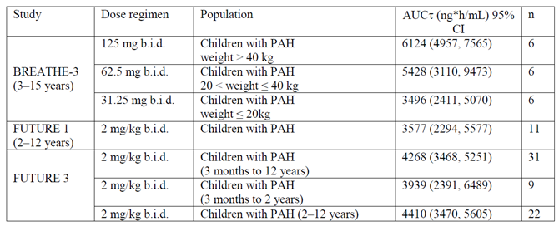
Evaluator’s comment:
No study has compared the two formulations of bosentan head to head in the paediatric population. The sponsor’s claim for that the two formulations are comparable is based on the PK results from three studies using different age ranges and different dosage instructions. Whilst the 95% CI for the AUC_{τ} results of the three studies overlap (Table 87), it cannot be assumed that the formulations are similar enough are therefore comparable given the differences in study populations. The patient age, dose and weight ranges vary across the groups analysed in Table 87 and it is unclear how AUC compares when administered at similar doses in patients of similar age/weight.
The only study that has directly compared the two formulations was performed in adults and did not meet the criteria for bioequivalence. The guidelines on bioequivalence allow for the widening of the acceptance interval for C_{max} for highly variable drugs under a defined set of conditions. The sponsor has not provided an argument to support the widening of the acceptance range. It is noted that the guidelines do not allow the acceptance criteria for AUC to be widened based on high intra-subject variability. The sponsor has stated that both AUC and C_{max} are important for establishing the bioequivalence of bosentan formulations. In addition, the sponsor has not identified any problems with the analytical method that could support an alternative study design or acceptance criteria for this drug/formulation.
The sponsor considers the two formulations comparable but has not referenced any standard against which ‘biocomparison’ can be measured.
- Please justify why bioequivalence studies have not been performed for the adult and paediatric formulations of bosentan in both the fed and fasted state?
Sponsor’s response:
Biocomparison between the adult and paediatric formulations of bosentan has only been performed in the fasted state as no clinically relevant effect of food was observed at the recommended dose of 125 mg (C_{max} increased by 22% and AUC increased by 10% in the presence of food) in healthy subjects. For drugs that can be administered with or without food, it is recommended by the guidelines (guidelines on the investigation of Bioequivalence EMA 2010 and Bioavailability and Bioequivalence Studies Submitted in NDAs or INDs; General Considerations FDA 2014) to conduct bioequivalence/biocomparison studies under fasted conditions as it is considered to be the most sensitive condition to detect potential differences.
Evaluator’s comment:
The TGA adopted EMA ‘Guideline on the Investigation of Bioequivalence’ states that ‘For products where the SmPC recommends intake of the reference medicinal product on an empty stomach or irrespective of food intake, the bioequivalence study should hence be conducted under fasting conditions.’ The Tracleer PI dosage and administration instructions state that Tracleer tablets can be administered with or without food, therefore when comparing two tablet formulations a study in the fasting state would be sufficient. However, Study AC-052-116 compared a tablet with a dispersible formulation and the guideline states that:
However, for products with specific formulation characteristics (for example microemulsions, solid dispersions), bioequivalence studies performed under both fasted and fed conditions are required unless the product must be taken only in the fasted state or only in the fed state.
Given the nature of the formulations and the statement in the PI that bosentan may be taken with or without food, studies performed under both the fasted and fed conditions are required.
The sponsor states that no clinically relevant effect of food was observed at the recommended dose of 125 mg but Study AC-052-116 compared the two formulations at the lower dose (62.5 mg versus 64mg). The TGA adopted guidelines recommend conducting bioequivalence studies at the highest strength but selection of a lower strength is acceptable for products with linear pharmacokinetics and a highly soluble drug substance. These conditions relate to the BCS-based biowaiver requirements for class I and III drugs and as discussed previously, bosentan is stated to be a class II drug. Selection of a lower strength may also be acceptable where the highest strength cannot be administered for safety/tolerability reasons but a justification for the use of the lower strength has not been included in the submission. The FDA guidance ‘Bioavailability and Bioequivalence Studies Submitted in NDAs or INDs; General Considerations’ is a draft guidance only, and has not been adopted by the TGA. The draft product specific guidance for bosentan recommends studies in both the fasted and fed states for establishing the bioequivalence of generic formulations. In addition, this guidance recommends the comparison of the 125 mg strength whereas Study AC-052-116 compared 62.5 mg of the adult formulation to 64 mg of the paediatric formulation.
- What evidence is there to demonstrate that the bosentan exposure plateau in the paediatric population noted in FUTURE-1 is reached at 2 mg/kg BD dosing rather than lower doses (for example 1mg/kg BD)?
Sponsor’s response:
There are no clinical data demonstrating that bosentan plateau exposure is reached at a dose of 2 mg/kg BD and not at a lower dose in the paediatric population. To precisely identify at which dosing regimen the bosentan exposure plateau is attained, a clinical study with doses lower than 2 mg/kg BD would be necessary. As bosentan was well tolerated and showed significant improvement in pulmonary vascular resistance (PVR) at the dose of 2 mg/kg, for logistical and ethical reasons lower doses were not explored in the paediatric population.
Evaluator’s comment:
The sponsor’s explanation is noted. The sponsor has not indicated whether PBPK modelling has examined this issue.
- Was the paediatric test formulation administered during period B dissolved prior to administration or was it administered as an oral tablet?
Sponsor’s response:
During period B of Study AC-052-116 bosentan was given as 2 undissolved tablets of 32 mg with 240 mL of water.
Evaluator’s comment:
It is unclear why the dispersible tablet was not dissolved prior to administration as per PI dosing instructions. The EU guidelines require bioequivalence studies for oral suspensions unless a biowaiver is applicable and ‘In those cases where the test product is an oral solution which is intended to be bioequivalent to another immediate release oral dosage form, bioequivalence studies are required.’ As discussed previously bosentan does not appear to meet the criteria for a biowaiver. The paediatric formulation is a dispersible tablet that is mean to be dissolved prior to administration and therefore should be administered as an oral solution in order to compare formulations.
The potential impact of the administration of undissolved tablets versus the dispersible solution has not been discussed. The draft FDA guidance on Bioavailability and Bioequivalence Studies states that:
In addition, a BA study may be needed with the unconventional dosage form swallowed intact to assess the impact of accidental swallowing of the intact product. Sampling should adequately capture the T_{max} and C_{max} in addition to total exposure.
However, the FDA guidance indicates this study is to be conducted in addition to a study where the drug is administered according to the intended label use/instructions.
- Please justify why the ratio of geometric means for AUC of 0.87 (90% CI 0.78, 0.96) should be considered to meet the requirements for acceptance of bioequivalence.
Sponsor’s response:
The sponsor states that AC-052-116 was a biocomparison study and was not powered to conclude on bioequivalence of the two formulations. The lower boundary of the 90% CI of the geometric means ratio was slightly outside the acceptance interval for bioequivalence. The sponsor states that the PK differences between the dispersible and the film coated formulations were not clinically relevant in view of the inter- and intra-individual variability observed for bosentan.
Evaluator’s comment:
The sponsor has stated that Study AC-052-116 was not powered to demonstrate bioequivalence. The sponsor has not provided any reasons to suggest that a suitably powered Study would be impractical or impossible to conduct. As outlined above in the evaluator’s comments on the response to Question 3 the guidelines do not support the widening of the acceptance criteria for AUC based on high intra-subject variability. Suitable criteria for demonstrating ‘biocomparability’ have not established.
- What was the rationale for setting a predefined equivalence limit of 0.66 to 1.5 for the 90% CI of the ratio of geometric means for AUCτ?
Sponsor’s response:
The similarity between the exposure to bosentan in children and adult PAH patients were to be tested using an equivalence hypothesis. Based on the variability in the PK data observed in the BREATHE-3 Study, the equivalence limits were set to 0.66 and 1.5 for the ratio of the geometric means of bosentan AUC_{τ} between children treated with 4 mg/kg in FUTURE-1 and adults in Study AC-052-357. These equivalence limits correspond to a 0.405 difference on the log-transformed scale and represent a ± 50% difference in the geometric mean. As the comparison performed in FUTURE-1 was not a within-subject comparison, slightly wider limits were applied than the standard ± 20%. The common standard deviation of the log-transformed data was estimated from BREATHE-3 to be 0.451.
Given these assumptions a minimum sample size of 30 evaluable patients was necessary in order to have 80% power to detect equivalence based on the 2 sided 90% CI of the ratio of the geometric means between children and adults falling within the established equivalence limits.
In FUTURE-1, the exposure in children treated with bosentan 4 mg/kg BD was similar to the exposure resulting from a 2 mg/kg BD administration and was approximately half the exposure observed in adult patients. Therefore the 90% CI of the ratio of the geometric means for AUC_{τ} was not used to conclude on the study.
Evaluator’s comment:
The FUTURE-1 Study included a comparison of exposure to bosentan in children PAH patients (FUTURE-1 Study patients) and adult PAH patients (historical control group treated with 125 mg BD). The null hypothesis (of non-equivalence) was to be rejected if both limits of the 90% CI (based on Student’s t-test) of the ratio of geometric means of AUC_{τ} between children and adults were entirely within the pre-set equivalence limits of 0.66 to 1.5. The predefined interval of equivalence appears quite broad compared to the standard acceptance criteria for bioequivalence but the CI for ratio of the geometric means of AUC_{τ} did not fall entirely within the predefined equivalence limits (0.5 (0.4 to 0.8)). As a result the null hypothesis (non-equivalence) was accepted.
- Please outline why 95% CI were calculated for the geometric mean ratio results comparing the BD and TDS dosing regimens rather than the usual 90% CI used to determine bioequivalence. What threshold of equivalence was defined for the 95% CI?
Sponsor’s response:
The sponsor states that the choice of the 95% CI was a conservative approach as a 95% CI is wider than a 90% CI. Therefore, to observe a nominally significant difference in bosentan exposure between BD and TDS dosing regimens (exclusion of one from the CI of the ratio of geometric means), the increase of the daily exposure must be larger with a 95% CI to indicate statistically significant increased exposure than it would with a 90% CI.
A strict bioequivalence approach could not be used in this study as FUTURE-3 hours and a parallel and not a crossover design as required in bioequivalence studies. Based on the overall sample size of 50 patients, the bosentan dosing regimen, and the exposure variability observed in FUTURE-1 Study (SD of the log-transformed data: 0.650), a range of daily exposure geometric mean ratios (TDS versus BD) and their related 95% CI was simulated for FUTURE-3 (see Table 88).
The two dosing regimens were considered statistically comparable when one was included in the 95% CI. Therefore, an increase in exposure up to 40% was not considered a statistically significant difference.

Table 88: Simulated geometric mean ratios and 95% CIs
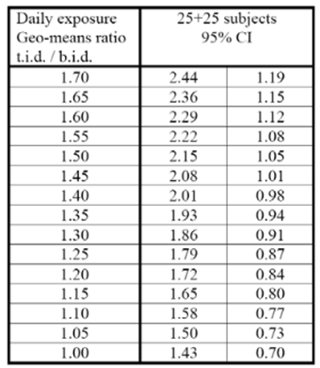
Evaluator’s comment:
The sponsor’s point that a strict bioequivalence approach was not undertaken due to the parallel study design is reasonable. The ratio of geometric means is noted to be low at 0.85 (95% CI 0.61 to 1.20) with wide confidence intervals due to both the inter-patient variability and the small sample size. The results suggest that increasing the dosing interval from BD to TDS is unlikely to increase systemic exposure in paediatric patients.
- The report states that one patient was excluded from PK analysis set due to a protocol violation. What was the protocol violation that led to exclusion from the analysis set?
Sponsor’s response:
Subject [information redacted] was excluded from the PK set as he did not have a reportable pre-dose drug concentration. This subject did not meet the definition of the Per-protocol PK analysis set which comprised all patients included in the All-treated set who were able to provide at least 5 of the 7 blood samples (including the pre-dose, the 2 hours, and 12 hours post-dose samples) requested for at least one evaluable PK profile and who did not violate the protocol in a way that might affect the evaluation of the PK endpoints.
The PK parameters were calculated for Subject [information redacted] and this subject was part of the PK analysis performed on the All-treated set. No significant difference was observed between the analysis performed with the All-treated set and the PK set.
Evaluator’s comment:
The sponsor’s response is considered acceptable.

Efficacy
- Please justify the extrapolation of efficacy data from the adult population using the adult formulation to the paediatric population using the paediatric formulation.
Sponsor’s response:
The sponsor proposes bridging from the clinical effectiveness of Tracleer in PAH demonstrated in adults to the paediatric population, based on the:
- similarity in the disease between adult and paediatric patients,
- similarity in the decrease in PVR observed in adult and paediatric PAH patients in response to Tracleer treatment at the maximally attainable exposure in children with PAH, and
- overlap of the exposure achieved in paediatric PAH patients with the film coated and dispersible tablet formulations, sufficient to consider the formulations essentially comparable in the effectiveness data interpretation.
The BREATHE-3 Study in 19 paediatric PAH patients (WHO functional class II and III) showed significant improvement in PVR after administration of bosentan film coated tablets at approximately 2 mg/kg BD (mean change from baseline: −389 (95% CI: −706, −72) dyn*sec/cm⁵). This effect is comparable in magnitude to the improvement in PVR observed in the active arms of placebo controlled adult PAH studies: mean change from baseline −223 (95% CI: −341, −106) dyn*sec/cm⁵ in Study AC-052-351 (WHO functional class III and IV treatment naïve patients), −69 (95% CI: −175, 36) dyn*sec/cm⁵ in Study AC-052-364 (WHO functional class II patients), and −317 (95% CI: −598, −36) dyn*sec/cm⁵ in Study AC-052-405 (WHO functional class III patients related to Eisenmenger physiology).
BREATHE-3 showed effectiveness of bosentan on PVR, both as monotherapy and on top of epoprostenol. Ten out of 19 patients were on stable epoprostenol at baseline and throughout the study. In the subgroup of patients on concomitant epoprostenol, the mean change from baseline in PVR was −115 (95% CI: −414, 185) dyn*sec/cm⁵, compared to −698 (95% CI: −1282, −114) dyn*sec/cm⁵ in patients not on concomitant epoprostenol. Similarly, in treatment naïve adult PAH patients, who were scheduled to start treatment with epoprostenol and to whom bosentan or placebo was administered on top of epoprostenol two days after treatment initiation of the latter, bosentan also had an additional effect on PVR. The mean change from baseline in PVR was −563 (95% CI: −800, −327) dyn*sec/cm⁵ in bosentan treated patients compared to −376 (95% CI: −663, −88) dyn*sec/cm⁵ in placebo patients (Study AC-052-355).
The sponsor references several published open label studies that report PVR changes from baseline of similar magnitude in paediatric PAH patients treated with the Tracleer film coated tablet formulation at the same dose as in BREATHE-3.
The range of individual exposures to bosentan after administration of the film coated and dispersible tablet formulations to healthy subjects was largely overlapping (Study AC-052-116, Table 89). In addition, overlapping exposure levels were observed between the BREATHE-3 and the FUTURE-1 and FUTURE-3 studies, conducted with the film coated and dispersible tablet formulations, respectively (Table 87). Therefore, similar haemodynamic effects are expected with the dispersible tablet compared to the adult formulation in paediatric patients.

Table 89: Bosentan exposure in healthy adult subjects after administration of single doses of bosentan at 62.5 mg (adult formulation) and 64 mg (2 x 32 mg paediatric formulation)
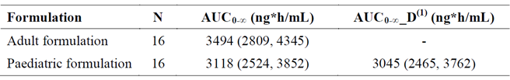
Data are geometric means (and 95% CI). (1) AUC0-∞_D is normalised to 62.5 mg.
Evaluator’s comment:
As outlined above, the sponsor and the EMA reached agreement on the similarity of the disease of PAH in adults and children and on study design when planning their paediatric development program in order to obtain approval for the indication ‘treatment of PAH in children’ and the paediatric formulation.
It is difficult to compare the results of the BREATHE-3, FUTURE-1 and FUTURE-3 Study results given the differences in paediatric patient population (forms of PAH included, age range and dosing regimen). It remains unclear whether the overlapping results for AUC reflect similar exposure as claimed by the sponsor. Study AC-052-116 found that, in healthy adults, exposure to bosentan was lower with the dispersible formulation than the film coated tablet formulation. The issue of whether bosentan exposure is also lower when using the dispersible formulation in the paediatric population with PAH is not addressed by the overlapping AUC results in Table 87. It has not been clearly demonstrated that the maximally attainable exposure in children with PAH has been attained with the dispersible formulation. Lower exposure to bosentan using the dispersible formulation could potentially result in decreased efficacy for the paediatric population.
- Please clarify the sponsor’s position regarding no additional clinical benefit in increasing the frequency of bosentan dosing from 2 mg/kg BD to TDS with respect to the results of the FUTURE-3 studies.
Sponsor’s response:
An increase in dosing frequency of bosentan from 2 mg/kg BD to 2 mg/kg TDS did not result in increased daily systemic exposure in paediatric PAH patients.
Consistently, exploratory efficacy results showed no clinically relevant differences between BD or TDS dosing regimens. Of note, these results were in agreement with the known efficacy profile of bosentan in paediatric PAH patients. The majority of patients showed stable or improved clinical condition (assessed by WHO FC, GCIS, NT-pro-BNP, and indirectly by the number of PAH-worsening events) with bosentan treatment.
The safety profile was consistent with the known safety profile of bosentan in adults and paediatrics, and showed no clinically relevant differences between BD or TDS dosing regimens.
Overall, there appeared to be no additional clinical benefit in increasing the frequency of dosing from two to three times daily. Therefore, 2 mg/kg BD remains the proposed dosing regimen of bosentan for a paediatric population.
Evaluator’s comment:
The efficacy endpoints in the FUTURE-3 Study were exploratory and were not statistically powered to show differences. It is noted that the FUTURE-3 Study did not identify an increase in bosentan exposure with a TDS dosing regimen.
- What was the protocol violation that led to the exclusion of one of the 13 bosentan treated patients from the PK analysis set?
Sponsor’s response:
The sponsor refers the reader to the response to Question 10.
Evaluator’s comment:
The sponsor’s response is considered acceptable.

Safety
- Please justify why the AE autoimmune hepatitis has not been included in the Australian Tracleer PI.
Sponsor’s response:
Following preliminary assessment of the 19th PSUR for bosentan, the PRAC Rapporteur requested a review of autoimmune hepatitis taking into consideration risk factors, mean doses, outcome, concomitant treatment, time to onset and indication. The cumulative analysis of AIH reports (estimated reporting rate 0.03%) submitted with 20th PSUR/PBRER, showed that clinical features of the reported events are consistent with those of AIH described in the literature as part of the clinical syndromes of mixed connective tissue disease, SLE, or SSc. There is insufficient information to definitely incriminate bosentan as an initiator of an autoimmune process or events of AIH, and no specific evidence to indicate that the administration of bosentan to patients with an underlying autoimmune disease would specifically increase the risk of hepatic events, including AIH. The possibility that an underlying autoimmune liver disease was made more manifest or worsened by the drug cannot be excluded due to a superimposed contribution of bosentan in some cases.
Following review of the cumulative analysis of AIH reports, PRAC rapporteur in their final assessment report (Rapporteur PSUR assessment report adopted on 11 June 2015) agreed that the provided review of cases of AIH did not show evidence that bosentan may be an initiator of autoimmune process or events of AIH and no specific evidence to indicate that the administration of bosentan to patients with an underlying autoimmune disease would specifically increase the risk of hepatic events, including AIH. Despite, the potential role of bosentan in unmasking or worsening of AIH in patient with autoimmune diseases remains unclear, it could not be ruled out in some cases in this review.
PRAC rapporteur recommended the following wording to be included in the SmPC under the SOC Hepatobiliary disorders: ‘Aminotransferase elevations associated with hepatitis (including possible exacerbation of underlying hepatitis) and/or jaundice’.
The current CCDS and Australian Tracleer PI describe:
- Under the SOC Hepatobiliary disorders, uncommon hepatitis and/or jaundice, and rare cases of unexplained hepatic cirrhosis or liver failure.
- In the post-marketing period rare cases of unexplained hepatic cirrhosis were reported after prolonged therapy with Tracleer in patients with multiple comorbidities and drug therapies. There have also been rare reports of liver failure.
The sponsor is of the opinion that the risk of hepatotoxicity is adequately addressed and no changes to the CCDS and to Australian Tracleer PI are deemed necessary.
Evaluator’s comment:
The sponsor’s rationale, for not including the specific term ‘autoimmune hepatitis’ in the Australian PI, is acceptable. However, the SmPC includes a statement regarding the risk of an exacerbation of underlying hepatitis. A similar statement in the Australian PI is recommended as provides prescribers with a more detailed description of the potential risk.
- Please clarify why symptomatic hypotension has not been included in the RMP Summary of Safety Concerns as an important potential risk.
Sponsor’s response:
Following review of the 19th PSUR for bosentan the PRAC Rapporteur requested a cumulative safety review of ‘the risk of fall which may be due to hypotension and syncope with a particular emphasis on cases resulting in injury (for example, fracture)’.
The cumulative analysis regarding fall submitted with 20th PSUR/PBRER revealed that the estimated reporting rate of fall is well within the expectation of the general population and also of the treated patient population suffering from PAH disease, associated aetiologies and comorbidities. In these cases the fall was more likely due to the natural progression of the PAH disease and the decline of the physical, cognitive and effective capacities of the patients. The interpretation as to whether fall was potentially due to hypotension was difficult in a few cases.
The PRAC considered the current information regarding hypotension and syncope and found that there was no convincing evidence between bosentan and fall. This signal could be considered closed but should continue to be closely monitored with routine pharmacovigilance. The sponsor will have to discuss this signal in the next PSUR only if further reports require re-evaluation of the issue.
Common ADRs of hypotension and syncope are described in the current CCDS and Australian Tracleer PI, and adequately reflect the risk. The sponsor continues to closely monitor reports of hip injury associated with syncope in the PSUR.
Evaluator’s comment:
The sponsor’s response is considered acceptable.

PI and CMI
- Please provide a justification based on efficacy and safety for altering the dosage instruction information to include patients aged between 1 and 3 years.
Sponsor’s response:
One of the objectives of the FUTURE-3 Study and its extension was to generate data in < 2 years of age. The protocol required that one third of the study population consisted of this population (21/64 patients). The sponsor states that this proportion was higher than in the non-selected PAH population, in order to generate meaningful data.
The sponsor states that the study results showed that the PK parameters of bosentan and its metabolites in patients < 2 years were consistent with those in patients ≥ 2 years. Consistently, the majority of patients in age groups < 2 years and ≥ 2 years showed stable or improved clinical condition (assessed by WHO FC, GCIS, NT-pro-BNP, and indirectly by the number of PAH-worsening events) with bosentan treatment. No new safety risks were identified in patients aged 3 months to < 2 years of age.
Based on these consistent results across age ranges, the dosage instruction information was amended to include patients aged between 1 and 3 years. Patients <1 year if age were not included given their low number (6).
Evaluator’s comment:
The analysis provided by the sponsor has considered patients < 2 years of age rather than those < 3 years of age. The number of patients aged between 1 and 3 years is not stated. Based on the above figures, it is assumed that the number of patients aged ≥ 1 and < 2 years of age was 15.
The efficacy analyses in the FURTURE-3 Study were exploratory and were not statistically powered to show differences and were not stratified for influencing factors. The haemodynamic subgroup included a small number of patients (10 patients, 2 patients < 2 years, 8 patients ≥ 2 years, all bosentan naïve). Several haemodynamic variables were analysed including PVR index but PVR and PVR index are not reported in Table 36. Change in cardiac output from baseline (a component of the PVR calculation) is also not included in Table 36. Supplementary tables appear to indicate that PVR and PVR index were measured at baseline in 4 of the 10 patients in the haemodynamics subgroup (2 in each treatment group) and none of these patients were < 2 years of age. The change from baseline in PVR index was an exploratory efficacy endpoint but the result does not appear to have been included in the FUTURE-3 CSR. The CSR does state that the low numbers reflect a decline in the use of invasive RHC assessment.
The sponsor has stated that the point estimates for the geometric mean ratios of AUC_{0-24C} and C_{maxC} for bosentan were comparable across age groups and systemic exposure was comparable between patients aged < 2 years and ≥ 2 years for both. A comparison in exposure for patients aged < 2 years and ≥ 2 years on BD dosing was not identified. Table 87 provides the AUC and 95% CI for these populations but the ratio of geometric means and 95% CI has not been provided.
The evidence provided by the FUTURE-3 Study does not clearly demonstrate efficacy or equivalence in bosentan exposure in the paediatric population aged < 3 years. The proposed changes to the dosage instruction information are not considered acceptable.
- Will the CMI for the adult formulation of Tracleer be updated to include the list of side effects outlined in the draft CMI for the paediatric formulation?
Sponsor’s response:
The sponsor confirms that the CMI for the adult formulation of Tracleer will be updated to include the list of side effects outlined in the draft CMI for the paediatric formulation.
Evaluator’s comment:
The sponsor’s response is considered acceptable.

Second round benefit-risk assessment

Second round assessment of benefits
After consideration of the responses to clinical questions, the benefits of Tracleer in the proposed usage are unchanged from those identified in the first round assessment of benefits.

Second round assessment of risks
After consideration of the responses to clinical questions, the risks of bosentan in the proposed usage are as shown in Table 90.

Table 90: Second round assessment of risks
Risks | Strengths and Uncertainties
The adult (film coated tablet) and paediatric (dispersible tablet) formulations are not bioequivalent. | The sponsor has argued that the two formulations are comparable rather than bioequivalent. Study AC-052-116 did not demonstrate bioequivalence with respect to either of the PK parameters AUC or C_{max}. The adult formulation of bosentan is currently available for use in the paediatric population in Australia based on the results of BREATHE-3 which evaluated the use of the adult formulation in children aged 3 to 15.  In Study AC-052-116 exposure to bosentan was lower with the dispersible tablet than the film coated tablet. It has not been established that exposure is comparable between the two formulations in the paediatric population. The two formulations are not bioequivalent therefore efficacy cannot be inferred in the paediatric population based on the results of BREATHE-3. Other studies in the paediatric population that tested the dispersible tablet formulation had only exploratory efficacy endpoints.  In Study AC-052-116 the dispersible tablet was not administered as per dosing instructions in the PI. It is possible that this may have affected the Study results.  In addition, the effect of the fed state on bioequivalence has not been investigated and the bioequivalence of an oral solution to the adult formulation has not been established.
Efficacy has not been established for the dispersible tablet formulation in the paediatric population. | The dispersible tablet formulation has been studied in the paediatric PAH population but the efficacy endpoints were exploratory. Efficacy has been established in adult patients with the adult tablet formulation. The EMA came to an agreement with the sponsor that the PAH condition is similar between adults and children and efficacy could be inferred if similar PK properties were established. However, bosentan exposure in the paediatric population was about half that seen in adults. In addition bioequivalence with the approved formulation has not been established. These factors make it difficult to infer efficacy in the paediatric population.
The optimal dosage regimen for paediatric patients with PAH has not been established. | A plateau in systemic exposure suggests that increasing the dose beyond 2 mg/kg or the frequency of dosing beyond twice daily will not increase exposure to bosentan. It is noted that the safety and efficacy of the 2 mg/kg dose for the paediatric population has not been established. Whilst it is anticipated that no additional benefit will be gained from doses above 2 mg/kg it is unclear whether this is the optimal dose with respect to safety and efficacy in the paediatric population.
The efficacy of bosentan for children aged between one and three years of age has not been established. | Exposure to bosentan is lower in the paediatric PAH population compared to adults with PAH. The FUTURE-3 Study found that C_{maxc} and AUC_{0-24C} were lower in children < 2 years old compared to those ≥ 2years old. Whilst the ratio of geometric means for TDS versus BD dosing are similar, it cannot be inferred that similar exposures are seen across the age groups when only BD or TDS dosing are considered. There does not appear to be enough data to support changing the dosing instructions to include patients aged between one and three years of age.  In addition, changes to this section of the PI would imply the safety and efficacy of the film coated tablet in this younger population. This is a problem given bioequivalence between the formulations has not been established.

Second round assessment of benefit-risk balance
The benefit-risk balance of bosentan given the proposed usage remains unfavourable. The bioequivalence of the adult and paediatric formulations has not been established in a healthy adult population. Therefore, it cannot be assumed that the dispersible formulation is bioequivalent to the approved formulation in the paediatric population with PAH.
Both the BREATHE-3 and FUTURE-1 Studies found a lower exposure to bosentan in paediatric patients compared to adult patients. This result may indicate an exposure plateau occurring at lower doses in paediatric patients. The FUTURE-3 Study found that TDS administration of 2 mg/kg bosentan did not increase systemic exposure to bosentan in the paediatric population. Therefore, it is difficult to extrapolate efficacy data from adults with PAH to the paediatric PAH population. The studies in the paediatric population presented in the submission had exploratory efficacy endpoints and the combination of lower exposure with both the dispersible formulation and in the paediatric population makes it difficult to extrapolate efficacy from studies in adults with PAH. Insufficient evidence was provided to support changes to the paediatric dosing instructions to include patients aged between 1 and 3 years of age.

Second round recommendation regarding authorisation
Approval of the dispersible tablet formulation of bosentan is not recommended for:
- idiopathic pulmonary arterial hypertension
- familial pulmonary arterial hypertension
- pulmonary arterial hypertension associated with scleroderma or
- pulmonary arterial hypertension associated with congenital systemic to pulmonary shunts including Eisenmenger’s physiology
in patients with WHO functional Class II, III or IV symptoms.
Approval cannot be recommended at this time as the new formulation is not bioequivalent to the approved formulation, an exposure plateau is observed in the paediatric population making the extrapolation of efficacy data difficult and the relevant studies examining the new formulation in the paediatric population had exploratory efficacy endpoints only.

Therapeutic Goods Administration
PO Box 100 Woden ACT 2606 Australia
Email: info@tga.gov.au Phone: 1800 020 653 Fax: 02 6232 8605
https://www.tga.gov.au

Uptodate.com database, Overview of pulmonary hypertension in adults, updated 31 August 2016, accessed 9 September 2016, https://www.uptodate.com/contents/overview-of-pulmonary-hypertension-in-adults?source=see_link
Uptodate.com database, Persistent pulmonary hypertension of the newborn, last updated 19 April 2016, accessed 9 September 2016, https://www.uptodate.com/contents/persistent-pulmonary-hypertension-of-the-newborn?source=search_result&search=pulmonary+hypertension+treatment&selectedTitle=7~150
Uptodate.com database, Treatment of pulmonary hypertension in adults, last updated 13 September 2016, accessed 22 September 2016, https://www.uptodate.com/contents/treatment-of-pulmonary-hypertension-in-adults?source=see_link#H4
Uptodate.com database, Persistent pulmonary hypertension of the newborn, last updated 19 April 2016, accessed 9 September 2016, https://www.uptodate.com/contents/persistent-pulmonary-hypertension-of-the-newborn?source=search_result&search=pulmonary+hypertension+treatment&selectedTitle=7~150

