|  |
| --- |
| **June 2018** |

|  |
| --- |
| Australian Public Assessment Report for Bosentan |
| Proprietary Product Name: Tracleer |
| Sponsor: Actelion Pharmaceuticals Australia Pty Ltd |

About the Therapeutic Goods Administration (TGA)

* The Therapeutic Goods Administration (TGA) is part of the Australian Government Department of Health and is responsible for regulating medicines and medical devices.
* The TGA administers the *Therapeutic Goods Act 1989* (the Act), applying a risk management approach designed to ensure therapeutic goods supplied in Australia meet acceptable standards of quality, safety and efficacy (performance) when necessary.
* The work of the TGA is based on applying scientific and clinical expertise to decision-making, to ensure that the benefits to consumers outweigh any risks associated with the use of medicines and medical devices.
* The TGA relies on the public, healthcare professionals and industry to report problems with medicines or medical devices. TGA investigates reports received by it to determine any necessary regulatory action.
* To report a problem with a medicine or medical device, please see the information on the TGA website <<https://www.tga.gov.au>>.

About AusPARs

* An Australian Public Assessment Report (AusPAR) provides information about the evaluation of a prescription medicine and the considerations that led the TGA to approve or not approve a prescription medicine submission.
* AusPARs are prepared and published by the TGA.
* An AusPAR is prepared for submissions that relate to new chemical entities, generic medicines, major variations and extensions of indications.
* An AusPAR is a static document; it provides information that relates to a submission at a particular point in time.
* A new AusPAR will be developed to reflect changes to indications and/or major variations to a prescription medicine subject to evaluation by the TGA.

Copyright

© Commonwealth of Australia 2018  
This work is copyright. You may reproduce the whole or part of this work in unaltered form for your own personal use or, if you are part of an organisation, for internal use within your organisation, but only if you or your organisation do not use the reproduction for any commercial purpose and retain this copyright notice and all disclaimer notices as part of that reproduction. Apart from rights to use as permitted by the *Copyright Act 1968* or allowed by this copyright notice, all other rights are reserved and you are not allowed to reproduce the whole or any part of this work in any way (electronic or otherwise) without first being given specific written permission from the Commonwealth to do so. Requests and inquiries concerning reproduction and rights are to be sent to the TGA Copyright Officer, Therapeutic Goods Administration, PO Box 100, Woden ACT 2606 or emailed to <[tga.copyright@tga.gov.au](mailto:tga.copyright@tga.gov.au)>.

Contents

Common abbreviations 5

I. Introduction to product submission 8

Submission details 8

Product background 9

Regulatory status 9

II. Registration timeline 10

III. Quality findings 10

Introduction 10

Drug substance (active ingredient) 11

Drug product 11

Biopharmaceutics 12

Quality summary and conclusions 13

IV. Nonclinical findings 14

Introduction 14

Assessment 14

Nonclinical conclusions and recommendation 15

V. Clinical findings 15

Introduction 16

Evaluator’s commentary on the background information 18

Pharmacokinetics 22

Pharmacodynamics 30

Dosage selection for the pivotal studies 30

Efficacy 31

Safety 32

First round benefit-risk assessment 39

First round recommendation regarding authorisation 41

Clinical questions and second round evaluation of clinical data submitted in response to questions 42

Second round benefit-risk assessment and recommendation regarding authorisation 42

VI. Pharmacovigilance findings 42

Summary 42

VII. Overall conclusion and risk/benefit assessment 43

Background 44

Quality 44

Nonclinical 44

Clinical 44

Risk management plan 47

Risk-benefit analysis 47

Outcome 56

Attachment 1. Extract from the Clinical Evaluation Report 57

## Common abbreviations

|  |  |
| --- | --- |
| Abbreviation | Meaning |
| AE | Adverse event |
| AIH | Autoimmune hepatitis |
| ARGPM | Australian Regulatory Guidelines for Prescription Medicines |
| ASA | Australian Specific Annexe |
| AUC | Area under the curve |
| AUC0-24C | Corrected AUC |
| AUCτ | AUC during a dosing interval |
| BCS | Biopharmaceutic Classification System |
| BD | Twice daily |
| CCDS | Company Core Data Sheet |
| CHMP | Committee for Medicinal Products for Human Use |
| CI | Confidence interval |
| Cmax | Maximum observed concentration |
| CmaxC | Corrected Cmax |
| CPMP | Committee for Proprietary Medicinal Products |
| CSR | Clinical Study Report |
| EEA | European Economic Area |
| EMEA | European Medicines Agency |
| EU | European Union |
| F1 | First filial generation |
| FC | Functional class |
| GCIS | Global clinical impression scale |
| GCP | Good clinical practice |
| GLP | Good laboratory practice |
| HCPM | Health Canada Product Monograph |
| HD | High dose |
| IBD | International birthdate |
| iNO | Inhaled nitric oxide |
| IPAH | idiopathic PAH |
| ka | Absorption rate constant |
| kt | Transfer rate constant |
| KM | Kaplan-Meier |
| LD | Low dose |
| MD | Medium dose |
| NOEL | No observable effect level |
| PAH | Pulmonary arterial hypertension |
| PAH-CHD | PAH secondary to congenital heart disease |
| PAH-SSc | PAH associated with systemic sclerosis |
| PH | Pulmonary hypertension |
| PI | Product Information |
| PIP | Paediatric investigational plan |
| PK | Pharmacokinetics |
| PKWP | Pharmacokinetics Working Party |
| PND | Post-natal day |
| PopPK | Population pharmacokinetics |
| PPD | Post-partum day |
| PPHN | Persistent pulmonary hypertension of the newborn |
| PT | Preferred Term |
| PVR | Pulmonary vascular resistance |
| RHC | Right heart catheterisation |
| RMP | Risk management plan |
| SAE | Serious adverse event |
| SmPC | Summary of Product Characteristics |
| t½ | Half-life |
| TDS | Three times daily |
| tmax | Time to maximum concentration |
| US | United States |
| US PI | United States Prescribing Information |
| WHO | World Health Organization |

## I. Introduction to product submission

### Submission details

|  |  |
| --- | --- |
| *Type of submission:* | Major variation: new dosage form and new strength |
| *Decision*: | Rejected |
| *Date of decision:* | 19 May 2017 |
| *Active ingredient:* | Bosentan |
| *Product name:* | Tracleer |
| *Sponsor’s name and address:* | Actelion Pharmaceuticals Australia Pty Ltd  PO Box 372  Frenches Forest NSW 1640 |
| *Dose form:* | Dispersible tablets |
| *Strength:* | 32 mg |
| *Container:* | Not applicable |
| *Pack size:* | Not applicable |
| *Approved therapeutic use:* | Not applicable |
| *Route of administration:* | Oral |
| *Dosage:* | Not applicable |
| *ARTG number:* | Not applicable |

### Product background

This AusPAR describes the application by Actelion Pharmaceuticals Australia Pty Ltd (the sponsor) to register Tracleer bosentan 32 mg dispersible tablets for the following indication:

*Tracleer is indicated for the treatment of*

* *idiopathic pulmonary arterial hypertension*
* *familial pulmonary arterial hypertension*
* *pulmonary arterial hypertension associated with scleroderma or*
* *pulmonary arterial hypertension associated with congenital systemic to pulmonary shunts including Eisenmenger’s physiology*

*in patients with WHO functional Class II, III or IV symptoms.*

Bosentan is an endothelin receptor antagonist currently registered in Australia for the treatment of various forms of pulmonary arterial hypertension (PAH). Causes of PAH include an idiopathic form, familial PAH, persistent pulmonary hypertension of the newborn (PPHN), and PAH due to diseases that localise to the small pulmonary muscular arterioles, including congenital heart disease.

The sponsor currently has registered immediate release film-coated tablets in two strengths, 62.5 mg and 125 mg. The current Tracleer PI states that a dose of 31.25 mg is required for children with a body weight less than 40 kg; however the 62.5 mg tablet is not scored to facilitate such dosing.

The proposed product is a 32 mg bosentan (as monohydrate) quadrisected dispersible tablet allowing it to be broken into quarters containing 8 mg of bosentan to faciliate adjustment of dosing based on weight and other factors in particular for the paediatric population.

### Regulatory status

The product received initial registration on the Australian Register of Therapeutic Goods (ARTG) in November 2002. The sponsor currently has registered immediate release film‑coated tablets in two strengths, 62.5 mg and 125 mg.

The dispersible tablet has been approved in Europe; it was submitted in the US in August 2016 and is currently under review by the US FDA. It has not been submitted in Canada or New Zealand.

At the time of market authorisation of Tracleer in the EU (2002), an agreement was made with the Committee for Proprietary Medicinal Products (CPMP) that the sponsor would investigate the use of bosentan in paediatric patients with PAH. The Committee for Medicinal Products for Human Use (CHMP) was of the opinion that data from BREATHE-3 were insufficient to support a therapeutic indication in children. The CHMP agreed to include the dosage information from BREATHE-3 in the Summary of Product Characteristics (SmPC) with a summary of the clinical findings.

## II. Registration timeline

Table 1: Registration timeline for Submission PM-2015-04745-1-3

|  |  |
| --- | --- |
| Description | Date |
| Submission dossier accepted and first round evaluation commenced | 20 May 2016 |
| First round evaluation completed | 25 October 2016 |
| Sponsor provides responses on questions raised in first round evaluation | 14 December 2016 |
| Second round evaluation completed | 10 February 2017 |
| Delegate’s Overall benefit-risk assessment and request for Advisory Committee advice | 6 March 2017 |
| Sponsor’s pre-Advisory Committee response | 20 March 2017 |
| Advisory Committee meeting (ACM 2) | 6 to 7 April 2017 |
| Registration decision | 19 May 2017 |
| Number of working days from submission dossier to decision* | 213 |

*Statutory timeframe is 255 working days

## III. Quality findings

### Introduction

The product proposed in this application is a dispersible tablet containing 32 mg of bosentan (as monohydrate) intended for use in paediatrics and adult patients who are unable to take the film-coated tablet. No new trade name is proposed. The 32 mg dispersible tabet has been commercially available overseas for more than 5 years.

The proposed product is a 32 mg bosentan (as monohydrate) quadrisected dispersible tablet allowing it to be broken into quarters containing 8 mg of bosentan to faciliate adjustment of dosing based on weight and other factors such as dose titration due to hepatic abnormalities. The proposed product is packed in an alu/alu blister (bottom foil and peel push foil). There are 14 dispersible tablets per blister strip and a total of 56 tablets per carton unit. A package insert is enclosed in the pack.

This submission incorporates a proposal to widen to patient population by decreasing the minimum age of paediatric patients from 3 years to 1 year old. For paediatric patients aged 1 year and older, the recommended starting and maintenance dose is 2 mg/kg twice daily. It is therefore difficult to establish the maximum dose for paediatrics as it is weight dependent. The proposed PI also indicates that adults who are unable to take the film coated tablet can consider taking the dispersible tablet. The maximum daily dose can be considered as 250 mg bosentan per day.

No change to the wording of the indication already registered for the film-coated tablet presentations of Tracleer is being sought.

Bosentan monohydrate is not subject to a BP/Ph Eur. monograph, but there is a pending USP monograph for bosentan monohydrate. There are no monographs for the finished product.

### Drug substance (active ingredient)

Bosentan monohydrate (structure shown below) is a white to yellowish fine powder that has solubility in water of 1 mg/100 mL. It is achiral and not hygroscopic.

Figure 1: Structure of bosentan

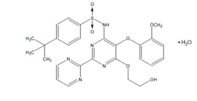

The drug substance sections were not evaluated as part of this application as the sponsor provided assurance these sections are the same as previously approved by the TGA for Tracleer bosentan (as monohydrate) 62.5 mg and 125 mg film coated tablets.

### Drug product

The proposed product contains 33.045 mg bosentan monohydrate (equivalent to 32 mg bosentan) and is a pale yellow to off-white clover shaped tablet, quadrisected on one side and debossed with ‘32’ on the other side.

Figure 2: Proposed dispersible tablet

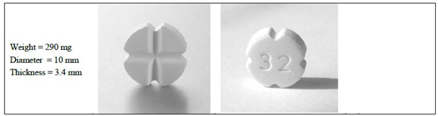

The proposed product is a dispersible tablet intended for paediatric use and is packed in alu/alu blisters with 14 tablets per blister strip and a total of 56 tablets per carton. The TGA requested information regarding the quantities of each sub excipient, how each of the sub excipients are controlled, whether they are compliant with any pharmacopoeial standards and if so which ones. The sponsor advised this information will be sent directly to the TGA by the supplier [information redacted] but this information has not yet been received and without this information it cannot be determined if the flavouring agent is of suitable quality.[1]

The quality of the product is controlled by acceptable specification that includes tests and limits for appearance, colour, average mass (of 10 tablets), friability, uniformity of dosage unit by content uniformity, assay, degradation products, disintegration, fineness of dispersion and microbial contamination. The proposed release and expiry limits have been accepted. The analytical methods used to analyse the product were adequately described and validated.

The stability data supplied supported a shelf life of 60 months for the unopened product when it is stored below 25°C and protected from light. An in-use shelf life of 7 days at room temperature has been not been accepted for the remaining portions of a quadrisected tablet. An in use period of 48 hours is acceptable in the interim however, contingent on the sponsor conducting the additional in-use stability study in Q1 2017 committed to in the response to generate data on disintegration time and fineness of dispersion.

The sponsor was asked to add the warning statement ‘Warning: causes birth defects’ to the proposed labelling. The sponsor has updated the carton (as well as the patient card Risk management plan (RMP) Australian Specific Annexe (ASA)) to include the warning statement ‘Warning: Tracleer may cause birth defects’. The warning statement proposed by the sponsor could be viewed as being weaker than that specified in *Standard for the Uniform Scheduling of Medicines and Poisons* (warning statement 7) because of the use of the word ‘may’. Clinical advice was therefore sought and based on this advice; the warning statement proposed is not accepted. If the warning statement was amended to read ‘Warning: causes birth defect’ the labelling could be approved.

### Biopharmaceutics

The sponsor has conducted the relative bioavailability study (Study AC-052-116). The study was a single centre, open label, two period, two treatment, randomised, crossover study in 16 healthy adult (18 to 45 years) male subjects. The study compared the relative bioavailability of a single dose of the registered 62.5 mg film coated tablet (Period A) with a single oral dose of 64 mg of bosentan administered as two of the proposed 32 mg dispersible tablets (Period B).

The effect of formulation (dispersible tablet versus film coated tablet) was assessed statistically using the pharmacokinetic parameters maximum observed concentration (Cmax), AUC0-t and AUC0-∞ measured for bosentan and the primary active metabolite Ro‑48‑5033. Prior to this analysis, the Cmax and area under the curve (AUC) values were dose normalised. For these parameters, the 90% confidence intervals for the ratios of the dispersible tablet and the film coated tablet should be within 0.8 to 1.25.[2] The results are displayed in Tables 2 and 3. The 90% confidence intervals of the geometric mean ratios fell outside the 0.80 to 1.25 equivalence range for the majority of pharmacokinetic parameters considered.

The proposed dispersible tablet was less bioavailable than, and not bioequivalent to, the registered tablet. This was brought to the attention of the Delegate.

Table 2: Effect of the formulation on bosentan pharmacokinetics: Paediatric (proposed dispersible tablet) versus adult formulation (registered film-coated tablet)

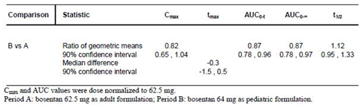

Table 3: Effect of the formulation on Ro-48-5033 pharmacokinetics: Paediatric (proposed dispersible tablet) versus adult formulation (registered film-coated tablet)

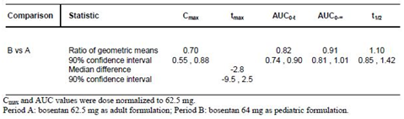

The sponsor has argued that:

1. although systemic exposure was lower in subjects treated with the dispersible tablet, there is high inter-subject variability in exposure to bosentan and the active metabolite Ro 48-5033 without any commensurate variation in efficacy (Study AC‑052-365); and
2. administration of bosentan at 2 mg/kg twice daily (BD) either in the paediatric dispersible tablet (AC-052-365 FUTURE-1) or in the adult film coated tablet form (AC‑052-356, BREATHE-3) to paediatric PAH patients resulted in comparable plasma concentrations.

### Quality summary and conclusions

Approval cannot be recommended at this stage based on the following reasons:

1. The Delegate has stated that the warning on the carton label should be strengthened from ‘Warning: Tracleer may cause birth defects’ to ‘Warning: causes birth defects’. This issue has been raised with the sponsor. (The sponsor has stated an intention to address this in their pre-ACM response).
2. Further information is required to ensure the safe use of remaining portions of a divided tablet. The in-use shelf life needs to be amended from 7 days to 48 hours as an interim measure, contingent on the sponsor’s commitment to perform an in use stability study to generate the additional disintegration and fineness of dispersion data requested in Q1 2017. This has been raised with the sponsor. (The sponsor has stated an intention to address this in their pre-ACM response).

With respect to bioavailability, the proposed dispersible tablet cannot be considered bioequivalent to the registered film-coated tablets. This was brought to the attention of the Delegate.

## IV. Nonclinical findings

### Introduction

The sponsor has applied to include a new oral solid dosage form and strength of Tracleer (bosentan) suitable for administration to the paediatric population. Tracleer is currently approved for clinical use in adults for the treatment of primary pulmonary hypertension or pulmonary hypertension secondary to scleroderma, in patients meeting WHO criteria for inclusion in functional Class III to IV hypertension, at a dose up to 125 mg twice daily. The paediatric formulation is a dispersible tablet containing 32 mg of bosentan. In support of the proposed change, the sponsor submitted two nonclinical studies investigating the toxicity of bosentan in juvenile rats.

### Assessment

#### Toxicology in neonatal/juvenile animals

Dose levels of 15 low dose (LD), 45 medium dose (MD) and 135 mg/kg/day bosentan high dose (HD) were used in a pivotal toxicity study on neonatal/juvenile Han Wistar rats based on a previous dose ranging study (60, 300 and 1500 mg/kg) that had shown mean body weight reductions of 13 to 43% in males and 7 to 40% in females.

Exposure ratios for the pivotal juvenile rat study were calculated based on animal:human plasma AUC(0–24 h). Human reference values are from Clinical Study AC-52-373 (FUTURE 3) for age groups above and below 2 years while animal values are taken from Study T‑10.407 on post-natal day (PND) 21 and 69, and are shown separately for males and females as there were significant differences in AUC0-24h between sexes.

Table 4: Relative exposure ratios

|  |  |  |  |  |  |  |  |
| --- | --- | --- | --- | --- | --- | --- | --- |
| Time | Dose (mg/kg bw/day) | AUC0-24h in juvenile rats (ng.h/mL) | | Exposure margin (based on AUC0-24h) for children < 2 years at 2 mg/kg bid* | | Exposure margin (based on AUC0-24h) for children > 2 years at 2 mg/kg bid ** | |
|  | | M | F | M | F | M | F |
| PPD 21 | 15 | 59700 | 168000 | 7.6 | 21.3 | 6.8 | 19.0 |
| 45 | 185000 | 270000 | 23.5 | 34.3 | 21.0 | 30.6 |
| 135 | 282000 | 191000 | 35.8 | 24.2 | 32.0 | 21.7 |
| PPD 69 | 15 | 11800 | 22500 | 1.5 | 2.9 | 1.3 | 2.6 |
| 45 | 20300 | 53700 | 2.6 | 6.8 | 2.3 | 6.1 |
| 135 | 49900 | 78100 | 6.3 | 9.9 | 5.7 | 8.9 |

*7879 ng/h/mL; ** 8820 ng/h/mL; Data at the NOAEL is bold PPD = Post-partum day

In the Nonclinical Overview the sponsor chose not only to pool the results for sexes but also to average out the AUC0-24h values across Post-partum day (PPD) 21 and PPD 69, yielding moderate multiples of the anticipated clinical systemic exposure of approximately 7 to 8 fold at the no observable effect level (NOEL). However, this approach masks the results in males which show no safety margin at the NOEL for animals on PPD 69.

There were no significant, persistent, treatment-related effects of bosentan on clinical chemistry, histopathology, developmental indices or reproductive performance at 15 mg/kg/day, which was established as the NOEL. The primary findings in the pivotal study at ≥ 45 mg/kg/day were reduced body weight gain, reduced femur length, increased relative heart weight and reduced testis weight (at 135 mg/kg only).

Reductions in mean food consumption and mean body weight gain lasted longer and were greater in females than males and the reductions in femur length correlated with these changes in both sexes: at PPD 21 long bone length was reduced in both males (exposure margin range: 21 to 24) and females (exposure margin range: 31 to 34) whereas at PPD 70 only females showed this effect.

At necropsy (PPD70), the MD and HD females and the HD males had increased relative heart weights but absolute heart weights were unchanged and there were no microscopic correlates.

At PPD 70, a statistically significant reduction in absolute epididymides weights was observed at all doses *cf.* control (exposure margin ≥ clinical exposure). Reductions in sperm counts were noted for both L/R caudal epididymes in HD juvenile males (exposure margin about 6). Exposure at the NOEL for sperm count (PPD 69) was approximately twice that anticipated clinically. These findings should be included in the Product Information (PI) (see discussion below).

### Nonclinical conclusions and recommendation

The safety of bosentan in the juvenile population was assessed in a dose range finding study and a full, Good Laboratory Practice (GLP) compliant toxicity study and fertility assessment of the first filial (F1) generation in neonatal/juvenile Han Wistar rats.

There are no major concerns for juvenile toxicity with respect to growth, development, cognitive, sensory and reproductive function.

Reductions in testes and epididymal weight were noted in juvenile rats at PPD 70 at similar to, or greater than, the expected clinical exposure levels (based on AUC).

Reductions in sperm counts were noted for both left and right caudal epididymes in HD juvenile males (exposure margin about 6) with a NOEL exposure margin of about 2 (AUC).

While these specific findings have not been noted with bosentan for adult rats, testicular findings have previously been noted in adult rats with other endothelin receptor antagonists such as macitentan (Submission PM-2012-04112-1-3) and [information redacted] and decreased sperm concentrations have been observed clinically with bosentan (Study AC-052-402), warranting the inclusion of appropriate warnings in the PI and RMP documents.

Overall, the results from the pivotal toxicity study in neonatal/juvenile rats submitted by the sponsor support the use of bosentan in the paediatric population.

The nonclinical evaluator also made recommendations with regard to the PI document however presentation of this is beyond the scope of the AusPAR.

## V. Clinical findings

A summary of the clinical findings is presented in this section. Further details of these clinical findings can be found in Attachment 1.

### Introduction

#### Clinical rationale

At the time of the original marketing authorisation of Tracleer in the EU, an agreement was made with the Committee for Proprietary Medicinal Products (CPMP) that the sponsor would investigate the use of bosentan in paediatric patients with PAH, due to the need for therapy in children.

The sponsor studied the use of bosentan in children in Study AC-052-356 (BREATHE-3) using the approved tablet formulation of Tracleer. BREATHE-3 showed a lower systemic exposure in young children compared to the exposure in adults treated with 125 mg BD. Data from this study were submitted to the CHMP for inclusion in the Tracleer Summary of Product Characteristics (SmPC). The CHMP was of the opinion that data from BREATHE-3 were insufficient to support a therapeutic indication in children for two main reasons:

1. The number of paediatric patients exposed was considered too small.
2. The dose of bosentan used may have been suboptimal since mean plasma concentrations of bosentan obtained in children were lower than those observed in adult PAH patients.

The CHMP agreed to include the dosage information from BREATHE-3 in the SmPC.

The sponsor has developed an oral paediatric formulation of bosentan to facilitate weight appropriate dosing in children with PAH. The sponsor and the EMA reached agreement on the similarity of the disease of PAH in adults and children and on study design in order to obtain approval for the indication ‘treatment of PAH in children’ and the paediatric formulation. The agencies are reported to have agreed that the pathophysiology, evolution, and progression of idiopathic or familial PAH are similar between children and adults. Therefore, the treatment effect of bosentan could be assumed to be similar across age groups provided that similar plasma concentrations are reached. The sponsor states that a pharmacokinetic (PK) study investigating the safety and tolerability of bosentan (Study AC-052-365, also referred to as FUTURE-1) was considered adequate to obtain approval of the paediatric formulation of bosentan.

As data from BREATHE-3 indicated a lower than expected exposure to bosentan in paediatric patients (Table 5), the FUTURE programme (FUTURE-1 and Study AC-052-367 (FUTURE-2)) was designed with the following objectives:

1. To increase the exposure in paediatric patients to that seen in adults.
2. To increase the overall paediatric data available from bosentan studies.

FUTURE-1 was designed as a PK study, with exploratory examination of efficacy and safety. Patients with WHO functional Class (FC) II or III PAH, received an initial dose of 2 mg/kg BD for 4 weeks, followed by a maintenance dose of 4 mg/kg BD up to a maximum of 120 mg BD bosentan for a total treatment period of 12 weeks. FUTURE-2 was an open label extension of the FUTURE-1 Study. Results of the FUTURE-1 Study indicated that the PK of bosentan in paediatric patients is characterised by an absorption plateau that limits exposure to bosentan, despite increasing doses (Figure 3, Table 5).

The paediatric formulation was approved in the EU in 2009 and the CHMP requested a comparison of the in vivo bioavailability of the dispersible and film coated tablet formulations as a post approval commitment. The CHMP also requested that further long term safety and clinical data should be collected in paediatric patients. Study AC-052-116 compared the PK properties of the dispersible tablet with the film coated tablet formulation in healthy adult subjects.

Study AC-052-373 (also referred to as FUTURE-3) investigated if increasing the dose frequency from twice daily (BD) to three times daily (TDS) would increase the exposure in paediatric PAH patients. The study found that TDS administration in the paediatric PAH population did not increase exposure to bosentan compared to BD administration (Table 6).

Study AC-052-391 (also referred to as FUTURE-4) evaluated the efficacy, safety and PK of bosentan (2 mg/kg BD) versus placebo as adjunctive treatment of PPHN in term or near term neonates whose response to inhaled nitric oxide (iNO) therapy was insufficient. Exposure achieved at steady state is reported to be similar to that observed in adult PAH patients receiving bosentan 125 mg BD. This was in contrast to the results in paediatric PAH patients aged ≥ 3 months, in which adult exposures to bosentan were not reached.

Table 5: Summary pharmacokinetics of bosentan in paediatric (BREATHE-3 and FUTURE-1) and adult (Study AC-052-357) PAH patients

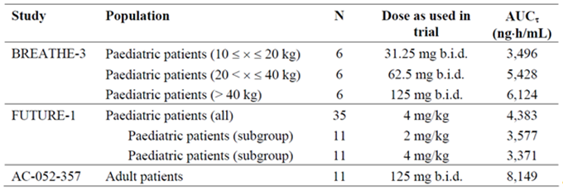

Figure 3: FUTURE-1 Arithmetic mean (± SD) plasma concentration versus time profiles of bosentan in paediatric patients with pulmonary arterial hypertension after multiple dose administration of bosentan at a dose of 2 and 4 mg/kg BD (n = 11)

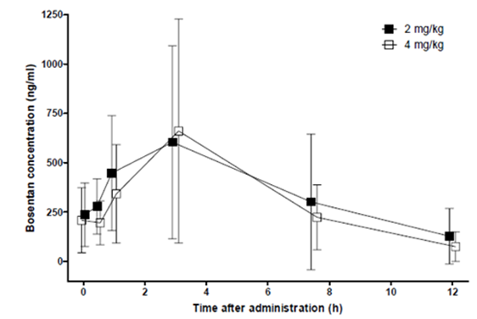

Table 6: FUTURE-3 Ratio of geometric means between treatment groups of PK parameters for bosentan (TDS/BD); overall age groups and by age group, PK set

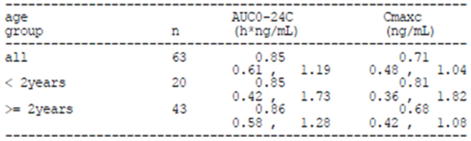

#### Formulation development

Previously, the sponsor studied the use of bosentan in children in BREATHE-3 using the approved tablet formulation of Tracleer. The sponsor has since developed a paediatric formulation of bosentan in order to make bosentan available as oral treatment with a weight appropriate dose and formulation for children with PAH.

The paediatric formulation is a dispersible tablet containing 32 mg of bosentan. The tablet has quadrisecting score lines, enabling it to be divided into four parts of 8 mg bosentan each. The whole tablet, or fractions thereof, can be dispersed in water on a teaspoon or in a glass to facilitate oral administration.

In the justification for not providing biopharmaceutic data, the sponsor states that no changes have been made to the quality aspects of the bosentan drug substance, the excipients fulfil the relevant quality standards and that bosentan is classified as a Class II compound according to Biopharmaceutic Classification System (BCS) and that dissolved bosentan in vivo is immediately bioavailable. The sponsor states that no specific biopharmaceutic studies were performed to demonstrate bioequivalence for the new dispersible tablet and the approved marketed formulation.

As dissolution testing only applies to solid oral dosage forms, no analytical studies have been performed to compare dissolution profiles of the 32 mg dispersible tablets, the 62.5 mg and 125 mg tablets and the oral suspension of bosentan used in early clinical development. All dosage forms developed are stated to be immediate release forms with 90% of bosentan is dissolved within 20 to 30 minutes for 62.5 mg and 125 mg tablets, and less than 15 min for an oral suspension or dispersion of bosentan.

### Evaluator’s commentary on the background information

Australian Regulatory Guidelines for Prescription Medicines (ARGPM) Guidance 15 states that biopharmaceutic data is required for oral suspensions unless otherwise justified. For new dosage forms bioequivalence must be established between the new dosage form and the currently registered dosage form. The sponsor states that no specific study has been performed to demonstrate that the new dispersible tablet, used in FUTURE-1 and FUTURE-2, is bioequivalent to the approved marketed formulation. However it is noted that Study AC-052-116 evaluated the PK properties of a dispersible paediatric formulation and an adult formulation in healthy adult male subjects. The sponsor should be requested to confirm which studies evaluated the marketed adult formulation, the paediatric formulation intended for market and the formulation in early stages of development.

Study AC-052-106 compared the bioavailability of an oral suspension of bosentan used in early clinical development and the approved marketed formulation. The study is stated to provide additional bridging support. Study AC-052-106 was summarised in Module 2 and the text indicates that a copy of the final Clinical Study Report (CSR) has been included but the study was not included in the current submission. The sponsor states that Study AC‑052-106 was provided in full as part of the original Tracleer application.

According to the ‘Guideline on the Investigation of Bioequivalence’[3] a biopharmaceutic classification system (BCS) based biowaiver may be applicable for immediate release drug products for BCS Class I or III drug substances under certain conditions. The justification for not providing biopharmaceutic studies indicates that bosentan is a BCS Class II compound. The guidance indicates that in ‘For dosage forms such as tablets, capsules and oral suspensions, bioequivalence studies are required unless a biowaiver is applicable’ and that in ‘cases where the test product is an oral solution which is intended to be bioequivalent to another immediate release oral dosage form, bioequivalence studies are required.’ The justification for not providing biopharmaceutic data is therefore not acceptable.

The status of the current submission in the US, Canada and New Zealand is unclear. The sponsor states that this application has not been rejected or withdrawn in the US or Canada but it is unclear whether an application to register the dispersible formulation has been made in these jurisdictions. The United States Prescribing Information (US PI) included in the submission does not describe paediatric dosing or the 32 mg dispersible tablet. The Health Canada Product Monograph (HCPM) included in the submission does not mention the paediatric formulation and contains similar dosing instructions to the current Australian Tracleer PI. It is not stated whether a similar application has been made in New Zealand.

#### Guidance

TGA and TGA adopted guidance documents of relevance to this submission:

* Australian Regulatory Guidelines for Prescription Medicines (ARGPM)
* EMEA/CHMP/EWP/147013/2004 Corr Guideline on the role of Pharmacokinetics in the Development of Medicinal Products in the Paediatric Population
* CPMP/EWP/QWP/1401/98 Rev. 1/ Corr ** Guideline on the Investigation of Bioequivalence
* EMA/618604/2008 Rev. 13 – Questions & Answers: positions on specific questions addressed to the Pharmacokinetics Working Party (PKWP)
* CHMP/EWP/185990/06 Guideline on Reporting the results of Population Pharmacokinetic Analysis
* 3CC3A Pharmacokinetic Studies in Man
* EMEA/CHMP/EWP/356954/2008 Guideline on the Clinical Investigations of Medicinal Products for the Treatment of Pulmonary Arterial Hypertension
* EMA/CHMP/213972/2010 Paediatric Addendum to the CHMP Guideline on the Clinical Investigations of Medicinal Products for the Treatment of Pulmonary Arterial Hypertension

Other guidance of relevance to this submission:

FDA Draft Guidance on Bosentan

#### Contents of the clinical dossier

The clinical efficacy and safety of the new formulation of bosentan in the paediatric population has been extrapolated from the currently-registered products and the PK of the two formulations. Several of the submitted studies collected data on safety and efficacy in the paediatric population.

The following clinical studies of relevance to the submission were provided:

* Two clinical pharmacology studies providing PK and safety pharmacology data.
* Two population PK (popPK) analyses
* Three uncontrolled studies of safety and efficacy
* Two supportive studies requested by the Delegate
* Two reports of analyses of data from more than one study
* One PSUR for the period 20 November 2013 to 19 November 2014
* 61 literature references.

The submission also contained the following documents of relevance to the clinical evaluation:

* Clinical Overview and addendum to support European Medicines Agency (EMEA) variation 39
* Clinical Overview and addendum to support EMEA variation 66
* Addendum (used to support EMEA Variation 51)
* Addendum Clinical Overview (20th PSUR nasal congestion)
* Summary of Biopharmaceutic Studies and Associated Analytical Methods
* Summary and Addendum to support variation 39
* Two documents titled ‘Summary to support EMEA variation 66’
* Three documents titled ‘Summary to support EMEA variation 39’
* Summary addendum (used to support EMEA Variation 51)
* Synopses of individual studies
* A list of literature references.

#### Paediatric data

Seven studies with paediatric data have been included in the submission (Table 7). The paediatric development program form indicates that the sponsor is seeking approval for the preterm or term newborn infant, infant and toddler and children age ranges (less than 28 days to 11 years). The form indicates that the sponsor has an agreed paediatric investigational plan (PIP) in Europe and an exemption from having to submit a paediatric assessment in the USA. The form states that all PIP studies have been completed.

Table 7: Paediatric studies included in the submission

|  |  |  |  |
| --- | --- | --- | --- |
| PK topic | Age group | Study ID | Synopsis |
| Intrinsic factor PK study reports | Children | AC-052-365 FUTURE-1 | An open label, multicentre study to assess the PK, tolerability, and safety of a paediatric formulation of bosentan in children with idiopathic or familial PAH. |
| Population PK analyses | Infants/children | AC-052-373 FUTURE-3 | PopPK of bosentan in children with PAH |
| Uncontrolled clinical studies | Children | AC-052-367 FUTURE-2 | An open label, long term, safety, and tolerability extension study using the paediatric formulation of bosentan in the treatment of children with idiopathic or familial PAH who completed FUTURE-1. |
| Infants/children | AC-052-373 FUTURE-3 | An open label, randomised, multicentre, multiple dose trial to evaluate the PK, tolerability, safety and efficacy of the paediatric formulation of bosentan BD versus TDS in children from 3 months to less than 12 years of age with PAH. |
| Infants/children | AC-052-374 FUTURE-3 extension | A prospective multicentre, open label extension of Future 3 to assess the safety, tolerability and efficacy of the paediatric formulation of bosentan BD versus TDS in children with PAH. |
| Reports of analyses of data from more than one study | Infants/children | AC-052-367 FUTURE-2  AC-052-373 FUTURE-3  AC-052-391 FUTURE-4 | This document is a compilation of appendices referred to in the Summary of Clinical Efficacy. |
| Infants/children | AC-052-365 FUTURE-1  AC-052-367 FUTURE-2  AC-052-373 FUTURE-3  AC-052-374 FUTURE-3 Extension  AC-052-391 FUTURE-4 | This document provides an analysis of the pooled long term safety data from the FUTURE Study series 1 to 4 Extension. |
| PK in special populations | Neonates | AC-052-391 FUTURE-4 | Exploratory, multicentre, double blind, placebo controlled, randomised, prospective study to evaluate PK, safety and efficacy of bosentan as add-on therapy to iNO in the management of PPHN. |
| Neonates | AC-052-392 FUTURE-4 Extension | Multicentre, non-drug interventional extension study to assess long term safety and effects on growth in patients who received bosentan or placebo as adjunctive therapy to iNO for PPHN in Future 4. |

#### Good clinical practice

Each of the Clinical Study Reports (CSRs) listed in the tabular listing of all clinical studies included has a statement indicating that research was conducted according to the principles of the ‘Declaration of Helsinki’ and with the laws and regulations of the countries in which the research was conducted. The wording regarding Good Clinical Practice (GCP) varies between studies but all studies indicate that the study was conducted in accordance with GCP.

### Pharmacokinetics

#### Studies providing pharmacokinetic data

In the clinical summary the sponsor lists the following clinical pharmacology studies of relevance to the submission:

* Study AC-052-106
* Study AC-052-116
* Study AC-052-356; BREATHE-3
* Study AC-052-357
* Study AC-052-365; FUTURE-1
* Study AC-052-373; FUTURE-3
* Study AC-052-391; FUTURE-4

Full CSRs have not been included in the submission for Study AC-052-106, BREATHE-3 and Study AC-052-357. A brief overview of these studies has been included in the submission which the evaluator summarised despite the lack of a full CSR.

The sponsor states that they seek marketing authorisation for the paediatric dispersible tablet of bosentan based primarily on data from the BREATHE-3, FUTURE-1 and FUTURE‑2 Studies. Previous submissions indicate that BREATHE-3 hours as been evaluated by the TGA as part of Submission PM-2005-2150-3 and it is noted that the results of this study are discussed in the current Tracleer PI. Table 8 summarises the submitted pharmacokinetic studies. A brief synopsis of referenced studies that weren’t included in the submission is provided in Table 9.

Table 8: Submitted pharmacokinetic studies

|  |  |  |  |
| --- | --- | --- | --- |
| PK topic | Subtopic | Study ID | Synopsis |
| PK in healthy adults | Bioequivalence † Single dose | AC-052-116 | Safety and tolerability study evaluating the relative PK properties of two different formulations of bosentan in healthy male subjects. |
| PK in special populations | Target population (paediatric PAH) § Multi dose | AC-052-365 FUTURE-1 | Assessed the PK, tolerability, and safety of a paediatric formulation of bosentan. |
| Target population (paediatric PAH) § Multi dose | AC-052-373 FUTURE-3 | Investigated the PK of a paediatric formulation of bosentan BD versus TDS in children with PAH. |
| Target population (PPHN) Multi-dose | AC-052-391 FUTURE-4 | Evaluated PK, safety and efficacy of bosentan as add-on therapy to iNO in the management of PPHN. |

† Bioequivalence of different formulations; § Subjects who would be eligible to receive the drug if approved for the proposed indication.

Table 9: Referenced pharmacokinetic studies not included in the submission

|  |  |  |
| --- | --- | --- |
| Study ID | Subtopics | Synopsis |
| AC-052-106 | PK in healthy adults, bioequivalence, single dose | A single-centre, prospective, open label, randomised, 4 way crossover study comparing the bioavailability of a 125 mg bosentan tablet relative to that of an oral suspension of 125 mg bosentan, under both fasting conditions. The study also compared the bioavailability of a 125 mg bosentan tablet to two 62.5 mg tablets under fed conditions. |
| AC-052-357 | PK in target population (adult PAH) | A multi-centre, open label, non-comparative study designed to obtain safety data with bosentan in adult patients with PAH. |
| AC-052-356 (BREATHE-3) | PK in target population (paediatric PAH) | A multi-centre, prospective, open label, non-controlled study to investigate the PK of bosentan given as single and multiple oral doses in paediatric patients with PAH. |
| AC-052-356 (BREATHE-3) | PK in target population (paediatric PAH) | A multi-centre, prospective, open label, non-controlled study to investigate the PK of bosentan given as single and multiple oral doses in paediatric patients with PAH. |

#### Evaluator’s conclusions on pharmacokinetics

Study AC-052-106 found that an oral suspension of bosentan was not bioequivalent to the tablet formulation with respect to Cmax as the 90% confidence interval (CI) for the ratio of geometric means fell outside the acceptance interval of 80.00 to 125.00% (Table 10). The ratio of geometric means for AUC0-∞ did fall within the acceptance interval. The sponsor states that this result together with the chemical characteristics of bosentan provides evidence for similar PK characteristics between the currently approved formula and oral suspensions or dispersions. In the submission the sponsor refers to bosentan as both a Class I and a Class II compound. It should be clarified with the sponsor which studies included the paediatric formulation intended for market, rather than a formulation from early clinical development. The sponsor states that since the new dispersible tablet is administered as a dispersion and it is reasonable to assume that the absorption, distribution, metabolism, and elimination characteristics of the paediatric formulation would correspond to those of the oral suspension used in Study AC-052-106 and, also to those of the approved, film coated, immediate release tablet. The sponsor has not justified only considering AUC as the important PK parameter for establishing bioequivalence for bosentan rather than using both AUC and Cmax. Bioequivalence has not been clearly demonstrated for an oral solution versus the approved tablet formulation of bosentan.

Table 10: AC-052-106 Geometric mean ratios for AUC0-∞ and Cmax

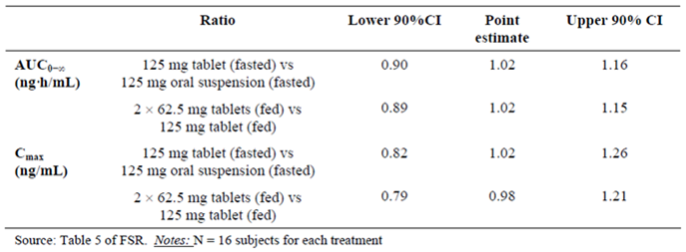

The comparison of formulations in healthy adult volunteers rather than children in Studies AC-052-106 and AC-052-116 is considered acceptable as stated in TGA adopted guideline[4]: ‘*In the vast majority of cases BE studies in healthy volunteers are adequate for products intended for use in children.*’

Supporting Study AC-052-116 failed to demonstrate bioequivalence of the paediatric and adult formulations and therefore bioequivalence in children cannot be assumed (Table 11). As outlined in the TGA adopted EU Guideline:[5]

In studies to determine bioequivalence after a single dose, the parameters to be analysed are AUC(0-t), or, when relevant, AUC(0-72h), and Cmax. For these parameters the 90% confidence interval for the ratio of the test and reference products should be contained within the acceptance interval of 80.00 to 125.00%.

Table 11: AC-052-116 Effect of the formulation on bosentan pharmacokinetics: Paediatric versus adult formulation

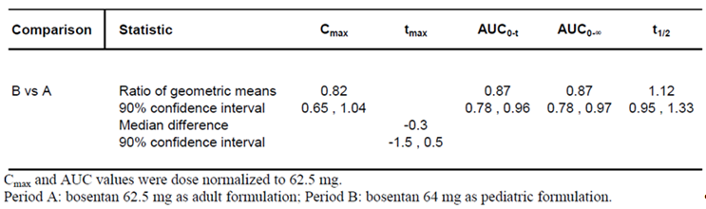

The sponsor states that the 90% CIs of the geometric mean ratios (Paediatric/Adult) fell only slightly outside the conventional 0.8 to 1.25 equivalence range but for Cmax the 90% CI were well outside the acceptance interval described in the guidelines.

The sponsor’s justification for not providing biopharmaceutic studies is not considered adequate as the relevant guidelines state that ‘*in those cases where the test product is an oral solution which is intended to be bioequivalent to another immediate release oral dosage form, bioequivalence studies are required.*’ It is noted that Study AC-052-106 was conducted to compare the bioavailability of an oral suspension of bosentan used in early clinical development and the approved marketed tablet formulations. The sponsor states that comparable PK characteristics between the oral suspension and the marketed tablet formulations support the comparability between the approved formulation and the new paediatric formulation. The evaluator notes that the Studies AC-052-106 and AC-052-116 failed to establish bioequivalence between the various formulations.

From a clinical perspective, the sponsor’s rationale for not performing dissolution testing is reasonable as the dispersible tablet is intended for administration as an oral solution but the issue is referred to the quality evaluator for consideration. In addition, the sponsor’s justification regarding BCS based biowaiver are referred to the quality evaluator. It is noted that bosentan is stated to be BCS Class II.

The BREATHE-3 Study found a lower exposure to bosentan in paediatric patients compared to adult patients. In BREATHE-3 patients were treated with the adult tablet formulation administered in a dosing regimen of approximating 2 mg/kg BD. FUTURE-1 examined whether a higher dose would increase exposure in paediatric patients. It was assumed that the PK of bosentan would be dose proportional up to at least 4 mg/kg BD in paediatric patients. In the 11 children who underwent PK assessments at both the 2 and 4 mg/kg doses, the exposure to bosentan was similar (Figure 3, above). This result may indicate an exposure plateau occurring at lower doses in paediatric patients. The ratio of geometric means and 90% CI for AUC for the 4 mg/kg dose was 0.5 (90% CI 0.4, 0.8), indicating that exposure to bosentan in adults was almost twice the exposure in children (Table 12). The sponsor states that exposure to bosentan in the FUTURE-1 Study was similar to that seen in BREATHE-3 and that in both studies the exposure for paediatric patients was lower than for adults (Table 13). Not enough information has been presented regarding the BREATHE-3 Study to determine whether the paediatric populations and the resulting PK results are comparable. It is noted that in the FUTURE-1 Study subgroup who underwent two PK assessments the AUC during a dosing interval (AUCτ) is lower than that seen for the BREATHE-3 subgroup with the lowest AUCτ.

Table 12: FUTURE-1 Comparison of AUCτ of bosentan in paediatric (4 mg/kg) and adult PAH patients (Study AC-052-357)

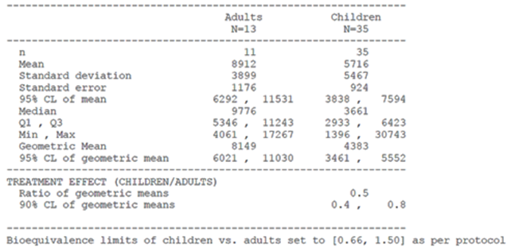

Table 13: Summary pharmacokinetics of bosentan in paediatric (BREATHE-3 and FUTURE-1) and adult (Study AC-052-357) PAH patients

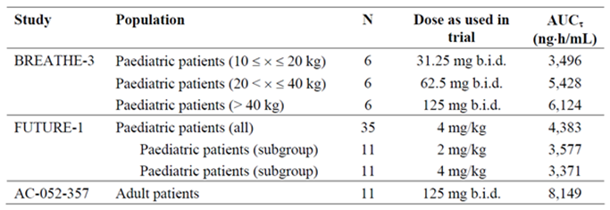

The FUTURE-3 Study compared BD and TDS administration of 2 mg/kg bosentan in the paediatric population. The increased dose frequency did not increase systemic exposure to bosentan (Figure 4, Table 14). Table 15 indicates that corrected Cmax (CmaxC) and corrected AUC (AUC0-24C) were much lower in children < 2 years of age compared to those ≥ 2 years of age. This result is important to consider given the proposal to expand the dosing instructions to include patients between one and three years of age. It is unclear why 95% CI rather than 90% CI were calculated for the ratio of geometric means for various PK parameters.

Figure 4: FUTURE-3 Arithmetic mean plasma concentration (± SD) versus time profiles of bosentan (TDS (n = 27) and BD (n = 31)) on a linear and semi-logarithmic scale, dose corrected, overall age group at Week 4, PK set

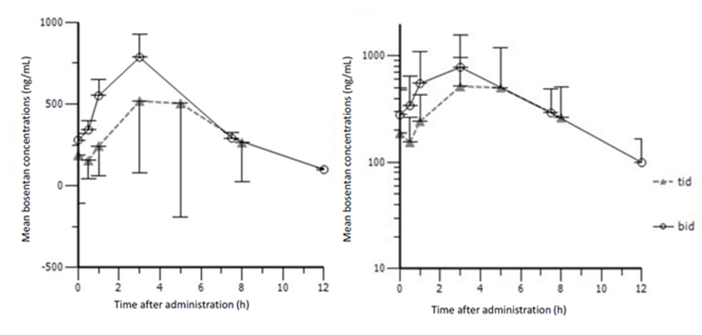

Table 14: FUTURE-3 Ratio of geometric means between treatment groups of PK parameters for bosentan (TDS/BD); overall age groups and by age group, PK set

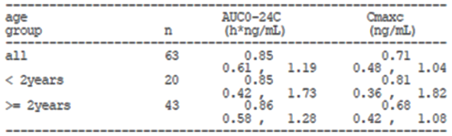

Table 15: FUTURE-3Summary of bosentan PK parameters per treatment group; by age group, PK set

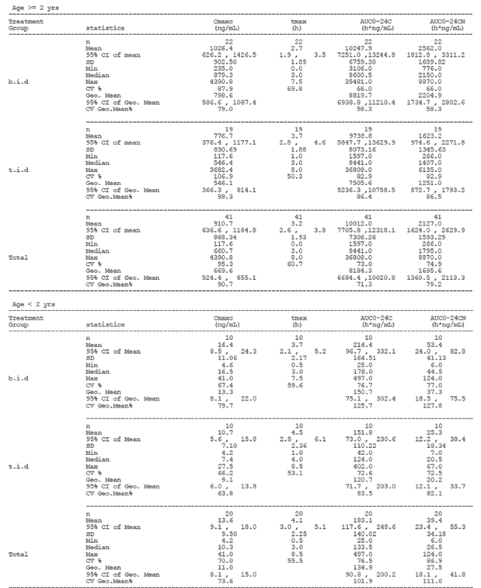

The FUTURE-4 Study in neonates with PPHN found that the bosentan PK profile was characterised by a slow and continuous increase in concentration over the first dosing interval (Figure 5). On Day 5, the pre-dose mean bosentan concentration was similar to that measured at the end of the dosing interval, suggesting the attainment of steady state conditions. Bosentan exposure remained variable on Day 5 but was reported to be similar to the exposure observed in adult PAH patients administered with 125 mg bosentan BD (Table 16). The sponsor states that the high bosentan PK variability observed in PPHN patients might be explained by several factors known to affect the absorption of oral drugs in neonates such as slower gut transit time due to delayed gastric emptying and reduced motility, mucus in the stomach, and gastric pH modifications.

Figure 5: FUTURE-4 Arithmetic mean whole blood concentration versus time profiles of bosentan and its metabolites on Day 1 (n = 11) and Day 5 (n = 7) on a linear scale, 2 mg/kg dose-corrected concentrations; PK analysis set

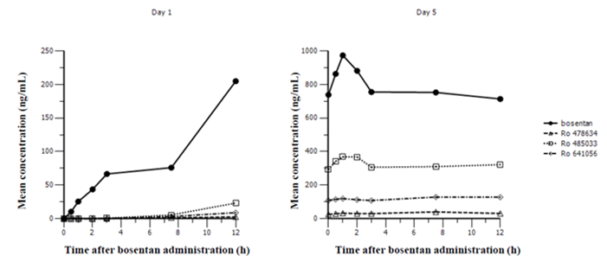

Table 16: FUTURE-4 Summary of bosentan; and metabolites Ro 47-8634, Ro 48‑5033, and Ro 64‑-1056, PK analysis set

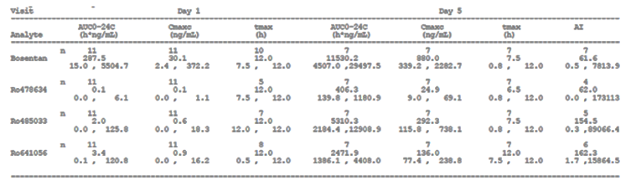

As outlined above the sponsor and EMA came to an agreement regarding the extrapolation of the treatment effect of bosentan from adults to children across age groups provided similar plasma concentrations are reached. The sponsor states that based on this agreement and following the ICH E11 Guideline;[6] the following studies were considered adequate to obtain approval for the dispersible formulation of bosentan in the EU:

* Study AC-052-365 (FUTURE-1)
* Physiologically-based pharmacokinetic modelling of bosentan with application to paediatric patients
* Study AC-052-116
* Study AC-052-373 (FUTURE-3 PopPK): Population pharmacokinetics of bosentan in children with PAH.

The referenced guideline states:

* The relevance of efficacy data obtained in adults for the paediatric population for systemically acting drugs depends on a number of factors such as the aetiology and course of the disease, as well as the mechanism of action of the drug in adult and paediatric patients. Provided that data from adults are considered relevant, pharmacokinetic information can be used to extrapolate efficacy to the paediatric population.
* If similar exposure in adult and paediatric patients can be assumed to produce similar efficacy, pharmacokinetic data alone can be used to extrapolate efficacy.
* If a similar relationship between concentration and clinical efficacy cannot be assumed, paediatric PK/PD (biomarker) data can be used to extrapolate efficacy. In this case, the predictability of the biomarker should have been documented. If this has been performed in adults only, its value for the paediatric population should be adequately justified. Evaluation of the PK-PD relationship in dose-ranging studies or multiple dose level studies is encouraged; as such information may be very valuable for dose-selection.

Assuming the features of PAH are similar in adults and children, the submitted studies have failed to demonstrate similar exposure in adult and paediatric patients. It is therefore difficult to extrapolate efficacy to the paediatric population. Based on the findings obtained at 2 mg/kg and 4 mg/kg, it is unlikely that increasing the dose of bosentan beyond 2 mg/kg in paediatric patients in a BD regimen will result in increased exposure to bosentan.

Whilst bosentan does not have a specific approved indication for the paediatric population the PI notes that there is limited experience with its use in children and provides dosage instructions for children aged three years and over. The PI notes that ‘*Although the number of patients studied in each dose group was generally insufficient to establish the optimal dosing regimen*’. As noted above, the bosentan exposure in the FUTURE-1 Study fell within the range seen in the BREATHE-3 Study but it is difficult to compare the patient populations based on the information provided in the submission.

It is noted that the PI states that the adult formulation of bosentan can be taken with or without food and that in healthy volunteers ‘*at a dose of 125 mg, administration of Tracleer with food did not have a significant effect on the extent of absorption but did increase the rate, leading to a 20% increase in peak plasma concentrations of bosentan. This is not expected to be clinically significant.*’ The guideline on bioequivalence states that:

* However, for products with specific formulation characteristics (for example microemulsions, solid dispersions), bioequivalence studies performed under both fasted and fed conditions are required unless the product must be taken only in the fasted state or only in the fed state.

This position is supported by the FDA draft guidance on bosentan which recommends two single dose, two way, crossover studies in order to establish bioequivalence. It is unclear why bioequivalence studies have not been conducted for the adult and paediatric formulations in both the fed and fasted state.

### Pharmacodynamics

#### Studies providing pharmacodynamic data

No pharmacodynamics studies were included in the submission.

### Dosage selection for the pivotal studies

No dose selection studies were included in the submission.

### Efficacy

#### Studies providing efficacy data

The following studies included in the submission had a primary efficacy outcome:

* Study AC-052-391 (FUTURE-4)

The following studies included in the submission had exploratory efficacy outcomes:

* Study AC-052-365 (FUTURE-1)
* Study AC-052-367 (FUTURE-2)
* Study AC-052-373 (FUTURE-3)
* Study AC-052-374 (FUTURE-3 Extension)

For the full evaluation report on efficacy please see Attachment 1: Extract from the Clinical Evaluation Report.

#### Evaluator’s conclusions on efficacy

The FUTURE-4 Study did not identify a benefit in adding bosentan to iNO therapy in neonates with PPHN who had not responded adequately to iNO. The sponsor has not requested an extension of indication for PPHN or changes to the dosage and administration instructions to include this age group.

The analyses of efficacy included in this submission were otherwise exploratory. The sponsor states that overall the outcomes of the efficacy variables from the paediatric PAH studies were consistent with the known effect of bosentan in adults as:

* The majority of patients (> 90%) showed improved or stable clinical condition (WHO functional class (FC) and global clinical impression scale (GCIS)) over a 6 month treatment period. Less than 10% showed deterioration during the same period.
* Kaplan-Meier (KM) event free estimates of worsening of PAH (defined as time to first occurrence of death, lung transplantation or hospitalisation for PAH worsening) over the short term period of 6 months was 88.1% (FUTURE-1 and 2) versus 96.8% (FUTURE-3). Over the long term treatment period in the FUTURE-1 and 2 Study, the KM event free estimate of worsening of PAH was 78.9% at 2 years and 73.6% at 4 years.

The sponsor states that favourable efficacy results were found at the bosentan exposures achieved with both the adult tablet formulation and with the paediatric tablet formulation used in Studies FUTURE-1 and FUTURE-2. In the FUTURE-3 Studies those on BD dosing tended to have worse outcomes than those on TDS dosing. These results may due to the imbalance in disease severity at Baseline. The sponsor states that there is no additional clinical benefit in increasing the frequency of bosentan dosing. The rationale for not increasing the dose frequency to TDS dosing with respect to these efficacy outcomes should be clarified.

The sponsor has proposed changing the dosage and administration instructions to include patients one year of age and over. The current dosage instructions provide advice for patients aged three years and over. The FUTURE series of studies included patients less than three years of age but the total number of patients in this age group remains small. It is unclear whether the number of patients aged between one and three years of age is sufficient to recommend a change to the dosage instructions.

### Safety

#### Studies providing safety data

Pivotal studies that assessed safety as the sole primary outcome:

* Study AC-052-367 (FUTURE-2)
* Study AC-052-374 (FUTURE-3 Extension)
* Study AC-052-392 (FUTURE-4 Extension)

Pivotal and/or main efficacy studies:

* Study AC-052-391 FUTURE-4

Other studies:

* Study AC-052-116
* Study AC-052-365 (FUTURE-1)
* Study AC-052-373 (FUTURE-3).

#### Patient exposure

The following summaries of patient exposure were provided. Patient exposure in the BREATHE-3, FUTURE-1 and FUTURE-2 Studies are summarised in Table 17.

In the FUTURE-3 Study the mean (± SD) exposure duration to bosentan was similar in the BD group (23.6 ± 3.71 weeks) and TDS group (23.3 ± 5.02 weeks). The mean daily dose (± SD) was 3.6 ± 0.42 mg/kg/day in the BD group and 6.0 ± 3.78 mg/kg/day in the TDS group.

In the FUTURE-3 Extension study the majority of patients (57.6% BD, 54.8% TDS) had at least 72 weeks of exposure to bosentan. The cumulative mean (± SD) exposure duration to bosentan was 64.1 ± 3.38 weeks in the BD group and 60.4 ± 4.20 weeks in the TDS group.

In the FUTURE-4 Study the median exposure (days, minimum to maximum) was similar in the bosentan (4.5 days, 0.5 to 10.0 days) and placebo groups (4.0 days, 2.5 to6.5 days). Approximately 60.0% of patients in both groups had at least 4 days of exposure to the study drug (Table 18).

No treatment was administered as part of the FUTURE-4 Extension study.

Table 17: Summary to support EMEA Variation 39; summary of overall bosentan exposure for paediatric studies

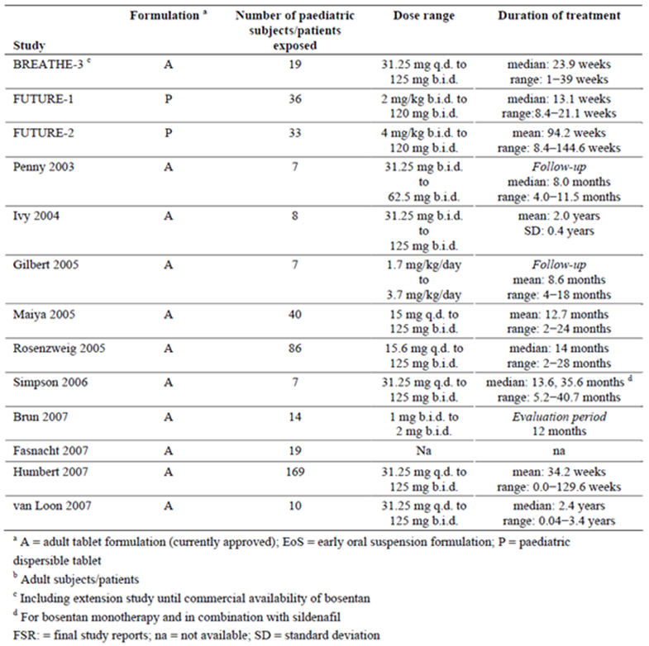

Table 18: Summary to support EMEA Variation 66; summary of study treatment exposure, FUTURE-4 PPHN safety analysis set

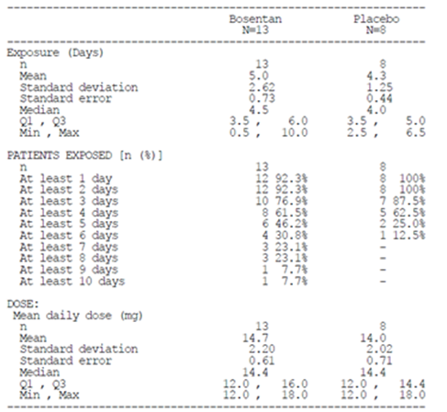

For further details regarding exposure and safety please see Attachment 1: Extract from the Clinical Evaluation Report.

#### Post marketing data

The 20thPSUR for bosentan has been included in the submission as a report of post marketing experience. The report summarises the safety data during the reporting period between 20 November 2013, to 19 November 2014 and cumulatively. The international birthdate (IBD) for bosentan is 20 November 2001.

[information redacted] Table 19 lists the important safety concerns outlined in the EU RMP at the beginning of the reporting period. As part of a Type II variation to include in the EU Product Information the data generated in the paediatric studies with bosentan, an updated version of Tracleer’s EU SmPC and bosentan’s RMP received CHMP Positive Opinion on 20 November 2014, after the data lock point of this PSUR. Important missing information ‘Use in children’ was removed, and the important concerns outlined in Table 20 were added to the list of safety concerns.

Following review of the 19th PSUR for bosentan, the PRAC Rapporteur requested cumulative safety reviews of:

* ascites (with a particular emphasis of cases associated with liver disorders);
* nasal congestion;
* the risk of fall which may be due to hypotension and syncope with a particular emphasis in cases resulting in injury; and
* autoimmune hepatitis (AIH).

The sponsor was requested to provide a cumulative safety review of all signals considered ongoing further to the finalisation of this PSUR assessment procedure (that is, DRESS and other severe cutaneous reactions, concomitant administration of bosentan and methotrexate and hepatotoxicity, hepatocellular carcinoma, cardiac disorders without PAH, blurred vision, arthralgia/myalgia and pain, menstrual disorders/vaginal haemorrhage).

Based on the cumulative reviews requested by the PRAC Rapporteur, the sponsor proposes to update the adverse drug reaction (ADR) table of the SmPC to state (new text in bold): ‘*Aminotransferase elevations associated with hepatitis* ***including possible exacerbation of underlying AIH in patients with autoimmune* *diseases*** *and/or jaundice’.* In addition ‘nasal congestion’ is to be added as a ‘common’ event under the ‘Respiratory, thoracic and mediastinal disorders’ system organ class (SOC). In addition, ‘symptomatic hypotension’ will be added as an important potential risk to the RMP.

The nature and severity of the reported events from all sources reflect the known safety profile of bosentan and the high morbidity and/or mortality of the underlying PAH and connective tissue disease. The events described in this report are not believed to present an increased risk to patients. A risk minimisation programme focusing on risk communication and education to prescribers remains in place for bosentan through controlled distribution, as per local requirements, including in the European Economic Area (EEA) and US.

The report states that given the efficacy data, which are consistent between clinical studies and marketed use, and the well-characterised safety profile, the benefit-risk profile of bosentan remains unchanged, and is favourable for its use in accordance with the approved product information.

Table 19: PSUR 20 Summary of safety concerns at the beginning of the PSUR reporting period

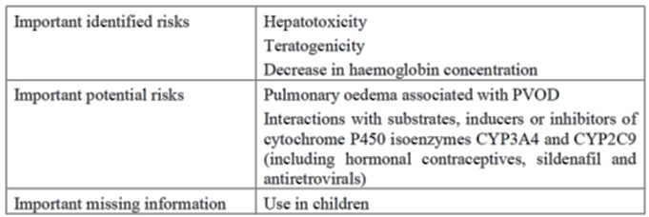

Table 20: PSUR 20 New important identified and potential risks added to the RMP after the data lock point

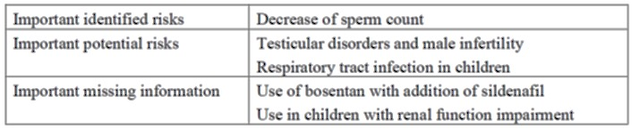

#### Ascites

Cumulatively, during the 13 years of post-marketing experience, the estimated reporting rate of ascites was low (0.3%). In most cases, including those containing an hepatobiliary event/investigation, ascites occurred in the context of progressive PAH disease and associated comorbidities, including RHF, fluid retention, and autoimmune rheumatoid diseases. In a few cases with complex medical history, multiple co-morbidities and therapies, a contribution of bosentan to the underlying hepatic event was difficult to establish. The current Company Core Data Sheet (CCDS) describes ‘uncommon’ hepatitis and/or jaundice, and rare cases of unexplained hepatic cirrhosis or liver failure.

Considering the above, the absence of a non-clinical signal, and the observed similar incidence of ascites in placebo and bosentan treated patients in the 20 placebo controlled studies in various indications, a causal relationship between bosentan and ascites was deemed unlikely.

#### Nasal congestion

The pooled safety data from 20 placebo controlled clinical studies with bosentan were analysed. The overall incidence of nasal congestion (preferred term (PT)) was 1.7% (43 out of 2486) in patients on bosentan and 1.2% (22 out of 1838) in patients on placebo.

The safety database held seven serious adverse event (SAE) cases that included the PT ‘nasal congestion’ have been received from clinical studies, including 2 cases pertaining to patients receiving placebo. Of the 5 cases reported on bosentan, none was assessed as related to study medication; none resulted in changes in medication, and all resolved. Two cases were reported for paediatric patients with PAH, an 8 year old girl who had been switched from bosentan to ambrisentan 2.5 weeks before onset of lobar pneumonia and concomitant nasal congestion and a 1 year old boy with trisomy 21 in a context of adenoviral upper respiratory infection.

Cumulatively, since IBD, 1255 cases were retrieved with an event of nasal congestion. Bosentan was withdrawn or interrupted in 184 cases and the dose was reduced in 14 cases (not necessarily related to the event of nasal congestion). The outcome of nasal congestion was reported in 58 of these 198 cases, being resolved or improved in 48 and not resolved in 10 cases. Outcome was not reported /unknown in the remaining 140 cases. In 1,001 cases it was reported that bosentan was maintained unchanged, and 123 of these cases had an outcome reported for nasal congestion: resolved or improved in 80 cases, not resolved in 43, and worsened in 2 cases. Outcome was not reported /unknown in the remaining 876 cases. Dose was increased in 2 cases (outcome not reported/ unknown), and action taken was unknown in 54 cases with outcome resolved or improved in 12 cases, not resolved in 2, and not reported/ unknown in the remaining 40 cases. A positive rechallenge including nasal congestion was reported for 4 cases. In 10 other cases with ‘positive rechallenge’ indicated in Argus, rechallenge referred to different events reported within the same case.

Based on the above evaluation, ‘nasal congestion’ was identified as a signal, which was closed during the current review period and classified as an ADR. The sponsor proposes to add ‘nasal congestion’ to the ADR table in the SmPC, as a ‘common’ event under the ‘Respiratory, thoracic and mediastinal disorders’ SOC. The CCDS will be updated accordingly.

#### Fall

In the 20 integrated placebo controlled trials hypotension was reported at a lower incidence in bosentan treated patients (5.8%) than in placebo treated patients (6.5%). In the PAH subset, the incidence on bosentan (3.2%) was similar to that on placebo (3.0%). Syncope was reported at a lower incidence in bosentan treated patients (2.3%) than in placebo treated patients (3.1%). In the PAH subset, the incidence of syncope on bosentan (4.1%) and placebo (4.0%) was similar. The incidence of syncope reported as a SAE was 1.0% on bosentan and 1.6% on placebo in the overall pool. A few patients discontinued treatment due to syncope (4 patients [0.2%] on bosentan and 2 patients (0.1%) on placebo). The distribution of events of fall and injuries is shown in Table 21.

Table 21: PSUR 20 Summary of selected TEAEs potentially associated with fall and events of injury in the overall pool and for the approved indications

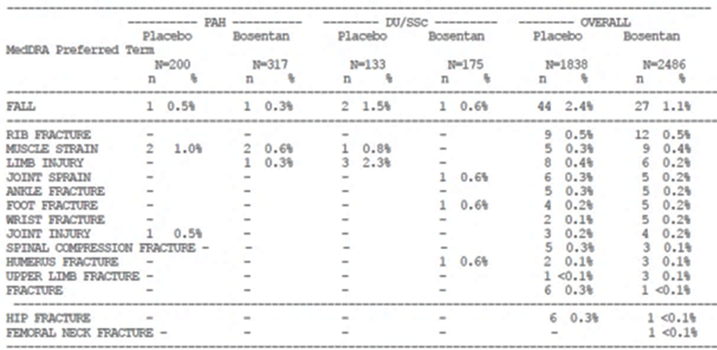

Falls were reported at a lower incidence in bosentan treated patients (1.1%) than in placebo treated patients (2.4%). In the PAH and DU/SSc subsets, the observed incidence of falls in patients treated with bosentan was 0.3% and 0.6%, respectively, and in the placebo treated patients 0.5% and 1.5%, respectively. Rib fracture was the most commonly reported injury event, reported in 0.5% of bosentan and placebo treated patients, followed by muscle strain and limb fracture.

The safety database contained 42 case reports containing an event of fall (2 case reports pertained to 1 patient) in bosentan treated patients from completed or ongoing clinical trials.

There were 1486 post market case reports pertaining to 1365 patients containing an event of fall were received, giving an estimated reporting rate of 1%. The majority of the cases (91.7%) were solicited through observational (non-interventional) post marketing surveillance (PMS) programmes. The majority of cases (81.9%) with an event of fall pertained to female patients; 70.9% of the cases pertained to the elderly, and 28.3% to adults. A total of 230 cases (pertaining to 224 patients) contained an event of fall and events denoting hypotension and/or syncope, representing an estimated reporting rate of 0.2% (230 cases / 147,197 exposed patients). In cases with events of fall and events denoting hypotension or syncope there were 90 cases with 120 events of injury. The most commonly reported events of injury included head/face injury and lower limb injury/fracture. There were 140 cases with events of fall, events denoting hypotension and/or syncope and without events of injury were retrieved from the safety database.

There were 1,256 cases (pertaining to 1,172 patients) contained an event of fall without events denoting hypotension and/or syncope and 573 of the 1,256 cases contained events of fall and injury. In the 573 cases, 703 events of injury were reported. The most commonly reported events of injury were lower limb fracture, mainly hip fracture (100), followed by head/face injury and upper limb fracture.

The latency of fall occurrence varied from less than 1 month following treatment initiation to up to more than 5 years. The date of fall occurrence and the date of bosentan initiation were available only in 314 of the 1,486 cases, including 44 cases with events of hypotension/syncope. Of the 314 cases the latency was shorter than 1 year in 129 cases (including 23 cases with a latency of up to 1 month) and longer than 1 year in 185 cases. The sponsor considers the long latency (> 1 year) in about 58.9% of cases with the available information to suggest that the occurrence of falls might be due to the underlying PAH disease and associated comorbidities and the age, gender, and the physical, cognitive and effective capacities of the patients.

The estimated reporting rate of fall is reported to be within the expected rate of fall for the general population and also the PAH patient population. The sponsor proposes updating the RMP to include symptomatic hypotension as an important potential risk.

#### Autoimmune hepatitis

Cumulatively, 51 cases containing an event of AIH have been reported from Development IBD (28 September 1993) up to the cut-off date for this PSUR. Four cases originated from clinical trials and 47 cases were reported from post marketing sources (Figure 6). Of the clinical trial reports, one case was from a placebo controlled study and the other three cases were reported from non-controlled open label studies with bosentan. One case involved a paediatric patient.

A total of 47 cases of AIH were received from post marketing sources. Since IBD, an estimated 147,197 patients have been exposed to commercial bosentan, giving an estimated reporting rate of AIH of 0.03%. The age ranged from 7 years to 83 years. 28 patients were adult and 18 were elderly (aged 65 years or more). One case pertained to a 7 year old female patient.

Figure 6: PSUR 20 Cases of autoimmune hepatitis

Figure 6: PSUR 20 Cases of autoimmune hepatitis
51 cases with reported events of autoimmune hepatitis
47 cases from postmarketing sources, 4 cases from interventional clinical trials.
Poastmarketing cases included 24 from postmarketing surveillance; 16 spontaneious report cases, 2 regularoty authority cases; 1 compassionate use case and 4 literature reports cases. 

#### Evaluator’s conclusions on safety

The sponsor has not requested an extension of indications to include neonates with PPHN and benefit was not demonstrated in this population. The results of the FUTURE-4 Extension study did not identify concerns regarding patient growth at 12 months follow‑up. It should be noted that the median duration of exposure was limited at 4.5 days (range 0.5 to 10.0 days).

The integrated analysis indicates that the majority of patients experienced TEAEs (87%) with a large proportion leading to a discontinuation of study treatment (17%). Adverse events (AEs) resulted in a fatal outcome in 14% of study participants. The most commonly reported TEAEs are described in the current Tracleer PI. The sponsor states that AE rates in PAH populations are generally high due to the severity of the condition, and ranged from approximately 60 to 90% in sponsored studies. AEs of specific interest to bosentan, such as elevated liver enzymes, decreased blood haemoglobin, and fluid retention, were stated to be reported at lower incidences in paediatric patients compared with adult patients.

The sponsor has stated they intend to add symptomatic hypotension to the list of important potential risks in the RMP. The RMP included in the submission does not include this important potential risk.

The sponsor has added nasal congestion to the PI as a common post market AE. As outlined above, PSUR 20 states that the sponsor intends to update the ADR table of the EU SmPC and the CCDS to *include autoimmune hepatitis.* Similar changes have not been proposed for the Australian PI with this submission.

### First round benefit-risk assessment

#### First round assessment of benefits

Indication:

* idiopathic pulmonary arterial hypertension
* familial pulmonary arterial hypertension
* pulmonary arterial hypertension associated with scleroderma or
* pulmonary arterial hypertension associated with congenital systemic to pulmonary shunts including Eisenmenger’s physiology

in patients with WHO Functional Class II, III or IV symptoms.

Table 22: First round assessment of benefits, strengths and uncertainties

| **Benefits** | **Strengths and Uncertainties** |
| --- | --- |
| The availability of a paediatric weight based formulation of bosentan. | The new formulation would allow for more precise weight based dosing of bosentan in the paediatric population. The tablet can be broken into 8 mg quadrants for administration. |
| A dispersible tablet formulation would allow for easier administration in the paediatric population. | The availability of a dispersible tablet would provide an easy to prepare and administer formulation. The product could potentially reduce reliance on compounded products or other measures used to make the adult formulation palatable for the paediatric population. |
| A dispersible tablet formulation could potentially be used in any PAH patient unable to take the adult formulation (for example swallowing difficulties). | The dispersible tablet formulation could potentially be used in adult or adolescent patients. Bioequivalence has not been established between the two formulations and the PI notes that ‘A pharmacokinetic comparison between the dispersible and the film coated tablet indicated slightly lower exposure to bosentan with the dispersible tablet in adult subjects’. The PI recommends the dispersible tablet formulation be reserved for patients who cannot take the film coated tablet. |
| Improved quality | The availability of a registered product that can be prepared as an oral solution may reduce reliance on compounded products and provide a better assurance of quality. |

#### First round assessment of risks

Table 23: First round assessment of risks

| **Risks** | **Strengths and Uncertainties** |
| --- | --- |
| Bioequivalence between the adult and paediatric formulations has not been demonstrated. | The submission relies on the bioequivalence of the adult and paediatric formulations in order to infer efficacy for the paediatric formulation. Study 052-116 did not demonstrate bioequivalence with respect to either of the PK parameters AUC or Cmax. The adult formulation of bosentan is currently available for use in the paediatric population in Australia. It has not been established that the two formulations are bioequivalent therefore efficacy cannot be inferred. In addition, the effect of the fed state on bioequivalence has not been investigated and the bioequivalence of an oral solution to the adult formulation has not been established. |
| Efficacy has not been established for the dispersible tablet formulation in the paediatric population. | The dispersible tablet formulation has been studied in the paediatric PAH population but the efficacy endpoints were exploratory. Efficacy has been established in adult patients with the adult tablet formulation. The EMA came to an agreement with the sponsor that the PAH condition is similar between adults and children and efficacy could be inferred if similar PK properties were established. However, bosentan exposure in the paediatric population was about half that seen in adults. In addition bioequivalence with the approved formulation has not been established. These factors make it difficult to infer in the paediatric population. |
| The optimal dosage regimen for paediatric patients with PAH has not been established. | A plateau in systemic exposure suggests that increasing the dose beyond 2 mg/kg or the frequency of dosing beyond twice daily will not increase exposure to bosentan. It is noted that the safety and efficacy of the 2 mg/kg dose for the paediatric population has not been established. Whilst it is anticipated that no additional benefit will be gained from doses above 2 mg/kg it is unclear whether this is the optimal dose with respect to safety and efficacy in the paediatric population. |
| The efficacy of bosentan for children aged between one and three years of age has not been established. | Exposure to bosentan is lower in the paediatric PAH population compared to adults with PAH. The FUTURE-3 Study found that Cmaxc and AUC0-24C were lower in children < 2 years old compared to those ≥ 2 years old. It is unclear whether there is enough data to support changing the dosing instructions to include patients aged between one and three years of age. |

#### First round assessment of benefit-risk balance

Study AC-052-116 failed to demonstrate bioequivalence of the dispersible tablet formulations and the approved marketed formulation in the healthy adult population and therefore bioequivalence in children cannot be assumed.

The BREATHE-3 and FUTURE-1 Studies found a lower exposure to bosentan in paediatric patients compared to adult patients. This result may indicate an exposure plateau occurring at lower doses in paediatric patients. The FUTURE-3 Study found that TDS administration of 2 mg/kg bosentan did not increase systemic exposure to bosentan in the paediatric population. Therefore, it is difficult to extrapolate efficacy data from adults with PAH to the paediatric PAH population.

### First round recommendation regarding authorisation

Approval of the dispersible tablet formulation of bosentan is not recommended for:

* idiopathic pulmonary arterial hypertension
* familial pulmonary arterial hypertension
* pulmonary arterial hypertension associated with scleroderma or
* pulmonary arterial hypertension associated with congenital systemic to pulmonary shunts including Eisenmenger’s physiology

in patients with WHO Functional Class II, III or IV symptoms.

Approval cannot be recommended at this time as the bioequivalence of the new formulation to the approved formulation has not been established and the similar exposure was not demonstrated in the adult and paediatric populations making the extrapolation of efficacy data difficult.

### Clinical questions and second round evaluation of clinical data submitted in response to questions

For details of the clinical questions, the sponsor’s responses and the evaluation of these responses please see Attachment 1.

### Second round benefit-risk assessment and recommendation regarding authorisation

After consideration of the responses to clinical questions, the benefits of Tracleer in the proposed usage are unchanged from those identified in the first round benefit-risk assessment.

The second round recommendation regarding authorisation is the same as that of the first round.

## VI. Pharmacovigilance findings

### Summary

The sponsor has applied to register a new oral solid dosage form (dispersible tablet) and strength (32 mg) of bosentan suitable for administration to the paediatric population for the currently approved indications. The proposed starting and maintenance dosage for paediatric patients aged 1 year or older is 2 mg/kg morning and evening.

The sponsor has submitted EU-RMP version 9 (10 February 2016; DLP 19 November 2013) and ASA version 1.0 (31 March 2016) in support of this application. No RMP was required at the time of registration in 2002 for pulmonary arterial hypertension (62.5 mg and 12 5mg tablets). No updated EU-RMP or ASA was submitted in the sponsor’s response.

The proposed Summary of Safety Concerns and their associated risk monitoring and mitigation strategies are summarised below:

Table 24: Summary of safety concerns

|  |  |  |  |  |  |
| --- | --- | --- | --- | --- | --- |
| Summary of safety concerns | | Pharmacovigilance | | Risk Minimisation | |
| Routine | Additional | Routine | Additional |
| **Important identified risks** | Hepatotoxicity | ✓ | – | ✓ | ✓ |
| Teratogenicity | ✓ | – | ✓ | ✓ |
| Decrease in haemoglobin concentration | ✓ | – | ✓ | ✓ |
| Decrease of sperm count |  | – |  | ✓ |
| **Important potential risks** | Pulmonary oedema associated with PVOD | ✓ | – | ✓ | – |
| Interactions with substrates, inducers or inhibitors of cytochrome P450 isoenzymes CYP3A4 and CYP2C9 (including hormonal contraceptives, sildenafil and antiretrovirals) | ✓ | – | ✓ | ✓ |
| Testicular disorders and male infertility | ✓ | – | ✓ | – |
| Respiratory tract infection in children | ✓ | – | ✓ | – |
| **Missing information** | Use of bosentan with the addition of sildenafil in children | ✓ | – | ✓ | – |
| Use in children with renal function impairment | ✓ | – | ✓ | – |

* An additional pharmacovigilance activity is a non-interventional observational Study AC-052-516 (Disease characteristics and outcomes of PAH in children and adolescents in real world clinical settings: Systematic review of four prospective, observational registries). This study collects further data on long-term safety and outcomes in paediatric patients with PAH, which is not an identified safety concern.
* The additional risk minimisation activity is a Patient Reminder Card containing information about blood tests and contraception which will be included in each pack of dispersible tablets. This is already inserted into the packs of 62.5 mg and 125 mg film coated tablets.
* A ‘Tracleer Prescribing and Monitoring Booklet’ already exists and is not considered by the sponsor to be an additional risk minimisation activity, and therefore has not been included as part of this RMP.

#### Wording for conditions of registration

Any changes to which the sponsor has agreed should be included in a revised RMP and ASA. However, irrespective of whether or not they are included in the currently available version of the RMP document, the agreed changes become part of the risk management system.

The suggested wording is:

* Implement EU-RMP (version 9, dated 10 February 2016, data lock point 19 November 2013) with Australian Specific Annex (version 1.0, dated 31 March 2016) and any future updates as a condition of registration.

## VII. Overall conclusion and risk/benefit assessment

The submission was summarised in the following Delegate’s overview and recommendations.

### Background

The BREATHE-3 Study using the approved tablet formulation of bosentan in children showed a lower systemic exposure in children compared to the exposure in adults. The EMA considered that BREATHE-3 was insufficient to support a therapeutic indication in children because: the number of children exposed was too small; and the dose of bosentan used may have been suboptimal. The FUTURE program of studies was designed to address these deficiencies.

### Quality

The proposed product is a dispersible tablet intended for paediatric use and is packed in blisters with 14 tablets per blister strip and a total of 56 tablets per carton. The quality of the product is controlled by acceptable specification that includes tests and limits for appearance, colour, average mass (of 10 tablets), friability, uniformity of dosage unit by content uniformity, assay, degradation products, disintegration, fineness of dispersion and microbial contamination. The proposed release and expiry limits have been accepted. The analytical methods used to analyse the product were adequately described and validated. The flavouring agent used in the tablets is acceptable.

The stability data supplied supported a shelf life of 60 months for the unopened product when it is stored below 25°C and protected from light. An in-use shelf life of 7 days at room temperature has been not been accepted for the remaining portions of a quadrisected tablet. An in-use period of 48 hours is acceptable in the interim however, contingent on the sponsor conducting the additional in-use stability study in Q1 2017 committed to in the sponsor’s response to generate data on disintegration time and fineness of dispersion.

The sponsor has been asked to add the statement ‘Warning: causes birth defects’ to the labelling, rather than the sponsor’s proposed statement ‘Warning: Tracleer may cause birth defects’.

### Nonclinical

The nonclinical evaluator considered that toxicity study results support the use of bosentan in the paediatric population.

The safety of bosentan in the juvenile population was assessed in a dose range finding study and a toxicity study and fertility assessment in neonatal/juvenile Han Wistar rats. There are no major concerns for juvenile toxicity with respect to growth, development, cognitive, sensory and reproductive function. Reductions in testes and epididymal weight were noted in juvenile rats at similar to, or greater than, the expected clinical exposure levels (based on AUC). Reductions in sperm counts were noted in juvenile males (exposure margin about 6). While these specific findings have not been noted with bosentan for adult rats, testicular findings have previously been noted in adult rats with other endothelin receptor antagonists such as macitentan and [information redacted], and decreased sperm concentrations have been observed clinically with bosentan, warranting the inclusion of appropriate warnings in the PI and RMP.

### Clinical

The clinical evaluator recommended rejection of the submission on the basis that; Study AC-052-116 failed to demonstrate bioequivalence of the dispersible tablet formulation and the approved marketed formulation in the healthy adult population; the studies in the paediatric population presented in the submission had exploratory efficacy endpoints only; and it is difficult to extrapolate efficacy in children from studies in adults with PAH.

The clinical dossier included the following data:

* Two clinical pharmacology studies providing PK and safety pharmacology data
* Two population PK analyses
* Three uncontrolled studies of safety and efficacy
* Two supportive studies requested by the Delegate
* Two reports of analyses of data from more than one study
* One PSUR for the period 20 November 2013 to 19 November 2014
* 61 literature references

#### Pharmacology

In healthy adults, peak plasma concentration is attained 3.7 ± 1.7 hours after a single oral dose; half-life is 5.6 ± 1.6 hours. Clearance is 3.8 L/hour in PAH patients versus 8.8 L/hour in healthy adults. Bosentan is highly (> 98%) plasma protein bound. Absolute bioavailability of oral bosentan is 41%. Administration with food did not affect extent of absorption but did increase Cmax by 20%. Bosentan is metabolised in the liver by CYP2C9 and CYP3A4; bosentan also induces both these enzymes. After multiple dosing, plasma concentrations of bosentan are 50 to 65% of those seen after a single dose. Of three metabolites, one is pharmacologically active and may contribute 20% of the effect of bosentan.

##### Study AC-052-116

Study AC-052-116 was a single centre, open label, two period, two treatment, randomised, crossover study in 16 healthy adult (18 to 45 years) male subjects, comparing a single dose of the registered 62.5 mg film coated tablet with a single dose of 64 mg of bosentan administered as two of the proposed 32 mg dispersible tablets. Cmax and AUC values were dose-normalised. The 90% confidence intervals of the geometric mean ratios fell outside the 0.80 to 1.25 equivalence range for the majority of pharmacokinetic parameters considered (Table 11 above). The proposed dispersible tablet was less bioavailable than, and not bioequivalent to, the registered tablet.

##### FUTURE-1 Study

In FUTURE-1, exposure to bosentan in children was half that in an adult historical control population (geometric mean AUCτ in adults 8149 (95% CI 6021 to 11030), in children 4383 (95% CI 3461 to 5552), ratio 0.5 (90% CI 0.4 to 0.8)). Cmax was also about half that seen in adults; median time to maximum concentration (tmax) was 3 hours. Exposure to bosentan and its metabolites was similar after doses of 2 mg/kg BD and 4 mg/kg BD (AUCτ was 3577 ng.h/mL for 2 mg/kg and 3371 ng.h/mL for 4 mg/kg). Geometric mean Cmax was 583 ng/mL for 2 mg/kg and 649 ng/mL for 4 mg/kg. There was no effect of age on bosentan exposure in the paediatric population in this study.

##### FUTURE 3 Study

In FUTURE 3, daily exposure to bosentan was similar after doses of 2 mg/kg BD and 2 mg/kg TDS (geometric mean AUC0-24 8535 ng.h/mL for BD dosing and 7275 ng.h/mL for TDS dosing). Cmax was 29% lower with TDS dosing compared to BD dosing.

No new pharmacodynamic data was presented as part of this submission.

In the BREATHE-3 Study in 19 children aged 3 to 15 years, mean decrease in pulmonary vascular resistance with bosentan 2 mg/kg BD was 389 dyn.s.cm-5, which is comparable to that seen in adults in other studies.

#### Efficacy

##### FUTURE-4 Study

FUTURE-4 was a double blind study evaluating the PK, efficacy and safety of bosentan as add-on therapy to iNO in the management of neonates with PPHN. The study did not find a benefit in adding bosentan. The sponsor is not currently seeking an indication for PPHN, but this study was included in the submission as it provided additional safety data.

##### FUTURE-1 Study

FUTURE-1 was an open label uncontrolled study of bosentan in 36 children aged 2 to 11 years with idiopathic (N = 31) or familial (N = 5) PAH. Subjects received bosentan 2 mg/kg BD for 4 weeks, followed by 4 mg/kg for a median total study duration of 13.1 weeks. Efficacy endpoints were WHO Functional Capacity (WHO FC), Global Clinical Impression Scale (GCIS), and SF-10 quality of life questionnaire. At Week 12, of 23 patients in WHO FC II at Baseline, one worsened to FC III, two improved to FC I, and the others remained stable. Of 12 patients in WHO FC III at baseline, three improved to FC II, and the others remained stable. Of 21 bosentan-naïve patients, 12 were considered ‘better’ or ‘significantly better’ on the Physician’s GCIS scale, with none considered ‘worse’.

##### FUTURE-2 Study

FUTURE-2 was an extension of FUTURE-1, with subjects receiving bosentan 4 mg/kg for a median 2.3 years. Of 28 patients, at end of study or premature discontinuation, WHO FC improved in 11 (39%) and worsened in 2 (7.1%). Of 26 patients with evaluable data, Physician’s GCIS rating was improved in 17 (65%), unchanged in 7, and worsened in 2. The Kaplan-Meier estimate of probability of no worsening of PAH at 5 years was 63% (95% CI, 35 to 82%).

##### FUTURE-3 Study

FUTURE-3 was an open label, uncontrolled study of bosentan 2 mg/kg BD versus 2 mg/kg TDS in 64 children aged 3 months to 2 years (21 children) and 2 to 11 years (79 children). Median duration was 24 weeks. The primary objectives of the study related to PK; efficacy analyses were not powered to show differences between treatments. During the study, ten patients improved WHO FC (five from FC III to II and five from FC II to I) one worsened from FC III to IV; the remainder were stable. In terms of Physician’s GCIS, most patients remained stable (72.7% BD, 77.4% TDS) or improved (26.9% BD, 19.2% TDS); worsening was seen in 6.5% (BD) versus 6.7% (TDS). In an extension study of FUTURE-3, at 18 months WHO FC was unchanged in 78% of patients and improved in 9%. Physician’s GCIS was unchanged in 57% of patients at 18 months and improved in around 30%.

#### Safety

The integrated safety analysis covered 100 patients (21 aged under 2 and 79 aged 2 to 11). 85 patients received bosentan for at least 12 months, and 53 for at least 24 months. 87% experienced TEAEs, with 17% (mainly cardiovascular, respiratory and hepatic events) leading to discontinuation of study treatment. AEs resulted in death in 14% of study participants, most commonly due to cardiovascular and respiratory events. The most commonly-reported TEAEs in the paediatric age group are similar to those described in the current Tracleer PI, including URTI (25%), nasopharyngitis (17%), and pyrexia (14%). Adverse event rates in PAH populations are generally high due to the severity of the condition, and ranged from approximately 60 to 90% in sponsored studies. Adverse events of specific interest to bosentan, such as elevated liver enzymes, decreased haemoglobin, and fluid retention, were reported at lower incidences in paediatric patients compared with adult patients.

### Risk management plan

The Pharmacovigilance and Special Access Branch (PSAB) has accepted the EU-RMP (version 9, dated 10 February 2016, data lock point 19 November 2013) with Australian Specific Annex (version 1.0, dated 31 March 2016).

An additional pharmacovigilance activity is a non-interventional observational Study AC‑052-516 (‘Disease characteristics and outcomes of PAH in children and adolescents in real world clinical settings: Systematic review of four prospective, observational registries’). This study collects further data on long-term safety and outcomes in paediatric patients with PAH, which is not an identified safety concern. The additional risk minimisation activity is a Patient Reminder Card containing information about blood tests and contraception which will be included in each pack of dispersible tablets. This is already inserted into the packs of 62.5 mg and 125 mg film coated tablets. A ‘Tracleer Prescribing and Monitoring Booklet’ already exists and is not considered by the sponsor to be an additional risk minimisation activity, and therefore has not been included as part of this RMP.

The proposed Summary of Safety Concerns and their associated risk monitoring and mitigation strategies are summarised in Table 24 (above).

### Risk-benefit analysis

#### Pharmacology

Systemic exposure to bosentan in adults was lower with the dispersible tablet than with the registered product; the two formulations were not bioequivalent. Exposure to bosentan was significantly lower in children taking 2 mg/kg BD than in adults taking 125 mg BD: AUC ratio was 0.5 with non-overlapping 95% CI. Exposure in children was similar after doses of either 2 mg/kg TDS or 4 mg/kg BD compared to 2 mg/kg BD, possibly indicating an exposure plateau for children. Bosentan was not studied in children at a dose lower than 2 mg/kg BD.

#### Efficacy

Efficacy analyses in this submission were exploratory only (apart from the FUTURE‑4 Study in PPHN, for which the sponsor is not seeking an extension of indication). Overall, children with PAH showed improved or stable clinical condition (measured by WHO FC and GCIS) while on treatment with bosentan. Because of the pharmacology results seen in children, it is difficult to extrapolate efficacy data from adults with PAH to the paediatric PAH population.

#### Safety

The integrated safety analysis included 100 children exposed to bosentan, with over half treated for at least 24 months. The rate of adverse events was high, but consistent with the known adverse event profile of bosentan.

#### Data deficiencies

There were few children (21 out of 100) aged under 2 years included in the study set. Efficacy results from the FUTURE studies were exploratory only.

#### Conditions of registration

The following are proposed as conditions of registration and the sponsor is invited to comment in the Pre-ACM response:

* The implementation of the EU-RMP for Tracleer (bosentan) (version 9, dated 10 February 2016) with Australian Specific Annex (version 1.0, dated 31 March 2016).

#### Questions for the sponsor

The sponsor is requested to address the following issues in the Pre-ACM response:

1. Please provide an update of the regulatory status of Tracleer (for paediatric use) in the USA.
2. Please provide any additional available post marketing data (for example, PSURs) regarding use of Tracleer in children.

#### Delegate’s considerations

The primary issues with this submission are as follows:

1. The proposed dispersible tablet formulation is not bioequivalent to the currently registered formulation.
2. Exposure to bosentan in children is significantly lower than in adults, making it difficult to extrapolate efficacy from adults to children.
3. Efficacy analyses in children submitted as part of the current application were of an exploratory nature only.

#### Proposed action

The Delegate was not in a position to say, at this time, that the application for Tracleer should be approved for registration.

#### Request for ACPM advice

The committee is requested to provide advice on the following specific issues:

1. Are there sufficient children under the age of 2 years included in the study set in order to draw conclusions about use in this age group?
2. Can efficacy of bosentan in adults be extrapolated to its use in children?
3. Do the outcomes seen in the FUTURE studies provide adequate evidence for efficacy of bosentan in children?
4. Is there adequate safety data concerning the use of bosentan in children?

The committee is (also) requested to provide advice on any other issues that it thinks may be relevant to a decision on whether or not to approve this application.

#### Response from sponsor

There are three parts to this response:

* the sponsor’s comment on the Summary of Issues as raised by the Delegate;
* the sponsor’s comments on ACM advice sought by the Delegate; and
* responses to the Delegate’s ‘Questions for the sponsor.’

##### Sponsor’s comment on the summary of issues as raised by the delegate

The Delegate has raised three points as primary issues of concern from the submission, on which the applicant would like to comment as follows:

1. ***The proposed dispersible tablet formulation is not bioequivalent to the currently registered formulation.***

The application is not based on strict bioequivalence of the dispersible and film coated formulations. It is based on data from all paediatric PAH studies conducted with the 32 mg dispersible tablet (Studies AC-052-365 (FUTURE 1), AC-052-373 (FUTURE 3), and AC‑052-391 (FUTURE 4)), as well as data from 1 paediatric study (BREATHE-3) and selected adult studies conducted with the film coated tablet, and 1 bio-comparison (dispersible versus adult tablet formulations) study in healthy adult subjects (Study AC‑052-116). The administration of bosentan to paediatric PAH patients, using either the dispersible tablet at a dose of 2 or 4 mg/kg BD (Study AC-052-365, FUTURE 1) or the film coated tablet at approximately 2 mg/kg BD (Study AC-052-356,BREATHE-3) resulted in comparable plasma concentrations of bosentan (Table 25). Importantly, there were no indications from these studies of differences in the efficacy or safety profiles between the different tablet formulations in paediatric PAH patients (please also see the response to B2).

Table 25: Comparison of bosentan exposure in paediatric populations

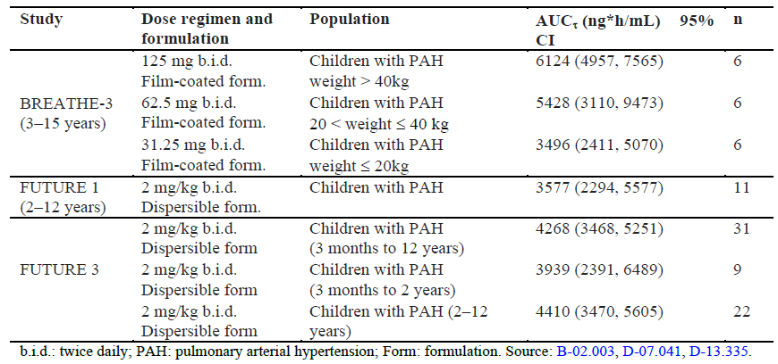

Study AC-052-116 was a bio-comparison study and was not statistically powered to conclude on bioequivalence of the dispersible and the film coated formulations. The ratios of the geometric means of Cmax, AUC0-t, and AUC0-∞ were within the conventional 0.8 to 1.25 equivalence interval. However, for the 3 parameters the lower boundary of the 90% confidence interval (CI) of the geometric mean ratio was outside the 0.8 to 1.25 interval (see Table 26).

Table 26: Effect of formulation on bosentan pharmacokinetics: Paediatric versus adult formulation

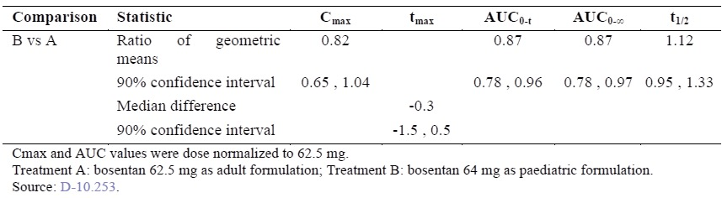

Considering the high inter-subject variability in exposure to bosentan observed in FUTURE 1 (dispersible formulation) and AC-052-356 (BREATHE-3), the slight decrease in exposure (Cmax and AUC) to bosentan after administration of the dispersible formulation in Study AC-052-116 is not expected to be clinically relevant in the intended target population of paediatric PAH patients.

Bridging from the clinical effectiveness of Tracleer in PAH demonstrated in adults to the paediatric population is justified due to:

* Similarity in the disease between adult and paediatric patients.
* Overlap of the exposure achieved in paediatric PAH patients with the film-coated and dispersible tablet formulations.
* Similarity in the decrease in pulmonary vascular resistance (PVR) observed in adult and paediatric PAH patients.

The effectiveness evaluation is based on the ‘bridging’ of data between the adult and paediatric studies, with a primary focus on PVR, but also taking into account other clinically relevant observations in these studies (WHO FC, time to disease worsening, etcetera). A summary of the exposure to bosentan in paediatric patients is provided below and the comparison of PVR in adult and paediatric PAH patients is detailed in the response to Question 2.

There is no appropriate paediatric formulation of an endothelin receptor antagonist approved in Australia. Prescribers wanting to use bosentan in paediatric PAH patients unable to swallow tablets must rely on pharmacists/parents to extemporaneously prepare an oral suspension of bosentan using the approved film coated tablet. The sponsor is of the opinion that the dispersible formulation supports a positive benefit/risk assessment in paediatric PAH patients down to 1 year of age.

1. ***Exposure to bosentan in children is significantly lower than in adults, making it difficult to extrapolate efficacy from adults to children.***

Acknowledging this fact, the current application is not seeking approval on the basis of PK extrapolation of efficacy from adults to children, but on the basis of similar haemodynamic responses in the two populations, accompanied with consistent clinical improvements.

1. ***Efficacy analyses in children submitted as part of the current application were of an exploratory nature only.***

Following the review of the FUTURE 1 and FUTURE 2 Studies by the EU CHMP, the FUTURE 3 and FUTURE 3 open label extension studies were conducted in agreement with the CHMP as post approval commitments to further explore the relationship between dose, dose frequency, and pharmacokinetics in paediatric PAH patients. Additional study objectives were to generate clinical data in children < 2 years of age. These exploratory clinical data are to be regarded as supportive to the hemodynamic data, which create a basis for the extrapolation of the efficacy in adults to the paediatric population.

The FUTURE 3 Study assessed the long-term safety, tolerability, and efficacy of the dispersible tablet formulation at doses of 2 mg/kg two versus three times a day in children with PAH. The uncontrolled FUTURE 3 Study was conducted in 64 PAH patients aged from 3 months to 12 years. The median exposure to study treatment was 24.1 (range; 6.0 to 26.4) weeks in the BD group and 24.3 (range: 0.4 to 28.7) weeks in the TDS group. In the FUTURE 3 Study, exposure to bosentan in patients treated with 2 mg/kg twice daily was comparable to that in the FUTURE 1 Study. Dosing bosentan 2 mg/kg TDS did not increase exposure, supporting the hypothesis that exposure to bosentan reaches a plateau. The efficacy analysis on the global population (64 patients) showed that the majority of patients had remained at least stable (that is, without deterioration) based on WHO functional class assessment (97% BD, 100% TDS) and physicians’ global clinical impression (94% BD, 93% TDS) during the treatment period. The Kaplan-Meier event free estimate for worsening of PAH (death, lung transplantation, or hospitalization for PAH worsening) at 24 weeks was 96.9% and 96.7% in the BD and TDS group, respectively. Collectively, these four studies (FUTURE 1, FUTURE 2, FUTURE 3 and its extension) were accepted by the EMA in fulfilment of the Paediatric Investigational Plan (PIP) and supported the inclusion of paediatric relevant wording in the SmPC.

##### ACM advice sought by delegate

The Delegate is seeking advice from the ACPM to four specific issues, on which the applicant would like to comment as follows:

1. ***Are there sufficient children under the age of 2 years included in the study set in order to draw conclusions about use in this age group?***

One of the objectives of the FUTURE 3 Study and its extension was to generate data in patients < 2 years of age. The protocol required that one third of the study population consisted of this population (21 out of 64 patients). This proportion, higher than in the PAH population in either other clinical studies or patient registries, was required in order to generate meaningful data in this age group.

Study results showed that the PK parameters of bosentan and its metabolites in patients < 2 years were consistent with those in patients ≥ 2 years. The majority of patients in age groups < 2 years and ≥ 2 years consistently showed a stable or improved clinical condition (assessed by WHO FC, GCIS, NT-pro-BNP, and indirectly by the number of PAH worsening events) with bosentan treatment. No new safety risks were identified in patients aged 3 months to < 2 years of age.

Based on these consistent results across age ranges, the dosage instruction information was amended to include patients aged between 1 and 3 years. Patients < 1 year of age were not included given their low number (N = 6).

In addition to the 21 out of 100 children treated in the clinical studies described above, there were 56 children < 2 years of age at the start of observation in the TOPP, REVEAL, and NL registries. A total of 23 of the 56 children were treated with Tracleer (Study AC‑052-516). Thus, the sponsor has provided information on a total of 44 children < 2 years of age in this application that were treated with bosentan. This is notable in an orphan indication, such as PAH, where paediatric patients are rare.

1. ***Can efficacy of bosentan in adults be extrapolated to its use in children?***

Given the similarities in disease characteristics and treatment response, as well as the observed overlapping plasma exposure to bosentan following administration of the film coated and the dispersible tablet formulations, the sponsor is of the opinion that there is adequate data to support the extrapolation of effectiveness observed in adults to the paediatric population. Clinical and haemodynamic characteristics of PAH, and the therapeutic response to PAH specific treatments, are similar in adults and children. Studies conducted to support effectiveness of bosentan using haemodynamic variables in adult (Studies AC-052-351, AC-052-364, AC-052-355 and AC-052-405) and paediatric (AC‑052‑356) PAH patients show similar improvement in both populations after administration of the film-coated tablet formulation. Both the AC-052-356 paediatric study and the four adult PAH studies included a spectrum of disease severity (WHO FC II to IV), and patients with and without background treatment (Table 27).

Table 27: Overview of paediatric and adult PAH studies considered for effectiveness bridging

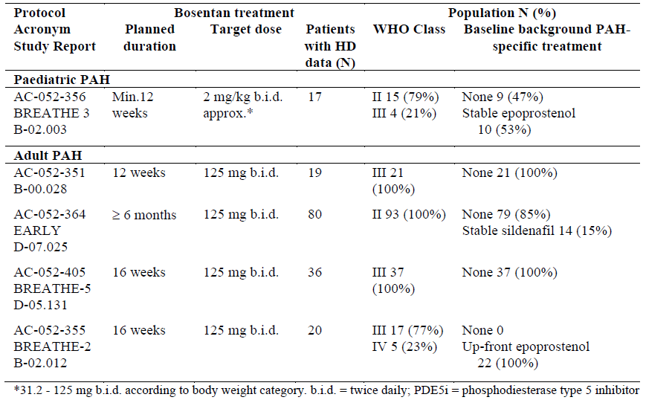

Study AC-052-356 in 19 paediatric PAH patients (WHO FC II and III) showed significant improvement in PVR after administration of bosentan film coated tablets at approximately 2 mg/kg BD (mean change from baseline: ‑389 (95% confidence interval (CI): ‑706, ‑72) dyn*sec/cm5). This effect is comparable in magnitude to the improvement in PVR observed in the active arms of placebo controlled adult PAH studies: mean change from baseline ‑223 (95% CI: ‑341, ‑106) dyn*sec/cm5 in Study AC-052-351 (WHO functional Class III and IV treatment-naïve patients), ‑69 (95% CI: ‑175, 36) dyn*sec/cm5 in Study AC-052-364 (WHO functional Class II patients), and ‑317 (95% CI: ‑598, ‑36) dyn*sec/cm5 in Study AC-052-405 (WHO functional Class III patients related to Eisenmenger physiology).

Absence of a placebo arm in Study AC-052-356 does not undermine the interpretation of the treatment effect based on the PVR change from baseline. This is due to the fact that right heart catheterisation (RHC) enables a robust measurement of the haemodynamic status in PAH patients. It is known that in the placebo-controlled studies of PAH approved drugs, there was no clinically relevant PVR improvement, that is, no placebo effect.[7],[8],[9],[10],[11],[12],[13],[14],[15],[16],[17],[18]

Study AC-052-356 showed effectiveness of bosentan on PVR, both as monotherapy and on top of epoprostenol. Ten out of 19 patients were on stable epoprostenol at baseline and throughout the study. In the subgroup of patients on concomitant epoprostenol, the mean change from baseline in PVR was ‑115 (95% CI: ‑414, 185) dyn*sec/cm5, compared to ‑698 (95% CI: ‑1282, ‑114) dyn*sec/cm5 in patients not on concomitant epoprostenol. Similarly, in treatment-naïve adult PAH patients, who were scheduled to start treatment with epoprostenol and to whom bosentan or placebo was administered on top of epoprostenol two days after treatment initiation of the latter, bosentan also had an additional effect on PVR. The mean change from baseline in PVR was ‑563 (95% CI: ‑800, ‑327) dyn*sec/cm5 in bosentan-treated patients compared to ‑376 (95%  CI: ‑663, ‑88) dyn*sec/cm5 in placebo patients (Study AC-052-355).

Several published open label studies report PVR changes from baseline of similar magnitude in paediatric PAH patients treated with the Tracleer film coated tablet formulation at the same dose as in Study AC-052-356.[19],[20],[21],[22],[23]

The range of individual exposures to bosentan after administration of the film-coated and dispersible tablet formulations to healthy subjects was largely overlapping (Study AC‑052‑116, Table 25). In addition, overlapping exposure levels were observed between Study AC-052-356 and Studies AC-052-365 and AC-052-373, conducted with the film-coated and dispersible tablet formulations, respectively (Table 26). Therefore, similar haemodynamic effects are expected with the dispersible tablet compared to the adult formulation in paediatric patients.

1. ***Do the outcomes seen in the FUTURE studies provide adequate evidence for efficacy of bosentan in children?***

The data from the FUTURE 3 and FUTURE 3 open label studies, as well as those from the FUTURE 1 and FUTURE 2 studies, are to be considered complementary to the hemodynamic data described above

PVR data indicated that, at a bosentan maintenance dose of approximately 2 mg/kg BD (film-coated tablet), PVR improvement in the paediatric patients in the BREATHE-3 Study was clinically relevant and comparable to that in adult PAH patients treated with bosentan 125 mg BD (Study AC-052-351, EARLY and BREATHE-5 Studies). These studies included PAH patients with a broad spectrum of disease severity (WHO FC II to IV) and with a range of treatment duration (3 to 6 months).

The low rate of disease deterioration, demonstrated by stable WHO FC status over a 3 month treatment duration across adult (n = 173: StudyAC-052-351, BREATHE-2, EARLY and BREATHE-5) and paediatric patients (n = 119: BREATHE-3, FUTURE 1 and 2, and FUTURE 3 core and its extension) reinforce their clinical meaningfulness.

1. ***Is there adequate safety data concerning the use of bosentan in children?***

The integrated safety analysis covered 100 patients (21 aged under 2, and 79 aged 2 to 11); of these, 85 patients received bosentan for at least 12 months, and 53 for at least 24 months. In addition, 4206 post marketing cases have been cumulatively reported for paediatric patients on bosentan (22nd PSUR). The most frequent AEs reported were abnormal liver tests, PAH manifestations, respiratory infections or pyrexia; no unusual pattern emerged regarding frequency and nature of the reported events. The overall availability of safety data from children is considered adequate.

##### Responses to ‘questions for the sponsor’

1. ***Please provide an update of the regulatory status of Tracleer (for paediatric use) in the USA***

The Tracleer (bosentan) dispersible tablet application, NDA 209279, is currently under evaluation by the US Food and Drug Administration (FDA). The expected action date remains 5 June 2017.

1. ***Please provide any additional available post marketing data (for example, PSURs) regarding use of Tracleer in children.***

The most current PSUR for bosentan, dated 16 January 2017, covering the period from 20 November 2015 to 19 November 2016, is enclosed.

#### Advisory Committee Considerations

The Advisory Committee on Prescription Medicines (ACPM), having considered the evaluations and the Delegate’s overview, as well as the sponsor’s response to these documents, advised the following:

The ACM, taking into account the submitted evidence of safety and efficacy agreed with the Delegate that Tracleer dispersible tablet containing 32 mg of bosentan are of the opinion that there is an overall negative benefit-risk profile for the proposed indication in the paediatric population.

*Tracleer is indicated for the treatment of:*

* *idiopathic pulmonary arterial hypertension*
* *familial pulmonary arterial hypertension*
* *pulmonary arterial hypertension associated with scleroderma or*
* *pulmonary arterial hypertension associated with congenital systemic to pulmonary shunts including Eisenmenger’s physiology in patients with WHO Functional Class II, III or IV symptoms.*

In making the recommendation the ACM noted:

* The proposed dispersible tablet formulation is not bioequivalent to the currently registered formulation.
* Exposure to bosentan in children is significantly lower than in adults, making it difficult to extrapolate efficacy from adults to children.
* The optimal dosage regimen for paediatric patients with PAH has not been established.
* Efficacy analyses in children submitted as part of the current application were of an exploratory nature only. (Efficacy has not been established for the dispersible tablet formulation in the paediatric population. The efficacy of bosentan for children aged between one and three years of age has not been established).

##### Specific Advice

The ACM advised the following in response to the Delegate’s specific questions on the submission:

1. ***Are there sufficient children under the age of 2 years included in the study set in order to draw conclusions about use in this age group?***

The ACM advised that overall, the total numbers in age < 2 years category appear sufficient, particularly for a rare paediatric condition. ACM noted that more data from clinical studies in infants of age < 1 year are needed to draw conclusions about that subset.

1. ***Can efficacy of bosentan in adults be extrapolated to its use in children?***

The ACM advised that the ability to extrapolate efficacy data from adults to children is limited due to differences in disease characteristics and the pharmacology results seen in children. ACM noted that it would be difficult to directly extrapolate efficacy data from adults with PAH to the paediatric PAH population primarily due to differences in the predominant types of PAH and disease characteristics seen in the overall paediatric age group versus adults. ACM concluded that the assumption about PAH in adults and paediatrics being similar is not necessarily true.

1. ***Do the outcomes seen in the FUTURE studies provide adequate evidence for efficacy of bosentan in children?***

ACM advised that the efficacy analyses in the FUTURE 1-3 studies, were exploratory in nature, but possibly provide ‘adequate’ evidence to support bosentan use in infants aged > 1 year.

ACM noted that in the FUTURE 4 Study in neonates with PPHN, the efficacy findings were negative. The sponsor is not seeking an indication for this.

1. ***Is there adequate safety data concerning the use of bosentan in children?***

The ACM advised that the number of paediatric patients exposed in clinical trials is still relatively small (n = 100) and duration of follow up relatively short to draw conclusions about safety outcomes. ACM noted that the larger numbers included in the Periodic Safety Update Reports (PSUR) with a total worldwide exposure in over 9,000 patients < 18 years of age, including over 7,000 aged < 12 years provides a more substantial dataset with regard to safety outcomes.

ACM noted that the lack of data regarding safety concerns in paediatric patients with renal impairment and concurrent use with sildenafil are currently listed for ‘routine’ pharmacovigilance in the RMP evaluation plans. ACM recommended a more active pharmacovigilance plan for these and other concerns especially in the longer term, in younger age groups and for the potential risk of male infertility in patients exposed to bosentan.

The ACM concluded that the evidence provided in the sponsor’s submission did not satisfactorily establish the safety and efficacy of the Tracleer dispersible tablet containing 32 mg of bosentan.

The ACM taking into account the submitted evidence of efficacy and safety considered this product to have an overall negative benefit-risk profile in the paediatric population.

### Outcome

Based on a review of quality, safety and efficacy, TGA decided not to register Tracleer bosentan 32 mg dispersible tablets indicated for use inpatients aged one year and older:

*Tracleer is indicated for the treatment of:*

* *idiopathic pulmonary arterial hypertension*
* *familial pulmonary arterial hypertension*
* *pulmonary arterial hypertension associated with scleroderma or*
* *pulmonary arterial hypertension associated with congenital systemic to pulmonary shunts including Eisenmenger’s physiology in patients with WHO Functional Class II, III or IV symptoms.*

#### Reasons for the decision

1. The Delegate considered that the quality of Tracleer 32 mg tablets for the proposed indication has been satisfactorily established.
2. Efficacy of the 32 mg bosentan tablet in the paediatric population was not directly established in the FUTURE-1, FUTURE-2, and FUTURE-3 Studies, since efficacy analyses in these studies were exploratory only. The three studies were uncontrolled, with FUTURE-2 being an extension of FUTURE-1. The uncontrolled nature of the studies means it is difficult to attribute any change seen during the course of the study to an effect of the treatment being investigated.
   1. FUTURE-1 enrolled 36 children. At the end of the study, 20 out of 23 subjects in WHO Functional Capacity (FC) II remained stable, while 2 out of 23 improved. 9 out of 12 subjects in WHO FC III remained stable, while 3 out of 12 improved.
   2. FUTURE-3 enrolled 64 children. In terms of WHO FC, at the end of the study, 53 out of 64 remained stable, while 10 out of 64 improved. Over 70% of subjects were stable according to Physician’s Global Clinical Impression Scale.
3. Efficacy of the 32 mg bosentan tablet cannot be inferred on the basis of bioequivalence to the currently-registered formulation. Study AC-052-116 compared the registered tablet to the 32 mg dispersible tablet in healthy adults. The 90% confidence intervals of the geometric mean ratios of Cmax and AUC fell outside the 0.80 to 1.25 equivalence range. The proposed dispersible tablet was less bioavailable than, and not bioequivalent to, the registered tablet.
4. Efficacy of the 32 mg tablet in children cannot be inferred from results in adults on the basis of pharmacokinetic data, since bosentan plasma concentrations were not similar between children and adults.
   1. Exposure to bosentan in children for the proposed dose regimen was half that seen in an adult historical control population (geometric mean AUCτ in adults 8,149 ng.h/mL, in children 4,383 ng.h/mL). Cmax was around half that seen in adults.
   2. Bosentan exposure in children appeared to plateau: exposure to bosentan and its metabolites was similar after doses of 2 mg/kg BD and 4 mg/kg BD (AUCτ was 3577 ng.h/mL for 2 mg/kg and 3,371 ng.h/mL for 4 mg/kg). Geometric mean Cmax was 583 ng/mL for 2 mg/kg and 649 ng/mL for 4 mg/kg.
5. Efficacy of the 32 mg tablet in children cannot be inferred from pharmacodynamic data, since pharmacodynamic data in children (BREATHE-3) relate to the currently-registered formulation only.
6. Extrapolation of efficacy of bosentan in adults to efficacy in children is additionally limited by differences in disease characteristics between adults and children, including differences in the types of PAH seen in children compared to adults.
7. The application for a change in patient group for Tracleer, from children aged 3 years and over, to children aged one year and over, is also rejected independently of the decision to refuse registration of the proposed 32 mg tablet formulation because the efficacy was not demonstrated in this age group in the FUTURE Studies.
8. Adverse events seen in the FUTURE Studies were consistent with the known adverse event profile of bosentan, however there were few children under the age of two years included in the data set. Safety results are difficult to interpret in the face of unproven efficacy.
9. I have considered the advice of the ACM, with which I agree. As such, and for the reasons stated above, I do not consider that the applicant has satisfactorily established the safety and efficacy of Tracleer 32 mg tablets for the proposed indication.

#### Delegate’s conclusion in relation to the application to register Tracleer 32 mg tablets for the proposed indication

In accordance with section 25(3) of the Act the Delegate decided not to register Tracleer 32 mg dispersible tablets for use in patients aged one year and older for the proposed indication because the safety and efficacy of the goods have not been satisfactorily established for the purposes for which they are to be used.

## Attachment 1. Extract from the Clinical Evaluation Report

|  |
| --- |
| Therapeutic Goods Administration |
| PO Box 100 Woden ACT 2606 Australia  Email: [info@tga.gov.au](mailto:info@tga.gov.au) Phone: 1800 020 653 Fax: 02 6232 8605  [**https://www.tga.gov.au**](https://www.tga.gov.au) |

1. Clarification: The information was subsequently provided and the evaluator assessment was that the response was considered acceptable. The flavoring agent is considered suitable for use in the proposed 32 mg bosentan (as monohydrate) dispersible tablets.
2. CPMP/EWP/QWP/1401/98 Rev. 1/Corr. Guideline on the investigation of bioequivalence.
3. CPMP/EWP/QWP/1401/98 Rev. 1/ Corr ** Guideline on the Investigation of Bioequivalence
4. EMA/618604/2008 Rev. 13 – Questions and Answers: positions on specific questions addressed to the Pharmacokinetics Working Party (PKWP)
5. CPMP/EWP/QWP/1401/98 Rev. 1/ Corr ** Guideline on the Investigation of Bioequivalence
6. ICH E11 Guideline: Clinical investigation of medicinal products in the paediatric population
7. Channick RN et al 2001. Effects of the dual endothelin-receptor antagonist bosentan in patients with pulmonary hypertension: a randomised placebo-controlled study. *Lancet.* 2001; 358: 1119-1123.
8. Galie N et al 2006 Bosentan Therapy in Patients With Eisenmenger Syndrome: A Multicenter, Double-Blind, Randomised, Placebo-Controlled Study *Circulation* 2006;114;48-54
9. Galie N, et al. 2008 Treatment of patients with mildly symptomatic pulmonary arterial hypertension with bosentan (EARLY study): a double-blind, randomised controlled trial. *Lancet.* 2008; 371: 2093-2100.
10. Barst R J et al 2004 Sitaxsentan Therapy for Pulmonary Arterial Hypertension. *Am J Respir Crit Care Med* 2004; 169: 441–447
11. Galie N et al 2005 Sildenafil Citrate Therapy for Pulmonary Arterial Hypertension. *N Engl J Med* 2005; 353: 2148-2157.
12. Olschewski H et al 2002. Inhaled iloprost for severe pulmonary hypertension. *N Engl J Med*. 2002; 347: 322-329.
13. Simonneau G et al 2002 Continuous subcutaneous infusion of treprostinil, a prostacyclin analogue, in patients with pulmonary arterial hypertension: a double-blind, randomized, placebo-controlled trial. *Am J Respir Crit Care Med*. 2002; 165: 800-804.
14. McLaughlin V V et al 2003 Efficacy and Safety of Treprostinil: An Epoprostenol Analog for Primary Pulmonary Hypertension *Journal of Cardiovascular Pharmacology 2003;* 41: 293-299
15. Galie N et al 2002 Effects of beraprost sodium, an oral prostacyclin analogue, in patients with pulmonary arterial hypertension: a randomized, double-blind, placebo-controlled trial*. J Am Coll Cardiol*. 2002; 39: 1496-1502.
16. Barst R J et al 2003 Beraprost therapy for pulmonary arterial hypertension. J. of American Cardiology 2003 ;41: 2119-2125
17. Pulido T et al 2013 SERAPHIN Investigators. *N Engl J Med.* 2013; 369: 809-818
18. Ghofrani H-A et al 2013 Riociguat for the Treatment of Pulmonary Arterial Hypertension *N Engl J Med* 2013; 369: 330-340.
19. Rosenzweig EB et al 2005 Effects of long-term bosentan in children with pulmonary arterial hypertension*. J* *Am Coll Cardiol.* 2005; 46: 697-704.
20. Ivy DD , et al 2004 Weaning and discontinuation of epoprostenol in children with idiopathic pulmonary arterial hypertension receiving concomitant bosentan. *Am J Cardiol*. 2004; 93: 943-946.
21. Penny DJ et al 2003 Preliminary experience with bosentan in children with primary pulmonary hypertension*. J Am Coll Cardiol.* 2003: 485A.
22. Hirono K et al. 2010 Bosentan induces clinical and hemodynamic improvement in candidates for right-sided heart bypass surgery. *The Journal of thoracic and cardiovascular surgery* 2010; 140: 346-351.
23. Hislop AA et al. 2011 Long-term efficacy of bosentan in treatment of pulmonary arterial hypertension in children. *Eur Respir J.* 2011; 38: 70-77.