PRODUCT INFORMATION

ADCETRIS®

NAME OF THE MEDICINE
brentuximab vedotin

CAS Number
914088-09-8

Description
ADCETRIS (brentuximab vedotin) is a CD30-directed antibody-drug conjugate (ADC) consisting of three components: 1) the chimeric IgG1 antibody cAC10, specific for human CD30, 2) the microtubule disrupting agent MMAE, and 3) a protease-cleavable linker that covalently attaches MMAE to cAC10.

Brentuximab vedotin has an approximate molecular weight of 153 kDa. Approximately 4 molecules of MMAE are attached to each antibody molecule. Brentuximab vedotin is produced by chemical conjugation of the antibody and small molecule components. The antibody is produced by mammalian (Chinese hamster ovary) cells, and the small molecule components are produced by chemical synthesis.
ADCETRIS contains 50 mg brentuximab vedotin per vial. Following reconstitution with 10.5 mL sterile water for injection, a solution containing 5 mg/mL brentuximab vedotin is produced. The reconstituted product contains trehalose dihydrate, sodium citrate dihydrate, citric acid monohydrate, and polysorbate 80 and water for injection. The pH is approximately 6.6.

Pharmacology
Brentuximab vedotin is an ADC that delivers an antineoplastic agent that results in apoptotic cell death in CD30-expressing tumour cells (such as classical Hodgkin’s lymphoma and systemic anaplastic large cell lymphoma). Nonclinical data suggest that the biological activity of brentuximab vedotin results from a multi-step process. Binding of the ADC to CD30 on the cell surface initiates internalisation of the ADC-CD30 complex, which then traffics to the lysosomal compartment. Within the cell, a single defined active species, MMAE, is released via proteolytic cleavage. Binding of MMAE to tubulin disrupts the microtubule network within the cell, induces cell cycle arrest and results in apoptotic death of the CD30-expressing tumour cell.
Contributions to the mechanism of action by other antibody associated functions have not been excluded.

Pharmacodynamics

Cardiac electrophysiology
Forty-six (46) patients with CD30-expressing hematologic malignancies were evaluable of the 52 patients who received 1.8 mg/kg of brentuximab vedotin every 3 weeks as part of a phase 1, single-arm, open-label, multicenter cardiac safety study. The primary objective was to evaluate the effect of brentuximab vedotin on cardiac ventricular re-polarization and the predefined primary analysis was the change in QTc from baseline to multiple time points in Cycle 1.
The upper 90% confidence interval (CI) around the mean effect on QTc was <10 msec at each of the Cycle 1 and Cycle 3 post-baseline time points. These data indicate the absence of clinically relevant QT prolongation due to brentuximab vedotin administered at a dose of 1.8 mg/kg every 3 weeks in patients with CD30-expressing malignancies.

Pharmacokinetics
The pharmacokinetics of brentuximab vedotin were evaluated in phase 1 studies and in a population pharmacokinetic analysis of data from 314 patients. In all clinical trials, brentuximab vedotin was administered as an intravenous infusion.

Absorption
Maximum concentrations of brentuximab vedotin ADC were typically observed at the end of infusion or the sampling timepoint closest to the end of infusion. A multi-exponential decline in ADC serum concentrations was observed with a terminal half-life of approximately 4 to 6 days. Exposures were approximately dose proportional. Minimal to no accumulation of ADC was observed with multiple doses at the every 3-week schedule, consistent with the terminal half-life estimate. Typical C_{max} and AUC of ADC after a single 1.8 mg/kg in a phase 1 study was approximately 31.98 μg/mL and 79.41 μg/mL x day respectively.
MMAE is the major metabolite of brentuximab vedotin. Median C_{max}, AUC and T_{max} of MMAE after a single 1.8 mg/kg of the ADC in a phase 1 study was approximately 4.97 ng/mL, 37.03 ng/mL x day and 2.09 days respectively. MMAE exposures decreased after multiple doses of brentuximab vedotin with approximately 50% to 80% of the exposure of the first dose being observed at subsequent doses. In the first cycle, higher MMAE exposure was associated with an absolute decrease in neutrophil count.

Distribution
In vitro, the binding of MMAE to human serum plasma proteins ranged from 68-82%. MMAE is not likely to displace or to be displaced by highly protein-bound medicines. In vitro, MMAE was a substrate of P-gp and was not an inhibitor of P-gp at clinical concentrations. In humans, the mean steady state volume of distribution was approximately 6-10 L for ADC. Based on population PK estimation the typical apparent volume of distribution of MMAE in the central compartment was 7.37 L and the typical apparent volume of distribution of MMAE in the peripheral compartment was 36.4 L.

Metabolism
The antibody component of the ADC is expected to be catabolised as a protein with component amino acids recycled or eliminated. In vivo data in animals and humans suggest that only a small fraction of MMAE released from brentuximab vedotin is metabolized. The levels of MMAE metabolites have not been measured in human plasma. At least one metabolite of MMAE has been shown to be active in vitro. MMAE is a substrate of CYP3A4 and possibly CYP2D6. In vitro data indicate that the MMAE metabolism that occurs is primarily via oxidation by CYP3A4/5. In vitro studies using human liver microsomes indicate that MMAE inhibits only CYP3A4/5 at concentrations much higher than was achieved during clinical application. MMAE does not inhibit other isoforms. MMAE did not induce any major CYP450 enzymes in primary cultures of human hepatocytes

Elimination
The ADC is eliminated by catabolism with a typical estimated CL and half life of 1.457 L/day and 4-6 days respectively. The elimination of MMAE was limited by its rate of release from ADC, typical apparent CL and half life of MMAE was 19.99 L/day and 3-4 days respectively.
An excretion study was undertaken in patients who received a dose of 1.8 mg/kg of brentuximab vedotin. Approximately 24% of the total MMAE administered as part of the ADC during a brentuximab vedotin infusion was recovered in both urine and faeces over a 1-week period. Of the recovered MMAE, approximately 72% was recovered in the faeces. A lesser amount of MMAE (28%) was excreted in the urine.

Pharmacokinetics in special populations
Population PK analysis showed that baseline serum albumin concentration was a significant covariate of MMAE clearance. The analysis indicated that MMAE clearance was 2-fold lower in patients with low serum albumin concentrations <3.0 g/dL compared with patients with serum albumin concentrations within the normal range.

Hepatic impairment
The liver is a major route of elimination of the unchanged active metabolite MMAE.

A study evaluated the PK of brentuximab vedotin and MMAE after the administration of 1.2 mg/kg of ADCETRIS to patients with mild (Child-Pugh A; n=1), moderate (Child-Pugh B; n=5) and severe (Child-Pugh C; n=1) hepatic impairment. Compared to patients with normal hepatic function, MMAE exposure increased approximately 2.3-fold in patients with hepatic impairment (see ‘Dosage and Administration’).

Renal impairment
The kidney is a route of excretion of the unchanged active metabolite MMAE.

A study evaluated the PK of brentuximab vedotin and MMAE after the administration of 1.2 mg/kg of ADCETRIS to patients with mild (n=4), moderate (n=3) and severe (n=3) renal impairment. Compared to patients with normal renal function, MMAE exposure increased approximately 1.9-fold in patients with severe renal impairment (creatinine clearance < 30 ml/min) (see ‘Dosage and Administration’).

Elderly patients
Clinical studies of brentuximab vedotin did not include sufficient numbers of patients aged 65 and over to determine whether they respond differently from younger patients.

Paediatric population
Clinical studies of brentuximab vedotin did not include sufficient numbers of patients below 18 years of age to determine whether the PK profile differs from adult patients.

Clinical Trials

Hodgkin lymphoma
The efficacy and safety of ADCETRIS as a single agent was evaluated in a pivotal open-label, single-arm, multicenter study (study SG035-0003) in 102 patients with relapsed or refractory HL. See Table 1 below for a summary of baseline patient and disease characteristics.

Table 1: Summary of baseline patient and disease characteristics in the phase 2 relapsed or refractory HL study
Patient characteristics | N =102
Median age, yrs (range) | 31 years (15-77)
Gender | 48M (47%)/54F (53%)
ECOG status
0 | 42 (41%)
1 | 60 (59%)
Prior Autologous Stem Cell Transplant (ASCT) | 102 (100%)
Prior chemotherapy Regimens | 3.5 (1-13)
Time from ASCT to first post-transplant relapse | 6.7 mo (0-131)
Histologically confirmed CD30-expressing disease | 102 (100%)
Disease characteristics
Primary Refractory to frontline therapyª | 72 (71%)
Refractory to most recent therapy | 43 (42%)
Baseline B symptoms | 35 (33%)
Stage III at initial diagnosis | 27 (26%)
Stage IV at initial diagnosis | 20 (20%)
- Primary refractory HL is defined as a failure to achieve a complete remission to, or progressed within 3 months of completing frontline therapy.
Eighteen (18) patients (18%) received 16 cycles of ADCETRIS; and the median number of cycles received was 9 (ranging from 1 to 16). Response to treatment with ADCETRIS was assessed by Independent Review Facility (IRF) using the Revised Response Criteria for Malignant Lymphoma (Cheson, 2007). Treatment response was assessed by spiral CT of chest, neck, abdomen and pelvis; PET scans and clinical data. Response assessments were performed at cycles 2, 4, 7, 10, 13, and 16 with PET at cycles 4 and 7.
The objective response rate (ORR) per IRF assessment was 75% (76 of 102 patients in the intent-to-treat [ITT] set). Complete remission (CR) was 33% (34 of 102 patients in the ITT set). The median overall survival (OS) is 40.5 months (the median observation time (time to death or last contact) from first dose was 32.7 months). The investigator assessments were generally consistent with the independent review of the scans. Of the patients treated, 7 responding patients went on to receive an allogeneic SCT. For further efficacy results see Table 2.

Table 2: Efficacy results in relapsed or refractory Hodgkin lymphoma patients treated with 1.8 mg/kg of ADCETRIS every 3 weeks
Best clinical response (N = 102 ) | IRF N (%) | 95% CI
Objective response rate (CR + PR) | 76 (75) | 64.9, 82.6
Complete remission (CR) | 34 (33) | 24.3, 43.4
Partial remission (PR) | 42 (41) | NA
Disease control rate (CR + PR + SD) | 98 (96) | 90.3, 98.9
Duration of response | Median per IRF | 95% CI
Objective response rate (CR + PR) ª | 6.7 months | 3.6, 14.8
Complete remission (CR) | Not reached | 10.8, NE^{b}
Overall survival ^{c} | Median | 95% CI
Median | 40.5 months | 28.7, NE
- The range of DOR was1.2+ months to 26.1+ months and the median follow-up time from first dose for patients who achieved objective response (OR) per IRF was 9.0 months.
- Not estimable.

No clinically meaningful differences in the objective response rate were observed among the following subgroups analysed: gender, baseline weight ( ≤100 kg versus >100 kg), baseline B symptoms, number of treatments prior to ASCT ( ≤2 versus >2), number of treatments post-ASCT (0 versus ≥ 1), relapsed versus refractory to last therapy, primary refractory disease, and time from ASCT to relapse post-ASCT ( ≤1 year versus >1 year).
Tumour reduction was achieved in 94% of patients. See Figure 1 for a waterfall chart of tumour reduction, ORR and CR.
Figure 1: Best clinical response per patient by IRF determination
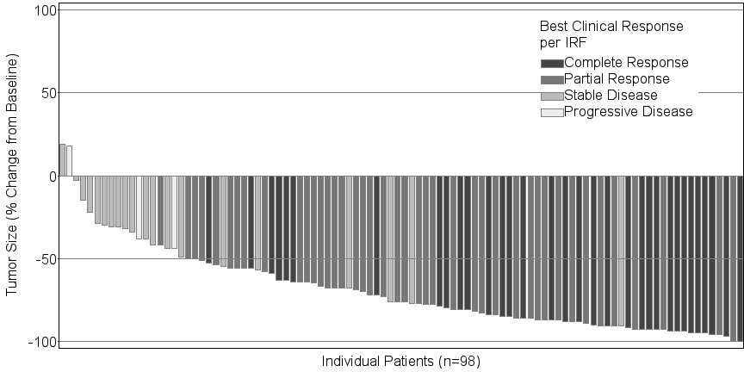
In the designation of CR per Revised Response Criteria for Malignant Lymphoma (Cheson et al., 2007), a post-treatment residual mass of any size is permitted as long as it is PET negative
Of the 35 patients (33%) who had B symptoms at baseline, 27 patients (77%) experienced resolution of all B symptoms at a median time of 0.7 months from initiation of ADCETRIS.
A pre-specified PFS analysis comparing current PFS per investigator versus PFS achieved with the last therapy received prior to study entry was performed. The analysis included a subset of patients who received systemic therapy post-ASCT prior to receiving ADCETRIS. See Figure 2 for a Kaplan-Meier (KM) plot of PFS with ADCETRIS compared to PFS from the most recent post-ASCT therapy.
Figure 2: Comparison of current PFS per investigator and PFS achieved with the last therapy received prior to study entry - subset of patients who received systemic therapy post-ASCT and prior to ADCETRIS
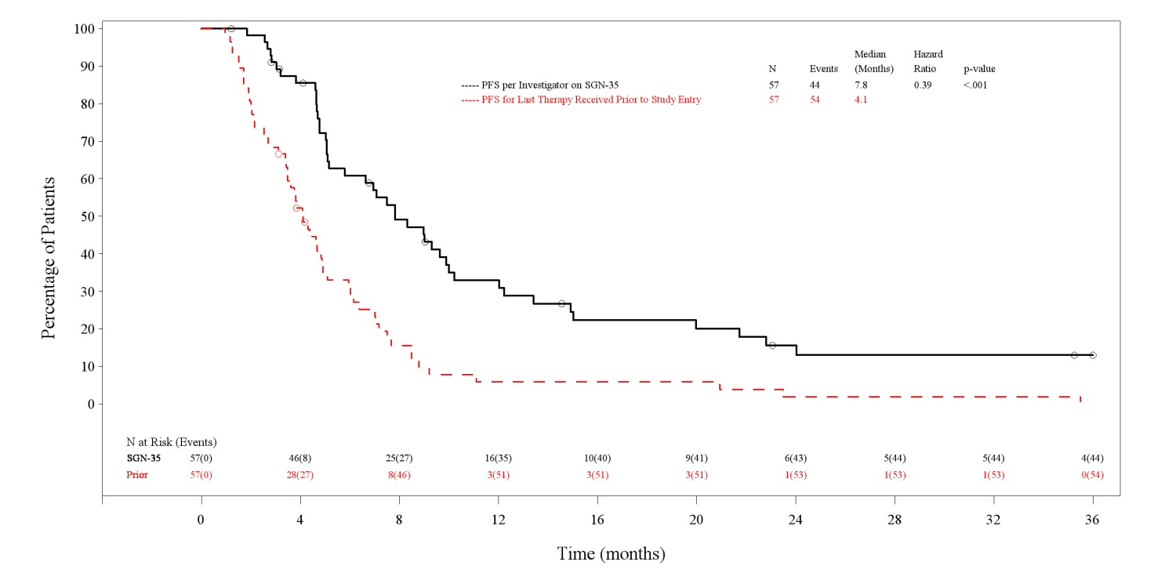
Symbols on the plot indicate censored patients.
Data were collected from patients (n=15) in phase 1 dose escalation and clinical pharmacology studies, and from patients (n=26) in a Named Patient Program (NPP), with relapsed or refractory HL who had not received an ASCT, and who were treated with 1.8 mg/kg of brentuximab vedotin every 3 weeks.
Baseline patient characteristics showed failure from multiple prior chemotherapy regimens (median of 3 with a range of 1 to 7) before first administration with brentuximab vedotin. Fifty nine percent (59%) of patients had advanced stage disease (stage III or IV) at initial diagnosis.
Results from these phase 1 studies and from the NPP experience showed, that in patients with relapsed or refractory HL without prior ASCT, clinically meaningful responses can be achieved as evidenced by an investigator-assessed, objective response rate of 54% and a complete remission rate of 22% after a median of 5 cycles of brentuximab vedotin.

Systemic anaplastic large cell lymphoma
The efficacy and safety of ADCETRIS as a single agent was evaluated in an open-label, single-arm, multicenter study (study SG035-0004) in 58 patients with relapsed or refractory sALCL. See Table 3 below for a summary of baseline patient and disease characteristics.
Table 3: Summary of baseline patient and disease characteristics in the phase 2 relapsed or refractory sALCL study
Patient characteristics | N =58
Median age, yrs (range) | 52 years (14-76)
Gender | 33M (57%)/25F (43%)
ECOG statusª
0 | 19 (33%)
1 | 38 (66%)
Prior ASCT | 15 (26%)
Prior chemotherapy Regimens (range) | 2 (1-6)
Histologically confirmed CD30-expressing disease | 57 (98%)
Anaplastic lymphoma kinase (ALK)-negative disease | 42 (72%)
Disease characteristics
Primary Refractory to frontline therapy^{b} | 36 (62%)
Refractory to most recent therapy | 29 (50%)
Relapsed to most recent therapy | 29 (50%)
Baseline B symptoms | 17 (29%)
Stage III at initial diagnosis | 8 (14%)
Stage IV at initial diagnosis | 21 (36%)
- One patient had a baseline ECOG status of 2, which was prohibited by protocol and is captured as Inclusion Criteria Not Met.
- Primary refractory sALCL is defined as a failure to achieve a complete remission to, or progressed within 3 months of completing frontline therapy.
The median time from initial sALCL diagnosis to first dose with ADCETRIS was 16.8 months. Ten (10) patients (17%) received 16 cycles of ADCETRIS; the median number of cycles received was 7 (range, 1 to 16).
Response to treatment with ADCETRIS was assessed by IRF using the Revised Response Criteria for Malignant Lymphoma (Cheson, 2007). Treatment response was assessed by spiral CT of chest, neck, abdomen and pelvis; PET scans and clinical data. Response assessments were performed at cycles 2, 4, 7, 10, 13 and 16 with PET at cycles 4 and 7.
The ORR per IRF assessment was 86% (50 of 58 patients in the ITT set). CR was 59% (34 of 58 patients in the ITT set). The estimated 36 month overall survival was 63% (the median observation time (time to death or last contact) from first dose was 33.4 months). The investigator assessments were generally consistent with the independent review of the scans. Of the patients treated, 9 responding patients went on to receive an allogeneic stem cell transplant and 7 responding patients went on to ASCT. For further efficacy results, see Table 4.
Table 4: Efficacy results in relapsed or refractory sALCL patients treated with 1.8 mg/kg of ADCETRIS every 3 weeks
Best clinical response (N = 58 ) | IRF N (%) | 95% CI
Objective response rate (CR + PR) | 50 (86) | 74.6, 93.9
Complete remission (CR) | 34 (59) | 44.9, 71.4
Partial remission (PR) | 16 (28) | NA
Disease control rate (CR + PR + SD) | 52 (90) | 78.8, 96.1
Duration of response | Median per IRF | 95% CI
Objective response (CR + PR)ª | 13.2 | 5.7, NE^{b}
Complete remission (CR) | Not reached | 13.0, NE
Overall survival | Median | 95% CI
Median | Not reached^{c} | 21.3, NE
- The range of DOR was 0.1+ months to 21.7+ months and the median follow-up time from first dose for patients who achieved objective response (OR) per IRF was 11.8 months.
- Not estimable.
- The estimated 36 month overall survival was 63% (the median observation time (time to death or last contact) from first dose was 33.4 months).
No clinically meaningful differences in the objective response rate were observed among the following subgroups analysed: gender, baseline weight ( ≤100 kg versus >100 kg), baseline B symptoms, prior ASCT, and post-treatment ASCT. The ORR for relapsed patients was higher than those who were refractory (97% vs. 76%).
Tumour reduction was achieved in 97% of patients. See Figure 3 for a waterfall chart of tumour reduction, ORR and CR.
Figure 3: Best clinical response per patient by IRF Determination
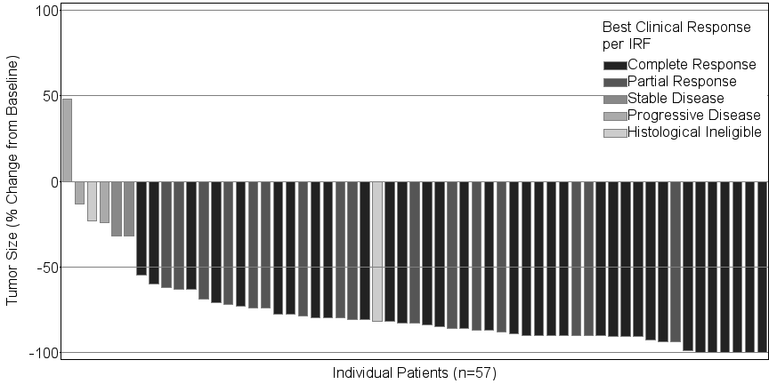
In the designation of CR per Revised Response Criteria for Malignant Lymphoma (Cheson et al., 2007), a post-treatment residual mass of any size is permitted as long as it is PET negative
Of the 17 patients (29%) who had B symptoms at baseline, 14 patients (82%) experienced resolution of all B symptoms in a median time from initiation of ADCETRIS of 0.7 months.
A pre-specified PFS analysis comparing current PFS per investigator versus PFS achieved with the last therapy received prior to study entry was performed. See Figure 4 for a KM plot of PFS with ADCETRIS compared to PFS from last therapy received prior to study entry.
Figure 4: Comparison of current PFS per investigator and PFS achieved with the last therapy received prior to study entry
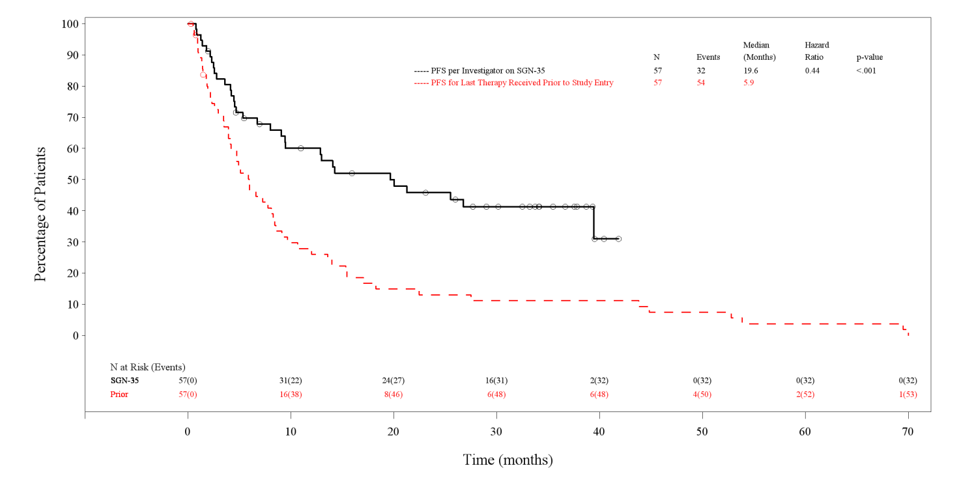
Symbols on the plot indicate censored patients.

Indications
Treatment of adult patients with relapsed or refractory CD30+ Hodgkin lymphoma (HL):
1. following autologous stem cell transplant (ASCT) or
2. following at least two prior therapies when ASCT or multi-agent chemotherapy is not a treatment option.
Treatment of adult patients with relapsed or refractory systemic anaplastic large cell lymphoma (sALCL).

Contraindications
Hypersensitivity to the active substance or to any of the excipients (see ‘Description’).
Combined use of bleomycin and ADCETRIS causes pulmonary toxicity.

Precautions

Progressive multifocal leukoencephalopathy
John Cunningham virus (JCV) reactivation resulting in progressive multifocal leukoencephalopathy (PML) and death can occur in ADCETRIS-treated patients. PML has been reported in patients who received this treatment after receiving multiple prior chemotherapy regimens. PML is a rare demyelinating disease of the central nervous system that results from reactivation of latent JCV and is often fatal.
Patients should be closely monitored for new or worsening neurological, cognitive, or behavioural signs or symptoms, which may be suggestive of PML. ADCETRIS dosing should be held for any suspected case of PML. Suggested evaluation of PML includes neurology consultation, gadolinium-enhanced magnetic resonance imaging of the brain and cerebrospinal fluid analysis for JCV DNA by polymerase chain reaction or a brain biopsy with evidence of JCV. A negative JCV PCR does not exclude PML. Additional follow up and evaluation may be warranted if no alternative diagnosis can be established. ADCETRIS dosing should be permanently discontinued if a diagnosis of PML is confirmed.
The physician should be particularly alert to symptoms suggestive of PML that the patient may not notice (e.g., cognitive, neurological, or psychiatric symptoms).

Pancreatitis
Acute pancreatitis has been observed in patients treated with ADCETRIS. Fatal outcomes have been reported. Patients should be closely monitored for new or worsening abdominal pain, which may be suggestive of acute pancreatitis. Patient evaluation may include physical examination, laboratory evaluation for serum amylase and serum lipase, and abdominal imaging, such as ultrasound and other appropriate diagnostic measures. ADCETRIS should be held for any suspected case of acute pancreatitis.

ADCETRIS should be discontinued if a diagnosis of acute pancreatitis is confirmed.

Serious infections and opportunistic infections
Serious infections such as pneumonia, staphylococcal bacteraemia, sepsis/septic shock (including fatal outcomes) and herpes zoster, and opportunistic infections such as Pneumocystis jiroveci pneumonia and oral candidiasis have been reported in patients treated with ADCETRIS. Patients should be carefully monitored during treatment for the emergence of possible serious and opportunistic infections.

Infusion-related reactions
Immediate and delayed infusion-related reactions (IRR), as well as anaphylaxis, have been reported. Patients should be carefully monitored during and after infusion. If anaphylaxis occurs, administration of ADCETRIS should be immediately and permanently discontinued and appropriate medical therapy should be administered. If an infusion-related reaction occurs, the infusion should be interrupted and appropriate medical management instituted. The infusion may be restarted at a slower rate after symptom resolution. Patients who have experienced a prior infusion-related reaction should be pre-medicated for subsequent infusions. Premedication may include paracetamol, an antihistamine and a corticosteroid.
Infusion-related reactions are more frequent and more severe in patients with antibodies to ADCETRIS (see ’Adverse Effects’).

Tumour lysis syndrome
Tumour lysis syndrome (TLS) has been reported with ADCETRIS. Patients with rapidly proliferating tumour and high tumour burden are at risk of tumour lysis syndrome. These patients should be monitored closely and managed according to best medical practice. Management of TLS may include aggressive hydration, monitoring of renal function, correction of electrolyte abnormalities, anti-hyperuricaemic therapy, and supportive care.

Peripheral neuropathy
ADCETRIS treatment may cause a peripheral neuropathy that is predominantly sensory. Cases of peripheral motor neuropathy have also been reported. ADCETRIS-induced peripheral neuropathy is typically an effect of cumulative exposure to this medicinal product and is reversible in most cases with a 16-week median time from onset to resolution. In the phase 2 population, at the time of last evaluation, the majority of patients (62%) had improvement or resolution of their peripheral neuropathy symptoms. Of the patients in the phase 2 studies, 56% experienced any grade of peripheral neuropathy, whereas Grade 3 events were experienced by 13% of patients and no Grade 4 or 5 events were reported. For patients who reported peripheral neuropathy, brentuximab vedotin treatment discontinuation occurred in 9%, dose reductions were reported in 8%, and dose delays occurred in 13% of patients. Patients should be monitored for symptoms of neuropathy, such as hypoesthesia, hyperesthesia, paraesthesia, discomfort, a burning sensation, neuropathic pain or weakness. Patients experiencing new or worsening peripheral neuropathy may require a delay and a dose reduction of ADCETRIS or discontinuation of treatment (see ‘Dosage & Administration’).

Haematological toxicities
Grade 3 or Grade 4 anaemia, thrombocytopenia, and prolonged ( ≥1 week) Grade 3 or Grade 4 neutropenia can occur with ADCETRIS. Complete blood counts should be monitored prior to administration of each dose. If Grade 3 or Grade 4 neutropenia develops, refer to ‘Dosage & Administration’.

Febrile neutropenia
Febrile neutropenia (fever of unknown origin without clinically or microbiologically documented infection with an absolute neutrophil count <1.0 x 10⁹/L, fever ≥ 38.5°C; ref Common Terminology Criteria for Adverse Events (CTCAE) v3) has been reported with treatment with ADCETRIS. Complete blood counts should be monitored prior to administration of each dose of this treatment. Patients should be monitored closely for fever and managed according to best medical practice if febrile neutropenia develops.

Stevens-Johnson syndrome and Toxic Epidermal Necrolysis
Stevens-Johnson syndrome (SJS) and toxic epidermal necrolysis (TEN) have been reported with ADCETRIS. Fatal outcomes have been reported. If SJS or TEN occur, treatment with ADCETRIS should be discontinued and appropriate medical therapy should be administered.

Hyperglycaemia
Hyperglycaemia has been reported during clinical trials in patients with an elevated Body Mass Index (BMI) with or without a history of diabetes mellitus. However, any patient who experiences an event of hyperglycaemia should have their serum glucose closely monitored. Anti-diabetic treatment should be administered as appropriate.

Long-term safety

There is insufficient evidence to judge the safety of treatment extended past 12 months.

Use in Renal impairment
A study evaluated the PK of brentuximab vedotin and MMAE after the administration of 1.2 mg/kg of ADCETRIS to patients with mild (n=4), moderate (n=3) and severe (n=3) renal impairment. Compared to patients with normal renal function, MMAE exposure increased approximately 1.9-fold in patients with severe renal impairment (creatinine clearance < 30 ml/min) (see ‘Dosage and Administration’).
Use in Hepatic impairment
The liver is a major route of elimination of the unchanged active metabolite MMAE. Limited clinical data from patients who were administered 1.2 mg/kg of ADCETRIS suggest that exposure to MMAE increased approximately 2.3-fold in patients with any degree of hepatic impairment, and that exposure to the antibody-drug conjugate may decrease, relative to patients with normal hepatic function. Use with caution in patients with hepatic impairment. Patients should be closely monitored for adverse events. Treatment with Adcetris should be discontinued in patients with hepatic impairment who are not demonstrating an adequate response to treatment.

Effects on Fertility
The effects of ADCETRIS on human male and female fertility have not been studied.
However, results from toxicity studies in rats indicate the potential for brentuximab vedotin to impair male reproductive function and fertility. Seminiferous tubule degeneration, sertoli cell vacuolation, reduced spermatogenesis and aspermia were observed in male rats that received weekly IV injections of ≥ 5 mg/kg brentuximab vedotin. The no effect dose (0.5 mg/kg) is below the recommended human dose of 1.8 mg/kg based on body weight. Testicular atrophy and degeneration had not fully reversed following a 16-week treatment-free period. MMAE, the main active metabolite of brentuximab vedotin, has been shown to have aneugenic properties in an in vivo rat bone marrow micronucleus study. These results were consistent with the pharmacological effect of MMAE on the mitotic apparatus (disruption of the microtubule network) in cells.
Therefore, men being treated with this medicine are advised to have sperm samples frozen and stored before treatment. Men being treated with this medicine are advised not to father a child during treatment and for up to 6 months following the last dose. Effects on spermatogenesis cannot be excluded after a 6 month treatment-free period.

Use in Pregnancy
Pregnancy Category D
There are no adequate and well-controlled studies with ADCETRIS in pregnant women. However based on its mechanism of action and findings in animals, ADCETRIS can cause fetal harm when administered to a pregnant women.
Embryofetal toxicities were seen in a rat embryofetal development study in which pregnant rats received two IV doses of ≥ 3 mg/kg brentuximab vedotin during a period of organogenesis, and included an increased incidence of post-implantation loss, decreased number of foetuses and an increase in the incidence of external malformations (umbilical hernias and malrotated hindlimbs).
ADCETRIS should not be used during pregnancy unless the benefit to the mother outweighs the potential risks to the fetus. If a pregnant woman needs to be treated she should be clearly advised on the potential risk to the fetus. Women of childbearing potential should be using two methods of effective contraception during treatment with ADCETRIS and until 6 months after treatment.
See the ‘Effects on Fertility’ section above pertaining to advice for women whose male partners are being treated with ADCETRIS.

Use in Lactation
There are no data as to whether ADCETRIS or its metabolites are excreted in human milk. A risk to the newborn/infant cannot be excluded. A decision should be made whether to discontinue breast-feeding or to discontinue/abstain from this therapy, taking into account a potential risk of breast-feeding for the child and the benefit of therapy for the woman.

Paediatric Use
The safety and efficacy of children less than 18 years have not yet been established. No data are available. In nonclinical studies, lymphoid depletion and reduced thymic weight were observed, consistent with the pharmacologic disruption of microtubules caused by MMAE derived from ADCETRIS.

Use in the Elderly
The safety and efficacy in elderly patients aged 65 and older have not been established. No data are available.

Genotoxicity
MMAE was genotoxic in the rat bone marrow micronucleus study through an aneugenic mechanism. This effect is consistent with the pharmacological effect of MMAE as a microtubule disrupting agent. MMAE was not mutagenic in the bacterial reverse mutation assay (Ames test) or the L5178Y mouse lymphoma forward mutation assay.

Carcinogenicity
Carcinogenicity studies with brentuximab vedotin or MMAE have not been conducted.

Interactions with other Medicines

The combined use of ADCETRIS and bleomycin is associated with pulmonary toxicity and is therefore contraindicated (see ‘Contraindications’).
There are no drug-drug interactions data available with other chemotherapy regimens.

Interaction with medicinal products metabolized through CYP3A4 route (CYP3A4 inhibitors/inducers)
Co-administration of ADCETRIS with ketoconazole, a strong CYP3A4 and P-gp inhibitor, increased the exposure to the antimicrotubule agent MMAE by approximately 73%, and did not alter the plasma exposure to ADCETRIS. Therefore, co-administration of brentuximab vedotin with strong CYP3A4 and P-gp inhibitors may increase the incidence of neutropenia. If neutropenia develops see ‘Dosage & Administration’.
Co-administration of brentuximab vedotin with rifampicin, a strong CYP3A4 inducer, did not alter the plasma exposure to brentuximab vedotin; however it reduced exposure to MMAE by approximately 31%.
Co-administration of midazolam, a CYP3A4 substrate, with brentuximab vedotin did not alter the metabolism of midazolam; therefore brentuximab vedotin is not expected to alter the exposure to medicines that are metabolized by CYP3A4 enzymes.

Coadministration with other CYP substrates
In vitro studies indicated that clinical drug-drug interactions are unlikely to occur as a result of MMAE-mediated inhibition or induction of CYP1A2, CYP2B6, CYP2C8, CYP2C9, CYP2C19 or CYP2D6.

Coadministration with Drugs that are Substrates of Transporters
In vitro, MMAE was not a substrate for the BCRP, MRP2, OATP1B1, OATP1B3, OAT1 or OCT2 transporters.

Adverse Effects

Summary of the safety profile
ADCETRIS was studied as monotherapy in 160 patients in two pivotal phase 2 studies (SG035-0003 and SG035-0004). The safety profile of ADCETRIS is based on available clinical trial data, the Named Patient Program (NPP), and post-marketing experience to date. Frequencies of adverse reactions described below and in Table 5 have been determined based on data generated from clinical studies.
Serious infections and opportunistic infections have been reported in patients treated with this medicine (see ’Precautions’). In the phase 2 population, 61% of patients reported an event term that referred to an infection. Treatment emergent events of infection that were assessed as related by the investigator occurred in 16% of patients.
Serious adverse drug reactions were: neutropenia, thrombocytopenia, constipation, diarrhoea, vomiting, pyrexia, peripheral motor neuropathy and peripheral sensory neuropathy, hyperglycaemia, demyelinating polyneuropathy, and tumour lysis syndrome.
Stevens-Johnson syndrome and toxic epidermal necrolysis have been reported in patients treated with ADCETRIS (see ’Precautions’).
The most frequently observed adverse reactions in patients receiving this treatment were: peripheral sensory neuropathy, fatigue, nausea, diarrhoea, neutropenia, vomiting, pyrexia, cough and upper respiratory tract infection.
In the phase 2 population, adverse events led to the discontinuation of study treatment for 36 patients (23%). Adverse events that led to treatment discontinuations in two or more HL or sALCL patients were peripheral sensory neuropathy (8%) and peripheral motor neuropathy (2%).
The safety data reported from the phase 1 dose escalation and clinical pharmacology studies (n=15 patients) and from the Named Patient Program (NPP; n = 26 patients), in patients with relapsed or refractory HL who had not received an ASCT (see section ‘Clinical Trials’), and were treated with the recommended dose of 1.8 mg/kg every three weeks, were consistent with the safety profile of the pivotal clinical studies.

Tabulated list of adverse reactions
Adverse reactions for ADCETRIS are listed by MedDRA System Organ Class and Preferred Term (see Table 5). Within each System Organ Class, adverse reactions are listed under frequency categories of: Very common ( ≥1/10); Common ( ≥1/100 to <1/10); Uncommon ( ≥1/1,000 to <1/100); Rare ( ≥1/10,000 to <1/1,000); Very rare ( <1/10,000); Frequency not known (cannot be estimated from the available data).
Table 5: Adverse reactions for ADCETRIS
System organ class | Adverse reactions
Infections and infestations
Very common: | Infectionª
Common: | Upper respiratory tract infection, herpes zoster, pneumonia
Uncommon: | Oral candidiasis, pneumocystis jiroveci pneumonia, staphylococcal bacteraemia
Frequency not known: | Progressive multifocal leukoencephalopathy
Blood and lymphatic system disorders
Very common: | Neutropenia
Common: | Anaemia, thrombocytopenia
Frequency not known: | Febrile neutropenia
Immune system disorders
Frequency not known: | Anaphylactic reaction
Metabolism and nutrition disorders
Common | Hyperglycaemia
Uncommon: | Tumour lysis syndrome*
Nervous system disorders
Very common: | Peripheral sensory neuropathy
Common: | Peripheral motor neuropathy, dizziness, demyelinating polyneuropathy*
Respiratory, thoracic and mediastinal disorders
Common: | Cough, dyspnoea
Gastro-intestinal disorders
Very common: | Diarrhoea, nausea, vomiting
Common: | Constipation
Uncommon: | Pancreatitis acute
Hepatobiliary disorders
Common: | Alanine aminotransferase/aspartate aminotransferase (ALT/AST) increased
Skin and subcutaneous tissue disorders
Very common: | Alopecia, pruritus
Common | Rash
Uncommon: | Stevens-Johnson syndrome*
Musculoskeletal and connective tissue disorders
Very common: | Myalgia
Common: | Arthralgia, back pain
General disorders and administration site conditions
Very common: | Fatigue, pyrexia, infusion-related reactions^{b}
Common: | Chills
*Reported as a serious adverse reaction only
- Preferred terms that were reported under the Infections and Infestations SOC include upper respiratory tract infection, herpes zoster, and pneumonia.
- Preferred terms associated with infusion-related reactions were chills (4%), nausea, dyspnoea and pruritus (3% each), and cough (2%).

Description of selected adverse reactions
Adverse reactions that led to dose delays of up to 3 weeks in more than 5% of patients were neutropenia (14%) and peripheral sensory neuropathy (11%).
The adverse reaction that led to a dose reduction in more than 5% of patients was peripheral sensory neuropathy (8%). Ninety percent (90%) of patients in the phase 2 studies remained at the recommended dose of 1.8 mg/kg while on treatment.
Severe and prolonged ( ≥1 week) neutropenia can occur with this treatment which may increase the risk of patients developing serious infections. The median duration of Grade 3 or Grade 4 neutropenia was limited (1 week); 2% of patients had Grade 4 neutropenia that lasted ≥ 7 days. Less than half of the patients in the phase 2 population with Grade 3 or Grade 4 neutropenia had temporally associated infections, and the majority of temporally associated infections were Grade 1 or Grade 2.
Among patients who experienced peripheral neuropathy, the median follow up time from end of treatment until last evaluation was approximately 10 weeks. At the time of last evaluation, 62% of the 84 patients who experienced peripheral neuropathy had resolution or improvement of their peripheral neuropathy symptoms. The median time from onset to resolution or improvement for all events was 6.6 weeks (range from 0.3 weeks to 54.4 weeks).
PML has been reported outside of the pivotal phase 2 clinical trials described in this section (see ’Precautions’).
Acute pancreatitis (including fatal outcomes) has been reported outside of the pivotal phase 2 clinical trials. Consider the diagnosis of acute pancreatitis for patients presenting with new or worsening abdominal pain (see Precautions).
Anaphylaxis has been reported outside of the pivotal phase 2 clinical trials discussed in this section. Symptoms of anaphylaxis may include, but are not limited to, urticaria, angioedema, hypotension and bronchospasm.
Febrile neutropenia has been reported outside of the pivotal phase 2 clinical trials described in this section (see ’Precautions’). A patient enrolled in a phase 1 dose escalation trial experienced Grade 5 febrile neutropenia after receiving a single dose of 3.6 mg/kg of brentuximab vedotin.

Immunogenicity
Patients with relapsed or refractory HL or sALCL in two phase 2 studies were tested for antibodies to brentuximab vedotin every 3 weeks using a sensitive electrochemiluminescent immunoassay. Approximately 35% of patients in these studies developed antibodies to brentuximab vedotin. Of these patients, the majority became positive prior to dose 2, 7% were persistently anti-therapeutic antibodies (ATA)-positive, and 62% of the ATA-positive patients had neutralizing antibodies. One (1) percent of patients experienced adverse reactions consistent with infusion-related reactions that led to discontinuation of treatment.
The presence of antibodies to brentuximab vedotin did not correlate with a clinically meaningful reduction in serum brentuximab vedotin levels and did not result in a decrease in the efficacy of brentuximab vedotin. While the presence of antibodies to brentuximab vedotin does not necessarily predict the development of an IRR, there was a higher incidence of IRRs observed in patients with persistently positive ATA (30%) relative to patients with transiently positive ATA (12%) and never positive ATA (7%).

Dosage and Administration
ADCETRIS should be administered under the supervision of a physician experienced in the use of anti-cancer agents.

Posology
The recommended dose is 1.8 mg/kg administered as an intravenous infusion over 30 minutes every 3 weeks. If the patient’s weight is more than 100 kg, the dose calculation should use 100 kg (see Table 8 in ‘Determining dosage amount’).
The recommended starting dose in patients with severe renal impairment is 1.2 mg/kg administered as an intravenous infusion over 30 minutes every 3 weeks. Patients with renal impairment should be closely monitored for adverse events (see ‘Pharmacology – Pharmacokinetics’).
ADCETRIS should be used with caution in patients with hepatic impairment. A lower starting dose should be considered. In a clinical study, doses of 1.2 mg/kg have been administered to patients with hepatic impairment (see ‘Precautions’ and ‘Pharmacokinetics’).
Complete blood counts should be monitored prior to administration of each dose of this treatment (see ‘Precautions’).
Patients should be monitored during and after infusion (see ’Precautions’).
Patients who achieve stable disease or better should receive a minimum of 8 cycles and up to a maximum of 16 cycles (approximately 1 year) (see ’Clinical Trials’).

Dose adjustments
Neutropenia
If neutropenia develops during treatment it should be managed by dose delays. See Table 6 below for appropriate dosing recommendations (see ’Precautions’).
Table 6: Dosing recommendations for neutropenia
Severity grade of neutropenia  (signs and symptoms [abbreviated description of CTCAEª]) | Modification of dose and schedule
Grade 1 (<LLN - 1500/mm³  <LLN - 1.5 x 10⁹/L) or  Grade 2 (<1500 - 1000/mm³  <1.5 – 1.0 x 10⁹/L) | Continue with the same dose and schedule
Grade 3 (<1,000 - 500/mm³  <1.0 - 0.5 x 10⁹/L) or  Grade 4 (<500/mm³  <0.5 x 10⁹/L) | Withhold dose until toxicity returns to ≤ Grade 2 or baseline then resume treatment at the same dose and schedule ^{b}. Consider growth factor support (G-CSF or GM-CSF) in subsequent cycles for patients who develop Grade 3 or Grade 4 neutropenia.
- Grading based on National Cancer Institute (NCI) Common Terminology Criteria for Adverse Events (CTCAE) v3.0; see Neutrophils/granulocytes; LLN= lower limit of normal
- Patients who develop Grade 3 or Grade 4 lymphopenia may continue treatment without interruption.

Peripheral neuropathy
If peripheral sensory or motor neuropathy emerges or worsens during treatment see Table 7 below for appropriate dosing recommendations (see ’Precautions’).
Table 7: Dosing recommendations for new or worsening peripheral sensory or motor neuropathy
Severity of peripheral sensory or motor neuropathy  (signs and symptoms [abbreviated description of CTCAEª]) | Modification of dose and schedule
Grade 1 (paraesthesia and/or loss of reflexes, with no loss of function) | Continue with the same dose and schedule
Grade 2 (interfering with function but not with activities of daily living) or  Grade 3 (interfering with activities of daily living) | Withhold dose until toxicity returns to ≤ Grade 1 or baseline, then restart treatment at a reduced dose of 1.2 mg/kg every 3 weeks
Grade 4 (sensory neuropathy which is disabling or motor neuropathy that is life threatening or leads to paralysis) | Discontinue treatment
- Grading based on National Cancer Institute (NCI) Common Terminology Criteria for Adverse Events (CTCAE) v3.0; see neuropathy: motor; neuropathy: sensory; and neuropathic pain.

Method of administration
The recommended dose of ADCETRIS is infused over 30 minutes.
ADCETRIS must not be administered as an intravenous push or bolus. ADCETRIS should be administered through a dedicated intravenous line and it must not be mixed with other medicinal products.
Procedures for proper handling and disposal of anticancer medicines should be considered.
Proper aseptic technique throughout the handling of this medicinal product should be followed.

Instructions for reconstitution
Each single use vial must be reconstituted with 10.5 mL of water for injections to a final concentration of 5 mg/mL.
- Direct the stream toward the wall of the vial and not directly at the cake or powder.
- Gently swirl the vial to aid dissolution. DO NOT SHAKE.
- The reconstituted solution in the vial is a clear to slightly opalescent, colourless solution with a final pH of 6.6.
- The reconstituted solution should be inspected visually for any foreign particulate matter and/or discoloration. In the event of either being observed, discard the medicinal product.

Preparation of infusion solution
The appropriate amount of reconstituted ADCETRIS must be withdrawn from the vial(s) and added to an infusion bag containing sodium chloride 9 mg/mL (0.9%) solution for injection in order to achieve a final concentration of 0.4-1.2 mg/mL ADCETRIS. The recommended diluent volume is 150 mL. The already reconstituted ADCETRIS can also be diluted into 5% dextrose for injection or Lactated Ringer's for injection.
Gently invert the bag to mix the solution containing ADCETRIS. DO NOT SHAKE.
Any portion left in the vial, after withdrawal of the volume to be diluted, must be disposed of in accordance with local requirements.
Do not add other medicinal products to the prepared ADCETRIS infusion solution or intravenous infusion set. The infusion line should be flushed following administration with sodium chloride 9 mg/mL (0.9%) solution for injection, 5% dextrose for injection, or Lactated Ringer's for injection.
Following dilution, infuse the ADCETRIS solution immediately at the recommended infusion rate.
Total storage time of the solution from reconstitution to infusion should not exceed 24 hours.

Determining dosage amount
Calculation to determine the total ADCETRIS dose (mL) to be further diluted:
ADCETRIS dose (mg/kg) x patients body weight (kg) | = Total ADCETRIS dose (mL) to be diluted further
Reconstituted vial concentration (5 mg/mL) | = Total ADCETRIS dose (mL) to be diluted further
Note: If patient’s weight is more than 100 kg, the dose calculation should use 100 kg. The maximal recommended dose is 180 mg.
Calculation to determine the total number of ADCETRIS vials needed:
Total ADCETRIS dose (mL) to be administered | = Number of ADCETRIS vials needed
Total volume per vial (10 mL/vial)) | = Number of ADCETRIS vials needed

Table 8: Sample calculations for patients receiving the recommended dose of 1.8 mg/kg of ADCETRIS for weights ranging from 60 kg to 120 kg
Patient weight (kg) | Total dose =  patient weight multiplied by recommended dose [1.8 mg/kgª]) | Total volume to be diluted^{b} = total dose divided by reconstituted vial concentration [5 mg/mL]) | Number of vials needed =  total volume to be diluted divided by total volume per vial [10 mL/vial])
60 kg | 108 mg | 21.6 mL | 2.16 vials
80 kg | 144 mg | 28.8 mL | 2.88 vials
100 kg | 180 mg | 36 mL | 3.6 vials
120 kg^{c} | 180 mg ^{d} | 36 mL | 3.6 vials
- For a reduced dose, use 1.2 mg/kg for the calculation.
- To be diluted in 150 mL of diluent and administered by intravenous infusion over 30 minutes every 3 weeks.
- If patient’s weight is more than 100 kg, the dose calculation should use 100 kg.
- The maximal recommended dose is 180 mg.

Disposal
ADCETRIS is for single use in one patient only. Any unused product or waste material should be disposed of in accordance with local requirements.

Overdosage
There is no known antidote for overdose of ADCETRIS. In case of overdose, the patient should be closely monitored for adverse reactions, particularly neutropenia, and supportive treatment should be administered (see ’Precautions’).
For information on the management of overdose, contact the Poison Information Centre on 131126 (Australia).

Presentation and Storage Conditions
ADCETRIS is supplied in a glass vial with a butyl rubber stopper and an aluminium/plastic flip-off seal, containing 50 mg ADCETRIS as a white to off-white lyophilized cake or powder. Each pack of Adcetris contains 1 vial.
Store ADCETRIS at 2°C-8°C. Refrigerate. Do not freeze. Keep the vial in the original carton in order to protect from light. Do not use beyond the expiry date included on the carton/vial.

After reconstitution
After reconstitution/dilution, from a microbiological point of view, the product should be used immediately. However, chemical and physical in-use stability has been demonstrated for 24 hours at 2°C-8°C.

Name and Address of the Sponsor
Takeda Pharmaceuticals Australia Pty Ltd
2-4 Lyonpark Rd
Macquarie Park NSW 2113

Poison Schedule of the Medicine
Schedule 4

Date of FIRST INCLUSION IN THE ARTG
20th December 2013

DATE OF MOST RECENT AMENDMENT
11th March 2014

