|  |
| --- |
| **March 2021** |

|  |
| --- |
| Australian Public Assessment Report for Brexpiprazole |
| Proprietary Product Name: Rexulti |
| Sponsor: Lundbeck Australia Pty Ltd |

About the Therapeutic Goods Administration (TGA)

* The Therapeutic Goods Administration (TGA) is part of the Australian Government Department of Health and is responsible for regulating medicines and medical devices.
* The TGA administers the *Therapeutic Goods Act 1989* (the Act), applying a risk management approach designed to ensure therapeutic goods supplied in Australia meet acceptable standards of quality, safety and efficacy (performance) when necessary.
* The work of the TGA is based on applying scientific and clinical expertise to decision-making, to ensure that the benefits to consumers outweigh any risks associated with the use of medicines and medical devices.
* The TGA relies on the public, healthcare professionals and industry to report problems with medicines or medical devices. TGA investigates reports received by it to determine any necessary regulatory action.
* To report a problem with a medicine or medical device, please see the information on the TGA website <<https://www.tga.gov.au>>.

About AusPARs

* An Australian Public Assessment Report (AusPAR) provides information about the evaluation of a prescription medicine and the considerations that led the TGA to approve or not approve a prescription medicine submission.
* AusPARs are prepared and published by the TGA.
* An AusPAR is prepared for submissions that relate to new chemical entities, generic medicines, major variations and extensions of indications.
* An AusPAR is a static document; it provides information that relates to a submission at a particular point in time.
* A new AusPAR will be developed to reflect changes to indications and/or major variations to a prescription medicine subject to evaluation by the TGA.

Copyright

© Commonwealth of Australia 2021  
This work is copyright. You may reproduce the whole or part of this work in unaltered form for your own personal use or, if you are part of an organisation, for internal use within your organisation, but only if you or your organisation do not use the reproduction for any commercial purpose and retain this copyright notice and all disclaimer notices as part of that reproduction. Apart from rights to use as permitted by the *Copyright Act 1968* or allowed by this copyright notice, all other rights are reserved and you are not allowed to reproduce the whole or any part of this work in any way (electronic or otherwise) without first being given specific written permission from the Commonwealth to do so. Requests and inquiries concerning reproduction and rights are to be sent to the TGA Copyright Officer, Therapeutic Goods Administration, PO Box 100, Woden ACT 2606 or emailed to <[tga.copyright@tga.gov.au](mailto:tga.copyright@tga.gov.au)>.

Contents

Common abbreviations 4

I. Introduction to product submission 6

Submission details 6

Product background 7

Regulatory status 7

II. Registration timeline 8

III. Submission overview and risk/benefit assessment 9

Quality 9

Nonclinical 9

Clinical 9

Risk management plan 30

First risk-benefit analysis 32

Second risk-benefit analysis 36

Outcome 39

## Common abbreviations

|  |  |
| --- | --- |
| Abbreviation | Meaning |
| 5-HT2A | Serotonin 2A receptor |
| ACM | Advisory Committee on Medicines |
| ADT | Antidepressant treatment |
| AE | Adverse event |
| ARTG | Australian Register of Therapeutic Goods |
| ASA | Australian-specific Annex |
| ATRQ | Massachusetts General Hospital Antidepressant Treatment Response Questionnaire |
| CGI-I | Clinical Global Impression – Improvement scale |
| CGI-S | Clinical Global Impression – Severity scale |
| CI | Confidence interval |
| CYP450 | Cytochrome P450 |
| DLP | Data lock point |
| DM-3411 | Major metabolite of brexpiprazole |
| DSM-IV | Diagnostic and Statistical Manual of Mental Disorders, fourth edition |
| ECT | Electroconvulsive therapy |
| EU | European Union |
| EU-RMP | European Union risk management plan |
| FDA | Food and Drug Administration (United States) |
| GVP | Good Pharmacovigilance Practice (s) |
| HAM-A | Hamilton Anxiety Scale |
| HAM-D17 | 17 item Hamilton Depression Rating Scale |
| LS | Least squares |
| MADRS | Montgomery–Åsberg Depression Rating Scale |
| MDD | Major depressive disorder |
| MedDRA | Medical Dictionary for Regulatory Activities |
| NDA | New Drug Application (United States Food and Drug Administration) |
| PI | Product Information |
| PSUR | Periodic safety update report |
| Q-LES‑Q-SF | Quality of Life Enjoyment and Satisfaction Questionnaire Short Form |
| RANZCP | Royal Australian and New Zealand College of Psychiatrists |
| RCT | Randomised control trial |
| RMP | Risk management plan |
| SAE | Serious adverse event |
| SD | Standard deviation |
| SDS | Sheehan Disability Scale |
| SE | Standard error |
| SSRI | Selective serotonin reuptake inhibitor |
| TEAE | Treatment emergent adverse event |
| US | United States |

## I. Introduction to product submission

### Submission details

|  |  |
| --- | --- |
| *Type of submission:* | Extension of indications |
| *Product name:* | Rexulti |
| *Active ingredient:* | Brexpiprazole |
| *Outcome*: | Withdrawn |
| *Date of withdrawal:* | 11 September 2020 |
| *Date of entry onto ARTG:* | Not applicable |
| *ARTG number:* | Not applicable |
| *Black Triangle Scheme:[1]* | Not applicable |
| *Sponsor’s name and address:* | Lundbeck Australia Pty Ltd  PO Box 1973  Macquarie Centre  NSW, 2113 |
| *Dose form:* | Film coated tablet |
| *Strengths:* | 0.25 mg, 0.5 mg, 1 mg, 2 mg, 3 mg, 4 mg |
| *Container:* | Blister pack |
| *Pack sizes:* | 30 (all strengths), 10 (starter pack of 1 mg and 2 mg) |
| *Approved therapeutic use:* | Not applicable |
| *Route of administration:* | Oral |
| *Proposed dosage:* | Proposed:  The recommended starting dose for brexpiprazole as adjunctive treatment is 0.5 mg or 1 mg once daily. Dose titration to 1 mg/day and up to the target dose of 2 mg/day should occur at intervals of up to 1 week based on the patient’s clinical response and tolerability. The maximum recommended dose is 3 mg/day. Periodically reassess to determine the continued need and appropriate dose for treatment. |
| *Pregnancy category:* | Not applicable |

### Product background

This AusPAR describes the application by Lundbeck Australia Pty Ltd (the sponsor) to register Rexulti (brexpiprazole) 0.25 mg, 0.5 mg, 1 mg, 2 mg, 3 mg and 4 mg film coated tablets for the following proposed extension of indications:

*Use as a short-term adjunctive therapy to antidepressants for the treatment of major depressive disorder (MDD) in adult patients with an inadequate response to prior antidepressant treatment. Rexulti should be used for the shortest period of time that is clinically indicated.*

Major depressive disorder (MDD) is a very common psychiatric condition, characterised by low mood, low self-esteem, feelings of hopelessness and despair, anhedonia, insomnia, reduced appetite and reduced libido. MDD is at the severe end of a spectrum that also includes milder forms of low mood such as dysthymia and appropriate unhappiness in relation to life stressors. In 2017, depressive disorders were ranked as the leading cause of disability worldwide.

50% to 60% of depressed patients respond to first-line antidepressant treatment (ADT). Conventional treatments for MDD include counselling aimed at addressing psychosocial factors, exercise, and medication, particularly selective serotonin reuptake inhibitors (SSRI). For refractory cases, treatment guidelines usually recommend switching to an alternative SSRI or commencing adjunctive therapy with antipsychotics, or using electroconvulsive therapy (ECT).

Adjunctive therapies include second-generation antipsychotics, such as aripiprazole and quetiapine. Aripiprazole has been approved by some authorities for this indication, but it is not registered for this indication in Australia; quetiapine has been approved in Australia for adjunctive treatment of depression associated with bipolar disorder. At the time the application described in this AusPAR was under consideration, only one medicine was currently approved in Australia for adjunctive/second line treatment of MDD; Seroquel XR (quetiapine modified release tablets).[2]

### Regulatory status

The product received initial registration on the Australian Register of Therapeutic Goods (ARTG) on 17 May 2017 for the follow indication:

*Rexulti is indicated for the treatment of schizophrenia.*

At the time the TGA considered this application, similar applications had been approved in the United States (US), Canada and Singapore, as shown in Table 1.

Table 1: International regulatory status

|  |  |  |  |
| --- | --- | --- | --- |
| Region | Submission date | Status | Approved indications |
| United States | 11 July 2014 | Approved: 10 July 2015 | *Rexulti is indicated for:*  *Adjunctive treatment of major depressive disorder (MDD).* |
| Canada | 22 May 2017 | Approved: 22 February 2019 | *Rexulti is indicated for:*  *Adjunctive treatment of major depressive disorder (MDD).* |
| Singapore | 20 December 2017 | Approved: 5 August 2019 | *Rexulti is indicated for:*  *Adjunctive treatment of major depressive disorder (MDD).* |

## II. Registration timeline

The following table captures the key steps and dates for this application and which are detailed and discussed in this AusPAR.

Table 2: Timeline for Submission PM-2018-05140-1-1

|  |  |
| --- | --- |
| Description | Date |
| Submission dossier accepted and first round evaluation commenced | 31 January 2019 |
| First round evaluation completed | 27 June 2019 |
| Sponsor provides responses on questions raised in first round evaluation | 2 September 2019 |
| Second round evaluation completed | 30 October 2019 |
| Delegate’s first overall benefit-risk assessment and request for Advisory Committee advice | 24 December 2019 |
| Sponsor’s pre-Advisory Committee response | 15 January 2020 |
| First Advisory Committee meeting | 7 February 2020 |
| Delegate’s second overall benefit-risk assessment and request for Advisory Committee advice | 10 July 2020 |
| Second Advisory Committee meeting | 6 August 2020 |
| Registration decision (Outcome) | Not applicable;1 |
| Completion of administrative activities and registration on the ARTG | Not applicable;1 |
| Number of working days from submission dossier acceptance to registration decision* | Not applicable1 |

1) The sponsor withdrew the submission on 11 September 2020, prior to the registration decision (Outcome); *Statutory timeframe for standard applications is 255 working days

## III. Submission overview and risk/benefit assessment

The submission was summarised in the following Delegate’s overview and recommendations.

### Quality

There was no requirement for a quality evaluation in a submission of this type since this submission was for an extension of indications to the same formulation of the active ingredient.

### Nonclinical

There was no requirement for a nonclinical evaluation in a submission of this type since this submission was for an extension of indications to the same formulation of the active ingredient.

### Clinical

#### Content of the clinical dossier

The submitted dossier consisted of:

* 10 evaluable studies in MDD, including 7 placebo controlled studies of adjunctive brexpiprazole and 3 open label studies of adjunctive brexpiprazole. The open label studies were only evaluable for safety. The evaluable studies were:
  + 3 short-term, fixed dose, Phase III studies:
    - Study 331-10-228 (2 mg brexpiprazole/day; referred to as Study 228);
    - Study 331-10-227 (1 mg and 3 mg brexpiprazole/day; referred to as Study 227); and
    - Study 331-13-214 (2 mg brexpiprazole/day; referred to as Study 214).
  + 1 short-term, flexible dose, Phase III study:
    - Study 331-12-282 (2 to 3 mg brexpiprazole/day) with extended release quetiapine (Seroquel XL) as an active reference (referred to as Study 282).
  + 2 short-term, flexible dose, Phase II studies:
    - Study 331-08-211 (0.15 mg to 2 mg brexpiprazole/day; referred to as Study 211); and
    - Study 331-09-222 (1 mg to 3 mg brexpiprazole/day; referred to as Study 222).
  + 1 long-term, flexible dose, Phase III study:
    - Study 14570A (1 mg to 3 mg brexpiprazole/day).
  + 3 long-term, open-label Phase III studies:
    - Study 331-08-212 (referred to as Study 212);
    - Study 331-10-238 (referred to as Study 238); and
    - Study 16160A.
* No new pharmacokinetic or pharmacodynamic studies.
* A clinical overview, summary of clinical efficacy, and summary of clinical safety.
* A proposed Product Information (PI) and Consumer Medicines Information (CMI) sheet.
* A monograph of the US Prescribing Information.
* Literature references.

The Delegate commented that the clinical evaluator has highlighted that the US Food and Drug Administration (FDA) approval was based on the two Phase III short term studies of 6 weeks duration each. Further, the Delegate has noted in the FDA Prescribing Information;[3] that the data set that was analysed for Study 227 is different from that included in this submission to the TGA.[4] Its implication to assessment of efficacy is that the treatment difference in this study was significant, when analysed with the data set that the FDA considered and not with the data set included in this dossier.

#### Pharmacology

The sponsor does not propose any changes to the formulation.

Rexulti contains brexpiprazole, an atypical antipsychotic agent as the active ingredient.

Rexulti is currently available as 0.25 mg, 0.5 mg, 1 mg, 2 mg, 3 mg and 4 mg tablets for oral use.

Rexulti tablets also contain the following inactive ingredients: lactose monohydrate, maize starch, microcrystalline cellulose, hydroxypropylcellulose, low-substituted hydroxypropylcellulose and magnesium stearate.

##### Pharmacokinetics/pharmacodynamics

This submission did not include new pharmacokinetic/pharmacodynamics data.

After a single dose administration, the peak plasma brexpiprazole concentration occurs within 4 hours. However, the steady-state concentrations are attained within 10 to 12 days of therapy.

The absolute oral bioavailability is 95%, and the administration with a regular meal does not significantly affect the maximum plasma concentration or the area under the curve of brexpiprazole. Brexpiprazole is highly protein bound in plasma to serum albumin and α1‑acid glycoprotein (more than 99%), and is metabolised primarily by the CYP450 3A4 and CYP450 2D6 enzymes.[5]

The terminal elimination half-life of brexpiprazole and its major metabolite (DM-3411) are 91 and 86 hours, respectively.

##### Dosage selection for pivotal studies

Dose determination was not based on dose-ranging Phase II studies. Rather, a range of doses were used in Phase III studies and the effective dose was determined retrospectively. Doses of 1 mg/day, 2 mg/day, 3 mg/day and flexible doses of 1 mg/day to 3 mg/day were used in the Phase III studies. Most of the patients in Study 70A received ≥ 2 mg/day.

#### Efficacy

The efficacy data is based on observations from seven randomised controlled trials (RCT). Six of them were short term studies. Three studies were with fixed dose, and out of them, two studies with the proposed 2 mg/day dosage. None of the studies could be considered as pivotal.

Study design was largely similar across all seven RCTs.

In all studies, brexpiprazole was assessed as adjunctive therapy in subjects who had failed to respond adequately to standard ADT during the prospective 8 week (or 10 week in some studies) pre-randomisation single-blind treatment phase (Phase A). The definition of an inadequate response to ADT was that depressive symptoms improved by less than 50% during Phase A, based on the HAM-D17;[6] and/or MADRS scores.[7]

Table 3: List of anti-depressant medicines allowed to be used in Phase A of the clinical studies

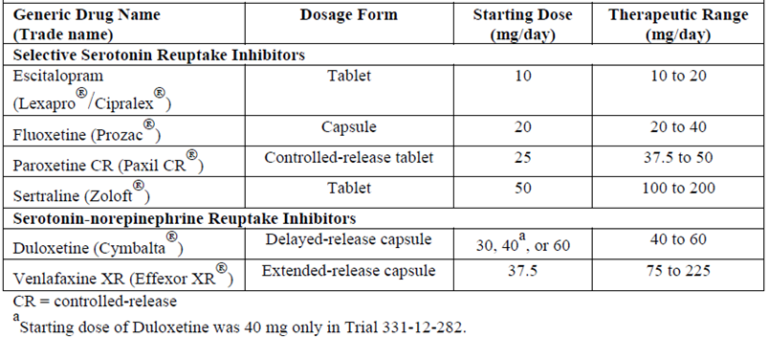

The Delegate commented that these ADTs are approved in Australia for first line and second line treatment of depression.

Adults with a single or recurrent episodes of non-psychotic MDD (diagnosed according to DSM-IV criteria);[8] that was ≥ 8 weeks in duration were recruited.

In all studies, subjects were required to have a Hamilton Depression Rating Scale 17-Item (HAM-D17) total score ≥ 18 at Baseline;6 and in Study 282, subjects were also required to have a baseline Montgomery-Åsberg Depression Rating Scale (MADRS) Score ≥ 26.7 Subjects were required to have had an inadequate response to 1 to 3 different ADTs within the current MDD episode, for at least 6 weeks prior to study entry, as assessed with the Massachusetts General Hospital Antidepressant Treatment Response Questionnaire (ATRQ).[9] Subjects were only randomised to adjunctive therapy if the response to ADT remained inadequate during a prospective single-blind treatment phase of 8 weeks (double blind and 8 to 10 weeks in Study 282).

Subjects who were considered to have had an inadequate response were then randomised to adjunctive brexpiprazole or to placebo, and they were studied in a double-blind manner for a further 6 weeks (Phase B).

The sponsor had an amendment (Protocol Amendment 3 for Studies 227 and 228) for the eligibility for randomisation to Phase B: These amendments were following consultation with FDA. Following amendment, in addition to HAM-D17 and CGI-I scores;[10] < 50% reduction in MADRS score was also considered as required to be eligible (inadequate treatment response to prior ADT) to be recruited into Phase B.

After implementation of Protocol Amendment 3:

* < 50% reduction in HAM-D17 Total Score between baseline of Phase A and the Week 8 visit;
* HAM-D17 Total Score ≥ 14 at the Week 8 visit;
* *< 50% reduction in MADRS Total Score between Baseline of Phase A and scheduled visits at Weeks 2, 4, 6, and 8;* and
* CGI-I score of ≥ 3 at scheduled visits at Weeks 2, 4, 6, and 8.

For all six of the short-term studies, the primary endpoint was the change in the MADRS, during 6 weeks of blinded, randomised treatment (to the end of Phase B), relative to the pre-randomisation Baseline (end of Phase A). Most of the studies based their key secondary endpoint on the Sheehan Disability Scale (SDS).[11]

Figure 1: Study design for Studies 228, 227 and 214

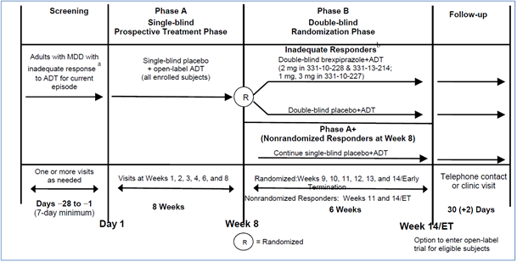

In all the fixed dose studies, (Studies 228, 227 and 214), all patients randomised to brexpiprazole initiated treatment at 0.5 mg/day during Week 1. The brexpiprazole dose was increased to 1 mg/day during Week 2 in all dose groups and, based on the assigned treatment, the dose was either maintained at 1 mg/day or increased to 3 mg/day (Study 227) or increased to 2 mg/day (Studies 228 and 214), from Week 3 onwards. Dosages were maintained at the assigned doses for the four remaining weeks. In the flexible dose study (Study 282), patients randomised to brexpiprazole initiated treatment at 1 mg/day during Week 1, and the dose was increased to the target dose of 2 mg/day during Week 2. Patients remained at 2 mg/day in Study 282 unless there was a decision to increase the dose to 3 mg/day.

MADRS was the primary endpoint for all short term studies. MADRS is a 10 item clinician rated scale that assesses the degree of depressive symptomatology (apparent sadness, reported sadness, inner tension, reduced sleep, reduced appetite, concentration difficulties, lassitude, inability to feel, pessimistic thoughts, and suicidal thoughts). Each item is scored from 0 (normal/symptom not present) to 6 (most severe symptoms) and the range for the total score is 0 to 60.

The key secondary instrument was the Sheehan Disability Scale (SDS), a 3 item self-rated instrument used to assess three domains of functioning (work/school, social life, and family life) with each item scored from 0 (no disruption at all) to 10 (extreme disruption).

##### Study 228

*Title*: Efficacy and safety of brexpiprazole 2 mg/day as an adjunctive therapy to an assigned open-label anti-depressive therapy (ADT) was compared with placebo in patients with MDD.

*Treatment duration*: 8 weeks of Phase A, followed by 6 weeks of Phase B.

826 patients were enrolled to Phase A, and out of them, 379 patients were further enrolled to Phase B. 188 patients were treated with brexpiprazole in Phase B.

The mean age was 44 years and 70% of the patients were female. Mean duration of current episode of depression was around 13 months and majority of patients had recurrent episodes. Mean MADRS total score was 26.9 and SDS score was 6. 187 and 191 patients were included in the brexpiprazole and placebo groups respectively, with 175 and 178 patients meeting the Amendment 3 randomisation criteria. Comparable number of patients dropped out during Phase B (14 in brexpiprazole and 13 in placebo groups).

###### Results

Table 4 displays the results of the primary efficacy analysis. At Week 14, patients treated with 2 mg brexpiprazole achieved a greater (around 30%) reduction (-8.27 points) in MADRS score (primary endpoint) from the baseline value at the end of Phase A, compared to placebo (-5.15 points). The treatment difference (-3.12 points) was statistically significant.

Table 4: Study 228 Results for the primary endpoint

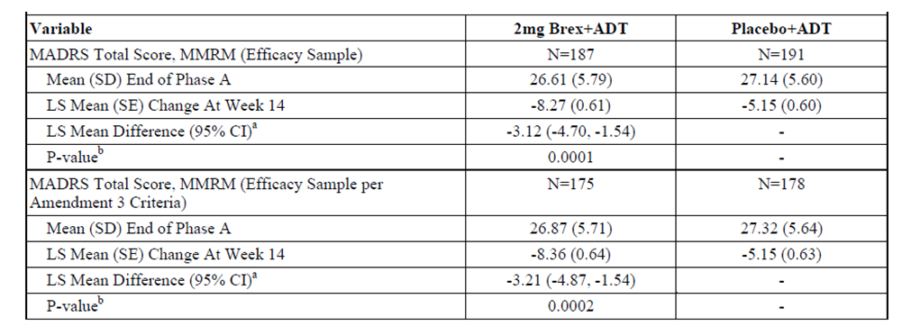

a) LS mean difference = difference in LS mean change. b) MMRM, with trial site, treatment group, visit, and treatment group-by-visit interaction as factor and baseline-by-visit interaction as a covariate. An ‘unstructured’ covariance was used.

MADRS = Montgomery-Asberg Depression Rating Scale; MMRM = multilevel modelling for repeated measures; N = number of subjects; SD = standard deviation; LS = least square; CI = confidence interval; Brex = brexpiprazole; ADT = antidepressant therapy.

The brexpiprazole group also achieved greater (around 20%) reduction in SDS score (‑1.35), compared to placebo (-0.91). The treatment difference was statistically significant.

Table 5: Study 228 Results for the secondary endpoint

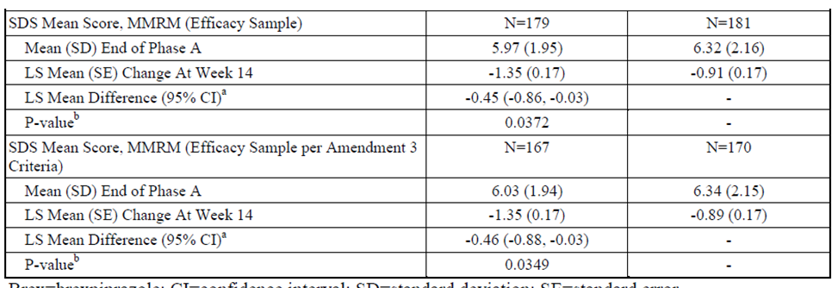

a) LS mean difference=difference in LS mean change. b) MMRM, with trial site, treatment group, visit, and treatment group-by-visit interaction as factor and baseline-by-visit interaction as a covariate. An ‘unstructured’ covariance was used.

SDS = Sheehan disability scale; MMRM = multilevel modelling for repeated measures; N = number of subjects; SD = standard deviation; LS = least square; CI = confidence interval; Brex = brexpiprazole; ADT = antidepressant therapy.

The brexpiprazole group also achieved greater reduction other efficacy endpoints such as CGI‑S score;[12] HAM-D17 score and HAM-A score;[13] compared to placebo. The treatment differences were statistically significant.

##### Study 227

The overall study design was similar to Study 228 (described above).

677 patients were randomised. Two doses of brexpiprazole were studied: 1 mg/day and 3 mg/day as an adjuvant to other ADTs. Efficacy was compared to placebo.

Patients were recruited in a 1:1:1 ratio into brexpiprazole 1 mg/day, 3 mg/day and placebo groups. Hochberg’s procedure was used to adjust for issues related to the multiplicity of doses.

Mean age of study population was around 45 years. 70% of patients were females. Overall, mean duration of current episode of depression was 17 months and around 86% of patients were having recurrent episodes at Baseline. Mean MADRS total score was 26.5 and SDS score was 5.8.

###### Results

A pre-specified threshold of 0.025 was assigned to the p‑value, to be considered as significant.

As per this protocol, the least squares (LS) of the mean difference in change in MADRS score at Week 14 for the brexpiprazole 3 mg group did not reach the threshold for significance (LS mean differences at Week 14 of −1.52, p = 0.0327). LS mean difference in change in MADRS score in 1 mg group was of lesser magnitude, compared to 3 mg group and it did not achieve statistical significance.

Figure 2: Study 227 Primary endpoint (least squares mean change in MADRS score from Baseline)

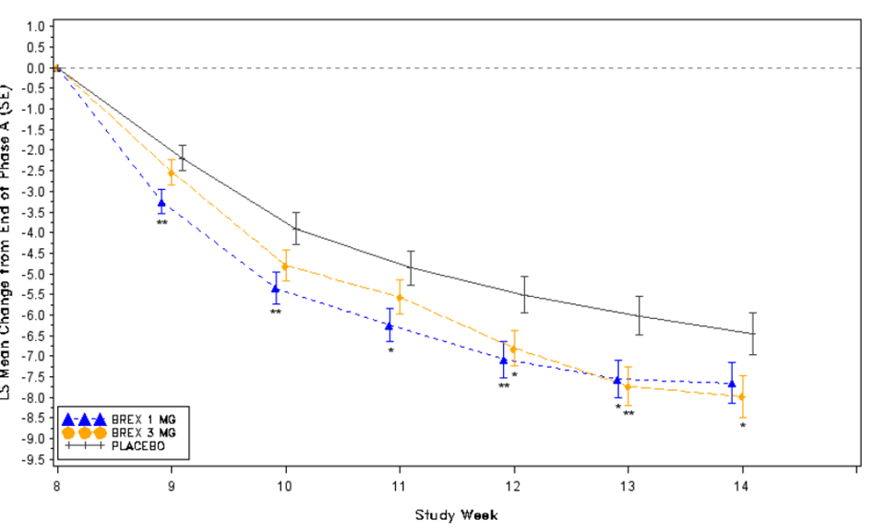

MADRS = Montgomery–Åsberg Depression Rating Scale; LS = least squares; SE = standard error; Brex = brexpiprazole (treatment group).

Secondary endpoints were not considered since this study did not meet its primary endpoint.

##### Study 214

*Study design*: A Phase III, placebo controlled, RCT to compare the efficacy of brexpiprazole versus placebo as adjunctive therapy in subjects with MDD that had not responded adequately to standard ADT.

*Study treatment*: brexpiprazole 2mg or placebo as an adjunct to standard ADT.

*Treatment duration*: 8 weeks of Phase A, followed by 6 weeks of Phase B.

394 patients were randomised to either the brexpiprazole or placebo group. Study design, inclusion and exclusion criteria were identical to Amendment 3 in the other RCTs in this submission with brexpiprazole (8 weeks of treatment with ADT and placebo (Phase A), followed by 6 weeks of treatment with brexpiprazole and placebo (Phase B)).

At Baseline, mean age was 42 years, around 73% of patients were females, mean current episode duration was around 16 months and 83% of patients had recurrent episodes of MDD. At the end of Phase A, mean (standard deviation; SD) MADRS score at Baseline was 26.6 (6.0) and SDS score was 5.6 (2.3).

###### Results

Primary endpoint: Brexpiprazole 2 mg was superior to placebo for the mean change in MADRS score after 6 weeks of treatment (from the end of Phase A to the end of Phase B): (difference in LS mean change −2.30, p = 0.0074).

The evaluator has highlighted that as seen in other studies in this submission, the treatment difference in the magnitude of change in MADRS score from Baseline of around 2 points, compared to placebo was modest.

After 6 weeks of treatment, there was no statistically significant treatment difference for mean change in SDS score between brexpiprazole and placebo.

Table 6: Study 214 Primary and secondary endpoints

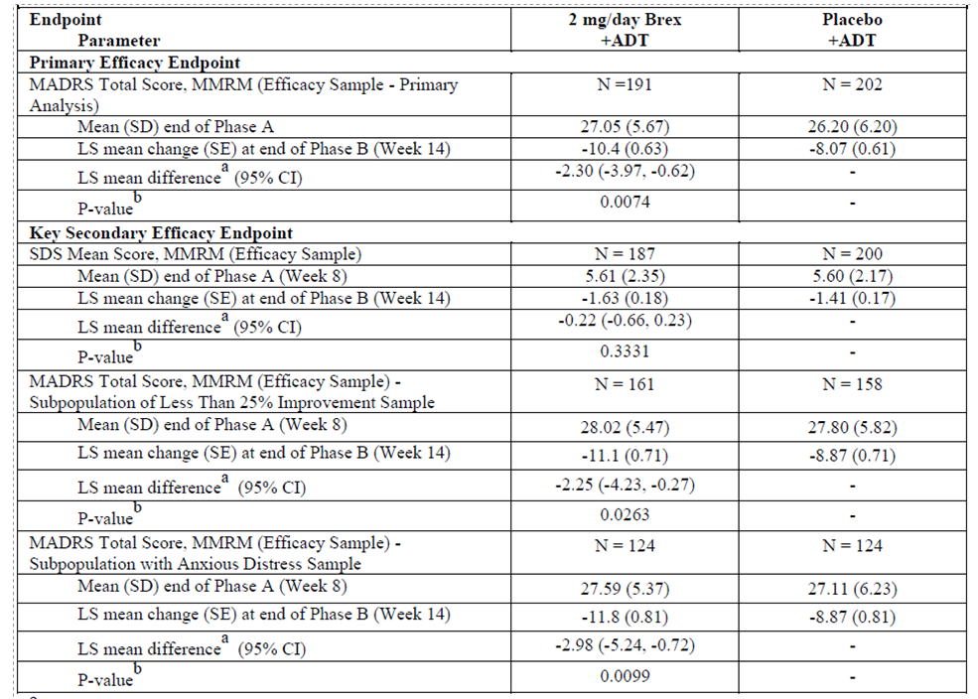

a) LS mean difference=difference in LS mean change. b) MMRM, with trial site, treatment group, visit, and treatment group-by-visit interaction as factor and baseline-by-visit interaction as a covariate. An ‘unstructured’ covariance was used.

MADRS = Montgomery–Åsberg Depression Rating Scale; MMRM = multilevel modelling for repeated measures; SD = standard deviation; LS = least squares; SE = standard error; CI = confidence interval; SDS = Sheehan Disability Scale; N = number of subjects Brex = brexpiprazole (treatment group); ADT = antidepressant therapy.

Considering the hierarchical statistical approach, since the secondary endpoint was negative, other efficacy endpoints were not considered.

##### Study 282

*Study design*: A Phase III flexible-dose double blind RCT with an active comparator. To compare short term efficacy of brexpiprazole 2 to 3 mg/day with placebo in poorly responsive MDD. An arm with extended release quetiapine (150 to 300 mg/day), as adjunctive therapy was included as active reference arm.

*Note*: This is the only study that examined the proposed flexible dose of 2 to 3 mg/day of brexpiprazole.

It was noted that patients were randomised in a 2:2:1 ratio to receive either brexpiprazole, placebo or quetiapine, with a lower proportion of patients in quetiapine group.

The Delegate commented that there were deficiencies in determination of treatment doses of both brexpiprazole and quetiapine. No clear protocol for dosing was included in the dossier.[14] It was left to the investigator’s discretion, if the efficacy was perceived to be inadequate. Moreover, it is unclear what proportion of patients in each group were in the higher and lower end of dose range.[15] These aspects could have impact of comparability of efficacy outcomes across treatment groups.

The evaluator has highlighted issues with determination of sample size for this study: The planned sample size of 200 in each of the brexpiprazole and placebo arms was expected to yield at least 90% power to detect the treatment effects at a two-tailed significance level of 0.05. Randomisation was planned at a 2:2:1 ratio (with less subjects in the Seroquel XR arm);[16] so the number of subjects to be allocated to the Seroquel XR arm was 100, despite the fact that this sample size of 100 subjects was expected to yield only 82% power to detect a treatment effect for Seroquel XR versus placebo. *The study was not specifically powered to allow comparisons between active treatments.*

Figure 3: Study 282 Schematic flow chart

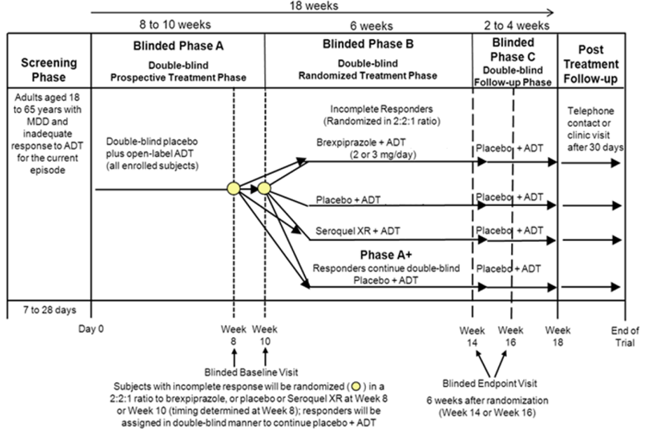

At Baseline, around 84% of patients were having recurrent episodes and the mean duration of current episode was around 12 months. At the end of Phase A, the mean MADRS total score was around 25, and SDS score around 5.6.

###### Results

The LS mean change in MADRS total score from end of Phase A to Phase B (after 6 weeks of treatment) was -6.04, -4.86 and -4.57 units for brexpiprazole, quetiapine and placebo respectively. The treatment difference of -1.48 between brexpiprazole and placebo was statistically significant. Treatment with quetiapine did not achieve statistically significant treatment difference, compared to placebo.

Table 7: Study 282 Results for the primary endpoint

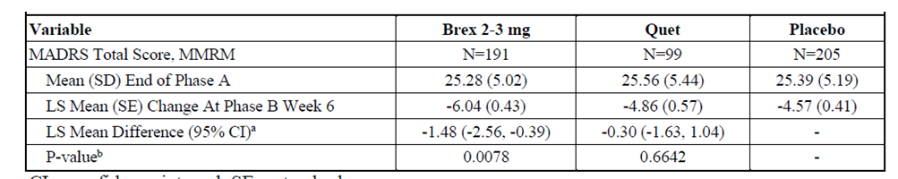

a) LS mean difference=difference in LS mean change. b) MMRM, with trial site, treatment group, visit, and treatment group-by-visit interaction as factor and baseline-by-visit interaction as a covariate. An ‘unstructured’ covariance was used.

MADRS = Montgomery–Åsberg Depression Rating Scale; MMRM = multilevel modelling for repeated measures; SD = standard deviation; LS = least squares; SE = standard error; CI = confidence interval; N = number of subjects Brex = brexpiprazole (treatment group); Quet = quetiapine extended release (treatment group)

There was a reduction in mean SDS score from end of Phase A for patients treated with brexpiprazole, however, the treatment difference, compared to placebo was not statistically significant.

Table 8: Study 282 Results for the secondary endpoint (mean change in SDS score)

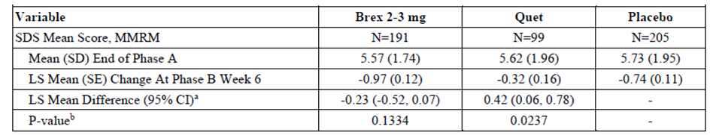

a) LS mean difference=difference in LS mean change. b) MMRM, with trial site, treatment group, visit, and treatment group-by-visit interaction as factor and baseline-by-visit interaction as a covariate. An ‘unstructured’ covariance was used.

SDS = Sheehan Disability Scale; MMRM = multilevel modelling for repeated measures; SD = standard deviation; LS = least squares; SE = standard error; CI = confidence interval; N = number of subjects Brex = brexpiprazole (treatment group); Quet = quetiapine extended release (treatment group)

Since the secondary endpoint did not achieve statistical significance, other secondary endpoints were not considered.

##### Studies 211 and 222 (short-term flexible dosing Phase II studies)

The submission included Study 211 and Study 222 as short term flexible dose Phase II studies. Both studies were identical in study design and patient population characteristics to previously described Phase III studies (8 weeks of Phase A, followed by 6 weeks of Phase B).

The range of brexpiprazole doses that were used in these studies were 0.15 mg/day, 0.50 ± 0.25 mg/day, or 1.5 ± 0.50 mg/day.

###### Results (Study 211)

A mean reduction in MADRS total score of around -8.23 units was observed in brexpiprazole 1.5 ± 0.5 mg/day at the end of Phase B, followed by -6.62 and -6.46 units in 0.15 mg/day and 0.50 ± 0.25 mg/day groups. The treatment difference was not statistically significant for all treatment groups. The 0.5 ± 0.5 mg/day group did not achieve the pre-specified significance threshold of p < 0.025. A similar trend was also seen for both the key secondary efficacy endpoints CGI-S score and SDS score. Treatment with all the doses of brexpiprazole in the study did achieve statistically significant treatment difference for Q‑LES‑Q-SF score;[17] compared to placebo (see below).

Table 9: Study 211 Results for the primary and key secondary endpoints

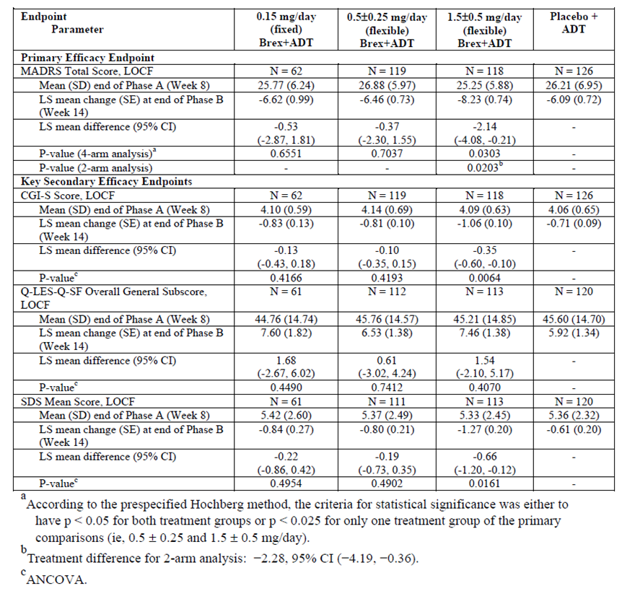

MADRS = Montgomery–Åsberg Depression Rating Scale; LOCF = last observation carried forward; SD = standard deviation; LS = least squares; SE = standard error; CI = confidence interval; CGI-S = Clinical Global Impression Severity Scale; Q-LES-Q-SF = Quality of Life Enjoyment and Satisfaction Questionnaire - Short Form; SDS = Sheehan Disability Scale; N = number of subjects Brex = brexpiprazole (treatment group); ADT = antidepressant therapy

Since the primary endpoints did not reach statistical significance, secondary endpoints were not considered.

###### Results (Study 222)

Primary and secondary endpoints of this study were not met. Results are shown in Tables 10 and 11, below.

Table 10: Study 222 Results for the primary endpoint

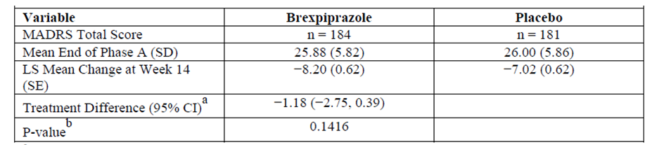

a) Treatment difference = difference in adjusted mean change: brexpiprazole − placebo. b) ANCOVA analysis for MADRS Total Score.

MADRS = Montgomery–Åsberg Depression Rating Scale; SD = standard deviation; LS = least squares; SE = standard error; CI = confidence interval; N = number of subjects.

Table 11: Study 222 Results for the key secondary endpoint

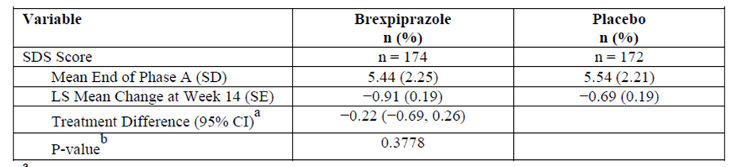

a) Treatment difference = difference in adjusted mean change: brexpiprazole − placebo. b) ANCOVA analysis for SDS Score.

SDS = Sheehan Disability Scale; SD = standard deviation; LS = least squares; SE = standard error; CI = confidence interval; N = number of subjects.

##### Study 70A (long term flexible dose study)

Study design: 8 weeks of Period A (prospective treatment with open label ADT and double-blind placebo), followed by 24 weeks of Period B (double blind RCT). Brexpiprazole was initiated at 1 mg/day and titrated for up to 3 mg/day, based on tolerability. The inclusion and exclusion criteria and baseline characteristics were comparable to other Phase III studies.

Figure 4: Study 70A Schematic flow chart and study design

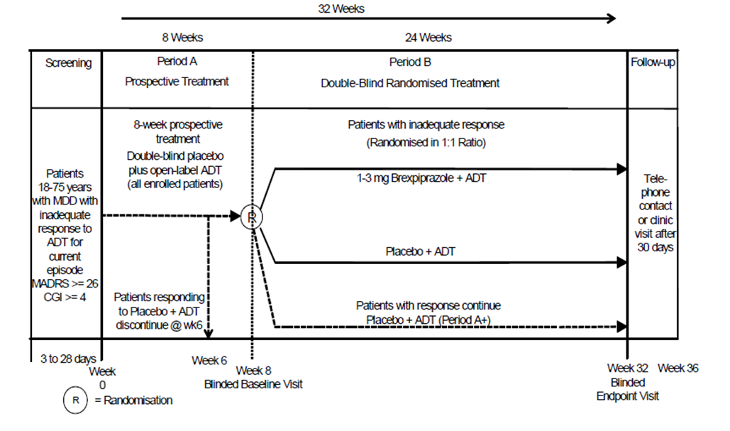

The primary endpoint was proportion of patients achieving full remission and key secondary endpoints were proportion of patients achieving full functional remission and global score remission.

###### Results

The study did not achieve both primary and key secondary endpoints. There was no significant difference in the proportion of patients who achieved full remission between brexpiprazole and placebo groups at Week 24.[18]

Table 12: Study70A Primary and key secondary efficacy endpoints

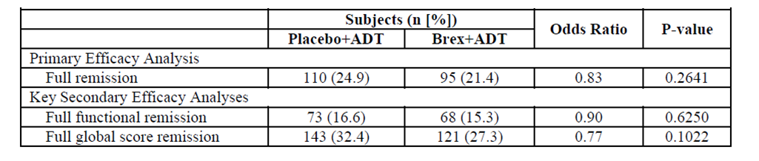

The Delegate commented that the efficacy outcomes of this study indicates that there won’t be a significant treatment benefit, in terms of remission of depression, if brexpiprazole is administered for 24 weeks as an adjuvant to ADT.

The sponsor has also included open label extension studies that examined long term efficacy and safety of brexpiprazole for treatment of MDD.

##### Study 212 (open label extension study)

Study design: This was a 52 week open label trial. Patients who completed Studies 211 and 222 were rolled over to this study.

###### Results

The CGI-S score improved between baseline and the last visit. The mean (SD) change in CGI-S from Baseline to the last visit was −0.96 (1.31) for those enrolled for the 52 week protocol (−0.70 (1.23) in the prior placebo + ADT group, −0.52 (1.30) in the prior brexpiprazole + ADT group, −0.95 (1.12) in the prior ADT-only group, and −1.47 (1.29) in the *de novo* group).

##### Study 238 (open label extension study)

This was a 52 week open label study for patients who rolled over from Phase III studies.

###### Results

The mean change from Baseline in the CGI-S score was an improvement of 1.05 (± 1.05) points. Subjects also had a mean CGI-I score of 2.1 (± 1.14) at the end of the treatment period (Week 52), corresponding to a range of changes between minimally and much improved.

The Delegate commented that the wide SD suggests the degree of variability in treatment outcome.

##### Study 60A (exploratory efficacy endpoint study)

This study focused on safety of brexpiprazole in elderly patients with MDD. 132 patients were enrolled. The study included a screening period up to 28 days, during which patients continued treatment with the same ADT they were taking prior to screening, a treatment period of 26-weeks, including a 4 week up-titration, and a safety follow-up period.

Treatment began with brexpiprazole 0.5 mg/day and patients were up-titrated in weekly steps to 2 mg/day (1 mg/day from the end of Week 1, and 2 mg/day from the end of Week 2 onwards). From the end of Week 4 onwards, the dose could be increased based on clinical judgement and tolerability to a maximum dose of 3 mg/day, or reduced if necessary for tolerability to a minimum of 1 mg/day.

Efficacy endpoints were exploratory.

A mean change of -14.5 points in MADRS total score was reported at Week 26. Similarly, a ‑1.8 points change was reported for CGI-S score.

##### Pooled analysis

The sponsor has included pooled efficacy data from the Phase II and Phase III studies. The Phase III studies (Studies 228, 282 and 214) were positive. The rest of the Phase III and Phase II studies were negative (Studies 227, 211, 222 and 70A). Study 70A was excluded from the pooled analysis for the reasons that the study was of long term duration, with a primary endpoint that was different to other Phase III short term studies. The evaluator has highlighted that these facts need to be taken into account when results of pooled analysis are considered.

The overall outcomes for MADRS was comparable to short term Phase III studies.

Table 13: Pooled analysis Change in MADRS

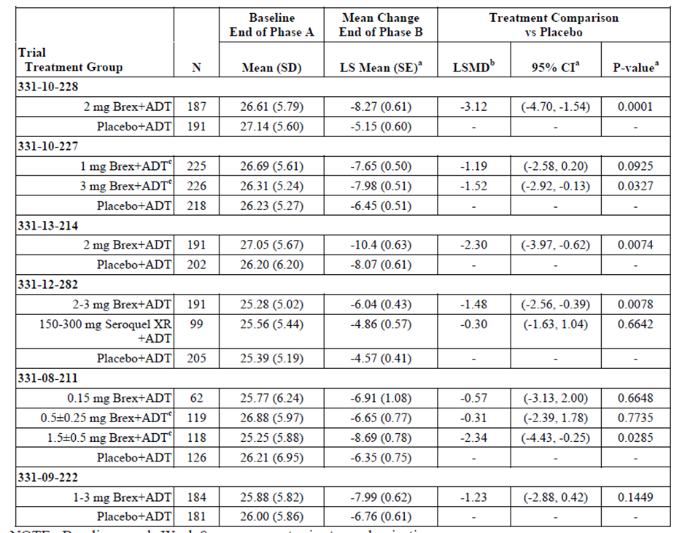

Pooled studies are: Studies 228, 227, 214, 282, 211 and 222.

Brex = brexpiprazole (treated group); ADT = antidepressant therapy; Seroquel XR = quetiapine (as fumarate) extended release (treated group); N = number of subjects; SD = standard deviation; LS = least squares; SE = standard error; LSMD = least squares of the mean difference; CI = confidence interval.

A 28% response rate was reported across three fixed dose short term studies with 2 to 3 mg brexpiprazole, compared to 21/1% in placebo. Since the analysis has patients with both 2 and 3 mg of brexpiprazole, it cannot be entirely related to the proposed 2 mg/day dose of brexpiprazole.

#### Safety

The Delegate has noted that the around 50% of patients across short term studies was exposed to the proposed 2 mg/day dose (see Table 14, below). However, the safety data provided is largely from pooled data across all patients treated with brexpiprazole in short term studies and hence it is not specific for the patients treated with 2 mg/day and cannot be related to the patients being treated with the proposed dose (lacks external validity).

Table 14: Summary of brexpiprazole treatment duration and dosing

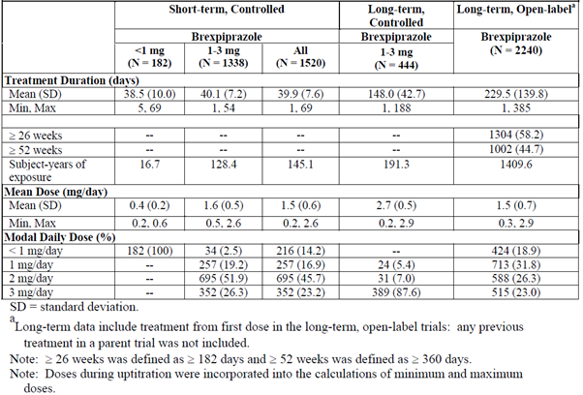

N = number of subjects; min = minimum; max = maximum

The Delegate commented that following tables for treatment emergent adverse events (TEAEs), adverse events (AEs) and serious adverse events (SAEs) do not provide information on incidence of TEAEs specifically for patients treated with the proposed 2 mg/day of brexpiprazole.[19]

##### Summary of treatment emergent adverse events

Across short-term studies, there was a 10% greater incidence of any TEAEs and TEAEs related to treatment in brexpiprazole group, compared to placebo. There was a three times increased incidence in TEAEs that led to discontinuation of treatment in brexpiprazole group, compared to placebo.

Table 15: Summary of treatment emergent adverse events across clinical studies

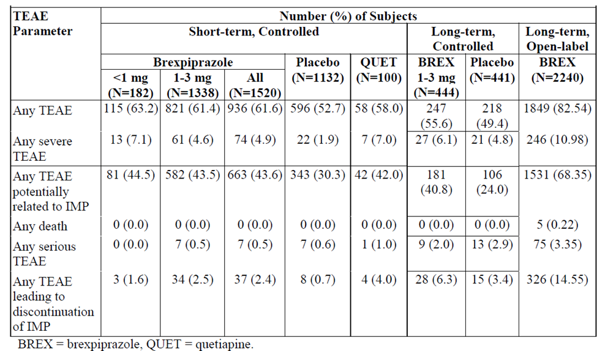

TEAE = treatment emergent adverse event; IMP = investigational medicinal product; N = number of subjects.

##### Adverse events

Weight gain and akathisia were the two AEs with two times greater incidence in brexpiprazole group, compared to placebo. These are expected AEs with this class of drugs.

Table 16: Incidence of adverse events across clinical studies by System Organ Class and MedDRA Preferred Term

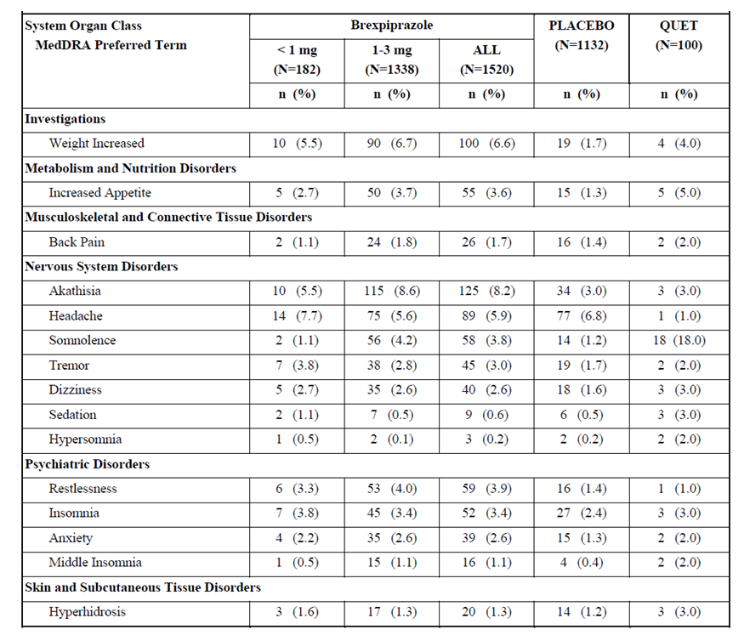

MedDRA = Medical Dictionary for Regulatory Activities; N = number of subects; QUET = quetiapine (as fumarate) extended release (treated group).

AEs that were considered as treatment-related were akathisia (8.0%), weight increased (6.3%), restlessness (3.9%), somnolence (3.6%), increased appetite (3.6%), headache (3.0%), fatigue (2.8%), tremor (2.8%), and insomnia (2.5%).

TEAEs specifically related to short term treatment with brexpiprazole 2 mg/day were assessed based on data from Studies 228 and 214. In both studies, there was a > 2 times greater incidence in weight gain in brexpiprazole group, compared to placebo. In Study 228, a significantly higher proportion of patients (n = 6 (3.21%)) in the 2 mg/day brexpiprazole + ADT group and 1 patient (0.53%) in the placebo + ADT group had clinically relevant weight gain of ≥ 7% (p = 0.0541). A similar outcome was also reported in Study 214.

Also, a higher incidence of akathisia was noted in brexpiprazole group, compared to placebo.

Table 17: Incidence of treatment emergent adverse events in Study 228 (Phase B) occurring in at least 2% of subjects in any treatment group (safety sample)

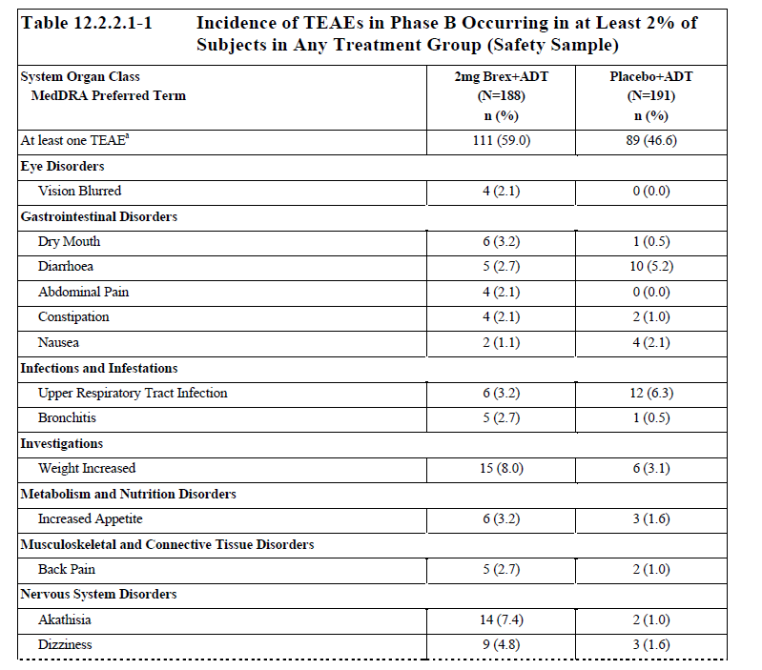

MedDRA = Medical Dictionary for Regulatory Activities; TEAE = treatment emergent adverse event; Brex = brexpipazole (treated group); ADT = antidepressant therapy; N = number of subjects.

Table 18: Incidence of treatment emergent adverse events in Study 214 (Phase B) occurring in at least 2% of subjects in any treatment group (safety sample)

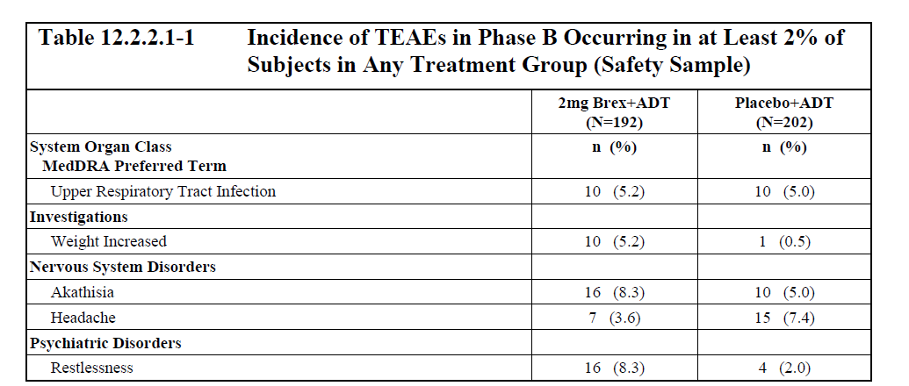

MedDRA = Medical Dictionary for Regulatory Activities; Brex = brexpipazole (treated group); ADT = antidepressant therapy; N = number of subjects.

In long term placebo controlled studies, an increased proportion of patients in brexpiprazole group experienced rise in fasting glucose, compared to placebo (7.1% versus 3.4%). The mean change from Baseline for fasting glucose to last visit was 1.74 mg/dL and 0.21 mg/dL for brexpiprazole and placebo, respectively. A similar increase in fasting triglycerides was also noted with patients in brexpiprazole group, compared to placebo.

##### Serious adverse events

Suicidal ideation was the most frequently reported SAE, experienced by two subjects in the brexpiprazole group and three subjects in the placebo group. Three SAEs were considered possibly related to brexpiprazole, and they were all reported in the brexpiprazole group: suicidal ideation, loss of consciousness and circulatory collapse. None of the serious TEAEs reported during the double blind treatment phase were fatal.

Table 19: Incidence of serious adverse events across clinical studies in subjects in any treatment group

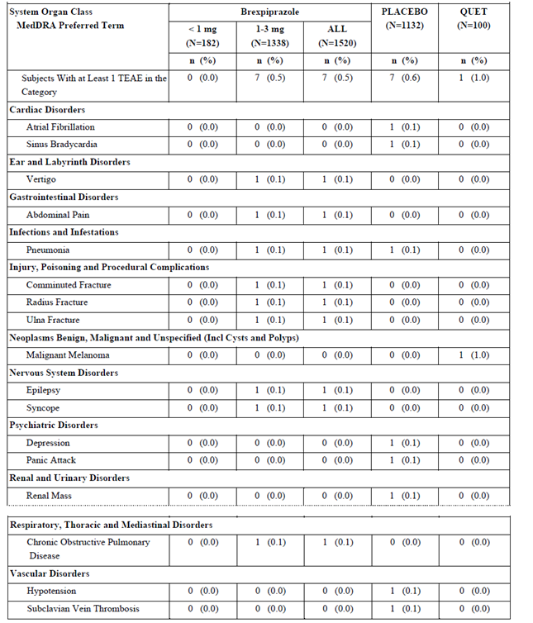

MedDRA = Medical Dictionary for Regulatory Activities; TEAE = treatment emergent adverse event; N = number of subjects; QUET = quetiapine (as fumarate) extended release (treated group).

##### Discontinuations due to adverse events

2.4% and 4% of patients in brexpiprazole and quetiapine groups respectively discontinued due to an AE, compared to 0.7% in placebo.

It was noted that somnolence, that is commonly observed in ADTs, had a lower incidence in the brexpiprazole 1 to 3 mg group, compared to the quetiapine extended release group (4.9% versus 21%).

Treatment-emergent suicidal ideation occurred in a similar percentage of the brexpiprazole group (10.5%) and placebo group (12.2%) groups.

There was no increased incidence of seizures during the study period of brexpiprazole in the included studies.

Weight gain was the leading cause of discontinuation of treatment with brexpiprazole in long term studies.

##### Deaths

There were 29 deaths in the brexpiprazole clinical development program.

Of the 29 deaths, 16 occurred in subjects who had been treated with brexpiprazole, 6 deaths occurred in subjects whose treatment remains blinded in ongoing trials, 6 deaths occurred prior to randomisation to brexpiprazole and 1 occurred during Phase A (on placebo + ADT). Most of the deaths were considered either not related (26 deaths) or unlikely related (2 deaths) to brexpiprazole by the investigator, but one death due to completed suicide was assessed as possibly related to brexpiprazole. The patient was a 52 year old female with long history of MDD.

#### Clinical evaluator’s recommendation

The clinical evaluator recommended rejection of this submission for the proposed indication (the evaluator’s rationale is discussed below in section: *First risk-benefit analysis, Delegate’s considerations*).

### Risk management plan

The most recently evaluated European Union risk management plan (RMP) was version 2.0 (27 March 2017; data lock point (DLP) 15 May 2015) and Australian-specific Annex (ASA) version 2.0 (29 March 2017). In support of the extended indications, the sponsor has submitted EU‑RMP version 1.3 (20 April 2018; DLP 31 August 2016) and ASA version 3.0 (December 2018).

The proposed summary of safety concerns and their associated risk monitoring and mitigation strategies are summarised below in Table 20.[20]

Table 20: Summary of safety concerns

|  |  |  |  |  |  |
| --- | --- | --- | --- | --- | --- |
| Summary of safety concerns | | Pharmacovigilance | | Risk minimisation | |
| **Routine** | **Additional** | **Routine** | **Additional** |
| **Important identified risks** | Weight gain | ✓ | – | ✓ | – |
| Seizure* | ✓ | – | ✓ | – |
| **Important potential risks** | Hyperglycaemia/diabetes (listed as Hyperglycaemia in EU-RMP) | ✓ | – | ✓ | – |
| Neuroleptic malignant syndrome (NMS) | ✓ | – | ✓ | – |
| Hyperprolactinaemia and related disorders | ✓ | – | ✓ | – |
| Suicidality* | ✓ | – | ✓ | – |
| Dyslipidaemia* | ✓ | – | ✓ | – |
| CPK increase* | ✓ | – | ✓ | – |
| VTE* | ✓ | – | ✓ | – |
| Dysphagia in elderly* | ✓ | – | ✓ | – |
| **Missing information** | Use in pregnancy and lactation | ✓ | – | ✓ | ✓ |
| Use in elderly (age > 65) | ✓ | – | ✓ | – |
| Substance abuse, misuse and overdose | ✓ | – | ✓ | – |
| Use in patients with insulin dependent diabetes mellitus (IDDM) | ✓ | – | ✓ | – |
| Use in patients with hepatic impairment* | ✓ | – | ✓ | – |
| Use in patients with renal impairment* | ✓ | – | ✓ | – |
| Psychiatric comorbidities* | ✓ | – | ✓ | – |
| Use in paediatrics* | ✓ | – | ✓ | – |

* = ASA only; CPK = creatine phosphokinase; VTE = venous thromboembolism

The summary of safety concerns above include the concerns identified in the EU-RMP as well as additional safety concerns specific to the ASA. This is acceptable.

Routine pharmacovigilance measures are proposed in the ASA for all safety concerns. The sponsor has proposed an American pregnancy registry as an additional pharmacovigilance activity. This is acceptable.

Routine risk minimisation measures only are proposed for Australia. These measures are considered sufficient to mitigate the risks of this product.

#### Risk management recommendations

There are no recommendations at the first round of RMP evaluation. As such there will be no further RMP evaluation reports for this submission unless further safety concerns are identified or requested by the Delegate.

#### Wording for conditions of registration

Any changes to which the sponsor has agreed should be included in a revised RMP and ASA. However, irrespective of whether or not they are included in the currently available version of the RMP document, the agreed changes become part of the risk management system.

The suggested wording is:

The Rexulti EU-Risk Management Plan (RMP) (version 1.3, 20 April 2018, data lock point 31 August 2016), with Australian Specific Annex (version 3.0, dated December 2018), included with submission PM-2018-05140-1-1, and any subsequent revisions, as agreed with the TGA will be implemented in Australia.

An obligatory component of risk management plans is routine pharmacovigilance. Routine pharmacovigilance includes the submission of periodic safety update reports (PSURs).

Reports are to be provided in line with the current published list of EU reference dates and frequency of submission of PSURs until the period covered by such reports is not less than three years from the date of this approval letter.

The reports are to at least meet the requirements for PSURs as described in the European Medicines Agency’s Guideline on good pharmacovigilance practices (GVP) Module VII-periodic safety update report (Rev 1), Part VII.B Structures and processes. Note that submission of a PSUR does not constitute an application to vary the registration.

### First risk-benefit analysis

#### Delegate’s considerations

The sponsor’s proposed extension of indication for the use of brexpiprazole in the treatment of patients with MDD is:

*Use as a short-term adjunctive therapy to antidepressants for the treatment of major depressive disorder (MDD) in adult patients with an inadequate response to prior antidepressant treatment. Treatment should only be continued beyond 6 weeks where this is clinically indicated.*

The dossier included four short term double blind RCTs. The study design is largely acceptable from a regulatory and clinical perspective. All the studies had 8 weeks of Phase A during which response to ADT was assessed. The duration of Phase A is in line with the Royal Australian and New Zealand College of Psychiatrists (RANZCP) guidelines for treatment of MDD to assess treatment response to an ADT.[21] Duration of Phase B (6 weeks) is also acceptable for assessment of possible remission of symptoms. The ADTs trialled during Phase A included both first and second line ADTs and the < 50% reduction in MADRS score to consider as inadequate treatment response is in line with clinical practice guidelines.

Since, the sponsor has proposed an indication for short-term therapy with brexpiprazole, the Delegate has focussed on evidence provided by the (prospectively designed) short‑term studies in this submission. A greater improvement in MADRS and SDS scores were observed in all short term studies for patients treated with brexpiprazole, compared to placebo. Statistical significance for MADRS at the proposed 2 mg/day dose was reported in all short term studies with the proposed dose. However, around 30 to 40% reduction in MADRS score from Baseline was observed in all short term studies. This is in short of the magnitude of reduction (≥ 50%) required for this endpoint, in order to be considered as a clinically relevant treatment response.[22] Moreover, a total score of ≤ 10 or 12 for MADRS, which is considered as remission;[23] was not achieved at Week 6 in any of the short term studies. This is particularly important since the sponsor’s proposed indication is for ‘*short term’* use. Major proportion of patients who were treated with brexpiprazole and not achieved remission are at greater risk of experiencing rebound depression. There were no studies included in this submission to examine the clinical course of patients in brexpiprazole group when their treatment will be stopped at 6 weeks (as per the proposed indication).

SDS measures treatment effect with other aspects of depression, not included in MADRS. Across short term studies, the magnitude of improvement for SDS scores from Baseline for patients treated with brexpiprazole (around 20%) was also modest, compared to placebo. It was noted that the treatment difference with placebo did not reach statistical significance in any of the short term studies, except Study 228. An overall nominal improvement in other efficacy end points was noted. However, they were not considered in the efficacy assessment as the key secondary endpoint, change in SDS score, was not significantly improved, compared to placebo in most of the short term studies.

Mechanistically, compared to aripiprazole, brexpiprazole is characterised by a lower intrinsic dopaminergic activity, and by higher post-synaptic serotonin 2A receptor (5-HT2A) antagonism. However, there were only two short term studies with 2 mg/day of brexpiprazole that provided safety data and hence limited the Delegate’s ability to assess the safety profile of brexpiprazole for the treatment of patient population indicated. A notably higher proportion of patients experienced clinically relevant weight gain from 6 weeks of treatment with brexpiprazole in Studies 228 and 214. This is particularly important from a clinical perspective, as there is a causal relationship between obesity and depression. A greater incidence of akathisia was also noted with 6 weeks of treatment with brexpiprazole. Long term treatment with brexpiprazole was associated with a greater incidence of high fasting glucose and triglycerides. These observations, together with the higher incidence of treatment discontinuation indicates lack of tolerability of brexpiprazole as an adjuvant to ADT.

The clinical evaluator recommended rejection on the basis of very small magnitude of benefit demonstrated at Week 6 and superiority of placebo after this time point and lack of data related to clinical effects when brexpiprazole is ceased at 6 weeks.

The evaluator recommended the following as the indication, if the product is approved:

*Use as a short-term adjunctive therapy to antidepressants for the treatment of major depressive disorder (MDD) in adult patients with an inadequate response to prior antidepressant treatment. Treatment should be weaned soon after 6 weeks, based on clinical judgement.*

The Delegate is of the opinion that, based on the efficacy endpoints chosen, the strength of evidence for short term treatment benefit for the patient population indicated, compared to placebo is modest. The clinical development program also had pitfalls such as lack of dose finding study and only two studies that provide specific efficacy and safety data for the proposed 2 mg/day dosage of brexpiprazole.

In summary, there is insufficient evidence for a positive benefit-risk profile for brexpiprazole for short term treatment of MDD patients with inadequate treatment response to other ADTs. At this stage, the Delegate will be considering Advisory Committee on Medicines (ACM) advice before making a final decision on this application.

#### Summary of issues

* Lack of dose-finding study for MDD is considered as a major deficiency in the clinical development programme.
* Magnitude of improvement for Montgomery–Åsberg Depression Rating Scale (MADRS) across studies did not achieve the required scores that indicate treatment ‘response’ or ‘remission’ at week 6.
* No significant improvement with Sheehan Disability Scale (SDS) was demonstrated in majority of short term studies.
* Depression is a chronic illness. The utility of brexpiprazole as a short term treatment option is unclear. Furthermore, proportion of patients with rebound depression after cessation of brexpiprazole and their subsequent management is uncertain. This is particularly important, considering the fact that in the clinical studies, patients treated with brexpiprazole neither achieved response nor remission.
* There was an increased incidence of weight gain and akathisia in brexpiprazole group, compared to placebo. At Week 6, a significantly higher proportion of patients in brexpiprazole group experienced clinically relevant increase (> 7%) in weight, compared to placebo. Magnitude of weight gain was also more pronounced with prolonged use of brexpiprazole and also the leading cause of discontinuation of treatment.
* A two-times higher proportion of patients in brexpiprazole group in long term study experienced shifts in fasting glucose from normal or impaired to high range. A similar finding was also noted with fasting triglycerides.
* Overall, three times increased incidence in TEAEs that led to discontinuation of treatment in brexpiprazole group was observed, compared to placebo.
* Modest evidence for treatment benefit, together with increased incidence of safety events and discontinuation indicates a negative benefit-risk profile for brexpiprazole for the proposed indication.

#### Proposed action

The Delegate was not in a position to say, at the time, that the application for brexpiprazole should be approved for registration.

#### Questions for the sponsor

The sponsor provided the following response to questions from the Delegate.

1. ***Are there any data related to the clinical outcomes of patients when their treatment with brexpiprazole is stopped at 6 weeks?***

No formal assessments of withdrawal have been conducted, but all studies included a 30 day follow-up period. Subjects included in the short-term trials were offered to continue in an open-label extension trial, and 75% of the subjects continued. During the 30 day follow-up period in the short-term controlled trials, 6.6% of subjects on brexpiprazole reported an AE versus 9.5% on placebo. The most frequently reported AE in the brexpiprazole group was depression (4 subjects, 0.9%) and headache, tension headache, and nausea in the placebo group (each 4 subjects, 1.1%).

1. ***A difference in the number of patients was noted with Study 227 in the FDA’s US Prescribing Information and also the efficacy outcomes, compared to the data included in this dossier. Please explain.***

The Australian dossier, as well as the US FDA’s New Drug Application (NDA), includes results from two efficacy analyses:

1. Efficacy sample (primary sample as specified in the protocols)
2. Efficacy sample per target population (the analyses excluded Phase A transient responders in Trials (Studies) 227 and 228 recruited prior to implementation of Amendment 3).

The US Prescribing Information includes data from the efficacy sample per target population. As with the US Prescribing Information, the sponsor initially proposed to include the efficacy sample per target population analyses in the Australian PI. Based on comments from the clinical evaluator, the current Australian PI has been amended to include results from the larger efficacy sample.

#### Advisory Committee considerations[24]

The Advisory Committee on Medicines (ACM), having considered the evaluations and the Delegate’s overview, as well as the sponsor’s response to these documents, advised the following:

The proposed indication considered by the ACM was:

*Use as a short-term adjunctive therapy to antidepressants for the treatment of major depressive disorder (MDD) in adult patients with an inadequate response to prior antidepressant treatment. Rexulti should be used for the shortest period of time that is clinically indicated.*

The ACM agreed that Rexulti had an overall negative benefit-risk profile for the proposed indication as the evidence submitted did not satisfactorily establish the robust efficacy of the product.

##### Specific advice

The ACM advised the following in response to the Delegate’s specific request for advice.

1. ***The Delegate is of the view that the evidence of brexpiprazole’s efficacy is modest to support the proposed indication. The committee’s comments will be appreciated.***

The ACM agreed with the Delegate that the evidence of brexpiprazole’s efficacy is modest. While on some occasions there were statistically significant differences in the endpoints compared to placebo and other accepted treatments for MDD, these differences are unlikely to be clinically meaningful for patients.

1. ***Across studies, the mean MADRS at Week 6 was neither in the ‘remission’ nor ‘response’ range. There is also lack of data that is related to the proportion of patients who could experience rebound depression after cessation of treatment at Week 6. Since the proposed indication is for short term use, from a clinical perspective, what are the implications of these findings on the long-term management of these patients?***

The ACM was concerned that ‘short-term use’ is not defined by the sponsor nor is it a term used in any of the relevant clinical guidance for Australian practice. Judicious and timely review, with titration of pharmacotherapy, is an essential feature of appropriate management of MDD (which by definition, is a chronic condition). It is highly unlikely that, for the proposed treatment population, any pharmacological intervention used for 6 weeks will have a meaningful or sustained effect on the underlying diagnosed condition of MDD. Furthermore, the ACM advised that there is a lack of evidence guiding any advice on cessation of brexpiprazole in MMD patients and data related to incidence of potential re-bound depression is lacking.

1. ***What will be the utility of brexpiprazole in the current treatment paradigm of MDD in Australia, particularly for patients with inadequate treatment response to first and/or second line ADTs?***

The ACM advised that a number of pharmacological and non-pharmacological options are commonly deployed for the treatment of MDD. There is a wide range of evidence that supports this practice. In view of the low quality of data submitted to support its efficacy, the utility of brexpiprazole in the current treatment paradigm of MDD is uncertain.

1. ***The Delegate is of the view that modest evidence for treatment benefit, together with increased incidence of safety events and discontinuation indicates a negative benefit-risk profile for brexpiprazole for the proposed indication. The committee’s comments will be appreciated.***

There was no suggestion of an overall increase in the known toxicity of Rexulti from wider, long term studies and global use in schizophrenia patients. There are, however, several signals that require further risk management. These have been outlined in the final proposed ASA to the European Union-Risk Management Plan (EU-RMP), which has been accepted by the sponsor. The major deficiency in the submission is the uncertainty around meaningful efficacy for brexpiprazole in the proposed indication. The risk/benefit balance is therefore clearly negative.

### Second risk-benefit analysis

The ACM reviewed this application at the ACM meeting in February 2020. The ACM agreed with the Delegate's conclusion not to approve this application for the proposed indication. This conclusion was based on the negative benefit-risk assessment.

The sponsor requested for an opportunity to justify their rationale for the proposed indication and to respond to ACM's comments. For the sake of procedural fairness, the Delegate accepted the sponsor's request and reviewed the sponsor’s response.

#### Delegate’s considerations

The efficacy data was largely a summary of the data that has already been submitted to the TGA.

The sponsor has stated that the proposed short-term (6 weeks) use of brexpiprazole reflects current Australian clinical practice. However, quetiapine fumarate (extended release; Seroquel XR), which is TGA approved for the treatment of MDD is indicated for acute and maintenance long term treatment of MDD. The ACM has also commented, *‘judicious and timely review, with titration of pharmacotherapy, is an essential feature of appropriate management of MDD (which by definition, is a chronic condition)*’. The sponsor has quoted statements from a paper by Mulder et al.;[25] which are opinions of the author, rather than clinical evidence. The statements are also not specific to brexpiprazole. The author has stated that the clinical effects following treatment with anti-psychotics are apparent within the first week and could be tapered and stopped after a *‘relatively short trial’*. The author has also stated that if beneficial, the treatment with antipsychotics may need to be maintained for a further *‘short period of time’*. The Delegate considers that the exact time period of short‑term treatment has not been well-defined. In addition, due to the lack of data, the maintenance aspect of treatment with anti-psychotics that was mentioned by the author is not applicable to brexpiprazole. For these reasons, the Delegate considers that this reference does not support the proposed indication for brexpiprazole.

Study 14570A with a 32 week treatment period failed to achieve primary (full remission) and secondary endpoints. However, the Delegate considers that the clinical data (32 week treatment period) from this study is not relevant for the proposed indication (6 week treatment duration).

The sponsor has stated that:

‘It is the Applicant’s position that efficacy has been demonstrated at a level supportive of approval in the indication proposed, and the 2 mg/day dose is more beneficial compared to anti-psychotics currently used in Australian clinical practice for treatment of patients with MDD. This leads to a clearly positive benefit-risk balance.’

Study 282 with quetiapine as an active comparator was not specifically powered to allow comparisons between active treatments. A comparative dose of quetiapine to 2 mg/day of brexpiprazole has also not been determined. Also, the 6 week treatment period during which quetiapine was compared to brexpiprazole does not align with the approved treatment regimen of quetiapine. The Delegate does not consider the 6 week treatment benefit of brexpiprazole and quetiapine (extended release; Seroquel XR) are comparable.

The sponsor has mentioned about an ongoing clinical trial to assess long-term benefit of continuation of adjunctive therapy in subjects who respond to adjunct brexpiprazole. This study is designed as a double blind, placebo controlled, randomised withdrawal maintenance trial of brexpiprazole in subjects who require adjunctive treatment of MDD. The primary efficacy endpoint of this trial is time to relapse. Completion of this study is anticipated by September 2022. Two interim analyses are planned during the conduct of the trial. This study is being conducted as a post-marketing commitment to the FDA.

In conclusion, the Delegate considers that the sponsor has not provided data to specifically address the issues identified by the Delegate and the ACM that contributed to the negative benefit-risk assessment.

#### Summary of issues

The key concerns following the review of this application at the previous ACM meeting were:

* *The major deficiency in the submission:*
  + the uncertainty around meaningful efficacy for brexpiprazole in the proposed indication.
  + *It is highly unlikely that, for the proposed treatment population, any pharmacological intervention used for 6 weeks will have a meaningful or sustained effect on the underlying diagnosed condition of MDD.*
  + *Lack of evidence guiding any advice on cessation of brexpiprazole in MMD patients and data related to incidence of potential re-bound depression is lacking.*
* The Delegate considers that the above issues are not specifically addressed by the sponsor in their response document.
* No new efficacy data has been provided to support the proposed indication.
* The Study 14570A with a 32 week treatment period failed to achieve primary (full remission) and secondary endpoints.
* The sponsor has stated the challenges in the treatment of patients with MDD.
* The sponsor has stated that the proposed short-term (6 week) use of brexpiprazole reflects current Australian clinical practice. The sponsor has not provided any Australian treatment guidelines for MDD to support this statement.

#### Proposed action

The Delegate was not in a position to say, at the time, that the application for brexpiprazole (Rexulti) should be approved for registration.

#### Advisory Committee considerations24

The Advisory Committee on Medicines (ACM), having considered the evaluations and the Delegate’s overview, as well as the sponsor’s response to these documents, advised the following:

The proposed indication considered by the ACM was:

*Use as a short-term adjunctive therapy to antidepressants for the treatment of major depressive disorder (MDD) in adult patients with an inadequate response to prior antidepressant treatment. Rexulti should be used for the shortest period of time that is clinically indicated.*

The ACM agreed that Rexulti had an overall negative benefit-risk profile for the proposed indication as the evidence submitted did not satisfactorily establish the quality and safety of the product.

The major deficiency in the submission remains the uncertainty around meaningful efficacy for brexpiprazole in the proposed indication. The risk/benefit balance is therefore clearly negative.

##### Specific advice

1. ***Considering the sponsor's response, what are the ACM's views on the adequacy of data to support the proposed indication for brexpiprazole.***

The ACM advised that the sponsor did not provide any new evidence for the proposed indication. The committee agreed that the evidence submitted by the sponsor is lacking efficacy data to support the extension of indication. The ACM advised that there was no remission or response effect across the studies, and no safety information about possible rebound depression after cessation of treatment at Week 6.

1. ***The committee is also requested to provide advice on any other issues that it thinks may be relevant to a decision on whether or not to approve this application.***

The ACM stated that MDD is difficult to treat and requires a 6 to 12 month treatment plan. They further stated that there are alternative treatment options available in Australia that have demonstrated a clinically relevant reduction in MADRS score after 12 weeks of treatment. The magnitude of reduction in MADRS scores with medicines that are approved by the TGA for the treatment of MDD were higher than those demonstrated in studies with brexpiprazole, and those studies were of longer duration than the ones with brexpiprazole.

The ACM advised that the lack of evidence to support clinically significant efficacy for brexpiprazole makes the utility of brexpiprazole in the treatment paradigm of MDD uncertain. From a regulatory perspective, the ACM's opinion was that the treatment options for MDD, which is recognised as a challenging condition to treat, should have a clinically relevant magnitude of efficacy. Moreover, from a clinical perspective, treatment intervention with agents with sub-optimal proven benefits might result in more uncertainties and delay in initiation of other therapeutic options for patients with an already challenging condition, such as MDD.

### Outcome

The sponsor withdrew their submission on 11 September 2020 before a decision had been made by the TGA.

|  |
| --- |
| Therapeutic Goods Administration |
| PO Box 100 Woden ACT 2606 Australia  Email: [info@tga.gov.au](mailto:info@tga.gov.au) Phone: 1800 020 653 Fax: 02 6232 8605  [**https://www.tga.gov.au**](https://www.tga.gov.au) |

1. The **Black Triangle Scheme** provides a simple means for practitioners and patients to identify certain types of new prescription medicines, including those being used in new ways and to encourage the reporting of adverse events associated with their use. The Black Triangle does not denote that there are known safety problems, just that the TGA is encouraging adverse event reporting to help us build up the full picture of a medicine's safety profile.
2. Seroquel XR (quetiapine, as fumarate, modified release tablets) is indicated for (in relation to MDD):

   *Major depressive disorder: Treatment of recurrent major depressive disorder (MDD) in patients who are intolerant of, or who have an inadequate response to alternative therapies.*
3. FDA Prescribing information for Rexulti (brexpiprazole) tablets, for oral use. Initial US Approval: 2015. Available from the FDA website.
4. TGA clarification: the TGA confirms that both the data set described in the FDA prescribing information (‘efficacy sample per final protocol’ (based upon a protocol amended (Protocol Amendment 3) population defined after the start of Study 227) and a data set (‘efficacy sample’) based upon the original study plan, were included in the dossier. Both underwent analysis by the clinical evaluator and the Delegate, and both are discussed at relevant points in this AusPAR.
5. **Cytochrome P450** (**CYP**) **enzymes**: CYPs are the major enzymes involved in drug metabolism, accounting for large part of the total metabolism. Most drugs undergo deactivation by CYPs, either directly or by facilitated excretion from the body. Also, many substances are bioactivated by CYPs to form their active compounds. Many drugs may increase or decrease the activity of various CYP isozymes either by inducing the biosynthesis of an isozyme (enzyme induction) or by directly inhibiting the activity of the CYP (enzyme inhibition). This is a major source of adverse drug interactions, since changes in CYP enzyme activity may affect the metabolism and clearance of various drugs. Such drug interactions are especially important to take into account when using drugs of vital importance to the patient, drugs with important side-effects and drugs with small therapeutic windows, but any drug may be subject to an altered plasma concentration due to altered drug metabolism.
6. The **Hamilton Depression Rating Scale** (**HDRS** or **HAM-D**) is a health care professional assessed scale of the severity of clinical depression in an already identified patient with clinical depression.

   The **17 item Hamilton Depression Rating Scale** (**HRSD17** or **HAM-D17**) is a 17 item scale designed to be used by a health care professional during a clinical interview with an already identified depressed patient. Depending on the item, each of the 17 items is scored between 0 and 2 or 0 and 4 points. The 17 items measure the severity of depressive symptoms and as examples the interviewer rates the level of agitation clinically noted during the interview or how the mood is impacting on an individual’s work or leisure pursuits. Total scores of 0 to 7 are considered as being normal (or in clinical remission), 8 to 16 suggestive of mild depression, 17 to 23 of moderate depression and scores over 24 are indicative of severe depression. The maximum possible score on the 17 item scale is 52.
7. The **Montgomery–Åsberg Depression Rating Scale** (**MADRS**) is a 10 item diagnostic questionnaire assed by a health care professional measuring the severity of depressive episodes in patients with mood disorders.

   Each of the 10 items yields a score of 0 to 6. The overall score ranges from 0 to 60. Total scores of 0 to 6 are considered normal (or in clinical remission), 7 to 19 suggestive of mild depression, 20 to 34 of moderate depression and scores over 34 are indicative of severe depression.
8. The **Diagnostic and Statistical Manual of Mental Disorders** (**DSM**) is a publication by the American Psychiatric Association (APA) for the classification of mental disorders using a common language and standard criteria. It is used by clinicians, researchers, psychiatric drug regulation agencies, health insurance companies, pharmaceutical companies, the legal system, and policymakers. **DSM-IV** is the fourth edition.

   The DSM evolved from systems for collecting census and psychiatric hospital statistics, as well as from a United States Army manual. Revisions since its first publication in 1952 have incrementally added to the total number of mental disorders, while removing those no longer considered to be mental disorders.
9. The **Massachusetts General Hospital** (**MGH**) **Antidepressant Treatment Response Questionnaire** (**ATRQ**) is a self-rated scale used to determine treatment resistance in major depressive disorder (MDD).
10. The **Clinical Global Impression** **– Improvement scale** (**CGI-I**) is a 7 point scale that requires the clinician to assess how much the patient's illness has improved or worsened relative to a baseline state at the beginning of the intervention.
11. The **Sheehan Disability Scale** (**SDS**) is a 5 item self-reported scale that assesses functional impairment in 3 subscales of work or school, social life, and family life. Total scores range from 0, being unimpaired to a maximum of 30 indicating highly impaired. Scores of ≥ 5 in any of the three subscales suggest impairment within that subscale area.
12. The **Clinical Global Impression – Severity scale** (**CGI‑S**) is a 7 point scale that requires the clinician to rate the severity of the patient's illness at the time of assessment, relative to the clinician's past experience with patients who have the same diagnosis.
13. The **Hamilton Anxiety Scale** (**HAM-A**) is a rating scale developed to quantify the severity of anxiety symptomatology, often used in psychotropic drug evaluation. It consists of 14 items, each defined by a series of symptoms. Each item is rated on a 5-point scale, ranging from 0 (not present) to 4 (severe).
14. Sponsor clarification: the sponsor conducted an analysis based upon patients in the 2 mg only brexpiprazole dose group; this was supplied in the sponsor’s Pre-ACM response.
15. Sponsor clarification: the sponsor wished to clarify that ‘the procedure for dose adjustment is described in […] the protocol as applicable for this type of study. The protocol was included as an appendix.’ As per the appendix: ‘At every visit throughout the 18 week treatment phase, the investigator may request a change in the dose of double-blind Investigational Medicinal Product (IMP) based on a clinical assessment of the benefit the subject is receiving and the subject’s tolerance of the trial medications. Requests for an increase in dose of the double-blind IMPs can occur only at scheduled visits; dose decreases may be requested at any time (scheduled or unscheduled visits).’
16. Seroquel XR is an extended release formulation of quetiapine (as quetiapine fumarate)
17. The **Quality of Life Enjoyment and Satisfaction Questionnaire - Short Form** (**Q-LES-Q-SF**) is a 16 item self-administered questionnaire that captures life satisfaction over the past week. Each question is rated on a 5 point scale from 1 (Very Poor) to 5 (Very Good). Scores from the individual items are added together and reported as percentage maximum possible score.
18. The primary endpoint in Study 70A was *Full Remission*, which was the proportion of subjects achieving a full remission (defined as a MADRS total score ≤ 10 and a ≥ 50% decrease from randomisation) for at least 8 consecutive weeks during randomised treatment.
19. Sponsor clarification: the applicant did provide safety data for the 2 mg during the procedure. This information was in the Summary of Clinical Safety Table 2.7.4.2.1.1.1.3-1: TEAEs Reported by At Least 2% of Subjects in the All Brexpiprazole Dose Group (1 to 3 mg) and Greater than Placebo by Dose, SOC, and PT (Safety Sample: MDD Fixed Dose Trials 331-10-227, 331-10-228, and 331-13-214) [not included in this AusPAR; Trials 331-10-227; 331-10-228 and 331-13-214 refer to Studies 227, 228 and 214 respectively; SOC = System Organ Class; PT = Preferred Term]
20. *Routine risk minimisation* activities may be limited to ensuring that suitable warnings are included in the product information or by careful use of labelling and packaging.

    *Routine pharmacovigilance* practices involve the following activities:

    All suspected adverse reactions that are reported to the personnel of the company are collected and collated in an accessible manner;

    Reporting to regulatory authorities;

    Continuous monitoring of the safety profiles of approved products including signal detection and updating of labelling;

    Submission of PSURs;

    Meeting other local regulatory agency requirements.
21. Royal Australian and New Zealand College of Psychiatrists (RANZCP); Royal Australian and New Zealand College of Psychiatrists clinical practice guidelines for mood disorders. *Australian and New Zealand Journal of Psychiatry* 2015, Vol. 49(12) 1-185.
22. Handbook Of Clinical Neurology. Available from the ScienceDirect website.
23. Zimmerman, M., M.A. Posternak, and I. Chelminski, Defining remission on the Montgomery-Asberg depression rating scale*. J Clin Psychiatry*, 2004. 65(2): p. 163-8.
24. The ACM provides independent medical and scientific advice to the Minister for Health and the Therapeutic Goods Administration (TGA) on issues relating to the safety, quality and efficacy of medicines supplied in Australia including issues relating to pre-market and post-market functions for medicines.

    The Committee is established under Regulation 35 of the Therapeutic Goods Regulations 1990. Members are appointed by the Minister. The ACM was established in January 2017 replacing Advisory Committee on Prescription Medicines (ACPM) which was formed in January 2010. ACM encompass pre and post-market advice for medicines, following the consolidation of the previous functions of the Advisory Committee on Prescription Medicines (ACPM), the Advisory Committee on the Safety of Medicines (ACSOM) and the Advisory Committee on Non-Prescription Medicines (ACNM). Membership comprises of professionals with specific scientific, medical or clinical expertise, as well as appropriate consumer health issues relating to medicines.
25. Mulder, R, Hamilton, A, Irwin, L, et al. Treating depression with adjunctive antipsychotics. *Bipolar Disord*. 2018; 20(Suppl. 2); 17– 24.