April 2022

Australian Public Assessment Report for Budesonide / glycopyrronium / formoterol
  - Proprietary Product Name: Breztri Aerosphere
  - Sponsor: AstraZeneca Pty Ltd

About the Therapeutic Goods Administration (TGA)
- The Therapeutic Goods Administration (TGA) is part of the Australian Government Department of Health and is responsible for regulating medicines and medical devices.
- The TGA administers the Therapeutic Goods Act 1989 (the Act), applying a risk management approach designed to ensure therapeutic goods supplied in Australia meet acceptable standards of quality, safety and efficacy (performance) when necessary.
- The work of the TGA is based on applying scientific and clinical expertise to decision-making, to ensure that the benefits to consumers outweigh any risks associated with the use of medicines and medical devices.
- The TGA relies on the public, healthcare professionals and industry to report problems with medicines or medical devices. TGA investigates reports received by it to determine any necessary regulatory action.
- To report a problem with a medicine or medical device, please see the information on the TGA website <https://www.tga.gov.au>.

About AusPARs
- An Australian Public Assessment Report (AusPAR) provides information about the evaluation of a prescription medicine and the considerations that led the TGA to approve or not approve a prescription medicine submission.
- AusPARs are prepared and published by the TGA.
- An AusPAR is prepared for submissions that relate to new chemical entities, generic medicines, major variations and extensions of indications.
- An AusPAR is a static document; it provides information that relates to a submission at a particular point in time.
- A new AusPAR will be developed to reflect changes to indications and/or major variations to a prescription medicine subject to evaluation by the TGA.

Copyright
© Commonwealth of Australia 2022
This work is copyright. You may reproduce the whole or part of this work in unaltered form for your own personal use or, if you are part of an organisation, for internal use within your organisation, but only if you or your organisation do not use the reproduction for any commercial purpose and retain this copyright notice and all disclaimer notices as part of that reproduction. Apart from rights to use as permitted by the Copyright Act 1968 or allowed by this copyright notice, all other rights are reserved and you are not allowed to reproduce the whole or any part of this work in any way (electronic or otherwise) without first being given specific written permission from the Commonwealth to do so. Requests and inquiries concerning reproduction and rights are to be sent to the TGA Copyright Officer, Therapeutic Goods Administration, PO Box 100, Woden ACT 2606 or emailed to <tga.copyright@tga.gov.au>.

Contents
List of abbreviations 4
I. Introduction to product submission 7
Submission details 7
Product background 8
Regulatory status 10
Product Information 11
II. Registration timeline 11
III. Submission overview and risk/benefit assessment 12
Quality 12
Nonclinical 13
Clinical 14
Risk management plan 39
Risk-benefit analysis 39
Outcome 46
Attachment 1. Product Information 47

List of abbreviations
Abbreviation | Meaning
ACM | Advisory Committee on Medicines
ADR | Adverse drug reaction
AE | Adverse event
ARTG | Australian Register of Therapeutic Goods
AESI | Adverse event of special interest
ATS | American Thoracic Society (United States of America)
AUC | Area under the concentration time curve
AUC_{0-4h} | Area under the concentration time curve from time 0 to 4 hours
AUC_{0-12h} | Area under the concentration time curve from time 0 to 12 hours
BFF | Budesonide / formoterol fumarate
BGF | Budesonide / glycopyrronium / formoterol fumarate
BMD | Bone mineral density
CAT | Chronic obstructive pulmonary disease (COPD) assessment test
CD8+ | Cluster of differentiation 8 positive
CHMP | Committee for Medicinal Products for Human Use (European Union)
CI | Confidence interval
CL/F | Apparent clearance
C_{max} | Maximum plasma concentration
COPD | Chronic obstructive pulmonary disease
DAE | Adverse event leading to discontinuation
eGFR | Estimated glomerular filtration rate
EMA | European Medicines Agency (European Union)
EU | European Union
EXACT | Exacerbations of chronic obstructive pulmonary disease (COPD) tool
FEV₁ | Forced expiratory volume in one second
FVC | Forced vital capacity
FEF_{25-75%} | Forced expiratory flow between 25% and 75% of forced vital capacity
F_{rel} | Relative bioavailability
GFF | Glycopyrronium / formoterol fumarate
GOLD | Global Initiative for Chronic Obstructive Lung Disease
ICS | Inhaled corticosteroid
k_{a} | Absorption rate constant
LABA | Long-acting beta-2 (β₂) agonist
LAMA | Long-acting muscarinic antagonist
LOCS III (P) | Lens opacities classification system III (posterior subcapsular cataract)
MDI | Metered dose inhaler
mITT | Modified intention-to-treat
PD | Pharmacodynamic(s)
PEFR | Peak expiratory flow rate
PI | Product Information
PK | Pharmacokinetic(s)
popPK | Population pharmacokinetic(s)
Q/F | Apparent inter-compartmental clearance
Q_{p1}/F | Flow rate to and from shallow peripheral compartment
Q_{p2}/F | Flow rate to and from deep peripheral compartment
SABA | Short acting beta-2 (β₂) agonist
SAE | Serious adverse event
SAMA | Short-acting muscarinic antagonist
TEAE | Treatment emergent adverse event
US(A) | United States of (America)
V_{c}/F | Apparent volume of distribution of central compartment
V_{p}/F | Apparent volume of distribution of peripheral compartment

I. Introduction to product submission

Submission details
Type of submission: | New fixed dose combination
Product name: | Breztri Aerosphere
Active ingredients: | Budesonide / glycopyrronium / formoterol fumarate dihydrate
Decision: | Approved
Date of decision: | 16 July 2021
Date of entry onto ARTG: | 19 July 2021
ARTG number: | 339070
Black Triangle Scheme: | No
Sponsor’s name and address: | AstraZeneca Pty Ltd  66 Talavera Road  Macquarie Park NSW 2113
Dose form: | Pressurised inhalation
Strengths: | 160 µg budesonide, 7.2 µg glycopyrronium and 5 µg formoterol fumarate dihydrate
Container: | Aerosol can
Pack sizes: | 28 and 120 actuations
Approved therapeutic use: | Maintenance treatment to prevent exacerbations and relieve symptoms in adults with moderate, severe, or very severe chronic obstructive pulmonary disease (COPD) who require treatment with a combination of an inhaled corticosteroid (ICS), a long-acting β2-agonist (LABA), and a long-acting muscarinic antagonist (LAMA).  Breztri Aerosphere 160/7.2/5 is not indicated for the initiation of therapy in COPD.
Route of administration: | Inhalation
Dosage: | The recommended dose is two actuations twice daily (two actuations in the morning and two actuations in the evening). Patients should be advised not to take more than two actuations twice daily.  For further information regarding dosage, refer to the Product Information.
Pregnancy category: | B3  Drugs which have been taken by only a limited number of pregnant women and women of childbearing age, without an increase in the frequency of malformation or other direct or indirect harmful effects on the human fetus having been observed.  Studies in animals have shown evidence of an increased occurrence of fetal damage, the significance of which is considered uncertain in humans.  The use of any medicine during pregnancy requires careful consideration of both risks and benefits by the treating health professional. This must not be used as the sole basis of decision making in the use of medicines during pregnancy. The TGA does not provide advice on the use of medicines in pregnancy for specific cases. More information is available from obstetric drug information services in your State or Territory.

Product background
This AusPAR describes the application by AstraZeneca Pty Ltd (the sponsor) to register Breztri Aerosphere (budesonide / glycopyrronium / formoterol fumarate dihydrate) 160 µg/7.2 µg/5 µg (respectively), inhalation for the following proposed indication:
Maintenance treatment to prevent exacerbations and relieve symptoms in adults with COPD who require treatment with LAMA+LABA+ICS
Chronic obstructive pulmonary disease (COPD) is a disease state characterised by progressive airflow obstruction due to chronic bronchitis or emphysema which may be partially reversible. It was the fifth leading cause of death in Australia in 2017. About 1 in 20 Australians aged 45 years and over had COPD in 2017 to 2018, according to self-reported survey data. In 2015, in Australia, COPD was the third leading specific cause of total disease burden. The prevalence of COPD increases with age, mostly occurring in people aged 45 years and over. COPD can interrupt daily activity, sleep patterns and the ability to exercise. People with COPD rate their health worse than people without the condition and report higher levels of psychological distress. COPD is commonly associated with other chronic diseases including heart disease, lung cancer, stroke, pneumonia and depression.
The pathogenesis of COPD is usually related to smoking which activates airway epithelial cells, alveolar macrophages, cluster of differentiation 8 positive (CD8+) lymphocytes and neutrophils leading to inflammation and fibrosis. The main mediators are interleukin-4, leukotriene-B4, tumour necrosis factor alpha and matrix metalloproteinases. This process and the inhibition of protease inhibitors enable proteases to destroy the alveolar walls, which combined with abnormal wall repair and remodelling is a characteristic of emphysema.
Pharmacological treatments for preventing COPD exacerbations and improving respiratory function include:
- Long-acting muscarinic antagonists (LAMA) which include aclidinium, glycopyrronium, tiotropium and umeclidinium. These appear to have similar efficacy and reduce the rate of moderate to severe exacerbations and provide improvements in spirometry compared to placebo.
- Long-acting beta-2 (β₂) agonists (LABA) which include salmeterol, formoterol, vilanterol, and olodaterol. Long-acting muscarinic antagonists (as monotherapy) have a lower risk of acute exacerbations and a lower risk of adverse effects compared with LABAs.
- Inhaled corticosteroids (ICS) which include fluticasone and budesonide. Inhaled corticosteroids decrease the exacerbation rate, but increases the risk of pneumonia (without increasing pneumonia mortality or the overall mortality rate).
- Long-acting muscarinic antagonist and long-acting beta-2 agonist (LAMA/LABA) combination treatments usually have greater efficacy than their individual components in monotherapy. These LAMA/LABA combinations may have some advantages over LABA/ICS combinations (specifically a small reduction in the rate of exacerbations).
Triple therapy in a single inhaler is considered to be promising, but still under evaluation. Trelegy Ellipta; 100/62.5/25 µg strength (fluticasone furoate / umeclidinium / vilanterol) is currently approved in Australia. It is an ICS/LABA/LAMA triple therapy in a single inhaler for use in COPD
In general, oral inhalation via metered dose inhaler (MDI) remains a mainstay of COPD therapy worldwide, providing a proven, compact, and convenient delivery system, which is well understood by patients, physicians, and regulatory authorities. Following the introduction of the first MDI more than 50 years ago, MDIs have become the most widely used delivery system for treatment of lung diseases, including COPD and asthma.
Using the same device type for all inhaled drugs (maintenance and rescue) may facilitate patient teaching, provide a level of continuity for the patient, and decrease the risk for confusion among devices. Patients tend to be satisfied with their current inhalers and familiarity with the device may also have relevance related to patient satisfaction. Satisfaction is also linked to treatment outcomes, as there is a statistically significant association between patient reported overall satisfaction with their maintenance inhaler and treatment compliance.
Breztri Aerosphere contains budesonide, a glucocorticosteroid, and two bronchodilators: glycopyrronium, a LAMA (anticholinergic) and formoterol, a LABA.
The combination of these substances with different mechanisms of action results in increased efficacy compared to use with any of the dual component therapies. Budesonide, when inhaled, has a rapid (within hours) and dose dependent anti-inflammatory action in the airways, resulting in reduced symptoms and fewer COPD exacerbations. Inhaled budesonide has less severe adverse effects than systemic corticosteroids.
Glycopyrronium has a rapid onset of action and works by blocking the bronchoconstrictor activity of acetylcholine on airway smooth muscle cells. Bronchodilation is chiefly induced through inhibition of the muscarinic M₃ receptor at the smooth muscle. Glycopyrronium shows 4- to 5-fold higher affinity for human M₃ and M₁ receptors than for the M₂ receptor subtype. Formoterol has a rapid onset of action. Bronchodilation is induced by causing direct relaxation of airway smooth muscle as a consequence of the increase in cyclic adenosine monophosphate through activation of adenylate cyclase.
As a consequence of the differential density of muscarinic receptors and β₂-adrenoceptors in the central and peripheral airways of the lung, muscarinic antagonists are more effective in relaxing central airways and β₂-adrenergic agonists are more effective in relaxing peripheral airways; relaxation of both central and peripheral airways with combination treatment may contribute to its beneficial effects on lung function.

Regulatory status
This product is considered a new fixed dose combination for Australian regulatory purposes.
At the time the TGA considered this application, similar applications had been approved in the European Union (EU) on 9 December 2020, the United States of America (USA) on 23 July 2020, and Japan on 18 June 2019. A similar application was under consideration in Canada (submitted on 30 July 2020).
Table 1: International regulatory status
Region | Submission date | Status | Approved indications
European Union | 22 November 2018 | 9 December 2020 | Trixeo Aerosphere is indicated as a maintenance treatment in adult patients with moderate to severe chronic obstructive pulmonary disease (COPD) who are not adequately treated by a combination of an inhaled corticosteroid and a long-acting beta2-agonist or combination of a long-acting beta2-agonist and a long-acting muscarinic antagonist (for effects on symptoms control and prevention of exacerbations see Section 5.1).
United States of America | 23 January 2020 | 23 July 2020 | Breztri Aerosphere is indicated for the maintenance treatment of patients with chronic obstructive pulmonary disease (COPD).  Limitations of use: Breztri Aerosphere is not indicated for the relief of acute bronchospasm or for the treatment of asthma (see Warnings and precautions (5.1, 5.2)).
Canada | 30 July 2020 | Under consideration | Under consideration
Japan | 4 September 2018 | 18 June 2019 | Breztri Aerosphere is indicated for relief from various symptoms of chronic obstructive pulmonary disease (chronic bronchitis, pulmonary emphysema) (when a combination of an inhaled corticosteroid, a long acting inhaled anticholinergic agent and a long acting inhaled β₂ agonist is necessary).

Product Information
The Product Information (PI) approved with the submission which is described in this AusPAR can be found as Attachment 1. For the most recent PI, please refer to the TGA website at <https://www.tga.gov.au/product-information-pi>.

II. Registration timeline
The following table captures the key steps and dates for this application and which are detailed and discussed in this AusPAR.
Table 2: Timeline for Submission PM-2020-02915-1-5
Description | Date
Submission dossier accepted and first round evaluation commenced | 31 July 2020
First round evaluation completed | 22 January 2021
Sponsor provides responses on questions raised in first round evaluation | 23 March 2021
Second round evaluation completed | 22 April 2021
Delegate’s Overall benefit-risk assessment and request for Advisory Committee advice | 6 May 2021
Sponsor’s pre-Advisory Committee response | 20 May 2021
Advisory Committee meeting | 3 and 4 June 2021
Registration decision (Outcome) | 16 July 2021
Completion of administrative activities and registration on the ARTG | 19 July 2021
Number of working days from submission dossier acceptance to registration decision* | 196
*Statutory timeframe for standard applications is 255 working days

III. Submission overview and risk/benefit assessment
The submission was summarised in the following Delegate’s overview and recommendations.
Relevant guideline or guidance document referred to by the Delegate is given below:
- European Medicines Agency (EMA), Committee for Medicinal Products for Human Use (CHMP), Guideline on Clinical Investigation of Medicinal Products in the Treatment of Chronic Obstructive Pulmonary Disease (COPD), EMA/CHMP/483572/2012, 21 June 2012.

Quality
Breztri Aerosphere is a fixed dose combination actuation pressurised MDI, formulated as a white suspension. Each actuation contains a delivered dose of 160 µg budesonide, 7.2 µg glycopyrronium (as bromide) and 5 µg formoterol (eformoterol) fumarate dihydrate. The chemical structure of the three active ingredients for Breztri Aerosphere are presented in Figure 1, Figure 2 and Figure 3.
Figure 1: Chemical structure of micronised budesonide
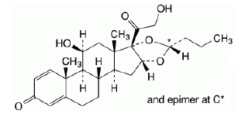
Figure 2: Chemical structure of micronised glycopyrronium bromide
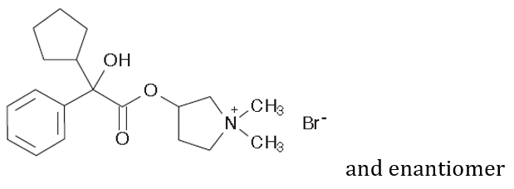
Figure 3: Chemical structure of micronised formoterol fumarate dihydrate
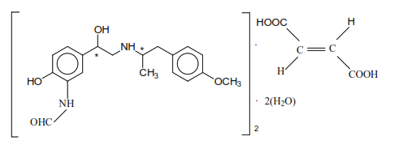
Breztri Aerosphere contains the same quantities of glycopyrronium (as bromide) and formoterol fumarate dihydrate, the same excipients, and the same delivery device as those in Bevespi Aerosphere; pressurised MDI. Bevespi Aerosphere is currently approved in Australia for the treatment of COPD. The main difference is the addition of budesonide in Breztri Aerosphere.
The proposed pack sizes for this product are 28 (containing 5.9 g of the bulk suspension) and 120 actuations (containing 10.7 g of the bulk suspension). These pack sizes are acceptable being in line with those for Bevespi Aerosphere.
The filled inhaler is individually wrapped in a four layers foil laminate pouch containing desiccant sachet to protect from moisture, and then packaged in a carton.
The proposed pressurised MDI used for the proposed product comprised of a coated aluminium can fit with a metering valve (collectively considered as a canister), a white actuator (or mouthpiece), and a grey actuator dust cap and a can top dose indicator.
The recommended dose in adults (18 years and over) is 2 actuations twice daily (2 in the morning and 2 in the evening). The maximum daily dose is 4 actuations.
The release and shelf life finished product specifications are sufficient to ensure the quality of the finished product at release and throughout the shelf life.
The stability data support the shelf life of the proposed product, which is 18 months, stored below 30°C for the unopened finished product packaged inside the pouch. The in-use shelf life for the 28 actuation product is 3 weeks from the date of removal of the inhaler from the foil pouch and the in-use shelf life for the 120 actuation product is 3 months from the date of removal of the inhaler from the foil pouch.
The chemistry and quality control aspects are considered acceptable. Approval is recommended from a pharmaceutical chemistry perspective.

Nonclinical
The nonclinical data was of adequate quality and scope. All pivotal safety related studies were performed according to Good Laboratory Practice.
No pharmacology studies with the triple combination were submitted. This is acceptable, with the use of these particular agents in the treatment of COPD, and the combination of pharmacological classes, not novel.
The three agents are metabolised by distinct pathways, and no obvious or meaningful pharmacokinetic (PK) interaction was apparent in rats or dogs, nor reported to occur in patients.
Repeat dose toxicity study with the triple combination by the inhalational route comprising a pivotal three-month study in dogs and shorter (two-week) studies in rats and dogs, and it revealed no novel or notable exacerbation of toxicity.
A newly submitted carcinogenicity study with (single agent) glycopyrronium bromide, involving inhalational administration to mice for two years at doses up to 1440 μg/kg/day, showed no tumorigenicity, was consistent with numerous existing studies.
No adverse effects on reproduction or development were observed for the excipient distearoylphosphatidylcholine in a set of newly submitted studies.
Pregnancy Category B3, as proposed by the sponsor, is considered appropriate.
There are no nonclinical objections to the registration of Breztri Aerosphere.

Clinical
The clinical dossier consisted of the following studies:
- Pharmacokinetic (PK) and pharmacodynamic (PD) studies
  - Six Phase I PK studies: five in volunteers (Studies PT010001, PT010002, PT010003, PT010010 and PT010011) and one study in COPD patients (Study PT010018)
  - A Phase I study of pulmonary deposition: Study D5980C00007
  - A population pharmacokinetic (popPK) analysis based on Studies PT0010801, PT003006, PT003013, PT0031002, PT005003, PT0050801, PT009001, PT010006, and PT010018.
- efficacy and safety studies
  - Two pivotal Phase III efficacy and safety studies: Study PT010005 (also known as the ETHOS trial) and Study PT010006 (also known as the KRONOS trial)
  - Two Phase III follow-on studies from Study PT010006: Studies PT010007 and PT010008.
The dossier represented a full development program for Breztri Aerosphere budesonide / glycopyrronium / formoterol fumarate (BGF) 160/7.2/5 µg. There are no paediatric data due to the nature of the indication and disease. The three active ingredients are all currently registered in Australia, either individually or in other combination products. Hence, with respect to the aforementioned settings, their efficacy, safety, PK, and PD profile have been previously characterised. This dossier focussed on the profile of fixed dose combination of BGF metered dose inhaler.

Pharmacokinetics and pharmacodynamics
Studies were conducted to assess the PK of budesonide, glycopyrronium, and formoterol when delivered by BGF MDI.
Study PT010001 is a Phase I, single centre, double blind (within device), single dose, four period, six treatment crossover study evaluating the safety and PK of three doses of BGF, one dose of Budesonide / formoterol fumarate, and two doses of budesonide aerosol in 84 healthy volunteers in November and December 2013. The study demonstrated dose proportionality for budesonide (with slight increase in exposure when combined with glycopyrronium). It demonstrated bioequivalence for glycopyrronium and budesonide, but not for formoterol (BGF with approximately 35% higher area under the concentration time curve from time 0 to 12 hours (AUC_{0-12h}) and 20% higher maximum plasma concentration (C_{max}) are not considered clinically relevant).
Study PT010002 is a Phase I, single centre, randomised, double blind, single dose, three period, three treatment, crossover study to evaluate the safety and PK of single doses of BGF MDI, budesonide / formoterol fumarate (BFF) MDI and Symbicort Turbuhaler, conducted in 72 healthy volunteers (aged 18 to 55 years) from June to September 2014. The study demonstrated bioequivalence for budesonide and formoterol in the presence and absence of glycopyrronium for BGF MDI compared with BFF MDI, but there was less relative exposure in the Symbicort Turbuhaler group.
Study PT010003 is a Phase I, single centre, randomised, double blind, placebo controlled, two period, ascending dose, crossover study to assess the safety and PK of two doses of BGF MDI in 20 healthy adult male and female first generation Japanese volunteers (aged 18 to 55 years) conducted from September to October 2014. The study provided support for the budesonide dose in general and for a Japanese population. There was some accumulation of glycopyrronium (see Table 3 below).
Table 3: Studies PT010003, PT010018 and PT010010 Geometric mean (% coefficient of variation) accumulation ratios for budesonide / glycopyrronium / formoterol in subjects with chronic obstructive pulmonary disease and Asian healthy volunteers
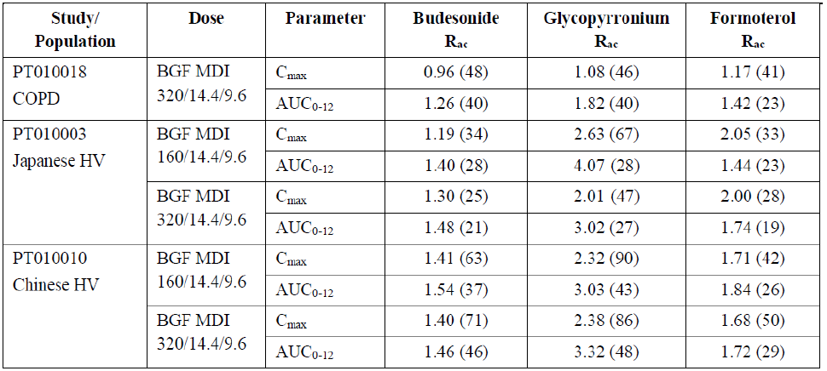
AUC₀₋₁₂ = area under the concentration time curve from time 0 to 12 hours; BGF = budesonide / glycopyrronium / formoterol fumarate; C_{max}: maximum plasma concentration; COPD = chronic obstructive pulmonary disease; HV = healthy volunteer; MDI: metered dose inhaler; R_{ac} ₌ accumulation ratio.
Study PT010010 is a Phase I, single centre, randomised, double blind, parallel group study to assess the PK and safety of two doses of BGF MDI and a single dose of BFF MDI in 96 healthy Chinese adult volunteers (aged 18 to 45 years) following a single administration and after twice daily administration for 7 days. The study was conducted from April to September 2017. There was some accumulation of glycopyrronium and formoterol over the 7 days (see Table 3 above), but no effect of budesonide on glycopyrronium or formoterol exposure.
Study PT010011 is a Phase I, single centre, randomised, open label, single dose, four period, four regimen, crossover study in healthy adult male or female volunteers (aged 18 to 40 years) to assess the relative bioavailability of BGF MDI (320/28.8/9.6 µg) with and without a spacer, and with and without oral charcoal. The study was conducted in the USA from October to December 2017. Exposure to all three drugs was increased in the presence of a spacer device and decreased in the presence of charcoal. The study demonstrated better drug delivery to the respiratory tract, and less to the oropharynx, when used with a spacer device.
Study PT010018 is a Phase I, single centre, open label study to assess the PK and safety of BGF MDI (320/14.4/9.6 μg) after single and after chronic administration for 7 days in 30 male or female adult patients (aged 40 to 80 years) with moderate to severe COPD. The study was conducted from August to December 2017. The study did not indicate significant accumulation of budesonide, but some accumulation of formoterol and glycopyrronium (see Table 3 above).
Study D5980C00007 is a Phase I single centre, randomised, two period, single dose, crossover study to assess the pulmonary deposition of radiolabelled BGF MDI after a 3 second and a 10 second breath hold in 10 healthy male adults (aged 28 to 50 years, ≥ 50 kg and with a body mass index of 18 to 30 kg/m²) conducted in the United Kingdom from September to October 2018. The study demonstrated greater delivery of drug to the respiratory tract and less to the gastrointestinal tract, with a 10 second breath hold, compared to a 3 second breath hold. Regional airway deposition was not affected by the length of the breath hold.
The PK results from efficacy Study PT010006 showed a comparable, but not bioequivalent, steady state PK profile between the with products during chronic administration in COPD patients.

Population pharmacokinetic data
A popPK analysis was conducted based on Studies PT0010801, PT003006, PT003013, PT0031002, PT005003, PT0050801, PT009001, PT010006 and PT010018 (not all investigated BGF). The methodology was deemed adequate.
Summary of results (references to studies not investigating BGF were omitted):
- Budesonide covariate effects (in the simulations, none of the covariates had a significant impact on exposure):
  - Body weight on flow rate to and from shallow peripheral compartment (Q_{p1}/F) and flow rate to and from deep peripheral compartment (Q_{p2}/F) (increasing with increasing body weight)
  - Age on apparent clearance (CL/F) (decreasing with increasing age)
- Glycopyrronium covariate effects (the simulations indicate a significant effect for renal function represented by the estimated glomerular filtration rate (eGFR) on exposure)
  - Absolute eGFR on CL/F (increasing with increasing absolute eGFR)
  - Body weight on apparent volume of distribution of central compartment (V_{c}/F), apparent inter-compartmental clearance (Q/F), and apparent volume of distribution of peripheral compartment (V_{p}/F) (increasing with increasing body weight)
  - Smoking status on absorption rate constant (k_{a}) (higher for current smokers relative former smokers) and on relative bioavailability (F_{rel}) (lower for current smokers relative former smokers)
  - Use of AeroChamber on F_{rel} (higher with AeroChamber than without)
- Formoterol covariate effects (the simulations indicate clinically significant covariate effects for body weight and for smokers)
  - Body weight on CL/F and V_{c}/F (increasing with increasing body weight)
  - Smoking status on k_{a} (lower for current smokers relative former smokers) and on CL/F (higher for current smokers relative former smokers)
  - Formulation effects for BFF MDI, glycopyrronium / formoterol fumarate (GFF) MDI, and FF MDI on F_{rel} (higher F_{rel} compared with BGF MDI)

Efficacy
Four studies provided efficacy data for BGF MDI:
- Two pivotal studies: Study PT010005 (52 weeks), and Study PT010006 (24 weeks)
- Two supportive studies (both extensions of Study PT010006): Study PT10007 and Study PT010008 (28 weeks)
Five additional studies (supportive for the budesonide component) and an analysis of pooled Bevespi Aerosphere studies (supportive for the glycopyrronium component) did not provide efficacy data for BGF MDI, but background data for the dual therapy fixed dose MDI products (from Studies PT009002, PT003006, PT003007, PT003014 and PT009003). These studies do not contribute to the efficacy assessment for the BGF MDI.

Study PT010005 (the ETHOS trial)

Study design
Study PT010005 is a Phase III, randomised, double blind, multi-centre (748 centres), parallel group, actively controlled study to assess the efficacy and safety of budesonide / glycopyrronium/ formoterol fixed dose combination MDI over a 52-week treatment period in 8572 adult patients (aged 40 to 81 years) with moderate to very severe COPD between July 2015 to July 2019.
Patients needed to have a history of moderate or severe COPD exacerbations in the 12 months prior to screening visit and remained symptomatic (COPD assessment test (CAT) score ≥ 10) while receiving two or more inhaled COPD maintenance treatments. Subjects were required to be current or former smokers with a history of at least 10 pack years of cigarette smoking.
The primary efficacy outcome measure was the rate of moderate or severe exacerbations (per year) analysed using negative binomial regression. Treatments were compared adjusting for baseline post-bronchodilator percent predicted forced expiratory volume in one second (FEV₁) and log baseline blood eosinophil count as continuous covariates, and baseline COPD exacerbation history (1, ≥ 2), region, and ICS use at screening visit (yes or no) as categorical covariates. The logarithm of time at risk of experiencing an exacerbation was used as an offset variable in the model.
The primary efficacy outcome measures of the pulmonary function test sub-study was:
- change from Baseline in morning pre-dose trough FEV₁ over 24 weeks; and
- FEV₁ AUC₀₋₄ over 24 weeks
The population was randomised 1:1:1:1 receive the following twice daily via MDI: BGF 320/14.4/9.6 µg, BGF 160/14.4 /9.6 µg, GFF 14.4/9.6 µg, or BFF 320/9.6 µg. All comparisons were for superiority, except for BGF 160/14.4/9.6 µg versus BFF (non-inferiority, then superiority). Multiplicity was addressed by using a hierarchical approach to hypothesis testing.
The treatment duration was 52 weeks (study design schema is depicted in Figure 4 below). Where study drug was interrupted during hospitalisation for a severe COPD exacerbation, restarting was possible after the event. Patients were vaccinated with pneumococcal vaccine annual influenza vaccine as per local guidelines. Prohibited medications were: LAMAs, short acting muscarinic antagonists (SAMAs), LABAs, fixed dose combination of LABA/LAMA, fixed dose combination of LABA/ICS, fixed dose combination of short acting beta-2 (β₂) agonists (SABAs)/SAMAs, SABAs, oral beta-agonists and theophylline.
Figure 4: Study PT010005 Study design
BD = bronchodilator; BFF = budesonide / formoterol fumarate; BGF = budesonide / glycopyrronium / formoterol fumarate; GFF = glycopyrronium / formoterol fumarate; V = Visit.

Baseline characteristics
There were 16,033 subjects screened, 8588 were randomised, 7187 (83.8%) completed the study, and 6654 (77.6%) completed 52 weeks of treatment. Of these, 59.7% were male, 40.3% female, and the age range was 40 to 81 years. 84.9% were White, 7.7% Asian and 3.6% Black or African American patients. The mean (standard deviation) body mass index was 27.4 (6.2) kg/m². The treatment groups were similar in baseline demographic characteristics and baseline disease characteristics. 28.5% had moderate baseline COPD severity (Global Initiative for Chronic Obstructive Lung Disease (GOLD) 2), 60.5% severe (GOLD 3), and 10.9% very severe (GOLD 4).

Primary endpoint results
Table 4: Study PT010005 Rates of chronic obstructive pulmonary disease exacerbations over 52 weeks (modified intention-to-treat; population)
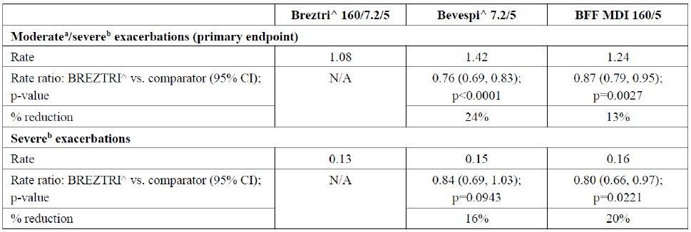
BFF = budesonide / formoterol fumarate; CI = confidence interval; MDI = metered dose inhaler; N/A = not applicable; vs. = versus.
^ Aerosphere
a. Moderate exacerbation - systemic corticosteroids and/or antibiotics for at least three days
b. Severe exacerbation - inpatient chronic obstructive pulmonary disease (COPD) related hospitalisation or COPD related death
Table 5: Study PT010005 Overview of results of primary and secondary efficacy endpoints (modified intention-to-treat population)
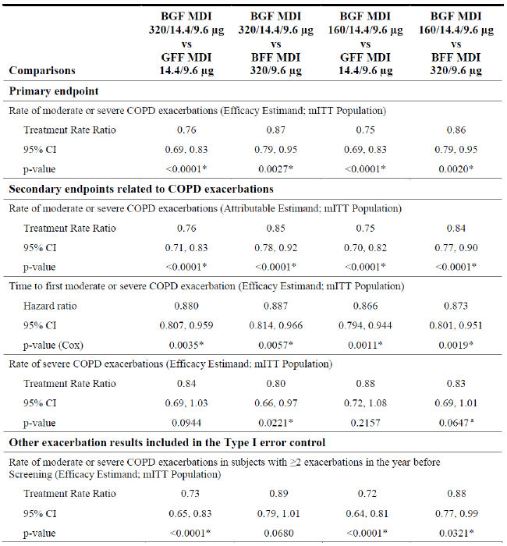

Table 5 continued: Study PT010005 Overview of results of primary and secondary efficacy endpoints (modified intention-to-treat population)
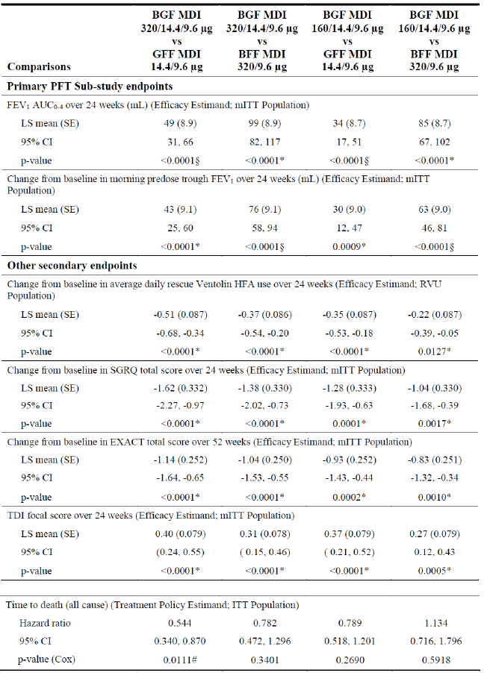
AUC₀₋₄ = area under the concentration time curve from time 0 to 4 hours; BFF = budesonide / formoterol fumarate; BGF = budesonide / glycopyrronium / formoterol fumarate; CI = confidence interval; EXACT = exacerbations of chronic obstructive pulmonary disease (COPD) tool; FEV₁ = forced expiratory volume in one second; GFF = glycopyrronium / formoterol fumarate; HFA = hydrofluoroalkane; ITT = intention-to-treat; LS = least square; MDI = metered dose inhaler; mITT = modified intention-to-treat; PFT = pulmonary function test; RVU = rescue Ventolin user; SE = standard error; SGRQ = St. George’s Respiratory Questionnaire; TDI = transition dyspnoea index; vs. = versus.
* Statistically significant
# Nominally significant (that is p < 0.046 but not statistically significant due to procedure for control of Type I error)
§ p < 0.046 but not included in Type I error control.
a. The non-inferiority margin for the rate of severe COPD exacerbations was 1.1 and the 95% CI for the comparison of BGF MDI (160/14.4/9.6 µg) to BFF MDI using the per-protocol estimated was (0.68, 1.00).
The rate of moderate or severe exacerbations (per year) was 1.08 for BGF MDI (320/14.4/9.6 μg, shown as Breztri 160/7.2/5 in Table 4 above), 1.42 for GFF MDI (shown as Bevespi 7.2/5 in Table 4 above) and 1.24 for BFF MDI. The main efficacy outcomes are summarised in Table 4 and Table 5 (results for BGF MDI (160/14.4/9.6 μg) are not shown in this section, but in Table 5):
- Using BGF MDI (320/14.4/9.6 μg) (n = 2137) as the reference, the rate ratio (95% confidence interval (CI)) was:
  - 0.76 (0.69, 0.83) for GFF MDI (n = 2120) (superior)
  - 0.87 (0.79, 0.95) for BFF MDI (n = 2131) (superior)
There were no clear subgroup effects for the primary efficacy outcome measure. Efficacy may be greater in patients with higher baseline severity.

Results of the pulmonary function test sub-study over 24 weeks

Forced expiratory volume in one second area under the concentration time curve from time 0 to 4 hours
There were greater improvements for the BGF MDI (320/14.4/9.6 µg; shown as Breztri 160/7.2/5) compared to GFF MDI (shown as Bevespi 7.2/5) (n = 779) and BFF MDI (n = 755) (in Table 6 below).
- The least square (LS) mean (95% CI) difference in change of FEV₁ AUC_{0-4h} at Week 24 was:
  - 49 (31, 66) mL compared to GFF MDI (superior)
  - 99 (82, 117) mL compared to BFF MDI (superior)

Morning pre-dose trough forced expiratory volume in one second
There were greater improvements for BGF MDI (320/14.4/9.6 μg; shown as Breztri 160/7.2/5) compared to GFF MDI (shown as Bevespi 7.2/5) and BFF MDI (in Table 6 below).
- The LSM (95% CI) difference in change of morning pre-dose FEV₁ at Week 24 was:
  - 43 (25, 60) mL compared to GFF MDI (superior)
  - 76 (58, 94) mL compared to BFF MDI (superior)
Table 6: Studies PT010005 and PT010006 Lung function test outcomes (modified intention-to-treat population)
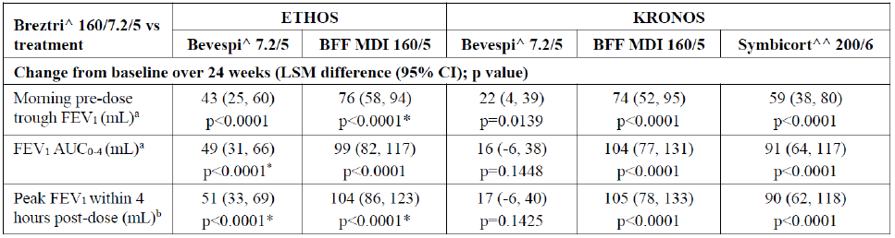
AUC₀₋₄ = area under the concentration time curve from time 0 to 4 hours; BFF = budesonide / formoterol fumarate; CI = confidence interval; ETOHS = the ETOHS trial; FEV₁ = forced expiratory volume in one second; KORONOS = the KORONOS trial; LSM = least square mean; MDI = metered dose inhaler; vs. = versus.
^ Aerosphere
^^ Symbicort Turbuhaler (open label)
* Unadjusted p-value
a. The KRONOS trial coprimary endpoint; the ETHOS trial secondary endpoint
b. Secondary endpoint both studies

Study PT010006 (the KRONOS trial)

Study design
Study PT010006 is a Phase III, randomised, double blind, multi-centre (215 centres in the US, Canada, Japan, China), parallel group, actively controlled study to assess the efficacy and safety of BGF fixed dose combination MDI over a 24-week treatment period in 1899 adult patients (aged 40 to 80 years) with moderate to very severe COPD between August 2015 to January 2018.
Patients needed to be symptomatic (CAT score ≥ 10) while receiving two or more inhaled COPD maintenance treatments. Subjects were required to be current or former smokers with a history of at least 10 pack years of cigarette smoking.
The primary efficacy outcome measure was (comparing BGF MDI versus BFF MDI, and BGF MDI versus Symbicort Turbuhaler):
- Change from Baseline in morning pre-dose trough FEV₁ over 24 weeks
- FEV₁ AUC₀₋₄ over 24 weeks (comparison to GFF MDI was not a primary endpoint for the EU/Canada)
The population was randomised 2:2:1:1 (stratified by reversibility and disease severity) to receive the following twice daily via MDI: BGF 320/14.4/9.6 μg, GFF 14.4/9.6 μg, BFF 320/9.6 μg, or Symbicort Turbuhaler (BFF 400/12 μg). Symbicort Turbuhaler was presented open label, and all others double blind in identical packaging.
All comparisons were for superiority except for the comparison of BFF MDI to Symbicort Turbuhaler, which was for non-inferiority and used a margin of -50 mL for the lower bound of a 2-sided 95% CI for the treatment difference.
The treatment duration was 24 weeks (Study design schema is depicted in Figure 5). Patients were vaccinated with pneumococcal vaccine annual influenza vaccine as per local guidelines. Prohibited medications were LAMAs, SAMA, LABAs, fixed dose combination of LABA/LAMA, fixed dose combination of LABA/ICS, fixed dose combination of SABAs and SAMAs, SABAs, oral beta-agonists and theophylline.
Figure 5: Study PT010006 Study design
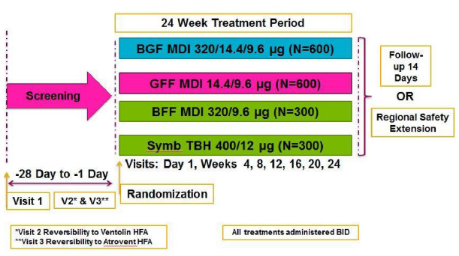
BFF = budesonide / formoterol fumarate; BGF = budesonide / glycopyrronium / formoterol fumarate; GFF = glycopyrronium / formoterol fumarate; MDI = metered dose inhaler; N = population size; TBH = turbuhaler; V = Visit.

Baseline characteristics
There were 3047 patients screened, 1902 randomised, 1899 treated and 1689 (88.9%) completed 24 weeks of treatment. There were 71.2% males, 28.8% females and the age range was 40 to 80 years. 1050 (55.4%) patients were aged ≥ 65 years. 50.1% were white, and 44.9% Asian patients. Baseline disease characteristics, and severity and duration of COPD were similar for all treatment groups. The population had less severe COPD compared to Study PT010005, which 49.1% were with moderate baseline COPD severity (GOLD 2), 42.9% were severe (GOLD 3), and 7.9% were very severe (GOLD 4). The median (range) disease duration was 6.9 (0.1 to 41.1) years. 3.9% were treated with oxygen during the study. Mean (standard deviation) compliance with study treatment was 95.2% (9.0) and was similar for all the treatment groups.

Primary endpoint results
The BGF MDI was superior to BFF MDI and to GFF MDI, except for the FEV₁ AUC_{0-4h} endpoint for GFF MDI (comparison to GFF MDI was not a primary endpoint for the EU/Canada) (Table 6 and Table 7).

Forced expiratory volume in one second area under the concentration time curve from time 0 to 4 hours
The LSM (95% CI) difference in change of FEV₁ AUC₀₋₄ at Week 24 was:
  - 16 (-6, 38) mL (p = 0.1448) compared to GFF MDI (superiority not shown)
  - 104 (77, 131) mL (p < 0.0001) compared to BFF MDI (superior)
  - 91 (64, 117) mL (p < 0.0001) compared to Symbicort Turbuhaler (superior)

Morning pre-dose trough forced expiratory volume in one second
The LSM (95% CI) difference in change of morning pre-dose FEV1 at Week 24 was:
  - 22 (4, 39) mL (p = 0.0139) compared to GFF MDI (superior)
  - 74 (52, 95) mL (p < 0.0001) compared to BFF MDI (superior)
  - 59 (38, 80) mL (p < 0.0001) compared to Symbicort Turbuhaler (superior)
There were no subgroup effects for either of the primary efficacy outcome measures.
Table 7: Study PT010006 Overview of results of primary and secondary efficacy endpoints (modified intention-to-treat population)
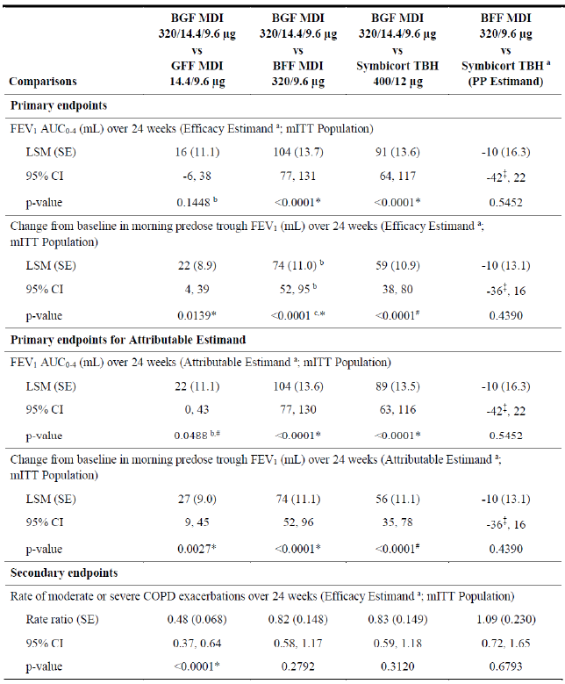

Table 7 continued: Study PT010006 Overview of results of primary and secondary efficacy endpoints (modified intention-to-treat population)
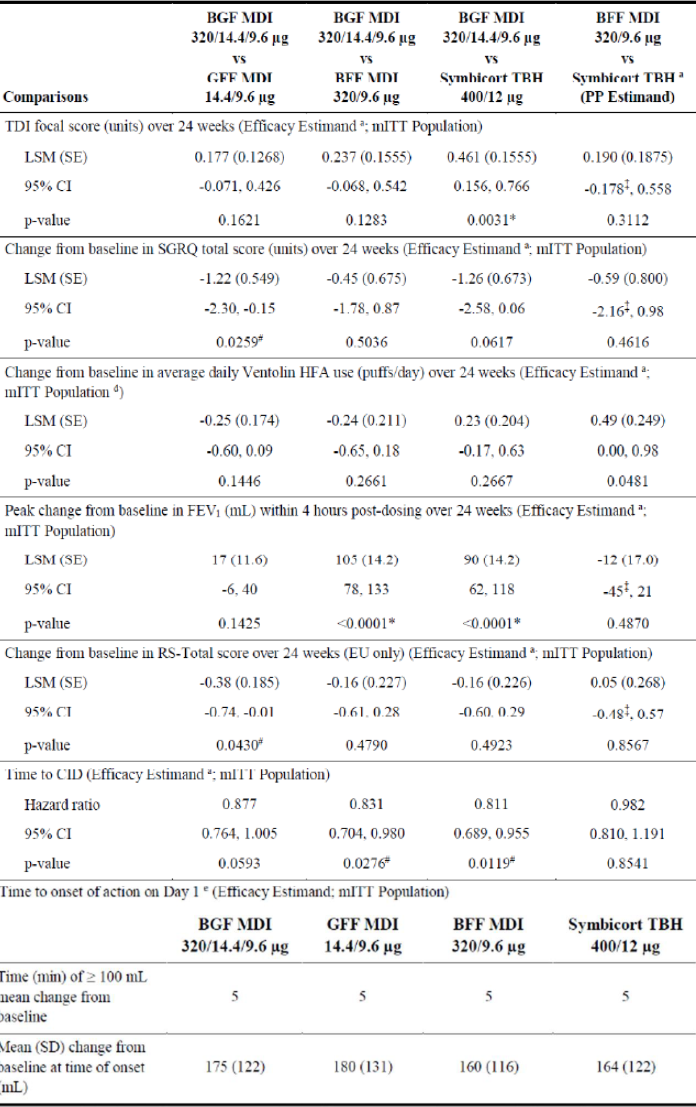
AUC₀₋₄ = area under the concentration time curve from time 0 to 4 hours; BFF = budesonide / formoterol fumarate; BGF = budesonide / glycopyrronium / formoterol fumarate; CI = confidence interval; CID = clinically important deterioration; COPD = chronic obstructive pulmonary disease; EU = European Union; FEV₁ = forced expiratory volume in one second; GFF = glycopyrronium / formoterol fumarate; HFA = hydrofluoroalkane; LSM = least square mean; MDI = metered dose inhaler; mITT = modified intention-to-treat; RS = respiratory symptom; SD = standard deviation; SE = standard error; SGRQ = St. George’s Respiratory Questionnaire; TBH = turbuhaler; TDI = transition dyspnoea index; vs. = versus.
* Statistically significant
# Nominally significant (that is p < 0.05 but not statistically significant due to procedure to control Type I error)
‡ Non-inferior to Symbicort Turbuhaler.
The non-inferiority margins for BFF MDI versus Symbicort Turbuhaler were as follows: change from Baseline morning pre-dose trough FEV₁ (-50 mL), FEV₁ AUC₀₋₄ (-75 mL), TDI focal score (-0.75), peak change from Baseline in FEV₁ (-75 mL), SGRQ total score (3 units), rescue Ventolin HFA use (0.75 puff/day), RS-total score (-1.5), and time to CID (1.1).
a. The BFF MDI versus Symbicort Turbuhaler comparison was for non-inferiority using the PP estimand, while all other comparisons were for superiority using the estimand noted.
b. The comparison of BGF MDI versus GFF MDI for FEV₁ AUC₀₋₄ over 24 weeks was not an efficacy endpoint for the EU/Canada approach and is provided only for completeness.
c. This comparison is a secondary efficacy endpoint.
d. Assessed using the efficacy estimand restricted to subjects in the rescue Ventolin use population.
e. Time to onset of action on Day 1 was analysed by treatment groups only.

Secondary endpoint results

Rate of moderate or severe exacerbations
The adjusted rate of moderate or severe exacerbations (annualised) was 0.46 for the BGF MDI (320/14.4/9.6 µg; shown as Breztri 160/7.2/5 in Table 8), 0.95 for the GFF MDI (7.2/5 µg), 0.56 for the BFF MDI (160/5 µg), and 0.55 for Symbicort Turbuhaler (200/6 µg; shown as BFF 200/6). The main efficacy outcomes are summarised in Table 4, Table 7 and Table 8.
- Using BGF MDI (320/14.4/9.6 µg) as the reference, the rate ratio (95% CI) was:
  - 0.48 (0.37, 0.64) for GFF MDI (superior)
  - 0.56 (0.58, 1.17) for BFF MDI (superiority not shown)
  - 0.83 (0.59, 1.18) for Symbicort Turbuhaler (superiority not shown)
Table 8: Study PT010006 Rate of chronic obstructive pulmonary disease exacerbations (modified intention-to-treat population)
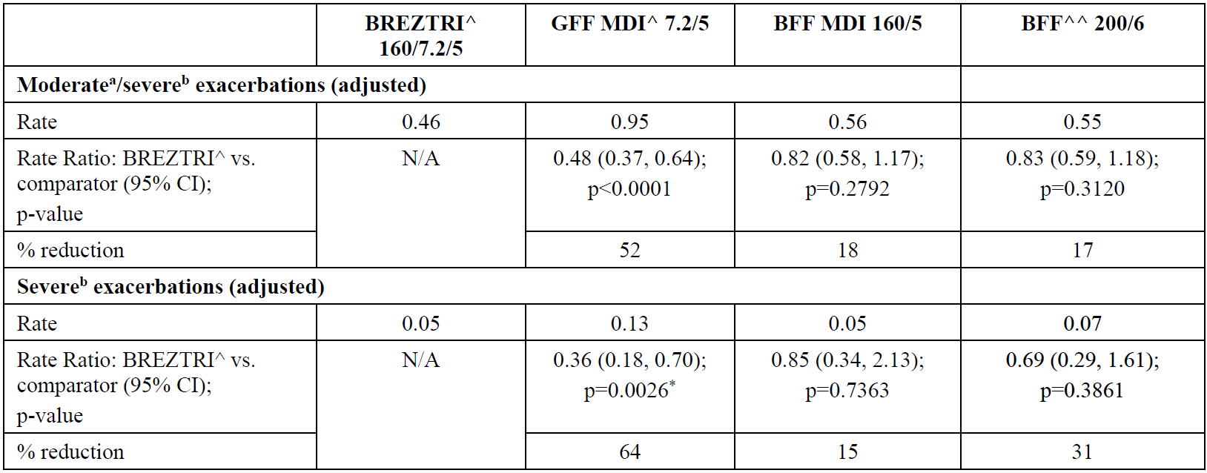
BFF = budesonide / formoterol fumarate; CI = confidence intervals; GFF = glycopyrronium / formoterol fumarate; MDI = metered dose inhaler; N/A = not applicable.
^ Aerosphere
^^ Turbuhaler (open label)
* Unadjusted p-value
a. Moderate exacerbation - systemic corticosteroids and/or antibiotics for at least 3 days
b. Severe exacerbation - inpatient chronic obstructive pulmonary disease (COPD) related hospitalisation or COPD related death

Study PT010007
Study PT010007 was an extension study of Study PT010006 to primarily assess long term safety and tolerability in 347 Japanese patients with efficacy as a secondary objective between August 2016 to June 2018 at 75 centres in Japan.
Patients remained in their PT010006 treatment groups and were blinded to treatment allocation, except for open label Symbicort Turbuhaler.
The efficacy outcome measures were FEV₁, forced vital capacity (FVC), peak expiratory flow rate (PEFR), forced expiratory flow between 25% and 75% of forced vital capacity (FEF_{25-75%}), COPD exacerbations, Ventolin; rescue, exacerbations of COPD tool (EXACT) total score and EXACT-respiratory symptoms total score and sub-scores. The safety outcome measures were adverse events (AEs), electrocardiograms, clinical laboratory tests and vital signs.
In Study PT010007, there were 347 patients enrolled and treated. Of which, 116 patients were in the BFG MDI (320/14.4/9.6 μg) group, 111 in the GFF MDI group, 58 in the BFF MDI group and 62 in the Symbicort Turbuhaler group. 94.2% were males and 5.8% females (range 45 to 80 years). All patients were Japanese. The treatment groups were similar in demographic, Baseline and disease characteristics.
The efficacy data were presented as summary statistics, and no formal hypothesis tests were performed. There was no significant difference between the groups regarding Ventolin rescue use.

Morning pre-dose FEV₁
The LS mean (95% CI) change from Baseline over 52 weeks in morning, pre-dose FEV₁ was 117 (93, 141) mL for the BGF group, 85 (61, 110) mL for the GFF group, 54 (20, 87) mL for the BFF group and 81 (47, 114) mL for the Symbicort Turbuhaler group.

Chronic obstructive pulmonary disease exacerbations (moderate or severe)
The rate was 0.37/year for BGF, 0.81/year for GFF, 0.26/year for BFF, and 0.31/year for Symbicort Turbuhaler group.

Respiratory symptoms total score
The mean (standard deviation) change from Baseline over 52 weeks was -0.9 (3.9) in the BFG MDI (320/14.4/9.6 μg) group, -0.2 (3.1) in the GFF MDI group, -0.6 (4.2) in the BFF MDI group and -0.3 (3.1) in the Symbicort Turbuhaler group.

Morning pre-dose forced vital capacity
The LS mean (95% CI) change from Baseline over 52 weeks was 150 (106 to 194) mL for the BFG group, 141 (96 to 185) mL for the GFF group, 10 (-51 to 72) mL for the BFF group and 90 (29 to 151) mL for Symbicort Turbuhaler group.

Morning pre-dose peak expiratory flow rate
The LS mean (95% CI) change from Baseline over 52 weeks was 24.140 (19.163, 29.116) L/min for BGF, 15.260 (10.218, 20.302) L/min for GFF, 9.572 (2.598, 16.546) L/min for BFF, and 11.900 (4.859, 18.740) L/min for Symbicort Turbuhaler.

Morning pre-dose forced expiratory flow between 25% and 75% of forced vital capacity
The LS mean (95% CI) change from Baseline over 52 weeks in morning, was 0.055 (0.040, 0.070) L/s for BGF, 0.037 (0.021, 0.053) L/s for GFF, 0.023 (0.001, 0.045) L/s for BFF, and 0.022 (0.001, 0.044) L/s for Symbicort Turbuhaler.

Study PT010008
Study PT010008 was a sub-study of Study PT010006 (primarily for safety, but with efficacy as a secondary objective), which continued treatment for an additional 28 weeks, and was conducted at 71 centres in the USA from September 2015 to September 2017. Only BGF, GFF and BFF, but not Symbicort Turbuhaler groups were included. The study was primarily designed to examine treatment effect on bone mineral density (BMD) and ophthalmologic effects (more details can be found in the Safety section of this AusPAR).
There were 378 patients included in the safety population of Study PT010008. Of which, 377 were treated after 24 weeks, and 337 (89.2%) were completed 52 weeks of treatment. 323 (70.8%) patients were in the BMD population and 311 (68.2%) in the ophthalmologic population. There were 53.1% males in the studied population.
The efficacy outcome measures were Ventolin rescue use, rate of COPD exacerbations, and change from Baseline in EXACT scores.
There appeared to be no significant difference between the groups in the change from Baseline in Ventolin rescue use. The mean (standard deviation) change from Baseline is -0.5 (1.7) puffs/day for BGF MDI (320/14.4/9.6 μg), -0.3 (2.0) puffs/day for GFF MDI and -0.8 (2.0) puffs/day for BFF MDI. The rate of moderate or severe COPD exacerbations was 0.59/year for BGF MDI (320/14.4/9.6 μg), 0.81/year for GFF MDI and 0.72/year for BFF MDI. The rate of severe COPD exacerbations was 0.07/year for BGF MDI (320/14.4/9.6 μg), 0.10/year for GFF MDI and 0.40/year for BFF MDI. There appeared to be no significant difference between the groups in EXACT scores. The mean (standard deviation) change from Baseline is -1.0 (3.1) for the BGF MDI (320/14.4/9.6 µg) , -0.7 (3.1) for GFF MDI and -1.0 (3.4) for BFF MDI.

Safety
The majority of the 24-Week and 52-Week safety data are derived from the randomised Study PT010005.

Exposure
The integrated summary of safety included data from Studies PT010005, PT010006, PT010007 and PT010008.

Overall exposure
There were 10425 patients included in this analysis. Of which, 2783 patients were treated with the BGF MDI (320/14.4/9.6 µg) , 2124 with the BGF MDI (160/14.4/9.6 µg), 2750 with the GFF MDI, 2450 with the BFF MDI and 318 with Symbicort Turbuhaler.

Patients who completed 24 weeks of treatment
There were 2465 (88.6%) patients for the BGF MDI (320/14.4/9.6 µg), 1900 (89.5%) for the BGF MDI (160/14.4/9.6 µg), 2270 (82.5%) for the GFF MDI, 2099 (85.7%) for the BFF MDI and 278 (87.4%) for Symbicort Turbuhaler. Not all of the patients were eligible to enter into a further 28 weeks of treatment.

Patients who completed 52 weeks of treatment
There were 1961 patients for the BGF MDI (320/14.4/9.6 µg), 1712 for the BGF MDI (160/14.4/9.6 µg), 1913 for the GFF MDI, 1765 for the BFF MDI and 54 for Symbicort Turbuhaler.

Demographics
Of all participants, 6443 (61.8%) were males, 2982 (38.2%) females. The age range was 40 to 81 years. 4934 (47.3%) were patients aged < 65 years, 4366 (41.9%) aged ≥ 65 years and < 75 years, and 1125 (10.8%) aged ≥ 75 years. Of the patients treated with the BGF MDI (320/14.4/9.6 µg), there were 1725 (62.0%) males, 1058 (38.0%) females and the age range was 40 to 81 years. 1336 (48.0%) were patients aged < 65 years, 1144 (41.1%) aged ≥ 65 years and < 75 years, and 303 (10.9%) aged ≥ 75 years.

Adverse event
The overall rates of treatment emergent adverse events (TEAEs) were similar for BFG MDI, GFF MDI, BFF MDI and Symbicort Turbuhaler.

24-week safety population
The most frequent TEAEs were in the System Organ Classes of infections and infestations (25.7%), respiratory, and thoracic and mediastinal disorders (14.2%). By Preferred Term, the most frequent TEAEs were nasopharyngitis (7.1%), COPD (5.5%), and upper respiratory tract infection (4.3%) (see Table 9 below).
Table 9: Studies PT010005 and PT010006 Treatment emergent adverse events occurring in ≥ 2% of subjects in any treatment group (24-week safety population)
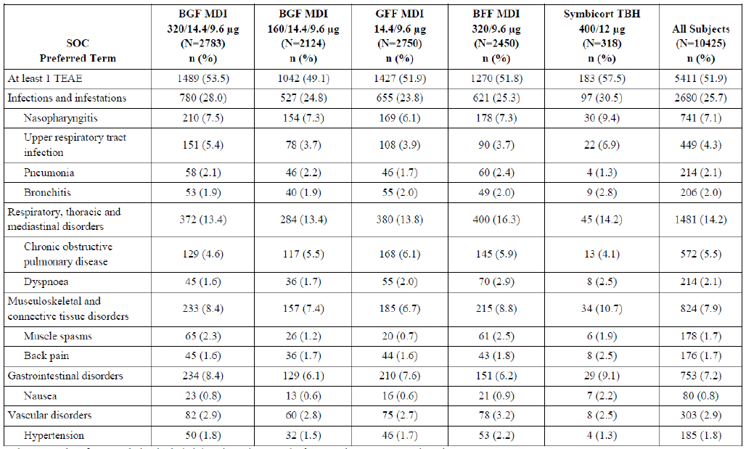
BFF = budesonide / formoterol fumarate; BGF = budesonide / glycopyrronium / formoterol fumarate; GFF = glycopyrronium / formoterol fumarate; MDI = metered dose inhaler; N = population size; n = sample size; SOC = System Organ Class; TBH = turbuhaler; TEAE = treatment emergent adverse event.
The 24-week safety population included data through 24 weeks from Study PT010005 and Study PT010006.
Adverse events (AEs) are presented by those occurring in ≥ 2% of subjects in any treatment group by Preferred Term, and the table is sorted by descending SOC frequency across all subjects.
In Study PT010005 and Study PT010006, TEAEs of chronic obstructive pulmonary disease (COPD) were expected and thus were not to be captured as AEs unless they met the definition of serious adverse events (SAE), however two nonserious TEAEs of COPD (per investigator assessment) were reported in two subjects (one subject each in the metered dose inhaler of 320 µg budesonide, 14.4 µg glycopyrronium and 9.6 µg formoterol fumarate and BFF MDI groups) in Study PT010005 and are not included in Study PT010005.
There were higher rates of dysphonia and oral candidiasis in the patients treated with the combinations that contained budesonide. However, the rates for these conditions in the BGF MDI group were low. Dysphonia was reported in 49 (1.8%) patients for the BGF MDI (320/14.4/9.6 µg), 17 (0.8%) for the BGF MDI (160/14.4/9.6 µg), 12 (0.4%) for GFF MDI, 42 (1.7%) for BFF MDI and 6 (1.9%) for Symbicort Turbuhaler. Oral candidiasis was reported in 48 (1.7%) patients for the BGF MDI (320/14.4/9.6 µg), 32 (1.5%) for the BGF 160/14.4/9.6 µg MDI, 21 (0.8%) for GFF MDI, 45 (1.8%) for BFF MDI and 5 (1.6%) for Symbicort Turbuhaler.
Although it might be expected that pneumonia would be more common with budesonide, the data did not confirm this. Pneumonia was reported in 58 (2.1%) patients for the BGF MDI (320/14.4/9.6 µg) group, 46 (2.2%) for the BGF MDI (160/14.4/9.6 µg), 46 (1.7%) for GFF MDI, 60 (2.4%) for BFF MDI and 4 (1.3%) for Symbicort Turbuhaler.

52-week safety population
The most frequent TEAEs were in the System Organ Classes of infections and infestations (37.5%), and respiratory, thoracic and mediastinal disorders (21.9%). By Preferred Term, the most frequent TEAEs were nasopharyngitis (11.3%), COPD (9.9%), and upper respiratory tract infection (5.7%) (see Table 10 below)
Table 10: Studies PT010005, Study PT010007 and PT010008 Treatment emergent adverse events occurring in ≥ 2% of subjects in any treatment group (52-week safety population)
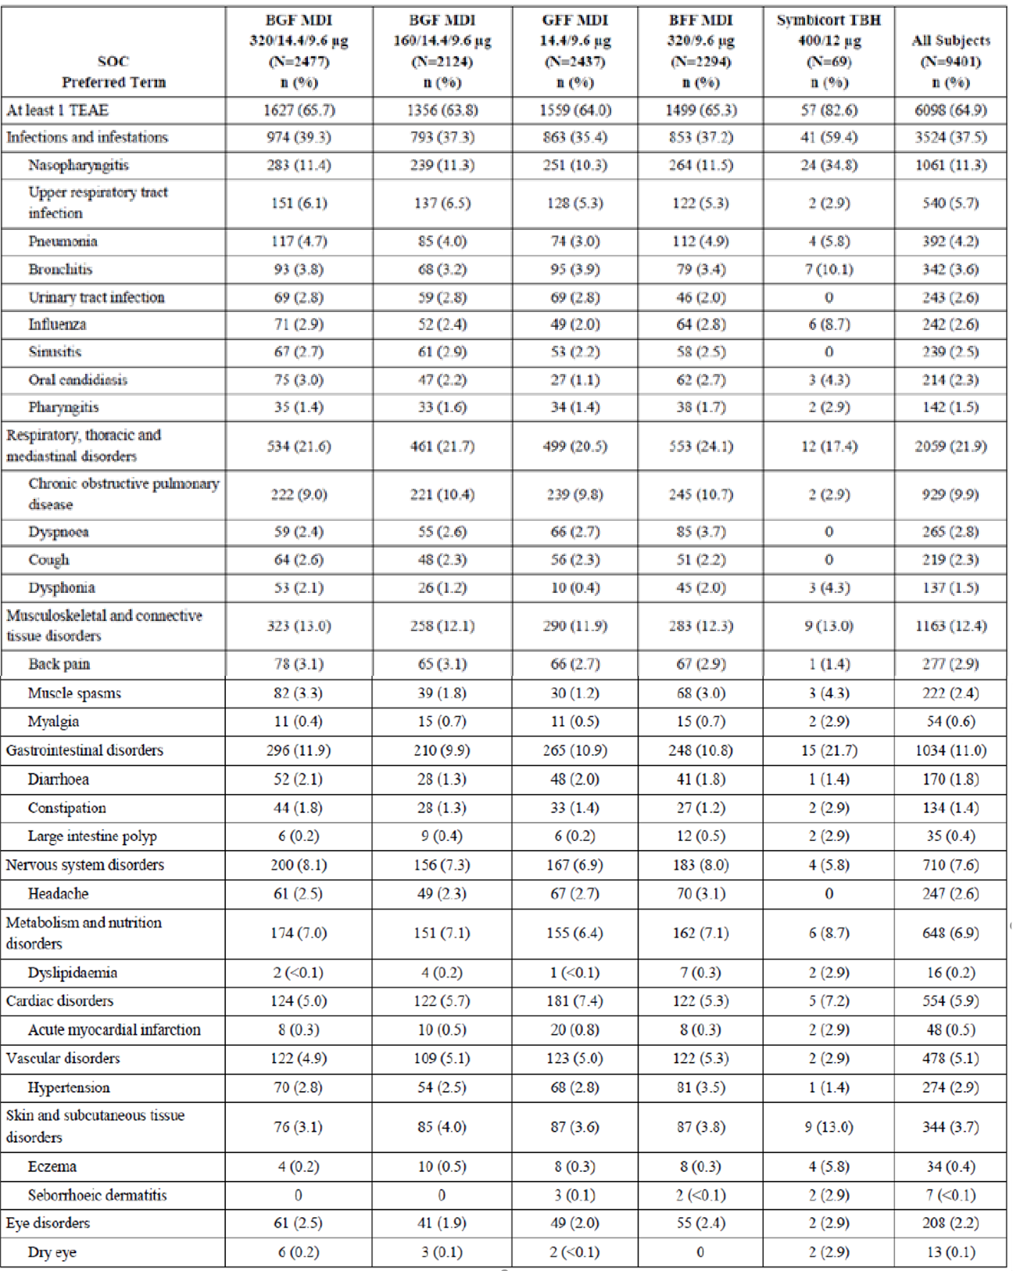

Table 10 continued: Studies PT010005, Study PT010007 and PT010008 Treatment emergent adverse events occurring in ≥ 2% of subjects in any treatment group (52-week safety population)
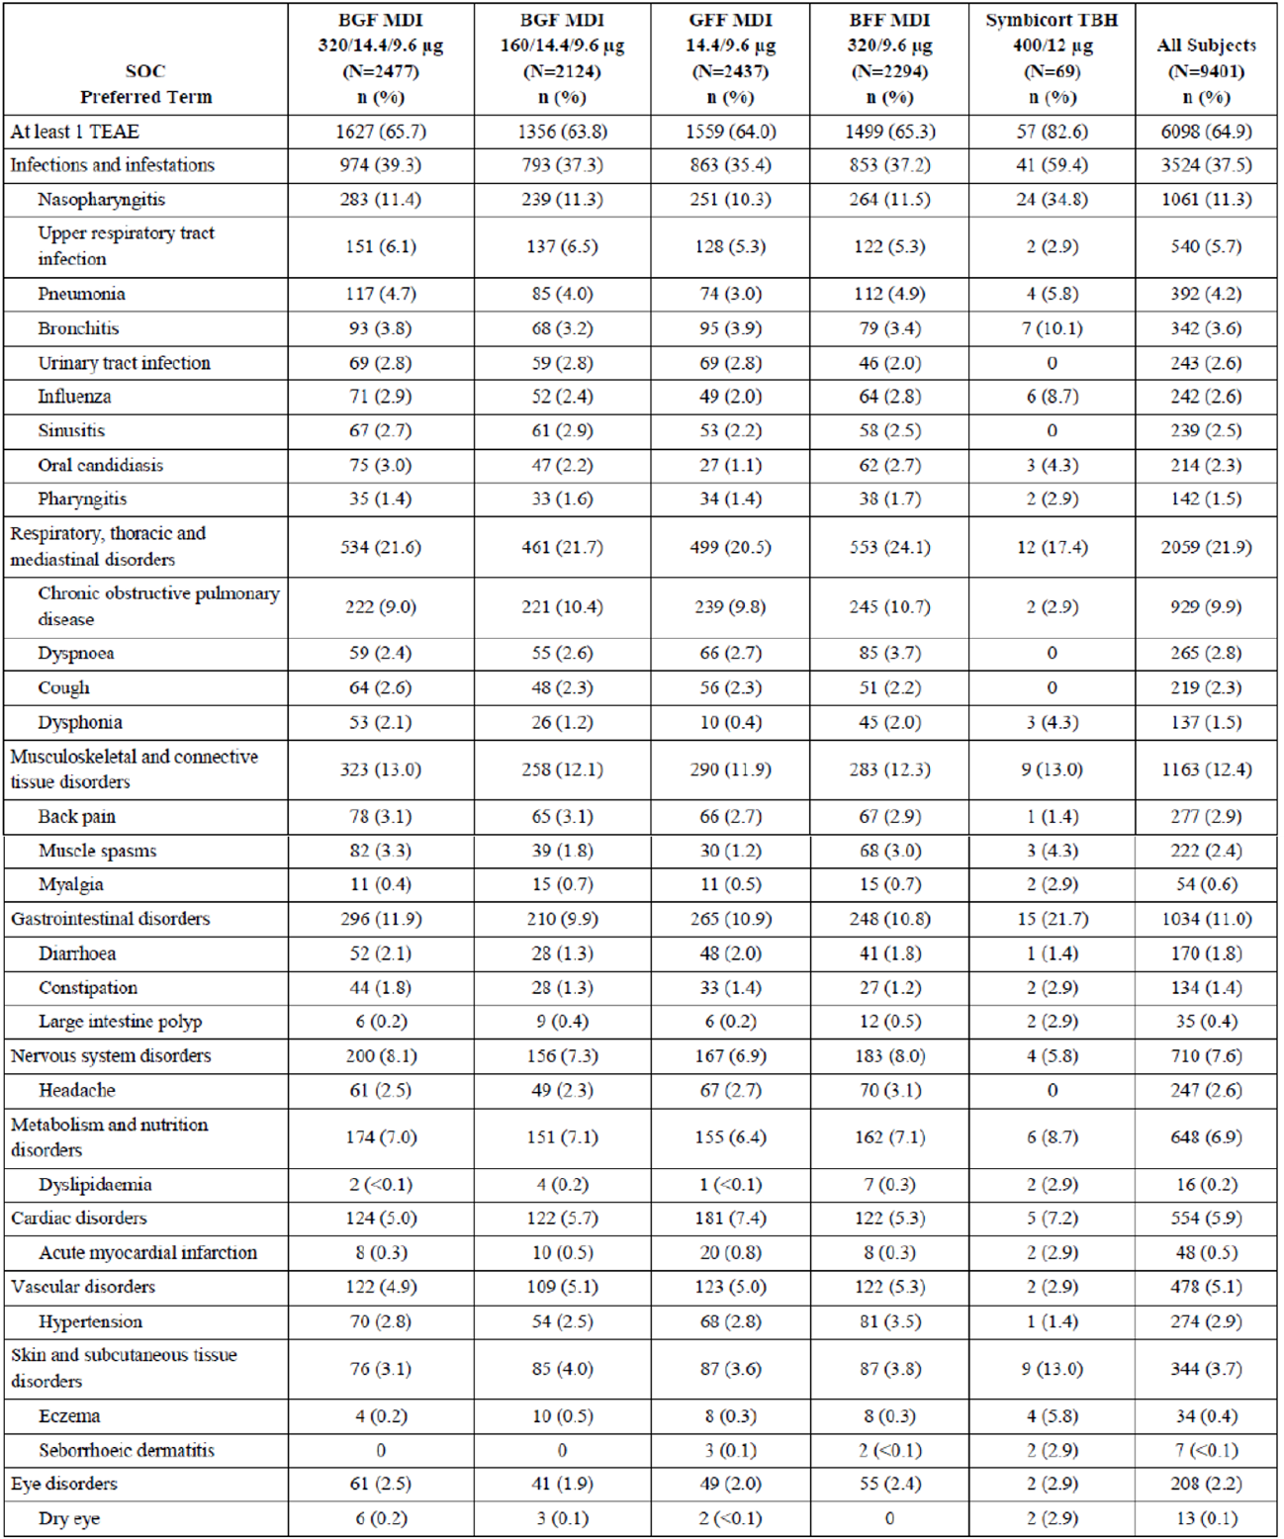
BFF = budesonide / formoterol fumarate; BGF = budesonide / glycopyrronium / formoterol fumarate; GFF = glycopyrronium / formoterol fumarate; MDI = metered dose inhaler; N = population size; n = sample size; SOC = System Organ Class; TBH = turbuhaler; TEAE = treatment emergent adverse event.
The 52-week safety population included data through 52 weeks from Study PT010005, Study PT010007 (including applicable 24-week data from Study PT010006), and Study PT010008 (including applicable 24-week data from Study PT010006).
Adverse events (AEs) are presented by those occurring in ≥ 2% of subjects in any treatment group by Preferred Term, and the table is sorted by descending m system organ class (SOC) frequency across all subjects.
In Studies PT010005, PT010007, and PT010008, TEAEs of chronic obstructive pulmonary disease (COPD) were expected and thus were not to be captured as AEs unless they met the definition of serious adverse events (SAE).
For the TEAEs known to be associated with ICS containing treatments, the AE rates of oral candidiasis and dysphonia were highest in the BGF MDI (320/14.4/9.6 µg), the BGF MDI (160/14.4/9.6 µg), and BFF MDI treatment groups (44.0, 28.6, and 40.1 events per 1000 person years, respectively, and 24.8, 14.3, and 23.4 events per 1000 person years, respectively) and lowest in the non-ICS containing GFF MDI treatment group (14.7 and 4.9 events per 1000 person years, respectively).

Treatment related adverse event (adverse drug reaction)

24-week safety population
There were 911 subjects (8.7%) reported TEAEs considered drug related by the investigator with the incidence highest in the BGF MDI (320/14.4/9.6 µg) group (10.0%) and lowest in the BGF MDI (160/14.4/9.6 µg) group (7.3%) (see Table 11 below)
Table 11: Studies PT010005 and PT010006 Treatment emergent adverse events suspected to be drug related occurring in ≥ 0.5% of subjects in any treatment group (24-week safety population)
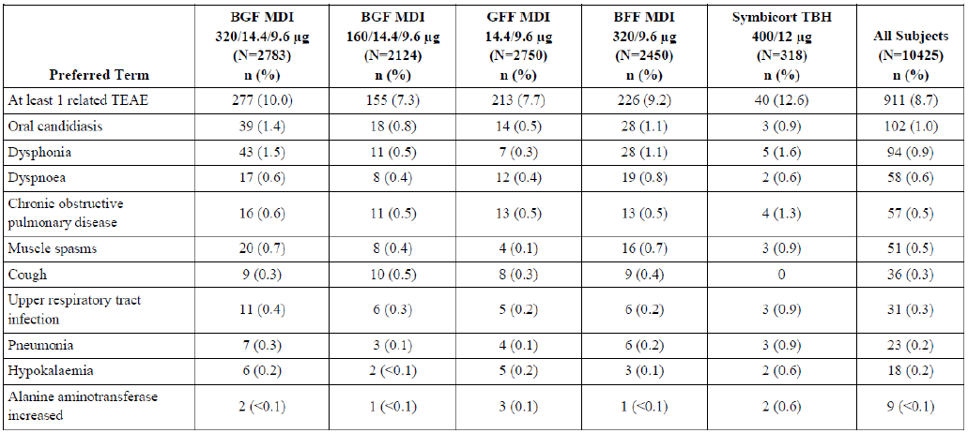
BFF = budesonide / formoterol fumarate; BGF = budesonide / glycopyrronium / formoterol fumarate; GFF = glycopyrronium / formoterol fumarate; MDI = metered dose inhaler; N = population size; n = sample size; TBH = turbuhaler; TEAE = treatment emergent adverse event.
The 24-week safety population included data through 24 weeks from Study PT010005 and Study PT010006.
Suspected to be drug related = possibly, probably, or definitely per the investigator.
Adverse events are presented by those occurring in ≤ 0.5% of subjects in any treatment group by Preferred Term (PT). and the table is sorted by descending PT frequency across all subjects.
By Preferred Term, the most frequent adverse drug reactions (ADRs) were oral candidiasis (1.0%), dysphonia (0.9%), and dyspnoea (0.6%). The ADR incidence was generally similar across the treatment groups, with the exception of oral candidiasis and dysphonia, which were most frequent in the BGF MDI (320/14.4/9.6 µg) group (1.4% and 1.5%, respectively) and least frequent in the GFF MDI group (0.5% and 0.3%, respectively).

52-week safety population
There were 949 subjects (10.1%) reported TEAEs considered drug related by the investigator with the incidence highest in the BGF MDI (320/14.4/9.6 µg) and BFF MDI treatment groups (11.7% and 11.0%, respectively) and lowest in the GFF MDI treatment group (8.0%) (see Table 12 below).
Table 12: Studies PT010005, PT010007 and PT010008 Treatment emergent adverse events suspected to be drug related occurring in ≥ 0.5% of subjects in any treatment group (52-week safety population)
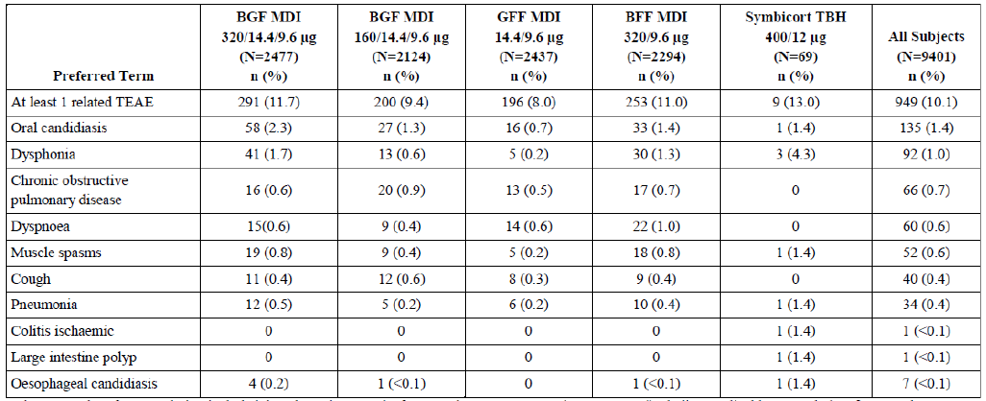
BFF = budesonide / formoterol fumarate; BGF = budesonide / glycopyrronium / formoterol fumarate; GFF = glycopyrronium / formoterol fumarate; MDI = metered dose inhaler; N = population size; n = sample size; TBH = turbuhaler; TEAE = treatment emergent adverse event.
The 52-week safety population included data through 52 weeks from Study PT010005, Study PT010007 (including applicable 24-week data from Study PT010006), and Study PT010008 (including applicable 24-week data from Study PT010006).
Suspected to be drug related = possibly, probably, or definitely per the investigator.
Adverse events are presented by those occurring in ≤ 0.5% of subjects in any treatment group by Preferred Term (PT), and the table is sorted by descending PT frequency across all subjects.
By Preferred Term, the most frequent ADRs were oral candidiasis (1.4%), dysphonia (1.0%), and COPD (0.7%). The ADR incidence was generally similar across the treatment groups, with the exception of oral candidiasis and dysphonia, which were most frequent in the BGF MDI (320/14.4/9.6 µg) group (2.3% and 1.7%, respectively) and least frequent in the GFF MDI group (0.7% and 0.2%, respectively).

Deaths
In the combined data, death rates were lower in the treatments that contained budesonide compared to GFF MDI. In Study PT010005 the time to death (all-cause) was longest for the BGF MDI (320/14.4/9.6 µg), but this was not statistically significant in comparison with GFF MDI after correction for Type 1 error (see Table 5).

Serious adverse events
The rates of serious adverse events (SAEs) were similar for the BGF MDI, GFF MDI, BFF MDI and Symbicort Turbuhaler.

Discontinuations
The rates of discontinuations due to adverse events (DAE) were lower in the BGF MDI compared to the GFF MDI group. In Study PT010006, three (0.5%) patients in the BGF MDI (320/14.4/9.6 µg) group discontinued because of dysphonia.

Adverse events of special interest

24-week safety population
The incidence of adverse event of special interest (AESIs) was less than 3% for any individual medical concept, and most frequent for cardiovascular condition (2.8%), pneumonia (2.4%), and lower respiratory tract infections other than pneumonia (2.3%) (see Table 13 below). The incidence was generally similar across the treatment groups, except the following:
- cardiovascular condition has been most frequently reported in the GFF MDI treatment group (3.7%) and least frequently reported in the BGF MDI (320/14.4/9.6 µg), the BGF MDI (160/14.4/9.6 µg), and the BFF MDI groups (2.5%, 2.6%, and 2.3%, respectively).
- candidiasis has been most frequently reported in the BGF MDI (320/14.4/9.6 µg), the BGF MDI (160/14.4/9.6 µg), and the BFF MDI treatment groups (2.0%, 1.7%, and 2.2%, respectively) and least frequently reported in the GFF MDI treatment group (0.8%).
- dysphonia or aphonia has been most frequently reported in the BGF MDI (320/14.4/9.6 µg) and BFF MDI treatment groups (1.8% and 1.7%, respectively) and least frequently reported in the BGF MDI (160/14.4/9.6 µg) and the GFF MDI treatment groups (0.8% and 0.4%, respectively).
- pneumonia has been most frequently reported in the BGF MDI (320/14.4/9.6 µg), the BGF MDI (160/14.4/9.6 µg), and the BFF MDI treatment groups (2.5%, 2.5%, and 2.7%, respectively) and least frequently reported in the GFF MDI treatment group (1.8%).
Table 13: Studies PT010005 and PT010006 Adverse event of special interests by medical concept (24-week safety population)
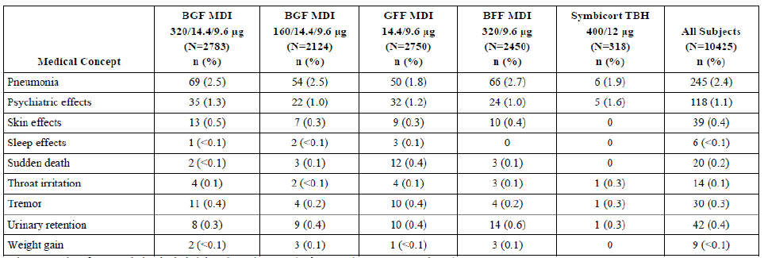
BFF = budesonide / formoterol fumarate; BGF = budesonide / glycopyrronium / formoterol fumarate; GFF = glycopyrronium / formoterol fumarate; MDI = metered dose inhaler; N = population size; n = sample size; TBH = turbuhaler.
The 24-week safety population included data through 24 weeks from Study PT010005 and Study PT010006.
Medical concepts are presented alphabetically.

52-week safety population
The overall incidence was less than 5.2% for any individual medical concept, and most frequent for cardiovascular condition (5.1%), pneumonia (4.8%), and lower respiratory tract infections other than pneumonia (4.3%) (see Table 14 below). The incidence of AESI medical concepts was generally similar across the treatment groups, except the following:
- cardiovascular condition has been most frequently reported in the GFF MDI treatment group (6.3%) and least frequent in the BGF MDI (320/14.4/9.6 µg), the BGF MDI (160/14.4/9.6 µg), and the BFF MDI groups (4.4%, 5.2%, and 4.4%, respectively).
- candidiasis and dysphonia or aphonia has been most frequently reported in the BGF MDI (320/14.4/9.6 µg) (3.4%, and 2.2%, respectively) and the BFF MDI (3.2% and 2.0%, respectively) groups and least frequent reported in the GFF MDI (1.1% and 0.4%, respectively) group.
- pneumonia has been most frequently reported in the BGF MDI (320/14.4/9.6 µg) (5.6%) and the BFF MDI (5.4%) groups and least frequently reported in the GFF MDI (3.4%) group.
Table 14: Studies PT010005, PT010007 and PT010008 Adverse event of special interests by medical concept (52-week safety population)
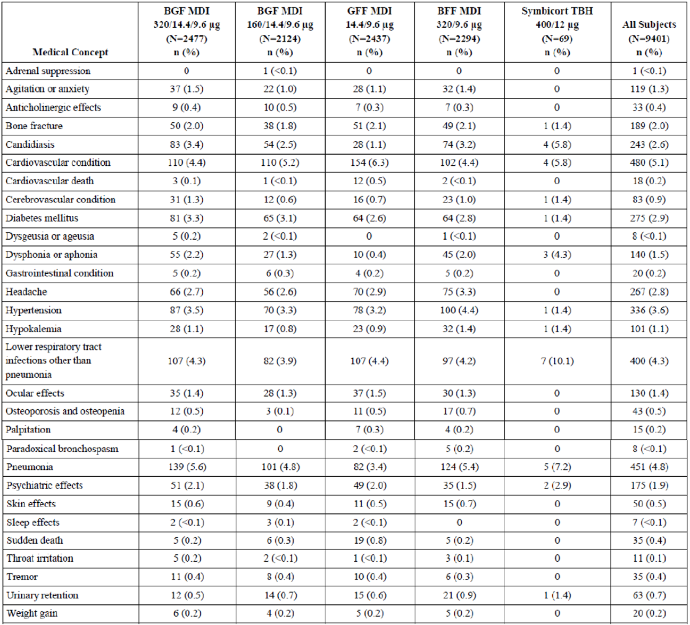
BFF = budesonide / formoterol fumarate; BGF = budesonide / glycopyrronium / formoterol fumarate; GFF = glycopyrronium / formoterol fumarate; MDI = metered dose inhaler; N = population size; n = sample size; TBH = turbuhaler.
The 52-week safety population included data through 52 weeks from Study PT010005, Study PT010007 (including applicable 24-week data from Study PT010006), and Study PT010008 (including applicable 24-week data from Study PT010006).
Medical concepts are presented alphabetically.
The overall incidences of bone fracture (2.0%), diabetes mellitus (2.9%), hypokalaemia (1.1%), ocular effects (1.4%), and osteoporosis and osteopenia (0.5%) were similar across the ICS- and non-ICS containing treatment groups. Hyperkalaemia and hyperglycaemia were not demonstrated to be significant risks in the clinical data. The data did not demonstrate any increase in cardiotoxicity for BGF MDI in comparison with GFF MDI and BFF MDI.
Study PT010008 specifically investigated BMD and ophthalmologic endpoints:
- Osteoporosis: The data for BMD do not exclude a risk of osteoporosis with BGF MDI. In Study PT010008, there was no significant change from Baseline in BMD at the spine over a 12-month treatment period for the BGF MDI (320/14.4/9.6 µg) group and no significant difference compared to the GFF MDI or BFF MDI group. However, the change from Baseline was statistically significant for the BGF MDI (320/14.4/9.6 µg) for BMD at the hip although there was no significant difference between treatment groups, where the LS mean (95% CI) percentage change from Baseline is -0.9 (-1.4, -0.3)% for the BGF MDI (320/14.4/9.6 µg), -0.3 (-0.9, 0.2)% for the GFF MDI and -1.1 (-1.9, -0.3)% for the BFF MDI group.
- Ocular corticosteroid toxicity: The primary ophthalmologic endpoint was the change from Baseline in lens opacities classification system III (posterior subcapsular cataract) (LOCS III (P)) score at Week 52.
Although there was no significant difference between BGF MDI and GFF MDI, there were significant increases from Baseline in intraocular pressure and LOCS III measures in the BGF MDI groups (see Table 15, Table 16, and Table 17), and cataract was reported as an AE in 6 (3.1%) patients in the BGF MDI (320/14.4/9.6 µg) group, none in the GFF MDI group and 2 (2.3%) in the BFF MDI group.
This indicates there may be some ocular corticosteroid toxicity with BGF MDI, and in the opinion of the clinical evaluator it is an important potential risk.
Table 15: Study PT010008 Change from Baseline in lens opacities classification system III (posterior subcapsular cataract) score at Week 52 (ophthalmologic population)
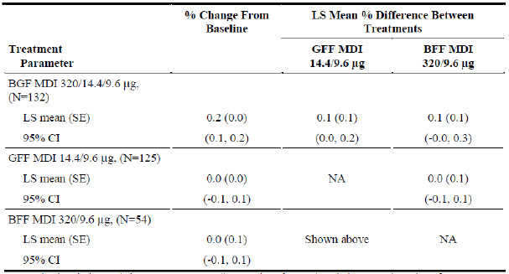
BFF = budesonide / formoterol fumarate; BGF = budesonide / glycopyrronium / formoterol fumarate; CI = confidence interval; LS = least square; MDI = metered dose inhaler; N = population size; NA = not applicable; SE = standard error.
The descriptive statistics were across eyes (irrespective of person) such that n = total number of eyes assessed.
Baseline was assessed at screening visit.
LS mean = least squares mean from the mixed model which included the following covariates: baseline lens opacities classification system III (posterior subcapsular cataract) (LOCS III (P)), smoking pack years, and age as continuous covariates and treatment, visit, and the treatment by visit interaction as categorical covariates. Eye (within subject) was included as a random effect.
Table 16: Study PT010008 Proportion of subjects with lens opacities classification system III grade increases of ≥ 0.5 (Class 1), ≥ 1.0 (Class 2), or ≥ 1.5 (Class 3) units in P-score at Week 28, Week 52, and end of treatment (ophthalmologic population)
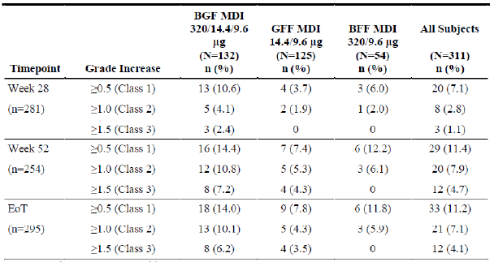
BFF = budesonide / formoterol fumarate; BGF = budesonide / glycopyrronium / formoterol fumarate; EoT = end of treatment; GFF = glycopyrronium / formoterol fumarate; N = population size; n = sample size.
Table 17: Study PT010008 Proportion of subjects with intraocular pressure ≥ 22 mmHg in either eye and proportion of subjects with an increase from Baseline ≥ 7 mmHg in either eye at Week 28, Week 52, and end of treatment (ophthalmologic population)
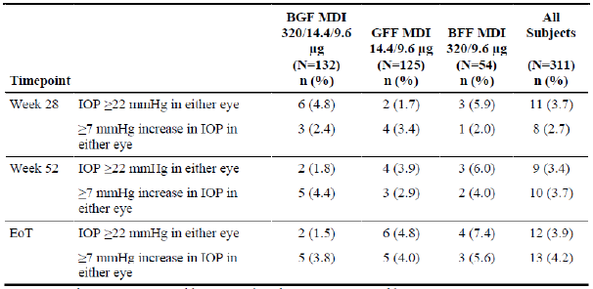
BFF = budesonide / formoterol fumarate; BGF = budesonide / glycopyrronium / formoterol fumarate; EoT = end of treatment; GFF = glycopyrronium / formoterol fumarate; IOP = intraocular pressure; N = population size; n = sample size.

Safety in special populations

Age
The overall incidence of TEAEs was similar across all age subgroups. The sponsor does not appear to have considered the potential contribution of glycopyrronium to anticholinergic burden. The target patient group for BGF MDI is in the older age groups, and also likely to be treated with multiple concomitant medications. Hence, in the opinion of the clinical evaluator, contribution to anticholinergic burden is missing information.

Post-market experience
No data available.

Risk management plan
There was no requirement for a risk management plan evaluation for a submission of this type.

Risk-benefit analysis

Delegate’s considerations

Pharmacokinetics and pharmacodynamics
The PK of the three actives in combination has been adequately studied. The actives did not influence each other’s bioavailability or PK when in combination. The in vitro studies did not identify any potential interactions at the level of metabolism of the actives.
There was dose proportionality for all three actives in the dose range used in clinical practice. Metered dose inhalers were more effective at delivering drug than dry powder inhalers.
With regard to PD, each of the actives works by its own unique mechanism, and their PD profile would not be expected to be different in the combination product.
There was some accumulation of all the actives in patients in chronic dosing, but only be potentially clinically significant for glycopyrronium. It is noted that accumulation was much less pronounced in the target population compared to healthy volunteers (see Table 18 below).
Table 18: Studies PT010003, PT010010 and PT010018 Geometric Mean (percentage coefficient of variation) accumulation ratios for budesonide, glycopyrronium, and formoterol in subjects with chronic obstructive pulmonary disease and healthy Asian volunteers
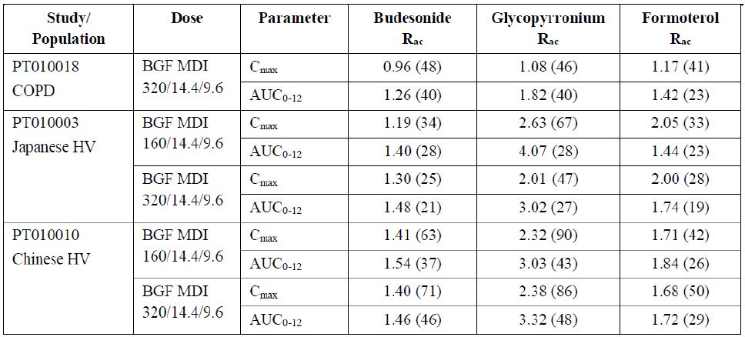
AUC₀₋₁₂ = area under the concentration time curve from time 0 to 12 hours BGF = budesonide / glycopyrronium / formoterol fumarate; C_{max} = maximum plasma concentration; COPD = chronic obstructive pulmonary disease; HV = healthy volunteer; MDI = metered dose inhaler; R_{ac} ₌ accumulation ratio.

Potential issue with glycopyrronium in renal impairment
The popPK study indicated decreased clearance of glycopyrronium in patients with renal impairment. The popPK analysis indicated that renal function (eGFR) affected apparent clearance of glycopyrronium (increasing with increasing absolute eGFR) (see Figure 6). For example, compared to a patient with an eGFR of 90.0 mL/min/1.73 m², a patient with an eGFR of:
- 63.7 mL/min/1.73 m² was predicted to have area under the concentration time curve (AUC) increased by 29%.
- 45.0 mL/min/1.73 m² was predicted to have AUC increased by 68%.
For patients with renal impairment, the use of a glycopyrronium-containing fixed dose combination may not be appropriate.
Figure 6: Studies PT0010801, PT003006, PT003013, PT0031002, PT005003, PT0050801, PT009001, PT010006 and PT010018 Impact of identified covariates on area under the concentration time curve at steady state for glycopyrronium (the metered dose inhaler of 320 µg budesonide, 18 µg glycopyrronium and 9.6 µg formoterol fumarate twice daily)
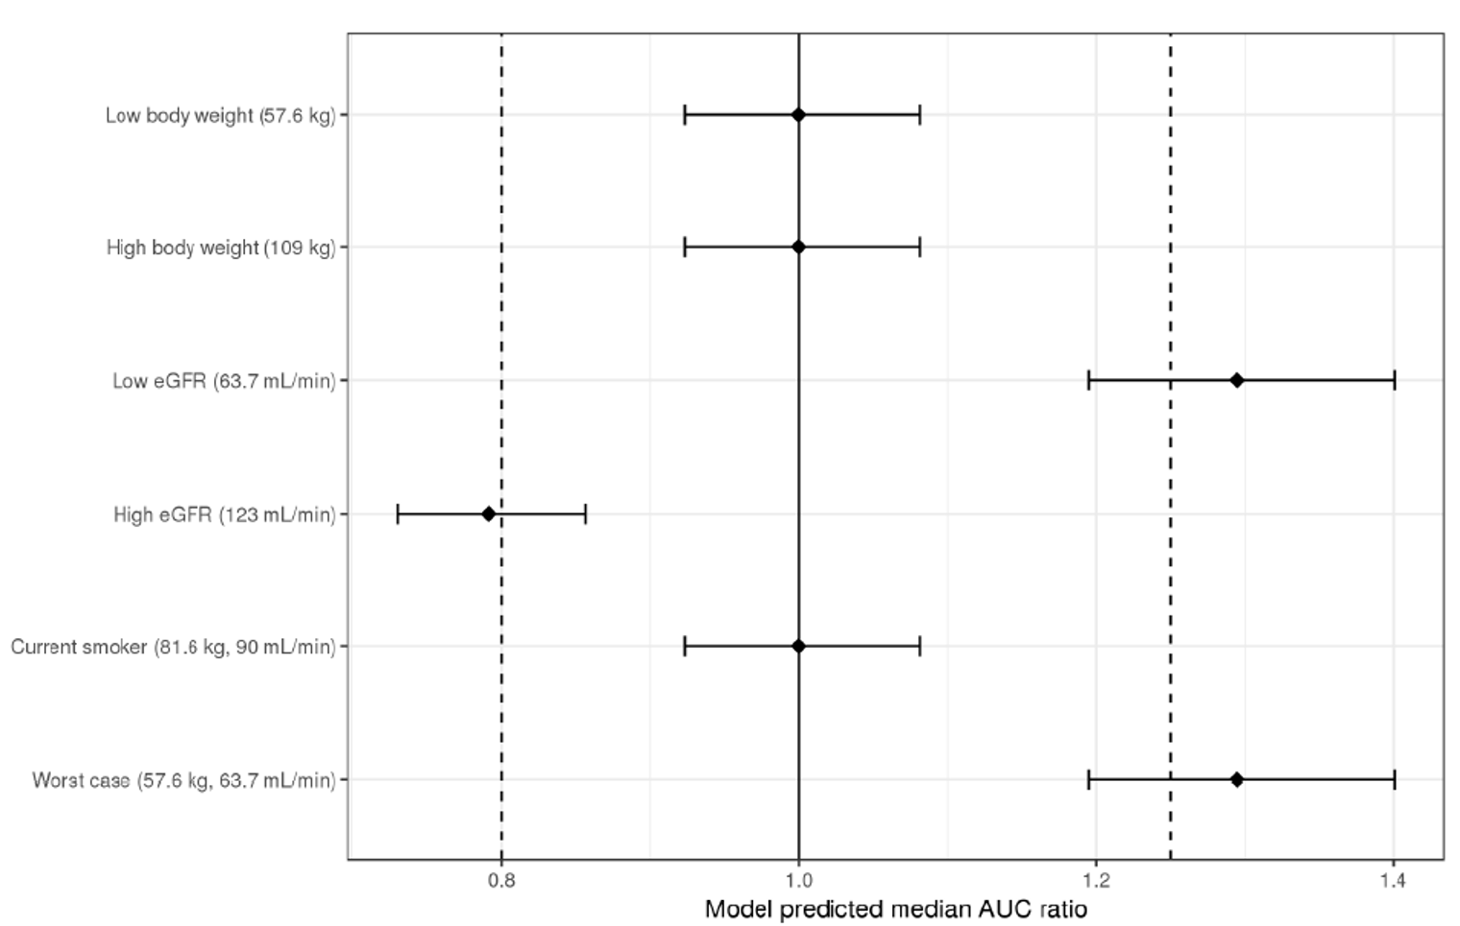
AUC = area under the concentration time curve; eGFR = estimated glomerular filtration rate.

Efficacy
The clinical trial program had two pivotal studies, Study PT010005 and Study PT010006, with Study PT010005 being more significant.
Study PT010006 was not considered insufficient to establish efficacy on its own. It has a pulmonary function primary endpoint (exacerbations measured as secondary objective), and its 24-week study period was rather short and not suited to measure seasonal variation in exacerbation rates (despite a subpopulation having an extended study period within the extension Studies PT010007 and PT010008). Furthermore, it did not show superior efficacy for the primary efficacy outcome measures for the BGF MDI (320/14.4/9.6 µg) in comparison with GFF (for FEV₁ AUC_{0-4h}), that is whether the addition of budesonide to GFF conferred significant benefit.
Study PT010005 appears to have addressed the concerns raised by PT010006 with its 52-week study period and exacerbation based primary endpoint and has demonstrated the benefit of adding the ICS budesonide to the fixed dose LABA/LAMA treatment.

Study design and conduct
Overall, the pivotal studies were well designed and conducted. To enable a useful comparison of the ICS/LAMA/LABA (BGF), the comparators included a LAMA/LABA (GFF) combination, and an ICS/LABA (BFF) combination. The doses of the comparator drugs were identical for each of the actives for the BGF MDI (320/14.4/9.6 µg) dose level, and thus supporting the validity of the comparators. The devices and excipients were also identical. Study PT010005 included BGF 320/14.4/9.6 µg and 160/14.4/9.6 μg groups. Study PT010006 only tested a BGF 320/14.4/9.6 µg group.
In Study PT010005, the outcome measures were extensive, and included a mixture of respiratory function tests, survival analysis and patient reported outcomes. There were also sub-study assessments of more detailed respiratory function testing and of cardiac safety. These outcomes were clinically relevant. In Study PT010006, the outcome measures focused more on respiratory function rather than COPD exacerbations. However, the outcome measures were extensive, and included a mixture of respiratory function tests, survival analysis and patient reported outcomes.
The statistical methods were complex and used sophisticated models for the hypothesis tests. Overall, the statistical methods were reasonable, and included baseline severity measures as covariates.
The study populations were balanced with respect to baseline demographic and disease characteristics, COPD severity and baseline efficacy outcome measures.

Study results
In Study PT010005, there was a clear benefit for BGF MDI at both budesonide dose levels in comparison with GFF MDI and BGG MDI. There was no apparent difference in efficacy between the two dose levels of BGF MDI studied. The study demonstrated benefit for clinical outcomes (time to exacerbation and time to death), for respiratory function outcomes (clinically and statistically significant, and maintained over time) and for patient reported outcomes (St. George's Respiratory Questionnaire). However, the triple therapy did not reduce healthcare utilisation and did not alter the rate of decline in respiratory function, that is the natural history of the underlying condition.
In Study PT010006, BGF MDI compared to GFF MDI did not deliver significant improvements in respiratory function (for FEV₁ AUC_{0-4h}), but there were significant improvements in morning pre-dose FEV₁ and FEV₁ AUC₀₋₄ compared to BFF MDI and Symbicort Turbuhaler that persisted throughout the treatment period. These improvements were clinically and statistically significant. Conversely, there were fewer moderate or severe COPD exacerbations over 24 weeks for BGF MDI compared to GFF MDI, but no significant difference compared to BFF MDI or Symbicort Turbuhaler. There were improvements in the transition dyspnoea index focal score for BGF MDI relative to Symbicort Turbuhaler. The improvement from Baseline in St. George's Respiratory Questionnaire total score was greater for BGF MDI than GFF MDI. There were no differences between the groups in Ventolin rescue or time to effect.
Neither Study PT010005 nor Study PT010006 demonstrated any decrease in healthcare resource utilisation with BGF MDI.
The results of Study PT010007 and Study PT010008 (extension studies of Study PT010006) were generally supportive.

Safety
The overall rates of TEAEs, SAEs and DAEs were similar for BGF MDI, GFF MDI, BFF MDI and Symbicort Turbuhaler. The safety profile of BGF MDI was generally consistent with the known profile of its components. There were higher rates of dysphonia and oral candidiasis in the patients treated with the combinations that contained budesonide. However, the rates for these conditions in the BGF MDI group were low. The mortality rate was lower with BGF MDI than with GFF MDI. The data did not demonstrate any increase in cardiotoxicity for BGF MDI in comparison with GFF MDI and BFF MDI.
The AE profile of BGF MDI was generally consistent with the known side effect profile of ICS, LABA and anticholinergic inhalers used in the treatment of COPD. There were no new or unexpected clear safety signals identified. There was no clear evidence of an additive effect from combining the three treatments in one fixed dose combination inhaler or of a clinically significant cumulative effect over longer term treatment. However, some uncertainties remain:
- Osteoporosis: The data for BMD do not exclude a risk of osteoporosis with BGF MDI.
- Ocular corticosteroid toxicity: Although there was no significant difference between BGF MDI and GFF MDI, there were significant increases from Baseline in intraocular pressure and LOCS III measures in the BGF MDI groups (see Table 15, Table 16, and Table 17), and cataract was reported as an AE in 6 (3.1%) patients in the BGF MDI (320/14.4/9.6 µg) group, none in the GFF MDI and 2 (2.3%) in the BFF MDI. This indicates there may be some ocular corticosteroid toxicity with BGF MDI, and in the opinion of the clinical evaluator it is an important potential risk.

Deficiencies of the data

Generalisability and COPD severity
Participants with mild or end stage COPD (oxygen dependent and with difficulty using treatments) were not included in the pivotal trials, and the proportion of participants with very severe COPD at Baseline was low compared to moderate or severe COPD (very severe: 10.9% in Study PT010005, and 7.9% in Study PT010006) (see Table 19 and Table 20). Originally, the clinical evaluator was unsatisfied with regard to the generalisability of the efficacy and safety data. This was mainly based on the large proportion of participant rejected from Study PT010005 and Study PT010006.
- For Study PT010005, 16,033 participants were screened and 7445 (46.4%) were rejected for randomisation. Of which, 20.8% was due to of severity of disease, 2.5% was because of history of exacerbations. Hence approximately half of the rejections were due to disease characteristics.
- For Study PT010006, 3047 participants were screened and 1145 (37.6%) were rejected for randomisation. Of which, 14.6% was due to severity of disease, 7.7% was due to respiratory disease and 1.9% was due to cardiac disease.
Table 19: Study PT010005 Severity and duration of chronic obstructive pulmonary disease (modified intention-to-treat population)
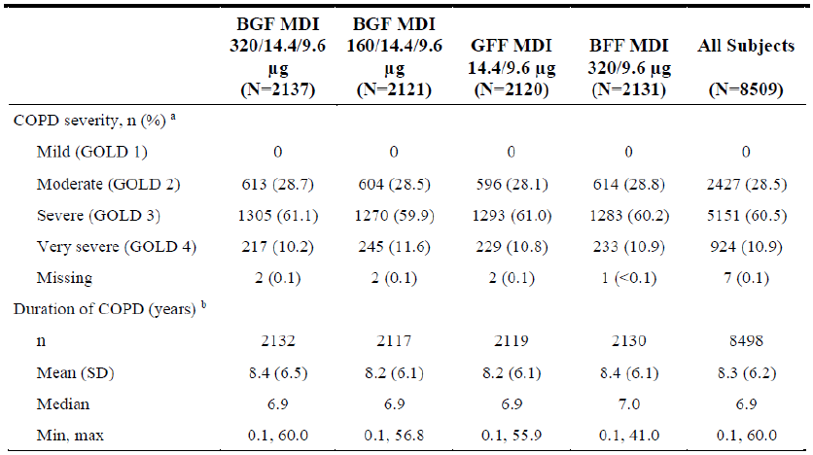
BFF = budesonide / formoterol fumarate; BGF = budesonide / glycopyrronium / formoterol fumarate; COPD = chronic obstructive pulmonary disease; GOLD = Global Initiative for Chronic Obstructive Lung Disease; GFF = glycopyrronium / formoterol fumarate; N = population size; n = sample size.
GOLD 1 (mild) = forced expiratory volume in one second (FEV₁) ≥ 80% predicted; GOLD 2 (moderate) = 50% ≤ FEV₁ < 80% predicted; GOLD 3 (severe) = 30% ≤ FEV₁ < 50% predicted; GOLD 4 (very severe) = FEV₁ < 30% predicted.
a. Severity of COPD was based on the non-missing post Ventolin hydrofluoroalkane (HFA) assessment of present predicted FEV₁ at Screening Visit 2 (or if the assessment was missing, the non-missing post Atrovent HFA assessment at Screening Visit 3).
b. The duration of COPD was calculated relative to the start of study drug at Day 1 (Visit 4).
Table 20: Study PT010006 Severity and duration of chronic obstructive pulmonary disease (modified intention-to-treat population)
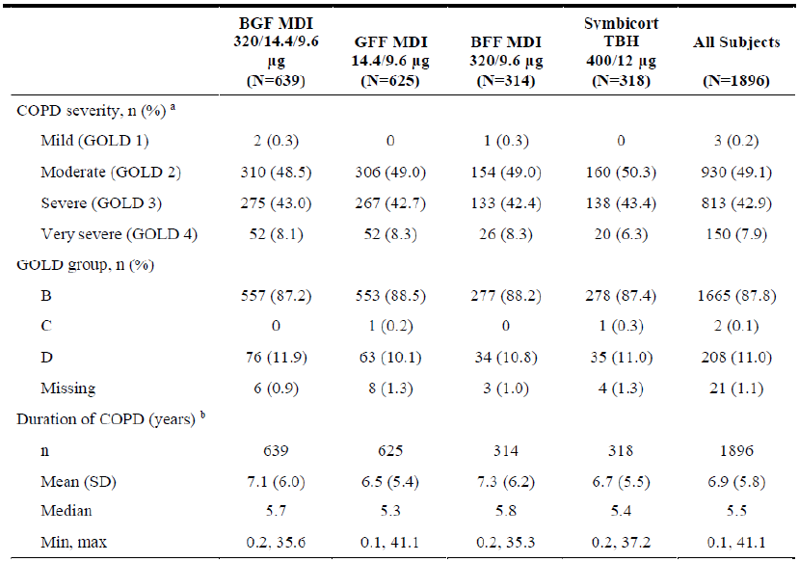
BFF = budesonide / formoterol fumarate; BGF = budesonide / glycopyrronium / formoterol fumarate; COPD = chronic obstructive pulmonary disease; GFF = glycopyrronium / formoterol fumarate; GOLD = Global Initiative for Chronic Obstructive Lung Disease; N = population size; n = sample size; SD = standard deviation; TBH = turbuhaler.
In subjects with forced expiratory volume in one second (FEV₁)/forced vital capacity (FVC) < 0.70, GOLD 1 (mild) = FEV₁ ≥ 80% predicted; GOLD 2 (moderate) = 50% ≤ FEV₁ < 80% predicted; GOLD 3 (severe) = 30% ≤ FEV₁ < 50% predicted; GOLD 4 (very severe) = FEV₁ < 30% predicted. The GOLD severity and groups were based on GOLD 2017 guidelines.
a. Severity of COPD was based on the non-missing post Ventolin hydrofluoroalkane (HFA) assessment at Screening Visit 2 (or if the assessment was missing, the non-missing post Atrovent HFA assessment at Screening Visit 3).
b. The duration of COPD was calculated relative to the start of study drug at Day 1 (Visit 4).
The exclusion criteria were extensive. Patients with comorbidities and complications appear to have been underrepresented in the study populations, and these patients might have lesser efficacy and/or greater vulnerability to adverse effects of treatment. However, the COPD population is usually characterised by comorbidity.
Overall, the clinical evaluator was satisfied that the proportion of participants rejected from randomisation due to comorbidity is unlikely to impact on the generalisability of the results to the Australian population. A significant proportion of the patients considered for treatment were not suitable for inclusion with the appropriate level of severity of COPD being the main consideration.
To adequately reflect the COPD patient population for which efficacy and safety have been demonstrated, the indication could be narrowed to include only patients with moderate to very severe COPD, or even more narrow (only patients with moderate to severe COPD).

Long term efficacy data
Study PT010005 provided evidence of efficacy for 52 weeks of treatment, that is over a longer time period compared to Study PT010006 which investigated 24 weeks of treatment. Study PT010007 and Study PT010008 (extension studies of Study PT010006) did not include formal hypothesis tests for long term efficacy but provided supportive evidence.

Treatment duration
Study PT010005 was a 52-week trial. In contrast, Study PT010006 had a treatment duration of 24 weeks, and only a smaller subset was investigated for an additional 28 weeks (for a total of 52 weeks), as part of its sub-studies (Studies PT010007 and PT010008).

Pregnancy and lactation
No BGF specific data were submitted.

Hepatic impairment
No BGF specific data were submitted.

Proposed action
For the populations of patients randomised and treated in the pivotal trials there was a favourable benefit risk profile for the BGF MDI (320/14.4/9.6 μg) in comparison with the GFF MDI and BFF MDI. The data demonstrated a benefit for the triple combination treatment in comparison with the dual combination treatments for patients with moderate to very severe COPD. Hence, the risk benefit profile appears to be favourable in patients with moderate to very severe COPD.
The following indication is recommended instead of the sponsor proposed indication:
Maintenance treatment to prevent exacerbations and relieve symptoms in adults with moderate, severe, or very severe chronic obstructive pulmonary disease (COPD) who require treatment with a combination of an inhaled corticosteroid, a long-acting beta2-agonist, and a long-acting muscarinic antagonist.
Breztri Aerosphere 160/7.2/5 is not indicated for the initiation of therapy in chronic obstructive pulmonary disease (COPD).

Advisory Committee considerations
The Advisory Committee on Medicines (ACM), having considered the evaluations and the Delegate’s overview, as well as the sponsor’s response to these documents, advised the following.

Specific advice to the Delegate
The ACM advised the following in response to the Delegate’s specific request for advice:
- Can the ACM comment on the proposed indication, in particular in the context of restricting the indication to patients with particular disease severity groups?
The ACM were supportive of restricting the proposed indication based on disease severity groups. The ACM agreed that adults with moderate, severe, or very severe COPD should be included within the proposed indication, as these groups would likely benefit from treatment. The ACM did note that participants with mild or end stage COPD (oxygen dependent and with difficulty using treatments) were not included in the pivotal studies. The ACM was of the view that there was limited evidence to support the inclusion of patients with mild COPD and advised that it should remain excluded from the proposed indication.
- Can the ACM comment to the potential need to investigate ocular corticosteroid toxicity further, for example as part of a post market commitment?
The ACM were of the view that glaucoma and cataracts may occur with long term use of ICS and recommended that the following (or similar) wording from the US Prescribing Information regarding glaucoma and referral to an ophthalmologist be included within the Australian PI:
‘Worsening of narrow angle glaucoma may occur. Use with caution in patients with narrow angle glaucoma and instruct patients to contact a healthcare provider immediately if symptoms occur.
Consider referral to an ophthalmologist in patients who develop ocular symptoms or use Breztri Aerosphere long term.’
The ACM were of the view that additional pharmacovigilance or additional risk minimisation activities were not required for ocular corticosteroid toxicity at this stage.
- The committee is also requested to provide advice on any other issues that it thinks may be relevant to a decision on whether or not to approve this application.
The ACM noted that the trade name used for BGF within the EU differs from the proposed Australian tradename and were of the view that the current proposed Australian tradename Breztri Aerosphere may provide a promotional advantage.

Conclusion
The ACM considered this product to have an overall positive benefit-risk profile for the indication:
Maintenance treatment to prevent exacerbations and relieve symptoms in adults with moderate, severe, or very severe chronic obstructive pulmonary disease (COPD) who require treatment with a combination of an inhaled corticosteroid, a long-acting beta2-agonist, and a long-acting muscarinic antagonist.
Breztri Aerosphere 160/7.2/5 is not indicated for the initiation of therapy in chronic obstructive pulmonary disease (COPD).

Outcome
Based on a review of quality, safety and efficacy, the TGA approved the registration of Breztri Aerosphere (budesonide / glycopyrronium / formoterol fumarate dihydrate) 160 µg/7.2 µg/5 µg (respectively), pressurised inhalation, aerosol can, indicated for:
Maintenance treatment to prevent exacerbations and relieve symptoms in adults with moderate, severe, or very severe chronic obstructive pulmonary disease (COPD) who require treatment with a combination of an inhaled corticosteroid (ICS), a long-acting β2-agonist (LABA), and a long-acting muscarinic antagonist (LAMA).
Breztri Aerosphere 160/7.2/5 is not indicated for the initiation of therapy in COPD.

Specific conditions of registration applying to these goods
- This approval does not impose any requirement for the submission of periodic safety update reports. You should note that it is a requirement that all existing requirements for the submission of PSURs as a consequence of the initial registration or subsequent changes must be completed.

Attachment 1. Product Information
The PI for Breztri Aerosphere approved with the submission which is described in this AusPAR is at Attachment 1. For the most recent PI, please refer to the TGA website at <https://www.tga.gov.au/product-information-pi>.
Therapeutic Goods Administration
PO Box 100 Woden ACT 2606 Australia
Email: info@tga.gov.au Phone: 1800 020 653 Fax: 02 6232 8605
https://www.tga.gov.au

The Black Triangle Scheme provides a simple means for practitioners and patients to identify certain types of new prescription medicines, including those being used in new ways and to encourage the reporting of adverse events associated with their use. The Black Triangle does not denote that there are known safety problems, just that the TGA is encouraging adverse event reporting to help us build up the full picture of a medicine's safety profile.
Australian Institute of Health and Welfare (AIHW) Chronic Obstructive Pulmonary Disease (COPD), last updated on 25 August 2020. Available at: https://www.aihw.gov.au/reports/chronic-respiratory-conditions/copd/contents/copd (accessed 3 March 2022).
Trelegy Ellipta was first registered on the ARTG on 16 January 2018 (ARTG number: 284636).
Stein, A. et al. Effects of perinatal mental disorders on the fetus and child, Lancet, 2014; 384: 1800-1819
Dolovich, M. et al. Device selection and outcomes of aerosol therapy: Evidence-based guidelines: American College of Chest Physicians/American College of Asthma, Allergy, and Immunology, Chest, 2005; 127: 335-371
Molimard, M. et al. Inhaler devices for chronic obstructive pulmonary disease: insights from patients and healthcare practitioners, J Aerosol Med Pulm Drug Deliv. 2015; 28: 219-228.
Chrystyn, H. et al. Impact of patients' satisfaction with their inhalers on treatment compliance and health status in COPD, Respir Med, 2014; 108: 358-365
Bevespi Aerosphere was first registered on the ARTG on 2 October 2018 (ARTG number: 291060).
Good Laboratory Practice is a code of standards following the International Council on Harmonisation (ICH) relevant to testing of medicines in laboratories during drug development.
Pregnancy Category B3 Drugs which have been taken by only a limited number of pregnant women and women of childbearing age, without an increase in the frequency of malformation or other direct or indirect harmful effects on the human fetus having been observed. Studies in animals have shown evidence of an increased occurrence of fetal damage, the significance of which is considered uncertain in humans.
Symbicort Turbuhaler was first registered on the ARTG on 5 May 2004 (ARTG number: 80877).
The randomised clinical trials analysed by the intention-to-treat (ITT) approach provide unbiased comparisons among the treatment groups. In the ITT population, none of the subjects are excluded, regardless of treatment compliance or attrition due to dropout or crossover, and the subjects are analysed according to the randomisation scheme. A modified intention-to-treat analysis (mITT) may sometimes be conducted excluding subjects post-randomisation.
Ventolin was first registered on the ARTG on 13 August 1991 (ARTG number: 12527).
The sponsor must still comply with routine product vigilance and risk minimisation requirements.
Global Initiative for Chronic Obstructive Lung Disease (GOLD), Global Strategy for the Diagnosis, Management, and Presentation of chronic Obstructive Pulmonary Disease, 2017 Report. Available at: https://goldcopd.org/wp-content/uploads/2017/02/wms-GOLD-2017-FINAL.pdf.
The ACM provides independent medical and scientific advice to the Minister for Health and the TGA on issues relating to the safety, quality and efficacy of medicines supplied in Australia including issues relating to pre market and post-market functions for medicines. Further information can be found here: https://www.tga.gov.au/committee/advisory-committee-medicines-acm.

