|  |
| --- |
| **July 2013** |

|  |
| --- |
| Australian Public Assessment Report for C1 esterase inhibitor |
| Proprietary Product Name: Cinryze |
| Sponsor: Cedarglen Investments Pty Ltd |

About the Therapeutic Goods Administration (TGA)

* The Therapeutic Goods Administration (TGA) is part of the Australian Government Department of Health and Ageing, and is responsible for regulating medicines and medical devices.
* TGA administers the *Therapeutic Goods Act 1989* (the Act), applying a risk management approach designed to ensure therapeutic goods supplied in Australia meet acceptable standards of quality, safety and efficacy (performance), when necessary.
* The work of the TGA is based on applying scientific and clinical expertise to decision-making, to ensure that the benefits to consumers outweigh any risks associated with the use of medicines and medical devices.
* The TGA relies on the public, healthcare professionals and industry to report problems with medicines or medical devices. TGA investigates reports received by it to determine any necessary regulatory action.
* To report a problem with a medicine or medical device, please see the information on the TGA website <[http://www.tga.gov.au](http://www.tga.gov.au/)>.

About AusPARs

* An Australian Public Assessment Record (AusPAR) provides information about the evaluation of a prescription medicine and the considerations that led the TGA to approve or not approve a prescription medicine submission.
* AusPARs are prepared and published by the TGA.
* An AusPAR is prepared for submissions that relate to new chemical entities, generic medicines, major variations, and extensions of indications.
* An AusPAR is a static document, in that it will provide information that relates to a submission at a particular point in time.
* A new AusPAR will be developed to reflect changes to indications and/or major variations to a prescription medicine subject to evaluation by the TGA.

Copyright

© Commonwealth of Australia 2013  
This work is copyright. You may reproduce the whole or part of this work in unaltered form for your own personal use or, if you are part of an organisation, for internal use within your organisation, but only if you or your organisation do not use the reproduction for any commercial purpose and retain this copyright notice and all disclaimer notices as part of that reproduction. Apart from rights to use as permitted by the *Copyright Act 1968* or allowed by this copyright notice, all other rights are reserved and you are not allowed to reproduce the whole or any part of this work in any way (electronic or otherwise) without first being given specific written permission from the Commonwealth to do so. Requests and inquiries concerning reproduction and rights are to be sent to the TGA Copyright Officer, Therapeutic Goods Administration, PO Box 100, Woden ACT 2606 or emailed to <[tga.copyright@tga.gov.au](mailto:tga.copyright@tga.gov.au)>.

Contents

I. Introduction to product submission 5

Submission details 5

Product background 5

Regulatory status 6

Product Information 7

List of abbreviations 8

II. Quality findings 9

Introduction 9

Drug substance (active ingredient) 9

Drug product 9

Biopharmaceutics 10

Quality summary and conclusions 10

III. Nonclinical findings 10

Introduction 10

Pharmacology 11

Pharmacokinetics 13

Toxicology 14

Nonclinical summary and conclusions 16

IV. Clinical findings 17

Introduction 17

Pharmacokinetics 18

Pharmacodynamics 23

Efficacy 25

Safety 61

List of questions 75

Clinical summary and conclusions 76

V. Pharmacovigilance findings 88

Risk management plan 88

VI. Overall conclusion and risk/benefit assessment 93

Quality 93

Nonclinical 94

Clinical 95

Risk management plan 100

Risk-benefit analysis 101

Outcome 103

Attachment 1. Product Information 103

## I. Introduction to product submission

### Submission details

|  |  |  |
| --- | --- | --- |
| *Type of Submission* | New Chemical Entity | |
| *Decision*: | Approved | |
| *Date of Decision:* | 19 March 2012 | |
| *Active ingredient(s):* | C1 esterase inhibitor |
| *Product Name(s):* | Cinryze |
| *Sponsor’s Name and Address:* | Cedarglen Investments Pty Ltd  22 Nottingham Avenue  Castle Hill NSW 2154 |
| *Dose form(s):* | Powder for injection |
| *Strength(s):* | C1 esterase inhibitor 500 units powder for solution for injection vial |
| *Container(s):* | Glass vial |
| *Pack size(s):* | Carton of 2 vials Cinryze and 2 vials Water for Injections |
| *Approved Therapeutic use:* | * Treatment and pre procedure prevention of angioedema attacks in adults and adolescents with C1 inhibitor deficiency. * Routine prevention of angioedema attacks in adults and adolescents with frequent attacks of hereditary angiodema (HAE), who are intolerant to or insufficiently protected by oral therapy. |
| *Route(s) of administration:* | Intravenous (IV) |
| *Dosage:* | Maximum dose of Cinryze is 1000 units (2 vials). Frequency of dosing depends on if used in prevention or treatment of angioedema attacks. |
| *ARTG Number (s)* | 177513 |

### Product background

This AusPAR describes an application by the sponsor, Cedarglen Investments Pty Ltd, to register a new chemical entity, C1 esterase inhibitor (Cinryze). Cinryze is formulated as a single use vial containing 500 units (U) of freeze dried powder from the plasma of human donors, purified by nanofiltration. It is to be reconstituted with 5 ml of solvent (water) for solution, and intended for administration by an IV route. Two vials are needed for a single dose (1000 U).

The proposed indication of Cinryze is for the treatment, routine prevention and pre procedure prevention of angioedema attacks in adults, adolescents, and children from 6 years of age with C1 inhibitor deficiency. Cinryze was designated an Orphan Drug Designation by the TGA on 15 October 2010. This is for the indication of the treatment, routine prevention and pre procedure prevention of angioedema attacks in adults, adolescents, and children from 6 years of age with C1 inhibitor deficiency.

Cinryze has been approved by US Food and Drug Administration (FDA) for routine prophylaxis against angioedema attacks in adolescent and adult patients with hereditary angioedema.

The sponsor is seeking approval for both indications of acute treatment and prevention in Europe and Australia. Cinryze was approved by the European Medicines Agency (EMA) in June 2011 for the treatment and pre procedure prevention of angioedema attacks in adults and adolescents with hereditary angioedema (HAE),[1] and routine prevention of angioedema attacks in adults and adolescent with severe and recurrent attacks of hereditary angioedema, who are intolerant or insufficiently protected by oral prevention treatments, or patients who are inadequately managed with repeated acute treatment.

The sponsor has stated in this submission that the data package for the Australian submission is the same as that submitted in the EU, except that the Water for Injections manufacturer has been changed from NVI to Hameln. The data package for the Australian and EU submission were similar to that submitted in the US but included the clinical study reports of two additional studies (Study LEVP 2005-1/Part A and Study LEVP 2006-1) not previously submitted in the US.[2] These two studies investigated the efficacy and safety of Cinryze for the treatment of acute HAE attacks.

### Regulatory status

Table 1 shows the international regulatory history of Cinryze at the time of submission of this dossier.

Table 1: Summary of international regulatory status of Cinryze approvals.

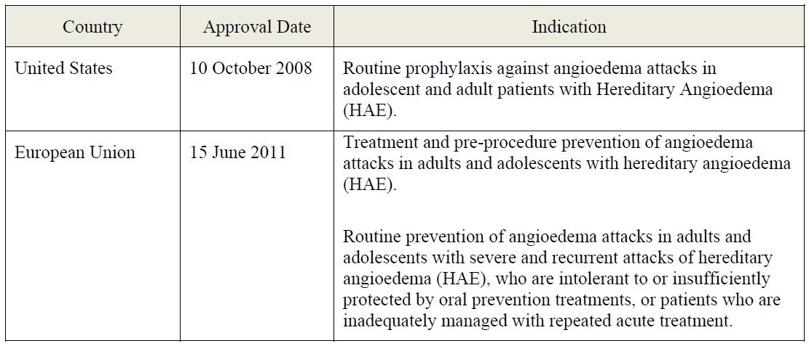

At the time of submission of this dossier, applications were also pending in Switzerland (submission date 10 June 2010), India (18 May 2011), and Israel (2 October 2011).

### Product Information

The approved Product Information (PI) current at the time this AusPAR was prepared can be found as Attachment 1.

### List of abbreviations

AE Adverse Event

ANOVA Analysis Of Variance

AUC Area Under the Plasma Concentration-Time Curve

AUCt1-t2 Area Under the Plasma Concentration-Time Curve Within Time Span t1 to t2

BUN Blood Urea Nitrogen

Cmax Maximum Plasma Drug Concentration

C1 INH C1 Esterase Inhibitor

CBC Complete Blood Count

CHMP Committee for Medicinal Products for Human Use

CI Confidence Interval

CMI Consumer Medicines Information

EMA European Medicines Agency

FDA Food and Drug Administration (US)

GCP Good Clinical Practice

HAE Hereditary Angioedema

HCP Health Care Professional

ICH International Conference on Harmonisation

ITT Intent To Treat

IV Intravenous

PD Pharmacodynamic(s)

PHR Proportional Hazards Regression

PI Product Information

PID Pain Intensity Difference

PK Pharmacokinetic(s)

PMF Plasma Master File

PSUR Periodic Safety Update Report

RMP Risk Management Plan

SAE Serious Adverse Event

SAP Statistical Analysis Plan

SD Standard Deviation

SOC System Organ Classification

SPID Sum of Pain Intensity Difference

Tmax Time to Reach Maximum Plasma Concentration Following Drug Administration

TEAE Treatment Emergent Adverse Event

U Units

VAS Visual Analog Scale

WFI Water For Injection(s)

## II. Quality findings

### Introduction

This is an application for Cinryze 500 U powder and solvent for solution for injection (C1 esterase inhibitor [human]) for the proposed indication: treatment, routine prevention and pre procedure prevention of angioedema attacks in adults, adolescents and children from 6 years of age with C1 esterase inhibitor (or C1 INH) deficiency. Cinryze is a purified C1 INH manufactured from fractionated human plasma. The plasma complies with the Ph. Eur. (European Pharmacopoeia) monograph 0853 on human plasma for fractionation. . Currently, there is no monograph for the active ingredient C1 INH.

C1 INH is a serine protease inhibitor and a member of the serpin family that is mainly synthesised in the liver and is obtained from human plasma pools.

Cinryze is a sterile, preservative and pyrogen free, freeze dried powder in a pack size of 500 U C1 INH per vial. It is to be reconstituted with 5 ml of WFI. The excipients in a vial of the Cinryze drug product are: 13 mg sodium citrate, 20 mg sodium chloride, 10 mg L-valine, 6 mg L-alanine, 23 mg L-threonine, and 103 mg sucrose. Vial of WFI (5 ml) is supplied with the package. Reconstitution with 5 ml of WFI results in a clear, colourless to light blue solution with a concentration of 100 U C1 INH per ml. The content of two reconstituted vials of Cinryze (10 ml) is to be pooled and administered into a vein at an injection rate of 1 ml per minute.

Cinryze has been designated as an orphan drug by the TGA on 15 October 2010 for the treatment, routine prevention and pre procedure prevention of angioedema attacks in adults, adolescents and children from 6 years of age with C1 INH deficiency.

### Drug substance (active ingredient)

C1 INH is a serine protease inhibitor and a member of the serpin family.

The source and safety of the plasma has been satisfactorily addressed in the associated PMF. The Drug Substance C1 inhibitor manufacturing starts with the human plasma pool processing, followed by adsorption, chromatographic, precipitation, pasteurisation, and filtration steps.

The drug substance for Cinryze is manufactured by Sanquin Plasma Products (SPP) located in Amsterdam, The Netherlands.

Stability data were generated under real time conditions to characterise the stability profile of the substance and to establish a shelf life. The real time data submitted support a shelf life of 24 months when stored at ≤ -25°C.

### Drug product

Cinryze is a white lyophilised powder for solution for IV injection in a pack size of 500 U C1 INH per vial. The freeze dried powder has a white colour, occasionally with a light blue trace. Vial of WFI (5 ml) is supplied with the package.

One U of Cinryze corresponds to the mean quantity of C1 INH present in 1 ml of normal fresh plasma. The lyophilised powder is to be stored below 25°C (2-25°C) and not frozen. The reconstituted C1 INH (human) has a shelf life of 3 h when stored at room temperature (15-25°C).

Cinryze is provided in colourless glass vials of 8 ml. WFI is provided in colourless glass vials of 6 ml. Vials of product and WFI are closed with bromobutyl stoppers and sealed with aluminium cap.

The manufacture of Cinryze Final Drug Product involves dilution of Drug Substance, filling into vials, lyophilization, labeling and packaging.

The manufacturing of Cinryze Final Drug Product and the labelling and packaging take place at SPP.

The product is sterilised using filtration. The WFI filled vials are terminally steam sterilised at ≥ 121°C for at least 15 min.

Cinryze is formulated using buffer comprised of Trisodium citrate, Sodium chloride, L-valine, L-alanine, L-threonine, Sucrose, pH between 6.6 and 7.4.

The proposed shelf life for Cinryze is 2 years when stored at 2-25°C. In use stability data have also been submitted. The proposed shelf life and storage condition for the reconstituted product is 3 h when stored at 15-25°C.

Stability data presented for the WFI showed that all three batches complied with the specifications and demonstrated good stability profiles for all test parameters.

### Biopharmaceutics

Biopharmaceutic data are not required for this product because the application was not submitted as a biosimilar product with any other currently in the ARTG (Australian Register of Therapeutic Goods).

### Quality summary and conclusions

The Quality data submitted in support of this application have been evaluated in accordance with the Australian legislation, pharmacopoeia standards and relevant technical guidelines adopted by the TGA. All aspects of Quality data have been assessed and considered satisfactory.

There are no outstanding issue in regards to Quality aspects.

## III. Nonclinical findings

### Introduction

C1 INH plasma products have been developed and manufactured by the Dutch organisation Sanquin Plasma Products for over 30 years. Sanquin introduced its first C1 INH in 1972. The product has been further developed over the years to increase purity and formulation safety and was registered in 1997 as Cetor in the Netherlands.

This application does not fully comply with International Conference on Harmonisation (ICH) guidelines for preclinical safety evaluation of biotechnology derived pharmaceuticals S6 (R1),[3] especially in regard to toxicological studies in a relevant species and use of an appropriate dose range. The overall quality of the nonclinical data was low[4] for the following reasons:

* Some of the C1 INH products used were unrelated to the current product and seemed to investigate the switch between earlier generation Sanquin C1 INH products;
* The nomenclature for different C1 INH products used throughout the application was inconsistent;
* The rat (used for all toxicity studies) was not confirmed as a relevant species for testing Cinryze; and
* The duration of studies (up to 2 weeks) is not sufficient to support long term use of human medicines.

Doses used were not adequate in terms of multiple of expected human exposure (AUC) and they were apparently insufficient to define the potential activity/toxicity profile of this medicine.

### Pharmacology

#### Primary pharmacology

No pharmacological studies were submitted; however, the pharmacological action of C1 esterase inhibitors in general is well characterised in published studies.[5] The plasma protein C1 INH is a serine protease inhibitor (serpin) that regulates blood clotting and inflammatory reactions by inhibiting three major systems: the complement (C1r, C1s and MASP), contact (factor XII and kallikrein), and coagulation system (factor XI and thrombin). Impaired inhibition of these systems can induce local tissue swelling. C1 INH plasma levels are low, or the protein does not function properly in patients with HAE. C1 INH is derived from human plasma and administered as a replacement therapy in HAE patients.

The lack of primary pharmacology studies, including studies in animal models of oedema, with Cinryze is accepted given that the function and actions of this substance are well characterised. However, the submission did not include information on whether the rat (used for all toxicity studies) was an appropriate pharmacological model in terms of responsiveness to C1 esterase inhibitors, which limits the value of the nonclinical toxicology program.

#### Safety pharmacology

The safety pharmacology program for Cinryze did not comply with ICH guidelines for preclinical safety evaluation of biotechnology derived pharmaceuticals S6 (R1).[6] The effect of Cinryze on cardiovascular respiratory, renal and central nervous system was not investigated. The absence of a comprehensive safety pharmacology program with Cinryze contributes to concerns over the adequacy of the nonclinical package for this application.

Two safety pharmacology studies were conducted that compared antigenicity and thrombogenicity of an earlier generation C1 INH product with a later generation C1 INH product, both of which are manufactured using similar methods to those used to manufacture Cinryze.

The potential to induce thrombosis was investigated *in vitro* and *in vivo*. The *in vitro* tests did not detect presence of activated coagulation factors in C1 INH products. However, a standard *in vivo* test for thrombogenicity (Wessler stasis model) revealed a potential for induction of thrombosis in rabbits. The thrombogenic potential was observed at the lowest administered dose (36 U/kg) of C1 esteraseremmer (a C1 INH manufactured by methods different to those proposed for C1 esterase in Cinryze). Despite a considerable degree of batch and animal variation, clear dose dependence was observed (Table 2). The effect was less pronounced after heat treatment of the product, but the low number of observations in this group as well as the limited dose range tested precluded a thorough assessment of the effect. It is of concern that for a 50 kg patient these thrombogenic doses are close to the recommended single human dose (20 U/kg).

Table 2: Summary Wessler stasis model.

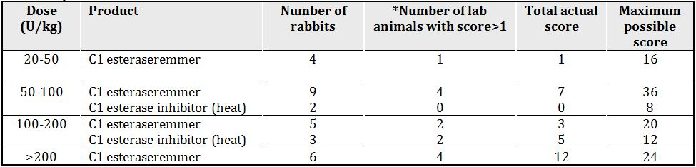

* Score: 0 = no clot; 1 = a number of macroscopic fibrin threads; 2 = a number of small clots; 3 = two or more larger clots; 4 = one clot of the size of the tied off segment.

Total score is the tally of each individual animal’s score; maximum score is the highest possible score if all rabbits achieved a score of 4 each.

The results obtained in animal experiments are an indication of a possible risk of thrombogenicity in humans.

It is acknowledged that potential for thrombogenicity is a known clinical risk that is addressed in the proposed PI as well as in proposed post market commitments. It should be noted that the investigators of this study concluded that

*“C1 INH HP exceeds a definite thrombogenic threshold at dosages greater than 200 U C l esterase inhibitor per kg”...*

This is based on findings from 5 rabbits and is not considered reliable.

The investigators also stated that

*“...it can be concluded, though with caution, that the thrombogenic threshold of the tested batch of the current product is in the range of 100-200 U C1 INH per kg body weight.”*

### Pharmacokinetics

A full PK analysis, including distribution, metabolism and excretion studies, was not conducted for Cinryze and is not required given that the active is a plasma protein.

Data were provided on the plasma kinetics of an earlier version of C1 INH after a single IV dose in rats, but adequate toxicokinetic data from both rat toxicity studies using Cinryze were provided.

In general a similar kinetic profile was observed after single and repeat administration of C1 INH in rats. Exposure (AUC0-last) generally increased slightly more than dose proportionally between low and high doses (5-30% increase) the effect was even more pronounced in pregnant females. The distribution volume ranged between 45 and 60 ml/kg. The half life of the protein in rats was variable and ranged between 5.6 h and 11 h. In contrast the average half life of C1 INH in humans with HAE was relatively long at 56-62 h (Study LEVP2006-5). A similar range was observed in healthy subjects.[7]

The reason for the lower half life in rats compared with humans is not known; however, an immune response mediated inactivation is possible. Consistent with the lower half life, the clearance in rats was faster (4.2-6.8 ml/h/kg) than in humans (0.85-1.17 ml/min; about 1 ml/h/kg for a 50 kg person). No consistent effects of dose, dosing regimen or gender were observed in rats.

#### Exposure comparisons

According to the nonclinical overview, dose selection for the single and repeat dose toxicity studies in rats was based on multiples of the human dose on a U/kg basis. However, because of the differences in clearance of C1 INH (about 5 times faster in rats than in humans), exposure (AUC) in rats will be considerably lower than in humans after a given IV dose. Exposure to C1 INH achieved in the rat toxicity and embryofoetal development studies when compared with that expected in humans is shown in Table 3.

Table 3: PK and relative drug exposures in animals.

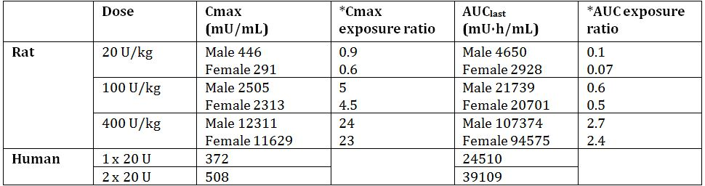

* Animal Cmax or AUC value divided by respective human value after 2 x 20 U dose.

Given the lack of findings in the rat toxicity studies, it is considered that the use of higher doses should have been considered, particularly for acute studies where antibody formation may not potentially be confounding.

Physiologically one U of C1 inhibitor corresponds with the C1 inhibitor activity in one ml of normal human serum. After injection of Cinryze in rats, systemic exposure (calculated as AUC0-last) to C1 INH is lower or similar to that in humans. The high dose of 400 U/kg therefore only reaches an exposure that is roughly comparable to systemic concentrations in humans after administration of the recommended dose. This is of concern in relation to the toxicity studies since animals have not been challenged adequately. In contrast, Cmax values are only slightly lower after administration of 20 U/kg but are higher after administration of 400 U/kg C1 inhibitor.

### Toxicology

Dosing occurred via the clinically intended route, but dose selection was based on a multiple of the human dose in terms of U/kg, which resulted in exposure in animals that was inadequate (in view of the lack of findings) when compared to the expected exposure in humans (see above).

#### Acute toxicity

One single dose toxicity study was conducted (in rats). Animals were given a single IV dose of 20, 100, or 400 U/kg C1 INH. Acute treatment was well tolerated. No treatment related clinical signs were reported. A criticism of the study is that in addition to the low systemic exposure the number of observations was also very low. Only 2 animals/treatment/ sampling time points were investigated. This further limits the ability of the study to accurately reflect occurrence of potential toxic events.

#### Repeat dose toxicity

A 7 and a 14 day repeat dose toxicity study were conducted in rats. IV administration of the highest dose (400 U/kg) appeared to be well tolerated. No consistent major micro or macroscopic pathophysiological changes were detected. It is not clear to what degree treatment with C1 INH was neutralised in rats during these studies. The presence of neutralising antibodies would make treatment ineffective, resulting in no apparent toxicity.

#### Immunotoxicity

Doses of 20-400 U/kg human C1 INH protein showed some immunogenic potential as expected for a human protein in rats. Most animals responded to C1 INH challenge with a dose dependent production of neutralising antibodies against the enzyme. Treatment with 400 U/kg C1 INH increased spleen body weight ratio by ~20% in both sexes. Histopathology of the spleen revealed an increased incidence of germinal centre hypertrophy. A dose independent increase in white blood cells (19-35%), particularly lymphocytes and monocytes, was observed in female rats. An increase in eosinophil levels (31%) was observed in both sexes at 400 U/kg.

Overall, the repeat administration of C1 INH with doses of up to 400 U/kg was apparently well tolerated in rats over a period of up to14 days. Whereas the high dose had no effects after 7 days minor immunological effects were observed after 14 days.

Long term toxicity studies in rodents are often impracticable due to the formation of antibodies against the human protein and were not attempted by the sponsor. However, this does rule out the possibility of using a second (preferably primate) species for toxicity studies.

#### Genotoxicity and carcinogenicity

No genotoxicity or carcinogenicity studies were performed. This is considered appropriate since these studies are not required according to ICH guideline S6 (R1).[8]

#### Reproductive toxicity

The effect of Cinryze on embryofoetal development was investigated in a dose finding preliminary study (6/group) and in a main study (20/group) in rats. Pregnant females were treated identically in both studies. Rats were dosed with 0, 20, 100, or 400 U/kg C1 INH by daily IV bolus injection from gestation day 6 to gestation day 17. Three days after the end of treatment, the rats were terminated and the implants examined for skeletal and soft tissue abnormalities. There were no treatment related clinical or necropsy findings. No effects on body weight, pregnancy performance or the type and distribution of foetal abnormalities. It is not clear how the preliminary study helped to establish appropriate doses since the highest administered dose was without effect and identical dosing regimens were performed.

The absence of findings in this study is not reassuring since, as in the 14 day toxicity study, neutralising antibodies most likely resulted in limited or no exposure to active drug.

##### Pregnancy classification

The sponsor has proposed Pregnancy Category B2;[9] however, this is not required since enzymes are exempt from classification.

#### Impurities

No specific toxicological evaluation of impurities present in Cinryze was conducted. The product used for the toxicity program is stated to be identical to that proposed for registration. The total daily intake of Cinryze at the highest dose used in rats (400 U/kg) was greater than expected daily intake for humans (~40 U/kg/day). However, as mentioned elsewhere in this report, there is no evidence that the rat is an adequate model for testing Cinryze. Therefore, it is not possible to qualify impurities above the acceptable limit (according to relevant ICH guidelines[10]) on the basis of basis of nonclinical data.

#### Paediatric use

Cinryze is proposed for paediatric use but no specific studies in juvenile animals were submitted.

#### Comments on the Safety Specification of the Risk Management Plan

Results and conclusions drawn from the nonclinical program for Cinryze detailed in the sponsor’s draft RMP are in general concordance with those of the nonclinical evaluator. Especially the focus on occurrence of thrombotic events which will be assessed by the conduction of a Phase 4 study in the US and the specific evaluation of subjects for thrombotic or thromboembolic events is noted.

### Nonclinical summary and conclusions

#### Summary

* Cedarglen Investments Pty Ltd has applied to register a new chemical entity, C1 protease inhibitor (Cinryze) for the treatment, routine prevention and pre procedure prevention of angioedema attacks in adults, adolescents and children from 6 years of age with C1 INH deficiency. Orphan drug status was granted on 15 October 2010 for the use of Cinryze in this indication.
* C1 INH is an endogenous plasma serine protease inhibitor that regulates blood clotting and inflammatory reactions by inhibiting important components of the immune (complement) and coagulation systems. Cinryze is intended as replacement therapy in those with HAE who have deficient or non functional C1 INH. Proposed doses are 1000 U IV, followed by a second 1000 U IV dose 60 minutes later if required, for treatment; and 1000 U IV every 3-4 days for prophylaxis.
* Nonclinical studies to support this application comprised short term (up to 14 days) toxicity studies and an embryofoetal development study in rats dosed IV with Cinryze. Single dose PK studies in rats and thrombogenicity studies were also submitted but these involved C1 INH products manufactured by methods not identical to those proposed for Cinryze.
* The nonclinical data package was of variable quality. Overall, the quality of the data package was considered low and did not adequately comply with relevant regulatory guidelines in terms of expected scope and duration of nonclinical studies, and demonstrated species relevance. The rat (used for the main toxicity and reproductive toxicology studies) was not confirmed as an appropriate human model for toxicity testing of C1 INH in terms of pharmacological and immunological responsiveness.
* Safety pharmacology studies comprised *in vitro* and *in vivo* (rabbits) assays for thrombogenicity with C1 INH that preceded the development of the protein proposed for registration. Dose dependent thrombogenic activity was demonstrated *in vivo* at doses relevant to human use, and similar activity may be expected with the C1 INH in Cinryze.
* It was not possible to clearly identify a threshold dose or a no effect dose for thrombogenicity of Cinryze from the rabbit study in this submission.
* Single dose PK studies with an earlier form of C1 INH showed that the enzyme is cleared faster in rats (resulting half life 6-13 h) than in humans (half life up to 62 h). Plasma levels of C1 INH were determined after IV administration of Cinryze 20, 100 and 400 U/kg in the toxicity and reproductive toxicity studies: for AUC, the exposure was generally lower or comparable to that expected in humans after a 2 x 1000 U dose.
* There were no notable findings in the toxicity and embryofoetal development toxicity studies, with the possible exception of a weak immunogenic response (inflammatory changes in the lungs and spleen germinal centre hypertrophy) in the 14 day study.
* The development of neutralising IgG antibodies to C1 INH was confirmed at the end of the treatment period in the 14 day toxicity study in rats; it is not known if antibodies developed earlier, but it is likely that the development of these compromised the rat as a useful model for testing C1 INH. Therefore, the repeat dose and reproductive toxicology studies in this species are of limited, if any, value.
* No specific toxicological evaluation of impurities present in Cinryze was conducted. Any impurities in Cinryze that occur above limits accepted without justification or qualification (according to relevant ICH guidelines[11]) cannot be qualified on the basis of the nonclinical data provided in this submission.

#### Conclusion and recommendation

* The nonclinical part of the submission did not comply with published guidelines.[12] Important deficiencies include a lack of studies addressing whether the rat (used for all toxicity studies) is an appropriate species for testing C1 INH; lack of comprehensive safety pharmacology studies with Cinryze; lack of toxicity testing in a second species (which is important given that the rat was not validated as an appropriate species); absence of studies to support long term use; and lack of studies to support paediatric use.
* Overall, this application cannot be supported on nonclinical grounds because Cinryze was not adequately tested in a validated and adequate nonclinical safety and toxicology program. It is acknowledged that the lack of adequate nonclinical data may be mitigated by the fact that the medicine is a replacement of an endogenous human plasma protein for which there is considerable clinical experience and for which published nonclinical studies have not to date identified unaddressed safety issues. Therefore, the risks associated with approving this application in the absence of adequate nonclinical data are not considered high.

## IV. Clinical findings

### Introduction

This is an application by the sponsor, Cedarglen Investments Pty Ltd, to register a new biological agent, Cinryze, a C1 INH. Cinryze is formulated as a single use vial containing 500 U of freeze dried powder from the plasma of human donors, purified by nanofiltration. It is to be reconstituted with 5 ml of solvent (water) for solution, and intended for administration by an IV route. Two vials are needed for a single dose (1000 U).

The current submission package does not contain data from any studies evaluating the use of Cinryze in a paediatric population. However, the sponsor has stated that the study population of the five clinical studies in this application included 46 unique subjects aged 2-17 years (2-5 years: n = 3; 6-11 years: n = 17; 12-17 years: n = 26), and that the sponsor is currently conducting 2 studies which include paediatric subjects.

All clinical studies reviewed in this evaluation were in compliance with GCP guidelines.

### Pharmacokinetics

#### Introduction

The evaluation of the clinical PK and PD of Cinryze is based on the results of a Phase I study, Study LEVP 2006-5. The sponsor has indicated that as C1 INH is an endogenous human plasma protein and the route of administration of Cinryze is IV, no biopharmaceutical and drug-drug interaction studies were conducted with Cinryze.

#### Methods

Study LEVP 2006-5 was a randomised, open label, parallel group study evaluating the PK and PD of Cinryze in non symptomatic adult HAE subjects given one or two 1000 U doses of Cinryze. Cinryze was administered by IV infusion. Subjects who were randomised to receive two doses of Cinryze received the second dose 60 minutes after the first dose.

Blood samples were taken pre infusion and at 5 minutes, 1 h, 3 h, 6 h, 24 h (1 day), 48 h (2 days), 96 h (4 days), and 168 h (7 days) after the final administration of Cinryze. The samples were used to measure plasma C1 INH antigen levels, functional C1 INH activity, and complement C4 concentrations. The first two parameters were for PK evaluation, while complement C4 concentration level was a PD biomarker. Samples were assayed for antigenic C1 INH protein by nephelometry, and functional C1 INH protein by an enzyme linked immunosorbent assay (ELISA). Complement C4 concentrations were measured by immunoturbidimetry using a Bayer ADVIA 1650 complement kit. Non compartmental PK analyses were performed using baseline corrected concentrations and a validated commercially available software.[13] Baseline corrected concentrations were derived by subtracting the baseline concentration measured just prior to dosing from each subsequent concentration. Baseline corrected values that were less than zero were set to zero.

A total of 27 subjects were randomised and treated. Of these, 13 received a single dose (1000 U) and 14 received a double dose (2000 U) of Cinryze. All 27 subjects were included in the PK analysis population. The majority of subjects (24 subjects, 88.9%) were White/Caucasian. Of the 27 subjects, 10 were males and 17 females. The subjects had an age range of 19 to 57 years.

#### Pharmacokinetics and dose proportionality

##### Plasma C1 inhibitor antigen

The antigenic C1 INH Cmax and AUC0-t increased from the single to double dose, but the increase was not dose proportional. Baseline corrected antigenic C1 INH Cmax and AUC0-t increased by approximately 1.53 fold and 1.48 fold, respectively, for a 2 fold increase in dose (Table 4).

Table 4: Mean (± SD) PK parameters for C1 INH antigen in HAE subjects following administration of Cinryze (Study LEVP 2006-5).

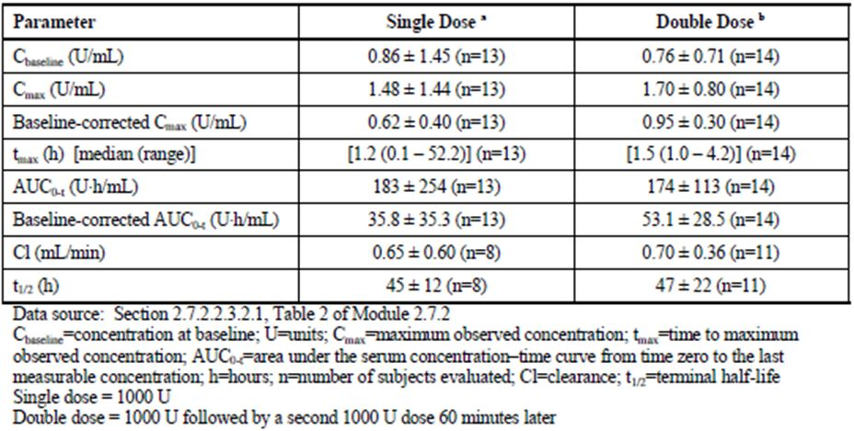

##### Functional C1 inhibitor

The Cmax and AUC0-t increased from the single to double dose, but the increase was not dose proportional. Baseline corrected functional C1 INH Cmax and AUC0-t values increased approximately 1.37 fold and 1.60 fold, respectively, for a 2 fold increase in dose (Table 5).

Table 5: Mean (± SD) PK parameters for functional C1 INH antigen in HAE subjects following administration of Cinryze (Study LEVP 2006-5).

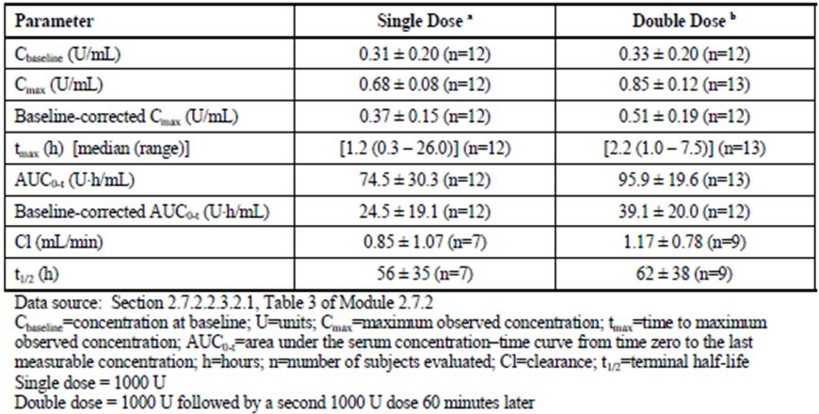

#### Special populations

Specific studies have not been conducted to evaluate the PK of Cinryze in special patient populations identified by gender, race, age or the presence of impaired renal or hepatic function. The sponsor has stated that a paediatric PK/PD study (Protocol 0624-203) commenced in March 2010.

##### Comments:

*It is acceptable that the PK of Cinryze have not been evaluated in special patient populations with impaired renal or hepatic function, and that drug-drug interactions have not been evaluated. C1 inhibitor is an endogenous human plasma glycoprotein which is metabolised via degradation into smaller peptides and individual amino acids. Cinryze is therefore not expected to be subjected to metabolism by the cytochrome P450 system, or excretion. The PK of Cinryze is not expected to be altered by the presence of renal or hepatic impairment.*

Although no specific PK studies were done in paediatric subjects (aged < 18 years) at the time of submission, C1 INH antigenic and functional levels were measured in the four Phase 3 studies submitted in this application, which included paediatric subjects who were given the same doses of Cinryze as the adult subjects. The number of paediatric subjects in the two randomised controlled trials, Studies LEVP 2005-1/Part A and LEVP 2005-1/Part B, were very small (n = 12 and 4, respectively), and a sub analysis of C1 INH antigenic and functional levels in paediatric subjects in these two studies was not performed. The sponsor performed a sub analysis of C1 INH antigenic and functional levels by age group for the two open label Studies LEVP 2006-1 and LEVP 2006-4 in which there were 23 and 22 subjects aged <18 years, respectively. These study designs are described below in this clinical evaluation report.

In Study LEVP 2006-1, mean changes in levels of C1 INH antigen from pre infusion to 60 minutes post infusion ranged from 6.0 to 20.0 mg/dL in subjects less than 18 years of age, compared with -11.0 to 16.0 mg/dL in subjects ≥ 18 years of age. The range of median change from baseline in C1 INH antigen values in 3 paediatric age groups (2 to 5 years, 6 to 11 years, and 12 to 17 years, respectively) compared with adults ≥ 18 years of age is presented in Figure 1. Median increases in C1 INH antigen values appeared to be slightly higher in subjects less than 18 years of age than in subjects ≥ 18 years of age, but the sample sizes involved were too small. In Study LEVP 2006-1, mean increases in functional C1 INH activity levels from pre infusion to 60 minutes post infusion ranged from ~20.0-88.0% in subjects less than 18 years of age, compared with ~21.0-66.0% in subjects ≥ 18 years of age. The range of median change from baseline in functional C1 INH values in three paediatric age groups (2 to 5 years, 6 to 11 years, and 12 to 17 years, respectively) compared with adults ≥ 18 years of age is presented in Figure 2. As with C1 INH antigen levels, median increases in functional C1 INH values appeared to be slightly higher in subjects less than 18 years of age than in subjects ≥ 18 years of age, but the sample sizes involved were too small to provide any conclusive evidence.

Figure 1: Summary of median change in C1 INH antigen values from pre to post infusion by age (Study LEVP 2006-1).

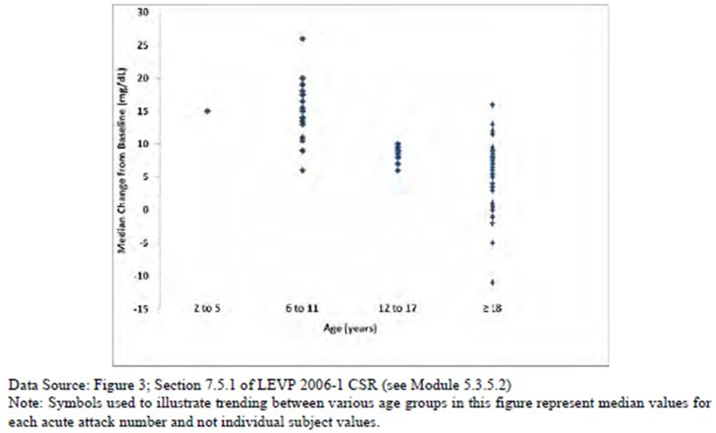

Figure 2: Summary of median change in functional C1 INH antigen values from pre to post infusion by age (Study LEVP 2006-1).

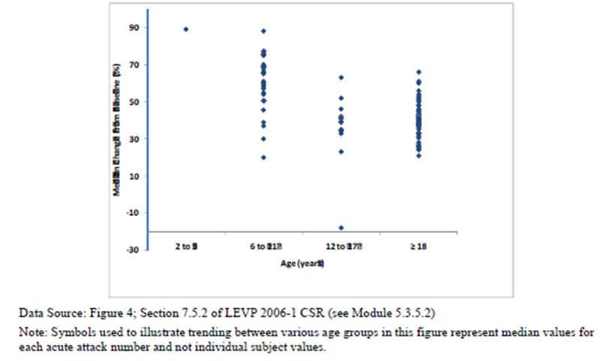

In Study LEVP 2006-4, mean changes in levels of C1 INH antigen from pre infusion to 60 minutes post infusion ranged from 6.7 to 15 mg/dL in subjects less than 18 years of age, compared with 5.6 to 8.4 mg/dL in subjects ≥ 18 years of age. The range of median change from baseline in C1 INH antigen values in three paediatric age groups (2 to 5 years, 6 to 11 years, and 12 to 17 years, respectively) compared with adults ≥ 18 years of age is presented in Figure 3. Median increases in C1 INH antigen values appeared to be slightly higher in subjects less than 18 years of age (range of 4 to 15 mg/dL) than in subjects ≥ 18 years of age (range of 6 to 8 mg/dL), although interpretation was limited by the small sample sizes.

Figure 3: Summary of median change in C1 INH antigen values from pre to post infusion by age (Study LEVP 2006-4).

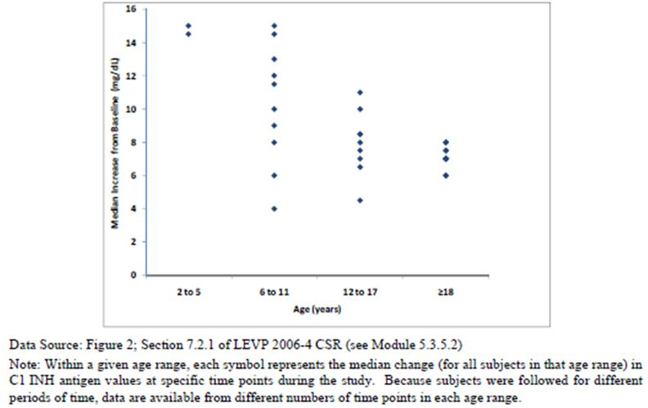

In Study LEVP 2006-4, mean increases in functional C1 INH activity levels from pre infusion to 60 minutes post infusion ranged from ~22.0-45.9% in subjects less than 18 years of age, compared with ~25.0-32.4% in subjects ≥ 18 years of age. The range of median change from baseline in functional C1 INH values in three paediatric age groups (2 to 5 years, 6 to 11 years, and 12 to 17 years, respectively) compared with adults ≥ 18 years of age is presented in Figure 4. As with C1 INH antigen levels, the sample sizes involved were too small for any robust interpretation.

Figure 4: Summary of median change in functional C1 INH antigen values from pre to post infusion by age (Study LEVP 2006-4).

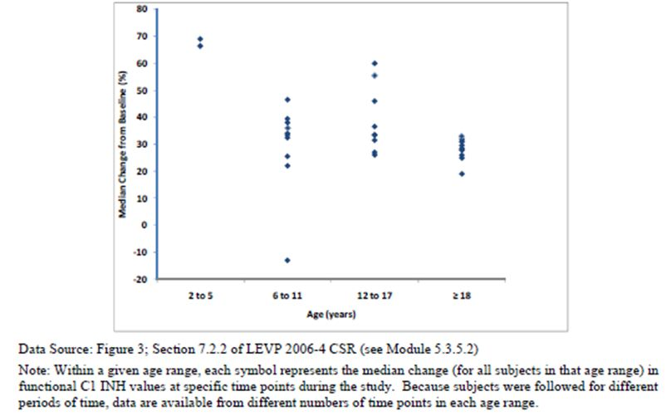

#### Evaluator’s overall conclusions on PK

The single clinical PK study was done in the target patient population instead of healthy individuals. This is appropriate as Cinryze is purified C1 inhibitor protein derived from pooled plasma of human donors, and is meant as a replacement treatment for patients with inherited C1 inhibitor deficiency.

The PK parameters of both C1 INH antigen and functional C1 INH protein were evaluated. This is appropriate as C1 INH deficiency may be a result of either reduced quantity of C1 INH or diminished C1 INH function.[14] Overall, the PK results showed that treatment with Cinryze resulted in increases in both antigenic and functional C1 INH. The concentrations of antigenic and functional C1INH were maximal within the first 2.2 h (median) after dosing. Cinryze has a long half life, with mean half lives ranging from about 2 to 2.5 days for antigenic and functional C1 INH.

The PK parameters did not demonstrate dose proportionality. Both the Cmax and AUC0-t increased with dose, but the increase was not dose proportional. A 2 fold increase in dose led to an increase of about 1.4 to 1.5 fold of baseline corrected antigenic and functional C1 INH Cmax values and an increase of about 1.5 to 1.6 fold of baseline corrected antigenic and functional C1 INH AUC0-t values. The sponsor did not give any reasons for the demonstrated lack of dose proportionality.

As a plasma protein, Cinryze is not expected to be subjected to metabolism by the cytochrome P450 system and the PK of Cinryze is not expected to be altered by the presence of renal or hepatic impairment. It is therefore acceptable that the PK of Cinryze were not evaluated in special patient populations with impaired renal or hepatic function, and that drug-drug interactions were not evaluated.

The proposed indications for Cinryze in this submission involve the use of Cinryze in adolescents and children from 6 years of age. However, at the time of submission, no data from PK studies done in paediatric subjects <18 years of age was available. It is noted by the evaluator that in the Phase 3 trials, in which subjects < 18 years of age were enrolled, C1 INH antigen and functional C1 INH protein levels were measured. A comparison of the range of median changes from baseline of C1 INH antigen and functional levels between paediatric subjects and adult subjects in the two open label Phase 3 studies showed that median increases in antigenic and functional C1 INH values appeared to be slightly higher in subjects less than 18 years of age than in subjects ≥ 18 years of age, but the sample sizes involved were too small for any robust interpretation. The sponsor has also stated that a paediatric PK/PD study (Protocol 0624-203) commenced in March 2010.

Overall, the PK information presented in the proposed Product Information is consistent with the PK study results.

### Pharmacodynamics

#### Introduction

The evaluation of the PD of Cinryze is based on the results of the Phase 1 study, Study LEVP 2006-5.

#### Mechanism of action

HAE, or C1 INH deficiency, is caused by an autosomal dominant mutation on chromosome 11 that leads to a decrease in C1 INH activity. There are 2 types of HAE: in Type I HAE (approximately 85% of cases), levels of C1 INH are low, while in Type II HAE (approximately 15% of cases), there are normal levels of functionally deficient C1 INH protein. There are no differences in clinical manifestations between Type I and Type II HAE.

C1 INH is an endogenous human plasma protein. The primary function of C1 INH is to regulate the activation of the complement system as well as the contact activation pathway (intrinsic pathway) of the coagulation system to prevent spontaneous activation of these systems. The complement system mediates the inflammatory process, and consists of plasma proteins which mainly circulate in an inactive form as proenzymes until they are activated. Activation of the complement system involves a cascade of sequential activation which converts each proenzyme into its active state and amplifies the response. C1 INH inhibits the complement system by binding C1r and C1s, two of the active enzyme subunits of the first component of the complement system (C1) in the classical pathway, and thereby inhibiting the activation of C1 enzyme. It also inhibits the complement system by binding to the MASPs in the lectin pathway. These inhibitory functions prevent spontaneous activation of the complement system cascade pathways. In addition, C1 INH also regulates the intrinsic coagulation pathway by binding to and inactivating kallikrein and factor XIIa, and thus preventing spontaneous activation of the intrinsic coagulation pathway.

A deficiency of C1 INH leads to spontaneous or trigger induced activation of the complement cascade pathway as well as permitting plasma kallikrein activation, which then leads to the production of the vasoactive peptide bradykinin. This can then result in attacks of non itching swellings of the skin or mucosa due to leakage of fluid from blood vessels into connective tissue. Laryngeal swelling can occur and is potentially life threatening. Administration of exogenous C1 INH increases serum levels of C1 INH activity and temporarily restores the natural regulation of the complement and intrinsic pathway systems, thereby controlling soft tissue swelling or the propensity to swell.

#### Primary pharmacology

In Study LEVP 2006-5, complement C4 concentration level was used as the PD biomarker.

At baseline, the mean (± SD) concentrations of C4 antigen were 6.5 (± 5.4) mg/dL and 8.5 (± 6.3) mg/dL in the single dose and double dose treatment groups, respectively. At Day 2, the mean (± SD) C4 levels were 9.2 (± 5.0) mg/dL and 15.3 (± 5.5) mg/dL in the single and double dose groups, respectively. The Cmax was higher with the double dose compared with the single dose, but the increase was not dose proportional. The median Tmax values were 47 h and 49 h after the single and double dose treatments, respectively (Figure 5 andTable 6).

Figure 5: Mean concentrations of complement C4 in HAE subjects following administration of Cinryze (Study LEVP 2006-5).

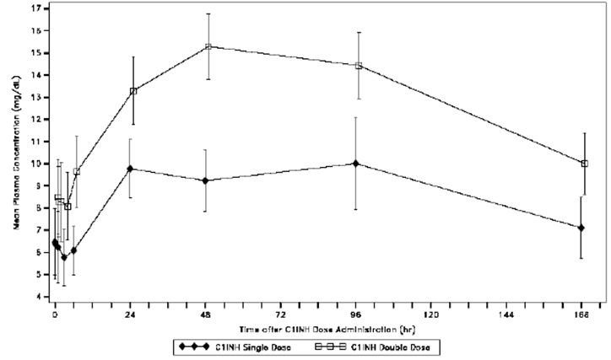

Table 6: Mean (± SD) PK parameters for Complement C4 in HAE subjects Following Administration of Cinryze (Study LEVP 2006-5).

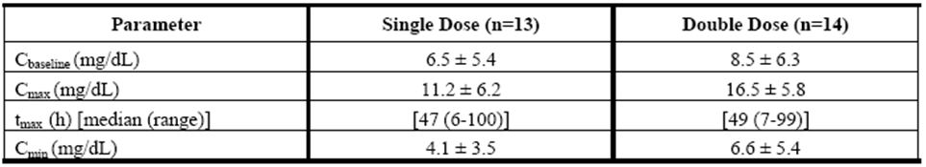

#### Relationship between plasma concentration and effect

No specific plasma concentration effect analysis was performed. However, it was noted that the difference in complement C4 Cmax values between the single dose and double dose treatment groups was similar to that observed with C1 INH antigen and functional C1 INH. The complement C4 Cmax value, a surrogate for biologic activity, increased by approximately 1.47-fold with a 2 fold increase in Cinryze dose. This increase was similar to that observed with C1 INH antigen, where baseline corrected antigenic C1 INH Cmax increased by approximately 1.53 fold for a 2 fold increase in dose. It was also similar to that observed with functional C1 INH, where baseline corrected functional C1 INH Cmax values increased ~1.37 fold for a 2 fold increase in dose.

With regards to PK, Cmax was achieved quickly at a median time of 1.2 h after a single dose administration. This is expected as the route of administration is IV. With regards to PD, the maximal biological effect, reflected as Cmax of complement C4 levels, was achieved much later at a median time of 47 h after a single dose administration. A similar pattern was observed with a double dose administration, when maximal plasma levels of C1 INH antigen and functional C1 INH protein were reached at a median time of 1.5 h and 2.2 h post infusion, respectively, while maximal biological effect was achieved at a median time of 49 h post infusion.

#### Evaluator’s overall conclusions on PD

The use of serum C4 levels as a PD biomarker is appropriate. In the complement system, the primary substrate of activated C1 enzyme is C4, that is, activated C1 enzyme leads to proteolytic cleavage of C4. A deficiency of C1 INH leads to uninhibited C1 enzyme activity, and results in diminished C4 levels. An increase in C4 levels can therefore be used as a measure of the biological effect of Cinryze. In clinical practice, serum C4 level is used as a screening test for HAE, where C4 levels would be lower than normal.

Overall, the PD results showed that treatment with Cinryze led to the intended biological effect, reflected by an increase in complement C4 levels. The maximal effect occurred ~2 days (median) after dosing, and lagged behind the maximal C1 INH antigenic and functional levels, which occurred within 2.2 h post dose. The maximal PD effect had a range of 6-100 h after a single dose and of 7-99 h after double dose. This is consistent with the long half life of Cinryze.

Although no specific plasma concentration effect analysis was performed, it was noted that the difference in complement C4 Cmax values between the single dose and double dose treatment groups was similar to that observed with C1 INH antigen and functional C1 INH. The complement C4 Cmax value, a surrogate for biologic activity, increased by ~1.47 fold with a 2 fold increase in dose. Baseline corrected antigenic C1 INH Cmax and functional C1 INH Cmax increased by ~1.53 fold and 1.37 fold, respectively, for a 2 fold increase in dose.

The PD data presented in the proposed PI is derived solely from the Phase 3 Study LEVP 2005-1/Part A. In Study LEVP 2005-1/Part A, C4 levels were measured at baseline and at 12 h post dose. No measurements beyond 12 h were done. In the Phase I Study LEVP2006-5, C4 levels were measured up to 7 days post dose, and showed a mean Tmax of about 48 h post dose (that is, Tmax occurred long after 12 h post dose). It is recommended that the sponsor include PD data from the Phase 1 study in the proposed PI.

### Efficacy

#### Introduction

Efficacy data for Cinryze is based on the data from two pivotal randomised, double blind placebo controlled Phase 3 trials (Study LEVP 2005-1/Part A and Study LEVP 2005-1/Part B). This efficacy data was supplemented by that from two open label trials (Study LEVP 2006-1 and Study LEVP 2006-4). Studies LEVP 2005-1/Part A and LEVP 2006-1 evaluated the use of Cinryze in the treatment of acute HAE attacks, while Studies LEVP 2005-1/Part B and LEVP 2006-4 evaluated the use of Cinryze in the prevention of HAE attacks. In addition, there was a separate analysis performed for efficacy of pre procedure administration of Cinryze for the prevention of HAE attacks following medical, surgical, or dental procedures. This analysis included data from Studies LEVP 2005-1/Part A and LEVP 2006-1, which permitted subjects to receive open label Cinryze for this purpose.

In this clinical evaluation report, the two pivotal Phase 3 trials (Study LEVP 2005-1/Part A and Study LEVP 2005-1/Part B) will be the main studies upon which the clinical efficacy will be evaluated. The two open label trials (Study LEVP 2006-1 and Study LEVP 2006-4) will be evaluated with regards to whether their results were consistent with the conclusions derived from the results of the pivotal Phase 3 trials.

#### Pivotal clinical studies

##### Study LEVP 2005-1/Part A

###### Methods

Objectives

The objective of the Phase 3 randomised, double blind placebo controlled, multicentre study was to evaluate the safety and efficacy of Cinryze for the treatment of acute HAE attacks. The study was conducted in 21 sites in the United States.

Inclusion and exclusion criteria

The study population consisted of subjects who were ≥ 6 years of age with documented HAE based on the criteria listed in Table 10, who had normal C1q levels, who did not have B cell malignancy and in whom anti C1 INH antibody was not present. In addition, in order to be eligible for randomisation, subjects who met the inclusion/exclusion criteria should present to the site with a qualifying HAE attack, defined as an abdominal attack with moderate or severe abdominal pain (with or without symptoms of nausea, vomiting, or diarrhea), a genitourinary attack with moderate or greater swelling of scrotum or vulva, or a facial attack with moderate or greater swelling that did not involve the airway (Table 7).

Table 7: Inclusion and exclusion criteria (Study LEVP 2005-1/Part A).

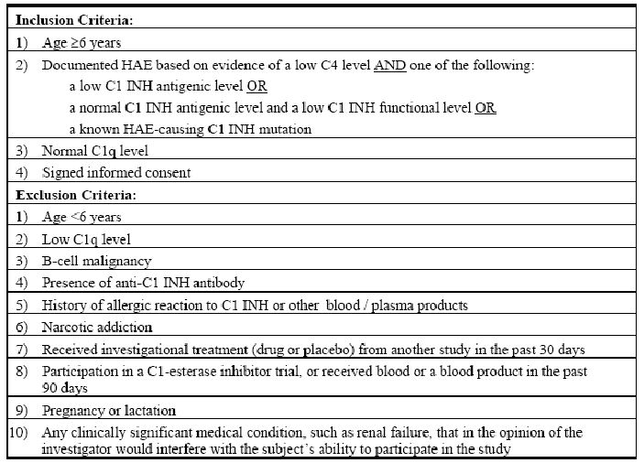

An attack that began in the extremities and progressed to the face, abdomen, or genitals did not preclude randomising the subject as long as the subject could identify a distinct time when the eligible attack began, and the timing of the symptoms was compatible with the normal course of a single HAE attack. If a subject presented with moderate or severe symptoms involving more than one eligible area, the most severe symptom was selected for evaluation. If a subject had qualifying symptoms of the same severity at different sites, the symptomatic sites were prioritised in the following descending order of priority to select the “defining symptom” for evaluation: gastrointestinal/abdominal, facial, genitourinary.

###### Comments:

*The study inclusion/exclusion criteria were appropriate. The criteria used to define the diagnosis of HAE were consistent with current clinical diagnostic criteria. There are two types of HAE: in Type I HAE (~85% of cases) where levels of C1 INH are low, while in Type II HAE (~15% of cases) there are normal levels of functionally deficient C1 INH protein. Patients with both types of HAE have low C4 levels as reduced inhibition of C1 leads to increased proteolytic cleavage of C4. In addition, patients with Type I HAE have low levels of both functional C1 INH and C1 INH antigen. Patients with Type II HAE have low levels of functional C1 INH but normal or increased levels of C1 INH antigen. The study criteria used to define the diagnosis of HAE allowed inclusion of patients with both Types I and II HAE.*

*In addition, the inclusion/exclusion criteria allowed exclusion of patients with acquired angioedema. There are two broad types of acquired angioedema. Acquired angioedema type I is associated with other diseases, most commonly B cell lymphoproliferative disorders, while acquired angioedema Type II is an autoimmune process defined by the presence of an autoantibody directed against C1 INH. Patients with acquired angioedema have low C1 INH and C4 levels, similar to patients with HAE. However, patients with acquired angioedema will also have low C1q levels, while those with HAE usually have normal C1q levels. The study exclusion criteria of excluding patients with low C1q levels, B cell malignancy or presence of anti C1 INH antibodies were therefore appropriate.*

Treatments

Subjects who met the inclusion/exclusion criteria were to come to the site within 4 h after the onset of a qualifying symptom. Subjects meeting both the inclusion/exclusion criteria and the randomisation criteria, were given double blind treatment with study drug (Cinryze 1000 U or placebo). At 60 minutes following the initial infusion, if the subject had not responded to treatment, a second infusion of the randomised study drug (1000 U Cinryze or placebo) was to be administered as soon as possible.

Subjects could receive rescue Cinryze (open label) during the same visit if they did not achieve significant symptom relief within 4 h after the initial treatment at the randomisation visit, or if they developed airway compromise following treatment with the randomised study drug. A second infusion of open label Cinryze could be given if symptoms did not begin to improve by 60 minutes after the first open label rescue Cinryze. Subjects who received randomised study drug could also be treated with rescue narcotics if they reported that their pain or discomfort was intolerable. Rescue with narcotics was considered a treatment failure. Subjects who received randomised study drug and who were rescued with narcotic treatment were not eligible for the 4 h open label Cinryze rescue described above.Enrolled subjects could also be treated with open-label Cinryze if they presented with laryngeal angioedema or if they required emergency or non cosmetic surgical procedures. As with subjects receiving randomised study drug, subjects receiving open label Cinryze for laryngeal angioedema could receive a second infusion if they did not respond to treatment within 60 minutes following the initial infusion. Subjects who were given open label Cinryze under these conditions could be randomised for a subsequent acute HAE attack. However, a minimum of 7 days from the open label treatment must have elapsed before they were eligible for randomisation.

###### Comments:

*It was stated in the study protocol that the rationale for the dosage regimen of acute treatment was based on the European label for Cetor. Cetor is manufactured by Sanquin in the Netherlands. Sanquin introduced its first C1 inhibitor in the 1970s, and the product has been further developed over the years and is currently approved and marketed in the Netherlands under the brand name of Cetor.[15] The approved indication of Cetor in the Netherlands is for acute treatment of HAE. Sanquin manufactures the same product under the brand name Cinryze on behalf of ViroPharma.[16] As both Cetor and Cinryze are the same product (C1 INH purified by nanofiltration) with different brand names, it is appropriate to base the acute treatment dosing regimen for the Phase 3 studies of Cinryze on the clinical dose of Cetor.*

###### Outcomes/endpoints

Primary efficacy endpoint

The primary efficacy measure was the time from initial randomised treatment to the beginning of unequivocal relief of the defining symptom.

After the start of infusion of the randomised treatment, subjects assessed their symptoms every 15 minutes up to 4 h post infusion or until unequivocal relief of the defining symptom was achieved. If a subject required a second infusion because of failure to respond to the initial dose within 60 minutes, evaluation of symptoms continued every 15 minutes up to 4 h after the first infusion.

Subjects rated symptom relief individually at each potential swelling site (gastrointestinal, genitourinary, facial, extremities, and respiratory) using the following five point scale:

* Absent now and before
* Absent now but present before
* Present, symptoms new
* Present, symptoms worse or the same
* Present, symptoms better

Unequivocal relief of the “defining” symptom was defined as at least three consecutive reports that the symptom was “absent now but present before” or “present, symptoms better.” The beginning of unequivocal relief of the defining symptom was defined as the first of the three consecutive reports.

Secondary efficacy endpoint

Secondary efficacy measures includedthe percentage of subjects who had unequivocal relief beginning within 4 h followingrandomised treatment**,** the time to complete resolution of the attack, and the effects of treatment on C1 INH and C4 levels.The effects of treatment were also rated by a VAS.

Time to complete resolution was defined as the time period between the first infusion and the complete resolution of symptoms as reported by the subject. Study personnel contacted subjects by telephone 72 to 96 h (that is, ~3 days) after discharge from the study site to assess the date and time at which complete resolution of the HAE attack occurred.

For the effects of treatment on C1 INH and C4 levels, blood samples were obtained prior to infusion and at 1, 4, and 12 to 24 h following the initial infusion. If a second treatment was considered necessary, samples were also to be taken 1 h after the second infusion, and the 4 and 12-24 h samples remained on the original schedule.

For the effects of treatment to be rated by a VAS, data regarding the amount of pain associated with the HAE attack were collected from subjects using a VAS, which was represented by a line 100 mm in length, with the extremes labelled as ‘No Pain/Swelling’ (0 mm) and ‘Most Severe Pain/Swelling’ (100 mm). Subjects drew a vertical line on the VAS to indicate the level of pain they were experiencing at each assessment time point. For each anatomical location of a HAE attack, pain severity was to be assessed prior to the initial blinded dose of study drug and every 15 minutes up to 4 h post infusion or until unequivocal relief of the defining symptom was achieved.

###### Comments:

*The primary and secondary endpoints are appropriate. The primary endpoint looked at efficacy in terms of the start of symptomatic relief of the defining attack post treatment with Cinryze or placebo. The secondary further characterised the efficacy, as well as further characterising the PK and PD parameters.*

###### Sample size

The sample size was calculated to provide more than 80% power to detect a reduction by 50% in the median time to relief of the defining symptom between the treatment and placebo groups. The assumptions used in the calculation of sample size for this study is based on a study by Kunschak and colleagues.[17]Based on an estimate of 0.83 hours for the median time to the start of unequivocal relief of defining symptoms for subjects treated with Cinryze, it was calculated that 34 subjects per treatment group were required to give a total of 65 observed events, and to provide 80% power, at 5% level of significance (2-sided test), to detect a 50% reduction in median time to unequivocal beginning of relief of the defining symptom.

###### Randomisation

Subjects who met the inclusion/exclusion and randomisation criteria were assigned randomised double blind study drug (Cinryze or placebo) in a 1:1 ratio. The randomisation order for Study LEVP 2005-1/Part A was generated at the beginning of the study for each site. The site randomisation order and codes were provided to each study site pharmacist. Subjects were assigned randomised study drug according to this pre determined order upon presentation of an eligible symptom.

###### Blinding (masking)

In Study LEVP 2005-1/Part A, treatment assignment was blinded to both investigators and subjects. However, a pre determined individual at each site (the study pharmacist) was not blinded, and was responsible for receiving all the study medication, determining the randomised treatment, preparing the randomised doses, and maintaining a log of all therapies.

###### Statistical methods

Changes to Statistical Analysis Plan (SAP)

As elaborated in this evaluation report, in response to the FDA comments to the study results in the initial application to the FDA, the sponsor enlisted an expert panel to provide additional expert opinion on the statistical analysis of the data of this study. The Clinical Study Report submitted for this application is the Final Study Report which incorporated the recommendations of the expert panel. The sponsor stated that the study data had not been changed or altered in any way – only the method of statistical analysis. The main changes were:

* the method for handling tied events in the primary efficacy analysis (from the Breslow method to the EXACT method);
* the addition of a sensitivity analysis on the primary efficacy outcome (requested by the FDA); and
* the addition of the analysis population of All Randomised (ITT Dataset in addition to the Efficacy Dataset[18] for the primary efficacy analysis and the analysis of the secondary endpoint of time to complete resolution of attack.

The addition of the analysis population of All Randomised (ITT) Dataset was requested by the FDA. In the Expert Panel Report, the expert panel stated that the Efficacy Dataset as defined in the SAP was consistent with the principle of “full analysis set” as defined in the relevant ICH E9 document,[19] but that the analyses that were originally submitted to the FDA were incorrectly labelled as being “ITT” analyses and the full analysis set principle was not explained or justified. The expert panel stated that in the Final Study Report, the primary efficacy analysis would be presented for both the All Randomised (ITT) Dataset and the Efficacy Dataset, but with the latter defining the primary analysis because it was specified in the SAP, and because the expert panel was of the view that it represented a meaningful and unbiased analysis of patients with true HAE attacks.[20]

The statistical methods described below will be that employed in the Final Study Report. The relevance and appropriateness of these methods and changes from the original SAP will be discussed below.

###### Analysis population

The analysis of efficacy was based on the population of all randomised subjects (that is, ITT population) (labelled as the “All Randomised (ITT) Dataset” in the Clinical Study Report) as well as the subset of subjects who had “true” HAE attacks (labelled as the “Efficacy Dataset” in the clinical study report). The primary efficacy analysis and the analysis of the secondary endpoint of time to complete resolution of attack were done on both the All Randomised (ITT) Dataset and the Efficacy Dataset. The other secondary endpoint analyses were done only on the Efficacy Dataset.

“True” HAE attacks were determined via measurements of complement C4 levels. During attacks of angioedema in HAE subjects, levels of C1 INH would decrease, the complement and contact systems would be activated, and C4 levels would be expected to fall. In this study, subjects needed to display a lower C4 level during an attack than at baseline (screening) as a method to provide assurance that the attack was a true HAE attack and not due to some other causes. This determination was made subsequent to treatment and before unblinding by comparing the results obtained at baseline to those obtained prior to infusion at the time of the treated attack. If the C4 level at pre infusion was lower than the C4 level at screening, the subject was considered to have a “true” HAE attack. Subjects with “true” HAE attacks were considered evaluable and included in the Efficacy Dataset.

The sponsor stated that due to changes in the laboratories utilised and the methods used to assess complement C4 levels during the course of the study, there were variations in the laboratory defined normal ranges. In addition, the sponsor felt that small differences in C4 levels between screening and pre infusion might have resulted from normal instrument or method variation and were not reliable indicators of a “true” HAE attack. The sponsor therefore decided to obtain an independent assessment to determine the potential for evaluation of a subject’s HAE attack when a clear reduction in complement C4 levels at pre infusion compared to baseline could not be determined. Subjects who did not have a clear reduction in C4 levels from screening to pre infusion were identified prior to database lock and prior to unblinding. An independent assessor,[21] who was considered an expert in the treatment of patients with HAE and who had no association with the trials, reviewed all available data for these subjects to determine if they had true HAE attacks based on the clinical picture, the C1 INH and complement C4 levels, and other pre infusion clinical information. The decision of the independent assessor was considered final.

###### Primary efficacy endpoint analysis

The primary efficacy variable was the time from the start of the firstinfusion of randomised study drug to beginning of unequivocal relief of the definingsymptom. Unequivocal relief of the defining symptom wasdefined as at least three consecutive reports that symptoms were “absent now but present before”or “present, symptoms better”. The beginning of unequivocalrelief was the time after infusion at which the first of these three reports occurred.

Subjects who did not achieve unequivocal relief of the defining symptom were included inthe analysis as censored observations. Subjects who had not achieved beginning ofunequivocal relief within 4 h of the first infusion were censored at 4 h. Subjectswho received rescue medication (either narcotics or Cinryze) within the 4 h observationwindow were censored at the time of rescue drug administration. Subjects who discontinuedthe study prior to 4 h post infusion and did not experience unequivocal relief ofsymptoms were censored at the time of withdrawal if they were withdrawn for a reasonunrelated to treatment failure. If the subject withdrew due to disease progression,investigator decision, withdrawn consent, death, or an adverse event (AE) related to the HAEattack, the subject was considered a treatment failure and would be censored at 4 h.

The primary endpoint was compared between treatment groups using the PHR model. The summary statistic provided by PHR is the hazard ratio, which is based on events that are detrimental to patient wellbeing. However, in this study, the studied event was beneficial, and was labelled in the clinical study report as “success ratio”. This is the ratio of the rate of start of unequivocal relief in the Cinryze treatment group divided by that in the placebo treatment group.

###### Secondary efficacy endpoints analyses

* ***Percentage of subjects who had unequivocal relief beginning within 4 h following randomised treatment***

In this analysis, treatment failures (including subjects who received rescue treatment with open label Cinryze and subjects with inadequate data) were counted as “failures” (that is, absence of relief within 4 h).

* ***Time to complete resolution of the attack***

The time to complete resolution of the defining symptom was analysed using the same model as the primary endpoint. The date and time of complete resolution of the HAE attack were recorded at the 3 day telephone follow up. The time from first infusion of study drug to complete resolution of symptoms was compared between the Cinryze and placebo groups using the same PHR model described for the primary analysis. Subjects who had not experienced complete resolution of symptoms at the time of the follow up telephone call, or who were lost to follow up, were censored at the 72 h time point.

* ***C1 INH antigenic levels, C1 INH functional levels, and complement C4 levels***

Changes from baseline (pre infusion) in C1 INH antigenic levels, C1 INH functional levels, and complement C4 levels were analysed by the Wilcoxon rank sum test.

* ***Symptom ratings using VAS***

Although pain scores were recorded for all anatomic locations, only those associated with the defining symptom of an attack were used in this analysis. For the defining symptom, each post treatment VAS score was subtracted from the baseline value to obtain a time specific PID score. A positive PID value indicates a clinical improvement (that is, reduction in pain intensity). As the VAS scores were assessed prior to the initial blinded dose of study drug and every 15 minutes up to 4 h post infusion or until unequivocal relief of the defining symptom was achieved, each subject would have a maximum of 17 VAS scores which could yield 16 PID scores, and these were summed over the entire 4 h post treatment period to obtain the SPID, which was defined by the sponsor as:

Symptom rating formula using VAS example

The SPID was compared between the two randomised treatment groups in the Efficacy Dataset, using an ANOVA that included the effects of treatment group and study centre.

##### Results

###### Participant Flow

A total of 324 subjects were screened in the study (Figure 6). Out of these, 71 subjects presented to the site with qualifying “randomisable” attacks. These subjects were assigned to treatment with randomised study drug (Cinryze, 36 subjects; placebo, 35 subjects). Of the 71 subjects who received randomised study drug, 70 completed the study through the 3 month follow up visit. One subject in the placebo treatment group discontinued for a reason recorded as “other”. This subject moved away from the study site before the 3 month follow up was completed.

Figure 6: Participant flow.

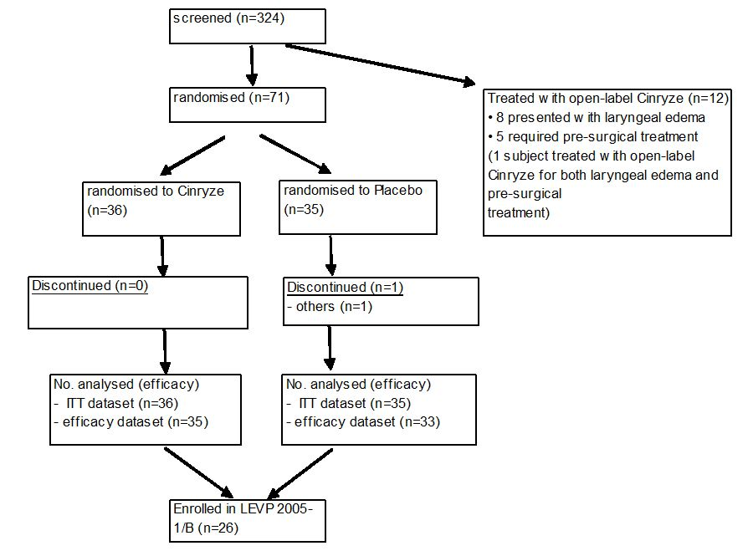

In addition to the 71 subjects who received randomised study drug, there were 12 subjects treated with open label Cinryze for “non randomisable” attacks and who received no randomised study drug. These subjects were not included in the evaluation of efficacy.

###### Baseline data

Demographic characteristics were similar between the 2 treatment groups in both the All Randomised (ITT) Dataset and Efficacy Dataset. In the All Randomised (ITT) Dataset, subjects have a mean (range) age of 36.8 (6 to 75) years in the Cinryze treatment group and a mean (range) age of 37.0 (9 to 64) years in the placebo treatment group. The majority of subjects in both treatment groups were female (27 subjects [75.0%] and 28 subjects [80.0%] in the Cinryze and placebo treatment groups, respectively) and Caucasian (34 subjects [94.4%] and 32 subjects [91.4%] in the Cinryze and placebo treatment groups, respectively). Overall, the mean number ofyears since the diagnosis of HAE was ~19 years and was similar in subjectsrandomised to treatment with Cinryze (18.41 years) and subjects randomised to placebo(20.50 years). The majority of subjects in both treatment groups had been diagnosed for≥15 years (21 subjects [58.3%] and 22 subjects [62.9%] in the Cinryze and placebo treatment groups, respectively). Historically, majority of the subjects in both treatment groups had reported severe abdominal symptoms (80.6% and 80.0% in the Cinryze and placebo treatment groups, respectively). The most common defining symptom in both treatment groups was abdominal attacks (68.6% and 78.8% in the Cinryze and placebo treatment groups, respectively). The mean and median values for baseline VAS Pain Intensity were similar in the Cinryze andplacebo treatment groups (mean baseline values of 60.7 and 65.6, and median baseline values of 61.0 and 66.0, in the Cinryze and placebo treatment groups, respectively).At baseline, the defining symptoms were categorised as moderate in 30 subjects (85.7%) in the Cinryzetreatment group and 22 subjects (66.7%) in the placebo treatment group, and as severe in 5 subjects (14.3%) in the Cinryze treatment groupand 10 subjects (30.3%) in the placebo treatment group.

###### Comments:

*Overall, baseline characteristics were similar between the two treatment groups. In this study, the majority of subjects in both treatment groups were female. While this is not representative of the general patient population, it is not likely to affect the ability of the study results to be extrapolated to the general patient population. Cinryze is a purified plasma protein to be administered intravenously and hence is not subjected to metabolic processes that may be affected by gender. In addition, the pathophysiology of the target disease state of HAE does not have a gender basis. The sponsor had noted in the submission that the predominance of female subjects in Cinryze clinical studies was not unexpected as the studies were conducted in the US at a time when no other C1 INH product was approved by the US FDA, and danazol was commonly used for managing HAE. Due to the potential side effects of danazol as an attenuated androgen, it had been expected that women with HAE would be more likely to seek alternative therapies and participate in the studies.*

###### Numbers analysed

The number of subjects in the All Randomised (ITT) Dataset and the Efficacy Dataset is summarised in Table 8below**.**

Table 8: Number of subjects in the All Randomised (ITT) Dataset and the Efficacy Dataset (Study LEVP 2005-1-Part A).

***Table 8: Number of subjects in the All Randomised (ITT) Dataset and the Efficacy Dataset (Study LEVP 2005-1-Part A).***

In order to select subjects for the Efficacy Dataset, complement C4 levels were to be used to determine if a subject was having a true HAE attack suitable for efficacy evaluation. Of the 71 subjects randomised, 48 had a clear decrease in C4 levels between baseline (screening) and the pre infusion value and were included in the Efficacy Dataset. The remaining 23 subjects had pre infusion C4 values that were not clearly lower than the baseline screening value. As a result, the nature of the attack and the suitability of these subjects for inclusion in the evaluation of efficacy were determined by a judiciary expert in the treatment of HAE. Of these 23 subjects, the expert reviewer determined that 18 subjects had a “high” likelihood of having had a true HAE attack and were included in the Efficacy Dataset. There were 5 subjects who had a “questionable” likelihood of a true HAE attack. Upon performing a clinical review of all available data for these subjects, the expert reviewer included 2 subjects in the Efficacy Dataset and the remaining 3 subjects were excluded.

Of the 71 randomised subjects, one subject was randomised to the placebo treatment group, but received Cinryze in error at the 60 minute infusion. Consistent with the principle of ITT population analysis, this subject was included in the placebo treatment group in both the All Randomised (ITT) Dataset and Efficacy Dataset.

###### Outcomes and estimation

Primary efficacy analysis

The primary efficacy variable was the time from initial treatment to the start ofunequivocal relief of the defining symptom. The Kaplan-Meier estimated cumulative proportions of subjects with unequivocal relief of the defining symptom at each timepoint up to 4 h post dose is plotted as a graph in Figures 7 and 8 for the All Randomised (ITT) Dataset and the Efficacy Dataset, respectively. In both the ITT and Efficacy Datasets, ~33% of subjects in the Cinryze treatment group had beginning of relief of symptom by 1 h, and 50% of the subjects had beginning of relief of symptom by 2 h. Approximately 60% of subjects had beginning of relief of symptom at 3 h and 4 h post dose. In the placebo treatment groups, the percentage of subjects with relief was lower at each time point.

Figure 7: Time to Start of Unequivocal Relief of Defining Symptom – All Randomised (ITT) Dataset (Study LEVP 2005-1-Part A).

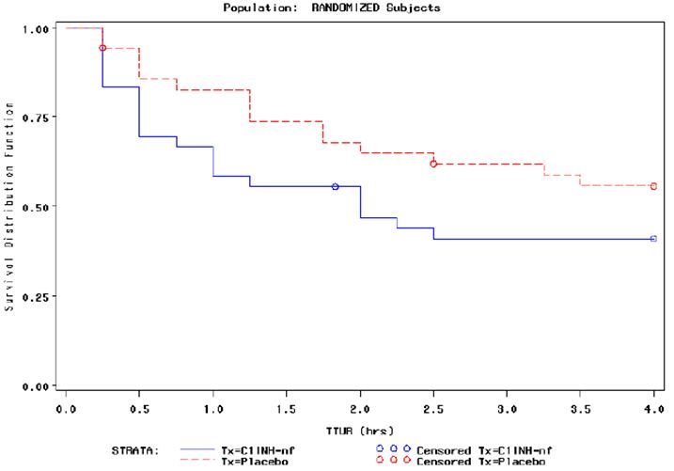

Figure 8: Time to Start of Unequivocal Relief of Defining Symptom – Efficacy Dataset (Study LEVP 2005-1-Part A).

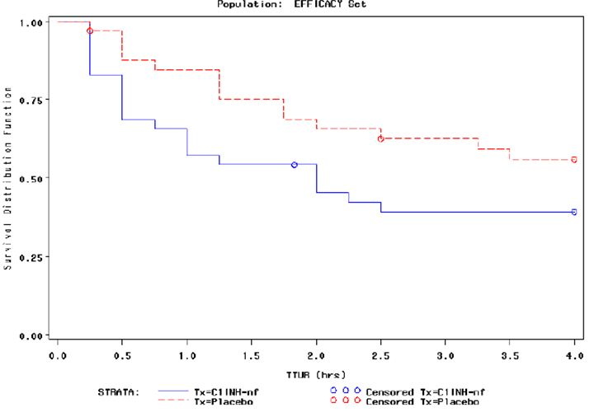

Results of the primary analysis are summarised in Table 9. In the All Randomised (ITT) Dataset, the median time to the start of unequivocal relief of symptoms was 2 h in the Cinryze treatment group and > 4 h in the placebo group. In the All Randomised (ITT) Dataset, 58.3% (21/36) of subjects in the Cinryze group and 42.8% (15/35) of subjects in the placebo group had unequivocal relief of the defining symptom beginning within 4 h post dose. The success ratio (95% CI), obtained from the PHR model, was 2.048 (1.008, 4.164) and was statistically significant (p = 0.048) This indicated that among subjects yet to achieve unequivocal relief of symptoms, a subject who received Cinryze was 2.048 times as likely to achieve unequivocal relief of symptoms as a subject who received placebo.

Table 9: Time to Start of Unequivocal Relief of Defining Symptoms: All Randomised (ITT) and Efficacy Datasets (Study LEVP 2005-1-Part A).

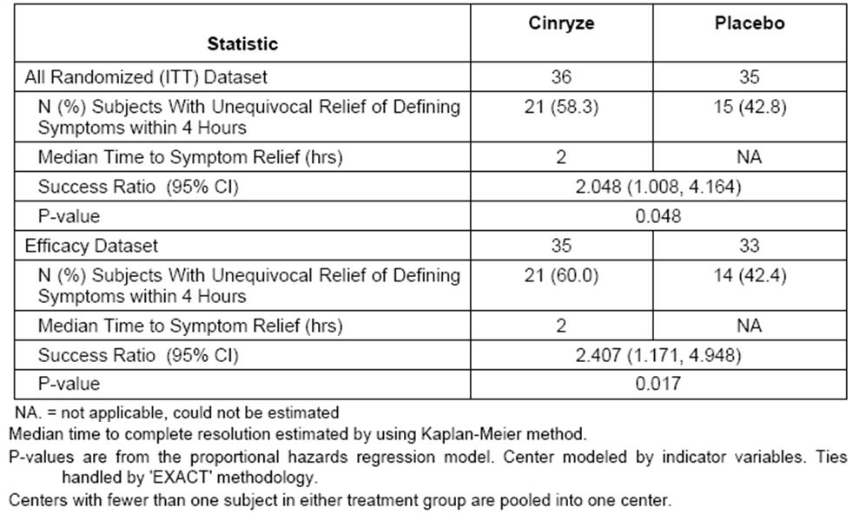

In the Efficacy Dataset, the median time to the start of unequivocal relief of symptoms was also 2 h in the Cinryze treatment group and > 4 h in the placebo group. In the Efficacy Dataset, 60.0% (21/35) of subjects in the Cinryze group and 42.4% (14/33) of subjects in the placebo group had start of unequivocal relief of the defining symptom within 4 h. The success ratio (95% CI), obtained from the PHR model, was 2.407 (1.171, 4.948) and was also statistically significant (p = 0.017). This indicated that among subjects yet to achieve unequivocal relief of symptoms, a subject who received Cinryze was 2.407 times as likely to achieve unequivocal relief of symptoms as a subject who received placebo.

###### Additional sensitivity analyses

Additional sensitivity analyses were done for the primary efficacy endpoint. In the sensitivity analysis, results were generated for a series of analyses that changed the outcome of each responder, defined as subjects who had start of unequivocal relief of defining symptoms within 4 h. The response of each responder was changed in turn, to as if that subject had not responded, that is, had not achieved onset of unequivocal relief of symptom within 4 h post dose. The outcomes of these analyses were displayed in two frequency plots, one showing Z scores for each analysis and the other showing estimated benefit rate ratios (hazard ratios) for each analysis. Graphs for analyses with the All Randomised (ITT) dataset are presented in Figures 9 and 10, and graphs for analyses with the Efficacy Dataset are presented in Figures 11 and 12.

Figure 9: Z scores for ITT Analysis Set (All Randomised [ITT] Dataset) (Study LEVP 2005-1-Part A).

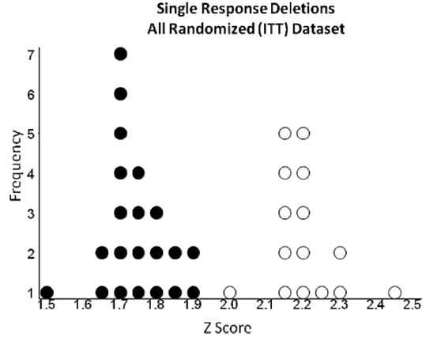

Each dot or circle represents one analysis. Dots represent analyses where the index subject is in the Cinryze arm; circles represent analyses where the index subject is in the placebo arm.

Figure 10: Estimated benefit rate ratios (hazard ratios) for All Randomised (ITT) Analysis Set (Study LEVP 2005-1-Part A).

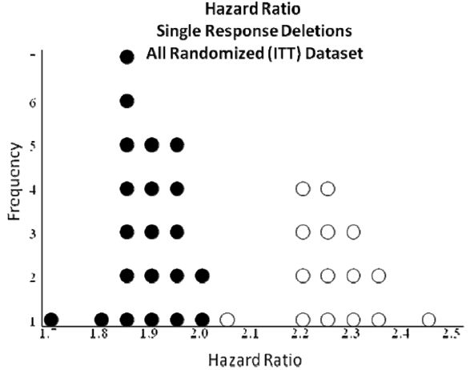

Each dot or circle represents one analysis. Dots represent analyses where the index subject is in the Cinryze arm; circles represent analyses where the index subject is in the placebo arm.

Figure 11: Z scores for ITT Analysis Set (All Randomised [ITT] Dataset) (Study LEVP 2005-1-Part A).

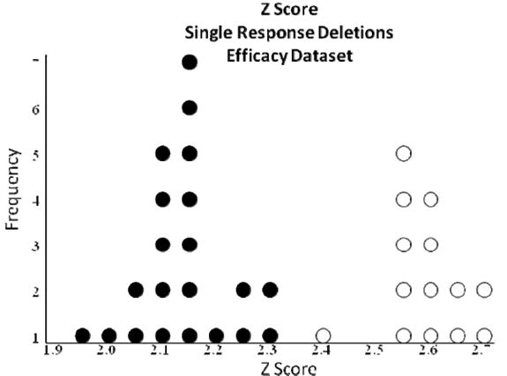

Each dot or circle represents one analysis. Dots represent analyses where the index subject is in the Cinryze arm; circles represent analyses where the index subject is in the placebo arm.

Figure 12: Z scores for ITT Analysis Set (All Randomised [ITT] Dataset) (Study LEVP 2005-1-Part A).

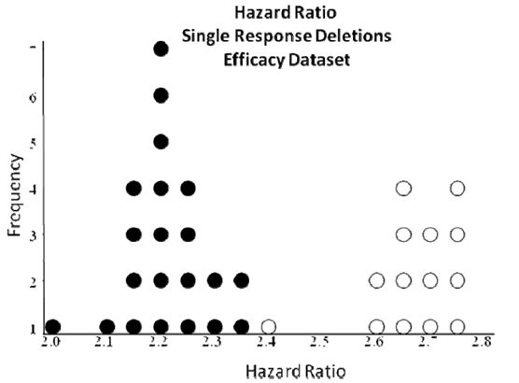

Each dot or circle represents one analysis. Dots represent analyses where the index subject is in the Cinryze arm; circles represent analyses where the index subject is in the placebo arm.

For analyses generated from the All Randomised (ITT) Dataset, the estimated hazard (success) ratios were indicative of a positive Cinryze effect for all single response deletions from the Cinryze arm (~1.7-2.0), although it was less than the calculated success ratio of 2.048 in the primary analysis. For analyses generated from the Efficacy Dataset, the estimated hazard ratios were also indicative of a positive Cinryze effect for all single response deletions from the Cinryze arm (~2.0-2.4) although it was also less than the calculated success ratio of 2.407 in the primary analysis. This indicated that if the response of each responder in the Cinryze arm was changed in turn to as if that subject had not responded, the analyses in both datasets still showed a positive Cinryze effect, although the effect was less than the observed success ratios.

The Z value corresponding to two sided p = 0.05 (that is, Z value corresponding to the criterion for significance) was 1.96. For analyses generated from the All Randomised (ITT) Dataset, the Z values for all single response deletions from the Cinryze arm were below 1.96, whereas all single response deletions from the placebo arm were above 1.96. The results indicated less robustness for analyses of the All Randomised (ITT) Dataset as it showed that while the primary analysis on this dataset showed a statistically significant Cinryze effect, any deletion from the Cinryze arm would result in a change to a non statistically significant outcome. In the Efficacy Dataset, all single response deletion analyses except one had a Z value greater than 1.96. This result indicated robustness of the Efficacy Set analyses as it showed that while the primary analysis on this dataset showed a statistically significant Cinryze effect, any deletion from the Cinryze arm would still result in a statistically significant outcome.

###### Secondary efficacy analyses

* ***Percentage of subjects who had unequivocal relief beginning within 4 h following randomised treatment***

In the Efficacy Dataset, 21 (60.0%) subjects had the beginning of unequivocal relief within 4 h in the Cinryze treatment group compared with 14 (42.4%) subjects in the placebo treatment group. In the primary efficacy analysis, these data were analysed by the PHR model to give the hazard or success ratio. In the secondary analysis, a simple proportion ratio, which did not account for the chronology of events and censoring, was calculated and gave a proportion ratio (95% CI) of 1.41 (0.87, 2.29). The difference between treatment groups was not statistically significant (p = 0.062).

* ***Time to complete resolution of the attack***

In the All Randomised (ITT) Dataset, the median time to complete resolution was 12.3 h in the Cinryze treatment group and 31.6 h in the placebo treatment group. The success ratio (95% CI) was 2.717 (1.471, 5.020) and was statistically significant (p = 0.001). This indicated that among subjects yet to achieve complete attack resolution, a subject who received Cinryze was 2.717 times as likely to achieve complete attack resolution in 3 days as a subject who received placebo.

The results were similar in the Efficacy Dataset, with a median time to complete resolution of 12.3 hours in the Cinryze treatment group and 25.0 h in the placebo treatment group. The success ratio (95% CI) was 2.460 (1.331-4.546) and was statistically significant (p = 0.004). This indicated that among subjects yet to achieve complete attack resolution, a subject who received Cinryze was 2.460 times as likely to achieve complete attack resolution in 3 days as a subject who received placebo.

* ***C1 INH antigenic levels, C1 INH functional levels, and complement C4 levels***

The C1 INH antigenic and functional levels and C4 antigenic levels in the Efficacy Dataset at pre infusion, 1, 4, and 12 h post infusion, for the Cinryze and placebo treatment groups are summarised in Table 10.

Table 10: C1 INH antigenic and functional levels and C4 antigenic levels, Efficacy Dataset (Study LEVP 2005-1-Part A).

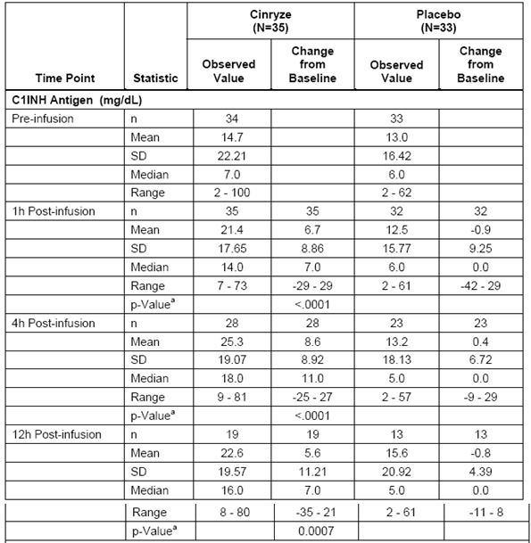

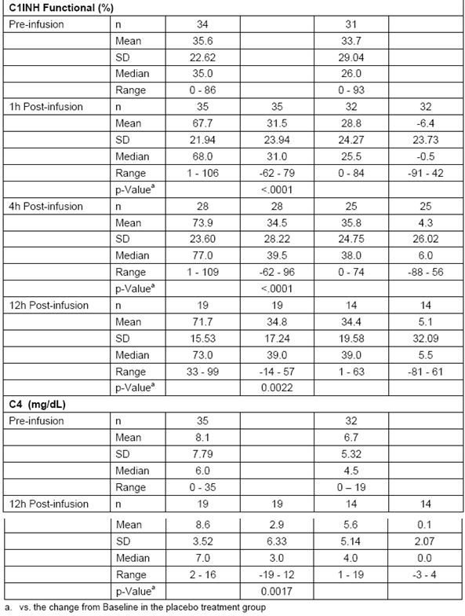

Pre infusion, the mean values of C1 INH antigenic activity were similar between the Cinryze and the placebo treatment groups (14.7 mg/dL and 13.0 mg/dL, respectively). At the 1, 4, and 12 h post infusion timepoints, the mean change from baseline in C1 INH antigen levels showed statistically significant greater increase (p < 0.001) in the Cinryze treatment group (+6.7 mg/dL, +8.6 mg/dL and +5.6 mg/dL at 1, 4 and 12 h, respectively) compared with placebo (-0.9 mg/dL, +0.4 mg/dL and -0.8 mg/dL, respectively).

Pre infusion, the mean values of C1 INH functional activity were similar between the Cinryze and the placebo treatment groups (35.6% and 33.7%, respectively). The mean change from baseline in C1INH functional activity showed a statistically significant (p = 0.0022) greater increase in the Cinryze treatment group (+31.5 %, +34.5 % and +34.8 % at the 1, 4, and 12 h post infusion timepoints, respectively) compared with placebo (-6.4 %, +4.3 % and +5.1 %, respectively).

Pre infusion, the mean values of C4 antigenic activity were below normal and similar between the Cinryze treatment group (8.1 mg/dL) and the placebo treatment group (6.7 mg/dL). At the 12 h post infusion timepoint, the mean change from baseline in C4 antigenic activity in the Cinryze treatment group was +2.9mg/dL compared to +0.1mg/dL in the placebo treatment group (p = 0.0017).

* ***Symptom ratings using VAS***

The mean SPID was 54.9 in the Cinryze treatment group and -15.5 in the placebo treatment group, giving a difference of 70.5. This difference was not statistically significant (p = 0.085).

###### Comments:

*The primary efficacy analysis with the All Randomised (ITT) Dataset showed that among subjects yet to achieve unequivocal relief of symptoms, a subject who received Cinryze was 2.048 times (success ratio) as likely to achieve unequivocal relief of symptoms as a subject who received placebo. However, although this was found to be statistically significant, the level of significance (p = 0.048), was at the threshold of the criterion for statistical significance (p < 0.05). Analysis with the Efficacy Dataset showed a similar success ratio of 2.407, but with a level of statistical significance that was more convincing (p = 0.017).*

*The Efficacy Dataset was a subset of the All Randomised (ITT) Dataset, and involved the exclusion from analysis of 3 subjects (1 from the Cinryze treatment group and 2 from the placebo group) who were judged not to be having a “true” HAE attack, based on complement C4 levels and clinical picture. Among the 3 subjects excluded from analysis, 1 subject from the placebo group was a responder (that is, with onset of relief of symptoms within 4 h post dose), while the remaining 2 were non responders. The evaluator agrees with the sponsor that although the Efficacy Dataset was a subset of the All Randomised (ITT) Dataset, and was labelled as an “efficacy dataset”, a term that is more commonly applied to per protocol populations, it fulfilled the criteria for a “full analysis set” (that is, an ITT population analysis) as set out in the ICH E9 document on Statistical Principles for Clinical Trials.[22] The ICH E9 document states that analysis should include all randomised subjects as far as possible, in order to reduce bias in the statistical analysis. However, it also states that*

*“There are a limited number of circumstances that might lead to excluding randomised subjects from the full analysis set including the failure to satisfy major entry criteria (eligibility violations), the failure to take at least one dose of trial medication and the lack of any data post randomisation. Such exclusions should always be justified. Subjects who fail to satisfy an entry criterion may be excluded from the analysis without the possibility of introducing bias only under the following circumstances:*

1. *the entry criterion was measured prior to randomisation;*
2. *the detection of the relevant eligibility violations can be made completely objectively;*
3. *all subjects receive equal scrutiny for eligibility violations; (This may be difficult to ensure in an open label study, or even in a double blind study if the data are unblinded prior to this scrutiny, emphasising the importance of the blind review.)*
4. *all detected violations of the particular entry criterion are excluded.”*

*In this study, although the exclusion of subjects who were judged not to have a “true” HAE attack was carried out after randomisation, this was most likely due to the infeasibility of having this exclusion carried out prior to randomisation as measurements of complement C4 levels at the laboratory would require a certain amount of turnaround time. In addition, this exclusion criterion was made objectively via laboratory measurements of complement C4 levels, was blinded, and was applied to all randomised subjects.*

*The sensitivity analyses showed that the Efficacy Dataset analysis was robust. The sensitivity analyses showed that in the Efficacy Dataset, if the response of each responder in the Cinryze group was changed in turn to as if that subject had not responded, the analyses would still show a positive Cinryze effect that was statistically significant (that is, gave a Z value greater than 1.96, the Z value that corresponded to the criterion for significance [p = 0.05])*

*Overall, in the Efficacy Dataset, 60.0% of subjects in the Cinryze treatment group had the beginning of unequivocal relief within 4 h compared with 42.4% of subjects in the placebo treatment group. Based on this, the primary efficacy analysis utilised an analysis that accounted for chronology of events and censoring, yielding results as described above showing that the difference between the treatment groups was statistically significant in favour of Cinryze. The secondary efficacy endpoint of the percentage of subjects who had unequivocal relief beginning within 4 h following randomised treatment utilised a simple proportion ratio analysis that did not account for chronology of events and censoring. This yielded results showing that the difference between the treatment groups was not statistically significant (p = 0.062).*

*The assessment of “unequivocal relief of symptoms” in the primary efficacy analysis included both improvement in as well as absence of symptoms, looked at the time of onset of the relief of symptoms, and was assessed for up to 4 h post dose. The secondary efficacy assessment of time to complete resolution looked at time of completed resolution of attack, and was assessed for up to 3 days post dose. It showed that the median time to complete resolution was 12.3 h in the Cinryze treatment group and from 25.0 to 31.6 h in the placebo treatment group. This secondary efficacy analysis showed that among subjects yet to achieve complete attack resolution, a subject who received Cinryze was 2.5 to 2.7 times as likely to achieve complete attack resolution as a subject who received placebo (p = 0.001 to 0.004).*

*In the PK/PD study submitted for Cinryze, Study LEVP 2006-5 results showed that although the maximal C1 INH antigenic and functional levels occurred at a median of 1.2 hours after a single dose, and 1.5 to 2.2 h after a double dose of Cinryze given 1 h apart, the maximal biological effect (as measured by an increase in complement C4 levels) occurred at a median time of ~2 days after dosing (47 h and 49 h after a single and double dose, respectively). The maximal biological effect had a wide range of 6 h to 100 h after a single dose and 7 h to 99 h after a double dose of Cinryze, consistent with the long half life of Cinryze. Although clinical effect is not always directly correlated with measured biological effect, the PK/PD study results suggested that the clinical effect of Cinryze may not be maximally manifested within 4 h post dose. The results of the primary and secondary efficacy analyses of Study LEVP 2005-1/Part A appeared to support this. Primary efficacy analysis showed that the median time to the start of unequivocal relief of symptoms was 2 h post Cinryze dose. However, the median time to complete resolution of the HAE attack was longer, at 12.3 h post dose (secondary efficacy analysis).*

*Primary efficacy analysis showed that among subjects yet to achieve unequivocal relief of symptoms, a subject who received Cinryze was 2.407 times as likely to achieve the beginning of unequivocal relief of symptoms as a subject who received placebo. The secondary efficacy analysis looking at complete resolution of symptoms within 3 days post-dose yielded a similar ratio: among subjects yet to achieve complete attack resolution, a subject who received Cinryze was 2.46 times as likely to achieve complete attack resolution as a subject who received placebo.*

#### Study LEVP 2005-1/Part B

##### Methods

###### Objectives

The objective of this study was to investigate the efficacy and safety of Cinryze as prophylactic treatment to prevent acute attacks of angioedema in subjects with HAE.

###### Study parameters

Study LEVP 2005-1/Part B was a Phase 3, randomised, double blind, placebo controlled, multicentre, crossover study.

###### Sites

The study was conducted in 15 sites in the United States.

###### Inclusion and exclusion criteria

The study population consisted of subjects who were ≥ 6 years of age with documented HAE based on the criteria listed in Table 10, who had normal C1q levels, who did not have B cell malignancy and in whom anti C1 INH antibody was not present. To be included in the study, they also needed to have a history of relatively frequent angioedema attacks (defined as at least 2 per month on average) either while on their current therapeutic regimen for HAE or while not on any regimen. They needed to have either participated in LEVP 2005-1/Part A, or met the inclusion/exclusion criteria of Study LEVP 2005-1/Part A presented above.

###### Comments:

*The inclusion/exclusion criteria used to define the diagnosis of HAE were consistent with current clinical diagnostic criteria, allowed inclusion of patients with both Type I and Type II HAE, and allowed exclusion of patients with acquired angioedema. In addition, only subjects with relatively**frequent angioedema attacks (defined as at least 2 per month on average) were included.*

###### Treatments

Subjects were randomised in a 1:1 allocation ratio to one of two prophylactic therapeutic sequences: 12 weeks of Cinryze followed by 12 weeks of placebo, or 12 weeks of placebo followed by 12 weeks of Cinryze. During the two 12 week treatment periods, subjects received one IV infusion (placebo or Cinryze, 1000 U) twice a week.

In addition, subjects were eligible to receive treatment with open label Cinryze during the study if they presented to the site with signs of laryngeal angioedema, required prophylaxis prior to an emergency or non cosmetic surgical procedure, or if open label treatment was required in the opinion of the investigator. For treatment of acute attacks, Cinryze 1000 U IV was to be administered, with a second 1000 U dose administered 60 minutes later if needed. For pre procedure prophylaxis, administration of Cinryze 1000 U IV (single dose) was to be given within 24 h of the procedure. While on open label treatment, treatment with randomised study medications were to proceed as planned. In the event that the next prophylactic infusion was scheduled to occur within 24 h of the open label treatment, the next prophylactic infusion was to be rescheduled to occur at least 24 h after the last open label infusion.

The sponsor has stated that the rationale for the prophylactic dose of 1000 U twice weekly was based on the clinical effectiveness of this dose level of another C1 INH product, Cetor, and the PK of Cetor, which has an elimination half life of ~48 h. The PK study for Cinryze, Study LEVP 2006-5, showed a slightly longer elimination half-life of 56 to 62 h, and the sponsor felt this supported the rationale for a Cinryze prophylactic dosing regimen of every 3 to 4 days, or approximately twice weekly.

###### Comments:

*As both Cetor and Cinryze are the same product (C1 INH purified by nanofiltration) with different brand names, it would have been appropriate to base the dosing regimen for the Phase 3 studies of Cinryze on the clinical dose of Cetor. However, the approved indication of Cetor in the Netherlands is only for acute treatment of HAE.[23] In this submission, no clinical study was referred to with regards to the therapeutic dose of Cetor for prophylaxis of HAE. However, based on the elimination half life of Cinryze, the dosing regimen is appropriate.*

###### Outcomes/endpoints:

Primary efficacy endpoint

The primary efficacy variable was the number of angioedema attacks during each treatment phase, using each subject as his/her own control, and normalised for the number of days the subject participated in that period.

In this study, an angioedema attack was defined as the subject reported indication of swelling at any location following a report of no swelling on the previous day. Attacks that progressed from one site to another were considered a single attack. Attacks that began to regress and then worsened before complete resolution were also considered to be a single attack. The number of attacks consisted of all angioedema attacks that occurred during each randomised treatment period, regardless of whether the subject received open-label Cinryze.

Secondary efficacy endpoints

Secondary endpoints includedthe number of subject withdrawals during each treatment period, the total number of days of swelling,the averageseverity of attacks, the average duration of attacks, and the number of open label Cinryze infusions. In addition, changes from baseline inantigenic and functional C1 INH levels during each treatment period were evaluated.

Sample size

In the sample size calculation, the sponsor had assumed an angioedema attack rate of 1 every 2 weeks in the placebo period and 1 every 12 weeks in the prophylactic Cinryze period. Based on this, it is calculated that 10 subjects per sequence would be needed to provide more than 90% power, at 5% level of significance (two sided test), to detect the treatment effect, giving a planned total sample size of 20 subjects.

Randomisation

Eligible subjects were randomised in a 1:1 allocation ratio to one of two prophylactic treatment sequences: 12 weeks of Cinryze followed by 12 weeks of placebo, or 12 weeks of placebo followed by 12 weeks of Cinryze. The randomisation order was generated at the beginning of the study. Randomisation order and codes were obtained from a central service by the study pharmacist when an eligible subject was presented.

Blinding (masking)

In Study LEVP 2005-1/Part B, treatment assignment was blinded to both investigators and subjects. However, a pre determined individual at each site (the study pharmacist) was not blinded, and was responsible for receiving all the study medication, determining the randomised treatment, preparing the randomised doses, and maintaining a log of all therapies.

###### Statistical methods:

Analysis population

The efficacy dataset included all subjects who received randomised, double blind study medication and received at least one infusion in the second period after crossover. The safety dataset included all subjects who received a complete or partial infusion of study medication. Efficacy analyses were performed on the efficacy dataset, except for the analysis on the number of subjects dropping out at each treatment period, which was performed on the safety dataset.

Primary efficacy endpoint analysis

The primary efficacy endpoint was the rate of angioedema attacks during each prophylactic treatment period, normalised for the number of days the subject participated in that period. Normalised attack rates were obtained by dividing the number of observed attacks by the number of days of participation in the corresponding study period.

Secondary efficacy endpoints analyses:

* ***Number of subject withdrawals or dropouts during each 12 week treatment period***

For the first treatment period, subject dropout was defined as a subject who did not have any Visit 24A (last infusion visit in the first treatment period) records. For the second treatment period, subject dropout was defined as a subject who did not have any Visit 24B (last infusion visit in the second treatment period) records. The sponsor analysed this as a binary categorical endpoint. At the end of each treatment period, each subject was assigned a Yes/No dropout status and a 2 x 2 table was produced for treatment by dropout status. A Fisher’s exact test was then carried out to compare between treatments.

* ***Average severity of attacks during each treatment period***

The severity of an attack was the highest value assigned by the subject to any location at any day during the attack. In order to calculate the average severity of attacks for each treatment period, each mild, moderate, and severe attack was assigned a score of 1, 2, or 3, respectively. The total severity score was calculated by multiplying the total number of mild attacks by 1, moderate attacks by 2, and severe attacks by 3, and then adding the results of these calculations. The average severity of attacks during each period was then derived by dividing the total severity score by the total number of attacks in that period. The difference between treatments was tested by a Wilcoxon Signed Rank Test.

* ***Average duration of attacks during each treatment period***

The duration of an attack was measured from the first report of swelling at any one of the five locations (abdominal, genitourinary, facial, respiratory including laryngeal, or extremity) until the first subsequent report of ‘no swelling’ at all five locations. The average duration of attacks during each treatment period was calculated by first summing the duration of each attack, then dividing that sum by the total number of attacks in that period. The difference between treatments was tested by a Wilcoxon Signed Rank Test.

* ***Number of open label Cinryze infusions during each treatment period***

The total number of open label Cinryze infusions required (counting double infusions as two infusions) during randomised Cinryze treatment was compared with the total number of open label Cinryze infusions required (counting double infusions as two infusions) during placebo treatment by a Wilcoxon Signed Rank Test.

* ***Effects of treatment on C1 INH levels during each treatment period***

Changes from baseline in C1 INH antigenic and functional levels were compared between study treatments (Cinryze versus placebo) by the Wilcoxon Signed Rank Test. Baseline value for the first period was defined as the pre infusion measurement at the first visit of the first period. Baseline value for the second period was defined as the pre infusion measurement at the first visit of the second period. C1 INH antigenic and functional levels were measured pre and post infusion every 4 weeks during randomised treatment.

* ***Total days of swelling during each treatment period***

The number of days each subject experienced swelling was compared between study treatments (Cinryze versus placebo) by a Wilcoxon Signed Rank Test. A day of swelling was defined as a day that a subject reported any indication of swelling at any location.

###### Comments:

*The primary and secondary endpoints are appropriate. The primary endpoint looked at prophylactic efficacy in terms of rate of angioedema attacks with Cinryze or placebo. The secondary endpoints further characterised the prophylactic efficacy in terms of the average duration and severity of the attacks, the total number of days of swelling, and the number of open label rescue Cinryze infusions needed, as well as further characterising the PK parameters.*

*In the sample size calculation, the sponsor had assumed an angioedema attack rate of 1 every 2 weeks in the placebo phase and 1 every 12 weeks in the prophylactic Cinryze phase. The attack rate of 1 every 2 weeks is consistent with the inclusion criteria that subjects should have at baseline a relatively frequent rate of HAE attacks, defined as at least 2 attacks a month. There was no information given in the statistical analysis plan or study protocol on how the attack rate of 1 every 12 weeks with prophylactic Cinryze was arrived at.*

##### Results

###### Participant Flow

All subjects enrolled in Part B had been enrolled in Part A (Figure 13). Overall, 26 subjects were enrolled. One subject received open label treatment but withdrew from the study prior to randomisation. Therefore, 25 subjects received randomisation codes. However, out of these 25 subjects, 1 subject withdrew prior to receiving any study medication. Overall, 24 randomised subjects were treated with study medication. Two subjects of the 24 randomised subjects were excluded from the efficacy dataset because these subjects failed to complete the first arm of the study and did not cross over to receive at least 1 treatment in the second arm of the study.

Figure 13: Participant flow.

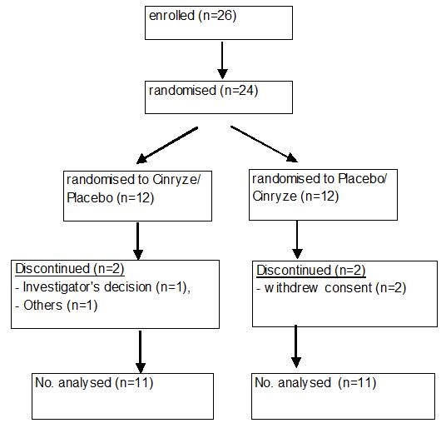

###### Baseline data

Overall, the majority of subjects were female (20 subjects, 90.9%), White (21 subjects, 95.5%), and with a mean age of 38.1 years (range of 9 to 73 years). In the Cinryze/Placebo treatment sequence group, there were 2 subjects who were male, while all subjects in the Placebo/Cinryze treatment sequence group were females. In the Cinryze/Placebo treatment sequence group, there was 1 subject who was Black/African American, while all subjects in the Placebo/Cinryze treatment sequence group were White.

###### Comments:

*As this was a crossover study where each subject served as his/her own control, the comparison of demographic characteristics between the randomised treatment sequence groups is not crucial. It is more relevant that the demographic characteristics of the study population were representative of the general patient population, so that results can be extrapolated to the general patient population. In this study, all subjects except for 2 were females and all subjects except for 1 were White. While this is not representative of the general patient population, it is not likely to affect the interpretation of the study results due to the nature of Cinryze being a purified plasma protein to be administered intravenously and hence not subjected to genetic polymorphisim of P450 system, and also due to the pathophysiology of the target disease state of HAE not having an ethnic or gender basis.*

Overall, the time since diagnosis of HAE ranged from 1 year to 44 years. The mean number of years since the diagnosis of HAE was ~18 years and the majority of subjects had been diagnosed for ≥15 years (14 subjects, 58.3%).

Historically, most of the subjects in both treatment sequences had reported severe abdominal symptoms (Cinryze/Placebo, 75%; Placebo/Cinryze, 83.3%) and severe laryngeal symptoms (Cinryze/Placebo, 66.7%; Placebo/Cinryze, 50.0%).

###### Numbers analysed

Of the 24 subjects treated with randomised study medication, 22 (91.7%) were treated with both randomised Cinryze and placebo and therefore included in the efficacy dataset. Eleven of these were in the Cinryze/Placebo treatment sequence group, and 11 were in the Placebo/Cinryze treatment sequence group.

###### Outcomes and estimation

Primary efficacy analysis

The analysis of the primary efficacy variable is summarised in Table 11. The mean (± SD) number of angioedema attacks in subjects treated with Cinryze was 6.1 (± 5.43) attacks with a range of 0 to 17 attacks. The mean (± SD) number of attacks in subjects treated with placebo was 12.7 (± 4.80) attacks with a range of 6 to 22 attacks. The difference in the number of angioedema attacks during treatment with Cinryze and treatment with placebo was statistically significant (p < 0.0001). The effects of sequence and period were not statistically significant.

Table 11: Number of angioedema attacks (Study LEVP 2005-1-Part B).

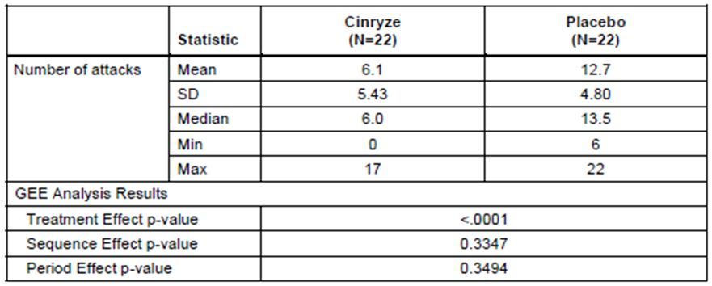

Secondary efficacy analyses

There is no difference in the number of subject withdrawals during each 12 week treatment period, between those on treatment with Cinryze and those on treatment with placebo. At the end of both Treatment Period 1 and 2, only 1 subject each in the Cinryze and placebo groups withdrew from the study.

The mean (± SD) severity of attacks was significantly lesser (p = 0.0008) during treatment with Cinryze [1.3 (± 0.85)] compared with placebo [1.9 (± 0.35)]. The mean (± SD) duration of attacks was also significantly shorter (p = 0.0004) during treatment with Cinryze [2.1 days (± 1.13 days)] compared with placebo [3.4 days (± 1.39 days)]. All 22 subjects in the efficacy dataset had an open label infusion with Cinryze during their placebo treatment period. Eleven subjects had an open label infusion with Cinryze during their Cinryze treatment period. The mean number (± SD) of open label rescue C1 INH infusions required was significantly greater (p < 0.0001) during treatment with placebo [15.4 (± 8.41 infusions)] compared to Cinryze [4.7 (± 8.66 infusions)]

* ***Total days of swelling during each treatment period***

The mean (± SD) total number of days of swelling was 10.1 (± 10.73) days during treatment with Cinryze and 29.6 (± 16.9) days during treatment with placebo. The difference in the total days of swelling during treatment with Cinryze and treatment with placebo was statistically significant (p < 0.0001).

* ***Effects of treatment on C1 INH levels during each treatment period***

C1 INH antigenic and functional levels pre infusion and 60 minutes post infusion at Visits 1, 8, 16, and 24 are summarised in Tables 12 and 13.

Table 12: C1 INH antigen levels (Study LEVP 2005-1-Part B).

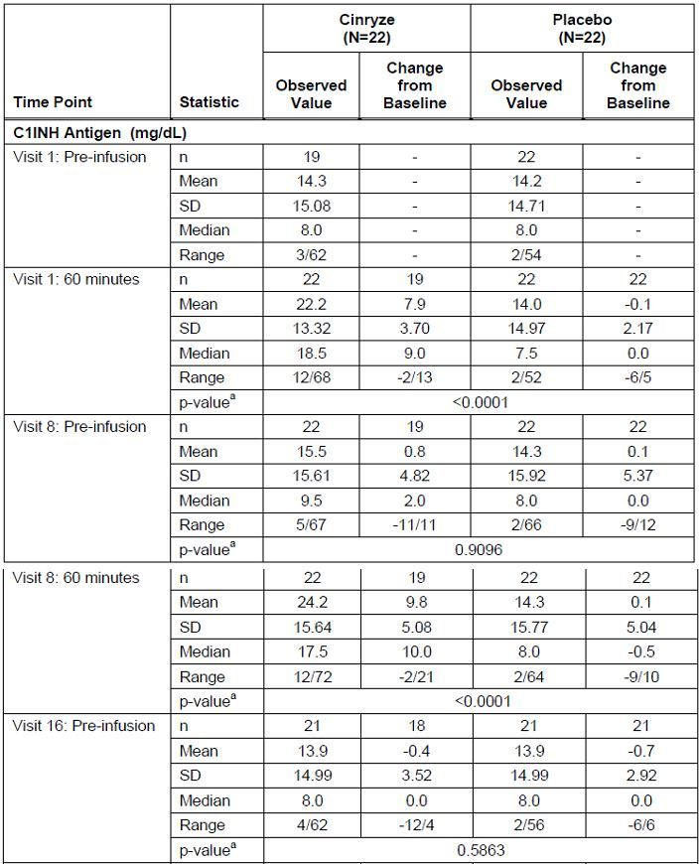

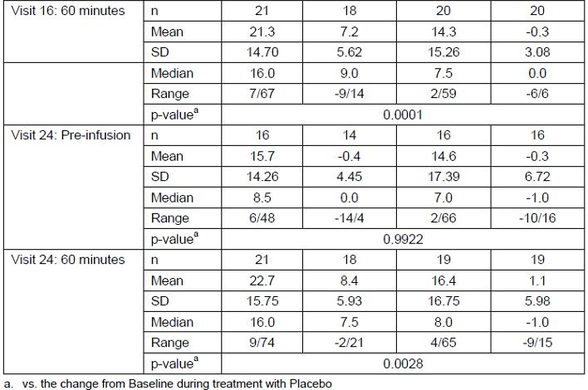

Table 13: C1 INH functional levels (Study LEVP 2005-1-Part B).

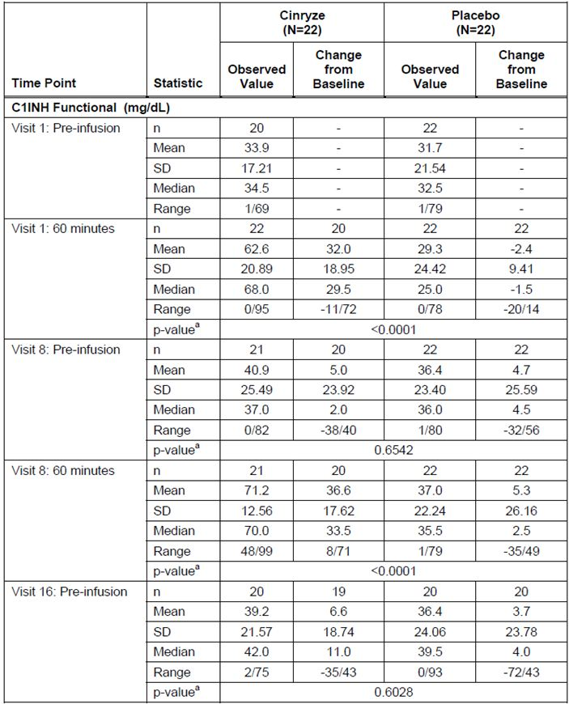

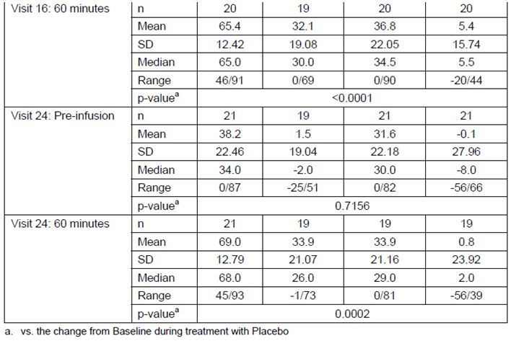

The mean value of baseline C1 INH antigen activity prior to treatment with Cinryze was similar to that prior to treatment with placebo (14.3 mg/dL and 14.2 mg/dL, respectively). The difference in changes of C1 INH antigen levels from baseline mean values to 60 minutes post infusion mean values between treatment with Cinryze and treatment with placebo was statistically significant (p = <0.0001 to 0.0028) for Visits 1, 8, 16, and 24. During treatment with Cinryze, the mean change from baseline in C1 INH antigenic levels after treatment ranged from +7.2 to +9.8 mg/dL. During treatment with placebo, the mean change from baseline was -0.3 to +1.1 mg/dL.

The mean value of C1 INH functional activity prior to treatment with Cinryze was similar to that prior to treatment with placebo (33.9 mg/dL and 31.7 mg/dL, respectively). The difference in changes of C1 INH antigen levels from baseline mean values to 60 minutes post infusion mean values between treatment with Cinryze and treatment with placebo was statistically significant (p = <0.0001 to 0.0002) for Visits 1, 8, 16, and 24. During treatment with Cinryze, the mean change from baseline in functional C1 INH after treatment ranged from +32.0 to +36.6 mg/dL. During treatment with placebo the mean change was -2.4 to +5.4 mg/dL.

###### Comments

*The primary efficacy analysis showed that there was a statistically significant lower (about half) frequency of HAE attacks in subjects treated with Cinryze, compared with placebo. The mean number of angioedema attacks in subjects treated with Cinryze was 6.1 attacks over a 12 week period. This gave a mean attack frequency rate of 1 attack every 2 weeks. The inclusion criteria of the study meant that subjects had at baseline (pre study) an attack frequency rate of at least 2 attacks a month, that is, at least 1 attack every 2 weeks, although when in the study while on placebo, the mean attack frequency rate of the subjects was 12.7 attacks over the 12 week period, that is, about 1 attack a week. The actual mean baseline (pre study) attack frequency rate of subjects were not analysed in this study, and it was unknown how much reduction from baseline the mean attack frequency rate of 1 attack every 2 weeks represents. There is also no clinical consensus on an attack frequency rate that would represent successful prophylaxis or successful control of the condition. However, it is noted that the sample size was estimated based on an assumed attack frequency rate of 1 attack in 12 weeks when being treated with prophylactic Cinryze.*

*The secondary efficacy analyses generally supported the prophylactic efficacy of Cinryze when compared to placebo, in terms of the average duration and severity of the attacks, the total number of days of swelling, and the number of open-label rescue Cinryze infusions needed.*

*Results of C1 INH antigenic levels post infusion were consistent with those in Study LEVP 2005-1/Part A.*

#### Supportive studies

##### Study LEVP 2006-1

###### Methods

Study LEVP 2006-1 was a multicentre, open label, single arm study evaluating the safety and efficacy of repeat use of Cinryze for the acute treatment of HAE attacks. This study was also designed to serve as a rollover study for subjects who participated in Study LEVP 2005-1/Part A.

Subjects were ≥ 1 year of age with a diagnosis of HAE. In addition, they needed to have completed participation in Study LEVP 2005-1/Part A and were not participating in Study LEVP 2005-1/Part B, after the 3 day telephone follow up, or:

* completed participation in Study LEVP 2005-1/Part B any time after the final prophylactic treatment in Part B, or
* enrolled but not randomised in Study LEVP 2005-1/Part A after LEVP 2005-1/Part A was closed, or
* were excluded from Study LEVP 2005-1 due to
  + pregnancy or lactation
  + age less than 6 years
  + narcotic addiction, or
  + presence of anti C1 INH antibodies, or
* were not enrolled in Study LEVP 2005-1 and enrolment in Study LEVP 2005-1 was closed and met the following diagnostic criteria:
  + a diagnosis of HAE
  + evidence of a low C4 level plus either a low C1 INH antigenic level or a low C1 INH functional level
  + a known HAE causing C1 INH mutation
  + a diagnosis of HAE based on a strong family history of HAE as determined by the principal investigator.

Eligible subjects could receive treatment for multiple attacks. Qualifying attacks included all laryngeal attacks and moderate or severe gastrointestinal, facial, genitourinary, or extremity attacks. In addition, subjects could receive treatment for an HAE attack if it was deemed necessary by the investigator (for example, for non laryngeal attacks that were not considered moderate or severe, but the investigator deemed that the subject would benefit from Cinryze treatment). Treatment for acute attacks was 1000 U of Cinryze intravenously with a second 1000 U dose 60 minutes later if needed. In addition, this protocol allowed for short term prophylaxis with Cinryze prior to emergency or non cosmetic surgical or dental procedures.

The efficacy endpoints evaluated included:

* the time to beginning of unequivocal relief of the defining symptom
* the proportion of subjects who achieved the start of unequivocal relief of the defining symptom within 1 and 4 h after start of the first dose of Cinryze
* the proportion of subjects who achieved the start of unequivocal relief of the defining symptom within 4 h after start of the first dose of Cinryze by attack number
* a calculated response proportion for each subject (number of attacks with start of unequivocal relief of the defining symptom within 1 and 4 hours after start of the first dose/total number of attacks)
* the mean of these response proportions, the change in time to beginning of unequivocal relief of the defining symptom for subjects who received multiple treatments, and the effects of Cinryze on C1 INH levels.

Beginning of unequivocal relief of the defining symptom was defined as the time corresponding to the first of three consecutive reports that symptoms were “present, symptoms better,” “absent but present before,” or “absent now and before”.

In the current study, subjects received Cinryze using the same dosing regimen as in Study LEVP 2005-1/Part A (that is, 1000 U IV, which could be repeated after 60 minutes if there was no symptom relief). However, unlike Study LEVP 2005-1/Part A, subjects in Study LEVP 2006-1 could be treated for more than one HAE attack. Study LEVP 2006-1 also allowed for the enrolment of subjects who would have been excluded from Study LEVP 2005-1/Part A due to:

* pregnancy or lactation
* age less than 6 years
* narcotic addiction, or
* presence of anti C1 INH antibodies

thus allowing the collection of data for the repeat use of Cinryze for the treatment of acute HAE attacks in a patient population that was previously unevaluated in Study LEVP 2005-1/Part A.

###### Results

There was no formal sample size determination. Overall, 113 subjects were enrolled, received at least one dose of Cinryze, and analysed for safety. Of the 113 enrolled subjects, 101 received Cinryze as treatment for an acute attack and were included in the analyses of efficacy. In the safety study population, 33.6% (38/113) were males and 66.4% (75/113) were females. The majority (80.5%; 91/113) were White/Caucasian. The mean age (± SD) was 34.5 (± 17.6) years, and the age range was 2 to 80 years.

In the efficacy study population, 101 subjects experienced a range of 1-57 attacks (median: 3.0). Fifteen subjects received treatment for at least 10 attacks, and 4 subjects were treated for >20 attacks. Overall, there were 609 attacks treated during the study. The proportion of attacks with unequivocal relief of the defining symptom was 68% (412/609) within 1 h after start of the first dose of Cinryze and 87% (529/609) within 4 h after start of the first dose of Cinryze. The median time to beginning of unequivocal relief in these subjects was 0.75 h. Of the 101 subjects who had at least 1 attack during the study, 79% (n = 80) achieved unequivocal relief of the defining symptom of the first attack within 4 h after start of the first dose of Cinryze. The number of attacks reported during the study had no effect on achievement of unequivocal relief. The median time to beginning of unequivocal relief was comparable among subjects who had up to 30 attacks during the study, ranging from 0.25 to 0.75 h. Overall, the mean response proportion was independent of the number of attacks reported per subject as results were similar whether subjects had 1 or 57 attacks.

###### Comments:

*This was an open label, uncontrolled study. In Study LEVP 2005-1/Part A (the randomised, placebo controlled, double blind study), ~60% of subjects in the Cinryze treatment group had the start of unequivocal relief of the defining symptom within 4 h, and the median time to the start of unequivocal relief of symptoms was 2 h in the Cinryze treatment group. In this Study LEVP 2006-1, results also showed that majority of subjects had the start of unequivocal relief of the defining symptom within 4 h of Cinryze infusion (79%). However, the results of this study showed the median time to beginning of unequivocal relief to be 0.75 h.*

##### Study LEVP 2006-4

###### Methods

Study LEVP 2006-4 was an open label, single arm, multicentre study evaluating the safety and efficacy of prophylactic use of Cinryze for the prevention of HAE attacks. This study was also designed to serve as a rollover study for subjects who participated in Study LEVP 2005-1/Part B.

During the study, Cinryze was administered as prophylactic treatment at a dose of 1000 U IV every 3 to 7 days (that is, about 1-2 times per week). Subjects were also eligible to receive treatment with Cinryze for acute HAE attacks. Qualifying attacks included gastrointestinal, genitourinary, facial, respiratory (including laryngeal), or extremity angioedema. Treatment for acute attacks was 1000 U of Cinryze IV with a second dose 60 minutes later if needed.

Efficacy endpoint was the frequency of HAE attacks which occurred during prophylactic treatment with Cinryze. A HAE attack was defined as a discrete episode during which the subject progressed from no angioedema to symptoms of angioedema. An attack that progressed from one site to another was considered a single attack. An attack that regressed but subsequently worsened before complete resolution, or attacks that occurred on continuous days was also considered a single attack. In addition, both pre and post infusion levels of C1 INH (functional and antigenic) and C4 were measured.

The dose of Cinryze used in this study was the same as that used in Study LEVP 2005-1/Part B (1000 U for each prophylactic dose), but the frequency of the dose was every 3 to 7 days (versus every 3 to 4 days in Study LEVP 2005-1/Part B). This study also allowed for the enrolment of subjects who would have been excluded from Study LEVP 2005-1/Part B due to:

* pregnancy or lactation
* age less than 6 years
* narcotic addiction, or
* presence of anti C1 INH antibodies.

###### Results

There was no formal sample size determination. Overall, 146 subjects were enrolled. All 146 subjects were analysed for the efficacy endpoints. In the study population, 23% (34/146) were males and 77% (112/146) were females. The majority (83%; 121/146) were White/Caucasian. The mean age (± SD) was 37 (± 16) years, and the age range was 3 to 82 years.

Prior to enrolment, subjects reported a median monthly HAE attack rate of 3.0 (range: 0.08-28.0). During prophylactic treatment with Cinryze, 86% (126/146) of subjects experienced ≤1 HAE attack per month. Overall, the median number of HAE attacks per month was 0.21 (range: 0-4.56). The mean (± SD) number of HAE attacks per month was 0.50 (± 0.754).

###### Comments:

*This was an open label, uncontrolled study. In Study LEVP 2005-1/Part B, the randomised, placebo controlled, double blind study, the mean number of angioedema attacks in subjects treated with Cinryze was 6.1 over a 12 week period (that is, ~2 attacks per month). However, in this study the mean number of HAE attacks per month was 0.50.*

##### Clinical studies in special populations

No specific clinical studies were performed in special populations. The efficacy data was analysed in the subpopulation of paediatric subjects in the four studies and for pre procedure prophylaxis in two studies.

###### Paediatric subjects

The number of paediatric subjects in each of the four studies by age group is presented in Table 14.

Table 14: Number of paediatric subjects in each study, and the overall number of unique paediatric subjects across the four studies.

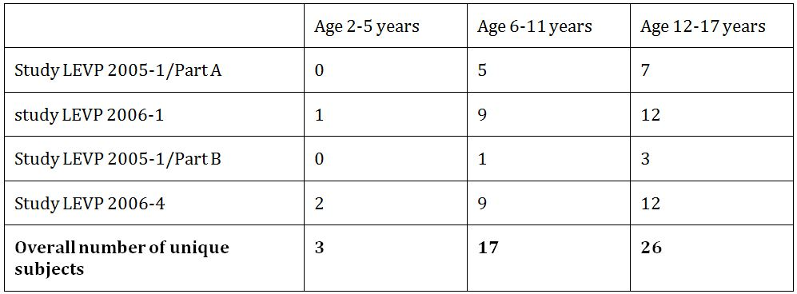

In Study LEVP 2005-1/Part A, the randomised controlled trial for acute treatment of HAE attacks, 12 paediatric subjects from 6 to 17 years of age were randomised and treated for a qualifying swelling episode. Seven were randomised to the Cinryze group, and 5 to the placebo group. This is summarised in Table 15. All administrations of Cinryze to paediatric subjects in this trial were 1000 U doses regardless of weight, and all 12 randomised subjects completed the study. Five of 7 paediatric subjects (71%) in the Cinryze group achieved beginning of unequivocal relief of the defining symptom within 4 h after initial treatment compared with 2 of 5 subjects (40%) in the placebo group. Median time to beginning of unequivocal relief was 30 minutes in the Cinryze group compared with 2 h in the placebo group. Overall, 80% (4/5) of children randomised to the placebo arm required rescue treatment with Cinryze and/or narcotics, compared with 29% (2/7) of children randomised to the Cinryze arm.

Table 15: Paediatric subjects (Study LEVP 2005-1/Part A).

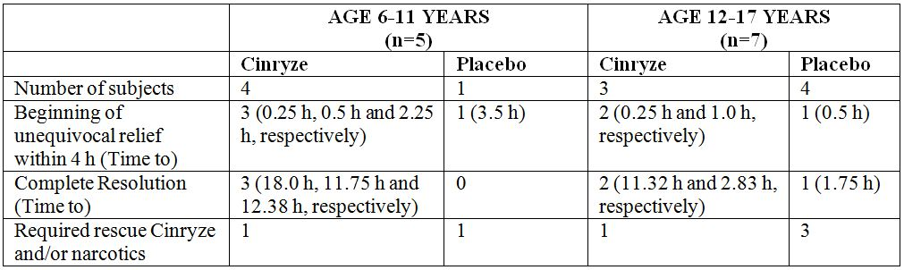

In Study LEVP 2006-1, the open label uncontrolled trial for acute treatment of HAE attacks, there was 1 paediatric subject within the age group of 2 to 5 years of age, 9 within the age group of 6 to 11 years of age, and 12 within the age group of 12 to 17 years of age. All administrations of Cinryze to paediatric subjects in this trial were 1000 U doses except for the 2 year old subject, who received two 500 U doses of Cinryze 1 h apart for the treatment of a facial attack. The proportion of attacks achieving unequivocal relief of the defining symptom among the children in various age groups compared to adults is presented in Table 16. The proportion of attacks with start of unequivocal relief within 1 or 4 h post dose was comparable between the paediatric and adult subject populations. Overall, 80.3% (61/76) of HAE attacks in children aged 6 to 11 years, and 77.3% (34/44) of HAE attacks in children aged 12 to 17 years had start of unequivocal relief within 1 h post dose, compared with 65.8% (312/474) of attacks in adults aged 18 to 64 years. In addition, 90.8% (69/76) of HAE attacks in children aged 6 to 11 years, and 88.6% (39/44) of HAE attacks in children aged 12 to 17 years had start of unequivocal relief within 4 hours post dose, compared with 87.1% (413/474) of attacks in adults aged 18 to 64 years.

Table 16: Proportion of attacks achieving unequivocal relief of the defining symptom within 1 and 4 h after start of the first dose of Cinryze by age group, ITT efficacy dataset (Study LEVP 2006-1).

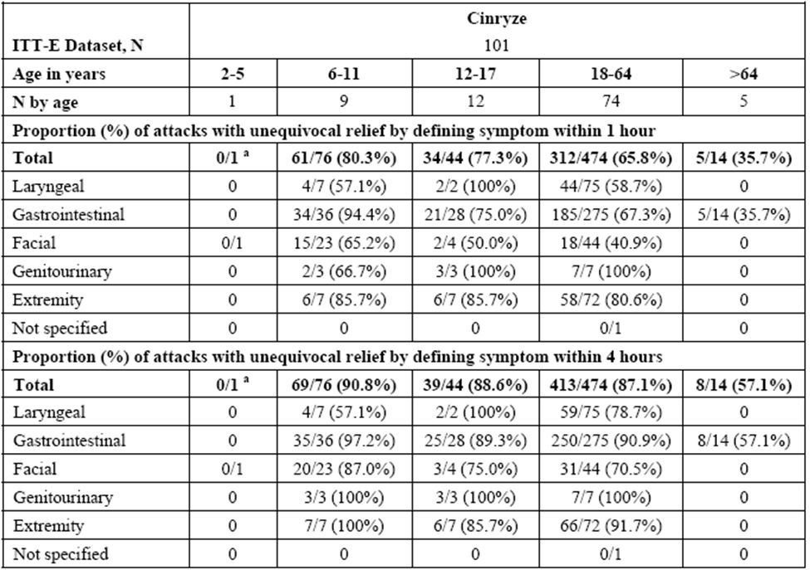

a: Subject 05-026 (2 years old) received two 500 U doses of Cinryze 1 h apart for the treatment of a facial attack. The subject had one report of symptom relief (“present, symptoms better”) about 3 h after start of the first 500 U dose of Cinryze, but had no subsequent symptom assessments performed. Therefore, the endpoint requirement of 3 consecutive reports of improved/absent symptoms was not met. However, the subject was discharged from the study centre 3 hours and 50 minutes after start of the first dose of Cinryze.

In Study LEVP 2005-1/Part B, the randomised controlled trial for prophylaxis of HAE attacks, there were4 subjects who were <18 years of age and all had previously participated in Study LEVP 2005-1/Part A. One subject was 9 years of age, and the other 3 were in the age group of 12 to 17 years. Two subjects were randomised to the Cinryze/Placebo treatment sequence and 2 subjects were randomised to the Placebo/Cinryze treatment sequence. All 4 subjects completed 12 weeks of treatment with Cinryze and placebo, and all administrations of Cinryze to paediatric subjects in Study LEVP 2005-1/Part B were 1000 U doses. Efficacy results for paediatric subjects in this study is summarised in Table 17.

Table 17: Efficacy Results for Paediatric Subjects (Study LEVP 2005-1/Part B).

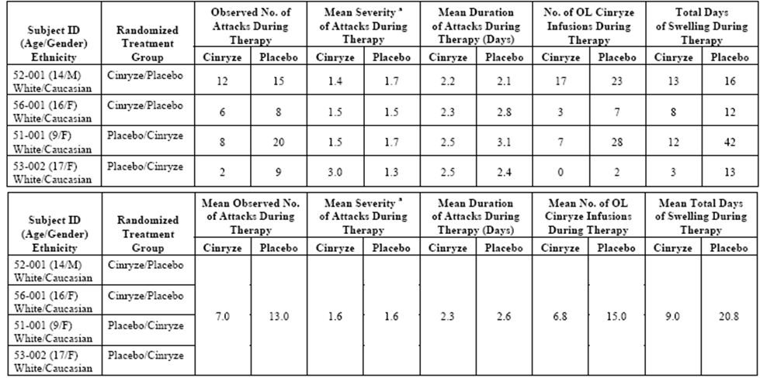

F = female; M = male; OL = open label; a: 1 = mild; 2 = moderate; 3 = severe.

Overall, in these 4 paediatric subjects, the mean number of attacks while on prophylactic Cinryze treatment was 7.0 over the 12 week treatment period, compared with 13.0 while on the placebo treatment. The mean severity of attacks was the same while on prophylactic Cinryze treatment compared to placebo, with a mean severity score of 1.6 for both treatment groups. The mean duration of attacks while on prophylactic Cinryze treatment was 2.3 days compared with 2.6 days while on the placebo treatment. The mean number of open label Cinryze infusions needed for treatment of HAE attacks while on prophylactic Cinryze treatment was 6.8, compared with 15.0 while on the placebo treatment. The mean number of days of swelling while on prophylactic Cinryze treatment was 9.0 days, compared with 20.8 days while on the placebo treatment. These results were not analysed for statistical significance.

In Study LEVP 2006-4, the open label uncontrolled trial for prophylaxis of HAE attacks, there were 2 paediatric subjects within the age group of 2 to 5 years of age, 9 within the age group of 6 to 11 years of age, and 12 within the age group of 12 to 17 years of age. The frequency of HAE attacks by age group in this study is summarised in Table 18. Prior to enrolment, the 23 paediatric subjects in this study reported a median (range) monthly HAE attack rate of 3.0 (0.5-28.0). During the study, they experienced a median (range) monthly attack rate of 0.39 (0-3.36). Overall, 22% (5/23) of these paediatric subjects reported no attacks while on prophylactic Cinryze.

Table 18: Frequency of HAE Attacks by Age Group: ITT Efficacy Dataset (Study LEVP 2006-4).

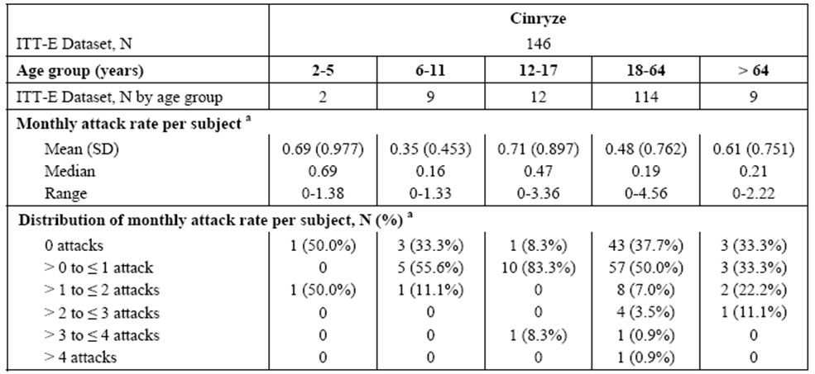

a: Monthly attack rate for each subject = 30.4 x (total number of attacks) / (last day of study drug - first day of study drug + 1)

###### Comments:

*In this submission, no PK data in children < 18 years of age was available. In the PK study submitted, Study LEVP 2006-1, subjects were ≥ 19 years of age. No prospective rationale was given in the submission for the use of the same dose of Cinryze in children as that used in adults in the clinical studies. In the study protocols, it was stated that the dosage regimen of Cinryze was based on that for Cetor. However, in the PI of Cetor, it was stated that:*

*“Considering the limited data on the efficacy and safety of C1 esterase inhibitors in children below 12 years of age, no dosage recommendation can be given”.[24]*

*Retrospective analyses of C1 INH antigenic and functional levels in the Phase 3 clinical studies by age group were done subsequently, but interpretation was difficult as the paediatric subpopulation sample size was small and C1 INH antigenic and functional levels were measured only at a few time points such that a full PK profile in paediatric subjects (that is, half life and clearance) was not obtained.*

*Although the paediatric subgroup analyses of each study involved very small sample sizes and were not analysed for statistical significance, these analyses generally showed comparable results to the overall results of each study. In Study LEVP 2005-1/Part A, primary efficacy analysis in the overall Efficacy Dataset showed that 60.0% (21/35) of subjects in the Cinryze group and 42.4% (14/33) of subjects in the placebo group had the start of unequivocal relief of the defining symptom within 4 h post dose. In the paediatric subgroup analysis, results were comparable, showing that 71% (5/7) in the Cinryze group achieved beginning of unequivocal relief of the defining symptom within 4 hours post-dose compared with 40% (2/5) in the placebo group. In the overall Efficacy Dataset, the median time to the start of unequivocal relief of symptoms was 2 h in the Cinryze treatment group and > 4 h in the placebo group. Analysis in the paediatric subgroup showed different absolute results, but gave a similar pattern of a shorter median time to beginning of unequivocal relief in the Cinryze group (30 minutes) compared to the placebo group (2 h).*

*In Study LEVP 2006-1, analyses in the overall study population showed that the proportion of attacks with start of unequivocal relief of the defining symptom within 1 h after start of the first dose of Cinryze was 68% (412/609). In the paediatric subgroup analysis, the results were comparable, showing that 80.3% (61/76) of HAE attacks in children aged 6 to 11 years, and 77.3% (34/44) of HAE attacks in children aged 12 to 17 years had start of unequivocal relief within 1 h post dose. Analyses in the overall study population showed that the proportion of attacks with start of unequivocal relief of the defining symptom within 4 h after start of the first dose of Cinryze was 87% (529/609). In the paediatric subgroup analysis, the results were comparable, showing that 90.8% (69/76) of HAE attacks in children aged 6 to 11 years, and 88.6% (39/44) of HAE attacks in children aged 12 to 17 years had start of unequivocal relief within 4 h post dose.*

*A comparison of the results from the Overall Study LEVP 2005-1/Part B analysis and the paediatric subgroup analysis results is summarised in Table 19, and showed that the results were mostly comparable.*

Table 19: Comparison of the results from the Overall Study LEVP 2005-1/Part B analysis and the paediatric subgroup analysis results.

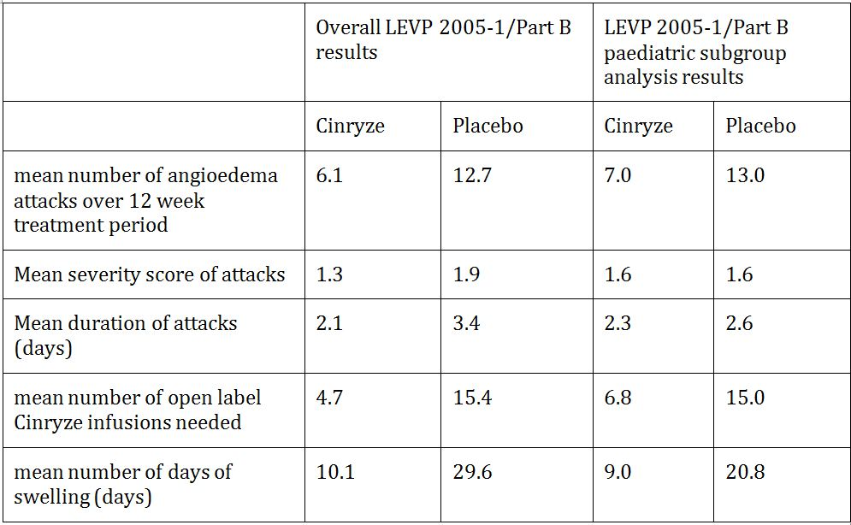

*Overall, in Study LEVP 2006-4 subjects reported a baseline, pre enrolment median monthly HAE attack rate of 3.0. During prophylactic treatment with Cinryze, the median number of HAE attacks per month was 0.21. In the paediatric subgroup analysis, the results were comparable. In the paediatric subgroup, subjects reported a baseline, pre enrolment median monthly HAE attack rate of 3.0. During prophylactic treatment with Cinryze, the median number of HAE attacks per month was 0.39.*

##### Pre procedure prophylaxis

Data on pre procedure administration of open label Cinryze were available from Studies LEVP 2005-1/Part A and LEVP 2006-1. In these studies, subjects were eligible to receive treatment with open label Cinryze if they required prophylaxis prior to an emergency or non cosmetic surgical procedure. In both studies, a single IV dose of Cinryze 1000 U was to be administered within 24 h before the procedure, if possible. Evaluation of the efficacy and safety of pre procedure administration of Cinryze was done by a retrospective review of the dosing data and HAE attacks reported within 72 h after a pre procedure dose, as well as AEs reported 7 days after a pre procedure dose. Efficacy data will be presented in this section, and the safety data will be presented in the safety section of the evaluation report.

Overall, 7 subjects in Study LEVP 2005-1/Part A and 36 subjects in Study LEVP 2006-1 received one or more pre procedure doses of Cinryze. Among these subjects, 2 subjects participated in Studies LEVP 2005-1/Part A and LEVP 2006-1, and therefore there were a total of 41 unique subjects who received pre procedure administration of Cinryze. These 41 subjects received Cinryze prior to a total of 91 procedures. Of the 91 procedures, 40 procedures were in children (< 18 years of age) and 51 procedures were in adults (≥ 18 years of age). The majority of procedures (55%, 50/91) were associated with dental work. A pre procedure dose of a single 1000 U infusion was administered in 87/91 procedures (96%), and 2 x 1000 U doses were administered on the same day for 3 procedures and over a 48 h period for 1 procedure.

Of the 91 procedures, 2 (2%) HAE attacks were reported within 72 hours after dosing. The 2 HAE attacks reported were 1 moderate genitourinary attack and 1 mild laryngeal attack, occurring two and three days, respectively, after a pre procedural dose of 1000 U. The genitourinary attack achieved unequivocal relief within 30 minutes after treatment with Cinryze 1000 U. The laryngeal attack did not achieve unequivocal relief within 4 h of treatment with Cinryze 1000 U, but the subject achieved relief prior to visit discharge on the same day.

#### Evaluator’s overall conclusions on clinical efficacy

The clinical efficacy results generally supported the indications of acute treatment, routine prophylaxis and pre procedure prophylaxis.

With regards to acute treatment of HAE attacks, results from the main randomised placebo controlled Phase 3 trial (Study LEVP 2005-1/Part A) showed that among subjects yet to achieve unequivocal relief of symptoms, a subject who received Cinryze was 2.0 to 2.4 times as likely to achieve the start of unequivocal relief of symptoms as a subject who received placebo. Among subjects yet to achieve complete attack resolution, a subject who received Cinryze was 2.5 to 2.7 times as likely to achieve complete attack resolution as a subject who received placebo. The median time to the start of unequivocal relief of symptoms was 2 h post dose. The median time to complete resolution was 12.3 h post dose.

This clinical efficacy results were consistent with the PK/PD profile. In the PK/PD study submitted for Cinryze (Study LEVP 2006-5), results showed that Cinryze has a long half life (mean terminal half life of 45 to 56 h with a single dose and 47 to 62 h with a double dose). The maximal C1 INH antigenic and functional levels occurred at a median of 1.2 h after a single dose, and 1.5 to 2.2 h after a double dose of Cinryze given 1 h apart. However, the maximal biological effect (as measured by an increase in complement C4 levels) occurred only at a median time of approximately 2 days after dosing (47 h and 49 h after a single and double dose, respectively). The maximal biological effect had a wide range of 6-100 h after a single dose and 7-99 h after a double dose of Cinryze, consistent with the long half life of Cinryze. Results in Study LEVP 2005-1/Part A, showing onset of unequivocal relief of symptoms at a median time of 2 h post dose, and a complete resolution of symptoms at a median time of 12.3 h post dose, is consistent with this PK/PD profile. In addition, although Study LEVP 2006-5 showed that maximal biological effect occurred at a median time of approximately 2 days after dosing, complement C4 levels in Study LEVP 2005-1/Part A showed that at an earlier time point of 12 h post infusion, there was already a statistically significant difference in the reduction from baseline of complement C4 levels between the Cinryze and placebo treatment groups.

Results from the open label study, Study LEVP 2006-1 generally supported the results of Study LEVP 2005-1/Part A. Study LEVP 2006-1 had a larger sample size than Study LEVP 2005-1/Part A, but was open label and uncontrolled. In Study LEVP 2006-1, 79% of subjects had the start of unequivocal relief of the defining symptom within 4 h of Cinryze infusion. This was generally comparable with the results of Study LEVP 2005-1/Part A, where ~60% of subjects in the Cinryze treatment group had the start of unequivocal relief of the defining symptom within 4 h of Cinryze infusion. The results of both Studies LEVP 2006-1 and LEVP 2005-1/Part A showed the median time to onset of unequivocal relief occurred within hours post dose (0.75 h and 2 h in Studies LEVP 2006-1 and LEVP 2005-1/Part A, respectively).

With regards to routine prophylaxis of HAE attacks, results from the main randomised placebo controlled Phase 3 trial (Study LEVP 2005-1/Part B), showed that there was a statistically significant lower (about half) frequency of HAE attacks in subjects treated with Cinryze, compared with placebo. The mean number of angioedema attacks in subjects treated with Cinryze was 6.1 attacks over a 12 week period, compared with a mean attack frequency rate of 12.7 attacks over a 12 week period when treated with placebo. The actual mean baseline (pre study) attack frequency rate of subjects were not analysed in this study, and it was unknown how much reduction from baseline the mean attack frequency rate of 1 attack every 2 weeks represents. There is also no current clinical consensus on an attack frequency rate that would represent successful prophylaxis or successful control of the condition. However, it is noted that the sample size was estimated based on an assumed attack frequency rate of 1 attack in 12 weeks when being treated with prophylactic Cinryze, although no information was given on the basis for this assumption.

The secondary efficacy analyses generally supported the prophylactic efficacy of Cinryze when compared to placebo, showing a statistically significant reduction in:

* the average duration and severity of the attacks,
* the total number of days of swelling, and
* the number of open label rescue Cinryze infusions needed when subjects were on prophylactic Cinryze treatment compared to placebo.

The mean duration of attacks was 2.1 days during treatment with Cinryze compared with 3.4 days during treatment with placebo. The mean severity of attacks was 1.3 during treatment with Cinryze compared with 1.9 during treatment with placebo. The mean total number of days of swelling was 10.1 days during treatment with Cinryze compared with 29.6 days during treatment with placebo. The mean number of open label rescue C1 INH infusions required during attacks was 4.7 during treatment with Cinryze compared with 15.4 during treatment with placebo.

Results from the open label study, Study LEVP 2006-4 generally supported the results of Study LEVP 2005-1/Part B. Study LEVP 2006-4 had a larger sample size than Study LEVP 2005-1/Part B, but was open label and uncontrolled. In Study LEVP 2006-4, the baseline pre enrolment median monthly HAE attack rate was 3.0. When on prophylactic Cinryze treatment, the median monthly HAE attack rate was 0.21.

With regards to pre procedure prophylaxis, data drawn from Studies LEVP 2005-1/Part A and LEVP 2006-1 showed that after pre procedure administration of Cinryze prior to 91 procedures, 2 HAE attacks were reported within the 72 h after the Cinryze dose. There is no clinical consensus on the baseline incidence of HAE attacks with procedures without prophylaxis, so no meaningful comparison can be made. However, it can be interpreted from the results that with pre procedure administration of Cinryze prior to 91 procedures, 89 procedures (98%) were not associated with a report of HAE attacks within 72 h post dose.

With regards to the paediatric subgroup analyses of each study, although these involved very small sample sizes and were not analysed for statistical significance, the results were generally comparable with the overall results of each study. Paediatric subgroup analyses of Study LEVP 2005-1/Part A showed that 71% (5/7) in the Cinryze group achieved beginning of unequivocal relief of the defining symptom within 4 h post dose compared with 40% (2/5) in the placebo group, and there was a shorter median time to beginning of unequivocal relief in the Cinryze group (30 minutes) compared to the placebo group (2 hours). Paediatric subgroup analyses of Study LEVP 2006-1 showed that 78.5% (95/121) of HAE attacks in children aged 2 to 17 years had start of unequivocal relief within 1 h post dose, and 89.3% (108/121) of HAE attacks in children aged 2 to 17 years, had start of unequivocal relief within 4 h post dose. Study LEVP 2005-1/Part B had only 4 paediatric subjects, and showed that the mean number of attacks while on prophylactic Cinryze treatment was 7.0 over the 12 week treatment period, compared with 13.0 while on the placebo treatment. Paediatric subgroup analyses of Study LEVP 2006-4 showed that during prophylactic treatment with Cinryze, the median number of HAE attacks per month was 0.39, compared with a baseline, pre enrolment median monthly HAE attack rate of 3.0.

The paediatric subjects in the studies received the same doses and dosing regimen of Cinryze as the adults, except for a 2 year old subject in Study LEVP 2006-1 who received two 500 U doses of Cinryze 1 hour apart for the acute treatment of a HAE attack. No prospective rationale was given in the submission for the use of the same dose of Cinryze in children as that used in adults in the clinical studies. The dosing regimen in paediatric subjects and the ability or inability of recommending a dosing regimen for paediatric subjects based on the available data will be discussed in section 6.2 of this evaluation report.

### Safety

#### Introduction

Safety data for Cinryze was based on the data from the two pivotal randomised, double blind placebo controlled Phase 3 studies (LEVP 2005-1/Part A and LEVP 2005-1/Part B). This safety data was supplemented by that from the PK study (Study LEVP 2006-5) and the two open label Phase 3 studies (LEVP 2006-1 and LEVP 2006-4). In this evaluation report, the two pivotal Phase 3 trials will be the main studies upon which the clinical safety will be evaluated. The PK study and the two open label trials will be evaluated with regards to whether their results were consistent with the safety conclusions derived from the results of the pivotal Phase 3 trials.

#### Patient exposure

Overall, eight studies were completed on Cinryze at the time of submission. In addition to the five studies submitted for this application, three compassionate use single subject studies/case studies were completed. The overall extent of exposure to Cinryze across the eight studies involved 14,573 infusions of 1000 U of Cinryze, administered to 262 unique subjects. This is summarised in Figure 14 and Table 20.

Figure 14: Extent of exposure to Cinryze across the eight safety studies.

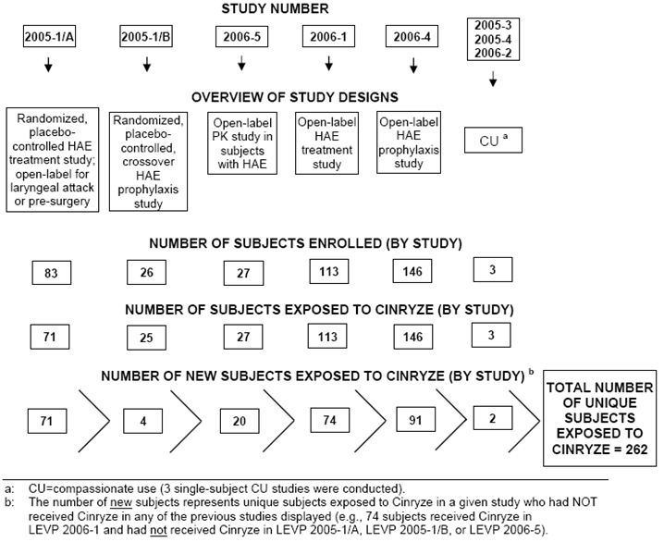

Table 20: Number of Cinryze infusions administered in the clinical development program.

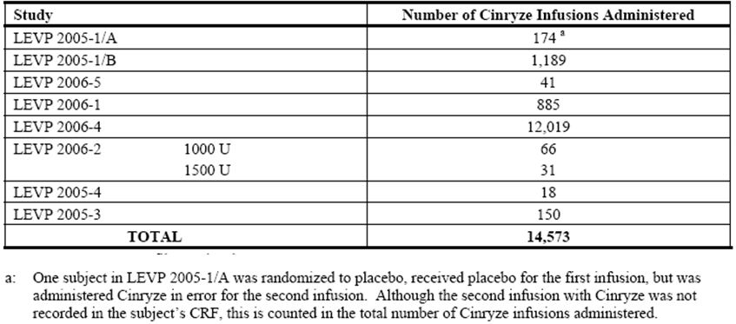

##### Comments:

*Overall, the amount of exposure to the drug is adequate to evaluate the safety profile of the drug. In the two Phase 3 trials, only 75 unique subjects were exposed to 1363 infusions. However, in the two open label studies, a further 165 unique subjects were exposed to 12,904 infusions. This is adequate to evaluate the safety profile of a purified plasma protein.*

#### Adverse events (AEs)

A summary of TEAE across the completed clinical studies is summarised in Tables 21 and 22. No AE were reported by the three subjects who participated in the three compassionate use single subject studies.

Table 21: AEs across Cinryze clinical studies, ITT Safety Population.

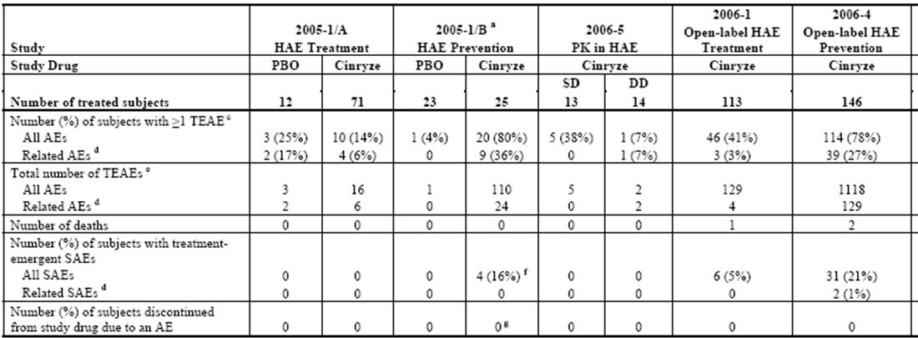

PBO = placebo; SD = single dose; DD = double dose; CU = compassionate use

Study LEVP 2005-1/Part B was a placebo controlled crossover study; all subjects were exposed to Cinryze.

Studies LEVP 2006-2, LEVP 2005-4, and LEVP 2005-3 were single-subject compassionate use protocols.

For Studies LEVP 2005-1/Part A, LEVP 2005-1/Part B, and LEVP 2006-5, TEAEs were defined in the clinical safety reports as those events that started on or after the time of first infusion (randomised or open label) of study drug (or whose severity worsened on or after that time) up to 30 days after the last infusion of study drug. For Studies LEVP 2006-1 and LEVP 2006-4, TEAEs were defined in the clinical safety reports as those events that started during the study drug therapy period (through 7 days after the last dose of Cinryze) and were not seen at baseline, or were seen at baseline but increased in severity during the study drug therapy period (through 7 days after the last dose of Cinryze).

Related AEs are those determined by the investigator to be of unknown, possible, probable or definite relationship to study drug. AEs with missing relationship were assumed to be related.

The total number of TEAEs includes each individual report of a given event for a given subject (that is, multiple occurrences of a given event reported by a subject are each counted in this total).

One of the 4 subjects had an SAE that occurred within 30 days after the subject’s last infusion of study drug in Study LEVP 2005-1/Part A; the subject subsequently transferred to a different site for participation in Study LEVP 2005-1/Part B. This event is included in the Study LEVP 2005-1/Part B database as a non treatment emergent SAE, although the SAE is a TEAE to Part A.

While no subjects discontinued study drug due to an AE in Study LEVP 2005-1/Part B, one subject received an infusion over 35 minutes instead of 10 minutes as specified in the study protocol. All doses for this subject were completed and none were missed.

Table 22: Commonly reported TEAEs (Studies LEVP 2006-5, LEVP 2005-1/A, LEVP 2006-1, LEVP 2005-1/B, and LEVP 2006-4).

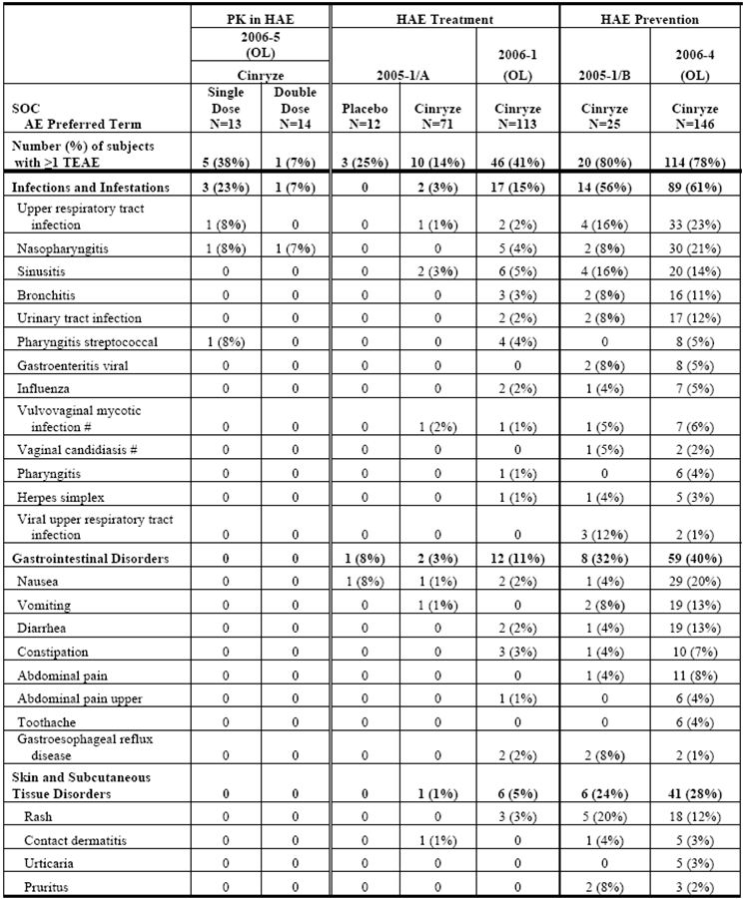

Table 22 (continued): Commonly reported TEAEs (Studies LEVP 2006-5, LEVP 2005-1/A, LEVP 2006-1, LEVP 2005-1/B, and LEVP 2006-4).

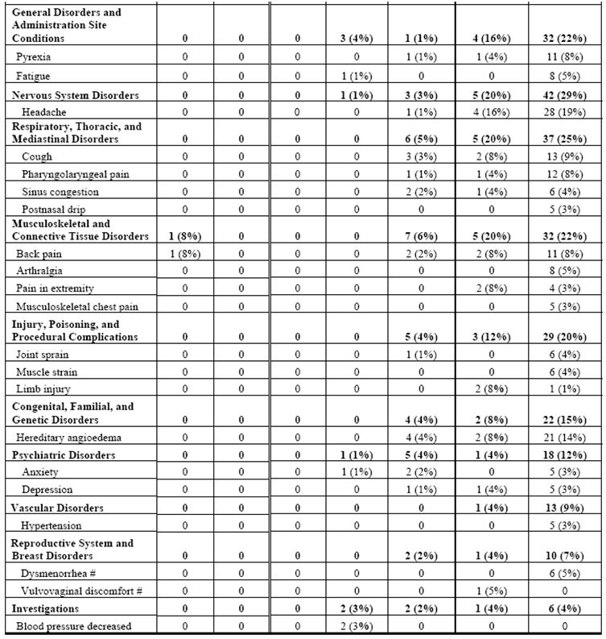

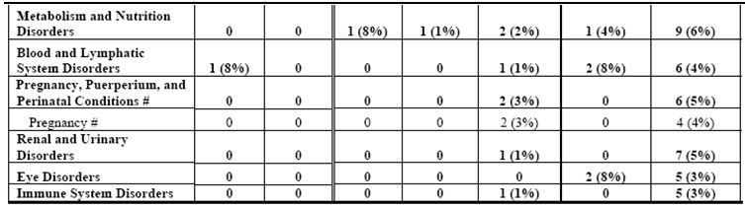

OL = open label; # signifies a gender specific SOC or term.

NOTE: A subject may have reported more than one TEAE or more than one TEAE per SOC.

##### Study LEVP 2005-1/Part A

There were 71 subjects in the All Randomised (ITT) Dataset and all 71 subjects were evaluated for safety. In addition, 12 subjects who were not randomised, but received open label Cinryze, were included in the assessment of safety. A summary of the most commonly reported TEAE by SOC and preferred term (reported in > 1 subject per SOC in either treatment group) in Study LEVP 2005-1/Part A is presented in Table 23. Although the study involved randomised Cinryze and placebo treatment groups, subjects in both randomised groups could also receive open label rescue or pre surgical procedure Cinryze. Overall in the study, 71 subjects received Cinryze as randomised, and/or open label treatment. In the safety analyses, the “Cinryze group” included these 71 subjects who received Cinryze as randomised, and/or open label treatment irrespective of initial randomised treatment group. The “placebo group” included the 12 subjects who received placebo only.

Table 23: TEAEs (All and Treatment Related) by SOC and Preferred Term (reported in > 1 subject per SOC in either treatment group): ITT Safety Population (Study LEVP 2005-1/Part A).

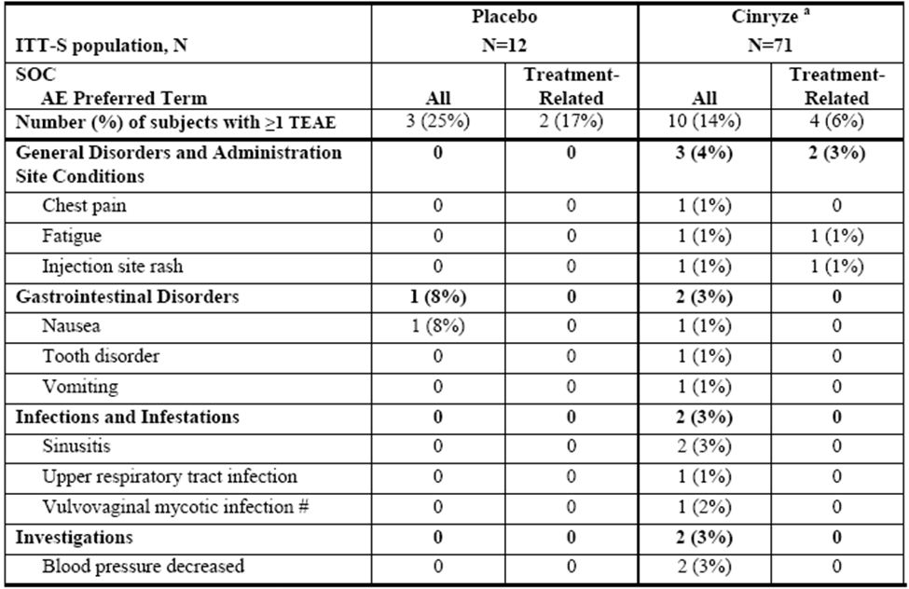

# signifies a gender specific term

a: Includes subjects exposed to Cinryze as randomised, rescue, and/or open label treatment.

NOTE: A subject may have reported more than one TEAE or more than one TEAE per SOC

In the Cinryze group, 10 subjects (14%) reported ≥ 1 TEAE and 4 subjects (6%) reported ≥ 1 treatment related TEAE. In the placebo group, 3 subjects (25%) reported ≥ 1 TEAE and 2 subjects (17%) reported ≥ 1 treatment related TEAE.

In the Cinryze group, the SOC in which subjects most commonly reported TEAE were general disorders and administration site conditions (4%, 3 subjects), followed by gastrointestinal disorders, infections and infestations, and investigations (each 3%, 2 subjects). By preferred term, the TEAE reported by more than one subject in the Cinryze group were sinusitis and blood pressure decreased (each reported by 2 subjects). All of these events were considered by the investigator to be unrelated to study drug. In the placebo group, no TEAE was reported by more than one subject within a SOC.

In the Cinryze treatment group, 5 treatment related TEAE were reported by 4 subjects. One TEAE of injection site rash was judged to be related to treatment. The other 4 TEAE (dizziness, anxiety, fatigue, anorexia) were judged to have an unknown relationship to treatment.[25]

##### Study LEVP 2005-1/Part B

Overall, 25 subjects were exposed to Cinryze as randomised treatment and/or open label treatment. There were 24 subjects who received randomised study medication in LEVP 2005-1/Part B and all 24 subjects were included in the evaluation of safety. In addition, 1 subject received open label Cinryze. Due to the crossover study design, all subjects in this study were exposed to open label and/or randomised Cinryze. The sponsor had stated that as all 25 subjects were exposed to Cinryze in this study during administration of randomised study drug or as open label treatment while receiving placebo, the comparison of safety results between Cinryze and placebo would not be meaningful. The sponsor had analysed and presented the safety data by summarising the AEs for all subjects who had been exposed to open label or randomised double blind Cinryze prior to the onset of the TEAE, and for subjects who had no exposure to Cinryze prior to the onset of the TEAE. Overall, only one TEAE (sinusitis) was considered to be associated with placebo, because it occurred prior to exposure to Cinryze. A summary of the most commonly reported TEAE by SOC and preferred term (reported in > 1 subject per SOC) by subjects who received Cinryze (randomised and/or open label) in Study LEVP 2005-1/Part B is presented in Table 24.

Table 24: TEAEs (All and Treatment Related) by SOC and Preferred Term (Reported in > 1 subject per SOC): ITT Safety Population (Study LEVP 2005-1/Part B).

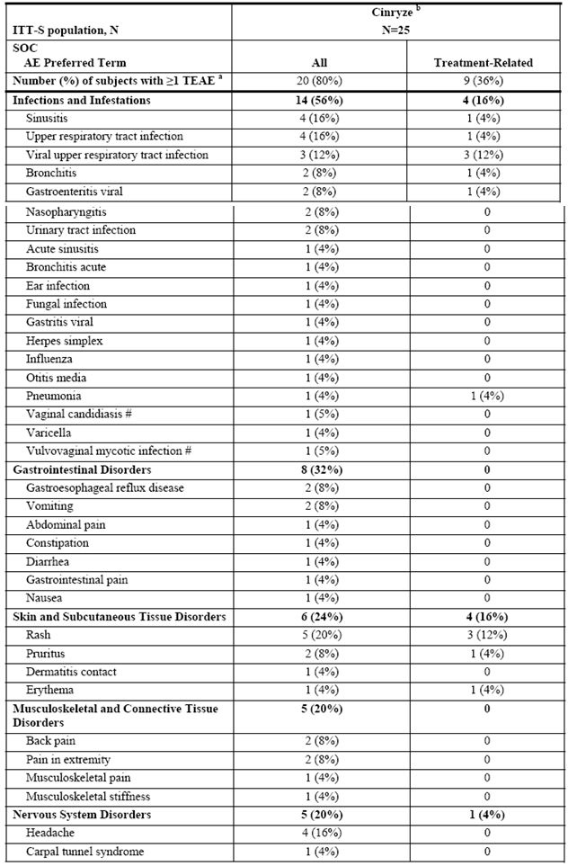

Table 24 (continued): TEAEs (All and Treatment Related) by SOC and Preferred Term (Reported in > 1 subject per SOC): ITT Safety Population (Study LEVP 2005-1/Part B).

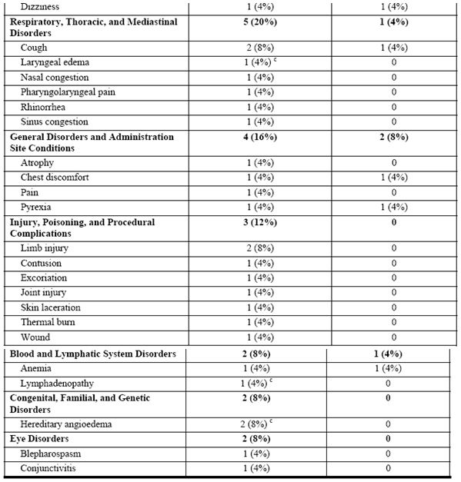

# signifies a gender specific term.

a: If Cinryze was administered within 30 days prior to AE onset, or Cinryze was the last study drug received prior to AE onset, then the AE was attributed to Cinryze treatment.

b: Includes all 25 subjects who were exposed to Cinryze as randomised treatment and/or open-label treatment.

c: Treatment emergent SAEs

NOTE: A subject may have reported more than one TEAE or more than one TEAE per SOC.

Twenty subjects (80%) reported ≥ 1 TEAE and 9 subjects (36%) reported ≥ 1 treatment related TEAE. The SOC in which subjects most commonly reported TEAE following exposure to Cinryze were infections and infestations (56%), followed by gastrointestinal disorders (32%) and skin and subcutaneous tissue disorders (24%). In the infections and infestations SOC, the most frequently reported TEAE were sinusitis and upper respiratory tract infection, each reported by four subjects, and each with one subject reporting an event that was considered by the investigator to be related to study drug. In the gastrointestinal disorders SOC, the most frequently reported TEAE were gastroesophageal reflux disease and vomiting, each reported by two subjects. All TEAE in this SOC were considered by the investigator to be unrelated to study drug. In the skin and subcutaneous tissue disorders SOC, the most frequently reported TEAE were rash (5 subjects), and pruritus (2 subjects) Of these, three subjects that had events of rash, and one subject with the event of pruritus, were considered to be related to study drug. By preferred terms the TEAE reported by more than one subject were headache (4 subjects), back pain, extremity pain, cough, limb injury, and HAE (2 subjects each). Of these, 1 subject with a TEAE of cough was considered to be related to study drug.

Overall, treatment related TEAE reported in >1 subjects were viral upper respiratory tract infection (12%, 3/25) and rash (12%, 3/25).

##### Studies LEVP 2006-5 (open label PK study), LEVP 2006-1 (open label, acute treatment) and LEVP 2006-4 (open label, prophylaxis)

In Study LEVP 2006-5, 27 subjects were exposed to Cinryze, 13 receiving single dose and 14 receiving double dose of Cinryze. Overall, six subjects reported ≥1 TEAE: 5 (38%) out of the 13 single dose subjects and 1 (7%) out of the 14 double dose subjects. A summary of the most commonly reported TEAE by SOC and preferred term (reported in >1 subject per SOC in either treatment group) in Study LEVP 2006-5 is presented in Table 25. The SOC in which subjects most commonly reported TEAE following exposure to Cinryze were infections and infestations (4 subjects [15%]; 3 subjects [23%] in the single dose group, and 1 subject [7%] in the double dose group). Two events of nasopharyngitis (1 severe, 1 moderate) reported by one subject in the double dose group were considered to have unknown relationship to the study drug. All other events were considered by the investigator to be unrelated to study drug.

Table 25: TEAEs (All and Treatment Related) by SOC and Preferred Term (reported in >1 subject per SOC) – ITT Safety Population (Study LEVP 2005-1/Part B).

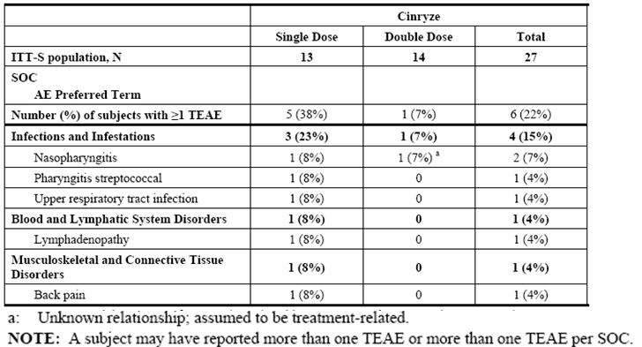

In Study LEVP 2006-1, 113 subjects were exposed to Cinryze.[26] The SOC in which subjects most commonly reported TEAE following exposure to Cinryze were infections and infestations (17 subjects; 15%), followed by gastrointestinal disorders (12 subjects; 11%). Three (3%) subjects reported a total of four TEAE considered by the investigator to be related to Cinryze. Two of these events (infusion site pain and rash) were considered to be possibly related to Cinryze and the remaining two events (sinusitis and joint swelling) were judged to be of unknown relationship to Cinryze.[27]

In Study LEVP 2006-4, 146 subjects were exposed to Cinryze. The SOC in which subjects most commonly reported TEAE following exposure to Cinryze were infections and infestations (89 subjects; 61%), followed by gastrointestinal disorders (59 subjects; 40%). TEAE considered by the investigator to be related to study drug are summarised in Table 26. Overall, 39 subjects (27%) reported ≥1 TEAE judged to be related to the study drug. The most frequently reported TEAE considered related to Cinryze was headache (reported by 8 subjects; 5.5%), nausea (reported by 6 subjects; 4.1%), and rash (reported by 4 subjects; 2.7%). TEAE considered by the investigator to be related to study drug and reported in >1 subject is tabulated in Table 27.

Table 26: TEAEs related to Cinryze – reported in >1 subject – ITT Safety Population (Study LEVP 2006-4).

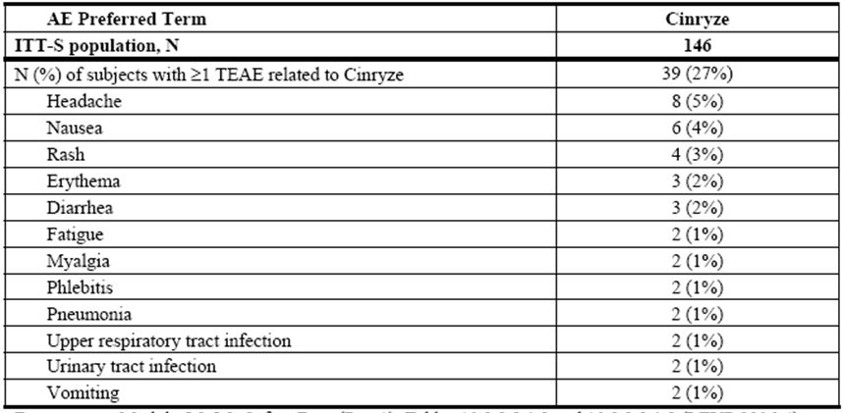

Table 27: TEAEs related to Cinryze – reported in >1 subject – ITT Safety Population.

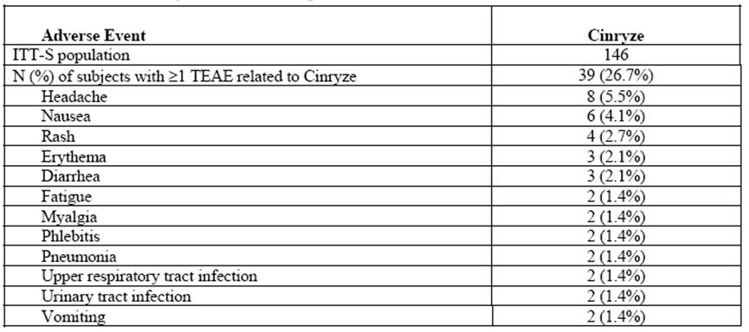

#### SAEs and deaths

No deaths occurred in Studies LEVP 2005-1/Part A, LEVP 2005-1/Part B and LEVP 2006-5. One death occurred in Study LEVP 2006-1, and 2 deaths in Study LEVP 2006-4. All 3 deaths were considered by the investigators to be unrelated to the study drug. In Study LEVP 2006-1, a 45 year old White male subject who received open label Cinryze for the treatment of HAE attacks, experienced a SAE of B cell lymphoma which resulted in death. In Study LEVP 2006-4, a 71 year old White male with a history of liver cancer who received open label Cinryze for the prevention of HAE attacks, experienced a SAE of non resectable malignant hepatic neoplasm, which resulted in death. The other death in Study LEVP 2006-4 involved a 34 year old White female who received open label Cinryze for the prevention of HAE attacks, and who experienced a SAE of pulmonary embolism which resulted in death. An autopsy report later indicated that the cause of death was pulmonary arterial embolisation of foreign material due to IV injection of oral medication (diphenhydramine and/or hydroxizine).

Other treatment emergent SAE (excluding those that resulted in death) were reported by a total of 41 subjects treated with Cinryze in three studies: 4 subjects in Study LEVP 2005-1/Part B, 6 subjects in Study LEVP 2006-1, and 31 subjects in Study LEVP 2006-4. Two of these SAE (exacerbation of major chronic depression and musculoskeletal chest pain, reported in LEVP 2006-4) were considered to have an unknown relationship to study drug. Both these SAE resolved. All other SAE were considered unrelated to study drug.

#### Laboratory findings

##### Haematology and clinical chemistry

Clinical laboratory assessments (CBC, BUN, and creatinine) were performed for subjects who participated in Studies LEVP 2005-1/Part A, LEVP 2005-1/Part B, and LEVP 2006-5. In Study LEVP 2005-1/Part A, CBC and clinical chemistry (BUN and creatinine) testing were performed pre infusion (baseline) and 12-24 h post infusion for subjects who received randomised study drug. In Study LEVP 2005-1/Part B, CBC and clinical chemistry testing were to be performed at the first study visit (pre infusion [baseline]) in Period 1 and at the 3 month follow up visit. However, only 12 of the 25 subjects who received study drug had baseline and any post baseline haematology and/or clinical chemistry evaluations. In Study LEVP 2006-5, CBC and clinical chemistry testing were performed pre infusion (baseline), and at the 1 day and 7 day post infusion follow up visits.

Overall, there were no significant laboratory findings of safety concern. In addition, in Study LEVP 2006-5, no dose related trends were observed between subjects who received a single dose of 1000 U Cinryze or two 1000 U doses separated by 1 h.

##### Virology

One of the safety concerns of particular interest for Cinryze and other plasma protein products is the risk of transmission of infectious diseases. Cinryze is manufactured from donated human plasma, and thus has an inherent potential risk for certain infectious disease transmissions.

Subjects in Studies LEVP 2005-1/Part A, LEVP 2005-1/Part B, LEVP 2006-5, LEVP 2006-1, and LEVP 2006-4 were tested for the presence of various viruses pre and post infusion, including hepatitis B, hepatitis C, and HIV. The results showed no evidence of transmission of hepatitis B, hepatitis C, and HIV to subjects during any of the studies.

Parvovirus B19 testing was performed in Studies LEVP 2005-1/Part A, LEVP 2005-1/Part B, LEVP 2006-1, and LEVP 2006-4. There was no evidence of Parvovirus B19 transmission in Studies LEVP 2005-1/Part A, LEVP 2005-1/Part B and LEVP 2006-4. One subject in LEVP 2006-1 had a confirmatory positive Parvovirus B19 infection post baseline. However, the sponsor stated that this subject received Cinryze from three separate lots prior to Parvovirus B19 seroconversion, and that Cinryze from one or more of these lots was also administered to 10 other subjects in this study with negative Parvovirus B19 tests at baseline. There was no evidence of new Parvovirus B19 infection in these subjects post baseline.

#### Safety in special populations

##### Paediatric subjects

In Study LEVP 2005-1/Part A, among the 12 paediatric subjects (aged < 18 years) exposed to Cinryze, no TEAEs were reported.

In Study LEVP 2006-1, the proportion of paediatric subjects (aged < 18 years) reporting a TEAE was 38% (9/24) and was comparable with that in subjects ≥18 years of age (42%, 37/89). No TEAE was reported for the 1 subject between 2-5 years of age. Among the 10 subjects in the age group of 6-11 years, 10 TEAEs were reported by 6 subjects.[28] Among the 13 subjects in the age group of 12-17 years, 5 TEAEs were reported by 3 subjects.[29] No paediatric subjects reported a TEAE that were considered by the investigator to be related to Cinryze, while among subjects >18 years of age, 3% (3/89) of subjects reported TEAE that were considered by the investigator to be related to Cinryze.

In Study LEVP 2005-1/Part B, TEAEs were reported by 100% (4/4) of subjects <18 years of age compared to 76% (16/21) of subjects ≥18 years of age. There was 1 subject in the age group of 6-11 years, and 13 TEAEs were reported by the subject.[30] Among the 3 subjects in the age group of 12-17 years, 9 TEAEs were reported by the 3 subjects.[31] TEAEs considered by the investigator to be related to Cinryze were reported by 25% (1/4) of subjects <18 years of age (1 event of pyrexia in a subject in the 6-11 years age group) compared to 38% (8/21) of subjects ≥18 years of age.

In Study LEVP 2006-4, TEAEs were reported by 74% (17/23) of subjects <18 years of age compared to 79% (97/123) of subjects ≥18 years of age. Treatment related TEAEs were reported by 17% (4/23) of subjects <18 years of age compared to 28% (35/123) of subjects ≥18 years of age. No subject between 2-5 years of age reported a treatment related TEAE. Among the 9 subjects in the age group of 6-11 years, and 4 treatment related TEAE (dizziness, headache, mouth ulceration, and nausea) were reported by 2 subjects. Among the 12 subjects in the age group of 12-17 years, 3 treatment related TEAE (infusion site erythema, metrorrhagia, and photosensitivity reaction) were reported by 2 subjects. The TEAEs in these children that were considered by the investigator to be possibly, probably, or definitely related to Cinryze were headache, nausea, and infusion site erythema. The events of dizziness, mouth ulceration, metrorrhagia, and photosensitivity reaction were judged to be of “unknown” relationship to Cinryze.

###### Comments:

*There were no obvious differences in the type or incidence of TEAEs between the paediatric subjects (<18 years of age) and the adult subjects (≥18 years of age). However, the sample sizes involved were very small.*

##### Pre procedure

Although the use of Cinryze as pre procedure prophylaxis would not be considered a special patient population per se, it will be presented here as pre procedure prophylaxis is one of the indications being submitted for registration, and the risk-benefit analysis would be different compared to that of acute treatment indication.

Overall, there were a total of 41 unique subjects who received pre procedure administration of Cinryze in Studies LEVP 2005-1/Part A and LEVP 2006-1. These 41 subjects received Cinryze prior to a total of 91 procedures. Twelve TEAE were reported by 7 subjects within 7 days after pre procedure administration of Cinryze. None of the TEAEs were considered by the investigator to be related to study drug. The only TEAE reported by more than one subject following pre procedure administration of Cinryze was mild constipation (2 subjects). Other events included single reports of coronary artery disease, back pain, renal transplant, adenoidal hypertrophy, increased blood glucose, intestinal perforation, B cell lymphoma, herpes simplex, upper abdominal pain, and procedural pain.

##### Pregnancy

No special analysis was done for the women who received Cinryze while pregnant. A description of the outcomes of the pregnancies is summarised here as a pregnancy category of B2 is included in the proposed PI by the sponsor.

Overall, 16 subjects received Cinryze during pregnancy: 1 subject in Study LEVP 2006-2 (compassionate use study), 2 subjects in Study LEVP 2006-1, 2 subjects who participated in both Studies LEVP 2006-1 and LEVP 2006-4, and 11 subjects in Study LEVP 2006-4. Out of these 16 subjects, 13 subjects delivered 14 healthy neonates (that is, there was 1 set of healthy twins), 1 subject had a spontaneous abortion, and 1 subject delivered a stillborn neonate with multiple congenital anomalies. These two adverse foetal outcomes were not considered to be related to Cinryze. The outcome was unknown for one subject.

#### Immunological events

The antigenicity of Cinryze was evaluated by an assessment of anti C1 INH antibodies in Studies LEVP 2005-1/Part A, LEVP 2005-1/Part B, LEVP 2006-5, LEVP 2006-1, and LEVP 2006-4. Anti-C1 INH antibody testing for Studies LEVP 2005-1/Part A, LEVP 2005-1/Part B, LEVP 2006-5, and LEVP 2006-1 was initially performed by a protocol defined laboratory. The sponsor stated that during the course of the studies there were occasional positive anti C1 INH antibody titres that were thought to be spurious due to incongruence with clinical picture, or repeated tests being found to be within normal limits. Samples from subjects in Studies LEVP 2005-1/Part A and LEVP 2005-1/Part B with positive titres based on the assay from the initial laboratory were retested at another laboratory, which showed the samples not to be positive for anti C1 INH antibodies. The sponsor concluded that there was no evidence of anti C1 INH antibody development following administration of Cinryze in Studies LEVP 2005-1/Part A and LEVP 2005-1/Part B.

Sanquin, the manufacturer of Cetor, subsequently developed a validated assay to detect IgA, IgM, and IgG antibodies against C1 inhibitor. This assay was used for antibody testing in Studies LEVP 2006-1 and LEVP 2006-4. The results showed that there was no antibody development following administration of Cinryze.

#### Discontinuation due to Adverse Events

No subjects in any of the eight completed studies discontinued study drug (Cinryze or placebo) due to an AE.

#### Evaluator’s overall conclusions on clinical safety

Overall, the safety profile of Cinryze in terms of commonly occurring AE was comparable across the clinical studies (Table 28). Across the five clinical studies, the most commonly occurring AE by SOC were infections and infestations, except in Study LEVP 2005-1/Part A, where it was general disorders and administration site conditions. Among the TEAEs, the preferred term of rash was the only TEAE that occurred at a frequency of ≥1% (it occurred at a frequency of ≥1% to <10%) (Table 23).None of these rashes were SAE, and no rash led to discontinuation of study drug.

Table 28: Commonly occurring AEs across Cinryze clinical studies.

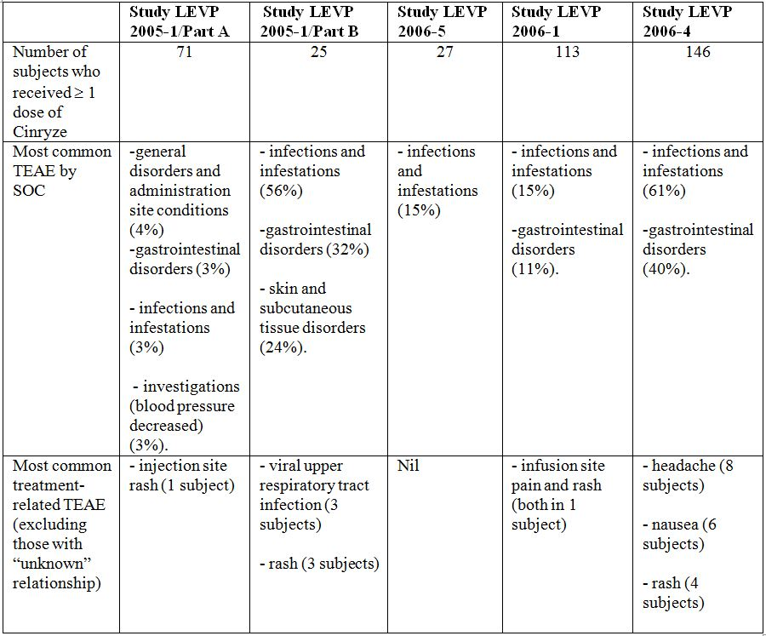

Studies LEVP 2005-1/Part A and LEVP 2005-1/Part B were placebo controlled trials. However, subjects in Study LEVP 2005-1/Part A were allowed to receive open label Cinryze even if they were randomised to the placebo treatment group, resulting in only 12 subjects who received placebo only and being able to serve as a control arm in the analysis of safety data. Study LEVP 2005-1/Part B was a crossover study in which all subjects received Cinryze. The sponsor looked at TEAE with an onset prior to Cinryze infusions, but in Study LEVP 2005-1/Part B only one TEAE (sinusitis) occurred prior to exposure to Cinryze. Therefore, in the safety evaluation of Cinryze, no meaningful comparison with placebo or analysis for statistical significance of any difference from placebo was done.

There were no particular safety concerns with regards to the incidence of deaths or SAEs. The 3 deaths that occurred (1 death in Study LEVP 2006-1 and 2 deaths in Study LEVP 2006-4) were considered by the investigators to be unrelated to the study drug. No SAEs were considered to be definitely or possibly related to Cinryze. Two SAEs (exacerbation of major chronic depression and musculoskeletal chest pain, reported in Study LEVP 2006-4) were considered to have an unknown relationship to study drug.

There were also no significant laboratory findings of safety concern. Only haematology and clinical chemistry tests were performed. However, this was appropriate as Cinryze is a plasma protein and not a small molecule drug. One of the safety concerns of particular interest for Cinryze and other plasma protein products is the risk of transmission of infectious diseases. Cinryze is manufactured from donated human plasma, and thus has an inherent potential risk for certain infectious disease transmissions, although donated human plasma would be screened for pathogens. The sponsor had also stated that the manufacturing process utilised to produce Cinryze incorporates three virus inactivation/removal steps: PEG precipitation, pasteurisation, and nanofiltration to reduce the possibility of infectious disease transmission. Virological testing showed no evidence of transmission of hepatitis B, hepatitis C, HIV or Parvovirus B19 with Cinryze infusion. No particular concern was also elicited in the antigenic analyses of Cinryze.

In terms of safety dose relationships, the sample size involved (13 subjects received single dose and 14 subjects received double dose of Cinryze in Study LEVP 2006-5) was too small to draw definite conclusions. From the data available, there was no obvious dose related safety trends observed between subjects who received a single Cinryze dose of 1000 U or two 1000 U doses separated by 1 h.

In the analyses of safety data in the paediatric population in the studies, there were no obvious differences in the type or incidence of TEAEs between the paediatric subjects (<18 years of age) and the adult subjects (≥18 years of age), but the sample size involved was small.

### List of questions

#### Pharmacokinetics

None.

#### Pharmacodynamics

None.

#### Efficacy

Are other studies being planned to evaluate the efficacy and safety of lower doses of Cinryze in paediatric subjects?

In the submitted clinical studies, the paediatric subjects received the same doses and dosing regimen of Cinryze as the adults, except for a 2 year old subject in Study LEVP 2006-1 who received two 500 U doses of Cinryze 1 h apart for the acute treatment of a HAE attack. No prospective rationale was given in the submission for the use of the same dose of Cinryze in children as that used in adults in the clinical studies. In this submission, no PK study results in children < 18 years of age was available yet, although it is noted that a paediatric PK/PD study (Protocol 0624-203) commenced in March 2010. In the study protocols, it was stated that the dosage regimen of Cinryze was based on that for Cetor. However, in the PI of Cetor, it was stated that:

*“Considering the limited data on the efficacy and safety of C1 esterase inhibitors in children below 12 years of age, no dosage recommendation can be given.”*

It is noted that retrospective analyses of C1 INH antigenic and functional levels in the clinical studies by age group were done subsequently, but interpretation was difficult as the paediatric subpopulation sample size was small and C1 INH antigenic and functional levels were measured only at a few time points such that a full PK profile in paediatric subjects (for example, half life and clearance) was not obtained. Although the sub analyses of safety data in the paediatric population in the studies showed no obvious safety concerns, the sample size was too small to allow robust interpretation. As no lower doses of Cinryze were tested in paediatric subjects, there was no information available on the efficacy and safety of a lower dose of Cinryze or what the lowest efficacious dose in paediatric subjects was.

It is noted that in Cinryze preclinical studies, a potential thrombogenic threshold at doses greater than 200 U/kg has been identified in a preclinical animal model. The evaluator agrees that as the proposed acute treatment dose regimen of Cinryze is 1000 U followed by another 1000 U an hour later if necessary, there is some margin of safety as long as a patient is >10 kg. As the proposed indication submitted included only children from 6 years of age, with likely weights of about 20 kg, there would be a certain margin of safety. However, the principle remains that a lowest efficacious dose should be elicited in order to increase any margin of safety, especially in view of variations in the body weights of children of the same age, the lack of dose-proportionality in the PK of Cinryze, and the long elimination half life of Cinryze.

#### Safety

None.

### Clinical summary and conclusions

#### Clinical aspects

##### Pharmacokinetics

A single clinical PK study (Study LEVP 2006-5) was done in the target patient population. No PK study was done in healthy individuals. This is appropriate as Cinryze is purified C1 inhibitor protein derived from pooled plasma of human donors, and is meant as a replacement treatment for patients with inherited C1 inhibitor deficiency.

Study LEVP 2006-5 was a randomised, open label, parallel group study evaluating the PK and PD of Cinryze in non symptomatic adult HAE subjects. Subjects were randomised to receive by IV infusion a single dose (1000 U) of Cinryze, or two 1000 U doses of Cinryze, to be given 1 h apart. A total of 27 subjects were randomised and treated, with 13 receiving a single dose and 14 receiving a double dose of Cinryze. All 27 subjects were included in the PK analysis population. The subjects had an age range of 19 to 57 years.

PK measures were C1 INH antigen and functional C1 INH protein levels. This is appropriate as C1 INH deficiency may be a result of reduced quantity of C1 INH or diminished C1 INH function. Overall, the PK results showed that treatment with Cinryze resulted in increases in both antigenic and functional C1 INH. After a single dose of Cinryze, the concentrations of antigenic and functional C1 INH were both maximal at a median time of 1.2 h. After a double dose of Cinryze, the concentrations of antigenic and functional C1 INH were maximal at a median time of 1.5 and 2.2 h, respectively. Cinryze has a long half life, with mean halflives ranging from about 2 to 2.5 days for antigenic and functional C1 INH.[32] The PK parameters did not demonstrate dose proportionality. Both the Cmax and AUC0-t increased with dose, but the increase was not dose proportional. A 2 fold increase in dose led to an increase of 1.4 to 1.5 fold of baseline corrected antigenic and functional C1 INH Cmax values and an increase of about 1.5 to 1.6 fold of baseline corrected antigenic and functional C1 INH AUC0-t values. The sponsor did not give any reasons for the demonstrated lack of dose proportionality.

No PK studies were done in paediatric subjects <18 years of age, although in the Phase 3 trials, in which subjects < 18 years of age were enrolled, C1 INH antigen and functional C1 INH protein levels were measured. The sponsor stated that a paediatric PK/PD study (Protocol 0624-203) commenced in March 2010.

There were also no studies conducted on drug-drug interactions and on the PK of Cinryze in subjects with renal or hepatic impairment. This is acceptable as Cinryze is a human plasma protein and glycoproteins are metabolised via degradation into smaller peptides and individual amino acids. Cinryze is therefore not expected to be subjected to metabolism by the cytochrome P450 system, or excretion. The PK of Cinryze is not expected to be altered by the presence of renal or hepatic impairment.

##### Pharmacodynamics

PD data was derived from the same PK study, Study LEVP 2006-5. The PD biomarker used was serum complement C4 levels. The use of this biomarker is appropriate. In the complement system, the primary substrate of activated C1 enzyme is C4, that is, activated C1 enzyme leads to proteolytic cleavage of C4. A deficiency of C1 INH leads to uninhibited C1 enzyme activity, and results in diminished C4 levels. An increase in C4 levels can therefore be used as a measure of the biological effect of Cinryze. In clinical practice, serum C4 level is used as a screening test for HAE, where C4 levels would be lower than normal.

Overall, the PD results showed that treatment with Cinryze led to the intended biological effect, reflected by an increase in complement C4 levels. The maximal effect occurred approximately 2 days (median) after dosing, and lagged behind the maximal C1 INH antigenic and functional levels, which occurred within 2.2 h (median) post dose. The maximal PD effect had a range of 6 to 100 h after a single dose and of 7 to 99 h after double dose. This is consistent with the long half life of Cinryze.

No specific plasma concentration-effect analysis was performed. However, it was noted that the difference in complement C4 Cmax values between the single dose and double dose treatment groups was similar to that observed with C1 INH antigen and functional C1 INH. The complement C4 Cmax value, a surrogate for biologic activity, increased by ~1.47 fold with a 2 fold increase in dose. This increase was similar to that observed with C1 INH antigen, where baseline corrected antigenic C1 INH Cmax increased by ~1.53 fold for a 2 fold increase in dose. It was also similar to that observed with functional C1 INH, where baseline corrected functional C1 INH Cmax values increased ~1.37 fold for a 2 fold increase in dose.

##### Efficacy

Overall, the clinical efficacy results supported the indications of acute treatment, routine prophylaxis and pre procedure prophylaxis of HAE attacks in HAE patients.

Efficacy data for Cinryze was based on the data from two pivotal randomised, double blind placebo controlled Phase 3 trials (Studies LEVP 2005-1/Part A and LEVP 2005-1/Part B), supplemented by that from two open label studies (Studies LEVP 2006-1 and LEVP 2006-4). Studies LEVP 2005-1/Part A and LEVP 2006-1 evaluated the use of Cinryze in the treatment of acute HAE attacks, while Studies LEVP 2005-1/Part B and LEVP 2006-4 evaluated the use of Cinryze in the prevention of HAE attacks. In addition, the efficacy data was analysed in the sub population of paediatric subjects in the four studies and for pre procedure prophylaxis in Studies LEVP 2005-1/Part A and LEVP 2006-1.

###### Acute treatment of HAE attacks

Main clinical study

Study LEVP 2005-1/Part A was a Phase 3, randomised, double blind, placebo controlled, multicentre study, evaluating the safety and efficacy of Cinryze for the treatment of acute HAE attacks. The study inclusion and exclusion criteria were appropriate, with the study diagnostic criteria of HAE being in line with that in current clinical practice. The study inclusion and exclusion criteria allowed inclusion of subjects with both Types I and II HAE, and also allowed screening for and exclusion of subjects with acquired angioedema. The primary and secondary endpoints of the study were appropriate. The primary endpoint looked at efficacy in terms of the start of symptomatic relief from attacks post treatment with Cinryze or placebo. The secondary endpoints further characterised the efficacy, as well as further characterising the PK and PD parameters. Overall 71 subjects presented to the site with qualifying “randomisable” attacks, and 36 subjects were randomised to receive Cinryze, and 35 subjects to receive placebo. Overall, baseline characteristics were similar between the two treatment groups. However, in this study, the majority of subjects in both treatment groups were female (75% and 80% in the Cinryze and placebo groups, respectively). While this is not representative of the general patient population, it is not likely to affect the ability of the study results to be extrapolated to the general patient population. Cinryze is a purified plasma protein to be administered IV and hence is not subjected to metabolic processes that may be affected by gender. In addition, the pathophysiology of the target disease state of HAE does not have a gender basis. The sponsor had noted in the submission that the predominance of female subjects in Cinryze clinical studies was not unexpected as they were conducted in the US at a time when no other C1 INH product was approved by the US FDA, and danazol was commonly used for managing HAE. Due to the potential side effects of danazol as an attenuated androgen, it was expected that women with HAE would be more likely to seek alternative therapies and participate in the studies. The analysis of efficacy was based on two analysis populations: the “All Randomised (ITT) Dataset” and the “Efficacy Dataset”, a subset of the ITT population that included only subjects who had “true” HAE attacks. “True” HAE attacks were defined as HAE attacks that were associated with complement C4 level that was lower than that at baseline (screening). There were 71 subjects in the All Randomised (ITT) Dataset, 36 in the Cinryze group, and 35 in the placebo group. There were 68 subjects in the Efficacy Dataset, 35 in the Cinryze group, and 33 in the placebo group. The evaluator agrees with the sponsor that although the Efficacy Dataset was a subset of the All Randomised (ITT) Dataset, and was labelled as an “efficacy dataset”, a term that is more commonly applied to per protocol populations, it fulfilled the criteria of a “full analysis set” (that is, an ITT population analysis) as set out in the ICH E9 document on Statistical Principles for Clinical Trials.[33] In this study, although the exclusion of subjects who were judged not to have a “true” HAE attack was carried out after randomisation, this was most likely due to the infeasibility of having this exclusion carried out prior to randomisation as measurements of complement C4 levels at the laboratory would require a certain amount of turnaround time. In addition, this exclusion criterion was made objectively via laboratory measurements of complement C4 levels, was blinded, and was applied to all randomised subjects.

The subsequent sensitivity analyses also showed that the Efficacy Dataset analysis was robust. The primary efficacy analysis in the Efficacy Dataset showed that there was a statistically significant positive Cinryze effect. The sensitivity analyses showed that in the Efficacy Dataset, if the response of each responder in the Cinryze group was changed in turn to as if that subject had not responded, the analyses still showed a positive Cinryze effect that was statistically significant.

The primary efficacy analysis with the All Randomised (ITT) Dataset showed that among subjects yet to achieve unequivocal relief of symptoms, a subject who received Cinryze was 2.048 times (success ratio) as likely to achieve unequivocal relief of symptoms as a subject whoreceived placebo. However, although this was found to be statistically significant, the level of significance, p = 0.048, was at the threshold of the criterion for statistical significance (0.05). Analysis with the Efficacy Dataset showed a similar success ratio of 2.407, but with a level of statistical significance that was more convincing (p = 0.017).

Overall, in the Efficacy Dataset, 60.0% of subjects in the Cinryze treatment group had the beginning of unequivocal relief within 4 h compared with 42.4% of subjects in the placebo treatment group. Based on this, the primary efficacy analysis utilised an analysis that accounted for chronology of events and censoring, yielding results as described above showing that the difference between the treatment groups was statistically significant in favour of Cinryze. The secondary efficacy endpoint of the percentage of subjects who had unequivocal relief beginning within 4 h following randomised treatment utilised a simple proportion ratio analysis that did not account for chronology of events and censoring. This yielded results showing that the difference between the treatment groups was not statistically significant (p = 0.062).

The assessment of “unequivocal relief of symptoms” in the primary efficacy analysis included both improvement in as well as absence of symptoms, looked at the time of onset of the relief of symptoms, and was assessed for up to 4 h post dose. The secondary efficacy assessment of time to complete resolution looked at time of completed resolution of attack, and was assessed for up to 3 days post dose. It showed that the median time to complete resolution was 12.3 h in the Cinryze treatment group and from 25.0 to 31.6 h in the placebo treatment group. This secondary efficacy analysis showed that among subjects yet to achieve complete attack resolution, a subject who received Cinryze was 2.5 to 2.7 times as likely to achieve complete attack resolution as a subject who received placebo (p = 0.001 to 0.004).

The clinical efficacy results were consistent with the PK/PD profile in Study LEVP 2006-5, which showed that although the maximal C1 INH antigenic and functional levels occurred at a median of 1.2 h after a single dose and 1.5 to 2.2 h after a double dose of Cinryze given 1 h apart, the maximal biological effect (as measured by an increase in complement C4 levels) occurred at a median time of approximately 2 days after dosing (47 h and 49 h after a single and double dose, respectively). The maximal biological effect had a wide range of 6 h to 100 h after a single dose and 7 h to 99 h after a double dose of Cinryze, consistent with the long half life of Cinryze. Results in study LEVP 2005-1/Part A, showing onset of unequivocal relief of symptoms at a median time of 2 h post dose, and a complete resolution of symptoms at a median time of 12.3 h post dose, is consistent with this PK/PD profile.

The results yielded similar proportion ratios for onset of relief of symptoms and complete resolution of symptoms. Primary efficacy analysis showed that among subjects yet to achieve unequivocal relief of symptoms, a subject who received Cinryze was 2.407 times as likely to achieve the beginning of unequivocal relief of symptoms as a subject who received placebo. The secondary efficacy analysis looking at complete resolution of symptoms within 3 days post dose yielded a similar proportion: among subjects yet to achieve complete attack resolution, a subject who received Cinryze was 2.46 times as likely to achieve complete attack resolution as a subject who received placebo.

Supportive study

Study LEVP 2006-1 was a multicentre, open label, single arm study evaluating the safety and efficacy of repeat use of Cinryze for the acute treatment of HAE attacks. Results from this study generally supported the results of Study LEVP 2005-1/Part A. Study LEVP 2006-1 had a larger sample size than Study LEVP 2005-1/Part A, but was open label and uncontrolled. The study inclusion and exclusion criteria and study endpoints were appropriate. The efficacy endpoints evaluated included the time to beginning of unequivocal relief of the defining symptom, and the proportion of subjects who achieved unequivocal relief of the defining symptom within 1 and 4 h after start of the first dose of Cinryze. Overall, 113 subjects were enrolled, received at least one dose of Cinryze, and analysed for safety. Of the 113 enrolled subjects, 101 received Cinryze as treatment for an acute attack and were included in the analyses of efficacy. Overall, 68% (412/609) of attacks had unequivocal relief of the defining symptom beginning within 1 h after start of the first dose of Cinryze, and 87% (529/609) within 4 h after start of the first dose of Cinryze. Of the 101 subjects, 79% (80/101) achieved unequivocal relief of the defining symptom of the first attack within 4 h after start of the first dose of Cinryze. The median time to beginning of unequivocal relief in these subjects was 0.75 h. The results were comparable with those of Study LEVP 2005-1/Part A. In Study LEVP 2005-1/Part A, ~60% of subjects in the Cinryze treatment group had the start of unequivocal relief of the defining symptom within 4 h, and the median time to the start of unequivocal relief of symptoms was 2 h in the Cinryze treatment group. In this study (Study LEVP 2006-1), the proportion of subjects who had the start of unequivocal relief of the defining symptom within 4 h of Cinryze infusion was similar (79%). However, in this study the median time to beginning of unequivocal relief was 0.75 h.

###### Routine prophylaxis of HAE attacks

Main clinical study

Study LEVP 2005-1/Part B was a Phase 3, randomised, double blind, placebo controlled, multicentre, crossover study. The study inclusion and exclusion criteria were appropriate. The criteria used to define the diagnosis of HAE were consistent with current clinical diagnostic criteria, and the inclusion and exclusion criteria allowed inclusion of patients with both Type I and II HAE, and allowed exclusion of patients with acquired angioedema. In addition, only subjects with relativelyfrequent angioedema attacks (defined as at least 2 per month on average) were included. The primary and secondary endpoints were appropriate. The primary endpoint looked at prophylactic efficacy in terms of rate of angioedema attacks with Cinryze or placebo. The secondary endpoints further characterised the prophylactic efficacy in terms of the average duration and severity of the attacks, the total number of days of swelling, and the number of open label rescue Cinryze infusions needed, as well as further characterising the PK parameters. The efficacy dataset included all subjects who received randomised, double blind study medication and received at least 1 infusion in the second period after crossover. Overall, 24 randomised subjects were treated with study medication. Of the 24 subjects treated with randomised study medication, 22 (91.7%) were treated with both randomised Cinryze and placebo and therefore included in the efficacy dataset. Eleven of these were in the Cinryze/Placebo treatment sequence group, and 11 were in the Placebo/Cinryze treatment sequence group.

For the primary efficacy analysis, as this was a crossover study where each subject served as his/her own control, the comparison of demographic characteristics between the randomised treatment sequence groups is not crucial. It is more relevant that the demographic characteristics of the study population were representative of the general patient population, so that results can be extrapolated to the general patient population. In this study, all subjects except for 2 were females. While this is not representative of the general patient population, it is not likely to affect the interpretation of the study results due to the nature of Cinryze being a purified plasma protein to be administered intravenously and hence not subjected to genetic polymorphism of P450 system, and also due to the pathophysiology of the target disease state of HAE not having an ethnic or gender basis.

The primary efficacy analysis showed that there was a statistically significant lower (about half) frequency of HAE attacks in subjects treated with Cinryze, compared with placebo. The mean number of angioedema attacks in subjects treated with Cinryze was 6.1 attacks over a 12 week period. This gives a mean attack frequency rate of 1 attack every 2 weeks. The inclusion criteria of the study means that subjects had at baseline (pre study) an attack frequency rate of at least 2 attacks a month, that is, at least 1 attack every 2 weeks, although when in the study while on placebo, the mean attack frequency rate of the subjects were 12.7 attacks over the 12-week period, that is, about 1 attack a week. The actual mean baseline (pre study) attack frequency rate of subjects were not analysed in this study, and it was unknown how much reduction from baseline the mean attack frequency rate of 1 attack every 2 weeks represents. There is also no clinical consensus on an attack frequency rate that would represent successful prophylaxis or successful control of the condition. However, it is noted that the sample size was estimated based on an assumed attack frequency rate of 1 attack in 12 weeks when being treated with prophylactic Cinryze.

The secondary efficacy analyses generally supported the prophylactic efficacy of Cinryze when compared to placebo, in terms of the average duration and severity of the attacks, the total number of days of swelling, and the number of open label rescue Cinryze infusions needed. Results showed a statistically significant reduction in the average duration and severity of the attacks, the total number of days of swelling, and the number of open label rescue Cinryze infusions needed when subjects were on prophylactic Cinryze treatment compared to placebo.

Supportive study

Study LEVP 2006-4 was an open label, single arm, multicentre study evaluating the safety and efficacy of prophylactic use of Cinryze for the prevention of HAE attacks. The study inclusion and exclusion criteria and study endpoints were appropriate. Overall, 146 subjects were enrolled. All 146 subjects were analysed for the efficacy endpoints. Prior to enrolment, subjects reported a median monthly HAE attack rate of 3.0 (range of 0.08-28.0). During prophylactic treatment with Cinryze, 86% (126/146) of subjects experienced ≤1 HAE attack per month. Overall, the median number of HAE attacks per month was 0.21 (range of 0-4.56).The mean (± SD) number of HAE attacks per month was 0.50 (± 0.754). Comparison of the results of this study with those of Study LEVP 2005-1/Part B showed that in Study LEVP 2005-1/Part B, the mean number of angioedema attacks in subjects treated with Cinryze was 6.1 over a 12 week period (that is, ~2 attacks per month). However, in this study the mean number of HAE attacks per month was 0.50.

###### Special population

Paediatric subjects

The efficacy data was analysed in the subpopulation of paediatric subjects in the four studies. Although the paediatric subgroup analyses of each study involved very small sample sizes (a total of 46 unique paediatric subjects, with 3, 17 and 26 unique subjects in the age groups of 2-5 years, 6-11 years and 12-17 years, respectively) and were not analysed for statistical significance, these analyses generally showed comparable results to the overall results of each study.

With regards to acute treatment of HAE attacks, paediatric subgroup analyses of Study LEVP 2005-1/Part A showed that 71% (5/7) in the Cinryze group achieved beginning of unequivocal relief of the defining symptom within 4 h post dose compared with 40% (2/5) in the placebo group, and there was a shorter median time to beginning of unequivocal relief in the Cinryze group (30 minutes) compared to the placebo group (2 h). This was comparable with the results in the overall Efficacy Dataset in the study, which showed that 60.0% (21/35) of subjects in the Cinryze group and 42.4% (14/33) of subjects in the placebo group had the start of unequivocal relief of the defining symptom within 4 h post dose, and that the median time to the start of unequivocal relief of symptoms was 2 h in the Cinryze treatment group and >4 h in the placebo group. Paediatric subgroup analyses of Study LEVP 2006-1 showed that 78.5% (95/121) of HAE attacks in children aged 2-17 years had start of unequivocal relief within 1 h post dose, and 89.3% (108/121) of HAE attacks in children aged 2-17 years, had start of unequivocal relief within 4 h post dose. This was comparable with the results in the overall study population, which showed that 68% (412/609) of HAE attacks had start of unequivocal relief within 1 h post dose, and 87% (529/609) of HAE attacks had start of unequivocal relief within 4 h post dose.

With regards to prophylactic treatment of HAE attacks, Study LEVP 2005-1/Part B had only 4 paediatric subjects, and showed that the mean number of attacks while on prophylactic Cinryze treatment was 7.0 over the 12 week treatment period, compared with 13.0 while on the placebo treatment. This was comparable with the results in the overall study population, which showed that the mean number of attacks while on prophylactic Cinryze treatment was 6.1 over the 12 week treatment period, compared with 12.7 while on the placebo treatment. Paediatric subgroup analyses of Study LEVP 2006-4 showed that during prophylactic treatment with Cinryze, the median number of HAE attacks per month was 0.39, compared with a baseline, pre enrolment median monthly HAE attack rate of 3.0. This was comparable with the results in the overall study population, which showed that during prophylactic treatment with Cinryze, the median number of HAE attacks per month was 0.21, compared with a baseline, pre enrolment median monthly HAE attack rate of 3.0.

###### Pre procedure prophylaxis

Data on pre procedure administration of open label Cinryze were drawn from Studies LEVP 2005-1/Part A and LEVP 2006-1 and showed that after pre procedure administration of Cinryze prior to 91 procedures, 2 HAE attacks were reported within the 72 hours after the Cinryze dose. There is no clinical consensus on the baseline incidence of HAE attacks with procedures without prophylaxis, so no meaningful comparison can be made. However, it can be interpreted from the results that with pre procedure administration of Cinryze prior to 91 procedures, 89 procedures (98%) were not associated with a report of HAE attacks within 72 h post dose.

##### Safety

###### Patient exposure

Overall, eight studies were completed on Cinryze at the time of submission. In addition to the five studies submitted for this application, three compassionate use single subject studies/case studies were completed. The overall extent of exposure to Cinryze across the eight studies involved 14,573 infusions of 1000 U of Cinryze, administered to 262 unique subjects.

Overall, the amount of exposure to the drug is adequate to evaluate the safety profile of the drug. In the two Phase 3 trials, only 75 unique subjects were exposed to 1363 infusions. However, in the two open label studies, a further 165 unique subjects were exposed to 12904 infusions. This is adequate to evaluate the safety profile for a purified plasma protein.

###### Adverse events

There were no particular safety concerns with regards to the incidence of AEs. Overall, the safety profile of Cinryze in terms of commonly occurring AE was comparable across the clinical studies. Across the five clinical studies, the most commonly occurring AEs by SOC were infections and infestations, except in Study LEVP 2005-1/Part A where it was general disorders and administration site conditions. Among the treatment related AEs, the preferred term of rash was the only TEAE that occurred at a frequency of ≥ 1% (it occurred at a frequency of ≥ 1% to <10%). None of these rashes were SAE and no rash led to discontinuation of study drug.

Studies LEVP 2005-1/Part A and LEVP 2005-1/Part B were placebo controlled trials. However, subjects in Study LEVP 2005-1/Part A were allowed to receive open label Cinryze even if they were randomised to the placebo treatment group, resulting in only 12 subjects who received placebo only and being able to serve as a control arm in the analysis of safety data. Study LEVP 2005-1/Part B was a crossover study in which all subjects received Cinryze. The sponsor looked at TEAEs with an onset prior to Cinryze infusions, but in Study LEVP 2005-1/Part B only one TEAE (sinusitis) occurred prior to exposure to Cinryze. Therefore, in the safety evaluation of Cinryze, no analysis for statistical significance of any difference from placebo was done.

In terms of safety dose relationships, the sample size involved (13 subjects received single dose and 14 subjects received double dose of Cinryze in Study LEVP 2006-5) is too small to draw definite conclusions. From the data available, there was no obvious dose related safety trends observed between subjects who received a single Cinryze dose of 1000 U or two 1000 U doses separated by 1 h.

###### SAEs and deaths

There were no particular safety concerns with regards to the incidence of deaths or SAE. The 3 deaths that occurred (1 death in Study LEVP 2006-1 and 2 deaths in Study LEVP 2006-4) were considered by the investigators to be unrelated to the study drug. No SAEs were considered to be definitely or possibly related to Cinryze. Two SAEs (exacerbation of major chronic depression and musculoskeletal chest pain, reported in Study LEVP 2006-4) were considered to have an unknown relationship to study drug.

###### Laboratory findings

There were no significant laboratory findings of safety concern. Only haematology and clinical chemistry tests were performed. This is appropriate as Cinryze is a plasma protein and not a small molecule drug. One of the safety concerns of particular interest for Cinryze and other plasma protein products is the risk of transmission of infectious diseases. Cinryze is manufactured from donated human plasma, and thus has an inherent potential risk for certain infectious disease transmissions, although donated human plasma would be screened for pathogens. The sponsor had also stated that the manufacturing process utilised to produce Cinryze incorporates three virus inactivation/removal steps: PEG precipitation, pasteurisation, and nanofiltration to further reduce the possibility of infectious disease transmission. Virological testing showed no evidence of transmission of hepatitis B, hepatitis C, HIV or Parvovirus B19 with Cinryze infusions.

###### Safety in special populations

Paediatric population

In the analyses of safety data in the paediatric population in the studies, there were no obvious differences in the type or incidence of TEAE between the paediatric subjects (<18 years of age) and the adult subjects (≥18 years of age), but the sample size involved was small.

The paediatric subjects in the studies received the same doses and dosing regimen of Cinryze as the adults, except for a 2 year old subject in Study LEVP 2006-1 who received two 500 U doses of Cinryze 1 h apart for the acute treatment of a HAE attack. No prospective rationale was given in the submission for the use of the same dose of Cinryze in paediatric subjects as that used in adults in the clinical studies. At the time of submission, no PK studies have been completed in paediatric subjects. Retrospective analyses of C1 INH antigenic and functional levels in the clinical studies by age group were done subsequently, but interpretation was difficult as the paediatric subpopulation sample size was small and C1 INH antigenic and functional levels were measured only at a few time points such that a full PK profile in paediatric subjects (for example, half life and clearance) was not obtained. Although the sub analyses of safety data in the paediatric population in the studies showed no obvious safety concerns, the sample size was too small to allow robust interpretation. The efficacy and safety of a lower dose of Cinryze in paediatric subjects was not evaluated.

It was stated in the submission that thrombotic events were one of the adverse events of particular interest for Cinryze and other C1 INH products, as apart from regulating the complement and intrinsic coagulation pathways, C1 INH also regulates the fibrinolytic system by inactivating plasmin, which is involved in clot dissolution. This means that administration of C1 INH could have procoagulatory effects. In clinical practice, thrombotic events have been reported in neonatal and infant patients undergoing cardiac bypass procedures while receiving a C1 INH product, Berinert. The dosing regimen in these infants was up to 500 U/kg and was administered to patients who did not have C1 INH deficiency. In Cinryze preclinical studies, a potential thrombogenic threshold at doses greater than 200 U/kg has been identified in a preclinical animal model. The proposed acute treatment dose regimen of Cinryze 1000 U followed by another 1000 U an hour later if necessary means that there is some margin of safety as long as a patient is > 10 kg in body weight. As the proposed indication submitted included only children from 6 years of age, with likely weights of about 20 kg, there would be a certain margin of safety. However, the principle remains that a lowest efficacious dose should be elicited in order to increase any margin of safety, especially in view of variations in the body weights of children of the same age, the lack of dose proportionality in the PK of Cinryze, the long elimination half life of Cinryze, and inter individual variability in PK.

###### Pre procedure prophylaxis

Overall, there were no significant concerns in the safety profile of subjects who received pre procedure prophylactic Cinryze. A total of 41 subjects received Cinryze prior to a total of 91 procedures. Twelve TEAE were reported by 7 subjects within 7 days after pre procedure administration of Cinryze. None of the TEAEs were considered by the investigator to be related to study drug and the only TEAE reported by more than one subject following pre procedure administration of Cinryze was mild constipation (2 subjects).

###### Immunological events

No particular concern was also elicited in the antigenic analyses of Cinryze.

###### Discontinuation due to adverse events:

No subjects in any of the eight completed studies discontinued study drug (Cinryze or placebo) due to an AE.

##### Benefit risk assessment

###### Benefits

The benefits of Cinryze as a C1 INH are in the acute treatment and prophylaxis of HAE attacks in HAE patients. In current clinical practice, different drugs are registered for different indications in different countries or regions for the acute treatment or prophylaxis of HAE attacks (Table 29).

Table 29: Registered drugs for the acute treatment or prophylaxis of HAE attacks.

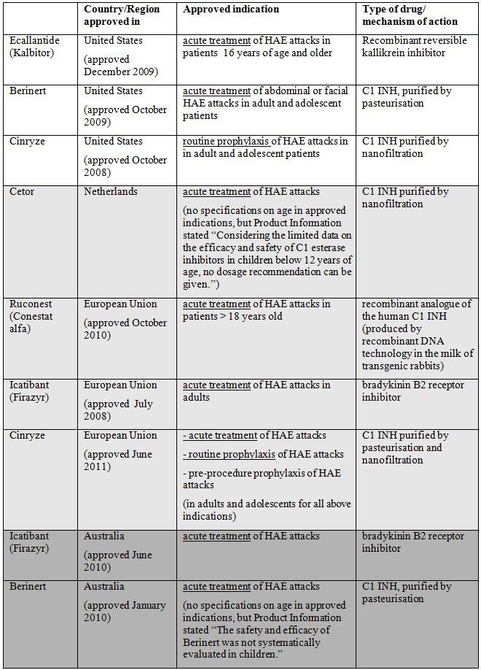

Source: FDA, EMA, TGA

In addition, drugs used in clinical practice for prophylaxis of HAE attacks includes attenuated androgens (for example, danazol) and tranexamic acid.

Although HAE is a rare genetic condition, HAE attacks are associated with morbidity and reduced quality of life, and can also be potentially fatal if the attacks involve the airways. There is only a limited range of drugs available for the acute treatment of HAE attacks. The range of drugs available for prophylaxis of HAE attacks is even more limited; in the US and EU, apart from Cinryze, the only other alternatives are danazol or tranexamic acid. Recombinant drug products are expansive, and danazol is associated with side effects like hepatotoxicity and virilisation, and is contraindicated in pregnancy, childhood, and breastfeeding. There is definite benefit in having an additional pharmacological treatment option.

Overall, the Cinryze clinical efficacy results supported the indications of acute treatment, routine prophylaxis and pre procedure prophylaxis of HAE attacks in HAE patients. However, there is limited data on paediatric subjects, and the rationale for the recommended dose in paediatric population is not convincing.

Results from Phase 3 clinical studies with Cinryze showed that, with regards to acute treatment of HAE attacks, the median time to onset of unequivocal relief of symptoms was 2 h post dose with Cinryze compared with > 4 h with placebo. The median time to complete resolution of attacks was 12.3 h with Cinryze compared with 25.0 h with placebo. Among subjects yet to achieve unequivocal relief of symptoms, a subject who received Cinryze was 2.407 times as likely to achieve the beginning of unequivocal relief of symptoms as a subject who received placebo (p = 0.017). Among subjects yet to achieve complete attack resolution, a subject who received Cinryze was 2.46 times as likely to achieve complete attack resolution as a subject who received placebo (p = 0.004). The open label study on acute treatment of HAE attacks showed that 68% and 87% of attacks had unequivocal relief of the defining symptom beginning within 1 and 4 h after start of the first dose of Cinryze, respectively. Out of 101 subjects analysed in the study, 79% achieved unequivocal relief of the defining symptom of the first attack within 4 h after start of the first dose of Cinryze.

Results from Phase 3 clinical studies with Cinryze showed that, with regards to prophylactic treatment of HAE attacks, the mean number of angioedema attacks in subjects treated with prophylactic Cinryze was 6.1 attacks over a 12 week period compared with 12.7 attacks in subjects treated with placebo (p <0.0001). The mean duration of attacks was shorter during treatment with Cinryze compared with placebo (2.1 days and 3.4 days, respectively; p = 0.0004) and the mean total number of days of swelling was also shorter during treatment with Cinryze compared with placebo (10.1 days and 29.6 days, respectively; p <0.0001). The mean severity of attacks was lower during treatment with Cinryze compared with placebo (score of 1.3 and 1.9, respectively; p = 0.0008). Subjects who were on Cinryze prophylaxis required a mean of 4.7 open label rescue C1 INH infusions compared with 15.4 infusions needed when subjects were on placebo (p <0.0001). The open label study on prophylactic treatment of HAE attacks showed that during prophylactic treatment with Cinryze, 86% of subjects experienced ≤ 1 HAE attack per month, with a mean frequency of 0.50 HAE attacks per month.

Sub analyses of data on pre procedure administration of Cinryze showed that with pre procedure administration of Cinryze prior to 91 procedures in 41 unique subjects, 89 procedures (98%) were not associated with a report of HAE attacks within 72 h post dose.

Although analyses of efficacy data in the subpopulation of paediatric subjects in the clinical studies showed efficacy results in paediatric subjects were generally comparable to the overall results of each study, the paediatric subgroup involved very small sample sizes (a total of 46 unique paediatric subjects, with 3, 17 and 26 unique subjects in the age groups of 2-5 years, 6-11 years and 12-17 years, respectively), and could not be analysed for statistical significance.

###### Risks

As a purified plasma protein derived from pooled plasma of human donors, the main safety concern with Cinryze is the transmission of infectious diseases, as well as the development of anti C1 INH antibodies. Safety data from the clinical studies showed that overall there were no particular safety concerns with regards to infectious disease transmission and antigenicity, as well as incidence of AEs.

Virological testing showed no evidence of transmission of hepatitis B, hepatitis C, HIV or Parvovirus B19 with Cinryze infusion. No particular concern was elicited in the antigenic analyses of Cinryze. Overall, there were no particular safety concerns with regards to the incidence of adverse events, and the safety profile of Cinryze in terms of commonly occurring AE was comparable across the clinical studies. There were also no particular safety concerns with regards to the incidence of deaths or SAE, and no significant laboratory findings of safety concern.

In terms of safety dose relationships, the sample size involved is too small to draw definite conclusions. From the limited data available, there was no obvious dose related safety trends observed between subjects who received a single Cinryze dose of 1000 U or two 1000 U doses separated by 1 h.

Of the 41 subjects who received Cinryze prior to a total of 91 procedures, 7 subjects reported a total of 12 TEAEs within 7 days after pre procedure administration of Cinryze, and none of the AE were considered by the investigator to be related to study drug.

Although the sub analyses of safety data in the paediatric population in the studies showed no obvious safety concerns, the sample size was too small to allow robust interpretation. The paediatric subjects in the clinical studies received the same doses and dosing regimen of Cinryze as the adults, except for a 2 year old subject in Study LEVP 2006-1 who received two 500 U doses of Cinryze 1 h apart for the acute treatment of a HAE attack. No prospective rationale was given in the submission for the use of the same dose of Cinryze in paediatric subjects as that used in adults in the clinical studies. Retrospective analyses of C1 INH antigenic and functional levels in the clinical studies by age group were done subsequently, but interpretation was difficult as the paediatric subpopulation sample size was small and C1 INH antigenic and functional levels were measured only at a few time points such that a full PK profile in paediatric subjects (for example, half life and clearance) was not obtained. As no lower doses of Cinryze were used in paediatric subjects, there was no information available on the efficacy and safety of a lower dose of Cinryze or what the lowest efficacious dose in paediatric subjects was.

It was stated in the submission that thrombotic events were one of the adverse events of particular interest for Cinryze and other C1 INH products, as apart from regulating the complement and intrinsic coagulation pathways, C1 INH also regulates the fibrinolytic system by inactivating plasmin, which is involved in clot dissolution. This means that administration of C1 INH could have procoagulatory effects. In clinical practice, thrombotic events have been reported in neonatal and infant patients undergoing cardiac bypass procedures while receiving a C1 INH product, Berinert. The dosing regimen in these infants was up to 500 U/kg and was administered to patients who did not have C1 INH deficiency. In Cinryze preclinical studies, a potential thrombogenic threshold at doses greater than 200 U/kg has been identified in a preclinical animal model. The proposed acute treatment dose regimen of Cinryze 1000 U followed by another 1000 U an hour later if necessary means that there is some margin of safety as long as a patient is > 10 kg in body weight. As the proposed indication submitted included only children from 6 years of age, with likely weights of about 20 kg, there would be a certain margin of safety. However, the principle remains that a lowest efficacious dose should be elicited in order to increase any margin of safety, especially in view of variations in the body weights of children of the same age, the lack of dose proportionality in the PK of Cinryze, the long elimination half life of Cinryze, and inter individual variability in PK.

###### Safety Specification

It is recommended that the RMP includes the future conduct of studies exploring the efficacy and safety of lower doses of Cinryze in children and adolescents. Otherwise, the safety specification in the RMP submitted appropriately addresses the safety concerns associated with Cinryze.

###### Balance

Clinical efficacy studies demonstrated efficacy in acute treatment, routine prophylaxis and pre procedure prophylaxis of HAE attacks of Cinryze over placebo. The safety data did not show any significant safety concerns.

However, with regards to the proposed indication for use of Cinryze for acute treatment, routine prophylaxis and pre procedure prophylaxis of HAE attacks in adolescents and children > 6 years of age, the sample size available was too small to make any robust interpretation although the efficacy and safety results were generally comparable to those in the adult subjects. With the potential occurrence of thrombotic events and with a preclinical study on Cinryze showing a potential thrombogenic threshold at doses greater than 200 U/kg, it is prudent to be conservative in maintaining a wide safety margin, pending further clinical studies on the efficacy and safety of lower doses of Cinryze in the paediatric population. This is especially so when a full PK profile of Cinryze in paediatric population is not available, current PK study does not demonstrate dose proportionality in the PK profile of Cinryze and the reason for this is unknown, Cinryze has a long elimination half life, there is an expected wide variation in body weights of paediatric subjects, and inter individual variability in PK needs to be taken into consideration.

It is reasonable to expect that in paediatric patients aged ≥ 12 years (that is, adolescents), their body weights would give sufficient margin of safety, taking into account expected inter individual variability in body weights and PK. However, in paediatric patients aged < 12 years (that is, children) it is recommended that further studies be done to elicit the minimum efficacious dose so that the safety margin can be better characterised. Based on this it is concluded that the benefit-risk ratio is positive with regards to the proposed indication for use of Cinryze for acute treatment, routine prophylaxis and pre procedure prophylaxis of HAE attacks only in adults and adolescents, but not in children.

Overall, the benefit-risk balance of Cinryze in the acute treatment, routine prophylaxis and pre-procedure prophylaxis of HAE attacks is positive in adults and adolescents, but not in children.

##### Conclusions

It is recommended that the application for registration of Cinryze for the indication of treatment, routine prevention and pre procedure prevention of angioedema attacks in patients with C1 inhibitor deficiency be approved, but restricted to adults and adolescents, and subject to a satisfactory response to the recommended changes in the PI.

## V. Pharmacovigilance findings

### Risk management plan

The sponsor submitted a RMP that was reviewed by the TGA’s Office of Product Review (OPR).

#### Safety specification

The sponsor provided a summary of Ongoing Safety Concerns which are shown at Table 30.

Table 30: Ongoing Safety Concerns for Cinryze.

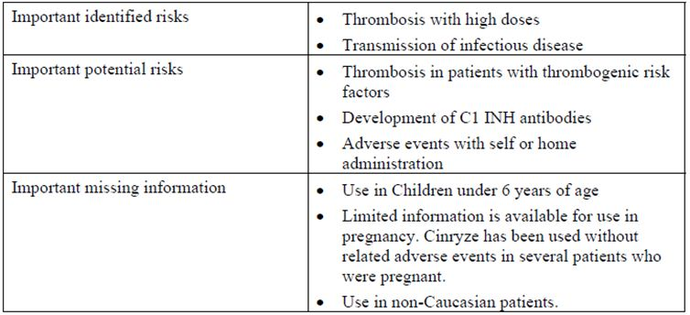

##### OPR reviewer comment:

The sponsor should consider including the Ongoing Safety Concern ‘Use in lactation’ as ‘Important missing information’.

#### Pharmacovigilance plan

The sponsor proposes routine pharmacovigilance activities, consistent with the activities outlined in published guidelines,[34] to monitor all the specified Ongoing Safety Concerns.

In addition, the sponsor proposes to further monitor the important identified risk: ‘Thrombosis with high doses’ and the important potential risk: ‘Development of C1 INH antibodies’. This would be through an open label, multicentre, Phase 4 study to assess the safety and efficacy of escalating doses of Cinryze in HAE subjects with inadequately controlled angioedema attacks while receiving the recommended Cinryze dosing regimen. In this study, the occurrence of thrombotic events and production of C1 INH antibodies will be monitored. The sponsor provided a synopsis of Protocol 0624-400, which commenced in July 2009 in the US.

Subjects with qualifying HAE attack rates, and who meet other specified entry criteria (for example, ≥6 years of age and ≥25 kg body weight), will be entered into a three step, dose escalation algorithm. Each step will consist of 12 weeks of initial monitoring of subject safety while receiving the escalated prophylaxis therapy dose, followed by computation of the average monthly attack rate based on subject reports of any HAE attack (regardless of intensity) and the actual duration of therapy for that step.

During the study, subjects or parents/caregivers will use a study diary each day to document specific information about any HAE attacks that occur and the number of associated days of missed school/daycare or work. Subjects or parents/caregivers will also receive instruction on how to recognize symptoms associated with potential thrombotic events and to seek medical attention for these symptoms in addition to informing their principal investigator.

The investigator or designee will monitor and document study compliance, tolerability of increased Cinryze dose, and AEs. For those subjects who are dosed by healthcare personnel at home or work, study personnel will contact each subject or parent/caregiver by telephone at weekly intervals during each 12 week monitoring period and every other week during the 3 month follow up period.

Safety will be monitored through the recording of adverse events and any changes in physical examinations, vital signs, or clinical safety laboratory testing. Confirmed diagnoses of clinically significant thrombotic or thromboembolic events will be reported as SAEs.

After a minimum of 6 months for those adequately controlled on the entry dose of this study (1500 U twice per week) and a maximum of 12 months of enrolment for subjects reaching the third tier of dose escalation (2500 U twice per week), subjects will have completed this study and their follow up will be referred to the physician who manages their HAE care.

This study will enrol 20 patients, each of whom will be assessed for successful control of HAE attacks following dose escalation. If four (or more) patients are deemed to have achieved successful control, the study will be declared a success. The sponsor states:

*“Assuming a null hypothesis of p ≤ 0.05 and desired power of 90%, observance of four (or more) patients with successful control will allow rejection of the null hypothesis in favour of the specific alternate hypothesis of p ≥ 0.30.”*

Safety data will be summarised by descriptive statistics. The occurrence of qualitative events will be reported as frequency counts. Continuous data (for example, labs and vital signs) will be reported by the mean and standard error for protocol specific time points and for changes from baseline.

The efficacy analysis will rely on calculation of patient specific HAE attack rates for both actionable attacks and any attacks. Rates will be normalised to monthly rates and subsequently reviewed for evidence of successful control. The sponsor reports that successful control of HAE attacks is defined as a calculated attack rate that is < 1.0 attack per month.

The sponsor reports that this study is ongoing in the US as an FDA post authorisation requirement. The first study report is expected on or before October 2012 (because of the small sample size, no interim analyses are planned).

The sponsor also states that in February 2010, an open label, multicentre, single dose Phase 2 study was initiated to evaluate the response and PK/PD of different doses of Cinryze for acute treatment in children less than 12 years of age with HAE (Protocol 0624-203). This study is planned to be completed by December 2012.

For the important missing information: ‘Use in pregnancy’, the sponsor recognises the specific need for more data on the use of Cinryze in pregnant HAE patients. Since pregnancy can act as a trigger for HAE attacks, the benefit of Cinryze in preventing an HAE attack often outweighs the potential safety risk to the foetus of receiving the drug. The foetal effects of Cinryze have not been fully evaluated; therefore, the sponsor proposes to collect additional information on pregnancies. Patients or health care practitioners will be requested to provide information on the pregnancy and the outcome of the pregnancy. Data collection will be voluntary and may be initiated by health care providers and/or pregnant patients. The sponsor states that patient initiated reports must be verified by their health care provider prior to entry into the Drug Safety database.

##### OPR reviewer’s summary in regard to the pharmacovigilance plan and appropriateness of milestones

In principle, there is no objection to the sponsor implementing additional pharmacovigilance activities to further monitor all of the specified ongoing safety concerns. However, the nonclinical and clinical aspects of the safety specifications remain subject to the evaluation by the Toxicology area of the OSE and by the OMA respectively.

The specified ongoing studies are not considered to be part of the planned clinical studies in the pharmacovigilance plan; therefore, the related study protocols have not been reviewed. Nevertheless an update on the progress/results/analysis of these studies will be expected in future PSURs according to planned dates for submission of final data.

The sponsor should also consider including ‘Use in lactation’ as important missing information. It is recommended that this Ongoing Safety Concern be monitored by routine pharmacovigilance activities. Consequently, the pharmacovigilance plan of the RMP should be amended accordingly.

#### Risk minimisation activities

##### Sponsor’s conclusion in regard to the need for risk minimisation activities

The ‘Summary Table of Planned Actions’ appears to imply that routine risk minimisation activities are sufficient for all the specified ongoing safety concerns. However, this table also states that in relation to the important potential risk: ‘Adverse events with self or home administration of Cinryze’, the sponsor proposes to develop a training programme for HCPs to train patients on self administration of Cinryze. In addition, the ‘Summary of the Pharmacovigilance and Risk Minimisation Actions’ states that in relation to this Ongoing Safety Concern, educational materials are proposed for all patients trained to self administer Cinryze.

##### OPR reviewer comment:

The proposed training programme for HCPs and the educational materials for patients are considered to be additional risk minimisation activities. Consequently, the sponsor should amend ‘Summary Table of Planned Actions’ to indicate that routine risk minimisation activities alone are insufficient to appropriately mitigate the specified Ongoing Safety Concern and to reflect the proposed use of additional risk minimisation activities for such purpose.

The ‘Summary Table of Planned Actions’ should also be amended to indicate that routine risk minimisation activities are not proposed for:

* the important potential risk: ‘Development of C1 INH antibodies’ due to no evidence of clinically relevant anti C1 INH antibody development following administration of Cinryze.
* the important missing information: ‘Use in non Caucasian patients’ due to the available clinical trial data not suggesting different safety risks based on race.

In addition, the nonclinical and clinical aspects of the safety specifications remain subject to the evaluation by the Toxicology area of the Office of Scientific Evaluation and by the Office of Medicines Authorisation, respectively.

##### Potential for medication errors

The sponsor has advised that there is minimal potential for medication errors when Cinryze is administered by a medically trained professional. There is the possibility that Cinryze can be administered by the patient or caregiver at home, and this could increase the possibility for medication errors to occur. This can be mitigated by appropriate selection and training by HCPs.

##### OPR reviewer comment:

Given the post marketing exposure of C1 INH in the US, the sponsor should provide information on the occurrence and frequency of medication errors from related PSURs. Consequently, this part of the RMP should be amended accordingly.

#### Summary of recommendations

The OPR provides these recommendations in the context that the submitted RMP is supportive to the application; the implementation of a RMP satisfactory to the TGA is imposed as a condition of registration; and the submitted RMP is applicable without modification in Australia unless so qualified:

* The nonclinical and clinical aspects of the safety specifications remain subject to the evaluation by the Toxicology area of the Office of Scientific Evaluation and by the Office of Medicines Authorisation, respectively.
* In principle, there is no objection to the sponsor implementing additional pharmacovigilance activities to further monitor all of the specified ongoing safety concerns. However, the specified ongoing studies are not considered to be part of the planned clinical studies in the pharmacovigilance plan, therefore the related study protocols have not been reviewed. Nevertheless an update on the progress/results/analysis of these studies will be expected in future PSURs according to planned dates for submission of final data.
* The sponsor should consider including ‘Use in lactation’ as important missing information. It is recommended that this Ongoing Safety Concern be monitored by routine pharmacovigilance activities. Consequently, the pharmacovigilance plan of the RMP should be amended accordingly.
* The proposed training programme for HCPs and the educational materials for patients are considered to be additional risk minimisation activities. Consequently, the sponsor should amend the ‘Summary Table of Planned Actions’ to indicate that routine risk minimisation activities alone are insufficient to appropriately mitigate the specified ongoing safety concern and to reflect the proposed use of additional risk minimisation activities for such purpose.
* The ‘Summary Table of Planned Actions’ should be amended to indicate that routine risk minimisation activities are not proposed for:
  + the important potential risk: ‘Development of C1 INH antibodies’ due to no evidence of clinically relevant anti C1 INH antibody development following administration of Cinryze.
  + the important missing information: ‘Use in non Caucasian patients’ due to the available clinical trial data not suggesting different safety risks based on race
* Given the post marketing exposure of C1 INH in the US, the sponsor should provide information on the occurrence and frequency of medication errors from related PSURs. Consequently, this part of the RMP should be amended accordingly.
* The sponsor’s proposed routine and additional risk minimisation activities would appear to be reasonable, except for the handling of indwelling catheters which is captured under the important potential risk: ‘Thrombosis in patients with thrombogenic risk factors’. In regard to the proposed routine prevention of angioedema attacks, it may be expected that the use of indwelling catheters would be greatest in this group of patients. It may also be expected that this group of patients would benefit from self administration. However this would appear incongruous with the following warning statement in the PI: “Patients with known risk factors for thrombotic events (including indwelling catheters) should be monitored closely.” Furthermore instructions for self administration in the proposed CMI or the educational materials for US patients provide no warning of this important potential risk. This difficulty is further exacerbated by the lack of context associated with the proposed indications in that no clarification is given as to whether it is proposed as a first line, second line, or third line therapy. In contrast, and as previously noted, the CHMP adopted a positive opinion on the risk-benefit balance for the treatment and pre procedure prevention of angioedema attacks in adults and adolescents with HAE and for the routine prevention of angioedema attacks in adults and adolescents with severe and recurrent attacks of HAE, who are intolerant to or insufficiently protected by oral prevention treatments, or patients who are inadequately managed with repeated acute treatment. The sponsor should clarify this situation and explain how it intends to overcome apparent discrepancies.
* If this product is approved for registration as a second line or third line therapy, it is suggested that appropriate reference be made to adjuvant therapy in the proposed training programme and educational materials.
* The sponsor has stated that the success of these educational materials will be evaluated by a panel of healthcare professionals and HAE patients/caregivers for readability and understanding of the key points. It would appear this evaluation is limited to the development of these educational materials. However, the sponsor should also detail how the effectiveness of these additional risk minimisation activities as a measure to reduce risk post development will be assessed.
* The sponsor should provide an assurance that final copies of the training programme and of the educational materials, together with evidence of their readability and understanding of the key points by the target audience, will be submitted to the TGA for review before they are used and distributed in Australia.
* In addition to the Ongoing Safety Concerns as specified by the sponsor it is recommended that ‘Use in lactation’ be included as important missing information. It is acknowledged that routine risk minimisation has already been proposed for this ongoing safety concern. Consequently, ‘Summary Table of Planned Actions’ and ‘Summary of the Pharmacovigilance and Risk Minimisation Actions’ of the RMP should be amended accordingly.
* In regard to the proposed routine risk minimisation activities, the draft product information document is considered satisfactory. However, the nonclinical and clinical aspects of the PI remain subject to the evaluation by the Toxicology area of the Office of Scientific Evaluation and by the Office of Medicines Authorisation, respectively.

## VI. Overall conclusion and risk/benefit assessment

The submission was summarised in the following Delegate’s overview and recommendations:

### Quality

The submitted Quality data have been evaluated in accordance with the Australian legislation, pharmacopoeia standards and relevant technical guidelines adopted by the TGA. All aspects of the Quality data have been assessed and considered satisfactory with no outstanding issues. The followings are required as conditions of registration.

#### Batch release testing

Independent batches of Cinryze C1 INH 500 U powder for solution for injection vial imported into Australia are not released for sale until samples and/or the manufacturer’s release data have been assessed and endorsed for release by the TGA Office of Laboratories and Scientific Services (OLSS). The sponsor should supply:

1. Certificates of Analysis of all active ingredient (drug substance) and final product.
2. Information on the number of doses to be released in Australia with accompanying expiry dates for the product and diluents.
3. Evidence of the maintenance of registered storage conditions during transport to Australia.
4. Three vials/ampoules/cartridges/syringes of each batch for testing by the Therapeutic Goods Administration OLSS together with any necessary standards, impurities and active pharmaceutical ingredients (with their Certificates of Analysis) required for method development and validation.

These batch release conditions will be reviewed and may be modified on the basis of actual batch quality and consistency.

#### Plasma Master File (PMF)

The provision of annual updates for the PMF as per the format outlined in the published guidelines[35] is required as a condition of registration.

#### Certified Product Details (CPD)

Certified Product Details should be provided as described in the Australian Regulatory Guidelines for Prescription Medicines.

#### Shelf life Conditions

The proposed shelf life for Cinryze is 2 years when stored at 2-25°C. The approved shelf life for the WFI is 24 months at 25°C.

These conditions remain in place until the sponsor is notified officially in writing of any change. Once notified of the end of these batch release conditions, the sponsor will be required to provide the annual post marketing reports which shall include certificates of analysis and shipping details for each batch imported during that time.

### Nonclinical

The submitted nonclinical data did not comply with published guidelines.[36] Important deficiencies include a lack of studies addressing whether the rat (used for all toxicity studies) is an appropriate species for testing C1 INH, lack of comprehensive safety pharmacology studies with Cinryze, lack of toxicity testing in a second species (which is important given that the rat was not validated as an appropriate species), absence of studies to support long term use, and lack of studies to support paediatric use.

The evaluator is of the view that this application cannot be supported on nonclinical grounds because Cinryze was not adequately tested in a validated and adequate nonclinical safety and toxicology program. However, it is acknowledged that the lack of adequate nonclinical data may be mitigated by the fact that the medicine is a replacement of an endogenous human plasma protein for which there is considerable clinical experience and for which published nonclinical studies have not to date identified unaddressed safety issues. Therefore, the risks associated with approving this application in the absence of adequate nonclinical data are not considered high.

### Clinical

#### Pharmacokinetics

A single PK study (Study LEVP 2006-5) was submitted. This was a randomised, open label, parallel group study conducted in non symptomatic adult HAE subjects. The study evaluated the PK and PD of Cinryze in the target population. A total of 27 subjects were randomised and treated with intravenous Cinryze. Thirteen subjects received single dose of 1000 U Cinryze and 14 subjects received a double dose (2 of the1000 unit) given 1 h apart. All 27 subjects were included in the PK analysis. The subjects had an age range of 19 to 57 years.

PK measures were C1 INH antigen and functional C1 INH protein levels. The results showed that after a single dose, the concentrations of antigenic and functional C1 INH were both maximal at a median time of 1.2 h. After a double dose of Cinryze, the concentrations of antigenic and functional C1 INH were maximal at a median time of 1.5 and 2.2 h, respectively. Cinryze has a long half life, with mean half lives ranging from about 2 to 2.5 days for antigenic and functional C1 INH. Both the Cmax and AUC0-t increased with dose, but the increase was not dose proportional. A 2 fold increase in dose led to an increase of 1.4 to 1.5 fold of baseline corrected antigenic and functional C1 INH Cmax values and an increase of about 1.5 to 1.6 fold of baseline corrected antigenic and functional C1 INH AUC0-t values. The reason for the lack of dose proportionality is not known.

No PK studies were done in paediatric subjects, although in the Phase 3 trials, subjects less than 18 years of age were enrolled, and C1 INH antigen and functional C1 INH protein levels were measured. The sponsor stated that a paediatric PK/PD study (Protocol 0624-203) was commenced in March 2010.

There were also no studies conducted on drug-drug interactions and on the PK of Cinryze in subjects with renal or hepatic impairment. This is acceptable as Cinryze is a human plasma protein and glycoproteins are metabolised via degradation into smaller peptides and individual amino acids. Cinryze is therefore not expected to be subjected to metabolism by the cytochrome P450 system, or excretion. The PK of Cinryze is not expected to be altered by the presence of renal or hepatic impairment.

#### Pharmacodynamics

PD data was derived from the same PK study, Study LEVP 2006-5. The PD biomarker is serum complement C4 levels. A deficiency of C1 INH leads to uninhibited C1 enzyme activity, and results in diminished C4 levels. An increase in C4 levels can therefore be used as a measure of the biological effect of Cinryze. The study showed that treatment with Cinryze led to an increase in complement C4 levels. The maximal effect occurred ~2 days (median) after dosing, and lagged behind the maximal C1 INH antigenic and functional levels, which occurred within 2.2 h (median) post dose. The maximal PD effect had a range of 6 to 100 h after a single dose and of 7 to 99 h after double dose. This is consistent with the long half life of Cinryze.

No specific plasma concentration effect analysis was performed. However, it was noted that the difference in complement C4 Cmax values between the single dose and double dose groups was similar to that observed with C1 INH antigen and functional C1 INH. The complement C4 Cmax value, a surrogate for biologic activity, increased by approximately 1.47 fold with a 2 fold increase in dose. This increase was similar to that observed with C1 INH antigen, where baseline corrected antigenic C1 INH Cmax increased by ~1.53 fold for a 2 fold increase in dose. It was also similar to that observed with functional C1 INH, where baseline corrected functional C1 INH Cmax values increased ~1.37 fold for a 2 fold increase in dose.

#### Efficacy

Efficacy of Cinryze was based on two pivotal studies supplemented by two supportive studies. The pivotal studies are two randomised, double blind placebo controlled Phase 3 trials (Studies LEVP 2005-1/Part A and LEVP 2005-1/Part B). The two supportive studies are open label studies (Studies LEVP 2006-1 and LEVP 2006-4). Studies LEVP 2005-1/Part A and LEVP 2006-1 evaluated the use of Cinryze in the treatment of acute HAE attacks while Studies LEVP 2005-1/Part B and LEVP 2006-4 evaluated the use of Cinryze in the prevention of HAE attacks. In addition, the efficacy was analysed in paediatric subjects from the four studies and for pre procedure prophylaxis in Studies LEVP 2005-1/Part A and LEVP 2006-1.

##### Treatment of acute HAE attacks

###### Pivotal study

Study LEVP 2005-1/Part A was a Phase 3, randomised, double blind, placebo controlled, multicentre study, and the study evaluated the safety and efficacy of Cinryze for the treatment of acute HAE attacks. The inclusion/exclusion criteria and primary/ secondary endpoints were discussed in detail in clinical evaluation report and were considered appropriate. The primary endpoint was “time to start of unequivocal symptomatic relief” after treatment with Cinryze or placebo. A total of 71 subjects were randomised, with 36 subjects received Cinryze and 35 subjects received placebo. The baseline characteristics were similar between the two groups. The majority of subjects in both groups were female, but this is considered as unlikely to affect the ability of the study results to be extrapolated to the general patient population, because Cinryze is a purified plasma protein and is not subjected to metabolic processes that may be affected by gender and the pathophysiology of the target disease state of HAE does not have a gender basis.

The efficacy analysis was based on two datasets: the “All Randomised (ITT) dataset” and the “Efficacy Dataset”. The Efficacy dataset was a subset of the ITT dataset that included only subjects who had “true” HAE attacks. “True” HAE attacks were defined as HAE attacks that were associated with lower complement C4 level. The ITT dataset included 71 subjects (36 in the Cinryze group and 35 in the placebo group) while Efficacy dataset included 68 subjects (35 in the Cinryze group and 33 in the placebo group).

The efficacy analysis in ITT dataset showed that the median time to the start of unequivocal relief of symptoms was 2 h in the Cinryze group and > 4 h in the placebo group. The proportion of subjects with unequivocal relief of the defining symptom beginning within 4 h post dose was 58.3% (21/36) in the Cinryze group and 42.8% (15/35) in the placebo group. The success ratio was 2.048 (95% CI: 1.008, 4.164) and was borderline in terms of statistical significance (p = 0.048). This indicates that among subjects yet to achieve unequivocal relief of symptoms, a subject who received Cinryze was 2.048 times (success ratio) as likely to achieve unequivocal relief of symptoms as a subject who received placebo. However, although this was found to be statistically significant, the level of significance (p = 0.048) was borderline.

The analysis in Efficacy dataset showed a similar success ratio of 2.407, but the level of statistical significance was more convincing (p = 0.017). The proportion of subjects with unequivocal relief of the defining symptom beginning within 4 h post dose was 60.0% in the Cinryze group compared with 42.4% in the placebo group.

The time to completed resolution of attack (secondary efficacy endpoint) was assessed for up to 3 days post dose. The results showed that the median time to complete resolution was 12.3 hours in the Cinryze group and from 25.0 to 31.6 h in the placebo group. This indicated that among subjects yet to achieve complete attack resolution, a subject who received Cinryze was 2.5 to 2.7 times as likely to achieve complete attack resolution as a subject who received placebo (p = 0.001 to 0.004).

None of the subjects treated with open label Cinryze for laryngeal attacks required hospitalization or intubation. The administration of Cinryze resulted in statistically significant increases in antigenic C1 INH, functional C1 INH, and complement C4 levels compared to placebo.

###### Supportive study

Study LEVP 2006-1 was a multicentre, open label, single arm study, and the study evaluated the repeat use of Cinryze for the treatment of acute HAE attacks. Results from this study generally supported the results from the pivotal study. This study had a larger sample size, but was open label and uncontrolled. The efficacy endpoints included the time to beginning of unequivocal relief of the defining symptom, and the proportion of subjects who achieved unequivocal relief of the defining symptom within 1 and 4 h after the first dose of Cinryze. A total of 113 subjects enrolled and received at least one dose of Cinryze. Of the 113 subjects, 101 received Cinryze and were included in the efficacy analyses. Overall, 68% (412/609) of attacks had unequivocal relief of the defining symptom beginning within 1 h after the first dose of Cinryze, and 87% (529/609) within 4 h after the first dose of Cinryze. Of the 101 subjects, 79% (80/101) achieved unequivocal relief of the defining symptom of the first attack within 4 h. The median time to beginning of unequivocal relief in these subjects was 0.75 h. The results were comparable with those of study LEVP 2005-1/Part A. In Study LEVP 2005-1/Part A, ~60% of subjects in the Cinryze group had the start of unequivocal relief of the defining symptom within 4 h, and the median time to the start of unequivocal relief of symptoms was 2 h in the Cinryze group. In this study, the proportion of subjects who had the start of unequivocal relief of the defining symptom within 4 h of Cinryze infusion was similar (79%); however, the median time to beginning of unequivocal relief was shorter at 0.75 h.

##### Routine prophylaxis of HAE attacks

###### Pivotal study

Study LEVP 2005-1/Part B was a Phase 3, randomised, double blind, placebo controlled, multicentre, crossover study and the study evaluated the prophylactic efficacy of Cinryze. The study population consisted of subjects with a history of relatively frequent angioedema attacks (at least 2 per month on average) while on their current therapeutic regimen for HAE (or no regimen at all). Subjects who qualified for entry into this study and wished to decrease their dose of 17-alpha-alkylated androgens or aminocaproic acid could do so prior to beginning the study but not after enrolment. The primary endpoint was the frequency of angioedema attacks in subjects who were treated with Cinryze or placebo. The secondary endpoints evaluated the average duration/severity of the attacks, total number of days of swelling, and the number of open label rescue Cinryze infusions needed. The efficacy dataset included all subjects who received randomised, double blind study medication and received at least 1 infusion in the second period after crossover.

A total of 24 subjects were randomised and treated. These subjects were randomised to a sequence of Cinryze/placebo. Of these 24 subjects, 22 were treated with both randomised Cinryze (IV 1000 units every 3 to 4 days for 12 weeks) and placebo, and therefore included in the efficacy dataset. Eleven subjects were in the Cinryze/Placebo treatment sequence group and 11 were in the Placebo/Cinryze treatment sequence group.

The primary efficacy analysis showed that there was a statistically significant lower (about half) frequency of HAE attacks in subjects treated with Cinryze compared with placebo. The mean number of attacks in subjects treated with Cinryze was 6.1 attacks over a 12 week period. This gives a mean attack rate of 1 attack every 2 weeks. The study inclusion criteria means that at baseline, study subjects had at least 2 attacks a month, that is, at least 1 attack every 2 weeks, although during the study the mean attack rate for the subjects on placebo were 12.7 attacks over 12 weeks, that is, about 1 attack per week. The actual mean baseline attack rate of subjects were not analyzed in this study, and it was not known how much reduction from baseline the mean attack rate of 1 attack every 2 weeks (in subjects treated with Cinryze) represents. There is also no consensus on an attack frequency that would represent the successful prophylaxis. However, it is noted that the sample size was estimated based on an assumed attack rate of 1 in 12 weeks when being treated with Cinryze.

The secondary efficacy analyses showed that comparing to subjects on placebo, for subjects on Cinryze prophylaxis, the mean duration of attacks was shorter (2.1 days and 3.4 days, respectively; p = 0.0004), the mean total number of days of swelling was also shorter (10.1 days and 29.6 days, respectively; p <0.0001), and the mean severity of attacks was lower (score of 1.3 and 1.9, respectively; p = 0.0008). In addition, subjects on Cinryze prophylaxis required a mean of 4.7 open label rescue C1 INH infusions while subjects on placebo required a mean of 15.4 rescue infusions (p <0.0001).

###### Supportive study

Study LEVP 2006-4 was an open label, single arm, multicentre study and the study evaluated the prophylactic use of Cinryze for the prevention of HAE attacks. Prior to enrolment, subjects reported a median monthly HAE attack rate of 3.0 (range of 0.08-28.0). A total of 146 subjects were enrolled and all were included in the prophylactic efficacy analysis. During prophylactic treatment with Cinryze, 86% (126/146) of subjects experienced ≤ 1 HAE attack per month, the median and mean number of HAE attacks per month was 0.21 (range of 0-4.56) and 0.50 (SD ± 0.754), respectively. It is noted that for subjects treated with Cinryze, the attack rate (0.50 per month) observed in this study is much lower than the attack rate (2 per month) observed in Study LEVP 2005-1/Part B (2 attacks per month).

##### Efficacy in Paediatric Population

The efficacy was analysed in paediatric subjects from the data across the four studies. There were a total of 46 paediatric subjects, with 3, 17 and 26 unique subjects in the age groups of 2-5 years, 6-11 years and 12-17 years, respectively. As each study involved only small number of paediatric subjects, and efficacy in paediatric subjects were not analysed for statistical significance.

With regards to treatment of acute HAE attacks, paediatric analyses of Study LEVP 2005-1/Part A showed that 71% (5/7) in the Cinryze group achieved beginning of unequivocal relief of the defining symptom within 4 h post dose compared with 40% (2/5) in the placebo group, and there was a shorter median time to beginning of unequivocal relief in the Cinryze group (30 minutes) compared to the placebo group (2 h). This was comparable with the results in the overall Efficacy Dataset in this study.

Paediatric subgroup analyses of Study LEVP 2006-1 showed that 78.5% (95/121) of HAE attacks in children aged 2 to 17 years had start of unequivocal relief within 1 h post dose, and 89.3% (108/121) of HAE attacks in children aged 2 to 17 years, had start of unequivocal relief within 4 h post dose. This was comparable with the results in the overall study population, which showed that 68% (412/609) of HAE attacks had start of unequivocal relief within 1 h post dose, and 87% (529/609) of HAE attacks had start of unequivocal relief within 4 h post dose.

With regards to prophylactic treatment of HAE attacks, Study LEVP 2005-1/Part B had only 4 paediatric subjects, and the results showed that the mean number of attacks while on prophylactic Cinryze was 7.0 over the 12 week period, compared with 13.0 while on the placebo treatment. This was comparable with the results in the overall study population.

Paediatric subgroup analyses of Study LEVP 2006-4 showed that during prophylactic treatment with Cinryze, the median number of HAE attacks per month was 0.39, compared with a baseline median monthly HAE attack rate of 3.0. This was comparable with the results in the overall study population, which showed that during prophylactic treatment with Cinryze, the median number of HAE attacks per month was 0.21, compared with a baseline, pre enrolment median monthly HAE attack rate of 3.0.

##### Efficacy in pre procedure prophylaxis

Data on pre procedure administration of open label Cinryze were drawn from Studies LEVP 2005-1/Part A and LEVP 2006-1. The analysis showed that after pre procedure use of Cinryze prior to 91 procedures in 41 unique subjects, 2 HAE attacks were reported within the 72 h after the Cinryze dose. There is no clinical consensus on the baseline incidence of HAE attacks with procedures without prophylaxis, so no meaningful comparison can be made. However, it can be interpreted from the results that with pre-procedure administration of Cinryze prior to 91 procedures, 89 procedures (98%) were not associated with a report of HAE attacks within 72 h post dose.

#### Safety

##### Patient exposure

A total of eight studies were completed on Cinryze at the time of submission. In addition to the five studies submitted for this application, three compassionate use single subject studies/case studies were completed. The overall extent of exposure to Cinryze across the eight studies involved 14,573 infusions of 1000 U of Cinryze, administered to 262 unique subjects. Overall, the amount of exposure to the drug is considered as adequate to evaluate the safety profile for a purified plasma protein.

##### Adverse events

Across the five clinical studies, the most commonly occurring AE by SOC were infections and infestations, except in Study LEVP 2005-1/Part A, where it was general disorders and administration site conditions. Among the TEAEs, the preferred term of rash was the only TEAE that occurred at a frequency of 1%. None of these rashes were SAE and no rash led to discontinuation of study drug.

Studies LEVP 2005-1/Part A and LEVP 2005-1/Part B were placebo controlled trials. However, subjects in Study LEVP 2005-1/Part A were allowed to receive open label Cinryze even if they were randomised to the placebo treatment group, resulting in only 12 subjects who received placebo only and being able to serve as a control arm in the analysis of safety data. Study LEVP 2005-1/Part B was a crossover study in which all subjects received Cinryze. The sponsor looked at TEAE with an onset prior to Cinryze infusions, but in Study LEVP 2005-1/Part B only one TEAE (sinusitis) occurred prior to exposure to Cinryze. Therefore, in the safety evaluation of Cinryze, no analysis for statistical significance of any difference from placebo was done.

In terms of safety dose relationships, the sample size involved (13 subjects received single dose and 14 subjects received double dose of Cinryze in Study LEVP 2006-5) is too small to draw definite conclusions. From the data available, there was no obvious dose related safety trends observed between subjects who received a single Cinryze dose of 1000 U or two 1000 U doses separated by 1 h.

There were no particular safety concerns with regards to the incidence of AE.

##### SAEs and deaths

There were 3 deaths that occurred, one in Study LEVP 2006-1 and two in Study LEVP 2006-4, all were considered to be unrelated to the study drug. No SAEs were considered to be definitely or possibly related to Cinryze. Two SAEs (exacerbation of major chronic depression and musculoskeletal chest pain, reported in Study LEVP 2006-4) were considered to have an unknown relationship to study drug.

##### Laboratory findings

One of the safety concerns for Cinryze and other plasma protein products is the risk of transmission of infectious diseases. The sponsor stated that the manufacturing process incorporates three virus inactivation/removal steps: PEG-precipitation, pasteurisation, and nanofiltration to further reduce the possibility of infectious disease transmission. Virological testing showed no evidence of transmission of hepatitis B, hepatitis C, HIV or Parvovirus B19 with Cinryze infusions.

##### Immunological events

No particular concern was also elicited in the antigenic analyses of Cinryze.

##### Discontinuation due to adverse events

No subjects in any of the eight completed studies discontinued study drug (Cinryze or placebo) due to an AE.

###### Safety in paediatric population

No obvious differences were noted in the type or incidence of TEAE between the paediatric subjects (<18 years of age) and the adult subjects (≥18 years of age) in the four studies. Although the sub analyses of safety data in the paediatric population in the studies showed no obvious safety concerns, the sample size was too small to allow robust interpretation.

###### Safety in pre procedure prophylaxis

Overall, there were no significant concerns in the safety profile of subjects who received pre procedure prophylactic Cinryze. A total of 41 subjects received Cinryze prior to a total of 91 procedures. Twelve TEAE were reported by 7 subjects within 7 days after pre procedure administration of Cinryze. None of the TEAEs were considered by the investigator to be related to study drug and the only TEAE reported by more than one subject following pre procedure administration of Cinryze was mild constipation (2 subjects).

### Risk management plan

The proposed RMP has been reviewed by the OPR and RMP evaluation reports provided for the Advisory Committee on Prescription Medicines (ACPM). The RMP evaluator’s recommendations to the delegate are supported, and the sponsor is required to address these issues to the satisfaction of the RMP evaluator. It is noted that a study exploring the efficacy and safety of lower doses of Cinryze in children less than 12 years of age is underway and is planned to be completed at the end of 2012.

### Risk-benefit analysis

#### Delegate considerations

It is acknowledged that the therapeutic agents available for the acute treatments and routine prophylaxis of HAE attacks are limited. There is a benefit of having an additional treatment option for HAE patients.

In the pivotal treatment Study LEVP 2005-1/Part A, the primary efficacy analysis showed a weak efficacy results with Cinryze treatment as there was only a borderline statistical significant improvement in the ITT dataset (median time to the start of unequivocal relief of symptoms, p = 0.048). In the pivotal prophylaxis Study LEVP 2005-1/Part B, the primary efficacy analysis showed a 50% reduction in the frequency of HAE attacks in subjects who were on prophylactic Cinryze compared to subjects who were on placebo. This level of reduction is not considered as an optimal outcome from clinical perspective. It should be noted that only patients with a history of more frequent attacks were involved in this study, and the reduction of attack frequency was achieved on top of the standard anti angioedema therapy. In view of the limitation of the data, CHMP requested that the indication for routine prophylaxis be restricted to the most severely affected patients, who are intolerant or insufficiently protected by other less invasive prophylactic treatments, or patients who are unsuitable for on demand therapy. The Delegate concurs with this recommendation. It is noted that further study is planned to explore the optimal dose required for better prophylaxis effect in HAE patients.

The number of paediatric subjects evaluated in all these studies was too small to allow robust conclusion regarding efficacy and safety in this population. Same dose of Cinryze was used in paediatric subjects as that used for adult subjects and no rationale was given for the selection of the dose. At the time of submission, no PK studies have been completed in paediatric subjects. Retrospective analyses of C1 INH antigenic and functional levels by age groups were done subsequently, but interpretation was difficult as the number of paediatric patients was small and C1 INH antigenic and functional levels were measured only at a few time points such that a full PK profile in paediatric subjects was not obtained. It is not known what would be the lowest efficacious dose in paediatric subjects as the efficacy and safety of a lower dose of Cinryze in paediatric subjects was not assessed in the submitted studies.

There is a concern that thrombotic events can occur with the use of Cinryze treatment as C1 INH could have procoagulatory effects, and in clinical practice, thrombotic events have been reported in neonatal and infant patients undergoing cardiac bypass procedures while receiving Berinert, a C1 INH product. A potential thrombogenic threshold at doses greater than 200 U/kg has been identified in an animal model. The proposed treatment dose of Cinryze in HAE patients (1000 U followed by another 1000 U an hour later if necessary) has some margin of safety as long as a patient is >10 kg in body weight. It is reasonable to expect that in patients aged ≥ 12 years (that is, adolescents), their body weights would give sufficient margin of safety. However, in younger children, a lowest efficacious dose should be elicited in order to increase safety margin, especially in view of body weights variations in young children and in view of the long elimination half life, lack of dose proportionality, and inter individual variability in the PK of Cinryze.

Based on the above evaluation, the delegate is of the view that the risk-benefit balance of Cinryze is favourable for the treatment and pre procedure prevention of angioedema attacks in adults and adolescents HAE, and is favourable for routine prophylaxis in the severely affected patients who have been unresponsive or intolerant to other less invasive prophylactic medication.

##### Specific issues for ACPM advice

The advice from ACPM is requested, specifically with the following restrictions to the indications proposed by the sponsor:

* The indication of treatment, routine prophylaxis, and pre-procedure prevention of angioedema attacks are to be granted for adults and adolescents patients only, not for children (<12 years of age).
* Routine prophylaxis of HAE attack is to be restricted to the most severely affected patients who are intolerant or insufficiently protected by other less invasive prophylactic treatments.

##### Proposed action

Pending advice from the ACPM, the delegate recommends the approval of Cinryze for the following indications:

*“Treatment and pre procedure prevention of angioedema attacks in adults and adolescents with hereditary angioedema (HAE).*

*Routine prevention of angioedema attacks in adults and adolescents with frequent attacks of hereditary angioedema (HAE), who are intolerant to or insufficiently protected by other less invasive prophylactic treatments.”*

Conditions of registration should include:

* Satisfying the requirements listed under “Biochemistry, manufacture & quality”;
* Submission of the reports of ongoing studies; and
* Satisfying the RMP requirements as agreed with the OPR.

#### Response from sponsor

The sponsor agrees with the overall evaluation. However, the sponsor would like to make the following clarifications.

##### Quality findings

Although the stability data for Cinryze supports a shelf life of 3 years when stored at 2-25°C, the data available for the WFI only supports a shelf life of 24 months at 25°C. Hence, the sponsor proposes a shelf life of 2 years at 2-25°C for the product as stipulated in the PI.

##### Nonclinical findings

As presented in the Marketing Authorisation Application, the nonclinical testing strategy for Cinryze took into consideration the history of successive generations of C1 INH products developed and manufactured by the Sanquin Blood Supply Foundation since 1972, and is aligned with the ICH guidelines,[37] the principles of which are applicable to plasma derived products.

##### Clinical findings

No comments.

#### Advisory Committee Considerations

The ACPM, having considered the evaluations and the Delegate’s overview, as well as the sponsor’s response to these documents, agreed with the Delegate that there was sufficient evidence of pharmaceutical efficacy, safety and quality to support an overall positive benefit-risk profile for the indication:

* *Treatment and pre procedure prevention of angioedema attacks in adults and adolescents with C1 inhibitor deficiency.*
* *Routine prevention of angioedema attacks in adults and adolescents with frequent attacks of hereditary angioedema (HAE) who are intolerant to or insufficiently protected by oral therapy.*

The ACPM advised that there was insufficient evidence to support the proposed indication for the paediatric population and agreed that the sponsor should be encouraged to conduct and submit appropriate studies for this population. In addition, the ACPM noted the absence of weight based dosage studies and any endeavour to determine the minimum effective dosage as well as guidance on dosing in children.

The ACPM supported the amendments proposed by the Delegate to the PI and CMI and advised on the inclusion of;

* *a statement in the ‘Precautions’ section to ensure focus on the safety issues relating to the status of this biological product.*

The ACPM advised that the implementation by the sponsor of the recommendations outlined above to the satisfaction of the TGA, in addition to the evidence of efficacy and safety provided would support the safe and effective use of this product.

### Outcome

Based on a review of quality, safety and efficacy, TGA approved the registration of Cinryze (C1 esterase inhibitor) 500 units powder for solution for injection. The improved indication reads as follows:

*Cinryze (C1 esterase inhibitor) is approved for:*

* *Treatment and pre procedure prevention of angioedema attacks in adults and adolescents with C1 inhibitor deficiency.*
* *Routine prevention of angioedema attacks in adults and adolescents with frequent attacks of hereditary angiodema (HAE), who are intolerant to or insufficiently protected by oral therapy.*

#### Specific conditions of registration applying to these therapeutic goods:

The implementation in Australia of the Cinryze C1 esterase inhibitor 500 units powder for solution for injection vial Risk Management Plan version 5, 1 November 2011 included with the submission and any subsequent revisions as agreed with the TGA and its OPR.

## Attachment 1. Product Information

The following Product Information was approved at the time this AusPAR was published. For the current Product Information please refer to the TGA website at <http://www.tga.gov.au/hp/information-medicines-pi.htm>.

1. Hereditary angioedema (HAE) arises from C1 inhibitor deficiency.
2. The Clinical Safety Report of Study LEVP 2005-1/Part A was initially submitted to the FDA in the US. However, after the indication for acute treatment of HAE was withdrawn from the US application, the sponsor enlisted an expert panel to review the data analysis, resulting in changes to the statistical analysis of the data. The Clinical Safety Report submitted for this Australian application and to the EU included these changes.
3. European Medicines Agency, “ICH guideline S6 (R1) – preclinical safety evaluation of biotechnology-derived pharmaceuticals (EMA/CHMP/ICH/731268/1998)”, June 2011, Web, accessed 25 January 2013 <http://www.ema.europa.eu/docs/en_GB/document_library/ Scientific_guideline/2009/09/WC500002828.pdf>.
4. Sponsor comment: “It is acknowledged in the summaries of the nonclinical evaluator and Delegate contained in this AusPAR that ‘the lack of adequate nonclinical data may be mitigated by the fact that the medicine is a replacement of an endogenous human plasma protein for which there is considerable clinical experience and for which published nonclinical studies have not to date identified unaddressed safety issues. Therefore, the risks associated with approving this application in the absence of adequate nonclinical data are not considered high.’”
5. Cicardi M. (2005) C1 inhibitor: molecular and clinical aspects. *Springer Semin Immun.* 27: 286-298; Davis AE, et al. (2010) C1 inhibitor, a multi-functional serine protease inhibitor. *Thromb Haemost.* 104: 886-893; Kusumam J. (2010) Treatment of episodes of hereditary angioedema with C1 inhibitor: serial assessment of observed abnormalities of the plasma bradykinin forming pathway and fibrinolysis. *Annals of Allergy, Asthma & Immunology* 104: 50-54; Kaplan AP. (2010) Enzymatic pathways in the pathogenesis of hereditary angioedema: The role of C1 inhibitor therapy. *J Allergy Clin Immunol.* 126: 918-925.
6. European Medicines Agency, “ICH guideline S6 (R1) – preclinical safety evaluation of biotechnology-derived pharmaceuticals (EMA/CHMP/ICH/731268/1998)”, June 2011, Web, accessed 25 January 2013 <http://www.ema.europa.eu/docs/en_GB/document_library/ Scientific_guideline/2009/09/WC500002828.pdf>.
7. Brackertz D, et al. (1975) Half-life of C1-INH in hereditary angioneurotic edema (HAE). *Clin. Allergy* 5: 89-94.
8. European Medicines Agency, “ICH guideline S6 (R1) – preclinical safety evaluation of biotechnology-derived pharmaceuticals (EMA/CHMP/ICH/731268/1998)”, June 2011, Web, accessed 25 January 2013 <http://www.ema.europa.eu/docs/en_GB/document_library/ Scientific_guideline/2009/09/WC500002828.pdf>.
9. Pregnancy Category B2: Drugs which have been taken by only a limited number of pregnant women and women of childbearing age, without an increase in the frequency of malformation or other direct or indirect harmful effects on the human foetus having been observed. Studies in animals are inadequate or may be lacking, but available data show no evidence of an increased occurrence of foetal damage.
10. European Medicines Agency, “ICH Topic Q 3 B (R2) Impurities in New Drug Products Step 5: Note for Guidance on Impurities in New Drug Products (CPMP/ICH/2738/99)”, June 2006, Web, accessed 25 January 2013 <http://www.ema.europa.eu/docs/en_GB/document_library/ Scientific_guideline/2009/09/WC500002676.pdf>.
11. European Medicines Agency, “ICH Topic Q 3 B (R2) Impurities in New Drug Products Step 5: Note for Guidance on Impurities in New Drug Products (CPMP/ICH/2738/99)”, June 2006, Web, accessed 25 January 2013 <http://www.ema.europa.eu/docs/en_GB/document_library/ Scientific_guideline/2009/09/WC500002676.pdf>.
12. European Medicines Agency, “ICH guideline S6 (R1) – preclinical safety evaluation of biotechnology-derived pharmaceuticals (EMA/CHMP/ICH/731268/1998)”, June 2011, Web, accessed 25 January 2013 <http://www.ema.europa.eu/docs/en_GB/document_library/ Scientific_guideline/2009/09/WC500002828.pdf>.
13. WinNonlin Pro, version 5.0.1, Pharsight Corporation, Mountain View, CA.
14. There are two types of HAE:

    * Type I HAE, where levels of C1 INH are low; and
    * Type II HAE, where there are normal levels of functionally deficient C1 INH protein.

    While there are no apparent differences in clinical manifestations between Type I and Type II HAE, diagnostic differentiation can be made based on laboratory assays. Patients with type I HAE have low levels of both functional C1 INH and C1 INH antigen. Patients with type II HAE have low levels of functional C1 INH but normal or increased levels of C1 INH antigen.
15. Sanquin, Summary of Product Characteristics, Cetor, 2003.
16. Cedarglen Investments, the Australian sponsor submitting this application, is involved in the commercialisation of Cinryze in Australia for ViroPharma.
17. Kunschak M, et al. (1998) A randomised, controlled trial to study the efficacy and safety of C1 inhibitor concentrate in treating hereditary angioedema. *Transfusion* 38: 540-549.
18. The Efficacy Dataset was the only analysis population dataset in the initial SAP, and was a subset of the ITT population. It included all randomised subjects who had a “true” HAE attack, defined as an attack that was associated with a reduced complement C4 level.
19. European Medicines Agency, “ICH Topic E 9 Statistical Principles for Clinical Trials Step 5: Note for Guidance on Statistical Principles for Clinical Trials (CPMP/ICH/363/96)”, September 1998, Web, accessed 25 January 2013 <http://www.emea.europa.eu/docs/en_GB/document_library/ Scientific_guideline/2009/09/WC500002928.pdf>.
20. Sponsor comment: “We do not feel this adds value to this section.”
21. The individual selected to do this review was Marco Cicardi, MD, at the University of Milan, Italy.
22. European Medicines Agency, “ICH Topic E 9 Statistical Principles for Clinical Trials Step 5: Note for Guidance on Statistical Principles for Clinical Trials (CPMP/ICH/363/96)”, September 1998, Web, accessed 25 January 2013 <http://www.emea.europa.eu/docs/en_GB/document_library/ Scientific_guideline/2009/09/WC500002928.pdf>.
23. Sanquin, Summary of Product Characteristics, Cetor, 2003.
24. Sanquin, Summary of Product Characteristics, Cetor, 2003.
25. In this study, events with unknown or unrecorded relationship were assumed to be related to Cinryze.
26. Study LEVP 2006-1 had two analysis dataset: Intent-To-Treat Efficacy (ITT-E) Dataset, which includes all subjects who received at least one dose of Cinryze for the treatment of an HAE attack (n = 101), and the Intent-To-Treat Safety (ITT-S) Dataset, which includes all subjects who received at least one dose of Cinryze for either treatment of an acute attack or short term prophylaxis (n = 113).
27. In this study, events with unknown or unrecorded relationship were assumed to be related to Cinryze.
28. The TEAEs were 2 events of streptococcal pharyngitis, and 1 event each of upper abdominal pain, constipation, cough, eczema, pharyngolaryngeal pain, rash, sinus congestion, and sinusitis.
29. The TEAEs were 1 event each of acne, hand fracture, URTI, bacterial vaginitis, and vulvovaginal mycotic infection.
30. The TEAEs were excoriation, headache, HAE, influenza, joint injury, limb injury, lymphadenopathy, nasal congestion, nasopharyngitis, poor venous access, pyrexia, varicella, and vomiting.
31. The TEAEs were cough, viral gastroenteritis, headache, nasopharyngitis, pharyngolaryngeal pain, rash, URTI, urinary tract infection, and vomiting.
32. Mean half life was 45 and 56 h after a single dose of Cinryze, for antigenic and functional C1 INH, respectively. Mean half life was 47 and 62 h after a double dose of Cinryze, for antigenic and functional C1 INH, respectively.
33. European Medicines Agency, “ICH Topic E 9 Statistical Principles for Clinical Trials Step 5: Note for Guidance on Statistical Principles for Clinical Trials (CPMP/ICH/363/96)”, September 1998, Web, accessed 25 January 2013 <http://www.emea.europa.eu/docs/en_GB/document_library/ Scientific_guideline/2009/09/WC500002928.pdf>.
34. European Medicines Agency, “ICH Topic E 2 E Pharmacovigilance Planning (Pvp) Step 5: Note for Guidance on Planning Pharmacovigilance Activities (CPMP/ICH/5716/03)”, June 2011, Web, accessed 25 January 2013 <http://www.ema.europa.eu/docs/en_GB/document_library/ Scientific_guideline/2009/09/WC500002828.pdf>.
35. European Medicines Agency, “Committee for Medicinal Products for Human Use (CHMP): Guideline on the Scientific Data Requirements for a Plasma Master File (PMF) Revision 1 (EMEA/CHMP/BWP/3794/03 Rev.1)”, 15 November 2006, Web, accessed 25 January 2013 <http://www.ema.europa.eu/docs/en_GB/document_library/Scientific_guideline/2009/09/WC500003663.pdf>.
36. European Medicines Agency, “ICH guideline S6 (R1) – preclinical safety evaluation of biotechnology-derived pharmaceuticals (EMA/CHMP/ICH/731268/1998)”, June 2011, Web, accessed 25 January 2013 <http://www.ema.europa.eu/docs/en_GB/document_library/ Scientific_guideline/2009/09/WC500002828.pdf>.
37. European Medicines Agency, “Committee for medicinal products for human use (CHMP): ICH guideline S6 (R1) – preclinical safety evaluation of biotechnology-derived pharmaceuticals Step 5” (EMA/CHMP/ICH/731268/1998)”, June 2011, Web, accessed 17 January 2013 <www.ema.europa.eu/docs/en_GB/document_library/Scientific_guideline/2009/09/WC500002828.pdf>.