|  |
| --- |
| **September 2015** |

|  |
| --- |
| Australian Public Assessment Report for Carglumic acid |
| Proprietary Product Name: Carbaglu |
| Sponsor: Emerge Health Pty Ltd |

About the Therapeutic Goods Administration (TGA)

* The Therapeutic Goods Administration (TGA) is part of the Australian Government Department of Health and is responsible for regulating medicines and medical devices.
* The TGA administers the *Therapeutic Goods Act 1989* (the Act), applying a risk management approach designed to ensure therapeutic goods supplied in Australia meet acceptable standards of quality, safety and efficacy (performance), when necessary.
* The work of the TGA is based on applying scientific and clinical expertise to decision-making, to ensure that the benefits to consumers outweigh any risks associated with the use of medicines and medical devices.
* The TGA relies on the public, healthcare professionals and industry to report problems with medicines or medical devices. TGA investigates reports received by it to determine any necessary regulatory action.
* To report a problem with a medicine or medical device, please see the information on the TGA website <<https://www.tga.gov.au>>.

About AusPARs

* An Australian Public Assessment Record (AusPAR) provides information about the evaluation of a prescription medicine and the considerations that led the TGA to approve or not approve a prescription medicine submission.
* AusPARs are prepared and published by the TGA.
* An AusPAR is prepared for submissions that relate to new chemical entities, generic medicines, major variations, and extensions of indications.
* An AusPAR is a static document, in that it will provide information that relates to a submission at a particular point in time.
* A new AusPAR will be developed to reflect changes to indications and/or major variations to a prescription medicine subject to evaluation by the TGA.

Copyright

© Commonwealth of Australia 2015  
This work is copyright. You may reproduce the whole or part of this work in unaltered form for your own personal use or, if you are part of an organisation, for internal use within your organisation, but only if you or your organisation do not use the reproduction for any commercial purpose and retain this copyright notice and all disclaimer notices as part of that reproduction. Apart from rights to use as permitted by the *Copyright Act 1968* or allowed by this copyright notice, all other rights are reserved and you are not allowed to reproduce the whole or any part of this work in any way (electronic or otherwise) without first being given specific written permission from the Commonwealth to do so. Requests and inquiries concerning reproduction and rights are to be sent to the TGA Copyright Officer, Therapeutic Goods Administration, PO Box 100, Woden ACT 2606 or emailed to <[tga.copyright@tga.gov.au](mailto:tga.copyright@tga.gov.au)>.

Contents

List of the most common abbreviations used in this AusPAR 5

I. Introduction to product submission 7

Submission details 7

Product background 8

Regulatory status 9

Product Information 12

II. Quality findings 12

Drug substance (active ingredient) 12

Drug product 12

Biopharmaceutics 13

Quality summary and conclusions 13

III. Nonclinical findings 13

Introduction 13

Pharmacology 13

Pharmacokinetics 14

Toxicology 15

Nonclinical summary and conclusions 19

IV. Clinical findings 20

Pharmacokinetics 22

Pharmacodynamics 24

Dosage selection for the pivotal studies 24

Efficacy - Treatment of NAGS deficiency 24

Efficacy - The acute treatment of hyperammonaemia in organic acidaemia 24

Safety 25

First round benefit-risk assessment 30

First round recommendation regarding authorisation 31

Clinical questions 31

Second round evaluation of clinical data submitted in response to questions 32

Clinical questions 32

Second round benefit-risk assessment 33

Second round recommendation regarding authorisation 33

V. Pharmacovigilance findings 33

Risk management plan 33

VI. Overall conclusion and risk/benefit assessment 46

Quality 46

Nonclinical 46

Clinical 47

Risk management plan 54

Risk-benefit analysis 54

Outcome 61

Attachment 1. Product Information 61

Attachment 2. Extract from the Clinical Evaluation Report 61

## List of the most common abbreviations used in this AusPAR

|  |  |
| --- | --- |
| Abbreviation | Meaning |
| ADME | absorption, distribution, metabolism and excretion study |
| AE | adverse event |
| ALAT | Alanine amino transferase |
| ARTG | Australian Register of Therapeutic Goods |
| ASA | Australian Specific Annexe (of the RMP) |
| ASAT | Aspartate aminotransferase |
| AUC | area under the plasma concentration time curve |
| CGA | carglumic acid |
| CI | confidence interval |
| Cmax | maximum plasma concentration |
| CNS | Central nervous system |
| CPMP | Committee for Proprietary Medicinal Products |
| CPS1 | carbamyl phosphate synthetase 1 |
| CYP450 | Cytochrome P450 |
| DNA | deoxyribonucleic acid |
| ECG | electrocardiogram |
| EMEA | European Medicines Agency |
| ERAUC | exposure ratio based on AUC |
| EU | European Union |
| FDA | Food and Drug Administration |
| GCP | Good Clinical Practice |
| GLP | Good laboratory practice |
| ICH | The International Conference on Harmonisation of Technical Requirements for Registration of Pharmaceuticals for Human Use |
| IV | intravenous |
| IVA | isovaleric acidaemia |
| LDH | lactate dehydrogenase |
| mg | milligram |
| MMA | methylmalonic acidaemia |
| NAG | N-acetylglutamate |
| NAGS | N-acetylglutamate synthase |
| NH3 | ammonia |
| OA | Organic acidaemias |
| OE | Orphan Europe |
| PA | propionic acidaemia |
| PCNA | Proliferating cell nuclear antigen |
| pH | Acidity (pH) |
| PI | Product Information |
| PK | pharmacokinetics |
| PO | Per oral |
| PSURs | Periodic Safety Update Reports |
| PT | preferred term (medical dictionary for regulatory activities) |
| QT | QT interval |
| QTc | QT interval, corrected for heart rate |
| SAE(s) | serious adverse event(s) |
| SAS | special access scheme |
| SD | standard deviation |
| SOC | system organ class |
| tmax | time to reach maximum plasma concentration |
| UCD | urea cycle disorder |

## I. Introduction to product submission

### Submission details

|  |  |
| --- | --- |
| *Type of submission:* | New chemical entity |
| *Decision*: | Approved |
| *Date of decision:* | 30 January 2015 |

|  |  |
| --- | --- |
| *Active ingredient:* | Carglumic acid |
| *Product name:* | Carbaglu |
| *Sponsor’s name and address:* | Emerge Health Pty Ltd  Suite 3, Level 1, 2 Theatre Place  Canterbury VIC 3126 |
| *Dose form:* | Tablet, dispersible |
| *Strength:* | 200 mg |
| *Container:* | Tube |
| *Pack size(s):* | 5 tablets, 60 tablets |
| *Approved therapeutic use:* | *Carbaglu is indicated in the treatment of*   * *Hyperammonaemia due to N-acetylglutamate synthase primary deficiency* * *Hyperammonaemia due to Organic Acidaemias such as:*   + *Hyperammonaemia due to isovaleric acidaemia*   + *Hyperammonaemia due to methymalonic acidaemia*   + *Hyperammonaemia due to propionic acidaemia* |
| *Route of administration:* | Oral (PO) |
| *Dosage:* | The recommended initial dosage for acute hyperammonaemia is 100 mg/kg/day to 250 mg/kg/day.(see approved Product Information for full *Dosage and Administration*) |
| *ARTG number:* | 215632 |

### Product background

This AusPAR describes the application by Emerge Health Pty Ltd (the sponsor) to register Carbaglu, carglumic acid for the following indication:

*Carbaglu is indicated in the treatment of*

* *Hyperammonaemia due to N-acetylglutamate synthase primary deficiency*
* *Hyperammonaemia due to Organic Acidaemias such as:*
  + *Hyperammonaemia due to isovaleric acidaemia*
  + *Hyperammonaemia due to methymalonic acidaemia*
  + *Hyperammonaemia due to propionic acidaemia.*

Urea cycle is the metabolic pathway for converting ammonia (NH3) to urea for excretion via kidneys. A number of urea cycle disorders (UCD) can occur in this pathway. A list of UCDs is included under *Clinical findings* below. The cycle is depicted in Figure 1.

Figure 1. The Urea Cycle.

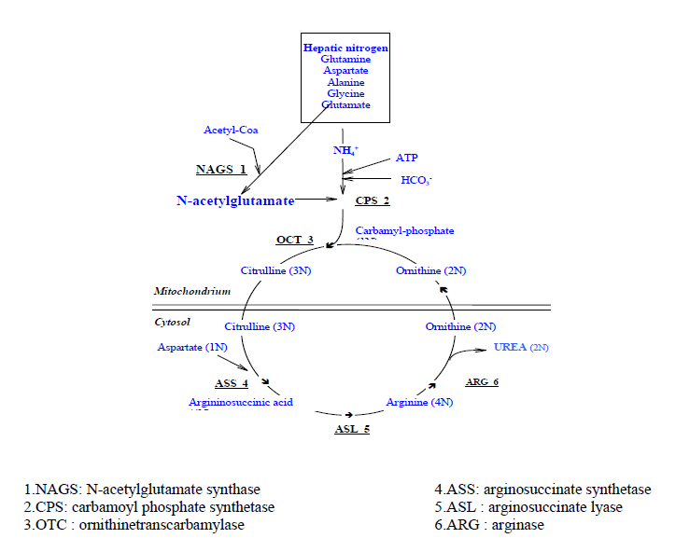

Carglumic acid is a structural analogue of N-acetylglutamate (NAG), a naturally occurring activator of carbamoyl phosphate synthetase 1 (CPS1), the first enzyme of the urea cycle. N-acetylglutamate is the product of N-acetylglutamate synthase (NAGS). Carglumic acid has been shown in vitro to activate liver CPS1. Carglumic acid reduced blood ammonia levels in mice with N-acetylglutamate synthase deficiency.

#### Urea cycle disorders

The urea cycle is the metabolic pathway that transforms nitrogen to urea for excretion from the body (Figure 1). Deficiency of an enzyme in the pathway causes a urea cycle disorder (UCD). The UCDs are:

* Carbamyl phosphate synthetase I (CPSI) deficiency
* Ornithine transcarbamylase (OTC) deficiency
* Argininosuccinate synthetase (ASS) deficiency (also known as classic citrullinaemia or type I citrullinaemia, CTLN1)
* Argininosuccinate lyase (ASL) deficiency (also known as argininosuccinic aciduria)
* N-acetyl glutamate synthetase (NAGS) deficiency
* Arginase deficiency

Urea cycle disorders, except for arginase deficiency, result in hyperammonaemia and life threatening metabolic decompensations in infancy. Survivors of the metabolic decompensation frequently have severe neurologic injury. Prompt recognition and treatment are needed to improve outcome.

In both forms of disease (NAGS deficiency and OA) early identification, diagnosis and treatment is critical. The clinical management requires high level intensive care unit care to support physiological functions and use of use of ‘ammonia scavengers’. These scavenger agents are non-specific and none are currently registered in Australia. The drugs which have been supplied under Special Access Scheme (SAS) for unapproved medicines in individual patients include sodium phenylbutyrate, sodium benzoate, arginine and carnitine. Approximately 50 to 75 requests per year are approved by the TGA delegates (SAS Category B) and a similar number appears to be notified to TGA by physicians under SAS Category A. There is one record of supply of carglumic acid under SAS in 2012.

### Regulatory status

The product received initial registration on the Australian Register of Therapeutic Goods (ARTG) on 12 February 2015.

At the time the TGA considered this application; a similar application had been approved in the following countries as shown in Table 1.

Table 1. Carglumic acid international regulatory status.

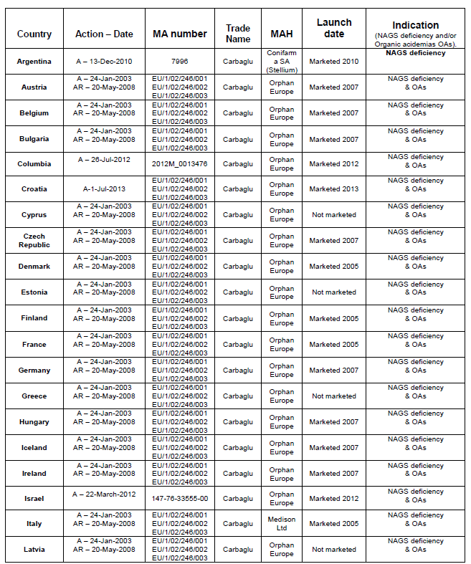

Table 1. (continued)

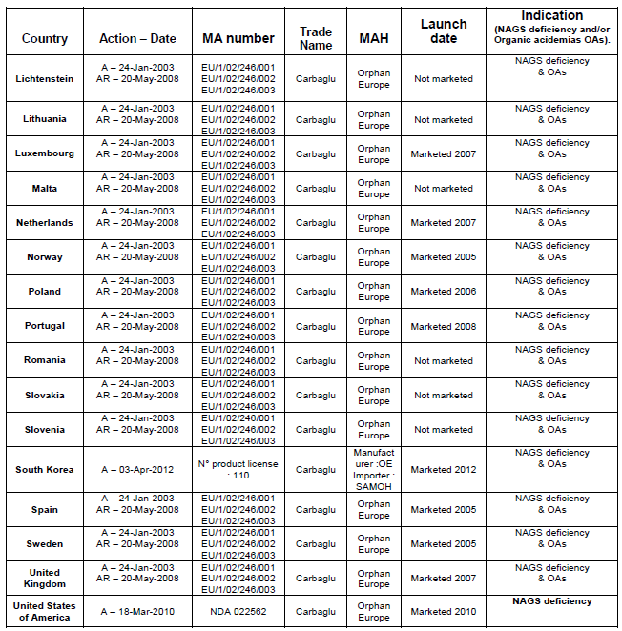

A: authorised. AR: authorisation renewal.

#### Orphan drug status

The TGA Delegate of the Secretary designated carglumic acid as an orphan drug for the treatment of;

* *Hyperammonaemia due to N-acetylglutamate synthase primary deficiency*
* *Hyperammonaemia due to Organic Acidaemias such as:*
  + *Hyperammonaemia due to isovaleric acidaemia*
  + *Hyperammonaemia due to methymalonic acidaemia*
  + *Hyperammonaemia due to propionic acidaemia*

on 29 February 2012.

Information provided by the sponsor at the time of ‘orphan drug’ designation indicated a prevalence of 146 patients in Australia at present covering both NAGS and the 3 OAs.

### Product Information

The approved Product Information (PI) current at the time this AusPAR was prepared can be found as Attachment 1. For the most recent Product Information please refer to the TGA website at <<https://www.tga.gov.au/product-information-pi>>.

## II. Quality findings

### Drug substance (active ingredient)

The chemical name of carglumic acid is N–carbamoyl- L-glutamic acid or (2S)-2-(carbamoylamino) pentanedioic acid. The active substance has one chiral carbon atom and has an optical isomer, which is N-carbamoyl-D-glutamic acid. The structure is shown in Figure 2.

Figure 2 Structure of carglumic acid.

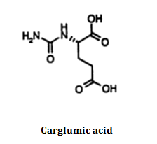

Carglumic acid is a white crystalline powder, soluble in boiling water, slightly soluble in cold water and practically insoluble in organic solvents. The pH of a 0.5% aqueous solution is between 2.2 and 3.2. The analytical methods used in routine controls were adequately validated and thus considered suitable. The production yield and the particle size of the active substance are also reproducible. All impurity limits were adequately justified.

### Drug product

The tablets have been formulated so as to obtain an easily water dispersible form with rapid in vitro dissolution profile. Because the dose shall be adapted to individual requirements scored tablets have been chosen as they provide dose regimen flexibility through the breaking of the tablets into halves or quarters.

The method of manufacture is a conventional high shear wet granulation and oven drying process, followed by compression. The choice of the excipients, their function and quantity has been sufficiently justified. Process parameters for mixing, drying and granule sizing are given and in process controls are stated. Validation was performed on four industrial batches.

Stability studies were carried out with a series of 3 batches corresponding to the final formula. All stability studies were conducted in compliance with the International Conference on Harmonisation of Technical Requirements for Registration of Pharmaceuticals for Human Use (ICH) requirements. The batches have been tested for all parameters included in the specifications with the addition of tablets hardness (no limit stated), friability (< 1.0%) and water content (no limit stated). During these studies, whatever the storage conditions, all parameters remained within specifications with the exception of impurities content which is time and temperature dependant. The proposed shelf life for the unopened commercially packaged product is 30 months ‘Store at 2-8°C. (Refrigerate. Do not freeze). Protect from light.’

The results from a complementary stability study also support the recommended shelf life of the product after first opening Store below 30°C. Do not refrigerate. Keep the container tightly closed in order to protect from moisture. Discard one month after first opening.

### Biopharmaceutics

The results of a comparative pharmacokinetic study between the dispersible tablet and the reference oral powder forms ensure that no bioavailability problems are expected due to substance properties or biopharmaceutics factors under present manufacture conditions. No significant differences were found between the developed formulation and the reference powder. However this initial formulation has been modified to respond to a safety concern. Dissolution studies support this change.

### Quality summary and conclusions

Registration is recommended with respect to chemistry, quality control and bioavailability aspects.

## III. Nonclinical findings

### Introduction

The breadth of studies in the submitted dossier was generally smaller than would be expected for a new chemical entity submission as minimal pharmacology studies were submitted to support efficacy, no secondary pharmacology studies, a basic set of pharmacokinetic studies, repeat dose studies were conducted with only a single species, and no carcinogenicity studies were submitted. However, the quality of the studies that were submitted was generally high, with all relevant studies conducted under good laboratory practice (GLP) conditions. As carglumic acid has been registered for ten years in Europe with clinical data available to contribute to knowledge of the safety profile of the drug and taking into account the life threatening nature of the disease, the minimal nonclinical package submitted is considered generally adequate.

### Pharmacology

#### Primary pharmacology

##### Rationale and mechanism of action

N-Acetylglutamate is a cofactor necessary for the function of the urea cycle, the main pathway of ammonia detoxification. Patients with a deficiency in N-acetylglutamate synthase (NAGS) are unable to synthesise NAG, which can lead to life threatening hyperammonaemia. Carglumic acid is intended to act as an analogue of NAG to help reduce and prevent hyperammonaemia in patients deficient in NAGS.

Organic acidaemia is characterised by the excretion of non amino organic acids in the urine, which generally occurs as a result of a dysfunction of specific steps in amino acid catabolism. Patients with propionic acidaemia (PA) or methylmalonic acidaemia (MMA) have recurrent episodes of hyperammonaemia. Carglumic acid is intended to reduce the hyperammonaemia in these patients by increasing ureagenesis.

##### Pharmacological action

Carbamoyl phosphate synthase is the first enzyme of the urea cycle and it requires NAG for full functional activity. In vitro studies demonstrated that carglumic acid could effectively act as a cofactor for CPS1, but its potency was 14 times lower than the typical endogenous cofactor, NAG. Nonetheless, the data support the notion that carglumic acid could substitute for NAG in patients with no or low levels of this compound.

The efficacy of carglumic acid was assessed in a mouse model of NAGS deficiency. In the absence of appropriate supplementation, these mice displayed severe signs of hyperammonaemia (lethargy, seizures, lying on side and decerebrate posture) with elevated plasma ammonia levels confirmed. Deaths occurred within 24 hours. The animal model is considered an appropriate model for the NAGS deficiency indication. Supplementation with carglumic acid (150 mg/kg/day per oral (PO); 450 mg/m2/day, approximately 9% of the maximum clinical dose[1]) improved survival (by 50%). When provided with citrulline, the survival rate improved considerably (89%) and the plasma levels of ammonia had normalised. A similar improvement in the survival rate was also observed in neonates (with treatment beginning a few hours following birth).

Overall, the pharmacology studies support the proposed use of carglumic acid for the treatment of hyperammonaemia in patients with a NAGS deficiency. The enhanced improvement in survival with the combination of carglumic acid and citrulline in the mouse model of the disease suggests carglumic acid alone is not adequate to prevent life threatening hyperammonaemia and additional ammonia lowering agents should be provided with carglumic acid to patients.

##### Secondary pharmacodynamics and safety pharmacology

No secondary pharmacology studies were submitted. This is considered acceptable, given no off target activities were seen in the toxicity studies.

Safety pharmacology studies assessed the effect on the cardiovascular, respiratory and central nervous systems. All studies were adequately conducted under GLP conditions. Effects on the renal and gastrointestinal systems were examined in the toxicity studies. In vitro, there was no effect on action potential duration in canine Purkinje fibres at ≤ 100 µM (19 µg/mL; 7 times the clinical maximum plasma concentration (Cmax)). No abnormalities were detected in electrocardiogram (ECG) recordings of dogs that received ≤ 1000 mg/kg PO carglumic acid (exposure ratio based on Cmax (ER Cmax) 53). No adverse effects were seen on central nervous system (CNS) or respiratory function in rats that received ≤ 1000 mg/kg PO carglumic acid (estimated Cmax 90.7 µg/mL (based on Study 20330), 33 times the clinical Cmax) or on the renal and gastrointestinal system in rats that received repeated oral doses of carglumic acid (≤ 2000 mg/kg). Overall, no adverse effects on the cardiovascular, respiratory, renal, gastrointestinal or CNS are predicted during clinical use.

### Pharmacokinetics

The rate of oral absorption of carglumic acid was moderate in all species (rats, rabbits, dogs and humans) with time to reach maximum plasma concentration (tmax) values ranging from 2 to 8 hours. Oral bioavailability was moderate to low in dogs (32 to 33%). Exposures were less than dose proportional in rats and rabbits (not assessed in other species). There were no sex differences in any pharmacokinetic parameters in rats and dogs. The terminal elimination half-life was similar in dogs and human subjects (21 to 30 hours). There was no evidence of accumulation with repeat dosing to rats and rabbits. However, lower exposures (by 57 to 80%) were seen in (pregnant) rabbits (but not rats) with repeat dosing, suggesting a difference in absorption or metabolism in this species.

No plasma protein binding data were provided. There was no particular partitioning of carglumic acid into blood cells; however, there was an indication of partitioning of metabolites into blood cells. The apparent volume of distribution was larger than total body water in rats and human subjects, suggesting extensive extravascular distribution. Following oral dosing of radioactive carbon labelled(14C)-carglumic acid to rats, high levels of radioactivity were predominantly observed in organs involved in absorption and excretion. There was no specific accumulation or retention of drug related material in any tissue. There was limited penetration of the blood brain barrier (concentrations 10 to 20% those in blood).

In vitro, minimal metabolism (≤ 8%) was detected in rat, dog, monkey and human hepatocytes. With the exception of one of three individuals, minimal metabolism was observed in human subjects (approximately 17%). Greater metabolism was seen in dogs (30% following intravenous (IV) dosing and 60% following PO dosing). The higher level of metabolism following oral dosing (compared with IV dosing) in dogs is suggestive of some pre systemic metabolism, possibly occurring in the gastrointestinal tract. Metabolites observed in dogs were hydantoin-5-propionic acid, diaza-1,3-dione-2,4-carboxy-7-cycloheptane and glutamate. Expiration of 14 carbon dioxide (CO2) was detectable in rats, dogs and humans (9%, ≤ 1.5% and < 4%, respectively, of the dose) following 14C-carglumic acid. Overall, there were no meaningful metabolic differences across species.

Excretion of drug related material was predominantly via the urine (approximately 80%) in dogs following IV dosing. Higher faecal excretion was seen in rats and dogs following oral dosing (18 to 37%). Drug related material was excreted predominantly in the faeces in most human subjects (72%). The higher excretion in faeces following oral dosing is likely due to poor absorption.

Overall, the pharmacokinetic profile of carglumic acid in rats and humans was qualitatively similar, thus supporting the use of the chosen animal species in toxicity studies.

#### Pharmacokinetic drug interactions

As carglumic acid undergoes minimal metabolism, at least in most human subjects, co-administered drugs that are inducers or inhibitors of cytochrome P450 (CYP450) enzymes are unlikely to affect the exposure to carglumic acid. No significant inhibition of CYP1A2, CYP2A6, CYP2B6, CYP2C8, CYP2C9, CYP2C19, CYP2D6, CYP2E1 or CYP3A4/5 activity was observed with ≤ 200 µM carglumic acid (14 times the clinical Cmax). Carglumic acid did not induce CYP1A1/2, CYP2B6 or CYP3A4/5 activity in human hepatocytes (≤ 200 µM; 14 times the clinical Cmax). Therefore, carglumic acid is not expected to alter the exposure of drugs that are substrates of CYP450 enzymes. No studies have been conducted to assess interactions involving transporters.

### Toxicology

#### Acute toxicity

Single dose toxicity studies with carglumic acid were conducted in rats (PO and IV dosing). The studies were GLP compliant and conducted according to the relevant European Union (EU) guideline[2]. The maximum non-lethal dose was the highest tested, 238.6 mg/kg IV and 2000 mg/kg PO. No drug related toxicities were evident, suggesting a low order of toxicity.

#### Repeat-dose toxicity

Repeat dose toxicity studies were conducted in newborn (4 days of age at the start of dosing) and young rats for 2 weeks and 26 weeks duration, respectively. Both studies were conducted under GLP conditions. The duration of the pivotal study is acceptable, given the intended chronic use of the drug. The age of the animals is considered appropriate given the age of the intended patient group (neonates to adults). The maximum tested doses are considered acceptable; the limit dose (1000 mg/kg/day) was used in the pivotal study with a higher dose used in the short term study. A comprehensive examination of potential toxicities was undertaken in both studies. Adequate exposures (area under the plasma concentration time curve (AUC) and Cmax)) were achieved (Table 2).

##### Relative exposure

No exposure data were provided for the maximum dose of 250 mg/kg/day. As this dose is intended to be given over 2 to 4 doses, the Cmax value for a 100 mg/kg dose will be used for comparative purposes. Exposure (AUC) to a 250 mg/kg/day dose is estimated by extrapolation from the AUC for a 100 mg/kg dose (estimated to be 53 µg∙h/mL).

Table 2. Relative exposure in repeat dose toxicity studies.

|  |  |  |  |  |  |  |
| --- | --- | --- | --- | --- | --- | --- |
| Species | Study duration | Dose  (mg/kg/day) | AUC0–24 h (µg∙h/mL) | Cmax µg/mL) | Exposure ratio based on | |
| AUC | Cmax |
| Rat (SD) | 2 weeks *a* | 250 | 325 | 45 | 6 | 17 |
| 500 | 649 | 90 | 12 | 33 |
| 1000 | 1298 | 179 | 24 | 66 |
| 2000 | 2596 | 358 | 49 | 132 |
| 26 weeks | 500 | 476 | 75 | 9 | 28 |
| 1000 | 755 | 86 | 14 | 32 |
| Human | – | 250 | 53 | 2.71 | – | – |

a. exposure data for the 500, 1000 and 2000 mg/kg/day doses were extrapolated from data for the 250 mg/kg/day dose and may be over estimates given the less than dose proportional relationship with exposure in this species

##### Major toxicities

All neonatal mice that received 2000 mg/kg/day PO carglumic acid died after 2 to 3 days of dosing. No deaths were observed at ≤ 1000 mg/kg/day PO (exposure based on AUC, at least 14 times the clinical exposure). During the first 10 days of dosing, reduced bodyweight gain was observed in neonates that received 1000 mg/kg/day PO and adults that received 2000 mg/kg/day PO carglumic acid. After this their bodyweight appeared to normalise. Initial high doses may cause a metabolic disturbance which stabilises with repeat dosing. Neonates appeared to be more sensitive to this effect than adults or young adults. Orange faeces were seen in neonates (but not juveniles) that received 1000 mg/kg/day PO carglumic acid.

There was no significant macroscopic or microscopic evidence of toxicity at ≤ 1000 mg/kg/day (resulting in 14 times the clinical AUC). There was a minor increase in liver weights at 1000 mg/kg/day PO but as it occurred without evidence of hepatic injury it is not considered to be a toxicological concern. Deposition of drug related material on the stomach mucosal surface was seen in some neonates but without any evidence of gastrointestinal damage. Hyper salivation was seen in most animals that received 1000 mg/kg/day PO carglumic acid for 26 weeks but this was not considered adverse. Overall, no clinically relevant toxicities were observed.

#### Genotoxicity

The genotoxic potential of carglumic acid was assessed in the standard battery of tests, conducted according to the relevant guideline[3]. In vitro carglumic acid was not mutagenic in bacterial cells and was not clastogenic in human lymphocytes. Occasional positive results were observed in the in vitro clastogenicity assay but these were shown to be artefactual. Negative results were seen in the rat micronucleus assay at oral doses ≤ 7000 mg/kg (estimated AUC 6650 µg∙h/mL; 126 times the maximum clinical exposure). There was no evidence of proliferation (proliferating cell nuclear antigen (PCNA) assay; multiple tissues assessed) in the pivotal repeat dose toxicity study. The weight of evidence indicates a low genotoxic potential with carglumic acid.

#### Carcinogenicity

No carcinogenicity studies were submitted. The sponsor stated that carcinogenicity studies are not normally required for this type of product citing ICH S6[4]. However, ICH S6 is not relevant for this type of synthetic product. Given the intended chronic use of carglumic acid, carcinogenicity studies would normally be expected. However, the absence of any toxicity, including immunotoxicity and pre neoplastic lesions, in the pivotal repeat dose toxicity study combined with the negative findings in genotoxicity studies, carglumic acid is considered to have a low carcinogenic potential. Nonetheless, in the longer term, a carcinogenicity study should be conducted to confirm this but the absence of such a study should not preclude registration for the life threatening indication.

#### Reproductive toxicity

Submitted reproductive toxicity studies assessed effects on female fertility and pre/postnatal development in rats and effects on embryofetal development in rats and rabbits. All studies were GLP compliant and were adequately conducted. Maximum tested doses were acceptable, the limit dose (or higher) was used and maternal toxicity was observed at the highest dose in rabbits. Adequate exposures were achieved in the rat fertility/embryofetal study, while low exposures were achieved in the rabbit study (Table 3), primarily due to the lower exposures seen after repeat dosing.

Table 3. Relative exposure in the reproductive toxicity studies.

|  |  |  |  |  |
| --- | --- | --- | --- | --- |
| Species | Study | Dose (mg/kg/day) | AUC0–24 h (µg∙h/mL) | Exposure ratio based on AUC |
| Rat (Sprague Dawley) | Fertility/embryofetal development | 500 | 477 | 9 |
| 2000 | 1478 | 28 |
| Rabbit (New Zealand White) | Embryo fetal development | 250 | 76.2 | 1.4 |
| 1000 | 126 | 2.4 |
| Human | – | 250 | 53 | – |

mg/kg to mg/m2 conversion factors were 6, 12 and 33 for rats, rabbits and humans, respectively.

There was no effect on female fertility in rats at ≤ 2000 mg/kg/day PO. In the pivotal repeat dose toxicity study, no effects on sperm quality or number or fertility were seen in male rats that received ≤ 1000 mg/kg/day PO for 26 weeks (exposure ratio based on AUC (ERAUC) 14). Therefore, effects on fertility are not predicted during clinical use. No adverse effects were seen on embryofetal development in rats or rabbits at ≤ 2000 mg/kg/day PO (ERAUC 28) and ≤ 1000 mg/kg/day PO (ERAUC 2.4), respectively.

In a pre/postnatal study in rats, pups from dams that received ≥ 500 mg/kg/day PO carglumic acid from gestation Day 6 and throughout lactation had reduced bodyweight gain with reduced postnatal survival to lactation Day 4 (1000 mg/kg/day PO only). As the pups were normal at birth and carglumic acid was excreted in milk (20% of maternal plasma levels), it is likely that the adverse effect on neonatal survival and growth are due to consumption of maternal milk. It is unknown if it is a direct drug related effect or if there is an indirect effect on milk quality. Aside from the reduced survival and impaired weight gain, there were no adverse effects on developmental parameters. The data indicate that mothers taking carglumic acid should not breast feed.

##### Pregnancy classification

The sponsor has proposed Pregnancy Category C[5]. This is for drugs which, due to their pharmacological action have caused adverse fetal effects in animals. No adverse effects were observed in embryofetal development studies in rats and rabbits. Therefore, Category B1[6] is considered more appropriate.

#### Paediatric use

Carglumic acid is intended for use in patients of all ages (neonates to adults). When given to neonatal and juvenile rats (≤ 1000 mg/kg/day PO; ERAUC 14), there was no adverse effect on physical or reflex development. There was no effect on neuro behavioural or sexual development in pups that were exposed to carglumic acid in breast milk. Overall, there were no concerns identified for a paediatric indication.

### Nonclinical summary and conclusions

* The submitted nonclinical package was generally small but considered adequate given the history of clinical use and the proposed life threatening indication.
* In a mouse model of NAG synthase deficiency, carglumic acid reduced plasma ammonia levels and improved the survival rate of animals. A more significant improvement was observed when carglumic acid was provided in combination with citrulline.
* Safety pharmacology studies covered the central nervous system, cardiovascular and respiratory systems. No adverse effects were observed at high doses/concentrations.
* The rate of oral absorption of carglumic acid was moderate in all species. Oral bioavailability was moderate to low in dogs. Tissue distribution of drug related material was unremarkable in rats. Carglumic acid undergoes minimal (human subjects) to moderate (dogs) metabolism. Following oral dosing, both faecal and urinary excretion was seen in animals, while predominantly faecal excretion was seen in human subjects.
* Pharmacokinetic drug interactions involving CYP450 enzymes are not predicted.
* A low order of toxicity was seen in rats following a single oral or IV dose of carglumic acid.
* Repeat dose toxicity studies were conducted in newborn and young rats for 2 weeks and 26 weeks duration, respectively. There was no significant macroscopic or microscopic evidence of toxicity at ≤ 1000 mg/kg/day (resulting in 14 times the clinical AUC). Minor impairment of bodyweight development was seen in neonates in the first few days of receiving 1000 mg/kg/day carglumic acid. Overall, no clinically relevant toxicities were observed.
* The weight of evidence indicates a low genotoxic potential with carglumic acid. No carcinogenicity studies were submitted. The absence of such studies should not preclude registration.
* Fertility was unaffected in rats at high exposures. No adverse embryofetal changes or effects on embryofetal development were observed in rats and rabbits. Carglumic acid was excreted in milk in lactating rats, with reduced postnatal survival and pup weight gain observed in breast fed pups.
* No adverse effects on development were seen in the toxicity studies relevant to a paediatric indication.

#### Conclusions and recommendation

* The primary pharmacology studies support the proposed use of the drug as an oral agent for the treatment of hyperammonaemia due to NAG synthase deficiency. The data indicate that use with additional agents may be necessary, as recommended in the PI.
* No clinically relevant safety concerns were identified. Adverse effects occurred at relatively high exposures.
* There are no objections on nonclinical grounds to the registration of Carbaglu for the proposed indication.
* The nonclinical evaluator also recommended amendments to the draft PI document but these are beyond the scope of this AusPAR.

## IV. Clinical findings

A summary of the clinical findings is presented in this section. Further details of these clinical findings can be found in Attachment 2.

#### Clinical rationale

##### Typical presentation

Severe defects typically present in term newborns that appear well for the first 24 to 48 hours after birth. The infant becomes symptomatic after feeding has started because of the protein load. Initial signs include somnolence, inability to maintain normal body temperature, and poor feeding, usually followed by vomiting, lethargy, and coma.

A common early sign in newborns with hyperammonaemia is central hyperventilation leading to respiratory alkalosis. Hyperventilation is thought to result from cerebral oedema caused by the accumulation of ammonia and other metabolites. Increasing cerebral oedema also may result in abnormal posturing and progressive encephalopathy with hypoventilation and respiratory arrest. Approximately 50 percent of infants with severe hyperammonaemia have seizures.

Affected patients have a lifelong risk of metabolic decompensation with intercurrent hyperammonaemia. Metabolic decompensation usually occurs during episodes of increased catabolism, such as infections (for example, gastroenteritis and otitis media), fasting, surgery or trauma.

#### N-acetyl-glutamate synthase deficiency

N-acetyl-glutamate synthase (NAGS) deficiency is a recessive autosomal inherited metabolic disorder. N-acetyl-glutamate synthase deficiency is one the most severe and rarest of the hereditary urea cycle disorders. N-acetyl-glutamate synthase is a mitochondrial enzyme, which is essential for the function of the urea cycle converting ammonia into urea in the liver cells and elimination through the kidneys.

The impairment of ammonia detoxication due to NAGS deficiency results in acute and chronic hyperammonaemia, hyperglutaminaemia and, eventually, hypocitrullinaemia. Hyperammonaemia and hyperglutaminaemia are particularly toxic to the central nervous system.

N-acetyl-glutamate synthase deficiency represents a serious life-threatening clinical condition. Patients with severe complete NAGS deficiency rapidly develop hyperammonaemia soon after birth (between 24 and 48 hours). The clinical course in the neonatal period may be lethal. Left untreated or insufficiently corrected, this condition leads to cerebral oedema, coma and eventually death. For those children who survive, psychomotor retardation is a frequent outcome.

Patients with partial NAGS deficiency (late onset) can present symptoms at almost any time of life because of any stressful triggering event such as an infection, trauma, vaccination, surgery and pregnancy.

#### Organic Acidaemias

The term ‘organic acidaemia’ or ‘organic aciduria’ (OA) applies to a group of disorders characterised by the excretion of non amino organic acids in urine. OAs are the result of dysfunction of specific step/s in amino acid catabolism, usually the result of specific deficient enzyme activity. The majority of the classic organic acid disorders are caused by abnormal amino acid catabolism of branched chain amino acids or lysine. They include maple syrup urine disease, propionic acidaemia (PA), methylmalonic acidaemia (MMA), methylmalonic aciduria and homocystinuria, isovaleric acidaemia (IVA), biotin unresponsive 3-methylcrotonyl-CoA carboxylasedeficiency, 3-hydroxy-3-methylglutaryl CoA(HMG-CoA) lyase deficiency, ketothiolase deficiency, and glutaric acidaemia type I.

The first clinical manifestations in all OAs could start in early stage (neonatal period) or in late stage. A neonate affected with an OA is usually well at birth and for the first few hours or days of life. The usual clinical presentation is at the time of a metabolic decompensation that leads towards toxic encephalopathy, vomiting, poor feeding, neurologic symptoms such as seizures, abnormal muscle tone, and lethargy, progressing to coma. The earlier is the onset of the first clinical manifestations the higher the severity and the poorer the outcome for the patient. Prognosis could be improved by early diagnosis and prompt effective treatment.

In the late onset, older child or adolescent, variant forms of the OAs can present as progressive loss of intellectual functions, ataxia or other focal neurologic signs, Reye-like syndrome, recurrent keto-acidosis, or psychiatric symptoms.

#### Guidance

The following guidance documents were supplied to the evaluator:

* Clinical Investigation of Medicinal Products for Long Term Use (Directive 75/318/EEC)
* Guideline on the Investigation of Medicinal Products in the Term and Preterm Neonate (EMEA/536810/2008)
* Guideline on the role of Pharmacokinetics in the Development of Medicinal Products in the Paediatric Population (EMEA/CHMP/EWP/147013/2004)
* Note for Guidance on Clinical Investigation of Medicinal Products in the Paediatric Population (CPMP/ICH/2711/99)
* Reflection Paper Formulations of Choice for the Paediatric Population (EMEA/CHMP/PEG/194810/2005)

#### Contents of the clinical dossier

The submission contained the following clinical information:

* 2 clinical pharmacology studies, both of these provided pharmacokinetic data in normal adult human subjects.
* Several bio-analytical studies.
* Two pivotal efficacy/safety studies.
* One clinical safety report, one report for the risk of QT interval (QT) prolongation and seven periodic safety update reports (PSURs).

There were no population pharmacokinetic analyses, clinical dose finding studies or other efficacy/safety studies.

#### Paediatric data

The submission included paediatric pharmacokinetic, efficacy and safety data including in young neonates.

#### Good clinical practice

The two pharmacokinetic studies in normal human adults were reported to have complied with Good Clinical Practice (GCP).

The retrospective clinical studies did not fully comply with GCP. While the data for the retrospective studies was collected in accordance with GCP principles, the original clinical data entry was not part of a clinical study (it was routine clinical practice) and, hence, not GCP compliant.

### Pharmacokinetics

#### Studies providing pharmacokinetic data

The pharmacokinetics (PK) dataset included the following:

* Single dose PK in 15 normal adult volunteers including 3 subjects as part of a mass balance study.
* A total of 23 samples from 10 patients receiving carglumic acid as part of a follow up program.
* A total of 53 samples in 20 patients receiving carglumic acid as part of treatment with carglumic acid.

None of the pharmacokinetic studies had deficiencies that excluded their results from consideration.

The findings of the study in normal adult (male) volunteers are shown in Figure 3 and Table 4 below.

Figure 3. Mean and standard deviation (SD) plasma profiles for carglumic acid obtained after single oral administration of 100 mg/kg of OE312 in 12 healthy male volunteers.

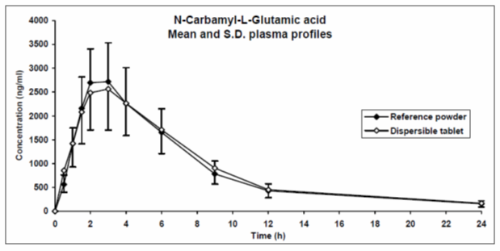

Table 4. Pharmacokinetic parameters of carglumic acid.

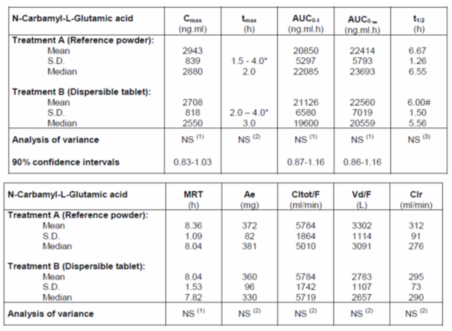

#### Evaluator’s conclusions on pharmacokinetics

The bioequivalence study in 12 normal adult males does define the PK parameters for a single dose of carglumic acid in this population. The study also demonstrated bioequivalence between Carbaglu and the unregistered powder previously available for treatment. The mass balance study in three adult males indicated a significant variation in the disposition of carglumic acid even though all three subjects had similar serum carglumic acid profiles.

The pharmacokinetic data in treated patients were sparse and difficult to interpret. The sponsor only produced raw data and no analysis of these data was presented. There were a range of concentrations seen in treated patients; these being within the range seen in the normal subjects. What is missing is a PK analysis of these data to estimate PK parameters or the likely concentration profile in the treated patients, most of whom were infants and children. The sponsor should have attempted an analysis of these data, for example, using population pharmacokinetic methods. The model could have been informed by the available adult data.

In summary, the pharmacokinetic data are insufficient to support the registration of Carbaglu for use in the target patient population. The evaluator recommends that the sponsor perform further analysis on the available data to investigate whether a satisfactory analysis of these data is possible to better define the PK of Carbaglu in infants and children.

### Pharmacodynamics

#### Studies providing pharmacodynamic data

No specific pharmacodynamic studies were submitted in the dossier.

### Dosage selection for the pivotal studies

There was no rational dose selection for the pivotal studies based upon prior pharmacokinetic studies. The pivotal clinical studies were retrospective clinical case series and the dose administered was determined by the individual treating physician.

### Efficacy - Treatment of NAGS deficiency

#### Studies providing efficacy data

##### Study – Carbaglu; Retrospective Data Review in NAGS Deficiency Patients

For details see Attachment 2

##### Other efficacy studies

For details see Attachment 2

#### Evaluator’s conclusions on clinical efficacy for the Treatment of NAGS deficiency

The available retrospective data were limited and of poor quality. There were missing data in patients with follow up levels on Days 1 to 7 for each of the efficacy outcomes (missing data in 2 to 14 out of 21 patients for ammonia, 1 to 6 out of 21 patients for glutamine, and 1 to 5 out of 21 patients for citrulline). The regimen including dosing was determined by the individual treating physicians. Also the data were not collected prospectively. The data set would have been more rigorous if the enrolled subjects were subject to a single protocol and data were collected prospectively. Finally, the report was only up until 2007 and further efficacy data may be available after that time. However, NAGS deficiency is a rare disorder and the evaluator accepts that a randomised controlled study was not feasible. Despite the limitations in the data, there is evidence that the administration of carglumic acid results in a dramatic and relatively sustained improvement on the biochemical changes and the clinical symptoms of acute hyperammonaemia associated with NAGS deficiency. The limited long term data indicate that there may be ongoing benefit in administration of carglumic acid to these patients. While there is no control group, there is expected to be a very poor prognosis in individuals severely affected with NAGS deficiency. The limited data presented in the dossier supports that carglumic acid may improve the outcome in some of these patients.

In summary, the efficacy data are sufficient to support the registration of Carbaglu for use in the treatment of NAGS deficiency.

### Efficacy - The acute treatment of hyperammonaemia in organic acidaemia

#### Study - Carbaglu retrospective observational study of hyperammonaemia in organic acidaemia decompensation episode

For details see Attachment 2

#### Evaluator’s conclusions on clinical efficacy for the acute treatment of hyperammonaemia in organic acidaemia decompensation episodes

The available retrospective data are limited and of poor quality. The regimen including dosing was determined by the individual treating physicians. Again the data were not collected prospectively. The data set would have been more rigorous if the enrolled subjects were subject to a single protocol and data were collected prospectively. Finally, the report was only up until 2009 and further efficacy data may be available after that time. The evaluator accepts that a randomised controlled study was not feasible given the rarity of organic acidaemia decompensation episodes. Despite the limitations in the data, there is evidence that the administration of carglumic acid results in a dramatic and relatively sustained improvement on the biochemical changes and the clinical symptoms of acute hyperammonaemia associated with the types of organic acidaemia studied. While there is no control group, there is expected to be a very poor outcome with severe hyperammonaemia associated with organic acidaemia. Because of the retrospective nature of the study, not all outcomes were measured in all patients. Also only one adult patient was included in the dossier; explained by the fact that few patients survive into adulthood. The limited data presented in the dossier supports that carglumic acid may improve the outcome in some of these patients.

In summary, the efficacy data, although limited, are sufficient to support the registration of Carbaglu for use in the treatment of hyperammonaemia in organic acidaemia decompensation episodes.

### Safety

#### Studies providing safety data

##### Study of NAGS deficient patients

In the pivotal efficacy studies data were retrieved from the clinical record retrospectively. The data were analysed by indication and considered NAGS deficient patients and organic acidaemia patients separately.

General AEs were assessed by the sponsor as part of their study analysis.

##### Study of patients treated for hyperammonaemia due to organic acidaemia

###### Other studies evaluable for safety only

Exposure in healthy volunteers

Two sponsored clinical trials in healthy volunteers were performed. Fifteen healthy volunteers were exposed to carglumic acid in total.

#### Patient exposure

According to the NAGS safety report, including patients who received carglumic acid only as therapeutic test of individual clinical/biochemical response before initiating any long term treatment (n = 44 patients), 143 patients have been exposed to carglumic acid irrespective of the indication (23 patients for confirmed NAGS and 76 for other non-approved indications) from 1 January 1991 up to 31 December 2008 (Figure 4).

Comment: The report does not state from which reports the Non-NAGS patients are derived from and this should be clarified.

Figure 4 Patient exposure.

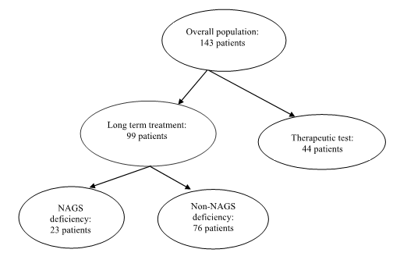

###### Study of NAGS deficient patients

For the safety analysis, 23 patients were exposed at least to one dose of the study drug and were considered as the ‘safety population’. At the report cut-off date (31/12/2007), the cumulative treatment duration for NAGS deficiency patients was 187.4 patient years taking into account the reported discontinuations. Table 5 in Attachment 2 summarises the details for each patient while Figure 5 below, shows the total duration of carglumic acid dosing.

Figure 5. Total duration of Carglumic Acid Dosing.

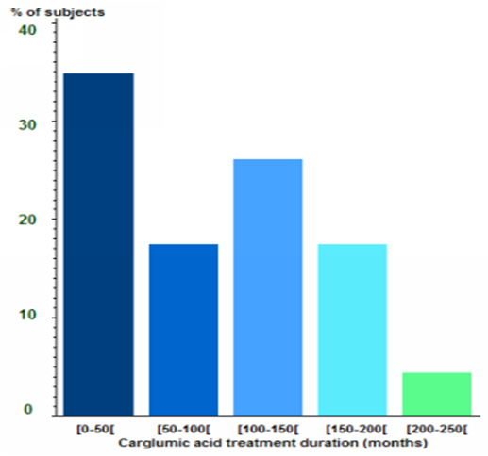

###### Study of patients treated for hyperammonaemia due to organic acidaemia

A total of 57 patients were exposed at least to one dose of the study drug and were considered as the ‘safety population’. The duration of the treatment with carglumic acid was between 1 and 16 days, with a mean of 5.3 days (median= 4.0 days). In regards to daily dose, the first dose of carglumic acid in the safety population ranged between 10 to 303 mg/kg, with a mean dose of 86.5 mg/kg (median = 62.9) of treatment. In 32.8% of the patients, the first dose was < 50 mg/kg, 26.9% between 50 and 100 mg/kg, 37.3% between 100 and 250 mg/kg, and 3.0% above 250 mg/kg. The duration of therapy ranged from 1 to 16 days (Table 5).

Table 5. Duration of carglumic acid treatment.

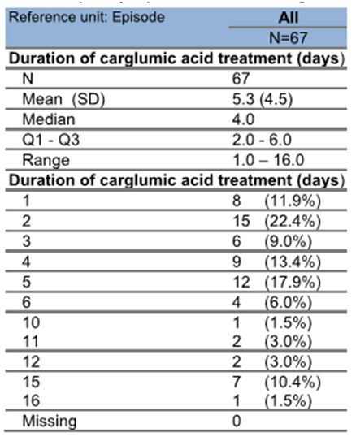

#### Post marketing data

The sponsor submitted the following safety updates:

The clinical safety report on carglumic acid covered the period of 1 January 1991 to 31 December 2008. Orphan Europe (OE) report (16 March 2009) PSUR for Cabarglu (carglumic acid) Period covered by this report: Feb 1, 2003 to July 31, 2003. This report covers the studies included in the dossier and has been reviewed as part of the safety data analysis.

Periodic Safety Update Report for Carbaglu (carglumic acid) Period covered by this report: Aug 1, 2003 to Jan 31, 2004.

Periodic Safety Update Report for Carbaglu (carglumic acid) Period covered by this report: Feb 1, 2004 to July 31, 2004. One death reported (thought unrelated).

Periodic Safety Update Report for Carbaglu (carglumic acid) Period covered by this report: Aug 1, 2004 to Jan 31, 2005.

Periodic Safety Update Report for Carbaglu (carglumic acid) Period covered by this report: Feb 1, 2005 to Jan 31, 2006.

Periodic Safety Update Report for Carbaglu (carglumic acid) Period covered by this report: Feb 1, 2006 to Jan 31, 2007.

Periodic Safety Update Report for Carbaglu (carglumic acid) Period covered by this report: Feb 1, 2007 to Jan 31, 2010.

Comment: This report covers a large number of AEs and some deaths (see Table 31 of Attachment 2). It is unclear how many of these overlap with those already reported in the retrospective studies and whether they were included in the safety report. This report does include two severe cardiac events; a cardiac arrest and a cardio-respiratory arrest. Given the paucity of QT/QTc (QT interval, corrected for heart rate) data in the dossier, an effect of carglumic acid cannot be excluded. The sponsor should clarify how many of the AEs overlap with the safety report.

#### Safety issues with the potential for major regulatory impact

##### Liver toxicity

As far as the evaluator could assess from the listings, there were no signals indicating a risk of liver toxicity.

Comment: The sponsor should provide an analysis confirming that there is no indication of a risk of liver toxicity.

##### Haematological toxicity

As far as the evaluator could assess from the listings, there were no signals indicating a risk of haematological toxicity.

Comment: The sponsor should provide an analysis confirming that there is no indication of a risk of haematological toxicity.

##### Serious skin reactions

As far as the evaluator could assess from the listings, there were no signals indicating a risk of serious skin reactions.

##### Cardiovascular safety

As far as the evaluator could assess from the data, there were no signals indicating a risk of cardiovascular toxicity. However, the information around the risk of QT prolongation is inadequate to fully assess this risk.

Comment: The two cardiac deaths suggest that further investigation of the potential cardiotoxicity should be undertaken.

##### Unwanted immunological events

As far as the evaluator could assess from the listings, there were no signals indicating a risk of unwanted immunological toxicity.

#### Other safety issues

##### Safety in special populations

Most of the presented data was in neonates and children. There were no data related to pregnancy or the elderly.

##### Safety related to drug-drug interactions and other interactions

No data were presented in relation to drug-drug interactions.

#### Evaluator’s conclusions on safety

Overall, the safety profile is consistent across the studies and the reported AE s do not indicate any major safety concerns. However, the safety section has several inconsistencies that require further explanation as detailed below.

According to the NAGS safety report, including patients who received carglumic acid only as therapeutic test of individual clinical/biochemical response before initiating any long-term treatment (n = 44 patients), 143 patients have been exposed to carglumic acid irrespective of the indication (23 patients for confirmed NAGS and 76 for other non-approved indications) from 1 January 1991 up to 31 December 2008 (Figure 4).

Comment**:** The report does not state from which reports the non-NAGS patients are derived from and this should be clarified.

According to the safety report, as of 31 December 2008, 18 of the 23 patients suffering from NAGS deficiency have experienced one or more AEs. In total, 120 AEs were reported including 37 SAEs and 83 non-serious AEs. However, in the study report, a total of 17 patients experienced an AE, with a total of 118 AEs (see Table 27, Attachment 2) with the type of events reported in Table 28, Attachment 2.

Comment**:** The inconsistencies in the number of AEs between reports should be clarified.

In the report titled ‘Carbaglu Retrospective Observational Study of Hyperammonaemia in Organic Acidaemia Decompensation Episodes’: Table 14 states that N=67 while the study itself states that N=57.

Comments**:** The inconsistencies in the number of patients should be clarified.

The sponsor should provide an analysis confirming that there is no indication of a risk of liver toxicity.

The sponsor should provide an analysis confirming that there is no indication of a risk of haematological toxicity.

A further investigation of the potential cardiotoxicity should be undertaken.

### First round benefit-risk assessment

#### First round assessment of benefits

The benefits of Carbaglu in the proposed usage are:

* Improvement in the biochemical and clinical derangements associated with acute hyperammonaemia caused by NAGS deficiency and in some organic acidaemias.
* While the numbers of patients with each particular type of organic acidaemias are small, the evaluator appreciates that these are extremely rare diseases and that the proposed treatment is for the hyperammonaemia rather than the underlying biochemical defect. The endpoints of improvement in the clinical biochemical markers of hyperammonaemia are appropriate and the primary endpoint of plasma ammonia concentrations is what would be used clinically. The evaluator does not think it is necessary to divide up the organic acidaemias for the purpose of treatment of the main complication; that being hyperammonaemia.
* Potential long term improved outcomes in patients, with NAGS deficiency, who receives ongoing therapy. The evaluator does acknowledge the lack of long term data on effects of treatment on growth and development. This is due lack of long-term data in enough patients in a sufficient number of patients.
* There are adequate data, albeit limited, in older neonates and children to support the efficacy of Carbaglu in these populations. There are almost no data in young adults and no data in older adults presented in the dossier. This is due to the extreme rarity of the disorder in adulthood. This may change in the future as more patients survive into adulthood with ongoing improvements in the therapy in childhood.

#### First round assessment of risks

Overall, the safety profile of Carbaglu is acceptable given the severity of the disease which it is treating. No concerning AE s were identified, although it must be acknowledged that the dataset is necessarily small.

The risks of Carbaglu in the proposed usage are related to the inadequacy of the presented data. Specifically these are:

* Poorly defined dosing regimen due to inadequate pharmacokinetic data in the target population. There are almost no data in adult patients and the data in children is not presented in a way that supports the proposed weight based dosing.
* Some deficiencies in the safety data, specifically concerning:
  + Uncertainty about the sources of patient safety data in the summary reports.
  + Inconsistencies in the number of AEs between reports.
  + Incomplete data on the risk of liver toxicity.
  + Incomplete data on the risk of haematological toxicity.
  + Incomplete data on the risk of cardiotoxicity.

#### First round assessment of benefit-risk balance

The proposed indications are rare and the consequences of non-treatment are disabling and, in some cases, life-threatening. There are few other potential therapies for the treatment of hyperammonaemia and none of these are particularly effective. Carbaglu currently offers the best acute therapy for hyperammonaemia associated with NAGS deficiency and the organic acidaemias as well as a potential long term therapy for patients with NAGS deficiency.

Despite this, the benefit-risk balance of Carbaglu is currently unfavourable given the proposed usage but would become favourable if the changes recommended below are adopted. Specifically these are that the dosing be better supported and the outstanding issues around the safety data addressed satisfactorily.

### First round recommendation regarding authorisation

The evaluator recommends that the application for Carbaglu currently be rejected. The application could be approved if the sponsor provides the following:

* A report estimating the PK parameters and the likely concentration profile of in the treated patients; defining differences between infants, children and adults if possible.
* The sources of patient safety data in the summary reports should be clarified.
* The inconsistencies in the number of AEs between reports should be addressed.
* An analysis confirming that there is no indication of a risk of liver toxicity.
* An analysis confirming that there is no indication of a risk of haematological toxicity.
* A further discussion, and potentially analysis, investigating cardiotoxicity.

### Clinical questions

#### Pharmacokinetics

1. There is no PK analysis of the patient data. PK parameters for a single dose of carglumic acid in 12 healthy adults were submitted. However, the PK data in treated patients were sparse and difficult to interpret. Only raw data was produced and no analysis of these data was presented. Please provide a population PK analysis based on these data to allow estimation of PK parameters in infants, children and adults.

#### Pharmacodynamics

No further questions.

#### Efficacy

1. From the report (for the Carbaglu retrospective observational study of hyperammonaemia) (see Section 7.3.1.8 ‘Analysis populations’, Attachment 2), the sponsor should explain why 16 patients were excluded from the efficacy evaluation when there were 17 patients with major deviations.
2. From the report (for the Carbaglu retrospective observational study of hyperammonaemia) (see Section 7.3.1.16 ‘Demographics’, Attachment 2), the sponsor should clarify the differences in weight at the initiation of the episodes and the initiation of the treatment.

#### Safety

1. According to the NAGS safety report, including patients who received carglumic acid only as therapeutic test of individual clinical/biochemical response before initiating any long-term treatment (n = 44 patients), 143 patients have been exposed to carglumic acid irrespective of the indication (23 patients for confirmed NAGS and 76 for other non-approved indications) from 1 January 1991 up to 31 December 2008 (Figure 4 above). The report does not state from which reports the Non-NAGS patients are derived from and this should be clarified.
2. According to the safety report, as of 31 December 2008, 18 of the 23 patients suffering from NAGS deficiency have experienced one or more AEs. In total, 120 AEs were reported including 37 SAEs and 83 non-serious AEs. However, in the study report, a total of 17 patients experienced an AE, with a total of 118 AEs with the type of events reported in Table 28 Attachment 2. The inconsistencies in the number of AEs between reports should be clarified.
3. The sponsor should provide an analysis confirming their assertion that there is no indication of a risk of liver toxicity (see Section 8.7 Attachment 2).
4. The sponsor should provide an analysis confirming their assertion that there is no indication of a risk of haematological toxicity (see Section 8.7 Attachment 2).
5. A further investigation of the potential for cardiotoxicity should be undertaken (see Section 8.7 Attachment 2).
6. The sponsor should supply a listing or analysis of vital signs in the clinical studies (see Section 8.7 Attachment 2).
7. The sponsor should clarify how many of the AEs in the PSUR for Carbaglu (carglumic acid) Period covered by this report: 1 February 2007 to 31 January 2010 overlap with the safety report (see post marketing data above).

## Second round evaluation of clinical data submitted in response to questions

### Clinical questions

For details of the sponsor’s responses and the evaluator’s comments on these responses see Attachment 2.

### Second round benefit-risk assessment

#### Second round assessment of benefits

No new clinical information was submitted in response to questions. Accordingly, the risks of carglumic acid are unchanged from those identified in the first round assessment of benefits.

#### Second round assessment of risks

After consideration of the responses to clinical questions, the risks of carglumic acid in the proposed usage are:

* Poorly defined dosing regimen due to inadequate pharmacokinetic data in the target population. There are almost no data in adult patients and the data in children is not presented in a way that supports the proposed weight based dosing.

#### Second round assessment of benefit-risk balance

The benefit-risk balance of Carbaglu is currently unfavourable given the proposed usage but would have become favourable if the changes recommended in the first round recommendation regarding authorisation had been adopted. Specifically these were that the dosing be better supported and the outstanding issues around the safety data addressed satisfactorily. The response from the sponsor did not address these concerns.

### Second round recommendation regarding authorisation

As the sponsor failed to address the pharmacokinetic and safety concerns raised by the first round evaluation, the evaluator recommends that the application for Carbaglu currently be rejected.

## V. Pharmacovigilance findings

### Risk management plan

The sponsor submitted a Risk Management Plan EU-RMP version OE/PV/CARB/1211, dated 8 December 2011, data lock point 25 October 2011 and Australian Specific Annexe (ASA) version 0.1, dated 4 October 2013 (which was reviewed by the TGA’s Post Market Surveillance Branch (PMSB).

#### Safety specification

The sponsor provided a summary of ongoing safety concerns which are shown at Table 6.

Table 6 Important identified and potential risks and missing information.

|  |  |
| --- | --- |
|  | |
| Important identified risks | No special concerns have arisen |
| Important potential risks | Lack of efficacy due to a not confirmed diagnosis of the metabolic disease or inadequate low dosing |
| Important missing information | Bradycardia |
| Pyrexia related effects |
| Unknown food and drug interactions |
| Effects on pregnancy and fetal outcomes |

#### Pharmacovigilance plan

The sponsor addresses all ongoing safety concerns through routine pharmacovigilance activities.

In addition, a Carbaglu surveillance protocol is underway in the USA. The sponsor states: *‘This protocol entitled Orphan Europe Carbaglu Surveillance Protocol in Collaboration with the Longitudinal Study of Urea Cycle Disorders (Protocol No 5111) was developed and agreed to with the US Food and Drug Administration (FDA) as part of the approval for Carbaglu. It is noted that Carbaglu is indicated specifically for the treatment of hyperammonaemia due to NAGS deficiency, a reduced indication when compared to the indication provided in Section 1.*

*The purpose of this study is to conduct post-marketing surveillance of carglumic acid to obtain long-term clinical safety information. The study is intended to be conducted over 15 years, and is performed in collaboration with the existing National Institutes of Health (NIH) sponsored Urea Cycle Disorders Consortium (UCDC). The surveillance program will include the development of a registry of patient with NAGS deficiency and a sub-study intended to study the effects of carglumic acid on pregnancy and foetal outcomes.*

*The Carbaglu Surveillance Protocol will require an annual reconciliation of all adverse events, with these events reported to the FDA and a final report forwarded to the FDA at the completion of the protocol in 2026.*

*The Carbaglu Surveillance Protocol will generate additional safety data on the use of carglumic acid for the treatment of hyperammonaemia due to NAGS, thereby supporting safety of the product in the treatment of Australian patients. Although the indication approved by the FDA is more restrictive than proposed as part of Emerge Health’s application, it is considered that the safety information can be directly extrapolated to the Australian population based on the hyperammonaemia treatment regime.’*

Regarding the pharmacovigilance system in Australia the sponsor states:

*Emerge Health has developed and implemented a pharmacovigilance system based primarily on the requirements stated in the TGA issued Australian Requirements and Recommendations for Pharmacovigilance Responsibilities of Sponsors of Medicines. Emerge Health’s pharmacovigilance process collects critical information relating to a possible adverse event to allow its assessment. All worldwide adverse events relating to the administration of Carbaglu are collected by the finished product manufacturer, Orphan Europe who consolidates all events to determine any applicable changes to the core safety information and consequently the Australian PI.*

*Emerge Health proposes that the Carbaglu surveillance protocol will not be extended to include Australian patients, nor will a similar study be conducted in Australia.*

*The supply of Carbaglu in Australia does not require any specific pharmacovigilance requirements in addition to routine surveillance practices. These routine pharmacovigilance practices will involve the following activities:*

* *All suspected adverse reactions that are reported to the personnel of the company are collected and collated in an accessible manner in collaboration with Orphan Europe;*
* *Reporting to regulatory authorities;*
* *Continuous monitoring of the safety profiles of approved products including signal detection and updating of labelling;*
* *Submission of PSURs;*
* *Meeting other local regulatory agency requirements.*

The sponsor states on page 12 of the EU-RMP that *‘routine pharmacovigilance will perform additional monitoring of special cases of lack of efficacy’*.

Regarding collection of adverse events in the pre- and post-authorisation phase in Europe, the sponsor states:

*‘Before the European approval, patients were provided with Carbaglu on a named patient basis; during this period, treating physicians provided OE with clinical data via specific forms designed by Orphan Europe (OE). After European approval, treating physicians continued to provide OE with clinical data via these specific forms. In addition to that and according to European regulations, these physicians spontaneously reported to OE information on adverse events (AE).*

*Therefore, the data available in the safety database describes all safety information originated from solicited sources (including clinical trials, named patient programmes, and patient registries) and unsolicited source (spontaneous reporting, literature reports, and regulatory cases notified by authorities).*

*All these cases are recorded into the OE global safety database (GSDB). The cut-off date for the RMP of Carbaglu, October 25, 2011, is based on the arbitrary date relating to the data available in the global safety database, covering the pre- and post-authorisation experience with Carbaglu.’*

#### Risk minimisation activities

The sponsor proposes routine risk minimisation activities to address all ongoing safety concerns.

In addition, it is noted that the sponsor describes (Table 17 in EU-RMP) that routine risk-minimisation activities are not sufficient to address the potential risk of ‘Effect on Pregnancy and Foetal Outcomes’. However, the activities described are:

* Provision of information in the PI,
* A surveillance protocol.

Provision of information in the PI is considered routine risk minimisation, and the surveillance protocol is considered additional pharmacovigilance. Therefore, Table 17 should be amended to clarify that only routine risk minimisation activities are used for all ongoing safety concerns.

Comment: There are no objections to the proposed risk minimisation activities.

#### Reconciliation of issues outlined in the RMP report

Table 7 summarises the PMSB’s first round evaluation of the RMP, the sponsor’s responses to issues raised by the PMSB and the PMSB’s evaluation of the sponsor’s responses.

Table 7. Reconciliation of issues outlined in the RMP report. Up to here

|  |  |  |
| --- | --- | --- |
| Recommendation in RMP evaluation report | Sponsor’s response | PMSB evaluator’s comment |
| 1. Safety considerations may be raised by the nonclinical and clinical evaluators through the TGA’s request for information and/or the nonclinical and clinical evaluation reports respectively. It is important to ensure that the information provided in response to these include a consideration of the relevance for the RMP, and any specific information needed to address this issue in the RMP. For any safety considerations so raised, the sponsor should provide information that is relevant and necessary to address the issue in the RMP. | Following a review of cases reported until 31 May 2014, OE considered that no change in the risk profile was identified. Potential risks were reported in the RMP. | The clinical and nonclinical evaluator will assess the validity of this response and ensure that the sponsor has satisfactorily addressed the issues raised in the CER and nonclinical evaluation report (NCER). |
| 2. The sponsor should amend the RMP to reflect that only routine risk-minimization activities are carried out to address all ongoing safety concerns. | The sponsors is pleased to confirm that the latest version of the RMP (European RMP version OE/PV/CARB/0114 data lock point 31 May 2014) has been amended to reflect that only routine risk minimisation activities are carried out to address all ongoing safety concerns. The ongoing safety concerns are potential risk of lack of efficacy, rash and cardiomyopathy. These ongoing safety concerns were reported in routine risk minimisation activities. | The sponsor describes in the EU-RMP as well as in the ASA that additional risk minimisation activities are carried out for the missing information of ‘Pregnant or Breast feeding women’. The activity described is a surveillance program conducted in the USA.  This activity is considered an additional pharmacovigilance activity and not an additional risk minimisation activity.  Consequently, the RMP has not been amended as requested in the round 1 RMP evaluation and therefore, this recommendation remains. |
| 3. It is recommended that the sponsor submits a more up to date version of the RMP, alongside with a summary table, outlining the differences between the currently available RMP and the more up to date version. | As noted above, an updated EU-RMP is submitted that has a data lock point of 31 May 2014.  A summary of the difference relating to the ongoing safety concern from the EU-RMP submitted with the initial application and the updated documents provided as part of this response are summarised below (points 4.1 to 4.4) | The response has been noted. Of note, the documents provided are inconsistent, and this should be corrected prior to approval. |
| 4.1: Cardiac effects (bradycardia) and General disorders and administration site conditions (Pyrexia) are identified AE s, which are described to occur with a frequency of uncommon. Consequently, these AEs should be listed as important identified risks in the table of ongoing safety concerns. | 4.1.1. Bradycardia: One case of bradycardia was reported.  Case X1[7]: PT bradycardia This event of bradycardia occurred in a patient treated for MMA. The event was considered as not serious by the reporter (no value of heart rate available). The patient recovered the same day.  Conclusion: OE considers that this bradycardia is probably due to the patient status (decompensation episode associated with vomiting and pyrexia) and is not related to Carbaglu toxicity. Consequently, this AE will be not listed as important identified risk in the table of ongoing safety concerns. | 4.1.1: Pending acceptance by the Office of Medicines Authorisation, this is considered acceptable. |
|  | 4.1.2-Pyrexia: A review of all Carbaglu cases received until 30 May 2014 was performed. Six cases with following PT (Pyrexia) were identified. Five cases were considered by the reporter as unrelated and for one case the causality was unlikely. For the case with causality unlikely (X27) the patient aged 3 years old experienced pyrexia in a context of decompensation episode. The pyrexia resolved.  Conclusion: OE considers that this pyrexia is probably due to an infection (common in a 3 years old child). This infection was probably responsible for this decompensation episode and was not related to Carbaglu toxicity. Consequently, this AE will be not listed as important identified risk in the table of ongoing safety concerns. | 4.1.2: Pending acceptance by the Office of Medicines Authorisation, this is considered acceptable. |
| 4.2: Gastrointestinal disorders (diarrhoea and vomiting) and investigations (increased transaminases) are reported AE s which are described to occur with a frequency as uncommon. Consequently, it is recommended that these events are added as important identified risks in the table of ongoing safety concerns. | 4.2.1. Diarrhoea: Six cases of diarrhoea were reported. Three cases were considered as not related by the reporter. Three other cases were reported by patients. For two cases (X37 and X47), patients presented watery diarrhoea when they start Carbaglu. The dosage was reduced and the problem resolved. A case was confirmed by physician as probably related to Carbaglu.  Conclusion: OE considers that diarrhoea can occur with a frequency as uncommon. These cases of diarrhoea were considered as non-serious because patients were not admitted to hospital. It is advised to decrease the dose to resolve the problem. OE considers that diarrhoea is ‘not an important identified risk’. | 4.2.1: Pending acceptance by the Office of Medicines Authorisation, this is considered acceptable. |
|  | 4.2.2. Vomiting: Fourteen cases of diarrhoea were reported. Ten cases were considered as not related by the reporter. For one case the causality was unlikely and for four cases the causality was not reported.  For these four cases, vomiting occurred at the beginning of treatment. However, Carbaglu is prescribed when the patient had hyperammonaemia and vomiting is a common symptom of the disease. Accordingly, it is difficult to assess if vomiting is due to Carbaglu or not or has worsened the underlying disease.  Vomiting is not a serious AE and cannot be considered as an important identified risk. Vomiting can be considered as ‘an identified risk not important’. As it is not possible to identify the cause of vomiting, OE considers that vomiting can occur with a frequency as uncommon. | 4.2.2: Pending acceptance by the Office of Medicines Authorisation, this is considered acceptable. |
|  | 4.2.3. Increased transaminases: Six cases with following PT were identified as events which can be considered as ‘increased transaminase’. For three cases these events were considered by the physician as not related to Carbaglu. Three events were reviewed.  Conclusion: After review of these cases, OE considers that the event increased transaminase is not a potential or identified risk. | 4.2.3: Pending acceptance by the Office of Medicines Authorisation, this is considered acceptable.  Please note: The information provided under point 4.2.3 in the middle column of this table is only an extract of the sponsor’s response. |
| 4.3: Skin and sub cutaneous tissue disorders (increased sweating) is a reported AE, which is described to occur with a frequency of common. Consequently, it is recommended that this event be added as important identified risk in the table of ongoing safety concerns. | 4.3: Two cases of hydrosis were reported in the safety database until 31 May 2014:  For the first case (case X57) according to OE, the causality is unlikely because the baby presented with sweating within a warm environment (hot weather). Moreover, the onset was unclear and may have commenced before Carbaglu administration.  For the second case (case X67), the patient presented at unspecified date excessive sweating. The reporter causality was not mentioned.  Conclusion: After review of these two cases, OE considers that there is no potential or identified risk for event hyperhydrosis. | 4.3: Pending acceptance by the Office of Medicines Authorisation, this is considered acceptable. |
| 4.4: It appears that there is no data available about the safety of the product in patients with renal and hepatic insufficiency. Consequently, it is recommended that these patients groups be added as missing information in the table of ongoing safety concerns. | 4.4: OE has confirmed that there remains no data available about the safety of the product in patients with renal and hepatic insufficiency.  To address this, within the updated RMP, Section 2.4.3 Limitations in respect to populations typically under-represented in clinical trial development programs has been expanded to include patients with renal or hepatic impairment. Furthermore, this cohort of patients has been included in Table 2-8 within the section Important Missing Information. | 4.4: Pending acceptance by the Office of Medicines Authorisation, this is considered acceptable. |
| 5. It is recommended that results of the surveillance protocol be separately reported in any future PSUR. | The sponsor hereby confirms that the results of the surveillance protocol be separately reported in future PSUR’s for Carbaglu submitted in Australia. | This is considered acceptable. |
| 6. The sponsor should provide an attachment to the ASA setting out all the forthcoming studies and the anticipated dates for their submission in Australia. | The sponsor wishes to confirm that no forthcoming studies are planned for Australia. However Appendix 2 of the ASA summarises the status of the global studies currently underway and the anticipated timeframe for the submission of interim and final data. | This is considered acceptable. |
| 7. The information in the safety database is based on a cut-off date of October 2011. It is recommended that the sponsor submits more up to date data. | As noted above, the updated RMP document has a data lock cut-off date of 31 May 2014. | The response has been noted. Of note, the documents provided are inconsistent, and this should be corrected prior to approval. |
| 8. The sponsor should amend the RMP to clarify that lack of efficacy is addressed through routine pharmacovigilance only. Nevertheless, this activity is not described in the ASA, and the sponsor should amend the ASA to include details about this activity to address this potential risk in Australia. | All cases of potential lack of efficacy were reviewed in the paragraph 2.6.5. Lack of efficacy was considered as a potential risk. This potential risk was added in the RMP paragraph 5.1 Risk minimization measures. | In the ASA in section ‘pharmacovigilance practices in Australia’ the sponsor describes that routine pharmacovigilance activities will be carried out to monitor the potential risk of ‘lack of efficacy’. Furthermore, the sponsor describes various risk-minimisation activities in this section, including:  A.) Raise the awareness to physicians to not cease Carbaglu use too early in the treatment of hyperammonaemia  B.) Comprehensive dosage and administration instructions within the Australian PI  C.) Inclusion of the Carglumic acid Responsive Test within the Dosage and Administration section of the Australian PI to allow adapting of the dose to the patient’s needs  D.) Inclusion of the Therapeutic Monitoring information within the Precautions section of the Australian PI.  All these activities are considered routine risk minimisation activities and therefore, should be removed from the pharmacovigilance section and included in the risk minimisation plan section of the ASA. Furthermore, the sponsor should provide further clarification as to how the awareness of physicians will be raised, as mentioned in point A.), above. |
| 9. The statement above Table 16 in the EU-RMP should be amended to describe that ‘Effects of pregnancy and foetal outcomes’ is the only ongoing safety concerns, for which additional pharmacovigilance activities are carried out, in form of a surveillance protocol. | The sponsor refers to Section 5.1 Risk minimization measures by safety concern has been updated, where Table 5.1.1 Risk minimization measures: pregnancy and breast-feeding has included the US surveillance protocol which included exposure during pregnancy and assessment of foetal outcomes as a means to assess the effectiveness risk minimization measure. | A surveillance protocol constitutes an additional pharmacovigilance activity, not an additional risk minimisation activity. Consequently, Table 5.1.1, and any other table as required, should be amended to describe that no additional risk minimisation activity is carried out for the risk of ‘pregnancy and breast-feeding’, but that an additional pharmacovigilance activity is carried out.  This recommendation remains. |
| 10. It is recommended that the sponsor amends the EU-RMP to include information regarding the potential for medication errors. | In response to the recommendation above, the sponsor refers to Section 2.6.4 potential for medical errors within the updated EU-RMP which addresses this additional EU requirement. | This is considered acceptable. |
| 11. The sponsor should provide a table summarising the safety specification, pharmacovigilance plan and planned risk minimization measures in Australian context in the ASA. Wording pertaining to important safety concerns in the proposed Australian PI and CMI should be included in the table. | In response to the TGA’s requested changes, please refer to the updated ASA provided in this response. | The response has been noted. However, this table should be amended to include the potential risk of ‘lack of efficacy’. |
| 12. The sponsor should amend the ASA to describe ‘bradycardia’ and ‘pyrexia related effects’ as identified risk. Furthermore, to align the classification of the ongoing safety concerns with the EURMP, the ASA should be amended to classify ‘unknown food and drug interactions’ and effects on pregnancy and foetal outcome’ as missing information. | As discussed in the Question 4.1, bradycardia and pyrexia are not considered as identified risk based on the review by OE.  Further, the risks of ‘unknown and food and drug interactions’ and ‘effects on pregnancy and foetal outcome’ have been included within the RMP (Section 2.4.4) and also within the updated ASA. These documents have been provided in the response. | This is considered acceptable. |
| 13. The sponsor describes ‘routine pharmacovigilance activities’ in section 3.1.1 and ‘review of the safety information derived through the Carbaglu surveillance protocol’ in section 3.1.2 of the ASA as planned actions in the risk minimization plan. These activities constitute pharmacovigilance activities and therefore, are not considered part of the risk minimisation plan. | The sponsor confirms that ‘routine pharmacovigilance activities’ and ‘review of the safety information derived through the Carbaglu surveillance protocol’ have been included within the pharmacovigilance plan section of the ASA rather than the risk minimization section. | This is considered acceptable. |
| 14. Recommendations for amendments of the PI/CMI. | The sponsor can confirm amendments recommended within the TGA’s evaluation report have been made to the proposed Australian PI and CMI. Copies of the updated documents have been provided. | Regarding the potential risk of Rash, the sponsor states in the EU-RMP ‘Rash will be added in the Summary of Product Characteristics (SmPC): frequency uncommon’.  Information regarding ‘Rash’ is not included in the proposed Australian PI, and it is recommended to the Delegate, that the sponsor adds information regarding this event in the Australian PI. The risk-minimisation plan of the ASA should be updated accordingly. |

#### Summary of outstanding issues

##### Issues in relation to the RMP

* It is recommended that the sponsor rectifies document internal inconsistencies/incorrect descriptions in the EU-RMP/ASA, in an updated version of the EU-RMP/ASA prior to approval.
* The sponsor should amend the RMP to reflect that only routine risk minimization activities are implemented to address all ongoing safety concerns (see Point 2 in Table 7).
* It is recommended that the risk-minimisation and pharmacovigilance section of the EU-RMP/ASA be amended as stated in Point 8 in Table 7.
* The EU-RMP should be amended to describe that ‘effects of pregnancy and foetal outcomes’ is the only ongoing safety concerns, for which additional pharmacovigilance activities are implemented, in form of a surveillance protocol (see Point 9 in Table 7).
* The sponsor should provide an updated table, including the potential risk of ‘lack of efficacy’, summarising the safety specification, pharmacovigilance plan and planned risk minimization measures in Australian context in the ASA. Wording pertaining to important safety concerns in the proposed Australian PI and CMI should be included in the table (see Point 11 in Table 7).
* Information regarding “rash” is not included in the proposed Australian PI, and it is recommended to the Delegate, that the sponsor adds information regarding this event in the Australian PI. The risk-minimisation plan of the ASA should be updated accordingly.

#### Advice from the Advisory Committee on the Safety of Medicines (ACSOM).

ACSOM advice was not sought for this submission.

#### Key changes to the updated RMP

In their response to the TGA request for information the sponsor provided an updated EU-RMP version OE/PV/CARB/0114, dated 23 July 2014, data lock point 31 May 2014 and ASA version 0.2, dated 31 July 2014. Key changes from the version evaluated in the first round are described by the sponsor in the ASA as shown in Table 8.

Table 8. Key changes to the RMP.

|  |  |  |
| --- | --- | --- |
| RMP OE/PV/CARB/1211 | RMP OE/PV/CARB/1104 | Comments |
| **Important identified risks** | | |
| No special concerns have arisen | No special concerns have arisen | No modification because since 2011, no new risk was clearly identified. |
| **Important potential risks** | | |
| Lack of efficacy did to a not confirmed diagnosis of the metabolic disease or inadequate low dosing. | Lack of efficacy  Rash  Cardiomyopathy | Lack of efficacy: a review of all cases of ‘potential’ lack of efficacy was performed. After this review, OE considers that there is no risk identified of ‘lack of efficacy.  Rash: one case of rash occurred. The causality is doubtful, so it is a potential risk.  Cardiomyopathy: one case of cardiomyopathy occurred in a CPS1 patient. The causality is doubtful, so it is a potential risk. |
| **Important missing information** | | |
| Bradycardia  Pyrexia related effects  Unknown food and drug interactions  Effects on pregnancy and foetal outcomes | Pregnant or breast feeding women  Fertility  Patients with cardiac diseases/renal and hepatic impairment  Unknown food and drug interaction | Bradycardia and pyrexia were events, it cannot be a missing information. After a review of cases of bradycardia and pyrexia, these events are not considered as potential or identified risks. Fertility and patients with cardiac diseases/real and hepatic impairment were added because there are not enough data for these specific populations. Unknown food and drug interaction is still important missing information because there is not enough data since 2011 to evaluate. |

#### Suggested conditions of registration

The European Risk Management Plan (version OE/PV/CARB/0114, dated 23 July 2014, data lock point 31 May 2014), with Australian Specific Annex (version 0.2, dated 31 July 2014), to be revised to the satisfaction of the TGA, must be implemented (see *Outstanding* issues above).

## VI. Overall conclusion and risk/benefit assessment

The submission was summarised in the following Delegate’s overview and recommendations:

### Quality

Registration is recommended with respect to chemistry, quality control and bioavailability aspects.

### Nonclinical

In vitro, carglumic acid activates hepatic CPS1. Although carglumic acid has lower affinity for CPS1 than naturally occurring NAG, in vivo it showed better protective effect than NAG and therefore a better drug candidate. The more effective and longer lasting in vivo effect of carglumic acid is due to a higher permeability across the mitochondrial membrane than NAG and the greater resistance of carglumic acid to hydrolysis by aminocyclase present in cytoplasm of hepatocytes.

In a mouse model of NAGS deficiency, carglumic acid reduced plasma ammonia levels and improved survival rate of animals. A more significant improvement was observed when carglumic acid was provided in combination with citrulline.

Metabolites observed in dogs were hydantoin-5-propionic acid (5-HPA), diaza-1, 3-dione-2, 4-carboxy-7-cycloheptane (diaza) and glutamic acid (glutamate).

In humans, plasma concentrations of 5-HPA were all below or close to the lower limit of quantification (LoQ) (10 ng/mL). Carglumic acid was the main component in the excreta of human subjects (83% in faeces and 100% in urine). Radiolabelled 14CO2 was detectable in the breath of human subjects who received 14C labelled carglumic acid (0.7 to 3.8% of the dose). Carglumic acid undergoes minimal (human) to moderate (dogs) metabolism. Following oral dosing, both faecal and urinary excretion was seen in animals, while predominantly faecal excretion was seen in humans. Pharmacokinetic drug interactions involving CYP450 enzymes are not expected.

Safety pharmacology studies covered the central nervous system, cardiovascular system and respiratory system. No adverse effects were observed at high doses/concentrations.

A low order of toxicity was seen in rats following a single oral or IV dose of carglumic acid. Repeat dose toxicity studies were conducted in newborn and young rats for 2 weeks and 26 weeks duration, respectively. There was no significant macroscopic or microscopic evidence of toxicity at ≤ 1000 mg/kg/day (14 x clinical AUC). Minor impairment of bodyweight development was seen in neonates in the first few days of receiving 1000 mg/kg/day carglumic acid. Overall, no clinically relevant toxicities were observed.

The weight of evidence indicates a low genotoxic potential with carglumic acid. No carcinogenicity studies were submitted.

Fertility was unaffected in rats at high exposures. No adverse embryofetal changes or effects on embryofetal development were observed in rats and rabbits. Carglumic acid was excreted in milk in lactating rats, with reduced postnatal survival and pup weight gain observed in breast fed pups. No adverse effects on development were seen in the toxicity studies relevant to a paediatric indication. Pregnancy category C is proposed.

The nonclinical evaluators have no objection to the proposed clinical use.

### Clinical

The clinical dossier consisted of two pharmacology studies (PK in healthy adults) and two retrospective reviews of efficacy/safety data considered pivotal for this submission. The safety data also included post market safety reports.

No PK studies in target population or special populations were conducted. No drug interaction studies were conducted. There were no dose finding studies.

The clinical evaluator recommends rejection due to inadequately described PK in neonates and concern about insufficient information about safety.

#### Pharmacokinetics

##### Study OE 312/PK/99-01

This was an open label single (oral) dose (100 mg/kg), bioequivalence (BE) study of 200 mg carglumic acid dispersible tablet versus carglumic acid powder in 12 healthy young males (mean age 23 years; range 18 to 28 years). The results indicate that the dispersible 200 mg tablet was BE to the powder formulation with respect to the parent drug carglumic acid (N-carbamyl-L-glutamic acid) as shown in Table 4 (above).

Total body clearance was about 6 L/min and volume of distribution was about 3000 L. The amount of N carglumic acid excreted unchanged in urine was low (5% of dose 24 h post administration). The half-life could not be accurately determined in this study due to lack of adequate sampling in a biphasic distribution. Bioavailability is stated to be 30%. This cannot be absolute bioavailability as an IV study was not done. The sponsor is request to clarify this in its pre-ACPM response.

In addition, the sponsor is requested to clarify the administration instructions (volume of fluid and any additional rinsing for the undissolved, remaining content of the tablet) for inclusion in PI in its pre-Advisory Committee on Prescription Medicines (ACPM) response. The instruction should be precise, consistent with the conditions of administration during the clinical trials, and note any differences for neonates and children or adults.

##### Study SPC 313-1

This was a mass-balance study in 3 healthy males (aged 40 to 55 years) each of whom received a single oral dose of 14C labelled carglumic acid (100 mg/kg). The parent compound was shown to be excreted in faeces (about 60% in Subjects 001 and 003 and 8.5% in Subject 002) and to a lesser extent in urine (approximately 8%). These results matched the radioactivity detected in faeces (approximately 72% in Subjects 001 and 003 and 16.5% in Subject 002) and in urine (approximately 9%). The estimated PK parameters were as follows in Table 9.

Table 9. Pharmacokinetic parameters for carglumic acid.

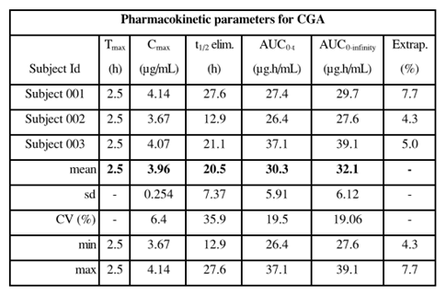

A proportion of carglumic acid may be degraded or metabolised by the intestinal bacterial flora. The likely end product of carglumic acid metabolism after absorption is carbon dioxide, eliminated through the lungs.

In response to a question in the first round evaluation the sponsor provided an expert opinion and included a graph of carglumic acid plasma levels in a small number of patients (< 6 months old and > 6 months old) ( see Figure 24 Attachment 2).

The graph appears to indicate that dosing up to 90 mg/kg/day body weight in neonates may provide similar (higher) plasma levels of carglumic acid compared to > 100 mg/kg/day dosing in > 6 months old age group. The proposed Australian PI is same as that approved in Europe and includes the following text:

*‘Plasma levels of carglumic acid were measured in patients of all age categories, from newborn infants to adolescents, treated with various daily doses (7 to 122 mg/kg/day). Their range was consistent with those measured in healthy adults, even in newborn infants. Whatever the daily dose, they were slowly declining over 15 hours to levels around 100ng/mL.’*

#### Clinical efficacy

##### NAGS deficiency - retrospective review

This was a retrospective review of data from patients in a ‘Named Patient Use’ programme in Europe from 1991 to 2007. A total of 23 NAGS deficiency patients (14 male; 9 female) were identified among all treated with carglumic acid for hyperammonaemia due to various causes. Molecular testing (DNA confirmation) was available in 18 patients (subsequently one more patient was confirmed homozygous). Eighteen patients were had ongoing carglumic acid treatment at the time of data cut off as shown in Figure 7 Attachment 2.

All patients were children < 1 month to 13 years old. In 9 patients, treatment with carglumic acid was initiated within the neonatal period. Nine patients started treatment between 2 to 7 months of age and 5 patients started treatment between 1 to 13 years of age. The mean baseline plasma NH3 (n = 20) was 218.9 (SD 299.0) µmol/L (median 142 µmol/L).

The patients were treated for a median of 95 months (range 7 to 248 months). During acute treatment doses between 100 to 250 mg/kg/day administered 2 to 5 times per day were used. The dose was then reduced over time depending upon the response.

The concomitant treatments included specific amino acids, ammonia scavengers (carnitine, sodium benzoate, phenylbutyrate) and haemodialysis. The timing of these interventions was not assessed. The sponsor was requested to provide details if available.

The efficacy was analysed short term (first 7 days of treatment) and long term (last reported evaluation excluding Day zero) and showed following results:

* The reduction in plasma NH3 was rapid (on day 1) and occurred over initial 1 to 3 days. The initial response (acute phase treatment over first 7 days) was maintained in the long term (last available observation) as shown in Figures 8 and 9 in Attachment 2 respectively.
* The mean plasma NH3 (n = 21) at last available observation (long term) was 52.0 µmol/L (SD 88.6). The 95% confidence interval for the mean was 11.4 µmol/L to 92.1 µmol/L.

The data presented in the currently approved US prescribing information differs from that presented above with respect to the number of patients at successive time points and is reproduced below in Table 10:

Table 10. Plasma ammonia levels at baseline and after treatment with Carbaglu.

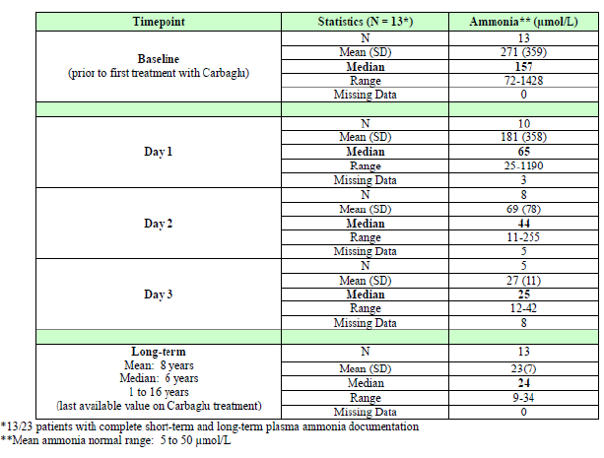

Plasma glutamine levels similarly decreased over first 3 days of treatment and were maintained long term (last available value) as shown in Figures 12 and 13 (Attachment 2) respectively. The changes in plasma citrulline levels indicated an overall expected increase as shown in Figures 15 and 16 (Attachment 2) respectively.

Among 10 patients with data available, 7 reported with ‘affected neurological development’ at baseline. At last follow up normal neurological development was reported in 5 out of these 7 patients. No patient with ‘unaffected’ status at baseline progressed to ‘affected neurological’ status at the long term evaluation. Among 7 patients with baseline data, 4 had signs of ‘retardation’. At last follow up recovery of psychomotor function was reported in 2 out of these 4 patients. No patient worsened after initiation of carglumic acid treatment.

Among 10 patients with hepatic data at baseline, 2 had ‘disrupted’ hepatic status. At the last evaluation, no patient was reported with ‘disrupted’ hepatic status.

Diet analysis showed that the majority of patients were quickly able to be switched from restricted protein intake to free protein intake with carglumic acid treatment and normalisation of plasma ammonia levels, with the exception of one patient who was maintained under a mildly restricted protein diet on a long term basis.

##### Experience with carglumic acid in USA

In a report covering the period from January 2004 to November 2008, seven patients had been enrolled in a FDA funded study (2 NAGS deficiency, 4 PA and 1 NAGS deficiency heterozygous) with the objective of assessing the effect of a 3 day treatment with carglumic acid on serum urea using radiolabelled 13C or 15N tracer. Patients were assessed pre-treatment and 72 hours after oral or gastrostomy administration of carglumic acid at a dose of 100 mg/kg/day for patients < 25 kg body weight or 2.2 g/m2/day for patients > 25 kg body weight.

Patient 1 and 3 had NAGS deficiency and both responded to treatment with a decrease in NH3 and glutamine and increased urea. Patient 2 had was NAGS mutation heterozygous and showed no significant change in any parameter.

Patients 4 to 7 had PA. Their pre-treatment ureagenesis was much less compromised than NAGS deficiency patients. They showed some increase in urea production and decrease in glutamine, while the decrease in NH3 was observed in patients 5 and 7 but not in patients 4 and 6.

##### Organic Acidaemias – retrospective review

This was a retrospective review of data from patients treated with carglumic acid for hyperammonaemia during OA decompensation episodes. Patients from multiple centres across 7 countries were included covering the period January 1995 to November 2009.

To be eligible for inclusion into this dataset the patients were required to have confirmed OA (PA, MMA or IVA), pre-treatment hyperammonaemia > 60 µmol/L and hyperammonaemia in at least one OA decompensation episode treated with carglumic acid. In neonates, ammonaemia is considered as plasma NH3 of 100 µmol/L. However a 60 µmol/L threshold, as defined in non neonatal population was used in this study.

Patients with severe hepatic insufficiency, inherited hepatic malformation or intercurrent disease were excluded. A total of 41 (4 IVA, 21 MMA and 16 PA) patients comprised the efficacy set, and 57 were included in the safety set. The dosing was at the discretion of the treating physician. The efficacy outcome was change in plasma NH3 from baseline to endpoint (up to 15 days after start of carglumic acid treatment) for every decompensation episode treated with carglumic acid.

At baseline, the median age was 9 days (range 2 to 8067 days; Q1 to Q3[8] 5 to 220 days). The participants had symptoms consistent with OA decompensation, including significant neurological and gastrointestinal symptoms. At the time of first decompensation episode, 28 patients were neonates and 13 were > 4 weeks age. All non neonates were children except for 1 adult. One patient suffered a second decompensation episode within the neonatal period. A total of 48 decompensation episodes were reported (29 in neonates, 19 in non neonates). A number of patients (43.8% episodes) were treated with an ammonia scavenger prior to initiation of carglumic acid therapy.

The majority of the episodes were initially treated with carglumic acid dose of 100 to 250 mg/kg/day. The initial carglumic acid initial dose was comparable in the three diagnosis groups. The trend to a decrease in the carglumic acid dose over the treatment days was observed. The histograms in Figure 6 below, show categories and frequency of doses used on the first and last day (up to 15 days post treatment at the discretion of the treating physician).

Figure 6. Carglumic acid dose categories - first and last day (efficacy population).

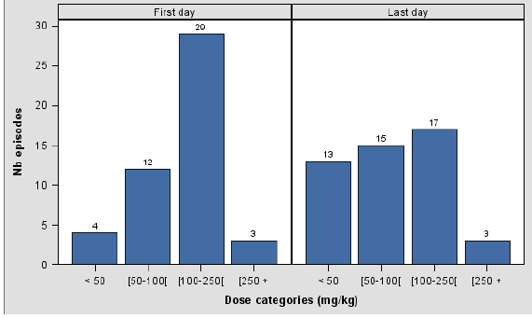

The duration of OA episode was a median of 6 days in the overall efficacy population (median of 6 days in neonate efficacy population and 7 days in non-neonate efficacy population). A total of 34 (82.9%) patients suffered 1 decompensation episode treated with carglumic acid, 6 patients (14.6%) suffered 2 decompensation episodes treated with carglumic acid and 1 (2.4%) patient suffered 3 episodes treated with carglumic acid.

The time elapsed in decompensation episodes between the start of episode and the initiation of the treatment with carglumic acid was a mean of 3 days (4.2 days PA, 2.5 days MMA, 0.8 days IVA). The mean time between the start of episodes and the initiation of treatment was 1.5 days in the neonate efficacy group and 5.3 days in the non neonate efficacy group.

The duration of treatment for hyperammonaemia with carglumic acid ranged between 1 to 15 days with a mean of 5.5 days (5.2 days PA, 6.1 days MMA, 3.5 days IVA). The mean duration of treatment in the neonates was 4.9 days and 6.5 days in the non neonates.

The median time to achieve the primary endpoint in overall efficacy population was 36.5 hours (mean 58.7 hours). The median time to achieve the primary end point was 38.4 hours in the neonate efficacy group and 28.3 hours in the non neonate efficacy group. The time was similar with or without NH3 scavenger use.

Mean NH3 at baseline was 350 µmol/L (median 215 µmol/L). Mean NH3 at endpoint was 58.5 µmol/L (median52.0 µmol/L) indicating correction of ammonaemia with carglumic acid treatment. Mean change in NH3 from baseline to endpoint was – 292 µmol/L (SD 321). At baseline, all episodes had ammonaemia > 60 µmol/L. At endpoint, 62.5% were ≤ 60 µmol/L and 37.5% > 60 µmol/L. The response was rapid as shown in Figure 21 Attachment 2.

At baseline, mean NH3 in patients not treated with ammonia scavengers prior to initiation of carglumic acid therapy was lower (261 µmol/L) compared to patients who received prior scavenger treatment (466 µmol/L). The response to carglumic acid was equally effective in both subgroups with mean NH3 at endpoint of 56 µmol/L in the former and 38 µmol/L in the latter group. The proportion of patients with endpoint NH3 ≤ 60 µmol/L was 56% in those with prior scavenger treatment compared to 71% among those without prior treatment with NH3 scavengers.

Amino acid chromatography indicated that glutamine levels were reduced from high to normal and from normal to low with carglumic acid treatment. Other amino acids levels in plasma also showed a trend towards lower concentrations. The results of urinary organic acid by diagnostic categories (IVA, MMA, PA) were variable.

At baseline, 65.7% patients were in low plasma bicarbonate (HCO3) range and 34.3% in the normal range. At endpoint, 55.0% were in low HCO3 range and 45.0% were in normal range. The effect was similar among patients treated with NH3 scavengers and those not treated with NH3 scavengers prior to receiving carglumic acid.

Beneficial effect was recorded for patient improvement in neurological status, psychiatric status, psychomotor status, hepatic status and respiratory data at endpoint compared to baseline. A significant number of patients had missing data at endpoint and therefore a proportionate comparison is not possible (Table 24, Attachment 2).

#### Clinical safety

A total of 143 patients, including 44 who received carglumic acid as therapeutic test, have been exposed to carglumic acid. These included 99 long term treatment patients including 23 NAGS patients and 76 non NAGS deficiency patients between 1 January 1991 and 31 December 2008.

##### NAGS deficiency

For the safety analysis, 23 patients were exposed to at least to one dose of carglumic acid. The cumulative treatment duration for NAGS deficiency patients was 187.4 patient years. The duration of treatment (Figure 23, Attachment 2) for these patients appears to have been 0 to 50 months (35%), 50 to 100 months (17%), 100 to 150 months (26%), 150 to 200 months (17%) and 200 to 250 months (4%). A total of 18/23 patients experienced at least one AE and included as shown in Table 11 below (reference US label).

Table 11. Adverse events for NAGs deficiency patients.

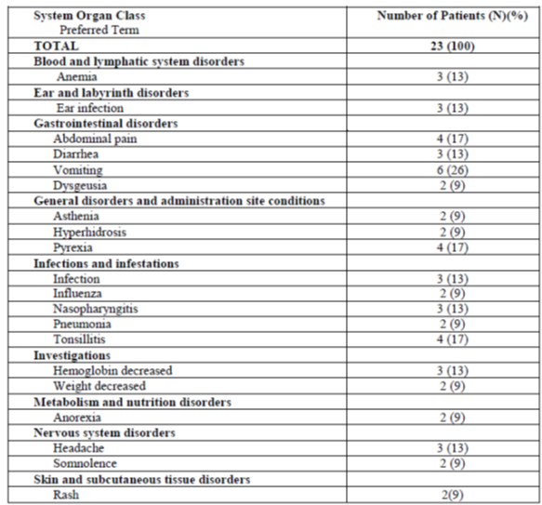

A total of 37 SAEs and 2 deaths were reported and were not considered treatment related.

##### Organic acidaemias

A total of 57 patients were exposed at least to one dose of the study drug. The duration of the treatment with carglumic acid was 1 to 16 days (mean 5.3 days; median 4 days). The first dose of carglumic acid ranged from 10 to 303 mg/kg (mean 86.5 mg/kg; median 62.9 mg/kg).

A total of 25/57 patients experienced at least one AE. A total of 74 AEs were reported. A total of 24 AEs in 9 patients were considered related to medication. A total of 22 SAEs were reported. Seven deaths were reported. For all fatal SAEs, investigator’s causality assessment to study drug was ‘unrelated’, except for one event ‘neurological damage’ for which investigator’s causality assessment was ‘related’.

For other SAEs, investigator’s causality assessment was ‘unrelated’, except for 5 events (cardiac arrest, diarrhoea, hepatic enzyme increased, worsening of encephalopathy and respiratory failure) for which investigator’s causality assessment was ‘unknown’ or ‘not mentioned’.

Overall in the dataset, the ECG data, including from healthy subjects in PK studies, was considered inadequate to assess the risk of QT/QTc prolongation with carglumic acid.

The adverse/safety outcomes, reported in the overall dataset, were generally considered related to the underlying disease. Carglumic acid was well tolerated. The AE s reported in the periodic safety updates were, consistent with those reported in the retrospective review of data.

In response to questions raised by the TGA , the sponsor confirmed that a review of all Carbaglu cases received until 30 May 2014 had been performed by OE which showed as follows:

* Nine cases were identified as events which can be considered as liver toxicity. Six of these events were considered by the physician as ‘not related’. The other 3 cases included 1 case of aspartate aminotransferase (AST)/alanine aminotransferase (ALT) increased (hepatic cytolysis, transaminases 10 x normal, intra cranial hypertension, multi organ failure death), 1 case of elevation of liver enzymes (sepsis, recovered) and 1 case of raised transaminase (no details, ‘off label use’).
* Two cases were identified as events as haematological toxicity including eosinophilia (on multiple drugs including antivirals; death) and thrombocytopenia and coagulopathy (hypotensive cardiac arrest, coagulopathy, thrombocytopenia, recovered).
* Three cases were identified as cardiotoxicity including 1 restrictive cardiomyopathy, 1 cardiac arrest (patient previously described under thrombocytopenia and coagulopathy) and 1 bradycardia (recovered).

The sponsor was requested to include a tabular summary of all AEs in its pre-ACPM response based on the review of safety data to 30 May 2014 and any further details of hepatic adverse effects.

#### Clinical evaluator’s recommendation (if applicable)

The clinical evaluator recommends rejection due to inadequately described PK in neonates and concern about insufficient information about safety.

### Risk management plan

The European Risk Management Plan (version OE/PV/CARB/0114, dated 23 July 2014, data lock point 31 May 2014), with Australian Specific Annex (version 0.2, dated 31 July 2014), apply to this submission and will be a condition of registration.

### Risk-benefit analysis

#### Delegate’s considerations

##### Delegate’s conclusion and recommendation

1. NAGS deficiency and Organic Acidaemias (3 types: IVA, MMA and PA) are very rare inherited metabolic disorders of urea cycle. The proposed indication was granted ‘orphan’ status. The disorders result is a life threatening toxic ammonia accumulation in plasma in the neonatal period or early childhood and have severe clinical sequelae in survivors. There are not many therapeutic options and none are specific or currently registered. The treatment needs to be initiated promptly in all cases whether neonatal (early onset) or late onset.
2. Carglumic acid is a specific and direct activator of CPS1, the first enzyme of urea cycle. Carglumic acid has been approved in Europe since 2003 (NAGS deficiency and OAs) and was approved in the USA in 2010 (NAGS deficiency).
3. Carglumic acid is administered orally and there appears to be no attempt to develop a parenteral preparation. The drug is considered to have undergone adequate testing in the nonclinical (toxicology studies) phase and there are no objections to the registration from the nonclinical evaluators.
4. Clinical data are understandably very limited. The PK information is minimal but considered acceptable. Further PK modelling especially in neonates would doubtless have been more useful. There are also no dose response data. The proposed dosing (100 to 250 mg/kg/day) is based on clinical usage only. The risk of drug-drug interactions is considered very low.
5. Treatment with carglumic acid, in case of NAGS deficiency and can be divided into 2 phases: acute treatment (initial 7 days) and long term maintenance (reported exposure 1 to 16 years; potentially indefinite). In OAs (IVA, MMA, PA), the endpoint is resolution of decompensation episode (up to 15 days in the reported data; maintenance not defined). The total clinical experience consists of 23 NAGS deficiency and 41 OA patients available in respective retrospective analysis of data for efficacy and safety. Data for additional 7 patients (4 NAGS and 3 OA) treated in the USA was also included.
6. The results showed rapid and dramatic fall in plasma ammonia levels with normalisation within 1 to 3 days after starting therapy with carglumic acid. The effect on secondary biochemical outcomes (glutamine, citrulline, urea) was consistent with expectation of restarting of urea production cycle. The carglumic acid, in acute phase, was used in conjunction with ammonia scavengers in both NAGS deficiency and OA indications.
7. The control of ammonaemia was maintained with treatment over the long term (last available observation). The clinical outcomes in terms of neurological and psychomotor development and normalisation of diet were beneficial. Ongoing treatment was associated with prevention of decompensation episodes.
8. In all cases a variable oral dose of 100 to 250 mg/kg/day in divided daily doses was used initially and then lowered gradually in maintenance phase according to patient response principally based on plasma biochemical markers such as NH3.
9. The number of patients and the data are very small, retrospective and incomplete and any meaningful inferential statistical analysis is not possible. However, even more than the small numbers, the bigger limitation was missing information for the patients included in the dataset which also makes any qualitative judgement difficult.
10. Similarly the dataset is too small for full characterisation of safety profile although overall the treatment with carglumic acid was well tolerated. Most safety/adverse outcomes could be ascribed to the manifestations of underlying metabolic disorder and its complications. Thus the proposed use may be considered acceptable given the clinical context.
11. However, certain specific risks such as cardiotoxicity and hepatotoxicity are significant concerns. Carglumic acid’s site of action is hepatic cells and it is more resistant to hydrolysis compared to its natural analogue. It is biologically plausible that its long term exposure may be toxic to hepatocytes. One case of hepatic necrosis in a small dataset may be indicative of this risk.
12. It is not conceivable that more data can be obtained in a prospective manner in sufficient numbers to allow better characterisation of efficacy and safety. On the other hand, expectation of accumulation of data in the post market phase is reasonable, especially if post-market activities include long term follow up of treated patients for major outcomes such as long term survival.

Given the arguments above and pending advice from the ACPM, the Delegate is of the opinion that approval of carglumic acid 200 mg dispersible oral tablets (Carbaglu), for the proposed indications (NAGS deficiency; OAs specifically IVA, MMA and PA) as well as the dosing regimen as proposed, is clinically justifiable in the context of a rare and serious inherited metabolic disorder and despite obvious deficiencies in the supporting dataset.

#### Proposed action

The Delegate has no reason to say, at this time, that the application for carglumic acid (Carbaglu) should not be approved for registration for the proposed indication.

#### Request for ACPM advice

The Committee is requested to provide advice on the following specific issues:

1. Is the proposed dosing (100 to 250 mg/kg), including neonates, justifiable despite absence of PK modelling and dose response evaluation?
2. Is the supporting dataset sufficient given the clinical context, that is, rarity, seriousness and lack of therapeutic options?
3. Has sufficient safety data been presented given the safety concerns of hepatotoxicity and cardiotoxicity and does ACPM have any specific advice regarding these concerns for the PI?
4. Does the committee have further specific advice regarding post market activities such as long term follow up of patients?

The committee is (also) requested to provide advice on any other issues that it thinks may be relevant to a decision on whether or not to approve this application.

#### Response from sponsor

Emerge Health and our partner OE, are pleased to have the opportunity to respond to the Delegate’s overview following the evaluation of the Carbaglu (carglumic acid) dispersible tablets Category 1 Application. The sponsor welcomed the Delegate’s initial opinion that the proposed indication for Carbaglu (NAGS deficiency and Organic Acidaemia’s IVA, MMA and PA) and the dosing regime is clinically justifiable, thereby supporting the approval of the product**.**

##### Proposed indication

Emerge Health has proposed the following indication for Carbaglu so as to align with the approved indication in Europe:

*Carbaglu is indicated in treatment of*

* *hyperammonaemia due to N-acetylglutamate synthase primary deficiency.*
* *hyperammonaemia due to isovaleric acidaemia.*
* *hyperammonaemia due to methymalonic acidaemia.*
* *hyperammonaemia due to propionic acidaemia.*

##### Outstanding pharmaceutical chemistry matters

Emerge Health is pleased to confirm that subsequent discussions with the TGA have resolved any outstanding matters relating to pharmaceutical chemistry matters.

##### Response to comments on clinical data

###### Pharmacokinetics

Emerge Health refers to the points raised as part of the clinical evaluation, specifically the limitations of the pharmacokinetic data in target population or special population, including the lack of drug interaction or dose ranging studies. Emerge Health also acknowledges the Delegates comment that the ‘*PK information is minimal but considered acceptable*’ and ‘*further PK modelling especially in neonates would doubtless have been more useful*’.

The development program followed for Carbaglu was one intended to demonstrate the safety and efficacy of carglumic acid in the treatment of hyperammonaemia as expeditiously as possible, to fulfil an unmet clinical need. Orphan Europe have acknowledged, that to achieve this additional PK studies were considered not feasible in such as sparse population such as NAGS patients. Also analysis of the PK parameters in the population used or the clinical studies were considered as not ethically acceptable, particularly due to the need for repeated blood samplings in the young study participants. Monitoring of blood levels of carglumic acid was conducted in a small number of patients (Table 5, Attachment 2) however, these data collected were not sufficient to assess the whole PK profile in paediatric subjects.

The sponsor wishes to confirm that absolute bioavailability of Carbaglu has not been assessed due to the difficulties encountered as part of manufacturing an solution of carglumic acid for IV infusion against which to compare the oral administration. Carglumic acid is not stable at neutral pH that would be suitable for IV administration and an appropriate formulation should be specifically developed.

The sponsor refers to the determination of relative bioavailability of the dispersible tablets assessed in healthy volunteers (refer to Study No OE312/PK/99-01) that compared dispersible tablets with an extemporary suspension of carglumic acid in 250 mL of water. The intact tablets resulted bioequivalent to the suspension of carglumic acid.

Further PK assessment of carglumic acid as provided in the ADME (absorption, distribution, metabolism and excretion study, performed in healthy volunteers (Study SPC313-1) where it was shown that at least 8% of the parent compound is absorbed (based on urinary excretion); while up to 70% of the administered dose is excreted in faeces as unmodified compound suggesting that most of this amount is not absorbed. Moreover about 12% of the total radioactivity is recovered in faeces as compounds derived from labelled carglumic acid, however it was not possible to establish if these related compounds are metabolites of the parent compound or degradation products due to the metabolism of enteric flora. Therefore, we can conclude that absolute bioavailability may range from 8% to 30% of the administered dose, which is in agreement with the value of about 30% observed in the dog (nonclinical study Biotec Centre 026/06 027).

Despite the low volume of PK data, the impact of these omissions may be reduced by the need to individually adjust the dose administered based of its effects on hyperammonaemia. The measurements of the glutamine levels in patients receiving carglumic acid (NAGS deficiency, retrospective review; see Figures 12 and 13 Attachment 2) allow for the monitoring of the treatment as well as, providing data to allow the adjustment of the doses.

###### Clinical efficacy – Concomitant treatments used during NAGS deficiency study

The sponsor refers to the Delegates’ comments relating to the concomitant treatments for hyperammonaemia reported as part of the NAGS Deficiency study and confirms that the description of the treatments was provided (see Table 11 of Attachment 2) as part of the original application. It is noted that the timing of the use of these concomitant treatments was not reported in the original clinical study report. Part II of the clinical study report provided the respective timings of previous or concomitant use of standard treatment and the initiation of carglumic acid treatment by patient.

Due to the serious nature of the underlying condition, the suggested guidelines for the management of urea cycle disorders[9] recommends to administer several treatments concurrently to expedite the ammonia detoxification. Further, once NAGS deficiency is diagnosed and the patient is stable, monotherapy with Carbaglu is the drug of choice.

*Present a tabular listing of all AEs based on the review of safety data to 30 May 2014 and any further details on hepatic AEs.*

*The noted inability to conduct a qualitative assessment of the data from the clinical studies based on the low numbers of subjects and the missing data.*

*Any additional PSUR’s available since the submission of the most recent PSUR.*

*Comment on not supplying data for blood pressure, pulse rate and respiratory rates (as per page 80 of Attachment 2).*

###### Clinical safety

The sponsor has provided a tabular summary of spontaneous AEs reported until 31 May 2014 along with a tabular summary of AEs reported as part of the NAGS Deficiency and Organic Acidaemia clinical studies. These tabular summaries are provided as a part of this response.

Table 12. Serious adverse event received in the study NAGS.

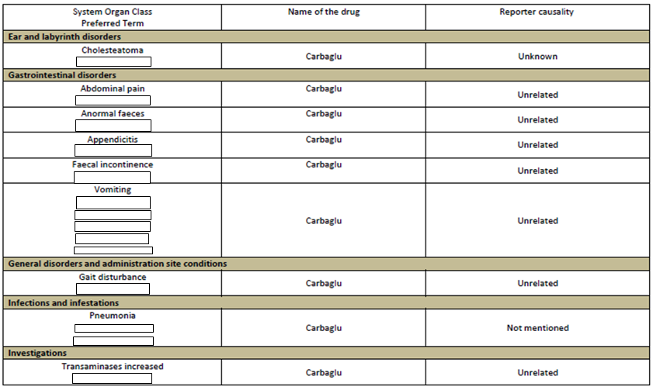

Table 13. Serious adverse event received in the study OA 2009: Carbaglu retrospective observational study of hyperammonaemia in OA decompensation episodes.

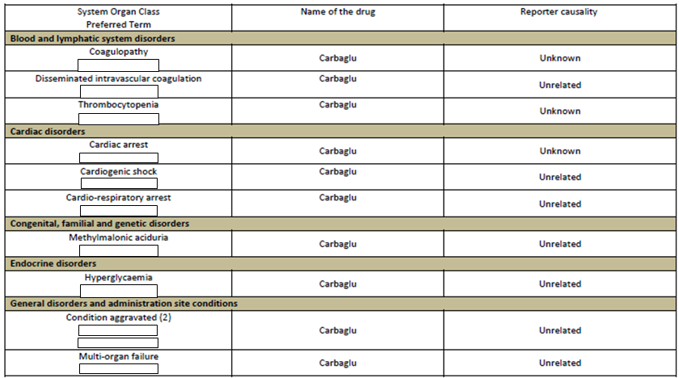

Table 14. Spontaneous cases received until 31 May 2014.

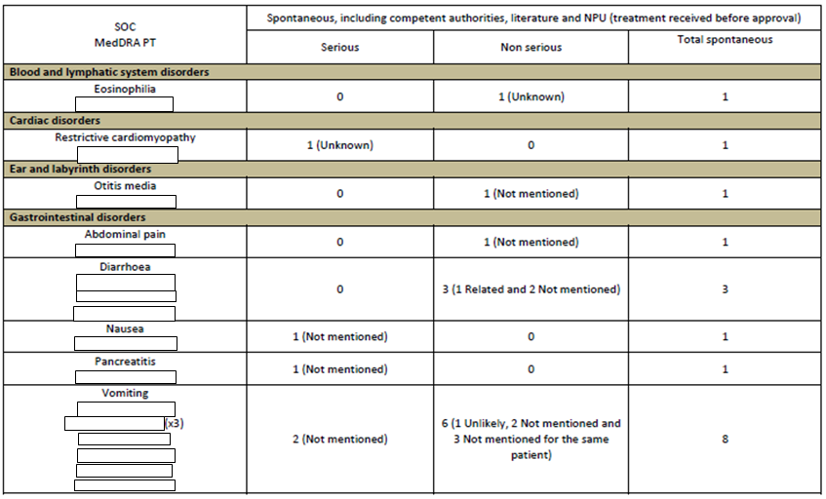

#### Advisory committee considerations

The Advisory Committee on Prescription Medicines (ACPM), having considered the evaluations and the Delegate’s overview, as well as the sponsor’s response to these documents, advised the following:

The ACPM, taking into account the submitted evidence of efficacy, safety and quality, agreed with the delegate and considered Carbaglu dispersible tablets containing 200 mg of carglumic acidto have an overall positive benefit–risk profile for the indication;

*Carbaglu is indicated in the treatment of;*

* *Hyperammonaemia due to N-acetylglutamate synthase primary deficiency*
* *Hyperammonaemia due to isovaleric acidaemia*
* *Hyperammonaemia due to methyl-malonic acidaemia*
* *Hyperammonaemia due to propionic acidaemia*

##### Proposed Product Information (PI)/Consumer Medicine Information (CMI) amendments

The ACPM agreed with the Delegate to the proposed amendments to the PI and Consumer Medicine Information (CMI) and specifically advised on the inclusion of the following:

* A statement in the Precautions section could be considered to the effect that there is insufficient evidence to determine if there is an association between Carbaglu and cardiotoxicity.
* The Committee noted the term ‘Consumer Medical Information’ in the heading in the accompanying CMI. This should be corrected to ‘Consumer Medicine Information’.

##### Specific advice

The ACPM advised the following in response to the Delegate’s specific questions on this submission:

1. *Is the proposed dosing (100-250 mg/kg), including neonates, justifiable despite absence of PK modelling and dose response evaluation?*

The ACPM advised that, given the limited data possible in this small population, the proposed dose range is consistent with that used in clinical practice to treat the proposed indication/s and is therefore justifiable on this basis.

1. *Is the supporting dataset sufficient given the clinical context i.e. rarity, seriousness and lack of therapeutic options?*

The ACPM agreed the target population is extremely small and therefore there are limited data available on the use of Carbaglu in the proposed setting. However, the data that are available are consistently and highly supportive of the use of Carbaglu in the proposed indications.

1. *Has sufficient safety data been presented given the safety concerns of hepatotoxicity and cardiotoxicity and does ACPM have any specific advice regarding these concerns for the Product Information?*

ACPM considered adverse hepatic and cardiac events seen in studies of Carbaglu are most likely confounded by the disease.

Hepatotoxicity is often associated with hyperammonaemia and adverse hepatic effects observed in studies of Carbaglu. Similarly hyperammonaemia can also itself be a cause of cardiotoxicity. It was therefore difficult to establish if adverse hepatic and cardiac events observed in studies of Carbaglu were due to the drug or the disease.

1. *Does the Committee have further specific advice regarding post market activities such as long term follow up of patients?*

ACPM supported the use of National and International registries to study patients taking Carbaglu. Ideally, study outcomes should be stratified by specific indication and dose, which may be helpful in defining optimal treatments and doses.

### Outcome

Based on a review of quality, safety and efficacy, TGA approved the registration of Carbaglu carglumic acid 200mg dispersible tablets for oral administration, indicated for:

*Carbaglu is indicated in the treatment of;*

* *Hyperammonaemia due to N-acetylglutamate synthase primary deficiency*
* *Hyperammonaemia due to Organic Acidaemias such as:*
  + *Hyperammonaemia due to isovaleric acidaemia*
  + *Hyperammonaemia due to methyl-malonic acidaemia*
  + *Hyperammonaemia due to propionic acidaemia*

#### Specific conditions of registration applying to these goods

1. The implementation of the carglumic acid EU-Risk Management Plan (EU-RMP), version OBIPV/CARB/0114, dated 23 July 2014, datalock point 31 May 2014 and ASA version 0.2, dated 31 July 2014 revised to the satisfaction of the TGA, included with submission PM-2013-02751-1-3, and any subsequent revisions, as agreed with the TGA will be implemented in Australia.
2. In addition, inclusion of Australian patients in overseas registries and reporting of information from overseas registries to the TGA, as agreed with the Post market Surveillance Branch of the TGA, should be included in an updated ASA.

## Attachment 1. Product Information

The Product Information approved for main Carbagluat the time this AusPAR was published is at Attachment 1. For the most recent Product Information please refer to the TGA website at <<https://www.tga.gov.au/product-information-pi>>.

## Attachment 2. Extract from the Clinical Evaluation Report

|  |
| --- |
| Therapeutic Goods Administration |
| PO Box 100 Woden ACT 2606 Australia  Email: [info@tga.gov.au](mailto:info@tga.gov.au) Phone: 1800 020 653 Fax: 02 6232 8605  [**https://www.tga.gov.au**](https://www.tga.gov.au) |

1. Based on a maximum clinical dose of 250 mg/kg/day, and a mg/kg to mg/m2 conversion factor of 20 for a 10 kg child.
2. Eudralex Vol 3. 3BS1a Single Dose Toxicity
3. ICH S2(R1)International Conference on Harmonisation of Technical Requirements for Registration of Pharmaceuticals for Human Use; Guidance on Genotoxicity testing and data interpretation for pharmaceuticals intended for human use S2 (R1).
4. ICH S6(R1)ICH Harmonised tripartite guideline. Preclinical safety evaluation of biotechnology-derived pharmaceuticals S6(R1).
5. Category C: *Drugs which, owing to their pharmacological effects, have caused or may be suspected of causing, harmful effects on the human fetus or neonate without causing malformations. These effects may be reversible. Accompanying texts should be consulted for further details.*
6. Category B1: *Drugs which have been taken by only a limited number of pregnant women and women of childbearing age, without an increase in the frequency of malformation or other direct or indirect harmful effects on the human fetus having been observed. Studies in animals have not shown evidence of an increased occurrence of fetal damage.*
7. Identifying information redacted
8. Interquartile range, that is, values from 25th to 75th percentile.
9. <<http://www.ojrd.com/content/7/1/32>>