October 2021

Australian Public Assessment Report for Casirivimab/imdevimab
  - Proprietary Product Name: Ronapreve
  - Sponsor: Roche Products Pty Limited

About the Therapeutic Goods Administration (TGA)
- The Therapeutic Goods Administration (TGA) is part of the Australian Government Department of Health and is responsible for regulating medicines and medical devices.
- The TGA administers the Therapeutic Goods Act 1989 (the Act), applying a risk management approach designed to ensure therapeutic goods supplied in Australia meet acceptable standards of quality, safety and efficacy (performance) when necessary.
- The work of the TGA is based on applying scientific and clinical expertise to decision-making, to ensure that the benefits to consumers outweigh any risks associated with the use of medicines and medical devices.
- The TGA relies on the public, healthcare professionals and industry to report problems with medicines or medical devices. TGA investigates reports received by it to determine any necessary regulatory action.
- To report a problem with a medicine or medical device, please see the information on the TGA website <https://www.tga.gov.au>.

About AusPARs
- An Australian Public Assessment Report (AusPAR) provides information about the evaluation of a prescription medicine and the considerations that led the TGA to approve or not approve a prescription medicine submission.
- AusPARs are prepared and published by the TGA.
- An AusPAR is prepared for submissions that relate to new chemical entities, generic medicines, major variations and extensions of indications.
- An AusPAR is a static document; it provides information that relates to a submission at a particular point in time.
- A new AusPAR will be developed to reflect changes to indications and/or major variations to a prescription medicine subject to evaluation by the TGA.

Copyright
© Commonwealth of Australia 2021
This work is copyright. You may reproduce the whole or part of this work in unaltered form for your own personal use or, if you are part of an organisation, for internal use within your organisation, but only if you or your organisation do not use the reproduction for any commercial purpose and retain this copyright notice and all disclaimer notices as part of that reproduction. Apart from rights to use as permitted by the Copyright Act 1968 or allowed by this copyright notice, all other rights are reserved and you are not allowed to reproduce the whole or any part of this work in any way (electronic or otherwise) without first being given specific written permission from the Commonwealth to do so. Requests and inquiries concerning reproduction and rights are to be sent to the TGA Copyright Officer, Therapeutic Goods Administration, PO Box 100, Woden ACT 2606 or emailed to <tga.copyright@tga.gov.au>.

Contents
List of abbreviations 4
I. Introduction to product submission 8
Submission details 8
Product background 10
Regulatory status 12
Product Information 13
II. Registration timeline 13
III. Submission overview and risk/benefit assessment 14
Quality 14
Nonclinical 16
Clinical 17
Risk management plan 63
Risk-benefit analysis 64
Outcome 74
Attachment 1. Product Information 77

List of abbreviations
Abbreviation | Meaning
ACE2 | Angiotensin converting enzyme 2
ACM | Advisory Committee on Medicines
ADA | Anti-drug antibodies
ADE | Antibody dependent enhancement
ADR | Adverse drug reaction(s)
AE | Adverse event(s)
AESI | Adverse event(s) of special interest
ARGPM | Australian Regulatory Guidelines for Prescription Medicines
ARTG | Australian Register of Therapeutic Goods
ASA | Australian specific annex
AUC_{0-28d} | Area under the plasma concentration versus time curve from Day 0 to Day 28
AUC_{last} | Area under the plasma concentration versus time curve from time zero to time of last measurable concentration
AUC_{tau,ss} | Area under the plasma concentration versus time curve over a dosing interval at steady state
BMI | Body mass index
C_{7d} | Drug concentration at Day 7
C_{28d} | Drug concentration at Day 28
CDC | Centers for Disease Control and Prevention (United States of America)
CHMP | Committee for Medicinal Products for Human Use (European Union)
CL | Clearance
C_{max} | Maximum drug concentration
CMI | Consumer Medicines Information
COPD | Chronic obstructive pulmonary disease
COVID-19 | Coronavirus disease 2019
CU | Compassionate use
CPD | Certified Product Details
DLP | Data lock point
EAP | Efficacy assessment period
EMA | European Medicines Agency (European Union)
EU | European Union
EUA | Emergency Use Authorization (Food and Drug Administration, United States of America)
FAS | Full analysis set
Fc | Fragment crystallisable
FDA | Food and Drug Administration (United States of America)
IC₅₀ | Half maximal (50%) inhibitory concentration
IgA | Immunoglobulin A
IgG | Immunoglobulin G
IgG1λ | Immunoglobulin G, subclass 1, lambda light chain
IgG1κ | Immunoglobulin G, subclass 1, kappa light chain
IRR | Infusion related reaction
ISR | Injection site reaction
IV | Intravenous
K_{A} | Absorption rate constant
K_{D} | Dissociation constant
mAb | Monoclonal antibody
mFAS | Modified full analysis set
OR | Odds ratio
PD | Pharmacodynamic(s)
PK | Pharmacokinetic(s)
PKAS | Pharmacokinetic analysis set
PI | Product Information
pM | Picomolar
popPK | Population pharmacokinetic
RBD | Receptor binding domain
RMP | Risk management plan
RNA | Ribonucleic acid
RT-(q)PCR | Reverse transcription (quantitative real time) polymerase chain reaction
SAE | Serious adverse event(s)
SAF | Safety analysis population
SAP | Statistical analysis plan
SARS-CoV-2 | Severe acute respiratory syndrome coronavirus 2
SC | Subcutaneous
SD | Standard deviation
TEAE | Treatment emergent adverse event(s)
t_{1/2} | Half-life
T_{max} | Time taken to reach the maximum concentration
UK | United Kingdom
US(A) | United States (of America)
V_{c} | Distribution volume of central compartment
VOC | Variant of concern
VOI | Variant of interest
V_{p} | Distribution volume of peripheral compartment
VUS | Variants under surveillance
WHO | World Health Organization

I. Introduction to product submission

Submission details
Type of submission: | New biological entity
Product name: | Ronapreve
Active ingredients: | Casirivimab/imdevimab
Decision: | Approved for provisional registration
Date of decision: | 15 October 20201
Date of entry onto ARTG: | 18 October 2021
ARTG numbers: | 373839 and 374310
Black Triangle Scheme: | Yes.  As a provisionally registered product, this medicine will remain in the Black Triangle Scheme for the duration of its provisional registration.
Sponsor’s name and address: | Roche Products Pty Limited  Level 8, 30-34 Hickson Road  Sydney NSW 2000
Dose forms: | Solution for infusion and injection
Strengths: | 120 mg/mL casirivimab and 120 mg/mL imdevimab
Containers: | Single use and multidose vials
Pack sizes: | 2 (6 mL single use vials, one vial contains casirivimab and one vial contains imdevimab)  2 (20 mL multidose vials, one vial contains casirivimab and one vial contains imdevimab)
Approved therapeutic use: | Ronapreve has provisional approval for the indications below:  Treatment:  Ronapreve is indicated for the treatment of COVID-19 in adults and adolescents (aged 12 years and older and weighing at least 40 kg) who do not require supplemental oxygen for COVID-19 and who are at increased risk of progressing to severe COVID-19.  Post-exposure prophylaxis:  Ronapreve is indicated for the prevention of COVID-19 in adults and adolescents (aged 12 years and older and weighing at least 40 kg) who have been exposed to SARS-CoV-2 and who either:  - have a medical condition making them unlikely to respond to or be protected by vaccination, or  - are not vaccinated against COVID-19. (refer to section 4.2 Dose and method of administration and 5.1, Clinical trials)  Ronapreve is not intended to be used as a substitute for vaccination against COVID-19.  The decision has been made on the basis of short term efficacy and safety data. Continued approval of this indication depends on the evidence of longer term efficacy and safety from ongoing clinical trials and post-market assessment.
Routes of administration: | Intravenous infusion and subcutaneous injection
Dosage: | Adults  The dosage in adult patients and adolescent patients 12 years of age and older weighing at least 40 kg is 600 mg of casirivimab and 600 mg of imdevimab administered either together as a single intravenous infusion via pump or gravity, or by subcutaneous injection. Intravenous infusion is strongly recommended. Subcutaneous injection is an alternative route of administration when intravenous infusion is not feasible and would lead to delay in treatment.  Casirivimab with imdevimab should be given together as soon as possible after a positive viral test for SARS-CoV-2 and not later than 7 days after the onset of first symptoms.  Paediatric population  The safety and efficacy of casirivimab and imdevimab in children less than 12 years of age has not yet been established. No data are available for this age group. No dosage adjustment is recommended in paediatric individuals of 12 years of age and older and weighing 40 kg or more.  For further information regarding dosage, refer to the Product Information.
Pregnancy category: | B2  Drugs which have been taken by only a limited number of pregnant women and women of childbearing age, without an increase in the frequency of malformation or other direct or indirect harmful effects on the human fetus having been observed.  Studies in animals are inadequate or may be lacking, but available data show no evidence of an increased occurrence of fetal damage.  The use of any medicine during pregnancy requires careful consideration of both risks and benefits by the treating health professional. This must not be used as the sole basis of decision making in the use of medicines during pregnancy. The TGA does not provide advice on the use of medicines in pregnancy for specific cases. More information is available from obstetric drug information services in your State or Territory.

Product background
This AusPAR describes the application by Roche Products Pty Limited (the sponsor) to register Ronapreve (casirivimab/imdevimab) 120 mg/mL casirivimab and 120 mg/mL imdevimab, solution for infusion and injection for the following proposed indication:
Treatment
Ronapreve is indicated for the treatment of confirmed COVID-19 in patients aged 12 years and older and weighing at least 40 kg that do not require supplemental oxygen for COVID-19 and who are at high risk of progressing to severe COVID-19.
Prevention
Ronapreve is indicated for the prevention of COVID-19 in individuals aged 12 years and older and weighing at least 40 kg who meet one or more of the following criteria:
- have been exposed or are at high risk of exposure to SARS-CoV-2
- have a medical condition making them unlikely to respond to or be protected by vaccination
Ronapreve is not intended to be used as a substitute for vaccination against COVID-19.
The severe acute respiratory syndrome coronavirus 2 (SARS-CoV-2) virus is an enveloped, positive sense, single stranded ribonucleic acid (RNA) beta coronavirus. SARS-CoV-2 has spread globally since its emergence, causing coronavirus disease 2019 (COVID-19). The World Health Organization (WHO) declared that the outbreak constituted a public health emergency of international concern on 30 January 2020 and declared the outbreak to be a pandemic on 11 March 2020., COVID-19 is predominantly a respiratory illness that can affect other organs. People with COVID-19 have reported a wide range of symptoms, ranging from mild symptoms to severe illness. Symptoms may appear 2 to 14 days after exposure to the virus. Symptoms may include fever or chills; cough; shortness of breath; fatigue; muscle or body aches; headache; new loss of taste or smell; sore throat; congestion or runny nose; nausea or vomiting; and diarrhoea.
Severe illness requiring hospitalisation, admission to the intensive care unit, intubation, mechanical ventilation or death, can occur in adults of any age with COVID-19. Adults of any age with certain underlying comorbidities such as cancer, chronic kidney disease, chronic obstructive pulmonary disease, obesity, Type 2 diabetes, pregnancy and immunocompromised states are at increased risk for developing severe illness from the virus that causes COVID-19. Other medical conditions or factors also make certain individuals at high risk for progression to severe disease.
Following suppression of the initial outbreak in early 2020, the situation in Australia has been characterised by periods of zero community transmission, interspersed with sporadic outbreaks caused by escape of the virus from the hotel quarantine system that has been used for returning overseas travellers. At the time of this report, the relevant public health units are struggling to contain outbreaks in Sydney and other areas caused by the delta variant of concern.
There are currently two products on the Australian Register of Therapeutic Goods (ARTG) with a COVID-19 treatment indication, and both are approved under the provisional; pathway:
- Veklury (remdesivir), was provisionally registered on 10 July 2020 for the treatment of COVID-19 in adults and adolescents (aged 12 years and older, weighing at least 40 kg) with pneumonia, requiring supplemental oxygen.,
- Xevudy (sotrovimab), was provisionally registered on 20 August 2021 for the treatment of adults and adolescents (aged 12 years and over and weighing at least 40 kg) with COVID-19 who do not require initiation of oxygen due to COVID-19 and who are at increased risk of progression to hospitalisation or death.,
There are currently four vaccines on the ARTG, and all are approved under the provisional pathway:
- Comirnaty (BNT162b2 (mRNA); also known as the Pfizer/BioNTech vaccine), provisionally approved for active immunisation to prevent COVID-19 caused by SARS-CoV-2, in individuals 12 years of age and older.,,
- COVID-19 Vaccine AstraZeneca (ChAdOx1-S), an adenoviral vectored vaccine, provisionally approved for active immunisation of individuals 18 years of age and older for the prevention of COVID-19 caused by SARS-CoV-2.,
- COVID-19 Vaccine Janssen (Ad26.COV2.S), an adenoviral vectored vaccine, provisionally approved for active immunisation to prevent COVID-19 caused by SARS-CoV-2 in individuals 18 years of age and older.,
- Spikevax (elasomeran; also known as the Moderna vaccine), provisionally approved for active immunisation to prevent COVID-19 caused by SARS-CoV-2 in individuals 12 years of age and older.,,
Despite the provisional approval of these agents, there remains an urgent need for effective therapeutics for COVID-19.
Casirivimab immunoglobulin G, subclass 1, kappa light chain (IgG1κ) and imdevimab immunoglobulin G, subclass 1, lambda light chain (IgG1λ) are two recombinant human monoclonal antibodies (mAb) which are unmodified in the fragment crystallisable (Fc) regions. Casirivimab and imdevimab bind to non-overlapping epitopes of the spike protein receptor binding domain (RBD) of SARS-CoV-2 with dissociation constant (K_{D}) = 45.8 picomolar (pM) and 46.7 pM, respectively. Single agent casirivimab or imdevimab; and the combination of both casirivimab and imdevimab together, blocked RBD binding to the human angiotensin converting enzyme 2 (ACE2) receptor with half maximal inhibitory concentration (IC₅₀) values of 56.4 pM, 165 pM and 81.8 pM, respectively.
The TGA continues to collaborate with international regulators for COVID-19 applications where possible, including information sharing through the ACCESS consortium.

Regulatory status
This product is considered a new biological entity for Australian regulatory purposes.
At the time the TGA considered this application, similar applications had been approved in the United Kingdom (UK) on 19 August 2021; and Japan on 19 July 2021. Similar applications were also under consideration in the United States of America (USA), submitted on 27 May 2021; the European Union (EU), submitted on 29 January 2021; and Switzerland, submitted on 4 March 2021.
Table 1: International regulatory status
Region | Submission date | Status | Approved indications
United States of America | 27 May 2021 | Under consideration | Under consideration
European Union | 29 January 2021 | Under consideration | Under consideration
United Kingdom | 5 February 2021 | Conditional approval granted on 19 August 2021 | Ronapreve is indicated for the prophylaxis and treatment of acute Covid-19 infection.
Switzerland | 4 March 2021 | Under consideration | Under consideration
Japan | 29 June 2021 | Approved on 19 July 2021 | SARS-CoV-2 infection

Product Information
The Product Information (PI) approved with the submission which is described in this AusPAR can be found as Attachment 1. For the most recent PI, please refer to the TGA website at <https://www.tga.gov.au/product-information-pi>.

II. Registration timeline
The following table captures the key steps and dates for this application and which are detailed and discussed in this AusPAR.
Data was provided as a rolling submission. Under normal circumstances, the TGA's assessment (for both provisional and general registration) begins once all information to support registration is available. As part of the Department of Health's response to the pandemic, the TGA has agreed to accept rolling data for COVID-19 vaccines, to enable early evaluation of data as it comes to hand.
Table 2: Timeline for Submission PM-2021-03952-1-2
Description | Date
Positive Designation (Provisional);⁴ | 20 August 2021
Submission dossier accepted and first round evaluation commenced | 31 August 2021
Evaluation completed | 13 October 2021
Delegate’s Overall benefit-risk assessment and request for Advisory Committee advice | 2 October 2021
Sponsor’s pre-Advisory Committee response | 6 October 2021
Advisory Committee meeting | 8 October 2021
Registration decision (Outcome) | 15 October 2021
Completion of administrative activities and registration on the ARTG | 18 October 2021
Number of working days from submission dossier acceptance to registration decision* | 33
*Statutory timeframe for standard applications is 255 working days

III. Submission overview and risk/benefit assessment
The submission was summarised in the following Delegate’s overview and recommendations.
Relevant guidelines or guidance documents referred to by the Delegate are listed below:
- European Medicines Agency (EMA), Committee for Medicinal Products for Human Use (CHMP), Guideline on Immunogenicity Assessment of Monoclonal Antibodies Intended for in vivo Clinical Use, EMA/CHMP/BMWP/86289/2, 24 May 2012.
- Food and Drug Administration (FDA) (United States), COVID-19: Developing Drugs and Biological Products for Treatment or Prevention Guidance for Industry, February 2021.

Quality
Both casirivimab and imdevimab (shown in Figure 1 Figure 2, respectively) are IgG1 recombinant mAbs each containing a single N-linked glycosylation site on each heavy chain.
Figure 1: Structure of casirivimab
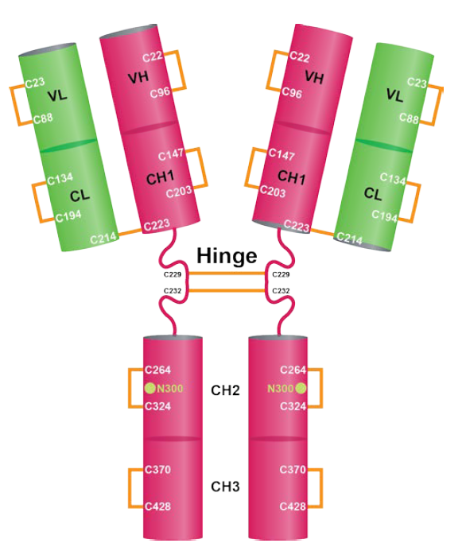
Schematic structure of casirivimab, comprised of two identical heavy chains (pink) and two identical light chains (green) connected by disulfide bonds, represented as orange lines.
VH = variable region of the heavy chain; VL = variable region of the light chain; CH = constant region of the heavy chain; CL = constant region of the light chain.
Figure 2: Structure of imdevimab
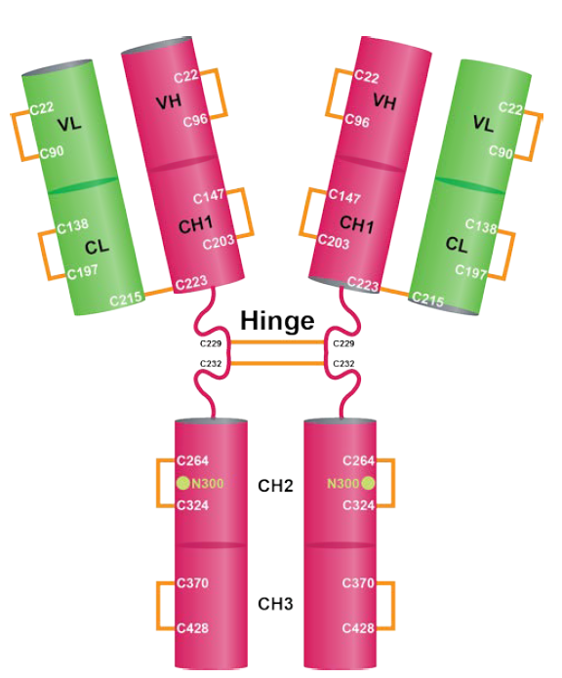
Schematic structure of imdevimab, comprised of two identical heavy chains (pink) and two identical light chains (green) connected by disulfide bonds, represented as orange lines.
VH = variable region of the heavy chain; VL = variable region of the light chain; CH = constant region of the heavy chain; CL = constant region of the light chain.
Casirivimab solution for injection is a sterile, preservative free, clear to slightly opalent, colorless to pale yellow solution supplied in a 6 mL single use vial or a 20 mL multidose vial. Imdevimab solution for injection is a sterile, preservative free, clear to slightly opalescent, colorless to pale yellow solution supplied in a 6 mL single use vial or a 20 mL multidose vial.
Ronapreve (casirivimab and imdevimab) is available as individual antibody solutions in separate vials, available in a dose pack containing either one 6 mL vial of each antibody or one 20 mL vial of each antibody (casirivimab and imdevimab).
Ronapreve 120 mg/mL solution for infusion or injection, single use vial contains pack of two 6 mL clear Type I glass vials with butyl rubber stopper containing one vial of 2.5 mL solution of 300 mg of casirivimab and one vial of 2.5 mL solution of 300 mg of imdevimab.
Ronapreve 120 mg/mL solution for infusion or injection, multidose vials contain pack of two 20 mL clear Type I glass vials with butyl rubber stopper containing one vial of 11.1 mL solution of 1332 mg of casirivimab and one vial of 11.1 mL solution of 1332 mg of imdevimab.
The recommended shelf life for the drug product is 12 months refrigerated at 2 to 8°C. Vials should not be frozen or shaken. Store vials in the outer carton to protect from light.
For the co-packaged 6 mL single-use vials, after initial puncture, the medicinal product should be used immediately. Any remaining product should be discarded.
For the co-packaged 20 mL multidose vials, after initial puncture, if not used immediately, the product in the vial can be stored for 16 hours at room temperature up to 25°C or for no more than 48 hours refrigerated between 2°C to 8°C.
The quality evaluator advises that there are no objections on quality grounds to the provisional approval of Ronapreve.

Proposed quality conditions of registration
The proposed quality conditions of registration are as follows:
- Laboratory testing and compliance with Certified Product Details
  - All batches of Ronapreve supplied in Australia must comply with the product details and specifications approved during evaluation and detailed in the Certified Product Details (CPD).
  - When requested by the TGA, the sponsor should be prepared to provide product samples, specified reference materials and documentary evidence to enable the TGA to conduct laboratory testing on the product. Outcomes of laboratory testing are published biannually in the TGA Database of Laboratory Testing Results http://www.tga.gov.au/ws-labs-index and periodically in testing reports on the TGA website.
- Certified Product Details
  - The Certified Product Details (CPD), as described in Guidance 7: Certified Product Details of the Australian Regulatory Guidelines for Prescription Medicines (ARGPM) http://www.tga.gov.au/industry/pm-argpm-guidance-7.htm, in PDF format, for the above products should be provided upon registration of these therapeutic goods. In addition, an updated CPD should be provided when changes to finished product specifications and test methods are approved in a Category 3 application or notified through a self-assessable change.

Nonclinical
There are no nonclinical objections to the provisional registration of Ronapreve. The summary and conclusions are presented below:
- In vitro pharmacology results suggest efficacy against currently circulating variants.
- Efficacy studies in animal models support the prevention indication but showed limited efficacy for the treatment indication.
- The potential risk of treatment failure due to the development of viral variants that are resistant to Ronapreve would need to be monitored clinically.
- No toxicity was observed in a study in monkeys at high doses.
- The nonclinical evaluator has made recommendations with regards to nonclinical information included in the PI. The sponsor was required to amend the PI as recommended by the TGA.
- There are no objections on nonclinical grounds to the provisional registration of Ronapreve for the proposed indication provided efficacy was demonstrated by clinical studies.

Clinical
Table 3 below summarised the studies contributing to this submission. Please note that Study COV-2066 will not be discussed in this overview as this study is for hospitalised COVID-19 patients which is not related to the proposed indication for this submission. In Study COV-2066, seronegative hospitalised (≤ 72 hours) patients within 10 days of COVID-19 symptom onset who were on low flow oxygen (Cohort 1, median 63 years old) received a single intravenous dose of casirivimab and imdevimab 2400 mg or 8000 mg. In an interim analysis with a minimum 8 days of follow-up, futility versus placebo was excluded, with a 22% reduction in the risk of death or mechanical ventilation (p = 0.23, below the pre-specified α = 0.3); however, sample sizes were too small (modified full analysis set (mFAS): n = 533) to definitively demonstrate clinical efficacy.
Table 3: Overview of clinical studies
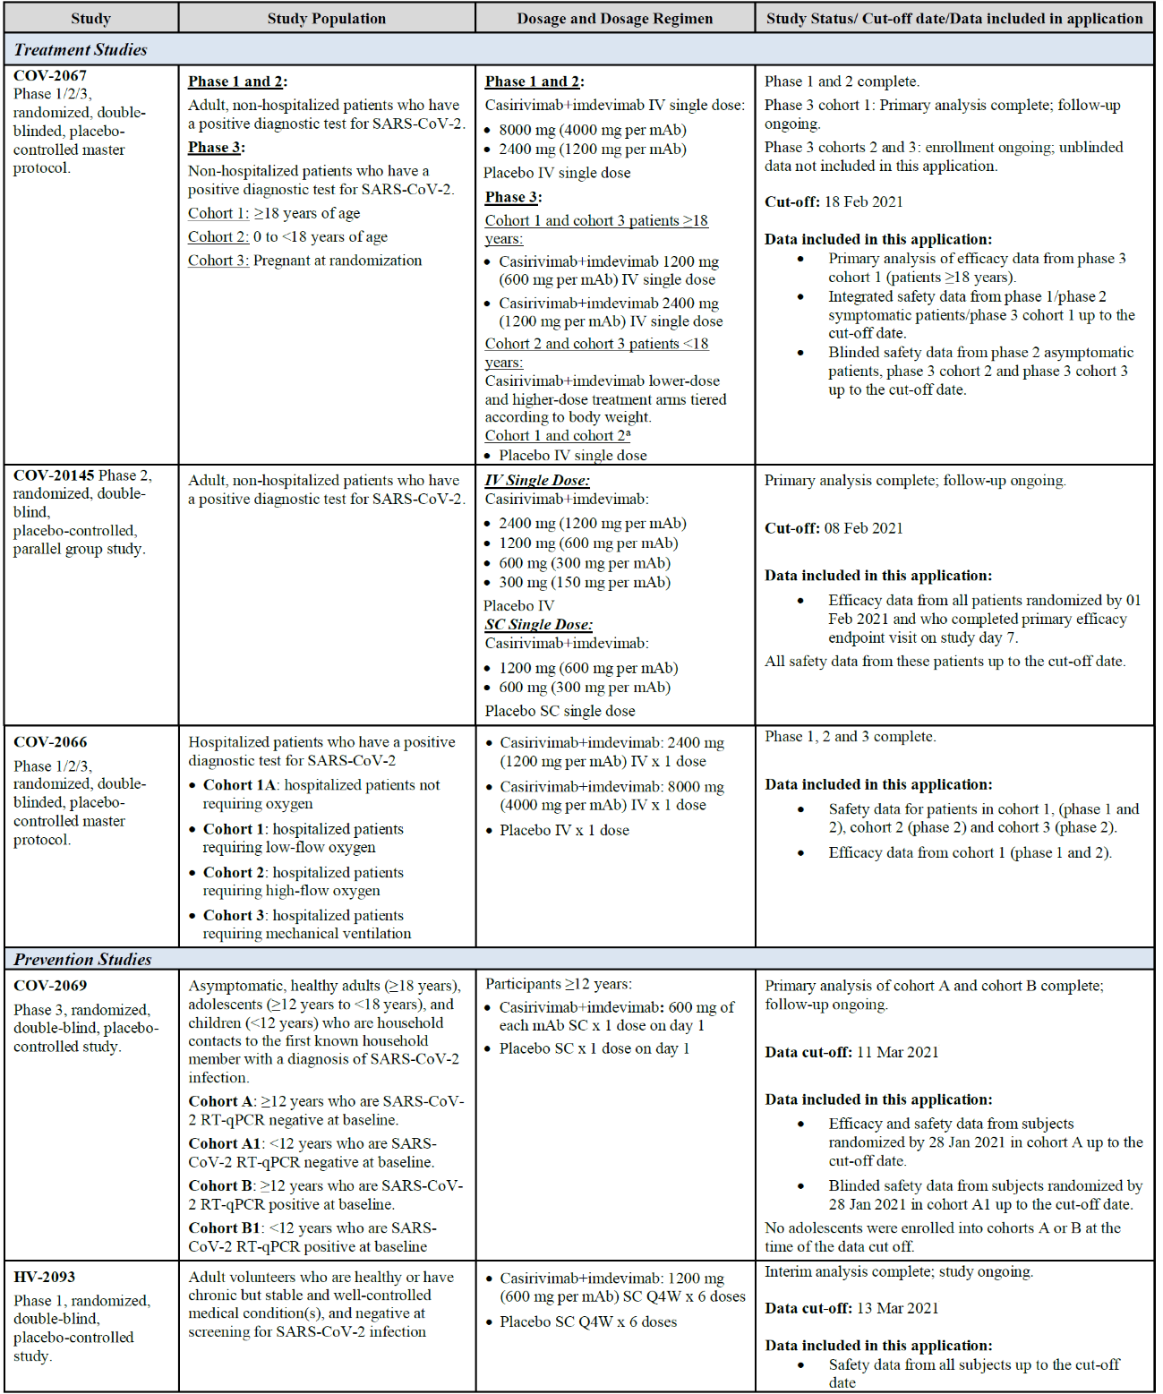
COV-2067 = Study COV-2067; SARS-CoV-2 = severe acute respiratory syndrome coronavirus 2; mAb = monoclonal antibody; IV = intravenous; COV-20145 = Study COV-20145; SC = subcutaneous; COV-2066 = Study COV-2066; RT-qPCR = reverse transcription quantitative real time polymerase chain reaction; COV-2069 = Study COV-2069; HV-2093 = Study HV-2093; Q4W= every 4 weeks.
a Per Independent Data Monitoring Committee (IDMC) recommendation, as of 25 Febuary 2021, patients will no longer be randomised to placebo.

Pharmacokinetics
The pharmacokinetics (PK) of casirivimab and imdevimab were assessed in 3 single dose studies (Studies COV-20145, COV-2067, and COV-2069) and one repeat dose study (Study HV-2093).

Study COV-20145 pharmacokinetics analysis
Prior to initiating Study COV-20145, available data from Study COV-2067 showed that casirivimab/imdevimab provided similar efficacy when given as 2400 mg or 8000 mg intravenous single dose regimens. In Study COV-20145, the Phase II randomised, double blind, placebo controlled study, additional lower intravenous single-dose regimens, as well as subcutaneous single-dose regimens, were evaluated in adult, non-hospitalised participants with SARS-CoV-2 infection to assess the virologic efficacy, safety, and tolerability at lower doses. An aim of this study was to identify a lower dose regimen capable of demonstrating similar virologic efficacy as seen with the 2400 mg intravenous dose in Study COV-2067. Eligible participants were randomised to receive a single dose of casirivimab/imdevimab or placebo by intravenous or subcutaneous route. Study intervention and route of administration randomisation ratio is shown in Table 4, below.
Table 4: Study COV-20145 Study arm assignment
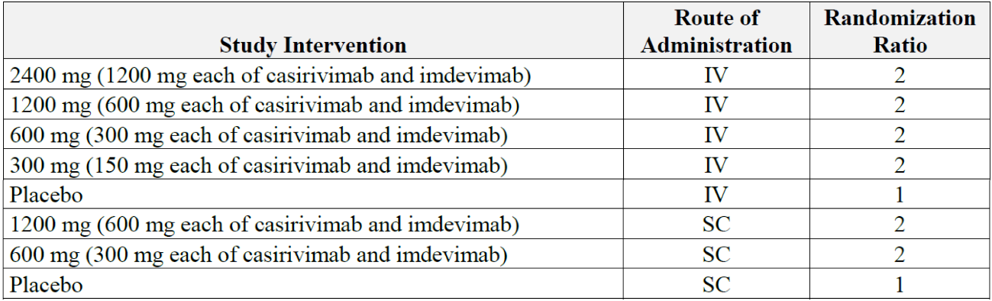
IV = intravenous; SC = subcutaneous.
A total of 815 subjects were randomised to 1 of 8 study arms. As of the cut-off date (8 February 2021), a total of 803 participants completed the Day 7 visit and more than one third of the 803 participants completed the Day 29 visit.
The results showed that the mean concentrations of casirivimab, imdevimab, and casirivimab/imdevimab increased dose proportionally for all intravenous and subcutaneous doses tested, indicating linear PK. The concentrations of casirivimab, imdevimab, and combined casirivimab/imdevimab declined over time in parallel, following intravenous or subcutaneous administration, as shown in Figure 3, below.
Figure 3: Study COV-20145 Mean (+standard deviation) concentrations of casirivimab, imdevimab, and combined casirivimab/imdevimab in serum by time and treatment group (log scale; pharmacokinetic analysis set)
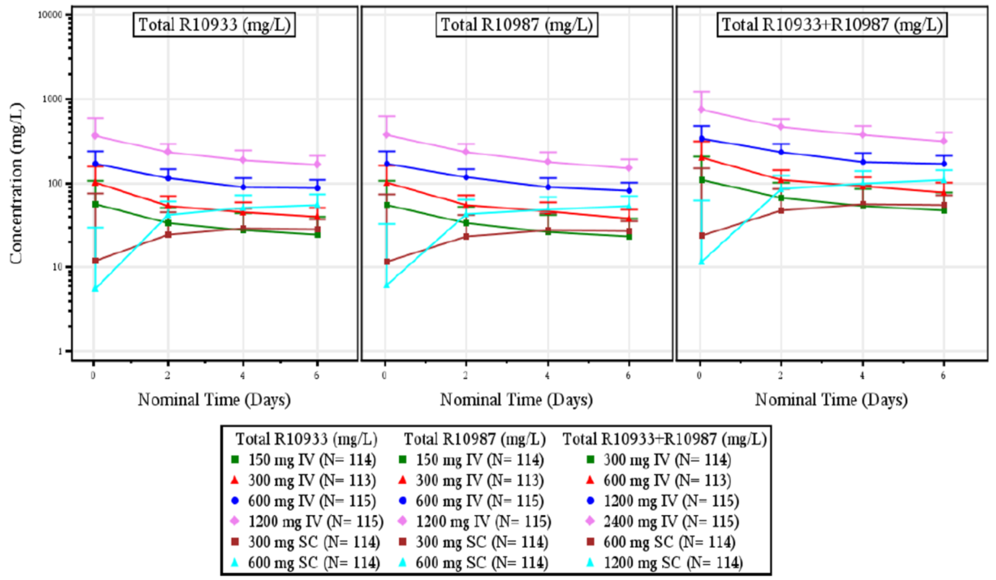
EOI = end of infusion; N = number of participants; IV = intravenous; LLOQ = lower limited of quantification; R10933 = drug development code for casirivimab; R10987 = drug development code for imdevimab; R10933 + R10987 = casirivimab + imdevimab; SC = subcutaneous; SD = standard deviation.
Concentration below the LLOQ were set to LLOQ were set to LLOQ/2. Combined concentrations (REGN10933 and REGN10987) were calculated only when both the analytes were not missing. Predose concentrations were not presented, concentration shown at Day 0 is an EOI or post dose concertation. Day(s) shown represent the number of day(s) following study drug administration.
Following administration of a single 1200 mg subcutaneous dose, the mean serum concentrations of both casirivimab and imdevimab on Day 3 were approximately 42 mg/L. Casirivimab and imdevimab reached mean maximum drug concentration (C_{max}) of 55.0 mg/L and 53.1 mg/L, respectively, on Day 7.
Non-compartmental analysis of casirivimab and imdevimab indicated a dose proportional increase in area under the plasma concentration time curve from time zero to time of last measurable concentration (AUC_{last}). This is shown in mean AUC_{last} values normalised by dose, which were similar, between 1.06 and 1.25 day mg/L/mg for all intravenous dose groups. The mean C_{max} and drug concentration at Day 7 (C_{7d}) also increased dose proportionally amongst all intravenous dosing groups. Following subcutaneous dosing, mean dose normalised C_{max}, AUC_{last} and C_{7d} were similar for the two subcutaneous dose groups, also indicating linear and dose proportional PK for both casirivimab and imdevimab. Median time taken to reach the maximum concentration (T_{max}) for the subcutaneous dose groups was 5.8 days for both antibodies.
It is noted that some additional data (Figure 4 below) were provided.
Figure 4: Study COV-20145 Mean (+standard deviation) concentrations of casirivimab/imdevimab combined in serum by nominal time after single intravenous and subcutaneous doses in ambulatory patients with COVID-19 (modified full analysis set)
COVID-19 = coronavirus disease 2019; IV = intravenous; REGEN-COV = casirivimab and imdevimab; SC = subcutaneous.
1: Nominal sampling time = clinical study time (visit day - 1), for example nominal sampling Day 6 corresponds to clinical study Day 7.
The target concentration of 20 mg/L was determined on the basis of preclinical data and modelling at the beginning of the development program.

Study HV-2093 pharmacokinetics analysis
Study HV-2093 is a Phase I, randomised, double blind, placebo controlled study. The study assessed the safety, tolerability, and PK of subcutaneous administered repeated doses of casirivimab/imdevimab in adult volunteers who are SARS-CoV-2 negative at Baseline. Efficacy was assessed as an exploratory endpoint.
The study is comprised of 3 periods: a screening/baseline period (up to 7 days), a treatment period (24 weeks), and a follow-up period (28 weeks). Figure 5: Study HV-2093 Study flow diagram.
Figure 5: Study HV-2093 Study flow diagram
SARS-CoV-2 = severe acute respiratory syndrome coronavirus 2; RT-PCR = reverse transcription polymerase chain reaction; R10933 = drug development code for casirivimab; R10987 = drug development code for imdevimab; R10933 + R10987 = casirivimab + imdevimab; SC= subcutaneous; EOTP = end of treatment period; EOS = end of study.
Table 5: Study HV-2093 Study objectives and endpoints, shown below, describes the objectives and endpoints for Study HV-2093.
Table 5: Study HV-2093 Study objectives and endpoints
AESI = adverse events of special interest; NCI = National Cancer Institute; CTCAE = common terminology criteria for adverse events; SC = subcutaneous; TEAE = treatment emergent adverse events; CSR = clinical study report; ADA = anti-drug antibodies
As of the data cut-off (13 March 2021), a total of 974 subjects were randomised in a 3:1 ratio to receive up to 6 subcutaneous doses of casirivimab/imdevimab 1200 mg (600 mg each, given every 4 weeks) or placebo. In total, 969 randomised participants were treated and included in the safety analysis population (SAF), with 240 in the placebo group and 729 in the active treatment group.
A summary of casirivimab, imdevimab, and casirivimab/imdevimab concentrations in serum is presented by analyte and nominal time in presented in Table 6. Mean casirivimab, imdevimab, and casirivimab/imdevimab concentrations are presented by nominal time in Figure 6 below.
Table 6: Study HV-2093 Summary of serum concentration of casirivimab and imdevimab (pharmacokinetic analysis set)
R10933 = drug development code for casirivimab; SC= subcutaneous; N = number of subjects; R10987 = drug development code for imdevimab; RERN10933 + REGNR10987 = casirivimab + imdevimab; n = number of subjects contributing to each timepoint; SD = standard deviation.
Values for below the level of quantification (BLQs) were set to zero. Timepoint Day 91 was removed as of protocol Amendment 3. Combined concentrations (total REGN10933 + total REGN10987) were calculated only when both the analytes were not missing.
Figure 6: Study HV-2093 Mean (standard deviation) concentrations of casirivimab, imdevimab and casirivimab/imdevimab combined in serum by time in adult volunteers (log scaled)
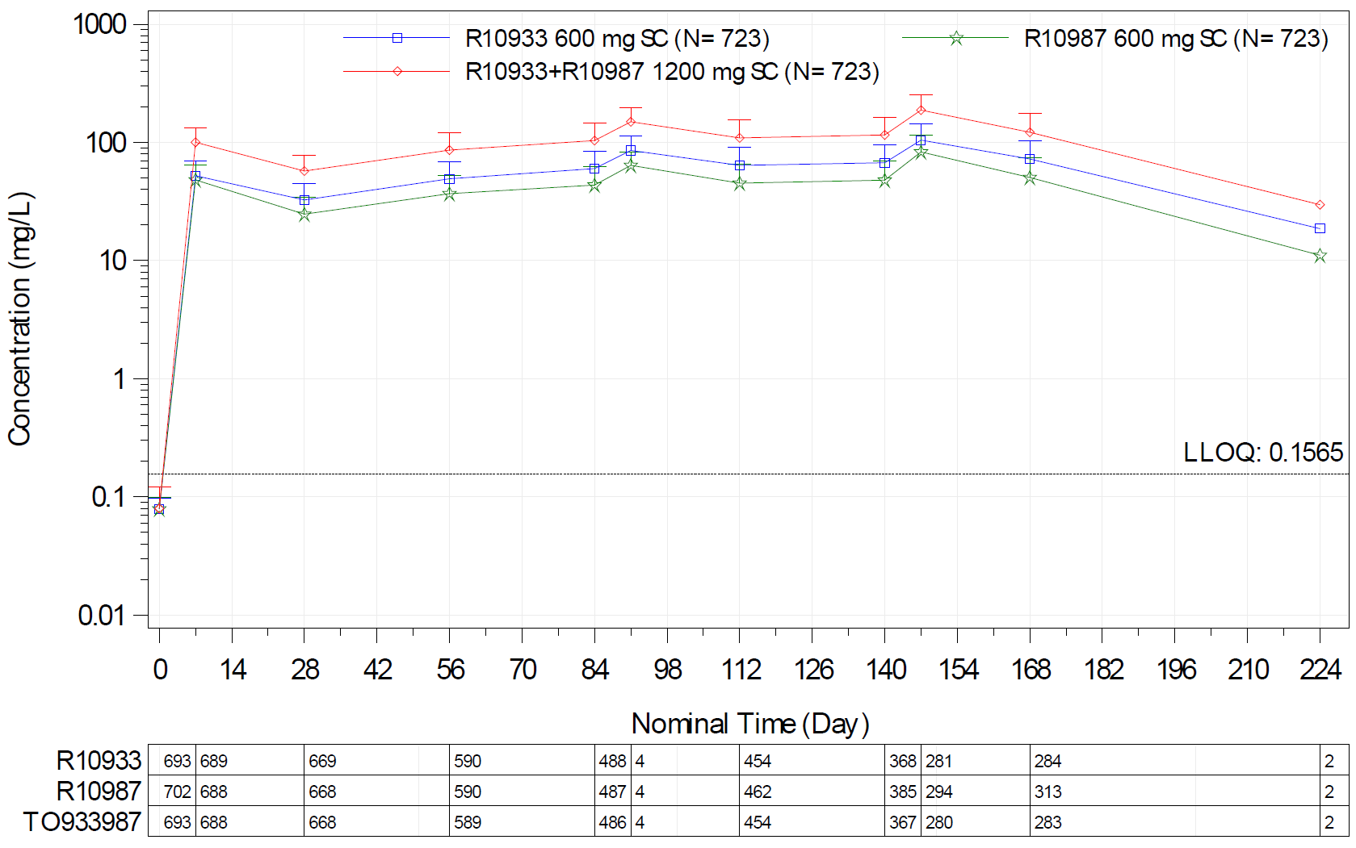
R10933 = drug development code for casirivimab; SC= subcutaneous; R10987 = drug development code for imdevimab; R10933 + R10987 = casirivimab + imdevimab; N = number of subjects; LLOQ = lower limit of quantification; TO933987 = combined concentration of total casirivimab + total imdevimab.
Concentrations below the LLOQ (horizontal dashed line) were set to LLOQ/2. Include protocol defined schedule visit only.
Combined concentrations were calculated only when both the analytes were not missing.
The serum casirivimab and imdevimab concentrations reached steady state following the third casirivimab/imdevimab dose at Week 12 and were maintained throughout the treatment period (Week 24). Accumulation of casirivimab and imdevimab based on trough concentration was approximately 2.2 and 2 fold. Mean trough casirivimab concentrations and mean trough imdevimab concentrations following the first dose were 32.6 mg/L and 24.7 mg/L, respectively. Concentrations of casirivimab and imdevimab observed over the study period following repeated doses of casirivimab/imdevimab were very similar, and the same trends were observed for the combined concentrations of casirivimab/imdevimab.

Study COV-2067 pharmacokinetics analysis
Casirivimab and imdevimab concentration time profiles in serum following 1200 mg and 4000 mg intravenous doses of each antibody showed a profile consistent with linear PK, defined by an initial distribution phase followed by a terminal mono-exponential elimination phase. At each dose level, mean concentrations of casirivimab and imdevimab were similar over the month following dosing. Concentrations of casirivimab and imdevimab in serum were not affected by baseline serostatus or baseline viral load. Similarly, patients with or without a COVID-19 related medically attended visit did not show any difference in combined antibody drug concentrations.
The subcutaneous route of administration was not used in this study, there was therefore no PK data on subcutaneous administration in this pivotal treatment study.

Study COV-2069 pharmacokinetics analysis
Blood samples were collected at various times throughout the study in a subset of participants from Cohort A and B. As of the cut-off dates for this PK analysis, a total of 169 participants were included in the pharmacokinetic analysis set (PKAS).
The concentration over time profiles for total casirivimab and total imdevimab following subcutaneous administration were similar to each other and were characterised by an initial absorption phase followed by a mono-exponential elimination phase. Concentration versus time profiles and PK parameters for casirivimab and imdevimab in serum were consistent between participants in Cohort A and Cohort B, and also between baseline seronegative and those who were baseline seropositive or had undetermined baseline serostatus. The casirivimab and imdevimab concentration time profiles were also similar in uninfected participants and those who were infected with SARS-CoV-2 and also not affected by baseline serostatus. A comparison of results for the sentinel group in Cohorts A and B indicated the PK parameters were consistent between the two cohorts for both casirivimab and imdevimab. Drug concentration at Day 28 (C_{28d}) is 30.7 mg/L for casirivimab and 24.8 mg/L for imdevimab.
Table 7: Study COV-2069 Pharmacokinetics parameters for casirivimab and imdevimab after a single 1200 mg subcutaneous dose for Cohort A and B (pharmacokinetic analysis set, based on the sentinel subset unless otherwise specified)
PK = pharmacokinetics; C_{max} = maximum concentration; t_{max} = time of maximum concentration; C₁ = concentration on Day 1; AUC₀₋₂₈ = area under the concentration versus time curve from Day 0 to Day 28; AUC_{inf} = area under the concentration versus time curve from Day 0 extrapolated to infinity; C₂₈ = concentration on Day 28.
1 Mean (standard deviation)
2 Median (range)
3 Observed concentration one day after dosing, that is, on study Day 2
4 The C₂₈ parameter includes the sentinel and safety subsets. Observed concentration 29 days after dosing, that is, on study Day 29
Analysis is based on a PK data cut-off date of 10 March 2021.
Figure 7: Study COV-2069 Mean (standard deviation) concentrations of casirivimab and imdevimab in serum over time for sentinel and safety cohorts after single 1200 mg subcutaneous dose (linear scale)
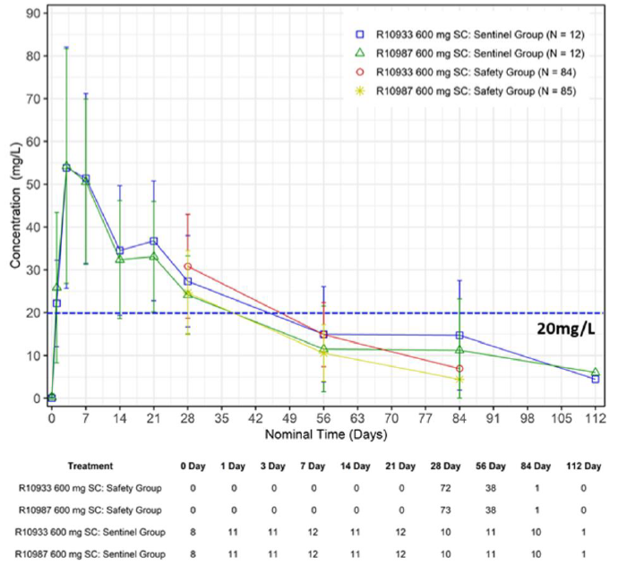
R10933 = drug development code for casirivimab; SC= subcutaneous; N = number of subjects ; R10987 = drug development code for imdevimab.

Pharmacodynamics
The pharmacodynamic (PD) effect of casirivimab/imdevimab was assessed by measuring SARS-CoV-2 viral load reduction in clinical studies, which is a direct effect driven by the mechanism of action of casirivimab/imdevimab in blocking the spike protein RBD interaction with ACE2. Secondary PD effects included an assessment of anti-drug antibodies (ADA) to casirivimab and imdevimab, although treatment emergent ADA were only assessed in Study HV-2093.

Study COV-20145 pharmacodynamic analysis
This Phase II randomised, double blind, placebo-controlled study assessed the dose response of single intravenous or subcutaneous dose of casirivimab and imdevimab in outpatients with SARS-CoV-2 infection. Treatment was initiated within 3 days of a positive SARS-CoV-2 test in 803 adult patients who were not at high risk of severe disease. Subjects were randomised into treatment arms and placebo arms. Nasopharyngeal samples were collected at Days 3, 5, 7, 15, and 22 for viral load determinations.
Figure 8: Study COV-20145 Study flow diagram
SARS-CoV-2 = severe acute respiratory syndrome coronavirus; R = randomisation; IV = intravenous; SC = subcutaneous; COVID-19 = coronavirus disease 2019; MAV = medically attended visit; NP = nasopharyngeal; TEAE. = treatment emergent adverse event; ER = emergency room; EOS = end of study.
The primary endpoint was the time weighted average daily change from Baseline in viral load (log₁₀ copies/mL) from Day 1 to Day 7, as measured by reverse transcription quantitative real time polymerase chain reaction (RT-qPCR) in nasopharyngeal swab samples. The primary analysis was conducted in the seronegative mFAS population (subjects with a positive RT-qPCR and seronegative at Baseline). A statistical testing hierarchy was used for comparing treatment groups to the pooled placebo group to control the type I error rate. The primary efficacy variable was tested hierarchically at an α = 0.05, two sided. If a test was insignificant, then the formal testing procedure stopped at that step.
Table 8: Study COV-20145 Time weighted average daily change from Baseline in viral load from Day 1 to Day 7 (seronegative modified full analysis set)
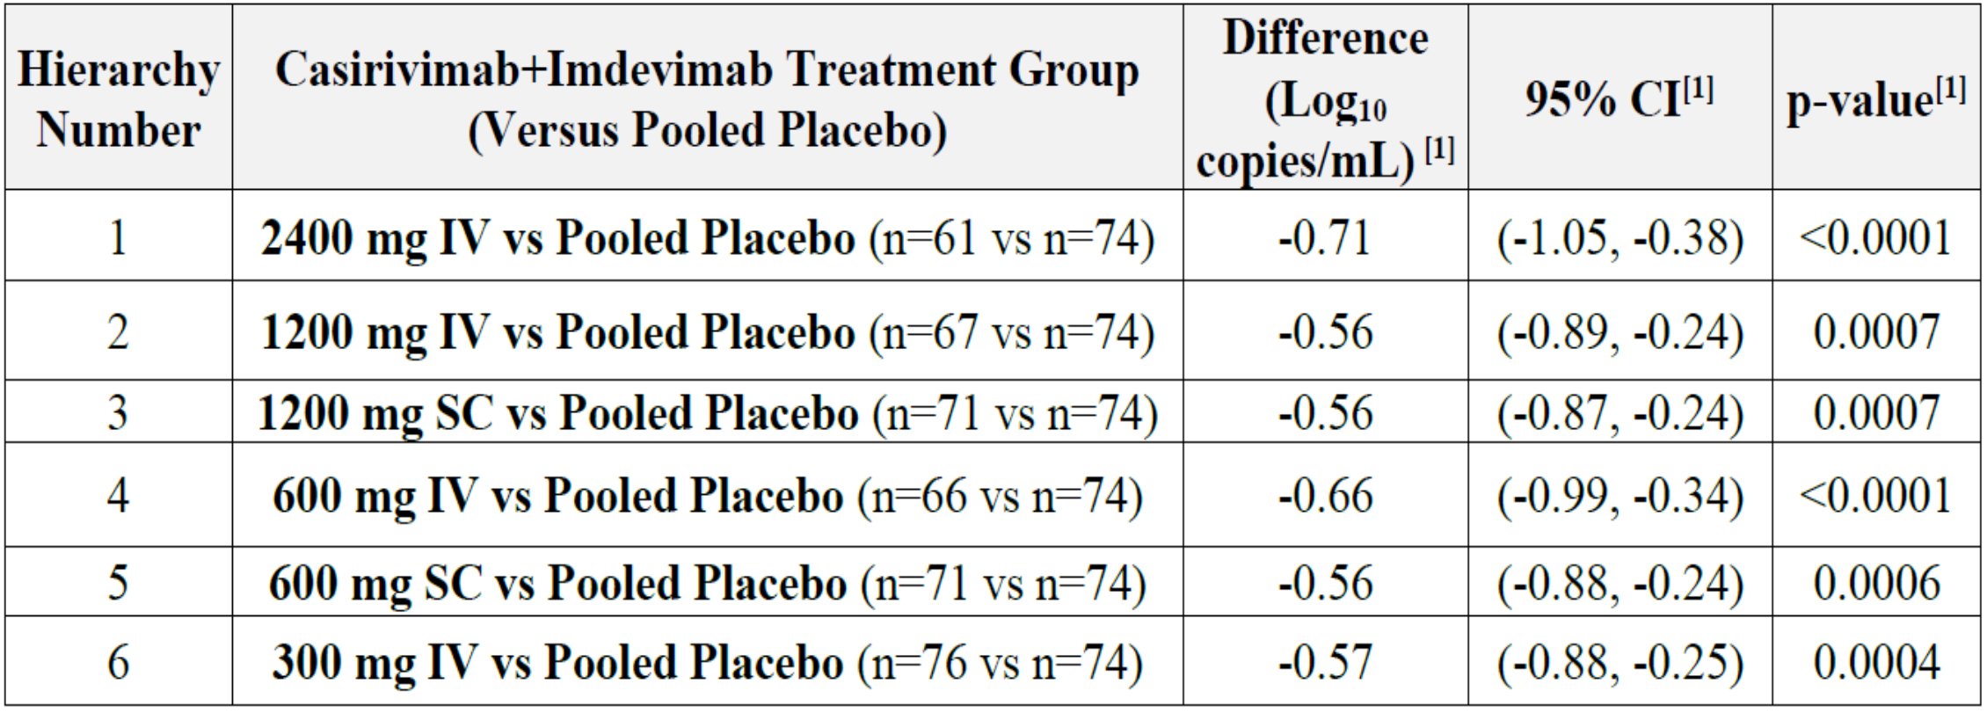
CI = confidence interval; IV = intravenous; n = number of subjects; vs = versus; SC = subcutaneous;.
1. Least squares (LS) means difference, 95% CI and p-value for change from Baseline is based on the analysis of covariance (ANCOVA) model with terms for treatment, Baseline, and Baseline-by-treatment interaction.
The analysis showed that in seronegative participants (who were infected but had not yet mounted a measurable immune response), single doses of casirivimab/imdevimab showed comparable virologic reduction at all doses assessed (intravenous: 2400 mg, 1200 mg, 600 mg and 300 mg; subcutaneous: 1200 mg and 600 mg). The various presentations appear to result in comparable outcome in terms of reduction of viral load, though the 2400 mg intravenous dosage appears to lower viral load more than the other dosages or routes of administration.
Similar virologic efficacy was observed at the same dose level whether administered through intravenous or subcutaneous routes. Virologic efficacy following single doses of casirivimab/imdevimab intravenous and subcutaneous was observed as early as Day 3 (first nasopharyngeal sample after treatment was on Day 3/no data before Day 3) and was similar for each intravenous and subcutaneous dose tested. Reductions in viral load were most pronounced in the subpopulation of participants with high baseline viral load.
Figure 9: Study COV-20145 Least squares mean (± standard error) change from Baseline in viral load (log₁₀ copies/mL) at each visit for all casirivimab/imdevimab treatments (intravenous and subcutaneous, seronegative modified full analysis set)
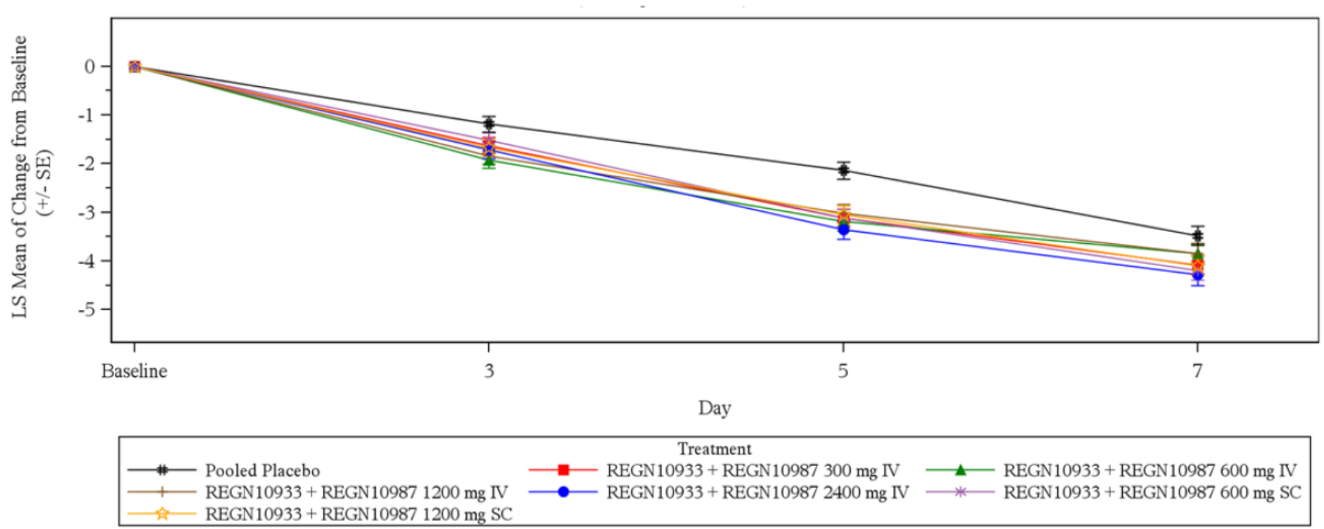
LS = least squares; SE = standard error; REGN10933 + REGN10987 = casirivimab + imdevimab; IV = intravenous; SC = subcutaneous.
Patients randomised on or before the 1 February 2021 with the data cut-off date of 8 February 2021. Baseline is defined as the last non-missing value measured prior to dosing.
Least squares means are based on the mixed model for repeated measures (MMRM) with terms for Baseline, treatment, visit, and all two-way interactions as fixed effects and subject as random effect.
The comparable results among the range of doses suggests that the minimal dose with full virologic effect has yet to be identified and that there may potentially be clinical efficacy at doses lower than 1200 mg with intravenous or subcutaneous forms of administration.

Study HV-2093 pharmacodynamic analysis
No viral load assessment was made in this study, as it was conducted in healthy adult subjects.
Immunogenicity, as measured by ADA to casirivimab and imdevimab, was low overall and was similar for placebo treated participants and casirivimab/imdevimab treated participants. ≤ 4% of participants had pre-existing ADA to casirivimab and/or imdevimab measured at Baseline. One (0.1%) participant who received casirivimab/imdevimab had treatment emergent ADA to casirivimab. Fourteen participants (2.0%) who received casirivimab /imdevimab had treatment emergent ADA to imdevimab. All positive ADA results were low titre (< 1000). The serum concentrations of casirivimab/imdevimab appeared similar in those with and without ADA.
Table 9: Study HV-2093 Anti-drug antibodies to casirivimab
ADA = anti-drug antibodies; n = sample size; R10933 + R10987 = casirivimab + imdevimab; SC = subcutaneous.
Table 10: Study HV-2093 Anti-drug antibodies to imdevimab
ADA = anti-drug antibodies; n = sample size; R10933 + R10987 = casirivimab + imdevimab; SC = subcutaneous.

Study COV-2067 pharmacodynamic analysis
Study COV-2067 assessed a range of different intravenous doses of casirivimab and imdevimab (single intravenous doses of 1200 mg, 2400 mg, or 8000 mg) in outpatients with COVID-19. The study evaluated the relationship between the change from Baseline in viral load and the concentrations of casirivimab/imdevimab in the primary analysis population (RT-PCR positive and seronegative).
The primary analysis demonstrated statistical significance for all virologic endpoints tested in the hierarchy. No clear exposure-related differences were observed for virologic efficacy over the dose range investigated, indicating a flat exposure-response relationship. Phase III analysis also showed that the mean reduction from Baseline in viral load at Day 7 was larger than placebo for both the casirivimab/imdevimab 2400 mg group (difference from placebo: -0.86 log₁₀ copies/mL/day, nominal p < 0.001) and the 1200 mg group (difference from placebo: -0.71 log₁₀ copies/mL/day, nominal p < 0.001). This trend was also observed for both dose groups at Day 15 and for the 1200 mg group at Day 29.
Nearly all patients were negative for ADA at all times, indicating minimal immunogenicity following administration of single intravenous doses of 1200 mg, 2400 mg, or 8000 mg of casirivimab/imdevimab. Concentrations in serum for casirivimab and imdevimab at Day 28 were similar between ADA negative and ADA positive patients.

Study COV-2069 pharmacodynamic analysis
Viral load was assessed as one of the secondary endpoints in Cohorts A and B in this study.
For Cohort A, treatment with casirivimab/imdevimab reduced the viral load compared to placebo in participants who developed a SARS-CoV-2 infection.
For Cohort B, treatment with casirivimab/imdevimab reduced the proportion of participants with high viral load infection (> 4 log₁₀ copies/mL) by 34.6% compared to placebo during the efficacy assessment period (40/98 (40.8%) in the casirivimab/imdevimab group versus 63/101 (62.4%) in the placebo group; nominal p = 0.0024). A consistent reduction in the magnitude of viral load was also demonstrated compared to placebo. The post-baseline mean viral load declined more rapidly in the casirivimab/imdevimab group, with a lower mean viral load maintained in the casirivimab/imdevimab group compared to placebo through Day 29.
More than 95% of subjects were negative for ADA at all times during the study, and the proportion testing positive for ADA was similar between placebo and active treatment groups. The presence of ADA did not affect the concentration time profiles of casirivimab or imdevimab.

Population pharmacokinetic analysis
A population pharmacokinetic (popPK) analysis was conducted to obtain integrated information on PK from studies with sparse PK sample collection, as well as from a combination of sparse and dense data collected from across the development program. Although adolescent subjects (≥ 12 years of age and ≥ 40 kg weight) were enrolled in studies (Study COV-2067 and Study COV-2069), no PK data were available at the time of this submission.
Casirivimab and imdevimab PK following intravenous or subcutaneous administration were adequately described by a two compartment disposition model with linear absorption following subcutaneous administration, direct intravenous administration into the central compartment, and linear elimination. Based on the observed data, concentrations of casirivimab and imdevimab increased in a dose proportional manner and displayed no evidence of non-linearity in the elimination phase.
Typical PK parameters from the final model for casirivimab were as follows:
- Clearance (CL) of 0.182 L/day, distribution volume of central compartment (V_{c}) of 3.88 L, first order absorption rate constant (K_{A}) of 0.22 day - 1, intercompartmental CL between the central and peripheral compartments (Q) of 0.583 L/day, and distribution volume of peripheral compartment (V_{p}) of 3.29 L.
Typical PK parameters from the final model for imdevimab were as follows:
- Clearance of 0.221 L/day, V_{c} of 3.86 L, K_{A} of 0.197 day - 1, Q of 0.502 L/day, and V_{p} of 3.56 L.
Based on popPK analysis, the total volume of distribution of casirivimab is 7.2 L for casirivimab and 7.4 L for imdevimab, indicating that both mAbs are primarily restricted to the vascular compartment. Following a single subcutaneous 1200 mg dose of casirivimab/imdevimab (600 mg each mAb), casirivimab and imdevimab were absorbed with an estimated bioavailability of 71.8% and 71.7%, respectively, and an estimated T_{max} of 6.7 days and 6.6 days, respectively.
Both CL and V_{c} increased with increasing body weight for casirivimab and imdevimab. Compared to a reference 81 kg subject, exposures (area under the plasma concentration time curve from dosing (Day 0) to Day 28 (AUC_{0-28d}), C_{max} and C_{28d}) are predicted to be 20 to 30% higher in subjects at the fifth percentile of body weight (55.4 kg) and 20% lower in subjects at the ninety fifth percentile of body weight (123 kg) for both casirivimab and imdevimab. Casirivimab and imdevimab CL increased with decreasing baseline albumin; however, the estimated effect on exposures was predicted to be < 10% at the fifth (38 g/L) and ninety fifth (49 g/L) percentiles of albumin in the analysis population.
Female subjects are predicted to have decreased CL and V_{c} for both casirivimab and imdevimab, resulting in 8 to 13% higher exposures than male subjects. Race, baseline viral load and hepatic function were statistically significant covariates of casirivimab and imdevimab CL, respectively, but are predicted to have less than a 5% effect on exposures compared to reference conditions.
In general, the PK of casirivimab and imdevimab are similar with the same covariates explaining the sources of variability. Covariates with statistically significant effects on the final model parameters were baseline albumin, female sex, black race, mild hepatic impairment and baseline viral load on CL, and baseline albumin, female sex on V_{c}. All statistically significant covariates resulted in small differences in the post-hoc exposure metrics with body weight having the largest effect numerically.
A popPK/PD model was developed to describe the relationship between viral load and drug concentration in patients from the 3 studies, Study COV-2067, Study COV-20145, Study COV-2069B. Based upon the assumption that a reduction in viral load is likely related to improved clinical outcomes, the overall goal of these population exposure response analyses was to identify the casirivimab/imdevimab doses that are expected to provide near-maximal antiviral activity.
Exploratory PK/PD analyses across these three studies and doses indicate no dose and exposure response relationship with respect to dose or exposure related effects on viral load data (change from Baseline at Day 7). This is in line with results from popPK/PD analysis of viral dynamics also suggesting that all studied doses result in maximum effect on the PD marker. All doses increased the viral load reduction to the same extent compared to placebo, regardless of route of administration and dose strength.
The simulations for the dosing scenarios of loading with 1200 mg intravenous or subcutaneous followed by 600 mg (300 mg of each antibody) every 4 weeks were provided. The exposure at steady state appeared to be comparable with the single dose for AUC_{0-28d} as compared to area under the plasma concentration time curve over a dosing interval at steady state (AUC_{tau,ss}) and C_{28d}. The popPK simulations predicted that trough concentrations in serum at steady state after an initial 600 mg casirivimab and 600 mg imdevimab intravenous or subcutaneous dose followed by monthly (every 4 weeks) 300 mg casirivimab and 300 mg imdevimab intravenous or subcutaneous doses are similar to the observed mean Day 29 serum concentrations for a single 600 mg casirivimab and 600 mg imdevimab subcutaneous dose seen in Study COV-2069 (where the clinical efficacy data are available).

Efficacy

Study COV-2067

Study design
Study COV-2067 is an adaptive, Phase I/II/III, randomised, double blinded, placebo controlled study to evaluate the efficacy and safety of casirivimab/imdevimab combination in outpatients with COVID-19. Phase I and Phase II have been completed, while Phase III is ongoing. Data are presently available for the primary analysis of symptomatic patients from the Phase I/II part, the primary analysis from Phase III Cohort 1 (patients ≥ 18 years) and a Phase I/II/III integrated, interim safety summary (all with data cut-off at 18 February 2021). For Phase III Cohorts 2 and 3, the primary endpoints will be safety/tolerability and PKs. The study design is depicted in Figure 10 below.
Figure 10: Study COV-2067 Study schematic
SARS-CoV-2 = severe acute respiratory syndrome coronavirus; COVID-19 = coronavirus disease 2019; R = randomisation; IV = intravenous; NP = nasopharyngeal; MAV = medically attended visit; EOS = end of study.
Schematic A represents study design of Phase I; schematic B represents study design of Phase II (and Phase III prior to the amended portion); and schematic C represents Phase III (amended portion).
In Phase I and II, patients were randomised 1:1:1 to receive a single intravenous dose of 2400 mg or 8000 mg or placebo. As no dose effect was observed in the combined Phase I and II analysis, the 8000 mg dose arm was discontinued. A lower 1200 mg dose arm was introduced in Phase III as part of Protocol Amendment 6.
In Phase III, the details of COVID-19 related medical visits are collected up to Day 29. Participants are followed to Day 169 for safety assessment. Patients were enrolled into one of three cohorts: Cohort 1 (> 18 years of age, not pregnant), Cohort 2 (less than 18 years of age, not pregnant), and Cohort 3 (pregnant at randomisation). In Cohort 1, eligible patients were randomised 1:1:1 to receive intravenous casirivimab/imdevimab 1200 mg, 2400 mg, and intravenous placebo.

Key inclusion/exclusion criteria
Key eligibility criteria applicable to Phase I, Phase II (symptomatic cohort), and Phase III Cohort 1 are as follows:
- Outpatients (non-hospitalised with oxygen saturation ≥ 93% on room air)
- Positive diagnostic test for SARS-CoV-2 infection ≤ 72 hours of randomisation
- Adults (≥ 18 years or country’s legal age of adulthood)
- Onset of COVID-19 symptoms ≤ 7 days of randomisation; symptoms were determined by the investigator
- No pregnancy at randomisation; must use highly effective contraception during study
- No prior, current, or planned future use of COVID-19 convalescent plasma, mAbs against SARS-CoV-2, intravenous immunoglobulin, systemic corticosteroids, or treatments for COVID-19
- (Following Protocol Amendment 6 for Phase III) ≥ 1 risk factor for developing severe COVID-19
- No prior use (prior to randomisation), current use (at randomisation), or planned use (within 90 days of study drug administration or per current Centers for Disease Control and Prevention (CDC) (United States) recommendations, as applicable) of any authorised or approved vaccine for COVID-19, or participation in a study of an investigational COVID-19 vaccine
Risk factors for severe COVID-19 were defined in Table 11 below.
Table 11: Study COV-2067 Risk factors for developing severe COVID-19
COVID-19 = coronavirus disease 2019; BMI = body mass index.
A major protocol change in Phase III included revision of the eligibility criteria (Protocol Amendment 6). This amendment restricted enrolment to patients with at least one risk factor for severe COVID-19. Prior to this amendment, Phase III enrolled patients with or without risk factors for severe COVID-19.

Objectives and efficacy endpoints
The study objectives, primary and key secondary efficacy endpoints, and associated statistical methods, are summarised in Table 12 below.
Table 12: Study COV-2067 Study objectives, primary and key secondary efficacy endpoints
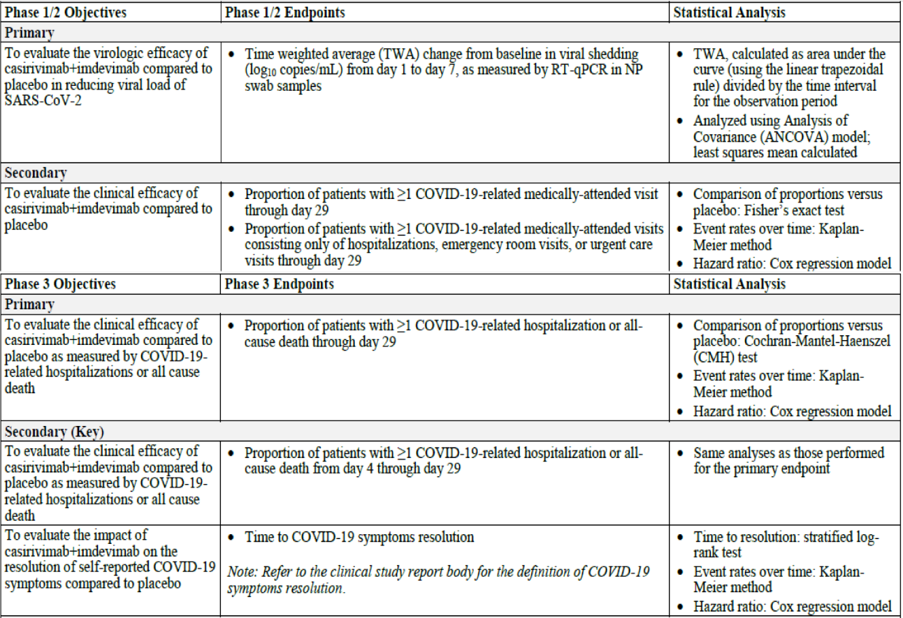
SARS-CoV-2 = severe acute respiratory syndrome coronavirus 2; TWA = time weighted average; ANCOVA = analysis of covariance; COVID-19 = coronavirus disease 2019; CMH = Cochran Mantel Haenszel.

Statistical analysis plan
The primary efficacy analyses were conducted as a combined Phase I/II and a Phase III analysis. In both analyses, to control for Type I error the primary and key secondary efficacy variables were evaluated hierarchically (at a significance level of α = 0.05). In both phases, populations tested in the hierarchy included the mFAS, Seronegative mFAS, and sub-populations of the mFAS with different viral load at Baseline. In Phase I/II, the mFAS included randomised participants with positive RT-qPCR from nasopharyngeal swab samples at randomisation. In Phase III, the mFAS was the pre-specified primary efficacy analysis set which included patients in the full analysis set (FAS) who had a positive RT-qPCR from nasopharyngeal swabs at randomisation and at least one protocol-defined risk factor for severe COVID-19 at Baseline. In addition, comparisons between Ronapreve 2400 mg and placebo, and between Ronapreve 1200 mg and placebo, were based on concurrent enrolment. The FAS comprised all randomised participants regardless of COVID-19 risk factors.
For Phase III, the null and alternative hypotheses were as follows (note, REGN10933/REGN10987 refers to casivirimab/imdevimab):
- Null hypothesis: The risk of having COVID-19 related hospitalisation or all cause death through Day 29 for REGN10933/REGN10987 2400 mg group is the same as that for placebo.
- Alternative hypothesis: The risk of having COVID-19 related hospitalisation or all cause death through Day 29 for REGN10933/REGN10987 2400 mg group is not the same as that for placebo
The proportion of patients with COVID-19-related hospitalisation or all cause death through Day 29 was to be compared between each dose group and placebo using the stratified Cochran Mantel Haenszel test with country as a stratification factor.

Study participants
A total of 6716 participants were screened, of which 6406 were randomised. Randomisation by study phase was as follows:
- Phase I: 72 participants
- Phase II: 727 participants
- Phase III: 5607 participants.
The first 799 symptomatic patients who were randomised were part of a combined Phase I and II analysis. All symptomatic patients, beginning with the eight hundredth randomised patient, were included in the Phase III portion of the trial.
For Phase I and II, since the first 275 participants had been assessed for virologic efficacy, the prospective virologic analysis included only the subsequent 524 patients randomised in Phase II (also referred to as the ‘next Phase II’ population). Of these, 442 met the criteria for mFAS.
In Phase III, a total of 4567 randomised participants had ≥ 1 risk factor for severe COVID-19 (see Table 13 below), and 4057 (88.8%) met the criteria for the mFAS. The total FAS population also included 1040 randomised participants who had no risk factors (not shown in Table 13).
Table 13: Study COV-2067 Summary of populations in each analysis set (Phase III Cohort 1, ≥ 1 risk factor for severe COVID-19)
REGN10933 + REGN10987 = casirivimab + imdevimab; IV = intravenous; N = number of subjects; FAS = full analysis set; mFAS = modified full analysis set.
Randomised patients through 17 January 2021. Data cut-off date is 18 February 2021.
The frequency of baseline risk factors for severe COVID-19 is provided in Table 14 below for the mFAS population. The most common risk factors were obesity (58.0%), older age (51.8% ≥ 50 years/13.5% ≥ 65 years), cardiovascular disease (36.3%), and chronic lung disease. Type 1 or Type 2 diabetes mellitus were less common (16.4% and 14.9% respectively). Chronic kidney/liver disease, and immunocompromised state were uncommon (≤ 3% frequency).
It is noted that patients with higher age (> 65 years of age) are underrepresented, this is more pronounced in the > 75 and > 85 years of age group.
The frequency of risk factors was balanced across the treatment groups.
Table 14: Study COV-2067 Frequency of baseline risk factors for severe COVID-19 (Phase III, modified full analysis set)
REGN10933 + REGN10987 = casirivimab + imdevimab; IV = intravenous; N = number of subjects; COVID-19 = coronavirus disease 2019; BMI = body mass index.
1: Placebo is presented in two columns based on those that were concurrently randomised to the 1200 mg and 2400 mg active treatment groups. The placebo group marked as ‘pooled for 1200 mg IV analysis’ is a subset of the placebo group marked as ‘pooled for 2400 mg IV analysis’.
The demographics and baseline characteristics for Phase III (Cohort 1) efficacy population were balanced across treatment groups. The median time from symptom onset to randomisation was 3 days (range: 0, 7). Subjects had a median of 6 COVID-19 symptoms at Baseline.
Baseline serostatus was balanced across treatment groups among those in the mFAS. 68.6% of patients in the mFAS were seronegative at Baseline, 23.6% were seropositive (as determined by either positive Euroimmune immunoglobulin A (IgA), Euroimmune immunoglobulin G (IgG), or Abbot Architect IgG assay) and 7.8% had a status of ‘other’.

Efficacy analysis

Phase I/II, primary efficacy analysis
In the primary analysis, statistical significance was achieved for all virologic endpoints tested in the hierarchy, but the last secondary endpoint in the hierarchy ‘proportion of participants with ≥ 1 COVID-19-related hospitalisation, [emergency room] ER visit or urgent care visit through Day 29’ did not reach significance. For the primary endpoint ‘time weighted average daily change from Baseline in viral load’ there was a reduction compared with placebo of 0.35 log₁₀ copies/mL for the mFAS, which was greater in those who were seronegative (0.68 log₁₀ copies/mL) and who had Baseline viral load > 106 copies/mL (0.60 log₁₀ copies/mL). There did not appear to be a dose response, as results were similar for the 2400 mg and 8000 mg dose.
A post-hoc analysis of the secondary clinical endpoint showed that the treatment effect was more pronounced in subjects with at least one risk factor for severe COVID-19, with a COVID-19 related Municipal Association of Victoria reported through Day 29 in 8 subjects (2.9%) across the combined treatment groups and in 15 subjects (10.3%) in the placebo group, treatment difference -7.4% (95% CI: -13.8%, -2.0%) p = 0.0027.

Phase III efficacy analysis (primary and key secondary endpoints)
The primary analysis of all endpoints in the hierarchy reached statistical significance. The proportion of participants who had at least one COVID-19 related hospitalisation or all cause death through Day 29 was significantly reduced with casirivimab/imdevimab 2400 mg compared to placebo (1.3% versus 4.6%), corresponding to a relative risk reduction of 71.3% (95% CI: 51.7%, 82.9%; p < 0.0001). The proportion of participants who had at least one COVID-19 related hospitalisation or all cause death through Day 29 was also significantly reduced with casirivimab/imdevimab 1200 mg compared to placebo (1.0% versus 3.2%), corresponding to a relative risk reduction of 70.4% (95% CI: 31.6%, 87.1%; p < 0.0024).
Table 15: Study COV-2067 Primary and key secondary efficacy results in the statistical hierarchy (Phase III)
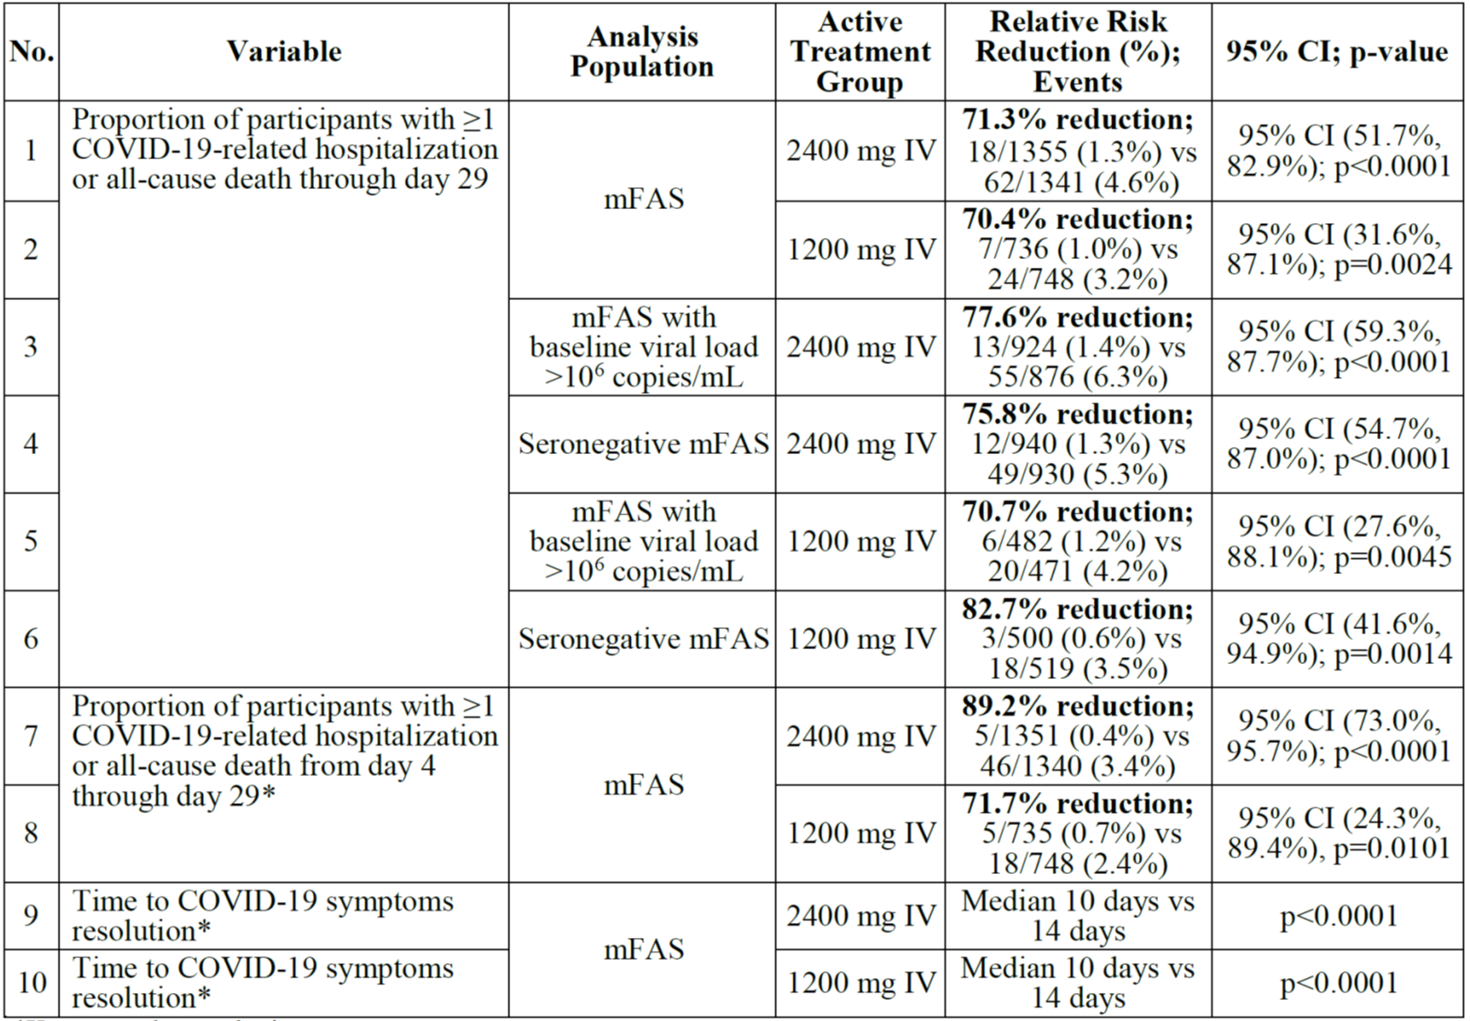
COVID-19 = coronavirus disease 2019; mFAS = modified full analysis set; IV = intravenous; vs = versus; CI = confidence interval.
* key secondary endpoint
Table 16: Study COV-2067 Summary of composite primary outcome in patients with and without risk factors
COV-2067 = Study COV-2067; COVID-19 = coronavirus disease 2019; mFAS = modified full analysis set; n = sample size; IV = intravenous; FAS = full analysis set.
The efficacy outcomes among patients who had no protocol defined risk factors suggest that the rate of events in these patients is too low to realise a benefit: 2/369 in placebo group and 0/771 in the two active treatment groups (see Table 16 above).
Efficacy results were consistent across various baseline viral load and serostatus subgroups (see Figure 11 below). Casirivimab/imdevimab also resulted in a lower proportion of hospitalisations or all cause death compared to placebo in the smaller group of participants who were seropositive at Baseline (not pre-specified as an efficacy endpoint). For this subset of participants treated with 2400 mg, the relative risk reduction versus placebo was 69.3% (nominal p = 0.0400). For the smaller number of participants treated with 1200 mg, the relative risk reduction was 84.6% (nominal p = 0.0588).
Figure 11: Study COV-2067 Subgroup results for COVID-19 related hospitalisations or all cause deaths through Day 29 in participants with more than one risk factor for severe COVID-19 (modified full analysis set)
COVID-19 = coronavirus disease 2019; R10933 + R10987 = casirivimab + imdevimab; N = number of subjects; CI = confidence interval; P = p-value; mFAS = modified full analysis set; vs = versus.
Treatment benefit with casirivimab/imdevimab was observed as early as 2 days after treatment and the difference in the proportion of patients with events between placebo and each of the casirivimab/imdevimab treatment groups maintained through Day 29.
Figure 12: Study COV-2067 Time to COVID-19-related hospitalisation or all cause death through Day 29 for casirivimab/imdevimab 2400 mg intravenous with ≥ 1 risk factor for severe COVID-19 (modified full analysis set)
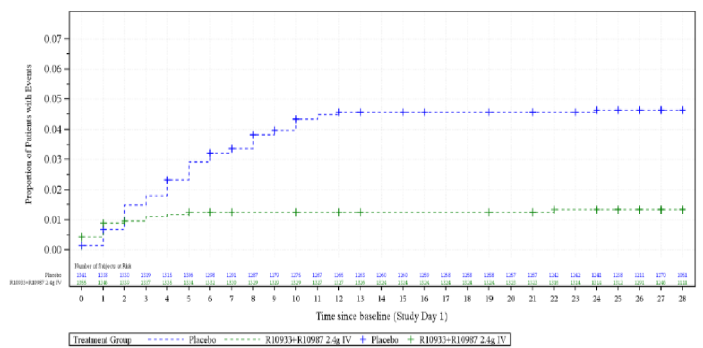
COVID-19 = coronavirus disease 2019; R10933 + R10987 = casirivimab + imdevimab; IV = intravenous.
Randomised patients through 17 January 2021. Data cut-off date is 18 February 2021.
Figure 13: Study COV-2067 Time to COVID-19-related hospitalisation or all cause death through Day 29 for casirivimab/imdevimab 1200 mg intravenous with ≥ 1 risk factor for severe COVID-19 (modified full analysis set)
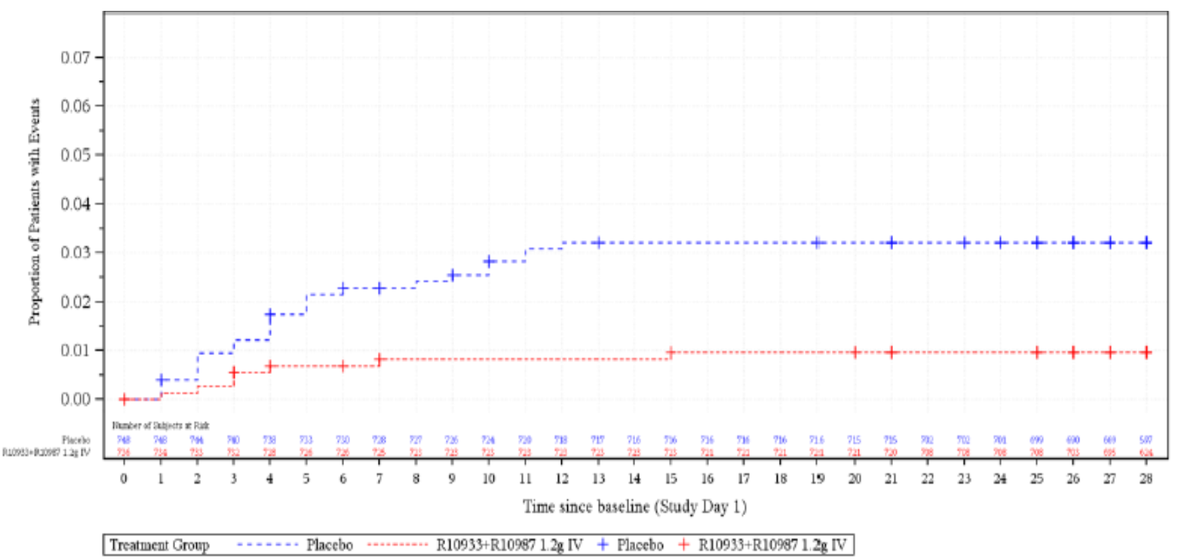
COVID-19 = coronavirus disease 2019; R10933 + R10987 = casirivimab + imdevimab; IV = intravenous.
Randomised patients through 17 January 2021. Data cut-off date is 18 February 2021.

Key secondary endpoint: proportion of participants with ≥ one COVID-19 related hospitalisation or all cause death from day 4 through Day 29
Kaplan Meier curves for time to COVID-19 related hospitalisation or all cause death show treatment benefit with casirivimab/imdevimab became apparent at about 2 days after treatment initiation, suggesting there might be a short lag to observe clinical benefit because viral suppression is achieved over several days.
Relative risk reduction in the Day 4 through 29 analysis for the 2400 mg dose group compared to placebo was 89.2% (95% CI: 73.0%, 95.7%; p < 0.0001); the proportion of participants with ≥ one COVID-19 related hospitalisation or all cause death in the 2400 mg group compared to placebo was 0.4% versus 3.4%.

Key secondary endpoint: time to resolution of symptoms
Treatment with casirivimab/imdevimab 2400 mg or 1200 mg was associated with a statistically significant reduction in time to resolution of symptoms, where the median time to resolution of symptoms was 10 days for both doses and 14 days for the placebo group. Note that symptoms could be reported as resolved despite ongoing mild/moderate cough, fatigue or headache.

Study COV-2069 (post-exposure prophylaxis)

Study design
This is a randomised, placebo controlled, Phase III study. The study aims to assess the efficacy and safety of subcutaneous casirivimab/imdevimab in preventing SARS-CoV-2 infection in household contacts of individuals infected with SARS-CoV-2. The study enrolled adults and adolescents (≥ 12 years) and paediatric participants (< 12 years) who were household contacts of the first household member known to be infected with SARS-CoV-2 (index case), but who were themselves either not infected, or infected but asymptomatic, at the time of screening.
Eligible participants were to be randomised 1:1 to receive a single dose of placebo (0.9% sodium chloride) or casirivimab/imdevimab 1200 mg (600 mg each mAb) on Day 1. Randomisation was performed on an individual participant basis. The cohort allocation was based on the assessment of SARS-CoV-2 RT-qPCR status at Baseline:
- Cohort A (Prevention); a negative PCR at Baseline (asymptomatic and uninfected)
- Cohort B (Pre-emptive therapy); a positive PCR at Baseline (asymptomatic but infected)
Each cohort was further divided based on baseline serology results. To rule out prior SARS-CoV-2 infection, participants were assessed for the presence of serum anti-SARS-CoV-2 antibodies indicative of prior infection. For each participant, the study comprised 3 periods: one day screening/baseline period, a one month efficacy assessment period (EAP), and a seven month follow-up period.
Figure 14: Study COV-2069 Study flow diagram
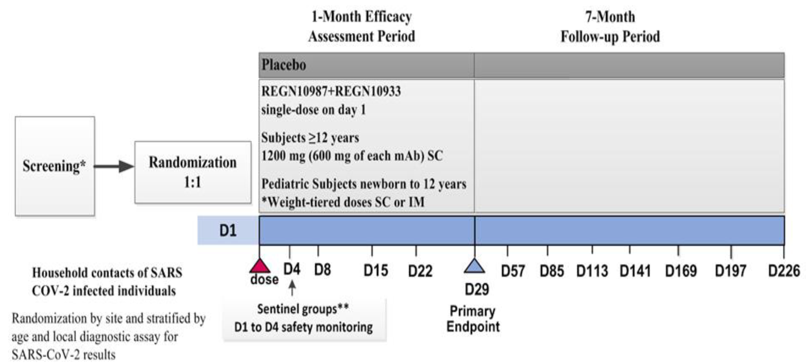
SARS-CoV-2 = severe acute respiratory syndrome coronavirus; R10933 + R10987 = casirivimab + imdevimab; mAb = monoclonal antibody; SC = subcutaneous; IM = intramuscular; D = day.
Assessments included weekly SARS-CoV-2 RT-qPCR testing by nasopharyngeal swabs, weekly interviews for COVID-19 symptoms and adverse events (AE) through Study Day 29 (EAP); and follow-up until Day 229.
Three definitions for symptomatic COVID-19 disease were used to account for differences in criteria adopted in various regions (that is, by broad term, CDC definition, and strict term definition, as defined in the protocol (see Table 17 below)). The association of signs and symptoms with COVID-19 was based on a temporal relationship (±14 days window) with a positive RT-qPCR test. The broad-term definition was used for the primary and key secondary endpoint analyses.
Table 17: Study COV-2069 COVID-19 signs and symptoms definitions
CDC = Centers for Disease Control and Prevention (United States of America); COVID-19 = coronavirus disease 2019; ARDS = acute respiratory distress syndrome.

Main inclusion and exclusion criteria
Participants enrolled were asymptomatic, healthy adults, adolescents, and children (including those with a chronic, stable medical condition) who were household contacts of the first known household member with a diagnosis of SARS-CoV-2 infection (index case). Participants themselves could have been positive (Cohort B) or negative (Cohort A) for SARS-CoV-2 at screening. Pregnant and breastfeeding participants were allowed to participate starting from Protocol Amendment 4. To be included in the study, participants must have been randomised within 96 hours of collection of the index case’s positive SARS-CoV-2 test sample and should have been living in the same household with the index case until Day 29. Participants who had received prior treatment or prophylaxis for SARS-CoV-2 were excluded. Nursing home residents and hospitalised subjects were also excluded.

Primary endpoints and statistical analysis for Cohort A and B
Table 18: Study COV-2069 Study objectives and endpoints
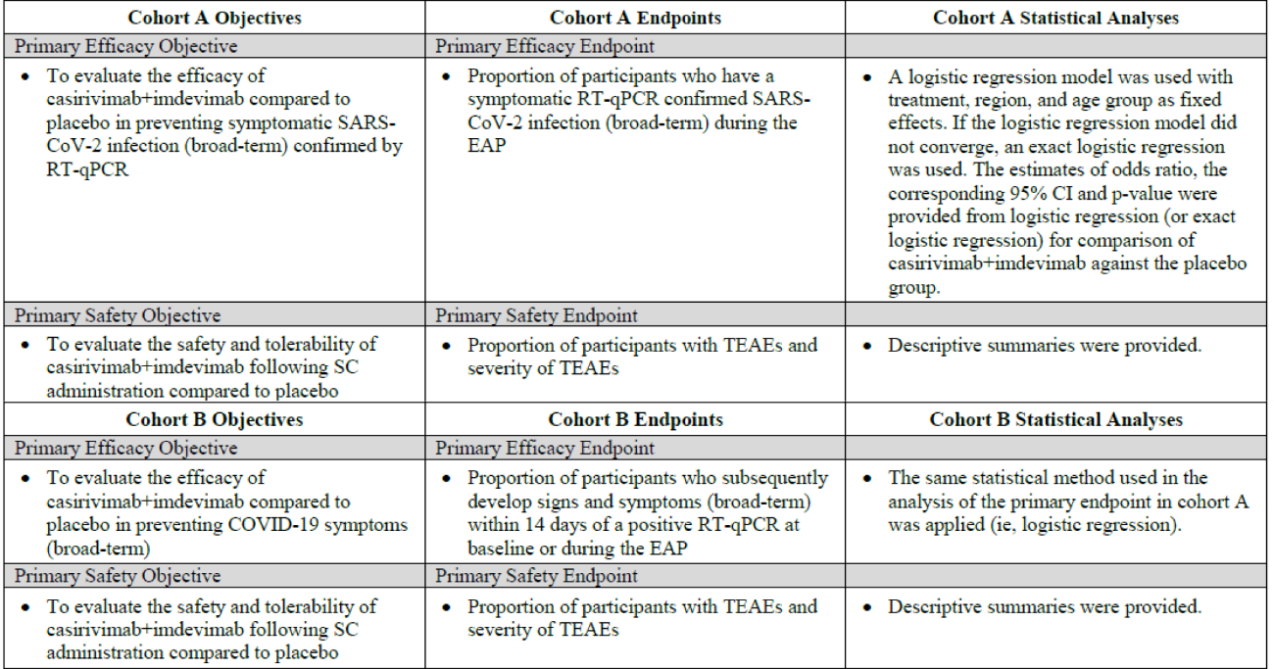
SARS-CoV-2 = severe acute respiratory syndrome coronavirus 2; RT-qPCR = reverse transcription quantitative real time polymerase chain reaction; EAP = efficacy assessment period; CI = confidence interval; SC = subcutaneous; TEAE = treatment emergent adverse event.

Statistical analysis plan
The planned analyses and determination of sample size are described in the statistical analysis plan (SAP) version 1.0, which was finalised prior to the database lock. As this Phase III trial was conducted without any prior Phase II prevention data, an administrative assessment (without formal testing) of the first 554 participants in Cohort A was conducted to verify the assumptions made during study planning, estimate the sample size, and inform the Phase III analysis plans. In 409 out of 554 participants without prior infection (that is, baseline seronegative), the proportion of participants with symptomatic events in the casirivimab/imdevimab group was 0% (0/186) compared to 3.6% (8/223) in the placebo group. Per the SAP, these 554 Cohort A participants were excluded from the primary efficacy analysis population in the study report, but were included in the safety analysis for Cohort A. The administrative assessment did not include the analysis populations for Cohort B.
The following null and alternative hypotheses were tested in the primary analysis:
- Null hypothesis: There is no treatment difference between casirivimab/imdevimab and placebo
- Alternate hypothesis: There is a treatment difference between casirivimab/imdevimab and placebo
The statistical analyses were conducted separately for each cohort.
The percentage of households in Cohort A with only a single study subject was ≥ 70%, so (as pre-specified) it was not deemed necessary to account for correlation among subjects within a household. A logistic regression model was used with treatment, region, and age group as fixed effects. The overall Type I error was controlled for the primary hypothesis based on a two sided test at an alpha level of 0.05. If the primary efficacy endpoint was statistically significant, the alpha level of 0.05 was released for the key secondary endpoints. In Cohort B, the same statistical methods as described for Cohort A were used to obtain the estimate of odds ratio and p-value for comparison between the treatment groups.

Analysis population
The study planned to enrol approximately 3500 adult and adolescent participants and approximately 250 paediatric participants < 12 years old. This was increased from n = 2000, based on the results of the administrative assessment.
A total of 3029 participants were randomised as of the cut-off date. The safety and efficacy analysis populations are shown in Table 19 below.
Table 19: Study COV-2069 Safety and efficacy analyses populations
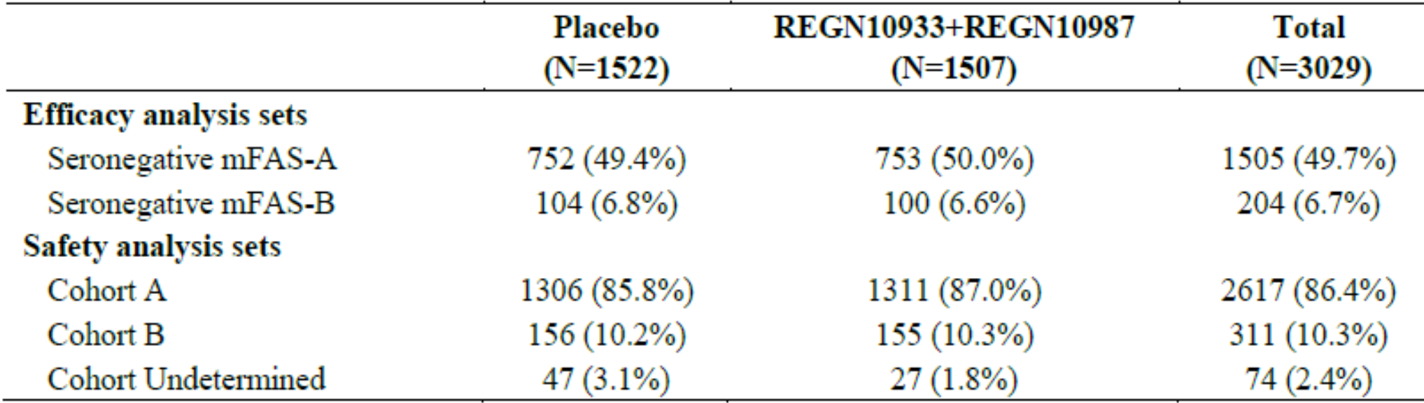
REGN10933 + REGN10987 = casirivimab + imdevimab; N = number of subjects; mFAS = modified full analysis set.
For the primary analysis, all participants randomised by 28 January 2021 are included. The cut-off date is 11 March 2021. For efficacy analysis, 554 participants in Cohort A who were in the administrative assessment are excluded.

Efficacy analysis
Efficacy analysis is discussed on the two cohorts below:
- Cohort A: prevention of infection in participants who were uninfected at Baseline
- Cohort B: prevention of symptomatic progression in participants who were infected but asymptomatic at Baseline.

Cohort A: Prevention of SARS-CoV-2 infection
The key demographic and baseline characteristics were generally similar between the seronegative FAS and all randomised and treated population in Cohort A. In the seronegative FAS-A, approximately 38% of the subjects were 50 years or older, 54% were women, 9% were Black, and 41% were of Hispanic or Latino ethnicity. Adolescents comprised a total of 68/1505 (4.5%) participants in the efficacy analysis, and elderly participants (age > 80 years) comprised a total of 7/1505 (0.5%). Approximately 30% of baseline seronegative participants in Cohort A had risk factors for progressing to severe COVID-19. The risk factors were generally balanced between treatment groups (see Table 20 below). Risk factors present in more than 10% of participants were body mass index (BMI) ≥ 35 kg/m² and age ≥ 65 years with cardiovascular disease, hypertension, or chronic obstructive pulmonary disease (COPD). Fewer than 2% of participants were immunosuppressed (due to disease or immunosuppressive treatment).
Table 20: Study COV-2069 Participants with risk factors at Baseline (seronegative modified full analysis set A)
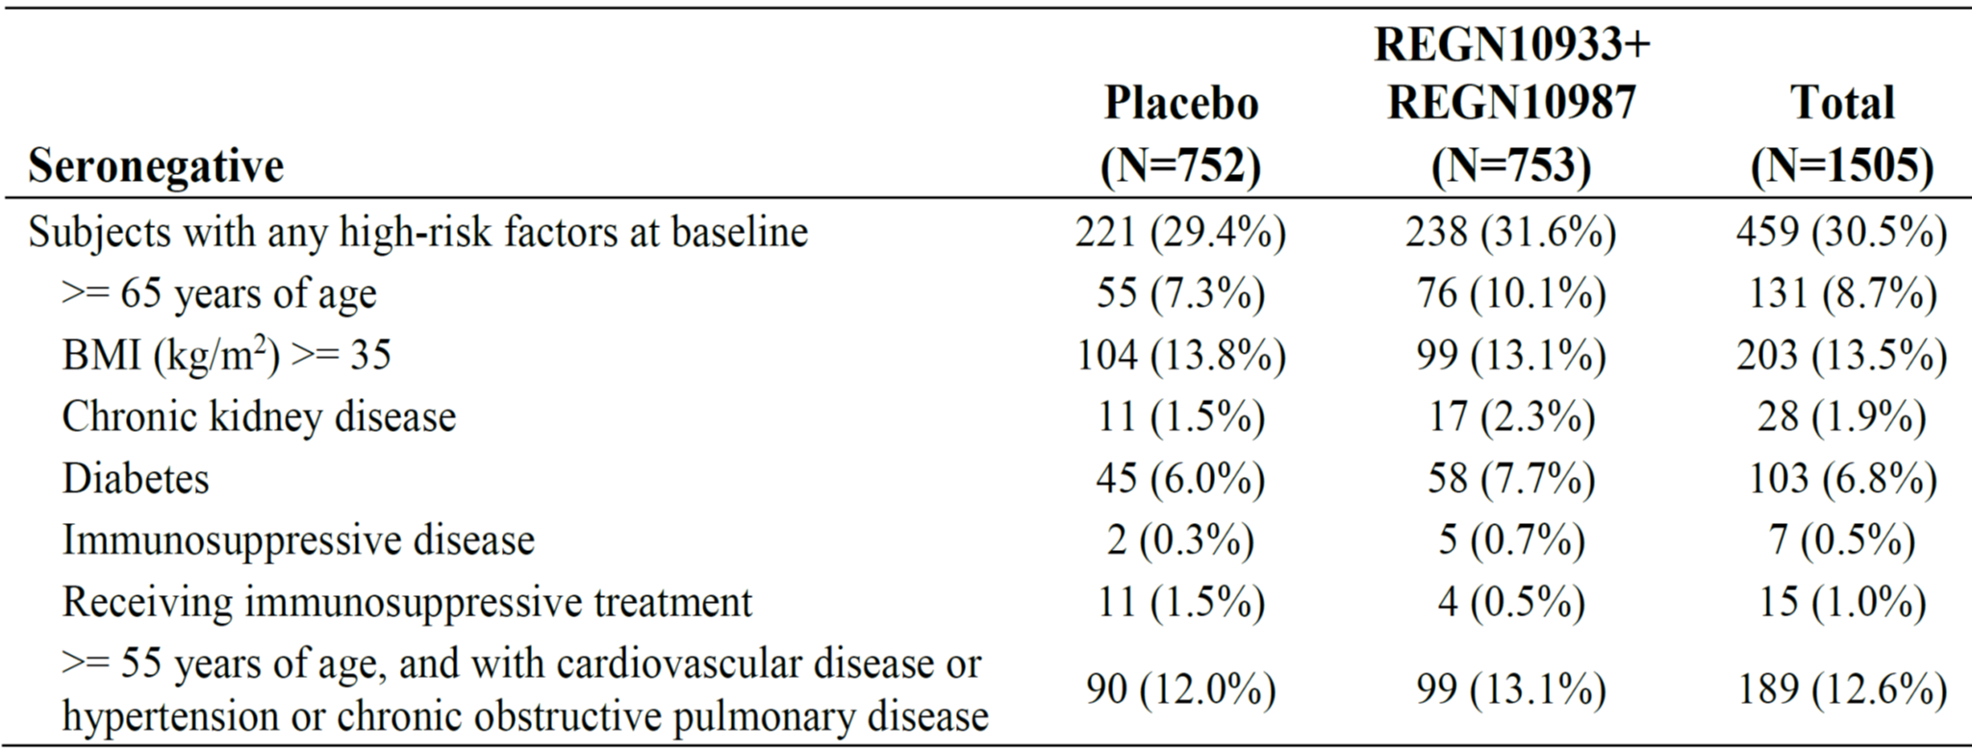
REGN10933 + REGN10987 = casirivimab + imdevimab; N = number of subjects; BMI = body mass index.
For the first step analysis, the data cut-off date is 11 March 2021.
Data collected from demographics, medical history and concomitant medication electronic case report from (eCRF).
The primary endpoint is the proportion of participants who have a symptomatic (broad term) RT-qPCR confirmed SARS-CoV-2 infection. The primary efficacy analysis was conducted in the seronegative modified full analysis set (seronegative mFAS-A) which include 1505 participants. There were 68 (4.5%) adolescents (age ≥ 12 to < 18 years) and 7 (0.5%) participants who were >80 years of age.
The analysis of the primary efficacy endpoint showed that subcutaneous casirivimab/imdevimab reduced the risk of symptomatic infection by 81.4% in participants who were seronegative at Baseline (Table 21). Symptomatic infection for this endpoint was defined as having a confirmed positive RT-qPCR during the EAP with a symptom from the broad term definition occurring within 14 days of the positive RT-qPCR test.
Table 21: Study COV-2069 Proportion of participants with symptomatic infection (broad term) during the evaluation phase (seronegative modified full analysis set A)
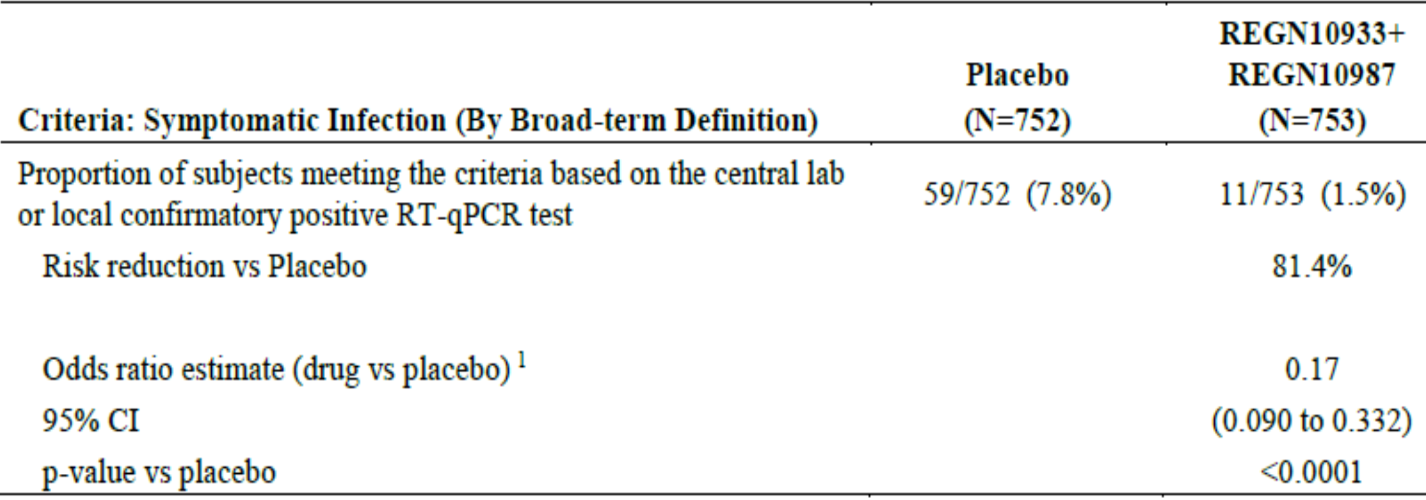
REGN10933 + REGN10987 = casirivimab + imdevimab; N = number of subjects; RT-qPCR = reverse transcription quantitative real time polymerase chain reaction; CI = confidence interval; vs = versus.
For the first step analysis, the data cut-off date is 11 March 2021.
1: The CI with p-value Is based on the odds ratio (casirivimab + imdesivir group versus placebo group) using a logistic regression model with the fixed categorical effects of treatment group, age group (age in years: 12 and over to under 50; and 50 and over), and region (Untied States of America (USA) versus non-USA).
The efficacy analysis for Cohort A met the primary endpoint and all key secondary endpoints except the last in the pre-specified statistical testing hierarchy, as shown in Table 22 below.
Table 22 Study COV-2069 Results of primary and key secondary endpoints (Cohort A)
OR = odds ratio; CI = confidence interval; RT-qPCR = reverse transcription quantitative real time polymerase chain reaction; SARS-CoV-2 = severe acute respiratory syndrome coronavirus 2; EAP = efficacy assessment period; vs = versus; R10933 = drug development code for casirivimab; R10987 = drug development code for imdevimab.
In supportive analyses of the primary endpoint, a consistent treatment effect was shown regardless of baseline serostatus, with an 82.3% risk reduction in symptomatic infection compared to placebo (odds ratio (OR) 0.17 (0.090, 0.312), nominal p < 0.0001). A comparable level of reduction was observed when the analysis included only baseline seropositive participants (81.1% risk reduction versus placebo, OR 0.19 (0.023, 1.682), nominal p = 0.1369).
Treatment benefit was observed as early as one day after treatment and was maintained through Day 29 (see Figure 15 below). Most events occurred in the first week, with a 71.9% risk reduction in the casirivimab/imdevimab group compared to placebo during the first week (OR 0.27 (0.126, 0.564), nominal p = 0.0005 (post-hoc analysis)). There was a 92.6% risk reduction with treatment compared to placebo in weeks 2 to 4 (OR 0.07 (0.017 to 0.304), nominal p = 0.0003).
Figure 15: Study COV-2069 Cumulative incidence of first symptomatic infection (broad term) over time (seronegative modified full analysis set A)
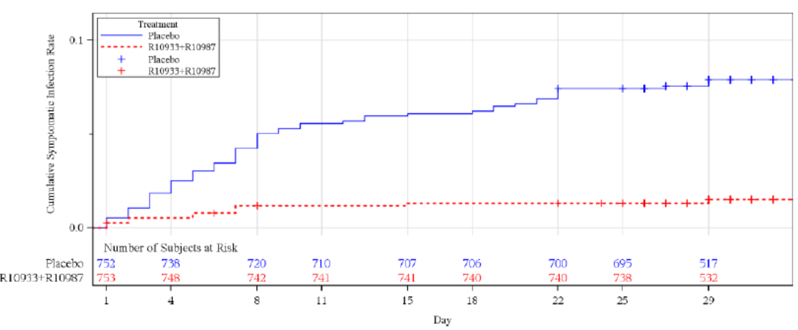
R10933 + R10987 = casirivimab + imdevimab.
For the first step analysis, the data cut-off date is 11 March 2021.
Three definitions for symptomatic infection were used to account for differences in criteria adopted in various regions of the world, ranging from broader to more strict definitions of those symptoms that constitute COVID-19 as well as that utilised by the CDC. Additional analyses conducted using these different definitions showed a consistent treatment effect, regardless of the definition used, in the reduction in incidence and duration of symptomatic infection in participants who were uninfected at Baseline. The magnitude of the effect in these supportive analyses was comparable to that observed for the main analysis based on the broad term definition.
Table 23: Study COV-2069 Proportion of participants with a symptomatic infection using broad term, Centers for Disease Control and Prevention, and strict term definitions (seronegative modified full analysis set A)
REGN10933 + REGN10987 = casirivimab + imdevimab; N = number of subjects; CI = confidence interval; CDC = Centers for Disease Control and Prevention (United States of America).
For the first step analysis, the data cut-off date is 11 March 2021.
1 The CI with p-value is based on the odds ratio (casirivimab + imdesivir group versus placebo group) using a logistic regression model with the fixed categorical effects of treatment group, age group (age in years: 12 and over to under 50; and 50 and over), and region (United States of America (USA) versus non-USA).
2 The primary endpoint for Cohort A is provided for reference.
3 Nominal p-value.

Cohort B: prevention of progression to symptomatic disease
The majority of participants in Cohort B were White and between 18 to 65 years of age, with a mean age of 40.9 years and a mean BMI of 28.1 kg/m². The female to male ratio was greater in the placebo group, while the proportion of participants with BMI ≥ 30 kg/m² was greater in the casirivimab/imdevimab group compared to placebo. Demographics for the primary efficacy population (seronegative mFAS-B) were comparable to the overall Cohort B population. Adolescents comprised a total of 26/207 (12.6%) participants in the efficacy analysis, and elderly (age >80 years) comprised a total of 3/207 (1.4%) participants. Other demographic parameters were generally balanced between treatment groups.
More than 30% of baseline seronegative participants in Cohort B had risk factors for progressing to severe COVID-19 (Table 24). Risk factors present in more than 10% of participants were age ≥ 65 years, BMI ≥ 35 kg/m² and age ≥ 55 years with cardiovascular disease, hypertension, or COPD. In each treatment group, ≤ 3% of participants were immunosuppressed.
Table 24: Study COV-2069 Participants with risk factors at Baseline (seronegative modified full analysis set B)
REGN10933 + REGN10987 = casirivimab + imdevimab; N = number of subjects; BMI = body mass index.
For the first step analysis the data cut-off date is 11 March 2021.
Data collected from demographics, medical history and concomitant medication electronic case report from (eCRF).
The primary efficacy analysis was based on 204 participants who were seronegative at Baseline (seronegative modified full analysis set B). Adolescents (age ≥ 12 to < 18 years) comprised a total of 26 (12.6%) participants, and elderly (age > 80 years) a total of 3 (1.4%) participants.
Treatment with casirivimab/imdevimab reduced the risk of progression to symptomatic disease by 31.5% compared to placebo (p = 0.0380), with 44 subjects in the placebo group and 29 subjects in the active treatment group developing broad-term symptoms of COVID-19 that met the primary endpoint definition. Symptomatic infection for this endpoint was defined as having a confirmed positive RT-qPCR result during the EAP with a symptom from the broad-term definition occurring within 14 days.
Table 25: Study COV-2069 Proportion of participants who subsequently develop signs and symptoms (broad-term) with onset within 14 days of a positive reverse transcription quantitative real time polymerase chain reaction at Baseline or during the efficacy assessment period (seronegative modified full analysis set B)
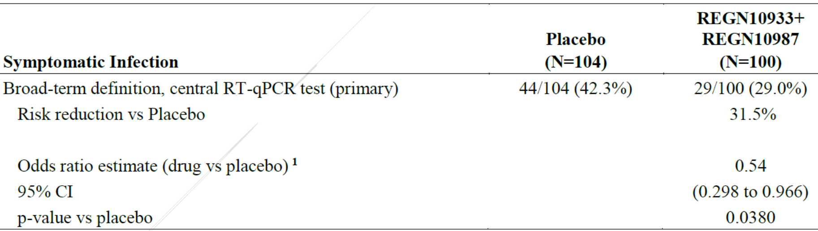
REGN10933 + REGN10987 = casirivimab + imdevimab; N = number of subjects; RT-qPCR = reverse transcription quantitative real time polymerase chain reaction; CI = confidence interval.
For the first step analysis, the data cut-off is 11 March 2021.
If a visit with a missing central lab RT-qPCR result had a local confirmatory positive RT-qPCR for a subject with a COVID-19 symptom occurring within 14 days, that visit was considered to have a positive result.
1 The CI with p-value is based on the odds ratio (casirivimab + imdesivir group versus placebo group) using a logistic regression model with the fixed categorical effects of treatment group, age group (age in years:12 and over to under 50; and 50 and over) and region (United States of America (USA) versus non-USA).
The efficacy analysis for Cohort B met the primary endpoint and key secondary endpoints in the pre-specified statistical testing hierarchy, as shown in Table 26 below:
Table 26: Study COV-2069 Efficacy analysis for Cohort B
OR = odds ratio; CI = confidence interval; RT-qPCR = reverse transcription quantitative real time polymerase chain reaction; SARS-CoV-2 = severe acute respiratory syndrome coronavirus 2; EAP = efficacy assessment period; vs = versus.
A consistent treatment benefit was observed in a post-hoc analysis of the primary endpoint performed in participants regardless of baseline serology, with a 35.4% risk reduction compared to placebo (OR 0.54 (0.325, 0.894), nominal p = 0.0166). A comparable level of reduction was also shown when the analysis included only baseline positive participants (33.9% risk reduction versus placebo, OR 0.62 (0.147, 2.587), nominal p = 0.5079).
Treatment benefit was observed as early as Day 4 and was maintained through Day 29 (see Figure 16 below). After Day 3, there was a risk reduction of 76.4% in baseline seronegative participants and 71.8% in the overall population regardless of baseline serostatus. Starting from Day 4, the cumulative incidence of symptomatic onset diverged between the two groups, with a lower incidence maintained in the treatment group through Day 29 for casirivimab/imdevimab.
Figure 16: Study COV-2069 Kaplan Meier cumulative incidence of time to first symptom within 14 days of a positive reverse transcription quantitative real time polymerase chain reaction (seronegative modified full analysis set B)
REGN10933 + REGN10987 = casirivimab + imdevimab.
For the first step analysis, the data cut-off date is 11 March 2021.

Study HV-2093 (repeat doses for chronic prophylaxis)
Study HV-2093 is an ongoing Phase I, randomised, double blind, placebo controlled study. The study assessed the safety and tolerability of multiple subcutaneous doses of casirivimab/imdevimab in healthy adult volunteers who are SARS-CoV-2 negative at Baseline. Participants are randomised in a 3:1 ratio to receive up to 6 subcutaneous doses of casirivimab/imdevimab or placebo. This study includes healthy participants as well as participants who have chronic but stable medical conditions. Participants are also enrolled across a wide age range. These selection criteria were chosen to allow the assessment of safety and PK in participants that are representative of the broad, diverse population who are at risk for SARS-CoV-2 infection.
All primary and secondary endpoints for this study pertain to safety, PK, and immunogenicity.
Results for exploratory endpoints pertaining to efficacy are presented below.
- Exploratory efficacy analysis: incidence of symptomatic SARS-CoV-2 infection
The repeated use of casirivimab/imdevimab 1200 mg subcutaneous (6 doses every 4 weeks) prevented the occurrence of symptomatic COVID-19: 12 of 240 participants (5.0%) receiving placebo developed symptomatic COVID-19 during the 24 week treatment period compared to 3 of 729 (0.4%) receiving casirivimab/imdevimab, corresponding to an absolute risk reduction of 4.6% (5.0 versus 0.4) and a relative risk reduction of 91.77% (nominal p < 0.0001). Note that the diagnosis of COVID-19 for this endpoint was made clinically and that positive RT-qPCR was not a requirement. There were 5 (2.1%) subjects in the placebo group who returned a positive RT-qPCR result for SARS-CoV-2 during the study, compared with zero in the casirivimab/imdevimab group.
Table 27: Study HV-2093 Proportion of subjects with symptomatic COVID-19 during the treatment period (safety analysis population)
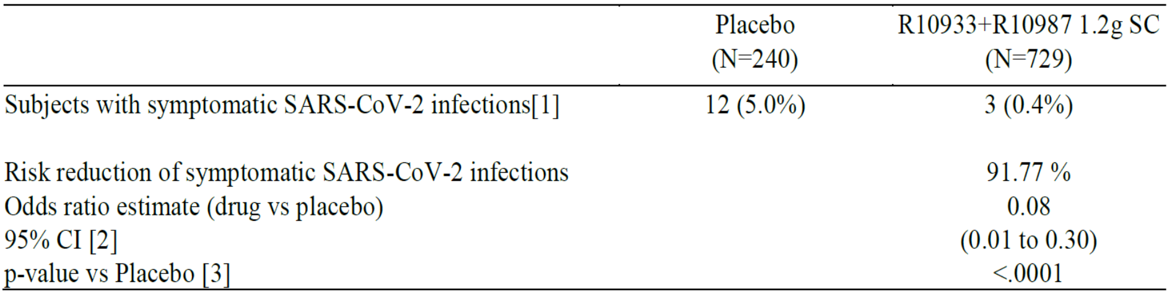
COVID-19 = coronavirus disease 2019; N = number of subjects; R10933 + R10987 = casirivimab + imdevimab; SC = subcutaneous; SARS-CoV-2 = severe acute respiratory syndrome coronavirus 2; CI = confidence interval; vs = versus.
1 Symptomatic SARS-CoV-2 infection was defined clinically by the investigator and reported as an adverse event; reverse transcription polymerase chain reaction (RT-PCR) testing was not required
2 The 95% exact CI is provided
3 Nominal p-value from Fisher’s exact test is provided
Included are events that were reported before the COVID-19 vaccination date, if any.
Similar results were observed for the entire study period: one additional participant in the placebo group had symptomatic SARS-CoV-2 infection in the follow-up period and no additional cases were reported in the active treatment group during the follow-up period, with a risk reduction of 92.4% (p < 0.0001). The risk reduction for participants with any SARS-CoV-2 infection (including 1 participant with asymptomatic infection in the casirivimab /imdevimab group) was also nominally significant: 89.0% relative to placebo (nominal p < 0.0001) during the treatment period and 89.87% during the entire study (nominal p < 0.0001).
The formation of anti-SARS-CoV-2 antibodies in baseline seronegative participants was observed in 4.9% of participants treated with placebo but none of the participants treated with casirivimab/imdevimab, indicating that casirivimab/imdevimab prevented (symptomatic and asymptomatic) SARS-CoV-2 infections.

Analysis across studies for treatment selected variants
To evaluate whether or not there is evidence of treatment-selected variants that may affect casirivimab/imdevimab potency, the SARS-CoV-2 genome is being sequenced from all available RT-PCR positive nasopharyngeal swab samples from the clinical trials. Results from the interim clinical viral variant analysis report for Studies COV-2066 and COV-2067 are discussed by the sponsor below.
The primary objectives of the analyses were to evaluate whether there is evidence of treatment-related variant selection and whether circulating variant of concern (VOC), variant of interest (VOI), or other baseline variants affect the clinical and virologic efficacy of casirivimab/imdevimab. Mutation analyses described are focused on the SARS-CoV-2 spike gene, including the RBD. Overall, no evidence of treatment emergent variants following casirivimab/imdevimab treatment was observed in this interim analysis. Samples collected from June to December 2020 across Study COV-2066 and Study COV-2067 were sequenced; however, insufficient numbers of subjects with variants under surveillance (VUS) or other baseline variants were observed to verify the in vitro results clinically. Only 13 baseline variants were observed in the spike protein RBD at ≥ 50% allele frequency (7 in Study COV-2066 and 6 in Study COV-2067). Of the post baseline variants identified, 6 algorithmically defined potentially treatment emergent variants were observed among five patients, including one hospitalised patient and four outpatients. None of the potentially treatment emergent variants were identified in the receptor binding domain (RBD), and none were observed in more than one patient. In addition, there was no detectable pattern or systematic selection of mutations at a particular amino acid position. Thus, no evidence of treatment emergent variants following casirivimab/imdevimab treatment was observed. No VOC or VOI were identified in any baseline or post baseline sample, this is expected given the lack of prevalence when the samples were collected.
Overall, these interim analyses found no evidence of emergence of treatment resistant variants.
Since very few patients were infected with VUS or other baseline variants observed in these studies, it is not possible to adequately assess if the mutations affect Ronapreve efficacy based on the currently available clinical trial data.

Activity against novel viral variants
The neutralisation potency of casirivimab alone; imdevimab alone; and casirivimab/imdevimab together was assessed against spike protein variants, including known VOC and VOI, variants identified in in-vitro escape studies, and variants from publicly available SARS-CoV-2 genome data obtained from the Global Initiative on Sharing All Influenza Data. A comprehensive list of pseudotyped virus-like particles encoding full sequences or key spike protein substitutions of VOC/VOI assessed for susceptibility to casirivimab and imdevimab alone and together is provided in Table 28 below.
The combination of casirivimab/imdevimab has been found to retain neutralisation potency against all the VOC/VOI, even if one of the antibodies is impacted.
Table 28: Pseudotyped virus like particle neutralisation data for full sequence or key SARS-CoV-2 spike protein variant substitutions from variants of interest/concern with casirivimab/imdevimab alone or together
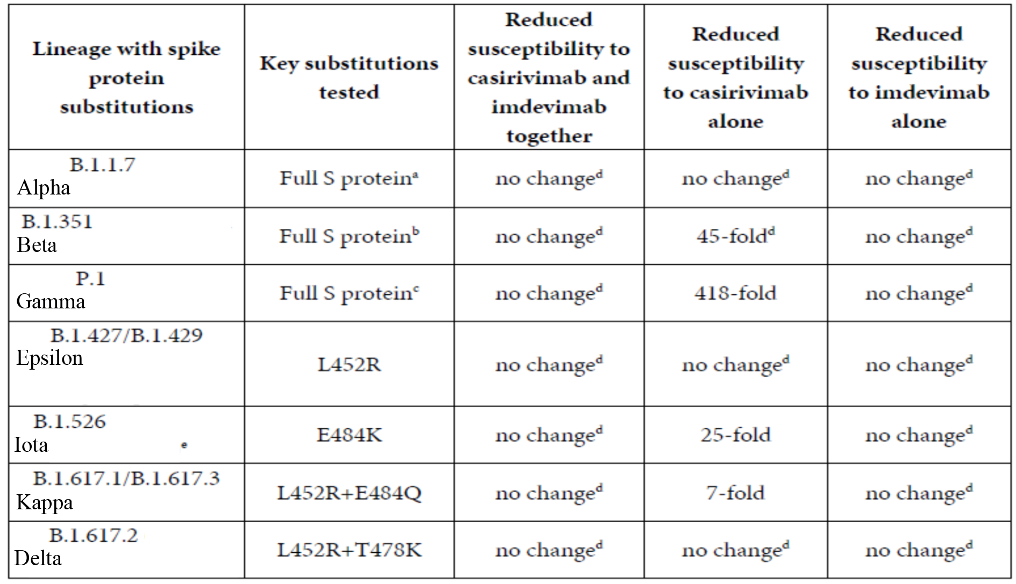
S Protein = spike protein.
a Pseudotyped VLP expressing the entire variant spike protein was tested. The following changes from wildtype spike protein are found in the variant: del69-70, del145, N501Y, A570D, D614G, P681H, T716I, S982A, D1118H.
b Pseudotyped VLP expressing the entire variant spike protein was tested. The following changes from wildtype spike protein are found in the variant: D80Y, D215Y, del241-243, K417N, E484K, N501Y, D614G, A701V.
c Pseudotyped VLP expressing the entire variant spike protein was tested. The following changes from wildtype spike protein are found in the variant: L18F, T20N, P26S, D138Y, R190S, K417T, E484K, N501Y, D614G, H855Y, T1027I, V1176F
d No change: < 5 fold reduction in susceptibility
e Not all isolates of this lineage harbour the E484K substitution (as of February 2021)
* Variants of interest/concern as defined by the Center for Disease Control and Prevention (United States of America).

Compassionate use program
The report from the US compassionate use program includes a retrospective analysis of COVID-19 outcome and safety data. Patients included in the compassionate use program were those who were otherwise ineligible for treatment under the US Emergency Use Authorization (EUA) that was current at the time (for example, patients who were hospitalised due to COVID-19, required supplemental oxygen therapy due to COVID-19, required an increase in baseline oxygen flow rate due to COVID-19, or physicians requested treatment after the 10 day window of symptom onset allowed under the EUA). Of the 236 treated patients, 55.1% were male. The age of the patients ranged from 1 to 98 years with a mean (standard deviation (SD)) of 48.3 (20.2) years; 15 (6.3%) of these patients were paediatric (< 18 years of age) and 22.9% were ≥ 65 years. 94.5% received a single 2400 mg (that is, 1200 mg of each mAb) intravenous dose of casirivimab/imdevimab, 3% received 8000 mg intravenous and the remainder received lower paediatric intravenous doses according to weight.
Of the 236 patients who received casirivimab/imdevimab for the treatment of COVID-19 under the compassionate use program from 13 August 2020 to 16 April 2021, 74.6% recovered, 2% had a known fatal outcome, 3.8% recovered with sequelae, 5.5% were ‘not recovered’ and 14% had outcome status ‘unknown’.
About half of the 236 patients (119) were immunocompromised with primary and secondary immunodeficiency associated antibody disorders: the majority had secondary causes of B-cell deficiency with transplant and treatment with anti-CD20 (rituximab) being the most common diagnoses. A similar proportion (75.6%, 90/119) of these immunocompromised patients also recovered from COVID-19 after treatment with casirivimab/imdevimab. The majority of these patients (54.2%) had persistent infection prior to treatment, with a time from positive PCR diagnosis prior to treatment of at least 11 days, and 44.6% of patients had a time of at least 21 days. Most (90.6%, 58/64) of the immunocompromised patients with available data showed an improvement in disease outcomes, including 89.7% (52/58) of patients with improvement per qualitative physician follow-up, 84.6% (33/39) patients with improved oxygenation status, and 100% (14/14) of patients with improved cycle threshold. Of the 28 patients who had post-baseline PCR data, 11 (39.3%) patients were PCR positive for at least 21 days before treatment and subsequently tested negative after treatment. This case series review provides an appreciation of the clinical outcomes as well as the ability to clear virus following treatment in patients with a variety of B-cell deficiencies and evidence of persistent infection prior to treatment. The results are consistent with the data from the clinical studies in seronegative individuals who had not yet mounted an antibody response.

Clinical safety
The safety evaluation is based on 7671 participants who received casirivimab/imdevimab either intravenous or subcutaneous in the randomised clinical studies contributing safety data to this application.
Table 29: Duration of observation in clinical studies
COV-2067 = Study COV-2067; IV = intravenous; SC = subcutaneous; COV-20145 = Study COV 20145; COV-2069 = Study COV-2069; HV-2093 = Study HV-2093; Q4W = every 4 weeks, COV-2066 = Study COV-2066.
a: Duration of observation numbers presented in this table show actual duration of observation for various IV and SC doses of casirivimab + imdevimab for unblended studies and estimated duration of observation for blinded studies. The numbers exclude subjects randomised to placebo.
Of these participants:
- 5248 received a single dose casirivimab/imdevimab intravenous
- 1694 received a single dose casirivimab/imdevimab subcutaneous
- 729 received repeated administration of casirivimab/imdevimab subcutaneous every 4 weeks x 6 doses.
Participants have been followed-up for safety for various durations depending on the data cut-off dates of the respective studies, but all had the opportunity to complete 28 days of follow-up. There are approximately 4470 and 2270 subjects with at least 4 weeks of exposure after single-dose intravenous and subcutaneous administration, respectively, at doses ≥ the to-be-marketed dose of 1200 mg. To support multiple dosing for prevention of COVID-19, 454 subjects from Study HV-2093 were exposed to casirivimab/imdevimab 1200 mg subcutaneous every 4 weeks for 24 weeks

Overview of adverse events

Overview of adverse events in treatment studies (Study COV-2067 and Study COV-20145)
The pooled Phase I/II/III safety data from Study COV-2067 and Study COV-20145 showed that the combination of casirivimab/imdevimab was well tolerated in adult outpatients with COVID-19. No dose dependent pattern of adverse events (AE) was observed. Note that there was only a targeted collection of AEs in Study COV-2067 (serious adverse events (SAE), adverse events of special interest (AESI), and Phase I Grade 3/4 AEs). The incidence of SAEs in both studies was low. The incidence of AESI was low in both studies; 1.5% of patients across the active treatment groups in Study COV-2067 (versus 2.5% with placebo), and ≤ 1.8% of patients in any treatment group in Study COV-20145 had AESI.
Hypersensitivity reactions were considered an identified but manageable risk with Ronapreve treatment. In Study COV-2067, no new or different safety concerns were identified in subgroups of patients based on age, baseline obesity status or baseline disease status. No analyses of AEs in these subgroups of patients were performed in Study COV-20145.
Table 30: Study COV-2067 Overview of adverse events
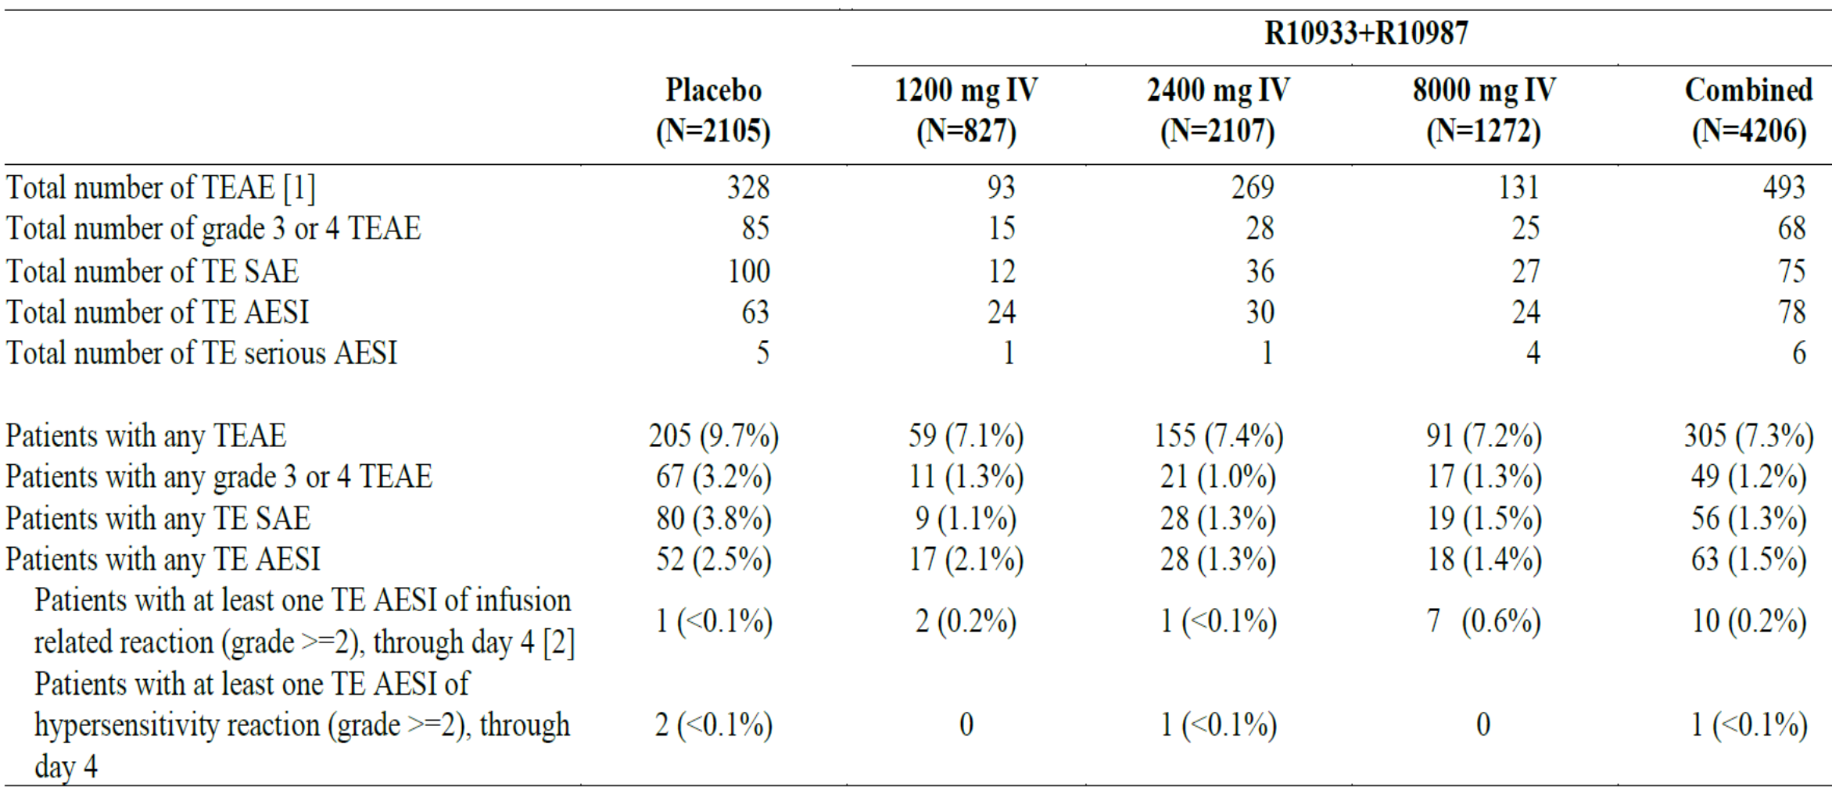
REGN10933 + REGN10987 = casirivimab + imdevimab; IV = intravenous; N = number of subjects; TEAE = treatment emergent adverse events; TE = treatment emergent; SAE = serious adverse event; AESI = adverse event of special interest.
Randomised patients through 17 January 2021; data cut-off date is 18 February 2021.
MedDRA (Version 23.1) coding dictionary applied.
Treatment emergent adverse events are defined as those that are not present at Baseline or represent the exacerbation of a pre-existing condition during the observation period which is from the time of study drug administration to the last study visit.
1 Treatment emergent adverse events collected include treatment emergent serious adverse events; adverse events of special interest; and Grades 3 and 4 treatment emergent adverse events as well as ad hoc/voluntarily reported treatment emergent adverse events by some sites.
2: Treatment emergent adverse events deemed treatment related as per investigator assessment
3: Infusion interruption: the administration of the infusion was interrupted before being completed, but subsequently was restarted and the full planned dose was administered.
4: Infusion discontinuation: the administration of the infusion was stopped before being completed, and the full planned dose was not administered

Study COV-20145
Across the intravenous dose groups from Day 1 through Day 169, the highest percentage of participants experiencing a treatment emergent adverse event (TEAE) in any dose group was 19.0%, experienced by participants in the casirivimab/imdevimab 1200 mg intravenous group, while the lowest was 7.8%, experienced by participants in the casirivimab/imdevimab 2400 mg intravenous group (Table 31). TEAEs were reported by 17.5% of subjects with placebo.
Table 31: Study COV-20145 Overview of adverse events through Day 169 (intravenous, safety analysis population)
IV = intravenous; N = number of subjects; REGN10933 + REGN10987 = casirivimab + imdevimab; TEAE = treatment emergent adverse events; SAE = serious adverse event; AESI = adverse event of special interest.
Patients randomised on or before 1 February 2021 with the data cut-off date of 8 February 2021.
Treatment emergent adverse events are defined as those that are not present at Baseline or represent the exacerbation of a pre-existing condition during the observation period which is from the time of study drug administration to the last study visit.
Across the subcutaneous dose groups from Day 1 through Day 169, the highest percentage of participants experiencing a TEAE in any dose group was 10.5%, experienced by participants in the 1200 mg subcutaneous group, while the lowest was 4.4%, experienced by participants in the 600 mg subcutaneous group (Table 32). In comparison, 10.3% of participants in the placebo subcutaneous group experienced at least 1 TEAE. For both the intravenous and subcutaneous administrations of casirivimab/imdevimab compared to placebo, there were no dose dependent trends in AEs, as evaluated by total TEAEs, Grade 3 or 4 TEAEs, SAEs, and AESI results. Overall, there were fewer participants who reported TEAE in the casirivimab/imdevimab subcutaneous groups compared to the similar intravenous dose groups.
Table 32: Study COV-20145 Overview of adverse events through Day 169 (subcutaneous, safety analysis population)
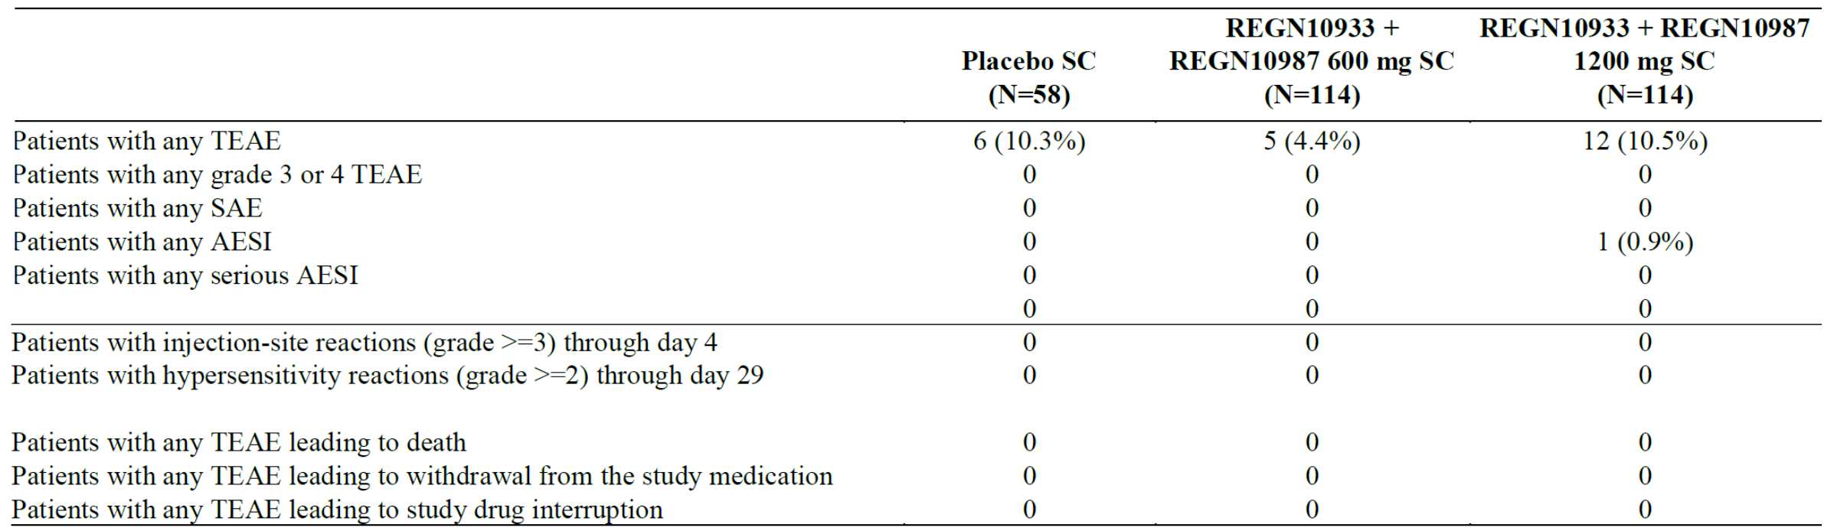
SC = subcutaneous; N = number of subjects; REGN10933 + REGN10987 = casirivimab + imdevimab; TEAE = treatment emergent adverse events; SAE = serious adverse event; AESI = adverse event of special interest.
Patients randomised on or before 1 February 2021 with the data cut-off date of 8 February 2021.
Treatment emergent adverse events are defined as those that are not present at Baseline or represent the exacerbation of a pre-existing condition during the observation period which is from the time of study drug administration to the last study visit.

Overview of adverse events in prevention studies (Study COV-2069 and Study HV-2093)

Study COV-2069
In Study COV-2069 Cohorts A and B, casirivimab/imdevimab was well tolerated in a generally healthy population of adolescents (age ≥ 12 to < 18 years) and adults (age ≥ 18 years) with no recent history of respiratory illness. There were no significant safety findings in the casirivimab/imdevimab group compared to placebo in either Cohort. SAE were infrequent. An overview of TEAEs during the study period for Cohort A is shown in Table 33 below.
Table 33: Study COV-2069 Overview of adverse events during the overall study period (safety analysis population A)
N = number of subjects; R10933 + R10987 = casirivimab + imdevimab; TEAE = treatment emergent adverse events; COVID-19 = coronavirus disease 2019; AESI = adverse event of special interest.
An overview of TEAE during the study period for Cohort B is shown in Table 34 below.
Table 34: Study COV-2069 Overview of adverse events during the overall study period (safety analysis population B)
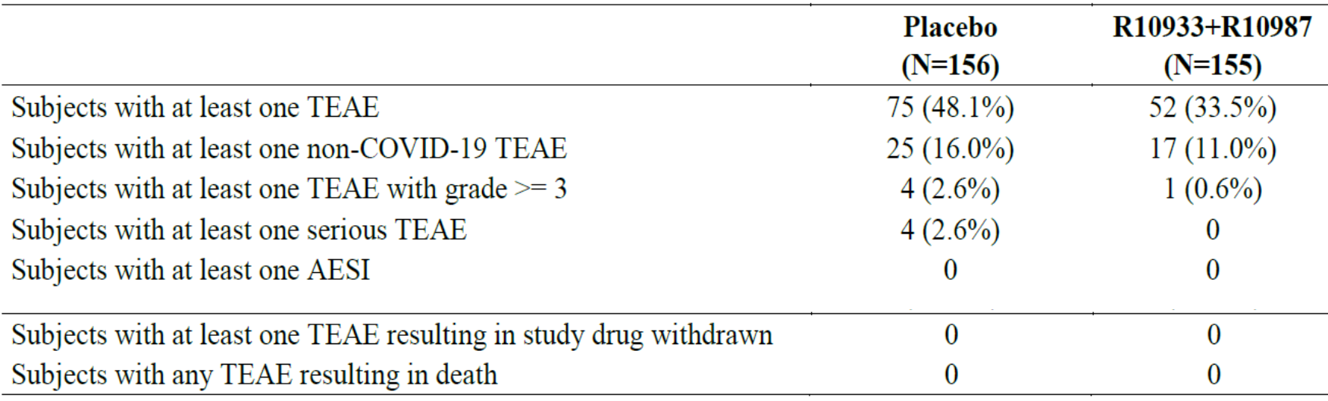
N = number of subjects; R10933 + R10987 = casirivimab + imdevimab; TEAE = treatment emergent adverse events; COVID-19 = coronavirus disease 2019; AESI = adverse event of special interest.
The SAF for both cohorts included seronegative and seropositive subjects. No difference in the safety profile of patients receiving casirivimab/imdevimab was observed between seronegative and seropositive subjects in either Cohort A or Cohort B. In both cohorts, the incidence of injection site reactions (ISR) was higher in the casirivimab/imdevimab group (4.2%, 3.9%) than the placebo group (1.5%, 0.6%). All ISRs were mild or moderate in severity and most events resolved without treatment. The data, together with the absence of serious acute hypersensitivity reactions with subcutaneous administration suggest that individuals may not require observation at a health care facility with subcutaneous administration of casirivimab/imdevimab.

Study HV-2093
In Study HV-2093, casirivimab/imdevimab 1200 mg subcutaneous every 4 weeks was well tolerated with no unexpected safety findings in healthy volunteers. The summary of TEAEs during the entire study period is presented in Table 35 below.
Table 35: Study HV-2093 Summary of adverse events during the entire study period (safety analysis population)
N = number of subjects; R10933 + R10987 = casirivimab + imdevimab; TEAE = treatment emergent adverse events; COVID-19 = coronavirus disease 2019; AESI = adverse event of special interest.
MedDRA (Version 23.1) coding dictionary applied.
Data cut-off date is 13 March 2021.
A greater proportion of participants experienced at least one TEAE during the entire study period in the casirivimab/imdevimab 1200 mg group (52.7%) than in the placebo group (46.3%). This imbalance is mainly due to the higher incidence of ISRs experienced by participants treated with casirivimab/imdevimab 1200 mg (34.7%) compared to placebo (15.5%). All ISRs were mild or moderate in severity and most events resolved without treatment. More participants in the placebo group experienced a TEAE leading to study drug withdrawal than in the casirivimab/imdevimab 1200 mg subcutaneous group. Additionally, there were few SAEs (all considered not related to study drug by the investigator) and no AESI during the entire study period.

Serious adverse events and deaths
Across the submitted studies, there were 5 deaths reported in subjects in the casirivimab/imdevimab groups, none of which were considered related to treatment.

Deaths in treatment studies
- Study COV-2067: 7 deaths were reported, of which 5 were in the placebo group. None were considered related to study treatment. The deaths in the active drug arms occurred in a 60 year old male with Type 2 diabetes (died Day 19), and a 57 year old male with obesity and Type 2 diabetes (died Day 23).
- Study COV-20145: there were no deaths reported in any of the treatment groups.

Deaths in prophylaxis studies
- In Study COV-2069, there were 2 (0.2%) participants in each treatment group in Cohort A who died during the study, none were considered treatment related, The deaths in the active treatment arms occurred in a 62 year old woman with acute myocardial infarction and congestive cardiac failure (Day 59) and a 58 year old male with sudden death (Day 80). Both participants had relevant medical history. There were no deaths in Cohort B.
- In Study HV-2093 there were no deaths during the treatment period and there was a single death during the follow-up period. A participant in the casirivimab/imdevimab 1200 mg group experienced a grade 5 fatal TEAE of diabetic complication on Study Day 171, which was assessed as not related to study drug.
An additional 5 deaths were reported in the compassionate use program. All events were related to COVID-19 and were not considered treatment related.
Serious adverse events were overall infrequent. The pattern of SAEs differed according to the different treatment populations.

Serious adverse events in treatment studies
In Study COV-2067, the incidence of SAEs was higher in the placebo group compared to the casirivimab/imdevimab groups (3.8% placebo versus 2.2% combined casirivimab/imdevimab groups). The most frequently reported SAE in all treatment groups were COVID-19 related, so the imbalance between placebo and active groups for SAEs may be reflective of the clinical efficacy. Two subjects (one in 2400 mg group and one in 8000 mg group) reported SAE considered treatment related by the investigator: one with worsening of underlying COVID-19, and one with nausea, vomiting, hyporesponsive to stimuli and hyperhidrosis. Across all treatment groups, participants with baseline risk factors for severe COVID-19 had higher rates of SAEs compared to those without baseline risk factors, consistent with their baseline risk and the observation that most SAEs were COVID-19 related.
Table 36: Study COV-2067 Summary of serious adverse event from Day 1 to last available data, pooled Phase I/II/III (symptomatic patients), reported in > 1 participant (safety analysis population)
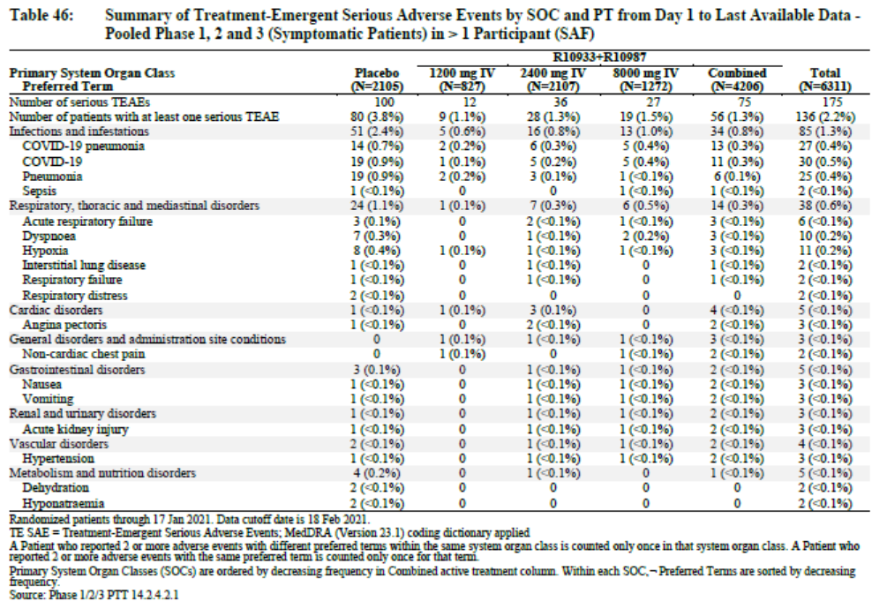
R10933 + R10987 = casirivimab + imdevimab; N = number of subjects; IV = intravenous; TEAE = treatment emergent adverse events; COVID-19 = coronavirus disease 2019.
Randomised patient through 17 January 2021. Data cut-off date is 18 February 2021.
MedDRA (Version 23.1) coding dictionary applied.
A patient who reported 2 or more adverse events with different Preferred Terms within the same System Organ Class is counties only once in that System Organ Class. A patient who reported 2 or more adverse events with the same Preferred Term is counted only once for that term.
Primary System Organ Classes are ordered by decreasing frequency in a combined active treatment column. Within each System Organ Class, Preferred Terms sorted by decreasing frequency.
In Study COV-20145, two participants (one each in the casirivimab/imdevimab 1200 mg intravenous and 2400 mg intravenous groups) experienced an SAE. Both participants had a spontaneous abortion (miscarriage), neither was considered to be related to study treatment. There were no SAEs with subcutaneous administration of casirivimab/imdevimab in this study.

Serious adverse events in prophylaxis studies
In Study COV-2069 Cohort A, SAE were infrequent (0.8% with casirivimab/imdevimab, 1.1% with placebo). COVID-19 and COVID-19 pneumonia events appear to be driving the imbalance observed with placebo. No SAEs were reported in the active treatment arm in Cohort B.
Table 37: Study COV-2069 Summary of serious adverse events, overall study period (safety analysis population A)
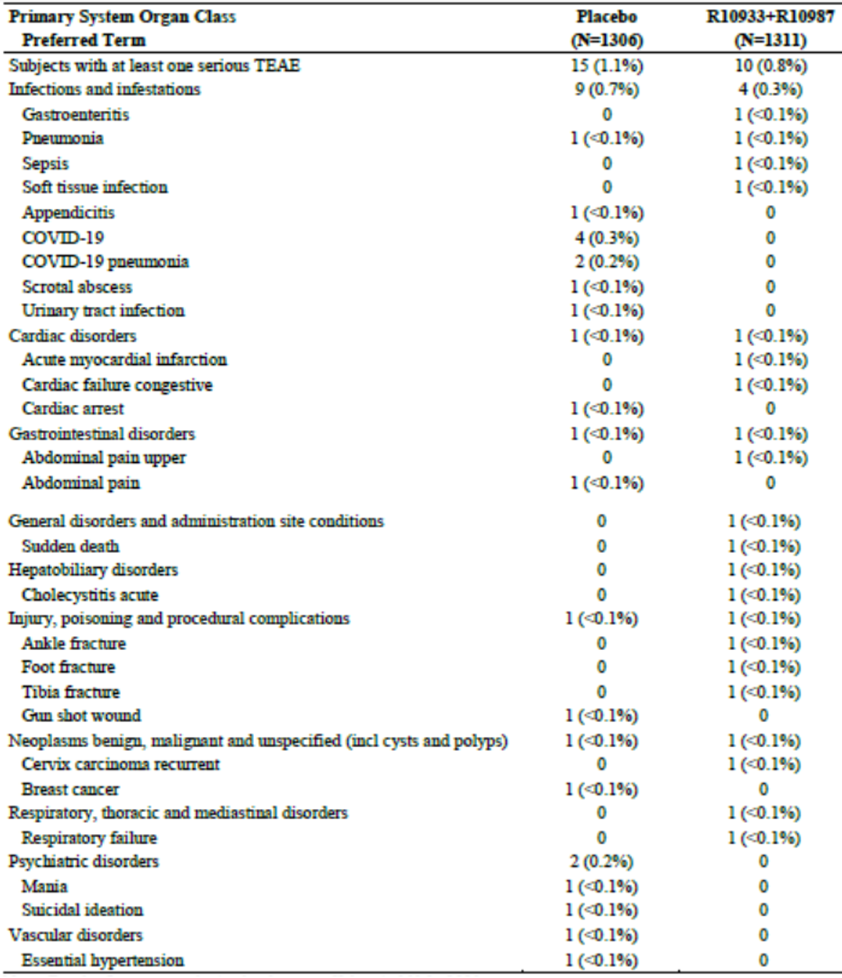
N = number of subjects; R10933 + R10987 = casirivimab + imdevimab; TEAE = treatment emergent adverse events; COVID-19 = coronavirus disease 2019.
For the first step analysis, the data cut-off date is 11 March 2021.
MedDRA (Version 23.1) coding dictionary applied.
A subject who reported 2 or more TEAEs with the same Preferred Term is counted only once for that term.
A subject who reported 2 or more TEAEs with different Preferred Terms within the same System Organ Class is counties only once in that System Organ Class.
In Study HV-2093, one subject in the placebo group and five subjects in the active treatment group reported SAEs (angina pectoris, post laminectomy syndrome, procedural pain, diabetic complication, spinal osteoarthritis, major depression and post traumatic stress disorder). All SAEs were considered unrelated to study drug.

Adverse events of special interest
Across the submitted studies, AESI were generally defined as Grade ≥ 2 infusion related reactions ((IRRs) if via intravenous administration), Grade ≥ 3 ISRs (if via subcutaneous administration) and Grade ≥ 2 hypersensitivity reactions occurring during the treatment period. In Study COV-20145, AESI also included TEAEs that led to a hospitalisation or emergency room visit. AESI as per these definitions above were overall very infrequent. Mild/moderate ISRs were reported in 4 to 23% of participants with subcutaneous administration, mostly erythema and pruritis, which may increase in frequency with repeat dosing (see below).
In Study COV-2067, Grade ≥ 2 IRRs were more commonly reported with active drug than placebo, but overall rates were low: ten (0.2%) versus one (<0.1%). Seven of the ten IRRs were reported following the highest dose (8000 mg). One participant (2400 mg group) reported a grade ≥ 2 hypersensitivity reaction (Grade 3 urticaria), versus 2 participants with placebo.
No IRRs, ISRs or, hypersensitivity reactions meeting the definition of AESI were reported in Study COV-20145. 5 participants reported AEs leading to hospitalisation or emergency room visit (one with placebo, one in 600 mg intravenous group, 2 in 1200 mg intravenous group and one in 1200 mg subcutaneous group), of which none were considered treatment related (all were related to underlying COVID-19 or medical history). One participant in the 2400 mg intravenous group discontinued study treatment mid-infusion due to an IRR which was considered treatment related.
While ISRs were more commonly reported in the active treatment arm versus placebo in Study COV-2069 Cohort A (4.0% versus 1.3%) all were mild/moderate and did not meet the definition of an AESI. Most occurred within the first 24 hours and resolved in a median of 2 days. The 2 most frequently reported signs or symptoms of ISR were erythema and pruritus. There were no hypersensitivity reactions of Grade 3 or higher severity reported. There were also no events meeting the AESI definition in Cohort B. Mild/moderate ISRs were numerically greater with active drug (6) than placebo (1).
No events meeting the definition of AESI were reported in Study HV-2093; however, mild/moderate ISRs were frequently reported. These were more commonly observed following active drug than placebo, driving the overall imbalance in TEAEs between active drug and placebo in this study. The 2 most common symptoms of the ISRs were erythema and pruritus. Differential rates in ISRs were noted across the study sites, with Sites 1 and 2 (of 7) reporting > 88% of the total ISRs. The sponsor could find no overt explanation for this. An apparent increase in ISRs was observed with doses 5 and 6. The sponsor stated this was due to a higher proportion of participants completing monthly dose administrations 5 and 6 at Sites 1 and 2 as compared to other study sites.
Table 38: Study HV-2093 Injection site reactions by visit and dose
N = number of subjects; R10933 + R10987 = casirivimab + imdevimab; SC = subcutaneous; ISR = injection site reaction.

Anaphylaxis
In the compassionate use program, an event of anaphylaxis was reported in a two year old toddler with history of multiple food allergies and allergy to betadine. Event onset was 42 minutes into a 120 minute infusion of a 450 mg dose of casirivimab/imdevimab, leading to permanent discontinuation of the infusion. He developed facial rash, hives on neck, erythema on face, fussiness, mottling of extremities and perioral cyanosis. The event was considered related to treatment, and resolved with adrenaline and antihistamines.
An event of anaphylaxis was also reported in Study COV-2067, occurring on 12 April 2021 (that is, after the data cut-off). This event occurred in a 24 year old male subject whose medical history included food allergy and seasonal allergy. ‘Gradually after completion of study drug infusion’ (casirivimab/imdevimab doses not stated), the patient experienced anaphylaxis including shortness of breath, swelling of tongue and lips. The subject presented to the emergency room but no corrective treatment was given and the event resolved the same day. It was considered unrelated to study drug and was deemed related to nebuliser treatment for allergies (treatment not specified).
A total of 5 cases of anaphylaxis have been reported with intravenous use from EUA data in the USA.

Clinical chemistry and vital signs
Laboratory data do not reveal any particular concern.
There were no clinically meaningful findings or trends observed in vital signs measurements.

Safety in special groups

Safety in adolescents and the elderly
The number of adolescents enrolled was relatively small, which precludes a detailed comparison with adults; however, no AEs reported in the adolescent population suggested a safety concern for casirivimab/imdevimab. The Study COV-2069 SAF included 88 adolescents in Cohort A and 38 adolescents in Cohort B. None reported Grade 3 or 4 TEAEs. ISRs appeared to be more common in adolescents than adults, as was asymptomatic COVID-19 (Cohort A).
Table 39: Study COV-2069 Summary of adverse events (Preferred Term in > 1 adolescent) by age group during the overall study period (safety analysis population A)
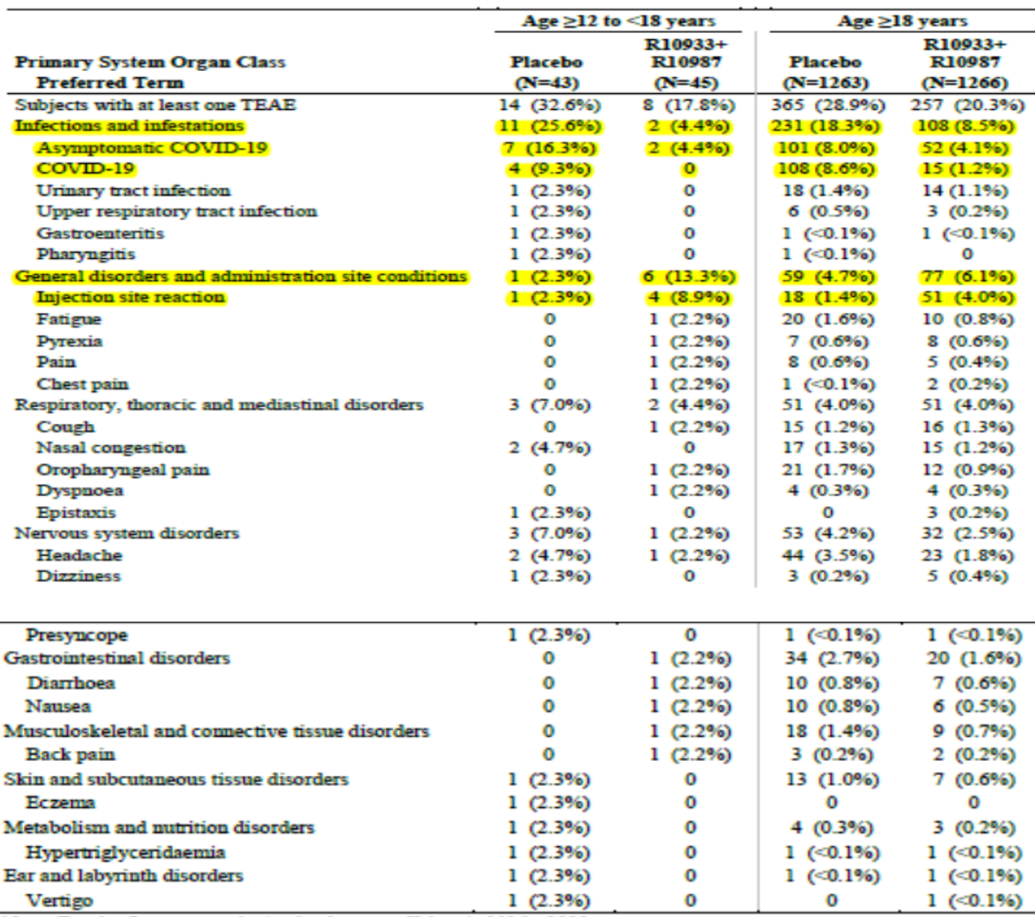
N = number of subjects; R10933 + R10987 = casirivimab + imdevimab; TEAE = treatment emergent adverse events; COVID-19 = coronavirus disease 2019.
For the first step analysis, the data cut-off date is 11 March 2021.
MedDRA (Version 23.1) coding dictionary applied.
A patient who reported 2 or more TEAEs with the same Preferred Term is counted only once for that term.
A patient who reported 2 or more TEAEs with different Preferred Terms within the same System Organ Class is counties only once in that System Organ Class.
There were no notable differences in the safety profile of casirivimab/imdevimab, including the occurrence of IRRs, in patients aged ≥ 65 years compared to those aged ≥ 18 to 65 years.
In Study COV-2067, a greater percentage of participants in the ≥ 65 years of age subgroup compared to the 18 to < 65 years of age subgroup (5.4% versus 0.8%) reported at least one SAE up to the data cut-off date; however, this remained lower than the proportion of participants aged ≥ 65 years with SAEs in the placebo group (13.8%). There was also an apparent dose dependent increase in the proportion of over 65’s reporting SAEs, from 2.9% (1200 mg dose) to 8.6% (8000 mg dose). An increase in SAEs was not observed in participants aged over 65 years in Study COV-2069. Of the 10 subjects in the active treatment groups reporting SAEs, none were aged over 65 years. This may reflect the difference in study populations (that is, Study COV-2067 included symptomatic COVID-19 and risk factor/s, while Study COV-2069 was healthier, comprising mostly SARS-CoV-2 negative subjects without comorbidities).

Use in pregnant women and lactating mothers
Across the studies (Studies COV-2067, COV-2069 and-COV-20145), a total of 10 patients were either pregnant at study entry or became pregnant during the study at the time of cut-off dates. Of these 10 patients, 6 received casirivimab/imdevimab and 4 received placebo. A further 3 patients reported pregnancies under the EUA or compassionate use program in the USA. Of these 13 patients, 5 had early termination of the pregnancy (one voluntary termination, three SAEs of spontaneous abortion and one SAE of ruptured ectopic pregnancy). The 4 SAEs were reported in patients receiving casirivimab/imdevimab; but none were considered related to study drug. Of the remaining patients with available information, 4 had either delivered babies without complication or had ongoing pregnancies with no concerns reported at the time of last contact.
There are no available data on the presence of casirivimab and/or imdevimab in human milk or animal milk, the effects on the breastfed infant, or the effects of the drug on milk production. Maternal IgG is known to be present in human milk. The developmental and health benefits of breastfeeding should be considered along with the mother’s clinical need for casirivimab and imdevimab and any potential adverse effects on the breastfed child from casirivimab and imdevimab or from the underlying maternal condition.

Use in COVID-19 vaccinated individuals
There are limited data on the use of casirivimab/imdevimab in COVID-19 vaccinated subjects. Prior or concomitant administration of a COVID-19 vaccine was an exclusion criterion across the submitted studies. Study COV-2069 was amended during the study to include patients who received a COVID-19 vaccine after the completion of efficacy assessments, and Study HV-2093 was amended during the study to allow subjects to receive a COVID-19 vaccine to evaluate safety and, if feasible, vaccine immune responses. This data is not yet available.
In Cohorts A and B respectively, 88 and 3 participants in the casirivimab/imdevimab groups in Study COV-2069 received COVID-19 vaccines. The median time from study drug administration to vaccination for Cohorts A and B respectively was 82 and 93 days. There were no TEAEs of concern following vaccination.
In Study HV-2093, 67 (9.2%) participants in the active treatment group (1200 mg subcutaneous) received COVID-19 vaccines, with a median of 18 days from last dose of study drug to vaccination. Among these participants, there were no grade ≥ 3 TEAEs, SAEs or AESI in the casirivimab/imdevimab groups following the vaccinations.
Based on the limited data set, there was no change in the safety profile of casirivimab/imdevimab in participants who subsequently received a COVID-19 vaccination. No data are available on the immune response to COVID-19 vaccination in these subjects.

Safety by baseline serostatus
There were overall no issues of concern in subjects seropositive for SARS-CoV-2 at Baseline.
In Study COV-2067, the proportion of subjects with at least one SAE in the active treatment arms was somewhat higher in subjects who were seropositive at Baseline compared with those who were seronegative, but the proportion of subjects with AESI was somewhat higher in those who were seronegative at Baseline compared with those who were seropositive. Overall these events were infrequent and these observations may not be clinically meaningful.
Table 40: Study COV-2067 Serious adverse events by baseline serostatus, from Day 1 through 29 (pooled Phase I/II/III safety analysis population)
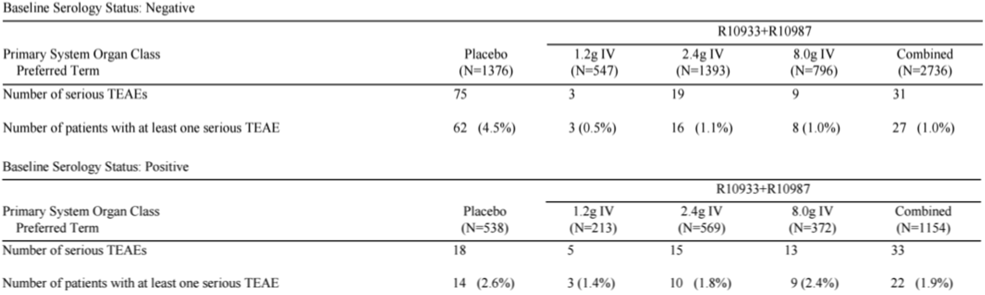
R10933 + R10987 = casirivimab + imdevimab; N = number of subjects; IV = introvanous; TEAE = treatment emergent adverse events.
Table 41: Study COV-2067 Adverse event of special interest by baseline serostatus, from Day 1 through 29 (pooled Phase I/II/III safety analysis population)
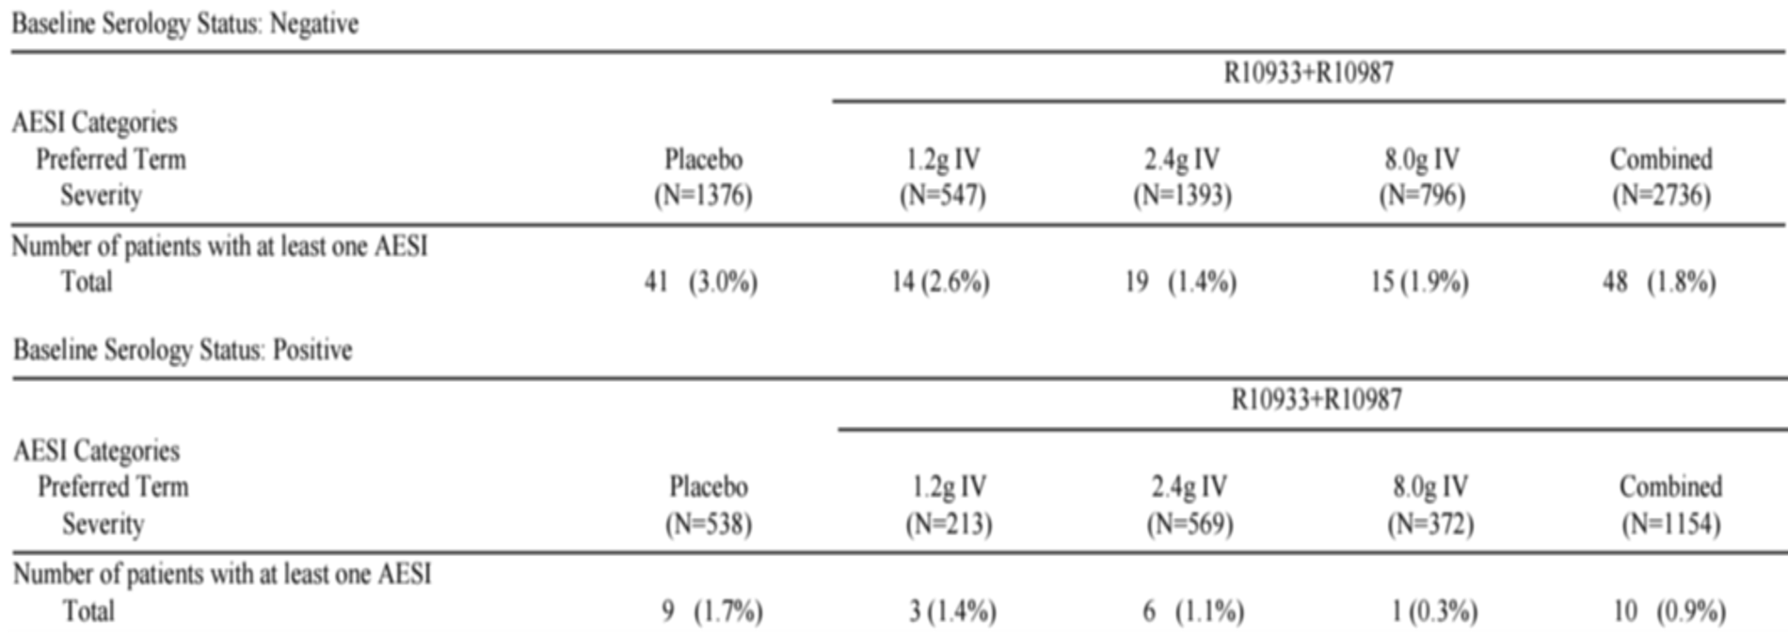
R10933 + R10987 = casirivimab + imdevimab; AESI = adverse events of special interest; N = number of subjects; IV = introvanous; TEAE = treatment emergent adverse events.
In Study COV-2069, there were no notable differences in the safety profile by baseline serology.

Risk management plan
The sponsor has submitted EU-risk management plan (RMP) version 0.1 (dated 13 July 2021; data lock point (DLP) 30 April 2021) and Australian specific annex (ASA) version 1.0 (dated August 2021) in support of this application. Later in the evaluation phase, the sponsor submitted an updated ASA version 1.1 (dated September 2021).
The summary of safety concerns and their associated risk monitoring and mitigation strategies are summarised in Table 42.
Table 42: Summary of safety concerns
Summary of safety concerns |  | Pharmacovigilance |  | Risk minimisation
 |  | Routine | Additional | Routine | Additional
Important identified risks | None | – | – | – | –
Important potential risks | None | – | – | – | –
Missing information | Use in pregnancy | * | † |  | –
*Follow-up questionnaire
† COVID-19 International Drug Pregnancy Registry
- The summary of safety concerns is acceptable at this stage. When making this conclusion, the RMP evaluator has considered the TGA’s nonclinical and clinical evaluations and advice provided by Advisory Committee on Medicines (ACM).
- The proposed pharmacovigilance plan is acceptable.
- The sponsor should update the Consumer Medicines Information (CMI) as required, in line with any changes made to the PI.

Risk-benefit analysis

Delegate’s considerations
The majority of patients infected by SARS-CoV-2 recover without significant sequelae; however, certain factors have been associated with an increased risk of developing severe COVID-19. Given the ongoing outbreak of SARS-CoV-2 infection and resulting COVID-19 related hospitalisations, there is an unmet urgent need for both treatment and prophylaxis options.
Ronapreve (casirivimab and imdevimab) is a neutralising antibody cocktail that has been developed to target the SARS-CoV-2 virus by simultaneously binding to distinct regions of the spike protein, thereby preventing the virus from infecting healthy cells.

Pharmacology
The PK of casirivimab/imdevimab were assessed in number of clinical studies.
In Study COV-2067, the concentration-time profiles for casirivimab and imdevimab in serum increased in a dose proportional manner following single intravenous injections of different doses. The estimated half-life (t_{1/2}) for the two antibodies ranged between 25 to 37 days.
In Study COV-20145, casirivimab and imdevimab concentrations were similar over the first 6 days following any given intravenous or subcutaneous dose. No casirivimab/imdevimab concentration or exposure-related differences in the change in viral load at Day 7 were observed, for intravenous and subcutaneous dosing groups.
In Study COV-2069, after 600 mg subcutaneous dose, casirivimab and imdevimab achieved maximum serum concentrations within the first week. The combined serum concentrations of casirivimab and imdevimab after subcutaneous dosing of 600 mg and 1200 mg reached a comparable concentration to the intravenous doses of 300 mg and 600 mg after a two day delay.
In Study HV-2903, casirivimab/imdevimab were administered as 4 subcutaneous doses every 4 weeks for up to 6 doses. Casirivimab and imdevimab concentrations in serum reached steady state following the third dose (Week 12) and were maintained throughout the treatment period (Week 24).
The dose regimens proposed for the treatment, acute and chronic prevention of COVID-19 are considered acceptable based on the totality of the submitted PK/PD, efficacy and safety analysis. In view of no apparent dose- and exposure-response relationship with efficacy, PD markers and safety, the selection of the lowest dose is supported. However, the use of subcutaneous administration bears some uncertainty for its use in the acute treatment indication, as there are concerns relating to the delay in achieving critical concentrations at the site of action as compared to intravenous dosing.

Benefits of treatment
Study COV-2067 assessed the efficacy of casirivimab and imdevimab for treatment of outpatients who do not require supplementary oxygen for COVID-19 management and who were within 7 days of symptom onset. For the primary efficacy population (mFAS) in Cohort 1 of Phase III, a total of 1355 participants received the 2400 mg dose, 736 received the 1200 mg dose and 1341 received placebo. The 1200 mg treatment group was only compared to concurrently enrolled placebo patients (n = 748) who were a subset of the overall placebo group. The study demonstrated that a single intravenous dose of casirivimab and imdevimab, either 1200 mg or 2400 mg, led to a ≥ 70% reduction of COVID-19-related hospitalisation or all-cause death over 29 days in infected outpatients who were considered at high risk of progressing to severe disease. The treatment also led to faster resolution of COVID-19 symptoms. The efficacy of casirivimab/imdevimab was consistent across various baseline viral load and serostatus subgroups, including patients who were SARS-CoV-2 seropositive at Baseline. Although the benefit in those who were seronegative at Baseline (mFAS population) was demonstrated in the primary analysis, the benefit appears to be there for the overall population without regards to baseline serostatus in the exploratory analysis. Serological testing is therefore not essential when making treatment decisions.
The efficacy outcomes among patients who had no protocol-defined risk factors showed that the rate of events in these patients is too low to realise a benefit (2/369 in placebo group and 0/771 in the two active treatment groups). It is considered appropriate to specify in the indication that the treatment is for outpatients (those who do not require oxygen supplementation) who are at increased risk for progressing to severe COVID-9. It is acknowledged that the prescribers’ perception of what constitutes ‘at risk’ populations may be broader than what was defined in the trial protocol and other medical conditions or factors (for example, race or ethnicity) may also place individual patients at risk for progression to severe COVID-19.
Treatment should be given within 7 days of symptom onset; this reflects the limits applied in the selection criteria for Study COV-2067. The treatment effect for delayed start (7 days later) is not known.
The evidence to support the treatment indication was obtained mainly in unvaccinated individuals with COVID-19. It is not known whether Ronapreve will have a benefit over and above any vaccine-associated effect of breakthrough COVID-19.
Study COV-2067 is still ongoing. Further data on Day 169 follow-up and data from Cohort 2 and 3 should be provided for consideration of full registration.
Study COV-20145 assessed a range of intravenous and subcutaneous doses of casirivimab/imdevimab. The study did not show any clear dose-response for the viral load reductions with all the doses evaluated. The results indicate that 1200 mg subcutaneous casirivimab/imdevimab has similar antiviral effect as 1200 mg intravenous dose (based on viral load reduction as measured at Days 3, 5, and 7). However, there are no clinical efficacy data with subcutaneous administration for the treatment study and there are concerns about the delay in achieving critical concentrations at the site of action with subcutaneous administration.
Data from CU provided supportive information with regards to the efficacy of casirivimab/imdevimab for the treatment of COVID-19 in immunocompromised patients with a variety of B-cell deficiencies. The clinical outcomes in these patients are consistent with the data from the clinical studies in seronegative individuals who had not yet mounted an antibody response.

Benefits of prophylaxis
Study COV-2069 assessed a single subcutaneous dose of casirivimab/imdevimab (1200 mg) for the prevention of COVID-19 in household contacts of individuals infected with SARS-CoV-2. The study demonstrated that in uninfected household contacts (SARS-CoV-2 PCR negative, Cohort A), a single subcutaneous 1200 mg dose of casirivimab/imdevimab reduced the risk of symptomatic infection by 81%. A 66% reduction in all infections (symptomatic and asymptomatic) was observed in the active treatment group. Individuals in the active treatment group who still experienced symptomatic infections were able to clear the virus faster and had shorter symptom duration, with no subjects in the active treatment group hospitalised or visiting the emergency room.
In asymptomatic patients infected at Baseline (SARS-CoV-2 PCR positive, Cohort B), a single subcutaneous dose of casirivimab/imdevimab reduced the overall risk of progressing to symptomatic COVID-19 by 31%, with a more pronounced risk reduction after Day 3. The efficacy was observed early and was maintained through day 29. subcutaneous casirivimab/imdevimab also reduced the duration of symptoms and the duration with high viral load.
Of the total subjects described in the study report, 1505/2067 (73%) in Cohort A and 207/314 (66%) in Cohort B were seronegative at Baseline. A consistent benefit was observed in an exploratory post-hoc analysis of the primary endpoint performed in participants regardless of baseline serology, with a 35.4% risk reduction compared to placebo (nominal p = 0.0166) in Cohort B. A comparable level of reduction was also shown when the analysis included only baseline positive participants (33.9% risk reduction versus placebo, nominal p = 0.5079). The efficacy analysis in subjects who were seropositive at Baseline is exploratory and should be interpreted with caution. In light of the feasibility to test serostatus prior to treatment decision in clinical practice, it is irrelevant to know that there is also benefit in those seropositive individuals with no increased adverse effects. Serological testing is therefore not considered essential when making treatment decisions.
Study COV-2069 included adolescents (≥ 12 to < 18 years of age) in the efficacy analysis (68 in Cohort A and 26 in Cohort B in the seronegative mFAS population). In the 68 adolescents in Study COV-2069A, no participant (0/34) treated with Ronapreve had symptomatic RT-qPCR confirmed SARS-CoV-2 infection compared to 4/34 (11.8%) of placebo participants (corresponding to a 100% relative risk reduction). Data from Study COV-2069B showed that in the adolescent subpopulation, the proportion of participants with asymptomatic RT-qPCR confirmed SARS-CoV-2 infection at Baseline who subsequently developed signs and symptoms of COVID-19 was lower in the group that received casirivimab/imdevimab (n = 2/15, 13.3%) compared to placebo (n = 5/11, 45.5%), corresponding to a 70.7% reduction in the risk of progression to symptomatic disease. The efficacy results with adolescents were found to be similar to that in adults, but the number of adolescents was limited.
It is noted that despite a median T_{max} of 5.73 to 6.87 days for subcutaneous casirivimab and imdevimab, the benefit for the prevention of SARS-CoV-2 infection in Cohort A was observed from Day 1 and for pre-emptive treatment of SARS-CoV-2 infection (Cohort B), the benefit was observed 4 days after initiating treatment and maintained through Day 29.
Study COV-2093 evaluated the PK and safety profile of the repeat-dosing regimen in healthy adult subjects. The 1200 mg dose (600 mg each mAb) was administered subcutaneously every 4 weeks for 6 doses in this study. Note this is double the proposed repeat (maintenance) dose of 600 mg (300 mg per mAb). The exploratory efficacy analysis indicated that repeat subcutaneous dosing of casirivimab /imdevimab 1200 mg every 4 weeks reduced the risk of symptomatic SARS-CoV-2 infection by 92% over the course of 6 months. There are no efficacy data available for the proposed repeat dose regimen for long term prophylaxis in immunocompromised population.
Population pharmacokinetics simulations: the results of simulations indicated that repeat dose regimen (1200 mg intravenous or subcutaneous loading with 600mg subcutaneous every 4 weeks) is expected to produce trough concentration values similar to the concentrations observed at Day 28 in Study COV-2069 where the post exposure prophylaxis efficacy has been demonstrated. This has provided support for the proposed repeat dosing regimen for chronic prevention indication. The safety and tolerability of repeat dose is supported by data from Study HV-2093 in which subjects were given up to 6 monthly injections of a 1200 mg subcutaneous dose. ISRs occurred more frequently with Ronapreve compared to placebo but were mild to moderate in severity.

Risks and uncertainties
Overall, the safety profile of Ronapreve appears favourable and in line with what is expected from a mAb targeting an external target and thus without intrinsic activity.
The safety review identified Adverse Drug Reactions related to hypersensitivity reactions, including IRRs and ISRs. Across studies, the majority of hypersensitivity reactions, including IRRs and ISRs, were mild or moderate and could be treated according to standard medical practice. Few patients experienced infusion interruptions or discontinuations, but most participants were able to resume treatment.
Safety data are limited in certain populations. There are uncertainties and theoretical risks associated with the use of Ronapreve. These are discussed below.

Limited data in certain populations

Pregnant women/lactating mothers
There is currently limited clinical experience with the use of casirivimab and imdevimab in patients and subjects who are pregnant or breastfeeding. Animal reproductive and developmental toxicity studies have not been conducted. Casirivimab and imdevimab should be used during pregnancy only if the potential benefit justifies the potential risk for the mother and the fetus/baby considering all associated health factors. Therefore, the use of casirivimab/imdevimab should only be considered during pregnancy or lactation if the potential benefit justifies the potential risk.

Paediatric and adolescent individuals
Data are currently lacking on the PK in paediatric and adolescent patients. Since the body weight range of adolescents ≥ 12 years of age is generally within the range of body weight in adult subjects and body weight is the main covariate that affects exposure, exposures of casirivimab and imdevimab in adolescent subjects (≥ 40 kg) are likely to be similar to those in adults. The SAF included 88 adolescents in Cohort A and 38 adolescents in Cohort B of Study COV-2069.

Immunocompromised population
Data are currently limited on the use of Ronapreve in the immunocompromised population. There is also a lack of information on whether patients in clinical studies had primary or secondary immunodeficiency. The product is likely to have a widespread use in immunocompromised individuals after regulatory approval. The sponsor should gather further information with regards to the efficacy of Ronopreve in this population.

Limited long term data for chronic prevention
Safety data in repeated use is only available for 6 months in a limited number of subjects in Study HV-2093. There are concerns regarding the increased AEs with prolonged and cumulative exposure. The sponsor should monitor the AEs and adverse drug reactions (ADR) with long term prophylactic use in the post market setting. Repeat dose regimen for chronic prevention is expected to be used more often in immunocompromised population. There is a theoretical risk that repeat dose may drive viral resistance especially at low doses proposed in the chronic prophylaxis setting, so post-market monitoring is important.

Effect against viral variants
The combination of casirivimab/imdevimab appears to retain potency in vitro against the main VOC circulating, including P.1 (classified by the WHO as Gamma), B.1.351 (classified by the WHO as Beta) and B.1.617.2 (classified by the WHO as Delta). However, it is not known whether the clinical efficacy against these variants is the same as the efficacy observed in the clinical trial, which was conducted prior to these variants becoming prevalent.
There is a potential for other viral variants to emerge in the future which may have reduced susceptibility to both antibodies. There is a theoretical risk of treatment failure due to the development of viral variants that are resistant to casirivimab/imdevimab.
As novel variants of concern/variants of interest are identified, the sponsor must assess the neutralising activity against variants to ensure susceptibility to casirivimab and imdevimab and to the combination. Efficacy of casirivimab/imdevimab in patients infected with viral variants should be monitored in company sponsored clinical trials.

Interfere with endogenous or vaccine response
Antibody administration may attenuate the endogenous immune response to SARS-CoV-2 and make patients more susceptible to re-infection. Based on evaluation of safety data from the clinical trial program, this theoretical risk of re-infection has not been observed.
Casirivimab/imdevimab binds to epitopes on the SARS-CoV-2 spike protein used as an immunogen in all COVID-19 vaccines; therefore, it may be possible that Ronapreve could interfere with the development of effective immune responses to COVID-19 vaccines.
Study COV-2067 and Study COV-2069 included only limited numbers of vaccinated individuals. In Study HV-2093, 30 (12.5%) participants in the placebo group and 67 (9.2%) in the treatment group received COVID-19 vaccines. Among these vaccinated participants, there were no grade ≥ 3 TEAEs, SAEs or AESI in the casirivimab/imdevimab groups following the vaccinations. The data on the effects of casirivimab and imdevimab on potential attenuation of vaccine response are limited at this stage. The sponsor should evaluate the possible effect of casirivimab and imdevimab on vaccine induced immune responses in post market studies.

Treatment failure due to anti-drug antibodies
Anti-drug antibodies may potentially be associated with a decrease in systemic drug concentrations and decrease in treatment effectiveness, and/or an increased incidence of hypersensitivity reactions/IRRs.
In Study COV-2067, nearly all patients (97.1% for casirivimab; 94.4% for imdevimab) were negative for ADA at all times, indicating minimal immunogenicity following single intravenous doses of 1200 mg, 2400 mg, or 8000 mg of casirivimab/imdevimab. Concentrations in serum for casirivimab and imdevimab at Day 28 were similar between ADA-negative and ADA-positive patients.
In Study HV-2093, the incidence of ADA following repeat doses was also low in subjects receiving casirivimab/imdevimab, and there was no apparent impact on efficacy or safety due to immunogenicity in the few patients with positive ADA.
The presence of neutralising ADA in ADA-positive samples has not yet been assessed in samples from submitted studies. The sponsor should submit further information when seeking full registration.

Antibody dependent enhancement
Antibody dependent enhancement (ADE) is thought to occur when binding of antibody to the target viral protein enhances Fcγ receptor mediated host cell entry of the virus. There is no evidence of ADE in animal studies of casirivimab/imdevimab in vivo. No treatment emergent AEs suggestive of ADE were observed during the safety follow-up periods of studies in the clinical development program. However, ADE is a potential risk and should be followed in future studies.

Other issues for Advisory Committee on Medicines discussion

Intravenous versus subcutaneous route
Intravenous infusion can represent a barrier to access the product. The subcutaneous dose is expected to ease the burden and increase use of Ronapreve in order to reduce the rate of COVID-19 related hospitalisations and deaths. subcutaneous administration has not been associated with serious or severe hypersensitivity reactions or ISRs and the mild or moderate reactions observed resolved either without intervention or with usual standard of care.
The draft Australian PI implies that intravenous and subcutaneous administration are interchangeable with no strong recommendation for intravenous infusion over subcutaneous injection for the treatment of COVID-19.
In contrast, the following statement is included in FDA’s healthcare professional fact sheet under ‘Routes of Administration for REGEN-COV’:
‘REGEN-COV may be administered by intravenous infusion or subcutaneous injection. For treatment, intravenous infusion is strongly recommended. subcutaneous injection is an alternative route of administration when intravenous infusion is not feasible and would lead to delay in treatment. For post-exposure prophylaxis, either subcutaneous injection or intravenous infusion can be used.’
The rationale for this inclusion can be seen from the information extracted from the Center for Drug Evaluation and Research review for the treatment indication;:
‘Subcutaneous dosing is typically associated with a slower absorption as compared to [intravenous] IV dosing. This would result in a delay in achieving critical concentrations at the site of pharmacological action as compared to IV dosing. While the clinical relevance of such a delay for monoclonal antibodies targeting SARS-CoV-2 is unknown at this time, a simple exposure matching approach using AUC or concentrations at later time points (e.g., Day 7, 14, or 28 concentrations) is not sufficient alone to bridge the efficacy from IV dosing to subcutaneous dosing. To support the authorization of 1200 mg subcutaneous dosing, the Applicant proposed a totality of evidence approach using efficacy, safety, and PK data collected across all clinical trials. The review team has concluded that PK and PD (viral load reduction) data can support the use of a 1200 mg subcutaneous dose for treatment of COVID-19 when IV dosing is not feasible and would result in a delay in treatment.’
‘Based on the available clinical data including PK and safety data for [intravenous] IV and subcutaneous administration of single dose of 600 mg of casirivimab and 600 mg of imdevimab, it is reasonable to conclude that subutaneous administration is acceptable in those situations where IV administration is not feasible and may result in treatment delay, noting that IV administration is the recommended and preferred dosing route. Viral load reductions, while limited in scope given lack of viral load collection in the first 48 hours after dosing and other limitations discussed previously, indicate a similar magnitude of viral load reduction with both 1200 mg IV or subcutaneous dosing. The primary concern is the limited data for the clinically meaningful endpoints of COVID-19 hospitalization and all-cause death with subcutaneous dosing from a dedicated efficacy trial; however, we note that the Applicant is not proposing subcutaneous dosing in lieu of the currently authorized IV dosing. The Applicant’s proposal for subcutaneous dosing as an alternative in select situations when IV infusion is not feasible and would lead to delay in treatment, is adequately supported by PK/PD data as well as available clinical safety data with subcutaneous administration.’
The ACM is requested to advise whether the Australian PI should include similar statement and should specify that the intravenous route is preferred over the subcutaneous route in the acute treatment setting.

Multidose presentation
Given the product is also being marketed as a single use presentation, there are questions about the need for:
- a multidose product intended for use in a single patient, and
- a multidose product intended for use in multiple patients.
The product does not contain a preservative and is not a vaccine to be utilised for a pandemic situation. The ACM has a long-standing position against the use of multidose presentations in multiple patients, unless there is a cogent justification as to why it is necessary to market the product as multidose.
The sponsor has been asked to provide the justification. ACM advice is also sought on this issue.

Proposed action
In view of the urgent public health need, and based on the review of submitted data on quality, safety and efficacy, the Delegate is of the view that the potential benefits outweigh the potential risks for the use of casirivimab and imdevimab combination for the following indications:
Ronapreve is provisionally registered for the indications below:
Treatment
Ronapreve is indicated for the treatment of COVID-19 in adults and adolescents aged 12 years and older and weighing at least 40 kg who do not require supplemental oxygen for COVID-19 and who are at increased risk of progressing to severe COVID-19.
Prevention
Ronapreve is indicated for the prevention of COVID-19 in adults and adolescents aged 12 years and older and weighing at least 40 kg who have been exposed or are at high risk of exposure to SARS-CoV-2 and who either
- have a medical condition making them unlikely to respond to or be protected by vaccination, or
- are not vaccinated against COVID-19.
The decision has been made on the basis of interim efficacy and safety data. Continued approval depends on the evidence of longer term efficacy and safety from ongoing clinical trials and post-market assessment.
The product is to be used as per the directions in the proposed PI.
The approval of casirivimab and imdevimab is associated with conditions that need to be met by the sponsor to ascertain the continued quality, safety, and efficacy of the product. Patients and doctors should be advised of the nature of the provisional registration.
Further changes to the PI may be required following the ACM discussion. The final approval is subject to the satisfactory resolution of any outstanding issues.

Advisory Committee considerations
The Advisory Committee on Medicines (ACM), having considered the evaluations and the Delegate’s overview, as well as the sponsor’s response to these documents, advised the following.

Specific advice to the Delegate
- Does ACM support the provisional registration of Ronapreve for the treatment and prophylaxis indications? Any comments and advice on the indication wording revised by the TGA?
The ACM noted that there was robust data to support a treatment-orientated indication and are supportive of provisional registration for the following indication which includes a reference to the clinical trials section of the PI:
Treatment:
Ronapreve is indicated for the treatment of COVID-19 in adults and adolescents aged 12 years and older and weighing at least 40 kg who do not require supplemental oxygen for COVID-19 and who are at increased risk of progressing to severe COVID-19 (refer to Clinical Trials).
The ACM was supportive of an indication for post-exposure prophylaxis only (see advice to Question 2, below, for discussion of long-term prophylactic usage), with the indication to state:
Post exposure prophylaxis:
Ronapreve is indicated for the prevention of COVID-19 in adults and adolescents aged 12 years and older and weighing at least 40 kg who have been exposed to SARS-CoV-2 and who either:
- have a medical condition making them unlikely to respond to or be protected by vaccination, or
- are not vaccinated against COVID-19
The ACM was of the view that including the wording ‘at high risk of exposure’ would encourage a long-term prophylactic use, noting that post-exposure prophylaxis is different from long-term prophylaxis.
The ACM discussed usage in the vaccinated population and noted the limited data in this population. The ACM commented that vaccination is very likely to induce neutralising antibodies in individuals with a robust immune response, reducing the need for antibody therapy. The ACM was of the view that most vaccinated individuals would not benefit from this therapy and advised that the PI should include the wording ‘There are limited data on efficacy in vaccinated populations.’
The ACM discussed the time limit of treatment from the onset of first symptoms and was of the view that the time limit should reflect the trial inclusion criteria. The ACM advised that the PI should state that treatment should be administered no later than 7 days after the onset of first symptoms as efficacy after this time is unclear.
- Does ACM support the proposed repeat dosing regimen for long term chronic prophylaxis?
The ACM noted there are limited efficacy and safety data for chronic prevention/long-term prophylaxis, as Study HV-2093 was a small Phase I study in healthy volunteers where efficacy was based on unconfirmed symptomatic infection.
The ACM expressed concern that no efficacy or safety data was available for long-term prophylaxis in the immunocompromised population, as this would be the intended treatment population.
The ACM also noted the small theoretical risk that repeated dosing may drive viral resistance.
On balance, the ACM was not supportive of long-term prophylaxis and agreed that long-term prophylaxis dosage instructions should be removed from the PI.
The ACM was of the view that the need for vaccination should be emphasised instead of using long-term prophylaxis.
- Subcutaneous (SC) administration provides an easy and convenient way to access the product. Does ACM have any concerns with regards to the efficacy of Ronapreve administered via SC route in the acute treatment setting? Should the Product Information (PI) specify that intravenous (IV) infusion is strongly recommended over SC administration in the acute treatment setting?
The ACM noted that the pivotal treatment study used IV dosage only, while the pivotal prophylaxis study used SC dosing.
The ACM was of the view that IV administration is preferred, where possible, over SC in the acute treatment setting.
The ACM supported the Delegate’s view that, based on the available clinical data including PK and safety data for IV and subcutaneous administration of single dose of 600 mg of casirivimab and 600 mg of imdevimab, subcutaneous administration is acceptable in those situations where IV administration is not feasible and may result in treatment delay. The ACM reiterated that intravenous administration is the recommended and preferred dosing route.
The ACM was of the view that the Australian PI should include a similar statement to the FDA statement:
‘For treatment, intravenous infusion is strongly recommended. subcutaneous injection is an alternative route of administration when intravenous infusion is not feasible and would lead to delay in treatment.’
- Does ACM consider there is a clinical need for the multidose presentation? Does ACM support the use of multidose presentation?
The ACM was of the view while there are some advantages to multidose vials, these are generally not preferred due to risk of errors and contamination.
The ACM did acknowledge that Ronapreve would be used in treatment centres or given to multiple patients sequentially and administered by highly trained professionals.
Given the current clinical need and potential access issues the ACM was supportive of the use of multidose vials in the short-term. The ACM commented that safety surveillance should encompass administration errors due to multidose vials.
- The committee is also requested to provide advice on any other issues that it thinks may be relevant to a decision on whether or not to approve this application.
The ACM discussed the timing of vaccination following this therapy and noted that it binds to epitopes on spike proteins used as an immunogen in all COVID-19 vaccines. The ACM noted that the CDC recommends delaying vaccination for 90 days following treatment and recommended that a similar statement be included in the PI:
‘For people who previously received passive antibody therapy as part of COVID-19 treatment, defer vaccination for at least 90 days after receipt of passive antibody therapy (monoclonal antibodies or convalescent plasma). This recommendation applies to people who receive passive antibody therapy before receiving any COVID-19 vaccine dose and to those who receive passive antibody therapy after the first dose of an mRNA COVID-19 vaccine but before the second dose, in which case the second dose should be deferred for at least 90 days following receipt of the antibody therapy.’
The ACM discussed risk stratification from the clinical trials and was supportive of these being specified in the clinical trials section of the PI. The ACM noted that few patients in the trials had chronic kidney disease, chronic liver disease, or were immunosuppressed.
The ACM emphasised that this therapy is not an alternative or substitute for vaccination. The ACM reiterated its view that vaccination is the preferred and primary option to prevent COVID-19.

Conclusion
The ACM considered this product to have an overall positive benefit-risk profile for the indication:
Ronapreve is provisionally registered for the indications below:
Treatment:
Ronapreve is indicated for the treatment of COVID-19 in adults and adolescents aged 12 years and older and weighing at least 40 kg who do not require supplemental oxygen for COVID-19 and who are at increased risk of progressing to severe COVID-19 (refer to Clinical Trials).
Post-exposure prophylaxis:
Ronapreve is indicated for the prevention of COVID-19 in adults and adolescents aged 12 years and older and weighing at least 40 kg who have been exposed to SARS-CoV-2 and who either:
- have a medical condition making them unlikely to respond to or be protected by vaccination, or
- are not vaccinated against COVID-19.
The decision has been made on the basis of interim efficacy and safety data. Continued approval depends on the evidence of longer term efficacy and safety from ongoing clinical trials and post-market assessment.

Outcome
Based on a review of quality, safety and efficacy, the TGA approved the registration of Ronapreve (casirivimab/imdevimab) 120 mg/mL casirivimab and 120 mg/mL imdevimab, solution for infusion and injection, single-use and multidose vials, indicated for:
Ronapreve has provisional approval for the indications below:
Treatment:
Ronapreve is indicated for the treatment of COVID-19 in adults and adolescents (aged 12 years and older and weighing at least 40 kg) who do not require supplemental oxygen for COVID-19 and who are at increased risk of progressing to severe COVID-19.
Post-exposure prophylaxis:
Ronapreve is indicated for the prevention of COVID-19 in adults and adolescents (aged 12 years and older and weighing at least 40 kg) who have been exposed to SARS-CoV-2 and who either:
- have a medical condition making them unlikely to respond to or be protected by vaccination, or
- are not vaccinated against COVID-19. (refer to Section 4.2 Dose and method of administration and 5.1, Clinical trials)
Ronapreve is not intended to be used as a substitute for vaccination against COVID-19.
The decision has been made on the basis of short term efficacy and safety data. Continued approval of this indication depends on the evidence of longer term efficacy and safety from ongoing clinical trials and post-market assessment.

Specific conditions of registration applying to these goods
- Ronapreve (casirivimab and imdevimab) is to be included in the Black Triangle Scheme. The Product Information (PI) and Consumer Medicines Information (CMI) for Ronapreve must include the black triangle symbol and mandatory accompanying text for the period of provisional registration.
- The Ronapreve European Union (EU)-Risk Management Plan (RMP) (version 0.1, dated 13 July 2021; data lock point 30 April 2021), with Australian Specific Annex (version 1.1, dated September 2021), included with submission PM-2021-03952-1-2, and any subsequent revisions, as agreed with the TGA will be implemented in Australia.
An obligatory component of risk management plans is routine pharmacovigilance.
Routine pharmacovigilance includes the submission of periodic safety update reports (PSURs).
Unless agreed separately between the supplier who is the recipient of the approval and the TGA, the first report must be submitted to TGA no later than 15 calendar months after the date of the approval letter. The subsequent reports must be submitted no less frequently than annually from the date of the first submitted report until the period covered by such reports is not less than three years from the date of the approval letter, or the entire period of provisional registration, whichever is longer.
The reports are to at least meet the requirements for PSURs as described in the European Medicines Agency’s Guideline on Good Pharmacovigilance Practices (GVP) Module VII-periodic safety update report (Rev 1), Part VII.B Structures and processes.
Note that submission of a PSUR does not constitute an application to vary the registration. Each report must have been prepared within ninety calendar days of the data lock point for that report.
Additional to the submission of PSURs, expedited monthly summary safety reports (including safety data for patients in Australia and reporting of Australia specific safety concerns) are to be provided for the first 6 months post registration, and thereafter at intervals specified by the TGA.
- Clinical
  - The final study reports for the following studies must be submitted to the TGA when they become available:
    - R10933-10987-COV-2067
    - R10933-10987-COV-2069
    - R10933-10987-HV-2093
    - R10933-10987-COV-20145
  - Updates regarding the clinical activity, efficacy, and effectiveness of casirivimab and imdevimab against the current and future Variants of Concern and Variants of Interest identified by the World Health Organization (WHO) must be provided to the TGA when they become available.
  - Updates on timelines of the comparable overseas regulators for conditional and full marketing authorization applications must be provided to the TGA when they become available.
- Submit to the TGA the post-market safety and effectiveness data for the use of repeat doses of Ronapreve in immunocompromised population when seeking full registration of Ronapreve.
- Nonclinical
Post approval commitments:
The sponsor is to provide study reports of in vitro selection/escape studies when they become available.
- Quality
Laboratory testing and compliance with Certified Product Details (CPD)
  - All batches of Ronapreve supplied in Australia must comply with the product details and specifications approved during evaluation and detailed in the Certified Product Details (CPD).
  - When requested by the TGA, the sponsor must provide product samples, specified reference materials and documentary evidence to enable the TGA to conduct laboratory testing on the Product.
Note: Outcomes of laboratory testing are published biannually in the TGA Database of Laboratory Testing Results: http://www.tga.gov.au/ws-labs-index and periodically in testing reports on the TGA website.
  - The Certified Product Details (CPD), as described in Guidance 7: Certified Product Details of the Australian Regulatory Guidelines for Prescription Medicines (ARGPM) [http://www.tga.gov.au/industry/pm-argpm-guidance-7.htm], in PDF format, for the medicines must be provided to the TGA upon registration. In addition, an updated CPD must be provided to the TGA when changes to finished product specifications and test methods are approved in a Category 3 application or notified through a self-assessable change.
- Post approval commitments:
The sponsor has submitted the list of manufacturing sites along with the responsibilities in the production of Ronapreve and specified functions.
Commitment is required from the sponsor that they maintain the validity of all manufacturer Good Manufacturing Clearance (GMP) Clearances for the duration of product supply to Australia. Additionally, that adherence to the conditions of GMP Clearance approval is upheld.
- Medicine Labels
Unless otherwise agreed to by the Secretary following an application under section 9D of the Act, the product must only be supplied with the following labels:
the international label as follows:
  - A) Single Use carton label
  - B) Single Use vial label
  - C) Multi-use vial label
  - D) Multi-use carton label
The sponsor will develop Australian-specific labels for the product, that conform with all relevant Australian labelling requirements, and will take all reasonable steps to implement such labelling before the end of the provisional registration period referred to in subsection 29(3) of the Act (being the period of 2 years starting on the day specified in the ARTG certificate of registration) (noting that, consistent with paragraph 28(5)(aaa) of the Act, changes to such matters as labels that have been agreed to as part of an evaluation under section 25 of the Act may only occur following submission under section 9D of a 'variation' application and approval by the TGA).

Attachment 1. Product Information
The PI for Ronapreve approved with the submission which is described in this AusPAR is at Attachment 1. For the most recent PI, please refer to the TGA website at <https://www.tga.gov.au/product-information-pi>.

Therapeutic Goods Administration
PO Box 100 Woden ACT 2606 Australia
Email: info@tga.gov.au Phone: 1800 020 653 Fax: 02 6232 8605
https://www.tga.gov.au

The Black Triangle Scheme provides a simple means for practitioners and patients to identify certain types of new prescription medicines, including those being used in new ways and to encourage the reporting of adverse events associated with their use. The Black Triangle does not denote that there are known safety problems, just that the TGA is encouraging adverse event reporting to help us build up the full picture of a medicine's safety profile.
World Health Organization (WHO) Statement on the Second Meeting of the International Health Regulations (2005) Emergency Committee Regarding the Outbreak of Novel Coronavirus (2019-nCoV). 30 January 2020. Available at: https://www.who.int/news/item/30-01-2020-statement-on-the-second-meeting-of-the-international-health-regulations-(2005)-emergency-committee-regarding-the-outbreak-of-novel-coronavirus-(2019-ncov)
World Health Organization (WHO) Director-General's Opening Remarks at the Media Briefing on COVID-19. 11 March 2020. Available at: https://www.who.int/director-general/speeches/detail/who-director-general-s-opening-remarks-at-the-media-briefing-on-covid-19---11-march-2020
As part of the provisional approval pathway, the provisional registration process will allow certain medicines to be provisionally registered in the Australian Register of Therapeutic Goods (ARTG) for a limited duration. These medicines are registered on the basis of preliminary clinical data, where there is the potential for a substantial benefit to Australian patients. The TGA will re-assess risks related to the absence of evidence through data provided at a later stage, as part of the confirmatory data. Confirmatory data should confirm the relationship between outcomes predicted by the surrogate endpoint, or other preliminary data, and the clinical benefit as demonstrated by direct clinical outcomes. The sponsor may apply to transition to full registration at any time up until the provisional registration lapse date, once they have completed the obligations outlined for the provisional registration period and complete confirmatory data on safety and efficacy are available.
Veklury was first registered on the ARTG on 10 July 2020 (ARTG number: 338419).
AusPAR for Veklury (remdesivir) new chemical entity, published on 21 July 2020. Available at: https://www.tga.gov.au/auspar/auspar-remdesivir
Xevudy was first registered on the ARTG on 20 August 2021 (ARTG number: 364110)
AusPAR for Xevudy (sotrovimab) new biological entity, published on 20 August 2021. Available at: https://www.tga.gov.au/auspar/auspar-sotrovimab
Comirnaty was first registered on the ARTG on 25 January 2021 (ARTG number: 346290).
AusPAR for Comirnaty (BNT162b2 (mRNA)) new biological entity, published on 25 January 2021. Available at: https://www.tga.gov.au/auspar/auspar-bnt162b2-mrna-comirnaty
AusPAR for Comirnaty (BNT162b2 (mRNA)) extension of indications, published on 23 July 2021. Available at: https://www.tga.gov.au/auspar/auspar-bnt162b2-mrna
COVID-19 Vaccine AstraZeneca was first registered on the ARTG on 16 February 2021 (ARTG number: 349072).
AusPAR for COVID-19 Vaccine AstraZeneca (ChAdOx1-S) new biological entity, published on 16 February 2021. Available at: https://www.tga.gov.au/auspar/auspar-chadox1-s
COVID-19 Vaccine Janssen was first registered on the ARTG on 25 June 2021 (ARTG number: 350150).
AusPAR for COVID-19 Vaccine Janssen (Ad26.COV2.S) new biological entity, published on 25 June 2021. Available at: https://www.tga.gov.au/auspar/auspar-ad26cov2s
Spikevax was first registered on the ARTG on 9 August 2021 (ARTG number: 370599).
AusPAR for Spikevax (elasomeran) new biological entity, adult indication, published on 9 August 2021. Available at: https://www.tga.gov.au/auspar/auspar-elasomeran
AusPAR for Spikevax (elasomeran) new biological entity, paediatric indication, published on 4 September 2021. Available at: https://www.tga.gov.au/auspar/auspar-elasomeran-0
The TGA is a member of the Access Consortium along with Health Canada, Health Sciences Authority of Singapore, Swissmedic and the UK's Medicines and Healthcare products Regulatory Agency (MHRA). The Access Consortium is a medium-sized coalition of regulatory authorities that work together to promote greater regulatory collaboration and alignment of regulatory requirements. More information is available at: https://www.tga.gov.au/australia-canada-singapore-switzerland-united-kingdom-access-consortium
European Medicines Agency (EMA), Committee for Medicinal Products for Human Use (CHMP), Guideline on Immunogenicity Assessment of Monoclonal Antibodies Intended for in vivo Clinical Use, EMA/CHMP/BMWP/86289/2, 24 May 2012. Available at: https://www.ema.europa.eu/en/documents/scientific-guideline/guideline-immunogenicity-assessment-monoclonal-antibodies-intended-vivo-clinical-use_en.pdf
Food and Drug Administration (FDA) (United States), COVID-19: Developing Drugs and Biological Products for Treatment or Prevention Guidance for Industry, February 2021. Available at: https://www.fda.gov/media/137926/download
Routine risk minimisation activities may be limited to ensuring that suitable warnings are included in the product information or by careful use of labelling and packaging. Routine pharmacovigilance practices involve the following activities: - All suspected adverse reactions that are reported to the personnel of the company are collected and collated in an accessible manner; - Reporting to regulatory authorities; - Continuous monitoring of the safety profiles of approved products including signal detection and updating of labelling; - Submission of PSURs; - Meeting other local regulatory agency requirements.
United States (US) Food and Drug Administration (FDA), Fact Sheet for Health Care Providers Emergency Use Authorization (EUA) of REGEN-COVTM (casirivimab and imdevimab). Available at: https://www.regeneron.com/downloads/treatment-covid19-eua-fact-sheet-for-hcp.pdf
United States (US) Food and Drug Administration (FDA), Emergency Use Authorization (EUA) for casirivimab and imdevimab Center for Drug Evaluation and Research (CDER) Review. Available at: https://www.fda.gov/media/150165/download
The ACM provides independent medical and scientific advice to the Minister for Health and the TGA on issues relating to the safety, quality and efficacy of medicines supplied in Australia including issues relating to pre market and post-market functions for medicines. Further information can be found here: https://www.tga.gov.au/committee/advisory-committee-medicines-acm.

