October 2012
Updated March 2014

Australian Public Assessment Report for Catumaxomab
  - Proprietary Product Name: Removab
  - Sponsor: Biotech Regulatory Solutions

About the Therapeutic Goods Administration (TGA)
- The Therapeutic Goods Administration (TGA) is part of the Australian Government Department of Health, and is responsible for regulating medicines and medical devices.
- The TGA administers the Therapeutic Goods Act 1989 (the Act), applying a risk management approach designed to ensure therapeutic goods supplied in Australia meet acceptable standards of quality, safety and efficacy (performance), when necessary.
- The work of the TGA is based on applying scientific and clinical expertise to decision-making, to ensure that the benefits to consumers outweigh any risks associated with the use of medicines and medical devices.
- The TGA relies on the public, healthcare professionals and industry to report problems with medicines or medical devices. TGA investigates reports received by it to determine any necessary regulatory action.
- To report a problem with a medicine or medical device, please see the information on the TGA website <http://www.tga.gov.au>.
About AusPARs
- An Australian Public Assessment Record (AusPAR) provides information about the evaluation of a prescription medicine and the considerations that led the TGA to approve or not approve a prescription medicine submission.
- AusPARs are prepared and published by the TGA.
- An AusPAR is prepared for submissions that relate to new chemical entities, generic medicines, major variations, and extensions of indications.
- An AusPAR is a static document, in that it will provide information that relates to a submission at a particular point in time.
- A new AusPAR will be developed to reflect changes to indications and/or major variations to a prescription medicine subject to evaluation by the TGA.
Copyright
© Commonwealth of Australia 2014
This work is copyright. You may reproduce the whole or part of this work in unaltered form for your own personal use or, if you are part of an organisation, for internal use within your organisation, but only if you or your organisation do not use the reproduction for any commercial purpose and retain this copyright notice and all disclaimer notices as part of that reproduction. Apart from rights to use as permitted by the Copyright Act 1968 or allowed by this copyright notice, all other rights are reserved and you are not allowed to reproduce the whole or any part of this work in any way (electronic or otherwise) without first being given specific written permission from the Commonwealth to do so. Requests and inquiries concerning reproduction and rights are to be sent to the TGA Copyright Officer, Therapeutic Goods Administration, PO Box 100, Woden ACT 2606 or emailed to <tga.copyright@tga.gov.au>.

Contents
I. Introduction to product submission 4
Submission details 4
Product background 4
Regulatory status 5
Product Information 5
II. Quality findings 5
Drug substance (active ingredient) 5
Drug product 6
III. Nonclinical findings 6
Introduction 6
Pharmacodynamics 6
Safety pharmacology 9
Pharmacodynamic drug interactions 10
Pharmacokinetics 11
Toxicology 11
Nonclinical summary and conclusions 14
IV. Clinical findings 15
Introduction 15
Pharmacokinetics 16
Pharmacodynamics 18
Efficacy 23
Safety 37
List of questions 45
Clinical summary and conclusions 45
V. Pharmacovigilance findings 51
Risk management plan 51
VI. Overall conclusion and risk/benefit assessment 56
Quality 56
Nonclinical 56
Clinical 57
Risk management plan 60
Conclusions 60
Outcome 72
Final outcome 73
AAT appeal 73

I. Introduction to product submission

Submission details
Type of submission: | New Chemical Entity
Decision: | Rejected
Date of decision: | 1 November 2011
Active ingredient: | Catumaxomab
Product name: | Removab
Sponsor’s name and address: | Biotech Regulatory Solutions  PO Box 33  Evans Head NSW 2473
Dose form: | Concentrate for solution for infusion; pre filled syringe
Strengths: | 10 μg/0.1 mL and 50 μg/0.5 mL
Route of administration: | Intraperitoneal
Dosages: | 10 μg Day 0, 20 μg Day 3, 50 μg Day 7, 150 μg Day 10, as 3 hour infusions

Product background
This AusPAR describes an application by the sponsor, Biotech Regulatory Solutions, to register Removab (catumaxomab), an antibody consisting of mouse and rat light and heavy chains representing highly homologous IgG subclasses: mouse kappa light and IgG2a heavy chains and rat lambda light and IgG2b heavy chains. It is produced by a quadroma cell line established by cell fusion.
Malignant ascites, an accumulation of peritoneal cavity fluid, is common in epithelial cancers such as breast, ovarian, gastric and colorectal cancer. Epithelial cancers overexpress epithelial cell adhesion molecule (EpCAM). EpCAM positive tumour cells are found in effusions such as ascites associated with these cancers. Binding of catumaxomab to EpCAM positive tumour cells, T cells and accessory immune cells causes release of pro inflammatory and cytotoxic cytokines resulting in the destruction of the tumour cells. A commercial EpCAM test kit is not available.
The standard treatment for malignant ascites in refractory cancer is paracentesis. If the cancer remains sensitive to chemotherapy, then chemotherapy is the preferred means of suppressing malignant ascites.
The proposed indication for Removab is as treatment for patients with malignant ascites due to EpCAM positive carcinomas.

Regulatory status
Removab was given marketing authorisation in the European Union (EU) in April 2009 for the intraperitoneal (IP) treatment of malignant ascites in patients with EpCAM positive carcinomas where standard therapy is not available or no longer feasible. The initial placing on the market was on 5 May 2009 in Germany. So far, Removab has been launched into the distribution chain in Germany, Austria, United Kingdom, France, Sweden, Finland, Norway, Denmark, Iceland, Belgium, Luxembourg, Netherlands, Italy, Czech Republic, Slovak Republic and Spain. Removab has since been approved by the Ministry of Health in Israel (August 2011) in the same indication as in the EU and by Health Canada (May 2012) for the palliative management of malignant ascites via IP infusion in patients with EpCAM positive carcinomas where standard therapy is not available or no longer feasible.

Product Information
The approved Product Information (PI) current at the time this AusPAR was prepared can be found as Attachment 1.

II. Quality findings

Drug substance (active ingredient)
The active substance of Removab, catumaxomab, is an engineered intact trifunctional, bispecific antibody (Figure 1) that features three different binding sites:
- the mouse Fab fragment binds to human EpCAM;
- the rat Fab region binds to human CD3;
- the hybrid Fc region permits binding of Fcγ receptor type I (CD64), type IIa (CD32a) and type III (CD16) positive accessory cells.
Figure 1: Schematic antibody structure of catumaxomab.
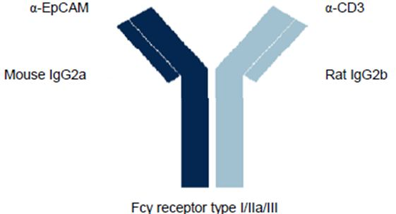
The theoretical molecular weight (MW) of catumaxomab was calculated based on the amino acid sequence, the addition of N-linked oligosaccharides, and the addition of a cysteinylation of an unpaired cysteine residue in the hinge region of the rat heavy chain.
The molecular weight of the major glycoform of the intact antibody was determined by LC/ESI-MS to be 150,658 Da, in agreement with the expected MW of 150,655 Da.
Catumaxomab consists of 1336 amino acids and the amino acid sequence was determined by a combination of cDNA sequencing and mass spectrometry. Additionally, the N-termini were determined by Edman sequencing and the C-termini were investigated by mass spectrometry.
Catumaxomab drug substance is an aqueous solution of 100 μg/mL of catumaxomab in 0.1M citrate buffer with 0.02 % polysorbate 80.

Drug product
Two presentations of drug product, corresponding to a 10 μg and a 50 μg dose of catumaxomab, respectively, are intended for marketing. These presentations are supplied in pre filled 1 mL glass syringes containing a nominal volume of 100 μl and 500 μl, respectively, and are used as a concentrate for solution for infusion.
The concentrate is diluted in sterile isotonic saline solution and administered to the patient by infusion. The sterile isotonic saline solution and the infusion set are standard medical items for parenteral use and are not part of the drug product presentation.
The colourless solution has a protein concentration of 100 μg/mL and is formulated in 0.1M sodium citrate buffer solution (pH 5.6) containing 0.02% polysorbate 80. All excipients are added during production of the drug substance and no further excipients are added during manufacturing of the drug product.

III. Nonclinical findings

Introduction
A large body of data were submitted to examine in vitro anti-cancer activity, but the in vivo data to support the proposed indication and the submitted toxicity package were quite limited. The toxicity testing was restricted due to the species specificity of the pharmacology of catumaxomab. However, alternative models are available and would have provided more meaningful information as to the potential toxicities of catumaxomab.

Pharmacodynamics

Primary pharmacodynamics

Target binding
An extensive series of in vitro studies was performed to characterise details of the binding of catumaxomab and/or its parental antibodies to its three targets. Peptide binding studies suggested that HO-3 (the EpCAM binding parent of catumaxomab) could bind at three sequences within the extracellular domain of EpCAM. Deletion of one of these sequences (within the first epidermal growth factor like domain of EpCAM) strongly impaired HO-3 binding to EpCAM. Three consensus glycosylation sites were identified in the extracellular domain of EpCAM. Mutation at all three sites abrogated glycosylation, but had no effect on HO-3 binding. This result suggested that changes in the glycosylation status of EpCAM (which can occur during tumourigenesis) would not affect catumaxomab binding. Peptide binding studies were also used to identify the sequence of CD3 bound by 26/II/6 (the CD3 binding parent of catumaxomab).
Equilibrium dissociation constants (K_{d}) for binding to EpCAM or CD3 were compared between catumaxomab and its parent antibodies (Table 1). Catumaxomab and HO-3 showed similar strong binding to EpCAM; however, catumaxomab showed significantly lower affinity for CD3 than its parent. The basis for the difference in binding to CD3 was not explored.
Table 1: Dissociation constant (K_{d}) of catumaxomab and its parental antibodies for their targets.
 | EpCAM | CD3
Catumaxomab | 0.56 ± 0.12 × 10⁻⁹ M (84 ng/mL) | 4.44 ± 0.17 × 10⁻⁹ M (666 ng/mL)
HO-3 | 0.55 ± 0.19 × 10⁻⁹ M | -
26/II/6 | - | 0.85 ± 0.03 × 10⁻⁹ M
Molecular weight for catumaxomab is ~150 kDa
The Fc region of catumaxomab originates from rodents. In vitro studies with human Fcγ receptor proteins showed that catumaxomab bound FcγRI (CD64) with a K_{d} of around
4.0 × 10⁻⁸ M (6 μg/mL), while binding of FcγRII (CD32) was approximately 70 fold weaker. Studies examining cell populations in human blood found that catumaxomab did not bind to FcγRIII (CD16) positive NK cells or FcγRII positive B cells but did bind to FcγRIII, FcγRII or FcγRI positive monocytes, with binding most prominent on monocytes expressing FcγRII and/or FcγRI.
Catumaxomab’s specificity for human EpCAM and CD3 was tested using cells and tissue from various species. Catumaxomab showed no evidence for binding to T cells from rodents, rabbits, dogs, or monkeys. Similarly, catumaxomab did not bind to EpCAM from rodents, and histochemical studies using rabbit, dog and monkey epithelial tissues provided no consistent evidence for specific binding. These results confirm the specificity of catumaxomab for human EpCAM and CD3, and suggest that animal experiments using catumaxomab would be of limited usefulness.

Induction of cytotoxicity
A large body of studies was performed detailing both the ability of catumaxomab to induce killing of various human tumour derived cell lines and the mechanism by which death was induced. Catumaxomab was able to induce carcinoma cell death by at least three routes. Some carcinoma lines underwent lytic cell death when incubated in vitro in the presence of catumaxomab and human serum. This cytotoxicity was dependent on the concentration of catumaxomab and on the anti EpCAM (but not the anti CD3) binding ability of catumaxomab. The role of the complement system in this cytotoxic activity was indicated by:
- loss of the activity following heating of serum;
- binding of complement proteins to carcinoma cells in the presence of catumaxomab; and
- the inverse dependence of cellular sensitivity to killing on the level of expression of membrane regulatory proteins of complement (CD46, CD55, and CD59).
Using in vitro co cultures of human carcinoma cells and peripheral blood leukocytes, it was shown that catumaxomab induced granzyme B (initiates apoptosis in target cells) secretion by both CD4⁺ and CD8⁺ T cells. Catumaxomab was also shown to induce efficient phagocytosis of carcinoma cells during in vitro co culture with macrophages.
Quantitative assays of cell survival showed that catumaxomab induced concentration dependent cytotoxicity of human carcinoma cells from a variety of tissues (for example, colon, pancreas, breast, ovary) when they were co cultured in vitro with human peripheral blood leukocytes. In contrast, the parental anti EpCAM antibody (HO-3) was not cytotoxic in this system, confirming a role of the anti CD3 domain in cytotoxicity. Catumaxomab was cytotoxic towards carcinoma cells that showed different levels of expression of EpCAM, but was not cytotoxic towards carcinoma cells that lacked EpCAM expression.

In vivo efficacy
The species specificity of catumaxomab meant that only limited in vivo efficacy studies in animals could be conducted. Nonetheless one in vivo study in severe combined immunodeficiency (SCID) mice was submitted. Human ovarian cells were injected into the peritoneal cavity along with human peripheral blood mononuclear cells as a source of effector cells. While this is a recognised malignant ascites model, catumaxomab was injected on Day 1, prior to tumour or ascites development. The evidence for catumaxomab to delay tumour development was not compelling. More importantly, no evidence was provided to indicate efficacy of catumaxomab to inhibit ascites production. The surrogate antibody, BiLu, specific for human EpCAM and mouse CD3, has been tested in a mouse tumour model, with tumour cells expressing human EpCAM. A similar experiment could have been performed with a mouse malignant ascites model, several of which are available, in which the tumour cells were engineered to express human EpCAM. If BiLu were administered after the establishment of ascites, this model would have provided more appropriate information to support the proposed indication as a therapy for malignant ascites.

Secondary pharmacodynamics
Catumaxomab’s specificity for human EpCAM and CD3 meant that animal studies with this antibody would likely be of limited usefulness in addressing possible safety issues. Instead, mice were IV (intravenous) dosed with BiLu: a similar trifunctional antibody to catumaxomab but combining anti human EpCAM and anti-mouse CD3 binding sites. Unfortunately, this antibody does not bind to mouse EpCAM. Similar to clinical data for catumaxomab, BiLu dosing of mice produced a transient decrease in the frequency of CD4 and CD8 positive cells (relative to total leukocytes) in peripheral blood. The basis for the latter effect was explored in in vitro studies and it was shown that:
- incubation of human peripheral blood mononuclear cells with catumaxomab induced increased expression of CD69 (an activation marker) on T cells;
- incubation of human umbilical vein endothelial cells with TNF-α (released during T cell activation) increased expression of the adhesion molecules CD62E and CD54; and
- exposure of T cells to catumaxomab produced a concentration dependent increase in their adhesion to endothelial cells that was enhanced by, but was not dependent upon, prior exposure of the endothelial cells to TNF-α.
Accordingly, these results are consistent with the hypothesis that the catumaxomab induced transient decline in T cell frequency derives from the adhesion of activated T cells to endothelium. Although catumaxomab could induce complement dependent cytotoxicity, in vitro studies confirmed the presence of the complement inhibiting factors (CD46, CD55 and CD59) on T cells, prevented complement dependent killing, suggesting this does not explain the decline in T cells.
Human GA733-1 gene encodes a protein with ca. 50% amino acid identity with EpCAM. Catumaxomab did not, however, bind to cells that express the GA733-1 gene product.
Catumaxomab binds to human T cells via CD3, thereby resulting in their activation and proliferation. When incubated with human blood cells, catumaxomab induced the release of cytokines (TNF-α, IL-6, IL-2, IL-12 and IL-1). As expected, cytokine release was higher in the presence of tumour cells. Catumaxomab did not induce histamine release in human blood samples. These data suggest that effects associated with cytokine release are a potential clinical concern.
Catumaxomab binding to normal human tissue sections was studied using standard immunohistochemical techniques. As expected, the antibody bound to the epithelium of various tissues, including the alimentary tract (stomach, ileum, and colon) and urogenital system (bladder, ureter, prostate, uterus, epididymis, and fallopian tube), and various glands (adrenal, liver, pancreas, sweat glands in skin, pituitary, thyroid, and mammary). Lymphocytes (for example, in lymph nodes) also showed a positive response consistent with CD3 positivity. Other tissues (for example, endothelium) showed little or no staining. The antibody was bound mainly to the cell membrane.
Further studies with human liver sections showed that both catumaxomab and HO-3 antibodies bound to bile duct epithelial cells but not to hepatocytes. Possible effects of catumaxomab on hepatocyte metabolic functions [as quantified by measurement of lactate dehydrogenase (LDH) and aspartate transaminase (AST) activity, and urea levels] were studied in in vitro co culture systems containing hepatocytes plus effector cells (Kupffer cells, T cells, etc). An increase in AST levels was consistently observed at 100 ng/mL catumaxomab. Only a mild increase in AST levels was seen with the anti EpCAM antibody, HO-3. The increase in AST levels seen in vitro are consistent with increased AST levels observed in toxicity studies and clinical studies. It is also of interest that two research groups have reported that rodent oval cells [putative hepatic stem cells capable of generating hepatocytes and biliary epithelial cells (cholangiocytes)] express EpCAM. The latter finding (assuming that it is transferable to human hepatic oval cells), coupled with the leakiness of hepatic sinusoids to large molecules and blood cells, and the presence of Fcγ receptor positive Kupffer cells, raises the theoretical possibility that circulating catumaxomab could have adverse effects on oval cells and biliary epithelial cells. Studies addressing such possibilities were not performed by the sponsor.

Safety pharmacology
No dedicated cardiovascular, respiratory, central nervous system (CNS), renal or gastrointestinal tract safety studies were submitted. Only CNS toxicities were examined in the submitted toxicity studies, with examinations limited to observations of clinical signs in response to catumaxomab and/or BiLu (a surrogate mouse antibody) treatment. Convulsions were seen in one mouse and a number of rats treated intravenously with ~5 mg/kg catumaxomab. No effect was seen in mice treated with 1.5 mg/kg, rats treated with 0.5 mg/kg or cynomolgus monkeys treated with 0.3 mg/kg. As the maximum plasma concentration at the no effect level, at least in mice, is estimated to be greater than 50,000 times the maximum plasma concentrations observed clinically, the convulsions are unlikely to be of clinical concern. Catumaxomab is an antibody and due to its size and the presence of an Fc domain is unlikely to cross the blood-brain barrier or be present in the brain in an appreciable amount.
No dedicated cardiovascular examinations were conducted. Catumaxomab is a monoclonal antibody and unlikely to inhibit hERG channels. Furthermore, EpCAM is not expressed in cardiac tissues and therefore adverse cardiovascular effects are not predicted.
The effect of catumaxomab or an appropriate surrogate on the respiratory, gastrointestinal and renal systems has not been adequately assessed in the submitted toxicity studies. EpCAM is expressed in the epithelium of the respiratory and gastrointestinal tracts, as well as in the kidney,⁸ and gastrointestinal toxicity has been seen in patients receiving IV injections of other anti EpCAM antibodies. The sponsor stated that normal EpCAM positive tissue is assumed to be inaccessible for intact antibodies in vivo owing to protection by the basal lamina. However, a later study, comparing multiple antibodies, demonstrated that binding of anti-EpCAM antibodies by normal tissue may be antibody specific. Therefore, the sponsor has not adequately demonstrated that catumaxomab does not bind to EpCAM expressing intact normal tissue. However, given the route of administration (IP) resulting in low maximum plasma levels of catumaxomab in malignant ascites patients (0.48 ng/mL, compared to a K_{d} of 84 ng/mL for catumaxomab at EpCAM), binding at peripheral EpCAM sites is expected to be low. However, in clinical studies, systemic exposure to catumaxomab was highly variable and likely dependent on tumour load. Therefore a risk of effects at peripheral EpCAM positive tissues may occur in individuals with greater systemic exposure.

Pharmacodynamic drug interactions
Combination of exposure to catumaxomab (with peripheral blood mononuclear cells) and one of several cancer chemotherapeutic drugs (including topoisomerase poisons, 5-fluorouracil and cisplatin) produced a synergistic increase in killing of a variety of EpCAM expressing human carcinoma cell lines. The basis for this synergism was not explored.
The ability of glucocorticoids to influence catumaxomab induced immune cell activation, cytokine and granzyme B release, and cytotoxic efficacy was studied in in vitro co cultures of human peripheral blood mononuclear cells and an EpCAM expressing human carcinoma cell line. It was shown that dexamethasone produced a dose dependent reduction of both granzyme B secretion and carcinoma cell killing, even in the presence of a high concentration of catumaxomab; whereas hydrocortisone decreased the level of cell killing only in the presence of low concentrations of catumaxomab. These results are consistent with the known ability of glucocorticoids to inhibit synthesis of cytokines and cell surface molecules related to immune function via inhibition of NF-κB (nuclear factor kappa B).

Pharmacokinetics
Catumaxomab, given as a single IV dose to mice, showed a moderately rapid initial phase of clearance from 0 to 8 h [t_{1/2} (elimination half-life) ~4 h], followed by a much slower terminal phase of clearance (t_{1/2} ~130 h). Uptake of catumaxomab into the bloodstream of mice following IP dosing showed a strong inverse linear correlation with the number of human mononuclear cells and EpCAM expressing carcinoma cells in the peritoneal cavity. This finding likely has implications for the treatment of patients with different tumour burdens.
Blood spiking experiments showed no obvious effect of catumaxomab concentration, over the range (0.5-5 ng/mL), on the proportion of cell bound versus free antibody. For example, 79% of catumaxomab molecules were free at 0.5 ng/mL, even though CD3 binding sites were in estimated 100 fold excess of antibody molecules at this concentration. This result can be explained by catumaxomab’s moderate K_{d} for CD3 of 4.4 × 10⁻⁹ M (Table 1), which does not allow quantitative binding to CD3 at low antibody concentrations (0.5-50 ng/mL equivalent to 3.3 × 10⁻¹²-3.3 × 10⁻¹⁰ M). The presence of an EpCAM positive carcinoma cell line, in similar binding experiments, resulted in a significant reduction of free catumaxomab. Such a result is consistent with the approximately 8 fold higher binding affinity of catumaxomab for EpCAM (Table 1) as compared with CD3. The presence of both EpCAM and CD3 positive cells in binding experiments produced a significant decrease in the fraction of free catumaxomab, suggesting an increase in affinity when catumaxomab is bound to both CD3 and EpCAM.
Catumaxomab’s distribution was examined following IV injection into SCID mice bearing an EpCAM positive human tumour. Catumaxomab continued to accumulate in the tumour up to 48 h post injection. Most mouse tissues displayed only non-specific binding of catumaxomab; as indicated by declining levels of antibody relative to tumour levels. Spleen was a partial exception, presumably reflecting the presence of cells expressing members of the Fc receptor family. The value of this study in extrapolating to the potential distribution of catumaxomab is limited. Catumaxomab does not bind to either the mouse EpCAM or mouse CD3 (which is likely not expressed in SCID mice), and therefore binding to non-tumour tissue and specific uptake by EpCAM positive carcinoma cells cannot be assessed in this model. Transgenic mouse models expressing human EpCAM, either from the human EpCAM promoter or from another promoter are available and would provide a better assessment of the biodistribution of catumaxomab or, ideally, the surrogate antibody, BiLu. The transgenic mouse model in which human EpCAM is expressed from the human EpCAM promoter, had a tissue expression profile of EpCAM similar to that in humans and has been used to examine the biodistribution of other anti EpCAM antibodies.¹¹

Toxicology
A series of toxicity studies was performed using either catumaxomab or BiLu (anti-human EpCAM and anti-mouse CD3) in rodents or monkeys. Good Laboratory Practice (GLP) compliant single dose toxicity studies with catumaxomab were conducted in mice and rats, using adequate animal numbers and observation period as per published guidelines. Administration was via the IV route. Two additional single dose studies using the IP route in mice and guinea pigs were submitted but were considered of limited value as examinations were restricted to mortalities and clinical signs, and animals were not subject to necropsy to determine target organ toxicity. Aside from convulsions at the highest tested dose (~5 mg/kg), resulting in death in one animal, no significant toxicities were observed in mice treated with 1.5 mg/kg IV and rats treated with 0.5 mg/kg IV. As catumaxomab does not bind to either EpCAM or CD3 in mice, the negative findings in these studies are of limited clinical relevance. The only other toxicity study conducted with catumaxomab was a dose escalation study in a single male cynomolgus monkey. This study is considered of limited value due to the absence of catumaxomab binding in this species, the use of only a single animal and the limited analyses performed (for example, necropsy was not conducted).
Two dose escalation studies were conducted in mice with the surrogate antibody, BiLu, using the IP and, in one study, the IV route. Only one of these studies was GLP compliant and, unfortunately, serum chemistry parameters were not examined in this study. Serum chemistry parameters were measured in the non GLP compliant study. However, this study did not include a control group and histopathological examinations were restricted to the liver and pancreas, although the latter was only examined after an 18 day treatment free period. Therefore, overall this study was considered of limited value. As BiLu does not bind murine EpCAM, these studies would not fully reveal toxicities associated with anti EpCAM and therefore catumaxomab activity; however, they are sufficient to provide some indications of toxicities associated with anti CD3 activity.
A reduction in lymphocyte levels was observed in mice treated with escalating doses up to 300 μg/kg IV BiLu. This effect is consistent with adhesion of activated T cells to the endothelium. Lymphopaenia was a common adverse effect reported in clinical trials with catumaxomab, confirming the clinical relevance of these findings. The liver appeared to be a target organ for toxicity for BiLu, with white areas observed in the liver of 1/5 males treated with escalating doses up to 30 μg/kg IP BiLu and centrilobular necrosis seen in 2/5 males treated up to 300 μg/kg IP BiLu. Increased AST activity was seen in males treated with up to 300 μg/kg IP BiLu. No notable effects were seen in females. The mechanism for hepatotoxicity is unknown but given they only occurred following IP injection and not following IV injection, the incidence does not appear to correlate with plasma levels of BiLu. As anti EpCAM activity may also have adverse effects on hepatobiliary tissues that would not have been assessed in the studies with BiLu, there may be some concern regarding hepatotoxicity during clinical use with catumaxomab. It is of note that increases in hepatic parameters [for example, AST, alanine transaminase (ALT), alkaline phosphatase (ALP)] were observed clinically, suggesting these hepatotoxicity findings may be clinically relevant.
No repeat dose toxicity studies were submitted. For biopharmaceuticals intended for life threatening diseases, repeated dose studies of at least two weeks duration are recommended. The justification provided by the sponsor for the absence of such studies was that an appropriate animal species was not available. As catumaxomab is not pharmacologically active in animals generally used for toxicity testing (mice, rats, rabbits, dogs or monkeys) and the surrogate, BiLu, is not fully representative of catumaxomab, repeat dose toxicity studies with catumaxomab or BiLu in the species used for single dose toxicity testing would not have been meaningful. EpCAM expression in mice is not fully representative of the tissue expression profile of EpCAM in humans. In the mouse, EpCAM is not only expressed in epithelia, but also in lymphoid organs and T and B cells. Therefore, an anti-mouse EpCAM/anti mouse CD3 antibody would not be a truly representative surrogate for catumaxomab in toxicity studies in mice. An appropriate model would be a transgenic mouse expressing human EpCAM, several of which are available.¹³ At least one repeat dose toxicity study with BiLu in such a model would have provided a better indication of the potential toxicity profile of catumaxomab.
Due to the limitations in the submitted toxicity package, the toxicity profile of catumaxomab has not been fully revealed. EpCAM is expressed in the epithelial tissues of the respiratory, gastrointestinal and urinary tracts, as well as the pancreas, gonads, uterus and cervix. Therefore, inflammatory responses in these tissues may occur following catumaxomab administration. Binding of anti EpCAM antibodies to the pancreas, kidney, lungs and gastrointestinal tract have been observed following IP injection to human EpCAM expressing mice.¹¹ Pancreatitis and gastrointestinal disorders have been observed clinically with anti EpCAM antibodies.⁹ Gastrointestinal disorders were observed clinically with catumaxomab, although a relationship with inflammatory responses in the gastrointestinal tract cannot be confirmed. Therefore, inflammatory responses in peripheral epithelial tissues must be assumed to be a risk with catumaxomab treatment.

Genotoxicity and carcinogenicity
Possible genotoxic or carcinogenic action by catumaxomab was not examined by the sponsor. This is acceptable given catumaxomab’s chemical nature, mode of action and lack of pharmacological activity in species typically used for carcinogenicity testing (mice and rats), and the proposed indication.¹⁵

Reproductive toxicity
Reproductive and developmental toxicity studies were not performed by the sponsor. The justification provided by the sponsor for their absence was the lack of an appropriate animal species, the intended patient population, and the late stage of the malignant disease. In principle, this is considered acceptable. EpCAM is expressed on the ovary duct and sertoli cells¹⁰ and anti EpCAM antibodies administered intraperitoneally to mice have shown to bind to the testes.¹¹ Therefore, catumaxomab may have an adverse effect on fertility.
Due to the presence of an Fc domain, placental transfer of catumaxomab is likely. EpCAM is expressed in embryonic stem cells and is expressed in various cells during embryogenesis and during differentiation. EpCAM null mice were shown to be non-viable, due to embryofetal death by gestation day 12. By gestation day 9, EpCAM deficient embryos were smaller and neural tube closure was delayed. Placentas associated with these embryos were small and thin and did not exhibit prominent vascularity. EpCAM is highly expressed in the placenta, and these embryofetal deaths may be associated with an extra embryonic effect. Therefore, based on its pharmacology, catumaxomab is likely to have adverse effects on embryofetal development, including malformations and death, thus warranting a Pregnancy Category of D.

Local tolerance
Studies using rabbits showed that catumaxomab, administered by various routes (for example, IV, IP, IA (intra-arterial), IM (intra muscular)], was well tolerated locally and produced no/modest erythema and oedema responses at the injection sites. However, the absence of findings should be considered with caution as catumaxomab does not bind to EpCAM, which is found in the skin, and therefore administration site reactions associated with the pharmacology would not have been revealed in the submitted studies.

Antigenicity
Repeat IV dosing of a cynomolgus monkey with catumaxomab produced high levels of both human associated mouse antibodies (HAMAs) and human associated rat antibodies (HARAs) to IgG. These levels were comparable with those found in clinical studies. In vitro studies confirmed the production of neutralising antibodies in patients. However, patients who were HAMA/HARA positive (but not anti-drug antibody positive) did not have neutralising antibodies. The production of anti-drug antibodies may decrease the activity of test article and cause hypersensitivity reactions.

Nonclinical summary and conclusions
- Biotech Regulatory Solutions (on behalf of Fresenius Biotech GmbH, Germany) proposes to register the new chemical entity, catumaxomab, for the IP treatment of malignant ascites in patients with EpCAM positive carcinomas where standard therapy is not available or no longer feasible. Catumaxomab is a trifunctional monoclonal antibody which binds to EpCAM, CD3, and Fcγ receptors. This allows catumaxomab to recruit T cells and immune system accessory cells to EpCAM positive tumour cells, and to thereby initiate tumour cell killing via multiple pathways.
- A large number of in vitro studies were submitted to investigate the mode of action and anti-tumour activity of catumaxomab. In vivo efficacy and toxicity studies were, however, limited.
- In vitro studies established catumaxomab’s affinity and specificity for binding to human EpCAM, CD3, and Fcγ receptors. These binding abilities enabled catumaxomab to induce killing of various EpCAM positive human carcinoma derived cell lines.
- A single study was submitted to investigate the in vivo efficacy of catumaxomab. However, due to the design and conduct of the study, the results are of limited relevance to the proposed indication.
- In vitro studies showed that activation of human T cells, following exposure to catumaxomab, resulted in increased adhesion to the endothelium. Transient decreases in T cells were seen in mice following dosing with a mouse surrogate antibody (anti mouse CD3/anti human EpCAM). Due to its anti CD3 domain, catumaxomab induced the release of cytokines from human blood cells. Catumaxomab did not induce histamine release.
- No safety pharmacology studies were submitted.
- The combination of catumaxomab with various cancer chemotherapeutic drugs was shown to produce a synergistic increase in killing of a variety of EpCAM expressing human carcinoma cell lines.
- Single dose studies in rodents were conducted with catumaxomab, while dose escalation studies in mice were conducted with a mouse surrogate antibody, BiLu. Lymphopaenia and indications of hepatotoxicity were observed in BiLu treated mice and were assumed to be associated with anti CD3 activity. Due to a lack of anti EpCAM activity in the tested species, these studies are unlikely to have revealed the full toxicological profile of catumaxomab. Inflammatory reactions at peripheral EpCAM positive tissues (for example, gastrointestinal and respiratory tracts and the pancreas) must be assumed to be possible.
- No repeat dose toxicity studies were submitted.
- Possible genotoxic or carcinogenic action by catumaxomab was not examined. This is acceptable given catumaxomab’s chemical nature, mode of action and proposed indication.
- Reproductive and developmental toxicity studies were not performed by the sponsor. This is acceptable given the intended clinical use of catumaxomab. Based on a role of EpCAM in embryofetal development, administration of catumaxomab during pregnancy may have adverse embryofetal effects.
- Catumaxomab, administered by various routes, was well tolerated locally by rabbits and produced no or only modest erythema and oedema responses at the injection sites. However, these findings are of limited value given that catumaxomab is not pharmacologically active in this species. As EpCAM is expressed in the skin epithelium, adverse reactions at the injection site are possible.
- Catumaxomab was immunogenic in monkeys. Sera from catumaxomab treated patients confirmed the production of neutralising antibodies.

Conclusions and recommendations
- In vitro studies with catumaxomab confirmed cytotoxic activity towards EpCAM expressing tumour cell lines. However, no adequate studies were submitted to support the proposed indication for a reduction in ascites symptoms.
- The toxicity package was limited, mainly due to a lack of pharmacological activity of catumaxomab in standard laboratory animals. Use of a surrogate antibody and in vitro studies revealed the following toxicities of potential clinical relevance: lymphopaenia, cytokine release syndrome, hepatotoxicity and the production of anti-drug antibodies. Toxicities associated with anti EpCAM activity would not have been revealed in the submitted studies. Therefore, inflammatory reactions on peripheral epithelial tissues as well as at the injection site are possible.
- Overall, due to limitations in the submission package, safety and efficacy would need to rely primarily on clinical data.

IV. Clinical findings

Introduction
Catumaxomab was designated by the TGA as an orphan drug on the 15 September 2010 for the following indication: “Treatment of patients with malignant ascites due to EpCAM+ carcinomas.” The submission for this proposed indication consists of a pharmacokinetic study (specifically undertaken to evaluate the pharmacokinetics in patients with malignant ascites), a Phase I/II dose finding study, and a pivotal Phase II/III study. A number of further studies are ongoing.
All aspects of Good Clinical Practice were observed in the three studies.

Pharmacokinetics
A single study was provided in this submission in relation to provision of data on pharmacokinetics for catumaxomab. Study IP-REM-PK-01 was designed to determine systemic exposure and characterisation of pharmacokinetics for catumaxomab administered intraperitoneally in EpCAM+ cancer patients with malignant ascites. This study was undertaken in three centres in Romania and four centres in Germany with the first patient being enrolled on 11 November 2005 and the last visit of the last patient on 7 November 2006.
The primary objective of this study was to determine systemic exposure of catumaxomab during and after four IP infusions with increasing doses. Secondary objectives included a characterisation of cytokine levels after IP application of catumaxomab, an assessment of safety and tolerability of catumaxomab, and an evaluation of the efficacy of catumaxomab.
For the study, an ELISA (enzyme linked immunosorbent assay) test method was developed and validated with sufficient sensitivity for recovery of the very low antibody concentrations in ascites and systemic circulation after IP administration.
Inclusion criteria for the study were:
- male and female patients with EpCAM expressing tumours and with malignant ascites requiring therapeutic puncture;
- histologically confirmed diagnosis of cancer;
- malignant ascites requiring peritoneal puncture;
- EpCAM+ tumour cells in the ascites fluid;
- a Karnofsky performance status (KPS) ≥ 60%;
- life expectancy of at least eight weeks; and
- refractory or resistant to systemic chemotherapy.
Exclusion criteria comprised inadequate renal function, inadequate hepatic function, a body mass index (BMI) of <17, and patients with extensive liver metastases.
The treatment regimen consisted of four infusions of catumaxomab over a period of 11 days up until a maximum of 21 days. The proposed schedule was on Day 0 infusion: 10 μg of test agent; Day 3: 20 μg; Day 6 or 7: 50 μg; Day 10: 150 μg.
Pharmacokinetic estimations were determination of free catumaxomab in plasma and free catumaxomab in ascites fluid using the ELISA method. The PK parameters were assessed after the third and fourth IP infusions with a lower limit of quantification 125pg/ml for plasma and 250pg/ml for ascites fluid.
A total of 13 patients were enrolled in the study: 2 male and 11 female patients. The mean age was 58.2 years and the mean weight was 68.2kg. Nine patients had a diagnosis of ovarian cancer, three of pancreatic cancer, and one had gastric carcinoma. Eleven patients received four IP infusions of catumaxomab and two patients received three IP infusions of catumaxomab.
Review of concentrations versus time profile of catumaxomab in plasma revealed that quantifiable catumaxomab concentrations could be obtained for 10/13 patients included in the analysis. The plasma concentration profile showed large inter individual variability. Despite this higher inter individual variability, systemic catumaxomab concentration plasma increased with the number of infusions and the dose administered in most patients. Nevertheless with each dosing interval, the concentrations did not accumulate over time but tended to decline after reaching a maximum; this indicated that the elimination from plasma was greater from the IP compartment. It is therefore considered that the plasma concentration time profiles give a reasonable estimate of a systemic exposure that can be expected when catumaxomab is administered IP.
Review of concentrations versus time profiles of catumaxomab in ascites fluid reveal that quantifiable free catumaxomab concentrations in ascites fluid could be obtained for all 13 patients. An overall trend to increasing concentrations of catumaxomab in ascites over the treatment period was observed in 10/13 patients.
In relation to the pharmacokinetic parameters measured, results demonstrated that there were implausibly high catumaxomab concentrations at time points after termination of treatment in some patients, which were found to be due to an interference of anti-drug antibodies with the catumaxomab assay. Therefore, all anti-drug antibody positive samples were reanalysed by a modified and validated method using a specific blocking agent. Some reanalysed samples still showed implausible increases in systemic catumaxomab concentration after termination of treatment. Accordingly, two Data Sets were characterised: Data Set I with the implausible data, and Data Set II with pharmacokinetically plausible data. Data Set II was the set of principal evaluation.
In the patients included in Data Set II, the total systemic exposure in terms of area under the concentration versus time curve (AUC) from dosing time of the third dosage interval to the last measurement time point (AUC_{last}) was 1700pg/ml, ranging from indeterminate to 13448pg/ml; this is indicated in Table 2. The corresponding maximum plasma drug concentration (C_{max}) was 489pg/ml ranging from indeterminate to 2290pg/ml. C_{max} values after the third infusion and the fourth infusion were 353pg/ml and 478pg/ml, respectively; this is illustrated in Table 2. The t_{1/2} had a mean of 4.05 days with a range of 0.73-17.5 days.
Table 2: Pharmacokinetic parameters of catumaxomab in plasma (Data set II, Study IP-REM-PK-01-EU).
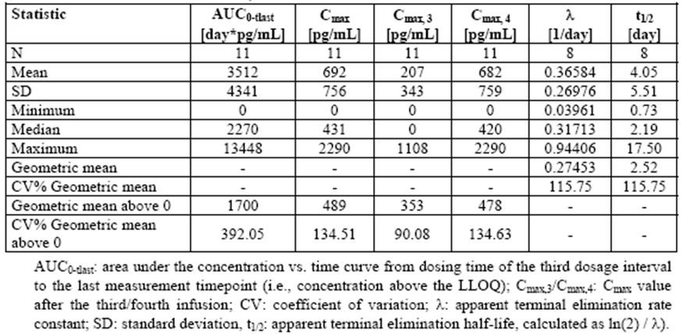
Attempts were made to assess AUC_{last} and C_{max} in ascitic fluid, but with such enormous variability in the results these are not considered valid.
These data have shown that pharmacokinetic measurement of catumaxomab is feasible in plasma but extremely difficult in ascites because of greater variability in results. Nevertheless, there does appear to be an increase in concentration with each infusion of catumaxomab; instead, the levels progressively decline after reaching C_{max} and no significant accumulative effect of catumaxomab is observed in plasma. The various pharmacokinetic evaluations would suggest a “normal” pharmacokinetic performance; it is unsurprising to observe a very large inter subject variability of the pharmacokinetic parameters.

Pharmacodynamics
Pharmacodynamic data was obtained principally from two studies, namely the pharmacokinetic trial IP-REM-PK-01 as well as the pivotal Study IP-REM-AC-01.
In vivo analyses were performed with ascites samples to analyse the direct effect of IP catumaxomab infusion on tumour cells and immune effector cells (leukocytes) within malignant ascites.
EpCAM+ tumour cells/CD45+ leukocyte ratio was measured throughout catumaxomab therapy and follow up. Activation markers on T cells and macrophages/monocytes induced by catumaxomab therapy were also quantified.
Review of this pharmacodynamic data for the two studies revealed that in general a decrease of the number of EpCAM+ tumour cells in the ascites fluid was accompanied by a pronounced increase in CD45+ leukocytes. Table 3 shows the course of the EpCAM tumour cell/CD45 leukocyte ratio assessed in the two studies. In both studies this ratio decreased distinctly between screening and the second and fourth infusions of catumaxomab, reaching a median of zero before the fourth infusion.
Table 3: EpCAM+ tumour cell/CD45+ leukocyte ratio in ascites in patients treated with catumaxomab (Study IP-REM-PK-01-EU and randomised part of Study IP-REM-AC-01).
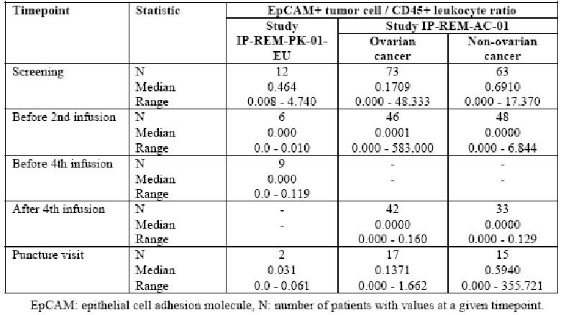
A review of the expression of activation markers CD25, HLA-DR and CD69 on immune cells directly measured from ascites is summarised in Table 4.
Table 4: Activation markers CD25, HLADR and CD69 on immune cells in patients with malignant ascites after IP administration of catumaxomab (Study IP-REM-PK-01-EU and randomised part of Study IP-REM-AC-01).
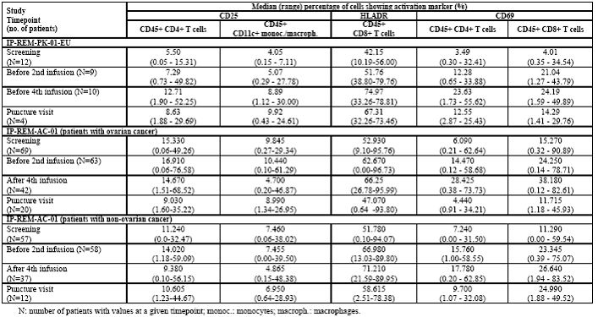
In relation to CD25 in both studies, the median percentage of activated cells for CD25 did not indicate a relevant change compared to screening before either the second or fourth infusions, or at therapeutic puncture.
In both studies the median percentage of HLA-DR expressing T cells increased between screening and the fourth infusion in patients receiving catumaxomab.
In both studies the median percentages of activated T cells for CD69 increased steadily during the treatment period in patients receiving catumaxomab. At therapeutic puncture, the median percentages of both T cell types with CD69 expression returned to baseline.
In summary, in the pivotal trial there were no relevant differences between the treatment groups (paracentesis plus catumaxomab versus paracentesis alone) at screening and at the puncture visit, and the differences in the median changes from screening to the puncture visit between the treatment groups were not statistically significant.
Further pharmacodynamic analyses were also performed involving in vitro assays with ascites cells harvested from the screening sample before therapy in both studies to assess the immunologic inter tumour potential of the immuno affected cells in ascites induced by catumaxomab, and support the possible systemic reaction. The ascites cells were incubated in vitro with or without catumaxomab to investigate:
- killing of tumour cells triggered by catumaxomab in a long term clonogenic assay;
- secretion of cytokines triggered by catumaxomab in the long term clonogenic assay;
- activation of T cells triggered by catumaxomab in a short term clonogenic assay; and
- proliferation of T cells (CD4/CD8) and monocytes/macrophages triggered by catumaxomab.
The long term clonogenic assay revealed that in the randomised trial, the median EpCAM tumour cell count decreased considerably in samples of catumaxomab compared to the samples without catumaxomab in both cancer strata; this is illustrated in Table 5. For the pharmacokinetic studies, the results were inconsistent but it should be noted that the number of patients included in this analysis was very low.
The median CD45+ leukocyte count increased in samples of catumaxomab compared to samples without catumaxomab in the pharmacokinetic study, and in the ovarian cancer patients in the pivotal trial but not in the non-ovarian cancer patients. This is indicated in Table 5.
Table 5: EpCAM+ cell and CD45+ leukocyte counts in ascites after incubation with and without catumaxomab (in vitro long term clonogenic assay, Studies IP-REM-PK-01-EU and IP-REM-AC-01).
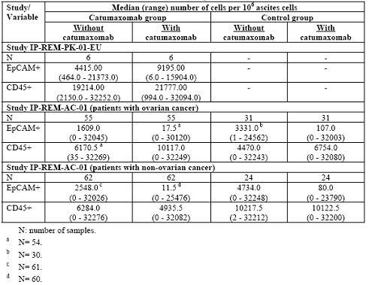
The long term clonogenic assays revealed that in relation to cytokine secretion, in both studies a strong stimulation of interferon gamma secretion in samples with catumaxomab compared to samples without catumaxomab was observed. In the randomised trial, an additional strong stimulation of IL-2 secretion in both cancer strata and IL-6 secretion in the non-ovarian cancer strata was observed. In both studies only moderate stimulation was observed for IL-4, IL-10 and TNF (tumour necrosis factor) alpha. The median differences of samples with and without catumaxomab were comparable between the treatment groups; these data are summarised in Table 6.
Table 6: Cytokine secretion after incubation of ascites samples with and without catumaxomab (in vitro long term clonogenic assay, Studies IP-REM-PK-01-EU and IP-REM-AC-01).
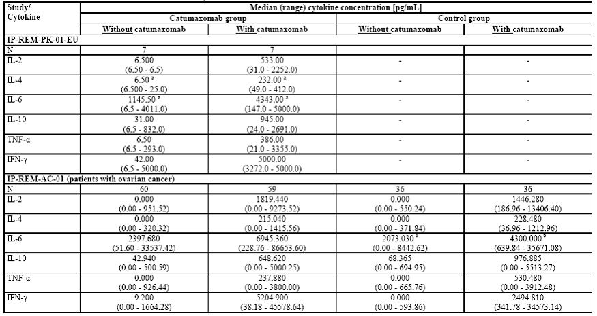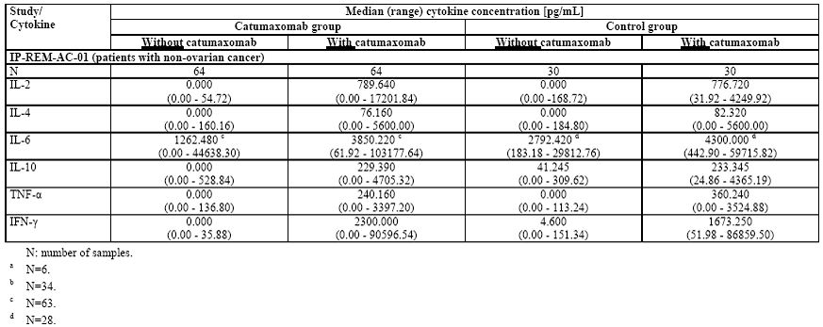
In the short term clonogenic assay in both studies, the assay demonstrated increased expression of CD69 and both CD4+ and CD8+ T cells in the samples with catumaxomab compared to the samples without catumaxomab. Further interferon gamma was only produced in T cells of ascites samples incubated with Catumaxomab and is illustrated in Table 7.
Table 7: CD69 expression and IFN-γ production by T cells after incubation of ascites samples with and without catumaxomab (in vitro short term clonogenic assay, Studies IP-REM-PK-01-EU and IP-REM-AC-01).
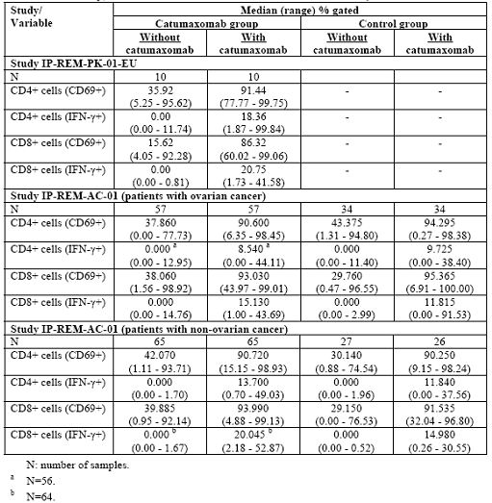
In relation to the T cell and macrophage proliferation assay, it was noted that after addition of catumaxomab proliferation of CD4+, CD4+ T cells and CD8+ T cells and CDLc+ monocytes/macrophages from the ascites could be demonstrated consistently in both studies. No proliferation of the cell types was seen without catumaxomab.
Recognising the mechanisms of action in the known safety profiles of catumaxomab cytokines in the systemic circulation was considered to be of clinical relevance for safety and tolerability. Thus, the various systemic cytokines IL-2, IL-4, IL-6, IL-10, interferon gamma and TNF alpha were determinates in the safety related pharmacodynamic variables.
Across the studies, notable increases in IL-6 were observed between baselines after infusion of catumaxomab with no clear dose relationship. Increases of clear trends toward increases after infusion of catumaxomab were also observed in TNF alpha, IL-10 and interferon gamma despite a high inter individual variability. IL-2 and IL-4 remained relatively unchanged and were only slightly increased after infusion of catumaxomab.
As catumaxomab is a non-humanised chimeric mouse/rat antibody, the development of antibodies against HAMA and HARA were investigated in all clinical studies. In all studies these antibodies were assessed before the first catumaxomab infusion and at the end of study/follow up. In time, the leaked ELISA assays were utilised for the detection of these antibodies.
Across the studies, notable increases in the proportion of patients with positive antibody results were observed between screening and in the study. In the pivotal study, the HAMA test was positive in 94.7% of patients one month after the fourth catumaxomab infusion compared to screening and before the fourth infusion when more than 90% of patients had been HAMA negative. In addition, a positive HAMA test result was accompanied by a positive HARA test result.
These data have essentially shown that infusion with catumaxomab results in activation of T cells and the various cytokines associated. These various cytokines have the potential to leak into the systemic circulation and are therefore associated with the principal adverse effects associated with catumaxomab. The pharmacodynamic data essentially confirms the likely mechanism of action of catumaxomab and also its potential adverse effect profile.

Efficacy
The pivotal study in this submission, Study IP-REM-AC-01, is the sole randomised Phase II/III trial investigating patients with malignant ascites due to epithelial cancers. The dosing schedule of catumaxomab for this trial was based on data provided from a supportive study, that is, Study STP-REM-01, which was a Phase I/II dose finding study. Accordingly, it is considered appropriate to first present the data from the dose finding study before discussing the pivotal trial.
Study STP-REM-01 was a study to investigate the tolerability and efficacy of IP catumaxomab in patients with ascites due to ovarian cancer. This was undertaken in a total of nine centres in Europe. The first patient enrolment occurred on 12 November 2001with the last patient completing treatment on 8 May 2003. The study was conducted to investigate the efficacy and tolerability as well as to identify the maximum tolerated dose (MTD) of catumaxomab administered repeatedly for 4-5 doses at a constant rate of six hours through IP infusion of increasing doses (5 μg up to 20 μg) to patients with ascites due to ovarian carcinoma.
This was an uncontrolled sequential dose rising study with each subject being investigated once. Patients with ascites due to ovarian cancer were treated with up to five IP infusions with catumaxomab at Day 0, 3, 6 and 9 in cases of four infusions, with the last dose group receiving a fifth infusion on Day 13.
Patients were allocated to one of six dose groups until dose limiting tolerability (DLT) was established. If none of the three patient groups experienced a dose limiting toxicity at a certain dose, the next three patients were treated with a higher dose. If 1/3 patients experienced a DLT, a further three patients up to a total of six were investigated at that dose. After the last patient at the given dose group had received their dose, the dose steering board reviewed the data and decided if the MTD was reached. If 2/3 patients of a dose group suffered a DLT, then the dose was not to be increased any further and the data steering board was to decide whether the previous dose level was to be considered MTD or whether further steps were necessary.
During the screening period, the patient’s eligibility for the study was established and the data for the baseline characteristics collected. Criteria for inclusion on trial included:
- body weight of at least 45kg;
- age >18 years;
- ovarian cancer with ascites clinically requiring at least one peritoneal puncture;
- EpCAM+ tumour cells and ascites fluid;
- life expectancy of at least eight weeks;
- at least one prior chemotherapy or not be suitable for chemotherapy or refused chemotherapy; and
- willing and able to provide informed consent and willing to attend follow up visits up to one month after application.
Patients were hospitalised on the morning before the day of first infusion, and until 24-48 hours after last infusion. As soon as the patients arrived on site, an IP catheter was placed for collection of ascites and administration of pre medication and catumaxomab. During hospitalisation, the patient’s safety was monitored at pre-determined times and efficacy data collected. The catheter could be removed from 24 hours after the start of the last infusion. Patients returned seven days after the start of the last infusion to undergo follow up safety evaluation. An end of trial examination consisting of all safety and efficacy measurements was carried 28 days after the start of last infusion.
According to the algorithm for the determination of the MTD, 3-6 patients had been enrolled in a dose group. A total of 26 patients were screened and 23 patients were treated. The first five cohorts of patients received four infusions and the last cohort five infusions at intervals of 3-4 days. The interval between two infusions could be prolonged for up to two days provided the interval between the first and last infusions did not exceed 23 days.
Criteria for assessment of efficacy included:
- reduction in spontaneous peritoneal ascites flow rate;
- tumour cell elimination from ascites flow;
- tumour marker CA72-4 and CA125; and
- the necessity of peritoneal puncture until end of trial (Day 37).
Safety and tolerability criteria included adverse events (AEs), wellbeing, vital functions, an electrocardiogram (ECG) and laboratory parameters, the need to discontinue or interrupt the infusion, and the need to administer medication to alleviate AEs.
The study population of 23 had a mean age of 62 years and a mean weight of 58kg. Seven patients had stage IV disease while 14 had stage IIIC and two had IIIB. A total of 22 patients with at least one line of previous cancer treatment were reported. The patients’ initial ovarian cancer diagnoses dated back to a range of 1-106 months. The number of surgical cancer treatments ranged from 1-3 surgeries and the number of medical cancer treatments from 1-8 therapies, with a median of three. Platinum compounds were used frequently and nearly all patients were heavily pre-treated and could be described as patients in the terminal stages of their disease.
Review of efficacy data revealed that the ascites flow rate showed a decrease by 52mls/hr from the median of 105mls/hr at baseline to a median of 23mls/hr on Day 1 after the fourth infusion.
In terms of necessity peritoneal puncture for the last infusion to the last individual visit, that is, ~28 days from the start of the last infusion, only 1/22 patients needed a peritoneal puncture.
Tumour cell elimination of the ascites occurred rapidly with the mean value of epithelial tumour cells being reduced 539 per 10⁶ screen cells before treatment to 39 per 10⁶ screen cells to the last individual measurement, resulting in a mean reduction of 99.9%. In 6/23 patients, tumour cell elimination to the level of the lower detection limit was observed (Figure 2).
Figure 2: Reduction of tumour cell load (Study STP-REM-01).
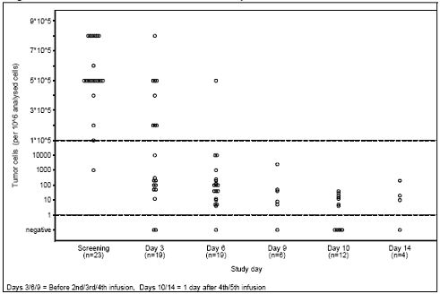
With regard to tumour markers, the tumour marker CA72-4 decreased in three patients by 18%, 19% and 49% but increased in ten patients by a range of 20-158% between pre-treatment and end of study. The tumour marker CA125 decreased in three patients by 22%, 32% and 43% but remained stable in one patient and increased in nine patients by a range of 21-852% between pre-treatment and end of study. Values were missing at the end of study for ten patients.
With regards to the maximum tolerated dose, two dose limiting toxicities occurred in dose group five, one being a grade III large bowel obstruction after a dose of 200 μg and one a grade IV increase in Serum Gamma Glutamyl Transferase (SGGT) after a dose of 50 μg. Therefore, the dose steering board decided that the MTD was reached in dose group five at 10/20/50/200 μg of catumaxomab.

Comment
This study has therefore shown that the dose schedule for IP administration of catumaxomab, that is, a dose of 10 μg on Day 1 followed by 20 μg followed by 50 μg followed by 200 μg of catumaxomab, is associated with a sustained ascites flow rate reduction, very marked reduction in tumour cells in the ascites, and only 1/23 patients required a peritoneal puncture between the last infusion and the last individual visit.
The above dose schedule is considered appropriate for MTD and therefore has represented the planned dose schedule for the pivotal study.

Pivotal trial
Study IP-REM-AC-01 was a two arm randomised (2:1) open label Phase II/III study in EpCAM+ cancer patients with symptomatic malignant ascites using paracentesis plus catumaxomab versus paracentesis alone. This trial was conducted in a total of 75 centres in 13 countries specialising in gynaecology and/or oncology for the ovarian cancer patients and oncology for the non-ovarian cancer patients. The first patient was enrolled on 6 September 2004 and the last patient’s last visit was 3 November 2006.
The primary objective of the study was to demonstrate the superiority of the treatment with paracentesis plus catumaxomab over a treatment with paracentesis alone in terms of puncture free survival.
Secondary objectives were to assess quality of life, patients’ health state, and timing of the first baseline therapeutic ascites puncture.
The study was planned for 126 (84 catumaxomab group, 42 control group) ovarian cancer patients and 120 non ovarian cancer patients to be randomly allocated to the treatment groups in a 2:1 ratio (catumaxomab:control) stratified by cancer entity (ovarian versus non ovarian) and countries.
The treatment periods were from Day 0 to Day 11. The entire treatment period was not to exceed 21 days. Up to five follow up visits were scheduled after the last infusion (catumaxomab group) or Day 0 (control group) at eight days, one month, three months, five months, and at the end of the study. The end of study visit was performed within one week if one of the following applied:
- necessity of therapeutic ascites puncture;
- necessity of anti-tumour treatment due to progressive disease (anti-tumour treatment was to be postponed until six weeks after Day 0 for the control group or last infusion for the catumaxomab group whenever possible);
- dropout for other reasons; or
- seven months +/- one week after last infusion on Day 0.
The cut off point for follow up of efficacy assessments was four months after last patient was randomised, while follow up for the safety assessments was up to seven months. After participation in the randomised part of the study, patients in the control group could be treated with catumaxomab in an optional single arm crossover period.
It should be noted that a different definition for “clock start” was used for the primary endpoint (puncture free survival) compared to the secondary endpoint of overall survival. The puncture free survival clock start for the control group was Day 0, whereas clock start for the catumaxomab group was one day after the last infusion, which was 11 days after Day 0 for patients receiving all four infusions as scheduled. Since the 11 days of treatment phase were excluded from puncture free survival time, the delayed clock start in the catumaxomab group reflects a conservative approach.
For overall survival, clock start was the day of randomisation for both treatment groups.
Patients in the catumaxomab group received catumaxomab as 4 x 6 hour constant rate IP infusions of 10 μg on Day 0, 20 μg on Day 3, 50 μg on Day 7, and 150 μg on Day 10.
The main criteria for inclusion were male and female patients with malignant ascites needing therapeutic ascites puncture who met the following criteria:
- histologically confirmed diagnosis of a cancer;
- epithelial cell adhesion molecule positive (EpCAM+) tumour cells in the ascites fluid;
- a Karnofsky index of at least 60;²¹
- negative pregnancy test at screening of women with childbearing potential; and
- life expectancy of at least eight weeks and at least one therapeutic ascites puncture within the five weeks before screening puncture.
The primary efficacy variable assessed was puncture free survival, which was defined as the time after Day 0 for the control group and one day after the last infusion for the catumaxomab group to first need for therapeutic ascites puncture or death (whichever occurred first).
Secondary and additional variables included ascites volume as computed from computed tomography (CT) scans, body weight, abdominal girth, volume of collected ascites fluid during therapeutic ascites puncture, total protein concentration of ascites collected during therapeutic ascites punctures, assessment of ascites signs and symptoms, tumour cell quantification of the ascites fluid via cytosine micrometastases detection system and light cycle polymerase chain reaction (PCR), overall survival, time to progression, progression free survival, and tumour response according to RECIST.
A total of 285 patients were randomised, 129 with ovarian cancer and 129 with non-ovarian cancer. The median age of patients in the ovarian cancer group was 59 years in the catumaxomab group and 58 years in the control group. A subfraction of 5.9% of patients in the catumaxomab group did not receive treatment although they had been randomised; four withdrew consent, and one left the study for other reasons. There were no relevant differences between the treatment groups regarding demographics.
Among the non-ovarian cancer group, the median age was 58.6 years in the catumaxomab group and 58 years in the control group. The proportion of patients who completed study was similar in both treatment groups, with 9.4% of patients in the catumaxomab group not receiving treatment. Although they had been randomised, four patients died, three patients left the study for other reasons, and one withdrew consent. There were no relevant differences between the treatment groups regarding demographics.
With regards to EpCAM screening results, a total of 481 patients were screened for EpCAM positivity and 203 ovarian cancer patients and 278 non-ovarian cancer patients were assessed as indicated in Table 8. The threshold for positivity was set at 400 EpCAM+ cells in 10⁶ total cells. Based on this threshold, 21% of all patients tested EpCAM-. Thus, the overall percentage of patients with at least one EpCAM+ tumour cell and ascites representing the patients for treatment with catumaxomab was about 79%. These screen tests were performed prior to randomisation. Only patients with positive EpCAM results were enrolled into study.
Table 8: EpCAM screening results (Study IP-REM-AC-01).
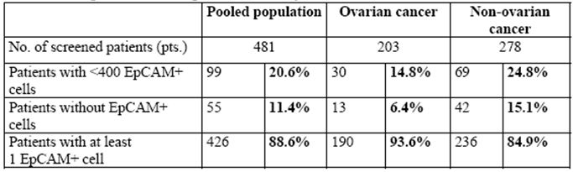
Review of primary disease among the non ovarian cancer patients indicated gastric carcinoma was present in 51% of patients followed by other tumour types and breast cancer. There were no relevant differences between treatment groups for distribution of tumour types and screening.
With regards to time since first cancer diagnosis in the ovarian cancer group, the median time to first diagnosis was 19 months with a range of 0-188 in the catumaxomab group and 23.5 with a range of 0-102 months in the control group. In the non-ovarian cancer group, the median time since first cancer diagnosis was 11 with a range of 0-229 months in the catumaxomab group, and 11 with a range of 0-343 months in the control group. All patients had at least stage III cancer.
Most ovarian cancer patients had undergone one or two surgeries with no relevant differences between the treatment groups. Most non ovarian cancer patients had undergone 0-1 surgery with no relevant differences between the treatment groups. In the ovarian cancer group, the two treatment groups were comparable regarding number of previous antineoplastic medication regimens: this was 3, with a range of 0-8, in the catumaxomab group; and 3, with a range of 0-10, in the control group. In the non-ovarian cancer groups, the treatment groups were comparable regarding the number of previous antineoplastic medication regimens: this was 1, with a range 0-10, in the catumaxomab group; and 1, with a range of 0-9, in the control group.
With regards to time since first diagnosis of ascites in the ovarian cancer group, the treatment groups were comparable in terms of times since diagnosis of ascites: this was 7, with a range 0-62 months, in the catumaxomab group; and 6.5, with a range of 0-82 months in the control group. In the non-ovarian cancer group, the treatment groups were comparable in terms of time since diagnosis of ascites: this was 2, with a range of 0-76 months, in the catumaxomab group; and 2, with a range of 0-58 months, in the control group. This is illustrated in Table 9. The time since last therapeutic ascites punctures was comparable between the treatment groups, as was the number of previous ascites punctures; these are again illustrated in Table 9.
Table 9: Status of primary disease and ascites history (Study IP-REM-AC-01).
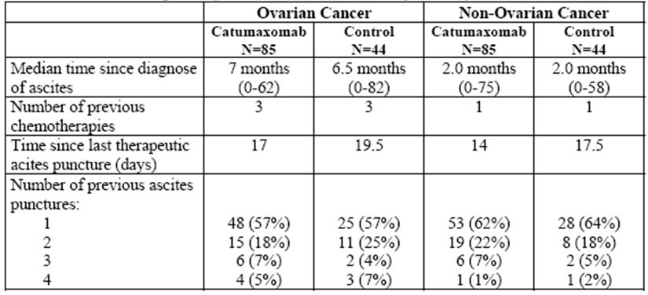
All ovarian and non-ovarian cancer patients had symptomatic ascites at screening. In the pooled population, the median size volume at Day 0 was comparable between the catumaxomab (2146 ml) and control group (2068 ml).
Review of the results for the primary endpoint (puncture free survival) demonstrated that in all cancer strata including the pooled analysis, puncture free survival was significantly longer with a p value of 0.0001 in the catumaxomab group compared to the control group. This is illustrated in Table 10 and Figure 3. In the pooled analysis, the median difference between the groups was 35 days at a 95% confidence interval (CI) of 25-45 days. The hazard ratio of the original analysis was 0.254 with a CI interval 0.185-0.350 corresponding to a 74.6% decrease in the risk for puncture or death of patients treated with catumaxomab. For ovarian cancer patients, the median difference between the groups was 41 days with a 95% CI of 32-50. For non-ovarian cancer patients, the median difference between the groups was 23 days with a 95% CI of 8-38 days.
Table 10: Puncture-free survival data including hazard ratios according to original analyses in Study IP-REM-AC-01.
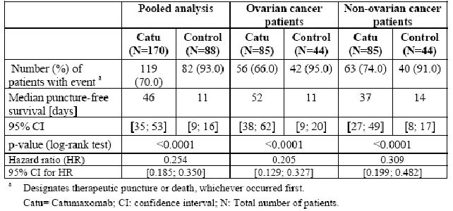
Figure 3: Kaplan-Meier estimates of puncture-free survival in the pooled population (full analysis set).
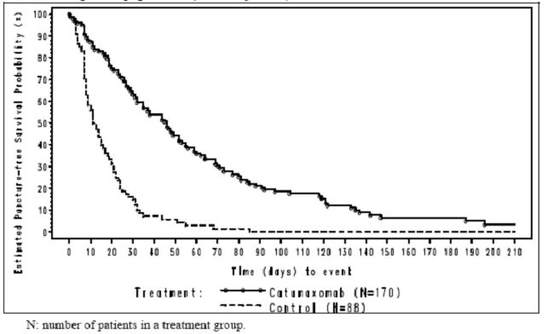
Two sensitivity analyses were undertaken to evaluate the results. Sensitivity analysis I was a conservative censoring of the full analysis set including all death cases before clock start in the catumaxomab arm. Sensitivity analysis II was a very conservative censoring of the full analysis set including in addition to all death cases before clock start any other censored observation.
For sensitivity analysis I in the catumaxomab group, 7% or 12/170 patients died before clock start. A proportion of 8/12 patients received catumaxomab and 10/12 patients belonged to the non-ovarian stratum. The puncture free survival time was set to zero for all twelve patients in the original and new analysis. Data of these patients were classified as censored observation in the original analysis, while all data was included as an event in the new analysis. This new analysis had an impact on the evaluation of catumaxomab group only.
Sensitivity analysis II resolved in a 100% event rate. It was determined that this must have an impact on the evaluation of puncture free survival for both the catumaxomab and control groups.
The results of these two sensitivity analyses are summarised in Table 11. The significantly longer puncture free survival of the original analysis was confirmed by the analysis above in both strata and the pooled population.
Table 11: Puncture-free survival sensitivity analyses (pooled population, full analysis set).
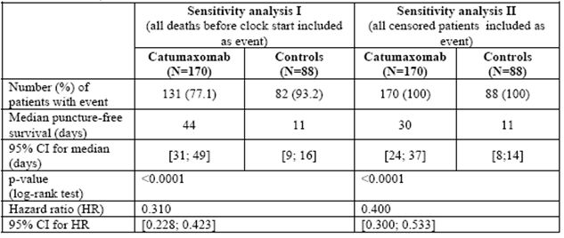
Review of the results for the secondary efficacy endpoints (time to first need for therapeutic ascites puncture) demonstrated that the median time was significantly longer in the catumaxomab group compared to the control group with a p value <0.0001 as illustrated in Table 12 and Figure 4. In the pooled analysis, the median difference between the groups was 64 days with a 95% CI of 47-81 days. For ovarian cancer patients, the median difference between the groups was 60 days with a 95% CI 41-79 days; for all non-ovarian cancer patients, the median difference was 65 days with a 95% CI 26-104 days.
Table 12: Time to first need for therapeutic ascites puncture in Study IP-REM-AC-01 including hazard ratios according to original analyses (full analysis set).
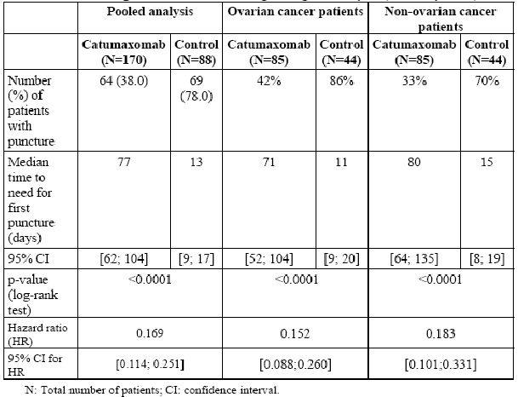
Figure 4: Kaplan-Meier estimates of time to first need of therapeutic puncture, pooled analysis (full analysis set).
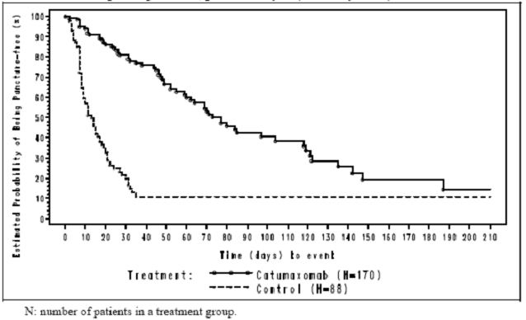
The significantly longer time to next therapeutic puncture seen for catumaxomab patients in the original analysis was confirmed by the alternative censored mechanism in which withdrawals were regarded as events. The hazard ratio for the original analysis was 0.169 and for the alternative censored mechanism 0.280. This indicated that catumaxomab reduced the risk for puncture by at least 72%. The upper limit of this 95% CI was markedly below one with a maximum of 0.392.
Results in the catumaxomab and control groups were comparable with regards to median time to puncture pre study in both strata. Time to first need for therapeutic puncture was significantly longer with a p value <0.0001 in the catumaxomab group compared to the control group and both cancer strata during the study. No pronounced difference was seen from median time to puncture pre study, while a clear increase in median time to puncture was observed in the catumaxomab group.
A correlation between collected ascites volume and time to puncture was undertaken. The results of a correlation analysis between ascites volume collected at puncture and time to puncture indicated that ascites fluid production occurred more rapidly in the control group compared to the catumaxomab group. The slope of the regression line for the control group was 2.7 times the slope of the regression line for the catumaxomab group for all ovarian cancer patients and 8.5 times the slope for non-ovarian cancer patients. This data is shown in Table 13 and Figures 5-6.
Table 12: Correlation analysis: collected ascites volume at puncture versus time to puncture (full analysis set).
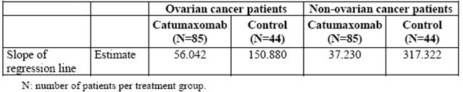
Figure 5: Collected ascites volume at puncture versus time to puncture, ovarian cancer patients (full analysis set).
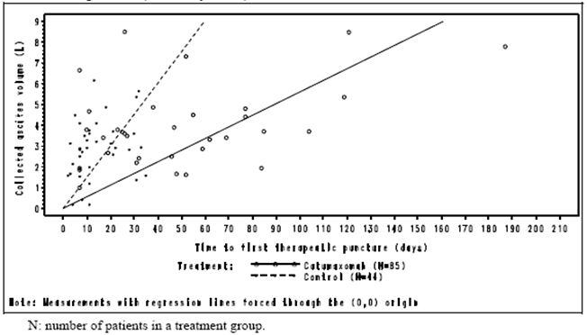
Figure 6: Collected ascites volume at puncture versus time to puncture, all non-ovarian cancer patients (full analysis set).
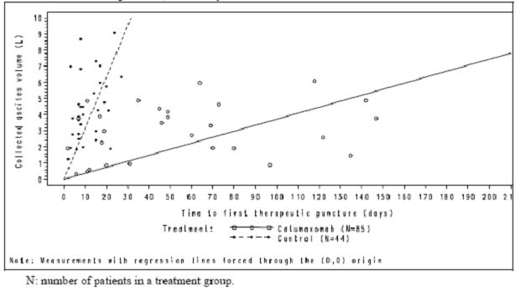
Review of median time to death without therapeutic puncture indicated that this was longer in the catumaxomab group than the control group. However, these differences are not statistically significant in any of the analysis groups.
In an attempt to assess ascites signs and symptoms of the various groups, a questionnaire had been developed in cooperation with the lead investigator covering 14 different ascites related signs and symptoms. No pooled analysis was carried out for this parameter but by visit six (that is, eight days after the last infusion for the catumaxomab group and eight days after Day 0 for the control group), fewer patients had signs and symptoms of the ascites in the catumaxomab group than the control group in 8/14 categories for the ovarian cancer patients (with statistical significance). For all non-ovarian cancer patients, fewer patients had signs and symptoms of ascites in the catumaxomab group than the control group in 6/14 categories (again with statistical significance).
In relation to ascites symptoms assessed by interview, with the exception of fatigue, fewer ovarian cancer patients in the catumaxomab group had symptoms than the control group for symptoms assessed by interview. Ascites symptoms assessed by interview were reduced (with statistical significance) at visit six in the catumaxomab group for abdominal pain, nausea, early satiety abdominal swelling and anorexia. For non-ovarian cancer patients, with the exception of heartburn, fewer patients in the catumaxomab group had symptoms in the control group of six for all signs and symptoms assessed. Ascites symptoms assessed by interview were reduced in the catumaxomab group for dyspnoea, abdominal pain and nausea. These differences were statistically significant.
For ascites signs assessed by physical and abdominal examination of ovarian cancer patients, the number of patients with ascites signs assessed by examination was reduced (with statistical significance) in the catumaxomab group for shifting dullness, fluid thrill and abdominal distension. Generally fewer patients in the catumaxomab group had ascites signs than the control group for signs assessed by physical and abdominal examination. For non-ovarian cancer patients, the number of patients with ascites signs as assessed by physical exam was reduced in the catumaxomab group for shifting dullness, fluid thrill and abdominal distension (with statistical significance). Generally fewer patients in the Catumaxomab group had ascites signs than the control group for all signs assessed by physical examination.
In order to assess overall survival and time to progression for the various treatment groups, a follow up was undertaken with the cut-off date for assessment of overall survival being 31 May 2007.
For overall survival, the two group analysis showed comparable results for the catumaxomab group and the control group in the pooled analysis set. In non-ovarian cancer patients, the median difference in the pooled analysis set group was four days and in the non-ovarian cancer group was three days; however, there was a clear difference in overall survival of 29 days in the ovarian cancer patients. Kaplan Meier estimates of overall survival for the pooled analysis are given in Figure 7. However, this was not statistically significant.
Figure 7: Kaplan-Meier estimates of overall survival (pooled analysis, full analysis set).
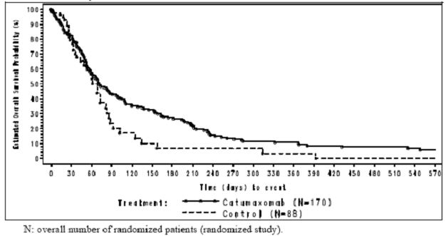
Review of the data according to the previously defined sensitivity analyses I and II again illustrated small differences in survival between various treatment groups and no significant differences.
In relation to assessment of time to disease progression, the protocol did not provide for a standardised method of determination of this in the post study period. Data was not analysed by independent readers. Accordingly, time to progression data was given by the investigator (in the post study case review forms) as a “yes/no” answer. The date of progression was recorded.
Utilising this approach for the two group analysis, there was a statistically significant difference between the two treatment groups for all populations analysed for the time to progression of the underlying cancer. Kaplan-Meier estimates of time to progression for the pooled analysis are shown in Figure 8.
Figure 8: Kaplan-Meier estimates of time to progression (pooled analysis, full analysis set).
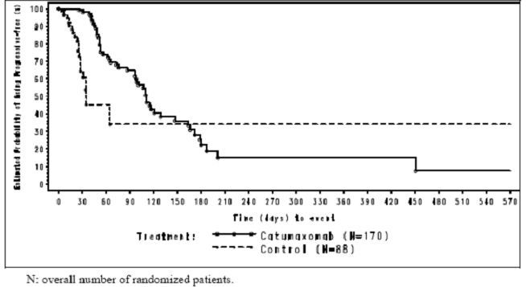
Analysis of progression free survival was not undertaken for the pooled population but for ovarian cancer patients the median progression free survival was significantly longer in the catumaxomab group than the control group: the p value was <0.0001. For all non-ovarian cancer patients, there was no statistically significant difference observed. It is important to note that these data were collected during the active part of the study, while the time to disease progression data was collected in follow up.
It was not possible to assess tumour response rates as there were very few patients with measurable disease.
Analyses of tumour cell load was undertaken during study in which there was a determination of tumour cell load of EpCAM+ tumour cells for the 10⁶ ascites cells as assessed by cytospin and light cycler PCR for the catumaxomab and control groups for screening and at puncture visit. In addition, measurements were performed in the catumaxomab group at visit three (before the second infusion) and visit five (one day after the last infusion).
No pooled analysis was carried out for this efficacy parameter. For ovarian cancer patients, the median tumour cell load was similar in both groups at screening. In the catumaxomab group, there was a pronounced decrease in tumour cell load during treatment. At visit three, 36.2% of the patients had tumour cell load of zero and at visit five 76.7% of patients had a tumour cell load of zero. There was a statistically significance difference between the two groups in tumour cell load at the puncture visit with p value of 0.0009 as indicated by Wilcoxon rank-sum test.
For all non-ovarian cancer patients, the median tumour cell load was lower in the catumaxomab group than in the control group at screening. In the catumaxomab group, there was a pronounced decrease in tumour cell load during treatment; at visit three, 48.4% of the patients had a tumour cell load of zero and by visit five, 89.1% of patients had a tumour cell load of zero. At puncture visit, there was a high degree of variability between patients in tumour cell load. The median tumour cell load was considerably lower in the catumaxomab group than the control group, but this difference was not statistically significant.
A further interesting parameter was measured in the post treatment follow up period for puncture free time for the catumaxomab treated patients. There was only a small number of patients involved in both catumaxomab and control groups, but it was demonstrated that the puncture free survival in catumaxomab treated patients was still prolonged in the post study period (34 days versus 25 days).
In an attempt to assess quality of life differences between the treatment groups, a European Organisation for Research and Treatment of Cancer (EORTC) QoL (Quality of Life) questionnaire title QLQC30 was assessed. For the pooled analyses, scores of most domains were similar in both treatment groups for screening and puncture visits. There was a high end degree of individual variability. For ovarian cancer patients, scores of most domains were similar for both groups, and similarly for non-ovarian cancer groups.
In an attempt to objectify assessments of ascites volumes, an evaluation of ascites volumes from CT scans by both local radiologists and central blinded readers demonstrated that the results were consistent in terms of appropriate times for puncture.
Review of daily collected ascites volumes revealed that for ovarian cancer patients and non-ovarian cancer patients the difference in median daily collected ascites volumes between the two groups was statistically significant: p values were p = 0.0006 for ovarian cancer patients and p <0.0001 for non-ovarian cancer patients. The median days for the fluid production were 3.3 times lower in the ovarian cancer catumaxomab group and 7.0 times lower in the non-ovarian catumaxomab group.
An optional single arm crossover period was added to the study to enable patients in the control group to be treated with catumaxomab after the end of their participation in the randomised part of the study. Before the patients were admitted to this phase of study, they were required to have had one protocol confirmed therapeutic ascites puncture after Day 0.
The primary efficacy endpoint for this phase of study was puncture free survival to time from one day after last infusion of catumaxomab to first need for therapeutic ascites puncture or time to death.
This crossover part allowed for intra individual comparison of patients from the randomised part – that is, when patients did not receive catumaxomab – and for the crossover part when the patients did receive catumaxomab. This meant the time to first need for therapeutic ascites puncture could be investigated in the same patients first without catumaxomab treatment and then after catumaxomab treatment. It is important to note that only a part of the control patients on the randomised part entered the crossover arm, and of those patients only a part had therapeutic puncture.
For ovarian and non-ovarian cancer patients, intra individual comparisons of time to first need for therapeutic ascites puncture between the randomised part of the study and the crossover period showed a shift towards longer intervals to therapeutic puncture during the crossover period. The median time to therapeutic puncture during the crossover period was considerably longer compared to the randomised part of the study. The small numbers involved in this part of the study precluded a statistical analysis.
In relation to the various cancer subgroups within the non-ovarian cancer patient group, it was possible to separately evaluate those patients with gastric carcinoma as they formed the majority of non-ovarian carcinomas. Puncture free survival was significantly longer with a p value of 0.0001 by log rank test with a median of 44 days in the Catumaxomab group compared to 15 days in the control group. The median difference was 29 days (Figure 9).
Figure 9: Kaplan-Meier estimate: puncture free survival for gastric cancer patients (full analysis set, Study IP-REM-AC-01).
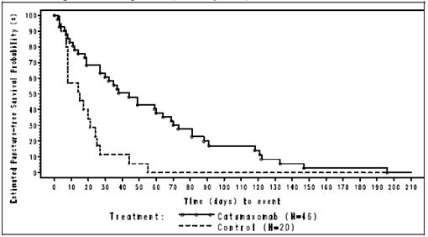
Time to first need for therapeutic puncture in the gastric cancer subpopulation was significantly longer with a p <0.0001 by log rank test in the catumaxomab group with a median of 118 days and in the control group a median of 15 days resulting; the median difference was thereby 103 days (Figure 10).
Figure 10: Kaplan-Meier estimate: time to first need for therapeutic puncture for gastric cancer patients (full analysis set, Study IP-REM-AC-01).
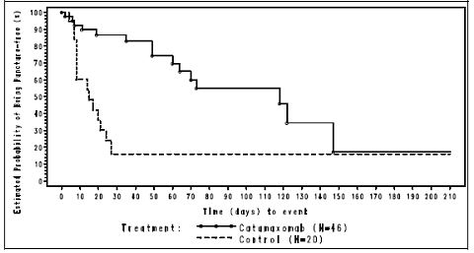
The analysis of overall survival demonstrated a statistically significant difference between the two treatment groups. With regard median overall survival, the difference was 27 days; this was statistically significant with a p value of 0.0313 (Figure 11).
Figure 11: Kaplan-Meier estimate: overall survival for gastric cancer patients (two-group analysis, full analysis set).
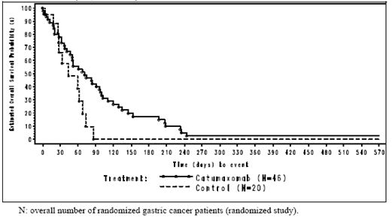
In relation to time to disease progression for the gastric cancer subgroup, again there was a statistically significant difference between the groups. The difference was 75 days.
With regards to the various other subgroups in the non-ovarian cancer patients, although the numbers are small the median puncture free survival days were longer for the catumaxomab treated patients versus control.
Another subgroup of interest was a comparison between patients with distant metastases than those without, demonstrating that despite the presence or absence of metastases, control of ascites was better with patients receiving catumaxomab. This was also apparent in patients with liver metastases as illustrated in Table 13.
Table 13: Correlation analysis: collected ascites volume at puncture versus time to puncture (full analysis set).
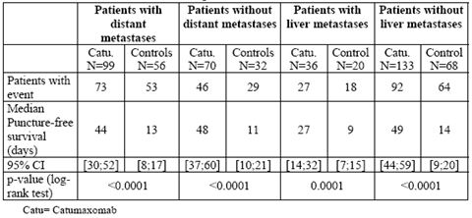
The development of HAMAs was considered a potential influence on puncture free survival in catumaxomab treated patients. Accordingly, data was analysed in relation to the development of HAMA positivity and compared to clinical outcome, that is, mainly puncture free survival. These statistical analyses were based on data from visit six, which was performed eight days after the fourth infusion of catumaxomab. As indicated, puncture free survival was significantly longer in HAMA positive patients compared to HAMA negative patients, that is, 64 versus 27 days, with a p value of <0.0001. A significant benefit for HAMA positive patients was also shown for time to first puncture being 104 versus 46 days (p = 0.0002) and also for overall survival 129 versus 64 days (p = 0.0003). When comparing the HAMA negative patients on the catumaxomab arm with the control patients, the results of catumaxomab treatment for the time to first puncture was 46 versus 21 days (p = 0.0045) and for puncture free survival was 27 versus 21 days (p = 0.0327); there was, however, no statistical significance for overall survival, which was 64 versus 62 days. The pattern of results was similar for the ovarian cancer and non-ovarian cancer stratum and for the subgroup of gastric cancer patients as well. The data would suggest that the development of HAMA positivity early after initiation of treatment has a beneficial effect.

Comment
The data from this moderate sized study involving a total of 258 patients evenly divided between those with ovarian cancer and those with various non-ovarian cancers demonstrated that for infusions of catumaxomab given approximately every three days over a period of ten days with increasing doses, this resulted in a significant delay in time to develop ascites requiring therapeutic paracentesis. These data were significant for both the ovarian and non-ovarian cancer groups as well as the various different parameters measured to ensure objective validity of the data.
In terms of characterising the rather unusual endpoint (puncture free survival) utilised in this study, and indicating its definition in terms of time to requirement for therapeutic paracentesis after completion of the infusion for the catumaxomab group versus time to therapeutic paracentesis for those not receiving catumaxomab infusions, the endpoint appears appropriate and certainly indicates the benefit in delay of further therapeutic paracenteses.
This study was conducted in EpCAM+ patients as determined by an appropriate laboratory test. This test is not commercially available in Australia but nevertheless more than 80% of patients with epithelial malignancies likely to cause malignant ascites are EpCAM+. Accordingly, the great majority of patients would have the potential to respond to catumaxomab irrespective of whether or not an appropriate a laboratory test was undertaken to determine EpCAM positivity. This investigator does not feel this represents an impediment to assessing the value of this study and the catumaxomab therapy.
Putting the catumaxomab approach to treatment in context, it is clear that the administration of catumaxomab results in a delay in the development of further malignant ascites by a median of 41 days. This is not a great length of time but nevertheless would clearly involve a degree of symptomatic benefit. Data is given to indicate a delay in time to disease progression in relation to catumaxomab administration, which essentially would relate to the recurrence of ascites as the principal determinant of disease progression. As demonstrated, there was no clear evidence of any overall survival benefit from administration of catumaxomab. In the context of being a symptomatic and palliative measure, this is not surprising.
This reviewer considers that the data from this study is robust and indicative of a symptomatic and palliative benefit for catumaxomab in this group of patients with malignant ascites. Although this is the only randomised trial, data from the supportive Study STP-REM-01 indicates a prolonged time to therapeutic paracentesis after four infusions of catumaxomab. Accordingly, this investigator considers that the administration of catumaxomab has a beneficial effect.

Safety
This review of the safety data presents an evaluation of pooled data from a total of five completed studies in which catumaxomab has been administered as an IP infusion in patients with malignant ascites. Two of the studies, namely AGO-OVAR-2 and IP-REM-PC-01, were not included in efficacy analysis as the treatment indications for these patients did not involve an assessment of malignant ascites. Nevertheless, the safety data from these two completed studies is appropriate for evaluation. It is worth commenting that the catumaxomab safety analyses in this submission related to trials in which catumaxomab was administered as a six hour constant infusion while the submission for marketing authorisation focussed on a three hour infusion time. Accordingly, safety data from six studies involving a three hour infusion time will be presented in the latter part of this safety assessment. Overall, a total of 258 patients were involved in the safety population.
For Study AGO-OVAR-2, this was a Phase II multicentre randomised open label study. It was designed to select the best out of two dose levels of catumaxomab administered by IP infusion to ovarian cancer patients that were refractory to platinum based chemotherapy. Patients did not require malignant ascites as part of the assessment.
For Study IP-REM-PC-01-DE, this was a Phase I multicentre uncontrolled sequential dose escalation study investigating the safety and tolerability and establishing the MDT of increasing doses of catumaxomab in patients with peritoneal carcinomatosis due to gastrointestinal malignancy.
Reviewing the integrated safety population among the total of 258 patients initially treated with catumaxomab, a total of 207 completed treatment. The mean age of these patients was 58.9 years with a range of 23-85 years. A total of 193 patients had malignant ascites of which 123 had ovarian cancer and 70 gastrointestinal cancers. A total of 157 patients (80 ovarian and 77 non ovarian) were from the pivotal Study IP-REM-AC-01. This accounts for almost two thirds of the overall population.
Most patients (79.5%) received all four infusions of catumaxomab as specified in the study protocol,l with four patients in Study STP-REM-01 receiving a fifth infusion. The mean total catumaxomab dose was 186.1+/-98.2 μg.
The most common cancers involved in this safety analysis were ovarian cancer followed by gastrointestinal cancer. Overall, 74.8% of the patients suffered from malignant ascites and all patients were in advanced stages.
Treatment emergent adverse events (TEAE) were those AEs occurring on therapy. Almost all patients in the overall population (98.8%) had a least one TEAE as indicated in Table 14. The percentage of patients with at least one TEAE considered by the investigator to be related to treatment was greater than the overall population being 90.3% compared to the pivotal study with 84.7% of patients. The percentage of patients who discontinued study therapy due to a TEAE considered related to study treatment was 5.4% in the overall population and for the pivotal trial 0.6%. The number of patients having a TEAE with ultimate death was 32.6% in the overall population and 45.2% in the pivotal study. A total of 15.1% of serious adverse events (SAEs) were considered related to study treatment by the investigator.
Table 14: Overview of treatment emergent adverse events (TEAEs) by group.
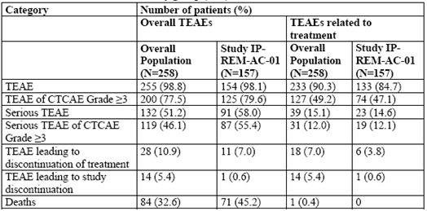
As might be anticipated, the most frequently reported TEAEs were gastrointestinal disorders involving 83.7% of patients, followed by general disorders and administration site conditions in 82.6% of patients. This is indicated in Table 15. Pyrexia, abdominal pain, nausea and vomiting were the most frequently reported TEAEs both in the overall population and pivotal trial. Catheter related complications were reported as TEAEs in five patients in the overall population, which included obstructive events, injection site infections and mechanical difficulties.
Table 15: Treatment emergent adverse events by system organ class in > 10% patients in either treatment group.
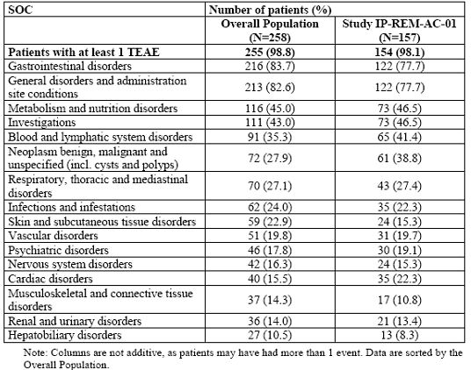
Pyrexia, abdominal pain, nausea, vomiting and lymphopenia were the most frequently reported TEAEs after all infusions in the pivotal study. In general, the proportion of patients with TEAEs was slightly higher after infusions one and three than after infusions two and four.
The nature of the four most common TEAEs considered at least possibly related to study treatment (namely pyrexia, abdominal pain, nausea and vomiting) were the same, and their frequency was comparable for both evaluation groups. A total of 90.3% of patients in the overall population had at least one TEAE considered by the investigator to be related to study treatment.
A total of 200 or 77.5% of patients in the overall population had at least one TEAE that was at least grade 3. Malignant neoplasm progression, abdominal pain and lymphopenia were the most frequent of these. Information on all grade 3/4 AEs and on median duration of these for the pivotal study is illustrated in Figure 12. The most frequent AEs of grade III/IV intensity for this pivotal study were lymphopenia, abdominal pain and pyrexia followed by elevated CRP (C reactive protein), fatigue, and elevated SGGT. AEs with the longest median duration were elevated CRP, elevated alkaline phosphatise, and asthenia. A total of 49.2% of patients in the overall population at least one grade III TEAE related to study treatment. The most frequently reported TEAEs were abdominal pain and lymphopenia. Symptomatic grade III/IV adverse reactions were experienced by 37.5% of the catumaxomab patients in the pivotal study. The frequency and median durations of these are displayed in Figure 13.
Figure 12: Adverse events of grade 3/4, catumaxomab group, safety set, N = 157 (Study IP-REM-AC-01).
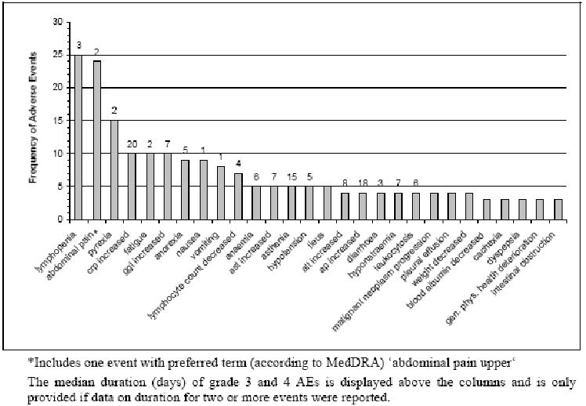
Figure 13: Symptomatic adverse drug reactions (ADRs) of grade 3, catumaxomab group, safety set, N = 157 (Study IP-REM-AC-01).
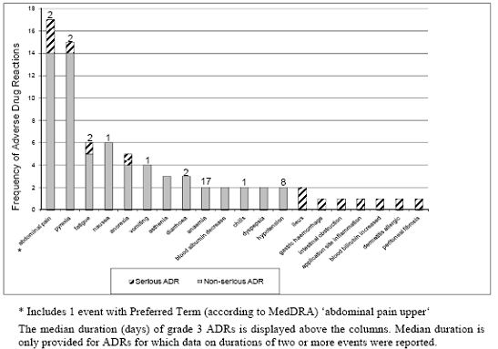
Reviewing specific AEs in relation to the cytokine related release syndrome (CRRS) and the systemic inflammatory response syndrome (SIRS), these were observed in the majority of patients treated with catumaxomab, generally being grade I or II in severity as indicated in Table 16. Of these CRRS related symptoms (namely pyrexia, nausea, vomiting, chills and hypotension), three cases were considered serious including one episode of pyrexia, one of hypotension, and also one episode of SIRS. Only the case of SIRS led to discontinuation of study medication. The onset of these AEs was on the day of infusion or the day after infusion in the majority of cases. The median duration of the grade 3/4 adverse reactions was only for one or two days. Symptomatic management of these symptoms with anti-pyretic analgesic and anti-emetic medication and volume repletion were generally successful.
Table 16: Cytokine related release syndrome (CRRS) and systemic inflammatory response syndrome (SIRS) by severity, catumaxomab group, safety set, N = 157 (Study IP-REM-AC-01).
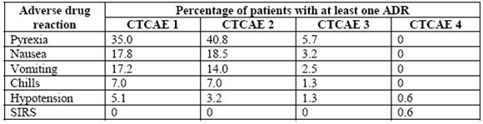
CTCAE: Common Terminology Criteria for Adverse Events
In relation to gastrointestinal adverse reactions including abdominal pain (constipation and diarrhoea), these were reported for the majority of patients and were generally grade 1 or 2 in severity as indicated in Table 17. Eight of the cases were reported as serious, including five cases of ileus and three of abdominal pain. Two of the cases including one abdominal pain and one ileus led to discontinuation of study medication. The onset of abdominal pain and diarrhoea was mainly on the day of infusion or the day after infusion, with a median duration of two days. Standard medication including analgesics, anti-diarrhoeal and electrolyte substitution were generally successful in management.
Table 17: Gastrointestinal adverse drug reactions by severity, catumaxomab group, safety set, N = 157 (Study IP-REM-AC-01).
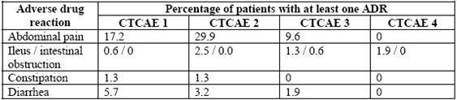
Adverse reactions including fatigue, asthenia, anorexia and general physical health deterioration are common AEs associated with chemotherapy and progressive malignancy. These symptoms were common in grade 1/2 severity and only occasionally documented in grade 3 severity as indicated in Table 18. Three of these cases were reported as serious including one fatigue, one anorexia and one general physical health deterioration, but none led to discontinuation of study medication.
Table 18: Fatigue/asthenia, anorexia and general physical health deterioration by severity, catumaxomab group, safety set, N = 157 (Study IP-REM-AC-01).
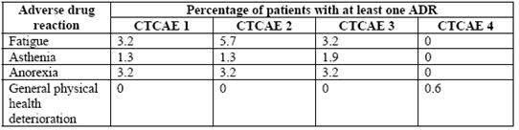
In the pivotal study it was demonstrated that adequate pre medication with agents such as paracetamol had a beneficial effect in reducing the incidence and severity of CRRS. Nevertheless, in most instances paracetamol only partially suppressed these symptoms and it is considered appropriate to plan evaluation of pre medication with steroids.
None of the AEs with an outcome of death that occurred after the start of the first infusion was considered related to catumaxomab. The majority of these deaths were due to progression of malignancy.
A review of the data revealed that 51.2% of the overall population experienced serious TEAEs. Progressive malignancy was the most common SAE, followed by ileus as a common complication of peritoneal malignancy, and then pleural effusion. Of these serious TEAEs considered related to study treatment, ileus and pyrexia were the most common. Only a small proportion of these were grade 3 in severity.
Review of treatment discontinuation due to AEs indicated that this was an uncommon situation in both treatment populations. Only a single patient in the pivotal trial ceased therapy because of TEAEs.
Review of clinical laboratory evaluations revealed that in the overall population, the most frequently reported AEs were increased CRP and SGGT as indicated in Table 19.
Table 19: Laboratory abnormalities reported as TEAEs occurring in >5% of patients in either group by preferred term.
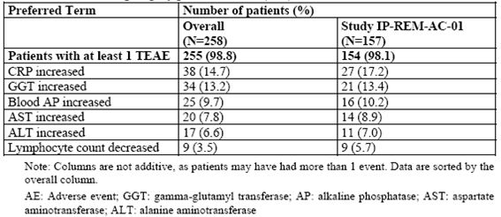
The elevated CRP is an indicator for inflammatory processes and therefore maybe influenced by the release of pro inflammatory cytokines as part of the mode of action of catumaxomab. Only a few of these laboratory findings were considered clinically relevant and there was no clear pattern in relation to haematology and/or blood chemistry changes. A tabular overview of haematology parameters for catumaxomab treated patients in the pivotal study is given in Table 20. It is noted that 17.2% of patients receiving catumaxomab in the pivotal study had a haematological abnormality of at least grade 3 who were considered clinically relevant. Coagulation abnormalities were considered clinically relevant if reported in the pivotal study in three patients and in the overall population in three patients with none being greater than grade 2 in severity.
Table 20: Median absolute values in haematology of catumaxomab treated patients, pooled analysis of ovarian and non-ovarian patients, over the treatment period (Study IP-REM-AC-01).
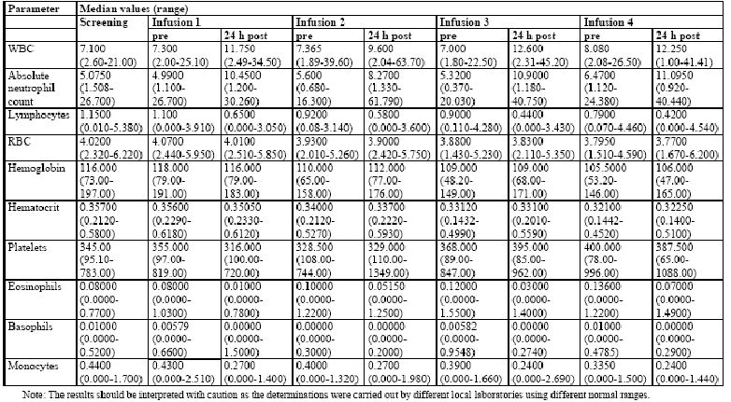
Clinically relevant serum chemistry abnormalities were observed in 28.3% of patients in the overall population and 40.8% of patients in the pivotal study. Liver enzyme elevations and total bilirubin abnormalities were considered clinically relevant in 20.5% patients in the overall population and 28.7% of patients in the pivotal study with 16.3% of patients in the overall population and 22.9% of patients in the pivotal study being grade III or greater. A tabular overview of liver enzyme changes is given in Table 21.
Table 21: Median absolute values in serum chemistry of catumaxomab treated patients, pooled analysis of ovarian and non-ovarian patients, over the treatment period (Study IP-REM-AC-01).
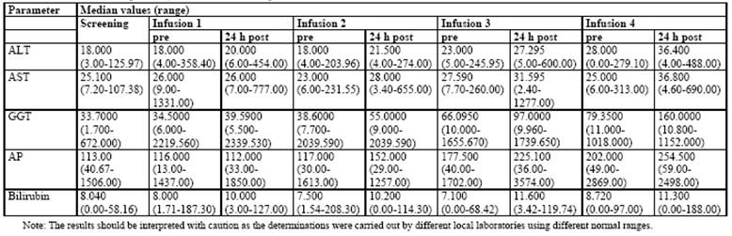
In reference to physical vital signs, physical findings and other clinical observations including pulse rate, temperature and blood pressure none showed clinically relevant abnormal changes in the various studies of note.

Safety analysis of three hour infusion studies
The studies discussed above in relation to safety evaluation involved IP infusion over a period of six hours, whereas the application planned for an IP infusion of catumaxomab over three hours. A total of 202 patients have been treated by three hour infusions in six separate studies. Study IP-REM-PC-01-DE was an investigation into patients with peritoneal carcinomatosis and with gastrointestinal malignancies undergoing a sequential dose escalation study assessing the safety and tolerability of the three hour infusion versus the six hour infusion. Data from the patients receiving the three hour infusion (n = 7) were compared to those patients receiving the six hour infusions (n = 5) and did not suggest an increased risk caused by shortening the infusion time. There is no influence of an impact on safety in this study.
Study IP-REM-PC-01 was a single centre uncontrolled open label phase I trial with sequential dose escalation for IP administration of catumaxomab to investigate the safety and tolerability of various dosages given directly into the open abdomen at the end of abdominal tumour surgery followed by post-operative IP infusion. Three different intra trial produced dose levels (5, 10 and 20 μg) were evaluated.
Six patients received three and six patients four post-operative IP infusions. In general, the safety profile observed in this study was similar to that seen in Study IP-REM-PC-01-DE than that of the six hour infusion of the pivotal study.
Study IP-REM-GC-02 was a multicentre open label randomised Phase II trial to investigate the outcome of an adjuvant treatment of catumaxomab in patients after curative resection of a confirmed gastric adenocarcinoma compared to surgery alone. The initial intra operative administration of 10 μg of catumaxomab as a bolus prior to resection was followed by a sequence of four ascending doses (10, 20, 50 and 150 μg) given as IP infusions post operatively. A total of 112 patients were enrolled with 55 randomised to catumaxomab versus surgery alone. The safety pattern for the catumaxomab group was generally in line with the expected pattern of AEs as previously described in the earlier studies, except for a more frequent occurrence of SIRS.
Study IP-CAT-GC-03 was an open label multicentre phase II study that was conducted with the safety and tolerability of catumaxomab in surgically resectable patients after neo adjuvant chemotherapy. The treatment with catumaxomab consisted of an initial dose of 10 μg given intra operatively as a bolus followed by four ascending doses of 10, 20, 50 and 150 μg administered three hourly by IP infusions post operatively. The study report remains under preparation. No undue AEs have been reported from preliminary analyses.
Study IP-CAT-OC-01 enrolled patients with advanced epithelial ovarian cancer who had undergone cytoreductive surgery after achieving a clinical complete response to chemotherapy. Patients then received four doses of three hour constant rate infusion of catumaxomab. The primary objective of the study was to determine the safety and tolerability. There were 47 patients in the safety analysis set, with 29 patients having completed four infusions within 21 days. The nature of AEs showed consistency with the experience of previous clinical trials from the established safety profile of catumaxomab.
Study IP-CAT-OC-02 enrolled adult female patients with advanced epithelial ovarian cancer who were planned to undergo tumour debulking surgery and adjuvant standard chemotherapy. The primary objective of the study was to determine the safety of an adjuvant treatment with catumaxomab in patients with epithelial ovarian cancer in terms of the post-operative complication rate, AEs and laboratory results. Patients were treated with 10 μg catumaxomab administered often in bolus followed by four escalating doses of catumaxomab as 10, 20, 50 and 150 μg as three hour infusions post operatively. Forty-one patients were evaluable for the primary safety endpoint. Safety data reflected the mode of action of catumaxomab generally in line with the expected pattern of AEs.

Comment
The data from this safety overview has generally shown that the IP administration of catumaxomab is associated with a safety profile consistent with the known mechanisms of action of catumaxomab including effects of cytokine release as well as systemic inflammatory release syndrome. Only a limited number of these AEs were grade 3/4 and no deaths occurred as a result of treatment. The majority of AEs were appropriately managed with symptomatic medication and plans are afoot for appropriate pre medication, which is likely to have a significant potential to reduce or prevent the incidence and severity of these AEs. No consistent disturbances of laboratory parameters were observed to raise concern regarding management of patients receiving IP catumaxomab.
The data with regards to the three hour infusion studies is consistent with that observed with the six hour infusion studies and does not raise any particular concerns regarding the proposed indication to utilise the three hour IP infusion in the proposed therapeutic application.

Post marketing experience
Catumaxomab was granted marketing authorisation in the European Union in April 2009. In May 2009, catumaxomab began to be available in Germany and Austria for treatment of IP therapy of malignant ascites in patients with EpCAM+ carcinomas where standard therapy was not available or no longer feasible. The only periodic safety update report available is to 20 October 2009 at which time approximately 130 patients had been treated with the marketed catumaxomab. No particular AEs were indicated.

List of questions
The only question this evaluator has is in relation to the issue of EpCAM positivity. It is noted there is no commercial kit available for assessment of EpCAM positivity and therefore any decisions regarding treatment will be empirical based on the nature of the malignancy. Accordingly, it would seem appropriate to decide in the PI that no particular mention to the requirement for assessment of EpCAM positivity be undertaken.

Clinical summary and conclusions

Clinical aspects
This application presents data for the monoclonal antibody catumaxomab to be approved for the indication of treatment of patients with malignant ascites due to EpCAM+ carcinomas. To support this submission three studies are provided. These involve:
- Study IP-REM-PK-01, a study of patients with malignant ascites due to EpCAM+ carcinoma to assess pharmacokinetics and pharmacodynamics of a six hour IP infusion of Catumaxomab;
- Study STP-REM-01, a study in patients with malignant ascites due to ovarian cancer in which a programme of sequential dose escalating six hour IP infusion of catumaxomab is undertaken to determine MTD.
Also included are pharmacodynamic assessments and some evaluation of efficacy.
The pivotal Study IP-REM-AC-01 is a Phase II/III study undertaken in patients with malignant ascites due to EpCAM+ carcinoma, which is a multicentre, multinational, two arm, randomised open label study involving comparison of six hour IP infusions of catumaxomab plus therapeutic paracentesis versus therapeutic paracentesis alone. This pivotal trial provides principal data with regards to assessment of efficacy as well as safety data. Additional safety data is also provided from several other studies to be indicated. Additional data is also provided with regards to consideration of a three hour IP infusion versus the six hour IP infusion utilised in the abovementioned trials.
Pharmacokinetic data is available from one study in this submission IP-REM-PK-01, which was a study undertaken to determine a systemic exposure and characterisation of pharmacokinetics of the trifunctional antibody catumaxomab administered IP in EpCAM+ cancer patients with malignant ascites. This was undertaken in seven centres in Europe involving 13 patients. Four IP infusions of catumaxomab of ascending doses of 10, 20, 50 and 150 μg were administered within an 11 day period. The principal objective was to characterise pharmacokinetics of catumaxomab after the second, third and fourth IP infusion. Secondary objectives were also to characterise cytokine levels after IP application of catumaxomab. This involved in vitro clonogenic assays from malignant ascites both short and long term.
A sensitive ELISA test method was developed with sufficient sensitivity for recovery of the very low antibody concentrations in ascites and in the systemic circulation after IP administration. Catumaxomab was also measurable in plasma in most patients. Pharmacokinetic analyses included determination of free catumaxomab in plasma together with assessment of several pharmacokinetic parameters.
Of the 13 patients enrolled, 11 received four and 2 received three IP infusions of catumaxomab. Nine of these patients had a diagnosis of ovarian cancer, three pancreatic cancers and one gastric cancer.
Quantifiable concentrations of catumaxomab could be determined in the plasma of 10/13 patients, and for all 13 patients in the ascites fluid. Despite high intra individual variability, a trend towards increased concentrations in plasma as well as ascites with the number of infusions and the doses applied were observed. After achieving the maximum in each, dosing interval concentrations tended to decline before the next dosing interval. Pharmacokinetic parameters based on the pharmacokinetically plausible values, that is:
- extent of exposure (AUC_{last}) had a geometric mean of 1700 day pg/ml, with a range of 0-1344 8-pg/ml;
- maximum systemic exposure (C_{max}) had a geometric mean above zero of 489pg/ml, with a range of 0-2290pg/ml
- elimination half-life (t_{½}) mean of 4.05 days, with a range of 0.73-17.5 days.
Other key results included the highest concentrations of the IP administered catumaxomab were detected in the ascites fluid as intended. After the third and fourth IP administration, catumaxomab was also detected in plasma showing systemic availability. Comparisons of systemic exposure to cytokine concentrations as well as clinical findings did not show any apparent relationship. These results indicated that systemic exposure determined after IP application of catumaxomab does not raise safety concerns.
Long term and short term clonogenic assays as well as T cell and macrophage proliferation assays were performed in Study IP-REM-PK-01 as well as the pivotal Study IP-REM-AC-01. These were designed to analyse:
- the number of EpCAM+ tumour cells and malignant ascites following administration of IP catumaxomab;
- the ratio between EpCAM+ tumour cells and CD45+ leucocytes;
- expression of T-cell activation markers CD69; and
- IFN-gamma levels, as well as systemic cytokine levels.
According to the postulated mechanism of action of catumaxomab, the elimination of tumour cells in the peritoneal cavity leads to a reduction of fluid production by interfering with the mechanisms for ascites production.
Results of the pharmacodynamic assessments revealed that there was a decrease of EpCAM+ tumour cells/CD45+ leukocyte ratio until the last IP infusion of catumaxomab. This indicated that the tumour cell reduction was not caused by a simple dilution or washout effect, but by a specific immunological reaction:
- Increased expression of activation markers on T cells (CD69) after administration of catumaxomab;
- T cell and macrophage proliferation assay, long term clonogenic assay and stimulation of IL-6 demonstrated that the hypothesis for immunological mode of action supported by pharmacodynamic data obtained from patients with malignant ascites; and
- Increased production of IFN gamma, IL-2 and IL-6 in ascites fluids due to catumaxomab.
Thus, these pharmacodynamic results support the direct anti-tumour effect of catumaxomab when administered IP in patients with malignant ascites.
Because catumaxomab involves a combined mouse and rat antibody, it was anticipated that there would be a potential development of anti-drug antibodies HAMA and HARA following treatment with catumaxomab. In order to assess the potential influence of this from the pivotal study, serum samples of the vast majority of patients were evaluated. More than 95% were negative for HAMA prior to administration of catumaxomab. However, before the fourth infusion, 91% of patients with ovarian cancer and 98% with non-ovarian cancer were still negative for HAMA. Eight days after last infusion of catumaxomab, 82% of the ovarian cancer patients and 69% non-ovarian cancer patients tested HAMA positive; one month after the fourth infusion, 95% of ovarian cancer patients and 94% of non-ovarian cancer patients were HAMA positive. The data demonstrated that patients who became HAMA positive had a significantly longer overall survival compared to HAMA negative patients but the direct implication of this is not clear. Nevertheless, it does indicate no apparent AEs from the development of HAMA antibodies in patients receiving IP catumaxomab.
Study STP-REM-01 was a Phase I/II study to investigate the tolerability and efficacy of IP catumaxomab in patients with malignant ascites due to ovarian cancer. It was also a plan to identify the maximum tolerated dose of increasing doses of 5-200 μg catumaxomab administered repeatedly for 4-5 doses at a constant rate six hour IP infusion. A total of nine centres throughout Europe participated in this multicentre study.
Five IP infusions with catumaxomab were administered on Day 0, 3, 6 and 9 for the four infusions and the last dose group received a fifth infusion on Day 13. Patients were allocated to 1/6 dose groups until the MTD was established. At least three patients were to be treated in each dose group. If none of the three patients experienced a DLT on a certain dose, the next three patients were treated with the next highest dose. If 1/3 patients experienced a DLT, a further three patients up to a total of six were investigated at that dose. If 2/3 of that dose group suffered a DLT, the dose was not to be increased any further and the data steering board decided whether the previous dose was to be considered as MTD.
A total of 26 patients were screened and 23 patients treated. The patients had a mean age of 62 years and all had advanced stage ovarian cancer having received at least one line of previous chemotherapy, with a median of three.
Two DLTs occurred in dose group five which determined the MTD as being at dose group five, that is, 10, 20, 50 and 200 μg. Accordingly, this became the basis for the dosing schedule to be undertaken for the pivotal study.
In relation to study efficacy, the ascites flow rate showed a mean decrease by 138ml/hr from 156ml/hr at baseline to 45ml/hr after the fourth infusion. Tumour cell elimination in the ascites took place quickly and efficiently; at the last individual measurement the EpCAM concentration was <0.1% or negative in all patients.
Together, this data established the MTD for the pivotal study and indicated a degree of efficacy for administration of IP catumaxomab in patients with advanced stage ovarian cancer with malignant ascites.
The pivotal Study IP-REM-AC-01 was a two arm randomised in a 2:1 fashion open label Phase II/III study in EpCAM+ cancer patients with symptomatic malignant ascites using paracentesis plus catumaxomab versus paracentesis alone. This study was undertaken in 75 centres in 13 countries. The primary objective was to demonstrate the superiority of the treatment with paracentesis plus catumaxomab over paracentesis alone in terms of puncture free survival. This was defined as the time after Day 0 for the control group and one day after the last infusion for the catumaxomab group to first need for therapeutic ascites puncture, or death (whichever occurred first). Other variables assessed included changes in ascites volume as computed by CT images, volume of collected ascites fluid, assessment of ascites signs and symptoms, and tumour cell quantification of the ascites fluid. Overall survival and time to disease progression as well as progression free survival were also assessed.
The study population consisted of a total of 258 patients divided into two strata, 129 patients with ovarian cancer and 129 with non-ovarian cancer. In each cancer stratum, 85 patients were randomised for treatment paracentesis plus catumaxomab, and 44 patients randomised to treatment with paracentesis alone.
Patients in the catumaxomab group received catumaxomab as four six-hour constant rate IP infusions of 10 μg (Day 0), 20 μg (Day 3), 50 μg (Day 7), and 150 μg (Day 10). Up to five follow up visits were scheduled after the last infusion for the catumaxomab group on Day 0 and the control group at eight days, one month, three months, five months, and seven months.
Patients in the control group were offered to be treated with catumaxomab after the end of their participation in the randomised part of the study.
Demographics among the ovarian cancer patients indicated a median age of 59 years for the catumaxomab group and 58 years in the control group. In the non-ovarian cancer group, the median age was 58.6 years in the catumaxomab group and 58 years in the control group.
Most ovarian cancer patients had undergone one or two surgeries and most non ovarian cancer patients had undergone 0-1 surgery. Among the ovarian cancer group, the two treatments were comparable regarding the number of previous anti neoplastic medication regimens, with a median of three in the catumaxomab group and three in the control group. In the non-ovarian cancer group, the treatment groups were comparable, with a median of one for both groups.
Among the non-ovarian cancer patients, gastric cancer was the most frequent in 51.2% followed by other tumour types and breast cancer.
Review of the results revealed that in all cancer strata, including the pooled analysis puncture free survival was significantly longer in the catumaxomab group compared to the control group (p < 0.0001). In the pooled analysis, the median difference between the groups was 35 days with a hazard ratio being 0.25, which corresponded to a 74.6% decrease in risk for puncture or death for patients treated with catumaxomab. For the ovarian cancer patients, the median difference between the groups was 41 days, and for all non-ovarian cancer patients the median difference was 23 days. Review of sensitivity analyses confirmed this significant difference for all groups.
Review of secondary efficacy endpoints revealed that in time to first need of therapeutic ascites puncture, the median time to first need of therapeutic puncture was significantly longer in the catumaxomab group compared to the control (p < 0.0001). In the pooled analysis, the median difference between the groups was 64 days; for ovarian cancer patients the median difference between the groups was 60 days, and for non-ovarian cancer patients was 65 days.
Review of the correlation between collected ascites volume and time to puncture indicate that the ascites fluid production occurred more rapidly in the control group compared to the catumaxomab group. A slope of the regression line for the control group was 2.7 times the slope of the regression line for the catumaxomab group for all ovarian cancer patients, and 8.5 times the slope for non-ovarian cancer patients. The evaluation of ascites signs and symptoms revealed that at visit six (that is, eight days after last infusion for the catumaxomab group and eight days after Day 0 for the control group), statistically significant fewer patients had signs and symptoms of ascites in the catumaxomab group than the control group in 8/14 categories assessed by questionnaires. For the non-ovarian cancer patients, statistically significant fewer patients had signs and symptoms of ascites in the catumaxomab group than the control group in 6/14 categories.
Assessment of tumour cell load revealed that for ovarian cancer patients the median tumour cell load was similar in both groups at screening but in the catumaxomab group there was a pronounced decrease in tumour cell load during treatment and at visit five; one day after the last infusion, 76.7% of the patients had a tumour cell load of zero. There was a significant difference between the two groups in tumour cell load at the puncture visit (p = 0.0009). For the non-ovarian cancer patients there was a pronounced decrease in tumour cell load; as indicated at visit five, 89.1% of the patients had tumour cell load of zero. The median tumour cell load was considerably lower in the catumaxomab group than the control group.
However, it is important to note that there were no significant differences for the two treatment groups in relation to overall survival. The mean overall survival for the catumaxomab group was 110 days and 81 days in the control group. In the non-ovarian cancer patients, the median overall survival was 52 days in catumaxomab group and 49 days in the control group. It is of some interest that in the gastric cancer patients, there was a significant difference in overall survival being 71 days in the catumaxomab group and 44 days in the control group (p = 0.0313).
Catumaxomab was consistently superior to control in time to tumour progression for all types of cancer studies (p < 0.05). For groups with median time to progression was ~110 days for the catumaxomab group and ~35 days in the control group.
In relation to progression free survival for ovarian cancer patients, the median progression free survival was significantly longer in the catumaxomab group (64 days) than the control group (35 days) (p < 0.0001). For all non-ovarian cancer patients there was no statistically significant difference observed between the catumaxomab (53 days) and control (33 days) groups (p = 0.153).
The crossover part of the study was where patients in the control group who had completed the randomised part of study were then able to be treated with catumaxomab. It is shown that among the 29 ovarian cancer patients that subsequently went on to receive catumaxomab, the median time to need for first therapeutic puncture after completion of infusion was 41 days; in the non-ovarian cancer patients, this was 52 days. This is clearly indicative of a therapeutic benefit as the median time to need for first therapeutic puncture during the randomised part of study was 10 days for the ovarian cancer patients and 7 days for the non-ovarian cancer patients.
These data demonstrate a therapeutic benefit for IP administration of catumaxomab in prolonging the time to requirement for therapeutic paracenteses in patients with malignant ascites due both to ovarian cancer and non-ovarian cancers. This represents a palliative measure, but in symptomatic terms is of very definite benefit to patients in the late stages of their malignancy.
In relation to safety, a pooled analysis of safety data for the IP infusion of catumaxomab over a six hour period is provided from five completed studies, including the three principal studies mentioned above along with two extra studies: Study HEO-OVAR-2.10 and Study IP-REM-PC-01-DE. Safety data from analyses of five studies involving a three hour infusion time (the proposed infusion time for the marketing application) are also provided from Studies IP-REM-PC-01 Addenda I and II and Studies IP-REM-GC-01, IP-REM-GC-02, IP-CAT-GC-03, IP-CAT-OC-01 and IP-CAT-OC-02.
For the six hour infusion data, a total of 258 patients were treated in the five studies using the IP administration of catumaxomab. A total of 207 patients completed the treatment. A total of 98.1% of patients in the pivotal study had at least one TEAE. A proportion of 90.3% of patients in the overall population and 84.7% of patients in the pivotal study experienced at least one TEAE considered by the investigator to be related to study treatment. The most frequently reported TEAEs for patients in the overall population were gastrointestinal disorders (83.7%) followed by general disorders and/or administration site conditions (82.6%), metabolism and nutrition disorders (45%) and investigations (43%).
The nature and frequency of TEAEs considered related to study treatment was similar to those of all TEAEs with pyrexia, abdominal pain, nausea and vomiting the most frequently reported TEAEs considered related to study treatment.
Abdominal pain was reported as a TEAE in 58.1% of patients. This transient effect was partially considered to be related to study procedures like paracentesis and IP infusions leading to peritoneal irritation reaction. Abdominal pain reached an intensity of grade III in 12.4% of patients but resolved under symptomatic treatment.
The percentage of patients who discontinued study therapy due to a TEAE considered related to study treatment was 5.1% for the overall population. There were no TEAEs with a fatal outcome considered related to catumaxomab by the investigator.
The percentage of patients with a TEAE with outcome of death was 32.6% in the overall population and 45.2% in the pivotal study. The pivotal study had a considerably longer observation period than the other four studies.
Overall, 76.7% of patients in the tested population had a least one TEAE of at least grade III. Malignant neoplasm progression (24.8%), abdominal pain (12.4%) and lymphopenia (9.3%) were the most frequently reported TEAEs of at least grade III in the overall population. The reported TEAEs were in general mild to moderate in intensity and reversible after symptomatic treatment.
The data demonstrated that symptoms related to cytokine release were dominant, namely pyrexia, chills, nausea, vomiting as well as symptoms of SIRS such as systemic inflammatory response. However, these were generally mild to moderate in intensity responding to appropriate symptomatic medication. Plans are underway to evaluate various premedication approaches including the use of steroids.
Data from the three hour infusion studies have essentially revealed a similar spectrum and degree of AEs indicating that this approach to administration of catumaxomab is not associated with any alteration in the AE profile.

Benefit risk assessment
The data provided in this submission has indicated that the administration of catumaxomab in patients with malignant ascites due to ovarian and other malignancies particularly gastrointestinal is associated with a therapeutic benefit. This is indicated in terms of reducing the frequency of required therapeutic paracentesis in patients with malignant ascites. The pivotal study provided a robust trial determining this benefit. It is worth commenting that the principal endpoint from this trial (puncture free survival) was an appropriate way of assessing potential benefit of an approach which is essentially designed to reduce a specific event in the context of an overall malignancy, that is, to reduce the requirement for therapeutic paracentesis in patients who developed malignant ascites as part of their late stage cancer. This represents a palliative and symptomatic management approach; nevertheless, this has value in the context of reducing patient discomfort, frequency of visits to hospital, and a reduction in degree of protein depletion from patients by reducing the frequency of drainage of ascites (a protein rich fluid). The data from this pivotal study did not demonstrate any influence on overall survival, which is not surprising but is of some interest that the data did suggest benefit in terms of time to disease progression. This most likely represents the fact that in many patients with ovarian and other gastrointestinal cancers, malignant ascites is the principal determinant of disease and therefore determination of disease progression when recurrent ascites develops.
It is also worth commenting at this point with regards to the issue of EpCAM positivity. This reviewer considers that at least 80% of patients with ovarian cancer and similar percentages of patients with other gastrointestinal cancers such as gastric cancer are EpCAM+, and that actual measurement of EpCAM positivity by laboratory assessment would not be of major value. There is no commercial kit available in Australia for such an evaluation; therefore, it is not likely to be undertaken. Nevertheless as the vast majority of patients with malignant ascites are likely EpCAM+ and therefore have potential to benefit from catumaxomab, there would seem no impediment to marketing the agent for patients with epithelial based malignancies developing ascites.
The trade off in terms of risk for this patient population essentially relates to a requirement for hospitalisation to receive the IP infusions of catumaxomab. With an implanted peritoneal catheter, this should be kept to a relative minimum. Nevertheless, the patients would require a three hour visit to hospital over at least 4-5 visits initially to benefit. The side effect profile was generally mild to moderate (while occurring frequently) and managed with appropriate symptomatic medication. The planned development of premedication approaches is likely to be of some assistance in this regard.
The data provided for the proposed indication for catumaxomab is essentially from one pivotal study. This represents a relatively limited amount of information but nevertheless is a robust result. As a considerable period of time would be required to accrue patients for a further follow up evaluation, this reviewer feels that approval for registration is still appropriate on the basis of a single study.
This reviewer therefore supports the proposed registration of catumaxomab but considers that the proposed indication should be altered from “treatment of patients with malignant ascites due to EpCAM+ carcinomas” to an alternative “treatment of patients for malignant ascites due to epithelial cell malignancies”. This avoids the concern regarding laboratory testing for EpCAM positivity as well as covering at least 80% of those patients most likely to have potential benefit from the use of IP catumaxomab.

V. Pharmacovigilance findings

Risk management plan
The sponsor submitted a Risk Management Plan which was reviewed by the TGA’s Office of Product Review (OPR).

Safety specification
The sponsor provided a summary of Ongoing safety Concerns which are shown at Table 22.
Category | Safety concerns (Identifier)
Important identified risks | cytokine release related symptoms (1)  systemic inflammatory response syndrome (SIRS) (2)  hepatic and hepatobiliary disorders (HHD) (3)  transient decrease in peripheral lymphocyte count (4)
Important potential risks | early occurrence of HAMA/HARA* in plasma (5)  limited scope of recommended premedication paracetamol with regard to cytokine release related symptoms (6)  gastric haemorrhage or upper GI haemorrhage (7)  doses higher than the recommended dose of catumaxomab per infusion (8)  off label use (9)  ileus, intestinal perforation, intra-abdominal infection, catheter related infection (10)  accidental IV infusion instead of IP (15)
Important missing information | Populations not studied:  patients with at least severe (or worse) hepatic dysfunction not studied and/or at least 70% of the liver metastasised not studied (11)  patients with at least moderate (or worse) renal dysfunction not studied (12)  patients with portal vein thrombosis/obstruction not studied (13)  non Caucasian patients not studied (14)
HAMA: human anti mouse antibodies
HARA: human anti rat antibodies

OPR reviewer comment:
Pending the evaluation of the clinical aspects of the safety specification, the above summary of ongoing safety concerns is acceptable.

Pharmacovigilance plan

Proposed pharmacovigilance activities
The sponsor has proposed to undertake a combination of routine and additional pharmacovigilance activities for each of the identified safety concerns.
The sponsor provides a discussion of the routine pharmacovigilance practices undertaken by Fresenius Biotech GmBH (the European sponsor).
In addition to routine pharmacovigilance activities, the sponsor has proposed to undertake additional activities for the important potential risks: early occurrence of HAMA/HARA (5) and limited scope of recommended premedication paracetamol with regard to cytokine release related symptoms (6); and also for each of the safety concerns identified as missing information (safety concerns 11-14).
The proposed additional activities are as follows:
- Early occurrence of HAMA/HARA (5)
  - Further clinical investigation on the occurrence of HAMA/HARA and the potential risk for patients in a Phase IIIb clinical study.
- Limited scope of recommended premedication paracetamol with regard to cytokine release related symptoms (6)
  - Clinical investigation of a different premedication in a Phase IIIb clinical study.
- Missing information (safety concerns 11-15)
  - Collect important missing information using a specific questionnaire in the context of spontaneous reporting.
The Phase IIIb study being used to investigate the occurrence of HAMA/HARA and use of premedication is Study IP-CAT-AC-03-PR-01; a two arm, randomised, open label, Phase IIIb study investigating the safety of a three hour IP infusion of catumaxomab with and without prednisolone premedication in patients with malignant ascites due to epithelial cancer.

OPR reviewer’s comments in regard to the pharmacovigilance plan and the appropriateness of milestones:
While there is no objection to the sponsor undertaking the proposed combination of routine and additional pharmacovigilance activities, it is recommended to the Delegate that the sponsor provides additional information on some of their proposed activities.
- The sponsor has submitted the EU RMP and therefore the discussion on routine pharmacovigilance practices relates directly to the European sponsor. It is recommended that the sponsor be required to provide a detailed description of the Australian pharmacovigilance system. This detailed description should not only detail the activities undertaken in Australia but also details on how the Australian sponsor interacts with their global colleagues, including, for example, if Individual Case Safety Reports (ICSRs) from Australia will be entered into the Fresenius Biotech global safety database (ARISg) as outlined in the RMP and if there is an Australian Safety Committee Meeting or if Australian reports of AEs are considered at the EU Safety Committee Meeting (SACOM).
- The sponsor has not provided a copy of the protocol for the Phase IIIb study, making an assessment of this additional pharmacovigilance activity difficult. The information in the RMP indicates that the study should be completed or nearing completion by now; the milestone for reporting states that the Case Safety Reports are due June 2011. It is recommended that the sponsor be required to provide an update on the current status of the Phase IIIb study.
- A copy of the questionnaires that the sponsor has proposed to use to collect important missing information has not been provided. It is recommended that the sponsor be required to provide a copy of the questionnaire in order to allow an evaluation of this proposed activity. Furthermore, it is recommended that the sponsor be required to provide information on how the sponsor plans to evaluate the effectiveness of the use of the questionnaires as an additional pharmacovigilance activity.

Risk minimisation activities

Sponsor’s conclusion in regard to the need for risk minimisation activities
For some of the Ongoing Safety Concerns the sponsor has determined that routine risk minimisation activities are sufficient as the risks are considered to be predictable and manageable.

OPR reviewer comment:
The sponsor’s evaluation of the need for risk minimisation activities is incomplete. In the RMP, the sponsor has stated:
“Each safety concern is presented with the applicant's position on the need for additional risk minimisation activities and the relevant justification... In these tables only those risks and missing information are presented where routine risk minimisation activities are foreseen.”
Despite this statement, a number of the safety concerns have been omitted from tables and the applicant’s position on the need for additional risk minimisation activities is not present. In contrast to the statement above, the summary of the RMP indicates that routine activities will be undertaken for all of the Ongoing Safety Concerns.
Nevertheless, through the reading of the entire RMP, the nature of the proposed indication and the clinical setting in which catumaxomab will be administered, it is evident that routine risk minimisation activities are sufficient for all of the Ongoing Safety Concerns.

Potential for medication errors
The sponsor has provided the following discussion on the potential for medication errors:
“Incorrect dosing
The potential for medication error through incorrect dosing is minimised by using a colour coding scheme on all primary and secondary packaging materials (syringe label, blister label and carton box):
Removab 10 mg: Blue
Removab 50 mg: Red
Accidental IV infusion instead of IP
The potential risk of medication error through administration via the IV use is minimised by displaying the route of administration in a prominent way on all components of the primary and secondary packaging material.
One case of accidental IV administration instead of IP was reported from marketed use of Removab (catumaxomab). Due to this experience, the medication administration record decided to add “accidental IV infusion instead of IP” as an important potential risk including appropriate measures to the updated EU RMP.
Removab is indicated for the IP treatment of malignant ascites in patients with EpCAM+ carcinomas where standard therapy is not available or no longer feasible.
Removab is marketed in the form of a concentrate for solution for infusion that has to be diluted in saline solution contained in a 50 ml syringe prior to IP administration to the patient. In the hospital environment this dilution step is routinely performed in the hospital pharmacy. The 50 ml syringe containing the diluted Removab solution for infusion is then transferred from the hospital pharmacy to the patient in the hospital ward for IP application.
As the IP route of administration is uncommon, we plan to provide a warning sticker for the 50 ml syringe containing the diluted Removab solution. This sticker would indicate the name of the product (Removab) as well as the route of application (IP use) and would be included in each packaging of Removab.”

OPR reviewer comment:
The sponsor’s discussion of the potential for medication errors is considered to be appropriate.
The mock ups of the Australian packaging show that the different concentrations can be clearly distinguished by their packaging.
The use of a warning sticker on the diluted solution to alert those administering the infusion that it is for IP infusion only is considered appropriate to minimise medication errors due to incorrect route of administration. However, it is recommended to the Delegate that the sponsor be required to confirm that the warning stickers will be included in the Australian packaging and to provide a mock up of the sticker, or if a mock up is not available, a copy of the text that will be on the sticker should be provided.

Risk minimisation plan

Planned actions
The sponsor has not proposed any additional activities beyond routine risk minimisation and therefore there is no risk minimisation plan.

OPR reviewer comment:
None.

Summary of recommendations
The OPR provides these recommendations in the context that the submitted RMP is supportive to the application and that the implementation of a RMP satisfactory to the TGA is imposed as a condition of registration.
- It is recommended to the Delegate that the sponsor update the “Summary of safety aspects or potential risks from nonclinical studies” reflect the non clinical evaluator’s comments: “The argument that catumaxomab is unlikely to bind EpCAM in intact tissues has not been substantiated by empirical data. Therefore, adverse reactions at peripheral EpCAM expressing tissues (that is, gastrointestinal tract and pancreas) must be assumed to be a risk.”
- While there is no objection to the sponsor undertaking the proposed combination of routine and additional pharmacovigilance activities, it is recommended to the Delegate that the sponsor provides additional information on some of their proposed activities.
  - The sponsor has submitted the EU RMP and therefore the discussion on routine pharmacovigilance practices relates directly to the European sponsor. It is recommended that the sponsor be required to provide a detailed description of the Australian pharmacovigilance system. This detailed description should not only detail the activities undertaken in Australia but also details on how the Australian sponsor interacts with their global colleagues, including if ICSRs from Australia will be entered into the Fresenius Biotech global safety database (ARISg) as outlined in the RMP and if there is an Australian Safety Committee Meeting or if Australian reports of AEs are considered at the EU Safety Committee Meeting (SACOM).
  - The sponsor has not provided a copy of the protocol for the Phase IIIb study, making an assessment of this additional pharmacovigilance activity difficult. The information in the RMP indicates that the study should be completed or nearing completion by now; the milestone for reporting states that the CSR is due June 2011. It is recommended that the sponsor be required to provide an update on the current status of the Phase IIIb study.
  - A copy of the questionnaires that the sponsor has proposed to use to collect important missing information has not been provided. It is recommended that the sponsor be required to provide a copy of the questionnaire in order to allow an evaluation of this proposed activity. Furthermore, it is recommended that the sponsor be required to provide information on how the sponsor plans to evaluate the effectiveness of the use of the questionnaires as an additional pharmacovigilance activity.
- The use of a warning sticker on the diluted solution to alert those administering the infusion that it is for IP infusion only is considered appropriate to minimise medication errors due to incorrect route of administration. However, it is recommended to the delegate that the sponsor be required to confirm that the warning stickers will be included in the Australian packaging and to provide a mock-up of the sticker, or if a mock up is not available, a copy of the text that will be on the sticker should be provided.
- It is recommended to the delegate that the sponsor be required to consider updating the dosage and administration instructions in the Product Information (PI) to replace “antiphlogistic” with the more widely used term “anti-inflammatory”, that is, “Prior to the intraperitoneal infusion, pre medication with analgesic/antipyretic/non-steroidal anti-inflammatory medicinal products is recommended.”

VI. Overall conclusion and risk/benefit assessment
The submission was summarised in the following Delegate’s overview and recommendations:

Quality
The application was reviewed at the 138th meeting of the Pharmaceutical Subcommittee (PSC) via teleconference on 23 May 2011. Subsequently, all biological and quality control issues were resolved.
In regard to the PSC recommendation for single use sodium chloride diluent, the sponsor responded that the diluent is not part of the product and that the decision as to use of single dose or multiple dose sodium chloride diluent should be based on the labelling of the sodium chloride solution and its sterility and preservative content. This was accepted.
Batch release testing of the first five batches to verify the quality and consistency of the product is proposed as a condition of registration.
There were no objections to registration.

Nonclinical
The specificity of catumaxomab for human antigens limits the applicability of animal testing. The nonclinical studies involved in vitro tests in human cells and in vivo tests in mice with a surrogate antibody (BiLu) with similar structure to catumaxomab. Lymphopenia and hepatotoxicity were observed in mice. The studies are unlikely to have revealed the full toxicological profile of catumaxomab.
Repeat dose toxicity, mutagenicity, carcinogenicity, reproductive and developmental toxicity studies were not done. Based on the role of EpCAM in embryofetal development, use of catumaxomab during pregnancy may have adverse embryofetal effects.
It was not adequately demonstrated that catumaxomab does not bind to EpCAM expressing normal tissue. Therefore, effects on normal EpCAM+ tissues in patients with high systemic catumaxomab exposure are possible.
The evaluator did not make a recommendation for registration.

Clinical

Pharmacology
The pharmacokinetic data was limited to 13 patients, 11 of whom received four catumaxomab infusions and two received three of the proposed dose regimen except that infusions were for six hours rather than the three hours proposed (Study IP-REM-PK-01-EU). Only two patients were male. The patients had malignant ascites associated with EpCAM expressing cancer refractory or resistant to chemotherapy. Catumaxomab was detectable in the plasma of 10 patients and in the ascites fluid of all patients. There was considerable variability as anti-drug antibodies interfered with the assay for catumaxomab. The plasma results in patients with plausible results are given in the Clinical Evaluation Report. The geometric mean apparent terminal plasma elimination half-life was 2.5 days (range 0.7-17).
Pharmacodynamic data from two studies (one of which was the efficacy Study IP-REM-AC-01) confirmed the likely mechanism of action of catumaxomab involving activation of T cells and associated cytokines. There was a high incidence of HAMAs and HARAs. In the efficacy study, the incidences of HAMA and HARA were 95% one month after the fourth catumaxomab infusion.

Efficacy
A dose ranging trial (Study STP-REM-01) in 23 patients with ascites due to EpCAM+ ovarian cancer tested six catumaxomab dosing regimens. Catumaxomab was infused intraperitoneally over six hours. The pooled data across all regimens indicated reduction in median ascites flow rate. The maximum tolerated dosage regimen was 10/20/50/200/200 μg on Day 0, 3, 6, 9, 13. Dose limiting toxicities were grade 4 SGGT increase at 50 μg and grade 3 bowel obstructions at 200 μg. Based on this, the last dose of this regimen was deleted and the fourth dose reduced to 150 μg for the efficacy study.
The single efficacy trial (Study IP-REM-AC-01) was a randomised, open label trial comparing paracentesis plus catumaxomab with paracentesis alone in patients with malignant ascites due to EpCAM+ epithelial cancers where standard chemotherapy was not available or no longer feasible. Patients were randomised 2:1 to the catumaxomab or control group and stratified according to ovarian or non-ovarian cancer. Karnofsky performance status was ≥ 60. The median ascites volume at baseline was 2.1 L in each group.
Catumaxomab was administered in four six-hour IP infusions of 10, 20, 50 and 150 μg on Day 0, 3, 7 and 10, respectively. Prior to each catumaxomab infusion, paracentesis was performed followed by infusion of 500 mL 0.9% sodium chloride into the peritoneal cavity to support distribution of catumaxomab. One day after the last infusion, the remaining fluid was drained from the peritoneal cavity. A peritoneal catheter remained in place for the four catumaxomab infusions. The control group received a single paracentesis on Day 0.
The primary efficacy endpoint was puncture free survival, defined as time to first need for therapeutic ascites puncture or death (measured from end of treatment, that is, Day 11 for catumaxomab and Day 0 for control). The need for therapeutic ascites puncture was assessed by investigators based on:
- Ascites volume > 1 L estimated from CT scan by blinded radiologists; and
- Symptomatic ascites in an ascites specific questionnaire and on physical examination.
Catumaxomab significantly increased puncture free survival by a median 35 days overall and by 41 and 23 days in ovarian and non-ovarian cancer, respectively (Table 23). Sensitivity analysis with patients censored before clock start added to the event count also significantly favoured catumaxomab but with a reduced median increase in puncture free survival of 19 days. Time to disease progression was not assessed in a standardised way. Progression free survival was not assessed in the overall trial population. There was no significant difference in overall survival (measured from time of randomisation).
Table 23. Efficacy Results, Intent-to-Treat population (Study IP-REM-AC-01).
 | Paracentesis + Catumaxomab (n=170) | Paracentesis (n=88) | Hazard Ratio [95% CI]
Puncture Free Survival (median days)  Overall  Ovarian Cancer subgroup  Non-Ovarian Cancer subgroup | 46 (n=170)  52 (n=85)  37 (n=85) | 11 (n=88)  11 (n=44)  14 (n=44) | 0.25  [0.19, 0.35] 0.21 [0.13, 0.33] 0.31 [0.20, 0.48]
Time to first need for therapeutic ascites puncture (median days) | 77 | 13 | 0.17 [0.11, 0.25]
Overall Survival (median days) | 72 | 68 | 0.72 [0.50, 1.05]
Hazard Ratio paracentesis+catumaxomab vs paracentesis
In CT scans assessed by local radiologists and central blinded readers, the median ascites volume at therapeutic punctures following treatment was 3.5 L for the catumaxomab group and 3.2 L for the control group with no significant difference between groups based on the Wilcoxon rank-sum test.
A questionnaire was used to assess 10 symptoms and 4 signs of ascites at visit six (8 days after the last infusion in the catumaxomab group and 8 days after paracentesis in the control group). There was no analysis in the total trial population, only in the ovarian and non-ovarian cancer subgroups. The subgroup analyses significantly favoured catumaxomab in about half the symptoms and signs (8/14 and 6/14 for ovarian and non-ovarian cancer patients, respectively. About half the randomised patients were lost to follow up. There was a significant difference in losses to follow up between catumaxomab and control in the ovarian cancer subgroup.
Catumaxomab did not significantly improve quality of life measured by EORTC QLQ-C30 in the ovarian and non-ovarian cancer subgroups. There was no assessment of quality of life in the overall population.
The sponsor cited several subgroup analyses of survival in response to the Clinical Evaluation Report. However, since the overall analysis was not significant, the subgroup analyses have limited validity. The subgroup findings would need to be confirmed in subsequent trials.

Safety
Safety data for catumaxomab was pooled from five studies in 258 patients. The studies were the pharmacokinetic Study IP-REM-PK-01-EU, the dose ranging Study STP-REM-01, the efficacy Study IP-REM-AC-01, and two additional studies in other indications, Study AGO-Ovar-2 and Study IP-REM-PC-01-DE. Two thirds of patients received the proposed catumaxomab dose regimen (10/20/50/150 µg) but as 6h rather than 3h intraperitoneal infusions. No patients received this regimen at the proposed 3h infusion rate. Of the remainder, most received lower doses. Ten patients received higher doses in 3h infusions (seven received 10/20/50/200 μg and three received 20/50/100/400 μg).
All patients received premedication with 1,000 mg of paracetamol. The three patients receiving the 20/50/100/400 μg catumaxomab regimen also received premedication with 10 mg of dexamethasone. Patients were monitored for 24h after each catumaxomab infusion in case of hypersensitivity reactions.
Almost all patients (99%) in the pooled population had an AE, 78% had severe adverse events (grade ≥ 3) and 51% had serious AEs. The corresponding figures for the catumaxomab group in the efficacy trial were 98%, 80% and 58%. The most frequent AEs considered related to catumaxomab were pyrexia (64%), abdominal pain (48%), nausea (41%) and vomiting (39%). The most frequent severe (Grade ≥ 3) AEs considered related to catumaxomab were abdominal pain (10%), lymphopenia (7%), serum GGT increase (7%) and pyrexia (5%). The most frequent serious AEs considered related to catumaxomab were ileus (3.1%), pyrexia (2.3%), subileus (1.6%) and abdominal pain (1.2%). No deaths were assessed as related to catumaxomab.
Increases in serum liver enzymes assessed as related to catumaxomab were common: GGT (12%), ALP (9%), AST (7%) and ALT (6%). Related grade ≥ 3 increases occurred for GGT (7%) and ALP (4%).
In the efficacy Study IP-REM-AC-01, the catumaxomab group experienced significantly more AEs than the control group. In the case of severe AEs, the incidence was 80% with catumaxomab versus 30% with controls, and for serious AEs, 58% catumaxomab versus 24% controls. Deaths occurred in 45% of catumaxomab patients compared with 15% of controls. Malignant cancer progression was significantly more frequent with catumaxomab (38%) than controls (16%).
The majority of catumaxomab patients experienced AEs due to cytokine release (pyrexia, nausea, vomiting, chills and hypotension). Cytokine release is due to catumaxomab’s mechanism of action. Life threatening SIRS with fever, tachycardia, tachypnoea and leucocytosis occurred in 0.6% of patients; onset was the day of catumaxomab infusion. Paracetamol premedication only partially suppressed cytokine release related symptoms. The evaluator recommended evaluation of corticosteroid premedication.
The safety of catumaxomab administered as 3 h IP infusions was assessed in four trials (Studies IP-CAT-OC-01, IP-CAT-OC-02, IP-REM-PC-01-DE, IP-REM-GC-02), none of which were in the proposed indication of malignant ascites. Minimal data were presented for two other trials. In the four trials, 126 patients received catumaxomab as 3 h IP infusions. There was no direct comparison of the proposed dose regimen given as 6 h and 3 h infusions.
In Study IP-CAT-OC-01, 47 patients were treated with catumaxomab for ovarian cancer with the dose regimen as proposed for malignant ascites but administered as 3 h infusions. The incidence of AEs was significantly higher than from 6 h infusions in a cross trial comparison with the efficacy trial in malignant ascites, for example, nausea (81% with 3 h versus 45% with 6 h), vomiting (72% versus 38%), abdominal pain (70% versus 50%), diarrhoea (51% versus 17%), pyrexia (81% versus 62%), fatigue (60% versus 22%) and chills (57% versus 14%). Increases in serum liver enzymes were also very common and increases in serum bilirubin common.
In two trials, Study IP-CAT-OC-02 and Study IP-REM-GC-02, an additional 10 μg bolus of catumaxomab was given; otherwise the dose was the same as proposed but administered later starting on Day 7 after the bolus dose. In Study IP-CAT-OC-02 in 41 patients with ovarian cancer, the incidences of the common AEs were similar to those in Study IP-CAT-OC-01 and considerably higher than in the malignant ascites efficacy trial. In Study IP-REM-GC-02 in 28 patients with gastric adenocarcinoma, the incidences of the common AEs were lower than the malignant ascites efficacy trial; however, the incidences of SIRS (39%) and anaemia (46%) were very high and increases in serum CK and GGT very common.
A safety comparison of 3 h and 6 h infusions in Study IP-REM-PC-01-DE had limited validity because of the small numbers of patients (7 in one group and 5 in the other).
There were no data on severe or serious AEs in any of the 3 h infusion trials.
The PI was updated at the time of preparation of this overview to include safety data from 11 studies in 517 patients. The new analysis was consistent with the original analysis except for the deletion of lymphopenia, which the sponsor should justify in their pre Advisory Committee on Prescription Medicines (ACPM) Response. SIRS was upgraded in incidence from uncommon to common.
The evaluator supported the registration of catumaxomab for the broader indication of “treatment of patients for malignant ascites due to epithelial cell malignancies” in view of the lack of availability of a test for EpCAM positivity.

Risk management plan
Issues in the RMP evaluation were satisfactorily addressed by the sponsor in their response of 1 August 2011 except as below regarding the Safety Specification. Implementation of the RMP version 6.0 dated 14 December 2009 is recommended as a condition of registration.
Based on the nonclinical data, the Safety Specification should include the following risk: “Adverse reactions at peripheral EpCAM expressing tissues (for example, gastrointestinal tract and pancreas)”. It is also recommended that “increased malignant cancer progression” be added as a possible risk (see Conclusions).

Conclusions
A single controlled efficacy trial assessed catumaxomab in patients with malignant ascites. Catumaxomab was given as an adjunct to paracentesis rather than as monotherapy as proposed. Further, infusions of catumaxomab were administered at the slower rate of 6 h rather than the proposed 3 h.
The benefit of catumaxomab was modest with a median one month increase in puncture free survival, the primary endpoint. The benefit was also contentious. Patients in the catumaxomab group may have been advantaged through better initial drainage of ascites since they had five initial paracenteses compared with one in the control group. Also, there was a risk of investigator bias in assessment of the endpoint. The trial was unblinded and the need for repeat paracentesis (a component of the endpoint) was left to investigators who based their decisions on two criteria: estimated ascites volume (also assessed independently), and symptoms and signs. Although there was no significant difference in ascites volumes between groups at repeat paracentesis, this was not sufficient evidence of equivalence or lack of bias in investigators’ decisions.
Catumaxomab showed variable benefit in ascites symptoms and signs eight days after treatment but this was done using an unvalidated questionnaire, there were differences between groups in losses to follow up and there were multiple comparisons making chance differences between groups likely.
The time to disease progression assessment was not standardised and progression free survival not assessed overall. There was no significant benefit in overall survival or quality of life. I agree with the clinical evaluator that the lack of survival benefit was not surprising in this setting which is of palliative treatment. However, quality of life is an important consideration in these patients with little remaining life time. There were no efficacy data for the proposed 3 h infusion regimen.
In a pooled safety analysis of five trials including the efficacy trial, there was a high incidence of severe and serious AEs with catumaxomab (78% and 51%, respectively). Comparison of catumaxomab with the control group in the efficacy trial showed that catumaxomab caused significant toxicity including significantly more deaths. None of the deaths were assessed as related to the drug; however, this requires further explanation. Most AEs were related to cytokine release.
Life threatening SIRS occurred in 0.6% of patients (uncommon), mostly within 24 h of catumaxomab infusion, but the incidence was upgraded to common after a later pooled safety analysis of 11 trials submitted when this overview was being prepared. In view of the risk of SIRS, monitoring for 24h after catumaxomab infusion is recommended. Premedication is also recommended to reduce SIRS and cytokine release related AEs. The PI recommends premedication with an analgesic, antipyretic or nonsteroidal anti-inflammatory agent. Only paracetamol premedication was evaluated in the efficacy trial.
Serum liver enzymes increases, including grade ≥ 3 increases, were common and suggest that catumaxomab may be hepatotoxic.
Catumaxomab was associated with significantly increased malignant cancer progression in the efficacy trial. This should be added to the Safety Specification as a possible risk.
There was a high incidence of HAMA/HARA of uncertain significance with respect to efficacy or safety.
There is a risk of effects on normal EpCAM positive tissues in patients with high systemic exposure to catumaxomab based on the nonclinical data.
There were no safety data for the proposed 3 h infusion regimen. More rapid infusion of catumaxomab over 3 h as proposed rather than 6 h is likely to be accompanied by an increased incidence of AEs. This was evident in two of the four trials of 3 h infusions in other indications. There was considerable variability in the incidences of AEs and no data for severe or serious AEs in the trials of 3 h infusions of catumaxomab, so the safety of 3 h infusions is uncertain.
To reflect the efficacy trial population, the indication (if approved) should be limited to refractory cancer where “standard therapy was not available or no longer feasible”. It should also be specified that it is an adjunct to paracentesis. Although the sponsor has proposed restricting the indication to EpCAM+ cancer, there is no commercial EpCAM test available. Since most cancers causing malignant ascites are EpCAM+, it may be appropriate to remove this restriction as proposed by the clinical evaluator.
In conclusion, the efficacy of catumaxomab in the proposed indication is uncertain for the following reasons:
- The one month benefit in puncture free survival, the primary endpoint in the efficacy trial, is contentious. Patients in the catumaxomab group are likely to have had better initial ascites drainage than controls and assessment of a component of the endpoint, time to first need for therapeutic ascites puncture, is open to bias since it was done by investigators unblinded to treatment assignment.
- Time to disease progression was not assessed in a standardised way and progression free survival was not assessed at all in the overall trial population.
- Catumaxomab did not significantly increase overall survival.
- It was not convincingly shown that catumaxomab reduced the symptoms and signs of ascites.
- Catumaxomab did not significantly improve quality of life measured by EORTC QLQ-C30.
- There were no data for the proposed 3 h infusion time.
There were also significant safety concerns with catumaxomab:
- Catumaxomab caused a high incidence of severe and serious AEs.
- Life threatening SIRS was common within 24 h of catumaxomab infusion.
- The risk of hepatotoxicity requires clarification.
- The risk of increased malignant cancer progression requires clarification.
- The risk of adverse effects on normal EpCAM positive tissues in patients with high systemic exposure to catumaxomab requires clarification.
- The significantly increased mortality with catumaxomab than controls in the efficacy trial requires clarification.
- There was a high incidence of anti catumaxomab antibodies of uncertain clinical significance.
- The data was obtained from administration of catumaxomab as 6 h infusions. There were no data for 3 h infusions in malignant ascites. More rapid infusion of catumaxomab over 3 h as proposed instead of 6 h is likely to cause an increased incidence of adverse reactions. Data from the use of catumaxomab administered as 3 h infusions in other indications and dosage regimens was inconclusive.
I do not recommend approval because of the efficacy and safety concerns.

Delegate’s draft decision
I propose to reject the application on the grounds that the efficacy and safety of catumaxomab in the proposed indication have not been established.

Response from sponsor
The sponsor strongly believes that efficacy and safety of catumaxomab has been demonstrated and treatment with catumaxomab is beneficial and of high clinical relevance in patients with the rare condition of malignant ascites. A teleconference was held on 5 September 2011 with the Delegate during the preparation of the pre ACPM response.

Background
Catumaxomab is intended for patients with advanced tumour diseases where ascites development increasingly causes burden to the patients. Paracentesis, which is currently used to manage malignant ascites only offers a short lasting relief of symptoms and fluid reaccumulates quickly within a few days. Diminished quality of life, insufficient efficacy of second line treatments and drug resistance in refractory tumours strongly underline the need for new treatments. Malignant ascites is a rare condition. Orphan drug designation was received from the TGA in September 2010 with an estimated total incidence of 1824 cases per year in Australia. Due to the rareness of the disease no standardised development guidelines exist. The pivotal Study IP-REM-AC-01 was developed in close cooperation with the European regulatory agencies (for example, the European Medicines Agency’s Committee for Medicinal Products for Human Use (CHMP) scientific advice, November 2004). As primary endpoint “puncture free survival” was agreed upon during the advice procedure in order to take into account the clinically relevant endpoint puncture free time and to consider the high mortality to be expected in this morbid patient population. The open label, non-blinded design was accepted by the CHMP for the following two reasons:
- It was assessed as ethically unsound to treat the control group with IP placebo infusions; and
- The administration of catumaxomab induces specific cytokine release related symptoms (for example, fever).
Furthermore, The CHMP agreed to paracentesis as standard of care for the control arm and to a single pivotal study due to the medical need and the rareness of the disease. In agreement with the CHMP several measures to objectify the need for therapeutic ascites puncture were implemented in the protocol.
The efficacy results of the pivotal study confirm that catumaxomab addresses the medical need in patients with malignant ascites. Besides the statistically significant result (p < 0.0001, log rank test) for the primary endpoint puncture free survival (median 46 days, catumaxomab group versus median 11 days, control group), time to first need of therapeutic puncture was significantly longer (p < 0.0001, log rank test) in the catumaxomab group (median 77 days) compared to control group receiving paracentesis only (median 13 days) resulting in the avoidance of up to 5 punctures. This is considered clinically relevant. Literature showed that the average number of punctures until end of life is up to 5.3. Thus, the vast majority of punctures might be avoided by catumaxomab treatment. Patients benefit from a five-fold longer life time without ascites symptoms as shown by a systematic assessment of ascites signs and symptoms during the pivotal study. Mutually supportive are quality of life data showing a statistically significant delayed deterioration of QoL scores in catumaxomab treated patients. Although the pivotal study was not statistically powered for overall survival a positive influence of catumaxomab was observed in all analyses performed. The hazard ratio of 0.723 supported this positive influence corresponding to a risk reduction for death of 28%. The 25% percentile also showed a pronounced difference of 110 days between the two treatment groups in favour of catumaxomab. This benefit seen in the overall population is supported by subgroup analyses. Also, time to progression (randomised part + post study) was significantly prolonged in the catumaxomab group (median 111 days) compared to the control group (median 35 days; p < 0.0001). In conclusion, the efficacy results in their entirety are very convincing and demonstrate that treatment with catumaxomab is beneficial and of high clinical relevance for patients with malignant ascites.
The safety results of the pivotal Study IP-REM-AC-01 (157 patients receiving catumaxomab) confirm the safety profile of catumaxomab as described in the Integrated Safety Analysis (ISA) (258 patients) with regard to the catumaxomab standard application sequence of 4 ascending doses. The most frequent ADRs relate to the mode of action of catumaxomab and/or the infusion procedures leading to a high level of predictability allowing the treating physician to inform and prepare the patient. Most ADRs were manageable by standard prophylactic or symptomatic treatment and were non serious. Only few catumaxomab patients discontinued study medication due to an ADR. Over 80% of patients received all four catumaxomab infusions in the pivotal study indicating a good tolerability, which is rarely seen for IP therapies. With regard to onset and duration, most ADRs were limited to the treatment period and did not occur thereafter. In the randomized part of the pivotal study none of the deaths was considered related to catumaxomab by the investigator. As expected the most commonly reported cause of death was progressive disease. The analysed data did not provide evidence that treatment with catumaxomab on top of tumour progression shortened the time to death. Similar causes of deaths occur in patients exposed to other treatment modalities such as chemotherapy or best supportive care. Reassuring is the positive trend for overall survival and the significant results for time to progression and progression free survival in favour of catumaxomab. HAMA/HARA antibodies developed in the great majority of patients within 4 weeks after catumaxomab treatment. Before the fourth infusion, only about 5% of patients treated with catumaxomab in the pivotal study developed HAMA/HARA antibodies in serum. No impact on the safety profile was detected. Based on the above the catumaxomab related risks appear to be acceptable for the target population of malignant ascites patients. An updated ISA (517 patients) confirms these results on the safety profile of catumaxomab. In view of the rareness of the disease the data base is considered sufficiently profound and broad to draw valid conclusions. In summary, the benefits for the patients presented in this application clearly outweigh the risks associated with a single course of catumaxomab treatment. Considering the urgent medical need, catumaxomab treatment is especially beneficial for the suggested patient population with malignant ascites.

Comments to the clinical evaluation
Based on the results of the pivotal Study IP-REM-AC-01, the concerns of the Delegate are addressed as follows:

Efficacy concerns

Potential bias at study start
Clock start for the catumaxomab group was one day after the last infusion (Day 11). Clock start for the control group was Day 0. The “delayed clock start” in the catumaxomab group reflects a conservative approach (in favour of the control group) since the 11 days treatment phase was excluded from the puncture free survival time. The number of therapeutic paracenteses was identical for the catumaxomab and control group. Both groups received a therapeutic paracentesis at screening and puncture. The study design is asymmetric with respect to the drainages. Catumaxomab patients received up to four additional drainages during catumaxomab treatment. A volume assessment showed that the four drainages in the catumaxomab group did not lead to any additional therapeutic treatment in terms of draining more fluid compared to the control group.

Potential bias at study end
Due to the open label design, there were several prospective and retrospective measures taken to minimise bias:
- the puncture required a confirmation of symptomatic ascites;
- the estimated ascites volume had to be > 1L; and
- the estimation had to be confirmed by independent blinded readers.
It could be shown, that the ascites was symptomatic at puncture visit. There were no patients without any symptoms in both treatment groups. A volume > 1L was confirmed in the vast majority of patients. Only ten patients had a collected ascites volume of ≤ 1 L.
In summary, there is no evidence for doubts on the validity of the primary endpoint.

Time to disease progression/progression free survival
The sponsor wants to clarify that time to disease progression was determined according to RECIST during the randomised study part. The response evaluation was carried out using CT images taken at the investigator’s radiology department according to the image acquisition guidelines to ensure adherence to the same standards at all centres. The CT images were read by two independent, blinded reviewers. During post study, time to progression (TTP) was based on the investigators’ evaluations according to the standard at their sites. Results for TTP and progression free survival (PFS) of the pooled population are presented in Table 24.
Table 24: Median time to progression (TTP) and progression free survival (PFS), full analysis set, pooled population (Study IP-REM-AC-01).
 | catumaxomab (N=170) | control (N=88) | p value (log rank)
Median TTP randomised part (days) | 110 | 35 | <0.0001
Median TTP including post study (days) | 111 | 35 | <0.0001
Median progression free survival (days) | 55 | 33 | <0.0001
As can be seen, an improved statistically significant outcome regarding tumour progression after catumaxomab treatment was demonstrated.

Overall survival
The company respectfully disagrees with the assessment that there is no benefit for overall survival seen. Table 25 gives an overview of all results indicating a positive impact of catumaxomab on overall survival.
Table 25: Overall survival in different analyses sets and in subgroups (Study IP-REM-AC-01).
OS Parameter | Pooled FAS (catu/con.) | Pooled SAS (catu/con.) | OvCa Stratum (catu/con.) | Subgroup Gastric Ca (catu/con.) | Subgroup HAMA¹ (HAMA+/-) | Subgroup RLC > 13% (catu/con.)
N | 170 / 88 | 157 / 88 | 85 / 44 | 46 / 20 | 85 / 27 | 109 / 59
Median (d) | 72 / 68 | 79 / 68 | 110 / 81 | 71 / 44 | 129 / 64 | 98 / 68
25% Percentile (d) | 198 / 88 | 207 / 88 | 253 / 134 | 129 / 68 | nd | nd
HR [95% CI] | 0.718 [0.495; 1.041] | 0.649 [0.446; 0.943] | 0.642 [0.353; 1.169] | 0.469 [0.232; 0.951] | 0.433 [0.272; 0.691] | 0.563 [0.346; 0.914]
6 m survival (%) | 27.5 / 6.7 | 28.9 / 6.7 | 38.3 / 9.0 | 17.3 / 0.0 | nd | nd
1 y survival (%) | 11.4 / 3.4 | 12.0 / 3.4 | 20.5 / 9.0 | 2.5 / 0.0 | nd | nd
p value (log rank) | 0.0783 | 0.0219 | 0.1432 | 0.0313 | 0.0003 | 0.0182
1) Visit 6, 8 days after last infusion
Abbreviations: FAS: Full Analysis Set; SAS: Safety Set; catu: catumaxomab group; con.: control group; OvCa: Ovarian Cancer; Gastric Ca: Gastric Cancer; HAMA: Human anti mouse antibodies; RLC: relative lymphocyte count.
All analyses for overall survival conclusively indicate an advantage for catumaxomab treated patients. This is noteworthy considering that a prolonged overall survival for catumaxomab patients in this study was not to be expected due to the late stage patient population.

Ascites signs and symptoms
The assessment of signs and symptoms was systematically investigated at screening and the visits following treatment/paracentesis based on a questionnaire developed in cooperation with the lead investigator. The outcome 8 days after treatment/paracentesis is most meaningful as the highest number of control patients were still in the study at that time point considering the median puncture free survival of 11 days in the control group. Analysis of this time point showed statistically significant improvements in favour of catumaxomab for several signs and symptoms (for example, nausea, dyspnea, abdominal pain) as outlined by the clinical evaluator. An analysis over all signs and symptoms assessing patients without any symptoms/signs over a time period of three months showed that there were no patients without any symptoms at all at screening and puncture visit (Figure 14), while significantly more patients were symptom free after catumaxomab treatment compared to control. The pattern of symptoms reported by the patients was consistent with the pattern of signs evaluated by the investigators resulting in a similar plot as for the symptoms presented in Figure 15. The results show a clear improvement of ascites symptoms already shortly after catumaxomab treatment and a prolonged time free of ascites symptoms compared with control.
Figure 14: Ascites symptoms, % patients with no symptoms, FAS, cat N=170, control N=88 (Study IP-REM-AC-01).
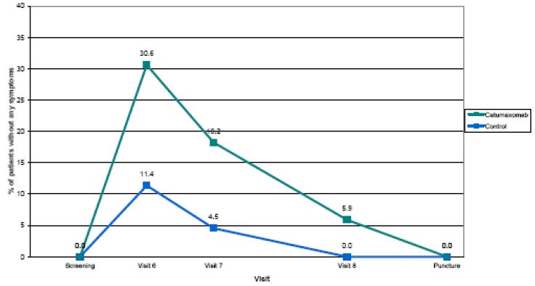
Please note that patients not attending a visit are not considered as without symptoms.
The results are convincing as they clearly indicate a pronounced and long lasting relief of ascites signs and symptoms after catumaxomab treatment compared to paracentesis.

Quality of life
Quality of life was assessed with the validated EORTC QLQ-C30 in addition to the ascites signs and symptoms questionnaire. The first analysis was descriptive comparing results at screening and puncture visit when all patients suffered from ascites symptoms. A reanalysis of QoL investigated time to first deterioration in QLQC30 scores in order to assess whether the puncture free time period after catumaxomab treatment impacts maintenance of QoL in these late stage patients (see full QoL report). Two thresholds were used for the definition of a clinically significant deterioration in QoL: -5 and -10. As results based on threshold -5 and -10 were similar, results based on threshold -5 only are presented in the following. QoL was compared between treatment groups using survival methods with log rank test. Deterioration in QoL scores was more rapid in the control group than in the catumaxomab group (median: 16-28 days versus 45-49 days, respectively). The difference in time to first deterioration in QoL between groups was statistically significant for all 15 QLQ-C30 scores (p < 0.05) and results were confirmed using Cox models (p < 0.05 for all scores) with hazard ratios ranging from 0.08 for nausea and vomiting to 0.42 for constipation corresponding to a statistically significant risk reduction of 92% to 58%. Further analyses including overall quality of life are presented in the full QoL report.
Figure 15: Time to first deterioration in QoL scores (Study IP-REM-AC-01).
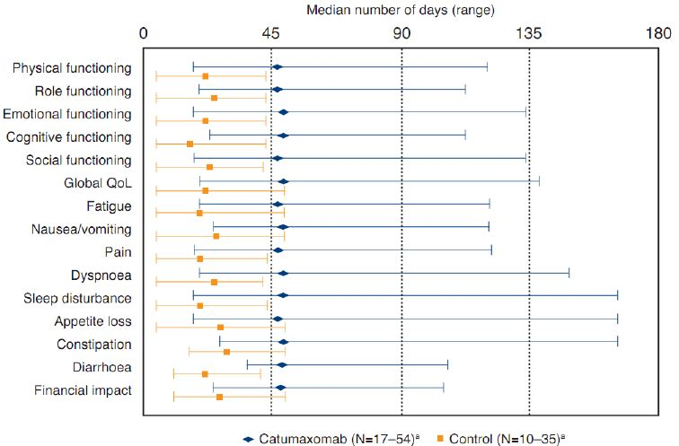
ª Only patients reporting deterioration in QoL score.
Number of patients censored = 106-143 catumaxomab and 50-75 control.
For all scores, p < 0.05 with log-rank test / Cox model.
These results obtained from a validated quality of life tool together with the mutually supportive outcome from the ascites signs and symptoms questionnaire clearly show that catumaxomab treated patients experience a considerable benefit not only due to a prolongation of puncture free survival but also by a stabilisation of quality of life.

Safety concerns

High incidence of severe and serious adverse reactions
The incidence of adverse reactions must be assessed considering the asymmetric study design:
Randomisation 2 to 1: Due to the 2:1 randomisation of the treatment and control groups, the actual randomisation factor was 1.93 (170 versus 88 patients in catumaxomab and control groups, respectively).
Observation period: The direct comparison between control and catumaxomab patients is misleading because of the approximately five fold longer observation period of the catumaxomab group compared to the control group in the randomised part of the study. This period was defined for both treatment arms as time from Day 0 until reaching the primary endpoint. The approximate five-fold longer observation period (11 days of treatment plus 46 days for reaching the study endpoint puncture free survival) in the catumaxomab group is due to the inclusion of the treatment period for this group and the fact that the primary endpoint (puncture or death) was reached much later.
The randomisation factor and the prolonged observation period of catumaxomab patients is reflected in the frequency of all safety related measures. The randomisation factor can be disregarded in case incidences are presented. However, the five-fold prolonged observation period needs to be considered for all safety related measures, for example, for the Delegate’s overview of AEs leading to a relativisation of the frequency of AEs including severe and serious adverse reactions. In addition, patients in the control group were less intensively monitored compared to catumaxomab patients that were hospitalised for 24 hours in context of each infusion. It is of further note that catumaxomab patients received an immunologically active treatment known to cause cytokine release, while the control group was treated with one paracentesis only; it was assessed as ethically unsound to apply IP placebo infusions. Thus, a direct comparison between catumaxomab and control group is not meaningful.

Systemic inflammatory response syndrome (SIRS)
In an updated ISA including 517 patients from 11 clinical studies, SIRS was reported in 5.0% of the patients; 4.6% were assessed as causally related to catumaxomab, and only in 3 patients (0.6%) SIRS was reported in the intensity of CTCAE grade 4. However, the vast majority (4.4%) was reported from studies with intraopoerative administration of catumaxomab (IP bolus administration of 10 μg before closure of the peritoneal cavity). Since SIRS is known to be caused by major surgery, it is difficult to clearly assess the causative role of the concurrently administered catumaxomab. In addition, the definition of SIRS according to medical associations comprises a combination of symptoms (pyrexia, tachycardia, dyspnoea, leukocytosis), which – as single symptoms – already are recorded as cytokine release related symptoms. Thus, the increased frequency of SIRS might not express an increased occurrence of a previously only rarely reported AE. It might reflect special documentation practices, especially, as in Study IP-REM-GC-02 where 11 of the 13 AEs of SIRS in 9 patients, all non-serious, were reported from 5 of the 6 participating centres of one country. More data on SIRS in the malignant ascites indication will be available from Study IP-CAT-AC-03 in which the usefulness of a corticosteroid premedication prior to catumaxomab was investigated. Final results of this study comprising data from 219 patients will be available by end of 2011 and can be submitted to the TGA as post authorisation commitment.

Risk of hepatotoxicity
Hepatobiliary disorder observed in context of catumaxomab administration mainly refer to transiently increased laboratory values of ALT, AST, GGT, bilirubine and ALP, in combination or isolated, without clinical signs or symptoms. These changes were on median level mostly mild to moderate, in general fully reversible and did not require special treatment. The median absolute values in serum chemistry of catumaxomab treated patients of Study IP-REM-AC-01 over the treatment period and one month thereafter is presented showing a return to baseline in most of the cases. This is confirmed by the data from the updated ISA (N=517) showing that only a minority of adverse reactions regarding liver parameters were ongoing at study end. As hepatocytes are EpCAM negative, catumaxomab does not bind directly to the liver. It could be shown that cytokines which were released due to the antibody’s binding to peripheral blood mononuclear cells (PBMCs) triggered a transient membrane leakage of the hepatocytes resulting in an increase of serum transaminases while the synthesis performance of the hepatocytes (for example, urea) remained stable. In summary, adverse reactions reported as changes in laboratory parameters were not clinically relevant and mostly returned to baseline after end of treatment. Please note that a considerable proportion of the patients (about 20% in the pivotal study) already showed increased liver parameters at baseline. Some of these patients were diagnosed with liver metastases known to have a negative and persistent impact on liver function on their own. Please note that the European Medicines Agency (EMA) accepted the deletion of laboratory findings of hepatic disorders as identified risk in the European RMP V7.0 following provision of valid arguments by the Marketing Authorisation Holder (MAH). The EMA commented that “the intended population to treat is in a late palliative phase of the malignant disease and it is important during the treatment to avoid unnecessary investigations and focus on symptom driven care. Therefore it is actually not relevant if a patient in this condition has increased hepatic liver enzymes, if the patient is asymptomatic from hepatic disorders”.

Risk of increased malignant cancer progression / Mortality in the catumaxomab group
Both groups differed with regard to the five-fold longer observation period for catumaxomab patients. The longer patients are observed, the higher is the likelihood to detect an event (death, malignant neoplasm progression) in these severely ill patients. Thus, based on the difference in observation time alone, one would expect an approximately five fold higher death rate for catumaxomab treated patients. The difference in the number of deaths between the two treatment arms is further a reflection of the 2:1 randomisation ratio. Therefore, about two times as many death cases could be expected to occur in the catumaxomab group if the observation periods were comparable. Most important, none of the 61 deaths in the randomised part of the study was considered related to catumaxomab by the investigator. The most commonly reported cause of death was progressive disease in both groups. The analysed data of the catumaxomab group did not provide evidence that catumaxomab triggered tumour progression or death. Further supportive are results from nonclinical investigations showing that catumaxomab does not induce proliferation of tumour cells. It is reassuring that – unexpected in this morbid patient population – a benefit in regards to overall survival and progression free survival was observed.

Risk of adverse reactions on normal EpCAM tissue
Analysis of PK parameters of catumaxumab revealed the highest concentrations of the IP administered catumaxomab in the ascites fluid. After the third and fourth IP administration, catumaxomab was detected in plasma. Systemic bioavailability could result in interactions of the antibody with EpCAM positive tissue, and in a potential safety risk. However, catumaxomab could reach the epithelial cells of normal tissue only if there is a disrupted capillary or a capillary leakage. In intact tissues EpCAM is “shielded” by the organisation of the epithelial tissue (tight junctions) (see also responses to the nonclinical evaluation report dated 21 July 2011). Tumour invasion and/or other damage (injury, inflammation, infection) are conditions in which binding of catumaxomab to EpCAM is possible. There are no correlations between the clinical findings in patients treated with catumaxomab and potential tissue binding sites shown in the preclinical development. Clinical data of 258 patients (ISA of 5 studies) did not show signals of organ damage as a consequence of catumaxomab binding to EpCAM positive tissue apart from commonly observed transient changes in hepatobiliary parameters. Adverse reactions possibly caused by binding of catumaxomab to the EpCAM positive normal bile duct epithelium are transient increases of alkaline phosphatase (3.5% of patients), bilirubin (1.2% of patients), and gamma glutamyl transferase (5.8% of patients) as well as hyperbilirubinemia (0.8% of patients). These changes in laboratory parameters mostly returned to baseline after end of treatment. Results are confirmed by the updated ISA comprising 517 patients.

Incidence of anti catumaxomab antibodies
A broad data base is available to assess the clinical relevance of anti catumaxomab antibodies. The vast majority of patients do not develop HAMA/HARA during the treatment period. Most of the patients become HAMA/HARA positive after the fourth infusion. Regarding safety, the broad ISA comprising 517 patients does not indicate any additional risk due to HAMA/HARA development. Only 8 patients showed anaphylactic or hypersensitivity reactions. Out of these, 5 received catumaxomab in the intra operative study setting which confirms the low number of cases in the non surgery setting. An additional risk associated with HAMA/HARA might be the potential formation of immune complexes. No relevant clinical symptoms or histological findings (for example, tubular necrosis) suggestive of immunocomplex effects on organ function were reported. Regarding efficacy, patients developing HAMA eight days after the last infusion (time point at which an interference of anti catumaxomab antibodies might be likely due to the PK profile of catumaxomab) showed an even improved benefit compared to HAMA negative patients at that time point. A statistically significantly longer puncture free survival, time to puncture and overall survival could be demonstrated for those patients from the study by Ott and colleagues. In conclusion, the safety of catumaxomab IP treatment is not compromised by the systemic occurrence of HAMA/HARA. The outcome in terms of efficacy is even improved in patients with an early HAMA development. This is clinically relevant since a fast HAMA response reflects a functional immune system.

Efficacy/safety of 3h infusion time
The sponsor agrees with the clinical evaluator that the data with regards to the 3 h infusion is consistent with that observed with the 6 h infusion studies and does not raise any particular concerns. Data from clinical studies in other indicat ions are regarded as worst case due to a lower tumour load in the peritoneal cavity leading to a potentially higher catumaxomab concentration in plasma. An analysis of an updated ISA now including 517 patients from 11 clinical studies with 3 h and 6 h IP infusion time showed that adverse reactions of clinical relevance are in general comparable with regard to nature, frequency and severity (see report ‘Comparison of the safety profile of catumaxomab: 6 h versus 3 h application’). Regarding efficacy, the sponsor does not consider 3 h data as decisive for a reduction of the infusion time. Due to the proposed treatment schedule over 11 days and a half-life of 2.5 days, an impact on the efficacy is not be expected. A profound database on the 3 h infusion time in the malignant ascites indication will be available from Study IP-CAT-AC-03. Final results of this study comprising data from 219 patients will be available by end of 2011 and can be submitted to the TGA as post authorisation commitment. First safety/efficacy data of this trial do not reveal any significant difference of the safety/efficacy profile compared to the 6 h infusion time. The 3 h infusion time was approved by the European Commission on 6 September 2011. The EU Summary of Product Characteristics (SPC) including the 3 h infusion time is attached in an appendix.

Comments to the nonclinical evaluation
Findings from nonclinical investigations are in line with clinical results and reconfirm the validity of the results. The main issues the nonclinical evaluator raised (limited relevance of the in vivo efficacy investigations and limited toxicity package due to lack of pharmacological activity in standard laboratory animals) were addressed in the sponsor’s response to the nonclinical evaluation report dated 21 July 2011.

Advisory committee considerations
The ACPM, having considered the evaluations and the Delegate’s overview, as well as the sponsor’s response to these documents, advised that this submission to register catumaxomab (Removab) concentrate, for solution 10 µg/0.1 mL and 50 µg/0.5 mL has not satisfactorily demonstrated adequate safety and efficacy in the proposed indication for the following reasons:
Efficacy: In the single controlled efficacy trial submitted which assessed catumaxomab in patients with malignant ascites, catumaxomab was given as an adjunct to paracentesis rather than as monotherapy, and infusions were administered at a slower rate than that proposed.
The benefit of catumaxomab treatment demonstrated was modest with a median one month increase in puncture free survival, the primary endpoint. Although this may be of benefit to some patients, it must be weighed against the toxicities reported.
Patients selected for the clinical trial had EpCAM positive malignant ascites; however, a commercial EpCAM test kit is not currently available for this diagnosis.
Progression free survival was not assessed in the overall trial population, only in the ovarian and non-ovarian cancer subgroups. Progression free survival was statistically significantly longer in the ovarian cancer subgroup. There was no significant difference in overall survival. The time to disease progression assessment was not standardised. New quality of life data submitted pre ACPM was not convincing.
Safety: A significant increase in toxicity was reported with the addition of catumaxomab. In a pooled safety analysis of five trials, including the efficacy trial, there was a high incidence of severe and serious adverse events with catumaxomab. Comparison of catumaxomab with the control group in the efficacy trial showed that catumaxomab caused significant toxicity, including bowel obstructions and significantly more deaths. None of the deaths were assessed as related to the drug but this should be further investigated. Most adverse events were related to cytokine release. There were limited safety data for the proposed 3 h infusion regimen.
The ACPM was concerned that the PI document recommends premedication with an analgesic, antipyretic or non-steroidal anti-inflammatory agent; however, only paracetamol premedication was evaluated in the efficacy trial.
Catumaxomab was associated with an increased incidence of malignant cancer progression in the efficacy trial. This should be added to the Safety Specification as a possible risk.
Overall, the ACPM were of the view that there risks were not sufficiently defined for a modest benefit.

Outcome
Based on a review of quality, safety and efficacy, TGA decided not to register Removab (catumaxomab) on the grounds that the efficacy and safety have not been satisfactorily established for the purposes for which it is to be used:
Removab is indicated as an adjunct to paracentesis in the treatment of malignant ascites due to epithelial cell malignancies where standard chemotherapy is not available or no longer feasible.

Reasons for decision
The efficacy of catumaxomab in the proposed indication was not satisfactorily established for the following reasons:
- The one month benefit of catumaxomab in puncture free survival, the primary endpoint in the efficacy trial, was modest. Patients in the catumaxomab group were likely to have had better initial ascites drainage than controls and assessment of a component of the endpoint, time to first need for therapeutic ascites puncture, was open to bias since it was done by investigators unblinded to treatment assignment.
- Catumaxomab significantly increased time to disease progression by a median 76 days. However, it was not assessed in a standard way over the whole observation period. International RECIST criteria were used only in the randomised part of the trial.
- Progression free survival was assessed in the stratified subgroups but not in the overall trial population. The increase in progression free survival was significant in the ovarian cancer subgroup but modest at a median increase of only 29 days.
- Catumaxomab did not significantly increase overall survival.
- It was not convincingly shown that catumaxomab reduced the symptoms and signs of ascites.
- It was not convincingly shown that catumaxomab improved quality of life.
- There were no data for the proposed 3 h infusion time.
The safety of catumaxomab in the proposed indication was not satisfactorily established for the following reasons:
- Catumaxomab caused a high incidence of severe and serious adverse reactions.
- Life threatening systemic inflammatory response syndrome (SIRS) was common within 24 h of catumaxomab infusion.
- Hepatotoxicity was common with catumaxomab.
- Catumaxomab was associated with increased malignant cancer progression.
- There is a risk of adverse effects on normal EpCAM positive tissues in patients with high systemic exposure to catumaxomab.
- The significantly increased mortality with catumaxomab in the efficacy trial requires explanation.
- There was a high incidence of anti catumaxomab antibodies of uncertain clinical significance.
- The data was obtained from administration of catumaxomab as 6 h infusions. There were no data for 3 h infusions in malignant ascites. More rapid infusion of catumaxomab over 3 h as proposed instead of 6 h is likely to cause increased adverse reactions. Use of catumaxomab administered as 3 h infusions in other indications and dosage regimens was inconclusive as to safety.

Final outcome
Following the initial decision described above, the sponsor sought a review under the provisions of Section 60 of the Therapeutics Goods Act. The Delegate of the Minister for the review was of the view that the sponsor had not established to the Delegate’s satisfaction the safety and efficacy of the product, Removab (catumaxomab) 100 μg/mL concentrate for solution for infusion. Accordingly, the Delegate decided to confirm the initial decision to reject the application to register Removab (catumaxomab) in the Australian Register of Therapeutic Goods (ARTG).

AAT appeal
Following the Delegate’s decision to confirm the initial decision to reject the application to register Removab (catumaxomab) in the ARTG, on 21 March 2012 the sponsor applied to the Administrative Appeals Tribunal (AAT) for review of the decision. This application was later withdrawn.

Therapeutic Goods Administration
PO Box 100 Woden ACT 2606 Australia
Email: info@tga.gov.au Phone: 1800 020 653 Fax: 02 6232 8605
http://www.tga.gov.au

Heiss MM, et al. The trifunctional antibody catumaxomab for the treatment of malignant ascites due to epithelial cancer: Results of a prospective randomised phase II/III trial. International Journal of Cancer 2010, 127: 2209-2221.
Ruf P, Lindhofer H. Induction of a long-lasting antitumor immunity by a trifunctional bispecific antibody. Blood 2001, 98: 2526-2534.
Hampl M, et al. Therapeutic effects of viral vector-mediated antiangiogenic gene transfer in malignant ascites. Human Gene Therapy 2001, 12: 1713-1729; Cheng WF, et al. Generation and characterization of an ascitogenic mesothelin-expressing tumor model. Cancer 2007, 110: 420-431; Lin YY, et al. Evaluation of pharmacokinetics of ¹¹¹In-labeled VNB-PEGylated liposomes after intraperitoneal and intravenous administration in a tumor/ascites mouse model. Cancer Biotherapy and Radiopharmaceuticals 2009, 24: 453-460.
Yovchev MI, et al. Identification of adult hepatic progenitor cells capable of repopulating injured rat liver. Hepatology 2008, 47: 636-647; Okabe M, et al. Potential hepatic stem cells reside in EpCAM+ cells of normal and injured mouse liver. Development 2009, 136: 1951-1960.
The C_{10 min} (plasma drug concentration at 10 minutes after the administration of a given dose) following a 1.3 mg/kg IV dose to mice was 28.5 μg/mL (Study 075.214.321).The average clinical C_{max} (maximum plasma drug concentration) following a 150 μg dose was 0.48 ng/mL (Study IP-REM-PK-01).
Zhang Y, Pardridge WM. Mediated efflux of IgG molecules from brain to blood across the blood-brain barrier. Journal of Neuroimmunology 2001, 114: 168-172.
Vargas HM, et al. Scientific review and recommendations on preclinical cardiovascular safety evaluation of biologics. Journal of Pharmacological and Toxicological Methods 2008, 58: 72-76
Balzar M, et al. The biology of the 17-1A antigen (Ep-CAM). Journal of Molecular Medicine 1999, 77: 699-712.
Herlyn D, et al. Initial clinical evaluation of two murine IgG2a monoclonal antibodies for immunotherapy of gastrointestinal carcinoma. American Journal of Clinical Oncology 1991, 14: 371-378; de Bono JS, et al. ING-1, a monoclonal antibody targeting Ep-CAM in patients with advanced adenocarcinomas. Clinical Cancer Research 2004, 10: 7555-7565.
McLaughlin PMJ, et al. The epithelial glycoprotein 2 (EGP-2) promoter-driven epithelial-specific expression of EGP-2 in transgenic mice: a new model to study carcinoma-directed immunotherapy. Cancer Research 2001, 61:4105-4111.
Kosterink JGW, et al. Biodistribution studies of epthilelial cell adhesion molecule (EpCAM)-directed monoclonal antibodies in th eEpCAM-transgenic mouse tumor model. Journal of Immunology 2007, 179: 1362-1368.
Auphan N, et al. Immunosuppression by glucocorticoids: inhibition of NF-κB activity through induction of IκB synthesis. Science 1995, 270: 286-290.
McLaughlin PMJ, et al. The epithelial glycoprotein 2 (EGP-2) promoter-driven epithelial-specific expression of EGP-2 in transgenic mice: a new model to study carcinoma-directed immunotherapy. Cancer Research 2001, 61:4105-4111; Mosolits S et al. Targeting human Ep-CAM in transgenic mice by anti-idiotype and antigen based vaccines. International Journal of Cancer 2004, 112: 669-677.
European Medicines Agency, Scientific Guidelines for Human Medicinal Products 3BS1A: Single Dose Toxicity, London, 2001.
European Medicines Agency, ICH guideline S6 (R1) – preclinical safety evaluation of biotechnology-derived pharmaceuticals, London, 2011.
Trzpis M, et al. Epithelial cell adhesion molecule: more than a carcinoma marker and adhesion molecule. American Journal of Pathology 2007, 171: 386-395.
European Medicines Agency, ICH Topic S9 – Nonclinical Evaluation for Anticancer Pharmaceuticals, London, 2009.
Trzpis M, et al. Epithelial cell adhesion molecule: more than a carcinoma marker and adhesion molecule. American Journal of Pathology 2007, 171: 386-395; Nagao K. Abnormal placental development and early embryonic lethality in EpCAM-null mice. PLoS One 2009, 4:e8543.
Nagao K. Abnormal placental development and early embryonic lethality in EpCAM-null mice. PLoS One 2009, 4:e8543.
Category D: Drugs which have caused, are suspected to have caused or may be expected to cause, an increased incidence of human fetal malformations or irreversible damage. These drugs may also have adverse pharmacological effects. Accompanying texts should be consulted for further details.
The Karnofsky performance status score runs from 100 to 0, where 100 is ‘perfect’ health and 0 is death: 100% – normal, no complaints, no signs of disease 90% – capable of normal activity, few symptoms or signs of disease 80% – normal activity with some difficulty, some symptoms or signs 70% – caring for self, not capable of normal activity or work 60% – requiring some help, can take care of most personal requirements 50% – requires help often, requires frequent medical care 40% – disabled, requires special care and help 30% – severely disabled, hospital admission indicated but no risk of death 20% – very ill, urgently requiring admission, requires supportive measures or treatment 10% – moribund, rapidly progressive fatal disease processes 0% – death See Karnofsky DA and Burchenal JH. The Clinical Evaluation of Chemotherapeutic Agents in Cancer in MacLeod CM (Ed.) Evaluation of Chemotherapeutic Agents, Columbia University Press, New York, 1949.
CTCAE grading is a five point scale generally corresponding to mild, moderate, severe, life threatening, and death. This grading system from the US National Cancer Institute inherently places a value on the importance of an event, although there is not necessarily 'proportionality' among grades (that is, a Grade 2 is not necessarily twice as bad as a Grade 1): Grade 0 - No Adverse Event (absent) or within normal limits Grade 1 - Mild Adverse Event (minor; no specific medical intervention; asymptomatic laboratory findings only, radiographic findings only; marginal clinical relevance) Grade 2 - Moderate Adverse Event (minimal intervention; local intervention; noninvasive intervention [packing, cautery]) Grade 3 - Severe and undesirable Adverse Event (significant symptoms requiring hospitalization or invasive intervention; transfusion; elective interventional radiological procedure; therapeutic endoscopy or operation) Grade 4 - Life-threatening or disabling Adverse Event (complicated by acute, life-threatening metabolic or cardiovascular complications such as circulatory failure, hemorrhage, sepsis. Life-threatening physiologic consequences; need for intensive care or emergent invasive procedure; emergent interventional radiological procedure, therapeutic endoscopy or operation) Grade 5 - Death related to Adverse Event
Schulze E, et al. Prolonged ascites symptom free time in patients with malignant ascites after treatment with catumaxomab. Source Poster for Annual European Society for Medical Oncology (ESMO) meeting, 2011.
Gonschior AK, et al. Quality of life in patients with malignant ascites and ascites symptoms after treatment with catumaxomab: results from a multicenter phase II/III study comparing paracentesis plus catumaxomab with paracentesis alone. Source Poster for Annual European Society for Medical Oncology (ESMO) meeting, 2011.
Osoba D, et al. Interpreting the significance of changes in health-related quality-of-life scores. Journal of Clinical Oncology 1998; 16: 139-144.
Ott MG, et al. Humoral response to catumaxomab correlates with clinical outcome: results of the pivotal phase II/III study in patients with malignant ascites. International Journal of Cancer 2012; 130:2195-2203.

