|  |
| --- |
| **March 2020** |

|  |
| --- |
| Australian Public Assessment Report for Ceritinib |
| Proprietary Product Name: Zykadia |
| Sponsor: Novartis Pharmaceuticals Australia Pty Ltd |

About the Therapeutic Goods Administration (TGA)

* The Therapeutic Goods Administration (TGA) is part of the Australian Government Department of Health and is responsible for regulating medicines and medical devices.
* The TGA administers the *Therapeutic Goods Act 1989* (the Act), applying a risk management approach designed to ensure therapeutic goods supplied in Australia meet acceptable standards of quality, safety and efficacy (performance) when necessary.
* The work of the TGA is based on applying scientific and clinical expertise to decision-making, to ensure that the benefits to consumers outweigh any risks associated with the use of medicines and medical devices.
* The TGA relies on the public, healthcare professionals and industry to report problems with medicines or medical devices. TGA investigates reports received by it to determine any necessary regulatory action.
* To report a problem with a medicine or medical device, please see the information on the TGA website < <https://www.tga.gov.au>> .

About AusPARs

* An Australian Public Assessment Report (AusPAR) provides information about the evaluation of a prescription medicine and the considerations that led the TGA to approve or not approve a prescription medicine submission.
* AusPARs are prepared and published by the TGA.
* An AusPAR is prepared for submissions that relate to new chemical entities, generic medicines, major variations and extensions of indications.
* An AusPAR is a static document; it provides information that relates to a submission at a particular point in time.
* A new AusPAR will be developed to reflect changes to indications and/or major variations to a prescription medicine subject to evaluation by the TGA.

Copyright

© Commonwealth of Australia 2020  
This work is copyright. You may reproduce the whole or part of this work in unaltered form for your own personal use or, if you are part of an organisation, for internal use within your organisation, but only if you or your organisation do not use the reproduction for any commercial purpose and retain this copyright notice and all disclaimer notices as part of that reproduction. Apart from rights to use as permitted by the *Copyright Act 1968* or allowed by this copyright notice, all other rights are reserved and you are not allowed to reproduce the whole or any part of this work in any way (electronic or otherwise) without first being given specific written permission from the Commonwealth to do so. Requests and inquiries concerning reproduction and rights are to be sent to the TGA Copyright Officer, Therapeutic Goods Administration, PO Box 100, Woden ACT 2606 or emailed to < [tga.copyright@tga.gov.au](mailto:tga.copyright@tga.gov.au)> .

Contents

Common abbreviations 4

I. Introduction to product submission 7

Submission details 7

Product background 8

Regulatory status 8

Product Information 8

II. Registration time line 8

III. Quality findings 9

IV. Nonclinical findings 9

V. Clinical findings 9

Introduction 10

Pharmacokinetics 14

Pharmacodynamics 18

Efficacy 18

Safety 19

First round benefit-risk assessment 32

First round recommendation regarding authorisation 35

Clinical questions and second round evaluation 36

Second round benefit-risk assessment 40

Second round recommendation regarding authorisation 41

VI. Pharmacovigilance findings 41

Risk management plan 41

VII. Overall conclusion and risk/benefit assessment 44

Background 44

Quality 48

Nonclinical 48

Clinical 48

RMP evaluation 70

Risk-benefit analysis 72

Outcome 77

Attachment 1. Product Information 78

## Common abbreviations

|  |  |
| --- | --- |
| Abbreviation | Meaning |
| ACM | Advisory Committee on Medicines |
| AE | Adverse event |
| AESI | Adverse event(s) of special interest |
| ALK | Anaplastic lymphoma kinase |
| ALT | Alanine aminotransferase |
| ARTG | Australian Register of Therapeutic Goods |
| ASA | Australian specific Annex |
| AST | Aspartate aminotransferase |
| AUC0-24h | Area under the plasma concentration-time curve from time 0 (dosing) to 24 hours |
| AUC0-inf | Area under the plasma concentration-time curve from time 0 (dosing) extrapolated to infinity |
| BIRC | Blinded independent review committee |
| BOR | Best overall response |
| CHMP | Committee for Medicinal Products for Human Use (EU) |
| CI | Confidence interval |
| Cmax | Maximum (peak) concentration of drug in plasma |
| CMI | Consumer Medicines Information |
| CNS | Central nervous system |
| CR | Complete response |
| CSR | Clinical study report |
| CT | Chemotherapy |
| Ctrough | Trough concentration |
| CV | Coefficient of variation |
| CYP | Cytochrome P450 |
| DCR | Disease control rate |
| DOR | Duration of response |
| ECG | Electrocardiogram |
| ECOG PS | Eastern Cooperative Oncology Group Performance Status (scale) |
| EGFR | Epidermal growth factor receptor |
| EML4-ALK | Echinoderm microtubule-associated protein 4-anaplastic lymphoma kinase |
| EMA | European Medicines Agency (EU) |
| EOT | End of treatment |
| EU | European Union |
| EU-RMP | European Union-risk management plan |
| FAS | Full analysis set |
| FDA | Food and Drug Administration (USA) |
| GCP | Good Clinical Practice |
| GGT | Gamma glutamyl transferase |
| GI | Gastrointestinal |
| HR | Hazard ratio |
| IHC | Immunohistochemistry |
| ILD | Interstitial lung disease |
| LDK378 | Ceritinib drug development name |
| MedDRA | Medical Dictionary for Regulatory Activities |
| MTD | Maximum tolerated dose |
| NSCLC | Non-small cell lung cancer |
| ORR | Overall response rate |
| OS | Overall survival |
| PAS | Pharmacokinetic analysis set |
| PFS | Progression-free survival |
| PI | Product Information |
| PK | Pharmacokinetic(s) |
| PopPK | Population pharmacokinetic(s) |
| PPI | Proton pump inhibitor |
| PR | Partial response |
| PT | Preferred Term |
| QoL | Quality of life |
| QTc | QT interval corrected for heart rate |
| QTcF | QT interval corrected for heart rate according to Fridericia’s formula |
| QTcP | QT interval corrected according to population-optimised heart rate correction model |
| RCT | Randomised controlled trial |
| RECIST | Response evaluation criteria in solid tumours |
| SAE | Serious adverse event |
| SCS | Summary of clinical safety |
| SmPC | Summary of Medicinal Product Characteristics (EU) |
| Tlast | Time to last quantifiable concentration |
| Tmax | Time to reach maximum plasma concentration |
| TTR | Time to response |
| ULN | Upper limit of normal |
| US(A) | United States (of America) |
| WHO | World Health Organization |

## I. Introduction to product submission

### Submission details

|  |  |
| --- | --- |
| *Type of submission:* | Extension of indications |
| *Decision*: | Approved |
| *Date of decision:* | 23 May 2018 |
| *Date of entry onto ARTG:* | 25 May 2018 |
| *ARTG number:* | 235737 |
| *Black Triangle Scheme* | No |
| *Active ingredient:* | Ceritinib |
| *Product name:* | Zykadia |
| *Sponsor’s name and address:* | Novartis Pharmaceuticals Australia Pty Ltd  PO Box 101  North Ryde NSW 1670 |
| *Dose form:* | Hard capsule |
| *Strength:* | 150 mg |
| *Container:* | Blister Pack |
| *Pack sizes:* | 50, 150 |
| *Approved therapeutic use:* | *Zykadia is indicated for the treatment of patients with locally advanced or metastatic non-small cell lung cancer (NSCLC) that is anaplastic lymphoma kinase (ALK)-positive.* |
| *Route of administration:* | Oral |
| *Dosage:* | The recommended dose of Zykadia is 450 mg taken orally once daily with food. For further details of dosage please see the Product Information (PI). |

### Product background

This AusPAR describes the application by Novartis Pharmaceuticals Australia Pty Ltd (the sponsor) to register Zykadia ceritinib 150 mg hard capsule for the following indication:

*Zykadia is indicated for the treatment of patients with locally advanced or metastatic non-small cell lung cancer (NSCLC) that is anaplastic lymphoma kinase (ALK)-positive.*

This is to replace the currently approved indication:

*Zykadia is indicated as monotherapy for the treatment of adult patients with anaplastic lymphoma kinase (ALK) positive locally advanced or metastatic non-small cell lung cancer (NSCLC) whose disease has progressed on or who are intolerant of crizotinib.*

*Note to Indication: This indication is approved based on tumour response rates and duration of response. An improvement in survival or disease –related symptoms has not been established.*

This application also includes two post-approval commitment studies (Studies A2303 and A2112) from initial registration for Zykadia. Changes to the PI resulting from the availability of these studies have been made.

Ceritinib is an orally active, small molecule, adenosine triphosphate (ATP)-competitive inhibitor of anaplastic lymphoma kinase (ALK) kinase inhibitor. It inhibits autophosphorylation of ALK, ALK mediated phosphorylation of downstream signalling proteins and proliferation of ALK dependent cancer cells.

### Regulatory status

The product received initial registration on the Australian Register of Therapeutic Goods (ARTG) on 31 March 2016 for the indication:

*Zykadia is indicated as monotherapy for the treatment of adult patients with ALK-positive locally advanced or metastatic non-small cell lung cancer (NSCLC) whose disease has progressed on or who are intolerant of crizotinib.*

*Note to the Indication: This indication is approved based on tumour response rate and duration of response. An improvement in survival or disease-related symptoms has not been established.*

At the time the TGA considered this application a similar application had not been rejected, withdrawn or repeatedly deferred in the United States of America (USA), European Union (EU), Canada or any other market (as of 4 August 2017).

### Product Information

The Product Information (PI) approved with the submission which is described in this AusPAR can be found as Attachment 1. For the most recent PI, please refer to the TGA website at < <https://www.tga.gov.au/product-information-pi>> .

## II. Registration time line

The following table captures the key steps and dates for this application and which are detailed and discussed in this AusPAR.

Table 1: Timeline for Submission PM-2017-00696-1-4

|  |  |
| --- | --- |
| Description | Date |
| Submission dossier accepted and first round evaluation commenced | 31 May 2017 |
| First round evaluation completed | 2 November 2017 |
| Sponsor provides responses on questions raised in first round evaluation | 22 December 2017 |
| Second round evaluation completed | 31 January 2018 |
| Delegate request for further information (RFI) | 27 February 2018 |
| Sponsor’s response to Delegate RFI | 16 March 2018 |
| Delegate’s Overall benefit-risk assessment and request for Advisory Committee advice | 14 April 2018 |
| Sponsor’s response to Delegate’s Overall benefit-risk assessment. | 30 April2018 |
| Advisory Committee meeting | This submission was not taken to an advisory committee. |
| Registration decision (Outcome) | 23 May 2018 |
| Completion of administrative activities and registration on the ARTG | 25 May 2018 |
| Number of working days from submission dossier acceptance to registration decision* | 209 |

*Statutory timeframe for standard applications is 255 working days

## III. Quality findings

There was no requirement for a quality evaluation in a submission of this type.

## IV. Nonclinical findings

There was no requirement for a nonclinical evaluation in a submission of this type.

## V. Clinical findings

A summary of the clinical findings is presented in this section.

### Introduction

The sponsor has proposed changes to the PI based on the three studies submitted in this application:

* Study A2112 (food effects study and limited efficacy, safety study for proposed modified starting dose level and change to fed conditions); and
* two Phase III studies in a pre-treated and naïve population:
  + Study A2303 (also known as the ASCEND-5 clinical trial), a confirmatory study for initial registered indication); and
  + Study A2301 (also known as the ASCEND-4 clinical trial), in a treatment-naïve population.

Study LDK378A2112 (Study A2112) has two parts. Part 1 of Study A2112 was submitted initially and intends to evaluate the single-dose and steady-state pharmacokinetics (PK), the safety profile (including gastrointestinal (GI) adverse events (AE)), and the efficacy of 450 mg or 600 mg ceritinib taken daily with a low-fat meal as compared with that of 750 mg daily in the fasted state in both treatment-naive and pre-treated patients with ALK+ NSCLC. Part 2 of the study intends to evaluate the efficacy of ceritinib in treatment-naïve patients with ALK+ by immunohistochemistry (IHC). A pre-planned interim efficacy analysis (data only) in naïve patients was submitted in s31 responses however the clinical study report (CSR) was provided soon after.

A pooled safety analysis includes the new Phase III Ascend 4 and 5 trial safety data and previously evaluated Studies X2101, A2203, A2201 and X1101. The safety data outputs from a seventh Study A2109 (a Chinese study) is also included in this application. The pooled analysis is part of the ASCEND 4 trial dossier.

Changes are proposed to the current Boxed warning (removal of: GI toxicities, taking dose fasted and interstitial lung disease (ILD)/pneumonitis), Pharmacokinetics (largely pertaining to the food effect from population pharmacokinetic (popPK) model). Changes to the following sections are consistent with new information arising from the two Phase III trials: Cardiac Electrophysiology, Clinical Trials, Indications, Precautions, Adverse reactions (including a new section of Gastrointestinal adverse reactions), Dosage and Administration, and Dose Adjustment sections.

An application for post approval commitment Study A2110, a Phase I, open label, multi-center, single dose study to evaluate the PK of LDK378;[1] in subjects with hepatic impairment compared to subjects with normal hepatic function was on ongoing.

#### Background

Anaplastic lymphoma kinase, a receptor tyrosine kinase, was first identified as a fusion protein resulting from chromosomal translocation in the majority of anaplastic large cell lymphoma (ALCL). When fused to other proteins, ALK becomes constitutively active, leading to increased catalytic kinase function, signal transduction activity, and oncogenic function. ALK gene rearrangement is found in about 5% of patients with non-small cell lung cancer (NSCLC);[2] and is thought to be mutually exclusive with epidermal growth factor receptor (EGFR) and KRAS mutations.[3],[4] It has been associated with a younger age, non-smoking status, and adenocarcinoma histology and a more advanced state at presentation.[5] Thus ALK gene rearrangements define a unique molecular subset of NSCLC.2

The prevalence of ALK-positive lung cancer in Australia was estimated by the TGA to be approximately 1200 in 2015 at the time of the orphan drug designation.

ALK gene rearrangements were identified as an oncogenic driver in this subset of NSCLC and this potential target has been confirmed by the improvement in response rates and progression free survival with crizotinib. This non-specific small molecule ALK, cMET;[6] and ROS-1 inhibitor;[7] is the only targeted agent currently approved for the treatment of locally advanced or metastatic ALK-positive NSCLC. Phase III trials in patients who had received one prior line of chemotherapy demonstrated a response rate of 65% (95% confidence interval (CI): 58, 72) for crizotinib compared with 20% (95% CI: 14, 26) with chemotherapy (p < 0.001). The median progression-free survival (PFS) was 7.7 months compared with 3.0 months in patients who received single-agent chemotherapy (hazard ratio 0.49; 95% confidence interval (CI): 0.37, 0.64; p < 0.001). Improvement in overall survival (OS) was not demonstrated and crossover to crizotinib on progression in the chemotherapy arm is likely to account for this. This study also includes one of the first reports of chemotherapy response rates in ALK-positive NSCLC (compared with NSCLC not otherwise specified). This trial followed single-arm trials of crizotinib in patients with ALK-positive NSCLC where response rates of 50 to 61% and duration of response of 6 to 10 months were reported.[8] In a Phase III open label trial in the first line setting, crizotinib resulted in a significantly increased median PFS compared with pemetrexed and platinum doublet chemotherapy; 10 months versus 7.0 months, hazard ratio (HR) 0.45; 95% CI:0.35, 0.6, p < 0.001). Quality of life and symptom control were also reported to be improved with crizotinib.[9] This confirmed the standard of care (SOC) to be crizotinib in patients newly diagnosed with locally advanced or metastatic ALK positive NSCLC. Note is made that the first-line study submitted in this application is ceritinib versus chemotherapy and it is questionable whether there is equipoise in such a trial design, unless conducted where there is no access to crizotinib.

Crizotinib (Xalkori) is registered by the TGA for the treatment of patients with ALK‑positive advanced NSCLC for the treatment of adults with stage IIIB or IV non-squamous type of NSCLC harbouring an ALK gene rearrangement in tumour material, defined as 15% (or greater) positive cells by fluorescence in situ hybridisation (FISH) testing.

##### Acquired resistance and brain metastases

Acquired drug resistance to crizotinib remains a problem, and may result from the development of resistant ALK mutations, ALK amplification, and/or activation of alternate aberrant signalling pathways.[10],[11] Brain metastases are common in NSCLC and the first site of progression on crizotinib.[12],[13],[14] Furthermore, not all patients respond to or tolerate crizotinib treatment.

Crizotinib has the following significant toxicities: hepatotoxicity (including fatal cases), pneumonitis (including fatal cases), QT prolongation;[15] bradycardia (usually asymptomatic), and vision disorders.

Second-generation ALK inhibitors registered by the TGA include ceritinib and alectinib, which are discussed below. Both were given approval on single arm Phase II studies on the basis of response rates in those previously treated with crizotinib (either with disease progression or intolerance) and the notes to the indication identify the preliminary nature of the data supporting the findings in these submissions in this uncommon cancer. This application meets the registration condition of submission of the confirmatory Phase III study in those previously treated with crizotinib, as well as presenting the Phase III study in first line use.

##### Current treatment options

###### Alectinib

Alectinib (Alecensa) is currently approved in Australia for the following indication:

*‘Alecensa is indicated for the treatment of patients with anaplastic lymphoma kinase (ALK)- positive, locally advanced or metastatic non-small cell lung cancer (NSCLC) who have progressed on or are intolerant to crizotinib.*

*Note to Indication: This indication is approved based on tumour response rates and duration of response. An improvement in survival or disease-related symptoms has not been established.’*

In a small first-line head-to-head study of 207 Japanese patients with ALK-positive NSCLC, randomly assigned to crizotinib or alectinib, a planned interim analysis, results demonstrated improved PFS with alectinib (median PFS was not reached in the alectinib arm and was 10.2 months in the crizotinib arm (hazard ratio (HR) 0.34, 99.7% CI 0.17 to 0.70)).[16] In a larger global study of 303 patients randomly assigned to first-line [alectinib](https://www.uptodate.com/contents/alectinib-drug-information?source=see_link) versus [crizotinib](https://www.uptodate.com/contents/crizotinib-drug-information?source=see_link) (the ALEX trial), those receiving alectinib had a reduction in risk of progression or death of 53 percent (HR 0.47, 95% CI 0.34 to 0.65), with median PFS not reached versus 11.1 months for those receiving crizotinib at a median follow-up of approximately 18 months. The median PFS on independent review was 25.7 months with alectinib and 10.4 months with crizotinib (HR 0.50) and overall survival results are not yet published. Peters et al.;[17] report the time to central nervous system (CNS) progression in the overall population was improved with alectinib (HR 0.16, 95% CI 0.10 to 0.28). Severe toxicities appear less frequent with alectinib (41 versus 50 %).

In Phase II studies, alectinib demonstrated significant disease activity in patients previously treated with crizotinib with brain metastases (some patients had also received prior CNS radiation).[18]

###### Ceritinib

Ceritinib is an oral medicine is stated to be a potent inhibitor of ALK kinase, with activity against ALK-positive NSCLC that has developed resistance to crizotinib. It was approved by the TGA on 24 March 2016 for the following indication:

*‘Zykadia is indicated as monotherapy for the treatment of adult patients with anaplastic lymphoma kinase (ALK) positive locally advanced or metastatic non-small cell lung cancer (NSCLC) whose disease has progressed on or who are intolerant of crizotinib.*

*Note to Indication: This indication is approved based on tumour response rates and duration of response. An improvement in survival or disease –related symptoms has not been established.’*

Brigatinib and lorlatinib are other ALK inhibitors, but neither is currently approved for use in Australia. Brigatinib was approved in the US (28 April 2017) and lorlatinib had not been approved in the US or EU at the time of writing this report.

#### Clinical rationale

Currently, the only approved first line therapy is either crizotinib or chemotherapy. The current submission in crizotinib-naïve ALK positive NSCLC versus chemotherapy seeks registration in the first-line but provides no direct comparison with crizotinib, the current standard of care. If approved, this may provide an alternative to crizotinib. This study also assesses the effect of ceritinib in those with brain metastases.

#### Contents of the clinical dossier

The dossier submitted includes the three studies:

* One PK, safety and efficacy primarily assessing food effect: Study A2112, with a clinical study report (CSR) and Clinical Overview. Also includes a new companion diagnostic for detection of ALK-EML4 protein.
* Phase III Study A2303 with:
  + CSR, Clinical Overview, Summary of Clinical Efficacy, Summary of Clinical Safety and a European Medicines Agency (EMA) report provided by the sponsor.
* Phase III Study A2301 with:
  + CSR, Population PK report, Clinical Overview, Summary of Clinical Efficacy, Summary of Clinical Safety and an EMA report provided by the sponsor.

#### Paediatric data

No paediatric data are submitted, consistent with this being a rare disease, mostly occurring in adults.

#### Good clinical practice

The sponsor has indicated that the studies submitted were carried out in compliance with Good Clinical Practice (GCP), including the archiving of essential documents.

#### Evaluators commentary on the clinical dossier

The sponsor included essentially three separate clinical dossiers within this one application, together with an Annex from the risk management plan (RMP) presenting integrated safety data based on the important identified and potential risks with ceritinib in the RMP.

The CSRs were well-presented, resulting in few clinical questions seeking clarification.

The sponsor has made multiple proposals for changes to the PI to reduce duplication of text and tables, and to remove data regarding immature endpoints, and to update the adverse event rates and their management.

### Pharmacokinetics

#### Study A2112 (Part I)

##### Study rationale

Based on the population PK analysis of the food effect study (Study A2101), a high-fat meal (approximately 1000 calories and 58 grams of fat) was found to delay the rate of ceritinib absorption to a significant degree and increase ceritinib bioavailability (increased Cmax and AUC0-inf by 41% and 73%);[19] this was compared with an increase of 43% and 58%, for Cmax and AUC0-inf respectively, after a low fat snack in Study A2108, presented in the Clinical Overview (data not included in this dossier as it pertains to a tablet formulation not the registered gel capsule, but see EMA report below). This change in shape of the PK profile leads to uncertainty in safety profile prediction.

The evalator comments that the maximum tolerated dose (MTD) from the development program was also the starting dose (750 mg) and therefore risks associated with increased exposure were not known but the risk of some severe adverse events such as QT prolongation appeared to be dose proportional at least as far as was known up to 750 mg. This potent food effect of increased exposure led to a boxed warning in the PI and Consumer Medicines Information (CMI) regarding taking ceritinib on an empty stomach to advise patients of the risks of taking it with food. Submission of Study A2112 was a condition of registration and the sponsor is seeking to remove the boxed warning and update the Dosage and Administration section, based on these results.

The EMA report ‘Joint rapporteur’s extension of indication variation assessment report –List of questions (updated)’ provided by the sponsor in the dossier states, ‘Data from a relative bioavailability study which evaluated the effect of a light snack on the PK of ceritinib in healthy subjects (Study A2108)’ on a new tablet formulation – the following is the summary taken from this EMA report:

*‘*Food-drug interactions (A2108): Study LDK378A2108 was a randomized, open-label cross-over study to evaluate the relative bioavailability of a new tablet formulation of ceritinib in comparison to the reference ceritinib (Cohort 1) and to evaluate the effect of a light snack on the PK of ceritinib capsules (Cohort 3) in healthy subjects.

The primary objective of Cohort 3 was to evaluate the relative bioavailability of a single 750 mg oral dose of ceritinib capsules administered with a light snack (containing approximately 100 to 300 calories and 1.5 grams of fat) in comparison to a single 750 mg oral dose of ceritinib capsules administered under fasted condition in healthy subjects.

Compared to the fasted state, a light snack (containing approximately 100 to 300 calories and 1.5 grams of fat) increased Cmax and AUC0-inf following a single 750 mg oral dose of ceritinib in healthy subjects by 45% and 54%, respectively, in Study A2108.

This magnitude of increase is similar to that caused by a low-fat meal as described in the previously submitted Study A2101, suggesting that even a meal or snack with a very low-fat content could lead to a non-negligible clinically meaningful increase in ceritinib exposure. Based on the observations in Studies A2108 and A2101, an increase in exposure would be expected when ceritinib is taken with food.’

The evaluator comments that an increase in exposure from the food effect on ceritinib 750 mg dosing is clearly demonstrated in this study and consistent with that previously reported. The EMA report makes limited mention of the Study A2112 submitted in this application and the sponsor is requested to provide the latest available EMA report relating to this study.

#### Studies providing pharmacokinetic data

PK data were presented in Study A2112.

Limited data were collected in the randomised Phase III Study A2301 examining ceritinib in patients not previously treated in the metastatic setting, and these are presented at the end of the evaluation of Study A2112, with comments and comparisons between the two where appropriate.

#### Evaluator’s conclusions on pharmacokinetics population pharmacokinetics and proposed PI changes

Overall, based on the evaluation of the population PK model, the evaluator does not consider that the model provides adequate evidence in support of the proposed changes to the PI.

Currently, the PI proposes the following statement in ‘Patients with hepatic impairment’, ‘Patients with renal impairment’ and ‘Effects of age, gender and race’:

##### Patients with hepatic impairment

‘Based on a population pharmacokinetic analysis of 140 patients with mild hepatic impairment (total bilirubin ≤ upper limit of normal (ULN) and aspartate aminotransferase (AST) > ULN or total bilirubin > 1.0 to 1.5 times ULN and any AST) and 832 patients with normal hepatic function (total bilirubin ≤ ULN and AST ≤ ULN), ceritinib exposures were similar in patients with mild hepatic impairment and normal hepatic function. Dose adjustment is not recommended for patients with mild hepatic impairment based on the results of a population pharmacokinetic analysis.’

The evaluator comments that the basis for the hepatic impairment is relevant as those with metastatic disease may overall experience an improvement with treatment if there is a response, and if the toxicities are closely managed, whereas those with some other underlying cause may experience a worsening of their liver function. Without studies or close subgroup analyses, the safety in these patients remains unclear.

These ceritinib results are not ‘similar’ and the difference is likely to be clinically significant and the risk to patients with existing limitations in functional hepatic reserve is unknown. The ‘dose adjustment’ should explicitly refer to ‘starting dose adjustment’ as it is highly likely that any patient receiving this drug will require an adjustment.

The following amendments are proposed:

‘Based on a population pharmacokinetic analysis of 140 patients with mild hepatic impairment (total bilirubin ≤ ULN and AST > ULN or total bilirubin > 1.0 to 1.5 times ULN and any AST) and 832 patients with normal hepatic function (total bilirubin ≤ ULN and AST ≤ ULN), ceritinib exposures were increased in patients with mild hepatic impairment (recommend inclusion of Figure 1 Fold change of ceritinib geometric mean of steady state exposure (AUCss) relative to reference group) compared with normal hepatic function. A dose-dependent relationship between ceritinib exposure and toxicity has been demonstrated. While there is no evidence to support a starting dose adjustment for patients with mild hepatic impairment, they may be at increased risk of toxicities including hepatotoxicity, and should be monitored closely and doses modified according to tolerability (See Precautions - Hepatotoxicity, Dosage and Administration).’

##### Patients with renal impairment

‘Based on a population pharmacokinetic analysis of 345 patients with mild renal impairment (CLcr 60 to < 90 mL/min), 82 patients with moderate renal impairment (CLcr 30 to < 60 mL/min) and 546 patients with normal renal function (≥ 90 mL/min), ceritinib exposures were similar in patients with mild and moderate renal impairment and normal renal function, suggesting that no dose adjustment is necessary in patients with mild to moderate renal impairment. Patients with severe renal impairment (CLcr < 30 mL/min) were not included in the clinical studies with Zykadia (see Dosage and Administration).’

The following changes are recommended:

Based on a population pharmacokinetic analysis of 345 patients with mild renal impairment (CLcr 60 to < 90 mL/min), 82 patients with moderate renal impairment (CLcr 30 to < 60 mL/min) and 546 patients with normal renal function (≥ 90 mL/min), ceritinib exposures were higher in patients with mild and moderate renal impairment compared with normal renal function. Patients in clinical studies experienced renal toxicity (see Precautions Renal toxicity) and a dose-dependent relationship between ceritinib exposure and toxicity has been demonstrated. While there is no evidence to support a starting dose adjustment for patients with mild or moderate renal impairment, there may be an increased risk of toxicity, and these patients should be monitored closely and doses modified according to tolerability (See Precautions - Dosage and Administration).’ Patients with severe renal impairment (CLcr < 30 mL/min) were not included in the clinical studies with Zykadia (see Dosage and Administration).

##### Effects of age, gender, and race

‘Population pharmacokinetic analyses showed that age, gender, and race had no clinically meaningful influence on ceritinib exposure.’

The evaluator comments that the PK from the population PK study and Study A2301 do not support the continued inclusion of this statement that race and gender had no clinically meaningful influence on ceritinib exposure. This needs to be amended, and a warning included these patients should be monitored closely for toxicities. Figure 1 should be included in the PI for a clear reference for prescribers. The following amendment is recommended:

‘The population PK and clinical studies indicate an increase in exposure was experienced by female patients and Asian patients and those with low body weight. A dose-dependent relationship between ceritinib exposure and toxicity has been demonstrated. While there is no evidence to support a starting dose adjustment is required, these patients should be monitored closely for toxicities, and doses adjustments made as required (see Precautions, Dosage and Administration). Age had no clinically meaningful difference on ceritinib exposure.’

##### Overall conclusions on pharmacokinetics

In conclusion, the population PK findings should be presented as a means of identifying groups at increased risk when using ceritinib, as dedicated studies in many of these groups have not been done.

Figure 1: Fold change of ceritinib geometric mean of steady-state exposure (AUCss) relative to reference group

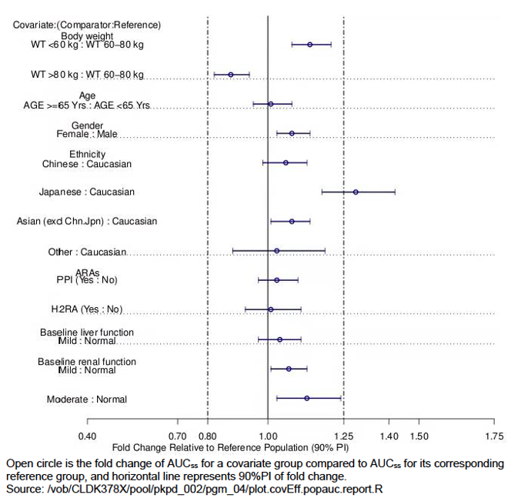

Source: Population PK report Figure 5-5. Abbreviations: WT = (body)weight; Yrs = years; Chn = Chinese subjects; Jpn = Japanese subjects; ARA = acid reducing agents; PPI = proton pump inhibitor; H2RA = Histamine (H2) receptor antagonist

The 750 mg dose is too high for most patients, and the evaluator recommends that future efforts should be aimed at:

1. establishing whether a lower starting dose results in the same efficacy with improved safety, thereby determining if the exposure resulting from the 750 mg dose is necessary for efficacy (noting most patients are not on this dose for long so this would seem unlikely);and
2. characterising the effects of food on GI tolerability aiming for a dose that results in exposure that is lower than that resulting from 750 mg fasted, but is still as efficacious.

### Pharmacodynamics

#### Studies providing pharmacodynamic data

No data provided.

### Efficacy

#### Studies providing efficacy data

* Study CLDK378A2301 (hereafter referred to as Study A2301) A Phase III multicentre, randomised study of oral LDK378;[20] versus standard chemotherapy in previously untreated adult patients with ALK rearranged (ALK-positive), stage IIIB or IV, non-squamous non-small cell lung cancer.
* Study CLDK378A2303 (hereafter referred to as Study A2303) A Phase III, multicentre, randomised, open-label study of oral LDK378;20 versus standard chemotherapy in adult patients with ALK rearranged (ALK-positive) advanced non-small cell lung cancer who have been treated previously with chemotherapy (platinum doublet) and crizotinib. This was the confirmatory study for the initial approval in previously treated patients.

#### Evaluator’s conclusions on efficacy

##### Study A2301

Ceritinib demonstrated consistent benefit over chemotherapy irrespective of being assessed in the different randomization strata except for patients with prior adjuvant chemotherapy (although both the patient and event numbers in this arm were small) and PFS gains were smaller for patients with brain metastases in the ceritinib arm 10.7 months (95% CI: 6.8,16.4) compared with 7 months (95% CI: 4.2, 11.1) in the chemotherapy arm.

##### Study A2303

This is a generally well-conducted, randomised international study, although the strict exclusion criteria and performance status, together with the rigor of monitoring (for example, electrocardiograms (ECGs)) may introduce some issues with external validity, when applied to the likely Australian patient population being treated outside of a clinical trial setting. The primary endpoint of progression free survival is appropriate in this study population. The study is clearly positive for the primary endpoint. Ceritinib demonstrated statistically significant and clinically meaningful superiority over chemotherapy with PFS of 5.4 versus 1.6 months. Several secondary endpoints support the greater efficacy of ceritinib (overall response rate (ORR) 39.7 versus 6.9%; disease control rate 76.5% versus 36.2%, intracranial response 26% versus 4.3%). There was no OS advantage (either from the planned analysis or a sensitivity analysis to account for treatment switching) but OS data were immature and the structure of the study, with a high rate of switching from chemotherapy to ceritinib, made it very unlikely that an OS difference would be found.

### Safety

#### Studies providing safety data

* Study A2301
* Study A2303
* Integrated safety analysis

Table 2: Integrated safety analysis, studies used for pooling

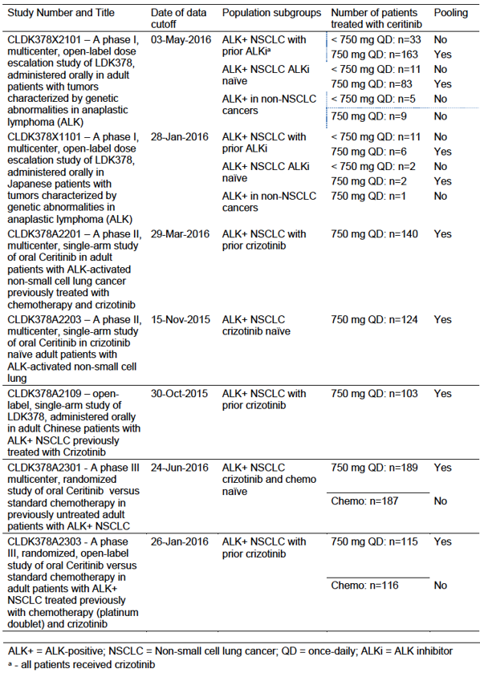

Source: Annex 12, EU RMP Table 12-1

In addition, listings of deaths and serious adverse events (SAEs) from the Novartis global safety database (ARGUS) after the cut-offs above through 11 August 2016 will also be provided ongoing studies of ceritinib in cancer patients.

Table 3: Integrated safety analyses: datasets, analysis sets, treatment groups

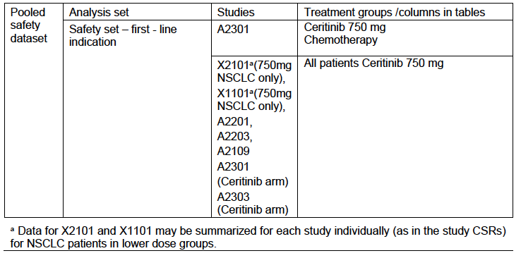

*Full analysis set*: for all studies other than Studies A2301 and A2303, consists of all NSCLC patients who received at least one dose of study drug; for Study A2301 and A2303, consists of all randomised patients.

*Safety set*: consists of all NSCLC patients who received at least one dose of study drug.

The approach taken was to compare the rates of adverse events listed in the RMP as important identified and potential risks for ceritinib, in the ceritinib and the chemotherapy arms from Study A2301 in previously untreated patients, with the rates for all patients treated to date with ceritinib in clinical trials (925 patients). These risk categories currently are:

* Important identified risks for ceritinib:
  + hepatoxicity;
  + QTc prolongation;
  + interstitial lung disease (ILD)/pneumonitis;
  + hyperglycaemia;
  + GI toxicity (nausea, diarrhea, vomiting);
  + pancreatitis; and
  + bradycardia.
* Potential risks for ceritinib:
  + neuropathy;
  + visual disorder;
  + photosensitivity;
  + leukopaenia;
  + oedema; and
  + renal cyst.

The evaluator comments that after evaluating Study A2301, the following should also be included as important identified risks:

* renal impairment; and
* Asian ethnicity.
* Leukopaenia should be elevated to an important identified risk.

#### Patient exposure

Summary tables of exposure by age, gender, race were presented for the entire clinical trial patient group and compared with the chemotherapy and ceritinib arm of the first line Study A2301.

Table 4: Integrated summary, clinical trial exposure by duration

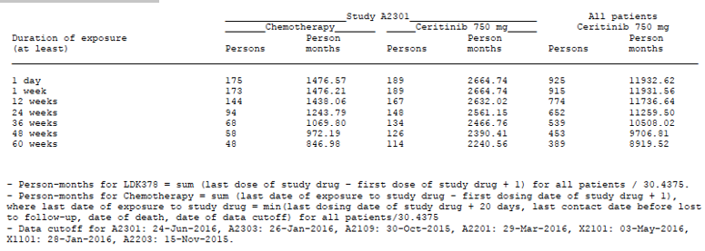

Source: Table 4-01p, Annex 12 EU-RMP

Table 5: Integrated summary, clinical trial exposure by age group and gender

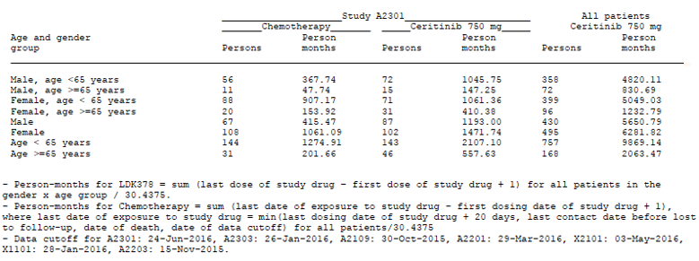

Source: Table 4-03p, Annex 12 EU-RMP

Table 6: Integrated summary, clinical trial exposure by race by treatment group

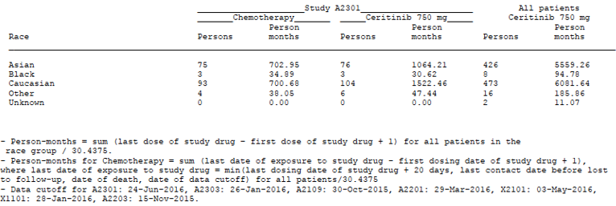

Source: Table 4-04p, Annex 12 EU-RMP

Table 7: Integrated summary, clinical trial exposure by special populations by treatment group

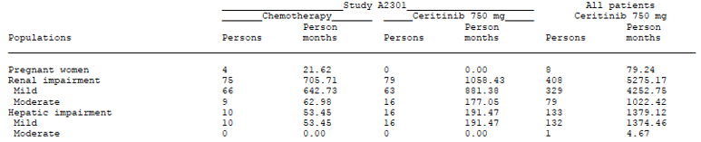

Source: Table 4-05p, Annex 12 EU-RMP)

#### Adverse events

##### Hepatotoxicity

The figures in Table 8 of this report indicates that 68.8% of patients in Study A2301 experienced events of hepatotoxicity captured by a range of terms, and 60.5% in the 925 patients in the pooled analysis.

The proposed PI text in the Hepatotoxicity Precautions section of the PI, is thus (with evaluator’s emphasis in italics to highlight the figures of concern:

‘Cases of hepatotoxicity occurred in *1.1%* of patients treated with Zykadia in clinical studies. Cases of abnormal liver function tests occurred in *2.2%* of patients treated with Zykadia in clinical studies. Cases of drug induced liver injury have been observed in 2 out of 925 (0.2%) of patients treated with Zykadia in clinical studies. Increases to grade 3 or 4 alanine aminotransferase (ALT) elevations were observed in 25% of patients receiving Zykadia. Concurrent elevations in ALT greater than three times the upper limit of normal and total bilirubin greater than two times the upper limit of normal, with normal alkaline phosphatase, occurred in less than 1% of patients in clinical studies. Hepatotoxicity events were managed with dose interruptions or reductions in 40.6% of patients. One percent of patients required permanent discontinuation of treatment in clinical studies with Zykadia. Few events required discontinuation of Zykadia.’

The evaluator has the following comments:

1. The evaluator recommends adoption of the text from the Food and Drug Administration (FDA) label, as the currently proposed text is confusing.
   1. The figures reported in the PI for hepatotoxicity appear to have been drawn from the selective use of the Medical Dictionary for Regulatory Activities (MedDRA) Preferred Term (PT) ‘Hepatotoxicity’ within the Integrated safety table. This may lead to considerable confusion as the title of the table is ‘Hepatotoxicity’, and all events are terms that represent such an event.
   2. Similarly, the figures of ‘Abnormal liver function tests’ are quoted in the PI as 2.2% (based on that PT), and then two sentences later it is stated that Grade 3 or 4 ALT (a liver enzyme) elevations were observed in 25% of patients. These two statements cannot be reconciled and reflect the confusing use of specific MedDRA PT to report these events.
2. The sponsor is requested to re-write this section, noting the FDA label expresses this very clearly, and adoption of that would be acceptable; using more general terms to indicate that patients treated with Zykadia experienced drug-induced hepatotoxicity.
3. It is unclear whether the current term ‘drug-induced liver injury’ indicates these cases met Hy’s law criteria;[21] to clarify the seriousness of the event being discussed.
4. The figure 40.6% is used from the Integrated safety set for those requiring dose reductions/interruptions but it was 55% in the first line population in Study A2301. This is a clinically relevant difference.
5. It should be clarified that 1% discontinued due to events of hepatotoxicity as there were many other reasons for discontinuing. This could be done by including this in the preceding about dose reductions and discontinuations, and deletion of the last sentence.

##### QT interval prolongation

The section regarding QT interval;15 prolongation from which the PI statements are cited, states:

‘QTc prolongation has been observed in clinical studies in patients treated with Zykadia, which may lead to an increased risk for ventricular tachyarrhythmias (e.g., Torsade de pointes) or sudden death. In clinical studies, 9.7% of patients treated with Zykadia had events of QT prolongation (any grade), including Grade 3 or 4 events in 2.1% of patients. These events required dose reduction or interruption in 2.1% of patients and led to discontinuation in 0.2% of patients.’

The figures in the PI reflect those with the MedDRA PT term ‘Electrocardiogram QT prolonged: rather than the reported adverse events for QTc;[22] prolongation on treatment which is acceptable given this is a specific test result. The figures should be corrected to those in Table 8-02 p from Annex 12 of the EU-RMP: 10.8% of patients experienced an adverse event (AE) of QT prolongation, 2.8% were Grade 3/4 while the other figures for dose reduction, interruption and discontinuation are correct (see Table 8 for correct figures).

###### PI comments

The following statement in the PI does not elaborate that the method of QTcP;[23] was used in determining QT prolongation, noting that in the evaluation of Study A2301, this resulted in a lower figure for this AE compared with QTcF.[24]

Table 8: QT prolongation events (Safety set)

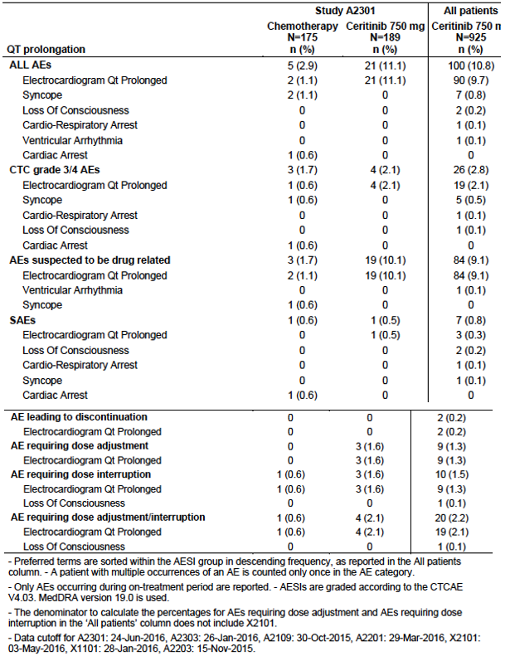

The proposed PI currently states, in both the Cardiac electrophysiology and the QT Interval Prolongation Precautions section:

‘A central analysis of ECG data demonstrated new QTc >500 ms in 12 patients (1.3%) among which six had elevated QTc > 450 ms at Baseline. There were 58 patients (6.3%) with a QTc increase from Baseline > 60 ms. A pharmacokinetic/pharmacodynamic analysis suggested that ceritinib causes concentration-dependent increases in QTc.’

Table 9: Integrated summary of ECG changes from Baseline (Safety set)

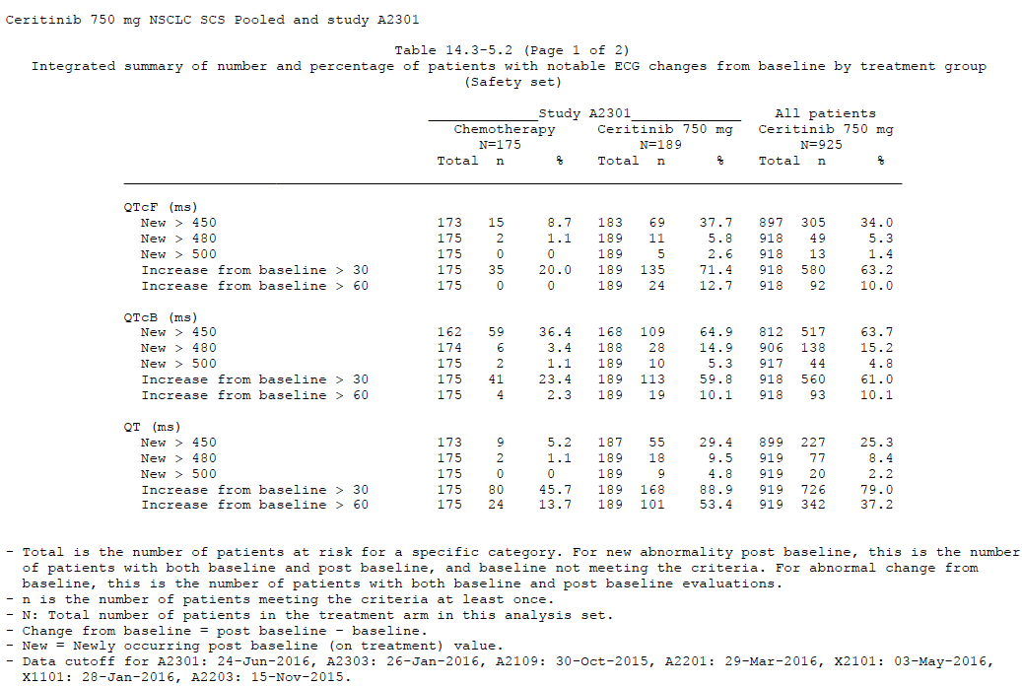

Source: SCS Appendix Table 14.3-5.2

Table 10: Integrated summary of number and percentage of patients with notable ECG changes from Baseline by treatment group (Safety set)

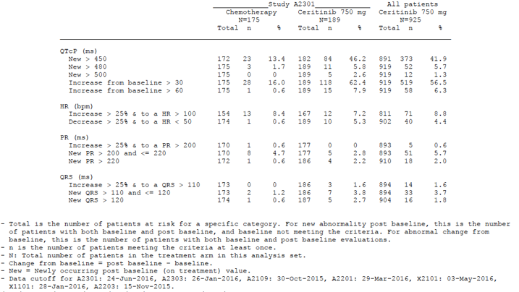

The evaluator comments:

1. This statement does not elaborate that QTcP;23 was used in determining QT prolongation, noting that in the evaluation of Study A2301 and in the pooled dataset, this resulted in a lower figure for this AE compared with QTcF.24
2. Dose-dependent exposure was also detected in Study A2301 and is this information is included in the SCS; it should be stated that this statement be amended as follows:

‘A pharmacokinetic/pharmacodynamic analysis ~~suggested~~indicates that ceritinib causes concentration-dependent increases in QTc.’

##### Bradycardia

Currently the proposed PI states:

‘In clinical studies, bradycardia and/or sinus bradycardia (heart rate less than 60 bpm) events (all grade 1) were reported in 12.3% of patients. These events required dose reduction or interruption in 0.2% of patients. None of these events led to discontinuation of Zykadia treatment. Asymptomatic cases of bradycardia (heart rate less than 60 bpm) have been observed in 11 out of 925 (1.2%) patients treated with Zykadia in clinical studies.’

The evaluator comments that Table 2-16 from the SCS (presented below as Table 11) and Table 8-08 from RMP Annex 12 include the same data state that all AEs of bradycardia were 13.1% (noting many were also events of QT prolongation), 2.7% Grade 3/4, and 0.2% dose reduction/interruption and 0.2% required discontinuation. In the pooled dataset, events of bradycardia and sinus bradycardia occurred in 1.2% and 1.1% of patients, with some requiring dose reduction. The sponsor quotes Table 8-08 in support of asymptomatic cases of bradycardia being reported in 11/925 patients but the evaluator could not find such a statement in these tables or the footnotes, and recommends this statement be removed.

The first sentence should be replaced with:

‘In clinical studies, bradycardia (heart rate less than 60 beats per minute) was reported in 1.2% and 1.1%, with some patients requiring dose reduction or delays, but none discontinuing due to manage this event.’

Table 11: Study A2301 and pooled dataset analyses for bradycardia (Safety sets)

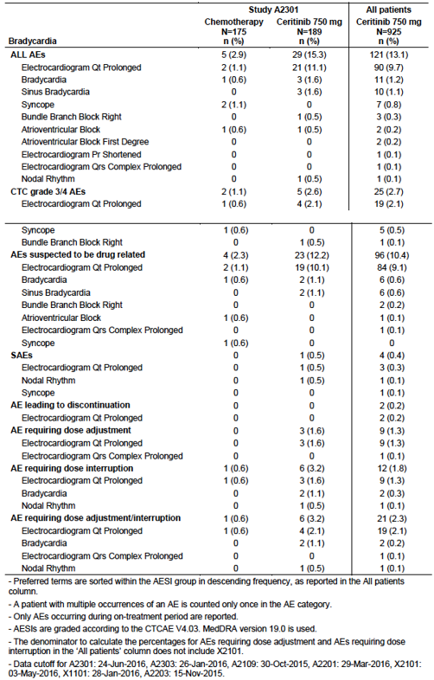

##### Interstitial lung disease

Currently the proposed PI states:

‘Severe, life-threatening, or fatal interstitial lung disease (ILD)/pneumonitis have been observed in patients treated with Zykadia in clinical studies. In clinical studies, any grade ILD/pneumonitis has been reported in 2.1% of patients treated with Zykadia, and grade 3 or 4 events have been reported in 1.2% of patients. Monitor patients for pulmonary symptoms indicative of pneumonitis. Exclude other potential causes of pneumonitis, and discontinue Zykadia in patients diagnosed with treatment-related pneumonitis, any grade (see Dosage and Administration and Adverse Events).’

The evaluator comments that the figures provided for evaluation in Table 8‑03p in Annex 12 to the EU-RMP and SCS Table 2-14 state the figure for the pooled analysis to be reported AEs of 2.4% with 1.3% Grade 3/4. It should be stated that 1.2% required dose reduction/interruptions and 1.1% discontinued due to pneumonitis. (PI Comments).

##### Hyperglycaemia

The proposed PI currently states:

‘Events of hyperglycaemia (all grades) have been reported in 9.4% of patients treated with Zykadia in clinical studies; 5.4% of patients reported a grade 3/4 event. These events required dose reduction or interruption in 1.4% of patients and led to discontinuation in 0.1% of patients. The risk of hyperglycaemia was higher in patients with diabetes mellitus and/or concurrent steroid use. Events of diabetes mellitus (all grades) have been reported in 2.3% of patients treated with Zykadia in clinical studies.’

The evaluator comments that this use of the select MedDRA PT again results in lower reporting rates that do not reflect the tables in the RMP Annex 12 or Table 2-17 SCS, copied below as Table 12. The evaluator believes the appropriate figures for inclusion in the PI to be all AEs for hyperglycaemia events of 13%, of which 6.5% were Grade 3/4, 1.9% required dose interruption/delays and 0.1% required discontinuation. The statement regarding diabetes mellitus should be removed as this is superfluous when all events describing these same outcomes are presented as they were in Table 2-17 of the SCS.

Dose-dependent exposure was also detected in Study A2301 and is this information is included in the SCS. This information should be included in the PI.

Table 12: Hyperglycaemia events (Safety set)

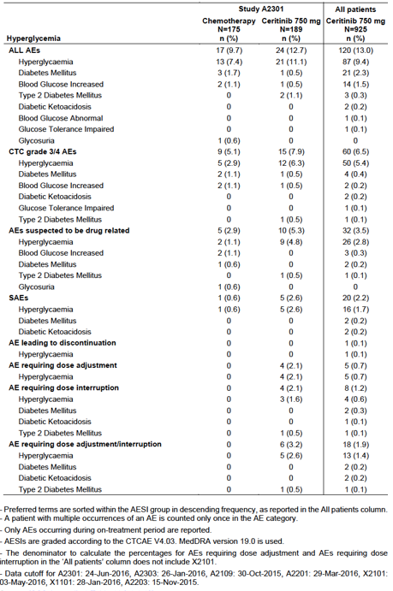

Source: SCS Table 2-17

##### Gastrointestinal toxicity events

The rates of adverse events included in the PI are consistent with those in the SCS and EU‑RMP Annex 12 tables. However, the sponsor has added in the option to take a lower dose with food to reduce these adverse events. This is predicate on acceptance of the findings of Study A2112; the evaluator considers the data are too immature to accept this PI dosing change and therefore this should be removed. In particular, should this dosing change be approved, the details of the dose reduction should be specified as the next dose level down of 600 mg when taken with food resulted in higher exposure than has been studied and a higher rate of AEs reported in the data to date.

‘Dose interruption and dose reduction with food may be employed as necessary (see Dosage and Administration and Adverse Events).’

Table 13: Gastrointestinal toxicity events (Safety set)

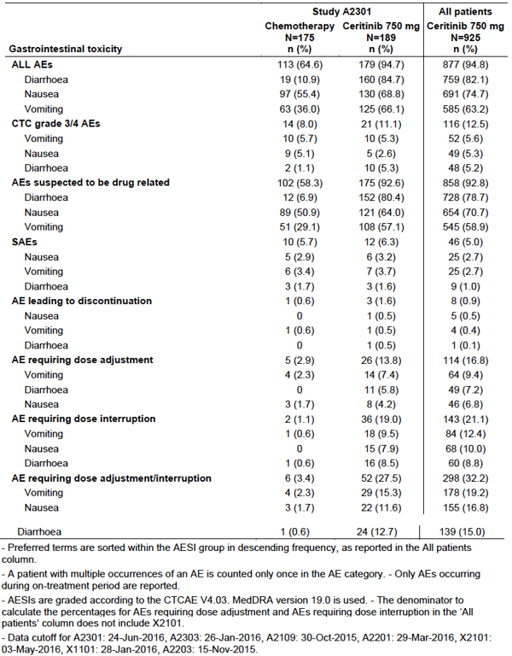

Source: SCS A2301 Table 2-18

##### Pancreatic toxicity

The proposed PI currently states:

‘In clinical studies, AEs of amylase increased (all grades) occurred in 7.0% of patients receiving Zykadia; 3.1% of patients reported a grade 3-4 event. AEs of lipase increased (all grades) occurred in 4.8% of patients receiving Zykadia; 3.5% of patients reported a Grade 3 or 4 event.’

The evaluator comments that theselective reporting of MedDRA PTs for amylase or lipase increase does not capture the pancreatic adverse events - these figures should be replaced with those from the table below for PT ‘Pancreatitis’ events: 9.6% for all AEs (noting that the sponsor has not included the events of pancreatitis in this Precaution on pancreatic toxicity), 5.8% for Grade 3/4 events, 4% requiring dose reduction/interruption and 0.5% discontinuations. It is acceptable to indicate that most abnormalities of lipase and amylase were laboratory-detected events, manageable with dose reductions or delays.

Table 14: Pancreatic events (Safety set)

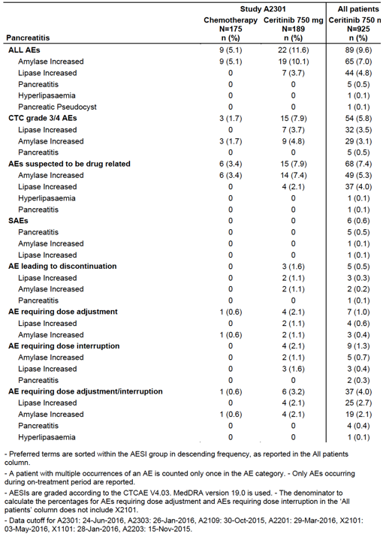

The following appear to be common in patients receiving ceritinib:

* leukopaenia (13.2% in the pooled dataset, 12.7% in Study A2301), this should be changed to an important identified risk in the RMP; and
* photosensitivity.

All AEs were 1.6% in the pooled dataset, with 1 patients experiencing a Grade 3/4 reaction, and most events appearing to be related to radiation treatment, but some also to sunlight. This should be included in the PI to warn about potential radiation reactions which would be administered commonly in this patient group for symptom palliation. Is this severe and should the drug be interrupted for radiation treatment? Have there been any reported instances of radiation recall? (this constitutes a clinical question raised by the Delegate, further mentioned in comments on the PI).

*Visual disorders*: AEs of visual disorder 7.8% were reported in the pooled dataset. These were not discussed.

#### Post marketing data

Periodic safety update reports (PSUR) have been submitted to the TGA and are not evaluated as part of this submission.

#### Evaluator’s conclusions on safety

In Study A2303, ceritinib caused more recorded drug toxicity, adverse events, serious adverse events, and required more dose reductions, interruptions and discontinuations due to toxicity than pemetrexed or docetaxel. Conventional cytotoxic agents used in a third line setting are commonly associated with substantial toxicity burdens, so the greater drug toxicity in the ceritinib arm is noteworthy. It should be recalled also that the study was designed to maximise ceritinib safety by excluding patients with disorders that might predispose to known ceritinib toxicities, and by excluding concurrent use of drugs with the potential to interact with ceritinib.

Most toxicities encountered with ceritinib were not novel. However, reversible elevations of creatinine were encountered frequently, and 29% of patients on ceritinib suffered weight loss of > 10%, far more than was seen on the chemotherapy arm.

GI toxicity and hepatic toxicity were most frequent, with serious adverse events of nausea and vomiting noted, and were generally manageable. While there were no deaths or recorded irreversible serious adverse events attributable to the drug, in one instance an investigator could not rule out adverse events from ceritinib contributing to a global decline in a patient who died shortly after discontinuation (ten days) from progressive disease. The rates of increase in QT interval were substantial in this study as in Study A2301, but did not translate into any clinical events, with close monitoring and minimisation of synergistic factors such as concomitant medications increasing the QT interval. Feared serious adverse events such as pancreatitis, serious arrhythmias and irreversible interstitial lung disease were not encountered. This is in the context of a selected study population, closely monitored by investigators familiar with the study protocol.

### First round benefit-risk assessment

#### First round assessment of benefits

##### Study A2301 First line usage of ceritinib compared with chemotherapy

Stage IIIb and metastatic ALK-positive NSCLC is an incurable condition, and the current standard of care is crizotinib, although recent reports of a significant improvement in progression-free survival with alectinib compared with crizotinib (Peters et al., 2017;12 Hida et al., 2017;11) have resulted in changes in the recommended treatment algorithms by sources such as UpToDate. At this time, the only ALK inhibitor approved for use as a first line therapy for ALK-positive NSCLC is crizotinib.

Study A2301 compared the use of ceritinib with doublet platinum-based chemotherapy followed by pemetrexed maintenance, in patients with Stage IIIb or metastatic ALK‑positive NSCLC as determined by the Ventana (D5F3) IHC assay, compared with four cycles of platinum-based doublet chemotherapy followed by maintenance pemetrexed.

###### Benefits

The efficacy findings support the superiority of ceritinib with an 8.5 month gain in median PFS over standard chemotherapy (16.6 months (95% CI: 12.6, 27.2) versus 8.1 months (95% CI: 5.8, 11.1)). The overall response rate was much higher (72.5% (95% CI: 65.5, 78.7) with ceritinib versus 26.7%, (95% CI: 20.5, 33.7)) and occurred much sooner with ceritinib (median time to response 6.1 weeks versus 13.4 weeks). Although complete responses were only observed in a single patient on ceritinib by blinded independent review committee (BIRC), the waterfall indicated a greater depth of response compared with chemotherapy.

Brain metastases are common in patients with ALK-positive NSCLC, and ceritinib treatment led to higher intracranial response rates and a longer duration of response than chemotherapy.

Overall survival data are immature and likely to be affected by the substantial built-in treatment switching to ceritinib, as well as to agents available outside of the trial, including other ALK inhibitors.

###### Risks

Balanced against these benefits are the very high risk of AEs that were also more severe for those on ceritinib: most notably gastrointestinal toxicity; nausea, vomiting and diarrhoea; as well as hepatotoxicity and renal impairment. Additional risks include QT prolongation, bradycardia, hyperglycaemia, pancreatitis (manifest largely as increases in amylase and lipase) and ILD/pneumonitis. From the pharmacokinetic study undertaken as part of this study, a clear safety-exposure relationship emerged for hepatotoxicity, GI toxicity, QT prolongation and hyperglycaemia.

The most frequently reported study drug-related AEs in the ceritinib group (> 20% of patients) were diarrhoea (80.4%), nausea (64.0%), ALT increased (59.3%), vomiting (57.1%), AST increased (50.8%), gamma glutamyl transferase (GGT) increased (34.9%), and decreased appetite (25.4%), blood alkaline phosphatase increased (24.9%), fatigue (22.2%), and abdominal pain (20.6%). Grade 3 or 4 AEs suspected to be study drug related reported in ≥ 10% patients in the ceritinib group were: ALT (29.6%), GGT (26.5%), and AST (15.9%) increased.

Dose reductions and delays early in the treatment course are frequently required, with 27% requiring one dose reduction, 18.5% requiring two dose reductions, 19.6% of patients requiring three dose reductions and 2.6% requiring 4 dose reductions. Dose reductions and interruptions peaked during from weeks 3-6 of treatment, with the median time to first dose reduction 9.1 weeks (following the visit at the start of Cycle 4) but were still required throughout the treatment period. This suggests that the starting dose is too high for the majority of patients, and together with the high inter-individual variability in PK parameters, that serial dose reductions are necessary to identify the most tolerable dose at an individual level.

Renal toxicities emerged as a new and significant cause of dose reductions, delays and the most common cause of discontinuation. There did not appear to be predisposing factors for renal impairment in some patients, suggesting a potential for primary nephrotoxicity. No information is not currently included in the Precautions section of the PI, and this is required. Of note, all patients discontinuing due to renal adverse events were Asian patients.

Another new signal emerged of an increased risk of adverse events, particularly severe events and those requiring discontinuation, for Asian patients. As a proportion of the study population, this group were overrepresented among requiring discontinuation for hepatotoxicity, renal toxicity and QT prolongation. The PK outcomes from this study showed higher trough concentration (Ctrough) levels for the following individual groups of patients, with potential for overlap: female, Asian, those with low body weight or low body mass index. These findings suggest these patients may be at increased risk of toxicities.

While more patients had an improvement in their performance status compared with chemotherapy patients, an equal proportion in the ceritinib arm experienced a deterioration of their performance status. Despite the impressive efficacy results, the quality of life data did not indicate a clear improvement especially early in the first few cycles of treatment when there would have been sufficient respondents in both arms for a meaningful comparison. Later quality is limited by a rapid decline in the proportion of the full analysis set (FAS) providing responses, particularly among patients receiving chemotherapy and potential bias given the open label nature of the study.

###### Uncertainties

Overall, the study was well presented and clear in its design, demonstration of outcomes.

However, the following are raised as limitations or uncertainties.

1. Study A2301 does not address the relative efficacy of ceritinib compared with crizotinib, the current standard of care for first line treatment ALK-positive NSCLC. It is noted that this study was initiated prior to results from the first line study of crizotinib indicated superior efficacy to chemotherapy. This presents ceritinib as an alternative first line option for those patients with newly diagnosed Stage IIIb or metastatic disease but will not inform regarding optimal sequencing of currently approved ALK inhibitors.
2. The exposure from the currently recommended starting dose appears too high for many patients, but strategies for optimizing this other than dose reduction and changing to taking a lower dose with food, do not appear to have been investigated. Patients receiving 750 mg on an empty stomach had a high rate of GI toxicity which appears potentially to be lowered by co-administration with a low-fat meal of a lower dose (450 mg) of ceritinib. However, this resulted in a slight increase in exposure from the food effect, and with fewer dose reductions due to GI toxicity, a maintained level of exposure that paradoxically, may lead to an increase in other toxicities. There was a clear relationship between exposure and adverse events such as hepatotoxicity, QT prolongation and hyperglycaemia, with increasing severity at higher exposure levels. Discontinuations were higher in the 450 mg fed arm, but with only 15 weeks’ median follow-up for safety, it is too early to be certain. Changes to the dosing approach in the PI are not supported, and the issue of nausea, vomiting and diarrhoea will remain, at least in the interim, until mature data from this food study are available to clarify the safety risks and confirm efficacy is satisfactory.
3. Given the 750 mg dose is too high for most patients, the evaluator recommends that future efforts should be aimed at:
   1. Establishing whether a lower starting dose results in the same efficacy with improved safety, thereby determining if the exposure resulting from the 750 mg dose is necessary for efficacy (noting most patients are not on this dose for long so this would seem unlikely) and
   2. Characterising the effects of food on GI tolerability aiming for a dose that results in exposure that is lower than that resulting from 750 mg fasted, but is still as efficacious.
4. The PK results from Study A2301, suggest that Ctrough levels are higher in women than men, in Asian patients, as well as those with lower body weight and lower body mass index. Study A2112 had substantially more women than men in the 450 mg fed arm which raises uncertainty about whether the exposure levels in that arm are generalisable to all patients.
5. Deaths on treatment were not frequent, with one very likely related to a drug interaction during the extension phase and possibly another which evaluator considers that the death from pneumonitis may be study drug related and the narrative has been requested.

###### Summary

Overall, the toxicities although sometimes severe were manageable and treatment resulted in a substantially improved progression-free survival. For patients informed of the risks of treatment and with a clear plan of how to manage adverse events, the benefit‑risk equation is considered positive.

##### Study A2303 ceritinib compared with chemotherapy in patients previously treated with chemotherapy and crizotinib

The safety concerns are substantial but do not invalidate the positive outcome of the study. Despite higher toxicity, patients gained a PFS nearly 4 months longer (or 3 times as long) on ceritinib as compared with chemotherapy. This is a clinically meaningful benefit. The safety concerns should be addressed by ensuring that practitioners and consumers are fully apprised of the risks of ceritinib by means of the PI and CMI. Patients with an Eastern Cooperative Oncology Group (ECOG) performance status (PS) = 2 were inadequately represented in Study A2303 and patients with ECOG PS =3 or 4 were excluded.[25] Based on the submitted data, the PI should clearly state that efficacy has not been demonstrated nor has toxicity been evaluated in these patient populations.

### First round recommendation regarding authorisation

Subject to satisfactory changes to the PI, particularly those relating to the risks and their management, authorisation of the proposed use in patients previously untreated for their Stage IIIb or metastatic ALK-positive NSCLC is supported.

Study A2303 This study has been submitted as a condition of registration. It is a positive study and fulfils the required condition, so registration for this indication should stand and the ‘Note to the Indication’ may be removed, subject to the implementation of recommended modifications to PI in the interest of patient safety.

### Clinical questions and second round evaluation

#### Pharmacokinetics

1. When will the results be available for the secondary objectives of Study A2112, which included broader efficacy and safety assessments, including in an expanded cohort of treatment-naïve patients at these different dose levels?
2. In the CSR for Study A2112, it is stated that examples of such a low-fat meal were included but these were not able to be located. Please provide copies of these examples.
3. If still seeking the amendment to the PI for the 450 mg fed dose, after receiving this report, please provide possible text describing a low-fat meal for inclusion in both the PI and the CMI; or explain why such text is not necessary. Please also explain how the EMA and FDA are dealing with this issue, noting that patients with ALK-positive NSCLC can come from a variety of cultural backgrounds.
4. Please comment on the following: More mature safety and efficacy data are required to support the PK data for the 450 mg fed dose, and the existing dose instructions and boxed warning should remain in the PI until there is sufficient clarity over the efficacy and safety of the proposed changes.

#### Pharmacodynamics

No questions.

#### Efficacy

No questions.

#### Safety

1. Narratives are presented for three patients experiencing Grade 3 QT prolongation in Study A2301; one discontinued but the others resumed at a lower dose after a treatment delay. No information is presented about QT intervals for the 2 patients after recommencing treatment at the lower dose levels. Please provide this information.
2. Renal toxicity of ceritinib has not been considered a significant issue hitherto. It is noted that 19.1% of patients on ceritinib in Study A2303 had elevated creatinine. Please comment on a possible mechanism of action for the apparently reversible creatinine increases observed in Study A2303 while on ceritinib. Also please comment on renal impairment in Study A2301.
3. In Study A2301, 1.6% of patients experienced photosensitivity AEs including 1 patient experienced a Grade 3 or 4 reaction of photosensitivity, and most events appearing to be related to radiation treatment, but some also to sunlight. Is this severe and should the drug be interrupted for radiation treatment? Have there been any reported instances of radiation recall? Should this be included in the PI?
4. The sponsor indicates in the comments box on the front page of the PI that both an ALK IHC test and FISH test are required for access to ceritinib. Note is made of the FDA decision to register the Ventana ALK IHC as a companion diagnostic in 2017. The sponsor is requested to discuss the implications, in the Australian context, of the selection of patients for the first line Study A2301 using the Ventana IHC.
5. The frequency of QT prolongation depends on the measure used (for example, QTcP, QTcF). Please advise on which measure(s) is (or are) used in the EMA Summary of Medicinal Product Characteristics and the FDA PI and why.

#### Evaluation of response

##### Responses provided by the sponsor

The second round clinical evaluator reviewed the following three documents provided by the sponsor:

* responses (clinical, PK, safety);
* responses to the Delegate; responses to the Delegate’s questions are contained in a document titled are acceptable to the second clinical evaluator; and
* responses (PI, CMI).[26]

##### Evaluation of responses

All responses from the sponsor are accepted by the second round clinical evaluator, with exceptions or further commentary as follows.

###### Question 1

Regarding the response to Question 1:

* It is noted that the US FDA label has been updated to reflect dosing of 450 mg with food (label dated December 2017), whilst the European Summary of Medicinal Produc Characteristics (SmPC) has not (as of 31 January 2018).

###### Question 5

Regarding the response to Question 5:

* QT prolongation is well-described in the PI as a warning/precaution, and in a boxed warning.

###### Question 6

Regarding the response to Question 6:

* The first round benefit-risk balance conclusion states:

‘Renal toxicities emerged as a new and significant cause of dose reductions, delays and the most common cause of discontinuation. There did not appear to be predisposing factors for renal impairment in some patients, suggesting a potential for primary nephrotoxicity. No information is not currently included in the Precautions section of the PI, and this is required. Of note, all patients discontinuing due to renal adverse events were Asian.’

* But elsewhere in the first round evaluation the evaluator states regarding Phase III Study A2303:

‘Comment: Mild and reversible increases in creatinine were common on ceritinib but severe renal toxicity was not reported. It should be recalled that patients with baseline significant abnormalities in renal function, as with liver function, were excluded from study. While not accounting for any discontinuations as was seen in Study A2301, the frequent occurrence of abnormal renal function appears to be a new safety signal that should be stated in the PI.’

* Therefore, the first round evaluator’s concerns have arisen from the evaluation of Study A2301. In this study report, there is a signal analysis of ‘all adverse events and lab abnormalities associated with creatinine increase and renal function’. Case narratives for these are provided.
* The sponsor’s response regarding creatinine elevation seen in Study 2301 is reproduced here for ease of reference:

‘Creatinine increase has been commonly observed in patients treated with ceritinib, and is mainly considered to be a pharmacologic effect of ceritinib (that is, inhibition of tubular creatinine secretion), and not due to direct nephrotoxicity. Elevations of creatinine are generally transient and reversible upon treatment interruption. The frequency and severity of creatinine increase is consistent among ceritinib lung cancer studies, and transient elevations in blood creatinine were also observed in healthy subjects following a single dose of ceritinib (that is, 33/96 subjects across five clinical pharmacology studies: Studies CLDK378A2101, A2105, A2106, A2104 and A2108).

In Study A2303, none of the creatinine increase events were Grade 3 or 4, or serious. In Study A2301, four patients reported a Grade 3; three patients reported serious AE of creatinine increase, all of which recovered upon treatment interruption. besides the likely effect of ceritinib on creatinine secretion, one out of these three patients had already elevated baseline creatinine levels, and two experienced concurrent GI toxicity/dehydration, which may have temporarily accentuated creatinine concentrations. There were no severe or life-threatening events of acute kidney injury, renal failure or renal impairment.

Pre-clinically, ceritinib was shown to inhibit transporter proteins that contribute to creatinine clearance *in vivo* (that is, MATE1). To differentiate whether the creatinine increase observed in patients treated with ceritinib could be mediated by renal transporters, serum cystatin C (eliminated via glomerular filtration) and creatinine levels before and after ceritinib administration were assessed in healthy subjects as part of Study CLDK378A2113. In this study, transient elevations in creatinine but not cystatin C levels were found, suggesting that the effect is related to reduced creatinine secretion rather than direct nephrotoxicity. Similar findings have been observed with crizotinib where inhibition of renal transporter proteins has been proposed as a possible mechanism for decreased estimated glomerular filtration rate.[27]

Rapid, transient increases with no accumulation over time and normalisation at the end of treatment (EOT) in blood creatinine levels but not blood urea nitrogen (BUN) have been observed in clinical studies, and further support this hypothesis; an example of creatinine and BUN time-profiles is shown below for patients treated in Study A2303 (Figure 6-1); identical pattern was found in Study A2301. Given creatinine clearance was typically calculated off blood creatinine concentrations (rather than determined based on 24 hour urine samples), decreases in creatinine clearance and respective adverse event reports in ceritinib trials are expected to be a result of the same phenomenon (that is, reduced renal creatinine secretion) in the majority of cases.

Safety data from Study A2301 and A2303 were further analysed by baseline renal function (FDA PK Renal Guidance 2010);[28] given patients with serum creatinine > 1.5 g/dL and/or calculated clearance < 50 mL/min were excluded from these studies as per protocol, there were no patients with severe, and only few with moderate baseline renal impairment. The review of the overall safety profile of ceritinib in patients with baseline mild and moderate renal impairment versus patients with normal renal function did not reveal any clinically relevant differences or new safety concerns, and is consistent with the established safety profile of ceritinib.

In summary, while common, creatinine elevation/renal impairment events occurring under ceritinib treatment are considered to be mainly related to pharmacologic inhibition of renal creatinine secretion rather than direct nephrotoxic effects; these events are generally mild or moderate and reversible upon treatment interruption or discontinuation, and are adequately described in the prescribing information. Based on the currently available information, the sponsor believes changes to the Core data sheet/label or RMP are not necessary.’

* In light of the sponsor’s response regarding creatinine elevation, the differences between arms are not surprising in the Phase III trials. Case narratives predominantly highlight confounding factors such as concurrent dehydration, diarrhoea or risk factors for renal impairment. A precaution is not warranted on the basis of the clinical trial data. A statement based on the final paragraph of the sponsor’s response, above, could be considered for the PI.
* No such information is included in the US label, and the ASCEND 5 trial was submitted to the FDA at the same time as the ASCEND 4 trial (though no label updates were made for the ASCEND 5 trial).

###### Question 8

Regarding the response to Question 8:

* Efficacy of ceritinib has been demonstrated in patients tested with both tests, and reasonable, though not perfect, concurrence between tests is shown. The PI doesn't currently state what test was used in trials or which should be used in clinic to determine ALK positivity. In general, tests are seldom perfect in sensitivity/specificity, and thus concurrence can seldom be expected to be 100%. TGA involvement in companion or complementary diagnostic specifications is beyond the scope of this application.
* The second round clinical evaluator agrees that it could be helpful to include in the clinical trials sections the name of the test that was used to determine ALK-positivity in each trial, such as is seen in the FDA label.

###### Question 10

Regarding the response to additional Question 10:

* The sponsor confirms that the pooled safety dataset studied in the RMP Annex 12 only includes NSCLC patients taking 750 mg (fasted)
* Regarding this group, the first round clinical evaluator states:

‘The findings in the pooled dataset are similar to those in the Study A2301 population, although increase in the rate and severity of liver function abnormalities were experienced by this previously untreated population. The results from the pooled dataset do not change the overall assessment of the safety of ceritinib for the proposed usage.’

###### Additional question

Regarding the response to the additional Question:

* In criticism of the clinical reasoning given in this response: the presence of x-ray findings suggest a cause other than asthma, the distribution of lung abnormalities was over two separate fields (upper on one side and lower on the other) making infection less likely, antibiotics/antimycotics and steroids failed to be effective, and suspicion by investigator is an unreliable predictor of causality.
* Despite these criticisms, the second round evaluator agrees that regardless of causality, pneumonitis/ILD is described by the current PI text:

‘Severe, life-threatening, or fatal interstitial lung disease (ILD)/pneumonitis have been observed in patients treated with Zykadia in clinical studies. In clinical studies, any grade ILD/pneumonitis has been reported in 2.1% of patients treated with Zykadia, and grade 3 or 4 events have been reported in 1.2% of patients. Monitor patients for pulmonary symptoms indicative of pneumonitis. Exclude other potential causes of pneumonitis, and discontinue Zykadia in patients diagnosed with treatment-related pneumonitis, any grade (see Dosage and Administration and Adverse Events).’

###### Additional comment on draft RMP

Regarding the response to the additional comment by the clinical evaluator on the draft RMP:

* The question is whether ceritinib causes leukopaenia at all, not whether it is
  + worse than chemotherapy or crizotinib;
  + manageable with dose reduction; or
  + serious or fatal.
* There is therefore extraneous argument included in this response around those topics.
* Despite these criticisms, it is agreed by the second round evaluator that the nature, severity and confounding factors in the leukopenia adverse events seen in the clinical trials is not reflective of clear causality between ceritinib and leukopaenia but is more suggestive that these mostly subclinical effects are derived from other causes such as infections, in a population compromised by underlying disease and previous therapy.

### Second round benefit-risk assessment

The benefits identified at the first round are unchanged by the second round assessment.

The risks identified at the first round are agreed by the second round clinical evaluator except for:

* nephrotoxicity is not an identified risk; and
* concerns regarding exposure in patients of low weight or Asian race are considered mediated by the size of PK change ascribed to these patients in context of inter-individual variability.

Uncertainties remain the same, namely:

* translation of measured outcomes into clinical meaning/quality of life, given the open-label nature of the study;
* relative efficacy/safety of ceritinib to other ALK inhibitors; and
* the fatal case of pneumonitis that occurred on-study may well have been treatment related, but this can’t be unequivocally established from the available data.

With the exception of the above, which the second round round evaluator believes are now established:

* the 450 mg dose in the fed state appears to be of similar efficacy and improved GI tolerability/similar safety compared to the 750 mg fasted dosing; and
* Study A2112 had a similar proportion of female patients in the 450 mg fed arm (56.1%) and 750 mg fasted arm (57.5%), however, the proportion of female patients was lower in the 600 mg fed arm (40.0%).

The first round clinical evaluator’s summary was:

‘Overall, the toxicities although sometimes severe were manageable and treatment resulted in a substantially improved progression-free survival. For patients informed of the risks of treatment and with a clear plan of how to manage adverse events, the benefit-risk equation is considered positive.

The second round clinical evaluator agrees with this summary after evaluation of the sponsor’s response to request for information.

## Second round recommendation regarding authorisation

Subject to PI changes satisfactory to the Delegate, authorisation of the following are recommended:

* the proposed usage of ceritinib in patients previously untreated for their Stage IIIb or metastatic ALK-positive NSCLC; and
* removal of the ‘Note to Indication’ and black box warnings as per the tracked changes in the submitted PI.

## VI. Pharmacovigilance findings

### Risk management plan

#### Summary of RMP evaluation[29]

* The sponsor has applied to extend the indications of ceritinib (Zykadia) to include first-line treatment of patients with locally advanced or metastatic NSCLC) that is ALK-positive.
* The proposed indication will replace the current second-line indication:

*‘use as monotherapy for the treatment of adult patients with anaplastic lymphoma kinase (ALK) positive locally advanced or metastatic non-small cell lung cancer (NSCLC) whose disease has progressed on or who are intolerant of crizotinib.’*

* The application also seeks to remove several black box warnings regarding severe adverse events such as gastrointestinal toxicity and ILD/pneumonitis, including fatal cases and a warning that Zykadia must be administered whilst fasting.
* In addition, the sponsor proposes to discontinue the patient wallet card which is the only additional risk minimisation activity for Zykadia. The reason for removal is based on the results of two Phase III studies which have now been completed and data from Part I of Study 2112 (a food effect study).
* The recommended dose of Zykadia is 750 mg taken orally once daily on an empty stomach at the same time each day.
* The most recently evaluated European Union risk management plan (EU-RMP) version 2.5 (dated 29 April 2015, data lock point (DLP) 27 June 2014) and Australian specific Annex (ASA) version 3.0 (dated 11 March 2016). In support of the extended indications, the sponsor has submitted EU-RMP version 9.0 (dated 2 March 2017; DLP 29 March 2016) and ASA version 4.0 (dated 1 May 2017). In its post first round response, the sponsor submitted ASA version 6.0 (dated 13 December 2017). The EU-RMP version 10.0 (dated 17 May 2017; DLP 29 March 2016) was provided to the TGA as a post-approval update prior to the response to questions.
* The proposed Summary of Safety Concerns and their associated risk monitoring and mitigation strategies are summarised below:

Table 15: Summary of safety concerns

|  |  |  |  |  |  |
| --- | --- | --- | --- | --- | --- |
| Summary of safety concerns | | Pharmacovigilance | | Risk Minimisation | |
| Routine | Additional | Routine | Additional |
| **Important identified risks** | Hepatotoxicity | ✓ | – | ✓ | ✓** |
| QT prolongation | ✓ | – | ✓ | ✓** |
| Interstitial lung disease/ Pneumonitis | ✓ | – | ✓ | ✓** |
| Hyperglycaemia | ✓ | – | ✓ | ✓** |
| GI toxicity (nausea, vomiting, diarrhoea) | ✓ | – | ✓ | ✓** |
| Bradycardia | ✓ | – | ✓ | ✓** |
| Pancreatitis | ✓ | – | ✓ | ✓** |
| **Important potential risks** | Neuropathy | ✓ | – | – | – |
| Concomitant use of ceritinib and strong CYP3A inhibitors or strong CYP3A inducers | ✓ | – | ✓ | – |
| Concomitant use of ceritinib and gastric acid reducing agents such as proton pump inhibitors (PPIs) | ✓ | ✓* | ✓ | – |
| **Missing information** | Patients with hepatic impairment | ✓ | ✓ | ✓ | – |
| Patients with severe renal impairment | ✓ | – | ✓ | – |
| Patients with severe cardiac impairment | ✓ | – | ✓ | – |
| Elderly patients | ✓ | – | ✓ | – |
| Paediatric patients | ✓ | – | ✓ | – |
| Pregnant and lactating women, and women of childbearing potential | ✓ | – | ✓ | – |
| Long-term safety | ✓ | – | – | – |
| Concomitant use of ceritinib and CYP3A, CYP2C9, CYP2A6, or CYP2E1 substrates; ceritinib and drugs that may prolong the QT interval | ✓ | ✓ | ✓ | – |

*Study LDK378A2113 is now completed. **Not an EU requirement, ASA only. The additional risk minimisation activity is the patient wallet card, and all the Important Identified Risks (except hyperglycaemia) have a black box warning in the PI as part of routine risk minimisation.

* Additional pharmacovigilance activities include two Phase I studies (Studies LDK378A2110 and LDK378A2103) to address the safety concerns indicated in the table above.
* The sponsor is requesting the removal of the one additional risk minimisation activity; a patient wallet card. If the requested black box warnings are not removed from the PI, then the sponsor should continue to provide the patient wallet card.

#### New and outstanding recommendations from second round evaluation

* The recommendations made in the first round evaluation, along with consideration of the sponsor response, were provided.
* There is one outstanding recommendation at the second round which is dependent on the outcome of the TGA evaluation:
  + If the Delegate decides to remove the black box warning, then the patient wallet card is no longer required; otherwise
  + Recommendation 6: If the Delegate decides not to remove the requested black box warnings, then the patient wallet card should remain in use.
  + If this is the case, then the patient wallet card should be updated with information on the timing of dosing in relation to food and the extended indication and be submitted to the TGA prior to the marketing of the new indication.

#### Proposed wording for conditions of registration

Any changes to which the sponsor has agreed should be included in a revised RMP and ASA. However, irrespective of whether or not they are included in the currently available version of the RMP document, the agreed changes become part of the risk management system.

The suggested wording is:

The Zykadia EU-Risk Management Plan (RMP) (version 10.0, dated 17 May 2017, data lock point 29 March 2016), with Australian Specific Annex (version 6.0, dated 13 December 2017), included with submission PM-2017-00696-1-4, and any subsequent revisions, as agreed with the TGA will be implemented in Australia.

The following wording is recommended for the PSUR requirement:

An obligatory component of risk management plans is routine pharmacovigilance. Routine pharmacovigilance includes the submission of Periodic Safety Update Reports (PSURs).

Reports are to be provided in line with the current published list of EU reference dates and frequency of submission of PSURs until the period covered by such reports is not less than three years from the date of this approval letter.

The reports are to at least meet the requirements for PSURs as described in the European Medicines Agency’s Guideline on good pharmacovigilance practices (GVP) Module VII-Periodic Safety Update Report (Rev 1), Part VII.B Structures and processes. Note that submission of a PSUR does not constitute an application to vary the registration. Each report must have been prepared within ninety calendar days of the data lock point for that report.

## VII. Overall conclusion and risk/benefit assessment

The submission was summarised in the following Delegate’s overview and recommendations.

### Background

#### Drug classification

Ceritinib is a small molecule inhibitor of an oncogenic fusion gene product, anaplastic lymphoma kinase (ALK). It is approved in Australia for the treatment of ALK-positive non-small cell lung cancer (NSCLC), after failure of crizotinib, an earlier generation ALK‑inhibitor. A third ALK inhibitor, alectinib, is now approved for first-line treatment of ALK-positive NSCLC. Trial data directly comparing ceritinib with crizotinib or ceritinib with alectinib are not available.

#### Australian regulatory history

Ceritinib was originally approved as a new chemical entity for the current indication in March 2016, on the basis of overall response rate (ORR) and duration of response (DOR) data from a Phase II clinical trial (Study A2201), with supporting data from a Phase I clinical trial (Study X2101).

Study X2101 (also known as the ASCEND-1 trial) was a global, multicentre, open-label, single-arm Phase I study with a dose-escalation phase and an expansion phase at 750 mg dose (n = 246) in patients who had locally advanced or metastatic ALK-positive malignancy that had progressed despite standard therapy (163 had received prior treatment with an ALK inhibitor).

Study A2201 (also known as the ASCEND-2 trial) was a global, multicentre, open-label, single-arm Phase II study of 750 mg ceritinib in patients with locally advanced or metastatic ALK-positive NSCLC (n = 140) who had been previously treated with 1 to 3 prior lines of cytotoxic chemotherapy followed by crizotinib, and then progressed on crizotinib.

The primary efficacy endpoint for both studies was ORR for patients who were treated with a dose of 750 mg, and secondary endpoints included DOR, progression-free survival (PFS) and overall survival (OS). Tumour evaluations were performed by the investigator according to Response Evaluation Criteria in Solid Tumours (RECIST) 1.0 in Study X2101 and RECIST 1.1 in Study A2201. Tumour evaluations were also performed separately by blinded independent review committee (BIRC). The efficacy results from these studies, as summarised in the current PI, are reproduced in Table 16.

As the approval was based on single-arm study data and surrogate markers of clinical benefit, and no formalised provisional registration pathway was available, a note to the indication was added to the Australian PI to highlight the uncertainty inherent in the registration data. The current indication is:

*‘Zykadia is indicated as monotherapy for the treatment of adult patients with anaplastic lymphoma kinase (ALK) positive locally advanced or metastatic non-small cell lung cancer (NSCLC) whose disease has progressed on or who are intolerant of crizotinib*

*Note to the Indication: This indication is approved based on tumour response rate and duration of response. An improvement in survival or disease-related symptoms has not been established.’*

Table 16: Overview of efficacy data in ALK-positive NSCLC patients from Studies X2101 and A2201

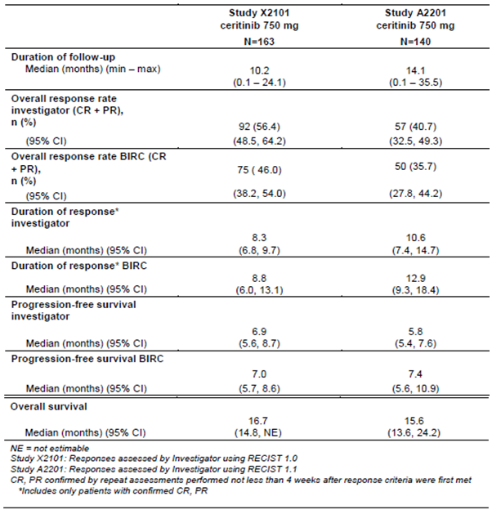

Extensive safety-related warnings, including black box warnings, were also implemented as a way of emphasising the uncertainty involved in the measurement of safety outcomes in the absence of a contemporaneous control arm. Conditions of registration included a requirement for the submission of results from a Phase II food study (Study A2112, also known as the ASCEND-8 trial) and a confirmatory Phase III randomised controlled trial (RCT) in crizotinib-treated patients (Study A2303, also known as the ASCEND-5 trial).

The current submission seeks to make extensive changes to the PI, on the basis of the three clinical studies listed in Table 17: the fed dosing study (ASCEND-8 trial), a confirmatory Phase III RCT in previously treated patients (ASCEND-5 trial) and an additional Phase III RCT study in previously untreated patients (Study A2301, also known as the ASCEND-4 trial).

Table 17: The three clinical trials that formed the basis of this extension of indications submission

|  |  |
| --- | --- |
| Study | Title |
| Study A2301 (ASCEND-4 trial) | A Phase III multi-centre, randomized study of oral LDK378 versus standard chemotherapy in previously untreated adult patients with ALK rearranged (ALK-positive), stage IIIB or IV, non-squamous non-small cell lung cancer. |
| Study A2303 (ASCEND-5 trial) | A Phase III, multi-centre, randomized, open-label study of 750 mg oral LDK378 versus standard chemotherapy in adult patients with ALK rearranged (ALK-positive) advanced non-small cell lung cancer who have been treated previously with chemotherapy (platinum doublet) and crizotinib. |
| Study A2112 (ASCEND-8 trial) | A multi-centre, randomized, open-label study to assess the systemic exposure, efficacy, and safety of 450 mg ceritinib taken with a low-fat meal and 600 mg ceritinib taken with a low-fat meal as compared with that of 750 mg ceritinib taken in the fasted state in adult patients with ALK-rearranged (ALK-positive) metastatic non-small cell lung cancer (NSCLC). |

LDK378: The drug development name for ceritinib in clinical studies/trials

Two key changes to the PI are:

1. the removal of the specification in the indication limiting use to post-failure of crizotinib (that is, allowing first-line use in ALK-mutation positive NSCLC); and
2. addition of a recommendation to adjust dosage from the starting dose of 750 mg daily on an empty stomach to 450 mg daily with food, for the management of gastrointestinal adverse events.

Other changes include updated clinical trial, efficacy, safety and population study data, and removal of related black box warnings.

#### International regulatory history

##### Overview of international regulatory status

The submission contained a tabular summary of international regulatory status at time of submission of data from the three trials ASCEND-4, ASCEND-5 and ASCEND-8. The table is reproduced below as Table 18.

Table 18: Summary of international regulatory status at time of submission for data from the three submitted clinical trials

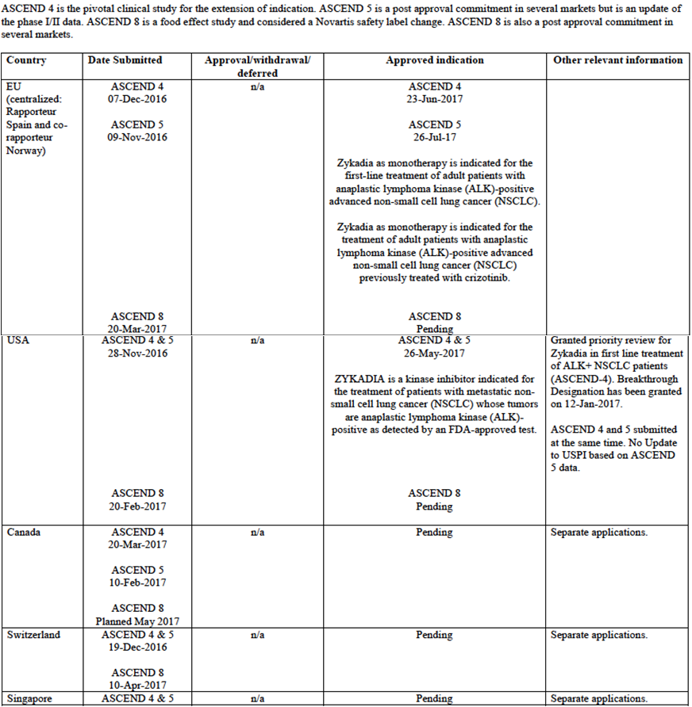

##### United States Food and Drug Administration

Ceritinib received accelerated approval from the FDA on 29 April 2014, based on the data from Study X2101/the ASCEND-1 trial (called ‘Study 1’ in the label) for the indication:

*‘Zykadia is a kinase inhibitor indicated for the treatment of patients with anaplastic lymphoma kinase (ALK)-positive metastatic non-small cell lung cancer (NSCLC) who have progressed on or are intolerant to crizotinib. This indication is approved under accelerated approval based on tumor response rate and duration of response. An improvement in survival or disease-related symptoms has not been established. Continued approval for this indication may be contingent upon verification and description of clinical benefit in confirmatory trials.’*

As noted in Table 18, in May 2017, the accelerated approval was converted to a full approval with the acceptance of the confirmatory Phase III study, theASCEND-5 trial, by the FDA. At the same time, the indication was amended to allow first line use by removing the specification for use after failure of crizotinib, based on the data from the ASCEND-4 trial.

Since the submission was received by the TGA (that is, since the compilation of Table 16 by the sponsor), the FDA has updated the US label based on data from the ASCEND-8 trial to amend the starting dose to 450 mg with food for all patients. The current US indication and dosage is thus (cross-references are to other numbered sections of the US label):

*‘Indications and usage*

*Zykadia is a kinase inhibitor indicated for the treatment of patients with metastatic non-small cell lung cancer (NSCLC) whose tumors are anaplastic lymphoma kinase (ALK)-positive as detected by an FDA-approved test.*

*Dosage and administration*

*450 mg orally once daily with food.’*

##### European Medicines Agency

Ceritinib was approved by the EMA in May 2015 for treating ALK-positive advanced NSCLC previously treated with crizotinib, based on the data from Study X2101/ASCEND-1 trial (called ‘Study A’ by the EMA) and Study A2201/ASCEND-2 trial (called ‘Study B’ by the EMA).

In May 2017, the first line indication was recommended for approval by the EMA's Committee for Medicinal Products for Human Use (CHMP) based on the ASCEND-4 trial data. Section 4.1 of the SmPC (‘Therapeutic indications’) now reads:

*Zykadia as monotherapy is indicated for the first-line treatment of adult patients with anaplastic lymphoma kinase (ALK)-positive advanced non-small cell lung cancer (NSCLC).*

*Zykadia as monotherapy is indicated for the treatment of adult patients with anaplastic lymphoma kinase (ALK)-positive advanced non-small cell lung cancer (NSCLC) previously treated with crizotinib.*

A decision is expected in March 2018 from the EMA regarding dose changes related to the ASCEND-8 trial.

### Quality

There was no requirement for a quality evaluation in a submission of this type.

### Nonclinical

There was no requirement for a nonclinical evaluation in a submission of this type.

### Clinical

#### Study A2112 (the ASCEND-8 trial)

Two datasets related to this study have been considered in this submission.

The first is the original CSR which was submitted with the dossier initially and was reviewed by the first round clinical evaluator. The data cut-off date for the primary analysis was 16 June 2016 and the CSR is dated 24 January 2017.

In response to a question, the sponsor provided top-line efficacy and safety results (but not a full CSR) from a pre-planned interim efficacy analysis with an updated data cut off date of 26 July 2017 in the sponsor’s post first round evaluation response. Full interpretation of these results is not possible without evaluation of the full CSR.

##### Study title

A multicentre, randomised, open-label study to assess the systemic exposure, efficacy, and safety of 450 mg ceritinib taken with a low-fat meal and 600 mg ceritinib taken with a low-fat meal as compared with that of 750 mg ceritinib taken in the fasted state in adult patients with ALK-rearranged (ALK-positive) metastatic non-small cell lung cancer (NSCLC).

##### Design

This was an open label, randomised, multi-centre, parallel design, Phase I study.

Patients were randomised 1:1:1, and stratified by:

* Prior treatment:
  + prior crizotinib use with ALK positivity determined by FISH;
  + crizotinib-naïve but may or may not have been previously treated with other systemic anti-cancer therapy, with ALK positivity determined by FISH; or
  + treatment-naïve with ALK positivity determined by IHC.
* Brain metastases at screening (presence versus absence).

Tumour assessments were investigator and BIRC assessed, according to RECIST version 1.1.

Follow up was 30 days post last dose for AEs and every 12 weeks for survival.

Patients were treated until progression by BIRC or unacceptable toxicity (or other discontinuation criteria were met).

Treatment beyond progression was allowed if continued clinical benefit per Investigator (despite progression per BIRC).

Sample size was based on inter-patient PK variability (coefficient of variation (CV) for Cmax 0.448) seen in previous Study X2101, and the strict PK evaluability criteria, up to 150 patients were planned for randomization so at least 90 (30 per arm) would have evaluable full PK profiles at steady-state. Based on a t-distribution with one-sided alpha-level of 0.05 and 2n-2 degrees of freedom, and a CV of 0.448, adequate precision for the estimated geometric mean ratio (half-width of the 90% CI for treatment difference comparison on a log scale = 0.185) could be obtained with n = 30.

##### Locations (study centres)

Study centres were in the following countries (number of centres in brackets): Austria (1), Belgium (1), Bulgaria (3), Canada (3), Czech Republic (1), Germany (3), Italy (9), Netherlands (1), New Zealand (1), Korea (4), Spain (3), United Kingdom (3), Greece (1), Lebanon (1), United States (10), Poland (2), Russia (1), Taiwan (1).

##### Dates

*First patient visit*: 9 April 2015.

*Primary analysis data cut-off date*: 16 June 2016.

*Study completion date*: study ongoing.

*CSR date (first round evaluation)*: 24 January 2017.

*Topline summary (provided in response for second round evaluation) of interim efficacy analysis with data cut-off date*: 26 July 2017.

##### Inclusion criteria (abbreviated)

The abbreviated inclusion criteria were:

* metastatic NSCLC;
* ALK-positive tumour:
  + if treatment naïve and enrolled prior to protocol amendment 1 (23 April 2015), then FISH test was accepted for ALK-positive identification;
  + after protocol Amendment 1, treatment-naïve subjects had to have ALK‑positivity confirmed by IHC;
  + previously treated patients could be ALK-positive on FISH or on IHC test.
* World Health Organization (WHO) performance status 0 to 2;25,[30]
* adequate organ function per laboratory values;
* at least one lesion measurable per RECIST if treatment-naïve; and
* non-reproductive, consenting adults.

##### Exclusion (abbreviated)

The abbreviated exclusion criteria were:

* prior treatment with ALK inhibitor other than crizotinib;
* prior systemic adjuvant or neoadjuvant therapy if relapse occurred within 12 months;
* major GI impairment or malabsorptive disease;
* history of ILD/interstitial pneumonitis or pancreatitis;
* unstable or symptomatic CNS disease, history of carcinomatous meningitis;
* clinically significant, uncontrolled heart disease, QT prolongation on triplicate ECG or concurrent medications that prolong QT;
* concurrent other anti-neoplastic therapy other than strong CYP3A4/5 (or CYP2C if narrow therapeutic index) inducers/inhibitors, warfarin, herbal preparations, unstable or increasing doses of corticosteroids, grapefruits, pomegranates, star fruit or Seville orange intake;
* alcohol intake, enzyme inducing anticonvulsants; and
* major surgery, radiotherapy (other than palliative to bone lesions), significant non‑NSCLC malignancy.

##### Intervention

Three doses of ceritinib were compared in the three (open-label) study arms, as described in Table 19.

Table 19: Treatment dosage

|  |  |  |
| --- | --- | --- |
|  | Efficacy analysis set: treatment naïve patients only | Safety analysis set: all patients (both treatment naïve and pre-treated) who received one dose of study drug |
| 450 mg Ceritinib daily with food | 41 | 89 |
| 600 mg ceritinib daily with food | 40 | 86 |
| 750 mg ceritinib daily on an empty stomach (current registered dose) | 40 | 90 |
| Total | 121 | 265 |

* In this study, a low-fat meal is considered to be a meal that contains approximately 1.5 to 15 grams of fat and approximately 100 to 500 total calories.
* Ceritinib in the fed arms was to be taken within 30 minutes of this meal.
* The two fed dose options were chosen using PK modelling, estimated to result in steady state exposure within 20% of that seen with the current recommended dose.
* 1 cycle = 21 days.

Dose reductions for toxicity followed the schedule described in Table 20.

Table 20: Dose reduction steps

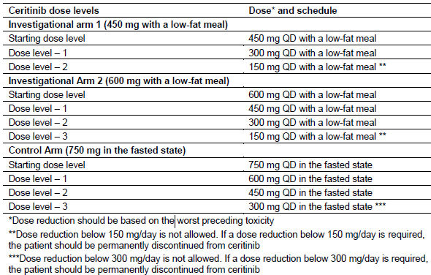

##### Endpoints

###### Primary

* Steady-state PK (AUC0-24h, Cmax, Tmax, Tlast;[31])

###### Secondary

* Efficacy (overall response rate (ORR) and duration of response (DOR) as assessed by BIRC per RECIST 1.1)
* Safety (AEs (seriousness, severity and relatedness), pregnancies, laboratory parameters, vital signs, WHO performance status, ECG)
* Single-dose PK.

###### Exploratory:

* Exposure-safety/efficacy analyses

##### Baseline characteristics

Based on the dataset submitted, the first round clinical evaluator stated:

* Confounding towards better efficacy could have occurred in the 600 mg arm due to lower incidences of liver metastases, poorly differentiated tumours and rates of prior crizotinib use. In the same arm, however, the higher rate of brain metastases (a poor prognostic feature) could have had the opposite effect.
* Confounding towards poorer efficacy could have occurred in the 450 mg arm due to lower performance status and higher rates of pretreatment with chemotherapy/crizotinib.

The sponsor’s summary of interim efficacy analysis states that baseline demographics were balanced with the exception of those outlined tin Table 21.

Table 21: Study A2112. Baseline demographics

|  |  |  |  |
| --- | --- | --- | --- |
|  | 750 mg arm | 600 mg arm | 450 mg arm |
| Female (%) | 57.5 | 40 | 56.1 |
| Caucasian (%) | 60.0 | 57.5 | 48.8 |
| Never smoked (%) | 67.5 | 55.0 | 58.5 |

The sponsor did not provide data regarding disease characteristics and prior antineoplastic therapies for the updated analysis set in their summary. Therefore, interpretation of the study findings with regard to efficacy and safety is limited.

The sponsor does state: ‘92.6% of patients entered the study with a World Health Organization (WHO) Performance Status (PS) score of 0 or 1.’

This reinforces the first round evaluator’s concerns that evidence for efficacy/safety in patients with poorer performance status is sparse: both Phase III trials also contained small numbers of patients with WHO PS of 2 (24 (6.4%) patients in the ASCEND-4 and 14 (6.1%) in the ASCEND-5 trials).

##### Disposition

The sponsor’s summary of interim efficacy analysis states:

‘The most common reasons (≥ 5% in all the patients in efficacy analysis set) for treatment discontinuation were progressive disease (reported in 18 patients, 14.9%) and death (reported in 6 patients, 5.0%). Among the 6 deaths, four were due to study indication and two other deaths were due to AEs not considered to be related to study treatment.’

Updated disposition data has not been provided or evaluated, limiting interpretation of the reported efficacy/safety outcomes.

##### Findings

###### Pharmacokinetics

After single dose administration, 450 mg fed dosing and 600 mg fed dosing resulted in 19% and 17% increases in Cmax compared to the 750 mg fasted dose.

PK outcomes at Cycle 2 Day 1 that is, at steady state were reported as follows in Table 22 in the submitted CSR.

Table 22: Summary of ceritinib primary PK parameters by treatment arm (Pharmacokinetic analysis set (PAS)) at Cycle 2 Day 1

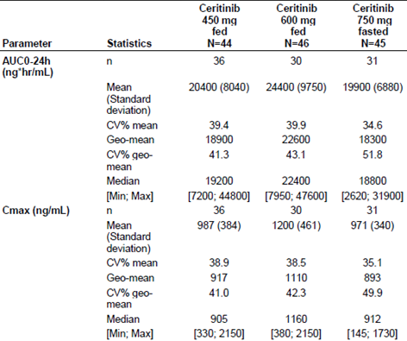

The geometric mean ratio (90% CI) at steady-state (Cycle 2,Day 1) of PK results for the 450 mg fed group versus the 750 mg fasted dose was:

* 1.04 (0.869, 1.24) for AUC0-24h
* 1.03 (0.865, 1.22) for Cmax

There was no detectable effect of food on Tmax. Steady state intra-individual and inter‑individual variability is summarised in Table 23.

Table 23: Summary of intra- and inter-patient variability for ceritinib steady-state trough concentration

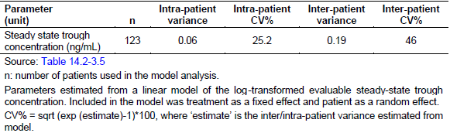

#### Efficacy

The sponsor provided with their response a summary from an interim efficacy analysis of this study (data cut-off date 26 July 2017). The following efficacy and safety analyses are from that top-line summary, that is, a full evaluation of the CSR has not been undertaken.

In the treatment-naïve group (n = 121):

* Overall response rate (ORR) in the 450 mg fed arm compared to the 750 mg fasted arm was:
  + 78.0% (95% CI: 62.4, 89.4) versus 70.0% (53.5, 83.4)
* Disease control rate (DCR) in the 450 mg fed arm compared to the 750 mg fasted arm was:
  + 92.7% (95% CI: 80.1, 98.5) versus 90.0% (95% CI: 76.3, 97.2).

Best overall response (BOR) is summarised in Table 24. DOR is summarised in Table 25 and PFS is summarised in Table 26.

Table 24: Best overall response per BIRC at interim analysis (data cut-off 26 July 2017)

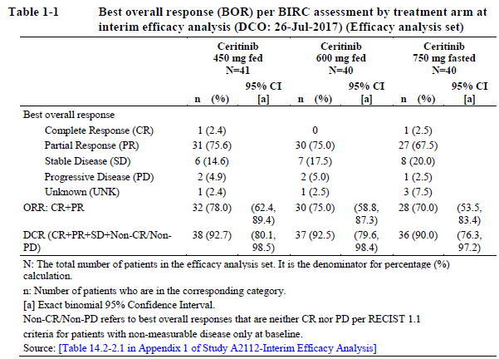

Table 25: Duration of response per BIRC at interim analysis (data cut-off: 26 July 2017) (patients with confirmed complete response or partial response)

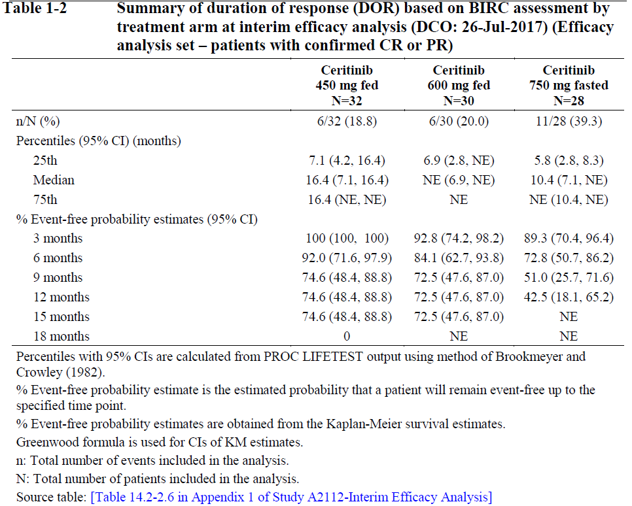

Table 26: PFS per BIRC at interim analysis (data cut-off: 26 July 2017)

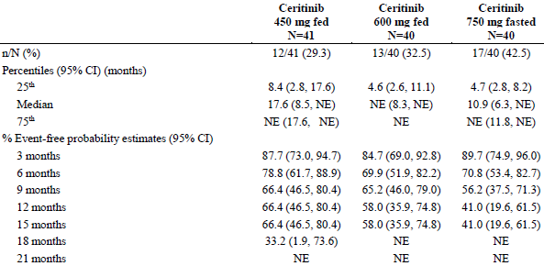

#### Safety

##### Exposure

Table 27: Exposure to ceritinib

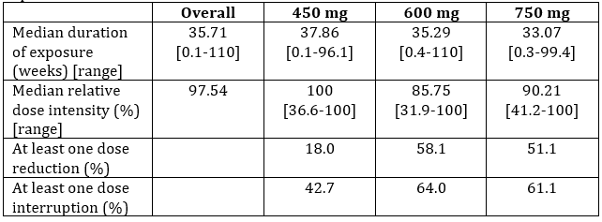

The safety set in the ASCEND-8 trial consisted of all 265 subjects (not just the group of 121 treatment-naïve subjects who formed the efficacy analysis set). AEs overall are summarised in Table 28. Specific breakdowns for adverse events of special interest (AESI) were not all included in the summary data provided by the sponsor, but comparative statistics for gastrointestinal and hepatotoxicity adverse events (the two most common events of special interest) are described in Table 29.

Table 28: Overall summary of adverse events at interim efficacy analysis (data cut-off 26 July 2017; Safety set, n = 265)

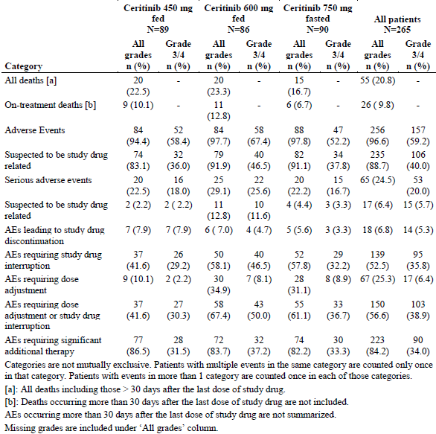

Table 29: Statistics for adverse events of special interest for gastrointestinal and hepatic toxicity selected by the sponsor included in the topline results reported to the TGA from the interim efficacy analysis (data cut-off date 26 July 2017)

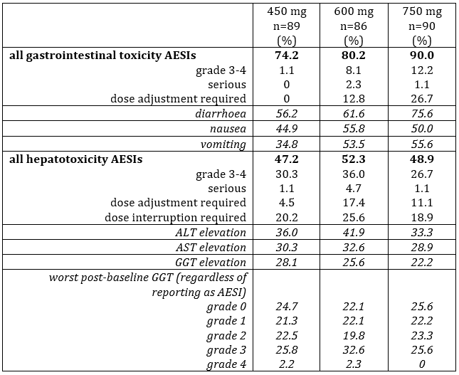

Nature of meal is not expected to affect steady-state exposure significantly, on the basis of the moderate variability seen in AUC0-inf with different meal types in previous ceritinib food effect studies (see Table 30) and the bioequivalence (within standard limits of 0.8 to 1.25) of the 450 mg fed and 750 fasted doses, despite the meal definition in this study allowing a wide range of fat (1.5 to 15 g of fat) and calorie content (100 to 500 calories).

The rationale given by the sponsor is that:

‘On the basis of observations from both studies, the improved absorption of ceritinib in the fed state is most likely due to the enhanced bile salt secretion in the postprandial intestine even with minimal fat intake, which leads to increased micellar solubilisation and wetting of the drug, both of which can enhance the dissolution rate and absorption of ceritinib. This suggests that the presence of dietary fat of any amount is sufficient to trigger the increased solubility and absorption of ceritinib and lead to maximum food effect, thus, close to 100% bioavailability.’

The long half life (41 hours) and nonlinear PK of ceritinib over time, with three weeks to reaching steady-state, also suggests that changes in meals through the week or even accidentally not taking doses with food once or twice a week would not be expected to significantly change steady-state exposure.

Table 30: Increase in exposure with food intake compared to fasted state in ceritinib food effect studies (from sponsor’s response)

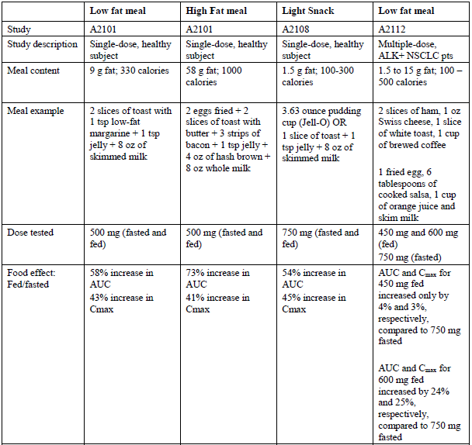

#### Population pharmacokinetic analysis

A popPK analysis was submitted in the dossier. Effects of covariates are summarised in Table 31 and between-covariate comparisons are represented graphically in Figure 2.

Issues arising from the popPK analysis included:

* Decreased estimates of clearance and higher AUCss were seen in Asian, and particularly Japanese, patients, even after correction for body weight, but were statistically insignificant and so eliminated from the final model.
* The final model estimated Japanese patients would also reach steady state faster.
* The model included relatively few Japanese subjects, raising uncertainty in these estimates.
* Similarly, to clearance, AUCss was slightly higher in Asian and 29% higher in Japanese patients compared to Caucasians. This was not entirely accounted for by adjusting for weight, suggesting a small ethnicity effect on PK. Safety and efficacy in Japanese patients was investigated in Study A2201 and not found to be different. No ethnicity based adjustments to the recommended starting dose are therefore warranted.
* Mild and moderate renal impairment groups showed AUCss 6.9% and 13.2% higher (respectively) than patients with normal renal function, in keeping with estimates from the popPK model at time of registration (7.4% and 15.6%). Starting dose adjustment on the basis of mild or moderate renal impairment is not warranted.
* Albumin and ALT are important covariates affecting ceritinib PK, in keeping with its hepatic elimination. The AUCss in a pre-existing mild hepatic impairment group was 4% higher than in normal hepatic function group, suggesting a minor effect and no dose adjustment warranted. Insufficient data for moderate or severe impairment was included to allow guidance in these groups. A recently submitted dossier concerns dose adjustment in moderate and severe hepatic impairment and should elucidate this issue.

Small changes in PK, unlikely to be clinically significant, may be attributable to gender, weight and race (particularly Japanese race). Based on standard bioequivalence parameters of 0.8 to 1.25, the observed variability is small.

Table 31: Effect of covariates on the geometric mean of steady-state exposure to ceritinib 750 mg once daily (90% PI)

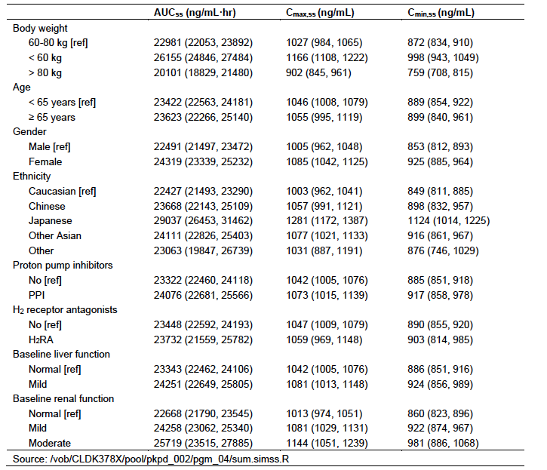

Source: PopPK report Table 5-4

Figure 2: Covariate-covariate comparisons showing relativity of exposure distributions (with 90% CI)

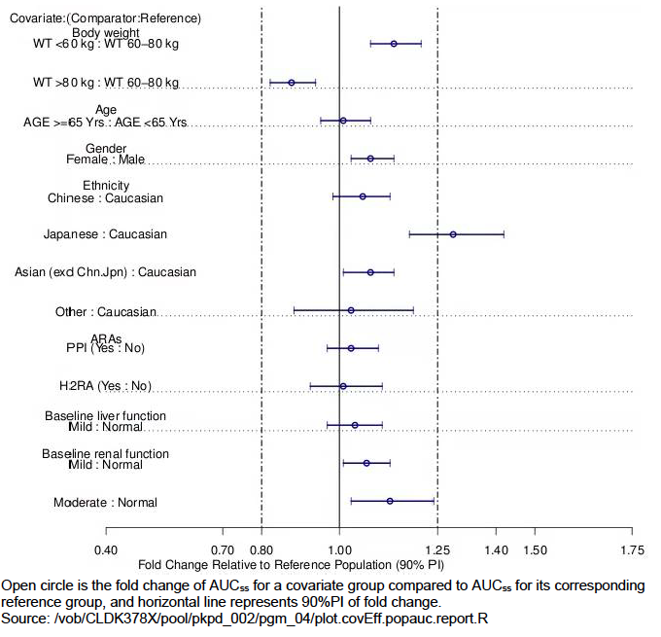

Source: Population PK report Figure 5-5. Abbreviations: WT = (body)weight; Yrs = years; Chn = Chinese subjects; Jpn = Japanese subjects; ARA = acid reducing agents; PPI = proton pump inhibitor; H2RA = Histamine (H2) receptor antagonist

#### Study A2301 (the ASCEND-4 trial)

##### Title

A Phase III multicentre, randomised study of oral LDK378;20 versus standard chemotherapy in previously untreated adult patients with ALK rearranged (ALK-positive), stage IIIB or IV, non-squamous non-small cell lung cancer.

##### Design

The Ascend-4 trial was an open label, randomised, global RCT.

Patients were randomised 1:1, and stratified by:

* WHO performance status (0 versus 1 or2);
* prior adjuvant chemotherapy (yes versus no); and
* brain metastases at screening (presence versus absence).

Patients were treated until progression by BIRC or unacceptable toxicity (or other discontinuation criteria were met).

Crossover was allowed (‘extension treatment’ (ET) = crossover to ceritinib group).

Treatment beyond progression was allowed if continued clinical benefit per investigator (despite progression per BIRC).

Dose adjustments were per usual for each treatment.

Tumour assessments were investigator and BIRC assessed, according to RECIST version 1.1. Intracranial tumour response was assessed by an independent neuro‑radiologist using modified RECIST version 1.1

Follow up was 30 days post last dose for AEs and every 3 months for survival

Sample size, assuming 38% reduction in HR, and median control PFS 8 months, 205 PFS events (approximately 348 patients according to assumed recruitment and drop out rates) was required to have 90% power and 1-sided alpha 2.5% to reject the null hypothesis using log-rank test and 2-look group sequential design.

##### Locations/centres

Locations/centres were in the following countries (number of locations/centres in brackets): Australia/New Zealand (3), Austria (2), Brazil (6), China (16), Columbia (1), Denmark (2), France (10), Germany (5), Greece (1), India (8), Ireland (1), Italy (18), Japan (7), Republic of Korea (4), Lebanon (2), Mexico (1), Netherlands (6), Norway (1), Poland (2), Russian Federation (2), Singapore (2), Spain (14), Sweden (4), Taiwan (6), Thailand (4), Turkey (2), United Kingdom (4).

##### Dates

*First patient visit*: 9 July 2013

*Last patient enrolled*: 1 April 2015

*Primary analysis data cut-off date*: 24 June 2016 (at 202 PFS events)

*Study completion date*: ongoing

*CSR date*: 10 November 2016

Final OS analysis/CSR conducted at approximately 253 deaths

##### Inclusion criteria (abbreviated)

Abbreviated inclusion criteria were:

* histologically or cytologically confirmed diagnosis of Stage IIIB or IV (or relapsed locally advanced or metastatic) non-squamous NSCLC;
* ALK-positive tumour (tested by Ventana ALK (D5F3) IHC assay);
* life expectancy at least 12 weeks;
* adequate organ function per laboratory values;
* measurable disease per RECIST;
* WHO Performance Status 0 to 2; and
* non-reproductive, consenting adults

##### Exclusion criteria (abbreviated)

Abbreviated exclusion criteria were:

* previous systemic treatment, including adjuvant or neoadjuvant if relapse occurred within 12 months;
* major GI impairment or malabsorptive disease;
* history of ILD/interstitial pneumonitis or pancreatitis;
* unstable or symptomatic CNS disease, history of carcinomatous meningitis;
* clinically significant, uncontrolled heart disease, QT prolongation on triplicate ECG or concurrent medications that prolong QT;
* concurrent strong CYP3A4/5 (or CYP2C if narrow therapeutic index) inducers/inhibitors; and
* major surgery, radiotherapy (other than palliative to bone lesions), significant non-NSCLC malignancy.

##### Treatments

*Intervention*: ceritinib 750 mg daily (fasted); n = 189.

*Comparator*: Chemotherapy (platinum plus pemetrexed doublet 4 cycles, then pemetrexed maintenance if no progression); n = 187.

##### Endpoints

###### Primary

* Progression-free survival (PFS) per RECIST version 1.1 by BIRC.

###### Secondary

* Overall survival (OS)
* Overall response rate (ORR) per BIRC and investigators
* Duration of response (DOR) per BIRC and investigators
* Disease control rate (DCR) per BIRC and investigators
* Time to response (TTR) per BIRC and investigators
* Intracranial ORR, DCR and DOR per BIRC
* PFS by Investigator
* Patient-reported outcomes
* Safety and PK.

##### Baseline characteristics

Baseline characteristics were reasonably balanced for demographics except as shown in Table 32.

Table 32: Baseline characteristics that were not considered balanced

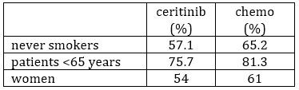

Arms were well balanced with regard to prior antineoplastic therapy and baseline disease characteristics.

##### Disposition

Table 33: Study A2301 Patient disposition by treatment arm (Full analysis set)

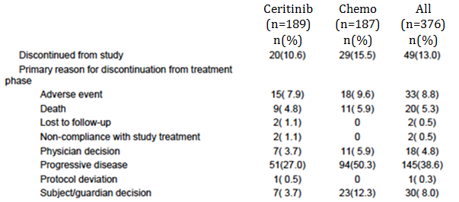

##### Findings

An 8.5 month benefit was seen on PFS in the ceritinib compared to the chemotherapy arm: a hazard reduction of 45%. Efficacy outcomes are summarized in Table 34, and were consistent across subgroups.

OS was immature at time of analysis. A third interim analysis for OS is planned when approximately 215 deaths are observed and a final analysis for OS will be conducted when approximately 253 deaths would be observed.

Interpretation of patient-reported outcomes remains limited due to the open-label nature of the study. Both more frequent increases and more frequent decreases in performance status were seen in the ceritinib arm than with chemotherapy, which may explain the lack of compelling improvement in quality of life (QoL) data despite clear benefit on PFS: that is, that in those who are not benefiting, the adverse effects are making QoL worse.

PK and safety were in keeping with the known profile for the 750 mg fasted dose.

The proportion of ceritinib arm requiring:

* One dose reduction was 27%
* Two dose reductions was 18.5%
* Three dose reductions was 19.6%
* > 3 dose reductions 2.6%.

An overview of rates of AEs is given in Table 35, below. Most (94.5% of) dose reductions were required due to an AE, primarily hepatotoxicity. The predominant AEs were GI and hepatic. Any grade AEs occurring in at least 10% of ceritinib arm are summarised in Table 36.

Table 34: Efficacy outcomes in the ASCEND-4 trial

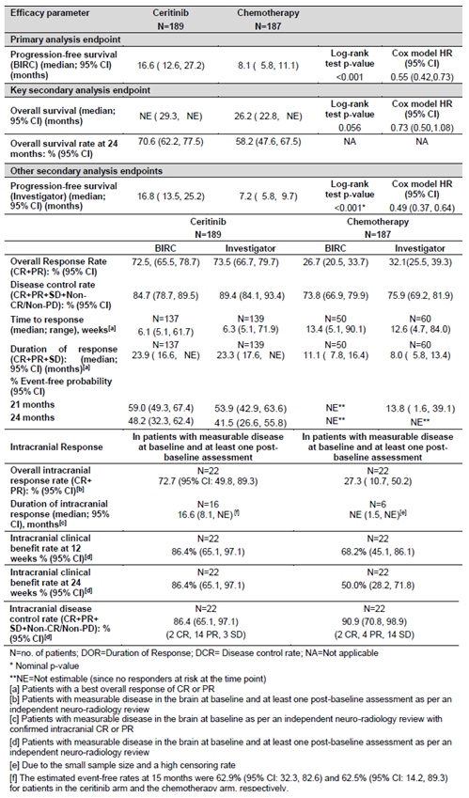

Table 35: Overview of adverse events in the ASCEND-4 trial

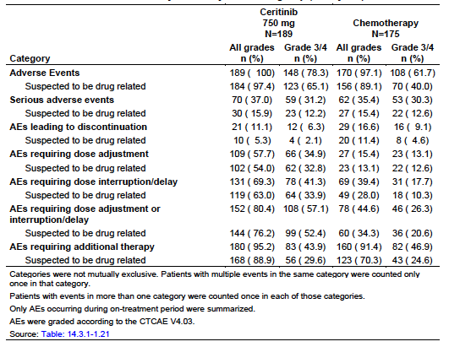

Table 36: Any grade adverse events occurring in at least 10% of ceritinib arm

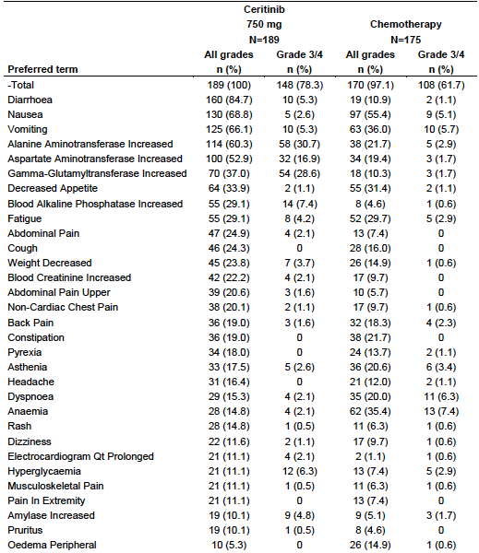

#### Study A2303 (the ASCEND-5 trial)

##### Title

A Phase III, multicentre, randomised, open-label study of 750 mg oral LDK378;20 versus standard chemotherapy in adult patients with ALK rearranged (ALK-positive) advanced non-small cell lung cancer who have been treated previously with chemotherapy (platinum doublet) and crizotinib.

##### Design

The ASCEND-5 trial was an open label, randomised, global RCT.

Patients were randomised 1:1, and stratified by:

* WHO Performance Status (0 versus 1 or2); and
* brain metastases at screening (presence versus absence)

Patients were treated until progression by BIRC or unacceptable toxicity (or other discontinuation criteria were met).

Crossover was allowed.

Treatment beyond progression allowed if continued clinical benefit per Investigator (despite progression per BIRC).

Dose adjustments per usual for each treatment.

Tumour assessments were investigator and BIRC assessed, according to RECIST version 1.1. Intracranial tumour response was assessed by an independent neuro‑radiologist using modified RECIST 1.1

Follow up was30 days post last dose for AEs and every 3 months for survival.

Sample size, assuming 40% reduction in HR, and median control PFS 3 months, 161 PFS events (approximately 236 patients according to assumed recruitment and drop out rates) was required to have 90% power and 1-sided alpha 2.5% to reject the null hypothesis using log-rank test.

##### Locations

ASCEND-5 was conducted in the countries as follows (with numbers of patients in each country in brackets): Belgium (7), Canada (6), France (16), Germany (13), Hong Kong (5), Ireland (6), Israel (5), Italy (42), Japan (29), Republic of Korea (21), Lebanon (2), Netherlands (5), Portugal (1), Russia Federation (9), Singapore (5), Spain (21) Switzerland (7), Turkey (9), United Kingdom (8), United States (14).

##### Dates

*First patient visit*: 28 June 2013

*Primary analysis data cut-off date*: 26 January 2016 (at 172 PFS events)

*Study completion date*: ongoing

*CSR date*: 1 September 2016

Final OS analysis/CSR conducted at approximately 196 deaths.

##### Inclusion criteria (abbreviated)

The abbreviated inclusion criteria were:

* histologically/cytologically confirmed Stage IIIB or IV, or relapsed locally advanced or metastatic non-squamous NSCLC;
* ALK-positive tumour (tested by Vysis ALK Break Apart FISH Probe Kit, Abbott Molecular Inc);
* previous systemic treatment for their advanced NSCLC with a) platinum-based doublet chemotherapy and b) crizotinib (in any order);
* life expectancy at least 12 weeks;
* adequate organ function per laboratory values;
* WHO Performance Status 0 to 2;
* measurable disease per RECIST; and
* non-reproductive, consenting adults.

##### Exclusion (abbreviated)

Abbreviated exclusion criteria were:

* other previous systemic treatment, including adjuvant or neoadjuvant if relapse occurred within 12 months;
* major GI impairment or malabsorptive disease;
* history of ILD/interstitial pneumonitis or pancreatitis;
* unstable or symptomatic CNS disease, history of carcinomatous meningitis;
* clinically significant, uncontrolled heart disease, QT prolongation on triplicate ECG or concurrent medications that prolong QT;
* concurrent strong CYP3A4/5 (or CYP2C if narrow therapeutic index) inducers/inhibitors; and
* major surgery, radiotherapy (other than palliative to bone lesions), significant non-NSCLC malignancy.

##### Treatments

* Intervention (n = 115): ceritinib 750 mg daily (fasted)
* Comparator (n = 116): single-agent chemotherapy (pemetrexed or docetaxel of Investigator’s choice, and if progressed on one, should have received the other):
  + pemetrexed: n = 40;
  + docetaxel: n = 73;
  + withdrew after randomisation: n = 3.

##### Endpoints

###### Primary

* Progression-free survival (PFS) per RECIST 1.1 by BIRC.

###### Secondary

* Overall survival (OS)
* Overall response rate (ORR) per BIRC and investigators
* Duration of response (DOR) per BIRC and investigators
* Disease control rate (DCR) per BIRC and investigators
* Time to response (TTR) per BIRC and investigators
* Intracranial ORR, DCR and DOR per BIRC
* PFS by investigator
* Patient-reported outcomes
* Safety and PK.

##### Baseline characteristics

Balanced for demographic, baseline disease characteristics and prior antineoplastic therapy except

Table 37: Demographic, baseline disease characteristics and prior antineoplastic therapy that were not balanced

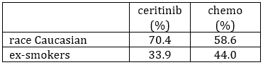

The clinical evaluator commented:

‘It is not clear what effect if any these imbalances might have on the primary efficacy endpoint. Of more concern is the low percentage of patients with PS = 2 in this study (6.1%: 7.2% in ceritinib arm, 4.3% in chemotherapy arm). It is difficult to accept either efficacy or safety data from this study in respect of patients with PS =2.’

##### Disposition

Table 38: Study A2303 Patient disposition by treatment arm (Full analysis set)

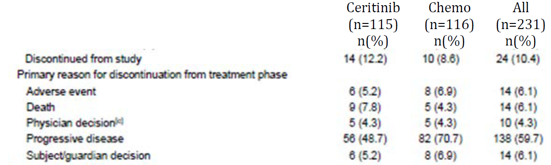

##### Findings

Efficacy outcomes are summarised in Table 39. Efficacy findings were consistent across randomisation strata.

OS was immature at time of analysis (50% information fraction), but analysis was performed per pre specified due to PFS result reached significance. A sensitivity analysis on the OS result undertaken to account for treatment switching to correct for crossover, showed similar results (HR 0.97, 95% CI 0.65, 1.45).

Very few patients had evaluable disease allowing for assessment of intracranial response rates.

Table 39: Efficacy outcomes in the ASCEND-5 trial

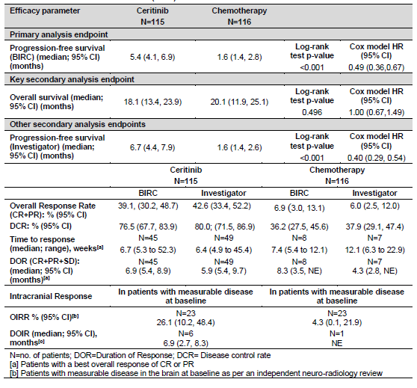

###### Patient reported outcomes

Questionnaires identified the GI toxicity of ceritinib as a significant QoL issue for patients. However, scores of overall functioning were better on ceritinib. Interpretation remains limited due to the open-label nature of the study.

PK and safety findings were in keeping with the known profile for the 750 mg fasted dose. Rates of dose reduction are summarised in Table 40, and rates of AEs leading to dose interventions or other therapy are summarised in Table 41. The most common AEs are summarised in Table 42; these again were predominantly GI and hepatic. The vast majority (96.6%) of reductions in the ceritinib arm were required due to an AE.

Mild, reversible increases in creatinine were common on ceritinib and have been attributed to a pharmacologic effect of ceritinib (inhibition of tubular creatinine secretion) rather than direct nephrotoxicity. Severe renal toxicity was not reported.

Table 40: Rates of dose reduction in the ASCEND-5 trial

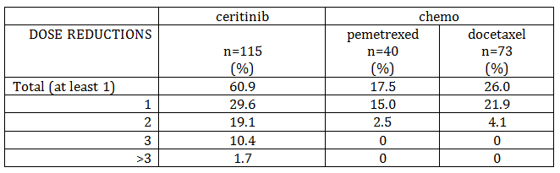

Table 41: Rates of AEs leading to intervention in the ASCEND-5 trial

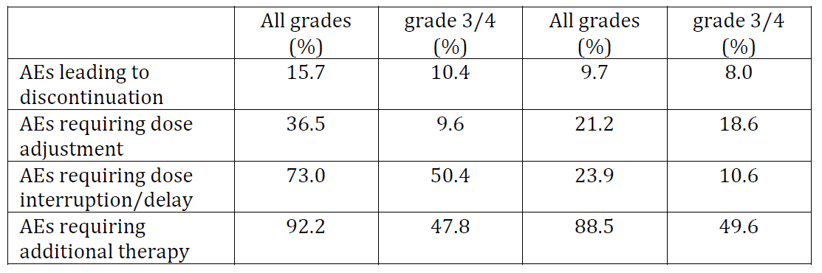

Table 42: Any grade AEs occurring in at least 10% of the ceritinib arm in the ASCEND-5 trial

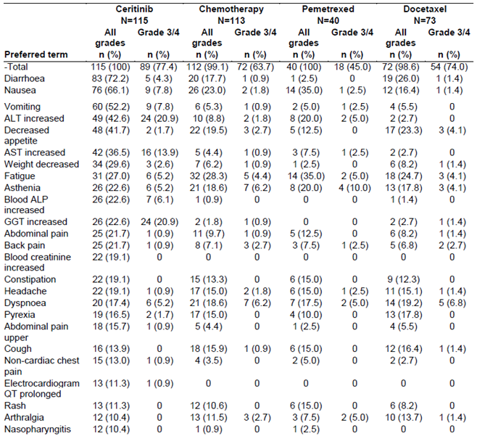

### RMP evaluation

The known safety profile of ceritinib, per the summary of safety concerns in the RMP is outlined in Table 43. The data in the submitted studies does not significantly alter this profile, except that the rates of GI toxicity appear to be lower (but not eliminated) with fed dosing, based on data from the ASCEND-8 trial. No changes to the RMP have been recommended.

Table 43: Summary of safety concerns from the risk management plan

|  |  |
| --- | --- |
| Summary of safety concerns | |
| Important identified risks | Hepatotoxicity |
| QT prolongation |
| Interstitial Lung Disease/ Pneumonitis |
| Hyperglycaemia |
| GI toxicity (nausea, vomiting, diarrhoea) |
| Bradycardia |
| Pancreatitis |
| Important potential risks | Neuropathy |
| Concomitant use of ceritinib and strong CYP3A inhibitors or strong CYP3A inducers |
| Concomitant use of ceritinib and gastric acid reducing agents such as PPIs |
| Missing information | Patients with hepatic impairment |
| Patients with severe renal impairment |
| Patients with severe cardiac impairment |
| Elderly patients |
| Paediatric patients |
| Pregnant and lactating women, and women of childbearing potential |
| Long-term safety |
| Concomitant use of ceritinib and CYP3A, CYP2C9, CYP2A6, or CYP2E1 substrates; ceritinib and drugs that may prolong the QT interval |

There was one outstanding issue from the RMP evaluation which is dependent on the Delegate’s decision regarding black box warnings. The second round RMP evaluator’s conclusion was:

‘If the Delegate decides to remove the black box warning then the patient wallet card is no longer required.

If the Delegate decides not to remove the requested black box warnings, then the patient wallet card should remain in use. If this is the case then the patient wallet card should be updated with information on the timing of dosing in relation to food and the extended indication and be submitted to the TGA prior to the marketing of the new indication.’

According to the Delegate, the black box warnings regarding QT prolongation and hepatic impairment remain in place, therefore the patient wallet card should also be retained. The sponsor should update the card with the new recommended dose.

### Risk-benefit analysis

#### Summary and conclusion

##### Extension of indications

To make the following changes to the current indication from:

*Zykadia is indicated as monotherapy for the treatment of adult patients with anaplastic lymphoma kinase (ALK) positive locally advanced or metastatic non-small cell lung cancer (NSCLC) whose disease has progressed on or who are intolerant of crizotinib.*

*Note to Indication: This indication is approved based on tumour response rates and duration of response. An improvement in survival or disease –related symptoms has not been established.*

to:

*Zykadia is indicated as monotherapy for the treatment of adult patients with locally advanced or metastatic non-small cell lung cancer (NSCLC) that is anaplastic lymphoma kinase (ALK)-positive.*

Additional significant PI changes include:

* addition of new dosage adjustment advice in case of gastrointestinal toxicity, on the basis of a food study (Study A2112 /ASCEND-8 trial, see below);
* addition of efficacy and safety data from two confirmatory Phase III trials (Study 2301/ASCEND-4 trial and Study 2303/ASCEND-5 trial), in previously untreated and previously treated patients respectively;
* removal of black box warnings on the basis of the Phase III data; and
* updated statistics from pooled safety analyses and population popPK analyses.

##### Dosage

Starting dose (unchanged):

‘750 mg taken orally once daily on an empty stomach at the same time each day.’

Dosage adjustment (new advice):

‘For patients taking 750 mg daily on an empty stomach who experience GI adverse reactions, reduce the daily dose to 450 mg with food to reduce local GI irritation while maintaining Zykadia exposure (see Pharmacology). Additional dose adjustment recommendations to manage GI adverse reactions are provided in Table 8 [of the PI].

If GI adverse reactions occur together with other select non-GI adverse reactions as listed in Table 8, recommendations for the management of the select non-GI adverse reactions should be followed to reduce Zykadia exposure (Table 8).’

##### Summary of Issue/s

###### ASCEND-4 trial

The choice of comparator prevents meaningful inference regarding comparative efficacy of other ALK inhibitors, but regardless, the Phase III data supports extension of the indication to use of ceritinib in patients with ALK-positive NSCLC that has not been previously treated systemically.

###### ASCEND-5 trial

This trial provides controlled data in the same usage/population as the earlier Phase trials on which approval of the current indication was based. The data is reassuring and confirmatory of the efficacy and safety of ceritinib in the currently approved indication.

###### ASCEND-8 trial

The data from this trial support that a daily ceritinib dose of 450 mg with food is equivalent to the current recommended dose (750 mg fasting) in terms of PK, efficacy and safety, with the exception that the lower dose with food shows better GI tolerability and fewer dose reductions.

The Delegate proposes that the starting dose should be changed for all patients to 450 mg daily with food, reducing per current advice by 150 mg each time, staying with fed dosing. The data suggest this will lead to better tolerability, more consistent exposure (less dose interruption) and possibly more efficacious use of the drug, whilst avoiding complicated or confusing dose reduction advice.

#### Delegate’s considerations

##### Benefit-risk summary

###### Condition

ALK is a fusion oncogene found in around 5% of NSCLC, which is associated with younger patient age, non-smoking status, advanced stage at presentation and adenocarcinoma histology. Australian prevalence is estimated to be less than 2000.

###### Current treatment options

* ALK inhibitors: crizotinib (first generation), ceritinib and alectinib (second generation) are currently registered in Australia;
* platinum-based doublet chemotherapy;
* single-agent (pemetrexed or doxetaxel) chemotherapy; or
* other targeted inhibitors if targetable mutations are identified in the tumour (but ALK appears to be mutually exclusive from EGFR and KRAS mutations).

Table 44: Summary of efficacy of other currently TGA-registered ALK inhibitors in randomised controlled trials

|  |  |  |  |
| --- | --- | --- | --- |
| Setting (trial name) | Comparator | Results | HR [95% CI], p value |
| Crizotinib after platinum doublet CT failure (PROFILE 1007 trial) n = 347 | Single-agent CT | PFS: 7.7 versus 3.0 months | 0.49 [0.37, 0.64], < 0.001 |
| Crizotinib first-line (PROFILE 1014 trial) n = 343 | pemetrexed + platinum CT | PFS: 10 versus 7.0 months | 0.45 [0.35, 0.6], < 0.001 |
| Alectinib after platinum doublet CT and crizotinib failure (ALUR trial) n = 107 | Single-agent CT | PFS: 7.1 versus 1.6 months  *CNS ORR: 54 versus 0%* | 0.32 [0.17–0.59], < 0.001 |
| Alectinib first-line (ALEX trial) n = 303 | crizotinib | PFS: NE versus 11.1 months  *CNS ORR: 81 versus 50%* | 0.47 [0.34, 0.65], < 0.0001 |

CI = confidence interval, HR= hazard ratio, PFS = progression-free survival, CNS ORR = central nervous system response rate in subjects with measurable disease; CT = chemotherapy

##### Benefits and associated uncertainties

In two Phase III open-label RCTs in patients with ALK-positive NSCLC, ceritinib was shown to have the following efficacy as shown in Table 45.

Table 45: Efficacy of ceritinib in the Phase III ASCEND 5 and ASCEND 4 trials

|  |  |  |  |
| --- | --- | --- | --- |
| Setting (trial name) | Comparator | Results | HR [95% CI], p value |
| Ceritinib after platinum doublet and crizotinib failure (Study 2303/ASCEND-5 trial) | Single-agent CT | PFS: 5.4 versus 1.6 months *CNS ORR: 26 versus 4%* | 0.49 [0.36, 0.67], < 0.001 |
| Ceritinib first-line (Study 2301/ASCEND-4 trial) | 4 cycles pemetrexed + platinum CT, then pemetrexed maintenance | PFS: 16.6 versus 8.1 months *CNS ORR: 73 versus 27%* | 0.55 [0.42,0.73],  < 0.001 |

A Phase II open-label clinical trial was conducted in 265 patients with ALK-positive NSCLC (121 of whom were treatment-naïve) comparing three doses of ceritinib:

* 450 mg daily with food (n = 44)
* 600 mg daily with food (n = 46)
* 750 mg daily under fasted conditions (n = 45)

In this study, the rate of GI adverse reactions (all grades of AEs of diarrhoea, nausea and vomiting) were lower in the 450 mg with food arm.

Table 46: GI adverse events in a Phase II trial

|  |  |  |  |
| --- | --- | --- | --- |
| GI adverse event | 450 mg n = 89 (%) | 600 mg n = 86 (%) | 750 mg n = 90 (%) |
| **All gastrointestinal toxicity AESIs**  Grade 3-4  serious  dose adjustment required | **74.2**  1.1  0  0 | **80.2**  8.1  2.3  12.8 | **90.0**  12.2  1.1  26.7 |
| diarrhoea | 56.2 | 61.6 | 75.6 |
| nausea | 44.9 | 55.8 | 50.0 |
| vomiting | 34.8 | 53.5 | 55.6 |

A PK analysis was performed on 97 subjects (36, 30 and 31 in the three respective dose groups as above) with evaluable PK data (data cut-off date 16 June 2016) that demonstrated the geometric mean ratio (90% CI) at steady-state (Cycle 2, Day 1) of PK results for the 450 mg fed group versus the 750 mg fasted dose was:

* 1.04 (0.869, 1.24) for AUC0-24h
* 1.03 (0.865, 1.22) for Cmax

There was no detectable effect of food on Tmax.

A later interim efficacy analysis of this study (data cut-off date 26 July 2017) demonstrated that in the treatment-naïve group (n = 121):

* Overall response rate (ORR) (95% CI) in the 450 mg fed arm compared to the 750 mg fasted arm was:
  + 78.0% (62.4, 89.4) versus 70.0% (53.5, 83.4).
* Disease control rate (DCR) in the 450 mg fed arm compared to the 750 mg fasted arm was:
  + 92.7% (80.1, 98.5) versus 90.0% (76.3, 97.2).

One complete response has been seen in each of the 450 mg and 750 mg arms.

##### Harms and associated uncertainties

Known risks of treatment with ceritinib are hepatotoxicity (manifesting as transaminase elevation), ILD/pneumonitis, QT interval prolongation, bradycardia, gastrointestinal events (including nausea, vomiting and diarrhoea), hyperglycaemia and pancreatic toxicity.

GI toxicity is a very common issue with the 750 mg fasted daily dose (which was used in all clinical studies): it occurred in 94.8% of patients across trials and Grade 3 or 4 (severe; warranting hospitalisation or life-threatening) diarrhoea, nausea and vomiting occurred in 5.2%, 5.3% and 5.6% of patients, respectively.

##### Risk management

Ceritinib is prescribed by experts in the use of oncology medicines, and its safety profile is adequately characterised and generally manageable with dose reductions. A patient information card to alert non-specialist care-givers remains in place and will be updated to reflect PI changes.

#### Benefit-risk balance

Given the life-threatening nature of the disease, initial approval of ceritinib on the basis of Phase II data was appropriate, and the inherent uncertainty was balanced by extensive risk mitigation text in the product information, including black boxed warnings and a note to the indication.

The ASCEND-5 trial data confirms the efficacy seen in the pivotal trials on which registration in this indication was based. Removal of the note to the indication is appropriate.

The ASCEND-4 trial data supports the use of ceritinib as an effective therapy in treatment of patients who have not had previous systemic treatment of their ALK-positive NSCLC. It does not provide comparative data to other ALK inhibitors. This presents ceritinib as an alternative first line option for those patients with newly diagnosed Stage IIIb or metastatic disease but does not inform regarding optimal sequencing of currently approved ALK inhibitors.

The ASCEND-4 and ASCEND-5 trial data reaffirm the known safety profile of ceritinib. Removal of some of the black box warnings is appropriate.

The ASCEND-8 trial data suggest that a dose of 450 mg with food is at least equivalent to a 750 mg dosing without food in terms of PK, efficacy and safety. It also suggests that such dosing may significantly reduce GI AEs. This study has reasonable external validity with regard to trials conducted using the 750 mg fasting dose. Therefore, for simplicity of dose reduction, avoidance of dosing errors, and minimisation of gastrointestinal adverse events, the recommended dosing for all patients should begin at 450 mg daily with food, decreasing in 150 mg increments, also dosed daily with food, as necessary thereafter.

#### Proposed action

The benefit-risk balance of approval of this submission is positive, subject to PI changes to be discussed with the Delegate.

#### Request for ACM advice

The Delegate did not refer this application to the Advisory Committee on Medicines (ACM) for advice.

#### Response from sponsor

On 30 April 2018 the sponsor provided a response to the Delegates overview.[32]

The sponsor welcomes the decision by the Delegate to approve the proposed indication and removal of ‘notes’ throughout the PI.

##### Boxed warning and patient wallet cart

Regarding the Delegate’s decision for retaining the patient wallet card on the basis boxed warnings for QT prolongation and hepatic impairment remain in place.

The sponsor stresses the wallet card did not come about due to boxed warnings. The boxed warnings were to manage the risks inherent when immature safety and efficacy data are submitted. The wallet card was proposed as an *additional RMP measure* to the boxed warnings as a way of mitigating these risks.

The sponsor considers the wallet card no longer necessary on the basis the data submitted in this application addresses the post approval commitments to submit Phase III data. Furthermore, the PI and CMI manage the safety issues adequately. The QTc prolongation boxed warning will remain until an application to remove it is carried out.

##### Dose changes

The Delegate has indicated that they are happy for the dose change to be a part of the current submission, rather than a new submission. Please comment.

###### Sponsor response

The sponsor welcomes this good news for patients. Zykadia 450 mg taken with food presented a lower incidence and severity of GI adverse reactions than observed in the Zykadia 750 mg fasted arm, no Grade 3/4 GI toxicities except for one Grade 3 AE of diarrhoea, a lower proportion of study drug reductions or interruptions, a lower proportion of patients with AEs requiring study drug adjustment or interruption, and reported a higher median relative dose intensity.

A change in the recommended dose from 750 mg under fasted conditions to 450 mg with food is supported by interim efficacy and safety results (submitted to the TGA) from an ongoing Phase I dose optimisation study, the ASCEND-8 trial (Study A2112). Zykadia 450 mg taken with food is approved in the US and received a positive CHMP recommendation on the 22 March 2018. The SmPC will be approved by the European Commission in May 2018. The sponsor can confirm the SmPC is aligned to the Australian PI Dose and Administration section.

In addition to the dose change, the revised dose adjustment recommendation for bradycardia (300 mg to 150 mg) was made in the submitted PI.

#### Advisory Committee Considerations[33]

The Delegate did not refer this application to the ACM for advice.

### Outcome

Based on a review of quality, safety and efficacy, the TGA approved the registration of Zykadia ceritinib 150 mg hard capsule, for the following extension of indications (replacing the previous indications):

*Zykadia is indicated for the treatment of patients with locally advanced or metastatic non‑small cell lung cancer (NSCLC) that is anaplastic lymphoma kinase (ALK)-positive.*

#### Specific conditions of registration applying to these goods

The Zykadia EU-Risk Management Plan (RMP) (version 10.0, dated 17 May 2017, data lock point 29 March 2016), with Australian Specific Annex (version 6.0, dated 13 December 2017), included with submission PM-2017-00696-1-4, and any subsequent revisions, as agreed with the TGA will be implemented in Australia.

## Attachment 1. Product Information

The PI for Zykadia approved with the submission which is described in this AusPAR is at Attachment 1. For the most recent PI, please refer to the TGA website at <<https://www.tga.gov.au/product-information-pi>>.

|  |
| --- |
| Therapeutic Goods Administration |
| PO Box 100 Woden ACT 2606 Australia  Email: [info@tga.gov.au](mailto:info@tga.gov.au) Phone: 1800 020 653 Fax: 02 6232 8605  [**https://www.tga.gov.au**](https://www.tga.gov.au) |

1. LDK378 is the drug development name used for ceritinib in clinical studies/trials
2. Shaw AT et al, 2013 Crizotinib versus chemotherapy in advanced ALK positive lung cancer. *N Engl J Med*; 2013; 368: 2385-2394
3. KRAS (Kirsten rat sarcoma viral oncogene homolog), a frequently activated proto-oncogene.
4. Gainor JF et al 2013 ALK Rearrangements Are Mutually Exclusive with Mutations in EGFR or KRAS: An Analysis of 1,683 Patients with Non–Small Cell Lung Cancer. *Clin Cancer Res* 2013; 19: 4273-4289
5. Shaw AT et al 2009 Clinical features and outcome of patients with non-small-cell lung cancer who harbor EML4-ALK*. J Clin Oncol*; 2009; 27: 4247-4253
6. cMET, a protein also known as tyrosine-protein kinase Met or hepatocyte growth factor receptor (HGFR), encoded for by the MET gene.
7. ROS-1, proto-oncogene tyrosine-protein kinase ROS, an enzyme encoded for by the ROS-1 gene.
8. Ou SH 2011 Crizotinib: a novel and first-in-class multitargeted tyrosine kinase inhibitor for the treatment of anaplastic lymphoma kinase rearranged non-small cell lung cancer and beyond. *Drug Design, Development and Therapy*2011; 5: 471-485
9. Solomon BJ, 2015 Intracranial Efficacy of Crizotinib Versus Chemotherapy in Patients with Advanced ALK-Positive Non–Small-Cell Lung Cancer: Results from PROFILE 1014. *J Clin Oncol* 2015; 34: 2858-2865
10. Katayama R et al 2012 Mechanisms of acquired crizotinib resistance in ALK-rearranged lung cancers. *Sci Transl Med*; 2012; 1-15
11. Doebele RC et al 2012 Mechanisms of resistance to crizotinib in patients with ALK gene rearranged non-small cell lung cancer. *Clin Cancer Res*; 2012; 18: 1472-1482.
12. Yang P et al 2012 Worse disease-free survival in never-smokers with ALK+_lung adenocarcinoma. *J Thorac Oncol* 2012; 7: 90–97
13. Camidge DR and Doebele RC 2012 Treating ALK-positive lung cancer –early successes and future challenges. *Nat Rev Clin Oncol* 2012; 9: 268-277
14. Camidge DR et al 2012 Activity and safety of crizotinib in patients with ALK-positive non-small-cell lung cancer: updated results from a phase 1 study. *Lancet Oncol*; 2012; 13: 1011-1019
15. The QT interval is the time taken from the start of the QRS wave complex to the end of the corresponding T wave on an electrocardiograph and approximates from the start of cardiac ventricular contraction to the end of cardiac ventricular relaxation.
16. Hida T et al, 2017 Alectinib versus crizotinib in patients with ALK-positive non-small-cell lung cancer (J-ALEX): an open-label, randomised phase 3 trial. *LANCET* 2017; 390: 29-39
17. Peters S et al 2017 Alectinib versus Crizotinib in Untreated ALK-Positive Non–Small-Cell Lung Cancer *N Engl J Med* 2017; 377: 829-838
18. Gadgeel et al, 2016 Pooled Analysis of CNS Response to Alectinib in Two Studies of Pretreated Patients with ALK-Positive Non-Small-Cell Lung Cancer. [J Clin Oncol.](https://www.ncbi.nlm.nih.gov/pubmed/27863201) 2016; 34: 4079-4085
19. Cmax : Maximum (peak) concentration of drug in plasma; AUC0-inf : area under the drug-plasma concentration curve from time 0 (dosing) extrapolated to infinity.
20. LDK378 is the drug development name for ceritinib, used in clinical studies/trials.
21. Hy’s law criteria: Evidence of hepatocellular injury with The drug causes hepatocellular injury, an elevated ALT or AST > 3 x the upper limit of normal and bilirubin of greater than 2× the upper limit of normal with no reason to explain the rise in aminotransferases and bilirubin.
22. QTc, QT interval corrected for heart rate.
23. QTcP, QT interval corrected according to population-optimised heart rate correction model.
24. QTcF, QT interval corrected for heart rated according to Fridericia’s formula.
25. The Eastern Cooperative Oncology Group (ECOG) performance status scale (published by Oken et al. in 1982) is used to assess the progression of a patient’s disease and how that disease effects the daily living abilities of the patient and may be used in helping determine the treatment and prognosis of the patient. The scale runs from 0 to 5 as follows: 0 = symptomatic (fully active, able to carry on all pre-disease activities without restriction); 1 = symptomatic but completely ambulatory (restricted in physically strenuous activity but ambulatory and able to carry out work of a light or sedentary nature. For example, light housework, office work); 2 = symptomatic, < 50% in bed during the day (ambulatory and capable of all self care but unable to carry out any work activities. Up and about more than 50% of waking hours); 3 = symptomatic, > 50% in bed, but not bedbound (capable of only limited self-care, confined to bed or chair 50% or more of waking hours); 4 = bedbound (completely disabled. Cannot carry on any self-care. Totally confined to bed or chair); 5 = death.
26. Presentation of the evaluation of the response to the PI and CMI are beyond the scope of this AusPAR.
27. Brosnan EM et al 2014 Drug-Induced Reduction in Estimated Glomerular Filtration Rate in Patients with ALK-Positive Non-Small Cell Lung Cancer Treated with the ALK Inhibitor Crizotinib. Cancer 2014 (March): 664-674
28. US FDA Guidance Document: Pharmacokinetics in Patients with Impaired Renal Function — Study Design, Data Analysis, and Impact on Dosing and Labeling. Docket Number:FDA-2010-D-0133. Issued by: Office of Medical Products and Tobacco, Center for Drug Evaluation and Research, United States Food and Drug Administration; March 2010
29. *Routine risk minimisation* activities may be limited to ensuring that suitable warnings are included in the product information or by careful use of labelling and packaging.

    *Routine pharmacovigilance* practices involve the following activities:

    All suspected adverse reactions that are reported to the personnel of the company are collected and collated in an accessible manner;

    Reporting to regulatory authorities;

    Continuous monitoring of the safety profiles of approved products including signal detection and updating of labeling;

    Submission of PSURs;

    Meeting other local regulatory agency requirements.
30. The World Health Organization performance status is based on the Eastern Cooperative Oncology Group performance status scale.
31. AUC0-24h: area under the plasma concentration-time curve from 0 to 24 hours; Cmax: maximum plasma concentration;Tmax: time to reach maximum plasma concentration; Tlast : time to last quantifiable concentration.
32. Note, this section contains the sponsor’s response to clinical questions raised by the Delegate in the Delegates Overview.. Other questions that were addressed were specifically related to the PI and are beyond the scope of the AusPAR.
33. The ACM provides independent medical and scientific advice to the Minister for Health and the Therapeutic Goods Administration (TGA) on issues relating to the safety, quality and efficacy of medicines supplied in Australia including issues relating to pre-market and post-market functions for medicines.

    The Committee is established under Regulation 35 of the Therapeutic Goods Regulations 1990. Members are appointed by the Minister. The ACM was established in January 2017 replacing Advisory Committee on Prescription Medicines (ACPM) which was formed in January 2010. ACM encompass pre and post-market advice for medicines, following the consolidation of the previous functions of the Advisory Committee on Prescription Medicines (ACPM), the Advisory Committee on the Safety of Medicines (ACSOM) and the Advisory Committee on Non-Prescription Medicines (ACNM). Membership comprises of professionals with specific scientific, medical or clinical expertise, as well as appropriate consumer health issues relating to medicines.