July 2019

Australian Public Assessment Report for Certolizumab pegol
  - Proprietary Product Name: Cimzia
  - Sponsor: UCB Australia Pty Ltd

About the Therapeutic Goods Administration (TGA)
- The Therapeutic Goods Administration (TGA) is part of the Australian Government Department of Health and is responsible for regulating medicines and medical devices.
- The TGA administers the Therapeutic Goods Act 1989 (the Act), applying a risk management approach designed to ensure therapeutic goods supplied in Australia meet acceptable standards of quality, safety and efficacy (performance) when necessary.
- The work of the TGA is based on applying scientific and clinical expertise to decision-making, to ensure that the benefits to consumers outweigh any risks associated with the use of medicines and medical devices.
- The TGA relies on the public, healthcare professionals and industry to report problems with medicines or medical devices. TGA investigates reports received by it to determine any necessary regulatory action.
- To report a problem with a medicine or medical device, please see the information on the TGA website <https://www.tga.gov.au>.
About AusPARs
- An Australian Public Assessment Report (AusPAR) provides information about the evaluation of a prescription medicine and the considerations that led the TGA to approve or not approve a prescription medicine submission.
- AusPARs are prepared and published by the TGA.
- An AusPAR is prepared for submissions that relate to new chemical entities, generic medicines, major variations and extensions of indications.
- An AusPAR is a static document; it provides information that relates to a submission at a particular point in time.
- A new AusPAR will be developed to reflect changes to indications and/or major variations to a prescription medicine subject to evaluation by the TGA.
Copyright
© Commonwealth of Australia 2019
This work is copyright. You may reproduce the whole or part of this work in unaltered form for your own personal use or, if you are part of an organisation, for internal use within your organisation, but only if you or your organisation do not use the reproduction for any commercial purpose and retain this copyright notice and all disclaimer notices as part of that reproduction. Apart from rights to use as permitted by the Copyright Act 1968 or allowed by this copyright notice, all other rights are reserved and you are not allowed to reproduce the whole or any part of this work in any way (electronic or otherwise) without first being given specific written permission from the Commonwealth to do so. Requests and inquiries concerning reproduction and rights are to be sent to the TGA Copyright Officer, Therapeutic Goods Administration, PO Box 100, Woden ACT 2606 or emailed to <tga.copyright@tga.gov.au>.

Contents
Common abbreviations 4
I. Introduction to product submission 6
Submission details 6
Product background 6
Regulatory status 7
Product Information 8
II. Registration time line 8
III. Quality findings 8
IV. Nonclinical findings 8
V. Clinical findings 9
Introduction 9
Pharmacokinetics 11
Pharmacodynamics 16
Dosage selection for the pivotal studies 17
Efficacy 17
Safety 20
First round benefit-risk assessment 41
First round recommendation regarding authorisation 44
Clinical questions and second round evaluation 45
Second round benefit-risk assessment 47
VI. Pharmacovigilance findings 48
Risk management plan 48
VII. Overall conclusion and risk/benefit assessment 50
Background 50
Quality 52
Nonclinical 52
Clinical 52
Risk management plan 71
Risk-benefit analysis 71
Outcome 82
Attachment 1. Product Information 82

Common abbreviations
Abbreviation | Meaning
ACM | Advisory Committee on Medicines
ADA | Anti-drug antibody
ADA 16 positive | Presence of at least one anti-CZP antibodies event (> 2.4 U/mL) in the first 16 weeks
AE | Adverse event
ALT | Alanine transaminase
ARTG | Australian Register of Therapeutic Goods
ASA | Australian Specific Annex
AST | Aspartate transaminase
AUC | Area under the curve
BMI | Body mass index
BSA | Body surface area
C_{AUC} | Cumulative area under the curve
CL/F | Apparent drug clearance
CV | Coefficient of variation
CYP | Cytochrome P450
CZP | Certolizumab pegol
EC₉₀ | The concentration at which 90% of the maximal effect is achieved
ECxx | Effective concentration xx%
EMA | European Medicines Agency
ETN | Etanercept
EU | European Union
GCP | Good Clinical Practice
LLOQ | Lower limit of quantification
MACE | Major Adverse Cardiovascular Event
MCMC | Markov Chain Monte Carlo
MedDRA | Medical Dictionary of Regulatory Affairs
NRI | Non-Responder Imputation
PASI | Psoriasis Area and Severity Index
PASIxx | Psoriasis Area Severity Index of xx%
PASS | Psoriasis Area Severity Score
PBO | Placebo
PD | Pharmacodynamic
PGA | Physician Global Assessment (of improvement/disease activity)
PK | Pharmacokinetic
PKPD | Pharmacokinetic(s)/Pharmacodynamic(s)
PT | Preferred Term
Q2W | Every 2 weeks
RA | Rheumatoid arthritis
SAE | Serious adverse event
SC | Subcutaneous
SD | Standard deviation
SOC | System Organ Class
t_{½} | Time taken for half the initial dose of medicine administered to be eliminated from the body
TNF | Tumour necrosis factor
ULN | Upper limit of normal
URTI | Upper respiratory tract infection
V/F | Apparent volume of distribution

I. Introduction to product submission

Submission details
Type of submission: | Major variation; extension of indications
Decision: | Approved
Date of decision: | 29 May 2019
Date of entry onto ARTG: | 13 June 2019
ARTG numbers: | 154728, 281317
Black Triangle Scheme | No
Active ingredient: | Certolizumab pegol
Product name: | Cimzia
Sponsor’s name and address: | UCB Australia Pty. Ltd.  Level 1, 1155 Malvern Rd  Malvern VIC 3144
Dose form: | Solution for injection
Strength: | 200 mg in 1 mL
Containers: | Prefilled syringe, prefilled pen
Pack sizes: | 2 x prefilled pens, 2 x prefilled syringes
Approved therapeutic use: | Plaque psoriasis  Cimzia is indicated for the treatment of adult patients with moderate to severe chronic plaque psoriasis who are candidates for systemic therapy or phototherapy.
Route of administration: | Subcutaneous injection
Dosage: | Loading dose 400 mg at Weeks 0, 2 and 4. Maintenance dose 200 mg at 2 week intervals or 400 mg at 2 week intervals. Please see the Product Information for details

Product background
This AusPAR describes the application by UCB Australia Pty. Ltd. (the sponsor) to register Cimzia certolizumab pegol, 200 mg in 1 mL in prefilled pen or prefilled syringe for subcutaneous injection for the following extension of indication:
Cimzia is indicated for the treatment of adult patients with moderate to severe plaque psoriasis who are candidates for systemic therapy or phototherapy.
Psoriasis is a chronic inflammatory skin disorder mainly characterised by erythematous papules and plaques with a silvery scale (plaque psoriasis). However, the disease may also manifest itself as guttate psoriasis, pustular psoriasis, inverse psoriasis, erythrodermic psoriasis, or nail psoriasis. In some individuals, systemic symptoms may occur.
There is a variety of treatments for plaque psoriasis, including:
- topical corticosteroids and emollients
- vitamin D analogues (for example, calcipotriene, calcitriol)
- topical/systemic retinoid (for example, tazarotene)
- topical tacrolimus or pimecrolimus
- UVB phototherapy
- non-biological agents (for example, methotrexate, cyclosporine, apremilast)
- biological immunomodulator (for example, infliximab, adalimumab, etanercept, ustekinumab, secukinumab, ixekizumab).
Certolizumab pegol (CZP) is a genetically engineered, humanised, antibody fragment antigen-binding (Fab’) with specificity for human tumour necrosis factor (TNF), derived originally from a murine immunoglobulin G2 monoclonal antibody, expressed in an E. coli bacterial expression system. The Fab’ is purified using standard chromatographic methods and conjugated to two linked 20 kDa polyethylene glycol (PEG) chains via a maleimide linker.
Certolizumab pegol is the fourth anti-TNF therapy proposed for the registration of plaque psoriasis in Australia after infliximab, adalimumab, and etanercept.

Regulatory status
Cimzia was first registered in Australia in 10 January 2010.
The product received initial registration on the Australian Register of Therapeutic Goods (ARTG) for the treatment of rheumatoid arthritis, psoriatic arthritis and ankylosing spondylitis on 20 January 2010 and a 200 mg/mL prefilled syringe was registered on 10 February 2017.
At the time the TGA considered this application; a similar application had been approved in (country, date) was under consideration in (country date) as shown in Table 1.
Table 1: International regulatory status
Country | Date of submission | Regulatory Status | Date of Decision
EU (centralised process) | July 2017 | Approved | 7 June 2018
USA | July 2017 | Approved | 24 May 2018
Canada | September 2017 | Approved | 16 August 2018
Switzerland | 25 September 2018 | Under evaluation

Product Information
The Product Information (PI) approved with the submission which is described in this AusPAR can be found as Attachment 1. For the most recent PI, please refer to the TGA website at <https://www.tga.gov.au/product-information-pi>.

II. Registration time line
The following table captures the key steps and dates for this application and which are detailed and discussed in this AusPAR.
Table 2: Timeline for Submission PM-2017-04943-1-1
Description | Date
Submission dossier accepted and first round evaluation commenced | 3 April 2018
First round evaluation completed | 6 September 2018
Sponsor provides responses on questions raised in first round evaluation | 30 October 2018
Second round evaluation completed | 23 November 2018
Delegate’s Overall benefit-risk assessment and request for Advisory Committee advice | 3 January 2019
Sponsor’s pre-Advisory Committee response | 11 January 2019
Advisory Committee meeting | 1 February 2019
Registration decision (Outcome) | 29 May 2019
Completion of administrative activities and registration on ARTG | 13 June 2019
Number of working days from submission dossier acceptance to registration decision* | 240
*Statutory timeframe for standard applications is 255 working days
Evaluations included under Quality findings and Nonclinical findings incorporate both the first and second round evaluations.

III. Quality findings
There was no requirement for a quality evaluation in a submission of this type.

IV. Nonclinical findings
There was no requirement for a nonclinical evaluation in a submission of this type.

V. Clinical findings
A summary of the clinical findings is presented in this section.

Introduction
Psoriasis is a chronic, inflammatory, immune based skin disorder with a genetic disposition that affects about 3% of the Australian population. Various types of psoriasis exist including plaque, guttate, inverse, pustular and erythrodermic forms; however, plaque psoriasis is the most common type comprising 80 to 90% of all cases. Though psoriasis can present at any age, the mean age of onset has a bimodal distribution at 15 to 20 years and 55 to 60 years. It is equally distributed across the genders. About 25 to 30% of subjects with psoriasis develop a concurrent inflammatory arthritis, psoriatic arthritis. Environmental factors and genetic components are thought to be implicated in the development of the disease. It is estimated that approximately 15 to20% of all psoriasis patients have moderate to severe disease, which is the target population of this application.
Psoriasis often has a substantial impact upon an affected individual’s quality of life (such as sleeping problems and disrupted leisure activities) and has a multitude of psychosocial and emotional effects upon patients including reduced self-esteem and body image issues. Up to 35% of psoriasis sufferers report depressive symptoms and up to 80% state that psoriasis impacts negatively on their quality of life. Patients with psoriasis have an increased incidence of malignancy such as skin cancers and possibly lymphoma, and recent literature including data from meta-analyses tends to indicate that cardiovascular risk and its associated mortality is higher in patients with psoriasis.
Depending on severity, a stepwise approach is typically used when managing psoriasis. The first line strategy is topical therapy, which satisfactorily controls psoriasis in approximately 70% of all cases. Topical therapies include various corticosteroids, tar preparations, emollients, salicylic acid, vitamin D analogues, retinoids and calcineurin inhibitors such as pimecrolimus. Various types of phototherapy are generally considered the next line of treatment in Australian guidelines, but their availability and potential limitations is a barrier to utilisation.
Until recently, non-biological systemic therapies, in particular, weekly low dose methotrexate, have been the mainstay of treatment refractory moderate to severe psoriasis. Other commonly used systemic therapies include oral cyclosporine and acitretin. However, evidence indicates that conventional systemic therapies have limited efficacy in treating psoriasis (for example, methotrexate and cyclosporine achieve a Psoriasis Area Severity Index (PASI) response of 50 to 70% after 12 to16 weeks of therapy), and carry significant toxicity and tolerability risks.
The efficacy and safety of biologic therapies such as tumour necrosis factor (TNF) and interleukin-17 inhibitors is established for patients with moderate to severe psoriasis (70 to 80% of patients achieve at least a 75% PASI response (PASI75) at 10 to 16 weeks). However, while biologic drugs have been shown to demonstrate significant efficacy in treating active psoriasis, loss of response over time may occur in up to 30% of patients and necessitate alternative treatment options. As such, the sponsor claims there is an unmet need for additional biologic therapies for active psoriasis.

Clinical rationale
Tumour necrosis factor plays a central role in the molecular and cellular events occurring in the pathogenesis of several autoimmune inflammatory conditions including psoriasis. Elevated concentrations of TNF have been found in the skin lesions of psoriasis. The efficacy and safety of anti-TNF medicines in treating patients with moderate to severe psoriasis is established. Certolizumab pegol is a recombinant, humanised monoclonal antigen binding antibody, which inhibits the binding of TNF to the surface of cells expressing TNF receptors such as T-lymphocytes in the skin of patients with active psoriasis. Certolizumab pegol is currently approved in Australia for use in three treatment indications, two of which (psoriatic arthritis and ankylosing spondylitis) are significantly associated with psoriasis. Reducing skin disease activity is the key therapeutic goal in managing psoriasis. Furthermore, certolizumab pegol has been widely used in Australian adult rheumatology clinical practice for 8 years with a well-characterised benefit: risk profile.

Guidance
The sponsor states that this submission is consistent with the TGA pre-submission planning form and letter in both scope and scale. The TGA has recommended review and consideration of one specific European Union (EU) regulatory guideline pertaining to the requested extension of indication (adopted by the TGA).
For the newly proposed treatment indication of psoriasis, the certolizumab pegol clinical development program includes 3 pivotal, randomised, double blind, parallel group Phase III studies supported by a Phase II program that examined dose response, post-treatment maintenance of effect and the response to re-treatment in prior responders. In addition, one of the pivotal studies (CIMPACT trial) had an active comparator therapy.
All the Phase III trials were appropriately designed with initial, double blind treatment periods of 16 weeks, and the certolizumab pegol application provided efficacy evaluations from these studies for up to 48 weeks of treatment follow-up. However, no long-term efficacy data has been provided at this stage.
Psoriasis is a chronic disease and therefore, long-term treatment response data is important. However, the key psoriasis regulatory guideline states that 12 weeks is the minimum required time frame for demonstration of short term clinical efficacy, with measurement of speed of response being desirable. In addition, it is recommended that at least one therapeutic confirmatory trial be followed by an observation period of at least 2 months to explore the duration of response, rebound and time to relapse. Furthermore, long-term safety data beyond 1 year may be necessary for registration. The regulatory guideline for psoriasis recommends that efficacy be assessed by at least
Two endpoints, ideally a validated standardised global score of response (such as the Physician’s Global Assessment of improvement, (PGA)) in conjunction with the Psoriasis Area Severity Score (PASS). However, it is considered that the PASI alone is not sufficient to evaluate psoriasis severity at baseline and following treatment. Regarding the choice of comparator therapy, there is no perfect ‘gold standard’ systemic treatment for severe psoriasis and the guideline states that the choice of an active comparator should be done in relation to the investigational medicine.

Evaluator comment
Certolizumab pegol is the fourth in class anti-TNF therapy proposed for the registration of psoriasis treatment in Australia. Certolizumab pegol is available as a liquid formulation in prefilled 1.0 mL vials (presented in pre-filled syringes) for administration by subcutaneous (SC) injection. Certolizumab pegol exerts an immunomodulatory effect via inhibition of the protean of TNF mediated effects on the immune response. There is an unmet need for additional effective therapies in psoriasis as response rates to current available treatment options (including several non-biologic systemic therapies and biologic drugs) are sub-optimal in a significant proportion of patients. Through inhibition of TNF alpha and subsequent modification of the inflammatory response, certolizumab pegol demonstrates biological plausibility for producing a beneficial treatment effect in chronic moderate to severe plaque psoriasis.
In general, the sponsor has adhered to the TGA adopted EU regulatory guideline of relevance in this submission.¹ There are significant, established safety concerns with anti-TNF therapies, including the risk and type of serious infections as well as other serious adverse effects such as risk of malignancy, heart failure, hypersensitivity reactions, hepatic abnormalities and immunogenicity.
The proposed treatment indication wording for certolizumab pegol clearly specifies that the sponsor is requesting registration of the drug for use in patients who are candidates for systemic therapy or phototherapy. There are no significant outstanding issues with the proposed commercial formulation and the remaining matter of the optimal dose regimen (certolizumab pegol 200 mg once every 2 weeks (Q2W) compared with 400 mg Q2W) will be discussed in this evaluation.

Contents of the clinical dossier
The submission contained the following clinical information:
- All 5 of the efficacy/safety studies collected pharmacokinetic (PK) data.
- A Population pharmacokinetic analysis and a pharmacokinetic/pharmacodynamic (PKPD) report based on data collected in the 3 Phase III studies.
- 3 pivotal efficacy/safety studies:
  - Study PS0005 (also known as the CIMPASI-1 trial);
  - Study PS0002 (CIMPASI-2 trial); and
  - Study PS0003 (CIMPACT trial).
- 2 other efficacy/safety studies; Studies C87040 and C87044 were conducted in adult patients with moderate to severe plaque psoriasis as supportive evidence.
- 4 pooled efficacy datasets using data from the 3 Phase III studies was also provided.

Paediatric data
The submission did not contain any paediatric data. The sponsor did not answer any of the format questions relating to an agreed paediatric investigation plan in Europe or the USA, or provide justification as to why the product is not suitable for children.

Good clinical practice
The studies presented in this submission are stated to have been conducted according to Good Clinical Practice (GCP) standards, and the study reports are consistent with adherence to GCP.

Pharmacokinetics

Studies providing pharmacokinetic data
The pharmacokinetic properties of certolizumab pegol have been extensively studied in the three current approved treatment indications of rheumatoid arthritis, psoriatic arthritis and ankylosing spondylitis. In support of this submission, the sponsor has provided new pharmacokinetic data in adult subjects with moderate to severe psoriasis from 3 pivotal Phase III studies (the CIMPASI-1, CIMPASI-2 and CIMPACT trials) and 2 consecutive Phase II trials (C87040 and C87044). The submission also included a population pharmacokinetic analysis using integrated data from all 3 of the Phase III trials. The overall objectives of the population pharmacokinetic analysis were to describe the pharmacokinetic of certolizumab pegol in subjects with moderate to severe chronic plaque psoriasis, and to identify and quantify the covariate-parameter relationships in the developed models. None of the studies that collected pharmacokinetic data had major deficiencies that excluded their results from consideration.

Evaluator’s conclusions on pharmacokinetics
The pharmacokinetic characteristics of certolizumab pegol in adult patients with rheumatoid arthritis, psoriatic arthritis and ankylosing spondylitis are well characterised and patients with psoriasis have similar pharmacokinetic responses to certolizumab pegol exposure. In subjects with autoimmune inflammatory arthritis, the drug is well absorbed after SC administration (bioavailability approximately 80%) and exhibits a relatively low apparent volume of distribution (4.71 L in psoriasis). Certolizumab pegol exhibits moderate pharmacokinetic variability for trough plasma levels and clearance in adult subjects with psoriasis. Target mediated drug disposition is presumed, and although the metabolic pathway for certolizumab pegol has not been formally characterised it is expected to be degraded into small peptides and amino acids via catabolic pathways in the same manner as endogenous immunoglobulin G.
The mean systemic drug clearance appears to be dose independent with a mean terminal half-life of approximately 14 days following SC administration in adult subjects with rheumatoid arthritis. Across the Phase III studies following multiple SC doses of certolizumab pegol 200 mg Q2W or 400 mg Q2W, steady state drug concentrations were reached by Week 16 and remained relatively stable through to Week 48 in those who didn’t develop anti-drug antibodies. Plasma certolizumab pegol trough concentrations increase in a dose proportional manner. Trough serum certolizumab pegol concentrations at steady state are approximately two fold higher following administration of 400 mg Q2W therapy compared to 200 mg Q2W. The sponsor is proposing both dose regimens for certolizumab pegol therapy in psoriasis.
The two main sources of pharmacokinetic variability identified in patients using the primary Phase III pharmacokinetic data and the population pharmacokinetic analysis are subject body weight and the presence of antidrug antibodies. Within the same certolizumab pegol dose, the variation in certolizumab pegol trough concentrations is predicted to be about two-fold between the highest and lowest body weight quintiles. An increase in weight (> 108 kg) results in significantly reduced drug exposure. Positive antidrug antibody status was associated with markedly lower trough certolizumab pegol concentrations compared to antibody negative status. The population pharmacokinetic analysis estimated the presence of antidrug antibodies increases apparent drug clearance (CL/F) by approximately three fold, resulting in a decrease in certolizumab pegol trough plasma levels of about 85%. No other demographic characteristic (age, ethnicity or gender) appears to have a significant effect on the pharmacokinetic of certolizumab pegol. There is no data in patients with severe renal or hepatic impairment.
The sponsor has not presented any studies examining the effect of certolizumab pegol on the pharmacokinetic of various cytochrome P450 (CYP) probe substrates, yet it is biologically plausible that inhibition of TNF may result in restoration of CYP activity, leading to increased metabolism of drugs that are CYP substrates. The effect of certolizumab pegol on CYP enzymes may be clinically relevant for a CYP substrate with a narrow therapeutic index.

Population pharmacokinetics evaluation

Introduction
The psoriasis development program consisted in two Phase II studies (C87040 and C87044) that have been completed in their entirety and three Phase III studies (PS0005, PS0002, and PS0003; also referred to as the CIMPASI-1, CIMPASI-2, and CIMPACT trials, respectively) that have been completed through Week 48 in adult subjects with moderate to severe chronic plaque PSO. The 96-week open-label treatment periods of the Phase III studies are ongoing. Furthermore, the development program evaluated two dose regimens:
- 400mg Q2W
- 200mg Q2W (with loading dose of 400mg at Weeks 0, 2, and 4)
For the popPK and pharmacokinetic/pharmacodynamic (PKPD) analysis, only data from the three Phase III studies were included.

Evaluation scope
The following tasks for the Population Pharmacokinetic (popPK) and PKPD analyses should be performed:
- To replicate the key analysis of the Population Pharmacokinetic analysis titled ‘Population PK and PKPD models describing the relationships between the cimzia exposure and the efficacy in terms of PASI and PGA responses in patients with chronic plaque psoriasis enrolled in three Phase III Studies (Studies CIMPASI-1, CIMPASI-2, and CIMPACT)’ dated 7 July 2017 and report whether results submitted by the sponsor can be confirmed.
- Review the report of the analysis using the Guideline on reporting the results of population pharmacokinetic analyses CHMP/EWP/185990/06 published by the European Medicines Agency (EMA) and adopted by the TGA and provide a detailed written report.
- Consider the EMA Guideline on the clinical investigation of the pharmacokinetics of therapeutic proteins CHMP /EWP/89249/2004 dated 24 January 2007 during the evaluation, particularly regarding:
  - the implications for the results of the popPK analyses and Exposure/response analyses of section 3.3 ‘PKPD relationship’ and
  - the implications of section 3.4 ‘Immunogenicity’ including whether the impact of antibodies on the efficacy and/or safety of the drug has been addressed in the course of the popPK analyses and exposure/response analyses.
- Review the pharmacokinetic/pharmacodynamic analyses in the popPK report and provide a critical appraisal, including the validity of the study design and the implications of results for dosage and other information in the proposed Australian PI. Re-analysis of data is not requested.
- Comment on:
  - the consequences if any of the results of your analysis for the first-round benefit-risk assessment (first round assessment of benefits; first round assessment of risks; and first round assessment of benefit-risk balance);
  - the implications of the results of your analyses for the information in the proposed Australian PI (sections on Pharmacokinetics and Dosage and Administration); and
  - whether the results of the models are relevant to the data that forms the basis for other parts of the proposed PI such as Use in Special Populations.

Summary

Summary of the replication of the final (key) analysis model
The final popPK and the two final PKPD models were rerun for this evaluation and were compared to the result provided in the sponsor’s report and also the electronic data and model files. The key models (popPK, PASI PKPD and PGA PKPD) supplied by the sponsor were repeated using the software NONMEM version 7.4 and PsN version 4.7.0. Only minor deviations from the submitted results were found. The results submitted in the report were confirmed given the evaluation performed. No concerns are noted.

Summary of the evaluation of the popPK and PKPD report against Guideline CHMP/EWP/185990/06
Overall, this was a clearly written report by the sponsor, all points outlined in the EMA Guideline were addressed, main decision and assumptions made during the analysis were outlined and could be followed easily. The data was appropriate to support the claims, as well as the methods and evaluation standards for a population pharmacokinetic analysis. The use of a mixed effect modelling approach with the data used was appropriate and consistent with guidelines.
Main comments raised during the popPK and PKPD models evaluations were:
- Information regarding the analytical assays to characterise concentrations of CZP were not described, except for a change in the lower limit of quantification (LLOQ) compared to a previous report. This may be available in other parts of the submission.
- A power model was utilised for all continuous covariates included, which may not be the most biologically plausible model. A physiologically based rational was not provided. The rational for covariate inclusion was limited and mainly based on previous unpublished reports. The sponsor may want to consider this in future analyses.
- Please clarify if 3.8% of post-dose CZP concentration means 3.8% of the 5907 CZP concentration originally obtained or 3.8% of the 4361 plasma concentration used in the popPK data set, to complete the information.
- Given that higher weight patients had a slower onset of effect in PASI score reduction and weight also significantly influences CL/F and apparent volume of distribution (V/F) with reduced exposure to CZP in higher weight patients, the sponsor should provide further arguments for a non-weight based dosing of CZP.
- Please comment on the finding that patients with an anti-drug antibody (ADA) event (> 2.4 U/mL) up to Week 16 had a different EC₉₀; on top of having reduced exposure due to an increased CL/F. How can this be explained? Developing ADA against CZP leads to a reduction in the exposure (due to increased CL/F) and on top of that the potency of CZP is reduced? Please extend the discussion around this for further support.

Conclusion
Overall, the popPK report and the PKPD analyses are in agreement with the guidelines.
The conclusions drawn from the final models are valid, the report provided a well-rounded discussion. Results of the popPK model and PKPD models could be replicated in this assessment and were found appropriate. Overall the exposure, efficacy (PASI and PGA) relationship modelling performed was appropriate and the analysis assumptions used and conclusions made are considered reasonable

Summary of the evaluation of the popPK and PKPD report against the Guideline for therapeutic proteins CHMP /EWP/89249/2004
The sponsor’s reports were evaluated against the guideline for therapeutic proteins in relation to the impact on the PK and pharmacodynamics (PD) of CZP. Immunogenicity was considered throughout and the report overall complies with the guideline. Patients with an ADA positive response were identified. A positive ADA event was found to influence the apparent clearance (CL/F) of CZP and EC₉₀ in the PASI model.

Conclusion
The final popPK model for CZP in psoriasis patients was found to be a one compartment model with first-order absorption and a first-order elimination from the central compartment. Inter-individual variability terms were supported on CL/F and V/F with a correlation between the two terms. ADA on CL/F, and weight on CL/F and V/F were included as structural covariates and resulted in statistically significant improvement of the model fit. The residual unexplained variability for CZP was described by a combined error model (proportional and additive). Shrinkage was reported to be < 10% on CL/F inter-individual variability and 59% on V/F inter-individual variability. Sensitivity analyses support the final model using the updated popPK data set.
The final parameters are shown in Table 3. The values were replicated by the evaluator using the provided data and model files.
Table 3: Parameter estimates of the final PK model for Cimzia
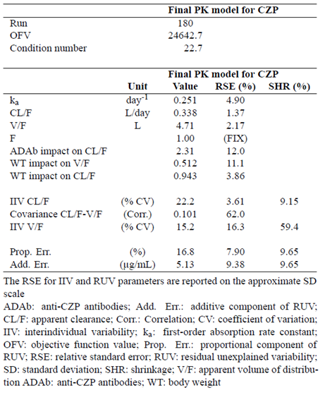

Pharmacodynamics

Studies providing pharmacodynamic data
In this submission, the sponsor has provided a new population PKPD analysis using the PASI data up to Week 16 from the CIMPASI-1, CIMPASI-2 and trials. The PASI PKPD model only included data up to Week 16 because the trials were designed to have a response driven change in therapy after 16 weeks. The pharmacokinetic/ pharmacodynamic dataset comprised 4919 PASI observations collected from 849 subjects.

Evaluator’s conclusions on pharmacodynamics
In this submission, the sponsor has provided a new population PKPD analysis using the PASI and plasma certolizumab pegol concentration data up to Week 16 from the three Phase III studies. The pharmacokinetic/pharmacodynamic dataset comprised 4919 PASI observations collected from 849 subjects. The analysis showed an exposure-response relationship between certolizumab pegol plasma concentrations and PASI with an EC₉₀ of 11.1 μg/mL and PASI half-life (t_{½}) of 22.5 days.
The exposure-response relationship of certolizumab pegol for predicting clinical efficacy in patients with psoriasis appears to be best explained by higher trough drug concentration rather than certolizumab pegol dose regimen as there appears to be substantial overlap in trough serum certolizumab pegol levels according to the dosing range of 200 to 400 mg Q2W. Consistent with prior knowledge, the two covariates identified to have the greatest impact upon exposure-response are the presence of antidrug antibodies and increased subject body weight. Positive antibody status results in substantially lower certolizumab pegol plasma concentrations and increases the EC₉₀ value for achieving PASI response significantly. Subjects with high body weights (> 90 kg) also have lower plasma certolizumab pegol concentrations and this results in an increase in time to maximum clinical response (longer PASI t_{½}).

Dosage selection for the pivotal studies
The totality of data from the Phase II psoriasis studies, including clinical outcomes (efficacy, safety and tolerability information), as well as the known PKPD data in other treatment indications support the investigation of two certolizumab pegol dose regimens in the pivotal Phase III studies. The Phase III trials predominantly investigated the certolizumab pegol treatment posology of 200 mg Q2W and 400 mg Q4W, which have been appropriately justified by the sponsor.
Comments regarding the appropriateness and adequacy of concurrent and/or comparator therapies in the Phase III studies are also pertinent to the interpretation of the reported outcomes. The majority of treatment comparisons involved the assessment of certolizumab pegol versus placebo, which is appropriate in establishing the relative merits of certolizumab pegol in psoriasis. Study PS0003 (CIMPACT trial) also had a comparison between certolizumab pegol and etanercept, which is also appropriate to reflect an active biologic comparator, but this biologic therapy may be relatively less effective than peers and hence is a minor deficiency of the current certolizumab pegol psoriasis study program.

Efficacy

Studies providing efficacy data
The efficacy of certolizumab pegol in patients with moderate to severe plaque psoriasis has been evaluated in three ongoing Phase III studies (Studies PS0001, PS0002 and PS0005) as well as two completed Phase II studies (C87040 and C87044). Each of the Phase III studies investigated efficacy in a placebo controlled manner through to 16 weeks. The trials recruited a range of psoriasis patients, spanning the treatment continuum from inadequate response to topical therapies, to subjects with an inadequate response to conventional systemic immunosuppression, and patients with an inadequate response to biologic therapies.
The two pivotal CIMPASI trials will be considered together in this report as their design, inclusion criteria and statistical analyses were similar. However, there were 5 key differences in study design across the Phase III studies (that is, when comparing the two CIMPASI trials to the CIMPACT trial). These key differences are as follows:
- Type of comparator: the CIMPASI studies were placebo controlled whereas CIMPACT included a placebo and active control etanercept.
- Certolizumab pegol dosing regimens: all the Phase III studies investigated 2 dose regimens of certolizumab pegol (200 mg Q2W and 400 mg Q2W) in the initial treatment period, but a longer dosing interval of 400 mg every 4 weeks was only evaluated in the maintenance treatment period of the CIMPACT study.
- Escape arm entry: in the CIMPASI studies, subjects not achieving a PASI50 response at Week 16 were eligible to receive escape certolizumab pegol treatment. In CIMPACT, subjects not achieving PASI75 response at Week 16 entered the escape arm.
- treatment assignment in blinded maintenance period: in the CIMPASI studies, subjects randomised to certolizumab pegol who achieved a PASI50 response at Week 16 continued with their original assigned treatment in the maintenance treatment phase. Subjects randomised to placebo who achieved PASI75 response continued placebo. Subjects randomised to placebo who achieved a PASI50 but not a PASI75 response at Week 16 received blinded certolizumab pegol 200 mg Q2W (following a loading dose of 400 mg at Weeks 16, 18 and 20). In CIMPACT, subjects who initially received certolizumab pegol or etanercept that achieved PASI75 response at Week 16 were re-randomised to certolizumab pegol or placebo upon entering the blinded maintenance treatment phase. Subjects randomised to placebo who achieved PASI75 response at Week 16 continued blinded placebo.
- Loss of response during maintenance phase: In the CIMPASI studies, all subjects who lost response to treatment (that is, no longer achieving PASI50 response) during maintenance treatment phase between Weeks 32 and 48 were withdrawn from the study. In CIMPACT, only subjects in the escape arm were withdrawn from the trial if a PASI50 response was not achieved at Week 32 or subsequent evaluations. Those that didn’t achieve PASI50 response at any time during the maintenance treatment period were considered to have relapsed and were eligible to enter the open label phase of the trial.

Evaluator’s conclusions on efficacy
In support of the registration of certolizumab pegol therapy for the treatment of moderate to severe psoriasis, this submission contains three ongoing Phase III studies (CIMPASI-1, CIMPASI-2 and CIMPACT), all of which were nominated as pivotal by the sponsor. The submission also included efficacy data from two completed Phase II studies (C87040 and C87044) for supporting data purposes. The overall clinical development program for certolizumab pegol provides a dataset that in general appropriately reflects the clinical psoriasis population in Australia. The Phase II/III studies enrolled a spectrum of patients with moderate to severe psoriasis, including patients who had never received any prior systemic therapy, patients who have an inadequate response to methotrexate (the most commonly used prior systemic treatment) and patients who had exposure to biologic therapies (but who were not primary efficacy non-responders).
Based upon the evaluation of efficacy data from the ongoing Phase III clinical studies through to the primary efficacy evaluation time point of 16 weeks, treatment with certolizumab pegol (either 200 mg Q2W after loading with 400 mg at Weeks 0, 2 and 4; or 400 mg Q2W from initiation) in adult patients with moderate to severe psoriasis yielded consistent and robust results for statistically and clinically improving the signs and symptoms of the disease (PASI and PGA responses) as well as improving health related quality of life (mainly measured by changes in Dermatology Life Quality Index scores over time). Compared to placebo (and etanercept in the CIMPACT Study), statistically significant and durable improvements were observed from the initial weeks of treatment across a diverse range of efficacy measures for certolizumab pegol, including the primary endpoints of clinically significant PASI and PGA response. Many subjects treated with certolizumab pegol achieved highly stringent levels of improvement (such as PASI75 or greater levels of clinical response) in psoriasis, which is highly desired outcome of treatment supported by the literature. Treatment with certolizumab pegol (both dose regimens) produced rapid and sustained improvements in clinical response and patient reported outcomes of relevance (such as the Dermatology Life Quality Index), which were maintained in most patients through to 48 weeks of treatment.
All the Phase III studies were randomised, double blind and parallel group controlled in design and enrolled adult patients with a confirmed diagnosis of psoriasis of at least 6 months duration. Subjects were required to have moderate to severe disease at baseline with a PASI score ≥ 12, affected body surface area > 10% and a PGA score > 3. The baseline demographic and disease related characteristics of patients in the Phase III trials are diverse but similar to those in the anticipated Australian patient cohort, and therefore generalisation of these results to the Australian context is expected. However, the main caveat to generalisability is the long duration of psoriasis, which appears to have been relatively under-treated in most subjects. This is an unusual feature of Australian patients in clinical practice. Expectedly, most recruited patients were male, of Caucasian ethnicity, and within the expected age range of 45 to 65 years. The average body mass index of studied patients is approximately 30 kg/m², which is to be expected. However, there are some other caveats to the generalisability of the treatment population. For example, all the studies excluded patients who were at a significant risk of infection or malignancy, or who had various abnormal laboratory results at baseline (for example, abnormal liver function tests). In addition, prospective patients were excluded from study involvement if they had a history of primary efficacy failure to any biologic therapy. This may result in selection bias with potential favouring of efficacy outcomes towards any biologic therapy for psoriasis.
The clinical efficacy data available up to 48 weeks in the Phase III studies indicated that most responding patients appear to maintain their clinical benefit with continued certolizumab pegol treatment. In addition, for placebo patients who switched to certolizumab pegol at 16 weeks, the rates of PASI and PGA response observed 16 weeks later were like those achieved in the originally treated certolizumab pegol cohorts. However, the results from the maintenance treatment period of the CIMPACT Study provide support for the additional efficacy benefits of the certolizumab pegol 400 mg Q2W dosing regimen versus 200 mg Q2W therapy. While most subjects who remained on certolizumab pegol 200 mg Q2W continued to have a clinically meaningful PASI75 response at week 48 (79.5%), subjects who remained on certolizumab pegol 400 mg Q2W therapy recorded a comparatively better efficacy response overall (98.0%). In the group of subjects who were re-randomised at Week 16 in the CIMPACT trial from certolizumab pegol 400 mg Q2W to receive a reduced dose of certolizumab pegol 200 mg Q2W during the maintenance treatment period, the PASI75 responder rate at Week 48 (relative to Week 16) was notably lower compared with those who were on a continuous certolizumab pegol 400 mg Q2W dosing regimen (80.0% versus 98.0%; post-hoc p-value < 0.05).

Comparison with etanercept
In the CIMPACT Study, etanercept was included as an active comparator. In formal statistical comparisons between both certolizumab pegol dose regimens versus etanercept at Week 12, the certolizumab pegol 400 mg Q2W group demonstrated statistical superiority over etanercept for the rate of PASI75 response. The certolizumab pegol 200 mg Q2W dosing regimen was numerically higher, but not statistically superior versus etanercept, and was determined to be statistically non-inferior to etanercept for the PASI75 responder rate at Week 12 of treatment.

Dose recommendations
Considering the totality of the efficacy results from three well controlled Phase III studies as well as the pooled datasets and Phase II trials, the proposed dose of certolizumab pegol 400 mg Q2W provides the greatest clinical benefit in treating psoriasis. A dose of certolizumab pegol 400 mg at Weeks 0, 2 and 4 followed by 200 mg Q2W thereafter may be considered as being clinically effective and provides flexibility to prescribing based upon individual patient circumstances.

Overall recommendation
In conclusion, the clinical efficacy and health related quality of life data presented thus far with certolizumab pegol therapy (either 200 mg Q2W or 400 mg Q2W) demonstrates a consistent and robust benefit in adult patients with moderate to severe chronic plaque psoriasis. In addition, the dataset meets the requirements of the TGA adopted EU regulatory guideline;¹ for demonstrating an effective treatment for psoriasis.

Safety

Studies providing safety data
In the pivotal efficacy studies (CIMPASI-1, CIMPASI-2 and CIMPACT trials), the following safety data was collected:
- Adverse events (AE) in general were assessed by completion of the AE Case Report Form at Weeks 2, 4, 8, 12, 16, 20, 24, 28, 32, 40 and 48. Physical examination was performed at baseline and at weeks 16 and 48.
- AEs of special interest, including serious infections, malignancy (including lymphoma), congestive heart failure, Major Adverse Cardiovascular Events (MACE), demyelinating disorders, serious skin reactions, serious bleeding events, lupus-like reactions and various major haematological disorders were assessed by case record form and physical examination as per the schedule for general AE evaluation.
- Laboratory tests, including haematology, clinical chemistry and urinalysis were performed at baseline, every 4 weeks for the first 16 weeks, and thereafter every 8 weeks until Week 48. A fasting lipid profile was collected at baseline and every 8 weeks until Week 48. Episodes of anaemia, neutropenia and thrombocytopenia were an AE of special interest as this is a potential identified risk with anti-TNF therapies.
- Screening assessments for tuberculosis (including targeted questionnaire, physical exam and chest X-ray and QuantiFERON Gold testing) were taken at baseline, but not routinely collected thereafter apart from a tuberculosis questionnaire administered at Weeks 12, 24, 32 and 48.
- Vital signs such as blood pressure were performed at each scheduled study visit. Subject weight was recorded at baseline, and Weeks 16 and 48.
- Urine pregnancy testing was performed at baseline in women of reproductive age.
- Serum for ADA to certolizumab pegol was collected at baseline and Weeks 2, 4, 16, 24, 32 or 36, and 48 during the Phase III studies, and at 10 weeks post-treatment.
AEs were summarised by the Medical Dictionary of Regulatory Affairs (MedDRA) classification (version 18.1) using System Organ Class (SOC) and Preferred Term (PT) nomenclature.
The Phase II studies (C87040 and C87044) also provided safety data:
- AEs were assessed weekly until Week 4, then every 2 weeks until the end of treatment (Week 12) and then every 4 weeks in the follow-up period of Study C87040. AEs were assessed every 2 weeks in the re-treatment trial (Study C87044).
- Safety blood parameters (haematology and liver function tests), physical examination, ECG and anti-drug antibodies were assessed every 2 to 4 weeks in both Phase II studies.

Patient exposure

Initial treatment period (Pool S1)
Overall exposure to study medication in the primary safety pool (Pool S1), which includes subjects enrolled in the Phase III, placebo-controlled studies CIMPASI-1, CIMPASI-2, and CIMPACT, is presented for the initial treatment period by randomised treatment group in Table 4.
Table 4: Exposure to study medication during the initial treatment period (Pool S1)
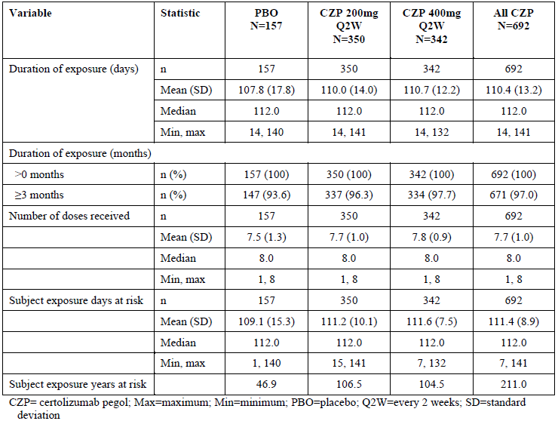
During the 16 week initial treatment phase for Pool S1, the mean duration of exposure was slightly lower in the placebo arm at 107.8 days compared with the certolizumab pegol 400 mg Q2W (110.7 days) and certolizumab pegol 200 mg Q2W (110.0 days) groups. However, the median number of days that study medication was received was 112 days in all three treatment arms. Most subjects (> 93%) in each treatment group continued to receive study medication for 3 or more months, but total drug exposure was higher in both certolizumab pegol dose groups due to a combination of sample size and subject withdrawal prior to week 16 (more with placebo). The total exposure in patient-years was similar between the certolizumab pegol 400 mg Q2W and certolizumab pegol 200 mg Q2W groups at 104.5 patient-years and 106.5 patient-years, respectively.

Maintenance treatment period (Pool S4)
Overall study medication exposure in Pool S4, which includes subjects participating in the Phase III, placebo controlled CIMPASI-1, CIMPASI-2, and CIMPACT trials during the maintenance treatment period, is presented by assigned treatment at Week 16 in Table 5.
Table 5: Exposure to study medication during the maintenance treatment period (Pool S4)
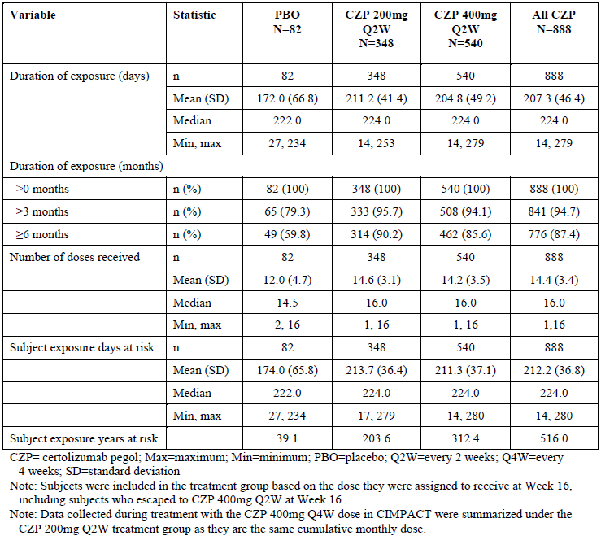
As expected in Pool S4, the mean duration of exposure was higher in both certolizumab pegol groups (211.2 days for 200 mg Q2W and 204.8 days for 400 mg Q2W) compared with the placebo arm (172 days) and was mainly explained by subjects in the placebo group from the CIMPACT trial who relapsed during the blinded maintenance treatment period and subsequently escaped to the open label treatment phase. The mean duration of exposure in the certolizumab pegol 200 mg Q2W group was slightly higher compared to the certolizumab pegol 400 mg Q2W arm (211.2 days versus 204.8 days). This appears to be explained by the higher rate of discontinuation among subjects on escape certolizumab pegol 400 mg Q2W therapy that were mandatorily withdrawn from the study if PASI50 response was not achieved in the maintenance treatment period. It is important to note that Pool S4 includes subjects in the placebo group who relapsed during the blinded maintenance treatment period of the CIMPACT trial, and who then escaped to certolizumab pegol 400 mg Q2W therapy.
In Pool S4, the total subject exposure was 312.4 patient-years in the certolizumab pegol 400 mg Q2W group, 203.6 patient-years in the certolizumab pegol 200 mg Q2W arm and 39.1 patient-years in the placebo group. The higher total exposure in the certolizumab pegol 400 mg Q2W group compared with the certolizumab pegol 200 mg Q2W arm (312.4 patient-years versus 203.6 patient-years) was primarily due to the difference in sample size (540 subjects in the certolizumab pegol 400 mg Q2W group and 348 subjects in the certolizumab pegol 200 mg Q2W arm). Pool S4 included a total of 888 subjects exposed to certolizumab pegol (either dose regimen) and 87.5% (n = 777) of those subjects completed the maintenance treatment period (between Weeks 16 and 48).

Phase II studies
In Study C87040, the mean exposure to treatment in terms of the number of administered study drug injections was the same for both certolizumab pegol groups, but lower for the placebo arm. It is important to note that subjects received two concurrent study injections at each visit over the 12 week active treatment period of Study C87040. A summary of the extent of treatment exposure in Study C87040 is provided in Table 6.
Table 6: Extent of treatment exposure in Study C87040
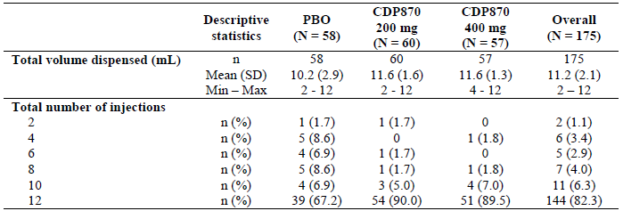
In addition, more subjects in the placebo group (32.2%) discontinued the trial compared with 8.5% of subjects in the certolizumab pegol 200 mg arm and 6.9% of subjects in the certolizumab pegol 400 mg group, mainly due to lack of efficacy.
In the re-treatment trial (Study C87044), the mean number of injections each certolizumab pegol treatment cohort received was similar at 11.6 to 11.8 injections. It is important to note that each certolizumab pegol treatment cohort in Study C87044 received 2 concurrent study medication injections at each visit to maintain blinding over the 12 week active re-treatment period. Table 7 provides a summary of exposure in Study C87044.
Table 7: Extent of treatment exposure in Study C87044
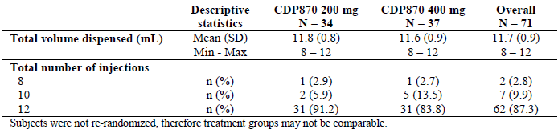

Long term safety (Pool S3)
In Pool S3, a total of 995 subjects were exposed to certolizumab pegol in the Phase III psoriasis studies (which represents a total drug exposure of 883.2 patient-years) and 117 subjects received certolizumab pegol in the Phase II program (an additional 68.5 patient-years of exposure). Table 8 summarises the exposure to certolizumab pegol in the long-term safety dataset (Pool S3).
In the Phase III studies, overall exposure was higher with certolizumab pegol 400 mg Q2W (478.3 patient-years) compared to certolizumab pegol 200 mg Q2W (404.9 patient-years). This observation is best explained by a higher proportion of certolizumab pegol 200 mg treated subjects having < 16 weeks of drug exposure (40.3% (283 of 703) with 200 mg Q2W versus 16.5% (112 of 677) with 400 mg Q2W). This difference in distribution of duration of exposure between the two certolizumab pegol dose regimens is driven by a high number of subjects who are first exposed to certolizumab pegol at a dose of 200 mg Q2W in the open label treatment periods.
Table 8: Exposure to certolizumab pegol for Pool S3 Subjects (as of data cut-off dates)
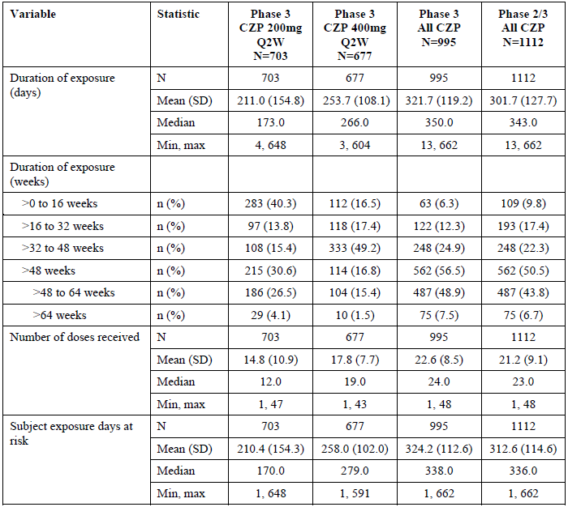

Safety issues with the potential for major regulatory impact

Deaths and other serious adverse events (SAE)

Initial treatment period (Pool S1)
No subjects died during the initial treatment periods of the Phase III trials. In Pool S1, the incidence of serious adverse events (SAEs) was similar between the placebo (4.5%; 7 of 157; 7 SAEs) and certolizumab pegol 400 mg treatment groups (4.7%; 16 of 342; 20 SAEs), but significantly lower in the certolizumab pegol 200 mg arm (1.4%; 5 of 350; 9 SAEs).
Except for osteoarthritis affecting 2 subjects in the certolizumab pegol 400 mg Q2W group, all other SAEs by preferred term were reported in single patients. Serious AEs of lymphadenitis, injection site reaction and anaphylactoid reaction (all of which were considered to be treatment related) were reported by 1 subject each in the certolizumab pegol 400 mg Q2W group. The SAE of anaphylactoid reaction (in a 44 year old male) occurred on the first day of certolizumab pegol dosing, required immediate hospitalisation and resolved 3 days later, and led to the subject permanently ceasing treatment. One subject in the certolizumab pegol 200 mg Q2W cohort, had a treatment related SAE of depression with suicide attempt requiring hospitalisation. All other SAEs were considered not related to study medication.

Maintenance treatment period (Pool S4)
One fatality was recorded in Pool S4. A 41year old male treated with certolizumab pegol 400 mg Q2W therapy in the CIMPACT Study died of multiple injuries at the scene of a motor vehicle accident during the maintenance treatment period. The overall incidence of SAEs in the maintenance treatment periods was relatively low with certolizumab pegol (4.6% [25 of 540] in the certolizumab pegol 400 mg Q2W arm and 5.2% [18 of 348] in the certolizumab pegol 200 mg Q2W group), but lower in the placebo group (2.4%; 2 of 82). Furthermore, the incident rates for SAEs was almost 2 fold in the certolizumab pegol groups (incident rate of 9.07 per 100 patient-years with 200 mg therapy and incident rate of 8.15 per 100 patient-years with 400 mg) compared with the placebo arm (5.2 per 100 patient-years). There were no noticeable differences in between the two certolizumab pegol groups for the types and pattern of SAEs.
In certolizumab pegol treated subjects (both dose regimens combined), SAEs were reported by at least 2 subjects in the following SOCs: infections and infestations (2 subjects treated with certolizumab pegol 400 mg Q2W (1 developed an abdominal abscess and infected haematoma and the other experienced pneumonia)); and injury, poisoning and procedural complications (9 subjects; 1.0% incidence each); musculoskeletal and connective tissue disorders (6 subjects; 0.7% incidence); nervous system disorders (4 subjects; 0.5% incidence); hepatobiliary disorders (3 subjects; 0.3%); and neoplasms (3 subjects; 0.3%); and cardiac disorders, and skin and subcutaneous tissue disorders, and gastrointestinal disorders (2 subjects each; 0.2% incidence).
No individual SAE by preferred term was reported by more than 1 subject in the all certolizumab pegol treated cohort apart from psoriatic arthritis (reported by 2 subjects in the certolizumab pegol 200 mg Q2W arm), migraine (reported by 1 subject in each certolizumab pegol arm), rib fracture (reported by 1 person in each certolizumab pegol group) and erysipelas (reported by 1 subject in the certolizumab pegol 200 mg Q2W group and 2 subjects in the certolizumab pegol 400 mg Q2W arm).
Treatment related SAEs were reported by 7 subjects treated with certolizumab pegol: 2 subjects in the certolizumab pegol 200 mg Q2W group and 5 subjects in the certolizumab pegol 400 mg Q2W arm. Related SAEs of hepatitis (not infectious) and drug-induced liver injury were reported in the certolizumab pegol 200 mg Q2W group. In the certolizumab pegol 400 mg Q2W group, related SAEs of E. coli sepsis and pyelonephritis (same subject), sepsis, tuberculosis, erysipelas and congestive heart failure were reported in Pool S4.

Phase II Studies
There were no deaths during the Phase II trials. In Study C87040, at least 1 SAE was reported by 1 (1.7% of 58) placebo subject, 2 (3.3% of 60) certolizumab pegol 200 mg treated patients and 5 (8.8% of 57) certolizumab pegol 400 mg treated subjects. The placebo subject recorded haemorrhagic diarrhoea as an SAE. In the certolizumab pegol 200 mg group, 3 SAEs were reported in 2 subjects (contusion, and urinary tract infection and gastroenteritis). In the certolizumab pegol 400 mg arm, 7 SAEs were recorded in 5 subjects including 2 pregnancies in 1 patient (once during treatment and the other post-treatment), 1 pregnancy in another subject, disseminated tuberculosis, anxiety (twice) and gastroenteritis, and psoriasis.
During the re-treatment period of Study C87044, no subjects reported an SAE. However, a 72 year old male subject died from cerebral haemorrhage 18 weeks after receiving their last dose of certolizumab pegol in Study C87044. Another subject (47 year old female) was scheduled to enter Study C87044 but failed screening because of suspected pulmonary tuberculosis (positive purified protein derivative skin test and calcified nodules on chest X-ray). Screening took place 33 weeks after her last dose of certolizumab pegol 400mg in Study C87040. The investigator considered the SAE to be treatment related.

Long term safety (Pool S3)
Two deaths were recorded in Pool S3. Both were the result of fatal traffic accidents. One additional treatment emergent death (deemed unrelated to certolizumab pegol) due to exacerbation of chronic obstructive pulmonary disease was reported after the clinical cut-off date but before the safety cut-off date of 6 March 2017.
Table 9 provides a summary of serious infections and other SAEs, including their incident rates that have been recorded in the long-term safety dataset (Pool S3). In general, the frequency and pattern of SAEs is consistent with the earlier certolizumab pegol safety datasets in patients with psoriasis and is within expectations for an anti-TNF therapy.
There is a small increased risk of serious infection with certolizumab pegol that does not increase over time on drug. In Pool S3, 12 certolizumab pegol treated subjects reported 14 infectious SAEs including 8 subjects in the certolizumab pegol 400mg group (1.2%; incident rate of 1.68 per 100 patient-years) and 4 patients in the certolizumab pegol 200 mg arm (0.6%; incident rate of 0.99 per 100 patient-years). An additional case of tuberculosis was identified after initial database lock. This subject developed tuberculosis 60 days after receiving their first dose of certolizumab pegol 400 mg Q2W (via escape) in the CIMPACT study after being previously treated with etanercept earlier in the trial. The SAE was considered to be treatment related and the subject was permanently withdrawn from certolizumab pegol. No other significant opportunistic infections were identified in Pool S3.
A total of 6 subjects (0.5%) in Pool S3 reported 8 malignancies with an exposure adjusted incidence rate of 0.68 per 100 patient-years, which is consistent with published expectations. Malignancy related AEs were equally observed in both certolizumab pegol dose groups, and included 3 non-melanoma skin cancers and 5 solid organ malignancies (breast cancer, prostate cancer, Hodgkin’s lymphoma and 2 types of malignant brain cancer in 1 subject). One of the malignancies was reported in the initial treatment period (basal cell carcinoma of skin) and all events were identified in either the maintenance or open label treatment phases.
Table 9: SAEs by SOCs (including preferred terms with at least 2 affected subjects in any group) in Pool S3
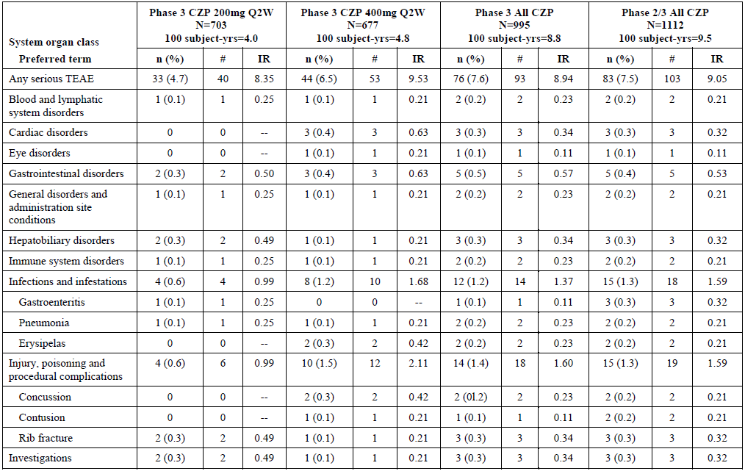
Table 8 (continued): SAEs by SOCs (including preferred terms with at least 2 affected subjects in any group) in Pool S3
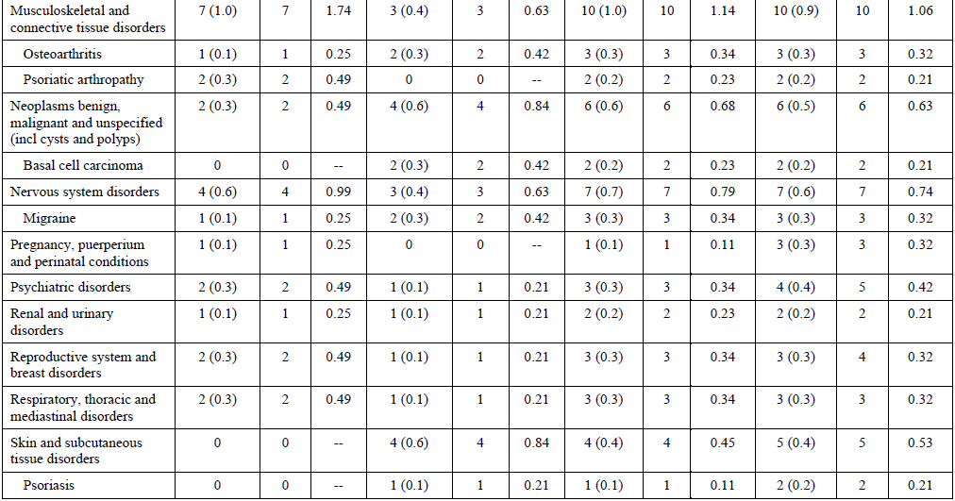

Liver function and hepatotoxicity

Initial treatment period (Pool S1)
In Pool S1, a total of 57 hepatic AEs were recorded in 34 subjects: 6 patients (3.8% of 157) in the placebo group had 7 hepatic AEs (incident rate of 13.05 per 100 patient-years), 17 subjects (4.9% of 350) in the certolizumab pegol 200 mg arm experienced 33 hepatic AEs (incident rate of 16.31 per 100 patient-years) and 11 subjects (3.2% of 342) in the certolizumab pegol 400mg group recorded 17 hepatic AEs (incident rate of 10.64 per 100 patient-years) (see Table 10).
Table 10: Summary of Hepatic AEs (in at least 2 subjects in any treatment group) of Pool S1
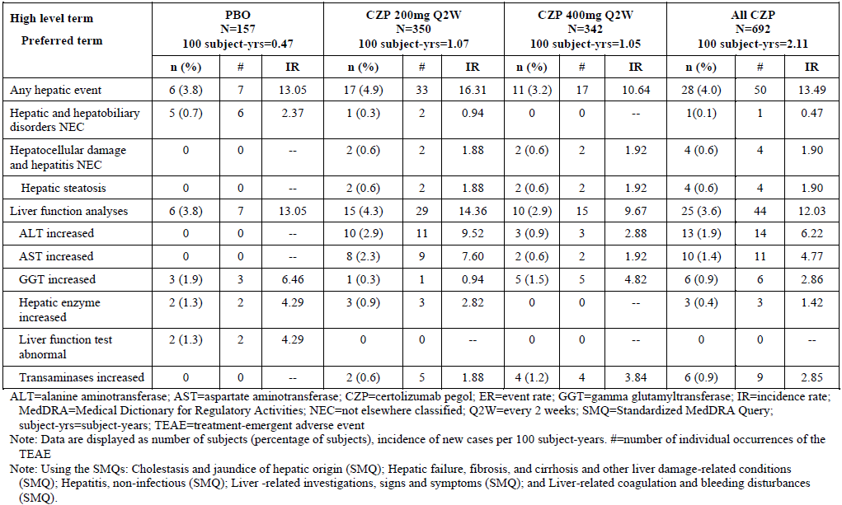
Most hepatic AEs were not considered to be treatment related. Two certolizumab pegol 200 mg treated subjects in CIMPASI-2 discontinued due to hepatic AEs and another certolizumab pegol 200 mg Q2W treated patient in the CIMPASI-2 study had increased serum transaminases recorded as SAE. However, no subject in Pool S1 met Hy’s law criterion.

Maintenance treatment period (Pool S4)
The liver function and hepatic AE data during the maintenance treatment period was combined into Pool S3 to give a longer term profile on this potential issue.

Phase II studies
No significant abnormalities of liver function were reported in the Phase II trials apart from 3 subjects (2 treated with certolizumab pegol 400 mg Q2W and 1 given certolizumab pegol 200 mg Q2W) developing grade 3 increases in serum gamma-glutamyl transferase levels at the end of treatment in Study C87040, which returned to normal values during the follow-up period. In addition, 3 subjects (1 in each of the 3 treatment groups) developed increased serum transaminases in Study C87040.

Long term safety (Pool S3)
In Pool S3, 71 subjects (7.1% of 995) treated with certolizumab pegol in the Phase III trials reported hepatic AEs. The incident rates were 8.17 per 100 patient-years for the certolizumab pegol 200 mg Q2W group and 9.30 per 100 patient-years for the certolizumab pegol 400 mg Q2W group. The incident rates in Pool S3 did not increase compared with the 2 certolizumab pegol dose groups in Pool S1 (16.31 per 100 patient-years for 200 mg Q2W and 10.64 per 100 patient-years for the 400 mg Q2W group), suggesting no increase in liver damage risk with longer exposure.
One subject treated with certolizumab pegol in the CIMPACT trial recorded an elevation in serum alanine transaminase (ALT) ≥ 20 x upper limit of normal (ULN) (1020 IU/L at Week 20) and an aspartate transaminase (AST) elevation ≥ 10 x ULN (431 IU/L at Week 20). The subject’s serum bilirubin was normal at all visits. No markedly abnormal post-baseline elevations of serum transaminases occurred in subjects receiving placebo. Three additional SAEs were reported in Pool S3 compared with Pool S1/S2. In the certolizumab pegol 200 mg group, SAEs of drug-induced liver injury and hepatitis (resulting in treatment discontinuation) were reported. In the certolizumab pegol 400 mg Q2W group, an SAE of cholecystitis was reported.
The percentages of subjects with elevations in bilirubin ≥ 1 x ULN and ≥ 1.5 x ULN were similar across all treatment groups. Elevations in bilirubin of ≥ 1 x ULN occurred in 99 certolizumab pegol treated subjects (10.2%) in the Phase III studies. Twenty-seven certolizumab pegol treated subjects (2.8%) in the Phase III trials had serum bilirubin elevation ≥ 1.5 x ULN. No subject met the Hy’s Law criterion, defined as bilirubin elevation ≥ 2 x ULN, and ALT or AST elevation ≥ 3 x ULN at the same visit. A summary of post-baseline liver function test elevations and Hy’s Law criterion during the combined initial, maintenance and open label treatment periods is presented for Pool S3 in Table 11.
Table 11: Post Baseline increases in liver function tests during initial, maintenance and open label treatment with certolizumab pegol (Pool S3)
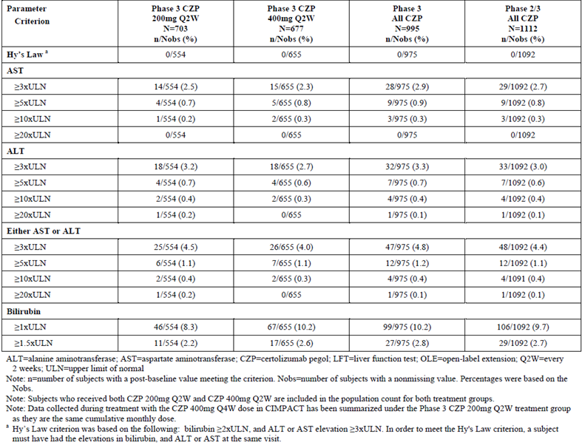

Renal function and renal toxicity

Initial treatment period (Pool S1)
In Pool S1, only 1 subject treated with certolizumab pegol 400 mg Q2W developed a significant increase from baseline in serum creatinine, which was transient and not related to study medication.

Maintenance treatment period (Pool S4)
No concerns regarding renal function impairment were observed with certolizumab pegol in this dataset.

Phase II studies
No significant abnormalities of renal function were reported in the Phase II trials.

Long term safety (Pool S3)
Nil concerns regarding renal toxicity were expected or identified with certolizumab pegol in the Pool S3 set.

Other clinical chemistry
Increased serum creatine phosphokinase levels in patients with axial spondyloarthritis have been a signal of potential concern with anti-TNF drugs as a class.

Initial treatment period (Pool S1)
During the initial treatment period of the Phase III trials, a higher frequency of normal baseline to high post-treatment creatine phosphokinase levels (on at least 1 occasion) was reported for certolizumab pegol treated subjects (16.3% [57 of 350] for 200 mg Q2W and 17.0% [58 of 342] for 400 mg Q2W) compared with placebo patients (12.1%; 19 of 157). A subject treated with certolizumab pegol 400 mg Q2W in the CIMPASI-2 Study recorded a serum creatine phosphokinase level of 20,823 U/L at Week 4 with no associated clinical AE. At Week 6, the creatine phosphokinase had declined to 309 U/L and by Week 8, the value had returned to within the normal range. No other treatment related trends in abnormal serum chemistry (glucose, calcium, sodium, potassium or magnesium) were observed.

Maintenance treatment period (Pool S4)
In Pool S4, a higher proportion of certolizumab pegol 200 mg Q2W treated subjects recorded increased blood creatine phosphokinase levels (2.3% [8 of 348] of subjects at incident rate of 3.95 per 100 patient-years) compared to the 2 other groups (1 placebo treated subject at incident rate of 2.56 per 100 patient-years and 6 certolizumab pegol 400 mg Q2W treated subjects [1.1% of 540] at incident rate of 1.93 per 100 patient-years). Raised post-treatment blood glucose levels were reported for several certolizumab pegol treated subjects, nearly all of which had a previous or current history of diabetes mellitus at baseline.

Phase II studies
No significant abnormalities of serum biochemistry were reported in the Phase II trials apart from 2 subjects (1 in the placebo arm and the other treated with certolizumab pegol 400 mg Q2W) recording grade 3 hyponatraemia (transient) and 1 patient in the certolizumab pegol 200mg arm having hyperkalaemia during Study C87040.

Long term safety (Pool S3)
During open label treatment, 10 subjects reported markedly high blood glucose levels, 2 recorded markedly elevated serum creatine phosphokinase levels and 1 subject had a transient high serum potassium level. This safety dataset did not reveal any new signals for abnormalities of serum chemistry or an increased frequency of known abnormalities above expectations.

Haematology and haematological toxicity

Initial treatment period (Pool S1)
Over the first 16 weeks of treatment, mean and median values for all haematology parameters were similar across the three treatment groups (placebo, certolizumab pegol 200 mg Q2W and certolizumab pegol 400 mg Q2W) with only small changes from baseline of no clinical relevance being noted. Regarding individual subject changes from baseline, the 2 altered parameters of note with certolizumab pegol therapy were:
- a slightly higher frequency of subjects with their platelet count going from normal at baseline to low post-treatment (1.3% [2 of 157] with placebo compared with 2.6% [9 of 350] with certolizumab pegol 200 mg Q2W and 1.8% [6 of 342] with certolizumab pegol 400 mg Q2W), and
- a higher incidence of markedly low haemoglobin level with certolizumab pegol 400 mg therapy (1.2% [4 of 342] compared with 1 subject in the placebo arm [0.6%] and 1 subject in the certolizumab pegol 200 mg group [0.3%]). No other notable emergent shift patterns were observed for any of the other haematology parameters.

Maintenance treatment period (Pool S4)
In Pool S4, mean and median changes from baseline over time for both dose regimens of certolizumab pegol during the maintenance treatment period were small and not of clinical significance. Very few markedly abnormal haematology results were reported at any visit during the maintenance treatment phase. In the all certolizumab pegol treated cohort, a total of 7 subjects (0.8%) reported low haemoglobin, 2 subjects (0.2%) recorded lymphopenia and 1 subject receiving certolizumab pegol 200 mg Q2W therapy in the CIMPACT Study experienced both neutropenia and thrombocytopenia.

Phase II studies
There were no clinically significant, treatment-related mean changes in any haematology parameter over time in either Phase II study. One subject treated with certolizumab pegol 200 mg Q2W in Study C87040 developed transient grade 3 neutropenia, which normalised under treatment, and no explanation was identified.

Long term safety (Pool S3)
During the open label treatment phase, an additional 3 certolizumab pegol treated subjects reported markedly low haemoglobin values, all of which were transient and returned to the normal range at a subsequent visit. One subject treated with certolizumab pegol 400 mg Q2W therapy recorded leucocytosis with neutrophilia and lymphopenia during the open label treatment period.

Lipid abnormalities
Increased serum cholesterol levels following suppression of systemic inflammation in patients with active inflammatory autoimmune arthritis (such as rheumatoid arthritis and psoriatic arthritis), has been noted with various biologic therapies including anti-TNF drugs.

Initial treatment period (Pool S1)
During the initial treatment periods of the Phase III studies, a noticeably higher proportion of certolizumab pegol treated subjects (18.0% [63 of 350] of patients with 200 mg Q2W and 20.8% [71 of 342] with 400 mg Q2W) recorded post-treatment increases in serum cholesterol compared with placebo subjects (11.5%; 18 of 157). However, most post-baseline increases in serum cholesterol were fluctuating and transient.

Maintenance treatment period (Pool S4)
In Pool S4, markedly increased levels of serum cholesterol or triglycerides were reported for approximately 1% of subjects in each certolizumab pegol dose group versus no such reports in placebo subjects.

Phase II studies
This outcome was not specifically reported in the Phase II trials.

Long term safety
In the open label treatment period, an additional 2 subjects (both treated with certolizumab pegol 200 mg Q2W therapy) had AEs of hyperlipidaemia or hypercholesterolaemia recorded in the database.

Cardiovascular safety
In Pool S1, 1 subject (0.3%; incident rate of 0.96 per 100 patient-years) treated with certolizumab pegol 400 mg Q2W group experienced acute coronary syndrome. In Pool S3, 5 subjects (0.5% overall) treated with certolizumab pegol in the Phase III studies reported 5 Major Adverse Cardiovascular Events (MACE). In addition to the case of acute coronary syndrome reported in Pool S1, there was 1 report of congestive cardiac failure in the maintenance treatment period of the CIMPASI-2 Study (subject was receiving certolizumab pegol 400 mg Q2W for 204 days resulted in treatment discontinuation), another report of cardiac failure, and 2 subjects in the certolizumab pegol 200 mg Q2W cohort recorded cerebrovascular accident and transient ischaemic attack. The incident rate for MACE in Pool S3 (all certolizumab pegol treated subjects) was within expectations for the treatment population at 0.53 per 100 patient-years.

Vital signs and physical examination findings
In Pool S1, no clinically meaningful changes from baseline in vital signs (blood pressure and weight) were observed during the initial treatment period. Mean changes from baseline pre-treatment values for systolic and diastolic blood pressure were small and clinically insignificant at all visits up to and including Week 16. For systolic blood pressure readings, the mean change from baseline ranged between -2.2 and +0.9 mmHg and for diastolic blood pressure the mean values ranged between -1.2 and +0.8 mmHg. The mean changes from baseline to Week 16 in subject weight were minimal across all treatment groups, ranging from -0.11 to +1.0 kg. At Week 16, the incidence of new onset of hypertension was 2.6% in certolizumab pegol treated subjects and 3.2% in the placebo arm.

Immunogenicity and immunological events
The formation of antibodies in response to treatment with protein therapeutics (known as immunogenicity), including immunoglobulin derived antibody drugs, is of importance for any potential effects upon the pharmacokinetic, efficacy or safety of the drug. The presence of antidrug antibodies has been extensively studied with certolizumab pegol in the other approved treatment indications. Previous experience indicates that over the tested certolizumab pegol dose range (and particularly evident with the certolizumab pegol 200 mg Q2W versus 400 mg Q2W regimens) there appears to be an inverse relationship between the incidence of positive antidrug antibodies and certolizumab pegol dose regardless of several other variables including disease indication, single versus multiple doses and route of administration.
In the Phase III rheumatoid arthritis studies, approximately 7% of all certolizumab pegol treated subjects recorded positive antidrug antibodies (at any assay level) on at least 1 occasion with concomitant methotrexate found to have a significant influence. When certolizumab pegol 400 mg Q4W therapy was given as monotherapy in rheumatoid arthritis, the incidence of positive antidrug antibodies was 22.5% versus 4.0% in subjects receiving the same certolizumab pegol dose with methotrexate.
During the psoriasis clinical development program, a validated screening ELISA method based on a double antigen sandwich (bridge) format was used to detect antidrug antibodies to certolizumab pegol. The ELISA method was developed, validated and used to detect antidrug antibodies to certolizumab pegol in the rheumatoid arthritis and other certolizumab pegol treatment indication programs. The screening ELISA had a cut-off value of > 2.4 units/mL to detect antidrug antibodies. Furthermore, the assay was considered to have adequate drug-tolerance for the detection of the antidrug antibodies to certolizumab pegol. During the Phase III psoriasis studies, the screening ELISA method was modified and validated to contain 3 testing tiers: screening, confirmation and titration assay. In addition, a validated cell-based HeLa assay was used to detect neutralising antibodies to certolizumab pegol. Neutralising antibodies were only characterised in subjects who tested positive for antidrug antibodies (that is, second line procedure only).

Integrated Phase III safety analyses
In the Phase III trials, a subject was considered antibody positive if the antidrug antibodies level was > 2.4 units/mL on at least 1 assessment while on certolizumab pegol treatment. Samples collected at baseline, at the safety follow-up visit, and at any visit > 70 days after the last certolizumab pegol dose were excluded. A summary of antidrug antibodies status by visit during the combined initial and maintenance treatment periods for the Phase III studies (Pool S3 dataset) is presented in Table 12.
Expectedly, the incidence of antidrug antibodies positivity was low across all groups at Weeks 2 and 4 (< 2.1%). Among those subjects who were PASI responders at Week 16 (and therefore were going to remain on their randomised certolizumab pegol treatment during the maintenance treatment phase), the incidence of antidrug antibody positivity at Week 16 was low overall but higher in the certolizumab pegol 200 mg Q2W group (8.1%; 16 of 209) compared with the blinded certolizumab pegol 400 mg Q2W arm (2.5%; 5 of 210). At Week 16, the highest incidence of positive antidrug antibodies was observed in subjects who were randomised to certolizumab pegol 200 mg Q2W therapy during the initial treatment period and who subsequently switched to certolizumab pegol 400 mg Q2W during the maintenance treatment period (37.3%; 28 of 75). The next 2 highest incidences of positive antidrug antibodies result at Week 16 were observed in the blinded certolizumab pegol 400 mg Q2W to escape certolizumab pegol 400 mg Q2W group (15.8%; 9 of 57) and the certolizumab pegol 200 mg Q2W to certolizumab pegol 400 mg Q4W cohort (11.6%; 5 of 44).
In the overall randomised certolizumab pegol 200 mg Q2W cohort (which includes PASI responders as well as escape subjects), the incidence of a positive antidrug antibody result at Week 16 was 2.8-fold higher than the corresponding certolizumab pegol 400 mg Q2W group (14.7% versus 5.3%, respectively). Of note, in both the certolizumab pegol treatment groups, two thirds of subjects who were antidrug antibody positive at Week 16 were PASI75 non-responders (33 of 51 subjects in the 200 mg Q2W group and 12 of 18 in the 400 mg Q2W arm).
During the 32 week maintenance treatment periods of the Phase III studies, the incidences of antidrug antibody positivity in the continuous certolizumab pegol 200 mg Q2W group, the blinded certolizumab pegol 400 mg Q2W arm and the combined cohort of subjects who were initially randomised to certolizumab pegol 400 mg Q2W who either remained on blinded certolizumab pegol 400 mg Q2W or escaped at Week 16 to certolizumab pegol 400 mg Q2W were low at each visit, although incidences were consistently higher in the certolizumab pegol 200 mg Q2W arm compared with the certolizumab pegol 400 mg Q2W group. In addition, the incidences of antidrug antibody positivity in both escape groups decreased over time in the maintenance treatment phase, but incidences were consistently higher at each visit in the certolizumab pegol 200 mg Q2W to certolizumab pegol 400 mg Q2W escape arm compared with the certolizumab pegol 400 mg Q2W to certolizumab pegol 400 mg Q2W escape group.
For CIMPACT subjects who were re-randomised from certolizumab pegol 200 mg Q2W to certolizumab pegol 400 mg Q4W (that is, the same monthly dose), the incidences of positive antidrug antibodies at each visit were comparable to or slightly lower compared with the Week 16 incidence. In comparison, for subjects re-randomised from certolizumab pegol 400 mg Q2W to certolizumab pegol 200 mg Q2W, the incidences of antidrug antibody positivity at each visit were generally low but increased over time relative to the Week 16 frequencies. Among those subjects who were initially randomised to either placebo or etanercept, those subjects re-randomised to certolizumab pegol 200 mg Q2W at Week 16 had a higher incidence of positive antidrug antiodies compared with the etanercept/placebo to escape certolizumab pegol 400 mg Q2W group at each time point during the maintenance treatment period, and particularly at Week 48 (18.2% versus 2.7%, respectively). However, the highest incidence of positive antidrug antibodies across all groups during the maintenance treatment period was observed at the Week 10 follow-up visit in those subjects who prematurely discontinued.
Table 12: Antidrug antibodies status by Visit during the Phase III Studies (Pooled Dataset-S3)
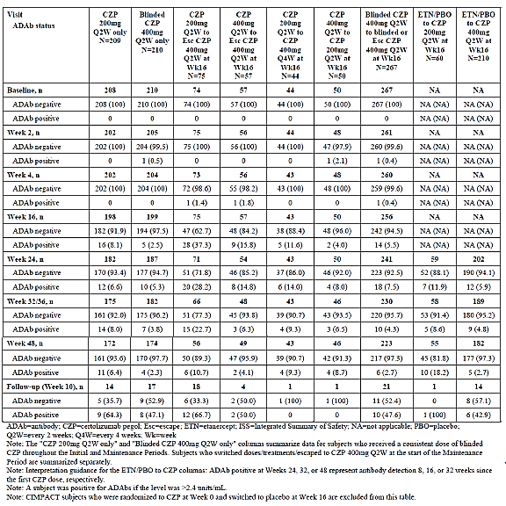
The detection of neutralising antibodies was only assessed for in the two CIMPASI studies. A total of 27 of 60 antidrug antibody positive patients had plasma certolizumab pegol concentrations low enough for the assessment of neutralising antibodies (< 0.3 μg/mL). All 27 of these subjects demonstrated neutralising activity.

Integrated phase II safety analyses
The definition of antidrug antibody positivity in the Phase II studies was any post baseline visit result > 2.4 units/mL. Blood samples for antidrug antibody analysis were collected at baseline (that is, prior to any certolizumab pegol) in Study C87040; Weeks 4, 8 and 12 of the treatment period of Study C87040; Weeks 4, 8, 12, 16, 20 and 24 of post-treatment follow-up period of Study C87040; and at Weeks 4, 8 and 12 of re-treatment in Study C87044. During the 12 week treatment period of Study C87040, a higher proportion of subjects treated with certolizumab pegol 200 mg Q2W (15.3%; 9 of 59) versus certolizumab pegol 400 mg Q2W (10.5%; 6 of 57) recorded at least 1 positive, post-baseline positive antidrug antibody result. The same trend was also evident during the combined 12 week treatment period of both Phase II studies (23.7% [14 of 59] for the 200 mg Q2W group and 19.3% [11 of 57] for the 400 mg Q2W arm). However, positive antidrug antibody results can sometimes be transient (and usually at lower titres), an alternative to examine the data is by scheduled assessment. Table 13 is a summary of antidrug antibody status by visit for the Phase II studies.
Table 13: Antidrug antibody status by Visit during the Phase II Studies (C87040 and C87044)
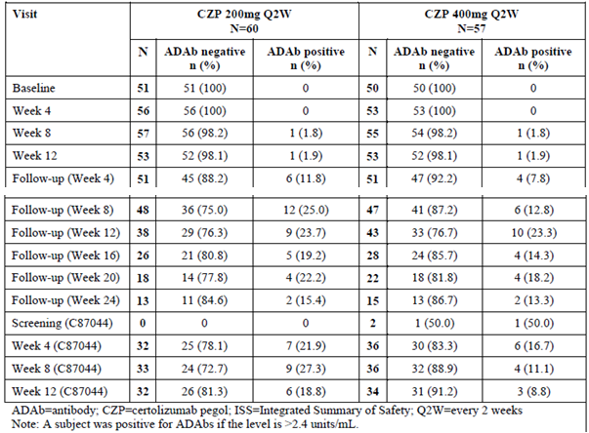
In Study C87040, only 1 subject in each certolizumab pegol treatment group was antidrug antibody positive at Weeks 8 (1.8% in each group) and 12 (1.9% in each certolizumab pegol arm). During the 24 week follow-up phase of Study C87040, a higher proportion of subjects in the certolizumab pegol 200 mg group tested positive to antidrug antibody at each time point. The difference between the 2 certolizumab pegol groups was most marked at 8 weeks of follow-up in Study C87040 (25.0% [12 of 48] in the 200 mg group versus 12.8% [6 of 47] in the 400 mg arm). The rates of antidrug antibody positivity reduced partially by Week 24 of follow-up in Study C87040 but quickly rose again (that is, by Week 4) with re-treatment in Study C87044. In Study C87044, the percentage of subjects with positive antidrug antibodies was higher at each time point with certolizumab pegol 200 mg Q2W (range: 18.8 to 27.3%) compared with certolizumab pegol 400 mg Q2W therapy (range: 8.8 to16.7%). Moreover, the incidences of positive antidrug antibodies at each time point upon re-treatment in Study C87044 were significantly higher than the corresponding post-treatment evaluations in Study C87040.
In the Phase II studies, of all antidrug antibody positive subjects, 52.0% (13 of 25) were neutralising antibody positive, including 50.0% (7 of 14) of subjects in the certolizumab pegol 200 mg Q2W group and 54.5% (6 of 11) of patients in the certolizumab pegol 400 mg Q2W arm.

Impact of antidrug antibodies upon subject disposition and safety
The impact of antidrug antibody positivity upon the pharmacokinetic and clinical efficacy of certolizumab pegol has already been considered earlier in this report. The presence of antidrug antibodies did not change the overall AE profile of certolizumab pegol and there was no apparent association between the presence of antidrug antibodies and injection site reactions or hypersensitivity AEs. Of the 120 subjects in the Phase III studies who tested antidrug antibody positive, a lower percentage of subjects completed the combined initial and maintenance treatment periods (70.8%; 85 of 120) compared to antidrug antibody negative patients (87.5%; 696 of 795).
The most frequent reason for premature discontinuation in antidrug antibody positive subjects was insufficient efficacy (14.2%; 17 of 120), including failure to meet the mandatory PASI response requirement for ongoing treatment. AEs were a minor reason for early cessation from the studies in antidrug antibody positive subjects and were not significantly higher than that observed in antidrug antibody negative patients.

Serious skin reactions
No serious skin reactions were reported in any of the Phase II and III psoriasis studies with certolizumab pegol.

Demyelinating-like disorders
Two subjects reported demyelinating AEs during the Phase III study program. In the CIMPASI-2 trial, a patient treated with certolizumab pegol 200 mg Q2W recorded an SAE of multiple sclerosis 15 days after their last dose of certolizumab pegol and 348 days after their first dose.
The SAE resulted in discontinuation of certolizumab pegol and was deemed related to certolizumab pegol by the investigator. The patient had also previously received adalimumab. Another subject in the CIMPACT Study recorded an SAE of primary progressive multiple sclerosis after 157 days of treatment with certolizumab pegol 400 mg Q2W. The patient had received secukinumab previously for psoriasis. The SAE resulted in discontinuation of certolizumab pegol. However, the SAE was not considered to be related to certolizumab pegol by the investigator because they had symptoms of gait disturbance and recurrent falls prior to study entry. A neurologist assessed the subject and magnetic resonance imaging confirmed the diagnosis.

Safety in special populations
A total of 7 pregnancies were reported in 6 female subjects in the psoriasis study program (1 in CIMPASI-1, 2 in CIMPASI-2 and 3 in Study C87040). Of the 3 pregnancies recorded in Study C87040, 2 occurred in 1 subject (1 was treatment emergent and the second pregnancy was post-treatment). The outcomes of these pregnancies were: 1 healthy delivered baby, 3 induced terminations (all in Study C87040) and 3 unknown outcomes as of database lock. Between the clinical and safety data cut-off dates, another 2 pregnancies were reported in the CIMPACT study with 1 resulting in an induced abortion and the other pregnancy outcome remains unknown.

Safety related to drug-drug interactions and other interactions
No new drug interaction studies have been submitted with this application. The sponsor states that the original certolizumab pegol registration application contained analyses showing that there is no drug interaction with modification of pharmacokinetic parameters between certolizumab pegol and methotrexate (5 to 17.5 mg/week) in patients with rheumatoid arthritis, or other common concurrent therapies such as NSAID, glucocorticoids, analgesics, 5-aminosalicylic acid analogues or anti-infective drugs.

Post-marketing data
Certolizumab pegol received its first marketing authorisation in September 2007 in Switzerland, and its initial marketing approval in the European Union in October 2009 and in the USA in April 2008. Over the last 10 years since its launch, the overall safety of certolizumab pegol has remained consistent with the expectations of the anti-TNF medicine class. As of 6 March 2017 (the most recent Periodic Safety Update Report; PSUR), an estimated 12,364 subjects worldwide have been exposed to certolizumab pegol in completed and ongoing clinical studies. Based on marketing data across all approved treatment indications, exposure to certolizumab pegol has been estimated to reach 256,112 patient-years during the last 3 year reporting interval of the PSUR and 420,451 patient-years cumulatively.
During the last reporting interval, 6 potential clinical safety signals were evaluated and 5 of those were refuted. The closed clinical safety signals included overall mortality rate in rheumatoid arthritis, cervical cancer, long term immunogenicity in patients with rheumatoid arthritis and Crohn’s disease, increased serum creatine phosphokinase levels, and autoimmune hepatitis. The safety concern of development of tuberculosis (despite prior or concurrent chemoprophylaxis) was confirmed as a signal with certolizumab pegol therapy.

Evaluator’s conclusions on safety
The safety of certolizumab pegol in psoriasis has been assessed in a total of 1112 adult subjects with moderate to severe psoriasis, who participated in 5 Phase II and III clinical studies (C87040, C87044, CIMPASI-1, CIMPASI-2 and CIMPACT) with a median duration of exposure to certolizumab pegol of 343 days. As of safety data cut-off dates (between October 2016 and March 2017), the total subject exposure is 951.7 patient-years.
In the three Phase III studies, 487 subjects with psoriasis have received continuous certolizumab pegol therapy for between 48 and 64 weeks and 75 patients have an exposure of > 64 weeks. In the Phase III trials, 703 have received certolizumab pegol 200 mg Q2W treatment and 677 subjects have received certolizumab pegol 400 mg Q2W therapy. The study populations in the Phase II and III trials often had long-standing psoriasis, but were heterogeneous with respect to prior therapies for psoriasis (for example, 70% of patients were naïve to prior biological therapies and almost 60% had never used a systemic, non-biologic treatment for psoriasis). Overall, there is a sufficient volume of safety data in this submission to make a meaningful assessment of certolizumab pegol safety for up to 1 year of treatment in the newly proposed treatment indication of moderate to severe psoriasis in adult patients.
The primary trial cohort nominated by the sponsor to evaluate safety was Pool S1, which looked at safety during the initial treatment period (between Weeks 0 and 16) of the Phase III studies and each of the trials had a common placebo controlled period. The incidences of overall AEs in Pool S1 were similar between the certolizumab pegol 400 mg Q2W (63.5%) and placebo groups (61.8%), but lower in the certolizumab pegol 200 mg Q2W arm (56.3%). However, treatment related AEs were reported at a higher frequency in the certolizumab pegol 400 mg group (15.8%) compared with the certolizumab pegol 200 mg arm (12.9%) and placebo group (12.7%). For overall and treatment related AEs, the SOC with the highest incidence of AEs was infections (> 30% incidence) followed by skin and subcutaneous disorders (10 to14%).
There was a trend toward a certolizumab pegol dose response effect in the SOC of general disorders and administration site conditions, with the main explanation for the difference being a higher incidence of injection site reactions in the certolizumab pegol 400 mg Q2W group. In Pool S1, the most frequently reported AEs by preferred term were nasopharyngitis (around 12% incidence in each of the 3 treatment groups) and upper respiratory tract infection (5 to 7% incidence across the 3 treatment arms). In Pool S4 (Phase III maintenance treatment periods), the incidences and exposure adjusted incident rates for AEs between the 2 certolizumab pegol dose groups as well as placebo, and were lower than that observed in the first 16 weeks of therapy. However, the most frequently reported type of AE by SOC in Pool S4 was infections, which occurred at a higher incidence (almost 37 to 40% with certolizumab pegol versus 29% with placebo) and also exposure adjusted incident rate compared with placebo (incident rate of 224 per 100 patient-years with certolizumab pegol 200 mg and 314 per 100 patient-years with certolizumab pegol 400 mg therapy versus 80 per 100 patient-years with placebo). Again, the most frequent type of infections in Pool S4 by PT was nasopharyngitis (14 to15% incidence with certolizumab pegol) and upper respiratory tract infection (around 7% incidence with certolizumab pegol).
The Phase II and Pool S3 long-term safety datasets showed a similar pattern of findings with respect to infections overall and the most common types of infection by preferred term.
In Pool S1, the incidence of SAEs was similar between the placebo (4.5%) and certolizumab pegol 400 mg groups (4.7%), but lower in the certolizumab pegol 200 mg Q2W cohort (1.4%). Three treatment related SAEs were reported in subjects receiving certolizumab pegol 400 mg injections – lymphadenitis, injection site reaction and anaphylactoid reaction (with first dose of treatment). One subject treated with certolizumab pegol 200 mg Q2W (in Pool S1) had a treatment related SAE of depression with suicide attempt.
The overall incidence of SAEs in the maintenance treatment periods (Pool S4) was relatively low with certolizumab pegol (4.6% [25 of 540] in the certolizumab pegol 400 mg Q2W arm and 5.2% [18 of 348] in the certolizumab pegol 200 mg Q2W group), but lower in the placebo group (2.4%; 2 of 82). Furthermore, the incident rates for SAEs was almost 2 fold in the certolizumab pegol groups (incident rate of 9.07 per 100 patient-years with 200 mg therapy and incident rate of 8.15 per 100 patient-years with 400 mg) compared with the placebo arm (5.2 per 100 patient-years). There were no noticeable differences in between the 2 certolizumab pegol groups for the types and pattern of SAEs. Pool S3 revealed an incidence and pattern of SAEs consistent with the known side effects of certolizumab pegol in other treatment indications.
Few subjects (4 in each certolizumab pegol treatment cohort) experienced AEs resulting in permanent treatment discontinuation in Pool S1. The 4 patients in the certolizumab pegol 400 mg arm withdrew because of the following AEs: anaphylactoid reaction, eczema, papular rash and neck pain. In the certolizumab pegol 200 mg treatment group the 4 subject withdrawals due to AEs were generalised pruritus and dizziness in 1 patient, raised serum transaminases in 2 subjects, and depression. No placebo subject withdrew in Pool S1 due to an AE. In Pool S4, the incidence of withdrawal due to AEs remained with both dose regimens of certolizumab pegol (3.7% with certolizumab pegol 400 mg Q2W and 2.6% with certolizumab pegol 200 mg Q2W therapy).
For certolizumab pegol treated subjects, the most frequently reported AEs leading to permanent discontinuation of drug were in the SOCs of infection (7 subjects overall [0.8% of 888]; sepsis in 2 subjects in the certolizumab pegol 400 mg Q2W group, latent tuberculosis in 1 subject in the certolizumab pegol 400 mg Q2W group and 1 subject in the certolizumab pegol 200 mg Q2W group, E. coli sepsis and tuberculosis in 1 subject each in the certolizumab pegol 400 mg Q2W group, and urinary tract infection in 1 subject in the certolizumab pegol 200 mg Q2W group); and skin and subcutaneous tissue disorders (6 subjects overall [0.7%]; dermatitis, guttate psoriasis, plaque psoriasis, pustular psoriasis and urticaria in 1 subject each in the certolizumab pegol 400 mg Q2W group, and atopic dermatitis in 1 subject in the certolizumab pegol 200 mg Q2W group).
The incidence of serious infection in Pool S3 was low at approximately 1.0% in each certolizumab pegol treatment group (incident rate of 1.68 per 100 patient-years in the certolizumab pegol 400mg group and 0.99 per 100 patient-years in the certolizumab pegol 200 mg arm). In addition, 3 subjects reported serious infections in the Phase II studies. Two cases of tuberculosis were reported with certolizumab pegol 400 mg Q2W treatment (1 each in Phase II and III). No other significant opportunistic infections were identified.
Injection site reactions were an AE of special interest in the psoriasis program. In Pool S1, the incidence and incident rate of injection site reactions was higher in the certolizumab pegol 400 mg group (3.5% [12 of 342]; 7 AEs with incident rate of 11.84 per 100 patient-years) than the certolizumab pegol 200 mg arm (1.7% [6 of 350]; 18 AEs with incident rate of 5.72 per 100 patient-years). The incidence and incident rate of injection site reactions in the placebo group were lowest at 0.6% (1 of 157) and 2.14 per 100 patient-years (1 AE). One subject treated with certolizumab pegol 400 mg Q2W in the CIMPASI-1 study had an SAE of injection site reaction – anaphylactoid reaction occurring after their first dose. In Pool S4, 11 subjects (2.0%) in the certolizumab pegol 400 mg arm (including 8 escape treatment subjects) reported injection site reactions compared with 1 patient in the certolizumab pegol 200 mg group (0.3%). None of the injection site reactions in Pool S4 were considered to be serious.
The incidence rate of death, malignancy (solid organ as well skin cancers) and major adverse cardiac events in the certolizumab pegol psoriasis dataset is within expectations of the treatment population. Two fatalities were recorded in subjects treated with certolizumab pegol 400 mg Q2W as of the clinical cut-off dates. Both were the result of trauma and were not related to certolizumab pegol. In addition, the types of cancer and MACE observed were low and did not identify any specific safety signals with certolizumab pegol. However, longer periods of treatment follow-up are required to inform about these potential safety concerns. In Pool S3, 2 cases of multiple sclerosis were reported in the Phase II and III studies (1 case with each certolizumab pegol dose).
A total of 75 subjects (6.7%) treated with certolizumab pegol recorded hepatic AEs in the Phase II and III studies. The incidence and exposure adjusted incident rates across the treatment groups in the Phase 3 trials was slightly higher with certolizumab pegol 400 mg Q2W (6.4% with incident rate of 9.3 per 100 patient-years) compared to certolizumab pegol 200 mg Q2W ((4.6% with incident rate of 8.2 per 100 patient-years). When comparing the safety pools (that is, S1 with S4), the rates of hepatic AEs did not increase over time on certolizumab pegol. In Pool S3, three additional hepatic related AEs were reported including 2 cases of drug-induced hepatitis or liver injury with certolizumab pegol 200 mg Q2W therapy. Regarding haematology parameters, Pool S1 identified two trends with certolizumab pegol therapy versus placebo:
- a slightly higher frequency of subjects with their platelet count going from normal at baseline to low post-treatment (1.3% with placebo compared with 2.6% with certolizumab pegol 200 mg Q2W and 1.8% with certolizumab pegol 400 mg Q2W); and
- a higher incidence of markedly low haemoglobin level with certolizumab pegol 400 mg therapy (1.2% compared with 0.6% in the placebo arm and 0.3% in the certolizumab pegol 200 mg group).
In the all certolizumab pegol treated cohort of Pool S4, a total of 7 subjects (0.8%) reported low haemoglobin, 2 subjects (0.2%) recorded lymphopenia and 1 subject receiving certolizumab pegol 200 mg Q2W therapy in the CIMPACT Study experienced both neutropenia and thrombocytopenia.
The safety dataset also identified 3 other abnormalities of laboratory values that occurred at a numerically higher frequency in the certolizumab pegol treatment cohorts compared with placebo. Elevations in hepatic transaminases, serum creatine phosphokinase levels and possibly dyslipidaemia have been associated with certolizumab pegol. None of these laboratory abnormalities displayed a clear certolizumab pegol dose response relationship. In general, patients who developed increases in liver function tests and serum creatine phosphokinase levels had changes of mild-moderate severity that were transient in nature and without associated clinical sequelae. The clinical impact of potentially atherogenic lipid profiles induced by biologic therapies, including certolizumab pegol and other anti-TNF treatments, in patients with psoriasis is unclear, but in short term follow-up, certolizumab pegol was not associated with an increased rate of major adverse cardiac events.
In the Phase III studies, the incidence of positive antidrug antibody was consistently more than 2 fold higher in the certolizumab pegol 200 mg Q2W group compared to subjects treated with certolizumab pegol 400 mg Q2W. In the initial treatment period of the Phase III trials, the overall frequency of antidrug antibody positivity was 14.7% (51 of 347) with certolizumab pegol 200 mg Q2W therapy compared with 5.3% (18 of 340) in those treated with certolizumab pegol 400 mg Q2W. In the combined initial and maintenance treatment periods of the Phase III studies, the incidence of positive antidrug antibodies was 19.2% (54 of 281) with certolizumab pegol 200 mg Q2W therapy compared with 8.3% (22 of 265) in those treated with certolizumab pegol 400 mg Q2W.
In the CIMPACT Study, subjects initially randomised to etanercept or placebo, and who were re-randomised to certolizumab pegol, the same observation was recorded (20.3% [12 of 59] treated with certolizumab pegol 200 mg Q2W recorded positive antidrug antibodies versus 7.7% [16 of 209] given certolizumab pegol 400 mg Q2W). As expected, the frequency of antidrug antibody positivity was considerably higher in subjects who escaped their initial certolizumab pegol treatment at Week 16 because of insufficient clinical response (versus PASI responders). In the Phase II trials (C87040 and C87044), the difference in incidence of antidrug antibody positivity between the 2 certolizumab pegol dose regimens was much less marked than the Phase III program.
The incidence of antidrug antibody positivity was higher in the certolizumab pegol 200 mg Q2W group compared with the certolizumab pegol 400 mg Q2W group during the 12 week initial treatment period of Study C87040 (15.3% [9 of 59] versus 10.5% [6 of 57], respectively) as well as during the combined 12 week treatment periods of Studies C87040 and C87044 (23.7% [14 of 59] versus 19.3% [11 of 57], respectively), but during the 24 week follow-up period in Study C87040, 30.0% (15 of 50) in both the certolizumab pegol 200 mg Q2W and certolizumab pegol 400 mg Q2W groups were antidrug antibody positive.
In addition, the appearance of antidrug antibodies during the follow-up period occurred earlier in the certolizumab pegol 200 mg Q2W group (at follow-up Weeks 4 and 8) compared with the certolizumab pegol 400 mg Q2W arm (at Week 12). The design of these Phase II studies differed from the Phase III trials with small numbers of subjects in each treatment group, a single certolizumab pegol 400 mg loading dose and relatively short treatment period of only 12 weeks. It is possible that the duration of treatment was too short for the difference in antidrug antibody incidence between the 2 certolizumab pegol dose groups to manifest itself. In all the studies, there was identifiable relationship between the occurrence of antidrug antibody positivity and safety concerns (overall and specific AEs).
In summary, the safety data indicates that certolizumab pegol has an acceptable overall safety profile up to 48 weeks of therapy in the treatment of adult patients with moderate to severe psoriasis. However, there is limited, direct, long-term safety data in the psoriasis population to assess the risk of some types of AEs such as malignancy and major adverse cardiac events, which will require additional longitudinal safety follow-up. From my assessment of the safety dataset, there are some significant safety concerns with certolizumab pegol therapy including the risk of serious infection, opportunistic infection (including new or reactivated tuberculosis), injection site and rare hypersensitivity reactions, demyelinating conditions, thrombocytopenia, liver function test abnormalities and dyslipidaemia. These safety concerns are consistent with the known profile of certolizumab pegol and other anti-TNF therapies in adult patients with other autoimmune conditions such as rheumatoid arthritis.
Significant pharmacovigilance will be required if approval is granted for registration of certolizumab pegol for the treatment of psoriasis. This would include vigilance for serious and opportunistic infections, MACE and malignancy (particularly, non-melanoma skin cancers).

First round benefit-risk assessment

First round assessment of benefits
Table 14: First round assessment of benefits
Indication: Treatment of adult patients with moderate to severe plaque psoriasis
Benefits | Strengths and Uncertainties
Both doses of certolizumab pegol produce high rates of clinically significant response (PASI75 response in ≥ 68% of subjects at 16 weeks) that is superior to placebo, and non-inferior (200 mg Q2W) or superior to etanercept (400 mg Q2W). | Consistently observed versus placebo in the Phase II and III trials. The comparison between certolizumab pegol and etanercept was examined in the Phase III study (CIMPACT trial).
Both doses of certolizumab pegol result in high rates of PGA response (≥ 48% subjects at 16 weeks), which are superior to placebo. | Consistently observed versus placebo in the Phase II and III trials.
Certolizumab pegol results in improvements in several patient reported outcomes, such as changes in health related quality of life that are superior to placebo. | Consistently observed in Phase III trials.
Treatment with certolizumab pegol 400 mg Q2W produced numerically greater responses at 16 weeks (PASI and PGA response) compared to certolizumab pegol 200 mg Q2W. | Data from two of the pivotal Phase III studies (CIMPASI-1 and CIMPACT trials) supported and the dose response effect with certolizumab pegol. However, studies were not powered to make statistical efficacy comparison between the 2 certolizumab pegol dose regimens.
Persistence of clinical response for up to 48 weeks in the subgroup of patients who are tolerating and responding to certolizumab pegol 200 mg Q2W or 400 mg Q2W therapy. | Supported by the efficacy outcomes reported in the pivotal Phase III studies.
Significant clinical response was observed in patients escaping to certolizumab pegol therapy after receiving control/placebo therapy, with responses no different to that seen with initial certolizumab pegol. | Phase II and III Studies.
Convenient schedule and administration mode; SC injection fortnightly with choice of 2 dose regimens. | Supported by pharmacokinetic and clinical data for certolizumab pegol. Alternative biologic therapy may require IV drug administration.
Clinical efficacy response with certolizumab pegol therapy observed across a diverse patient spectrum and in all patient subgroups (including those who had received prior biologic treatment). | Supported by the Phase II or III clinical study program and the integrated efficacy analysis sets.
Diminished likelihood of achieving clinical response in subjects who develop anti-drug antibodies to certolizumab pegol. | Examined in Phase II and III studies; and supported by Population pharmacokinetic-pharmacodynamic analysis.

First round assessment of risks
Table 15: First round assessment of risks
Risks | Strengths and Uncertainties
Increased incidence of serious infection with certolizumab pegol versus placebo, and including 2 cases of tuberculosis | Phase II or III studies.
Increased incidence of injection site reactions with certolizumab pegol versus placebo, and including 1 SAE of anaphylactoid reaction following first dose | Phase III studies (Pool S1 dataset). Injection site reactions were certolizumab pegol dose related; increased risk with certolizumab pegol 400 mg Q2W versus 200 mg Q2W.
Increased incidence of permanent treatment discontinuations due to AEs with certolizumab pegol versus placebo. | This was consistently observed in the Phase II and III clinical studies (Pool S1 and S4).
Most common types of AE by PT were nasopharyngitis and upper respiratory tract infection (URTI) with certolizumab pegol; similar incidence to placebo. | Observed in Phase III trials.
Two confirmed cases of multiple sclerosis with certolizumab pegol therapy have been recorded in psoriasis subjects. | Reported in Pool S3 dataset.
Increased rates of raised atherogenic lipid profiles (cholesterol) with certolizumab pegol therapy versus placebo; however, no increased rate of MACE has been recorded in short-term follow-up. | This was observed in the Phase III clinical studies. In the pooled safety dataset, the incidence and type of MACE was not increased with certolizumab pegol but follow-up is time limited.
Increased rates of raised serum hepatic transaminases with certolizumab pegol versus placebo, and rare cases of drug induced hepatitis with certolizumab pegol. | This was observed in the Phase III clinical studies (Pool S1).
Live vaccines cannot be given concurrently with certolizumab pegol. | The sponsor has not provided any studies specifically examining this issue.
Consistently higher rates (2 fold) of antidrug antibody formation with certolizumab pegol 200 mg Q2W therapy compared to certolizumab pegol 400 mg Q2W. Positive antidrug antibody results in increased drug clearance and a lower likelihood of achieving clinical response. | The sponsor has conducted extensive analysis of the Phase II and III clinical studies to ascertain the risk.
Higher incidence of anaemia and mild decrease in platelet count with certolizumab pegol versus placebo. | Reported in Pools S1 and S4.
Certolizumab pegol has not been studied in patients < 18 years of age, in subjects with significant organ dysfunction, and in those with concurrent Hepatitis B or C virus or HIV. | The populations with inadequate clinical data regarding certolizumab pegol therapy are identified in the proposed RMP.

First round assessment of benefit-risk balance
The overall benefit-risk balance of certolizumab pegol in adult patients with moderate to severe chronic plaque psoriasis is favourable. Although there are several biologic therapies approved for the treatment of psoriasis, including 3 alternative anti-TNF drugs, a significant proportion of patients still do not achieve optimal or adequate efficacy when clinically meaningful measures of improvement, such as the rates of PASI75 and PGA response. Other limitations to currently available therapies in Australia include diminished efficacy over time and drug related safety concerns such as opportunistic infection (including tuberculosis and invasive fungal infections), malignancy (for example, skin cancers and lymphoma) and various laboratory test abnormalities (for example, abnormal liver function tests and cytopaenia). Thus, there remains a significant unmet need for new drugs with unique properties that can provide a rapid onset of effect, as well as improved and sustained symptom improvement and a safety profile that allows for long-term (multi-year) use.
Certolizumab pegol is a recombinant engineered, humanised, fragment antigen-binding prime that binds with high affinity to TNF alpha, thereby neutralising membrane associated and soluble human TNF alpha in a dose dependent manner. TNF alpha is a naturally occurring cytokine that is involved in normal inflammatory and immune responses, but the cytokine also plays a key role in the pathogenesis of psoriasis. In this submission, certolizumab pegol has been evaluated in a moderate sized clinical program, which complied with the EMA’s Committee for Medicinal Products for Human Use (CHMP) guidelines for evaluation of treatment in psoriasis. The clinical studies have evaluated an adequate number of subjects in the target patient population and demonstrated that certolizumab pegol is an effective versus placebo in the treatment of moderate to severe plaque psoriasis, and produces clinical responses similar to (certolizumab pegol 200 mg Q2W) or superior to (certolizumab pegol 400 mg Q2W) that of a commonly used active comparator therapy (etanercept). The dataset indicates that the most effective dose of certolizumab pegol therapy is 400 mg Q2W by SC injection. In addition, the trials demonstrate that clinical efficacy responses are robust in subjects receiving the proposed 200 mg Q2W (following loading with 400 mg at Weeks 0, 2 and 4) as the alternate posology tested in the Phase II and III study program. The superior efficacy of certolizumab pegol versus placebo was consistently seen across patient subgroups, including with prior exposure to biologic and anti-TNF therapies.
The safety profile of certolizumab pegol observed in the psoriasis clinical study program is consistent with that known for the drug, based on the anticipated effects of TNF inhibition, including an increased risk of serious infection (in particular, tuberculosis), cases of multiple sclerosis and injection site reactions (some of which can be serious and associated with systemic hypersensitivity reactions). The risk profile of certolizumab pegol is based on a total of 1112 certolizumab pegol-treated patients with psoriasis involved in the three pivotal Phase III studies as well as the Phase II study program. Certolizumab pegol is a biologic therapy given by SC injection, thus the occurrence of antidrug antibodies was also expected. There was a 2 fold increased frequency of developing antidrug antibodies with the lower certolizumab pegol dose regimen of 200 mg Q2W compared with certolizumab pegol 400 mg Q2W. The main impact of a subject becoming antidrug antibody positive was significantly increased drug clearance with a lower likelihood of developing sufficient clinical response. No safety concerns were associated with the development of antidrug antibodies.
In the psoriasis trials, there was an increased incidence in serious infection in the 2 certolizumab pegol dose groups compared to placebo, with a slightly increased frequency and incident rate of serious infection with the highest dose of certolizumab pegol. Furthermore, 2 patients in the Phase II and III psoriasis program developed tuberculosis while receiving certolizumab pegol. No other serious opportunistic infections were reported with certolizumab pegol. There was also an increased incidence of mild-moderate hepatic AEs or liver function abnormalities and dyslipidaemia with certolizumab pegol versus placebo, which was not clearly dose related.
Malignancy represents a theoretical risk with any immunosuppressive therapy, but there is no evidence that certolizumab pegol confers an increased risk for malignancy in the current dataset of short-term drug exposure. In the submitted trials, certolizumab pegol treatment (particularly, the higher dose of 400 mg Q2W) was associated with a higher incidence of injection site reactions compared to placebo, but these were generally mild, localised and self-limiting. There was 1 case of serious anaphylactoid reaction following the first dose of certolizumab pegol in the psoriasis program.

First round recommendation regarding authorisation
The clinical reviewer recommended acceptance of the sponsor’s request for the registration of certolizumab pegol for the treatment of moderate to severe, chronic plaque psoriasis in adult patients who are candidates for systemic therapy or phototherapy. The treatment indication reflects the populations studied in the submitted trials. The current submission provides robust evidence that certolizumab pegol is effective in improving the clinical extent and severity of psoriasis, as well as improving health related quality of life. The safety profile of certolizumab pegol in patients with psoriasis is consistent with the known characterisation of certolizumab pegol in other autoimmune disease treatment indications, and represents an acceptable level of potential toxicity given the impact (clinical and quality of life outcomes) of affected individuals with moderate to severe psoriasis.
The clinical reviewer agrees with the sponsor proposed posology for certolizumab pegol therapy of 400 mg Q2W as the totality of the clinical dataset indicates that this is the most clinically effective regimen, which carries no clear additional risk of toxicity over the lower dose regimen of 200 mg Q2W apart from an increased risk of injection site reactions. Regarding justification for the sponsor proposed certolizumab pegol posology, 2 dose regimens (certolizumab pegol 200 mg Q2W (with loading doses of 400 mg at Weeks 0, 2 and 4) and certolizumab pegol 400 mg Q2W by SC injection) were selected for investigation in the Phase III studies. Both doses achieved higher, clinically significant rates of PASI and PGA response at 16 weeks of therapy compared to placebo. The lower dose regimen has been included in the PI as alternative posology, which is appropriate for selected individuals and clinical circumstances.
Should approval of the sponsor’s proposed registration of certolizumab pegol for the treatment of moderate to severe psoriasis be granted, the clinical evaluator also recommended that approval be subject to:
- satisfactory response to the clinical questions (see following section);
- regular periodic safety update reports; and
- when available, the sponsor provides the TGA with the final clinical study reports for the three ongoing Phase III studies.

Clinical questions and second round evaluation

Question 1
Given that positive anti-drug antibody status to Cimzia is associated with markedly lower trough drug concentrations, what can be done to reduce the likelihood of developing of anti-drug antibodies? Are there any concomitant medications that may be effective in reducing the likelihood of developing anti-drug antibodies? If so, were they explored in the psoriasis clinical trials?

Sponsor response
The sponsor acknowledges that further work is needed to evaluate the role of concomitant medicines (in particular, methotrexate) with anti-TNF therapies on the rate of immunogenicity and drug survival in patients with psoriasis. Some small patient number psoriasis studies have shown a trend in favour of concurrent methotrexate in reducing the formation of antidrug antibodies with anti-TNF drugs, and data in other treatment indications (in particular, rheumatic arthritis) show the practice results in a beneficial effect. However, the sponsor states that concomitant methotrexate or other immunosuppressant drugs such as azathioprine are not routinely co-prescribed with biologic therapies in patients with psoriasis. Furthermore, in the certolizumab pegol psoriasis study program, the use of concomitant systemic immunosuppressant drugs such as methotrexate was prohibited and enrolled subjects were not to have such treatments for at least 4 weeks prior to their baseline visit.

Evaluation of response
The formation of antidrug antibodies with biologic therapies (including certolizumab pegol) is associated with lowered drug plasma concentration and exposure, which for some patients becomes clinically relevant through reduced efficacy or a secondary loss of treatment response. There is no association between antidrug antibody development with certolizumab pegol therapy and the occurrence of specific safety concerns. Given that the prevention of antidrug antibody formation has a probable clinical impact on efficacy, the clinical evaluator encourages the sponsor to actively investigate the use of concomitant immunosuppressive drugs such as methotrexate in adult patients with psoriasis. Nonetheless, this issue should not be a condition of registration as comparator therapies (that is, other anti-TNF drugs) have been approved with similar concerns about antidrug antibody development and drug survival.

Question 2
High subject weight (such as > 108 kg) also significantly reduces drug exposure. Patients with psoriasis have a tendency to be of increased weight (mean body mass index of 31 kg/m² in the CIMPASI studies). Should the dose regimen information with Cimzia use in psoriasis have flexibility for the higher dose regimen in subjects with increased body weight?

Sponsor response
The sponsor does not support the proposal of a weight based dose regimen for certolizumab pegol in psoriasis and has provided a response to this issue in the population pharmacokinetic/pharmacodynamic in response to Question 4, below. The sponsor concurs that the population pharmacokinetic and pharmacokinetic/pharmacodynamic models conclude that subject body weight significantly impacts upon drug clearance, apparent volume of distribution and time to achieve maximal PASI response. However, the sponsor asserts that both certolizumab pegol maintenance dose regimens being requested for registration in psoriasis (200 mg Q2W and 400 mg Q2W) have similar exposure-response curves and achieve similar clinical response rates (that is, PASI and PGA responses within 5% of each other) at Weeks 16 and 48. The sponsor also notes that subjects in the higher body weight quintiles tend to have a lower clinical response rates than patients with lower body weight, and that this outcome is not significantly influenced by the higher (400 mg Q2W) or lower (200 mg Q2W) maintenance dose regimen of certolizumab pegol. The sponsor believes the current proposed dose regimen provides sufficient flexibility by stating “The dose of Cimzia for adult patients with plaque psoriasis is 400 mg every 2 weeks. Alternatively, a dose of 400 mg initially (Week 0) and at Weeks 2 and 4 followed by 200 mg every 2 weeks may be considered.”

Evaluation of response
The evaluator concurs with the sponsor that the proposed dose regimen for certolizumab pegol in patients with psoriasis does not need to include a weight based recommendation. The proposed wording suggests that the higher dose regimen is the base (or default) regimen to be used in most patients, and that the lower dose maintenance regimen will be used less commonly in the clinical setting. However, it is important that the approved PI conveys the nature and magnitude of subject weight upon pharmacokinetic parameters and clinical response (that is, delay to maximum clinical response) for certolizumab pegol. The sponsor’s proposed PI changes adequately address the impact of higher subject weight upon the pharmacokinetic of certolizumab pegol.

Question 3
All of the Phase III studies enrolled subjects with long standing psoriasis (median duration of approximately 15 years) who were relatively naïve to any systemic therapy option (for example, about half had no prior exposure to systemic, non-biologic therapies). Given these trial population characteristics, how generalisable are the efficacy findings to the Australian context?

Sponsor response
The sponsor states that there is little contemporary information available for psoriasis treatment patterns and guidelines in Australia, however the Australian treatment landscape is similar to European standards. In particular, the Australasian College of Dermatologists in 2017 adopted European guidelines as treatment goals for psoriasis.
The sponsor highlights that 60% of subjects in the certolizumab pegol Phase III psoriasis studies were recruited from European centres. Given that contemporary Australian treatment goals closely reflect European guidelines, the sponsor has concluded that the available evidence provides support that the certolizumab pegol Phase III psoriasis trial populations are broadly generalisable to the Australian clinical setting.

Evaluation of response
While acknowledging there is a paucity of published data on psoriasis treatment pathways for Australian patients, nearly all subjects who receive biologic therapies for moderate to severe psoriasis in Australia do so via the Pharmaceutical Benefits Scheme (PBS) subsidy scheme. The Australian Department of Health published a post-market review of the use of biologics in the treatment of severe chronic plaque psoriasis in June 2014. The abridged PBS restrictions for adult patients with moderate to severe psoriasis to qualify for treatment with a biologic therapy include a failure to achieve an adequate PASI response to at least 3 of the 4 following treatments (unless contraindicated or intolerant): phototherapy (UVB or PUVA) for 3 treatments per week for at least 6 weeks; methotrexate at a dose of at least 10 mg weekly for at least 6 weeks; cyclosporin at a dose of at least 2 mg per kg per day for at least 6 weeks; or acitretin at a dose of at least 0.4 mg per kg per day for at least 6 weeks. Furthermore, the PBS restriction states that biologic treatment must be as given monotherapy or in combination with methotrexate. The PBS eligibility criteria indicate a significantly greater extent of prior treatment than what was recorded in the Phase III certolizumab pegol psoriasis studies, which results in limited external validity of the trials outcomes to the Australian clinical setting. Furthermore, the United Kingdom’s National Institution for Health and Care Excellence Guideline for the assessment and management of psoriasis (published October 2012, reviewed June 2017) reports a similar extent and choice of prior phototherapy and/or systemic treatment as the PBS restrictions in psoriasis patients before recommending access to biologic treatment options.

Question 4
There are significantly higher rates of treatment response to Cimzia in the CIMPASI-2 trial versus the other 2 Phase III studies. Please explain how this observation may have occurred?

Sponsor response
The sponsor concurs with the observation of a higher clinical response rates recorded in each treatment group of the CIMPASI-2 trial compared with the respective arms in the other 2 Phase III studies (CIMPASI-1 and CIMPACT trials). The sponsor is unable to provide a clear explanation for the observation although some baseline differences (demographic and clinical) were noted between the trials. Overall, the sponsor asserts that the clinical response rates seen in the certolizumab pegol psoriasis programs are within expectations, and the Phase III studies yielded similar results to that observed in the Phase II certolizumab pegol program. Hence, the sponsor believes the totality of the certolizumab pegol psoriasis program results are generalisable to the psoriasis population in Australia.

Evaluation of response
Although the Phase III certolizumab pegol psoriasis study program showed some degree of heterogeneity in results, the overall program had sufficient internal consistency to indicate that the treatment responses to certolizumab pegol therapy are reliable and clinically meaningful. The higher clinical response rates in all treatment groups of CIMPASI-2 compared to their corresponding arms in the other 2 Phase III trials remains unclear, but does not appear to represent a significant cause for concern regarding the robustness of treatment outcome in psoriasis with certolizumab pegol.

Second round benefit-risk assessment
After consideration of the responses to the clinical questions, there is no change to the opinion expressed in the first round benefit-risk assessment. The overall benefit-risk balance of certolizumab pegol treatment in the proposed treatment indication of adult patients with moderate to severe psoriasis who are candidates for phototherapy and/or systemic drugs is favourable. Clinically relevant efficacy has been observed with certolizumab pegol therapy in the adult psoriasis population, and in totality the trial program’s results have sufficient external validity to contemporary Australian practice and guidelines. The major risks with certolizumab pegol therapy (versus placebo) include an increased risk of serious infection, rare cases of multiple sclerosis, injection site reactions, raised serum transaminases, atherogenic lipid profiles and mild thrombocytopaenia.

VI. Pharmacovigilance findings
The most recently evaluated EU-RMP was version 8.0 (dated 14 November 2012) and ASA version 1.0. In support of the extended indications, the sponsor has submitted EU-RMP version 13.1 (dated 16 January 2018; DLP 6 March 2017) and ASA version 6.0 (dated 23 February 2018). The sponsor submitted a revised ASA version 6.0 (dated 16 October 2018) in its response to the first round RMP evaluation.

Risk management plan
The proposed summary of safety concerns and their associated risk monitoring and mitigation strategies are summarised below.
Table 16: Sponsor’s summary of safety concerns
Summary of safety concerns |  | Pharmacovigilance |  | Risk Minimisation
 |  | Routine | Additional | Routine | Additional
Important identified risks | Infections including tuberculosis, legionella, listeria, invasive fungal and serious opportunistic infections * |  | –
Important identified risks | Moderate to severe congestive heart failure (NYHA class III/IV) |  | –
Important identified risks | Hypersensitivity reactions |  | –
Important identified risks | Malignancies including lymphoma, leukaemia, Merkel cell carcinoma, hepatosplenic T-cell lymphoma, and melanoma |  | –
Important identified risks | Demyelinating-like disorders including Guillain-Barre syndrome, demyelinating polyneuropathy, multifocal motor neuropathy † |  | – |  | –
Important identified risks | Aplastic anaemia, neutropaenia, thrombocytopaenia, pancytopaenia, and leukopaenia |  | – |  | –
Important identified risks | Lupus and lupus-like illness |  | – |  | –
Important identified risks | Immunogenicity including sarcoidosis |  | – |  | –
Important identified risks | New onset or worsening of psoriasis (including palmoplantar pustular psoriasis) and related conditions |  | – |  | –
Important identified risks | Hepatobiliary events including hepatitis, hepatitis B virus reactivation, hepatic enzymes increased, and cholestasis |  | –
Important potential risks | Cardiac ischemia and cerebrovascular ischemia |  | – |  | –
Important potential risks | Serious bleeding events |  | –
Missing information | Pregnancy
Missing information | Children and adolescents |  | – |  | –
Missing information | Live vaccines |  | –
Missing information | Use in patients with hepatitis C/HIV |  | – |  | –
Missing information | Treatment withdrawal and re-introduction in patients with early axial spondyloarthritis |  | – | – | –
Missing information | Long-term use in plaque psoriasis |  |  | – | –
Australian Specific Safety Concerns | Injection site reactions |  | – |  | –
*The specification of legionella, listeria and invasive fungal infections is specific to Australia. †The specification of Guillain-Barre syndrome, demyelinating polyneuropathy, multifocal motor neuropathy is specific to Australia.

Summary of RMP evaluation
- The sponsor has applied to extend the indications of certolizumab pegol. Cimzia is currently approved for the treatment of rheumatoid arthritis, psoriatic arthritis and ankylosing spondylitis in adults. The dosage for the currently approved indications is a loading dose of 400 mg subcutaneously every two weeks for three doses, then a subcutaneous maintenance dose of either 200 mg every two weeks or 400 mg every four weeks. The current submission seeks to extend the indications to include the treatment of moderate to severe plaque psoriasis in adults who are candidates for systemic therapy or phototherapy.
- The most recently evaluated EU-RMP was version 8.0 (dated 14 November 2012) and ASA version 1.0. In support of the extended indications, the sponsor has submitted EU-RMP version 13.1 (dated 16 January 2018; DLP 6 March 2017) and ASA version 6.0 (dated 23 February 2018). The sponsor submitted a revised ASA version 6.0 (dated 16 October 2018) in its response to questions.
- The sponsor’s proposed pharmacovigilance and risk minimisation plans are acceptable from an RMP perspective.

New and outstanding recommendations from second round evaluation
There is one outstanding recommendation:
When available, the sponsor should revise the ASA to include the proportion of health professionals targeted to receive the proposed educational materials who actually received them. The revised ASA should be provided to the TGA for review as an RMP update. This may be completed after the approval of the submission and should not impede registration. Future RMP updates should be assigned a version number that is different to previous versions to avoid confusion.

Proposed wording for conditions of registration
The suggested wording is:
The Cimzia EU-Risk Management Plan (RMP) (version 13.1, dated 16 January 2018; DLP 6 March 2018), with Australian Specific Annex (version 6.0, dated 16 October 2018), included with submission PM-2017-04943-1-1, and any subsequent revisions, as agreed with the TGA will be implemented in Australia.
The following wording is recommended for the PSUR requirement:
An obligatory component of risk management plans is routine pharmacovigilance. Routine pharmacovigilance includes the submission of periodic safety update reports (PSURs).
Reports are to be provided in line with the current published list of EU reference dates and frequency of submission of PSURs until the period covered by such reports is not less than three years from the date of this approval letter.
The reports are to at least meet the requirements for PSURs as described in the European Medicines Agency’s Guideline on good pharmacovigilance practices (GVP) Module VII-periodic safety update report (Rev 1), Part VII.B Structures and processes. Note that submission of a PSUR does not constitute an application to vary the registration.

Additional activities for compliance monitoring
The sponsor has been requested to submit a revised ASA which describes the proportion of health professions targeted to receive the proposed educational materials who actually receive them. The review of this information should be followed up through the RMP Compliance Program.

VII. Overall conclusion and risk/benefit assessment
The submission was summarised in the following Delegate’s overview and recommendations.

Background
Psoriasis (PSO) is a chronic inflammatory skin disorder mainly characterised by erythematous papules and plaques with a silvery scale (plaque psoriasis). However, the disease may also manifest itself as guttate psoriasis, pustular psoriasis, inverse psoriasis, erythrodermic psoriasis, or nail psoriasis. In some individuals, systemic symptoms may occur.
There is a variety of treatments for plaque psoriasis, including:
- topical corticosteroids and emollients;
- vitamin D analogues (for example, calcipotriene, calcitriol);
- topical/systemic retinoids (for example, tazarotene);
- topical tacrolimus or pimecrolimus;
- UVB phototherapy;
- non-biological agents (for example, methotrexate, cyclosporine, or apremilast); and
- biological immunomodulators (for example, infliximab, adalimumab, etanercept, ustekinumab, secukinumab, or ixekizumab).

Drug class
Certolizumab pegol (CZP) is a genetically engineered, humanised, antibody fragment antigen-binding (Fab’) with specificity for human TNF, derived originally from a murine immunoglobulin G2 monoclonal antibody, expressed in an E. coli bacterial expression system. The Fab’ is purified using standard chromatographic methods and conjugated to 2 linked 20 kDa polyethylene glycol (PEG) chains via a maleimide linker. CZP is the fourth anti-TNF therapy proposed for the registration of plaque psoriasis in Australia after infliximab, adalimumab, and etanercept.

Australian regulatory status
Cimzia was registered in January 2010 for treatment of rheumatoid arthritis (RA). Subsequent extensions to the indications to include psoriatic arthritis (PA) and ankylosing spondylitis (AS) have subsequently been approved.

Overseas regulatory status
The proposed plaque psoriasis indication for Cimzia was approved in the USA in May 2018 and was recommended for approval by the CHMP in April 2018. The dose regimens for plaque psoriasis differ in these jurisdictions. Even though similar, neither jurisdiction has the dose regimen proposed to the TGA.
The proposed dose regimen in the Australian PI is:
The dose of Cimzia for adult patients with plaque psoriasis is 400 mg every 2 weeks. Alternatively, a dose of 400 mg initially (Week 0) and at Weeks 2 and 4 followed by200 mg every 2 weeks may be considered (see Section 5.1 Pharmacodynamic Properties, Clinical trials).
In the USA the dose regimen is as follows:
400 mg (given as 2 subcutaneous injections of 200 mg each) every other week. For some patients (with body weight ≤ 90 kg), a dose of 400 mg (given as 2 subcutaneous injections of 200 mg each) initially and at Weeks 2 and 4, followed by 200 mg every other week may be considered.
In Canada, the dose regimen is as follows:
The recommended dose of Cimzia for adult patients with plaque psoriasis is 400 mg every 2 weeks. A dose of 400 mg initially (Week 0) and at Weeks 2 and 4 followed by 200 mg every 2 weeks may be considered (see Clinical Trials, Plaque Psoriasis, Study Results).
In the EU the plaque psoriasis dose regimen is as follows:
Loading dose
The recommended starting dose of Cimzia for adult patients is 400 mg (given as 2 subcutaneous injections of 200 mg each) at weeks 0, 2 and 4. […]
After the starting dose, the maintenance dose of Cimzia for adult patients with plaque psoriasis is 200 mg every 2 weeks. A dose of 400 mg every 2 weeks can be considered in patients with insufficient response.
Available data in adults with plaque psoriasis suggest that a clinical response is usually achieved within 16 weeks of treatment. Continued therapy should be carefully reconsidered in patients who show no evidence of therapeutic benefit within the first 16 weeks of treatment. Some patients with an initial partial response may subsequently improve with continued treatment beyond 16 weeks.

Guidance
The main indication-specific guidance document is:
- CHMP/EWP/2454/02 corr.; Guideline on clinical investigation of medicinal products indicated for the treatment of psoriasis (18 November 2004)
The main pharmacology-specific guidance documents are:
- CHMP/EWP/14327/2004; Guideline on the clinical investigation of the pharmacokinetics of therapeutic proteins (24 January 2007)
- CHMP/EWP/185990/06 Guideline on reporting the results of population pharmacokinetic analyses (21 June 2007).

Quality
There was no requirement for a quality evaluation in a submission of this type.

Nonclinical
There was no requirement for a nonclinical evaluation in a submission of this type.

Clinical
Five efficacy and safety studies pertaining to the proposed indication were submitted. Of those, the main efficacy studies were three Phase III trials, and two supporting Phase II trials. There were no studies in this submission that were primarily to assess pharmacokinetic and pharmacodynamic data. However, two population pharmacokinetic/pharmacodynamic analyses were performed on the existing studies.

Pharmacology
The PK of certolizumab pegol has been extensively examined in previous submissions.
Two Population PKPD analyses were conducted by the sponsor:
- Population PKPD analysis RPCE05C0901 (based on data from Phase II Study C87040)
- Population PKPD analysis CL0264 (based on data from the three Phase III studies)
The Population PKPD analysis CL0264 was separately evaluated in a report by a pharmcokineticist.

Population PKPD analysis RPCE05C0901
Population PKPD analysis RPCE05C0901 used Phase II study data.
This Population PKPD analysis used 1,315 PASI response/nonresponse records and 1490 PGA response/nonresponse records from 175 patients in Phase II Study C87040. The proportion of PASI75 responders was simulated for 1000 patients using PK and exposure-response models for 6 dose regimens plus placebo.
Results for the modelling of dose regimen and PASI75 up to Week 12 was obtained from the Population PK report are shown below in Figure 1 and Table 17).
Table 17: Population PKPD analysis RPCE05C0901: proportion of patients with a successful PASI75 response at Week 12 by dosing regimen
Dose regimen | Proportion of PASI75 responders
400 mg Q2W | 0.87
400 mg Q4W | 0.83
200 mg Q2W | 0.82
100 mg Q2W | 0.75
50 mg Q2W | 0.64
100 mg Q8W | 0.57
placebo Q2W | 0.12
Figure 1: Population PKPD analysis RPCE05C0901: proportion of patients with a successful PASI75 response up to Week 12 by dosing regimen
The proportion of patients with a successful response at Week 12 were 0.87, 0.83, 0.82, 0.75, 0.64, 0.57, and 0.12 for 400 mg Q2W, 400 mg Q4W, 200 mg Q2W, 100 mg Q2W, 50 mg Q2W, 100 mg Q8W, and placebo, respectively as shown in Table 17.
The proportion of patients with a successful response was similar for dosing regimens 400 mg Q2W, 400 mg Q4W and 200 mg Q2W, and lower for the other dosing regimens where the response for 100 mg Q2W was greater than for 50 mg Q2W or 100 mg Q8W.

Covariates
Covariates assessed were weight, psoriasis duration and use of immunosuppressants.
In the pharmacokinetic model, the exposure required to achieve half of the maximum drug effect (EC₅₀) increased as weight increased, decreased as the duration of the psoriasis increased, and was higher for patients who have had systemic immunosuppressant agents as a previous medication. The inter-patient variance was relatively high, estimated at 2.40 standard deviations.

Weight
In this model, an increase in EC₅₀ with body weight was estimated to be 2.86 pg.day/mL per kg. An example using the model: a 90 kg subject has a 25% smaller chance of responding by Week 6 compared to a 70 kg subject where the subjects had psoriasis for 20 years, had not had systemic immunosuppressant agents as a previous medication, and have a median cumulative area under the curve (C_{AUC}) for regimen 1 (400 mg initial dose at Week 0 with 200 mg Q2W thereafter) at Week 6 (1464 pg.day/mL).

Psoriasis duration
In this model, a decrease in EC₅₀ with duration of psoriasis was estimated to be 0.786 pg.day/mL per year. Example using the model: a subject with psoriasis for 5 years has a 46% less chance of responding by Week 6 than a subject with psoriasis for 20 years, where the subject is 80 kg, has not had systemic immunosuppressant agents as a previous medication, and has a median C_{AUC} of Regimen 1 by Week 6.

Previous use of immunosuppressants
The fractional change in EC₅₀ for patients who had systemic immunosuppressant agents as a previous medication was estimated to be 2.69 (EC₅₀ = 592 pg.day/mL). Example using the model: a subject who has had systemic immunosuppressant agents previously has a 43% less chance of responding by Week 6 compared to a subject who has not had systemic immunosuppressant agents where the subject has psoriasis for 20 years and median C_{AUC} for Regimen 1 at Week 6.

Main limitations
The sponsor has provided some limitations of their study, in particular, the poor precision of EC₅₀ and high inter-individual variability require caution when interpreting the results. The PKPD modelling in this study was drawn from Week 6 and Week 12 data.
The data source was only one Phase II study. Only 9 (5%) patients did not have prior systemic or phototherapy and only 2 patients were antibody positive on or after Week 8 and consequently, these covariates were not evaluated.

Population PKPD analysis CL0264
This was a Population PKPD analysis (CL0264) using Phase III study data.

Study data
A population pharmacokinetic analysis using integrated data from all three Phase III trials in this submission was performed (CIMPASI-1, CIMPASI-2 and CIMPACT study data up to Week 16 for PASI and PGA; up to Week 48 for plasma concentration). Data from the Phase II trials was not included as the assay method for determining plasma certolizumab pegol concentrations was different and the sample size of the combined Phase III studies was deemed sufficient.

Objectives
The overall objectives of the Population PKPD analysis were to describe the pharmacokinetic of certolizumab pegol in subjects with moderate to severe chronic plaque psoriasis, and to identify and quantify the covariate-parameter relationships in the developed models.

Modelling
This was achieved through population pharmacokinetic modelling of the certolizumab pegol concentration time data using a non-linear, mixed effects approach using 4361 data records collected from 820 subjects. A previously developed certolizumab pegol population pharmacokinetic model in rheumatoid arthritis patients was refined for this purpose.
The impact of the covariates age, body weight, baseline PASI, sex, disease duration, geographical region, prior biologic therapy, and occurrence of at least one anti-certolizumab pegol antibodies event (> 2.4 U/mL) in the first 16 weeks (ADA 16 positive), were evaluated in the PASI covariate analysis of the pharmacokinetic model.

Assumptions
Consistent with the current knowledge about the pharmacokinetic of SC administered certolizumab pegol, the pharmacokinetic of certolizumab pegol in subjects with psoriasis was best described by a one-compartment model, with first order absorption and first order elimination from the central compartment.
Covariates based on current knowledge for other indications were expected to be major predictors for the variability in the elimination or disposition of certolizumab pegol (structural covariates) and were included at an early stage of the model development.
The presence of antidrug antibodies was expected to have a substantial impact on the certolizumab pegol plasma concentrations and as such, antidrug antibody status was assessed as a structural covariate on CL/F at an early stage of the model building. Presence of antidrug antibodies was also included as a categorical time-varying covariate.
Body weight was identified as the best body size predictor of CL/F and as a good predictor of V/F. No further significant covariates were identified during the search for further covariate-parameter relationships.

Results

PK parameters
The estimated CL/F for the final model was 0.338L/day and the V/F was 4.71L. Inter-individual variability (IIV) was moderate with the coefficient of variation (CV)% being 22.2% for CL/F and 15.2% for V/F. Absorption and distribution phase modelling was limited as most certolizumab pegol concentrations were trough concentrations.
Consistent with the impact quantified in subjects with rheumatoid arthritis, the presence of antidrug antibodies lead to a CL/F impact factor of 2.31, resulting in a decrease in certolizumab pegol trough levels of about 85%. Limited antidrug antibody data prevented further investigations.
Body weight was identified as best body size descriptor. Both CL/F and V/F increase with body weight, leading to lower certolizumab pegol plasma concentrations in heavier subjects. Certolizumab pegol C_{trough} predicted values for the different body weight quintiles are shown in Table 18. Within the same dose level, the variation in certolizumab pegol trough levels are predicted to be about 2 fold between the highest and lowest body weight quintiles. Subjects with a body weight lower than 75 kg at a dose of certolizumab pegol 200 mg Q2W are predicted to have similar certolizumab pegol trough levels as subjects with body weight higher than 108 kg at a dose of certolizumab pegol 400 mg Q2W.
Table 18: Population PKPD analysis CL0264: predicted certolizumab pegol trough concentrations at Week 16 stratified by body weight quintiles
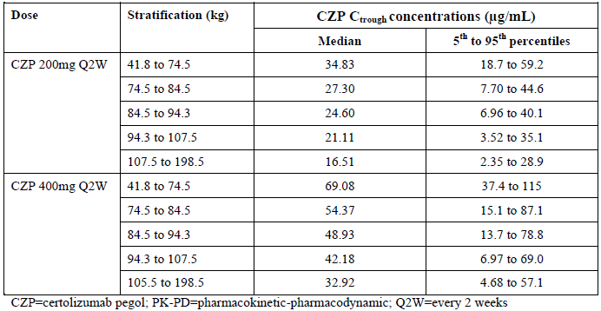

Covariates
The following covariates had a statistically significant association to PASI scores:
- prior biologic therapy (higher PASI at baseline);
- geographical region (North American subjects had lower baseline PASI and a more rapid onset of the effect than Western European and Central/Eastern European subjects);
- high body weight (slower onset of the PASI response and smaller placebo effect);
- low baseline PASI (smaller certolizumab pegol induced decrease in PASI compared to subjects with high baseline PASI; the effect magnitude was directly proportional to baseline before this covariate was included in the model); and
- ADA positive subjects (at Week 16) (higher EC₉₀ resulting in a reduced PASI response)

PASI model
At Week 16, the impact of certolizumab pegol on PASI was close to the maximal PASI response observed in the studies (for both the 200 mg Q2W and 400 mg Q2W groups, with the 400 mg Q2W being closer to the maximum response) (see Figure 2). Nevertheless, even though close to the maximum, the maximum was not reached and further differentiation between the 2 dose levels may occur at later time points.

Covariates
The following covariates had a statistically significant association to PASI scores:
- prior biologic therapy (higher PASI at baseline);
- geographical region (North American subjects had lower baseline PASI and a more rapid onset of the effect than Western European and Central/Eastern European subjects);
- high body weight (slower onset of the PASI response and smaller placebo effect);
- low baseline PASI (smaller certolizumab pegol induced decrease in PASI compared to subjects with high baseline PASI; the effect magnitude was directly proportional to baseline before this covariate was included in the model); and
- ADA positive subjects (at Week 16) (higher EC₉₀ resulting in a reduced PASI response)

Results
At Week 16, the impact of certolizumab pegol on PASI was close to the maximal PASI response observed in the studies (for both the 200 mg Q2W and 400 mg Q2W groups, with the 400 mg Q2W being closer to the maximum response). Nevertheless, even though close to the maximum, the maximum was not reached and further differentiation between the 2 dose levels may occur at later time points.
Figure 2: Pop PKPD analysis CL0264. Model predicted and observed PASI scores versus certolizumab pegol plasma concentration at Week 16

Antidrug antibodies
The antidrug antibody sampling was very limited (in the pooled source data 8.3% were ADA 16 positive; 16.5% had an antidrug antibody event), and the sponsor has stated that, therefore, it was not possible to develop more complex models to capture a more detailed effect of antidrug antibody on certolizumab pegol pharmacokinetic. Limited data is presented in Table 19.
At Week 16, the differences in PASI75 response between 200 mg Q2W and 400 mg Q2W are predicted to be < 4% (ADA 16 negative subjects) and < 5% (ADA 16 positive subjects), regardless of the weight category.
Table 19: Pop PK/PD analysis CL0264. Predicted proportion of PASI75 responders at Week 16, based on the final PASI model, stratified by dose at randomisation and by ADA status

Body weight
Heavier patients have lower certolizumab pegol plasma concentrations than lower body weight patients (range in the source studies: 42 to 198 kg), and heavier patients appear to reach steady-state clinical response later (16 weeks for a 90 kg subject versus 21 weeks for a 150 kg subject).
For lower weight patients, the time to maximum PASI effect would be ≤ 16 weeks and an assessment of their status at Week 16 would be appropriate (in both a clinical context, as well as a study context to assess which dosage regimen would be more suitable: 200 mg Q2W, or 400 mg Q2W, or cessation of certolizumab pegol.
For larger weight patients, in whom the maximum effect is not reached at Week 16, Week 48 may be a more appropriate time point for evaluation (in a study setting). However, the appropriateness of a Week 48 evaluation in a clinical context is uncertain, and an earlier time point for assessment may be more suitable.
Figure 3 shows the relationship of PASI75 responder proportion versus body weight (at Weeks 16 and 48, and by antidrug antibody status).
Figure 3: Population PKPD analysis CL0264. Relationship of PASI75 responder proportion versus body weight (at Weeks 16 and 48, and by ADA status)
In response to the request to provide arguments for a non-weight based dosing of certolizumab pegol (given the effect of weight shown in the population pharmacokinetic analysis), the sponsor provided the following:
The sponsor considers non-weight based dosing of certolizumab pegol to be appropriate based on the available data including the analysis by body weight and body mass index (BMI) by quintiles. For both doses the analysis by body weight quintiles at Week 16 and Week 48 showed that subjects in the higher body weight quintiles tend to have lower response rates than subjects in the lower weight categories.
From both the population pharmacokinetic and the pharmacokinetic/ pharmacodynamic model it was concluded that body weight affects both CL and volume and it also affects the time to achieve maximum response. However, both doses were at the upper end of the exposure-response curve and therefore, changes in plasma concentrations do not results in relevant response differences. At Week 16, the differences in PASI response (PASI75 or PASI90) between certolizumab pegol 200 mg Q2W and certolizumab pegol 400 mg Q2W are predicted to be less than 5% regardless of the body weight. Both doses of certolizumab pegol demonstrated superior efficacy compared to placebo regardless of body weight or BMI and there was no apparent difference in responses between doses at the higher body weight quintiles. For these reasons the sponsor considers the data supports a non-weight based dose regimen.

PGA model
The final PGA model evaluation showed that the model tended to under-predict the ‘clear’ state of the observed PGA response. Due to this, the PGA PKPD model was not used for further simulations and no conclusions on covariate effects resulted from it.

Main limitations
In the population pharmacokinetic evaluation report, comments on limitations were made. Additionally, it is noted that the PGA model was not used. Only limited antidrug antibody data was available, and its relation on PASI should have been explored further. The PASI/PGA models should have been based on data until Week 48, and not only on data until Week 16, even though some results were extrapolated into the maintenance phase until Week 48. The concentration modelling was based on data until Week 48, but the effect on concentration has limited clinical relevance. Consequently, the population pharmacokinetic report does not necessarily provide complete data to help decide on an appropriate dosage regimen, in particular for certain subgroups, for example, those in whom a later onset of response is expected.

Overall PopPK conclusion
An evaluation of the sponsor’s population pharmacokinetic analysis was obtained. The Population PK evaluator considered that information given in the proposed Australian PI is in keeping with results of the Population PK and PKPD analyses. References to the analysis in the Australian PI were deemed to accurately reflect the findings of this evaluation.

Clinical evaluator conclusions on pharmacology

Similarity compared to other indications
The pharmacokinetic characteristics of certolizumab pegol in adult patients with rheumatoid arthritis, psoriatic arthritis and ankylosing spondylitis are well characterised, and patients with psoriasis have similar PK responses to certolizumab pegol exposure.

Steady-state concentration and dose proportionality
Across the Phase III studies following multiple SC doses of certolizumab pegol 200 mg Q2W or 400 mg Q2W, steady state drug concentrations were reached by Week 16 and remained relatively stable through to Week 48 in those who did not develop ADA.
Plasma certolizumab pegol trough concentrations increase in a dose proportional manner. Trough serum certolizumab pegol concentrations at steady state are approximately 2 fold higher following administration of certolizumab pegol 400 mg Q2W therapy compared to 200 mg Q2W. The sponsor is proposing both dose regimens for certolizumab pegol therapy in psoriasis.

Pharmacokinetic variability
The two main sources of PK variability identified in patients using the primary Phase III PK data and the population pharmacokinetic analysis were body weight and the presence of ADAs.

Efficacy
The efficacy of certolizumab pegol in patients with moderate to severe plaque psoriasis has been evaluated in 3 ongoing Phase III studies (Studies PS0003 (CIMPACT trial), PS0002 (CIMPASI-2 trial) and PS0005 (CIMPASI-1 trial)) as well as 2 completed Phase II Studies (C87040 and C87044).
There were 3 pivotal studies: the CIMPASI-1 and CIMPASI-2 trials had an identical design, and the CIMPACT trial had a similar design but with the addition of an active control (etanercept 50 mg twice weekly) and patients were eligible to be re-randomised to placebo or active treatment at Week 16. These studies are briefly summarised below.

CIMPASI-1 and CIMPASI-2 trials

Design
These were randomised, double blind, placebo controlled, multicentre studies to demonstrate the efficacy and safety of certolizumab pegol over placebo. Each study included 5 periods: screening, initial treatment (double blind, placebo controlled), maintenance treatment (dose-blind), open label treatment, and safety follow-up. The double blind treatment period of 16 weeks was used to demonstrate the efficacy of certolizumab pegol over placebo. Further dose blind treatment from Weeks 16 to 48 was intended to collect information on maintenance dosing.
Subjects had to be at least 18 years of age (no upper age limit) with a diagnosis of chronic plaque psoriasis for at least 6 months prior to screening. Patients were required to have at least moderately active disease at baseline with a PASI score ≥ 12, affected body surface area ≥ 10% and a PGA score of ≥ 3. Subjects were also required to be candidates for systemic psoriasis therapy and/or phototherapy and/or chemo-phototherapy. Subjects with other non-plaque types of psoriasis (guttate, erythrodermic or pustular forms) were ineligible.
During the initial 16 week treatment period subjects were randomised in a 2:2:1 ratio to receive either certolizumab pegol 400 mg Q2W, certolizumab pegol 200 mg Q2W (both after a loading regimen of 400 mg at Weeks 0, 2 and 4), or placebo SC injections Q2W. Subjects were assessed at Week 16. Subjects who achieved at least a 50% reduction from baseline in their PASI response (PASI50) at Week 16, continued therapy. Those on active treatment continued their assigned certolizumab pegol treatment regimen.
Subjects initially randomised to placebo continued on placebo past Week 16, if they were PASI75 responders. Subjects given placebo who were PASI50 but not PASI75 responders received certolizumab pegol 400 mg at Weeks 16, 18 and 20 (loading dose regimen) followed by certolizumab pegol 200 mg Q2W starting at Week 22. Subjects who did not achieve a PASI50 response at Week 16 escaped blinded treatment and received open label certolizumab pegol 400 mg Q2W. After 16 weeks of unblinded certolizumab pegol 400 mg Q2W subjects who did not achieve a PASI50 were withdrawn from the study. During the dose blind Maintenance Treatment Period, subjects continued to receive study medication in a dose-blind fashion and were assessed at Weeks 32 through Week 48 for continued PASI50 response. Subjects who did not achieve a PASI50 response at Week 32 or a later time point were withdrawn from the study.

Efficacy variables and analysis
The co-primary efficacy variables were PASI score and PGA Clear or Almost clear (with at least 2-category improvement) at Week 16. The PASI and PGA are described in brief: the PASI combines the assessment of the severity of lesions and the area affected into a single score in the range 0 (no disease) to 72 (maximal disease). The PGA was a 0 (clear) to 4 (severe) point scale. The PASI component of the co-primary variable was PASI75 response/non-response with PASI75 response defined as a ≥ 75% improvement in PASI score from baseline). Other PASI response rates were also determined (≥ 50%, ≥ 90%, and 100%) but these were not included in the primary efficacy variable.
For each study, the statistical analysis of the co-primary and secondary efficacy variables accounted for multiplicity and controlled the type I error rate at a 2-sided alpha level of 0.05 by using a fixed-sequence testing procedure. The type I error was split equally between the 2 certolizumab pegol dose groups so that each dose was tested at a 2-sided alpha level of 0.025.

Demographic characteristics
A total of 234 subjects in CIMPASI-1 and 227 subjects in CIMPASI-2 were assessed for efficacy. In CIMPASI-1 the mean age was 44.9 years (range: 21 to 76 years), 69.2% were male, 90.2% were Caucasian and the mean BMI was 31.2 kg/m² (range: 18.8 to 59.4 kg/m²). 68.4% of subjects had never used a biologic therapy for psoriasis and 80.3% (188 of 234) were naïve to anti-TNF therapy. The mean standard deviation (SD) PASI score at baseline was 19.82 (7.94). In CIMPASI-2 the mean age was 45.9 years (range: 20 to 75 years), 55.9% were male, 93.0% were Caucasian and the mean body mass index (BMI) was 31.8 kg/m² (range: 15.8 to 66.1 kg/m²). 66.5% of subjects had never used a biologic therapy for psoriasis and 76.7% were naïve to anti-TNF therapy. The mean (SD) PASI score at baseline was 18.60 (6.15). Subjects in both studies were appropriately selected with no major differences in selection characteristics between study groups in either study.

Week 16 results
While there were co-primary efficacy endpoints, these were assessed independently.
In CIMPASI-1, a PASI75 response at Week 16 was achieved by 6.5%, 66.5% and 75.8% of subjects given placebo, certolizumab pegol 200 mg Q2W and certolizumab pegol 400 mg Q2W respectively. Both doses of certolizumab pegol were superior to placebo for PASI75 response at Week 16. PGA response at Week 16 was achieved by 4.2%, 47.0% and 57.9% of subjects given placebo, certolizumab pegol 200 mg Q2W and certolizumab pegol 400 mg Q2W respectively. Both certolizumab pegol dose regimens were superior to placebo.
In CIMPASI-2, a PASI75 response at Week 16 was achieved by 11.6%, 81.4% and 82.6% of subjects given placebo, certolizumab pegol 200 mg Q2W and certolizumab pegol 400 mg Q2W respectively. Both doses of certolizumab pegol were superior to placebo for PASI75 response at Week 16. PGA response at Week 16 was achieved by 2%, 66.8% and 71.6% of subjects given placebo, certolizumab pegol 200 mg Q2W and certolizumab pegol 400 mg Q2W respectively. Both certolizumab pegol dose regimens were superior to placebo.
In both studies the results of the primary analysis using the Markov chain Monte Carlo method for multiple imputation were supported and confirmed by similar findings from sensitivity analyses using non-responder imputation and model-based multiple imputation. There were no statistical comparisons between the 2 certolizumab pegol dose groups. PASI and PGA were assessed at Weeks 2, 4, 8 and 12 as well as Week 16.

Week 48 results
At Week 48 there was a larger separation of primary efficacy measures between the Q2W and Q4W certolizumab pegol dose regimens in CIMPASI-1, but not in CIMPASI-2. There were no statistical comparisons between the two certolizumab pegol dose regimens.
In CIMPASI-1, the Week 48 PASI75 responder proportion was 67.2% for the certolizumab pegol 200 mg Q2W dose group and 87.1% for the certolizumab pegol 400 mg Q2W dose group. The Week 48 PGA responder proportion was 52.7% for the certolizumab pegol 200 mg Q2W and 69.5% for the certolizumab pegol 400 mg Q2W group.
In CIMPASI-2 the Week 48 PASI75 responder proportion was 78.7% for the certolizumab pegol 200 mg Q2W dose group and 81.3% for the certolizumab pegol 400 mg Q2W dose group. The Week 48 PGA responder proportion was 71.1% for the certolizumab pegol 200 mg Q2W and 70.3% for the certolizumab pegol 400 mg Q2W group.

Other analyses
Various subgroup and time to effect analyses were also performed. In general, the 400 mg Q2W certolizumab pegol dose group had better outcomes at Week 16 and Week 48 than the 200 mg Q2W dose group. PASI and PGA generally increased to Week 16 and were stable through to Week 48. The placebo response rate was higher in CIMPASI-2 (11.6% versus 4.2% in CIMPASI-1).

CIMPACT trial

Design
This study was double blind, randomised, placebo and active controlled followed by a double blind, placebo controlled maintenance period. As in the CIMPASI studies there were 5 study periods: Screening, Initial Treatment Period (double blind, placebo and active controlled), Maintenance Treatment Period (double blind, placebo controlled), Open label Extension (OLE) Treatment Period and a Safety Follow-up Period. During the 16 week Initial Treatment Period, subjects were randomised in a 3:3:3:1 ratio to receive: certolizumab pegol 200 mg Q2W with the same loading dose as in the CIMPASI studies; certolizumab pegol 400 mg Q2W with no loading dose; etanercept 50 mg twice weekly (last dose at Week 11.5); or placebo.
At Week 16, subjects who were PASI75 responders continued to the maintenance treatment period as follows:
- Subjects initially randomised to placebo continued on placebo.
- Subjects initially randomised to etanercept were re-randomised (2:1) to either certolizumab pegol 200 mg Q2W (with loading dose of 400 mg at Weeks 16, 18, and 20) or placebo.
- Subjects initially randomised to certolizumab pegol 200 mg Q2W were re-randomised (2:2:1) to receive either certolizumab pegol 200 mg Q2W or certolizumab pegol 400 mg Q4W or placebo.
- Subjects initially randomised to certolizumab pegol 400 mg Q2W were re-randomised (2:2:1) to certolizumab pegol 200 mg Q2W or certolizumab pegol 400 mg Q2W or placebo.
All subjects who did not achieve a PASI75 at Week 16 were not randomised and were given open-label certolizumab pegol 400 mg Q2W (the escape group). During the maintenance period subjects who relapsed, defined as < PASI50 response, were withdrawn from double blind treatment and given open-label certolizumab pegol 400 mg Q2W (the escape group). If a subject in the escape group did not achieve a PASI50 at Week 32, that subject was withdrawn from the study. A subject who achieved a PASI50 at Week 32, but did not achieve a PASI50 at a later visit was withdrawn from the study at that time.
The selection criteria were near identical to those of the CIMPASI studies. Subjects were required to have at least moderately active disease at baseline with a PASI score > 12, affected body surface area (BSA) > 10% and a PGA score of > 3 and be candidates for systemic psoriasis therapy and/or phototherapy and/or chemo-phototherapy.

Efficacy variables and analysis
The primary endpoint was a PASI75 response at Week 12. The primary analysis was based on logistic regression for the Randomised Set. The odds ratio of the responder rate at Week 12 was estimated and tested between randomised treatment groups using a logistic regression model with factors of treatment group, pooled centre, and prior biologic exposure (yes/no).

Demographic characteristics
A total of 559 subjects commenced initial treatment. Of these, 533 entered the Maintenance phase and 310 of 533 (58.2%) achieved a PASI75 response at Week 16 and were re-randomised into blinded treatments and 223 entered the escape groups.
The 4 treatment groups recruited into CIMPACT were generally well balanced with respect to demographic characteristics. Overall, the mean age of subjects was 45.7 years (range: 18 to 80 years), 68.2% were male, 96.6% were Caucasian and mean BMI was 29.6 kg/m². The mean (SD) PASI score at baseline was 20.89 (8.14). 72.5% of subjects had never used a biological therapy for psoriasis and 96.2% were naive to anti-TNF therapy.

Week 12 results
A Week 12 of induction phase PASI75 response was achieved by 5.0%, 61.3%, 66.7% of the placebo, certolizumab pegol 200 mg Q2W and certolizumab pegol 400 mg Q2W respectively. These differences were statistically significant for both certolizumab pegol dose regimens. Additionally a Week 12 PASI75 response was achieved by 53.3% of subjects given etanercept. The PASI75 increased in both certolizumab pegol dose groups at Week 16 compared to Week 12 and was 68.2% in the 200 mg Q2W group and 74.7% in the 400 mg Q2W dose group.

Week 48 results
Table 20: PASI75 responder rate at Week 48 by treatment arm in CIMPACT (Week 16 randomised set)
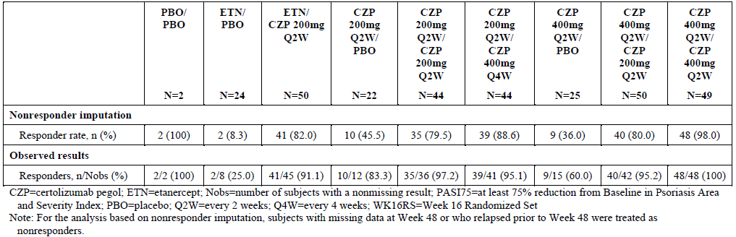
In the blinded maintenance treatment groups (that is, subjects who were PASI75 responders at Week 16), ≥ 79.5%of subjects in each group that received certolizumab pegol treatment continued to be PASI75 responders at Week 48. Subjects initially treated with certolizumab pegol and re-randomised to placebo for maintenance treatment had a considerable loss of efficacy response over time, but no subjects experienced a rebound effect (defined as a >125% increase from baseline in PASI score within 14 weeks after the final dose of certolizumab pegol treatment).

Pooled efficacy analyses across Phase III studies
Efficacy analyses using pooled data from the Phase III studies allow for an estimation of dose effects in various subgroups. Some trends were noted in some patient subgroups. For both dose regimens of certolizumab pegol, psoriasis responder rates at Week 16 were generally lower in subjects in the two highest quintiles of BMI at baseline, patients with baseline PASI scores greater than the study population median, and in subjects who tested positive for anti-drug antibodies. The Week 48 data showed the same psoriasis response outcomes for those patient subgroup interactions.
The sponsor has provided pooled analyses of efficacy data obtained in the 3 Phase III trials (for the certolizumab pegol and placebo arms only) mainly to investigate efficacy in selected patient subgroups and to yield more precise treatment effect data. An overview of the efficacy pools is shown in Table 21.
Table 21: Overview of efficacy pools
The three main significant additional efficacy observations are:
Firstly, for the patient subgroup analyses of Pool E1, the key outcome measures of PASI75, PASI90 and PGA response were evaluated at the primary time point of 16 weeks for the following baseline characteristics: gender, age, body weight, BMI quintiles, race, ethnicity, geographic region, prior biologic drug exposure, prior anti-TNF exposure, prior systemic therapy (non-biologic) and baseline BSA affected by psoriasis. All patient subgroups had a clinically meaningful difference in the above psoriasis response measures with both doses of certolizumab pegol compared to placebo. No consistent, clinically meaningful differences were seen for psoriasis response based on the above characteristics. The rates of PASI75/90 and PGA response with certolizumab pegol were similar in subjects with or without a history of prior systemic treatment for psoriasis. This is supportive of the proposed first line treatment indication (after topical therapies) in patients who are candidates for systemic therapy or phototherapy.
However, some trends were noted in some patient subgroups. For both dose regimens of certolizumab pegol, psoriasis responder rates at weeks 16 were generally lower in subjects in the 2 highest quintiles of BMI at baseline, patients with baseline PASI scores greater than the study population median, and in subjects who tested positive for anti-drug antibodies. The Week 48 data (using the Pool E3 data) showed the same psoriasis response outcomes for the above stated patient subgroup interactions.
The second observation relates to replication of efficacy findings across the 3 Phase III studies, which had identical initial treatment periods. In all 3 trials, both dose regimens of certolizumab pegol achieved statistically significant and clinically meaningful responses over placebo for PASI75, PASI90 and PGA response at Week 16. Furthermore, while the maintenance period design in CIMPACT was dissimilar compared to the CIMPASI studies, all 3 studies showed maintenance of response to certolizumab pegol through to 48 weeks. However, in 2 of the 3 studies (CIMPASI-1 and CIMPACT), very similar result trends across the key efficacy outcomes at Weeks 16 and 48 were observed, and there was a clear dose response with certolizumab pegol. In the CIMPASI-2 Study, all 3 treatment groups had much higher clinical response rates (for example, 14 to18% higher for the rate of PGA response at Week 16) compared to the other 2 Phase III trials, and a dose response effect with certolizumab pegol was not reported. There were some minor differences in baseline patient characteristics between the 2 sets of trials (for example, a slightly higher proportion of subjects recruited into the CIMPASI-2 Study had prior anti-TNF exposure and considerably less were recruited from European sites), but none of these differences would be expected to explain the difference in clinical response. The lack of consistency across the 3 pivotal Phase III studies remains unexplained and casts doubt of the overall results integrity.
The third observation relates to the magnitude of treatment response at 16 and 48 weeks according to the certolizumab pegol dose regimen. While the studies were not powered to make formal statistical comparisons between the 2 certolizumab pegol dose regimens, 2 of the 3 Phase III studies (CIMPASI-1 and CIMPACT) as well as the pooled E2 dataset indicated that certolizumab pegol 400 mg Q2W provided numerically greater responses than certolizumab pegol 200 mg Q2W therapy at Week 16 and 48 (Table 22). The difference in treatment response according to certolizumab pegol dose was more evident with the more stringent outcome of PASI90 response, but inconsistent and not so overt with PASI100.
Table 22: Major efficacy outcomes at Week 16 and 48 by randomised certolizumab pegol treatment
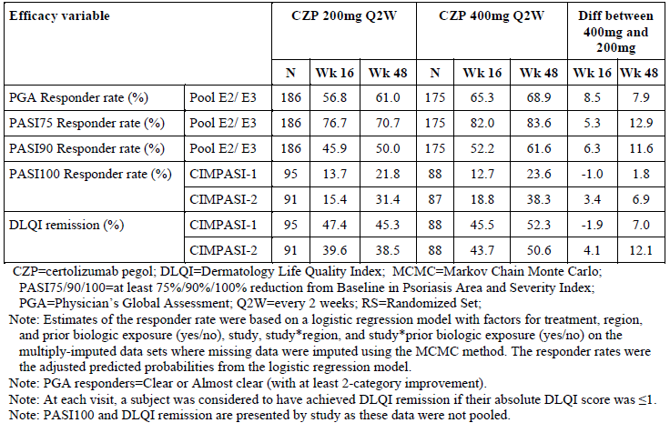

Safety
The clinical evaluator stated that there was a sufficient volume of safety data in this submission to make a meaningful assessment of certolizumab pegol safety for up to 1 year of treatment in the newly proposed treatment indication of moderate to severe psoriasis in adult patients.

Exposure
1112 adult patients with moderate to severe psoriasis were exposed to certolizumab pegol in 5 Phase II and III clinical studies/trials (C87040, C87044, CIMPASI-1, CIMPASI-2 and CIMPACT), with a median exposure of 343 days. Total exposure was 951.7 patient-years (data lock point: between October 2016 and March 2017).
In the three Phase III studies, 487 patients had continuous certolizumab pegol exposure for 48 to 64 weeks and 75 patients for > 64 weeks. In the Phase III trials, 703 received certolizumab pegol 200mg Q2W treatment and 677 received certolizumab pegol 400 mg Q2W.

Prior therapies
The study populations in the Phase II/III trials often had long-standing psoriasis, but were heterogeneous with respect to prior therapies for psoriasis (for example, 70% were naïve to prior biological therapies and almost 60% had never used a systemic, non-biologic treatment).

Safety cohorts
The trial safety cohorts were:
- Pool S1 (primary trial cohort): initial treatment periods (Weeks 0 to 16) of the Phase III studies; each of the trials had a common placebo controlled period.
- Pool S4: maintenance treatment periods (Weeks 16 to 48) of the 3 Phase III studies.
- Pool S2: identical to Pool S1 apart from the addition of safety data (Weeks 0 to16) from the Phase II Study C87040. However, in the clinical evaluation report Phase II safety data was considered separately.
- Pool S3: safety data from all patients exposed to certolizumab pegol (3 dose regimens; 200 mg Q2W, 400 mg Q2W and 400 mg Q4W) in all 5 of the Phase II and III studies, and contains information up to 144 weeks of treatment exposure (including initial, maintenance and open label treatment periods). However, due to the limitations of Pool S3, the sponsor has restricted presentation and discussion of Pool S3 data to AEs of special interest.

Pool S1 AEs
The overall AE incidences were similar between the certolizumab pegol 400 mg Q2W (63.5%) and placebo groups (61.8%), but lower in the certolizumab pegol 200 mg Q2W arm (56.3%). However, treatment related AEs were higher in the certolizumab pegol 400 mg group (15.8%) compared with the certolizumab pegol 200 mg arm (12.9%) and placebo group (12.7%). For overall and treatment related AEs, the SOC with the highest incidence of AEs was infections (> 30% incidence), followed by skin and subcutaneous disorders (10 to14%).
There was a trend toward a certolizumab pegol dose response effect in the SOC of general disorders and administration site conditions, with the main explanation for the difference being a higher incidence of injection site reactions in the certolizumab pegol 400 mg Q2W group. In Pool S1, the most frequently reported AEs by preferred term were nasopharyngitis (approximately 12% incidence in each of the 3 groups) and upper respiratory tract infection (5 to7% incidence across the 3 groups).

Pool S4 AEs
In Pool S4 (Phase III maintenance treatment periods), the incidences and exposure adjusted incident rates for AEs between the 2 certolizumab pegol dose groups as well as placebo were lower than those observed in the first 16 weeks of therapy.
However, the most frequently reported type of AE by SOC was infections, which occurred at a higher incidence (almost 37 to 40% with certolizumab pegol versus 29% with placebo) and also exposure adjusted incident rate compared with placebo (incident rate of 224 per 100 patient-years with certolizumab pegol 200 mg versus 314 per 100 patient-years with certolizumab pegol 400 mg therapy versus 80 per 100 patient-years with placebo). Again, the most frequent type of infections in Pool S4 by preferred term was nasopharyngitis (14 to15% incidence with certolizumab pegol) and URTI (approximately 7% incidence with certolizumab pegol).

Pool 1 SAEs and withdrawals
In Pool S1, the incidence of SAEs was similar between the placebo (4.5%) and certolizumab pegol 400mg groups (4.7%), but lower in the certolizumab pegol 200 mg Q2W cohort (1.4%). Three treatment related SAEs were reported in patients receiving certolizumab pegol 400 mg injections; 1 each oflymphadenitis, injection site reaction and anaphylactoid reaction (with first dose of treatment). 1 patient treated with certolizumab pegol 200 mg Q2W (in Pool S1) had a treatment related SAE of depression with suicide attempt.
Few subjects (4 in each certolizumab pegol treatment cohort) experienced AEs resulting in permanent treatment discontinuation. The 4 patients in the certolizumab pegol 400 mg arm withdrew due to anaphylactoid reaction, eczema, papular rash and neck pain. In the certolizumab pegol 200 mg treatment group the 4 subject withdrawals due to AEs were generalised pruritus and dizziness in 1 patient, raised serum transaminases in 2 subjects, and depression. No placebo subject withdrew in Pool S1 due to an AE.

Pool 4 SAEs and withdrawals
The incidence of SAEs was relatively low with certolizumab pegol (4.6% [25 of 540] in the certolizumab pegol 400 mg Q2W arm and 5.2% (18 of 348) in the certolizumab pegol 200 mg Q2W group), but lower in the placebo group (2.4% (2 of 82)). Furthermore, the incident rates for SAEs were almost 2 fold in the certolizumab pegol groups (incident rate of 9.07 per 100 patient-years with 200 mg therapy and incident rate of 8.15 per 100 patient-years with 400mg) compared with the placebo arm (5.2 per 100 patient-years). There were no noticeable differences in between the 2 certolizumab pegol groups for the types and pattern of SAEs.
The incidence of withdrawal due to AEs remained relatively low with both dose regimens of certolizumab pegol (3.7% with certolizumab pegol 400 mg Q2W and 2.6% with certolizumab pegol 200 mg Q2W therapy). For certolizumab pegol treated patients, the most frequently reported AEs leading to permanent discontinuation were in the SOCs of infection (7 subjects overall (0.8% of 888); sepsis in 2 certolizumab pegol 400 mg Q2W patients, latent tuberculosis in 1 patient (certolizumab pegol 400mg Q2W) and 1 patient (certolizumab pegol 200 mg Q2W), E. coli sepsis and tuberculosis in 1 patient each in the certolizumab pegol 400 mg Q2W group, and urinary tract infection in 1 patient in the certolizumab pegol 200 mg Q2W group); and skin and subcutaneous tissue disorders (6 patient overall (0.7%); dermatitis, guttate psoriasis, plaque psoriasis, pustular psoriasis and urticaria in 1 patient each in the certolizumab pegol 400 mg Q2W group, and atopic dermatitis in 1 subject in the certolizumab pegol 200 mg Q2W group).

Phase II studies and Pool S3
The Phase II and Pool S3 long-term safety datasets showed a similar pattern of findings with respect to infections overall and the most common types of infection by Preferred Term. Pool S3 revealed an incidence and pattern of SAEs consistent with the known side effects of certolizumab pegol in other treatment indications.

AEs of special interest

Infections
The incidence of serious infection in Pool S3 was low at approximately 1.0% in each certolizumab pegol treatment group (incident rate of 1.68 per 100 patient-years in the certolizumab pegol 400 mg group and 0.99 per 100 patient-years in the certolizumab pegol 200 mg arm). In addition, 3 subjects reported serious infections in the Phase II studies. Two cases of tuberculosis were reported with certolizumab pegol 400 mg Q2W treatment (1 each in Phase II and III). No other significant opportunistic infections were identified.

Injection site reactions
In Pool S1, the incidence and incident rate of injection site reactions was higher in the certolizumab pegol 400 mg group (3.5% [12 of 342]; 7 AEs with incident rate of 11.84 per 100 patient-years) than the certolizumab pegol 200 mg arm (1.7% (6 of 350); 18 AEs with incident rate of 5.72 per 100 patient-years). The incidence and incident rate of injection site reactions in the placebo group were lowest at 0.6% (1 of 157) and 2.14 per 100 patient-years (1 AE). One subject treated with certolizumab pegol 400 mg Q2W in the CIMPASI-1 study had an SAE of injection site reaction – anaphylactoid reaction occurring after their first dose. In Pool S4, 11 subjects (2.0%) in the certolizumab pegol 400 mg arm (including 8 escape treatment subjects) reported injection site reaction compared with 1 patient in the certolizumab pegol 200 mg group (0.3%). None of the injection site reactions in Pool S4 were considered to be serious.

Deaths, malignancy and major adverse cardiac events
The incidence rate of death, malignancy (solid organ as well skin cancers) and major adverse cardiac events (MACE) in the certolizumab pegol psoriasis dataset was within expectations of the treatment population. Two fatalities in certolizumab pegol 400 mg Q2W patients were not related to certolizumab pegol. In addition, the types of cancer and MACE observed were low and did not identify any specific safety signals with certolizumab pegol. However, longer periods of treatment follow-up are required to inform about these potential safety concerns. In Pool S3, 2 cases of multiple sclerosis were reported in the Phase II and III studies (1 case with each certolizumab pegol dose).

Hepatic AEs
A total of 75 patients (6.7%) treated with certolizumab pegol recorded hepatic AEs in the Phase II and III studies. The incidence and exposure adjusted incident rates across the treatment groups in the Phase III trials was slightly higher with certolizumab pegol 400 mg Q2W (6.4% with incident rate of 9.3 per 100 patient-years) compared to certolizumab pegol 200 mg Q2W (4.6% with incident rate of 8.2 per 100 patient-years). When comparing the safety pools (that is, S1 with S4), the rates of hepatic AEs did not increase over time on certolizumab pegol.
In Pool S3, three additional hepatic related AEs were reported including 2 cases of drug-induced hepatitis or liver injury with certolizumab pegol 200 mg Q2W therapy.

Haematological AEs
Regarding haematology parameters, Pool S1 identified 2 trends with certolizumab pegol therapy versus placebo:
- a slightly higher frequency of subjects with their platelet count going from normal at baseline to low post-treatment (1.3% with placebo compared with 2.6% with certolizumab pegol 200 mg Q2W and 1.8% with certolizumab pegol 400 mg Q2W); and
- a higher incidence of markedly low haemoglobin level with certolizumab pegol 400 mg therapy (1.2% compared with 0.6% in the placebo arm and 0.3% in the certolizumab pegol 200 mg group). In the all certolizumab pegol treated cohort of Pool S4, a total of 7 subjects (0.8%) reported low haemoglobin, 2 subjects (0.2%) recorded lymphopaenia and 1 subject receiving certolizumab pegol 200 mg Q2W therapy in the CIMPACT study experienced both neutropaenia and thrombocytopaenia.

Laboratory abnormalities
The safety dataset also identified 3 other abnormalities of laboratory values that occurred at a numerically higher frequency in the certolizumab pegol treatment cohorts compared with placebo. Elevations in hepatic transaminases, serum creatine phosphokinase levels and possibly dyslipidaemia have been associated with certolizumab pegol. None of these laboratory abnormalities displayed a clear certolizumab pegol dose response relationship. In general, patients who developed increases in liver function tests and serum creatine phosphokinase levels had changes of mild-moderate severity that were transient in nature and without associated clinical sequelae. The clinical impact of potentially atherogenic lipid profiles induced by biologic therapies, including certolizumab pegol and other anti-TNF treatments, in patients with psoriasis is unclear, but in short term follow-up, certolizumab pegol was not associated with an increased rate of major adverse cardiac events.

Antidrug antibodies
In the Phase III studies, the incidence of positive antidrug antibodies was consistently more than 2 fold higher in the certolizumab pegol 200 mg Q2W group compared to patients treated with certolizumab pegol 400 mg Q2W. In the initial treatment period of the Phase III trials, the overall frequency of antidrug antibody positivity was 14.7% (51 of 347) with certolizumab pegol 200 mg Q2W therapy compared with 5.3% (18 of 340) in those treated with certolizumab pegol 400 mg Q2W. In the combined initial and maintenance treatment periods of the Phase III studies, the incidence of positive antidrug antibodies was 19.2% (54 of 281) with certolizumab pegol 200 mg Q2W therapy compared with 8.3% (22 of 265) in those treated with certolizumab pegol 400 mg Q2W. Of the subjects who developed antibodies to certolizumab pegol (CIMPASI studies only), 45% (27 of 60) had antibodies that were classified as neutralising. Antibody formation was associated with lowered drug plasma concentration and reduced efficacy.
In the CIMPACT Study, subjects initially randomised to etanercept or placebo, and who were re-randomised to certolizumab pegol, the same observation was recorded (20.3% (12 of 59) treated with certolizumab pegol 200 mg Q2W recorded positive antidrug antibodies versus 7.7% (16 of 209) given certolizumab pegol 400 mg Q2W). As expected, the frequency of antidrug antibody positivity was considerably higher in subjects who escaped their initial certolizumab pegol treatment at Week 16 because of insufficient clinical response (versus PASI responders).
In the Phase II trials (Studies C87040 and C87044), the difference in incidence of antidrug antibody positivity between the two certolizumab pegol dose regimens was much less marked than the Phase III program. The incidence of antidrug antibody positivity was higher in the certolizumab pegol 200 mg Q2W group compared with the certolizumab pegol 400 mg Q2W group during the 12 week initial treatment period of Study C87040 (15.3% (9 of 59) versus 10.5% (6 of 57), respectively) as well as during the combined 12 week treatment periods of Studies C87040 and C87044 (23.7% (14 of 59) versus 19.3% (11 of 57), respectively), but during the 24 week follow-up period in Study C87040, 30.0% (15 of 50) in both the certolizumab pegol 200 mg Q2W and certolizumab pegol 400 mg Q2W groups were antidrug antibody positive. In addition, the appearance of antidrug antibodies during the follow-up period occurred earlier in the certolizumab pegol 200 mg Q2W group (at follow-up Weeks 4 and 8) compared with the certolizumab pegol 400 mg Q2W arm (at Week 12). The design of these Phase II studies differed from the Phase III trials with small numbers of subjects in each treatment group, a single certolizumab pegol 400 mg loading dose and relatively short treatment period of only 12 weeks. It is possible that the duration of treatment was too short for the difference in antidrug antibody incidence between the two certolizumab pegol dose groups to manifest itself.
In all the studies, there was identifiable relationship between the occurrence of antidrug antibody positivity and safety concerns (overall and specific AEs).

Evaluator’s summary on safety
In summary, the safety data indicates that certolizumab pegol has an acceptable overall safety profile up to 48 weeks of therapy in the treatment of adult patients with moderate to severe psoriasis. However, there is limited, direct, long-term safety data in the psoriasis population to assess the risk of some types of AEs such as malignancy and MACE, which will require additional longitudinal safety follow-up. From my assessment of the safety dataset, there are some significant safety concerns with certolizumab pegol therapy including the risk of serious infection, opportunistic infection (including new or reactivated tuberculosis), injection site and rare hypersensitivity reactions, demyelinating conditions, thrombocytopaenia, liver function test abnormalities and dyslipidaemia. These safety concerns are consistent with the known profile of certolizumab pegol and other anti-TNF therapies in adult patients with other autoimmune conditions such as rheumatoid arthritis. Significant pharmacovigilance will be required if approval is granted for registration of certolizumab pegol for the treatment of psoriasis. This would include vigilance for serious and opportunistic infections, MACE and malignancy (particularly, non-melanoma skin cancers).

Clinical evaluator’s recommendation
The clinical evaluator deemed the overall benefit-risk balance of certolizumab pegol in adult patients with moderate to severe chronic plaque psoriasis to be favourable and recommend registration (subject to some conditions outlined in the clinical evaluation report). The clinical evaluator agreed with the sponsor proposed posology for certolizumab pegol therapy of 400 mg Q2W as the most clinically effective regimen, with no clear additional risk of toxicity over the 200 mg Q2W regimen apart from an increased risk of injection site reactions. The lower dose regimen was deemed appropriate for selected individuals and clinical circumstances.

Risk management plan
The safety specification in the proposed RMP is satisfactory in content. The RMP outlines several important identified safety concerns with certolizumab pegol therapy, which is consistent with the adverse event profiles reported in the current submission. The RMP reports the following important risks with certolizumab pegol such as risk of serious infection including tuberculosis, moderate to severe congestive heart failure, serious systemic hypersensitivity reactions, malignancy potential, demyelinating disorders, hepatobiliary AEs, aplastic anaemia, serious thrombocytopenia and neutropenia, new onset or worsening of psoriasis, lupus like syndromes, immunogenicity and the potential risk of MACE. In addition, the sponsor proposed plan for pharmacovigilance is appropriate for the identified and potential safety concerns. The long-term safety of treatment with certolizumab pegol in psoriasis will be monitored in the long-term extension phases of the three Phase III studies, which plan to collect safety data from patients for total treatment duration of up to 144 weeks.
The suggested wording for registration is:
The Cimzia EU-Risk Management Plan (RMP) (version 13.1, dated 16 January 2018; DLP 6 March 2018), with Australian Specific Annex (version 6.0, dated 16 October 2018), included with submission PM-2017-04943-1-1, and any subsequent revisions, as agreed with the TGA will be implemented in Australia.

Risk-benefit analysis

Delegate’s considerations
The main issues arising in this submission are the issues centred on dosing:
- overall maintenance dosing (that is, which dosing regimen is the most appropriate as a maintenance dose in most patients);
- dose adjustments based on individual patient circumstance (for example, based on known covariate data: weight, low baseline PASI); and
- timing of assessment for response.
The sponsor proposes dosing the following dosing:
the dose of Cimzia for adult patients with plaque psoriasis is 400 mg every 2 weeks. Alternatively, a dose of 400 mg initially (Week 0) and at Weeks 2 and 4 followed by 200 mg every 2 weeks may be considered.
In the USA, the dose regimen is as follows:
400 mg (given as 2 subcutaneous injections of 200 mg each) every other week. For some patients (with body weight ≤ 90 kg), a dose of 400 mg (given as 2 subcutaneous injections of 200 mg each) initially and at Weeks 2 and 4, followed by 200 mg every other week may be considered.
In Canada, the dose regimen is as follows:
The recommended dose of Cimzia for adult patients with plaque psoriasis is 400 mg every 2 weeks. A dose of 400 mg initially (Week 0) and at Weeks 2 and 4 followed by 200 mg every 2 weeks may be considered (see Clinical Trials, Plaque Psoriasis, Study Results).
In the EU, the plaque psoriasis dose regimen is as follows:
Loading dose
The recommended starting dose of Cimzia for adult patients is 400 mg (given as 2 subcutaneous injections of 200 mg each) at Weeks 0, 2 and 4. […]
After the starting dose, the maintenance dose of Cimzia for adult patients with plaque psoriasis is 200 mg every 2 weeks. A dose of 400 mg every 2 weeks can be considered in patients with insufficient response.
Available data in adults with plaque psoriasis suggest that a clinical response is usually achieved within 16 weeks of treatment. Continued therapy should be carefully reconsidered in patients who show no evidence of therapeutic benefit within the first 16 weeks of treatment. Some patients with an initial partial response may subsequently improve with continued treatment beyond 16 weeks.
All of the above regimens have the same loading/starting doses of 400 mg at Weeks 0, 2, and 4. But then, the dosing diverges: the EU maintenance dosing is 200 mg Q2W with the option to increase to 400 mg Q2W where there is an insufficient response; the US maintenance dosing is 400 mg Q2W with the option to reduce to 200 Q2W in some patients (with body weight ≤ 90 kg); the proposed Australian dosing is similar to the US dosing, except it does not specify particular patient groups in whom the dose should be reduced; the Canadian dosing is essentially identical to the proposed Australian dose.
The US dosing is peculiar, given the sponsor’s preference for non-weight based doing in the Australian context, and given the response to evaluator queries. Only the EU dosing specifies a recommendation for a time point to assess the response.
The sponsor has provided their rationale for the proposed is summarised below:
- Claimed greater efficacy response for psoriasis in the 400 mg Q2W group (versus 200 mg Q2W) across the spectrum of efficacy endpoints in the Phase III trials assessed at Week 16 and Week 48 (most pronounced at Week 48). However, the studies were not sufficiently powered to show this statistically.
- Claimed no need for specific dosing recommendation for patient subgroups based on multiple pre-specified and post hoc analyses were conducted [the analyses were not specified and seem to not have been provided].
- Lower proportion of antidrug antibodies in the 400 mg Q2W group (approximately half compared to 200 mg Q2W).
- Claimed greatest clinical benefit to patients in the 400 mg Q2W dose.
It appears that a dose between the two Phase III trial tested dosing regimens (for example, 300 mg Q2W, or alternating 200 mg Q2W and 400 mg Q2W) was not considered by the sponsor.

Efficacy
Both doses (certolizumab pegol 200 mg Q2W and 400 mg Q2W) have shown efficacy over placebo (statistically significant). However, none of the studies or the pooled data was powered sufficiently to statistically compare between the two certolizumab pegol dosing regimens. The absolute values appear to favour the 400 mg dosing (Table 22), but this is unlikely statistically significant. The numerical difference in treatment response according to certolizumab pegol dose was more evident with the more stringent outcome of PASI90 response, but inconsistent and not so overt with PASI100.
The sponsor has conducted a further analysis on stratified groups, and for some subgroups, there appeared to favour 400 mg Q2W (even statistically significant). However, these results were based on 90% CIs and would unlikely be significant at 95% CIs.

Safety
The proposed dosing regimen for psoriasis (if 400 mg Q2W are used) will effectively double the exposure in psoriasis patients when compared to the other indications (maintenance dose: 200 mg Q2W).
The overall AE incidences were similar between the certolizumab pegol 400 mg Q2W (63.5%) and placebo groups (61.8%), but lower in the certolizumab pegol 200 mg Q2W arm (56.3%). Overall, there seems to be a dose-response relationship with regard to safety with patients 400mg Q2W dosing attracting a larger proportion of AEs and SAEs, even though in some of the safety pools there was no such trend.
In the Phase III studies, the incidence of positive ADA was consistently more than 2 fold higher in the certolizumab pegol 200 mg Q2W group compared to patients treated with certolizumab pegol 400 mg Q2W. The aetiology remains uncertain, but antidrug antibody presence has shown to affect efficacy.
There appears to be sufficient safety data for adult patients with moderate to severe psoriasis up to one year and the safety profile is acceptable overall. Data beyond one year (up to 144 weeks) will become available from the extension of the efficacy studies. The clinical evaluator has recommended significant pharmacovigilance activities, in particular to monitor for serious and opportunistic infections, MACE and malignancy (particularly, non-melanoma skin cancers). It would be rather important to follow up that data to establish any potential differences between the dosing regimens.

Dosing

Maintenance dosing
If only efficacy and PKPD data from trials were considered, the 400 mg Q2W appears to be favourable compared to 200 mg Q2W. This was consistent in all studies and more pronounced at Week 48 (compared to Week 16), but with the caveat that this was not statistically tested.
However, this does not take into account potential individual clinical circumstances, and was mainly based on responder proportions of PASI and PGA scores. Using responder proportions of PASI and PGA scores is compliant with current guidance. However, improvement compared to baseline (as continuous variable) rather than responder proportions may have been able to provide a clearer picture on dosing comparison. Furthermore, there are many known issues with the PASI scoring system (even though validated and commonly used), and correlation with a more recent scoring system may have been advantageous.
Choosing one dose over the other may not necessarily make a significant difference in a real world setting with regard to efficacy, but may with regard to safety.

Dose adjustments based on individual patient circumstance
Based on Population PKPD analysis CL0264, only the following may affect dosing in a clinical setting:
- high body weight (slower onset of the PASI response and smaller placebo effect); and
- low baseline PASI (smaller certolizumab pegol induced decrease in PASI compared to subjects with high baseline PASI; the effect magnitude was directly proportional to baseline before this covariate was included in the model)
Measuring antidrug antibodies may not be possible, or practical, and a decision to continue or discontinue certolizumab pegol would likely be made on response rather than ADA results.

Timing of assessment for response
In the clinical trials, an assessment of PASI75 at Week 16 is usually one of the primary endpoints. One size does not fit all, but this allows for a comparison between different treatments for psoriasis. In the case of certolizumab pegol, this Week 16 assessment may not be that suitable in a clinical setting, as some patients (for example, patients with high body weight) may not have reached an adequate PASI response then and may be regarded as non-responders.

Communication of the dosing regimen
A prudent option may be to give the clinician as much information as needed to make an informed choice for dosing based on individual patient circumstances. This could be via the PI and also through appropriate additional risk minimisation activities.

Conclusion
From the data available, there is no definite objection to the sponsor’s proposed dosing regimen. However, advice from Advisory Committee on Medicines (ACM) to refine the regimen is requested.

Questions to the sponsor
- The sponsor should provide a summary of the data that is the basis for the recommendation in the US label that for some patients (with body weight ≤ 90 kg), Cimzia 400 mg (given as 2 subcutaneous injections of 200 mg each) initially and at Weeks 2 and 4, followed by 200 mg every other week can be considered.
- The sponsor should provide a justification for the differing dose regimens in the EU, Canada, and the USA.

Proposed action
The Delegate had no reason to say, at this time, that the application for Cimzia should not be approved for the proposed extension of indications, subject to successful negotiation of the conditions of registration pertaining to plaque psoriasis.

Request for ACM advice
The Committee’s advice on the optimal dose regimen, taking into consideration the available evidence is requested. Comment is specifically requested on the following proposals:
- Overall maintenance dosing (that is, which dosing regimen is the most appropriate as a maintenance dose in most patients)
- Dose adjustments based on individual patient circumstance (for example, based on known covariate data: weight, low baseline PASI); and
- Timing of assessment for response (that is, to decide to continue or discontinue certolizumab pegol, or to change the dose)
- The most appropriate way to communicate the dosing regimen to clinicians (for example, via PI only, or through additional risk minimisation activities).

Response from sponsor
The sponsor confirms the same initial clinical data package was submitted to TGA and in US (and in EU and Canada) to support approval of the psoriasis indication. Furthermore, the proposed dosage regimen of 400 mg every 2 weeks, with an alternative dose of 400 mg initially (Week 0) and at Weeks 2 and 4 followed by 200 mg every 2 weeks may be considered, was submitted in the initial application in each country. The data from all three studies (CIMPASI-1, CIMPASI-2, and CIMPACT) as well as supportive data from the pooled analyses demonstrate that both certolizumab pegol doses, certolizumab pegol 200 mg Q2W and certolizumab pegol 400 mg Q2W, were highly efficacious at Week 16.
Clinically meaningful and statistically significant improvements were observed at Week 16 in psoriasis area and severity, as assessed by PASI75 and PASI90; as well as global physician assessment of disease activity via Physician’s Global Assessment (PGA). Furthermore, both certolizumab pegol dose groups demonstrated a durable clinical response through 48 weeks that was both clinically meaningful and robust. Given that both doses are effective, the sponsor considers that it is important to give prescribing flexibility to physicians based on individual patient considerations and clinical circumstances.

Question 1
The sponsor should provide a summary of the data that is the basis for the recommendation in the US label that for some patients (with body weight ≤ 90 kg), Cimzia 400 mg (given as 2 subcutaneous injections of 200 mg each) initially and at Weeks 2 and 4, followed by 200 mg every other week can be considered.

Response
During the review process FDA requested post-hoc analyses of:
- efficacy endpoints (PGA, PASI75, PASI90)
- adverse events, and
- ADA incidence rate stratified by dose (200 mg versus 400 mg) and body weight using low and high weight subgroups (body weight < 90 kg versus ≥ 90 kg for 200 mg and 400 mg doses) in study CIMPASI-1, CIMPASI-2, CIMPACT, and pooled studies.
A summary of the sponsor’s response to FDA is provided below. As a reminder, the studies were not powered to make formal statistical comparisons between certolizumab pegol doses. In the sponsor’s view the post-hoc analyses requested by FDA stratified by dose (200 mg versus 400 mg) and body weight confirmed the positive benefit-risk of both dose regimens and further supported the dosing recommendation initially proposed. Nevertheless, FDA requested the sponsor to modify the psoriasis dose in the US label to state that for some patients (with body weight ≤ 90 kg), a dose of 400 mg (given as 2 subcutaneous injections of 200 mg each) initially and at Weeks 2 and 4, followed by 200 mg every other week may be considered. Summary of Post-Hoc Analyses Requested by FDA (by body weight category for efficacy, safety and antidrug antibodies).
- The initial treatment period post-hoc analyses for PASI75, PASI90, and PGA at Week 16 for Pool E1 (Initial Treatment Period of CIMPASI-1, CIMPASI-2, and CIMPACT) show responder rates were higher in the < 90 kg category compared with the ≥ 90 kg category, regardless of certolizumab pegol dose. For PGA and PASI90, responder rates were numerically higher in the certolizumab pegol 400 mg Q2W group compared with the certolizumab pegol 200 mg Q2W group, regardless of weight category. The PASI75 responder rate was numerically higher in the certolizumab pegol 400 mg Q2W group compared with the certolizumab pegol 200 mg Q2W group for the ≥ 90 kg category, whereas for the < 90 kg category the PASI75 the responder rates were similar for the two doses (Table 23).
Table 23: Responder rates at Week 16 by body weight category for Pool E1 (non responder imputation)
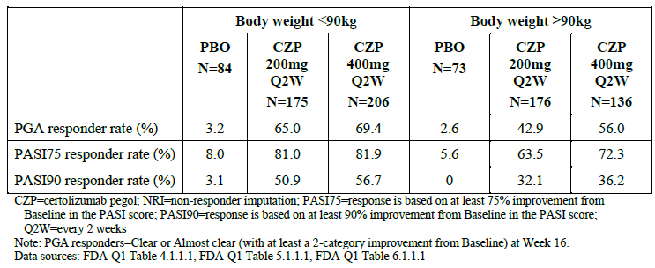
- For the maintenance treatment period, efficacy data of CIMPASI-1 and CIMPASI-2 were combined in Pool E3 due to the fact that these 2 studies are identical in design (Table 24). CIMPACT was analysed separately (Table 25).
  - In Pool E3 (CIMPASI-1 and CIMPASI-2), PGA, PASI75 and PASI90 responder rates at Week 48 were higher in the < 90 kg category compared with the ≥ 90 kg category, regardless of certolizumab pegol dose. Responder rates were higher in both weight categories in the certolizumab pegol 400 mg Q2W group compared with the certolizumab pegol 200 mg Q2W group.
  - In CIMPACT, the PGA, PASI75 and PASI90 responder rates were higher in the certolizumab pegol 400 mg Q2W group compared with the certolizumab pegol 200 mg Q2W group, regardless of weight category. Unlike Pool E3 (CIMPASI-1 and CIMPASI-2) where the response rates were consistently greater regardless of dose in the < 90 kg category, a different trend was seen in CIMPACT, likely due to the small sample size of both weight categories (due to re-randomising of all PASI75 responders at Week 16).
Table 24: Responder rates at Week 48 by body weight category for Pool E3 (non-responder imputation)
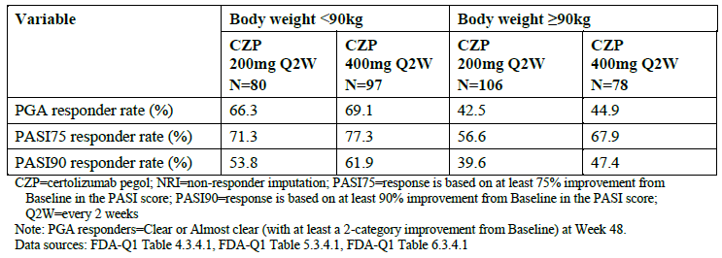
Table 25: Responder rates at Week 48 by body weight category in subjects who were PASI75 responders at Week 16 and received the same blinded certolizumab pegol dose across both initial and maintenance treatment period in CIMPACT (maintenance, non-responder imputation)
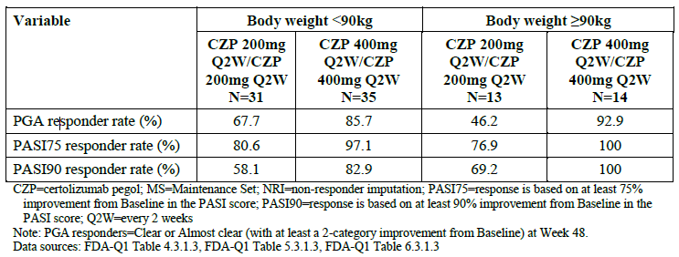
- An overview of treatment emergent AEs (Table 26), serious treatment emergent AEs (Table 27), and treatment emergent AEs leading to discontinuation of study drug by weight category (Table 28) was provided for:
  - Pool S1 (subjects who received study medication during the initial treatment period (Weeks 0 to 16) of the Phase III studies: CIMPASI-1, CIMPASI-2, and CIMPACT [(certolizumab pegol and placebo arms only)),
  - Pool S4 (subjects who received study medication during the Maintenance Treatment period (Week 16 to Week 48) in CIMPASI-1, CIMPASI-2, and CIMPACT) and
  - Pool S3 (subjects treated with Certolizumab pegol during CIMPASI-1, CIMPASI-2, and CIMPACT (initial, maintenance, and open label extension treatment periods up to the clinical cut date of 30 Jun 2017) as well as the Phase II studies C87040 and C87044).
- The post-hoc analyses demonstrated:
  - Overall, regardless of weight category, the risk of treatment emergent AEs does not increase with longer or higher exposure.
  - Overall, the incidence of serious treatment emergent AEs is low regardless of dose, especially in the certolizumab pegol 200mg Q2W group in the < 90 kg category in Pool S1, where there was only 1 subject with a serious treatment emergent AE. Low numbers do not allow direct comparison of serious treatment emergent AE incidence between the dose and weight category, and therefore, no conclusion can be drawn. Pool S3 is the best estimation of long term safety, and incidence rates of serious treatment emergent AEs are similar when considering each dose, regardless of weight.
  - Overall, the rates of treatment emergent AEs leading to discontinuation of study drug are low, and no conclusions can be drawn regarding an effect of dose or weight. Pool S3 is the best estimation of long-term safety, and incidence rates of treatment emergent AEs leading to discontinuation are similar when considering each dose, regardless of weight.
Table 26: Overview of any treatment emergent AE in Pool S1, Pool S4, and Pool S3 by body weight category
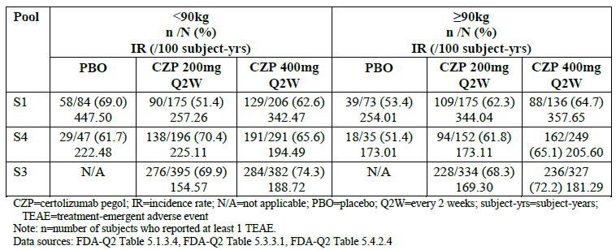
Table 27: Overview of any serious treatment emergent AE in Pool S1, Pool S4, and Pool S3 by body weight category
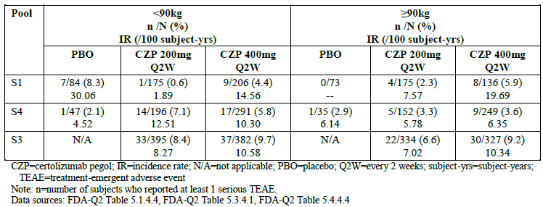
Table 28: Overview of any treatment emergent AE leading to permanent discontinuation of study drug in Pool S1, Pool S4, and Pool S3 by body weight category
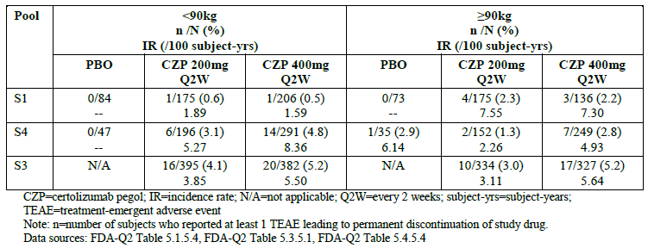
- Post-hoc analyses for antidrug antibodies stratified by dose and body weight showed the incidence of antidrug antibody positivity was higher in subjects receiving certolizumab pegol 200 mg Q2W than in those receiving certolizumab pegol 400 mg Q2W, as previously presented. In addition, the incidence of antidrug antiobody positivity was higher in subjects with body weight ≥ 90 kg than with body weight < 90 kg at both dose levels, with a greater impact of body weight being observed at certolizumab pegol 400 mg Q2W. Similar results were observed at the study level for CIMPASI-1, CIMPASI-2, and CIMPACT, respectively, during the initial treatment period and during the combined initial and maintenance treatment period.
In conclusion, in the original submission, it was demonstrated that both certolizumab pegol doses provide robust efficacy across the spectrum of endpoints assessed in the psoriasis development program. Regardless of weight category, both certolizumab pegol doses continued to show robust efficacy across all endpoints and time points assessed in this response. Furthermore, in the pooled analyses, certolizumab pegol 400 mg Q2W demonstrated higher response than certolizumab pegol 200 mg Q2W, particularly for the more stringent endpoint of PASI90.
The certolizumab pegol 200 mg Q2W and certolizumab pegol 400 mg Q2W doses, regardless of body weight category, have acceptable and similar safety profiles, with no increased risks following longer term exposure. The analysis of ADA by weight category supports the original analysis, where the certolizumab pegol 200 mg Q2W group had consistently higher levels of antidrug antibodies.
In the sponsor’s opinion the additional analyses by body weight category for efficacy, safety and antidrug antibodies confirm the positive benefit-risk of both dose regimens and further support the original proposed dosing recommendation of:
The recommended dose is 400 mg every other week. A dose of 400 mg initially and at Weeks 2 and 4, followed by 200mg every other week may be considered.
However, FDA requested the sponsor to modify the psoriasis dose in the US label to state that for some patients (with body weight ≤ 90 kg), a dose of 400 mg (given as 2 subcutaneous injections of 200 mg each) initially and at Weeks 2 and 4, followed by 200 mg every other week may be considered.

Question 2
The sponsor should provide a justification for the differing dose regimens in the EU, Canada, and the USA.

Response
The differences in the dose regimens approved for psoriasis in the EU, Canada and US are based on the different Health Authority’s own interpretation of the data the sponsor provided during the submission. A summary of the label negotiations related to the dose regimen approved in US, Canada and EU is provided below.
US:
For the US label, a summary of the background leading to the US psoriasis approved dose regimen is provided in response to Question 1. Canada Upon review of the sponsor’s application, Health Canada accepted the psoriasis dose regimen initially proposed by the sponsor.
Europe:
In EU, EMA agreed that both 200 mg Q2W and 400 mg Q2W doses were essentially at the upper end of the exposure-response curve and that both dose levels studied have shown efficacy versus placebo with somewhat more patients (usually 5 to 10%) responding to the proposed higher dose of 400 mg Q2W at Week 16. Furthermore, EMA generally agreed with the sponsor that initiating treatment at certolizumab pegol 400 mg Q2W provides greater benefit than switching to this dose level in case of inadequate response to certolizumab pegol 200 mg Q2W.
The dose regimen approved in EU was largely driven by the slightly higher incidence of some adverse events for the 400 mg dose compared with the 200 mg dose in some of the safety pool analyses during the initial treatment period.
EMA acknowledged that the safety profile in patients with moderate to severe plaque psoriasis is similar to that known from other indications in which certolizumab pegol is approved. However, EMA noted a trend towards a slightly higher incidence of treatment-emergent adverse events and serious adverse events (SAEs) in the 400 mg Q2W group. EMA acknowledged the sponsor’s response on this observation, that the slightly higher incidence treatment emergent AEs and SAEs in the certolizumab pegol 400 mg Q2W group is mainly driven by the initial treatment period, where the overall treatment emergent AE and SAE rates for the certolizumab pegol 400 mg Q2W dose were comparable to placebo, and the incidence of treatment emergent AEs and SAEs at the certolizumab pegol 200 mg Q2W dose was lower than placebo. EMA agreed that the incidence rate of the total number of treatment emergent AEs after an additional 32 weeks of exposure does not seem to increase. EMA commented that the risk of infections appears to be higher at the certolizumab pegol 400 mg Q2W dose during the first 16 weeks of treatment with a trend to be slightly higher also after longer exposure duration, but they also acknowledged it is difficult to draw firm conclusions given the low number of events overall, and that there seems to be no pattern in the type of infection observed between the two certolizumab pegol dose regimens.
EMA concluded there was no firm evidence that the safety profile of long term dosing with certolizumab pegol 400mg Q2W significantly differs from certolizumab pegol 200 mg Q2W.
Despite this assessment, EMA requested the sponsor to modify the psoriasis dose in the EU label to state: After the starting dose (of 400 mg (given as 2 subcutaneous injections of 200 mg each) at Weeks 0, 2 and 4) the maintenance dose of Cimzia for adult patients with plaque psoriasis is 200 mg every 2 weeks. A dose of 400 mg every 2 weeks can be considered in patients with insufficient response.

Advisory Committee Considerations
The ACM, taking into account the submitted evidence of efficacy and safety, agreed that Cimzia solution for injection syringe and solution for injection pre-filled pen (auto injector), containing 200 mg/mL of certolizumab pegol, with an initial loading dose of 400 mg every two weeks for three doses, then 200 to 400 mg every two weeks thereafter, has an overall positive benefit-risk profile for the proposed indication:
- Treatment of adult patients with moderate to severe chronic plaque psoriasis who are candidates for systemic therapy or phototherapy.
In providing this advice the ACM noted that:
- The current indications for Cimzia are for the treatment of rheumatoid arthritis, psoriatic arthritis and ankylosing spondylitis, with various restrictions.
- The sponsor has proposed a dosing regimen of 400 mg every 2 weeks, with an alternative regimen ‘which may be considered’ of 400 mg every 2 weeks for the first three doses, followed by 200 mg every 2 weeks.
- The alternative, lower dose regimen proposed is consistent with the dosing regimen in use for the other approved indications of Cimzia.
- The dosing regimens for Cimzia for the psoriasis indication that have been approved in international jurisdictions all vary slightly from each other; the sponsor has indicated that this is due to the different analyses and emphases placed by each regulator, based on the same data.
- Data provided by the sponsor is not considered to be sufficient to demonstrate statistically significant superior efficacy for the higher dose of Cimzia compared to the lower, and there does appear to be a dose-response relationship with regard to patient safety, with the lower dosing regimen attracting fewer adverse events.
- Given the high degree of inter-individual variability in patient response, the Committee considered it beneficial to allow a degree of flexibility in prescribing to allow clinicians to adjust dose depending on patient circumstances and apparent response. Thus, the Committee suggested specifying a dose range of 200 to 400 mg for maintenance dosing.

Specific Advice
The Delegate requested advice on specific questions on this submission. The ACM advised the following in response to the Delegate’s questions:
The Committee’s advice on the optimal dose regimen, taking into consideration the available evidence is requested. Comment is specifically requested on the following proposals:
- Overall maintenance dosing (that is, which dosing regimen is the most appropriate as a maintenance dose in most patients).
The ACM was of the view that the dosing for Cimzia should be set at a 400 mg loading dose every 2 weeks for the first 3 doses, followed by a maintenance dose range of 200 to 400 mg every 2 weeks. This dose would be guided by clinical judgement and patient response. In recommending this dose range, the ACM took into consideration the overseas dosing regimens approved by other jurisdictions and the evidence supplied by the sponsor. The ACM also noted that while it is true that the dosing for Cimzia for the proposed indication in plaque psoriasis is higher than the dosing for other approved indications, there is a history of TNF inhibitors underperforming when used for plaque psoriasis, which would support use at higher doses.
- Dose adjustments based on individual patient circumstance (for example, based on known covariate data: weight, low baseline PASI)
The ACM did not support the inclusion of dose adjustments based on covariate data in the indication for Cimzia and felt that concerns relating to these might better be addressed through additional discussion in the PI.
- Timing of assessment for response (that is, to decide to continue or discontinue certolizumab pegol, or to change the dose)
The ACM was of the view that 16 weeks would be the appropriate length of time to assess response, based on trial data. It was noted that this will be inconsistent with the assessment of response for similar treatments, which is typically done at 12 weeks, and that 16 weeks may be an inadequate period for assessment of response in some patient sub-groups (for example, with weights of 90 kg or greater). The ACM suggested that these concerns should be addressed through additional discussion in the PI.
- The most appropriate way to communicate the dosing regimen to clinicians (for example, via PI only, or through additional risk minimisation activities).
The ACM agreed that the dosing regimen should be stipulated as above.
The ACM advised that implementation by the sponsor of the recommendations outlined above to the satisfaction of the TGA, in addition to the evidence of efficacy and safety provided would support the safe and effective use of this product.

Outcome
Based on a review of quality, safety and efficacy, TGA approved the registration of Cimzia certolizumab pegol, 200 mg in 1 mL in prefilled pen or prefilled syringe for subcutaneous injection, indicated for:
Cimzia is indicated for the treatment of adult patients with moderate to severe chronic plaque psoriasis who are candidates for systemic therapy or phototherapy.

Specific conditions of registration applying to these goods
The Cimzia EU-Risk Management Plan (RMP) (version 13.1, dated 16 January 2018; DLP 6 March 2018), with Australian Specific Annex (version 6.0, dated 16 October 2018), included with submission PM-2017-04943-1-1, and any subsequent revisions, as agreed with the TGA will be implemented in Australia.

Attachment 1. Product Information
The PI for CIMZIA approved with the submission which is described in this AusPAR is at Attachment 1. For the most recent PI, please refer to the TGA website at <https://www.tga.gov.au/product-information-pi>.
Therapeutic Goods Administration
PO Box 100 Woden ACT 2606 Australia
Email: info@tga.gov.au Phone: 1800 020 653 Fax: 02 6232 8605
https://www.tga.gov.au

CPMP/EWP/2454/02 corr “Guideline on Clinical Investigation of Medicinal Products for the Treatment of Psoriasis” (effective 18 November 2004)
EC₉₀ = the concentration at which 90% of the maximal effect is achieved
t_{½} = time taken for half the initial dose of medicine administered to be eliminated from the body
Routine risk minimisation activities may be limited to ensuring that suitable warnings are included in the product information or by careful use of labelling and packaging. Routine pharmacovigilance practices involve the following activities: - All suspected adverse reactions that are reported to the personnel of the company are collected and collated in an accessible manner; - Reporting to regulatory authorities; - Continuous monitoring of the safety profiles of approved products including signal detection and updating of labeling; - Submission of PSURs; - Meeting other local regulatory agency requirements.
at least 75% and 90% reduction respectively in Psoriasis Area and Severity Index from baseline
The ACM provides independent medical and scientific advice to the Minister for Health and the Therapeutic Goods Administration (TGA) on issues relating to the safety, quality and efficacy of medicines supplied in Australia including issues relating to pre-market and post-market functions for medicines. The Committee is established under Regulation 35 of the Therapeutic Goods Regulations 1990. Members are appointed by the Minister. The ACM was established in January 2017 replacing Advisory Committee on Prescription Medicines (ACPM) which was formed in January 2010. ACM encompass pre and post-market advice for medicines, following the consolidation of the previous functions of the Advisory Committee on Prescription Medicines (ACPM), the Advisory Committee on the Safety of Medicines (ACSOM) and the Advisory Committee on Non-Prescription Medicines (ACNM). Membership comprises of professionals with specific scientific, medical or clinical expertise, as well as appropriate consumer health issues relating to medicines.

