|  |
| --- |
| **October 2013** |

|  |
| --- |
| Australian Public Assessment Report for Cetuximab |
| Proprietary Product Name: Erbitux |
| Sponsor: Merck Serono Australia Pty Ltd |

About the Therapeutic Goods Administration (TGA)

* The Therapeutic Goods Administration (TGA) is part of the Australian Government Department of Health, and is responsible for regulating medicines and medical devices.
* The TGA administers the *Therapeutic Goods Act 1989* (the Act), applying a risk management approach designed to ensure therapeutic goods supplied in Australia meet acceptable standards of quality, safety and efficacy (performance), when necessary.
* The work of the TGA is based on applying scientific and clinical expertise to decision-making, to ensure that the benefits to consumers outweigh any risks associated with the use of medicines and medical devices.
* The TGA relies on the public, healthcare professionals and industry to report problems with medicines or medical devices. TGA investigates reports received by it to determine any necessary regulatory action.
* To report a problem with a medicine or medical device, please see the information on the TGA website <<http://www.tga.gov.au>>.

About AusPARs

* An Australian Public Assessment Record (AusPAR) provides information about the evaluation of a prescription medicine and the considerations that led the TGA to approve or not approve a prescription medicine submission.
* AusPARs are prepared and published by the TGA.
* An AusPAR is prepared for submissions that relate to new chemical entities, generic medicines, major variations, and extensions of indications.
* An AusPAR is a static document, in that it will provide information that relates to a submission at a particular point in time.
* A new AusPAR will be developed to reflect changes to indications and/or major variations to a prescription medicine subject to evaluation by the TGA.

Copyright

© Commonwealth of Australia 2013  
This work is copyright. You may reproduce the whole or part of this work in unaltered form for your own personal use or, if you are part of an organisation, for internal use within your organisation, but only if you or your organisation do not use the reproduction for any commercial purpose and retain this copyright notice and all disclaimer notices as part of that reproduction. Apart from rights to use as permitted by the *Copyright Act 1968* or allowed by this copyright notice, all other rights are reserved and you are not allowed to reproduce the whole or any part of this work in any way (electronic or otherwise) without first being given specific written permission from the Commonwealth to do so. Requests and inquiries concerning reproduction and rights are to be sent to the TGA Copyright Officer, Therapeutic Goods Administration, PO Box 100, Woden ACT 2606 or emailed to <[tga.copyright@tga.gov.au](mailto:tga.copyright@tga.gov.au)>.

Contents

I. Introduction to product submission 4

Submission details 4

Product background 5

Regulatory status 6

Product Information 7

II. Quality findings 7

III. Nonclinical findings 7

IV. Clinical findings 8

Introduction 8

Pharmacokinetics 8

Pharmacodynamics 9

Efficacy 9

Safety 14

List of questions 16

Clinical summary and conclusions 16

V. Pharmacovigilance findings 17

Risk management plan 17

VI. Overall conclusion and risk/benefit assessment 18

Quality 20

Nonclinical 20

Clinical 20

Risk management plan 27

Risk-benefit analysis 27

Outcome 36

Attachment 1. Product Information 37

Attachment 2. Extract from the Clinical Evaluation Report 37

## I. Introduction to product submission

### Submission details

|  |  |
| --- | --- |
| *Type of submission:* | Major variation: review of the indication and other changes to the Product Information |
| *Decision*: | Approved |
| *Date of decision:* | 14 May 2013 |

|  |  |
| --- | --- |
| *Active ingredient:* | Cetuximab |
| *Product name:* | Erbitux |
| *Sponsor’s name and address:* | Merck Serono Australia Pty Ltd Units 3-4/25 Frenchs Forest Road East Frenchs Forest NSW 2086 |
| *Dose form:* | Injection solution |
| *Strengths:* | 100 mg/20 mL and 500 mg/100 mL |
| *Container:* | Vial |
| *Pack size:* | 1 x single use vial |
| *Revised approved therapeutic use:* | Erbitux is indicated for the treatment of patients with epidermal growth factor receptor (EGFR)-expressing, K-RAS[1] wild-type metastatic colorectal cancer.   * In combination with infusional 5-fluorouracil/folinic acid plus irinotecan. * In combination with irinotecan in patients who are refractory to first-line chemotherapy. * In first-line in combination with FOLFOX. * As a single agent in patients who have failed or are intolerant to oxaliplatin-based therapy and irinotecan-based therapy. * (See CLINICAL TRIALS) |
| *Route of administration:* | Intravenous infusion |
| *Dosage (abbreviated):* | Erbitux is administered once a week for all indications. The initial dose is 400 mg cetuximab per m2 body surface area. The subsequent weekly doses are 250 mg/m2 each. |
| *ARTG numbers:* | 132393 and 132396 |

### Product background

Cetuximab is a monoclonal antibody against epidermal growth factor receptor (EGFR; ErbB-1). EGFR is over-expressed in many human cancers, including colorectal cancers.

Erbitux injection solution containing cetuximab received initial registration on the Australian Register of Therapeutic Goods (ARTG) in 2005, for the following indication regarding metastatic colorectal cancer (mCRC):

*Cetuximab is indicated for the treatment of patients with metastatic colorectal cancer that has been demonstrated to be epidermal growth factor receptor (EGFR) positive and whose disease has progressed or is refractory to irinotecan based therapy. Cetuximab can be used at the doses recommended either in combination with irinotecan or as a single agent.*

In 2007, Erbitux was also approved for use in the treatment of locally advanced squamous cell cancer of the head and neck, with the current indication in this context being: *Erbitux is indicated for the treatment of patients with squamous cell cancer of the head and neck. In combination with radiation therapy for locally advanced disease; In combination with platinum-based chemotherapy for recurrent and/or metastatic disease.*

The application discussed in this AusPAR relates only to the indication for metastatic colorectal cancer and therefore the indication for locally advanced squamous cell cancer of the head and neck is not referred to at length in this AusPAR or in Attachment 2 of this AusPAR (Extract from the Clinical Evaluation Report).

Following evaluation by TGA of a variation application, the approved indications regarding mCRC were revised in January 2010 to the following (which are identical to those approved in Europe at that time):

*Erbitux is indicated for the treatment of patients with epidermal growth factor receptor (EGFR)-expressing, K-RAS[2] wild-type metastatic colorectal cancer.*

* *In combination with chemotherapy.*
* *As a single agent in patients who have failed or are intolerant to oxaliplatin - based therapy and irinotecan-based therapy.*

In 2011, the sponsor advised the TGA that the European Medicines Agency (EMA) Committee for Medicinal Products for Human Use (CHMP) had assessed newly reported clinical trial data for cetuximab in mCRC from an investigator-sponsored trial, the COntinuous chemotherapy plus cetuximab or INtermittent chemotherapy (COIN) Study, and found no improvement could be shown for key efficacy parameters, Overall Survival (OS) and Progression Free Survival (PFS), particularly in patients who received combination therapy with oral capecitabine+oxaliplatin (XELOX). The CHMP recommended the indications for use of cetuximab *in combination with chemotherapy* be revised to reflect these findings.

The indications subsequently approved for inclusion in the EU Summary of Medicine Characteristics (SmPC) relating to mCRC were:

*Erbitux is indicated for the treatment of patients with epidermal growth factor receptor (EGFR)-expressing, K-RAS wild-type metastatic colorectal cancer*

* *in combination with irinotecan-based chemotherapy or FOLFOX4[3]*
* *as a single agent in patients who have failed oxaliplatin- and irinotecan-based therapy and who are intolerant to irinotecan.*

Therefore, treatment with XELOX would no longer be an option with the revised indication.

In view of the above development, the TGA advised the sponsor that: “given the evidence of lack of efficacy when cetuximab is used in combination with chemotherapy regimens other than FOLFOX4 and irinotecan, it is strongly recommended that you consider restricting the indication in Australia along similar lines to that now approved in Europe. A restriction to the indication could be implemented through a safety-related notification (SRN[4]).” If the sponsor wished to further amend the indications, a full application with supporting data would need to be submitted for evaluation.

The sponsor subsequently amended the Australian indication via a SRN to the following (current) indication:

*Erbitux is indicated for the treatment of patients with epidermal growth factor receptor (EGFR)-expressing, K-RAS wild-type metastatic colorectal cancer.*

* *In combination with irinotecan-based chemotherapy or continuous infusional 5-fluorouracil/folinic acid plus oxaliplatin (see CLINICAL TRIALS).*
* *As a single agent in patients who have failed or are intolerant to oxaliplatin - based therapy and irinotecan-based therapy.*

While the revised indication is more restrictive than that previously approved in Australia, it was nevertheless broader than recommended by the CHMP and therefore required justification on the basis of data for evaluation by TGA.

This AusPAR describes the application by Merck Serono Australia Pty Ltd (the sponsor) to justify the indication described above, in particular the [use of cetuximab] *in combination with irinotecan-based chemotherapy or continuous infusional 5-fluorouracil/folinic acid plus oxaliplatin.*

Additional changes were also proposed to the Product Information (PI); details of these are beyond the scope of the AusPAR.

### Regulatory status

Erbitux injection solution received initial registration on the ARTG in 2005. See also *Background*, above. The international regulatory status for cetuximab in mCRC at the time this application was reviewed by the TGA is shown in Table 1.

Table 1. Erbitux in metastatic colorectal cancer; overseas regulatory status

| Country/ Region | Approval date | Approved indications (for mCRC) |
| --- | --- | --- |
| European Union (centralised) | February 2012 | Erbitux is indicated for the treatment of patients with epidermal growth factor receptor (EGFR)-expressing, KRAS wild-type metastatic colorectal cancer   * in combination with irinotecan-based chemotherapy, * in first-line in combination with FOLFOX, * as a single agent in patients who have failed oxaliplatin- and irinotecan based therapy and who are intolerant to irinotecan. |
| Switzerland | 13 September 2010 | For the treatment of patients with EGFR (epidermal growth factor receptor) expressing KRAS wild-type metastatic colorectal cancer:   * in combination with FOLFIRI or FOLFOX * as a single agent in patients who have failed oxaliplatin- and irinotecan-based therapy or who are intolerant to irinotecan. |
| United States of America | 6 July 2012 | Erbitux is indicated for the treatment of K-Ras mutation-negative (wild-type), epidermal growth factor receptor (EGFR)-expressing, metastatic colorectal cancer (mCRC) as determined by FDA-approved tests for this use   * in combination with FOLFIRI (irinotecan, 5-fluorouracil, leucovorin) for first line treatment, * in combination with irinotecan in patients who are refractory to irinotecan based chemotherapy, * as a single agent in patients who have failed oxaliplatin- and irinotecan based chemotherapy or who are intolerant to irinotecan   Limitation of Use: Erbitux is not indicated for treatment of K-Ras mutation positive colorectal cancer |
| Canada | 20 December 2012 | ERBITUX (cetuximab) is indicated for the treatment of EGFR-expressing  K-ras wild-type metastatic colorectal carcinoma (mCRC)   * in combination with FOLFIRI (irinotecan, 5-fluorouracil, leucovorin) for first-line treatment. * The benefits and risks of ERBITUX in combination with FOLFIRI, for first line treatment in mCRC patients, have been observed only in a subgroup analysis of patients with ECOG performance status of 0 or 1 (see CLINICAL TRIALS). * in combination with irinotecan in patients who are refractory to other irinotecan-based chemotherapy regimens. * as a single agent in patients who are intolerant to irinotecan-based chemotherapy. * as a single agent for the treatment of patients who have failed both irinotecan- and oxaliplatin-based regimens and who have received a fluoropyrimidine.   Use of ERBITUX is not indicated for the treatment of colorectal cancer in patients with K-ras mutations or unknown K-ras status |

### Product Information

The approved Product Information (PI) current at the time this AusPAR was prepared can be found as Attachment 1.

## II. Quality findings

There was no requirement for a quality evaluation in a submission of this type.

## III. Nonclinical findings

There was no requirement for a nonclinical evaluation in a submission of this type.

## IV. Clinical findings

A summary of the clinical findings is presented in this section. Further details of these clinical findings can be found in Attachment 2.

### Introduction

#### Scope of the clinical dossier

The indications for use of cetuximab in first line treatment in mCRC were narrowed, via a SRN in 2011, by specifying the type of chemotherapy to be used in combination with cetuximab. The current submission mainly addresses this issue. The following data were submitted to support the indication:

* updated clinical study reports (CSR) for two company-sponsored, pivotal studies evaluated previously by the TGA for the first line mCRC indication: the Phase III CRYSTAL and the Phase II OPUS studies.
* 2 new investigator-sponsored studies, the COIN and NORDIC VII trials (COIN led to the CHMP investigation into the benefit/risk of combination therapy in patients with K‑RASwild type tumours).
* a paediatric pharmacokinetics (PK) Study CA225085
* 47 publications (some providing only background information)
* 3 Periodic Safety Update Reports (PSURs; numbers 8, 9 and 10) not previously evaluated by the TGA and covering the period from 01 October 2008 to 30 September 2011.

The sponsor provided reassurance that the updated reports for the CRYSTAL and OPUS studies “do not contain any new efficacy information and the current PI already reports the results from later cut-off dates and subgroup analyses by K-RAS tumour status. There was no change to the safety profile of cetuximab in these studies after re-calculations based on the new cut-off dates.” The rest of the studies, with the exception of the company-sponsored PK study, were investigator-sponsored trials for which no study reports were available. These trials were reported with varying degrees of detail; some resulted in published papers that were provided in the dossier.

### Pharmacokinetics

Study CA 225085 was a Phase I study of cetuximab at multiple ascending doses in combination with irinotecan at a fixed dose in paediatric and adolescent patients (n = 46) with refractory solid tumours. It was designed to characterise the serum PK, safety and efficacy of cetuximab when combined with irinotecan.

This study was submitted mainly to support a proposed PI change relating to paediatric PK. Changes to the PI other than to the indication are beyond the scope of the AusPAR, therefore details of this study are not included in this document.

The evaluator’s conclusions regarding this study were:

* Cetuximab in combination with irinotecan was safely administered in paediatric and adolescent subjects with solid tumours.
* The safety profile of the combination was similar between the 2 age groups, and consistent with the known safety profile of each of the individual drugs in adult subjects.
* The maximum tolerated dose (MTD) for the combination of cetuximab and irinotecan was different between the 2 age groups. However, the recommended Phase II cetuximab dose for both age groups is 250 mg/m2 together with irinotecan 16 or 20 mg/m2 IV x 5 days x 2 weeks.
* PK analysis indicated a similar cetuximab exposure profile between the 2 age groups and was comparable to that known for adults.

### Pharmacodynamics

Samples were not collected for PD analyses in the PK Study CA 225085. No other PD data were presented.

### Efficacy

#### Background

Treatment of mCRC has been changing considerably in recent years. Combinations of 5‑fluorouracil/leucovorin (5-FU/LV) containing both bolus (Roswell Park) and infusional administration (de Gramont schedule) regimens with a second active drug, either irinotecan or oxaliplatin, have been accepted as the mainstay of first line treatment.

During the last years, the IFL regimen (weekly irinotecan and IV push administration of 5‑FU or LV) no longer represents the gold standard of front line treatment of mCRC and was replaced by the combination of irinotecan or oxaliplatin with infusional 5-FU regimens (FOLFIRI (folinic acid + fluorouracil + irinotecan) or FOLFOX, respectively).

To investigate the use of cetuximab as an add-on option to currently used chemotherapy regimens in mCRC, various studies were analysed for this application. These studies are presented in Table 2.

Table 2. Overview of studies

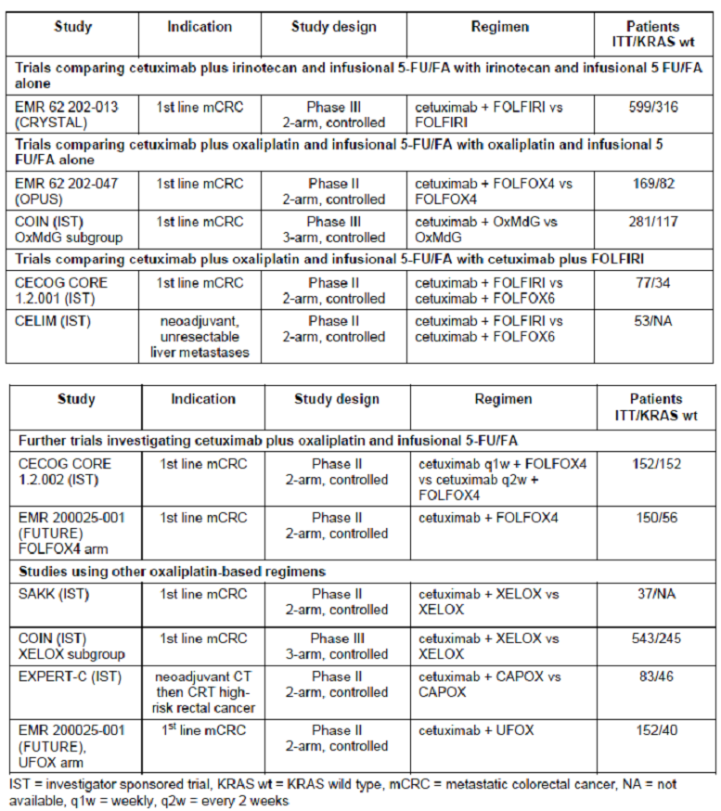

#### Main studies for the current submission

The CRYSTAL and OPUS studies were previously evaluated by the TGA for a variation application (approved in 2010) for cetuximab in mCRC. Updated data (including for OS) for these studies were provided and an addendum to the original version of the study reports was included for the current application.

The COIN Study, that prompted the review of the benefit/risk profile of cetuximab in mCRC, is the main investigator-sponsored trial discussed in the submission.

The sponsor also reviewed the available information from the NORDIC VII Study (sponsored by Nordic Colorectal Cancer Biomodulation Group, NCCBG) in the context of the first line mCRC indication for cetuximab. However, because the Nordic FLOX (5-FU as a bolus, folinic acid and oxaliplatin) regimen used in the study is not registered for cetuximab, and due to missing information and lack of final data, a meaningful and complete assessment of the outcome of this study was not deemed possible. The results from this study were, therefore, not considered by the sponsor in the analyses provided.

##### Other studies

Various investigator-sponsored studies with cetuximab and various chemotherapy regimens, and results from pooled analyses across studies were also provided.

#### Summary and conclusions regarding efficacy

In this submission, the indication for cetuximab in combination with chemotherapy regimens for the treatment of mCRC was re-evaluated. The first line palliative chemotherapy for advanced mCRC, involving the combination of cetuximab with irinotecan-based chemotherapy and continuous infusional 5-FU or FA plus oxaliplatin, is addressed.

The clinical evaluator considered overall that the results presented for both irinotecan- and oxaliplatin-based combination therapies were not impressive, even in the K-RAS wild type population.

The conclusions, below, are focused on efficacy outcomes from 2 company-sponsored pivotal trials that were previously evaluated by the TGA [the CRYSTAL and OPUS Studies], and one large National Cancer Research Institute (NCRI)-sponsored study [COIN] that led to the review of the present indications for cetuximab in first line indications for mCRC.

The important point to consider in evaluating the outcome of the studies is that the benefits for the targeted population, that is, patients with K-RAS wild type tumours, was estimated based on retrospective exploratory analyses and that statistical significance levels (alpha values) were not adjusted for the multiplicity of statistical tests.

The updated data, including the OS data, submitted for the CRYSTAL (n = 1198) and OPUS studies (n = 337) are consistent with the data evaluated previously by the TGA. The COIN Study, which is difficult to interpret, basically put into question the combination of cetuximab with oxaliplatin as a backbone of chemotherapy regimens.

The numerous investigator-sponsored studies and the analyses of pooled data that were also submitted are of interest but cannot be relied on in decision-making.

##### Cetuximab added to irinotecan (FOLFIRI) chemotherapy

Cetuximab added to irinotecan (FOLFIRI) chemotherapy provided extra benefit for K-RAS wild population based on the outcome of Phase III CRYSTAL Study, and these results are not disputed here. “This was also the first time that the addition of an EGFR antibody therapy to a standard continuous 5-FU-based regimen, in first line mCRC treatment, resulted in an overall survival benefit.”

The retrospective analysis of patients with K-RAS wild-type tumours demonstrated that the addition of cetuximab to FOLFIRI resulted in a clinically relevant and statistically significant benefit in tumour-related outcomes when compared to the standard irinotecan-based chemotherapy (considered by some as one of the most effective chemotherapy combinations in the initial treatment of CRC). The addition of cetuximab to FOLFIRI prolonged median OS from 20.0 to 23.5 months (p = 0.0094) compared with FOLFIRI alone. Consistently, progression-free survival (PFS, a primary endpoint) and response rate (RR) were also significantly increased in patients treated with cetuximab.

In the wild type K-RAS subgroup, PFS (assessed by an Independent Review Committee, IRC) was increased statistically significantly by 1.5 months (p = 0.001). Elderly K-RAS wild type patients and patients with European Co-operative Oncology Group (ECOG[5]) performance status > 2 derived no benefit from cetuximab added to FOLFIRI. For the overall population, PFS benefit reached marginal significance for the cetuximab + FOLFIRI combination group (p = 0.0479); the level of significance for benefit for OS in the overall population was p = 0.04.

To obtain the picture of complexity, the results of another study involving cetuximab in combination with irinotecan, also evaluated previously by the TGA, are mentioned here: Unlike in other trials, cetuximab did not significantly affect PFS or OS in wild type K-RAS subjects in the EPIC Study (2nd line therapy comparing cetuximab and irinotecan versus irinotecan alone).

##### Oxaliplatin-based chemotherapy in combination with cetuximab

By comparison, the trials using oxaliplatin-based chemotherapy in combination with cetuximab have not shown improved OS and this failure has raised the possibility of a negative interaction between oxaliplatin and cetuximab.

In the Phase II OPUS Study, the addition of cetuximab to FOLFOX4 in patients with K-RAS wild type tumours led to a significantly longer PFS time, a significantly higher overall response (OR), and improvement in OS time compared with patients receiving FOLFOX4 alone (not significant). The updated analysis with later cut off data showed improved PFS in K-RAS wild population; 8.3 months versus 7.2 months (p = 0.0064). The updated OS data were 22.8 months versus 18.5 months (p = 0.39), respectively for the cetuximab + FOLFOX 4 versus FOLFOX 4 alone.

The primary objective, the objective response rate (ORR), was not met in the overall population. The PFS time and OS were similar in the 2 treatment groups for the ITT population.

Of note, with the exception of the primary efficacy endpoint (OR in the intention-to-treat (ITT) population), all further efficacy analyses were considered exploratory and statistical significance levels (alpha values) were not adjusted for the multiplicity of statistical testing.

Retrospective analyses of these 2 studies, the CRYSTAL and OPUS trials, supported overall efficacy in K-RAS wild type patients. The OPUS Study in particular led to the conclusions that cetuximab should not be used in the treatment of mCRC patients whose tumours have K-RAS mutations or for whom K-RAS tumour status is unknown. In these patients negative effects on PFS and OS were seen with cetuximab add-on to FOLFOX4.

The outcome of the large investigator-sponsored COIN trial (total randomised patients n = 2245) is not clear cut. The primary analysis demonstrated that the addition of cetuximab to oxaliplatin-based chemotherapy conferred no benefit in relation to PFS or OS irrespective of K-RAS mutational status, although RR was significantly improved in patients with K-RAS wild-type tumours. Of note, there was a negative outcome for the comparison of cetuximab + XELOX treatment arm versus XELOX alone. This resulted in the fluoropyrimidine regimen based on oral capecitabine being no longer considered a viable combination with cetuximab.

It has been postulated that the lower dose of capecitabine subsequently administered in the XELOX arm may also conceivably have been suboptimal for the treatment of mCRC: “Indeed, closer inspection of the results suggested that patients with K-RAS wild-type tumours who received XELOX + cetuximab derived no additional benefit, whereas those who received infusional 5-FU/oxaliplatin (oxaliplatin + modified de Gramont schedule of 5-FU; OxMdG) + cetuximab had prolonged PFS time (hazard ratio (HR) 0.77, p = 0.056) compared with those receiving OxMdG alone.”

Pooled analyses of the results of the OPUS Study and the OxMdG subgroup of the COIN Study treated with infusional 5-FU/FA + oxaliplatin (OxMdG subgroup) have been discussed in the submission clinical overview in support of the oxaliplatin-based combination chemotherapy. These are of interest but do not add much weight to efficacy data.

##### Summary

In summary, the efficacy of oxaliplatin-based regimens in combination with cetuximab for first line treatment of mCRC had been questioned. This led to review of the data from company-sponsored trials and a number of investigator-led studies.

A number of pooled analyses have also been presented, as well as comparisons with irinotecan-based chemotherapy regimens in combination with cetuximab, capitalising on similarities in statistical comparisons (such as comparable HRs).

In all of the studies, the results for the targeted K-RAS wild population were based on retrospective subgroup analyses and the studies were not powered to show the difference in the subgroups. When considered with the initial approval for first line indication in mCRC, the absolute gains were small, but statistically significant and often clinically meaningful.

Thus, the outcomes of the studies are far from clear-cut and the results are less convincing for the combination of cetuximab with oxaliplatin based regimens, including continuous infusional 5-FU/FA + oxaliplatin.

There have been inconsistencies in efficacy data from the trials involving cetuximab with oxaliplatin-based chemotherapy, and no survival benefit has been convincingly demonstrated.

##### Other developments

The recently published online preliminary results of a “large, Phase III, European trial” add further uncertainty to the efficacy of oxaliplatin-based chemotherapy combined with cetuximab. The PETACC8 trial[6] was originally designed to compare 12 cycles of FOLFOX4 versus FOLFOX4 + cetuximab. “In the multicenter randomised study, the combination of FOLFOX4 plus cetuximab (Erbitux) did not prolong disease-free survival, compared with FOLFOX alone, even in patients with K-RAS wild-type tumours. The disease-free survival rate at 3 years was 75.1% in 791 patients given FOLFOX 4 with cetuximab and 78% in 811 patients in the control group.”

“These preliminary results of the PETACC8 cooperative group trial were presented for the first time on June 29 at the European Society for Medical Oncology (ESMO’s) 14th World Congress on Gastrointestinal Cancer. The disappointing outcome follows a negative report from the North Central Cancer Treatment Group (NCCTG) N0147 trial, which also looked at the benefit of cetuximab added to FOLFOX in the adjuvant colorectal cancer setting (Alberts *et al*. 2012[7]).”

“The current study specifically looked at patients with K-RAS wild type. These are patients who should, in theory, still be able to respond to an EGFR inhibitor, such as cetuximab.”

“The probability for a positive result in the final analysis is very low. … Cetuximab might have a different form of activity on micrometastatic disease compared to that observed in stage IV disease.”

In July 2012 FDA granted approval for cetuximab in combination with FOLFIRI in first line treatment of patients with K-RAS mutation-negative (wild type), EGFR-expressing mCRC as determined by FDA-approved tests for this use. Oxaliplatin-based chemotherapy in combination with cetuximab is not approved for mCRC in the US in any line of treatment.

##### Conclusion

The evaluator concludes that the submitted data, and overall information available to date, supports cetuximab in combination with irinotecan-based chemotherapy in first line indication for mCRC but does not support the combination with continuous infusional 5-FU/FA + oxaliplatin.

### Safety

#### Background

The safety profile of cetuximab is well known and characterised based on previous randomised controlled trials (RCTs) in mCRC, squamous cell carcinoma of the head and neck (SCCHN), and non-small cell lung cancer (NSCLC).

The safety profile in the target mCRC population with K-RAS wild-type tumour status was evaluated in CRYSTAL and OPUS studies. There were no major differences in the safety profile of cetuximab between the K-RAS wild-type population and the overall safety population.

The overview of the K-RAS safety population, based on 4 controlled, randomised studies in mCRC (NCIC, EPIC, CRYSTAL, and OPUS studies) was submitted and included as part of a previous application. In the overall safety population (n = 3369) of the 4 RCTs, 37% (1250/3369) of subjects were evaluable for K-RAS status, and of these 62% (779/1250) had tumours with K-RAS wild type genes.

Overall, the frequencies of serious adverse events (SAEs), including treatment-related and cetuximab-related SAEs, did not reveal major differences between the 2 populations in these 4 RCTs. Similar conclusions were drawn for AEs leading to discontinuation of cetuximab and/or study treatment. Imbalances in neutropenia were found but were not considered clinically relevant.

The profiles of the AE neutropenia and corresponding laboratory variables differed in the safety and K-RAS wild type populations of the studies in which cetuximab was given in combination with chemotherapy. In the K-RAS wild type population, frequencies in the cetuximab groups tended to be higher than in the respective control groups. However, there was no consistent pattern across studies and in Study CA225006 (EPIC study) the differences were explained by an additional analysis. It is considered that imbalances may be due to differences in treatment duration or exposure.”

#### Overview of studies providing safety data for the current application

The current review of safety data involved the following studies supporting the use of cetuximab as an add-on option to continuous infusional 5-FU/FA + oxaliplatin: Table 3.

Table 3. Metastatic CRC trials by infusional 5-FU regimen.

**Table 3. Metastatic CRC trials by infusional 5-FU regimen.**

The data are based on study reports for completed company-sponsored trials and the available and published data for non company-sponsored trials. The review focuses on the overall safety population, as the K-RAS mutation status was not available in all studies.

In all company-sponsored trials, treatment-emergent AEs (during treatment and up to 30 days after last dose of study drug) irrespective of relationship to study treatment are presented. This may not be the case in the other trials. Data comparison across trials has some limitations because of differences in data documentation, analysis and presentation of safety results, i.e. pre-specified AE documentation, different coding dictionaries and versions.

The studies involved in safety analysis included:

* OPUS Study and the OxMdG subgroup of COIN - trials that involved comparison of cetuximab and infusional 5-FU/FA + oxaliplatin versus infusional 5-FU/FA + oxaliplatin alone.
* CECOG CORE 1.2.001 and CELIM studies - trials that compared cetuximab and infusional 5-FU/FA + oxaliplatin versus cetuximab and FOLFIRI.
* CECOG CORE 1.2.002 and FUTURE studies (FOLFOX arm).

#### Safety findings

Based on the additional safety data observed in the above studies, the safety profile of cetuximab in combination with infusional 5-FU + oxaliplatin is unchanged as compared to that reported earlier. However, in the COIN Study, a significantly higher incidence of Grade ≥ 3 diarrhoea was observed for patients in the cetuximab + XELOX group (26%) versus the XELOX alone group (15%), leading to frequent dose reductions of both capecitabine and oxaliplatin and a protocol amendment that defined 850 mg/m2 twice daily as the capecitabine dose for patients treated with cetuximab. The sponsor observed that in other trials of cetuximab + XELOX or XELIRI similar results for Grade 3/4 diarrhoea were reported; in none of these studies was it reported to be a major issue.

In the 6 selected above studies, 801 patients (safety population) were treated with cetuximab in combination with continuous infusional 5-FU/FA + oxaliplatin. The AEs observed were consistent with the known safety profiles of cetuximab, oxaliplatin and the chemotherapy agents employed. The incidence of the most frequent Grade 3/4 AEs was generally in the same range. The incidence of neutropenia ranged from 24% - 34%.

Neurotoxicities generally reported as Grade 3/4, peripheral neuropathy or peripheral sensory neuropathy are known side effects of oxaliplatin and had an incidence of 1.2%‑6.3%. In the COIN Study a higher frequency (14.0%) was reported. The incidence of neurotoxicity was not increased in combination with cetuximab compared to the comparator arm in the randomised controlled trials; OPUS and COIN studies.

The incidence of palmar-plantar erythrodysesthesia (range 0-6%) is known for fluoropyrimidines and the increased frequency is a known interaction with cetuximab.

In summary, the safety profile of cetuximab in combination with continuous infusional 5‑FU/FA + oxaliplatin is unchanged as compared to that reported earlier. Considering the impact of severe diarrhoea on XELOX administration, a statement on the interaction with capecitabine and oxaliplatin (XELOX) has been included in the PI (*Interactions with other medicines* section): *“In combination with capecitabine and oxaliplatin (XELOX) the frequency of severe diarrhoea may be increased.”*

Furthermore, the statement on cardiovascular disorders was updated (*Precautions* section of the PI) to reflect, besides age, the performance status (PS): *“An increased frequency of severe and sometimes fatal cardiovascular events and treatment emergent deaths has been observed in the treatment of non-small cell lung cancer, squamous cell carcinoma of the head and neck and colorectal carcinoma. In some studies association with age ≥ 65 years has been observed. When prescribing cetuximab, the cardiovascular and performance status of the patients and concomitant administration of cardiotoxic compounds such as fluoropyrimidines should be taken into account.”*

Finally, a statement on the efficacy results in the pivotal CRYSTAL Study was added: *“Patients with K-RAS wild-type tumours and an ECOG performance status of > 2 or who were 65 years of age or older, had no benefit in overall survival time, when cetuximab was added to FOLFIRI.”* (*Clinical trials* section).

#### Conclusions regarding safety

The safety findings were presented for the individual studies. No separate, integrated safety report on cetuximab in combination with irinotecan and oxaliplatin based chemotherapy regimens has been provided.

The sponsor concluded: “Overall the combinations of cetuximab with continuous infusional 5-FU/FA and oxaliplatin or irinotecan show acceptable and manageable toxicity in the treatment of first-line metastatic CRC. The corresponding safety profile is adequately reflected in the current product information for cetuximab.” The evaluator had no reason to object to these conclusions.

### List of questions

None

### Clinical summary and conclusions

The current submission contains data to provide justification for the current indications for cetuximab as first line therapy for mCRC *“in combination with irinotecan-based chemotherapy or continuous infusional 5-fluorouracil/folinic acid plus oxaliplatin.”*

The previous rather broad indications for cetuximab in first line therapy for mCRC “in combination with chemotherapy” have been restricted by SRN in September last year by specifying the exact regime of chemotherapy to be used.

The subsequent review of the data for mCRC indication generated by Merck Serono and by the independent investigators has provided the evidence of lack of efficacy when cetuximab is used in combination with chemotherapy regimens other than FOLFOX4 and irinotecan.

The current evaluation report is based on the review of a significant amount of data that the sponsor submitted, including the update reports to 2 pivotal studies for the first line mCRC indication that were previously evaluated by the TGA; the Phase III CRYSTAL and the Phase II OPUS studies.

Submitted data from the 2 investigator-sponsored studies that led to the review of the benefit/risk of combination therapy in patients with K-RAS wild type tumours, the COIN and NORDIC VII trials were also reviewed, as were a large number of published papers.

The evaluator concluded that the submitted data and overall information available to date supports the use of cetuximab in combination with irinotecan-based chemotherapy in first line indication for mCRC but does not support the combination with continuous infusional 5-FU/FA + oxaliplatin.

The other significant change to the PI includes addition of statements on paediatric population, based on submitted company-sponsored Phase I, PK Study CA225085 of cetuximab in combination with irinotecan in paediatric population with solid tumours; this does not represent any controversial issue.

#### Recommendation regarding authorisation

The major part of this submission by Merck Serono Australia Pty Ltd relates to the approval of indications for cetuximab in combination with irinotecan- and oxaliplatin-based chemotherapy in first line therapy for mCRC.

Based on the available information and considering the targeted indications of cetuximab as part of combination palliative chemotherapy in life-threatening disease, the evaluator supports cetuximab in combination with irinotecan-based chemotherapy in first line indication for mCRC.

The combination of cetuximab with continuous infusional 5-FU/FA + oxaliplatin is not supported in this setting.

The remaining proposed updates to the PI of Erbitux are supported; conditional upon the sponsor addressing the recommendations relating to the changes to the PI.[8]

## V. Pharmacovigilance findings

### Risk management plan

The Risk Management Plan (RMP) included in this application, version 14.1 dated 2 March 2011, was previously evaluated by the TGA for an application that was subsequently withdrawn by the sponsor. At the time, the TGA’s Office of Product Review (OPR) deemed the RMP acceptable, subject to some assurances from the company which were later provided.

For the current application, TGA requested the sponsor provide any available updates to RMP version 14.1 dated 2 March 2011. Updated RMP was subsequently provided and reviewed by the OPR.

#### Summary of recommendations

There were no outstanding concerns regarding the RMP.

The OPR provided comments and recommended revisions to the PI; details of these are beyond the scope of the AusPAR.

## VI. Overall conclusion and risk/benefit assessment

The submission was summarised in the following Delegate’s overview and recommendations:

Cetuximab is a monoclonal antibody against EGFR which is over-expressed in many human cancers including colorectal cancers. Cetuximab has indications in mCRC and head and neck cancer.

In this application, the sponsor aims to justify a narrowing of the mCRC indication that was implemented via a SRN in 2011. The clinical evaluator argues that the indication was not narrowed enough. The concern is that there are insufficient data supporting efficacy in first-line treatment of mCRC with FOLFOX + cetuximab. This overview focuses on that topic.

***Regulatory history***

An indication in mCRC was initially approved in 2005, changed in 2010 and changed again (via a SRN) in 2011. The current application aims to provide data in support of the 2011 change.

The 2005 initial registration approved the following second-line mCRC indication: *For the treatment of patients with metastatic colorectal cancer that has been demonstrated to be epidermal growth factor receptor (EGFR) positive and whose disease has progressed or is refractory to irinotecan based therapy. Cetuximab can be used at doses recommended either in combination with irinotecan or as a single agent.*

In 2008 it was shown that panitumumab (another monoclonal antibody targeting EGFR) added to FOLFOX4 had no beneficial impact on PFS in mCRC patients with K-RAS mutations (see for example, Amado *et al*. 2008[9]). This echoed earlier findings with cetuximab in the OPUS Study.

The application approved in 2010 adjusted the indication to account for inefficacy regarding K-RAS mutant tumours, but within the K-RAS wild-type subset broadening use to allow first-line treatment (in broad combination with ‘chemotherapy’). Single agent use was shifted to third line: *Treatment of patients with epidermal growth factor receptor (EGFR)-expressing, K-RAS wild-type metastatic colorectal cancer: In combination with chemotherapy; As a single agent in patients who have failed or are intolerant to oxaliplatin based therapy and irinotecan-based therapy.*

The 2011 change in wording, to the current form, was via SRN. This wording specifies the chemotherapy that should accompany first-line cetuximab but maintains the broader second-line use:

*Erbitux is indicated for the treatment of patients with epidermal growth factor receptor (EGFR)-expressing, K-RAS wild-type metastatic colorectal cancer*

* *In combination with irinotecan-based chemotherapy or continuous infusional 5- fluorouracil/folinic acid plus oxaliplatin (see CLINICAL TRIALS)*
* *As a single agent in patients who have failed or are intolerant to oxaliplatin-based therapy and irinotecan-based therapy.*

For the current application, the sponsor provided data to support the narrowing of first-line indication from combination with ‘chemotherapy’ to combination with specific chemotherapy regimens as per the above indication.

Following receipt of the clinical evaluation report, the sponsor proposed an amended indication as follows:

*Erbitux is indicated for the treatment of patients with epidermal growth factor receptor (EGFR)-expressing, K-RAS wild-type metastatic colorectal cancer*

* *In combination with irinotecan-based chemotherapy*
* *In first-line in combination with FOLFOX*
* *As a single agent in patients who have failed or are intolerant to oxaliplatin-based therapy and irinotecan-based therapy*
* *(see CLINICAL TRIALS).*

This would align the Australian indication almost completely with the EU wording (see table below).

The application also proposed to modify several statements in the PI concerning *Precautions* (interstitial lung disease; prevention of skin reactions; patients with K-RAS mutated tumours) and PK in paediatric patients, and to re-organise parts of the *Adverse Effects* section.

***Overseas status***

Overseas approaches diverge with regard to first-line therapy: the EMA has approved use in combination with irinotecan-based therapy or with FOLFOX (similar to the Swiss approach); but the FDA has approved first-line use in combination with FOLFIRI only.

Table 4. Overseas status of cetuximab in mCRC

| Country | Current mCRC wording |
| --- | --- |
| EU (SmPC, last updated 23.1.2013) | Erbitux is indicated for the treatment of patients with epidermal growth factor receptor (EGFR)-expressing, KRAS wild-type metastatic colorectal cancer   * in combination with irinotecan-based chemotherapy, * in first-line in combination with FOLFOX, * as a single agent in patients who have failed oxaliplatin- and irinotecan-based therapy and who are intolerant to irinotecan. |
| USA (PI, 6.7.2012) | *K-Ras* mutation-negative (wild-type), EGFR-expressing, metastatic colorectal cancer as determined by FDA-approved tests   * in combination with FOLFIRI for first-line treatment * in combination with irinotecan in patients who are refractory to irinotecan-based chemotherapy, * as a single agent in patients who have failed oxaliplatin- and irinotecan-based chemotherapy or who are intolerant to irinotecan. |
| Switzerland | For the treatment of patients with EGFR (epidermal growth factor receptor) expressing KRAS wild-type metastatic colorectal cancer:   * in combination with FOLFIRI or FOLFOX * as a single agent in patients who have failed oxaliplatin- and irinotecan-based therapy or who are intolerant to irinotecan |

***Clinical guidelines***

With regard to first-line therapy in metastatic disease, the National Comprehensive Cancer Network (NCCN) provides a treatment algorithm. For initial intensive therapy, the only option containing cetuximab is: FOLFIRI ± cetuximab or panitumumab (for K-RAS wild type tumours only).

Consistent with the US indication, cetuximab is not recommended in the NCCN guidance in the first-line setting with anything other than FOLFIRI (except in the case of patients who are not suitable for intensive therapy, where cetuximab monotherapy is an option).

The NSW Cancer Institute’s EviQ guidelines for mCRC refer to use of FOLFIRI with cetuximab, but do not refer to use of FOLFOX with cetuximab. There is also reference to cetuximab and irinotecan, not necessarily in first-line use.

### Quality

There was no requirement for a quality evaluation in a submission of this type.

### Nonclinical

There was no requirement for a nonclinical evaluation in a submission of this type.

### Clinical

An overview of key studies is provided in Table 5.

Table 5. Overview of key studies

| Study | Design | Comments | |
| --- | --- | --- | --- |
| **MERCK-SERONO–SPONSORED (all previously evaluated by the TGA)** | | | |
| NCIC Study  (CA225025) | Add-on to best supportive care  (3rd line) | | [A]  [B] Retrospective K-RAS status analysis in 69% |
| EPIC  (CA225006) | Cetuximab add-on to irinotecan monotherapy  (2nd line) | | [A]  [B] Retrospective K-RAS status analysis in 1/4 |
| CRYSTAL  (EMR 62 202-013) | Add-on to FOLFIRI  (first line) | | [A]  [B] Retrospective K-RAS status analysis in 89%  [C], [D] |
| OPUS  (EMR 62 202-047) | Add-on to FOLFOX4  (first line) | | [A]  [B] Retrospective K-RAS status analysis in 93%  [C], [D] |
| **INVESTIGATOR-SPONSORED (not previously evaluated by the TGA)** | | | |
| COIN (OxMdG subgroup) | Add-on to OxMdG (oxaliplatin + fluoropyrimidines) | [D]  This study prompted review of risk-benefit in mCRC. | |
| NORDIC VII | Combination with Nordic FLOX (5-FU / FA + oxaliplatin) | [D]  Brief summary only. Results not considered in detail due to use of Nordic FLOX, etc. | |
| A = used to support initial (2005) 2nd line indication  B = used to support 2010 narrowing to K-RAS wild type population  C = used to support 2010 broad combination first line treatment  D = used to support 2011 specific combination first line treatment | | | |

Various other studies were also submitted:

* Several (CECOG CORE 1.2.001 in first line mCRC; CELIM in the specific setting of liver metastases) compared cetuximab + FOLFIRI against cetuximab + FOLFOX6. New EPOC results were preliminary and supplied late, as were APEC top-line results.
* Several (SAKK in first line; COIN’s XELOX subgroup in first line) compared cetuximab + XELOX versus XELOX alone.
* Paediatric PK Study CA225085 (cetuximab + irinotecan, in subjects 1-18 yrs with refractory solid tumours) was provided to support a proposed PI change (the clinical evaluator had no objections to this PI change).

#### Efficacy

##### First-line use with FOLFIRI

The use of cetuximab first-line in combination with FOLFIRI is supported by the clinical evaluator, FDA and NCCN. The sponsor and the EU CHMP consider that a broader indication in combination with “irinotecan-based chemotherapy” is appropriate.

The pivotal study in support of such use is CRYSTAL. An update (31 May 2009 cut-off) is provided. More subjects had K-RAS status determined (1063/1198 or 88.7%); of those evaluable, 62.7% were wild type. Given the indication is restricted to wild type K-RAS subjects, comments are restricted to analyses of that group.

Median PFS was 9.9 months for the cetuximab + FOLFIRI arm, and 8.4 months for the FOLFIRI arm (a modest 1.5 month improvement, which was statistically significant). The HR was 0.70 (95% CI 0.56-0.87).

Median OS was 23.5 months for the cetuximab + FOLFIRI arm, and 20 months for the FOLFIRI arm (a 3.5 month gain). The HR was 0.80 (95% CI 0.67-0.95). In the small group with ECOG performance status >2, there was no OS benefit in the cetuximab arm. In the larger group of patients ≥65 yrs of age, there was also essentially no benefit.

##### First-line use with FOLFOX-like regimens

This use of cetuximab first-line in combination with FOLFOX is supported by the sponsor but not by the clinical evaluator. The EMA has approved this use; the US FDA has not. The NCCN guidelines do not endorse this use. The following table describes various FOLFOX-like regimens:

Table 6. FOLFOX-like regimens

|  | Oxaliplatin | 5-FU | Folinic acid |
| --- | --- | --- | --- |
| FOLFOX4 in OPUS;  2 wk cycle | 85 mg/m2 over 2 hrs on Day 1 | On each of Days 1 and 2: 400 mg/m2 bolus then 22 hr infusion of 600 mg/m2 | 200 mg/m2 over 2 hrs on Days 1 and 2 |
| FOLFOX6 modified (metastatic; EviQ)  2 wk cycle | 85 mg/m2 over 2 hrs on Day 1 | 400 mg/m2 bolus then 2400 mg/m2 over 46 hrs | 50 mg on Day 1 |
| OxMdG in COIN;  2 wk cycle | 85 mg/m2 over 2 hrs on Day 1 | 400 mg/m2 bolus then 2400 mg/m2 over 46 hrs | L-FA 175 mg over 2 hrs |
| Nordic FLOX;  2 wk cycle | 85 mg/m2 over 1 hr on Day 1 | On each of Days 1 and 2: 500 mg/m2 as bolus | 60 mg/m2 as bolus after 5‑FU on each of Days 1-2 |

###### OPUS study

A pivotal study in support of this use is OPUS, where FOLFOX4 was the reference regimen. An update (30 November 2008 cut-off) is provided. In this case, 315/337 patients were evaluable for K-RAS status; of these, 56.8% were wild type. Again, only the wild type population is considered below. Although ORR was the primary endpoint, PFS and OS are considered useful.

Median PFS was 8.3 months for cetuximab + FOLFOX4, versus 7.2 months for FOLFOX4. The hazard ratio (HR) was impressive at 0.57 (95% CI 0.38-0.86), but effect size in terms of difference in median PFS was more modest.

Median OS was 22.8 months for cetuximab + FOLFOX4, versus 18.5 months for FOLFOX4 (not statistically significant). The HR was 0.86 (95% CI 0.60-1.22).

OPUS is supportive of use in combination with FOLFOX, with gains similar to those seen in CRYSTAL. The investigator-sponsored COIN Study produced a different picture, as described below.

###### COIN study

COIN had three arms: Arm A (control): oxaliplatin + fluoropyrimidine (OxFp) chemotherapy (XELOX/OxMdG[10]); Arm B: cetuximab at the standard approved regimen added to the same chemotherapy schedule; Arm C: intermittent schedule of OxFp chemotherapy (OxMdG/XELOX) without cetuximab.

Comparison of Arm A ([5-FU or capecitabine] + oxaliplatin) and Arm B (same + cetuximab) is key.

There was a pre-defined subgroup analysis for those receiving 5-FU + oxaliplatin (OxMdG) and for those receiving capecitabine + oxaliplatin (XELOX) (there was no random allocation to OxMdG and XELOX; patients / clinicians chose OxMdG or XELOX before randomisation into main arms).

OxMdG is comparable with but not identical to FOLFOX4/FOLFOX6. The K-RAS wild type subgroup (55.4% of those evaluable) is considered. The most relevant comparison is between 117 wild type patients who received cetuximab + OxMdG and 127 wild type patients who received OxMdG. Table 7 below sets out results; survival curves from this study are shown in Figures 1 and 2; and subgroup analyses are shown in Figures 3 and 4.

Table 7. COIN Study: Efficacy in the K-RAS wild type population by treatment arm and OxFp regimen.

Table 7. COIN study: Efficacy in the K-RAS wild type population by treatment arm and OxFp regimen.

Figure 1. COIN Study. Overall survival in patients with K-RAS wild type tumours by OxFp regimen (XELOX, OxMdG)

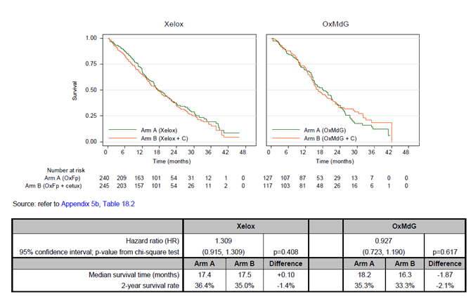

Figure 2. COIN Study. PFS in patients with K-RAS wild type tumours by OxFp regimen (XELOX, OxMdG)

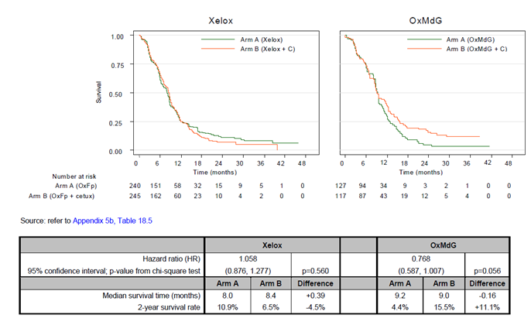

Figure 3. COIN Study. PFS. Efficacy by number of metastatic sites or liver-limited disease

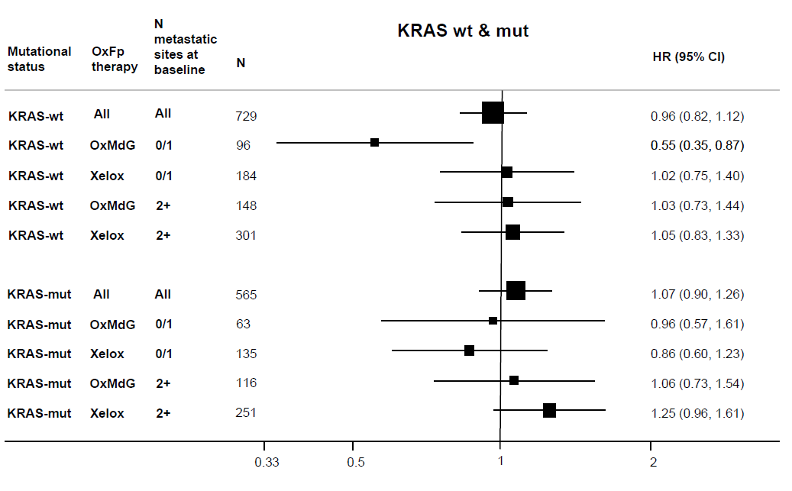

Figure 4. COIN Study. OS. Efficacy by number of metastatic sites or liver-limited disease

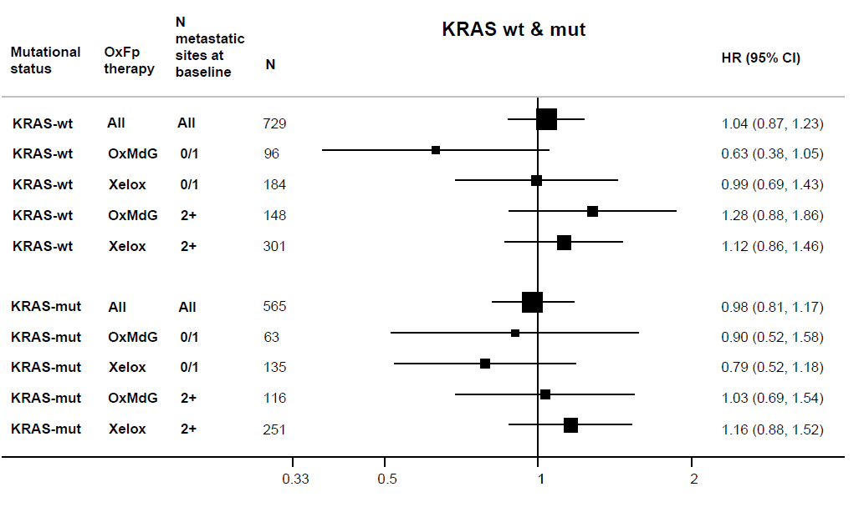

* Overall response rate at 12 weeks was slightly higher in the cetuximab + OxMdG arm (54%) than the OxMdG arm (47%).
* For median PFS, results are similar (9.0 versus 9.2 months respectively). Comparison of PFS survival curves favoured cetuximab + OxMdG (HR 0.77, 95% CI 0.59-1.01) without statistical significance being attained. Benefit was restricted to those with 0-1 metastatic sites at baseline (Figure 3).
* For median OS, results were worse in the cetuximab + OxMdG arm (16.3 months versus 18.2 months). Comparison of OS survival curves suggested little difference: HR 0.93 (95% CI 0.72-1.19). There was a sharp distinction between those with 0-1 metastatic sites at baseline (HR approximately 0.63, favouring addition of cetuximab), and those with 2 or more sites (HR approximately 1.28) (Figure 4).

It can be debated what weight should be placed on comparison across arms of medians versus comparison of ‘survival curves’ as expressed by HRs, or their shape (Figures 1 and 2 above). That the measures are in conflict (especially for OS) points to a lack of robust efficacy for cetuximab, in this trial.

Based on COIN, the sponsor considered that XELOX should not be used (with cetuximab in first-line mCRC).

Beyond this, COIN does raise some concern that the benefit of cetuximab + FOLFOX is not as robust as might be suggested by the OPUS Study. A possibility is that benefit is restricted to those with liver-limited metastases. While this finding can be described as ‘exploratory’ it is notable that it is a recurring signal (see below).

###### Other studies

The NORDIC VII Study is outlined in the CER (see Attachment 2 of this AusPAR). As per the table above, it uses less 5-FU than other FOLFOX-like regimens, and 5-FU is given as a bolus. The study cannot support the current indication, which specifies continuous infusional 5-FU. In K-RAS wild type subjects, median OS was 22.0 months with FLOX and 20.1 months with FLOX + cetuximab. ORR was not improved either.

The PETACC8 trial is mentioned in the CER. It was in Stage III disease and so is not considered further in this overview.

#### Liver-limited disease

Analysis in COIN of efficacy in patient groups with 0-1 versus 2+ metastatic sites is hypothesis-generating rather than definitive in itself, but previous trials have shown increased response rates in liver-limited disease (for example, CRYSTAL and OPUS). Analysis by liver-limited disease is not directly comparable to analysis by number of metastases, however:

* In OPUS, in patients with liver metastases only, addition of cetuximab to FOLFOX-4 resulted in best ORR of 56%, versus 41% for the FOLFOX-4 arm. (For those with metastases beyond the liver, figures were 42% versus 39.5% respectively.) When PFS was considered, median PFS was higher in the cetuximab arm only in the ‘liver metastases only’ group.
* In CRYSTAL, PFS favoured the cetuximab-treated arm more clearly in those with liver metastases only (HR 0.64, versus 0.91 in those with other sites); this difference was attenuated in the wild type population.

#### Comparisons of chemotherapy backbones

It is also useful to consider whether head-to-head studies of differing backbones (particularly FOLFIRI versus FOLFOX-like chemotherapy) produce differing results.

**CECOG CORE 1.2.001** compared “cetuximab + FOLFOX6 [[11]]”versus “cetuximab + FOLFIRI” in first line treatment of unresectable mCRC. Sample size was small, and particularly small in the K-RAS wild type subgroup (n = 62). The study was not powered to detect a difference in key endpoints in the K-RAS wild type subgroup. Point estimates favoured the FOLFOX6 backbone.

After the evaluation phase, the sponsor supplied the following limited information about the **APEC Study**:

APEC is an Asia Pacific non-randomised, open-label Phase III study evaluating the safety and efficacy of FOLFIRI plus cetuximab or FOLFOX plus cetuximab as first-line therapy in subjects with K-RAS wild-type metastatic colorectal cancer. Preliminary results indicate an identical PFS of 11.1 months for each of the combinations (n = 289; FOLFIRI plus cetuximab arm n = 101; FOLFOX plus cetuximab arm n = 188).

At the time, the APEC data were confidential and had not yet been presented.

**CELIM** did not analyse by K-RAS status and was restricted to the setting of neoadjuvant treatment of liver metastases, so is not directly relevant. Neither backbone emerged clearly ahead of the other, with regard to efficacy.

Another investigator-sponsored study, **New EPOC**, is of similar relevance. This was a study of cetuximab as add-on to either OxMdG or irinotecan + MdG (IrMdG). K-RAS wild type colorectal cancer patients with operable liver metastases, with no prior chemotherapy for advanced colorectal cancer, were enrolled. Treatment was for 12 weeks both before and after resection of liver metastases, but only 108/252 subjects underwent surgery. The trial was stopped for the following reason:

With 45.3% (96/212; 42 events in arm A and 54 in arm B) of the expected events observed, PFS was significantly worse in the cetuximab arm (14.8 versus 24.2 months, HR (95% CI) 1.50037 (1.000707 to 2.249517), p=0.048).

Notable in New EPOC was the negative effect size (a >9 month difference in PFS). Analysis by whether oxaliplatin or irinotecan were used as backbone chemotherapy was not presented, although apparently most patients used an OxMdG backbone and relatively few used IrMdG. Analysis of outcomes prior to resection (that is, in a purely metastatic setting) was not presented. Only top-line results were given; the study has not been evaluated in any detail.

#### Safety

Given the pivotal nature of the OPUS and COIN Studies for efficacy, safety aspects of these studies are emphasised below.

In OPUS, various significant AEs were more common in the cetuximab + FOLFOX4 arm than in the FOLFOX4 arm. Palmar-plantar erythrodysaesthesia syndrome was seen in 11.2% versus 4.2%. Also, severe cardiac events were seen in 4.7% versus 0%. In the K‑RAS wild type population, neutropenia was more prominent in the arm given cetuximab.

In COIN, safety was not analysed by K-RAS status. Severe skin rash and severe palmar-plantar erythrodysaesthesia syndrome were more prominent in the cetuximab + OxMdG arm than in the OxMdG arm, as was severe hypomagnesaemia. An important finding was the extent of gastrointestinal toxicity in the cetuximab + XELOX arm, relative to XELOX alone. This led to a protocol amendment, reducing capecitabine dose. On the other hand, neutropenia was more prominent in those given OxMdG, especially in combination with cetuximab.

For the sake of comparison, in CRYSTAL (FOLFIRI backbone), there was also a slight increase in severe cardiac events in the arm given cetuximab. In the K-RAS wild type group, neutropenia was again more prominent.

In CELIM, there was a suggestion of less toxicity in the cetuximab + FOLFOX6 arm than in the cetuximab + FOLFIRI arm. In the perhaps more relevant CECOG CORE 1.2.001 Study, the opposite impression was generated.

#### Clinical evaluator’s recommendation

The clinical evaluator does not consider that the submitted data support the current mCRC first-line indication. The evaluator considers that there are sufficient data to support first-line use in combination with irinotecan-based chemotherapy but insufficient data to support first-line use in combination with continuous infusional 5-FU / FA + oxaliplatin.

### Risk management plan

The RMP supplied with this application (dated 2 March 2011) has been reviewed and approved in a previous setting for cetuximab. The TGA’s OPR reviewed the most up-to-version and confirmed it is appropriate provided various revisions to the PI were considered.[12]

### Risk-benefit analysis

#### Delegate considerations

The sponsor proposes the following (updated) indication for cetuximab in the mCRC setting:

*Erbitux is indicated for the treatment of patients with epidermal growth factor receptor (EGFR)-expressing, K-RAS wild-type metastatic colorectal cancer*

* *In combination with irinotecan-based chemotherapy*
* *In first-line in combination with FOLFOX*
* *As a single agent in patients who have failed or are intolerant to oxaliplatin-based therapy and irinotecan-based therapy*

*(see CLINICAL TRIALS).*

In response to the clinical evaluation report, the sponsor also proposes a new contra-indication:

*The combination of Erbitux with oxaliplatin-containing chemotherapy is contra-indicated for patients with mutant K-RAS metastatic colorectal cancer (mCRC) or for whom K-RAS mCRC status is unknown.*

The Delegate considered the following issues:

##### Combination with irinotecan-based chemotherapy

* Should the indication specify use in combination with FOLFIRI?

The clinical evaluator says it should; the sponsor supports broader wording. The basis for the current broad wording (“irinotecan-based chemotherapy”) was data submitted in a previous application (approved in 2010). Pivotal there was CRYSTAL, which used FOLFIRI. The TGA Delegate for that application noted: *Even though cetuximab has only been tested with FOLFIRI and FOLFOX4 in controlled trials for the first-line indication, it is likely to add benefit to other chemotherapy regimens. The product information warns prescribers to consider respective product information when use of cetuximab with other chemotherapy is being considered. This is important in predicting the toxicity of the proposed drug combination. The general indication will allow flexibility with continually changing chemotherapy regimens.*

Subsequently, the SRN in 2011 narrowed the wording to “irinotecan-based chemotherapy”; it is the current application that seeks to justify this change.

Data have emerged suggesting that the benefit of adding cetuximab may be tied more closely than once thought to choice of specific chemotherapy backbone. An example is use with XELOX: COIN suggests adding cetuximab to XELOX is not beneficial in first line mCRC. EviQ implies that in mCRC, the following chemotherapy regimens are ‘irinotecan-based’:

* irinotecan alone
* FOLFIRI
* FOLFIRI modified
* XELIRI (capecitabine and irinotecan)

XELIRI can be viewed as ‘irinotecan-based chemotherapy’ yet COIN found that capecitabine + oxaliplatin should not be combined with cetuximab. XELIRI may be used where FOLFIRI is not suitable or practical, without regard to first versus subsequent- line use. COIN data emerged after the TGA evaluation of the application approved in 2010.

The Delegate considered this new evidence raises doubt about the benefit-risk profile of cetuximab in combination with XELIRI and agreed that the indication should be narrowed until there are suitable data supporting broader use in first line mCRC. The Delegate supported use of the term “FOLFIRI”, but potentially a term that captures the modified FOLFIRI regimen would be more appropriate. (The modified regimen is quite closely related to the regimen used in CRYSTAL and can be supported on that basis.) The Delegate proposed to seek the advice of the Advisory Committee on Prescription Medicines (ACPM) on this issue.

##### Combination with FOLFOX-like chemotherapy

* Should the indication allow combination with FOLFOX in treatment of first line mCRC?

The clinical evaluator thinks not. The main concerns as outlined in the CER (see also Figure 2 above) are that COIN results did not support this use, and that neither OPUS nor COIN demonstrated a survival benefit convincingly.

The Delegate agreed with the sponsor that it is reasonable to consider PFS as a pivotal endpoint, though it would be more reassuring if OS data were consistent and/or supportive.

The Delegate had less concern about the use of retrospective analysis of K-RAS status given the strong mechanistic basis for this subgrouping. The disadvantage of focusing on K-RAS wild type patients in terms of power to detect differences across arms is offset by the ability to examine results across multiple studies. While OPUS was supportive of the current indication, efficacy was not dramatic. COIN suggested a more marginal benefit, if any, in the wild type subgroup given a FOLFOX-like regimen, but there was no strongly negative signal. Results of studies where cetuximab + FOLFIRI were compared with cetuximab + FOLFOX did not clearly indicate that combination with FOLFOX was inferior. The Delegate’s view was that it is reasonable for this indication to remain and proposed to seek the advice of the ACPM on this matter.

##### Liver-limited disease; efficacy by number of metastatic sites

There was a signal in several important studies that the benefit of cetuximab is most evident (in the setting of first line treatment of mCRC) in patients with either liver-limited metastatic disease or few metastatic sites. A similar finding is not immediately obvious in the pivotal study (the PRIME Study) for panitumumab. The Delegate proposed inclusion of this information under *Precautions* in the PI, as follows:

*Metastatic colorectal cancer at sites other than liver*

*In sub-group analyses of progression-free survival (in studies including OPUS and CRYSTAL), the benefit of cetuximab has been more prominent in those patients with liver-limited metastatic colorectal cancer. The benefit-risk balance in patients with metastatic CRC that includes sites outside the liver is less well established.*

Alternatively, relevant detail could be included in the *Clinical Trials* section.

###### Proposed action

The Delegate proposed to modify the sponsor’s most recently proposed indication to read:

*Erbitux is indicated for the treatment of patients with epidermal growth factor receptor (EGFR)-expressing, K-RAS wild-type metastatic colorectal cancer*

* *In combination with FOLFIRI*
* *In first-line in combination with FOLFOX*
* *As a single agent in patients who have failed or are intolerant to oxaliplatin-based therapy and irinotecan-based therapy*

*(see CLINICAL TRIALS).*

#### Request for ACPM advice

This was an unusual submission in that it was structured to ‘justify’ an existing indication. The ACPM’s advice was sought in view of (a) the evident difficulty, since original registration, in arriving at a suitable indication for cetuximab in mCRC; and (b) the emergence of new clinical trial data that bear on this question.

The Delegate proposed to seek general advice from the ACPM with regard to the mCRC indication for cetuximab and to request the Committee address the following in particular:

* Should reference to combination with irinotecan-based chemotherapy be restricted to combination with FOLFIRI? Is there a better term to reflect the intent of this change, i.e. so that it is obvious that the modified FOLFIRI regime is also included?
* Should the indication be narrowed to exclude first line combination with FOLFOX?
* Is there sufficient evidence to restrict use in any way or include recommendations in the PI with regard to liver-limited metastatic disease?

#### Response from sponsor

##### Introduction

The emergence of new clinical data raised questions on the benefit-risk profile of Erbitux (cetuximab) in combination with certain oxaliplatin-based chemotherapy regimens for the treatment of patients with K-RAS wild-type mCRC. The sponsor proactively moved to restrict the oxaliplatin-based combination to continuous infusional therapies only. This restriction was quickly implemented via a safety-related notification and subsequently complemented by the submission of the clinical data that led to this decision for the TGA’s review.

This pre-ACPM response focuses on issues raised in the Delegate’s Overview for which the Committee’s advice is sought. The sponsor’s proposed indication is now (changes since the original submission are underlined):

*Erbitux is indicated for the treatment of patients with epidermal growth factor receptor (EGFR)-expressing, K-RAS wild-type metastatic colorectal cancer*

* *in combination with irinotecan-based chemotherapy*
* *in first-line in combination with FOLFOX*
* *as a single agent in patients who have failed or are intolerant to oxaliplatin-based therapy and irinotecan-based therapy.*

*(see CLINICAL TRIALS and PRECAUTIONS)*

##### Combination with irinotecan-based chemotherapy

Following review of the data from the Medical Research Council-sponsored Phase III COIN Study, in particular the results in patients treated with cetuximab and XELOX, the Delegate has raised a concern regarding the possible use of cetuximab with XELIRI. The sponsor is aware of two published articles reporting original results from Phase II open-label studies relevant to this issue and has summarised the results below.

Cartwright *et al*.[13] describe a non-randomised study with 69 patients who were treated with cetuximab plus XELIRI (200 mg/m2 irinotecan on Day 1; 1700 mg/m2 capecitabine per day given on days 1-14 of a 21-day cycle). K-RAS tumour status was not reported and results are thus only available for the overall population.

Moosmann *et al*.[14] reported a study comparing cetuximab plus CAPIRI (200 mg/m2 irinotecan on Day 1; 1600 mg/m2 capecitabine per day on days 1-14 of a 21-day cycle, Arm A) and cetuximab + CAPOX (130 mg/m² oxaliplatin on Day 1; 2000 mg/m² per day, on days 1-14 of a 21-day cycle, Arm B).

Efficacy results for patients treated with cetuximab plus CAPIRI/XELIRI are summarised in the table below and compared to the results obtained in the pivotal Phase III CRYSTAL Study for cetuximab plus FOLFIRI. The efficacy results for cetuximab plus CAPOX reported in the Moosmann study are not described in detail here; they were of similar magnitude to those seen in the cetuximab plus CAPIRI arm for the intent-to-treat and K-RAS wild-type populations.

Table 8. Efficacy results for patients treated with cetuximab plus CAPIRI/XELIRI/ FOLFIRI

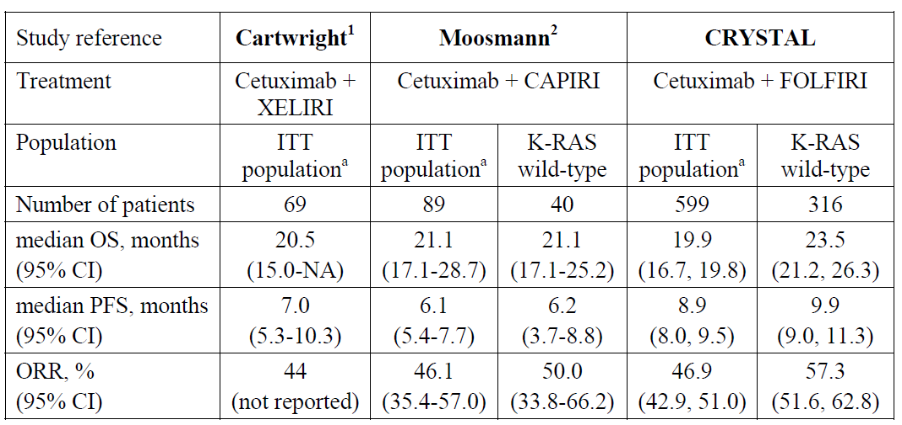

a Intent to treat population, unselected for K-RAS status OS=overall survival; PFS=progression-free survival; ORR=overall response rate

The most frequent Grade 3/4 treatment-related adverse events (AEs) in the Cartwright study included diarrhoea (23%), neutropenia (19%), rash (9%), hand-foot skin reaction (9%) and nausea/vomiting (7/9%); 32% of patients required dose reductions. All patients had left the study at the time of publication primarily because of disease progression (34.3%) or AEs (40.0%).

In the Moosmann study, the most frequent Grade 3/4 treatment-related AEs in patients treated with cetuximab plus CAPIRI (n = 89) included diarrhoea (15.7%), exanthema/desquamation (12.4%) and neutropenia (9.0%). Hand-foot syndrome was also reported frequently: Grade 2/3 events in 12.4% of patients. Dose reduction was necessary in 31.8% of cetuximab plus CAPIRI treatment cycles. For patients treated with cetuximab plus CAPOX (n = 88), exanthema/desquamation (20.5%), diarrhoea (19.3%), and sensory neurotoxicity (14.8%) were the most frequently reported Grade 3/4 treatment-related AEs, while neutropenia was reported in 1.1% of patients; Grade 2/3 hand-foot syndrome events were seen in 22.7% of patients. Dose reduction was necessary in 44.4% of cetuximab plus CAPOX treatment cycles.

The patient numbers in both studies are small and do not allow for a decisive interpretation. When comparing the results obtained in the total study populations (not selected for K-RAS status), ORR and OS results are well in line with those reported in the pivotal CRYSTAL Study, for cetuximab plus FOLFIRI. PFS was however shorter than in CRYSTAL, which may be explained by the shorter treatment duration of only 18 weeks (median) in the Moosmann and Cartwright studies as compared to about 25 weeks in the CRYSTAL Study. In the K-RAS wild-type subset, a trend towards smaller efficacy for cetuximab plus CAPIRI in the Moosmann study, compared to cetuximab plus FOLFIRI investigated in the CRYSTAL Study, is noted. This may be due to the fact that, unexpectedly, no increase in efficacy was seen in the K-RAS wild-type subset of the Moosmann study as compared to the total study population. This phenomenon might be explainable by selection bias and confounding with prognostic variables; however, corresponding analyses were not described in the publication. In the absence of a comparator arm without cetuximab, results need to be interpreted with caution.

The sponsor therefore agrees with the Delegate that suitable data supporting the use of cetuximab in combination with irinotecan and capecitabine are lacking. However, there is no high-level evidence suggesting a negative benefit-risk profile for the association either.

As to the combination of cetuximab with irinotecan alone, the sponsor is not aware of any data suggesting the benefit-risk profile of this regimen should be questioned, and results from studies supporting this use are already included in the PI. The sponsor is therefore uncertain of the reasons behind its removal from the Delegate’s proposed modified indication.

###### Conclusion

The sponsor does not believe a change in indication is warranted for the combination of cetuximab with irinotecan-based chemotherapy. However, in recognition of the Delegate’s concern regarding cetuximab in combination with XELIRI and the scarcity of evidence available at present, the sponsor proposes to add a precaution in the PI to ensure adequate disclosure to prescribing physicians, as follows:

*“Combination with Capecitabine and Irinotecan*

*The benefit-risk balance of cetuximab in combination with XELIRI (capecitabine plus irinotecan) has not been established. This combination is therefore not recommended in the treatment of patients with metastatic colorectal cancer.”*

A cross-reference in *Indications* to the *Precautions* section is also proposed.

##### Combination with FOLFOX

###### Efficacy and safety

In this submission, the sponsor presented all available data for cetuximab in combination with oxaliplatin-based regimens for the TGA’s evaluation.

In brief, a positive benefit-risk profile for this combination was demonstrated in the pivotal Phase II OPUS Study, where a significant and meaningful benefit was seen in ORR: 57.3% (95% CI: 45.9, 68.2) for cetuximab plus FOLFOX4 versus 34.0% (24.7, 44.3) for FOLFOX4 alone, p=0.003 and in PFS: median 8.3 months (95% CI: 7.2, 12.0) versus 7.2 months (5.6, 7.4) with a HR of 0.57 (0.38, 0.86), p=0.006, in patients with wild-type K-RAS metastatic disease, per the current indication. Benefits were also seen in OS, even though the study was not powered for the assessment of this endpoint. Indeed, with a median follow-up of about 33 months in both treatment groups, a higher rate of deaths was observed in the group of patients treated with FOLFOX4 compared to those patients who received cetuximab plus FOLFOX4 (73.2% versus 67.1%). The increase in median OS reached a magnitude of 4.3 months with a HR of 0.86 (95% CI: 0.60, 1.22).

Also, the results observed in the modified de Gramont oxaliplatin (OxMdG) subset of the COIN Study show improved ORR (odds ratio 1.44, 95% CI: 0.85, 2.43) and PFS (HR 0.77, 95% CI: 0.59, 1.01) when cetuximab was added to OxMdG, a FOLFOX-like regimen.

The robustness of the OPUS findings is supported by the comparability of results to those of the pivotal Phase III Study CRYSTAL in which cetuximab was added to FOLFIRI and showed significant benefit in PFS, ORR and overall survival compared to FOLFIRI alone. Further support is given by smaller yet relevant studies comparing cetuximab plus FOLFIRI versus cetuximab plus FOLFOX6 (CECOG CORE 1.2.001 and CELIM), and by the recently concluded open-label Phase II APEC Study investigating cetuximab plus FOLFIRI and cetuximab plus FOLFOX.

In addition, as presented in the response to the clinical evaluation, a meta-analysis by Ku *et al*.[15] and a systematic review by Vale *et al*.[16] concluded that there was no evidence that the choice of oxaliplatin or irinotecan affected the degree of benefit from cetuximab and no strong evidence that the treatment effect varied by line of treatment (first or second line).

Finally, the results from OPUS compare favourably with those of the pivotal Phase III Study 20050203 investigating the monoclonal antibody panitumumab plus FOLFOX versus FOLFOX alone, which supported its indication “as first line therapy in combination with FOLFOX”.

The COIN Study did not support the use of cetuximab in combination with a capecitabine based chemotherapy regimen and, following an assessment of available evidence in such combinations, the sponsor proactively restricted the indication to infusional regimens. The significantly higher incidence of Grade ≥ 3 diarrhoea observed for patients in the cetuximab plus XELOX group versus the XELOX alone group in COIN was also reflected in the PI.

Taking into account the available evidence supporting the various oxaliplatin-based regimens, the sponsor has further restricted the indication wording to “in first-line in combination with FOLFOX”.

In the submission clinical overview, the sponsor presented an analysis of safety from all studies using FOLFOX-like regimens completed before the end of 2011, which included the abovementioned studies (excluding APEC), CECOG CORE 1.2.002 (investigating once-weekly versus twice-weekly cetuximab and FOLFOX4) and FUTURE (including a treatment arm with cetuximab and FOLFOX4). In these six studies, 801 patients (safety population) were treated with cetuximab in combination with FOLFOX-like regimens; the AEs observed were consistent with the known safety profiles of cetuximab, oxaliplatin and other chemotherapy agents. The incidences of the most frequent Grade 3 or 4 events were generally in the same range. The incidence of neutropenia ranged from 24 to 34%. Neurotoxicities generally reported as Grade 3 or 4 peripheral neuropathy or peripheral sensory neuropathy are known side effects of oxaliplatin and had an incidence in the range of 1.2% to 6.3%. In the COIN Study a higher frequency (14.0 %) was reported. The incidence of neurotoxicity was not increased in combination with cetuximab compared to the comparator arms in the randomised controlled studies (OPUS and COIN). The incidence of palmar-plantar erythrodysesthesia (range 0-6%) is known for fluoropyrimidines and the increased frequency is a known interaction with cetuximab. This is addressed with precautionary wording in the PI, as is the increased frequency of severe cardiac events noted by the Delegate.

Overall the combination of cetuximab with FOLFOX shows acceptable and manageable toxicity in the treatment of first-line mCRC. The sponsor submits that the corresponding safety profile is adequately reflected in the current product information for cetuximab.

##### Clinical utility

There are currently few treatment options for patients suffering from K-RAS wild-type mCRC. Patients with clearly resectable liver-only metastases have the best prognosis. However, the burden of mortality from mCRC remains high and patients with non-operable and/or multi-site metastases often require individualised treatment strategies. Clinicians need to be able to personalise therapy according to treatment goals, patient characteristics, tumour characteristics, predictive and prognostic factors and the patient’s wishes, and to do so, they require options.

The Delegate has noted that the NCCN and NSW EviQ guidelines for mCRC do not recommend the use of cetuximab and FOLFOX in first-line treatment. The latest European Society for Medical Oncology (ESMO) Consensus guidelines[17], however, do include the combination of cetuximab with FOLFOX or FOLFIRI as an option, especially when a high intensity treatment is required to induce downsizing of unresectable liver metastases to convert them to resectability, or for a rapid induction of a tumour response to reduce symptoms of mCRC, based on evidence from the OPUS and CRYSTAL studies as well as the CELIM Study. The sponsor understands from discussions with local clinicians that this setting is of relevance in Australia too.

The sponsor wishes to clarify here that the investigator-sponsored New EPOC Study investigated the peri-operative treatment of patients with operable liver metastases. This patient subgroup is usually treated with FOLFOX alone, if neoadjuvant or peri-operative treatment is prescribed and the use of cetuximab in this patient subset is not recommended in treatment guidelines. This differentiates New EPOC from other studies with neoadjuvant or peri-operative treatment, for example, CELIM, that have investigated the treatment of patients with primarily non-resectable metastases. The results of the New EPOC Study remain immature with only half of the events required for meaningful statistical analysis being available at this point and are not directly relevant to this discussion, although certainly of interest to the sponsor in the wider context of possible cetuximab use.

The option to use FOLFOX in combination with cetuximab remains important for patients for whom treatment with FOLFIRI may not be suitable or where a shorter chemotherapy regimen is preferred to limit liver toxicity; for instance, when attempting to reduce the size of liver metastases to induce resectability.

###### Conclusion

The body of evidence available to date and the increasingly acknowledged need for personalised treatment of patients with K-RAS wild-type mCRC, continue to justify the role of first-line combination therapy with cetuximab plus FOLFOX.

##### Influence of metastatic sites

The Delegate is of the opinion that there is a signal for increased benefit in first-line treatment of mCRC patients, in those with liver-limited disease (LLD), and is seeking the Committee’s advice as to whether additional wording should be included in the PI.

The table below displays results from the OPUS and CRYSTAL studies, in patients with K‑RAS wild-type mCRC, according to treatment, and grouped by disease status (LLD versus non-LLD).

Table 9. Efficacy in patients with K‑RAS wild-type mCRC, according to treatment and liver disease status (LLD versus non- LLD)

Table 9. Efficacy in patients with K RAS wild-type mCRC, according to treatment and liver disease status (LLD versus non- LLD)

a Stratified hazard ratios are for chemotherapy + cetuximab versus chemotherapy groups. HR=hazard ratio; LLD=liver-limited disease; ORR=overall response rate; OS=overall survival; PFS=progression-free survival

When comparing cetuximab plus chemotherapy with chemotherapy alone, hazard ratios for PFS and OS are numerically in favour for patients with non-LLD suggesting a bigger effect of the addition of cetuximab in this patient group. The only exception is PFS in the CRYSTAL Study; however also in this case the reduction of the risk of progression by 26% is very meaningful. Differences in prognosis between patients with LLD and non-LLD and the fact that patients with LLD have less advanced disease account for greater improvements of response rate and longer median PFS and OS times in patients with LLD. However, some of the subgroups in these analyses are small, especially for the patients with LLD in the OPUS Study; therefore, results need to be interpreted with caution. In general, no clear trend was seen across endpoints, favouring one group or the other.

###### Conclusion

Adding cetuximab to standard first-line combination chemotherapy (FOLFOX or FOLFIRI) improved clinical outcomes across the efficacy endpoints studied in patients with either LLD or non-LLD, with the relative improvement in overall survival being greatest in patients with non-LLD. Thus, the available evidence does not favour patients with LLD and the statement proposed by the Delegate for addition in the PI is considered unsupported by the data.

###### Recommended changes to the Product Information

These are beyond the scope of the AusPAR.

##### Overall conclusion

In conclusion, the sponsor believes that the revised indication wording proposed for patients with K-RAS wild-type metastatic colorectal cancer is supported by the body of evidence and that the latest PI adequately reflects the profile of cetuximab in these patients.

#### Advisory committee considerations

The Advisory Committee on Prescription Medicines (ACPM) having considered the evaluations and the Delegate’s overview, as well as the sponsor’s response to these documents, advised the following:

The ACPM, taking into account the submitted evidence of efficacy, safety and quality, considered these products to have an overall positive benefit–risk profile for the amended indication;

*Erbitux is indicated for the treatment of patients with epidermal growth factor receptor (EGFR)-expressing, K-RAS wild-type metastatic colorectal cancer*

* *In combination with infusional 5-FU / folinic acid plus irinotecan.*
* *In combination with irinotecan in patients who are refractory to other irinotecan-based chemotherapy regimens.*
* *As a single agent in patients who have failed or are intolerant to oxaliplatin-based therapy and irinotecan-based therapy*

*(see CLINICAL TRIALS).*

In making this recommendation the ACPM:

* expressed concern that the evidence in support of efficacy of cetuximab treatment with FOLFOX was considered highly unimpressive. There was evidence of limited efficacy in PFS but OS was in fact worse, and
* was of the view that the evidence of greater efficacy for liver-limited metastatic patients may be affected by the event rate in a small population.

##### Proposed PI/CMI amendments:

The ACPM agreed with the Delegate to the proposed amendments to the PI and Consumer Medicine Information (CMI) and specifically advised on the inclusion of the following:

* the trial results should be incorporated in the a *Clinical Trials* section of the PI to ensure prescribers are fully informed.

The ACPM advised that the implementation by the sponsor of the recommendations outlined above to the satisfaction of the TGA, in addition to the evidence of efficacy and safety provided would support the safe and effective use of these products.

### Outcome

Based on a review of quality, safety and efficacy, TGA approved the revised indications for Erbitux cetuximab 100 mg/20 mL and 500 mg/100 mL solution for injection vial, as follows:

*Erbitux is indicated for the treatment of patients with epidermal growth factor receptor (EGFR)-expressing, K-RAS wild-type metastatic colorectal cancer*

* *In combination with infusional 5-fluorouracil/folinic acid plus irinotecan.*
* *In combination with irinotecan in patients who are refractory to first-line chemotherapy.*
* *In first-line in combination with FOLFOX.*
* *As a single agent in patients who have failed or are intolerant to oxaliplatin-based therapy and irinotecan-based therapy.*

*(See CLINICAL TRIALS)*

The full indications are now:

*Erbitux is indicated for the treatment of patients with epidermal growth factor receptor (EGFR)-expressing, K-RAS wild-type metastatic colorectal cancer*

* *In combination with infusional 5-fluorouracil/folinic acid plus irinotecan.*
* *In combination with irinotecan in patients who are refractory to first-line chemotherapy.*
* *In first-line in combination with FOLFOX.*
* *As a single agent in patients who have failed or are intolerant to oxaliplatin-based therapy and irinotecan-based therapy.*

*(See CLINICAL TRIALS)*

*Erbitux is indicated for the treatment of patients with squamous cell cancer of the head and neck.*

* *In combination with radiation therapy for locally advanced disease.*
* *In combination with platinum-based chemotherapy for recurrent and/or metastatic disease.*

## Attachment 1. Product Information

The Product Information approved at the time this AusPAR was published is at Attachment 1. For the most recent Product Information please refer to the TGA website at <<http://www.tga.gov.au/hp/information-medicines-pi.htm>>.

## Attachment 2. Extract from the Clinical Evaluation Report

1. K-RAS: Kirsten rat sarcoma
2. K-RAS is a central down-stream transducer of EGFR signalling. Signal transduction through the EGFR results in activation of wild-type (mutation-negative) K-RAS protein. The K-RAS gene can harbour oncogenic mutations that may result in tumour resistance to therapies that target the EGFR. K-RAS is one of the most frequently activated oncogens in human cancers. In cells with activating K-RAS mutations, the mutant K-RAS protein is active independent of EGFR regulation. Approximately 40% of colorectal cancer cells express mutated version of K-RAS gene. The mutant K-RAS protein in these cells is thus constitutively activated and not inhibited by cetuximab.
3. FOLFOX: A chemotherapy comprising continuous infusional folinic acid + 5-fluorouracil + oxaliplatin: A number after the words FOLFOX (eg, FOLFOX4, FOLFOX6) indicates the specific doses of these agents.
4. A ‘safety related notification’ is a notification by the sponsor (made under section 9D(2) of the *Therapeutic Goods Act* 1989 ) to TGA that a variation is made to an ARTG entry of a medicine on the grounds of safety. A variation is safety-related if it reduces the patient population (such as by removing an indication), or has the effect of adding a warning or precaution (such as an adverse effect or interaction).
5. ECOG scales and criteria are used by doctors and researchers to assess how a patient's disease is progressing, assess how the disease affects the daily living abilities of the patient, and determine appropriate treatment and prognosis.
6. Adjuvant Cetuximab Fails to BOOST FOLFOX in Stage III Colon Cancer. *Oncology STAT*; July 17, 2012 (online).
7. Alberts *et al*. Effect of Oxaliplatin, Fluorouracil, and Leucovorin With or Without Cetuximab on Survival Among Patients With Resected Stage III Colon Cancer:  A Randomized Trial. *JAMA* 2012;13:1383-1393.
8. Details of PI revisions are beyond the scope of the AusPAR.
9. Amado RG, Wolf M, Peeters M, *et al.* Wild-type KRAS is required for panitumumab efficacy in patients with metastatic colorectal cancer*. J Clin Oncol* 2008:26:1626-1634.
10. XELOX = oxaliplatin + oral capecitabine. OxMdG = oxaliplatin + infusional 5-FU/FA
11. Different from “FOLFOX6 modified” in use of 100 mg/m2 oxaliplatin and higher dose FA
12. Recommended revisions to the PI are beyond the scope of the AusPAR
13. Cartwright T., Kuefler P. *et al*. Results of a Phase II Trial of Cetuximab plus Capecitabine/Irinotecan as First-line Therapy for Patients with Advanced and/or Metastatic Colorectal Cancer. *Clinical Colorectal Cancer* 2008: 7:6: 390-397.
14. Moosmann N., Fischer von Weikersthal L. *et al*. Cetuximab Plus Capecitabine and Irinotecan Compared With Cetuximab Plus Capecitabine and Oxaliplatin As First-Line Treatment for Patients With Metastatic Colorectal Cancer: AIO KRK-0104—A Randomized Trial of the German AIO CRC Study Group. *Journal of Clinical Oncology* 2011:29(8):1050-1058.
15. Ku GY, Haaland A, de Lima Lopes G Jr. Cetuximab in the first-line treatment of K-ras wildtype metastatic colorectal cancer: the choice and schedule of fluoropyrimidine matters. *Cancer Chemother Pharmacol* 2012:70(2):231-238.
16. Vale CL, Tierney JF, Fisher D *et al*. Does anti-EGFR therapy improve outcome in advanced colorectal cancer? A systematic review and meta-analysis. *Cancer Treatment Reviews* 2012: 38(6):618-625.
17. Schmoll H.J., Van Cutsem E., Stein A. *et al*. ESMO Consensus Guidelines for management of patients with colon and rectal cancer. A personalized approach to clinical decision making. *Annals of Oncology* 2012:23:2479–2516