|  |
| --- |
| **July 2012 of CER** |

|  |
| --- |
| AusPAR Attachment 2 |
| Extract from the Clinical Evaluation Report for clobazam |
| Proprietary Product Name: Frisium |
| Sponsor: Sanofi-Aventis Australia Pty Ltd |

About the Therapeutic Goods Administration (TGA)

* The Therapeutic Goods Administration (TGA) is part of the Australian Government Department of Health, and is responsible for regulating medicines and medical devices.
* The TGA administers the *Therapeutic Goods Act 1989* (the Act), applying a risk management approach designed to ensure therapeutic goods supplied in Australia meet acceptable standards of quality, safety and efficacy (performance), when necessary.
* The work of the TGA is based on applying scientific and clinical expertise to decision-making, to ensure that the benefits to consumers outweigh any risks associated with the use of medicines and medical devices.
* The TGA relies on the public, healthcare professionals and industry to report problems with medicines or medical devices. TGA investigates reports received by it to determine any necessary regulatory action.
* To report a problem with a medicine or medical device, please see the information on the TGA website <<http://www.tga.gov.au>>.

About the Extract from the Clinical Evaluation Report

* This document provides a more detailed evaluation of the clinical findings, extracted from the Clinical Evaluation Report (CER) prepared by the TGA. This extract does not include sections from the CER regarding product documentation or post market activities.
* The words [Information redacted], where they appear in this document, indicate that confidential information has been deleted.
* For the most recent Product Information (PI), please refer to the TGA website <<http://www.tga.gov.au/hp/information-medicines-pi.htm>>.

Copyright

© Commonwealth of Australia 2013  
This work is copyright. You may reproduce the whole or part of this work in unaltered form for your own personal use or, if you are part of an organisation, for internal use within your organisation, but only if you or your organisation do not use the reproduction for any commercial purpose and retain this copyright notice and all disclaimer notices as part of that reproduction. Apart from rights to use as permitted by the *Copyright Act 1968* or allowed by this copyright notice, all other rights are reserved and you are not allowed to reproduce the whole or any part of this work in any way (electronic or otherwise) without first being given specific written permission from the Commonwealth to do so. Requests and inquiries concerning reproduction and rights are to be sent to the TGA Copyright Officer, Therapeutic Goods Administration, PO Box 100, Woden ACT 2606 or emailed to <[tga.copyright@tga.gov.au](mailto:tga.copyright@tga.gov.au)>.

Contents

List of abbreviations 4

1. Clinical rationale 5

2. Contents of the clinical dossier 7

2.1. Scope of the clinical dossier 7

2.2. Paediatric data 10

2.3. Good clinical practice 10

3. Pharmacokinetics 10

4. Pharmacodynamics 11

5. Dosage selection for the pivotal studies 11

6. Clinical efficacy 11

6.1. Indication 11

6.2. Pivotal efficacy studies 11

6.3. Other efficacy studies 27

6.4. Analyses performed across trials (pooled and meta analyses) 28

6.5. Evaluator’s overall conclusions on clinical efficacy 32

7. Clinical safety 34

7.1. Studies providing evaluable safety data 34

7.2. Patient exposure 37

**7.3.** **Adverse events** 38

7.4. Laboratory tests 45

7.5. Post-marketing experience 46

7.6. Evaluator’s overall conclusions on clinical safety 46

8. First round benefit-risk assessment 47

8.1. First round assessment of benefits 47

8.2. First round assessment of risks 47

8.3. First round assessment of benefit-risk balance 48

9. First round recommendation regarding authorisation 48

10. Clinical questions 49

11. References 49

## List of abbreviations

| Abbreviation | Meaning |
| --- | --- |
| AE | adverse event |
| AED | anti epileptic drug |
| ALT | alanine transaminase |
| ANCOVA | analysis of covariance |
| AST | aspartate transaminase |
| BUN | blood urea nitrogen |
| CBC | complete blood count |
| CZP | carbamazepine |
| CO | cross-over |
| CPS | complex partial seizure |
| DB | double blind |
| DD | double dummy |
| ECG | electrocardiogram |
| EEG | electroencephalogram |
| EMA | European Medicines Agency |
| FDA | Food and Drug Administration |
| GCP | Good Clinical Practice |
| GTCS | Generalised Tonic Clonic Seizure |
| LBS | literature based submission |
| LGS | Lennox Gastaut Syndrome |
| LOCF | Last Observation Carried Forward |
| mITT | modified Intention To Treat |
| NNH | Number Needed to Harm |
| NNT | Number Needed to Treat |
| P | placebo |
| PC | placebo controlled |
| PG | parallel group |
| PHE | phenytoin |
| RCT | Randomised Controlled Trial |
| SAE | serious adverse event |
| SD | standard deviation |
| SPS | simple partial seizure |
| TLE | temporal lobe epilepsy |
| TA | total albumin |
| T-3, T-4 | thyroxine |
| TSH | thyroid stimulating hormone |
| WISC-R | Wechsler Intelligence Scale for Children-Revised |

## Clinical rationale

Epilepsy which is defined by the recurrence of spontaneous/unprovoked seizures – i.e. seizures not provoked by transient systemic, metabolic or toxic disorders – constitutes a vast ensemble of diverse clinical situations which differ by age of onset, type of seizures (only one or several type(s) in an individual patient), aetiological background, resulting handicap, prognosis and response to treatment.

More than 50 million adults and children suffer from epilepsy world-wide. The two highest peaks of incidence are in children and in the elderly population (above 65 years). Prevalence estimates of epilepsy in the total population vary from 4 to 8 per l000 subjects.

Clinical recurrent seizures are the primary marker of the condition. They are of several types as classified in the International Classification of Epileptic Seizures, mainly: generalised onset, focal onset, which may become secondarily generalised and unclassified seizures.

In addition to the type of the seizures, electroencephalographic monitoring allows a definition of specific epilepsy syndromes which are listed in the International Classification of Epilepsies and Epilepsy syndromes. Many are age-dependent. Brain imaging may add to the aetiological diagnosis. Focal onset seizures, related to a focal brain dysfunction, occur in approximately 60% of cases and include symptomatic (lesion defined), cryptogenic (no lesion detected but probably symptomatic), and idiopathic forms. Generalised seizures represent approximately 30% of cases. They occur often in a non-lesional and genetic context; other cases are symptomatic or cryptogenic. In the remaining 10%, the classification is uncertain.

The majority of paediatric epilepsies consist of age-dependent epilepsy syndromes whose manifestations are affected by ongoing brain maturation. That is the case for the most frequent paediatric idiopathic partial epilepsies (e.g. benign epilepsy with centrotemporal spikes) and for epilepsy syndromes (e.g. West syndrome/Infantile spasms, Dravet syndrome, Lennox- Gastaut syndrome, myoclonic-astatic epilepsy and Continuous Slow Waves during Sleep). Another major difference in paediatric and adult epilepsies is that some syndromes carry a grave prognosis for cognitive outcome due to the impact of epilepsy, the so-called epileptic encephalopathies. Focal non-idiopathic epilepsies in childhood may also have an important impact on cognitive development if not treated early and appropriately. Some age-dependent epilepsy syndromes do not persist in adulthood (e.g. West syndrome or Benign epilepsy with centrotemporal spikes).

Antiepileptic drugs (AEDs) are the main treatment option. Approximately 60% of newly diagnosed patients are seizure-free on a single AED (monotherapy). An additional 10%-20% achieve freedom of seizure with polytherapy. It follows that about 30% of patients are not satisfactorily controlled. In addition many patients suffer from significant adverse effects.

Most AEDs have been evaluated in add-on studies in patients refractory to previous therapies. Typically, in these studies 20 to 40 percent of patients with focal epilepsy obtain a 50% or greater reduction in the frequency of seizures, compared to 2 to 25% of patients given placebo. However, very few patients become seizure-free, which is the ultimate goal.[1]

Lennox Gastaut syndrome (LGS) is relatively uncommon but remains a significant management challenge. It is intractable, and has severe social and cognitive consequences. Lennox-Gastaut syndrome occurs in 3% of children with epilepsy and is characterized by multiple seizure types, slow spike-and-wave discharges and a poor prognosis for seizure control and cognitive development. The age of onset is usually between 2 and 8 years, with later onset being usually seen in those in whom an underlying cause is not demonstrated. Seizures causing falls are also very dangerous aspect of this disorder. Such events can lead to serious head injury and requires the wearing of protective helmets. These are referred to as “drop attacks” and are associated with tonic, atonic or myoclonic seizures. Seizures in LGS are considered to be intractable and are largely generalized in nature. LGS is associated with an encephalopathy in 78 to 96 percent of patients. LGS is associated with a distinctive EEG pattern, which helps in its diagnoses. LGS is frequently preceded by infantile spasms. Although it is a single syndrome entity, it may be associated with a number of causal aetiologies (e.g. perinatal hypoxia or ischemia, cerebral infections tuberous sclerosis etc.) or it may be cryptogenic, without any identifiable aetiology.

Randomised controlled trials of adjunctive felbamate, lamotrigine, topiramate and rufinamide have demonstrated a >50% reduction in seizure frequency, but very few children achieve complete seizure control and rarely, drugs that may be effective in the treatment of LGS may exacerbate certain epileptic syndromes such as myoclonic seizures in children with myoclonic astatic epilepsy.[2]

A Cochrane review of the treatment LGS concluded that the optimum treatment was uncertain and that no drug has been shown to be highly efficacious. Prognosis for complete seizure freedom is poor, with greater than 80% of patients suffering with seizures despite “optimal treatment.” Patients may maintain characteristics of the LGS as they mature into adulthood, but others may develop other sorts of seizure disorders. Also, the occurrence of seizures in a structurally and functionally maturing brain, can affect the normal development of children in the broadest sense.

Benzodiazepines enhance GABA-A inhibition resulting in pharmacodynamic activity against a seizure final common pathway. The 1,4-benzodiazepines, such as diazepam, have an established role in the acute management of epileptic seizures, however the 1,5-benzodiazepine clobazam has a unique chemical structure which results in a broader spectrum of antiepileptic activity, inhibiting the spread of seizures and increasing the seizure threshold, compared to the 1,4-benzodiazepines. The 1,4-benzodiazepines have other disadvantages such as the retention of diazepam in fat stores and the short half-life of lorazepam. Clobazam is a 1,5-benzodiazepine licensed as an anxiolytic in Australia and world-wide since the 1970s. The problems with 1,4-benzodiazepines are not encountered with clobazam as the half-life of the active metabolite is between 35 and 133 hours, resulting in a steady state relative concentration of clobazam.

Concerning the clinical efficacy of clobazam, the short-term efficacy has been widely studied but drug tolerance may be reported after long-term administration.

## Contents of the clinical dossier

### Scope of the clinical dossier

The clinical overview references data from a wide variety of clinical trials of variable quality from the 1970s to the present. The clinical development strategy relates to a post hoc selection of appropriate data. Supportive data from adult studies are also used.

The submission contains the following clinical information:

* Early studies where clobazam was used as an anxiolytic:
  + Clobazam was initially developed and licensed as an anxiolytic in the 1970s-80s. The original registration studies were performed to the practice standards of the time, but included 11 RCTs of parallel group, double blind design. These included three pivotal studies versus placebo and 7 comparative studies versus either placebo and/or diazepam. Approximately 1527 patients aged 17-77 were involved. The efficacy and safety profile as an anxiolytic and antiepileptic drug (AED) relate to the pharmacodynamic effects on enhancing GABA-A inhibition. Some data from the anxiolytic studies are therefore referred to in support of this application, in particular where they involved infants and children.
* Early Development in epilepsy:
  + Including many open and retrospective studies which provide some supportive safety data.
* Data included in the 1995 submission:
  + Eight placebo controlled RCTs were included in the 1995 submission, but only 2 involved children. 15 open studies were also included, 10 of which involved children. Reference is made to the previous 1995 submission for a detailed overview of these studies. The relevant studies from the previous submission have been re-assessed to provide a mixture of pivotal and supportive data for this application.
* New Data:
  + Data from three new RCTs in paediatric patients are included in the Clinical Overview.
  + Data from several recent non controlled clinical trials, some in refractory partial epilepsy are provided.
  + Data derived from reviews and meta analyses.
* Safety Data:
  + Safety data from the clinical trials outlined above have been supplemented by data from the worldwide safety database of the sponsor company. A targeted literature search related to thyroid adenomas is presented.
* Additional supportive data:
  + Reference is made to appropriate best practice guidelines and the endorsement of Australian expert opinions

*Comment: The evaluator considered the appropriateness of designating the monotherapy study[3] as pivotal. The specific indication sought by the sponsor in this submission is to include adjunctive therapy in paediatric patients with refractory epilepsy who are not adequately stabilized with their current anticonvulsant therapy. The study was a monotherapy study with two parts: a monotherapy study in a heterogeneous group of patients with drug naive epilepsy, and another form of monotherapy conversion study with two arms. The monotherapy conversion group included patients with previous treatment failure with one AED because of poor seizure control or patients with one or two previous AEDs due to side effects. Those in the previously treated group were assigned to one of two study arms previous failure with carbamazepine (CZP) or with other AEDs. Those in the CZP failure group were randomised to receive clobazam versus phenytoin (PHE). Those in the “other” failure group were randomised to receive clobazam versus CZP.*

*For a monotherapy study there are a number of methodological issues according to the European Medicines Agency (EMA) Guideline on clinical investigation of medicinal products in the treatment of epileptic disorders.[4]*

*It is recommended that idiopathic generalised epilepsies should be explored separately (primary generalised epilepsies accounted for 11.2% overall).*

*In monotherapy studies, the primary efficacy variable should be based on the proportion of patients remaining seizure free for at least 6 months. The monotherapy study[5] included idiosyncratic endpoints of retention on the study medication for 12 months or discontinuation of the medication for any reason, including side effects or inadequate seizure control. Although it is suggested that in monotherapy conversion, a treatment retention time may be an acceptable primary outcome variable.*

*Given that the study is not a typical study and does not conform to EMA guidelines, it may not be considered pivotal but is very strongly supportive of the antiepileptic effect of clobazam in medium term use:*

*Patients were children and the majority had partial epilepsy syndromes, not LGS. More than half of the conversion to monotherapy group included patients who were refractory to one previous AED treatment.*

*A measure of drug tolerance to the antiepileptic effect of clobazam is measured and reported*

*The study is of sufficient duration (12 months).*

*The pivotal add on study by Ng and colleagues[6] is highly relevant to the case for use of clobazam LGS epilepsy. This study does provide strong evidence for efficacy, dosing and safety in this very difficult rare form of childhood refractory epilepsy.*

*The study by Conry and colleagues[7] was considered by the sponsor as a pivotal. However, it is not of typical design; that is, the study is of very short duration (the maintenance period was only 4 weeks) and uses an active LD control rather than placebo. It was designed as a “Phase II” multicentre, randomised, double blind, HD/LD comparison, parallel group study. According to EMA guidelines,[8] a maintenance period should last at least 12 weeks in order to establish that “the efficacy is not short lasting” – a potential concern for clobazam especially. No data concerning potential rebound effects were generated. This study should also be considered strongly supportive.*

*Comment: The most significant shortcoming in the development program is the absence of a study specifically examining the effects of add on clobazam for treatment of childhood refractory partial epilepsy compared to placebo – the indication for which is primarily being sought by the sponsor. The justification for extension of the indication to include childhood refractory epilepsy given by the sponsor is that LGS is a “worst case” test model for epilepsy therapies. This will be discussed later.*

Table 1: Randomised Controlled Trials of clobazam in children providing evidence of clobazam efficacy (pivotal or strong supportive).

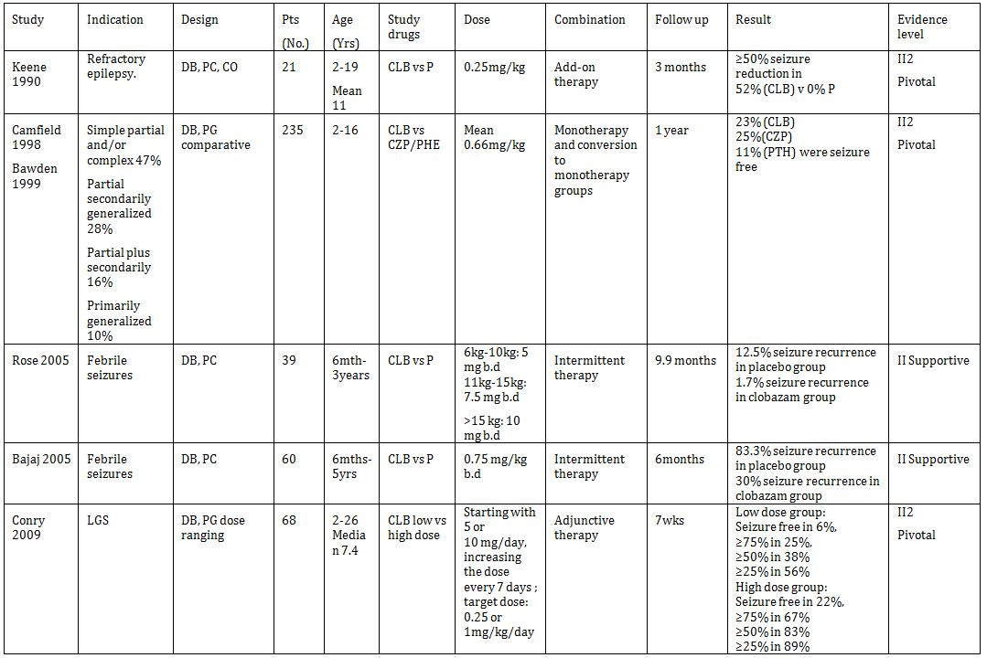

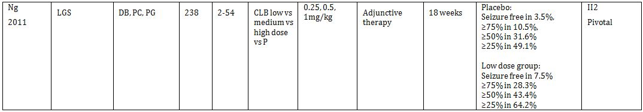

CLB=Clobazam. DB=Double blind. PC=placebo controlled. CO=cross-over. PG=parallel group. P=placebo. CZP=Carbamazepine. PHE=Phenytoin.

### Paediatric data

The submission included paediatric efficacy/safety data.

### Good clinical practice

The clinical studies in the submission complied with published guidelines CPMP/ICH/135/95 Note for Guidance on Good Clinical Practice (as annotated with TGA comments),[9] including appropriate ethical standards.

## Pharmacokinetics

Not evaluated.

## Pharmacodynamics

Not evaluated.

## Dosage selection for the pivotal studies

References and doses were:

* Keene et al.[10] 0.5mg/kg/d
* Conry et al.[11] 0.25mg/kg/d vs 1.0mg/kg/d
* Ng et al.[12] 0.25mg/kg/d, 0.5mg/kg/d, and 1.0mg/kg/d
* Bajaj et al.[13] 0.75mg/kg/d intermittent
* Rose et al.[14] 1-1.6mg/kg/d intermittent

## Clinical efficacy

### Indication

*Children (4 years of age and over):*

*As adjunctive therapy in patients with partial refractory epilepsy who are not adequately stabilised with their current anticonvulsant therapy*

### Pivotal efficacy studies

#### Study: Clobazam as an Add-on Drug in the Treatment of Refractory Epilepsy of Childhood[15]

##### Study design, objectives, locations and dates

A double-blind cross-over study assessing clobazam versus placebo for medically refractory epilepsy (defined as more than 4 seizures a month).

Total 8 months: 1 month baseline evaluation, 3 months treatment with clobazam or placebo, one month cross-taper, then 3 months treatment with the opposite treatment.

##### Inclusion and exclusion criteria

Inclusion criteria:

* age between 6 months to 18 years
* greater than 4 seizures per month
* no current benzodiazepine treatment

Exclusion criteria:

* underlying degenerative central nervous system
* brain tumour
* past history of poor drug compliance

##### Study treatments

Clobazam 0.5mg/kg/day initially. If a clinical response was not seen in the first month of phase two, the dosage was increased to 1.0 mg/kg/day providing there were no side effects.

If there was excessive drowsiness dosage was decreased by 0.25 mg/kg/day at that time regardless of the level of seizure control.

*Comment: The study is generally weak because participants serve as their own control i.e. the crossover nature of the design rather than a parallel group study and it is very small. However, at the time this may have been considered acceptable practice.*

##### Efficacy variables and outcomes

Seizure frequency was not reported at baseline and methods of ascertaining seizure frequency not reported.

The main efficacy variables were:

* A drug success was stated to have occurred if the patient had a 50% or more reduction in seizure frequency when on the clobazam in comparison to the baseline and placebo phases of the study

The primary efficacy outcome was 11 patients (52%) had a significant reduction (50% or greater) in their seizure frequency without significant side effects while taking clobazam. No patients had a significant reduction in their seizure frequency when in the placebo phase.

* no patients had an increase in their seizure frequency while taking clobazam.
* 2 patients had to withdraw during the clobazam phase because of severe behavioural changes which did not respond to lowering the drug dosage

*Comment: Instruments used to ascertain seizure frequency were likely to have been appropriate for the time.*

##### Randomisation and blinding methods

A master code list was kept in the pharmacy which could be broken if problems arose during the study. Breaking of the patient’s code was done by the pharmacist at the request of the treating physician. Such a patient was considered a failure and included in the analysis as such along with the reason.

##### Analysis populations

Not reported. All patients entered were implied to have been included in the analysis.

##### Sample size

The calculation of patient number was based on an expected number of successes for this drug (according to the literature) of approximately 60%. The expected percentage of children with refractory seizures who might stop having seizures spontaneously during an 8-month period was assigned a 10% figure. In order to see a significant difference between the groups a p value of 0.05 was chosen. The number of patients felt necessary to confirm the study hypotheses was calculated to be twenty.

##### Statistical methods

Not reported

##### Participant flow

A total of 21 patients were recruited: 10 received clobazam first, 11 received placebo first.

##### Major protocol violations/deviations

None reported.

##### Baseline data

Baseline data is shown in Table 2.

Table 2: Group characteristics after randomisation.

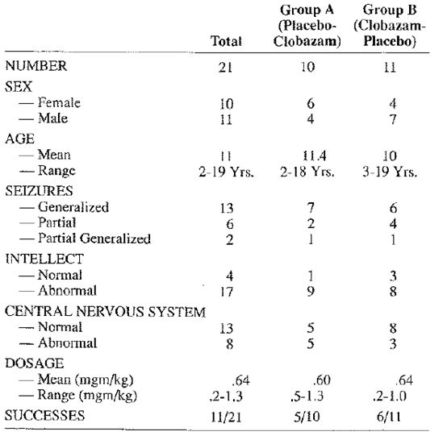

*Comment: The study participants were representative of a subset of the patient group for which the indication sought by the sponsor. Patients were children with refractory partial epilepsy. However, the generalisability of this study to the indication sought is poor because the sample size was small and the participants displayed a high prevalence of significant central nervous system abnormalities on clinical examination and most (17 of 21) had intellectual disability. On this basis, the study should be considered strongly supportive rather than pivotal.*

##### Results for the primary efficacy outcome

Increased responder rate reported with clobazam in 52% of 21 patients compared to none with placebo. However, no between group *p* value was reported that the evaluator could find.

#### Study: Clobazam has equivalent efficacy to carbamazepine and phenytoin as monotherapy for childhood epilepsy[16]

##### Study design, objectives, locations and dates

Design: There were three study arms. One arm included only children with newly diagnosed epilepsy but no previous AED treatment (drug naive). These patients were randomised to receive either CLB or CZP. The other two arms included patients with previous AED treatment (previously treated). They had previous treatment failure with one AED because of poor seizure control or with one or two previous AEDs due to side effects. Those in the previously treated group were assigned to one of two study arms-previous failure with CZP or with other AEDs. Those in the CZP failure group were randomised to receive CLB versus PHE. Those in the “other” failure group were randomised to receive CLB versus CZP.

Objectives: The trial was designed to follow the normal routines of clinical practice for treatment of children with newly diagnosed or newly treated epilepsy and to assess 1-year retention rates, seizure control, and side effects of “standard” AED therapies versus clobazam.

Location and dates: 14 paediatric neurologists from 14 Canadian sites 1991-6.

##### Inclusion and exclusion criteria

Patients were recruited from hospital outpatient department and neurologist’s private rooms.

Inclusion criteria:

* Patients aged 6 months to 17 years with simple or complex partial seizures or primary or secondary generalised epilepsy
* Drug naive or failing to respond to first line drug therapy for efficacy reasons or failing first or second line drug treatment for safety reasons

Exclusion criteria:

* LGS or myoclonic epilepsy
* Failing to respond to two drugs for efficacy reasons
* Seizures due to infections/neurodegenerative aetiology

##### Study treatments

Test Product:

* Clobazam 10 mg tablet, 0.5 mg/kg/day

Reference Products:

* Carbamazepine 200 mg tablet (Tegretol CR) 10 mg/kg/day
* Phenytoin 50 mg tablet (Dilantin Infatabs) 5 mg/kg/day

##### Efficacy variables and outcomes

The main efficacy variables were:

* Endpoints for the study were retention on the study medication for 12 months or discontinuation of the medication for any reason, including side effects or inadequate seizure control.

##### Randomisation and blinding methods

Within each study arm, drug assignment was randomised using a permuted block technique with a depth of 6 for each study centre. The study was double blind using a modified “double dummy” technique. This meant that each patient received both an active medication and a placebo. For example, in the drug naive arm, patients randomised to CLB also received a CZP placebo, and those randomised to CZP also received a CLB placebo.

##### Analysis populations

The analysis population included a heterogeneous group of paediatric patients with epilepsy (Table 3) requiring monotherapy having 2 or more attacks who were either drug naive, failed one previous AED due to lack or efficacy or failed one or 2 previous AEDs due to side effects.

Table 3: Characteristics of sample.

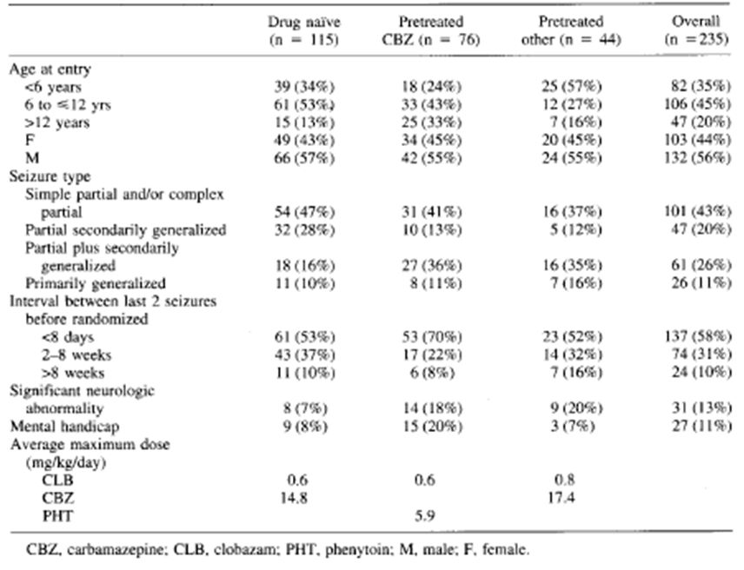

*Comment: This analysis population consists of paediatric patients requiring monotherapy treatment and is broadly different to the proposed indication by the sponsor (i.e. to use clobazam as adjunctive therapy). Patients in this study may well be reflective of a broad outpatient epilepsy practice but would be generally expected to respond better to antiepileptic drug treatment compared to patients requiring add-on clobazam for refractory epilepsy. This may be particularly true in the case of development of tolerance which may be expected to be less of a problem in a population requiring monotherapy compared to patients with treatment refractory partial epilepsy. It should be noted that the study largely included patients with partial epilepsy and it could also be argued that the study included patients previously refractory to one first line AED who had a short (less than 8 days) inter seizure interval for the last 2 seizures – and therefore the study likely would have included a proportion of patients similar to the proposed indication – with partial seizures who would subsequently have developed “refractory epilepsy”.*

*Moreover, the evaluator notes that the EMA guidelines recommend that the idiopathic generalised epilepsies “should be explored separately...”. The IGEs were lumped in with partial epilepsies and no separate analysis was done in this study.*

##### Sample size

Sample size was determined by assuming that CLB would be compared to standard therapy (CZP and PHE) with an alpha error of 0.05 and a power of 0.8 to detect a >20% difference in retention rate.

##### Statistical methods

For the primary analysis, all data were analysed according to the intention-to-treat principle, including all randomised patients. Baseline characteristics of the clinical population were investigated to determine their relationship to length of retention on the assigned study drug using Kaplan-Meier estimates and log-rank statistics. The distribution of covariates previously shown to influence seizure control was compared between the various arms of the study (age of onset, intellectual and neurologic handicap, interval between the last two seizures before randomization, and seizure type) using Mantel Haenzsel and chi-squared statistics. The distribution of baseline variables and the retention rates determined by these variables within study arms were compared to justify pooling of results across strata to make the clobazam versus standard therapy (CZP or PHE) comparison.

##### Participant flow

Fifteen Canadian study centres enrolled 236 subjects between August 1991 and February 1995. One family withdrew their consent before the child received any medication. All other 235 subjects were considered in this intention to treat analysis; however, 10 did not meet the exact entry criteria (two had only one seizure before treatment, seven had previous efficacy failure with two drugs, and one had a brain tumour). Inclusion of these 10 subjects in the analysis did not significantly alter the results.

Medication assignments were: clobazam 119, CZP 78, and PHE 38. One hundred fifteen patients were drug naive and randomised to clobazam (n = 63) or CZP (n = 51). One additional patient in this study arm inadvertently received PHE. One hundred twenty children were previously treated. Seventy-six had previously failed CZP and were randomised to receive clobazam (n = 39) or PHE (n = 37). Forty-four had failed other AEDs and were randomised to clobazam (n = 17) or CZP (n = 27).

##### Major protocol violations/deviations

None.

##### Baseline data

Baseline seizure frequency is not reported.

##### Results for the primary efficacy outcome

131 (56%) patients were retained on their initial medication for 12 months.

The estimated retention rate from survival curves for patients receiving CLB versus standard therapy (CZP or PHE) was the same at 12 months (54.6% ± 4.6 SEM vs. 56.9% ± 4.6; p = 0.7) (Figure 1). Retention by treatment arm is given in Figure 2. There was no significant difference in retention rate between drug naive and previously treated children (59.1% ± 4.6 vs. 52.5% ± 4.6; p = 0.6); however, the retention rate in the group previously treated with CZP was significantly less than the retention for the “other” pre treatment failure group (44.7% ± 5.7 vs. 65.9% ± 7.15; p = 0.02).

Figure 1: Survival curve for retention on clobazam versus standard therapy.

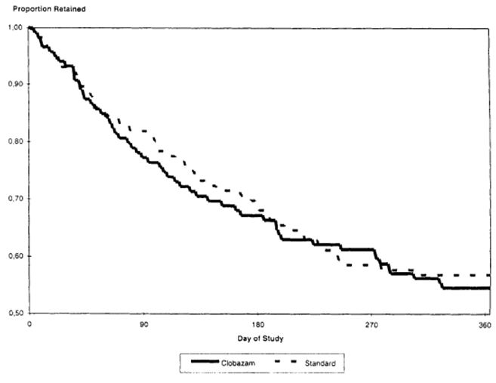

Figure 2: Clobazam monotherapy study percent of patients retained by treatment arm and study drug termination due to all reasons.

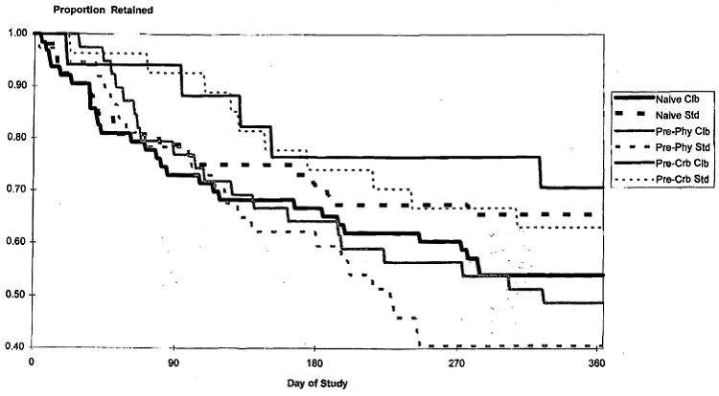

##### Results for other efficacy outcomes

A total of 51 (39%) of the 131 patients were seizure free for the entire 12-month study period. This included 23% of those initially randomised to CLB, 25% to CZP, and 11% to PHE.

Tolerance:

* + 1. Definition #1- Tolerance to an AED was identified when a child had no seizures for a critical period while receiving study medication and then had “break-through” seizures sufficient to lead to discontinuation of study medication, despite increases in dose. To be eligible for tolerance calculations, patients had to have an interval <2 months between their last two seizures before study entry and had to be treated in the study for at least 3 months. The critical seizure-free period was defined as three times the interval between the last two seizures before study entry. If the interval was <1 month, the critical period was assigned to be 3 months. In essence, tolerance occurred if there were no seizures for 3-6 months, then sufficient seizures to consider the medication a failure.

Analysis: 116 patients were therefore eligible for assessment of possible tolerance

Tolerance was noted in 7.5% (4 of 53) patients receiving CLB, 4.2% (2 of 48) receiving CZP, and 6.7% (1 of 15) receiving PHE (p = not significant).

* + 1. Definition #2 – the second definition was the occurrence of any seizure during the study. Using the second definition of escape, the overall percentage of patients exhibiting tolerance was 30.2%. There was no evidence of any difference in the percentages between the clobazam treated patient and the patients treated with standard therapy both within and across the strata (Table 4).

Table 4: Percent of patients (n) exhibiting tolerance by pre treatment and treatment group escape defined as any seizure.

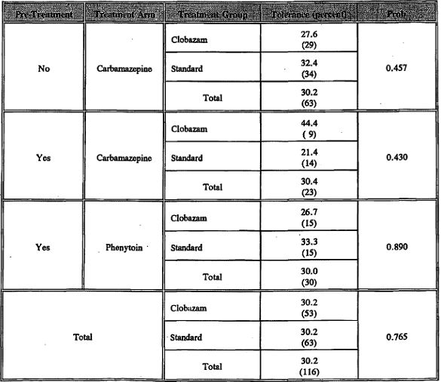

* + 1. Definition #3 – Tolerance as defined by termination from the study for reasons related to efficacy. The overall percentage was 6.9%. There was no evidence of any difference in the percentages between the clobazam treated patient and the patients treated with standard therapy both within and across the strata (Table 5).

Table 5: Percent of patients (n) exhibiting tolerance by pre treatment and treatment group escape defined as terminated for reasons of no efficacy.

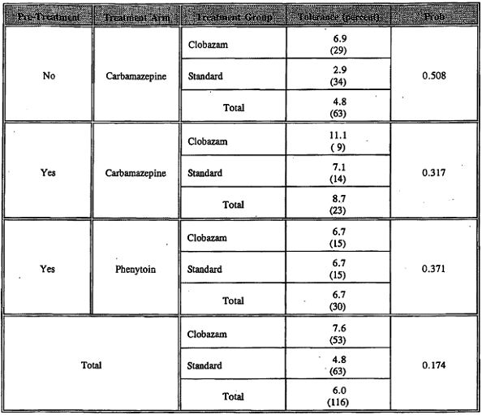

#### Study: Conry et al, clobazam in the treatment of Lennox-Gastaut syndrome[17]

##### Study design, objectives, locations and dates

This study was designed as a “Phase II” multicentre, randomised, double-blind, high/low dose comparison, parallel-group study conducted at 14 US sites. The study compared two arms, low and high CLB dose as adjunctive therapy for drop seizures in patients with LGS.

##### Inclusion and exclusion criteria

Inclusion criteria:

* patients fulfilling criteria for LGS with onset age less than 11 years
* more than one type of generalised seizure including more than 2 drop seizures a week
* on 1-3 AEDs

Exclusion criteria:

* progressive neurological disease (except tuberous sclerosis)

*Comment: The study is limited to LGS and does not include refractory partial epilepsy patients.*

##### Study treatments

Patients with two or more drop seizures per week during the baseline period were placed in one of six weight groups and randomly assigned to either low-dose CLB (target dose of 0.25 mg/kg/day; maximum 10 mg/day) or high-dose CLB (target dose of 1.0 mg/kg/day; maximum 40 mg/day) treatment groups. Dosing was based on body weight up to a weight of 37.6 kg; at greater weights dosing was fixed at a maximum of 10 mg/day (low dose group) or 40 mg/day (high dose group) to provide a range of efficacious doses in the paediatric population with LGS.

During the titration period, patients started with either 5 or 10 mg CLB in divided (two) daily doses, increasing the dose every 7 days until reaching the target dose. Upon reaching the target dose, patients maintained the blinded dose for a 4-week maintenance period. Patients with low body weight in the low-dose group received 5 mg CLB as one of two daily doses, with placebo for the second dose.

*Comment: The lack of placebo comparator is unusual in a study of this nature. According the EMA guidelines “The pivotal add-on studies should have a randomised, double-blind, placebo-controlled parallel group study design.” However, use of more than one dose arm in this study provides some evidence for the clinically effective dose range as well as the optimal effective dose.*

*Also, it should be noted that no the maintenance period was shorter than the recommended 12 weeks (EMA guideline). So from this study it cannot be concluded that efficacy is not short lasting. Its principal limitations were its inability to examine habituation because of its short duration and lack of a complete examination of the dose response relationship. In this regard, I would consider the study strongly supportive rather than pivotal.*

*Data concerning potential withdrawal and/or rebound effects were also not generated at end of maintenance period as most patients entered the open-label extension study (61 of 68).*

##### Efficacy variables and outcomes

Throughout the study, the patient’s parent/caregiver maintained a daily seizure diary to record the number of seizures; specifically, any drop seizures.

* The primary efficacy analysis was the percent reduction in drop seizure rates (average per week) from the 4-week baseline period compared to the 4-week maintenance period within each treatment group.

*Comment: The primary efficacy variable accords with TGA-adopted guidelines.*

* Efficacy was also assessed as the proportion of patients in each treatment group considered treatment responders (patients with a ≥25%, ≥50%, ≥75%, and 100% reduction in drop seizures) using a one-sided Fisher’s exact test.
* The percent reduction in weekly nondrop seizures within treatment groups (Wilcoxon signed-rank tests) and between treatment groups (Wilcoxon rank-sum test) was also analysed.
* Responses on the investigator and parent/caregiver global evaluations were assessed and treated as continuous variables, and differences between the treatment groups were analysed using a one-sided t-test using the MITT population.

##### Randomisation and blinding methods

CLB was supplied in 5 mg tablets in blister cards for the titration period and open-label bottles during the taper period. Placebo was provided to ensure identical tablets and packaging across weight groups. An unblinded physician adjusted the patient’s dose during the taper period, upon transition to the open-label extension study, and during the open-label study.

##### Analysis populations

The intent-to-treat (ITT) population were appropriate and consisted of all randomised subjects who received study drug and had both a baseline and postbaseline measurement; the efficacy analyses were conducted using the modified intent-to-treat (MITT) population, which consisted of all randomised subjects who provided informed consent, took at least one dose of study drug, and had at least one efficacy measurement during the maintenance period.

##### Sample size

Not reported.

##### Statistical methods

The percent reduction in drop seizure rate (primary efficacy outcome) for each patient was calculated as: [(baseline drop seizure rate) maintenance drop seizure rate)/baseline drop seizure rate] * 100. The percent change in drop seizure rates from baseline to maintenance was analysed within each treatment group using one-sided Wilcoxon signed-rank tests, and between treatment groups using a one-sided Wilcoxon rank-sum test.

##### Major protocol violations/deviations

None reported.

##### Baseline data

Patients entering the study were diagnosed with LGS with median age of 7.4 years. Demographics were well matched between groups. Demographics were generally well matched between groups. Baseline seizure activity was somewhat higher in the high dose group. Only US patients were studied and there was a preponderance of Caucasians.

*Comment: The study involves patients with LGS. The sponsor states that for extension of the indication to include childhood refractory epilepsy is that LGS is a “worst case” test model for epilepsy therapies. With regards to short term use of clobazam in LGS, in addition to the current understanding of the role of benzodiazepines in seizure suppression[18] and the large amount of preclinical and open label data available, this contention is considered supported by the evaluator.*

##### Results for the primary efficacy outcome

* The primary efficacy analysis was the percent reduction in drop seizure rates (average per week) from the 4-week baseline period compared to the 4-week maintenance period within each treatment group.
* Outcome: Baseline seizure activity was somewhat higher in the high dose group. Only US patients were studied and there was a preponderance of Caucasians. Results of the primary endpoint analysis are presented in the table below (transcribed from the statistical review). The high-dose group exhibited statistically significant greater seizure control than did the low-dose group (Table 6).

Table 6: Primary endpoint analysis: maintenance period percent change form baseline in drop seizures.

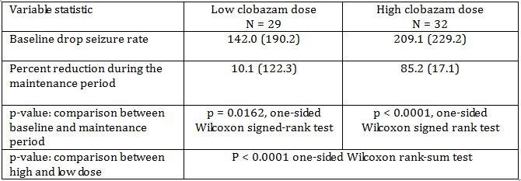

##### Results for other efficacy outcomes

* Efficacy was also assessed as the proportion of patients in each treatment group considered treatment responders (patients with a ≥25%, ≥50%, ≥75%, and 100% reduction in drop seizures) using a one-sided Fisher’s exact test.
* Outcome: Percentage of treatment responders in weekly drop seizures was higher within each classification (Figure 3).

Figure 3: Percentage of treatment responders in weekly drop seizures by classification.

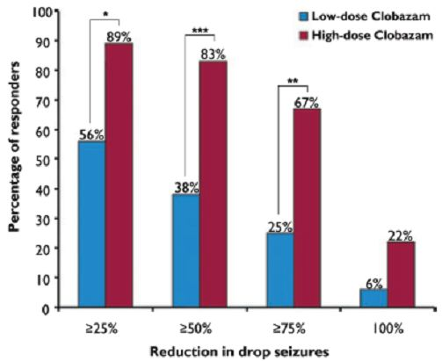

One-sided Fisher’s exact test: *p = 0.0025, **p = 0.0006, ***p = 0.0001. Low-dose (0.25 mg/kg/day clobazam), n = 32; high-dose (1.0 mg/kg/day clobazam), n = 36.

* The percent reduction in weekly nondrop seizures within treatment groups (Wilcoxon signed-rank tests) and between treatment groups (Wilcoxon rank-sum test) was also analysed.
* Outcome: In the low-dose group, the percent change in nondrop seizures from baseline (9 ± 92%, n = 19) was not significant (p = 0.1466), whereas in the high-dose group, the percent change in nondrop seizures from baseline (59 ± 55%, n = 22) was significant (p < 0.0001).
* Responses on the investigator and parent/caregiver global evaluations were assessed and treated as continuous variables, and differences between the treatment groups were analysed using a one-sided t-test using the mITT population.
* Outcome: In the parent/caregiver global evaluations, patients in the high-dose group were more likely to show significant improvements in overall symptoms compared with the low-dose group. At end of maintenance period, the percentage of patients considered to be much improved or very much improved increased in the high-dose group (27 of 29, 93%), but decreased in the low-dose group (12 of 28, 43%). Similarly, the high-dose group showed significantly lower scores (i.e., greater improvement) than the low-dose group at the end of the maintenance period (1.8 vs. 2.8, p < 0.0001).

*Comment: This study strongly supports the results of the pivotal study[19] and provides further evidence for the efficacy of clobazam in the adjunctive treatment of seizure types (both drop and non-drop seizures) associated with LGS. The maintenance period is too short to address the issue of tolerance (as addressed in the pivotal study[20]). This study supports the proposed dosing by showing superior efficacy of the high dose arm over the low dose arm.*

#### Study: Ng et al, Randomised, phase III study results of clobazam in Lennox-Gastaut syndrome[21]

##### Study design, objectives, locations and dates

A Phase III, Double-Blind, Placebo-Controlled, Efficacy and Safety Study of clobazam as adjunctive therapy in patients with Lennox-Gastaut Syndrome (CONTAIN). A total of 238 patients were randomised, including 165 patients at 33 sites in the United States, 55 patients at 13 sites in India, and 18 patients at 5 sites in Europe and Australia; 177 patients (74.4%) completed the study.

##### Inclusion and exclusion criteria

Patients aged 2-60 years weighing ≥12.5 kg were eligible to participate in the CONTAIN trial if they had onset of LGS before 11 years of age. A clinical diagnosis of LGS was evidenced by ≥1 type of generalized seizure (including drop seizures) for ≥6 months and a previous EEG report documenting generalized, slow spike-and-wave (≤2.5 Hz) patterns. Patients had to have ≥2 drop seizures a week during the 4 week baseline period.

*Comment: This study focuses specifically on LGS patients with ≥2 drop seizures a week.*

##### Study treatments

The study included 4-week baseline, 3-week titration, and 12-week maintenance periods, followed by either continuation in an open-label study or a 2- or 3-week taper period, depending on weight, with a follow-up visit 1 week after last dose.

On day-1, patients were stratified by weight (12.5 kg to ≤30 kg, >30 kg) and Clobazam 5-mg tablets and matching placebo tablets were supplied. During titration, clobazam 5 mg/day or 10 mg/day or placebo (in divided doses) was initiated, and dosage was increased per schedule every 7 days until the assigned target dosage was attained. At any time beginning with week 1 during titration, investigators could decrease daily dosages by a single tablet (placebo or clobazam 5 mg/day) if patients developed any signs or symptoms representing difficulty tolerating study drug.

*Comment: Data concerning potential withdrawal and/or rebound effects were also not generated at end of maintenance period as most patients entered the open-label extension study (206 of 238).*

##### Efficacy variables and outcomes

* The primary efficacy endpoint was percentage decrease in the average weekly rate of drop seizures from the 4-week baseline period to the 12-week maintenance period. A secondary efficacy assessment included percentage decreases in average weekly rate of nondrop seizures.

*Comment: The primary efficacy variable accords with TGA-adopted guidelines.*

* Responder rates (percentages with ≥25%, ≥50%, ≥75%, and 100% decreases in drop seizures from baseline to maintenance period)
* Physicians’ and caregivers’ global evaluations of the patients’ overall changes in symptoms over time

##### Randomisation and blinding methods

Patients were randomly assigned (through central randomization via interactive voice response system) to one of 4 groups:

1. placebo;
2. low-dosage clobazam: target of 0.25 mg/ kg/day (maximum, 10 mg/day);
3. medium-dosage clobazam: target of 0.5 mg/kg/day (maximum, 20 mg/day); or
4. high-dosage clobazam: target of 1.0 mg/kg/day (maximum, 40 mg/day).

##### Analysis populations

All 238 randomised patients were included in the safety population. As prespecified following discussions between Lundbeck Inc. and the FDA, efficacy analyses were performed for the mITT population, which included all randomised patients who had baseline data, ≥1 dose of study drug, and ≥1 daily seizure measurement during the maintenance period.

The mITT population excluded 21 patients who did not have≥1 daily seizure measurement during the maintenance period. Thus, efficacy analyses included 217 patients (57 for placebo and 53, 58, and 49 for the low-, medium-, and high-dosage clobazam groups).

##### Sample size

Sample size calculations were based on percentage decreases in weekly drop seizures rates observed in the Phase II study (85.3%, clobazam 1.0 mg/kg/day; 12.0%, clobazam 0.25 mg/kg/day) and estimated decreases of 36.4% for clobazam 0.5 mg/kg/day and 10% for placebo. Based on an assumed overall standard deviation of 91.6% and 2-tailed significance at 0.0025, 46 patients per group (184 total) would provide 80% power to detect a significant difference from placebo, resulting in a total of 216 randomised patients (assumes 15% dropout rate), and a total of 240 enrolled patients (assumes 10% dropout rate during baseline) needed.

##### Statistical methods

The primary efficacy endpoint was evaluated by ANCOVA, with percentage decrease in drop seizures as the dependent variable and treatment, pooled centre, and baseline drop seizure rate as the independent variables. Conventional statistical significance is based on p ≤ 0.05. However, superiority of clobazam to placebo with p ≤ 0.01 was considered robust statistical evidence in this single multicentre study, consistent with discussions with the FDA prior to initiation of the study. For the primary efficacy variable, a test for linear dosage response was included and was based on equally spaced treatment groups in the primary ANCOVA model.

The percentage decreases in average weekly rate of nondrop and total (drop and nondrop) seizures from the baseline to the maintenance period were calculated via the same ANCOVA model described for the primary endpoint. The same ANCOVA model was also employed to analyse the rank-transformed percentage decreases in weekly rates of nondrop seizures. Responder rates (percentages of patients with ≥25%, ≥50%, ≥75%, and 100% decrease in drop seizures) were calculated through logistic regression, with responder as the dependent variable and treatment, centre, and baseline seizure rate as independent variables. Physicians’ and caregivers’ global evaluations over time were calculated using the Cochran-Mantel-Haenszel test, including treatment and pooled centre as factors.

##### Participant flow

A total of 238 patients were randomised into 4 parallel treatment arms.

##### Major protocol violations/deviations

At study inception, the protocol permitted patients to easily discontinue from (CONTAIN) and enter an open-label extension. This led to many premature discontinuations within 4 weeks of starting therapy. To address this issue, the study protocol was revised in October 2008, after 81 patients had enrolled. With the amendment, patients whose seizures worsened were required to have completed week 9 of the study (i.e., after an adequate trial of study drug) before discontinuing and entering the open-label extension. At the time of the amendment, 29 (36%) of 81 enrolled patients had discontinued, 26 before the amendment went into effect and 3 after. Twenty-three of those 29 entered the open-label extension study. Following the amendment, 157 patients enrolled, of which 32 (20%) discontinued. Further, 9 of these 32 entered the open-label extension study.

##### Baseline data

Patients entering the study were diagnosed with LGS with mean age of 12.4 years. Demographics were well matched between groups. There was a preponderance of Caucasians (61.8% overall).

*Comment: The study involves patients with LGS. The sponsor states that for extension of the indication to include childhood refractory epilepsy is that LGS is a “worst case” test model for epilepsy therapies. With regards to short term use of clobazam in LGS, in addition to the current understanding of the role of benzodiazepines in seizure suppression[22] and the large amount of preclinical and open label data available, this contention is considered to be supported by the evaluator.*

##### Results for the primary efficacy outcome

* The primary efficacy endpoint was percentage decrease in the average weekly rate of drop seizures from the 4-week baseline period to the 12-week maintenance period. A secondary efficacy assessment included percentage decreases in average weekly rate of nondrop seizures.
* Outcome: Significant mean percentage decrease in drop and nondrop seizures from baseline to maintenance period in all treatment groups with clobazam but not placebo. There was a linear trend (p ≤ 0.0001) of increasing efficacy with increasing dosage in drop seizures. For nondrop seizures, the rank-transformed percentage decrease in weekly seizure rates was greater for the high-dosage group vs. placebo (p = 0.0070) (Figure 4).

Figure 4: Mean percentage decreases (95% CI) in weekly rate of seizures from the baseline to maintenance period.

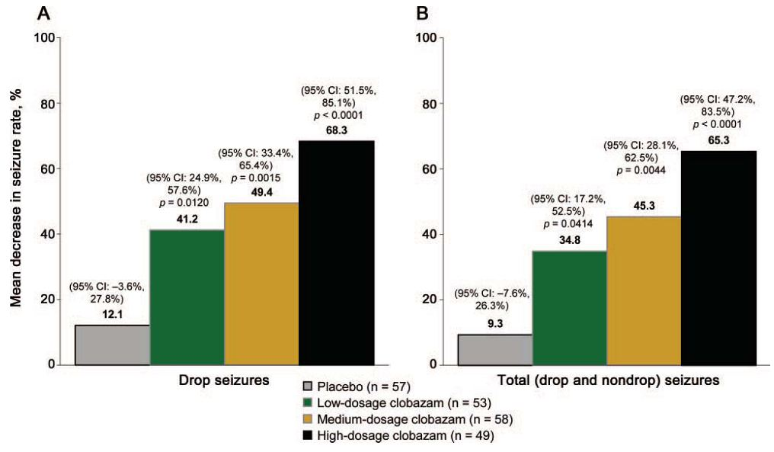

##### Results for other efficacy outcomes

* Responder rates (percentages with ≥25%, ≥50%, ≥75%, and 100% decreases in drop seizures from baseline to maintenance period)
* Outcome: Percentages of patients with ≥25%, ≥50%, ≥75%, and 100% decreases from baseline to maintenance period in average weekly rate of drop seizures increased with increasing clobazam dosage. The logistic regression model was unable to provide valid estimates of statistical significance for the 100% response threshold. *p <0.01 vs. placebo. **p <0.05 vs. placebo (Figure 5).

Figure 5: Responder rates.

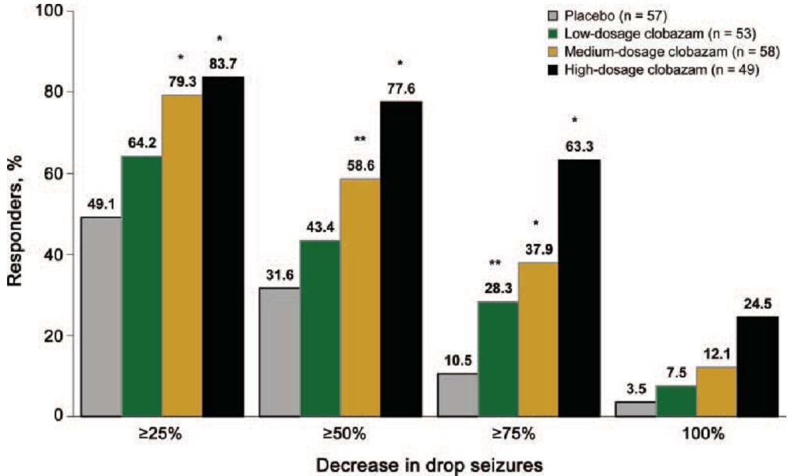

* Physicians’ and caregivers’ global evaluations of the patients’ overall changes in symptoms over time.
* Outcome: All 3 clobazam dosages led to significant improvements in clinician and caregiver’s global evaluations (Figure 6).

Figure 6: Physicians and caregivers’ global evaluations.

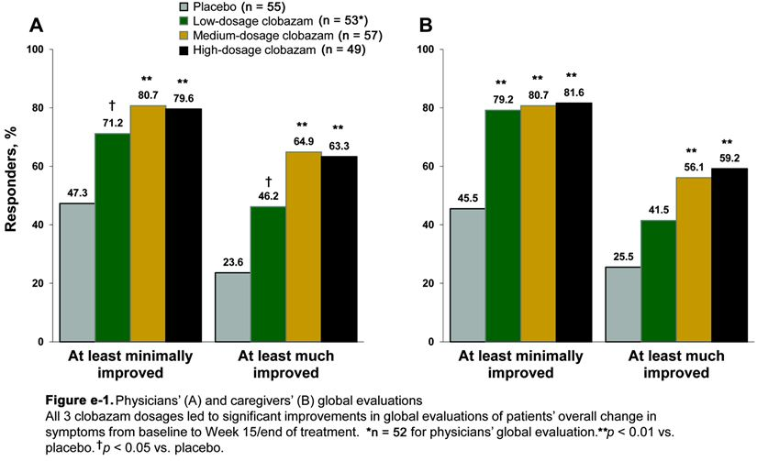

Tolerance: Examination of tolerance was a particularly important secondary endpoint. This was analysed by comparing the percent of patients achieving a ≥ 50% reduction in average weekly rate of drop seizures from baseline to the first 4 weeks of the maintenance period who then experienced a return to baseline seizure during the last 4 weeks of the maintenance period or discontinuation due to a lack of efficacy. The percent of patients fulfilling this criterion were then compared amongst groups. According to this analysis, 5.3% to 9.5% of patients in the different drug treatment groups fulfilled the definition of tolerance as compared to 5.6% patients in the placebo groups. An additional analysis of tolerance based on responder analyses showed that the percent of CLB subjects with no change or improvement from the first 4 weeks to the last 4 weeks of the maintenance period in this study was greater than the percent of CLB subjects who worsened or withdrew in each treatment group.

*Comment: These data are suggest that no obvious significant tolerance over the studied period. The evaluator contends that there may be two problems with the first analysis to allow the conclusion of no tolerance: 1) the sponsor is limiting themselves to selecting only patients who responded with a 50% or greater reduction in seizures during the first 4 weeks, 2) the sponsor’s criteria for a complete return to baseline during the last 4 weeks to define tolerance is too strict. Furthermore, this analysis does not provide a simple quantitative measure of tolerance.*

*According to the FDA evaluation for clobazam in LGS,[23] a further analysis performed to evaluate for missing data, however, partially addresses this issue. The percent reduction for patients in the first and last 4 weeks of the maintenance period to the baseline was compared and no pertinent decrement was observed. This, of course, may be subject to the effect of dropouts, which was about was about 6 to 20% in different groups. However, this analysis was supportive of minimal or no tolerance. To further explore tolerance, a primary endpoint last observation carried forward analysis of the modified intent-to treat set, comparing the percent reduction seizure frequency from baseline to the first 4 week and to the last 4 weeks. In this analysis, patients who dropped out before the last 4 weeks had their last 4 weeks carried forward. This analysis is presented in the table below as a difference from placebo (Table 7).*

Table 7: Percent reduction in seizure frequency (change from baseline), as compared to placebo, during the first 4 and last 4 weeks of the maintenance period – an LOCF analysis of the MITT set.

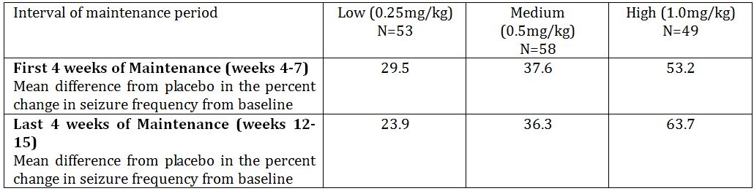

*Comment: Although it appears that there was a mild desensitization effect in the low dose, none were appreciated in the higher doses. Benzodiazepine tolerance may often be observed within the time period studied although the evidence for the development of tolerance in open label studies will be presented later by the evaluator. In that case, the present study should be adequate to demonstrate the phenomena. Moreover, an analysis of an extension open label study (OV-1004) was presented to the FDA for the purposes of registration of clobazam in LGS in the US.[24] The persistence of therapeutic effect was demonstrated in the open label extension study for up to periods greater the one year. This latter data is not presented in the literature based submission to the TGA so could not be assessed by the evaluator.*

### Other efficacy studies

#### Rose et al.[25]

In 2005, Rose and colleagues[26] reported the results of a prospective, randomised, double-blind placebo- controlled study evaluating the efficacy of intermittent clobazam therapy in preventing the recurrence of febrile seizures. Neurologically normal children between 6 months and 3 years of age with a history of febrile seizures and no evidence of acute CNS infection or EEG abnormality were included into the study; 19 children in a clobazam group and 20 in the placebo group were randomly allocated. The dispensed medication was administered at the onset of fever and continued for 48 hours irrespective of the duration of fever. The children were then monitored for seizures and adverse effects of clobazam. The children were followed up for a mean period of 9.9 months. Mean number of febrile episodes in the clobazam group was 3.1 and in placebo group 2.56. Six (12.5%) of the 48 episodes in placebo group and one (1.7%) of 60 episodes in clobazam group had seizure recurrence which is statistically significant (p=0.04) providing evidence that intermittent clobazam therapy is an effective measure in the prevention of recurrence of febrile seizures.

*Comment: This study was largely conducted to modern GCP standards although some weaknesses are noted – such as the lack of systematic evaluation of AEs. Although this study involved intermittent therapy in febrile seizures, it provides relevant supportive evidence of efficacy in partial epilepsy for short-term use.*

#### Bajaj et al.[27]

In 2005, Bajaj and colleagues[28] reported the results of a double blind placebo controlled trial involving sixty patients aged 6 months to five years presenting with febrile seizures. The patients in the treatment group (group A) were given intermittent prophylactic clobazam at 0.75 mg/kg body weight twice daily and the placebo group (group B) were given placebo tablets during the course of fever. After treatment with clobazam seven and two patients had generalized and partial seizures, respectively while 23 and two patients had generalized and partial seizures for group B, respectively. Thus, recurrence of FS was observed in 30% (nine) patients in group A and 83.3% (25) in group B. The average number of seizures preceding six months was 4.33 ± 2.78 in the clobazam group and, this declined significantly to 0.7 ± 1.37 (p <0.001), while in the placebo group no decline in seizure frequency was observed.

*Comment: This study is considered to provide similar supportive evidence as the study from Rose et al.*

### Analyses performed across trials (pooled and meta analyses)

Table 8 summarises previously submitted randomised controlled data in adults. Tables 9 and 10 summarise open label studies in children and adults.

Table 8: Randomised controlled trials in adults (presented in 1995 literature based submission).

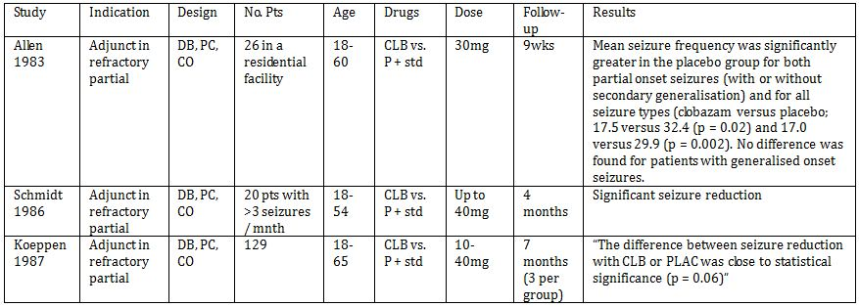

Table 9: Open studies in children.

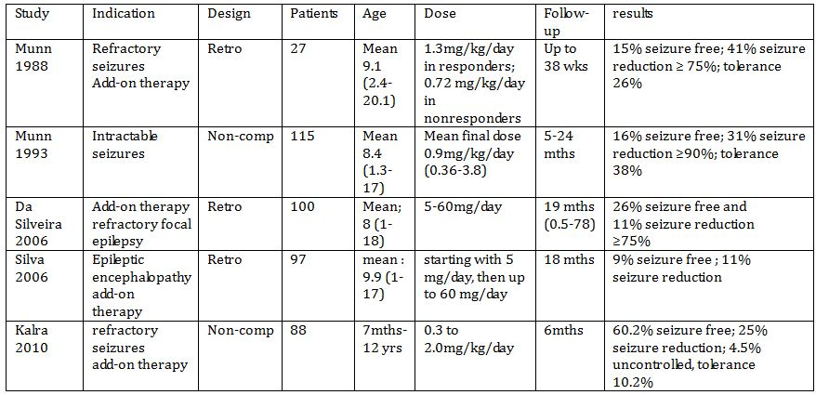

Table 10: Open studies in children and adults.

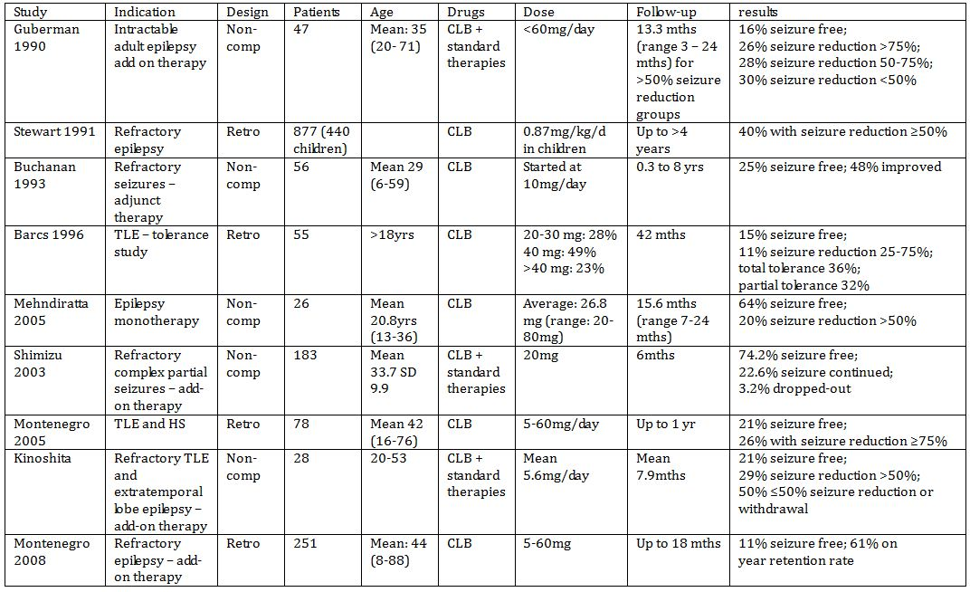

The sponsor reports that the five non-comparative studies provide consistent supportive evidence of clobazam as an add-on therapy in intractable epilepsy in 427 children; the seizure free rate reached between 9 and 60.2% and improvement (reduction by 50 or 75% of seizure frequency) was observed in 11 to 41% further patients. The large Canadian retrospective analysis collected data for up to 440 children and the consistency of the results from these studies would support a consistent effect.

*Comment: the evaluator agrees that taken overall, the open label data is consistent and provides supportive evidence for the efficacy of clobazam as an add-on therapy in epilepsy but evaluation of tolerance in open label studies appears less consistent even allowing for markedly differing methodologies.*

*Discussion of Persistence of Efficacy and/or Tolerance Effects in open label literature:*

*In approximately 40% of patients who respond initially to clobazam, it has been reported that there is a relative or absolute loss of efficacy. This may occur from a few days up to 27 months after starting therapy.*

*In open label studies:*

* + - Gastaut reported good results were seen in 75% in 140 epilepsy patients treated with add on therapy with clobazam. However, in only 50% of the cases at the end of the treatment period. In 45 of the 107 patients who experienced an initial benefit there was a reduction in the anticonvulsant properties of clobazam during the course of the trial. In 17 cases, this phenomenon of exhaustion was partial and clobazam treatment was continued but loss of effect was total in 28 cases. In these patients clobazam treatment was withdrawn. It was observed that the reduction in anti-epileptic effect occurred in general before month 3 of treatment (around day 45 in 50% of the patients) but was sometimes very early, developing during the first weeks or even the first days.[29]
    - In the study by Allen and colleagues, there was no evidence of tolerance in a 9 week treatment period. (Tolerance was assessed by noting the frequency of seizures in the first and last halves of the active treatment period.)[30]
    - Schmidt and colleagues assessed in a double-blind add-on trial in 20 patients with chronic complex partial seizures uncontrolled by maximally tolerable daily dosage of standard antiepileptic drug therapy. They reported only four (56%) of nine patients maintained the good initial therapeutic response of more than 75% reduction in seizure frequency to clobazam reached at months 1 or 2 when re-examined at month. However, during month 3 of the active treatment, four other patients became completely controlled or improved by more than 75%.[31]
    - In an open label study of clobazam in children with resistant seizures in 17 patients (34%), seizures increased again in frequency after responding initially to clobazam. This exhaustion of effect occurred usually within 4 months of starting clobazam. In 11 of these 17 patients, there was only a partial relapse.[32]
    - A retrospective study by Singh and colleagues of patients with intractable epilepsy found 50 of 173 patients who were very good responders (>74% seizure reduction). 25 of these at a sustained response and 25 developed tolerance which was defined as a relapse greater than 50% of pre clobazam seizure frequency. The mean interval to development of tolerance was reported 8.9 plus minus 7.9 months.[33]
    - The Canadian Clobazam Cooperative group report of 1991. Using a standard case report, 32 neurologists, who had each treated greater than or equal to 10 patients, provided retrospective data for 877 patients. 20% stopped Clobazam for poor efficacy 4% for safety reasons and 8% for both. Tolerance was given as a reason for discontinuation in 9.2% of 877 patients.[34] In 43 patients, treatment was terminated within 1 year. In 102 patients, intermittent clobazam treatment was used in an attempt to prevent the development of tolerance. Fifty one (50%) of these patients continued clobazam therapy as drug effect was maintained. For 13 patients (12.8%), intermittent therapy was discontinued because of tolerance. This suggested tolerance to occur equally frequently whether clobazam was used intermittently or as regular maintenance therapy.
    - In an open label study of add on therapy with clobazam in patients who did not respond to 3 or more conventional anti-epileptic drugs, tolerance (defined as when the efficacy was initially greater than 50% reduction - or better and later became worse than the initial efficacy) occurred in 24% mean 4.5 months (2 -12 months).[35]
    - Munn reported experience with 27 patients with severe intractable epilepsy disorders,[36] 25 with intellectual disability treated in an open label fashion with clobazam. 11 patients experienced greater than 75% reduction seizure frequency treated with clobazam for mean 44 weeks. 16 patients were non responders (7 were secondary nonresponders due to tolerance).
    - In another report, Munn examined the effect of clobazam on seizure control in 115 children with intractable seizures average age 8.4 years.[37] Tolerance: defined as an increase in seizure frequency after an initial improvement in seizure control was seen in 30 of 79 patients who initially exhibited a greater than 50% improvement in seizure control (38%). Tolerance occurred two weeks to 24 months after clobazam was added mean time to tolerance 7 months median 3 months.[38] Complete tolerance was seen in 9 patients, partial tolerance in 9 and partial tolerance that responded to an increased dose of clobazam in 12 patients.
    - In a cohort of 88 children reported by Kalra and colleagues with ‘refractory’ epilepsy who were started on clobazam as add-on therapy, good seizure control was reported in 85%. Tolerance developed in 6% at 3 months and 10.2% at 6 months.[39]
    - In an open label extension of a double blind cross over study, 11 children had >50% reduction in seizure frequency with clobazam, and only 2 experienced an increase in seizure frequency after 2 years of treatment.[40]
    - Martin reported evidence of "exhaustion of drug effect in 15 of 49 patients with an onset from 1-12 months (median 6.5 months) with a return to fits and the need to increase clobazam dosage in order to achieve control.[41]
    - In 1990, Guberman and colleagues presented the results of a study involving 47 adults with intractable seizures over periods ranging from 6 months to 12 years (mean 4 years).[42] Tolerance was observed in 6 patients (14%). Clobazam had no effect on the blood levels of other anti-epileptic drugs, except in 2 patients taking phenytoin which increased within days of starting clobazam, but decreased when the clobazam dose was lowered. Clobazam was discontinued in 13 of the patients (28%); 7 due to side effects at a mean dose of 18.5 mg/day, lack of efficacy in 4 cases and increased seizures in 2 patients.
    - In 1993, Buchanan reported the use of clobazam in clinical practice with protracted follow up to 8 years. A total of 56 patients, aged 6 to 59 years (mean 29 years) with 34 having partial seizures (18 CPS + GTCS, 14 CPS and 2 SPS, 15 primary generalised epilepsy and 7 patients had generalised seizures with handicap were studied. Of the 56 patients, 28 (50%) continued to take the drug for 3 months to 8 years (mean 3 years) after commencing it. A total of 28 patients ceased taking the drug: 11 due to tolerance, 10 due to a lack of effect, 5 due to side effects, one patient died and the final patient simply ceased taking the drug. Tolerance was therefore seen in 19.6% of patients and occurred from 3 months to 3 years (mean 1.36 years) after commencing clobazam.[43]
    - In 1996, Barcs and Halasz reported the results of a retrospective study exploring the loss of efficiency of clobazam treatment (development of tolerance) when used as an add-on therapy in the management of 55 patients >18 with TLE experiencing seizures more frequently than weekly. Tolerance was defined as the development of partial or complete loss of CLB’s therapeutic effectiveness, which was indicated by the return of seizures compared to a previous improved state. The evolution of tolerance was estimated as follows. After, 1 month the total tolerance rate was 3 %. At 2.5 months the total tolerance rate increased to 11 % and the partial tolerance rate was 3%. In the 6th month the total tolerance rate was 21 % and the partial 15%. After the first year of the treatment 27% had total and 25% partial tolerance. The tolerance process seems to slow down after one year. In the 18th month of treatment the tolerance rate increased to only 32 % and the partial to 27%. At the end of the second year of the treatment total tolerance was 36% and the partial 32%.[44]
    - In 2003, Shimizu and colleagues presented the results of a study conducted on 183 patients with intractable complex partial seizures using clobazam on add-on therapy. Complete remission was initially achieved in 61 patients, tolerance developed in almost half (49.2%) within the first 3 months, whereas 23 out of 31 patients (74.2%) who remained seizure free for the first 3 months continued to be so over the next 3 months.[45]

### Evaluator’s overall conclusions on clinical efficacy

Two well conducted randomised controlled studies show robust short to medium term efficacy of reduction in seizures (particularly the most disabling variety of seizures – drop seizures) in children with LGS.[46] The maintenance period in one study was adequate, according to EMA guidelines, to “establish that efficacy is not short lasting”.[47] These modern studies used appropriate efficacy outcomes and there were remarkably consistent results. For example, in the Phase II study the ≥50% responder rate for drop seizures was 83% at a dose of 1mg/kg/day[48] whereas in the Phase III study, the ≥50% responder rate for drop seizures was 77.6% at a dose of 1mg/kg/day.[49] Moreover, there was specific analysis to examine for development of tolerance in the Phase III study to suggest that there was no issue. Results of open label extension use for clobazam in LGS do not appear to have been included in the current submission. However, publically available efficacy evaluations in open label extension patients (a large majority of patients participating in the Phase II and III studies entered the open label extension – about 267 of 303 patients) done by the FDA looking for development of tolerance to clobazam in LGS patients did not suggest the development of significant issues.

Large experience with clobazam in epilepsy is displayed through six non comparative studies, including 867 children. These studies were prospective (n=2) or retrospective (n=2). Five of them described the use of clobazam as an add on therapy to AEDs. In most cases, the decision to initiate combination therapy was made after failure observed with several consecutive monotherapies with AEDs. Seizures for which the patients were included were mainly described as refractory or resistant to conventional AEDs.

Clobazam was administered at the initial daily dose of about 0.25-0.35 mg/kg/day and was then progressively increased until seizures were controlled or toxicity developed. The final dose ranged from 0.5 to 2 mg/kg/day. Clobazam was discontinued when the maximum tolerated dose was reached without seizure improvement or due to adverse event.

The primary endpoints were the number of seizure free patients and the rate of patients with a seizure reduction higher than 50%, 75% or 90%, with a follow up duration ranging from 3 months to >4 years. Given the variety of patients’ characteristics and of types of epilepsy, the results were rather homogeneous, with a seizure free rate of 9-25% (five studies; and another one at 41%), a ≥90% seizure reduction of 31% (one study), ≥75% seizure reduction of 11-41% (four studies), and ≥50% seizure reduction of 24-46% (five studies).

In the studies where clobazam was used as an add on therapy in intractable epilepsy in children; the seizure free rate reached between 9 and 41% and improvement (reduction by 50 or 75% of seizure frequency) was observed in 11 to 46% further patients. Further experience was analysed through studies mixing adults and children, of which a Canadian retrospective analysis collected up to 440 children. These studies further demonstrate the usefulness of clobazam as an add-on therapy in epilepsy.

The evaluator generally agrees with the sponsor’s conclusion that the current data suggests that for patients with drug refractory epilepsy, when used as an add-on treatment, clobazam may reduce the frequency of seizures although it is not possible to quantify precisely the treatment effect or perhaps duration of treatment effect.

The evaluator notes that the current submission does not fulfil the current adopted guidelines for evaluation of an AED as add on therapy for refractory partial epilepsy. The study by Keene and colleagues[50] cannot be considered as providing pivotal evidence. However, the sponsor has argued that LGS represents a worst case scenario for partial epilepsy and partial seizures in LGS patients were also improved by clobazam. This contention is supported by current preclinical models of epilepsy, long term (largely open label studies) of clobazam as add on therapy for partial epilepsy, and consensus expert guidelines.[51] The evaluator also notes that it is recommended by the EMA guidelines that LGS and partial epilepsy be studied separately mainly due to, presumably, the notion that drugs found effective in partial epilepsy may be ineffective in LGS rather than the other way round. The evaluator notes that while the one blinded, randomised study of clobazam as add on for refractory childhood partial epilepsy by Keene and colleagues[52] is inadequate by modern standards, it does provide supportive evidence that clobazam has at least short term efficacy in seizure reduction. Therefore it is reasonable to assume on the evidence presented that clobazam does have efficacy for the short to medium term treatment of refractory partial epilepsies.

On the other hand, the development of tolerance in patients treated with clobazam for refractory partial epilepsy is less well studied – particularly with regards to prevalence, time to onset and management. Open label studies generally support the development of tolerance within a few months of treatment initiation in partial epilepsy although tolerance may partially improve with further treatment titration. However, there are several reports of the late emergence of clinically relevant tolerance with clobazam as adjunctive therapy – this evidence seems to particularly relate to patients with partial or temporal lobe epilepsy.[53]

The evaluator notes that it has been asserted by some that even though tolerance might develop, this aspect may have been overemphasized in view of the fact that a long-term benefit figure of 28% could be expected without tolerance.[54] Moreover, the evaluator could not find any significant examples of rebound epilepsy when clobazam was withdrawn slowly (for example, over a period of 3 weeks).[55]

The evaluator notes that currently in Australia another benzodiazepine (a 1,4- benzodiazepine), clonazepam, is approved for use in “Neurologically proven epilepsy”. Clobazam may have a more favourable side effect profile than clonazepam for use in epilepsy.[56]

## Clinical safety

### Studies providing evaluable safety data

#### General adverse events (AEs)

##### Keene et al.[57]

A side effects record sheet was reviewed at each clinic visit.

##### Canadian study group for childhood epilepsy[58] and Bawden et al.[59]

Methods of AE determination: At study entry and at each follow up visit, a checklist of systemic and behavioural side effects was completed by the attending paediatric neurologist, based on spontaneous and elicited parental reports and physical examination. Behavioural side effects were characterised as externalising (for example, restless, aggressive) or internalising (for example, depressed, withdrawn) in nature. Symptoms were assessed using four levels of severity (none, mild, moderate, and severe). Side effects from this list were used in the analyses if they were ‘emergent events’, that is, if they emerged during treatment or increased in severity from baseline and were judged to be moderate or severe.

##### Conry et al.[60]

AE and SAE methods: The safety of CLB was evaluated by laboratory assessments (chemistry, haematology, and urinalysis), vital signs, electrocardiography (ECG), physical and neurologic examinations, and AE assessment. Treatment emergent AEs and serious adverse events (SAEs) were summarised by severity and relationship to study drug. The safety population consisted of all randomised patients who took at least one dose of the study drug.

##### Ng et al.[61]

AE and SAE evaluation was done in a manner similar to Conry et al.[62]

##### Rose et al.[63] and Bajaj et al.[64]

Assessors enquired after adverse effects.

#### AEs of particular interest, including neuropsychological measures

##### Canadian study group for childhood epilepsy[65] and Bawden et al.[66]

Neuropsychological assessments - methods: Neuropsychological assessments were competed at 6 weeks and 12 months after patients began to take the study medication. Areas of psychological functioning were chosen for examination on the basis of previous research showing sensitivity to AED effects. Tests were administered and scored by psychological technicians who were blind to medication status. None of the children were post-ictal at the time of the psychological assessments. Intelligence was assessed using the Wechsler Intelligence Scale for Children-Revised (WISC-R) Memory was assessed using the Verbal Learning subtest of the Wide Range Assessment of Memory and Learning, Nonverbal Selective Reminding Test, Continuous Recognition Memory Test, and the Digit Span subtest of the WISC-R. Psychomotor speed was assessed with the Grooved Pegboard Test, subtest 14 of the Underlining Test, and the Coding subtest of the WISC-R. Attention was examined using the Freedom from Distractibility Factor Score, obtained by averaging scores on the Arithmetic, Coding, and Digit Span subtests from the WISC-R, and by using the average number of correct items on subtests 1, 2, 3, 4, 5, and 13 from the Underlining Test. A measure of impulsivity was obtained by averaging the numbers of errors of commission on these same subtests of the Underlining Test.

#### Laboratory tests

##### Keene et al.[67]

At the end of each maintenance phase, patients had a repeat EEG, Complete Blood Count (CBC), platelet count, aspartate transaminase (AST), blood urea nitrogen (BUN), thyroid stimulating hormone (TSH), total albumin (TA), thyroxine (T-3 or T-4), creatinine, blood glucose, and Serum Anticonvulsant Level determination(s). No abnormal values for complete blood count, platelet count, urea, creatinine, glucose, ALT, TSH, T-3 or T-4 occurred.

* + - 1. ***Canadian study group for childhood epilepsy[68] and Bawden et al.[69]***

Methods: Predose serum AED levels at 6 weeks, 6 and 12 months after randomisation, at the time of discontinuation of medication, and whenever levels were judged desirable by the treating physician. Patients had a complete blood count, platelet count, and BUN, creatinine, and AST. No other routine blood or urine screening was mandated in the absence of clinical signs or symptoms.

Results: No patient had screening laboratory tests that lead to discontinuation of study medication. One patient died from a ventriculoperitoneal shunt obstruction unrelated to study medication.

##### Ng et al.[70]

Methods: Safety assessments included laboratory assessments (chemistry, haematology, and urinalysis), physical and neurologic examinations, vital sign monitoring, and ECG monitoring.

#### Pivotal studies that assessed safety as a primary outcome

The study by Bawden and colleagues[71] was a pivotal study that assessed safety as a primary outcome.

#### Dose response and non pivotal efficacy studies

No dose response data available in supportive studies.

#### Other studies evaluable for safety only

These studies are not included in the efficacy analysis as they were primarily designed to assess tolerability/safety of clobazam.

##### Patat et al.[72]

The effects on memory and psychomotor performance and the subjective effects of three anxiolytic benzodiazepines (lorazepam 2 mg, diazepam 10 mg and clobazam 20 mg orally) have been evaluated in a double blind, placebo controlled, crossover study in 10 healthy volunteers. At each session, measurements were made prior to and + 3.5 h after drug administration, except in the case of REY’s test, which was presented at H + 1 h (learning) and was evaluated at H + 8 h and at H + 24 h (delayed recall). Single clinical doses of diazepam and lorazepam caused anterograde amnesia by disturbing acquisition, consolidation and retrieval. Clobazam did not impair memory. Lorazepam impaired performances in all the tests used to evaluate perception, immediate memory, reaction time, psychomotor skill and intellectual capacity. Diazepam caused a decrease in cortical arousal and the speed of perception of visual stimuli, whereas clobazam increased reaction time and reduced cortical arousal. Lorazepam caused a significant degradation of performance relative to the other two treatments.

##### Patat et al.[73]

The effects of various benzodiazepine tranquillizers (clobazam 20 mg, bromazepam 6 mg and lorazepam 2 mg) were investigated by posturography in 16 subjects in a controlled trial. Twelve received each of the three anxiolytics for 1 week in a crossover design, four received placebo for 1 week during the three successive treatment periods. A pharmacodynamic study was carried out after the first administration, and another assessment was done after 1 week of treatment. The first administration of lorazepam caused the most marked disturbances of body sway (increase of spectral energies, length and amplitude of the stabilogram). The first administration of lorazepam was also accompanied by an increase of the posturographic parameters, although less marked. Administration of clobazam did not produce any impairment of equilibrium, indicating that it is devoid of any sedative effect measurable by posturography. No changes of the postural sway can be detected on the measurement recorded 10 h after the last dose of 1 week’s treatment.

##### Trimble et al.[74]

Healthy volunteers as well as patients with epilepsy were studied for 2 weeks in a double blind crossover design to determine the effect of anticonvulsant drugs on cognitive function and behaviour. The healthy volunteers experienced significant deficits in performance with the four drugs examined, phenytoin, carbamazepine, sodium valproate, and clobazam. The most wide spread changes were seen with phenytoin, carbamazepine, sodium valproate, and clobazam did not interfere with tests of memory function. The results of the patients’ studies showed that:

1. when anticonvulsants are reduced, patients receiving polytherapy improve their cognitive function;
2. patients with high serum levels of anticonvulsant drugs demonstrated more cognitive impairment than those with low levels;
3. when carbamazepine is substituted for another anticonvulsant, cognitive function is improved; and
4. in patients receiving monotherapy, high serum levels are linked to greater cognitive impairment than lower levels and the profile of changes differs between the drugs.

### Patient exposure

The literature review identifies 2236 subjects exposed to clobazam. However, exposure information was unknown in the Psychiatry studies in 389/1484 patients, leaving only 1095 patients with exposure information in those studies. Exposure is shown in Table 11.

Table 11: Estimated clobazam exposures in unique subjects.

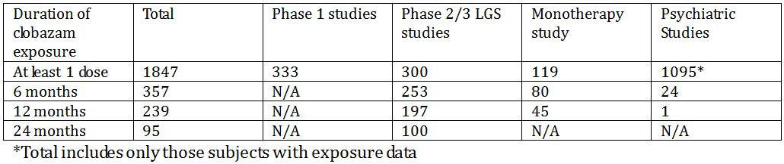

In the Phase II/III trials, subjects were exposed to clobazam at doses in the sponsor’s proposed recommended range (considering either the modal or maximum dose) and included monitoring for other AED levels. The potential clinical toxicity of clobazam with other AEDs has been examined[75] and potential interactions between clobazam and phenobarbitone, phenytoin, felbamate, valproate, oxcarbazepine and carbamazepine have been reported.[76]

#### Demographics

In Phase I trials, the age range was 18-74 years. In the Phase II/III trials, the age range was 1.8 to 54 years. The mean age in the study by Conry and colleagues[77] was approximately 9 years, and in Phase III study[78] the mean for each dosage was approximately 9-11 years. In the monotherapy study[79] the average age was approximately 8 years. The percentage of males in each study was slightly higher than the percentage of females, and was 59-64%. In the Phase I-III trials, subjects were predominately white (≥ 58%). Race data was not recorded in the monotherapy study.[80] In the Phase III study[81] approximately 70% of the subjects were from the US, approximately 23% from India, and approximately 7% from the rest of the world. In the study by Conry and colleagues,[82] all subjects were from the US.

* 1. **Adverse events**
     1. **All adverse events (irrespective of relationship to study treatment)**
        1. ***Pivotal studies***

Data is presented from Phase II/III studies in LGS, a monotherapy study comparing CLB to CZP and PHE and a small crossover study by Keene and colleagues.[83] Amalgamation of data would be difficult due to differing methodologies. No specific safety or methodological issues are identified.

##### Other studies

###### Rose et al.[84]

Rose and colleagues reporting on the intermittent use of clobazam versus placebo for the prevention of febrile convulsions reported that the three major side effects reported were drowsiness, ataxia and weakness. Drowsiness and weakness were present almost equally in both the clobazam and the placebo group (drowsiness: 46.8% and 52.1% and weakness: 4.8% and 4.2%, respectively). The difference was not statistically significant. Ataxia was present in 5 (8.3%) in clobazam group and none in the placebo, the difference being statistically significant (p=0.04).

###### Bajaj et al.[85]

Bajaj and colleagues reported on the intermittent use of clobazam versus placebo for the prevention of febrile convulsions in children. No significant adverse effect except irritability was observed in four patients on clobazam.

Other studies include a range of smaller randomised studies as well as a broad range of reported open label studies and post marketing experiences.

#### Treatment-related adverse events (adverse drug reactions)

##### Pivotal studies

###### Keene et al.[86]

Two patients had to withdraw during the clobazam phase because of severe behavioural changes which did not respond to lowering the drug dosage.

###### Canadian study group for childhood epilepsy[87] and Bawden et al.[88]

Frequencies of emergent behavioural side-effects were low with three (12.5%) of the patients taking clobazam exhibiting externalising behavioural side-effects and three exhibiting internalising behavioural side-effects. Of the patients taking standard monotherapy, three (17.6%) exhibited internalizing behavioural side effects and two (11.8%) exhibited externalising behavioural side-effects. There were no differences between the clobazam and standard monotherapy groups in the frequencies of externalising (x2= 0.17, P=NS) or internalising (x2=0.82, P=NS) behavioural side-effects. The number of AEs described by checklist is given in Table 12.

Table 12: Number of adverse events described by checklist.[89]

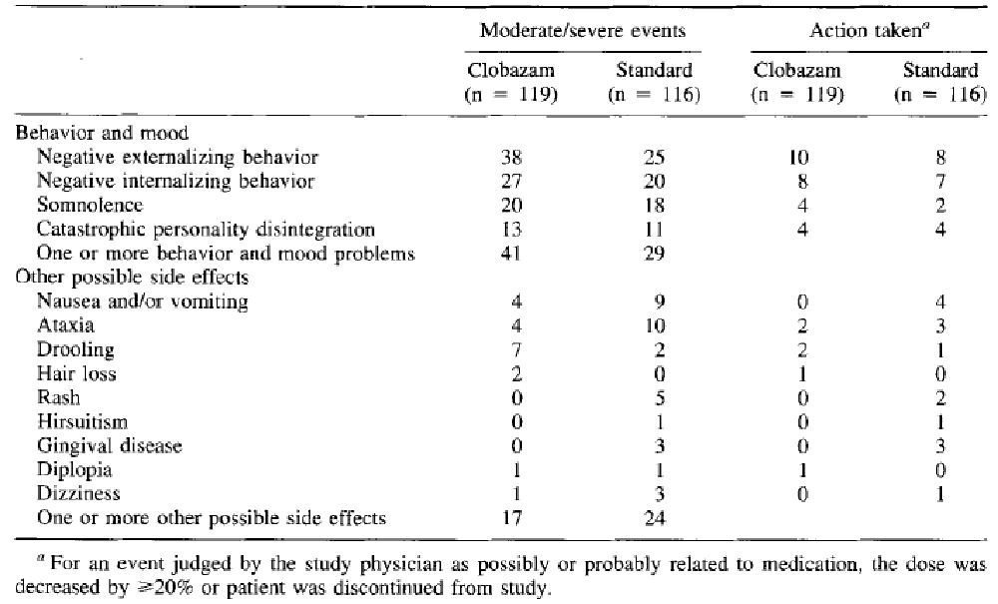

###### Conry et al.[90]

AEs related study drug and experienced by ≥5% patients include somnolence, lethargy, sedation, salivary hypersecretion, constipation, aggression, hypomania, and insomnia. The incidence of treatment-emergent AEs, regardless of relation to therapy, was similar between the low-dose group (84%) and the high-dose group (86%). The low dose group and high dose group were also similar in incidence of mild (47% vs. 44%), moderate (34% vs. 36%), and severe (3% vs 6%) AEs.

A total of five SAEs in four patients were reported during the study; none resulted in premature discontinuation of CLB, and all resolved during the study. No patients experienced an SAE of status epilepticus. One patient in the high-dose group experienced an SAE of severe aspiration with an alternative aetiology of increased saliva production or a pre-existing neurologic condition. The patient underwent a swallow study; the results were abnormal (aspiration with all textures). The SAEs of sleep apnoea syndrome (low-dose group), and constipation and pyrexia (high-dose group) were considered moderate in severity and not related to study medication. One patient in the high-dose group experienced an SAE of severe respiratory distress with an alternative aetiology of tonsillar hypertrophy. The patient was hospitalized, CLB was maintained, and the SAE resolved following adenotonsillectomy. Study medication was decreased by 5 mg and the SAE resolved. One severe case of sedation was experienced by a patient in the low-dose group; the event was considered to be probably related to study medication and resulted in temporary discontinuation after 39 days of dosing, but was not considered an SAE. The AE resolved and the patient subsequently enrolled in the open-label extension study. Nine AEs related to seizures/epilepsy (i.e., newly appearing seizure types) were reported in this study; convulsions (four patients), and complex partial seizures, tonic convulsion, clonic convulsion, petit mal epilepsy (as recorded on the patient’s AE case report form), and myoclonus (one patient each). All AEs related to seizures/epilepsy were mild or moderate in severity and none were considered to be definitely related to CLB. No AEs of status epilepticus were reported.

###### Ng et al.[91]

Safety assessments included adverse event (AE) assessment (Table 13). No concerning side effects were reported by organ class (Table 14). The percentages of patients with ≥1 AE were 67.8% for placebo, 72.4% for the low-dosage group, 88.7% for the medium-dosage group, and 76.3% for the high-dosage group. AEs experienced by ≥5% of patients in any treatment group are provided in Table 13. AEs with ≥10% difference between placebo and any clobazam group were somnolence, pyrexia, lethargy, drooling, and constipation. Sedation was reported for 8 (4.5%) clobazam-treated patients (1 in the low dosage group, 2 in the medium-dosage group, and 5 in the high-dosage group). Of these AEs, somnolence and drooling increased in frequency with increasing clobazam dosage. A dosage-related trend was observed for the overall incidence of AEs leading to discontinuation.

Table 13: Treatment-emergent adverse events experienced by ≥5% of patients in any treatment group.[92]

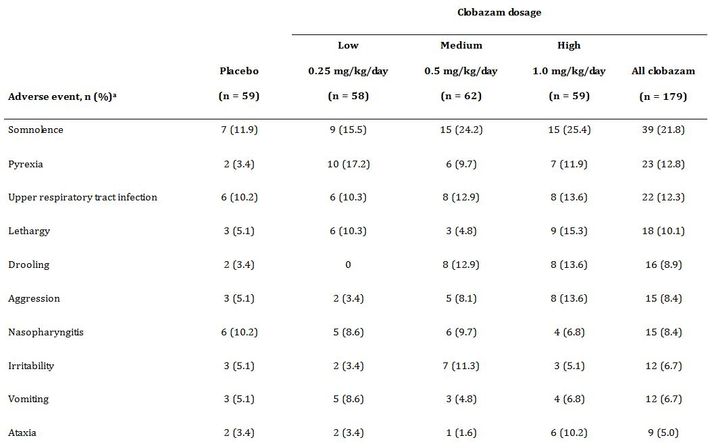

Table 13 continued: Treatment-emergent adverse events experienced by ≥5% of patients in any treatment group.[93]

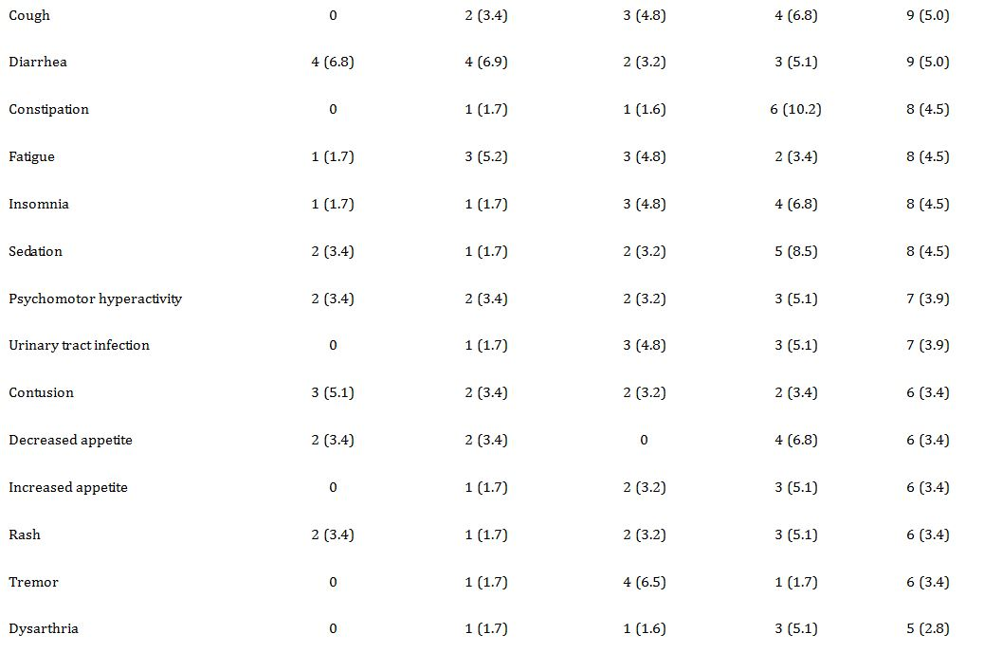

Table 13 continued: Treatment-emergent adverse events experienced by ≥5% of patients in any treatment group.[94]

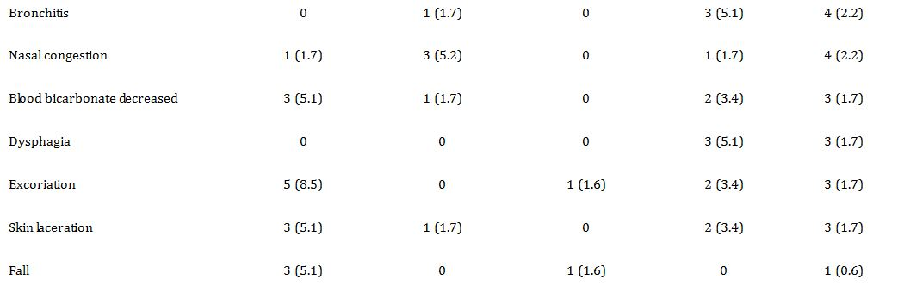

a. Patients with ≥1 occurrence of the same event were counted only once. AEs are listed in descending order of frequency in the all-clobazam group.

Table 14: Serious adverse events by system organ class.[95]

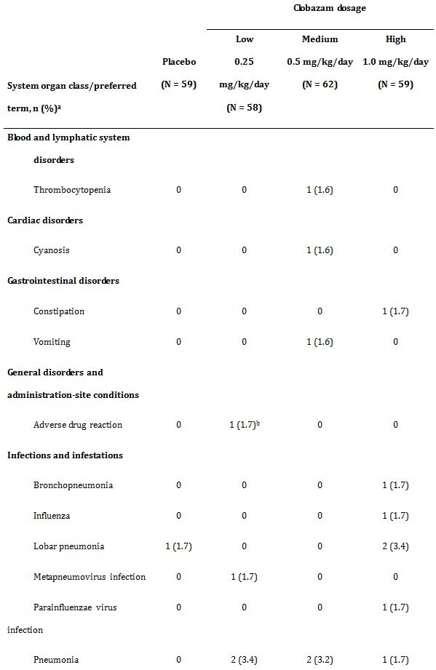

Table 14 continued: Serious adverse events by system organ class.[96]

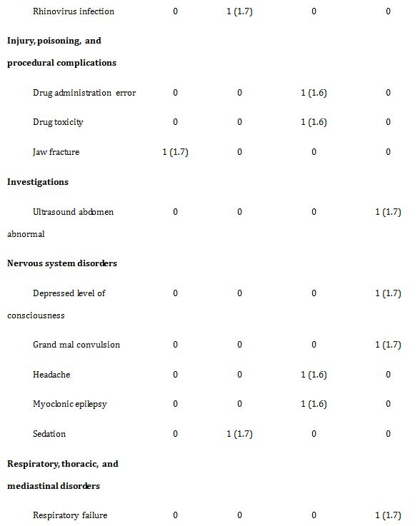

Few patients reported new seizure types (2 in the placebo group, 1 in the low-dosage group, 2 in the medium-dosage group, and 3 in the high-dosage group). There were SAEs related to seizures (myoclonic epilepsy for 1 patient in the medium-dosage group and grand mal convulsion for 1 patient in the high-dosage group).

Sixteen patients experienced SAEs (2 in the placebo group and 3, 6, and 5 in the low-, medium-, and high-dosage groups, respectively). SAEs for ≥2 patients were lobar pneumonia (1 in the placebo group and 2 in the high-dosage group) and pneumonia (2 in the low-dosage group, 2 in the medium-dosage group, and 1 in the high-dosage group). No deaths were reported.

Twenty-nine patients had their dosages decreased at some point during the study because of an AE. Of these 29, 1 patient was in the placebo group, and 4, 9, and 15 patients were in the low-, medium-, and high-dosage groups, respectively. Ten of 29 discontinued because of an AE (1, 4, and 5 patients in the low-, medium-, and high-dosages groups).

##### Other studies

See review by Robertson.[97]

#### Deaths and other serious adverse events

##### Pivotal studies

No deaths were reported in the pivotal studies related to clobazam. There was 1 death in the monotherapy study[98] in a subject on Carbamazepine.

##### Other studies

There were 9 deaths in the clobazam exposed subjects, all during the open label extension trial of the Phase II/III studies in epilepsy.[99] Of the 9 deaths in the open label extension reported in the clobazam submission to the FDA, 5 were male and 4 were female. The ages were 4 (n=2), 5, 7, 8, 12, 19, 22, and 36 years. The total daily doses at the time of the event were 10 mg, 20 mg, 30 mg (n=2), 35 mg (n=2), 40 mg, and 50 mg (n=2). In 3 cases the reported cause of death was pneumonia. Among those cases, 1 patient had an AE of somnolence noted approximately 1 month prior to, and was continuing at the time she developed pneumonia. The other 2 cases did not have an AE of somnolence at the time of pneumonia. One additional patient died while receiving hospice care following hospitalisation for pneumonia and dehydration. Three patients died at home and had no clearly identified cause of death (death n=2, epilepsy). One patient died during hospitalisation for seizures with reported cause of death respiratory failure. One patient died during hospitalisation for hematoma and urosepsis. All subjects had severe neurological disabilities.

#### Discontinuation due to adverse events

##### Pivotal studies

###### Canadian study group for childhood epilepsy[100] and Bawden et al.[101]

Numerically fewer patients randomised to clobazam reached the end-point (i.e. stopped taking the study medication) for reasons of safety.

###### Conry et al.[102]

Ten of 68 patients (15%) discontinued the study. In the low-dose group, one patient (3%) discontinued at the patient/parent/caregiver request and three patients (10%) discontinued due to AEs (convulsion, aggression, and oral intake reduced as a consequence of sedation and drooling). In the high-dose group, six patients (19%) discontinued due to AEs of somnolence (two patients), chorea, abnormal (defiant) behaviour, encephalopathy, and sedation (one patient each). All of the AEs were mild or moderate and considered to be possibly or probably related to study medication. With the exception of the AE of aggression in the low-dose group, which persisted throughout the study, all of the events resolved with discontinuation of study drug. Four of the patients who discontinued prematurely because of AEs enrolled in the open-label extension study.

###### Ng et al.[103]

Twenty-seven patients (2 in the placebo group, 4 in the low-dosage group, 8 in the medium-dosage group, and 13 in the high-dosage group) discontinued because of AEs. Treatment-emergent AEs that led to premature discontinuation for ≥2 patients were lethargy, somnolence, aggression, ataxia, insomnia, and fatigue.

##### Neuropsychological studies

###### Canadian study group for childhood epilepsy[104] and Bawden et al.[105]

Initial neuropsychological assessments were carried out 6 weeks after the study medication was started, at which point the dosage had been stabilised. There were no statistically significant differences between the clobazam and standard monotherapy groups (Carbamazepine or Phenytoin) on measures of intelligence, memory, psychomotor speed, attention, or impulsivity.

Clobazam dosage was not related to measures of neuropsychological functioning with only two of 31 correlations significant at the 0.05 level. Clobazam serum levels tended to be negatively related with measures of neuropsychological functioning, but typically accounted for less than 10% of the variance in these measures.

Neuropsychological assessments were repeated for those individuals who remained on the study medication for 12 months. There were no statistically significant differences between the clobazam and standard monotherapy groups on any of the neuropsychological measures. There were few group differences in the change score analyses. The only significant difference was on the Coding subtest of the WISC-R. The standard monotherapy group improved by 1.2 scaled score units whereas the clobazam group declined by 0.5 scaled score units (t‑2.35, p <0.05).

### Laboratory tests

#### Liver function, Kidney function, clinical chemistry, and haematology

##### Pivotal studies

###### Keene et al.[106]

No abnormal values for complete blood count, platelet count, urea, creatinine, glucose, ALT, TSH, T-4 or T-3 occurred during

###### Canadian study group for childhood epilepsy[107] and Bawden et al.[108]

No patient had screening laboratory tests that lead to discontinuation of study medication. One patient died from a ventriculoperitoneal shunt obstruction unrelated to study medication.

###### Ng et al.[109]

Few treatment-emergent AEs associated with abnormal clinical laboratory results considered to be at least possibly related to study drug (thrombocytopenia and increased eosinophil count) were reported. No clinically meaningful trends were observed for clinical laboratory assessments, vital signs, ECG or EEG results, or in physical and neurologic examinations.

##### Other studies

Clobazam has potential interactions with phenobarbitone, phenytoin, felbamate, valproate, oxcarbazepine and carbamazepine and this is reflected in the PI.[110]

CYP2C19 genotype is responsible for interindividual variations in clobazam plasma concentrations and its metabolite and can be affected by some drugs.[111]

### Post-marketing experience

Clobazam is marketed in over 80 countries by Sanofi-Aventis and it was first approved in Australia over 40 years ago. A total of 356 cases, including 243 medically-confirmed cases and 113 medically-unconfirmed cases were presented from the Sanofi-Aventis pharmacovigilance database. Among these 356 cases, 196 were non serious, 160 were serious. Fifty one (51) occurred in patients aged [0-3 years], 74 cases in patients aged [3-6 years], 125 cases in patients aged [7-12 years], 82 cases in patients aged [13-17 years] and 24 cases in children with not specified age. The evaluator has reviewed post-marketing experience and not identified safety issues that would preclude approval of an expanded indication for clobazam.

Post-marketing reports include no convincing evidence of serious skin reactions to clobazam including Stevens Johnson Syndrome and Toxic Epidermal Necrolysis.

### Evaluator’s overall conclusions on clinical safety

In the Phase II/III trials overall, 92% (277/300) of patients had one or more AEs. Those reported for at least 5% of clobazam trial subjects were somnolence (25%), upper respiratory infection (24%), pyrexia (19%), pneumonia (15%), lethargy (14%), nasopharyngitis(14%), constipation (14%), aggression (13%), fall (13%), otitis media (13%), insomnia (12%), urinary tract infection (11%), drooling 11%), sedation (10%), skin laceration (10%), and convulsion, viral infection, diarrhoea, vomiting, contusion, irritability, ataxia, sinusitis, decreased appetite, influenza, fatigue, cough, gastroenteritis, and pharyngitis streptococcal (all less than 10%). There were no AEs in Phase II/III trials coded to the preferred terms aplastic anaemia, agranulocytosis, Stevens Johnson Syndrome, Toxic epidermal necrolysis, acute renal failure, acute liver failure, pancytopenia, or rhabdomyolysis.

In the Phase II/III RCTs, there were small differences in overall AE risk when comparing low dose and high dose clobazam groups in the study by Conry and colleagues,[112] and when comparing clobazam and placebo groups in Ng et al.[113] In the study by Conry and colleagues,[114] 84% (27/32) of low dose patients and 86% (31/36) of high dose patients experienced one or more AEs. In the study by Ng and colleagues,[115] 68% (40/59) of placebo patients, 72% (42/58) of LD, 89% (55/62) of MD, and 76% (45/59) of HD clobazam patients experienced one or more AEs. A dose response was noted for somnolence and constipation with clobazam. AEs reported for ≥ 5% of clobazam patients and more frequently than placebo in the study by Ng and colleagues[116] were vomiting, constipation, pyrexia, irritability, fatigue, upper respiratory tract infection, somnolence, lethargy, drooling, ataxia, sedation, aggression, insomnia, and cough.

The evaluator notes no concerning findings for AEs regarding laboratory findings, ECG abnormalities, drug disease or drug-drug interactions. There are no concerning issues identified with regards to human carcinogenicity. In Phase II/III LGS trials where some subjects who discontinued were tapered off clobazam, no AEs were reported and there were no reports of withdrawal seizures.

In general, the AE profile observed with CLB in studies conducted by other sponsors and during post marketing experience is consistent with events seen with other benzodiazepines, such as sedation/drowsiness, dizziness, and ataxia. In these clinical studies conducted in patients with epilepsy that reported the overall percentage of patients who experienced AEs with CLB therapy, the numbers varied, but were in general approximately 40%. The most common AEs included sedation, behavioural abnormalities, ataxia, and drooling. AEs generally increased as dose increased and were generally mild and transient. In practice, these risks may be mitigated by slow up titration of clobazam. The evaluator has identified no safety issues that would preclude expanding the indication for clobazam.

## First round benefit-risk assessment

### First round assessment of benefits

The benefits of clobazam in the proposed usage are:

* Number Needed to Treat (NNT) for ≥ 50% reduction in drop seizures in LGS according to Ng et al:[117]
  + LD (0.25 mg/kg/d) NNT 8.5
  + MD (0.50 mg/kg/d) NNT 3.7
  + HD (1.00 mg/kg/d) NNT 2.2
* For reduction in seizures in treatment refractory childhood partial epilepsy according to Keene et al:[118]
  + MD (0.50 mg/kg/d) NNT 1.9

### First round assessment of risks

The risks of clobazam in the proposed usage are:

* In the study by Ng and colleagues,[119] Number Needed to Harm (NNH) calculated for *any AE* compared to placebo:
  + LD (0.250 mg/kg/d) NNH 25
  + MD (0.50 mg/kg/d) NNH 4.8
  + HD (1.00 mg/kg/d) NNH 12.5

However, it should be noted that AEs were generally mild and transient. No significant differences were found in SAEs in the study by Ng et al.[120]

The only other “risk” identified by the evaluator is the potential issue of tolerance with long term use of clobazam. Insufficient data is available to fully evaluate this “risk”.

The potential for benzodiazepines to be abused both orally and intravenously is well recognised. However, different benzodiazepines have different abuse potential; the more rapid the increase in the plasma level following ingestion, the greater the intoxicating effect and the more open to abuse the drug becomes. The speed of onset of action of a particular benzodiazepine seems to correlate well with the ‘popularity’ of that drug for abuse. It is noted that since clobazam is not water soluble it would be difficult for abusers to make an injectable form. Moreover, in the evaluator’s opinion, the propensity for abuse would be greater for the already approved indication of anxiety (in Australia) compared to the narrower indication of refractory childhood epilepsy. Therefore, the abuse potential for expanding the indication of clobazam in the evaluator’s opinion would be extremely low.

### First round assessment of benefit-risk balance

The benefit-risk balance of clobazam is unfavourable given the proposed usage, but would become favourable if the changes recommended below are adopted.

## First round recommendation regarding authorisation

In the evaluator’s opinion, the submission would have been significantly improved by the provision of data pertaining to the open label study of patients participating in the studies by Conry and colleagues[121] and Ng and colleagues.[122]

Based on the literature submission provided, the recommends approval of the submission with modification of the proposed indication:

In Children ≥ 4years

*As adjunctive therapy in patients with Lennox Gastaut epilepsy who are not adequately stabilised with their current anticonvulsant therapy.*

And

*As short to medium term adjunctive therapy in patients with partial refractory epilepsy who are not adequately stabilised with their current anticonvulsant therapy.*

## Clinical questions

None.

## References

1. Committee for medicinal products for human use. Guideline on clinical investigation of medicinal products in the treatment of epileptic disorders. 2010 Jul 22.
2. Guerrini R, Belmonte A, Genton P. Antiepileptic drug-induced worsening of seizures in children. Epilepsia 1998;39 Suppl 3:S2-10.
3. Clobazam has equivalent efficacy to carbamazepine and phenytoin as monotherapy for childhood epilepsy. Canadian Study Group for Childhood Epilepsy. Epilepsia 1998 Sep;39:952-959.
4. Ng YT, Conry JA, Drummond R, Stolle J, Weinberg MA. Randomised, phase III study results of clobazam in Lennox-Gastaut syndrome. Neurology 2011 Oct 11;77:1473-1481.
5. Conry JA, Ng YT, Paolicchi JM, et al. Clobazam in the treatment of Lennox-Gastaut syndrome. Epilepsia 2009 May;50:1158-1166.
6. Keene DL, Whiting S, Humphreys P. Clobazam as an add-on drug in the treatment of refractory epilepsy of childhood. Can J Neurol Sci 1990 Aug;17:317-319.
7. Bawden HN, Camfield CS, Camfield PR, et al. The cognitive and behavioural effects of clobazam and standard monotherapy are comparable. Canadian Study Group for Childhood Epilepsy. Epilepsy Res 1999 Feb;33:133-143.
8. Rose W, Kirubakaran C, Scott JX. Intermittent clobazam therapy in febrile seizures. Indian J Pediatr 2005 Jan;72:31-33.
9. Bajaj AS, Bajaj BK, Puri V, Tayal G. Intermittent clobazam in febrile seizures: an Indian experience. J Pediatr Neurol 2005;2:19-23.
10. Treiman DM. GABAergic mechanisms in epilepsy. Epilepsia 2001;42 Suppl 3:8-12.
11. Cross-Discipline team leader review. APPLICATION NUMBER:202067Orig1s000 2011Available from: URL: www.accessdata.fda.gov/drugsatfda_docs/nda/2011/202067Orig1s000CrossR.pdf
12. FDA APPLICATION NUMBER: 202067Orig1s000 MEDICAL REVIEW(S). FDA 2011Available from: URL: www.accessdata.fda.gov/drugsatfda_docs/nda/2011/202067Orig1s000MedR.pdf
13. Allen JW, Oxley J, Robertson MM, Trimble MR, Richens A, Jawad SS. Clobazam as adjunctive treatment in refractory epilepsy. Br Med J (Clin Res Ed) 1983 Apr 16;286:1246-1247.
14. Schmidt D, Rohde M, Wolf P, Roeder-Wanner U. Clobazam for refractory focal epilepsy. A controlled trial. Arch Neurol 1986 Aug;43:824-826.
15. Koeppen D, Baruzzi A, Capozza M, et al. Clobazam in therapy-resistant patients with partial epilepsy: a double-blind placebo-controlled crossover study. Epilepsia 1987 Sep;28:495-506.
16. Munn R, Camfield P, Camfield C, Dooley J. Clobazam for refractory childhood seizure disorders--a valuable supplementary drug. Can J Neurol Sci 1988 Nov;15:406-408.
17. Munn R, Farrell K. Open study of clobazam in refractory epilepsy. Pediatr Neurol 1993 Nov;9:465-469.
18. da Silveira MR, Montenegro MA, Franzon RC, Guerreiro CA, Guerreiro MM. Effectiveness of clobazam as add-on therapy in children with refractory focal epilepsy. Arq Neuropsiquiatr 2006 Sep;64:705-710.
19. Silva RC, Montenegro MA, Guerreiro CA, Guerreiro MM. Clobazam as add-on therapy in children with epileptic encephalopathy. Can J Neurol Sci 2006 May;33:209-213.
20. Kalra V, Seth R, Mishra D, Saha NC. Clobazam in refractory childhood epilepsy. Indian J Pediatr 2010 Mar;77:263-266.
21. (21) Guberman A, Couture M, Blaschuk K, Sherwin A. Add-on trial of clobazam in intractable adult epilepsy with plasma level correlations. Can J Neurol Sci 1990 Aug;17:311-316.
22. Stewart WA, Wood EP, Gordon KE, Camfield PR. Successful treatment of severe infantile hyperekplexia with low-dose clobazam. J Child Neurol 2002 Feb;17:154-156.
23. Buchanan N. Clobazam in the treatment of epilepsy: prospective follow-up to 8 years. J R Soc Med 1993 Jul;86:378-380.
24. Barcs G, Halasz P. Effectiveness and tolerance of clobazam in temporal lobe epilepsy. Acta Neurol Scand 1996 Feb;93:88-93.
25. Mehndiratta MM, Krishnamurthy M, Rajesh KN, Singh G. Clobazam monotherapy in drug naive adult patients with epilepsy. Seizure 2003 Jun;12:226-228.
26. Shimizu H, Kawasaki J, Yuasa S, Tarao Y, Kumagai S, Kanemoto K. Use of clobazam for the treatment of refractory complex partial seizures. Seizure 2003 Jul;12:282-286.
27. Montenegro MA, Ferreira CM, Cendes F, Li LM, Guerreiro CA. Clobazam as add-on therapy for temporal lobe epilepsy and hippocampal sclerosis. Can J Neurol Sci 2005 Feb;32:93-96.
28. Kinoshita M, Ikeda A, Begum T, Terada K, Shibasaki H. Efficacy of low-dose, add-on therapy of clobazam (CLB) is produced by its major metabolite, N-desmethyl-CLB. J Neurol Sci 2007 Dec 15;263:44-48.
29. Montenegro MA, Arif H, Nahm EA, Resor SR, Jr., Hirsch LJ. Efficacy of clobazam as add-on therapy for refractory epilepsy: experience at a US epilepsy center. Clin Neuropharmacol 2008 Nov;31:333-338.
30. Gastaut H, Low MD. Antiepileptic properties of clobazam, a 1-5 benzodiazepine, in man. Epilepsia 1979 Aug;20:437-446.
31. Farrell K. Benzodiazepines in the treatment of children with epilepsy. Epilepsia 1986;27 Suppl 1:S45-S52.
32. Singh A, Guberman AH, Boisvert D. Clobazam in long-term epilepsy treatment: sustained responders versus those developing tolerance. Epilepsia 1995 Aug;36:798-803.
33. Clobazam in treatment of refractory epilepsy: the Canadian experience. A retrospective study. Canadian Clobazam Cooperative Group. Epilepsia 1991 May;32:407-416.
34. Sugai K. Clobazam as a new antiepileptic drug and clorazepate dipotassium as an alternative antiepileptic drug in Japan. Epilepsia 2004;45 Suppl 8:20-25.
35. Munn R, Camfield P, Camfield C, Dooley J. Clobazam for refractory childhood seizure disorders--a valuable supplementary drug. Can J Neurol Sci 1988 Nov;15:406-408.
36. Barcs G, Halasz P. Effectiveness and tolerance of clobazam in temporal lobe epilepsy. Acta Neurol Scand 1996 Feb;93:88-93.
37. Martin AA. The Anti-epileptic Effects of Clobazam: A Long-term Study in Resistant Epilepsy. In: Hindmarch I SP, ed. Clobazam. Orlando, Fla: Academic Press Inc, 1981:151-157.
38. Wheless JW, Clarke DF, Arzimanoglou A, Carpenter D. Treatment of pediatric epilepsy: European expert opinion, 2007. Epileptic Disord 2007 Dec;9:353-412.
39. Remy C. Clobazam in the treatment of epilepsy: a review of the literature. Epilepsia 1994;35 Suppl 5:S88-S91.
40. Robertson MM. The Place of Clobazam in the Treatment of Epilepsy: An Update. Hum Psychopharmacol 1995;10:S43-S63.
41. Wildin JD, Pleuvry BJ, Mawer GE, Onon T, Millington L. Respiratory and sedative effects of clobazam and clonazepam in volunteers. Br J Clin Pharmacol 1990 Feb;29:169-177.
42. Van der Meyden CH, Bartel PR, Sommers DK, Blom M, Pretorius LC. Effects of clobazam and clonazepam on saccadic eye movements and other parameters of psychomotor performance. Eur J Clin Pharmacol 1989;37:365-369.
43. Patat A, Klein MJ, Hucher M. Effects of single oral doses of clobazam, diazepam and lorazepam on performance tasks and memory. Eur J Clin Pharmacol 1987;32:461-466.
44. Patat A, Foulhoux P. Effect on postural sway of various benzodiazepine tranquillizers. Br J Clin Pharmacol 1985 Jul;20:9-16.
45. Trimble MR, Thompson PJ. Anticonvulsant drugs, cognitive function, and behavior. Epilepsia 1983;24 Suppl 1:S55-S63.
46. Goggin T, Callaghan N. Blood levels of clobazam and its metabolites and therapeutic effect.: Academic Press Inc; 1985 159-165.
47. Vakil SD, Critchley EMR, Cocks A, Hayward HW. The effect of clobazam on blood levels of phenobarbitone, phenytoin and carbamazepine (preliminary report). London: Academic Press Inc; 1981 165-167.
48. Sobaniec W. Certain aspects of interaction between sodium valproate and other anticonvulsant drugs in the therapy of epilepsy in children. Mater Med Pol 1992 Apr;24:115-119.
49. Bun H, Monjanel-Mouterde S, Noel F, Durand A, Cano JP. Effects of age and antiepileptic drugs on plasma levels and kinetics of clobazam and N-desmethylclobazam. Pharmacol Toxicol 1990 Aug;67:136-140.
50. Contin M, Riva R, Albani F, Baruzzi AA. Effect of felbamate on clobazam and its metabolite kinetics in patients with epilepsy. Ther Drug Monit 1999 Dec;21:604-608.
51. Arnoldussen W, Hulsman P, Renteester TH. Interaction of Valproate and Clobazam on Oxcarbazepine. Epilepsia 1993;34:160.
52. Wang J, Hug D, Gautschi K, Wieser HG. Clobazam for treatment of Epilepsy. J Epilepsy 1993;6:180-184.
53. Contin M, Sangiorgi S, Riva R, Parmeggiani A, Albani F, Baruzzi A. Evidence of polymorphic CYP2C19 involvement in the human metabolism of N-desmethylclobazam. Ther Drug Monit 2002 Dec;24:737-741.
54. Giraud C, Tran A, Rey E, Vincent J, Treluyer JM, Pons G. In vitro characterization of clobazam metabolism by recombinant cytochrome P450 enzymes: importance of CYP2C19. Drug Metab Dispos 2004 Nov;32:1279-1286.
55. Giraud C, Treluyer JM, Rey E, et al. In vitro and in vivo inhibitory effect of stiripentol on clobazam metabolism. Drug Metab Dispos 2006 Apr;34:608-611.
56. Kosaki K, Tamura K, Sato R, Samejima H, Tanigawara Y, Takahashi T. A major influence of CYP2C19 genotype on the steady-state concentration of N-desmethylclobazam. Brain Dev 2004 Dec;26:530-534.
57. Seo T, Nagata R, Ishitsu T, et al. Impact of CYP2C19 polymorphisms on the efficacy of clobazam therapy. Pharmacogenomics 2008 May;9:527-537.
58. Walzer M, Bekersky I, Blum RA, Tolbert D. Pharmacokinetic drug interactions between clobazam and drugs metabolized by cytochrome P450 isoenzymes. Pharmacotherapy 2012 Apr;32:340-353.

1. European Medicines Agency, “Guideline on clinical investigation of medicinal products in the treatment of epileptic disorders (CHMP/EWP/566/98 Rev.2/Corr)”, 22 July 2010, Web, accessed 19 August 2013 <http://www.ema.europa.eu/docs/en_GB/document_library/Scientific_guideline/2010/01/ WC500070043.pdf>.
2. Guerrini R, et al. (1998) Antiepileptic drug-induced worsening of seizures in children. *Epilepsia* 39 Suppl 3: S2-10.
3. [No authors listed] (1998) Clobazam has equivalent efficacy to carbamazepine and phenytoin as monotherapy for childhood epilepsy. Canadian Study Group for Childhood Epilepsy. *Epilepsia* 39: 952-959.
4. European Medicines Agency, “Guideline on clinical investigation of medicinal products in the treatment of epileptic disorders (CHMP/EWP/566/98 Rev.2/Corr)”, 22 July 2010, Web, accessed 19 August 2013 <http:///www.ema.europa.eu/docs/en_GB/document_library/Scientific_guideline/2010/ 01/ WC500070043.pdf>.
5. [No authors listed] (1998) Clobazam has equivalent efficacy to carbamazepine and phenytoin as monotherapy for childhood epilepsy. Canadian Study Group for Childhood Epilepsy. *Epilepsia* 39: 952-959.
6. Ng YT, et al. (2011) Randomised, phase III study results of clobazam in Lennox-Gastaut syndrome. *Neurology* 77: 1473-1481.
7. Conry JA, et al. (2009) Clobazam in the treatment of Lennox-Gastaut syndrome. *Epilepsia* 50: 1158-1166.
8. European Medicines Agency, “Guideline on clinical investigation of medicinal products in the treatment of epileptic disorders (CHMP/EWP/566/98 Rev.2/Corr)”, 22 July 2010, Web, accessed 19 August 2013 <http://www.ema.europa.eu/docs/en_GB/document_library/Scientific_guideline/2010/01/ WC500070043.pdf>.
9. Therapeutic Goods Administration, “Note for Guidance on Good Clinical Practice (CPMP/ICH/135/95): Annotated with TGA comments”, July 2000, Web, accessed 19 August 2013 <http://www.tga.gov.au/pdf/ euguide/ich13595.pdf>.
10. Keene DL, et al. (1990) Clobazam as an add-on drug in the treatment of refractory epilepsy of childhood. *Can J Neurol Sci.* 17: 317-319.
11. Conry JA, et al. (2009) Clobazam in the treatment of Lennox-Gastaut syndrome. *Epilepsia* 50: 1158-1166.
12. Ng YT, et al. (2011) Randomised, phase III study results of clobazam in Lennox-Gastaut syndrome. *Neurology* 77: 1473-1481.
13. Bajaj AS, et al. (2005) Intermittent clobazam in febrile seizures: an Indian experience. *J Pediatr Neurol.* 2: 19-23.
14. Rose W, et al. (2005) Intermittent clobazam therapy in febrile seizures. *Indian J Pediatr.* 72: 31-33.
15. Keene DL, et al. (1990) Clobazam as an add-on drug in the treatment of refractory epilepsy of childhood. *Can J Neurol Sci.* 17: 317-319.
16. [No authors listed] (1998) Clobazam has equivalent efficacy to carbamazepine and phenytoin as monotherapy for childhood epilepsy. Canadian Study Group for Childhood Epilepsy. *Epilepsia* 39: 952-959.
17. Conry JA, et al. (2009) Clobazam in the treatment of Lennox-Gastaut syndrome. *Epilepsia* 50: 1158-1166.
18. Treiman DM. (2001) GABAergic mechanisms in epilepsy. *Epilepsia* 42 Suppl 3: 8-12.
19. Ng YT, et al. (2011) Randomised, phase III study results of clobazam in Lennox-Gastaut syndrome. *Neurology* 77: 1473-1481.
20. Ng YT, et al. (2011) Randomised, phase III study results of clobazam in Lennox-Gastaut syndrome. *Neurology* 77: 1473-1481.
21. Ng YT, et al. (2011) Randomised, phase III study results of clobazam in Lennox-Gastaut syndrome. *Neurology* 77: 1473-1481.
22. Treiman DM. (2001) GABAergic mechanisms in epilepsy. *Epilepsia* 42 Suppl 3: 8-12.
23. Cross-Discipline team leader review. APPLICATION NUMBER:202067Orig1s000 2011: <http://www.accessdata.fda.gov/drugsatfda_docs/nda/2011/202067Orig1s000CrossR.pdf>
24. DA APPLICATION NUMBER: 202067Orig1s000 MEDICAL REVIEW(S). FDA 2011: <http://www.accessdata.fda.gov/drugsatfda_docs/nda/2011/202067Orig1s000MedR.pdf>
25. Rose W, et al. (2005) Intermittent clobazam therapy in febrile seizures. *Indian J Pediatr.* 72: 31-33.
26. Rose W, et al. (2005) Intermittent clobazam therapy in febrile seizures. *Indian J Pediatr.* 72: 31-33.
27. Bajaj AS, et al. (2005) Intermittent clobazam in febrile seizures: an Indian experience. *J Pediatr Neurol.* 2: 19-23.
28. Bajaj AS, et al. (2005) Intermittent clobazam in febrile seizures: an Indian experience. *J Pediatr Neurol.* 2: 19-23.
29. Gastaut H, Low MD. (1979) Antiepileptic properties of clobazam, a 1-5 benzodiazepine, in man. *Epilepsia* 20: 437-446.
30. Allen JW, et al. (1983) Clobazam as adjunctive treatment in refractory epilepsy. *Br Med J (Clin Res Ed.)* 286: 1246-1247.
31. Schmidt D, et al. (1986) Clobazam for refractory focal epilepsy. A controlled trial. *Arch Neurol.* 43: 824-826.
32. Farrell K. (1986) Benzodiazepines in the treatment of children with epilepsy. *Epilepsia* 27 Suppl 1: S45-S52.
33. Singh A, et al. (1995) Clobazam in long-term epilepsy treatment: sustained responders versus those developing tolerance. *Epilepsia* 36: 798-803.
34. [No authors listed] (1991) Clobazam in treatment of refractory epilepsy: the Canadian experience. A retrospective study. Canadian Clobazam Cooperative Group. *Epilepsia* 32: 407-416.
35. Sugai K. (2004) Clobazam as a new antiepileptic drug and clorazepate dipotassium as an alternative antiepileptic drug in Japan. *Epilepsia* 45 Suppl 8: 20-25.
36. Munn R, et al. (1988) Clobazam for refractory childhood seizure disorders--a valuable supplementary drug. *Can J Neurol Sci.* 15: 406-408.
37. Munn R, Farrell K. (1993) Open study of clobazam in refractory epilepsy. *Pediatr Neurol.* 9: 465-469.
38. Munn R, Farrell K. (1993) Open study of clobazam in refractory epilepsy. *Pediatr Neurol.* 9: 465-469.
39. Kalra V, et al. (2010) Clobazam in refractory childhood epilepsy. *Indian J Pediatr.* 77: 263-266.
40. Barcs G, Halasz P. (1996) Effectiveness and tolerance of clobazam in temporal lobe epilepsy. *Acta Neurol Scand.* 93: 88-93.
41. Martin AA. (1981) The Anti-epileptic Effects of Clobazam: A Long-term Study in Resistant Epilepsy. In: Hindmarch I, ed. Clobazam. Orlando, Fla: Academic Press Inc., pp. 151-157.
42. Guberman A, et al. (1990) Add-on trial of clobazam in intractable adult epilepsy with plasma level correlations. *Can J Neurol Sci.* 17: 311-316.
43. Buchanan N. (1993) Clobazam in the treatment of epilepsy: prospective follow-up to 8 years. *J R Soc Med.* 86: 378-380.
44. Barcs G, Halasz P. (1996) Effectiveness and tolerance of clobazam in temporal lobe epilepsy. *Acta Neurol Scand.* 93: 88-93.
45. Shimizu H, et al. (2003) Use of clobazam for the treatment of refractory complex partial seizures. *Seizure* 12: 282-286.
46. Ng YT, et al. (2011) Randomised, phase III study results of clobazam in Lennox-Gastaut syndrome. *Neurology* 77: 1473-1481; Conry JA, et al. (2009) Clobazam in the treatment of Lennox-Gastaut syndrome. *Epilepsia* 50: 1158-1166.
47. European Medicines Agency, “Guideline on clinical investigation of medicinal products in the treatment of epileptic disorders (CHMP/EWP/566/98 Rev.2/Corr)”, 22 July 2010, Web, accessed 19 August 2013 <http://www.ema.europa.eu/docs/en_GB/document_library/Scientific_guideline/2010/ 01/WC500070043.pdf>.
48. Conry JA, et al. (2009) Clobazam in the treatment of Lennox-Gastaut syndrome. *Epilepsia* 50: 1158-1166.
49. Ng YT, et al. (2011) Randomised, phase III study results of clobazam in Lennox-Gastaut syndrome. *Neurology* 77: 1473-1481.
50. Keene DL, et al. (1990) Clobazam as an add-on drug in the treatment of refractory epilepsy of childhood. *Can J Neurol Sci.* 17: 317-319.
51. Wheless JW, et al. (2007) Treatment of pediatric epilepsy: European expert opinion, 2007. *Epileptic Disord.* 9: 353-412.
52. Keene DL, et al. (1990) Clobazam as an add-on drug in the treatment of refractory epilepsy of childhood. *Can J Neurol Sci.* 17: 317-319.
53. Munn R, Farrell K. (1993) Open study of clobazam in refractory epilepsy. *Pediatr Neurol.* 9: 465-469; Barcs G, Halasz P. (1996) Effectiveness and tolerance of clobazam in temporal lobe epilepsy. *Acta Neurol Scand.* 93: 88-93; Singh A, et al. (1995) Clobazam in long-term epilepsy treatment: sustained responders versus those developing tolerance. *Epilepsia* 36: 798-803.
54. Remy C. (1994) Clobazam in the treatment of epilepsy: a review of the literature. *Epilepsia* 35 Suppl 5: S88-S91.
55. Robertson MM. (1995) The place of clobazam in the treatment of epilepsy: an update. *Hum Psychopharmacol.* 10: S43-S63
56. Wildin JD, et al. (1990) Respiratory and sedative effects of clobazam and clonazepam in volunteers. *Br J Clin Pharmacol.* 29: 169-177; van der Meyden CH, et al. (1989) Effects of clobazam and clonazepam on saccadic eye movements and other parameters of psychomotor performance. *Eur J Clin Pharmacol.* 37: 365-369.
57. Keene DL, et al. (1990) Clobazam as an add-on drug in the treatment of refractory epilepsy of childhood. *Can J Neurol Sci.* 17: 317-319.
58. [No authors listed] (1998) Clobazam has equivalent efficacy to carbamazepine and phenytoin as monotherapy for childhood epilepsy. Canadian Study Group for Childhood Epilepsy. *Epilepsia* 39: 952-959.
59. Bawden HN, et al. (1999) The cognitive and behavioural effects of clobazam and standard monotherapy are comparable. Canadian Study Group for Childhood Epilepsy. *Epilepsy Res.* 33: 133-143
60. Conry JA, et al. (2009) Clobazam in the treatment of Lennox-Gastaut syndrome. *Epilepsia* 50: 1158-1166.
61. Ng YT, et al. (2011) Randomised, phase III study results of clobazam in Lennox-Gastaut syndrome. *Neurology* 77: 1473-1481.
62. Conry JA, et al. (2009) Clobazam in the treatment of Lennox-Gastaut syndrome. *Epilepsia* 50: 1158-1166.
63. Rose W, et al. (2005) Intermittent clobazam therapy in febrile seizures. *Indian J Pediatr.* 72: 31-33.
64. Bajaj AS, et al. (2005) Intermittent clobazam in febrile seizures: an Indian experience. *J Pediatr Neurol.* 2: 19-23.
65. [No authors listed] (1998) Clobazam has equivalent efficacy to carbamazepine and phenytoin as monotherapy for childhood epilepsy. Canadian Study Group for Childhood Epilepsy. *Epilepsia* 39: 952-959.
66. Bawden HN, et al. (1999) The cognitive and behavioural effects of clobazam and standard monotherapy are comparable. Canadian Study Group for Childhood Epilepsy. *Epilepsy Res.* 33: 133-143
67. Keene DL, et al. (1990) Clobazam as an add-on drug in the treatment of refractory epilepsy of childhood. *Can J Neurol Sci.* 17: 317-319.
68. [No authors listed] (1998) Clobazam has equivalent efficacy to carbamazepine and phenytoin as monotherapy for childhood epilepsy. Canadian Study Group for Childhood Epilepsy. *Epilepsia* 39: 952-959.
69. Bawden HN, et al. (1999) The cognitive and behavioural effects of clobazam and standard monotherapy are comparable. Canadian Study Group for Childhood Epilepsy. *Epilepsy Res.* 33: 133-143.
70. Ng YT, et al. (2011) Randomised, phase III study results of clobazam in Lennox-Gastaut syndrome. *Neurology* 77: 1473-1481.
71. Bawden HN, et al. (1999) The cognitive and behavioural effects of clobazam and standard monotherapy are comparable. Canadian Study Group for Childhood Epilepsy. *Epilepsy Res.* 33: 133-143.
72. Patat A, et al. (1987) Effects of single oral doses of clobazam, diazepam and lorazepam on performance tasks and memory. *Eur J Clin Pharmacol.* 32: 461-466.
73. Patat A, Foulhoux P. (1985) Effect on postural sway of various benzodiazepine tranquillizers. *Br J Clin Pharmacol.* 20: 9-16.
74. Trimble MR, Thompson PJ. (1983) Anticonvulsant drugs, cognitive function, and behavior. *Epilepsia* 24 Suppl 1:S55-S63
75. Goggin T, Callaghan N. (1985) Blood levels of clobazam and its metabolites and therapeutic effect: Academic Press Inc., pp. 159-165.
76. Vakil SD, et al. (1981) The effect of clobazam on blood levels of phenobarbitone, phenytoin and carbamazepine (preliminary report). London: Academic Press Inc., pp. 165-167; Sobaniec W. (1992) Certain aspects of interaction between sodium valproate and other anticonvulsant drugs in the therapy of epilepsy in children. *Mater Med Pol.* 24: 115-119; Bun H, et al. (1990) Effects of age and antiepileptic drugs on plasma levels and kinetics of clobazam and N-desmethylclobazam. *Pharmacol Toxicol.* 67: 136-140; Contin M, et al. (1999) Effect of felbamate on clobazam and its metabolite kinetics in patients with epilepsy. *Ther Drug Monit.* 21: 604-608; Arnoldussen W, et al. (1993) Interaction of valproate and clobazam on oxcarbazepine. *Epilepsia* 34: 160; Wang J, et al. (1993) Clobazam for treatment of Epilepsy. *J Epilepsy* 6: 180-184.
77. Conry JA, et al. (2009) Clobazam in the treatment of Lennox-Gastaut syndrome. *Epilepsia* 50: 1158-1166.
78. Ng YT, et al. (2011) Randomised, phase III study results of clobazam in Lennox-Gastaut syndrome. *Neurology* 77: 1473-1481.
79. [No authors listed] (1998) Clobazam has equivalent efficacy to carbamazepine and phenytoin as monotherapy for childhood epilepsy. Canadian Study Group for Childhood Epilepsy. *Epilepsia* 39: 952-959.
80. [No authors listed] (1998) Clobazam has equivalent efficacy to carbamazepine and phenytoin as monotherapy for childhood epilepsy. Canadian Study Group for Childhood Epilepsy. *Epilepsia* 39: 952-959.
81. Ng YT, et al. (2011) Randomised, phase III study results of clobazam in Lennox-Gastaut syndrome. *Neurology* 77: 1473-1481.
82. Conry JA, et al. (2009) Clobazam in the treatment of Lennox-Gastaut syndrome. *Epilepsia* 50: 1158-1166.
83. Keene DL, et al. (1990) Clobazam as an add-on drug in the treatment of refractory epilepsy of childhood. *Can J Neurol Sci.* 17: 317-319.
84. Rose W, et al. (2005) Intermittent clobazam therapy in febrile seizures. *Indian J Pediatr.* 72: 31-33.
85. Bajaj AS, et al. (2005) Intermittent clobazam in febrile seizures: an Indian experience. *J Pediatr Neurol.* 2: 19-23.
86. Keene DL, et al. (1990) Clobazam as an add-on drug in the treatment of refractory epilepsy of childhood. *Can J Neurol Sci.* 17: 317-319.
87. [No authors listed] (1998) Clobazam has equivalent efficacy to carbamazepine and phenytoin as monotherapy for childhood epilepsy. Canadian Study Group for Childhood Epilepsy. *Epilepsia* 39: 952-959.
88. Bawden HN, et al. (1999) The cognitive and behavioural effects of clobazam and standard monotherapy are comparable. Canadian Study Group for Childhood Epilepsy. *Epilepsy Res.* 33: 133-143.
89. [No authors listed] (1998) Clobazam has equivalent efficacy to carbamazepine and phenytoin as monotherapy for childhood epilepsy. Canadian Study Group for Childhood Epilepsy. *Epilepsia* 39: 952-959.
90. Conry JA, et al. (2009) Clobazam in the treatment of Lennox-Gastaut syndrome. *Epilepsia* 50: 1158-1166.
91. Ng YT, et al. (2011) Randomised, phase III study results of clobazam in Lennox-Gastaut syndrome. *Neurology* 77: 1473-1481.
92. Ng YT, et al. (2011) Randomised, phase III study results of clobazam in Lennox-Gastaut syndrome. *Neurology* 77: 1473-1481.
93. Ng YT, et al. (2011) Randomised, phase III study results of clobazam in Lennox-Gastaut syndrome. *Neurology* 77: 1473-1481.
94. Ng YT, et al. (2011) Randomised, phase III study results of clobazam in Lennox-Gastaut syndrome. *Neurology* 77: 1473-1481.
95. Ng YT, et al. (2011) Randomised, phase III study results of clobazam in Lennox-Gastaut syndrome. *Neurology* 77: 1473-1481.
96. Ng YT, et al. (2011) Randomised, phase III study results of clobazam in Lennox-Gastaut syndrome. *Neurology* 77: 1473-1481.
97. Robertson MM. (1995) The place of clobazam in the treatment of epilepsy: an update. *Hum Psychopharmacol.* 10: S43-S63.
98. [No authors listed] (1998) Clobazam has equivalent efficacy to carbamazepine and phenytoin as monotherapy for childhood epilepsy. Canadian Study Group for Childhood Epilepsy. *Epilepsia* 39: 952-959.
99. Ng YT, et al. (2011) Randomised, phase III study results of clobazam in Lennox-Gastaut syndrome. *Neurology* 77: 1473-1481; Conry JA, et al. (2009) Clobazam in the treatment of Lennox-Gastaut syndrome. *Epilepsia* 50: 1158-1166.
100. [No authors listed] (1998) Clobazam has equivalent efficacy to carbamazepine and phenytoin as monotherapy for childhood epilepsy. Canadian Study Group for Childhood Epilepsy. *Epilepsia* 39: 952-959.
101. Bawden HN, et al. (1999) The cognitive and behavioural effects of clobazam and standard monotherapy are comparable. Canadian Study Group for Childhood Epilepsy. *Epilepsy Res.* 33: 133-143.
102. Conry JA, et al. (2009) Clobazam in the treatment of Lennox-Gastaut syndrome. *Epilepsia* 50: 1158-1166.
103. Ng YT, et al. (2011) Randomised, phase III study results of clobazam in Lennox-Gastaut syndrome. *Neurology* 77: 1473-1481.
104. [No authors listed] (1998) Clobazam has equivalent efficacy to carbamazepine and phenytoin as monotherapy for childhood epilepsy. Canadian Study Group for Childhood Epilepsy. *Epilepsia* 39: 952-959.
105. Bawden HN, et al. (1999) The cognitive and behavioural effects of clobazam and standard monotherapy are comparable. Canadian Study Group for Childhood Epilepsy. *Epilepsy Res.* 33: 133-143.
106. Keene DL, et al. (1990) Clobazam as an add-on drug in the treatment of refractory epilepsy of childhood. *Can J Neurol Sci.* 17: 317-319.
107. [No authors listed] (1998) Clobazam has equivalent efficacy to carbamazepine and phenytoin as monotherapy for childhood epilepsy. Canadian Study Group for Childhood Epilepsy. *Epilepsia* 39: 952-959.
108. Bawden HN, et al. (1999) The cognitive and behavioural effects of clobazam and standard monotherapy are comparable. Canadian Study Group for Childhood Epilepsy. *Epilepsy Res.* 33: 133-143.
109. Ng YT, et al. (2011) Randomised, phase III study results of clobazam in Lennox-Gastaut syndrome. *Neurology* 77: 1473-1481
110. Vakil SD, et al. (1981) The effect of clobazam on blood levels of phenobarbitone, phenytoin and carbamazepine (preliminary report). London: Academic Press Inc., pp. 165-167; Sobaniec W. (1992) Certain aspects of interaction between sodium valproate and other anticonvulsant drugs in the therapy of epilepsy in children. *Mater Med Pol.* 24: 115-119; Bun H, et al. (1990) Effects of age and antiepileptic drugs on plasma levels and kinetics of clobazam and N-desmethylclobazam. *Pharmacol Toxicol.* 67: 136-140; Contin M, et al. (1999) Effect of felbamate on clobazam and its metabolite kinetics in patients with epilepsy. *Ther Drug Monit.* 21: 604-608; Arnoldussen W, et al. (1993) Interaction of valproate and clobazam on oxcarbazepine. *Epilepsia* 34: 160; Wang J, et al. (1993) Clobazam for treatment of Epilepsy. *J Epilepsy* 6: 180-184.
111. Contin M, et al. (2002) Evidence of polymorphic CYP2C19 involvement in the human metabolism of N-desmethylclobazam. *Ther Drug Monit.* 24: 737-741; Giraud C, et al. (2004) In vitro characterization of clobazam metabolism by recombinant cytochrome P450 enzymes: importance of CYP2C19. *Drug Metab Dispos.* 32: 1279-1286; Giraud C, et al. (2006) In vitro and in vivo inhibitory effect of stiripentol on clobazam metabolism. *Drug Metab Dispos.* 34: 608-611; Kosaki K, et al. (2004) A major influence of CYP2C19 genotype on the steady-state concentration of N-desmethylclobazam. *Brain Dev.* 26: 530-534; Seo T, et al. (2008) Impact of CYP2C19 polymorphisms on the efficacy of clobazam therapy. *Pharmacogenomics* 9: 527-537; Walzer M, et al. (2012) Pharmacokinetic drug interactions between clobazam and drugs metabolized by cytochrome P450 isoenzymes. *Pharmacotherapy* 32: 340-353.
112. Conry JA, et al. (2009) Clobazam in the treatment of Lennox-Gastaut syndrome. *Epilepsia* 50: 1158-1166.
113. Ng YT, et al. (2011) Randomised, phase III study results of clobazam in Lennox-Gastaut syndrome. *Neurology* 77: 1473-1481.
114. Conry JA, et al. (2009) Clobazam in the treatment of Lennox-Gastaut syndrome. *Epilepsia* 50: 1158-1166.
115. Ng YT, et al. (2011) Randomised, phase III study results of clobazam in Lennox-Gastaut syndrome. *Neurology* 77: 1473-1481.
116. Ng YT, et al. (2011) Randomised, phase III study results of clobazam in Lennox-Gastaut syndrome. *Neurology* 77: 1473-1481.
117. Ng YT, et al. (2011) Randomised, phase III study results of clobazam in Lennox-Gastaut syndrome. *Neurology* 77: 1473-1481.
118. Keene DL, et al. (1990) Clobazam as an add-on drug in the treatment of refractory epilepsy of childhood. *Can J Neurol Sci.* 17: 317-319.
119. Ng YT, et al. (2011) Randomised, phase III study results of clobazam in Lennox-Gastaut syndrome. *Neurology* 77: 1473-1481.
120. Ng YT, et al. (2011) Randomised, phase III study results of clobazam in Lennox-Gastaut syndrome. *Neurology* 77: 1473-1481.
121. Conry JA, et al. (2009) Clobazam in the treatment of Lennox-Gastaut syndrome. *Epilepsia* 50: 1158-1166.
122. Ng YT, et al. (2011) Randomised, phase III study results of clobazam in Lennox-Gastaut syndrome. *Neurology* 77: 1473-1481.