|  |
| --- |
| **October 2013** |

|  |
| --- |
| Australian Public Assessment Report for Clobazam |
| Proprietary Product Name: Frisium |
| Sponsor: Sanofi-Aventis Australia Pty Ltd |

About the Therapeutic Goods Administration (TGA)

* The Therapeutic Goods Administration (TGA) is part of the Australian Government Department of Health, and is responsible for regulating medicines and medical devices.
* The TGA administers the *Therapeutic Goods Act 1989* (the Act), applying a risk management approach designed to ensure therapeutic goods supplied in Australia meet acceptable standards of quality, safety and efficacy (performance), when necessary.
* The work of the TGA is based on applying scientific and clinical expertise to decision-making, to ensure that the benefits to consumers outweigh any risks associated with the use of medicines and medical devices.
* The TGA relies on the public, healthcare professionals and industry to report problems with medicines or medical devices. TGA investigates reports received by it to determine any necessary regulatory action.
* To report a problem with a medicine or medical device, please see the information on the TGA website <[http://www.tga.gov.au](http://www.tga.gov.au/)>.

About AusPARs

* An Australian Public Assessment Record (AusPAR) provides information about the evaluation of a prescription medicine and the considerations that led the TGA to approve or not approve a prescription medicine submission.
* AusPARs are prepared and published by the TGA.
* An AusPAR is prepared for submissions that relate to new chemical entities, generic medicines, major variations, and extensions of indications.
* An AusPAR is a static document, in that it will provide information that relates to a submission at a particular point in time.
* A new AusPAR will be developed to reflect changes to indications and/or major variations to a prescription medicine subject to evaluation by the TGA.

Copyright

© Commonwealth of Australia 2013  
This work is copyright. You may reproduce the whole or part of this work in unaltered form for your own personal use or, if you are part of an organisation, for internal use within your organisation, but only if you or your organisation do not use the reproduction for any commercial purpose and retain this copyright notice and all disclaimer notices as part of that reproduction. Apart from rights to use as permitted by the *Copyright Act 1968* or allowed by this copyright notice, all other rights are reserved and you are not allowed to reproduce the whole or any part of this work in any way (electronic or otherwise) without first being given specific written permission from the Commonwealth to do so. Requests and inquiries concerning reproduction and rights are to be sent to the TGA Copyright Officer, Therapeutic Goods Administration, PO Box 100, Woden ACT 2606 or emailed to <[tga.copyright@tga.gov.au](mailto:tga.copyright@tga.gov.au)>.

Contents

I. Introduction to product submission 3

Submission details 3

Product background 4

Regulatory status 5

Product Information 8

II. Quality findings 8

III. Nonclinical findings 8

Introduction 8

Pharmacokinetics 8

Toxicology 9

Nonclinical summary and conclusions 13

IV. Clinical findings 14

Introduction 14

Pharmacokinetics 16

Pharmacodynamics 16

Efficacy 17

Safety 19

List of questions 23

Clinical summary and conclusions 23

V. Pharmacovigilance findings 25

Risk management plan 25

VI. Overall conclusion and risk/benefit assessment 26

Risk-benefit analysis 28

Outcome 31

Attachment 1. Product Information 31

Attachment 2. Extract from the Clinical Evaluation Report 32

## I. Introduction to product submission

### Submission details

|  |  |
| --- | --- |
| *Type of Submission* | Extension of indications |
| *Decision:* | Approved |
| *Date of Decision:* | 15 May 2013 |

|  |  |  |
| --- | --- | --- |
| *Active ingredient(s):* | Clobazam | |
| *Product Name(s):* | Frisium | |
| *Sponsor’s Name and Address:* | Sanofi-Aventis Australia Pty Ltd  12-24 Talavera Road  Macquarie Park NSW 2113 | |
| *Dose form(s):* | Tablets | |
| *Strength(s):* | 10 mg | |
| *Container(s):* | Tablet blister pack |
| *Approved Therapeutic use:* | Children (4 years of age and over):  As adjunctive therapy in patients with partial refractory and Lennox-Gestaut epilepsy types who are not adequately stabilised with their current anticonvulsant therapy. | |
| *Route(s) of administration:* | Oral | |
| *Dosage:* | The dosing regimen is to start with 5 mg per day with a maintenance dose of 0.3 to 1 mg/kg per day. Daily doses of up to 30 mg can be taken as a single dose at night. | |
| *ARTG Number (s)* | 12400 | |

### Product background

This AusPAR describes a literature based submission (LBS) by the sponsor, Sanofi-Aventus Australia Pty Ltd, to register an extension of the indications for Frisium (clobazam) 10 mg tablets to include adjunctive therapy in paediatric patients with refractory epilepsy who are not adequately stabilised with their current anticonvulsant therapy.

The current approved indication for Frisium is:

*Short term use (up to one month) for the symptomatic management of acute anxiety and sleep disturbances associated with anxiety.*

The following new indication is proposed for Frisium:

Children (4 years of age and over):

*As adjunctive therapy in patients with partial refractory epilepsy who are not adequately stabilised with their current anticonvulsant therapy.*

Lennox-Gastaut syndrome (LGS) is relatively uncommon but remains a significant management challenge. It is intractable and has severe social and cognitive consequences. LGS occurs in 3% of children with epilepsy and is characterised by multiple seizure types, slow spike-and-wave discharges and a poor prognosis for seizure control and cognitive development. The age of onset is usually between 2 and 8 years, with later onset being usually seen in those in whom an underlying cause is not demonstrated. Seizures causing falls are also a dangerous aspect of this disorder. Such events can lead to serious head injury and requires the wearing of protective helmets. These are referred to as “drop attacks” and are associated with tonic, atonic or myoclonic seizures. Seizures in LGS are considered to be intractable and are largely generalised in nature. LGS is associated with an encephalopathy in 78-96% of patients. LGS is associated with a distinctive electroencephalogram (EEG) pattern which helps in its diagnosis. LGS is frequently preceded by infantile spasms. Although it is a single syndrome entity, it may be associated with a number of causal aetiologies (for example, perinatal hypoxia or ischemia, cerebral infections tuberous sclerosis) or it may be cryptogenic without any identifiable aetiology.

Benzodiazepines enhance γ-aminobutyric acid (GABA)-A inhibition resulting in pharmacodynamic activity against a seizure final common pathway. The 1,4-benzodiazepines, such as diazepam, have an established role in the acute management of epileptic seizures. However, the 1,5-benzodiazepine clobazam has a unique chemical structure which results in a broader spectrum of antiepileptic activity inhibiting the spread of seizures and increasing the seizure threshold compared to the 1,4-benzodiazepines. The 1,4-benzodiazepines have other disadvantages such as the retention of diazepam in fat stores and the short half life of lorazepam. Clobazam is a 1,5-benzodiazepine licensed as an anxiolytic in Australia and worldwide since the 1970s.

The dosage regime of clobazam is recommended as an addition to the patient’s current antiepileptic therapy. It is recommended that normally treatment be started at 5 mg daily. A maintenance dose of 0.3 to 1.0 mg/kg body weight daily is usually sufficient. Daily doses up to 30 mg may be taken as a single dose at night. The tablets are to be swallowed without chewing with sufficient amount of liquid (approx ½-1 glass).

No new dosage forms or strengths are proposed.

### Regulatory status

The sponsor submitted an Australian application for orphan drug designation to extend the indication for clobazam tablets for the treatment of paediatric refractory epilepsy. The application was granted by the TGA on 14 September 2009. Prior to the orphan drug application, the sponsor made two previous submissions to the TGA in 1986 and 1995 regarding an additional, broad indication for the use of clobazam in adults and children in all refractory epilepsy types .

The first submission in 1986 was deemed insufficient to support approval due to inadequate data in several clinical and nonclinical areas. A subsequent LBS in 1995 was similarly determined to be deficient for three main reasons:

* Regulatory compliance issues:
  + Lack of compliance with guidelines, in particular with respect to the literature search strategy which may have resulted in an incomplete literature review.
* Inadequate clinical and nonclinical data covering several key areas:
  + Pharmacokinetics and rationale for dosing.
  + Metabolic interactions, particularly with other medications.
  + Tolerance with chronic use.
  + Withdrawal and rebound effects.
  + Evidence of efficacy and safety from well controlled Randomised Controlled Clinical Trials (RCTs).
  + Lack of Part III (nonclinical) data, particularly addressing the issue of thyroid adenomas.
* Inadequate discussion in the Expert Clinical Overview to cover the main specified deficiencies of the 1986 submission.

Regarding overseas regulatory history, clobazam 10 mg tablets have been approved for use in paediatric patients with refractory epilepsy in Canada, Japan, New Zealand, Switzerland, UK and the USA (Table 1).

Table 1: Overseas regulatory status of Frisium (clobazam).

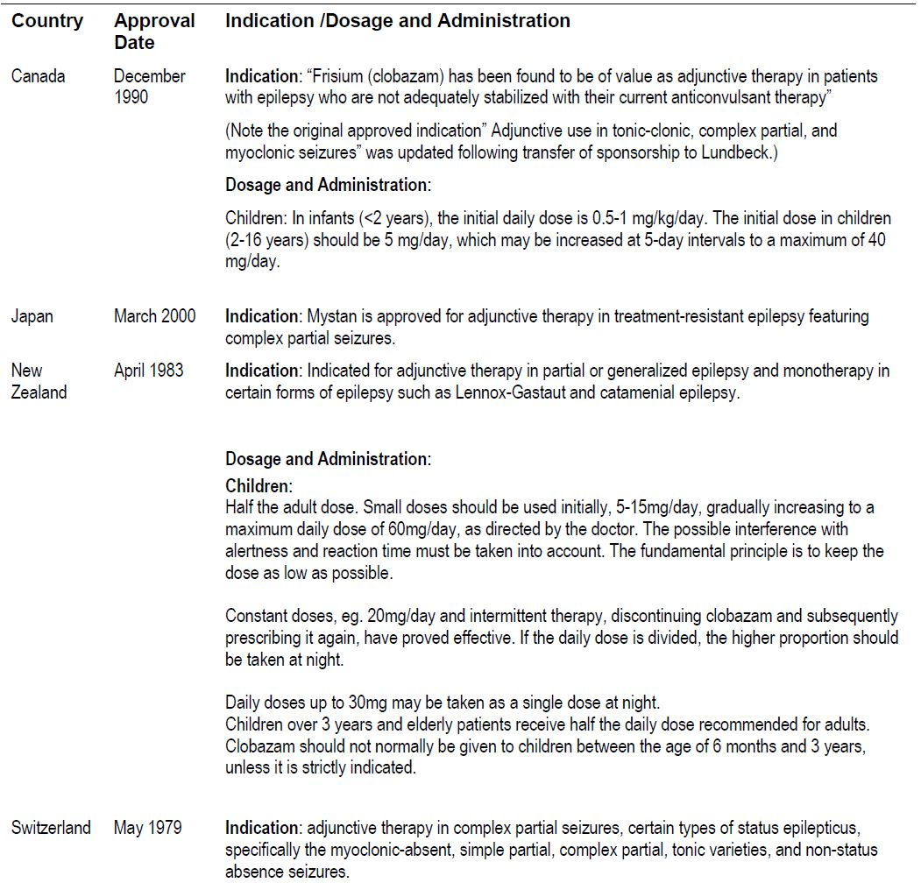

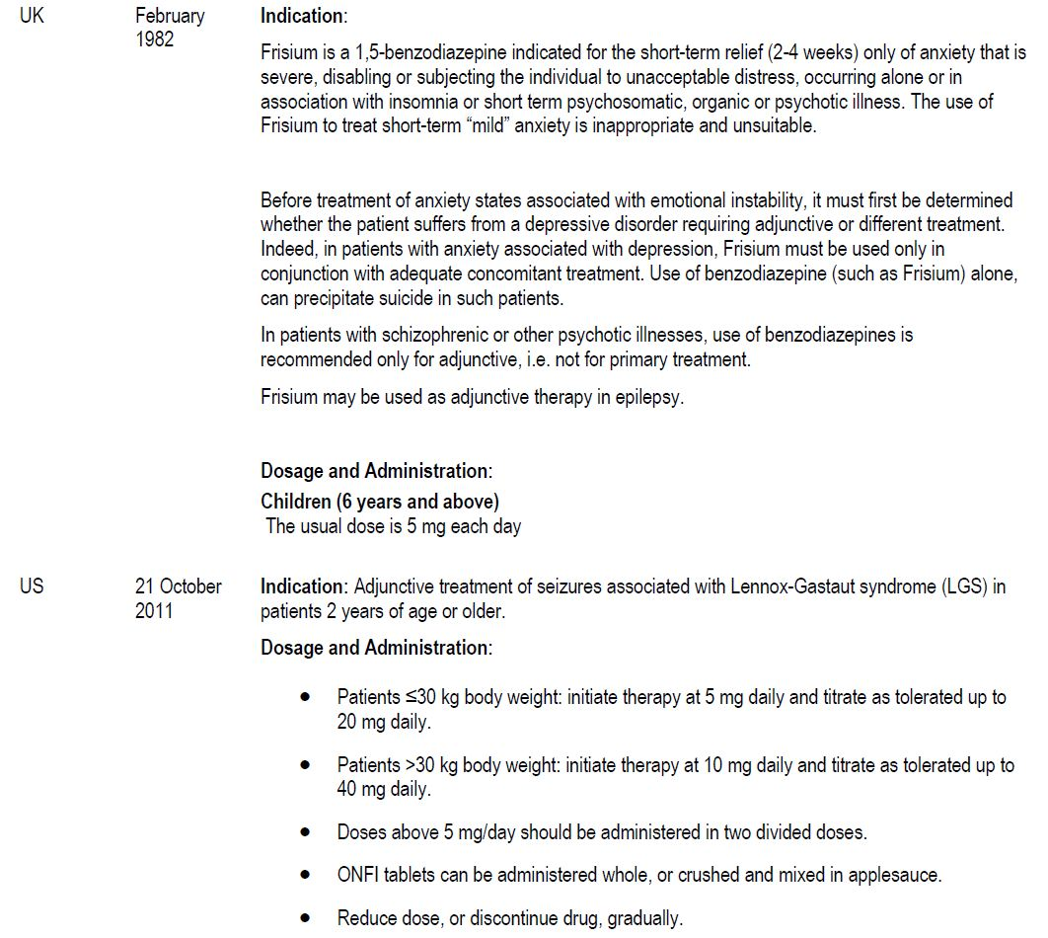

### Product Information

The approved Product Information (PI) current at the time this AusPAR was prepared can be found as Attachment 1.

## II. Quality findings

There was no requirement for a quality evaluation in a submission of this type.

## III. Nonclinical findings

### Introduction

The sponsor is seeking to extend the indication and patient population of clobazam (Frisium, 10 mg tablets) for use in children (≥ 4 years of age) as an adjunctive therapy to treat refractory epilepsy. Because clobazam has a long history of use in Australia, the sponsor provided nonclinical data in the form of a hybrid LBS. No new nonclinical efficacy studies for this new indication were submitted, however, the sponsor cited a considerable history of off label use of clobazam as an anticonvulsant. Nonclinical evidence of the efficacy of clobazam came from three published literature reports that demonstrated the anticonvulsant effects of clobazam in *in vitro* and *in vivo* rat models of epilepsy. Also submitted were numerous published literature reports and reviews on the thyroid tumour and four early genotoxicity studies. The submitted LBS listed further studies relevant to safety that were provided on request which included four reproductive toxicity studies in rats and rabbits. No supporting toxicokinetic data were provided. Some nonclinical information was also sourced by the TGA evaluator from the Food and Drug Administration (FDA) nonclinical evaluation report for clobazam (Onfi; sponsor, Lundbeck Inc.) which is publicly available on the FDA website.

A deficiency of the nonclinical dossier was the absence of juvenile toxicity studies relevant to medicines intended to be given to a juvenile population, as per the relevant nonclinical guideline.[1] A juvenile rat toxicity study was assessed in the FDA nonclinical evaluation report for clobazam (Onfi) with a relevant precautionary statement inserted in the PI document. Because the study was commissioned by a different sponsor (Lundbeck Inc.), the sponsor of Frisium stated that they did not have access to this study (or others that were requested as part of a Section 31 request) and were unable to submit it in support of its proposed paediatric indication. Some of the key published literature reports were in foreign languages (Japanese and French). Only one was translated into English. Four Japanese articles reporting full reproductive toxicity studies were only translated, in part, into English (abstracts, data and tables) which limited the ability to discern technical details or derive contextual understanding about the studies.

### Pharmacokinetics

No data on the pharmacokinetics of clobazam were included in the nonclinical submission. However, there were three published reports included in the clinical submission, including one that pertained to the ADME (absorption, distribution, metabolism, and excretion) characteristics of clobazam in animals and two *in vitro* studies on CYP isozymes involved in hepatic metabolism of clobazam. These studies, although not detailed, provided an insight into potential drug interactions of clobazam that are not referred to in the PI. Inactivation of the active metabolite of clobazam, N-desmethylclobazam (NCLB), was identified as being reliant on the CYP isozyme 2C19, flagging a potential drug interaction with strong or moderate inhibitors of 2C19 (for which clinical evidence does exist), as well as for poor 2C19 metabolisers.

It was noted that none of the submitted animal toxicity studies had toxicokinetic data to associate toxicities with plasma levels of clobazam or NCLB. The juvenile toxicity study cited in the FDA report and subject to a Section 31 request was conducted to modern standards and thus did have area under the plasma concentration-time curve (AUC) values for both clobazam and NCLB. However, the lack of paediatric AUC data meant that these values were not used to derive relative exposure ratios.

### Toxicology

#### Genotoxicity

The sponsor submitted four studies and one published report to support new statements in the PI concerning genotoxicity (in accordance with the Australian Regulatory Guidelines for Prescription Medicines). None of the submitted studies showed clobazam to have genotoxic or clastogenic potential although there was evidence of cytotoxicity particularly at the higher tested concentrations. Metabolic activation reduced this cytotoxicity in some of the tested systems. Although not all the studies were compliant with Good Laboratory Practice guidelines, reflecting their age (conducted between 1980-1994), the testing conditions employed for all the presented studies were acceptable and in line with the guidelines of the International Conference on Harmonisation of Technical Requirements for Registration of Pharmaceuticals for Human Use (ICH). The lack of genotoxic potential of both clobazam and the active metabolite N-desmethyl-clobazam was confirmed in more recent (2005-2009) studies (FDA nonclinical evaluation report for Onfi).

#### Carcinogenicity

The sponsor did not submit any carcinogenicity studies per se, although some of the submitted searched literature noted carcinogenic effects (thyroid tumours in rats). In the previous nonclinical report for clobazam, two carcinogenicity studies were evaluated (which had also been evaluated in the FDA evaluation report for clobazam (Onfi)). The studies were conducted in mice and rats utilising dietary administration and, consistent for the time, did not include toxicokinetic measurements to confirm adequate exposure to clobazam. Apart from lack of kinetic data, both mouse and rat studies suffered from significant design limitations. The basis for dose selection (identical in both studies: 4, 20, 100 mg/kg/day) was not described. The mouse study was of shorter duration (80 weeks) than currently expected. The replacement of High Dose (HD) mouse early decedents (due to fighting) may have affected study validity and the adequacy of tissue sampling from sufficient animals of both species is unclear. The HDs administered in these studies were reasonable multiples of the 30 mg adult human dose (15-30x, based on body surface area comparisons; see Relative Exposure table below).

Tumour incidence was low in both male and female mouse groups. However, the replacement of HD male decedents may have confounded the ability to discern treatment related tumour development in this cohort. In the rat study, mortality was high in the second year, though there were negligible differences between treatment groups for both males and females to confirm that this was a treatment dependent effect. Significant tumour incidence included increased thyroid follicular cell adenomas in HD males (with a small, non significant increase at the Medium Dose (MD)), but no obvious similar effect in females. Malignant thyroid tumours were not found in the rats apart from a single MD female. The female treated rats showed increased incidences of differing hyperplastic uterine changes and total (various) uterine tumours at the HD but a relationship to treatment was not clear. As noted in the previous nonclinical evaluation, no further examination was performed (for example, measurement of biochemical or endocrine parameters) beyond standard macroscopic assessment to enable characterisation of these effects.

A selection of submitted published articles discussed mechanistic aspects of how clobazam induces thyroid tumours in rodents, that is, increased clearance of T4 secondary to hepatic enzyme induction leading to elevated TSH. This well characterised mechanism is associated with the liver enzyme inducing effects of benzodiazepines in general and is not considered relevant to humans because of differences in the way rodents and humans exert homeostatic control of thyroid hormone secretion.[2] Tentative comparisons with other benzodiazepines (diazepam and an active metabolite, oxazepam) were made in the FDA report where similar types of tumours (hepatocellular adenomas and thyroid follicular cell adenomas) were reported for oxazepam and clobazam in rodents, and were attributed to alterations to circulating thyroid hormones unrelated to liver enzyme inducing effects. However, the differences in the incidences of tumour types – oxazepam produced clear increases in hepatocellular adenomas, whereas those reported for clobazam indicated a tendency rather than a clear effect which suggests that there are differences in the tumourigenic response between the two benzodiazepines.

The design deficiencies of the rodent carcinogenicity bioassays limit the interpretability of the observations, although the male rat thyroid finding would appear to be valid.

#### Reproductive toxicity

Four published literature reports on the reproductive toxicity of clobazam were submitted in Japanese but with the tables and figures in English. Three studies concerned the effects of clobazam on fertility, embryofoetal development (organogenesis) and peri/postnatal development in rats, whilst a fourth embryofoetal development study (including treatment during organogenesis) examined the effects of clobazam in rabbits; all studies used PO (oral) (gavage) administration in a starch vehicle. The language of publication prevented confirmation of GLP status, although this is unlikely to have been recorded given the publication dates of the reports (~1983). The studies did not include toxicokinetic data or any information on placental transfer or excretion into milk. The selection of dosing periods in these studies was generally appropriate; although based on current guideline requirements for multigenerational pre and postnatal studies, the peri/postnatal developmental study in rats[3] did not use a dosing period that included exposure during organogenesis (from GD [Gestational Day] 6 or 7, compared with GD 17 onwards), consistent with toxicological practice at the time. There were no treatment related mortalities in the rat studies.

There were no significant intergroup differences in fertility and litter values (that is, corpora lutea, implantations and live embryos). It is unclear whether cross breeding between treated and untreated rats took place; however, as mating success and conception rates were not affected by clobazam this may not be of significance. Both paternal and maternal weight gain in the HD group (750 mg/kg/day) were reduced which did not correspond to changes in food consumption in either sex. The only treatment related developmental effect was a higher number of foetuses from HD females with variant lumbar ribs potentially related to lower weight gains (maternal toxicity) in this treatment group. Skeletal effects were also apparent when clobazam was administered to rats during organogenesis, where F1 foetuses and pups from MD (250 mg/kg/day) and HD (750 mg/kg/day) groups were found to have a higher incidence of variant lumbar rib development, corresponding to reduced maternal weight gain and food consumption during gestation. Low levels of functional/behavioural changes (reflexes responses and decreased ambulation) in offspring from treated females were likely to have been exaggerated class related effects. Thyroid effects or changes were not apparent in these studies. In the peri/postnatal study in rats, the only relevant treatment affected parameter was increased stillbirths in the HD (750 mg/kg/day) group and likely to have been secondary to maternotoxicity (reduced weight gain/food consumption recorded).

The rabbit was more sensitive to the toxic effects of clobazam. A preliminary dose range finding study noted very high maternal deaths in the MD (100 mg/kg/day) and HD (150 mg/kg/day) groups. In the main study, maternal mortality was still high (9/15) in the HD (50 mg/kg/day) group with reduced body weight gain and food and water consumption in this and the MD (25 mg/kg/day) groups and was associated with class related impairments to gait and activity. The maternal no observed adverse effect level (NOAEL) was thus the LD (Low Dose) (10 mg/kg/day). Treatment at the HD clearly increased foetal deaths and reduced the survival rate at 24 h post birth. The F1 NOAEL was considered to be 25 mg/kg/day.

The earlier, previously evaluated reproductive toxicity studies with clobazam are dated (early 1970s).There were numerous deficiencies in design and reporting, including inappropriate dosing periods that do not cover the full period of organogenesis in rodents, lack of dose justification, limited endpoint assessment, and no toxicokinetic data. The doses used were considerably lower than those reported in the Japanese studies and, based on evidence of parental toxicity, were likely to have been generally too low. The only notable findings from these studies were:

an increased neonatal mortality at 200 mg/kg/day in the mouse fertility study, which was not seen in rat fertility studies (up to only 85 mg/kg/day;[4] up to 750 mg/kg/day);

* an increased incidence of external malformations (including cleft palate) at 100 mg/kg/day in the mouse embryofoetal development study (up to 100 mg/kg/day GD 7-12), which was not seen in another mouse study (up to 100 mg/kg/day GD 6-17) or rat embryofoetal development studies (up to 100 mg/kg/day GD 6-20; LNCT-022, up to 400 mg/kg/day GD 9-14;[5] up to 750 mg/kg/day GD 7-17).

Although the finding of cleft palate in mice has been reported for other benzodiazepines (for example, diazepam and clonazepam), it is possible that this species is sensitive to cleft palate induction as other rodent studies did not confirm the observation. The overall inadequacies of this group of early studies limit any firm conclusions regarding the potential reproductive toxicity of clobazam, although the available data do not indicate a teratogenic potential.

##### Pregnancy classification

The sponsor did not propose to change the pregnancy category for clobazam (Category C) nor did they seek to amend the existing generic precautionary statement regarding the use of benzodiazepines during pregnancy. In view of its substance class, the choice of Category C for clobazam is appropriate and should be maintained.

#### Paediatric use

Although this submission seeks to extend the indications of clobazam (Frisium) to include use in paediatric patients (≥ 4 years) the sponsor did not submit any nonclinical data to support use in this patient population. In the sponsor provided PI document for Onfi (clobazam tablets registered in the USA for use in children ≥ 2 years for LGS), the section on paediatric use described a juvenile toxicity study in rats with adverse effects on bone growth and development. This study, which investigated treatment with clobazam 4, 36 and 120 mg/kg/day PO by gavage from PND (Post Natal Day) 14 to 49/53, was also assessed in the FDA report. Notably there were effects on bone development (reduced femur length in HD females, reduced bone mineral content and density in all treated female groups) and increased motor activity (HD females), which had resolved in a recovery subset group by PND 119. As well, there were delayed responses in HD females performing the Morris water maze test at the end of the recovery period. The study also included toxicokinetic measurements for clobazam and its active metabolite N-desmethylclobazam at the beginning of the treatment period (PND 14) and towards the end (PND 48). As there were no paediatric pharmacokinetic data in the current submission these AUC measurements were not used to determine exposure ratios.

#### Comments on the safety specification of the risk management plan

The sponsor did not refer to any safety specifications that were relevant to nonclinical observations. With regard to the thyroid effects in rodents, the sufficient clinical use of clobazam and indeed other benzodiazepines suggests that these effects are not relevant to humans.

The developmental effects reported in the juvenile toxicity study will require closer scrutiny to establish whether they represent a viable risk to patients and if so, the sponsor should outline an appropriate risk mitigation strategy. This may depend on whether this medicine is only for occasional/short term use for refractory episodes of seizures.

##### Relative exposure

Exposure ratios (Table 2) are based on body surface area estimates (mg/m2) and calculated against human adults (50 kg) and predicted human child (4 years old, 15 kg) dosage levels.

Table 2: Relative exposure in two carcinogenicity, four reproductive toxicity, and one juvenile toxicity studies.

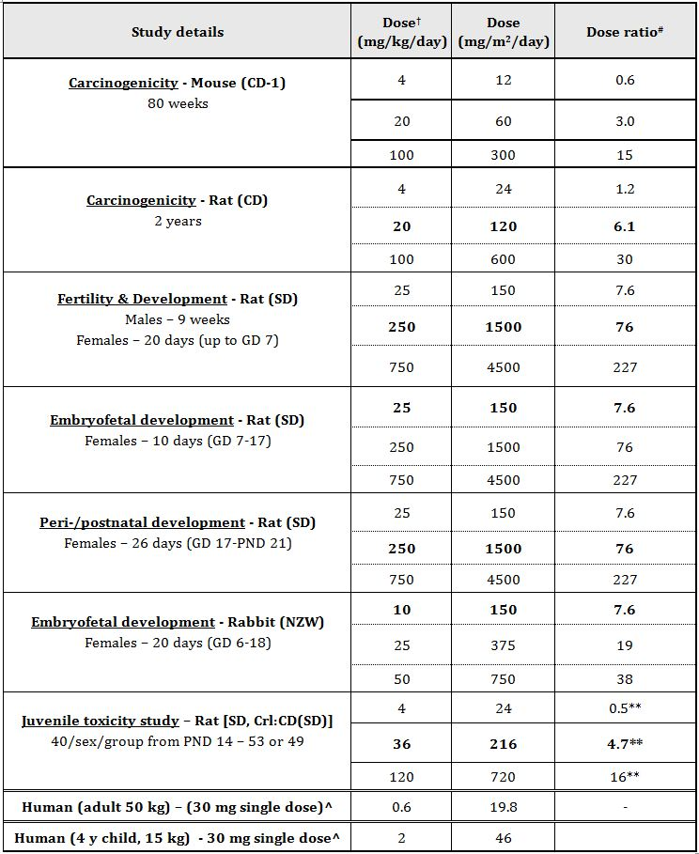

NOAELs are **bolded**; *Based on a maximum dose of 30 mg to be taken as a single dose at night as specified in proposed PI

Conversion factors: Mouse 3; Rat 6; Rabbit 15; Human (child 4 y, 15 kg) 23; Human (adult, 50 kg) 33

** Comparison made relative to dose for 4 yr old child; # = animal:human dose (mg/m2); ^ MRHD; † PO administration

### Nonclinical summary and conclusions

* Submitted nonclinical data consisted of genotoxicity studies previously evaluated 30 years ago, and several published articles including four reproductive toxicity studies that were conducted in rats and rabbits. These studies were in Japanese and, although the tabular data were in English, no translations of the text were provided. The nonclinical dossier did not include any juvenile animal toxicity studies, but relevant information was sourced from the published FDA nonclinical evaluation of clobazam (Onfi; sponsor, Lundbeck).
* Serum protein binding of clobazam is higher in humans than rats, dogs and monkeys (85%, compared with 66, 83 and 75%, respectively). Clobazam undergoes oxidative metabolism by CYPs 3A4, 2C19 and 2B6 to form the active metabolite N-desmethylclobazam. Further metabolism of the active metabolite is largely dependent on 2C19, highlighting the potential for clinically relevant drug interactions.
* Clobazam did not display genotoxic activity in a standard test battery. In limited (previously evaluated) rodent carcinogenicity assays, the only relevant finding was thyroid follicular cell adenomas in male rats, attributed to enhanced hepatic thyroxine clearance and considered not relevant to humans due to species differences in endocrine homeostatic mechanisms.
* In published reproductive toxicity studies, clobazam did not affect fertility in rats, embryofoetal development in rats and rabbits, or early postnatal parameters at oral doses extending into the maternotoxic range. Previously evaluated reproductive toxicity studies had numerous deficiencies in design and conduct which limit their interpretability.
* In the juvenile rat toxicity study, oral treatment with clobazam during early development (PND 14-48) reduced femur length and bone mineral content and density, and increased motor activity, all of which had resolved in recovery animals (PND 119). Effects on behaviour (Morris water maze test) persisted in the recovery animals.
* Despite the fact that Frisium is an established medicine with a considerable history of clinical use in Australia, there are significant gaps in the available nonclinical information, partly attributable to the age and limitations of the data. For the current submission, the important consideration is the level of available nonclinical support for extending the patient group to children aged 4 years and older, which is limited to a single juvenile animal study derived from published summary data. The decision to approve extending the indication and patient population for Frisium will depend on clinical data.

## IV. Clinical findings

A summary of the clinical findings is presented in this section. Further details of these clinical findings can be found in Attachment 2.

### Introduction

The clinical overview references data from a wide variety of clinical trials of variable quality from the 1970s to the present. The clinical development strategy relates to a post hoc selection of appropriate data. Supportive data from adult studies are also used.

The submission contains the following clinical information:

* Early studies where clobazam was used as an anxiolytic:
  + Clobazam was initially developed and licensed as an anxiolytic in the 1970s-80s. The original registration studies were performed to the practice standards of the time, but included 11 RCTs of parallel group, double blind design. These included three pivotal studies versus placebo and 7 comparative studies versus either placebo and/or diazepam. Approximately 1527 patients aged 17-77 were involved. The efficacy and safety profile as an anxiolytic and antiepileptic drug (AED) relate to the pharmacodynamic effects on enhancing GABA-A inhibition. Some data from the anxiolytic studies are therefore referred to in support of this application, in particular where they involved infants and children.
* Early Development in epilepsy:
  + Including many open and retrospective studies which provide some supportive safety data.
* Data included in the 1995 submission:
  + Eight placebo controlled RCTs were included in the 1995 submission, but only 2 involved children. 15 open studies were also included, 10 of which involved children. Reference is made to the previous 1995 submission for a detailed overview of these studies. The relevant studies from the previous submission have been re-assessed to provide a mixture of pivotal and supportive data for this application.
* New Data:
  + Data from three new RCTs in paediatric patients are included in the Clinical Overview.
  + Data from several recent non controlled clinical trials, some in refractory partial epilepsy are provided.
  + Data derived from reviews and meta analyses.
* Safety Data:
  + Safety data from the clinical trials outlined above have been supplemented by data from the worldwide safety database of the sponsor company. A targeted literature search related to thyroid adenomas is presented.
* Additional supportive data:
  + Reference is made to appropriate best practice guidelines and the endorsement of Australian expert opinions

*Comment: The evaluator considered the appropriateness of designating the monotherapy study[6] as pivotal. The specific indication sought by the sponsor in this submission is to include adjunctive therapy in paediatric patients with refractory epilepsy who are not adequately stabilized with their current anticonvulsant therapy. The study by Camfield was a monotherapy study with two parts: a monotherapy study in a heterogeneous group of patients with drug naive epilepsy, and another form of monotherapy conversion study with two arms. The monotherapy conversion group included patients with previous treatment failure with one AED because of poor seizure control or patients with one or two previous AEDs due to side effects. Those in the previously treated group were assigned to one of two study arms previous failure with carbamazepine (CZP) or with other AEDs. Those in the CZP failure group were randomized to receive clobazam versus phenytoin (PHE). Those in the “other” failure group were randomised to receive clobazam versus CZP.*

*For a monotherapy study there are a number of methodological issues according to the European Medicines Agency (EMA) Guideline on clinical investigation of medicinal products in the treatment of epileptic disorders.[7]*

*It is recommended that idiopathic generalised epilepsies should be explored separately (primary generalised epilepsies accounted for 11.2% overall).*

*In monotherapy studies, the primary efficacy variable should be based on the proportion of patients remaining seizure free for at least 6 months.*

*The monotherapy study[8] included idiosyncratic endpoints of retention on the study medication for 12 months or discontinuation of the medication for any reason, including side effects or inadequate seizure control. It is suggested that in monotherapy conversion, a treatment retention time may be an acceptable primary outcome variable.*

*Given that the study is not a typical study and does not conform to EMA guidelines, it may not be considered pivotal but is very strongly supportive of the antiepileptic effect of clobazam in medium term use:*

*Patients were children and the majority had partial epilepsy syndromes, not LGS. More than half of the conversion to monotherapy group included patients who were refractory to one previous AED treatment.*

*A measure of drug tolerance to the antiepileptic effect of clobazam is measured and reported*

*The study is of sufficient duration (12 months).*

*The pivotal add on study by Ng and colleagues[9] is highly relevant to the case for use of clobazam LGS epilepsy. This study does provide strong evidence for efficacy, dosing and safety in this very difficult rare form of childhood refractory epilepsy.*

*The study by Conry and colleagues[10] was considered by the sponsor as a pivotal. However, it is not of typical design; that is, the study is of very short duration (the maintenance period was only 4 weeks) and uses an active LD control rather than placebo. It was designed as a “Phase II” multicentre, randomised, double blind, HD/LD comparison, parallel group study. According to EMA guidelines,[11] a maintenance period should last at least 12 weeks in order to establish that “the efficacy is not short lasting” – a potential concern for clobazam especially. No data concerning potential rebound effects were generated. This study should also be considered strongly supportive.*

*Comment: The most significant shortcoming in the development program is the absence of a study specifically examining the effects of the add on clobazam for treatment of childhood refractory partial epilepsy compared to placebo, the indication for which is primarily being sought by the sponsor. The justification for extension of the indication to include childhood refractory epilepsy given by the sponsor is that LGS is a “worst case” test model for epilepsy therapies. This will be discussed later.*

### Pharmacokinetics

Not evaluated.

### Pharmacodynamics

Not evaluated.

### Efficacy

#### Evaluator’s overall conclusions on clinical efficacy

Two well conducted randomised controlled studies show robust short to medium term efficacy of reduction in seizures (particularly the most disabling variety of seizures – drop seizures) in children with LGS.[12] The maintenance period in one study was adequate, according to EMA guidelines, to “establish that efficacy is not short lasting”.[13] These modern studies used appropriate efficacy outcomes and there were remarkably consistent results. For example, in the Phase II study the ≥50% responder rate for drop seizures was 83% at a dose of 1mg/kg/day[14] whereas in the Phase III study, the ≥50% responder rate for drop seizures was 77.6% at a dose of 1mg/kg/day.[15] Moreover, there was specific analysis to examine for development of tolerance in the Phase III study to suggest that there was no issue. Results of open label extension use for clobazam in LGS do not appear to have been included in the current submission. However, publically available efficacy evaluations in open label extension patients (a large majority of patients participating in the Phase II and III studies entered the open label extension – about 267 of 303 patients) done by the FDA looking for development of tolerance to clobazam in LGS patients did not suggest the development of significant issues.

Large experience with clobazam in epilepsy is displayed through six non comparative studies, including 867 children. These studies were prospective (n=2) or retrospective (n=2). Five of them described the use of clobazam as an add on therapy to AEDs. In most cases, the decision to initiate combination therapy was made after failure observed with several consecutive monotherapies with AEDs. Seizures for which the patients were included were mainly described as refractory or resistant to conventional AEDs.

Clobazam was administered at the initial daily dose of about 0.25-0.35 mg/kg/day and was then progressively increased until seizures were controlled or toxicity developed. The final dose ranged from 0.5 to 2 mg/kg/day. Clobazam was discontinued when the maximum tolerated dose was reached without seizure improvement or due to adverse event.

The primary endpoints were the number of seizure free patients and the rate of patients with a seizure reduction higher than 50%, 75% or 90%, with a follow up duration ranging from 3 months to >4 years. Given the variety of patients’ characteristics and of types of epilepsy, the results were rather homogeneous, with a seizure free rate of 9-25% (five studies; and another one at 41%), a ≥90% seizure reduction of 31% (one study), ≥75% seizure reduction of 11-41% (four studies), and ≥50% seizure reduction of 24-46% (five studies).

In the studies where clobazam was used as an add on therapy in intractable epilepsy in children; the seizure free rate reached between 9 and 41% and improvement (reduction by 50 or 75% of seizure frequency) was observed in 11 to 46% further patients. Further experience was analysed through studies mixing adults and children, of which a Canadian retrospective analysis collected up to 440 children. These studies further demonstrate the usefulness of clobazam as an add on therapy in epilepsy.

The evaluator generally agrees with the sponsor’s conclusion that the current data suggests that for patients with drug refractory epilepsy, when used as an add on treatment, clobazam may reduce the frequency of seizures although it is not possible to quantify precisely the treatment effect or perhaps duration of treatment effect.

The evaluator notes that the current submission does not fulfil the current adopted guidelines for evaluation of an AED as add on therapy for refractory partial epilepsy. The study by Keene and colleagues[16] cannot be considered as providing pivotal evidence. However, the sponsor has argued that LGS represents a worst case scenario for partial epilepsy and partial seizures in LGS patients were also improved by clobazam. This contention is supported by current preclinical models of epilepsy, long term (largely open label studies) of clobazam as add on therapy for partial epilepsy, and consensus expert guidelines.[17] The evaluator also notes that it is recommended by the EMA guidelines that LGS and partial epilepsy be studied separately mainly due to, presumably, the notion that drugs found effective in partial epilepsy may be ineffective in LGS rather than the other way round. The evaluator notes that while the one blinded, randomised study of clobazam as add on for refractory childhood partial epilepsy by Keene and colleagues[18] is inadequate by modern standards, it does provide supportive evidence that clobazam has at least short term efficacy in seizure reduction. Therefore it is reasonable to assume on the evidence presented that clobazam does have efficacy for the short to medium term treatment of refractory partial epilepsies.

On the other hand, the development of tolerance in patients treated with clobazam for refractory partial epilepsy is less well studied – particularly with regards to prevalence, time to onset and management. Open label studies generally support the development of tolerance within a few months of treatment initiation in partial epilepsy although tolerance may partially improve with further treatment titration. However, there are several reports of the late emergence of clinically relevant tolerance with clobazam as adjunctive therapy – this evidence seems to particularly relate to patients with partial or temporal lobe epilepsy.[19]

The evaluator notes that it has been asserted by some that even though tolerance might develop, this aspect may have been overemphasized in view of the fact that a long-term benefit figure of 28% could be expected without tolerance.[20] Moreover, the evaluator could not find any significant examples of rebound epilepsy when clobazam was withdrawn slowly (for example, over a period of 3 weeks).[21]

The evaluator notes that currently in Australia another benzodiazepine (a 1,4- benzodiazepine), clonazepam, is approved for use in “Neurologically proven epilepsy”. Clobazam may have a more favourable side effect profile than clonazepam for use in epilepsy.[22]

### Safety

In the pivotal efficacy studies, the following safety data were collected.

#### General adverse events (AEs)

##### Keene et al.[23]

A side effects record sheet was reviewed at each clinic visit.

##### Canadian study group for childhood epilepsy[24] and bawden et al.[25]

Methods of AE determination: At study entry and at each follow up visit, a checklist of systemic and behavioural side effects was completed by the attending paediatric neurologist, based on spontaneous and elicited parental reports and physical examination. Behavioural side effects were characterised as externalising (for example, restless, aggressive) or internalising (for example, depressed, withdrawn) in nature. Symptoms were assessed using four levels of severity (none, mild, moderate, and severe). Side effects from this list were used in the analyses if they were ‘emergent events’, that is, if they emerged during treatment or increased in severity from baseline and were judged to be moderate or severe.

##### Conry et al.[26]

AE and SAE methods: The safety of CLB was evaluated by laboratory assessments (chemistry, haematology, and urinalysis), vital signs, electrocardiography (ECG), physical and neurologic examinations, and AE assessment. Treatment emergent AEs and serious adverse events (SAEs) were summarised by severity and relationship to study drug. The safety population consisted of all randomised patients who took at least one dose of the study drug.

##### Ng et al.[27]

AE and SAE evaluation was done in a manner similar to Conry et al.[28]

##### Rose et al.[29] and Bajaj et al.[30]

Assessors enquired after adverse effects.

#### AEs of particular interest, including neuropsychological measures

##### Canadian study group for childhood epilepsy[31] and bawden et al.[32]

Neuropsychological assessments - methods: Neuropsychological assessments were competed at 6 weeks and 12 months after patients began to take the study medication. Areas of psychological functioning were chosen for examination on the basis of previous research showing sensitivity to AED effects. Tests were administered and scored by psychological technicians who were blind to medication status. None of the children were post-ictal at the time of the psychological assessments. Intelligence was assessed using the Wechsler Intelligence Scale for Children-Revised (WISC-R) Memory was assessed using the Verbal Learning subtest of the Wide Range Assessment of Memory and Learning, Nonverbal Selective Reminding Test, Continuous Recognition Memory Test, and the Digit Span subtest of the WISC-R. Psychomotor speed was assessed with the Grooved Pegboard Test, subtest 14 of the Underlining Test, and the Coding subtest of the WISC-R. Attention was examined using the Freedom from Distractibility Factor Score, obtained by averaging scores on the Arithmetic, Coding, and Digit Span subtests from the WISC-R, and by using the average number of correct items on subtests 1, 2, 3, 4, 5, and 13 from the Underlining Test. A measure of impulsivity was obtained by averaging the numbers of errors of commission on these same subtests of the Underlining Test.

#### Laboratory tests

##### Keene et al.[33]

At the end of each maintenance phase, patients had a repeat EEG, Complete Blood Count (CBC), platelet count, aspartate transaminase (AST), blood urea nitrogen (BUN), thyroid stimulating hormone (TSH), total albumin (TA), thyroxine (T-3 or T-4), creatinine, blood glucose, and Serum Anticonvulsant Level determination(s). No abnormal values for complete blood count, platelet count, urea, creatinine, glucose, ALT, TSH, T-3 or T-4 occurred.

##### Canadian study group for childhood epilepsy[34] and bawden et al.[35]

Methods: Predose serum AED levels at 6 weeks, 6 and 12 months after randomisation, at the time of discontinuation of medication, and whenever levels were judged desirable by the treating physician. Patients had a complete blood count, platelet count, and BUN, creatinine, and AST. No other routine blood or urine screening was mandated in the absence of clinical signs or symptoms.

Results: No patient had screening laboratory tests that lead to discontinuation of study medication. One patient died from a ventriculoperitoneal shunt obstruction unrelated to study medication.

##### Ng et al.[36]

Methods: Safety assessments included laboratory assessments (chemistry, haematology, and urinalysis), physical and neurologic examinations, vital sign monitoring, and ECG monitoring.

#### Pivotal studies that assessed safety as a primary outcome

The study by Bawden and colleagues[37] was a pivotal study that assessed safety as a primary outcome.

#### Dose response and non pivotal efficacy studies

No dose response data available in supportive studies.

#### Other studies evaluable for safety only

These studies are not included in the efficacy analysis as they were primarily designed to assess tolerability/safety of clobazam.

##### Patat et al.[38]

The effects on memory and psychomotor performance and the subjective effects of three anxiolytic benzodiazepines (lorazepam 2 mg, diazepam 10 mg and clobazam 20 mg orally) have been evaluated in a double blind, placebo controlled, crossover study in 10 healthy volunteers. At each session, measurements were made prior to and + 3.5 h after drug administration, except in the case of REY’s test, which was presented at H + 1 h (learning) and was evaluated at H + 8 h and at H + 24 h (delayed recall). Single clinical doses of diazepam and lorazepam caused anterograde amnesia by disturbing acquisition, consolidation and retrieval. Clobazam did not impair memory. Lorazepam impaired performances in all the tests used to evaluate perception, immediate memory, reaction time, psychomotor skill and intellectual capacity. Diazepam caused a decrease in cortical arousal and the speed of perception of visual stimuli, whereas clobazam increased reaction time and reduced cortical arousal. Lorazepam caused a significant degradation of performance relative to the other two treatments.

##### Patat et al.[39]

The effects of various benzodiazepine tranquillizers (clobazam 20 mg, bromazepam 6 mg and lorazepam 2 mg) were investigated by posturography in 16 subjects in a controlled trial. Twelve received each of the three anxiolytics for 1 week in a crossover design, four received placebo for 1 week during the three successive treatment periods. A pharmacodynamic study was carried out after the first administration, and another assessment was done after 1 week of treatment. The first administration of lorazepam caused the most marked disturbances of body sway (increase of spectral energies, length and amplitude of the stabilogram). The first administration of lorazepam was also accompanied by an increase of the posturographic parameters, although less marked. Administration of clobazam did not produce any impairment of equilibrium, indicating that it is devoid of any sedative effect measurable by posturography. No changes of the postural sway can be detected on the measurement recorded 10 h after the last dose of 1 week’s treatment.

##### Trimble et al.[40]

Healthy volunteers as well as patients with epilepsy were studied for 2 weeks in a double blind crossover design to determine the effect of anticonvulsant drugs on cognitive function and behaviour. The healthy volunteers experienced significant deficits in performance with the four drugs examined, phenytoin, carbamazepine, sodium valproate, and clobazam. The most wide spread changes were seen with phenytoin, carbamazepine, sodium valproate, and clobazam did not interfere with tests of memory function. The results of the patients’ studies showed that:

1. when anticonvulsants are reduced, patients receiving polytherapy improve their cognitive function;
2. patients with high serum levels of anticonvulsant drugs demonstrated more cognitive impairment than those with low levels;
3. when carbamazepine is substituted for another anticonvulsant, cognitive function is improved; and
4. in patients receiving monotherapy, high serum levels are linked to greater cognitive impairment than lower levels and the profile of changes differs between the drugs.

**Evaluator’s overall conclusions on clinical safety**

In the Phase II/III trials overall, 92% (277/300) of patients had one or more AEs. Those reported for at least 5% of clobazam trial subjects were somnolence (25%), upper respiratory infection (24%), pyrexia (19%), pneumonia (15%), lethargy (14%), nasopharyngitis(14%), constipation (14%), aggression (13%), fall (13%), otitis media (13%), insomnia (12%), urinary tract infection (11%), drooling 11%), sedation (10%), skin laceration (10%), and convulsion, viral infection, diarrhoea, vomiting, contusion, irritability, ataxia, sinusitis, decreased appetite, influenza, fatigue, cough, gastroenteritis, and pharyngitis streptococcal (all less than 10%). There were no AEs in Phase II/III trials coded to the preferred terms aplastic anaemia, agranulocytosis, Stevens Johnson Syndrome, Toxic epidermal necrolysis, acute renal failure, acute liver failure, pancytopenia, or rhabdomyolysis.

In the Phase II/III RCTs, there were small differences in overall AE risk when comparing low dose and high dose clobazam groups in the study by Conry and colleagues,[41] and when comparing clobazam and placebo groups in Ng et al.[42] In the study by Conry and colleagues,[43] 84% (27/32) of low dose patients and 86% (31/36) of high dose patients experienced one or more AEs. In the study by Ng and colleagues,[44] 68% (40/59) of placebo patients, 72% (42/58) of LD, 89% (55/62) of MD, and 76% (45/59) of HD clobazam patients experienced one or more AEs. A dose response was noted for somnolence and constipation with clobazam. AEs reported for ≥ 5% of clobazam patients and more frequently than placebo in the study by Ng and colleagues[45] were vomiting, constipation, pyrexia, irritability, fatigue, upper respiratory tract infection, somnolence, lethargy, drooling, ataxia, sedation, aggression, insomnia, and cough.

The evaluator notes no concerning findings for AEs regarding laboratory findings, ECG abnormalities, drug disease or drug-drug interactions. There are no concerning issues identified with regards to human carcinogenicity. In Phase II/III LGS trials where some subjects who discontinued were tapered off clobazam, no AEs were reported and there were no reports of withdrawal seizures.

In general, the AE profile observed with CLB in studies conducted by other sponsors and during post marketing experience is consistent with events seen with other benzodiazepines, such as sedation/drowsiness, dizziness, and ataxia. In these clinical studies conducted in patients with epilepsy that reported the overall percentage of patients who experienced AEs with CLB therapy, the numbers varied, but were in general approximately 40%. The most common AEs included sedation, behavioural abnormalities, ataxia, and drooling. AEs generally increased as dose increased and were generally mild and transient. In practice, these risks may be mitigated by slow up titration of clobazam. The evaluator has identified no safety issues that would preclude expanding the indication for clobazam.

### List of questions

None.

### Clinical summary and conclusions

#### First round benefit-risk assessment

##### First round assessment of benefits

The benefits of clobazam in the proposed usage are:

* Number Needed to Treat (NNT) for ≥ 50% reduction in drop seizures in LGS according to Ng et al:[46]
  + LD (0.25 mg/kg/d) NNT 8.5
  + MD (0.50 mg/kg/d) NNT 3.7
  + HD (1.00 mg/kg/d) NNT 2.2
* For reduction in seizures in treatment refractory childhood partial epilepsy according to Keene et al:[47]
  + MD (0.50 mg/kg/d) NNT 1.9

##### First round assessment of risks

The risks of clobazam in the proposed usage are:

* In the study by Ng and colleagues,[48] Number Needed to Harm (NNH) calculated for *any AE* compared to placebo:
  + LD (0.250 mg/kg/d) NNH 25
  + MD (0.50 mg/kg/d) NNH 4.8
  + HD (1.00 mg/kg/d) NNH 12.5

However, it should be noted that AEs were generally mild and transient. No significant differences were found in SAEs in the study by Ng et al.[49]

The only other “risk” identified by the evaluator is the potential issue of tolerance with long term use of clobazam. Insufficient data is available to fully evaluate this “risk”.

The potential for benzodiazepines to be abused both orally and intravenously is well recognised. However, different benzodiazepines have different abuse potential; the more rapid the increase in the plasma level following ingestion, the greater the intoxicating effect and the more open to abuse the drug becomes. The speed of onset of action of a particular benzodiazepine seems to correlate well with the ‘popularity’ of that drug for abuse. It is noted that since clobazam is not water soluble it would be difficult for abusers to make an injectable form. Moreover, in the evaluator’s opinion, the propensity for abuse would be greater for the already approved indication of anxiety (in Australia) compared to the narrower indication of refractory childhood epilepsy. Therefore, the abuse potential for expanding the indication of clobazam in the evaluator’s opinion would be extremely low.

##### First round assessment of benefit-risk balance

The benefit-risk balance of clobazam is unfavourable given the proposed usage, but would become favourable if the changes recommended below are adopted.

#### First round recommendation regarding authorisation

In the evaluator’s opinion, the submission would have been significantly improved by the provision of data pertaining to the open label study of patients participating in the studies by Conry and colleagues[50] and Ng and colleagues.[51]

Based on the literature submission provided, the recommends approval of the submission with modification of the proposed indication:

In Children ≥ 4years

*As adjunctive therapy in patients with Lennox Gastaut epilepsy who are not adequately stabilised with their current anticonvulsant therapy.*

And

*As short to medium term adjunctive therapy in patients with partial refractory epilepsy who are not adequately stabilised with their current anticonvulsant therapy.*

## V. Pharmacovigilance findings

### Risk management plan

The sponsor submitted a Risk Management Plan which was reviewed by the TGA’s Office of Product Review (OPR).

#### Safety specification

The sponsor provided a summary of Ongoing Safety Concerns which are shown at Table 3.

Table 3: Ongoing safety concerns for Frisium.

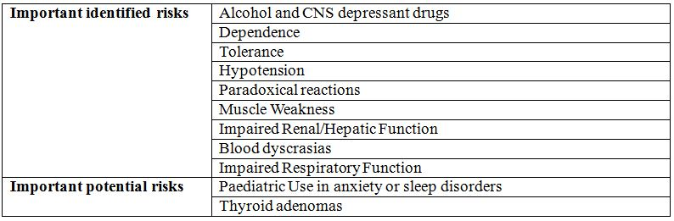

##### OPR reviewer comment:

The above summary of the Ongoing Safety Concerns is considered acceptable, unless additional concerns are raised from the evaluation of the nonclinical and clinical aspects of the safety specification.

#### Pharmacovigilance plan

##### Proposed pharmacovigilance activities

Routine pharmacovigilance activities are proposed by the sponsor to monitor the ongoing safety concerns associated with clobazam (Frisium).

##### OPR reviewer comment in regard to the pharmacovigilance plan and the appropriateness of milestones

Routine pharmacovigilance activities are considered to be acceptable to monitor the ongoing safety concerns associated with clobazam (Frisium).

#### Risk minimisation activities

##### Sponsor’s conclusion in regard to the need for risk minimisation activities

The sponsor provides the following conclusion in regards to the need for risk minimisation activities:

*The RMP includes the proposed routine pharmacovigilance and risk minimisation activities to ensure the benefit-risk of clobazam in the treatment of children with paediatric refractory epilepsy.*

*On the basis of the well established safety profile and clinical experience with the active substance over many years, no ‘missing information’ has been identified. No specific risk minimisation activities are proposed beyond routine measures provided by appropriate safety statements in the Product Information (PI) and Consumer Medicines Information (CMI).*

##### OPR reviewer comment:

Routine risk minimisation activities are considered acceptable to mitigate the risks associated with clobazam (Frisium).

#### Summary of recommendations

The OPR provides these recommendations in the context that the submitted RMP is supportive to the application. The draft PI and CMI documents should *not* be revised until the Delegate’s Overview has been received:

It is recommended that the Delegate:

* Implement RMP Version 1.1, dated May 2012, and any future updates as a condition of registration.

It is recommended to the Delegate that the sponsor:

* Amend the PI to include the Precaution: Monitoring “*If Frisium is administered for repeated cycles of therapy (including as an adjunctive therapy for the treatment of refractory epilepsy in children), periodic blood counts and liver, renal and thyroid function tests are advisable*”, that is proposed in the RMP as a routine risk minimisation activity for the **Important identified risks** ‘Impaired Renal/Hepatic Function’ and ‘Blood dyscrasias’.

It is recommended that the Delegate consider:

* If it is acceptable that the sponsor has removed the precautionary statement on thyroid adenomas and replaced it with the precautionary statement on carcinogenicity.
* An apparent inconsistency between the precautions and adverse events sections on the proposed PI with regards to laboratory tests. That is, the proposed PI has a section in the precautions section on the effect of laboratory tests with the statement ‘Data not available’. However, abnormal liver function tests and haematology have been observed with clobazam (see PI, Adverse effects section).
* This product is only available as a 10 mg tablet which may not allow accurate dosing in young children. In the Summary of Product Characteristics (SmPC) it is stated in Section 4.2 Posology and method of administration, Treatment of epilepsy in association with one or more other anticonvulsants, Children: “*As there is no age appropriate formulation to enable safe and accurate dosing, no dosage recommendations can be made in children under 6 years of age*”. The Delegate may consider requesting this statement be included in the PI.

## VI. Overall conclusion and risk/benefit assessment

The reasons of failure of the two earlier clobazam submissions to the TGA (1986 and 1995) have been previously described in this AusPAR. Those submissions sought an additional, broad indication for the use of clobazam in adults and children in all refractory epilepsy types.

According to the clinical evaluator, it would appear that the regulatory compliance issues and an aspect relating to inadequate clinical data (Metabolic lnteractions, particularly with other medications; Withdrawal and Rebound effects) are now satisfactorily reviewed. The data on Pharmacokinetics and Tolerance with chronic use are not quite precise and the clinical evaluator did comment at large on the latter. However, clobazam is an old drug already registered in Australia, NZ, Canada, UK and USA for various indications including epilepsy (except Australia, where it is used ‘off label’ for that purpose). On the issue of ‘Evidence of efficacy and safety from well controlled randomised clinical trials’, the clinical evaluator could only identify supportive rather pivotal studies. The clinical evaluator has not uncovered ‘Expert Clinical Overview’ adequately discussing the main specified deficiencies of the 1986 submission in the current application.

Overall, the clinical evaluator found the benefit-risk balance of clobazam unfavourable but stated that it would become favourable if the proposed indication is changed to:

In Children ≥4years

*‘As adjunctive therapy in patients with Lennox Gastaut epilepsy who are not adequately stabilised with their current anticonvulsant therapy’.*

and

*‘As short to medium term adjunctive therapy in patients with partial refractory epilepsy who are not adequately stabilized with their current anticonvulsant therapy’.*

(The clinical evaluator mentioned that 12 months is reasonable on the basis of the open label data evaluated.)

Regarding the above, the sponsor has not applied for the LGS indication (which is the indication in the US). The sponsor’s proposed Australia indication is akin to the registered UK indication (Frisium may be used as adjunctive therapy in epilepsy). The caveat for the UK indication stated that:

*“The patient must be reassessed after a period not exceeding 4 weeks and regularly thereafter, in order to evaluate the need for continued treatment. A break in therapy may be beneficial if drug exhaustion develops, recommending therapy at a low dose. At the end of the treatment (including in poor responding patients), since the risk of withdrawal phenomena/rebound phenomena is greater after abrupt discontinuation of treatment, it is recommended to gradually decrease the dosage”.*

The caveat for the sponsor’s proposed Australia indication stated that

*“The patient must be reassessed after a period not exceeding four weeks and regularly thereafter in order to evaluate the need for continued treatment. The possible interference with alertness and reaction time must be taken into account. The fundamental principle is to keep the dose as low as possible. Constant doses and intermittent therapy, discontinuing clobazam and subsequently prescribing it again, have proved effective. If the daily dose is divided, the higher proportion should be taken at night”.*

Taken together, it would appear that the sponsor’s proposed indication with the above caveat somehow represents the flavour expressed in the clinical evaluator’s proposed amended second indication.

The dosage instructions in the proposed Australia PI stated that

*“Daily doses up to 30 mg may be taken as a single dose at night. The tablets are to be swallowed without chewing with sufficient amount of liquid (approx ½ - 1 glass)”.*

The sponsor is required to convincingly demonstrate that the proposed children population have the ability to regularly swallow tablets (without chewing), prior to registering the clobazam tablet formulation in children for the proposed indication. ln that regard, it is noteworthy that the RMP evaluator has also touch based on the issue:

*“This product is only available as a 10 mg tablet which may not allow accurate dosing in young children. In the Summary of Product Characteristics (SmPC) it is stated in Section 4.2 Posology and method of administration, Treatment of epilepsy in association with one or more other anticonvulsants, Children: As there is no age appropriate formulation to enable safe and accurate dosing, no dosage recommendations can be made in children under 6 years of age”.*

Perhaps a liquid formulation is more appropriate to register for the proposed Extension of Indications!

The clinical evaluator has suggested some changes to the proposed PI and stated that the decision to approve extending the indication and patient population for Frisium will depend on clinical data. The issue raised by the RMP evaluator of moving the thyroid adenoma statement from the Precaution to the Carcinogenicity section is acceptable, given the modification placed on it by the clinical evaluator. The cause of discrepancy – ‘Data not available’ – pointed out by the RMP evaluator between the Precautions and AEs sections of the proposed PI should be removed.

### Risk-benefit analysis

#### Delegate considerations

Even though the submission is far from being perfect, a consideration of clobazam’s widespread use (registered and off label) in Australia and comparable overseas countries, in addition to the caveat in place for its proposed Extension of Indications

*“As adjunctive therapy in patients with partial refractory epilepsy who are not adequately stabilised with their current anticonvulsant therapy”*

will lean towards recommending approval. The recommendation is subject to resolving issues arising from the Advisory Committee for Prescription Medicines (ACPM) deliberations, the formulation and to the finalisation of matters pertaining to the PI and RMP to the satisfaction of the TGA.

This Delegate’s Overview was submitted to the ACPM for advice.

#### Response from sponsor

The sponsor comments on the matters for which the advice of the ACPM is sought, as outlined in the Delegate’s Overview of 28 February 2013, are presented below.

##### Adequacy of the package to support an extension of indication

The sponsor agrees with the Delegate and clinical evaluator that there are limitations to the supporting data package for the application for use as adjunctive therapy in paediatric partial refractory epilepsy. In recognising the inability of the sponsor to present a full modern dataset as part of the registration package as well as the two prior rejections of an application for a broader paediatric indication, a pre submission meeting was held with the TGA to ensure that the planned application would be acceptable for evaluation. The pre submission meeting was also attended by representatives of the Paediatric Medicines Advisory Group (PMAG) who had repeatedly requested the sponsor to make a submission for clobazam in paediatric refractory epilepsy in consideration of the recognised unmet need and off label use over many years.

Considering the extensive clinical experience over many years both in countries where the indication is approved and ‘off label’ in Australia, the sponsor concurs with the recommendations of the Delegate that there is sufficient weight of evidence to support a positive benefit-risk assessment for approval.

The sponsor agrees with the indication specified by the Delegate as outlined below:

Children (4 years of age and over)

*As adjunctive therapy in patients with partial refractory epilepsy who are not adequately stabilised with their current anticonvulsant therapy.*

The sponsor notes the indication proposed by the clinical evaluator, based on the submitted data, includes the following additional recommendation which the sponsor also supports for inclusion.

*As adjunctive therapy in patients with Lennox Gastaut epilepsy who are not adequately stabilised with their current anticonvulsant therapy.*

The data supporting use of Frisium in partial refractory epilepsy was primarily based on two published pivotal studies used to support a US application under the tradename ‘Onfi’ for use of clobazam in LGS in patients aged 2 years and older. A copy of the publications and the FDA Medical Review was provided in the application.

LGS is a rare and particularly difficult form of refractory epilepsy to treat. Although the clinical picture differs from partial epilepsy, irrespective of underlying aetiology, the seizure mechanism still involves the “final common pathway” of GABA-A inhibition. AEDs such as clobazam which enhance GABA-A inhibition are thus expected to show efficacy in LGS.

As proposed by the sponsor and concluded by the clinical evaluator, LGS represents a valid “worst case” surrogate efficacy model for refractory epilepsy and data demonstrating efficacy in LGS therefore provides strong pivotal support for efficacy in partial epilepsy. Furthermore, using LGS as a surrogate model for general forms of partial refractory epilepsy has the full endorsement of the Australian clinicians and supporting statements were included as part of the Clinical Overview. On this basis whilst the indication of LGS was not specifically referenced by the sponsor, the approval of clobazam for use in partial refractory epilepsy relies on the LGS indication data and thus supports its inclusion in the PI.

##### Suitability of Frisium formulation for paediatric use

The formulation of Frisium intended for paediatric use is presented as a scored 10 mg tablet which breaks evenly into two halves to support the recommended starting dose in paediatrics of 5 mg. The sponsor included the ‘breakability’ data as part of the responses to the LoQ based on the comments from the RMP evaluator about the suitability of the formulation for accurate dosing in young children. The tablet dimensions are very small compared with a standard adult tablet, for example, paracetamol (see Figure 1).

Figure 1: Comparison of tablet dimensions between paracetamol and clobazam (Frisium).

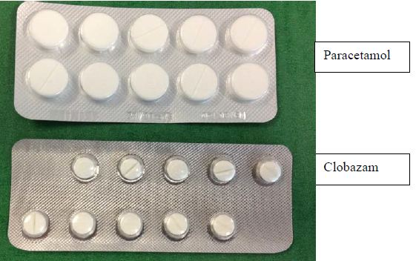

Frisium has been in use both in Australia and globally for more than two decades and there has been no adverse reports of difficulties of administration of the tablets to children in any country, noting that the approvals in several countries include use in children below the age of 4, which is the minimum age proposed for Australia. Similarly, the recent US approval for Onfi for treatment in LGS is for the currently available tablet formulation.

Reflecting the orphan status of the indication, Frisium is only intended for use in rare cases as adjunctive therapy in those paediatric patients who are not adequately stabilized on their current anticonvulsant therapy. Development of a liquid paediatric formulation solely for use in Australia when the local and global experience has not identified a risk over many years of use could not be supported. It should also be borne in mind that in the absence of an approval for this application Frisium tablets would continue to be used off-label in Australia, without the benefit for physicians in having information in the Product Information that provides relevant information on dosing and appropriate management to effectively mitigate risks. Furthermore, inclusion as an approved indication will facilitate post marketing safety surveillance.

To further enhance the PI with regard to use in children and to reflect the breakability of the tablets the following updates to the *Dosing and Administration* section of the PI have been incorporated:

* Specific reference to breakability of tablets:
* *The 10 mg tablets can be divided into equal halves of 5 mg*
* Specific reference to age of intended paediatric population children for whom treatment is indicated:

*Children (4 years of age and over)*

##### RMP

On the basis of the extensive clinical experience with Frisium in the proposed indication in Australia and globally over many years the sponsor does not consider there is any additional risk mitigation activities required, beyond routine pharmacovigilance and labelling to address the comments from the nonclincial evaluator in relation to findings in the juvenile toxicity study, particularly considering that the product is not intended for long term use and as stated in the PI requires’ reassessement every 4 weeks and regularly thereafter in order to evaluate the need for continued treatment’ as part of the routine patient management activities.

##### Summary

In summary, based on the available nonclinical and clinical data for Frisium and extensive experience in clinical practice over many decades, there is sufficient evidence that the benefit outweighs the risk when clobazam is used as adjunctive therapy for partial refractory epilepsy. This view is endorsed by the PMAG who consider clobazam as an important therapeutic option, considering the small number of patients who require adjunctive therapy as they are not adequately stabilised with their current anticonvulsant therapy.

#### Advisory committee considerations

The ACPM, having considered the evaluations and the Delegate’s overview, as well as the sponsor’s response to these documents, advised the following.

The ACPM, taking into account the submitted evidence on efficacy, safety, the caveat regarding duration of use for the proposed indication, and a consideration of clobazam’s widespread use in Australia and comparable overseas countries, agreed that clobazam has an overall positive benefit-risk profile for the indication:

*As adjunctive therapy in patients with partial refractory and Lennox-Gastaut epilepsy types who are not adequately stabilised with their current anticonvulsant therapy.*

##### Proposed PI/CMI amendments:

The ACPM agreed with the Delegate to the proposed amendments to the PI and Consumer Medicine Information (CMI) and specifically advised on the inclusion of the following:

* a statement in the *Dosage and Administration / Precautions / Contraindications* sections of the PI (and reflected in the CMI) to more accurately reflect the data and lack of data on use in patients with renal insufficiency
* a statement in the *Dosage and Administration* section of the PI (and reflected in the CMI) to more accurately reflect the limitations on administration of a tablet formulation in children.

##### Proposed conditions of registration

The ACPM agreed with the Delegate on the proposed conditions of registration.

The ACPM advised that the implementation by the sponsor of the recommendations outlined above to the satisfaction of the TGA, in addition to the evidence of efficacy and safety provided would support the safe and effective use of this product.

### Outcome

Based on a review of quality, safety and efficacy, TGA approved the registration of Frisium (clobazam) 10 mg tablet blister pack for the **new indication**:

***Children (4 years of age and over):***

*As adjunctive therapy in patients with partial refractory and Lennox-Gestaut epilepsy types who are not adequately stabilised with their current anticonvulsant therapy.*

The full indications are now:

***Adults:***

*Short term use (up to one month for the symptomatic management of acute anxiety and sleep disturbances associated with anxiety.*

***Children (4 years of age and over):***

*As adjunctive therapy in patients with partial refractory and Lennox-Gestaut epilepsy types who are not adequately stabilised with their current anticonvulsant therapy.*

#### Specific conditions of registration applying to these therapeutic goods:

1. The implementation in Australia of the Frisium (clobazam) RMP Version 1.1, dated May 2012, included with submission PM-2011-04302-3-1, and any subsequent revisions, as agreed with the TGA and its OPR.

## Attachment 1. Product Information

The Product Information approved at the time this AusPAR was published is at Attachment 1. For the most recent Product Information please refer to the TGA website at <<http://www.tga.gov.au/hp/information-medicines-pi.htm>>.

## Attachment 2. Extract from the Clinical Evaluation Report

1. European Medicines Agency, “Committee for Human Medicinal Products (CHMP): Guideline on the Need for Non-Clinical Testing in Juvenile Animals of Pharmaceuticals for Paediatric Indications (EMEA/CHMP/SWP/169215/2005)”, 24 January 2008, Web, accessed 19 August 2013 <www.ema.europa.eu/docs/en_GB/document_library/Scientific_guideline/2009/09/WC500003305.pdf>.
2. Wu KM, Farrelly JG. (2006) Preclinical development of new drugs that enhance thyroid hormone metabolism and clearance: inadequacy of using rats as an animal model for predicting human risks in an IND and NDA. *Am J Ther.* 13: 141-144.
3. Fuchigami K, et al. (1983) Perinatal and postnatal study of clobazam administered orally in rats. *Oyo Yakuri (Pharmacometrics)* 25: 917-929 (Japanese).
4. Fuchigami K, et al. (1983) Fertility study of clobazam administered orally in rats. *Oyo Yakuri (Pharmacometrics)* 25: 907-916 (Japanese).
5. Fuchigami K, et al. (1983) Perinatal and postnatal study of clobazam administered orally in rats. *Oyo Yakuri (Pharmacometrics)* 25: 917-929 (Japanese).
6. [No authors listed] (1998) Clobazam has equivalent efficacy to carbamazepine and phenytoin as monotherapy for childhood epilepsy. Canadian Study Group for Childhood Epilepsy. *Epilepsia* 39: 952-959.
7. European Medicines Agency, “Guideline on clinical investigation of medicinal products in the treatment of epileptic disorders (CHMP/EWP/566/98 Rev.2/Corr)”, 22 July 2010, Web, accessed 19 August 2013 <www.ema.europa.eu/docs/en_GB/document_library/Scientific_guideline/2010/ 01/WC500070043.pdf>.
8. [No authors listed] (1998) Clobazam has equivalent efficacy to carbamazepine and phenytoin as monotherapy for childhood epilepsy. Canadian Study Group for Childhood Epilepsy. *Epilepsia* 39: 952-959.
9. Ng YT, et al. (2011) Randomized, phase III study results of clobazam in Lennox-Gastaut syndrome. *Neurology* 77: 1473-1481.
10. Conry JA, et al. (2009) Clobazam in the treatment of Lennox-Gastaut syndrome. *Epilepsia* 50: 1158-1166.
11. European Medicines Agency, “Guideline on clinical investigation of medicinal products in the treatment of epileptic disorders (CHMP/EWP/566/98 Rev.2/Corr)”, 22 July 2010, Web, accessed 19 August 2013 <www.ema.europa.eu/docs/en_GB/document_library/Scientific_guideline/2010/ 01/WC500070043.pdf>.
12. Ng YT, et al. (2011) Randomized, phase III study results of clobazam in Lennox-Gastaut syndrome. *Neurology* 77: 1473-1481; Conry JA, et al. (2009) Clobazam in the treatment of Lennox-Gastaut syndrome. *Epilepsia* 50: 1158-1166.
13. European Medicines Agency, “Guideline on clinical investigation of medicinal products in the treatment of epileptic disorders (CHMP/EWP/566/98 Rev.2/Corr)”, 22 July 2010, Web, accessed 19 August 2013 <www.ema.europa.eu/docs/en_GB/document_library/Scientific_guideline/2010/ 01/WC500070043.pdf>.
14. Conry JA, et al. (2009) Clobazam in the treatment of Lennox-Gastaut syndrome. *Epilepsia* 50: 1158-1166.
15. Ng YT, et al. (2011) Randomized, phase III study results of clobazam in Lennox-Gastaut syndrome. *Neurology* 77: 1473-1481.
16. Keene DL, et al. (1990) Clobazam as an add-on drug in the treatment of refractory epilepsy of childhood. *Can J Neurol Sci.* 17: 317-319.
17. Wheless JW, et al. (2007) Treatment of pediatric epilepsy: European expert opinion, 2007. *Epileptic Disord.* 9: 353-412.
18. Keene DL, et al. (1990) Clobazam as an add-on drug in the treatment of refractory epilepsy of childhood. *Can J Neurol Sci.* 17: 317-319.
19. Munn R, Farrell K. (1993) Open study of clobazam in refractory epilepsy. *Pediatr Neurol.* 9: 465-469; Barcs G, Halasz P. (1996) Effectiveness and tolerance of clobazam in temporal lobe epilepsy. *Acta Neurol Scand.* 93: 88-93; Singh A, et al. (1995) Clobazam in long-term epilepsy treatment: sustained responders versus those developing tolerance. *Epilepsia* 36: 798-803.
20. Remy C. (1994) Clobazam in the treatment of epilepsy: a review of the literature. *Epilepsia* 35 Suppl 5: S88-S91.
21. Robertson MM. (1995) The place of clobazam in the treatment of epilepsy: an update. *Hum Psychopharmacol.* 10: S43-S63
22. Wildin JD, et al. (1990) Respiratory and sedative effects of clobazam and clonazepam in volunteers. *Br J Clin Pharmacol.* 29: 169-177; van der Meyden CH, et al. (1989) Effects of clobazam and clonazepam on saccadic eye movements and other parameters of psychomotor performance. *Eur J Clin Pharmacol.* 37: 365-369.
23. Keene DL, et al. (1990) Clobazam as an add-on drug in the treatment of refractory epilepsy of childhood. *Can J Neurol Sci.* 17: 317-319.
24. [No authors listed] (1998) Clobazam has equivalent efficacy to carbamazepine and phenytoin as monotherapy for childhood epilepsy. Canadian Study Group for Childhood Epilepsy. *Epilepsia* 39: 952-959.
25. Bawden HN, et al. (1999) The cognitive and behavioural effects of clobazam and standard monotherapy are comparable. Canadian Study Group for Childhood Epilepsy. *Epilepsy Res.* 33: 133-143
26. Conry JA, et al. (2009) Clobazam in the treatment of Lennox-Gastaut syndrome. *Epilepsia* 50: 1158-1166.
27. Ng YT, et al. (2011) Randomized, phase III study results of clobazam in Lennox-Gastaut syndrome. *Neurology* 77: 1473-1481.
28. Conry JA, et al. (2009) Clobazam in the treatment of Lennox-Gastaut syndrome. *Epilepsia* 50: 1158-1166.
29. Rose W, et al. (2005) Intermittent clobazam therapy in febrile seizures. *Indian J Pediatr.* 72: 31-33.
30. Bajaj AS, et al. (2005) Intermittent clobazam in febrile seizures: an Indian experience. *J Pediatr Neurol.* 2: 19-23.
31. [No authors listed] (1998) Clobazam has equivalent efficacy to carbamazepine and phenytoin as monotherapy for childhood epilepsy. Canadian Study Group for Childhood Epilepsy. *Epilepsia* 39: 952-959.
32. Bawden HN, et al. (1999) The cognitive and behavioural effects of clobazam and standard monotherapy are comparable. Canadian Study Group for Childhood Epilepsy. *Epilepsy Res.* 33: 133-143
33. Keene DL, et al. (1990) Clobazam as an add-on drug in the treatment of refractory epilepsy of childhood. *Can J Neurol Sci.* 17: 317-319.
34. [No authors listed] (1998) Clobazam has equivalent efficacy to carbamazepine and phenytoin as monotherapy for childhood epilepsy. Canadian Study Group for Childhood Epilepsy. *Epilepsia* 39: 952-959.
35. Bawden HN, et al. (1999) The cognitive and behavioural effects of clobazam and standard monotherapy are comparable. Canadian Study Group for Childhood Epilepsy. *Epilepsy Res.* 33: 133-143.
36. Ng YT, et al. (2011) Randomized, phase III study results of clobazam in Lennox-Gastaut syndrome. *Neurology* 77: 1473-1481.
37. Bawden HN, et al. (1999) The cognitive and behavioural effects of clobazam and standard monotherapy are comparable. Canadian Study Group for Childhood Epilepsy. *Epilepsy Res.* 33: 133-143.
38. Patat A, et al. (1987) Effects of single oral doses of clobazam, diazepam and lorazepam on performance tasks and memory. *Eur J Clin Pharmacol.* 32: 461-466.
39. Patat A, Foulhoux P. (1985) Effect on postural sway of various benzodiazepine tranquillizers. *Br J Clin Pharmacol.* 20: 9-16.
40. Trimble MR, Thompson PJ. (1983) Anticonvulsant drugs, cognitive function, and behavior. *Epilepsia* 24 Suppl 1:S55-S63
41. Conry JA, et al. (2009) Clobazam in the treatment of Lennox-Gastaut syndrome. *Epilepsia* 50: 1158-1166.
42. Ng YT, et al. (2011) Randomized, phase III study results of clobazam in Lennox-Gastaut syndrome. *Neurology* 77: 1473-1481.
43. Conry JA, et al. (2009) Clobazam in the treatment of Lennox-Gastaut syndrome. *Epilepsia* 50: 1158-1166.
44. Ng YT, et al. (2011) Randomized, phase III study results of clobazam in Lennox-Gastaut syndrome. *Neurology* 77: 1473-1481.
45. Ng YT, et al. (2011) Randomized, phase III study results of clobazam in Lennox-Gastaut syndrome. *Neurology* 77: 1473-1481.
46. Ng YT, et al. (2011) Randomized, phase III study results of clobazam in Lennox-Gastaut syndrome. *Neurology* 77: 1473-1481.
47. Keene DL, et al. (1990) Clobazam as an add-on drug in the treatment of refractory epilepsy of childhood. *Can J Neurol Sci.* 17: 317-319.
48. Ng YT, et al. (2011) Randomized, phase III study results of clobazam in Lennox-Gastaut syndrome. *Neurology* 77: 1473-1481.
49. Ng YT, et al. (2011) Randomized, phase III study results of clobazam in Lennox-Gastaut syndrome. *Neurology* 77: 1473-1481.
50. Conry JA, et al. (2009) Clobazam in the treatment of Lennox-Gastaut syndrome. *Epilepsia* 50: 1158-1166.
51. Ng YT, et al. (2011) Randomized, phase III study results of clobazam in Lennox-Gastaut syndrome. *Neurology* 77: 1473-1481.