CLOBEX® SHAMPOO PRODUCT INFORMATION

## NAME OF THE MEDICINE

CLOBEX Shampoo: clobetasol propionate 500 micrograms/mL

Australian Approved Name (AAN): clobetasol propionate

Common Name: clobetasol propionate

Chemical Name: 21-chloro-9-fluoro-11ß, 17-dihydroxy-16ß-methylpregna-1, 4-diene-3, 20-dione 17-propionate

Molecular Formula: C25H32ClFO5

Molecular Weight: 467.0

Structural Formula: clobetasol propionate

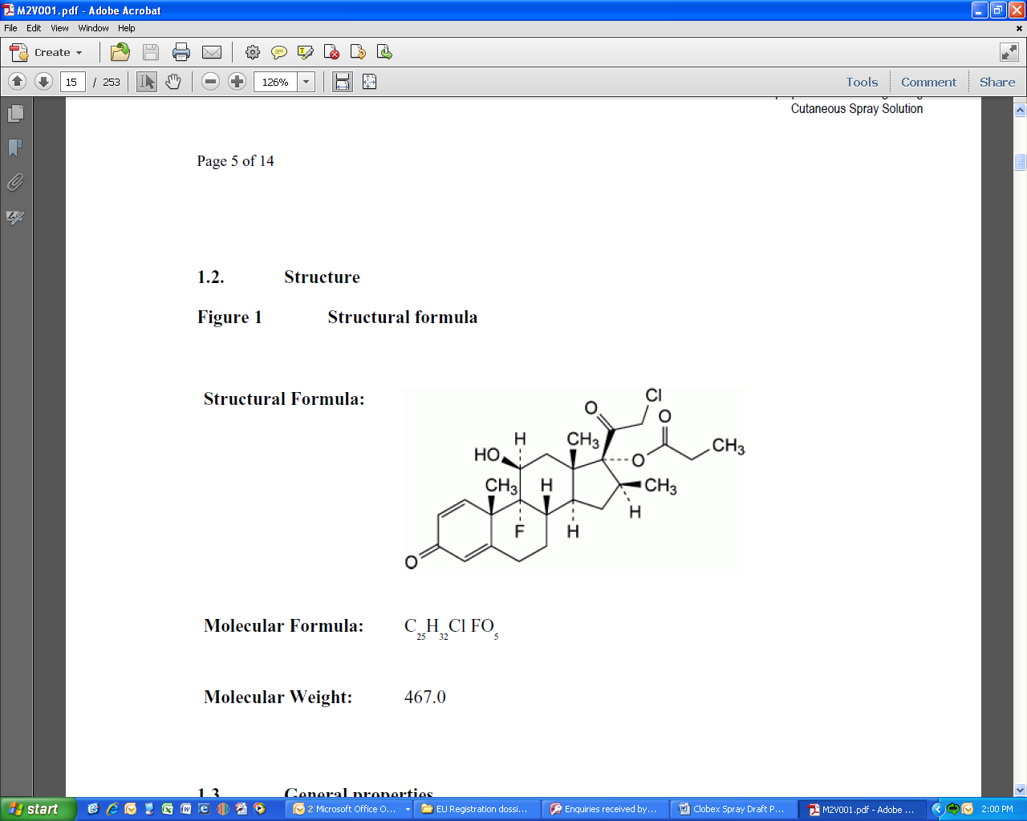

CAS Number: 25122-46-7

## DESCRIPTION

A shampoo topical application. Viscous, translucent, colourless to pale yellow liquid shampoo with alcoholic odour. One millilitre of CLOBEX Shampoo contains 500 micrograms of clobetasol propionate.

List of excipients

Ethanol

Coco-betaine

Sodium laureth sulfate

Polyquaternium-10

Sodium citrate

Citric acid

Purified Water

## PHARMACOLOGY

Pharmacodynamic properties

Pharmacotherapeutic group: Corticosteroids, Very Potent (Group IV)

ATC code: D07AD01

### Mechanism of action and Pharmacodynamic effects

Like other topical corticosteroids, clobetasol propionate has anti-inflammatory, antipruritic, and vasoconstrictive properties. The mechanism of the anti-inflammatory activity of topical corticosteroids in general is unclear. However, corticosteroids are thought to act by induction of phospholipase A2 inhibitory proteins, collectively called lipocortins. It is postulated that these proteins control the biosynthesis of potent mediators of inflammation such as prostaglandins and leukotrienes by inhibiting the release of their common precursor, arachidonic acid. Arachidonic acid is released from membrane phospholipids by phospholipase A2.

### Pharmacokinetics

In vitro liberation –penetration studies on human skin showed that only a small percentage (0.1 %) of the applied dose of CLOBEX Shampoo can be found in the epidermis (including the stratum corneum) when applied for 15 minutes and then rinsed. The very low topical absorption of clobetasol propionate from CLOBEX Shampoo when applied according to the recommended clinical use (15 minutes before rinse off) resulted in negligible systemic exposure in animal studies and in clinical trials. Available clinical data revealed that only 1 of 141 subjects had a quantifiable clobetasol propionate plasma concentration (0.43 ng/mL).

The present pharmacokinetic data indicate that systemic effects following clinical treatment with CLOBEX Shampoo are highly unlikely due to the low systemic bioavailability of clobetasol propionate.

## CLINICAL TRIALS

Five, randomised, controlled Phase III clinical trials were conducted to establish the efficacy and safety of CLOBEX Shampoo. In all studies, treatment with CLOBEX Shampoo was for 4 weeks with a daily application for 15 minutes before rinsing. Two studies were vehicle-controlled and three were comparative against an active control [scalp solution of calcipotriol 50µg/ml (Daivonex); coal tar solution at 1 % w/w (Polytar Liquid); clobetasol propionate 0.05% gel].

The two vehicle-controlled clinical trials involved 290 patients with moderate to severe scalp psoriasis treated with either CLOBEX Shampoo or the corresponding vehicle applied once daily for 15 minutes before lathering rinsing for a period of 4 weeks. Efficacy results are presented in the table below.

Table 1: Efficacy outcomes in vehicle-controlled clinical trials

|  |  |  |  |  |
| --- | --- | --- | --- | --- |
|  | CLOBEX Shampoo  n (%) | | CLOBEX Shampoo Vehicle n (%) | |
|  | Study A | Study B | Study A | Study B |
| Total number of Patients | 95 | 99 | 47 | 49 |
| Success Rate1  at endpoint2 | 40(42.1%) | 28(28.3%) | 1(2.1%) | 5(10.2%) |
| Subjects with Scalp Psoriasis Parameter  Clear (None) at Endpoint  Erythema3  Scaling3  Plaque Thickening3 | 17(17.9%)  21(22.1%)  35(36.8%) | 12(12.1%)  15(15.2%)  34(34.3%) | 3(6.4%)  0(0%)  5(10.6%) | 1(2.0%)  2(4.1%)  5(10.2%) |

1Success rate defined as the proportion of patients with a 0 (clear) or 1 (minimal) on a 0 to 5 point physician’s Global Severity Scale for Scalp psoriasis.

2At four (4) weeks or last observation recorded for a subject during the treatment period (baseline if no post-baseline data were available).

3Patients with 0 (clear) on a 0 to 3 point Scalp psoriasis parameter scale.

In all three studies in which comparison was made, CLOBEX Shampoo has shown a superior efficacy compared to the vehicle.

The efficacy of CLOBEX Shampoo applied for 15 minutes, once a day was compared over 4 weeks to that of calcipotriol solution 50µg/ml applied twice a day (Daivonex) and to that of a coal tar solution at 1% w/w (Polytar Liquid) applied twice a week. Both trials enrolled subjects with moderate to severe scalp psoriasis. After 4 weeks of treatment (Day 28) CLOBEX Shampoo was shown to be superior to Daivonex solution (table 2) and Polytar Liquid (table 3) on the two co-primary endpoints: Total Sum Score (TSS) and Global Severity Scale (GSS).

**Table 2. Efficacy outcomes in trial versus Calcipotriol solution**

|  |  |  |  |
| --- | --- | --- | --- |
|  | CLOBEX Shampoo | Calcipotriol solution 50µg/ml | p |
| Total number of Patients (ITT) | 76 | 75 |  |
| TSS Baseline  Mean (SD) | 4.86 (1.95) | 4.95 (1.49) |  |
| TSS Day 28  Mean (SD) | 1.76 (1.57) | 2.36 (1.64) | p < 0.05 |
| GSS Baseline  Mean (SD) | 3.49 (0.60) | 3.51 (0.60) |  |
| GSS Day 28  Mean (SD) | 1.55 (1.20) | 2.03 (1.31) | p < 0.05 |

**Table 3. Efficacy outcomes in trial versus Polytar Liquid**

|  |  |  |  |
| --- | --- | --- | --- |
|  | CLOBEX Shampoo | Polytar Liquid | p |
| Total number of Patients (ITT) | 121 | 41 |  |
| TSS Baseline  Mean (SD) | 6.1 (1.4) | 6.3 (1.2) |  |
| TSS Day 28  Mean (SD) | 3.2 (2.0) | 5.2 (1.9) | p =0.0001 |
| GSS Baseline  Mean (SD) | 3.4 (0.6) | 3.5 (0.6) |  |
| GSS Day 28  Mean (SD) | 1.9 (1.0) | 3.0 (1.0) | p =0.0001 |

CLOBEX Shampoo (applied daily for 15 minutes and then rinsed) has finally been found non inferior to a clobetasol propionate 0.05% gel applied once a day to the dry scalp without rinsing.

Efficacy and safety of Clobex Shampoo were not investigated beyond 4 weeks of treatment.

## INDICATIONS

Topical treatment of moderate to severe scalp psoriasis in adults.

## CONTRA-INDICATIONS

Hypersensitivity to the active substance or to any of the excipients

Skin areas affected by bacterial, viral (varicella, herpes simplex, herpes zoster), fungal or parasitic infections and specific skin diseases (skin tuberculosis, skin diseases caused by lues).

CLOBEX Shampoo must not be applied to the eye and eyelids (risk of glaucoma, risk of cataract) or to ulcerous wounds.

Children under 2 years of age

## PRECAUTIONS

Topical corticosteroids should be used with caution for a number of reasons including post treatment rebound relapses, development of tolerance (tachyphylaxis) and development of local or systemic toxicity such as atrophy and telangiectasia of the skin or hypothalamic-pituitary-adrenal (HPA) axis suppression. There is a risk of HPA suppression with prolonged use and also with the use of large volumes. CLOBEX Shampoo should not be used for more than 4 consecutive weeks; nor should a dose greater than 7.5 mLs daily be used. In rare instances, treatment of psoriasis with corticosteroids (or its withdrawal) is thought to have provoked generalised pustular psoriasis in case of intensive and prolonged topical use. In very rare cases, hypersensitivity to corticosteroids can be observed. This can be suspected in case of resistance to treatment.

In general, treatment of large surface areas, long-term continuous therapy with corticosteroids, use of occlusive dressings can enhance absorption and lead to a higher risk of systemic effects. In such cases, medical supervision should be increased and patients may be evaluated periodically for evidence of HPA axis suppression. Patients applying doses of CLOBEX Shampoo in excess of 50mL per week should be carefully monitored. Systemic absorption of topical corticosteroids has caused reversible adrenal suppression with the potential for glucocorticosteroid insufficiency, manifestations of Cushing’s syndrome, hyperglycemia, and glucosuria in some patients. Such systemic effects disappear when treatment is stopped. However, abrupt discontinuation can lead to acute adrenal insufficiency, especially in children.

CLOBEX Shampoo is only intended for the treatment of scalp psoriasis and should not be used to treat other skin areas. In particular, CLOBEX Shampoo is not recommended for use in the face, intertriginous areas (axillae and genitoanal regions) and on other erosive skin surfaces as this could increase the risk of topical adverse events such as atrophic changes, telangiectasia or cortico-induced dermatitis.

CLOBEX shampoo is not recommended in patients with acne vulgaris, rosacea or perioral dermatitis.

If CLOBEX Shampoo does enter the eye, the affected eye should be rinsed with copious amounts of water.

### Effects on fertility

When administered subcutaneously to rats, clobetasol propionate reduced the viability of embryos and reduced maternal reproduction capacities.

Animal studies of the effect of CLOBEX Shampoo on fertility have not been conducted. However, clobetasol propionate had no effect on male or female mating performance in rats when administered subcutaneously (SC) at doses up to 50 µg/kg/day. Reductions in both the number of estrous cycles and embryo viability were observed at SC doses from 25-50 µg/kg/day.

### Use in Pregnancy (Category B3)

Animal studies of the effect of CLOBEX Shampoo on embryofetal development have not been conducted. However, clobetasol propionate was shown to be teratogenic when administered topically or subcutaneously during organogenesis in mice, rats and rabbits. Fetotoxicity and fetal malformations (including skeletal abnormalities, cleft palate, cranioschisis or umbilical cord hernia) were observed in mice (30 µg/kg/day SC), rats (50 µg/kg/day topical) and rabbits (3 µg/kg/day SC) at doses (on a mg/m2 basis) less than the maximum human topical dose.

There are no adequate or well-controlled studies of clobetasol propionate in pregnant women. Studies in animals have shown reproductive toxicity. The clinical relevance of the effects of clobetasol and other corticosteroids in developmental animal studies is unknown. CLOBEX Shampoo should be avoided during pregnancy, unless clearly necessary.

### Use in Lactation

Systemically administered corticosteroids pass into breast milk. There are no adequate data on the possible milk transfer of topical clobetasol propionate. However, studies in rats (see below) have shown postnatal pup effects following subcutaneous maternal dosing during weaning. Thus, CLOBEX Shampoo should be avoided in breastfeeding women, unless clearly necessary.

### Use in Children

The experience in the paediatric population is limited. CLOBEX shampoo is not recommended for use in children and adolescents below 18 years of age. Because of a higher ratio of skin surface area to body mass, children are at a greater risk than adults of HPA axis suppression when they are treated with topical corticosteroids. They are also at greater risk of adrenal insufficiency after withdrawal of treatment, and of Cushing’s syndrome while on treatment.

### Use in the Elderly

No specific studies have been performed.

### Use in renal or hepatic impairment

No specific studies have been performed. Patients with severe liver dysfunction and severe diabetes mellitus should be treated with special caution and closely monitored for side effects.

### Genotoxicity

Clobetasol propionate did not demonstrate any genotoxic potential *in vitro* (Ames, fluctuation and gene conversion tests and chromosome aberration assay) or *in vivo* (mouse micronucleus test).

### Carcinogenicity

Long term rodent carcinogenicity studies have not been conducted with CLOBEX Shampoo. However, a clobetasol propionate lotion formulation had no carcinogenic potential when applied topically to rats for 2 years at doses (on a mg/m2 basis) corresponding to less than one thirtieth of the maximum human topical dose.

### Effect on Ability to Drive and Use Machines

As a topical corticosteroid, CLOBEX Shampoo has no or negligible influence on the ability to drive and use machines.

## INTERACTIONS WITH OTHER MEDICINES

No interaction studies have been performed

## ADVERSE EFFECTS

During clinical development, in a total of 558 patients receiving CLOBEX Shampoo, the most commonly reported adverse drug reaction was skin discomfort with an incidence of approximately 5%. Most adverse events were rated as mild to moderate and they were not affected by race or gender. Clinical signs of irritation were uncommon (0.5%). No serious drug-related adverse events were reported during any of the clinical trials.

If signs of local intolerance appear, application should be suspended until they disappear. If signs of hypersensitivity appear, application should be stopped immediately.

Table 2 below reports the adverse reactions related to treatment by body system and by absolute frequency according to the following classification:

Very common ≥ 10%

Common ≥ 1% to < 10%

Uncommon ≥0.1% to <1%

Table 4:

|  |  |  |
| --- | --- | --- |
| Body System | Incidence | Adverse reactions |
| Skin and subcutaneous tissue disorders | Common | Skin discomfort  Acne/folliculitis |
| Uncommon | Local signs of irritation  Pruritus  Urticaria  Telangiectasia  Skin atrophy |
| Eye disorders | Common | Eye stinging/burning |

As a class attribution, prolonged use of topical corticosteroids, treatment of extensive areas or use of large amounts can result in sufficient systemic absorption to produce the features of hypercortisolism (Cushing syndrome) or of Hypothalamus-Pituitary-Adrenal (HPA) axis suppression. Should HPA axis suppression occur, it is likely to be transient with a rapid return to normal values. However, as CLOBEX Shampoo is to be kept in place for only 15 minutes before rinsing, systemic absorption is seldom observed, see Pharmacokinetics, and therefore, the risk of appearance of HPA axis suppression is very low compared to non rinsed potent corticosteroids products. No HPA axis suppression has been observed during clinical trials with CLOBEX Shampoo.

Prolonged and/or intensive treatment with potent corticosteroid preparations may cause local atrophic changes, such as local skin atrophy, striae, telangiectasia, erythema, purpura, contact dermatitis.

When applied to the face, very potent corticosteroids can induce perioral dermatitis, skin atrophy or worsen rosacea. During development of CLOBEX Shampoo, skin atrophy was assessed using ultrasound measurement of skin thickness in a specific clinical trial involving 13 patients. After 4 weeks of treatment with CLOBEX Shampoo, no skin thinning was observed.

There are reports of pigmentation changes, acne, pustular eruptions and hypertrichosis with topical corticosteroids.

### Post-marketing safety experience

Manifestations of Cushing’s syndrome have been described in post market reports following long term duration of use of clobetasol propionate. In addition, a report of adrenal suppression has been reported following long-term use in an off label indication (lichen planus).

Erythema, rash and allergic contact dermatitis have been described in post-market reports.

## DOSAGE AND ADMINISTRATION

For topical use on the scalp only.

#### Instructions for use/handling

CLOBEX Shampoo should be applied directly on dry scalp once daily taking care to cover and massage the lesions well. Using the measuring cup included, measure out

7.5 mL which is sufficient to cover all the scalp and is the maximum daily dosage. CLOBEX Shampoo should be then left in place without covering for 15 minutes before rinsing. As with any topical medication, patients should wash their hands carefully after application. After 15 minutes, the product must be rinsed with water and / or hair can be washed by using an additional amount of regular shampoo if needed to facilitate washing. In order to avoid interaction with hair colour dying product, such as hair colour changes, CLOBEX Shampoo should be thoroughly rinsed. Then, hair can be dried as usual.

Avoid contact with the eyes. If the shampoo accidentally comes in contact with the eyes, rinse out the eyes with water immediately.

The treatment duration should be limited to a maximum of 4 weeks. As soon as clinical results are observed, applications should be spaced out or replaced, if needed, by an alternative treatment. If no improvement is seen within four weeks, reassessment of the diagnosis may be necessary.

Chronic overdosage may occur in the case of continuous use of large quantities for long periods of time.

## OVERDOSAGE

Acute overdose is very unlikely to occur, however, in the case of chronic overdose or misuse, the features of hypercortisolism may appear and in this situation, treatment should be discontinued gradually. However, because of the risk of acute adrenal suppression, this should be done under medical supervision. For information on the management of overdose, contact the Poison Information Centre on 13 11 26 (Australia).

## PRESENTATION AND STORAGE CONDITIONS

One millilitre of CLOBEX Shampoo contains 500 micrograms of clobetasol propionate.

For a full list of excipients, see **Description.**

### Nature and contents of the container

The product is packaged in high density polyethylene (HDPE) bottles of 60 mL or 125 mL fitted with polypropylene snap closures.  The HDPE bottle of 30 mL is fitted with a polypropylene screw closure.

Bottles contain 30 mL, 60 mL or 125 mL of Shampoo which contain 4, 8 and 16 days treatment, respectively.

Not all pack sizes may be marketed.

### Storage:

Store below 25C. Store in the original container.

Shelf-life after first opening: 4 weeks

## NAME AND ADDRESS OF SPONSOR

Galderma Australia Pty Ltd

Suite 4, 13B Narabang Way

Belrose NSW 2085

Ph. 1800 800 765

## POISON SCHEDULE – S4 – PRESCRIPTION MEDICINE

® Registered Trademark

AUST R No 188346

DATE OF FIRST INCLUSION IN THE AUSTRALIAN REGISTER OF THERAPEUTIC GOODS (THE ARTG) 14 MAR 2013

DATE OF MOST RECENT AMENDMENT 24 APR 2013