|  |
| --- |
| **Date of CER: 28 February 2013** |

|  |
| --- |
| AusPAR Attachment 2 |
| Extract from the Clinical Evaluation Report for cobicistat |
| Proprietary Product Name: Tybost |
| Sponsor: Gilead Sciences Pty Ltd |

About the Therapeutic Goods Administration (TGA)

* The Therapeutic Goods Administration (TGA) is part of the Australian Government Department of Health, and is responsible for regulating medicines and medical devices.
* The TGA administers the *Therapeutic Goods Act 1989* (the Act), applying a risk management approach designed to ensure therapeutic goods supplied in Australia meet acceptable standards of quality, safety and efficacy (performance), when necessary.
* The work of the TGA is based on applying scientific and clinical expertise to decision-making, to ensure that the benefits to consumers outweigh any risks associated with the use of medicines and medical devices.
* The TGA relies on the public, healthcare professionals and industry to report problems with medicines or medical devices. TGA investigates reports received by it to determine any necessary regulatory action.
* To report a problem with a medicine or medical device, please see the information on the TGA website <<http://www.tga.gov.au>>.

About the Extract from the Clinical Evaluation Report

* This document provides a more detailed evaluation of the clinical findings, extracted from the Clinical Evaluation Report (CER) prepared by the TGA. This extract does not include sections from the CER regarding product documentation or post market activities.
* The words [Information redacted] indicate confidential information has been deleted.
* For the most recent Product Information (PI), please refer to the TGA website <<http://www.tga.gov.au/hp/information-medicines-pi.htm>>.

Copyright

© Commonwealth of Australia 2013  
This work is copyright. You may reproduce the whole or part of this work in unaltered form for your own personal use or, if you are part of an organisation, for internal use within your organisation, but only if you or your organisation do not use the reproduction for any commercial purpose and retain this copyright notice and all disclaimer notices as part of that reproduction. Apart from rights to use as permitted by the *Copyright Act 1968* or allowed by this copyright notice, all other rights are reserved and you are not allowed to reproduce the whole or any part of this work in any way (electronic or otherwise) without first being given specific written permission from the Commonwealth to do so. Requests and inquiries concerning reproduction and rights are to be sent to the TGA Copyright Officer, Therapeutic Goods Administration, PO Box 100, Woden ACT 2606 or emailed to <[tga.copyright@tga.gov.au](mailto:tga.copyright@tga.gov.au)>.

Contents

List of abbreviations 4

1. Clinical rationale 9

2. Contents of the clinical dossier 9

2.1. Scope of the clinical dossier 9

2.2. Paediatric data 10

2.3. Good clinical practice 10

3. Pharmacokinetics 10

3.1. Studies providing pharmacokinetic data 10

3.2. Summary of pharmacokinetics 11

3.3. Evaluator’s overall conclusions on pharmacokinetics 19

4. Pharmacodynamics 19

4.1. Studies providing pharmacodynamic data 19

4.2. Summary of pharmacodynamics 20

4.3. Evaluator’s overall conclusions on pharmacodynamics 26

5. Dosage selection for the pivotal studies 27

6. Clinical efficacy 27

6.1. Pivotal efficacy studies 27

6.2. Other efficacy studies 51

6.3. Analyses performed across trials (pooled & meta analyses) 51

6.4. Evaluator’s conclusions on clinical efficacy 53

7. Clinical safety 54

7.1. Studies providing evaluable safety data 54

7.2. Pivotal studies that assessed safety as a primary outcome 54

7.3. Patient exposure 54

7.4. Adverse events 55

7.5. Laboratory tests 61

7.6. Post-marketing experience 64

7.7. Safety issues with the potential for major regulatory impact 65

7.8. Other safety issues 65

7.9. Evaluator’s overall conclusions on clinical safety 66

8. First round benefit-risk assessment 67

8.1. Assessment of benefits 67

8.2. Assessment of risks 67

8.3. Assessment of benefit-risk balance 68

9. Recommendation regarding authorisation 68

10. Clinical questions 68

11. References 68

## List of abbreviations

| Abbreviation | Meaning |
| --- | --- |
| 3TC | lamivudine |
| λz | terminal elimination rate constant, estimated by linear regression of the terminal elimination phase of the log plasma/serum/PBMC concentration versus time curve of the drug |
| ADR | adverse drug reaction |
| ADV | adefovir |
| AE | adverse event |
| aGFR | actual glomerular filtration rate |
| ALT | alanine aminotransferase |
| ARV | antiretroviral |
| AST | aspartate aminotransferase |
| ATR | efavirenz/emtricitabine/tenofovir disoproxil fumarate, co-formulated (Atripla) |
| ATV | atazanavir |
| AUC | area under the plasma concentration-time curve |
| AUC0-last | area under the plasma/serum/PBMC concentration versus time curve from time zero to the last quantifiable concentration |
| AUCinf | area under the plasma/serum/PBMC concentration versus time curve extrapolated to infinite time, calculated as AUC0−last + (Clast/λz) |
| AUCtau | area under the plasma/serum/PBMC concentration versus time curve over the dosing interval |
| AUCx-xx | partial area under the plasma/serum concentration versus time curve from time “x” |
| BMD | bone mineral density |
| CD4 | cluster determinant 4 |
| CI | confidence interval |
| CK | creatine kinase |
| Cx | plasma/serum concentration of drug at a specified time (x) after dosing |
| Clast | last observed quantifiable plasma/serum/PBMC concentration of the drug |
| Cmax | maximum observed plasma/serum/PBMC concentration of drug |
| Ctau | observed drug concentration at the end of the dosing interval |
| Ctrough | plasma concentration at the end of the dosing interval |
| CL | systemic clearance of the drug after intravenous administration |
| CLcr | creatinine clearance |
| CMH | Cochran-Mantel-Haenszel |
| /co | boosted with cobicistat |
| CSR | clinical study report |
| CV | coefficient of variation |
| CYP | cytochrome P450 enzyme(s) |
| DRV | darunavir |
| ECxx | concentration of a compound inhibiting virus replication by xx% |
| ECG | electrocardiogram |
| ECHO | echocardiogram |
| EFV | efavirenz |
| eGFR | estimated glomerular filtration rate |
| eGFRCG | estimated glomerular filtration rate calculated using the Cockcroft-Gault equation |
| EVG | elvitegravir |
| FDA | (United States) Food and Drug Administration |
| FTC | emtricitabine (Emtriva) |
| GFR | glomerular filtration rate |
| GGT | gamma-glutamyltransferase |
| HAART | Highly active antiretroviral therapy |
| HBV | hepatitis B virus |
| HCV | hepatitis C virus |
| HDL | high-density lipoprotein |
| HIV, HIV-1, HIV-2 | human immunodeficiency virus, type 1, type 2 |
| HMG CoA | 3-hydroxy-3-methyl-glutaryl-CoA |
| IAS | International AIDS Society |
| ICxx | concentration that results in xx% inhibition |
| ICH | International Conference on Harmonisation (of Technical Requirements for Registration of Pharmaceuticals for Human Use) |
| Ig | immunoglobulin (IgG, IgM) |
| INR | international normalised ratio |
| INSTI | integrase strand-transfer inhibitor |
| ITT | intent-to-treat |
| KM | Kaplan-Meier |
| LDL | low-density lipoprotein |
| LSM | least-squares mean |
| M21 | cobicistat metabolite (carbamate cleavage); also named E1, GS-9454, and GS-342006 |
| M26 | cobicistat metabolite (dealkylation at methylurea); also named E5 and GS-341842 |
| M31 | cobicistat metabolite (isopropyl methine hydroxylated); also named E3, GS-9612, and GS-364751 |
| M39 | cobicistat metabolite (cleavage and deethylation of the morpholine) |
| M=E | missing equals excluded |
| M/S=F | missing or ART switch equals failure |
| M=F | missing equals failure |
| MATE | multidrug and toxin extrusion protein |
| MDZ | midazolam |
| MedDRA | Medical Dictionary for Regulatory Activities |
| MH | Mantel-Haenszel |
| mRNA | messenger ribonucleic acid |
| MRP | multidrug resistance-associated protein |
| NNRTI | nonnucleoside reverse transcriptase inhibitor |
| NRTI | nucleoside reverse transcriptase inhibitor |
| NtRTI | nucleotide reverse transcriptase inhibitor |
| OAT | organic anion transporter |
| OATP | organic anion transporting polypeptide |
| OCT | organic cation transporter |
| PBMC | peripheral blood mononuclear cell |
| PD | pharmacodynamic(s) |
| PDE-5 | phosphodiesterase-5 |
| Pgp or MDR1 | P-glycoprotein |
| PI | protease inhibitor |
| PK | pharmacokinetic(s) |
| PR | electrocardiographic interval occurring between the onset of the P wave and the QRS complex, representing time for atrial and ventricular depolarisation, respectively |
| QT | electrocardiographic interval between the beginning of the Q wave and termination of the T wave, representing the time for both ventricular depolarisation and repolarisation to occur |
| QTc | QT interval corrected for heart rate |
| STRIBILD | combination tablet containing elvitegravir/ cobicistat/ emtricitabine/ tenofovir disoproxil fumarate, coformulated /r boosted with ritonavir |
| RAL | raltegravir |
| RTV | ritonavir |
| SAE | serious adverse event |
| SAP | statistical analysis plan |
| SD | standard deviation |
| SmPC | (EU) Summary of Product Characteristics |
| SSRI | selective serotonin reuptake inhibitor |
| T½ | estimate of the terminal elimination half-life of the drug in serum/plasma/PBMC, calculated by dividing the natural log of 2 by the terminal elimination rate constant (λz) |
| TDF | tenofovir disoproxil fumarate (Viread) |
| TDF/FTC | emtricitabine/tenofovir disoproxil fumarate, coformulated (Truvada) |
| TFV | tenofovir |
| TLOVR | time to loss of virologic response |
| Tmax | time (observed time point) of Cmax |
| TPV | tipranavir |
| TSH | thyroid-stimulating-hormone |
| TVD | combination tablet of emtricitabine/tenofovir disoproxil fumarate, coformulated (Truvada) |
| UGT | uridine diphosphate glucuronosyltransferase |
| ULN | upper limit of the normal range |
| VF | virologic failure |
| Vz/F | The apparent volume of distribution of the drug |
| ZDV | zidovudine |

## Clinical rationale

Despite the availability of drugs for the treatment of human immunodeficiency virus (HIV) infection, there remains a significant medical need for new therapies due to the development of resistance to existing treatments. Highly active antiretroviral therapy (HAART) regimens containing a protease inhibitor (PI) have been shown to delay the progression of HIV-1 related disease and prevent death, turning HIV infection into a chronic and manageable disease. However, drug resistance and issues of safety, tolerability, and adherence resulting from the complexity of administration schedules have limited the clinical use of first generation PIs.

Many products either fail to reach the market due to their undesirable PK profile or are approved but have inconvenient regimens and unfavourable side effects due to their suboptimal PK properties. Marketed HIV protease inhibitors are typical examples of such drugs. As a class, HIV PIs are metabolised rapidly by CYP enzymes in the intestine and liver, resulting in low systemic exposure and short half-lives after oral delivery.

Ritonavir, a potent HIV PI, is also an efficient mechanism-based inhibitor of CYP3A. The combination of a low, subtherapeutic (antiviral) dose of ritonavir with drugs metabolised by CYP3A, including other HIV PI drugs, results in a significant “boosting” of plasma concentrations of the latter co-administered drug. Later generation PIs, such as lopinavir (LPV), atazanavir (ATV), and, more recently, darunavir (DRV), have benefited from boosting with low-dose ritonavir (100-400 mg/day RTV), which prolongs plasma half-lives and provides high trough concentrations of PIs.

The use of ritonavir to boost PI exposure has been associated with adverse metabolic effects such as hypertriglyceridaemia, insulin resistance, and lipodystrophy. Additionally, ritonavir has inhibition and induction effects on metabolising enzymes other than CYP3A that necessitate complex drug-drug interaction considerations before use. Cobicistat, when compared to ritonavir, more selectively inhibits CYP3A, displaying weak to minimal inhibition of other CYP enzymes; it is a less potent inducer of other metabolising enzymes in vitro, and it has been shown to have less potential for clinically significant drug interactions via these non-CYP3A pathways. In addition it may have fewer adverse metabolic effects than ritonavir. The proposed use of cobicistat is to be a desirable alternative to ritonavir as a PK enhancer of atazanavir and darunavir for use in the treatment of patients with HIV-1 infection.

## Contents of the clinical dossier

### Scope of the clinical dossier

The clinical dossier documented a full clinical development program of pharmacology, efficacy and safety.

The submission contained the following clinical information:

* 4 clinical pharmacology studies, including 4 studies (GS-US-216-0101, GS-US-216-0110, GS-US-216-0115 and GS-US-216-0119) that provided pharmacokinetic data and 1 study (GS-US-216-0119) that provided pharmacodynamic data
* 1 population pharmacokinetic analysis report
* 2 pivotal efficacy/safety studies (GS-US-216-0105 and GS-US-216-0114) which also provided PK data
* Tabulations from Integrated Summary of Efficacy and Integrated Summary of Safety

*Comment: The Summaries are dated between May and June 2012 and by agreement with TGA are the summaries submitted in the USA – they include many more studies (21) than have been submitted in Australia, for example, they are summaries of studies of both COBI single tablet and as component of the Stribild combination tablet. Many studies referenced in the summaries as being of COBI single tablets have not been included in this submission, but were submitted in the Stribild submission. A list of these studies and the submission in which they were included is provided. All studies have been evaluated. Reference is made to the Stribild submission evaluator’s report where relevant.*

### Paediatric data

The submission did not include paediatric data. The sponsor stated that the product was not intended for children under 18 years of age. No reason for this is provided and as HIV occurs in the paediatric population this is not an acceptable comment from the sponsor. The EU Guideline specifically states: “The development of acceptable and palatable pharmaceutical formulations with suitable strengths for children is normally expected to take place early.”

The RMP states that a paediatric program including development of an age appropriate formulation has been initiated but gives no indication of when a formulation or data will be available.

### Good clinical practice

All of the studies were conducted under a United States Investigational New Drug Application (IND) and in accordance with recognised international scientific and ethical standards, including but not limited to the International Conference on Harmonisation guideline for Good Clinical Practice (ICH GCP) and the original principles embodied in the Declaration of Helsinki. These standards are consistent with the requirements of the US Code of Federal Regulations (CFR) Title 21, Part 312 (21CFR312), and the European Community Directive 2001/20/EC.

The protocol, consent form, study subject information sheets, and advertisement were submitted by each investigator to a duly constituted Institutional Review Board for review and approval before study initiation. All patients provided written informed consent after adequate explanation of the aims, methods, objectives, and potential hazards of the study and before undertaking any study-related procedures.

## Pharmacokinetics

### Studies providing pharmacokinetic data

Table 1 shows the studies relating to each pharmacokinetic topic and the location of each study summary.

Table 1: Submitted pharmacokinetic studies.

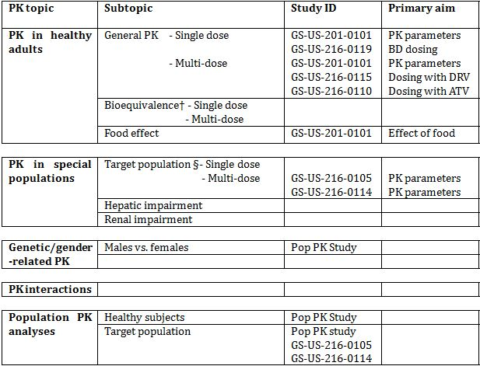

* Indicates the primary aim of the study.

† Bioequivalence of different formulations.

§ Subjects who would be eligible to receive the drug if approved for the proposed indication.

None of the pharmacokinetic studies had deficiencies that excluded their results from consideration.

### Summary of pharmacokinetics

The information in the following summary is derived from conventional pharmacokinetic studies unless otherwise stated. As most of the PK studies were submitted and evaluated in the Stribild submission and not included in this submission, the studies are identified but not summarised.

#### Physicochemical characteristics of the active substance

Empirical Formula: C40H53N7O5S2; Formula Weight: 776.0.

Cobicistat has three chiral centres and is produced as a single isomer. The stereochemical configurations at these chiral centres are controlled through the synthetic process and use of starting materials having suitably high chiral purities. The pKa1 = 1.8 (thiazole group); pKa2 = 2.5 (alkylthiazole group); pKa3 = 6.4 (morpholino group). The compound is practically insoluble in water and non-polar organic solvents but is freely soluble in polar organic solvents.

#### Pharmacokinetics in healthy subjects

##### Absorption

Based on dose escalation studies, the bioavailability of cobicistat at a dose of 150 mg is expected to be high. *In vitro* studies demonstrated that cobicistat displays high intestinal permeability primarily via passive transcellular diffusion and does not undergo active secretory transport.

Following oral administration, peak cobicistat concentrations are observed ~4 to 5 hours post dose regardless of dose level in healthy subjects. Cobicistat’s apparent clearance is low (~11-15% of hepatic blood flow) and at doses higher than 150 to 200 mg, exposure increase (i.e. greater than dose proportional) is driven by reduction in systemic clearance rather than higher bioavailability.

The effect of increased intragastric pH was evaluated in Studies GS-US-216-0120[1] and GS-US-216-0122[2] in which cobicistat boosted EVG 150 mg was administered with omeprazole or administered simultaneously or staggered with a representative H2-receptor antagonist (famotidine). The absorption of cobicistat was not influenced by local gastrointestinal pH.

##### Bioavailability

###### Absolute bioavailability

The absolute bioavailability of cobicistat after oral administration has not been investigated. The drug is formulated as an oral tablet.

###### Bioequivalence of clinical trial and market formulations

The bioequivalence of the formulations used in the early PK studies and the later safety and efficacy studies (intended commercial product) was tested in Study GS-US-216-0116a but this study was not submitted in this submission. It was submitted in the dossier for the 4 drug combination tablet (STRIBILD). The summaries and evaluation report for STRIBILD state that the two formulations are bioequivalent.

###### Influence of food

The effect of food on was evaluated following administration of the STRIBILD combination product in Study GS-US-236-0105[3] and following administration of the cobicistat stand alone tablet in combination with GS-8374 (an investigational protease inhibitor) in Study GS-US-201-0101.

Assessment of the effect of food on cobicistat PK administered as part the STRIBILD combination product indicated that cobicistat exposure parameters were bioequivalent under light meal and fasted conditions Study GS-US-236-0105.[4] For the high calorie/high fat meal, cobicistat Cmax and AUC decreased modestly relative to the light meal and the fasted condition. In contrast, elvitegravir (EVG) AUCinf and Cmax increased by 34% and 22%, respectively, for the light meal condition and increased by 87% and 56%, respectively, for the high calorie/high fat meal condition. These data indicate the separate effects of food on cobicistat and the boosted agent (EVG) contributing to the overall exposures of these agents. These results also indicate the lack of clinical relevance of modestly lower cobicistat exposures with a high fat meal, as evidenced by the maintenance of boosted EVG exposures (in fact higher) upon administration with a high calorie/high fat meal.

In Study GS-US-201-0101 following administration of cobicistat single agent tablet (in combination with an investigational HIV-1 protease inhibitor no longer in clinical development) cobicistat AUCinf and Cmax were 66% and 24% higher respectively, following a light meal compared to administration under fasted conditions. Sufficient PK boosting was achieved under all fed dosing exposures.

Since administration of food also separately affects the plasma exposures of the to be boosted agent based on its physicochemical properties, dosing recommendations with cobicistat will be driven by the co-administered agent (ATV or DRV, each of which needs to be administered with food) rather than cobicistat itself.

###### Dose proportionality

Cobicistat displayed both dose and time dependent changes in apparent clearance (CL/F) with nonlinear increases in systemic exposure, consistent with the properties of a mechanism-based inhibitor. Cobicistat apparent clearance was 98% lower between the highest and lowest doses in the single-dose range and 95% lower between the highest and lowest doses in the multiple-dose range, reaching a nadir after single- or multiple-dose administration at ≥ 150 to 200 mg.

Peak cobicistat concentrations were observed ~ 4 to 4.5 hours post dose regardless of dose. Single doses over an 8-fold dose range yielded a 164-fold range in AUCinf. Upon multiple dosing over a 6-fold range, cobicistat demonstrated a 47-fold range in AUCtau, consistent with a nonlinear increase in exposure due to mechanism-based inhibition.

##### Distribution

###### Volume of distribution

The distribution of cobicistat in compartments other than plasma (e.g. cerebrospinal fluid or genital tract secretions) has not been clinically studied but is not considered likely given the distribution data generated in non clinical studies.

From the population PK analysis, based on a one compartment mammillary PK model with zero and first order absorption rate constants and absorption lag times, and including the effect of body weight on the apparent volume of the central compartment (Vc/F) of COBI, the typical apparent systemic clearance of cobicistat (CL/F) was estimated to be 15.0 L/h. The typical Vc/F was estimated to be 77.0 L. The COBI absorption profile was modelled using a zero-order absorption process with duration of 1.16 h, a first-order absorption rate constant of 0.88 h-1, and a lag time of 0.18 h.

A statistically significant, positive correlation was observed between body weight and cobicistat Vc/F. However, relative to the median weight, the range of observed weights (5th and 95th percentiles) corresponded to differences of only -22% and 24% in COBI Vc/F, respectively. Such changes are not deemed to be clinically relevant in adults as cobicistat exposures were in a range associated with robust boosting and CYP3A inhibition (AUCtau 10,000 to 14,600 ng•h/mL across weight quartiles). No other clinically relevant effects of demographic or formulation characteristics were observed on cobicistat PK.

###### Plasma protein binding

Based on equilibrium dialysis studies (*in vitro* and plasma samples from healthy subjects clinical studies including subjects with renal and hepatic impairment) cobicistat was on average 97 to 98% bound to human plasma proteins and independent on concentration.

###### Erythrocyte distribution

After multiple oral dosing of cobicistat ([14C] cobicistat administered on the last day of the multiple dose period) in healthy subjects, the blood to plasma ratio of total 14C-radioactivity was time independent and ~0.5 indicating that cobicistat is excluded from the cellular components of the blood (Study GS-US-216-0111).[5]

##### Metabolism

Cobicistat is extensively metabolised in vitro via CYP3A (major) and CYP2D6 (minor) mediated oxidation, and there is no evidence of direct Phase 2 metabolism.

Primary metabolites include isopropyl oxidation (M31, E3, GS-9612), cleavage at the N-methylurea (M26, E5, GS-341842), cleavage of the carbamate (M21, E1, GS-9454), and cleavage and deethylation of the morpholine (M39). CYP3A can catalyse all reactions, while CYP2D6 contributes to the generation of M31 (E3). Mean plasma exposure of M31 was < 3% of cobicistat exposure (AUC) at the 150 mg dose in clinical studies following single-dose administration (Study GS-US-216-0111[6]; mass-balance study of cobicistat).

##### Excretion

Following administration of [14C] cobicistat, 86.2% of the dose was recovered in faeces, consistent with hepatobiliary excretion, and primarily as parent drug or metabolites M21 or M31; renal elimination is a minor pathway (8.2% of the administered dose was recovered in urine) and occurred primarily as unchanged parent drug and with low levels of metabolites M21 and M31.

In plasma, cobicistat was the predominant species, representing 98.6% of the circulating radioactivity; observed metabolites were at undetectable to very low concentrations relative to systemic exposure of cobicistat. Metabolites M21, M26, and M31 are weaker inhibitors of CYP3A compared with cobicistat, and due to their low systemic concentrations, should not contribute to the primary pharmacodynamic effect of CYP3A inhibition.

###### Intra- and inter-individual variability of pharmacokinetics

From the population PK analysis, the intersubject variability in cobicistat exposures (AUCtau and Cmax) was generally low/modest and comparable across studies (%CV: 20%-50% and 14%-43%, respectively, across all studies with cobicistat 150 mg administered once daily).

#### Pharmacokinetics in the target population

A cross-study comparison of cobicistat PK parameters between healthy subjects (Study GS-US-216-0110) and HIV-1 infected subjects from the Studies GS-US-216-0105 (intensive and sparse) and GS-US-216-0114 (intensive) following multiple-dose administration of ATV/co (300/150 mg) indicated that cobicistat AUCtau, Cmax, and Ctau were comparable in these populations.

Cobicistat exposures following multiple-dose administration of DRV/co (800/150 mg) to healthy subjects (Study GS-US-216-0115) were generally comparable to those observed with ATV/co.

Table 2: Steady-state cobicistat PK parameters after once-daily administration of ATV/co (300/150 mg) in HIV-1 infected subjects (Studies GS-US-216-0105 and GS-US-216-0114 population PK analysis) or in healthy subjects (Study GS-US-216-0110).

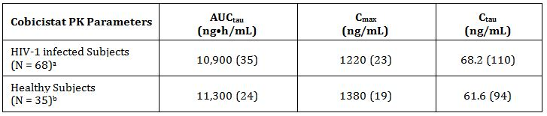

Data are mean (%CV) and are shown to 3 significant digits.

a The model-based cobicistat PK parameters were available for 68 subjects in the ATV/co+TVD treatment group (n = 46 in Study GS-US-216-0105 and n = 22 in Study GS-US-216-0114).

b 3 Subjects did not have evaluable cobicistat PK profiles and were excluded from the cobicistat PK analysis set.

Pharmacokinetic parameters of cobicistat were determined following multiple-dose administration of ATV/co+TVD in treatment-naive HIV-1 infected subjects in the efficacy and safety Studies GS-US-216-0105 and GS-US-216-0114.

In Study GS-US-216-0105 all subjects, including those in the PK substudy, had the following samples taken for PK analysis:

* Single Trough PK Sample: collected 20-24 hours following an observed (in-clinic) dose at Weeks 8, 24, and 48
* Single PK blood sample collected at visits from Weeks 4, 12, 16, 32, and 40

In addition in a subset of subjects (target n = 24 evaluable) at selected study sites an intensive PK Substudy was performed. The PK substudy visit occurred between the Week 2 and Week 8 visits. The substudy included intensive PK profiling. Blood samples were collected at the following time points: pre-dose, 1, 2, 3, 3.5, 4, 4.5, 5, 6, 8, 10, 12, and 24 hours after the dose of study drug.

The assay used was the same as that in the PK studies in healthy volunteers – a validated LC/MSMS with the following parameters:

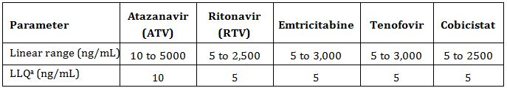

LLQ = lower limit of quantification

The following PK parameters were determined and summarized using descriptive statistics: AUCtau, Cmax, Ctau, Clast, Tmax, Tlast, t½, λz, Vz/F, and CL/F.

The ATV Cmax, Ctau, and AUCtau were comparable when given as ATV/co+TVD or ATV/r+TVD. The mean ATV trough concentrations in subjects receiving ATV/co+TVD or ATV/r+TVD were greater than 46-fold above the protein-binding adjusted IC90 against wild-type HIV-1 (14 ng/mL) throughout the 48-week dosing period.

The PK parameters of ATV, cobicistat, RTV, FTC and TFV following steady state administration of ATV/co+TVD or ATV/r+TVD were consistent with those observed in other published studies in HIV-1 infected patients, as well as other sponsor studies in healthy subjects.

Table 3: Study GS-US-216-0105: summary of ATV, COBI, RTV, FTC, and TFV PK parameters (PK Substudy Analysis Set).

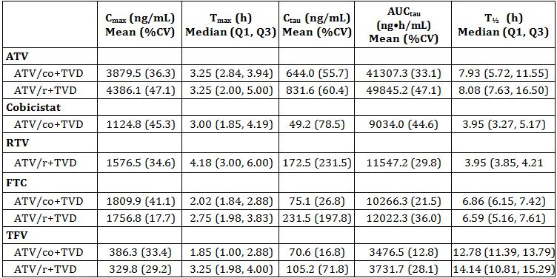

In Study GS-US-216-0114 all subjects, including those in the PK substudy, had a single PK sample collected as part of their safety laboratory blood draws at study visits at Weeks 2, 4, 8, 12, 16, 24, 32, 40, and 48.

In addition, a PK substudy was performed in a subset of subjects (target n = 48 evaluable) at selected study sites. The PK substudy visit occurred between the Week 2 and Week 8 visits. The substudy included intensive PK profiling. Blood samples were collected at the following time points: predose, 1, 2, 3, 3.5, 4, 4.5, 5, 6, 8, 10, 12, and 24 hours after the dose of study drug.

The assay used was the same as that in the PK studies in healthy volunteers – a validated LC/MSMS with the following parameters:

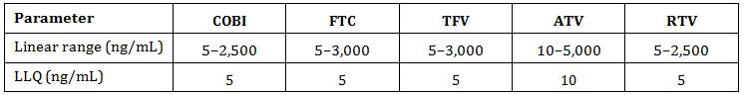

Overall, the plasma exposures of ATV, cobicistat, RTV, FTC, and TFV were consistent with historical data. The PK parameters of ATV were comparable following steady-state administration of ATV/co+TVD or ATV/r+TVD. The mean ATV Ctau in subjects receiving ATV/co+TVD or ATV/r+TVD was 56.9-fold and 61.0-fold above the protein-binding adjusted IC90 against wild-type HIV-1 (14 ng/mL).

Table 4: Study GS-US-216-0114: Summary of ATV, COBI, RTV, FTC, and TFV PK parameters (PK substudy analysis set).

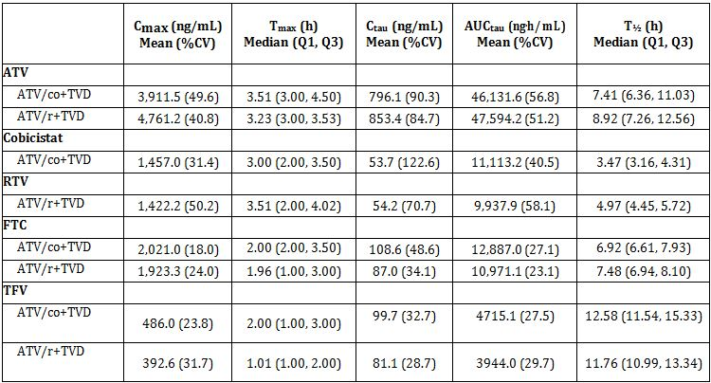

%CV = percentage coefficient of variation; Q1, Q3 = first and third interquartiles

For each subject in PK substudy, intensive PK was done at one time at Weeks 2, 4 or 8.

Cobicistat and ritonavir exposures were consistent with those associated with robust PK enhancement (boosting) and in the range of values observed in the Phase 1 study in healthy subjects (Study GS-US-216-0110).

The PK parameters of TFV were modestly higher (~20%) following steady-state administration of TVD with ATV/co versus ATV/r, and within the range of historical exposures observed with boosted-PIs (including ATV) in healthy subjects described in the literature. The PK parameters of FTC were comparable following steady-state administration of ATV/co+TVD or ATV/r+TVD, and exposures in both treatments.

#### Pharmacokinetics in other special populations

##### Pharmacokinetics in subjects with impaired hepatic function

The PK cobicistat when used as booster of elvitegravir [EVG] was examined in non-HIV-1 infected subjects with moderate hepatic impairment (Child-Pugh-Turcotte [CPT] Classification B) were compared with data for subjects with normal hepatic function (matched for age, gender, and body mass index) in Study GS-US-183-0133.[7]

The AUCtau and Cmax of cobicistat were generally comparable in the subjects with moderate hepatic impairment relative to matched control subjects. Cobicistat Ctau was higher (geometric least-squares mean [GLSM] ratio 207.70%) although not considered to be clinically relevant. Accordingly, no dose adjustment of COBI is required in subjects with mild (CPT Classification A) or moderate hepatic impairment. Cobicistat has not been studied in patients with severe hepatic impairment

##### Pharmacokinetics in subjects with impaired renal function

The PK cobicistat when used as booster of elvitegravir [EVG] was examined in non-HIV-1 infected subjects with severe renal impairment (eGFR < 30 mL/min) were compared with data for subjects with normal renal function (eGFR ≥ 90 mL/min) in Study GS-US-216-0124c. For cobicistat, AUCtau, Cmax, and Ctau were approximately 25%, 22%, and 13% higher, respectively, in subjects with severe renal impairment compared with matched control subjects. The differences in exposures between subjects with severe renal impairment and those with normal renal function are not considered clinically significant and do not warrant dose adjustment. No differences in cobicistat plasma protein binding were observed between the 2 groups.

##### Pharmacokinetics according to age

From the population PK analyses, following once-daily administration of the cobicistat single-agent tablet from a total of 9 studies (7 in healthy volunteers and 2 in HIV-1 infected patients), median (first quartile [Q1], third quartile [Q3]) age was 37 (30, 44) years (range 18 to 76 years), with 37 subjects aged ≥ 55 years. Age did not have an effect on cobicistat exposures in healthy and HIV-1 infected subjects and was not a clinically relevant covariate based on population PK analyses, however it is noted that there were very few subjects >65 years.

##### Pharmacokinetics related to gender

From the population PK analyses, ~34% of subjects were female. Gender did not have an effect on cobicistat exposures in healthy and HIV-1 infected subjects and was not a clinically relevant covariate based on population PK analyses.

##### Pharmacokinetics according to race

From the population PK analyses, the percentages of subjects who were white, black, or other (US classifications) were 73%, 24%, and 3%, respectively. Race did not have an effect on cobicistat exposures in healthy and HIV-1 infected subjects and was not a clinically relevant covariate based on population PK analyses.

##### Pharmacokinetics according to body surface area

From the population PK analyses, the median (Q1, Q3) body surface area was 1.90 (1.73, 2.00) m2. Body surface area did not have an effect on cobicistat exposures in healthy and HIV-1 infected subjects and was not a clinically relevant covariate based on population PK analyses.

#### Pharmacokinetic interactions

##### Pharmacokinetic interactions demonstrated in human studies

Based on the activity of cobicistat as a mechanism based inhibitor of CYP3A, a targeted set of interaction studies were conducted to evaluate the potential for drug interactions. Most of these studies were submitted and evaluated in the STRIBILD submission and not submitted in this submission. They are identified and referenced here for completeness.

###### Drugs affecting cobicistat

The administration of cobicistat with CYP3A inducers (e.g. rifabutin, rifampicin, St John’s wort, systemic dexamethasone, carbamazepine, phenobarbital, and phenytoin) may result in lower exposures of cobicistat, and in turn, reduce its pharmacodynamic (PD) boosting effect on the co-administered to-be-boosted agent.

Study GS-US-216-0123[8] studied the effect of EVG/co co-administered with dose-adjusted rifabutin. In this study, cobicistat exposures were lower upon co-administration with the inducing agent, which resulted in approximately 60% lower exposures (trough concentrations) of the boosted drug. Given the potential for these lower exposures of the to-be-boosted agent to result in loss of therapeutic activity and the development of resistance, administration of cobicistat with CYP3A inducers is not recommended and/or is contraindicated).

Interaction studies with H2-receptor antagonists or proton pump inhibitors demonstrated that changes in gastric pH do not affect cobicistat PK or its pharmacoenhancing ability (Studies GS-US-216-0120[9] and GS-US-216-0122[10]).

There is no data available to support the use of cobicistat to boost multiple ARV agents (e.g. double boosting). In Study GS-US-201-0104,[11] cobicistat was co-administered with both EVG and DRV (all once daily), mean trough concentrations for both ARVs were ~40% to 50% lower compared with results seen when cobicistat is co-administered with DRV alone (Study GS-US-216-0115); cobicistat exposures were ~ 15% to 20% lower. Co-administration of EVG once daily with DRV/co 600/150 mg twice daily in Study GS-US-216-0119 resulted in exposures of both ARVs that were comparable with historical reference values.

###### Drugs affected by cobicistat

Cobicistat is a mechanism based inhibitor of human CYP3A enzymes with a potency of inhibition similar to that of ritonavir. As such, drugs subject to extensive metabolism by CYP3A will have substantial increases in exposure with cobicistat. Cobicistat is a weak inhibitor of CYP2D6 and UGT1A1 and does not inhibit CYP2B6 or CYP2C9, and no clinically significant drug-drug interactions are expected with drugs metabolized via these pathways (Study GS-US-216-0112[12]). Cobicistat does not activate human AhR, and shows no evidence of induction of CYP1A2 (activity or mRNA) in human hepatocytes. Cobicistat is a very weak activator of human PXR and will not result in induction of drug metabolizing enzymes or transporters.

At high concentrations present within the intestinal lumen during drug absorption, cobicistat can inhibit intestinal efflux transporters, such as MDR1 and BCRP. Cobicistat is a moderate inhibitor of hepatic uptake transporters, OATP1B1 and OATP1B3, which may result primarily in absorption-level interactions (higher peak concentrations/lower first-pass metabolism) of agents that are substrates for these transporters, rather than any changes to their systemic clearance (Study GS-US-216-0123[13]). It also inhibits OCT2 and the renal efflux transporters OCTN1 and MATE1, which may inhibit the tubular secretion of endogenous substrates such as creatinine (OCT2/MATE1). Based on literature data on known inhibitors of these transporters, the magnitude of increase in exposures of victim drugs is 13% to 47%, and has not necessitated dose modifications. Cobicistat shows weak or undetectable inhibition of MDR1, MRP1, MRP2, MRP4, BCRP, MATE2-K, and the renal uptake transporters, OAT1 and OAT3, so systemic concentrations of cobicistat would be insufficient to inhibit their activity and no clinically relevant interactions are expected.

### Evaluator’s overall conclusions on pharmacokinetics

The pharmacokinetics of cobicistat have been extensively studied – mostly in studies not included in this submission but included and evaluated in the STRIBILD submission. The overall analysis of the PK of cobicistat is therefore based on individual studies and on a population analysis with a large dataset (9,584 cobicistat concentration-time records [8,880 intensive and 704 sparse data]) from a total of 504 subjects across 16 clinical studies.

The studies using cobicistat with DRV were conducted in healthy volunteers but the studies with ATV were conducted in both healthy volunteers and in HIV-1 infected patients. The results demonstrated that the PK parameters were comparable in the two populations.

Given the metabolism of cobicistat by CYP3A and the similarity of the product to ritonavir – the company has appropriately conducted a comprehensive range of interaction studies with drugs known to interact with CYP3A and these have previously been evaluated in the STRIBILD submission.

The proposed Product Information is generally an adequate summary of the PK presented in the submission with the exception of the following:

* Based on data submitted, the Tmax should be 3-4 hours rather than just 4 hours;
* The statement that no food study was conducted is incorrect – Study GS-US-201-0101 studied the effect of food on the PK on cobicistat in healthy subjects. It would be correct to say no food study was conducted in HIV-1 infected patients.

## Pharmacodynamics

### Studies providing pharmacodynamic data

Table 5 shows the studies relating to each pharmacodynamic topic and the location of each study summary.

Table 5: Submitted pharmacodynamic studies.

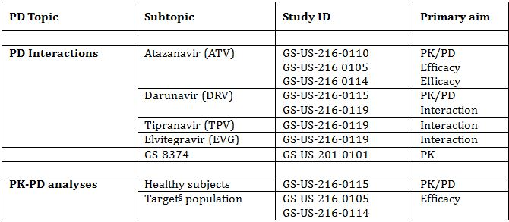

* Indicates the primary aim of the study.

§ Subjects who would be eligible to receive the drug if approved for the proposed indication.

None of the pharmacodynamic studies had deficiencies that excluded their results from consideration.

The PK/PD (pharmacokinetic/pharmacodynamic) relationship was also investigated in the following studies evaluated in the STRIBILD studies:

* A proof of concept study of the selected CYP3A activity of COBI (Study GS-US-216-0101);
* A study of COBI’s effect on selected CYPs and the drug efflux transporter Pgp (Study GS-US-216-0112);
* A dose selection study of COBI’s effects on a validated CYP3A metabolic probe (midazolam) relative to RTV (Study GS-US-216-0116).

The effectiveness of COBI to boost DRV is based solely on the PK results. In place of a clinical efficacy study with DRV, the sponsor has provided one PK study (Study GS-US-216-0115) and an analysis of the PK/PD relationship using data from the Phase III studies which were the basis for approval of the DRV/r 800/100 mg once daily dosing indication. These studies TCM114-C211 and TCM114-C229 were conducted by the sponsor of DRV (Johnson & Johnson) and were studies of DRV/r 800/100 mg in HIV-1 infected subjects. The DRV exposures and associated antiviral responses were in the range seen with DRV/co. These studies are not summarised but are discussed.

### Summary of pharmacodynamics

The sponsor included two studies in the PD section of the submission: Study GS-US-216-0110 and GS-US-216-0115 both conducted in healthy subjects. These are variously described by the sponsor as PK/PD studies and PK interaction studies. No separate PD section is presented in the summaries but given the mechanism of action as a CYP3A4 inhibitor and the intended indication as a booster of protease inhibitors when taken together this is understandable. These studies are summarised as PK studies. Studies supporting the PD of the product were evaluated in the STRIBILD submission.

#### Mechanism of action

Cobicistat is a potent, mechanism-based inhibitor of CYP3A, similar to ritonavir. A mechanism-based inhibitor is a substrate for an enzyme that, through the process of its metabolism, generates a metabolite that irreversibly inhibits that enzyme. Mechanism-based inhibition is characterised clinically by evidence of persistent inhibition of enzyme activity after plasma concentrations of the inhibitor have declined. Cobicistat increases the systemic levels of the protease inhibitors atazanavir (ATV) and darunavir (DRV) and the investigational HIV-1 integrase strand-transfer inhibitor elvitegravir (INSTI EVG), whose bioavailability and elimination are affected by CYP3A-enzyme mediated metabolism.

Cobicistat has been shown in vitro to be a more specific CYP3A inhibitor than ritonavir. In contrast to ritonavir, cobicistat was specifically designed to be devoid of HIV protease inhibition by removing the hydroxyl isostere from ritonavir and by modifying the P2 moiety to prevent binding of the ritonavir core to the active site of HIV-1 protease. Since low dose ritonavir theoretically has the potential to select for protease inhibitor resistant virus when used as a pharmacoenhancer of the INSTI EVG in the absence of a fully active protease inhibitor, the availability of a booster without antiretroviral activity enabled the use of cobicistat as a pharmacoenhancer of EVG (in the 4 drug combination product STRIBILD) in the treatment naive population.

Cobicistat has no antiviral activity against HIV, HBV, and HCV in vitro. Cobicistat does not have any effect on HIV-1 protease activities at concentrations up to 30 μM. The *in vitro* anti-HIV EC50 of cobicistat in MT-2 cells in the absence or presence of human serum proteins are >30 μM and >90 μM, respectively. Additionally, cobicistat displayed no anti-HBV or anti-HCV activity at tested concentrations up to 12.5 μM and 30 μM, respectively. Due to the lack of detectable anti-HIV-1 activity of GS-9350, it is not possible to select PI resistance mutations to cobicistat in vitro.

#### Pharmacodynamic effects

##### Pharmacokinetic/pharmacodynamic relationship of cobicistat as a booster for ATV and DRV

The intended PD effect of cobicistat is as a pharmacoenhancer of the to-be boosted ARV agents atazanavir or darunavir.

Studies GS-US-216-0110 and GS-US-216-0115, respectively, demonstrated that ATV 300 mg and DRV 800 mg steady-state exposures were similar following administration with COBI 150 mg versus RTV 100 mg and were similar to historical data and in the range associated with durable efficacy.

Table 6: Steady-state ATV and DRV PK parameters after co-administration with cobicistat 150 mg or RTV 100 mg in healthy subjects (Studies GS-US-216-0110 and GS-US-216-0115).

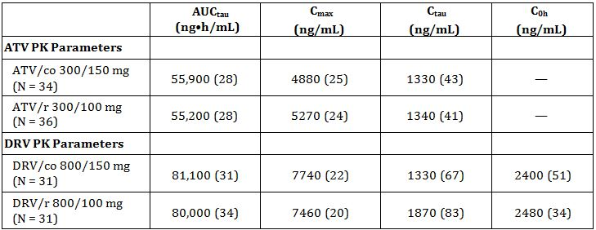

Data are mean (%CV) and are shown to 3 significant digits.

Similar results were seen in HIV-1 infected patients in the intensive pharmacokinetic sub-studies conducted as part of the efficacy studies (Studies GS-US-216-0105 and GS-US-216-0114).

Table 7: Steady-state ATV PK parameters after once-daily administration of ATV/co+TVD or ATV/r+TVD in HIV-1 infected subjects (Studies GS-US-216-0105 and GS-US-216-0114 intensive PK sub-studies).

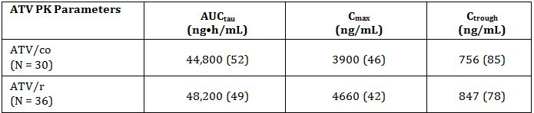

Data are mean (%CV) and are shown to 3 significant digits.

All treated subjects who participated in the PK substudy in GS-US-216-0105 or GS-US-216-0114 were included, except one subject in the ATV/co+TVD group who was excluded from the analysis due to measurable RTV concentrations.

For ATV the PK data is supported by the results of the efficacy studies - in which the virologic outcome (HIV-1 RNA <50 copies/mL) was comparable between co-administration of cobicistat and ritonavir. In Study GS-US-216-0114 treatment with ATV/co+TVD was non inferior to ATV/r+TVD.

Study GS-US-216-0115 demonstrated bioequivalent exposures for DRV assessed based on AUCtau, Cmax, and C0h. DRV Ctrough was modestly (~30%) lower with DRV/co versus DRV/r, primarily due to unexpected modestly higher DRV 24-hour concentrations relative to its concentration-time profile.

In place of a clinical efficacy study with DRV, the sponsor has provided a PK-PD analysis of cobicistat as a booster for DRV based on data from the study of DRV/co in healthy subjects (Study GS-US-216-0115) and using data from the Phase 3 studies of DRV/r 800/100 mg in HIV-1 infected subjects in which DRV exposures and associated antiviral responses were in the range seen with DRV/co. The studies used for this analysis, TCM114-C211 and TCM114-C229, were the basis for approval of the DRV/r 800/100 mg once-daily dosing indication.

Study TMC114-C211 (also referred to as ARTEMIS) was a Phase 3, randomised, open label controlled study of DRV/r 800/100 once daily versus lopinavir (LPV/r) 800/200 mg (each administered with TVD) in HIV-1 infected ARV treatment-naive patients.

In the population PK analysis, the median DRV AUC24h was 87,854 ng•h/mL and the median C0h was 2041 ng/mL. In the PK substudy, the mean DRV C0h at each time point (1786 to 2133 ng/mL) was consistently above the protein binding-corrected EC50 value for wild-type virus (55 ng/mL).

The PK-PD relationships between the DRV PK parameters AUC24h and C0h following administration of DRV/r 800/100 mg and the change in log10 viral load from baseline at Week 48 are presented in Figure 1 by quartile ranges of the PK parameters for DRV. No relationship was identified between DRV AUC24h or C0h values and change in log10 viral load from baseline at Week 48.

Figure 1: Mean (SE) change in log10 viral load from baseline at Week 48 (Observed Case) by quartiles of DRV AUC24h (upper graph) and C0h (lower graph) (TMC114-C211).

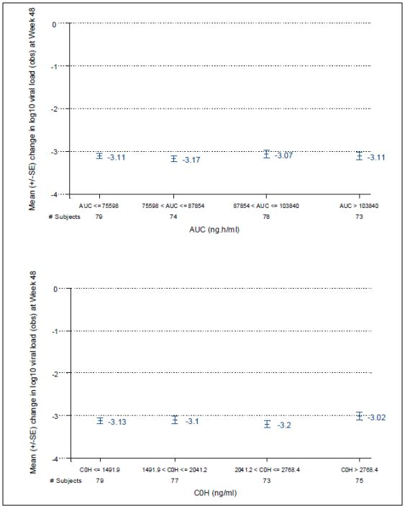

The PK/PD relationships between the DRV PK parameters AUC24h and C0h and virologic response (plasma viral load < 50 copies/mL) at Week 48 are presented in Figure 2 by quartile ranges of the PK parameters for DRV. No relevant relationship was identified between DRV AUC24h or C0h values and virologic response at Week 48.

Figure 2: Virologic response defined as viral load < 50 copies/mL at Week 48 (observed case) by quartiles of DRV AUC24h (upper graph) and C0h (lower graph) (TMC114-C211).

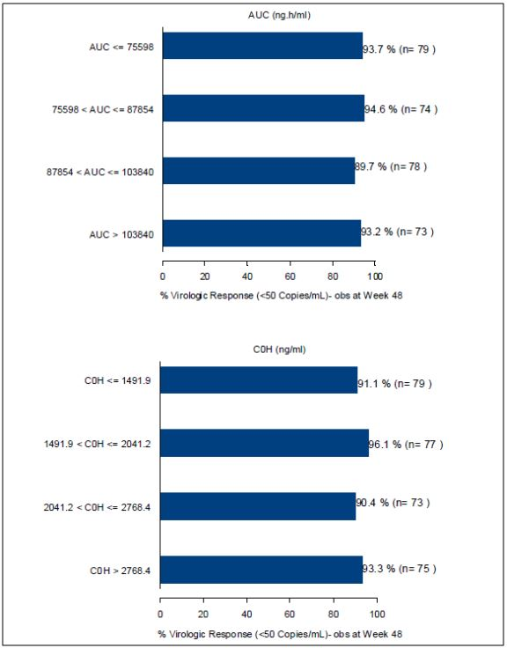

Study TMC-114-C229 (also referred to a ODIN) was a Phase 3, randomised, open label study of DRV/r 800/100 mg once daily versus DRV/r 600/100 mg twice daily (each administered with an individually optimised background regimen) in HIV-1 infected ARV treatment experienced patients with no DRV resistance associated mutations.

The decreases in log10 viral load from baseline at Week 48 following DRV/r 800/100 mg once daily were generally comparable over the DRV exposure range (Figure 3). No relevant relationship between DRV C0h and the change in log10 viral load from baseline at Week 48 was observed.

Figure 3: Mean (SE) change in log10 viral load from baseline at Week 48 (observed case) by quartiles of DRV AUC24h (upper graph) and C0h (lower graph) (TMC114-C229).

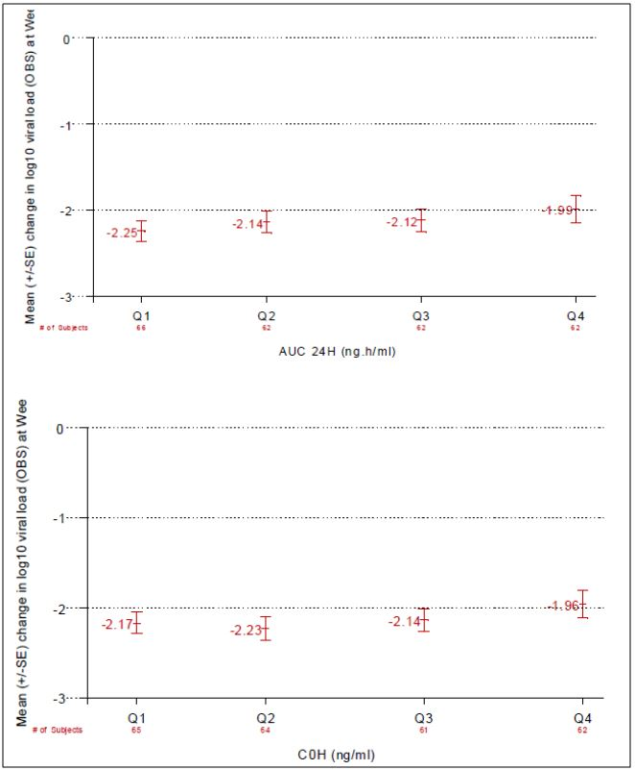

Virologic response defined as plasma viral load < 50 copies/mL at Week 48 following administration of DRV/r 800/100 mg once daily indicated no relevant relationship between DRV exposures versus response. A somewhat lower response in subjects with the highest AUC24h or C0h quartiles was observed (Figure 4), which is not considered to be clinically relevant.

Figure 4: Virologic response defined as viral load < 50 copies/mL at Week 48 (observed case) by quartiles of DRV AUC24h (upper graph) and C0h (lower graph) (TMC114-C229).

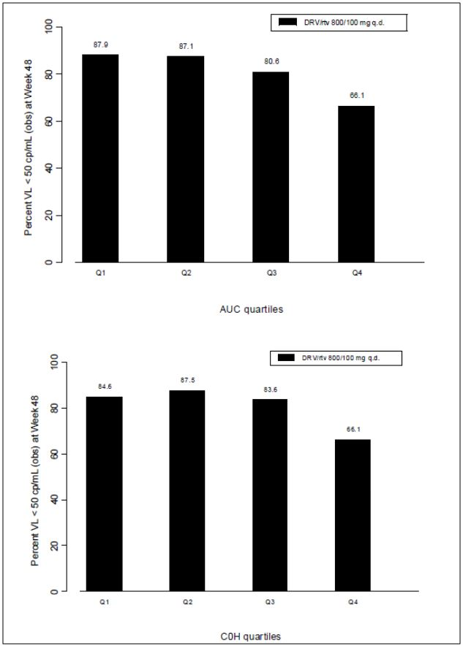

The initial (planned per protocol) PK and PK/PD analysis from these studies suggested no relevant relationship between DRV PK (AUC24h or C0h) and efficacy. Additional PK/PD analysis on the TMC114-C211 and TMC114-C229 data sets, which allowed for modelling relationships between virologic response and PK parameters in a flexible way, also did not demonstrate an association between reduction in DRV C0h and virologic response up to a reduction of 50% in DRV C0h. Overall, given the bioequivalent DRV C0h and modestly lower Ctrough with DRV/co versus DRV/r, and the shallow exposure-efficacy relationship for boosted DRV, comparable efficacy is expected between DRV/co versus DRV/r.

##### Resistance analysis

Cobicistat is a CYP3A inhibitor with no HIV, HBV or HCV antiviral activity.

Study GS-US-216-0105 was a Phase 2 randomised, double-blind study to evaluate the safety and efficacy of cobicistat-boosted ATV (ATV/co) versus RTV-boosted ATV (ATV/r), each administered with FTC/TDF, in HIV-1 infected, ARV treatment-naive adults.

All subjects had their HIV-1 reverse transcriptase (RT) and protease genes analysed at screening (TruGene HIV-1 Genotyping Assay). As part of the enrolment criteria, all patients lacked any TDF, FTC, or ATV resistance mutations, and were considered sensitive to all study drugs by the TruGene assay. The HIV-1 subtype was determined for each subject from the screening genotype. Most subjects had HIV-1 subtype B (96.2% of subjects [76 of 79]).

Subjects who were on study drugs and experienced either suboptimal virologic response or virologic rebound, as defined below, were considered to have virologic failure and were included in the resistance analysis population. Suboptimal virologic response was assessed at Week 8 and was defined as having HIV-1 RNA ≥50 copies/mL and < 1 log10 reduction from baseline by the Week 8 visit, which was confirmed at the subsequent visit. Virologic rebound was defined as having 2 subsequent visits with HIV-1 RNA ≥ 400 copies/mL after having achieved HIV-1 RNA < 50 copies/mL, or as having 2 subsequent visits with > 1 log10 increase in HIV-1 RNA from their nadir.

Of the 79 randomised and treated subjects, 2 subjects were analysed for resistance development, one in each group. Post baseline data were available for these 2 subjects, of whom none developed a major NRTI-R mutation or a PI-resistance (PI-R) mutation.

Study GS-US-216-0114 was a Phase 3 randomised, double-blind study to evaluate the safety and efficacy of cobicistat-boosted ATV versus RTV-boosted ATV, each administered with Truvada (TVD), in HIV-1 infected, ARV treatment-naive adults.

As part of the screening requirements, all 692 subjects from ITT analysis set were analysed for pre-existing resistance in the protease and RT portions of the pol gene using the GeneSeq assay. These screening data were used for baseline resistance analyses. As required by the enrolment criteria, all subjects showed genotypic sensitivity to FTC, TDF, and ATV by the GeneSeq assay at screening. Consistent with the enrolment criteria, no subject had a K65R or M184V/I RT mutation at study entry. Primary PI-R mutations were observed in 2.6% of subjects (18 of 692), most commonly L33F and L90M in protease, but were considered fully sensitive to ATV on their screening report. NRTI resistance (NRTI-R) mutations were observed in 8.4% of subjects (58 of 692), most commonly V118I (5.2% of subjects [36 of 692]) in RT. The HIV-1 subtype was determined for each subject from the screening genotype. Most subjects had HIV-1 subtype B (81.9% of subjects [567 of 692]).

Subjects who were on study drugs and experienced either suboptimal virologic response or virologic rebound, defined as for Study GS-US-216-0105, were considered to have virologic failure and were included in the resistance analysis population.

Of the 692 randomised and treated subjects, 24 subjects (3.5%) were analysed for resistance development, 12 (12 of 344 [3.5%]) in the ATV/co+TVD group and 12 (12 of 348 [3.4%]) in the ATV/r+TVD group. Post baseline data were available for 11 of the 12 subjects in the ATV/co+TVD group, of whom 2 (2 of 344 [0.6%]) developed a primary NRTI-R mutation (M184V) and 1 of these with phenotypic resistance to FTC. Post baseline data were available for all 12 subjects in the ATV/r+TVD group analysed for resistance development, none of whom developed resistance to a component of ATV/r+TVD.

### Evaluator’s overall conclusions on pharmacodynamics

The studies included in this submission have focussed on the PK/PD interactions with other ARV therapies – atazanavir (ATV), darunavir (DRV) which are included in the indication and tipravavir (TPV) and elvitegravir (EVG) which are not.

ATV exposures were comparable when boosted by cobicistat versus ritonavir, in both healthy subjects and HIV-1 infected patients (Studies GS-US-216-0110 and GS-US-216-0114). The observed cobicistat boosted ATV exposures were in the range of values observed previously using ARV/r. Results from the studies GS-US-216-0110 and GS-US-216-0115 demonstrated that ATV 300 mg and DRV 800 mg steady state exposures were similar following administration with cobicistat 150 mg versus ritonavir 100 mg.

No further efficacy data was submitted to support the proposed indication of the combination of cobicistat and DRV. Approval of this indication rests solely with pharmacokinetic data.

## Dosage selection for the pivotal studies

The 150 mg dose of cobicistat was selected based on the cumulative pharmacodynamic, PK, and safety/tolerability results from 5 Phase 1 studies in healthy subjects (Studies GS-US-216-0101,[14] GS-US-236-0101,[15] GS-US-216-0110, GS-US-216-0115 and GS-US-216-0116[16]). The first 2 studies established that cobicistat 150 mg has the potential to boost the exposures of CYP3A substrates (midazolam and the HIV IN strand transfer inhibitor elvitegravir, respectively) similar to ritonavir (RTV) 100 mg. Study GS-US-216-0115 demonstrated that cobicistat 150 mg boosted darunavir (800 mg once daily) similar to 100 mg ritonavir providing bioequivalent AUCtau and consistently maintaining darunavir DRV trough concentrations above protein-adjusted EC50 for wild type virus.

Study GS-US-216-0110 demonstrated that co-administration with cobicistat 150 mg resulted in ATV exposures (AUCtau, Cmax, and Ctrough) that are bioequivalent to those achieved with RTV 100 mg. Additionally, similar to RTV 100 mg, cobicistat 150 mg co-administration resulted in ATV trough concentrations that were ~95-fold above the median wild-type EC90 (14 ng/mL) and ~8.8-fold above the minimum target trough concentration (150 ng/mL) recommended in the US guidelines for persons with drug-susceptible virus. The combination of cobicistat plus ATV in this study was generally well tolerated and consistent with the established safety profile of ATV.

## Clinical efficacy

### Pivotal efficacy studies

#### Study GS-US-216-0114

A Phase 3, Randomised, Double Blind Study to Evaluate the Safety and Efficacy of GS-9350 [Cobicistat] boosted Atazanavir Versus Ritonavir Boosted Atazanavir Each Administered with Emtricitabine/Tenofovir Disoproxil Fumerate in HIV-1 Infected, Antiretroviral Treatment Naive Adults.

*Comment: This study is designed as a 2 year study with the primary endpoint at week 48. The study report is an interim report at 48 weeks (report dated January 2012).*

##### Study design, objectives, locations and dates

A randomised, double blind, multicentre, active controlled study conducted in 143 sites worldwide: (Australia 6, Austria 3, Belgium 3, Brazil 6, Canada 7, Denmark 1, Dominican Republic 1, France 11, Germany 7, Italy 4, Mexico 1, The Netherlands 1, Portugal 2, Spain 2, Switzerland 3, Thailand 5, UK 6 and USA 74) between March 2010 and November 2011.

###### Primary objective

To evaluate the efficacy of a regimen containing cobicistat boosted ATV (ATV/co) versus RTV boosted (ATV/r), each administered with emtricitabine (FTC) and tenofovir disoproxil fumerate (TDF) (combination product TVD) in HIV-1 infected, antiretroviral treatment-naive adult subjects as determined by the achievement of HIV-1 ribonucleic acid (RNA) < 50 copies/mL at Week 48.

###### Secondary objective

To evaluate the efficacy, safety, and tolerability of the 2 treatment regimens through 96 weeks of treatment. The study schema is shown in Figure 5.

Figure 5: Study GS-US-216-0114: schema.

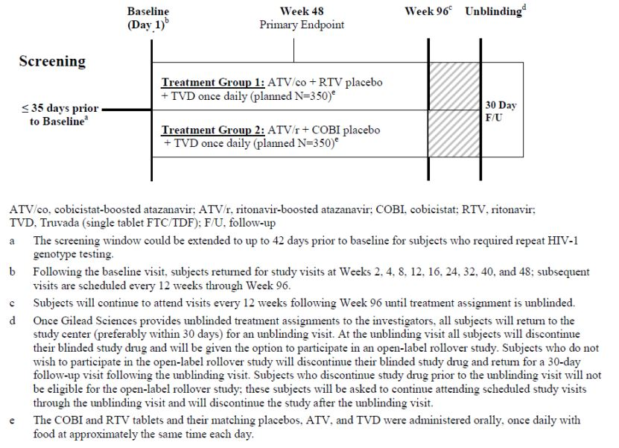

After Week 96, subjects can continue to take their blinded study drug every 12 weeks until treatment assignments have been unblinded, at which point they can be given the option to participate in an open-label rollover study.

##### Inclusion and exclusion criteria

###### Inclusion

HIV-1 infected, antiretroviral treatment naive adults (aged ≥18 years) who meet the following criteria:

* Plasma HIV-1 RNA levels ≥ 5,000 copies/mL at screening
* Estimated glomerular filtration rate (eGFR) calculated using the Cockcroft-Gault method (eGFRCG) ≥ 70 mL/min at screening
* No prior use of any approved or experimental antiretroviral drug for any length of time
* Screening genotype report showed sensitivity to FTC, TDF and ATV
* Normal electrocardiogram (ECG) (or, if abnormal, determined by the investigator to be not clinically significant)
* Hepatic transaminases (aspartate aminotransferase [AST] and alanine aminotransferase [ALT]) ≤ 5 x the upper limit of normal (ULN)
* Total bilirubin ≤ 1.5 mg/dL, or normal direct bilirubin
* Adequate hematologic function (absolute neutrophil count ≥ 1,000/mm3; platelets ≥ 50,000/mm3; haemoglobin ≥ 8.5 g/dL)
* Serum amylase ≤ 5 x ULN (subjects with serum amylase > 5 x ULN remained eligible if serum lipase was ≤ 5 x ULN)
* All subject agree to use highly effective methods of contraception throughout study and for 30 days following discontinuation of study drugs
* Life expectancy of ≥ 1 year

###### Exclusion

* A new AIDS-defining condition diagnosed within the 30 days prior to screening
* Receiving drug treatment for hepatitis C, or anticipated to receive treatment for hepatitis C during the course of the study
* Experiencing decompensated cirrhosis (e.g., ascites, encephalopathy)
* Females who were breastfeeding
* Positive serum pregnancy test (female of childbearing potential)
* Had an implanted defibrillator or pacemaker
* Had an ECG PR interval ≥ 220 msec
* Current alcohol or substance use judged by the investigator to potentially interfere with subject study compliance
* A history of malignancy within the past 5 years (prior to screening) or ongoing malignancy other than cutaneous Kaposi’s sarcoma (KS), basal cell carcinoma, or resected, non-invasive cutaneous squamous carcinoma. Subjects with cutaneous KS were eligible, but must not have received any systemic therapy for KS within 30 days of baseline or been anticipated to require systemic therapy during the study
* Active serious infections (other than HIV-1 infection) requiring parenteral antibiotic or antifungal therapy within 30 days prior to baseline
* Receiving ongoing therapy with any of the medications not to be used with cobicistat FTC, TDF, ATV, or RTV; subjects with known allergies to the excipients of cobicistat, TVD, or RTV tablets, or ATV capsules

##### Study treatments

* **Treatment Group 1:** cobicistat 150 mg + ATV 300 mg + TVD (single tablet FTC/TDF 200/300 mg) + RTV placebo, once daily with food
* **Treatment Group 2:** RTV 100 mg + ATV 300 mg + TVD (single tablet FTC/TDF 200/300 mg) + cobicistat placebo, once daily with food

Ritonavir, Atazanavir and the combination table Emtricitabine 200 mg/Tenofovir Disoproxil Fumarate 300 mg were all commercial stock as available in the USA.

##### Efficacy variables and outcomes

The primary efficacy outcome was the percentage of patients with HIV-1 RNA < 50 copies/mL at Week 48 using the US FDA defined snapshot analysis.

Other efficacy outcomes included:

* Achievement and maintenance of confirmed HIV-1 RNA < 50 copies/mL through Week 48 (based on the FDA defined time to loss of virologic response (TLOVR) algorithm (See Figure 29 in section 14.2 page 108)
* Pure virologic failure (PVF) with HIV-1 RNA cutoff at 50 copies/mL by Week 48
* Percentage of patients with HIV-1 RNA < 50 copies/mL using missing = failure and missing = excluded methods
* Change from baseline in log10 HIV-1 RNA copies /mL
* Change from baseline in CD4 cell count and CD4 percentage (CD4%)

##### Randomisation and blinding methods

Subjects were randomised in a 1:1 ratio to the two treatment groups. Randomisation was stratified by HIV-1 RNA level (≤ 100,000 copies/mL or > 100, 000 copies per mL) at screening.

Study drug (cobicistat, ritonavir and matching placebos) was dispensed to subjects in a blinded fashion.

##### Analysis populations

**Intent to treat (ITT) analysis set:** included all randomised subjects who received at least 1 dose of study drug. This was the primary analysis set for efficacy analyses. 344 patients in the ATV/co + TVD group and 349 patients in the ATV/r + TVD group.

**Per Protocol (PP) analysis set:** included all randomised subjects who received at least 1 dose of study drug and had not committed any major protocol violation, including violation of key entry criteria. 295 patients in the ATV/co + TVD group and 304 patients in the ATV/r + TVD group.

**Safety analysis set:** included all randomized subjects who received at least 1 dose of study drug. 344 patients in the ATV/co + TVD group and 348 patients in the ATV/r + TVD group.

**PK substudy analysis set:** included all randomised subjects who received at least 1 dose of study medication, and for whom steady-state PK parameters of study medication were calculable. 22 patients in the ATV/co + TVD group and 26 patients in the ATV/r + TVD group.

##### Sample size

A total sample size of 700 HIV-1 infected subjects randomised in a 1:1 ratio to 2 treatment groups (350 subjects per group) has at least 95% power to establish non-inferiority with respect to the response rate of HIV-1 < 50 copies/mL at Week 48 between the 2 treatment groups, as defined by the US FDA snapshot analysis. For sample size and power computations it was assumed that both treatment groups would have a response rate of 0.795 (based on Gilead Study GS-01-934), that the non-inferiority margin was 0.12, and that the significance level of the test was at a 1-sided, 0.025 level.

##### Statistical methods

The primary efficacy endpoint was the percentage of subjects with virologic success (i.e., HIV-1 RNA < 50 copies/mL) at Week 48, as determined using the FDA-defined snapshot analysis. The percentage of subjects with virologic success at Week 48 was used to assess treatment non-inferiority of ATV/co + TVD compared with ATV/r + TVD using a conventional 95% confidence interval (CI) approach, with a non-inferiority margin of 12%. The baseline HIV-1 RNA stratum (≤ 100,000 copies/mL or > 100,000 copies/mL)-weighted difference in the response rate and its 95% CI were calculated based on stratum-adjusted Mantel-Haenszel (MH) proportion. If the non-inferiority of ATV/co + TVD was established, superiority testing was to be conducted between treatments using the same 95% CI. Supporting analyses of the primary endpoint included sensitivity analyses to evaluate the effects of study drug discontinuations not related to virologic response and late discontinuations, and subgroup analyses to assess homogeneity of treatment differences between specified subgroups (i.e., age, sex, race, baseline HIV-1 RNA level, baseline CD4 cell count, and study drug adherence).

The same statistical methods applied to analysis of the primary efficacy endpoint were used for the analysis of all secondary and tertiary endpoints involving percentages. However, the PVF failure analysis was descriptive in nature and used the ITT analysis set only. No inferential statistics were provided.

##### Participant flow

Participant flow in Study GS-US-216-0114 is shown in Figure 6.

Figure 6: Study GS-US-216-0114: participant flow.

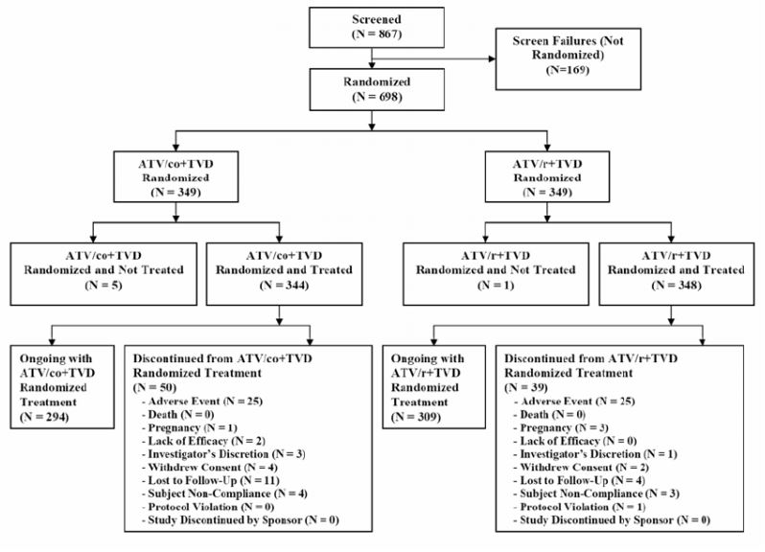

##### Major protocol violations/deviations

A total of 106 important protocol deviations occurred in 88 subjects during the study. Relevant protocol deviations were proportionally distributed between treatment groups and study centres. The majority of important protocol deviations were due to non-adherence, which was defined as a subject with less than 70% adherence at any visit based on pill count.

A total of 24 subjects violated a single eligibility criterion. The majority of entry criteria violations were due to subjects having a new CD4 cell count < 200 cells/μL at the screening visit. All of the violations due to CD4 count at study entry were identified after treatment had commenced; these subjects did not have any other AIDS-defining condition and were not discontinued from the study. None of these deviations affected the overall interpretation of the study data.

##### Baseline data

Overall, demographic and general baseline characteristics were similar between the two treatment groups (Table 8).

Table 8: Study GS-US-216-0114: demographics and baseline characteristics (Safety Analysis set).

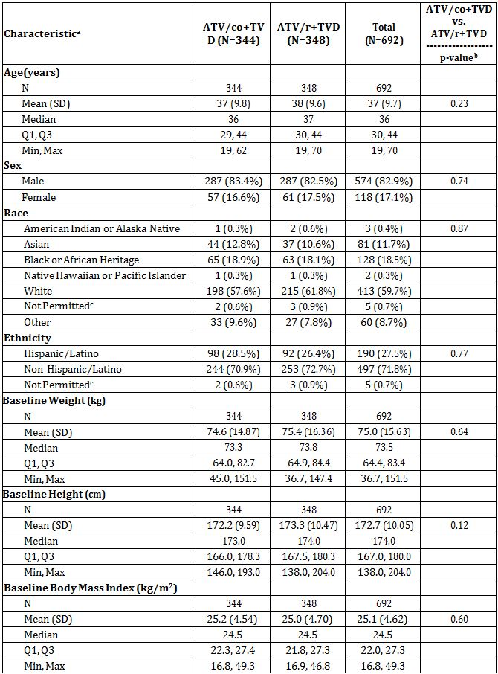

a The denominator for percentages is based on the number of subjects in the safety analysis set.

b For categorical data, p-value was from the CMH test (general association statistic was used for nominal data). For continuous data, p-value was from the 2-sided Wilcoxon rank sum test.

c Not Permitted = Regulators do not allow collection of race or ethnicity information.

There were no significant differences between the 2 treatment groups for any of the disease characteristics. The mean (SD) baseline HIV-1 RNA value was 4.83 (0.589) log10 copies/mL, CD4 count was 352 (172.9) cells/μL, and CD4% was 20.6% (8.57). Overall, 60.3% of subjects had baseline HIV-1 RNA ≤ 100,000 copies/mL. The most common HIV risk factor category was homosexual sex (65.5% of subjects). The majority of subjects (83.4%) had asymptomatic HIV-1 infection, 9.1% of subjects had symptomatic HIV-1 infection, and 7.5% of subjects had been diagnosed with AIDS. A small percentage of subjects were HBsAg positive (3.6%) or HCV seropositive (5.3%). Overall, the mean (SD) baseline eGFR was 117.2 (30.08) mL/min using the CG method, 102.4 (18.73) mL/min/1.73m2 using the MDRD method, and 100.8 (21.11) mL/min/1.73m2 using the CysC method. There were no significant differences between treatment groups in baseline eGFR using CG, MDRD, or CysC methods.

##### Results for the primary efficacy outcome

The primary efficacy endpoint was the percentage of subjects with virologic success at Week 48 (HIV-1 RNA < 50 copies/mL) using the FDA-defined snapshot analysis algorithm.

Virologic outcomes at Week 48 were similar between the 2 treatment groups for the primary endpoint analysis using the ITT analysis set (Table 9). At Week 48, 85.2% of subjects (293 of 344) in the ATV/co+TVD group and 87.4 % of subjects (304 of 348) in the ATV/r+TVD group had virologic success. The difference in the percentages of subjects with virologic success was −2.2% (95% CI: −7.4% to 3.0%). Since the lower bound of the 2-sided 95% CI of the baseline HIV-1 RNA stratum weighted difference in response rates (ATV/co+TVD – ATV/r+TVD) was greater than the prespecified –12% non-inferiority margin, ATV/co+TVD was determined to be non-inferior to ATV/co+TVD. Sensitivity analysis supported the primary endpoint analysis.

Table 9: Study GS-US-216-0114: virologic outcome at Week 48 (HIV-1 RNA cutoff at 50 copies/mL, snapshot analysis, ITT analysis set).

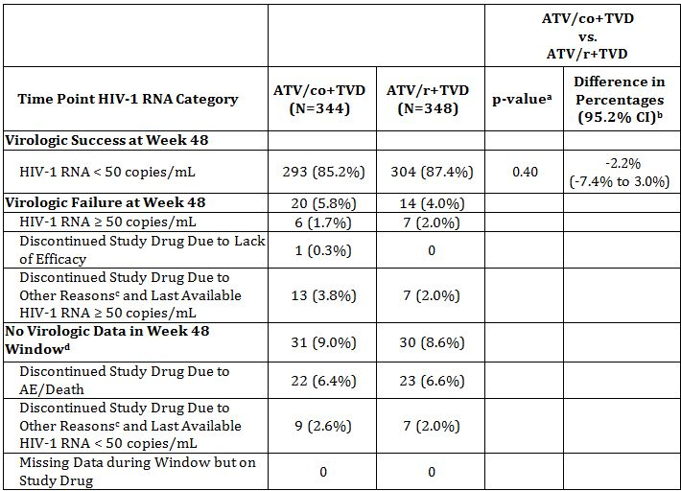

a P-value for the superiority test comparing the percentages of virologic success was from the CMH test stratified by baseline HIV-1 RNA stratum.

b Difference in percentages of virologic success and its 95.2% CI were calculated based on baseline HIV-1 RNA stratum-adjusted MH proportion.

c Discontinuation due to other reasons includes subjects who discontinued study drug due to investigator's discretion, withdrew consent, lost to follow-up, subject noncompliance, protocol violation, and pregnancy.

d Week 48 window is between Day 309 and 378 (inclusive).

##### Results for other efficacy outcomes

###### Virologic outcome, TLOVR analysis

The FDA-defined TLOVR analysis corroborated the results of the snapshot analysis, confirming that ATV/co+TVD and ATV/r+TVD had comparable rates of virologic response. Based on the TLOVR analysis, 82.8% of subjects (285 of 344) in the ATV/co+TVD group and 85.3% of subjects (297 of 348) in the ATV/r+TVD group achieved and maintained confirmed HIV-1 RNA <50 copies/mL through Week 48 and were considered responders (Table 10).

Table 10: Study GS-US-216-0114: virologic outcome at Week 48 (HIV-1 RNA cutoff at 50 copies/mL, TLOVR analysis) (ITT analysis set).

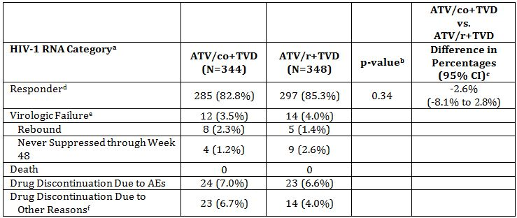

Week 48 window is between Days 309 and 378 (inclusive).

b P-value for response rate (responder) was from the CMH test stratified by baseline HIV-1 RNA level (<=100,000 or >100,000 copies/mL).

c Difference in response rate (responder) and its 95% CI were from baseline HIV-1 RNA stratum-adjusted MH proportion.

d Responder refers to subject who achieved and maintained confirmed HIV-1 RNA <50 copies/mL through Week 48.

e Virologic failure includes confirmed viral rebound and failure to achieve confirmed HIV-1 RNA <50 copies/mL through Week 48.

f Drug discontinuation due to other reasons includes lost to follow-up, subject withdrawal, noncompliance, protocol violation, and other reasons.

The baseline HIV-1 RNA stratum-weighted difference in the percentages of responders at Week 48 was -2.6% (95% CI: -8.1% to 2.8%), which is consistent with the results of the primary endpoint analysis. In the Kaplan-Meier (KM) analysis of TLOVR, the percentage of subjects with loss of virologic response was similar between treatment groups. At Week 48, 19% of subjects in the ATV/co+TVD group and 16% of subjects in the ATV/r+TVD group had loss of virologic response (overall p-value = 0.44).

###### Time to loss of virologic response

In the KM analysis of TLOVR, the percentage of subjects with loss of virologic response was similar between treatment groups (Figure 7).

Figure 7: Study GS-US-216-0114: time to loss of virologic response with HIV-1 RNA cutoff at 50 copies/mL (Kaplan-Meier estimate) (ITT analysis set).

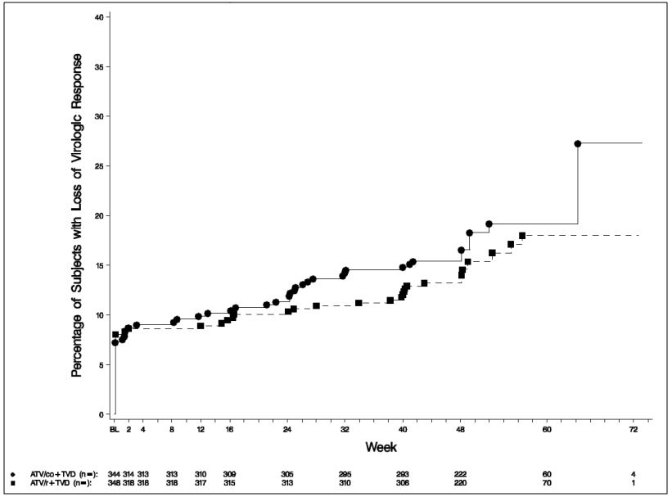

###### Pure virologic failure (PVF) analysis

In the PVF analysis, similar percentages of subjects had virologic success through Week 48: 89.5% of subjects (308/344) in the ATV/co+TVD group and 90.2% of subjects (314/348) in the ATV/r+TVD group.

###### Percentage of subjects with plasma HIV-1 RNA < 50 copies/mL at week 48

The percentages of subjects with HIV-1 RNA <50 copies were similar between treatment groups from Week 2 to Week 48 using missing = failure and missing = excluded methods.

At Week 48 (missing = failure), the percentage of subjects with plasma HIV-1 RNA levels < 50 copies/mL was 89.0% (306 of 344) in the ATV/co+TVD group and 89.7% (312 of 348) in the ATV/r+TVD group. The stratum-weighted difference in response rate between treatment groups (ATV/co+TVD − ATV/r+TVD) was −0.7% (95% CI: −5.4% to 3.9%).

In the missing = excluded analysis, the percentage of subjects with HIV-1 RNA levels < 50 copies/mL was 97.1% (306 of 315) in the ATV/co+TVD group and 96.0% (312 of 325) in the ATV/r+TVD group at Week 48. The stratum-weighted difference in the response rate between treatment groups (ATV/co+TVD − ATV/r+TVD) was 1.1% (95% CI: -1.8% to 4.1%).

###### Change from baseline in plasma HIV-1 RNA

Mean (SD) baseline HIV-1 RNA levels were 4.81 (0.585) log10 copies/mL in the ATV/co+TVD group and 4.84 (0.594) log10 copies/mL in the ATV/r+TVD group. HIV-1 RNA levels decreased following administration of study drug, and the mean decreases were similar in the ATV/co+TVD group and the ATV/r+TVD group at all time points (Week 2 through Week 48). At Week 48, the mean (SD) decreases from baseline in HIV-1 RNA were -3.08 (0.658) log10 copies/mL in the ATV/co+TVD group and -3.09 (0.731) log10 copies/mL in the ATV/r+TVD group (Figure 8). The difference in least-squares means (LSM) was -0.01 (95% CI: -0.09 to 0.07).

Figure 8: Study GS-US-216-0114: Mean and 95% CIs of change from baseline in HIV-1 RNA (log10 copies/mL) by visit (ITT analysis set).

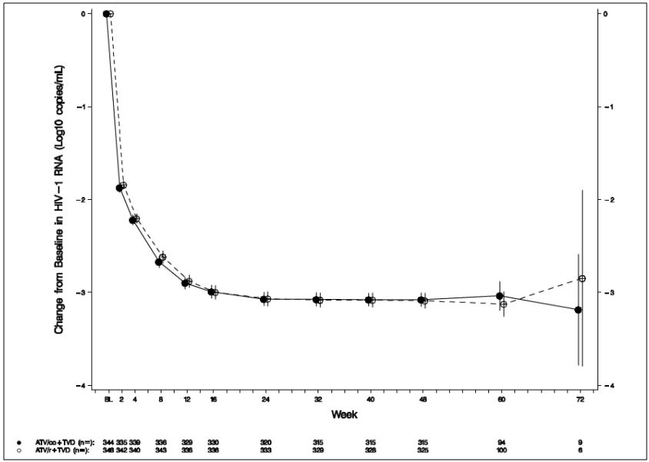

###### Change from baseline in CD4 cell count at week 48

Mean (SD) baseline CD4 cell counts were 353 (170.5) cells/μL in the ATV/co+TVD group and 351 (175.5) cells/μL in the ATV/r+TVD group. CD4 counts increased following administration of study drug, and the mean increases were similar between the ATV/co+TVD and ATV/r+TVD groups at all time points through Week 48. At Week 48, the mean (SD) increases from baseline in CD4 cell count were 213 (151.0) cells/μL in the ATV/co+TVD group and 219 (150.4) cells/μL in the ATV/r+TVD group (Figure 9). The difference in LSM from an ANOVA model was −5 (95% CI: −28 to 18).

Figure 9: Study GS-US-216-0114: mean and 95% CIs of change from baseline in CD4 cell count (cells/μL) (ITT analysis set).

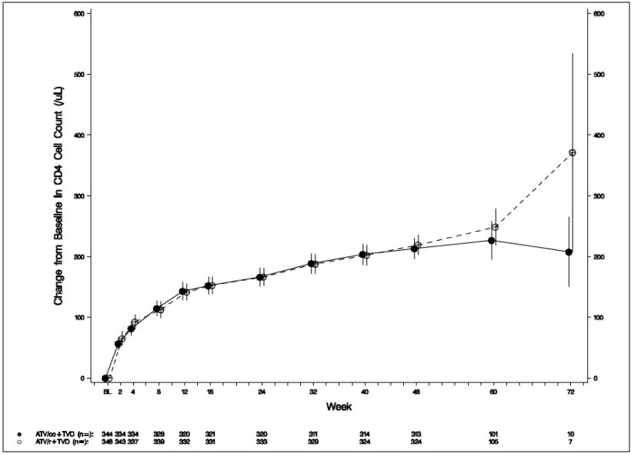

###### Change from baseline in CD4 percentage at week 48

Mean (SD) baseline CD4% was 20.4% (8.72) in the ATV/co+TVD group and 20.8% (8.42) in the ATV/r+TVD group. CD4% increased following administration of study drug, and the mean increases were similar between the 2 groups. At Week 48, the mean (SD) increases from baseline in CD4% were 9.7% (4.79) in the ATV/co+TVD group and 9.8% (5.27) in the ATV/r+TVD group. The difference in LSM was 0.0 (95% CI: −0.8 to 0.8).

###### Resistance

Resistance development to 1 or more components of ATV/co+TVD or ATV/r+TVD occurred infrequently in this study (Table 11). Of the 692 randomised and treated subjects, 24 subjects (3.5%) were analysed for resistance development and comprised the resistance analysis population. In the ATV/co+TVD group, 12 subjects were analysed for resistance development (12 of 344, 3.5%), with data available for 10 subjects. Two subjects (2 of 344, 0.6%) in the ATV/co+TVD group developed a primary nucleoside reverse transcriptase resistance mutation to FTC (M184V). In the ATV/r+TVD group, 12 subjects were analysed for resistance development (12 of 348, 3.4%), none of whom developed resistance to components of ATV/r+TVD.

Table 11: Study GS-US-216-0114: development of HIV-1 genotypic and phenotypic resistance at Week 48).

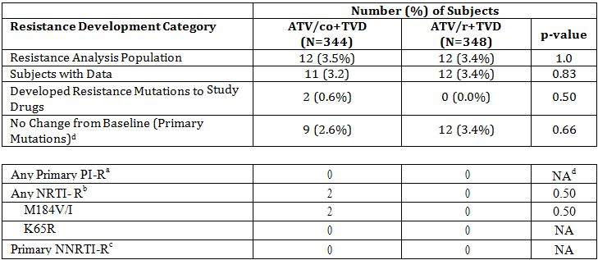

a Primary PI-R mutations are D30N, V32I, L33F, M46I/L, I47V/A, G48V, I50V/L, I54M/L, T74P, L76V, V82F/L/A/T/S, I84V, N88S, and L90M in PR.

b NRTI-R mutations are M41L, E44D, A62V, K65R, D67N, T69D/N, T69 insertions, K70R/E, L74V/I, V75I, F77L, Y115F, F116Y, V118I, Q151M, M184V/I, L210W, T215Y/F, and K219Q/E/R/N/H in RT.

c NNRTI-R mutations are L100I, K103N, V106A/M, V108I, Y181C/I, Y188H/C/L, G190A/S/E, and P225H in RT.

d Not applicable

#### Conclusions:

* ATV/co+TVD was non inferior to ATV/r+TVD in HIV-1 infected, antiretroviral treatment-naive subjects. The efficacy results were robust and confirmed by multiple sensitivity and subgroup analyses
* No subject developed resistance to protease inhibitors and resistance to NRTIs occurred in only 2 subjects in the ATV/co+TVD group
* The plasma exposures of ATV were comparable when boosted by cobicistat and ritonavir

#### Study GS-US-216-0105

A Phase 2, Randomised, Double Blinded Study of the Safety and Efficacy of GS-9350 [Cobicistat] Boosted Atazanavir (ARV/co) Compared to Ritonavir(RTV) Boosted Atazanavir (ATV/r) in Combination with Emtricitabine/Tenofovir Disoproxil Fumarate (FTC/TDF =TVD) in HIV-1 Infected, Antiretroviral Treatment Naive Adults.

##### Study design, objectives, locations and dates

This was a double blind, multicentre, randomised, active controlled study conducted in 32 centres in the USA between May 2009 and June 2011.

###### Primary objective

To evaluate the efficacy of a regimen containing cobicistat boosted ATV (ATC/co)+TVD versus RTV boosted ATV (ATV/r)+TVD in HIV-1 infected, antiretroviral treatment naive adult subjects as determined by the achievement of HIV-1 RNA <50 copies at Week 24.

###### Secondary objectives

* To evaluate the efficacy of a regimen containing ATV/co+TVD versus ATV/r+TVD in HIV-1 infected, antiretroviral treatment naive adult subjects as determined by the achievement of HIV-1 RNA <50 copies at Week 48
* To evaluate the safety and tolerability of the two treatments through 48 weeks of treatment

Subjects returned for study visits at Weeks 2, 4, 8, 12, 16, and then every 8 weeks through Week 48. After Week 48, subjects continued to take their study drugs and attend visits every 12 weeks. At the Week 60 visit all subjects were unblinded and given the option to receive ATV/co+TVD in an open-label rollover extension study (Figure 10).

Figure 10: Study GS-US-216-0105: schema.

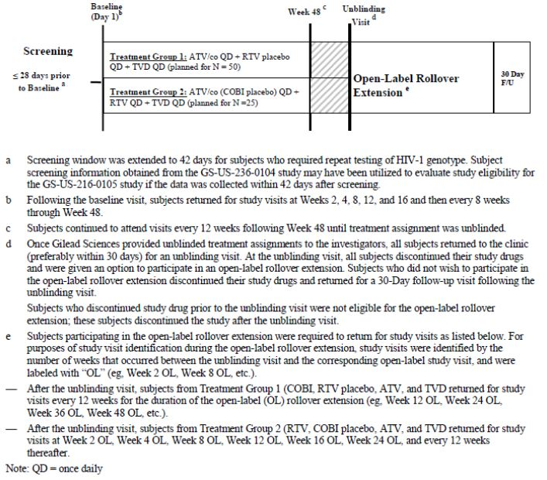

##### Inclusion and exclusion criteria

###### Inclusion

HIV-1 infected antiretroviral treatment naive patients who met the following criteria:

* Plasma HIV-1 RNA levels ≥ 5000 copies/mL
* No prior use of any approved or experimental anti-HIV drug
* Normal electrocardiogram (ECG) (or if abnormal, determined by the investigator to be not clinically significant)
* Adequate renal function: estimated glomerular filtration rate (eGFR) ≥ 80 mL/min according to the Cockcroft-Gault (CG) formula.
* Hepatic transaminases (AST and ALT) ≤ 2.5 × ULN
* Total bilirubin ≤ 1.5 mg/dL, or normal direct bilirubin
* Adequate hematologic function (absolute neutrophil count ≥ 1000/mm3; platelets ≥ 50,000/mm3; haemoglobin ≥ 8.5 g/dL)
* CD4 cell count > 50 cells/μL
  + Serum amylase ≤ 1.5 × ULN (subjects with serum amylase >1.5 × ULN remained eligible if serum lipase was ≤ 1.5 × ULN)
* Normal thyroid stimulating hormone (TSH)
* Negative serum pregnancy test (females of childbearing potential only)
* Males and females of childbearing potential agreed to utilize highly effective contraception methods from screening throughout the duration of study treatment and for 30 days following the last dose of study drugs.
* Age ≥ 18 years
* Life expectancy ≥ 1 year

###### Exclusion

* A new acquired immune deficiency syndrome (AIDS)-defining condition diagnosed within the 30 days prior to screening
* Documented drug resistance to nucleoside or nucleotide reverse transcriptase inhibitors (NRTIs), nonnucleoside reverse transcriptase inhibitors (NNRTIs), or primary PI resistance mutation(s)
* Hepatitis B surface antigen (HBsAg) positive
* Hepatitis C antibody positive
* Experiencing cirrhosis
* Experiencing ascites
* Experiencing encephalopathy
* Females who were breastfeeding
* Positive serum pregnancy test (female of childbearing potential)
* Vaccinated within 90 days of study dosing
* A history or family history of Long QT Syndrome (Wolfe-Parkinson-White Syndrome), or a family history of sudden cardiac death or unexplained death in an otherwise healthy individual under the age of 30 years
* Presence or history of cardiovascular disease, cardiomyopathy, and/or cardiac conduction abnormalities
* A prolonged QTcF interval (QT interval corrected for heart rate using Fridericia’s formula) at screening (e.g., a prolongation of the QTcF interval of > 450 msec for males and > 470 msec for females)
* PR interval ≥ 200 msec or ≤ 120 msec on ECG at screening
* QRS ≥ 120 msec on ECG at screening
* An implanted defibrillator or pacemaker
* Receiving ongoing therapy with any of the drugs not to be used with cobicistat, TVD and ATV (list provided in protocol)
* Current alcohol or substance use judged by the investigator to potentially interfere with subject study compliance.
* A history of or ongoing malignancy (including untreated carcinoma in-situ) other than cutaneous Kaposi's sarcoma (KS), basal cell carcinoma, or resected, non-invasive cutaneous squamous carcinoma. Subjects with biopsy-confirmed cutaneous KS were eligible, but must not have received any systemic therapy for KS within 30 days of baseline and were not anticipated to require systemic therapy during the study.
* Active, serious infections (other than HIV-1 infection) requiring parenteral antibiotic or antifungal therapy within 30 days prior to baseline.
* Any known allergies to the excipients of ATV capsules, RTV capsules, cobicistat tablets or TVD tablets.

##### Study treatments

* **Treatment Group 1:** cobicistat 150 mg once daily + RTV placebo once daily + ATV 300 mg once daily + TVD (single-tablet emtricitabine/tenofovir disoproxil fumarate [FTC/TDF] 200/300 mg) once daily
* **Treatment Group 2:** RTV 100 mg once daily + cobicistat placebo once daily + ATV 300 mg once daily + TVD (single-tablet FTC/TDF 200/300 mg) once daily

Ritonavir, Atazanavir and TVD were commercial stock as sold in the USA.

##### Efficacy variables and outcomes

The primary efficacy outcome was the percentage of subjects with HIV-1 RNA < 50 copies/mL at Week 24.

Other efficacy outcomes included:

* The percentage of subjects with HIV-1 RNA < 50 copies/mL at Week 48 (M=F or M=E or M/S=F)
* Virologic outcomes at Week 24 and Week 48 using the FDA-defined snapshot analysis and HIV-1 RNA < 50 copies/mL
* The change from baseline in log10 HIV-1 RNA (copies/mL) at Week 24 and 48, respectively
* The change from baseline in CD4 cell count and percentage at Week 24 and 48, respectively

##### Randomisation and blinding methods

Patients were randomised in a 2:1 ratio to one of the two treatments groups. Randomisation was stratified by HIV-1 RNA level (≤100,000 copies/mL or >100,000 copies/mL) at screening.

Study drugs were administered in a blinded fashion using matched placebo tablets for cobicistat and matched capsules for ritonavir.

##### Analysis populations

**Intent to treat (ITT) analysis set:** included all subjects who were randomised into the study and received at least 1 dose of study drug = 50 in the ATV/co+TVD group and 29 in the ATV/r+TVD group

**Per protocol (PP) analysis set:** included all subjects who were randomised into the study and received at least 1 dose of study drug, and had not committed any major protocol violation, including violation of key entry criteria = 44 in the ATV/co+TVD group and 26 in the ATV/r+TVD group

**Safety analysis set:** included all subjects who were randomised and received at least one dose of study drug = 50 in the ATV/co+TVD group and 29 in the ATV/r+TVD group

**Pharmacokinetic (PK) substudy analysis set:** included all subjects who were randomised and received at least 1 dose of study medication, and for whom steady-state PK parameters of ATV, cobicistat E3 (GS-9612, cobicistat metabolite [also designated M31]), RTV, TFV, or FTC (at Weeks 2, 4, or 8) were calculable = 8 in the ATV/co+TVD group and 10 in the ATV/r+TVD group

##### Sample size

A sample size of 50 subjects in the cobicistat group (Treatment Group 1) was chosen to estimate the response rate of HIV-1 RNA < 50 copies/mL at Week 24 for the regimen to allow for the planning of Phase 3 studies. A total sample size of 75 subjects has 26% power to evaluate non-inferiority with respect to the response rate of HIV-1 RNA < 50 copies/mL at Week 24 if a response rate of 84% for both groups and a non-inferiority margin of 0.12 are assumed.

A total of 85 subjects were actually enrolled in the study, with 79 subjects dosed, 4 subjects more than the sample size planned (75 subjects).

##### Statistical methods

The primary analysis of efficacy was based on the ITT analysis set for randomised treatment groups. The secondary analysis of efficacy was based on the PP analysis set. Subjects were analysed according to the treatment they were randomised to for the ITT analysis set.

The primary efficacy endpoint was the percentage of subjects with HIV-1 RNA < 50 copies/mL at Week 24. The primary analysis for the primary efficacy endpoint was analysed using the missing equals failure (M=F) method; secondary analyses used missing or antiretroviral therapy switch equals failure (M/S=F) and missing equals excluded (M=E) methods. The baseline HIV-1 RNA stratum (≤ 100,000 copies/mL or > 100,000 copies/mL) weighted difference in the response rate and its 95% confidence interval (CI) were calculated based on Cochran-Mantel-Haenszel proportion.

The primary efficacy endpoint was assessed for non inferiority of treatment with ATV/co+TVD relative to treatment with ATV/r+TVD. Non inferiority was assessed using a conventional 95% confidence interval (CI) approach, with a delta of 0.12

The percentage of subjects with HIV-1 RNA < 50 copies/mL at Week 48 (M=F, M/S=F, and M=E) and virologic outcomes at Weeks 24 and 48 using snapshot analysis and HIV-1 RNA < 50 copies/mL were analysed using the same methods as for the primary efficacy endpoint.

The changes from baseline in log10 HIV-1 RNA and CD4 cell count and percentage were summarised by using descriptive statistics. The differences in changes from baseline in log10 HIV-1 RNA, and CD4 cell count and percentage between randomised treatment groups and the associated 95% CI were constructed using analysis of variance model (ANOVA), including baseline HIV-1 RNA level (≤ 100,000 copies/mL or > 100,000 copies/mL).

Subjects were grouped as follows: [ATV/co→ATV/co]+TVD (all subjects who were randomised to ATV/co) and [ATV/r→ATV/co]+TVD (subjects randomised to ATV/r and who then switched to ATV/co in the extension phase). The number of subjects with HIV-1 RNA < 50 copies/mL and changes from baseline in log10 HIV-1 RNA and CD4 cell count and percentage were summarised for the [ATV/co→ATV/co]+TVD and [ATV/r→ATV/co]+TVD groups using descriptive statistics.

For post baseline resistance analyses of subjects with virologic failure or failure to achieve <400 copies of plasma HIV-1 RNA at study discontinuation, protease/reverse transcriptase (PR/RT) genotyping and phenotyping assays were performed.

##### Participant flow

Participant flow is shown in Figure 11.

Figure 11: Study GS-US-216-0105 participant flow.

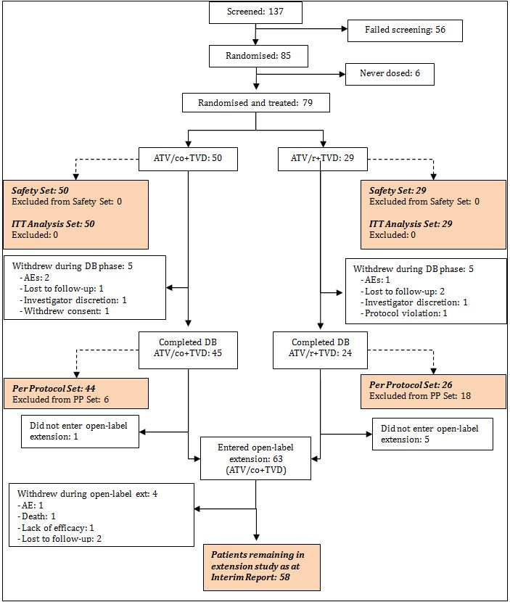

##### Major protocol violations/deviations

A total of 66 important protocol deviations occurred in 39 subjects during the study. The majority of important deviations were a departure from the required dosing requirements, which was defined as a subject with greater than 10% missed doses between study visits. Four subjects each had 5 reported deviations. Six important protocol deviations that were categorised as violations of inclusion/exclusion criteria were reported. Relevant protocol deviations were proportionally distributed across study centres. None of these important deviations affected the quality or interpretability of the data.

##### Baseline data

Overall, demographic and general baseline characteristics were similar between the two treatment groups (Tables 12-13). There was no significance difference between the two treatment groups in baseline viral load, CD4 cell count, or CD4 percentage. Overall, 70% of patients had a baseline HIV-1 RNA level at baseline ≤100,000 copies/mL.

Table 12: Study GS-US-216-0105: demographics and baseline characteristics (Safety Analysis set).

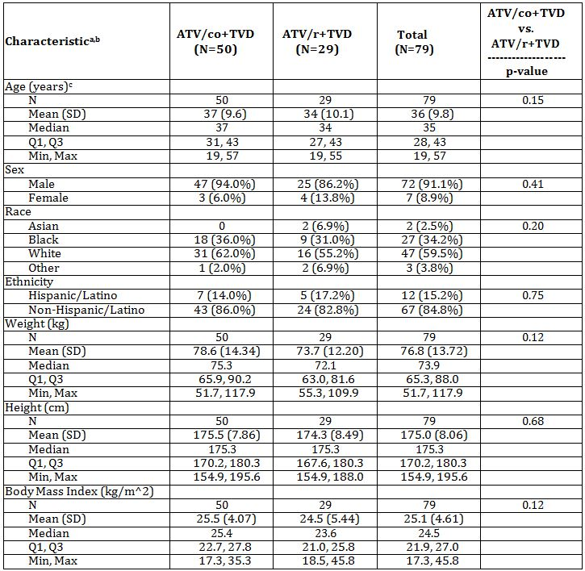

a Denominator for percentages was the number of subjects in the safety analysis set.

b For categorical data, p-values were from the Fisher exact test; for continuous data, p-values were from the Wilcoxon rank sum test.

c Age was calculated at first dose date of study drug.

Table 13: Study GS-US-216-0105: baseline disease characteristics (Safety Analysis set).

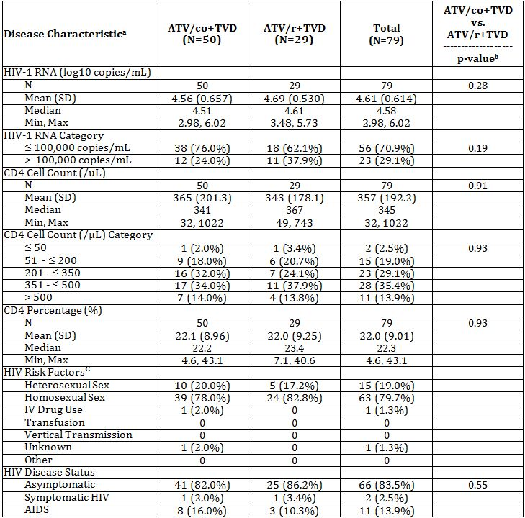

##### Results for the primary efficacy outcome

###### Percentage of subjects with plasma HIV-1 RNA < 50 copies/mL at week 24

Results of the primary endpoint analysis at Week 24 and secondary endpoint analysis at Week 48 demonstrated high rates of virologic response in both treatment groups of this study. For the primary efficacy endpoint analysis, the percentage of subjects with plasma HIV-1 RNA < 50 copies/mL at Week 24 (ITT, M=F) was 84.0% (42/50) in the ATV/co+TVD group and 89.7% (26/29) in the ATV/r+TVD group.

At Week 24, the baseline HIV-1 RNA stratum weighted difference in the response rates between the 2 treatment groups was -7.4% (95% CI: -24.6% to 9.9%). Using M/S=F methods, the percentage of subjects with plasma HIV-1 RNA < 50 copies/mL at Week 24 was 84.0% (42/50) in the ATV/co+TVD group and 86.2% (25/29) in the ATV/r+TVD group. At Week 24, the baseline HIV-1 RNA stratum weighted difference in the response rates between the 2 treatment groups was -4.4% (95% CI: -22.5% to 13.6%). Results using M=E methods were similar to those using M=F methods (Table 14).

Table 14: Study GS-US-216-0105: percentage of subjects with plasma HIV-1 RNA < 50 copies/mL at Week 24 (ITT Analysis set).

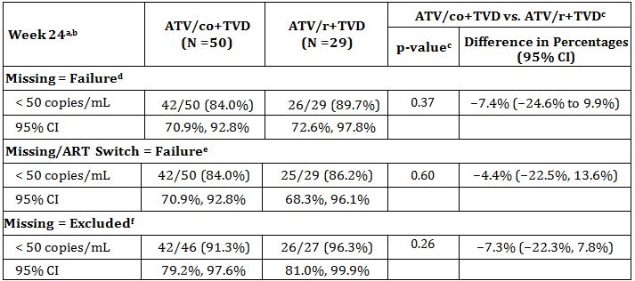

a HIV-1 RNA results were from HIV Cobas Amplicor version 1.5 assay only.

b The 95% CI for proportion estimate of HIV-1 RNA < 50 copies/mL for each treatment was obtained using Exact method.

c P-values were from the CMH tests stratified by baseline HIV-1 RNA category (≤ 100,000 or > 100,000 copies/mL). Difference in percentages of success and its 95% CI were calculated based on baseline HIV-1 RNA stratum-adjusted Mantel-Haenszel (MH) proportion.

d For missing = failure: Denominator for percentage was the number of subjects in ITT analysis set. P-value and percentage difference (95% CI) were based on a binary response: success (HIV RNA <50 c/mL) and failure (HIV RNA ≥50 copies/mL or missing).

e For missing/ART switch: Denominator for percentage was the number of subjects in the ITT analysis set. P-value and percentage difference (95% CI) were based on a binary response: success (HIV-1 RNA <50) and failure (HIV-1 RNA ≥50, missing, ART switch). Subjects who discontinued study drug and had no follow-up information on new ART were treated as having an ART switch. The commercial ATR switch for subjects who were randomized to and treated in ATR group was not considered an ART switch.

f For missing = excluded: Denominator for percentage was the number of subjects in the ITT analysis set with non missing HIV-1 RNA value at each visit. P-value, percentage difference, and its 95% CI were based on a binary response: success (HIV-1 RNA < 50 copies/mL) and failure (HIV-1 RNA ≥ 50 copies/mL).

*Comment: The sponsor makes no reference to and does not discuss the non inferiority analysis. It is clear from the table above that the two treatments are not non inferior. Since the lower bound of the 2-sided 95% CI of the baseline HIV-1 RNA stratum weighted difference in response rates (ATV/co+TVD – ATV/r+TVD) was less than the prespecified –12% non-inferiority margin, ATV/co+TVD was not non-inferior to ATV/r+TVD.*

##### Results for other efficacy outcomes

###### Percentage of subjects with plasma HIV-1 RNA < 50 copies/mL at week 48

The percentage of subjects with plasma HIV-1 RNA < 50 copies/mL at Week 48 (M=F) was 82.0% (41/50) in the ATV/co+TVD group and 89.7% (26/29) in the ATV/r+TVD group. The baseline HIV-1 RNA stratum-weighted difference in the response rate between the two treatment groups was -8.3% (95% CI: -25.9% to 9.4%; p = 0.34) (Table 15 and Figure 12). Similar results were obtained using the M/S=F and M=E methods.

Table 15: Study GS-US-216-0105: percentage of subjects with plasma HIV-1 RNA < 50 copies/mL at Week 48 (ITT Analysis set).

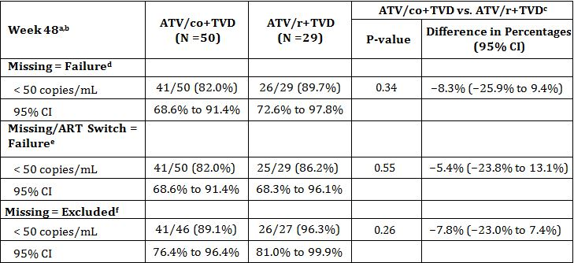

a HIV-1 RNA results were from HIV Cobas Amplicor version 1.5 assay only.

b The 95% CI for proportion estimate of HIV-1 RNA < 50 copies/mL for each treatment was obtained using Exact method.

c P-values were from the CMH tests stratified by baseline HIV-1 RNA category (<= 100,000 or > 100,000 copies/mL). Difference in percentages of success and its 95% CI were calculated based on baseline HIV-1 RNA stratum-adjusted MH proportion.

d For missing = failure: Denominator for percentage was the number of subjects in the ITT analysis set. P-value and percentage difference (95% CI) were based on a binary response: success (HIV-1 RNA < 50 copies/mL) and failure (HIV-1 RNA >= 50 copies/mL or missing).

e For missing/ART switch: Denominator for percentage was the number of subjects in the ITT analysis set. P-value and percentage difference (95% CI) were based on a binary response: success (HIV-1 RNA<50) and failure (HIV-1 RNA>=50, missing, ART switch). Subjects who discontinued study drug and had no follow-up information on new ART were treated as having an ART switch.

f For missing = excluded: Denominator for percentage was the number of subjects in the ITT analysis set with non missing HIV-1 RNA value at each visit. P-value, percentage difference, and its 95% CI were based on a binary response: success (HIV-1 RNA < 50 copies/mL) and failure (HIV-1 RNA >= 50 copies/mL).

Figure 12: Study GS-US-216-0105: percentage of subjects with plasma HIV-1 RNA < 50 copies/mL by visit (ITT Analysis set; M = F).

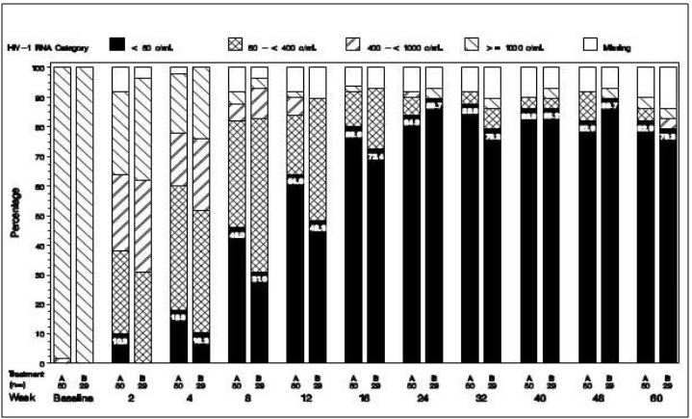

Denominator for the percentage was the number of subjects in the ITT analysis set.

Treatment A = ATV/co+TVD; Treatment B = ATV/r+TVD

*Comment: This is as clear as this figure appears in the Clinical Safety Report.*

###### Percentage of subjects with plasma HIV-1 RNA < 50 copies/mL at weeks 24 and 48 using snapshot analysis

Using snapshot analysis, 84.0% (42/50) of subjects in the ATV/co+TVD group and 86.2% (25/29) of subjects in the ATV/r+TVD group had virologic success at Week 24. The difference in the percentage of subjects with virologic success was -4.4% (95% CI: -22.5% to 13.6%). At Week 48, 82.0% (41/50) of subjects in the ATV/co+TVD group and 86.2% (25/29) of subjects in the ATV/r+TVD group had virologic success (Table 16). The difference in the percentage of subjects with virologic success was -5.4% (95% CI: -23.8% to 13.1%).

Table 16: Study GS-US-216-0105: virologic outcomes at Weeks 24 and 48 using snapshot analysis and HIV-1 RNA < 50 copies/mL (ITT Analysis set).

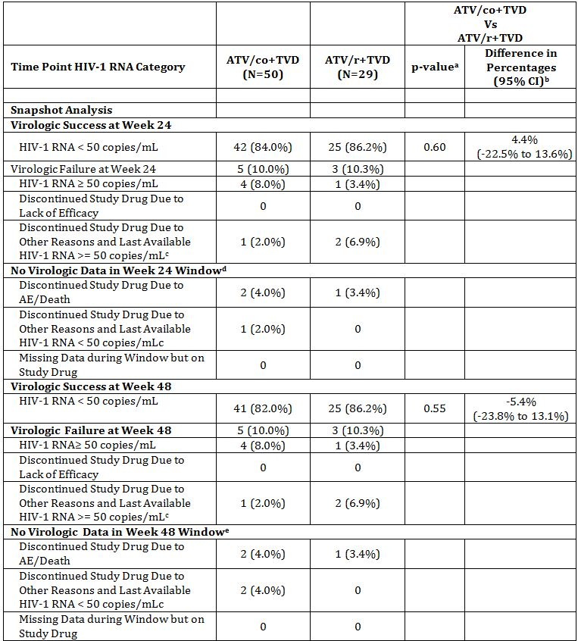

a p-value was from the CMH test stratified by baseline HIV-1 RNA category (<=100,000 or >100,000 copies/mL).

b Difference in percentages of virologic success and its 95% CI were calculated based on baseline HIV-1 RNA stratum adjusted MH proportion.

c Discontinuation due to other reasons includes subjects who discontinued study drug due to investigator's discretion, withdrew consent, lost to follow-up, subject non-compliance, and protocol violation.

d Week 24 window is between Day 141 and 196 (inclusive)

e Week 48 window is between Day 309 and 378 (inclusive)

###### Change from baseline in HIV-1 RNA (log10 copies/mL) at weeks 24 and 48

Baseline plasma as well as change from baseline through Week 60 in HIV-1 RNA was similar between treatment groups. The mean (SD) change at Week 24 was -2.80 (0.619) log10 copies/mL in the ATV/co+TVD group (n = 46) and -2.97 (0.707) log10 copies/mL in the ATV/r+TVD group (n = 27) (p = 0.87). The mean (SD) change at Week 48 was -2.79 (0.678) log10 copies/mL in the ATV/co+TVD group (n = 46) and -2.96 (0.765) log10 copies/mL in the ATV/r+TVD group (n = 27) (p = 0.82) (Figure 13).

Figure 13: Study GS-US-216-0105 mean and 95% CIs of change from baseline in HIV-1 RNA (log10 copies/mL) by visit (Randomised Phase; ITT Analysis set).

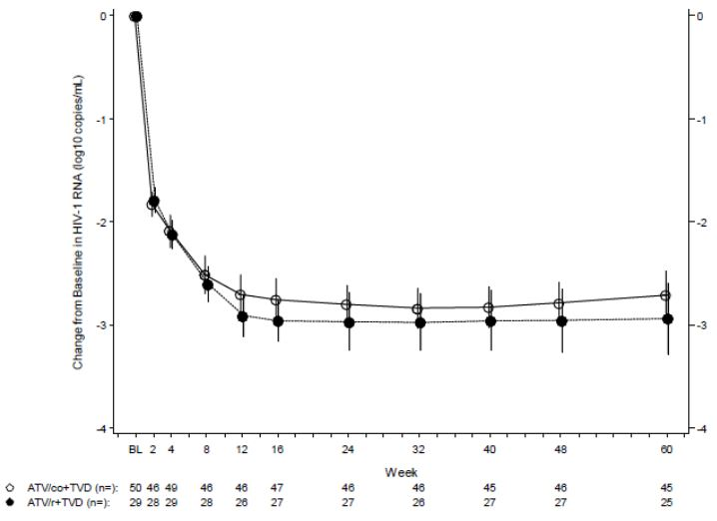

###### Change from baseline in CD4 cell count

There was no significant difference between treatment groups in CD4 cell count at baseline as well as change from baseline through Week 60. The mean (SD) change from baseline at Week 24 was 200 (164.6) cells/μL in the ATV/co+TVD group and 202 (115.1) cells/μL in the ATV/r+TVD group (p = 0.78, ITT). The mean (SD) change from baseline at Week 48 was 243 (186.5) cells/μL in the ATV/co+TVD group and 213 (168.2) cells/μL in the ATV/r+TVD group (p = 0.29) (Figure 14). Similar results were observed in the PP analysis set.

Figure 14: Study GS-US-216-0105 mean and 95% CIs of change from baseline in CD4 cell count (cells/μL) (Randomised Phase; ITT Analysis set).

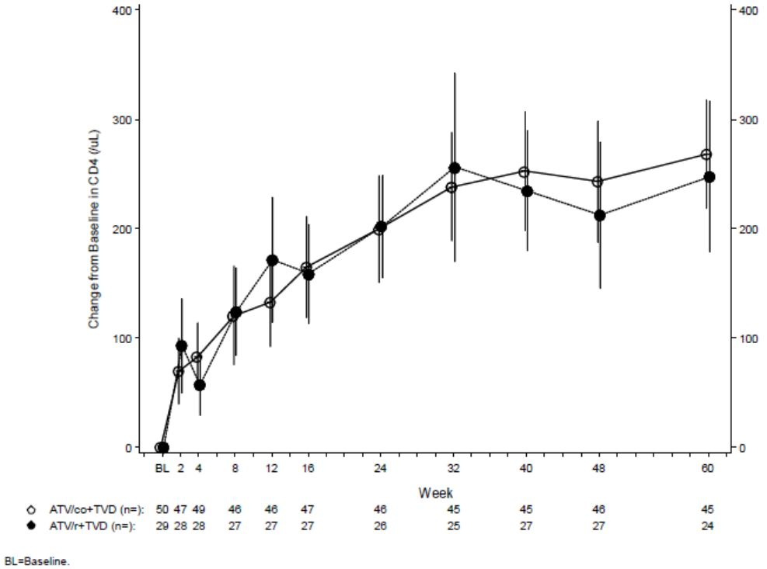

###### Change from baseline in CD4 percentage at week 24 and 48

The mean (SD) change at Week 24 was 7.3% (5.00) in the ATV/co+TVD group (n = 46) and 8.3% (4.47) in the ATV/r+TVD group (n=26) (p = 0.55). The mean (SD) change at Week 48 was 8.5% (4.95) in the ATV/co+TVD group (n = 46) and 10.2% (5.44) in the ATV/r+TVD group (n = 27) (p = 0.25). Similar results were observed in the PP analysis set.

###### All ATV/co efficacy

Virologic suppression was maintained and immunologic improvement continued through 96 weeks of treatment with ATV/co+TVD (the [ATV/co→ATV/co]+TVD group).

Using the M=F method, the percentage of subjects in the [ATV/co→ATV/co]+TVD group with plasma HIV-1 RNA < 50 copies/mL at Week 96 (All ATV/co+TVD efficacy analysis set) was 75.5% (37/49).

Using the M=E method, the percentage of subjects in the [ATV/co→ATV/co]+TVD group with plasma HIV-1 RNA < 50 copies/mL at Week 96 (All ATV/co+TVD efficacy analysis set) was 94.9% (37/39). The mean (SD) change from baseline in CD4 cell count at Week 96 was 317 (186.1) cells/μL.

Virologic suppression was maintained and immunologic improvement continued through 36 weeks of treatment in subjects who switched from ATV/r+TVD to ATV/co+TVD in the open-label phase of the study (the [ATV/r→ATV/co]+TVD group.

Using the M=F method, the percentage of subjects in the [ATV/r→ATV/co]+TVD group with plasma HIV-1 RNA < 50 copies/mL at open-label Week 36 (All ATV/co+TVD efficacy analysis set) was 84.2% (16/19). The mean (SD) change from open-label baseline in CD4 cell count at open label Week 36 was 45 (189.8) cells/μL.

###### Development of resistance

Of the 79 randomised and treated patients, 2 patients on study drug with virologic failure were analysed for resistance development. These 2 patients showed no evidence of viral resistance to study drugs.

###### Conclusions

* In both treatment groups (ATV/co+TVD and ATV/+TVD), high rates of viral suppression and increases in CD4 cell counts over 24 and 48 weeks of treatment
* No comment is made in report about the non inferiority analysis – non inferiority was not shown but this was to be expected given the very low power of the study
* Total number of patients enrolled low
* Virologic suppression was maintained and immunologic improvement continued through the open label extension study, providing evidence of durable efficacy
* No genotypic of phenotypic resistance to NRTIs, NNRTIs or PIs developed
* The plasma exposures of ATV, cobicistat, RTV, FTC and TFV were consistent with previous data from healthy subjects and HIV infected patients. The mean ATV trough concentrations in subjects receiving ATV/co+TVD or ATV/r+TVD were greater than 46 fold above the protein binding adjusted IC90 against wild type HIV (14 ng/mL) throughout the 48 week dosing period

### Other efficacy studies

No other studies were submitted. Studies including cobicistat were included in the related submission for the STRIBALD submission.

### Analyses performed across trials (pooled & meta analyses)

The sponsor has pooled the results from the two pivotal Studies GS-US-216-0114 and GS-US-216-0105, presumably due to the lack of power in Study GS-US-216-0105 which is reflected in the result of non inferiority.

#### Study population

The two studies had similar entry criteria: ARV treatment naive, HIV-1 infected subjects with HIV-1 RNA ≥5,000 copies/mL at screening, with no prior use of any approved or experimental ARV drug for any length of time. In both studies, randomisation was stratified by HIV-1 RNA at screening (≤100,000 copies/mL or >100,000 copies/mL). In study GS-US-216-0114, screening genotype reports had to sensitivity to FTC, TDF and ATV, and a screening eGFTCG ≥70 mL/min. In study GS-US-216-0105 screening reports had to show no NRTI, NNRTI, or primary PI resistance mutations (by ISA-USA guidelines) and a screening CD4 count of >50 cells/μL.

#### Analysis sets

In the pooled population 783 patients were randomised – 405 to ATV/co+TVD and 378 to ATV/r+TVD.

The analysis was done on the ITT analysis set which was defined as – subjects who were randomised and received at least one dose of study drug = 771 – 394 ATV/co+TVD and 377 ATV/r+TVD.

#### Results

##### Plasma HIV-1 RNA concentrations

The primary endpoint for the pooled ITT analysis set was the percentage of subjects with virologic success at Week 48 as defined by the FDA snapshot analysis algorithm. The non inferiority of treatment with ATV/co+TVD relative to treatment with ATV/r+TVD was assessed using a 2 sided 95% CI based on stratum-adjusted Mantel Haenszel (MD) proportions with a non inferiority margin of 12%.

Based on the Pooled Data, the percentages of subjects having virologic success (ITT) at Week 48 were 84.8% of subjects (334 of 394 subjects) in the ATV/co+TVD group and 87.3% of subjects (329 of 377 subjects) in the ATV/r+TVD group. The baseline HIV-1 RNA stratum-adjusted difference in the percentages of subjects with virologic success was -2.5% (95% CI: -7.5% to 2.5%). Because the lower bound of the 2-sided 95% CI of the difference in response rate (ATV/co+TVD – ATV/r+TVD) was greater than the prespecified −12% non inferiority margin, ATV/co+TVD was determined to be non inferior to ATV/r+TVD.

The percentages of subjects who had virologic failure (ITT) at Week 48 were 6.3% of subjects (25 of 394 subjects) in the ATV/co+TVD group and 4.5% of subjects (17 of 377 subjects) in the ATV/r+TVD group. Reasons for virologic failure in the Week 48 analysis window were balanced across the treatment groups. Reasons for lack of virologic data in the Week 48 analysis window were balanced across the treatment groups.

The results are shown in Table 17.

Table 17: Study GS-US-216-0105 and 0114: virologic outcome at Week 48 (HIV-1 RNA cutoff at 50 copies/mL, snapshot analysis – ITT Analysis set).

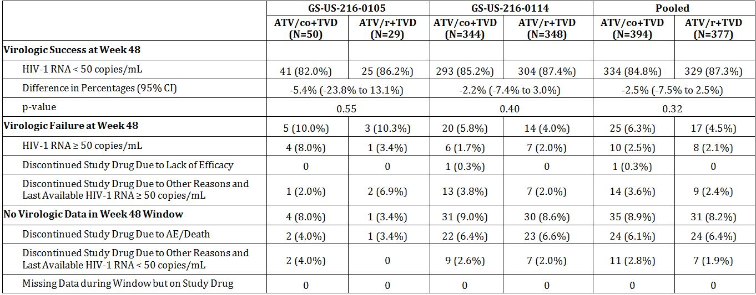

Week 48 window is between Day 309 and 378 (inclusive).

Discontinuation due to other reasons includes subjects who discontinued study drug due to investigator’s discretion, withdrew consent, lost to follow-up, subject noncompliance, protocol violation, and pregnancy.

P-values for treatment comparisons were from the Cochran-Mantel-Haenszel (CMH) test stratified by baseline HIV-1 RNA stratum and study (for pooled analysis).

Difference in percentages of virologic success and its 95% CI were calculated based on MH proportions adjusted by baseline HIV-1 RNA stratum and study (for pooled analysis).

##### Comparisons of results in subpopulations

The primary analysis of virologic response (HIV-1 RNA <50 copies/mL, snapshot analysis algorithm) was analysed for each of the following subgroups using the ITT analysis set:

* Age (years): <40 and ≥40
* Sex: male and female
* Race: white and non white
* Baseline HIV-1 RNA level (copies/mL): ≤100,000 and >100,000
* Baseline CD4 count (cells/μL): ≤350 and >350

Despite that the numbers in some subgroups are small and the studies were not powered for individual subgroup analyses, subgroup analyses revealed high and generally comparable rates of virologic success with wide CIs for ATV/co+TVD and ATV/r+TVD in the GS-US-216-0105 and GS-US-216-0114 studies compared to those observed for the overall study population, with no statistically significant differences demonstrated between any subgroups (Figure 15).

Figure 15: Study GS-US-216-0105 and GS-US-216-0114: forest plot of treatment difference in virologic success at Week 48 (HIV-1 RNA < 50 copies/mL, snapshot analysis) by subgroup – ITT analysis set).

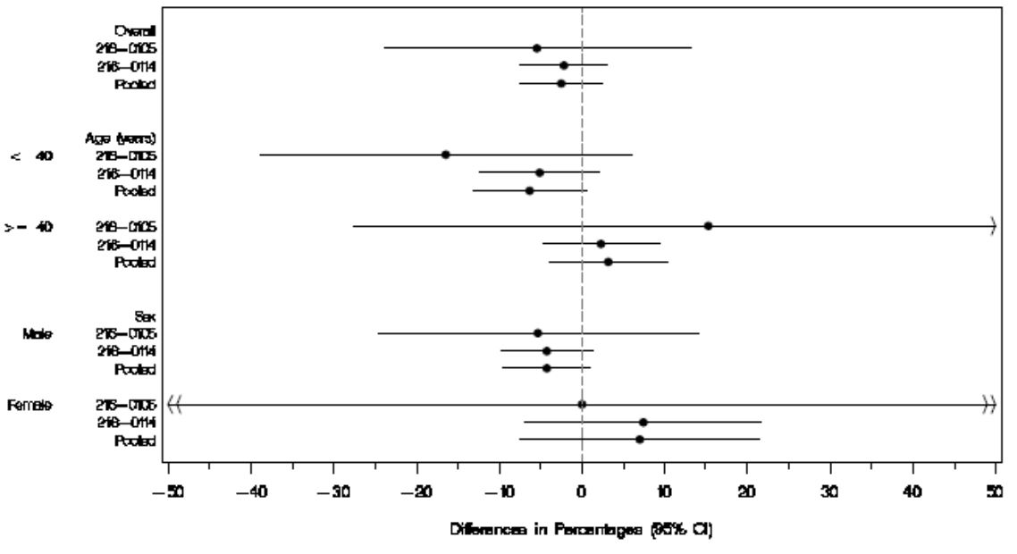

Difference in response rate and its 95% CI were calculated based on the MH proportions adjusted by baseline HIV-1 RNA stratum (if it is not the subgroup factor) and study (for pooled analysis).

Relative to the vertical line at 0, differences on the right favour the ATV/co+TVD group and differences on the left favour the ATV/r+TVD group.

The 95% CI was truncated if it exceeded ±50%.

### Evaluator’s conclusions on clinical efficacy

The sponsor has provided evidence for the efficacy of cobicistat as an enhancer for atazanavir in both PK studies and clinical studies. While only one of the two studies provided demonstrated non inferiority to ATV/r+TVD the other studied was too underpowered to be expected to show a result of non inferiority. In the CSR or the summaries, the sponsor provide an adequate explanation for the under powering of the study and it may raise doubt to considering Study GS-US-216-0105 as a pivotal study but it has been included as a pivotal study due to the reliance on the data in the pooled analysis and as it provides important PK and safety information.

There are no clinical studies with cobicistat boosted darunavir: the company has provided evidence based on the PK Study GS-US-216-0115 established PK boosting of DRV with cobicistat provided the exposure to DRV is similar between DRV/co and DRV/r.

While it would have been more acceptable to have clinical data available there is sufficient strength to the PK data to approve the requested indication of pharmacokinetic enhancer of DRV.

## Clinical safety

### Studies providing evaluable safety data

The following studies provided evaluable safety data.

#### Pivotal efficacy studies

In the pivotal efficacy studies, the following safety data were collected:

* General adverse events (AEs) were assessed by collection of adverse events throughout the studies.
* AEs of particular interest, including renal events, bone fractures, hepatic events, thyroid, cardiovascular and skin events, were assessed by reviewing all events for specific MedDRA preferred terms.
* Laboratory tests, including tests for kidney function, liver function, and lipid function were performed at baseline and at pre-specified times during the study.

#### Pivotal studies that assessed safety as a primary outcome

Not applicable.

#### Dose-response and non-pivotal efficacy studies

Not applicable.

#### Other studies evaluable for safety only

Not applicable.

#### Clinical pharmacology studies

All but one of the clinical pharmacology studies were conducted in healthy volunteers. The results for the individual studies are provided. Only deaths and SAEs are included in the Summary of Clinical Safety.

### Pivotal studies that assessed safety as a primary outcome

Not applicable.

### Patient exposure

The patient exposure for the clinical pharmacology studies in healthy volunteers is not provided in the Summary of Clinical Safety (Table 18).

Table 18: Studies GS-US-216-0105 and GS-US-216-0114: duration of exposure to study drug (Safety Analysis set).

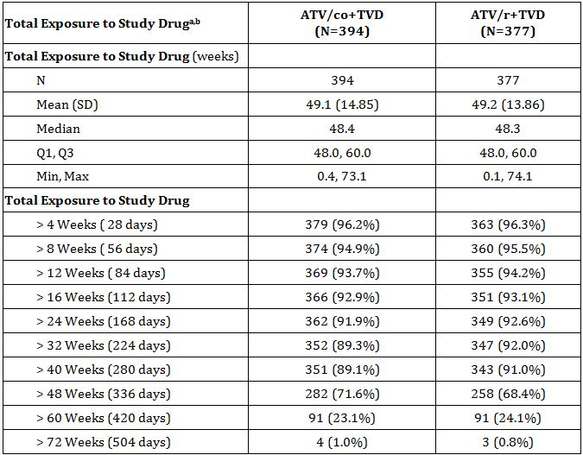

a Duration of exposure to study drug was the number of weeks between the first dose and the last dose of study drug.

b If the last dose date was completely missing (e.g., lost to follow-up) or a subject was still on study drug, the maximum of study drug start and end dates, clinic and laboratory visit dates excluding the 30-day follow-up visit date was used to impute the last dose date.

### Adverse events

#### All adverse events (irrespective of relationship to study treatment)

##### Pivotal studies

In the pooled safety analysis set of Studies GS-US-216-0105 and GS-US-216-0114, similar percentages of subjects in each group reported any AE (ATV/co+TVD 91.6%, 361 subjects; ATV/r+TVD 92.0%, 347 subjects. Similar percentages of subjects reported any Grade 2, 3, or 4 AEs.

A slightly higher percentage of subjects in the ATV/co+TVD (17.8%, 70 subjects) reported a Grade 3 or 4 AEs compared with ATV/r+TVD (13.3%, 50 subjects).

The most frequently reported AEs by treatment group (Table 19) were:

* ATV/co+TVD group - jaundice (18.8%, 74 subjects), ocular icterus (17.3%, 68 subjects), and nausea (16.8%, 66 subjects);
* ATV/r+TVD group - diarrhoea (21.2%, 80 subjects), ocular icterus (18.0%, 68 subjects), and nausea (15.6%, 59 subjects).

Table 19: Studies GS-US-216-0105 and GS-US-216-0114: Treatment-Emergent Adverse Events reported for at least 5% of subjects in either treatment group (Safety Analysis set).

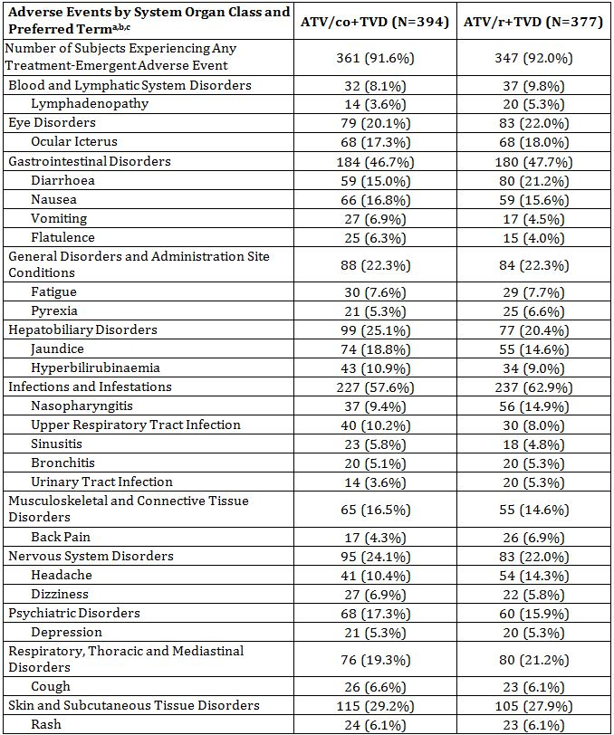

a Adverse events were coded using MedDRA 14.0.

b System organ class (SOC) was presented alphabetically, and preferred term was presented by decreasing order based on the total frequencies.

c Multiple AEs were counted only once per subject for each SOC and preferred term, respectively.

##### Other studies

No notable AEs occurred in the healthy subjects which alter that seen in the HIV-1 infected patients.

#### Treatment-related adverse events (adverse drug reactions)

##### Pivotal studies

In the pooled safety analysis set, the percentage of subjects who reported any AE considered related to study drug by the investigator was comparable between treatment groups (ATV/co+TVD 56.9%, 224 subjects; ATV/r+TVD 57.3%, 216 subjects).

In both treatment groups, the most frequently reported AEs considered related to study drug by the investigator were: ocular icterus, nausea and jaundice.

SAEs considered related to treatment were infrequent in both treatment groups (ATV/co+TVD 1.3%, 5 subjects; ATV/r+TVD 1.6%, 6 subjects). The percentage of subjects who reported a Grade 3 or 4 AEs considered related by the investigator to be related to study drug was low and comparable between treatment groups (ATV/co+TVD 6.9%, 27 subjects; ATV/r+TVD 4.5%, 17 subjects) (Table 20).

Table 20: Studies GS-US-216-0105 and GS-US-216-0114: Treatment-Emergent Adverse Events considered related to study drug reported for at least 1% of subjects in Any treatment group (Safety Analysis set).

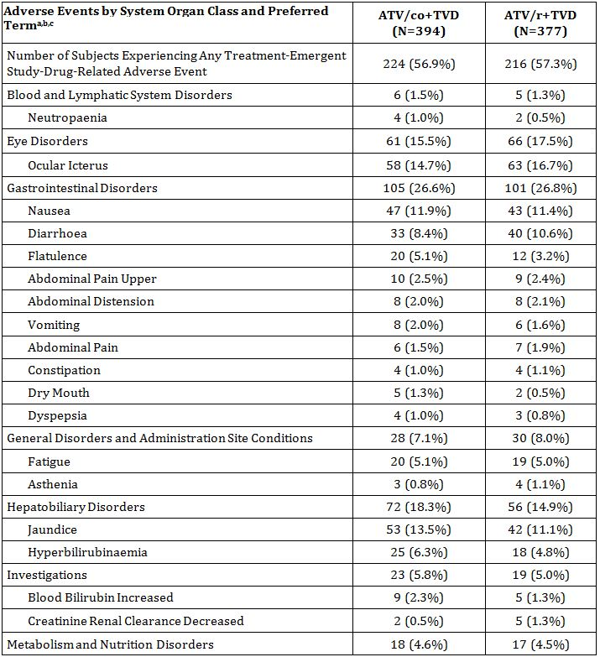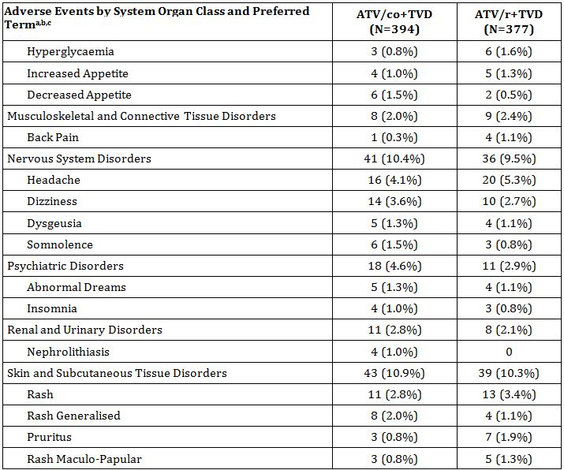

a Adverse events were coded using MedDRA 14.0.

b System organ class (SOC) was presented alphabetically, and preferred term was presented by decreasing order based on the total frequencies.

c Multiple AEs were counted only once per subject for each system organ class, high level term and preferred term, respectively.

#### Deaths and other serious adverse events

##### Pivotal studies

No subject died during the studies in either treatment group in the pooled analysis set. One subject died due to an accidental death of unknown cause during the open label phase of Study GS-US-216-0105.

In the pooled analysis set, the overall incidence of SAEs was low, with a slightly higher percentage of subjects reporting an SAE in the ATV/co+TVD group (9.6%, 38 subjects) compared with the ATV/r+TVD group (6.6%, 25 subjects).

SAEs were reported across a variety of organ systems, and there was no apparent pattern in the types of SAEs in either treatment group. The only SAE reported in more than 1% of subjects in either treatment group was acute renal failure, which was reported for no subject in the ATV/co+TVD group and 4 subjects (1.1%) in the ATV/r+TVD group.

Serious AEs in the Infections and Infestations SOC were balanced between the two treatment groups (ATV/co+TVD - 3.7%, 14 subjects; ATV/r+TVD – 3.7%, 14 subjects). The SAEs were generally considered to be unrelated to study drug.

The overall incidence of SAEs considered related to study drug by the investigator was low and balanced between treatment groups (ATV/co+TVD 1.3%, 5 subjects; ATV/r+TVD 1.6%, 6 subjects). No individual SAE considered related to study drug by the investigator was reported for more than 1 subject in either treatment group.

##### Other studies

No deaths were reported in the clinical pharmacology studies.

One treatment emergent SAE (spontaneous abortion) was reported in the clinical pharmacology studies in healthy volunteers, and one treatment emergent SAE (diabetic foot ulcer) was reported in one patient with severe renal impairment. This last SAE occurred in a study not included in this submission. The details from the summary are that the patient was a 71 year old male with a history of type 2 diabetes mellitus and polyneuropathy. The event was not considered related to study drug by the investigator (Study GS-US-216-0105).

#### Discontinuation due to adverse events

##### Pivotal studies

The percentage of subjects reporting an AE that led to premature study drug discontinuation was comparable between treatment groups (ATV/co+TVD 6.9%, 27 subjects; ATV/r+TVD 7.2%, 27 subjects).

The only AEs that led to discontinuation in more than 1% of subjects in either treatment group were events associated with hyperbilirubinaemia such as jaundice (ATV/co+TVD 2.3%, 9 subjects; ATV/r+TVD 1.9%, 7 subjects) and ocular icterus (ATV/co+TVD 2.0%, 8 subjects; ATV/r+TVD 1.3%, 5 subjects). The events are consistent with the AEs described in the ATV product information.

All other individual AEs that led to discontinuation were reported for <1% of subjects in both treatment groups.

##### Other studies

Discontinuations due to treatment emergent AEs are detailed in Table 21. No trends were observed.

Table 21: GS-US-216 Study Series: discontinuations due to Treatment-Emergent AEs in completed cobicistat Phase 1 studies).

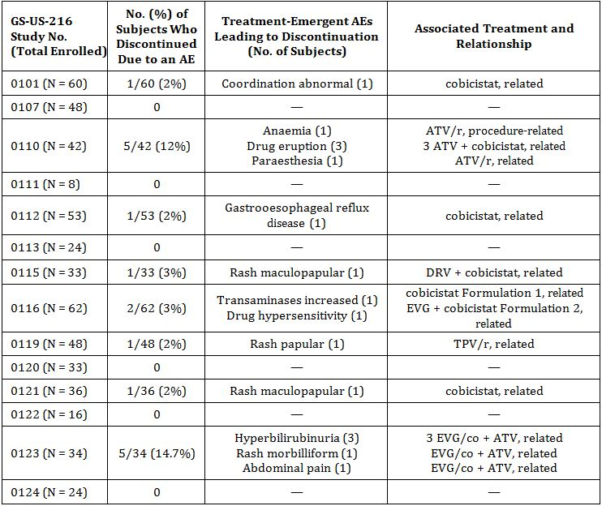

TPV = tipranavir; ATV = atazanavir, EVG = elvitegravir; /r = boosted with ritonavir

#### AEs of special interest

##### Renal events

In the pooled analysis of the pivotal studies, 8 subjects reported a renal AEs of interest,[17] with a lower incidence observed among subjects in the ATV/co+TVD group (0.3%, 1 subject) compared with the ATV/r+TVD group (1.9%, 7 subjects; p = 0.034). No subject required dialysis or another form of renal replacement therapy during the study.

In the ATV/co+TVD group, the 1 reported renal AE of interest in GS-US-216-0114 was a Grade 3 SAE of acquired Fanconi Syndrome. The subject continued to receive ATV/co+TVD for approximately 1 month after the onset of Fanconi Syndrome, but the AE resolved 6 days after the subject discontinued study drug.

In the ATV/r+TVD group, the 7 reported renal AEs of interest included 4 subjects (1.1%) who reported acute renal failure, 2 subjects who reported renal failure, and 1 subject who reported Fanconi Syndrome (acquired).

In the pooled analysis set 12 subjects discontinued study drug due to all renal AEs. The percentages of subjects were balanced between treatment groups (ATV/co+TVD 1.5%, 6 subjects; ATV/r+TVD 1.6%, 6 subjects).

In the ATV/co+TVD group, renal events leading to discontinuations of study drug included the following events: acquired Fanconi Syndrome (grade 3, resolved); creatinine renal clearance decreased (grade 3 continuing); glomerular filtration rate abnormal (grade 2; resolved); blood creatinine increased (grade 1; continuing); renal impairment (grade 2; continuing); and nephropathy (grade 3; continuing).

In order to determine whether any of the discontinuations were due to proximal tubulopathy, an assessment was conducted of the clinical and laboratory characteristics for each of the 12 subjects who discontinued study drug due to a renal AE during the randomized phase in Studies GS-US-216-0105 or GS-US-216-0114. For this assessment, renal laboratory parameters (serum creatinine, serum phosphate, urine protein, and urine glucose) were reviewed for abnormalities and magnitude of change relative to baseline. In addition to these laboratory assessments, the clinical circumstances at the time of the laboratory abnormalities (e.g., changes before and after study drug discontinuation, medical history, and concomitant medications) were evaluated. Based on this review, it was determined that 5 of 6 subjects in the ATV/co+TVD group (1.3% overall) and 2 of 6 subjects in the ATV/r+TVD group (0.5% overall) with renal AEs leading to discontinuation had laboratory findings consistent with proximal tubulopathy.

##### Hepatic events

Liver toxicity has been associated with ATV administration and most ARV therapies.

A similar number of subjects (14 in the ATV/co+TVD group and 12 in the ATV/r+TVD group) discontinued study drug due to hepatobiliary-related AEs (i.e., jaundice, ocular icterus, hyperbilirubinaemia, blood bilirubin increased, alanine aminotransferase (ALT) increased, or hypertransaminasemia).

Subjects with hepatic AEs described above in general had liver function test results expected with the use of boosted ATV (i.e., total bilirubin elevation [predominantly indirect bilirubin] without transaminase elevation), underlying chronic hepatitis B or C infection, abnormal baseline transaminases, or alternative aetiologies, such as acute HCV infection. Following a comprehensive review of AEs and laboratory parameters, no subjects were found to have evidence of severe drug-induced liver injury. No subjects met Hy’s Law. All study drug related hepatic AEs were largely reversible upon discontinuation of study drug and did not appear to have clinical sequelae.

##### Skin events

In the pooled analysis set the percentage of subjects who reported any skin rash AE was comparable between treatment groups (ATV/co+TVD 17.8%, 70 subjects; ATV/r+TVD 19.6%, 74 subjects; p = 0.52). The most frequently reported important rash AEs were as follows:

* ATV/co+TVD group: rash (6.1%, 24 subjects), pruritus (3.6%, 14 subjects), and generalized rash (2.3%, 9 subjects)
* ATV/r+TVD group: rash (6.1%, 23 subjects), pruritus (4.8%, 18 subjects), and papular rash (2.4%, 9 subjects)

##### Bone fractures

Bone fractures were evaluated as AEs of interest for cobicistat because bone toxicity has been associated with tenofovir (TFV). In the pooled analysis set bone fractures were reported for similar percentages of subjects in each treatment group (ATV/co+TVD 0.5%, 2 subjects; ATV/r+TVD 1.1%, 4 subjects; p = 0.44). All but one of the reported fractures was due to traumatic injury. A nontraumatic fracture (spinal compression fracture) was reported for 1 subject in the ATV/r+TVD group.

### Laboratory tests

#### Liver function

##### Pivotal studies

Liver enzyme elevations in ALT and aspartate aminotransferase (AST) occurred in a slightly higher percentage of subjects in the ATV/co+TVD group compared with the ATV/r+TVD group (ALT: ATV/co+TVD 18.4%, 72 subjects; ATV/r+TVD 12.5%, 47 subjects; and AST: ATV/co+TVD 21.2%, 83 subjects; ATV/r+TVD 14.1%, 53 subjects).

Abnormalities in GGT and alkaline phosphatase occurred in a similar percentage of subjects in both treatment groups. Total bilirubin elevations were also similar in the ATV/co+TVD group compared with the ATV/r+TVD group (ATV/co+TVD 96.7%, 379 subjects; ATV/r+TVD 96.5%, 362 subjects); these findings are consistent with the ATV prescribing information, which indicates that most patients who receive ATV experience asymptomatic elevations in indirect bilirubin.

Fourteen subjects in each treatment group had elevations in AST or ALT to 3 times the ULN concurrent with elevations of total bilirubin to 2 times the ULN. Direct bilirubin elevations to > 2 times the ULN were infrequent in both treatment groups (ATV/co+TVD 0.5%, 2 subjects; ATV/r+TVD 1.1%, 4 subjects). Subjects with significant liver function test abnormalities generally had abnormal baseline transaminases (AST or ALT), underlying chronic hepatitis B or C co-infection, or a medical history of alcoholism or alcohol abuse.

##### Other studies

Not applicable.

#### Kidney function

##### Pivotal studies

###### Serum creatinine

In the pooled analysis set increases from baseline in median values for serum creatinine in the ATV/co+TVD group were noted as early as Week 2 (median change from baseline at Week 2 was 0.11 mg/dL), after which they generally stabilised through Week 48 (median change from baseline at Week 48 was 0.13 mg/dL.

The pattern of change in serum creatinine in the ATV/r+TVD group was similar; however, the changes from baseline were slightly smaller than those seen in the ATV/co+TVD group (median change from baseline at Week 2 was 0.05 mg/dL; median change from baseline at Week 48 was 0.09 mg/dL).

A higher percentage of subjects in the ATV/co+TVD group compared with the ATV/r+TVD groups had Grade 1 serum creatinine abnormalities reported (ATV/co+TVD 6.4%, 25 subjects; ATV/r+TVD 3.7%, 14 subjects). Grade 2 or 3 abnormalities were infrequent, occurring in 1 (0.3%) and 2 (0.5%) subjects, respectively, in the ATV/co+TVD and no subjects in the ATV/r+TVD group.

###### Estimated GFR

eGFR by Cockcroft-Gault method

In the pooled safety analysis set modest decreases in median eGFRCG were observed post baseline in both the ATV/co+TVD group and the ATV/r+TVD group (median change from baseline at Week 48 -12.9 mL/min ATV/co+TVD and -9.3 mL/min ATV/r+TVD). Decreases in eGFRCG were seen as early as Week 2, with only minimal additional decreases after that time point; median values remained within the normal range.

eGFR by modification of diet in renal disease method

Results for eGFR calculated using the modified diet in renal disease equation (eGFRMDRD) were consistent with those observed for eGFRCG.

eGFR by Cystatin C-derived method

Contrary to the decreases in eGFRCG in the ATV/co+TVD group from the pooled analysis set described above, median cystatin C-derived GFR (cysGFR) did not decrease in either treatment group in these studies. In the ATV/co+TVD group, the baseline median cysGFR was 101.0 mL/min/1.73 m2 and the median change from baseline at Week 48 was 5.3 mL/min/1.73 m2. These findings may be consistent with the results from Study GS-US-216-0121 where the administration of cobicistat led to increase in serum creatinine (and decrease in eGFRCG) without affecting actual GFR measured by iohexol clearance.

Serum phosphorus

Median values for serum phosphorus were within normal ranges throughout all time points in the pooled analyses.

###### Glycosuria

Glycosuria was observed for a similar percentage of subjects in both treatment groups in the pooled analysis set (ATV/co+TVD 4.9%, 19 subjects; ATV/r+TVD 4.5%, 17 subjects. Overall, glycosuria tended to occur transiently and in isolation.

###### Proteinuria

Proteinuria was observed for a similar percentage of subjects in the ATV/co+TVD and ATV/r+TVD groups in the pooled analysis set (ATV/co+TVD 33.0%, 129 subjects; ATV/r+TVD 32.3%, 121 subjects). As with urine glucose, overall, proteinuria tended to be isolated and transient occurrences.

###### Urine fractional excretion of phosphate

Urine phosphate was assessed in Study GS-US-216-0114. In that study, there were small increases in median values for urine fractional excretion of phosphate in the ATV/co+TVD group (baseline median 8.7%, median change from baseline was 2.0% at Week 2 and was stable within a range of 1.1%-2.1% through Week 48). There were small increases from baseline in median values for urine fractional excretion of phosphate in the ATV/r+TVD group (baseline median 8.7%, median change from baseline was 1.8% at Week 2 and was stable within a range of 1.4%-1.7% through Week 48).

##### Other studies

###### Serum creatinine

Cobicistat administration has been shown to result in small reversible increases in serum creatinine without affecting actual renal glomerular function as assessed via iohexol clearance (Study GS-US-216-0121[18]). Serum creatinine is cleared by the kidney through a combination of glomerular filtration and active secretion. Active tubular secretion is a minor component of the renal elimination of creatinine, accounting for 10% to 40% of its clearance in patients with normal renal function. With respect to renal transporters, cobicistat is a weak inhibitor of MRP4, and multidrug and toxin extrusion protein 2-K (MATE2-K) organic cation transporter type 2 (OCT2) and a more potent inhibitor of multidrug and toxin extrusion protein type 1 (MATE1) and organic cation transporter novel, type 1 (OCTN1), with similar potencies to ritonavir. Since OCT2 and MATE1 transporters appear to play a role in the active tubular secretion of creatinine by the kidney inhibition of these transporters by cobicistat provides a plausible explanation for the clinical finding of a reduction in renal creatinine clearance without a change in actual glomerular filtration rate, i.e., cobicistat effects the active secretion of creatinine, but not passive filtration.

#### Fasting glucose and lipid parameters

##### Pivotal studies

In the pooled safety analysis set of Studies GS-US-216-0105 and GS-US-216-0114 numerically smaller increases in fasting total cholesterol (p = 0.080) and triglycerides (p = 0.043) were observed at Week 48 in the ATV/co+TVD group.

Mean increases from baseline through Week 48 in low-density lipoprotein (LDL) cholesterol and high-density lipoprotein (HDL) cholesterol were similar in the ATV/co+TVD and ATV/r+TVD groups.

There were no clinically relevant changes from baseline through Week 48 in mean values for fasting glucose in either group in either Study GS-US-216-0105 or Study GS-US-216-0114.

In both treatment groups, mean values for fasting total cholesterol, LDL cholesterol, HDL cholesterol, and triglycerides; remained within the normal range for each analyte.

Abnormalities in fasting and non fasting glucose and lipid parameters were generally Grade 1 or Grade 2 in severity. No pattern in the occurrence of Grade 3 or 4 abnormalities was apparent.

##### Other studies

Not studied in PK studies in healthy volunteers.

#### Thyroid stimulating hormone, T3 and T4; and immunoglobulins

##### Pivotal studies

Thyroid and immunoglobulins assessments were performed in Study GS-US-216-0105. In that study, there were no clinically relevant changes from baseline in median values for thyroid stimulating hormone (TSH), T3, or T4 in either group during the randomised phase, or in the All ATV/co+TVD group.

There were small decreases in median values for IgG and immunoglobulin M (IgM) in both groups during the randomized phase and in the All ATV/co+TVD group. Median values remained in the normal range.

##### Other studies

Not studied in PK studies in healthy volunteers.

#### Electrocardiograph and ECHO findings

Because cobicistat showed the potential to prolong the PR interval and decrease LV function in isolated rabbit hearts, and a tendency to slightly prolong the PR interval in dogs, additional echocardiogram (ECHO) and electrocardiogram (ECG) data were collected in a Phase 1 study with COBI and in the Phase 2 and 3 studies with COBI and the STRIBILD product.

##### Pivotal studies

No integration of ECG data was performed; results are presented by individual study.

In Study GS-US-216-0114, there were no notable differences between treatment groups in the percentages of subjects with ECG abnormalities. For the majority of subjects, there were no ECG abnormalities observed. Two subjects (0.6%) in each treatment group with normal ECGs at baseline had developed clinically significant abnormal ECGs by Week 48:

* ATV/co+TVD:
  + developed sinus bradycardia with sinus arrhythmia and extensive ST elevation suggestive of pericarditis. The abnormal ECG findings were observed on Day 44, and study drug was discontinued due to an SAE of rhabdomyolysis on Day 60. The ECG normalized on Day 108
  + nonspecific ST changes with no concomitant AE reported
* ATV/r+TVD:
  + Sinus arrhythmia and first degree AV block which resolved on the day of onset
  + possible inferior infarct at same time as AE of Grade 2 hypertensive crisis

In Study GS-US-216-0105, there were no clinically relevant changes from baseline in median values for ECG parameters (PR, QRS, QT, or QTcF intervals, or heart rate) during the randomised phase or in the All ATV/co+TVD group. For the majority of subjects, there were no shifts in categories for ECG results during the randomised phase or in the All ATV/co+TVD group.

One subject in the ATV/co+TVD group and 2 subjects in the ATV/r+TVD group had clinically significant ECG findings reported:

* ATV/co+TVD:
  + probable anteroseptal myocardial infarction, age indeterminate, consider left atrial enlargement - Subject had chest pain reported as an AE with onset on the same day as the abnormal ECG findings (Day 337) that was ongoing. The subject also had pericarditis of unknown cause reported as an SAE, Grade 3 in severity, with onset on Day 648 and resolution on Day 679. No action was taken with study drug and the AEs were not considered related to study drug by the investigator.
* ATV/r+TVD:
  + Possible left ventricular hypertrophy/possible left atrial enlargement;
  + PR interval out of range.

##### Other studies

Study GS-US-216-0107,[19] at cobicistat doses/exposures (AUCtau) approximately 2- or 4-fold above therapeutic dose/exposures, demonstrated a lack of significant changes in ECG and met the ICH E14 definition of a negative “thorough QT/QTc study”. A statistically significant, small, negative association between cobicistat plasma concentration and QTc interval was observed that is not considered to be clinically significant. An expected modest dosing-related increase in PR interval between 3 and 5 hours after dosing was observed that is not considered to be clinically significant. No clinically significant AEs, ECG abnormalities, or changes in physical exams or vital signs were observed.

Study GS-US-216-0116,[20] at a COBI dose of 150 mg with corresponding exposures, demonstrated no clinically relevant changes in the left ventricular function, with all 3 measures (end-systolic volume, end-diastolic volume, and ejection fraction) in the normal range based on time-matched ECHO assessments.

### Post-marketing experience

Not applicable as product not approved in any market.

### Safety issues with the potential for major regulatory impact

#### Renal impairment

Study GS-US-216-0124[21] examined the pharmacokinetics of cobicistat in HIV-1 infected subjects at the extremes of renal function (eGFR <30 mL/min and eGFR ≥90 mL/min) and healthy controls. The study found no clinically meaningful differences in cobicistat pharmacokinetics. On the basis of this the sponsor is not recommending any dose adjustment of cobicistat in subjects with renal impairment. In addition, EVG/co was well tolerated in the study.

Study GS-US-216-0121[22] examined the pharmacokinetics of cobicistat in HIV-1 infected subjects with mild to moderate renal impairment (placebo-controlled study evaluating cobicistat only, eGFR 50-79 mL/min, with an additional cohort of subjects with normal renal function, eGFR ≥80 mL/min). The overall safety profile was similar to that seen in other studies.

The results in these studies was reviewed in detail in addition to the renal AEs reported in the efficacy trials and particularly the discontinuations due to renal events. Since clinically meaningful differences in PK of cobicistat or EVG were not observed in subjects at the extremes of renal function (eGFRCG <30 mL/min and eGFRCG >90 mL/min) the sponsor is not recommending any dose adjustment in subjects with renal impairment. This is acceptable as EVG/co was well tolerated in the efficacy trials with few AEs. Those that did occur were Grade 1 in severity and none of the subjects in either renal function group prematurely discontinued study drug.

Cobicistat has been shown to decrease estimated CLcr due to inhibition of tubular secretion of creatinine without affecting actual renal glomerular function. This needs to be considered with cobicistat is administered with a drug that has dosing adjustment recommendations guided by estimated CLcr, e.g. cobicistat should not be initiated as a part of a regimen containing FTC, 3TC, TDF, or ADV in patients who have an estimated Clcr <70 mL/min because dose adjustment of these drugs is required below 50 ml/min and no dose adjustments have be established in combination with cobicistat.

#### Liver toxicity

Cobicistat is primarily metabolised and eliminated by the liver. The PK of cobicistat in non HIV-1 infected subjects was evaluated in subjects with moderate hepatic impairment (Child-Pugh-Turcotte [CPT] Classification B, with an additional cohort of matched subjects [age, gender, and BMI] with normal hepatic function) in Study GS-US-183-0133.[23] No clinically relevant differences in cobicistat PK were observed between subjects with moderate impairment and healthy subjects. The sponsor is not recommending any dose adjustment for patients with mild to moderate hepatic impairment. The effect of severe hepatic impairment (Child-Pugh Class C) has not been studied.

### Other safety issues

#### Safety in special populations

##### Safety in pregnancy and lactation

No studies of cobicistat have been conducted in pregnant women. It is stated that the animal studies do not indicate direct or indirect harmful effects of cobicistat with respect to pregnancy, embryonal and foetal development, parturition, or postnatal development. The Product Information states that cobicistat should be used during pregnancy only if the potential benefit outweighs the potential risk to the foetus.

It is not known whether cobicistat is excreted in human milk. Because of both the potential for HIV transmission and the potential for serious adverse reactions in nursing infants, the Product Information states that mothers should be instructed not to breastfeed if they are receiving cobicistat.

Five pregnancies were reported in the Phase 1 studies with cobicistat (including 1 pregnancy reported following the study) but only 2 subjects had received cobicistat. Details of these pregnancies are as follows:

* In Study GS-US-216-0101,[24] subject (cobicistat 100 mg) had a positive pregnancy test result on Day 13 of Period 2 (Day 45 from the study start). Cobicistat was discontinued, and the subject was discontinued from the study. A healthy baby was born at 40 weeks gestation via Caesarean section with no delivery complications.
* In Study GS-US-201-0101, subject had a confirmed pregnancy reported on Day 65 (48 days after the last dose of study drug). She had received one oral dose of GS-8374 600 mg + cobicistat 150 mg under fed conditions on Day 1, followed by an oral dose of study drugs once daily under fed conditions for 10 days. The outcome of the pregnancy was a live birth.

##### Safety in elderly patients

No pharmacokinetic studies have been performed in the elderly (those aged 65 years and older). Insufficient numbers of elderly subjects with HIV-1 infected subjects in clinical studies treated with cobicistat to determine whether they respond differently than younger subjects.

In the population PK analysis age was not a significant covariant, indicating no effect of age.

In the pooled analysis of Studies GS-US-216-0105 and GS-US-216-0114 it is stated that there were similar percentages of subject <40 or ≥40 years of age in the two treatment groups – the max age in the two studies was 57 and 62 years respectively and this provides no real evidence of safety in the elderly population.

#### Safety related to drug-drug interactions and other interactions

Co-administration of cobicistat with drug highly dependent on CYP3A for clearance and for which elevated plasma concentrations are associated with serious and/or life-threatening events are well documented and appropriately contraindicated in the proposed Product Information (PI).

Co- administration of cobicistat with medicinal products that are potent CYP3A inducers is also well documented and contraindicated in the proposed PI, as it may result in decreased plasma concentrations of cobicistat and consequently that of ATV or DRV being boosted, leading to loss of therapeutic effect and possible development of resistance.

### Evaluator’s overall conclusions on clinical safety

The safety and tolerability profile of COBI is supported by a safety database that includes not only this submission but also the submission for the STRIBILD combination product. No specific safety issues were raised in the evaluation of the STRIBILD submission relating to COBI.

The safety of COBI is supported by the low overall rate of study drug withdrawals and the mild to moderate severity of most of the AEs. The most frequently reported AEs for the ATV/co + TVD regimen were jaundice, ocular icterus and nausea, consistent with the information in the ATV PI. Subgroup analysis of AEs by sex, age, race, HIV-1 stratum at baseline, and CD4 cell count at baseline showed no differences between subgroups.

The main safety issue relates to renal function. Increases in serum creatinine, which led to modest decreases in the estimated glomerular filtration rate calculated using the Cockcroft-Gault equation (eGFRCG), were observed in the subjects who received COBI. The changes were noted as early as Week 2 of treatment, with only minimal additional decreases after that time point (to Week 48). COBI does not affect actual renal glomerular function.

A comprehensive review of AEs and laboratory parameters was undertaken by the sponsor in Studies GS-US-216-0105 and GS-US-216-0114. In this review, renal events were infrequent in subjects in the ATV/co + TVD group and were reported at a similar frequency to that observed in the ATV/r + TVD group. Several of the subjects with renal events had concurrent medical illness or evidence of pre existing renal impairment. Discontinuation of study drug due to renal AEs was infrequent and balanced between treatment groups. Renal laboratory abnormalities were reversible upon discontinuation of ATV/co + TVD without clinical sequelae. These findings are consistent with renal adverse reactions observed during postmarketing surveillance with TDF.

COBI does not appear to induce liver damage, based on studies in mild to moderate hepatic impairment. No studies in severe impairment have been performed. COBI is being recommended to use as a booster of ATV, whose PI recommends dose reduction in patients with mild to moderate hepatic impairment. This should be reflected in the COBI PI.

Based on nonclinical findings that identified the potential for COBI to affect the thyroid and IgG levels, and for COBI to prolong the PR interval and decrease LV function, safety monitoring relevant to these systems were conducted and evaluated in the studies. No safety concerns were apparent based on the clinical assessments.

No significant difference was seen in lipid profiles between ATV/co + TVD and ATV/r + TVD treatment.

The safety data on DRV boosted by COBI are limited with no data in HIV-1 infected patients.

## First round benefit-risk assessment

### Assessment of benefits

The benefits of Tybost in the proposed usage are:

* COBI has demonstrated pharmacokinetic enhancement of the protease inhibitors ATV and DRV, including the maintenance of high Ctrough levels;
* The ATV/co + TVD regimen has demonstrated potent and durable ARV in two studies. The virologic response rates of the ATV/co + TVD and ATV/r + TVD were comparable and over 80%;
* Study GS-US-216-0114 demonstrated that ATV/co + TVD was non inferior to ATV/r + TVD in achieving virologic success at 48 weeks;
* COBI had a favourable safety profile based on combination of ATV/co + TVD.

### Assessment of risks

The risks of Tybost in the proposed usage are:

* Potential for side effects, particularly renal effects. COBI inhibits active secretion of creatinine leading to small creatinine elevations. COBI does not affect glomerular function. Therefore, small increases in serum creatinine are expected after initiation of a COBI containing regimen that results in decreases of approximately 15 mL/min in estimated glomerular filtration rate (eGFR) but not actual glomerular filtration rate (aGFR);
* Use of COBI with other agents as part of a regimen containing, FTC, 3TC, TDF or ADV in patients who have an estimated creatinine clearance (Clcr) <70 mL/min cannot be recommended because dose adjustment of these drugs is required below 50 mL/min and dose adjustments in combination with COBI have not been established;
* The data presented only supports once daily dosing of COBI. There is insufficient data to support twice daily dosing;
* The use of COBI with DRV is only supported by two pharmacokinetic studies. No clinical data supporting use in HIV-1 infected patients was provided. Data on safety of DRV boosted with COBI is not available. Safety is claimed by the sponsor based on the comparable exposure to DRV between DRV/co and DRV/r.
* Data on use in children is not provided despite requirement in EU guideline.

### Assessment of benefit-risk balance

The benefit-risk balance of Tybost, given the proposed usage, is favourable.

The efficacy of COBI is based predominantly in the PK data which is extensive, particularly data submitted in the STRIBILD submission. The PK and clinical data relating to the boosting of ATV is stronger than that for DRV but the PK and safety data on DRV demonstrate that the exposure to DRV is similar between DRV/co and DRV/r.

## Recommendation regarding authorisation

Based on the clinical data submitted, it recommended that the application for Tybost be approved.

## Clinical questions

No clinical questions.

## References

Guideline on the Clinical Development of Medicinal Products for the Treatment of HIV Infection EMEA/CPMP/EWP/633/02 Revision 2, which came into effect in June 2009 and was adopted by TGA in July 2009.

Points to Consider on Switching Between Superiority and Non inferiority CPMP/EWP/482/99, which came into effect in July 2000 and was adopted by TGA in June 2000.

1. Evaluated in STRIBILD submission.
2. Evaluated in STRIBILD submission.
3. Evaluated in STRIBILD submission.
4. Evaluated in STRIBILD submission.
5. Evaluated in STRIBILD submission.
6. Evaluated in STRIBILD submission.
7. Evaluated in STRIBILD submission.
8. Evaluated in STRIBILD submission.
9. Evaluated in STRIBILD submission.
10. Evaluated in STRIBILD submission.
11. Evaluated in STRIBILD submission.
12. Evaluated in STRIBILD submission.
13. Evaluated in STRIBILD submission.
14. Evaluated in STRIBILD submission.
15. Evaluated in STRIBILD submission.
16. Evaluated in STRIBILD submission.
17. Fanconi syndrome, Fanconi syndrome acquired, renal failure, acute renal failure, and renal tubular disorder.
18. Evaluated in STRIBILD submission.
19. Evaluated in STRIBILD submission.
20. Evaluated in STRIBILD submission.
21. Evaluated in STRIBILD submission.
22. Evaluated in STRIBILD submission.
23. Evaluated in STRIBILD submission.
24. Evaluated in STRIBILD submission.