|  |
| --- |
| **December 2013** |

|  |
| --- |
| Australian Public Assessment Report for cobicistat |
| Proprietary Product Name: Tybost |
| Sponsor: Gilead Sciences Pty Ltd |

About the Therapeutic Goods Administration (TGA)

* The Therapeutic Goods Administration (TGA) is part of the Australian Government Department of Health, and is responsible for regulating medicines and medical devices.
* The TGA administers the *Therapeutic Goods Act 1989* (the Act), applying a risk management approach designed to ensure therapeutic goods supplied in Australia meet acceptable standards of quality, safety and efficacy (performance), when necessary.
* The work of the TGA is based on applying scientific and clinical expertise to decision-making, to ensure that the benefits to consumers outweigh any risks associated with the use of medicines and medical devices.
* The TGA relies on the public, healthcare professionals and industry to report problems with medicines or medical devices. TGA investigates reports received by it to determine any necessary regulatory action.
* To report a problem with a medicine or medical device, please see the information on the TGA website <<http://www.tga.gov.au>>.

About AusPARs

* An Australian Public Assessment Record (AusPAR) provides information about the evaluation of a prescription medicine and the considerations that led the TGA to approve or not approve a prescription medicine submission.
* AusPARs are prepared and published by the TGA.
* An AusPAR is prepared for submissions that relate to new chemical entities, generic medicines, major variations, and extensions of indications.
* An AusPAR is a static document, in that it will provide information that relates to a submission at a particular point in time.
* A new AusPAR will be developed to reflect changes to indications and/or major variations to a prescription medicine subject to evaluation by the TGA.

Copyright

© Commonwealth of Australia 2013  
This work is copyright. You may reproduce the whole or part of this work in unaltered form for your own personal use or, if you are part of an organisation, for internal use within your organisation, but only if you or your organisation do not use the reproduction for any commercial purpose and retain this copyright notice and all disclaimer notices as part of that reproduction. Apart from rights to use as permitted by the *Copyright Act 1968* or allowed by this copyright notice, all other rights are reserved and you are not allowed to reproduce the whole or any part of this work in any way (electronic or otherwise) without first being given specific written permission from the Commonwealth to do so. Requests and inquiries concerning reproduction and rights are to be sent to the TGA Copyright Officer, Therapeutic Goods Administration, PO Box 100, Woden ACT 2606 or emailed to <[tga.copyright@tga.gov.au](mailto:tga.copyright@tga.gov.au)>.

Contents

I. Introduction to product submission 4

Submission details 4

Product background 4

Regulatory status 5

Product Information 5

II. Quality findings 5

Drug substance (active ingredient) 5

Drug product 6

Biopharmaceutics 6

Quality summary and conclusions 6

III. Nonclinical findings 6

Introduction 6

Pharmacology 7

Pharmacokinetics 8

Toxicology 10

Nonclinical summary and conclusions 12

IV. Clinical findings 12

Introduction 12

Pharmacokinetics 12

Pharmacodynamics 14

Efficacy 15

Safety 15

List of questions 16

Clinical summary and conclusions 17

V. Pharmacovigilance findings 18

Risk management plan 18

VI. Overall conclusion and risk/benefit assessment 22

Quality 22

Nonclinical 22

Clinical 24

Risk management plan 30

Risk-benefit analysis 31

Outcome 38

Attachment 1. Product Information 39

Attachment 2. Extract from the Clinical Evaluation Report 39

## I. Introduction to product submission

### Submission details

|  |  |  |
| --- | --- | --- |
| *Type of submission:* | New Chemical Entity | |
| *Decision*: | Approved | |
| *Date of decision:* | 15 October 2013 | |
| *Active ingredients:* | Cobicistat |
| *Product names:* | Tybost |
| *Sponsor’s name and address:* | Gilead Sciences Pty Ltd  Level 6, 417 St Kilda Road  Melbourne VIC 3004 |
| *Dose form:* | Immediate release film coated tablets |
| *Strength:* | 150 mg |
| *Container:* | High density polyethylene (HDPE) bottles |
| *Pack size:* | 30 tablets |
| *Approved therapeutic use:* | Tybost is indicated as a pharmacokinetic enhancer of appropriate HIV-1 protease inhibitors in adults (See Dosage and Administration). |
| *Route of administration:* | Oral |
| *Dosage:* | The recommended dose of Tybost is one 150 mg tablet, taken orally once daily (od) with food, in combination with atazanavir (ATV; 300 mg od) or darunavir (DRV; 800 mg od). Tybost is not recommended for use with HIV-1 protease inhibitors other than those presented in the ‘Dosage and Administration’ section. No dose adjustment of Tybost is required in patients with renal impairment, including those with severe renal impairment, and no dose adjustment of Tybost is required in patients with mild or moderate hepatic impairment. |
| *ARTG number:* | 200445 |

### Product background

This AusPAR describes a submission by the sponsor, Gilead Sciences Pty Ltd, to register a new chemical entity, cobicistat (trade name: Tybost), for the following indication:

*Tybost tablets are indicated as a pharmacokinetic enhancer of the HIV-1 protease inhibitors atazanavir and darunavir in adults.*

Cobicistat (COBI) is a structural analogue of ritonavir (RTV) and a mechanism based inhibitor of CYP3A. A mechanism based inhibitor is unique in that its metabolism is what actually inactivates the CYP3A enzyme, preventing it from metabolising any subsequent substrate. It requires re-synthesis of the enzyme as opposed to a competitive inhibitor which has to maintain a high concentration throughout the dosing interval. COBI has a very short half life (median terminal half life 3.5 h), which is desirable for a mechanism based inhibitor. Consequently, it is intended for use as pharmacokinetic enhancer/booster of the CYP3A substrates atazanavir (ATV) and darunavir (DRV). It has no anti HIV activity and does not inhibit the activity of other registered anti HIV drugs *in vitro*.

COBI is seen to be a desirable alternative to RTV as a pharmacokinetic enhancer of ATV and DRV because compared to RTV it more selectively inhibits CYP3A and displays weak to minimal inhibition of other CYP enzymes; it is a less potent inducer of other metabolising enzymes *in vitro*; and it has been shown to have less potential for clinically significant drug interactions via these non CYP3A pathways. RTV has inhibition and induction effects on metabolising enzymes other than CYP3A that necessitate complex drug-drug interaction considerations before use. Additionally, the use of RTV as a booster of protease inhibitor exposure has been associated with adverse metabolic effects such as insulin resistance, hypertriglyceridaemia and lipodystrophy. If approved, Tybost will be the first product with an indication for use as a pharmacokinetic (PK) enhancer.

COBI is also a component of the fixed dose combination tablet Stribild (also previously referred to as the QUAD). Stribild contains tenofovir disoproxil fumarate (TDF) 300 mg + emtricitabine (FTC) 200 mg + elvitegravir (EVG) 150 mg + COBI 150 mg and was approved by the TGA for the treatment of HIV infection in adults who have no known resistance mutations to the individual drugs in February 2013.

### Regulatory status

At the time of the Australian submission to the TGA, applications with the same indication and supported by essentially the same dossier had been lodged in the USA, Canada, and Europe.[1]

No information is available for Switzerland or New Zealand.

### Product Information

The approved Product Information (PI) current at the time this AusPAR was prepared can be found as Attachment 1.

## II. Quality findings

### Drug substance (active ingredient)

Gilead Sciences Pty Ltd has submitted an application to register Tybost tablets, containing 150 mg of COBI. COBI is also a component of the fixed dose combination tablet Stribild, comprising 300 mg of TDF, 200 mg of FTC, 150 mg of EVG, and 150 mg of COBI. Stribild tablets were registered in Australia on 7 February 2013.

The COBI drug substance used in Tybost tablets is identical to that used in Stribild tablets. The structure of COBI is shown in Figure 1.

Figure 1: Chemical structure of cobicistat (COBI).

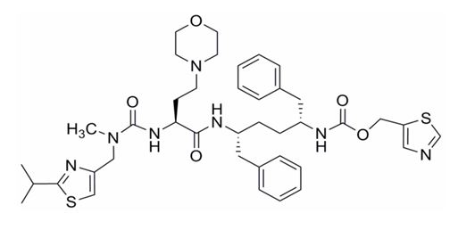

### Drug product

The immediate release tablets are orange, round, biconvex, film coated tablets debossed with “GSI” on one side and plain faced on the other side. The tablets are packed in 60 mL, white, HDPE bottles. Each bottle contains 30 tablets and 1 g of silica desiccant. Each bottle is capped with a white, child resistant polypropylene screw cap fitted with an induction sealed, aluminium faced liner.

The proposed shelf life of 2 years below 25°C is supported by the stability data submitted.

### Biopharmaceutics

A study (GS-US-216-0116) was submitted to show that the COBI tablet formulation proposed for registration is bioequivalent to an earlier Phase II tablet formulation.

The effect of food on Tybost tablets has not been studied. The PI recommends that Tybost tablets be given with food because ATV and DRV are taken with food. Food studies on Stribild tablets showed that a high fat meal reduced the area under the plasma concentration-time curve (AUC) and maximum plasma drug concentration (Cmax) of COBI by 17% and 24%, respectively, although a light meal had no significant effect.

The following justification was provided for not conducting an absolute bioavailability study:

*“Based on Gilead’s thorough understanding of the clinical development programme, and accordingly, the bioavailability of COBI is considered to be high an absolute bioavailability study for COBI was not deemed necessary and therefore not performed.”*

This justification was referred to the Clinical Delegate.

### Quality summary and conclusions

A number of issues were raised following the initial evaluation of this application, but all issues have since been satisfactorily resolved. There are now no objections to registration of this product in respect of Chemistry, Manufacturing and Controls.

## III. Nonclinical findings

### Introduction

The sponsor has applied to register COBI (Tybost) 150 mg oral tablets as a pharmacokinetic enhancer of the registered HIV protease inhibitors ATV (Reyataz) and DRV (Prezista), in HIV infected adults. Similar applications have been made in the USA (28 June) and EU (26 May 2012), and an application is proposed in Canada. The proposed regimen is COBI 150 mg and ATV 300 mg or DRV 800 mg once daily with food. There are no dosage data with any other protease inhibitors. COBI is a CYP3A inhibitor, and structural analogue of RTV (Norvir), an HIV protease inhibitor. COBI has no anti HIV activity. ATV and DRV are currently registered for use with low dose RTV in adults, and paediatric patients 6-18 years of age.

A recent application was made to register the fixed dose combination of EVG/COBI/TDF (Stribild) 150/150/300/200 mg for HIV treatment in adults with no known resistance mutations to the individual drugs. The 282nd Advisory Committee on Prescription Medicines (ACPM) meeting considered that Stribild had an overall positive benefit-risk profile. The COBI dose in Stribild is the same as the proposed single tablet. Stribild was approved in the USA in August 2012. An application to approve Stribild was also made in the EU. ATV and DRV nonclinical studies were previously evaluated.

The Stribild application contained an adequate nonclinical dossier for COBI. The Stribild application contained a safety pharmacology study and 1 and 13 week toxicity studies with COBI combined with ATV. Nonclinical studies were not conducted with COBI combined with DRV: their absence was justified in terms of the relevant guidelines.[2]

The COBI tablet has the same excipients as Stribild. The film coating is sunset yellow FCF (FD&C yellow #6) aluminium lake (E110), polyethylene glycol, polyvinyl alcohol, talc (E553B), titanium dioxide (E171), and yellow iron oxide (E172).

### Pharmacology

#### Primary pharmacology

COBI was previously shown to be a specific inhibitor of human CYP3A activity *in vitro*. It has no anti HIV activity and does not inhibit the activity of other registered anti HIV drugs *in vitro*.

#### Secondary pharmacodynamics

Chronic treatment of patients with HIV protease inhibitors, including RTV, has caused lipodystrophy, elevated blood cholesterol and triglycerides, and insulin resistance. A previous *in vitro* study (PC-216-2004) of lipid accumulation in human preadipocytes, and inhibition of glucose uptake in mouse preadipocytes, showed that COBI (10 µM) and ATV had significantly less inhibitory effects on glucose uptake than RTV. The lack of effects of ATV and DRV on insulin stimulated glucose uptake and lipid accumulation in adipocytes *in vitro* correlates with their improved metabolism profiles *in vivo*.[3]

#### Safety pharmacology

In a previous study (TX-216-2006), COBI was associated with decreased body temperature and trends for decreased locomotor activity and arousal in rats at 150 and 500 mg/kg (No Observed Adverse Effect Level [NOAEL] = 50 mg/kg), which may have reflected general toxicity. No effects were observed on rat respiration (NOAEL = 500 mg/kg).

Previous studies (TX-216-2009, TX-216-2015) in HEK293 cells *in vitro* showed that COBI (0.1-10 µM) inhibited hERG, hCav1.2 and hNav1.5 channels in a concentration dependent manner ((half maximal inhibitory concentration [IC50] of 1.8, 6 and 86.5 µM, respectively).

In previous safety pharmacology studies *in vitro*, ATV (3, 10, 30 µM) caused small increases in the action potential duration at 50% (APD50) and 90% (APD90) in rabbit Purkinje fibres, weakly inhibited Na+ and K+ (hERG) currents (respective IC50 of >30 µM and 10.4 µM), and inhibited Ca2+ currents in primary rat ventricular myocytes (IC50 = 10.4 µM). Electrocardiogram (ECG) changes were observed in a 2 week study in dogs at high doses, but qualitative assessment of QT intervals in the 9 month toxicity study in dogs revealed no abnormalities.

ATV may cause cardiac abnormalities in humans, in particular PR interval prolongation (PI). A previous Langendorff study (no. 953-0901) in isolated, perfused rabbit hearts tested the effects of COBI ± ATV. In unpaced hearts, COBI induced significant decreases in left ventricular developed pressure (LVDP), left ventricular systolic pressure (LVSP), minimal and maximal increase in left ventricular pressure (dP/dtmin and dP/dtmax), and a significant increase in coronary perfusion pressure (CPP), at ≥ 1.5 µM, while ATV induced significant decreases in heart rate. The combination of COBI/ATV 1.5/1.5 µM induced significant decreases compared to baseline in LVDP, LVSP, dP/dtmin, dP/dtmax and heart rate. Heart rate was also significantly decreased at 0.45/1.5 µM. The decreases in LVDP, LVSP, dP/dtmin and dP/dtmax induced by the combination were of smaller magnitude than those induced by COBI alone, but the combination induced a larger reduction in heart rate than that induced by ATV alone. In paced hearts, COBI 4.5 µM and ATV 15 µM induced significant increases in PR intervals (60% and 45% respectively), while ATV induced significant increases in the monophasic action potential duration at 90% of repolarisation (MAP90) and triangulation at 45 µM. The 1.5/1.5µM combination induced a significant increase in PR interval (only slightly higher than with COBI alone). Exposure to the combination was not associated with development of Early Afterdepolarisation (EAD). There were no significant effects with COBI 0.45 µM, ATV 4.5 µM, and COBI/ATV 0.45/1.5 µM. The human COBI Cmax at the 150 mg dose is 1.57 µM (1.22 µg/mL), hence the maximum unbound concentration is ~0.1 µM.

Previous adequate safety pharmacology studies with DRV alone showed no cardiovascular effects *in vitro* or *in vivo* (DRV PI).

### Pharmacokinetics

#### Metabolism

COBI strongly inhibited human CYP3A *in vitro* (Ki [inhibition constant] = 1.07 µM versus RTV 0.26 µM); inhibition was less marked in nonclinical species. Clinical studies reported that co-administration with COBI significantly increased exposures to ATV and DRV. COBI weakly inhibited CYP2C8 (IC50= 30.1 µM) and CYP2D6 (IC50= 9.2 µM), and inhibited CYP2B6 (IC50 = 2.8 µM), but did not inhibit CYP1A2, 2C9 or 2C19 *in vitro* (reports AD-216-2029, AD-216-2070, AD-216-2040).

ATV inhibited human CYP3A, 1A2, 2C9 and 3A4/5 (respective Ki values 12.2, 12.7 and 2.3 µM), but did not inhibit CYP2A6, 2C19, 2D6, 2E1 or 4A9/11 *in vitro*.

DRV inhibited human CYP3A, 2C9, 2D6 and 2C19 (respective Ki values 0.4, 32, 41 and 25 µM), but did not significantly inhibit CYP2A6, 2E1 or 1A2 *in vitro*.

In combination with ATV or DRV, the inhibitory effect of COBI on CYP3A would predominate.

COBI induced rat pregnane X nuclear receptor (PXR), but was a weak inducer of human PXR (reports AD-216-2071, AD-216-2039) *in vitro*. Induction of rat PXR was likely to increase expression of the associated proteins CYP3A and UGT1A1. COBI increased CYP1A2and CYP3A4, but not CYP2B6, UGT1A1 or MDR1 mRNA *in vitro* (reports AD-216-2071, AD-216-2039).

DRV increased CYP3A4, 2B6, 2C8, 2C9 2C18 and 2C19, but not CYP1A2 or CYP2C19 mRNA levels in cultured human hepatocytes.

ATV was not an inducer of CYP isozymes *in vitro*.[4]

The *in vitro* induction studies indicate some potential for drug interactions with the combination of COBI and DRV, although these may not be as marked as with RTV, a potent inducer of CYP isozymes in human hepatocytes.[5]

#### Transporters

Previous studies (Stribild) of the effects of COBI and RTV on human transporter activities are shown in Table 1.

Table 1: Effects of COBI and RTV on human transporter activities.

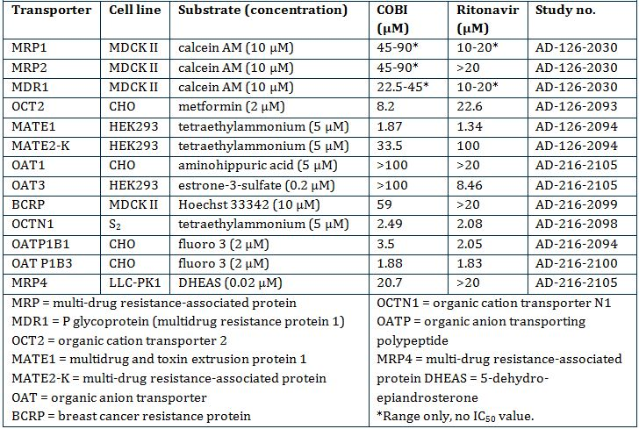

Taking into consideration the COBI Cmax of 1.57 µM (1.22 µg/mL) at the 150 mg dose, and an unbound fraction of 6.33%, COBI would not inhibit MRP1, MRP2, MDR1, BCRP, OAT1 or OAT3, but it may inhibit the hepatic uptake transporters OATP1B1 and OATP1B3, and the renal transporters MATE1 (multidrug and toxin extrusion protein) and OCTN1 (organic cation transporter), and possibly also MATE2-K and OCT2.

#### Relative systemic exposures

Exposure ratios relevant to the COBI PI are shown in Table 2. The steady state plasma AUC0-τ of COBI (Tybost) 150 mg combined with ATV 100 mg was 10.9 µg.h/mL in HIV-1 infected subjects (Study GS-US-216-0110). COBI exposure ratios in the Stribild application were based on a slightly lower human AUC0-τ of 8.3 µg.h/mL.

Table 2: Exposure ratios relevant to the COBI PI.

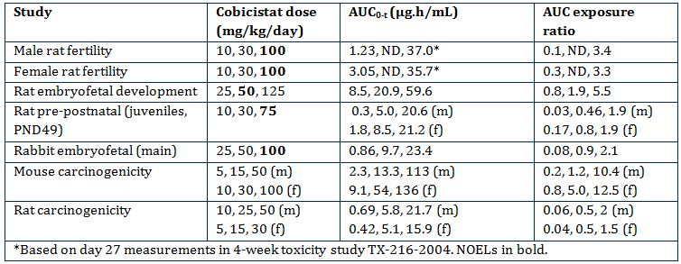

### Toxicology

Previous adequate repeat-dose toxicity studies with COBI showed effects in the liver (increased weights, hepatocellular hypertrophy) in mice, rats, and dogs. Liver transaminases (alanine aminotransferase [ALT] and aspartate aminotransferase [AST]) were increased in mice, in association with hepatocyte hypertrophy and vacuolation. Thyroid follicular cell hyperplasia/hypertrophy was observed in rats, and was very likely species specific. Other effects included slightly decreased erythroid values and increased platelets in rats, increased cholesterol in mice and rats, and increased serum protein and urinary volume in rats.

Repeat dose toxicity studies with ATV identified the liver as the main target, with increases in relative liver weights in mice, rats and dogs, increases in bilirubin, and hepatocyte hypertrophy in mice and rats reflecting liver enzyme induction. The increases in bilirubin may have been caused by inhibition of glucuronide conjugation, as ATV was shown to inhibit UDP glucuronosyl transferase 1A1 activity *in vitro*. Minimal increases in urine volume were observed in rats. The rat diuretic effects were not associated with changes in antidiuretic hormone or aldosterone.

Due to the overlapping toxicities of COBI and ATV, the combination was tested in previous 1 and 13 week studies (TX-216-2024) in rats. Minor effects of treatment were increased serum cholesterol and urine volume with ATV alone and the combination, which were reversed after 4 weeks recovery. CYP3A4 activity was increased with COBI alone and in the combination. Relative liver weights were increased with the combination in males, and were still elevated (by 29% versus the vehicle control) after the recovery period.

Previous repeat dose toxicity studies with DRV showed hepatotoxicity in mice, rats and dogs (associated with enzyme induction in rodents), and increased erythrocyte turnover. The coagulation system was also affected in rats. Salivation was increased in rats and dogs, and vomiting and diarrhoea were dose related in dogs. A 6 month combination study in rats with DRV and RTV showed small increases in erythrocytes, and effects in the liver and thyroid. These effects may have reflected the increased exposure to DRV, although RTV may have contributed to the liver toxicity and effect on erythrocytes (DRV SPC).

No toxicity studies were conducted with COBI in combination with DRV. The combination of DRV and RTV was tested in a previous 6 month toxicity study in rats. There were small increases in the effects on RBC parameters, the liver and thyroid, which may have resulted from sustained exposure to DRV, and effects of RTV on erythrocytes and the liver.

#### Genotoxicity

All three new genotoxicity studies with COBI impurities were negative. Previous adequate genotoxicity studies with COBI were negative.

ATV was positive in an *in vitro* cytogenetics assay in human lymphocytes, but was negative in assays for bacterial mutation, unscheduled DNA synthesis *ex vivo*, and micronuclei in rats *in vivo* (PI).

DRV was not genotoxic in previous adequate studies *in vitro* or *in vivo* (PI).

#### Carcinogenicity

In previous long term carcinogenicity studies, COBI elicited thyroid follicular cell tumours in rats, but no tumours in mice. The follicular cell tumours were almost certainly related to hepatocyte hypertrophy, and changes in thyroid hormone levels were observed in rat toxicity studies.

ATV carcinogenicity studies showed a significant increase in the incidence of hepatocellular adenomas in High Dose (HD) female mice, but no increases in tumours in male mice, or rats (PI).

DRV carcinogenicity studies showed dose related increases in hepatocellular adenomas and carcinomas in mice and rats, and increased follicular cell adenomas in male rats. The rodent liver and thyroid tumours have limited/no relevance to humans (PI).

#### Reproductive toxicity

In the rat fertility and early embryonic development studies with COBI, there were no effects in males or females, the No Observed Effect Level (NOEL) was 100 mg/kg/day. There were no toxicokinetic data, exposures were estimated from a 4 week toxicity study.

In the main COBI embryofoetal development study in rats, a non significant increase in post implantation loss, and a reduction in foetal weight was observed at the HD, associated with markedly lower bodyweight gain, and reduced food consumption, over the dosing period. Increased incidences of incomplete ossification of a number of foetal bones were probably a consequence of the lower foetal bodyweights. The sponsor’s proposed Australian pregnancy category of B1 for COBI is acceptable.

The COBI peri postnanatal study included a juvenile rat study in which findings mirrored those in adults, that is, hepatocyte hypertrophy, elevated thyroid stimulating hormone, thyroid follicular hypertrophy, and small increases in platelets and serum protein.

ATV had no effects on rat fertility or rat and rabbit embryofetal development; however, exposure ratios were relatively low. The rat peri postnatal study showed reversible reductions of offspring bodyweights. The Australian pregnancy category is B2 (PI).

DRV had no effects on fertility, other than lower female bodyweights and 16% fewer corpora lutea at 1000 mg/kg/day, resulting in 12% fewer live foetuses/litter. DRV had no effects on fertility in rats or embryofoetal development in mice and rabbits, but exposures were low. The rat peri postnatal study showed reversible reductions in offspring bodyweights. The Australian pregnancy category is B2 (PI).

Breast feeding is not recommended due to the risk of HIV transmission.

#### Immunotoxicity

A previous 4 week immunotoxicity study (TX-216-2022) with COBI in rats showed immunosuppressive effects, namely lymphoid depletion in spleen germinal centres, significantly reduced IgG levels, and reduced antibody responses to keyhole limpet haemocyanin. However, immunotoxicity was not evident in the 13 week toxicity study in mice, the 27 week study in rats and the 39 week study in dogs.

ATV and DRV showed no immunotoxicity in 4 week studies in rats.

### Nonclinical summary and conclusions

There are no nonclinical objections to the registration of COBI (Tybost) 150 mg oral tablets for co-administration with ATV or DRV in treatment of HIV infected adults. In contrast to the COBI/ATV combination, the COBI/DRV combination was not tested in nonclinical studies, and registration will rely more on clinical data.

## IV. Clinical findings

*A summary of the clinical findings is presented in this section. Further details of these clinical findings can be found in Attachment 2.*

### Introduction

The clinical dossier documented a full clinical development program of pharmacology, efficacy and safety.

The submission contained the following clinical information:

* 4 clinical pharmacology studies, including 4 studies (GS-US-216-0101, GS-US-216-0110, GS-US-216-0115 and GS-US-216-0119) that provided pharmacokinetic data and 1 study (GS-US-216-0119) that provided pharmacodynamic data
* 1 population pharmacokinetic analysis report
* 2 pivotal efficacy/safety studies (GS-US-216-0105 and GS-US-216-0114) which also provided PK data
* Tabulations from Integrated Summary of Efficacy and Integrated Summary of Safety

*Comment: The Summaries are dated between May and June 2012 and by agreement with TGA are the summaries submitted in the USA – they include many more studies (21) than have been submitted in Australia, for example, they are summaries of studies of both COBI single tablet and as component of the Stribild combination tablet. Many studies referenced in the summaries as being of COBI single tablets have not been included in this submission, but were submitted in the Stribild submission. A list of these studies and the submission in which they were included is provided. All studies have been evaluated. Reference is made to the Stribild submission evaluator’s report where relevant.*

### Pharmacokinetics

#### Studies providing pharmacokinetic data

Table 3 shows the studies relating to each pharmacokinetic topic and the location of each study summary.

Table 3: Submitted pharmacokinetic studies.

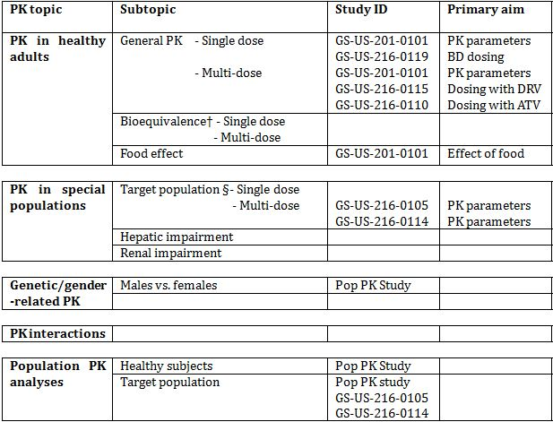

* Indicates the primary aim of the study.

† Bioequivalence of different formulations.

§ Subjects who would be eligible to receive the drug if approved for the proposed indication.

None of the pharmacokinetic studies had deficiencies that excluded their results from consideration.

#### Evaluator’s overall conclusions on pharmacokinetics

The pharmacokinetics of COBI have been extensively studied mostly in studies not included in this submission but included and evaluated in the Stribild submission. The overall analysis of the PK of COBI is therefore based on individual studies and on a population analysis with a large dataset (9,584 COBI concentration-time records [8,880 intensive and 704 sparse data]) from a total of 504 subjects across 16 clinical studies.

The studies using COBI with DRV were conducted in healthy volunteers but the studies with ATV were conducted in both healthy volunteers and in HIV-1 infected patients. The results demonstrated that the PK parameters were comparable in the two populations.

Given the metabolism of COBI by CYP3A and the similarity of the product to RTV, the company has appropriately conducted a comprehensive range of interaction studies with drugs known to interact with CYP3A and these have previously been evaluated in the Stribild submission.

The proposed PI is generally an adequate summary of the PK presented in the submission with the exception of the following:

* Based on data submitted, the time to reach peak plasma concentration following drug administration (Tmax) should be 3-4 h rather than just 4 h;
* The statement that “no food study was conducted” is incorrect. Study GS-US-201-0101 studied the effect of food on the PK on COBI in healthy subjects. It would be correct to say “no food study was conducted in HIV-1 infected patients”.

### Pharmacodynamics

#### Studies providing pharmacodynamic data

Table 4 shows the studies relating to each pharmacodynamic topic and the location of each study summary.

Table 4: Submitted pharmacodynamic studies.

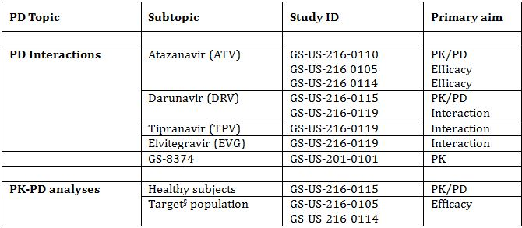

* Indicates the primary aim of the study.

§ Subjects who would be eligible to receive the drug if approved for the proposed indication.

None of the pharmacodynamic studies had deficiencies that excluded their results from consideration.

The PK/PD (pharmacokinetic/pharmacodynamic) relationship was also investigated in the following studies evaluated in the Stribild studies:

* A proof of concept study of the selected CYP3A activity of COBI (Study GS-US-216-0101)
* A study of COBI’s effect on selected CYPs and the drug efflux transporter Pgp (Study GS-US-216-0112)
* A dose selection study of COBI’s effects on a validated CYP3A metabolic probe (midazolam) relative to RTV (Study GS-US-216-0116)

The effectiveness of COBI to boost DRV is based solely on the PK results. In place of a clinical efficacy study with DRV, the sponsor has provided one PK study (Study GS-US-216-0115) and an analysis of the PK/PD relationship using data from the Phase III studies which were the basis for approval of the DRV/r 800/100 mg once daily dosing indication. These studies TCM114-C211 and TCM114-C229 were conducted by the sponsor of DRV (Johnson & Johnson) and were studies of DRV/r 800/100 mg in HIV-1 infected subjects. The DRV exposures and associated antiviral responses were in the range seen with DRV/co. These studies are not summarised but are discussed.

#### Evaluator’s overall conclusions on pharmacodynamics

The studies included in this submission have focussed on the PK/PD interactions with other ARV therapies: ATV and DRV, which are included in the indication, and tipravavir (TPV) and EVG, which are not.

ATV exposures were comparable when boosted by COBI versus RTV, in both healthy subjects and HIV-1 infected patients (Studies GS-US-216-0110 and GS-US-216-0114). The observed COBI boosted ATV exposures were in the range of values observed previously using ARV/r. Results from the studies GS-US-216-0110 and GS-US-216-0115 demonstrated that ATV 300 mg and DRV 800 mg steady state exposures were similar following administration with COBI 150 mg versus RTV 100 mg.

No further efficacy data was submitted to support the proposed indication of the combination of COBI and DRV. Approval of this indication rests solely with pharmacokinetic data.

### Efficacy

#### Evaluator’s conclusions on clinical efficacy

The sponsor has provided evidence for the efficacy of COBI as an enhancer for ATV in both PK studies and clinical studies. While only one of the two studies provided demonstrated non inferiority to ATV/r + TVD, the other studied was too underpowered to be expected to show a result of non inferiority. In the Clinical Safety Report or the summaries, the sponsor provides an adequate explanation for the study’s low power, and that it may raise doubt to considering Study GS-US-216-0105 as a pivotal study. However, it has been included as a pivotal study due to the reliance on the data in the pooled analysis and because it provides important PK and safety information.

There are no clinical studies with COBI boosted DRV; the company has provided evidence based on the PK Study GS-US-216-0115 established PK boosting of DRV with COBI provided the exposure to DRV is similar between DRV/co and DRV/r.

While it would have been more acceptable to have clinical data available, there is sufficient strength to the PK data to approve the requested indication of pharmacokinetic enhancer of DRV.

### Safety

#### Studies providing evaluable safety data

The following studies provided evaluable safety data:

##### Pivotal efficacy studies

In the pivotal efficacy studies, the following safety data were collected:

* General adverse events (AEs) were assessed by collection of AEs throughout the studies.
* AEs of particular interest, including renal events, bone fractures, hepatic events, thyroid, cardiovascular and skin events, were assessed by reviewing all events for specific MedDRA preferred terms.
* Laboratory tests, including tests for kidney function, liver function, and lipid function were performed at baseline and at pre specified times during the study.

##### Pivotal studies that assessed safety as a primary outcome

Not applicable.

##### Dose response and non pivotal efficacy studies

Not applicable.

##### Other studies evaluable for safety only

Not applicable.

##### Clinical pharmacology studies

All but one of the clinical pharmacology studies were conducted in healthy volunteers. The results for the individual studies are provided. Only deaths and serious AEs (SAEs) are included in the Summary of Clinical Safety.

#### Evaluator’s overall conclusions on clinical safety

The safety and tolerability profile of COBI is supported by a safety database that includes not only this submission but also the submission for the Stribild combination product. No specific safety issues were raised in the evaluation of the Stribild submission relating to COBI.

The safety of COBI is supported by the low overall rate of study drug withdrawals and the mild to moderate severity of most of the AEs. The most frequently reported AEs for the ATV/co + TVD regimen were jaundice, ocular icterus and nausea, consistent with the information in the ATV PI. Subgroup analysis of AEs by sex, age, race, HIV-1 stratum at baseline, and CD4 cell count at baseline showed no differences between subgroups.

The main safety issue relates to renal function. Increases in serum creatinine, which led to modest decreases in the estimated glomerular filtration rate calculated using the Cockcroft-Gault equation (eGFRCG), were observed in the subjects who received COBI. The changes were noted as early as Week 2 of treatment, with only minimal additional decreases after that time point (to Week 48). COBI does not affect actual renal glomerular function.

A comprehensive review of AEs and laboratory parameters was undertaken by the sponsor in Studies GS-US-216-0105 and GS-US-216-0114. In this review, renal events were infrequent in subjects in the ATV/co + TVD group and were reported at a similar frequency to that observed in the ATV/r + TVD group. Several of the subjects with renal events had concurrent medical illness or evidence of pre existing renal impairment. Discontinuation of study drug due to renal AEs was infrequent and balanced between treatment groups. Renal laboratory abnormalities were reversible upon discontinuation of ATV/co + TVD without clinical sequelae. These findings are consistent with renal adverse reactions observed during postmarketing surveillance with TDF.

COBI does not appear to induce liver damage, based on studies in mild to moderate hepatic impairment. No studies in severe impairment have been performed. COBI is being recommended to use as a booster of ATV, whose PI recommends dose reduction in patients with mild to moderate hepatic impairment. This should be reflected in the COBI PI.

Based on nonclinical findings that identified the potential for COBI to affect the thyroid and IgG levels, and for COBI to prolong the PR interval and decrease LV function, safety monitoring relevant to these systems were conducted and evaluated in the studies. No safety concerns were apparent based on the clinical assessments.

No significant difference was seen in lipid profiles between ATV/co + TVD and ATV/r + TVD treatment.

The safety data on DRV boosted by COBI are limited with no data in HIV-1 infected patients.

### List of questions

No clinical questions.

### Clinical summary and conclusions

#### Benefit-risk assessment

##### Assessment of benefits

The benefits of Tybost in the proposed usage are:

* COBI has demonstrated pharmacokinetic enhancement of the protease inhibitors ATV and DRV, including the maintenance of high Ctrough levels;
* The ATV/co + TVD regimen has demonstrated potent and durable ARV in two studies. The virologic response rates of the ATV/co + TVD and ATV/r + TVD were comparable and over 80%;
* Study GS-US-216-0114 demonstrated that ATV/co + TVD was non inferior to ATV/r + TVD in achieving virologic success at 48 weeks;
* COBI had a favourable safety profile based on combination of ATV/co + TVD.

##### Assessment of risks

The risks of Tybost in the proposed usage are:

* Potential for side effects, particularly renal effects. COBI inhibits active secretion of creatinine leading to small creatinine elevations. COBI does not affect glomerular function. Therefore, small increases in serum creatinine are expected after initiation of a COBI containing regimen that results in decreases of approximately 15 mL/min in estimated glomerular filtration rate (eGFR) but not actual glomerular filtration rate (aGFR);
* Use of COBI with other agents as part of a regimen containing, FTC, 3TC, TDF or ADV in patients who have an estimated creatinine clearance (Clcr) <70 mL/min cannot be recommended because dose adjustment of these drugs is required below 50 mL/min and dose adjustments in combination with COBI have not been established;
* The data presented only supports once daily dosing of COBI. There is insufficient data to support twice daily dosing;
* The use of COBI with DRV is only supported by two pharmacokinetic studies. No clinical data supporting use in HIV-1 infected patients was provided. Data on safety of DRV boosted with COBI is not available. Safety is claimed by the sponsor based on the comparable exposure to DRV between DRV/co and DRV/r.
* Data on use in children is not provided despite requirement in EU guideline.

##### Assessment of benefit-risk balance

The benefit-risk balance of Tybost, given the proposed usage, is favourable.

The efficacy of COBI is based predominantly in the PK data which is extensive, particularly data submitted in the Stribild submission. The PK and clinical data relating to the boosting of ATV is stronger than that for DRV but the PK and safety data on DRV demonstrate that the exposure to DRV is similar between DRV/co and DRV/r.

#### Recommendation regarding authorisation

Based on the clinical data submitted, it recommended that the application for Tybost be approved.

## V. Pharmacovigilance findings

### Risk management plan

The sponsor submitted a Risk Management Plan (RMP) which was reviewed by the TGA’s Office of Product Review (OPR).

#### Safety specification

The sponsor provided a summary of ongoing safety concerns which are shown at Table 5.

Table 5: Ongoing safety concerns as identified by the sponsor.

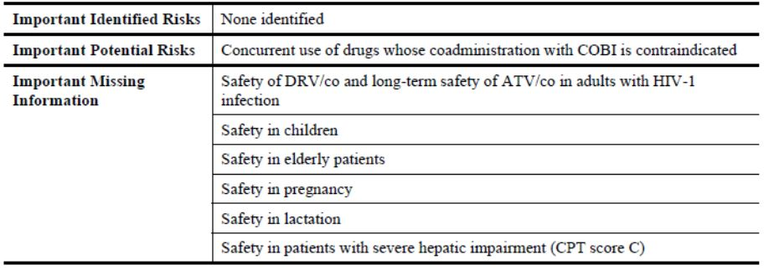

##### OPR reviewer comment

The above ongoing safety concerns are generally consistent with those previously accepted for the COBI element of Stribild. However, it is not clear why the Important Missing Information ‘Long-term safety of DRV/co in adults with HIV-1 infection’ has been excluded as an ongoing safety concern. Notwithstanding the evaluation of the nonclinical and clinical aspects of the Safety Specification (SS), it is recommended that the sponsor should provide compelling justification to this effect or alternatively include it as an ongoing safety concern, giving consideration as to what routine and additional pharmacovigilance and risk minimisation activities will be proposed for it.

#### Pharmacovigilance plan

##### Proposed pharmacovigilance activities

The sponsor states that routine pharmacovigilance activities, consistent with the activities outlined in published guidelines,[6] are proposed to monitor all the specified Ongoing Safety Concerns.

The following clinical studies are proposed to further monitor the important missing information: ‘Safety in children’:

* GS-US-183-0154: A Phase II/III, multicentre, open label, non randomised, multi cohort, two part study evaluating the PK, safety, and antiviral activity of EVG co-administered with COBI and two first line NRTIs in HIV-1 infected, antiretroviral treatment naive subjects aged <18 years.

##### OPR reviewer’s comments in regard to the pharmacovigilance plan (PP) and the appropriateness of milestones

The ongoing clinical studies are not considered to be part of the planned clinical studies in the pharmacovigilance plan. Therefore, the related study protocols have not been reviewed. Nevertheless, an update on the progress/results/analysis of these studies, as outlined above, will be expected in future Periodic Safety Update Reports (PSURs).

The sponsor should provide an assurance that the draft protocols for the planned clinical studies proposed to further monitor the important missing information ‘Safety in children’ will be provided to the TGA for review when they become available.

#### Risk minimisation activities

##### Sponsor’s conclusion in regard to the need for risk minimisation activities

The sponsor has concluded that routine risk minimisation activities are sufficient for all the specified ongoing safety concerns. Consequently no risk minimisation measures additional to the provision of safety information in the product labelling are considered by the sponsor to be warranted for the use of COBI.

##### OPR reviewer comment:

The above conclusion was previously accepted for the COBI element of Stribild. Consequently, this is acceptable.

#### First round summary of recommendations

The OPR provides these recommendations in the context that the submitted RMP is supportive to the application; the implementation of a RMP satisfactory to the TGA is imposed as a condition of registration; and the draft PI and Consumer Medicine Information (CMI) documents should *not* be revised until the Delegate’s Overview has been received:

* Safety considerations may be raised by the nonclinical and clinical evaluators through the consolidated Section 31 request and/or the Nonclinical and Clinical Evaluation Reports respectively. It is important to ensure that the information provided in response to these include a consideration of the relevance for the RMP, and any specific information needed to address this issue in the RMP. For any safety considerations so raised, the sponsor should provide information that is relevant and necessary to address the issue in the RMP.
* The summary of the ongoing safety concerns as specified by the sponsor are generally consistent with those previously accepted for the COBI element of Stribild. However, it is not clear why the important missing information ‘Long-term safety of DRV/co in adults with HIV-1 infection’ has been excluded as an ongoing safety concern. Notwithstanding the evaluation of the nonclinical and clinical aspects of the SS, it is recommended that the sponsor should provide compelling justification to this effect or alternatively include it as an ongoing safety concern, giving consideration as to what routine and additional pharmacovigilance and risk minimisation activities will be proposed for it.
* The ongoing clinical studies are not considered to be part of the planned clinical studies in the pharmacovigilance plan. Therefore, the related study protocols have not been reviewed. Nevertheless, an update on the progress/results/analysis of these studies, as outlined in Annex 2 of the AU-RMP, will be expected in future PSURs.
* The sponsor should provide an assurance that the draft protocols for the planned clinical studies proposed to further monitor the important missing information ‘Safety in children’ will be provided to the TGA for review when they become available.
* The sponsor’s conclusion that routine risk minimisation activities are sufficient for all the specified ongoing safety concerns was previously accepted for the COBI element of Stribild. It is agreed that no risk minimisation measures additional to the provision of safety information in the product labelling is currently warranted for the use of COBI.
* The sponsor’s proposed application of routine risk minimisation activities would appear to be reasonable and therefore acceptable. However, it is not clear as to why the proposed contraindication of co-administration with ‘PDE-5 inhibitors: sildenafil and tadalafil for the treatment of pulmonary arterial hypertension’ is so limited and not inclusive of the approved erectile dysfunction indication. The sponsor should clarify this matter.
* In regard to the proposed routine risk minimisation activities, the draft PI document is considered satisfactory.
* In regard to the proposed routine risk minimisation activities, the draft CMI is considered satisfactory.

#### Second round evaluation of the sponsor’s response to the RMP evaluation

Reconciliation of issues outlined in the RMP report is shown in Table 6.

Table 6: Reconciliation of issues outlined in the RMP report.

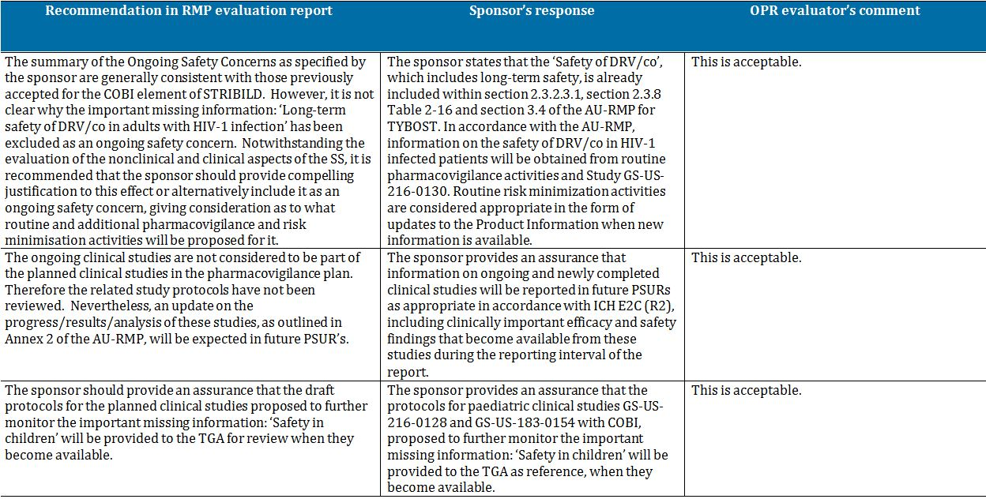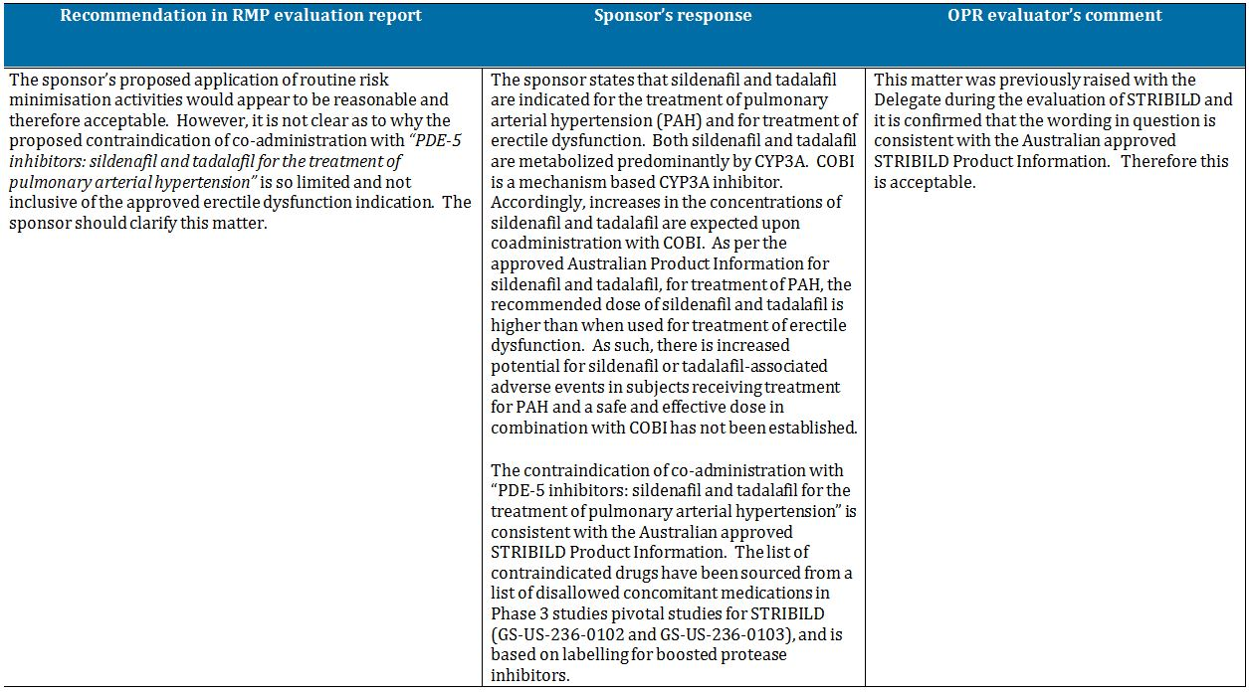

##### Outstanding issues

###### Issues in relation to the RMP

There are no outstanding issues in relation to the RMP for this submission.

###### Advice from the Advisory Committee on the Safety of Medicines (ACSOM)

ACSOM advice was not sought for this submission.

##### Comments on the safety specification of the RMP

###### Clinical evaluation report

The SS in the draft RMP is satisfactory.

###### Nonclinical evaluation report

The nonclinical evaluator made no specific comments on the SS in the nonclinical evaluation report.

## VI. Overall conclusion and risk/benefit assessment

The submission was summarised in the following Delegate’s overview and recommendations:

### Quality

The COBI drug substance used in Tybost tablets is identical to that used in Stribild tablets and all excipients used in the formulation are common pharmaceutical ingredients.

The drug development program used two COBI formulations that were very different with respect to composition and manufacturing processes. The effects of these differences were evaluated in Study GS-US-216-0116 which showed the COBI tablet formulation proposed for registration is bioequivalent to an earlier Phase I/II tablet for all three PK parameters tested: AUCtau, (area under the drug concentration-time curve over the dosing interval) Cmax, and Ctau (observed drug concentration at the end of the dosing interval).

The evaluator noted that effect of food on Tybost tablets has not been studied and that no evidence has been provided that either tablet formulation displays optimal oral bioavailability. COBI is a Biopharmaceutics Classification System (BCS) Class 2 drug substance (that is, high permeability, low solubility), so absorption could be dissolution rate limited.

* Study GS-US-216-0116 demonstrated the pharmacokinetic performance of COBI was formulation independent;
* Further to this, the relative bioavailability and disposition of COBI (in combination with EVG) was unaffected upon co-administration or staggered (12 h) administration with omeprazole, with exposure parameters being within classical bioequivalence boundaries (that is, 90% Confidence Interval [CI] within 80-125%). Similarly, COBI exposures were within bioequivalence bounds following co-administration or staggered (12 h) administration with famotidine (Studies GS-US-216-0120 and GS-US-216-0122, Stribild submission). It was considered the lack of any drug-drug interaction between COBI and acid reducing agents indicates that the dissolution of COBI Tablets at higher stomach pH will have no effect on the bioavailability.

No objections were raised to registration of Tybost with regard to Chemistry, Manufacturing and Controls at the time of completion of the evaluation rounds. However, the TGA recently became aware that the US Food and Drug Administration (FDA) has issued Complete Response Letters advising that it cannot approve the US NDA for COBI in its current form as a result of recent GMP inspections in which deficiencies were observed. At the time of completion of this Request for Advice, the TGA was working through additional information provided by the sponsor to determine the nature and scope of the deficiencies, and the sponsor’s proposed actions to address those deficiencies.

### Nonclinical

There were no nonclinical objections to registration of the product. The majority of the nonclinical data for COBI, including data pertaining to the proposed combination of COBI with ATV, were included in the Stribild submission. A small amount of supplementary nonclinical data, mostly dealing with the metabolism and pharmacokinetic drug interactions of COBI were included in the current submission. The key nonclinical findings for COBI are:

* COBI exhibits a largely mechanism based inhibition of human microsomal fraction CYP3A activity *in vitro*, with a similar potency to RTV (IC50 of 0.15 nM). It has little or no activity against other CYP isoforms tested, except for weak inhibition of CYP2B6 and CYP2D6 (IC50 values of 2.8 and 9.2 µM, respectively), and it also weakly inhibits UGT1A1 (IC50 of 16.3 µM). COBI activates rat and, to a lesser extent, human pregnane X receptors, with activation of the human form being less pronounced than with RTV;
* Unlike RTV, COBI has no activity against HIV-1;
* At the proposed 150 mg dose (with an associated Cmax of 1.57 µM), COBI may inhibit the hepatic uptake transporters OATP1B1 and OATP1B3 (respective IC50 values of 3.5 µM and 1.9 µM) and the renal transporters MATE1 (IC50 value 1.9 µM) and OCTN1 (IC50 value 2.5 µM);
* COBI elicited some changes in isolated rabbit hearts, including prolonged PR interval and a negative inotropic effect, but QT interval prolongation was not seen. *In vivo*, QT intervals were slightly prolonged (single dose) or unaffected (4 week toxicity study) by per oral (PO) treatment of dogs with up to 45 mg/kg;
* *In vitro* plasma protein binding was extensive in mouse, rat, dog and human samples (91.1-97.7 at 1-10 µM). Rat tissue distribution studies showed high radioactivity concentrations in the liver, adrenals and pituitary and low values in the brain/spinal cord and testes. COBI was a p-glycoprotein substrate in transfected canine kidney MDCKII cells, but no significant efflux was seen across Caco-2 cell monolayers;
* COBI metabolites seen in vitro in mouse, rat, dog and human samples were predominantly a carbamate cleavage product (M21), a dealkylated methylurea derivative (M26) and a hydroxylated product (M31). Metabolism by human recombinant CYP2D6 and to a lesser extent CYP3A was shown. M21 and M31 were also prominent in mice, rats and dogs *in vivo* after PO administration, and were human faecal metabolites. Excretion of radioactivity after PO [14C]COBI administration to the mouse, rat, dog and humans was overwhelmingly via the faeces. Biliary excretion was shown in the rat and dog. Weak induction of CYP3A4 and CYP1A2 mRNA levels was shown in human hepatocytes *in vitro*;
* COBI elicited an increased incidence of thyroid follicular cell tumours in rats, but no tumours in mice and altered thyroid hormones were observed in rat toxicity studies , and were considered to be to be specific to this species;
* Repeat dose toxicity studies with COBI showed increased liver weight and hepatocellular hypertrophy in mice, rats and dogs. Increases in transaminases in association with hepatocyte hypertrophy and vacuolation were observed in mice.
* Functional renal changes were observed with COBI, mainly a reversible diuretic like effect in the rat toxicity studies, but these were not associated with any serum chemistry or histological indications of renal toxicity; and
* In reproductive toxicity studies the COBI doses that could be used were limited by maternal toxicity, but no specific effects on reproductive parameters were observed. However, no safety margin was measurable with the HD (75 mg/kg/day) in the pre/post natal study.

With respect to the proposed ATV/COBI combination, it was found that:

* COBI 30 mg/kg/day dose substantially elevated exposure to lower doses of ATV (20 and 50 mg/kg/day) in rats. Day 90 ATV AUC0-24 h values were respectively 3.9x and 2.9x (males) or 2.6x and 1.45x (females) those in the absence of COBI. This was despite significantly higher terminal CYP3A activities in females receiving combination treatment with COBI (2.6-3.5x vehicle values);
* An *in vitro* study of lipid accumulation in human preadipocytes, and inhibition of glucose uptake in mouse preadipocytes, showed that COBI and ATV had significantly less inhibitory effects on glucose uptake than RTV. Inhibition of glucose uptake at 10 µM was 55% for RTV, 9.5% for COBI and 0.4% for ATV;
* In unpaced rabbit hearts, the combination of COBI/ATV 1.5/1.5 µM induced significant decreases from baseline in LVDP, LVSP, minimal and maximal increase in left ventricular pressure (dP/dtmin and dP/dtmax) and heart rate. Heart rate was also significantly decreased at 0.45/1.5 µM. The decreases in LVDP, LVSP, dP/dtmin and dP/dtmax induced by the combination were of smaller magnitude than those induced by COBI alone, but the combination induced a larger reduction in heart rate than that induced by ATV alone (it is known that ATV is associated with concentration and dose dependent prolongation of the PR interval). In paced hearts, COBI 4.5 µM and ATV 15 µM induced significant increases in PR intervals (60% and 45% respectively), while ATV induced significant increases in MAP90 and triangulation at 45 µM. The 1.5/1.5µM combination induced a significant increase in PR interval (only slightly higher than with COBI alone). There were no significant effects with COBI 0.45 µM, ATV 4.5 µM, and COBI/ATV 0.45/1.5 µM;
* Both COBI and ATV alone have effects on the liver. In the 1 and 13 week repeat dose toxicity studies in rats CYP3A4 activity was increased with COBI alone and in combination with ATV. Relative liver weights were increased with the COBI/ATV combination in males, and were still elevated (by 29% versus the vehicle control) after the recovery period. In the same studies, other effects included increased serum cholesterol and urine volume with ATV alone and the combination, which were reversed after 4 weeks recovery.

No toxicity studies were conducted with the COBI/DRV combination. The evaluator noted the approval of that combination would have to rely on clinical data alone.

### Clinical

#### Clinical pharmacology

##### Safety pharmacology

In the Stribild submission, a well designed and conducted dedicated QT study (GS-US-216-0107) showed that COBI did not prolong QTcF interval at exposures 2 and 4 fold above the recommended therapeutic dose. A modest increase in PR interval (+9.6 msec) occurred around Cmax, 3 to 5 h after dosing but this finding was not considered to be clinically significant. The effect of COBI on left ventricular function was also evaluated 40 in healthy volunteers (GS-US-216-0116; Stribild) because of negative inotropic effect of COBI observed in isolated rabbit hearts. ECG evaluations showed no clinically significant change from baseline.

In the Stribild submission, COBI was associated with rapid and approximately 0.1 to 0.2 milligram per decilitre increases in serum creatinine. This translated into decreases in estimated GFR based on serum creatinine; specifically, Cockcroft and Gault equation derived measures in subjects with normal and mild/moderate renal impairment (Study GS-US-216-0121). The changes were reversible and returned to baseline values following a 7 day washout period. However, excretion of the contrast agent iohexol, which is filtered by the glomerulus, was unchanged on Day 7 or Day 14 relative to Day 0, indicating that actual GFR was unaffected. The time to onset, magnitude, and time to resolution of the observed changes in eGFR are consistent with the inhibition of tubular secretion of creatinine by COBI. Furthermore, nonclinical studies showed that both COBI and RTV can inhibit the MATE1 transporter that is responsible for the efflux of creatinine from the proximal tubule. Thus, the decrease in estimated creatinine clearance is due to inhibition of tubular secretion of creatinine rather than effects on GFR.

##### Pharmacokinetics

The key features of COBI pharmacokinetics identified in the Stribild submission were:

* The absolute bioavailability of oral COBI is unknown: there is no IV formulation;
* Food studies on Stribild tablets showed that a high fat meal reduced the AUC and Cmax of COBI by 17% and 24%, respectively, although a light meal had no significant effect. The Tybost PI recommends that the tablets be given with food because ATV and DRV are taken with food (as was the case with the clinical efficacy/safety studies in the current submission);
* Single and multiple dosing with COBI 50, 100 and 200 mg doses in healthy subjects showed both dose and time dependent changes in apparent clearance (CL/F), with nonlinear increases in systemic exposure to COBI, consistent with the properties of a mechanism based inhibitor (Study GS-US-216-0101). The study also examined suppression of CYP3A by COBI using a midazolam probe. Midazolam plasma exposure increased by about 20 times with COBI 200mg and with RTV 100 mg dosing compared with midazolam alone. Despite non linearity of COBI plasma exposure in this dose range noted early in this study, the effect on CYP3A (midazolam clearance and plasma exposure) was indicative of dose response;
* Consistent PK profiles and exposures for COBI were observed across a range of studies: Tmax ranged from 3 to 4.5 h;
* COBI is highly protein bound;
* In a mass balance study (GS-US-216-0111), 94% radioactivity was recovered: 86% from faeces and <10% from urine. Intact drug is the predominant species in plasma (99%) with no quantifiable metabolites in plasma. In faeces, 27% radioactivity was accounted for by the intact molecule and remaining by metabolites (mainly E3 and E1);
* Following once daily administration of combination elvitegravir/COBI for 7 days, the AUCtau, Cmax and Ctau for COBI were approximately 25%, 22%, and 13% higher in non HIV-1 infected subjects with severe renal impairment (eGFRCG < 30 mL/min) than in control subjects with normal renal function (eGFR ≥ 90 mL/min) matched for age, gender and BMI (Study GS-US-216-0124). These differences in exposures were not considered clinically relevant and it was concluded that dose adjustment of COBI was not required in subjects with renal impairment;
* In Study GS-US-183-0133 comparing the PKs of COBI in non-HIV-1 infected subjects with moderate hepatic impairment (Child-Pugh-Turcotte Classification B) and matched normal controls, the AUCtau and Cmax of COBI were comparable for the two groups (90% CI of ratio between 0.8 and 1.25). Ctau was significantly higher in subjects with moderate hepatic impairment (geometric least squares mean ratio 208%), but this was not considered clinically relevant. No data are available on the use of COBI in patients with severe hepatic impairment; and
* Age, gender and race did not influence COBI exposures in healthy or HIV-1 infected individuals.

In the current submission, additional data were provided mainly in the form of PK interaction studies of COBI with ATV and DRV, as well as a population PK modelling of pooled intensive and sparse sampling data following administration of COBI (as a single agent tablet or as a component of Stribild) as follows.

###### ATV/COBI PKs

In Study GS-US-216-0110, ATV exposures (AUC; Cmax) and trough levels (Ctau) were bioequivalent (that is, the 90% CI of the geometric means ratio lay within 80% to 125%) following once daily dosing of ATV/COBI 300/150 mg versus ATV/RTV 300/100 mg over 10 days in healthy subjects. Comparable Tmax and half life values were also observed.

Intensive PK sampling performed in a subset of 24 HIV-1 infected treatment naive patients in Study GS-US-216-0105 showed key PK parameters for ATV (Cmax, Tmax, Ctau, AUCtau and half life) were comparable when given as ATV/COBI + TVD or ATV/RTV + TVD (Table 7). The mean ATV trough concentrations in subjects receiving ATV/COBI + TVD or ATV/RTV + TVD were more than 46 fold above the protein binding adjusted IC90 against wild type HIV-1 (14 ng/mL) throughout the 48 week dosing period. Also, the PK parameters for ATV, COBI, RTV, FTC and TFV following steady state administration of ATV/COBI + TVD or ATV/RTV + TVD were consistent with those observed in other published studies in HIV-1 infected patients.

Table 7: Study GS-US-216-0105: Summary of ATV, COBI, RTV, FTC, and TFV PK parameters (PK substudy analysis set).

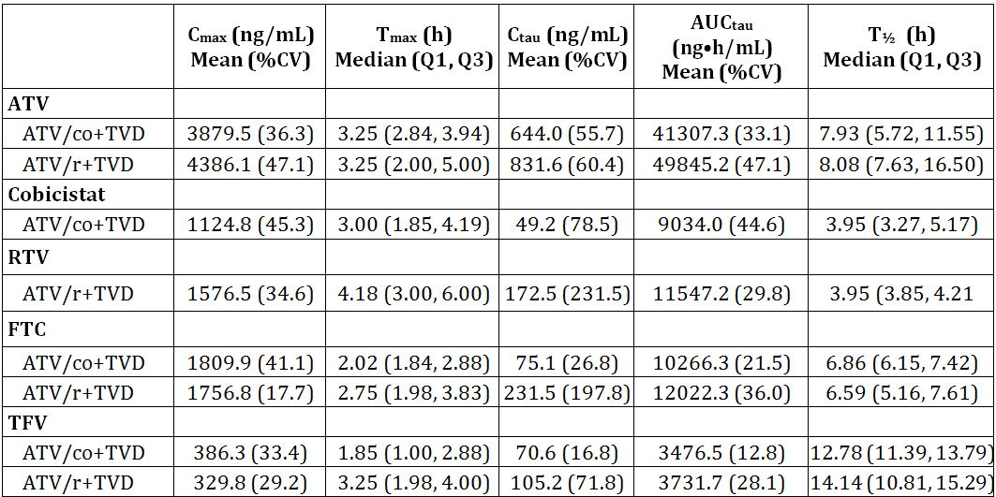

Similar findings were obtained in Study GS-US-216-0114, where intensive PK sampling performed in a subset of 48 HIV-1 infected treatment-naive patients showed the ATV Cmax, Tmax, Ctau, AUCtau and half life were comparable when given as ATV/COBI + TVD or ATV/RTV + TVD (Table 8). Plasma exposures of ATV, COBI, RTV, FTC, and TFV were also consistent with historical data. The mean ATV trough concentration in subjects who received ATV/COBI + TVD was 56.9 fold above the protein binding adjusted IC90 against wild-type HIV-1 (14 ng/mL) compared to 61.0 fold in subjects receiving ATV/RTV + TVD.

Table 8: Study GS-US-216-0114: Summary of ATV, COBI, RTV, FTC, and TFV PK parameters (PK substudy analysis set).

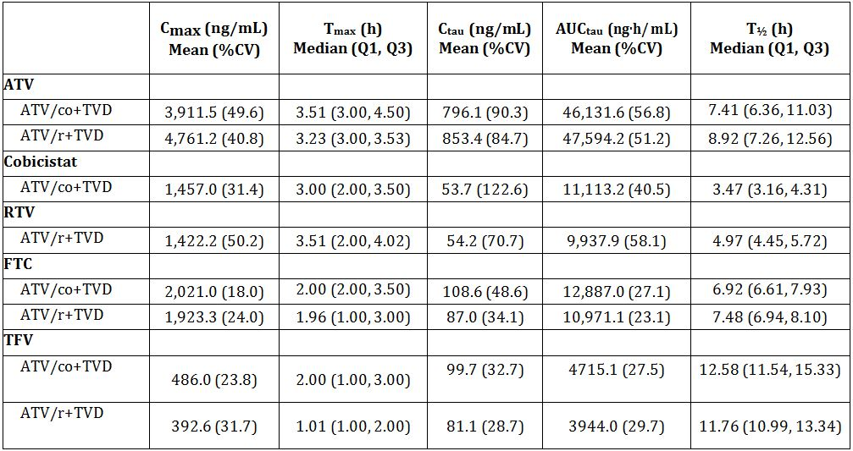

%CV = percentage coefficient of variation; Q1, Q3 = first and third interquartiles

For each subject in PK substudy, intensive PK was done at one time at Weeks 2, 4 or 8.

A cross study comparison showed COBI PK parameters (AUCtau, Cmax, and Ctau) were comparable between healthy subjects (Study GS-US-216-0110) and HIV-1 infected subjects from Studies GS-US-216-0105 (intensive and sparse sampling) and GS-US-216-0114 (intensive sampling) following multiple dose administration of ATV/COBI (300/150 mg) (Table 9).

Table 9: Steady state COBI PK parameters after once daily administration of ATV/co (300/150 mg) in HIV-1 infected subjects (Studies GS-US-216-0105 and GS-US-216-0114 population PK analysis) or in healthy subjects (Study GS-US-216-0110).

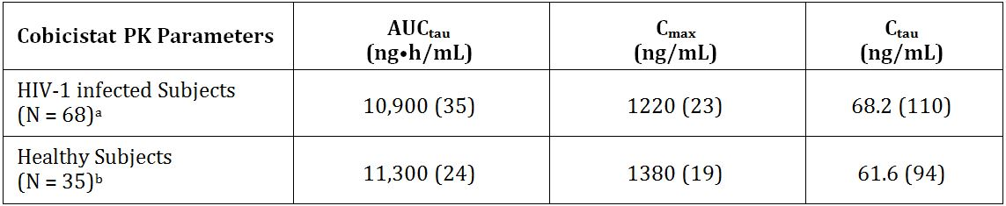

Data are mean (%CV) and are shown to 3 significant digits.

a The model-based cobicistat PK parameters were available for 68 subjects in the ATV/co+TVD treatment group (n = 46 in Study GS-US-216-0105 and n = 22 in Study GS-US-216-0114).

b 3 Subjects did not have evaluable cobicistat PK profiles and were excluded from the cobicistat PK analysis set.

###### DRV/COBI PKs

Steady state DRV exposures (AUCtau and Cmax) following multiple dose administration of DRV 800 mg/COBI 150 mg or DRV 800 mg/RTV 100 mg were bioequivalent in 31 healthy subjects completing Study GS-US-216-0115. The geometric least squares mean ratio for Ctau was low (69.4%; 90% CI 59.0-81.7%) because of an unexpected and unexplained increase in DRV concentrations at the 24 h time point in the DRV + RTV treatment arm. However, when pre dose DRV concentrations (C0h) were analysed, the levels were comparable, as indicated by a geometric least squares mean ratio of 89.4% (90% CI: 80.4-99.4%). The pre dose concentrations were >37 fold above the protein adjusted EC50 for wild type virus (55 ng/mL).

#### Efficacy

##### COBI boosted ATV

The clinical efficacy of ATV/COBI was examined in two non inferiority studies in which HIV-1 infected, antiretroviral treatment naive adults with plasma HIV-1 RNA levels ≥5,000 copies/mL at screening received a regimen containing either COBI boosted ATV (ATV 300 mg/COBI 150 mg) or RTV boosted ATV (ATV 300 mg/RTV 100 mg), each administered with FTC (200 mg) and TDF (300 mg) (combination product Truvada (TVD)). Non inferiority of the treatment regimens was assessed using the proportion of subjects achieving and maintaining confirmed HIV-1 RNA < 50 copies/mL, with a non inferiority margin (delta) of -12%.

The pivotal study – Study GS-US-216-0114 – was a large, well designed and conducted randomised, double blind, international multicentre Phase III study in which the primary efficacy outcome parameter was derived at Week 48 using the US FDA defined snapshot analysis. Randomisation was stratified by HIV-1 RNA level (≤100,000 copies/mL or >100,000 copies/mL) at screening. In this study, 698 patients (median age 36 years; 83% male; 60% Caucasian; mean HIV-1 RNA 4.83 log10 copies/mL; 60% with HIV-1RNA ≤100,000 copies/mL; and mean CD4 count 352 cells/mm3) were randomised 1:1 to treatment (n=349 in each group). Hepatitis B co-infection was reported in 3.6% subjects and hepatitis C co-infection was reported for 5.3% subjects. A total of 344 patients in the ATV/COBI + TVD group and 349 in the ATV/RTV + TVD group comprised the ITT analysis sets, which were well matched with respect to age, gender, race and baseline characteristics and disease characteristics.

At 48 weeks, the proportion of subjects achieving and maintaining HIV-1 RNA < 50 copies/mL were similar for the two groups (85.2% ATV/COBI/TVD versus 87.4% ATV/RTV/TVD). The stratum adjusted between group difference was found to be -2.2% (95% CI: -7.4% to 3.0%). The 95% CI sat wholly to the right of -12%, indicating ATV/COBI/TVD was non inferior to ATV/RTV/TVD. The results of numerous other secondary endpoints, including virologic response based on time to loss of virologic response (cut off HIV-1 RNA <50 copies/mL) at 48 weeks, time to loss of virologic response (cut off HIV-1 RNA <50 copies/mL) at 48 weeks, change from baseline in HIV-1 RNA, and change from baseline in CD4 count were all consistent with the findings for the primary endpoint. Resistance data were available for a very small subset of patients (approximately 3% in each group); no subject developed resistance to protease inhibitors and two subjects in the ATV/COBI + TVD group developed resistance to NRTIs.

The second study – Study GS-US-216-0105 – was a much smaller randomised, double blind, US based multicentre, Phase II study in which the primary efficacy outcome parameter was derived at Week 24, and at 48 weeks as a secondary objective. Once again, randomisation was stratified by HIV-1 RNA level (≤100,000 copies/mL or >100,000 copies/mL) at screening. A total of 79 patients (median age 36 years; 91% male; 60% Caucasian; mean HIV-1 RNA 4.61 log10 copies/mL; 71% with HIV-1RNA ≤100,000 copies/mL; and mean CD4 count 357 cells/mm3) were randomised 2:1 to treatment and received at least one dose of study drug (n = 50 in the ATV/COBI + TVD group; n = 29 in the ATV/RTV + TVD group). Patients with Hepatitis B and C co-infection were excluded from this study.

The results of the primary endpoint analysis at 24 weeks and secondary analysis at 48 weeks showed high virologic response rates in both treatment groups. At 24 weeks the proportion of subjects achieving and maintaining HIV-1 RNA <50 copies/mL were 84.0% ATV/COBI/TVD versus 89.7% ATV/RTV/TVD). The stratum adjusted between group difference was -7.4% (95% CI: -24.6% to 9.9%), which failed to meet the non inferiority criterion. Between group differences for other secondary endpoints also failed to meet the non inferiority criterion. This study was grossly underpowered due to its small sample sizes.

The sponsor pooled the results from Studies GS-US-216-0114 and GS-US-216-0105. The pooling of results appears reasonable based on the similarity of patient characteristics, the study design and the derivation of the 48 week efficacy endpoint (virologic success HIV-1 RNA <50 copies/mL) using the FDA defined snapshot analysis. In the pooled population, 405 patients received ATV/COBI + TVD and 378 received ATV/RTV + TVD. The ITT analysis set comprised 394 patients in the ATV/COBI + TVD group and 377 in the ATV/RTV + TVD group. The proportion of patients with virologic success at Week 48 as defined by the FDA snapshot analysis algorithm was 84.8% in the ATV/COBI + TVD group and 87.3% in the ATV/RTV + TVD group. The baseline HIV-1 RNA stratum adjusted difference in the percentages of subjects with virologic success was -2.5% (95% CI: -7.5% to 2.5%). The 95% CI sat wholly to the right of -12%, indicating ATV/COBI/TVD was non inferior to ATV/RTV/TVD.

##### COBI boosted DRV

There are no clinical efficacy/safety studies of COBI boosted DRV. The available data relevant to the efficacy of COBI boosted DRV comprises:

* The data from the PK Study GS-US-216-0115, which shows the exposure to DRV is bioequivalent between DRV 800 mg/COBI 150 mg and DRV 800 mg/RTV 100 mg; and
* A PK-PD analysis of data from two Phase III studies of DRV 800 mg/RTV 100 mg in HIV-1 infected subjects, conducted by the sponsor of DRV:
  + Study TMC114-C211 was a randomised, open label, controlled study of DRV/RTV 800/100 once daily versus lopinavir (LPV/RTV) 800/200 mg (each administered with TVD) in HIV-1 infected ARV treatment naive patients. In a PK substudy, the mean DRV C0h (that is, pre dose levels) at assessments undertaken at Weeks 4, 24 and 48 (1786 to 2133 ng/mL) was consistently above the protein binding corrected EC50 value for wild type virus (55 ng/mL). No relationship was identified between DRV AUC24h or C0h values and either change in log10 viral load from baseline at Week 48 or the proportion of patients with virologic response (plasma viral load <50 copies/mL) at Week 48;
  + Study TMC-114-C229 was a randomised, open label study of DRV/RTV 800/100 mg once daily versus DRV/RTV 600/100 mg twice daily (each administered with an individually optimised background regimen) in HIV-1 infected ARV treatment experienced patients with no DRV resistance associated mutations. The decreases in log10 viral load from baseline at Week 48 following DRV/RTV 800/100 mg once daily were generally comparable over the DRV exposure range. No relevant relationship between DRV C0h and the change in log10 viral load from baseline at Week 48 was observed.

The initial (planned per protocol) PK and PK/PD analysis from these studies suggested no relevant relationship between RTV boosted DRV PK (AUC24h or C0h) and efficacy (virologic response defined as plasma viral load <50 copies/mL at Week 48). Additional modelling did not demonstrate an association between reduction in DRV C0h and virologic response up to a reduction of 50% in DRV C0h.

#### Safety

COBI in combination with ATV and TVD was generally well tolerated, with approximately 7% patients discontinuing treatment because of adverse events (which is comparable to that occurring in patients receiving ATV/RTV + TVD). AEs leading to withdrawal were mostly jaundice and ocular icterus.

Healthy subjects in Phase I studies who received either COBI or Stribild experienced rapid and approximately 0.1 to 0.2 milligram per decilitre increases in serum creatinine. This translated into decreases in estimated GFR based on serum creatinine, specifically, Cockcroft and Gault equation derived measures. In the pivotal Phase III Study GS-US-216-0114, a similar effect was observed where these changes occurred almost immediately upon dosing within the first one to two doses, stabilised thereafter and returned to baseline upon cessation of study drug. The mean change from baseline in estimated GFR by the Cockcroft-Gault method (eGFRCG) after 48 weeks of treatment was -13.4mL/min in the ATV/COBI + TVD group compared to -8.7mL/min in the ATV/RTV + TVD group. However, in Study GS-US-216-0121 (Stribild submission) where the administration of COBI led to increase in serum creatinine (and decrease in eGFRCG) at Days 7 and 14, excretion of the contrast agent iohexol, which is filtered by the glomerulus, was unchanged on Day 7 or Day 14 relative to Day 0. This indicates that actual GFR was unaffected. Nonclinical studies showed that both COBI and RTV can inhibit the MATE1 transporter that is responsible for the efflux of creatinine from the proximal tubule. Thus, the decrease in estimated creatinine clearance is due to inhibition of tubular secretion of creatinine.

In a pooled analysis of data from Studies GS-US-216-0114 and GS-US-216-0105, 12 subjects discontinued study drug due to all renal AEs: balanced between treatment groups (ATV/COBI + TVD 1.5%, 6 subjects; ATV/RTV + TVD 1.6%, 6 subjects). A review of all renal laboratory parameters (serum creatinine, serum phosphate, urine protein, and urine glucose) and the clinical picture for these patients found that 5 of the 6 subjects in the ATV/COBI + TVD group (1.3% overall) and 2 of the 6 subjects in the ATV/RTV + TVD group (0.5% overall) had events consistent with proximal tubulopathy (increases in creatinine with concomitant proteinuria and glycosuria).

There are no safety data for COBI in combination with DRV in HIV infected patients. Data from 33 healthy subjects who received at least one dose of study drug (COBI/DRV or RTV/DRV) in Study GS-US-216-0115 showed a numerically lower incidence of AEs and treatment related AEs for COBI/DRV than RTV/COBI. The most common AEs were headache and maculopapular rash.

#### Evaluator’s conclusion on benefit-risk

The clinical evaluator concluded that the benefit-risk balance of Tybost, given the proposed usage is favourable. In reaching that conclusion the evaluator noted the paucity of information supporting the combination of COBI and DRV and considered that while it would have been more acceptable to have clinical data available, there was sufficient strength to the PK data to approve the requested indication as a pharmacokinetic enhancer of DRV.

### Risk management plan

There are no outstanding issues in relation to the proposed RMP for COBI. ACSOM advice was not sought by the OPR on this or the Stribild submission. The RMP evaluator recommended that implementation of COBI RMP for Australia (Version: 0.1, dated August 2012), revised as specified in the sponsor’s response of 27 March 2013 to the TGA’s consolidated Section 31 request, be a condition of registration. As part of its response to the Section 31 request, the sponsor has committed to reporting on ongoing and newly completed clinical studies in future PSURs and will submit the protocols for paediatric clinical studies of COBI (Studies GS-US-216-0128 and GS-US-183-0154) when they become available.

### Risk-benefit analysis

#### Delegate considerations

The PK enhancement activity of COBI as a booster of ATV and DRV has been demonstrated through Studies GS-US-216-0110 and GS-US-216-0115, respectively.

The efficacy and safety of COBI boosted ATV when used in combination with Truvada in antiretroviral treatment naive HIV infected adults has been demonstrated in a well designed pivotal study and a pooled analysis of data from the pivotal study and a low powered supporting study. In the pooled analysis, the proportion of patients with virologic success at Week 48 was 84.8% in the ATV/COBI + TVD group and 87.3% in the ATV/RTV + TVD group. The baseline HIV-1 RNA stratum adjusted difference in the percentages of subjects with virologic success was -2.5%. The 95% CI of -7.5% to 2.5% lay wholly to the right of the prespecified non-inferiority margin of -12%, indicating ATV/COBI/TVD was non inferior to ATV/RTV/TVD. The Delegate considers that the totality of data (that is, proof of pharmacokinetic enhancement; non inferior clinical efficacy; and acceptable safety profile in the two studies submitted) is sufficient to support a positive risk-benefit for the use of COBI to boost ATV.

No efficacy/safety studies of COBI boosted DRV have been undertaken. Consequently, the sponsor is relying on the demonstration of the bioequivalent DRV C0h and modestly lower Ctrough with COBI boosted DRV versus RTV boosted DRV, and the shallow exposure efficacy relationship for RTV boosted DRV to infer comparable efficacy between COBI/DRV and RTV/DRV. Safety of the combination is also claimed by the sponsor on the basis of comparable exposure to DRV from COBI/DRV and RTV/DRV. No preclinical toxicity data and only a minimal amount of safety data generated from the bioequivalence study (n = 31 healthy subjects) are available for the COBI/DRV combination. Some reassurance is provided by the extensive investigation of potentially clinically relevant drug-drug interactions for COBI. The agents studied include antiretroviral agents, treatments of invasive fungal or mycobacterial infection, antacids and proton pump inhibitors, HMG-CoA reductase inhibitors and oral contraceptives. This information is presented appropriately in the proposed PI. The Delegate agrees with the clinical evaluator that while it would have been more acceptable to have clinical data available, there is sufficient strength to the PK and PK/PD data to include DRV within the scope of protease inhibitors for which COBI can be used as a pharmacokinetic enhancer.

The main safety issue identified from the Stribild and Tybost submissions is the effect of COBI on renal function. Increases in serum creatinine levels are expected as a consequence of COBI's inhibition of creatinine secretion, without changes in actual GFR. While this does not represent a safety issue for COBI, it raises the question of how to distinguish between these ‘benign’ increases in serum creatinine and early signs of renal toxicity associated with some of the agents that will be used in combination with COBI boosted protease inhibitors (that is, those previously used in conjunction with RTV boosted ATV and RTV boosted DRV). For example, the use of tenofovir has been associated with nephropathy, manifesting as either a partial or complete Fanconi syndrome with or without reduction in GFR. In the studies submitted with the application, 5 subjects who received COBI/ATV + TVD experienced proximal tubulopathy. It is noted that the approved PI for Stribild (which comprises both COBI and tenofovir) includes the statement:

*Although COBI may cause modest increases in serum creatinine and modest declines in estimated creatinine clearance without affecting renal glomerular function, patients who experience a confirmed increase in serum creatinine of greater than 0.4 mg per dL from baseline should be monitored for renal safety, including measuring serum phosphorous, urine glucose and urine protein.*

A similar statement should at least be included in the Tybost PI. However, in Fanconi Syndrome tubular dysfunction may precede a decline of renal function, so the question is whether routine monitoring of urinary glucose and protein (which would not be confounded by COBI's inhibition of creatinine secretion) should be undertaken as a simple risk minimisation strategy from the outset of treatment of patients using COBI rather than waiting until there is a threshold change in serum creatinine levels before investigation is undertaken. The ACPM’s advice is requested as to whether they agree there is a need for statements about monitoring of renal function in the Tybost PI and, if so, what the nature and the timing of the monitoring should be.

One final issue of concern to this Delegate is the proposed indication for Tybost promotes the off label use of DRV and ATV. The approved indication for DRV is:

*"Prezista (with low dose RTV as a pharmacokinetic enhancer) is indicated in combination with other antiretroviral agents, for the treatment of human immunodeficiency virus-1 (HIV-1) infection..."*

That is, it very specifically indicates DRV is to be used with RTV. Also, the approved PI for ATV provides pharmacokinetic and dosage and administration information for ATV when used with RTV. This information constitutes the labelling of the product. Under subsection 22(5) of the *Therapeutic Goods Act 1989*, it is an offence to promote (by any means) the use of a product outside its approved indication, and a Delegate cannot knowingly approve something that is contrary to the legislation.

The sponsor of COBI has not provided any advice that it has commenced or is considering a coordinated effort with the sponsors of ATV or DRV to amend the indications and labelling of those products to address this issue. In the absence of such efforts, this Delegate considers an acceptable solution is to change the indication to

*“Tybost is indicated for use as a pharmacokinetic enhancer of appropriate HIV-1 protease inhibitors in adults where efficacy has been demonstrated clinically (see Clinical Trials)”.*

Although this issue is of a legal nature, and not within the remit of matters normally referred to the ACPM, the views of the ACPM members are sought on the suitability of the alternative indication for COBI proposed by the Delegate.

##### Summary of issue/s

* The data package submitted in support of the use of COBI as a pharmacokinetic booster of DRV comprises PK and PK/PD data only, whereas the use of COBI as a pharmacokinetic booster of ATV is well supported by PK, efficacy and safety data.
* Increases in serum creatinine levels are expected as a consequence of COBI's inhibition of creatinine secretion, without changes in actual GFR. While this does not represent a safety issue for COBI, it raises the question of how to distinguish between ‘benign’ increases in serum creatinine and early signs of renal toxicity associated with some agents that will be used in combination with COBI boosted ATV and DRV. The Delegate has proposed that the PI recommend monitoring of renal function be undertaken routinely.
* The Delegate has proposed an alternative indication:

*Tybost is indicated for use as a pharmacokinetic enhancer of appropriate HIV-1 protease inhibitors in adults where efficacy has been demonstrated clinically (see Clinical Trials).*

##### Request to ACPM

The Delegate thanks the ACPM for discussing and providing advice on the following issues:

* Whether the data are sufficient to support a positive risk-benefit for the use of COBI to boost ATV;
* Whether the data submitted are sufficient to support a positive risk-benefit for the use of COBI to boost DRV;
* Whether the following alternative indication proposed by the Delegate is acceptable:

*“Tybost is indicated for use as a pharmacokinetic enhancer of appropriate HIV-1 protease inhibitors in adults where efficacy has been demonstrated clinically (see Clinical Trials)”;*

and

* Whether the ACPM considers there is a need for a statement about monitoring of renal function in the Tybost PI and, if so, advice is sought on what the nature and the timing of the monitoring should be.

The committee is also requested to provide advice on any other issues that it thinks may be relevant to a decision on whether or not to approve this application.

##### Pre ACPM preliminary assessment

At this time, based on the information, the Delegate is not inclined to approve the application to register Tybost as a pharmacokinetic enhancer of the HIV-1 protease inhibitors ATV and DRV in adults.

However, pending further advice from within the TGA about GMP deficiencies identified recently by the FDA, the Delegate is inclined to approve the registration of Tybost with the following indication:

*“Tybost is indicated for use as a pharmacokinetic enhancer of appropriate HIV-1 protease inhibitors where efficacy has been demonstrated clinically (see Clinical Trials)”.*

#### Response from sponsor

##### Summary

COBI is a new chemical entity and structural analogue of the human immunodeficiency virus Type 1 (HIV-1) protease inhibitor RTV that was designed to have no antiretroviral (ARV) activity. It is a mechanism based cytochrome P450 3A (CYP3A) inhibitor that enhances or “boosts” the exposure of the HIV-1 protease inhibitors ATV and DRV, which are CYP3A substrates.

The Delegate requests guidance as to whether the data submitted are sufficient to support a positive risk-benefit for the use of COBI to boost ATV and DRV. It was concluded by the clinical evaluator, and the Delegate is in agreement, that the benefit-risk balance of Tybost is favourable. The totality of data is sufficient to support a positive risk-benefit for the use of COBI to boost ATV and DRV. This is based on the safety and efficacy data from Phase II and III studies of COBI boosted ATV in HIV-1 infected patients, and on the PK and safety data from Phase I study of COBI boosted DRV in healthy subjects, which is of sufficient strength to approve the requested indication of a pharmacokinetic enhancer of ATV and DRV.

The pharmacokinetics of COBI have been extensively studied, further supporting evidence was cross referred within the application for Stribild single tablet regimen (COBI, EVG, FTC, TDF) recently reviewed by the ACPM and subsequently approved by TGA. The overall analysis of the PK of COBI as a pharmacoenhancer of ATV and DRV is therefore based on individual studies and on a population analysis with a large dataset (9,584 COBI concentration time records [8,880 intensive and 704 sparse data]) from a total of 504 subjects across 16 clinical studies. Cross reference between different submissions is allowed within the TGA regulatory process, and these supporting data provide additional evidence of the efficacy, safety and tolerability profile of Tybost tablets.

Taking into account the TGA’s concerns regarding the potential implications of stipulating other medicines directly in the COBI indication, the sponsor proposes the following indication that suitably reflects the safety and efficacy of COBI demonstrated in the Category 1 application under consideration:

*Tybost is indicated for use as a pharmacokinetic enhancer of appropriate HIV-I protease inhibitors in adults (see Dosage and Administration).*

This indication is different to that proposed by TGA which is explained below.

Up to 40% of investigational drugs fail to reach market due to their undesirable PK profile.[7] Among approved drugs, some have inconvenient dosing regimens and unfavourable side effects due to their suboptimal PK properties. Marketed HIV protease inhibitors are typical examples of such drugs especially those that are unboosted. As a class, HIV protease inhibitors are metabolised rapidly by CYP enzymes in the intestine and liver, resulting in low systemic exposure and short half lives after oral delivery. RTV, a potent HIV protease inhibitor, is also an efficient mechanism based inhibitor of CYP3A. The combination of a low, subtherapeutic (antiviral) dose of RTV with drugs metabolized by CYP3A, including other HIV protease inhibitor drugs, results in a significant “boosting” of plasma concentrations of the latter coadministered drug. As a consequence, the majority of marketed HIV protease inhibitors are prescribed in combination with low-dose (100-400 mg/day) RTV.[8]

ATV (Reyataz) and DRV (Prezista) are both indicated in Australia for co-administration with low dose RTV for the treatment of HIV-1 infected adults and paediatric patients 6 years of age and older in combination with other ARV medicinal products.[9] Antiretroviral treatment regimens including ATV or DRV boosted by RTV in combination with other ARV agents are included as current preferred and/or recommended regimens in the European and US Guidelines for the treatment of HIV-1 infection.[10]

The proposed indication for Tybost tablets is for use once daily as a PK enhancer of the HIV-1 protease inhibitors ATV and DRV in adults. Pending regulatory approval, Tybost tablets would be the first pharmaceutical agent with an indication for use as a PK enhancer.

Following concern that the original indication could be viewed as promoting other medicines off label, the Delegate has stated the inclination to approve the registration of Tybost with the following alternative indication:

*Tybost is indicated for use as a pharmacokinetic enhancer of appropriate HIV-I protease inhibitors in adults where efficacy has been demonstrated clinically (see Clinical Trials).*

The sponsor agrees with the suggestion of an alternative indication statement. However, the indication statement as proposed by the Delegate would exclude the use of COBI as a pharmacokinetic enhancer of DRV since only the data from the Phase III study of COBI-boosted ATV + Truvada in HIV-1 infected subjects is reflected in the Clinical Trials section of the PI. The indication for COBI as a booster of DRV is supported by data from the PK Study GS-US-216-0115 and data from PK/PD analyses which demonstrate the effectiveness of COBI as a pharmacoenhancer of DRV according to accepted regulatory standards. As such, COBI should be approved in combination with DRV, as well as ATV; a situation that the Delegate’s proposed indication could inadvertently prevent. As such, the sponsor proposes the following indication:

*Tybost is indicated for use as a pharmacokinetic enhancer of appropriate HIV-I protease inhibitors in adults (see Dosage and Administration).*

The indication statement proposed by the sponsor is identical to that proposed by the delegate, except that reference is instead made to the ‘Dosage and Administration’ section of the PI which provides a list of protease inhibitors to be administered with COBI.

The remainder of this response is separated into five sections to directly address the Delegate’s comments.

##### Discussion of Delegate’s comments

###### Whether the data are sufficient to support a positive risk-benefit for the use of COBI to boost ATV

The Delegate considers that the totality of data (that is, proof of pharmacokinetic enhancement; non inferior clinical efficacy; and acceptable safety profile in the Phase II and III studies submitted) is sufficient to support a positive risk-benefit for the use if COBI to boost ATV.

The proposed indication for COBI serving as a pharmacoenhancer of ATV is supported by 48 week safety and efficacy data from Phase III Study GS-US-216-0114, which provide comparative data of COBI boosted ATV relative to RTV boosted ATV in combination with FTC/TDF in HIV-1 infected, treatment naïve adults. These studies were informed by the proof of concept Study GS-US-216-0110 comparing ATV exposures achieved from boosting by COBI versus RTV. The indication is further supported by cross reference to the comprehensive clinical programme of Phase I, II and III clinical studies provided to the TGA as part of the Category 1 application for Stribild, which was approved by TGA on 8 February 2013.

The ATV/co + TVD regimen has demonstrated a favourable safety profile, supported by a large safety database at the recommended dose and the length of treatment. Pooled data at Week 48 (Studies GS-US-216-0105 and GS-US-216-0114) indicate that the ATV/co + TVD regimen induces lower elevations of triglyceride levels than the ATV/r + TVD regimen. COBI also offers the potential for differentiated drug-drug interactions than RTV due to its more selective CYP inhibition profile; furthermore, it is a much less potent inducer of other metabolising enzymes *in vitro*, and it has been shown to have less potential for clinically significant drug interactions via these non CYP3A pathways.

###### Whether the data are sufficient to support a positive risk-benefit for the use of COBI to boost DRV

It was concluded by the clinical evaluator and Delegate that there is sufficient strength to the PK and PK-PD data to include DRV within the scope of protease inhibitors for which COBI can be used as a pharmacokinetic enhancer.

The proposed indication of COBI serving as a pharmacoenhancer of DRV is based on bridging pharmacokinetic data from the comparative bioavailability Study GS-US-216-0115, which examined DRV exposures when boosted with COBI versus RTV, and Janssen Pharmaceutical’s DRV/RTV registration Studies TMC114-C211 and TMC114-C229 in HIV-1 infected subjects. COBI 150 mg once daily boosted the pharmacokinetics of DRV 800 mg similarly to RTV 100 mg, providing bioequivalent exposure (AUCtau and Cmax) and consistently maintaining DRV trough concentrations above the protein adjusted EC50 for wild type virus. These results were similar to those reported in previous clinical studies of DRV 800 mg with RTV 100 mg once daily.

Safety results indicated that DRV 800 mg, dosed once daily for 10 days, was well tolerated when co-administered with COBI or RTV.

In addition, the overall safety profile of COBI as a booster of ATV and EVG (as part of Stribild) has been demonstrated, and is supported by the comprehensive clinical programme of Phase I, II and III clinical studies provided to the TGA as part of the Category 1 application for Stribild.

###### Whether the following alternative indication proposed by the Delegate is acceptable:

*“Tybost is indicated for use as a pharmacokinetic enhancer of appropriate HIV-1 protease inhibitors in adults where efficacy has been demonstrated clinically (see Clinical Trials)”.*

The sponsor agrees with the suggestion of an alternative indication statement; however, the sponsor believes the indication statement as proposed by the Delegate would exclude the use of COBI as a pharmacokinetic enhancer of DRV. This was not the intent of the Delegate considering that the conclusion from both the clinical evaluator and Delegate is that there is sufficient strength to the PK and PK/PD data to include DRV within the scope of protease inhibitors for which COBI can be used as a pharmacokinetic enhancer.

Only the data from the Phase III study of COBI boosted ATV+ Truvada in HIV-1 infected subjects is reflected in the ‘Clinical Trials’ section of the PI. The indication for COBI as a booster of DRV is supported by data from the PK Study GS-US-216-0115 and data from PK/PD analyses which demonstrate the effectiveness of COBI as a pharmacoenhancer of DRV according to accepted regulatory standards. As such, COBI should be approved in combination with DRV, as well as ATV; a situation that the Delegate’s proposed indication could inadvertently prevent. As a result, the sponsor proposes an alternative indication statement as follows:

*Tybost is indicated for use as a pharmacokinetic enhancer of appropriate HIV-I protease inhibitors in adults (see Dosage and Administration).*

The indication statement proposed by the sponsor is identical to that proposed by the delegate, except that reference is instead made to the ‘Dosage and Administration’ section of the PI which provides a list of protease inhibitors to be administered with COBI.

###### Whether the ACPM considers the need for a statement about monitoring of renal function in the Tybost PI and if, so, advice is sought on what the nature and the timing of the monitoring should be.

The renal safety profile of TDF in the presence of COBI administered as either the COBI single agent or as part of the Stribild single tablet regimen was consistent with the extensive clinical and postmarketing experience seen with TDF containing products.

Therapy with Tybost as a component of an ARV regimen should be initiated by a physician experienced in the management of HIV infection. The sponsor does not believe that routine monitoring of urine glucose and urine protein should be undertaken as a simple risk minimisation strategy from the outset of treatment in all patients using COBI. Where possible, harmonisation of monitoring is recommended in the PI for HIV treatments containing an identical component active ingredient. As a consequence, it would benefit Australian prescribers to align the statements within the Stribild and Tybost product information regarding monitoring. In order to provide consistent messaging, the sponsor proposes to add the following statement which is consistent with the approved Stribild PI:

*Tybost has been shown to decrease estimated creatinine clearance due to inhibition of tubular secretion of creatinine without affecting actual renal glomerular function. This effect should be considered when interpreting changes in estimated creatinine clearance in patients initiating Tybost (particularly in patients with medical conditions or receiving drugs needing monitoring with estimated creatinine clearance, or when coadministered with drugs with dosing adjustment recommendations guided by estimated creatinine clearance).*

*Although COBI may cause modest increases in serum creatinine and modest declines in estimated creatinine clearance without affecting renal glomerular function, patients who experience a confirmed increase in serum creatinine of greater than 0.4 mg per dL from baseline should be monitored for renal safety.*

###### GMP deficiencies recently identified by the FDA

The sponsor appreciates that TGA are working through additional information provided by the sponsor in response to the issuing of FDA Complete Response Letters to the sponsor. The sponsor understands and appreciates the importance of strict adherence to cGMP requirements. Such adherence ensures the continued high quality of our products and, ultimately, the safety of the patients who take those products. The sponsor takes the inspectional observations of the FDA investigators seriously.

The deficiencies noted during the FDA inspection have been addressed and supplemental data presented confirms the veracity of the data provided in the Category 1 application.

##### Conclusion

ATZ and DRV are currently indicated for use in combination with low dose RTV as a booster. COBI is a new chemical entity and structural analogue of RTV. Pending regulatory approval, COBI would be the first drug with an indication as a PK enhancer. COBI is a potent, novel, and differentiated pharmacokinetic enhancer of the HIV-1 protease inhibitors ATV and DRV indicated for use once daily in adults. Clinical and/or PK data demonstrate that once daily dosing of COBI was well tolerated and effective at boosting ATV 300 mg and DRV 800 mg once daily to therapeutic levels with high rates of viral suppression. Overall, ATV and DRV exposures were in a range associated with durable efficacy and long term safety. Tybost tablets are a novel and differentiated PK enhancement option for use with ATV and DRV in HIV-1 infected adults.

#### Advisory committee considerations

The ACPM, taking into account the submitted evidence of efficacy, safety and quality, agreed with the Delegate and considered Tybost tablets containing 150 mg of COBI to have an overall positive benefit-risk profile for the Delegate’s modified indication:

*Tybost is indicated for use as a pharmacokinetic enhancer of appropriate HIV-1 protease inhibitors in adults where efficacy has been demonstrated clinically (see Clinical Trials).*

##### Proposed conditions of registration:

The ACPM agreed with the delegate on the proposed conditions of registration and specifically advised on the inclusion of the following:

* Negotiation of PI and CMI to the satisfaction of the TGA.

##### Proposed PI/CMI amendments:

The ACPM agreed with the Delegate to the proposed amendments to the PI and CMI and specifically advised on the inclusion of the following:

* Statements on renal function and impairment need to be combined rather than scattered through the document;
* The ACPM noted that data and units of measurement from the US were used; these should be converted into Australian standards;
* A statement in the relevant sections of the PI and the CMI that CrCl, urine glucose and urine albumin/creatinine (ratio) should be assessed before starting therapy and monitored during therapy;
* A statement in the relevant sections of the PI and the CMI that consideration should be given to periodic monitoring of serum phosphorus in patients at risk for renal impairment;
* A statement in the relevant sections of the PI and the CMI to the effect that although COBI may cause modest increases in serum creatinine and modest declines in CrCl, patients who experience a confirmed increase in serum creatinine of greater than 35 µmol/L from baseline should be closely monitored and evaluated for evidence of tubulopathy;
* A statement in the relevant section of the PI that proteinuria, normoglycemic glycosuria, and increased fractional excretion of phosphorous may represent the first signs of tubulopathy and precede any decline in renal function;
* A statement in the relevant sections of the PI and the CMI that patients on EVG/COBI/FTC/TDF should be switched to an alternative antiretroviral regimen if estimated CrCl decreases to less than 50 mL/min;
* A statement in the relevant section of the PI and the CMI that concomitant use of nephrotoxic drugs should be avoided.

The ACPM advised that the implementation by the sponsor of the recommendations outlined above to the satisfaction of the TGA, in addition to the evidence of efficacy and safety provided would support the safe and effective use of this product.

### Outcome

Based on a review of quality, safety and efficacy, TGA approved the registration of Tybost tablets containing 150 mg of cobicistat, indicated for:

*Tybost is indicated as a pharmacokinetic enhancer of appropriate HIV-1 protease inhibitors in adults (See Dosage and Administration).*

#### Specific conditions of registration applying to these therapeutic goods

1. For the Tybost (cobicistat) submission number PM-2012-02160-3-2, the Australian RMP Version: 0.1 dated 6 August 2012, to be revised as specified in the sponsor’s correspondence dated 27 March 2013, must be implemented in Australia.

An obligatory component of RMP is Routine Pharmacovigilance. Routine Pharmacovigilance includes the submission of PSURs. Reports are to be provided annually until the period covered by such reports is not less than three years from the date of this approval letter. No fewer than three annual reports are required. The reports are to at least meet the requirements for PSURs as described in the European Medicines Agency’s Guideline on Good Pharmacovigilance Practices (GVP) Module VII-Periodic Safety Update Report, Part VII.B. "Structures and processes". Note that submission of a PSUR does not constitute an application to vary the registration. Each report must have been prepared within ninety calendar days of the data lock point for that report.

Unless agreed separately between the supplier who is the recipient of the approval and the TGA, the first report must be submitted to TGA no later than 15 calendar months after the date of this approval letter. The subsequent reports must be submitted no less frequently than annually from the date of the first submitted report until the period covered by such reports is not less than three years from the date of this approval letter.

The annual submission may be made up of two PSURs each covering six months. If the sponsor wishes, the six monthly reports may be submitted separately as they become available.

Sections 29A and 29AA of the *Therapeutic Goods Act 1989* provide for penalties where there has been failure to inform the Secretary in writing, as soon as a person has become aware, of:

* 1. information that contradicts information already given by the person under this Act;
  2. information that indicates that the use of the goods in accordance with the recommendations for their use may have an unintended harmful effect;
  3. information that indicates that the goods, when used in accordance with the recommendations for their use, may not be as effective as the application for registration or listing of the goods or information already given by the person under this Act suggests;
  4. information that indicates that the quality, safety or efficacy of the goods is unacceptable.

## Attachment 1. Product Information

The Product Information approved at the time this AusPAR was published is at Attachment 1. For the most recent Product Information, please refer to the TGA website at <<http://www.tga.gov.au/hp/information-medicines-pi.htm>>.

## Attachment 2. Extract from the Clinical Evaluation Report

1. Sponsor comment: “These applications have since been approved in Canada (27 August 2013) and in Europe (19 September 2013).”
2. European Medicines Agency, “Committee for Medicinal Products for Human Use (CHMP): Guideline on the Non-Clinical Development of Fixed Combinations of Medicinal Products (EMEA/CHMP/SWP/258498/2005)”, 24 January 2008, Web, accessed 20 November 2013 <www.tga.gov.au/pdf/euguide/swp25849805final.pdf>; US Food and Drug Administration, “Guidance for Industry: Nonclinical Safety Evaluation of Drug or Biologic Combinations”, March 2006, Web, accessed 20 November 2013 <www.fda.gov/OHRMS/DOCKETS/98fr/05d-0004-gdl0002.pdf>.
3. Hruz PW, et al. (2011) GS-8378, a novel HIV protease inhibitor, does not alter glucose homeostasis in cultured adipocytes or in a healthy-rodent system. *Antimicrobial Agents and Chemotherapy* 55:1377-1382.
4. Mugundu GM, et al. (2010) Impact of ritonavir, atazanavir and their combination on the CYP3A4 induction potential of efavirenz in primary human hepatocytes. *Drug Metabolism Letters* 4:45-50.
5. Dixit V, et al. (2007) Cytochrome P450 enzymes and transporters induced by anti-human immunodeficiency virus protease inhibitors in human hepatocytes: implications for predicting clinical drug interactions. *Drug Metab Dispos.* 35:1853-1859.
6. European Medicines Agency, “ICH Topic E 2 E Pharmacovigilance Planning (Pvp), Step 5: Note for Guidance on Planning Pharmacovigilance Activities (CPMP/ICH/5716/03)”, June 2005, Web, accessed 22 November 2013 <www.ema.europa.eu/docs/en_GB/document_library/ Scientific_guideline/2009/09/WC500002818.pdf>.
7. DiMasi JA. (2001) Risks in new drug development: approval success rates for investigational drugs. *Clin Pharmacol Ther.* 69:297-307.
8. Gallant JE. (2004) Protease-inhibitor boosting in the treatment-experienced patient. *AIDS Rev.* 206:226-233.
9. Prezista (darunavir) Oral Suspension, for Oral use, PREZISTA (darunavir) Tablet, Film Coated for Oral Use. AU Product Information. Janssen Pharmaceuticals, Inc. Revised April 2013; Reyataz (atazanavir sulfate) Capsules. AU Product Information. Bristol-Myers Squibb Company, Revised May 2013.
10. US Department of Health and Human Services, “Guidelines for the Use of Antiretroviral Agents in HIV-1-Infected Adults and Adolescents” Web, accessed 27 March 2012 <aidsinfo.nih.gov/ contentfiles/lvguidelines/adultandadolescentgl.pdf >; European AIDS Clinical Society (EACS) Guidelines for the Clinical Management and Treatment of HIV Infected Adults in Europe. Version 6.0, October 2011, pp. 1-61.