|  |
| --- |
| **July 2021** |

|  |
| --- |
| Australian Public Assessment Report for Crizanlizumab |
| Proprietary Product Name: Adakveo |
| Sponsor: Novartis Pharmaceuticals Australia Pty Ltd |

About the Therapeutic Goods Administration (TGA)

* The Therapeutic Goods Administration (TGA) is part of the Australian Government Department of Health and is responsible for regulating medicines and medical devices.
* The TGA administers the *Therapeutic Goods Act 1989* (the Act), applying a risk management approach designed to ensure therapeutic goods supplied in Australia meet acceptable standards of quality, safety and efficacy (performance) when necessary.
* The work of the TGA is based on applying scientific and clinical expertise to decision-making, to ensure that the benefits to consumers outweigh any risks associated with the use of medicines and medical devices.
* The TGA relies on the public, healthcare professionals and industry to report problems with medicines or medical devices. TGA investigates reports received by it to determine any necessary regulatory action.
* To report a problem with a medicine or medical device, please see the information on the TGA website <<https://www.tga.gov.au>>.

About AusPARs

* An Australian Public Assessment Report (AusPAR) provides information about the evaluation of a prescription medicine and the considerations that led the TGA to approve or not approve a prescription medicine submission.
* AusPARs are prepared and published by the TGA.
* An AusPAR is prepared for submissions that relate to new chemical entities, generic medicines, major variations and extensions of indications.
* An AusPAR is a static document; it provides information that relates to a submission at a particular point in time.
* A new AusPAR will be developed to reflect changes to indications and/or major variations to a prescription medicine subject to evaluation by the TGA.

Copyright

© Commonwealth of Australia 2021  
This work is copyright. You may reproduce the whole or part of this work in unaltered form for your own personal use or, if you are part of an organisation, for internal use within your organisation, but only if you or your organisation do not use the reproduction for any commercial purpose and retain this copyright notice and all disclaimer notices as part of that reproduction. Apart from rights to use as permitted by the *Copyright Act 1968* or allowed by this copyright notice, all other rights are reserved and you are not allowed to reproduce the whole or any part of this work in any way (electronic or otherwise) without first being given specific written permission from the Commonwealth to do so. Requests and inquiries concerning reproduction and rights are to be sent to the TGA Copyright Officer, Therapeutic Goods Administration, PO Box 100, Woden ACT 2606 or emailed to <[tga.copyright@tga.gov.au](mailto:tga.copyright@tga.gov.au)>.

Contents

List of abbreviations 4

I. Introduction to product submission 5

Submission details 5

Product background 6

Regulatory status 8

Product Information 9

II. Registration timeline 9

III. Submission overview and risk/benefit assessment 10

Quality 10

Nonclinical 11

Clinical 12

Risk management plan 23

Risk-benefit analysis 24

Outcome 32

Attachment 1. Product Information 33

## List of abbreviations

|  |  |
| --- | --- |
| Abbreviation | Meaning |
| ACM | Advisory Committee on Medicines |
| ARTG | Australian Register of Therapeutic Goods |
| EMA | European Medicines Agency (European Union) |
| EU | European Union |
| FDA | Food and Drug Administration (United States of America) |
| HbS | Sickle haemoglobin |
| HbSC | Sickle cell haemoglobin C disease |
| HbSS | Sickle cell disease/sickle cell anaemia |
| HbSβ | Sickle cell beta thalassaemia |
| HbSβ+ | Sickle cell beta+ thalassaemia |
| HbSβ0 | Sickle cell beta0 thalassaemia |
| PSGL-1 | P-selectin glycoprotein ligand 1 |
| RMP | Risk management plan |
| SEG101 | Crizanlizumab (formulation evaluated in this submission) |
| SelG1 | Crizanlizumab (early formulation) |
| US(A) | United States (of America) |

## I. Introduction to product submission

### Submission details

|  |  |
| --- | --- |
| *Type of submission:* | New biological entity |
| *Product name:* | Adakveo |
| *Active ingredient:* | Crizanlizumab |
| *Decision*: | Approved |
| *Date of decision:* | 6 April 2021 |
| *Date of entry onto ARTG:* | 8 April 2021 |
| *ARTG number:* | 327317 |
| *Black Triangle Scheme:**[1]* | Yes  This product will remain in the scheme for 5 years, starting on the date the product is first supplied in Australia. |
| *Sponsor’s name and address:* | Novartis Pharmaceuticals Australia Pty Ltd  54 Waterloo Road,  Macquarie Park, NSW, 2113 |
| *Dose form:* | Concentrate for solution for infusion |
| *Strength:* | 10 mg/mL |
| *Container:* | Vial |
| *Pack size:* | One (single) 100 mg/10 mL vial |
| *Approved therapeutic use:* | *Adakveo is indicated for the prevention of recurrent vaso-occlusive crises in patients aged 16 years and older with sickle cell disease.* |
| *Route of administration:* | Intravenous infusion |
| *Dosage:* | Patients aged 16 years and over  The recommended dose of Adakveo is 5 mg/kg administered over a period of 30 minutes by intravenous infusion at Week 0, Week 2, and every 4 weeks thereafter.  Adakveo can be given alone or with hydroxycarbamide (hydroxyurea) (see section 5.1 Pharmacodynamic Properties, Clinical Trials in the Product Information).  For further information regarding dosage, refer to the Product Information. |
| *Pregnancy category:* | B1  Drugs which have been taken by only a limited number of pregnant women and women of childbearing age, without an increase in the frequency of malformation or other direct or indirect harmful effects on the human fetus having been observed.  Studies in animals have not shown evidence of an increased occurrence of fetal damage.  The use of any medicine during pregnancy requires careful consideration of both risks and benefits by the treating health professional. This must not be used as the sole basis of decision making in the use of medicines during pregnancy. The TGA does not provide advice on the use of medicines in pregnancy for specific cases. More information is available from obstetric drug information services in your State or Territory. |

### Product background

This AusPAR describes the application by Novartis Pharmaceuticals Australia Pty Ltd (the sponsor) to register Adakveo (crizanlizumab) 10 mg/mL concentrate for solution for infusion vial for the following proposed indication:

*for the prevention of vaso-occlusive crises in sickle cell disease patients.*

The proposed dosage is 5 mg/kg by intravenous infusion over 30 minutes at Week 0, Week 2 and every 4 weeks thereafter.

#### Sickle cell disease

Sickle cell disease is a group of genetic blood disorders caused by a single missense mutation (Glu6Val)[2] in the beta-globin gene that results in the production of sickle haemoglobin (HbS). The three most common types of sickle cell disorders are sickle cell anaemia (HbSS), sickle cell haemoglobin C disease (HbSC) and sickle cell beta thalassaemia (HbSβ). Sickle beta thalassaemia can be divided into sickle beta0 thalassaemia (HbSβ0), where there an absence of normal haemoglobin and sickle beta+ thalassaemia (HbSβ+), where there is a reduced amount of normal haemoglobin.

Sickle cell disease has a complex pathophysiology that fundamentally is initiated by the polymerisation of deoxy sickle haemoglobin, that alters red cell shape, reduces flexibility and increases the risk of vascular obstruction, particularly in small blood vessels. Sickle cell crises can be spontaneous or can be precipitated by dehydration, hypoxia or infection, resulting in complications such as vaso-occlusion (painful crisis), sepsis, acute chest syndrome,[3] stroke, priapism, aplastic crisis, and acute splenic or hepatic sequestration.

Clinical symptoms of sickle cell disease usually manifest at about 6 months of age once fetal haemoglobin levels have declined. Vaso-occlusive phenomena and haemolysis are the clinical hallmarks of sickle cell disease. Vaso-occlusion results in recurrent painful episodes (previously called sickle cell crisis) and a variety of serious organ system complications that can lead to life-long disabilities and even death. Haemolysis of red blood cells causing chronic anaemia and pigment gallstones is the hallmark of sickle cell disease and can lead to tissue ischemia and damage, potentially resulting in serious complications.[4] Any organ can be affected. Vaso-occlusive crises are the most common acute, recurrent, unpredictable and painful manifestation of sickle cell disease. Vaso‑occlusive crises are a major cause of morbidity and organ damage, and the most frequent cause of emergency room visits and hospitalisations. Vaso-occlusive crises are significantly associated with early mortality, and among the most common causes of death in patients with sickle cell disease. Vaso-occlusive crises and other acute and chronic effects of sickle cell disease can occur in patients of any age. Sickle vaso‑occlusion and haemolytic anaemia drive the development of disease complications.

The highest frequencies of sickle cell disease are found in sub-Saharan Africa, parts of India, the Middle East and the Mediterranean. Sickle cell disease predominantly affects individuals with ancestry from these regions.

A 2018 snapshot compiled by the Australian Haemoglobinopathy Registry indicates that there are 365 patients with clinically significant thalassaemia and sickle cell disorders. Of these, there are 212 adult patients (≥ 18 years), 15.6% identified with sickling disorders (HbSS, HbSC or HbSβ thalassaemia) and 153 patients < 18 years, 54.2% with sickling disorders. This translates to 116 patients from 8 active sites across 5 states.

#### Current treatment options

Analgesia for pain during vaso-occlusive crisis and antibiotics for infection control because of the functional asplenia of patients with sickle cell disease are given as part of supportive care. Individuals with sickle cell disease are vulnerable to infection due to functional asplenia that develops in early childhood.

Hydroxycarbamide (also known as hydroxyurea) is a mainstay in the overall management of individuals with sickle cell disease, since it reduces the incidence of acute vaso-occlusive pain episodes and other vaso-occlusive events including acute chest syndrome and in some cases stroke; decreases hospitalisation rates; and prolongs survival. It is not approved for use in patients with sickle cell disease in Australia. Hydroxycarbamide (hydroxyurea) has multiple mechanisms of action in sickle cell disease. It induces fetal haemoglobin reduces production of neutrophils, reticulocytes and platelets. As an elevated white blood count has been associated with both morbidity and mortality of sickle cell anaemia lowering the white blood count in sickle cell anaemia is itself potentially therapeutic. Both neutrophils and reticulocytes promote vaso-occlusion through vascular adhesion. Additional benefits of hydroxycarbamide treatment include an increase in elevated mean corpuscular volume, despite reduced reticulocytosis, better hydration, less haemolysis, and fewer sickled forms. Overall blood flow is improved, with a higher haemoglobin concentration and lower lactate dehydrogenase and bilirubin levels.[5]

Haematopoietic cell transplantation is the only available curative option in individuals with sickle cell disease, and a discussion of the risks and benefits of haematopoietic cell transplantation should be offered to all individuals with sickle cell disease. Blood transfusions are used to treat and prevent complications of sickle cell disease, including preparation for surgery, treatment of symptomatic anaemia, acute stroke, multi-organ failure, and acute chest syndrome; and prevention of stroke, acute chest syndrome, and recurrent priapism.

#### Crizanlizumab

Crizanlizumab is a selective immunoglobulin G2 kappa humanised monoclonal antibody that binds to P-selectin with high affinity and blocks the interaction with its ligands including P-selectin glycoprotein ligand 1 (PSGL-1). Crizanlizumab can also dissociate preformed P-selectin/PSGL-1 complex.

P-selectin, an adhesion molecule expressed on the activated vascular endothelial cells and platelets, contributes to the cell-to-cell and cell-to-endothelium interactions that are involved in the pathogenesis of vaso-occlusive crises in sickle cell disease. Blocking P‑selectin on the surface of activated endothelium and platelets has been shown to effectively inhibit interactions between endothelial cells, platelets, red blood cells, sickled red blood cells, and leukocytes, thereby preventing vaso-occlusion. Crizanlizumab inhibits P-selectin and represents an efficacious, well-tolerated, novel, potentially disease-modifying option to prevent vaso-occlusive crises in patients with sickle cell disease of all sickle cell genotypes.

In the chronic pro-inflammatory state associated with sickle cell disease, P-selectin is over-expressed and circulating blood cells and the endothelium are activated and become hyperadhesive. P-selectin mediated multi-cellular adhesion is a key factor in the pathogenesis of vaso-occlusion and vaso-occlusive crises. Elevated levels of P-selectin are found in patients with sickle cell disease. Binding P-selectin on the surface of the activated endothelium and platelets has been shown to effectively block interactions between endothelial cells, platelets, red blood cells, and leukocytes, thereby preventing vaso-occlusion. The prevention of vaso-occlusive crises could minimise or prevent tissue and organ damage, and decrease the subsequent risk of premature death among patients with sickle cell disease.

### Regulatory status

#### Australian regulatory status

This product is considered a new biological entity for Australian regulatory purposes.

Crizanlizumab was given Orphan drug designation[6] status by the TGA in October 2019 for the prevention of vaso-occlusive crises in sickle cell disease patients.

#### International regulatory status

Crizanlizumab has been designated an orphan drug in both the European Union (EU) and the United States of America (USA). Crizanlizumab was designated as a Breakthrough Therapy for the prevention of vaso-occlusive crises in sickle cell disease patients by the United States (US) Food and Drug Administration (FDA) on 20 December 2018.

At the time the TGA considered this application, a similar application (submitted 16 May 2019) had been approved in the USA under priority review on 15 November 2019 for the following indication:

*Crizanlizumab is indicated to reduce the frequency of vasoocclusive crises in adults and pediatric patients aged 16 years and older with sickle cell disease.*

The FDA has required the sponsor to conduct post-approval trials which will be submitted over several years.

In the EU, a similar application was submitted on 29 May 2019 to the European Medicines Agency (EMA). On 23 July 2020, the EMA released a positive opinion for crizanlizumab, and on 28 October 2020 subsequently approved crizanlizumab for the following indication:

*Adakveo is indicated for the prevention of recurrent vaso occlusive crises (VOCs) in sickle cell disease patients aged 16 years and older. It can be given as an add on therapy to hydroxyurea/hydroxycarbamide (HU/HC) or as monotherapy in patients for whom HU/HC is inappropriate or inadequate.*

In Switzerland, a similar submission submitted on 17 October 2019, was under review at the time the TGA considered this application.

The sponsor stated that, at the time the TGA considered this application, there had been no referrals, withdrawals or rejections of similar applications in other countries.

### Product Information

The Product Information (PI) approved with the submission which is described in this AusPAR can be found as Attachment 1. For the most recent PI, please refer to the TGA website at <<https://www.tga.gov.au/product-information-pi>>.

## II. Registration timeline

The following table captures the key steps and dates for this application and which are detailed and discussed in this AusPAR.

Table : Timeline for Submission PM-2019-05705-1-6

|  |  |
| --- | --- |
| Description | Date |
| Designation (Orphan) | 22 October 2019 |
| Submission dossier accepted and first round evaluation commenced | 31 January 2020 |
| First round evaluation completed | 30 June 2020 |
| Sponsor provides responses on questions raised in first round evaluation | 31 August 2020 |
| Second round evaluation completed | 13 October 2020 |
| Delegate’s Overall benefit-risk assessment and request for Advisory Committee advice | 2 November 2020 |
| Sponsor’s pre-Advisory Committee response | 11 November 2020 |
| Advisory Committee meeting | 3 and 4 December 2020 |
| Registration decision (Outcome) | 6 April 2021 |
| Completion of administrative activities and registration on the ARTG | 8 April 2021 |
| Number of working days from submission dossier acceptance to registration decision* | 215 |

*Statutory timeframe for standard applications is 255 working days

## III. Submission overview and risk/benefit assessment

### Quality

The quality evaluator raised no objection to registration of crizanlizumab.

The evaluation noted crizanlizumab is a humanised monoclonal antibody against human P-selectin, produce in cell culture using Chinese hamster ovary cells using an expression vector.

The steps in cell culture, purification and storage and transportation were outlined. The drug substance and drug product materials undergo in process control testing and in process acceptance criteria testing. All manufacturing steps and analytical procedures are validated.

During development two processes of manufacture were used, termed SEG101 and SelG1. The comparability assessment found drug substance manufactured by the two processes were comparable. Two further formulations of SEG101 with a sodium citrate rather than histidine buffer and with the addition of sucrose and polysorbate 80 were also found comparable.

The finished drug product is a colourless to slightly yellowish brown solution with a target pH of 6.0, and a target osmolality of 300 mOsm/kg. The solution for infusion is not photostable and requires protection from light.

The primary packaging for crizanlizumab concentrate for solution for infusion 100 mg/10 mL consists of a colourless 10 mL type 1 glass vial closed with a grey chlorobutyl rubber stopper and an aluminium cap with a yellow flip-off disk. The cap does not come into contact with the drug product.

Sufficient data were provided to support the proposed shelf life of 24 months when stored at 2 to 8°C

#### Quality-related proposed conditions of registration

The sponsor is reminded of the batch release and certification of product details requirements outlined in the quality evaluation report.

There are no specific conditions of registration relating to quality matters recommended in the quality evaluation reports.

### Nonclinical

The nonclinical evaluator has raised no objection to registration of crizanlizumab. The evaluator’s findings are summarised below:

* The nonclinical dossier contained an adequate set of studies. The scope of nonclinical studies was in accordance with the relevant TGA-adopted guidelines ICH M3 (R2);[7] and the ICH S6 (R1).[8] All pivotal toxicity studies were Good Laboratory Practice compliant.
* Materials used in most nonclinical studies were early development batches (manufacture process code: SelG1). The crizanlizumab drug substance proposed for marketing in Australia is now manufactured by the sponsor (manufacture process code: SEG101). The only nonclinical study carried out with the sponsor’s crizanlizumab drug substance (SEG101) was an enhanced pre/postnatal study in monkeys. Advice on comparability should be sought from the TGA quality and pharmaceutical chemistry evaluator indicating that the SelG1 and SEG101 drug substance/product are comparable. The applicability of the nonclinical findings is dependent on acceptable similarities between the two drug substances [this issue is addressed earlier in this AusPAR; see section: Quality].
* *In vitro*, crizanlizumab bound to soluble human P selectin with nanomolar affinity and inhibited binding of this target to its ligand (PSGL-1). Crizanlizumab inhibited ‘rolling and tethering’ of neutrophils to activated platelets by dissociating the P-selectin/ PSGL-1 complex. Efficacious concentrations were within that expected in patients. In vitro studies confirmed cynomolgus monkeys as a suitable animal model for toxicity. No animal efficacy studies were submitted, although some published studies with a mouse surrogate antibody or the precursor antibody to crizanlizumab showed efficacy in mouse models of sickle cell disease.
* Crizanlizumab did not have pro-aggregant effects on platelets *in vitro* and has a low potential to cause antibody-dependent cellular cytotoxicity or complement-dependent cytotoxicity. Immunohistochemistry staining with crizanlizumab on tissues examined of monkey and human origin was consistent with known P-selectin expression and a similar pattern was seen in both species.
* No adverse effects on the function of central nervous, cardiovascular or respiratory systems during clinical use are predicted from animal studies.
* The pharmacokinetics of crizanlizumab in cynomolgus monkeys and human subjects was generally consistent with the protein nature of the drug: long half-lives and limited extravascular distribution. The pharmacokinetic profile of crizanlizumab was considered acceptably similar in cynomolgus monkeys and human subjects.
* Repeat-dose toxicity studies of up to 6 months by the clinical (intravenous) route were conducted in cynomolgus monkeys. Maximum exposures (based on area under the concentration-time curve) crizanlizumab were moderate but acceptable. No clear direct treatment-related effects were seen in monkeys at doses of ≤ 50 mg/kg crizanlizumab administered intravenously once every 4 weeks to monkeys. However, effects potentially secondary to antidrug antibody formation were seen in a small number of animals (minimal to moderate inflammation in blood vessels in various organs potentially associated with deposition of antidrug antibody complexes and hypersensitivity reactions). These effects were considered adverse and the no observed adverse effect level for toxicity with crizanlizumab was 25 mg/kg intravenously every 4 weeks.
* No genotoxicity or carcinogenicity studies were submitted, which is considered acceptable.
* A risk assessment based on submitted nonclinical data and the published literature with relevant gene knockout mice models, concluded there is no evidence of an increased carcinogenic risk to patients.
* In an enhanced pre/postnatal study in cynomolgus monkeys, there was a non-dose related increased incidence of third-trimester pregnancy losses (spontaneous abortions and stillbirths) in treated monkeys. Published literature do not identify a critical role for P‑selectin in pregnancy or embryofetal development. The embryofetal deaths maybe associated with antidrug antibody formation and not a direct drug-related effect.
* No injection site reactions were seen when SEG101 crizanlizumab was administered intravenously to monkeys in the enhanced pre/postnatal study. However, the vehicle used was different from the final clinical formulation, so the predictive value of the absence of findings is limited. Haemocompatibility was demonstrated *in vitro* using human blood.

### Clinical

#### Pharmacology

##### Pharmacokinetics

Crizanlizumab pharmacokinetics and pharmacodynamics were examined in four clinical studies in healthy subjects and patients with sickle cell disease, as summarised in Table 2, below.

Table : Studies submitted in support of registration that have provided pharmacology data

|  |  |  |  |  |
| --- | --- | --- | --- | --- |
|  | Study A2101 | Study A2201 (registration study) | Study A2102 | Study A2202 |
| Phase | Phase I | Phase II | Phase I | Phase II |
| Formulation | SelG1 | SelG1 | SEG101/SelG1 | SEG101 |
| Design | Placebo controlled, double blind, first in human, single centre | Randomised, double-blind, placebo controlled, multicentre | Randomised, open-label, parallel group, single dose, single centre | Open-label, multicentre |
| Population | Healthy subjects | Patients with sickle cell disease patients aged 16 to 63 years, with 2 to 10 vaso-occlusive crises leading to a healthcare visit in the past 12 months | Healthy subjects | Patients with sickle cell disease aged 17 to 65 years, with at least 1 vaso-occlusive crisis leading to healthcare visit in the last 12 months |
| Purpose | Safety, PK, PD, tolerability (immunogenicity) and dose finding | Efficacy Safety, PK/PD | PK/PD, comparability of SolG1 and SEG101 | PK/PD, Safety |
| Arms, dose (mg/kg) | 0.2 mg/kg to 8 mg/kg; placebo | 2.5 mg/kg, 5 mg/kg, placebo | 5 mg/kg, 7.5 mg/kg | 5 mg/kg, 7.5 mg/kg# |
| Number of patients or healthy subjects | N = 27: Single dose 0.2 mg/kg: n = 4, (3 active, 1 placebo) 0.5 mg/kg: n = 4, (3 active, 1 placebo) 1 mg/kg: n = 4 (3 active, 1 placebo) 5 mg/kg: n = 8 (6 active, 2 placebo)  Multiple dose (two doses, 2 weeks apart): 8 mg/kg (n = 7; 5 active, 2 placebo) | N = 198 (5 mg/kg: n = 67) mg/kg: n = 66) (placebo; n = 65) | N = 68 (5 mg/kg: n = 61) (7.5 mg/kg: n = 7) | N = 45 (all in 5 mg/kg) n = 39 in PK analysis set and n = 19 in PD analysis set; n = 20 in PD analysis set 1 |
| Countries | USA | USA (151 patients) Brazil (40 patients) Jamaica (7 patients) | USA | USA |
| Status | Completed | Completed | Completed | Ongoing |

PK = pharmacokinetics; PD = pharmacodynamics.

# 7.5 mg/kg not available for this submission.

Crizanlizumab is administered intravenously and so has complete bioavailability and a rapid increase to maximum concentration over 1 to 2 hours. The volume of distribution was 4.26 L given at a dose of 5 mg/kg to healthy subjects, with non-linear clearance that decreased with increasing dosage. Clearance at the proposed dose was approximately 12 mL/hour with a half-life of 28 hours. At steady state (Week 156) in the target population the mean apparent half-life was 7.6 days.

Two formulations were used in the development of crizanlizumab. SelG1 was an early formation, and SEG101 is the formulation proposed for approval. Bioequivalence between the two formulations was not established for area under the concentration-time curve which was 28% higher in SEG101. The maximum (peak) concentrationwas equivalent between the two formulations. The clinical evaluator has noted that this is of limited relevance given the intravenous route of administration if one is satisfied that the mechanism of action of the two antibodies is the same. This equivalence relies mainly on a test of ‘biosimilarity’ in the quality and pharmaceutical chemistry data as the early formulation, SelG1, was used in the pivotal trial.

Hepatic or renal impairment, considered by the evaluator likely to be confounded by disease severity, are unlikely to have a significant influence on pharmacokinetic parameters as crizanlizumab is an antibody and metabolised by proteolysis. Population pharmacokinetic analysis supports this interpretation.

Soluble P-selectin concentrations were associated with a lower crizanlizumab trough concentration at steady state. Apart from body weight, already taken into account by weight-based dosing no other covariates were considered to have any important clinical implications.

##### Pharmacodynamics

Inhibition of P-selectin binding was examined as a pharmacodynamic endpoint in all four studies outlined in Table 2, shown above.

Inhibition of P-selectin binding was dose dependent. It had a rapid onset within hours of administration of crizanlizumab and persistent over the 4-week dose interval between trough measurements, as shown in Figure 1, below.

Figure 1: Study A2201 Arithmetic mean trough (pre-dose) P-selectin inhibition, by dose

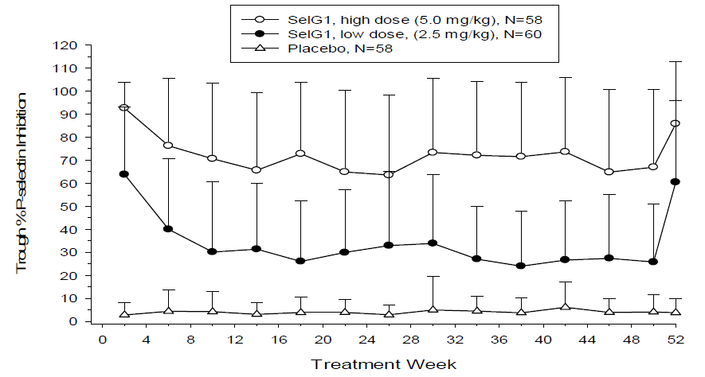

The clinical evaluator has noted that complete inhibition of binding was not achieved at the proposed 5 mg/kg dose and greater efficacy might be achieved with a higher dose. The sponsor has indicated that a 7.5 mg/kg dose regimen this will be investigated a future study. However, as the evaluator has noted, the correlation between absolute P-selectin binding inhibition and clinical outcomes in patients with sickle cell disease is not determined.

The rationale for the proposed dose for efficacy and safety investigation was from Study A2101 that demonstrated a single dose of 5 mg/kg provided complete blockade of P‑selectin for at least 28 days, and an acceptable safety profile with SelG1 at doses of 5 mg/kg and 8 mg/kg.

#### Efficacy

##### Study A2201 (SUSTAIN trial)

The main efficacy study was Study A2201, also known as the SUSTAIN trial. This was a Phase II, multicentre, randomised, placebo-controlled, double-blind study conducted over 12 months which examined the safety and efficacy of crizanlizumab at two doses (5 mg/kg and 2.5 mg/kg) in 174 patients randomised equally to the three arms, conducted between 2013 and 2016. Included patients had confirmed sickle cell disease, were between 16 and 65 years of age, and could receive concomitant hydroxycarbamide (hydroxyurea) if stable on a dose for at least 3 months prior to enrolment. Patients had a history of between 2 and 10 sickle cell pain crisis events within the 12 months prior to enrolment. Exclusion criteria were lengthy and included patients receiving chronic anticoagulation (except aspirin), on a chronic transfusion regimen or with unstable chronic disease.

Fifty patients per arm gave the study around 90% power to detect a 40% reduction in sickle cell pain crisis events using Wilcoxon’s rank sum test (alpha = 0.05). Assuming a 15% drop out rate, approximately 174 total patients were to be randomised into the study.

Patients had a median age of 28 years (range: 16 to 63 years) and the majority were female (55.1%). Most patients (91.9%) were Black or African American and most (71.2%) had a homozygous sickle haemoglobin type (HbSS). About two-thirds (62.1%) of patients were using hydroxycarbamide (hydroxyurea), and had suffered between 2 to 4 sickle cell pain crises in the prior 12 months (65.2%).

Table : Study A2201 Baseline demographics of patient population (intent to treat population)

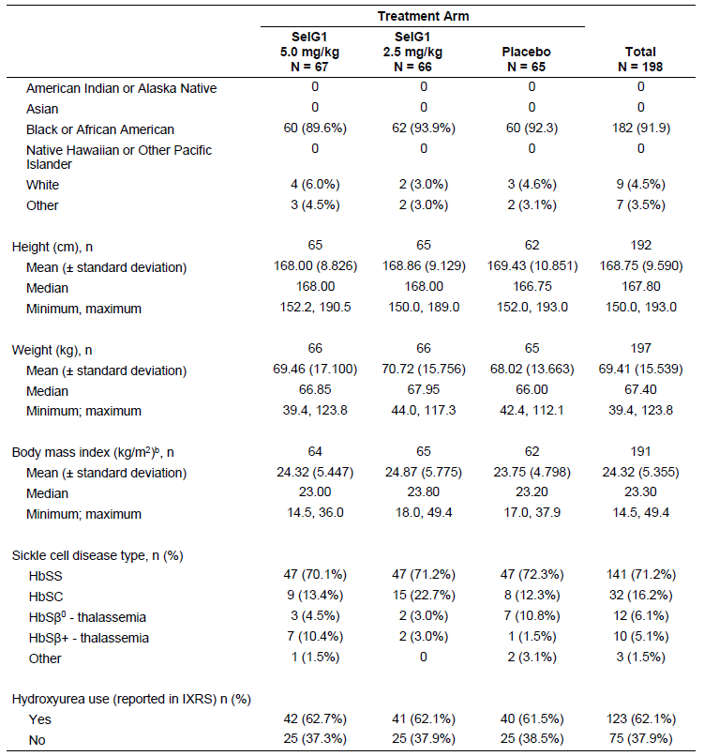

HbSβ+ = sickle haemoglobin beta+-thalassaemia; HbSβ0 = sickle haemoglobin beta0-thalassaemia; HbSC = heterozygous sickle haemoglobin (sickle cell haemoglobin C); HbSS = homozygous sickle haemoglobin (sickle cell anaemia); IXRS = interactive voice/web response system; N = number of patients; SelG1 = crizanlizumab (Adakveo) formulation used in study.

b) A patient could select more than one race.

Table : Study A2201 Hydroxycarbamide (hydroxyurea) use in patient population (intent to treat population)

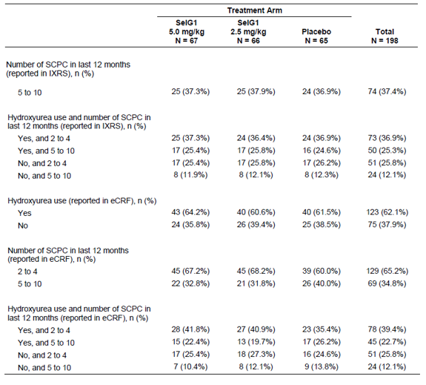

Note: hydroxyurea is an alternative name for hydroxycarbamide.

Percentages were calculated as number of patients per category/number of patients per treatment arm x 100.

eCRF = electronic case report form; IXRS = integrated interactive voice/web response system; N = number of patients; SCPC = sickle cell pain crises; SelG1 = crizanlizumab (Adakveo) formulation used in study.

Table : Study A2201 Patient disposition

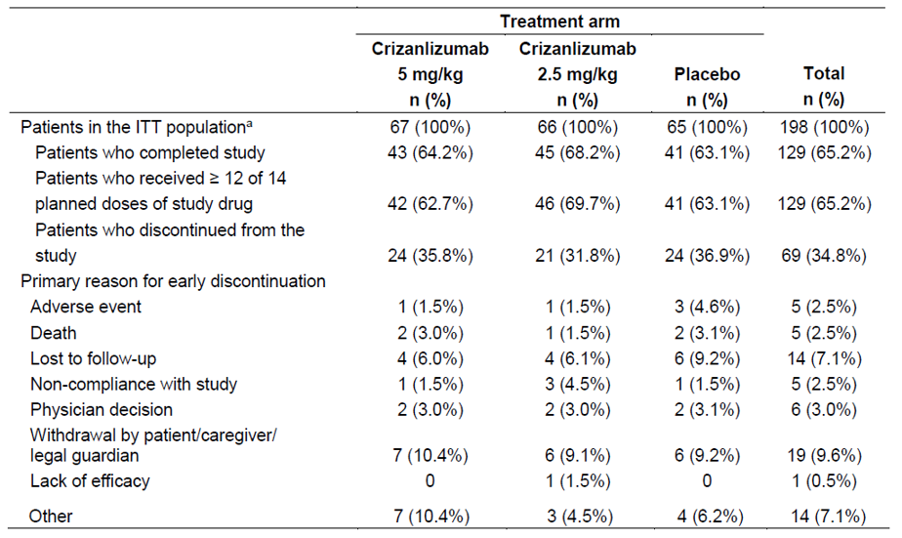

Percentages are based on the intent to treat (ITT) population.

ITT = intent to treat; mITT = modified intent to treat; N = number of patients; PP = per protocol.

a) The ITT population includes all randomised patients.

b) The mITT population includes all ITT patients who received at least one dose of study drug.

c) The safety population includes all randomised patients who received at least one dose of study drug.

d) The PP population includes all ITT patients who received at least 12 of the 14 planned study drug doses, completed a visit at least 14 days after the final dose of study drug, and had no other major protocol violations that would impact the efficacy assessments.

Major protocol violations occurred in 40.3%, 33.3% and 36.9% of the 5 mg/kg, 2.5 mg/kg and placebo groups, respectively. About one third of patients across the study did not received 12 of the 14 planned study doses, about 17% did not complete a visit at least 14 days after the final dose of study drug and around 3% did not have the requisite 2 to 10 sickle cell pain crisis events in the preceding 12 months.

The primary endpoint of the study was the annual rate of sickle cell pain crisis events per year in each arm. The key secondary endpoint was the annual rate of days hospitalised. Other secondary endpoints included time to first and second sickle cell pain crisis events, annual rate of uncomplicated sickle cell pain crisis events and annual rate of acute chest syndrome.

A sickle cell pain crisis event was defined as an acute episode of pain with no other cause than a vaso-occlusive event that required a medical facility visit and treatment with oral or parenteral narcotics, or parenteral NSAIDs (non-steroidal anti-inflammatory drugs). These events were adjudicated by a Crisis Review Committee comprised of three independent haematologists.

The Hodges Lehmann method estimator was used for the differences between the medians, median differences and the median confidence intervals of the primary endpoint. A hierarchical testing procedure was followed that assumed the higher dose would be more efficacious. Testing followed in a pre-specified manner with the primary endpoint for the lower dose. If one test of the primary endpoint was significant the key secondary endpoint would be tested. The results of the primary endpoint are tabulated below.

Table : Study A2201 Results of primary endpoint (intent to treat population)

Study A2201 Results of primary endpoint (intent to treat population)

The intent to treat (ITT) population is made up of all patients who were randomised and analysed according to the randomised treatment arm.

CI = confidence interval; HU = hydroxyurea (hydroxycarbamide); ITT = intent to treat) IXRS = integrated interactive voice/web response system; SCPC = sickle cell pain crises.

a) The annualised rate of SCPC was defined as the total number of pain crises for a patient occurring from the date of randomisation to the end date x 365 divided by the number of days during that same time period. End date = last dose date + 14 days. For patients not dosed, end date = end of study date. The SCPC were based on Crisis Review Committee adjudicated data.

b) Medians, median differences, and CIs for the median differences were estimated using Hodges-Lehmann method. The Hodges-Lehmann median is a non-parametric estimator of the location parameter.

c) P-values were from a Stratified Wilcoxon Rank Sum Test, with HU therapy (yes, no) and categorised crises history (2 to 4, 5 to 10) as recorded in the IXRS system as the strata.

The absolute difference in standard medians for the primary endpoint was 1.35 and the relative difference was 45.3%. Efficacy was not demonstrated for the crizanlizumab (Adakveo) formulation used in the study (SelG1) at the 2.5 mg/kg dose.

The evaluator noted that sensitivity analyses for the modified intent to treat, per protocol population and the population excluding patients who did not complete 6 months of study drug treatment also showed statistical significance only for the crizanlizumab 5 mg/kg versus placebo comparison. Subgroup analyses by hydroxycarbamide (hydroxyurea) use and number of episodes of sickle cell pain crisis prior to treatment, and genotype (HbSS and non HbSS) were consistent with crizanlizumab 5 mg/kg being more effective than placebo in reducing the rate of sickle cell pain crises. Assessments by age, sex and ethnicity were reported as not clear due to male patients having higher rates of Hispanic ethnicity, more frequently receiving hydroxycarbamide (hydroxyurea), having had a lower rate of vaso-occlusive crises in the year preceding start of the study, and being of younger age.

For the key secondary endpoint in the intent to treat population the Hodges-Lehmann median annual rates of days hospitalised were: 12.48 days for the crizanlizumab 5 mg/kg, 9.01 days for the 2.5 mg/kg and 13.00 days for the placebo group. The difference was not statistically significant for either of the crizanlizumab dose versus placebo comparisons, and between group differences were not statistically significant in the modified intent to treat and per protocol population analyses.

The evaluator noted no allowance was made for multiple statistical comparisons for other endpoints so considered the outcomes for descriptive purposes only. The median time to first sickle cell pain crisis was 4.07 months, 2.20 months and 1.38 months in the crizanlizumab 5 mg/kg, crizanlizumab 2.5 mg and placebo groups respectively. The annual rate of days with sickle cell pain crisis was 16.65 for the crizanlizumab 5 mg/kg group, 16.82 for the crizanlizumab 2.5 mg/kg group and 22.56 for the placebo group. There were no differences in red blood cell units transfused or in patient reported outcomes as measured by the SF-36 questionnaire.[9]

#### Safety

Safety data were derived from Study A2201 (the SUSTAIN trial) and Study A2202. Study A2202 is an ongoing, Phase II, multicentre, open-label study to assess the pharmacokinetics and pharmacodynamics of using the market formulation of crizanlizumab with or without hydroxycarbamide (hydroxyurea) in sickle-cell patients with vaso-occlusive crises. Study A2202 contributed additional safety data from an additional 45 patients from an interim analysis. Further safety information was derived from the pharmacology studies.

Overall, 175 patients with sickle cell disease received at least one infusion of crizanlizumab at doses of 2.5 mg/kg (n = 64) or 5.0 mg/kg (n = 111). In Study A2202 the mean exposure to crizanlizumab 5 mg/kg was 18.5 weeks (standard deviation: 10.43) and in Study A2201 the mean duration of exposure to crizanlizumab 5 mg/kg was 293.8 days, (standard deviation: 119.04) or approximately 42 weeks.

The distribution of adverse events in the integrated safety analysis was tabulated and is shown as Table 7. For adverse events occurring in ≥ 5% of patients in the integrated safety analysis, see Table 8.

Table : Studies A2201, A2202 Overall adverse event rates in the individual and combined studies (safety and pooled safety populations)

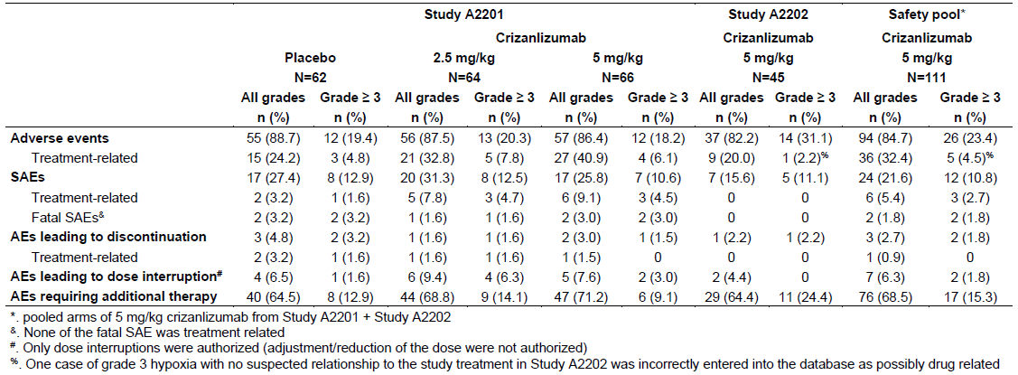

Table : Studies A2201, A2202 Adverse events reported in ≥ 5% of patients in the individual and combined studies (safety and pooled safety populations)

**Studies A2201, A2202 Adverse events reported in ≥ 5% of patients in the individual and combined studies (safety  and pooled safety populations)**

At least one suspected treatment‑related adverse event was reported for 36 crizanlizumab patients (32.4%) in the safety pool. The most frequently reported adverse events with a suspected relationship to crizanlizumab were: headache; diarrhoea; and nausea, each reported in 4 patients (3.6%). All other suspected treatment‑related adverse events with crizanlizumab were reported in 1 or 2 patients only.

Five deaths occurred among crizanlizumab patients in Study A2201: 2 in the 5 mg/kg arm (one each from sickle cell disease with vaso-occlusive crisis; and endocarditis and sepsis from a catheter/port contamination) and 1 in the 2.5 mg/kg arm (from sickle cell disease complications). One death from complications of a cardiac arrest 25 days after the last dose of study medication was reported in Study A2202.

At least one serious adverse event was reported for 24 patients (21.6%) in the safety pool. The serious adverse events reported in more than a single patient were: pneumonia (3 patients, 2.7%); pyrexia; endocarditis; sepsis; and urinary tract infection (2 patients, 1.8% each). Serious adverse events with a suspected relationship to crizanlizumab were reported for 6 patients (5.4%).

Infections as a serious adverse event were also reported in 10 (16.1%) patients given placebo in Study A2201. The most frequent serious infections in patients given placebo were pneumonia (n = 3; 4.8%) and urinary tract infection (n = 3; 4.8%).

Discontinuations from treatment occurred in 25.2% of the 5 mg/kg crizanlizumab cohort, but only a low rate of this being due to adverse events (n = 2; 1.8%) or death (n = 2; 1.8%), and none due to lack of efficacy.

##### Safety endpoints of special interest

There was no indication of drug induced liver injury in patients receiving crizanlizumab.

Serum creatinine increased in 25% and 15.2% of patients who received crizanlizumab 2.5 mg/kg and 5 mg/kg respectively in Study A2201 but none of these were Grade 3 or 4 in severity.

Worst post-baseline haematology findings are summarised in Table 9, below.

Table : Studies A2201, A2202 Worst post-baseline haematology abnormality in the individual and combined studies (safety and pooled safety populations)

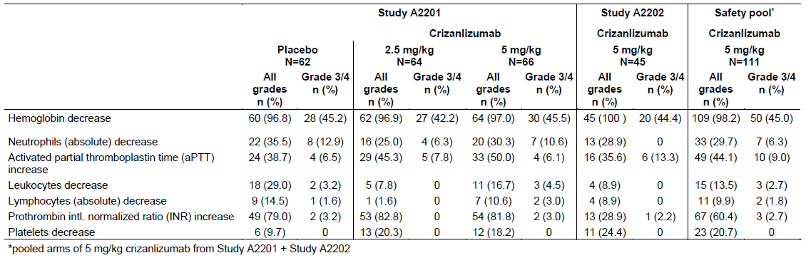

Severity as per Common Terminology Criteria for Adverse Events grades.

Interference with automated platelet counts due to clumping has been observed in patients treated with crizanlizumab, particularly in tubes containing ethylenediaminetetraacetic acid (EDTA).

Two patients suffered infusion related reactions in Study A2201, both of which were Grade 1 and fully resolved. The clinical evaluator noted an additional 4 patients in the 2.5 mg/kg dose group were reported to have infusion related reactions which, in 3 cases, were not considered to be infusion related reactions to crizanlizumab further investigation. In 2 of these hypersensitivity to another agent was considered more likely. One patient had a ‘systemic inflammatory response syndrome’ on study Day 157 that was serious. One patient experienced lower back, shoulder and groin pain immediately after the third infusion (Day 44) but, after having pre-medication on the next administration, received 10 further administrations without recurrence or need for pre-medication.

Anti-drug antibodies were transiently detected in one patient on crizanlizumab 5mg/kg, and a total of five patients (1.9%) in all studies. No impact of antidrug antibodies on the pharmacokinetics, efficacy or safety of crizanlizumab was detected.

Haemorrhage was reported in 12.6% of patients given crizanlizumab (14 patients) and 12.9% (8 patients) randomised to placebo in the integrated safety pool. Of these, 11 and 8 events occurred in the crizanlizumab 5 mg/kg and placebo arms of Study A2201 respectively. None of these adverse events were Grade 4 or led to study withdrawal, or were considered related to therapy. The only Grade 3 haemostatic adverse events were ‘haemoglobin decrease’ in 2 patients, which the evaluator notes this as likely related to underlying disease.

Dedicated cardiac QT interval studies were not performed.[10] For QTc,[11] an increase in QTc between 450 and 480 ms was reported in 9 patients on treatment, and an increase in QTc to > 500 ms in one patient. The rate of reporting QT prolongation in Study A2201 was the same between the placebo and 5 mg/kg crizanlizumab arms.

Concomitant use of hydroxycarbamide (hydroxyurea) was not associated with an increased incidence of adverse events.

#### Clinical evaluator’s recommendation

The clinical evaluator has recommended registration of crizanlizumab and has raised no issues.

### Risk management plan

The risk management plan (RMP) evaluator has reviewed EU RMP Version 1.0 dated 9 May 2019; data lock point,19 October 2018 and Version 1.3, dated 3 August 2020; data lock point 19 October 2018, SEG101A2202 4 October 2019. The RMP evaluator also reviewed the Australian-specific annex, Version 1.0 dated 5 September 2019; Version 1.1 dated 7 August 2020; and Version 1.2 dated 20 October 2020.

The summary of safety concerns and their associated risk monitoring and mitigation strategies are summarised in Table 10.[12],[13]

Table : Summary of safety concerns

|  |  |  |  |  |  |
| --- | --- | --- | --- | --- | --- |
| Summary of safety concerns | | Pharmacovigilance | | Risk minimisation | |
| **Routine** | **Additional** | **Routine** | **Additional** |
| Important identified risks | Infusion-related reactions | ✓ | ✓† | ✓ | – |
| Important potential risks | Effects on haemostasis (haemorrhage) | ✓ | ✓† | – | – |
| Immunogenicity related clinical consequences | ✓ | ✓† | ✓ | – |
| Infections | ✓ | ✓† | – | – |
| Missing information | Long-term safety | ✓ | ✓†§ | – | – |
| Use in pregnant and breast feeding women | ✓ | ✓*§ | ✓ | – |

* Pregnancy outcomes Intensive Monitoring program (PRIM) utilising follow up checklist/questionnaires; † Clinical trials; § Registry study.

#### Risk management plan evaluator’s recommendations regarding conditions of registration

The RMP evaluator suggested the following wording for the RMP-related conditions of registration:

The Adakveo EU-Risk Management Plan (RMP) (version 1.3, date 3 August 2020, DLP 19 October 2018, SEG101A2202 4 October 2019), with Australian Specific Annex (version 1.2, dated 20 October 2020), included with PM-2019-05705-1-6, and any subsequent revisions, as agreed with the TGA will be implemented in Australia.

The following wording was recommended for the periodic safety update report requirement:

An obligatory component of risk management plans is routine pharmacovigilance. Routine pharmacovigilance includes the submission of periodic safety update reports (PSURs).

Unless agreed separately between the supplier who is the recipient of the approval and the TGA, the first report must be submitted to TGA no later than 15 calendar months after the date of this approval letter. The subsequent reports must be submitted no less frequently than annually from the date of the first submitted report until the period covered by such reports is not less than three years from the date of this approval letter. The annual submission may be made up of two PSURs each covering six months. If the sponsor wishes, the six monthly reports may be submitted separately as they become available.

If the product is approved in the EU during the three years period, reports can be provided in line with the published list of EU reference dates no less frequently than annually from the date of the first submitted report until the period covered by such reports is not less than three years from the date of this approval letter.

The reports are to at least meet the requirements for periodic safety update reports as described in the EMA’s Guideline on good pharmacovigilance practices (GVP) Module VII, periodic safety update report (Rev 1), Part VII.B Structures and processes. Note that submission of a periodic safety update report does not constitute an application to vary the registration. Each report must have been prepared within ninety calendar days of the data lock point for that report.

As Adakveo is a new biological entity the evaluator recommended it should be included in the Black Triangle Scheme as a condition of registration;1 and suggested the following wording for the condition of registration:

Adakveo (crizanlizumab) is to be included in the Black Triangle Scheme. The PI and CMI for [Adakveo] must include the black triangle symbol and mandatory accompanying text for five years, which starts from the date that the sponsor notifies the TGA of supply of the product.

### Risk-benefit analysis

#### Delegate’s considerations

Sickle cell disease is a relatively rare disease in Australia. Its sequelae include episodes of severe pain with vaso-occlusive events which can be life-threatening or irreversible. There is no specific treatment registered in Australia for the condition, and not all patients would be suitable for haematopoietic stem cell transplantation. This clinical setting is considered when considering the evidence presented to support crizanlizumab.

The primary evidence supporting crizanlizumab in sickle cell disease is derived from Study A2201, and supported the claim of a reduction in sickle cell pain crisis events at the proposed 5 mg/kg dose.

The primary and secondary outcomes were favourable for crizanlizumab. While the results from the secondary endpoint, the time to first sickle cell pain crisis event, were considered for descriptive purposes rather than statistical claims by the evaluator, it is reassuring that the median time to first and second sickle cell pain crisis events were favourable for crizanlizumab 5 mg/kg over placebo.

Long term efficacy data were not included in the submission. Only 66 patients were exposed to crizanlizumab for about 42 weeks, so the durability of the efficacy results is uncertain, and benefits for overall survival, reduced duration of hospitalisation and sustained long term functioning have not been established.

The study only included patients in the age range 16 to 63 years, which may reasonably represent the adult population given the reduced life-expectancy with sickle cell disease. However, in Australia the population of sickle cell disease is likely to include children, and there are no data in patients aged < 16 years. It is therefore uncertain whether a limitation in the age range in the population in the wording of the indication is warranted given this absence of data, in particular pharmacokinetic and safety data, in this age range.

While not clear safety signal emerged in the clinical development program presented in the submission, infrequent but severe infusion reactions have been reported by the sponsor on its global website;[14] and the sponsor is requested to comment on this issue in response to the Delegate’s Overview. Regarding other safety issues, haemorrhage and infection events were similar in frequency between the crizanlizumab and placebo groups. Long term safety data were unavailable for consideration. It is noted additional data from clinical trials have been included in the EU RMP for consideration in Australia as additional pharmacovigilance activities against potential data gaps. The small numbers of patients studied to date limit the conclusions that can be drawn regarding uncommon and rare safety events.

It is noted an optimal crizanlizumab dose has not yet been defined and the clinical evaluator noted the sponsor is considering investigation of a 7.5 mg/kg dose.

Study A2201 also aimed to enrol patients with between 2 and 10 sickle cell pain crisis events in the previous year. Efficacy in patients with more active disease is uncertain, similarly the benefit risk profile is less certain in patients with much less active disease.

#### Proposed action

While the benefits and risks have been outlined in this submission, there are numerous uncertainties given the limitations of the evidence, however taking into account the clinical context and the evidence presented so far, subject to the advice from the Advisory Committee on Medicines (ACM), the preliminary view tends towards a favourable benefit risk profile for crizanlizumab for patients aged ≥ 16 years. The ACM is asked to consider the evidence presented in support of the indication as requested and to provide advice on its wording.

#### Questions for the sponsor

The sponsor provided the following responses to questions from the Delegate.

##### Question 1

***Please comment on whether the evidence to date supports the use of crizanlizumab for the proposed indication.***

The clinical efficacy of crizanlizumab in the prevention of vaso-occlusive crises has been demonstrated in the SUSTAIN trial with an acceptable safety profile providing a favourable benefit-risk balance in the targeted population of patients with sickle cell disease. In view of the high unmet medical need, the intended indication for crizanlizumab will provide a new treatment option which has demonstrated clinical benefit with a meaningful reduction of vaso-occlusive crisis frequency in patients who currently have no satisfactory therapy available.

* Study A2201 (SUSTAIN trial) supports a positive benefit-risk of crizanlizumab 5 mg/kg in patients with sickle cell disease

In Study A2201 (SUSTAIN trial), treatment with crizanlizumab 5 mg/kg resulted in a 45.3% lower median annual rate of vaso-occlusive crises compared to placebo (Hodges-Lehmann, median absolute difference of -1.01 compared with placebo, 95% CI (-2.00, 0.00)), which was statistically significant (p = 0.010) (see Table 11, below).

Table : Study A2201 (SUSTAIN trial) Main efficacy results (intent to treat population)

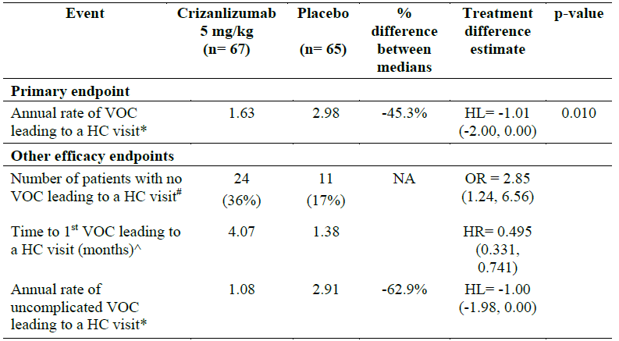

* Standard median, HL = Hodges-Lehmann absolute median difference between treatment arms (95% CI), Wilcoxon Rank Sum test; HC = healthcare; VOC = vaso-occlusive crisis

# n (%), OR = Odds Ratio (95% CI), Cochran Mantel-Haenszel test

^ Estimated Kaplan-Meier median, HR = Hazard-ratio (95% CI) calculated based on Cox regression analysis with HU therapy (yes, no), categorized crises history (2 to 4, 5 to 10), and treatment as covariates

As shown in all sensitivity analyses performed in the Summary of Clinical Efficacy, the treatment effect estimate for frequency of vaso-occlusive crises leading to healthcare visit is systematically in favour of crizanlizumab whatever the assumption done for imputation of missing data. In addition, this result on the primary efficacy endpoint is fully supported by clinically relevant effect demonstrated by (see Table 11, above):

* a greater than a two-fold increase in the proportion of patients with no vaso-occlusive crises in patients receiving crizanlizumab 5 mg/kg compared to placebo.
* a three-fold longer Kaplan-Meier estimated median time to first vaso-occlusive crises compared with placebo (see Figure 2, below).
* a reduction in the frequency of uncomplicated vaso-occlusive crises versus placebo.

Figure : Study A2201 (SUSTAIN) Kaplan-Meier estimates of time to first vaso-occlusive crisis leading to healthcare visit (intent to treat population)

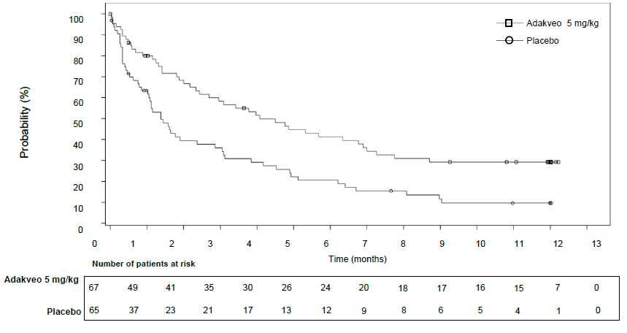

The well-tolerated safety profile of crizanlizumab was outlined in the original submission, mainly based on the results from registration Study A2201 (SUSTAIN trial).

* The efficacy results and updated safety results of the ongoing Study A2202 further supports a positive benefit-risk of crizanlizumab 5 mg/kg in patients with sickle cell disease.

The positive benefit-risk of crizanlizumab is further supported by updated safety and efficacy data from the ongoing Study A2202 with longer follow-up.

At the time of the initial market authorisation approval submission (18 December 2019), the status of the supportive Study A2202 did not allow an evaluation of efficacy. However, such preliminary efficacy data are now available and supportive of the SUSTAIN trial results, thus strengthening the level of evidence. As of the cut-off date of 4 October 2019 (providing additional 7 months of data from previous cut-off date), 45 patients were treated with crizanlizumab 5mg/kg for a median duration of 64.7 weeks (range: 6 to 90 weeks) with 80% of patients having been on treatment ≥ 54 weeks and 87% of patients still ongoing, surpassing that of the randomized Study A2201 (that is, median treatment duration of 53.9 weeks).

Descriptive statistics of the annualised rate of vaso-occlusive crises leading to a healthcare visit at Baseline and on treatment as well as the change from baseline in Study A2202 are summarised in Table 12, below. The Study A2202 protocol defines vaso-occlusive crisis leading to healthcare visits in the same way as Study A2201. There is, however, no adjudication of vaso-occlusive crises in Study A2202 (at the contrary of Study A2201), and the numbers presented below are based on the investigator-reported crises. The baseline annualised rate of vaso-occlusive crises is defined as the number of vaso-occlusive crises reported in the 12 months prior to study entry in the electronic case report form.

In patients treated with crizanlizumab 5 mg/kg, there was a median reduction from a Baseline of 0.97 vaso-occlusive crises leading to healthcare visits per year. This is consistent with the results observed in the SUSTAIN trial (median reduction from a Baseline of 1 vaso-occlusive crisis per year in the crizanlizumab 5 mg/kg arm versus 0 in the placebo arm).

As a note, these updated data from the ongoing Study A2202 has also been provided as part of responses to EMA and Swissmedic questions.

Table : Study A2202 Annualised rate of vaso-occlusive crisis events leading to healthcare visits (intent to treat population)

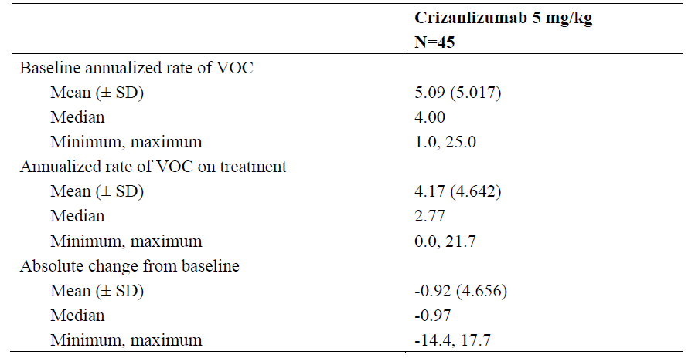

The preliminary efficacy results from Study A2202 in terms of vaso-occlusive crisis reduction from baseline are consistent with those observed in Study A2201 (SUSTAIN trial) with crizanlizumab 5 mg/kg, and further provide support evidence on the use of crizanlizumab for the proposed indication.

The updated data from the ongoing Study A2202 do not alter the safety profile of crizanlizumab.

Between the two recent Study A2202 cut-off dates, the safety profile remains similar in terms of type, frequency, and severity of adverse events. The sponsor concludes that the data from the ongoing Study A2202 continue to be supportive of a favourable safety profile for crizanlizumab. The final clinical study report for Study A2202 is expected to be available in December 2025.

Based on the data available and taking into account the clinical context, the benefit-risk profile for crizanlizumab for the prevention of vaso-occlusive crises in sickle cell disease patients is favourable.

##### Question 2

***Please comment on the wording of the indication and whether it should be restricted to the patient population represented in the clinical studies.***

Sickle cell disease is a seriously debilitating and life-threatening disease with no specific treatment registered in Australia for the condition. Vaso-occlusive crises are the hallmark of the disease, and are an acute, recurrent, and unpredictable complication of sickle cell disease that induces tissue ischemia and severe pain.

Vaso-occlusive crises are a major cause of morbidity and organ damage and the most frequent cause of emergency room visits and hospitalisations. Sickle cell disease is considered a rare disease in Australia, and crizanlizumab was granted Orphan drug designation by TGA in October 2019.

The proposed indication for crizanlizumab, that is, ‘the prevention of vaso-occlusive crises in sickle cell disease patients’, was discussed during the pre-submission meeting with the TGA on 4 September 2019 where the Delegate recommended to not include an age restriction within the indication due to the current Australian landscape, lack of treatment options for these patients, and the ongoing paediatric studies in development for crizanlizumab program. It was also discussed that the limited data in patients < 16 years could be addressed in other sections of the PI. Therefore, the use of crizanlizumab in the appropriate patient population is reflected in the proposed PI, as shown below:

Section 4.2 Dose and Method of Administration

Patients aged 16 years and over - the recommended dose of Adakveo is 5 mg/kg administered over a period of 30 minutes by intravenous (IV) infusion at Week 0, Week 2, and every 4 weeks thereafter.

Paediatric use (below 16 years) - The safety and efficacy of Adakveo in paediatric patients below the age of 16 years have not been established.

Section 4.4 Special Warnings and Precautions for Use

Paediatric use (below 16 years) - The safety and efficacy of Adakveo in paediatric patients below the age of 16 years have not been established.

Furthermore, the clinical evaluator’s assessment concludes:

‘Given the high degree of efficacy in reducing vaso-occlusive crises demonstrated with crizanlizumab and the lack of major safety issues associated with its use, [the clinical evaluator] considers the benefit-risk balance to be favourable. It should be reviewed when longer term data for both safety and efficacy and for use in paediatric populations are available’.

The proposed PI has also been revised in line with the clinical evaluator’s recommendation to remove the statement ‘Adakveo is not recommended in this age group’ in relation to patients below 16 years old. The removal of this statement in the PI is also in line with the proposed indication statement.

The sponsor is continuing the clinical development of crizanlizumab with studies in paediatric patients, including Studies B2201 and A2301.

Study B2201 is an ongoing paediatric study in patients with sickle cell disease aged 6 months to < 18 years old with a history of at least one vaso-occlusive crisis leading to healthcare visit in the past year. The study population is divided into 3 groups: Group 1 (≥ 12 to < 18 years), Group 2 (≥ 6 to < 12 years), and Group 3 (≥ 6 months to <6 years). The primary analysis report for Study B2201 Group 1 data (≥ 12 to < 18 years) will be available by September 2022.

Study A2301 is an ongoing study designed to assess efficacy and safety of two doses of crizanlizumab versus placebo in patients with sickle cell disease aged 12 years and older with history of vaso-occlusive crisis leading to healthcare visit. The primary analysis clinical study report for Study A2301 is planned for December 2025 and final analysis clinical study report in December 2029.

In conclusion, the sponsor considers the proposed PI clearly positions the use of crizanlizumab in patients over 16 years of age. To further mitigate any potential risks, the use in paediatric patients (< 16 years of age) is included as an additional pharmacovigilance activity in the Australian specific annex to the RMP. Due to the high unmet medical need in Australia and the continuing development in the paediatric population, the sponsor considers the approval of crizanlizumab for the prevention of vaso-occlusive crises in sickle cell disease patients as a major advance in treatment options for this debilitating disease. Based on the above discussion, Novartis considers the proposed indication for crizanlizumab is supported.

##### Question 3

***Please comment on the impact of the major protocol violations on the internal validity of Study A2201.***

The frequency of major protocol violations (that is, deviations) has no major impact on the internal validity of Study A2201. Indeed, patients who reported a protocol deviation with an impact or a potential impact on the primary endpoint were excluded from the per protocol population, and as described in the Summary of Clinical Efficacy, the analysis of the per protocol population supports the outcome of the primary efficacy analysis. The amount and type of relevant protocol deviations are thus not affecting the study outcome.

The per protocol population in Study A2201 was defined as all intent to treat patients who received at least 12 of the 14 planned study drug doses, completed a visit at least 14 days after final dose of study drug, and had 2 to 10 vaso-occlusive crises in the year preceding randomisation (see Figure 3, below). At least one of these criteria was not met (considered a major protocol deviation as outlined above) for 73 patients (24, 22 and 27 patients for placebo, crizanlizumab 2.5 and 5 mg/kg respectively) leading to their exclusion from the per protocol population. The primary analysis results in the per protocol population are supportive of the results in the intent to treat population, demonstrating the absence of impact of the major protocol deviations reported on the study outcome.

Figure : Study A2201 Treatment comparison of annual rate of vaso-occlusive crisis leading to healthcare visit (intent to treat and per protocol population)

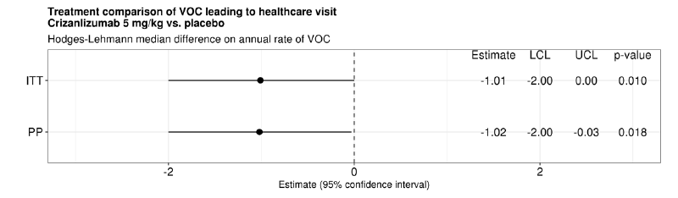

ITT = intent to treat; LCL = lower confidence limit; PP = per protocol; VOC = vaso-occlusive crisis; UCL = upper confidence limit.

##### Question 4

***It is noted that the sponsor has committed to post-marketing studies in the USA (noted by the clinical evaluator) and the EU (as outlined in the EU RMP). Please provide a tabulated brief summary of the study design, projected patient numbers, projected timelines for completion and projected timelines for provision of the study reports to the TGA for each of these studies.***

The summary of post-marketing studies for crizanlizumab and additional RMP specific measures are provided [not included in this AusPAR]. Projected timelines for submission to the TGA will be in-line with EU submission timelines, which are yet to be confirmed.

##### Question 5

***Please comment on the risk of severe infusion reaction with crizanlizumab, as identified in the sponsor’s web statement of July 2020. Are there plans for additional risk communication regarding this potential safety signal?***

Infusion-related reactions are a known side effect of monoclonal antibodies including crizanlizumab.

Infusion-related reaction is an important identified risk in the RMP and is also included in the ‘Warning and precautions’ section of the label. In addition, section ‘Adverse reactions’ of the label includes infusion related reactions and specific pain events such as back pain, arthralgia, abdominal pain, musculoskeletal chest pain, myalgia and oropharyngeal pain as adverse drug reactions. These adverse drug reactions can occur at any time during treatment including within 24 hours of infusion and might be signs and symptoms of infusion-related reactions.

As communicated previously, the sponsor has received several post-marketing reports of severe pain events occurring during/within 24 hours of infusion (infusion related reaction), and preliminary analysis of the available data has revealed that these pain events are a presentation of infusion related reactions.

The final outcome of this signal evaluation will be provided in the first periodic safety update report by the end January 2021. The sponsor is assessing wording for additional text in the proposed PI that should become available post-ACM outcome and can be proposed to the TGA at the PI negotiation stage.

#### Advisory Committee considerations[15]

The Advisory Committee on Medicines (ACM), having considered the evaluations and the Delegate’s overview, as well as the sponsor’s response to these documents, advised the following.

##### Specific advice to the Delegate

1. ***Please comment on the whether the evidence to date supports the use of crizanlizumab for the proposed indication.***

The ACM agrees that the data submitted supports the use of crizanlizumab for the proposed indication, but there are caveats in the indication. The ACM expressed concern that there are minimum safety and efficacy data on paediatric patients (< 16 years of age) to justify the sponsor’s broad indication that does not specify patient age.

The ACM noted that there are ongoing clinical studies that investigate the use of Adakveo in paediatric patients, however, the data will only be available in 2025.

1. ***Please comment on the wording of the indication and whether it should be restricted to the patient population represented in the clinical studies.***

The ACM was of the view to restrict the indication to the patient population represented in the submitted clinical studies, and to restrict use of Adakveo to sickle cell disease patients aged 16 years and older, as per the EMA approved indication for Adakveo.

The ACM agrees that Adakveo can be given as an add-on therapy to hydroxycarbamide (hydroxyurea) or as monotherapy in patients for whom hydroxycarbamide (hydroxyurea) is inappropriate or inadequate. The ACM advised to include this in the indication as per the EMA approved indication for Adakveo.

The ACM noted that there are ongoing studies that are expected to address some of the limitations in the data to date and agrees with the Delegate that these studies could be included as additional conditions of registration if Adakveo is approved.

##### Conclusion

The ACM considered this product to have an overall positive benefit-risk profile for the indication:

*Adakveo is indicated for the prevention of recurrent vaso-occlusive crises (VOCs) in sickle cell disease patients aged 16 years and older. It can be given as an add-on therapy to hydroxyurea/hydroxycarbamide (HU/HC) or as monotherapy in patients for whom HU/HC is inappropriate or inadequate.*

### Outcome

Based on a review of quality, safety and efficacy, the TGA approved the registration of Adakveo (crizanlizumab), 10 mg/mL, concentrate for solution for infusion, vial, indicated for:

*Adakveo is indicated for the prevention of recurrent vaso-occlusive crises in patients aged 16 years and older with sickle cell disease.*

#### Specific conditions of registration applying to these goods

* Adakveo (crizanlizumab) is to be included in the Black Triangle Scheme. The Product Information (PI) and Consumer Medicines Information (CMI) for Adakveo must include the black triangle symbol and mandatory accompanying text for five years, which starts from the date that the sponsor notifies the TGA of supply of the product.
* The Adakveo European Union (EU)-Risk Management Plan (RMP) (version 1.3, date 3 August 2020, data lock point (DLP) 19 October 2018, SEG101A2202 4 October 2019), with Australian Specific Annex (version 1.2, dated 20 October 2020), included with PM-2019-05705-1-6, and any subsequent revisions, as agreed with the TGA will be implemented in Australia.

An obligatory component of risk management plans is routine pharmacovigilance. Routine pharmacovigilance includes the submission of periodic safety update reports (PSURs).

Unless agreed separately between the supplier who is the recipient of the approval and the TGA, the first report must be submitted to TGA no later than 15 calendar months after the date of the approval letter. The subsequent reports must be submitted no less frequently than annually from the date of the first submitted report until the period covered by such reports is not less than three years from the date of the approval letter. The annual submission may be made up of two PSURs each covering six months. If the sponsor wishes, the six monthly reports may be submitted separately as they become available.

If the product is approved in the EU during the three years period, reports can be provided in line with the published list of EU reference dates no less frequently than annually from the date of the first submitted report until the period covered by such reports is not less than three years from the date of the approval letter.

The reports are to at least meet the requirements for PSURs as described in the European Medicines Agency’s Guideline on good pharmacovigilance practices (GVP) Module VII-periodic safety update report (Rev 1), Part VII.B Structures and processes. Note that submission of a PSUR does not constitute an application to vary the registration. Each report must have been prepared within ninety calendar days of the data lock point for that report.

* Batch release testing and compliance with Certified Product Details

All batches of Adakveo supplied in Australia must comply with the product details and specifications approved during evaluation and detailed in the Certified Product Details (CPD).

When requested by the TGA, the sponsor should be prepared to provide product samples, specified reference materials and documentary evidence to enable the TGA to conduct laboratory testing on the product. Outcomes of laboratory testing are published biannually in the TGA Database of Laboratory Testing Results http://www.tga.gov.au/ws-labs-index and periodically in testing reports on the TGA website.

* Certified Product Details

The CPD, as described in Guidance 7: Certified Product Details of the Australian Regulatory Guidelines for Prescription Medicines (ARGPM) [http://www.tga.gov.au/industry/pm-argpm-guidance-7.htm], in PDF format, for the above products should be provided upon registration of these therapeutic goods. In addition, an updated CPD should be provided when changes to finished product specifications and test methods are approved in a Category 3 application or notified through a self-assessable change.

* For all injectable products the PI must be included with the product as a package insert.

## Attachment 1. Product Information

The PI for Adakveo approved with the submission which is described in this AusPAR is at Attachment 1. For the most recent PI, please refer to the TGA website at <<https://www.tga.gov.au/product-information-pi>>.

|  |
| --- |
| Therapeutic Goods Administration |
| PO Box 100 Woden ACT 2606 Australia  Email: [info@tga.gov.au](mailto:info@tga.gov.au) Phone: 1800 020 653 Fax: 02 6232 8605  [**https://www.tga.gov.au**](https://www.tga.gov.au) |

1. The **Black Triangle Scheme** provides a simple means for practitioners and patients to identify certain types of new prescription medicines, including those being used in new ways and to encourage the reporting of adverse events associated with their use. The Black Triangle does not denote that there are known safety problems, just that the TGA is encouraging adverse event reporting to help us build up the full picture of a medicine's safety profile.
2. The mutation occurs when valine (V) replaces glutamate (E) in position 6 of the haemoglobin beta subunit, and the replacement is referred to as Glu6Val.
3. Acute chest syndrome may present as chest pain, cough, fever, hypoxia and lung infiltrates from complications such as pulmonary infarction/embolism (often from bone marrow or fat emboli) or viral/bacterial pneumonia.
4. Overview of the management and prognosis of sickle cell disease *Up to Date* accessed 26 February 2020.
5. R.K Agrawal et al. Hydroxyurea in sickle cell disease: drug review, *Indian J Hematol Blood Transfus*. 2014; 30(2): 91-96.
6. **Orphan drugs** are often developed to treat small and very specific patient populations who suffer from rare diseases and conditions. In order to facilitate orphan drug access to the Australian marketplace and help offset orphan drug development costs the TGA waives application and evaluation fees for prescription medicine registration applications if a related orphan designation is in force. A medicine may be eligible for orphan drug designation if all orphan criteria set by the TGA are met. The orphan designation application precedes the registration application and the designation is specific to the sponsor, orphan indication for which designation was granted and dosage form of the medicine.
7. International Council for Harmonisation (ICH) guideline M3 (R2): Non-clinical safety studies for the conduct of human clinical trials for pharmaceuticals.
8. International Council for Harmonisation (ICH) guideline S6 (R1): Preclinical safety evaluation of biotechnology-derived pharmaceuticals.
9. The **36-Item Short Form Health Survey** (**SF-36**) is a set of generic, coherent, and easily administered quality-of-life measures. These measures rely upon patient self-reporting and are now widely utilised by managed care organisations and in the research setting for routine monitoring and assessment of care outcomes in adult patients.
10. The **QT interval** is the time from the start of the QRS wave complex to the end of the corresponding T wave. It approximates to the time taken for ventricular depolarisation and repolarisation, that is to say, the period of ventricular systole from ventricular isovolumetric contraction to isovolumetric relaxation.
11. The **corrected QT interval** (**QTc**) estimates the QT interval at a standard heart rate. This allows comparison of QT values over time at different heart rates and improves detection of patients at increased risk of arrhythmias.
12. *Routine risk minimisation* activities may be limited to ensuring that suitable warnings are included in the product information or by careful use of labelling and packaging.

    *Routine pharmacovigilance* practices involve the following activities:

    All suspected adverse reactions that are reported to the personnel of the company are collected and collated in an accessible manner;

    Reporting to regulatory authorities;

    Continuous monitoring of the safety profiles of approved products including signal detection and updating of labelling;

    Submission of PSURs;

    Meeting other local regulatory agency requirements.
13. In the weeks preceding approval of the submission, the TGA accepted the removal of ‘Missing information: Use in paediatric patients (including children and adolescents below 16 years of age)’ from the summary of safety concerns in the ASA, as the revised indication limits use to patients aged 16 years and older. ASA V1.3, which incorporated this change, was submitted to the TGA post-approval.
14. Safety of crizanlizumab (website); Novartis AG (2020). https://www.crizanlizumab.info/
15. The ACM provides independent medical and scientific advice to the Minister for Health and the Therapeutic Goods Administration (TGA) on issues relating to the safety, quality and efficacy of medicines supplied in Australia including issues relating to pre-market and post-market functions for medicines.

    The Committee is established under Regulation 35 of the Therapeutic Goods Regulations 1990. Members are appointed by the Minister. The ACM was established in January 2017 replacing Advisory Committee on Prescription Medicines (ACPM) which was formed in January 2010. ACM encompass pre and post-market advice for medicines, following the consolidation of the previous functions of the Advisory Committee on Prescription Medicines (ACPM), the Advisory Committee on the Safety of Medicines (ACSOM) and the Advisory Committee on Non-Prescription Medicines (ACNM). Membership comprises of professionals with specific scientific, medical or clinical expertise, as well as appropriate consumer health issues relating to medicines.