|  |
| --- |
| AusPAR Attachment 2 |
| Extract from the Clinical Evaluation Report for Crizotinib  Proprietary Product Name: Xalkori |
| Sponsor: Pfizer Australia Pty Ltd |

|  |
| --- |
| **October 2017** |

About the Therapeutic Goods Administration (TGA)

* The Therapeutic Goods Administration (TGA) is part of the Australian Government Department of Health, and is responsible for regulating medicines and medical devices.
* The TGA administers the *Therapeutic Goods Act 1989* (the Act), applying a risk management approach designed to ensure therapeutic goods supplied in Australia meet acceptable standards of quality, safety and efficacy (performance), when necessary.
* The work of the TGA is based on applying scientific and clinical expertise to decision-making, to ensure that the benefits to consumers outweigh any risks associated with the use of medicines and medical devices.
* The TGA relies on the public, healthcare professionals and industry to report problems with medicines or medical devices. TGA investigates reports received by it to determine any necessary regulatory action.
* To report a problem with a medicine or medical device, please see the information on the TGA website <<https://www.tga.gov.au>>.

About the Extract from the Clinical Evaluation Report

* This document provides a more detailed evaluation of the clinical findings, extracted from the Clinical Evaluation Report (CER) prepared by the TGA. This extract does not include sections from the CER regarding product documentation or post market activities.
* The words [Information redacted], where they appear in this document, indicate that confidential information has been deleted.
* For the most recent Product Information (PI), please refer to the TGA website <<https://www.tga.gov.au/product-information-pi>>.

Copyright

© Commonwealth of Australia 2018

This work is copyright. You may reproduce the whole or part of this work in unaltered form for your own personal use or, if you are part of an organisation, for internal use within your organisation, but only if you or your organisation do not use the reproduction for any commercial purpose and retain this copyright notice and all disclaimer notices as part of that reproduction. Apart from rights to use as permitted by the *Copyright Act 1968* or allowed by this copyright notice, all other rights are reserved and you are not allowed to reproduce the whole or any part of this work in any way (electronic or otherwise) without first being given specific written permission from the Commonwealth to do so. Requests and inquiries concerning reproduction and rights are to be sent to the TGA Copyright Officer, Therapeutic Goods Administration, PO Box 100, Woden ACT 2606 or emailed to <[tga.copyright@tga.gov.au](mailto:tga.copyright@tga.gov.au)>.

Contents

List of abbreviations 5

1. Submission details 7

1.1. Submission type 7

1.2. Drug class and therapeutic indication 7

1.3. Dosage forms and strengths 7

1.4. Dosage and administration 7

2. Background 7

2.1. Information on the condition being treated 7

2.2. Current treatment options 8

2.3. Clinical rationale 8

2.4. Formulation 8

2.5. Guidance 8

2.6. Evaluator’s commentary on the background information 8

3. Contents of the clinical dossier 9

3.1. Scope of the clinical dossier 9

3.2. Paediatric data 9

3.3. Good clinical practice 9

3.4. Evaluator’s commentary on the clinical dossier 9

4. Pharmacokinetics 10

4.1. Studies providing pharmacokinetic information 10

4.2. Summary of pharmacokinetics 10

5. Pharmacodynamics 16

5.1. Summary of pharmacodynamics 16

6. Dosage selection for the pivotal studies 16

7. Clinical efficacy 17

7.1. Studies providing evaluable efficacy data 17

7.2. Pivotal or main efficacy studies for ROS1‑positive patients 17

7.3. Other efficacy studies (ALK‑positive NSCLC) 31

7.4. Analyses performed across trials: pooled & meta analyses 37

7.5. Evaluator’s conclusions on clinical efficacy 37

8. Clinical safety 37

8.1. Studies providing evaluable safety data 38

8.2. Adverse events 39

8.3. Evaluation of issues with possible regulatory impact 44

8.4. Other safety issues 53

8.5. Post marketing experience 53

8.6. EMA conclusions on clinical safety in ROS1‑positive patients 53

8.7. Evaluator’s overall conclusions on clinical safety 53

First round benefit-risk assessment 54

8.8. First round assessment of benefits 54

8.9. First round assessment of risks 55

8.10. First round assessment of benefit-risk balance 55

9. First round recommendation regarding authorisation 55

10. Clinical questions 55

10.1. Clinical questions 55

11. Second round evaluation 56

11.1. Responses to questions 56

11.2. Additional information 62

12. Second round benefit-risk assessment 70

12.1. Second round assessment of benefits 70

12.2. Second round assessment of risks 70

12.3. Second round assessment of benefit-risk balance 70

13. Second round recommendation regarding authorisation 70

14. References 70

## List of abbreviations

| Abbreviation | Meaning |
| --- | --- |
| AE | Adverse Event |
| ALK | Anaplastic Lymphoma Kinase |
| ALT | Alanine aminotransferase |
| AST | Aspartate aminotransferase |
| AUCtau | Area under the plasma concentration-time curve from time zero to time tau, the dosing interval |
| BOR | Best overall response |
| CI | Confidence interval |
| CR | Complete response |
| CTCAE | Common Terminology Criteria for Adverse Events |
| DCR | Disease control rate |
| DR | Duration of Response |
| FISH | Fluorescence in situ hybridization |
| IRR | Independent radiology review |
| MGH | Massachusetts General Hospital |
| NSCLC | Non-Small Cell Lung Cancer |
| ORR | Objective Response Rate |
| OS | Overall survival |
| PFS | Progression Free Survival |
| PR | Partial Response |
| RE | Response Evaluable |
| RECIST | Response evaluation criteria in solid tumours |
| ROS1 | ROS1 proto-oncogene receptor tyrosine kinase |
| RP2D | Recommended phase 2 dose |
| SA | Safety Analysis |
| SD | Stable disease |
| TKI | Tyrosine kinase inhibitor |
| TTP | Time to progression |
| TTR | Time to tumour response |

## Submission details

### Submission type

This is an application to extend the indications of Xalkori (crizotinib 200 mg & 250 mg) capsules.

### Drug class and therapeutic indication

Crizotinib is an anti-neoplastic agent, tyrosine kinase inhibitor (WHO ATC code L01XE16).

Crizotinib is indicated for the treatment of patients with anaplastic lymphoma kinase (ALK)‑positive advanced non-small-cell lung cancer (NSCLC).

### Dosage forms and strengths

No changes proposed.

### Dosage and administration

No changes proposed.

## Background

### Information on the condition being treated

Crizotinib is currently approved for the treatment of patients with anaplastic lymphoma kinase (ALK)–positive advanced non-small cell lung cancer (NSCLC).

The ROS1 oncogene encodes an orphan receptor tyrosine kinase related to anaplastic lymphoma kinase (ALK), along with members of the insulin-receptor family.

First discovered as the oncogene product of an avian sarcoma RNA tumour virus, ROS1 (ROS1 proto-oncogene receptor tyrosine kinase) is activated by chromosomal rearrangement (chromosome 6) in a variety of human cancers, including non–small-cell lung cancer (NSCLC), cholangiocarcinoma, gastric cancer, ovarian cancer, and glioblastoma multiforme (Birchmeier, 1986).

Rearrangement leads to fusion of a portion of ROS1 that includes the entire tyrosine kinase domain with 1 of 12 different partner proteins. The resulting ROS1 fusion kinases are constitutively activated and drive cellular transformation (Shaw et al. 2014).

ROS1 rearrangements occur in approximately 1-2% of patients with NSCLC.

As with ALK rearrangements, ROS1 rearrangements are more commonly found in patients who have never smoked or have a history of light smoking and who have histologic features of adenocarcinoma. However, at the genetic level, ALK and ROS1 rearrangements rarely occur in the same tumour, with each defining a unique molecular subgroup of NSCLC (Shaw et al. 2014).

### Current treatment options

There no other approved drugs specifically targeting the ROS1 proto-oncogene receptor tyrosine kinase.

### Clinical rationale

Several lines of evidence suggest that ROS1 may represent another therapeutic target of the ALK inhibitor crizotinib (see introduction in Shaw et al. 2014).

First, the kinase domains of ALK and ROS1 share 77% amino acid identity within the ATP-binding sites. Crizotinib binds with high affinity to both ALK and ROS1, which is consistent with this homology.

Second, in cell-based assays for inhibition of autophosphorylation of different kinase targets, both ALK and ROS1 are sensitive to crizotinib, with a half-maximal inhibitory concentration of 40 to 60 nM.

Third, in cell lines expressing ROS1 fusions, crizotinib potently inhibits ROS1 signalling and cell viability.

Finally, case reports have described marked responses to crizotinib in patients with ROS1-rearranged NSCLC (Shaw et al. 2014).

### Formulation

#### Formulation development

No proposed changes.

#### Excipients

No proposed changes.

### Guidance

* EMA/CHMP/205/95/Rev.4: Guideline on the evaluation of anticancer medicinal products in man
* CHMP/ICH/2/04: The Clinical Evaluation of QT/QTc Interval Prolongation And Pro-arrhythmic Potential For Non-Antiarrhythmic Drugs.

### Evaluator’s commentary on the background information

Lung cancer is the leading cause of cancer death worldwide (Gold 2014).

For certain patients with NSCLC, molecularly targeted therapies have transformed treatment and improved outcomes (Gold, 2014).

ROS1 proto-oncogene receptor tyrosine kinase is activated by chromosomal rearrangement. The resulting ROS1 fusion kinases are constitutively activated and drive cellular transformation (Shaw et al. 2014).

ROS1 rearrangements are uncommon, occurring in approximately 1-2% of patients with NSCLC.

This submission is a request for an extension of indications for Xalkori (crizotinib) to include ROS1‑positive advanced NSCLC

Xalkori (crizotinib) was approved by the TGA in Sept 2013 for the treatment of patients with anaplastic lymphoma kinase (ALK)-positive advanced non-small cell lung cancer (NSCLC).

The scientific rationale to target patients with ROS1‑positive NSCLC seems strong.

It is noted that the data are derived from a Phase I study.

## Contents of the clinical dossier

### Scope of the clinical dossier

The sponsor has submitted safety and efficacy data on crizotinib from 53 patients with ROS1-positive advanced NSCLC in the single arm study A8081001.

The sponsor has also submitted data from 3 post approval commitment studies

* Study A8081001 sub-study: crizotinib-rifampicin steady state drug-drug interaction
* Study A8081007 final study report and overall survival
* Study A8081014 ECG sub-study

Module 5 contained the full study reports for studies;

* A8081001[1], a phase 1 study of the safety, pharmacokinetics and pharmacodynamics of crizotinib in patients with ROS1-positive advanced NSCLC
* A8081007*, a phase 3 study of the efficacy and safety of crizotinib vs chemotherapy (pemetrexed or docetaxel) in patients with ALK‑positive advanced NSCLC.
* A8081014* a phase 3 study of the efficacy and safety of crizotinib vs pemetrexed /cisplatin or pemetrexed/carboplatin in previously untreated patients with ALK‑positive advanced NSCLC: ECG Substudy - QTc Evaluation and Safety Analysis Report.

There are also tables of pooled data from more than one study for the support of PI changes.

There is a Validation Report for the ROS1 Laboratory developed Test from MGH.

Additionally, numerous publications are included.

### Paediatric data

No paediatric data submitted.

### Good clinical practice

The sponsor provides assurances that GCP was followed.

### Evaluator’s commentary on the clinical dossier

This submission requests to extend the indications for Xalkori (crizotinib) to include treatment of patients with ROS1‑positive NSCLC. Patients with ROS1‑positive NSCLC represent approximately 1-2% of the total NSCLC population, therefore the patient numbers available for clinical trials are limited.

This submission contains data from 53 patients from study A8081001, a phase 1 study of the safety, pharmacokinetics and pharmacodynamics of crizotinib in patients with ROS1-positive advanced NSCLC. The endpoint is objective response rate.

While this is a small dataset on which to base an evaluation, it is probably not unreasonable given the scarcity of eligible patients to study.

In addition the submission contains an update on overall survival of patients in StudyA8081007 a phase 3 study (crizotinib vs pemetrexed or docetaxel) which formed the basis of the original approval for crizotinib in patients with ALK‑positive advanced NSCLC.

There is a summary of clinical safety based on study 1001.

Two specialised sub-studies (DDI with rifampicin and some extra ECG data) are also included.

Module 1 contains a copy of the EMA evaluation report and reference is made to this report where appropriate in this evaluation, particularly question asked, responses and the conclusions.

There is an updated RMP and a draft therapeutic management guide (added in February 2017).

The organisation of the dossier was adequate.

## Pharmacokinetics

### Studies providing pharmacokinetic information

This submission contains a CSR for a drug-drug interaction sub-study (Study 1001) of crizotinib with rifampicin, a strong cytochrome P450 (CYP) 3A inducer.

Pre-dose sparse PK samples (PKP‑Ctrougth) were collected in 53 patients with ROS1-positive NSCLC in Study 1001.

Table 1: Submitted pharmacokinetic studies.

| PK topic | Subtopic | Study ID | * | Synopsis |
| --- | --- | --- | --- | --- |
| PK interactions | Rifampicin | A8081001 substudy | DDI | Study 1001 |
| Pre-dose plasma levels | Crizotinib Ctrough | A8081001 ROS1‑positive NSCLC cohort | Crizotinib Ctrough | Study 1001 |

### Summary of pharmacokinetics

#### Physicochemical characteristics of the active substance

No proposed changes.

#### Pharmacokinetics in healthy subjects

**Comment**: As there is some extra PK data included in this submission, the evaluator has provided a brief overview of the pharmacokinetics of crizotinib for reference (Extract from Australian PI).

##### Absorption

Following oral single dose administration in the fasted state, crizotinib is absorbed with median time to achieve peak concentrations of 4 to 6 hours. Following crizotinib 250 mg twice daily, steady state was reached within 15 days and remained stable with a median accumulation ratio of 4.8.

##### Bioavailability

The absolute bioavailability of crizotinib was determined to be 43% (range 32% to 66%) following the administration of a single 250 mg oral dose.

A high-fat meal reduced crizotinib area-under-the-plasma-concentration versus time curve from time zero to infinity (AUCinf) and maximum observed plasma concentration (Cmax) by approximately 14% when a 250 mg single dose was given to healthy volunteers. Crizotinib can be administered with or without food.

##### Distribution

The geometric mean volume of distribution (Vss) of crizotinib was 1,772 L following intravenous administration of a 50 mg dose, indicating extensive distribution into tissues from the plasma.

Binding of crizotinib to human plasma proteins in vitro is 91%; in the in vitro study, there was variability in the fraction of unbound crizotinib at a clinically relevant concentration. In vitro studies suggest that crizotinib is a substrate for P-glycoprotein (P-gp). The blood-to-plasma concentration ratio is approximately 1.

##### Metabolism

In vitro studies demonstrated that CYP3A4/5 were the major enzymes involved in the metabolic clearance of crizotinib. The primary metabolic pathways in humans were oxidation of the piperidine ring to crizotinib lactam and O-dealkylation, with subsequent Phase 2 conjugation of O-dealkylated metabolites.

In vitro studies in human liver microsomes demonstrated that crizotinib is a time-dependent inhibitor of CYP2B6 and CYP3A.

##### Excretion

Following single doses of crizotinib, the apparent plasma terminal half-life of crizotinib was 42 hours in patients.

Following the administration of a single 250 mg radiolabelled crizotinib dose to healthy subjects, 63% and 22% of the administered dose was recovered in faeces and urine, respectively.

Unchanged crizotinib represented approximately 53% and 2.3% of the administered dose in faeces and urine, respectively.

The mean apparent clearance (CL/F) of crizotinib was lower at steady state (60 L/hr) after 250 mg twice daily than that after a single 250 mg oral dose (100 L/hr), which was likely due to auto-inhibition of CYP3A by crizotinib after multiple dosing.

##### Cardiac electrophysiology

The QT interval prolongation potential of crizotinib was assessed in all patients who received crizotinib 250 mg twice daily. Serial ECGs in triplicate were collected following a single dose and at steady state to evaluate the effect of crizotinib on QT intervals. Thirty four of 1619 patients (2.1%) with at least 1 post baseline ECG assessment were found to have QTcF (corrected QT by the Fridericia method) ≥500 msec and 79 of 1585 patients (5.0%) with a baseline and at least 1 post baseline ECG assessment had an increase from baseline QTcF ≥60 msec by automated machine-read evaluation of ECG (see PRECAUTIONS - QT Interval Prolongation).

An ECG substudy using blinded manual ECG measurements was conducted in 52 ALK‑positive NSCLC patients who received crizotinib 250 mg twice daily. A central tendency analysis indicated that a QTc effect ≥20 msec can be excluded. A pharmacokinetic/ pharmacodynamic analysis suggested a relationship between crizotinib plasma concentration and QTc. In addition, a decrease in heart rate was found to be associated with increasing crizotinib plasma concentration (see PRECAUTIONS - QT Interval Prolongation).

#### Pharmacokinetic interactions

The following statement appears in the current PI:

*Agents that may decrease crizotinib plasma concentrations - Coadministration of Crizotinib and CYP3A Inducers Coadministration of a single 250 mg crizotinib dose with rifampicin (600 mg once daily), a strong CYP3A4 inducer, resulted in 82% and 69% decreases in crizotinib AUCinf and Cmax, respectively, compared to when crizotinib was given alone. Coadministration of crizotinib with strong CYP3A inducers may decrease crizotinib plasma concentrations. The concurrent use of strong CYP3A inducers, including but not limited to carbamazepine, phenobarbital, phenytoin, rifabutin, rifampicin and St. John’s wort, should be avoided.*

*However, the effect of CYP3A inducers on steady-state crizotinib exposure has not been established.*

##### Study 1001: sub-study rifampicin DDI

###### Results

There were 15 patients in the safety population, who received at least one dose of crizotinib or rifampicin. Of these 15 patients, 12 were included in the PK concentration population with 10 patients included in the PK parameter population; among the 10 patients in the PK parameter population, all were included in the analysis for Treatment Period A and 7 patients were included in the analysis for Treatment Period B. The 3 of 10 patients were excluded from Treatment Period B because they did not receive adequate dosing of either crizotinib or rifampicin prior to PK sampling. Following multiple oral doses of crizotinib 250 mg BID from Cycle 1 Day 1 (C1D1) to C1D15, crizotinib exposures as measured by geometric mean AUCtau and Cmax on C1D15 were 3110 ng·hr/mL and 326.4 ng/mL, respectively. The geometric mean Ctrough of crizotinib on C1D15 was 251.7 ng/mL.

Following co-administration of multiple oral doses of crizotinib 250 mg BID and rifampicin 600 mg QD from C1D16 to C2D1, crizotinib concentrations appeared to reach a reduced plateau within 10 days after co-administration of rifampicin. Exposures as measured by geometric mean AUCtau and Cmax on C2D1 were 509.6 ng·hr/mL and 71.53 ng/mL, respectively. The mean Ctrough of crizotinib on C2D1 was 26.67 ng/mL.

Table 2: Study 1001 DDI crizotinib/rifampicin PK parameters

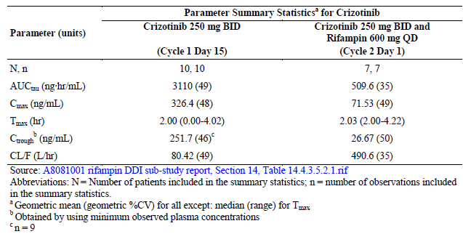

Co-administration of crizotinib with rifampicin decreased crizotinib AUCtau and Cmax by approximately 84% and 79%, respectively. Ratios of the adjusted geometric means for crizotinib AUCtau and Cmax, expressed as a percentage, were 15.57% (90% CI: 10.89, 22.26) and 20.64% (90% CI: 14.59, 29.18), respectively, following administration of crizotinib with rifampicin relative to crizotinib administrated alone.

Table 3: Study 1001 Summary of Treatment Comparisons for Crizotinib PK Parameters

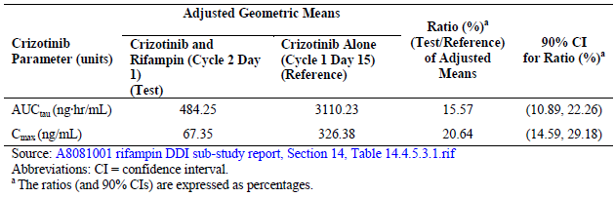

**Comment**: Data from a sub-study of Study 1001 was included in the submission to examine the crizotinib drug-drug interaction with rifampicin, a strong CYP3A4 inducer, at steady state.

Co-administration of crizotinib 250 mg BID with rifampicin 600mg QD decreased steady-state crizotinib AUC and Cmax by approx. 84% and 79%, respectively.

The DDI demonstrated under steady state conditions is very similar to that found after a single dose.

The following statement is proposed to be included to the PI, it is a minor amendment to the current statement. “Coadministration of crizotinib (250 mg twice daily) with rifampicin (600 mg once daily), a strong CYP3A4 inducer, resulted in 84% and 79% decreases in crizotinib steady-state AUCtau and Cmax, respectively, compared to when crizotinib was given alone. Coadministration of crizotinib with strong CYP3A inducers may decrease crizotinib plasma concentrations. The concurrent use of strong CYP3A inducers, including but not limited to carbamazepine, phenobarbital, phenytoin, rifabutin, rifampicin and St. John’s wort, should be avoided.”

The authors state that “co-administration of crizotinib with weak or moderate inducers is not expected to result in a clinically meaningful decrease in crizotinib exposure.”

The submitted data support the inclusion of these modified statements in the PI.

#### Pharmacokinetics in patients with ROS1‑positive advanced NSCLC

The following account is a summary from the Study 1001 body of report CSR.

A total of 53 patients with ROS1-positive NSCLC who were treated with crizotinib and had at least 1 measured plasma concentration of crizotinib on-treatment were included in PKP_C population. Of these 53 patients, 46 had at least 1 pre-dose plasma concentration (Ctrough) of crizotinib and were included in the PKP_Ctrough population.

There were 19 male and 27 female patients in the PKP_Ctrough population. Twenty-five patients were non-Asian (24 were White and 1 was Black) and 21 patients were Asian (including 13 Korean, 4 Chinese and 4 Other Asians). The mean (SD) age was 53.6 (13.40) years, the mean (SD) height was 166.5 (10.00) cm, and the mean (SD) weight was 71.2 (16.50) kg.

Crizotinib levels were determined using a validated high-performance liquid chromatography mass spectrometry method. The mean values (%CV) of crizotinib pre-dose concentrations (Ctrough) over time are presented. Crizotinib Ctrough appeared to reach steady state by 15 days after repeated oral administration of crizotinib, which is consistent with the terminal half-life of crizotinib of 42 hours. For patients from the ROS1-positive NSCLC cohort, the mean values of Ctrough ranged from 255 to 381 ng/mL over the treatment period of Days 15 to 113.

Table 4: Study 1001 Pre-dose Concentrations (Ctrough) of Crizotinib (ROS1-Positive NSCLC)

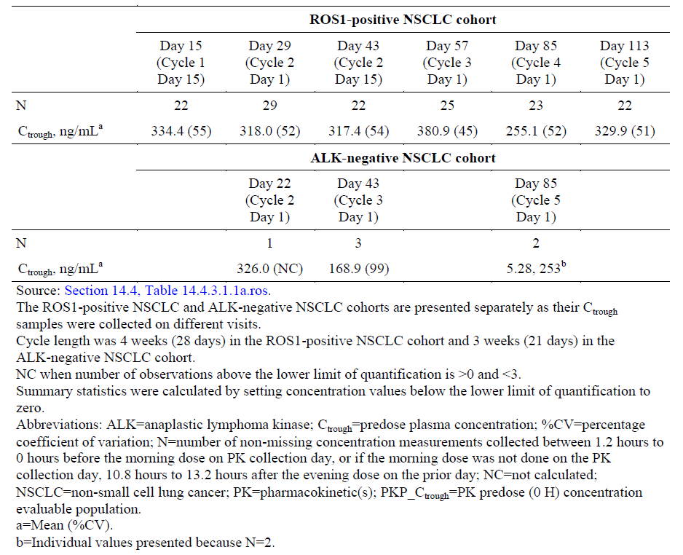

For patients from the ALK-negative NSCLC cohort, Ctrough values varied over the treatment period due to the limited number of observations at each visit.

The geometric mean of crizotinib Ctrough,ss was 263 ng/mL with an overall variability of 55%. Asian patients generally had higher Ctrough,ss than non-Asian patients.

Table 5: Study 1001 Mean Steady State Pre-dose Concentrations (Ctrough,ss) of Crizotinib (Asian, Non-Asian and Overall) (ROS1-Positive NSCLC)

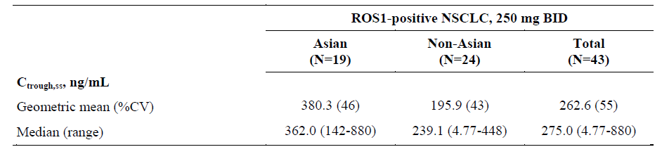

##### Additional information EMA report

The EMA noted the higher variability in crizotinib trough concentrations in ROS1‑positive patients compared to ALK‑positive patients and asked the Sponsor if there are any potential covariates that may explain the outliers.

In their response the Sponsor noted the similar mean Ctrough value (263ng/mL v 276ng/mL) in ROS1‑positive patients and ALK‑positive patients respectively.

They suggested the relatively small sample size (n=43) may have contributed to the variability and a few very high and low values.

The Sponsor analysed two patients with very low values and two patients with high values.

Potential covariates were evaluated, however only Asian ethnicity was identified as a covariate.

##### Summary of PK in ROS1 patients

In ROS1-positive NSCLC patients, crizotinib Ctrough over time showed that steady state was reached within 15 days after administration of 250 mg BID dose.

The geometric mean of crizotinib Ctrough,ss was 263 ng/mL, with a variability of 55%. Asian patients generally had higher Ctrough,ss than non-Asian patients.

**Comment**: Overall, crizotinib concentrations were comparable between patients with ROS1-positive advanced NSCLC and patients with ALK-positive advanced NSCLC in Study 1001.

## Pharmacodynamics

Tumour tissue was obtained to confirm the ROS1 gene rearrangement as part of the inclusion criteria for Study 1001.

In Study 1001 an analysis was presented on the relationship of Objective Response Rate (Best Overall Response) and the mean percentage of ROS1‑positive cells.

There was no apparent relationship found.

QT prolongation study is discussed under safety.

### Summary of pharmacodynamics

Extract from Australian PI:

*Crizotinib is an inhibitor of the ALK receptor tyrosine kinase (RTK) and its oncogenic variants (i.e., ALK fusion events). Crizotinib is also an inhibitor of the Hepatocyte Growth Factor Receptor (HGFR, c-Met), ROS1 (c-ros) and Recepteur d’Origine Nantais (RON) RTKs.*

*Crizotinib demonstrated concentration-dependent inhibition of the kinase activity of ALK, ROS1 and c-Met in biochemical assays and inhibited phosphorylation and modulated kinase dependent phenotypes in cell-based assays. Crizotinib demonstrated growth inhibitory activity and induced apoptosis in tumour cell lines exhibiting ALK fusion events (including echinoderm microtubule-associated protein-like 4-ALK [EML4-ALK] and nucleophosmin- ALK [NPM-ALK]) or ROS1 fusion events.*

*Crizotinib demonstrated anti-tumour activity in mice bearing tumour xenografts that expressed ALK fusion proteins. The anti-tumour efficacy of crizotinib was dose-dependent and correlated to pharmacodynamic inhibition of phosphorylation of ALK fusion proteins (including EML4- ALK and NPM-ALK) in tumours in vivo.*

## Dosage selection for the pivotal studies

No new dose finding studies submitted.

## Clinical efficacy

This submission proposes to extend the indications of Xalkori (crizotinib) to include treatment of patients with ROS1‑positive advanced NSCLC.

It is also proposed to update the Xalkori PI with the final overall survival data from study 1007.

### Studies providing evaluable efficacy data

The dossier contained a report on one study (1001) providing data on the use of crizotinib in patients with ROS1‑positive advanced NSCLC and updated overall survival and a safety summary from a previously evaluated study, Study 1007 in patients with ALK‑positive NSCLC.

### Pivotal or main efficacy studies for ROS1‑positive patients

###### Study ID A8081001 (Study1001)

**Comment**: This study (1001) provides safety and efficacy data on the use of crizotinib for the cohort of NSCLC patients with the ROS1 gene rearrangement, which is the main focus of the current submission which proposes to extend the indications of crizotinib (Xalkori).

#### Study design, objectives, locations and dates

###### Design

Study 1001 is an ongoing Phase 1, open-label, multicentre study evaluating dose escalation, safety, pharmacodynamics, PK, and anti-tumour activity of crizotinib administered as a single oral agent in patients with advanced NSCLC or other malignancies. A preliminary clinical study report (CSR) (data snapshot on 01 November 2010) was generated to support the initial marketing applications for crizotinib.

The maximum tolerated dose (MTD) and recommended phase 2 dose (RP2D) of crizotinib were determined to be 250 mg BID.

As information about the safety and anti-tumour activity of crizotinib emerged, additional cohorts and sub-studies were introduced into the study, including 1 cohort of patients with ROS1-positive NSCLC.

Patients with ROS1-positive NSCLC or with ALK-negative NSCLC were to be administered crizotinib orally at a starting dose of 250 mg BID. This dose was chosen as it was identified as the MTD and RP2D, as described above.

This CSR presents data for 53 patients with ROS1-positive NSCLC in Study 1001, based on a data cut-off date of 30 November 2014.

Patients were enrolled from 8 centres in 3 countries (Australia and South Korea [Republic of Korea], 1 centre each; United States, 6 centres).

###### Conduct of the study

The original study protocol (dated 05 December 2005) was amended 20 times. The ROS1-positive NSCLC cohort and ALK-negative NSCLC cohort were introduced by Amendment 12 (dated 09 November 2009) and Amendment 17 (dated 27 September 2011), respectively.

###### Objectives

The objectives of the overall study applicable to patients with ROS1-positive NSCLC were as follows:

1. Determine the safety profile of crizotinib.
2. Document any evidence of anti-tumour activity of crizotinib.
3. Determine PK profile of crizotinib following oral administration.

#### Inclusion and exclusion criteria

###### Inclusion criteria

Patients included in the ROS1-positive NSCLC cohort had to meet all of the following inclusion criteria to be eligible for enrolment into the study:

1. Histologically confirmed NSCLC positive for chromosomal translocations at ROS gene including but not limited to CD74-ROS and SLC34A2-ROS fusion events.
2. Solid tumours were required to have measurable disease as per RECIST version 1.0. However, patients whose tumours were not measurable were allowed to enter the study if approved by the Sponsor. Target lesions that had previously been irradiated were not considered measurable (lesion) unless an increase in size was observed following completion of radiation therapy.
3. Able, in the investigator’s opinion, to receive at least 2 cycles of treatment.
4. Female or male, 18 years of age or older.
5. Eastern Cooperative Oncology Group (ECOG) performance status (PS) 0 or 1. However, patients with an ECOG PS of 2 were allowed to enter the study upon agreement between the investigator and Sponsor.
6. Resolution of all acute toxic effects of prior therapy or surgical procedures to Grade ≤1 (except alopecia).
7. Adequate organ function as defined by the following criteria:

* Serum aspartate transaminase (AST) and serum alanine transaminase (ALT) ≤2.5 x upper limit of normal (ULN), or AST and ALT ≤5 x ULN if liver function abnormalities were due to underlying malignancy;
* Total serum bilirubin ≤1.5 x ULN (except for patients with documented Gilbert’s syndrome; however, enrolment had to be approved by the Sponsor);
* Absolute neutrophil count (ANC) ≥1500/μL;
* Platelets ≥30,000/μL; ≥100,000/μL prior to IRB/EC approval of Protocol Amendment 16
* Haemoglobin ≥9.0 g/dL;
* Serum creatinine ≤2.0 x ULN.

For the ALK-negative NSCLC cohort, inclusion criteria were the same as for the ROS1-positive NSCLC cohort, except for Criterion 1, which was as follows:

Histologically or cytologically proven diagnosis of NSCLC that was locally advanced or metastatic, and of the adenocarcinoma subtype (including mixed adeno-squamous histology). Patients were to have received at least 1 prior chemotherapy regimen.

Patients were to have been determined to be ALK-negative by the central laboratory but may have been pre-screened and shown to have ALK‑negative NSCLC by a local test. All patients had to be non-smokers, ex-smokers, or light smokers (≤10 pack-years). Note that light smokers were permitted only after IRB/EC approval of Protocol Amendment 13.

**Comment**: For patients in the ROS1-positive NSCLC cohort, ROS1 rearrangement testing was performed centrally by Massachusetts General Hospital (MGH) or by a local laboratory using a ROS1 Fluorescence in situ Hybridisation (FISH) assay or reverse transcriptase polymerase chain reaction (RT-PCR).

A validation report of the MGH laboratory developed test utilising FISH probes targeted against the ROS1 gene was submitted as part of the dossier. The FISH probes detect the ROS1 gene in interphase cells of formalin fixed paraffin embedded tissue samples.

It is important to know how ROS1‑positive NSCLC patients will be identified in clinical practice in Australia.

###### Exclusion criteria

Patients in both the ROS1-positive and ALK-negative NSCLC cohorts presenting with any of the following were not to be included in the study:

1. Major surgery, radiation therapy, or systemic anti-cancer therapy within 2 weeks of starting study drug.
2. Prior high-dose chemotherapy requiring hematopoietic stem cell rescue.
3. Current treatment on another clinical study.
4. Brain metastases, spinal cord compression, carcinomatous meningitis, or leptomeningeal disease unless appropriately treated and neurologically stable for at least 2 weeks and not taking medications contraindicated in Exclusion Criteria 10-12.
5. Any of the following within the 6 months prior to starting study drug: myocardial infarction, severe/unstable angina, coronary/peripheral artery bypass graft, congestive heart failure, cerebrovascular accident including transient ischemic attack, or pulmonary embolus. However, upon agreement between the investigator and Sponsor, the 6-month post-event-free period for a patient with a pulmonary embolus could be waived if due to advanced cancer. Appropriate treatment with anticoagulants was permitted.
6. Ongoing cardiac dysrhythmias of NCI CTCAE Grade ≥2, uncontrolled atrial fibrillation of any grade, or corrected QT interval (QTc) interval >470 msec. Note, atrial fibrillation was restricted to uncontrolled atrial fibrillation after IRB/EC approval of Protocol Amendment 13.
7. Hypertension that could not be controlled by medications (>150/100 mmHg despite optimal medical therapy).
8. Pregnancy or breastfeeding. Female patients were required to be surgically sterile or postmenopausal, or were to agree to use effective contraception during the period of therapy. All female patients with reproductive potential were to have a negative pregnancy test (serum or urine) prior to enrolment. Male patients were to be surgically sterile or were to agree to use effective contraception during the period of therapy.

The definition of effective contraception was to be based on the judgment of the principal investigator or a designated associate.

1. Other severe acute or chronic medical or psychiatric condition or laboratory abnormality that would impart, in the judgment of the investigator and/or Sponsor, excess risk associated with study participation or study drug administration, which would have made the patient inappropriate for entry into this study.
2. Use of drugs that are known strong cytochrome P450 (CYP)3A4 inhibitors within 7 days prior to the first dose of crizotinib, including but not limited to atazanavir, clarithromycin, ketoconazole, itraconazole, telithromycin, troleandomycin, ritonavir, indinavir, nelfinavir, saquinavir, nefazodone, and voriconazole. Patients were to avoid consuming grapefruits or grapefruit juice. The topical use of these medications (if applicable), such as 2% ketoconazole cream, was to be allowed. All concomitant medication was to be approved by the Sponsor.
3. Use of drugs that are known strong CYP3A4 inducers within 12 days prior to the first dose of crizotinib, including but not limited to carbamazepine, phenobarbital, phenytoin, rifabutin, rifampicin, and St. John’s wort. All concomitant medication was to be approved by the Sponsor.
4. Concurrent use of drugs that are CYP3A4 substrates with narrow therapeutic indices, including but not limited to dihydroergotamine, ergotamine, pimozide, astemizole*, cisapride*, and terfenadine* (*withdrawn from United States market). All concomitant medication was to be approved by the Sponsor.

#### Study treatments

Crizotinib was taken orally at a starting dose of 250 mg BID.

#### Efficacy variables and outcomes

Screening/baseline imaging assessments were to include CT or MRI scans of the chest, abdomen, and pelvis. Brain scans and bone scans were to be performed at baseline if disease was suspected.

Post-baseline tumour assessments were only to be performed, every other cycle (8 weeks), to assess areas of known disease unless other sites of disease were suspected.

Disease response was categorized using RECIST (version 1.0 for the ROS1-positive NSCLC cohort and version 1.1 for the 3 patients with ROS1-positive NSCLC in the ALK-negative NSCLC cohort).

Tumour assessments were to be performed by the investigators every second cycle (every 8 weeks in the ROS1-positive NSCLC cohort and every 6 weeks in the ALK-negative NSCLC cohort) until RECIST defined disease progression. Only areas of known disease were to be assessed unless other sites of disease were suspected.

Once a patient had completed 15 cycles, tumour assessments could have been performed every 4 cycles (every 16 weeks in the ROS1-positive NSCLC cohort and every 12 weeks in the ALK-negative NSCLC cohort).

All tumour responses were to be confirmed at least 4 weeks after the initial response.

The efficacy endpoint was objective response rate (ORR), assessed by the investigator.

All available tumour scans for patients in the ROS1-positive NSCLC cohort were to be retrospectively reviewed by an independent radiology laboratory (p57 of CSR).

Follow-up survival data were to be collected at least every 3 months after discontinuing crizotinib for a minimum of 1 year after the final dose.

#### Randomisation and blinding methods

This is a single arm, open label study, so no blinding or randomisation.

#### Analysis populations

The following analysis populations were planned for the patients with ROS1-positive NSCLC, including the 3 patients from the ALK-negative NSCLC cohort who were retrospectively determined to have ROS1-positive NSCLC (tumour biopsies were analysed by FISH at MGH).

*Safety Analysis Population*

The Safety Analysis (SA) population was defined as all enrolled patients who received at least 1 dose of crizotinib from Cycle 1 Day 1.

This was the primary population for all standard analyses and safety analyses

*Response-Evaluable (RE) Population*

The RE population was defined as all patients in the SA population who had an adequate baseline disease assessment.

In addition, for any interim reporting of the data, patients also needed to meet 1 of the following 2 criteria:

* Had at least 1 post-baseline disease assessment at least 6 weeks from first dose.
* Withdrew from the study or experienced PD/death at any time on-study.

#### Sample size

To evaluate the anti-tumour activity of crizotinib in patients with ROS1-positive NSCLC, approximately 30 patients were originally planned to be enrolled in the ROS1-positive NSCLC cohort.

Twenty seven (27) evaluable patients were required to achieve a power of at least 85% to test the null hypothesis that the ORR of crizotinib would be 10% or less, vs the alternative hypothesis that the ORR would be more than 10% assuming an alternative target rate of 0.30, at a 1-sided alpha level of 0.05 and with the use of a single-stage design. The null hypothesis would be rejected if greater than or equal to 6 objective responses were observed among the 27 evaluable patients.

Enrolment of 30 patients allowed for adjustment for a 10% loss of patients who may not have been evaluable for response.

As of 19 April 2012, 8 confirmed objective responses (CR, partial response [PR]) were observed in a total of 14 response evaluable patients enrolled in the ROS1-positive NSCLC cohort. Based on the number of confirmed objective responses observed, the null hypothesis was rejected.

As recorded in the Note to File dated 12 November 2012, and in Protocol Amendment 20, the sample size of the ROS1-positive NSCLC cohort was increased to a total of 50 patients in order to provide a more robust estimation of anti-tumour activity in this patient population.

#### Additional information from EMA report

The EMA requested that the sponsor clarify the temporal sequence of events leading to a sample size increase.

The Sponsor stated the sample size of the ROS1-positive NSCLC cohort was increased from 30 patients to a total of 50 patients as recorded in the Note to File dated 12 November 2012 in order to obtain additional data that would allow a more robust estimation of efficacy in this patient population.

**Comment**: There was a considerable delay in writing a formal protocol amendment.

#### Statistical methods

###### Efficacy endpoint

The point estimate of the objective response rate (ORR) will be provided along with the corresponding exact 2-sided 95% confidence interval using the exact method based on the F-distribution. The best overall response will also be summarised.

###### Determination of sample size

To evaluate the anti-tumour activity of crizotinib in patients with ROS1-positive NSCLC, approximately 30 patients were originally planned to be enrolled in the ROS1-positive NSCLC cohort.

Twenty seven (27) evaluable patients were required to achieve a power of at least 85% to test the null hypothesis that the ORR of crizotinib would be 10% or less, vs the alternative hypothesis that the ORR would be more than 10% assuming an alternative target rate of 0.30, at a 1-sided alpha level of 0.05 and with the use of a single-stage design. The null hypothesis would be rejected if greater than or equal to 6 objective responses were observed among the 27 evaluable patients.

Enrolment of 30 patients allowed for adjustment for a 10% loss of patients who may not have been evaluable for response.

As of 19 April 2012, 8 confirmed objective responses (CR, partial response [PR]) were observed in a total of 14 response evaluable patients enrolled in the ROS1-positive NSCLC cohort. Based on the number of confirmed objective responses observed, the null hypothesis was rejected. As recorded in the Note to File dated 12 November 2012, and in Protocol Amendment 20, the sample size of the ROS1-positive NSCLC cohort was increased to a total of 50 patients in order to provide a more robust estimation of anti-tumour activity in this patient population.

##### Participant flow

A total of 53 patients with ROS1-positive NSCLC received at least 1 dose of crizotinib on Day 1 of Cycle 1, including 50 patients in the ROS1-positive NSCLC cohort and 3 patients in the ALK-negative NSCLC cohort.

All enrolled patients (assigned to study treatment) have received at least 1 dose of crizotinib, therefore the all enrolled patient population is the same as the SA population.

A summary of patient disposition for the SA population is presented in Table 6.

At the data cut-off date for this report, crizotinib treatment was ongoing for 25 (47.2%) patients, while 28 (52.8%) patients had discontinued from study treatment. The most common reason for discontinuation was PD, observed for 13 (24.5%) patients.

Table 6: Study 1001 Patient Disposition at End of Treatment (ROS1-Positive NSCLC) – Safety Analysis Population

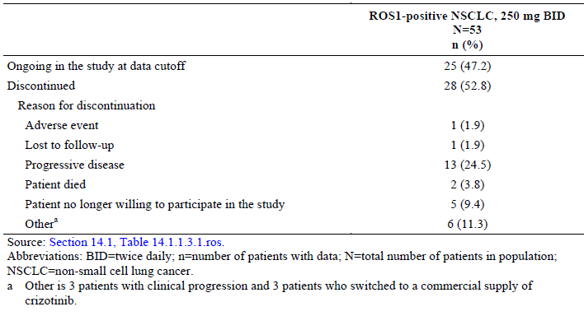

##### Major protocol violations/deviations

Major protocol deviations are summarised by category.

The sponsor states “A formal acknowledgment was made by the study team that deviations were reviewed and GCP compliance was maintained”.

Table 7: Study 1001 Protocol Deviations

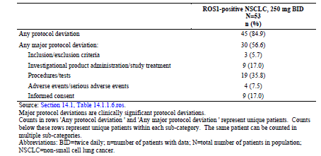

##### Baseline data

A summary of demographics and other baseline characteristics for the SA population is below.

Patients had a median (range) age of 55 (25 to 81) years, and most were White (56.6%) or Asian (39.6%), female (56.6%), and had a history of never smoking (75.5%). The majority of patients (71.7%) were <65 years of age. The majority of patients have an ECOG PS of 0 (43.4%) or 1 (54.7%); 1 patient was enrolled with an ECOG PS of 2.

Table 8: Study 1001 Demographic Characteristics.

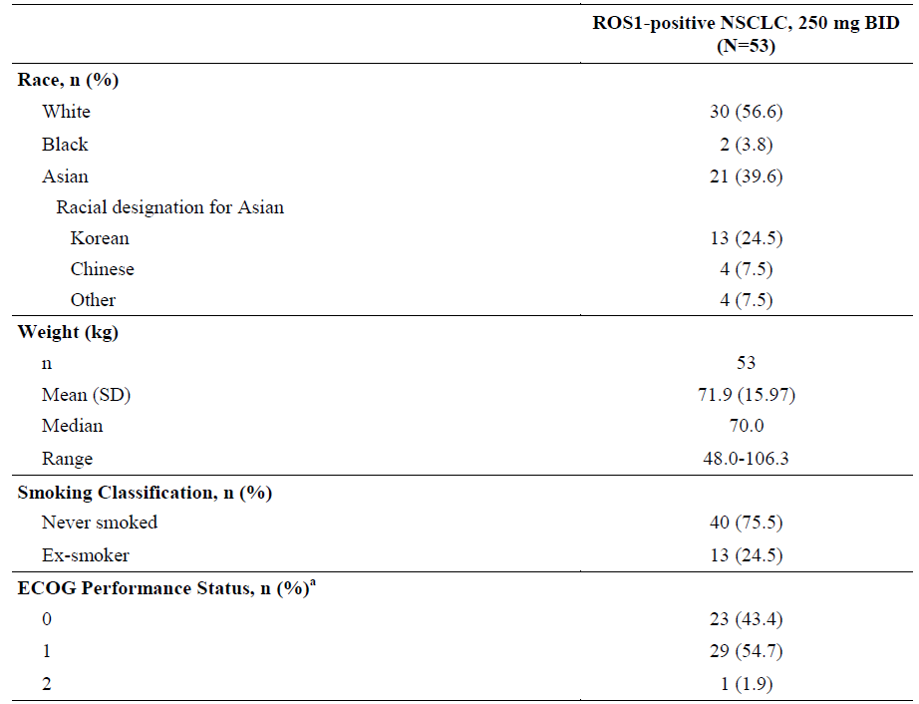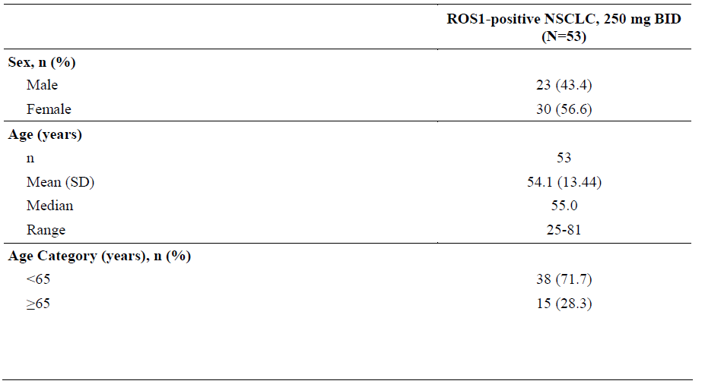

A summary of the histology of the primary diagnosis is presented. Most patients (96.2%) had a histological classification of adenocarcinoma.

Table 9: Study 1001 Primary Diagnosis; Histology.

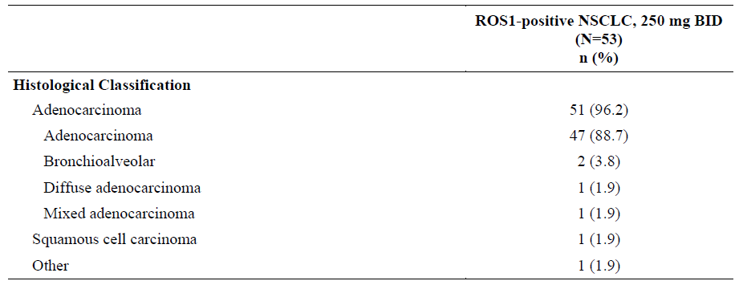

The majority of patients (86.8%) had received at least 1 line of prior systemic advanced/metastatic therapy for the primary diagnosis; 13.2% had not received prior therapy for advanced/metastatic disease and were, therefore, in the first-line treatment setting at the time of enrolment. The number of prior treatments for the primary diagnosis is detailed.

Table 10: Study 1001 Prior Treatments for Primary Diagnosis (ROS1-Positive NSCLC) - Safety Analysis Population.

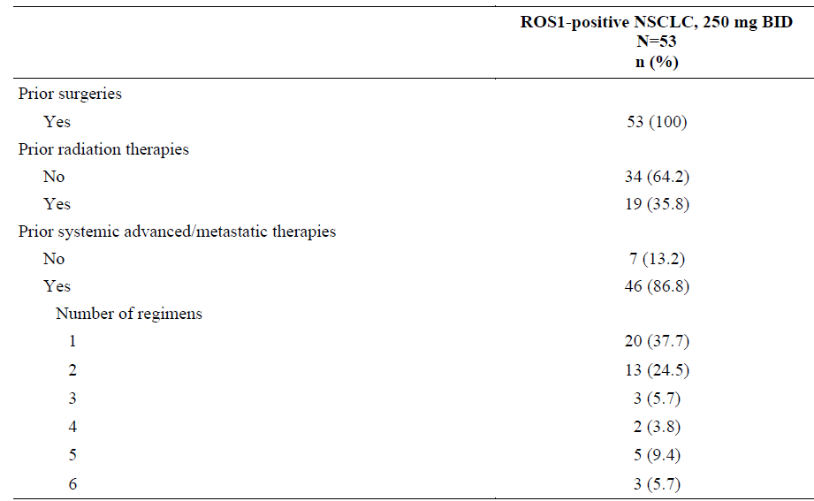

All 53 patients with NSCLC had advanced stage (either Stage III or IV) disease at baseline.

4/53 patients (7.5%) had Stage III disease, remainder had Stage IV.

Median (range) duration since diagnosis was 1.16 (0.0 to 11.2) years.

All 53 (100%) patients presented with measurable disease and had adequate baseline assessments.

##### Results for the efficacy outcome

###### Objective response rate

ORR for the RE population is presented. Among the 53 study patients, 5 (9.4%) patients had a CR, 32 (60.4%) patients had a PR, and 11 (20.8%) patients had stable disease as their best response. ORR was 69.8% (95% CI: 55.7, 81.7).

Table 11: Study 1001 Best overall response

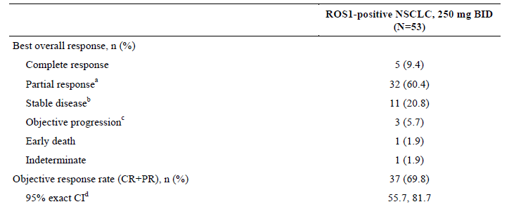

A waterfall plot of best percentage change from baseline in target lesion tumour size by percentage ROS1 positivity is shown in Figure 1 for the RE population.

Figure 1: Study 1001 Waterfall Plot of best percentage (%) change from baseline in target lesions by patient (N*=51).

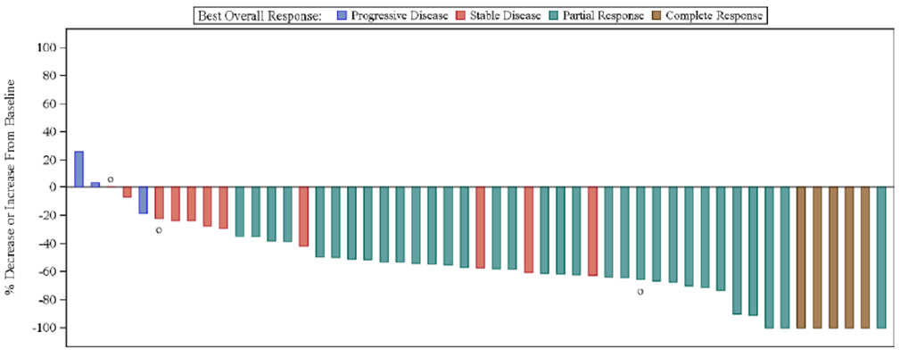

*N=51 is based on the Response Evaluable population, excluding patients with early death or indeterminate response.

The observed ORR was independent of baseline characteristics, including age group (<65 years and ≥65 years), gender, race group (Asian and non-Asian), number of prior treatment regimens for advanced/metastatic disease (0 and ≥1), ECOG PS (0 and 1), and the percentage of ROS1-positive cells.

ORR for the untreated group of NSCLC patients and the pre-treated group of patients: in the group with no prior therapy (n=7) there was one CR, 5 PR and one SD. In the group with one or more prior therapies (n=46) there were 4 CR, 27 PR and 10 SD.

###### Duration of Response (DR)

A summary of DR for the 37 objective responders (CR/PR) is presented. As of data cut-off for this CSR, 22/37 patients (59.5%) did not have subsequent disease progression or death after the response. The median DR by the Kaplan-Meier method was not reached.

Table 12: Study 1001 Duration of Response – Objective Responders.

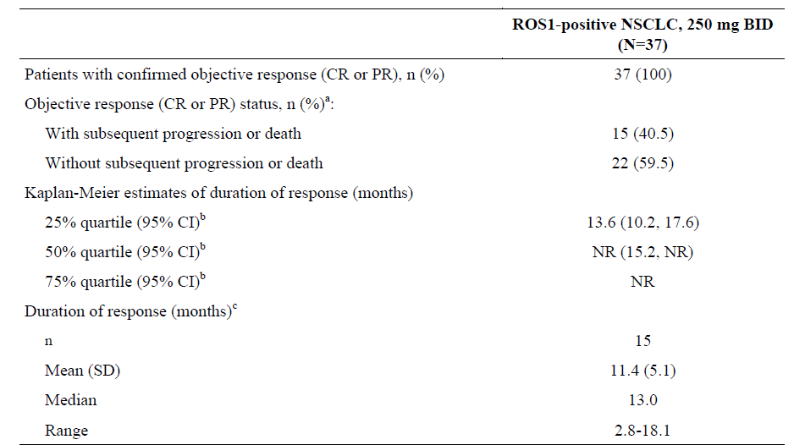

###### Time to tumour response

A summary of time to first tumour response (TTR) for the 37 patients with objective responses is shown. The median TTR was 7.9 weeks (range: 4.3 to 32.0 weeks) which was the approximate time of the first on-treatment tumour scan for patients with ROS1-positive NSCLC. Slightly greater than half of the responders (51.4%) experienced first tumour response before 8 weeks.

Table 13: Study 1001 Time to first response.

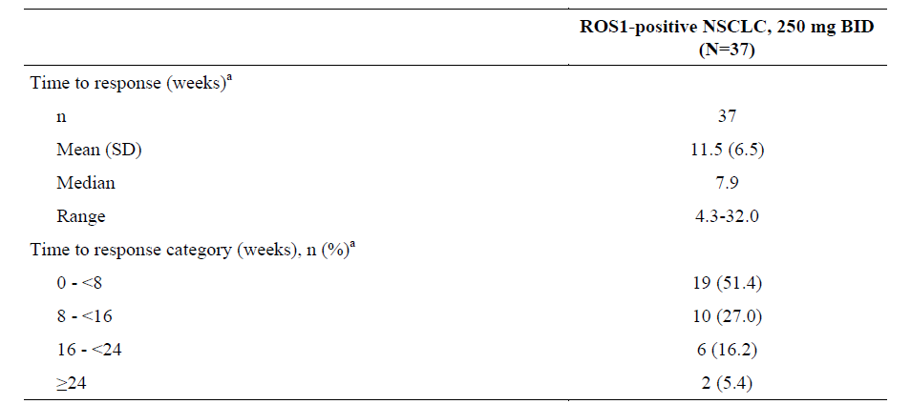

##### Results for other efficacy outcomes

###### Progression Free Survival (PFS)

A summary of PFS for the SA population is presented. Of 53 patients in the SA population, 49.1% had subsequent PFS events, with the large majority of these events being assessed as objective progression by the investigator (23/26 patients; 88.5%). At the time of the data cut-off for this report, 39.6% of patients are still in follow-up for PFS. The median PFS was 19.3 months (95% CI: 14.8, NR).

Table 14: Study 1001 Progression Free Survival.

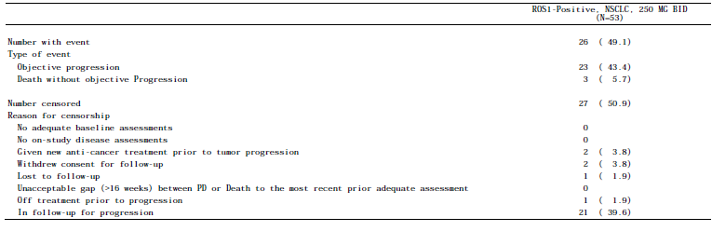

The Kaplan-Meier curve of PFS is provided. The probability of being alive and progression-free at 6 months was 76.9% (95% CI: 62.8, 86.1).

Figure 2: Study 1001 KM Plot of Progression Free Survival

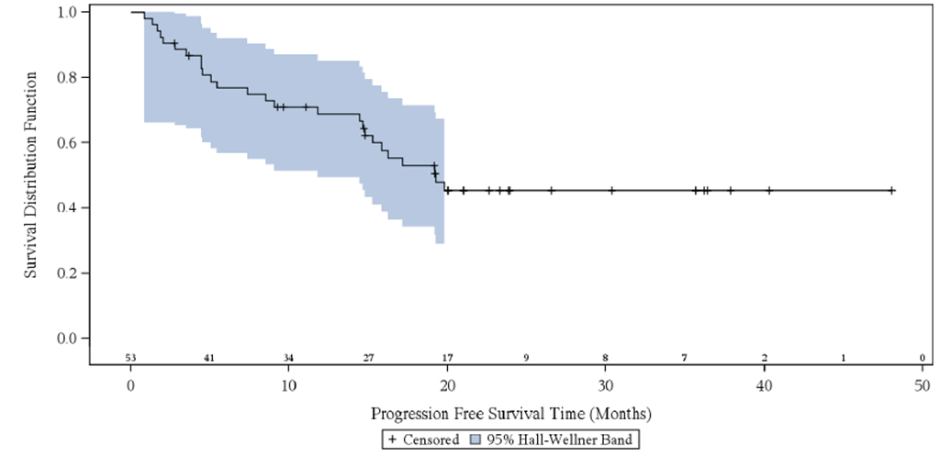

###### Overall survival

A summary of OS for the SA population is presented. At the time of the data cut-off for this report, the median duration of follow-up for OS was 25.4 months (95% CI: 22.5, 28.5) based on the reverse Kaplan-Meier method for the SA population. Overall, 16 (30.2%) patients had died by the time of the data cut-off for this report; 37 (69.8%) patients were censored, of which 33 (62.3%) patients were still in follow-up. The median OS had not been reached.

Table 15: Study 1001 Overall Survival

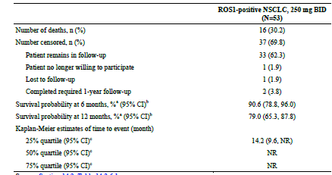

The probabilities of survival at 6 months and at 12 months were 90.6% (95% CI: 78.8, 96.0) and 79.0% (95% CI: 65.3, 87.8), respectively.

The Kaplan-Meier curve of OS is shown.

Figure 3: Study 1001 KM Plot of overall survival

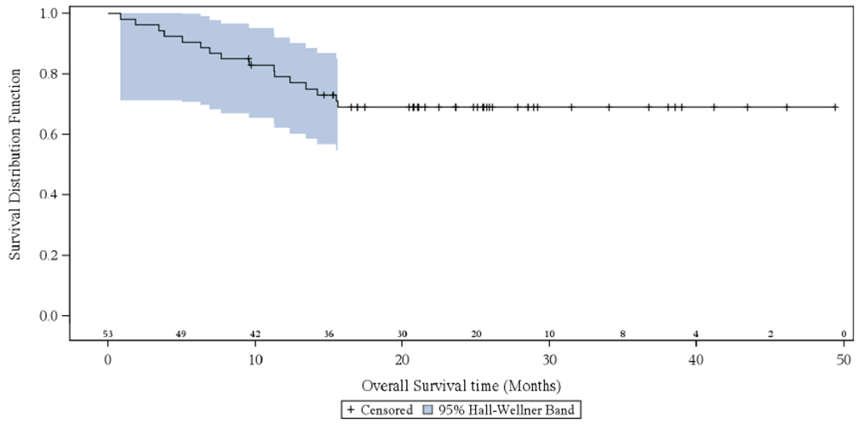

#### Additional Information from EMA report

A tabulated summary of the efficacy outcomes for crizotinib in patients with ROS1‑positive advanced NSCLC was presented clearly in the EMA evaluation report and is shown below.

Table 16: Study 1001 Effects Table for crizotinib treatment of adults with ROS1-positive advanced NSCLC

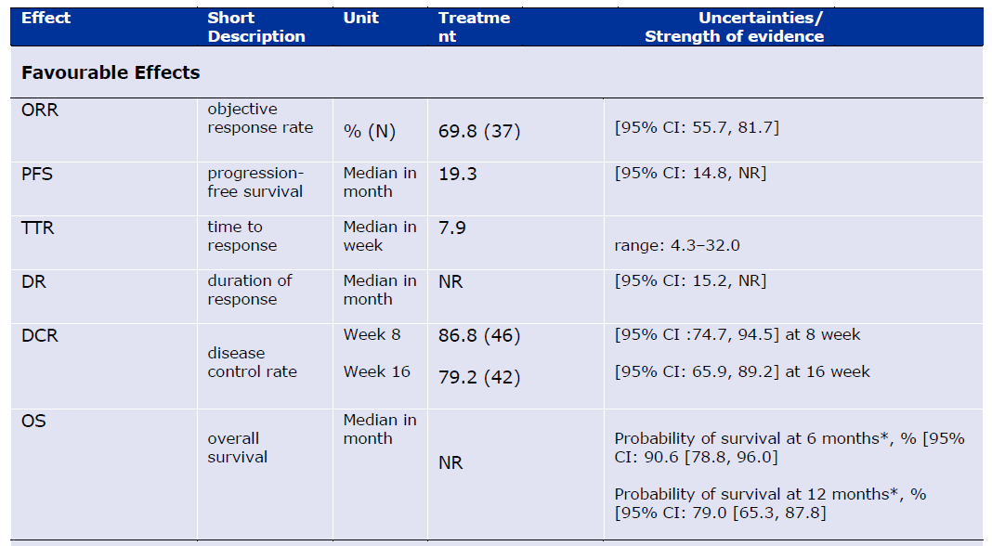

EMA Conclusion on Clinical Efficacy was:

*However, taking into account the biological plausibility, the rarity of the condition and the challenges in conducting a randomised study, available data are considered to sufficiently support the efficacy of crizotinib in ROS-1 NSCLC patients regardless of the line of treatment.*

The EMA requested that the Sponsor present their plans on how to identify mechanisms of underlying primary and secondary resistance to crizotinib in clinical practice.

The Sponsor outlined a number of ongoing activities which are generating data around various biomarkers from tumour samples and circulating free tumour DNA and that a biomarker report should be available in Q2/2018.

##### Evaluator commentary

This submission presents data for 53 patients with ROS1-positive advanced NSCLC in the phase 1 Study 1001, treated with crizotinib 250 mg BID, based on a data cut-off date of 30 November 2014.

ROS1 rearrangements are present in approximately 1-2% of NSCLC patients, therefore the patient numbers available for analysis in this study are relatively small (53 patients).

The efficacy endpoint was objective response rate (ORR) using tumour assessments based on RECIST v1.0 for the ROS1-positive NSCLC cohort and RECIST v1.1 for the 3 patients with ROS1-positive NSCLC in the ALK-negative NSCLC cohort, as assessed by the investigator.

The objective response rate was 70% (37/53 patients, 5 CR, 32 PR).

The ORR appeared independent of baseline characteristics, including age group (<65 years and ≥65 years), gender, race group (Asian and non-Asian), number of prior treatment regimens for advanced/metastatic disease (0 and ≥1), ECOG PS (0 and 1), and the percentage of ROS1-positive cells.

These ORR data are also supported by the PFS and DR results stated below.

As of data cut-off for this CSR, 22/37 patients (59.5%) did not have subsequent disease progression or death after the response.

The median PFS was 19.3 months (95% CI: 14.8 months, NR).

The median DR by the Kaplan-Meier method was not reached (95% CI: 15.2 months, NR).

The probability of being alive and progression-free at 6 months was 76.9% (95% CI: 62.8, 86.1).

The probabilities of survival at 6 months and at 12 months were 90.6% (95% CI: 78.8, 96.0) and 79.0% (95% CI: 65.3, 87.8), respectively.

These data demonstrate that crizotinib 250 mg BID has clinically meaningful efficacy in patients with ROS1‑positive advanced NSCLC.

### Other efficacy studies (ALK‑positive NSCLC)

#### Study ID A8081007 (Study 1007)

**Comment**: A preliminary report for study 1007 (a phase 3 study of crizotinib vs pemetrexed or docetaxel) in patients with ALK‑positive NSCLC was available at the time of the original registration of crizotinib in Australia (27 Sept 2013) and summary data are included in the Australian approved PI.

This submission contains an update to study 1007, namely the final analysis of overall survival (OS), a secondary endpoint for the study, as the protocol pre-specified number of OS events had occurred.

Updated summary safety results for study 1007 are also included in the dossier.

###### Study design

Study 1007 is a multinational, multicentre, open-label phase 3 efficacy and safety study of crizotinib vs standard of care chemotherapy (pemetrexed or docetaxel) in patients with previously treated NSCLC (with 1 prior platinum based chemotherapy regimen) whose tumours harbour ALK fusions.

###### Objectives

The primary objective of this study was:

* To demonstrate that crizotinib (Arm A) was superior to standard-of-care chemotherapy, pemetrexed or docetaxel (Arm B), in prolonging PFS

###### Secondary objectives

* To compare secondary measures of clinical efficacy including OS, ORR, and DCR between the 2 treatment arms, and evaluate DR and TTR.
* OS was defined as the time from randomisation to the date of death due to any cause.
* Upon confirmation of PD by the IRR, patients in the chemotherapy arm of the study had the opportunity to receive crizotinib in Study 1005. For these patients, survival follow-up data and follow-up systemic therapies were collected in Study 1005. Data from both study databases were used for analysis of OS and reported in this CSR.

Differences in OS between treatment arms were analysed by the 1-sided log-rank test stratified for baseline stratification factors. Estimates of the OS curves obtained from the Kaplan-Meier method were presented. OS curves were also displayed graphically. The median event time (and other percentiles) and corresponding 2-sided 95% confidence interval (CI) for the event times were provided for each treatment arm.

Treatment arm comparison was also performed using the unstratified log-rank test. Cox regression models, adjusted for baseline stratification factors and other baseline characteristics, were fitted. The estimated hazard ratio (HR) and 2-sided 95% CI were provided. Survival probabilities at 6 and 12 months were estimated using the Kaplan-Meier method and the 2-sided 95% CI was presented. Subgroup analyses were provided for baseline patient and disease characteristics and for the baseline stratification factors: median OS (and other percentiles) and 2-sided 95% CI were estimated.

* To assess the safety and tolerability of crizotinib compared to chemotherapy (pemetrexed or docetaxel).

###### Main inclusion criteria

1. Histologically or cytologically proven diagnosis of NSCLC that was locally advanced or metastatic.
2. Positive for translocation or inversion events involving the ALK gene locus
3. Patients must have had progressive disease (PD) after only 1 prior chemotherapy regimen. This regimen must have been platinum-based and may have included maintenance therapy.
4. Tumours were to have measurable disease as per RECIST v1.1.
5. Adequate organ function as defined by the following criteria:

* Hepatic function:
  + Serum aspartate aminotransferase (AST) and serum alanine aminotransferase (ALT) ≤2.5 × upper limit of normal (ULN), or AST and ALT ≤5 × ULN if liver function abnormalities were due to underlying malignancy; however, for patients who were randomly assigned to Arm B and needed to receive docetaxel, ALT and/or AST was not to be >1.5 × ULN concomitant with alkaline phosphatase >2.5 × ULN.
  + Total serum bilirubin ≤1.5 × ULN; however, for patients who were randomly assigned to Arm B to receive docetaxel, total serum bilirubin was to be ≤1 × ULN.
* Bone marrow function:
  + Absolute neutrophil count (ANC) ≥1500/μL.
  + Platelets ≥100,000/ μL.
  + Haemoglobin ≥8.0 g/dL.
* Renal function:
  + Creatinine clearance (based on modified Cockcroft-Gault formula) ≥45 mL/minute.

###### Main exclusion criteria

1. Current treatment on another therapeutic clinical study.
2. Prior therapy specifically directed against ALK.
3. Spinal cord compression unless treated with the patient attaining good pain control and stable or recovered neurologic function, carcinomatous meningitis, or leptomeningeal disease.
4. Any of the following within the 3 months prior to starting study drug: myocardial infarction, severe/unstable angina, coronary/peripheral artery bypass graft, congestive heart failure, or cerebrovascular accident including transient ischemic attack.
5. Ongoing cardiac dysrhythmias of National Cancer Institute Common Terminology Criteria for Adverse Events (NCI CTCAE) Grade ≥2, uncontrolled atrial fibrillation of any grade, or corrected QT interval (QTc) interval >470 msec.

###### Treatments

Patients were randomized in a 1:1 ratio to receive crizotinib (Arm A) or chemotherapy (pemetrexed or docetaxel; Arm B). Each treatment cycle was defined as 21 days.

* Crizotinib 250 mg BID
* Pemetrexed 500 mg/m2 was to be administered by IV infusion over 10 minutes or according to institutional practices on Day 1 of a 21-day cycle.
* Docetaxel, 75 mg/m2, was to be administered by IV infusion over 1 hour or according to institutional practices on Day 1 of a 21-day cycle.

###### Disposition of patients

A total of 347 patients were randomised in the study, 173 to crizotinib and 174 to chemotherapy.

343 patients received study treatment (172 received crizotinib and 171 received chemotherapy). A total of 91.9% of patients in the crizotinib arm and 98.3% of patients in the chemotherapy arm were permanently discontinued from study treatment

###### Disposition of patients at end of treatment

A summary of patient disposition at EOT by treatment arm is provided. Overall, 91.9% of patients in the crizotinib arm and 98.3% of patients in the chemotherapy arm permanently discontinued from study treatment. The most frequent reasons (>10% of patients) for permanent discontinuation of study treatment in either treatment arm were objective progression or relapse and global deterioration of health status. There was a greater percentage of deaths as reason for discontinuation from study treatment in the crizotinib arm than the chemotherapy arm.

Table 17: Study 1007 Patient Disposition at End of Treatment by Treatment Arm

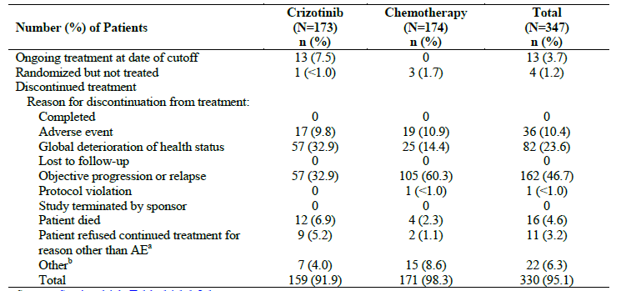

###### Disposition of patients at end of study

Overall, 302 (87.0%) patients discontinued from the study. The most common reason for discontinuation from the study was patient death (115 [66.5%] patients) in the crizotinib arm and “other” reasons (mainly crossover to Study 1005) (144 [82.8%] patients) in the chemotherapy arm. There was a greater percentage of deaths as reason for discontinuation from study in the crizotinib arm than the chemotherapy arm and this was most likely due to the design of the study, as patients in the crizotinib arm were to be followed for survival until death under this study protocol, while patients in the chemotherapy arm had the option to crossover to Study 1005 to receive crizotinib and, therefore, were to be followed for survival until death under Study 1005 protocol.

Table 18: Study 1007 Patient Disposition at End of Study by Treatment Arm

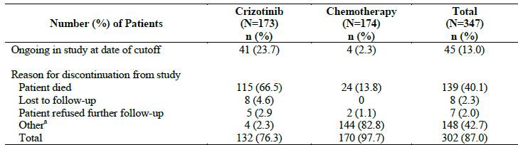

*Overall Survival*

A total of 116 (67.1%) patients in the crizotinib arm and 126 (72.4%) patients in the chemotherapy arm were known to have died as per data cut-off. Data of patients not known to have died were censored at the time they were last known to be alive. Among these, a total of 41 (23.7%) patients in the crizotinib arm and 32 (18.4%) patients in the chemotherapy arm were in the follow-up for survival at the data cut-off.

There was no statistically significant improvement in OS for crizotinib vs chemotherapy. There was, however, a numerical improvement in OS in the crizotinib arm (HR: 0.854; 95% CI: 0.661, 1.104 with a p-value of 0.1145; 1-sided stratified log-rank test).

The median OS was 21.7 months for crizotinib and 21.9 months for chemotherapy.

A total of 151 patients randomised to chemotherapy received crizotinib as the first follow-up systemic anticancer therapy and 39 patients randomised to crizotinib received chemotherapy (pemetrexed or docetaxel) as the first follow-up systemic anticancer therapy.

Table 19: Study 1007 Overall Survival.

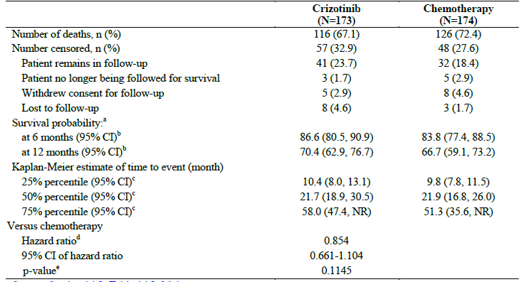

A Kaplan-Meier plot of OS by treatment arm is presented.

Figure 4: Study 1007 Kaplan-Meier Plot of Overall Survival by Arm - Full Analysis

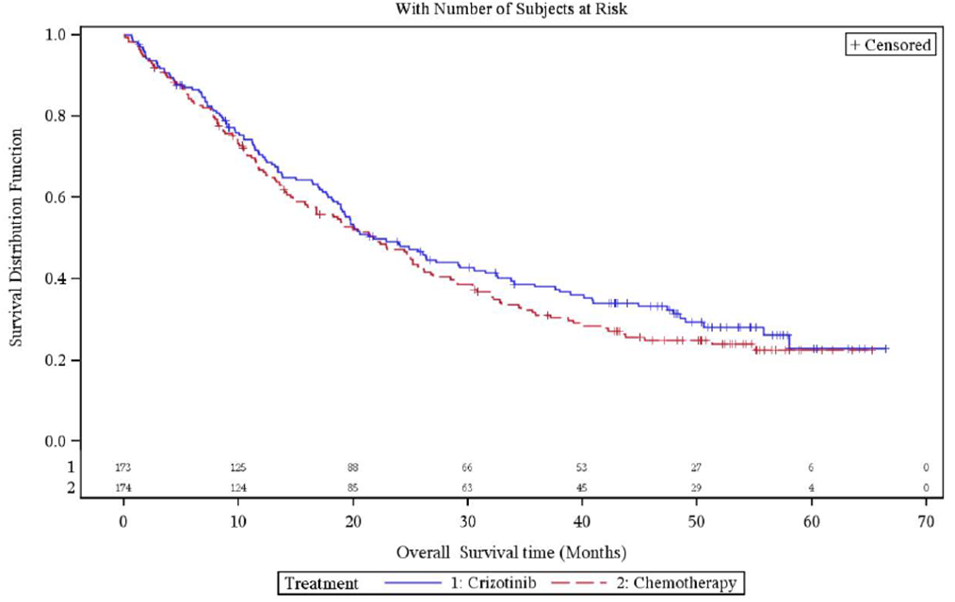

An overview of OS and survival probabilities at 6 months and 12 months at the final and interim analyses is provided. The median OS values at the final analysis were in line with those estimated at the interim analysis,(which is included in the current approved TGA PI). The survival probabilities at 6 months and 12 months for the final analysis were comparable to those estimated for the interim analysis.

Table 20: Study 1007 Overview of Final and Interim Overall Survival Data

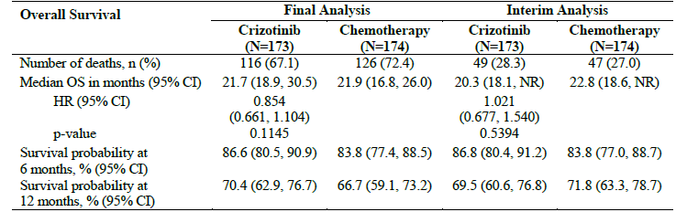

A summary of patient crossover to crizotinib treatment in Study 1005 from the chemotherapy arm is provided. Reasons for crossover to crizotinib were objective RECIST-defined disease progression for 134 (77.0%) patients, study primary objective met for 3 (1.7%) patients. The median time to crossover (i.e. the time from randomisation in Study 1007 to the start of crizotinib in Study 1005) to crizotinib was 21.0 weeks (range: 0.57 to 183 weeks).

Table 21: Study 1005 Summary of Crossover to Crizotinib in the Chemotherapy Arm

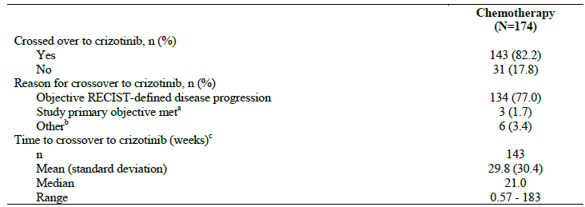

#### Evaluator commentary: other efficacy studies (Study 1007)

Study 1007 is a multinational, multicentre, randomised, open-label phase 3 efficacy and safety study of crizotinib vs standard of care chemotherapy (pemetrexed or docetaxel) in patients with previously treated (with 1 prior platinum based chemotherapy regimen) NSCLC whose tumours have ALK fusions.

Study 1007 was of adequate size with 173 patients randomised to crizotinib and 174 patients randomised to chemotherapy.

The primary endpoint was PFS and the data for this endpoint were evaluated in a previous submission and formed the basis for the approval of crizotinib by the TGA and these data are included in the current Australian PI.

The median OS in the crizotinib arm from the Study 1007 reported in the preliminary CSR was 20.3 months (95% CI 18.1, not reached)

These OS results were preliminary as only 40% of the events required for the pre-specified final OS analysis were reported. These results were contained in the original Australian regulatory submission and appear in the current TGA approved PI.

The final analysis of Study 1007 is included in this submission and has shown the median OS was 21.7 months (95% CI 18.9, 30.5) for crizotinib and 21.9 months (95% CI 16.8, 26.0) for chemotherapy, which are not statistically (or clinically) different.

However, these OS analyses were not adjusted for the confounding effects of crossover, ie most patients in this study received follow-up systemic anticancer therapy.

A total of 151 patients (87%) randomised to chemotherapy received crizotinib as the first follow-up systemic anticancer therapy (mostly in Study 1005) and 39 patients randomised to crizotinib received chemotherapy (pemetrexed or docetaxel) as the first follow-up systemic anticancer therapy.

The median time to crossover from chemotherapy to crizotinib was 21 weeks, (range 0.57-183 weeks.

The clinical overview attempts to place these OS data in context by quoting Scagliotti et al 2009 and Garassino et al 2013 to note that the historical median OS of patients with unselected advanced NSCLC who were treated with second line pemetrexed or docetaxel is approx. 9 months.

The median OS results reported in this final report are not significantly different to those reported in the preliminary analysis so do not alter the benefit / risk balance for crizotinib in patients with NSCLC who are ALK‑positive.

### Analyses performed across trials: pooled & meta analyses

Tables of pooled data from more than one trial were submitted to support changes to the PI.

### Evaluator’s conclusions on clinical efficacy

This submission presents data for 53 patients with ROS1-positive advanced NSCLC in the phase I Study 1001.

The efficacy endpoint was objective response rate (ORR) using tumour assessments based on RECIST v1.0 for the ROS1-positive NSCLC cohort and RECIST v1.1 for the 3 patients with ROS1-positive NSCLC in the ALK-negative NSCLC cohort, as assessed by the investigator.

The objective response rate was 70% (37/53 patients, 5 CR, 32 PR).

The median PFS was 19.3 months (95% CI: 14.8 months, NR).

The median DR by the Kaplan-Meier method was not reached (95% CI: 15.2 months, NR).

These data demonstrate that crizotinib 250 mg BID has clinically meaningful efficacy in patients with ROS1‑positive advanced NSCLC.

This submission also presents data from Study 1007 which is a multinational, multicentre, randomised, open-label phase 3 efficacy and safety study of crizotinib vs standard of care chemotherapy (pemetrexed or docetaxel) in patients with previously treated (with 1 prior platinum based chemotherapy regimen) NSCLC whose tumours have ALK fusions.

Study 1007 was of adequate size with 173 patients randomised to crizotinib and 174 patients randomised to chemotherapy.

The final analysis of study 1007 is included in this submission and has shown the median OS was 21.7 months (95% CI 18.9, 30.5) for crizotinib and 21.9 months (95% CI 16.8, 26.0) for chemotherapy, which are not statistically (or clinically) different.

However, these OS analyses were not adjusted for the confounding effects of crossover, ie most patients in this study received follow-up systemic anticancer therapy.

A total of 151 patients (87%) randomised to chemotherapy received crizotinib as the first follow-up systemic anticancer therapy (mostly in study 1005) and 39 patients randomised to crizotinib received chemotherapy (pemetrexed or docetaxel) as the first follow-up systemic anticancer therapy.

The overall survival of these trial patients is substantially longer than historical controls.

The median OS results reported in this final report are not significantly different to those reported in the preliminary analysis so do not alter the benefit / risk balance for crizotinib in patients with NSCLC who are ALK positive.

## Clinical safety

Study 1001 provided safety data on 53 patients with ROS1‑positive NSCLC who received crizotinib.

Also included in the dossier was an updated safety summary from Study 1007 in patients with ALK‑positive NSCLC, which is described in more detail below.

### Studies providing evaluable safety data

Study 1001 provided safety data on 53 patients with ROS1‑positive NSCLC who received crizotinib.

Study 1007 was a multinational, multicentre, randomised, open-label, Phase 3, efficacy and safety study of crizotinib versus (vs) standard-of-care chemotherapy (pemetrexed or docetaxel) in patients with previously treated (with 1 prior platinum-based chemotherapy regimen) NSCLC whose tumours harbor ALK fusions.

A preliminary CSR with a data cut-off date of 30 March 2012 was previously submitted to regulatory authorities since the required number of events for the primary endpoint, progression-free survival (PFS), was reached. The study randomised 173 patients to the crizotinib arm and 174 patients to the chemotherapy arm. Enrolment was complete by the time of the preliminary report. The preliminary CSR was submitted to the regulatory authorities, including the TGA, US FDA and EMA.

Included in this dossier is updated safety data from the final A8081007 CSR for the 343 patients with ALK-positive NSCLC (172 patients who received crizotinib and 171 patients who received chemotherapy) based on a data cut-off date of 31 August 2015.

For the final CSR, the median duration of study treatment was increased from 31.0 weeks to 48.0 weeks for the crizotinib group and from 12.3 weeks to 13.0 weeks for the chemotherapy group from the preliminary to the final reports, respectively.

A submission to the TGA to update the crizotinib PI was made in 2015 (PM-2015-00375-4-1, TRIM Reference R15/832015) and the data for Study 1007 included data on crizotinib exposure of 48 weeks and chemotherapy of 13 weeks. The corresponding data are included in the current PI.

#### Duration of exposure

*Study 1001 ROS1‑positive NSCLC*

The majority of patients (36/53; 67.9%) had a crizotinib treatment duration >12 months, starting dose 250 mg BID.

Table 22: Study 1001 Duration of Treatment (Exposure)

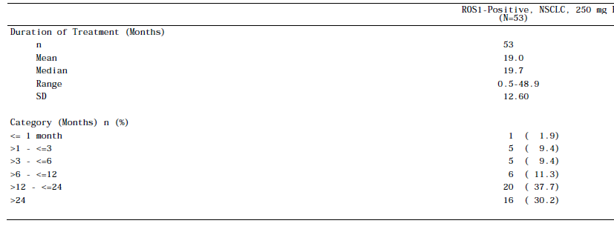

The CSR states ‘at the time of the data cut-off date for this report, the median duration of crizotinib treatment was 23.2 months (95% CI: 15.0, NR), with 47.2% of patients still actively receiving crizotinib’.

This is inconsistent with a median duration of 19.7 months, as this duration was determined using descriptive statistics and does not take into account that crizotinib treatment was still ongoing for 47% of patients. Elsewhere in the CSR, a median duration of treatment is derived by the Kaplan Meier method as 23.2 months.

###### Study 1007 ALK‑positive NSCLC

Median exposure for the crizotinib group is 48 weeks (range 1.3 – 262.6) and for the chemotherapy group 13.0 weeks (range 3 – 162).

Table 23: Study 1007 exposure to crizotinib or chemotherapy

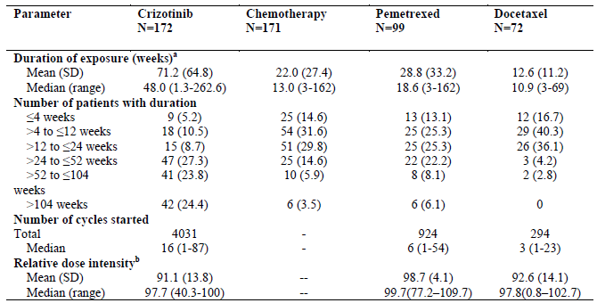

### Adverse events

#### All adverse events and treatment related adverse events

###### Study 1001 ROS1‑positive NSCLC

A summary of the numbers of all-causality AEs and treatment-related AEs is provided. All 53 patients reported at least 1 all-causality AE. Treatment-related AEs were reported by 52 (98.1%) patients. All-causality SAEs were reported by 22 (41.5%) patients; 2 patients had treatment-related SAEs.

Table 24: Study 1001 Treatment-Emergent Adverse Events

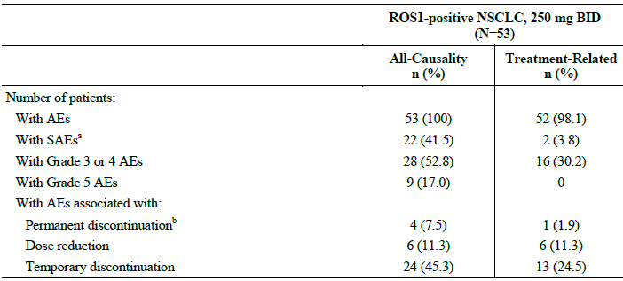

The most common (≥30%) all-causality AEs were vision disorder, nausea, oedema, vomiting, diarrhoea, constipation, dizziness, URTI, elevated transaminases, fatigue, and neuropathy.

The most common (≥30%) treatment-related AEs were vision disorder, nausea, oedema, diarrhoea, vomiting, constipation, and elevated transaminases.

There were no AEs indicative of cardiac failure.

All-causality AEs and treatment-related AEs with maximum Grade 3 or 4 and an incidence of ≥2% of patients are summarised below. The most common (≥5%) Grade 3 all-causality AEs were hypophosphataemia, neutropenia, headache, dyspnoea, syncope, and vomiting. The most common (≥5%) Grade 3 treatment-related AEs were hypophosphataemia and neutropenia.

The most common (≥5%) Grade 4 all-causality AE was pulmonary embolism. There were no Grade 4 treatment-related AEs.

##### Additional information from EMA report

It is noted that 6 patients had a dose reduction due to AEs. The EMA found a seventh patient who had a dose reduction and asked the Sponsor to clarify the reasons.

On further investigation, the Sponsor determined that this seventh patient also had a dose reduction due to AEs.

Table 25: Study 1001 Most Common (≥2%) Treatment-Emergent Grade 3 or 4 Adverse Events in Decreasing Order

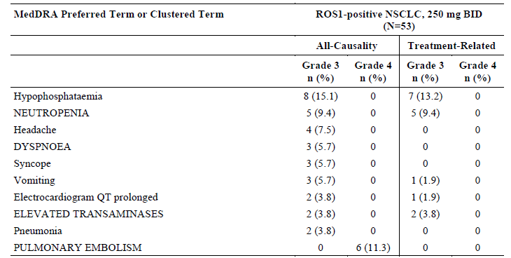

*Study 1007 ALK‑positive NSCLC*

The Sponsor defined meaningful differences in all-causality AEs those that were reported with an incidence of ≥10% of patients across all cycles in either treatment group and had a ≥5% absolute difference between treatment groups.

A summary of those all-causality AEs that met these criteria is provided. All-causality AEs of diarrhoea, vision disorder, nausea, vomiting, constipation, elevated transaminases, oedema, decreased appetite, upper respiratory tract infection, neutropenia, headache, dizziness, dysgeusia, neuropathy, abdominal pain, leukopenia, back pain, weight decreased, pain in extremity, blood alkaline phosphatase increased, disease progression, and dyspepsia were reported with a meaningfully higher frequency in patients treated with crizotinib than for patients treated with chemotherapy.

All-causality AEs of fatigue, alopecia, and myalgia were reported with a meaningfully higher frequency for patients treated with chemotherapy than for patients treated with crizotinib.

Table 26: Study 1007 All cause adverse events

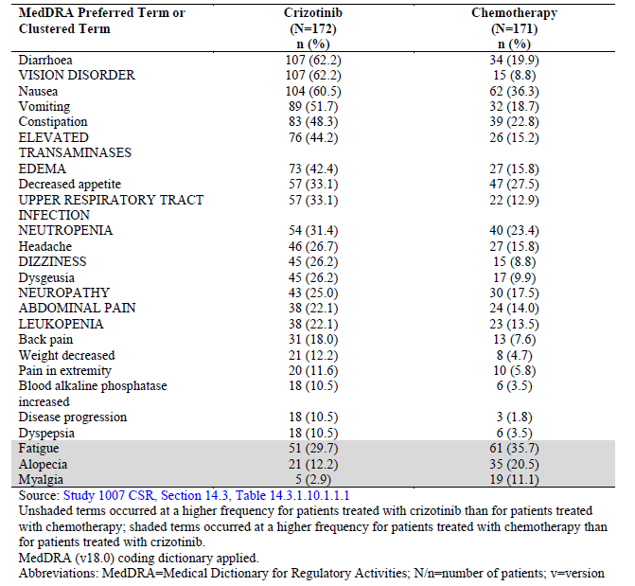

Based on the current crizotinib safety data, a list of preferred terms and clustered terms was developed and underwent internal clinical and safety review to apply medical judgment in determining ADRs likely associated with crizotinib. The ADR list is presented.

Table 27: Study 1007. Adverse Drug Reactions

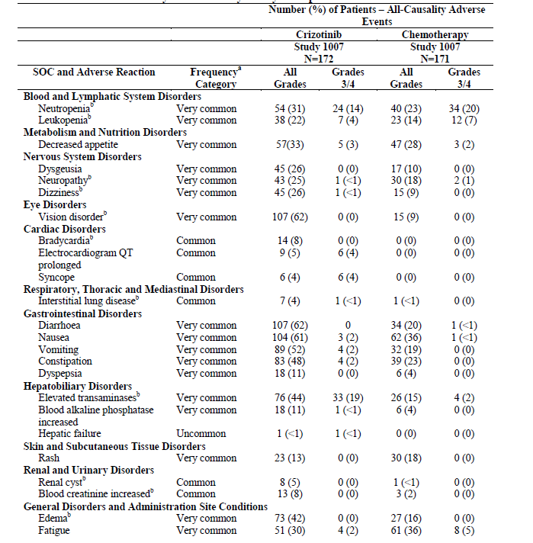

#### Deaths and other serious adverse events

###### Study 1001 ROS1‑positive NSCLC

Overall, 9 (17.0%) patients died within 28 days after the last dose of crizotinib, and 7 (13.2%) patients died more than 28 days after the last dose of crizotinib. The most common cause of death was disease under study. There were no deaths that were considered to be related to treatment by either the investigator or sponsor.

Table 28: Study 1001 Deaths

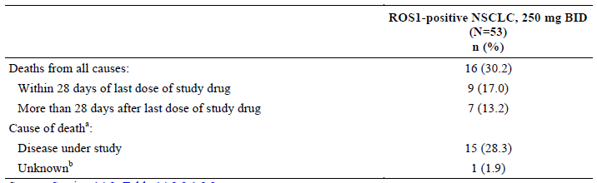

A summary of all-causality and treatment-related SAEs is provided. All-causality SAEs were reported for 22 (41.5%) patients, with disease progression and pneumonia being the most commonly reported (≥5% of patients). Treatment-related SAEs were bradycardia and gastrointestinal amyloidosis, each reported by 1 (1.9%) patient. Of note, the investigator considered the SAE of gastrointestinal amyloidosis to be of unknown causality, but there is a possibility that the condition may have been present prior to start of crizotinib treatment.

Table 29: Study 1001 Most Common (≥2%) Treatment-Emergent Serious Adverse Events in Decreasing Order of All-Causality Frequency.

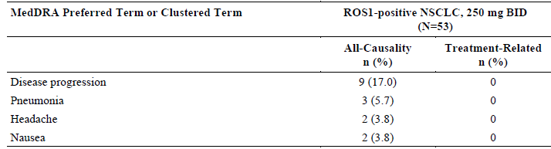

*Study 1007 ALK‑positive NSCLC*

For patients on chemotherapy who crossed over to Study 1005, death data were captured in the Study 1005 clinical database, but were also analysed as part of the follow-up period for Study 1007, specifically for the OS endpoint analysis and for this summary of deaths.

The total number of deaths from all causes was 115 (66.9%) for crizotinib and 123 (71.9%) for chemotherapy. The 30-day and 60-day all-cause mortality was similar between the 2 treatment arms.

The most common cause of death was the disease under study (101 [58.7%] patients on crizotinib and 112 [65.5%] patients on chemotherapy [including 93 patients who crossed over to Study 1005])

Table 30: Study 1001 Deaths

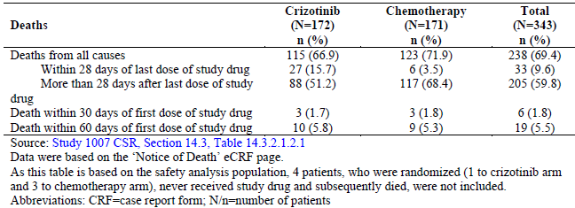

#### Discontinuations due to adverse events

###### Study 1001 ROS1‑positive NSCLC

All-causality AEs associated with permanent treatment discontinuation were disease progression (2 [3.8%] patients), nausea (1 [1.9%] patient) and pericardial effusion (1 [1.9%] patient); the event of nausea was considered to be treatment-related.

All-causality AEs associated with dose reduction were reported for 6 (11.3%) patients; the only AE associated with dose reduction for more than 1 patient was elevated transaminases (2 [3.8%] patients). The AEs associated with dose reduction were considered to be treatment-related for all 6 (11.3%) patients.

All-causality AEs associated with temporary treatment discontinuation were reported for 24 (45.3%) patients; the most commonly reported (≥5% of patients) were vomiting, neutropenia, and nausea.

Treatment-related AEs associated with temporary treatment discontinuation were reported for 13 (24.5%) patients; the most commonly reported (≥5% of patients) was neutropenia and vomiting.

Table 31: Study 1001 Most Common (≥2%) Treatment-Emergent Adverse Events Associated With Temporary Treatment Discontinuation

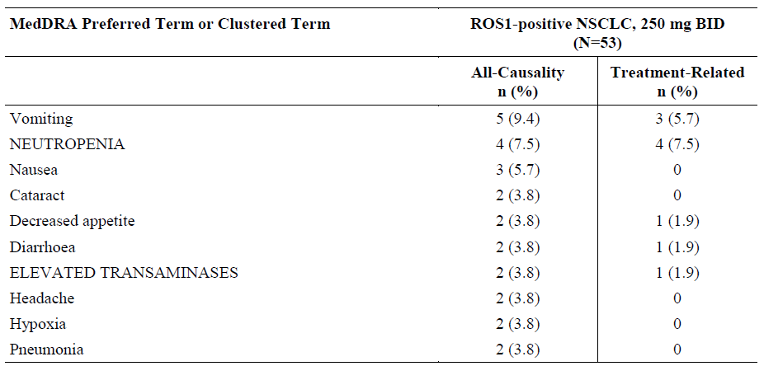

*Study 1007 ALK‑positive NSCLC*

In the crizotinib treatment group 19.8% of patients experienced all-causality AEs associated with permanent discontinuation of treatment compared to 19.9% of patients on chemotherapy. The most common (≥1% patients) all-causality AEs associated with permanent discontinuation were disease progression (4.7%), interstitial lung disease(2.9%), dyspnoea (2.3%), elevated transaminases (1.7%), and death, hepatotoxicity, pulmonary embolism, and pneumonia (each 1.2%) for patients treated with crizotinib, and pleural effusion (2.3%), disease progression and neutropenia (each 1.8%), and asthenia, fatigue, general physical health deterioration, neuropathy, and pericardial effusion (each 1.2%) for patients treated with chemotherapy.

A total of 16.9% of crizotinib-treated patients and 14.0% of chemotherapy-treated patients had all-causality AEs associated with a dose reduction. The most commonly reported all-causality AEs associated with a dose reduction (≥1% of patients) were elevated transaminases(8.7%), neutropenia (4.1%), and electrocardiogram QT prolonged (2.3%) for patients treated with crizotinib, and neutropenia (8.2%). stomatitis (1.8%) and fatigue (1.2%) for patients treated with chemotherapy.

### Evaluation of issues with possible regulatory impact

#### Liver function and liver toxicity

###### Study 1001 ROS1‑positive NSCLC

Treatment-related elevated transaminases were reported for 16 (30.2%) patients, including 2 patients with Grade 3 events. There were no Grade 4 treatment-related events of elevated transaminases and no permanent discontinuations of treatment associated with treatment-related elevated transaminases. No treatment-related hepatotoxicity or Hy’s Law cases were identified in patients with ROS1-positive NSCLC in this study.

*Study 1007 ALK‑positive NSCLC*

All-causality elevated transaminases and hepatotoxicity were reported for 76 (44.2%) and 9 (5.2%) crizotinib-treated patients, respectively, and 26 (15.2%) and 1 (0.6%) chemotherapy-treated patients, respectively. Grade 3 and 4 all-causality elevated transaminases were reported for 25 (14.5%) and 8 (4.7%) crizotinib-treated patients, respectively, and 4 (2.3%) and 0 chemotherapy-treated patients, respectively. Grade 3 hepatotoxicity was reported for 3(1.7%) crizotinib-treated patients and 0 chemotherapy-treated patients. There were no Grade 4 or 5 cases of all-causality hepatotoxicity for either treatment. Exposure-adjusted incidence rates for all-causality elevated transaminases and hepatotoxicity were not statistically significantly different between crizotinib and chemotherapy treatments.

#### Vision disorders

###### Study 1001 ROS1‑positive NSCLC

Treatment-related vision disorder was reported for 45 (84.9%) patients; the events were Grade 1 for 44 of the 45 patients. There were no Grade 3 or 4 treatment-related AEs of vision disorder and no treatment-related SAEs of vision disorder. Of note, there were no AEs associated with severe visual loss. The median time to first onset for treatment-related vision disorder was 8 days and the median duration was 297 days (range: 7 to 1486 days). The prevalence of treatment-related vision disorder was highest during the Weeks 1 to 4 interval (71.7%) and then gradually decreased over each 4-week interval through Week 24 (from 65.4% to 54.3% of patients).

Most patients did not have new findings/worsening of findings when ophthalmologic examinations were performed on-treatment; the most common (≥5%) new findings/worsening of findings were reported for biomicroscopic examination of the lens (15.1% of patients for both eyes), fundoscopic examination of the vitreous body (11.3% for both eyes), and fundoscopic examination of the fundus (5.3% for the left eye).

No patients had treatment-related vision disorder associated with temporary treatment discontinuation, dose reduction, or permanent treatment discontinuation

###### Study 1007 ALK‑positive NSCLC

All-causality vision disorder was the most frequent AE reported for 107 (62.2%) crizotinib-treated patients and 15 (8.8%) chemotherapy-treated patients. No crizotinib-treated or chemotherapy-treated patients had Grade ≥3 all-causality events. Exposure-adjusted incidence rates for all-causality AEs of vision disorder were statistically significantly higher for crizotinib-treated patients than for chemotherapy-treated patients (2-sided p-value <0.0001).

#### Renal function and renal toxicity

###### Study 1001 ROS1‑positive NSCLC

Treatment-related renal cyst was reported for 1 (1.9%) patient. Time to onset was 490 days and duration was 245 days. This event was not associated with temporary treatment discontinuation, dose reduction, or permanent treatment discontinuation.

There were no Grade 3, 4 or 5 treatment-related AEs of renal cyst and no treatment-related SAEs of renal cyst.

Treatment-related blood creatinine increased was reported for 2 (3.8%) patients. There were no Grade 3, 4 or 5 treatment-related events and no treatment-related SAEs of blood creatinine increased. The median time to first onset for treatment-related blood creatinine increased was 134 days (range: 15 to 253 days) and the median duration was 50 days (range: 29 to 71 days).

*Study 1007 ALK‑positive NSCLC*

All-causality AEs of renal cyst were reported for 8 (4.7%) crizotinib-treated patients and 1 (0.6%) chemotherapy-treated patient. There were no Grade ≥3 all-causality AEs in either treatment. Exposure-adjusted incidence rates for all-causality AEs of renal cyst were not statistically significantly different between the crizotinib and chemotherapy treatments.

#### Other clinical chemistry

###### Study 1001 ROS1‑positive NSCLC

Grade 3 hypophosphataemia was reported in 8 patients (15.1%).

###### Study 1007 ALK‑positive NSCLC

Grade 3 hypophosphataemia was reported in 4 patients (2.3%) in the crizotinib‑treated group and 3 patients (1.85) in chemotherapy‑treated patients.

#### Haematology and haematological toxicity

###### Study 1001 ROS1‑positive NSCLC

Grade 3 neutropenia was reported in 5 patients (9.4%).

###### Study 1007 ALK‑positive NSCLC

Grade 3/4 neutropenia was reported in 24 patients (14%) in the crizotinib‑treated group and 34 patients (20%) in the chemotherapy‑treated group.

#### Electrocardiograph findings and cardiovascular safety

###### Study 1001 ROS1‑positive NSCLC

Treatment-related Electrocardiogram QT prolonged was reported for 1 (1.9%) patient; this event was Grade 3 in severity but was not associated with permanent discontinuation of treatment. Two (3.8%) patients had a QTcF ≥500 msec post-baseline and both also had a maximum QTcF change from baseline of ≥60 msec. There were no additional patients with a maximum QTcF change from baseline of ≥60 msec.

###### Study 1007 ALK‑positive NSCLC

Crizotinib-related Electrocardiogram QT prolonged was reported for 6 (3.5%) patients. Four (2.3%) patients had Grade 3 treatment-related electrocardiogram QT prolonged; there were no Grade 4 or 5 treatment-related events. There was 1 (0.6%) patient with crizotinib-related SAE of electrocardiogram QT prolonged.

###### Study A8081014 (Study 1014)

**Comment**: A sub-study of Study 1014 was conducted in response to a post-marketing commitment requested by the EMA to increase the number of ECG time points after crizotinib administration and to add central independent manual review of ECG results.

The EMA also requested that adverse event (AE) preferred terms of sudden death, electrocardiogram QT prolonged, syncope, dizziness, and bradycardia and preferred terms related to arrhythmia, as well as the cardiac disorders system organ class (SOC) be analysed for possible relevancy to QT interval prolongation and the risk of electrolyte imbalance linked to important frequency of diarrhoea and vomiting. Study 1014 was amended to satisfy this EMA request and the resulting ECG data and safety summaries are the focus of this report.

###### Background and study design

Study 1014 is an ongoing, open-label, multicentre, randomized Phase 3 study of crizotinib 250 mg twice daily versus chemotherapy (ie, pemetrexed/cisplatin or pemetrexed/carboplatin) in previously untreated patients with ALK-positive advanced NSCLC.

To address the EMA post-marketing commitment, the Study 1014 protocol was amended (Amendment 6, dated 06 September 2012) to include ECG measurements (in triplicate) in crizotinib-treated patients;

* to be performed pre-morning dose on Day 1 of Cycles 1, 2, and 3, and
* to cover the time of expected maximum crizotinib concentration (Tmax) on Day 1 of Cycles 1, 2, and 3 (specifically ECG measurements at 3 and 5 hours post-morning crizotinib dose).

Each treatment cycle was defined as 3 weeks (21 days). These ECG tracings for the crizotinib arm were to be sent electronically to a central ECG laboratory for independent manual review of interval measurements.

This report is focused on the independent review data for this subset of patients (ie, ECG central review population) and safety summaries for the specific AEs of interest for the ECG central review population and the safety analysis population from Study 1014.

###### Results

The Study 1014 CSR provides data on the safety analysis population (171 patients with ALK-positive NSCLC treated with crizotinib and 169 patients with ALK-positive NSCLC treated with chemotherapy).

The median duration of study treatment was longer in the crizotinib arm (median 47.4 weeks) than in the chemotherapy arm (median 18.0 weeks) where a maximum of 6 cycles was permitted.

The sponsor states “The Study 1014 protocol was amended as quickly as possible to address the EMA commitment; however, the study was already near the end of the enrolment period when sites received IRB/EC approval of Amendment 6. A total of 13 patients were randomised to crizotinib after sites had IRB/EC approval of Amendment 6. Eleven patients in the crizotinib arm had baseline assessments and at least 1 post-treatment ECG reviewed centrally and are included in the ECG central review population.”

###### Demographic data

A summary of demographic and baseline disease characteristics is provided for the ECG central review population and the safety analysis population.

Table 32: Study 1014 Summary of Demographic and Baseline Disease Characteristics

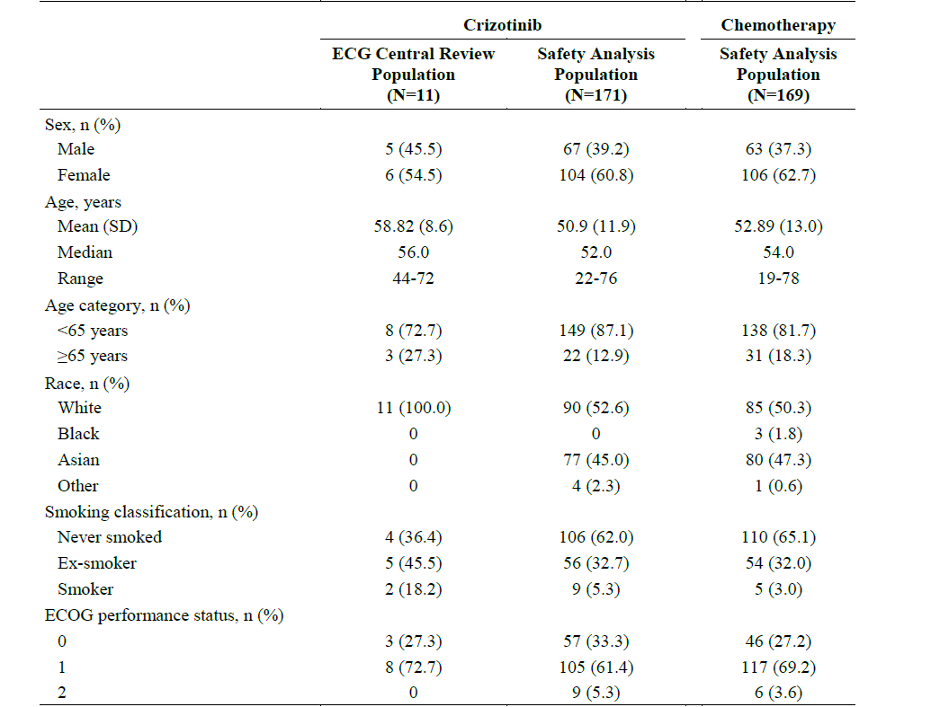

###### ECG results

Of the 11 patients in the ECG central review population, none had a maximum QTcF of ≥500 msec or a maximum QTcF increase from baseline of ≥60 msec. No patients had a maximum QTcB of ≥500 msec or a maximum QTcB increase from baseline of ≥60 msec.

Adverse events of Electrocardiogram QT prolonged were not reported for any patient in the ECG central review population.

Table 33: Study 1014 Categorisation of ECG Data - Maximum Post-dose and Increase from Baseline.

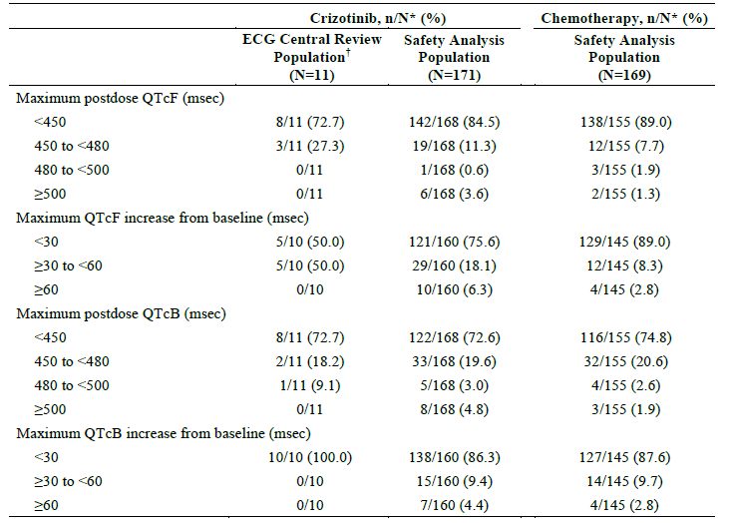

*Cardiac Disorders System Organ Class*

A summary of patients experiencing all‑causality Cardiac Disorders SOC events is provided.

In the ECG central review population, 1 patient (9.1%) experienced an AE in the cardiac disorders SOC (non-serious, treatment-related Grade 1 AE of pericardial effusion). In the crizotinib-treated safety analysis population, 38 patients (22.2%) and in the chemotherapy-treated safety analysis population, 15 patients (8.9%) experienced an AE in the cardiac disorders SOC.

In the ECG central review population, no patients experienced an SAE in the cardiac disorders SOC.

Four (4) patients (2.3%) in the crizotinib-treated safety analysis population and 7 patients (4.1%) in the chemotherapy-treated safety analysis population experienced an SAE in the cardiac disorders SOC. No patients in the crizotinib-treated safety analysis population had Grade 5 SAEs in the cardiac disorders SOC. In the crizotinib-treated safety analysis population 2 patients (1.2%) experienced Grade 4 SAEs of Cardiac tamponade.

Two additional patients in the crizotinib-treated safety analysis population experienced SAEs (1 patient each with Grade 3 atrial fibrillation and Grade 3 atrioventricular block).

One patient in the chemotherapy-treated safety analysis population experienced a Grade 5 SAE of cardiac arrest. There were 6 additional patients with SAEs in the chemotherapy-treated safety analysis population, specifically: Grade 3 Syncope (2 patients),

Grade 2 atrial fibrillation (1 patient), Grade 2 cardiotoxicity (1 patient), Grade 2 pericarditis (1 patient), and Grade 1 pericardial effusion (1 patient).

Table 34: Study 1014 Summary of Treatment-Emergent Adverse Events in the Cardiac Disorders System Organ Class (All Causality, All Cycles)

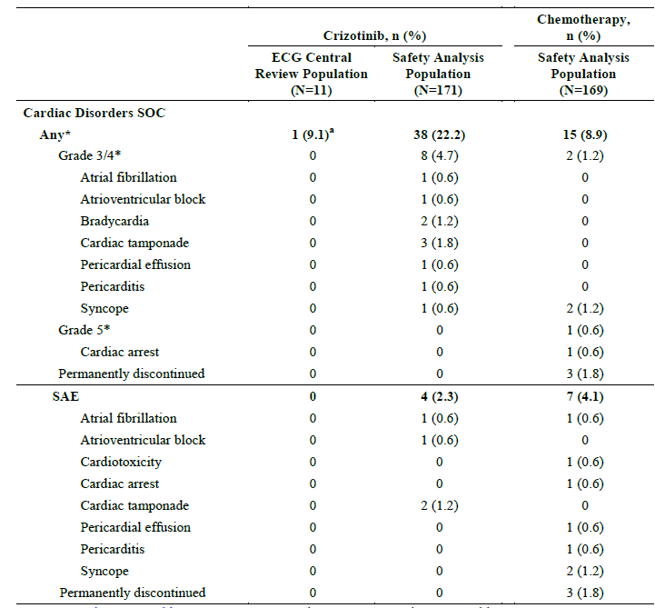

###### Bradycardia

All‑causality bradycardia was reported for 23 patients (13.5%) in the crizotinib‑treated safety analysis population and 1 patient in the chemotherapy‑treated safety population.

For the 23 patients in the crizotinib‑treated population who experienced bradycardia the median time to first onset was 43 days and median duration was 169 days.

Of these 23 reports, 2 were grade 3, no grade 4 or 5.

###### Dizziness

All‑causality dizziness was reported for 31 patients (18.1%) in the crizotinib-treated safety analysis population (all grade 1or2) and 17 patients (10.1%) in the chemotherapy-treated safety population.

All‑causality dizziness was not reported in the ECG central review population

For the 31 patients in the crizotinib-treated safety analysis population who experienced dizziness, the median time to first onset was 63 days and the median duration was 44 days.

**Comment**: A sub-study within Study 1014 was conducted in response to a post-marketing commitment requested by the EMA to increase the number of ECG time points after crizotinib administration and to add central independent manual review of ECG results.

In the ECG central review population, there were no significant changes in QTcF, PR interval, or QRS complex.

As only 11/171 crizotinib‑treated patients underwent independent central review of ECGs these data are extremely limited.

Prolonged QT is already noted in the approved PI as a common ADR associated with crizotinib.

All‑causality bradycardia was not reported in the ECG central review population.

All‑causality bradycardia was reported for 23 patients (13.5%) in the crizotinib-treated safety analysis population and 1 patient (0.6%) in the chemotherapy-treated safety population.

Bradycardia is also a recognised ADR in the approved PI for crizotinib with frequency of 12-13%.

All‑causality syncope was not reported in the ECG central review population.

All‑causality syncope was reported for 1 patient (0.6%) in the crizotinib-treated safety analysis population and 2 patients (1.2%) in the chemotherapy-treated safety population.

All‑causality dizziness was not reported in the ECG central review population.

All‑causality dizziness was reported for 31 patients (18.1%) in the crizotinib-treated safety analysis population and 17 patients (10.1%) in the chemotherapy-treated safety population.

Syncope is recorded in the approved PI as a common ADR associated with crizotinib.

Overall the safety profile reported in Study 1014 appears to be consistent with the safety profile from previously reported trials and the Australian approved PI.

#### Vital signs and clinical examination findings

###### Study 1001 ROS1‑positive NSCLC

Minimum and maximum change from baseline for blood pressure and pulse rate are shown.

Table 35: Study 1001 Change from baseline BP and pulse rate

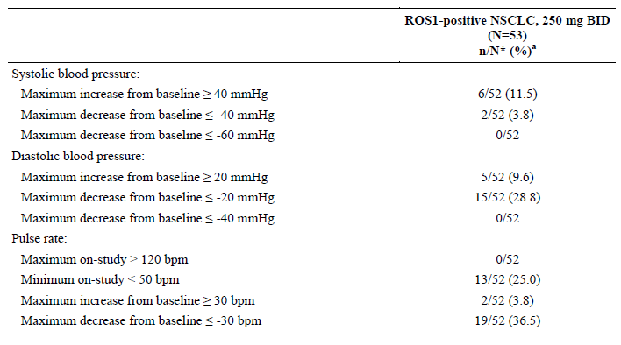

a % = (n/N*) x 100

No patients had an increase in pulse rate >120 bpm. All-causality AEs of heart rate increased and sinus tachycardia were each reported for 1 (1.9%) patient.

Pulse rate <50 bpm was reported for 25.0% of patients. All-causality bradycardia was reported for 14 (26.4%) patients.

Increases in DBP ≥20 mmHg were reported for 9.6% of patients and increases in SBP ≥40 mmHg were reported for 11.5% of patients. All-causality hypertension was reported for 1 (1.9%) patient. No patients had decreases in DBP of ≤40 mmHg or decreases in SBP ≤60 mmHg. All-causality hypotension was reported for 5 (9.4%) patients.

Increases in body weight ≥10% were reported for 32.7% of patients and decreases in body weight ≤10% were reported for 9.6% of patients. All-causality weight increased and weight decreased were each reported for 4 (7.5%) patients.

*Study 1007 ALK‑positive NSCLC*

Minimum and maximum change from baseline for vital signs measurements (blood pressure and pulse rate) and body weight are presented. A maximum on-study pulse rate >120 bpm was reported for 2 (1.2%) crizotinib-treated patients and 15 (9.0%) chemotherapy-treated patients. All-causality AEs of tachycardia and supraventricular tachycardia were reported for 1.2% and 0% of crizotinib-treated patients, respectively, and for 1.2% and 0.6% of chemotherapy-treated patients, respectively. A minimum on-study pulse rate <50 bpm was reported for 28 (16.4%) crizotinib-treated patients and 1 (<1.0%) chemotherapy-treated patient.

Table 36: Study 1007 Summary of Vital Signs Minimum and Maximum Change

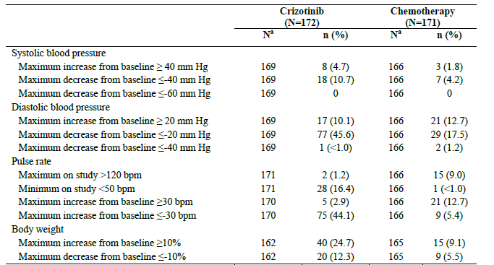

#### Immunogenicity and immunological events

*Study 1001 ROS1‑positive NSCLC*

No immunological events reported.

*Study 1007 ALK‑positive NSCLC*

No immunological events reported.

#### Serious skin reactions

*Study 1001 ROS1‑positive NSCLC*

No serious skin reactions reported.

*Study 1007 ALK‑positive NSCLC*

No serious skin reactions reported.

#### Interstitial Lung Disease

*Study 1001 ROS1‑positive NSCLC*

Treatment-related interstitial lung disease was reported for 1 (1.9%) patient. The event was Grade 1 and was not considered serious. Time to onset was 112 days and duration was 8 days. This event was associated with temporary treatment discontinuation for 7 days and was not associated with dose reduction or permanent treatment discontinuation.

*Study 1007 ALK‑positive NSCLC*

Treatment-related interstitial lung disease was reported for 5 (2.9%) crizotinib-treated patients and 1 (0.6%) chemotherapy-treated patient. One (0.6%) crizotinib-treated patient had Grade 3 treatment-related interstitial lung disease and 2 (1.2%) crizotinib-treated patients had fatal (Grade 5) treatment-related events. There were no Grade 4 treatment-related events for patients treated with crizotinib and no Grade 3, 4 or 5 treatment-related events for patients treated with chemotherapy. Treatment-related SAEs of interstitial lung disease were reported for 4 (2.3%) crizotinib-treated patients and 0 chemotherapy-treated patients.

### Other safety issues

#### Safety in special populations

No data submitted.

#### Safety related to drug-drug interactions and other interactions

Drug-drug interactions are covered in the Pharmacokinetic section.

### Post marketing experience

No post marketing data were submitted with this application.

### EMA conclusions on clinical safety in ROS1‑positive patients

EMA conclusions on clinical safety:

*The known crizotinib safety profile was confirmed in ROS1-positive patients, with no new safety concerns raised by data from these additional 53 patients. Dose modification was fruitfully applied for the management of adverse reactions. However, the very limited number of ROS1-positive NSCLC patients included in this analysis does not allow to clearly explain the increased frequency, with a difference of ≥10% in comparison to ALK-positive NSCLC patients, of some crizotinib ADRs, such as vision disorder, dizziness, bradycardia and rash.*

### Evaluator’s overall conclusions on clinical safety

Study 1001 presented data on 53 patients with ROS1‑positive advanced NSCLC treated with crizotinib 250 mg BID; median duration of treatment was 23.2 months (95% CI: 15.0, NR), with 47.2% of patients still actively receiving crizotinib at the time of data cut-off.

No new safety signals were identified from patients with ROS1-positive NSCLC in Study 1001 and data were consistent with the established safety profile for crizotinib, as described in the approved PI. A similar AE profile for the most common AEs was observed for all-causality and treatment-related AEs.

An updated summary of clinical safety for Study 1007 was included in the dossier, based on median exposure of 48 weeks for crizotinib and 13.0 weeks for chemotherapy.

The frequency of adverse drug reactions reported in this clinical summary are consistent with the current TGA approved PI for crizotinib.

A sub-study within Study 1014 was conducted in response to a post-marketing commitment requested by the EMA to increase the number of ECG time points after crizotinib administration and to add central independent manual review of ECG results.

In the ECG central review population, there were no significant changes in QTcF, PR interval or QRS complex.

As only 11/171 crizotinib‑treated patients underwent independent central review of ECGs these data are extremely limited.

There are 10 identified risks for crizotinib established from previous clinical trials and post marketing experience namely; Hepatotoxicity, Pneumonitis/interstitial lung disease, Vision Disorder, QTc Prolongation on ECG, Bradycardia, Leukopenia, Renal Cyst, Oedema, Neuropathy, and the most recently added (10 March 2017) Cardiac Failure.

For the majority of identified risks no clear mechanism has been identified and it is not possible to predict for any individual patient what they might experience.

## First round benefit-risk assessment

### First round assessment of benefits

See table below.

Table 37: First round assessment of benefits.

| Indication | |
| --- | --- |
| Benefits | Strengths and Uncertainties |
| This submission presents data for 53 patients with ROS1-positive advanced NSCLC in the phase I Study 1001 treated with crizotinib 250 mg BID, based on a data cut-off date of 30 November 2014.  The efficacy endpoint was objective response rate (ORR) using tumour assessments based on RECIST v1.0 for the ROS1-positive NSCLC cohort and RECIST v1.1 for the 3 patients with ROS1-positive NSCLC in the ALK-negative NSCLC cohort, as assessed by the investigator.  The objective response rate was 70% (37/53 patients, 5 CR, 32 PR).  The ORR appeared independent of baseline characteristics, including age group (<65 years and ≥65 years), gender, race group (Asian and non-Asian), number of prior treatment regimens for advanced/metastatic disease (0 and ≥1), ECOG PS (0 and 1), and the percentage of ROS1-positive cells.  These ORR data are also supported by the PFS and DR results stated below.  As of data cut-off for this CSR, 22/37 patients (59.5%) did not have subsequent disease progression or death after the response.  The median PFS was 19.3 months (95% CI: 14.8 months, NR).  The median DR by the Kaplan-Meier method was not reached (95% CI: 15.2 months, NR).  The probability of being alive and progression-free at 6 months was 76.9% (95% CI: 62.8, 86.1).  The probabilities of survival at 6 months and at 12 months were 90.6% (95% CI: 78.8, 96.0) and 79.0% (95% CI: 65.3, 87.8), respectively.  These data demonstrate that crizotinib 250 mg BID has clinically meaningful efficacy in patients with ROS1‑positive advanced NSCLC. | ROS1 rearrangements are present in approx. 1-2% of NSCLC patients, therefore the patient numbers available for analysis in this study are relatively small (53 patients).  The scientific rationale for targeting patients with ROS1 rearrangement seems strong.  The sponsor has made it clear that a phase III trial will not be performed.  As stated under ‘benefits’ the high observed objective response rate and supporting data from the other endpoints provide confidence in a clinically meaningful effect for crizotinib in patients with ROS1‑positive advanced NSCLC. |

### First round assessment of risks

See table below.

Table 38: First round assessment of risks.

| Risks | Strengths and Uncertainties |
| --- | --- |
| There are 10 identified risks for crizotinib established from previous clinical trials and post marketing experience, namely:   1. Hepatotoxicity 2. Pneumonitis/interstitial lung disease 3. Vision Disorder 4. QTc Prolongation on ECG 5. Bradycardia 6. Leukopenia 7. Renal Cyst 8. Oedema 9. Neuropathy   And the most recently added (10 March 2017)  10. Cardiac Failure  The frequency and potential seriousness of each risk is discussed at some length in the RMP. | The pattern of adverse events in the 53 patients with ROS1‑positive advanced NSCLC was not obviously different to these identified risks for crizotinib.  As expected with a small cohort of patients not every previously identified ADR was seen in this study.  While many of the adverse events occur frequently they are also commonly Grade1 or 2 events and can often be managed by dose reduction or dose interruption.  As the majority of patients with NSCLC will die from progressive disease this level of adverse events are acceptable in the context of the high objective response rate observed with crizotinib.  For the majority of these identified risks no clear mechanism has been identified and it is not possible to predict for any individual patient what they might experience. |

### First round assessment of benefit-risk balance

The data submitted demonstrate a positive benefit risk balance for crizotinib 250 mg BID in patients with ROS1‑positive advanced NSCLC.

## First round recommendation regarding authorisation

Pending satisfactory answers to the clinical questions, the data submitted support an extension of indications for crizotinib 250 mg BID to be used in patients with ROS1‑positive advanced NSCLC.

## Clinical questions

### Clinical questions

#### Pharmacokinetics

No questions.

#### Pharmacodynamics

1. Could the Sponsor explain the diagnostic cascade to identify the ROS1 genetic rearrangement in NSCLC patients in the clinical trial 1001?

#### Efficacy

1. The indication proposed for Australia for Xalkori is for the treatment of patients with ROS1-positive advanced non-small cell lung cancer (NSCLC).

The indication approved in the US for Xalkori is for the treatment of patients with metastatic NSCLC whose tumors are ROS1-positive.

Given the submission states that data submitted is the same in Australia and the US, can the Sponsor provide an explanation for these differences in proposed indication?

1. Given only 1-2% of NSCLC patients have the ROS1 gene rearrangement, how will NSCLC patients be tested in clinical practice in Australia to identify the ROS1 genetic rearrangement?

Has a central laboratory been identified in Australia to conduct FISH testing or other diagnostic testing? Are any diagnostic tests for identifying ROS1 rearrangements approved in Australia?

1. In the clinical overview it is stated that “All available tumour scans for patients in the ROS1-positive NSCLC cohort were to be retrospectively reviewed by an independent radiology laboratory”. Where in the dossier have these data been submitted?

Please comment on any differences in the ORR based on local review of tumour scans compared to central review.

#### Safety

1. Different median exposures for patients receiving crizotinib are quoted for Study 1001 in different places.

In the CSR, the median duration of crizotinib treatment is stated as 23.2 months, the supporting table states 19.7 months as median duration of treatment. Elsewhere in the CSR, there is a median duration of treatment derived by the Kaplan Meier method as 23.2 months. The draft PI states median crizotinib exposure is 101 weeks.

Could the Sponsor clarify which value is correct?

1. In the cover letter it is stated that a new study, Study 1062, is ongoing to assess the frequency of risk factors for and sequelae of potential sight threatening events and severe visual loss following exposure to crizotinib.

Could the Sponsor provide the first interim report?

## Second round evaluation

### Responses to questions

#### Pharmacodynamics

**Question 1**

* *Could the Sponsor explain the diagnostic cascade to identify the ROS1 genetic rearrangement in NSCLC patients in the clinical trial 1001?*

**Sponsor’s response**

Study A8081001 (referred to as Study 1001) is an ongoing Phase 1 study designed to evaluate the preliminary anti-tumour activity, safety, pharmacokinetics and pharmacodynamics of crizotinib when administered as a single agent in the treatment of patients with advanced NSCLC harbouring specific genetic alterations, including patients with alterations in ROS1 gene. A ROS1 FISH assay was originally developed by the Diagnostic Molecular Pathology Laboratory at the MGH and used as a clinical trial assay (CTA) to assess rearrangements involving the ROS1 gene. The MGH ROS1 FISH assay represents the primary test used to identify patients with ROS1-positive NSCLC for enrolment into the ROS1 cohort of Study 1001.

The ROS1 tests and specimen testing distribution for Study 1001 ROS1 cohort is as follows:

* Massachusetts General Hospital (N=24, ROS1 FISH test; N=2 ROS1 research FISH test*)
* Seoul National University Hospital (N=12; ROS1 FISH test)
* University of Colorado CMOCO (N=5; ROS1 FISH test)
* Memorial Sloan Kettering Cancer Centre (N=3; ROS1 FISH test)
* Clarient (N=1; ROS1 RT-PCR test)
* Peter MacCallum Cancer Centre (N=1; ROS1 FISH test)
* Response Genetics (N=1, ROS1 RT-PCR test)
* Caris (Miraca Life Sciences) (N=1, ROS1 FISH test)

*A research version of the ROS1 FISH test was originally used prior to clinical laboratory validation.

Overall, 50 patients with ROS1-positive NSCLC were identified.

Additional work was performed to demonstrate the concordance between the ROS1 FISH CTAs and the Kreatech ROS1 FISH assay that is commercially available. The primary objective of this additional work was to ensure that the ROS1 FISH methodology used in Study 1001 was concurrent to the Kreatech ROS1 FISH methodology. Thus, if concordance occurs, this would allow the Kreatech ROS1 FISH assay to be established as the single reference to compare any other CTAs. In Study 1001 the ROS1 status of NSCLC tissue specimens was determined by laboratory-developed break-apart FISH (96%) or RT-PCR (4%) CTAs and the specimens that were available were re-tested with the Kreatech ROS1 FISH assay validated in a Clinical Laboratory Improvement Amendment (CLIA) certified laboratory for all ROS1-positive and ROS1-negative specimens against which concordance with the Kreatech ROS1 FISH assay could be determined. The primary evaluation of concordance was based on positive percent agreement (PPA) as determined by analysis of ROS1-positive specimens obtained from patients enrolled in the ROS1 cohort of Study 1001, and negative percent agreement (NPA) as determined by analysis of a separate set of NSCLC ROS1-negative specimens obtained through commercial vendors. The results of this additional work indicated that the concordance between CTAs and the Kreatech ROS1 FISH test was 100% with respect to the detection of ROS1 fusions.

References are noted.[2]

Please see Response to Question 3 that further describes the diagnostic pathways used in clinical practice in Australia to identify and screen patients with ROS1-positive NSCLC.

**Comment**: The Sponsor’s response is noted and accepted.

There was one patient enrolled in Australia and the diagnostic test was performed at the Peter MacCallum hospital (FISH test).

#### Efficacy

**Question 2**

* *The indication proposed for Australia for Xalkori is for the treatment of patients with ROS1-positive advanced non-small cell lung cancer (NSCLC).*

*The indication approved in the US for Xalkori is for the treatment of patients with metastatic NSCLC whose tumors are ROS1-positive.*

*Given the submission states that data submitted is the same in Australia and the US, can the Sponsor provide an explanation for these differences in proposed indication?*

**Sponsor’s response**

The applications in the EU, US and Australia for treatment of ROS1-positive NSCLC with Xalkori are all based on data from Study 1001 ROS1-positive NSCLC cohort, with the Australian application more closely aligned to the EU application.

Although the indication approved in the US is for the “treatment of patients with metastatic NSCLC whose tumors are ROS1-positive”, the indication approved in the EU is for the “treatment of adults with ROS1-positive advanced non-small cell lung cancer (NSCLC)” (see EU Summary of Product Characteristics (SmPC)).

Thus, the proposed Australian indication is consistent with the EU approved indication concerning treatment of ROS1-positive advanced NSCLC.

The Xalkori USPI indication statement for ROS1-positive NSCLC was proposed by Pfizer to be consistent with the FDA-approved indication statement for the ALK-positive NSCLC indication in the USPI (see US Prescribing Information). The indication statement states “metastatic disease” only based on previous feedback from the FDA during review of the supplemental New Drug Application (NDA) for Phase 3 Study 1007 (previously treated patients with ALK-positive NSCLC) where the FDA made this change to be consistent with other US lung cancer approvals.

The Study 1001 data indicate that, at baseline, of the 53 patients with ROS1-positive NSCLC there were 4 patients (7.6%) with Stage III disease and 48 patients (90.5%) with Stage IV disease and the disease stage is missing for 1 patient (1.9%). Also, the indication proposed in Australia, “treatment of patients with ROS1-positive advanced NSCLC” is consistent with the currently approved indication of “treatment of patients with ALK-positive advanced NSCLC” with respect to disease stage.”

**Comment**: The evaluator thinks it is appropriate to accept the proposed Australian indication, namely:

*Xalkori is indicated for the treatment of patients with ROS1-positive advanced non-small cell lung cancer (NSCLC).*

**Question 3**

* *Given only 1-2% of NSCLC patients have the ROS1 gene rearrangement, how will NSCLC patients be tested in clinical practice in Australia to identify the ROS1 genetic rearrangement?*

*Has a central laboratory been identified in Australia to conduct FISH testing or other diagnostic testing? Are any diagnostic tests for identifying ROS1 rearrangements approved in Australia?*

**Sponsor’s response**

Currently there are two diagnostic pathways used in clinical practice in Australia to identify and screen patients with ROS1-positive NSCLC. One of these pathways (Pathway 1) is mainly used in regional areas, whereas the other pathway (Pathway 2) is used in major capital cities such as Sydney and Melbourne.

* Pathway 1 screens for ROS1 overexpression using immunohistochemistry (IHC) in EGFR and ALK mutation negative NSCLC patients.
* Pathway 2 is the pathway recommended by the International Association for the Study of Lung Cancer (IASLC), the College of American Pathologists (CAP) and the Association for Molecular Pathology (AMP) guidelines. According to this pathway the testing for EGFR, ALK and ROS1 is done upfront concurrently in all locally advanced or metastatic NSCLC patients. For testing of ALK and ROS1, 4 micron tumour tissue sections are cut to be analysed by IHC. This IHC screening test is reimbursed through the Medicare Benefits Schedule (MBS).

After screening through either of the 2 pathways mentioned above, the ROS1 cases positive by IHC are then confirmed by conducting a ROS1 FISH test, which is only conducted in a minority of centres in Australia, including, but not limited to the Royal Prince Alfred Hospital and St Vincent’s Hospital in Sydney, the Peter MacCallum Cancer Centre and Sonic Healthcare Group in Melbourne. Notably, these centres are also ‘Centres of Excellence’ for the ALK FISH tests.

Details of a ROS1 FISH assay conducted at the Peter MacCallum Cancer Centre and Royal Prince Alfred Hospital have been published (Rogers et al., 2015; Selinger et al., 2017). Since there are only few commercially available FISH probes for ROS1 testing in Australia such as the ZytoVision FISH probes and the Abbott’s ROS1 Break Apart FISH probes, individual centres currently develop and validate their own modified “local” FISH protocols for detecting ROS1 rearrangements. It is proposed that testing should only be performed in laboratories that have received National Association of Testing Authorities (NATA) accreditation with an established quality assurance program specific for ROS1 fusion test developed by the Royal College of Pathologists of Australasia (RCPA) Medical Services Advisory Committee (MSAC) Population, Intervention, Comparator, Outcomes (PICO confirmation - Application 1454). It is anticipated that ROS1 testing will be limited to specialised pathology laboratories based in major centres.

Access to testing for patients in regional or remote areas would be facilitated by the collection of a tumour tissue sample at their local treatment centre and transportation to an accredited pathology laboratory for testing. The ‘Centres of Excellence’ which currently perform the majority of ALK FISH testing have specialised laboratories capable of accurate and efficient processing of Australian ALK samples and it is anticipated that these same centres are also likely to become the ‘Centres of Excellence’ for ROS1 FISH testing in the future.

In terms of other tests, the PICO confirmation application 1454 outlines other tests such as RT-PCR, multigene panel testing using Sanger and next generation sequencing.

Furthermore, the Pharmaceutical Benefits Advisory Committee (PBAC) has advised that if these alternatives are proven to be as good as or better than FISH / IHC and incur similar or less cost (i.e., are cost effective) then MSAC may consider broadening the MBS funded test options to include these tests.”

References are noted.[3]

**Comment**: The sponsor’s response is noted and accepted. Clarification of diagnostic testing for NSCLC in the Australian context is appreciated.

**Question 4**

* *In the clinical overview it is stated that “All available tumour scans for patients in the ROS1-positive NSCLC cohort were to be retrospectively reviewed by an independent radiology laboratory”. Where in the dossier have these data been submitted?*

*Please comment on any differences in the ORR based on local review of tumour scans compared to central review.*

**Sponsor’s response**

An independent radiology review (IRR) of radiographic images that were used by the investigators to assess anti-tumour activity for patients with ROS1-positive advanced NSCLC in Study 1001 has been completed, and the results are presented in the Study 1001 Independent Radiology Review Report. Since the IRR report was not included in the initial submission, this report is now being submitted. A summary of the results is provided below.

**IRR report executive summary**

A retrospective collection of all available radiographic scans from patients with ROS1- positive advanced NSCLC in Study 1001 was conducted. The radiographic scans could include computed tomography (CT) scans, magnetic resonance imaging (MRI) scans, bone scans and X-rays. The investigative sites were requested to collect and transfer all available scans to the independent third-party core imaging laboratory (BioClinica, Princeton, NJ, United States) for review.

A total of 50 patients with ROS1-positive advanced NSCLC enrolled into the ROS1-positive NSCLC cohort are included in this IRR report. Of note, 3 patients with advanced NSCLC belonging to the anaplastic lymphoma kinase (ALK)-negative cohort (referred to as ALK‑negative cohort #2 in the study protocol) were retrospectively found to be ROS1-positive and are not included in the IRR analysis for this report due to different tumour assessment frequency (every 6 weeks vs every 8 weeks) and the use of a different Response Evaluation Criteria in Solid Tumors (RECIST) version (version 1.1 vs version 1.0) than for the ROS1- positive NSCLC cohort.

All 50 patients in the ROS1-positive NSCLC cohort were response-evaluable (RE), as defined in the ROS1 clinical study report (ROS1 CSR), for the derived tumour assessment and for the IRR assessment of the objective response rate (ORR).

The results from the independent third-party core imaging laboratory showed that 1 patient (2.0%) achieved a confirmed complete response (CR) and 32 patients (64.0%) achieved a confirmed partial response (PR), 12 patients (24.0%) had SD, and 4 patients (8.0%) had objective progression. Therefore the independent assessment of ORR was 66.0% (33 of 50 patients; 95% CI: 51.2, 78.8).

The total event agreement rate between the derived tumour assessment and IRR assessment was 82.0%. The IRR-assessed ORR is consistent with and provides an independent confirmation of the derived tumour assessment of ORR of 72.0% (95% CI: 57.5, 83.8) for the 50 patients in the response-evaluable population.

**Comment**: As noted in the sponsor’s response, the total event agreement rate between the derived tumour assessment and IRR assessment was 82.0%.

The ORR by IRR is 66% compared to 72% in the local review (derived tumour response).

Of note, IRR assessed CR in one patient compared to 5 patients assessed as CR in the local review. There is no explanation from the sponsor on how or why these discrepancies arose.

As the IRR utilised retrospective collection of scans there was inevitably some missing data, however this did not seem to fully account for the discrepancies

#### Safety

**Question 5**

* *Different median exposures for patients receiving crizotinib are quoted for Study 1001 in different places.*

*In the CSR, the median duration of crizotinib treatment is stated as 23.2 months, the supporting table states 19.7 months as median duration of treatment. Elsewhere in the CSR, there is a median duration of treatment derived by the Kaplan Meier method as 23.2 months. The draft PI states median crizotinib exposure is 101 weeks.*

*Could the Sponsor clarify which value is correct?*

**Sponsor’s response**

Duration of crizotinib treatment was summarised using both descriptive statistics (19.7 months) and the Kaplan-Meier method (23.2 months). This latter method takes into account the fact that crizotinib treatment was still ongoing for 47% of the patients at the time of data cutoff date and provides a more reliable estimate for the median duration of treatment. As such, and as noted in the CSR, median duration of crizotinib treatment is presented based on the Kaplan-Meier estimate:

*Kaplan-Meier analysis of duration of treatment is provided. At the time of the data cutoff date for this report, the median duration of crizotinib treatment was 23.2 months (95% CI: 15.0, NR), with 47.2% of patients still actively receiving crizotinib.*

As median duration of treatment in the PI is in weeks for patients with ALK-positive NSCLC, the median duration of treatment for patients with ROS1-positive NSCLC has been provided in the same unit to keep consistency throughout the document.

In the light of the above, the median duration of treatment in months has been converted into weeks, using the below conversion formula:

conversion formula

**Comment**: The sponsor’s response is noted and accepted.

**Question 6**

* *In the cover letter it is stated that a new study, Study 1062, is ongoing to assess the frequency of risk factors for and sequelae of potential sight threatening events and severe visual loss following exposure to crizotinib.*

*Could the Sponsor provide the first interim report?*

**Sponsor’s response**

The first interim report of Study 1062 is provided. The second interim report of this study is expected to be available by November 2017 and can be provided upon request.

Supporting documentation is noted.[4]

**Comment**: The interim report refers to one case, so it is too early to make any meaningful assessment.

### Additional information

#### Hepatic impairment

##### Study 1012

The Synopsis for study 1012 is provided.

##### Study design

This was a multicentre, open-label, non-randomized, Phase 1 clinical study of crizotinib in patients with advanced cancer and varying degrees (mild and moderate) of hepatic impairment and race-, age-, weight-, gender-, and Eastern Cooperative Oncology Group (ECOG) performance status (PS)-matched patients with normal hepatic function. In order to explore the PK and safety of crizotinib in patients with severe hepatic impairment, patients with severe hepatic impairment were also enrolled in this study. Patients with severe hepatic impairment were not to be matched by any control group.

Patients in this study were assigned to different treatment groups (Groups A [patients with normal hepatic function], B [patients with mild hepatic impairment], C [patients with moderate hepatic impairment], and D [patients with severe hepatic impairment]) according to their liver function. The criteria for patient assignment based on their liver function (according to National Cancer Institute [NCI] guidance) are listed.

Table 39: Criteria for Patient Assignment by Liver Function

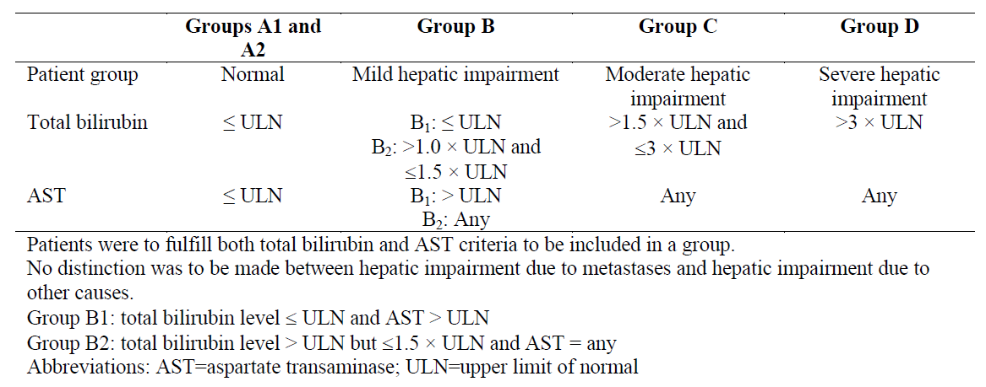

##### Patient evaluation groups

A total of 88 patients with advanced cancer (histologically or cytologically confirmed solid malignancy or lymphoma that was metastatic or unresectable, and for which standard curative or palliative measures did not exist, or were no longer effective) were assigned to dosage of crizotinib depending on level of hepatic impairment.

Baseline characteristics of patients are shown in Table 52 in the Study Synopsis in the Appendix to this report.

* Group A (n= 26) had normal hepatic function;
* Groups B (n= 20), C (n = 26), and D (n = 16), had mild, moderate and severe hepatic impairment respectively.
* Only 2 patients had lung cancer (both in group A); the majority in the groups with hepatic impairment had hepatocellular cancer, hepatic cancer, or metastatic colon cancer. The proposed sample size of 70 patients was estimated accounting for an approximate 40% patient attrition rate, with the aim of ensuring there were 38 PK-evaluable patients for statistical analyses; 6 in group D, 8 in all other groups. The CSR defined the PK-evaluable patient group and PK analysis group. The doses of crizotinib were:
  + 250 mg twice daily (BID) for Groups A1 and B;
  + 250 mg QD for the first stage of Group C (Group C1);
  + 200 mg BID for Groups A2 and the second stage of Group C (Group C2); and
  + 250 mg QD for Group D.

These doses for Groups A1, B and C1 were based on the results of population-based PK simulations that indicated increased exposure was likely to be marked for patients with moderate hepatic impairment. Doses for Groups A2, C2 and D were determined at a second stage based on preliminary safety and PK data for evaluable patients in Group C1.

* + Small numbers of subjects in each group completed the study and contributed data to the PK analyses
  + Following crizotinib 250 mg BID dosing, patients with mild hepatic impairment (Group B) showed similar systemic crizotinib exposure at steady state compared to their matched control with normal hepatic function (Group A1). The geometric mean ratios between Group B and Group A1 for AUCdaily and Cmax were 91.12% (90% CI: 56.56%, 146.79%) and 91.20% (90% CI: 57.47%, 144.72%), respectively.

Table 40: Patient Evaluation Groups by Hepatic Function – Full Analysis Population

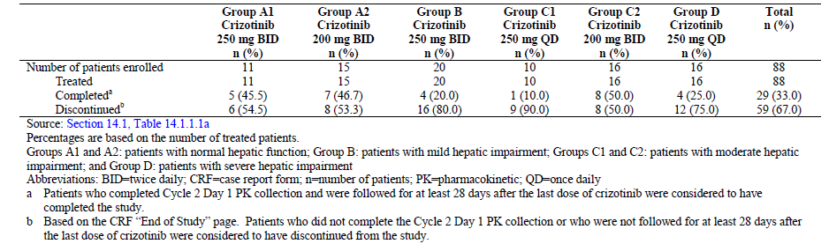

##### Potential cases of drug-induced liver injury (Hy’s Law)

Abnormal values in AST and/or alanine transaminase (ALT) concurrent with abnormal elevations in total bilirubin that met the criteria outlined below in the absence of other causes of liver injury were considered potential cases of drug-induced liver injury (potential Hy’s Law cases) and were considered important medical events.

The threshold of laboratory abnormalities for a potential case of drug-induced liver injury depended on the patient’s individual baseline values and underlying conditions. Patients who presented with the following laboratory abnormalities were to be evaluated further to definitively determine the aetiology of the abnormal laboratory values:

* Patients with baseline AST or ALT and total bilirubin values within the normal range: post-baseline AST or ALT ≥3 × ULN concurrent with a total bilirubin ≥2 x ULN with no evidence of haemolysis and an alkaline phosphatase ≤2 × ULN or not available.
* For patients with pre-existing AST or ALT or total bilirubin values above the ULN: post-baseline AST or ALT ≥2 × baseline values and ≥3 × ULN, or ≥8 × ULN (whichever was smaller, concurrent with total post-baseline bilirubin increased by 1 × ULN over baseline or ≥3 × ULN (whichever was smaller).

The patient was to return to the study site and be evaluated as soon as possible, preferably within 48 hours from awareness of the abnormal results. This evaluation was to include laboratory tests, detailed history, and physical assessment, and the possibility of hepatic neoplasia (primary or secondary) was to be considered. In addition to repeating AST and ALT, laboratory tests were to include albumin, creatine kinase, total bilirubin, direct and indirect bilirubin, gamma-glutamyl transferase (GGT), prothrombin time (PT)/international normalised ratio (INR), and alkaline phosphatase. A detailed history, including relevant information such as a review of ethanol, acetaminophen, recreational drug and supplement consumption, family history, occupational exposure, sexual history, travel history, history of contact with a jaundiced patient, surgery, blood transfusion, history of liver or allergic disease, and work exposure, was to be collected. Further testing for acute hepatitis A, B, or C infection and liver imaging (eg, biliary tract) could have been warranted. All cases confirmed on repeat testing as meeting the laboratory criteria defined above, with no other cause for liver function test (LFT) abnormalities identified at the time, were to be considered potential Hy’s Law cases irrespective of availability of all the results of the investigations performed to determine aetiology of the abnormal LFTs. Such potential Hy’s Law cases were to be reported as SAEs.

##### Pharmacokinetic results

Individual and geometric mean AUCdaily and Cmax (Cycle 2 Day 1) values are presented.

Figure 5: Individual and Geometric Mean Crizotinib AUCdaily and Cmax by Hepatic Function at Steady State (Cycle 2 Day 1)

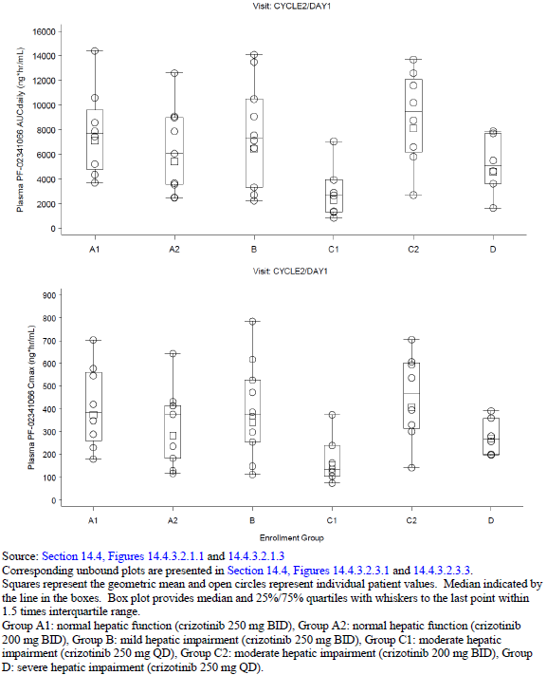

##### Discussion

The relatively small number of patients in each subgroup, coupled with the degree of inter-patient variability and associated overlapping confidence intervals makes the interpretation of these data difficult.

The mean steady-state CL/F in patients with normal hepatic function (Groups A1 and A2) receiving 250 mg BID and 200 mg BID crizotinib doses, respectively, was similar, suggesting linear PK between 200 mg BID and 250 mg BID in patients with normal hepatic function.

The PK of crizotinib in patients with mild hepatic impairment (Group B) was comparable to that of matched control patients with normal hepatic function (Group A1) with similar CL/F observed at steady state, indicating that mild hepatic impairment may have minimal effects on PK of crizotinib.

When dose increased from 250 mg QD (Group C1) to 200 mg BID (Group C2) for patients with moderate hepatic impairment, the mean total exposure of crizotinib increased more than dose-proportional (mean AUCdaily increased from 2305 ng·hr/mL to 8108 ng·hr/mL), suggesting non-linear PK of crizotinib in patients with moderate hepatic impairment tested between 250 mg QD and 200 mg BID.

When receiving the same crizotinib dose of 200 mg BID, patients with moderate hepatic impairment (Group C2) showed higher mean systemic exposure and lower CL/F compared to the matched control group (Group A2) with normal hepatic function, suggesting a decreased overall elimination of crizotinib in patients with moderate hepatic impairment. In addition, the mean total systemic exposure of crizotinib in patients with moderate hepatic impairment receiving 200 mg BID crizotinib (Group C2) was comparable to that observed in patients with normal hepatic impairment receiving a dose of 250 mg BID (Group A1).

The mean total systemic exposure of crizotinib in patients with severe hepatic impairment receiving 250 mg QD crizotinib (Group D) was lower than that observed in patients with normal hepatic impairment receiving a dose of 250 mg BID crizotinib (Group A1), but higher than that observed in patients with moderate hepatic impairment receiving 250 mg QD crizotinib (Group C1).

##### Safety results[5]

The duration of treatment of patients by Group: the duration is quite short for patients with hepatic impairment.

The most frequently reported all-causality AEs for the total population were Nausea, Fatigue, ELEVATED TRANSAMINASES, Vomiting, Hyponatraemia, ANAEMIA, OEDEMA, BLOOD CREATININE INCREASED, Disease progression, VISION DISORDER, Decreased appetite, CHOLESTASIS, Ascites, Constipation, Diarrhoea, and ABDOMINAL PAIN.

The most frequently reported all-causality AEs were generally consistent across the hepatic function groups with the exception of all-causality CHOLESTASIS and Ascites, which were only reported in patients with hepatic impairment. Most of the AEs were of Grade 1 or 2. The most frequently reported treatment-related AEs for the total population were Nausea, Vomiting, Fatigue, and VISION DISORDER. There were no all-causality AEs of VISUAL LOSS.

The following all-causality AEs were reported in patients with hepatic impairment but not in patients with normal hepatic function: CHOLESTASIS, Ascites, HEPATOTOXICITY, and THROMBOCYTOPENIA, with incidences >10% out of the 62 patients with hepatic impairment. These AEs were mostly expected in patients with hepatic impairment based on the underlying disease and mostly were not considered treatment-related.

However, Hepatic failure, which is within the clustered term of HEPATOTOXICITY, is an uncommon adverse drug reaction appearing in the Special Warnings and Precautions for Use of Pfizer’s Crizotinib Core Data Sheet, but, as noted above, all-causality HEPATOTOXICITY was not reported in patients with normal hepatic function in this study.

In general, the incidences of all-causality Grade 3 and Grade 4 AEs were higher in patients with hepatic impairment than in patients with normal hepatic function (see study synopsis in appendix). No Grade 3 treatment-related AEs occurred in more than 5 (5.7%) patients. Treatment-related Grade 4 AEs were reported for 3 patients (ELEVATED TRANSAMINASES [Group D], CHOLESTASIS [Group C2], and Respiratory failure [Group A2]; 1 [1.1%] patient each).

A total of 28 (31.8%) patients had Grade 5 all-causality AEs. Twenty-four (85.7%) out of the 28 fatal AEs were due to disease progression; other fatal AEs were Gastrointestinal haemorrhage, INTERSTITIAL LUNG DISEASE, Respiratory failure, and Septic shock (1 patient each). No Grade 5 all-causality AEs were considered treatment-related.

The most frequently reported all-causality serious AEs (SAEs) were Disease progression (23 [26.1%] patients). Four treatment-related SAEs were reported: Asthenia, Diarrhoea, Respiratory failure, and Vomiting.

For haematology laboratory parameters, the proportions of patients with shifts from Grade ≤2 at baseline to Grade 3 post-baseline were small and similar across the groups. There were no shifts from Grade ≤2 at baseline to Grade 4 post-baseline.

For chemistry laboratory parameters, shifts from Grade ≤2 at baseline to Grade 3 or 4 post-baseline for hyponatremia, total bilirubin, AST, and hypoalbuminemia appeared to be less frequent for patients with normal hepatic function than for patients with hepatic impairment.

Twelve (12) patients with hepatic impairment met the criteria for a potential Hy’s Law case.

Of these, 3 patients were in Group B, 3 in Group C1, 2 in Group C2 and 4 in Group D.

As most of the population of patients with hepatic impairment had abnormal liver function at baseline and experienced subsequent disease progression, these factors confound the analysis for the elevation in liver function tests.

**Comment**: Limitations to these data include the small number of patients in each subgroup, and the variable effect of underlying disorders and advanced cancers suffered by the enrolled subjects. Only 2 patients had lung cancer (both in group A).

There was an efficacy component to this trial which has not been evaluated, however the ORR outcomes show no CR and few with PR.

Of the 12 potential Hy’s Law cases, 6 patients had primary hepatocellular cancer and 5 patients had liver metastases, mainly from colorectal cancer. These patients also had abnormal liver function tests at baseline. Most of these patients were reported to have disease progression and deterioration of global health. Three of these patients died from disease progression during the study period. These 12 potential Hy’s Law cases were not considered to be true Hy’s Law cases by investigators or the Sponsor.

This conclusion is not unreasonable given the confounding factors noted above. It is difficult to generalise the safety findings in this population of patients with advanced liver disease to the NSCLC patient population.

It is informative for the prescriber to be aware of the study in patients with hepatic impairment and see the impact on exposure associated with moderate and severe hepatic impairment. More detail should be added on the patient population (hepatocellular cancer and liver metastases), the high discontinuation rate on crizotinib treatment and the difficulty in generalising these findings to NSCLC patients. The statement on dose adjustment is not appropriate and should be removed, however it is recommended that the cross reference to PRECAUTIONS –Hepatotoxicity be retained.

It would be prudent to be cautious about using crizotinib, a drug with potential liver toxicity, in patients with hepatic impairment.

The Sponsor has proposed lower starting doses for crizotinib in patients with moderate and severe liver impairment.

The proposed changes to crizotinib dosing are not warranted based on the quality of the data submitted and I recommend to the Delegate that this Section of the PI should not be changed.

#### Drug-drug interaction (DDI) study

##### Study 1001 sub-study

The objective of this sub-study was to characterize the potential effect of multiple doses of itraconazole (200 mg QD) on the steady-state PK of crizotinib following repeated 250 mg QD dosing of crizotinib in patients with advanced cancer.

Metabolism of crizotinib is primarily mediated by CYP3A isozymes in human liver microsomes and hepatocytes. The concomitant administration of a strong CYP3A inhibitor, itraconazole, increased the steady-state systemic exposure of crizotinib.

Patients had histologically confirmed advanced malignancies (except for leukemias) refractory to standard of care therapy, or for whom no standard of care therapy was available. Colon cancer (n = 4) was the only diagnosis reported for more than one patient.

Patients (n =17) were treated in a schedule with two 28 day cycles to receive study treatments as follows: Treatment Period A (Test): crizotinib 250 mg once daily was to be administered from C1D1 to C1D15 and commercially available itraconazole 200 mg once daily from C1D1 to C1D16 (up to before C1D16 crizotinib dosing). Treatment Period B (Reference) crizotinib 250mg QD was to be administered from C1D16 to C2D1.

Blood sampling was undertaken to determine and compare PK parameters for crizotinib and metabolitePF-06260182 for periods A and B (PK concentration population n = 15, PK parameter evaluable analysis population both periods n = 9.

Table 41: Patient Populations

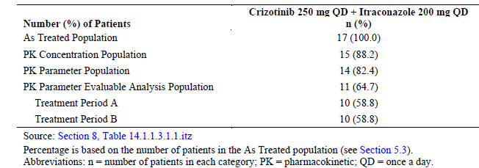

Individual and geometric mean plasma crizotinib AUCtau and Cmax values following multiple oral doses of crizotinib 250 mg QD alone (Cycle 2 Day 1) or co-administered with itraconazole 200 mg QD (Cycle 1 Day 15) are shown graphically.

The results demonstrated that co-administration of itraconazole (200 mg QD) increased steady-state crizotinib AUCtau and Cmax by 57% and 33%, respectively, following multiple dosing (250 mg QD) of crizotinib, compared to crizotinib administered alone.

The results also demonstrated that the administration of itraconazole increased the steady-state of the main metabolite of crizotinib PF-06260182 AUCtau and Cmax by 134% and 98%, respectively, following multiple dosing (250 mg QD) of crizotinib compared to crizotinib administered alone.

The observations from this multiple-dose crizotinib sub-study are consistent with those from a previous single-dose (150 mg) crizotinib DDI study with a strong CYP3A inhibitor, ketoconazole (200 mg BID), in healthy volunteers. However, the magnitude of increase in crizotinib exposure (57%) in this multiple-dose crizotinib DDI study was smaller than that observed with the single-dose crizotinib DDI study (120%).

The Sponsor stated that:

*acknowledging that different strong CYP3A inhibitors were used for the single crizotinib dose vs multiple crizotinib dose DDI studies (ketoconazole vs itraconazole), the smaller increase of crizotinib exposure observed in this DDI sub-study may be explained by a hypothesis that non-CYP3A metabolism pathways become more dominant in crizotinib metabolism due to auto-inhibition of CYP3A as observed after multiple dosing of crizotinib.*

Figure 6: Individual and Geometric Mean Plasma Crizotinib AUCtau and Cmax Values Following Multiple Oral Doses of Crizotinib 250 mg QD Alone (Cycle 2 Day 1) or Coadministered with Itraconazole 200 mg QD (Cycle 1 Day 15)

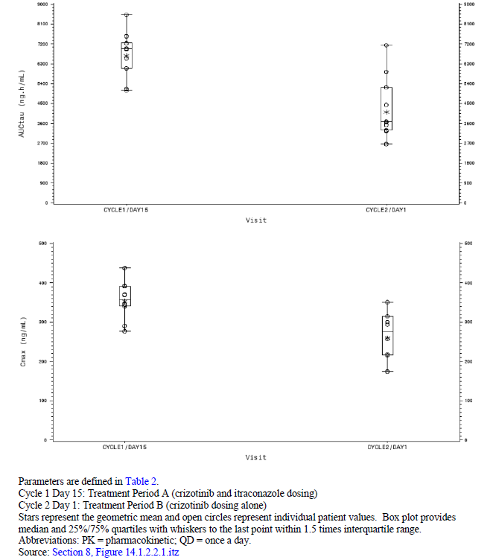

##### Overall conclusion

Co-administration of crizotinib (250 mg QD) with itraconazole (200 mg QD), a strong CYP3A inhibitor, increased steady-state AUCtau and Cmax of crizotinib by 57% and 33%, respectively, compared to crizotinib administered alone.

**Comment**: This DDI study utilised the usual recommended dose of itraconazole of 200 mg a day.

The Sponsor has not provided a reason for deleting the existing text in the PI statement regarding the co-administration of single dose crizotinib and ketoconazole.

The statement on co-administration of crizotinib and itraconazole is supported by the trial data submitted.

## Second round benefit-risk assessment

### Second round assessment of benefits

There are some differences in the assessment of ORR between local review and central review, however these differences do not alter the overall conclusion that these data demonstrate that crizotinib 250 mg BID has clinically meaningful efficacy in patients with ROS1‑positive advanced NSCLC.

### Second round assessment of risks

The assessment of risks has not changed from the first round.

### Second round assessment of benefit-risk balance

The overall assessment of benefit-risk balance has not changed from the first round and the data submitted demonstrate a positive benefit risk balance for crizotinib 250 mg BID in patients with ROS1‑positive advanced NSCLC.

## Second round recommendation regarding authorisation

The data submitted support an extension of indications for crizotinib 250 mg BID to be used in patients with ROS1‑positive advanced NSCLC.

## References

Birchmeier, C et al. (1986) Characterization of an Activated Human ros gene. Molecular and Cellular Biology 3109-3116.

Garassino et al (2013) Erlotinib vs docetaxel as second line treatment of patients with advanced non-small cell lung cancer. Lancet Oncol 14, 981-88.

Gold KA (2014) ROS1 – Targeting the one percent in lung cancer. NEJM 371,(21) 2030-2031

Scagliotti et al. (2009) the differential efficacy of pemetrexed according to NSCLC histology: a review of two phase III studies. Oncologist 14(3): 472-80.

Shaw AT, et al. (2014) Crizotinib in ROS1-Rearranged Non-Small Cell Lung Cancer. NEJM 371 (21) 1963-1971.

|  |
| --- |
| Therapeutic Goods Administration |
| PO Box 100 Woden ACT 2606 Australia  Email: [info@tga.gov.au](mailto:info@tga.gov.au) Phone: 1800 020 653 Fax: 02 6232 8605  [**https://www.tga.gov.au**](https://www.tga.gov.au) |

1. Studies 1001, 1007 and 1014 all involved patients with advanced cancer. For these studies, ‘ROS1‑positive advanced NSCLC’ and ‘ALK‑positive advanced NSCLC’ may hereafter be referred to as ROS1‑positive NSCLC’ and ‘ALK‑positive NSCLC', respectively.
2. Shaw AT, Ou S-HI, Bang Y-J, et al., 2014. Crizotinib in ROS1-rearranged non-small cell lung cancer. New Engl J Med. 2014; 371: 1963-1971; Bergethon K, Shaw AT, Ou SHI, et al., 2012. ROS1 rearrangements define a unique molecular class of lung cancers. J Clin Oncol. 2012; 30(8):863-870; Rogers TM, Arnau GM, Ryland GL, et al., 2017. Multiplexed transcriptome analysis to detect ALK, ROS1 and RET rearrangements in lung cancer. Sci Rep. 2017; Feb 9;7
3. Rogers TM, Russell PA, Wright G, et al., 2015. Comparison of methods in the detection of ALK and ROS1 rearrangements in lung cancer. J Thorac Oncol. 2015; 10(4):611-618; Selinger CI, Li BT, Pavlakis N, et al., 2017. Screening for ROS1 gene rearrangements in non-small-cell lung cancers using immunohistochemistry with FISH confirmation is an effective method to identify this rare target. Histopathology 2017; 70(3):402-411.
4. Synopsis for Study A8081062; Study A8081062 First Interim Annual Report: A Descriptive Study of Potential Sight Threatening Events and Severe Visual Loss Following Exposure to Xalkori (crizotinib).
5. Terms in upper case are clustered terms.