|  |
| --- |
| **October 2018** |

|  |
| --- |
| Australian Public Assessment Report for Crizotinib |
| Proprietary Product Name: Xalkori |
| Sponsor: Pfizer Australia Pty Ltd |

About the Therapeutic Goods Administration (TGA)

* The Therapeutic Goods Administration (TGA) is part of the Australian Government Department of Health and is responsible for regulating medicines and medical devices.
* The TGA administers the *Therapeutic Goods Act 1989* (the Act), applying a risk management approach designed to ensure therapeutic goods supplied in Australia meet acceptable standards of quality, safety and efficacy (performance) when necessary.
* The work of the TGA is based on applying scientific and clinical expertise to decision-making, to ensure that the benefits to consumers outweigh any risks associated with the use of medicines and medical devices.
* The TGA relies on the public, healthcare professionals and industry to report problems with medicines or medical devices. TGA investigates reports received by it to determine any necessary regulatory action.
* To report a problem with a medicine or medical device, please see the information on the TGA website <<https://www.tga.gov.au>>.

About AusPARs

* An Australian Public Assessment Report (AusPAR) provides information about the evaluation of a prescription medicine and the considerations that led the TGA to approve or not approve a prescription medicine submission.
* AusPARs are prepared and published by the TGA.
* An AusPAR is prepared for submissions that relate to new chemical entities, generic medicines, major variations and extensions of indications.
* An AusPAR is a static document; it provides information that relates to a submission at a particular point in time.
* A new AusPAR will be developed to reflect changes to indications and/or major variations to a prescription medicine subject to evaluation by the TGA.

Copyright

© Commonwealth of Australia 2018

This work is copyright. You may reproduce the whole or part of this work in unaltered form for your own personal use or, if you are part of an organisation, for internal use within your organisation, but only if you or your organisation do not use the reproduction for any commercial purpose and retain this copyright notice and all disclaimer notices as part of that reproduction. Apart from rights to use as permitted by the *Copyright Act 1968* or allowed by this copyright notice, all other rights are reserved and you are not allowed to reproduce the whole or any part of this work in any way (electronic or otherwise) without first being given specific written permission from the Commonwealth to do so. Requests and inquiries concerning reproduction and rights are to be sent to the TGA Copyright Officer, Therapeutic Goods Administration, PO Box 100, Woden ACT 2606 or emailed to <[tga.copyright@tga.gov.au](mailto:tga.copyright@tga.gov.au)>.

Contents

Common abbreviations 4

I. Introduction to product submission 6

Submission details 6

Product background 6

Regulatory status 7

Product Information 8

II. Registration timeline 8

III. Quality findings 8

IV. Nonclinical findings 8

V. Clinical findings 9

Introduction 9

Pharmacokinetics 10

Pharmacodynamics 11

Dosage selection for the pivotal studies 11

Efficacy 12

Safety 13

First round benefit-risk assessment 21

First round recommendation regarding authorisation 23

Second round evaluation 23

Second round benefit-risk assessment 24

Second round recommendation regarding authorisation 24

VI. Pharmacovigilance findings 24

Risk management plan 24

VII. Overall conclusion and risk/benefit assessment 27

Quality 27

Nonclinical 27

Clinical 27

Risk management plan 32

Risk-benefit analysis 32

Outcome 41

Attachment 1. Product Information 41

Attachment 2. Extract from the Clinical Evaluation Report 41

## Common abbreviations

|  |  |
| --- | --- |
| Abbreviation | Meaning |
| ACM | Advisory Committee on Medicines |
| AE | Adverse event |
| ALK | Anaplastic lymphoma kinase |
| ALT | Alanine aminotransferase |
| ASA | Australian specific annex |
| AST | Aspartate aminotransferase |
| AUC | Area under the plasma concentration-time curve |
| AUCtau | Area under the plasma concentration-time curve from time zero to time tau, the dosing interval |
| bpm | Beats per minute |
| BD | Twice daily |
| BOR | Best overall response |
| CI | Confidence interval |
| CR | Complete response |
| CSR | Clinical study report |
| CTCAE | Common Terminology Criteria for Adverse Events |
| Ctrough | Minimum plasma concentration |
| CYP | Cytochrome P450 system |
| DBP | Diastolic blood pressure |
| DCR | Disease control rate |
| DLP | Data lock point |
| DR | Duration of response |
| ECG | Electrocardiogram |
| EMA | European Medicines Agency |
| FDA | Food and Drug Administration (United States) |
| FISH | Fluorescence in situ hybridisation |
| IRR | Independent radiology review |
| MGH | Massachusetts General Hospital |
| NSCLC | Non-small cell lung cancer |
| ORR | Objective response rate |
| OS | Overall survival |
| PFS | Progression free survival |
| PI | Product Information |
| PR | Partial response |
| PK | Pharmacokinetic(s) |
| RE | Response evaluable |
| RECIST | Response evaluation criteria in solid tumours |
| RMP | Risk management plan |
| ROS1 | ROS1 proto-oncogene receptor tyrosine kinase |
| RP2D | Recommended Phase II dose |
| SA | Safety analysis |
| SBP | Systolic blood pressure |
| SD | Stable disease |
| SOC | System organ class |
| TKI | Tyrosine kinase inhibitor |
| Tmax | Time to maximum plasma concentration |
| TTP | Time to progression |
| TTR | Time to tumour response |

## I. Introduction to product submission

### Submission details

|  |  |
| --- | --- |
| *Type of submission:* | Extension of indications |
| *Decision*: | Approved |
| *Date of decision:* | 12 December 2017 |
| *Date of entry onto ARTG:* | 13 December 2017 |
| *ARTG numbers:* | 190963, 190964, 190965, 190966 |
| *Active ingredient:* | Crizotinib |
| *Product name:* | Xalkori |
| *Sponsor’s name and address:* | Pfizer Australia Pty Ltd  38-42 Wharf Road  West Ryde NSW 2114 |
| *Dose form:* | Capsule |
| *Strengths:* | 200 mg, 250 mg |
| *Containers:* | Capsule blister pack, capsule bottle |
| *Approved therapeutic use:* | *Xalkori is indicated for the treatment of patients with ROS1‑positive advanced non-small cell lung cancer (NSCLC)* |
| *Route of administration:* | Oral |
| *Dosage:* | 250 mg taken twice daily with or without food |

### Product background

This AusPAR describes the application by the sponsor to extend the indications for Xalkori (crizotinib).

The current indications are:

*Xalkori is indicated for the treatment of patients with anaplastic lymphoma kinase (ALK)-positive advanced non-small cell lung cancer (NSCLC).*

The proposed new indication is:

*Xalkori is indicated for the treatment of patients with ROS1-positive advanced non-small cell lung cancer (NSCLC).*

Crizotinib was approved for the treatment of patients with anaplastic lymphoma kinase (ALK)-positive advanced non-small cell lung cancer (NSCLC) in September 2013.

The ROS1 oncogene encodes an orphan receptor tyrosine kinase related to anaplastic lymphoma kinase (ALK). ROS1 (ROS1 proto-oncogene receptor tyrosine kinase) is activated by chromosomal rearrangement (chromosome 6) in a variety of human cancers, including NSCLC, cholangiocarcinoma, gastric cancer, ovarian cancer, and glioblastoma multiforme. Rearrangement leads to fusion of a portion of ROS1 that includes the entire tyrosine kinase domain with 1 of 12 different partner proteins. The resulting ROS1 fusion kinases are constitutively activated and drive cellular transformation.

ROS1 rearrangements occur in approximately 1 to 2% of patients with NSCLC. ROS1 rearrangements are more commonly found in patients who have never smoked, or have a history of light smoking, and who have histologic features of adenocarcinoma. ALK and ROS1 rearrangements rarely occur in the same tumour, with each defining a unique molecular subgroup of NSCLC. The kinase domains of ALK and ROS1 share 77% amino acid identity within the ATP-binding sites. Crizotinib binds with high affinity to both ALK and ROS1. In cell-based assays for inhibition of autophosphorylation of different kinase targets, both ALK and ROS1 are sensitive to crizotinib, and in cell lines expressing ROS1 fusions, crizotinib potently inhibits ROS1 signalling and cell viability. Case reports described marked responses to crizotinib in patients with ROS1-rearranged NSCLC, prompting further study.[1]

Crizotinib has orphan drug designation from the TGA for ROS1 positive NSCLC.

### Regulatory status

The regulatory status of Xalkori crizotinib (ROS1-positive NSCLC indication) at the time of this submission to TGA is shown in Table 1.

Table 1: Regulatory status of Xalkori (crizotinib) at the time of this submission to the TGA for the ROS1-positive NSCLC indication

|  |  |  |
| --- | --- | --- |
| Country | Approval date | Indication1 |
| EU2 | 25 Aug 2016 | Approved Indication: Xalkori as monotherapy is indicated for the treatment of adults with ROS1-positive advanced non-small cell lung cancer (NSCLC). |
| USA | 11 Mar 2016 | Approved Indication: Xalkori is indicated for the treatment of patients with metastatic NSCLC whose tumors are ROS1- positive as detected by an FDA-approved test. |
| Canada | 28 Aug 2017 | Approved Indication: Xalkori is indicated as monotherapy for use in patients with ROS1 positive locally advanced (not amenable to curative therapy) or metastatic NSCLC. |
| Switzerland | 20 Mar 2017 | Approved Indication: Xalkori is indicated for the treatment of patients with ROS1-positive advanced non-small cell lung cancer (NSCLC). |
| Singapore | 4 Sep 2017 | Approved Indication: Xalkori is indicated for the treatment of patients with locally advanced or metastatic NSCLC that is ROS1-positive as detected by an accurate and validated assay. |
| New Zealand | n/a | Proposed Indication: Xalkori is indicated for the treatment of patients with ROS1-positive advanced NSCLC. |

1) Xalkori is approved for treatment of ALK-positive advanced or metastatic NSCLC in all these countries and only the approved or proposed indication relating to ROS1-positive NSCLC has been tabulated.

2) All applications in the EU were via the Centralised Procedure. France is the Rapporteur and Italy is the Co-Rapporteur.

### Product Information

The Product Information (PI) approved with the submission which is described in this AusPAR can be found as Attachment 1. For the most recent PI, please refer to the TGA website at <<https://www.tga.gov.au/product-information-pi>>.

## II. Registration timeline

The following table captures the key steps and dates for this application and which are detailed and discussed in this AusPAR.

Table 2: Registration timeline

|  |  |
| --- | --- |
| Description | Date |
| Submission dossier accepted and first round evaluation commenced | 3 January 2017 |
| First round evaluation completed | 6 June 2017 |
| Sponsor provides responses on questions raised in first round evaluation | 5 July 2017 |
| Second round evaluation completed | 30 August 2017 |
| Delegate’s Overall benefit-risk assessment and request for Advisory Committee advice | 4 September 2017 |
| Sponsor’s pre-Advisory Committee response | 18 September 2017 |
| Advisory Committee meeting | 5-6 October 2017 |
| Registration decision (Outcome) | 12 December 2017 |
| Completion of administrative activities and registration on ARTG | 13 December 2017 |
| Number of working days from submission dossier acceptance to registration decision* | 214 |

* Legislative timeframe is 255 working days (see *Therapeutic Goods Regulations 1990*)

## III. Quality findings

There was no requirement for a quality evaluation in a submission of this type.

## IV. Nonclinical findings

The sponsor applied to extend the indications for Xalkori (crizotinib). As part of this process, a proposed updated version of the PI document has been submitted. Included amongst the proposed changes to the PI is an addition to the “Pharmacodynamics” section that requires nonclinical evaluation.

According to the sponsor’s comment attached to the ‘Pharmacodynamics’ section of the proposed PI (see annotated version), the addition is supported by Studies 144804 and 181812, which were part of a dossier of nonclinical studies submitted in support of a previous proposed update of the PI for Xalkori (Submission No. PM-2015-00375-1-4; update was approved 7 April 2016).

The proposed changes to the PI have been reviewed based on an examination of the supportive studies.

## V. Clinical findings

A summary of the clinical findings is presented in this section. Further details of these clinical findings can be found in Attachment 2.

### Introduction

#### Clinical rationale

Several lines of evidence suggest that ROS1 may represent another therapeutic target of the ALK inhibitor crizotinib.[2]

First, the kinase domains of ALK and ROS1 share 77% amino acid identity within the ATP‑binding sites. Crizotinib binds with high affinity to both ALK and ROS1, which is consistent with this homology.

Second, in cell-based assays for inhibition of autophosphorylation of different kinase targets, both ALK and ROS1 are sensitive to crizotinib, with a half-maximal inhibitory concentration of 40 to 60 nM.

Third, in cell lines expressing ROS1 fusions, crizotinib potently inhibits ROS1 signalling and cell viability.

Finally, case reports have described marked responses to crizotinib in patients with ROS1‑rearranged NSCLC.[3]

#### Guidance

The following documents were relevant to this submission:

* EMA/CHMP/205/95/Rev.4: Guideline on the evaluation of anticancer medicinal products in man
* CHMP/ICH/2/04: The Clinical Evaluation of QT/QTc Interval Prolongation And Pro-arrhythmic Potential For Non-Antiarrhythmic Drugs.

#### Contents of the clinical dossier

The sponsor has submitted safety and efficacy data on crizotinib from 53 patients with ROS1-positive advanced NSCLC in the single arm Study A8081001.[4] Study A8081001 is a Phase I study of the safety, pharmacokinetics and pharmacodynamics of crizotinib in patients with advanced cancer.

The sponsor has also submitted data from 3 post approval commitment studies:

* Study A8081001 sub-study: crizotinib-rifampicin steady state drug-drug interaction.
* Study A8081007 final study report and overall survival;[5] Study A8081007 is a Phase III study of the efficacy and safety of crizotinib versus chemotherapy (pemetrexed or docetaxel) in patients with ALK positive advanced NSCLC.
* Study A8081014 ECG sub-study; [6] Study A8081014 is a Phase III study of the efficacy and safety of crizotinib versus pemetrexed/cisplatin or pemetrexed/carboplatin in previously untreated patients with ALK positive advanced NSCLC.

There are also tables of pooled data from more than one study for the support of PI changes.

There is a Validation Report for the ROS1 laboratory developed test from Massachusetts General Hospital (MGH).

Additionally, numerous publications are included.

#### Paediatric data

No paediatric data submitted.

#### Good clinical practice

The sponsor provides assurances that GCP was followed.

### Pharmacokinetics

#### Studies providing pharmacokinetic data

This submission contains a Clinical Study Report (CSR) for a drug-drug interaction sub-study (Study 1001) of crizotinib with rifampicin, a strong cytochrome P450 (CYP) 3A inducer (shown in Table 3, below).

Pre-dose sparse pharmacokinetic (PK) samples (PKP‑Ctrough) were collected in 53 patients with ROS1-positive NSCLC in Study 1001.

Table 3: Submitted pharmacokinetic studies.

|  |  |  |  |  |
| --- | --- | --- | --- | --- |
| PK topic | Subtopic | Study ID | * | Synopsis |
| PK interactions | Rifampicin | A8081001 substudy | DDI | Study 1001 |
| Pre-dose plasma levels | Crizotinib Ctrough | A8081001 ROS1‑positive NSCLC cohort | Crizotinib Ctrough | Study 1001 |

#### Evaluator’s conclusions on pharmacokinetics in patients with ROS1‑positive advanced NSCLC

In ROS1-positive NSCLC patients, crizotinib minimal/trough concentrations (Ctrough) over time showed that steady state was reached within 15 days after administration of 250 mg twice daily (BD) dose.

The geometric mean of crizotinib trough concentrations at steady state (Ctrough,ss)was 263 ng/mL, with a variability of 55%. Asian patients generally had higher Ctrough,ss than non-Asian patients.

Overall, crizotinib concentrations were comparable between patients with ROS1-positive advanced NSCLC and patients with ALK-positive advanced NSCLC in Study 1001.

### Pharmacodynamics

Tumour tissue was obtained to confirm the ROS1 gene rearrangement as part of the inclusion criteria for Study 1001.

In Study 1001 an analysis was presented on the relationship of objective response rate (best overall response) and the mean percentage of ROS1 positive cells.

There was no apparent relationship found.

QT prolongation study is discussed under safety.

#### Summary of pharmacodynamics

The following is an extract from the Australian PI:

*Crizotinib is an inhibitor of the ALK receptor tyrosine kinase (RTK) and its oncogenic variants (i.e., ALK fusion events). Crizotinib is also an inhibitor of the Hepatocyte Growth Factor Receptor (HGFR, c-Met), ROS1 (c-ros) and Recepteur d’Origine Nantais (RON) RTKs.*

*Crizotinib demonstrated concentration-dependent inhibition of the kinase activity of ALK, ROS1 and c-Met in biochemical assays and inhibited phosphorylation and modulated kinase dependent phenotypes in cell-based assays. Crizotinib demonstrated growth inhibitory activity and induced apoptosis in tumour cell lines exhibiting ALK fusion events (including echinoderm microtubule-associated protein-like 4-ALK [EML4-ALK] and nucleophosmin- ALK [NPM-ALK]) or ROS1 fusion events.*

*Crizotinib demonstrated antitumour activity in mice bearing tumour xenografts that expressed ALK fusion proteins. The antitumour efficacy of crizotinib was dose-dependent and correlated to pharmacodynamic inhibition of phosphorylation of ALK fusion proteins (including EML4- ALK and NPM-ALK) in tumours in vivo.*

### Dosage selection for the pivotal studies

No new dose finding studies submitted.

### Efficacy

#### Studies providing efficacy data

The clinical dossier contained a report on one study (Study 1001) providing data on the use of crizotinib in patients with ROS1 positive advanced NSCLC and updated overall survival and a safety summary from a previously evaluated study, Study 1007 in patients with ALK positive NSCLC.

#### Evaluator’s conclusions on efficacy

This submission presents data for 53 patients with ROS1-positive advanced NSCLC in the Phase I Study 1001.

The efficacy endpoint was objective response rate (ORR) using tumour assessments based on RECIST v1.0 for the ROS1-positive NSCLC cohort and RECIST v1.1 for the 3 patients with ROS1-positive NSCLC in the ALK-negative NSCLC cohort, as assessed by the investigator.[7],[8],[9]

The ORR was 70% (37/53 patients, 5 complete response (CR), 32 partial response (PR)).

The median progression free survival (PFS) was 19.3 months (95% CI: 14.8 months, not reported (NR)).

The median duration of response (DoR) by the Kaplan-Meier method was not reached (95% CI: 15.2 months, NR).

These data demonstrate that crizotinib 250 mg BD has clinically meaningful efficacy in patients with ROS1 positive advanced NSCLC.

This submission also presents data from Study 1007 which is a multinational, multicentre, randomised, open-label Phase III efficacy and safety study of crizotinib versuss standard of care chemotherapy (pemetrexed or docetaxel) in patients with previously treated (with 1 prior platinum based chemotherapy regimen) NSCLC whose tumours have ALK fusions.

Study 1007 was of adequate size with 173 patients randomised to crizotinib and 174 patients randomised to chemotherapy.

The final analysis of Study 1007 is included in this submission and has shown the median overall survival (OS) was 21.7 months (95% CI 18.9, 30.5) for crizotinib and 21.9 months (95% CI 16.8, 26.0) for chemotherapy, which are not statistically (or clinically) different.

However, these OS analyses were not adjusted for the confounding effects of crossover, that is, most patients in this study received follow-up systemic anticancer therapy.

A total of 151 patients (87%) randomised to chemotherapy received crizotinib as the first follow-up systemic anticancer therapy (mostly in Study 1005) and 39 patients randomised to crizotinib received chemotherapy (pemetrexed or docetaxel) as the first follow-up systemic anticancer therapy.

The OS of these trial patients is substantially longer than historical controls.

The median OS results reported in this final report are not significantly different to those reported in the preliminary analysis so do not alter the benefit/risk balance for crizotinib in patients with NSCLC who are ALK positive.

### Safety

#### Studies providing safety data

Study 1001 provided safety data on 53 patients with ROS1 positive NSCLC who received crizotinib.

Also included in the dossier was an updated safety summary from Study 1007 in patients with ALK positive NSCLC, which is described in more detail below.

##### Studies providing evaluable safety data

Study 1001 provided safety data on 53 patients with ROS1 positive NSCLC who received crizotinib.

Study 1007 was a multinational, multicentre, randomised, open-label, Phase III, efficacy and safety study of crizotinib versus standard of care chemotherapy (pemetrexed or docetaxel) in patients with previously treated (with 1 prior platinum-based chemotherapy regimen) NSCLC whose tumours harbor ALK fusions.

A preliminary CSR with a data cut-off date of 30 March 2012 was previously submitted to regulatory authorities since the required number of events for the primary endpoint, PFS, was reached. The study randomised 173 patients to the crizotinib arm and 174 patients to the chemotherapy arm. Enrolment was complete by the time of the preliminary report. The preliminary CSR was submitted to the regulatory authorities, including the TGA, US Food and Drug Administration (FDA) and the European Medicines Agency (EMA).

Included in this dossier is updated safety data from the final Study A8081007 (Study 1007) CSR for the 343 patients with ALK-positive NSCLC (172 patients who received crizotinib and 171 patients who received chemotherapy) based on a data cut-off date of 31 August 2015.

For the final CSR, the median duration of study treatment was increased from 31.0 weeks to 48.0 weeks for the crizotinib group and from 12.3 weeks to 13.0 weeks for the chemotherapy group from the preliminary to the final reports, respectively.

A submission to the TGA to update the crizotinib PI was made in 2015;[10] and the data for Study 1007 included data on crizotinib exposure of 48 weeks and chemotherapy of 13 weeks. The corresponding data are included in the current PI.

#### Safety issues with the potential for major regulatory impact

##### Liver function and liver toxicity

###### Study 1001 ROS1 positive NSCLC

Treatment-related elevated transaminases were reported for 16 (30.2%) patients, including 2 patients with Grade 3 events. There were no Grade 4 treatment-related events of elevated transaminases and no permanent discontinuations of treatment associated with treatment-related elevated transaminases. No treatment-related hepatotoxicity or Hy’s Law cases were identified in patients with ROS1-positive NSCLC in this study.

###### Study 1007 ALK positive NSCLC

All-causality elevated transaminases and hepatotoxicity were reported for 76 (44.2%) and 9 (5.2%) crizotinib-treated patients, respectively, and 26 (15.2%) and 1 (0.6%) chemotherapy-treated patients, respectively. Grade 3 and 4 all-causality elevated transaminases were reported for 25 (14.5%) and 8 (4.7%) crizotinib-treated patients, respectively, and 4 (2.3%) and 0 chemotherapy-treated patients, respectively. Grade 3 hepatotoxicity was reported for 3(1.7%) crizotinib-treated patients and 0 chemotherapy-treated patients. There was no Grade 4 or 5 cases of all-causality hepatotoxicity for either treatment. Exposure-adjusted incidence rates for all-causality elevated transaminases and hepatotoxicity were not statistically significantly different between crizotinib and chemotherapy treatments.

##### Vision Disorders

###### Study 1001 ROS1 positive NSCLC

Treatment-related vision disorder was reported for 45 (84.9%) patients; the events were Grade 1 for 44 of the 45 patients. There were no Grade 3 or 4 treatment-related adverse events (AE) of vision disorder and no treatment-related serious adverse events (SAE) of vision disorder. Of note, there were no AEs associated with severe visual loss. The median time to first onset for treatment-related vision disorder was 8 days and the median duration was 297 days (range: 7 to 1486 days). The prevalence of treatment-related vision disorder was highest during the Weeks 1 to 4 interval (71.7%) and then gradually decreased over each 4-week interval through Week 24 (from 65.4% to 54.3% of patients).

Most patients did not have new findings/worsening of findings when ophthalmologic examinations were performed on-treatment; the most common (≥ 5%) new findings/worsening of findings were reported for biomicroscopic examination of the lens (15.1% of patients for both eyes), fundoscopic examination of the vitreous body (11.3% for both eyes), and fundoscopic examination of the fundus (5.3% for the left eye).

No patients had treatment-related vision disorder associated with temporary treatment discontinuation, dose reduction, or permanent treatment discontinuation

###### Study 1007 ALK positive NSCLC

All-causality vision disorder was the most frequent AE reported for 107 (62.2%) crizotinib-treated patients and 15 (8.8%) chemotherapy-treated patients. No crizotinib-treated or chemotherapy-treated patients had Grade ≥ 3 all-causality events. Exposure-adjusted incidence rates for all-causality AEs of vision disorder were statistically significantly higher for crizotinib-treated patients than for chemotherapy-treated patients (2-sided p-value < 0.0001).

##### Renal function and renal toxicity

###### Study 1001 ROS1 positive NSCLC

Treatment-related renal cyst was reported for 1 (1.9%) patient. Time to onset was 490 days and duration was 245 days. This event was not associated with temporary treatment discontinuation, dose reduction or permanent treatment discontinuation.

There were no Grade 3, 4 or 5 treatment-related AEs of renal cyst and no treatment-related SAEs of renal cyst.

Treatment-related blood creatinine increased was reported for 2 (3.8%) patients. There were no Grade 3, 4 or 5 treatment-related events and no treatment-related SAEs of blood creatinine increased. The median time to first onset for treatment-related blood creatinine increased was 134 days (range: 15 to 253 days) and the median duration was 50 days (range: 29 to 71 days).

###### Study 1007 ALK positive NSCLC

All-causality AEs of renal cyst were reported for 8 (4.7%) crizotinib-treated patients and 1 (0.6%) chemotherapy-treated patient (Study 1007 CSR). There were no Grade ≥ 3 all‑causality AEs in either treatment. Exposure-adjusted incidence rates for all-causality AEs of renal cyst were not statistically significantly different between the crizotinib and chemotherapy treatments.

##### Other clinical chemistry

###### Study 1001 ROS1 positive NSCLC

Grade 3 hypophosphataemia was reported in 8 patients (15.1%).

###### Study 1007 ALK positive NSCLC

Grade 3 hypophosphataemia was reported in 4 patients (2.3%) in the crizotinib treated group and 3 patients (1.85) in chemotherapy treated patients.

##### Haematology and haematological toxicity

###### Study 1001 ROS1 positive NSCLC

Grade 3 neutropaenia was reported in 5 patients (9.4%).

###### Study 1007 ALK positive NSCLC

Grade 3/4 neutropaenia was reported in 24 patients (14%) in the crizotinib‑treated group and 34 patients (20%) in the chemotherapy‑treated group.

##### Electrocardiograph findings and cardiovascular safety

###### Study 1001 ROS1 positive NSCLC

Treatment-related electrocardiogram QT prolonged was reported for 1 (1.9%) patient; this event was Grade 3 in severity but was not associated with permanent discontinuation of treatment. Two (3.8%) patients had a QTcF ≥ 500 msec post-baseline and both also had a maximum QTcF change from baseline of ≥ 60 msec. There were no additional patients with a maximum QTcF change from baseline of ≥ 60 msec.

###### Study 1007 ALK positive NSCLC

Crizotinib-related electrocardiogram QT prolonged was reported for 6 (3.5%) patients. Four (2.3%) patients had Grade 3 treatment-related electrocardiogram QT prolonged; there were no Grade 4 or 5 treatment-related events. There was 1 (0.6%) patient with crizotinib-related SAE of electrocardiogram QT prolonged.

###### Study A8081014 (Study 1014)

A sub-study of Study 1014 was conducted in response to a post-marketing commitment requested by the EMA to increase the number of ECG time points after crizotinib administration and to add central independent manual review of electrocardiogram results.

The EMA also requested that AE Preferred Terms of sudden death, electrocardiogram QT prolonged, syncope, dizziness, and bradycardia and preferred terms related to arrhythmia, as well as the cardiac disorders System Organ Class (SOC) be analysed for possible relevancy to QT interval prolongation and the risk of electrolyte imbalance linked to important frequency of diarrhoea and vomiting. Study 1014 was amended to satisfy this EMA request and the resulting electrocardiogram data and safety summaries are the focus of this report.

###### Background and study design

Study 1014 is an ongoing, open-label, multicentre, randomised Phase III study of crizotinib 250 mg BD versus chemotherapy (that is, pemetrexed/cisplatin or pemetrexed/carboplatin) in previously untreated patients with ALK-positive advanced NSCLC.

To address the EMA post-marketing commitment, the Study 1014 protocol was amended to include electrocardiogram measurements (in triplicate) in crizotinib-treated patients;

* to be performed pre-morning dose on Day 1 of Cycles 1, 2, and 3; and
* to cover the time of expected maximum crizotinib concentration (Tmax) on Day 1 of Cycles 1, 2, and 3 (specifically electrocardiogram measurements at 3 and 5 hours post-morning crizotinib dose).

Each treatment cycle was defined as 3 weeks (21 days). These ECG tracings for the crizotinib arm were to be sent electronically to a central ECG laboratory for independent manual review of interval measurements.

This report is focused on the independent review data for this subset of patients (that is, ECG central review population) and safety summaries for the specific AEs of interest for the ECG central review population and the safety analysis population from Study 1014.

###### Results

The Study 1014 CSR provides data on the safety analysis population (171 patients with ALK-positive NSCLC treated with crizotinib and 169 patients with ALK-positive NSCLC treated with chemotherapy).

The median duration of study treatment was longer in the crizotinib arm (median 47.4 weeks) than in the chemotherapy arm (median 18.0 weeks) where a maximum of 6 cycles was permitted.

The sponsor states:

*The Study 1014 protocol was amended as quickly as possible to address the EMA commitment; however, the study was already near the end of the enrolment period when sites received IRB/EC approval. A total of 13 patients were randomised to crizotinib after sites had IRB/EC approval. Eleven patients in the crizotinib arm had baseline assessments and at least 1 post-treatment ECG reviewed centrally and are included in the ECG central review population.*

###### Demographic data

A summary of demographic and baseline disease characteristics is provided for the ECG central review population and the safety analysis population, as shown in Table 4, below.

Table 4: Study 1014 Summary of demographic and baseline disease characteristics

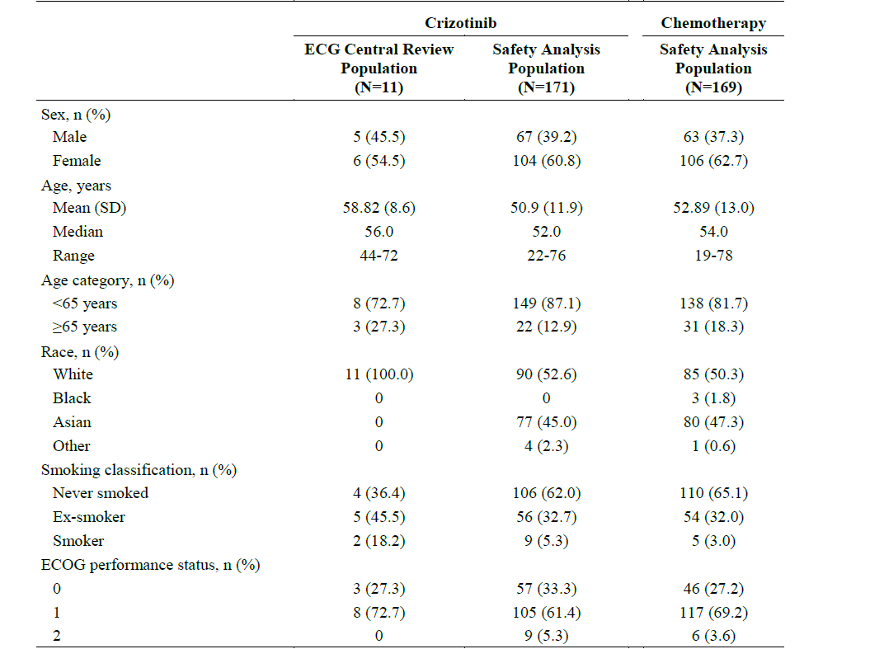

###### ECG results

Of the 11 patients in the ECG central review population, none had a maximum QTcF of ≥ 500 msec or a maximum QTcF increase from baseline of ≥ 60 msec.[11] No patients had a maximum QTcB of ≥ 500 msec or a maximum QTcB increase from baseline of ≥ 60 msec.[12]

Adverse events of ‘electrocardiogram QT prolonged’ were not reported for any patient in the ECG central review population.

Table 5: Study 1014 Categorisation of ECG data; maximum post-dose and increase from baseline

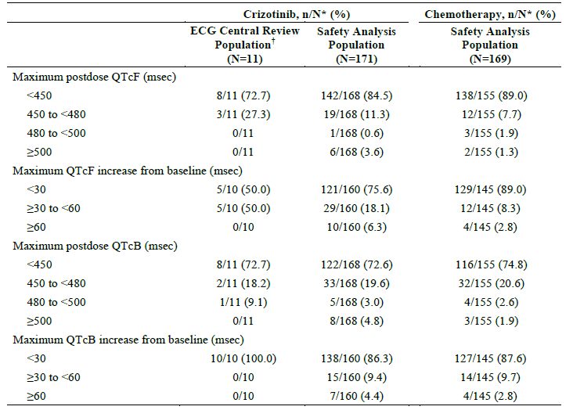

###### Cardiac disorders system organ class

In the ECG central review population, 1 patient (9.1%) experienced an AE in the cardiac disorders SOC (non-serious, treatment-related Grade 1 AE of pericardial effusion). In the crizotinib-treated safety analysis population, 38 patients (22.2%) and in the chemotherapy-treated safety analysis population, 15 patients (8.9%) experienced an AE in the cardiac disorders SOC.

In the ECG central review population, no patients experienced an SAE in the cardiac disorders SOC.

Four patients (2.3%) in the crizotinib-treated safety analysis population and 7 patients (4.1%) in the chemotherapy-treated safety analysis population experienced an SAE in the cardiac disorders SOC. No patients in the crizotinib-treated safety analysis population had Grade 5 SAEs in the cardiac disorders SOC. In the crizotinib-treated safety analysis population 2 patients (1.2%) experienced Grade 4 SAEs of cardiac tamponade.

Two additional patients in the crizotinib-treated safety analysis population experienced SAEs (1 patient each with Grade 3 atrial fibrillation and Grade 3 atrioventricular block).

One patient in the chemotherapy-treated safety analysis population experienced a Grade 5 SAE of cardiac arrest. There were 6 additional patients with SAEs in the chemotherapy-treated safety analysis population, specifically: Grade 3 Syncope (2 patients),

Grade 2 atrial fibrillation (1 patient), Grade 2 cardiotoxicity (1 patient), Grade 2 pericarditis (1 patient), and Grade 1 pericardial effusion (1 patient).

Table 6: Study 1014 Summary of treatment-emergent adverse events in the Cardiac Disorders SOC (All Causality, All Cycles)

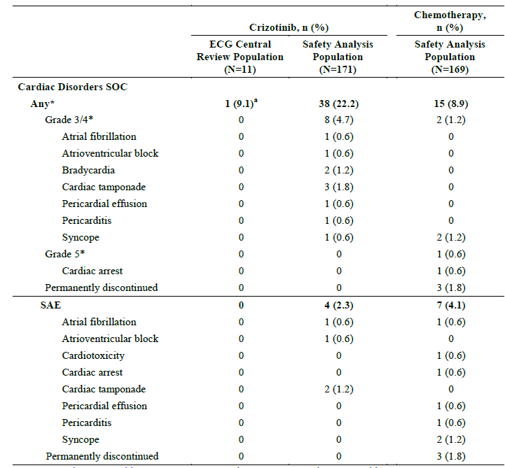

###### Bradycardia

All causality bradycardia was reported for 23 patients (13.5%) in the crizotinib treated safety analysis population and 1 patient in the chemotherapy treated safety population.

For the 23 patients in the crizotinib treated population who experienced bradycardia the median time to first onset was 43 days and median duration was 169 days.

Of these 23 reports, 2 were Grade 3, none were Grade 4 or 5.

###### Dizziness

All causality dizziness was reported for 31 patients (18.1%) in the crizotinib-treated safety analysis population (all grade 1or2) and 17 patients (10.1%) in the chemotherapy-treated safety population.

All causality dizziness was not reported in the ECG central review population.

For the 31 patients in the crizotinib-treated safety analysis population who experienced dizziness, the median time to first onset was 63 days and the median duration was 44 days.

A sub-study within Study 1014 was conducted in response to a post-marketing commitment requested by the EMA to increase the number of ECG time points after crizotinib administration and to add central independent manual review of ECG results. In the ECG central review population, there were no significant changes in QTcF, PR interval, or QRS complex. As only 11/171 crizotinib treated patients underwent independent central review of ECGs these data are extremely limited. Prolonged QT is already noted in the approved PI as a common ADR associated with crizotinib. All causality bradycardia was not reported in the ECG central review population. All causality bradycardia was reported for 23 patients (13.5%) in the crizotinib-treated safety analysis population and 1 patient (0.6%) in the chemotherapy-treated safety population. Bradycardia is also a recognised ADR in the approved PI for crizotinib with frequency of 12-13%. All causality syncope was not reported in the ECG central review population. All causality syncope was reported for 1 patient (0.6%) in the crizotinib-treated safety analysis population and 2 patients (1.2%) in the chemotherapy-treated safety population. All causality dizziness was not reported in the ECG central review population. All causality dizziness was reported for 31 patients (18.1%) in the crizotinib-treated safety analysis population and 17 patients (10.1%) in the chemotherapy-treated safety population. Syncope is recorded in the approved PI as common ADR associated with crizotinib. Overall the safety profile reported in Study 1014 appears to be consistent with the safety profile from previously reported trials and the Australian approved PI.

##### Vital signs and clinical examination findings

###### Study 1001 ROS1 positive NSCLC

Minimum and maximum change from baseline for blood pressure and pulse rate are shown in Table 7, below.

Table 7: Study 1001 Change from baseline BP and pulse rate.

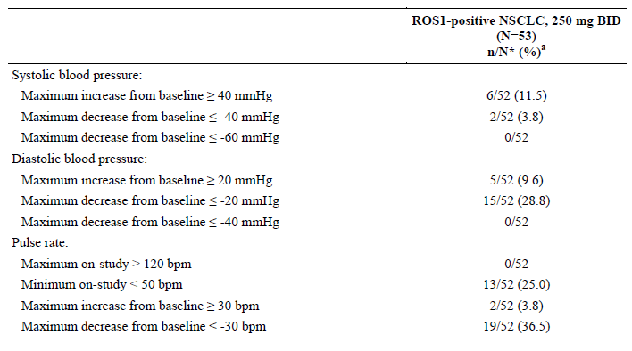

a % = (n/N*) x 100

No patients had an increase in pulse rate > 120 beats per minute (bpm). All-causality AEs of heart rate increased and sinus tachycardia were each reported for 1 (1.9%) patient.

Pulse rate < 50 bpm was reported for 25.0% of patients. All-causality bradycardia was reported for 14 (26.4%) patients.

Increases in diastolic blood pressure (DBP) ≥ 20 mmHg were reported for 9.6% of patients and increases in systolic blood pressure (SBP) ≥ 40 mmHg were reported for 11.5% of patients. All-causality hypertension was reported for 1 (1.9%) patient. No patients had decreases in DBP of ≤ 40 mmHg or decreases in SBP ≤ 60 mmHg. All-causality hypotension was reported for 5 (9.4%) patients.

Increases in body weight ≥ 10% were reported for 32.7% of patients and decreases in body weight ≤ 10% were reported for 9.6% of patients. All-causality weight increased and weight decreased were each reported for 4 (7.5%) patients.

###### Study 1007 ALK positive NSCLC

Minimum and maximum change from baseline for vital signs measurements (blood pressure and pulse rate) and body weight are presented. A maximum on-study pulse rate > 120 bpm was reported for 2 (1.2%) crizotinib-treated patients and 15 (9.0%) chemotherapy-treated patients. All-causality AEs of tachycardia and supraventricular tachycardia were reported for 1.2% and 0% of crizotinib-treated patients, respectively, and for 1.2% and 0.6% of chemotherapy-treated patients, respectively. A minimum on-study pulse rate < 50 bpm was reported for 28 (16.4%) crizotinib-treated patients and 1 (< 1.0%) chemotherapy-treated patient.

Table 8: Study 1007 Summary of vital signs minimum and maximum change

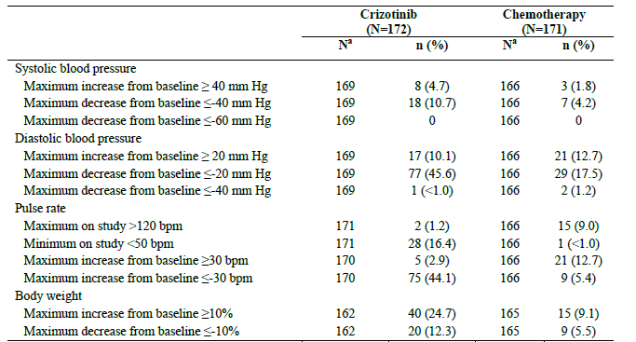

##### Immunogenicity and immunological events

###### Study 1001 ROS1 positive NSCLC

No immunological events reported.

###### Study 1007 ALK positive NSCLC

No immunological events reported.

##### Serious skin reactions

###### Study 1001 ROS1 positive NSCLC

No serious skin reactions reported.

###### Study 1007 ALK positive NSCLC

No serious skin reactions reported.

##### Interstitial Lung Disease

###### Study 1001 ROS1 positive NSCLC

Treatment-related interstitial lung disease was reported for 1 (1.9%) patient. The event was Grade 1 and was not considered serious. Time to onset was 112 days and duration was 8 days. This event was associated with temporary treatment discontinuation for 7 days and was not associated with dose reduction or permanent treatment discontinuation.

###### Study 1007 ALK positive NSCLC

Treatment-related interstitial lung disease was reported for 5 (2.9%) crizotinib-treated patients and 1 (0.6%) chemotherapy-treated patient. One (0.6%) crizotinib-treated patient had Grade 3 treatment-related interstitial lung disease and 2 (1.2%) crizotinib-treated patients had fatal (Grade 5) treatment-related events. There were no Grade 4 treatment-related events for patients treated with crizotinib and no Grade 3, 4, or 5 treatment-related events for patients treated with chemotherapy. Treatment-related SAEs of interstitial lung disease were reported for 4 (2.3%) crizotinib-treated patients and 0 chemotherapy-treated patients.

#### Post-marketing data

No post marketing data were submitted with this application.

#### Evaluator’s conclusions on safety

Study 1001, presented data on 53 patients with ROS1 positive advanced NSCLC treated with crizotinib 250 mg BID, median duration of treatment was 23.2 months (95% CI: 15.0, upper bounds NR), with 47.2% of patients still actively receiving crizotinib at the time of data cut-off.

No new safety signals were identified from patients with ROS1-positive NSCLC in Study 1001, and data were consistent with the established safety profile for crizotinib, as described in the approved PI. A similar AE profile for the most common AEs was observed for all-causality and treatment-related AEs.

An updated summary of clinical safety for Study 1007 was included in the dossier, based on median exposure of 48 weeks for crizotinib and 13.0 weeks for chemotherapy.

The frequency of adverse drug reactions reported in this clinical summary are consistent with the current TGA approved PI for crizotinib.

A sub-study within Study 1014 was conducted in response to a post-marketing commitment requested by the EMA to increase the number of ECG time points after crizotinib administration and to add central independent manual review of ECG results.

In the ECG central review population, there were no significant changes in QTcF, PR interval, or QRS complex.

As only 11/171 crizotinib treated patients underwent independent central review of ECGs these data are extremely limited.

There are 10 identified risks for crizotinib established from previous clinical trials and post marketing experience namely; Hepatotoxicity, Pneumonitis/interstitial lung disease, Vision Disorder, QTc Prolongation on ECG, Bradycardia, Leukopenia, Renal Cyst, Oedema, Neuropathy, and the most recently added (10 March 2017) Cardiac Failure.

For the majority of identified risks no clear mechanism has been identified and it is not possible to predict for any individual patient what they might experience.

### First round benefit-risk assessment

#### First round assessment of benefits

The first round assessment of benefits is summarised in Table 9, below.

Table 9: First round assessment of benefits

|  |  |
| --- | --- |
| Indication | |
| Benefits | Strengths and Uncertainties |
| This submission presents data for 53 patients with ROS1-positive advanced NSCLC in the phase I Study 1001, treated with crizotinib 250 mg BID, based on a data cut-off date of 30 November 2014.  The efficacy endpoint was objective response rate (ORR) using tumour assessments based on RECIST v1.0 for the ROS1-positive NSCLC cohort and RECIST v1.1 for the 3 patients with ROS1-positive NSCLC in the ALK-negative NSCLC cohort, as assessed by the investigator.  The objective response rate was 70% (37/53 patients, 5 CR, 32 PR).  The ORR appeared independent of baseline characteristics, including age group (<65 years and ≥65 years), gender, race group (Asian and non-Asian), number of prior treatment regimens for advanced/metastatic disease (0 and ≥1), ECOG PS (0 and 1), and the percentage of ROS1-positive cells.  These ORR data are also supported by the PFS and DR results stated below.  As of data cut-off for this CSR, 22/37 patients (59.5%) did not have subsequent disease progression or death after the response.  The median PFS was 19.3 months (95% CI: 14.8 months, NR).  The median DR by the Kaplan-Meier method was not reached (95% CI:15.2 months, NR).  The probability of being alive and progression-free at 6 months was 76.9% (95% CI: 62.8, 86.1).  The probabilities of survival at 6 months and at 12 months were 90.6% (95% CI: 78.8, 96.0) and 79.0% (95% CI: 65.3, 87.8), respectively.  These data demonstrate that crizotinib 250 mg BID has clinically meaningful efficacy in patients with ROS1 positive advanced NSCLC. | ROS1 rearrangements are present in approx. 1-2% of NSCLC patients, therefore the patient numbers available for analysis in this study are relatively small (53 patients).  The scientific rationale for targeting patients with ROS1 rearrangement seems strong.  The sponsor has made it clear that a phase III trial will not be performed.  As stated under ‘benefits’ the high observed objective response rate and supporting data from the other endpoints provide confidence in a clinically meaningful effect for crizotinib in patients with ROS1 positive advanced NSCLC. |

#### First round assessment of risks

The first round assessment of risks are summarised in Table 10, below.

Table 10: First round assessment of risks

|  |  |
| --- | --- |
| Risks | Strengths and Uncertainties |
| There are 10 identified risks for crizotinib established from previous clinical trials and post marketing experience, namely:   1. Hepatotoxicity 2. Pneumonitis/interstitial lung disease 3. Vision Disorder 4. QTc Prolongation on ECG 5. Bradycardia 6. Leukopenia 7. Renal Cyst 8. Oedema 9. Neuropathy   And the most recently added (10 March 2017)   1. Cardiac Failure   The frequency and potential seriousness of each risk is discussed at some length in the RMP. | The pattern of adverse events in the 53 patients with ROS1 positive advanced NSCLC was not obviously different to these identified risks for crizotinib.  As expected with a small cohort of patients not every previously identified ADR was seen in this study.  While many of the adverse events occur frequently they are also commonly Grade1 or 2 events and can often be managed by dose reduction or dose interruption.  As the majority of patients with NSCLC will die from progressive disease this level of adverse events are acceptable in the context of the high objective response rate observed with crizotinib.  For the majority of these identified risks no clear mechanism has been identified and it is not possible to predict for any individual patient what they might experience. |

#### First round assessment of benefit-risk balance

The data submitted demonstrate a positive benefit risk balance for crizotinib 250 mg BID in patients with ROS1 positive advanced NSCLC.

### First round recommendation regarding authorisation

Pending satisfactory answers to the clinical questions, the data submitted support an extension of indications for crizotinib 250 mg BID to be used in patients with ROS1‑positive advanced NSCLC.

### Second round evaluation

For details of the second round evaluation including the issues raised by the evaluator (Clinical questions), the sponsor’s responses and the evaluation of these responses please see Attachment 2.

### Second round benefit-risk assessment

#### Second round assessment of benefits

There are some differences in the assessment of ORR between local review and central review, however these differences do not alter the overall conclusion that these data demonstrate that crizotinib 250 mg BID has clinically meaningful efficacy in patients with ROS1 positive advanced NSCLC.

#### Second round assessment of risks

The assessment of risks has not changed from the first round.

#### Second round assessment of benefit-risk balance

The overall assessment of benefit-risk balance has not changed from the first round and the data submitted demonstrate a positive benefit risk balance for crizotinib 250 mg BD in patients with ROS1‑positive advanced NSCLC.

### Second round recommendation regarding authorisation

The data submitted support an extension of indications for crizotinib 250 mg BD to be used in patients with ROS1‑positive advanced NSCLC.

## VI. Pharmacovigilance findings

### Risk management plan

#### Summary of RMP evaluation[13]

In support of the application to extend the indication to include the treatment of patients with ROS1-positive advanced NSCLC(Submission PM-2016-03535-1-4), the sponsor has submitted EU-RMP version 7.3 (dated 16 September 2016; data lock point (DLP) 25 August 2015) and Australian Specific Annex (ASA) version 4.0 (dated 28 November 2016). In its post first round response, the sponsor submitted ASA version 4.1 (dated 28 June 2017) in support of the application.

The proposed Summary of Safety Concerns and their associated risk monitoring and mitigation strategies are summarised in Table 11, below.

Table 11: Summary of safety concerns.

|  |  |  |  |  |  |
| --- | --- | --- | --- | --- | --- |
| Summary of safety concerns | | Pharmacovigilance | | Risk Minimisation | |
| Routine (R) | Additional (A) | R | A |
| **Important identified risks** | **Hepatotoxicity** | ✓ | ✓ | ✓ | ✓ |
| **Pneumonitis / Interstitial lung disease** | ✓ | ✓ | ✓ | ✓ |
| **QTc Prolongation** | ✓ | ✓ | ✓ | ✓ |
| **Bradycardia** | ✓ | ✓ | ✓ | ✓ |
| **Vision Disorder** | ✓ | ✓ | ✓ | ✓ |
| **Renal Cyst** | ✓ | ✓ | ✓ | ✓ |
| **Oedema** | ✓ | ✓ | ✓ | ✓ |
| **Leukopenia** | ✓ | ✓ | ✓ | ✓ |
| **Neuropathy** | ✓ | ✓ | ✓ | ✓ |
| **Gastrointestinal perforationa (ASA-Important Potential Risk)** | ✓ | ✓ | ✓ | ✓* |
| **Cardiac failureb** | ✓ | ✓ | ✓ | ✓* |
| **Important potential risks** | **Reproductive Toxicity (including pregnant and lactating women)** | ✓ | – | ✓ | ✓ |
| **Photosensitivity** | ✓ | ✓ | ✓ | – |
| **Malignant melanoma** | ✓ | ✓ | – | – |
| **Missing information** | **Paediatric patients** | ✓ | ✓ | ✓ | – |
| **Drug interaction with CYP3A4 substrates with narrow therapeutic indices, or P-glycoprotein substrates** | ✓ | ✓ | ✓ | ✓ |
| **Patients undergoing long-term treatment** | ✓ | ✓ | – | – |

a Considered an Important Identified Risk in the EU only and included in the ASA as an Important Potential Risk; b Considered an Important Identified Risk in the EU, Japan, Switzerland and other ex-US countries and included in the ASA under Important Identified Risk; * The sponsor has added Cardiac Failure and Gastrointestinal Perforation in the revised Australian Therapeutic Management Guide submitted with its post-first round response.

* Additional pharmacovigilance activities include:
  + A Multi-national post-approval database surveillance study (A8081038),
  + Two pharmacokinetic studies (Studies A8081001 and A8081012), the results of which were submitted to the TGA with the sponsor’s post-first round response. The results of Study A8081012 led to updates to the Dosage and Administration section of the PI.
  + Two cross-sectional studies in Europe (Studies A8081049 and A8081050) to collect information on whether patients received, read and understood the educational material to determine the effectiveness of the educational material. The results of these studies were also provided by the sponsor in its post-first round response.
* Additional risk minimisation activities include a Therapeutic Management Guide and a Patient Booklet which includes a ‘My Planner’ (similar to a Patient Alert Card) (Australia). The EMA has endorsed the removal of the Therapeutic Management Guide from the educational materials in Europe but the sponsor will continue to supply the guide in Australia.

#### New and outstanding recommendations from second round evaluation

There are new recommendations at the second round evaluation stage, and one recommendation for the Clinical Delegates consideration carried over from the first round report.

##### Second round recommendations (new)

* Recommendation 9: The sponsor should retain ‘Patients with severe hepatic impairment’ as missing information as the study to support its removals had limitations which made interpretation of the data difficult. At this stage the data do not support removal of this safety concern.[14]
* Recommendation 10: The modifications to remove interactions with strong CYP3A inhibitors and inducers from the missing information on drug interactions are acceptable based on the data provided for CYP inhibitors, and previously evaluated data for inducers. However, given that co-administration with a strong CYP3A inhibitor significantly increased plasma crizotinib levels, it is recommended that ‘drug interactions with strong CYP3A inhibitors’ is included as an important potential risk.[15]
* Recommendation 11: The sponsor should ensure that the updated advice in the Therapeutic Management Guide regarding dose adjustment in patients with various degrees of hepatic impairment based on the hepatic study is consistent with the PI, noting the recommendations of the clinical evaluator in the second round clinical evaluation report.

##### Referral to the Delegate (from Round 1):

* Recommendation 8: The delegate should consider whether gastrointestinal perforation, an important potential risk in the ASA, should be included in the Adverse Events section of the PI, in addition to the statement in the Precautions section.

#### Proposed wording for conditions of registration

Any changes to which the sponsor has agreed should be included in a revised RMP and ASA. However, irrespective of whether or not they are included in the currently available version of the RMP document, the agreed changes become part of the risk management system.

The suggested wording is:

*Implement EU-RMP (version 7.3, dated 16 September 2016, data lock point 25 August 2015) with ASA (version 4.1, dated 28 June 2017) and any future updates as a condition of registration.*

## VII. Overall conclusion and risk/benefit assessment

The submission was summarised in the following Delegate’s overview and recommendations:

### Quality

There was no requirement for a quality evaluation in a submission of this type.

### Nonclinical

Proposed changes to the ‘Pharmacodynamics’ section of the PI required nonclinical evaluation. The evaluator recommended changes in text describing demonstrated anti‑tumour activity in mice bearing tumour xenografts. These changes were made by the sponsor and no issues remained.

### Clinical

Overall, the clinical evaluator considered that the data submitted supported an extension of indications for crizotinib 250 mg BD to be used in patients with ROS1 positive advanced NSCLC.

#### Pharmacology

##### Study 1001 Rifampicin substudy

Data from a drug-drug interaction sub-study of crizotinib with rifampicin, a strong cytochrome P450 (CYP) 3A inducer, was included. In this substudy of 15 patients, 10 had data for analysis for 14 day exposures to crizotinib 250 mg BD and 7 contributed to PK analyses following co-administration of crizotinib and rifampicin 600 mg once daily for 14 days. Co-administration of crizotinib with rifampicin decreased crizotinib AUCtau and Cmax by approximately 84% and 79%, respectively. The evaluator considered that the submitted data supported the inclusion of modified statements in the PI.

At the second round evaluation stage, the sponsor provided two new Phase I studies; Study 1012 in subjects with hepatic impairment, and an additional PK sub-study of Study 1001 examining drug-drug interactions with itraconazole, a strong CYP3A inhibitor. Based on these data further amendments were proposed to PK, Interactions, and Dosage and Administration sections of the PI.

##### Study 1012 Hepatic impairment

A total of 88 patients with advanced cancer (histologically or cytologically confirmed solid malignancy or lymphoma that was metastatic or unresectable, and for which standard curative or palliative measures did not exist, or were no longer effective) were assigned to dosage of crizotinib depending on level of hepatic impairment as defined by laboratory parameters.

Group A (n = 26) had normal hepatic function; Groups B (n = 20), C (n = 26), and D (n = 16) had mild, moderate and severe hepatic impairment respectively. Two patients in group A had lung cancer. The majority with hepatic impairment had hepatocellular cancer, hepatic cancer, or metastatic colon cancer.

Patients with mild and moderate hepatic impairment were matched for race, age, gender and ECOG status with patients with normal hepatic function.

The planned sample size of 70 patients aimed to ensure there were 38 PK-evaluable patients for statistical analyses, 6 in group D, 8 in all other groups.

The doses of crizotinib were:

* 250 mg BD for Groups A1 and B;
* 250 mg QD (four times daily) for the first stage of Group C (Group C1);
* 200 mg BD for Groups A2 and the second stage of Group C (Group C2); and
* 250 mg QD for Group D.

These doses for Groups A1, B and C1 were based on the results of population-based PK simulations that indicated increased exposure was likely to be marked for patients with moderate hepatic impairment. Doses for Groups A2, C2 and D were determined at a second stage based on preliminary safety and PK data for evaluable patients in Group C1.

Median duration was 6.3 weeks, and 66 patients received crizotinib for ≤ 12 weeks.

The most common reasons for discontinued treatment were objective progression or relapse (in total 32 (36.4%) patients: 15/26 (58%) in Group A; 7/20 (35%) Group B; 8/26 (31%) Group C and 2/16 (12.5%) Group D), and global deterioration of health status (28 (31.8%) patients in total: 2/26 (7.7%) in Group A 6/20 (30 %) in Group B, 10/26 (38%) in Group C, and 10/16 (62.5%) in Groups D).

This suggests hepatic impairment was a reflection of the underlying severity of illness.

Table 12: Patient disposition at end of study by hepatic function: full analysis population

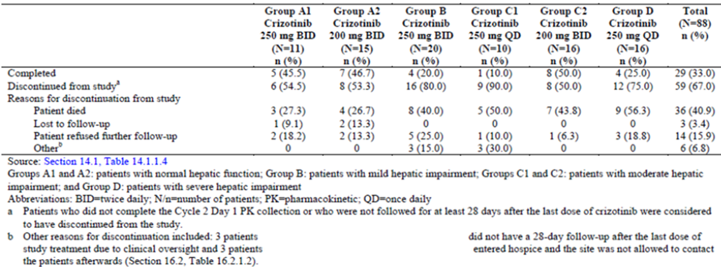

A total of 36 (40.9%) patients required a dose interruption and 14 (15.9%) patients required a dose reduction. PK evaluation was derived from Group A1 and A2 (n = 8, 9), Group B (n =9), Group C1, C2 (n = 7, 8) and Group D (n = 6).

A statistical summary of the AUC and Cmax parameters is shown in Table 13, below.

Table 13: Statistical summary of the AUC and Cmax parameters

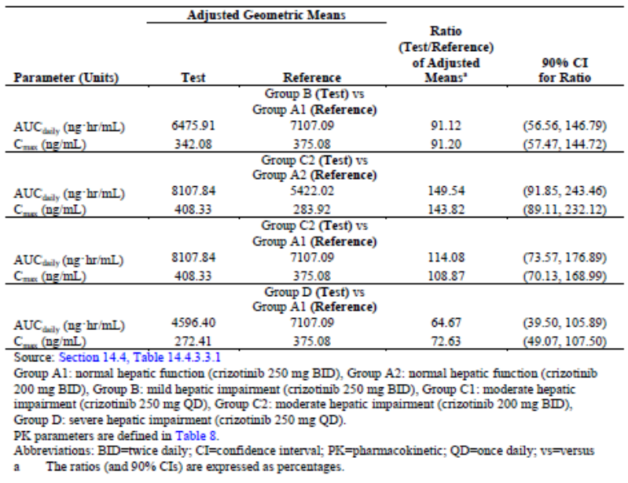

The Clinical Overview provided by the sponsor with this study concluded that patients with moderate hepatic impairment showed higher systemic crizotinib exposure compared to their matched control patients at the same dose level of 200 mg BD, but showed comparable exposure to normal control patients dosed with crizotinib 250 mg BD.

It was also noted that the mean systemic crizotinib exposure increased more than dose proportionally when the crizotinib dose was increased from 250 mg QD to 200 mg BD in patients with moderate hepatic impairment.

Therefore the conclusion by the sponsor was that further increasing the crizotinib dose to the next dose level (200 mg BD) for patients with severe hepatic impairment may result in crizotinib exposure in those patients greater than that in patients with normal hepatic function at the approved starting dose of 250 mg BD.

While it is acknowledged that numbers for PK evaluation met pre-specified sample size calculations, it appears that the potential influence of crizotinib on discontinuations due to hepatotoxicity, with differential impact on available PK data, could not be excluded.

##### Study 1001: Itraconazole substudy

Itraconazole is a known strong CYP3A inhibitor. An approximately 2-fold increase in crizotinib AUC,ss was anticipated when crizotinib is coadministered with itraconazole. Sample size calculations specified at least 8 PK-evaluable patients.

Co-administration of itraconazole (200 mg QD) increased steady-state crizotinib AUCtau and Cmax by 57% and 33%, respectively, following multiple dosing (250 mg QD) of crizotinib, compared to crizotinib administered alone. Itraconazole also increased the steady-state of the main metabolite of crizotinib (PF-06260182) AUCtau and Cmax by 134% and 98%, respectively, suggesting that metabolism of PF-06260182 is more dependent on CYP3A activity than metabolism of crizotinib.

#### Efficacy

##### Study 1001

Study 1001 is an ongoing Phase I, open-label, multicentre study evaluating dose escalation, safety, pharmacodynamics, PK, and anti-tumour activity of crizotinib administered as a single oral agent in patients with advanced NSCLC or other malignancies. As information about the safety and anti-tumour activity of crizotinib emerged, additional cohorts and sub-studies were introduced into the study, including a cohort of patients with ROS1-positive NSCLC. The sponsor stated on application that a Phase III trial will not be performed in this group.

The CSR provided data for 53 patients with ROS1-positive NSCLC in Study 1001, based on a data cut-off date of 30 November 2014. Patients were enrolled from 8 centres in 3 countries (Australia and South Korea 1 centre each; United States, 6 centres). Of 53 patients with NSCLC, measurable disease and adequate baseline assessments, 4 patients (7.5%) had Stage III disease, 49 had Stage IV.

The efficacy endpoint was objective response rate (ORR), assessed by the investigator. All available tumour scans for patients in the ROS1-positive NSCLC cohort were to be retrospectively reviewed by an independent radiology laboratory. Follow-up survival data were to be collected at least every 3 months after discontinuing crizotinib for a minimum of 1 year after the final dose.

Of 53 study patients, 5 (9.4%) patients had a CR, 32 (60.4%) patients had a PR, and 11 (20.8%) patients had stable disease as their best response. ORR was 69.8% (95% CI: 55.7, 81.7).

In the group with no prior therapy (n = 7) there was one CR, 5 PR and one SD. In the group with one or more prior therapies (n = 46) there were 4 CR, 27 PR and 10 SD. As of data cut-off for this CSR, 22/37 patients (59.5%) did not have subsequent disease progression or death after the response. At the time of the data cut-off 39.6% of patients were still in follow-up for PFS. The median PFS was 19.3 months (95% CI: 14.8, NR).

Overall, 16 (30.2%) patients had died by the time of the data cut-off for the CSR; 37 (69.8%) patients were censored, of which 33 (62.3%) patients were still in follow-up. The median OS had not been reached. The probabilities of survival at 6 months and at 12 months were 90.6% (95% CI: 78.8, 96.0) and 79.0% (95% CI: 65.3, 87.8), respectively.

Figure 1: Study 1001 Waterfall plot of best percentage (%) change from baseline in target lesions by patient (N* = 51)

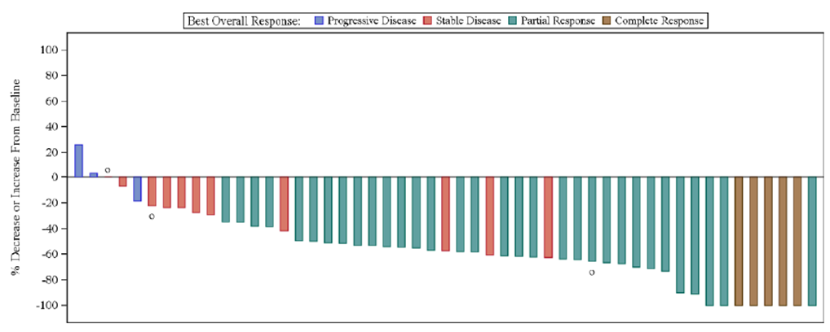

* N = 51 is based on the Response Evaluable population, excluding patients with early death or indeterminate response.

The Section 31 Clinical Questions included requests for details of the diagnostic process for the study subjects, and how this relates to the process envisaged in Australia.

In summary, the confirmatory ROS1 fluorescence in situ hybridisation (FISH) test is anticipated to be conducted in accredited specialised centres. Access to testing for patients in regional or remote areas would be facilitated by the collection of a tumour tissue sample at their local treatment centre and transportation to an accredited specialised pathology laboratory for testing.

The proposed wording in the Australian PI is:

*Detection of either ALK-positive or ROS1-positive NSCLC is necessary for selection of patients for treatment with crizotinib because these are the only patients for whom benefit has been shown.*

Assessment for either ALK-positive or ROS1-positive NSCLC should be performed by laboratories with demonstrated proficiency in the specific technology being utilised. Improper assay performance can lead to unreliable test results.

##### Conclusion on efficacy

In the Phase I Study 1001 in a small sub-group of patients with ROS1-positive advanced NSCLC, the ORR data showed a high observed objective response rate, 69.8% (95% CI: 55.7, 81.7). Together with supporting data from the other endpoints, this suggests that crizotinib 250 mg BD is likely to have clinically meaningful efficacy in adult patients with ROS1-positive advanced NSCLC.

#### Safety

##### Study 1001

The majority of patients (36/53; 67.9%) had a crizotinib treatment duration >12 months, starting dose 250 mg BID. Median duration of treatment was 23.2 months (95% CI: 15.0, NR), with 47.2% of patients still actively receiving crizotinib at the time of data cut-off. Inclusion criteria for hepatic function were AST and ALT ≤ 2.5 x ULN, or AST and ALT ≤ 5 x ULN if liver function abnormalities were due to underlying malignancy, and total serum bilirubin ≤ 1.5 x ULN.

No new safety signals were identified from patients with ROS1-positive NSCLC in Study 1001. Data were consistent with the established safety profile for crizotinib, as described in the approved PI. A similar AE profile for the most common AEs was observed for all-causality and treatment-related AEs.

##### Study 1012

The frequency of worsening LFTs requiring investigation as potential Hy’s law cases as per the study protocol was 12/88 (13.6%), all in patients with abnormal LFTs at baseline. Most of these subjects had primary or secondary hepatic cancer. In Study 1012 patients were monitored closely for toxicity; according to the CSR, patients with baseline hepatic impairment had LFTs assessed weekly in the first cycle, every 2 weeks in cycle 2, every cycle thereafter and as clinically indicated; ‘There was to be more frequent testing for Grade 2 to 4 elevations or in case of signs or symptoms consistent with hepatotoxicity or hepatic failure (e.g. fatigue, weakness, anorexia, nausea, vomiting, right upper quadrant abdominal pain, jaundice, dark urine, and in rare cases, fever, and rash). More frequent monitoring could have been performed at the discretion of the investigator’. Dose modifications in the study protocol for suspected treatment-related hepatotoxicity in patients with liver impairment at baseline included treatment interruption and repeat LFTs within 24 to 48 hours for patients with elevations 2 x above baseline for bilirubin and/or 3 x above baseline for AST/ALT.

##### Conclusion on safety

There were no new signals observed in the ROS-1 positive NSCLC population.

It is recommended that the PI should be updated with respect to monitoring and hepatic adverse events to align with the SmPC.

### Risk management plan

Gastrointestinal perforation is included under ‘Precautions’ but not in the ‘Adverse Effects’ section, as only ADRs are tabulated in the Xalkori PI. The sponsor considers that there is insufficient information to consider GI perforation as an Adverse Drug Reaction or an Important Identified Risk. The Delegate was asked to consider whether gastrointestinal perforation should be included in the Adverse Events section of the PI, in addition to the statement in the ‘Precautions’ section.

The suggested wording for conditions of registration is:

*Implement EU-RMP (version 7.3, dated 16 September 2016, data lock point 25 August 2015) with ASA (version 4.1, dated 28 June 2017) and any future updates as a condition of registration.*

### Risk-benefit analysis

#### Unresolved issues

##### Efficacy

The application for extension of indications is based on results from small patient numbers in a Phase 1 single arm study in ROS1-positive advanced NSCLC patients.

The results showed a high ORR of approximately 70%, median PFS of around 19 months at data cut-off, and immature available overall survival data. There appears to be no likelihood of a subsequent Phase 3 study, and there is unmet need for this identifiable patient population.

These considerations support the proposed additional Indication ‘Xalkori is indicated for the treatment of patients with ROS1-positive advanced non-small cell lung cancer (NSCLC).’

* Safety and efficacy of Xalkori in paediatric patients have not been established, but lung carcinoma rarely occurs in children. Specification of ‘adult’ patients, as in the EMA indication, is to be considered.
* It is unclear whether the Australian PI should make specific recommendations regarding screening for and confirming the ROS1 mutation.

##### Safety

The safety profile for crizotinib, from the limited data available, appears similar for the ROS1 patient group as for the ALK positive NSCLC group for whom the drug is already approved.

Safety issues for crizotinib include drug-induced hepatotoxicity. In the current Australian PI, the first paragraph of ‘Precautions’ (‘Hepatotoxicity’) describes hepatic AEs from clinical trials, advises monitoring two weekly in the first two months, with dose modification for patients who develop elevated LFTs, and states ‘Crizotinib should be used with caution in patients with hepatic impairment’, cross-referenced to Pharmacology and Dose Modification for transaminase elevations in the ‘Dosage and Administration’.

Data provided in Study 1012 showed increased exposure in hepatic impairment.

* Updating the PI with respect to monitoring and adverse events to align with the European Summary of Product Characteristics (SmPC) should be considered. Changes to ‘Dosage and Administration’ should also be consistent.

#### Summary of issues

ROS1 rearrangements occur in approximately 1 to 2% of patients with NSCLC. Data from 53 patients with ROS1-positive advanced NSCLC in a Phase I single arm Study A8081001 were provided. The ORR was 70%, median PFS 19 months at data cut-off, with immature OS data. No Phase III study is planned.

* Laboratory testing for testing for ROS1 is done in few centres.

The additional proposed indication is supported by the evaluation: ‘Xalkori is indicated for the treatment of patients with ROS1-positive advanced non-small cell lung cancer (NSCLC).’

* Treatment of ‘adult’ patients would be consistent with the EMA-approved indication.

Additional PK information from a study in 88 patients with hepatic impairment was provided during evaluation. Changes to dosage in hepatic impairment were proposed based on the results.

* Corresponding changes have not been made in the SmPC.

#### Proposed action

The Delegate has no reason to say, at this time, that the application for extension of Indications to treatment of patients with ROS1-positive advanced NSCLC should not be approved for registration.

#### Request for ACM advice

The committee is requested to provide advice on the following specific issues:

1. What are views of the ACM on the adequacy of the safety and efficacy data to support extension to this small patient group?
2. Is the information provided by the sponsor about identification of the ROS1 populationadequate in the Australian context?
3. Does the ACM consider that PK data provided are adequate to support proposed recommendations for dosage in hepatic impairment?
4. Can the committee suggest any other improvements to the PI/CMI?

The committee is also requested to provide advice on any other issues that it thinks may be relevant to a decision on whether or not to approve this application.

#### Response from sponsor

##### Introduction

In this pre-ACM response, the sponsor would like to provide comments on the issues that the Delegate has brought to the attention of the ACM and the items on which the Delegate is seeking advice from the ACM. In addition, the recommendations in the second round RMP evaluation report are discussed at the end of this response.

The matters being addressed in this response are identified by italic type.

##### Summary of issues

###### 1. Laboratory Testing for ROS1

* *ROS1 rearrangements occur in approximately 1 to 2% of patients with NSCLC. Data from 53 patients with ROS1-positive advanced NSCLC in a Phase I single arm Study A8081001 were provided. The ORR was 70%, median PFS 19 months at data cut-off, with immature OS data. No Phase III study is planned.*

Laboratory testing for testing for ROS1 is done in a few centres.

The sponsor acknowledges that ROS1-positive NSCLC is a rare condition and confirms there are no plans for a Phase III study due to considerations of the clinical equipoise, given the available information on the activity of crizotinib in this setting and the significant enrolment challenges as a result of the rarity of the condition and that Xalkori is now approved for ROS1-positive NSCLC in 48 countries, including Canada, Japan, EU and USA.

Since testing for ROS1 should only be performed in laboratories that have received National Association of Testing Authorities (NATA) accreditation with an established quality assurance program specific for ROS1 fusion test developed by the Royal College of Pathologists of Australasia (RCPA) Medical Services Advisory Committee (MSAC) Population, Intervention, Comparator, Outcomes, ROS1 testing is currently limited to specialised pathology laboratories based in major centres. For testing of patients in regional or remote areas, access would be facilitated by the collection of a tumour tissue sample at their local treatment centre and transportation to an accredited pathology laboratory for testing. The ‘Centres of Excellence’ which currently perform the majority of ALK FISH testing have specialised laboratories capable of accurate and efficient processing of Australian ALK samples and it is anticipated that these same centres are also likely to become the ‘Centres of Excellence’ for ROS1 FISH testing in the future.

###### 2. Wording of indication

* *The additional proposed indication is supported by the evaluation: ‘Xalkori is indicated for the treatment of patients with ROS1-positive advanced non-small cell lung cancer (NSCLC).’*

Treatment of ‘adult’ patients would be consistent with the EMA-approved indication.

The sponsor acknowledges the Delegate’s comment; nevertheless, in order to maintain consistency with the approved indication for ALK-positive NSCLC, which refers to “treatment of patients”, the sponsor prefers to retain the wording proposed in the initial application.

Also, treatment of lung carcinoma, including NSCLC, is included in the EMA’s listing of conditions subject to class waivers for a Paediatric Investigation Plan (PIP) on the grounds that this condition rarely occurs in the paediatric population. Considering lung carcinoma is predominantly only observed in adults and ROS1-positive NSCLC is an even rarer subset of NSCLC in comparison to ALK-positive NSCLC, the sponsor does not consider it necessary to include the word ‘adult’ in the indication.

###### 3. Dose adjustments in hepatic impairment

* *Additional PK information from a study in 88 patients with hepatic impairment was provided during evaluation. Changes to dosage in hepatic impairment were proposed based on the results.*

Corresponding changes have not been made in the SmPC.

The sponsor would like to advise that hepatic impairment Study A8081012 was submitted to the EMA on 28 July 2017. Based on the results of this study, dosing recommendations for patients with hepatic impairment are proposed for inclusion in the SmPC. This variation is currently under evaluation by the EMA. Similar applications have also been submitted to the US FDA and Health Canada.

##### Advice sought

The committee is requested to provide advice on the following specific issues.

1. *What are views of ACM on the adequacy of the safety and efficacy data to support extension to this small patient group?*

The sponsor considers that crizotinib offers clinically meaningful benefit to patients with ROS1-positive advanced NSCLC based on the observed objective response rate, 70% (95% CI: 56, 82), together with supporting data from secondary endpoints, including duration of response. This view is supported by the clinical evaluator who stated:

*These data demonstrate that crizotinib 250 mg BD has clinically meaningful efficacy in patients with ROS1 positive advanced NSCLC.*

In addition, no new safety signals were identified in patients with ROS1-positive NSCLC. Data were consistent with the established safety profile for crizotinib and a similar AE profile for the most common AEs was observed for all-causality and treatment related AEs.

For these reasons, the sponsor considers that with the substantial anti-tumour activity observed with crizotinib in ROS1-positive NSCLC, the overall large safety database of crizotinib and the rarity of ROS1-positive NSCLC, data from single-arm Study A8081001 are sufficient for registration of the proposed indication.

The sponsor considers that crizotinib represents a major public health advance as a new therapeutic option for patients with ROS1-positive advanced NSCLC, a molecularly defined subgroup that currently lacks any approved therapeutic agents specific for this molecular diagnosis.

1. *Is the information provided by the sponsor about identification of the ROS1 population adequate in the Australian context?*

Two diagnostic pathways are used in clinical practice in Australia to identify and screen patients with ROS1-positive NSCLC. One of these pathways (Pathway 1) is mainly used in regional areas, whereas the other pathway (Pathway 2) is used in major capital cities such as Sydney and Melbourne.

Pathway 1 screens for ROS1 overexpression using immunohistochemistry (IHC) in EGFR mutation and ALK rearrangement negative NSCLC patients.

Pathway 2 is the pathway recommended by the International Association for the Study of Lung Cancer (IASLC), the College of American Pathologists (CAP) and the Association for Molecular Pathology (AMP) guidelines. According to this pathway the testing for EGFR, ALK and ROS1 is done upfront concurrently in all locally advanced or metastatic NSCLC patients. For testing of ALK and ROS1, 4 micron tumour tissue sections are cut to be analysed by IHC. This IHC screening test is reimbursed through the Medicare Benefits Schedule (MBS).

After screening through either of the two pathways mentioned above, the ROS1 cases positive by IHC are then confirmed by conducting a ROS1 FISH test, which is only conducted in a small number of centres in Australia, including, but not limited to the Royal Prince Alfred Hospital and St Vincent’s Hospital in Sydney, the Peter MacCallum Cancer Centre and Sonic Healthcare Group in Melbourne. Notably, these centres are also ‘Centres of Excellence’ for the ALK FISH tests. As mentioned in the response to Issue 1 above, ROS1 testing is currently limited to specialised pathology laboratories based in major centres; patients from regional and remote areas will have the opportunity to have their samples tested at one of these centres.

1. *Does ACM consider that PK data provided are adequate to support proposed recommendations for dosage in hepatic impairment?*

The sponsor confirms that according to the results of Study A8081012, no starting dose adjustment is required for patients with mild hepatic impairment. However, the recommended starting dosage regimens of crizotinib for patients with moderate and severe hepatic impairment based on the results of this study are 200 mg twice daily and 250 mg once daily, respectively.

In patients with *moderate hepatic impairment* treated with crizotinib 200 mg twice daily, the mean crizotinib AUCdaily and Cmax at steady state were about 1.5- and 1.4-fold, respectively, of those in patients with normal hepatic function treated with the same dose of crizotinib (200 mg BD). In patients with moderate hepatic impairment receiving crizotinib 200 mg BD, both the mean crizotinib AUCdaily and Cmax at steady state were about 1.1-fold of those in patients with normal hepatic function receiving crizotinib 250 mg BD.

In patients with *severe hepatic impairment* receiving crizotinib 250 mg once daily, the mean AUCdaily and Cmax at steady state was about 0.65- and 0.73-fold, respectively, of those in patients with normal hepatic function receiving crizotinib 250 mg BD.

Overall, there were no notable differences in the adverse events profiles between patients with normal hepatic function and patients with mild, moderate or severe hepatic impairment. Crizotinib was generally tolerable and manageable with dosing interruption, dose reduction and/or standard medical therapy.

In light of the above, the sponsor considers that the pharmacokinetic and safety data from Study A8081012 support the dosing recommendations for patients with hepatic impairment.

##### Unresolved issues

###### Efficacy

* *Safety and efficacy of Xalkori in paediatric patients have not been established, but lung carcinoma rarely occurs in children. Specification of ‘adult’ patients, as in the EMA indication, is to be considered.*

Please refer to the comment provided above to Issue 2 in the ‘Summary of Issues’.

* *It is unclear whether the Australian PI should make specific recommendations regarding screening for and confirming the ROS1 mutation.*

The PI currently states, ‘Detection of either ALK positive or ROS1 positive NSCLC is necessary for selection of patients for treatment with crizotinib because these are the only patients for whom benefit has been shown.’ The sponsor proposes to reinforce this requirement by adding the following sentence to the Xalkori PI:

*An accurate and validated assay for either ALK or ROS1 is necessary for the selection of patients for treatment with Xalkori.*

###### Safety

The safety profile for crizotinib, from the limited data available, appears similar for the ROS1 patient group as for the ALK positive NSCLC group for whom the drug is already approved.

Safety issues for crizotinib include drug-induced hepatotoxicity. In the current Australian PI the first paragraph of ‘Precautions’ (‘Hepatotoxicity’) describes hepatic AEs from clinical trials, advises monitoring two weekly in the first two months, with dose modification for patients who develop elevated LFTs, and states ‘Crizotinib should be used with caution in patients with hepatic impairment’, cross-referenced to Pharmacology and Dose Modification for transaminase elevations in the ‘Dosage and Administration’.

Data provided in Study 1012 showed increased exposure in hepatic impairment.

* Updating the PI with respect to monitoring and adverse events to align with the SmPC should be considered. Changes to ‘Dosage and Administration’ should also be consistent.

The sponsor considers that no changes to this information in the Australian PI are warranted because the sponsor considers that the frequency of liver function test monitoring ‘every 2 weeks during the first 2 months of treatment, then once a month and as clinically indicated, with more frequent repeat testing for Grades 2, 3 or 4 elevations’ is adequate based on the experience from crizotinib clinical trials. There is no evidence from post-marketing data or other sources that increased frequency of liver function test monitoring will improve management of patients who might develop ALT or AST elevations, while it will cause additional burden for cancer patients to have their liver function tested every week. Furthermore, the text regarding liver function tests in the Australian PI is consistent with the information in the US PI and Canadian Product Monograph.

As mentioned in the response above to Issue 3 in the ‘Summary of Issues’, hepatic impairment Study A8081012 has recently been submitted to the EMA. Based on the results of this study, dosing recommendations for patients with moderate or severe hepatic impairment and also changes to the ‘Hepatotoxicity’ text in the SmPC have been proposed.

##### RMP evaluation

The second round RMP evaluation report included 3 new recommendations (Recommendations 9, 10 and 11) and one recommendation for consideration by the Delegate that was carried over from the first round RMP evaluation (Recommendation 8). The sponsor’s comments on these recommendations are provided below.

###### RMP evaluation: Recommendation 9

* *The sponsor should retain ‘Patients with severe hepatic impairment’ as missing information as the study to support its removals had limitations which made interpretation of the data difficult. At this stage the data do not support removal of this safety concern.*

The sponsor acknowledges the difficulties in conducting this study, especially considering the high drop-out rate for this patient population, which requires patients to have advanced cancer with varying degrees of hepatic impairment, including severe hepatic impairment. Despite these limitations, a total of 88 patients were enrolled in the study. Of the 88 patients enrolled, 26 had normal hepatic function, and 20, 26 and 16 patients were categorised in the mild, moderate and severe hepatic impairment groups, respectively. Of note, 4 patients with severe hepatic impairment completed all required pharmacokinetic assessments.

Therefore, the sponsor considers that the completion of Study A8081012 provides sufficient information regarding the use of crizotinib in ‘Patients with severe hepatic impairment’, and this safety concern has been removed from ‘missing information’ in the crizotinib EU RMP.

Study A8081012 was designed to evaluate the effect of hepatic impairment on the steady state pharmacokinetics and safety of crizotinib in advanced cancer patients. The results demonstrated that the steady-state exposure of crizotinib based on geometric mean values for AUCdaily and Cmax in patients with severe hepatic impairment receiving crizotinib 250 mg once daily was about 0.63- and 0.71-fold lower, respectively, than in patients with normal hepatic function receiving 250 mg twice daily. Based on these results, a starting dose adjustment of crizotinib to 250 mg once daily is recommended for patients with severe hepatic impairment, and this is reflected in the proposed PI (using the wording recommended by the TGA Delegate).

Therefore, based on the results of Study A8081012 and considering a dosing recommendation for patients with severe hepatic impairment is proposed for inclusion in the PI, the sponsor considers that there is sufficient evidence to support the removal of ‘Patients with severe hepatic impairment’ from ‘missing information‘ in the ASA of the RMP.

###### RMP evaluation: Recommendation 10

* *The modifications to remove interactions with strong CYP3A inhibitors and inducers from the missing information on drug interactions are acceptable based on the data provided for CYP inhibitors, and previously evaluated data for inducers. However, given that co-administration with a strong CYP3A inhibitor significantly increased plasma crizotinib levels, it is recommended that ‘drug interactions with strong CYP3A inhibitors’ is included as an important potential risk.*

Considering two crizotinib clinical studies evaluating the risk of a drug-drug interaction with strong CYP3A inhibitors have been conducted, the sponsor does not consider ‘drug interactions with strong CYP3A inhibitors’ to be an important potential risk based on the information available. Also, these interactions are not an ‘important potential risk’ in the EU RMP.

According to the EMA’s Guideline on good pharmacovigilance practices risk management systems, the important potential risks are ‘those important potential risks that, when further characterised and if confirmed, would have an impact on the risk-benefit balance of the medicinal product.’ The risks of using strong CYP3A inhibitors and strong CYP3A inducers have been well characterised from the clinical drug-drug interaction studies of crizotinib. The effect of strong CYP3A inhibitors has been taken into consideration of the risk-benefit balance of crizotinib and it is clearly indicated in the PI that the use of strong CYP3A inhibitors and inducers should be avoided while being treated with crizotinib. Thus, it is not appropriate for ‘drug interactions with strong CYP3A inhibitors’ to be included in the ASA as an important potential risk.

###### RMP evaluation: Recommendation 11

* *The sponsor should ensure that the updated advice in the Therapeutic Management Guide regarding dose adjustment in patients with various degrees of hepatic impairment based on the hepatic study is consistent with the PI, noting the recommendations of the clinical evaluator in the second round clinical evaluation report.*

The TGA Delegate has proposed text concerning dosing adjustments in patients with various degrees of hepatic impairment for inclusion in the PI and the sponsor confirms that the information in the Therapeutic Management Guide will be consistent with the dosage adjustment recommendations in the PI.

###### RMP evaluation referral to the Delegate (from the first round): Recommendation 8

* *The Delegate should consider whether gastrointestinal perforation, an important potential risk in the ASA, should be included in the Adverse Events section of the PI, in addition to the statement in the Precautions section.*

The sponsor does not believe that gastrointestinal perforation (GIP) should be included in the ‘Adverse Effects‘ section of the PI and considers the information in the "Precautions" section is sufficient. None of the cases of GIP reported in clinical trials was considered to be related to crizotinib by the investigator or the sponsor, and in the post-marketing reports, alternative aetiologies may have contributed to the onset of GIP. GIP is not included in the company core data sheet, nor is it included in any section of the USPI or Canadian Product Monograph. A recent review by Health Canada of the potential risk of developing GIP with the use of crizotinib concluded that the available information did not establish a link between the use of crizotinib and developing GIP. Similarly, the TGA clinical evaluator commented in the Round 2 Clinical Evaluation Report that:

*There does not appear to be clear evidence of a signal for an association of gastrointestinal perforation with crizotinib usage.*

For these reasons, the sponsor considers the current information in the PI concerning GIP is sufficient and inclusion of GIP in the ‘Adverse Effects‘ section of the PI is not warranted.

##### Conclusion

Xalkori has demonstrated clinically meaningful efficacy and a positive benefit/risk balance in patients with ROS1-positive advanced NSCLC. Currently there is no standard effective therapy for patients in Australia with ROS1-positive advanced NSCLC and Xalkori fulfils an unmet medical need for the treatment of this patient population.

#### Advisory Committee Considerations[16]

The Advisory Committee on Prescription Medicines (ACM), taking into account the submitted evidence of efficacy, safety and quality, agreed with the Delegate and considered Xalkori capsule containing 250 mg / 200 mg of crizotinib to have an overall positive benefit-risk profile for the proposed indication:

Current indication:

*Xalkori is indicated for the treatment of patients with anaplastic lymphoma kinase (ALK)-positive advanced non-small cell lung cancer (NSCLC).*

Proposed indication (as above, with the additional indication):

*Xalkori is indicated for the treatment of patients with ROS1-positive advanced non-small cell lung cancer (NSCLC).*

The ACM resolved to recommend the following indication:

*Xalkori is indicated in the treatment of patients with ROS-1 positive advanced non small cell lung cancer and confirmed by ROS1 fluorescence in situ hybridisation test.*

In making this recommendation, the ACM:

* noted that ROS1 rearrangements occur in approximately 1 to 2% of patients with NSCLC with only a phase 1 study provided
* noted that ROS1 testing is carried out in few centres
* proposed changes to dosage in hepatic impairment have not been made in the SmPC.

##### Proposed conditions of registration

The ACM agreed with the Delegate on the proposed conditions of registration and advised on the inclusion of the following:

* Subject to satisfactory implementation of the RMP most recently negotiated by the TGA
* Negotiation of the PI and CMI to the satisfaction of the TGA.

##### Specific advice

The ACM advised the following in response to the delegate’s specific questions on the submission.

The committee is requested to provide advice on the following specific issues:

1. ***What are views of the ACM on the adequacy of the safety and efficacy data to support extension to this small patient group?***

The ACM noted that the Phase I safety and efficacy data was adequate to support the proposed extension of indication. The ACM noted that the Phase I data was promising and that it would be challenging to undertake a Phase III study due to the small patient group.

1. ***Is the information provided by the sponsor about identification of the ROS1 population adequate in the Australian context?***

The ACM noted that ROS1 testing relies on the FISH assay and is not considered a standard test. The ACM also noted that the ROS1 population is a small patient group and could present potential challenges on how patients will be identified and tested. The ACM considered the potential challenges and recommended the following modification to the proposed indication:

*Xalkori is indicated in the treatment of patients with ROS-1 positive advanced non small cell lung cancer and confirmed by ROS1 fluorescence in situ hybridisation test.*

1. ***Does the ACM consider that PK data provided are adequate to support proposed recommendations for dosage in hepatic impairment?***

The ACM agreed that crizotinib should not be given in severe hepatic impairment. The ACM noted that weekly monitoring for the first 4 weeks, 2 weekly for the next 4 weeks and then monthly thereafter was appropriate in hepatic impairment. The ACM also noted that dose interruptions would be part of the management regimen as elevations in transaminases are noted to be reversible.

1. ***Can the committee suggest any other improvements to the PI/CMI?***

The ACM noted that the PI/CMI needs to include caution with respect to GI perforation and agents that increase crizotinib plasma concentrations: co-administration of crizotinib and CYP3A inhibitors.

The ACM advised that implementation by the sponsor of the recommendations outlined above to the satisfaction of the TGA, in addition to the evidence of efficacy and safety provided would support the safe and effective use of this product.

### Outcome

Based on a review of quality, safety and efficacy, TGA approved the registration of:

* Xalkori (crizotinib) 200 mg capsule blister pack (ARTG: 190964 )
* Xalkori (crizotinib) 200 mg capsule bottle (ARTG: 190966)
* Xalkori (crizotinib) 250 mg capsule blister pack (ARTG: 190965)
* Xalkori (crizotinib) 250 mg capsule bottle (ARTG: 190963)

for the new indication:

*Xalkori is indicated for the treatment of patients with ROS1-positive advanced non-small cell lung cancer (NSCLC).*

The full indications are now:

*Xalkori is indicated for the treatment of patients with anaplastic lymphoma kinase (ALK)-positive advanced non-small cell lung cancer (NSCLC).*

*Xalkori is indicated for the treatment of patients with ROS1-positive advanced non-small cell lung cancer (NSCLC).*

#### Specific conditions of registration applying to these goods

* The Xalkori crizotinib EU RMP, version 7.3, dated 16 September 2016 (data lock point 25 August 2015) with ASA, version 4.1, dated 28 June 2017, and any subsequent revisions, as agreed with the TGA will be implemented in Australia.
* The Therapeutic Management Guide should be updated to include information about monitoring and dosing in hepatic impairment, and be submitted to the TGA for review prior to distribution to HCPs.
* The sponsor should submit final EMA assessment of changes to the PI arising from Study 1012 (hepatic impairment).

## Attachment 1. Product Information

The PI for Xalkori approved with the submission which is described in this AusPAR is at Attachment 1. For the most recent PI, please refer to the TGA website at <<https://www.tga.gov.au/product-information-pi>>.

## Attachment 2. Extract from the Clinical Evaluation Report

|  |
| --- |
| Therapeutic Goods Administration |
| PO Box 100 Woden ACT 2606 Australia  Email: [info@tga.gov.au](mailto:info@tga.gov.au) Phone: 1800 020 653 Fax: 02 6232 8605  [**https://www.tga.gov.au**](https://www.tga.gov.au) |

1. Shaw AT, Ou S-HI, Bang Y-J, et al., 2014. Crizotinib in ROS1-rearranged non-small cell lung cancer. New Engl J Med. 2014; 371: 1963-1971.
2. Shaw AT, Ou S-HI, Bang Y-J, et al., 2014. Crizotinib in ROS1-rearranged non-small cell lung cancer. New Engl J Med. 2014; 371: 1963-1971.
3. Shaw AT, Ou S-HI, Bang Y-J, et al., 2014. Crizotinib in ROS1-rearranged non-small cell lung cancer. New Engl J Med. 2014; 371: 2167-2177.
4. Studies 1001, 1007 and 1014 all involve patients with advanced cancer. For these studies, ‘ROS1 positive advanced NSCLC’ and ‘ALK positive advanced NSCLC’ may hereafter be referred to as ROS1 positive NSCLC’ and ‘ALK positive NSCLC', respectively.
5. Studies 1001, 1007 and 1014 all involve patients with advanced cancer. For these studies, ‘ROS1 positive advanced NSCLC’ and ‘ALK positive advanced NSCLC’ may hereafter be referred to as ROS1 positive NSCLC’ and ‘ALK positive NSCLC', respectively.
6. Studies 1001, 1007 and 1014 all involve patients with advanced cancer. For these studies, ‘ROS1 positive advanced NSCLC’ and ‘ALK positive advanced NSCLC’ may hereafter be referred to as ROS1 positive NSCLC’ and ‘ALK positive NSCLC', respectively.
7. RECIST = Response evaluation criteria in solid tumours
8. Therase P. et al.; New guidelines to evaluate the response to treatment in solid tumours. Journal of the National Cancer Institute; 92:3 (2000)
9. Eisenhauer E. et al.; New response evaluation criteria in solid tumours (version 1.1). European Journal of Cancer; 45 (2009) pp. 228-247
10. Submission PM-2015-00375-4-1
11. QTcF = corrected QT interval calculated using the Fredericia formula
12. QTcB = corrected QT interval calculated using the Barrett forumla
13. *Routine risk minimisation* activities may be limited to ensuring that suitable warnings are included in the product information or by careful use of labelling and packaging.

    *Routine pharmacovigilance* practices involve the following activities:

    • All suspected adverse reactions that are reported to the personnel of the company are collected and collated in an accessible manner;

    • Reporting to regulatory authorities;

    • Continuous monitoring of the safety profiles of approved products including signal detection and updating of labelling;

    • Submission of PSURs;

    • Meeting other local regulatory agency requirements.
14. Removal of this concern from the ASA was accepted in the post-second round RMP evaluation report.
15. Removal of this concern from the ASA was accepted in the post-second round RMP evaluation report.
16. The ACM provides independent medical and scientific advice to the Minister for Health and TGA on issues relating to the safety, quality and efficacy of medicines supplied in Australia including issues relating to pre-market and post-market functions for medicines. The Committee is established under Regulation 35 of the *Therapeutic Goods Regulations 1990*. Members are appointed by the Minister. The ACM was established in January 2017 replacing Advisory Committee on Prescription Medicines (ACPM) which was formed in 2010. ACM encompasses pre and post-market advice for medicines, following the consolidation of the previous functions of the Advisory Committee on Prescription Medicines (ACPM), the Advisory Committee on the Safety of Medicines (ACSOM) and the Advisory Committee on Non-Prescription Medicines (ACNM). Membership comprises of professionals with specific scientific, medical or clinical expertise, as well as appropriate consumer health issues relating to medicines.