Australian Public Assessment Report for Cyclizine lactate

  - Proprietary Product Name: Valoid
  - Sponsor: Link Medical Products Pty Ltd

January 2013

About the Therapeutic Goods Administration (TGA)
- The Therapeutic Goods Administration (TGA) is part of the Australian Government Department of Health and Ageing, and is responsible for regulating medicines and medical devices.
- TGA administers the Therapeutic Goods Act 1989 (the Act), applying a risk management approach designed to ensure therapeutic goods supplied in Australia meet acceptable standards of quality, safety and efficacy (performance), when necessary.
- The work of the TGA is based on applying scientific and clinical expertise to decision-making, to ensure that the benefits to consumers outweigh any risks associated with the use of medicines and medical devices.
- The TGA relies on the public, healthcare professionals and industry to report problems with medicines or medical devices. TGA investigates reports received by it to determine any necessary regulatory action.
- To report a problem with a medicine or medical device, please see the information on the TGA website <www.tga.gov.au>.
About AusPARs
- An Australian Public Assessment Record (AusPAR) provides information about the evaluation of a prescription medicine and the considerations that led the TGA to approve or not approve a prescription medicine submission.
- AusPARs are prepared and published by the TGA.
- An AusPAR is prepared for submissions that relate to new chemical entities, generic medicines, major variations, and extensions of indications.
- An AusPAR is a static document, in that it will provide information that relates to a submission at a particular point in time.
- A new AusPAR will be developed to reflect changes to indications and/or major variations to a prescription medicine subject to evaluation by the TGA.
Copyright
© Commonwealth of Australia 2012
This work is copyright. You may reproduce the whole or part of this work in unaltered form for your own personal use or, if you are part of an organisation, for internal use within your organisation, but only if you or your organisation do not use the reproduction for any commercial purpose and retain this copyright notice and all disclaimer notices as part of that reproduction. Apart from rights to use as permitted by the Copyright Act 1968 or allowed by this copyright notice, all other rights are reserved and you are not allowed to reproduce the whole or any part of this work in any way (electronic or otherwise) without first being given specific written permission from the Commonwealth to do so. Requests and inquiries concerning reproduction and rights are to be sent to the TGA Copyright Officer, Therapeutic Goods Administration, PO Box 100, Woden ACT 2606 or emailed to <tga.copyright@tga.gov.au>.
Contents
I. Introduction to product submission 4
Submission details 4
Product background 4
Regulatory status 5
Product information 5
II. Quality findings 5
Drug substance (active ingredient) 5
Drug product 5
Biopharmaceutics 6
Advisory committee considerations 6
Quality summary and conclusions 6
III. Nonclinical findings 6
Introduction 6
Pharmacodynamics 6
Pharmacokinetics and relative exposure 8
Toxicology 9
Nonclinical summary and conclusions 11
IV. Clinical findings 12
Introduction 12
Pharmacokinetics 14
Pharmacodynamics 17
Efficacy 23
Safety 45
Preliminary benefit-risk assessment and recommendations 63
List of questions 65
V. Pharmacovigilance findings 65
Risk management plan 65
VI. Overall conclusion and risk/benefit assessment 67
Quality 67
Nonclinical 68
Clinical 68
Risk management plan 73
Risk-benefit analysis 73
Outcome 75
VII. References 75
Appendix I 79
Appendix II 85
Attachment 1. Product Information 87

I. Introduction to product submission

Submission details
Type of Submission | New Chemical Entity
Decision: | Approved
Date of Decision: | 13 June 2012

Active ingredient: | Cyclizine lactate
Product Name: | Valoid
Sponsor’s Name  and address: | Link Medical Products Pty Ltd  5 Apollo St  Warriewood NSW 2102
Dose form: | Injection solution
Strength: | 50 mg/1 mL
Container: | Ampoule
Pack size: | 5 ampoules/carton
Approved Therapeutic use: | For the prevention of nausea and vomiting in the post operative period.
Route of administration: | Intravenous (IV) injection
Dosage: | 50 mg up to three times daily
ARTG Number: | 180894

Product background
This AusPAR describes the application by Link Medical Products Pty Ltd to register Valoid injection containing cyclizine lactate 50 mg/1 mL as a new chemical entity (NCE).
Cyclizine is a piperizine-derivative histamine H₁ receptor antagonist with anticholinergic activity. It has been used internationally to treat nausea and vomiting due to various causes and in various settings for more than 50 years but has never been registered in Australia. The anti-emetic mechanism of action of cyclizine is not fully understood but is thought to be via anti-muscarinic and anti-histamine effects at the chemoreceptor trigger zone of the vomiting centre in the midbrain; and possibly also involves antispasmodic effects on intestinal smooth muscle.
The sponsor initially proposed the following indications for cyclizine lactate:
- the treatment of nausea and vomiting caused by narcotic analgesics and by general anaesthetics in the post-operative period
- pre-operative use in patients undergoing emergency surgery to reduce the hazard of regurgitation and aspiration of gastric contents during induction of general anaesthesia
The proposed dose was 50 mg intramuscularly (IM) or intravenously (IV) up to three times daily (tid). The sponsor’s request to include Cycline-Link as an additional trade name after the submission was accepted for evaluation was not considered as part of this submission.
Published references referred to in this AusPAR have been listed at the end of this AusPAR (under References).

Regulatory status
The product Valoid received initial ARTG Registration on 19 June 2012.
Valoid injection 50 mg/mL has been approved in the UK since 1985 and in Ireland since 1979. Injections containing 50 mg/mL cyclizine lactate from other sponsors are available in New Zealand and were available in Canada (first marketed in 1954) and the USA (1990) but have since been discontinued.

Product information
The approved product information (PI) current at the time this AusPAR was prepared can be found as Attachment 1.

II. Quality findings

Drug substance (active ingredient)
Cyclizine has the following structure:
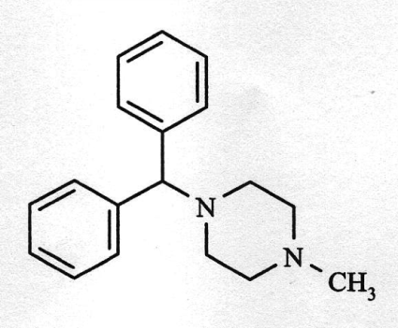
It contains no chiral centres, and is not known to exhibit polymorphism. It is practically insoluble in water, but is readily soluble as the lactate salt at the pH of the injection (3.5). The chemical formula of cyclizine is C₁₈H₂₂N₂ (molecular weight 266); that of cyclizine lactate is C₂₁H₂₈N₂O₃ (molecular weight 356.46).
The drug substance complies with the British Pharmacopiea (BP) monograph for cyclizine, with the addition of a gas chromatography (GC) test for related substances analogous to that described in the BP/European Pharmacopiea (Ph. Eur.) monograph for cyclizine hydrochloride. Appropriate limits are applied to N- methylpiperazine (0.5%), benzhydrol (0.5%) and any unspecified impurity (0.10%).
Matters raised by TGA in relation to the manufacture of the drug substance were resolved satisfactorily.

Drug product
Cyclizine lactate is defined as the 1:1 salt of cyclizine and lactic acid. The product is labelled in terms of the content of cyclizine lactate (50 mg cyclizine lactate is equivalent to 37.4 mg cyclizine base).
The excipients used in the manufacture of the drug product comply with pharmacopoeial standards. They are conventional for use in the manufacture of parenteral products and were found to be acceptable. None is derived from animals or genetically modified organisms.
The manufacturing methods utilised are conventional processes commonly used to produce parenteral drug products. No reprocessing procedures are proposed at this point in time.
The quality evaluator initially considered that approval of this submission could not be recommended until a suitable method for monitoring the finished product had been developed and appropriate stability data using that method were generated. This subsequently occurred.

The proposed shelf life of 4 years below 25°C was considered acceptable.

Biopharmaceutics
Biopharmaceutic data are not required for the IV route of administration. No data were submitted on the bioavailability of the injection when administered by the intramuscular (IM) route.

Advisory committee considerations
Quality aspects were considered at the 140th (2011/5) meeting of the Pharmaceutical Subcommittee (PSC) of the Advisory Committee on Precription Medicines (ACPM), held August 2011. The PSC endorsed all the questions raised by the TGA in relation to quality and pharmaceutic aspects of the submission and did not require the submission to be re-presented to the subcommittee.

Quality summary and conclusions
There were no biopharmaceutic data to support IM administration and therefore approval of Valoid by this route was not recommended.

III. Nonclinical findings

Introduction
Although cyclizine has a very long history of clinical use, the nonclinical animal studies cited in this dossier (submitted as a literature-based submission) are not as comprehensive or scientifically robust as would be expected to support the registration of a NCE, because of their age (preceding regulatory guidelines), design, lack of good laboratory practice (GLP)-compliance, and minimal coverage of nonclinical issues.
The quality of the documents supplied was variable and at times problematic with regard to print quality (illegibility of some figures and tables) and on some occasions, language, where foreign language reports were provided without accompanying English translations (these were subsequently provided on request). Some documents referenced as nonclinical studies would have been more suited to the clinical section of the dossier and vice versa. On one occasion an abstract from the proceedings journal of a conference was cited as a source, when using the full published report would have been more appropriate and useful.
On a positive note, the inclusion of an organisational table, which listed the cited reports in the order of those used to substantiate a particular section of the nonclinical submission aided in understanding the rationale for their inclusion in the dossier.

Pharmacodynamics

Primary pharmacodynamics
Cyclizine is a piperazine-derivative histamine H₁ receptor antagonist, also believed to exert antimuscarinic actions. These antimuscarinic actions combined with the antihistaminic effects of cyclizine may be partially responsible for its central antiemetic effects by an action on the vestibular system and the chemoreceptor trigger zone.
There were little data that specifically addressed the primary pharmacodynamic effects of cyclizine relevant to the proposed indication. However, the data published by Dent et al., 1954 did show an inhibitory effect by cyclizine on an experimental model of emesis (42% reduction in the incidence of vomiting in dogs). Cyclizine was also shown to afford protection against histamine shock and severe bronchoconstriction in guinea pigs exposed to nebulised histamine (Norton et al., 1954). There were also other observations related to the antihistaminic properties of cyclizine (such as inhibition of histamine-induced changes to blood pressure in anaesthetised cats and spasms in isolated guinea pig ileum). However, and perhaps reflecting the age of these reports (approximately 60 years), the studies were not well designed as part of a human pharmaceutical development regimen, because little information was provided on dose-dependency and specificity of actions; as well, there was a lack of quantifiable measures of the actions of cyclizine (that is, no 50% inhibitory concentration (IC₅₀) data were provided for any of the animal models). These deficits can be put into context, with the far less rigorous requirements for pharmacological and mechanistic supporting studies at the time that this medicine was developed, followed by the extensive history of clinical use of cyclizine for the proposed or related indications. The absence of sufficient nonclinical evidence of efficacy for the proposed indications will require adequate clinical evidence of efficacy.

Secondary pharmacodynamics
Very little data were provided that explored the secondary pharmacodynamic characteristics of cyclizine. In the one study cited, cyclizine was reported to have no effects on acetylcholine-induced changes to blood pressure, or on noradrenergic and sympathetic nervous system processes. Cyclizine reduced serotonin-induced changes to blood pressure in cats. Cyclizine was also reported to exert a local anaesthetic effect based on its ability to reduce responsiveness to painful stimuli in guinea pigs. The antimuscarinic actions of cyclizine were evident from data that showed an attenuation of changes to blood pressure that resulted following stimulation of preganglionic fibres of the vagus in anaesthetised cats (although acetylcholine-induced changes to blood pressure were not affected by cyclizine). As the source of information describing these secondary effects came from one standalone reference, it is difficult to make any comments on the reliability and reproducibility of these observations and whether they have any implications for the use of cyclizine as an antiemetic. Also further elaboration on the reported effects of cyclizine on serotonin-mediated actions (that is, serotonin-induced reductions to blood pressure) might have been useful, as it may have provides further clarification about its antiemetic mechanism of action.

Safety pharmacology
The sponsor did not undertake any formal safety pharmacology studies. Because most of the studies provided were published prior to the 1990s, they were not GLP-compliant.
The battery of safety pharmacology investigations covered the central nervous system (CNS) and cardiovascular system (CVS) only. Minimal data concerning the safety of cyclizine on the CVS were confined to two earlier reports that provided information on the effects of cyclizine on blood pressure (cats, in vivo) and heart rate (guinea pigs, in vitro), suggesting a depressant effect. No data (including data on potential effects on the electrocardiograph (ECG) and human ether-à-go-go-related gene (hERG) ion channel) were provided to give insight into potential conductance abnormalities that might arise with cyclizine. The latter safety studies are considered integral by current regulatory standards, particularly in view of the reported local anaesthetic effects of cyclizine. Safety data concerning the CNS came from only one study, which reported decreased spontaneous motor activity at 5 mg/kg by intraperitoneal (IP) injection and increased activity at 20 mg/kg IP. No effect on conditioned responses was observed when rats were given cyclizine (10 and 30 mg/kg IP). Separate reference was made to a study that reported hyperactivity in mice given cyclizine and variable locomotor interactions with opioid substances, though the significance of this to safety was not clear.
Several studies associated repeat dose (2-8 weeks) oral (PO) cyclizine with pancreatic beta islet cell damage and alterations of glucose (plasma) and insulin (plasma; beta cells in vitro). These effects were seen at ≥75 mg/kg/day, and one study determined a no observed effect level (NOEL) of 40 mg/kg/day PO. There were no systemic exposure data to compare with anticipated clinical exposures, limiting any extrapolation for human risk assessment. In a request for information from the TGA, the sponsor was asked to provide evidence that these effects do not pose safety concerns for humans. In response, the sponsor referred to the significantly higher doses used in these animal studies (75 mg/kg/day) compared with the expected maximum human dose (150 mg) and the fact that these observations was associated with repeated dose exposure (2–8 weeks) compared with the proposed (considerably shorter term) use in humans (limited to peri-operative use). The sponsor also argued that concentrations of cyclizine that inhibited insulin secretion in vitro were equivalent to 3 μg/mL, whereas a bolus injection of 25 mg cyclizine given to healthy volunteers achieved peak plasma levels less than 100 ng/mL (30 times less), which subsequently fell to less than 3 ng/mL after 24 h. (By extrapolation, a 50 mg bolus injection may produce peak levels of up to 200 ng/mL, approximately 15 times less). The margin following repeated clinical dosing (up to 3 times a day) is unclear. In view of the proposed indication (use of cyclizine to treat short term instances of nausea and vomiting post- and/or pre-operatively; 50 mg/mL up to 3 times a day), the level and/or duration of exposure to cyclizine might not approach that eliciting potential/actual islet cell damage. Data from a Periodic Safety Update Report (PSUR) for cyclizine from April 1996 to January 2010 submitted did not signal any indication of a risk of diabetes in humans.
No information was provided on gastrointestinal (GI), renal or respiratory effects of cyclizine.

Pharmacodynamic interactions
Cyclizine exerted mild antinociceptive actions and also enhanced those of pentazocine and morphine in rats and mice. The duration of antinociception was enhanced in an additive manner and was also observed with other H₁ antihistaminic drugs (for example, diphenhydramine and chlorpheniramine), which likely reflects a general involvement of histamine in central pain pathways unrelated to cyclizine itself. This may also explain the number of clinical reports that described cases of combined cyclizine and opioid abuse.
Given that the sponsors are seeking to register cyclizine for the treatment of nausea and vomiting caused by narcotic analgesics and general anaesthetics in the post-operative period, it may highlight the need for greater information on the interaction between opioids and cyclizine to assess any potential clinical relevance.
As a further note on opiate interactions, the PI also specified that cyclizine (as Valoid) enhances the soporific effects of pethidine, although this may refer to clinical evidence that was not referenced in the nonclinical submission.

Pharmacokinetics and relative exposure
Pharmacokinetic data are based on earlier studies with detection techniques that may lack the sensitivity of current methods (no details of Methods of Analysis were provided).
Pharmacokinetic data were very limited. There were no plasma kinetic data for the test species used in the toxicity studies. Distribution studies in rats indicated cyclizine binding to rat lung, and other tissues (lung > spleen > liver > kidney > brain > heart > muscle > plasma); plasma protein binding in rats was 59% or 76%, depending on the study. Metabolic pathways were explored by analysis of dog (greyhound) urine. Demethylation produces the major metabolite in this species, norcyclizine (M1; excreted unconjugated); also detected were four monohydroxylated compounds (M2-M5; excreted as Phase II conjugates), and four basic metabolites. Other metabolic pathways in greyhounds included N₁-dealkylation of cyclizine and the basic metabolites to form neutral and phenolic Phase I metabolites containing the diphenyl-methane/methylene substructures, which are excreted as Phase II conjugates.
Cyclizine was extensively metabolised in humans, where norcyclizine was also the major urinary metabolite (although it was not always detected in serum). Following a single bolus dose of cyclizine 25 mg IV, the mean area under the plasma concentration time curve from time zero to infinity (AUC_{0-∞}) was 273 ng.h/mL, volume of distribution 16.5 L/kg, elimination half life (t½) 13.5 h, and total clearance 0.87 L/h/kg.
In vitro assays provided some evidence for inhibition of monoamine oxidase (MAO) in mice, and cytochrome (CYP) 2D6/2C9 and sulfotransferase activities in human liver. There was variable inhibition of MAO, especially deamination of benzylamine (a selective MAO-B substrate, IC₅₀ 13.5 μM). In human liver microsomes (extensive metabolisers), cyclizine showed concentration-dependent inhibition of CYP2D6 (IC₂₀ 12 µM, IC₅₀ 109 µM) and CYP2C9 (IC₂₀ 85 µM), while in human liver homogenates cyclizine inhibited estrone sulfotransferase (IC₅₀ 0.44 µM).
The clinical peak plasma concentration (C_{max}) of cyclizine in persons receiving the maximum recommended human dose (MRHD; 50 mg IV or IM up to 3 times daily) is not known, but could be in the region of 150 ng/mL (0.56 µM) from a single 50 mg injection. This suggests that potential CYP interactions are unlikely at therapeutic concentrations; the finding with liver steroid sulfotransferase may be clinically relevant.
There were no toxicokinetic measurements from any of the animal studies to compare with anticipated clinical exposure at the MRHD.

Toxicology

Acute toxicity
Acute toxicity data were provided from a study and with only one animal model (albino CF-1 mouse strain), which listed 50% lethal dose (LD₅₀) values of cyclizine when administered IP and PO. The LD₅₀ values for IP administration were in the modest range (69–82 mg/kg), whereas the values derived for PO administration were approximately double (165 mg/kg).

Repeat dose toxicity
Repeat-dose toxicity was assessed in a single study using male CF rats that received dietary cyclizine at four different concentrations (doses: 0, 15, 26, 59 and 142 mg/kg/day) for a period of 12 weeks and effects on growth and blood count profiles were assessed at the end of treatment. At the highest dose, body weight gain was significantly reduced (no effect at lower doses). There were no apparent effects on blood chemistry or haematology. Post mortem analyses revealed changes to liver morphology as well as evidence of pulmonary oedema; otherwise no other assessments were conducted to assess changes. These studies preceded observations concerning the effects of cyclizine on pancreatic islet cells, and there was no confirmatory gross pathology of pancreatic tissue or measurement of blood sugar to ascertain a potential diabetogenic effect of cyclizine (as described in Safety Pharmacology, above).

Genotoxicity and carcinogenicity
With regard to genotoxicity, only one study was provided, exploring the possible mutagenicity of cyclizine in a bacterial system only (five strains of Salmonella Typhimurium were tested). The main finding from this study was that cyclizine (1000 μg/plate) on its own, and in the presence of metabolic activation, did not induce significant numbers of mutants. Cyclizine, when reacted with acidified nitrite to promote nitrosation, did however induce revertant mutants in two of the bacterial strains tested. Because the possibility of nitrosation is highest in the acidic gastric environment, it was argued that because it is to be administered parenterally cyclizine is unlikely to pose a significant risk of forming a potentially mutagenic nitrosated species. No cytotoxicity was observed at the maximal concentration used in this assay (1 mg/plate), which is considered low by current regulatory guideline standards (5 mg/plate is the stipulated maximum concentration), and the assay validity is therefore uncertain.
There was no further assessment of the genotoxic potential for cyclizine as would be expected under current nonclinical guidelines. The genotoxic potential of cyclizine has not been adequately investigated.
Scant information was provided by the sponsor on the carcinogenicity of cyclizine. Reference was made to one animal study that merely listed cyclizine among the range of substances fed to rats in combination with nitrite for a period of 80 weeks without any reported incidence of tumour development. However, details on experimental methodology/parameters (such as dose, formulation, numbers within treatment groups, and toxicities) were not provided, and no assessment can be made of these cited findings.
The TGA requested information from the sponsor to address these deficiencies, either in the form of new nonclinical studies or by providing sufficient justification for their absence in the dossier. In response, the sponsor argued against the necessity for extensive genotoxicity testing in view of the widespread use of cyclizine over the years, which has not shown incidences of ‘any pregnancy-related problems as would be expected if cyclizine had significant mutagenic properties’. To support this statement, the sponsor submitted an additional clinical study (Nelson and Forfar, 1971), which was referred to the clinical evaluator for further assessment and comment on the validity of the statement above.
The sponsor also cited previously submitted carcinogenicity data to support their argument of negligible genotoxic risk. However, as described above, the details of this study were grossly inadequate to enable any valid assessments and extrapolations on the potential genotoxic, let alone carcinogenic, risk of cyclizine. The lack of carcinogenicity studies can be acceptable for a medicine used for only short periods, although in the case of cyclizine, genotoxicity testing was also very limited.
It bears mentioning also that none of the cited studies used the same formulation and salt (cyclizine lactate) as the product intended for registration. This is of significance because the one submitted genotoxicity study showed nitrosated cyclizine (which forms under acidic conditions) to give rise to mutations in some bacterial strains and the product specifications indicated that cyclizine lactate solution has a pH range of between 3.3–3.7. Therefore it might still be prudent for the sponsor to conduct more thorough investigations on the genotoxic properties of cyclizine to definitively assess whether in its form it could potentially generate species that may be genotoxic. Otherwise, in the absence of adequate nonclinical data or justification, a qualified risk assessment of cyclizine cannot be made to determine the potential genotoxic risk of cyclizine.

Reproductive toxicity
Reproductive toxicity data were obtained from papers published between 1963-1972, with studies conducted in rats, mice and rabbits. This period preceded the development of nonclinical guidelines for reproductive toxicity assessment, and the study designs described in these published reports do not follow the current guideline-endorsed approaches. Thus, no studies examined the potential effects of treatment during the pre-coital period or later than late gestation, including postnatal treatment. All studies examined treatment of animals during gestation, although the timing of exposure during the gestational period was variable both among studies and even within the same study, confounding the interpretation of the results. One study (using rats, mice and rabbits) used both PO and parenteral administration, but the parenteral route was not defined. Another study had no untreated control group. There were also no kinetic studies investigating placental transfer or excretion into milk. On a more general note, none of the animal studies reported mortalities or any evidence of maternal toxicity, suggesting that tested dose levels were only modest and could have been escalated.
Nevertheless, some relevant information could be derived from the composite data. In general, rats exposed to cyclizine during gestation displayed a dose-dependent increase in both resorptions and malformations, with the highest tested dose (125 mg/kg/day PO, on gestation day (GD) 12-15) causing complete fetal resorption. A NOEL for reduced fertility was not established. In two studies the NOEL for malformations was 50 mg/kg/day for dosing during late organogenesis (GD 12-15); with a more extensive dosing period (GD 1-15), a low level of malformations was noted, although the resorption rate was high. At a higher dose (75 mg/kg/day, GD 12-15), both resorptions and malformations were unequivocal. In another study, a NOEL for malformations was not established (< 25 mg/kg/day, GD 1-16).
In the mouse, malformations were seen at 50 and 75 mg/kg/day, but not consistently, although the high degree of resorptions (100% at 75 mg/kg IP, GD 1-13) may have masked the actual incidences of malformations since they themselves may have induced resorptions. In the rabbit, resorptions occurred only at the 75 mg/kg/day dose but there was a dose-dependent increase in fetal malformations including problems with eye development, spina bifida and microcephaly, with a threshold dose of approximately 25 mg/kg/day.
Clinical reports concerning the incidence of teratogenicity were also provided by the sponsor, which (although published over 40 years ago) indicated relatively low incidences of fetal abnormalities that could be associated with cyclizine use. These reports were referred to the clinical evaluator.
In response to a TGA request for information, the sponsor cited animal studies showing a teratogenic effect by cyclizine, which the sponsor indicated has been proposed to be due to a mechanistic effect involving “binding of an active metabolite of these compounds to cartilage (to) displace calcium and the induction of foetal oedema as a simple mechanical cause for the observed orofacial malformations”. The source of this information is unclear and the cited reference by King et al., 1965 made no specific mention of a mechanistic effect accounting for teratogenicity by cyclizine. The sponsor indicated that the relevance of this mechanism in humans should be easy to validate but did not provide further details on how this was the case. The sponsor’s response referred to previously submitted epidemiological investigations, and included a new reference (Nelson and Forfar, 1971) and adverse drug reactions (ADRs) relevant to Reproductive Toxicity. These were referred to the clinical evaluator for assessment as to whether they support the assertions of the sponsor with regard to the use of cyclizine during pregnancy.

Nonclinical summary and conclusions
- The supporting nonclinical data were solely in the form of published reports, with no additional studies carried out by the sponsor. Document quality was variable and generally low, a limitation acknowledged by the sponsors, because most of the nonclinical studies were published many years ago prior to GLP-compliance and regulatory guidelines.
- Cyclizine is a piperizine-derivative histamine H₁ receptor antagonist with reported antimuscarinic actions, known for this class of substances. The nonclinical data used to demonstrate primary pharmacodynamic efficacy were limited to one early study (from 1954) that documented an antiemetic effect by cyclizine in an experimental model of emesis, with little/no data presented that explored the dose-dependency, efficacy, selectivity and/or mode of action. Limited experimental data showed antihistamine but not anticholinergic activity. Evidence of efficacy will need to rely on the clinical data, including its history of clinical use as an antiemetic.
- In the published safety pharmacology studies (the majority published prior to 1990), only the cardiovascular and central nervous systems were (minimally) investigated (for example, no ECG or hERG assays were performed). In rats, PO cyclizine (≥ 75 mg/kg/day) was associated with pancreatic pathology and plasma glucose/insulin changes.
- Pharmacokinetic data were limited, including no exposure measurements from the toxicity studies. In rats, cyclizine was found to be distributed to lung and other tissues. Metabolic pathway analysis (greyhound urine) showed norcyclizine as the major metabolite (demethylation); others included monohydroxylated and basic compounds, and N₁-dealkylation products, many as Phase II conjugates. The primary human metabolite was also norcyclizine, which had negligible antihistaminic properties. Cyclizine inhibited human hepatic estrone sulfotransferase and murine MAO-B, but showed only weak inhibition of human CYP2D6 and 2C9.
- The one repeat dose toxicity report (dietary administration in rats) noted liver changes (enlarged/spotted at 142 mg/kg/day, light-coloured at 26 and 59 mg/kg/day) and pulmonary oedema (142 mg/kg/day), but few other effects. There were no exposure data.
- Genotoxicity assessment was limited to one Ames test, in which mutations were only seen when cyclizine was in a nitrosated form; this may be relevant for PO administration if nitrites are present in food. There were no carcinogenicity studies; a cited study noted no tumours in rats fed cyclizine with nitrite for an 80 week period.
- Published reproductive toxicity studies examined PO cyclizine administration in rats, mice and rabbits during gestation, with evidence of resorptions and malformations in all species, although NOEL values were not consistent across the (variable) study designs. There was no evidence of maternal toxicity. Placental transfer, excretion into milk and maternal exposure measurements were not conducted.

Conclusions and recommendations
Based on current regulatory guidelines and GLP standards required for nonclinical studies to support the registration of an NCE, the nonclinical dossier submitted for the registration of cyclizine (Valoid) is not adequate. Studies used to support the primary pharmacodynamic effects of cyclizine did not sufficiently demonstrate efficacy for the proposed indication or mechanism of action. Safety pharmacology was also minimally investigated, and there were no follow-up studies of the pancreatic effects reported in rats. Kinetic studies did not determine exposures in the species used for toxicological studies, so comparisons with anticipated clinical exposure were not possible. Metabolism was studied only in dogs (a species that was not used for any of the toxicity tests), and it is unknown whether the potential toxicity of human metabolites was assessed in the animal studies. Repeat dose toxicity was confined to one 12 week dietary study in rats. Although the lack of carcinogenicity studies is acceptable for a medicine used for only short periods, genotoxicity testing was very limited (one bacterial mutation assay using a low cyclizine concentration). Reproductive toxicity studies were also inadequate, with no pre-coital or postnatal exposure investigated.
The nonclinical dataset needs to be assessed in view of CPMP/SWP/799/95, which describes the acceptable nonclinical requirements for the registration of medicines with an extensive clinical history. In these cases, many traditional nonclinical studies are not required if all aspects of clinical efficacy and safety have been addressed by clinical experience; however, nonclinical data on genotoxicity and embryofetal and peri/postnatal development may still be required. In view of these issues, the clinical evaluator will need to be assured that the identified nonclinical deficiencies are adequately offset by sufficiently well-documented clinical information.

IV. Clinical findings

Introduction
Cyclizine is a well established antiemetic and has been used parenterally in routine clinical practice for more than 50 years. There is also evidence of clinical need in Australia. Currently, 60,000 Valoid ampoules are provided for the Australian public on a named patient basis each year.
Clinical data comprised a literature based submission (with approximately72 references) to register a NCE. In relation to NCEs and literature based submissions the following statement is made in a TGA guideline: Under exceptional circumstances, however, literature Based Submissions (LBS) may be accepted for medicines, which, although they may have been marketed in other countries for many years, are considered new chemical entities (NCE) in Australia because they have never been marketed here.
Many of the references provided were very poor quality copies, some unreadable, others unable to undergo useful text recognition so that rather than cut and paste quotations had to be retyped. This delayed assessment. The nonclinical submission also contained some clinical reports.
Because of conflicting information in the dossier, the sponsor’s clarification was sought on the proposed indications. The sponsor subsequently confirmed that the intended indications are:
- the treatment of nausea and vomiting caused by narcotic analgesics and by general anaesthetics in the post-operative period
- pre-operative use in patients undergoing emergency surgery to reduce the hazard of regurgitation and aspiration of gastric contents during induction of general anaesthesia
The evaluator considered the first indication is ambiguous, being readily interpreted as two indications:
- The treatment of nausea and vomiting caused by narcotic analgesics and
- The treatment of nausea and vomiting caused by general anaesthetics in the post-operative period.
The evaluator assessed the submitted evidence accordingly, noting that post-operative vomiting associated with local anaesthesia was shown by Bonica et al., 1958 to be considerably less frequent than with general anaesthesia. Further the evaluator believes that the only pivotal study that was clearly associated with local anaesthesia (Nortcliffe et al., 2003; all patients received ephedrine as needed (PRN); patients received cyclizine at the end of surgery, morphine was given intrathecally with fentanyl and heavy bupivacaine prior to surgery) was confounded by the use of ephedrine (as well as intrathecal opiate). The other study that may have been associated with local anaesthesia (Hildyard et al., 2001) was an abstract only, submitted with limited data.

Literature search
The search strategy was based on the current indications for Valoid in the United Kingdom (UK). These indications however had been partly based on historical data and, by extrapolation to data on the use of the oral formulation of cyclizine. It was found that the clinical data available in the literature was insufficient to support all claims that had featured in the literature search strategy. Therefore the claims in the proposed PI are limited to:
The prevention and treatment of nausea and vomiting:
Nausea and vomiting caused by narcotic analgesics and by general anaesthetics in the post-operative period
Valoid may be given pre-operatively in patients undergoing emergency surgery in order to reduce the hazard of regurgitation and aspiration of gastric contents during induction of general anaesthesia.
In email correspondence, the TGA informed the sponsor that the search strategy was acceptable.

Good clinical practice
The submission was literature based. None of the cited studies in this report was carried out according to Good Clinical Practice.

Pharmacokinetics
These were submitted for 1 volunteer after 50 mg PO (Walker and Kanfer, 1987) and 6 healthy volunteers after 25 mg IV (Walker and Kanfer 1996). Measurement was by HPLC with a lower limit of quantitation (LLOQ) of 1 ng/mL and a relative standard deviation (SD) and accuracy of ≤ 10% for both cyclizine and norcyclizine in serum and urine. Further data on 1 volunteer after 50 mg PO (Griffin and Baselt, 1984), and 1 after 50 mg IV was found (Land et al., 1981).
Figure 1. Cyclizine serum concentration-time profile in a human subject after the administration of a single 50 mg PO dose (from Walker and Kanfer, 1987)
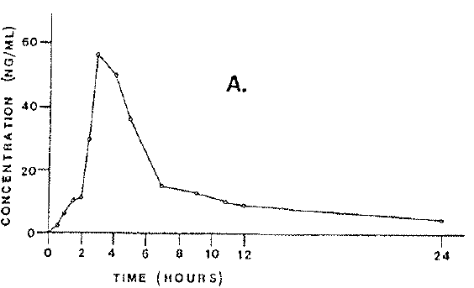
Figure 2. Urinary excretion plot of cyclizine after the administration of a single 50 mg PO dose (from Walker and Kanfer, 1987)
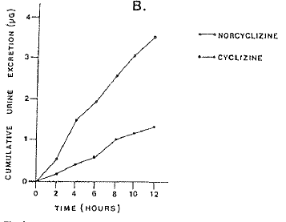

Figure 3. Blood cyclizine concentration profile for an adult subject following PO ingestion of 50 mg of cyclizine hydrochloride (from Griffin and Baselt, 1984)
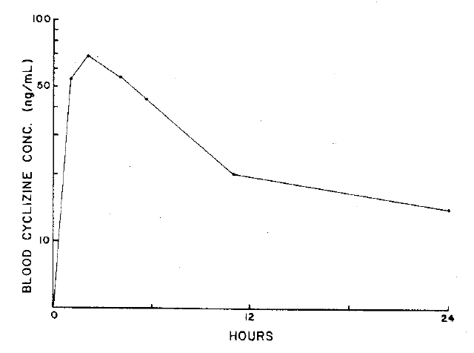
Blood levels declined in a biphasic manner, with estimated half-lives of 7 h and 24 h for the early and late phases, respectively.
Figure 4. Urine cyclizine concentration profile for an adult subject following PO ingestion of 50 mg of cyclizine hydrochloride (from Griffin and Baselt, 1984).
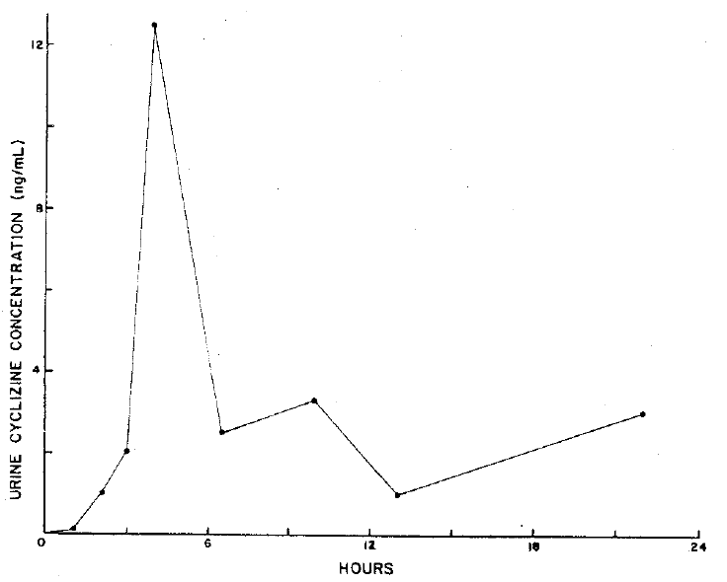
The 24 h urinary excretion of unchanged cyclizine amounted to only 0.01% of the administered dose.

Table 1. Cyclizine pharmacokinetics for subjects 1 to 6 following administration of an IV bolus dose of 0.5 mL of a cyclizine lactate solution (50 mg/mL) (from Walker and Kanfer, 1996).
Subject | AUC_{0-∞}  µg/L*h | MRT  h | λ_{z}  h⁻¹ | t_{1/2}  h | V_{ss}  L/kg | V_{z}  L/kg | Cl_{TOT}  L/h/kg | Cl_{R} | % dose in urine
1 | 237.63 | 15.16 | 0.0492 | 16.52 | 15.68 | 21.04 | 1.034 | 0.00361 | 0.53
2 | 259.00 | 15.62 | 0.0510 | 13.58 | 11.38 | 14.29 | 0.729 | 0.00934 | 1.03
3 | 324.89 | 15.64 | 0.0562 | 12.32 | 12.32 | 14.01 | 0.788 | 0.00186 | 0.32
4 | 253.97 | 12.57 | 0.0658 | 10.53 | 11.06 | 13.37 | 0.879 | 0.00277 | 0.46
5 | 263.02 | 19.74 | 0.0433 | 16.00 | 17.32 | 20.23 | 0,877 | 0.00442 | 0.41
6 | 300.65 | 14.03 | 0.0568 | 12.21 | 12.82 | 16.10 | 0.914 | 0.00306 | 0.57
Mean | 273.53 | 15.46 | 0.0537 | 13.53 | 13.43 | 16.50 | 0.870 | 0.00418 | 0.55
SD | 32.53 | 2.40 | 0.0077 | 2.33 | 2.51 | 3.33 | 0.105 | 0.00244 | 0.25
MRT = mean residence time (MRT), which is the time when 63.2% of an IV has been eliminated from the pharmacokinetic system. λz = the terminal rate constant. Vz = the apparent volume of distribution. V_{ss} = the volume of distribution at steady state. Cl_{TOT} = total clearance. Cl_{R} = renal clearance. Note this is derived from a poor copy of Table 1 in Walker and Kanfer, 1996).
From Walker and Kanfer, 1996: “The mean value of 15.50 ± 3.53 L/kg for V_{z} clearly indicates extensive distribution of cyclizine. A high value for V_{z} is expected since experiments in which cyclizine was administered to male rats resulted in concentrations of cyclizine in the lung, spleen, liver and kidney 20–110 fold higher than those in plasma (Kuntzman et al, 1965). Norcyclizine, the main metabolite, was isolated in the urine but was conspicuously absent in serum. Metabolic inactivation of cyclizine, primarily by demethylation (Kuntzman et al, 1965) to form norcyclizine or by glucuronidation (Luo et al, 1991) in the liver, is an indication that extrarenal clearance accounts for most of the removal of drug from the body. In addition, renal clearance of cyclizine and norcyclizine were negligible with less than 1% of the dose excreted up to 36 h and the presence of norcyclizine in urine emphasises that alternative mechanisms of elimination are responsible for the removal of cyclizine from the body. Current utilization of oral cyclizine and its associated dosage recommendations (4-6 hourly) are apparently based on a much shorter half-life, implying that chronic use may result in accumulation of the drug based on the terminal elimination half-life of approximately 13 h established in this study.”
Land et al., 1981 reported a peak level of approximately 350 ng/mL after IV administration of a 50 mg dose.
Figure 5. Plasma cyclizine profile in healthy adult male subject after administration of 50 mg cyclizine IV (from Land et al., 1981).
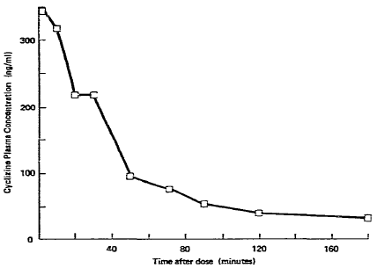
The delay in excretion seen in the plasma profile at around 30 min is well known for basic drugs (for example, amphetamine).
Luo et al., 1991 gave 2 volunteers 2 doses of 30 mg of cyclizine 6 h apart; urine was collected for a period of 36 h from the first dose. 16.9% and 11.7% of the dose was excreted in the volunteer’s urine as N⁺glucuronide. N⁺Glucuronidation also occurs at the piperazine ring of cyclizine, specifically at the N-methyl substituent.

Evaluator’s overall conclusions on pharmacokinetics
The major deficiencies are:
- The lack of repeated dose studies or a pharmacokinetic model on which to base dosage recommendations.
- The lack of a bioequivalence study for IM dosing.
In a justification for not providing appropriate biopharmaceutic studies (Module 1.11.2 of the dossier), the sponsor argues that:
- The known physical properties of cyclizine demonstrate that it would be highly permeable across tissue.
- Administration of the doses by the IM route would be unlikely to affect the plasma half life since the same tissue diffusion mechanisms pertain after distribution into tissue from the IV injection.
- An IM injection would likely result in lower initial plasma levels with possible incomplete suppression of symptoms prior to peak levels being reached.
Unfortunately in this section the sponsor also quotes a plasma half life of approximately 20 h whereas Walker and Kunfer, 1966 gives a mean of 13.53 h.
The sponsor also states in the justification section that: “Cyclizine has been approved across worldwide markets at single doses of 50 mg given orally, by IV or IM injection.”

Pharmacodynamics

Primary pharmacodynamic effects

Vestibular function
Reicke (1976) tested the nystagmus produced by a rotation and head tilt test (Coriolis effect) to assess peripheral vestibular function and its modification by 50 mg PO cyclizine.
While nausea was reduced, there was no effect on nystagmus. Reicke interpreted this as indicating a central action on the vomiting centre rather than the peripheral vestibular function. However Reike quoted Gunter et al., 1954 as seeing a marked reduction on vestibular function testing with 100 mg cyclizine, but 50 mg had variable effects.
Gowans et al., 2000 looked at the effects of 50 mg of PO cyclizine on visual-vestibular interactions in humans, and found no significant suppressive effect on postural sway and circularvection; optokinetic nystagmus initial slow phase velocity was significantly increased (p < 0.05), although optokinetic nystagmus amplitude and frequency were unaffected. Again suggesting that cyclizine 50 mg has minimal suppressive effects on these aspects of visual-vestibular interaction.
In a paper by Gunter et al., 1954 ten patients given orally either 50 or 100 mg cyclizine or 100 mg chlorcyclizine were investigated with the cold microcaloric test and galvanic stimulation of the mastoid area. Figures 6-8 and Table 2 are from Gunter et al., 1954:

Figure 6. Onset of nystagmus.
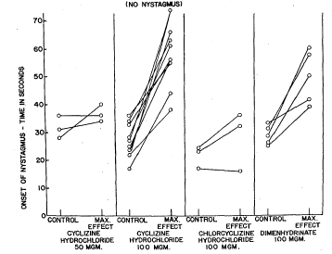
Figure 7. Duration of nystagmus.
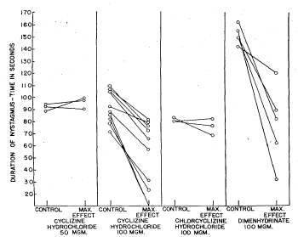
Figure 8. Ratio of time of onset to duration of nystagmus
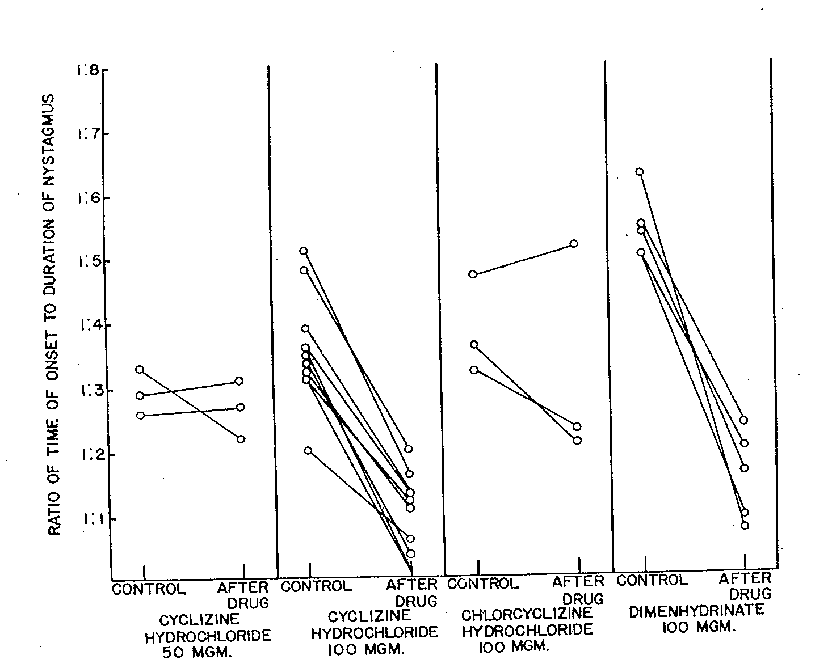
Table 2. Influence of cyclizine HCL on vestibular function measured by Galvanic Stimulation Method
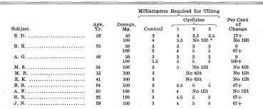
*"No tilt" indicates tilting could not be made to occur before the rising milliamperage
exceeded the patient's local tolerance.

Secondary pharmacodynamic effects

Drowsiness
Lederer and Putnam (1958) looked at subjectively reported drowsiness in 100 subjects after 50 mg PO cyclizine: 14 had Mild-effects that were not enough to interfere with normal class routine; 10 had Moderate-effects that were severe enough to interfere with class routine; 4 had Severe-effects that interfered with class routine and social activity to the point of moderate or severe incapacitation, requiring bed rest. Placebo produced 2 mild, 5, moderate and 1 severe drowsiness reactions.
Brand et al., 1968 looked at subjectively reported drowsiness in a motion sickness inducing situation with 58 subjects. Drowsiness was dose related: placebo 54%, cyclizine: 15 mg 55%, 25 mg 66%, 40 mg 78%, 65 mg 71%, 100 mg 79%. They also looked at the effect on mental performance and noted an improvement against placebo in mental arithmetic: cyclizine: 15 mg 10.8%, 25 mg 11.5%, 40 mg 7.2%, 65 mg 14.0%, 100 mg 18.3%. The explanation given was that the effect on mental performance of nausea was greater than the effect of medication in those who had no nausea (there were however a significant number vomiting in all groups: placebo 55%, cyclizine: 15 mg 35%, 25 mg 35%, 40 mg 28%, 65 mg 24%, 100 mg 21%). Subsequent arithmetic testing (Brand et al., 1968) in the absence of motion could show no drug effect with 15 or 100 mg.
Clubley et al., 1979 looked at performance and vigilance with a battery of tests under laboratory conditions with 2 groups of 12 subjects taking placebo (lactose), or cyclizine 25 and 50 mg a week apart, or placebo, or cyclizine 50 and 100 mg a week apart. Values after cyclizine 25 and 50 mg did not differ from those after lactose for the number of signals detected over 1 h in the auditory vigilance test, auditory reaction time tested over 15 min and tapping rates. There were no changes ascribable to treatments in arithmetic, digit symbol substitution test or digit symbol substitution test.
In Trial group 2 cyclizine 50 or 100 mg produced no changes in auditory vigilance significantly different from those following lactose, but the number of detections was lower after cyclizine 100 mg. Mean values in reaction time were longer after cyclizine 50 and 100 mg than lactose; 5-5.25 h after cyclizine 100 mg the number of sums completed was reduced compared with lactose. This was the only performance test in which cyclizine differed significantly from lactose. The only significant subjective effect after cyclizine was increased mental sedation at 6 h after the 100 mg dose. The energy in the delta frequency band was greater 2.8 h after cyclizine 100 mg than after both lactose and cyclizine 50 mg; by 6.1 h the energy in the delta band was still significantly higher after cyclizine 100 mg compared with cyclizine 50 mg but not lactose. There were no differences in the alpha, beta and theta bands at 2.8 h or 6.1 h after treatment between cyclizine 50 or 100 mg and lactose.

Haemodynamics
Clubley et al., 1979 also monitored heart rate by recording classical limb lead I. There were no treatment effects on heart rate in either trial group.
Bassett et al., 1996 in reviewing 80 teenage cases of abuse reporting to the Utah Poisons Centre (of whom only 25% had co ingestions) found that 52% had tachycardia (> 115 beats/min), 69% had systolic hypertension (> 135 mmHg), 15% had diastolic hypertension, and 14% had fever (> 38°C).

Effect on lower oesophageal sphincter
Brocke-Utne et al., 1977 and 1978, in 2 different journals’ reports of 2 studies reported on 8 awake and healthy volunteers in each study receiving 25 mg cyclizine IV. They showed in both studies that the basal barrier (due to sphincter) pressure increased from a basal mean pressure of 19.1 cm H₂O to 33.5 cm H₂O (p < 0.005). The results in the second (1978) study, for all parameters measured, are identical except they are reported in kilopascals (kPa). There was no reference to them being the same subjects, indeed the 1978 study contains the statement: “Both cyclizine and metoclopramide increased barrier pressure significantly, thus confirming previous reports indicating that these two drugs increase LOS tone (…Brock-Utne et al., 1976; Brock-Utne et al., 1977)”.

Table 3. Gastro-oesophageal pressures before and after cyclizine.
Source: Figure 1 from Brock-Utne et al., 1977.

Genetic-, gender- and age-related differences in pharmacodynamic response
A study by Tan et al., 1988 in patients with severe heart failure showed deterioration in cardiovascular function and is considered in the Safety section below.

Pharmacodynamic interactions
Nil discussed in submission. However Clubley et al., 1979 included a comparison with groups on caffeine and cyclizine combinations, not relevant to the submission.
Back et al., 2007 state: “There is evidence that cyclizine inhibits CYP2D6, and also that CYP2D6-inhibiting H₁-antihistamines can increase the plasma concentrations of haloperidol (a CYP2D6 substrate).”
The addition of cyclizine to haloperidol (as in the patient described, and as is common practice) may therefore in itself result in a higher plasma level of haloperidol, and thus an increased risk of adverse effects.

Antanalgesic effects
Nicholl et al., 1962 compared the analgesic index (alterations in pain threshold and response readings) before and after injections including cyclizine 50 mg IV to 6 healthy patients. Cyclizine had considerable antanalgesic effect compared to other drugs then used as shown in the following.
Figure 9. Average effects of the IV injection of cyclizine 50 mg (C) and trimethobenzamide 200 mg (T) on the mean of the threshold and response readings.
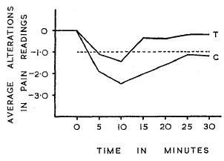
Each drug was studied in six subjects.

Table 4. Analgesia indices of drugs studied
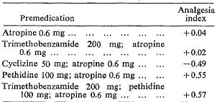
Comment: Some (but not all) of the efficacy studies submitted appear to support this, for example, O’Brien et al., 2003.
Table 5. Morphine administration by antiemetic (from O’Brien et al., 2003)
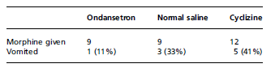

Relationship between drug concentration and pharmacodynamic effects
Brand et al. (1967) showed a linear log dose-response curve for PO cyclizine:
Figure 10. Log. Dose-response curve. (-)-Hyoscine () and cyclizine HC1 (X) (placebo vomiting rate, 55%).
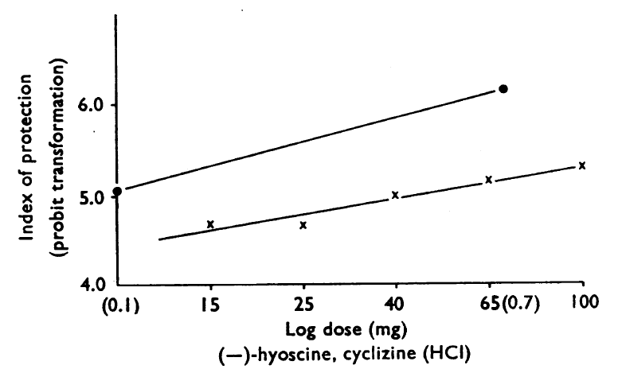
Table 6. Response index of protection (from nausea & vomiting).
 | Dose (mg) | Response index of protection, as probit
Cyclizine | 15 | 4.68
Cyclizine | 25 | 4.68
Cyclizine | 40 | 5.0
Cyclizine | 65 | 5.16
Cyclizine | 100 | 5.30

Evaluator’s overall conclusions on pharmacodynamics
There appears to be a reputation for the drug having “few significant side effects” (as O’Brien et al., 2003 put it). However many of the adverse events (AEs) reported relate to the actions of the drug. The relatively few pharmacodynamic and efficacy studies suggest effects on vestibular function, drowsiness, haemodynamics, lower oesophageal sphincter and antanalgesic effects. The problem lies in determining to what extent the effects relate to dose, route of administration and individual sensitivity. What evidence there is showed vestibular effects only for 100 mg orally; drowsiness was shown in some patients in some studies; haemodynamic effects were seen in overdose and revealed at the proposed dose IV to the detriment of patients in cardiac failure.

Efficacy

Dosage selection for the pivotal studies
There was no discussion of the effective dosage in the [sponsor’s] Clinical Summary or the Cochrane review (Carlisle J and Stevenson CA, 2006). As already stated, deficiencies [in the clinical data] are:
- The lack of repeated dose studies or a pharmacokinetic model on which to base dosage recommendations.
- The lack of a bioequivalence study for IM dosing.
As mentioned above, the sponsor, in justifying the absence of a bioequivalence study, quotes a plasma half life of approximately20 h whereas Walker and Kunfer, 1966 gives a mean of 13.53 h; and the sponsor argues that: “Cyclizine has been approved across worldwide markets at single doses of 50 mg given orally, by IV or IM injection.”
Most trials used 50 mg PO or parenteral. However cyclizine in 100 mg dosage notably decreased labyrinthine sensitivity. The results with cyclizine 50 mg were inconsistent and variable (Gutner et al., 1954).
With regard to frequency of dose again this was not discussed, but: “Current utilization of oral cyclizine and its associated dosage recommendations (4-6 hourly) are apparently based on a much shorter half-life, implying that chronic use may result in accumulation of the drug based on the terminal elimination half-life of approximately 13 h established in this study” (Walker and Kanfer, 1996).
Comment: The evaluator’s experience of the drug used post middle ear surgery (for example, stapedectomy) was 100 mg IM 8 hourly, but for not more than 24 h. When used beyond this duration on a continuing 8 hourly basis, CNS (extrapyramidal) effects tended to occur. It is clear from the studies that 50 mg PO, IM or IV are considered appropriate doses: Brand et al. (1967) used 15-100 mg PO, Lederer and Putnam (1958) used 50 mg PO, Gunter et al. (1954), looking at the effect on nystagmus (inner ear) found 50 mg ineffective compared with 100 mg PO, Nicholl et al. (1962) used 50 mg IV.
All the efficacy studies on post operative and opiate induced nausea and vomiting used 50 mg IM or IV. Brocke-Utne et al. (1977, 1978) however showed 25 mg IV was effective on the lower oesophageal sphincter pressure.

Nausea and vomiting caused by general anaesthetics in the post-operative period
The evaluator agrees with the sponsor that anaesthetic techniques have changed considerably over time. Regional anaesthesia was often accompanied by some supplementation. While this may have been general anaesthesia (GA) (usually for intra-abdominal procedures), the alternative was heavy sedation that usually included a phenothiazine and an opiate.
Bonica et al. (1958) showed the considerable variation in incidence of nausea and vomiting with different anaesthetic techniques as well as different surgical sites. This needs to be considered when reviewing study results.
Table 7. Incidence of nausea and vomiting [with] general versus local anaesthesia (Table 3 in Bonica et al., 1958)
Table 8. Relationship of operation site to nausea and vomiting. (Table 4 in Bonica et al., 1958)
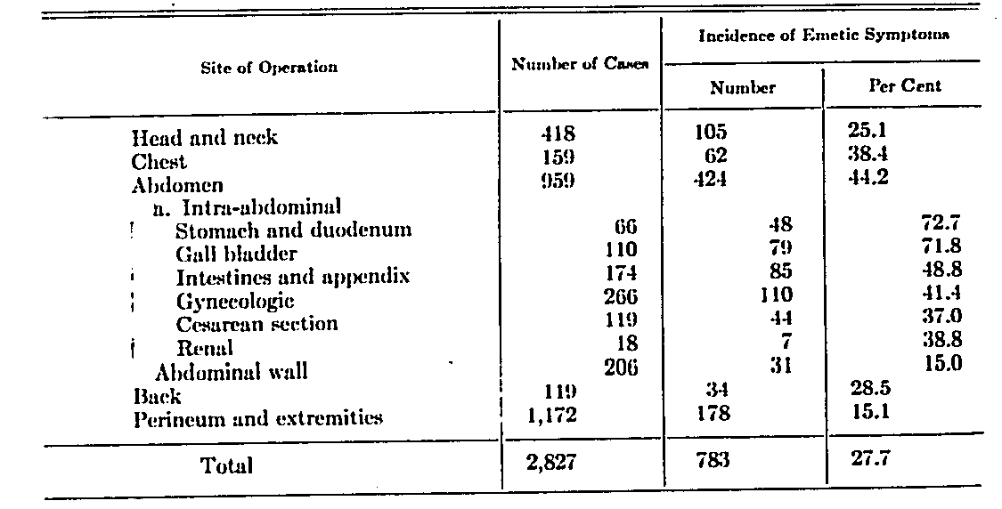
Le and Gan (2010) refer to the [Apfel] scoring system of four highly predictive risk factors for post-operative nausea and vomiting (PONV): female gender, history of motion sickness or PONV, non smoker, and use of perioperative opioids. The presence of 0, 1, 2, 3, or 4 of these factors corresponded to a PONV incidence of 10%, 21%, 39%, 61%, and 79%, respectively. However, while higher Apfel scores correlate to a greater incidence of PONV symptoms in the early (0-24 h) postoperative period, it appears to have little predictive value for emetic symptoms occurring in the late (24-72 h) postoperative/post discharge period. Sinclair et al. 1999 (taking in 3 year and 17,000 patients) added to these 4 factors; duration of anaesthesia longer than 30 min, general anaesthesia, and type of surgery, as independent predictors of PONV. The following table is from Le and Gan (2010).

Table 9. Risks factors for PONV and post-discharge nausea and vomiting (PDNV)
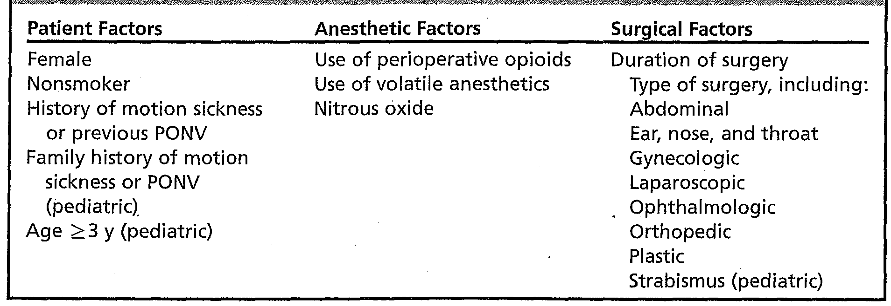
All of the studies in the following tables were prospective, randomised, blinded with 50 mg cyclizine given parenterally (Walder and Aitkenhead, 1995 also included an infusion).

Table 10. Efficacy: the treatment of nausea and vomiting caused by general anaesthetics in the post-operative period - Principal Studies
Study [by date] | Study objective | Premedication | Patients receiving Cyclizine
Study [by date] | Study objective | Premedication | Route | Time | No. | M/F Mean age years (range)
Grimsehl et al, 2002^{d} | Difference in the incidence of PONV cyclizine verses (vs.) ondansetron | NK¹ | IV | Induction | 37 | F 31 (SD 6)
Cholwill et al, 1999^{c} | Incidence of PONV and use of escape antiemetic vs. placebo and ondansetron | NK¹ | IV | Immediately prior to induction | 57 | F 31 (22-42)
Watts, 1996^{c} | Incidence of PONV (historical) and vs. after ondansetron and metoclopramide | temazepam | IV | Prior to induction | 53 | F 30.3
Chestnutt and Dundee, 1986^{c} | Comparison of the safety and efficacy vs. perphenazine and placebo | opiate (meptazinol) alone or plus study drug | IM | About 1.5h prior to surgery^{2.} Surgery took 8–15 min | 40 | F 33 (SD 11)
Dundee et al, 1975^{c} | Incidence of PONV vs. perphenazine and placebo | morphine or pethidine alone or plus study drug | IM | About 1.5h prior to surgery. Surgery took 5-10 mins | 300 | F NK
NK = not indicated in report ¹ Day surgery cases probably no premed. ² Based on figure 1 in the study ^{c} Double-blind SD = standard deviation
Table 11. Efficacy: the treatment of nausea and vomiting caused by general anaesthetics in the post-operative period - Supporting Studies
Study | Study objective | Premedication | Patients receiving Cyclizine
Study | Study objective | Premedication | Route | Time | No. | M/F Mean age years (range)
Ahmed et al., 2000^{c} | Difference in the incidence of PONV with placebo, ondansetron alone and in combination with cyclizine | NK¹ | IV | After induction | 60 | F 32 SD (6)
Johns et al., 2006^{ab} | Risk of PONV alone or in combination with granisetron | NK¹ | IV | Induction | 316 | F 41.9 (SD 13.1)
Laffey and Boylan, 2002^{c} | The prevention of PONV | diazepam | IV | 20 min prior to end of surgery plus infusion in patient-controlled analgesia (PCA) | ?14 | F ?46
Walder and Aitkenhead, 1995^{d} | Reduction of opiate related PONV vs. droperidol | temazepam | IV | 20 min prior to end of surgery plus infusion in PCA | 25 | F 41.9 (SD 11.8)
Dundee et al,1966 | Comparison of the safety and efficacy vs. trimethobenzamide and placebo | morphine or atropine alone or plus study drug | IM | About 1.5h prior to surgery. Surgery took 6-9 mins | 150 | F 32
ª Not included in the Cochrane 2006 meta-analysis ^{b} The administering anaesthetist was not blind but patients and all other staff remained blind ^{c} Double-blind ^{d} Observer blind.
Table 12. Efficacy: Effect on opiate-induced nausea and vomiting
Study | Study objective | Premedication | Patients receiving Cyclizine
Study | Study objective | Premedication | Route | Time | No. | M/F Mean age years (range)
Dundee and Jones, 1968 ª | Suppression of oral opiate induced nausea and vomiting | not applicable | PO |  | 83 | M 38 F 45 (31-89)
Chestnutt and Dundee, 1986ª | Reduction in PONV vs. perphenazine and placebo | opiate (meptazinol) alone or plus study drug | IM | About 1.5h prior to surgery^{2.} Surgery took 8–15 mins | 40 | F 33 (SD 11)
Dundee et al., 1975ª | Comparison of the effects vs. perphenazine on opiate related nausea and vomiting | morphine or pethidine alone or plus study drug | IM | About 1.5h prior to surgery. Surgery took 5-10 mins | 300 | F NK
Dundee et al., 1966 | Balance of desirable/undesirable effects | atropine or pethidine 100 mg alone or with study drug | IM | About 1.5h prior to surgery. Surgery took 5-7mins | 150 | F 31.8
NOTE: Chestnutt and Dundee, 1986 and Dundee et al., 1975 are listed here as well since they looked at the effect on opiate premed for 90 mins preoperatively.
ª Double-blind. ^{b} The administering anaesthetist was not blind but patients and all other staff remained blind. ² Based on figure 1 in the study.

Efficacy studies considered pivotal by the sponsor
The sponsor, on page 14 of the Clinical Summary states:
“…twelve clinical studies investigating cyclizine in the prevention of nausea and vomiting caused by narcotic analgesics and by general anaesthetics relating to the period of modern anaesthesia. The studies are Johns et al 2006; O’Brien et al 2003; Grimsehl et al 2002; Nortcliffe et al 2003; Ahmed et al 2000; Cholwill et al 1999; Watts 1996; Walder & Aitkenhead 1995; Chestnutt & Dundee 1986; Dundee et al 1975; Laffey & Boylan 2002 & Hildyard et al 2001.”
Of these the evaluator considers the following are not acceptable for evidence for efficacy:
- Hildyard et al., 2001: Abstract only was submitted, with limited data.
- O'Brien et al., 2003: Antihistamine was used as premedication (PO trimeprazine); outside the age group for [the proposed] indications.
- Nortcliffe et al., 2003: All patients received ephedrine PRN; patients received cyclizine at the end of surgery, morphine was given intrathecally with fentanyl and heavy bupivacaine prior to surgery.
Of the remaining studies the evaluator considers that four studies could not be considered pivotal to the proposed indication.
Two studies use dosage and administration differing from that proposed - being given both as an IV bolus of the proposed dose 20 min prior to end of surgery and also an infusion in the PCA:
- Laffey and Boylan, 2002.
- Walder and Aitkenhead, 1995.
One study only made comparison of a combination (that included cyclizine) with another active drug (ondansetron):
- Ahmed et al., 2000.
One study had no placebo and only made comparison with a combination (that is, there was no placebo control and there was no statistical comparison given with the other active drug (granisetron), except that the incidence of PONV after discharge from the day surgery unit was significantly higher (confidence intervals not given) in those who had received granisetron:
- Johns et al., 2006.
The remaining 5 studies give a total of 487 patients in minor gynaecological surgery. Of these 147 (in 3 studies) would be considered as having had modern techniques for day surgery, while 340 (in 2 studies, dated to 1986 and 1975) had an opiate premedication.
The sponsor did not consider one study other than as historical (Dundee et al.,1966), yet it really did not differ from Chestnutt and Dundee 1986 or Dundee et al., 1975, except that it was not blinded for the combination of cyclizine and pethidine (one of the groups of interest).

Efficacy studies considered pivotal by the evaluator

Cholwill JM, Wright W, Hobbs GJ, Curran J. Comparison of ondansetron and cyclizine for prevention of nausea and vomiting after day-case gynaecological laparoscopy. Br J Anaesth. 1999; 83(4): 611-614.
A double-blind, randomised, placebo-controlled study comparing IV ondansetron 4 mg versus cyclizine 50 mg, for the prevention of postoperative nausea and vomiting for 24 h after day-case gynaecological laparoscopy. Single centre in the UK.
Anaesthesia Induction: propofol 2 mg/kg after alfentanil 10 µg/kg and glycopyrrolate 200 µg. Maintenance: vecuronium 0.05 mg/kg laryngeal mask with intermittent positive-pressure ventilation 33% oxygen in nitrous oxide with added isoflurane to an end-tidal carbon dioxide partial pressure of 4.5-5.0 kPa. Reversal: neostigmine 2.5 mg and glycopyrrolate 200 µg.
Analgesia : 1 h preoperative diclofenac 100 mg PRN; intraoperative morphine 0.18 mg/kg IV Postoperative increments of morphine IV or a combination paracetamol 1 g + codeine phosphate 60 mg orally, PRN.
Inclusion criteria: ASA I or II women undergoing day-case gynaecological laparoscopy, with stratification for past history of PONV.
Exclusion criteria: receiving antiemetic drugs, pregnant, breast-feeding or with body mass index (BMI) > 30 kg/m².
Antiemetics: According to randomisation immediately before induction, IV ondansetron 4 mg, cyclizine 50 mg or 0.9% saline (60 per group). Rescue was prochlorperazine 12.5 mg IM.
The study objective was to assess the incidence of PONV and the use of escape antiemetic vs. placebo and ondansetron. The primary outcome measures were the incidence of moderate or severe nausea, vomiting and number of patients receiving escape antiemetic.
The single worst scores for pain, sedation and nausea from any of the three times before discharge and in the period covered by telephone questionnaire (after discharge) were used for analysis. To demonstrate a 50% reduction in the incidence of vomiting or number of patients receiving escape medication (from 30% to 15%) at α = 0.05, 180 patients conferred a power of at least 0.8 to the study. Data from patients who received escape treatment were excluded from the post-discharge analysis. Overall comparisons were performed using analysis of variance (ANOVA) or Chi-square (χ²) tests where appropriate. If a difference was statistically significant at the 5% level, pairwise comparisons were performed. The drugs were blinded to patients, investigators and recovery room staff. Data from this study are shown below.
Table 13. Patient demographics
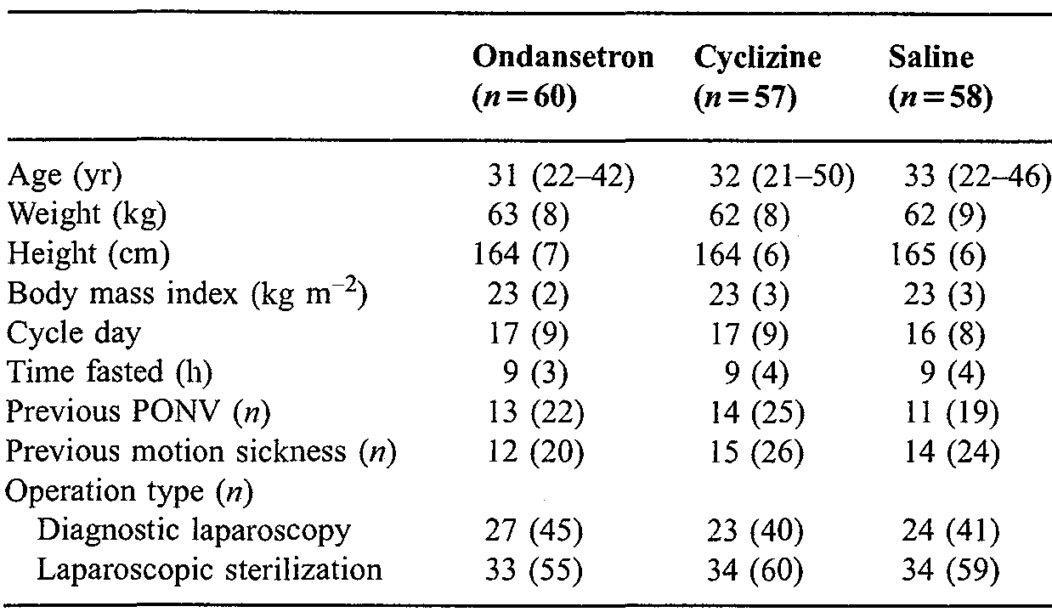
Data are mean (SD or range) or number (%)
Post operatively before discharge, compared with saline, both ondansetron and cyclizine reduced significantly the incidence of moderate or severe nausea (p = 0.02 and p = 0.001, respectively) and the requirement for escape antiemetic (p = 0.04 and p < 0.001, respectively). The incidence of vomiting after ondansetron and cyclizine was less than that after saline (32% and 23%, respectively, versus 41%; p = 0.1 overall).
Table 14. Outcomes before discharge in the three groups
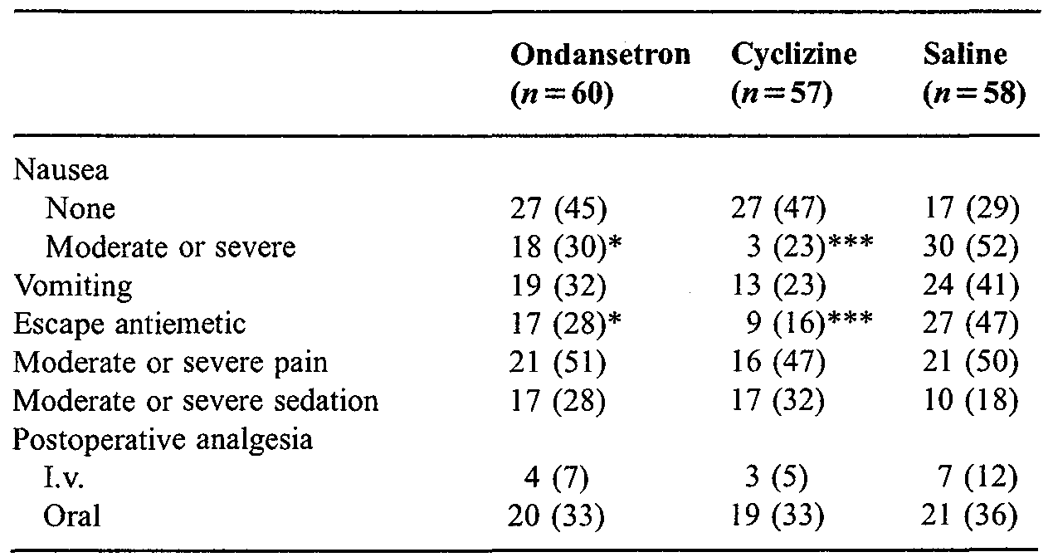
Data are n (%). *p < 5, ***p < 0.001 compared with saline
After surgery, 13 patients were admitted 7 with PONV (2 ondansetron and 5 saline patients). These 13 and the 53 patients who received rescue antiemetics were excluded from further analysis. 106/109 remaining patients completed the telephone questionnaire. The incidence of moderate or severe nausea was comparable in all groups. The incidence of vomiting after discharge was reduced with ondansetron and cyclizine compared with saline (not statistically significant).
Table 15. Outcomes after discharge in the three groups and summary data of those suffering no PONV throughout the study.
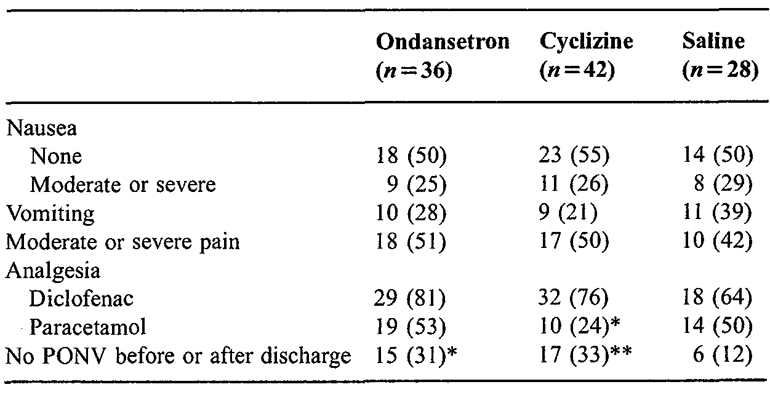
Data are (%). *p < 0.05, **P < 0.01 compared with saline.
The number of patients who had no nausea or vomiting throughout the study was significantly less after either ondansetron and cyclizine compared with saline (p = 0.02 and p < 0.01, respectively).
The authors in the Discussion state:
“We were surprised that apart from the significant reduction overall PONV throughout the entire study with both ondansetron and cyclizine, there were no other significant differences between groups after discharge. We had expected that cyclizine might have demonstrated greater efficacy after discharge, as it is effective in motion-induced PONV. However, exclusion of patients who had received escape antiemetic in hospital from the post-discharge analysis may explain this observation and support the common conclusion that effective prophylaxis and early control of PONV is an appropriate clinical strategy. Furthermore, this reduction in patient number would have reduced the power of the post- discharge analysis, increasing the likelihood of a type 2 error. Similarly, failure of the reduction in the incidence of vomiting after ondansetron and cyclizine to reach overall statistical significance (P = 0. 1) may also be explained by a type 2 error.”

Grimsehl K, Whiteside JB, Mackenzie N Comparison of cyclizine and ondansetron for the prevention of postoperative nausea and vomiting in laparoscopic day-case gynaecological surgery. Anaesthesia. 2002; 57(1): 61-65.
A randomised, double-blind, active controlled study to compare the efficacy and cost-effectiveness of cyclizine and ondansetron for prophylaxis of PONV in patients undergoing day-case gynaecological laparoscopy. Single centre; UK.
Anaesthesia: Induction: propofol 2-3 mg/kg; fentanyl 1 µg/kg. Maintenance: laryngeal mask 33% oxygen in nitrous oxide with added isoflurane; spontaneous ventilation.
Analgesia: diclofenac PRN prior to start of surgery; postoperative 1-2 mg increments of morphine IV or a combination of paracetamol 1 g + codeine phosphate 16 mg orally, PRN.
Inclusion criteria: ASA I or II women scheduled to undergo either diagnostic laparoscopy or laparoscopic sterilisation.
Exclusion criteria: none listed.
Antiemetics: According to randomisation at induction, IV ondansetron 4 mg or cyclizine 50 mg (37 per group). Rescue was prochlorperazine 12.5 mg IM.
This study was to compare the efficacy and cost-effectiveness of cyclizine and ondansetron for prophylaxis of PONV in patients undergoing day-case gynaecological laparoscopy. The primary outcome measure was the difference in the incidence of nausea between the two antiemetics. The sample size was chosen to show a difference in the incidence of nausea of 35% between the two anti-emetics, based on an α risk of 0.05 and a β risk of 0 .1. The worst scores for nausea prior to discharge and after discharge were used for comparative analysis. Data from patients requiring escape anti-emetic were omitted from subsequent analysis. Comparisons were made using Student's t-test, Mann-Whitney U-test and Fisher's exact test where appropriate. A Bonferroni correction was made for multiple two-way analyses. Data from this study are shown below.
Table 16. Patient demographics
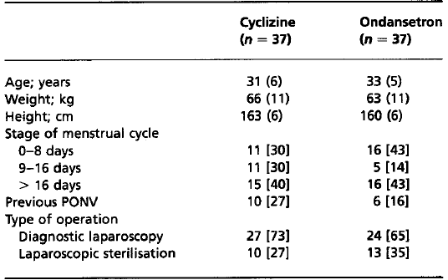
Data are mean (SD or range) or number (%)
The total incidence of PONV in the first 24 h following surgery was comparable in both groups [cyclizine, 21 (56%); ondansetron, 20 (54%): p = not significant (ns)]
Table 17. Anaesthetic/recovery times and incidence of PONV.
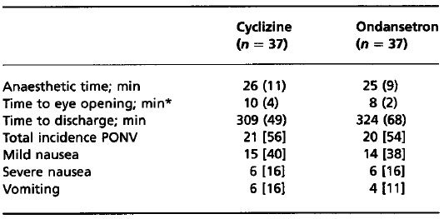
Mean (SD) or n [%] *p < 0.001 between the groups.
Before discharge levels of nausea, vomiting, need for escape anti-emetic and analgesic requirements were similar in both groups.
Table 18. Outcomes before discharge.
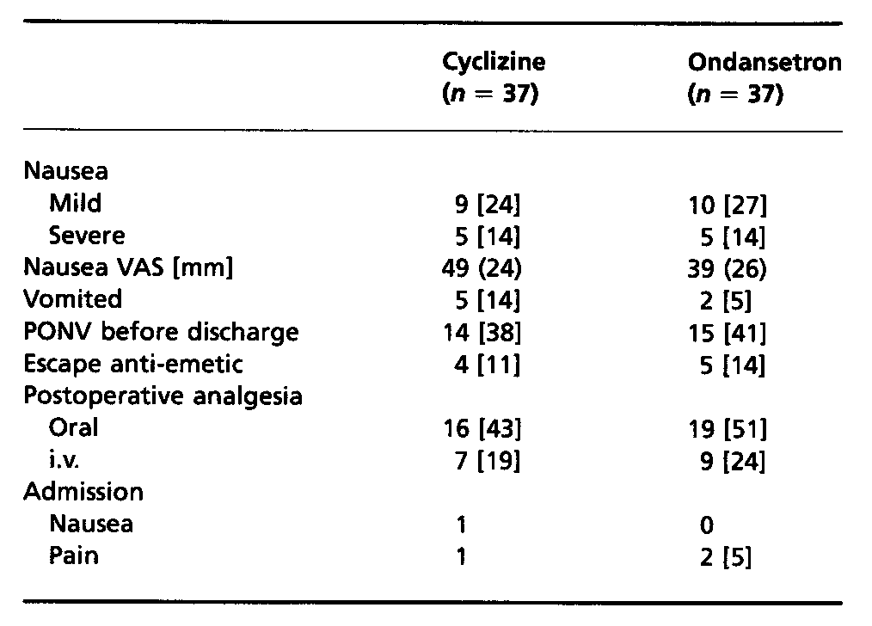
Mean (SD) or n [%].
Nine patients required escape anti-emetic (cyclizine - 4; ondansetron - 5; p = ns); 1 cyclizine patient was admitted for PONV; 1 cyclizine and 2 ondansetron patients were admitted due to inadequate analgesia; 3 cyclizine and 2 ondansetron patients failed to return the postoperative questionnaire. All were omitted from the after-discharge analysis.
Table 19. Outcomes on journey home or first 24 h after discharge.
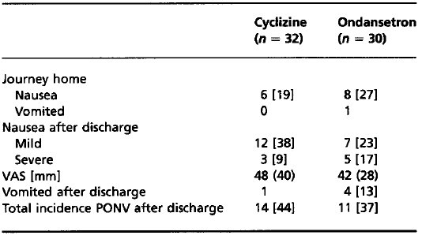
Mean (SD) or n [%].
Anaesthetic times were similar in both groups, but mean (SD) time to eye opening was significantly prolonged in the group receiving cyclizine [cyclizine 10 (4) min, ondansetron 8 (2) min; p < 0.001]. However, there were no significant differences in the time to discharge between the two groups.
Comment: The comparison if there was a difference of 35% in the incidence of nausea between the groups, then the study was powered to show it, is open to being interpreted as 13/37 patients or about 7/21 patients. However the difference was only 1 patient [cyclizine, 21 (56%); ondansetron, 20 (54%)] and it was reported as p = ns, there was no testing for non-inferiority and no confidence intervals provided.

Watts SA. A randomised double-blinded comparison of metoclopramide, ondansetron and cyclizine in day-case laparoscopy. Anaesthesia & Intensive Care. 1996; 24(5): 546-551.
An initial unblinded group of 38 received no prophylactic antiemetic to assess the incidence of PONV associated with the procedure in the absence of antiemetic. This was followed by a randomised, double-blind comparison of the efficacy of ondansetron, metoclopramide and cyclizine. Single centre; NZ.
Anaesthesia: Premedication: temazepam 10-20 mg. Induction: propofol 2-3 mg/kg after fentanyl 1.5 µg/kg. Maintenance: vecuronium 0.08 mg/kg, 50% nitrous oxide in oxygen with added isoflurane 0.5-1.0% ventilated to normocarbia. Reversal: neostigmine and atropine.
Analgesia: peri operative diclofenac 100 mg PRN; intraoperative morphine 0.18 mg/kg IV Postoperative increments of morphine IV in recovery, 10 mg IM PRN on the ward.
Inclusion criteria: women undergoing day-case gynaecological laparoscopic procedures.
Exclusion criteria: receiving opiate or antiemetic drugs in the previous 24 h; pregnant; deemed to be better served by a different anaesthetic technique; requiring more extensive surgery.
Antiemetics: According to randomisation immediately before induction, IV ondansetron 4 mg (59 patients), cyclizine 50 mg (55) or metoclopramide 10 mg (53). Rescue was prochlorperazine 12.5 mg IM.
The study objective was to assess the incidence of PONV (historical) and versus after ondansetron and metoclopramide. The primary outcome measure, the incidence of PONV, was determined by isolating patients who required treatment of their nausea or who actually had an emetic episode; this was then expressed as a percentage of the group as a whole.
The overall incidence of PONV was tested using Chi-square analysis. The antiemetic groups were compared on all nausea and sedation scores using Kruskal-Wallis one-way ANOVA. The relationship between day of menstrual cycle and postoperative nausea and vomiting was tested using the Spearman Rank Correlation. Significance level for all tests was set at p < 0.05. The incidence result for the no antiemetic initial phase was used to determine the power necessary for the subsequent comparative trial, and showed that a sample of 160 patients would be sufficient to detect differences in efficacy between three agents with 95% confidence.
Nausea was assessed on a four-point scale:
0 = absence of PONV,
1 = mild nausea settling spontaneously,
2 = nausea requiring treatment,
3 = actual emetic episode.
Of the initial ‘no antiemetic’ patients, 20 had minimal or no nausea (group B), while 18 required treatment or vomited (group A). These sub-groups were comparable demographically with only past history of PONV being significantly correlated with current PONV (p = 0.0l). Overall incidence of PONV was 48%. There was a 9% overnight admission rate as a result of severe nausea or unrelenting emesis.
Table 20. Characteristics of patients enrolled in initial study.
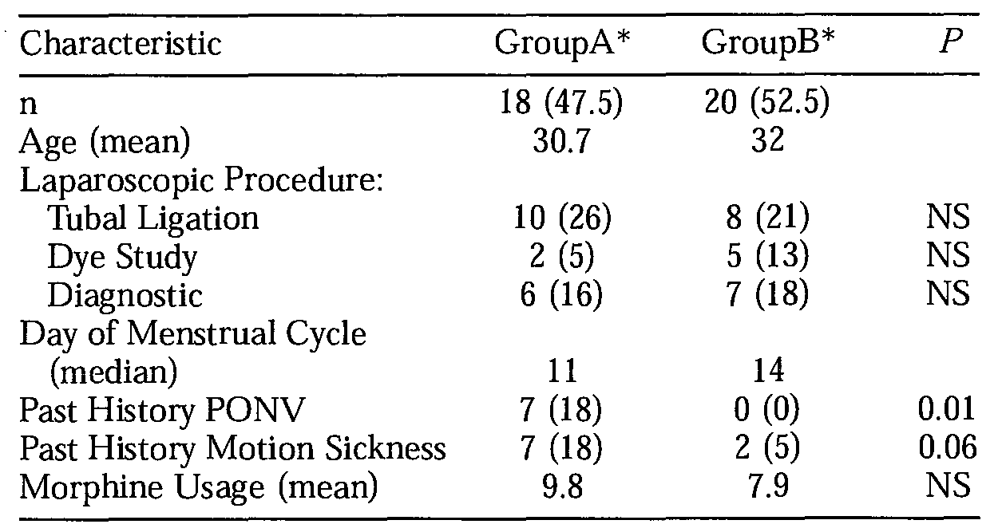
Values are expressed as number of patients (%) or mean value. *Patients are divided into groups according to nausea scores returned over a 24 h study period. Group A = PONV scores ≥ 2 at any time. Group B = PONV scores ≤ 1 at all times
Table 21. Demographic characteristics of patients enrolled in the double blind comparative study.
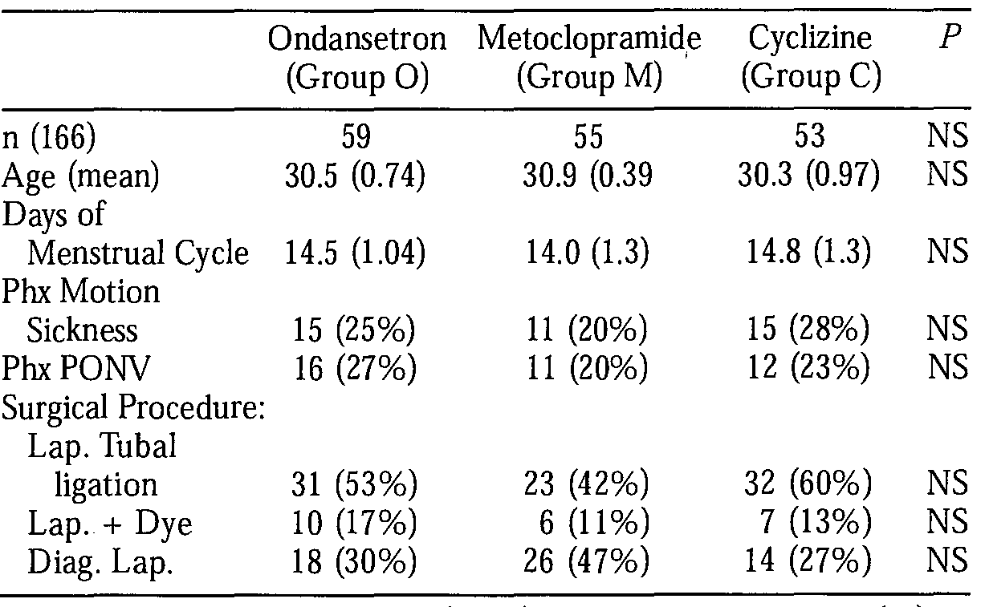
Values are expressed as mean (plus or minus standard error of the mean; SEM) or number of patients (%) as appropriate. (Phx = past history; Lap. = laparoscopy)
The PONV scores were similar for all three groups when assessed in the recovery room and at 24 h postoperatively. There were, however, significantly lower PONV scores with metoclopramide and ondansetron at both 2 h (p = 0.008) and at discharge (p = 0.002) when compared with cyclizine.
Table 22. Postoperative nausea and sedation scores by group
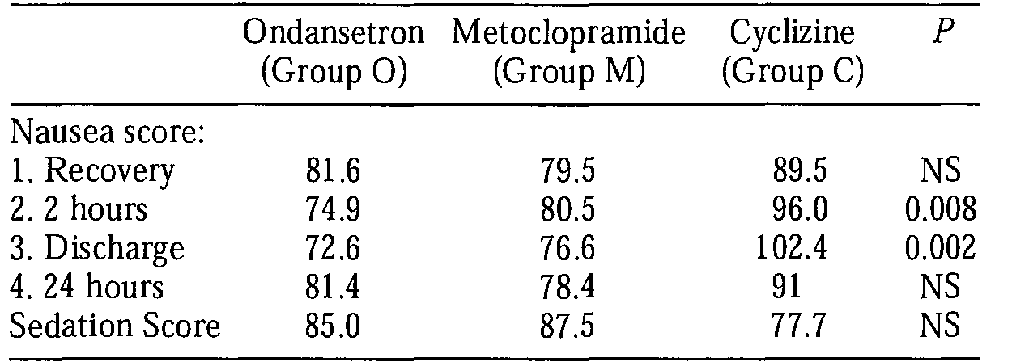
Scores are expressed as mean rank values (Kruskal-Wallis Test).
Two ondansetron and 4 cyclizine patients were admitted overnight for severe nausea and/or vomiting.
Table 23. Incidence of clinical postoperative nausea and vomiting, overnight admission, and opiate usage by group
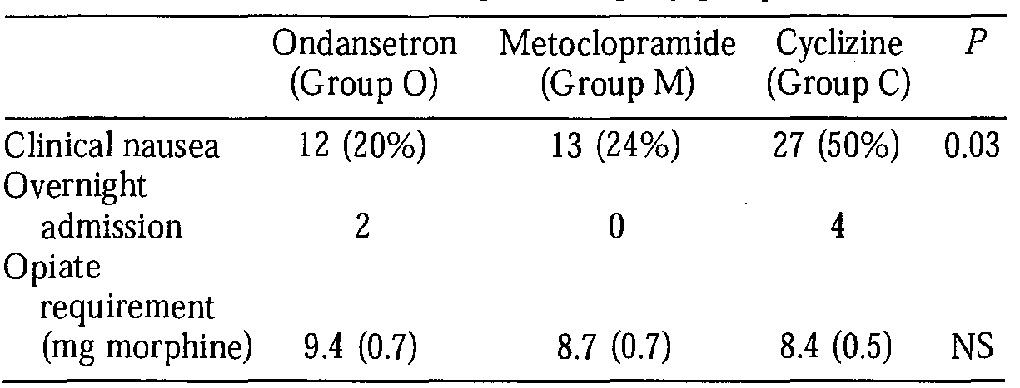
Numbers are expressed as patients in each group with a PONV score ≥ 2 at any time, and opiate usage as mean morphine requirement (mg), (SEM).

Chestnutt WN and Dundee JW. The influence of cyclizine and perphenazine on the emetic effect of meptazinol. Eur J Anaesth. 1986; 3(1): 27-32.
A double-blind placebo-controlled study to compare the efficacy and safety of cyclizine and perphenazine when given in conjunction with meptazinol as preoperative medication conducted at 3 centres in the UK.
Anaesthesia: Premedication: IM 1.5 h preoperatively, 100 mg meptazinol with 50 mg cyclizine or 2.5 mg perphenazine or saline (40 patients per group). Induction: methohexitone 1.6 mg/kg. Maintenance: nitrous oxide 70% in oxygen with methohexitone PRN. Supplemented with halothane or ethrane (for 4 cyclizine and 2 placebo patients).
Analgesia: preoperative meptazinol IM.
Inclusion criteria: fit women undergoing minor gynaecological procedures.
Exclusion criteria: none given.
Antiemetics: According to randomisation 1.5 h preoperatively, IM 50 mg cyclizine or 2.5 mg perphenazine or saline. Rescue appears to be IM cyclizine 50 mg.
The study objective was the comparison of the safety and efficacy versus perphenazine and placebo. The primary outcome measures were the incidence of slight or marked nausea, vomiting (alone or with nausea). The differences between the 3 treatment groups were tested by the Kruskal-Wallis test, and the significance of the differences between pairs of treatments evaluated using a two-sample Wilcoxon test. Chi-square test was used for categorical data.
Table 24. Physical characteristics of patients (n = 40)
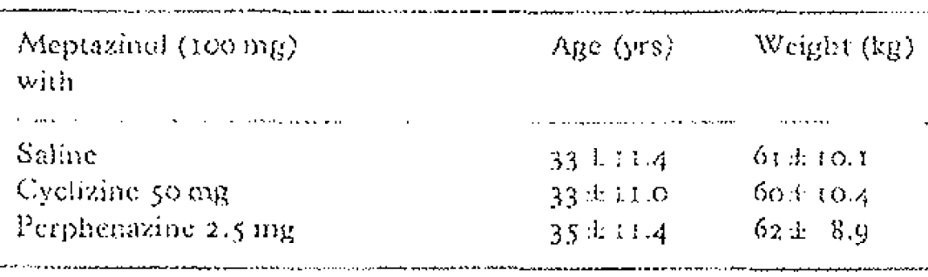
(mean ± SD)
Table 25. Frequency distribution of maximal emetic tendency for the pre-operative, post-operative and total study periods.
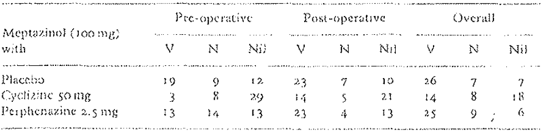
Figure 11. Time profile of emetic sequelae following 100 mg meptazinol administered IM as pre-anaesthetic medication for minor gynaecological procedures and accompanied by saline, 50 mg cyclizine or 2.5 mg perphenazine
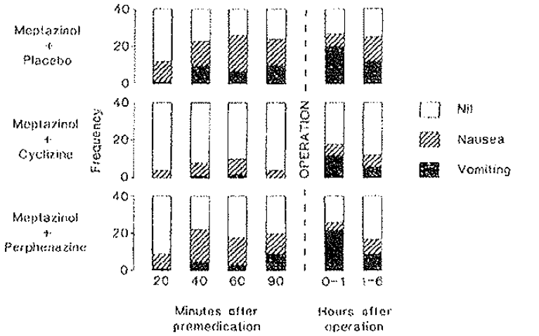
The cyclizine treated group had significantly less nausea or vomiting then either the perphenazine or saline groups at all times, pre-operatively (p < 0.001), post-operatively (p < 0.05), or overall (p < 0.01).

Dundee JW, Loan WB, Morrison JD. A comparison of the efficacy of cyclizine and perphenazine in reducing the emetic effects of morphine and pethidine. Br J Clin Pharmac. 1975; 2(1): 81-85.
A double-blind study comparing the ability of cyclizine (50 mg) and perphenazine (2.5 and 5.0 mg) to counteract the emetic effects of pethidine (100 mg) and morphine (10 and 15 mg) in women undergoing a standard minor gynaecological operation with a standard anaesthetic. While patients were initially completely randomly allocated to the treatments toward the end of the study they were allocated to treatments by a clinician other than the investigators “to eliminate the bias due to the powerful emetic effect of cervical dilatation per se” by balancing “the numbers in each group who had and who had not dilatation of the cervix uteri.” Conducted at a single centre in the UK.
Anaesthesia: Premedication: IM 1.5 h preoperatively pethidine (100 mg), or morphine (10 or 15 mg) alone or with cyclizine (50 mg) or perphenazine (2.5 mg or 5 mg). Induction and maintenance: methohexitone nitrous oxide/oxygen with no volatile agents.
Analgesia: preoperative pethidine (100 mg), or morphine (10 or 15 mg) IM. No postoperative analgesics.
Antiemetics: According to randomisation/allocation 1.5 h preoperatively, IM 50 mg cyclizine or 5 mg or 2.5 mg perphenazine. Rescue: none apparent.
Inclusion criteria: fit women undergoing minor gynaecological procedures.
Exclusion criteria: none given.
Population: 100 patients per group were intended but perphenazine 5 mg was withdrawn from the study after 50 patients because of the associated high incidence of restlessness.
Table 26. Numbers of patients in the different series studied.
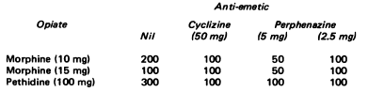
The authors state: “Each of the groups was broadly comparable with respect to average age and weight and duration of operation and in an analysis reported in detail elsewhere it has been shown that these are not important sources of bias in this experimental design (Morrison et al, 1968).”
The study objective was to assess the incidence of PONV versus perphenazine and placebo. The outcome measures were the incidence of pre and postoperative nausea and/or vomiting. Details of the population calculation not provided. Details of the statistical analysis were not given, except as results.
Both anti-emetics markedly reduced sickness after pethidine to a significant degree (p < 0.0001). The incidence of both vomiting and nausea was too low after the morphine for any statistical differences to be detected. Both cyclizine (50 mg) and perphenazine (5 mg) very significantly (p < 0.001) reduced postoperative vomiting and nausea in patients premedicated with morphine (10 mg). Their protective action was most marked in the first hour after operation. Morphine (15 mg) was followed by more postoperative vomiting and nausea than the 10 mg dose (χ² = 11.315; p < 0.001).
All preparations studied appeared to be equally effective after the 15 mg dose of morphine as anti-emetics (χ² = 15.064; p < 0.0005), but over half the patients still had some emetic sequelae. Both doses of perphenazine caused a highly significant reduction in postoperative sickness after pethidine (100 mg) and [this was] slightly more effective than cyclizine (50 mg).
The authors state: “Under the conditions of this study both cyclizine (50 mg) and perphenazine (2.5 and 5.0 mg) were useful in countering the emetic sequelae following morphine (10 and 15 mg) and pethidine (100 mg). They appeared to act quickly as judged by the reduction in preoperative vomiting and nausea after pethidine. However, their anti-emetic effects appeared to be of much shorter duration than the emetic effect of either.”
Table 27. Incidence (%) of vomiting (V) and nausea (N) in the patients premedicated with a narcotic analgesic, with or without cyclizine (C) or perphenazine (P).
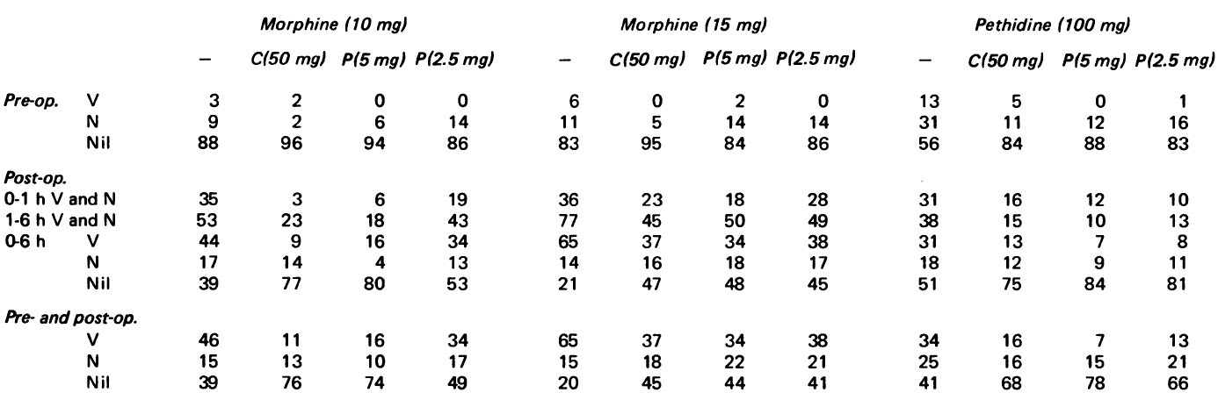

Analyses performed across trials (pooled analyses and meta-analyses) – PONV

Carlisle J, Stevenson CA. Drugs for preventing postoperative nausea and vomiting. Cochrane Database of Systematic Reviews. 3, 2006.
Selection criteria included randomised clinical trials (RCTs) that compared a drug with placebo or another drug, or compared doses or timing of administration, that reported postoperative nausea or vomiting as an outcome; including RCTs that evaluated the effect of a drug or drugs given before the onset of postoperative nausea and vomiting, but excluding studies of treatment for established postoperative nausea or vomiting and studies of anaesthetic drugs or analgesics. The drug could be given preoperatively, at induction of anaesthesia, intraoperatively or postoperatively (before nausea or vomiting had occurred), and included participants undergoing general anaesthesia, regional anaesthesia or sedation.
There were 10 studies included in the meta-analysis related to cyclizine: O’Brien et al., 2003; Grimsehl et al., 2002; Nortcliffe et al., 2003; Ahmed et al., 2000; Cholwill et al., 1999; Watts, 1996; Walder and Aitkenhead 1995; Chestnutt and Dundee 1986; Dundee et al., 1975; Hildyard et al 2001.
The risk for postoperative nausea and/or vomiting is decreased compared to placebo:
Table 28. Placebo versus Drug - selected agents approved or commonly used off-label for PONV.
Drug | Nausea | Vomiting | Nausea or Vomiting | Rescue antiemetic
 | RR (95% CI) | RR (95% CI) | RR (95% CI) | RR (95% CI)
Cyclizine | 0.65 (0.47 - 0.90) | 0.57 (0.43 - 0.75) | 0.68 (0.58 - 0.80) | 0.27 (0.14 - 0.62)
Dexamethasone | 0.57 (0.48 - 0.69) | 0.51 (0.46 - 0.57) | 0.49 (0.44 - 0.54) | 0.50 (0.42 - 0.59
Dolasetron | 0.82 (0.76 - 0.90) | 0.63 (0.51 - 0.76) | 0.72 (0.62 - 0.83) | 0.67 (0.57 to 0.79)
Droperidol | 0.65 (0.60 - 0.71) | 0.65 (0.61 - 0.70) | 0.62 (0.58 - 0.67) | 0.53 (0.47 - 0.60)
Ephedrine | 0.50 (0.20 - 1.23) | 0.91 (0.64 - 1.27) | 0.79 (0.55 - 1.15) | 0.82 (0.41 - 1.66)
Metoclopramide | 0.82 (0.76 - 0.88) | 0.75 (0.70 - 0.81) | 0.76 (0.70 - 0.82) | 0.78 (0.69 - 0.88)
Ondansetron | 0.68 (0.63 - 0.74) | 0.55 (0.50 - 0.59) | 0.56 (0.50 - 0.63) | 0.55 (0.49 - 0.61)
Prochlorperazine | 0.73 (0.56 - 0.96) | 0.68 (0.52 - 0.89) | 0.68 (0.55 - 0.86) | 0.49 (0.22 - 1.08)
Tropisetron | 0.77 (0.71 - 0.84) | 0.59 (0.50 - 0.69) | 0.70 (0.61 - 0.81) | 0.62 (0.53 - 0.72)
Source: Cochrane 2006 review. RR – relative risk
The only cyclizine versus effective drug review result was against ondansetron.
Table 29. Effective drug versus effective drug
Drug | Nausea | Vomiting | Nausea or Vomiting | Rescue antiemetic | Differences
 | RR (95% CI) | RR (95% CI) | RR (95% CI) | RR (95% CI)
Cyclizine – Ondansetron | 1.00  (0.69 - 1.44) | 1.36  (0.58 - 3.18) | 1.19  (0.73 - 1.95) | 0.66  (0.31 - 1.40) | 0/4
Source: Cochrane 2006 review.
The authors’ conclusions were that:
“Most patients given a drug to prevent nausea or vomiting after surgery will not benefit from it. Nausea or vomiting is reported to affect at most 80 out of 100 people after surgery. If all 100 of these people are given a drug, 28 would benefit, and 72 would not. Nausea and vomiting are usually less common and therefore drugs are less useful. For 100 people, of whom 30 would vomit or feel sick after surgery if given placebo, 10 people would benefit from a drug and 90 would not. Between one to five patients out of every 100 given a prophylactic antiemetic may expect to experience a mild side effect such as headache, sedation or dry mouth. There is convincing evidence that eight drugs reduce PONV by a similar amount: cyclizine, droperidol, granisetron, metoclopramide, ondansetron, tropisetron, dolasetron and dexamethasone. There is only limited evidence that more drug is more effective: there is convincing evidence that more drug is more effective for droperidol and limited evidence for dexamethasone and ondansetron. Evidence for differences in the efficacy of these eight drugs is not convincing.”
The sponsor’s Expert reviewer was critical of one of the studies included in the review (Hildyard et al., 2001). Likewise the evaluator has concerns at the inclusion of two studies:
- O’Brien et al., 2003, where children were given an oral antihistamine premed as well as the trial drug.
- Nortcliffe et al., 2003, where all patients received ephedrine, morphine was given intrathecally prior to surgery and patients received cyclizine at the end of surgery.
Further, Walder and Aitkenhead, 1995 used cyclizine both as an IV bolus 20 min prior to the end of surgery and also as an infusion in the PCA.

Efficacy Studies - the treatment of nausea and vomiting caused by narcotic analgesics
The supporting evidence for this indication is based on 3 studies using single dose IM premedication where patients were observed for only 90 min (see above for study descriptions) and one study using oral opiate and oral cyclizine.

Chestnutt and Dundee, 1986
The cyclizine treated group had significantly less nausea or vomiting than either the perphenazine or saline groups pre-operatively (p < 0.001).
Table 30. Frequency distribution of maximal tendency for the pre-operative study period.

Dundee et al, 1975
Cyclizine markedly reduced sickness after pethidine to a significant degree (p < 0.0001). The incidence of both vomiting and nausea was too low after the morphine for any statistical differences to be detected.
Table 31. Percentage incidence of vomiting (V) and nausea (N) in the patients premedicated with a narcotic analgesic, with or without cyclizine (C) or perphenazine (P).
Dundee JW, Halliday F, Nicholl RM, Moore J. Studies of drugs given before anaesthesia. X. Two non-phenothiazine anti-emetics--cyclizine and trimethobenzamide. Br J Anaesth. 1966; 38(1): 50-57.
This study was similar to Chestnutt and Dundee 1986 and Dundee et al., 1975 in methodology except that it was not blinded for the combination of cyclizine and pethidine. Cyclizine significantly decreased (p < 0.05) the incidence of pre-operative vomiting associated with pethidine.
Table 32. Details of subjects and average duration of operation.
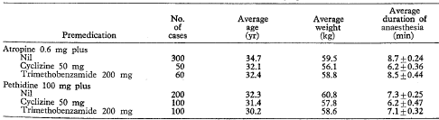
Table 33. Observations before anaesthesia, after pre-anaesthetic medication had been given.
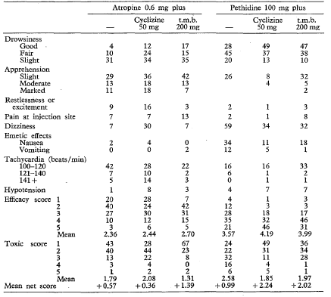
Atropine or pethidine were given alone or in combination with cyclizine 50 mg and trimethobenzamide (t.m.b.) 200 mg as indicated. Results are expressed as percentage.

Dundee and Jones, 1968
The trial was intended as a double blind sequential study of the effect of cyclizine on the nausea and vomiting produced by a variety of opiates and placebo. The authors state:
“Already established regimes of analgesics were continued and combined with either 50 mg cyclizine or an identical placebo tablet, irrespective of the dose of analgesic. It was frequently possible to try several equipotent analgesics on the same patient at intervals of several weeks, thus increasing the number of available observations”.
“Where it was ethically permissible, because of lack of severity of the pain, placebos resembling each of the analgesics in the trial were also used. In some instances the emetic effect of these had been tested prior to starting the full trial. Patients who became nauseated or vomited after the placebo are referred to as ‘placebo readers’ in the results.”
“It was originally planned that each patient would take the active anti emetic drug and the inert placebo for either three or seven days, depending on whether they were to return to the clinic in one or two weeks time. Since they were always given a supply of tablets in excess of their requirements in a few cases, where the beneficial effects of the cyclizine were marked, this drug was taken for a longer period of time than the placebo.
An essential part of the organization of this trial was the dispensing of all drugs directly to the patients on their attendance at the out-patient clinic, rather than giving them a prescription. They were supplied with a written set of instructions as to the dosage and frequency of administration of each drug, each preparation being referred to by a number and letter, A and B being used in random order for cyclizine and the placebo. The patient’s co-operation was assured by explaining that it was ‘up to himself to find which treatment suited him best’. Each patient in the trial was asked to complete a questionnaire which recorded daily the analgesia anti side-effects of the drugs.”
Table 34. The effect of cyclizine on incidence (%) of emetic effects in all patients.
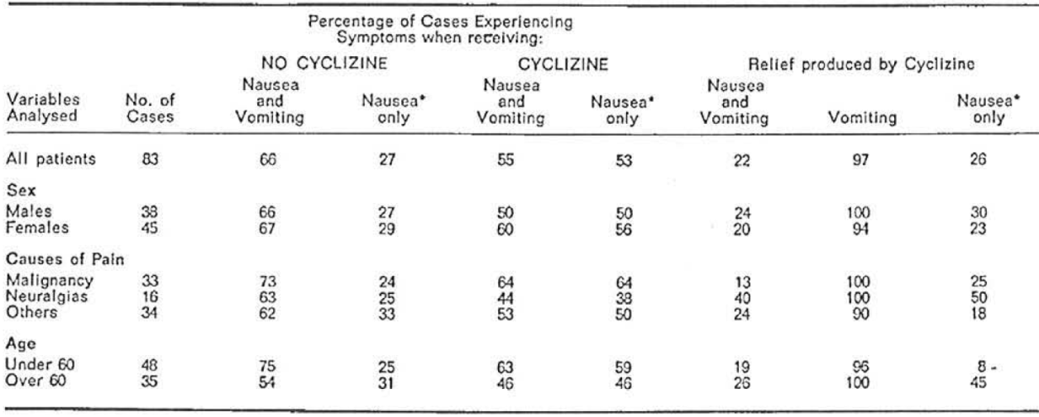
* Apparent discrepancy is due to patients who vomited without Cyclizine and who had nausea only when the anti-emetic drug was given.
Table 35. Comparison of the protective action of cyclizine against analgesic induced nausea and vomiting in patients who were nauseated by placebo (positive response) and in those in whom the placebo had no such effect. 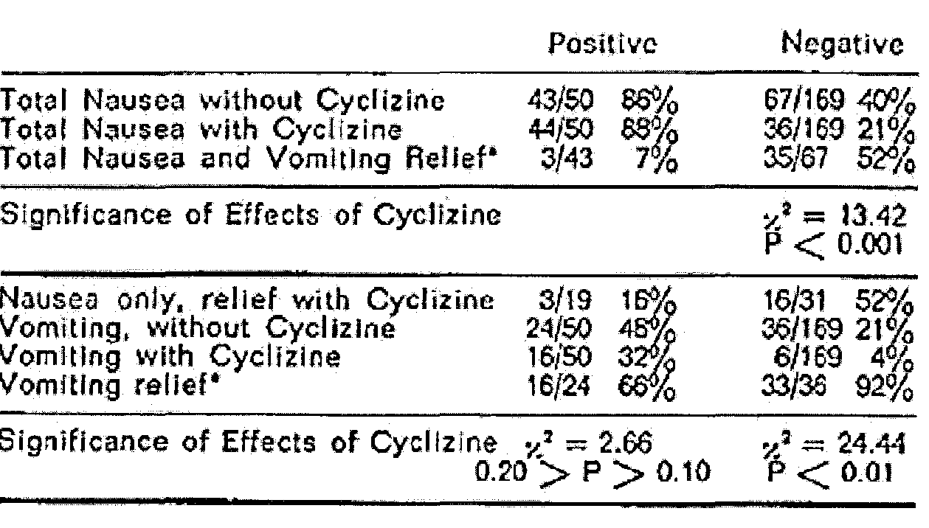
* Apparent discrepancy is due to patients who vomited without Cyclizine and who had nausea only when the anti-emetic drug was given.
The authors further state:
“The table shows the incidence of nausea and vomiting without cyclizine to be twice as high in the positive placebo group as in the other. It is interesting to note that while the placebo reactions themselves are mild, this does not influence the severity of nausea due to analgesics; in both groups about 55 per cent of those who were nauseated at all did actually vomit. Relief by cyclizine is virtually confined to the negative placebo reaction group.”
The evaluator has concerns about (a) the validity of the results in that there is some evidence of abuse/withdrawal that could have produced a desire to report nausea or vomiting where none was occurring; and (b) the studies’ applicability to the proposed formulation which requires injection.

Efficacy Studies - Pre-operative use in patients undergoing emergency surgery to reduce the hazard of regurgitation and aspiration of gastric contents during induction of general anaesthesia
The sponsor’s Summary of Clinical Efficacy did not discuss this [proposed] indication. In the sponsor’s Clinical Overview it is stated:
“Cyclizine has demonstrated a significant effect on lower oesophageal pressure. Intravenous cyclizine 25 mg given intravenously to volunteers increased the mean barrier pressure from by an average of 1.87 kPa to 3.29 kPa (P < 0.005) (Brock-Utne et al., 1977). This has been seen as of particular benefit in patients undergoing emergency surgery.
The superiority of cyclizine compared to other agents in the prevention of vomiting in emergency surgery has not been demonstrated clinically and comparisons of meaningful clinical studies are unlikely to be conducted due to the nature of the clinical situation. Apart from the clinical difficulty of recruitment of patients in this emergency situation the ethical obstacles appear to be unsurmountable due to the difficulties in obtaining fully informed consent in this situation and other issues of study conduct. “
Thus no evidence has been produced or is likely to be produced to support the claim of efficacy in reducing the hazard of regurgitation and aspiration of gastric contents during induction of general anaesthesia.
There is evidence (Brocke-Utne et al., 1977, 1978; see section on Pharmacodynamics, above) that in healthy volunteers the basal barrier (due to sphincter) pressure increased with cyclizine. This may decrease the risk of regurgitation in the awake emergency patient. There was no evidence provided that this protection persists on induction of anaesthesia.

Evaluator’s conclusions on clinical efficacy for post-operative nausea and vomiting
Dent et al., 1954 in relation to vomiting wrote “With the advent of new anaesthetic drugs and associated alteration in techniques of administration, the incidence of this complication has been reduced.”
The balance of evidence for efficacy of the proposed dosage and administration used in post operative nausea and vomiting is favourable with Cholwill et al., 1999 (42 patients), Chestnutt and Dundee, 1986 (40 patients) and Dundee et al., 1975 (300 patients) showing significant effect compared to placebo; while Grimsehl et al., 2002 (37 patients) claimed they showed no significant difference from ondansetron. Dundee et al., 1966 did show an incidence of PONV after atropine only premed fell from 55 to 25% but the difference was not significant. Watts, 1996 (59 patients) showed no effect compared to placebo (overall 50% versus 48%).
Only the studies by Cholwill et al., 1999 and Watts, 1996 used muscle relaxants. Chowill reversed them with neostigmine and glycopyrrolate, while Watts reversed with neostigmine and atropine: this may account for the differences in results.
All these 5 studies used only a single dose of 50 mg of cyclizine IM or IV except Chestnutt and Dundee, 1986, where 2 patients received a second dose of cyclizine.
While the studies were all of short duration procedures, they were gynaecologic procedures, mostly in women of child bearing age, and including nitrous oxide, major risk factors. Indeed the anaesthetics and procedures are generally considered a good model for testing for emesis in relation to surgery. Unfortunately, other than Dundee’s (1975) study the numbers involved are small. Details of all studies’ statistical analyses were published, but that for Dundee et al., 1975 was not submitted.

Evaluator’s conclusions on clinical efficacy for the treatment of nausea and vomiting caused by narcotic analgesics
The balance of evidence for efficacy of the proposed dosage and administration used in the treatment of nausea and vomiting caused by narcotic analgesics is favourable with Chestnutt and Dundee, 1986 and Dundee et al., 1975 showing significant effect compared to placebo; although Dundee et al., 1966 did so as well, it was essentially an open study. These were studies only for 1.5 h before anaesthesia was added. Dundee et al., 1975 stated: “anti-emetic effects appeared to be of much shorter duration than the emetic effect of either (morphine or pethidine).” There were no studies of repeat dosing for this indication. Thus the evaluator has concerns in relation to repeated use.

Evaluator’s conclusions on clinical efficacy for pre-operative use in patients undergoing emergency surgery
No evidence has been produced or is likely to be produced to support the claim of efficacy in reducing the hazard of regurgitation and aspiration of gastric contents during induction of general anaesthesia. In healthy volunteers the basal barrier (due to sphincter) pressure is increased with cyclizine.

Safety

Studies providing evaluable safety data
Safety data from efficacy studies considered pivotal by the evaluator are summarised below.
Cholwill et al., 1999: No safety data.
Chestnutt and Dundee, 1986: at 90 mins preoperatively, cyclizine patients were significantly more (p < 0.01) drowsy than those who had received placebo. Apprehension decreased with time and there was no significant difference between treatments at any time point. There was no clinically significant restlessness in any group of patients. The incidence of marked dizziness was 5/40 for placebo and 3/40 for cyclizine patients.
The presence of dry mouth was reported after treatment by 14 patients in the placebo group, and 28 patients in the cyclizine group. When the occurrence of this symptom, before treatment, is accounted for there is no significant difference between the groups. Nine patients in the placebo group and 15 in the cyclizine group reported blurring of vision but there was no significant difference between the groups. None of the premedication regimes had a clinically significant effect on the cardiovascular system.
Figure 12. Frequency of notable drowsiness (i.e. moderate or marked) or apprehension of any degree at the time intervals of the preoperative study period, following 100 mg meptazinol accompanied by saline, 50 mg cyclizine or 2.5 mg perphenazine.
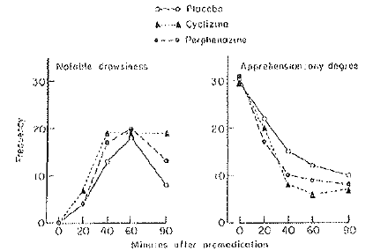
Dundee et al., 1966: Dizziness, a frequent complication with cyclizine, was always mild and transitory. Cyclizine increased the frequency of excitatory phenomena to a significant (p < 0.001) degree when pethidine was not given, but no such increase was found when it was combined with pethidine pre-anaesthetic medication.
The increased incidence of excitatory phenomena and the high average total dose of methohexitone following the use of cyclizine can be attributed to its moderate antanalgesic action as described by Nicholl et al., 1962. This may be correlated with the frequency with which poor conditions of anaesthesia followed the use of this premedicant; a further reason is thus provided for advising against its pre-operative use without analgesics.
The soporific effects of both anti-emetics are again evident when they were combined with pethidine (see Table 36, below). In the case of cyclizine this has been noted by Bonica et al., 1958 and Blatchford 1961; whilst Moore et al., 1956 recommended that, for this reason, doses of routine premedication drugs should be reduced when it is intended to combine them with cyclizine
While cyclizine 50 mg reduced the frequency of preoperative dizziness noted following pethidine, this symptom is still complained of by one-third of all patients; this is an unacceptably high incidence.
Pethidine and cyclizine required two syringes and two injection sites.
Table 36. Observations before anaesthesia, after pre-anaesthetic medication had been given. Atropine or pethidine were given alone or in combination with cyclizine 50 mg and trimethobenzamide (t.m.b.) 200 mg as indicated.
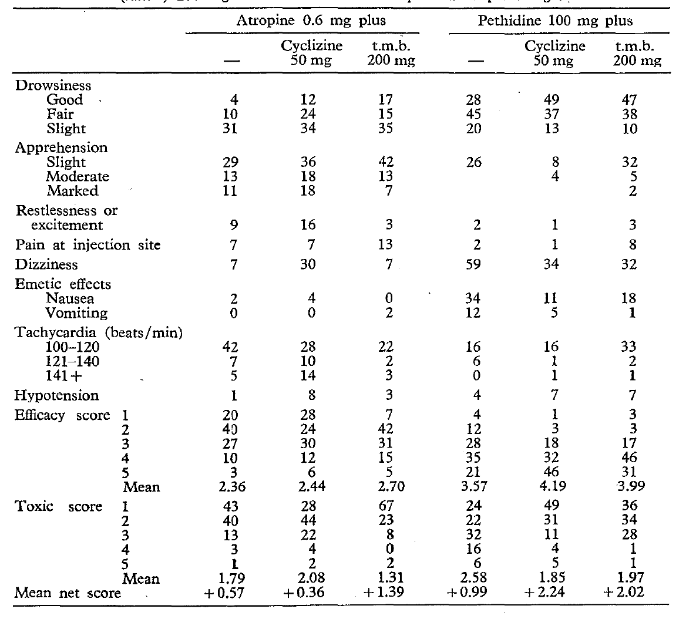
Results expressed as percentage.
Table 37. Course of anaesthesia as shown by average dose of drugs, frequency of complications, and state of consciousness 2 minutes after discontinuation of nitrous oxide-oxygen anaesthesia (from Dundee et al., 1966)
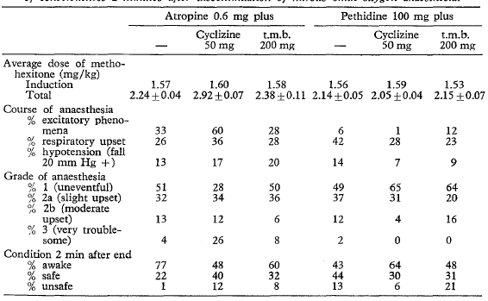
Dundee, 1975: Restlessness was not observed with cyclizine.
Dundee and Jones, 1968: No safety data.
Grimsehl et al., 2002: When given IV, cyclizine has been shown to cause sedation and this may be of relevance in the day-case setting. It was demonstrated that the patients in the cyclizine group had a significantly longer time to eye opening than the ondansetron group (p < 0.001). There was no difference, however, in the time to discharge between the two groups.
Watts, 1996: This study failed to demonstrate any difference between any of the agents following analysis of sedation scores. No dystonic side-effects or major adverse reactions were recorded for any of the trial agents. One patient who received cyclizine developed localized erythematous rash.

Safety data from the non-pivotal efficacy studies

Johns R.A, Hanousek J, Montgomery J.E. A comparison of cyclizine and granisetron alone and in combination for the prevention of postoperative nausea and vomiting. Anaesthesia. 2006; 61(11): 1053-1057.
With regard to side-effects, significantly more women who were given cyclizine complained of drowsiness but this did not affect their recovery in terms of unplanned admissions. The side-effects that were analysed in this study were considered to be those most commonly suffered by patients being given the two drugs used according to clinical practice and the data sheet for each drug. However, it is very difficult to draw any meaningful conclusions as to the direct relationship between the side-effects and the use of these drugs because of the large number of confounding factors such as anaesthesia itself, the fluids given, the type of surgery and the use of opioids. This study was not powered to analyse each of these factors independently and in detail.
Table 38. Side-effects that could be attributed to the anti-emetics used in the study.
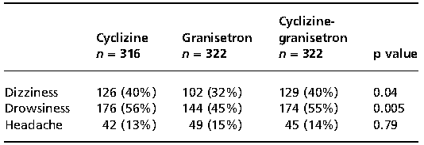
Values are number (%).

Laffey and Boylan JF Cyclizine and droperidol have comparable efficacy and side effects during patient-controlled analgesia. Irish J Med Sci. 2002; 171(3): 141-144.
Postoperative period: No overt dysphoria or extrapyramidal symptoms occurred. State Trait Anxiety Inventory [STAI; a widespread method of measuring pre-operative anxiety for research] scores decreased over time (p < 0.001) to a similar extent in each group. Mini mental state (MMS) scores were decreased at 4 h relative to baseline and later post-operative scores (p < 0.0001) but were comparable in both groups throughout. Scores in the Trieger dot test (where individuals are asked to connect a series of 50 dots of a geometrical figure) did not differ between groups at any time points.
Patient sedation, psychomotor performance and anxiety levels were similar with both antiemetic agents. Anxiety levels decreased significantly over time in both groups. The authors state: “With a 'number needed to treat' value of 3 we felt unable for ethical reasons to use placebo controls.”
Figure 13. STAI scores. State anxiety decreased comparably over time in both groups.
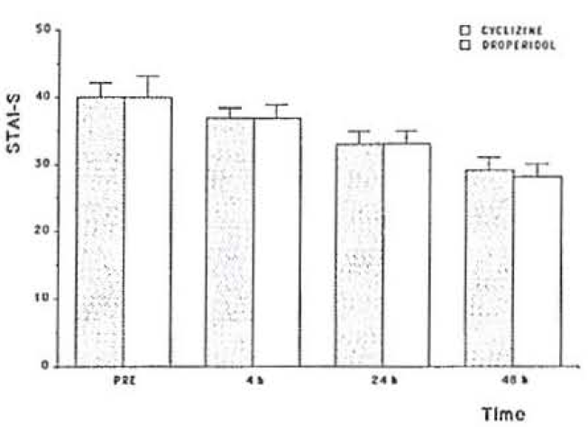
Data are mean (plus or minus standard error of the mean; SEM).
Figure 14. MMS scores. MMS scores decreased at 4 h postoperatively relative to pre-operative scores in both groups.
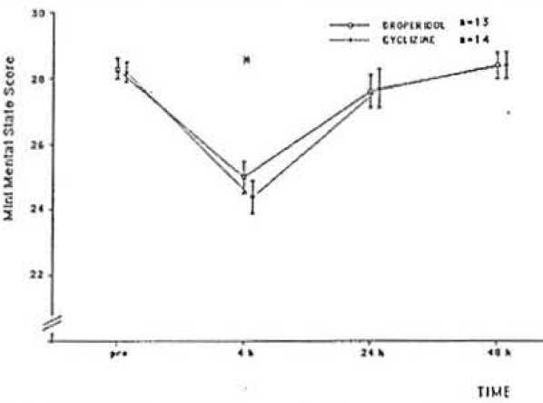
Data are mean (SEM). ·p < 0.01.
Figure 15. Notched box plots depicting Trieger dot test scores. Values were similar for both group 5 at all time points.
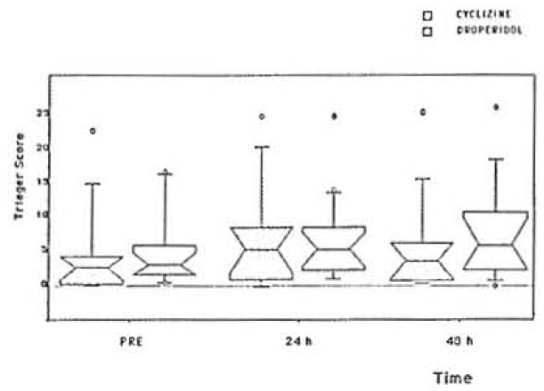
Data are medians (plus or minus inter-quartile range; Q1-Q3).

Moore DC, Bridenbaugh LD, Piccioni VF, Adams AP, Lindstrom CA. Control of Post Operative Nausea and Vomiting: A Double-Blind Study. Anesthesiology. 1956; 17: 690-695.
The authors reported that: “no tissue necrosis occurred following the parenteral administration of MAREZINE [cyclizine lactate solution]. Burning, the prevalence of which forced us to discontinue the injection of MAREZINE when it was first tried in 1953, caused only an occasional complaint during this study. Perhaps this is explained by the care which was taken in this series to avoid the inadvertent placement of the solution subcutaneously, since it had been suggested that too superficial a placement of this drug might have been responsible for the burning…. To date, we have seen no reactions other than an occasional case of drowsiness”.

Nortcliffe SA, Shah J, Buggy DJ. Prevention of postoperative nausea and vomiting after spinal morphine analgesia for caesarean section: comparison between cyclizine, dexamethasone, and placebo. Br J Anaesth. 2003; 90(5): 665-670.
Systolic arterial pressures (SAP), ventilatory frequency, and sedation were all clinically unremarkable and also not significantly different between the groups. The data showed no evidence of increased sedation in patients receiving cyclizine compared with dexamethasone or placebo.
Table 39. Pain, adverse effects and overall satisfaction with antiemetic therapy.
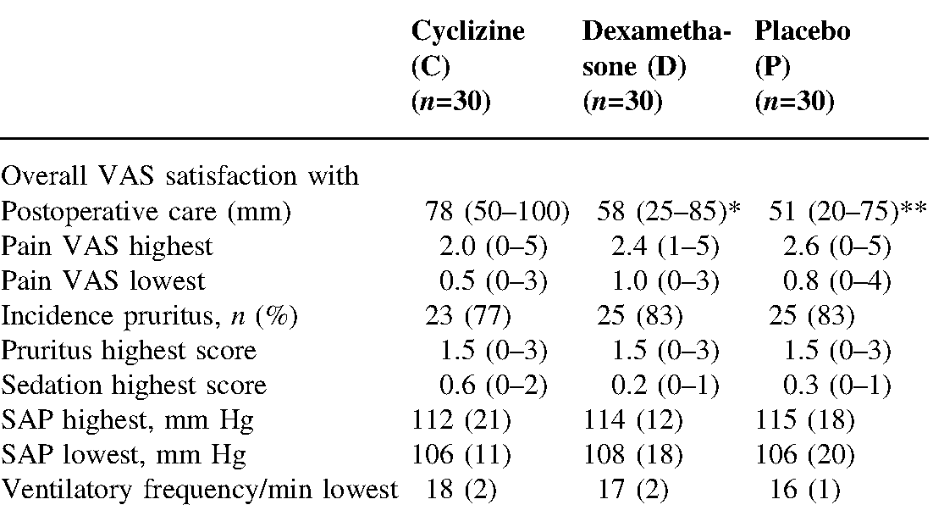
Mean (SD), median (range) or number (%) as appropriate. *p = 0.03, C vs. D; **p = 0.008, C vs. P
VAS=visual analogue scale for pain or patient satisfaction with postoperative care, as indicated.

O'Brien C.M. Titley G. Whitehurst P. A comparison of cyclizine, ondansetron and placebo as prophylaxis against postoperative nausea and vomiting in children. Anaesthesia. 2003; 58(7):707-711.
Pain on injection was recorded only in those receiving cyclizine (p < 0.001). No arrhythmias were recorded with ondansetron and normal saline, but one patient (of 50) developed a nodal tachycardia following administration of cyclizine.

Walder AD and Aitkenhead AR. A comparison of droperidol and cyclizine in the prevention of postoperative nausea and vomiting associated with patient-controlled analgesia. Anaesthesia. 1995; 50(7): 654-656.
There were no significant differences in pain, sedation, or nausea scores between the groups. Three patients in group 1 (droperidol) and one in group 2 (cyclizine) reported feelings of anxiety and agitation which improved when the PCA was discontinued. One patient in group 2 reported blurred vision immediately postoperatively, this resolved spontaneously after 30 min.

Other studies evaluable for safety only

Brand, J.J, Colquhoun W.P and Perry, W.L.M Side effects of L-Hyoscine and Cyclizine studied by objective tests. Aerospace Med. 1968; 39(9):999-1002.
Cyclizine 15 and 100 mg PO had no effect on salivation, pulse rate, vision, or mental performance (arithmetic).

Tan LB, Bryant S, Murray RG. Detrimental haemodynamic effects of cyclizine in heart failure. Lancet. 1988; i: 560:1.
Cyclizine significantly increased systemic and pulmonary arterial pressures, and right and left ventricular filling pressures, and negated the venodilatory effects of diamorphine. The use of cyclizine in patients with heart failure should, therefore, be avoided.

Case studies that assessed safety
- Back and Taubert, 2007: Akathisia and an unusual symptomatic treatment
- Collier 1986: Agranulocytosis associated with oral cyclizine responded to discontinuation.
- Dagg and Wrathall, 2003: Dystonic reaction to cyclizine.
- Griffiths and Peachy, 1970: Fixed drug eruption– erythema, irritation and inflammation.
- Kew et al., 1973: Hypersensitivity hepatitis.
- King et al., 2003 Probable dystonic reaction after a single dose of cyclizine in a patient with a history of encephalitis.
- Klawans and Moskovitz, 1977: Cyclizine induced chorea.
- Marr and Orvin, 2006: Transient paralysis after administration of cyclizine.
- Michailidou and Peck, 2004: Dystonic reaction to cyclizine.
- Russell, 1969: Cyclizine anaphylaxis, when administered with propanidid.
- Sandhu et al., 2005 Transient paralysis after administration of a single dose of cyclizine, two cases.
- Sewell and Nixon, 2003: Dystonic reaction to cyclizine. The female developed generalised choreiform movements, which lasted for approximately 20 min. Her reaction was reported to the manufacturer of Valoid (cyclizine). The authors reported that “In the previous 10 years, they [the sponsor] had 40 reports of uncoordinated muscle movements associated with cyclizine. ..They classify this side-effect as rare… These uncoordinated muscle movements are variously described: dystonia, twitching, facial twitching, choreiform movements, chorea, extrapyramidal effects, jerky movements, tremor, orofacial dyskinesia, dyskinesia, hyperkinesia, hyperreflexia, muscle spasm, muscle rigidity and muscle hypertonia.”

Pivotal studies that assessed safety as a primary outcome
Not Applicable.

Patient exposure
For the period 1 April 1996 to 31 January 2010 the total number of Valoid ampoules sold was 37,877,560. The injections may be given up to three times a day but in many cases just a single dose is given to patients undergoing operation. The number of daily doses administered in this period is in excess of six million.

Adverse events

All adverse events (irrespective of relationship to study treatment)
Adverse events in the literature that are reported in the proposed PI include:
Drowsiness, sedation, dizziness, blurring of vision, headache, excitatory phenomena, chorea, dystonic reaction, transient paralysis, dry mouth, localized erythematous rash, fixed drug eruption – erythema irritation and inflammation, anaphylaxis, agranulocytosis, and tachycardia.
Those not in the proposed PI were:
Anxiety (reported in Walder and Aitkenhead, 1995).
Akathisia (reported in Back and Taubert, 2007).

Treatment-related adverse events (adverse drug reactions)
See above.

Deaths
None reported in literature.

Serious adverse events
Serious adverse events (SAEs) reported in the literature include:
Dystonic reaction (5), transient paralysis (3), and 1 each of drug eruption, anaphylaxis, agranulocytosis, and hypersensitivity hepatitis.

Discontinuation due to adverse events
Many of the study reports were of a single dose so that despite an SAE, there was no discontinuation. AEs leading to discontinuation include:
One each of anaphylaxis, agranulocytosis, dystonic reaction, feelings of anxiety and agitation.

Laboratory tests
None reported in literature.

Post-marketing experience
The first PSUR was 1 April 1991 to 31 March 1996; written by Glaxo Wellcome the original Marketing Authorisation Holder. Amdipharm submitted 3 PSURs, for the periods:
- 1 April 1996 to 31 October 2004,
- 1 November 2004 to 30 June 2008,
- 1 July 2008 to 31 January 2010.
PSUR 1st April 1996 to 31st October 2004
218 reports (471 events), 121 SAEs. 169 parenteral, 90 IV, 18 IM, 5 SC, 20 PO.
Six reported deaths with limited associated information.
A 45 year old female patient developed necrotising fasciitis after a single day’s treatment with cyclizine injection.
Table 40. Summary of AEs (PSUR April 1996 to October 2004)
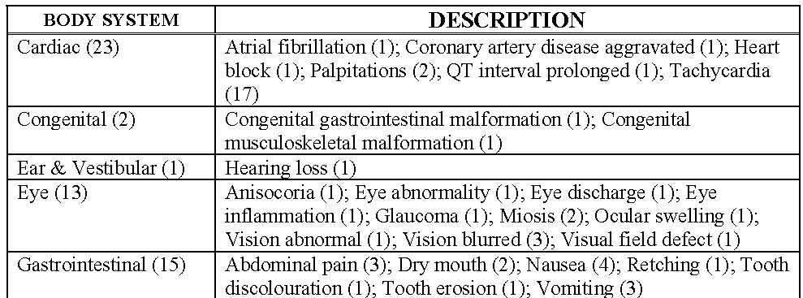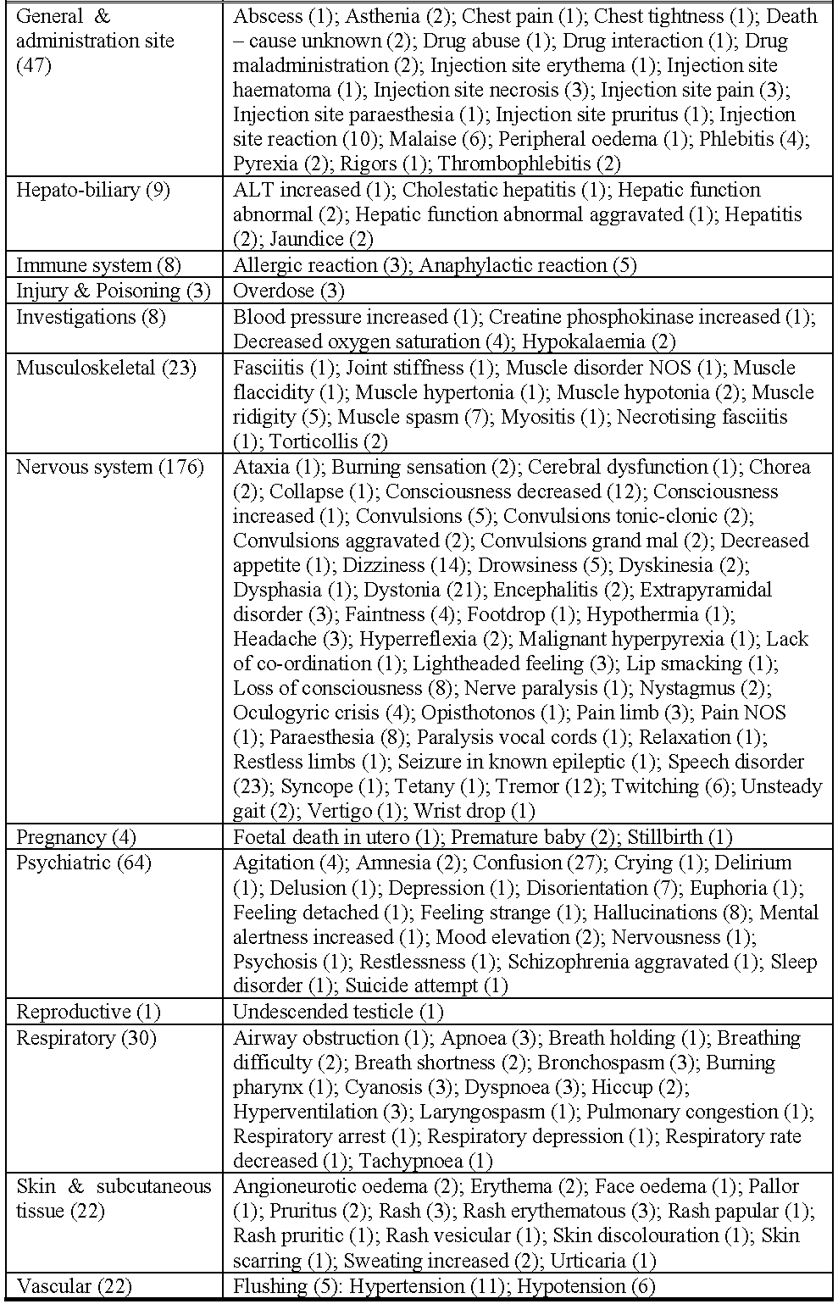

PSUR 1 November 2004 to 30 June 2008
Table 41. Summary of AEs (PSUR November 2004 to June 2008)
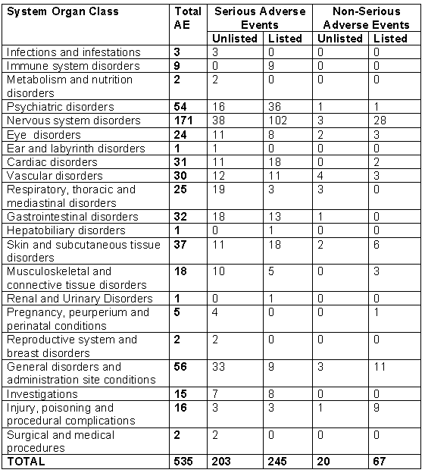
See Appendix I for a list of AEs by Preferred Term.

PSUR 1 July 2008 to 31 January 2010
It was recommended that the European Summary of Product Characteristics (SmPC) be updated to include the statement that ‘rapid IV administration can lead to symptoms similar to overdose’.
Table 42. Summary of AEs (PSUR July 2008 to January 2010).
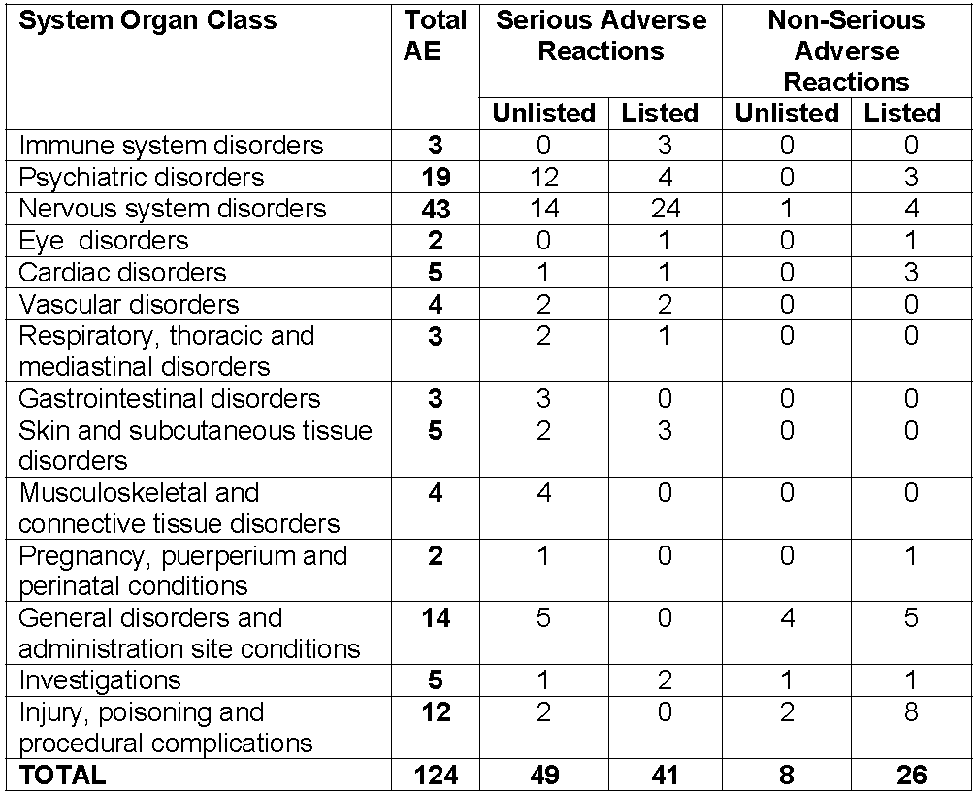
See Appendix II for a list of AEs by Preferred Term.

Specific safety issues of regulatory importance

Liver toxicity
None reported in literature.

Haematological toxicity
Agranulocytosis.

Serious skin reactions
None reported in literature.

Injection site reactions
Moore et al., 1956 reported seeing none in that study but referred to seeing it previously. O'Brien et al., 2003 reported that pain on injection (IV) was recorded only in those receiving cyclizine (p < 0.001). It is possible that IM injections have their sensation modified by the drug’s local anaesthetic properties.
It is reported in the 1996-2004 PSUR:
“There were six reports of phlebitis/thrombophlebitis and three of injection site necrosis. Other reports described pain, erythema, inflammation, vein tracking and stinging or burning sensations. A single report of abscess involved subcutaneous infusion into the upper arms over a period of three weeks. A further nine reports of injection site reactions were included in the previous PSUR.
It is possible that some of these cases may have been a consequence of administration of Valoid with saline-containing solutions. Cyclizine has a pH of 3.3-3.7, and is known to be incompatible with solutions with a pH of 6.8 and above. Any solution with significant concentrations of chloride ions, including normal saline, may lead to the precipitation of the less soluble cyclizine hydrochloride.”
Two reports of AEs associated with long-term use of cyclizine injection:
- A 38-year-old female on cyclizine IM three times daily (TDS) for five years developed lesions on the legs; biopsy showed fasciitis and myositis. Serum creatinine kinase was elevated
- A male with terminal cancer on IM Valoid 50 mg for some months reported that the injection had caused damage to the muscles around the site of injection. The patient described the event as necrosis and reported that he had to undergo surgical removal of the dead tissue from the arm.

Cardiovascular safety
Significantly increased systemic and pulmonary arterial pressures and right and left ventricular filling pressures in patients with heart failure.

Unwanted immunological events
Agranulocytosis.

Other safety issues

Use in Pregnancy
The relevant references are listed in Table 43, below. The evaluator has concerns at accepting the data from McBride 1969, 1963.
The studies only looked at congenital anomalies. While cyclizine is more likely to be used in early pregnancy the possibility of withdrawal symptoms in the neonates of mothers using it late in pregnancy does not appear to have been considered. In the absence of the data from McBride, there were in the submission only 111 pregnant patients who were reviewed after taking cyclizine. Additional data was contained in the paper by Asker et al., 2005, which was provided on request from the TGA.
Milkovich et al., 1976:
While the results contain no signal for cyclizine the study contained only 111 patients who had taken cyclizine, and the standard error (of the mean) for the Severe congenital anomaly (SCA) rate at 5 years was comparatively high.
Table 43. Severe congenital anomaly (SCA) rates* for children at ages 1 month, 1 year, and 5 years according to the nausea and vomiting (N/V) complaints of their mothers and the drugs prescribed for the complaints within 84 days from their last menstrual period (LMP)
Nausea and vomiting (N/V) status | No. of mothers with single live births | SCA rate per 100 children at ages |  |  | Standard error for SCA rate at 5 years
Nausea and vomiting (N/V) status | No. of mothers with single live births | 1 month | 1 year. | 5 years | Standard error for SCA rate at 5 years
Total | 10,205 | 1.5 | 2.4 | 3.5 | 0.18
N/V of pregnancy | 6,305 | 1.6 | 2.5 | 3.4 | 0.23
Cyclizine | 111 | 1.8 | 1.8 | 3.7 | 1.82
No drug prescribed for N/V | 4,353 | 1.5 | 2.2 | 3.2 | 0.27
No N/V of pregnancy
Medical record stated no N/V | 1,564 | 1.4 | 2.4 | 3.8 | 0.39
Medical record contained no statement | 2,336 | 1.4 | 2.8 | 3.7 | 0.34

Table 44. SCA rates per 100 live births at 1 month, 1 year, and 5 years of age for children, according to the drug and to the gestational time in pregnancy that the mother was prescribed the drug for N/V of pregnancy.
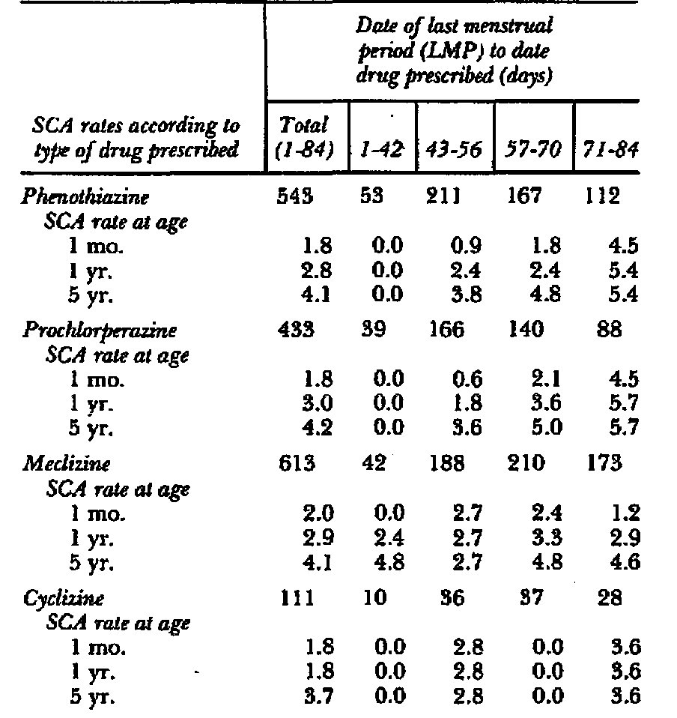
Table 45. Peri natal death rates* and peri natal deaths and severe congenital anomaly (SCA) rates combined according to gravida’s nausea and vomiting (N/V) status and the drugs prescribed for N/V within the first 84 days of pregnancy.
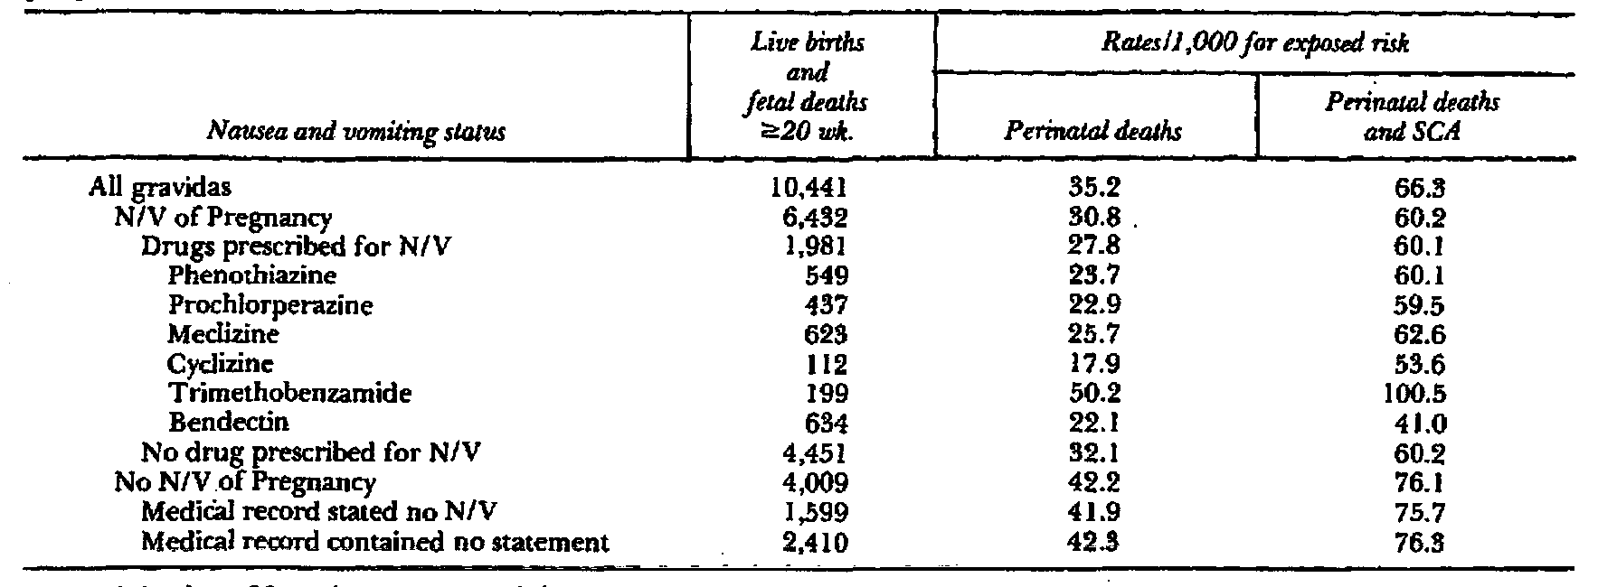
*Fetal deaths at 20 weeks and neonatal deaths.
Table 46. Summary of all submitted studies relevant to pregnancy. Table continued across two pages.
Reference | Details and relevant findings. | Comments
Collins, 1964 | Review. Based on animal data, not recommended in early pregnancy. No evidence of fetal damage - quoting Mellin et al.,1963 | -
McBride, 1963 | Reported an incidence of congenital abnormalities of 0.1% in 6,000 deliveries of women who had taken cyclizine, from a total of 21,562 deliveries over 5years 1957-1962  - congenital heart disease, 5  - cleft palate and/or hare-lip, 5  - anencephaly, 1  - myeloencephalocele, 2  - hydrocephalus, 1  - bilateral cataract, 1 | Part of nonclinical submission
McBride, 1969 | Reported an incidence of cleft palate of 0.4% in 1,125 deliveries of women who had taken cyclizine in the first 3 months from a total of 25,333 deliveries over 6 years 1956-61  Incidence among mothers with nausea and vomiting who did not take cyclizine was 3.64% of 1,100 deliveries ( no significant difference)  Incidence among mothers who did not take cyclizine was 0.08% of 24,208 deliveries. (significantly different from those with N/V suggesting N/V was the cause) | Not in nonclinical submission
Mellin et al., 1963. | Of 266 babies with malformations, no mothers had taken cyclizine. | Letter  Part of nonclinical submission
Milkovich L and van den Berg, 1976 | Human incidence. While the results contain no signal for cyclizine the study contained only 111 patients who had taken cyclizine, and the standard error for the Severe congenital anomaly rate at 5 years was comparatively high. | Precautions  Not in nonclinical submission
Sadusk et al., 1965 | Is in list of references for the sponsor’s Clinical Summary, but paper is only in nonclinical dossier. The report of the findings of a Food and Drug Administration (FDA) committee that on the basis of lack of evidence recommended insertion [on product labelling] of the following statements, and review in 2 years.  “The following information should be taken into account in determining whether the potential benefits of ... (cyclizine, meclizine, chlorcyclizine) . . . outweigh the risks of its use in women of childbearing age and particularly during pregnancy. A review of available animal data reveals that this drug exerts a teratogenic response in animals such as the . . . (rat, mouse, rabbit, or dog). While available clinical data are inconclusive, scientific experts are of the opinion that this drug may possess a potential for adverse effects on the human foetus. Consequently, consideration should be given to initial use of a non phenothiazine agent that is not suspected of having a teratogenic potential. In any case, the dosage and duration of treatment should be kept to a minimum.  The effectiveness of these drugs for the prevention and treatment of nausea and vomiting of pregnancy has not been established, and the decision to use such drugs should be based upon the seriousness of the situation, remembering that while these drugs have been used clinically for a decade, there are yet no controlled studies to demonstrate usefulness in an objective fashion. In most cases, nausea and vomiting of pregnancy may be unpleasant but does not present a serious threat to the health of the patient or to the progress of her pregnancy. In view of the desirability of keeping the administration of all drugs to a minimum during pregnancy, management by physiologic means such as proper nutrition and by psychological support is preferable to antiemetic drug therapy.”  The results of the subsequent review were not submitted. | -  Part of nonclinical submission
Yerushalmy and Milkovich, 1965 | Not related to cyclizine. | Part of nonclinical submission

Some PSURs contained relevant information:

PSUR 1 April 1996 to 31 October 2004
Of 10 exposed in pregnancy 7 had no obvious congenital defects (1 was later diagnosed with 80% hearing loss in one ear); 3 had congenital abnormalities (all different).
The Medicines and Health Care Regulatory Agency (MHRA) Committee on Safety of Medicines (CSM) Drug Analysis Print for cyclizine contains fourteen reports of congenital anomalies, including the three cases presented within this report. Three reports of alimentary tract anomalies (duodenal atresia, imperforate anus, oesophageal atresia), five of limb deformities and single cases of ear malformation, cataract, cleft lip, micrognathia, renal agenesis and cryptorchism have been received by the CSM since 1964.

PSUR 1 November 2004 to 30 June 2008
Asker et al., 2005 analysed the Swedish Medical Birth Registry to define the use of anti-emetics during pregnancy and the outcome of the pregnancies. During the period July 1 1995 to 2002, 29,804 pregnant women with 31,130 infants reported the use of antiemetic drugs from a total of 665,572 pregnant women with 676,198 infants that were registered.
Table 47. Reported use of cyclizine and the period of pregnancy during which the drug was taken (from Asker et al., 2005)
 | Period of reported drug useª
Drug | First trimester | Second to third trimester | First to third trimester | Total
Cyclizine | 1,221 | 460 | 337 | 2,018
ª First trimester means that prior use of the drug was reported during the first antenatal visit (usually before week 12); second to third trimester means that the drug was prescribed after the first antenatal visit; first to third trimester means that prior use of the drug was reported during the first antenatal visit and an antiemetic was prescribed during subsequent antenatal care.
Table 48. Preterm birth, low birth weight, small-for-gestational age and congenital malformations* according to cyclizine use (from Asker et al., 2005)
 | Group | Number | Percentage | ORª | 95% CIª
Preterm birth | Population | 33,653 | 5.1 | 1.00 | Reference
Preterm birth | Cyclizine | 97 | 4.7 | 1.01 | 0.87–1.16
Low birth weight | Population | 21,086 | 3.2 | 1.00 | Reference
Low birth weight | Cyclizine | 47 | 2.3 | 0.81 | 0.65–0.99
Small-for-gestational age | Population | 14,247 | 2.2 | 1.00 | Reference
Small-for-gestational age | Cyclizine | 32 | 1.6 | 0.84 | 0.59–1.20
Congenital malformations | Population | 23,745 | 3.5 | 1.00 | Reference
Congenital malformations | Cyclizine | 79 | 3.6 | 1.08 | 0.86–1.35
ª Odds ratios (OR) with 95% CI, adjusted for year of birth, maternal age, parity, smoking, and years of involuntary childlessness. * Registered in the Medical Birth Registry among all infants born.
Extracted from Asker et al., 2005: “The registered malformation rate varies for the different drugs, with 3.6% for cyclizine being the highest. However, this variability may be random (chi-square = 4.9 at 6 df , p = 0.56). Many of the registered malformations are mild conditions and have not been registered uniformly; for example, coloboma of the eye, preauricular tags, branchial cysts or fistulas, patent ductus arteriosus at preterm birth, single umbilical artery, undescended testicle, unstable hip, and skin malformations (mainly naevus). After these mild conditions are removed from the analysis, 684 infants with malformations remain in the antiemetic-exposed group (2.2%) and 16,994 in the population (2.5%). The adjusted OR remains at 0.90 (95% CI 0.83–0.97). The use of all sources for congenital malformations gave a better ascertainment and also identified malformations observed after the neonatal period – 4.7% of all infants born have a recorded congenital malformation on this basis. Among infants exposed to antiemetics, the rate is 4.3% and the crude OR is 0.93 (95% CI 0.88–0.98). This material was used in order to identify specific groups of congenital malformations. The ORs vary between the different groups, but a chi-square analysis indicates that the heterogeneity has only a marginal statistical significance (chi-square = 14.1 at 7 df, p = 0.049). Hypospadias, however, shows intrinsically a significantly low OR.
The register also has weaknesses. It is unlikely that all drug use is reported or recorded. In this study, about 5% of all women reported the use of antiemetics during pregnancy. In a questionnaire study from a region of Sweden, 15% of the women reported the use of drug treatment of NVP and about 13% reported the use of antihistamines. The lower rate in the present study may not only be due to a lack of reporting/recording but also to the fact that women after the first antenatal care visit may use over-the-counter drugs which will not be registered. However, the incomplete identification of women who used antiemetics will only slightly influence the risk estimates because the relatively few unidentified cases will only marginally dilute statistics of the large control population. Another draw-back of the register is that little information is available on the timing or duration of drug use or the amount taken. Data for women who only used a single tablet is confounded with data for women who used drugs for an extended period. This tends to bias the estimated ORs towards unity.
No information is obtainable for spontaneous or induced abortions. According to present Swedish law, induced abortions cannot be registered with personal identification data, which makes it impossible to study such cases for, among other things, drug use. A number of abortions will have been induced because of congenital malformations detected during prenatal diagnosis and will not be included in the analysis. While this will scarcely affect the risk estimates, it will reduce the power of the study. If the malformation in question is always or nearly always aborted (like anencephaly or bilateral kidney agenesis), obviously a possible teratogenic effect of the studied drugs cannot be identified. If the use of a drug (e.g., anticonvulsant) can affect the probability or degree of a detailed prenatal diagnosis, biased results can be obtained. It is very unlikely that the use of antiemetics will have such an effect.”

Safety related to drug-drug interactions and other interactions
Cyclizine is sedative, and CNS depression with other sedatives is expected. Because of its anticholinergic activity, cyclizine may enhance the side-effects of other anticholinergic drugs.

Abuse and addiction
There were a number of literature reports of abuse and addiction. The distinction between recreational abuse, intentional overdose and inadvertent overdose was not always clear.
Table 40. Summary of all submitted studies relevant to abuse and addiction. Table continued across two pages.
Therapeutically initiated
Bailey and Davies, 2008 | IV cyclizine 4 cases  Rapid injection buzz (high for 30 – 120 mins)  Mostly psychological but some physical withdrawal symptoms (feeling sick and achy)  Potentiation of stimulant effects of opioids hallucinations with higher doses  Abuse produces aggression and seizures
Hughes and Coote, 1988. | Dependence with withdrawal in chronic pain patients Case reports (3)
Recreational abuse - oral preparations – ingested or injected
Ruben et al., 1989. | 20 opiate addicts on oral methadone, habitual abusers of cyclizine, were interviewed. The effects initially were of intense stimulation, often with hallucinations, sometimes with aggressive behaviour, and occasionally with epileptic fits. Subsequent depressive mood changes occurred often accompanied by a craving for cyclizine
Bassett et al., 1996. | Reviewed 80 teenage cases of abuse reporting to the Utah Poisons Centre (of whom only 25% had co ingestions), 52% had tachycardia (> 115 beats/min), 69% had systolic hypertension (> 135 mmHg), 15% had diastolic hypertension, and 14% had fever (> 38ºC).  The most commonly reported symptom was hallucinations, noted in 70% of cases. Other reported symptoms included confusion or disorientation in 40%, agitation in 31 %, tremor in 9%, dysarthria in 7%, drowsiness in 5%, ataxia in 2%, chest pain in 1 %, and seizures in 1 %.  Ingestion was considered to have been secondary to abuse in 89% of cases, suicide attempt in 4%, misuse in 2%, and intentional/unknown in 5%.
Turnbull and Isaacson, 1977. | Case study, injection of dissolved oral tablets
Williams et al., 1997. | Not in submission. Subsequently submitted on request from TGA. Dipianone HCl (an opiate) plus cyclizine injection of dissolved oral tablets 86 patients current intravenous abusers. There was a mortality rate of 3%.
Accidental Overdose
Haidvogl and Rosegger, 1975. | 6 cases of accidental overdose in infants. Symptoms included agitation – ataxia, sleeplessness, visual and acoustic hallucinations, confused orientation, febrile, facial reddening, wide pupils.
Overdose not otherwise specified (NOS)
Resch et al., 1982. | Abstract only submitted (later translated): 38 cases reviewed of 128 reports to poisons centre of intoxication with cyclizine in adults and children. Use of gastric lavage and physostigmine recommended.
Griffin and Baselt, 1984. | The cyclizine blood concentration of 450 ng/mL reported in the drowning death of an actress probably represents more than normal usage of this drug. In acute fatal overdoses involving cyclizine, much higher blood concentrations (1.5 to 15 µg/mL have been observed

Overdose in children
Resch et al., 1982 report the following in relation to children:
“The toxic dose, i.e. the dose, which causes at least some of the clinical symptoms described below, is 5mg/kg body weight in our patient collective.
The first sign of intoxication is usually an unapparent state of excitation with an increased urge to move, tremors, athetoid patterns of movement, ataxia, rigidity, stereotypes and other hyperkinetic extrapyramidal manifestations, with there being no record of any definite dose or age dependency with regard to intensity and nature of motor agitation.
The hyperkinesias can escalate to tonic-clonic seizures, with children and adolescents especially showing an increased disposition for this, while in the age group over 16 years at appropriate doses no seizures are described in any documented case, in our experience children aged between 5 – 16 years develop convulsions in around 70 % of cases. No real dose-dependency can be derived for the occurrence of seizures, however it becomes evident that, from a dose of 40 mg/kg body weight, a clustering of convulsions to over 60 % are also observed in the infant age group. The convulsive states can sometimes take on a threatening aspect and lead to respiratory insufficiency with cyanosis, as was the case in 6 of our patients.
In over 70 % of cases in infants, following consumption of more than 40mg/kg cyclizine, and in schoolchildren up to even 100 %, a range of central and peripheral atropine-like symptoms are found, with hallucinations, confusion, temporal and spatial disorientation on the one hand and clear facial reddening, dry skin, mydriasis and tachycardia on the other hand. Dry mucosa and phonation disorder, described as typical in the context of atropine intoxication, can only be detected in one case.
A phase of central depression is associated with the excitation phase and, in rare cases, can dominate the clinical symptoms. There is no definite age dependency, yet it is revealed that in the group of 5-16 year olds dose-dependent signs of sedation, disorientation, somnolence to the point of coma are to be found in 85 % of cases, i.e. more frequently than in the other age groups. In contrast to earlier publications, in our experience central depressive effects of cyclizine also become manifest in infancy in over 50 %.
There is no actual prognostic sign. Only one out of all cases was recorded as fatal, and in fact following a complicated course with aspiration pneumonia, constant convulsive states and apnoea during a seizure on the 5th day. This child had taken the highest oral dose, 88.8mg/kg body weight, of all known intoxication cases.”

Evaluator’s overall conclusions on clinical safety
The most common adverse reaction in the trials is sedation/drowsiness. This is so for most of the trials involving anaesthesia with and without opiate premedication, an effect noted with most antihistamines. The oral trials also found it common but mostly subjective.
Pain on injection was noted in the earlier IM studies as well as IV in children. In the latter study (O’Brien et al., 2003) pain occurred despite an antihistamine premedication.
Many of the reported adverse events are those that would be expected given the central anticholinergic mode of action of the drug. They are well described by Resch et al., 1982 in overdose in children. Together with the absence of a multiple dose pharmacokinetic trial or pharmacokinetic modelling with a drug whose half life exceeds the proposed dosing interval, it suggests the possibility of a narrow therapeutic index, especially with repeated dosing.
The potential for abuse and the possibility of addiction are of concern.
The odds ratio for congenital malformations of 1.08 is of some, but not great concern (the confidence intervals cross 1.0). No data was available on the possibility of withdrawal symptoms in the neonates of mothers using cyclizine late in pregnancy.

Preliminary benefit-risk assessment and recommendations

Preliminary assessment of benefits

The treatment of nausea and vomiting caused by narcotic analgesics and by general anaesthetics in the post-operative period
The benefits of cyclizine in the proposed usage are:
- Efficacy was demonstrated in the studies.
- PONV has a better response to multimodal therapy and cyclizine appears in part to act to modify vestibular function (but at 100 mg orally).
- The drug has a long history of use for this indication.
- Long term use is not covered by the indication.

Pre-operative use in patients undergoing emergency surgery
The benefits of cyclizine in the proposed usage are:
- Both cyclizine and metoclopramide increased barrier pressure significantly, thus confirming previous reports indicating that these two drugs increase lower oesophageal sphincter tone
- It is a single 25 mg dose use.

Preliminary assessment of risks

The treatment of nausea and vomiting caused by narcotic analgesics and by general anaesthetics in the post-operative period
The risks of cyclizine in the proposed usage are:
- The evidence of efficacy is limited in that
  - the studies for PONV essentially used only a single dose of 50 mg of cyclizine IM or IV
  - and those on opiates alone were studies only for 1.5 h before anaesthesia was added.
- Only 2 studies used muscle relaxants: 1 showed efficacy, 1 did not, and different agents were used for reversal of the muscle relaxation.
- The absence of a multiple dose pharmacokinetic trial or pharmacokinetic modelling with a drug whose half life exceeds the proposed dosing interval suggests the possibility of a narrow therapeutic index, especially with repeated dosing.
- The drug can cause pain on injection.
- Long term use can cause muscle damage.
- The drug has a low pH that may lead to incompatibilities.

Pre-operative use in patients undergoing emergency surgery
The risks of cyclizine in the proposed usage are:
- No evidence has been produced or is likely to be produced to support the claim of efficacy in reducing the hazard of regurgitation and aspiration of gastric contents during induction of general anaesthesia.
- There is evidence (Brocke-Utne et al., 1977, 1978; see section on Pharmacodynamics) in healthy volunteers that the basal barrier (due to sphincter) pressure increased with cyclizine. This may decrease the risk of regurgitation in the awake emergency patient but it does not necessarily follow that it does so on induction of anaesthesia.
- The evidence is not good in that the studies by Brocke-Utne et al., 1977 and 1978 appear to be duplicate reports.

Preliminary assessment of benefit-risk balance
The benefit-risk balance of cyclizine for the treatment of nausea and vomiting caused by narcotic analgesics and by general anaesthetics in the post-operative period, is favourable given the age the drug has been in the market, however the lack of long term studies and appropriate pharmacokinetic data restrict its use, possibly to single dosing.
The benefit-risk balance of cyclizine for pre-operative use in patients undergoing emergency surgery to reduce the hazard of regurgitation and aspiration of gastric contents during induction of general anaesthesia is unfavourable.

Preliminary recommendation regarding authorisation
The evaluator recommended that the application for registration of cyclizine on the Australian Register of Therapeutic Goods (ARTG) be approved with the modified indications of:
- the prevention and short-term treatment of nausea and vomiting caused by narcotic analgesics and by general anaesthetics in the post-operative period
- pre-operative use in patients undergoing anaesthesia and surgery to increase lower oesophageal sphincter pressure where this is required.

List of questions

Safety
In Dundee et al., 1966 the authors comment:
“The only real advantage of trimethobenzamide over cyclizine was its miscibility with pethidine; doses of pethidine 100 mg and trimethobenzamide 200 mg were prepared premixed in 2-ml ampoules, whereas, as stated previously, pethidine and cyclizine required two syringes and two injection sites.”

From the 1996-2004 PSUR:
“Cyclizine has a pH of 3.3-3.7, and is known to be incompatible with solutions with a pH of 6.8 and above. Any solution with significant concentrations of chloride ions, including normal saline, may lead to the precipitation of the less soluble cyclizine hydrochloride.”
The evaluator recommended the sponsor provide compatibilities with common infusions used in anaesthesia, for example IV fluids, propofol, muscle relaxants, opiates.
Sponsor’s response: The sponsor’s response contained the warning
"..if cyclizine lactate injection must be diluted for use in a syringe driver, the drug should be diluted with water for injection or 5% dextrose injection
Interaction with propofol or muscle relaxants (both of which may be given by infusion) is unknown.
Some strengths of oxycodone resulted in precipitation This was the only Australian marketed opiate for which there was information.
Compatibility with 50 mg/5mL ranitidine was shown (there is also a 50 mg/5 mL marketed.”
The evaluator recommended that the Dosage and Administration section of the PI carry appropriate warnings.

V. Pharmacovigilance findings

Risk management plan
The summary of the Ongoing Safety Concerns as specified by the sponsor is as follows:
There are some possible safety concerns with Valoid which the Applicant believes have been appropriately addressed in the PI and the intended post-authorisation communications.
These concerns are:
- Off-label use
- Paediatric use
- Rapid administration of injection
- Use in pregnant women
- Hypotensive patients in emergency surgery
- Product abuse
OPR reviewer comment
Pursuant to the evaluation of the nonclinical and clinical aspects of the safety specifications, it is recommended that ‘injection site reactions’ be added to the list of Potential safety concerns.

Pharmacovigilance plan
The sponsor provides the information that the pharmacovigilance system of Link Medical Products will be incorporated into the Amdipharm (UK and Ireland licence holder) pharmacovigilance system. The sponsor provides a detailed description of the pharmacovigilance activities to be undertaken routinely.
The sponsor does not propose any additional pharmacovigilance activities.

OPR reviewer’s comments in regard to the pharmacovigilance plan (PP) and the appropriateness of milestones
The sponsor notes in the RMP Section Post-marketing (non-study) exposure that the database only contains 390 case reports. The sponsor has explained that although the product has been on the market for 50 years Amdipharm has held the licence since 1 December 2003 and that the ADR case reports are for the time period 1 December 2003 to 31 August 2011. The sponsor has provided complete case line listings and a frequency table for review. In addition the sponsor has provided the MHRA Drug Analysis Print (DAP) for all cyclizine cases for the period 1 July 1963 to 27 July 2011 containing the Council for International Organizations of Medical Sciences (CIOMS) forms for all 760 cases.

Risk minimisation activities
In the detailed action plan for specific safety concerns the sponsor states that the safety concerns raised within the RMP have been accounted for with warnings in the PI and intended communications. The sponsor believes this strategy is adequate to address the risks associated with this product.
OPR reviewer comment:
The sponsor has indicated, following a TGA request for information, that there will be additional materials provided with the launch of the product that will focus on the PI. The sponsor has not provided sample material for comment. Therefore the adequacy of the material to address the safe administration of Valoid cannot be evaluated. The sponsor is requested to provide a copy of this material to the TGA, for information, post registration.
The sponsor indicates that changes in spontaneous adverse event reporting will be used as an indicator of the effectiveness of the communication.
Given the small number of adverse events reported for cyclizine, and the sponsor’s argument for the relative safety of cyclizine in many of its potential off-label indications in Australia, it is suggested that spontaneous adverse event reporting is unlikely to a useful tool for the evaluation of the post-authorisation communications. A drug utilisation study may provide a better profile of the use of the product in the community post registration.
In regard to the proposed routine risk minimisation activities, changes to the proposed PI are recommended.
In regard to the proposed routine risk minimisation activities, it is recommended to the Delegate that the draft consumer medicine information document be revised to reflect any changes to the PI.

Summary of recommendations
The OPR provides these recommendations in the context that the submitted RMP is supportive to the application; and the implementation of the RMP (undated, version not identified) and the sponsor’s responses to TGA requests for information, is imposed as a condition of registration when so qualified:
Risk minimisation plan
The sponsor has indicated that there will be additional materials provided with the launch of the product that will focus on the PI. The sponsor has not provided sample material for comment. Therefore the adequacy of the material to address the safe administration of Valoid cannot be evaluated. The sponsor is requested to provide a copy of this material to the TGA, for information, post registration.
Given the small number of adverse events reported for cyclizine, and the sponsor’s argument for the relative safety of cyclizine in many of its potential off-label indications in Australia, it is suggested that spontaneous adverse event reporting is unlikely to a useful tool for the evaluation of the post authorisation communications to prevent off-label use. A drug utilisation study may provide a better profile of the use of the product in the community post registration.
Product Information
Suggested revisions to the proposed PI were recommended. Inclusion of these is beyond the scope of this AusPAR.

VI. Overall conclusion and risk/benefit assessment
The submission was summarised in the following Delegate’s overview and recommendations:

Quality
There are no objections in respect of Chemistry, Manufacturing and Controls to registration of this product.
The quality evaluator had stated that approval could not be recommended until the company developed a suitable method for monitoring the finished product and generates appropriate stability data. The sponsor has now developed a suitable method and provided the appropriate stability data.
No bioavailability data for the injection when administered by the IM route were submitted.
This submission was discussed at the PSC at its August 2011 meeting. The PSC saw no quality or pharmaceutical aspects which would preclude registration: the PSC endorsed all the questions raised by the TGA in relation to quality and pharmaceutic aspects of the submission and considered all outstanding issues should be addressed to the satisfaction of the TGA.

Nonclinical
The nonclinical evaluator considered that based on current regulatory guidelines and GLP standards required for nonclinical studies to support registration of a new chemical entity, the nonclinical dossier was not adequate. The nonclinical data used to demonstrate primary pharmacodynamic efficacy were limited to one study (from 1954) that documented an antiemetic effect by cyclizine in an experimental model of emesis, with little/no data presented that explored the dose-dependency, efficacy, selectivity and/ or mode of action. Limited experimental data showed antihistamine but not anticholinergic activity.
Cardiovascular and central nervous systems were (minimally) investigated in safety pharmacology studies but no ECG or hERG assays were performed. In rats oral cyclizine at doses above 75 mg/kg/day was associated with pancreatic pathology and plasma glucose/insulin changes. Metabolism was studied only in dogs (a species not used for any of the toxicity tests) and it is unknown whether the potential toxicity of human metabolites was assessed in the animal studies.
Repeat dose toxicity was limited to a 12 week dietary study in rats. The primary human metabolite, norcyclizine had negligible antihistaminic properties. Cyclizine inhibited human hepatic estrone sulfotransferase and murine MAO-B but showed only weak inhibition of human CYP2D6 and 2C9.
Genotoxicity assessment was limited to one Ames test in which mutations were seen only when cyclizine was in a nitrosated form. The nonclinical evaluator considered this may be relevant for oral administration if nitrites are present in food. There were no carcinogenicity studies, but this could be accepted if the medicine was used only for short periods.
Published reproductive toxicity studies examined oral cyclizine administration in rats, mice and rabbits during gestation. There was evidence of resorptions and malformations in all species. NOEL values were not consistent across the variable study designs.
There was no evidence of maternal toxicity. Placental transfer, excretion into milk, and maternal exposure measurements were not assessed.
In view of the above issues, the nonclinical evaluator considered that clinical evaluation was needed for assurance that the identified nonclinical deficiencies are adequately offset by sufficiently well-documented clinical information.

Clinical

Pharmacology
Only one single dose study of the pharmacokinetics of cyclizine was submitted. This was of a bolus IV dose of 25 mg cyclizine, given as 0.5 mL of 50 mg/mL solution to 6 subjects. Concentration/time data were also available from one subject given a single oral 50 mg dose and one subject given a single 50 mg intravenous dose. No pharmacokinetic data were available for the proposed intramuscular route of administration.
Data from the pharmacokinetic study are summarised in Table 1 of this AusPAR.
Published papers have stated that cyclizine is primarily metabolised by demethylation to norcyclizine or by glucuronidation. Renal clearance is negligible.
The submission included some papers published in the 1950s that considered aspects of the pharmacodynamic effects of cyclizine. Effects on the vestibular apparatus were examined with results suggesting that a 50 mg dose would have minimal suppressive effects on visual-vestibular interaction. There is good evidence that in overdose cyclizine is associated with tachycardia, systolic and diastolic hypertension and fever. These are well-known effects of antihistamine overdose.
Two studies by the same authors (Brocke-Utne et. al.) published in the 1970s examined the effect of single 25 mg doses of cyclizine given intravenously to healthy, awake volunteers. Oesophageal sphincter pressure increased from a basal mean of 19.1 cm H₂O to 33.5 cm H₂O (p < 0.005). It is not clear if these studies were in fact the same study of the same patients or if different patients were enrolled in studies of the same design with similar results.
A dose of 50 mg of cyclizine, given IV to 11 patients with severe heart failure (New York Heart Association grade 4) was associated with raised ventricular filling pressures and an increase in after-load. This was accompanied by a reduction in cardiac output. These events could lead to reduction of coronary artery flow and increase in myocardial oxygen consumption which could be compromising in patients with severe cardiac failure.

Efficacy
The dose chosen for the efficacy studies appears to have been based on historical use rather than from Phase II efficacy/safety studies. The evaluator has noted that anaesthetic techniques have changed considerably over time. Consequently the techniques reported in the submitted papers may no longer be regularly used and historical data on the incidence of nausea and vomiting associated with various types of surgery may not be relevant. However, comparative data where patients in each group received similar anaesthetics with and without cyclizine may be evaluable for efficacy. All the presented studies used either PO or parenteral doses of 50–100 mg cyclizine.
The sponsor requested indications for the prevention and treatment of nausea and vomiting including A) that caused by narcotic analgesics and by general anaesthetics in the post-operative period and B) pre-operative use in emergency surgery to reduce the hazard of regurgitation and aspiration of gastric contents during induction of general anaesthesia.
Most of the evidence presented was for prevention of PONV. Treatment of established PONV was not specifically assessed. To support that PONV component of the proposed indications a Cochrane systematic review of drugs for preventing PONV and 12 studies were presented.
The Cochrane review Drugs for Preventing Post-operative Nausea and Vomiting is discussed in the section on Analyses performed across trials (pooled analyses and meta-analyses in this AusPAR. As noted in the sponsor’s Clinical Overview, the Cochrane review authors searched The Cochrane Central Register of Controlled Trials (CENTRAL) (Issue 2, 2004), MEDLINE (January 1966 to May 2004), EMBASE (January 1985 to May 2004), CINAHL (1982 to May 2004), AMED (1985 to May 2004), SIGLE (to May 2004), ISI WOS (to May 2004), LILAC (to May 2004) and INGENTA bibliographies. Randomised, controlled trials that compared a drug with placebo or another drug, or compared doses or timing of administration, that reported post-operative nausea or vomiting as an outcome were selected. Each of the authors independently assessed trial quality and extracted outcome data.
This systematic review included randomised clinical trials that compared a drug with placebo or another drug for prevention of PONV, or compared doses or timing of administration and reported PONV as an outcome. Studies of treatment for established PONV were excluded. Study drug could be given pre-operatively, at induction of anaesthesia, intra-operatively or post-operatively (before nausea and vomiting had occurred). It included participants undergoing general anaesthesia, regional anaesthesia or sedation. Overall the review included 737 studies involving 103,237 people. Sixty different drugs were identified, including cyclizine. Efficacy in prevention of PONV was demonstrated for 8 of these 60 drugs, including cyclizine.
In relationship to cyclizine, the authors of the Cochrane Review assessed the following 10 studies: Ahmed et al., 2000; Chestnutt and Dundee, 1986; Cholwill et al., 1999; Dundee et al., 1975; Grimsehl et al., 2002; Hildyard et al., 2001; Nortcliffe et al., 2003; O’Brien et al., 2003; Walder & Aitkenhead, 1995 and Watts, 1996. In that review, a drug was considered effective if it achieved statistically significant benefits when compared to placebo for all four of the following outcomes: nausea; vomiting; nausea or vomiting; and use of rescue anti-emetic.
The RR for PONV for each of the 8 study drugs that showed a statistically significant difference vs. placebo are shown in Table 28 of this AusPAR. Cyclizine had a RR of 0.65 (95% CI 0.47–0.90) for nausea, 0.57 (95% CI 0.43–0.75) for vomiting and 0.68 (95% CI 0.58–0.80) for nausea or vomiting and 0.27 (95% CI 0.14–0.62) for rescue antiemetic. A comparison of cyclizine and ondansetron was also performed. This showed no statistically significant differences for any of the parameters assessed between the 2 drugs, however there was a trend towards more efficacy with ondansetron for vomiting, nausea or vomiting and use of rescue medication.
The evaluator considered 5 of 12 studies submitted by the sponsor as pivotal and has provided explanations for considering the remaining studies as supportive. The 5 pivotal studies are summarised in Table 10 of this AusPAR. All of these were included in the Cochrane Review. These studies were either double-blind (4 studies) or observer-blind (1 study). In total 487 patients were given either parenteral cyclizine (IV in 3 studies and IM in 2 studies) or ondansetron with or without metaclopramide (3 studies) or placebo (2 studies) at or immediately before induction of anaesthesia. All the pivotal studies were in women undergoing gynaecological surgery.
The study by Cholwill et al., 1999 was a double-blind, randomised, placebo and active controlled study comparing ondansetron 4 mg IV with cyclizine 50 mg IV and placebo for the prevention of PONV for 24 h after day-case gynaecological laparoscopy. All patients were ASA I or II and were stratified by history of PONV. The primary outcome measures were the incidence of moderate or severe nausea, vomiting and the number of patients receiving escape antiemetic.
A total of 175 patients were randomised across the 3 treatment groups. Average age in the 3 groups was from 31 to 33 years (range 22 to 50 years). From 19% (placebo group) to 25% (cyclizine group) had histories of PONV. Most patients were undergoing laparoscopic sterilisation. Moderate or severe nausea was reported by 3 (23%) patients given cyclizine, 18 (30%) given ondansetron and by 30 (52%) given placebo. Escape antiemetic was given to 9 (16%) patients given cyclizine, 17 (28%) given ondansetron and 27 (47%) given placebo. These results were statistically significant for comparisons of both cyclizine and ondansetron with placebo. No statistical comparison of cyclizine vs. ondansetron was performed. Vomiting occurred in 13 (23%), 19 (32%) and 24 (41%) patients given cyclizine, ondansetron and placebo respectively. These differences were not statistically significant.
The second pivotal study was reported by Grimsehl et al., 2002. This was a randomised, double-blind, active controlled study that compared cyclizine 50 mg IV with ondansetron 4 mg IV at induction. 64 patients were enrolled. PONV was reported in 21 (56%) patients given cyclizine and in 20 (54%) given ondansetron. Severe nausea was reported in 6 (16%) patients in each group and vomiting in 6 (16%) patients given cyclizine and in 4 (11%) given ondansetron. The difference in incidence of PONV between the treatments groups was not statistically significant. This was a small study powered to demonstrate between treatment differences of 35% or more in the incidence of PONV. No such differences were demonstrated.
The study by Watts (1996) had an initial open sub-study in which 38 patients underwent a procedure without prophylactic antiemetic and data from that sub-study were used to establish an expected rate of PONV in the subsequent randomised, double-blind, comparative study in which patients received IV cyclizine 50 mg, ondansetron 4 mg or metoclopramide 10 mg immediately before induction. All patients received the same anaesthetic protocol. The primary outcome measure in this study was PONV measured as either requiring treatment of nausea or having an emetic episode.
In the sub-study, 18/38 (47%) patients required treatment for PONV. In the main study clinical nausea was reported in 27 (50%) patients given cyclizine, 12 (20%) given ondansetron and 13 (24%) given metoclopramide. Overnight admissions due to severe PONV were reported for 4 patients given cyclizine and 2 given ondansetron. Nausea was also assessed on a 4 point scale from 0 to 3 where 0 = absence of PONV, 1 = mild nausea settling spontaneously, 2 = nausea requiring treatment and 3 = actual emetic episode. Nausea scores were determined in the recovery room at 2 h post- surgery, at discharge, and at 24 h post-surgery. Statistically significant differences in nausea scores favouring both ondansetron and metoclopramide over cyclizine were reported at the 2 h post-surgery and at discharge timepoints.
The study by Chestnutt and Dundee, 1986 was a double-blind, placebo-controlled study to compare efficacy and safety of cyclizine and perphenazine (a typical antiphychotic) given in conjunction with meptazinol (an opioid analgesic). Intramuscular cyclizine 50 mg, perphenazine 2.5 mg or saline was given 1.5 h preoperatively. The primary outcome measure was the incidence of slight or marked nausea and vomiting (alone or with nausea). This was assessed pre and post-operatively and overall. Forty patients were randomised to each group. The overall incidence of either nausea or vomiting was 33/40 (82.5%) for placebo, 22/40 (55%) for cyclizine and 34/40 (85%) for perphenazine.
Cyclizine statistically significantly reduced nausea or vomiting compared with placebo and with perphenazine at the pre-operative and post-operative assessments and overall.
Dundee et al., 1975 was the final published study report considered pivotal. This was a double-blind study comparing pre-operative IM cyclizine 50 mg and perphenazine 2.5 mg or 5.0 mg in women undergoing a minor gynaecological operation with a standard anaesthetic including opioids (morphine or pethidine). This study was randomised initially then amended to permit allocation by a clinician other than the investigators to balance the numbers in each group who had or had not had dilatation of the cervix uteri in each group. Initially 100 patients were randomised to each group. The 5 mg perphenazine group was withdrawn during study due to a high incidence of restlessness.
The objective was to assess the incidence of PONV of cyclizine versus perphenazine and placebo. Outcome measures were the incidences of pre and post-operative nausea and/ or vomiting. Results for this study were presented by sub-group receiving pethidine (n=300), morphine 10 mg (n=200) and morphine 15 mg (n=100). Each of the 3 antiemetic groups were thus assessed efficacy in subgroups given for each of the 3 opioids regimens. This had the effect of reducing the power of the study to detect statistically significant differences. Nevertheless it was reported that both cyclizine and 2.5 mg perphenazine were statistically significantly superior to placebo in reducing PONV in patients who received pethidine. Whether this study controlled for multiplicity effects in its statistical analysis is not clear. Overall, the Delegate did not consider this study suitable as a pivotal study due to the lack of information on method and timing of administration of study medications and on statistical methods.
The proposed indication of treatment of PONV caused by narcotic analgesics was investigated in 3 studies discussed in the section on Efficacy studies – The treatment of nausea and vomiting caused by narcotic analgesics of this AusPar. The first by Chestnutt and Dundee, 1986 was included in the Cochrane systematic review and is discussed above. That study had many subgroups (3 subgroups in each of the 3 treatment groups) and was a relatively small study. I am not satisfied it was adequate to assess the relative efficacy of cyclizine or perhenazine in preventing or treating PONV due to either opioids or general anaesthetics. The second study investigating treatment of PONV (Dundee et al., 1975) was also discussed as a pivotal study for prevention of PONV. Two further studies by Dundee or co-authored by Dundee in the 1960s were submitted to support a specific statement regarding treatment of PONV due to narcotic analgesics. These studies are described in the section on Efficacy studies – The treatment of nausea and vomiting caused by narcotic analgesics.
Only one published paper was submitted in support of the proposed indication of pre-operative use in patients undergoing emergency surgery to reduce the hazard of regurgitation and aspiration of gastric contents during induction of general anaesthesia. This was a 1977 paper in which lower oesophageal sphincter pressure was measured in 8 healthy volunteers who were quietly resting in the supine position after a 5 h fast. The subjects had not received a general anaesthetic. Lower oesophageal sphincter pressures were measured before and after 25 mg cyclizine IV and a mean increase in pressure was noted.

Safety
Safety data from published studies are usually limited. This is particularly the case for older published studies such as those included in this submission. The clinical evaluator has noted that sedation/drowsiness was the most common adverse drug reactions in clinical trials. Many of the adverse events are consistent with central anticholinergic effects. Most safety information has come from post-market sources as described in the section on Post marketing experience of this AusPAR. Cyclizine has been available internationally since the 1960s. Nervous system disorders were the most frequently reported adverse events and included alterations to consciousness, convulsions, dizziness, extrapyramidal effects, and reduced level of consciousness.
Psychiatric reactions including hallucinations and disorientation, and allergic reactions including severe anaphylaxis have also been reported (the sponsor’s Clinical Overview refers). Local injection site reactions including muscle necrosis were reported with continuing IM use. The clinical evaluator noted that agranulocytosis had been reported as an adverse event. This appears to be based on one post-market report of a woman who developed agranulocytosis 6 weeks after receiving 3 doses of 50 mg cyclizine (the sponsor’s Clinical Overview refers).
There are considerable data relating to the use of cyclizine in pregnancy however this use is not in the context of single dose use for prevention of PONV. The documentation on the safety of cyclizine use in pregnancy is summarised in Table 46 of this AusPAR.
Cyclizine has potential for abuse and dependency. This is unlikely in the context of single dose use for prevention of PONV however it is clear that cyclizine has caused dependence when given for other indications or when taken without indication. Four cases of abuse of IV cyclizine were reported in patients with cancer. Abuse can be associated with aggression and seizures. Six cases of accidental overdose in children were consistent with anticholinergic syndrome with signs and symptoms including hallucinations, disorientation, tachycardia, flushing, fever, and mydriasis. Seizures have also been reported in the context of cyclizine overdose.

Risk management plan
The RMP evaluator considered the submitted RMP was supportive of the application and recommended that implementation of the RMP and the sponsor’s responses to TGA questions (pertaining to the RMP) be imposed as a condition of registration when so qualified. Routine pharmacovigilance activities have been proposed. The sponsor has indicated there is potential for off-label use in palliative care for nausea, possible use in children and use in the management of vestibular disease. The sponsor intends to inform prescribers of the licensed indication for Valoid. Amendments to the draft PI were recommended.

Risk-benefit analysis

Delegate considerations
The quality evaluator considered that approval of this submission could not be recommended until a suitable method for monitoring the finished product had been developed and appropriate stability data using that method was generated. This subsequently occurred and there are no current pharmaceutical chemistry objections to registration.
Data on the pharmacokinetics of cyclizine are extremely limited. There were no data on the pharmacokinetics of cyclizine given in repeat doses, in the 50 mg dose proposed, or for IM administration. It could not be established from the data presented that the pharmacokinetics of cyclizine are linear. As a minimum the sponsor should have provided data to demonstrate the pharmacokinetics of cyclizine given with the regimen and routes of administration proposed for registration.
In overdose cyclizine has similar effects to that of other centrally acting antihistamines. The study on oesophageal sphincter tone appears to be the basis for the statement in the Pharmacodynamic section of draft PI that cyclizine increases lower oesophageal sphincter tone and reduces the sensitivity of the labyrinthine apparatus. It may inhibit the part of the midbrain known collectively as the emetic centre. The proposed dose is likely to adversely affect individuals who have heart failure and its use should not be recommended in patients with severe heart failure.
Assessment of efficacy of cyclizine in reducing PONV has relied primarily on older published studies using comparators that in some cases, including in the pivotal studies, are not registered in Australia for the proposed indication. Differences in the incidences of PONV vary with the anaesthetic regimen used, the patient group, surgical procedure and past-history of PONV in the individual patients. The studies presented were mostly small. All these factors contribute to inconsistent efficacy results across studies.
The Cochrane Review was helpful in establishing some degree of efficacy of cyclizine in prevention of PONV and assessment of 5 of the 10 studies involving cyclizine in that review are sufficient, in my view to establish that the proposed dose of cyclzine, given either by IV or IM in the peri-operative period reduces the incidence of PONV.
No evidence the cyclizine is an effective treatment for established PONV was included in the submission. There was insufficient evidence that cyclizine has a specific role in treatment of PONV due to narcotic analgesics to permit a specific indication referring to narcotic analgesics. The studies examining this indication were very old and had major limitations, including insufficient information on the method of statistical analysis.
It is clear that cyclizine, given at the proposed dose of 50 mg either IM 1.5 h prior to surgery or IV at induction has some efficacy in reducing PONV. Efficacy appears to vary between studies, as would be anticipated given the other factors that influence PONV.
The proposed indication of pre-operative use in patients undergoing emergency surgery to reduce the hazard of regurgitation and aspiration of gastric contents during induction of general anaesthesia is not supported by adequate evidence. The only study in support of that indication is insufficient because: only 8 subjects were assessed; they had not received a general anaesthetic which would reduce LOS tone; the proposed dose of cyclizine was not given; and the lower oesophageal sphincter pressure that would prevent regurgitation during a general anaesthetic has not been established.

Conclusion and recommendation
The Delegate proposes to approve registration of Valoid containing 50 mg cyclizine lactate in 1 mL injection ampoule for
The prevention of nausea and vomiting in the post-operative period.
The advice of the ACPM is specifically requested on the following:
- Should a statement on the cause of the PONV be included in the indication, for example caused by opioids and by general anaesthetic agents?
- Should a time period for use during the post-operative period should be specified in the indication, if so what should that time period be?
- Should treatment of established PONV be included in the indication given the limited data to support this use?
- Should the route of administration be limited to IV in the absence of pharmacokinetic data on the distribution and pharmacokinetics of cyclizine following IM administration.

Advisory committee considerations
The ACPM, taking into account the submitted evidence of efficacy, safety and quality, agreed with the Delegate and considered this product to have an overall positive benefit-risk profile for the following indication:
For the prevention of post-operative nausea and vomiting.
In making this recommendation, the ACPM agreed with the Delegate that there was insufficient evidence to support the proposed broader indication of:
- reduction of the hazard of regurgitation and aspiration of gastric contents during induction of general anaesthesia.
- post operative nausea and vomiting specifically caused by narcotic analgesics
The ACPM did not support the intramuscular administration route due to inadequate pharmacokinetic data and the absence of safety data for this route.
The ACPM advised that the amendments to the PI and CMI include:
- a statement in the Clinical Trials section to reflect that the principal studies were conducted in young female patients only and may include data from older studies that may not align with current anaesthetic regimens and practice.
- Inclusion in all appropriate sections including the Contraindications and Dosage and Administration sections to strengthen the overall description of the cardiovascular effects and specifically the safety risks for patients with cardiac failure. Highlight that the data supports administration to commence within first 24 hours with duration of therapy limited to 48 hours.
The ACPM advised that the implementation by the sponsor of the recommendations outlined above to the satisfaction of the TGA, in addition to the evidence of efficacy and safety provided would support the safe and effective use of these products.

Outcome
Based on a review of quality, safety and efficacy, TGA approved the registration of Valoid 50 mg/1 mL cyclizine lactate injection ampoule for IV administration at a dose of 50 mg up to three times daily, indicated for:
the prevention of nausea and vomiting in the post operative period.

Specific conditions of registration applying to these therapeutic goods
1. The implementation in Australia of the cyclizine lactate Risk Management Plan (RMP), included with the sponsor’s responses to TGA requests for information in relation to this submission, and any subsequent revisions, as agreed with the TGA and its OPR.
2. The provision of a copy of the proposed additional educational material for healthcare professionals, as described in your responses to TGA requests for information, to the TGA, for information post registration.

VII. References
Ahmed AB, Hobbs GJ, Curran JP. Randomiszed, placebo-controlled trial of combination antiemetic prophylaxis for day-case gynaecological laparoscopic surgery. Br J Anaesth. 2000; 85(5): 678-682.
Asker C, Norstedt W, Kallen B. Use of antiemetic drugs during pregnancy in Sweden. Eur J Clin Pharmacol. 2005; 61(12): 899-906.
Back I, Taubert M. Akathisia and an unusual symptomatic treatment: A case report.
Palliative Med. 2007; 21: 713-715.
Bailey F, Davies A. The misuse/abuse of antihistamine antiemetic medication (cyclizine) by cancer patients. Palliative Med. 2008; 22: 869-871.
Bassett K, Schunk JE, Crouch BI. Cyclizine abuse by teenagers in Utah. Am J Emerg Med. 1996; 14: 472-474.
Blatchford E. Studies of anti-emetic drugs: A comparative study of cyclizine (Marzine), pipamazine (Mornidine), trimethobenzamide (Tigan), and hyoscine. Can J Anesthesia 1961; 8(2): 159–65.
Bonica JJ, Crepps W, Monk B, Bennett B. Postanesthetic nausea, retching and vomiting; evaluation of cyclizine (Marezine) suppositories for treatment. Anesthesiology. 1958; 19(4): 532-540.
Brand JJ, Colquhoun WP, Gould AH, Perry WLM. (-)-Hyoscine and cyclizine as motion sickness remedies. Br J Pharmac Chemother. 1967; 30: 463-469.
Brand, J.J ,Colquhoun W.P, Perry, W.L.M. Side effects of L - Hyoscine and Cyclizine studied by objective tests. Aerospace Med. 1968; 39(9): 999-1002.
Brock-Utne JG, Downing JW, Dimopoulos GE, Moshal MG. The effect of cyclizine hydrochloride on lower oesophageal sphincter pressure in man. S Afr Med J. 1977; 51(26): 977-978.
Brock-Utne JG, Rubin J, Welman S, Dimopoulos GE, Moshal MG, Downing JW. The action of commonly used antiemetics on the lower oesophageal sphincter. Br J Anaesth. 1978; 50: 295-298.
Carlisle, J, Stevenson CA. Drugs for preventing postoperative nausea and vomiting. Cochrane Database of Systematic Reviews. 2006; 3.
Chestnutt WN, Dundee JW. The influence of cyclizine and perphenazine on the emetic effect of meptazinol. Eur J Anaesth. 1986; 3(1): 27-32.
Cholwill JM, Wright W, Hobbs GJ, Curran J. Comparison of ondansetron and cyclizine for prevention of nausea and vomiting after day-case gynaecological laparoscopy. Br J Anaesth. 1999; 83(4): 611-614.
Clubley M, Bye CE, Henson TA, Peck AW, Riddington CJ. Effects of caffeine and cyclizine alone and in combination on human performance, subjective effects and EEG activity. Br J Clin Pharmac. 1979; 7: 157-163.
Collier PM. Agranulocytosis associated with oral cyclizine. Br Med J. 1986; 292:174.
Collins, S. Hazards of Drug Therapy. Med J Aust. February 15, 1964 p. 222
Dagg LE, Wrathall DW. Dystonic reactions to cyclizine. Anaesthesia. 2003; 58: 712-726.
Dent SJ, Ramachandra V, Stephen CR. Postoperative vomiting: incidence, analysis, and therapeutic measures in 3,000 patients. Anesthesiology.1955; 16(4): 564-572.
Dundee JW, Halliday F, Nicholl RM, Moore J. Studies of drugs given before anaesthesia. X. Two non-phenothiazine anti-emetics--cyclizine and trimethobenzamide. Br J Anaesth. 1966; 38(1): 50-57.
Dundee JW, Jones PO. The prevention of analgesic-induced nausea and vomiting by cyclizine. Br J Clin Pract. 1968; 22(9): 379-382.
Dundee JW, Loan WB, Morrison JD. A comparison of the efficacy of cyclizine and perphenazine in reducing the emetic effects of morphine and pethidine. Br J Clin Pharmac. 1975; 2(1): 81-85.
Gowans J, Matheson A, Darlington CL, Smith PF. The effects of scopolamine and cyclizine on visual-vestibular interaction in humans. J Vestib Res. 2000; 10(2): 87-92.
Griffin DS, Baselt RC Blood and urine concentrations of cyclizine by nitrogen-phosphorus gas-liquid chromatography. J Anal Toxicol. 1984; 8(2): 97-99.
Griffiths WA, Peachy DG. Fixed drug eruption. Br J Derm. 1970; 82: 616-617.
Grimsehl K, Whiteside JB, Mackenzie N Comparison of cyclizine and ondansetron for the prevention of postoperative nausea and vomiting in laparoscopic day-case gynaecological surgery. Anaesthesia. 2002; 57(1): 61-65.
Gunter LB, Gould WJ, Cracovaner AJ. Effects of cyclizine hydrochloride and chlorcyclizine hydrochloride upon vestibular function. AMA Arch Otolaryng. 1954; 59: 503-509
Haidvogl M and Rosegger H. Cyclizine Intoxication in Childhood Paediatrics Paediology 1975; 10: 170-175.
He N, Zhang WQ, Shockley D, Edeki T. Inhibitory effects of HI-antihistamines on CYP2D6- and CYP2C9-mediated drug metabolic reactions in human liver microsomes. Eur J Clin Pharmacol. 2002; 57(12): 847-851.
Hildyard CL, Quinn A, Dresner M, Freeman J. Cyclizine reduces the incidence of nausea and vomiting after elective caesarean section with intrathecal diamorphine. Br J Anaesth. 2001; 87(4): 672P.
Hughes A, Coote J. Cyclizine dependence. Pharm J. 1988; 1: 130.
Johns RA, Hanousek J, Montgomery JE. A comparison of cyclizine and granisetron alone and in combination for the prevention of postoperative nausea and vomiting. Anaesthesia. 2006; 61(11): 1053-1057.
Kew MC, Segel J., Zoutendyk A. “Hypersensitivity Hepatitis" Associated with administration of cyclizine. Br Med J. 1973; 2: 307.
King CTG, Weaver SA, Varrod SA. Antihistamines and teratogenicity in the rat. J Pharmacol Exp Ther 1965; 147: 391-398.
King H, Corry P, Wauchob T et al. Probable dystonic reaction after a single dose of cyclizine in a patient with a history of encephalitis. Anaesthesia. 2003; 58: 257-260.
Klawans-Harold L, Moskovitz C. Cyclizine induced chorea. J Neurol Sci. 1977; 31: 237-244.
Kuntzman R, Klutch A, Tsai I et al. Physiological distribution and metabolic inactivation of chlorcyclizine and cyclizine. J Pharmacol Exp Ther. 1965; 149: 29-35.
Laffey JG, Boylan JF. Cyclizine and droperidol have comparable efficacy and side effects during patient-controlled analgesia. Irish J Med Sci. 2002; 171(3): 141-144.
Land G, Dean K, Bye A. Determination of cyclizine and norcyclizine in plasma and urine using gas-liquid chromatography with nitrogen selective detection. J. Chromatogr. 1981; 222: 13540. [Not submitted].
Le TP, Gan JG. Update on the Management of Postoperative Nausea and Vomiting and Postdischarge Nausea and Vomiting in Ambulatory Surgery. Anaesthesiology Clinics; 2010; 225-249.
Lederer LG, Putnam LE. Comparison of drowsiness induced by bonamine and marezine. J Aviat Med. 1958; 29(12): 885-890.
Luo H, Hawes EM, McKay G, Korchinski ED, Midha KK. N+-Glucuronidation of aliphatic tertiary amines, a general phenomenon in the metabolism of H1-antihistamines in humans. Xenobiotica. 1991; 21(10): 1281-1288.
Marr R, Orvin A. Transient paralysis after administration of cyclizine. Anaesthesia. 2006; 61: 1226-1227.
McBride WG. The teratogenic action of drugs. Med J Aust. 1963; II(17): 689-693.
McBride WG. An aetiological study of drug ingestion by women who gave birth to babies with cleft palate. Aust N Z J Obstet Gynaecol. 1969; 9(2): 103-104.
Mellin GW, Katzenstein M. Meclozine and foetal abnormalities. Lancet. 1963; 26(1): 222-223.
Michailidou M, Peck T. Dystonic reaction to cyclizine. Anaesthesia. 2004; 59: 413-414.
Milkovich L, van den Berg BJ. An evaluation of the teratogenicity of certain antinauseant drugs. Am J Obst Gynec. 1976; 125: 244-248.
Moore DC, Bridenbaugh LD, Piccioni VF, Adams AP, Lindstrom CA. Control of Post Operative Nausea and Vomiting: A Double-Blind Study. Anesthesiology. 1956; 17: 690-695.
Nelson MM, Forfar JO. Associations between drugs administered during pregnancy and congenital abnormalities of the fetus. Br Med J. 1971; 1(5748): 523-527.
Nicholl RM, Moore J, Dundee JW. Alterations in response to somatic pain associated with anaethesia. XI. Two non-phenothiazine anti-emetics: cyclizine and trimethobenzamide. Br J Anaesth. 1962; 34: 287.
Nortcliffe SA, Shah J, Buggy DJ. Prevention of postoperative nausea and vomiting after spinal morphine analgesia for caesarean section: comparison between cyclizine, dexamethasone, and placebo. Br J Anaesth. 2003; 90(5):665-670.
Norton S, Colvlle KI, Light AE et al. Pharmacologic properties of cyclizine hydrochloride (marezine). J Pharmacol Exp Ther 1954; 112(3): 297-305.
O'Brien CM, Titley G, Whitehurst P. A comparison of cyclizine, ondansetron and placebo as prophylaxis against postoperative nausea and vomiting in children. Anaesthesia 2003; 58(7): 707-711.
Pendse VK., Madan BR. Some pharmacological actions of cyclizine, chlorcyclizine and homchlorcyclizine. Indian J Physiol Pharmacol 1969; 13: 31-36.
Reicke N. The etiology and drug therapy of kinesia: investigations by means of the coriolis effect under cyclizine. J Otorhinolaryngol Relat Spec. 1976; 38(5): 267-275.
Resch F, Bachner I, Hruby K, Lenz K. The intoxication with cyclizine in infancy and adult age (Experiences of a contamination-information-central office). Klin Padiatr. 1982; 194: 42-45.
Ruben SM, Mclean PC, Melville J. Cyclizine abuse among a group of opiate dependents receiving methadone. Br J Addiction. 1989; 84: 929-934.
Russell JT. Cyclizine anaphylaxis, when administered with propanidid. Anaesthesia. 1969; 24: 76-80.
Sadusk JF, Palmisano PA. Teratogenic effect of meclizine, cyclizine and chlorcyclizine. 1965; J Am Med Assoc. 194(9): 987-989.
Sandhu S, Clarck TNS, Greaves D et al. Transient paralysis after administration of a single dose of cyclizine. Anaesthesia. 2005; 60: 1235-1236.
Sewell A, Nixon M. Dystonic reaction in cyclizine. Anaesthesia. 2003; 58: 928.
Sinclair DR, Chung, F, Mezei G. Can postoperative nausea and vomiting be predicted? Anesthesiology. 1999; 91(1): 109–118
Suzuki A, Yasui-Furukori N, Mihara K, Kondo T, Furukori H, Inoue Y, Kaneko S, Otani K. Histamine HI-receptor antagonists, promethazine and homochlorcyclizine, increase the steady-state plasma concentrations of haloperidol and reduced haloperidol. There Drug Manit. 2003; 25(2): 192-196.
Tan LB, Bryant S, Murray RG. Detrimental haemodynamic effects of cyclizine in heart failure. Lancet. 1988; i: 560–561.
Turnbull AR, Isaacson P. Ischaemia colitis and drug abuse. Br Med J. 1977; 15: 1000.
Walder AD, Aitkenhead AR. A comparison of droperidol and cyclizine in the prevention of postoperative nausea and vomiting associated with patient-controlled analgesia. Anaesthesia. 1995; 50(7): 654-656.
Walker RB, Kanfer I. Sensitive high-performance liquid chromatographic determination of cyclizine and its demethylated metabolite, norcyclizine, in biological fluids using solid phase extraction. Chromatographia. 1987; 24: 287-290.
Walker RB, Kanfer I. Pharmacokinetics of cyclizine following intravenous administration to human volunteers. Eur J Pharmacol Sci. 1996; 4: 301-306.
Watts SA. A randomised double-blinded comparison of metoclopramide, ondansetron and cyclizine in day-case laparoscopy. Anaesthesia Intensive Care. 1996; 24(5): 546-551.
Williams PG, Ansell SM, Milne FJ. Illicit intravenous drug use in Johannesburg--medical complications and prevalence of HIV infection. S Afr Med J. 1997; 87(7): 889-891.
Yerushalmy J, Milkovich L. Evaluation of the teratogenic effects of meclizine in man. Am J Obst Gynec. 1965; 93: 553-562.

Appendix I
PSUR 1st November 2004 to 30th June 2008. AEs by Preferred Term

Infections and Infestations
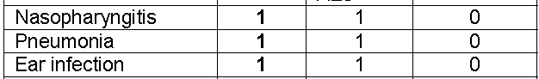
Immune system disorders
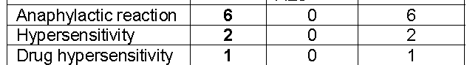
Metabolism and nutrition disorders
Psychiatric disorders
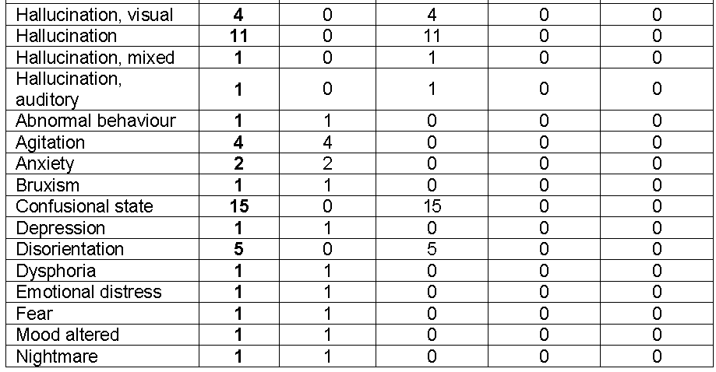
Nervous system disorders
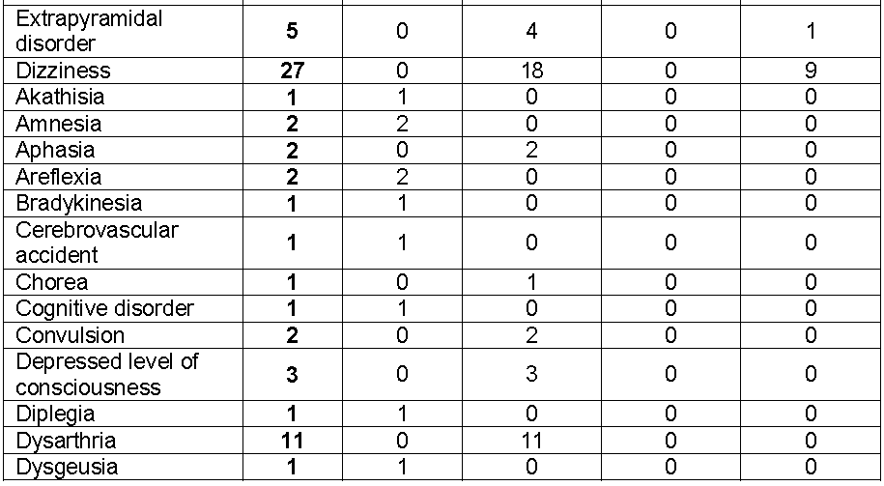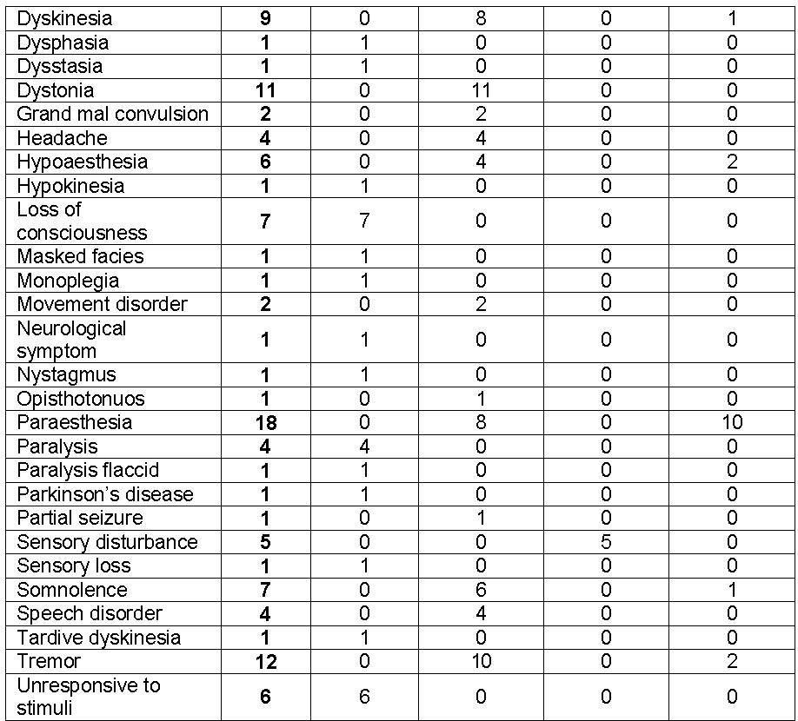
Eye disorders
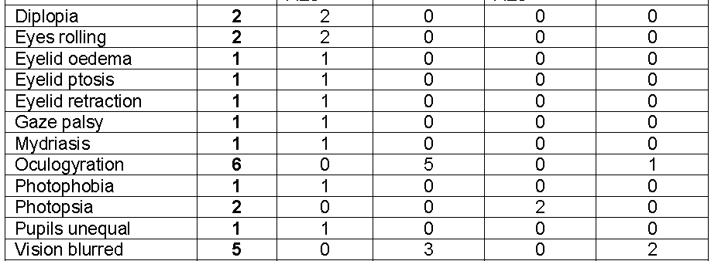
Ear and labyrinth disorders
Cardiac disorders
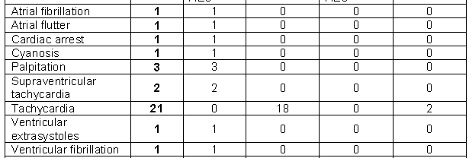
Vascular disorders

Respiratory, thoracic and mediastinal disorders
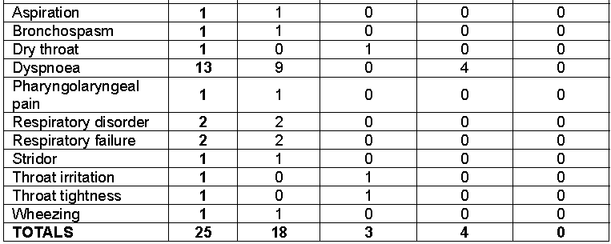
Gastrointestinal disorders
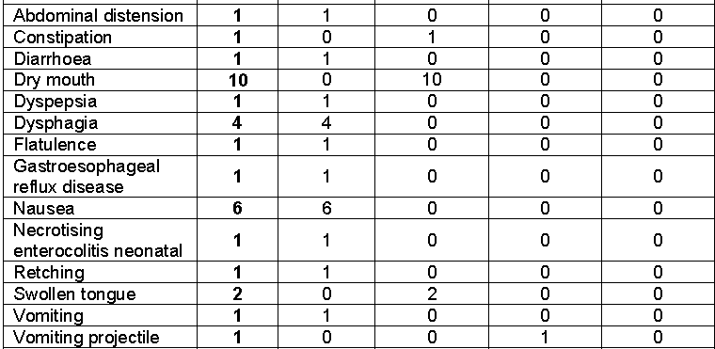
Hepatobiliary disorders
Skin and subcutaneous tissue disorders
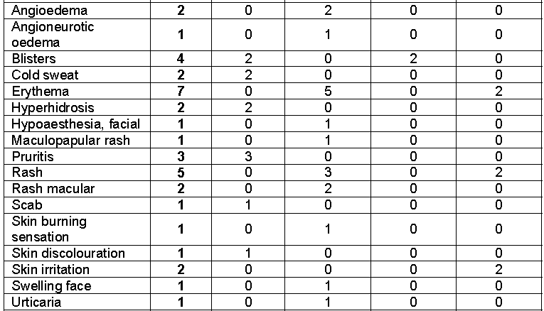
Musculoskeletal and connective tissue disorders
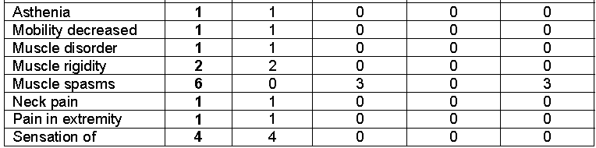
Renal and urinary disorders
Pregnancy, puerperium and peri natal disorders
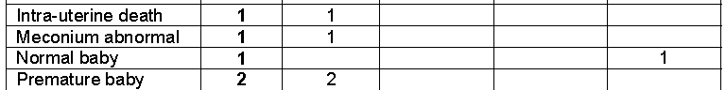
Reproductive system and breast disorders
General disorders and administration site conditions
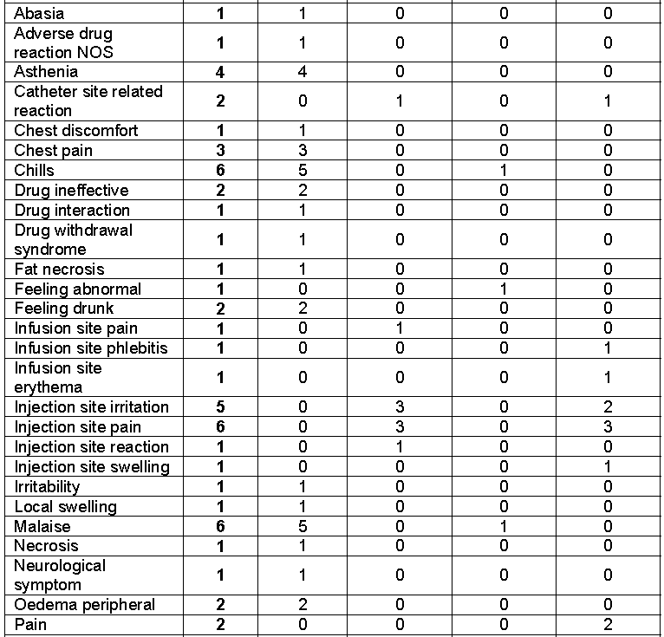
Investigations
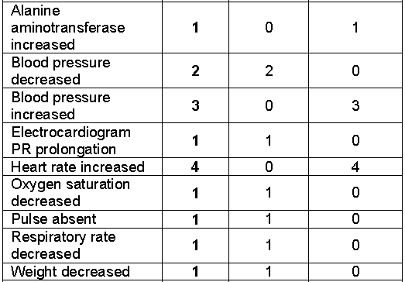
Injury, poisoning and procedural complications
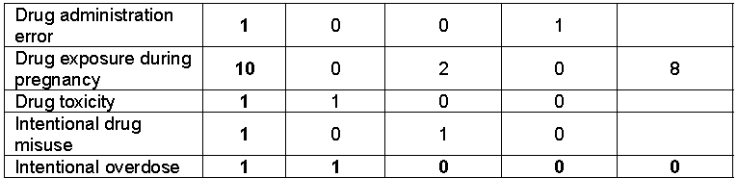
Surgical and medical procedures


Appendix II
Immune system disorders


Psychiatric disorders
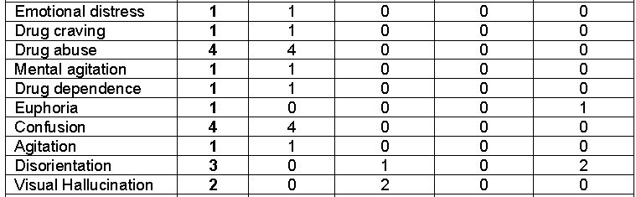

Nervous system disorders
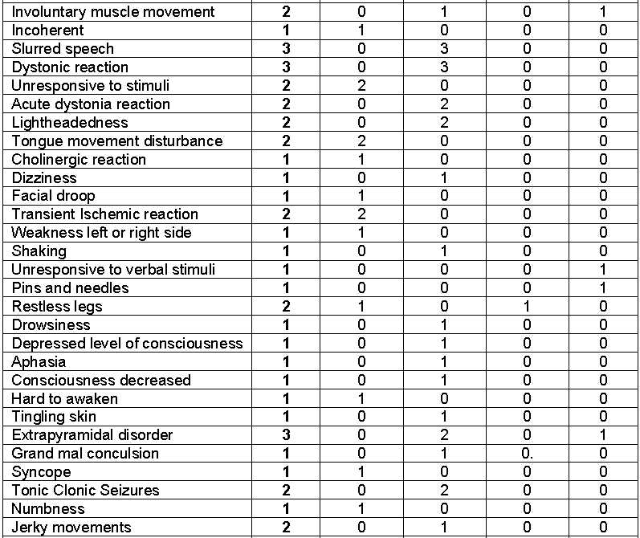
Eye disorders
Cardiac disorders
Vascular disorders
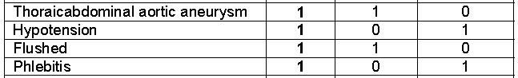
Respiratory, thoracic and mediastinal disorders
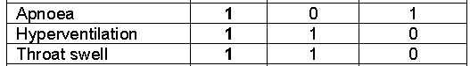
Gastrointestinal disorders
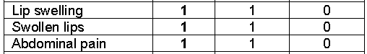
Skin and subcutaneous tissue disorders

Musculoskeletal and connective tissue disorders
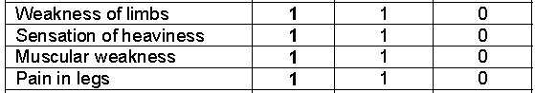
Pregnancy, puerperium and peri natal disorders
General disorders and administration site conditions
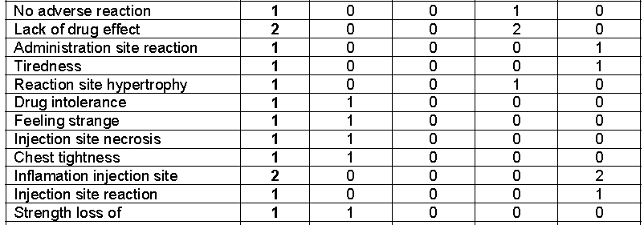
Investigations
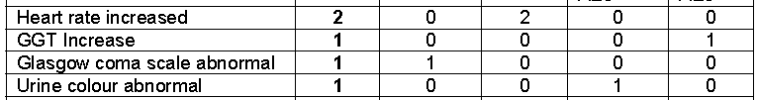

Attachment 1. Product Information
The following Product Information was approved at the time this AusPAR was published. For the current Product Information please refer to the TGA website at <http://www.tga.gov.au/hp/information-medicines-pi.htm>.

MIGRAL®, an [oral] combination product containing cyclizine, ergotamine and caffeine, was once registered in Australia but registration has since been cancelled.
A rough estimate of safety margin may be obtained by comparing relative doses expressed as mg/m² (although the administration routes differ). Thus, the 75 mg/kg dose in rats (450 mg/m²) is approximately 4.5x a clinical dose of 50 mg tid in a 50 kg individual (99 mg/m²). The NOEL (40 mg/kg) is ca 2.4x a 50 mg tid clinical dose.
This was not observed in all studies (for example, Pendse and Madan, 1969).
Diphenylmethane (M1), benzophenone (M2), benzhydrol (M3).
The need for carcinogenicity studies of pharmaceuticals. pp. 73-78 (3BS8a) of The Rules Governing Medicinal Products in the European Union - EudraLex - Medicinal products for human use, 1998 Edition: Volume 3B - Safety and the Environment
Guideline on the non-clinical documentation for mixed marketing authorisation applications, 13 October 2005.
TGA guideline on Literature Based Submissions Points to Consider, available at http://www.tga.gov.au/pdf/pm-literature-based-submissions.pdf.
All patients received ephedrine PRN; patients received cyclizine at the end of surgery, morphine was given intrathecally with fentanyl and heavy bupivacaine prior to surgery.
There was no Brock-Utne et al., 1976 among the list of references and a handwritten note on the submitted article suggests it doesn’t exist.
He et al., 2002.
Suzuki et al., 2003.
Reference describing this was not submitted.
There is evidence of the use of ephedrine as an antiemetic.
The choice of such cases for PONV studies is not unusual – they have a higher incidence and, being short and more of them, numbers are more readily recruited.
Based on the date of publication and the patient selection for day surgery, in the absence of a statement about premedication, the evaluator, based on clinical experience believes none was given in most of these later studies.
American Society of Anaesthesiologists (ASA) physical status classification system: ASA I patients are considered to be normal and healthy. ASA II patients have mild to moderate systemic disease or are healthy ASA I patients who demonstrate a more extreme anxiety and fear toward dentistry.
Overall incidence of PONV was determined by isolating patients with a nausea score of 2 or greater at any time (clinically significant PONV) and this was expressed as a percentage of the group as a whole.
The study authors state: “A full description of the methodology used in this long continuing series of clinical trials has been given by Dundee, Nicholl & Moore (1962)”, but this reference was not submitted.
The Clinical Summary (Module 2.7), page 14, states: “..the data on patients in the Hildyard et al. (2001) study were insufficient to present as pivotal data in this study. Specifically the presentation was in a non-peer reviewed Proceedings section for the…”
Not fully evaluated.
Trissel LA. Handbook on Injectable Drugs, Cyclizine Lactate. American Society of Health System Pharmacists® 12th Ed (in section 31 response)

