First Round CER report: January 2014
Second Round CER report: May 2014

AusPAR Attachment 2

Extract from the Clinical Evaluation Report for dabigatran etexilate
  - Proprietary Product Name: Pradaxa
  - Sponsor: Boehringer Ingelheim Pty Ltd

About the Therapeutic Goods Administration (TGA)
- The Therapeutic Goods Administration (TGA) is part of the Australian Government Department of Health, and is responsible for regulating medicines and medical devices.
- The TGA administers the Therapeutic Goods Act 1989 (the Act), applying a risk management approach designed to ensure therapeutic goods supplied in Australia meet acceptable standards of quality, safety and efficacy (performance), when necessary.
- The work of the TGA is based on applying scientific and clinical expertise to decision-making, to ensure that the benefits to consumers outweigh any risks associated with the use of medicines and medical devices.
- The TGA relies on the public, healthcare professionals and industry to report problems with medicines or medical devices. TGA investigates reports received by it to determine any necessary regulatory action.
- To report a problem with a medicine or medical device, please see the information on the TGA website <https://www.tga.gov.au>.
About the Extract from the Clinical Evaluation Report
- This document provides a more detailed evaluation of clinical findings, extracted from the Clinical Evaluation Report (CER) prepared by the TGA. This extract does not include CER sections regarding product documentation or post market activities.
- The words (Information redacted), where they appear in this document, indicate that confidential information has been deleted.
- For the most recent Product Information (PI), please refer to the TGA website <https://www.tga.gov.au/product-information-pi>.
Copyright
© Commonwealth of Australia 2016
This work is copyright. You may reproduce the whole or part of this work in unaltered form for your own personal use or, if you are part of an organisation, for internal use within your organisation, but only if you or your organisation do not use the reproduction for any commercial purpose and retain this copyright notice and all disclaimer notices as part of that reproduction. Apart from rights to use as permitted by the Copyright Act 1968 or allowed by this copyright notice, all other rights are reserved and you are not allowed to reproduce the whole or any part of this work in any way (electronic or otherwise) without first being given specific written permission from the Commonwealth to do so. Requests and inquiries concerning reproduction and rights are to be sent to the TGA Copyright Officer, Therapeutic Goods Administration, PO Box 100, Woden ACT 2606 or emailed to <tga.copyright@tga.gov.au>.

Contents
List of abbreviations 5
1. Introduction 7
2. Clinical rationale 8
3. Contents of the clinical dossier 8
3.1. Scope of the clinical dossier 8
3.2. Paediatric data 9
3.3. Good clinical practice 9
4. Pharmacokinetics 10
4.1. Studies providing pharmacokinetic data 10
4.2. Summary of pharmacokinetics 10
4.3. Evaluator’s overall conclusions on pharmacokinetics 14
5. Pharmacodynamics 14
5.1. Studies providing pharmacodynamic data 14
5.2. Summary of pharmacodynamics 14
5.3. Evaluator’s overall conclusions on pharmacodynamics 16
6. Dosage selection for the pivotal studies 16
7. Clinical efficacy 17
7.1. Indication 1: Treatment of acute deep vein thrombosis (DVT) and/or pulmonary embolism (PE) and prevention of related death 17
7.2. Indication 2: Prevention of recurrent deep vein thrombosis (DVT) and/or pulmonary embolism (PE) and related death 46
8. Clinical safety 66
8.1. Studies providing evaluable safety data 66
8.2. Patient exposure 68
8.3. Adverse events 72
8.4. Laboratory tests 92
8.5. Post-marketing experience 98
8.6. Safety issues with the potential for major regulatory impact 98
8.7. Other safety issues 99
8.8. Evaluator’s overall conclusions on clinical safety 99
9. First round benefit-risk assessment 101
9.1. First round assessment of benefits 101
9.2. First round assessment of risks 101
9.3. First round assessment of benefit-risk balance 101
10. First round recommendation regarding authorisation 102
11. Clinical questions 103
11.1. Pharmacokinetics 103
11.2. Pharmacodynamics 103
11.3. Efficacy 103
11.4. Safety 104
12. Second round evaluation 104
12.1. Pharmacokinetics 104
12.2. Pharmacodynamics 105
12.3. Efficacy 105
12.4. Safety 107
13. Second round benefit-risk assessment 107
13.1. Second round assessment of benefits 107
13.2. Second round assessment of risks 107
13.3. Second round assessment of benefit-risk balance 107
14. Second round recommendation regarding authorisation 107
15. References 108

List of abbreviations
Abbreviation | Meaning
ACS | Acute Coronary Syndrome
AE | Adverse Event
ANOVA | Analysis of Variance
aPTT | Activated Partial Thromboplastin Time
AUC | Area Under Curve
BMI | Body Mass Index
CI | Confidence interval
CL | Clearance
C_{max} | Peak (or maximum) concentration
CRBE | Clinically Relevant Bleeding Event
CrCl | Creatinine Clearance
CRP | C-Reactive Protein
CUS | Compression Ultrasonography
CV | Coefficient of Variation
DE | Dabigatran Etexilate
DVT | Deep Vein Thrombosis
ECG | Electrocardiogram
ECT | Ecarin Clotting Time
GCP | Good Clinical Practice
gMean | Geometric Mean
INR | International Normalised Ratio
KM | Kaplan-Meier
LMWH | Low Molecular Weight Heparin
MBE | Major Bleeding Event
NSAID | Non-Steroidal Anti-Inflammatory Drug
OR | Odds Ratio
PE | Pulmonary Embolism
PD | Pharmacodynamic
P-gp | P-glycoprotein
PK | Pharmacokinetic
POC | Point-of-Care (testing)
PPI | Proton Pump Inhibitor
PPS | Per Protocol Set
PT | Preferred Term
SAE | Serious adverse event
SD | Standard Deviation
sec | seconds
SOC | System Organ Class
T½ | Half-life of drug elimination
UFH | Unfractionated Heparin
ULN | Upper Limit of Normal
VTE | Venous Thromboembolism
WF | Warfarin

Introduction
This is a submission to extend the indication for Dabigatran etexilate (DE) to include the treatment of acute deep vein thrombosis (DVT) and/or pulmonary embolism (PE), as well as to prevent the recurrence of venous thromboembolism (VTE) and its associated morbidity.
No change in the drug formulation or presentation is proposed.
Dabigatran etexilate is a small molecule pro-drug, which does not exhibit pharmacological activity. After oral administration, DE is absorbed and converted to the active drug, dabigatran by esterase catalysed hydrolysis in the plasma and liver. DE is a member of the Antithrombotic drug class (ATC code: B01AE07). Dabigatran is a direct thrombin inhibitor, which competitively and reversibly inhibits both free and fibrin-bound thrombin, preventing the conversion of fibrinogen to fibrin, thereby preventing thrombus formation. In addition, thrombin induced platelet aggregation is inhibited.
The current approved therapeutic indications in Australia for DE are:
Prevention of venous thromboembolic events in adult patients who have undergone major orthopaedic surgery of the lower limb (elective total hip or knee replacement).
Prevention of stroke and systemic embolism in patients with non-valvular atrial fibrillation and at least one additional risk factor for stroke.
The sponsor proposes 2 additional indications for DE:
Treatment of acute deep vein thrombosis (DVT) and/or pulmonary embolism (PE) and prevention of related death.
Prevention of recurrent deep vein thrombosis (DVT) and/or pulmonary embolism (PE) and related death.
Dosage forms and strengths
The following dosage forms and strengths are currently registered in Australia: capsules containing 75 mg, 110 mg and 150 mg of DE. No new dosage forms or strengths are proposed in this submission.
Dosage and administration
For the proposed indication of VTE treatment, the recommended daily dose of DE is 300 mg taken orally as 150 mg capsules twice daily following parenteral anticoagulation for at least 5 days. Treatment should be continued for 6 months.
For the proposed indication of prevention of recurrent VTE, the recommended daily dose of DE is 300 mg taken orally as 150 mg capsules twice daily. Treatment should be continued life-long depending on the individual patient risk.
For both proposed indications, the dosing recommendations state “The presence of the following factors may increase the risk of bleeding: for example age ≥ 75 years, moderate renal impairment (CrCL 30 - 50 mL/min) or previous gastrointestinal bleed (see Precautions, Haemorrhagic risk). No dose adjustment is necessary for patients with single risk factors. Limited clinical data is available for patients with multiple risk factors. In these patients, DE should only be given if the expected benefit outweighs bleeding risks.”

Clinical rationale
Venous thromboembolism (VTE) is a common disorder which remains a major cause of morbidity and mortality in Australia, and internationally. It is estimated that the annual Australian incidence of VTE is 18,248 cases, comprised of 11,340 cases of PE and 6908 cases of DVT (Access Economics, 2008). The condition may clinically present as DVT, PE or both concurrently. DVT and PE are considered to be 2 different but overlapping clinical presentations of the same pathologic process. Thrombus extension, recurrence of disease and fatal PE are the most important sequelae of VTE. The incidence of VTE varies substantially with subject age. In those < 40 years of age, the incidence is approximately 1 in 1000, but the disease occurrence rises with increasing age. It is estimated that 1 in 100 people over the age of 80 years will experience VTE. In those who have suffered a VTE episode, the risk of recurrence within 8 years is approximately 30%. In general, the risk of recurrence decreases with time and is influenced by factors such as whether or not the index VTE event was provoked (for example recent surgery or immobilisation) or not, as well as the presence of risk factors for recurrence (for example thrombophilia).
Current acute management of patients with VTE consists of initial treatment for 5 to 7 days with usually a heparin based therapy such as Unfractionated Heparin (UFH) or Low Molecular Weight Heparin (LMWH), followed by 3 to 12 months of anticoagulant therapy, typically oral vitamin K antagonists such as warfarin (WF). Alternatively some patients may receive ongoing treatment with subcutaneously administered LMWH as an alternative to oral anticoagulation. Treatment with warfarin may be difficult for several reasons such as the drug’s delayed onset of antithrombotic effect, narrow therapeutic index, variable pharmacological response, interaction with other medicines and the need for regular laboratory monitoring. Additionally, warfarin therapy may be complicated by clinically significant bleeding events in up to 7% of patients. Hence, there is clinical need for additional oral anticoagulant therapies to provide alternative therapeutic options.
Dabigatran etexilate is the oral pro-drug of dabigatran. The pro-drug has no anticoagulant activity. Dabigatran is a direct thrombin inhibitor with a relatively rapid onset of action, and an acceptable efficacy and safety profile in treating patients with 2 current approved indications in Australia, without the need for routine laboratory monitoring. These characteristics make it an appealing candidate to investigate further for potential use in the treatment and prevention of recurrence of VTE.

Contents of the clinical dossier
The submission contains 2 pivotal controlled trials (Studies 1160.53 and 1160.46) supporting the requested indication for the treatment of VTE. Study 1160.46 was designed to replicate Study 1160.53. In addition, there are 2 pivotal studies (1160.47 and 1160.63) supporting the requested indication of prevention of recurrent VTE. One of the VTE prevention trials (Study 1160.63) included an observational follow up period for 12 months. The final clinical study reports for all 4 pivotal studies were provided in this submission.

Scope of the clinical dossier
The submission contained the following clinical information:
- 1 new clinical pharmacology sub-study (data derived from Study 1160.53) which provided Pharmacokinetic (PK) and Pharmacodynamic (PD) data in the target patient population.
- No new population PK analyses.
- 4 pivotal efficacy/safety studies – as summarised in Table 1.
- No new dose-finding studies.
- Pooled efficacy analyses of the active controlled studies (1160.53 and 1160.46) supporting the indication of acute treatment of VTE; and a pooled efficacy analysis of the 2 pivotal trials, supporting the prevention of recurrent VTE (Studies 1160.47 and 1160.63).
The submission also included a Clinical Overview, Summary of Clinical Pharmacology, Summary of Clinical Efficacy, Summary of Clinical Safety and literature references.

Table 1: Overview of the 4 pivotal studies for VTE treatment and secondary prevention contained in this submission.
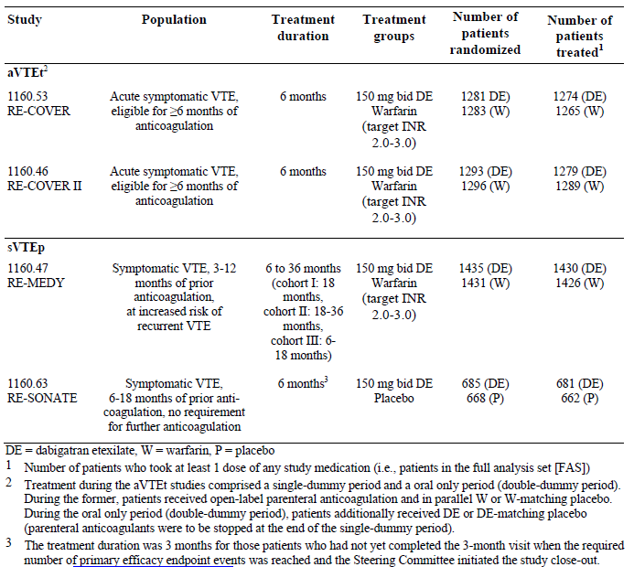

Paediatric data
The submission did not include paediatric data.

Good clinical practice
All of the studies in the DE clinical development program for the treatment and prevention of VTE were conducted in accordance with the principles of Good Clinical Practice (GCP) and compliance with ethical requirements was met.

Pharmacokinetics

Studies providing pharmacokinetic data
In support of this application, 1 of the pivotal studies (1160.53) collected a limited quantity of Pharmacokinetic (PK) data in the target patient population.

Summary of pharmacokinetics
The information in the following summary is derived from conventional PK studies in humans. The following information is derived from the sponsor’s summaries as well as the currently approved product information.
Dabigatran etexilate is a small molecule pro-drug which does not have any pharmacological activity. After oral ingestion, DE is rapidly absorbed and converted to the active drug, dabigatran, by esterase catalysed hydrolysis in plasma and in the liver. Dabigatrin is a competitive and reversible direct thrombin inhibitor. C_{max} is reached within 1 to 2 hours following oral administration. C_{max} and the Area Under the plasma concentration time Curve (AUC) are dose proportional. Absolute bioavailability of dabigatrin following oral administration is approximately 6.5% (range: 3 to 7%). The low bioavailability is due to its physiochemical properties which include poor solubility at a gastric pH > 3.0, and its absorption limiting transport out of enterocytes by P-glycoprotein (P-gp). DE is a moderate affinity substrate for P-gp, but the active drug (dabigatran) is not. The apparent volume of distribution at steady state in adults is 60 to 70 L indicating moderate tissue distribution. Dabigatran exhibits low (35%) concentration independent binding to human plasma proteins. Dabigatran demonstrates a biexponential decline with the mean terminal half-life (T½) being 12 to 14 hours in elderly healthy volunteers and 14 to 17 hours in those undergoing major orthopaedic surgery. T½ is independent of dose. Dabigatran is primarily eliminated by glomerular filtration. The use of DE is contraindicated in patients with severe renal impairment (estimated Creatinine Clearance (CrCL) < 30 mL/min) as the exposure (AUC) to DE is approximately 6 times higher and the T½ is approximately 2 times longer than that observed in subjects without renal impairment. In subjects with moderate renal insufficiency (CrCL 30 to 50 mL/min) the dose of DE should be reduced as the AUC increases by approximately 3 fold and T½ is extended to a mean of 18 hours. In elderly subjects (> 65 years of age), the dose of DE should be reduced, as the AUC is approximately 2 times in higher than in subjects of 18 to 40 years of age.
Because only the pro-drug DE is a substrate for P-gp, its absorption from the gastrointestinal tract can be altered by P-gp inducers or inhibitors during its passage through enterocytes. However, once DE has been absorbed and converted to the active moiety (dabigatran) it is no longer susceptible to P-gp substrates. There is a potential for drug interactions with DE based on P-gp interactions. The concurrent administration of potent P-gp inhibitors such as quinidine should be avoided, as the AUC of dabigatrin will increase 2 fold. In addition, care should be taken with the concurrent use of DE with other P-gp inhibitors such as oral verapamil, ketoconazole, HIV protease inhibitors, amiodarone and dronedarone. These P-gp inhibitors result in variable increases in dabigatran AUC by 50 to 200%, primarily as a consequence of increased absorption of the pro-drug DE. Conversely, strong P-gp inducers such as rifampicin, tipranivir and St John’s Wort can result in significant decreases in the AUC of dabigatrin by up to 65%.

Pharmacokinetics in the target population
Study 1160.53 was a randomised, double blind, parallel group, active controlled trial with a planned duration of 6 months of treatment comparing fixed dose DE (150 mg bid) with warfarin (target INR 2.0 to 3.0). Patients received DE (or matching placebo capsules) after an initial minimal treatment period of 5 days with an approved parenteral anticoagulant (usually heparin).
In Study 1160.53, scheduled samples for the assessment of PK parameters were to be collected at Visits 4 (Day 30) and 9 (Day 180). The PK analysis only included blood samples for trough drug concentrations taken within 10 to 16 hours after the previous DE or DE placebo dose. In addition, unscheduled blood samples were to be collected for the determination of plasma concentrations as soon as symptomatic VTE, Major Bleeding Events (MBE), or acute renal failure was suspected. For the analysis, only centrally confirmed clinical events were considered, and unscheduled samples were taken into account that had been collected within 14 days of the event onset date. The concentrations of total dabigatran in plasma were analysed using a validated HPLC-MS method, which was described in this submission.
A total of 2539 subjects were documented to have received at least 1 dose of study medication in Study 1160.53, which included 1273 patients in the DE group (who also took matching placebo warfarin tablets), and 1266 subjects in the warfarin arm (who also took matching DE placebo capsules). Approximately two thirds (66.8%; 850 out of 1273) of patients in the DE group had trough plasma concentrations of total dabigatran at Visit 4 (Day 30), and more than half (58.6%; 743 out of 1273) of subjects had values collected at Visit 9 (Day 180). The median trough plasma concentrations of total dabigatran for patients in the DE group were stable over the treatment period (Visit 4: 58.7 ng/mL; and Visit 9: 60.2 ng/mL), but demonstrated high inter-individual variability (CV% at Visit 4 was 79.7, and at Visit 9 was 90.3%). Plotting the individual trough concentrations at Visit 4 versus values at Visit 9 showed those patients’ trough concentrations at the 2 visits was closely related. The intra individual ratio of trough concentrations at the 2 visits was 100.99% (90% CI 96.66%, 105.52%).

Trough concentrations by demographic characteristics
Trough plasma concentrations of total dabigatran were investigated in patient subgroups. At Visit 4 (30 days), female patients had higher trough concentrations of total dabigatran than male subjects – refer to Table 2 (data presented by geometric mean (gMean) trough plasma concentrations of total dabigatran). Trough concentrations increased with increasing age (gMean of 43.3 ng/mL for 18 to < 40 years of age versus gMean of 121 ng/ML for subjects aged ≥ 75 years). In addition, patients with a CrCL of < 50 mL/min had higher trough concentrations of total dabigatran (gMean 170 ng/mL) compared to those with CrCL of 50 to 80 mL/min (gMean 85.8 ng/mL) and subjects with CrCL ≥ 80 mL/min (gMean 50.5 ng/mL). The mean changes observed in total dabigatran trough concentrations for subjects with renal impairment in Study 1160.53 is highly comparable to that reported in the patient subgroups of the RE-LY Study (pivotal study for atrial fibrillation indication). Body weight also had a minor influence upon trough levels.

Table 2: Trough plasma concentrations of total dabigatran at Visit 4 in Study 1160.53 by demographic characteristics.
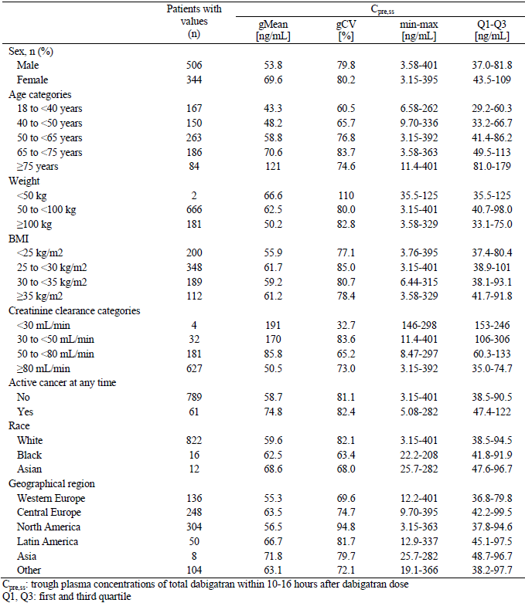

Trough concentrations by concurrent medications
Trough plasma concentrations of total dabigatran were investigated in subjects who were taking medicines of special interest (verapamil, amiodarone and other P-gp inhibitors) with DE. At Visit 4 (30 days), only 27 patients (3.2% of 850) were taking P-gp inhibitors, the most common co medication being verapamil (n = 14). The concomitant use of verapamil was associated with an increased gMean dabigatran trough concentration (82.4 ng/mL) compared to those not taking verapamil (59.4 ng/mL). At Visit 9 (180 days) 11 patients were receiving concurrent verapamil and similarly the concomitant use of verapamil was associated with an increased gMean dabigatran trough concentration (97.3 ng/mL) compared to those not taking verapamil (59.1 ng/mL). In addition the concurrent use of concomitant verapamil and DE increases the inter subject variability. For example, the 10th to 90th percentile gMean trough concentrations at Visit 4 ranged from 41.3 to 283 ng/mL (versus 26.1 to 145 ng/mL in those not taking verapamil). Only 3 patients at Visit 4 and 2 subjects at Visit 9 were taking concurrent amiodarone, and the gMean dabigatran concentrations for patients with or without amiodarone were similar (albeit very small patient numbers). Only 1 subject was taking concurrent rifampicin in Study 1160.53 and the trough concentration of total dabigatran was slightly lower than expected at Day 30 being 45.3 ng/mL.
Because DE requires an acidic environment for dissolution and absorption, the concurrent use of proton pump inhibitor (PPI) drugs has been shown to be associated with reduced dabigatran AUC and C_{max} because of reduced oral bioavailability. However in Study 1160.53 the PK analysis of those taking concurrent PPI compared to those not receiving concomitant PPI showed no differential effect on median trough levels of total dabigatran at both Visits 4 and 9. At Visit 4 this PK analysis involved 848 patients (742 without PPI, and 106 receiving concurrent PPI) and at Visit 9 the analysis involved 745 subjects (658 without PPI, and 87 receiving concurrent PPI).

Trough concentrations by event occurrence
Trough plasma concentrations of total dabigatran were investigated in subjects who experienced recurrent VTE (that is therapeutic failure) and bleeding events (significant toxicity). The gMean trough concentrations were comparable between patients with (57.1 ng/mL) and without (59.8 ng/mL) recurrent VTE (as shown in Table 3). For 1 patient who died of a PE and who had an available PK value the trough dabigatran concentration at Visit 4 was 116 ng/mL.

Table 3: Trough plasma concentration at Visit 4 in Study 1160.53 by event occurrence.
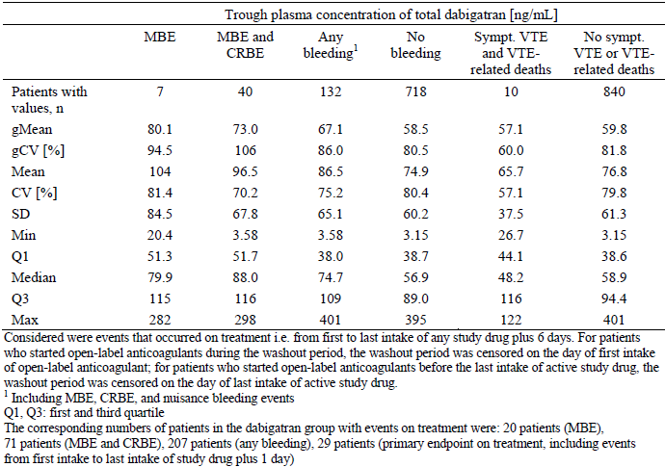
The rate of MBE and any bleeding tended to increase with the plasma concentration of total dabigatran. However, there were relatively few patients with MBE (and any bleeding) that also had PK sampling done at the correct time, so the 95% CIs were very wide. The odds ratio (OR) for patients experiencing MBE versus patients without MBE was 7.09 (95% CI 1.00, 50.44) for a 10 fold increase in the trough concentration of dabigatran. For any bleeds, the OR of patients with and without event was 1.90 (95% CI 1.10, 3.28) for a 10 fold increase in the trough concentration. Unfortunately, very few patients had events that occurred on treatment and also an unscheduled PK sample collected. The mean (SD) dabigatran concentration was 22.93 (14.14) ng/mL in patients with symptomatic DVT (n = 4), 37.83 (23.24) ng/mL in patients with symptomatic PE (n = 3), and 127.87 (166.05) ng/mL in patients with MBE (n = 5). Two patients developed acute renal failure with collected PK sampling. The total dabigatran concentrations in these patients were 204 ng/mL (CrCL was 32.1 mL/min at the time of the PK sampling) and 10.4 ng/mL (CrCL was 158.8 mL/min, that is hyperfiltrating at the time of the PK sampling). Three patients (2 in the DE group and 1 in the warfarin arm) experienced MBE with concomitant P-gp inhibitor use. One of the DE treated patients experienced an MBE 1 month after completing a 7 day course of clarithromycin. For the other DE-treated patients, there was no apparent temporal relationship between use of the P-gp inhibitor and the MBE. This subject had an MBE 4 months prior to starting tacrolimus.

Evaluator’s overall conclusions on pharmacokinetics
The PK properties of DE in healthy volunteers, and adult subjects undergoing orthopaedic surgery or with atrial fibrillation have been previously assessed. The sponsor has provided a limited quantity of new PK data (trough DE concentrations collected at Days 30 and 180 of treatment) in this submission for patients with the additional treatment indication of treatment of VTE. The sponsor is proposing two minor changes to the PK section of the current PI: insertion of PK data from Study 1160.53 regarding increased drug exposure in patients with renal impairment, and an insert explaining the exclusion of patients from Study 1160.53 who had moderate or severe hepatic impairment at baseline.
The key PK findings for DE use in adult patients with VTE are:
- Plasma trough concentrations of dabigatran are stable over a time period extending from Day 30 to Day 180, but exhibit high inter individual variability
- Subjects with renal impairment (CrCL < 50 mL/min) have significantly higher trough total dabigatran concentrations indicating a higher drug exposure
- Trough dabigatran concentrations at 30 days are higher in females compared to men, and in older subjects (aged > 75 years) versus younger patients (< 40 years of age)
- Plasma trough levels of dabigatran are higher with the concomitant use of verapamil (P-gp inhibitor) and DE; and
- Overall there is some limited PK data to support a relationship between higher dabigatran plasma concentrations and bleeding events; however a potential relationship between lower dabigatran concentrations and recurrent VTE is not established.

Pharmacodynamics

Studies providing pharmacodynamic data
In support of this application, 1 of the pivotal studies (1160.53) collected a limited quantity of Pharmacodynamic (PD) data in the target patient population.

Summary of pharmacodynamics
The information in the following summary is derived from conventional PD studies in humans. The following information is derived from the sponsor’s summaries, as well as the currently approved product information.

Mechanism of action
Dabigatran is a direct thrombin inhibitor, which competitively and reversibly inhibits both free and fibrin bound thrombin, preventing the conversion of fibrinogen to fibrin, thereby preventing thrombus formation. In addition, thrombin induced platelet aggregation is inhibited.
There is a correlation between plasma dabigatran concentration and the degree of anticoagulant effect. Prothrombin Time is an insensitive way to reliably predict the anticoagulant activity of dabigatran. Ecarin Clotting Time (ECT) is a sensitive assay that increases in direct proportion to dabigatran plasma concentration. However, ECT is not readily available in clinical practice. Activated Partial Thromboplastin Time (aPTT) increases in a non-linear manner with dabigatran plasma concentration, but deviates from linearity at higher dabigatran concentrations.

Pharmacodynamic effects
In Study 1160.53, scheduled samples for the assessment of PD (coagulation) parameters were to be collected at Visits 4 (Day 30) and 9 (Day 180). The coagulation parameters of interest were aPTT and ECT. The coagulation parameters of aPTT and ECT were analysed using a validated methodology, which was described in this submission. In Study 1160.53, the relationship between trough drug concentrations, coagulation parameters and clinical events (recurrent VTE, MBE and acute renal failure) was explored. Additionally, unscheduled blood samples were to be collected for the determination of coagulation parameters as soon as symptomatic VTE or MBE occurred. For this analysis, only centrally confirmed clinical events were considered, and unscheduled samples were taken into account that had been collected within 14 days of the event onset date.
A total of 2539 subjects were documented to have received at least 1 dose of study medication in Study 1160.53, which included 1273 patients in the DE group (who also took matching placebo warfarin tablets), and 1266 subjects in the warfarin arm (who also took matching DE placebo capsules). Approximately two thirds (67.2%; 855 out of 1273) of patients in the DE group had trough plasma concentrations of total dabigatran at Visit 4 (Day 30), and more than half (59.3%; 755 out of 1273) of subjects had values collected at Visit 9 (Day 180). The gMean trough aPTT for DE treated subjects at Visit 4 (45.5 sec) were comparable to those recorded at Visit 9 (44.5 sec). The aPTT results exhibited moderate inter individual variability with the gCV% in the range of 27 to 32%.
In comparison, patients in the warfarin group had a slightly shorter gMean trough aPTT of approximately 40 sec. In total, 48 DE treated patients were noted to have high aPTT values exceeding 120 sec. It was checked whether these patients had used open label anticoagulants up to 24 hours before sampling as a possible explanation for the unexpectedly high aPTT value. Among the 48 patients only 1 such patient was identified. This patient had inadvertently taken warfarin, but did not suffer a bleeding event or other AE in the trial. The gMean trough ECT in the DE group was 50.3 seconds at Visit 4, and 50.2 seconds at Visit 9. The inter-individual variability (gCV) of ECT values was smaller (CV% approximately 30%) than the inter-individual variability in trough plasma concentrations of total dabigatran, and comparable to the variability seen for aPTT. The gMean trough ECT in the warfarin treatment group was shorter than in the DE treated subjects (37.6 sec at Visit 4; and 37.7 sec at Visit 9). For both aPTT and ECT, higher results were observed for patients with demographic characteristics (females, older age, impaired renal function) known to affect the plasma concentration of total dabigatran. As there is a good correlation between drug exposure (AUC) and the degree of anticoagulant effect, this finding is expected.
Very few patients had an event that occurred on treatment with an appropriately collected unscheduled PD sample. The mean (SD) aPTT was 33.83 (5.39) sec in patients with symptomatic DVT (n = 4), 36.75 (7.29) sec in patients with symptomatic PE (n = 4), and 72.35 (49.53) seconds in patients with MBE (n = 6). For 2 patients with acute renal failure, the aPTT was 37.2 and 30.3 sec. The mean (SD) ECT was 35.70 (6.10) sec in patients with symptomatic DVT, 36.38 (5.89) sec in patients with symptomatic PE, and 71.42 (53.84) sec in patients with MBE. The ECT was 45.0 sec and 29.9 sec in the 2 patients with acute renal failure.
The data examining the relationship between the plasma concentration of total dabigatran and aPTT, as well as ECT, was fitted to regression models. There was a non-linear correlation between aPTT and the plasma concentration of total dabigatran, but a linear relationship between ECT and the plasma concentration of total dabigatran.

Evaluator’s overall conclusions on pharmacodynamics
In this submission, the sponsor has provided a limited quantity of new PD data (aPTT and ECT results collected at Days 30 and 180 of treatment; as well at unscheduled times for those with specified clinical events) in the target patient population. The newly presented PD data does not demonstrate any new or unexpected PD findings or associations that have not been previously presented. The gMean trough aPTT and ECT values are stable over an extended treatment period of 30 to 180 days, and exhibit moderate inter subject variability. Differences in the gMean trough aPTT and ECT are consistent with the differences observed for plasma concentration of total dabigatran in the investigated patient subgroups. There is some PD data to suggest a possible relationship between higher aPTT and ECT results and bleeding events but it remains unclear whether or not low aPTT and ECT values are associated with recurrent VTE (that is therapeutic failure). The sponsor does not propose any changes to the current PD section of the PI.

Dosage selection for the pivotal studies
No specific dose finding studies have been performed for patients with VTE. The dose and administration frequency of DE used in the 4 pivotal VTE studies, and proposed by the sponsor for licensing, has been extrapolated from the posology approved for use to reduce the risk of stroke and systemic embolism in adult patients with atrial fibrillation. The sponsor asserts that the totality of the clinical efficacy and safety data collected in those preceding trials (and approved in previous submissions), supplemented with PK and anticoagulation biomarker data, provides a clear justification for examining the dose selected for the VTE indication (DE 150 mg, given twice daily). Dose selection for the first pivotal trial in this submission (Study 1160.53) was additionally supported by 2 dose finding studies performed in patients with atrial fibrillation. One of these dose finding trials (PETRO) was completed before the trial protocol for Study 1160.53 was written, and the other dose finding trial (PETRO-EX) was ongoing at the time of writing. The sponsor also states that the target population in the additional VTE indications have similar demographic and disease characteristics to those with atrial fibrillation. Furthermore, DE 150 mg twice daily is now approved in > 70 countries for the treatment of atrial fibrillation. Overall, the posology of DE used in the 4 pivotal studies contained in this submission has been reasonably justified by extrapolation.
In 3 of the 4 pivotal studies in this submission (1160.53, 1160.46 and 1160.47), warfarin with a target INR range of 2.0 to 3.0 was the active comparator treatment. This is consistent with contemporary clinical practice in Australia. One of those 3 trials (Study 1160.47) focussed on the secondary prevention of VTE in patients at high risk of recurrence. In the 4th trial in this submission (Study 1160.63) there was no active comparator. This trial was a superiority study examining the efficacy and safety of DE versus placebo over the long term (up to 18 months) in the secondary prevention of recurrent VTE in patients at high risk of relapse. This is an appropriate inclusion as part of the overall study program in VTE. Although several well designed studies have shown that follow up oral anticoagulation therapy with vitamin K antagonists (like warfarin) reduce the risk of recurrent VTE for the duration of therapy, there is a lack of scientific clarity on the optimal duration of secondary prevention and the overall benefit: risk assessment of treatment over extended time frames. The use of a placebo comparator was considered justified given the uncertain scientific evidence for management in this clinical scenario at the time of protocol development and patient recruitment.

Clinical efficacy

Indication 1: Treatment of acute deep vein thrombosis (DVT) and/or pulmonary embolism (PE) and prevention of related death

Pivotal efficacy studies

Study 1160.53 (also known as the RE-COVER Study)

Study design, objectives, locations and dates
Study 1160.53 was a Phase III, randomised, double blind, double dummy, parallel group, active controlled trial with a planned duration of 6 months of treatment, comparing fixed dose DE (150 mg bid) with warfarin (target INR 2.0 to 3.0). The objective of the study was to compare the efficacy and safety of DE and warfarin for a 6 month treatment period of acute symptomatic VTE following initial treatment (5 to 10 days) with an approved parenteral anticoagulant for this indication. The treatment period was preceded by a screening phase of 1 to 3 day’s duration. Confirmation of the index VTE episode by objective clinical testing was to be obtained prior to or not longer than 72 hours after enrolment but prior to randomization.
The active treatment period was of 6 months duration and had 2 phases: an initial single dummy period whereby patients received open label parenteral therapy plus blinded oral therapy with either warfarin or warfarin placebo; followed by a second part which consisted of a double dummy period of blinded oral therapy with either DE or DE placebo. Treatment with warfarin or warfarin placebo was continued in the double dummy phase, and the dose was adjusted according to the patients INR (true or sham depending on treatment allocation). Follow up visits were scheduled for Days 30, 60, 90, 120, 150 and 180. In addition, patients were to be followed up for 30 days after the completion of planned study treatment (that is the end of study visit was performed at Day 210). Patients who required anticoagulation beyond the planned duration of 6 months could either be switched to standard oral anticoagulation after the last intake of trial medication, or could be enrolled into 1 of 2 DE therapy prevention studies (1160.47 or 1160.63).
Study 1160.53 was conducted between April 2006 and May 2009. A total of 231 enrolling centres (228 of which randomised subjects) in 29 countries (including North and South America, Western and Central Europe, Australia and New Zealand, South Africa, India and Israel) were involved in the trial.
There were 4 global amendments to the original protocol, the first of which was implemented before the commencement of patient recruitment. The amendments contained clarifications about INR monitoring, the avoidance of moderate or strong P-gp inhibitors (for example quinidine) as well as specific advice about the concomitant use of verapamil and guidance for the management of patients requiring surgery or invasive procedures. None of the amendments resulted in major changes to the study design which may have affected the outcome or statistical analysis.

Inclusion and exclusion criteria
To be eligible for inclusion patients had to be at least 18 years of age at the time of enrolment with acute symptomatic unilateral or bilateral DVT of the leg involving proximal veins (trifurcation area, popliteal, superficial femoral, deep femoral, common femoral and iliac veins), and/or acute symptomatic PE confirmed by definitive objective testing for whom at least 6 months of anticoagulation treatment was considered appropriate by the investigator. Appropriate objective testing included DVT detected by either venous compression ultrasonography or venography; and PE detected by either ventilation perfusion lung scan, pulmonary angiography or spiral helical CT scan. Objective confirmation of VTE was to be obtained prior to randomisation and within 72 hours of enrolment.
The exclusion criteria involved 5 domains and patients meeting any 1 of the features were to be excluded from participation:
- Diagnosis; overt symptoms of VTE for longer than 2 weeks prior to enrolment; PE with 1 of the following 4 features (haemodynamic instability, embolectomy, thrombolysis or suspected source of PE other than legs); need for anticoagulation treatment for disorders other than VTE; and pregnancy/lactation
- Excessive risk of bleeding (investigator’s judgement); haemorrhagic disorder or bleeding diathesis; trauma or major surgery within the last month; known or suspected intracranial pathology (for example neoplasm or vascular malformation); gastrointestinal haemorrhage within the past 3 months; symptomatic or endoscopically documented gastroduodenal ulcer in the previous 30 days; and history of major bleeding (for example intraocular, retroperitoneal or spinal)
- Past history; allergy to heparins, warfarin or radio opaque contrast media; alcohol or substance abuse; developed transaminase elevations upon exposure to ximelagatran; recent unstable cardiovascular disease (included uncontrolled hypertension or myocardial infarction within the last 3 months); and active liver disease (for example cirrhosis of any cause, or chronic Hepatitis B or C infection)
- Baseline results; hepatic dysfunction (defined as ALT or AST > 2 x Upper Limit of Normal (ULN)), severe renal impairment (defined as estimated CrCL ≤ 30 mL/min), anaemia (haemoglobin < 100 g/L), or thrombocytopenia (platelet count < 100 x 10⁹/L)
- Recent or concurrent treatments; anticipated need to use moderate to strong inhibitors of p-glycoprotein (for example ketoconazole, rifampicin and quinidine) during the trial; actual or anticipated use of vena caval filter; and treatment with thrombolytic agents within 14 days of enrolment.

Study treatments
All patients were expected to receive an initial 5 to 10 days of treatment with a parenteral anticoagulant therapy, expected to be heparin (that is Unfractionated Heparin (UFH) given intravenously, or Low Molecular Weight Heparin (LMWH) administered by subcutaneous injection). The single dummy period (open label parenteral therapy plus blinded oral treatment) started with randomization. During the single dummy phase, patients received the initial parenteral treatment and either warfarin or warfarin placebo (with target INR of 2.0 to 3.0). As soon as the subject had received at least 5 days of parenteral therapy and had an INR value (real or sham) of ≥ 2.0 on 2 consecutive measurements, treatment with fixed dose DE 150 mg twice daily (or DE placebo) was to be initiated. At this stage, treatment with warfarin or warfarin placebo was continued, and parenteral therapy was ceased. Patients continued to receive DE 150 mg twice daily and warfarin placebo, or DE placebo and warfarin for the remainder of the trial depending on their treatment allocation. DE capsules were to be taken with water twice daily (morning and evening).
The original protocol stipulated that DE be taken at the same time of the day (within a strict time window of 2 hours), but this advice was removed with protocol amendment 1 (that is prior to first patient involvement). The first dose of DE (or DE placebo) was to be administered within 2 hours of the time period whereby the initial parenteral therapy would have been due, or at the time of discontinuation in the case of continuous anticoagulation treatment (that is with intravenous UFH). Treatment with DE (or DE placebo) was only commenced in the double dummy period. DE has a relatively rapid onset of anticoagulant effect, and unlike warfarin has no initial procoagulant tendency, so it is appropriate to commence DE at this time point in the trial design (that is after the initial period of parenteral anticoagulation).
Treatment with warfarin or warfarin placebo was to be started on the day of randomization, unless the subject had already received an oral vitamin K antagonist on that day. Tablets were to be taken once daily, at approximately the same time each day. The first dose of warfarin was recommended to not exceed 5 mg. INR monitoring using a POC (point of Care) device was to be started immediately, and readings were taken daily until the target INR range of 2.0 to 3.0 was achieved. After a stable warfarin (or warfarin placebo) dose had been determined, INR measurements were to be performed every 1 to 4 weeks during the 6 month trial (at the investigator’s discretion). Warfarin tablets were supplied in 3 different unit strengths (1 mg, 3 mg and 5 mg), and tablets were not to be broken. Because warfarin has an initial procoagulant effect for up to 2 days after initiation (caused by blocking the activation of 2 endogenous anticoagulants, protein C and S), it is routine clinical practice to administer concurrent anticoagulation therapy (usually heparin based) until the onset of its anticoagulant effect. By commencing warfarin (or warfarin placebo to maintain the treatment blind) in the single dummy phase, the design of Study 1160.53 replicated good clinical practice.
Treatment compliance with DE (or DE placebo) was checked by the study site staff during the trial by capsule counts at scheduled visits. Over the 6 month study, the rates of non-compliance with DE (2.0%) or matching placebo DE capsules (2.5%) were low in both treatment groups. Treatment compliance with warfarin was not directly assessed but instead the INR time in range (that is the time when the INR was in the target range 2.0 to 3.0) was evaluated for the time period between the first intake of DE placebo and the last intake of warfarin. On average, 15.9 INR measurements were performed per patient in the warfarin group during the 6 month trial (median of 15 readings; range of 0 to 54 INR results). Expectedly the mean number of INR measurements was highest in the first month after randomization (8.2 readings per patient in Month 1), and decreased thereafter (1.5 to 1.9 monthly readings per patient from Months 3 to 6). In the first month, the mean percentage of time that warfarin treated patients (n = 1214) remained in the target INR range of 2.0 to 3.0 was 53.3% (14.6% of the time subjects had INR < 2.0, and 32.0% of the time patients had INR > 3.0). By 6 months (n = 1091), the mean percentage of time in the target INR range of 2.0 to 3.0 was 65.7% (18.9% of the time subjects had INR < 2.0, and 15.4% of the time patients had INR > 3.0). The frequencies of warfarin treated patients with time in the INR target range of 2.0 to 3.0 was assessed by tertile thresholds (< 52%, 52 to 71.9%, and ≥ 72%). In the first month, 49.6% (602 out of 1214) of subjects spent less than 52% of their time in the target range of 2.0 to 3.0, while 21.5% (261 out of 1214) of patients were 52 to 71.9%, and 28.9% (352 out of 1214) of subjects spent ≥ 72% of their time in the target range of 2.0 to 3.0. Over the course of the study, the proportion of subjects who spent less than 52% of the time in the target INR range progressively decreased to 34.7% (379 out of 1091) by Month 6, while the percentage of subjects with at least 72% of the time in the target INR increased (60.6% (661 out of 1091) by Month 6).
The final clinical study report and appendices did not present the variability in sham INR readings compared with the variability of real INR results in warfarin treated subjects. However, a too high INR reading led to 12 interruptions of the warfarin placebo in the DE group (0.9% of 1273) compared with 58 interruptions of warfarin in the warfarin treatment cohort (4.6% of 1266). In addition, the DE or DE placebo capsule was interrupted for too high INR result in higher proportion of warfarin treated subjects (0 interruptions for the DE group versus 13 interruptions in the warfarin arm). The inequity in this observation raises the possibility of unintentional unblinding, and a potential impact on treatment efficacy.

Efficacy variables and outcomes
The main efficacy variables were:
- Venous Thromboembolism (VTE); defined as the composite incidence of DVT (detected by either venous compression ultrasonography (CUS) or venography) and PE (detected by either ventilation perfusion lung scan, pulmonary angiography or spiral helical CT scan), and
- VTE Related Death.
The primary efficacy outcome in Study 1160.53 was the composite of recurrent symptomatic VTE and deaths related to VTE. All recurrent VTE episodes required objective verification by definitive diagnostic testing (as outlined above). An independent committee that was blinded to treatment allocation centrally adjudicated all recurrent VTE events and deaths. The central adjudication committee was composed of 3 members, and verification of VTE and/or death was based on the consensus of at least 2 of those members. VTE related death was concluded if there was evidence of PE on objective diagnostic testing or autopsy. Death that could not be attributed to documented cause (such as myocardial infarction, stroke, cancer, bleeding or an infectious etiology), and for which PE could not be ruled out was recorded as an unexplained death.
Only adjudicated results were used in the analyses. The primary efficacy outcome was assessed at 2 time points: up to Day 180 (that is end of the active treatment period) and ‘end of their post-treatment period’ (defined as up to Day 224 in those who completed the active treatment phase, or upon premature discontinuation).
Secondary efficacy outcomes in Study 1160.53 included:
- Composite of recurrent symptomatic VTE and all deaths
- Symptomatic DVT
- Symptomatic PE
- Deaths related to VTE
- All deaths
All of the secondary efficacy endpoints were assessed up to study Day 180 (that is end of the active treatment period), as well as up to the end of the post treatment period (that is up to Day 224).

Randomisation and blinding methods
Eligible patients were randomised 1:1 to either DE or warfarin within 72 hours of enrolment by a centralised process using an Interactive Voice System Response (IVRS) system. Randomisation was stratified in blocks of 4 by active cancer and symptomatic PE. This method generated 4 strata: active cancer and symptomatic PE, active cancer and no symptomatic PE, no active cancer but symptomatic PE, and neither variable being present. Active cancer was defined as the diagnosis of cancer (other than basal cell or squamous cell carcinoma of the skin) within 5 years before enrolment, any treatment for cancer within 5 years of enrolment, or recurrent or metastatic disease.
The study had a double blind design so neither the patients or investigators were informed about their treatment allocation. Since the 2 study treatments (DE and warfarin) differed in appearance, blinding was achieved using a double dummy design. Each subject received either DE capsules or matching placebo capsules, as well as either warfarin or warfarin placebo tablets. Each therapy arm was of identical physical appearance, and the packaging and labelling were the same. Warfarin tablets and the matching placebo warfarin tablets were colour coded: 1 mg tablet being brown, 3 mg tablet being blue and the 5 mg tablet was pink. INR results had to be monitored to guide warfarin dosing. A sham INR procedure was used to prevent unintentional unblinding. INR measurements were performed using a POC (Point Of Care) testing device that could provide an INR result (real or encrypted).

Analysis populations
The primary and secondary efficacy analyses were based on the Full Analysis Set (FAS), which follows the modified intention to treat principle. The FAS consisted of all randomised subjects who were documented to have received at least 1 dose of study drug. Sensitivity efficacy analyses were performed using the Per-Protocol (PPS) population. This consisted of all patients who received at least 1 dose of study drug, and excluded any patient who experienced a major protocol deviation as determined by the sponsor.

Sample size
Because Study 1160.53 used a time to event analysis, the statistical power and sample size calculations are dependent on the number of observed events. The trial planned to include 1275 patients per treatment group (that is a total number of at least 2550 subjects) to achieve a statistical power of at least 90% to claim non-inferiority with a margin of 2.75 for the Hazard Ratio (HR) of DE versus warfarin, assuming a VTE event rate of 2% in the warfarin arm over a 6 month period. The VTE rate of 2% for warfarin was based on the results in published active controlled studies using heparin followed by warfarin for 3 to 6 months (THRIVE and MATISSE studies). For the DE treatment group, a VTE event rate of 2%, and an overall dropout rate of 20%, during 6 months of therapy were assumed.

Statistical methods
The primary statistical analysis was a test for non-inferiority of DE versus warfarin. If non-inferiority was confirmed, then the superiority of DE versus warfarin for the primary efficacy endpoint was to be assessed. Two non-inferiority margins were pre specified: 2.75 for the HR (observed during the trial, including the post treatment follow up period) and 3.6% for the risk difference at 6 months (that is 180 days). By requiring that both non-inferiority margins were achieved in the primary efficacy analysis, the result was demonstrating that DE preserved at least 57% of the warfarin effect versus placebo with regard to the HR, and at least 75% of the warfarin effect versus placebo with regard to the risk difference, both based on the upper bounds of the 95% CIs. The choice of the non-inferiority margins was based on the data available at the time of protocol development, and is consistent with the relevant regulatory guideline (EMEA/CPMP/EWP/2158/99).
Hazard Ratios were calculated based on the times to first occurrence of the components of the composite primary efficacy endpoint using a proportional hazards model (Cox regression), stratified by active cancer (yes/no) and symptomatic PE (yes/no) at baseline. Risk differences were calculated using Kaplan-Meier (KM) estimates of the cumulative risk at 6 months after randomisation, stratified by active cancer (yes/no) and symptomatic PE (yes/no) at baseline.
The same statistical methods used for the primary efficacy analysis were applied to the secondary efficacy outcome evaluation.

Participant flow
A total of 2630 patients were enrolled into Study 1160.53, and 2564 were randomised to either DE (n = 1280) or warfarin (n = 1284). Of the 66 (2.51%) patients who enrolled but were not randomised, the most frequent reason for non-randomisation was violation of the inclusion or exclusion criteria (1.9%; 50 out of 2630) followed by withdrawal of consent (0.3%; 8 out of 2630). Two patients (0.1%) were not randomised because of developing adverse events in the initial parenteral anticoagulation phase of the trial.
Most of the randomised subjects (99.0%; 2539 out of 2564) were documented to have received at least 1 dose of study medication: 1273 out of 1281 (99.5%) in the DE group and 1266 out of 1283 (98.6%) in the warfarin arm. Of the 2539 treated patients, 92.2% (2341 out of 2539) completed the planned observation period.
The rates of treatment completion were similar between the 2 treatment groups: 84.0% (1069 out of 1273) for the DE arm and 85.5% (1083 out of 1266) for warfarin group. Table 4 provides a summary of participant flow and reasons for premature discontinuation from the trial. Discontinuations due to worsening of disease (that is extension of existing thrombus or a new VTE event) were slightly higher in the DE group (2.75%; 35 out of 1273) compared with warfarin therapy (1.98%; 25 out of 1266).

Table 4: Patient disposition in Study 1160.53.
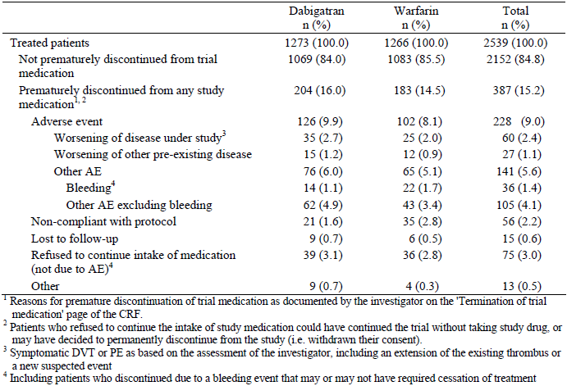
In Study 1160.53, subject randomisation was stratified by the presence or absence of active cancer and symptomatic PE at baseline. The number of randomised patients with an initial symptomatic PE was 807 (400 in the DE group and 407 in the warfarin arm) compared to 1757 patients without initial symptomatic PE (880 in the DE group and 877 in the warfarin arm). The rates of patients who completed treatment (82 to 86%) were equally balanced between the two treatment strategies regardless of the PE strata (yes/no) at baseline. Overall, 122 patients (64 in the DE group and 58 in the warfarin arm) had a history of active cancer, but most subjects (1216 in the DE arm and 1226 in the warfarin group) did not have active cancer at baseline. The rates of premature discontinuation were higher in patients with active cancer (26.6% (17 out of 64) for DE and 21.1% (12 out of 58) for warfarin) compared to those without active cancer at baseline (15.5% (187 out of 1216) for DE and 14.1% (171 out of 1226) for warfarin).

Major protocol violations/deviations
A total of 125 patients (4.9% of 2539) had protocol violations that may have affected the efficacy evaluation, and therefore were excluded from the PPS analysis. Of the 125 subjects 51 (4.0% of 1273) in the DE group and 74 (5.8% of 1266) in the warfarin arm had important efficacy related protocol deviations. Table 5 provides a summary of the major protocol violations that may have affected the efficacy results.

Table 5. Subjects with important efficacy related protocol violations in Study 1160.53.
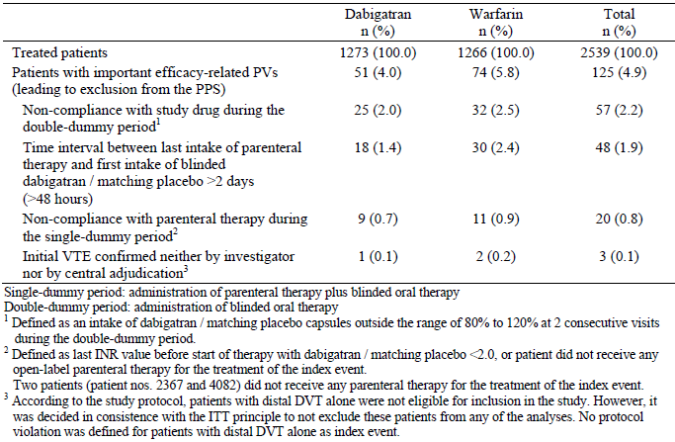
In addition to important efficacy related protocol deviations 42 subjects (1.7% of 2539) were identified to have violations of inclusion or exclusion criteria. Such deviations affected 16 patients in the DE group (1.3% of 1273) and 26 subjects (2.1% of 1266) in the warfarin arm. The most common enrolment criteria violations were baseline serum transaminases > 2 x ULN (5 subjects in the DE arm and 14 patients in the warfarin group), baseline haemoglobin < 100 g/L (5 patients in the DE group and 3 in the warfarin arm), and overt VTE for > 2 weeks prior to enrolment (3 patients in the DE group and 2 in the warfarin arm). During the trial 4 women of childbearing potential (1 in the DE group and 3 in the warfarin arm) refused to comply with the study’s contraception recommendations.

Baseline data
No significant differences between the two treatment groups were observed for baseline subject characteristics. Overall there were slightly more male subjects (58.4%; 1484 out of 2539). Patients had an average age of 54.7 years and 31.1% (790 out of 2539) of all subjects were 65 years of age or older. The majority of patients (94.8%; 2407 out of 2539) were of Caucasian ethnicity. For the 2539 patients in the FAS, recruitment by geographical region was 31.2% (n = 793) from Western Europe, 29.9% (n = 759) from Central Europe, 17.4% (n = 441) from North America, 6.1% (n = 156) from Latin America, 1.7% (n = 44) from India and 13.6% (n = 346) from ‘other’ countries including Australia and New Zealand. Mean BMI was 28.6 kg/m². Just over half of the patients (51.1%; 1298 out of 2539) had never smoked, and 21.3% (541 out of 2539) were current smokers. The baseline mean CrCL of the study population was 105.1 mL/min (SD 40.3 mL/min). Most patients (72.2%; 1833 out of 2539) had a baseline CrCL of ≥ 80 mL/min, although 13 patients (5 in the DE group and 8 in the warfarin arm) had a baseline CrCL of < 30 mL/min, which was an exclusion criterion. In addition a total of 21.7% (551 out of 2539) of subjects had CrCL 50 to 79 mL/min and 4.7% (120 out of 2539) had CrCL 30 to 49 mL/min. The demographic characteristics of patients were also investigated by stratification factor. Patients with active cancer at baseline (n = 121) were on average older than the overall trial population (63.7 years versus 54.7 years), had a slightly lower body weight (79.3 kg versus 84.9 kg) and a lower mean CrCL (85.9 mL/min versus 105.1 mL/min). The demographic characteristics of patients without active cancer at baseline were comparable with the characteristics of the overall trial population.
The 2 treatment groups were balanced with respect to the baseline characteristics of the index VTE event. For the majority of subjects (68.9%; 1749 out of 2539) the index VTE event was symptomatic DVT alone. The index VTE event was symptomatic PE alone in 21.3% (541 out of 2539) of patients, while 9.6% (245 out of 2539) of patients had both symptomatic PE and DVT as their index VTE episode. For 4 patients (2 in each treatment group), the index VTE event was not confirmed by objective testing by the investigator, and the central adjudication committee concurred that 3 of these 4 patients did not experience an index VTE (1 in the DE arm and 2 in the warfarin group). Overall, 1994 patients (78.5% of treated patients) had as their index event acute symptomatic DVT with or without symptomatic PE, and 786 patients (31.0%) had initial symptomatic PE with or without additional symptomatic DVT. The rate of central VTE confirmation (that is the ratio of centrally confirmed index VTE to locally suspected index events) was high (97 to 99%).
Additional baseline examinations were performed in patients with acute symptomatic DVT or PE to identify the presence of asymptomatic thromboembolic events. A total of 1728 patients had a confirmed symptomatic unilateral DVT alone as their index event. A baseline CUS for the contralateral, symptom free leg was performed in the majority (97.7%; 1688 out of 1728) of these patients. Most of these subjects (94.6%; 1635 out of 1728) had no asymptomatic DVT in their contralateral leg, but 3.1% of patients (53 out of 1728; 27 in the DE group and 26 in the warfarin arm) had an additional asymptomatic lower limb DVT in their contralateral leg. In most of the patients (95.4%; 1649 out of 1728) with symptomatic unilateral DVT, a baseline CT scan of the lung or a radionucleotide lung scan was performed. In these subjects, asymptomatic PE was diagnosed in 45.0% (777 out of 1728; 390 in the DE arm and 387 in the warfarin group). Of the 21 patients with symptomatic bilateral DVT as their index VTE, 19 had a CT of the lung or lung scan done. In 7 patients (33.3%) an asymptomatic PE was confirmed. In the 541 patients with symptomatic PE alone as their index episode, a bilateral CUS was performed in 96.5% (522 out of 541). Of these patients, 34.2% of patients (185 out of 541; 93 in the DE group and 92 in the warfarin arm) were found to have an asymptomatic DVT as well. Of the 238 patients with symptomatic unilateral DVT and PE at baseline, 97.9% of patients (233 out of 238) had a baseline CUS performed in the contralateral symptom free leg, and 34.2% (185 out of 541) were found to have asymptomatic DVT in the contralateral lower limb. In summary, 30.9% of treated patients had, in addition to their index VTE event, an asymptomatic PE at baseline and 9.8% had an asymptomatic DVT, which reflects the extensive burden of thromboembolic diseases in patients presenting with symptomatic VTE. The above data is consistent with expectations for the presence of asymptomatic VTE at baseline.
Table 6 summarises the baseline risk factors for recurrent VTE. In total, 69.4% of patients (1762 out of 2539) had at least 1 identifiable risk factor for recurrent VTE. Previous VTE was the most frequent risk factor (25.6%; 649 out of 2539), followed by a history of venous insufficiency (19.4%; 492 out of 2539), surgery/trauma (19.1%; 484 out of 2539), prolonged immobilization (15.6%; 396 out of 2539), recent systemic use of oestrogen (10.8%; 275 out of 2539), and thrombophilia (9.3%; 236 out of 2539). There was no between group difference detected for any of the risk factors for recurrent VTE. Of 176 patients with active cancer at any time, 121 patients (4.8%) had active cancer at baseline, and 55 patients (2.2%) were diagnosed with cancer during the study.

Table 6. Risk factors for recurrent VTE in Study 1160.53.
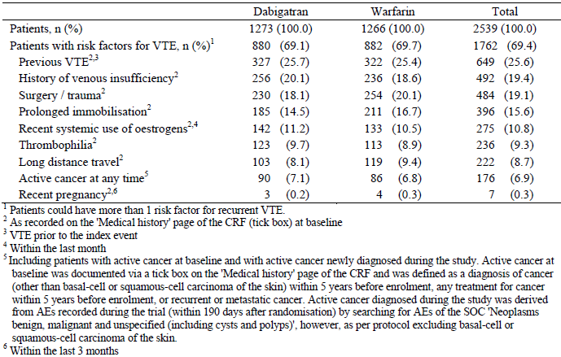
As per the study protocol, all but 2 patients (1 patient in each treatment group) received parental anticoagulation therapy for the treatment of the index VTE. The majority of patients received treatment with LMWH (90.0%; 2286 out of 2539). Initial parenteral therapy with UFH was received by 12.1% (308 out of 2539) of subjects, and fondaparinux was administered to 3.4% (86 out of 2539) of patients. Ten percent of patients (253 out of 2539) received more than 1 parental therapy during the initial single dummy period. Patients in both treatment groups were exposed to parenteral therapy for a median of 9 days. Most patients received parenteral anticoagulation for the planned 5 to 10 days (71.6% (912 out of 1273) of patients in the DE group, and 67.5% (855 out of 1266) of subjects in the warfarin arm). Ten patients (0.8% of 1273) in the DE arm and 15 subjects (1.2% of 1266) in the warfarin arm received < 5 days of parenteral anticoagulation. More than a quarter of patients received parenteral anticoagulation beyond recommendations: 11 to 13 days (17.3% (220 out of 1273) in the DE group and 18.3% (232 out of 1266) in the warfarin arm), and for ≥ 14 days (10.2% (130 out of 1273) in the DE group and 12.9% (163 out of 1266) in the warfarin arm).
Prior and concomitant medication therapies were an important consideration in Study 1160.53. Overall, 15.0% of patients (381 out of 2539) had received anticoagulant therapy prior to, and stopped treatment, before the intake of warfarin or warfarin placebo. A comparable percentage of subjects in each of the treatment groups (15.6% (198 out of 1266) for the warfarin group and 14.4% (183 out of 1273) for the DE arm) had this baseline characteristic. The majority of these patients (12.6% overall; 321 out of 2539) had used oral vitamin K antagonists. The use of LMWH or UFH, other than as part of the parenteral therapy allowed by the study protocol for the index event, was infrequent (1.9% (47 out of 2539) for LMWH and 0.9% (22 out of 2539) for UFH). One patient in the DE group reported the prior intake of a direct thrombin inhibitor. The prior use of fondaparinux was not recorded in any subject.
The prior use of NSAID was reported by 17.7% of patients 449 out of 2539), with a more frequent use in the DE arm (21.7%; 276 out of 1273) than in the warfarin group (13.7%; 173 out of 1266). Prior use of aspirin was reported by 11.7% of patients (296 out of 2539), with similar frequencies of patients in both treatment arms (12.2% (155 out of 1273) in the DE group and 11.1% (141 out of 1266) in the warfarin arm). The majority of aspirin use was at low dose (≤ 100 mg/day), and presumably for cardiovascular disease prophylaxis. In addition, 1.2% of patients (42 out of 2539) were recorded to use antiplatelet drugs other than aspirin at baseline. The concomitant use of NSAID with active study drug (DE or warfarin) was reported by 15.3% (195 out of 1273) of patients in the DE group and 18.8% (238 out of 1266) of subjects in the warfarin arm. Aspirin was used by 7.5% (95 out of 1273) of patients in the DE arm and 7.7% (97 out of 1266) of subjects in the warfarin group during the study. Anti platelet drugs other than aspirin were used by an additional 7 subjects (5 in the warfarin group and 2 in the DE arm) during the trial.
The intake of P-gp substrates prior to the intake of active study drug was rare. Overall 0.8% of patients reported the prior use of P-gp inhibitors, the most frequent of which was clarithromycin (0.4%). The prior or concomitant use of quinidine was contraindicated, and no patients in Study 1160.53 reported this history. During the trial the concomitant use of P-gp inhibitors was reported in a low proportion of patients. Verapamil (1.2%; 30 out of 2539) was the most frequent P-gp inhibitor started prior to the first intake of active study drug and continued during the study followed by diltiazem (0.6%; 15 out of 2539). Clarithromycin (0.8%; 21 out of 2539) was the most frequent P-gp inhibitor started after the first intake of study drug followed by verapamil (0.4%; 11 out of 2539). The use of P-gp inducers was less frequent than the use of P-gp inhibitors. Four patients (2 in each group) started rifampicin and 1 patient started tenofovir prior to the first intake of active study drug with warfarin. No patient in the DE arm started the use of a P-gp inducer within 30 days of the first intake of active study drug. Overall, the use of P-gp inhibitors and inducers was infrequent and balanced between the two treatment groups.
The use of restricted medications (including restricted anticoagulant therapy) during the trial was reported in 8.3% of all patients, with a lower frequency in the DE group (6.7%) compared to the warfarin arm (10.0%). The most frequently reported restricted medications were LMWH (1.3% (17 out of 1273) for the DE group, and 2.4% (31 out of 1266) in the warfarin arm), followed by corticosteroids (1.3% in the DE group versus 1.8% in the warfarin arm), and the use of ASA at a daily dose of > 100 mg (0.9% in the DE arm versus 1.3% in the warfarin group). In addition to LMWH use during the study concomitantly with active study medication (double dummy period) other restricted anticoagulant drug use included therapy with UFH (0.6% (8 out of 1273) in the DE arm and 1.1% (14 out of 1266) in the warfarin group), oral vitamin K antagonists (0.6% in both treatment arms), and fondaparinux (1 patient in the DE group and 3 subjects in the warfarin arm).
The medical history of patients was recorded at screening and the most frequent background medical history included hypertension (35.9%; 911 out of 2539), diabetes mellitus (8.3%; 211 out of 2539) and coronary artery disease (6.5%; 166 out of 2539). Other pre-specified medical conditions (such as heart failure, peptic ulcer and stroke) were recorded in less than 5% of patients overall. There were no differences between the two treatment groups regarding the incidence of past relevant medical history.

Results for the primary efficacy outcome
The total number of subjects with centrally adjudicated recurrent symptomatic VTE or VTE related death at the end of their post treatment period was 34 (2.67% of 1274) in the DE group and 32 (2.53% of 1265) in the warfarin arm; refer to Table 7. The primary outcome event was mainly accounted for by symptomatic DVT (17 in the DE arm versus 22 in the warfarin group) followed by symptomatic, non-fatal PE (16 in the DE arm versus 7 in the warfarin group). A total of 4 VTE related deaths (that is fatal PE) were observed: 1 in the DE group and 3 in the warfarin therapy arm. The total number of primary outcome events was 34 in each treatment group as 2 warfarin treated patients had 2 symptomatic VTE events (1 had an additional DVT, and 1 had symptomatic PE at a later date). In addition to the above centrally adjudicated events, 3 patients (all in the DE group) had suspected recurrent VTE (2 with DVT, and 1 with PE) that were locally confirmed by objective testing but were considered ‘non-evaluable’ by the central adjudication panel. Furthermore, 6 patients had suspected recurrent VTE (2 PE; 1 in each treatment group; and 4 DVT; 2 in each arm) that were not locally confirmed, and for which the site investigators did not provide films of sufficient quality for central adjudication.
Using the end of the post treatment period dataset, the HR of the primary efficacy outcome for DE versus warfarin was 1.05 (95% CI 0.65, 1.70). The p-value for non-inferiority was < 0.0001. As the upper bound of the 95% CI was below the pre-defined non-inferiority margin of 2.75 and the p-value was statistically significant, the null hypothesis of inferiority of DE versus warfarin could be rejected. The p-value for superiority of DE versus warfarin was 0.8508 (that is not statistically significant).

Table 7. Number of subjects and events with recurrent symptomatic VTE or VTE related death in Study 1160.53 (centrally adjudicated; FAS population).
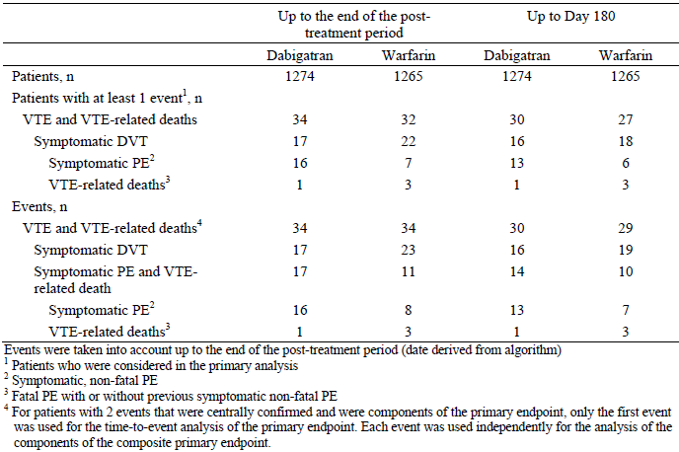
In the warfarin arm, up to Day 180, 30 patients (2.35% of 1274) in the DE group and 27 (2.13% of 1265) experienced recurrent VTE or death due to VTE. The pattern of events accounting for the composite endpoint at Day 180 was similar to that observed at the end of the post-treatment period. The cumulative risk difference for the primary composite endpoint at 6 Months between DE and warfarin was 0.4 (95% CI -0.8, 1.5). The p-value for non-inferiority was < 0.0001. As the upper limit of the 95% CI was below the pre-defined non-inferiority margin of 3.6% and the p-value was statistically significant, the null hypothesis of inferiority of DE versus warfarin could be rejected. The p-value for superiority of DE versus warfarin was 0.5026 (that is not statistically significant). The KM curves for the primary efficacy endpoint were almost congruent for both treatment groups over the 210 days of follow up. For both treatment groups, the KM curve was steeper in the first 3 months of therapy and became shallower thereafter up until 210 days. This observation is to be expected and indicates that the recurrent risk of VTE is higher in the 3 months after the first occurrence of a symptomatic event.
A sensitivity analysis using the PPS (rather than FAS) for the primary endpoint occurrence at both 6 months and up to the end of the post treatment period confirmed the results of the primary analysis. Using the end of post treatment dataset, a total of 33 patients (2.59% of 1274) in the DE group and 31 subjects (2.45% of 1265) in the warfarin arm experienced recurrent VTE or VTE-related death. The HR for DE versus warfarin was 1.03 (95% CI 0.63, 1.69), which is similar to the primary analysis 1.05 (95% CI 0.65, 1.70). At 6 months, the cumulative risk of the primary endpoint in the PPS was 2.28% (29 out of 1274) in the DE arm and 2.06% (26 out of 1265) in the warfarin group. The risk difference was 0.3% (95% CI -0.8%, 1.5%).
Subgroup analyses of the primary endpoint were performed to evaluate the consistency of the treatment effect (for DE and warfarin) across a variety of subgroups identified by baseline demographic (geographical region) and patient characteristics (age, gender, race, weight, CrCL and concomitant medications); as well as risk factors for recurrent VTE (prior history of VTE, and malignancy at any time). In addition, the predefined statistical plan also examined whether or not 1 or more parenteral anticoagulant treatment for the index VTE had an effect on outcome. Three subgroup by treatment interactions were observed, all of which demonstrated a numerically higher incidence in the DE versus warfarin group; refer to Table 8.
The primary endpoint occurred at a higher frequency in those with:
- Previous VTE receiving DE (3.66%; 12 out of 328) compared to warfarin (1.6%; 5 out of 321); HR for the difference was 2.03 (95% CI 0.83, 4.98; p = 0.07),
- One parenteral therapy for index VTE given DE (2.51%; 29 out of 1154) versus warfarin (1.77%; 20 out of 1132); HR for the difference was 1.34 (95% CI 0.79, 2.26; p = 0.04), and
- Concomitant use of NSAID when receiving DE (3.59%; 7 out of 195) compared to warfarin (0.84%; 2 out of 238); HR for the difference was 4.93 (95% CI 1.05, 23.23; p = 0.03).
No interaction between the effect of DE and concurrent use of NSAID has been identified in other clinical trials so the significance of this observation is unclear.

Table 8. Treatment effect of Dabigatran versus Warfarin on the primary efficacy Endpoint in subgroups with p-value < 0.1 in Study 1160.53.
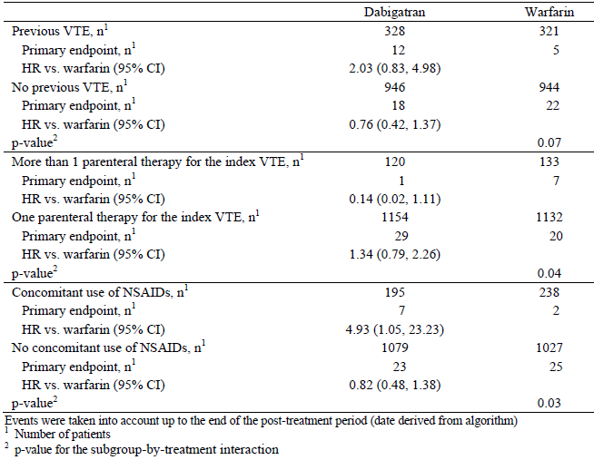
The cumulative risks and risk differences were also assessed by baseline stratification factors. Expectedly, the cumulative risk of the primary endpoint was higher in patients with an initial symptomatic PE (2.9% (11 out of 392) for DE and 3.3% (13 out of 394) for warfarin) compared to subjects who presented without PE (2.25% (19 out of 882) for DE and 1.7% (14 out of 871) for warfarin), refer to Table 9. Similarly, patients with active cancer had a higher cumulative risk for the primary endpoint (3.5% (2 out of 64) for DE and 5.4% (3 out of 57) for warfarin) than those without active cancer at baseline (2.4% (28 out of 1210) for DE and 2.0% (24 out of 1208) for warfarin). Expectedly, the highest risk of recurrent VTE or VTE related death was in patients with both active cancer and symptomatic PE at baseline, regardless of treatment option (DE or warfarin).

Table 9. Primary efficacy endpoint incidence by stratification factors in Study 1160.53.
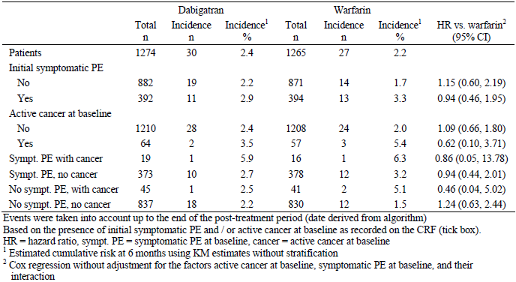

Results for other efficacy outcomes

Composite of recurrent symptomatic VTE and death of any cause
At 6 months, 48 patients (3.9% of 1274) in the DE group and 44 subjects (3.6% of 1265) in the warfarin arm met this composite endpoint; refer to Table 10. The cumulative risk difference at 6 months of recurrent symptomatic VTE and death for DE versus warfarin was 0.3% (95% CI -1.0%, 1.7%). The presence of active cancer at baseline was the strongest risk factor for determining who experienced this outcome: without PE (9.1% in the DE group, and 17.5% in the warfarin arm), and if initial PE (23.5% in the DE group, and 6.3% in the warfarin arm).
Up until Day 224, a similar number of patients in each of the treatment groups experienced recurrent VTE or died: 55 subjects in the DE group (4.3% of 1274) and 53 patients in the warfarin arm (4.2% of 1265). The HR for this composite endpoint was 1.0 (95% CI 0.69, 1.46) for DE versus warfarin. Table 9 provides a summary of the number of recurrent VTE events and all deaths up until the end of the post-treatment period (that is up to Day 224) and also at 6 months (Day 180). The most common identifiable cause of death in both treatment groups was cancer (8 in the DE group and 9 in the warfarin arm). Further description of the VTE outcomes is provided in the evaluation of the other secondary efficacy endpoints.

Table 10. Recurrent VTE and all deaths in Study 1160.53 (centrally adjudicated; FAS)
.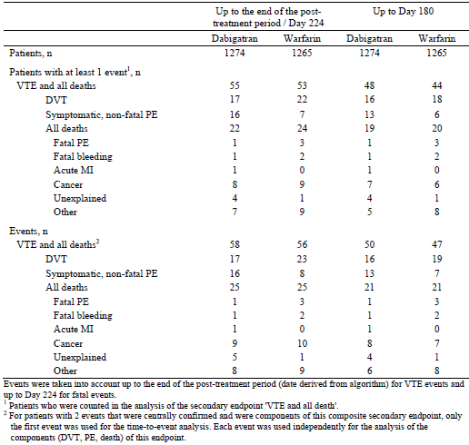

Symptomatic DVT
At 6 months, the number of patients experiencing an acute symptomatic DVT was comparable between the 2 treatment groups: 16 (1.3% of 1274) for DE and 18 (1.5% of 1265) for warfarin. The comparative risk difference between DE and warfarin was -0.2% (95% CI -1.1%, 0.7%). For both treatment groups the majority of DVT events were identified in the first 120 days of therapy.
In a supporting analysis up until the end of the post treatment period, a further 1 patient in the DE group (17 overall) developed an acute symptomatic DVT versus an additional 4 in the warfarin group (22 in total). The HR of DE versus warfarin for symptomatic DVT in the end of post treatment dataset was 0.76 (95% CI 0.40, 1.42). No treatment related differences were detected with additional evaluation using the randomisation strata or subgroups of interest.

Symptomatic PE
At 6 months, the number of patients experiencing a symptomatic, non-fatal PE was higher in the DE group (n = 13; 1.1% of 1274) compared with warfarin (n = 7; 0.6% of 1265) for warfarin. The comparative risk difference between DE and warfarin was 0.5% (95% CI -0.30%, 1.0%). For both treatment groups the majority of non-fatal PEs occurred in the first 90 days of treatment, although several cases occurred late in both treatment groups (that is between Days 160 and 210). The mean (and median) time to PE was longer in the DE group at 84 days (55 days) compared with the warfarin arm (mean of 59 days and median of 40 days).
In a supporting analysis up until the end of the post treatment period, a further 3 patients in the DE group (16 overall) developed a non-fatal PE versus 1 additional subject in the warfarin group (8 in total). The HR of DE versus warfarin for symptomatic DVT in the end of post treatment dataset was 2.0 (95% CI 0.86, 4.68). Nineteen of the 24 symptomatic non-fatal PE patients were taking active treatment at the time of the event (14 in the DE group and 5 patients in the warfarin arm). The on treatment analysis of symptomatic PE at the end of the post treatment period yielded a HR of 2.80 (95% CI 1.01, 7.77) for DE versus warfarin.
Although the CIs for risk differences between the 2 treatment groups were wide and included zero, the risk of a recurrent non-fatal PE was highest in subjects treated with DE who had an initial symptomatic PE and active cancer at baseline (5.9% for DE versus zero for warfarin), whereas the rate of recurrent non-fatal PE was numerically similar between the DE and warfarin groups for other strata characteristics. Although not statistically significant a greater number of patients in the DE who experienced non-fatal PE compared to warfarin were younger (18 to 50 years; 8 for DE versus 3 in the warfarin group), male (11 in the DE arm versus 3 in the warfarin group), had a body weight ≥100 kg (6 in the DE group versus 1 in the warfarin arm), smokers (current or previous; 9 for DE versus 3 in the warfarin group), with a baseline CrCL of 50 to 79 mL/min (5 in the DE arm versus 1 in the warfarin group) had a prior use of anticoagulants (10 in the DE group versus 3 in the warfarin arm) and were taking concurrent NSAID (6 in the DE group versus 2 in the warfarin arm).

VTE related death
A total of 4 patients (1 in the DE group and 3 in the warfarin arm) died from PE at Day 180. There were no additional VTE related deaths in the post treatment period (up to Day 224). The HR for VTE related death was 0.33 (95% CI 0.03, 3.15) for DE versus warfarin. At 6 months, the cumulative risk of VTE related death was 0.08% (1 out of 1274) in the DE group and 0.24% (3 out of 1265) in the warfarin arm. All 4 patients who died from VTE during the trial had an initial symptomatic PE at enrolment, but only 1 subject (in the warfarin arm) had the additional risk factor of active cancer.

All deaths
At 6 months, 21 patients had died in each treatment group. The cumulative risk of death by 6 months in each treatment group was 1.7% (risk difference for DE versus warfarin being -0.1% (95% CI -1.0%, 0.8%)). An additional 4 subjects in each of the treatment groups died up until the end of their post treatment period (that is a total of 25 subjects died in each treatment group). The HR for death up until Day 224 was 0.94 (95% CI 0.54, 1.63) for DE versus warfarin. The highest risk of all cause death was observed in patients with an initial symptomatic PE and active cancer at baseline (18.4% for DE and 6.3% for warfarin).

Evaluator summary
In conclusion, although Study 1160.53 showed no statistically significant differences in treatment effect between DE and warfarin, there were numerically fewer DVTs and fewer fatal PEs, but more symptomatic PEs in the DE versus warfarin treatment group.

Study 1160.46 (also known as the RE-COVER II Study)

Study design, objectives, locations and dates
Study 1160.46 was designed to replicate Study 1160.53, and had a near identical trial design. The main design difference between the 2 studies was that the initial treatment period with parenteral anticoagulation was defined to be of at least 5 days duration in RE-COVER II (versus defined as 5 to 10 days in RE-COVER).
Study 1160.46 was a Phase III, randomised, double blind, double dummy, parallel group, active controlled trial with a planned duration of 6 months of treatment, comparing fixed dose DE (150 mg bid) with warfarin (target INR 2.0 to 3.0). The objective of the study was to compare the efficacy and safety of DE and warfarin for a 6 month treatment period of acute symptomatic VTE following initial treatment (at least 5 days) with an approved parenteral anticoagulant. The treatment period was preceded by a screening phase of 1 to 3 day’s duration. Confirmation of the index VTE episode by objective clinical testing was to be obtained prior to or not longer than 72 hours after enrolment but prior to randomization. A schematic overview of the design of Study 1160.46 is shown in Figure 1.
Figure 1. Flowchart of Study 1160.46.
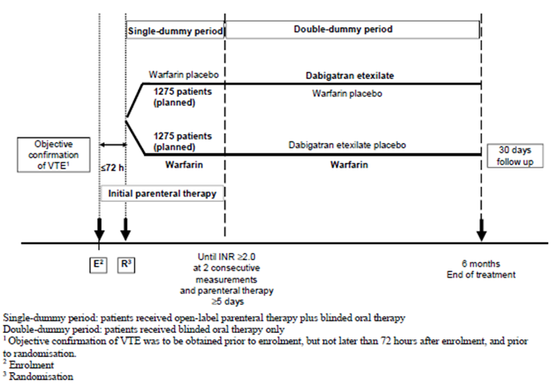
The active treatment period was of 6 months duration and had two phases: an initial single dummy period whereby patients received open label parenteral therapy plus blinded oral therapy with either warfarin or warfarin placebo; followed by a second part which consisted of a double dummy period of blinded oral therapy with either DE or DE placebo. Subjects were required to have an INR value of ≥2.0 on 2 consecutive measurements in the single dummy period. Treatment with warfarin or warfarin placebo was continued in the double dummy phase, and the dose was adjusted according to the patients INR (true or sham depending on treatment allocation). Follow up visits were scheduled for Days 30, 60, 90, 120, 150 and 180. In addition, patients were to be followed up for 30 days after the completion of planned study treatment (that is the end of study visit was performed at Day 210). Patients who required anticoagulation beyond the planned duration of 6 months could either be switched to standard oral anticoagulation after the last intake of trial medication, or could be enrolled into 1 of 2 DE therapy prevention studies (1160.47 or 1160.63).
Study 1160.46 was commenced 2 years after Study 1160.53. Patient involvement occurred between June 2008 and May 2011. A total of 208 sites in 31 countries (including North and South America, Central and Western Europe, Australia and New Zealand, South Africa, Asia and Israel) enrolled subjects in the trial. There were 6 amendments to the original protocol, all of which occurring after the commencement of patient recruitment. The amendments contained clarifications about the qualifying baseline laboratory results, exclusion of concurrent administration of moderate to strong P-gp inhibitor drugs (for example quinidine, rifampicin and ketoconazole), detailed guidance on the use on concurrent use of verapamil, provided information on the perioperative/invasive procedure management of DE during the study period (if required), and extended the study recruitment period by 5 months because of slower than expected subject enrolment (amendment 6). None of the amendments resulted in major changes to the study design, which may have affected the outcome or statistical analysis.

Inclusion and exclusion criteria
The inclusion and exclusion criteria for Study 1160.46 were identical to Study 1160.53, apart from 1 minor change. The threshold value for exclusion at baseline because of elevated liver function tests was slightly higher in RE-COVER II (ALT or AST > 3 x ULN) versus RE-COVER (ALT or AST > 2 x ULN). Because RE-COVER II started 2 years after RE-COVER the sponsor considered that it had a larger dataset of hepatic safety with DE to make this change.

Study treatments
All patients were expected to receive at least 5 days of treatment with a parenteral anticoagulant therapy, either intravenous UFH, or subcutaneous LMWH. The single dummy period (open label parenteral therapy plus blinded oral treatment) started with randomization. During the single dummy phase, patients received the initial parenteral treatment and either warfarin or warfarin placebo (with target INR of 2.0 to 3.0). As soon as the subject had received at least 5 days of parenteral therapy and had an INR value (real or sham) of ≥ 2.0 on 2 consecutive measurements, treatment with fixed dose DE 150 mg twice daily (or DE placebo) was initiated. At this stage, treatment with warfarin or warfarin placebo was continued, and parenteral therapy was ceased. Patients continued to receive DE 150 mg twice daily and warfarin placebo, or DE placebo and warfarin for the remainder of the trial depending on their treatment allocation. DE capsules were to be taken with water twice daily (morning and evening). The original protocol stipulated that DE be taken at the same time of the day (within a strict time window of 2 hours), but this advice was removed with protocol amendment 1 (that is prior to first patient involvement). The first dose of DE (or DE placebo) was to be administered within 2 hours of the time period whereby the initial parenteral therapy would have been due, or at the time of discontinuation in the case of continuous anticoagulation treatment (that is with intravenous UFH).
Treatment with warfarin or warfarin placebo was to be started on the day of randomization, unless the subject had already received an oral vitamin K antagonist on that day. Tablets were to be taken once daily, at approximately the same time each day. The first dose of warfarin was recommended to not exceed 5 mg. INR monitoring using a POC device was to be started immediately, and readings were taken daily until the target INR range of 2.0 to 3.0 was achieved. After a stable warfarin (or warfarin placebo) dose had been determined, INR measurements were to be performed every 1 to 4 weeks during the 6 month trial (at the investigator’s discretion). Warfarin tablets were supplied in 3 different unit strengths (1 mg, 3 mg and 5 mg), and tablets were not to be broken.
Compliance with DE treatment was checked by the study centre personnel during the trial by capsule counts at scheduled visits. Over the 6 month study, the rates of non-compliance with DE (2.3%) or matching placebo DE capsules (1.7%) were low in both treatment groups. Treatment compliance with warfarin was not directly assessed but instead the INR time in range (that is the time when the INR was in the target range 2.0 to 3.0) was evaluated for the time period between the first intake of DE placebo and the last intake of warfarin. On average, 16.3 INR measurements were performed per patient in the warfarin group during the 6 month trial (median of 16 readings; range of 0 to 50 INR results). Expectedly, the mean number of INR measurements was highest in the first month after randomization (8.5 readings per patient in Month 1), and decreased thereafter (1.5 to 1.8 monthly readings per patient from Months 3 to 6). In the first month, the mean percentage of time that warfarin treated patients (n = 1242) remained in the target INR range of 2.0 to 3.0 was 50.7% (16.3% of the time subjects had INR < 2.0, and 32.9% of the time patients had INR > 3.0). By 6 months (n = 902), the mean percentage of time in the target INR range of 2.0 to 3.0 was 58.9% (25.6% of the time subjects had INR < 2.0, and 15.5% of the time patients had INR > 3.0). The frequencies of warfarin treated patients with time in the INR target range of 2.0 to 3.0 was assessed by tertile thresholds (< 49%, 49 to 66.9%, and ≥67%). In the first month, 52.2% (648/1242) of subjects spent less than 49% of their time in the target range of 2.0 to 3.0, while 17.7% (220/1242) of patients were 49 to 66.9%, and 30.1% (374/1242) of subjects spent ≥ 67% of their time in the target range of 2.0 to 3.0. Over the course of the study, the proportion of subjects who spent less than 49% of the time in the target INR range progressively decreased to 35.3% (395/1119) by Month 5, while the percentage of subjects with at least 67% of the time in the target INR increased (52.1% (583/1119) by Month 5).
The final clinical study report and appendices did not present the variability in sham INR readings compared with the variability of real INR results in warfarin treated subjects. However, treatment interruptions due to either too high or too low INR reading occurred at a much higher frequency in the warfarin treatment group (178 patients (13.8% of 1288) had drug interruptions) compared with to DE arm (16 subjects (1.3% of 1280) had drug interruptions).

Efficacy variables and outcomes
The primary efficacy outcome in the RE-COVER II Study was the same as in RE-COVER; that is the composite of recurrent symptomatic VTE and deaths related to VTE. All recurrent VTE episodes required objective verification by definitive diagnostic testing. An independent committee that was blinded to treatment allocation centrally adjudicated all recurrent VTE events and deaths. Only adjudicated results were used in the analyses. The primary efficacy outcome was assessed at 2 time points: up to Day 180 (that is end of the active treatment period) and “end of their post-treatment period” (defined as up to Day 224 in those who completed the active treatment phase, or upon premature discontinuation).
The same 5 secondary efficacy outcomes evaluated in the RE-COVER Study were assessed in the RE-COVER II trial: composite of recurrent VTE and all deaths, symptomatic DVT, symptomatic PE, VTE related deaths, and all deaths. The secondary efficacy endpoints were evaluated up to Day 180 and at the end of the post-treatment period (that is up to Day 224).

Randomisation and blinding methods
Randomisation and blinding methods were identical to Study 1160.53. Eligible patients were randomised 1:1 to either DE or warfarin.

Analysis populations
The primary and secondary efficacy analyses were based on the Full Analysis Set (FAS), which follows the modified intention to treat principle. The FAS consisted of all randomised subjects who were documented to have received at least 1 dose of study drug. Sensitivity efficacy analyses were performed using the Per-Protocol (PPS) population. This consisted of all patients who received at least 1 dose of study drug, and excluded any patient who experienced a major protocol deviation as determined by the sponsor.

Sample size
The RE-COVER II trial planned to enrol 1275 patients per treatment group (that is a total number of at least 2550 subjects) to obtain a minimum of 46 confirmed recurrent VTE episodes. Such an assumption would achieve a statistical power of at least 90% to claim non-inferiority with a margin of 2.75 for the HR of DE versus warfarin, assuming a VTE event rate of 2% in the warfarin arm over 6 months. The calculation of statistical power was based on 1 sided tests at a significance level of α = 0.025. For the DE treatment group, a VTE event rate of 2%, and an overall dropout rate of 20%, during 6 months of therapy were assumed.

Statistical methods
The statistical methods utilised in Study 1160.46 were identical to Study 1160.53. The primary statistical analysis was a test for non-inferiority of DE versus warfarin. If non-inferiority was confirmed, then the superiority of DE versus warfarin for the primary efficacy endpoint was to be assessed. Two non-inferiority margins were pre-specified: 2.75 for the HR (observed during the trial, including the post treatment follow up period), and 3.6% for the risk difference at 6 months (that is 180 days). By requiring that both non-inferiority margins were achieved in the primary efficacy analysis, the result was demonstrating that DE preserved at least 57% of the warfarin effect versus placebo with regard to the HR, and at least 75% of the warfarin effect versus placebo with regard to the risk difference, both based on the upper bounds of the 95% CIs. The choice of the non-inferiority margins was based on the data available at the time of protocol development, and is consistent with the relevant regulatory guideline (EMEA/CPMP/EWP/2158/99).
Hazard Ratios were calculated based on the times to first occurrence of the components of the composite primary efficacy endpoint using a proportional hazards model (Cox regression), stratified by active cancer (yes/no) and symptomatic PE (yes/no) at baseline. Risk differences were calculated using Kaplan-Meier (KM) estimates of the cumulative risk at 6 months after randomisation, stratified by active cancer (yes/no) and symptomatic PE (yes/no) at baseline. The same statistical methods used for the primary efficacy analysis were applied to the secondary efficacy outcome evaluation.

Participant flow
A total of 2701 patients were enrolled into Study 1160.46, and 2589 were randomised across 208 centres in 31 countries to either DE (n = 1294) or warfarin (n = 1295). Of the 112 (4.15%) patients who enrolled but were not randomised, the most frequent reason for non-randomisation was violation of the inclusion or exclusion criteria (3.1%; 83/2701).
Of the randomised subjects, 21 (14 in the DE group and 7 in the warfarin arm) did not receive treatment with study medication. As such, most were documented to have received at least 1 dose of study medication: 1280 out of 1294 (98.9%) in the DE group and 1288 out of 1295 (99.5%) in the warfarin arm. Of the 2568 treated patients, 90.6% (2327 out of 2568) completed the planned observation period. The rates of treatment completion were similar between the 2 treatment groups: 85.3% (1092 out of 1280) for the DE arm and 85.9% (1106 out of 1288) for warfarin group. Table 11 provides a summary of participant flow and reasons for premature discontinuation from the trial. Discontinuations due to worsening of disease (that is extension of existing thrombus or a new VTE event) were numerically higher in the DE group (2.2%; 28 out of 1280) compared with warfarin therapy (1.8%; 23 out of 1288).

Table 11. Patient disposition in Study 1160.46.
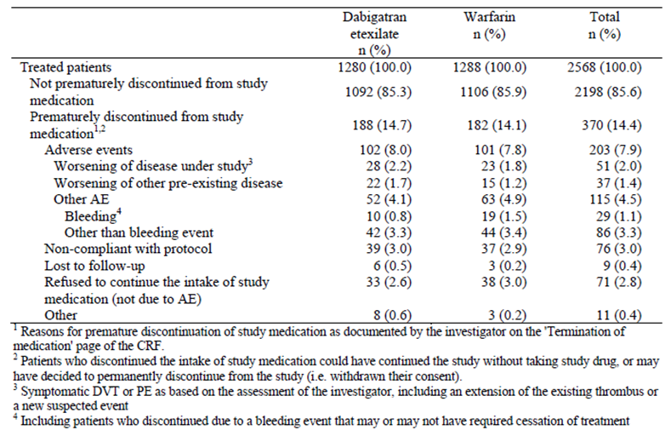
In Study 1160.46, subject randomisation was stratified by the presence or absence of active cancer and symptomatic PE at baseline. The number of randomised patients with an initial symptomatic PE was 816 (402 in the DE group and 414 in the warfarin arm) compared to 1752 patients without initial symptomatic PE (878 in the DE group and 874 in the warfarin arm). The rates of patients who completed treatment (84 to 87%) were equally balanced between the two treatment strategies regardless of the PE strata (yes/no) at baseline. Overall, 100 patients (50 in each treatment group) had active cancer, but most subjects (1230 in the DE arm and 1238 in the warfarin group) did not have active cancer at baseline. The rates of premature discontinuation were higher in patients with active cancer (38% (19 out of 50) for DE and 36% (18 out of 50) for warfarin) compared to those without active cancer at baseline (13.7% (169 out of 1230) for DE and 13.2% (164 out of 1238) for warfarin).

Major protocol violations/deviations
A total of 70 patients (2.7% of 2568) had protocol violations that may have affected the efficacy evaluation, and therefore were excluded from the PPS analysis. Of the 70 subjects, 38 (3.0% of 1280) in the DE group and 32 (2.5% of 1288) in the warfarin arm had important efficacy related protocol deviations. Table 12 provides a summary of the major protocol violations that may have affected the efficacy results. In addition to important efficacy related protocol deviations, 18 subjects in each of the treatment groups (1.4% of 2568) were identified to have violations not impacting upon efficacy outcomes.

Table 12. Subjects with important efficacy related protocol violations in Study 1160.46.
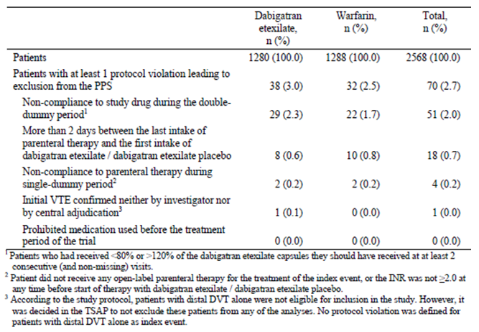

Baseline data
The 2 treatment groups were balanced with regard to baseline subject characteristics. More than half of all subjects (60.6%; 1557 out of 2568) were male. Patients had a mean age of 54.9 years, and 31.2% (800 out of 2568) of all subjects were 65 years of age or older. The majority of patients (77.6%; 1992 out of 2568) were of Caucasian ethnicity, and 20.9% (537 out of 2568) were of Asian background. For the 2568 patients in the FAS, recruitment by geographical region was 32.8% (n = 843) from Central Europe, 20.0% (n = 513) from Asia, 17.4% (n = 446) from Western Europe, 15.7% (n = 404) from North America, 0.5% (n = 14) from Latin America, and 13.6% (n = 348) from ‘other’ countries including Australia and New Zealand. The mean BMI of the study population was 28.4 kg/m². Just over half of the patients (53.4%; 1372/2568) had never smoked, and 21.8% (561/2568) were current smokers. The mean baseline CrCL of the study population was 107.7 mL/min (SD 42.4 mL/min). Most patients (72.7%; 1868 out of 2568) had a baseline CrCL of ≥ 80 mL/min, although 10 patients (7 in the DE group and 3 in the warfarin arm) had a baseline CrCL of < 30 mL/min, which was an exclusion criterion. In addition a total of 21.5% (551 out of 2568) of subjects had CrCL 50 to 79 mL/min and 4.7% (120 out of 2568) had CrCL 30 to 49 mL/min. The demographic characteristics of patients were also investigated by stratification factor. Patients with active cancer at baseline (n = 121) were on average older than the overall trial population (65.3 years versus 54.9 years), had a slightly lower body weight (74.5 kg versus 83.1 kg) and a lower mean CrCL (82.9 mL/min versus 107.7 mL/min). The demographic characteristics of patients without active cancer at baseline were comparable with the characteristics of the overall trial population.
The two treatment groups were balanced with respect to the baseline characteristics of the index VTE event. For the majority of subjects (68.1%; 1750/2568) the index VTE event was symptomatic DVT alone. The index VTE event was symptomatic PE alone in 23.2% (595 out of 2568) of patients, while 8.6% (221 out of 2568) of patients had both symptomatic PE and DVT as their index VTE episode. For 2 patients (1 in each treatment group) the index VTE event was not confirmed by objective testing by the investigator, but the central committee adjudicated that for 1 of these patients (warfarin group) an index PE had occurred. The rate of central VTE confirmation (that is the ratio of centrally confirmed index VTE to locally suspected index events) was high (97 to 98%).
Additional baseline examinations were performed in patients with acute symptomatic DVT or PE to identify the presence of asymptomatic thromboembolic events. A total of 1734 patients had a confirmed symptomatic unilateral DVT alone as their index event. A baseline CUS for the contralateral, symptom free leg was performed in the majority (99.4%; 1724 out of 1734) of these patients. Most of these subjects (93.9%; 1629 out of 1734) had no asymptomatic DVT in their contralateral leg, but 5.5% of patients (95 out of 1734; 56 in the DE group and 39 in the warfarin arm) had an additional asymptomatic lower limb DVT in their contralateral leg. In most of the patients (93.8%; 1627 out of 1734) with symptomatic unilateral DVT, a baseline CT scan of the lung or a radionucleotide lung scan was performed. In these subjects, asymptomatic PE was diagnosed in 47.2% (819 out of 1734; 405 in the DE arm and 414 in the warfarin group). All of the 16 patients with symptomatic bilateral DVT as their index VTE had a CT of the lung or lung scan done. In 5 patients (31.3%) an asymptomatic PE was confirmed. In the 595 patients with symptomatic PE alone as their index episode, a bilateral CUS was performed in 96.3% (573 out of 595). Of these patients, 34.1% of patients (203 out of 595; 111 in the DE group and 92 in the warfarin arm) were found to have an asymptomatic DVT as well. Of the 216 patients with symptomatic unilateral DVT and PE at baseline, 98.6% of patients (213 out of 216) had a baseline CUS performed in the contralateral symptom free leg, and only 6.0% (13 out of 216) were found to have asymptomatic DVT in the contralateral lower limb. In summary, 32.1% of treated patients had, in addition to their index VTE event, an asymptomatic PE at baseline and 12.1% had an asymptomatic DVT, which reflects the extensive burden of thromboembolic diseases in patients presenting with symptomatic VTE. The above data is consistent with expectations for the presence of asymptomatic VTE at baseline.
Table 13 summarises the baseline risk factors for recurrent VTE. In total, 59.4% of patients (1526 out of 2568) had at least 1 identifiable risk factor for recurrent VTE. Previous VTE was the most frequent risk factor (17.5%; 450 out of 2568), followed by surgery/trauma (17.2%; 442 out of 2568), history of venous insufficiency (15.8%; 405 out of 2568), prolonged immobilization (13.7%; 351 out of 2568), long distance travel (7.8%; 201 out of 2568), recent systemic use of oestrogen (7.7%; 197 out of 2568), and thrombophilia (6.7%; 172 out of 2568). There was no between group difference detected for any of the risk factors for recurrent VTE. Of 155 patients with active cancer at any time, 100 patients (3.9% of 2568) had active cancer at baseline, and 35 patients (1.4% of 2568) were diagnosed with cancer during the study.

Table 13. Risk factors for recurrent VTE in Study 1160.46.
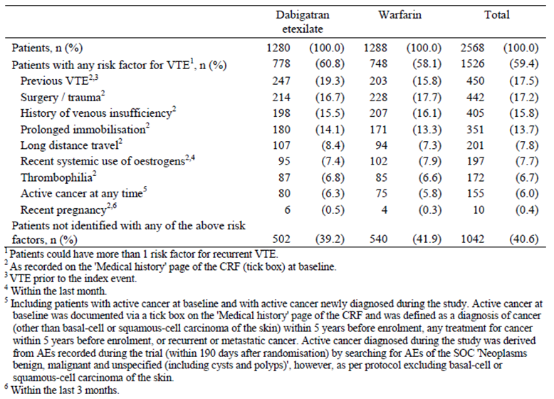
All patients received parental anticoagulation therapy for the treatment of the index VTE. The majority of patients received treatment with LMWH (88.8%; 2280 out of 2568). Initial parenteral therapy with UFH was received by 15.8% (405 out of 2539) of subjects, and fondaparinux was administered to 2.1% (53 out of 2568) of patients. Overall, 11.0% of patients (283 out of 2568) received more than 1 parental therapy during the initial single dummy period. Patients in both treatment groups were exposed to parenteral therapy for a median of 9 days. Most patients received parenteral anticoagulation for 5 to 10 days (75.0% (960 out of 1280) of patients in the DE group, and 70.7% (911 out of 1288) of subjects in the warfarin arm). Nine patients (0.7% in each treatment group received < 5 days of parenteral anticoagulation. Approximately one quarter of all patients received parenteral anticoagulation beyond recommendations: 11 to 13 days (13.2% (169 out of 1280) in the DE group and 17.7% (228 out of 1288) in the warfarin arm), and for ≥ 14 days (11.1% (142 out of 1280) in the DE group and 10.9% (140 out of 1288) in the warfarin arm).
Concomitant medication therapies were an important consideration in Study 1160.46. The concomitant use of NSAID was reported by 22.4% of patients (575 out of 2568), at a similar frequency in each of the treatment groups (22.1% (283 out of 1280) in the DE arm, and 22.7% (292 out of 1288) in the warfarin group). Concurrent use of aspirin was recorded in 9.4% of patients (242 out of 2568), at a slightly higher frequency in the DE treatment arm (10.2%; 130 out of 1280) compared to the warfarin group (8.7%; 112 out of 1288). The majority of aspirin use was at low dose (≤ 100 mg/day). In addition, 0.7% of patients (18/2568) were recorded to use antiplatelet drugs other than aspirin during the trial.
The concomitant intake of P-gp inhibitors during the study drug was reported in 33 patients (1.3% of 2568; 20 patients in the DE group and 13 subjects in the warfarin arm). The most frequent p-gp inhibitor used was verapamil (0.7% overall) followed by amiodarone (0.3% overall). No patient received concomitant quinidine during the trial. The use of P-gp inducers was less frequent than the use of P-gp inhibitors (n = 10 patients; 4 in the DE group and 6 in the warfarin arm). Six patients (3 in each group) started carbamazepine, 3 patients (all in the warfarin arm) started rifampicin and 1 patient (in the DE group) started St John’s Wort prior to the first intake of active study drug.
The use of restricted medications (including restricted anticoagulant therapy) during the trial was reported in 10.9% (281 out of 2568) of all patients, with similar frequencies in both treatment groups. The most frequently reported restricted medications were NSAID (4.0%; 102 out of 2568), LMWH (1.0% (13 out of 1280) for the DE group, and 1.4% (18 out of 1288) in the warfarin arm), corticosteroids (3.3%; 84 out of 2568), and aspirin (0.7%; 18 out of 2568).
The medical history of patients was recorded at screening and the most frequent background medical history included hypertension (35.1%; 902 out of 2568), diabetes mellitus (9.8%; 251 out of 2568), and coronary artery disease (7.1%; 183 out of 2568). Other pre-specified medical conditions (such as heart failure, peptic ulcer and stroke) were recorded in less than 4% of patients overall. There were no differences between the 2 treatment groups regarding the incidence of past relevant medical history.

Results for the primary efficacy outcome
The number of patients experiencing the primary outcome of recurrent symptomatic VTE or VTE related death up to the end of their post treatment period was 34 (2.66% of 1279) in the DE group and 30 (2.33% of 1289) in the warfarin arm; refer to Table 14. In 1 patient, the primary outcome event was a VTE related death (that is fatal PE). This patient had been randomised to the DE treatment group, but as he was still in the single dummy period of the trial when he died, and never received treatment with DE. The total number of primary outcome events was 74. Eight patients (6 in the DE group and 2 in the warfarin arm) had more than 1 outcome event. Three patients had a PE and DVT on the same day (2 in the DE arm, and 1 warfarin treated patient). The remaining 5 patients had VTE episodes separated in time including 1 DE patient experiencing 2 DVTs approximately 1 month apart; another DE treated patient had a DVT as the index event and suffered a PE 1 week later; 1 DE patient had an initial PE and then a fatal PE on the next day; another DE patient had 3 DVTs, 1 PE, and a fatal PE over the course of 6 weeks; and 1 warfarin treated patient had a DVT and then a PE 4 days later. The HR of the primary endpoint of DE versus warfarin was 1.13 (95% CI 0.69, 1.85). Since the upper bound of the CI was below the pre-defined non-inferiority margin of 2.75, the null hypothesis of inferiority of DE versus warfarin could be rejected (p-value for non-inferiority = 0.0002). The p-value for superiority of DE versus warfarin was 0.6159. Based on the results for the HR, it was concluded that DE was non-inferior to warfarin for the primary composite outcome measure of recurrent symptomatic VTE and VTE related death.

Table 14. Number of subjects and events with recurrent symptomatic VTE or VTE related death in Study 1160.53 (centrally adjudicated; FAS population).
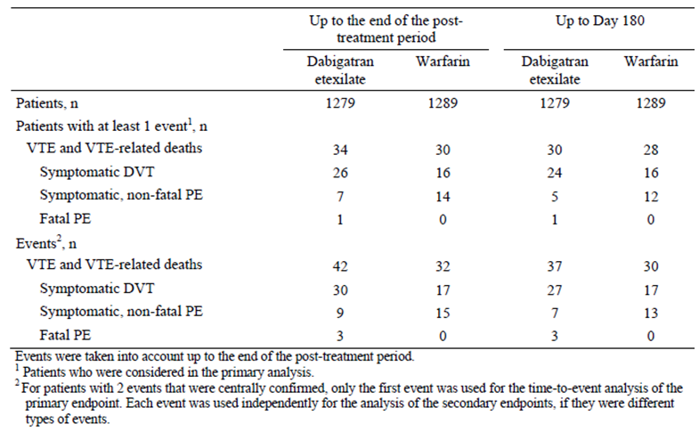
Up to Day 180, the number of patients meeting the primary endpoint of recurrent VTE or VTE-related death was 30 (2.4% of 1279) in the DE group and 28 (2.2% of 1289) in the warfarin arm. The pattern of events accounting for the composite endpoint at Day 180 was similar to that observed at the end of the post treatment period. The cumulative risk difference for the primary composite endpoint at 6 months between DE and warfarin was 0.2 (95% CI -1.0, 1.3). The p-value for non-inferiority was < 0.0001. As the upper limit of the 95% CI was below the pre-defined non-inferiority margin of 3.6% and the p-value was statistically significant, the null hypothesis of inferiority of DE versus warfarin could be rejected. The p-value for superiority of DE versus warfarin was 0.7756 (that is not statistically significant). The KM curves for the primary efficacy endpoint were almost congruent for both treatment groups over the 210 days of follow up. For both treatment groups, the KM curve was steeper in the first 3 months of therapy and became shallower thereafter up until 210 days.
Various pre-defined sensitivity analyses of the primary endpoint were performed, which were consistent with the primary analysis. Sensitivity analyses included using the PPS (rather than FAS) for the primary endpoint (HR 1.10; 95% CI 0.67, 1.81), an on-treatment analysis (HR 0.96; 95% CI 0.56, 1.65), and an analysis considering unexplained death as VTE related (HR 1.12; 95% CI 0.71, 1.76).
Subgroup analyses of the primary endpoint were performed to evaluate the consistency of the treatment effect (for DE and warfarin) across a variety of subgroups identified by baseline demographic (geographical region) and patient characteristics (age, gender, race, weight, CrCL and concomitant medications); as well as risk factors for recurrent VTE (prior history of VTE, and malignancy at any time). In addition, the predefined statistical plan also examined whether or not 1 or more parenteral anticoagulant treatment for the index VTE had an effect on outcome. For all but 1 subgroup, the 95% CIs for the HR included 1.0 and therefore no subgroup-by-treatment interactions could be concluded. A numerically higher incidence of recurrent VTE or VTE related death in the DE versus warfarin group was observed for current smokers (12 out of 279 in the DE group versus 3 out of 282 in the warfarin arm). The HR of DE versus warfarin for this subgroup had a very wide CI (HR 4.10; 95% CI 1.16, 14.54).
The HRs and cumulative risks were also assessed by baseline stratification factors of initial symptomatic PE and cancer. Unexpectedly, the cumulative risk of the primary endpoint was higher in patients without initial symptomatic PE (2.7% (23 out of 876) for DE and 2.3% (20 out of 876) for warfarin) compared to subjects who presented with PE (1.8% (7 out of 403) for DE and 2.0% (8 out of 413) for warfarin); refer to Table 15. Patients with active cancer had a higher cumulative risk for the primary endpoint (5.2% (2 out of 50) for DE and 4.4% (2 out of 50) for warfarin) than those without active cancer at baseline (2.3% (28 out of 1229) for DE and 2.1% (26 out of 1239) for warfarin).

Table 15. Primary efficacy endpoint incidence by stratification factors in Study 1160.46.
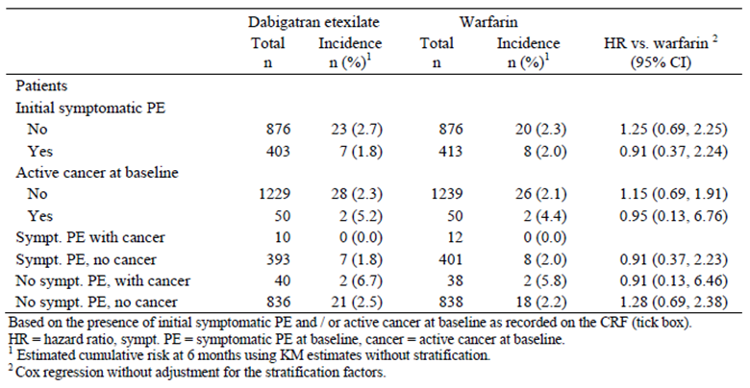

Results for other efficacy outcomes

Composite of recurrent symptomatic VTE and all deaths
At 6 months, 51 patients (4.0% of 1279) in the DE group and 48 subjects (3.8% of 1289) in the warfarin arm met this composite endpoint. The cumulative risk difference at 6 months of recurrent symptomatic VTE and death for DE versus warfarin was 0.3% (95% CI -1.1%, 1.6%). The presence of active cancer at baseline was the strongest risk factor for determining who experienced this outcome: without initial PE (26.1% in the DE group, and 27.0% in the warfarin arm), and with initial PE (20.0% in the DE group, and 18.2% in the warfarin arm).
Up until the end of the post treatment period, a slightly greater number of patients in the DE treatment group experienced recurrent VTE or died (57 subjects; 4.46% of 1279) compared to 51 patients in the warfarin arm (3.96% of 1289). The HR for this composite endpoint was 1.09 (95% CI 0.75, 1.60) for DE versus warfarin.

Symptomatic DVT
At 6 months, the number of patients experiencing an acute symptomatic DVT was numerically greater in the DE treatment group (2.0%; 25 out of 1279) compared to the warfarin arm (1.3%; 17 out of 1289). However, the comparative risk difference between DE and warfarin was -0.6% (95% CI -0.3%, 1.5%) which did not indicate a statistically significant observation. For both treatment groups the majority of DVT events were identified in the first 120 days of therapy.
In an expanded time frame of up until the end of the post treatment period, a further 3 patients in the DE group (28 overall) developed an acute symptomatic DVT versus no additional patients in the warfarin group (17 in total). The HR of DE versus warfarin for symptomatic DVT in the end of post treatment dataset was 1.65 (95% CI 0.90, 3.01). No treatment related differences were detected with the randomisation strata or subgroups of interest.

Symptomatic PE
At 6 months, the number of patients experiencing a symptomatic, non-fatal PE was higher in the warfarin group (n = 13; 1.0% of 1289) compared with DE (n = 7; 0.6% of 1279) for warfarin. The comparative risk difference between DE and warfarin was -0.4% (95% CI -1.1%, 0.3%). For both treatment groups the majority of non-fatal PEs occurred in the first 90 days of treatment, although several cases occurred late in both treatment groups (that is between Days 160 and 210).
In a supporting analysis up until the end of the post treatment period, a further 2 patients in each of the treatment groups experienced a non-fatal PE. The HR of DE versus warfarin for symptomatic, non-fatal PE up to the end of post treatment period was 0.59 (95% CI 0.26, 1.35).

VTE related death
Up until the end of the post treatment period, 3 patients in the DE group and no subject in the warfarin arm died from VTE. The HR for VTE related death was not evaluable as all deaths occurred in the DE arm. At 6 months, the cumulative risk of VTE related death was 0.2% (3/1279) in the DE group and zero in the warfarin arm, which yielded a risk difference of 0.2% (95% CI 0.0%, 0.5%). Two of the 3 patients who died from VTE during the trial had neither symptomatic PE at enrolment or active cancer, and the other deceased subject had a PE as the index event but without cancer.

All deaths
At 6 months, 25 patients had died in each treatment group. The cumulative risk of death by 6 months in each treatment group was 2.0% (risk difference for DE versus warfarin being 0.1% (95% CI -0.7%, 1.0%)). An additional 4 subjects in the DE treatment group and 1 patient in the warfarin arm died up until the end of their post-treatment period (that is a total of 29 subjects died in the DE group and 26 patients died in the warfarin treatment group). The HR for death up until Day 224 was 1.04 (95% CI 0.61, 1.77) for DE versus warfarin. The highest risk of all-cause mortality was observed in patients with active cancer at baseline, but without initial PE (20.7% for DE and 27.1% for warfarin) followed by patients with active cancer and PE at baseline (20.0% for DE and 18.2% for warfarin).
The most frequent cause of death in both treatment groups was cancer (15 patients in each treatment group), 10 deaths were categorised as unexplained (5 subjects in each treatment group) and 8 as ‘other’ reasons (5 in the DE group and 3 in the warfarin arm).

Evaluator summary
In conclusion, Study 1160.46 revealed DE therapy was associated with more symptomatic DVTs and fatal PEs, but less symptomatic, non-fatal PEs compared to the warfarin treatment group. However, none of these observations were statistically significant for demonstrating differences in treatment effect between DE and warfarin.

Analyses performed across trials (pooled analyses)
The main objective of the pooled analysis of Studies 1160.53 and 1160.46 was to obtain the overall estimate of the HR (using a Cox proportional hazards model) for the incidence of VTE and VTE related death between DE and warfarin. Additionally, KM plots were prepared for the primary endpoint (that is the composite of recurrent symptomatic VTE and VTE related deaths).
The primary efficacy endpoint occurred at a similar rate in both treatment groups: 2.7% for DE treated subjects, and 2.4% for warfarin treated patients. The heterogeneity p-value was non-significant; homogeneity was assumed and a common treatment effect was used for both studies. The HR of DE versus warfarin for the primary efficacy endpoint was 1.09 (95% CI 0.77, 1.54). Both treatments were therefore assumed to be similar with regard to the primary efficacy endpoint. Results for the ITT analysis and other sensitivity analyses were consistent with the primary analysis. Overall, an excess of 0.4 events (VTE and VTE related deaths) in 100 patient-years of treatment would be expected for patients on DE versus warfarin. The KM curves for the primary endpoint were nearly congruent and crossed at multiple points. For both treatment groups, the curves indicated a higher risk of VTE recurrence in the 2 month period immediately after the initial symptomatic VTE.
The secondary efficacy endpoint of recurrent symptomatic VTE and all cause deaths (including unexplained deaths) occurred at a similar rate in both treatment groups: 4.3% in the DE group and 4.1% in the warfarin arm. For this composite endpoint, the HR of DE versus warfarin was 1.04 (95% CI 0.80, 1.37), which was not statistically significant. The test for heterogeneity resulted in a p-value of 0.6049. The KM curves of both treatment groups for this key secondary endpoint were nearly congruent and crossed multiple times. For both treatment groups, the estimated cumulative risk increased slowly and continuously over the course of the studies. The composite endpoint of VTE and all-cause deaths was also assessed by the incidence of each component, which was similar among the treatment groups. Death accounted for most of the events (2.00% in the DE group, and 2.04% in the warfarin arm) followed by symptomatic DVT (1.45% in the DE group, and 1.21% in the warfarin arm) and PE (0.82% each).

Evaluator’s conclusions on clinical efficacy for Indication 1: Treatment of acute deep vein thrombosis (DVT) and/or pulmonary embolism (PE) and prevention of related death
The sponsor has provided the efficacy data from 2 replicate, pivotal, randomised, multi-centre, double blind trials (1160.53 and 1160.46) to support the efficacy of DE in treating adult patients with acute symptomatic VTE and to prevent its associated mortality.
The primary efficacy outcome in the two pivotal Phase III studies was the proportion of subjects who experienced the composite of recurrent symptomatic VTE and VTE related death (centrally adjudicated by an independent committee). The use of this primary endpoint is consistent with the appropriate regulatory guideline (CPMP/EWP/563/98) for determining the utility of a therapy in treating acute symptomatic VTE. There were also several secondary efficacy endpoints in both studies (individual components of the primary outcome, as well as all deaths) which are appropriate supporting measures.
In general, the trials were of adequate design to evaluate the proposed indication, and they had a clear and appropriate plan of analysis. In both of the trials, the primary statistical plan was a test for the non-inferiority of DE versus warfarin, and if non-inferiority was confirmed then the superiority of DE versus warfarin for the primary efficacy outcome was to be assessed. Two non-inferiority margins were pre-specified: 2.75 for the HR, and 3.6% for the risk difference at 6 months. The choice of the non-inferiority margins was based on the data available at the time of protocol development, and is consistent with the relevant regulatory guideline (EMEA/CPMP/EWP/2158/99).
Active comparator therapy with INR adjusted warfarin (target INR 2.0 to 3.0) was used in both studies and this choice is consistent with contemporary practice and literature, including international treatment guidelines. The quality of the warfarin control as measured by various analyses of INR adequacy suggested that warfarin control may have been sub-optimal, but overall was consistent with real life clinical practice. Good quality warfarin control is defined as time in the therapeutic range of > 70%). In both of trials, this level of INR control in the warfarin treatment groups was not achieved. Up to 20% of all patients were taking various concomitant treatments such as NSAID, low dose aspirin, and P-gp substrates that may be expected in the target population.
In Study 1160.53, a total of 2564 subjects were randomised to either DE (n = 1273) or warfarin (n = 1266) for 180 days of active treatment, and post treatment follow up of an additional 30 days (that is 210 days in total). In Study 1160.46, a total of 2589 patients were randomised to receive either DE (n = 1294) or warfarin (n = 1295) for 6 months of treatment plus another 30 days of follow up. The majority of patients (approximately 85%) in both treatment groups completed the recommended follow up period in both pivotal studies. A relatively low proportion (< 5%) of major protocol violations that may have affected efficacy assessments occurred in both pivotal Phase III studies, with equal incidence among the treatment groups.
The populations examined in the Phase III studies are similar in demographics to patients that would be treated in Australian clinical practice. The trials mainly recruited patients from Western and Central Europe. The majority of recruited subjects were middle aged (younger than expected) and had normal baseline renal function (CrCL ≥ 80 mL/min). Preceding parenteral anticoagulation treatment (rates, as well agents used) is consistent with Australian treated patients. For the majority of patients (68%) the index VTE event was DVT, but PE was appropriately represented in the patient cohorts (> 20%). Nearly 10% of all subjects presented with both symptomatic DVT and PE. In addition to the index VTE episode, almost one third of DVT patients had an asymptomatic PE identified on objective testing. The above is consistent with expectations in the target population and reflects the extensive burden of clot in patients with symptomatic VTE. Moreover, the volume of data is sufficient to make an assessment of the comparative efficacy of DE in patients presenting with DVT, PE, or both manifestations of the same pathological process. More than 60% of all subjects had at least 1 identifiable risk factor for recurrent VTE, and in general the patient cohorts were at high risk for recurrent VTE events.
In general, the incidence and pattern of co-morbid illness was lower than expected. The 2008 Access Economics report estimated that in Australia, the incidence of VTE was highest in those aged > 70 years, whereas the average age of patients in both study cohorts was < 60 years, with less than one third of all treated patients being aged >6 5 years. As such, the generalisability of the studies results to a broader population in Australia has limitations. Moreover, patients at a high risk of bleeding were excluded.
The primary efficacy endpoint analysis in both pivotal Phase III trials demonstrated that DE was non-inferior to warfarin for the composite outcome of centrally confirmed recurrent symptomatic VTE and VTE related death. Superiority could not be demonstrated. Furthermore, in both trials pre-defined sensitivity analyses of the primary endpoint using the PPS (rather than FAS), and an on treatment analysis were consistent with the primary analysis. The results for the secondary efficacy endpoints consistently supported the primary analysis demonstrating that in both pivotal Phase III studies DE is non-inferior to warfarin for recurrent symptomatic DVT, PE and death (VTE related and all cause mortality). The cumulative risk of the primary efficacy endpoint was higher in patients with an initial symptomatic PE (compared to subjects who presented without PE) in Study 1160.53 but this observation was not replicated in the follow up Study 1160.46. In both trials, patients with active cancer had a higher cumulative risk for the primary endpoint. Expectedly, the highest risk of recurrent VTE or VTE related death is recognised to occur in patients with active cancer and/or symptomatic PE at baseline, regardless of treatment option (DE or warfarin). Nonetheless, the current dataset robustly supports that DE is non-inferior to warfarin in treating both clinical manifestations of VTE (that is both DVT and PE).
In summary, the data in this submission supports that DE is non-inferior to INR adjusted warfarin (at an acceptable level of quality control) in treating adult patients with acute symptomatic VTE, reducing both the risk of recurrent symptomatic VTE as well as VTE related mortality. The two pivotal Phase III studies have assessed the efficacy of DE over an appropriate time frame of follow up (180 days of treatment with an additional 30 days of post-treatment follow up), and compared the relative effect of DE to the main alternative treatment approach.

Indication 2: Prevention of recurrent deep vein thrombosis (DVT) and/or pulmonary embolism (PE) and related death

Pivotal efficacy studies

Study 1160.63 (also known as the RE-SONATE Study)

Study design, objectives, locations and dates
Study 1160.63 was a Phase III, randomised, double blind, placebo controlled trial comparing fixed dose DE (150 mg bid) with placebo. The primary objective of the study was to determine whether DE was superior to placebo in the long term prevention of acute symptomatic VTE in patients who had completed 6 to 18 months of treatment with a vitamin K antagonist for a confirmed symptomatic VTE within the previous 6 to 18 months. The study was an event driven, superiority trial. As pre specified in the protocol, when the required number of centrally confirmed recurrent symptomatic VTE events was reached (that is at least 36 events), the trial close out process was initiated, including termination of patient recruitment. Patients who had not completed 3 months of therapy at trial close out (30 September 2010) ended their treatment at the 3 Month visit. All other patients were to continue double blind treatment for the intended (planned) treatment period of 180 days (6 months).
At screening, no imaging was required but previous documentation of the index VTE (that is the qualifying event within the last 6 to 18 months) was required, and was forwarded for central adjudication. Patients found to have a screening INR of ≤ 2.3 were to have their vitamin K antagonist therapy ceased, randomised and then started study medication within 12 to 24 hours after cessation of the vitamin K antagonist treatment. Randomisation was postponed in those subjects with INR > 2.3. Scheduled visits during the intended treatment period of 6 months occurred at Days 15, 30, 90 and 180. The post-treatment period included both the original 30 day follow up period, as well as the 11 months of the extended follow up period (protocol amendment 2).
Patients who had completed Study 1160.53 were eligible to rollover into this trial. After signing informed consent to enrol into Study 1160.63, patients from Study 1160.53 immediately discontinued their warfarin/warfarin placebo medication, but continued to take their DE/DE placebo therapy, and were randomised into Study 1160.63 when their INR was ≤ 2.3.
Study 1160.63 was conducted between December 2007 and December 2011. A total of 147 enrolling centres in 21 countries (including Western and Central Europe, North America, Asia, Australia, New Zealand, and South Africa) were involved in the trial.
There were 7 global amendments to the original protocol, all of which were implemented after the commencement of patient recruitment. The amendments contained clarifications about the concurrent use of moderate to strong P-gp inhibitor drugs (for example quinidine, rifampicin and ketoconazole), detailed guidance on the use on concurrent use of verapamil, provided information on the perioperative/invasive procedure management of DE during the study period (if required), and extended the patient follow up period to 12 months (amendment 2). None of the amendments resulted in major changes to the study design, which may have affected the outcome or statistical analysis. Protocol amendment 2 (dated 30 May 2008) was an appropriate and important protocol change as the extended follow up period of 12 months allowed for the determination of whether or not there was an increase in VTE recurrence following discontinuation of DE.

Inclusion and exclusion criteria
To be eligible for inclusion, patients had to be at least 18 years of age at the time of enrolment with a confirmed symptomatic PE or proximal DVT of the leg (trifurcation area, popliteal, superficial femoral, deep femoral, common femoral and iliac veins), which had been treated for 6 to 18 months with therapeutic doses of an oral vitamin K antagonist (intended INR 2.0 to 3.0) up to the time of randomisation. Bridging therapy for any reason within the 6 to 18 months of vitamin K antagonist treatment was allowed for a maximum of 30 days.
The exclusion criteria involved 5 domains and patients meeting any 1 of the features were to be excluded from participation:
- Diagnosis: continued need for therapeutic anticoagulant treatment for index VTE beyond 18 months; need for anticoagulation treatment for disorders other than VTE; and pregnancy/lactation
- Concurrent conditions: active or high risk of bleeding (investigator’s judgement); acute bacterial endocarditis; uncontrolled hypertension; known active cancer; and life expectancy < 6 months
- Past history; known allergy to DE or its excipients; alcohol or substance abuse; and active liver disease (for example cirrhosis of any cause)
- Baseline results: hepatic dysfunction (defined as ALT or AST > 3 x ULN); and severe renal impairment (defined as estimated CrCL ≤ 30 mL/min); and
- Recent or concurrent treatments: anticipated need to use moderate to strong inhibitors of p-glycoprotein (for example ketoconazole, rifampicin and quinidine) during the trial.

Study treatments
The investigational treatment in this study was DE 150 mg twice daily (morning and evening), and the comparator was matching placebo capsules. The protocol recommended that DE be taken at approximately the same time of the day (within a time window of +/- 2 hours). Patients were to continue their preceding vitamin K antagonist therapy or RE-COVER study medication (that is DE or DE placebo) until randomisation. Patients could only be randomised when their INR was ≤ 2.3.
Treatment compliance was checked every 3 months during the trial by capsule counts at scheduled visits. Over the 6 month active treatment period of the study, the rates of non-compliance with DE (4.3%) or matching placebo DE capsules (4.2%) were low in both treatment groups.

Efficacy variables and outcomes
The primary efficacy endpoint in Study 1160.63 was the incidence of recurrent symptomatic VTE, defined as the composite of symptomatic DVT and PE (non-fatal and fatal) during the intended treatment period. Deaths that were unexplained were considered as fatal PEs for the evaluation of the primary endpoint. All recurrent VTE episodes required objective verification by definitive diagnostic testing. An independent committee that was blinded to treatment allocation centrally adjudicated all recurrent VTE events and deaths. Only adjudicated results were used in the analyses.
Secondary efficacy outcomes were the composite of recurrent symptomatic VTE (symptomatic DVT, symptomatic non-fatal PE, and fatal PE, excluding unexplained deaths) and the individual components comprising the primary efficacy endpoint.

Randomisation and blinding methods
Patients were randomised 1:1 to either DE or placebo therapy by a centralised process using an Interactive Voice System Response (IVRS) system. Randomisation was stratified by centre using permuted blocks of 4, and within each centre by prior participation in Study 1160.53.
The study had a double blind design so neither the patients or investigators were informed about their treatment allocation. Each subject received either, DE capsules or matching placebo capsules, which were of identical physical appearance, packaging and labelling.

Analysis populations
The primary and secondary efficacy analyses were based on the FAS, which consisted of all randomised subjects who were documented to have received at least 1 dose of study drug. Sensitivity efficacy analyses were performed using the Per-Protocol (PPS) population. This consisted of all patients who received at least 1 dose of study drug, and excluded any patient who experienced a major protocol deviation (such as active cancer at study entry, or first INR ≤ 2.3 but first dose of study medication taken > 36 hours later).

Sample size
Because Study 1160.63 used a time to event analysis, the statistical power and sample size calculations are dependent on the number of observed events. Assuming a 70% risk reduction in the DE treatment group compared to placebo, a total of 36 events would give a power of 95% to demonstrate that DE was superior to placebo (2-sided type I error = 0.05). Assuming a mean frequency of 3% for the primary outcome in the placebo arm, approximately 900 patients per treatment group was needed.

Statistical methods
The primary statistical analysis was a test for the superiority of DE versus placebo. The primary efficacy endpoint was analysed in terms of the time to first occurrence using a Cox proportional hazards model including the main effect of treatment. The DE to placebo HR and its corresponding 2 sided 95% CIs were calculated. Superiority of DE over placebo was to be concluded if the upper 95% confidence limit of the HR was less than 1. KM plots stratified by treatment were produced for efficacy endpoints that occurred during the intended treatment period. The log rank test was performed as a sensitivity analysis. The composite endpoint of recurrent symptomatic VTE without unexplained death was analysed in the same manner as described for the primary efficacy analysis. The frequencies of the individual components contributing to the primary efficacy endpoint were summarised by treatment group, 95% CIs were calculated using the Clopper-Pearson method, and Fisher’s exact test was used to compare the 2 treatment groups.
The cumulative incidence of recurrent symptomatic VTE events (with and without unexplained deaths) from randomization up to the end of the 12 month extended follow up period, after the intended treatment period, was determined. KM plots stratified by treatment were produced, and log rank p-values and HRs were determined.

Participant flow
A total of 1366 patients were enrolled (provided informed consent) into Study 1160.63, and 1353 were randomised to either DE (n = 685) or placebo (n = 668). Of the 13 (1.0%) patients who enrolled but were not randomised, the most frequent reason for non-randomisation was violation of the inclusion or exclusion criteria (7 subjects) followed by withdrawal of consent (5 patients).
All but 10 of the randomised subjects (99.3%; 1343 out of 1353) were documented to have received at least 1 dose of study medication: 681 out of 685 (99.4%) in the DE group and 662 out of 668 (99.1%) in the control arm. The rates of treatment completion at 6 months were similar between the 2 treatment groups: 91.3% (622 out of 681) for the DE arm and 94.6% (626 out of 662) for placebo group. Figure 2 provides a summary of participant flow and reasons for premature discontinuation from the trial. Discontinuations due to worsening of disease (that is recurrent symptomatic VTE) were much higher in the control group (7.4%; 49 out of 662) compared with DE therapy (0.15%; 4 out of 681).
Figure 2. Patient disposition in Study 1160.63.
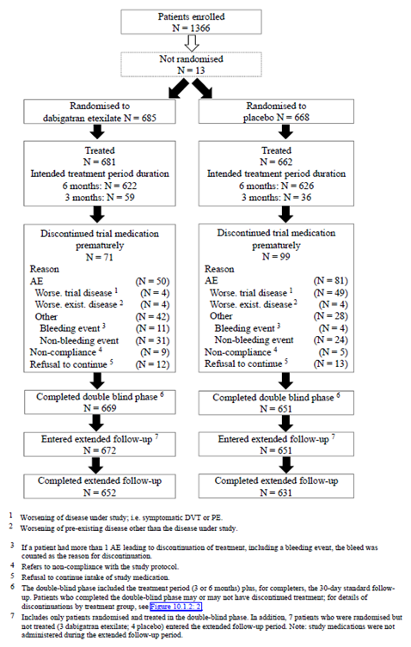
In Study 1160.53, subjects were followed up for an extended period of time (up to 12 months) following completion of their treatment. The rates of completion for the extended follow up phase were 95.2% (652 out of 685) in the DE group and 94.5% (631 out of 668) in the placebo arm.

Major protocol violations/deviations
A total of 141 patients (10.5% of 1343) had protocol violations that may have affected the efficacy evaluation, and therefore were excluded from the PPS analysis. Of the 141 subjects, 78 (11.5% of 681) in the DE group and 63 (9.5% of 662) in the control arm had important efficacy related protocol deviations. The most common reasons for exclusion from the PPS because of potentially important protocol violations that may have affected the efficacy assessments were first INR ≤ 2.3 but first dose of study medication taken > 36 hours later (21 patients in each treatment group (3.1% of each cohort)), qualifying VTE not confirmed by the central adjudication committee (20 patients (2.9% of 681) in the DE group, and 8 subjects (1.2% of 662) for placebo), treatment non-compliance (22 patients (3.2% of 681) in the DE group, and 19 subjects (2.9% of 662) for placebo), and treatment exposure too short (that is less than 160 days for those with an intended treatment period of 180 days, and less than 80 days for those expected to receive 3 months of treatment). This last type of protocol deviation affected 18 (2.6% of 681) patients in the DE group and 16 (2.4% of 662) subjects in the placebo arm. In addition to important efficacy related protocol deviations, 58 subjects (4.3% of 1343) were identified to have violations of inclusion or exclusion criteria. The enrolment criteria violations included 3 subjects with baseline serum transaminases > 3 x ULN (all in the DE arm), and 3 patients (1 in the DE group and 2 in the control arm) with active cancer.

Baseline data
The treatment groups were generally balanced with respect to demographic and baseline disease characteristics. The overall patient population was predominately Caucasian (89.0%; 1195 out of 1343), and just over half were male (55.5%; 745 out of 1343). The mean age of the cohort was 55.8 years, and approximately one fifth of all patients (20.9%; 281 out of 1343) were 70 years of age or older. More than half of all subjects were recruited from Western (55.2%; 741 out of 1343) or Central Europe (25.0%; 336 out of 1343). The mean BMI of the cohort was 28.4 kg/m2, and 16.6% (223 out of 1343) of all subjects were current smokers. The baseline CrCL of the study population was 100.4 mL/min (SD 36.4 mL/min). Most patients (69.5%; 934 out of 1343) had a baseline CrCL of ≥ 80 mL/min, 24.9% (334 out of 1343) of subjects had CrCL 50 to 79 mL/min and 5.3% (71 out of 1343) of subjects had CrCL 30 to 49 mL/min. One patient in the DE group had a baseline CrCL of < 30 mL/min, which was an exclusion criterion. A total of 12 patients in the placebo group (8 had previously received DE) and 15 subjects in the DE arm (7 had previously received DE) were rollover patients from the RE-COVER Study. For the majority of patients, the duration of prior vitamin K antagonist therapy was 6 to 18 months, as specified in the trial protocol (68.8% (924 out of 1343) had received 6 to 12 months, and 22.9% (307 out of 1343) had received 12 to 18 months). For 99 patients in the FAS (7.4%; 49 in the DE group and 50 in the placebo arm), the duration of previous vitamin K antagonist medication was < 6 months, and for 13 subjects (1.0%; 6 in the DE group and 7 in the control arm) the duration of prior anticoagulation treatment was > 18 months.
The characteristics of the qualifying events were balanced between the treatment groups. Based on local assessments, the qualifying event was symptomatic DVT alone for 64.6% (867 out of 1343) of patients, symptomatic PE alone for 28.2% (379 out of 1343) of subjects, and both symptomatic DVT and PE for 7.2% (97 out of 1343) of patients. The central and local assessments of qualifying VTE correlated strongly for both treatment groups (98.6 to 99.8%). The mean time between the onset of the qualifying VTE episode and randomisation was 9.7 months (median: 8.3 months; range: 5 to 34 months). The mean INR values at baseline were comparable in both treatment groups (1.68 for DE (5th to 95th percentile values of 1.0 to 2.3) and 1.69 for placebo (5th to 95th percentile values of 1.03 to 2.3)). Five patients (all in the DE group) had no INR reading at baseline. The mean time from having an INR ≤ 2.3 until the first intake of study drug was also comparable in both treatment groups (10.8 hours for DE (5th to 95th percentile values of 0.8 to 24.8 hours), and 10.0 hours for placebo (5th to 95th percentile values of 0.9 to 26.5 hours)).
Regarding baseline risk factors for recurrent VTE, a total of 155 patients (11.5% of 1343) had an identifiable coagulation abnormality, most commonly Factor V Leiden deficiency or prothrombin gene mutation. Recent immobilization was recorded in 89 subjects (6.6% of 1343). There was no between-group difference detected for any of the risk factors for recurrent VTE.
Concomitant medication use of interest was recorded in 19.4% (260 out of 1343) of patients, at a similar frequency in each of the treatment groups (20.1% (137 out of 681) in the DE group, and 18.6% (123 out of 662) in the control arm). Of these drugs, NSAID use (11.9%; 160 out of 1343) and aspirin therapy (7.7%; 104 out of 1343) were the most common concurrent treatment. The concomitant use of P-gp inhibitors or inducers was rare (1.7% (23 out of 1343) and 0.8% (11 out of 1343), respectively). Restricted medications (including restricted anticoagulants) were used concomitantly with study drug by 3.6% (48 out of 1343) of patients. Heparin and heparinoid drugs were the most frequently reported restricted medication at an overall incidence of 2.5% (34 out of 1343; 16 patients in the DE group and 18 subjects treated with placebo). During the extended follow up period, the use of anticoagulant medications considered to be preventative of a symptomatic recurrent VTE was less frequent in the DE group (20.3%; 138 out of 681) than for the placebo arm (25.5%; 169 out of 662). Both vitamin K antagonists and LMWHs were less commonly reported for DE patients (14.1% (96 out of 681) and 12.2% (83 out of 681), respectively) than for placebo patients (20.1% (133 out of 662) and 17.1% (113 out of 662), respectively).
The most frequent baseline condition of interest was hypertension reported in 38.8% (521 out of 1343) of patients, followed by diabetes mellitus (8.0%; 107 out of 1343) and heart failure (4.6%; 62 out of 1343). Hypertension was more common in DE patients (41.3%; 281 out of 681) than in placebo subjects (36.3%; 240 out of 662). A baseline history of prior myocardial infarction was more common in DE patients (2.1%; 14 out of 681) than in placebo patients (0.8%; 5 out of 662). All other medical conditions (such as coronary artery disease, peptic ulcer and past history of cancer) at baseline had a frequency of < 6% and were equally balanced between the two treatment groups.

Results for the primary efficacy outcome
The incidence of the primary endpoint (symptomatic recurrent VTE, including unexplained deaths) occurring during the intended treatment period was 0.4% (3 out of 681) in the DE group and 5.6% (37 out of 662) in the placebo arm. The HR for DE versus placebo was 0.08 (95% CI 0.02, 0.25). This result conferred the superiority of DE versus placebo as the upper 95% CI limit of the HR was less than 1 (p < 0.0001). The upper limit of the 95% CI indicated that DE reduced the risk of recurrent symptomatic VTE events by at least 75% compared to placebo. Sensitivity analyses of the primary endpoint (such as analysis using the PPS) confirmed the robustness of the primary analysis, with CIs either the same or very similar to the primary analysis. KM curves for DE and placebo therapy for the primary endpoint diverged soon after the start of treatment, and continued to diverge throughout the treatment period of up to 180 days.
Subgroup analyses of the primary endpoint were performed in an exploratory manner to evaluate the consistency of the treatment effect across a variety of subgroups identified by baseline demographic (geographical region) and patient characteristics (age, gender, race, and CrCL); as well as risk factors for recurrent VTE (prior history of VTE, duration of prior vitamin K antagonist therapy, and type of qualifying VTE) and previous participation in the RE-COVER Study. For the subgroups analysed, no effect was observed on the incidence and time to first symptomatic recurrent VTE or unexplained death. The incidence of the primary endpoint for RE-COVER patients in the placebo group was 16.7% (2 out of 12) and zero (0 out of 15) for those in the DE treatment arm. The HR for DE versus placebo in rollover patients from RE-COVER was 0.08 (95% CI 0.02, 0.25). This result was consistent with that observed for the entire FAS population.

Results for other efficacy outcomes

Recurrent symptomatic VTE excluding unexplained death
The incidence of recurrent symptomatic VTE during the intended treatment period was 0.4% (3 out of 681) in the DE group and 5.3% (35 out of 662) in the placebo arm. The HR for DE versus placebo for the time to first recurrence of VTE was 0.08 (95% CI 0.03, 0.27). Superiority was demonstrated for DE versus placebo as the upper 95% CI limit of the HR was < 1. Since there were only 2 unexplained deaths (both in the placebo group), these findings were similar to the primary analysis. A KM plot of the time to first recurrence of symptomatic VTE showed that DE and placebo therapy diverged soon after the start of treatment, and continued to diverge throughout the 180 day treatment phase.
With the onset of the extended follow up period, and the cessation of anticoagulation in those subjects allocated to DE, there was an increase in the rate of recurrent VTE events. At the end of the extended follow up period, the cumulative incidence of recurrent VTE was 6.9% (47 out of 681) for the DE group versus 10.7% (71 out of 662) for the placebo arm. Overall, an additional 44 DE and 34 placebo group subjects developed recurrent VTE during the extended follow up phase of the trial. The HR for time to first occurrence of a symptomatic recurrent VTE for DE versus placebo for the entire study period was 0.61 (95% CI 0.42, 0.88). When unexplained deaths were included in the analysis (as a supporting analysis), the treatment difference in favour of DE was also statistically significant with the HR for the entire study period being 0.63 (95% CI 0.43, 0.90; p = 0.0127). Risk differences for the cumulative occurrence of recurrent symptomatic VTE (with or without including unexplained deaths) demonstrated that DE was superior to placebo up to Days 180, 220, 365 and 540 after randomization. The KM plots of time to the first centrally confirmed recurrent VTE over the entire study period showed no significant rebound increase in VTE events (or unexplained death) after discontinuation of DE, but rather a steady increased risk of recurrent VTE which paralleled that observed with placebo therapy during the initial 6 months of the study. As an additional supporting analysis, the HR for the time to first occurrence of a recurrent symptomatic VTE (including unexplained deaths, and censored by the need for additional, non-study anticoagulant therapy) for DE versus placebo for the entire study period was 0.76 (95% CI 0.6, 0.95; p = 0.0148).

Individual components of the composite primary endpoint
Consistent with the primary analysis, all individual components of the composite primary endpoint were less frequent in the DE group compared to placebo. Table 16 provides a summary of the individual event types that occurred during the intended treatment period of 180 days.

Table 16. Recurrent VTE and unexplained deaths in Study 1160.63 (centrally adjudicated; FAS).
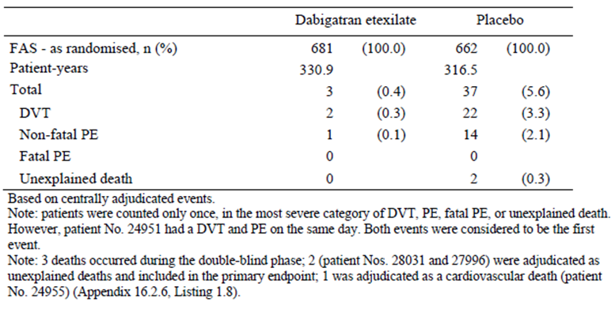
Only 3 (0.4% of 681) DE treated patients developed a total of 3 events during the intended treatment period compared to 37 (5.6% of 662) subjects in the control arm who experienced 38 events contributing to the primary efficacy analysis. No fatal PE occurred in either treatment group. The most frequent event was recurrent symptomatic DVT, which affected 22 patients (3.3% of 662) in the placebo group and 2 subjects (0.4% of 681) in the DE arm. The frequency of non-fatal PE was higher in the placebo group (2.1%; 14 out of 662) compared to the DE arm (0.1%; 1 out of 681). There were 2 unexplained deaths in the placebo group. The comparative risk difference and 95% CIs between DE and placebo for any of the individual components of the primary efficacy endpoint were statistically in favour of DE therapy.
In the analysis which included the extended post treatment follow up period, a further 29 patients in the DE group (31 overall) and an additional 26 subjects in the control arm (48 overall) developed an acute symptomatic DVT. In the post treatment period, the number of additional patients experiencing a symptomatic, non-fatal PE was higher in the DE group (n = 17; 18 overall) compared with placebo (n = 11; 25 overall). Two patients (both in the DE group) died in the extended follow up period due to PE (centrally confirmed by objective testing). One death occurred 38 days after ceasing DE, and the other fatality occurred 216 days after discontinuing DE.

Evaluator summary
In conclusion, Study 1160.63 demonstrated that DE was superior to placebo in preventing recurrent symptomatic VTE, and possibly unexplained death (although there were only 2 fatalities in 662 placebo treated patients) during the 6 months of active treatment. In the extended follow up period (that is post-treatment for up to 12 months), the occurrence of VTE in the previously DE treated subjects was similar to that observed in the control group, indicating that there is no preservation of the benefit (or potential harm, that is rebound effect) in preventing VTE following discontinuation of DE.

Study 1160.47 (also known as the RE-MEDY Study)

Study design, objectives, locations and dates
Study 1160.47 was a Phase III, randomised, double blind, parallel group, active controlled trial with a planned duration of 6 to 36 months of treatment comparing fixed dose DE (150 mg bid) with Warfarin (target INR 2.0 to 3.0). The objective of the study was to compare the efficacy and safety of DE and warfarin for the long term treatment and secondary prevention of symptomatic VTE in patients who had been successfully treated with either DE (as part of the RE-COVER or RE-COVER II studies) or an approved anticoagulant for 3 to 12 months for previous confirmed acute symptomatic VTE.
Patient involvement in Study 1160.47 occurred between July 2006 and October 2010. A total of 261 centres in 33 countries (including North and Latin America, Western and Eastern Europe, Australia and New Zealand, South Africa, Asia and Israel) enrolled subjects in the trial.
There were 9 amendments to the original protocol, all of which were implemented after the commencement of patient recruitment. Two of the amendments resulted in significant changes to the study design and statistical analysis, and consequently may have influenced the outcome of the trial. Protocol amendment 2 (dated March 15, 2007) changed the required time period of previous anticoagulation prior to entry into Study 1160.47 from the original 3 to 6 months to 6 to 12 months. This change was implemented following the publication of guidelines of the 7th ACCP Consensus Conference on Antithrombotic Therapy, which recommended that for patients at high risk of recurrent VTE, a minimum of 6 to 12 months of anticoagulation therapy was best contemporary practice. The same amendment also gave investigators the option of using bridging anticoagulation with LMWH for patients who had just completed participation in the RE-COVER Study, and who were rolling over into the RE-MEDY trial. The rationale for the amendment was that some patients may have been potentially switching from DE therapy in the preceding trial to warfarin in this study, and it was assumed that warfarin might take several days to exert a therapeutic effect in these subjects. Protocol amendment 6 (dated 12 December 2008) contained several significant changes to the study conduct. Firstly, the planned treatment period was altered from the original 18 months to up to 36 months. Secondly, the number of recruited subjects was increased by at least 400 patients. Enrolment was to cease once the planned total number of 2400 patients had been randomised, but no later than 31 December, 2009 (and therefore, the last patient completion date was 31 July 2010). As a result of the changes to the planned treatment duration (6 to 36 months) and overall patient recruitment, several changes to the analysis plan (including statistical calculations) and patient visit schedule were required. Amendment 6 allowed for patients completing the RE-COVER II Study to become eligible for the RE-MEDY Study.
As a result of protocol amendment 6, 3 cohorts of subjects were identified in Study 1160.47:
- Patients who completed the trial prior to the implementation of this amendment or those not willing to consent to the change (such subjects had a planned treatment duration of 18 months)
- Patients who were randomised prior to implementation of the protocol change and who consented to the amendment (such patients had a planned treatment duration of 18 to 36 months) and
- Patients randomised after implementation of this amendment but enrolled within 18 months of the planned study close out (these subjects had a planned treatment duration of 6 to < 18 months).
As a result of protocol amendment 6, the 3 different patient cohorts were treated like sub trials in the primary analysis of the primary efficacy endpoint. Pooling of the efficacy results was done by applying meta-analysis techniques.
The other 7 protocol amendments did not result in major changes to the study conduct and contained clarifications about the qualifying baseline laboratory results and monitoring of liver function tests, use of POC testing devices, exclusion of concurrent administration of moderate to strong P-gp inhibitor drugs (for example quinidine, rifampicin and ketoconazole), detailed guidance on the concurrent use of verapamil, provided information on the perioperative and invasive procedure management of DE during the study period (if required) and extended the study recruitment period by 7 months because of slower than expected subject enrolment (protocol amendment 3).
According to the original protocol, the trial duration was to be approximately 19 months, which included a screening period of up to 7 days, an 18 month treatment period (DE or warfarin), and a 30 day follow up phase subsequent to the completion of active therapy. Protocol amendment 6 extended the active treatment period to up to 36 months (from 18 months). Between the screening and randomisation visits, the INR was to be monitored in the clinic, preferably on a daily basis. Patients were randomised once their baseline INR was ≤ 2.3. Subjects were to start study medication on the same day if their INR was < 2.0, or on the following day if their INR was between 2.0 and 2.3. Randomisation was postponed in those subjects with INR > 2.3. In the interval between screening and randomisation, bilateral lower limb venous CUS was performed. Scheduled visits during the intended treatment period of up to 36 months occurred at Days 15, 30, 60, 90, 120, 150 and 180; and every 90 days thereafter.

Inclusion and exclusion criteria
The inclusion criteria for Study 1160.47 were similar to Study 1160.63. To be eligible for inclusion in the RE-MEDY Study, patients had to be at least 18 years of age at the time of enrolment with an objectively confirmed symptomatic PE or proximal DVT of the leg (trifurcation area, popliteal, superficial femoral, deep femoral, common femoral and iliac veins) which had been treated for at least 3 to 12 months with either therapeutic doses of an oral vitamin K antagonist (intended INR 2.0 to 3.0) or DE (if rolling over from either Study 1160.53 or 1160.43) up to the time of randomisation.
The exclusion criteria were extensive and almost identical to that outlined for Study 1160.53 (RE-COVER). The major exclusion criteria included symptomatic VTE at screening, patients with primary PE with suspected origin other than the lower limbs, actual or anticipated use of vena caval filter, interruption of anticoagulant therapy for ≥ 2 weeks during the initial VTE treatment period, patients at high risk of bleeding (investigator’s judgement), various baseline laboratory test abnormalities (including ALT or AST > 2 x ULN, known anaemia or thrombocytopenia and CrCL ≤ 30 mL/min), recent unstable cardiovascular disease (including uncontrolled hypertension) and patients who developed elevations of serum transaminases with ximelagatrin.

Study treatments
Each patient was randomly assigned to either fixed dose DE (150 mg twice daily, to be taken in the morning and evening) and warfarin placebo tablets (with a sham INR target of 2.0 to 3.0); or the comparator was warfarin therapy (target INR 2.0 to 3.0) and matching DE placebo capsules. The start of treatment procedure was different for roll-over subjects (from the RE-COVER and RE-COVER II studies) and de novo subjects. Newly recruited patients were to stop their previous anticoagulant treatment at the screening visit, have their INR checked daily, and commence study treatment when the INR was ≤ 2.3. Subjects were to start study medication on the same day if their INR was < 2.0, or on the following day if their INR was between 2.0 and 2.3. For roll-over patients, DE (or matching placebo capsules) from the last kit of the RE-COVER or RE-COVER II studies was to continue until randomisation, but warfarin (or matching placebo) was to cease at screening. Again the INR was to be checked daily, and study medication for the RE-MEDY Study could be commenced when the INR was ≤ 2.3 (same rules as above).
Treatment with warfarin or warfarin placebo tablets was to be taken once daily, at approximately the same time each day. The first dose of warfarin was recommended to not exceed 5 mg. INR monitoring using a POC device was to be started immediately and readings were taken daily until the target INR range of 2.0 to 3.0 was achieved. After a stable warfarin (or warfarin placebo) dose had been determined, INR measurements were to be performed every 1 to 4 weeks during the 36 month trial (at the investigator’s discretion). Warfarin tablets were supplied in 3 different unit strengths (1 mg, 3 mg and 5 mg), and tablets were not to be broken.
Treatment compliance with DE (or DE placebo) was checked by capsule counts at scheduled visits. During the study, the rates of non-compliance with DE (2.0%) or matching placebo DE capsules (1.8%) were low in both treatment groups. Treatment compliance with warfarin was not directly assessed but instead the INR time in range (that is the time when the INR was in the target range 2.0 to 3.0) was evaluated for the time period between the first intake of DE placebo and the last intake of warfarin.
On average, 22.9 INR measurements were performed per patient in the warfarin group over an average exposure period of 15.8 months (median of 22 readings; range of 0 to 84 INR results). Four warfarin treated subjects had no recorded INR measurements. In the first month, the mean percentage of time that warfarin treated patients (n = 1216) remained in the target INR range of 2.0 to 3.0 was 51.9% (24.2% of the time subjects had INR < 2.0, and 23.8% of the time patients had INR > 3.0). By 6 months (n = 1305) the mean percentage of time in the target INR range of 2.0 to 3.0 was 63.7% (22.6% of the time subjects had INR < 2.0, and 13.7% of the time patients had INR > 3.0). The relative rates of INR control up until 36 months of treatment were similar to that observed by 6 months of treatment, although the overall number of actively treated warfarin subjects decreased with time (for example n = 1108 at 10 to 12 months, n = 859 at 16 to 18 months, n = 196 at 22 to 24 months and n = 67 at 28 to 30 months).
The frequencies of warfarin treated patients with time in the INR target range of 2.0 to 3.0 was assessed by quartile thresholds (< 50%, 50 to 65%, 65.1 to 77% and ≥ 77%). In the first month, 49.8% (606 out of 1216) of subjects spent less than 50% of their time in the target range of 2.0 to 3.0, while 9.9% (120 out of 1216) of patients were in target 50 to 65% of the time, 5.9% (72 out of 1216) of subjects were in target 65.1 to 77% of the time, and 37.4% (418 out of 1216) of subjects spent ≥ 77% of their time in the target range of 2.0 to 3.0. Over the course of the study, the proportion of subjects who spent less than 50% of the time in the target INR range progressively decreased to 35.0% (457 out of 1305) by month 6, while the percentage of subjects with at least 77% of the time in the target INR increased (46.0% (600 out of 1305) by month 6).

Efficacy variables and outcomes
The primary efficacy outcome in the RE-MEDY Study was the same as in RE-COVER and RE-COVER II studies; that is the composite of recurrent symptomatic VTE and deaths related to VTE. All recurrent VTE episodes required objective verification by definitive diagnostic testing. An independent committee that was blinded to treatment allocation centrally adjudicated all recurrent VTE events and deaths. Only adjudicated results were used in the analyses.
The same 5 secondary efficacy outcomes evaluated in the RE-COVER and RE-COVER II studies were assessed in the RE-MEDY trial: composite of recurrent VTE and all deaths, symptomatic DVT, symptomatic PE, VTE related deaths, and all deaths.

Randomisation and blinding methods
An IVRS was used to randomly assign patients to one of 2 treatment groups with a randomisation ratio of 1:1. Randomisation was stratified into 4 cells resulting from the combination of 2 stratification factors: active cancer (yes/no) and symptomatic PE (yes/no). To prevent unequal treatment allocation, blocks of 4 were used and the blocks were assigned to strata. Active cancer was defined as a diagnosis of cancer (other than basal cell or squamous cell carcinoma of the skin) within 5 years before the enrolment; any treatment for cancer within 5 years; or recurrent or metastatic cancer.
Study 1160.47 had a double blind design. Patients and investigators were unaware of treatment allocation. Since the 2 study treatments (DE and warfarin) differed in appearance, blinding of therapy was achieved using a double dummy design. Each subject received either DE capsules or matching placebo capsules, as well as either warfarin or warfarin placebo tablets. Each therapy arm was of identical physical appearance; and the packaging and labelling were the same. Warfarin tablets and the matching placebo warfarin tablets were colour coded: 1 mg tablet being brown, 3 mg tablet being blue and the 5 mg tablet was pink. INR results had to be monitored to guide warfarin dosing. A sham INR procedure was used to prevent unintentional unblinding. INR measurements were performed using a POC testing device that could provide an INR result (real or encrypted).

Analysis populations
All efficacy analyses (primary and secondary) were based on the FAS, which consisted of all randomised subjects who were documented to have received at least 1 dose of study drug. Of the 2866 randomised subjects, 2856 (99.7%) were documented to have received at least 1 dose of study medication (1430 of 1435 (99.7%) in the DE group, and 1426 of 1431 (99.7%) in the warfarin arm). Sensitivity analyses of the primary efficacy endpoint were performed using the PPS. This consisted of all patients who received at least 1 dose of study drug, and excluded any patient who experienced a major protocol deviation (such as drug non-compliance). In Study 1160.47, 97.6% (1400 out of 1435) of patients in the DE arm and 97.8% (1400 out of 1431) in the warfarin group were included in the PPS.

Sample size
In Study 1160.47, a time to event analysis was used, and therefore the statistical power and sample size calculations were dependent on the number of observed events. In the original protocol, a sample size of 1000 patients per treatment group was needed to achieve a statistical power of at least 85% to claim non-inferiority of DE versus warfarin with a HR margin of 2.85. This calculation was based on the assumption of a HR of 2.0 in patients treated with warfarin over 18 months. The power calculations used 1 sided tests with a significance level of α = 0.025. For the DE treatment group, an event rate of 2.0% and an overall drop out frequency of 20% over 18 months was assumed. The additional simultaneous requirement of a 2.8% margin in the risk difference at 18 months was adopted to preserve the clinical relevance of the HR margin in case the baseline HR increased (assumed range was 2.0 to 4.0%).
Pre-specified in the protocol, the overall event rate during the trial was monitored to assess the potential need to increase the sample size. At the cut-off date of September 2008, 1600 patients had been enrolled and the total HR of 1.2% over 18 months had been observed. At this event rate, a statistical power of only 66% to prove non-inferiority was projected. Consequently, to ensure a statistical power of 80%, the treatment duration of ongoing patients was increased to up to 36 months, and the total number of recruited subjects was increased (protocol amendment 6). Based on simulations, a combined number of about 2400 subjects were needed to achieve a statistical power of at least 80% to claim non inferiority. Following protocol amendment 6, 1400 patients were anticipated to be in the first patient cohort (planned treatment duration of 18 months), about 600 subjects in the second cohort (planned treatment duration of 18 to 36 months), and 400 patients in the third cohort (planned treatment duration of 6 to < 18 months).

Statistical methods
The primary statistical analysis was a test for non-inferiority of DE versus warfarin (1 sided test with a significance level of 0.025). If non-inferiority was confirmed, then the superiority of DE versus warfarin for the primary efficacy endpoint was to be assessed (2 sided test with significance level of 0.05).
Two non inferiority margins were pre-specified: 2.85 for the HR (from a Cox model), and 2.8% for the risk difference at 18 months (using KM estimates). By requiring that both non inferiority margins were achieved in the primary efficacy analysis, the result was demonstrating that DE preserved at least 70% of the warfarin effect versus placebo with regard to the HR (based on the point estimate) and at least two thirds of the warfarin effect versus placebo with regard to the risk difference (based on the lower bound of the 95% CI). The non inferiority margins for Study 1160.47 was derived from published data on warfarin when used for secondary prevention of VTE (PREVENT and ELATE studies). In these trials, the rate of VTE recurrence over 18 months was approximately 1.5 to 2.0%. In addition, the THRIVE III Study compared the effect of ximelagatrin with placebo for the secondary prevention of VTE, and found a 2% rate of recurrent VTE over treatment duration of 18 months. The choice of the non inferiority margins was based on the data available at the time of protocol development, and is consistent with the relevant regulatory guideline (EMEA/CPMP/EWP/2158/99).
HRs were calculated based on the times to first occurrence of the components of the composite primary efficacy endpoint using a proportional hazards model (Cox regression), stratified by active cancer (yes/no) and symptomatic PE (yes/no) at baseline. Risk differences were calculated using KM estimates of the cumulative risk at a minimum of 18 months of treatment (540 days). Following the implementation of protocol amendment 6, the HR (point estimate and 95% CI) of DE versus warfarin were obtained within each of the 3 cohorts from a Cox proportional hazards model that included the factors treatment and symptomatic PE as qualifying VTE event (yes/no). The other stratification factor (that is active cancer at baseline) was not included as a factor in the model. The overall HR was calculated by pooling the HRs across the cohorts with inverse variance weighting of by-cohort HRs. The risk difference was estimated using a meta-analysis approach: cohorts 1 and 2 were pooled because of the low number of events; risk differences were estimated within each stratum (symptomatic PE as qualifying event) using standard KM estimates for the pooled cohorts 1 and 2; then risk differences were pooled across strata using the weighted average of the KM estimates. The risk difference of cohort 3 was estimated based on KM estimates of pooled strata. The overall risk difference was calculated as weighted KM estimates across cohorts 1 and 2, and cohort 3. For the risk difference at 18 months, patients in cohort 1 were censored at the minimum of 18 months and the date of the last contact at which an assessment for VTE was performed. Patients in cohorts 2 and 3 without an event were censored at the minimum of 18 months, the planned treatment stop date, and the last contact date with VTE assessment.
The same statistical methods used for the primary efficacy analysis were applied to the secondary efficacy outcome evaluations. Data from patients of all 3 treatment cohorts were pooled for the analyses. The censoring rules for the secondary endpoints were the same as specified above for the primary endpoint. An exception was the censoring for the endpoints of death and the composite of VTE and death. For these 2 endpoints, patients in cohort 1 were censored for the HR at the minimum of 18 months, and the date they were last known to be alive. Patients in cohorts 2 and 3 were censored at the minimum of the trial termination date and the date they were last known to be alive.

Participant flow
A total of 2918 patients were enrolled into Study 1160.47, and 2866 were randomised to either DE (n = 1435) or warfarin (n = 1431). Of the 52 (1.8% of 2918) patients who enrolled but were not randomised, the most frequent reason for non-randomisation was violation of the inclusion or exclusion criteria (32 subjects; 1.1% of 2918) followed by withdrawal of consent (5 patients) and other reasons (14 subjects).
All but 10 of the randomised subjects (5 in each treatment group) were documented to have received at least 1 dose of study medication. The rates of successful completion on study therapy during the trial were similar between the 2 treatment groups: 80.7% (1154 out of 1430) for the DE arm and 80.3% (1145 out of 1426) for the warfarin group. Nineteen patients in each treatment group (1.3% per arm) discontinued therapy due to worsening of disease (that is recurrent symptomatic VTE). Most randomised subjects in both treatment groups completed the planned observation time: 94.3% (1348 out of 1430) for the DE arm and 93.3% (1331 out of 1426) for the warfarin group.
As a result of protocol amendment 6, 3 cohorts of subjects were involved in Study 1160.47. Cohort 1 was comprised of patients who completed the trial prior to the implementation of this amendment, or those not willing to consent to the change (planned treatment duration of 18 months). More than half of all subjects (55.0%; 1572 out of 2856) were classified into this first group (54.4% (778 out of 1430) patients in the DE group and 55.7% (794 out of 1426) subjects in the warfarin arm). Cohort 2 contained 553 patients (19.4% of 2856) who were randomised prior to implementation of the protocol change and who consented to the amendment (planned treatment duration of 18 to 36 months). Cohort 3 subjects were those randomised after the implementation of this amendment but enrolled within 18 months of the planned study close out (planned treatment duration of 6 to < 18 months). About a quarter of all subjects were in cohort 3 (25.6%; 731 out of 2856). The proportion of patients who discontinued treatment prematurely was balanced between the 2 treatment groups in all 3 cohorts. However, the overall percentage of subjects who stopped active treatment prematurely was higher in cohort 1 (26.0%) than cohorts 2 (9.8%) and 3 (13.0%).
In Study 1160.47, subject randomisation was stratified by the presence or absence of active cancer at baseline and symptomatic qualifying PE. Overall, 119 patients (60 in the DE group and 59 in the warfarin arm) had active cancer at baseline, but most subjects (1370 in the DE arm and 1367 in the warfarin group) did not. As expected, the rates of premature discontinuation were higher in patients with active cancer (31.7% (19 out of 60) for DE and 30.5% (18 out of 59) for warfarin) compared to those without active cancer at baseline (18.8% (257 out of 1370) for DE and 19.2% (263 out of 1367) for warfarin). The number of randomised patients with a qualifying PE was 994 (491 in the DE group and 503 in the warfarin arm) compared to 1862 patients without initial symptomatic PE (757 in the DE group and 724 in the warfarin arm). The rates of patients who completed treatment (81 to 84%) were equally balanced between the 2 treatment strategies regardless of the PE strata (yes/no) at baseline.
Patients who had been treated with DE in the RE-COVER Study and were randomised to DE in the RE-MEDY trial were less likely to prematurely discontinue treatment than those randomised to warfarin in the RE-MEDY Study (19.1% (45 out of 236) for DE versus 25.2% (64 out of 254) for warfarin). However, patients treated with warfarin in the RE-COVER Study showed similar discontinuation rates across both treatment groups in the RE-MEDY trial (20.5% (58 out of 283) for the DE group versus 19.8% (48 out of 243) for the warfarin arm).

Major protocol violations/deviations
A total of 56 patients (2.0% of 2856) had protocol violations that may have affected the efficacy evaluation, and therefore were excluded from the PPS analysis. Of the 56 subjects, 30 (2.1% of 1430) in the DE group and 26 (1.8% of 1426) in the control arm had important efficacy related protocol deviations. The most common reason for exclusion from the PPS was treatment non-compliance (29 patients (2.0% of 1426) in the DE group, and 25 subjects (1.8% of 1426) for placebo). Non-compliance was conferred when patients had received < 80% or > 120% of the DE (or DE placebo capsules) they should have received on at least 2 consecutive visits. Two patients (1 in each treatment group) did not have an objectively confirmed qualifying VTE.
In addition to important efficacy related protocol deviations, 11 subjects (0.4% of 2856) were identified to have violations of inclusion or exclusion criteria. The enrolment criteria violations included 3 subjects with baseline serum transaminases > 2 x ULN, 1 patient with baseline CrCL < 30 mL/min, and 7 patients with anaemia at baseline.

Baseline data
The 2 treatment groups were balanced with respect to baseline demographic characteristics. The overall patient population was predominately Caucasian (90.1%; 2572 out of 2856), and more than half of all subjects were male (61.0%; 1742 out of 2856). The mean age of the cohort was 54.6 years, and 29.8% (850 out of 2856) of all patients were 65 years of age or older. Subjects were predominately recruited from Eastern (34.1%; 975 out of 2856) or Western Europe (27.5%; 784 out of 2856). Other geographical regions represented in the trial’s patient inclusion were North America (11.9%; 339 out of 2856), Asia (7.5%; 215 out of 2856), Latin America (6.9%; 197 out of 2856) and ‘Other’ (12.1%; 346 out of 2856), which included Australia, New Zealand and South Africa. The mean BMI of the cohort was 29.1 kg/m², and 15.9% (454 out of 2856) of all subjects were current smokers. The mean baseline CrCL of the study population was 105.4 mL/min (SD 38.3 mL/min). Most patients (73.6%; 2103 out of 2856) had a baseline CrCL of ≥ 80 mL/min, 21.6% (617 out of 2856) of subjects had CrCL 50 to 79 mL/min and 3.6% (104 out of 2856) of subjects had CrCL 30 to 49 mL/min. Four patients (all in the warfarin group) had a baseline CrCL of < 30 mL/min, which was an exclusion criteria. A total of 35.6% (1016 out of 2856) of randomised patients had participated in the RE-COVER Study (36.3% (519 out of 1430) in the DE group, and 34.9% (497 out of 1426) in the warfarin arm); and 4.4% (125 out of 2856) of all subjects had completed treatment in the RE-COVER II trial (4.9% (70 out of 1430) in the DE arm, and 3.9% (55 out of 1426) in the warfarin group). For the rollover patients from the RE-COVER Study who received DE in the RE-MEDY trial, prior treatment with DE was recorded in 16.5% (236 out of 1430), and previous treatment with warfarin was reported in 19.8% (283 out of 1430). For the rollover patients from the RE-COVER Study who received warfarin in the RE-MEDY trial, prior treatment with DE was recorded in 17.8% (254 out of 1426), and previous treatment with warfarin was reported in 17.0% (243 out of 1426).
For the majority of patients, the duration of prior vitamin K antagonist therapy was 6 to 18 months, as specified in the trial protocol (68.8% (924 out of 1343) had received 6 to 12 months, and 22.9% (307 out of 1343) had received 12 to 18 months). For 99 patients in the FAS (7.4%; 49 in the DE group and 50 in the placebo arm), the duration of previous vitamin K antagonist medication was < 6 months, and for 13 subjects (1.0%; 6 in the DE group and 7 in the control arm) the duration of prior anticoagulation treatment was > 18 months.
The characteristics of the qualifying VTE episode were similar between the treatment groups. Based on local assessments, the qualifying event was symptomatic DVT alone for 65.1% (1860 out of 2856) of patients, symptomatic PE alone for 23.1% (659 out of 2856) of subjects, and both symptomatic DVT and PE for 11.7% (335 out of 2856) of patients. For 1 patient in each treatment group there was an absence of documentation that the qualifying event was confirmed by objective testing. The mean time between the onset of the qualifying VTE episode and randomisation was 199.3 days (median: 188 days; range: 58 to 5039 days). Most patients had their qualifying VTE in the recommended preceding time frame: 3 to 6 months prior (33.2%; 948 out of 2856), 6 to 9 months ago (55.0%; 1572 out of 2856), and 9 to 12 months previously (8.7%; 248 out of 2856). For 70 randomised subjects (2.5% of 2856), the qualifying event was > 12 months ago (n = 29 (2.0% of 1430) for DE, and n = 41 (2.9% of 1426) for warfarin). Sixteen patients (10 in the DE group, and 6 in the warfarin arm) had their index VTE < 3 months previously.
Regarding risk factors for recurrent VTE a total of 525 patients (18.4% of 2856) had an identifiable coagulation abnormality, most commonly Factor V Leiden deficiency, antiphospholipid antibodies or prothrombin gene mutation. Recent immobilization was recorded in 199 subjects (7.0% of 2856). There was no between group difference detected for any of the risk factors for recurrent VTE.
Concomitant medication use of interest was recorded in 23.6% (674 out of 2856) of patients, at a similar frequency in each of the treatment groups (22.4% (321 out of 1430) in the DE group, and 24.8% (353 out of 1426) in the warfarin arm). Of these drugs, NSAID use (18.0%; 515 out of 2856) and aspirin therapy (6.7%; 192 out of 2856) were the most common concurrent treatment. The concomitant use of P-gp inhibitors or inducers was rare (1.2% (35 out of 2856) and 0.7% (21 out of 2856), respectively). Restricted medications (including restricted anticoagulants) were used concomitantly with study drug by 15.2% (433 out of 2856) of patients, at a slightly higher frequency in the DE group (16.3%; 233 out of 1430) compared to the warfarin arm (14.0%; 200 out of 1426). Glycoprotein IIb/IIIa inhibitors were the most frequently reported restricted medication at an overall incidence of 6.2% (178 out of 2856; 98 patients in the DE group (6.9%), and 80 subjects treated with warfarin (5.6%)) followed by LMWH use (4.0% overall; 115 out of 2856). The administration of open label anticoagulant medications within 6 days after the last intake of study drug was similar in both treatment groups (20.7% (296 out of 1430) in the DE group, and 19.9% (284 out of 1426) in the warfarin arm). All but 2 of these patients received vitamin K antagonists or some form of heparin based treatment (17.8% (255 out of 1430) and 7.6% (108 out of 1430) respectively for DE treated patients; and 16.7% (238 out of 1426) and 6.4% (91 out of 1426) respectively for warfarin treated patients).
The most frequent baseline condition of interest was hypertension reported in 38.6% (1102 out of 2856) of patients, followed by diabetes mellitus (9.0%; 258 out of 2856) and coronary artery disease (7.2%; 207 out of 2856). All other medical conditions (such as peptic ulcer disease and heart failure) at baseline had a frequency of < 4% and were equally balanced between the two treatment groups.

Results for the primary efficacy outcome
The number of patients experiencing the primary outcome of centrally adjudicated recurrent symptomatic VTE or VTE related death during the planned treatment period was 26 (1.8% of 1430) in the DE group and 18 (1.3% of 1426) in the warfarin arm; refer to Table 17. For 2 patients (1 in each treatment group), the primary outcome event was a VTE related death (that is fatal PE). The most common primary outcome episode was DVT (17 patients in the DE arm, and 13 in the warfarin group) followed by non-fatal PE (10 subjects in the DE group, and 5 in the warfarin arm). The total number of primary outcome events was 45 (27 events in the DE group and 18 events in the warfarin arm).

Table 17. Number of subjects and events with recurrent symptomatic VTE or VTE related death in Study 1160.47 (centrally adjudicated; FAS population).
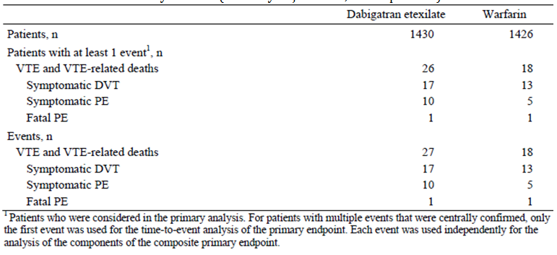
The HR of the primary endpoint of DE versus warfarin was 1.44 (95% CI 0.78, 2.64). Since the upper bound of the CI was below the pre-defined non-inferiority margin of 2.85, the null hypothesis of inferiority of DE versus warfarin could be rejected (p value for non-inferiority = 0.0137). The p value for superiority of DE versus warfarin was 0.2424. Based on the results for the HR, it was concluded that DE was non inferior to warfarin for the primary composite outcome measure of recurrent symptomatic VTE and VTE related death.
The cumulative risk difference for the primary composite endpoint at 18 months was 1.74% (22 out of 1430) in the DE group and 1.38% (17 out of 1426) in the warfarin arm. The risk difference for DE versus warfarin was 0.38% (95% CI -0.50%, 1.25%). The p value for non-inferiority was < 0.0001. As the upper limit of the 95% CI was below the pre-defined non-inferiority margin of 2.8% and the p value was statistically significant, the null hypothesis of inferiority of DE versus warfarin could be rejected. The p value for superiority of DE versus warfarin was 0.4013 (that is not statistically significant). The KM curves for the primary efficacy endpoint were almost congruent for both treatment groups over the first 10 months of follow up, and then diverged progressively thereafter apart from a brief period of almost meeting at around 18 months of therapy.
Of the 44 patients experiencing primary outcome events during the planned treatment period, the majority of subjects were in cohort 1 (32 patients: 18 in the DE group and 14 in the warfarin arm), 7 patients were in cohort 2 (4 in the DE group and 3 in the warfarin arm) and 5 patients were in cohort 3 (4 in the DE arm and 1 in the warfarin group). Because of the low number of events in cohorts 2 and 3, not all strata were evaluable separately (as planned) for the meta-analysis approach of the primary analysis.
Various pre-defined sensitivity analyses of the primary endpoint were performed, which were consistent with the primary analysis. Sensitivity analyses included using the PPS (rather than FAS) for the primary endpoint (HR 1.42; 95% CI 0.77, 2.60), an on treatment analysis (HR 1.35; 95% CI 0.69, 2.64), and an analysis for the observation period (HR 1.24; 95% CI 0.71, 2.18).
The HRs and cumulative risks were also assessed by baseline stratification factors of initial symptomatic PE and cancer. The cumulative risk of the primary endpoint was higher in patients with PE as their qualifying event, particularly for those allocated to treatment with DE (2.9% (14 out of 491) for DE versus 1.4% (7 out of 503) for warfarin); refer to Table 18. In comparison, subjects without qualifying PE had a lower rate of recurrence in both treatment groups (1.3% (12 out of 939) for DE and 1.2% (11 out of 923) for warfarin). Patients with active cancer at baseline also had a higher cumulative risk for the primary endpoint (3.3% (2 out of 60) for DE and 1.7% (1 out of 59) for warfarin) than those without active cancer at baseline (1.8% (24 out of 1370) for DE and 1.2% (17 out of 1367) for warfarin). For all 4 strata, the 95% CIs for the HRs included 1, indicating that the observed numerical differences between the treatment groups were not statistically significant.

Table 18. Primary efficacy endpoint incidence by stratification factors in Study 1160.47.
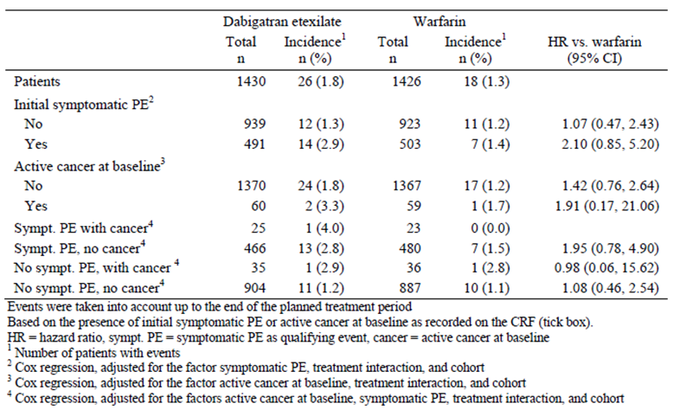
Subgroup analyses of the primary endpoint were performed to evaluate the consistency of the treatment effect (for DE and warfarin) across a variety of subgroups identified by baseline demographic (geographical region) and patient characteristics (age, gender, race, weight, BMI and CrCL); as well as the time from the onset of the index VTE episode. For all but two subgroup analyses, the 95% CIs for the HR included 1.0 and therefore no subgroup by treatment interactions could be concluded. A numerically higher incidence of recurrent VTE or VTE related death in the DE versus warfarin group was observed for those subjects with BMI ≥ 35 kg/m² (360 patients; risk difference of 3.11 (95% CI 0.41, 5.81)) and the subgroup of patients with CrCL between 50 and 80 mL/min (617 patients; risk difference of 2.04 (95% CI 0.40, 3.67)). However, because of the overall low number of subjects in these subgroups, and given the multiplicity of analyses, these observations are not likely to be clinically relevant.

Results for other efficacy outcomes

Composite of recurrent symptomatic VTE and all deaths
During the planned treatment period, 42 patients (2.94% of 1430) in the DE group and 36 subjects (2.52% of 1289) in the warfarin arm met this composite endpoint. The HR for this composite endpoint was 1.18 (95% CI 0.75, 1.84) for DE versus warfarin.
The cumulative risk difference at 18 months of recurrent symptomatic VTE and death was 2.86% (36 out of 1430) for the DE group and 2.53% (32 out of 1426) for the warfarin arm. The risk difference at 18 months for DE versus warfarin was 0.09% (95% CI -1.11%, 1.28%).
In both treatment groups, the KM curves for the composite of recurrent VTE or death showed events occurring throughout the observed treatment period, although episodes appeared to be more frequent between 18 and 24 months of therapy. In the first 9 months, the estimated cumulative risk was slightly higher in the DE group than the warfarin arm, but thereafter the curves were overlapping.
The presence of active cancer at baseline was the strongest risk factor for determining who experienced this outcome: with initial PE (18.2% in the DE group, and 10.0% in the warfarin arm), and without initial PE (11.4% in the DE group, and 9.1% in the warfarin arm).

Symptomatic DVT
The number of patients experiencing an acute symptomatic DVT was 17 in the DE treatment group (1.9% of 1430) compared to 13 in the warfarin arm (0.9% of 1426). The HR of DE versus warfarin for symptomatic DVT in the planned treatment dataset was 1.32 (95% CI 0.64, 2.71).
At 18 months, 1.17% (15 out of 1430) of patients in the DE group and 0.98% (12 out of 1426) subjects in the warfarin arm had recorded a recurrent symptomatic DVT. The comparative risk difference at 18 months between DE and warfarin was 0.19% (95% CI -0.63%, 1.00%), which did not indicate a statistically significant observation. No treatment related differences were detected with the randomisation strata or subgroups of interest.

Symptomatic PE
During the planned treatment phase, the number of patients experiencing a symptomatic, non-fatal PE was numerically higher in the DE group (n = 10; 0.70% of 1430) compared with the warfarin arm (n = 5; 0.35% of 1426). The HR of DE versus warfarin for symptomatic, non-fatal PE during the planned treatment period was 1.32 (95% CI 0.64, 2.71).
At 18 months, 0.66% (8 out of 1430) of patients in the DE group and 0.40% (5 out of 1426) subjects in the warfarin arm had recorded a recurrent symptomatic PE. The comparative risk difference between DE and warfarin was 0.26% (95% CI -0.32%, 0.84%). For both treatment groups the occurrence of non-fatal PEs was evenly distributed over the first 18 months of treatment.

VTE related death
One patient in each of the treatment groups died from PE. The HR of DE versus warfarin for VTE related death was 1.01 (95% CI 0.06, 16.22). The cumulative risks at 18 months were 0.08% for DE and 0.077 for warfarin.

All deaths
A total of 36 subjects (17 patients (1.2% of 1430) in the DE group, and 19 (1.3% of 1426) in the warfarin arm) died during the planned treatment period. The HR of DE versus warfarin for death of any cause was 0.90 (95% CI 0.47, 1.72). The most frequent cause of death in both treatment groups was cancer (7 patients in the DE arm, and 9 subjects in the warfarin treatment group).
The cumulative risk of death at 18 months was 1.22% (15 out of 1430) in the DE group and 1.24% (16 out of 1426) in the warfarin arm. The risk difference for DE versus warfarin for death at 18 months was 0.02% (95% CI -0.89%, 0.84%).

Evaluator summary
In summary, Study 1160.47 demonstrated that fixed dose DE therapy was non inferior to well controlled warfarin for the prevention of recurrent symptomatic VTE in patients who had received appropriate anticoagulation treatment for 3 to 12 months of their index VTE episode.

Analyses performed across trials (pooled analyses and meta-analyses)
Because the primary efficacy endpoints of Studies 1160.46 (composite of recurrent symptomatic VTE and VTE related death) and 1160.63 (incidence of recurrent symptomatic VTE) were different, a pooled analysis of the primary endpoint was not undertaken.
The frequencies of the different secondary efficacy endpoints were similar between the DE and warfarin groups in Study 1160.47, and the 95% CIs overlapped for each of the secondary endpoints. In Study 1160.63, the frequencies of all secondary endpoints were lower in the DE group than the control arm. The treatment differences were statistically significant for recurrent symptomatic VTE and all-cause deaths, symptomatic DVT, and symptomatic PE, but not for unexplained death or all-cause death. Table 19 presents a summary of the incidence of secondary efficacy endpoints up until the end of the planned treatment period for both secondary prevention VTE studies.

Table 19. Incidence of secondary efficacy endpoints for secondary prevention VTE studies.
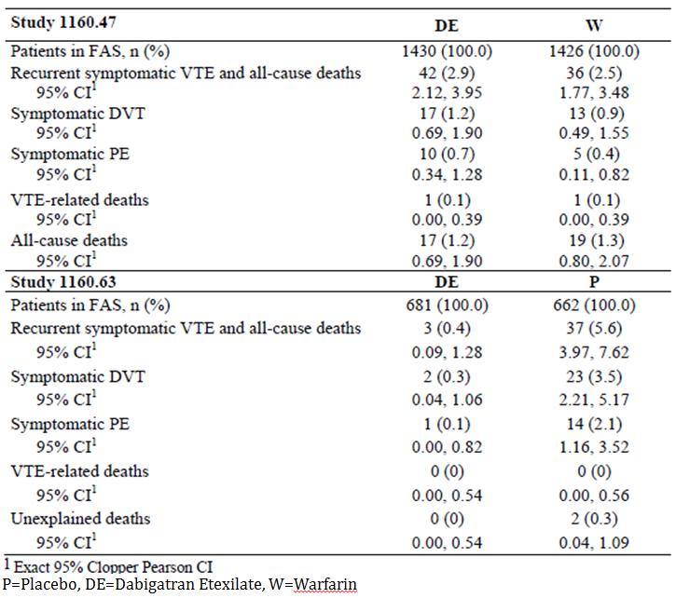

Evaluator’s conclusions on clinical efficacy for Indication 2: Prevention of recurrent deep vein thrombosis (DVT) and/or pulmonary embolism (PE) and related death
The sponsor has provided the efficacy data from 2 pivotal, randomised, multicentre, double blind trials (1160.63 and 1160.47) to support the efficacy of DE in the secondary prevention of recurrent VTE, and to prevent its associated mortality. Study 1160.47 used an active controlled comparator (warfarin with an INR target of 2.0 to 3.0) and had planned treatment duration of 6 to 36 months (in 3 patient cohorts). Study 1160.63 was a placebo controlled trial with a planned treatment period of 6 months for the majority of recruited subjects. This study included an observational follow up period of up to 12 months after the cessation of study treatment.
The primary efficacy outcome in Study 1160.47 was identical to that evaluated in the two acute VTE treatment trials (1160.53 and 1160.6). This endpoint was the proportion of subjects in each treatment group who experienced the composite of recurrent symptomatic VTE and VTE related death (centrally adjudicated by an independent committee). The placebo controlled trial (1160.63) had a slightly different primary endpoint, which was the incidence of recurrent symptomatic VTE during the intended treatment period. There were several secondary efficacy endpoints in both studies (individual components of the primary outcome, as well as all deaths), which are appropriate supporting measures for determining the utility of a therapy in the secondary prevention of recurrent symptomatic VTE.
In general, the trials were of adequate design to evaluate the proposed indication, and both studies had a clear and appropriate plan of analysis. In Study 1160.47, the primary statistical plan was a test for the non-inferiority of DE versus warfarin, and if non-inferiority was confirmed then the superiority of DE versus warfarin for the primary efficacy outcome was to be assessed. Two non-inferiority margins were pre-specified: 2.85 for the HR, and 2.8% for the risk difference at 18 months. The choice of the non-inferiority margins was based on the data available at the time of protocol development, and is consistent with the relevant regulatory guideline (EMEA/CPMP/EWP/2158/99).
Active comparator therapy with INR adjusted warfarin (target INR 2.0 to 3.0) was used in Study 1160.47. This choice is appropriate. The quality of the warfarin control as measured by various analyses of INR adequacy suggested that warfarin control may have been sub optimal, but overall was consistent with real life clinical practice. Good quality warfarin control is defined as time in the therapeutic range of > 70%). In both of trials, this level of INR control in the warfarin treatment groups was not achieved. In addition, up to a quarter of all patients were taking various concomitant treatments (such as NSAID, low dose aspirin, and P-gp substrates) that may be expected in the target population.
In Study 1160.47, a total of 2866 subjects were randomised: 1435 to DE and 1431 to warfarin. The overall median treatment duration was 534 days in both groups, and the overall median observation time was just over 18 months in both treatment groups (567 days in the DE group, and 566 days in the warfarin arm). About 2% of all patients had protocol deviations that may have affected the efficacy evaluation.
In Study 1160.63, a total of 1343 randomised patients received at least 1 dose of study drug: 681 in the DE group, and 662 subjects in the warfarin arm. Most patients received treatment for the planned 6 months. The majority of patients (> 90%) in both treatment groups completed the recommended 6 month follow up in Study 1160.63. Just over 10% of all subjects were documented to have a major protocol violation that may have affected their efficacy assessment. This occurred at a slightly higher incidence in the DE group (11.5%) compared to the control arm (9.5%).
The populations examined in the two Phase III studies are similar in demographics to patients that would be treated in Australian clinical practice. The trials mainly recruited patients from Europe. The majority of recruited subjects were middle aged (younger than expected) and had normal baseline renal function (CrCL ≥ 80 mL/min). For the majority of patients (65%) the index VTE event was DVT, but PE was appropriately represented in the patient cohorts (approximately 25%). Nearly 10% of all subjects presented with both symptomatic DVT and PE. The volume of patient data is sufficient to make an assessment of the comparative efficacy of DE in patients presenting with DVT, PE, or both manifestations of the same pathological process. More than 60% of all subjects had at least 1 identifiable risk factor for recurrent VTE and in general the patient cohorts were at high risk for recurrent VTE events.
In general, the incidence and pattern of co-morbid illness was lower than expected. The 2008 Access Economics report estimated that in Australia, the incidence of VTE was highest in those aged > 70 years, whereas the average age of patients in both study cohorts was < 60 years, with less than one third of all treated patients being aged > 65 years. As such, the generalisability of the results of the studies to a broader population in Australia has limitations. Moreover, patients at a high risk of bleeding were excluded.
The primary efficacy endpoint analysis in Study 1160.47 demonstrated that DE was non-inferior to warfarin for the composite outcome of centrally confirmed recurrent symptomatic VTE and VTE related death. Superiority could not be demonstrated. Sensitivity analyses of the primary endpoint using the PPS (rather than FAS), an on treatment analysis, and an analysis for the observation period were consistent with the primary analysis. The results for the secondary efficacy endpoints consistently supported the primary analysis demonstrating that DE is non-inferior to warfarin for recurrent symptomatic DVT, PE and VTE related death.
The primary efficacy endpoint analysis in Study 1160.63 demonstrated that DE was superior to placebo for the composite outcome of centrally confirmed recurrent symptomatic VTE, including unexplained death during the intended treatment period. Sensitivity analyses of the primary endpoint (such as analysis using the PPS) confirmed the robustness of the primary analysis, with CIs either the same or very similar to the primary analysis. The results for the secondary efficacy endpoints supported the primary analysis in demonstrating that DE is superior to placebo for preventing recurrent symptomatic VTE, however no fatal PEs were recorded in the trial to examine the claim of preventing VTE related mortality. Two unexplained deaths were observed in the placebo group but this data is insufficiently robust to support the claim of preventing VTE related mortality when DE is used as a secondary prevention approach in those with a previous VTE episode.
In summary, the data in this submission supports that DE is non-inferior to INR adjusted warfarin (at an acceptable level of quality control) in preventing recurrent symptomatic VTE, but there is insufficient data to justify the claim that DE is effective in reducing the risk of VTE related mortality. The two pivotal Phase III studies have assessed the efficacy of DE over an appropriate time frame of follow up, comparing the relative effect of DE to both active treatment (warfarin) and placebo.

Clinical safety

Studies providing evaluable safety data
The following studies provided evaluable safety data:

Pivotal efficacy studies
In the 4 pivotal efficacy studies (1160.53, 1160.46, 1160.47 and 1160.63), the following safety data was collected:
- General adverse events (AEs) were assessed by face to face questioning, which took place at inclusion, and every scheduled study visit (every 30 days). Telephone interviews for AE reporting was also available at certain pre-specified study visits, including the last follow up visit in each study. AEs were coded according to the Medical Dictionary for Drug Regulatory Activities (MedDRA) code list.
- AEs of particular interest included bleeding events and Acute Coronary Syndrome (ACS) events. These were assessed and reported by site investigators in a standardised manner on the case report forms, and then all relevant information was forwarded to a blinded central committee for adjudication (further detail below).
- Laboratory tests including haematology and biochemistry (renal and hepatic function, as well as clinical chemistry) were performed at screening, and every 30 days thereafter during the active treatment periods. Abnormalities of liver function tests (particularly, elevations in serum transaminases and/or total serum bilirubin) were a pre-specified laboratory parameter of interest. For 3 of the 4 pivotal studies (excluding Study 1160.46, which was the last pivotal study to be conducted) an independent hepatic review panel monitored liver safety as a standard safety measure. The panel reviewed all liver function data in a treatment blinded fashion from all patients with > x 3 ULN elevations of serum transaminases (AST and/or ALT).
- Pregnancy tests (in young women) and 12 lead ECG were performed at baseline, and at the last study visit.
- Vital signs (body weight, blood pressure, heart rate) were assessed at baseline, and at each scheduled face to face study visit thereafter (usually every 30 days while on active treatment).

Bleeding events
Bleeding events were an AE of special interest, and were classified as major or minor according to the outcome, extent of blood loss, severity and rate of bleeding. Minor bleeding events were further subdivided into Clinically Relevant Bleeding Events (CRBEs) and nuisance bleeds. The definition of MBE followed the recommendations of the International Society on Thrombosis and Haemostasis.
A bleeding event was categorised as an MBE if it fulfilled at least 1 of the following criteria:
- Fatal Bleeding;
- Symptomatic bleeding in a critical area or organ; such as intracranial, intra spinal, intraocular, retroperitoneal, intra articular, pericardial, or intramuscular with compartment syndrome; or
- Bleeding causing a fall in haemoglobin level of at least 20 g/L or requiring a transfusion of 2 or more units of whole blood or red cells.
A minor bleeding event was any bleed that did not fulfil any of the criteria for MBE. A minor bleeding was categorised as a CRBE if it fulfilled at least 1 of the following criteria:
- Spontaneous skin haematoma ≥ 25 cm²
- Spontaneous nose bleed > 5 minutes duration
- Macroscopic haematuria, either spontaneous or, if associated with an intervention lasting > 24 hours
- Spontaneous rectal bleeding (more than spotting on toilet paper)
- Gingival bleeding > 5 minutes
- Bleeding leading to hospitalization and/or requiring surgical treatment
- Bleeding leading to a transfusion of < 2 units of whole blood or red cells; and
- Any other bleeding event considered clinically relevant by the investigator.
All minor bleeding events that did not fulfil any of the criteria for CRBEs were classified as a nuisance bleed. Consistent with regulatory guidelines, a central independent committee that was blinded with regard to treatment allocation adjudicated all bleeding events.

Acute Coronary Syndrome (ACS)
All suspected ACS events occurring in all 4 pivotal VTE treatment trials with DE were to be recorded, and a blinded central adjudication committee reviewed all suspected ACS events. In the active controlled studies (1160.53, 1160.46 and 1160.47) all suspected investigator reported ACS events were then adjudicated by the central committee as a definite event, likely event, unlikely event, or no ACS. In the placebo controlled trial (1160.63), cardiovascular events were classified as confirmed, not confirmed or not evaluable. There were 3 categories of ACS events in the trials to assist with data pooling of ACS events: myocardial infarction, ischaemia/unstable angina, or cardiac death.

Pivotal studies that assessed safety as a primary outcome
There were no pivotal studies in this submission that assessed safety as the primary outcome.

Dose-response and non-pivotal efficacy studies
No new dose response and non-pivotal efficacy studies provided safety data in this submission.

Other studies evaluable for safety only
Not applicable.

Patient exposure

Analysis Populations
All safety analyses were performed on the Treated Set (TS), which includes all patients who were documented to have taken at least 1 dose of study drug. The safety data for these patients were analysed according to the treatment they actually received. In case a patient received more than 1 treatment in a study, the first medication kit used by the patient determined the treatment group assignment.
The number of randomised patients was similar in the three active controlled Studies 1160.53, 1160.46, and 1160.47. The placebo controlled Study 1160.63 included about half as many patients as in each of the other studies; refer to Table 1. Most (> 95%) randomised patients were treated with study drug. A total of 66 DE randomised patients did not receive active study drug across the 4 pivotal studies: 22 withdrew consent, 31 were non-compliant with entry criteria or the study protocol, 3 had an AE prohibiting treatment, and 10 had no specific reason recorded.

Exposure to study medication
Patients received open label parenteral anticoagulation therapy and either warfarin or warfarin placebo during the single dummy period in the acute VTE treatment studies (1160.53 and 1160.46). The single dummy period lasted from the first intake of study drug until patients had received at least 5 days of parenteral therapy and had an INR value of ≥ 2.0 at 2 consecutive measurements. Encrypted INR values, with an IVRS that returned actual or sham INR values for individual patients, allowed study centre personnel to remain blinded to whether the patient was receiving warfarin or placebo. Afterward, the initial parenteral therapy was discontinued and the double dummy period started. The double dummy period lasted from first intake of any study drug (DE or DE placebo) until last intake of any study drug, including periods of temporary interruptions of active study drug. The total treatment period lasted from the beginning of the single dummy period until the end of the double dummy period in the acute VTE treatment studies. Exposure during the single dummy period is not discussed in this section but has been detailed in the efficacy section of each study in this report.

Exposure to study drug in the 4 pivotal VTE Studies (pooling of exposure)
The mean duration of exposure to any study drug during the double dummy period was 277.6 days in the DE group, 297.6 days in the warfarin arm, and 162 days in the placebo group when all 4 pivotal VTE studies were pooled together. This represents a total exposure of 3261 patient-years for DE, 2946 patient-years for warfarin, and 292 patient-years for placebo; refer to Table 20.

Table 20. Exposure to study drug in the double dummy period of all 4 pivotal VTE studies.
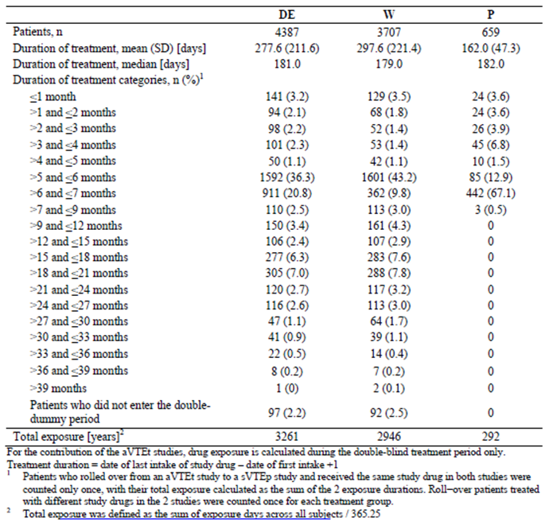
Table 20 incorporates data from different study designs and durations. In all 4 pivotal studies, some patients received DE. warfarin was the active comparator in Studies 1160.53, 1160.46, and 1160.47 (the longest of the 4 studies, with planned treatment duration of up to 36 months). Placebo treatment was the comparator in Study 1160.63 (planned treatment duration of 6 months). The differences in duration of treatment explain the differences in exposure seen in the table, as well as for the apparent bimodal distribution for DE and warfarin exposure.

Exposure to study drug in the pooled acute VTE treatment Studies (1160.53 and 1160.46)
The mean duration of exposure to study drug was similar in the DE (163.4 days) and warfarin groups (162.7 days) during the double dummy period of the acute VTE treatment studies. The majority of patients (66.2% (1689 out of 2553) in the DE group and 70.3% (1795 out of 2554) in the warfarin arm) were treated for 5 to 6 months; refer to Table 21. Most patients (approximately 89% in each treatment group) were still receiving treatment for more than 150 days (cumulatively) in the pooled dataset of the acute VTE treatment studies.

Table 21. Exposure to study drug in the double dummy period of the 2 acute VTE treatment studies (1160.53 and 1160.46).
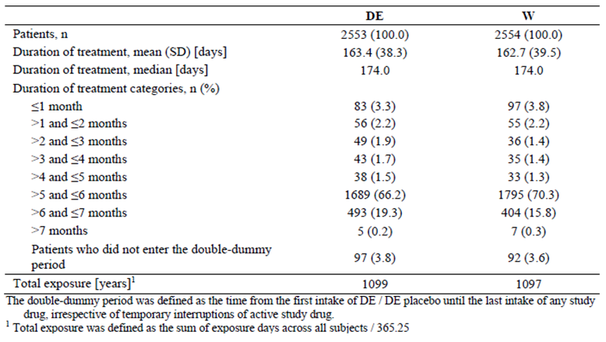
Similar durations of treatment exposure during the double dummy period were reported for the individual studies. In addition, the mean length of the observational period (from randomization until the end of study participation) was similar between the treatment groups.

Exposure to study drug in study 1160.47 (active controlled prevention trial)
Study 1160.47 did not have an initial parenteral treatment (single dummy) period. Study 1160.47 was the longer of the 2 secondary prevention studies, and had planned treatment duration of 6 to 36 months. The mean duration of study drug exposure was similar between the DE (473.3 days) and warfarin groups (473.5 days); refer to Table 22. More than half of all subjects (60.1% in the DE group, and 59.5% in the warfarin arm) were still being treated after 510 days of cumulative therapy.

Table 22. Exposure to study treatment in Study 1160.47.
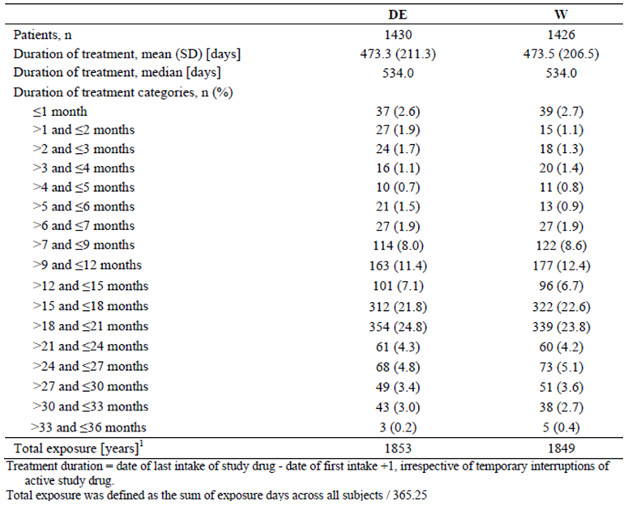
The mean length of the observational period was similar between the 2 treatment groups in Study 1160.47, with almost half of the patients in each group being observed for 18 to 24 months. For more than 950 patients in the DE group, there was observational data for more than 18 months.

Exposure to study drug in study 1160.63 (placebo controlled prevention trial)
Study 1160.63 did not have an initial parenteral treatment (single dummy) period, and was the shorter of the 2 secondary prevention studies. This trial was a placebo controlled, event driven study with planned treatment duration of 6 months for most patients and a planned duration of 3 months for patients who had not yet completed the 3 month visit at the time of trial close out. The mean duration of exposure was similar between the DE (165.3 days) and placebo groups (162.0 days). Most patients were treated for more than 6 months; refer to Table 23. Approximately 70% of patients were still being treated after 180 days (cumulative).
The intended treatment period was 6 months for most patients (625 in the DE group, and 623 in the control arm). The mean observational time for these patients was approximately 540 days, and most patients (approximately 74%) were observed between 18 and 21 months.

Table 23. Exposure to study treatment in Study 1160.63.
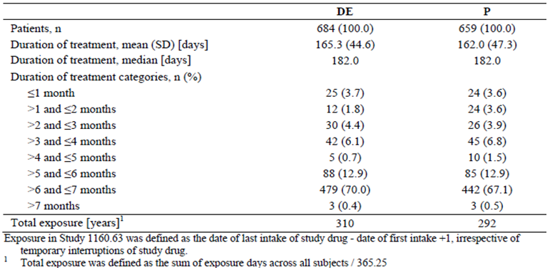

Adverse events

All adverse events (irrespective of relationship to study treatment)

VTE Treatment studies

Study 1160.53
The overall incidence of treatment emergent AEs was similar in both treatment groups, reported in 66.3% (844 out of 1273) of patients in the DE group and 67.6% (856 out of 1266) of subjects in the warfarin arm. When only the double dummy period was considered, 62.8% (770 out of 1226) of patients in the DE group and 65.2% (792 out of 1214) in the warfarin arm reported AEs. An overview of treatment-emergent AEs for the entire treatment period of Study 1160.53, as well as a break up of AEs that occurred during the single dummy and the double dummy periods is provided in Table 24.

Table 24. Summary of adverse events during treatment in Study 1160.53.
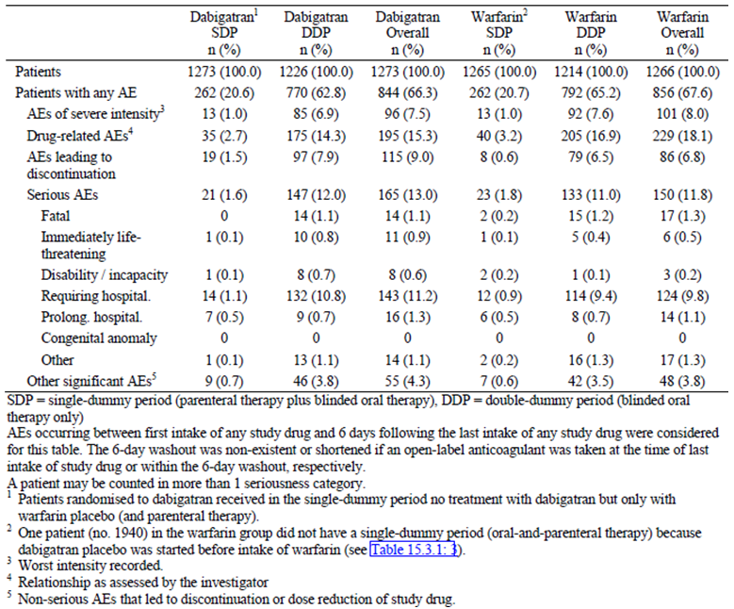
The frequencies of AEs by System Organ Class (SOC), as well as by Preferred Term (PT) were comparable in both treatment groups; refer to Table 25. The most frequently reported AEs by SOC were gastrointestinal disorders, which were more frequent in the DE group (25.1%; 319 out of 1273) than in the warfarin arm (19.2%; 243 out of 1266). The treatment difference was not due to the most frequent AE in this class, nausea (3.8% in the DE group versus 4.6% in the warfarin arm), but mostly due to diarrhoea (4.5% in the DE group versus 3.0% in the warfarin arm) and dyspepsia (3.1% in the DE group versus 0.7% in the warfarin arm). Respiratory, thoracic, and mediastinal disorders were less frequently reported in the DE group (12.6%; 161 out of 1273) than in the warfarin arm (16.5%; 209 out of 1266). This treatment difference can be mainly explained by a higher incidence of epistaxis (2.8% versus 6.3%) and dyspnoea (3.2% versus 4.2%) in the warfarin group. Investigation related AEs were reported less frequently for DE (4.2%; 53 out of 1273) than for warfarin (6.2%; 78 out of 1266). This difference was mostly due to the PT of increased INR (0% for DE versus 1.2% for warfarin). Of the SOCs with an incidence below 5% per treatment group, cardiac disorders affected 3.5% of DE and 3.6% of warfarin treated patients. Hepatobiliary disorders were reported for 2.5% of DE and 1.9% of warfarin patients, with cholelithiasis (0.6% versus 0.4%) and hepatic steatosis (0.5% in both groups) as most frequent AEs on a PT level. On a PT level, there were 3 AEs with an incidence of at least 5% in either treatment group: headache (6.2% (79 out of 1273) in the DE group versus 7.0% (88 out of 1266) in the warfarin arm), pain in extremity (5.0% (64 out of 1273) in the DE arm versus 5.6% (71 out of 1266) in the warfarin group) and epistaxis (2.8% (36 out of 1273) in the DE group versus 6.3% (80 out of 1266) in the warfarin arm). Most of the patients who recorded AEs during the treatment period had events of mild (31.2% for DE, and 31.1% for warfarin) or moderate intensity (27.6% for DE, and 28.5% for warfarin). There were no between group treatment differences for the individual types of AEs by severity.

Table 25. Adverse events by SOC and PT during treatment in Study 1160.53.
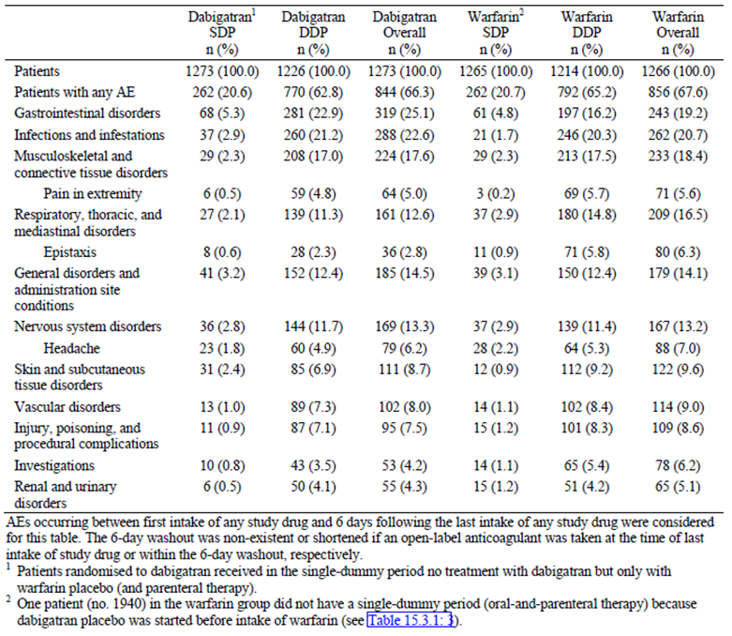

Study 1160.46
The overall incidence of treatment-emergent AEs was similar in both treatment groups, reported in 66.6% (852 out of 1280) of patients in the DE group and 71.1% (916 out of 1288) of subjects in the warfarin arm. When only the double dummy period was considered, 60.1% (739 out of 1230) of patients in the DE group and 65.0% (811 out of 1248) in the warfarin arm reported AEs. An overview of treatment-emergent AEs for the entire treatment period of Study 1160.46, as well as a break-up of AEs that occurred during the single dummy and the double dummy periods is provided in Table 26.

Table 26. Summary of adverse events during treatment in Study 1160.46.
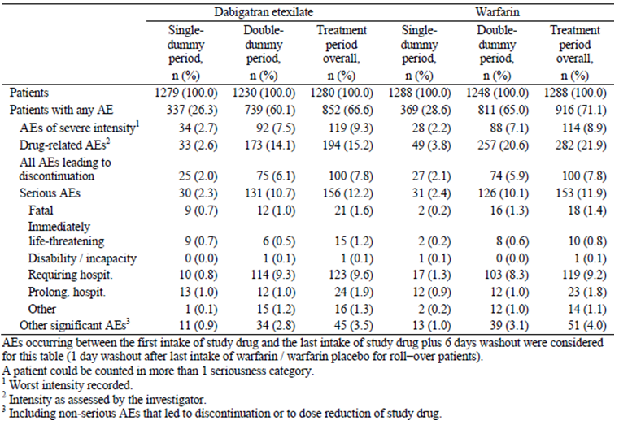
The SOC with the most frequently reported AE was gastrointestinal disorders (22.9% (293 out of 1280) in the DE group and 22.8% (294 out of 1288) in the warfarin arm) followed by infections (19.4% (248 out of 1280) in the DE group and 20.3% (261 out of 1288) in the warfarin arm). There were two SOCs where a difference in incidence between the treatment groups was observed. Firstly, it was seen for the SOC of investigations which was reported for 11.0% (142 out of 1288) of patients in the warfarin group compared to 7.6% (97 out of 1280) of subjects in the DE arm. This was largely explained by the higher number of reports of increased INR in the warfarin group (3.0%; 38 out of 1288) versus 0.2% (2 out of 1280) in the DE arm. The second difference was in the SOC of renal and urinary disorders which was recorded in 7.1% (91 out of 1288) of patients in the warfarin group compared to 4.4% (55 out of 1280) of subjects in the DE group. This was largely accounted for by haematuria recorded in 3.9% (50 out of 1288) of patients in the warfarin group versus 1.3% (16 out of 1280) of subjects in the DE arm. During the treatment period, there were 2 AEs by PT with an incidence of at least 5% in either treatment group: headache (4.5% in the DE group and 5.4% in the warfarin arm) and pain in extremity (6.0% in the DE group and 5.4% in the warfarin arm). Over the entire study treatment period, mild AEs were recorded by 34.3% (439 out of 1280) of DE patients and 37.0% (476 out of 1288) of warfarin subjects; moderate intensity AEs by 23.0% (294 out of 1280) of DE patients and 25.3% (326 out of 1288) of warfarin subjects; while severe AEs were reported by 9.3% (119 out of 1280) of DE patients and 8.9% (114 out of 1288) of warfarin subjects.

VTE prevention studies

Study 1160.63
The overall incidence of patients experiencing treatment emergent AEs (which included bleeding events and efficacy outcome events) were comparable in the two treatment groups (50.6% (346 out of 684) for the DE group and 49.2% (324 out of 659) in the placebo arm. Table 27 provides a summary of the most frequent AEs (reported by at least 2% of patients in either treatment group) by SOC and PT. The most frequently reported type of AE by SOC in patients receiving DE was gastrointestinal disorders (16.5%; 113 out of 684). There was a lower incidence of gastrointestinal AEs in placebo patients (8.8%; 58 out of 659). The difference in incidence between the 2 groups is predominately explained by the higher frequency of dyspepsia (4.1% versus 1.2%) and rectal haemorrhage (2.2% versus 0.3%) in DE treated patients. Vascular disorders were less frequently reported for patients taking DE (6.4% (44 out of 684) in the DE group compared to 11.5% (76 out of 659) in placebo patients). The difference in incidence was predominately due to the higher incidence of DVT for patients on placebo (5.2%) compared with subjects receiving DE (0.4%).

Table 27. Adverse events by SOC and PT during treatment in Study 1160.63.
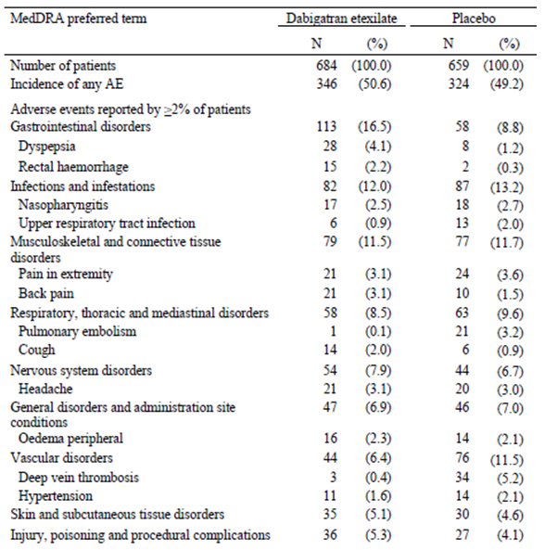
The incidence of AEs was also analysed for pre-specified patient subgroups (age, gender, ethnicity, CrCL at baseline and concomitant anticoagulant or P-gp inhibitor use). Subjects aged 65 years or older had a higher incidence of AEs in both treatment groups (56 to 57%) compared to younger subjects (45 to 47%). Female subjects had a higher incidence of AEs when receiving treatment with DE (55.1% (166 out of 301) versus 47.0% (180 out of 383) in males), but this was not evident in female patients on placebo (46.8% (139 out of 297) versus 51.1% (185 out of 362) in males). A lower CrCL at baseline also influenced the incidence of AEs in those taking DE: 58.5% (24 out of 41) for 30 to 49 mL/min, 55.8% (92 out of 165) for CrCL 50 to 79 mL/min and 48.0% (228 out of 475) for CrCL > 80 mL/min. In the placebo patients, the incidence of AEs according to baseline CrCL were 50.0% (15 out of 30) for 30 to 49 mL/min, 52.1% (88 out of 169) for CrCL 50 to 79 mL/min and 47.9% (220 out of 459) for CrCL > 80 mL/min. The concomitant use of anticoagulant therapy (76.5 to 94.4% versus 48 to 50% in those not taking other anticoagulants) and P-gp inhibitors significantly increased the risk of AEs (70 to 80% versus 49 to 50% in those not taking P-gp inhibitors) in both treatment groups.

Study 1160.47
In this active controlled study, the overall incidence of treatment emergent AEs during the treatment period was similar in both treatment groups: 72.0% (1029 out of 1430) of patients in the DE group, and 70.8% (1010 out of 1426) of patients in the warfarin arm. Furthermore, the overall incidence of AEs was similar in both treatment groups during the post treatment phase: 11.8% (165 out of 1395) of patients in the DE group, and 11.6% (161 out of 1384) of patients in the warfarin arm. Table 28 provides an overall summary of treatment-emergent AEs for Study 1160.47, presented by AEs that occurred during the active treatment and post-treatment periods.

Table 28. Summary of adverse events in Study 1160.47 (during treatment and post treatment).
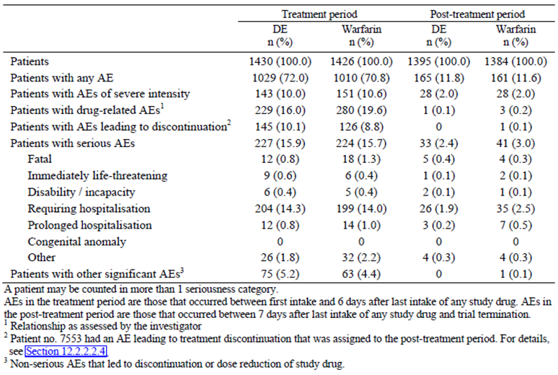
In both phases of the trial (active treatment and post treatment), the frequency and pattern of AEs when examined by SOC and PT were comparable between the 2 treatment arms for most categories. The most frequently occurring AE by SOC (at least 5% incidence in either treatment group) was infections, which were reported less frequently in the DE group (29.7%; 424 out of 1430) than in the warfarin arm (34.4%; 490 out of 1426). The incidence of gastrointestinal disorders was higher in the DE group compared to the warfarin arm (26.3% (376 out of 1430) versus 22.2% (317 out of 1426)). This difference was related to a higher incidence of diarrhoea (5.2% (75 out of 1430) versus 3.7% (53 out of 1426)) and dyspepsia (4.1% versus 1.9%) in the DE group. There was a higher frequency of abnormal investigations in the warfarin group (9.5% (136 out of 1426) for warfarin versus 5.5% (79 out of 1430) for DE). Epistaxis was also recorded at a higher frequency in the warfarin group (6.7% (95 out of 1426) for warfarin versus 3.2% (46 out of 1430) for DE). There were no between-group treatment differences for the individual types of AEs by severity. Most of the patients who recorded AEs during the treatment period had events of mild (30.9% for DE, and 30.1% for warfarin) or moderate intensity (31.0% for DE, and 30.2% for warfarin).

Treatment-related adverse events (adverse drug reactions)

VTE treatment studies

Study 1160.53
During the entire treatment period, 15.3% (195 out of 1273) of patients in the DE group, and 18.1% (229 out of 1266) of patients in the warfarin arm reported AEs that were assessed as being drug related by the investigator. Table 29 presents the most frequent investigator-categorised, drug related AEs by treatment group (overall, and by treatment period). This dataset demonstrates a similar pattern of observation to the overall AE profile.

Table 29. Treatment related adverse events by SOC and PT during treatment in Study 1160.53.
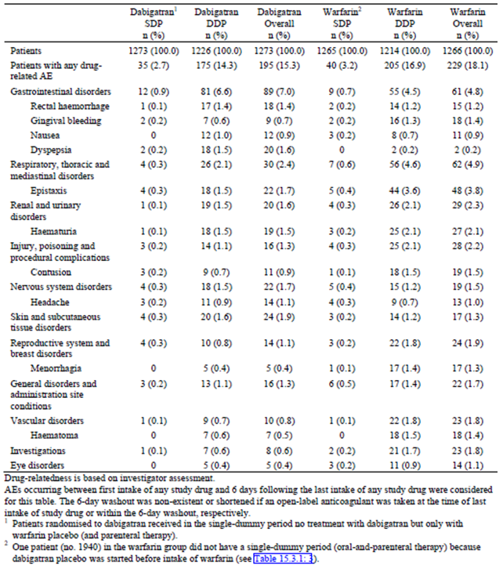
The SOC with the highest incidence of drug related AEs was gastrointestinal disorders. In the DE group, the incidence of gastrointestinal disorders was higher than in the warfarin group (7.0% versus 4.8%), mostly due to dyspepsia. Drug related respiratory, thoracic, and mediastinal disorders were less frequent in the DE group than in the warfarin arm (2.4% versus 4.9%). The treatment difference is explained by epistaxis, the most frequent event in this class (1.7% (22 out of 1273) for DE versus 3.8% (48 out of 1266) for warfarin. Drug related haematuria accounted for almost all AEs in the SOC of renal and urinary disorders and was less often reported in the DE versus warfarin group (1.5% versus 2.1%). Injury, poisoning, and procedural complications were assessed as drug related by the investigator in fewer DE than warfarin treated patients (1.3% versus 2.2%). Contusion was by far the most frequent event in this class (0.9% (11 out of 1273) for DE compared to 1.5% (19 out of 1266) for warfarin). Within the SOC of reproductive system and breast disorders, menorrhagia accounted for the numerically higher incidence in the warfarin group than in the DE arm (1.3% versus 0.4%). Eye disorders were more often considered to be drug related in the warfarin group, with conjunctival haemorrhage as the most frequent event. By PT, the AEs most frequently assessed as being drug related were epistaxis (1.7% for DE versus 3.8% for warfarin), haematuria (1.5% for DE versus 2.1% for warfarin), rectal haemorrhage (1.4% for DE versus 1.2% for warfarin), contusion (0.9% for DE versus 1.5% for warfarin), and gingival bleeding (0.7% for DE versus 1.4% for warfarin). Expectedly for anticoagulation therapy, all of the above types of AEs that were considered to be drug related were different types of bleeding events.

Bleeding events
The incidence of bleeding events (major, clinically relevant and overall) was an AE of interest in Study 1160.53. MBEs were reported for 20 patients (1.6% of 1273) in the DE group and 24 subjects (1.9% of 1266) in the warfarin arm. Of these, 3 patients (2 in the DE group and 1 in the warfarin arm) had 2 MBEs each. The total numbers of MBEs on treatment were 22 in the DE arm and 25 in the warfarin group; refer to Table 30. The HR of DE versus warfarin for MBEs was 0.82 (95% CI 0.45, 1.48), which indicates that there was no statistically significant treatment difference for the risk of MBEs. The cumulative risk for MBEs at 6 months was 1.7% in the DE group and 2.0% in the warfarin arm. The risk difference of DE versus warfarin was -0.4% (95% CI -1.3%, 0.5%). As expected, patients with active cancer at baseline had a substantially higher cumulative bleeding risk than patients without active cancer. The bleeding risk did not differ between patients with and without initial symptomatic PE. No meaningful treatment differences were seen for the HRs by presence or absence of these stratification criteria. The KM curves for the time to first MBE showed a steeper initial slope in the first month for both treatment groups, and then the curve slopes became shallower. This suggests the risk of MBE tends to be higher early in the treatment phase, probably due to the initial parenteral therapy. Three patients in each treatment group had MBE in the single dummy phase. One patient in each of the treatment groups died of major bleeding. Both subjects had intracranial haemorrhage. Two additional warfarin treated patients suffered intracranial bleeding, which was not fatal. The location of other MBEs was gastrointestinal (9 in the DE group and 5 in the warfarin arm), urogenital (5 in the DE group and 6 in the warfarin arm), intra-articular (1 in the DE group and 4 in the warfarin arm), and intra-muscular (1 in the DE group and 3 in the warfarin arm). Most MBEs (20 events in the DE group and 18 events in the warfarin arm) resulted in a fall in the haemoglobin level of ≥ 20 g/L or the need for a transfusion of ≥ 2 units of whole blood or red blood cells. Of the bleeding events which investigators assessed as major, 94.4% (17 of 18) in the DE group and 88.9% (16 of 18) in the warfarin arm were confirmed as MBEs by the adjudication committee. Five (DE) and 9 (warfarin) additional bleeding events were adjudicated as major by the central adjudication committee, but these had been considered non-major by site investigators.

Table 30. Bleeding events during treatment in Study 1160.53.
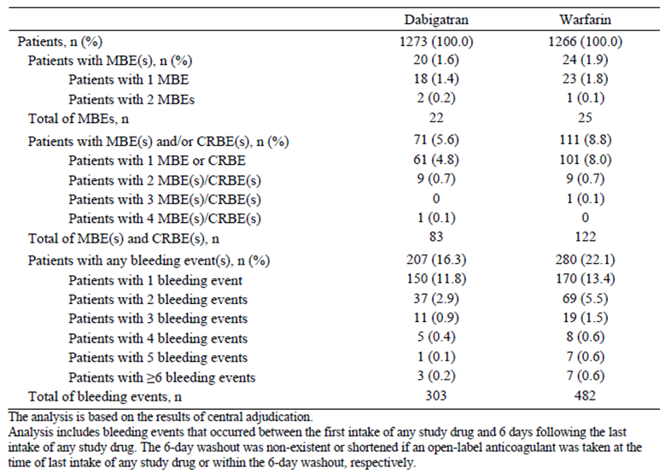
The incidences of MBEs and/or CRBEs were 5.6% (71 out of 1273) in the DE group and 8.8% (111 out of 1266) in the warfarin arm, with 10 patients in each group reporting more than 1 bleeding AE. The total numbers of MBEs and CRBEs were 83 in the DE arm and 122 in the warfarin group. The incidence of any bleeding events was lower for the DE group (16.3%; 207 out of 1273) than for the warfarin group (22.1%; 280 out of 1266). The total number of bleeding events was lower in the DE group (303 AEs) than for warfarin (482 events). The HR of DE versus warfarin for any bleeding event was 0.71 (95% CI 0.59, 0.85), which indicates that there was a statistically significant lower risk of bleeding with DE compared to warfarin. Similarly, the cumulative risk for any bleeding at 6 months was 17.3% in the DE group and 23.3% in the warfarin arm, with the risk difference being -6.0% (95% CI -9.3%, -2.8%). The KM curves for the time to first bleeding event appeared to separate early during the trial (after 15 days) and continued to diverge slightly thereafter (up until 180 days). With respect to the location of bleeding events, the largest group were urogenital bleeds (53 in the DE group and 95 in the warfarin arm) followed by nasal bleeds (40 in the DE group and 107 in the warfarin arm). Gastrointestinal bleeds were recorded 53 times in the DE group and on 35 occasions in the warfarin arm. About half of all bleeding events were classified as ‘other’ locations.
While being treated with active study drug, 18 patients (1.5% of 1226) in the DE group and 14 subjects (1.1% of 1266) in the warfarin arm received at least 1 blood transfusion. In the majority of these patients (11 treated with DE (0.9%) and 8 receiving warfarin (0.6%)), the transfusions were given for the management of bleeding events. Most patients (15 in the DE group and 8 in the warfarin arm) who received transfusions of whole blood or red cells required at least 2 units. The mean number of units transfused was 3.8 in the DE group and 2.4 in the warfarin arm.

Acute coronary syndrome events
There were very few suspected ACS events (n = 14; 12 myocardial infarcts and 2 cases of unstable angina) that were adjudicated as being definite events in both treatment groups: 0.7% (9 out of 1273) of patients in the DE group and 0.4% (5 out of 1266) of subjects in the warfarin arm. This included 5 cases in the DE arm and 3 in the warfarin group, which occurred while subjects were actively taking study drug (including the day after last intake). In addition, 4 patients in the DE group and 2 in the warfarin arm suffered ACS events after stopping active study medication. The 4 DE treated subjects with ACS had their events 4, 14, 24 and 31 days after ceasing DE. The 2 warfarin treated patients with ACS developed their events 15 and 16 days after last intake of warfarin. One patient in the warfarin group (15 days post intake) died from a definitive ACS event (myocardial infarction complicated by sudden cardiac death). Because of the overall small number of affected patients, it was indeterminable whether ACS events occurred at a higher rate in the DE versus warfarin treatment group in Study 1160.53.

Study 1160.46
During the entire treatment period, 15.2% (194 out of 1280) of patients in the DE group, and 21.9% (282 out of 1288) of patients in the warfarin arm reported AEs that were assessed as being drug related by the investigator. Table 31 presents the most frequent investigator-categorised, drug related AEs by treatment group (overall, and by treatment period).

Table 31. Treatment related adverse events by SOC and PT during treatment in Study 1160.46.
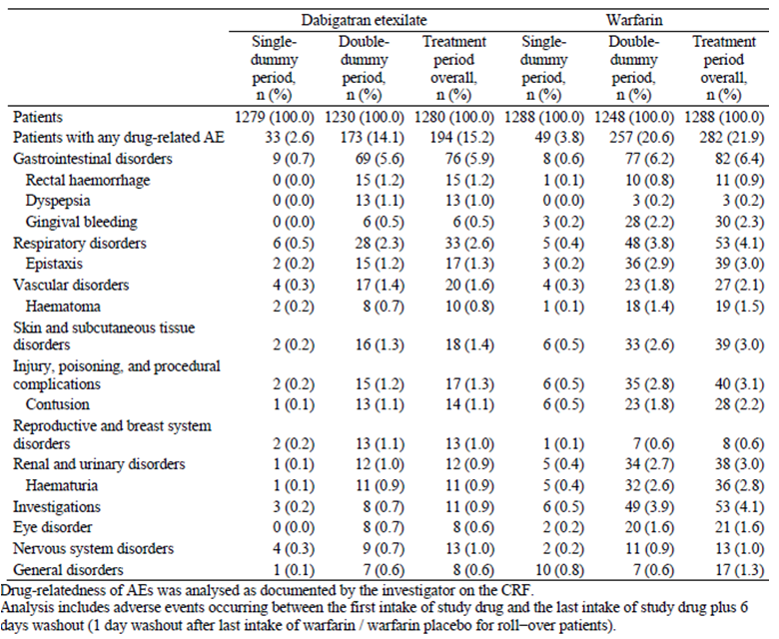
At the PT level of assessment, of the 7 most frequent, drug related AEs, 2 were numerically greater in the DE group. These were rectal haemorrhage (1.2% (15 subjects) for DE versus 0.9% (11 patients) for warfarin) and dyspepsia (1.0% (13 subjects) for DE versus 0.2% (3 patients) for warfarin). Epistaxis, haematoma, haematuria, contusion, and gingival bleeding were more common in subjects receiving warfarin.

Bleeding events
The incidence of bleeding events was an AE of special interest in Study 1160.46. MBEs were reported for 15 patients (1.2% of 1280) in the DE group and 22 subjects (1.7% of 1288) in the warfarin arm. Of these, 3 patients (1 in the DE group and 2 in the warfarin arm) had 2 MBEs each. The total numbers of MBEs on treatment were 16 in the DE arm and 24 in the warfarin group; refer to Table 32. The HR of DE versus warfarin for MBEs was 0.69 (95% CI 0.36, 1.32) which indicates that there was no statistically significant treatment difference for the risk of MBEs. The cumulative risk for MBEs at 6 months was 1.2% in the DE group and 1.8% in the warfarin arm. The risk difference of DE versus warfarin was -0.6% (95% CI -1.6%, 0.3%; p = 0.1946). Patients with active cancer and an initial PE treated with warfarin had the highest risk of MBE (12 single events). The bleeding risk did not differ between patients when other baseline strata were investigated. The KM curves for the time to first MBE for both treatment groups were flat and close to each other over the 180 days of active treatment, as well as in the post treatment follow up phase. Of the 15 DE randomised patients with MBE, 8 occurred in the in the single dummy phase (7 of which were actually prior to commencing DE). In the warfarin group, 4 MBEs occurred in the single dummy period prior to starting warfarin (that is 18 MBEs occurred in subjects actually taking warfarin). One patient in the warfarin treatment group died of major bleeding (upper gastrointestinal haemorrhage). Two patients in each treatment group suffered intracranial bleeding, none of which was fatal. The location of other MBEs was gastrointestinal (6 in the DE group and 10 in the warfarin arm), urogenital (2 in the DE group and 7 in the warfarin arm), and all other sites affected no more than 2 patients in either treatment group (intra articular, intra muscular, and retroperitoneal). One DE treated subject (73 year old female with mantle cell lymphoma and baseline DVT) had a MBE of retroperitoneal haemorrhage while taking a concurrent P-gp inhibitor (verapamil). Most MBEs (13 events in the DE group and 19 events in the warfarin arm) resulted in a fall in the haemoglobin level of ≥ 20 g/L or the need for a transfusion of ≥2 units of whole blood or red blood cells. There was a high correlation (≥90%) between local and central adjudication for MBEs in both treatment groups.

Table 32. Bleeding events during treatment in Study 1160.46.
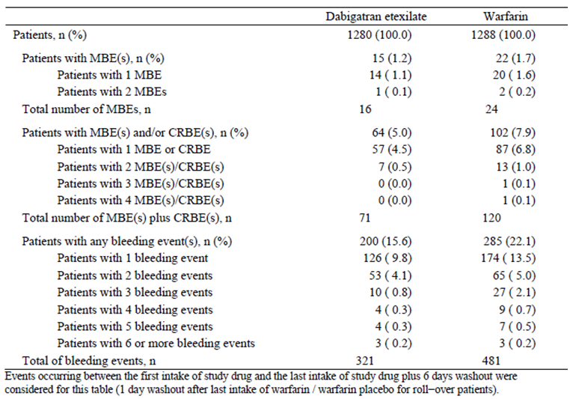
The incidences of MBEs and/or CRBEs were 5.0% (64 out of 1280) in the DE group and 7.9% (102 out of 1288) in the warfarin arm, with 7 patients in the DE group and 10 subjects in the warfarin arm reporting more than 1 bleeding AE. The total numbers of MBEs and CRBEs were 71 in the DE arm and 120 in the warfarin group. The incidence of any bleeding events was lower for the DE group (15.6%; 200 out of 1280) than for the warfarin group (22.1%; 285 out of 1288). The total number of bleeding events was lower in the DE group (321 AEs) than for warfarin (481 events). The HR of DE versus warfarin for any bleeding event was 0.67 (95% CI 0.56, 0.81), which indicates that there was a statistically significant lower risk of bleeding with DE compared to warfarin (p < 0.0001). Similarly, the cumulative risk for any bleeding at 6 months was 16.4% in the DE group and 23.3% in the warfarin arm, with the risk difference being -7.1% (95% CI -10.2%, -4.0%). The KM curves for the time to first bleeding event appeared to separate early during the trial (before15 days) and continued to diverge slightly thereafter (up until 180 days). With respect to the location of bleeding events, the largest group were urogenital bleeds (51 in the DE group and 75 in the warfarin arm) followed by nasal bleeds (43 in the DE group and 76 in the warfarin arm) and gastrointestinal bleeds (48 in the DE group and 33 in the warfarin arm). About half of all bleeding events were classified as ‘other’ locations (49.8% (160 out of 321) in the DE group and 53.0% (255 out of 481) in the warfarin arm).
During the study, 19 patients in each treatment group (1.5% for both) received at least 1 blood transfusion. In approximately half of these patients (8 treated with DE (0.6%) and 10 receiving warfarin (0.8%)), the transfusions were given for the management of bleeding events. Most patients (5 in the DE group and 9 in the warfarin arm) who received transfusions of whole blood or red cells required at least 2 units. The mean number of units transfused was lower in the DE group at 2.6 compared with 5.3 units in the warfarin arm.

Acute coronary syndrome events
In total, investigators reported 22 suspected ACS events in 19 treated subjects (0.9% (11 out of 1280) of patients in the DE group and 0.6% (8 out of 1288) of subjects in the warfarin arm). Of the 22 suspected ACS events that were centrally adjudicated, 6 were classified as definite (all myocardial infarcts) and 3 as likely (all cases of unstable angina). All 5 cases of myocardial infarction in the DE treatment group (0.4% of 1280) were centrally confirmed. Three cases occurred while subjects were actively taking DE, and for 2 patients the ACS onset 4 and 90 days post treatment. One patient in the warfarin group had a confirmed myocardial infarct, occurring 10 days after ceasing treatment. Another subject receiving warfarin died of likely sudden cardiac death. Although the overall number of affected patients is small, there were a numerically higher number of ACS events (investigator reported and centrally confirmed) in the DE versus warfarin treatment group in Study 1160.46.

VTE prevention studies

Study 1160.63
The overall incidence of patients experiencing AEs that were considered by investigators to be treatment related was higher for patients in DE group (11.5%; 79 out of 684) compared to the control group (6.5%; 43 out of 659). Drug related gastrointestinal disorders were more frequent in patients taking DE (5.8% (40 out of 684) versus 3.5% (23 out of 659) in the placebo group). Treatment related AEs by PT that were more frequently reported for patients in the DE group (difference between treatment groups > 0.5%) were dyspepsia (1.5% for DE versus 0.5% for placebo), rectal haemorrhage (1.3% for DE versus 0.2% for placebo), and contusion (1.0% for DE versus 0.2% for placebo); refer to Table 33.

Table 33. Treatment related adverse events by SOC and PT during treatment in Study 1160.63.
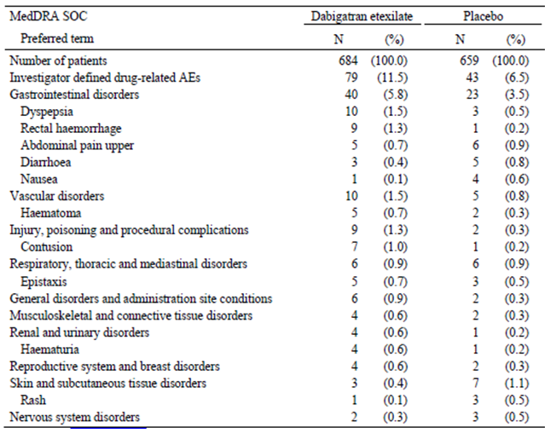

Bleeding events
The incidence of MBEs on treatment was very low in this trial. MBEs were reported for only 2 patients (0.3% of 684) on DE and none receiving placebo (n = 659). The 95% CI (Clopper-Pearson method) for DE was 0.04 to 1.05 compared with 0.0 to 0.56 for placebo (p = 0.4998, Fisher’s exact test). One of the DE subjects was a [information redacted] man who suffered a major gastrointestinal haemorrhage from a gastric ulcer. This MBE was considered to be treatment related. The other DE patient who had a MBE was a [information redacted] male who experienced a major gastrointestinal haemorrhage requiring blood transfusion following colonoscopy and polypectomy while on study drug.
The incidences of CRBEs and of any bleeding event were significantly higher for patients on DE (5.3% (36 out of 684) and 10.5% (72 out of 684), respectively) than for patients on placebo (1.8% (12 out of 659) and 5.9% (39 out of 659), respectively). The HR for CRBEs was 2.92 (95% CI: 1.52, 5.60; p = 0.0013), indicating a significantly higher risk of CRBE on DE compared with placebo. For any bleeding event, the HR of DE versus placebo was 1.82 (95% CI: 1.23, 2.68; p = 0.0027). The KM curves for the time to first CRBE and for the time to first bleeding event of any kind of DE and placebo diverged immediately after the start of treatment.

Cardiovascular events
The overall incidence of cardiovascular events during the treatment period was low and comparable for the DE (0.4%; 3 out of 684) and placebo (0.3%; 2 out of 659) treatment groups. One subject in each treatment group suffered myocardial infarction. The other 3 patients (2 in the DE group and 1 in the control arm) experienced cerebral ischaemia.

Study 1160.47
During the active treatment period, drug related AEs were reported less frequently in DE treated patients (16.0%; 229 out of 1430) than those in the warfarin group (19.6%; 280 out of 1426). Table 34 presents the most frequent investigator categorised, drug related AEs by treatment group.

Table 34. Treatment related adverse events by SOC and PT during treatment in Study 1160.47.
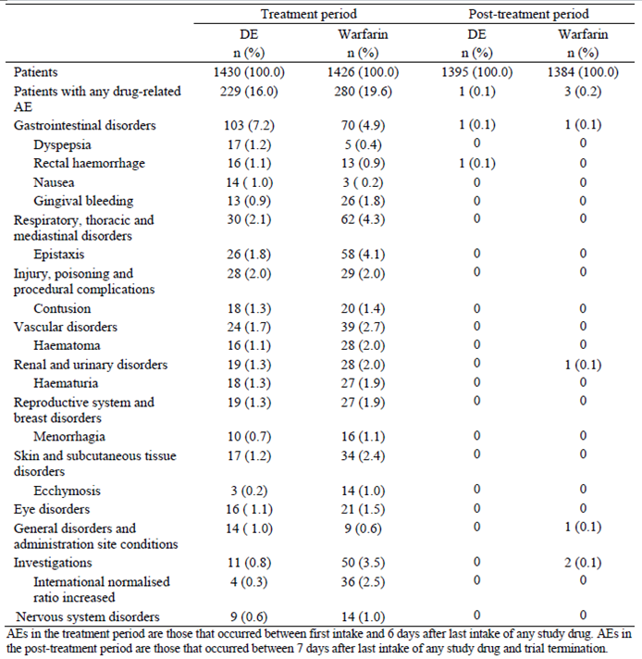
The 3 most frequent drug related AEs (by PT) during the treatment period were epistaxis (1.8% of patients (261430) in the DE group versus 4.1% of patients (58 out of 1426) in the warfarin arm), contusion (1.3% (18 out of 1430) for DE and 1.4% (20 out of 1426) for warfarin), and haematuria (1.3% (18 out of 1430) in the DE group versus 1.9% (27 out of 1426) in the warfarin arm).
During the post treatment period, AEs related to drug intake were reported for 1 patient (0.1% of 1395) in the DE group and 3 patients (0.2% of 1384) in the warfarin arm. For 2 of the 3 warfarin treated subjects, there was an investigation related abnormality (increased INR).

Bleeding events
During the on treatment period, MBEs were reported for 13 patients (0.9% of 1430) in the DE group and 25 subjects (1.8% of 1426) in the warfarin arm. Two patients in each group experienced 2 MBEs each. The total numbers of MBEs on treatment were 15 in the DE arm and 27 in the warfarin group; refer to Table 35. The HR of DE versus warfarin for MBEs was 0.52 (95% CI 0.27, 1.02), which indicates that there was no statistically significant treatment difference for the risk of MBEs (p = 0.0577). The cumulative risk for MBEs at 18 months was statistically lower in the DE group (0.65%; 8 out of 1430) compared to the warfarin arm (1.94%; 23 out of 1426). The risk difference of DE versus warfarin was -1.29% (95% CI -2.20%, -0.38%).
The KM curves for the time to first MBE for both treatment groups were flat and close to each other for the first 3 months of active treatment, diverged between 3 and 18 months (lower for DE), and then because of several MBEs in the DE group between 18 and 22 months, converged at around 22 months in the post treatment follow up phase. KM plots were also produced for the time to the first MBE for each of the 3 patient cohorts. For cohort 1, which included approximately 55% of all subjects in the trial, the DE curve was positioned below the warfarin curve from just after 1 month until the end of the treatment period. For cohort (about 20% of all subjects), the DE curve was persistently located above the warfarin curve from 6 months until the end of the treatment period. The MBEs in cohort 2 explain why the cumulative risk of MBE for DE patients at 21 months increased in the extended follow up period. In cohort 3 (about 25% of all patients), no relevant difference between the treatment groups was observed.
One patient receiving warfarin died of major bleeding (cerebral haemorrhage). Two patients in each treatment group suffered intracranial bleeding, none of which was fatal. The location of other MBEs was gastrointestinal (5 in the DE group and 8 in the warfarin arm), intra ocular (4 in the DE arm and 2 in the warfarin group), intra muscular (4 cases in the warfarin group), urogenital (1 in the DE group and 3 in the warfarin arm), and all other sites affected no more than 2 patients in either treatment group (intra articular, peritoneal and retroperitoneal). Most MBEs (9 events in the DE group and 18 events in the warfarin arm) resulted in a fall in the haemoglobin level of ≥ 20 g/L or the need for a transfusion of ≥ 2 units of whole blood or red blood cells. There was a high correlation (≥ 95%) between local and central adjudication for MBEs in both treatment groups.
During the entire study period, 18 DE patients recorded MBE, 13 occurred during intake of drug and 5 occurred after ceasing treatment. In the warfarin group, 24 patients had MBEs in the active treatment period and 3 subjects had MBEs after stopping treatment.
Patient subgroup analysis of MBE did not reveal any treatment by subgroup interaction. In particular, active cancer and an initial PE did not appear to influence the risk of MBE for either treatment group.

Table 35. Bleeding events during treatment in Study 1160.47.
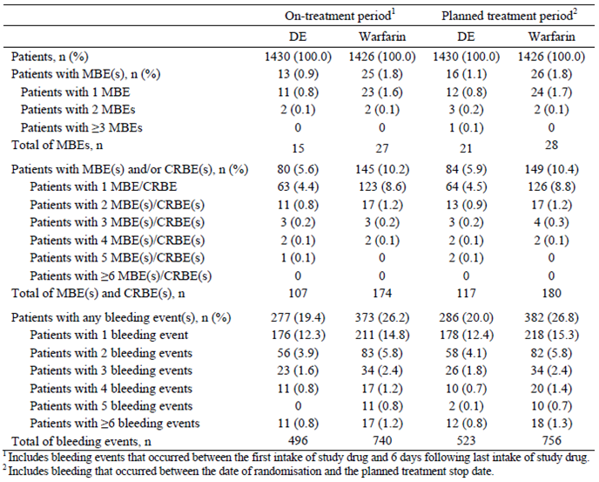
The incidences of MBEs and/or CRBEs during treatment were 5.6% (80 out of 1430) in the DE group and 10.2% (145 out of 1426) in the warfarin arm, with 17 patients in the DE group and 22 subjects in the warfarin arm reporting more than 1 bleeding AE. The total numbers of MBEs and CRBEs were 107 in the DE arm and 174 in the warfarin group. The incidence of any bleeding events during treatment was lower for the DE group (19.4%; 277 out of 1430) than for the warfarin group (26.2%; 373 out of 1426). The total number of bleeding events was lower in the DE group (496 events) than for warfarin (740 events). The HR of DE versus warfarin for any bleeding event was 0.71 (95% CI 0.61, 0.83), which indicates that there was a statistically significant lower risk of bleeding with DE compared to warfarin (p < 0.0001). Similarly, the cumulative risk difference for any bleeding at 18 months was -7.86% (95% CI -11.3%, -4.45%).
The KM curves for the time to first bleeding event appeared to separate early during the trial (before 15 days), and thereafter the DE group curve was consistently positioned below the curve for the warfarin arm. With respect to the location of bleeding events, the largest group were urogenital bleeds (83 events in the DE group and 114 in the warfarin arm) followed by nasal bleeds (64 in the DE group and 146 events in the warfarin arm) and gastrointestinal bleeds (56 in the DE group and 42 in the warfarin arm). About half of all bleeding events were classified as ‘other’ locations.
During the study, 9 patients in the DE group (0.6% of 1430) and 18 subjects in the warfarin arm (1.2% of 1426) received at least 1 blood transfusion. In approximately two thirds of these patients (7 treated with DE (0.4%) and 11 receiving warfarin (0.7%)), the transfusions were given for the management of bleeding events. Most patients (6 in each treatment group) who received transfusions of whole blood or red cells required at least 2 units. The mean number of units transfused was higher in the DE group at 5.0 compared with 3.5 units in the warfarin arm.

Acute coronary syndrome events
In total, investigators reported 59 suspected ACS events in 54 subjects (2.2% (33 out of 1430) of patients in the DE group and 1.4% (21 out of 1426) of subjects in the warfarin arm); refer to Table 36. Of the suspected ACS events that were centrally adjudicated, 20 were classified as definite (13 in the DE group and 7 in the warfarin arm) and 3 as likely (2 in the DE arm and 1 in the warfarin group). The analysis of definite or likely ACS events (centrally confirmed) showed a statistically higher incidence in the DE group (0.9%; 13 out of 1430) compared to the warfarin arm (0.2%; 3 out of 1426; p = 0.02); refer to Table 36.
During the treatment period, 12 patients in the DE group (9 cases of myocardial infarction and 3 cases of unstable angina) had centrally confirmed definite ACS events. While receiving warfarin, 2 patients had centrally confirmed definite ACS events (1 case each of myocardial infarction and unstable angina). The HR for DE versus warfarin for centrally adjudicated definite or likely ACS events occurring while on-treatment was 4.35 (95% CI 1.24, 15.27).

Table 36. Suspected and centrally confirmed ACS events in Study 1160.47 (during and after active treatment).
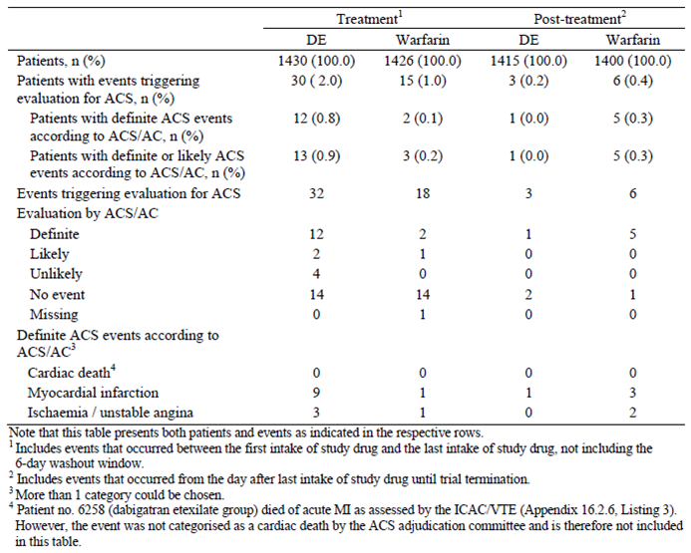
Six patients (5 in the warfarin group and 1 in the DE arm) experienced definite ACS events in the post treatment period. For the DE treated subject, myocardial infarction was recorded 1 day after ceasing the drug. For all but 1 of the warfarin treated subjects, the onset of a definite ACS event was > 14 days post-treatment. No subject died of likely or definite cardiac event.

Deaths and other serious adverse events

VTE treatment studies

Study 1160.53
During the conduct of this trial, 56 of the 2654 randomised patients were known to have died at any time following randomisation. Of these, 27 had been randomised to DE (2.1% of 1273) and 29 to warfarin (2.3% of 1266). Of the 27 patients in the DE group who died, 25 had fatal AEs during or following the intake of active study drug: 14 during active treatment and 11 in the period after active treatment was stopped. Two additional patients in the DE group had only received warfarin placebo. Of the 29 patients randomised to warfarin who died, 19 patients had fatal AEs during active treatment (including the day after last intake) and 10 patients in the period after active treatment was stopped. Three deaths were due to AEs that were assessed as being drug related by the investigator (1 in the DE arm, and 2 in warfarin group). These patients died of bleeding events. The most frequent recorded cause of death was malignancy (7 patients in each treatment group). Nine patients (4 in the DE group and 5 in the warfarin arm) died of respiratory disorders, and 4 (3 in the DE group and 1 in the warfarin arm) died of infection.
During the treatment period, SAEs (including death) were reported for 13.0% (165 out of 1273) of patients in the DE group and 11.8% (150 out of 1266) subjects in the warfarin arm. Immediate life threatening SAEs were reported for 11 DE treated (0.9%) and 6 warfarin treated (0.5%) patients. This included 1 stroke and 1 arrhythmia in each treatment group. SAEs that caused disability and/or incapacity occurred in 8 DE treated (0.6%) and 3 warfarin treated (0.2%) patients. The most frequently reported SAE on a PT level was recurrent VTE (1.9% (24 out of 1273) for DE versus 1.3% (16 out of 1266) for warfarin), followed by dyspnoea (0.4% (5 out of 1273) for DE versus 0.8% (10 out of 1266) for warfarin), pneumonia (0.4% (5 out of 1273) for DE versus 0.6% (8 out of 1266) for warfarin) and haematuria (0.3% (4 out of 1273) for DE versus 0.7% (9 out of 1266) for warfarin). A total of 18 subjects (1.4% of 1273) in the DE group and 16 patients (1.3% of 1266) in the warfarin arm were hospitalised for major bleeding events. The mean (median) duration of hospitalisation was 10.3 days (8.5 days) in the DE group, and 13.5 days (9.0 days) in the warfarin arm.

Study 1160.46
During Study 1160.46, 59 of the 2589 randomised patients died: 31 had participated in the DE group (2.4% of 1294) and 28 in the warfarin arm (2.2% of 1295). Of the 31 patients in the DE group who died, 21 had fatal AEs during active treatment (9 in the single dummy period and 12 in the double dummy phase) and the other 10 subjects died in the period after active treatment was stopped. Of the 28 patients randomised to warfarin who died, 18 patients had fatal AEs during active treatment (2 in the single dummy period and 16 in the double dummy phase) and 10 patients in the period after active treatment was stopped. One warfarin treated patient died of major bleeding (upper tract gastrointestinal haemorrhage on Day 106). The most frequent recorded cause of death was malignancy (9 patients in the DE group and 10 in the warfarin arm), and 5 patients (2 in the DE group and 3 in the warfarin arm) died of infection.
During the treatment period, SAEs (including death) were reported for 12.2% (156 out of 1280) of patients in the DE group and 11.9% (153 out of 1288) subjects in the warfarin arm. Immediate life threatening SAEs were reported for 12 DE treated (1.2%) and 10 warfarin treated (0.8%) patients. One patient in each treatment group suffered an SAE that caused disability and/or incapacity. Excluding recurrent VTE, the most frequently reported SAE on a PT level was pneumonia (0.7% (9 out of 1280) for DE versus 0.3% (4 out of 1288) for warfarin) followed by dyspnoea (0.2% (3 out of 1280) for DE versus 0.6% (8 out of 1288) for warfarin), pneumonia (0.4% (5 out of 1273) for DE versus 0.6% (8 out of 1266) for warfarin), haematuria (0.2% (3 out of 1280) for DE versus 0.7% (9 out of 1288) for warfarin) and chest pain 0.5% (7 out of 1280) for DE versus 0.4% (5 out of 1288) for warfarin). A total of 9 subjects (0.7% of 1280) in the DE group and 18 patients (1.4% of 1288) in the warfarin arm were hospitalised for major bleeding events. The mean (median) duration of hospitalisation was longer in the DE group at 15.3 days (11 days) compared to 11.7 days (7 days) in the warfarin arm.

VTE prevention studies

Study 1160.63
A total of 14 patients died during the entire study period, and another subject died post study. Three patients died during the on treatment period: 1 in the DE group (lung cancer), and 2 in the control arm (hypertensive heart disease and chronic lymphocytic leukaemia). Twelve patients died in the post treatment period: 5 in the DE group and 7 patients in the placebo arm). In the DE group, there was 1 case each of lung carcinoma, cerebrovascular accident and severe intestinal infarction. The other 2 fatalities in the DE group were related to VTE (38 days and 216 days after last dose of DE). In the placebo group, 1 patient each was reported with a fatal case of PE, myocardial infarction, and mesenteric vessel thrombosis; and 4 patients died due to neoplasms (1 patient with a rectal neoplasm and 3 patients with a malignant lung neoplasm).
During the treatment period, the incidence of SAEs was lower for patients treated with DE (6.9%; 47 out of 684) than for patients taking placebo (9.1%; 60 out of 659). The difference was predominantly due to the much higher incidence of recurrent VTE (reported as an SAE) in the placebo group. Two patients in DE group (0.3% of 684) had an immediately life threatening SAE (1 diabetic hyperglycaemic coma, and 1 acute myocardial infarction; both were considered unrelated to study medication). One placebo patient (0.2% of 659) had an SAE that resulted in persistent or significant disability or incapacity (lung neoplasm diagnosed 3 days after start of treatment; unrelated to study medication). SAEs considered to be drug related, were reported for 2 patients in the DE group (both haemorrhage related; post polypectomy and bleeding gastric ulcer) and for 4 patients in the placebo arm (metrorrhagia, gastric ulcer, haematemesis and dyspnoea).
The overall incidence of post treatment SAEs was similar in both treatment groups during the 30 day follow up period (3.4% in the DE group and 2.1% in the control arm) and during the extended follow up period (9.6% in the DE group and 10.1% for placebo). The most common post treatment SAE was recurrent VTE. All other types of SAEs reported in the post treatment and extended follow up phase were by ≤ 3 patients in either treatment group.

Study 1160.47
During the conduct of this trial, 44 patients were known to have died at any time post randomisation. Of these, 12 patients (0.8% of 1430) in the DE group and 18 patients (1.3% of 1426) in the warfarin arm died after having the onset of the reported AE during the treatment period, while 5 patients (0.4% of 1395) in the DE group and 4 patients (0.3% of 1384) in the warfarin arm had AEs with an onset during the post treatment period, and subsequently died. In addition to these fatalities, another 5 subjects (1 in the DE arm and 4 in the warfarin group) were known to have died in the post study phase. One patient died due to an AE that the investigator assessed as being drug related (warfarin group). This patient died of cerebral haemorrhage while receiving active treatment. One patient in each treatment group died of PE. However, the most frequent recorded causes of death during active treatment were malignancy (6 patients in the DE group and 11 in the warfarin arm) followed by cardiac disorders (2 subjects in the DE group and 1 in the warfarin arm).
During the treatment period, SAEs (including fatal events) were reported for 15.9% of patients (227 out of 1430) in the DE group and 15.7% of patients (224 out of 1426) in the warfarin arm. SAEs that caused disability and/or incapacity occurred in 6 patients (0.4%) treated with DE and 5 patients (0.4%) receiving warfarin. The 3 most frequent SAEs by SOC were gastrointestinal disorders (2.6% (37 out of 1430) in the DE group and 2.7% (38 out of 1426) in the warfarin arm), infections (2.3% (33 out of 1430) in the DE arm and 2.5% (35 out of 1426) in the warfarin group), and cardiac disorders (2.2% (31 out of 1430) in the DE group versus 1.1% (15 out of 1426) in the warfarin arm). Among the cardiac disorders, the most pronounced treatment imbalances were observed for myocardial infarction (0.7% in the DE group versus 0.0% in the warfarin arm). Recurrent VTE was the most common SAE by PT (1.3% (19 out of 1430) for DE versus 0.6% (9 out of 1426) for warfarin) followed by chest pain (0.3% (4 cases) in the DE group and 0.6% (9 patients) in the warfarin arm), abdominal pain (0.3% (4 cases) for DE versus 0.6% (8 cases) for warfarin) and prostate cancer (0.3% (5 cases) for DE versus 0.5% (7 cases) for warfarin).
Patients treated with DE in the RE-MEDY trial had a lower incidence of SAEs if they had previously received DE in RE-COVER (14.4%; 34 out of 236) than if they had taken warfarin (21.2%; 60 out of 283). Subjects treated with warfarin in the RE-MEDY study had a higher incidence of SAEs if they had previously received DE in RE-COVER (18.5%; 47 out of 254) than if they had taken warfarin (14.0%; 34 out of 243). Therefore, rollover patients who switched study drug when entering RE-MEDY had a higher incidence of SAEs than rollover subjects who continued the same drug they received in the preceding RE-COVER trial.

Discontinuation due to adverse events

VTE Treatment studies

Study 1160.53
The proportions of patients who discontinued study drug due to AEs with an onset during the entire treatment period were 9.0% (115 out of 1273) in the DE group and 6.8% (86 out of 1266) in the warfarin arm. A greater number of patients in the DE arm discontinued study medication in the single dummy phase compared to the warfarin group (1.5% (19 out of 1273) for DE versus 0.6% (8 out of 1265) for warfarin). However, when the analysis was restricted to the double dummy period, the frequency of AEs that led to premature discontinuation was numerically higher in the DE group (7.9%; 97 out of 1226) compared to the warfarin arm (6.5%; 79 out of 1214). Some patients were assigned as discontinuing study drug in the post treatment period (8 patients in the DE group, and 11 subjects in the warfarin arm) or even the post study period (another 8 patients in the DE arm, and 2 patients in the warfarin group).
For the entire treatment period, the most frequent AEs leading to premature discontinuation were recurrent VTE (2.5% (31 out of 1273) for the DE group versus 1.7% (22 out of 1266) for the warfarin cohort). The study protocol required patients to discontinue treatment in case of verified recurrent VTE. The other most frequent AEs that caused patients to discontinue study treatment (> 1% incidence in either treatment group) were respiratory disorders (1.9% (24 out of 1273) of patients in the DE group, and 1.2% (15 out of 1266) of subjects in the warfarin arm), gastrointestinal disorders (1.3% (16 out of 1273) of patients in the DE group, and 1.1% (14 out of 1266) of subjects in the warfarin arm), and general disorders and administration site conditions (1.2% (15 out of 1273) of patients in the DE group, and 0.4% (5 out of 1266) of subjects in the warfarin arm). Nine patients (0.7% of 1273) in the DE arm and 8 subjects (0.6% of 1266) discontinued study drug to abnormal investigations.
In addition to permanent study drug discontinuations, the intake of DE was interrupted at least once for 9.7% (124 out of 1273) of DE treated patients, and 11.9% (151 out of 1266) of warfarin treated subjects. The most common causes of treatment interruption were too high INR, which affected 12 patients in the DE group (sham INR readings) and 58 subjects in the warfarin arm; and bleeding events (18 patients in the DE group and 34 subjects in the warfarin arm). The mean duration of study drug interruption was 16.9 days in the DE arm and 14.2 days in the warfarin group. Most of the patients had a total duration of treatment interruption of 8 to 29 days (78 subjects in the warfarin arm, and 68 patients in the DE arm).

Study 1160.46
In both treatment groups, 100 patients discontinued during the treatment period due to AEs (7.8% in both groups). Excluding recurrent VTE, the most frequent recorded SOCs resulting in treatment discontinuation were investigation abnormalities (0.9% (11 out of 1280) in the DE group and 1.0% (13 out of 1288) in the warfarin arm), and gastrointestinal disorders (0.7% (9 out of 1280) in the DE group and 1.0% (13 out of 1288) in the warfarin arm).
Temporary interruption of study drug treatment occurred at a higher frequency in the warfarin group (19.6%; 253 out of 1288) compared to the DE arm (11.0%; 141 out of 1280). The most frequent cause of treatment interruption was too high INR, which affected 16 patients in the DE group (sham INR readings) and 178 subjects in the warfarin arm. Surgery and bleeding events were the other most frequent causes of treatment interruptions and occurred at a similar frequency in each of the treatment groups. The mean duration of study drug interruption was 9.4 days in the DE arm and 7.0 days in the warfarin group. Most of the patients had a total duration of treatment interruption of 1 to 7 days (172 subjects (71.1% of 242) in the warfarin arm, and 66 patients (56.9% of 116) in the DE arm).

VTE prevention studies

Study 1160.63
The percentage of patients who prematurely discontinued study drug due to AEs with an onset during the active treatment period was lower in the DE group at 7.3% (50 out of 684) compared to the control arm (12.3%; 81 out of 659). This difference appeared was due to the much higher incidence of VTE in the placebo group compared to the DE arm. The incidence of bleeding events leading to discontinuation of study medication was 1.6% for patients (11 out of 684) in the DE group and 0.6% for placebo patients (4 out of 659). In addition, a higher proportion of subjects in the DE group (2.8%; 19 out of 684) withdrew due to gastrointestinal disorders than the placebo arm (1.7%; 11 out of 659).

Study 1160.47
The proportion of patients who prematurely discontinued study drug due to AEs with an onset during the active treatment period was higher in the DE group at 10.1% (145 out of 1430) compared to warfarin arm (8.8%; 126 out of 1426). This difference appeared to be due to a higher incidence of cardiac disorders leading to discontinuation in the DE group (1.0%; 15 out of 1430) than in the warfarin arm (0.2%; 3 out of 1426). Among the cardiac disorders, the most pronounced imbalances were observed for myocardial infarction (7 patients (0.5%) in the DE arm, and 0 patients in the warfarin group). By PT, AEs leading to discontinuation of study drug with a frequency of at least 0.5% in either treatment group were DVT (0.8% (12 cases) in the DE group, and 1.1% 16 cases) in the warfarin arm) followed by haematuria (0.5% (7 cases) in each treatment group). Treatment discontinuation following the occurrence of VTE was specified in the study protocol, which required patients to discontinue study treatment in the case of a locally confirmed recurrent VTE.
Temporary interruption of study drug treatment occurred at a higher frequency in the warfarin group (26.5%; 378 out of 1426) compared to the DE arm (21.1%; 302 out of 1430). The most frequent cause of treatment interruption were surgery (10.3% of all subjects), ‘other causes’ (9.8% of cases), too high or too low INR (3.7% of all patients) and bleeding events (2.9% of all subjects). The mean duration of study drug interruption was 12 days in the DE arm and 10 days in the warfarin group. Most patients had a total duration of treatment interruption of < 30 days (280 subjects (92.7% of 302) in the DE arm, and 360 patients (95.2% of 378) in the warfarin arm).

Laboratory tests

Liver function

VTE Treatment studies

Study 1160.53
In both treatment groups, the mean changes from baseline to the last value taken on treatment was small and similar for liver function test parameters (serum transaminases, total bilirubin and alkaline phosphatase). Mean values in both groups were within the reference ranges for all time windows analysed over the 7 month study. Abnormalities of possible clinical significance were most frequently reported for ALT and AST followed by total bilirubin, and were recorded at the same or slightly higher frequency in the warfarin group (3.2% (38 out of 1198) for ALT, 1.8% (22 out of 1198) for AST, and 1.1% (13 out of 1198) for bilirubin) than in the DE arm (2.2% (26 out of 1204) for ALT, 1.7% (21 out of 1204) for AST, and 0.6% (7 out of 1204) for bilirubin). Liver function test results were further categorised by multiples above the ULN. Increased serum transaminases above the reference range were infrequent, and no treatment related difference was discernible; refer to Table 37.

Table 37. Patients with increases in serum transaminases on active drug in Study 1160.53.
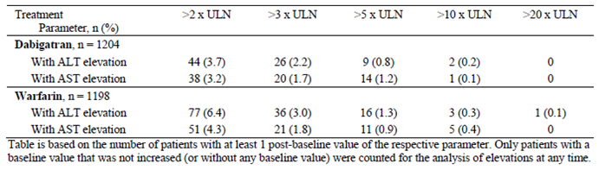
During treatment, ALT and AST values of > 3x ULN at any time post-baseline (that is only for patients with normal or no values at baseline) were reported for 2.2% (26 out of 1204) and 1.7% (20 out of 1204) of patients in the DE group compared with 3.0% (36 out of 1198) and 1.8% (21 out of 1198), respectively in the warfarin arm. The same pattern (that is numerically slightly higher in the warfarin versus DE group) was observed when ALT and AST elevations > 2 x ULN, as well as more substantial elevations at any time post baseline, were examined. One patient in the warfarin group developed an increase in serum ALT > 20 x ULN. Any ALT increase > 3 x ULN was reviewed by a hepatic review panel. In total, 44 DE treated subjects and 49 warfarin cases were assessed by the panel for the causal relationship between increased ALT and study drug. For 2 patients in each treatment group, the assessment was ‘probably related’, that is a good temporal relationship with study drug intake was presented and no other obvious potential cause for the elevations was identified. In none of these 4 cases was the total bilirubin concentration > 2 x ULN. A further 11 DE treated patients and 12 warfarin cases were rated as ‘possibly related’, indicating a poor temporal relationship but no identification of alternative etiology.
Patients with elevations of ALT > 3 x ULN, who also had elevations of total bilirubin of > 2 x ULN within 30 days of the transaminase elevation were of special interest as they were considered as potential Hy’s law cases. In total, there were 8 patients (3 in the DE group and 5 in the warfarin arm) meet such criteria. In 1 warfarin treated patient, the high ALT (and total bilirubin) was recorded at baseline, and in 1 DE subject about a month after stopping active study drug. Therefore, 6 of the 8 patients developed the increased LFT results during active treatment (2 patients in the DE group and 4 patients in the warfarin arm). In all 6 cases, the abnormal liver function tests were attributed to hepatobiliary obstruction, and for 4 subjects (1 in the DE group and 3 in the warfarin arm) associated with neoplasms.

Study 1160.46
In both treatment groups, the mean changes from baseline to the last value on treatment was small and similar for liver function test parameters (serum transaminases, total bilirubin and alkaline phosphatase). Mean values in both groups were within the reference ranges for all time windows analysed over the trial period. Abnormalities of possible clinical significance were most frequently reported for ALT and AST, and were recorded at a similar frequency in the warfarin (3.2% (40 out of 1248) for ALT, and 2.2% (27 out of 1248) for AST) and DE groups (2.5% (31 out of 1238) for ALT, and 2.3% (29 out of 1238) for AST). Liver function test results were further categorised by multiples above the ULN. Increased serum transaminases above the reference range were infrequent, and no treatment related difference was discernible; refer to Table 38.

Table 38. Patients with increases in serum transaminases on active drug in Study 1160.46.
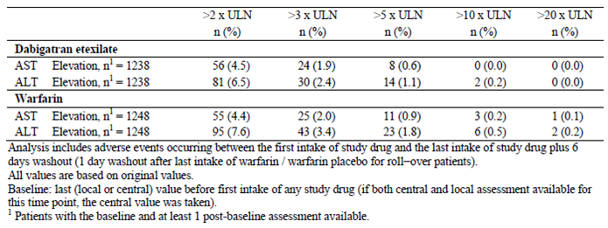
During treatment, ALT and AST values of > 3x ULN at any time post-baseline (that is only for patients with normal or no values at baseline) were reported for 2.4% (30 out of 1238) and 1.9% (24 out of 1238) of patients in the DE group compared with 3.4% (43 out of 1248) and 2.0% (25 out of 1248), respectively in the warfarin arm. There was also a small numerically higher incidence of ALT (but not AST) elevations > 2 x ULN in the warfarin versus DE group (7.6% (95 out of 1248) for warfarin versus 6.5% (81 out of 1238) for DE). More substantial elevations (for example increases in serum ALT > 5 x and > 10x ULN) at any time post baseline were also more frequent in the warfarin group, albeit small numbers of affected patients.
Patients with elevations of ALT > 3 x ULN, who also had elevations of total bilirubin of > 2 x ULN within 30 days of the transaminase elevation were of special interest as they were considered as potential Hy’s law cases. Two patients in each treatment group meet the criteria. One of the DE treated patients had not commenced DE (discontinued in the single dummy period) and 1 of the warfarin treated subjects developed abnormal liver function tests 1 day after starting active study drug. The other DE treated patient had a baseline history of fatty liver disease and recorded increased liver function tests 19 days after starting treatment, DE was temporarily ceased (for 35 days) but then re-commenced without recurrence. The other case was a [information redacted] patient receiving warfarin who developed abnormal liver function tests on Day 152 which completely resolved 2 weeks later on re-testing. Warfarin was continued throughout the study period, and the event remains unexplained.

VTE prevention studies

Study 1160.63
There were no clinically meaningful differences between the two treatment groups (DE and placebo) for mean and outlier values of liver function tests. More than 95% of patients in each of treatment groups never developed elevated liver function tests. The percentage of subjects who developed ALT or AST > 3 x ULN was identical in the two groups (0.6%). One patient treated with DE had an ALT value > 10 x ULN 1 month post commencement of DE. The baseline ALT reading was > 3 x ULN, and the patient should have been excluded from involvement in the study at baseline. After appropriate investigation, it was subsequently identified that the patients had acute hepatitis A, with complete resolution of the abnormal liver function tests 3 months later. Only 1 placebo subject developed an increase in serum total bilirubin > 2 x ULN. No potential Hy’s Law cases were identified in this trial.

Study 1160.47
No relevant treatment differences were observed for the mean changes from baseline to the last value on treatment, and maximum post baseline value for the liver function test parameters of serum transaminases, total bilirubin and alkaline phosphatase. For ALT and AST, the mean maximum post baseline value was up to 20 U/L higher than baseline in both treatment groups.
Liver function test abnormalities of possible clinical significance were most frequently reported for ALT followed AST. Such abnormalities were recorded at a similar frequency in the warfarin and DE groups (2.1% (30 out of 1402) for ALT and 1.3% (23 out of 1402) for AST in the warfarin group compared with 1.8% (26 out of 1411) for ALT and 1.6% (23 out of 1411) for AST in the DE arm). Liver function test results were further categorised by multiples above the ULN. Increased serum transaminases above the reference range were infrequent, and no treatment related difference was discernible, see Table 39.

Table 39. Patients with increases in serum transaminases on active drug in Study 1160.47.
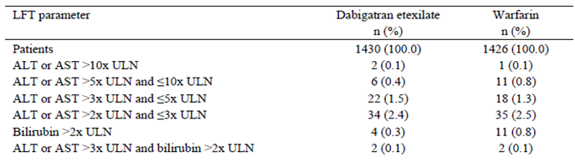
Patients with elevations of ALT > 3 x ULN, who also had elevations of total bilirubin of > 2 x ULN within 30 days of the transaminase elevation were of special interest as they were considered as potential Hy’s law cases. Two patients in each treatment group meet the criteria. Both DE treated patients had alternative reasons for the abnormal liver function tests (pancreatic cancer and liver cancer, respectively).

Kidney function

VTE Treatment studies

Study 1160.53
No clinically significant mean changes from baseline to the last value on treatment for renal function was observed. A similar proportion of patients in each treatment group developed abnormalities of serum urea or creatinine, which were of possible clinical significance (2.1% (25 out of 1202) for the DE group and 1.9% (23 out of 1197) for the warfarin arm). Most of these abnormalities were transient and associated with significant bleeding events (that is pre-renal cause) rather direct drug related nephrotoxicity.

Study 1160.46
A similar proportion of patients in each treatment group developed elevations of serum urea and/or creatinine, which were of possible clinical significance: 1.6% (20 out of 1234) for increased creatinine and 0.3% (4 out of 1233) for raised urea in the DE group compared to 1.7% (21 out of 1246) and 0.5% (6 out of 1246), respectively in the warfarin arm. Most of these abnormalities were transient and associated with bleeding events.

VTE prevention studies

Study 1160.63
The mean serum creatinine values were 1.0 mg/dL (SD 0.2) in both treatment groups at baseline, and at the last value on treatment. In total, 0.5% of DE patients and 0.3% of placebo subjects developed transient increases in serum creatinine during the trial, which were of possible clinical relevance.

Study 1160.47
A similar proportion of patients in each treatment group developed elevations of serum urea and/or creatinine, which were of possible clinical significance: 1.7% (24 out of 1411) for increased urea and 2.5% (35 out of 1411) for raised creatinine in the DE group compared to 1.0% (14 out of 1402) and 2.9% (40 out of 1402), respectively in the warfarin arm.

Other clinical chemistry

VTE treatment studies

Study 1160.53
No clinically significant mean changes from baseline to the last value on treatment for clinical chemistry (sodium and potassium) was observed. A similar proportion of patients in each treatment group developed abnormalities of serum sodium or potassium, which were of possible clinical significance (0.3% (4 out of 1202) for the DE group and 0.5% (6 out of 1197) for the warfarin arm). Most of these abnormalities were transient and not drug related.

Study 1160.46
Five patients in the DE group (0.4% of 1233) and 4 subjects in the warfarin arm (0.3% of 1246) recorded abnormalities of serum sodium or potassium, which were of possible clinical significance. However, none were clinically relevant or recorded as AEs.

VTE prevention studies

Study 1160.63
No clinically significant changes (mean and individual) were observed.

Study 1160.47
Seven patients in each treatment group (0.5%) recorded abnormalities of serum sodium (increased or decreased) of possible clinical significance. In addition, 13 patients in each treatment group (0.9%) recorded abnormalities of serum potassium (increased or decreased) of possible clinical significance.

Haematology

VTE Treatment studies

Study 1160.53
The mean changes from baseline to the last value on treatment was small and did not show relevant treatment related differences. While the mean haematocrit and mean haemoglobin levels increased slightly, the mean white blood cell count decreased (-0.6 x 10⁹/L for the DE group, and -0.9 x 10⁹/L for the warfarin arm), and also the mean platelet count decreased marginally.
The percentage of patients who recorded decreased levels of possible clinical significance for haematocrit and haemoglobin were observed more frequently in the warfarin group (4.8% (58 out of 1196) for haematocrit, and 4.1% (49 out of 1198) for haemoglobin) than the DE arm (3.5% (42 out of 1202) for haematocrit, and 3.5% (42 out of 1202) for haemoglobin). This may be explained by the more frequent occurrence of bleeding events in the warfarin group.

Study 1160.46
The mean changes from baseline to the last value on treatment was small and did not show relevant treatment related differences. The proportion of patients who recorded decreased levels of possible clinical significance for haematocrit, haemoglobin and total white cell count were generally similar between the treatment groups. In the warfarin group, 4.9% (61 out of 1248) of patients had reduced haematocrit at some time, and 4.4% (55 out of 1248) had decreased haemoglobin; compared to the DE arm whereby 4.4% (55 out of 1237) recorded decreased haematocrit, and 3.6% (45 out of 1237) had decreased haemoglobin. For patients developing reduced white cell count, the recorded incidence was 1.0% (12 out of 1231) in the DE group and 0.8% (10 out of 1244) in the warfarin arm.

VTE prevention studies

Study 1160.63
No clinically significant changes (mean and individual outlier values) were reported.

Study 1160.47
The mean changes from baseline to the last value on treatment was small for all haematology parameters. In both treatment groups, there was a slight decrease in mean haematocrit, haemoglobin and platelet count (-10 x 10⁹/L). The proportion of patients who recorded decreased levels of possible clinical significance for haematocrit and white blood cell count were similar between the treatment groups. In the warfarin group, 4.6% (65 out of 1402) of patients had reduced haematocrit, and 0.4% (5 out of 1345) had decreased white cell count; compared to the DE arm whereby 4.2% (59 out of 1409) recorded decreased haematocrit, and 0.6% (8 out of 1346) had decreased white cell count.

Electrocardiograph

VTE treatment studies
In Study 1160.53, about one quarter of all patients had an abnormal ECG at baseline. At the end of treatment, ECG results were only evaluable for one half of all subjects. Of these, 18.4% of patients in the DE group and 18.9% of subjects in the warfarin arm had abnormal ECG traces, most of which were clinically irrelevant. No significant treatment related differences were observed for ECG changes in Study 1160.46.

VTE prevention studies
In both secondary prevention studies, approximately 20% of subjects in each treatment group had an abnormal ECG at baseline. At the end of treatment visit, abnormal ECG results were observed for 16 to 18% of patients in all treatment groups. No significant treatment related differences were observed for ECG changes in Studies 1160.47 and 1160.63.

Vital signs

VTE treatment studies
No clinically relevant mean changes in blood pressure (systolic and diastolic), as well as pulse rate were observed in either Study 1160.53 or 1160.46.

VTE prevention studies
No clinically relevant mean changes in blood pressure (systolic and diastolic), as well as pulse rate were observed in either Study 1160.47 or 1160.63.

Pregnancies

VTE treatment studies
During Study 1160.53, 5 pregnancies (1 in the DE group and 4 in the warfarin arm) were reported. All of the pregnancies ended either spontaneously or by induced abortion.
A total of 9 pregnancies were reported in Study 1160.46, 8 of who in women treated with study drug (1 receiving DE, and 7 taking warfarin). The partner of a male subject receiving warfarin also became pregnant during the trial, and she subsequently delivered a healthy male infant. The DE treated subject underwent an elective termination of pregnancy at 8.5 weeks gestation. All but 1 of the 7 warfarin treated patients had an elective abortion before 12 to 13 weeks of gestation. One subject was identified as pregnant 6 months after commencing warfarin, stopped warfarin, and continued the pregnancy to term. She delivered a healthy female infant without complications.

VTE prevention studies
During Study 1160.47, 6 patients in the DE group and 8 subjects in the warfarin arm became pregnant. Of the reported cases of pregnancy, 2 normal babies were born (1 patient in each treatment group), and all other cases ended either spontaneously or by induced abortion.

Post-marketing experience
As DE has not been approved anywhere in the world at present for the indications of treatment and secondary prevention of VTE, there is no post marketing experience specific to the requested target populations in this submission. The sponsor has provided an updated report (data collected up to 18 September 2012) regarding its experience in patients taking DE for thromboprophylaxis in non-valvular atrial fibrillation and following major orthopaedic surgery. The most recent update does not indicate any newly identified or potential safety concerns with DE.

Safety issues with the potential for major regulatory impact

Liver toxicity
Abnormalities of liver function tests are of special interest for DE as a preceding direct thrombin inhibitor (ximelagatrin) was known to cause abnormalities of liver function tests (markedly raised serum transaminases with or without increases in serum total bilirubin). In the 4 pivotal studies included in this submission, no important differences in the frequency and severity of liver function test abnormalities were observed in the active controlled studies (DE compared with warfarin). In the placebo controlled trial (1160.63), the frequency of patients with elevations of liver function values of possible clinical significance was similar between the DE and control arms. Further details on the potential for hepatotoxicity have been discussed in section 8.4.1 of this report. Nonetheless, this issue will require ongoing pharmacovigilance in the requested target population if approval is granted.

Bleeding events
DE is associated with an increased risk of bleeding (major, clinically relevant and overall) compared to placebo (known effect plus the results of Study 1160.63 in this submission). However, when DE is compared to INR adjusted warfarin for the acute treatment and secondary prevention of VTE the frequency of major and/or clinically relevant bleeding is similar, and the incidence of any bleeding is lower. The location of MBE is similar between DE and warfarin, but for all bleeding events tended to be higher in the warfarin treated subjects from the urogenital and nasal tracts, and numerically greater in the DE subjects from the gastrointestinal tract.

Cardiovascular safety
In three of the 4 pivotal studies (all of the active controlled trials) in this submission, myocardial infarctions were numerically greater in the DE treated patients groups (compared to warfarin). In Study 1160.47 (RE-MEDY), a statistically higher incidence of centrally adjudicated definite or likely ACS events was observed in the DE treatment group (0.9%; 13 out of 1430) than the warfarin arm (0.2%; 3 out of 1426; p = 0.02). In both of the acute treatment studies (1160.53 and 1160.46) there was a slightly increased absolute risk of ACS events in the DE treatment group compared to the warfarin arm in the order of magnitude of 0.3%. In both of the acute VTE treatment studies, the result was not statistically significant. In the placebo controlled RE-SONATE trial (1160.63), only 1 confirmed myocardial infarction was recorded in each of the treatment groups. A recent meta-analysis by Uchino et al (2012) has hypothesised that the data indicates DE may be less protective of ACS compared to warfarin in subjects at risk of coronary occlusion, but that DE itself does not directly precipitate ACS events (as seen in the placebo controlled trial). Nonetheless, the potential for an increased risk of cardiovascular morbidity and mortality with DE cannot be excluded. This important safety issue will require ongoing pharmacovigilance in the requested target population.

Other safety issues

Safety in special populations
The current PI provides specific advice about the use of DE in patients with moderate or severe renal impairment. It also warns that patients with moderate renal impairment (CrCL 30 to 50 mL/min) receiving treatment with DE have a ‘potentially higher risk’ of major bleeding. This submission confirms that patients with significantly impaired renal function have an increased risk of AEs, which is comparable between the active treatment strategies of DE and warfarin.
The current submission also indicates that older patients (> 65 years of age) have an frequency of AEs compared to younger subjects, but this increased risk is not treatment dependent (that is occurring at the same frequency between DE and warfarin treated subjects).

Safety related to drug-drug interactions
The current PI already contains extensive information about the risk of drug interactions (PK and/or PD related). This submission does not contain any new information on the risk of additional drug interactions or a change in the likelihood of those events occurring.

Evaluator’s overall conclusions on clinical safety
In this submission, the total clinical safety dataset for the use of DE in adult patients with VTE consists of 8753 patients in 4 pivotal studies: 4387 of whom received DE at proposed dose of 150 mg twice daily, 3707 were treated with INR adjusted warfarin (target 2.0 to 3.0) and 659 subjects took placebo therapy in the secondary prevention trial (Study 1160.63). The overall exposure to DE in the VTE dataset is 3261 patient-years (and 2946 patient-years for comparator warfarin). In the 4 pivotal studies, approximately 90% of patients received DE for at least 5 months in total (as part of a first, and then re-treatment period study design). Overall, there is sufficient volume of data to make a meaningful assessment of safety over the short and medium-term of treatment (that is up to 2 years) in the newly proposed treatment indications of acute treatment of VTE and secondary prevention.
In general, the study populations had baseline characteristics (demographic, disease related and co-morbidity) indicative of the intended target population for the claimed indication. The majority of subjects in the Phase III studies were male, Caucasian and middle aged. In the pivotal Phase III trials, approximately 30% of all recruited patients were aged > 65 years, which is an under representation of older aged subjects compared to Australian community statistics (Access Economics report 2008). The pivotal studies excluded patients with a high baseline risk of bleeding. In addition, there is no or very limited experience in certain patient subgroups of relevance including subjects with renal or hepatic impairment, pregnant or lactating women, and those with a low body weight (< 50 kg).
Bleeding is the most concerning AE associated with any anticoagulant therapy (including DE). MBEs and/or CRBEs occurred at a similar (not statistically different) frequency in DE and warfarin treated patients in all three of the active controlled studies. The overall incidence of any bleeding event was lower in the DE treatment groups than the warfarin arms. The location of MBEs was similar in both the DE and warfarin treatment groups. However, for all bleeding events, warfarin treated subjects tended have a higher bleeding risk from the urogenital and nasal tracts, and for the DE subjects a numerically greater risk of any bleed from the gastrointestinal tract. In the placebo controlled study (1160.63), the incidences of CRBEs and of any bleeding event were significantly higher for patients on DE. Only 2 MBEs occurred during the trial, both affecting DE treated subjects.
The other key safety conclusions identified in the four Phase III trials are as follows:
- The overall incidence of AEs was similar in the DE, warfarin and placebo groups
- However, the incidence of gastrointestinal disorders was higher in patients who received DE compared with placebo, and often higher to that observed in patients receiving warfarin
- Permanent discontinuations from study medication because of AEs were similar in frequency among the active treatment groups, but withdrawal due to gastrointestinal disorders occurred at a higher frequency in those taking DE
- At 6 to 18 months of follow up, the overall incidence of SAEs was low and similar in frequency between the active treatment groups, with the most frequent type of SAE (excluding recurrent VTE) being pneumonia, dyspnoea and adverse cardiovascular events
- The Phase III studies confirmed that patients with renal impairment, and those aged > 65 years are a subset of patients at the highest risk of AEs (regardless of anticoagulant treatment, including DE).
Elevations in hepatic transaminases (AST and ALT) were recorded in approximately 2% of patients treated with DE in the pivotal studies. Abnormalities of liver function tests were observed at a similar frequency with both warfarin and placebo in the 4 clinical trials. The majority of these changes in liver function tests were mild and without associated clinical implications.
In summary, the safety data indicates that DE has an acceptable safety profile compared to the main alternative active therapy (INR adjusted warfarin within the target range of 2.0 to 3.0) in the treatment of adult patients with symptomatic VTE (Studies 1160.53 and 1160.46). Similarly, when DE is used in the secondary prevention of recurrent VTE in patients at high risk, the safety profile is acceptable compared to other active treatment (warfarin) but clearly there is a higher incidence of bleeding with any anticoagulant treatment (including DE) over placebo. The submitted dataset contains a sufficient volume of short and medium term safety data (up to 2 years) to assess the risk of many types of AEs associated with anticoagulation. Nonetheless, in 3 of the 4 pivotal studies (all of the active controlled trials) in this submission, myocardial infarctions were numerically greater in the DE treated patients groups (compared to warfarin), but the observation was not statistically significant in 2 of the 3 pivotal trials. Therefore, the potential for an increased risk of cardiovascular morbidity and mortality with DE cannot be excluded and this important safety issue requires ongoing pharmacovigilance. The major identified safety concern with DE is bleeding (major, clinically relevant and overall). The safety concerns identified in this submission are consistent with known profile of DE in other approved indications, mainly when used for thromboprophylaxis in patients with atrial fibrillation and at least 1 additional risk factor for stroke. Significant pharmacovigilance would be required if approval is granted for extension of treatment indications. This would include vigilance for bleeding, acute coronary syndrome events and the risk of AEs in patient subgroups (for example those with renal impairment).

First round benefit-risk assessment

First round assessment of benefits
The benefits of DE in the proposed usage are:
- DE is non-inferior to warfarin for treating acute symptomatic VTE and its associated mortality
- DE is non-inferior to warfarin, and superior to placebo, in the secondary prevention of recurrent VTE (however, extended duration treatment beyond 18 months is an area of uncertainty)
- DE provides an alternative to INR adjusted warfarin and other anticoagulation therapies in treating patients with VTE (initial parenteral therapy is still required for acute symptomatic VTE)
- No requirement for routine laboratory monitoring of anticoagulant activity
- DE is an orally administered treatment which provides dosing convenience over parenteral therapies for the majority of target patients.

First round assessment of risks
The risks of DE in the proposed usage are:
- Increased risk of bleeding (major, clinically relevant and overall) which is comparable to alternative active therapies such as warfarin but higher than placebo
- Potential for increased risk of myocardial infarction - numerically higher in the DE treated versus warfarin treated subjects in this submission, but not statistically significant difference in 2 of the 3 pivotal studies
- Safety not established in those with a high risk of bleeding (for example bleeding diathesis) as these patients were excluded from the trial populations (that is some limitations to external validity)
- In general, safety data in patients with VTE limited to < 2 years of follow up
- No antidote to the anticoagulant effects of DE is currently available for those with major toxicity (in particular, those experiencing major bleeding events or requiring urgent surgery)
- No readily available and validated method of monitoring the anticoagulant effect of DE
- DE is contra indicated in patients with severe renal impairment (CrCL < 30 mL/min), and patients with moderate renal impairment have an increased risk of bleeding
- DE is contra indicated during pregnancy (risk factor for VTE) and lactation
- Potential for drug interactions related to changes in intestinal P-gp activity

First round assessment of benefit-risk balance
The benefit-risk balance of DE is favourable for the acute treatment of symptomatic VTE, and is similarly favourable for the indication of secondary prevention of VTE for up to 18 months of therapy. However, the risk-balance of DE therapy for secondary prevention of VTE beyond 18 months of treatment is unclear from the current dataset.
This submission contains robust data to support the claim that DE is non-inferior to warfarin (INR control of sufficient quality) for treating acute symptomatic VTE and its associated mortality. In addition, DE is non-inferior to warfarin, and superior to placebo, in the secondary prevention of recurrent VTE. However, extended duration treatment beyond 18 months is an area of uncertainty. DE provides an alternative to INR adjusted warfarin and other anticoagulation therapies in treating patients with VTE after an initial period of parenteral anticoagulation therapy. DE is non-inferior to warfarin in treating patients whose initial clinical presentation is with either DVT or PE. Some patient subgroups (such as those with active cancer) are at a higher risk of VTE recurrence, but that risk is consistent with DE or warfarin. There are 2 major safety concerns in the current dataset that require consideration. There is an increased risk of bleeding (major, clinically relevant and overall) with DE which is comparable to alternative active therapies such as warfarin, but higher than placebo. The 3 active controlled studies showed an increased frequency of myocardial infarction in DE versus warfarin treated subjects, which was statistically significant in 1 of those 3 studies (Study 1160.47).
There are some caveats to the current dataset. The efficacy and safety of DE in patients at a high risk of bleeding is not established. In addition, DE treatment is contra indicated in those with severe renal impairment (CrCL < 30 mL/min) and there are several important potential drug interactions with P-gp substrates that require caution or avoidance of concurrent administration. There is no information for DE on the management of patients with recurrent VTE whilst receiving anticoagulation. In practice, many clinicians would recommend an increase in target INR for warfarin treated subjects or a switch to heparin based therapy in the maintenance treatment phase (that is, after an initial period of parenteral anticoagulation).

First round recommendation regarding authorisation
The clinical evaluator recommends acceptance of the sponsor’s proposed extension of treatment indications for DE to include the treatment and secondary prevention of VTE. However, the proposed wording of treatment extension contains an additional element. The sponsor is also asking for the indication to include ‘prevention of related death’ in both clinical scenarios (acute treatment phase, as well as in the extended secondary prevention period).
The current submission provides robust evidence of DE reducing the risk of VTE recurrence when used in both the acute treatment phase and secondary prevention period. There is evidence that DE is comparable to warfarin in reducing the risk of VTE related death when commenced in the acute treatment phase; however, there is insufficient evidence for the claim of ‘prevention of related death’ in the extended secondary prevention period. At the very least, the clinical evaluator recommends that this phrase be removed from the second newly proposed indication (that is prevention or recurrent VTE). However, in the clinical evaluator’s opinion an indication listing consistent with the proposed USA wording would be most appropriate and easily understood by clinicians if licensing is approved. The clinical evaluator proposes the indication of ‘For the acute treatment and reduction of risk of recurrence of deep vein thrombosis and pulmonary embolism’.
The clinical evaluator would recommend that approval of the sponsor’s proposed extension of indication be subject to satisfactory response to the questions in Section 11 of this report and regular periodic safety update reports.

Clinical questions

Pharmacokinetics
- The pharmacokinetic data from the Study 1160.53 shows that patients with a CrCL of < 50 mL/min had much higher trough concentrations of total dabigatran (more than a 3 fold increase) compared to subjects with CrCL ≥ 80 mL/min. For the approved indication of thromboprophylaxis in patients with atrial fibrillation, there is flexibility in the dosing of Pradaxa to consider using the lower dose of 110 mg twice daily (versus 150 mg twice daily). In this submission, why has the option of dose reduction in patients with moderate renal impairment (CrCL 30 to 50 mL/min) not been requested in the PI, or examined in the clinical study program. Could the sponsor please comment on this issue?

Pharmacodynamics
- Thrombin Time (TT) is the most sensitive assay for determining if dabigatran is present in the plasma (Douxfils et al, 2012). In the PD sub study of Study 1160.53, were samples for TT collected and if not, why?

Efficacy
- In Studies 1160.53 and 1160.46 it was unclear how the variability in sham INR readings (dabigatran treatment groups) compared to the variability in real INR results (warfarin treatment groups) during the active treatment periods of both trials. There appeared to be a higher incidence of treatment interruptions in the warfarin treatment groups for too high or too low INR results compared to the dabigatran arms. Could the sponsor comment on the degree of INR variability (sham versus real INR results) between the treatment groups in Studies 1160.53 and 1160.46? If there was inequity between the active treatments for this observation, could the sponsor comment on whether or not such an observation may have affected the efficacy results, including the potential for unintentional treatment unblinding?
- In Studies 1160.53 and 1160.47, the trial protocol required patients to discontinue study treatment if they developed a verified recurrent VTE event. In the submitted tables summarising patient disposition (that is number of subjects ‘discontinuing due to worsening of disease under study’), number of patients with primary efficacy outcome events and discontinuations there is a discrepancy between the patient numbers for each treatment group. For example, in the dabigatran treated patients in Study 1160.53, the patient disposition table indicates 35 subjects discontinued due to worsening of disease under study, the primary efficacy table reports 30 patients experiencing the primary efficacy outcome up to Day 180 and the discontinuation due to adverse events table shows 31 patients recording PE or DVT. Could the sponsor explain how the discrepancy in reported patient numbers with each table has been derived?
- For subjects rolling over into the RE-MEDY trial (Study 1160.47) from just completing participation in the RE-COVER Study (Study 1160.53), bridging anticoagulation with LMWH was optional. Could the sponsor comment on whether or not there were an increased number of VTE events in subjects changing from dabigatran to warfarin who did not receive bridging anticoagulation versus those who did, and the timing of VTE events after randomisation (that is reflecting inadequate bridging anticoagulation therapy)?
- In Studies 1160.53 and 1160.46 the pre-specified non inferiority margin was 2.75, and in Study 1160.47 the pre-specified non inferiority margin was 2.85. These appear to be overly generous. In the EINSTEIN Studies examining the effect of rivaroxaban for the treatment of VTE compared to warfarin, the non inferiority margin was 2.0. Could the sponsor provide a detailed clinical justification for the pre-specified non-inferiority margins used in Studies 1160.53, 1160.46 and 1160.47?

Safety
- Could the sponsor comment what (if any) effect the temporary treatment interruptions as a result of sham INR readings (too low or too high) may have had on safety outcomes?
- Could the sponsor comment as to why dabigatran (or dabigatran placebo) capsules were withheld for out of range INR results? Should treatment interruptions for too high or too low INR values have been limited to warfarin or warfarin placebo treatment? What is the rationale for ceasing both treatment arms?

Second round evaluation
The sponsor’s response dated 28 March 2014 addresses 8 questions that were raised in the first round clinical assessment. Each of these responses will be assessed in order.

Pharmacokinetics

Question 1. evaluation of response
In the response, the sponsor has presented data collected in the RE-COVER and RE-LY studies that show for patients with renal impairment (CrCL 30 to < 50 mL/min and CrCL 50 to < 80 mL/min), trough concentrations of total dabigatran are similarly increased compared to patients with CrCL ≥ 80 mL/min regardless of the treatment indication (that is VTE or thromboprophylaxis in atrial fibrillation). Using modelling of the drug exposure major bleeding relationship, the sponsor states that for a patient with moderate renal impairment (CrCL 30 to < 50 mL/min) receiving DE 150 mg twice daily for the acute treatment for VTE, the predicted probability of MBE is 2.29% (assumed trough dabigatran concentration of 185 ng/mL). Moreover, if the dose of DE were reduced to 110 mg twice daily, then the risk of MBE would decrease to 1.73%. In addition, for patients with CrCL 50 to < 80 mL/min, no clear relationship between the preserved beneficial clinical effect of DE, drug exposure and risk of MBE could be established. The sponsor asserts that in the current submission dataset, no clinically relevant subgroup by treatment interaction (including renal impairment) could be observed for both efficacy and safety (mainly bleeding) outcomes. Nonetheless, in both the DE and warfarin treatment groups, the rates of MBE, MBE/CRBE and any bleeding increased with declining renal function. Pooling the data from the 3 VTE treatment studies, the observed rate of MBE for DE treated subjects with CrCL 30 to < 50 mL/min is slightly higher (5.7%; 6 out of 106) compared with warfarin treated patients (4.4%; 5 out of 114), but for the composite outcome of MBE/CRBE or any bleeds, the rate of events was similar or less for those who received DE (11.4% (13 out of 114) for MBE/CRBE, and 19.8% (21 out of 106) for any bleeding) compared to warfarin (10.6% (13 out of 123) for MBE/CRBE, and 25.4% (29 out of 114) for any bleeding). All of the 95% CIs for the HR of bleeding events between the 2 treatment groups stratified by baseline CrCL were large and overlapped 1, indicating no significant statistical significance. In summary, the sponsor has justified the request for 1 DE dosing regimen (150 mg twice daily) for patients with VTE, including patients with moderate renal impairment (CrCL 30 to 50 mL/min), but ongoing pharmacovigilance of the risk of MBE with DE in the setting of renal impairment is recommended.
Q2 Thrombin Time (TT) is the most sensitive assay for determining if dabigatran is present in the plasma (Douxfils et al, 2012). In the PD sub-study of Study 1160.53, were samples for TT collected, and if not, why?

Pharmacodynamics

Question 2. evaluation of response
The sponsor states that no formal PD sub study was undertaken in the VTE clinical program for DE, but additional blood samples to assess dabigatran related anticoagulation were collected on occasions when PK samples were collected (visits 4 and 9; Days 30 and 180). The sponsor did not perform TT due to technical limitations with the assay, but chose to examine ECT and aPTT because of less inter assay variability. In addition, the sponsor states that although TT is the most sensitive method of detecting DE, it lacks precision and cannot determine high dabigatran concentrations (> 25 ng/mL). Furthermore, the sponsor asserts that ECT has the best relationship over a wide concentration range in determining dabigatran concentrations. In summary, the sponsor has justified the rationale undertaken for the limited additional PD analysis undertaken in the VTE development program for DE.

Efficacy

Question 3. evaluation of response
In the response, the sponsor asserts that the non inferiority margins for the RE-COVER and RE-COVER II studies were determined in late 2005/early 2006 based on historical data (6 placebo controlled studies published between 1979 and 1995) and clinical input, and without any available precedents. Furthermore, at the time of protocol development a superiority trial of DE versus placebo was appropriately considered unethical. The non inferiority margins calculated for the EINSTEIN studies assessing rivaroxaban were based on different and later published data (14 studies of both placebo and active control therapy published between 1960 and 2003), as well as utilising different methodologies (DE used meta analyses of HR and weighted estimates, and rivaroxaban used a random effects model to determine odds ratio and then subsequently the HR). Protocol development in the EINSTEIN studies occurred approximately 12 months after the RE-COVER trials. The different historical datasets and models yielded different lower bounds of the 95% CI. The dabigatran HR was 12.2 with a broad 95% CI of 5.14 to 29.2, and the rivaroxaban model determined an odds ratio of 5.56 with a narrower 95% CI of 4.0 to 7.14. In the rivaroxaban trials, the specified non inferiority margin was no more than 50% of the treatment effect of the standard treatment (that is non inferiority margin 2.0; lower bound of the 95% CI was 4.0). Experts consider this to be the minimal required non inferiority margin for evaluating serious efficacy endpoints (Scott, 2009). The RE-COVER studies determined a non inferiority margin of 2.75 (lower bound of the 95% CI was 5.14). Using the liberal 50% rule for calculating the non inferiority margin, the margin should have been no more than half the lower CI: 5.14% divided by 2 = 2.57. The sponsor has not specifically addressed the limitation of the non inferiority margin calculation. Using an arithmetic approach, the sponsor has stated that 57% of the warfarin effect has been preserved with a non inferiority margin of 2.75 in the DE studies, and that 67% of the warfarin effect has been preserved with a non inferiority margin of 2.0 in the rivaroxaban trials. The sponsor also states that the results of the RE-COVER studies showed an upper bound of the 95% CI for the primary endpoint of < 2.0 (1.70 for RE-COVER and 1.85 for RE-COVER II). As these non inferiority margins fell within the more restricted margin of < 2.0, the actual data supports the robustness of the primary efficacy endpoint findings. I concur that the observed results provide reassurance as to the validity of DE in demonstrating non inferiority to warfarin for the acute treatment of VTE. Furthermore, the statistical plan in both RE-COVER trials also specified a non inferiority margin for the risk difference (3.6% for both studies), which had to be (and was) met simultaneously.
For the RE-MEDY Study (Study 1160.47), no other published trial for the same treatment indication and study population, with warfarin as a comparator therapy, existed at the time of protocol development. Hence, the determination of the non inferiority margin pre-specified for the RE-MEDY Study cannot be benchmarked. Nonetheless, a non inferiority margin for both the HR and risk difference was pre-specified and met in Study 1160.47. A retrospective calculation of the results determined that DE preserved at least 50.4% of the treatment effect in the secondary prevention of recurrent VTE.
In summary, the sponsor has clearly outlined the reasoning behind the determination of the non inferiority margins for the 3 studies in the question, and justified those determinations as being contemporary for the time of protocol development. The actual observed results in Studies 1160.53 and 1160.46 support the statistical robustness of the primary efficacy endpoint observations. There is 1 minor caveat to the statistical plan, which is in conflict with best practice (that is the non-inferiority margin for both RE-COVER studies being > 50% of the lower bound of the 95% CI), but in the clinical evaluator’s opinion this is unlikely to have impacted upon the interpretation of the trials’ findings.

Question 4 evaluation of response
The sponsor has presented data in the response confirming that in all 3 VTE treatment studies, warfarin treated patients had a greater number of INR measurements (mean of 12.3 in the RE-COVER trials, and 23.3 in RE-MEDY) during the double dummy period than DE treated subjects (mean of 9.6 in the RE-COVER studies, and 20.2 in RE-MEDY). Similarly, in all 3 VTE treatment studies, warfarin treated patients exhibited higher intra patient variability (median of 0.51 to 0.58) in their INR readings than the DE treated subjects (median of 0.10 to 0.19). The presented data confirms that in all 3 VTE treatment trials there is an inequity between the active treatments for the number of INR measurements and variability, but the sponsor has made no specific comment on the potential impact of such, other than to state ‘On the investigator level, it is unlikely that such a difference would be observed in a limited number of patients per site’.
In summary, the variability in INR monitoring (number of recordings and variability) between the warfarin and DE treatment groups is a design limitation of the 3 VTE treatment studies in this submission, which may have resulted in the potential for unintentional treatment unblinding. There appeared to be a higher incidence of treatment interruptions in the warfarin treatment groups for too high or too low INR results compared to the DE arms. The sponsor has not adequately acknowledged this methodological weakness and its potential impact on the observed efficacy outcomes.

Question 5 evaluation of response
In the response, the sponsor has adequately explained how the apparent discrepancies noted in the question above arose. In particular, the quoted tables display slightly different information dependent on whether the recurrent VTE events were assessed by the site investigator only (for example patient disposition and discontinuation due to AE tables in Study 1160.53) or were they centrally adjudicated and confirmed (for example primary efficacy outcome table in Study 1160.53). The sponsor also states that another factor contributing to the patient number discrepancies for recurrent VTE was that site investigators did not always follow the study protocol and continued study treatment despite recurrent VTE (that is protocol violation). In summary, the sponsor has justified the patient number discrepancies in the presented dataset, which highlight a potential limitation of the study findings.

Question 6 evaluation of response
A total of 279 patients switched from the DE arm of Study 1160.53 to the warfarin group of Study 1160.47. Of these subjects, 24 received bridging anticoagulation and 255 patients did not receive any bridging anticoagulation during the transition period. None of the 24 patients given bridging anticoagulation suffered recurrent VTE during Study 1160.47, and 6 subjects (2.4% of 255) who did not receive bridging anticoagulation experienced recurrent VTE during Study 1160.47. In all 6 subjects, the recurrent VTE episode occurred > 6 weeks following transition into Study 1160.47. In addition, all 6 of the affected patients had a transition period into Study 1160.47 of less than 24 hours from competing their last day of involvement in Study 1160.53. I concur with the sponsor that the quick transition (within 24 hours) into Study 1160.47 from 1160.53, and the interval between change over and recurrent VTE (> 6 weeks interval), makes it unlikely that not receiving bridging anticoagulation was a significant factor explaining the recurrent VTE event in these 6 warfarin treated subjects in Study 1160.47.

Safety

Question 7 evaluation of response
In the response, the sponsor has identified a total of 7 DE treated subjects in the 3 VTE treatment studies that had temporary treatment interruptions due to sham INR readings. None of those patients experienced recurrent VTE, and 2 did not report any AEs following their treatment interruption. One patient recorded a minor bleed 10 days after the re start of DE but this AE would appear to be unrelated to the temporary treatment interruption. The remainder of AEs in the patients of interest occurred several weeks after the recommencement of DE apart from 1 AE, which involved aggravation of nausea and vomiting within 4 days of re starting DE. As such, the data does not indicate that the temporary treatment interruptions of DE due to abnormal sham INR values had any significant impact upon the safety of patients.

Question 8 evaluation of response
The sponsor states that the trial protocols for all 3 VTE treatment studies specified that treatment interruptions for too high or too low INR readings should have been limited to warfarin or warfarin placebo therapy. However, some investigators additionally discontinued DE or DE placebo (that is protocol violation). A total of 7 DE treated patients had DE discontinued due to a high sham INR reading: 1 case in RE-COVER, 3 subjects in RE-COVER II and 3 patients in the RE-MEDY Study. As the overall number of cases was small in each study, the sponsor asserts that it is very unlikely that these temporary treatment interruptions had any significant impact on the study results. I concur with the sponsor on this opinion.

Second round benefit-risk assessment

Second round assessment of benefits
After consideration of the responses to the clinical questions, the benefits of DE in the proposed usage are unchanged from those identified in the first round assessment of benefits.

Second round assessment of risks
After consideration of the responses to the clinical questions, the risks of DE in the proposed usage are unchanged from those identified in first round assessment of risks.

Second round assessment of benefit-risk balance
After consideration of the responses to the clinical questions, the benefit-risk balance of DE, given the proposed usage, is favourable. There is no change to the opinion expressed in the first round assessment of benefit risk-balance.

Second round recommendation regarding authorisation
The clinical evaluator recommends acceptance of the sponsor’s proposed extension of treatment indications for DE to include the treatment and prevention of recurrent VTE. The current submission provides robust evidence that treatment with DE reduces the risk of VTE recurrence when used in both the acute treatment and secondary prevention phase, and the current submission has demonstrated that DE is comparable to warfarin in reducing the risk of VTE related death when commenced in the acute treatment phase. However, the clinical evaluator does not recommend acceptance of the proposed treatment extension wording ‘prevention of related death’ in both clinical scenarios (acute treatment phase, as well as in the extended secondary prevention period). There is insufficient evidence for the claim of ‘prevention of related death’ in the extended secondary prevention period.
The clinical evaluator would recommend that approval of the sponsor’s proposed extension of indication be subject to regular periodic safety update reports, and the provision by the sponsor to the TGA of the final clinical study reports for the proposed post marketing studies (as outlined in the updated RMP).

References
Anderson FA and Spencer FA. Risk Factors for venous thromboembolism. Circulation 2003; 107: I9-I16.
Agnelli G, Prandoni P, Santamaria MG, et al. Three months versus one year of oral anticoagulant therapy for idiopathic deep vein thrombosis. N Engl J Med 2001; 345: 165-169.
Camm AJ, Lip GY, De Caterina, et al. 2012 focused update of the ESC Guidelines for the management of atrial fibrillation. Eur Heart J 2012; 33: 2719-2747.
Douxfils J, Mullier F, Robert S, et al. Impact of dabigatrin on a large panel of routine or specific coagulation assays. Laboratory recommendations for monitoring of dabigatrin etexilate. Thromb Haemost. 2012; 107: 985-997.
Fiessinger JN, Huisman MV, Davidson BL, et al. Ximelagatrin vs low-molecular-weight heparin and warfarin for the treatment of deep vein thrombosis: a randomised trial. JAMA 2005; 293: 681-689.
Goldhaber SZ and Bounameaux H. Pulmonary Embolism and Deep Vein Thrombosis. Lancet 2012; 379: 1835-1846.
Kearon C. Extended anticoagulation for unprovoked venous thromboembolism: a majority of patients should be treated. J Thromb Thrombol. 2011; 31: 295-300.
Ridker PM, Goldhazer SZ, Danielson E, et al. Long term, low-intensity warfarin therapy for the prevention of recurrent venous thromboembolism. N Engl J Med 2003; 348: 1425-1434.
Schulman S, Wahlander K, Lundstrom T, et al. Secondary prevention of venous thromboembolism with the oral direct thrombin inhibitor ximelagatrin. N Engl J Med 2003; 349: 1713-1721.
Scott IA. Non-inferiority trials: determining whether alternative treatments are good enough. MJA 2009; 190: 326-330.
Uchino K, Hernandez AV. Dabigatran association with higher risk of acute coronary syndrome: meta-analysis of non-inferiority randomised controlled trials. Arch Intern Med 2012; 172: 397-402.

Therapeutic Goods Administration
PO Box 100 Woden ACT 2606 Australia
Email: info@tga.gov.au Phone: 1800 020 653 Fax: 02 6232 8605
https://www.tga.gov.au

