PRODUCT INFORMATION

Zinbryta® (daclizumab)

Name of THE medicine

**ZINBRYTA (**daclizumab)

Solution for injection, in pre-filled pen

Solution for injection, in pre-filled syringe

ZINBRYTA is supplied as 150 milligrams of daclizumab per 1.0 mL.

The CAS Registry Number is 152923-56-3.

DESCRIPTION

Daclizumab is a humanized IgG1 monoclonal antibody that binds specifically to the alpha subunit of the interleukin-2 receptor (IL-2Rα, CD25).

Daclizumab has immunomodulatory effects by selectively blocking signaling through high affinity IL-2 receptors, a receptor that is up-regulated on the surface of activated lymphocytes, while leaving IL-2 signaling by intermediate affinity IL-2 receptors intact.

Daclizumab is produced by recombinant DNA technology and consists of 90% material from the human IgG1 constant domains and 10% material from the complementarity-determining region (CDR) sequences of a murine monoclonal antibody that binds CD25. Daclizumab is produced in a mammalian cell line (NS0) using animal component-free medium. Daclizumab is composed of two humanized gamma-1 heavy chains and two humanized kappa light chains and has a molecular weight of approximately 144 kilodaltons (kDa).

ZINBRYTA is supplied as a sterile, preservative-free, colourless to slightly yellow, clear to slightly opalescent liquid. The drug product is supplied in a single-use pre-filled pen or as a single-use pre-filled syringe.

**Excipients**

Sodium succinate, anhydrous 5.94 mg; Succinic acid 0.35 mg; Sodium chloride 5.84 mg; Polysorbate 80 0.30 mg; Water for Injection; 0.14 mmol sodium per dose.

PHARMACOLOGY

Mechanism of Action

Daclizumab is a humanized monoclonal antibody that binds to CD25 (IL-2Rα), and prevents IL-2 binding to CD25. Daclizumab modulates IL-2 signaling by blocking CD25-dependent, high-affinity IL-2 receptor signaling, resulting in higher levels of IL-2 available for signalling through the intermediate-affinity IL-2 receptor.

Key effects of this IL-2 pathway modulation potentially related to the therapeutic effects of daclizumab in MS include:

* Selective antagonism of activated T-cell responses.
* Expansion of immunoregulatory CD56bright NK cells which have been shown to selectively decrease activated T cells.

Together these immunomodulatory effects of daclizumab are believed to reduce CNS pathology in MS and thereby reduce the occurrence of relapses and disability progression.

Pharmacodynamics

In clinical studies, the pharmacodynamic effects of ZINBRYTA administered 150 mg subcutaneously every 4 weeks were consistent with modulation of IL-2 signaling.

Saturation of CD25 on circulating T cells was seen within 8 hours after the first dose of daclizumab treatment, and was sustained during the treatment period.

An approximately 2-fold increase in serum IL-2 concentration was observed at the earliest time-point evaluated after ZINBRYTA treatment (3.9 ± 5.7 pg/mL at baseline to 6.7 ± 7.5 pg/mL at week 8) and was sustained thereafter at a similar level during the treatment period.

There was an increase in CD56bright NK cells and a decrease in regulatory T cells (defined as CD4+CD127lowFoxP3+ T cells) during ZINBRYTA treatment.

The increase in CD56bright NK cells was observed within 2 weeks after the first dose of ZINBRYTA. After 1 year of treatment CD56bright NK cells expanded approximately 5-fold from a mean of 13.6 ± 8.5 cells/mm3 (0.75% of lymphocytes) at baseline to 72.9 ± 60.1 cells/mm3 and numbers were sustained at a similar level during the treatment period. CD56bright NK cell counts returned to baseline approximately 20-24 weeks after the last dose.

The decrease in regulatory T cells was observed within 2 weeks after the first dose of ZINBRYTA. By week 8, regulatory T cell counts decreased approximately 60% from a mean of 14.1 ± 9.6 cells/mm3 at baseline to a mean of 5.5± 4.3 cells/mm3 and were then sustained at a similar level during the treatment period. Regulatory T cell counts returned to baseline levels approximately 20-24 weeks after the last dose.

During ZINBRYTA treatment, mean cell counts for the major immune subsets (T, B, and NK cells) remained within normal ranges. Total lymphocyte, T and B cell counts decreased on average ≤10% from baseline during the first year of treatment. Total lymphocyte counts returned to baseline levels approximately 8-12 weeks after the last dose of ZINBRYTA (150 mg). Total lymphocyte counts <0.8x109 cells/L (CTCAE [Common Terminology Criteria for Adverse Events] Grade 2; at least one measurement) occurred in 4% of placebo-treated and 5% of ZINBRYTA-treated patients in the SELECT study (Study 1), and 9% of interferon beta-1a (IM)-treated and 8% of ZINBRYTA-treated patients in the DECIDE study (Study 2). Total NK cell counts increased approximately 1.5-fold as a result of the change in CD56bright NK cells.

Pharmacokinetics

The pharmacokinetics of daclizumab were similar between healthy volunteers and patients with multiple sclerosis (MS), based on multiple studies. Daclizumab pharmacokinetics are well described by a two-compartment model with first-order absorption and elimination.

Absorption

Following SC administration of daclizumab, the median time to reach maximum serum concentrations (Tmax) ranged from 5 to 7 days. The absolute bioavailability of 150 mg SC daclizumab was approximately 90% based on a cross-study population pharmacokinetic analysis of SC and IV dosing.

Distribution

Following administration of daclizumab 150 mg SC every 4 weeks, steady-state serum daclizumab concentrations were achieved by the 4th dose and daclizumab accumulated to a level approximately 2.5-fold compared to a single dose. At steady state, daclizumab mean maximum serum concentration (Cmax), minimum serum concentration (Cmin) and area under the serum concentration-time curve over the dosing interval (AUCtau) values were approximately 30 µg/mL, 15 µg/mL and 640 µg*day/mL, respectively, with inter-subject variability (% CV) of approximately 40%.

Based on the cross-study population pharmacokinetic analysis, the steady-state volume of distribution of daclizumab is 6.34 L in a patient with a body weight of 68 kg (approximate median of evaluated patients). This small volume of distribution indicates that daclizumab is primarily confined to the vascular and interstitial spaces.

Biotransformation

The exact metabolic pathway for daclizumab has not been characterized. As an IgG1 monoclonal antibody, daclizumab is expected to undergo catabolism to peptides and amino acids in the same manner as endogenous IgG. Daclizumab is not expected to undergo metabolism by hepatic enzymes such as CYP isoenzymes (see INTERACTIONS WITH OTHER MEDICINES).

Elimination

As an IgG1 monoclonal antibody, daclizumab is not expected to undergo renal elimination.

Based on the cross-study population pharmacokinetic analysis, the clearance of daclizumab is 0.212 L/day with a terminal half-life value of approximately 21 days. Daclizumab clearance in patients who developed neutralizing antibodies was, on average, 19% higher (see ADVERSE EFFECTS /Clinical Trials/Immunogenicity).

LinearityNon-linearity

Consistent with results from individual studies, a cross-study population pharmacokinetic analysis indicated that daclizumab exposure is more than dose-proportional in the 50 mg to 100 mg SC dose range and is dose proportional in the 100 mg to 300 mg SC dose range.

Pharmacokinetic/Pharmacodynamic Relationship(s)

Within the studied regimens of daclizumab 150 mg and 300 mg SC every 4 weeks in MS patients, there was no clear relationship between daclizumab exposure and clinical efficacy endpoints (ARR, T2 lesions and Gd-enhancing lesions) or safety endpoints of interest (serious infection status, moderate or severe cutaneous adverse event, and AST/ALT > 5 times the upper limit of normal).

Special Populations

Renal or Hepatic Impairment

No studies were conducted to evaluate daclizumab pharmacokinetics in patients with renal or hepatic impairment. Daclizumab is not expected to undergo renal elimination or metabolism by hepatic enzymes (see DOSAGE AND ADMINISTRATION/Patients with Renal Impairment, Patients with Hepatic Impairment).

Weight

Based on the cross-study population pharmacokinetic analysis, body weight accounted for less than 40% of the inter-patient variability in daclizumab clearance. No meaningful differences in clinical efficacy or safety were observed among the subgroups of MS patients by weight quartile in the DECIDE study/Study 2.

Age and Gender

Based on the cross-study population pharmacokinetic analysis, daclizumab pharmacokinetics were not influenced by age (range: 18 to 66 years; n=1670) or gender (n = 567 males and 1103 females).

Race

No pharmacokinetic differences were observed between Japanese and Caucasian healthy volunteers.

CLINICAL TRIALS

Efficacy

The efficacy of ZINBRYTA was demonstrated in two studies in patients with relapsing multiple sclerosis (RMS). Both studies included patients who had experienced at least 1 relapse (clinical and/or MRI) during the year prior to randomisation, and had an Expanded Disability Status Scale (EDSS) score between 0 to 5.0. For DECIDE (Study 2), at least 2 relapses (one of which was a clinical relapse) within the prior 3 years was also required.

The SELECT study (Study 1) was a double-blind, randomised, placebo-controlled, study with either ZINBRYTA 150 milligrams (n=208), or 300 milligrams (n=209) versus placebo (n=204) every 4 weeks for 52 weeks.

In the SELECT study (Study 1) the mean age of patients was 35.7 years and the mean disease duration since diagnosis was 4.1 years. The mean number of relapses in the 12 months prior to study inclusion was 1.4, and 31% of patients had ≥2 relapses in the year prior to entering the study. The median EDSS score at baseline was 2.5, with 36% of patients having a ≥3.5 EDSS score. At baseline 44% of patients had ≥1 Gd-enhancing lesions (mean number 1.8). The percentage of patients with prior use of MS disease modifying therapies (DMT) was 20%.

The DECIDE study (Study 2) was a double-blind, randomised, parallel-group, active control study with ZINBRYTA 150 milligrams every 4 weeks (n=919) versus interferon beta-1a (IM) 30 mcg weekly (n=922), for a minimum of 2 to a maximum of 3 years (96 to 144 weeks).

In the DECIDE study (Study 2) the mean age of patients was 36.3 years, and the mean disease duration since diagnosis was 4.2 years. The mean number of relapses in the 12 months prior to study inclusion was 1.6 and 46% of patients had ≥2 relapses in the year prior to entering the study. The median EDSS score at baseline was 2.0 and 30% of patients had an EDSS score of ≥3.5. At baseline 46% of patients had ≥1 Gd-enhancing lesions (mean number 2.1). The percentage of patients with prior use of MS DMT was 41%.

Table 1: Study design and baseline characteristics for the SELECT study (Study 1) and the DECIDE study (Study 2)

|  |  |  |
| --- | --- | --- |
| **Study Name** | **SELECT (Study 1)** | **DECIDE (Study 2)** |
| **Study Design** | | |
| Treatment | 52 weeks | 96 to 144 weeks |
| Disease History | Patients with RMS, at least 1 relapse (clinical and/or MRI) during the year prior to randomisation, and had an Expanded Disability Status Scale (EDSS) score between 0 to 5.0. For DECIDE (Study 2), at least 2 relapses (one of which was a clinical relapse) within the prior 3 years was also required | |
| **Baseline Characteristics** | | |
| Mean age (years) | 35.7 | 36.3 |
| Mean disease duration (years) | 4.1 | 4.2 |
| Mean number of relapses within 12 months prior to study | 1.4 | 1.6 |
| Median EDSS score at baseline | 2.5 | 2.0 |
| Percent with EDSS ≥3.5 | 36% | 30% |
| Percent with ≥1 Gd enhancing lesion (mean) | 44% (1.8) | 46% (2.1) |
| Percent ≥2 relapses in the year prior to study | 31% | 46% |
| Percent prior DMT use (%) | 20% | 41% |

*DMT- disease modifying therapies*

Table 2, and Figure(s) 1-2 show the results for the SELECT study (Study 1).

Table 2: SELECT (Study 1) Clinical and MRI results (at 52 weeks)

|  |  |  |  |
| --- | --- | --- | --- |
|  | **Placebo** | **ZINBRYTA 150mg** | **P-value** |
| **Clinical Endpoints** | | | |
| Number of patients | 196 | 201 |  |
| Annualized relapse rate  Relative reduction [95%CI] | 0.458 | 0.211  54%  [33%, 68%] | p<0.0001 |
| Percentage of patients relapse-free  Relative risk reduction* [95%CI] | 64% | 81%  55%  [33%, 70%] | p<0.0001 |
| Percentage with 12 weeks confirmed disability progression  Relative risk reduction [95%CI] | 13% | 6%  57%  [12%,79%] | p=0.0211 |
| Percentage with 24 weeks confirmed disability progression  Relative risk reduction [95%CI] | 11% | 2.6%  76%  [37%,91%] | p=0.0037 |
| Mean change in MSIS29 physical score | 3.0  point worsening | 1.0  point improvement | p=0.0008# |
| **MRI endpoints** | | | |
| Mean number of new or newly enlarging T2 hyperintense lesions  Relative reduction [95%CI] | 8.13 | 2.4  70%  [60%, 78%] | p<0.0001 |
| Mean number of new T1 Gd-enhancing lesions between 8 and 24 weeks (on monthly MRI scans)  Relative reduction [95%CI] | 4.79 | 1.46  69%  [52%, 80%] | p<0.0001 |

*Relative reduction in the risk of relapse  
# Not statistically significant per the closed testing procedure for secondary endpoints

In the SELECT study (Study 1), treatment with ZINBRYTA 150 mg every 4 weeks versus placebo significantly reduced the annualized relapse rate (ARR) by 54% (95%CI [33%, 68%], p<0.0001) (Table 2). ZINBRYTA reduced the risk of relapse compared to placebo by 55% (95%CI [33%, 70%], p<0.0001) at 52 weeks.

ZINBRYTA treated patients had a relative risk reduction in 12 week and 24 week confirmed disability progression of 57% (95%CI [12%,79%], p=0.02) and 76% (95%CI [37%,91%], p=0.0037) respectively compared to placebo treated patients. The 300 mg dose did not provide additional benefit over the 150 mg dose.

ZINBRYTA impacted MRI endpoints including a reduction in the mean number of new or newly enlarging T2 hyperintense lesions at week 52 (70%, 95%CI [60%, 78%], p<0.0001) and the mean number of new T1 Gd enhancing lesions between 8 and 24 weeks (69%, 95%CI [52%, 80%], p<0.0001) compared to placebo.

Using the MSIS-29 physical scale, a validated disease-specific patient-reported outcome measuring the physical impact of MS, the mean change at week 52 was a 1.0 point improvement in the ZINBRYTA group versus a 3.0 point worsening in placebo.

Table 3, and Figure(s) 3-4 show the results for the DECIDE study (Study 2).

Table 3: DECIDE (Study 2) Clinical and MRI results (96 to 144 weeks)

|  |  |  |  |
| --- | --- | --- | --- |
|  | **Interferon beta-1a (IM) 30mcg** | **ZINBRYTA 150mg** | **p-value** |
| **Clinical endpoints** | | | |
| Number of patients | 922 | 919 |  |
| Annualized relapse rate*  Relative reduction [95%CI]* | 0.393 | 0.216  45%  [35%, 53%] | p<0.0001 |
| Percentage of patients relapse-free  Relative risk reduction#* [95%CI] | 59% | 73%  41%  [31%, 50%] | p<0.0001 |
| Percentage with 12 weeks confirmed disability progression,  Relative risk reduction* [95%CI] | 14% | 12%  16%  [-7%, 34%] | p=0.16 |
| Percentage with 24 weeks confirmed disability progression,  Relative risk reduction*  [95%CI] | 12% | 9%  27%  [2%, 45%] | p=0.03 |
| Percentage of patients with a clinically meaningful ( ≥7.5 point) worsening MSIS-29 physical score,  Relative odds reduction  [95%CI] | 23% | 19%  24%  [5%, 40%] | p=0.018 |
| **MRI Endpoints** | | | |
| Mean number of new or newly enlarging T2 hyperintense lesions,  Relative reduction [95%CI] | 9.44 | 4.31  54%  [47%, 61%] | p<0.0001 |
| Mean number of new T1 Gd-enhancing lesions,  Relative odds reduction [95%CI] | 1.0 | 0.4  75%  [68%, 80%] | p<0.0001 |
| Mean number of new T1 hypointense lesions,  Relative reduction [95%CI] | 4.43 | 2.13  52%  [45%, 58%] | p<0.0001 |
| Values refer to results at 96 weeks, unless otherwise indicated.  *Rates and risk reductions/endpoints are calculated over the treatment period up to 144 weeks.  #Relative reduction in the risk of relapse. | | |  |

In the DECIDE study (Study 2), treatment with ZINBRYTA 150 mg every 4 weeks (n=919) was compared to treatment with interferon beta-1a (IM) (n=922) over the treatment period up to 144 weeks.

ZINBRYTA significantly reduced the annualized relapse rate by 45% (95%CI [35%, 53%], p<0.0001) and lowered the risk of relapse by 41% (95%CI [31%, 50%], p<0.0001), compared to interferon beta-1a (IM) treated patients.

ZINBRYTA treated patients had a relative risk reduction in 12 week and 24 week confirmed disability progression of 16%, (95%CI [-7%, 34%], p=0.16) and 27% (95%CI [2%, 45%], p=0.03) respectively compared to interferon beta-1a (IM) treated patients.

At week 96, ZINBRYTA demonstrated a reduction in the number of new, or newly enlarging T2 hyperintense lesions by 54% (95%CI [47%, 61%], p<0.0001), the number of new T1 Gd-enhancing lesions by 75% (95%CI [68%, 80%], p<0.0001) and the number of new T1 hypointense lesions by 52% (95%CI [45%, 58%], p<0.0001).

ZINBRYTA reduced clinically meaningful worsening in the patient-reported physical impact of MS (≥7.5 point worsening from baseline to week 96 in the MSIS-29 physical score) by 24% (95%CI [5%, 40%], p=0.018) compared to interferon beta-1a (IM).

Subgroup Analysis

Subgroup analysis in the SELECT study (Study 1) and DECIDE study (Study 2) trials demonstrated a consistent effect of ZINBRYTA compared to placebo and interferon beta-1a (IM) across subgroups defined by demographic and MS disease characteristics. In the DECIDE study (Study 2) subgroup analysis, there was a statistically significant reduction observed compared to interferon beta-1a (IM) on annualized relapse rate and the number of new or newly enlarging T2 hyperintense lesions across subgroups (gender, age, prior MS DMT therapy, and disease activity levels).

Figure 1: SELECT Study (Study 1) Percentage of patients relapse-free

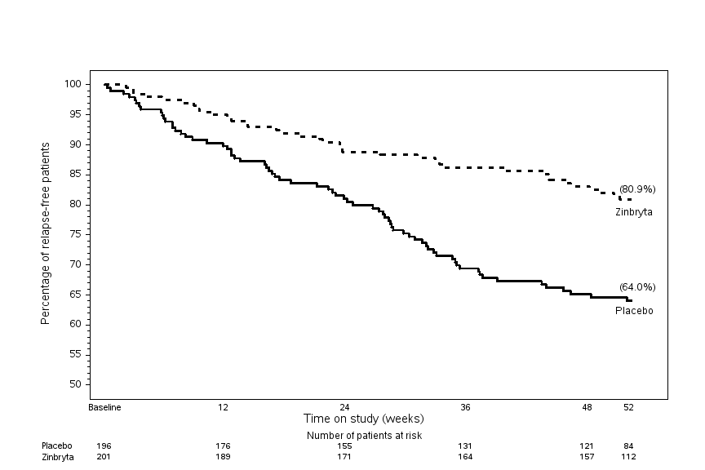

Figure 2: SELECT Study (Study 1) Proportion of patients with 24 week confirmed disability

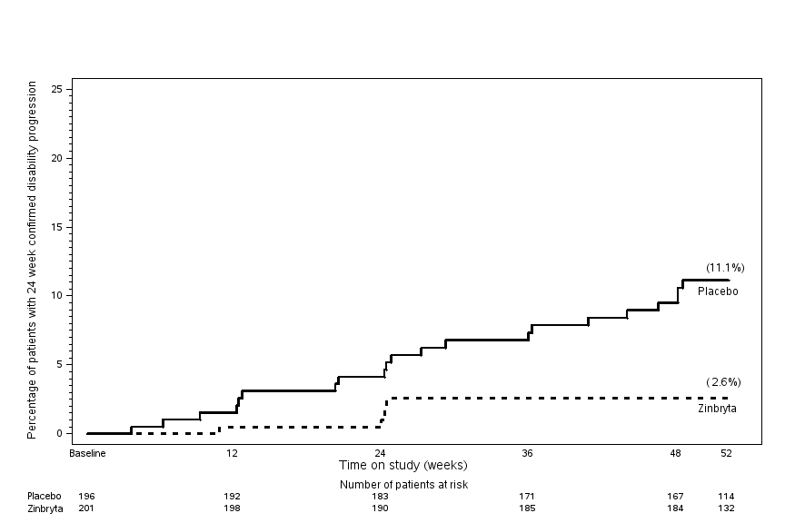

Figure 3: DECIDE Study (Study 2) Percentage of patients relapse-free

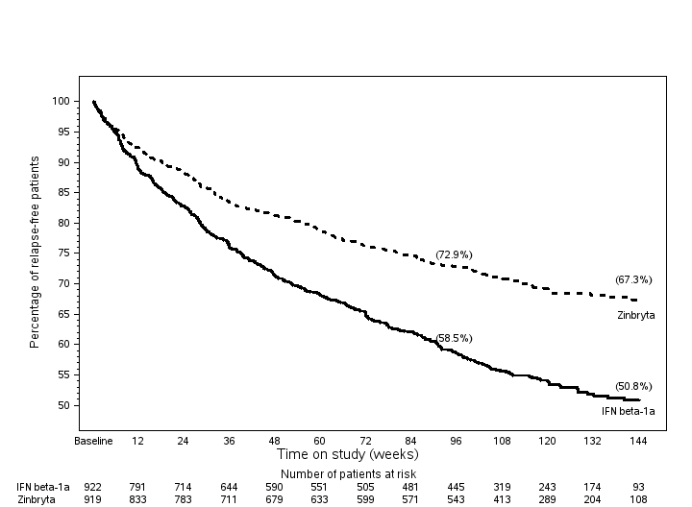

Figure 4: DECIDE Study (Study 2) Proportion of patients with 24 week confirmed disability

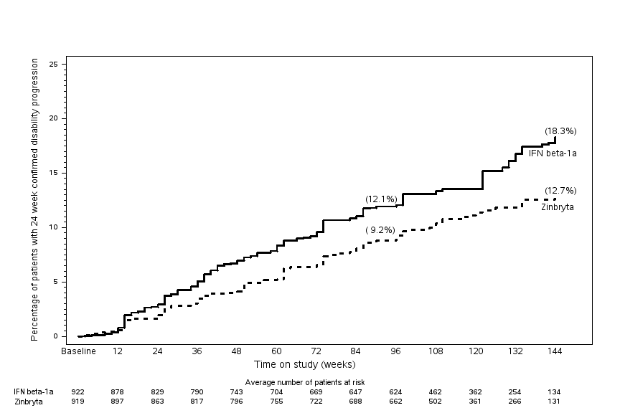

INDICATIONS

ZINBRYTA is indicated for the treatment of relapsing forms of multiple sclerosis (MS) to delay the progression of physical disability and to reduce the frequency of relapse.

CONTRAINDICATIONS

ZINBRYTA is contraindicated in patients with:

* pre-existing hepatic disease or hepatic impairment, including ALT or AST at least 2 times the ULN at baseline, because ZINBRYTA could exacerbate existing liver dysfunction (see PRECAUTIONS and DOSAGE and ADMINISTRATION)
* a history of autoimmune hepatitis or other autoimmune condition involving the liver (see PRECAUTIONS)
* a history of hypersensitivity to daclizumab or any other components of the formulation (see DESCRIPTION). Use in such patients may result in anaphylaxis or life-threatening multi-organ hypersensitivity

PRECAUTIONS

General

***Hepatic Injury***

ZINBRYTA can cause life-threatening severe liver injury, including liver failure and autoimmune hepatitis. Elevations of serum transaminases and severe hepatic injury have occurred in patients treated with ZINBRYTA (see ADVERSE Effects). Serious events, including autoimmune hepatitis, hepatitis and jaundice, were observed in 1 % of patients. In a clinical study, a case of fatal autoimmune hepatitis occurred in a patient re-initiating treatment with 300 mg of ZINBRYTA after a planned 6 month treatment interruption period.

In clinical studies, serum transaminase elevations occurred during treatment and up to 4 months after the last dose of ZINBRYTA. Most patients had elevations that were asymptomatic and resolved spontaneously. An increased incidence of elevations of alanine aminotransferase (ALT) or aspartate aminotransferase (AST) > 5 times the upper limit of normal (ULN) was reported in ZINBRYTA-treated patients compared to placebo (4 % versus <1 %) or interferon beta-1a (IM) (6 % versus 3 %). The incidence of discontinuation due to drug related hepatic disorders was 5 % in ZINBRYTA-treated patients and 4 % in interferon beta-1a (IM).

*Monitoring of Liver function*

Prior to starting treatment with ZINBRYTA, obtain serum transaminases (ALT and AST) and bilirubin levels. Monitor serum transaminases and bilirubin levels monthly during treatment and up to 4 months after the last dose of ZINBRYTA (see DOSAGE and ADMINISTRATION).

Treatment modifications are recommended based on test results (see Table 4).

Table 4 ZINBRYTA treatment modification for liver abnormalities

|  |  |
| --- | --- |
| **Lab Value(s)** | **Recommendations** |
| Confirmed ALT or AST > 5 times ULN  OR  Confirmed ALT or AST > 3 times ULN and bilirubin > 2 times ULN | **Treatment discontinuation**  Re-initiation of therapy may be considered if other aetiologies are found, values have returned to normal and benefits to the patient of resuming therapy outweigh the risks. |
| ALT or AST > 3 times ULN | **Treatment interruption and close monitoring**  Resume when ALT or AST have reached < 2 times ULN |
| ULN – upper limit of normal |  |

Patients with ALT or AST > 2 times the ULN prior to treatment were not included in clinical studies (see CONTRAINDICATIONS).. Observe patients for signs and symptoms of hepatic dysfunction when ZINBRYTA is used concomitantly with other hepatotoxic drugs.

If a patient develops clinical signs or symptoms suggestive of hepatic dysfunction (eg. unexplained nausea, vomiting, abdominal pain, fatigue, anorexia, or jaundice and/or dark urine), promptly measure serum transaminases and interrupt or discontinue treatment with ZINBRYTA, as appropriate.

In patients with prolonged elevations of serum transaminases, evaluate for other possible causes, such as infection, and consider referral to a specialist. Autoimmune hepatitis (without the presence of auto-antibodies) has been observed in clinical studies. Treatment with systemic corticosteroids may be appropriate.

***Immune-Mediated Disorders***

Treatment with ZINBRYTA increases the risk of immune-mediated disorders, including autoimmune disorders such as autoimmune hepatitis. Across all clinical studies (controlled and open-label), immune-mediated disorders occurred in 28% of patients on ZINBRYTA, the most common of which were skin reactions and lymphadenopathy (see ADVERSE EFFECTS). Prescribers should be vigilant regarding emergent immune-mediated disorders. For suspected immune-mediated disorders, ensure adequate evaluation to confirm etiology or to exclude other causes. If a patient develops a serious immune-mediated disorder, consider stopping ZINBRYTA and refer the patient to an appropriate specialist for further evaluation and treatment.

***Skin Reactions***

ZINBRYTA causes skin reactions. In clinical studies ZINBRYTA increased the incidence of skin reactions [18 % vs 13 % (placebo); 37 % vs 19 % (interferon beta-1a (IM))] and serious skin reactions [<1 % vs 0 % (placebo); 2 % vs <1 % (interferon beta-1a (IM))] compared to placebo and interferon beta-1a (IM).

The most common skin reactions were rash, dermatitis, and eczema. The majority of patients had skin reactions that were mild or moderate in severity. Skin reactions generally resolved with standard of care, including treatment with topical or systemic steroids. In some cases discontinuation of ZINBRYTA may be appropriate. Discontinuation due to skin reactions was 4 % in ZINBRYTA-treated patients.

If a patient develops a diffuse or highly inflammatory rash, consider referring to a dermatologist and discontinuation of ZINBRYTA (see ADVERSE Effects).

***Depression***

In clinical studies, depression-related events occurred more frequently in patients receiving ZINBRYTA than in patients receiving placebo or interferon beta-1a(IM). ZINBRYTA increased the incidence of depression [5% vs 1% (placebo); 8% vs 6% (interferon beta-1a(IM))]; the incidence of serious events of depression was < 1% with ZINBRYTA.

ZINBRYTA should be administered with caution to patients with previous or current depressive disorders. Patients treated with ZINBRYTA should be advised to report any symptoms of new or worsening depression and/or suicidal ideation to the prescribing physician.

If a patient develops severe depression and/or suicidal ideation, cessation of ZINBRYTA should be considered (see ADVERSE EFFECTS).

***Infections***

ZINBRYTA increases the risk of infections. In clinical studies ZINBRYTA increased the incidence of infections [50 % vs 44 % (placebo); 65 % vs 57 % (interferon beta-1a (IM))] and serious infections [3 % vs 0 % (placebo); 4 % vs 2 % (interferon beta-1a (IM))] compared to placebo and interferon beta-1a (IM).

The most common types of infections were upper respiratory tract infections and viral infections. The median duration was similar between the treatment groups.

The rate of infections and serious infections did not increase over time. The majority of patients with infections continued on treatment with ZINBRYTA.

If serious infection develops, consider withholding treatment with ZINBRYTA until the infection resolves. Discontinuation of ZINBRYTA due to infections was <1 % in clinical trials.

In clinical trials, cases of tuberculosis occurred in countries where tuberculosis is endemic. Evaluate high-risk patients for tuberculosis infection prior to initiating treatment with ZINBRYTA. For patients testing positive for tuberculosis, treat by standard medical practices prior to therapy with ZINBRYTA (see DOSAGE and ADMINISTRATION).

Consider delaying initiation of ZINBRYTA therapy in patients with severe active infection (see ADVERSE Effects).

ZINBRYTA has not been studied in patients with immunodeficiency syndromes.

***Gastrointestinal Disorders***

An increased incidence of serious colitis (<1 %) was reported in patients treated with ZINBRYTA in clinical studies.

The colitis improved with discontinuation of ZINBRYTA and standard treatment.

Consider referring patients who develop symptoms of colitis (eg. abdominal pain, fever, prolonged diarrhoea) to a specialist (see ADVERSE Effects).

**Effects on Fertility**

No impact on male or female fertility as assessed by fertility indices was detected in studies in male and female cynomolgus monkeys in which daclizumab (total of 5 doses) was administered at subcutaneous dose levels of up to 200 mg/kg/fortnight. Exposure (based on serum AUC) in these studies was up to 100 times (males) and 85 times (females) that expected in patients at the recommended clinical dose.

There are no data on the effects of ZINBRYTA on human fertility.

**Use in Pregnancy (Category B3)**

There are limited data on the use of ZINBRYTA in pregnant women.

IgG antibodies are known to cross the placenta and placental transfer of daclizumab was observed in cynomolgus monkeys.

In cynomolgus monkeys, administration of daclizumab at subcutaneous doses of up to 200 mg/kg/week during the period of organogenesis did not produce fetal malformations or variations, but fetal loss was increased at the high dose, associated with serum AUC exposure about 140 fold the AUC exposure expected in patients at the recommended clinical dose. The no-effect dose (50 mg/kg/week) was associated with AUC exposure 33 fold the expected clinical exposure.

In cynomolgus monkeys, administration of daclizumab at a subcutaneous dose of 50 mg/kg/week during the last two-thirds of pregnancy had no adverse effects on fetal or postnatal development up to 6 months of age. This dose resulted in a serum AUC about 55 fold the AUC expected in patients at the recommended clinical dose.

ZINBRYTA should be used during pregnancy only if the potential benefit justifies the potential risk to the fetus.

*Labour and Delivery*

The effects of ZINBRYTA on labour and delivery are unknown.

*Women of Childbearing Potential*

The benefit of treatment with ZINBRYTA versus potential risk should be discussed with women of childbearing age or women who become pregnant during therapy.

**Use in Lactation**

Human IgG is excreted into human milk. Low levels of daclizumab have been detected in the milk of lactating cynomolgus monkeys. It is not known whether daclizumab is excreted in human milk.

Therefore it is recommended that a decision be made whether to discontinue breast-feeding or to discontinue treatment with ZINBRYTA, taking into account the benefit of breast‑feeding to the child and of therapy to the woman.

### Paediatric Use

The safety and efficacy of ZINBRYTA in patients below 18 years of age has not been studied.

### Use in the Elderly

Clinical studies of ZINBRYTA did not include patients over 65 years to determine whether they respond differently than younger patients.

## Genotoxicity

Genotoxicity studies have not been conducted with daclizumab. As daclizumab is a monoclonal antibody it would not be expected to have genotoxic potential.

## Carcinogenicity

Carcinogenicity studies with daclizumab have not been conducted.

**Effects on Ability to Drive and Use Machines**

No studies on effects on the ability to drive or use machines during treatment with ZINBRYTA have been performed.

## Toxicology

In two 9 month studies conducted in cynomolgus monkeys daclizumab was subcutaneously administered at doses of 10-200mg/kg/fortnight.

Chronic administration of daclizumab at all doses increased the incidence of skin findings (compared to those observed in control animals). These findings (dry, red raised patchy areas of the skin that correlated microscopically with acanthosis/hyperkeratosis and sub-acute to chronic inflammation) were characterized predominantly as mild to moderate, with one case assessed as severe.

A dose dependent increase in the incidence of microglial aggregates above background was observed in the brain and spinal cord of monkeys treated with 35mg/kg or greater (serum AUC about 20 times or greater the AUC expected in patients at the recommended clinical dose). The no-effect dose was 10 mg/kg (serum AUC about 5 times clinical AUC exposure). Following a recovery period of up to 12 weeks, there was evidence of reversibility. Microglial aggregates in monkeys did not increase in incidence or severity with increased duration of dosing and were not associated with neuronal damage or neurobehavioral effects. A small subset of microglial aggregates were associated with microhemorrhage but with no evident functional sequelae in monkeys.

*In vitro* investigative studies suggest that microglial aggregates are not due to a direct effect of daclizumab on microglial cells but are likely attributable to an increase in local IL-2 bioavailability.

The clinical relevance of microglial aggregates is unknown, however no deleterious neurologic effects attributed to the microscopic change have been observed in monkeys.

Special Populations

***Patients with Hepatic Impairment***

ZINBRYTA is contraindicated in patients with pre-existing hepatic disease or hepatic impairment, including ALT or AST at least 2 times the ULN prior to treatment (see CONTRAINDICATIONS and PRECAUTIONS, Hepatic Injury).

Interactions with Other Medicines

ZINBRYTA 150 mg SC every 4 weeks for 12 weeks in MS patients did not affect the systemic exposure of concomitantly administered oral midazolam (CYP3A substrate), warfarin (CYP2C9 substrate), dextromethorphan (CYP2D6 substrate), omeprazole (CYP2C19 substrate), and caffeine (CYP1A2 substrate). Therefore, no dosage adjustments are needed for drugs that are substrates of these CYP enzymes when given concomitantly with ZINBRYTA.

**Immunisations**

In a clinical study, patients (n=90) on long-term treatment with ZINBRYTA mounted appropriate immune responses to an inactivated trivalent seasonal influenza vaccine. The magnitude of the immune response to the seasonal influenza vaccine, and proportion of patients with seroconversion and seroprotection were consistent with norms defined in healthy volunteer populations. Patients on ZINBRYTA may receive non-live vaccines.

The safety of immunisation with live vaccines during treatment with ZINBRYTA has not been studied. Vaccination with live vaccines is not recommended during treatment and up to 4 months after discontinuation.

ADVERSE Effects

The most common adverse reactions (incidence ≥5% and ≥2% higher incidence than comparator) reported for ZINBRYTA were rash, alanine aminotransferase (ALT) increased and depression compared to placebo; and nasopharyngitis, upper respiratory tract infection, influenza, oropharyngeal pain, rash and lymphadenopathy compared to interferon beta-1a (IM).

The most commonly reported adverse events leading to discontinuation in patients treated with ZINBRYTA were hepatic events including elevations of serum transaminases (5 %) and cutaneous events (4 %).

**Clinical Trials**

In clinical studies, 2133 patients with relapsing multiple sclerosis (RMS) have been treated with ZINBRYTA. In the placebo-controlled, active comparator-controlled and other studies, 1785 patients with RMS evaluable for safety have been treated for periods up to 6 years with an overall exposure of approximately 4100 person-years. Of these, 1215 patients have received more than 2 years and 573 patients more than 3 years of treatment.

In the placebo-controlled study (the SELECT study/Study 1), 417 patients received ZINBRYTA (150 mg n=208; 300 mg n=209; every 4 weeks) for up to 1 year with 423 person-years of exposure.

The adverse reactions presented in Table 5 (and Table 6) are based on safety information from 208 patients treated with 150 mg of ZINBRYTA and 204 patients treated with placebo.

In this study, the safety profiles of 150 mg and 300 mg of ZINBRYTA were similar.

In the active-controlled study (the DECIDE study/Study 2), 919 patients received ZINBRYTA (150 mg, every 4 weeks) and 922 patients received interferon beta-1a (IM) (30 mcg weekly) for a minimum of 2 years and up to 3 years, with 1952 person-years of exposure to ZINBRYTA (Table 5 and 7).

***Tabulated List of Adverse Reactions***

Adverse drug reactions for ZINBRYTA are defined as those adverse events occurring with a ≥2% higher incidence in patients treated with ZINBRYTA compared with placebo and interferon beta-1a (IM) in the clinical studies. In addition, other potentially relevant adverse events observed at a <2% difference are also included when determining adverse drug reactions, based on a reasonable possibility of causality.

The adverse reactions are presented as MedDRA preferred terms under the MedDRA system organ class (SOC) by frequency and incidence.

The incidence of the adverse reactions is expressed according to the following categories:

• Very common ≥1/10

• Common ≥1/100 to <1/10

• Uncommon ≥1/1,000 to <1/100

• Rare ≥1/10,000 to <1/1,000

• Very rare (<1/10,000)

• Not known (cannot be estimated from the available data)

Table 5: Adverse Reactions reported for ZINBRYTA

| **System Organ Class** | **Adverse reaction** | **Frequency** |
| --- | --- | --- |
| Infections and Infestations | Nasopharyngitis† | Very Common |
| Upper respiratory tract infection† | Very Common |
| Influenza† | Common |
| Bronchitis | Common |
| Pharyngitis | Common |
| Respiratory tract infection | Common |
| Tonsillitis† | Common |
| Rhinitis* | Common |
| Viral infection | Common |
| Pneumonia | Common |
| Laryngitis | Common |
| Folliculitis | Common |
| Blood and lymphatic system disorders | Lymphadenopathy† | Common |
| Anaemia* | Common |
| Lymphadenitis | Common |
| Psychiatric disorders | Depression* | Common |
| Respiratory, thoracic and mediastinal disorders | Oropharyngeal pain† | Common |
| Gastrointestinal disorders | Diarrhea | Common |
| Skin and subcutaneous tissue disorders | Rash*† | Common |
| Eczema† | Common |
| Erythema | Common |
| Pruritus | Common |
| Acne† | Common |
| Seborrhoeic dermatitis† | Common |
| Dry skin | Common |
| Dermatitis | Common |
| Dermatitis allergic | Common |
| Rash maculopapular | Common |
| Psoriasis | Common |
| Skin exfoliation | Common |
| Exfoliative rash | Uncommon |
| Toxic skin eruption | Uncommon |
| Eczema nummular | Uncommon |
| General disorders and administration site conditions | Pyrexia* | Common |
| Investigations | Lymphocyte count decreased | Common |
| ALT increased* | Common |
| AST increased* | Common |
| Liver function test abnormal | Common |
| Hepatic enzyme increased | Common |

*Observed with a ≥2 % higher incidence than placebo

†Observed with a ≥2 % higher incidence than interferon beta-1a (IM)

Table 6: Adverse Reactions in Study 1 reported at a ≥2 % higher incidence for ZINBRYTA 150 mg compared to placebo

|  |  |  |  |
| --- | --- | --- | --- |
| **System Organ Class** | **Adverse reaction** | **Placebo**  **N=204**  **%** | **ZINBRYTA 150mg**  **N=208**  **%** |
| Infections and Infestations | Rhinitis | 1 | 4 |
| Blood and lymphatic system disorders | Anemia | <1 | 3 |
| Psychiatric disorders | Depression | 1 | 5 |
| Skin and subcutaneous tissue disorders | Rash | 3 | 6 |
| General disorders and administration site conditions | Pyrexia | <1 | 3 |
| Investigations | ALT increased | 2 | 5 |
|  | AST | <1 | 3 |

Table 7: Adverse Reactions in Study 2 reported at a ≥2 % higher incidence for ZINBRYTA 150 mg compared to interferon beta-1a (IM)

|  |  |  |  |
| --- | --- | --- | --- |
| **System Organ Class** | **Adverse reaction** | **Interferon beta-1a (IM) 30 mcg**  **N=922**  **%** | **ZINBRYTA 150 mg**  **N=919**  **%** |
| Infections and Infestations | Nasopharyngitis | 21 | 25 |
| Upper respiratory tract infection | 13 | 16 |
| Influenza | 6 | 9 |
| Tonsillitis | 2 | 4 |
| Blood and lymphatic system disorders | Lymphadenopathy | <1 | 5 |
| Respiratory, thoracic and mediastinal disorders | Oropharyngeal pain | 4 | 8 |
| Skin and subcutaneous tissue disorders | Rash | 3 | 7 |
| Eczema | 1 | 4 |
| Acne | <1 | 3 |
| Seborrhoeic dermatitis | <1 | 3 |

Other clinically relevant adverse drug reactions observed at <2% difference included pharyngitis, bronchitis, viral infection, respiratory tract infection, folliculitis, laryngitis, pneumonia, lymphadenitis, erythema, pruritus, dry skin, dermatitis, dermatitis allergic, rash maculopapular, psoriasis, skin exfoliation, exfoliative rash, eczema nummular, toxic skin eruption, diarrhea, lymphocyte count decreased, liver function test abnormal, and hepatic enzyme increased.

***Lymphadenopathy***

In clinical studies, ZINBRYTA increased the incidence of lymphadenopathy, with onset occurring throughout the treatment period. Discontinuation due to lymphadenopathy was < 1% in ZINBRYTA-treated patients. The majority of patients with lymphadenopathy continued on treatment with ZINBRYTA, and the majority of cases resolved within 3 months.

***Immunogenicity***

As with all therapeutic proteins, there is potential for patients to develop antibodies to daclizumab. In the DECIDE study /Study 2, patients were tested for anti-drug (daclizumab) antibodies (ADA) at week 4 and approximately every 3 months thereafter. Treatment-emergent ADAs and neutralizing antibodies (NAbs) were observed in 19% (175/913) and 8% (71/913) of study patients, respectively. The majority of the treatment-emergent ADA responses were transient (12% [110/913]) and the remaining minority (7% [65/913]) were persistent. Treatment-emergent ADA and NAb responses predominantly occurred during the first year of treatment and their frequency declined with continued ZINBRYTA treatment.

In patients with NAbs, daclizumab clearance was increased on average by 19% (see Pharmacokinetics). There was no apparent correlation of ADA or NAbs development to clinical response, adverse events, or pharmacodynamic profile of daclizumab.

The observed incidence of antibody positivity may be influenced by several factors including sample handling, timing of sample collection, number of time points evaluated, the sensitivity and specificity of the assay employed, concomitant medications and underlying disease. For these reasons, comparison of the incidence of antibodies to ZINBRYTA with the incidence of antibodies to other products may be misleading.

DOSAGE AND ADMINISTRATION

ZINBRYTA should be initiated by a neurologist experienced in the management of multiple sclerosis.

**Prior to initiating ZINBRYTA, obtain and evaluate the following:**

*Hepatic Assessment*

Serum transaminases (alanine aminotransferase (ALT) and aspartate aminotransferase (AST)) and total bilirubin levels. Initiation of ZINBRYTA is contraindicated in patients with pre-existing hepatic disease or hepatic impairment including ALT or AST at least 2 times the ULN at baseline (see CONTRAINDICATIONS and PRECAUTIONS).

*Assessment of Tuberculosis and Other Infections*

* Patients at high risk for tuberculosis infection should be evaluated prior to initiating treatment with ZINBRYTA (see PRECAUTIONS). For patients testing positive for tuberculosis, treat tuberculosis by standard medical practice prior to therapy with ZINBRYTA.
* Avoid initiating ZINBRYTA in patients with tuberculosis or other severe active infection (see PRECAUTIONS).
* Screen patients for Hepatitis B and C. ZINBRYTA is contraindicated in patients with   
  pre-existing hepatic disease (see CONTRAINDICATIONS).

**During therapy with ZINBRYTA:**

Test transaminase levels and total bilirubin monthly and assess before the next dose of ZINBRYTA. Follow transaminase levels and total bilirubin monthly for up to 4 months after the last dose of ZINBRYTA. As shown in Tables 4 and 8, interruption or discontinuation of ZINBRYTA therapy is recommended for management of certain liver test abnormalities.

Table 8: ZINBRYTA treatment modification for liver abnormalities

|  |  |
| --- | --- |
| **Lab Value(s)** | **Recommendations** |
| Confirmed ALT or AST > 5 times ULN  OR  Confirmed ALT or AST > 3 times ULN and bilirubin > 2 times ULN | **Treatment discontinuation**  Re-initiation of therapy may be considered if other aetiologies are found, values have returned to normal and benefits to the patient of resuming therapy outweigh the risks. |
| ALT or AST > 3 times ULN | **Treatment interruption and close monitoring**  Resume when ALT or AST have reached < 2 times ULN |
| ULN – upper limit of normal |  |

The recommended dose of ZINBRYTA is 150 milligrams injected subcutaneously once a month.

**Special Dosage Instructions**

ZINBRYTA is for subcutaneous use.

Patients should be trained in the proper technique for self-administering subcutaneous injection using the pre-filled pen/pre-filled syringe. The usual sites for subcutaneous injection include the thigh, abdomen, and back of the upper arm.

Each ZINBRYTA pre-filled pen/pre-filled syringe is provided with the needle pre-attached. Pre-filled pens/pre-filled syringes contain a single dose only and should be discarded after use.

***Preparation***

Once removed from the refrigerator ZINBRYTA should be allowed to warm to room temperature (about 30 minutes) prior to injection. External heat sources such as hot water must not be used to warm ZINBRYTA.

ZINBRYTA pre-filled pen/pre-filled syringe must not be used if the liquid is cloudy or contains floating particles. The liquid must be colourless to slightly yellow.

### Adults

No special dosing instructions.

### Patients with Renal Impairment

ZINBRYTA has not been studied in patients with renal impairment. As renal excretion is not a major route of ZINBRYTA elimination no dose adjustments are considered necessary (see Pharmacokinetics).

### Patients with Hepatic Impairment

ZINBRYTA has not been studied in patients with hepatic impairment. ZINBRYTA is contraindicated in patients with pre-existing hepatic impairment (see CONTRAINDICATIONS and Precautions/Patients with Hepatic Impairment and Pharmacokinetics).

### Other

***Missed Dose***

In case a dose is missed and it is within 2 weeks of the missed dose, patients should be instructed to inject their missed dose as soon as it is remembered and then remain on their original monthly dosing schedule. If a dose is missed and it is more than 2 weeks from the missed dose, patients should skip the missed dose, wait to dose again until their next scheduled dose, and then remain on their original monthly dosing schedule. Only one dose should be administered at a time.

OVERDOSAGE

Reported experience with overdose is limited.

The safety of doses above 300 mg SC and 400 mg intravenous (IV) have not been evaluated. Doses up to this level were well tolerated with no evidence of acute toxicity.

In case of overdose with ZINBRYTA, the patient should be advised to seek medical attention if they experience any signs or symptoms of adverse reactions.

Contact the Poisons Information Centre on 13 11 26 for advice on management of overdose.

PRESENTATION AND STORAGE CONDITIONS

Pre-filled Pen

ZINBRYTA is a sterile, colourless to slightly yellow, clear to slightly opalescent liquid in a pre-filled pen. A pre-filled syringe of ZINBRYTA is contained within a single-use, disposable, spring-powered injector. The syringe inside the pre-filled pen is a 1.0 mL pre-filled syringe made of glass (Type 1) with a bromobutyl rubber plunger stopper and thermoplastic rigid needle shield, containing 1.0 mL of solution. The rubber plunger stopper and rigid needle shield are not made with natural rubber latex or dry natural rubber. A 29 gauge, 0.5 inch staked needle is pre-affixed to the syringe.

†Pack Size: Pack containing 1 or 3 pre-filled pen(s)

Pre-filled Syringe

ZINBRYTA is a sterile, colourless to slightly yellow, clear to slightly opalescent liquid in a single-use pre-filled syringe.

ZINBRYTA is contained in a 1.0 mL single-use, disposable pre-filled syringe made of glass (Type 1) with a bromobutyl rubber plunger stopper and thermoplastic rigid needle shield. The pre-filled syringe contains 1.0 mL of solution. The rubber plunger stopper and rigid needle shield are not made with natural rubber latex or dry natural rubber. A 29 gauge, 0.5 inch staked needle is pre-affixed to the syringe.

†Pack Size: Pack containing 1 or 3 pre-filled syringe(s).

†*Not all pack sizes or presentations may be distributed.*

Storage Conditions

Store in the original carton to protect from light. Store in a refrigerator between 2oC to 8oC. Do not freeze. Discard if it has been frozen.

ZINBRYTA should be at room temperature for administration. Remove ZINBRYTA from a refrigerator and allow to reach room temperature (about 30 minutes) prior to injection. Do not use external heat sources, such as hot water, to warm ZINBRYTA.

ZINBRYTA can be stored, protected from light, at room temperature up to 30oC for 30 days. Do not place ZINBRYTA back into the refrigerator after warming to room temperature. If ZINBRYTA is at room temperature (up to 30oC) for more than 30 days it should be discarded.

ZINBRYTA is for single use in one patient only. Discard any residue.

NAME AND ADDRESS OF the SPONSOR

Biogen Australia Pty Ltd

ABN 30 095 760 115

Level 3

123 Epping Road

North Ryde NSW 2113

POISON SCHEDULE

Prescription Only Medicine

DATE OF first inclusion in the australian register of therapeutic goods

22 September 2016