**AUSTRALIAN PRODUCT INFORMATION**

**FORXIGA®**

(dapagliflozin propanediol monohydrate) Tablets

# Name of the medicine

The active ingredient in FORXIGA is dapagliflozin propanediol monohydrate.

# Qualitative and quantitative composition

Dapagliflozin drug substance is a white to off-white powder, is non-hygroscopic, crystalline. Dapagliflozin is non-ionizable; thus, its aqueous solubility and partition coefficient are not affected by changes in pH. Dapagliflozin is a Biopharmaceutical Classification System (BCS) Class III drug.

Each film-coated tablet of FORXIGA contains 10 mg of dapagliflozin (as dapagliflozin propanediol monohydrate).

*Excipient with known effect*: lactose

For the full list of excipients, see section 6.1 List of excipients.

# Pharmaceutical form

FORXIGA (dapagliflozin) 10 mg tablets are yellow, biconvex, diamond, film coated tablets.

# Clinical particulars

## Therapeutic indications

### Type 2 diabetes mellitus

#### Glycaemic control

FORXIGA is indicated in adults with type 2 diabetes mellitus:

* as monotherapy as an adjunct to diet and exercise in patients for whom metformin is otherwise indicated but was not tolerated.
* as initial combination therapy with metformin, as an adjunct to diet and exercise, to improve glycaemic control when diet and exercise have failed to provide adequate glycaemic control and there are poor prospects for response to metformin monotherapy (for example, high initial haemoglobin A1c [HbA1c] levels).
* in combination with other anti-hyperglycaemic agents to improve glycaemic control, when these together with diet and exercise, do not provide adequate glycaemic control (see section 5.1 Pharmacodynamic properties – Clinical trials and section 4.4 Special warnings and precautions for use for available data on different add-on combination therapies).

#### Prevention of hospitalisation for heart failure

FORXIGA is indicated in adults with type 2 diabetes mellitus and established cardiovascular disease or risk factors for cardiovascular disease to reduce the risk of hospitalization for heart failure (see section 5.1 Pharmacodynamic properties – Clinical trials).

### Heart failure

FORXIGA is indicated in adults for the treatment of symptomatic heart failure with reduced ejection fraction, as an adjunct to standard of care therapy (see section 5.1 Pharmacodynamic properties).

### Chronic kidney disease

FORXIGA is indicated to reduce the risk of progressive decline in kidney function in adults with proteinuric chronic kidney disease (CKD Stage 2,3 or 4 and urine ACR ≥ 30 mg/g)

## Dose and method of administration

### Type 2 diabetes mellitus

The recommended dose of FORXIGA is 10 mg taken orally once daily at any time of the day regardless of meals.

When FORXIGA is used as an add-on therapy with insulin or an insulin secretagogue (e.g, sulfonylurea), a lower dose of insulin or an insulin secretagogue may be considered to reduce the risk of hypoglycaemia.

The recommended starting doses of FORXIGA and metformin when used as initial combination therapy are 10 mg FORXIGA plus 500 mg metformin once daily. Patients with inadequate glycaemic control on this starting dose should have their metformin dose increased according to approved metformin Product Information.

### Heart failure

The recommended dose of FORXIGA is 10 mg taken orally once daily at any time of the day

regardless of meals. FORXIGA should be used in conjunction with individualised standard of care therapy.

### Chronic kidney disease

The recommended dose of FORXIGA is 10 mg taken orally once daily at any time of the day regardless of meals.

### Special populations

#### Renal impairment

No dose adjustment is required based on renal function.

Initiating treatment with FORXIGA in patients with eGFR <25 mL/min/1.73 m2 is not recommended (see section 4.4 Special warnings and precautions for use).

The glucose lowering efficacy of FORXIGA is reduced in patients with estimated glomerular filtration rate (eGFR) below 45 mL/min/1.73 m2 (see section 4.4 Special warnings and precautions for use, and section 5.1 Pharmacodynamic properties – Clinical Trials). Therefore, if eGFR falls below 45 mL/min/1.73 m2, additional glucose lowering treatment should be considered in patients with diabetes mellitus.

#### Hepatic Impairment

No dosage adjustment for FORXIGA is necessary for patients with mild or moderate hepatic impairment. FORXIGA should not be used in patients with severe hepatic impairment (see section 4.4 Special warnings and precautions for use).

#### Paediatric and adolescent

Safety and effectiveness of FORXIGA in paediatric and adolescent patients have not been established.

#### Elderly

No dosage adjustment is recommended based on age (see section 5.1 Pharmacodynamic properties).

## Contraindications

* Known hypersensitivity to any of the ingredients.

## Special warnings and precautions for use

FORXIGA should not be used in patients with type 1 diabetes (see section 4.1 Therapeutic Indications) or for the treatment of diabetic ketoacidosis (see section 4.4 Special Warnings and Precautions for Use – Ketoacidosis).

### Use in renal impairment

### There is limited experience with initiating treatment with FORXIGA in patients eGFR <25 mL/min/1.73 m2.

Dapagliflozin increases serum creatinine and decreases eGFR (see 4.8 Adverse effects (Undesirable effects)). Renal function abnormalities can occur after initiating dapagliflozin. Patients with hypovolaemia may be more susceptible to these changes.

The glucose lowering efficacy of dapagliflozin is dependent on renal function and is reduced where eGFR is <45 mL/min/1.73 m2. (See section 4.2 Dose and method of administration).

### Use in hepatic impairment

There is limited experience in clinical trials in patients with hepatic impairment. Dapagliflozin exposure is increased in patients with severe hepatic impairment. FORXIGA should not be used in patients with severe hepatic impairment (see section 4.2 Dose and method of administration and section 5.2 Pharmacokinetic properties– Special Populations).

### Use in Patients at Risk for Volume depletion and or hypotension

The diuretic effect of FORXIGA is a potential concern for volume depleted patients. Due to its mechanism of action, FORXIGA induces osmotic diuresis which may lead to the modest decrease in blood pressure observed in clinical studies (see section 5.1 Pharmacodynamic properties – Clinical trials).

When considering initiating dapagliflozin, there may be patients for whom the additional diuretic effect of dapagliflozin is a potential concern either due to acute illness (such as gastrointestinal illness) or a history of hypotension or dehydration with diuretic therapy for patients who may become volume depleted. Initiation of therapy with dapagliflozin is therefore not recommended in these patients.

In case of intercurrent conditions that may lead to volume depletion, such as gastrointestinal illness, heat stress or severe infections, careful monitoring of volume status (e.g. physical examination, blood pressure measurements, laboratory tests including electrolytes) is recommended. Temporary interruption of FORXIGA is recommended for patients who develop volume depletion until the depletion is corrected (see section 4.8 Adverse effects (Undesirable effects)).

Caution should be exercised in patients for whom a dapagliflozin-induced drop in blood pressure could pose a risk, such as patients with known cardiovascular disease, patients on antihypertensive therapy with a history of hypotension or elderly patients.

### Ketoacidosis in patients with diabetes mellitus

FORXIGA should not be used for the treatment of diabetic ketoacidosis (DKA).

There have been reports of ketoacidosis, including DKA, a serious life-threatening condition requiring urgent hospitalisation in patients taking dapagliflozin and other sodium-glucose cotransporter 2 (SGLT2) inhibitors. Fatal cases of ketoacidosis have been reported in patients taking dapagliflozin.

Patients treated with FORXIGA who present with signs and symptoms consistent with ketoacidosis, including nausea, vomiting, abdominal pain, malaise and shortness of breath, should be assessed for ketoacidosis, even if blood glucose levels are below 14 mmol/L (250 mg/dL). If ketoacidosis is suspected, FORXIGA should be suspended, the patient should be evaluated and prompt treatment initiated.

Treatment of ketoacidosis generally requires insulin, fluid, potassium and carbohydrate replacement.

Restarting SGLT2 inhibitor treatment in patients with previous DKA while on SGLT2 inhibitor treatment is not recommended unless another clear precipitating factor is identified and resolved.

Before initiating FORXIGA, consider factors in the patient history that may predispose to ketoacidosis.

Factors that predispose patients to ketoacidosis include insulin deficiency from any cause (including insulin pump failure, history of pancreatitis or pancreatic surgery), insulin dose reduction, reduced caloric intake or increased insulin requirements due to infections, low carbohydrate diet, acute illness, surgery, a previous ketoacidosis, dehydration and alcohol abuse. FORXIGA should be used with caution in these patients. Consider monitoring patients for ketoacidosis and temporarily discontinuing FORXIGA in clinical situations known to predispose to ketoacidosis.

### Surgery

Treatment with FORXIGA should be ceased prior to major surgery. An increase in other glucose lowering agents may be required during this time. Patients scheduled for non-urgent surgery who have not ceased dapagliflozin should be assessed and consideration should be given to postponing the procedure.

Treatment with FORXIGA may be restarted once the patient’s condition has stabilised and oral intake is normal.

### Urinary Tract Infections

There have been post-marketing reports of serious urinary tract infections including urosepsis and pyelonephritis requiring hospitalisation in patients receiving SGLT2 inhibitors, including FORXIGA. Urinary tract infections were more frequently reported for dapagliflozin 10 mg compared to control in a placebo-pooled analysis up to 24 weeks (4.7% vs. 3.5%, respectively). Urinary glucose excretion may be associated with an increased risk of urinary tract infection. Evaluate patients for signs and symptoms of urinary tract infections and treat promptly, if indicated (see section 4.8 Adverse effects (Undesirable effects)). Temporary interruption of dapagliflozin should be considered when treating pyelonephritis or urosepsis. Discontinuation of dapagliflozin may be considered in cases of recurrent urinary tract infections; see section 4.8 Adverse effects (Undesirable effects).

### Necrotising fasciitis of the perineum (Fournier’s gangrene)

Post-marketing cases of necrotising fasciitis of the perineum (also known as Fournier’s gangrene), a rare, but serious and potentially life-threatening necrotising infection, have been reported in female and male patients with diabetes mellitus treated with SGLT2 inhibitors, including dapagliflozin (see section 4.8 (Adverse effects (Undesirable effects)). Serious outcomes have included hospitalisation, multiple surgeries, and death.

Patients treated with FORXIGA who present with pain or tenderness, erythema, swelling in the genital or perineal area, fever, malaise should be evaluated for necrotising fasciitis. If suspected, FORXIGA should be discontinued and prompt treatment should be instituted (including broad-spectrum antibiotics and surgical debridement if necessary).

### Lower limb amputations

In one long-term clinical study with another SGLT2 inhibitor, an increase in cases of lower limb amputation (primarily of the toe) has been observed.  The medicine in that study is not dapagliflozin. However, it is unknown whether this constitutes a class effect. It is important to regularly examine the feet and counsel all patients with diabetes on routine preventative footcare.

### Use with Medications Known to Cause Hypoglycaemia

Insulin and insulin secretagogues, such as sulfonylureas, cause hypoglycaemia. Therefore, a lower dose of insulin or the insulin secretagogue may be required to reduce the risk of hypoglycaemia when used in combination with FORXIGA (see section 4.8 Adverse effects (Undesirable effects)).

### Paediatric use

Safety and effectiveness of FORXIGA in paediatric patients have not been established. Delayed growth and metabolic acidosis in rats were observed in both sexes at higher doses (greater than or equal to 15 mg/kg/day). The developmental age of animals in this study approximately correlates to 2 to 16 years in humans.

### Use in the elderly

No dosage adjustment for FORXIGA is required based on age (see Section 4.2 Dose and administration). Older patients are more likely to have impaired renal function. The renal function recommendations provided for all patients also apply to elderly patients (see Section 4.4 Special warnings and precautions for use).

### Cardiac failure

There is limited clinical experience in patients with NYHA class IV.

### Effects on laboratory tests

Interference with 1,5-anhydroglucitol (1,5-AG) Assay

Monitoring glycaemic control with 1,5-AG assay is not recommended as measurements of 1,5-AG are unreliable in assessing glycaemic control in patients taking SGLT2 inhibitors. Use alternative methods to monitor glycaemic control.

Haematocrit

In the pool of 13 short-term placebo-controlled studies (see section 4.8 Adverse effects (Undesirable effects)), increases from baseline in mean haematocrit values were observed in FORXIGA-treated patients starting at Week 1. At Week 24, the mean changes from baseline in haematocrit were -0.33% in the placebo group and 2.30% in the FORXIGA 10 mg group. By Week 24, haematocrit values >55% were reported in 0.4% of placebo-treated patients and 1.3% of FORXIGA 10 mg–treated patients.

In the pool of 9 placebo-controlled studies with short-term and long-term data, at week 102, the mean changes in haematocrit values were 2.68% vs. -0.46%, respectively. Results for haematocrit values >55% during the short-term plus long-term phase (the majority of patients were exposed to treatment for more than one year), were similar to week 24.

Most patients with marked abnormalities of elevated haematocrit or haemoglobin had elevations measured a single time that resolved at subsequent visits.

Serum Inorganic Phosphorus

In the pool of 13 short-term placebo-controlled studies, increases from baseline in mean serum phosphorus levels were reported at Week 24 in FORXIGA-treated patients compared with placebo-treated patients (mean increase of 0.042 mmol/L versus -0.0013 mmol/L, respectively). Higher proportions of patients with marked laboratory abnormalities of hyperphosphataemia (≥1.81 mmol/L for age 17-65 years or ≥1.65 mmol/L for age ≥66 years) were reported on FORXIGA at Week 24 (0.9% versus 1.7% for placebo and FORXIGA 10 mg, respectively).

In the pool of 9 placebo-controlled studies with short-term and long-term data, at week 102, reported increases in mean serum phosphorus were similar to week 24 results. During the short-term plus long-term phase laboratory abnormalities of hyperphosphataemia were reported in a higher proportion of patients in the FORXIGA group compared to placebo (3.0% vs. 1.6%, respectively). The clinical relevance of these findings is unknown.

Lipids

In the 13-study short-term placebo-controlled pool, small changes from baseline in mean lipid values were reported at week 24 in FORXIGA 10 mg treated patients compared with placebo (see section 4.8 Adverse effects (Undesirable effects)). Mean percent change from baseline at week 24 for FORXIGA 10 mg vs. placebo, respectively was as follows: total cholesterol 2.5% vs. 0.0%; HDL cholesterol 6.0% vs. 2.7%; LDL cholesterol 2.9% vs. -1.0%; triglycerides -2.7% vs. -0.7%. The ratio between LDL cholesterol and HDL cholesterol decreased for both treatment groups at week 24.

In the pool of 9 placebo-controlled studies with short-term and long-term data, the mean percent change from baseline at week 102 for FORXIGA 10 mg vs. placebo, respectively was as follows: total cholesterol 2.1% vs.‑1.5%; HDL cholesterol 6.6% vs. 2.1%; LDL cholesterol 2.9% vs. -2.2%; triglycerides -1.8% vs. -1.8%.

In the cardiovascular outcomes study, no clinical important differences in total cholesterol, HDL cholesterol, LDL cholesterol or triglycerides were seen.

Liver Function Tests

In the 21-study active and placebo-controlled pool (see section 4.8 Adverse effects (Undesirable effects)), there was no imbalance across treatment groups in the incidence of elevations of ALT or AST. ALT >3 x ULN was reported in 1.2% of patients treated with FORXIGA 10 mg and 1.6% treated with comparator. ALT or AST >3 x ULN and bilirubin >2 x ULN was reported in 0.1% of patients on any dose of dapagliflozin, 0.2% of patients on FORXIGA, and 0.1% of patients on comparator.

## Interactions with other medicines and other forms of interactions

The metabolism of dapagliflozin is primarily mediated by UGT1A9-dependent glucuronide conjugation. The major metabolite, dapagliflozin 3-O-glucuronide, is not an SGLT2 inhibitor.

In *in-vitro* studies, dapagliflozin neither inhibited CYP 1A2, 2A6, 2B6, 2C8, 2C9, 2C19, 2D6, 3A4, nor induced CYP1A2, 2B6 or 3A4. Therefore, dapagliflozin is not expected to alter the metabolic clearance of coadministered drugs that are metabolized by these enzymes and drugs which inhibit or induce these enzymes are not expected to alter the metabolic clearance of dapagliflozin. Dapagliflozin is a weak substrate of the P-glycoprotein (P-gp) active transporter and dapagliflozin 3-O-glucuronide is a substrate for the OAT3 active transporter. Dapagliflozin or dapagliflozin 3-O-glucuronide did not meaningfully inhibit P-gp, OCT2, OAT1, or OAT3 active transporters. Overall, dapagliflozin is unlikely to affect the pharmacokinetics of concurrently administered medications that are P-gp, OCT2, OAT1, or OAT3 substrates.

In interaction studies conducted in healthy subjects, using mainly single dose design, the pharmacokinetics of dapagliflozin were not altered by metformin (an hOCT-1 and hOCT-2 substrate), pioglitazone (a CYP2C8 [major] and CYP3A4 [minor] substrate), sitagliptin (an hOAT-3 substrate, and P-glycoprotein substrate), glimepiride (a CYP2C9 substrate), voglibose, hydrochlorothiazide, bumetanide, valsartan, or simvastatin (a CYP3A4 substrate).  Therefore, meaningful interaction of dapagliflozin with other substrates of hOCT-1, hOCT-2, hOAT-3, P-gp, CYP2C8, CYP2C9, CYP3A4, and other α-glucosidase inhibitors would not be expected.

Dapagliflozin also did not alter the pharmacokinetics of metformin, pioglitazone, sitagliptin, glimepiride, hydrochlorothiazide, bumetanide, valsartan, simvastatin, digoxin (a P‑gp substrate), or warfarin (S-warfarin is a CYP2C substrate). Therefore, dapagliflozin is not a clinical meaningful inhibitor of hOCT-1, hOCT-2, hOAT-3, P-gp transporter pathway, and CYP2C8, CYP2C9, CYP2C19 and CYP3A4 mediated metabolism.

Following coadministration of dapagliflozin with rifampicin (an inducer of various active transporters and drug-metabolizing enzymes) or mefenamic acid (an inhibitor of UGT1A9), a 22% decrease and a 51% increase, respectively, in dapagliflozin systemic exposure was seen, but with no clinically meaningful effect on 24-hour urinary glucose excretion in either case. No dose adjustment of dapagliflozin is recommended when dapagliflozin is coadministered with either rifampicin or mefenamic acid.

Other Interactions

The effects of smoking, diet, herbal products, and alcohol use on the pharmacokinetics of dapagliflozin have not been specifically studied.

## Fertility, pregnancy and lactation

### Effects on fertility

In a study of fertility in rats, no effects on mating, fertility, or early embryonic development were seen when males received oral doses up to 210 mg/kg/day or when females received oral doses up to 75 mg/kg/day (yielding plasma AUC values at least 1000 times the clinical exposure at the maximum recommended human dose [MRHD] of 10 mg/day). However, at 210 mg/kg/day, a dose associated with profound toxicity (including mortality), seminal vesicle and epididymal weights were reduced; sperm motility and sperm counts were reduced; and there were increased numbers of morphologically abnormal sperm. No adverse effects on sperm or male reproductive organs were seen at 75 mg/kg/day (700 times the clinical exposure at the MRHD).

### Use in pregnancy – Category D

There are no data from the use of dapagliflozin in pregnant women. Studies in rats have shown toxicity to the developing kidney in the time period corresponding to the second and third trimesters of human pregnancy (see section 4.4 Special warnings and precautions for use). Therefore, FORXIGA must not be used during the second and third trimesters of pregnancy.  When pregnancy is detected, treatment with FORXIGA should be discontinued.

In conventional studies of embryofoetal development in rats and rabbits, dapagliflozin was administered for intervals coinciding with the period of organogenesis in humans. An increased incidence of embryofoetal lethality, decreased foetal weight and an increased incidence of foetal visceral and skeletal anomalies were seen in rats at maternotoxic doses (oral doses greater than or equal to 150 mg/kg/day). The no observed effect level for embryofoetal effects in rats was an oral dose of 75 mg/kg/day (1530 times the exposure in patients at the maximum recommended human dose [MRHD]). No developmental toxicities were observed in rabbits at oral doses up to 180 mg/kg/day (1265 times the exposure in patients at the MRHD).

### Use in lactation

FORXIGA must not be used by breastfeeding women. It is not known whether dapagliflozin or its metabolites are excreted in human milk. Studies in rats have shown excretion of dapagliflozin in milk. Direct and indirect exposure of dapagliflozin to weanling juvenile rats and during late pregnancy are each associated with increased incidence and/or severity of renal pelvic and tubular dilatations in progeny. The long-term functional consequences of these effects are unknown. These periods of exposure coincide with a critical window of renal maturation in rats. As functional maturation of the kidneys in humans continues in the first 2 years of life, dapagliflozin-associated dilated renal pelvis and tubules noted in juvenile rats could constitute potential risk for human renal maturation during the first 2 years of life. Additionally, the negative effects on body weight gain associated with lactational exposure in weanling juvenile rats suggest that FORXIGA must be avoided during the first 2 years of life.

## Effects on ability to drive and use machines

No studies on the effects on the ability to drive and use machines have been performed. Patients should be alerted to the risk of hypoglycaemia when dapagliflozin is used in combination with a sulfonylurea or insulin.

## Adverse effects (Undesirable effects)

Significant adverse events are also described in the section 4.4 Special warnings and precautions for use section.

### Clinical Experience

Two major pools of patients were used to evaluate adverse effects with FORXIGA 10 mg versus control; a pool of 13 placebo-controlled studies and a larger pool comprised of 21 active- and placebo-controlled studies.

In the dedicated cardiovascular outcomes study in patients with type 2 diabetes mellitus, 8574 patients received FORXIGA 10 mg and 8569 received placebo for a median exposure time of 48 months. In total, there were 30623 patient-years of exposure to FORXIGA.

In the dapagliflozin cardiovascular outcome study in patients with heart failure with reduced ejection fraction (DAPA-HF), 2368 patients were treated with dapagliflozin 10 mg and 2368 patients with placebo for a median exposure time of 18 months. The patient population included patients with type 2 diabetes mellitus and without diabetes, and patients with eGFR ≥30 mL/min/1.73 m2.

In the dapagliflozin renal outcome study in patients with chronic kidney disease (DAPA-CKD), 2149 patients were treated with dapagliflozin 10 mg and 2149 patients with placebo for a median exposure of 27 months. The patient population included patients with type 2 diabetes mellitus and without diabetes, with eGFR ≥25 and ≤75 mL/min/1.73 m2. Treatment was continued if eGFR fell to levels below 25 mL/min/1.73 m2.

##### Placebo-controlled studies

The first pool is a pre-specified pool of patients from 13 short-term, placebo-controlled studies including the monotherapy studies, add-on studies, and the initial combination with metformin study. In the pool, 2360 patients were treated with FORXIGA 10 mg and 2295 were treated with placebo with a mean duration of exposure of 22 weeks.

The overall incidence of adverse events in patients treated with FORXIGA 10 mg was 60.0% compared to 55.7% for the placebo group. The incidence of discontinuation of therapy due to adverse events in patients who received FORXIGA 10 mg was 4.3%% compared to 3.6% for the placebo group. The most commonly reported events leading to discontinuation and reported in at least 3 FORXIGA 10 mg-treated patients were renal impairment (0.8%), decrease in creatinine clearance (0.6%), increased blood creatinine (0.3%), urinary tract infections (0.2%), and vulvovaginal mycotic infection (0.1%).

##### Active- and Placebo-Controlled Studies

The second pool is a pool of patients from 21 active- and placebo-controlled studies used to evaluate and present data for malignancies and liver tests. In this pool, 5936 patients were treated with FORXIGA and 3403 were treated with control (either as monotherapy or in combination with other antidiabetic therapies). These 21 studies provide a mean duration of exposure to FORXIGA 10 mg of 55 weeks (6247 patient-years).

The adverse reactions in the 13-study placebo controlled pool reported (regardless of investigator assessment of causality) in ≥2% of patients treated with FORXIGA 10 mg and 1% and at least 3 patients more than treated with placebo are shown in Table 1.

|  |  |  |  |
| --- | --- | --- | --- |
| Table 1. Adverse reactions (Regardless of Investigator Assessment of Causality) in the 13 Placebo-Controlled Study* Pool Reported in ≥2% of Patients Treated with FORXIGA 10 mg and ≥1% More Frequently than in Patients Treated with Placebo | | | |
|  | % of patients | | |
| FORXIGA 10mg N=1193 | Placebo N=1393 | |
| Infections and infestations | | | |
| Genital Infection§ | 5.5 | 0.6 | |
| Urinary tract infection* | 4.7 | 3.5 | |
| Musculoskeletal and Connective Tissue Disorders | | | |
| Back pain | 3.5 | 2.4 | |
| Renal and Urinary disorders |  | | |
| Polyuria¶ | 3.3 | 1.2 | |
| Metabolism and nutrition disorders | | | |
| Hypoglycaemia‡ | 13.5 | 10.1 | |
| §Genital infection includes the preferred terms, listed in order of frequency reported: vulvovaginal mycotic infection, vaginal infection, balanitis, genital infection fungal, vulvovaginal candidiasis, vulvovaginitis, balanitis candida, genital candidiasis, genital infection, genital infection male, penile infection, vulvitis, vaginitis bacterial, and vulval abscess.  * Urinary tract infection includes the following preferred terms, listed in order of frequency reported: urinary tract infection, cystitis, Escherichia urinary tract infection, genitourinary tract infection, pyelonephritis, trigonitis, urethritis, kidney infection, and prostatitis.  ¶Polyuria includes the preferred terms, listed in order of frequency reported: pollakiuria, polyuria, urine output increased.  ‡ See heading ‘Hypoglycaemia’ below. | | | |
|  | | | |

Additional adverse reactions in 5% of patients treated with FORXIGA 10 mg, 1% more than patients in placebo/comparator, and reported in at least three more patients treated with FORXIGA 10 mg and regardless of relationship to FORXIGA reported by investigator, are described below by treatment regimen.

* In the add-on to metformin studies: headache (5.3% FORXIGA 10mg and 3.1% placebo).

Diabetic ketoacidosis was identified with a frequency of rare (1/10,000 to <1/1000), based on annual rate, in a large cardiovascular outcomes study with dapagliflozin in patients with type 2 diabetes.

The safety profile of dapagliflozin was overall consistent across the studied indications. DKA was observed only in patients with diabetes mellitus.

No new adverse reactions were identified in the DAPA-HF heart failure study.

### Description of selected adverse events

#### Hypoglycaemia

The frequency of hypoglycaemia depended on the type of background therapy used in the clinical studies in diabetes mellitus. Studies with add-on sulfonylurea and add-on insulin therapies had higher rates of hypoglycaemia with FORXIGA treatment than with placebo treatment (see section 4.4 Special warnings and precautions for use).

In studies of FORXIGA used in monotherapy, add-on to metformin, and initial combination with metformin up to 102 weeks, there were no major episodes of hypoglycaemia reported. In a study of FORXIGA added on to sitagliptin (with or without metformin) for up to 48 weeks, one major episode of hypoglycaemia was reported in a patient treated with FORXIGA 10 mg plus sitagliptin (without metformin). In these studies, the frequency of minor episodes of hypoglycaemia was similar (<5%) across the treatment groups, including placebo.

In a study with FORXIGA 10 mg added on to glimepiride for up to 48 weeks that also included other doses of dapagliflozin, one episode of major hypoglycaemia in a patient in the dapagliflozin 2.5 mg plus glimepiride group was reported. Minor episodes of hypoglycaemia were reported in 7.9% of patients in the FORXIGA 10 mg plus glimepiride group and 2.1% patients in the placebo plus glimepiride group.

In an add-on to metformin study that compared dapagliflozin to glipizide up to 104 weeks, there were 3 episodes of major hypoglycaemia in the glipizide plus metformin group and none in the FORXIGA plus metformin group. Minor episodes of hypoglycaemia were reported in 2.5% of subjects in the dapagliflozin plus metformin group and 42.4% of subjects in the glipizide plus metformin group.

In an add-on to metformin and a sulfonylurea study, up to 52 weeks, no episodes of major hypoglycaemia were reported. Minor episodes of hypoglycaemia were reported in 15.6% of subjects who received dapagliflozin 10 mg plus metformin and a sulfonylurea and in 4.6% of subjects who received placebo plus metformin and a sulfonylurea.

In the analysis of pooled safety data of 1169 patients from trials evaluating saxagliptin in combination with dapagliflozin at 24 weeks, the overall incidence of hypoglycaemia for the pooled safety data of was low (≤1.8% in any treatment group); there was no increase in hypoglycaemia in saxagliptin plus dapagliflozin plus metformin treatment group compared to the saxagliptin plus metformin or dapagliflozin plus metformin treatment groups. The combined use of saxagliptin plus dapagliflozin plus metformin was not associated with an increase in the risk of hypoglycaemia when compared to the individual agents as monotherapy. This was consistent with prior clinical trial experience regardless of whether the combination was added to metformin concurrently or sequentially.

In a study of FORXIGA 10 mg initiated concomitantly with extended release exenatide (on a background of metformin), there were no episodes of major or minor hypoglycaemia reported.

In an add-on to insulin study up to 24 weeks, episodes of major hypoglycaemia were reported in 1 (0.5%) and 1 (0.5%) patient in FORXIGA 10 mg plus insulin and placebo plus insulin groups, respectively. Up to 104 weeks, 2 (1.0%) and 1 (0.5%) patients in FORXIGA 10 mg plus insulin and placebo plus insulin groups reported major episodes. Up to 24 weeks, minor episodes were reported in 79 (40.3%) patients in the FORXIGA 10 mg plus insulin group and in 67 (34%) patients in placebo plus insulin group. Up to 104 weeks, minor episodes were reported in 104 [53.1%] patients for FORXIGA 10 mg plus insulin and 82 [41.6%] patients for placebo. Patients in this study could also be treated with a maximum of two oral anti-diabetes medications (OADs) including metformin.

In the dapagliflozin cardiovascular outcomes study, no increased risk of major hypoglycaemia was observed with dapagliflozin therapy compared with placebo. Major events of hypoglycaemia were reported in 58 patients (0.7%) treated with dapagliflozin and 83 (1.0%) patients treated with placebo.

In the DAPA-HF study, major events of hypoglycaemia were reported in 4 (0.2%) patients in both the dapagliflozin and placebo treatment groups and observed only in patients with type 2 diabetes mellitus.

In the DAPA-CKD study, major events of hypoglycaemia were reported in 14 (0.7%) patients in the dapagliflozin group and 28 (1.3%) patients in the placebo group and observed only in patients with type 2 diabetes mellitus.

Volume depletion

In the pooled analysis of 13 short-term, placebo-controlled studies, events suggestive of volume depletion (including reports of dehydration, hypovolemia or hypotension) were reported in 1.1% and 0.7% of patients who received FORXIGA 10 mg and placebo, respectively. Across the pool of 21 active and placebo-controlled studies, serious events occurred in 0.2% of patients and were balanced between FORXIGA 10 mg and comparator (see section 4.4 Special warnings and precautions for use).

Adverse events of volume depletion were more commonly seen in patients with moderate renal impairment.

In the cardiovascular outcomes study, the numbers of patients with events suggestive of volume depletion were balanced between treatment groups: 213 (2.5%) and 207 (2.4%) in the dapagliflozin and placebo groups, respectively. Serious adverse events were reported in 81 (0.9%) and 70 (0.8%) in the dapagliflozin and placebo group, respectively. Events were generally balanced between treatment groups across subgroups of age, diuretic use, blood pressure and angiotensin-converting enzyme inhibitor/angiotensin receptor blocker use. In patients with eGFR <60 mL/min/1.73 m2 at baseline, there were 19 events of serious adverse events suggestive of volume depletion in 604 patients in the dapagliflozin group and 13 events in 658 patients in the placebo group.

In the DAPA-HF study, the numbers of patients with events suggestive of volume depletion were 170 (7.2%) in the dapagliflozin group and 153 (6.5%) in the placebo group. There were fewer patients with serious events of symptoms suggestive of volume depletion in the dapagliflozin group (23 [1.0%]) compared with the placebo group (38 [1.6%]). Results were similar irrespective of presence of diabetes at baseline and baseline eGFR.

In the DAPA-CKD study, the numbers of patients with events suggestive of volume depletion were 120 (5.6%) in the dapagliflozin group and 84 (3.9%) in the placebo group. There were 16 (0.7%) patients with serious events of symptoms suggestive of volume depletion in the dapagliflozin group and 15 (0.7%) patients in the placebo group.

Genital Infections

In the pooled analysis of 13 short-term, placebo-controlled studies, events of genital infections were reported in 5.5% and 0.6% of patients who received FORXIGA 10 mg and placebo, respectively. The events of genital infections reported in patients treated with FORXIGA 10 mg were all mild to moderate. Most events of genital infection responded to an initial course of standard treatment and rarely resulted in discontinuation from the study (0.2% FORXIGA 10 mg vs. 0% placebo). Subjects with a history of recurrent genital infection were more likely to experience an infection.

Infections were more frequently reported in females (8.4% FORXIGA 10 mg vs. 1.2% placebo) than in males (3.4% FORXIGA 10 mg vs. 0.2% placebo). The most frequently reported genital infections were vulvovaginal mycotic infections in females, and balanitis in males.

In 9 of the 13 studies in the placebo-controlled pool, long-term data was available. In this short-term plus long-term placebo-pooled analysis (mean duration of treatment was 439.5 days for FORXIGA 10 mg and 419.0 days for placebo); the proportions of patients with events of genital infections were 7.7% (156/2026) in the FORXIGA 10 mg group and 1.0% (19/1956) in the placebo group. Of the patients treated with FORXIGA 10 mg who experienced an infection, 67.9% had only one and 10.9% had 3 or more. Of the patients treated with placebo who experienced an infection, 89.5% had only one and none had 3 or more.

In the cardiovascular outcomes study, the number of patients with serious adverse events of genital infections were few and balanced: 2 (<0.1%) patients in each of the FORXIGA and placebo groups. There were 74 and 7 patients with non-serious adverse events of genital infections leading to study drug discontinuation in the dapagliflozin group and placebo group, respectively.

In the DAPA-HF study, no patient reported a SAE of genital infections in the FORXIGA group and one in the placebo group. There were 7 (0.3%) patients with adverse events leading to discontinuations (DAE) due to genital infections in the FORXIGA group and none in the placebo group.

In the DAPA-CKD study, there were 3 (0.1%) patients with SAE of genital infections in the FORXIGA group and none in the placebo group. There were 3 (0.1%) patients with DAEs due to genital infections in the FORXIGA group and none in the placebo group.

Necrotising fasciitis of the perineum (Fournier’s gangrene)

In the dapagliflozin cardiovascular outcomes study with 17,160 patients with type 2 diabetes mellitus and a median exposure time of 48 months, a total of 6 cases of Fournier’s gangrene were reported on treatment, one in the dapagliflozin-treated group and 5 in the placebo group.

Urinary Tract Infections

In the pooled analysis of 13 short-term, placebo-controlled studies, events of urinary tract infections were reported in 4.7% and 3.5% of patients who received FORXIGA 10 mg and placebo, respectively. Most events of urinary tract infections reported in patients treated with FORXIGA 10 mg were mild to moderate. Most patients responded to an initial course of standard treatment, and urinary tract infections rarely caused discontinuation from the study (0.2% FORXIGA 10 mg vs. 0.1% placebo). Subjects with a history of recurrent urinary tract infection were more likely to experience an infection. Infections were more frequently reported in females (8.5% FORXIGA 10 mg vs. 6.7% placebo) than in males (1.8% FORXIGA 10 mg vs. 1.3% placebo) (see section 4.4 Special warnings and precautions for use).

In the short-term plus long-term placebo-pooled analysis of 9 short-term studies with long term data available the proportions of patients with events of urinary tract infections were 8.6% in the FORXIGA 10 mg group and 6.2% in the placebo group. Of the patients treated with FORXIGA 10 mg who experienced an infection, 77.6% had only one and 6.3% had 3 or more. Of the patients treated with placebo who experienced an infection, 77.7% had only one and 9.9% had 3 or more.

In the cardiovascular outcomes study, there were fewer patients with serious adverse events of urinary tract infections in the FORXIGA group compared with the placebo group: 79 (0.9%) and 109 (1.3%), respectively.

In the DAPA-HF study, the number of patients with SAEs of UTI were low and balanced:   
14 (0.6%) patients in the FORXIGA group and 17 (0.7%) patients in the placebo group. There were 5 (0.2%) patients with DAEs due to urinary tract infections in each of the FORXIGA and placebo groups.

In the DAPA-CKD study, there were 29 (1.3%) patients with SAEs of UTI in the FORXIGA group and 18 (0.8%) patients in the placebo group. There were 8 (0.4%) patients with DAEs due to urinary tract infections in the FORXIGA group and 3 (0.1%) in the placebo group.

Diabetic ketoacidosis (DKA)

In a large cardiovascular outcomes study with dapagliflozin in patients with type 2 diabetes, where 8574 patients received dapagliflozin 10 mg and 8569 patients received placebo, with a median exposure time of 48 months, events of DKA were reported in 27 patients in the dapagliflozin 10 mg group and 12 patients in the placebo group. The events occurred evenly distributed over the study period. Of the 27 patients with DKA events in the dapagliflozin group, 22 had concomitant insulin treatment at the time of the event. Precipitating factors for DKA were as expected in a type 2 diabetes mellitus population (see Section 4.4 Special warnings and precautions for use).

In the DAPA-HF study, events of DKA were reported in 3 patients with type 2 diabetes

mellitus in the FORXIGA group and none in the placebo group.

In the DAPA-CKD study, events of DKA were not reported in any patient in the FORXIGA group (either in patients with T2DM or in patients without diabetes) and in 2 patients with type 2 diabetes mellitus in the placebo group.

Events related to decreased renal function

Use of dapagliflozin was associated with increases in serum creatinine and decreases in eGFR. These changes were observed to reverse after treatment discontinuation, suggesting acute haemodynamic changes play a role in the renal function abnormalities observed with dapagliflozin.

In the 13-study, short-term, placebo-controlled pool, mean serum creatinine levels increased a small amount at Week 1 (mean change from baseline: 0.0036 mmol/L FORXIGA 10 mg versus 0.0007 mmol/L placebo) and decreased toward baseline by Week 24 (mean change from baseline: 0.019 mg/dL FORXIGA 10 mg versus 0.008 mg/dL placebo)12. There were no further changes through Week 102.

In the cardiovascular outcomes study, there were fewer patients with marked laboratory abnormalities of creatinine, creatinine clearance, eGFR, and urine albumin to creatinine ration (UACR) in the FORXIGA group compared with the placebo group. Fewer renal events (e.g., decreased renal creatinine clearance, renal impairment, increased blood creatinine, and decreased glomerular filtration rate) were reported in the FORXIGA group compared with the placebo group: 422 (4.9%) and 526 (6.1%), respectively. There were fewer patients with events reported as acute kidney injury in the FORXIGA group compared with the placebo group: 125 (1.5%) and 175 (2.0%), respectively. There were fewer patients with SAEs of renal events in the FORXIGA group compared with the placebo group: 80 (0.9%) and 136 (1.6%), respectively. eGFR decreased over time in both treatment groups. At 1 year, mean eGFR was slightly lower, and at 4 years, mean eGFR was slightly higher in the dapagliflozin group compared with the placebo group.

In the DAPA-HF study, eGFR decreased over time in both the dapagliflozin group and the placebo group. The initial decrease in mean eGFR was -4.3 mL/min/1.73 m2 in the dapagliflozin group and -1.1 mL/min/1.73 m2 in the placebo group. At 20 months, change from baseline in eGFR was similar between the treatment groups: -5.3 mL/min/1.73 m2 for dapagliflozin and -4.5 mL/min/1.73 m2 for placebo.

In the DAPA-CKD study, eGFR decreased over time in both the dapagliflozin group and the placebo group. The initial (day 14) decrease in mean eGFR was -4.0 mL/min/1.73 m2 in the dapagliflozin group and -0.8 mL/min/1.73 m2 in the placebo group. At 28 months, change from baseline in eGFR was -7.4 mL/min/1.73 m2 in the dapagliflozin group and ‑8.6 mL/min/1.73 m2 in the placebo group.

### Postmarketing experience

The following post-marketing case reports have been reported during post-approval use of FORXIGA. Because these cases are reported voluntarily from a population of an unknown size, it is not always possible to reliably estimate their frequency.

*Metabolism and nutrition disorders* – Ketoacidosis

*Infections and infestations* – Pyelonephritis, urosepsis, necrotising fasciitis of the perineum (Fournier’s gangrene)

*Skin and subcutaneous tissue disorders* – Rash, angioedema

There have been postmarketing reports of acute kidney injury, some requiring hospitalisation and dialysis, in patients receiving SGLT2 inhibitors, including dapagliflozin; some reports involved patients younger than 65 years of age.

### Reporting suspected adverse effects

Reporting suspected adverse reactions after registration of the medicinal product is important. It allows continued monitoring of the benefit-risk balance of the medicinal product. Healthcare professionals are asked to report any suspected adverse reactions at www.tga.gov.au/reporting-problems.

## Overdose

Orally administered dapagliflozin has been shown to be safe and well tolerated in healthy subjects at single doses up to 500 mg (50 times the MRHD). These subjects had detectable glucose in the urine for a dose-related period of time (at least 5 days for the 500 mg dose), with no reports of dehydration, hypotension, or electrolyte imbalance, and with no clinically meaningful effect on QTc interval. The incidence of hypoglycaemia was similar to placebo.

In clinical studies where once-daily doses of up to 100 mg (10 times the MRHD) were administered for 2 weeks in healthy subjects and patients with type 2 diabetes, the incidence of hypoglycaemia was slightly higher than placebo and was not dose-related. Rates of adverse events including dehydration or hypotension were similar to placebo, and there were no clinically meaningful dose-related changes in laboratory parameters including serum electrolytes and biomarkers of renal function.

In the event of an overdose, appropriate supportive treatment should be initiated as dictated by the patient’s clinical status. The removal of dapagliflozin by haemodialysis has not been studied.

For information on the management of overdose, contact the Poisons Information Centre on 131126 (Australia).

# Pharmacological properties

## Pharmacodynamic properties

### Mechanism of action

Dapagliflozin is a reversible competitive inhibitor of sodium glucose co-transporter 2 (SGLT2) with nanomolar potency that improves glycaemic control in patients with type 2 diabetes mellitus and provides cardio-renal benefits.

Inhibition of SGLT2 by dapagliflozin reduces reabsorption of glucose from the glomerular filtrate in the proximal renal tubule with a concomitant reduction in sodium reabsorption leading to urinary excretion of glucose and osmotic diuresis. Dapagliflozin therefore increases the delivery of sodium to the distal tubule which increases tubuloglomerular feedback and reduces intraglomerular pressure. This combined with osmotic diuresis leads to a reduction in volume overload, reduced blood pressure, and lower preload and afterload, which may have beneficial effects on cardiac remodelling and preserve renal function. Other effects include an increase in haematocrit and reduction in body weight.

The cardio-renal benefits of dapagliflozin are not solely dependent on the blood glucose- lowering effect and not limited to patients with diabetes. In addition to the osmotic diuretic and related hemodynamic actions of SGLT2 inhibition, potential secondary effects on myocardial metabolism, ion channels, fibrosis, adipokines and uric acid may be mechanisms underlying the cardio-renal beneficial effects of dapagliflozin.

Dapagliflozin improves both fasting plasma glucose (FPG) and post-prandial plasma glucose (PPG) levels by reducing renal glucose reabsorption leading to urinary glucose excretion. This glucose excretion (glucuretic effect) is observed after the first dose, is continuous over the 24 hour dosing interval, and is sustained for the duration of treatment. The amount of glucose removed by the kidney through this mechanism is dependent upon the blood glucose concentration and GFR. Thus, in subjects with normal blood glucose and/or low eGFR, dapagliflozin has a low propensity to cause hypoglycaemia, as the amount of filtrated glucose is small and can be reabsorbed by SGLT1 and unblocked SGLT2 transporters. Dapagliflozin does not impair normal endogenous glucose production in response to hypoglycaemia. Dapagliflozin acts independently of insulin secretion and insulin action. Over time, improvement in beta cell function (HOMA-2) has been observed in clinical studies with dapagliflozin.

The majority of the weight reduction was body fat loss, including visceral fat rather than lean tissue or fluid loss as demonstrated by dual energy X-ray absorptiometry (DXA) and magnetic resonance imaging.

SGLT2 is selectively expressed in the kidney. Dapagliflozin does not inhibit other glucose transporters important for glucose transport into peripheral tissues and is approximately 1000-3000 times more selective for SGLT2 vs. SGLT1, the major transporter in the gut responsible for glucose absorption.

### Pharmacodynamic effects

Increases in the amount of glucose excreted in the urine were observed in healthy subjects and in patients with type 2 diabetes mellitus following the administration of dapagliflozin. Approximately 70 g of glucose was excreted in the urine per day (corresponding to 280 kcal/day) at a dapagliflozin dose of 10 mg/day in patients with type 2 diabetes mellitus for 12 weeks. Evidence of sustained glucose excretion was seen in patients with type 2 diabetes mellitus given dapagliflozin 10mg/day for up to 2 years.

This urinary glucose excretion with dapagliflozin also results in osmotic diuresis and increases in urinary volume. Urinary volume increases in patients with type 2 diabetes mellitus treated with FORXIGA 10 mg were sustained at 12 weeks and amounted to approximately 375 mL/day.The increase in urinary volume was associated with a small and transient increase in urinary sodium excretion that was not associated with changes in serum sodium concentrations.

Urinary uric acid excretion was also increased transiently (for 3-7 days) and accompanied by a reduction in serum uric acid concentration. At 24 weeks, reductions in serum uric acid concentrations ranged from 18.3 to 48.3 μmol/L.

Cardiac Electrophysiology

Dapagliflozin was not associated with clinically meaningful prolongation of QTc interval at daily doses up to 150 mg (15 times the recommended dose) in a study of healthy subjects. In addition, no clinically meaningful effect on QTc interval was observed following single doses of up to 500 mg (50 times the recommended dose) dapagliflozin in healthy subjects.

### Clinical trials – Type 2 diabetes mellitus

More than 28000 patients have been included in 22 double-blind, controlled type 2 diabetes mellitus clinical studies conducted to evaluate the safety and efficacy of FORXIGA; more than 15000 patients in these studies were treated with FORXIGA.

Monotherapy

A double-blind, placebo-controlled study of 24-week duration (with an additional extension period) was conducted to evaluate the safety and efficacy of monotherapy with FORXIGA in subjects with inadequately controlled type 2 diabetes mellitus. Once-daily treatment with FORXIGA resulted in statistically significant (p <0.0001) reductions in HbA1c compared to placebo (Table 2).

In the extension period, HbA1c reductions were sustained through Week 102 (‑0.61%, and ‑0.17% adjusted mean change from baseline for FORXIGA 10 mg and placebo, respectively).

Table 2. Results at Week 24 (LOCFa) of a placebo‑controlled study of FORXIGA as monotherapy

|  |  |  |  |
| --- | --- | --- | --- |
|  | Monotherapy | | |
|  | FORXIGA  10 mg | Placebo | |
| **Nb** | 70 | 75 | |
| **HbA1c (%)**  **Baseline (mean)**  Change from baselinec  Difference from placeboc  (95% CI) | 8.01  ‑0.89  ‑0.66*  (‑0.96, ‑0.36) | 7.79  ‑0.23 | |
| **Subjects (%) achieving:**  **HbA1c < 7%**  Adjusted for baseline | 50.8§ | 31.6 | |
| **Body weight (kg)**  Baseline (mean)  Change from baselinec  Difference from placeboc  (95% CI) | 94.13  ‑3.16  ‑0.97  (‑2.20, 0.25) | 88.77  ‑2.19 | |
| a LOCF: Last observation (prior to rescue for rescued subjects) carried forward  b All randomised subjects who took at least one dose of double-blind study medication during the short‑term double‑blind period  c Least squares mean adjusted for baseline value  * p‑value < 0.0001 versus placebo  § Not evaluated for statistical significance as a result of the sequential testing procedure for secondary end points | | |

Combination Therapy

FORXIGA was studied as add-on to metformin, add-on to a sulfonylurea (glimepiride), add-on to metformin and a sulfonylurea, add-on to a DPP4 inhibitor (sitagliptin [with or without metformin], saxagliptin with metformin), add-on to insulin (with or without other antidiabetic therapies) and when initiated concomitantly with a GLP-1 receptor agonist (extended release exenatide) on a background of metformin.

Initial Combination Therapy with Metformin

638 patients randomised to one of three treatment arms following a 1-week lead-in period received : FORXIGA 10 mg plus metformin XR (up to 2000 mg per day), FORXIGA 10 mg plus placebo, or metformin XR (up to 2000 mg per day) plus placebo. Metformin dose was up-titrated weekly in 500 mg increments, as tolerated, with the maximum and median dose achieved being 2000 mg. The patients were treatment-naïve, defined as either never having received diabetes medication or having had such for less than 24 weeks since the diagnosis of diabetes, not for more than 14 days during the 12 weeks prior to enrolment, and not at all during the 4 weeks prior to enrolment.

The combination treatment of FORXIGA 10 mg plus metformin provided significant improvements in HbA1c and FPG, compared with either of the monotherapy treatments and significant improvements in body weight compared with metformin alone. (Table 3). FORXIGA 10 mg as monotherapy also provided significant improvements in FPG and body weight compared with metformin alone and was non-inferior to metformin monotherapy in lowering HbA1c. The proportion of patients who were rescued or discontinued for lack of glycaemic control during the 24 week double-blind treatment period (adjusted for baseline HbA1c) was higher on treatment with metformin plus placebo (13.5%) than on FORXIGA 10 mg plus placebo and FORXIGA 10 mg plus metformin (7.8%, and 1.4%).

| Table 3. Results at Week 24 (LOCF*) in an Active-Controlled Study of FORXIGA Initial Combination Therapy with Metformin XR | | | |
| --- | --- | --- | --- |
| Efficacy Parameter | FORXIGA  10 mg +  Metformin XR | FORXIGA 10 mg | Metformin XR |
|  | N=211† | N=219† | N=208† |
| HbA1c (%) |  |  |  |
| Baseline (mean) | 9.10 | 9.03 | 9.03 |
| Change from baseline (adjusted mean‡) | −1.98 | −1.45 | −1.44 |
| Difference from FORXIGA (adjusted mean‡)  (95% CI) | −0.53§  (−0.74, −0.32) |  |  |
| Difference from metformin (adjusted mean‡) (95% CI) | −0.54§  (−0.75, −0.33) | −0.01¶ (−0.22, 0.20) |  |
| Percent of patients achieving HbA1c <7% adjusted for baseline | 46.6%# | 31.7% | 35.2% |
| Change from baseline in HbA1c in patients with baseline HbA1c ≥9% (adjusted mean‡) | −2.59# | −2.14 | −2.05 |
| Body Weight (kg) |  |  |  |
| Baseline (mean) | 88.56 | 88.53 | 87.24 |
| Change from baseline (adjusted mean‡) | −3.33 | −2.73 | −1.36 |
| Difference from metformin (adjusted mean‡)  (95% CI) | −1.97§  (−2.64, −1.30) | −1.37§  (−2.03, −0.71) |  |

* LOCF: last observation (prior to rescue for rescued patients) carried forward.

† All randomised patients who took at least one dose of double-blind study medication during the short-term   
 double-blind period.

‡ Least squares mean adjusted for baseline value.

§ p-value <0.0001.

¶ Non-inferior versus metformin.

# p-value <0.05.

Add-on combination therapy with other anti-hyperglycaemic agents

In a 52‑week, active-controlled non-inferiority study (with 52‑ and 104 week extension periods), FORXIGA was evaluated as add‑on therapy to metformin compared with a sulfonylurea (glipizide) as add‑on therapy to metformin in subjects with inadequate glycaemic control (HbA1c >6.5% and ≤ 10%). The results showed a similar mean reduction in HbA1c from baseline to Week 52, compared to glipizide, thus demonstrating non‑inferiority (Table 4). At Week 104, adjusted mean change from baseline in HbA1c was ‑0.32% for FORXIGA and ‑0.14% for glipizide. At Week 208, the secondary endpoint of adjusted mean change from baseline in HbA1c was -0.10% for FORXIGA and 0.20% for glipizide (see Fig 1). At 52, 104 and 208 weeks, a significantly lower proportion of subjects in the group treated with FORXIGA (3.5%, 4.3% and 5.0% respectively) experienced at least one event of hypoglycaemia compared to the group treated with glipizide (40.8%, 47.0% and 50.0% respectively). The proportions of subjects remaining in the study at Week 104 and at Week 208 were 56.2% and 39% respectively for the group treated with FORXIGA and 50.0% and 34.6% respectively for the group treated with glipizide.

Table 4. Results at Week 52 (LOCFa) in an active‑controlled study comparing FORXIGA to glipizide as add‑on to metformin

|  |  |  |
| --- | --- | --- |
| Parameter | FORXIGA  + metformin | Glipizide  + metformin |
| **Nb** | 400 | 401 |
| **HbA1c (%)**  Baseline (mean)  Change from baselinec  Difference from glipizide + metforminc  (95% CI) | 7.69  ‑0.52  0.00d  (‑0.11, 0.11) | 7.74  ‑0.52 |
| **Body weight (kg)**  Baseline (mean)  Change from baselinec  Difference from glipizide + metforminc  (95% CI) | 88.44  ‑3.22  ‑4.65*  (‑5.14, ‑4.17) | 87.60  1.44 |
| aLOCF: Last observation carried forward  bRandomised and treated subjects with baseline and at least 1 post‑baseline efficacy measurement  cLeast squares mean adjusted for baseline value  dNon‑inferior to glipizide + metformin  *p‑value < 0.0001 | | |
| Figure 1. Adjusted Mean Change from Baseline Over Time in HbA1c (%) in a 208-Week  Active-Controlled Study Comparing FORXIGA to Glipizide as Add-on to Metformin (Longitudinal Repeated Measures Analysis, Excluding Data after Rescue) | | | |
| New Picture | | | |

FORXIGA as an add‑on with either metformin, glimepiride, metformin and a sulfonylurea, sitagliptin (with or without metformin), saxagliptin with metformin or insulin resulted in statistically significant reductions in HbA1c at 24 weeks compared with subjects receiving placebo (p <0.0001; Tables 5, 6 and 7).

Table 5. Results of 24‑week placebo-controlled studies of FORXIGA in add‑on combination with metformin, sitagliptin (with or without metformin) or saxagliptin with metformin

|  | Add‑on combination | | | | | | | |
| --- | --- | --- | --- | --- | --- | --- | --- | --- |
| Metformin1 | | | DPP4 Inhibitor | | | | |
| (sitagliptin2) ± Metformin1 | | | Saxagliptin3 + Metformin1 | |
| FORXIGA 10 mg | Placebo | FORXIGA  10 mg | | Placebo | FORXIGA 10 mg | | Placebo |
| **N** | 135a | 137a | 223a | | 224a | 160b | | 160b |
| **HbA1c (%)**  Baseline (mean)  Change from baselinec  Difference from placeboc  (95% CI) | 7.92^  ‑0.84  ‑0.54*  (‑0.74, ‑0.34) | 8.11^  ‑0.30 | 7.90^  ‑0.45  ‑0.48*  (‑0.62, ‑0.34) | | 7.97^  0.04 | 8.24#  -0.82  -0.72*  (-0.91, -0.53) | | 8.16#  -0.10 |
| **Subjects (%) achieving:**  **HbA1c < 7%**  Adjusted for baseline | 40.6** | 25.9 |  | |  | 38.0* | | 12.4 |
| **Body weight (kg)**  Baseline (mean)  Change from baselinec  Difference from placeboc  (95% CI) | 86.28  ‑2.86  ‑1.97*  (‑2.63, ‑1.31) | 87.74  ‑0.89 | 91.02  ‑2.14  ‑1.89*  (‑2.37, ‑1.40) | | 89.23  ‑0.26 | 85.83  -1.91  -1.50*  (-2.12, -0.89) | | 88.24  -0.41 |
| 1 Metformin ≥1500 mg/day; 2sitagliptin 100 mg/day; 3saxagliptin 5 mg/day  ^ LOCF: Last observation (prior to rescue for rescued subjects) carried forward  # LRM = Longitudinal repeated measures (using values prior to rescue  a All randomised subjects who took at least one dose of double-blind study medicinal product during the short‑term double‑blind period  b Randomised and treated patients with baseline and at least 1 post-baseline efficacy measurement  c Least squares mean adjusted for baseline value  * p‑value <0.0001 versus placebo + oral glucose‑lowering medicinal product  ** p‑value <0.05 versus placebo + oral glucose‑lowering medicinal product | | | | | | | | |

Table 6. Results of 24‑week placebo-controlled studies of dapagliflozin in add‑on combination with sulfonylurea (glimepiride) or metformin and a sulfonylurea

|  | Add‑on combination | | | | |
| --- | --- | --- | --- | --- | --- |
| Sulfonylurea  (glimepiride1) | | Sulfonylurea  + Metformin2 | | |
| Dapagliflozin  10 mg | Placebo | Dapagliflozin  10 mg | Placebo | |
| **Na** | 151 | 145 | 108 | 108 | |
| **HbA1c (%)**b  Baseline (mean)  Change from Baselinec  Difference from Placeboc  (95% CI) | 8.07  ‑0.82  ‑0.68*  (‑0.86, ‑0.51) | 8.15  ‑0.13 | 8.08  ‑0.86  -0.69*  (-0.89, -0.49) | 8.24  ‑0.17 | |
| **Subjects (%) achieving:**  **HbA1c < 7% (LOCF)**d  Adjusted for baseline | 31.7* | 13.0 | 31.8* | 11.1 | |
| **Body weight (kg) (LOCF)**d  Baseline (mean)  Change from Baselinec  Difference from Placeboc  (95% CI) | 80.56  ‑2.26  ‑1.54*  (‑2.17, ‑0.92) | 80.94  ‑0.72 | 88.57  ‑2.65  -2.07*  (-2.79, -1.35) | 90.07  -0.58 | |
| 1 glimepiride 4 mg/day; 2Metformin (immediate- or extended-release formulations) ≥1500 mg/day plus maximum tolerated dose, which must be at least half maximum dose, of a sulfonylurea for at least 8 weeks prior to enrolment.  a Randomised and treated patients with baseline and at least 1 post-baseline efficacy measurement.  b Columns 1 and 2, HbA1c analysed using LOCF (see footnote d); Columns 3 and 4, HbA1c analyzed using LRM (see footnote e)  c Least squares mean adjusted for baseline value  d LOCF: Last observation (prior to rescue for rescued subjects) carried forward  e LRM: Longitudinal repeated measures analysis  * p‑value <0.0001 versus placebo + oral glucose‑lowering medicinal product(s) | | | | | |

Table 7. Results at Week 24 (LOCFa) in a placebo-controlled study of FORXIGA in combination with insulin (alone or with oral glucose-lowering medicinal products)

| Parameter | FORXIGA 10 mg  + insulin  ± oral glucose‑lowering medicinal products2 | Placebo  + insulin  ± oral glucose‑lowering medicinal products2 |
| --- | --- | --- |
| **N**b | 194 | 193 |
| **HbA1c (%)**  Baseline (mean)  Change from baselinec  Difference from placeboc  (95% CI) | 8.58  ‑0.90  ‑0.60*  (‑0.74, ‑0.45) | 8.46  ‑0.30 |
| **Body weight (kg)**  Baseline (mean)  Change from baselinec  Difference from placeboc  (95% CI) | 94.63  ‑1.67  ‑1.68*  (‑2.19, ‑1.18) | 94.21  0.02 |
| **Mean daily insulin dose (IU)**1  Baseline (mean)  Change from baselinec  Difference from placeboc  (95% CI)  Subjects with mean daily insulin dose reduction of at least 10% (%) | 77.96  ‑1.16  ‑6.23*  (‑8.84, ‑3.63)  19.7** | 73.96  5.08  11.0 |
| a LOCF: Last observation (prior to or on the date of the first insulin up-titration, if needed) carried forward  b All randomised subjects who took at least one dose of double-blind study medicinal product during the short-term double‑blind period  c Least squares mean adjusted for baseline value and presence of oral glucose-lowering medicinal product  * p‑value <0.0001 versus placebo + insulin ± oral glucose‑lowering medicinal product  ** p‑value <0.05 versus placebo + insulin ± oral glucose‑lowering medicinal product  1 Up‑titration of insulin regimens (including short-acting, intermediate, and basal insulin) was only allowed if subjects met pre‑defined FPG criteria.  2 Fifty percent of subjects were on insulin monotherapy at baseline; 50% were on 1 or 2 oral glucose‑lowering medicinal product(s) in addition to insulin: Of this latter group, 80% were on metformin alone, 12% were on metformin plus sulfonylurea therapy, and the rest were on other oral glucose‑lowering medicinal products. | | |

The reductions in HbA1c observed at Week 24 were sustained in add‑on combination studies (glimepiride and insulin) with 48‑week data (glimepiride) and up to 104‑week data (insulin, see Fig 2). At Week 48 when added to sitagliptin (with or without metformin), the adjusted mean change from baseline for FORXIGA 10 mg and placebo was ‑0.30% and 0.38%, respectively. For the add‑on to metformin study, HbA1c reductions were sustained through Week 102 (‑0.78% and 0.02% adjusted mean change from baseline for 10 mg and placebo, respectively, see also Fig 3). At Week 104 for insulin (with or without additional oral glucose‑lowering medicinal products), the HbA1c reductions were ‑0.71% and ‑0.06% adjusted mean change from baseline for FORXIGA 10 mg and placebo, respectively. At Weeks 48 and 104, the insulin dose remained stable compared to baseline in subjects treated with FORXIGA 10 mg at an average dose of 76 IU/day (See Fig 4). In the placebo group there was a mean increase of 10.5 IU/day and 18.3 IU/day from baseline at Weeks 48 and 104, respectively. The proportion of subjects remaining in the study at Week 104 was 72.4% for the group treated with FORXIGA 10 mg and 54.8% for the placebo group.

|  |  |
| --- | --- |
| Figure 2. HbA1c (%) Adjusted Mean Change from Baseline Over Time Short-term and Long-term Treatment Period in a Placebo-controlled Study of FORXIGA in Combination with Insulin with or without up to 2 Oral Anti-diabetic Therapies Excluding Data After Insulin Up-titration. | |
| Error bars represent 95% confidence intervals for the adjusted mean change from baseline | |

Figure 3. Adjusted Mean Change from Baseline Over Time in HbA1c in a 102‑Week Placebo-Controlled Study of FORXIGA in Combination with Metformin (Longitudinal Repeated Measures Analysis, Excluding Data after Rescue)

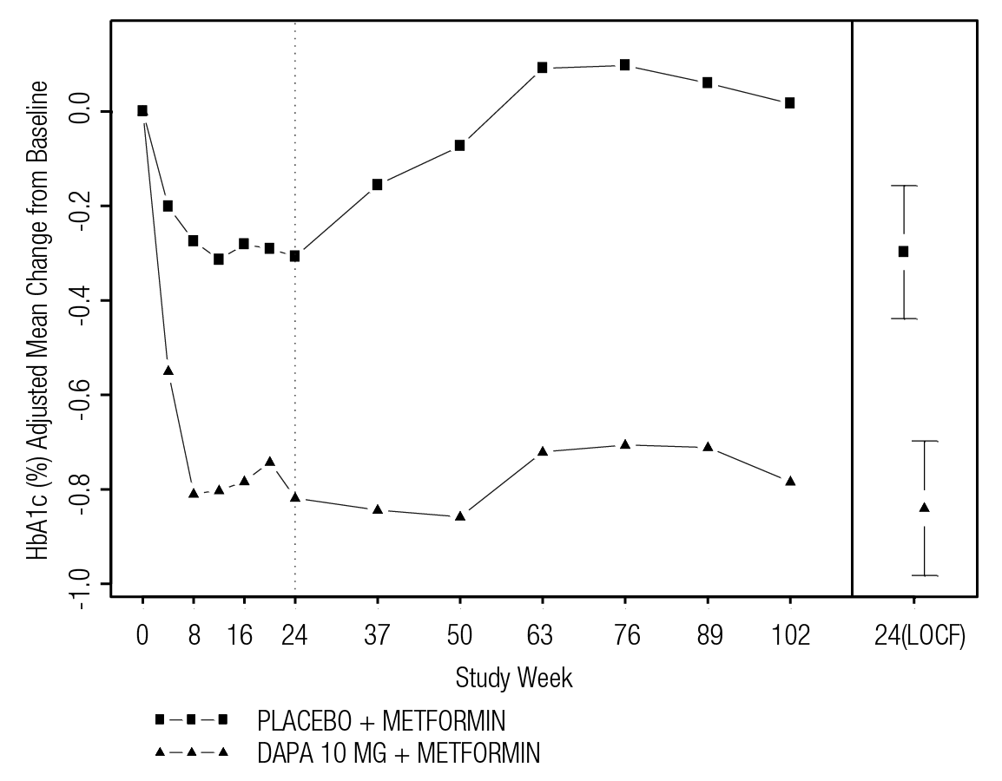

LOCF: Last observation (prior to rescue for rescued subjects) carried forward.

Values for 24 (OCF) represent adjusted mean and 95% confidence intervals based on an ANCOVA model.

Values for other weeks represent adjusted means based on a longitudinal repeated measures model.

|  |
| --- |
| Figure 4. Mean Daily Insulin Dose (IU/day) Adjusted Mean Change from Baseline Over Time in a Placebo-controlled Study of FORXIGA in Combination with Insulin with or without up to 2 Oral Anti-diabetic Therapies Short-term and Long-term Treatment Period Including Data After Insulin Up-titration    Error bars represent 95% confidence intervals for the adjusted mean change from baseline |

**Concomitant Initiation therapy with saxagliptin and dapagliflozin in patients inadequately controlled on metformin**

In a 24-week randomised, double-blind, active comparator-controlled superiority study comparing the combination of saxagliptin and dapagliflozin added concomitantly to metformin, versus saxagliptin (DPP4-Inhibitor) or dapagliflozin (SGLT2 inhibitor) added to metformin in patients with type 2 diabetes mellitus with inadequate glycaemic control on metformin alone (HbA1c ≥8% and ≤12%).The saxagliptin and dapagliflozin group achieved significantly greater reductions in HbA1c versus either the saxagliptin group or dapagliflozin group at 24 weeks (see Table 8).

Table 8. HbA1c at Week 24 in Active-Controlled Study Comparing the Combination of Saxagliptin and Dapagliflozin Added Concurrently to Metformin with either Saxagliptin or Dapagliflozin Added to Metformin

| Efficacy Parameter | Saxagliptin 5 mg + Dapagliflozin 10 mg + Metformin XR#  N=179b | Saxagliptin 5 mg + Metformin XR  N=176b | Dapagliflozin 10 mg + Metformin XR  N=179b |
| --- | --- | --- | --- |
| HbA1c (%) at week 24a | | | |
| Baseline (mean) | 8.9 | 9.0 | 8.9 |
| Change from baseline  (adjusted mean)  (95% CI) | -1.5  (-1.6, -1.3) | -0.9  (-1.0, -0.7) | -1.2  (-1.4, -1.0) |
| Difference from saxagliptin+metformin  (adjusted meanc) (95% CI) | | -0.6d  (-0.8, -0.4) |  |
| Difference from dapagliflozin+metformin  (adjusted meanc) (95% CI) | |  | -0.3e  (-0.5, -0.0) |
| Subjects (%) achieving HbA1C <7% (LOCFf) | | | |
| Adjusted for baseline | 41.4 | 18.3 | 22.2 |
| Body weight (kg) | | | |
| Baseline (mean)  Change from Baselinec  Difference from placebo +saxa+metc  (95% CI)  Difference from placebo +dapa+metc  (95% CI) | 87.13  -2.05  -2.05  (-2.73, -1.37)  -1.50  (-2.12, -0.89) | 87.98  0.00 | 86.25  -2.39 |

# XR = extended release

a LRM = Longitudinal repeated measures (using values prior to rescue)

b Randomised and treated patients with baseline and at least 1 post-baseline efficacy measurement

c Least squares mean adjusted for baseline value

d p-value < 0.0001

e p-value=0.0166

f  LOCF = Last Observation Carried Forward

**Concomitant Initiation of FORXIGA and Extended Release Exenatide in Patients Inadequately Controlled on Metformin**

A total of 694 adult patients with type 2 diabetes mellitus and inadequate glycaemic control (HbA1c ≥8.0 and ≤12.0%) on metformin alone (≥1,500 mg/day) participated in this 28‑week randomised, double‑blind, active‑controlled trial to compare the concomitant initiation of FORXIGA 10 mg once daily and extended release exenatide 2 mg once weekly (GLP‑1 receptor agonist) on a background of metformin versus extended release exenatide 2 mg once weekly alone and FORXIGA 10 mg once daily alone, when added to metformin. Following a 1‑week placebo lead‑in period, patients were randomised equally to one of three double‑blind treatment groups to receive either FORXIGA 10 mg and extended release exenatide, FORXIGA 10 mg and placebo or extended release exenatide and placebo. During the treatment period, patients continued on the same type and dose of metformin as when they entered the study. At baseline, patients had a mean age of 54.2 years and a BMI of 32.73 kg/m2. Randomisation was stratified by HbA1c at baseline (<9.0% or ≥9.0%) and patients were regularly monitored every 4 weeks in this study.

The primary endpoint was the change in HbA1c from baseline to Week 28 (see Fig 5). Compared to FORXIGA 10 mg alone and to extended release exenatide alone, concomitant initiation of FORXIGA 10 mg and extended release exenatide resulted in statistically significant reductions in HbA1c from baseline at Week 28 (Table 9).

Figure 5. Change in HbA1c over Time, LS Mean (SE) – 28-Week Treatment Period (Intent-to-Treat Analysis Set)

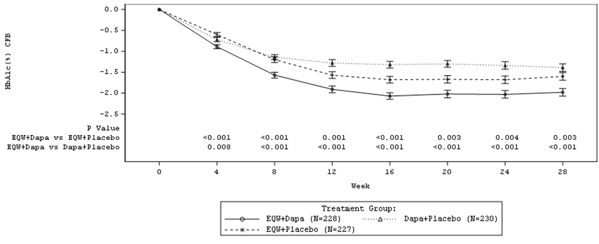

CFB=change from baseline; EQW=exenatide 2 mg once weekly; Dapa=dapagliflozin 10 mg once daily.

Baseline is defined as Week 0.

Table 9. Results of a 28-Week Active-Controlled Trial of FORXIGA 10 mg and Extended Release Exenatide Concomitant Add-On to Metformin

| Efficacy Parameter | FORXIGA 10 mg QD  +  Extended release exenatide 2 mg QW | FORXIGA 10 mg QD  +  Placebo QW | Extended release exenatide 2 mg QW  +  Placebo QD |
| --- | --- | --- | --- |
| Intent-to-Treat population (N) c | 228 | 230 | 227 |
| HbA1c (%) | | | |
| Baseline (mean)a | 9.29 | 9.25 | 9.26 |
| Change from baseline | ‑1.98 | ‑1.39 | ‑1.60 |
| Mean difference in change from baseline vs. FORXIGA (95% CI) | ‑0.59*  (‑0.84 ‑0.34) |  |  |
| Mean difference in change from baseline vs. Extended release exenatide QW (95% CI) | ‑0.38**  (‑0.63 ‑0.13) |  |  |
| Percent of patients achieving HbA1c  7.0%b | 44.7% | 19.1% | 26.9% |
| Body weight (kg) |  |  |  |
| Baseline (mean) a | 92.13 | 90.87 | 89.12 |
| Change from baseline | ‑3.55 | ‑2.22 | ‑1.56 |
| Mean difference in change from baseline vs. FORXIGA (95% CI) | ‑1.33**  (‑2.12 ‑0.55) |  |  |
| Mean difference in change from baseline vs. Extended release exenatide (95% CI) | ‑2.00*  (‑2.79‑1.20) |  |  |
| FPG (mmol/L) | | | |
| Baseline (mean)a | 10.9 | 10.5 | 10.5 |
| Change from baseline | ‑3.7 | ‑2.7 | ‑2.5 |
| Mean difference in change from baseline vs. FORXIGA (95% CI) | ‑0.92*  (‑1.36 ‑0.49) |  |  |
| Mean difference in change from baseline vs. Extended release exenatide (95% CI) | ‑1.12*  (‑1.55‑0.68) |  |  |
| 2-hour PPG (mmol/L) | | | |
| Standard meal test population (n) | 198 | 199 | 188 |
| Baseline (mean) a | 14.9 | 14.5 | 14.8 |
| Change from baseline | ‑4.9 | ‑3.4 | ‑3.3 |
| Mean difference in change from baseline vs. FORXIGA (95% CI) | ‑1.49*  (‑2.04‑0.93) |  |  |
| Mean difference in change from baseline vs. Extended release exenatide (95% CI) | ‑1.54*  (‑2.10 ‑0.98) |  |  |
| Seated systolic blood pressure (mmHg) | | |
| Baseline (mean) a | 130.7 | 129.5 | 129.3 |
| Change from baseline | ‑4.3 | ‑1.8 | ‑1.2 |
| Mean difference in change from baseline vs. FORXIGA (95% CI) | ‑2.4  (‑4.5 ‑0.4) |  |  |
| Mean difference in change from baseline vs. Extended release exenatide (95% CI) | ‑3.0**  (‑5.2‑0.9) |  |  |

QD=once daily, QW=once weekly, N=number of patients in treatment group, CI=confidence interval, FPG= fasting plasma glucose, PPG=postprandial plasma glucose

a Adjusted least squares means (LS Means) and treatment group difference(s) in the change from baseline values at Week 28 are modelled using a mixed model with repeated measures (MMRM) including treatment, region, baseline HbA1c stratum (<9.0% or ≥9.0%), week, and treatment by week interaction as fixed factors, and baseline value as a covariate.

b Categories are derived from continuous measurements. All patients with missing endpoint data are imputed as non-responders. Treatment comparison is based on Cochran-Mantel-Haenszel (CMH) test stratified by baseline HbA1c (<9.0% or ≥9.0%). P-values are from the general association statistics.

c Patients who received at least 1 dose of study medication and had at least 1 post-baseline HbA1c assessment.

* p < 0.001, **p < 0.01, p < 0.05.

P‑values are all adjusted p‑values for multiplicity.

Analyses exclude measurements post rescue therapy and post premature discontinuation of study medication discontinuation, except for systolic blood pressure analysis, which includes measurements post rescue therapy but excludes data post premature discontinuation of study medication discontinuation.

Fasting plasma glucose

Treatment with FORXIGA 10 mg as a monotherapy or as an add‑on to either metformin, glimepiride, metformin and a sulfonylurea, sitagliptin (with or without metformin) or insulin resulted in statistically significant reductions in fasting plasma glucose (‑1.90 to ‑1.20 mmol/L) compared to placebo (‑0.33 to 0.21 mmol/L) at 24 weeks. This effect was observed at Week 1 of treatment and maintained in studies extended through Week 104.

Post‑prandial glucose

Treatment with FORXIGA 10 mg as an add‑on to glimepiride resulted in statistically significant reductions in 2‑hour post‑prandial glucose at 24 weeks that were maintained up to Week 48.

Treatment with FORXIGA 10 mg as an add‑on to sitagliptin (with or without metformin) resulted in reductions in 2‑hour post‑prandial glucose at 24 weeks that were maintained up to Week 48.

Body weight

FORXIGA 10 mg as an add‑on to metformin, glimepiride, metformin and a sulfonylurea, sitagliptin (with or without metformin) or insulin resulted in statistically significant body weight reduction at 24 weeks (p <0.0001, Tables 5, 6 and 7) with placebo-corrected reductions of 1.97 kg (2.43%), 1.54 kg (2.07%), 2.07 kg (2.25%), 1.89 kg (2.18%) and 1.68 kg (1.83%), respectively . These effects were sustained in longer‑term trials (see Fig 6 for add-on to insulin). At 48 weeks, the difference for FORXIGA as add‑on to sitagliptin (with or without metformin) compared with placebo was ‑2.22 kg. At 102 weeks, the difference for FORXIGA as add‑on to metformin compared with placebo, or as add‑on to insulin (at 104 weeks) compared with placebo was ‑2.14 and ‑2.88 kg, respectively.

As an add‑on therapy to metformin in an active‑controlled non‑inferiority study, FORXIGA resulted in a statistically significant body weight reduction compared with glipizide of ‑4.65 kg at 52 weeks (p <0.0001, Table 4) that was sustained at 104 and 208 weeks (‑5.06 kg and 4.38 kg respectively) (see Fig 7).

The adjusted mean change from baseline in body weight at Week-24 when FORXIGA 10 mg and saxagliptin were added concomitantly to metformin was ‑2.05 kg (-2.27%) in the saxagliptin plus dapagliflozin plus metformin group and −2.39 kg (-2.67%) in the dapagliflozin plus metformin group, while the saxagliptin plus metformin group had no change (0.00) (See also Table 8). At Week 24 in the FORXIGA 10 mg as add-on to saxagliptin with metformin study, change from baseline in body weight was -1.91 kg   
(-2.23%) in the FORXIGA 10 mg plus saxagliptin plus metformin group (see Table 5).

Figure 6. Total Body Weight (kg) Adjusted Mean Change from Baseline Over Time in a Placebo-controlled Study of FORXIGA in Combination with Insulin with or without up to 2 Oral Anti-diabetic Therapies Short-term and Long-term Treatment Period Including Data After Insulin Up-titration



Error bars represent 95% confidence intervals for the adjusted mean change from baseline

|  |
| --- |
| Figure 7. Adjusted Mean Change from Baseline Over Time in Body Weight (kg) in a 208-Week Active-Controlled Study Comparing FORXIGA to Glipizide as Add-on to Metformin (Longitudinal Repeated Measures Analysis, Excluding Data after Rescue) |
| New Picture (1) |

Cardiovascular outcomes

Dapagliflozin Effect on Cardiovascular Events (DECLARE) was an international, multicenter, randomized, double-blind, placebo-controlled clinical study conducted to determine the effect of FORXIGA compared with placebo on cardiovascular (CV) and renal outcomes when added to current background therapy. All patients had type 2 diabetes mellitus and either at least two additional CV risk factors (age ≥55 years in men or ≥60 years in women and one or more of dyslipidemia, hypertension or current tobacco use) without having had a CV event at baseline (primary prevention) or established CV disease (secondary prevention).

Of 17160 randomized patients, 6974 (40.6%) had established CV disease and 10186 (59.4%) did not have established CV disease. 8582 patients were randomized to FORXIGA 10 mg and 8578 to placebo and were followed for a median of 4.2 years.

The mean age of the study population was 63.9 years, 37.4% were female, 79.6% were White, 3.5% Black or African-American and 13.4% Asian. In total, 22.4% had had diabetes for ≤5 years, mean duration of diabetes was 11.9 years. Mean HbA1c was 8.3% and mean BMI was 32.1 kg/m2.

At baseline, 10.0% of patients had a history of heart failure. Mean eGFR was 85.2 mL/min/1.73 m2, 7.4% of patients had eGFR <60mL/min/1.73 m2 and 30.3% of patients had micro- or macroalbuminuria (urine albumin to creatinine ration [UACR] ≥30 to ≤300 mg/g or >300 mg/g, respectively).

Most patients (98.1%) used one or more diabetic medications at baseline, 82.0% of the patients were being treated with metformin, 40.9% with insulin, 42.7% with a sulfonylurea, 16.8% with a DPP4 inhibitor, and 4.4% with a GLP-1 agonist.

Approximately 81.3% of patients were treated with an angiotensin-converting enzyme inhibitor (ACEi) or an angiotensin receptor blocker (ARB), 75.0% with statins, 61.1% with antiplatelet therapy, 55.5% with acetylsalicylic acid, 52.6% with beta-blockers, 34.9% with calcium channel blockers, 22.0% with thiazide diuretics and 10.5% with loop diuretics.

Results on primary and secondary endpoints are displayed in Figure 8.

Figure 8 Treatment effects for the primary composite endpoints and their components, and the secondary endpoints and components

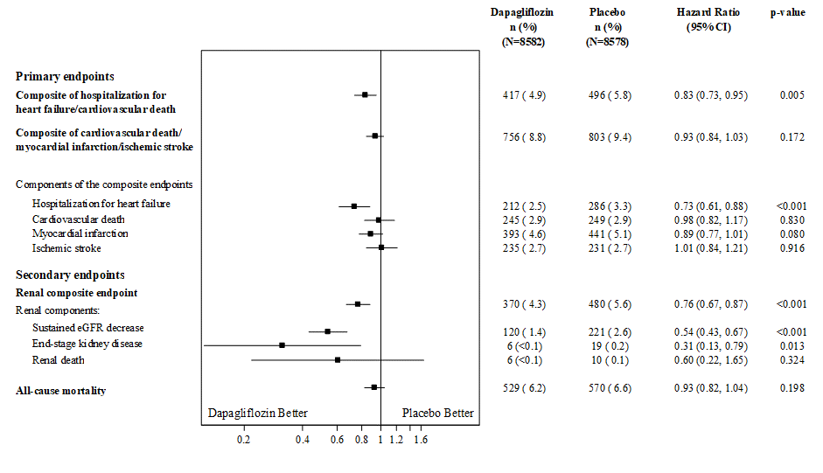

p-values are two-sided p-values for primary endpoints and nominal p-values for secondary endpoints and single components. Time to first event was analyzed in a Cox proportional hazards model. The number of first events for the single components are the actual number of first events for each component and does not add up to the number of events in the composite endpoint.  
Renal composite endpoint is defined as sustained confirmed ≥40% decrease in eGFR to eGFR <60 mL/min/1.73 m2 and/or ESKD (dialysis ≥90 days or kidney transplantation, sustained confirmed eGFR <15 mL/min/1.73 m2) and/or renal or CV death.  
CI=confidence interval.

*Hospitalization for heart failure or cardiovascular death*

FORXIGA 10 mg was superior to placebo in preventing the primary composite endpoint of hospitalization for heart failure or CV death (HR 0.83 [95% CI 0.73, 0.95]; p=0.005) (Figure 9).

Exploratory analyses of the single components suggest that the difference in treatment effect was driven by hospitalization for heart failure (HR 0.73 [95% CI 0.61, 0.88]) (Figure 8), with no clear difference in CV death (HR 0.98 [95% CI 0.82 to 1.17]).

Figure 9 Time to first occurrence of hospitalization for heart failure or cardiovascular death

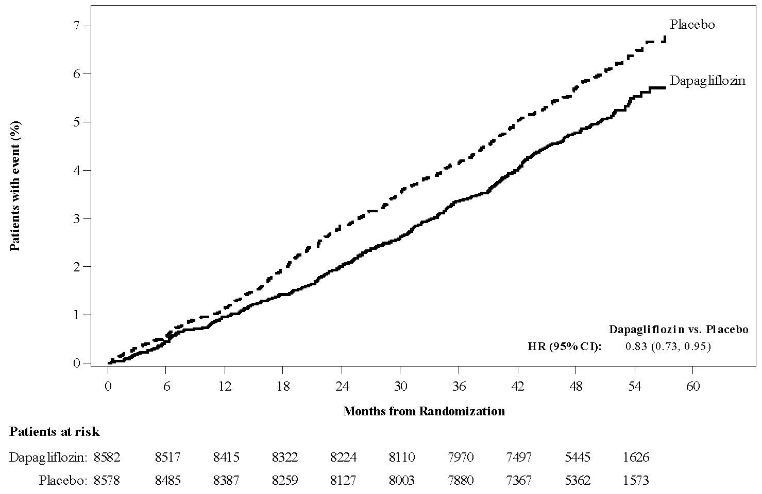

Patients at risk is the number of patients at risk at the beginning of the period.

CI Confidence interval, HR Hazard ratio.

*Major adverse cardiovascular events*

FORXIGA demonstrated cardiovascular safety (tested as non-inferiority versus placebo for the composite of CV death, myocardial infarction or ischemic stroke [MACE]; one-sided p <0.001).

*Nephropathy*

The composite of confirmed sustained eGFR decrease, ESKD, renal or CV death was a secondary variable in the DECLARE study. Because confirmatory testing stopped before the secondary variables were assessed, the analyses of the secondary variables should be considered exploratory.

FORXIGA reduced the incidence of events of the composite of confirmed sustained eGFR decrease, ESKD, renal or CV death (HR 0.76 [95% CI 0.67, 0.87], Figure 10). The difference between groups was driven by reductions in events of the renal components; sustained eGFR decrease, ESKD and renal death (Figure 8), and was observed both in patients with and without CV disease.

Figure 10 Time to first occurrence of sustained eGFR decrease, ESKD, renal or CV death

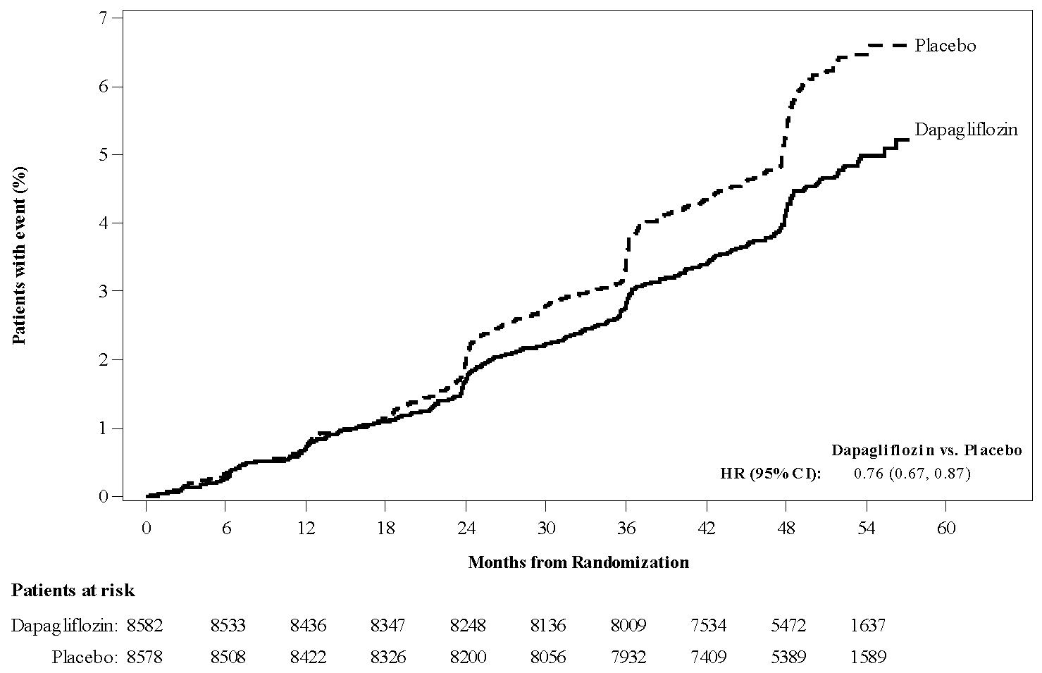

Patients at risk is the number of patients at risk at the beginning of the period.

Renal composite endpoint defined as sustained confirmed eGFR decrease ≥40% to eGFR <60 mL/min/1.73m2  and/or ESKD and/or renal or CV death.

CI Confidence interval; HR Hazard ratio.

When evaluating the renal components, there were 127 and 238 events of new or worsening nephropathy (sustained eGFR decrease, ESKD or renal death) in patients in the FORXIGA and placebo groups, respectively. The HR for time to nephropathy was 0.53 (95% CI 0.43, 0.66) for FORXIGA versus placebo.

Beneficial effects of FORXIGA on renal outcomes were also observed for albuminuria, e.g.,

* In patients without pre-existing albuminuria, FORXIGA reduced the incidence of sustained albuminuria (UACR >30 mg/g) compared with placebo (HR 0.79 [95% CI 0.72, 0.87]).
* In patients without pre-existing macroalbuminuria, new onset of macroalbuminuria (UACR >300 mg/g) was reduced in the FORXIGA group compared with the placebo group (HR 0.54 [95% CI 0.45, 0.65]).
* In patients with pre-existing macroalbuminuria, regression of macroalbuminuria was greater in the FORXIGA group compared with the placebo group (HR 1.82 [95% CI 1.51, 2.20]).

The treatment benefit of FORXIGA over placebo was observed both in patients with and without existing renal impairment.

Supportive Studies

Dual Energy X-ray Absorptiometry in Patients with Diabetes

Due to the mechanism of action of FORXIGA a study was done to evaluate body composition and bone mineral density. FORXIGA 10 mg added on to metformin in 182 patients with type 2 diabetes over a 24 week period provided significant improvements compared with placebo plus metformin, respectively, in body weight (mean change from baseline: -2.96 kg v. -0.88 kg); waist circumference (mean change from baseline: -2.51 cm   
v. -0.99 cm), and body fat mass as measured by DXA (mean change from baseline -2.22 kg   
v. -0.74 kg) rather than lean tissue or fluid loss. FORXIGA plus metformin treatment showed a numerical decrease in visceral adipose tissue compared with placebo plus metformin treatment (change from baseline -322.6 cm3 vs. -8.7 cm3) in an MRI substudy. In an ongoing extension of this study to week 50, there was no important change in bone mineral density for the lumbar spine, femoral neck or total hip seen in either treatment group (mean change from baseline for all anatomical regions <0.5%, 7/89 dapagliflozin and 4/91 comparator subjects showed a decrease of 5% or more). These effects were sustained in a further extension of the study to 102 weeks where no important changes in BMD for the lumbar spine, femoral neck or total hip in either treatment group were observed.

Special Populations

Patients with mild renal impairment (eGFR 60 to <90 mL/min/1.73 m2)

In the clinical trial program more than 3000 patients with mild renal impairment were treated with dapagliflozin. Efficacy was assessed in a pooled analysis across 9 clinical studies consisting of 2226 patients with mild renal impairment. The mean change from baseline in HbA1c and the placebo-corrected mean HbA1c change at 24 weeks was -1.03% and -0.54%, respectively for FORXIGA 10 mg (n=562). The safety profile in patients with mild renal impairment is similar to that in the overall population.

Patients with moderate renal impairment (eGFR 30 to <60 mL/min/1.73 m2)

The efficacy and safety of FORXIGA was evaluated in two dedicated studies of patients with moderate renal impairment.

In a randomized, double blind, placebo-controlled trial a total of 321 adult patients with type 2 diabetes mellitus and eGFR ≥45 to <60 mL/min/1.73 m2 (moderate renal impairment subgroup Chronic Kidney Disease [CKD] 3A), with inadequate glycaemic control on current treatment regimen, were treated with FORXIGA 10 mg or placebo. At Week 24, FORXIGA 10 mg (n=159) provided significant improvements in HbA1c, FPG, Body Weight and SBP compared with placebo (n=161) (Table 10). The mean change from baseline in HbA1c and the placebo-corrected mean HbA1c change was −0.37% and −0.34%, respectively. The mean change from baseline in FPG and the placebo-corrected mean FPG was -1.19 mmol/L and -0.92 mmol/L, respectively. The mean body weight reduction (percentage) and the placebo-corrected mean body weight reduction was -3.42% and -1.43 %, respectively. The mean reduction in seated systolic blood pressure (SBP) and the placebo-corrected mean reduction in SBP was -4.8 mmHg and -3.1 mmHg, respectively.

Table 10: Results at Week 24 in a Placebo-Controlled Study of FORXIGA Treatment in Diabetic Patients with Moderate Renal Impairment (Class 3A, eGFR 45 to <60 mL/min/1.73 m2)

| Efficacy Parameter | FORXIGA 10 mg N=159 | Placebo  N=161 |
| --- | --- | --- |
| **HbA1c (%)** |  |  |
| Baseline (mean) | 8.35 | 8.03 |
| Change from baseline (adjusted mean*) | -0.37 | -0.03 |
| Difference from placebo (adjusted mean*)  (95% CI) | -0.34§  (-0.53, -0.15) |  |
| **FPG (mmol/L)** |  |  |
| Baseline (mean) | 10.16 | 9.62 |
| Change from baseline (adjusted mean*) | -1.19 | -0.27 |
| Difference from placebo (adjusted mean*)  (95% CI) | -0.92§  (-1.48, -0.36) |  |
| **Body Weight (percentage)** |  |  |
| Baseline (mean) | 92.51 | 88.30 |
| % Change from baseline (adjusted mean*) | -3.42 | -2.02 |
| Difference from placebo (adjusted mean*)  (95% CI) | -1.43§  (-2.15, -0.69) |  |
| **Seated Systolic Blood Pressure (mmHg)** |  |  |
| Baseline (mean) | 135.7 | 135.0 |
| Change from baseline (adjusted mean*) | -4.8 | -1.7 |
| Difference from placebo (adjusted mean*)  (95% CI) | -3.1¶  (-6.3, 0.0) |  |

* Least squares mean adjusted for baseline value.  
§ p-value ≤0.001.  
¶ p-value <0.05.

The safety profile of dapagliflozin in the study was consistent with that in the general population of patients with type 2 diabetes. Mean eGFR decreased initially during the treatment period in the dapagliflozin group and subsequently remained stable during the   
24-week treatment period (FORXIGA: -3.39 mL/min/1.73 m2 and placebo: ‑0.90 mL/min/1.73 m2). At 3 weeks after termination of FORXIGA, the mean change from baseline in eGFR in the dapagliflozin group was similar to the mean change in the placebo group (FORXIGA: 0.57 mL/min/1.73 m2 and placebo: -0.04 mL/min/1.73 m2).

The efficacy and safety of FORXIGA was also assessed in a study of 252 patients with diabetes with eGFR 30 to <60 mL/min/1.73 m2 (moderate renal impairment subgroup CKD 3A, eGFR ≥45 to <60 mL/minute/1.73 m2 and CKD 3B, eGFR ≥30 to <45 mL/minute/1.73 m2).  FORXIGA treatment did not show a significant placebo corrected change in HbA1c in the overall study population (CKD 3A and CKD 3B combined) at 24 weeks. At Week 52, FORXIGA was associated with a greater reduction in mean eGFR (FORXIGA 10 mg −4.46 mL/min/1.73 m2 and placebo −2.58 mL/min/1.73 m2). At Week 104, these changes persisted (eGFR: FORXIGA 10 mg −3.50 mL/min/1.73 m2 and placebo −2.38 mL/min/1.73 m2). With FORXIGA 10 mg, eGFR reduction evident at Week 1 and remained stable through Week 104, while placebo-treated patients had a slow continuous decline through Week 52 that stabilized through Week 104.

At Week 52 and persisting through Week 104, greater increases in mean parathyroid hormone (PTH) and serum phosphorus were observed in this study with FORXIGA 10 mg compared to placebo, where baseline values of these analytes were higher. Elevations of potassium of ≥6 mEq/L were more common in patients treated with placebo (12.0%) than those treated with FORXIGA 10 mg (4.8%) during the cumulative 104-week treatment period. The proportion of patients discontinued for elevated potassium, adjusted for baseline potassium, was higher for the placebo group (14.3%) than for the FORXIGA 10 mg group (6.7%).

Overall, there were 13 patients with an adverse event of bone fracture reported in the FORXIGA group. Eight (8) of these 13 fractures were in patients who had eGFR 30 to 45 mL/min/1.73 m2 and 10 of the 13 fractures were reported within the first 52 weeks. There was no apparent pattern with respect to the site of fracture. No bone fractures were reported in the dedicated study of patients with eGFR ≥45 to <60 mL/min/1.73 m2 (CKD 3A). No fractures were reported in the placebo group.

Blood Pressure

In the pre‑specified pooled analysis of 13 placebo-controlled studies (see section 4.8 Adverse effects (Undesirable effects)), treatment with dapagliflozin 10 mg resulted in a systolic blood pressure change from baseline of –3.7 mmHg and diastolic blood pressure of –1.8 mmHg versus –0.5 mmHg systolic and ‑0.5 mmHg diastolic blood pressure for the placebo group at Week 24. Similar reductions were observed up to 104 weeks.

In two 12-week, placebo-controlled studies a total of 1,062 patients with inadequately controlled type 2 diabetes and hypertension (despite pre-existing stable treatment with an ACE-I or ARB in one study and an ACE-I or ARB plus one additional antihypertensive treatment in another study) were treated with FORXIGA 10 mg or placebo. At Week 12 for both studies, FORXIGA 10 mg plus usual antidiabetic treatment provided improvement in HbA1c, and decreased the placebo-corrected systolic blood pressure on average by 3.1 and 4.3 mmHg, respectively.

### Clinical trial – Heart failure

Clinical efficacy

Dapagliflozin And Prevention of Adverse outcomes in Heart Failure (DAPA-HF) was an international, multicentre, randomized, double-blind, placebo-controlled study in patients with heart failure (New York Heart Association [NYHA] functional class II-IV) with reduced ejection fraction (left ventricular ejection fraction [LVEF] ≤40%) to determine the effect of FORXIGA compared with placebo, when added to background standard of care therapy, on the incidence of CV death and worsening heart failure.

Of 4744 patients, 2373 were randomized to FORXIGA 10 mg and 2371 to placebo and followed for a median of 18 months. The mean age of the study population was 66 years, 77% were male, 70% White, 5% Black or African-American and 24% Asian.

At baseline, 67.5% patients were classified as NYHA class II, 31.6% class III and 0.9% class IV, median LVEF was 32%, 42% of the patients in each treatment group had a history of type 2 diabetes mellitus, and an additional 3% of the patients in each group were classified as having type 2 diabetes mellitus based on a HbA1c ≥6.5% at both enrolment and randomisation.

Patients were on standard of care therapy; 94% of patients were treated with ACEi, ARB, or angiotensin receptor-neprilysin inhibitor (ARNI, 11%), 96% with beta-blocker, 71% with mineralocorticoid receptor antagonist (MRA), 93% with diuretic and 26% had an implantable device.

Patients with eGFR ≥30 mL/min/1.73 m2 at enrolment were included in the study. The mean eGFR was 66 mL/min/1.73 m2, 41% of patients had eGFR <60mL/min/1.73 m2 and 15% had eGFR <45 mL/min/1.73 m2.

The DAPA-HF outcomes study compared FORXIGA versus placebo in a population representative of that found in clinical practice. The overall study objective was to determine whether FORXIGA prevents cardiovascular death and worsening heart failure, and if FORXIGA improves heart failure symptoms.

##### Cardiovascular death and worsening heart failure

FORXIGA 10 mg was superior to placebo in preventing CV death and worsening heart failure, with consistent treatment effect on primary and secondary endpoints.

FORXIGA reduced the incidence of the primary composite endpoint of CV death, hospitalization for heart failure or urgent heart failure visit (HR 0.74 [95% CI 0.65, 0.85]; p<0.0001). The number needed to treat per year was 26 (95% CI 18, 46). The FORXIGA and placebo event curves separated early and continued to diverge over the study period (Figure 11).

Figure 11 Time to first occurrence of the composite hospitalization of cardiovascular death, hospitalization for heart failure or urgent heart failure visit

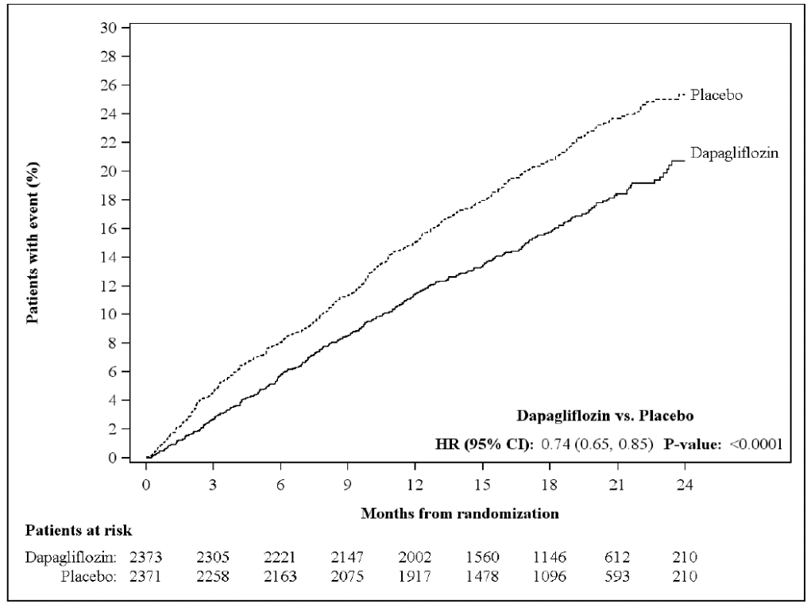

An urgent heart failure visit was defined as an urgent, unplanned, assessment by a physician, e.g. in an Emergency Department, and requiring treatment for worsening heart failure (other than just an increase in oral diuretics).  
Patients at risk is the number of patients at risk at the beginning of the period.

All three components of the primary composite endpoint individually contributed to the treatment effect (Figure 12). There were few urgent heart failure visits. FORXIGA also reduced the incidence of cardiovascular death or hospitalization for heart failure (HR 0.75 [95% CI 0.65, 0.85], p < 0.0001).

Figure 12 Treatment effects for the primary composite endpoint, its components and all-cause mortality

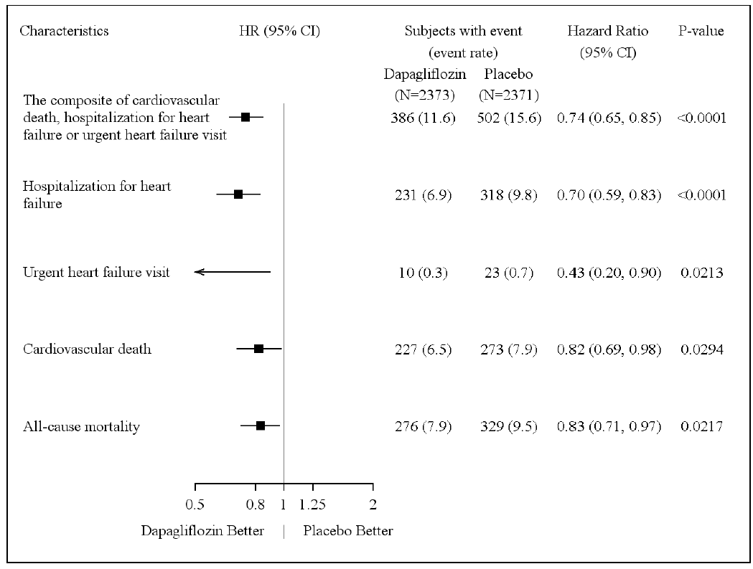

An urgent heart failure visit was defined as an urgent, unplanned, assessment by a physician, e.g. in an Emergency Department, and requiring treatment for worsening heart failure (other than just an increase in oral diuretics).

The number of first events for the single components are the actual number of first events for each component and does not add up to the number of events in the composite endpoint.

Event rates are presented as the number of subjects with event per 100 patient years of follow-up.

p-values for single components and all-cause mortality are nominal.

FORXIGA also reduced the total number of events of hospitalizations for heart failure (first

and recurrent) and cardiovascular death; there were 567 events in the FORXIGA group versus 742 events in the placebo group (Rate Ratio 0.75 [95% CI 0.65, 0.88]; p=0.0002).

The treatment benefit of FORXIGA was observed in heart failure patients both with type 2

diabetes mellitus and without diabetes (Figure 13).

Figure 13 Treatment effects in all patients, in patients with type 2 diabetes mellitus and in patients without diabetes

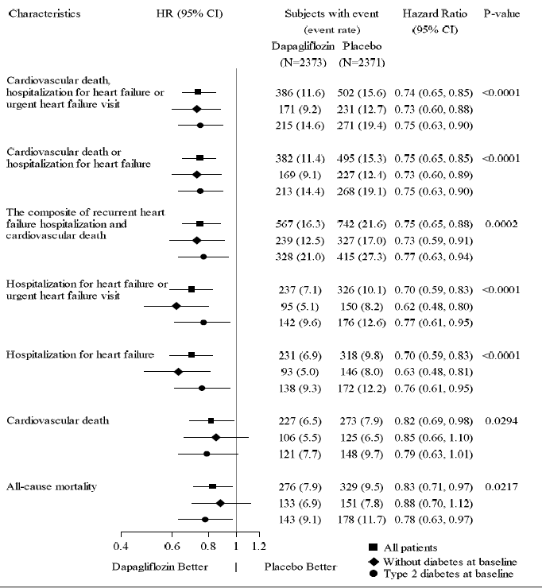

An urgent heart failure visit was defined as an urgent, unplanned, assessment by a physician, e.g. in an Emergency Department, and requiring treatment for worsening heart failure (other than just an increase in oral diuretics).

For the composite of recurrent hospitalizations for heart failure and cardiovascular death, rate ratios are presented rather than hazard ratios and the numbers of events are shown rather than subjects with event.

The number of first events for the single components are the actual number of first events for each component and does not add up to the number of events in the composite endpoint.

Event rates are presented as the number of subjects with event per 100 patient years of follow-up, or, for the composite of

recurrent heart failure hospitalizations and CV death, as the average number of events per 100 patient years.

p-values for components of the primary composite endpoint and for all-cause mortality are nominal.

The treatment benefit of FORXIGA over placebo on the primary endpoint was also consistent

across other key subgroups (Figure 14).

Figure 14 Treatment effects for the primary composite endpoint by sub-groups

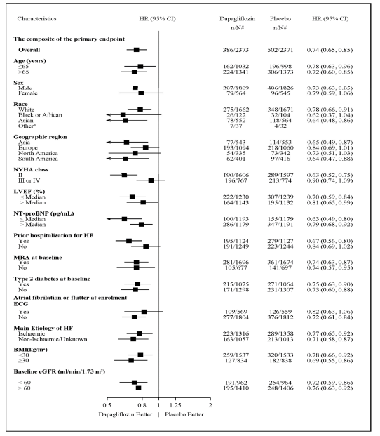

a Hazard ratio estimates are not presented for subgroups with less than 15 events in total, both arms combined.  
n/N# Number of subjects with event/number of subjects in the subgroup.  
NT-proBNP = N-terminal pro b-type natriuretic peptide. HF = Heart failure

##### Patient reported outcome – heart failure symptoms

The treatment effect of FORXIGA on heart failure symptoms was assessed by the Total Symptom Score of the Kansas City Cardiomyopathy Questionnaire (KCCQ-TSS), which quantifies heart failure symptom frequency and severity, including fatigue, peripheral oedema, dyspnoea and orthopnoea. The score ranges from 0 to 100, with higher scores representing better health status.

Treatment with FORXIGA resulted in a statistically significant and clinically meaningful benefit over placebo in heart failure symptoms, as measured by change from baseline to Month 8 in the KCCQ-TSS, (Win Ratio 1.18 [95% CI 1.11, 1.26]; p<0.0001). Both symptom frequency and symptom burden contributed to the results. Benefit was seen both in improving heart failure symptoms and in preventing deterioration of heart failure symptoms.

In responder analyses, the proportion of patients with a clinically meaningful improvement on the KCCQ-TSS from baseline at 8 months, defined as 5 points or more, was higher for the dapagliflozin treatment group compared with placebo. The proportion of patients with a clinically meaningful deterioration, defined as 5 points or more, was lower for the dapagliflozin treatment group compared to placebo. The benefits observed with dapagliflozin remained when applying more conservative cut-offs for larger clinically meaningful change (Table 11).

Table 11 Number and percent of patients with clinically meaningful improvement and deterioration on the KCCQ-TSS at 8 months

|  |  |  |  |  |
| --- | --- | --- | --- | --- |
| **Change from baseline at**  **8 months:** | **Dapagliflozin**  **10 mg**  **na=2086** | **Placebo**  **na=2062** |  |  |
| ***Improvement*** | **n (%)**  **improvedb** | **n (%)**  **improvedb** | **Odds ratioc**  **(95% CI)** | **p-valuef** |
| ≥ 5 points (small improvement) | 1198 (57.4) | 1030 (50.0) | 1.14  (1.07,1.22) | <0.0001 |
| ≥ 10 points (moderate to large improvement) | 1124 (53.9) | 968 (46.9) | 1.15  (1.08, 1.22) | <0.0001 |
| ≥ 15 points (large improvement) | 1120 (53.7) | 984 (47.7) | 1.14  (1.07,1.22) | <0.0001 |
| ***Deterioration*** | **n (%)**  **deterioratedd** | **n (%)**  **deterioratedd** | **Odds ratioe**  **(95% CI)** | **p-valuef** |
| ≥ 5 points (small deterioration) | 524 (25.1) | 682 (33.1) | 0.84  (0.78, 0.90) | <0.0001 |

a Number of patients with an observed KCCQ-TSS or who died prior to 8 months

b Number of patients who had an observed improvement of at least 5, 10 or 15 points from baseline. Patients who died prior to the given timepoint are counted as not improved. Patients with a KCCQ-TSS at baseline which was too high for them to experience an improvement were defined as improved if they remained there at 8 months.

c For improvement, an odds ratio > 1 favours dapagliflozin 10 mg.

d Number of patients who had an observed deterioration of at least 5 or 10 points from baseline. Patients who died prior to the given timepoint are counted as deteriorated. Patients with a KCCQ-TSS at baseline which was too low for them to experience a deterioration were defined as deteriorated if they remained there at 8 months.

e For deterioration, an odds ratio < 1 favours dapagliflozin 10 mg.

f p-values are nominal.

##### Nephropathy

There were 28 and 39 events of the composite of confirmed sustained ≥ 50% eGFR decrease, ESKD, or renal death in patients in the FORXIGA and placebo groups, respectively, (HR 0.71 [95% CI 0.44, 1.16]).

##### All-cause mortality

The incidence of all-cause mortality was lower in the FORXIGA treatment group compared with placebo (HR 0.83; 95% CI [0.71, 0.97], Figure 12).

### Clinical trial – Chronic kidney disease

Clinical Efficacy

The Study to Evaluate the Effect of Dapagliflozin on Renal Outcomes and Cardiovascular Mortality in Patients with Chronic Kidney Disease (DAPA-CKD) was an international, multicenter, event-driven, randomized, double-blind, parallel-group, placebo-controlled study comparing FORXIGA with placebo, when added to background standard of care therapy, in chronic kidney disease (CKD) patients with eGFR ≥25 to ≤75 mL/min/1.73 m2 and albuminuria (urine albumin creatinine ratio [UACR] ≥200 and ≤5000 mg/g). The primary objective was to determine the effect of FORXIGA compared with placebo in reducing the incidence of the composite endpoint of ≥50% sustained decline in eGFR, end stage kidney disease (ESKD) (defined as sustained eGFR <15 mL/min/1.73 m2, chronic dialysis treatment or receiving a renal transplant), CV or renal death.

A total of 4304 patients were randomised to FORXIGA 10 mg (N=2152) or placebo (N=2152) once daily and followed for a median of 28.5 months. Treatment was continued if eGFR fell to levels below 25 mL/min/1.73 m2 during the study and could be continued in cases when dialysis was needed.

At baseline, mean eGFR was 43.1 mL/min/1.73 m2 and median UACR was 949.3 mg/g, 44.1% of patients had eGFR 30 to <45 mL/min/1.73 m2 and 14.5% had eGFR <30 mL/min/1.73 m2. 67.5% of the patients had type 2 diabetes mellitus.

Patients were on standard of care (SOC) therapy; 97.0% of patients were treated with an angiotensin-converting enzyme inhibitor (ACEi) or angiotensin receptor blocker (ARB).

The mean age of the study population was 61.8 years, 66.9% were male, 53.2% White, 4.4% Black or African-American, and 34.1% Asian.

FORXIGA was superior to placebo in reducing the incidence of the primary composite endpoint of ≥50% sustained decline in eGFR, reaching ESKD, CV or renal death (HR 0.61 [95% CI 0.51, 0.72]; p<0.0001). The number needed to treat per 27 months was 19 (95% CI 15, 27). Based on the Kaplan-Meier plot, the FORXIGA and placebo event curves began to separate early (4 months) and continued to diverge over the study period (Figure 15).

**Figure 15 Time to first occurrence of the primary composite endpoint, ≥50% sustained decline in eGFR, ESKD, CV or renal death**

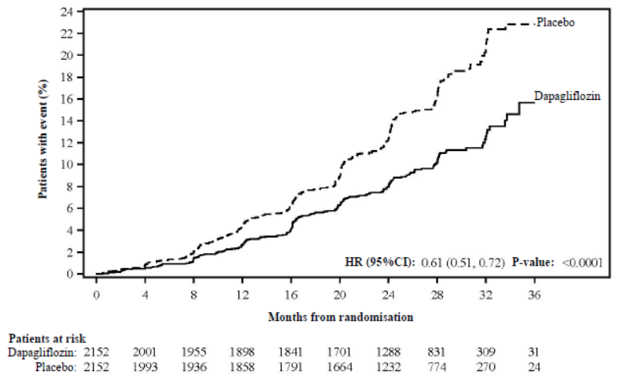

Patients at risk is the number of patients at risk at the beginning of the period.

All four components of the primary composite endpoint individually contributed to the treatment effect (Figure 16). FORXIGA also reduced the incidence of the composite endpoint of ≥50% sustained decline in eGFR, ESKD or renal death (HR 0.56 [95% CI 0.45, 0.68], p<0.0001), the composite endpoint of CV death and hospitalization for heart failure (HR 0.71 [95% CI 0.55, 0.92], p=0.0089), and all-cause mortality (HR 0.69 [95% CI 0.53, 0.88], p=0.0035) (Figure 17).

**Figure 16 Treatment effects for the primary and secondary composite endpoints, their individual components, and all-cause mortality**

The number of first events for the single components are the actual number of first events for each component and does not add up to the number of events in the composite endpoint.

Event rates are presented as the number of subjects with event per 100 patient years of follow-up.

Hazard ratio estimates are not presented for subgroups with less than 15 events in total, both arms combined.

p-values for components of the composite endpoints are nominal.

**Figure 17 Time to first occurrence of death from any cause**

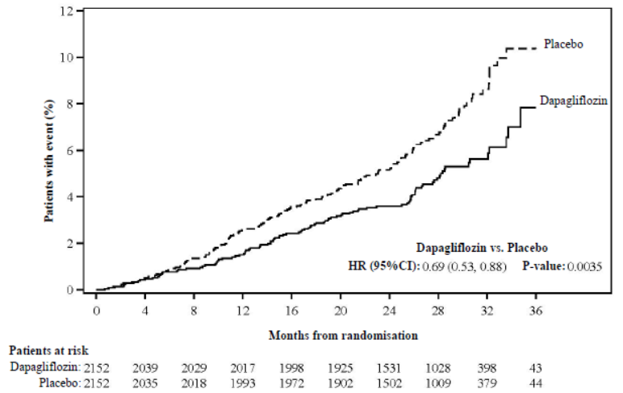

Patients at risk is the number of patients at risk at the beginning of the period.

The treatment effect of FORXIGA was consistent in chronic kidney disease patients with type 2 diabetes mellitus and without diabetes (Figure 18).

**Figure 18** **Treatment effects in patients with type 2 diabetes mellitus and in patients without diabetes**

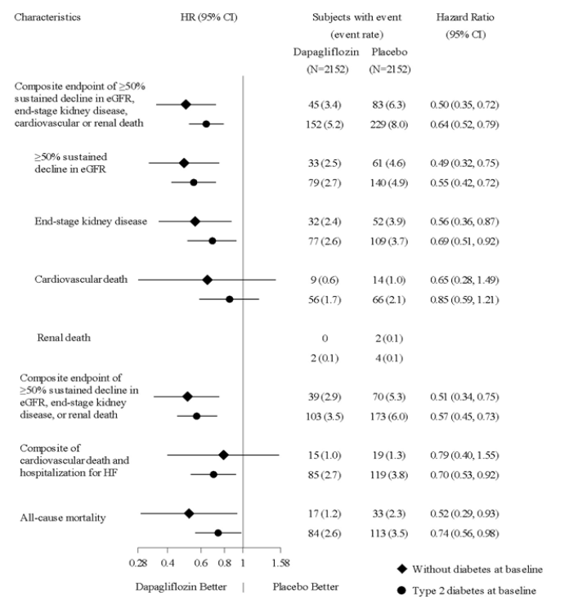

The number of first events for the single components are the actual number of first events for each component and does not add up to the number of events in the composite endpoint.

Hazard ratio estimates are not presented for subgroups with less than 15 events in total, both arms combined.

Event rates are presented as the number of subjects with event per 100 patient years of follow-up.

.

The treatment benefit of FORXIGA over placebo on the primary composite endpoint was consistent across key subgroups (Figure 19).

**Figure 19 Treatment effects for the primary composite endpoint by sub-groups**

n/N# Number of subjects with event/number of subjects in the subgroup.

There were fewer patients with renal-related adverse events in the FORXIGA group compared with the placebo group, 144 (6.7%) and 169 (7.9%) in the FORXIGA and placebo groups, respectively.

## Pharmacokinetic properties

### Absorption

Dapagliflozin was rapidly and well absorbed after oral administration and can be administered with or without food. Maximum dapagliflozin plasma concentrations (Cmax) were usually attained within 2 hours after administration in the fasted state. The Cmax and AUC values increased proportional to the increment in dapagliflozin dose. The absolute oral bioavailability of dapagliflozin following the administration of a 10 mg dose is 78%. Food had relatively modest effects on the pharmacokinetics of dapagliflozin in healthy subjects. Administration with a high-fat meal decreased dapagliflozin Cmax by up to 50% and prolonged Tmax by approximately 1 hour, but did not alter AUC as compared with the fasted state.These changes are not considered to be clinically meaningful.

### Distribution

Dapagliflozin is approximately 91% protein bound. Protein binding was not altered in various disease states (e.g., renal or hepatic impairment).

### Metabolism

Dapagliflozin is extensively metabolized, primarily to yield dapagliflozin 3-O-glucuronide. Dapagliflozin 3-O-glucuronide, with a molar plasma AUC 52% higher than that of dapagliflozin itself at the clinical dose, is an inactive metabolite and does not contribute to the glucose lowering effects. The formation of dapagliflozin 3-O-glucuronide is mediated by UGT1A9, an enzyme present in the liver and kidney, and CYP mediated metabolism was a minor clearance pathway in humans.

### Excretion

Dapagliflozin and related metabolites are primarily eliminated via urinary excretion, of which less than 2% is unchanged dapagliflozin. After oral administration of 50 mg [14C]‑dapagliflozin dose, 96% was recovered, 75% in urine and 21% in faeces. In faeces, approximately 15% of the dose was excreted as parent drug. The mean plasma terminal half-life (t1/2) for dapagliflozin was 12.9 hours following a single oral dose of FORXIGA 10 mg to healthy subjects.

### Special Populations

No dosages adjustments based on pharmacokinetic analyses are recommended for mild, moderate and severe renal impairment, mild, moderate, and severe hepatic impairment, age, gender, race and body weight.

Renal Impairment

At steady-state (20 mg once-daily dapagliflozin for 7 days), patients with type 2 diabetes and mild, moderate or severe renal impairment (as determined by iohexol clearance) had mean systemic exposures of dapagliflozin that were 32%, 60% and 87% higher, respectively, than those of patients with type 2 diabetes and normal renal function. At dapagliflozin 20 mg once-daily, higher systemic exposure to dapagliflozin in patients with type 2 diabetes mellitus and renal impairment did not result in a correspondingly higher renal glucose clearance or 24 hour glucose excretion. The renal glucose clearance and 24 hour glucose excretion was lower in patients with moderate or severe renal impairment as compared to patients with normal and mild renal impairment. The steady-state 24-h urinary glucose excretion was highly dependent on renal function and 85, 52, 18 and 11 g of glucose/day was excreted by patients with type 2 diabetes mellitus and normal renal function or mild, moderate or severe renal impairment, respectively. There were no differences in the protein binding of dapagliflozin between renal impairment groups or compared to healthy subjects. The impact of haemodialysis on dapagliflozin exposure is not known. The effect of reduced renal function on systemic exposure was evaluated in a population pharmacokinetic model. Consistent with previous results, model predicted AUC was higher in patients with chronic kidney disease compared with patients with normal renal function, and was not meaningfully different in chronic kidney disease patients with type 2 diabetes mellitus and without diabetes.

Hepatic Impairment

A single dose (10 mg) dapagliflozin clinical pharmacology study was conducted in patients with mild, moderate or severe hepatic impairment (Child-Pugh classes A, B, and C, respectively) and healthy matched controls in order to compare the pharmacokinetic characteristics of dapagliflozin between these populations. There were no differences in the protein binding of dapagliflozin between hepatic impairment groups or compared to healthy subjects. In patients with mild or moderate hepatic impairment mean Cmax and AUC of dapagliflozin were up to 12% and 36% higher, respectively, compared to healthy matched control subjects. These differences were not considered to be clinically meaningful and no dose adjustment from the proposed usual dose of 10 mg once daily for dapagliflozin is proposed for these populations.  In patients with severe hepatic impairment (Child-Pugh class C) mean Cmax and AUC of dapagliflozin were up to 40% and 67% higher than matched healthy controls, respectively. FORXIGA should not be used in patients with severe hepatic impairment (see section 4.4 Special warnings and precautions for use).

Age

No dosage adjustment for dapagliflozin is recommended on the basis of age. The effect of age (young: ≥18 to <40 years [n=105] and elderly: ≥65 years [n=224]) was evaluated as a covariate in a population pharmacokinetic model and compared to patients ≥40 to <65 years using data from healthy subject and patient studies). The mean dapagliflozin systemic exposure (AUC) in young patients was estimated to be 10.4% lower than in the reference group [90% CI: 87.9, 92.2%] and 25% higher in elderly patients compared to the reference group [90% CI: 123, 129%]. However, an increased exposure due to age-related decrease in renal function can be expected. There are insufficient data to draw conclusions regarding exposure in patients >70 years old.

Paediatric and Adolescent

Pharmacokinetics in the paediatric and adolescent population have not been studied.

Gender

No dosage adjustment from the dose of 10 mg once daily is recommended for dapagliflozin on the basis of gender. Gender was evaluated as a covariate in a population pharmacokinetic model using data from healthy subject and patient studies. The mean dapagliflozin AUCss in females (n=619) was estimated to be 22% higher than in males (n=634) [90% CI: 117,124].

Race

No dosage adjustment from the dapagliflozin dose of 10 mg once daily is recommended on the basis of race. Race (white, black [African descent] or Asian) was evaluated as a covariate in a population pharmacokinetic model using data from healthy subject and patient studies. Differences in systemic exposures between these races were small. Compared to whites (n=1147), Asian subjects (n=47) had no difference in estimated mean dapagliflozin systemic exposures [90% CI range 3.7% lower, 1% higher]. Compared to whites, black (African descent) subjects (n=43) had 4.9% lower estimated mean dapagliflozin systemic exposures [90% CI range 7.7% lower, 3.7% lower].

Body Weight

No dose adjustment from the proposed dapagliflozin dose of 10 mg once daily is recommended in patients with diabetes mellitus or in patients without diabetes on the basis of weight.

In a population pharmacokinetic analysis using data from healthy subject and patient studies, systemic exposures in high body weight subjects (≥120 kg, n=91) were estimated to be 78.3% [90% CI: 78.2, 83.2%] of those of reference subjects with body weight between 75 and 100 kg. This difference is considered to be small, therefore, no dose adjustment from the proposed dose of 10 mg dapagliflozin once daily in type 2 diabetes mellitus patients with high body weight (≥120 kg) is recommended.

Subjects with low body weights (<50 kg) were not well represented in the healthy subject and patient studies used in the population pharmacokinetic analysis. Therefore, dapagliflozin systemic exposures were simulated with a large number of subjects. The simulated mean dapagliflozin systemic exposures in low body weight subjects were estimated to be 29% higher than subjects with the reference group body weight. This difference is considered to be small and based on these findings no dose adjustment from the proposed dose of 10 mg dapagliflozin once daily in patients with type 2 diabetes mellitus with low body weight   
(<50 kg) is recommended.

## Preclinical safety data

### Genotoxicity

Dapagliflozin was positive in an *in-vitro* clastogenicity assay in the presence of metabolic activation. However, dapagliflozin was negative in the Ames mutagenicity assay and in a series of *in-vivo* clastogenicity studies evaluating micronuclei or DNA repair in rats at exposure multiples at least 2100 times the human exposure at the MRHD. The weight of evidence from these studies, along with the absence of tumour findings in the rat and mouse carcinogenicity studies, support that dapagliflozin is not genotoxic.

### Carcinogenicity

Dapagliflozin did not induce tumours in two-year carcinogenicity studies in mice or rats at oral doses up to 40 mg/kg/day and 10 mg/kg/day respectively. These doses correspond to AUC exposure levels at least 78 times the human AUC at the MRHD of 10 mg/day.

# Pharmaceutical particulars

## List of excipients

Microcrystalline cellulose, lactose, crospovidone, silicon dioxide, magnesium stearate, polyvinyl alcohol, titanium dioxide, macrogol 3350, purified talc and iron oxide yellow.

## Incompatibilities

Incompatibilities were either not assessed or not identified as part of the registration of this medicine.

## Shelf life

In Australia, information on the shelf life can be found on the public summary of the Australian Register of Therapeutic Goods (ARTG). The expiry date can be found on the packaging.

## Special precautions for storage

The tablets should be stored below 30°C.

## Nature and contents of container

The film coated tablets are packed into aluminium/aluminium blisters in pack sizes of 7 and 28 tablets.

## Special precautions for disposal

In Australia, any unused medicine or waste material should be disposed of by taking to your local pharmacy.

## Physicochemical properties

### Chemical structure

Dapagliflozin propanediol monohydrate is an orally-active inhibitor of the human renal sodium-glucose co-transporter 2 (SGLT2), the major transporter responsible for renal glucose reabsorption. Dapagliflozin is described chemically as (1*S*)-1,5-Anhydro-1-C-[4-chloro-3-[(4-ethoxyphenyl)methyl]phenyl]-D-glucitol, (*S*)-propylene glycol, monohydrate.

The chemical structure of dapagliflozin propanediol monohydrate is:



*Molecular formula*: C21H25ClO6 •C3H8O2 •H2O

*Molecular weight*: 502.98

*CAS Number*: 960404-48-2

# Medicine schedule (Poisons Standard)

Schedule 4 - Prescription Only Medicine

# Sponsor

AstraZeneca Pty Ltd  
ABN 54 009 682 311  
66 Talavera Road  
MACQUARIE PARK NSW 2113

Telephone: 1800 805 342

# Date of first approval

22 October 2012

# Date of revision

8 September 2021

## Summary table of changes

|  |  |
| --- | --- |
| Section Changed | Summary of new information |
| 4.1 | Extension of indications as per DAPA-CKD study |
| 4.2 | Updated section based on DAPA-CKD data |
| 4.3 | Updated section based on DAPA-CKD data |
| 4.4 | Updated section based on DAPA-CKD data |
| 4.8 | Updated section to include DAPA-CKD data |
| 5 | Updated section with clinical data from DAPA-CKD and some minor corrections |

FORXIGA is a registered trademark of the AstraZeneca group of companies.

©AstraZeneca, 2021 Doc ID-002319654 v15.0