|  |
| --- |
| **March 2022** |

|  |
| --- |
| Australian Public Assessment Report for Dapagliflozin (as propanediol monohydrate) |
| Proprietary Product Name: Forxiga |
| Sponsor: AstraZeneca Pty Ltd |

About the Therapeutic Goods Administration (TGA)

* The Therapeutic Goods Administration (TGA) is part of the Australian Government Department of Health and is responsible for regulating medicines and medical devices.
* The TGA administers the *Therapeutic Goods Act 1989* (the Act), applying a risk management approach designed to ensure therapeutic goods supplied in Australia meet acceptable standards of quality, safety and efficacy (performance) when necessary.
* The work of the TGA is based on applying scientific and clinical expertise to decision-making, to ensure that the benefits to consumers outweigh any risks associated with the use of medicines and medical devices.
* The TGA relies on the public, healthcare professionals and industry to report problems with medicines or medical devices. TGA investigates reports received by it to determine any necessary regulatory action.
* To report a problem with a medicine or medical device, please see the information on the TGA website <<https://www.tga.gov.au>>.

About AusPARs

* An Australian Public Assessment Report (AusPAR) provides information about the evaluation of a prescription medicine and the considerations that led the TGA to approve or not approve a prescription medicine submission.
* AusPARs are prepared and published by the TGA.
* An AusPAR is prepared for submissions that relate to new chemical entities, generic medicines, major variations and extensions of indications.
* An AusPAR is a static document; it provides information that relates to a submission at a particular point in time.
* A new AusPAR will be developed to reflect changes to indications and/or major variations to a prescription medicine subject to evaluation by the TGA.

Copyright

© Commonwealth of Australia 2022  
This work is copyright. You may reproduce the whole or part of this work in unaltered form for your own personal use or, if you are part of an organisation, for internal use within your organisation, but only if you or your organisation do not use the reproduction for any commercial purpose and retain this copyright notice and all disclaimer notices as part of that reproduction. Apart from rights to use as permitted by the *Copyright Act 1968* or allowed by this copyright notice, all other rights are reserved and you are not allowed to reproduce the whole or any part of this work in any way (electronic or otherwise) without first being given specific written permission from the Commonwealth to do so. Requests and inquiries concerning reproduction and rights are to be sent to the TGA Copyright Officer, Therapeutic Goods Administration, PO Box 100, Woden ACT 2606 or emailed to <[tga.copyright@tga.gov.au](mailto:tga.copyright@tga.gov.au)>.

Contents

List of abbreviations 4

I. Introduction to product submission 6

Submission details 6

Product background 7

Regulatory status 9

Product Information 10

II. Registration timeline 10

III. Submission overview and risk/benefit assessment 11

Quality 11

Nonclinical 11

Clinical 11

Risk management plan 21

Risk-benefit analysis 23

Outcome 25

Attachment 1. Product Information 27

## List of abbreviations

|  |  |
| --- | --- |
| Abbreviation | Meaning |
| ACE | Angiotensin-converting enzyme |
| ACM | Advisory Committee on Medicines |
| AE | Adverse event |
| ARB | Angiotensin receptor blocker |
| ARTG | Australian Register of Therapeutic Goods |
| ASA | Australia specific annex |
| AUC | Area under the plasma concentration time curve |
| CHMP | Committee for Medicinal Products for Human Use (European Union) |
| CKD | Chronic kidney disease |
| CL/F | Apparent clearance |
| CMI | Consumer Medicines Information |
| DLP | Data lock point |
| eGFR | Estimated glomerular filtration rate |
| EMA | European Medicines Agency (European Union) |
| EU | European Union |
| ESRD | End stage renal disease |
| GVP | Good Pharmacovigilance Practices |
| HbA1c | Haemoglobin A1c |
| KRT | Kidney replacement therapy |
| PI | Product Information |
| PK | Pharmacokinetic(s) |
| popPK | Population pharmacokinetic(s) |
| PSUR | Periodic safety update report |
| RMP | Risk management plan |
| SAE | Serious adverse event |
| SGLT-2 | Sodium glucose co-transporter-2 |
| UACR | Urine albumin to creatinine ratio |
| Vc/F | Apparent volume of the central compartment |
| Vp/F | Apparent volume of the peripheral compartment |

## I. Introduction to product submission

### Submission details

|  |  |
| --- | --- |
| *Type of submission:* | Extension of indications |
| *Product name:* | Forxiga |
| *Active ingredient:* | Dapagliflozin (as propanediol monohydrate) |
| *Decision*: | Approved |
| *Date of decision:* | 6 September 2021 |
| *Date of entry onto ARTG:* | 8 September 2021 |
| *ARTG number:* | 180147 |
| *Black Triangle Scheme:[1]* | No |
| *Sponsor’s name and address:* | AstraZeneca Pty Ltd  66 Talavera Road  Macquarie Park NSW 2113 |
| *Dose form:* | Film coated tablet |
| *Strength:* | 12.3 mg dapagliflozin propanediol monohydrate (equivalent to 10 mg dapagliflozin) |
| *Container:* | Blister pack |
| *Pack sizes:* | 7 and 28 |
| *Approved therapeutic use:* | ***Chronic kidney disease***  *Forxiga is indicated to reduce the risk of progressive decline in kidney function in adults with proteinuric chronic kidney disease (CKD Stage 2, 3 or 4 and urine ACR ≥ 30 mg/g)* |
| *Route of administration:* | Oral |
| *Dosage:* | *Adult population*  The recommended dose of Forxiga is 10 mg taken orally once daily at any time of the day regardless of meals.  *Paediatric and adolescent population*  Safety and effectiveness of Forxiga in paediatric and adolescent patients have not been established.  Dosage is based on multiple factors, including the condition being treated and pre-existing conditions of the patient.  For further information regarding dosage, refer to the Product Information. |
| *Pregnancy category:* | D  Drugs which have caused, are suspected to have caused or may be expected to cause, an increased incidence of human fetal malformations or irreversible damage. These drugs may also have adverse pharmacological effects. Accompanying texts should be consulted for further details.  The use of any medicine during pregnancy requires careful consideration of both risks and benefits by the treating health professional. This must not be used as the sole basis of decision making in the use of medicines during pregnancy. The TGA does not provide advice on the use of medicines in pregnancy for specific cases. More information is available from obstetric drug information services in your State or Territory. |

### Product background

This AusPAR describes the application by AstraZeneca Pty Ltd (the sponsor) to register Forxiga (dapagliflozin) 10 mg, film coated tablet for the following proposed extension of indications:

*Forxiga is indicated in adults for the treatment of chronic kidney disease.*

Chronic kidney disease (CKD) refers to all conditions of the kidney affecting the filtration and removal of waste from the blood for 3 months or more. Chronic kidney disease is identified by reduced filtration by the kidney and/or by the leakage of protein or albumin in the urine. Chronic kidney disease is mostly diagnosed at more advanced stages when symptoms become more visible. End stage kidney disease is the most severe form of CKD where people usually require kidney replacement therapy (KRT), a kidney transplant or dialysis to survive. Chronic kidney disease is largely preventable because many of its risk factors including high blood pressure, tobacco smoking, overweight and obesity, and impaired glucose regulation, are considered modifiable. Early detection of CKD by simple blood or urine tests enables treatment to prevent or slow down its progression.

In 2011 to 20⁠12, an estimated one in ten people (1.7 million Australians) aged 18 and over had biomedical signs of CKD, according to the Australian Bureau of Statistics.[2] The risk of CKD increases rapidly with age, affecting around four in ten (42%) people aged 75 and over. There were around 5,100 new cases of end stage kidney disease in Australia in 2013, which equates to around 14 new cases per day. Of these, around 50% were receiving KRT.

The burden of CKD increased rapidly with age, with CKD being the seventh leading cause of burden among those aged 85 and over. Impaired kidney function contributes to the burden of CKD as well as several other diseases. In Australia, according to the National Mortality Database, CKD contributed to around 16,800 (11%, or one in nine) deaths in 2018, with 79% of these recording CKD as an associated cause of death.[3] Chronic kidney disease is more often recorded as an associated cause as the disease itself may not lead directly to death. In 2017⁠ to 20⁠18, CKD was recorded as the principal or additional diagnosis in around 1.9 million hospitalisations (17% of all hospitalisations) in Australia.[4] In 2018, around 25,400 people received KRT. Kidney replacement therapy rates are higher in males than females at all ages as end stage kidney disease is more prevalent in the male population. Kidney replacement therapy rates increase with age until the age of 80 and then fall from age 80. Generally, the impact of CKD increases with rising socioeconomic disadvantage. Rates of CKD hospitalisation were 2.2 times as high in the lowest socioeconomic areas compared with the highest.[5]

Type 2 diabetes mellitus is treated by a dietary and exercise regimen including weight-loss. In addition, pharmacologically there are a range of medications such as sulfonylureas, biguanides and sodium glucose co-transporter-2 (SGLT-2) inhibitors such as dapagliflozin. Dapagliflozin is widely approved for the treatment of type 2 diabetes and also in some markets for the treatment of type 1 diabetes. The dapagliflozin type 2 diabetes mellitus indications have been extended to include benefits in terms of reduced risk of hospitalisation for heart failure.

Currently, renin-angiotensin system blockade with angiotensin-converting enzyme (ACE) inhibitors or angiotensin receptor blockers (ARB) are currently used for treatment of CKD in patients with or without type 2 diabetes. These agents primarily slow the progression of the disease. There are a range of other treatments used to treat CKD (for example, dialysis, haemofiltration fluids) and its manifestations (for example, diuretics, sodium, potassium or bicarb supplements, calcium, vitamin D, phosphate binders, potassium binders, erythropoietin and iron). Another member of the SGLT‑2 inhibitor class, canagliflozin, has shown a 30% cardio-renal risk reduction and 34% risk reduction for renal adverse events (AEs) in patients with diabetic nephropathy and albuminuria.[6]

Sodium glucose co-transporter-2 (SGLT-2) is expressed in the kidney and pharmacological inhibition reduces proximal tubule reuptake of sodium and glucose and is associated with altered sodium handling and glycosuria, with urinary diuresis.

Chronic kidney disease has a significant association with type 2 diabetes and also occurs in non-diabetic populations including those patients with hypertension and glomerulonephritis. The incidence of CKD is increasing in recent decades in particular with the aging population and increased numbers of patients with diabetes and hypertension. End stage renal disease (ESRD) and long-term dialysis or kidney transplantation may be an end result of this process.[7]

It is appropriate to assess the effect of dapagliflozin on its ability to improve renal and cardiovascular outcomes in diabetic and non-diabetic patients with CKD.

### Regulatory status

The product received initial registration on the Australian Register of Therapeutic Goods (ARTG) on 22 October 2012 for the below indication:

***Monotherapy***

*Dapagliflozin, forxiga is indicated as an adjunct to diet and exercise in patients with type 2 diabetes mellitus for whom metformin is otherwise indicated but was not tolerated.*

***Initial combination***

*Dapagliflozin, forxiga is indicated for use as initial combination therapy with metformin, as an adjunct to diet and exercise, to improve glycemic control in patients with type 2 diabetes mellitus when diet and exercise have failed to provide adequate glycemic control and there are poor prospects for response to metformin monotherapy (for example, high initial HbA1c levels).*

***Add-on combination***

*Dapagliflozin, forxiga is indicated in patients with type 2 diabetes mellitus to improve glycemic control:*

* + *in combination with metformin, when metformin alone with diet and exercise does not provide adequate glycemic control;*
  + *in combination with a sulfonylurea (SU), when a SU alone with diet and exercise does not provide adequate glycemic control;*
  + *in combination with insulin (alone or with one or both of metformin or a sulfonylurea [SU]) when the existing therapy, along with diet and exercise, does not provide adequate glycemic control.*

At the time the TGA considered this application, similar applications had been approved in the United States of America on 30 April 2021 and New Zealand on 4 March 2021. Similar applications were under consideration in Singapore (submitted on 23 October 2020), the European Union (EU) (submitted on 9 November 2020), the United Kingdom (submitted on 4 January 2021), Canada (submitted on 15 January 2021), and Switzerland (submitted on 22 January 2021).

Table : International regulatory status

|  |  |  |  |
| --- | --- | --- | --- |
| Region | Submission date | Status | Approved indications |
| Singapore | 23 October 2020 | Under consideration | Under consideration |
| United States of America | 3 November 2020 | Approved on 30 April 2021 | *Farxiga (dapagliflozin) is indicated:*   * *To reduce the risk of sustained eGFR decline, end-stage kidney disease, cardiovascular death, and hospitalization for heart failure in adults with chronic kidney disease at risk of progression.* |
| European Union | 9 November 2020 | Under consideration | Under consideration |
| New Zealand | 27 November 2020 | Approved on 4 March 2021 | *Chronic kidney disease*  *Forxiga is indicated in adults for the treatment of chronic kidney disease (see Section 5.1).* |
| United Kingdom | 4 January 2021 | Under consideration | Under consideration |
| Canada | 15 January 2021 | Under consideration | Under consideration |
| Switzerland | 22 January 2021 | Under consideration | Under consideration |

### Product Information

The Product Information (PI) approved with the submission which is described in this AusPAR can be found as Attachment 1. For the most recent PI, please refer to the TGA website at <<https://www.tga.gov.au/product-information-pi>>.

## II. Registration timeline

The following table captures the key steps and dates for this application and which are detailed and discussed in this AusPAR.

Table : Timeline for Submission PM-2020-06068-1-5

|  |  |
| --- | --- |
| Description | Date |
| Determination (Priority);[8] | 13 November 2020 |
| Submission dossier accepted and first round evaluation commenced | 4 January 2021 |
| Evaluation completed | 15 June 2021 |
| Delegate’s Overall benefit-risk assessment and request for Advisory Committee advice | 24 June 2021;[9] |
| Sponsor’s pre-Advisory Committee response | 8 July 2021 |
| Advisory Committee meeting | 5 and 6 August 2021 |
| Registration decision (Outcome) | 6 September 2021 |
| Completion of administrative activities and registration on the ARTG | 8 September 2021 |
| Number of working days from submission dossier acceptance to registration decision* | 147 |

* Target timeframe for priority applications is 150 working days from acceptance for evaluation to the decision.

## III. Submission overview and risk/benefit assessment

The submission was summarised in the following Delegate’s overview and recommendations.

The following guideline was referred to by the Delegate as being relevant to this submission:

* European Medicines Agency (EMA), Committee for Medicinal Products for Human Use (CHMP), Guideline on the clinical investigation of medicinal products to prevent development/slow progression of chronic renal insufficiency, EMA/CHMP/500825/2016, 15 September 2016.

### Quality

There was no requirement for a quality evaluation in a submission of this type.

### Nonclinical

There was no requirement for a nonclinical evaluation in a submission of this type.

### Clinical

The clinical dossier consisted of a single Phase III clinical pharmacology pivotal study: Study D169AC00001 (also known as the DAPA-CKD trial).

#### Pharmacology

##### Pharmacokinetics

###### Target population

* Estimated dapagliflozin area under the plasma concentration time curve (AUC) values were similar in CKD patients with and without type 2 diabetes mellitus.
* Dapagliflozin AUC was approximately 1.58-fold higher in CKD patients with type 2 diabetes mellitus compared to adults with type 2 diabetes mellitus but without CKD and 1.55-fold higher in CKD patients without type 2 diabetes mellitus compared to healthy subjects.

###### Intra and inter individual variability

* Between subject variability on apparent clearance (CL/F) and apparent volume of the peripheral compartment (Vp/F) were 0.114 and 0.823, respectively and the additive and proportional errors in adults were 0.185 and 0.285, respectively.

###### Special populations

* Dapagliflozin AUC values were 1.6-, 2.0- and 2.4-fold higher in patients with estimated glomerular filtration rate (eGFR) values of 45 to 60 mL/min/1.73 m2, 30 to 45 mL/min/1.73 m2 and 15 to 29 mL/min/1.73 m2, respectively, compared to patients with normal renal function.
* Overall, patients with CKD, both with and without type 2 diabetes mellitus, had lower median eGFR values than either patients with type 2 diabetes mellitus alone or healthy subjects.
* Dapagliflozin AUC values were higher in older subjects and subjects with lower body weights; however, the effects of age and body weight on dapagliflozin pharmacokinetics (PK) are unlikely to be clinically relevant.
* The population pharmacokinetic (popPK) analysis identified no clinically relevant impact of race or gender on dapagliflozin AUC.

##### Population pharmacokinetics data

The conduct of the popPK study provided in support of the current submission appears to be satisfactory, the data analyses undertaken were appropriate and the analytical methods used to measure exposure levels were validated.

Dapagliflozin PK could be adequately described by a linear 2-compartment model with first order absorption and lag time. Covariate relationships identified included eGFR on CL/F (increased CL/F with higher eGFR); sex on CL/F (higher CL/F in males); and body weight on apparent volume of the central compartment (Vc/F) (higher Vc/F with higher body weight).

Overall, there is little change to the clinical pharmacology content described in the revised PI and where discussed the new popPK results appear to be accurately reported.

##### Pharmacodynamics

No new information has been submitted regarding the pharmacodynamics of dapagliflozin as part of the current submission.

#### Efficacy

##### Dose selection for pivotal studies

No new dedicated dose findings studies were undertaken as part of the current submission. The dose of dapagliflozin 10 mg daily was used as this is a currently registered dose used in type 2 diabetes and based on sponsor’s rationale has demonstrated a favourable benefit-risk balance in the dapagliflozin clinical development programme. Pharmacokinetic and pharmacodynamic data previously showed that dapagliflozin 10 mg near maximally inhibits SGLT-2 in the kidney.

In Study D169AC00001, reduction of the dapagliflozin dose from 10 mg to 5 mg was allowed if events suggestive of volume depletion, hypotension, and/or unexpected worsening of kidney function were seen and not resolved by correction of medical condition or altering the dose of concomitant medications.

##### Study D169AC00001

This was a multicentre event-driven, randomised, double blind, parallel group, placebo controlled study evaluating dapagliflozin 10 mg versus placebo given once daily in addition to standard of care, to prevent the progression of CKD and renal or cardiovascular death.

Figure : Study D169AC00001 Study design

Figure 1: Study D169AC00001 Study design

Study D169AC00001 was designed to evaluate dapagliflozin 10 mg versus placebo given once daily in addition to standard of care, to prevent the progression of chronic kidney disease and renal or cardiovascular death.
It was estimated that approximately 10,000 patients would be enrolled to reach the target of approximately 4,000 randomised patients. 
The anticipated duration of the study was approximately 45 months. The study closure procedures were to be initiated when the predetermined number of primary endpoints was predicted to have occurred (n=681), that is, the study end date.

d = day; E = enrolment, etc = *et cetera* (and so on); R = randomisation; SCV = study closure visit; SED = study end date (that is, date when the predetermined number of adjusted primary event is predicated to have occurred).

Randomisation occurred in 1:1 ratio. Randomisation was stratified in interactive voice/web response system based on patients with and without type 2 diabetes at the time of randomisation to keep the approximate balance between treatment groups within each subpopulation. At randomisation, Visit 2 (Day 0), eligible patients were randomly assigned to either dapagliflozin 10 mg (which could be reduced to 5 mg) once daily or placebo once daily (to match dapagliflozin) orally.

Table : Study D169AC00001 Primary objectives

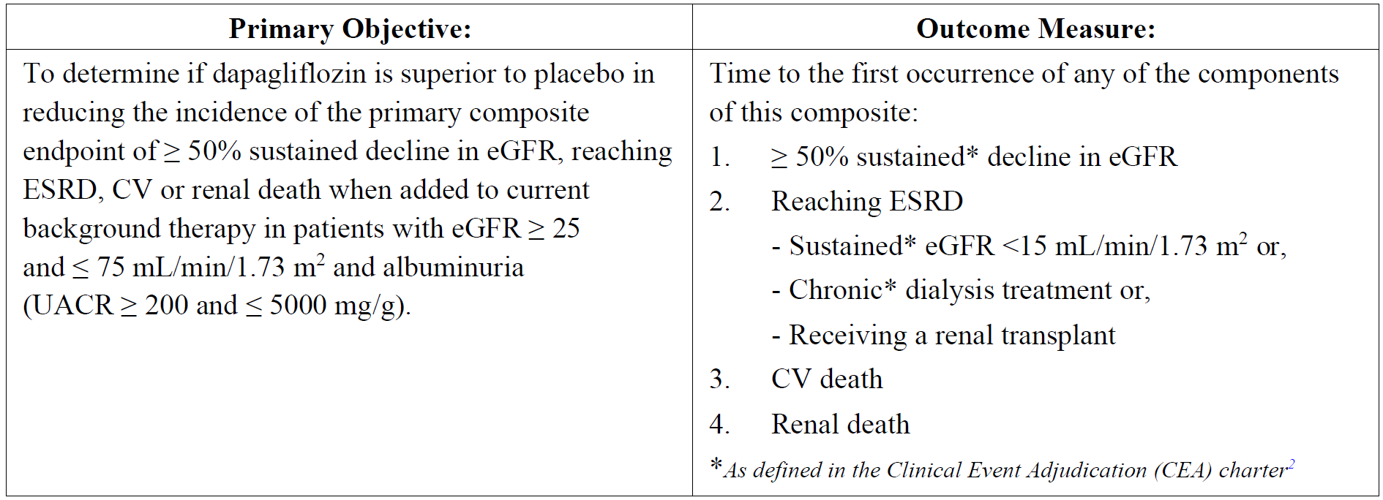

CEA = clinical event adjudication; CV = cardiovascular; eGFR = estimated glomerular filtration rate; ESRD = end stage renal disease; UACR = urine albumin creatinine ratio.

Table : Study D169AC00001 Secondary objectives

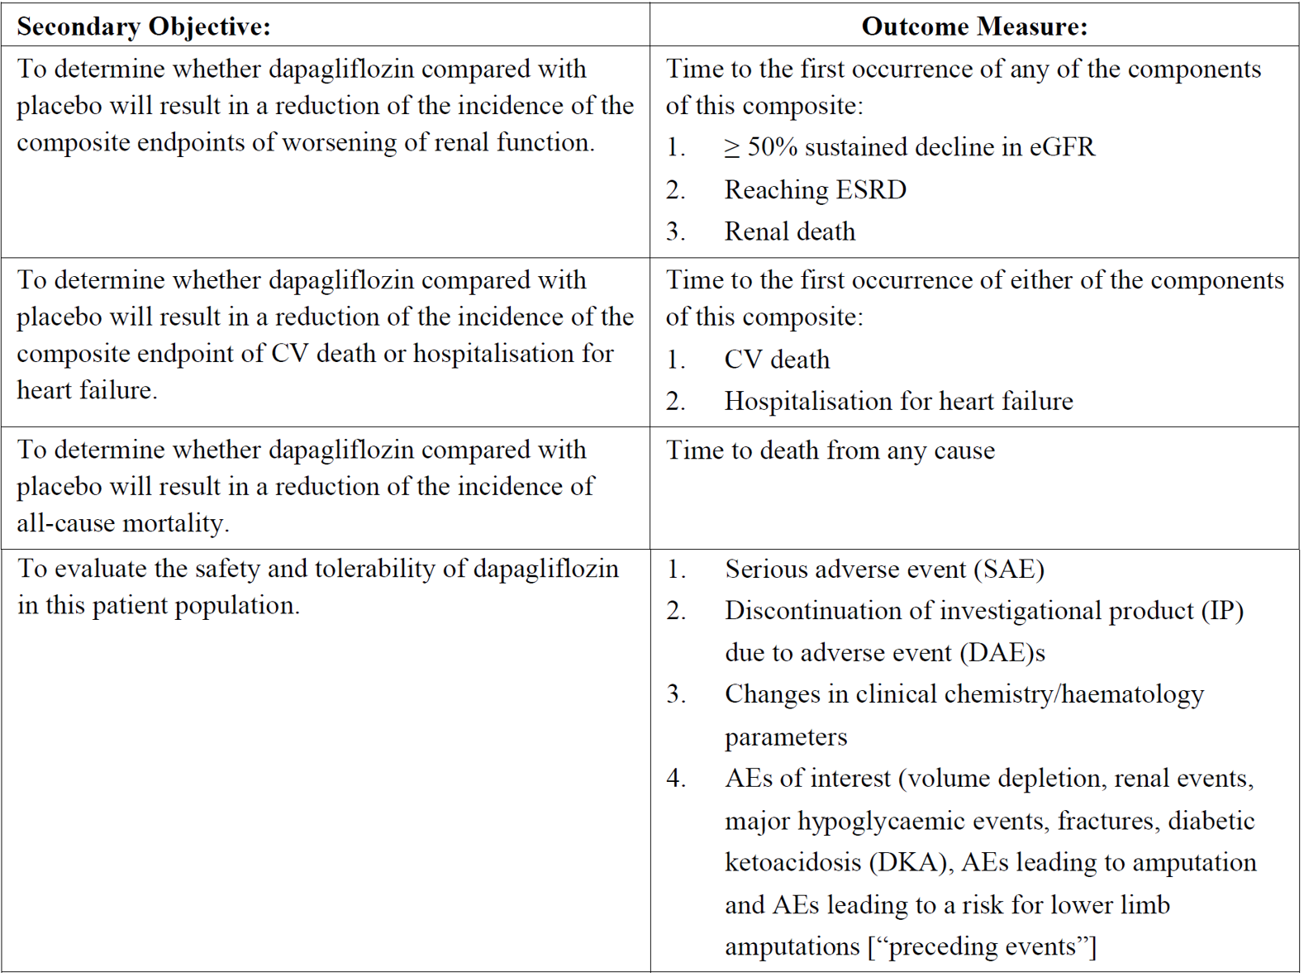

AE = adverse event; CEA = clinical event adjudication; CV = cardiovascular; DAE = discontinuation of investigational product due to adverse event; DKA = diabetic ketoacidosis; eGFR = estimated glomerular filtration rate; ESRD = end stage renal disease; IP = investigational product; SAE = serious adverse event; UACR = urine albumin creatinine ratio.

###### Inclusion and exclusion criteria

Patients included were females or males aged ≥ 18 years at the time of consent eGFR ≥ 25 and ≤ 75 mL/min/1.73 m2 at Visit 1 and evidence of increased albuminuria 3 months before Visit 1 (urine albumin to creatinine ratio (UACR) ≥ 200 and ≤ 5000 mg/g). The further inclusion criterion was that of stability of the maximum tolerated labelled daily dose of treatment with ACE inhibitors or ARB for at least 4 weeks before Visit 1. Exclusion criteria included therapy with SGLT-2 inhibitor within 8 weeks prior to enrolment or previous intolerance of an SGLT‑2 inhibitor; type 1 diabetes; New York Heart Association Class IV congestive heart failure at the time of enrolment; myocardial infarction; and unstable angina, stroke or transient ischemic attack within 12 weeks prior to enrolment.

###### Analysis populations

The target population had CKD (eGFR ≥ 25 and ≤ 75 mL/min/1.73 m2) with albuminuria (UACR ≥ 200 and ≤ 5000 mg/g) with type 2 diabetes or without diabetes. Patients with known polycystic kidney disease, glomerulonephritis with flares (lupus or anti‑neutrophil cytoplasmic antibody associated vasculitis) or ongoing active renal inflammation were excluded.

###### Statistical methods

In the analysis of the primary composite endpoint, dapagliflozin versus placebo was compared using a Cox proportional hazards model with a factor for treatment group, stratified by randomisation stratification factors (type 2 diabetes, UACR) and adjusting for baseline eGFR. A closed testing procedure using pre-specified hierarchical ordering of the primary and secondary endpoints was utilised. A one-sided 0.025 level for multiplicity across primary and secondary endpoints was applied.

###### Results

In total, 7517 patients were enrolled, 4304 were randomised and 4289 completed the study. The median time in study until the primary analysis censoring date was 27.6 months and median time until last visit was 28.5 months. In total, 13.5% of patients prematurely and permanently discontinued treatment, with similar proportions in the dapagliflozin group (12.7%) and the placebo group (14.4%).

Patient demographic characteristics were generally well balanced between treatment groups. Approximately two thirds were male, and the mean age was 61.8 years. Patients were randomised worldwide.

Baseline mean eGFR was 43.1 mL/min/1.73 m2, median UACR was 949.3 mg/g and mean systolic blood pressure was 137.1 mmHg. A total of 14.5% had an eGFR < 30 mL/min/1.73 m2 with a similar frequency between the treatment groups at randomisation. Based on clinical assessment, the most likely aetiology of the CKD was diabetic nephropathy (58.3%), ischaemia/hypertensive nephropathy (16.0%) and chronic glomerulonephritis (16.1%). A total of 67.5% of patients had type 2 diabetes and 32.5% did not have diabetes. There were comparable proportions of diabetic or non-diabetic populations in the dapagliflozin and placebo groups.

At randomisation, 97% of patients were receiving either ACE inhibitors or an ARB at randomisation. The use of ACE inhibitors or ARBs were balanced between treatment groups at randomisation. The use of ACE inhibitors, ARBs, other CKD and cardiovascular medications remained high and stable during the study and was balanced between treatment groups at randomisation. Most common other cardiovascular medications were lipid lowering agents (69.4%), calcium channel blockers (50.7%) and anti-thrombotic agents (47.4%). The most commonly used diabetes medications were insulin (55.4%), biguanides (43.0%) and sulfonylureas (26.8%), the use of diabetes medications being balanced between the treatment groups.

Results for the primary and secondary efficacy outcome

The study demonstrated that dapagliflozin was superior to placebo in reducing the incidence of the composite of a ≥ 50% sustained decline in eGFR, ESRD and renal or cardiovascular death.

Table : Study D169AC00001 Overview of confirmatory analysis of primary and secondary endpoint hierarchy (full analysis set)

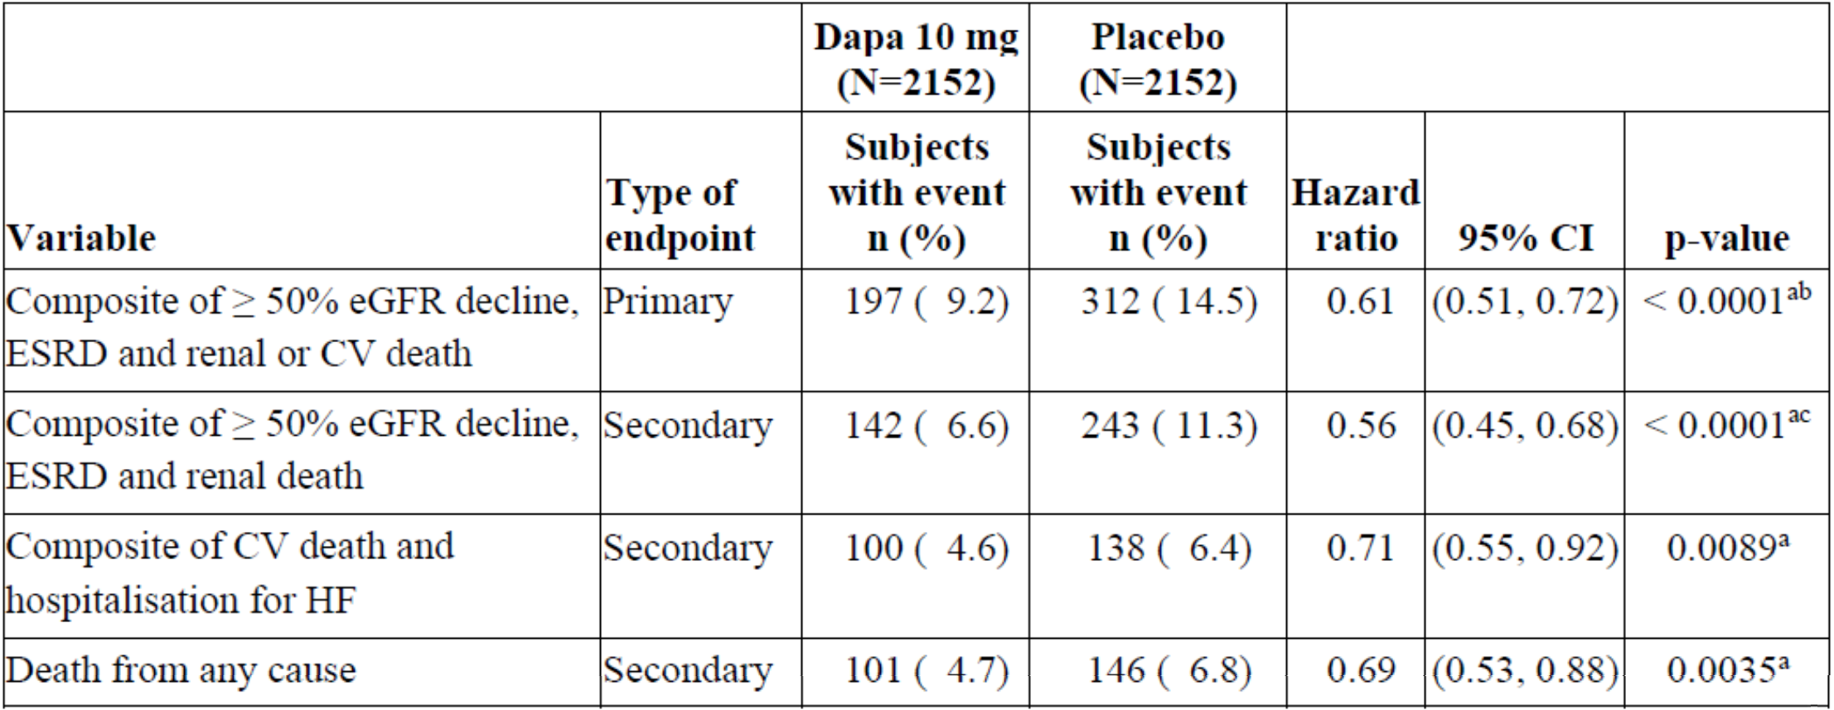

CI = confidence interval; CV = cardiovascular; Dapa = dapagliflozin; eGFR = estimated glomerular filtration rate; ESRD = end stage renal disease; HF = heart failure; N = number of subjects in treatment group; n = number of patients with event for time to first event analysis.

a. Indicates statistical significance. Statistical testing was performed in the sequence above until the first non-significant result is observed, at a two-sided significance level of 0.05.

b. Unformatted p-value 0.000000028267.

c. Unformatted p-value 0.000000017998.

The eGFR event needs to be sustained (defined two consecutive eGFR decline more than 28 days apart) to be an event, ≥ 50% eGFR decline is compared to Baseline.

Hazard ratio, CI and p-value are calculated from Cox proportional hazards model (score test) with factor for treatment group, stratified by randomisation stratification of type 2 diabetes mellitus status and urine albumin creatinine ratio, and adjusting for baseline eGFR.

Figure : Study D169AC00001 Kaplan-Meier plot of the composite of a ≥ 50% sustained estimated glomerular filtration rate decline, end stage renal disease and renal or cardiovascular death (full analysis set)

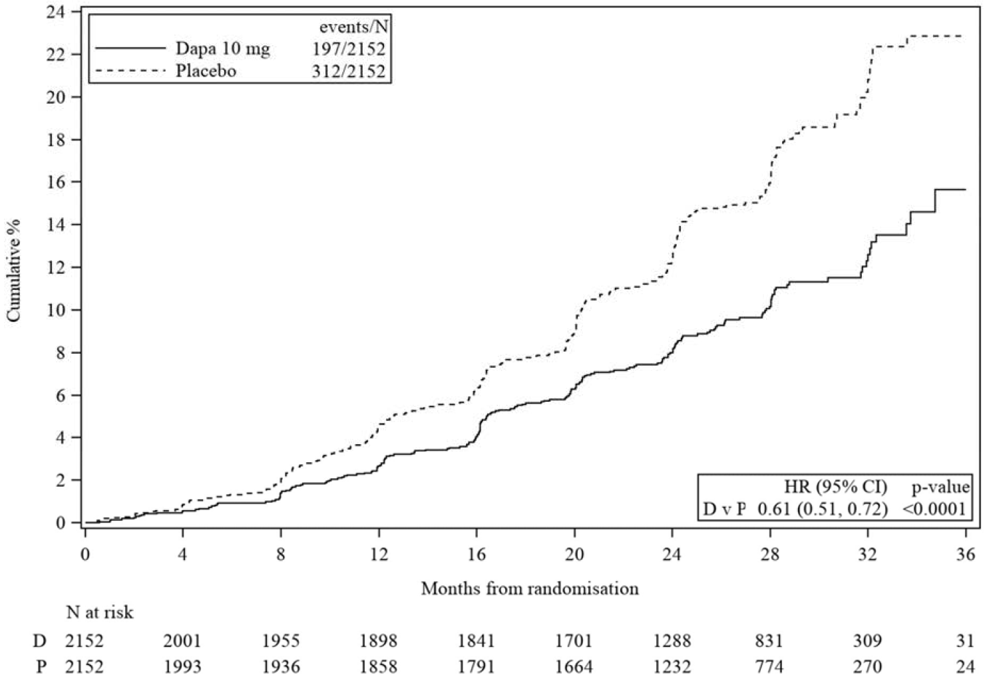

CI = confidence interval; Dapa = dapagliflozin, D = dapagliflozin 10 mg; eGFR = estimated glomerular filtration rate; HR = hazard ratio; N = number of subjects; P = placebo; v= versus.

N at risk is the number of subjects at risk at the beginning of the period. One month corresponds to 30 days. Two-sided p-value displayed. HR, CI and p-value are from the cox proportional hazard model.

Dapagliflozin was also superior to placebo for the reduction of all the secondary endpoints (renal composite endpoint without cardiovascular death, composite of cardiovascular death and hospitalisation for heart failure and all-cause mortality). These effects of dapagliflozin versus placebo were generally consistent across the analysed subgroups, in patients with type 2 diabetes or without diabetes and in subgroups based on eGFR and UACR at Baseline.

###### Exploratory analysis

Table : Study D169AC00001 Time to first event of the composite endpoint the composite of a ≥ 50% sustained estimated glomerular filtration rate decline from Baseline, end stage renal disease and renal or cardiovascular death (full analysis set)

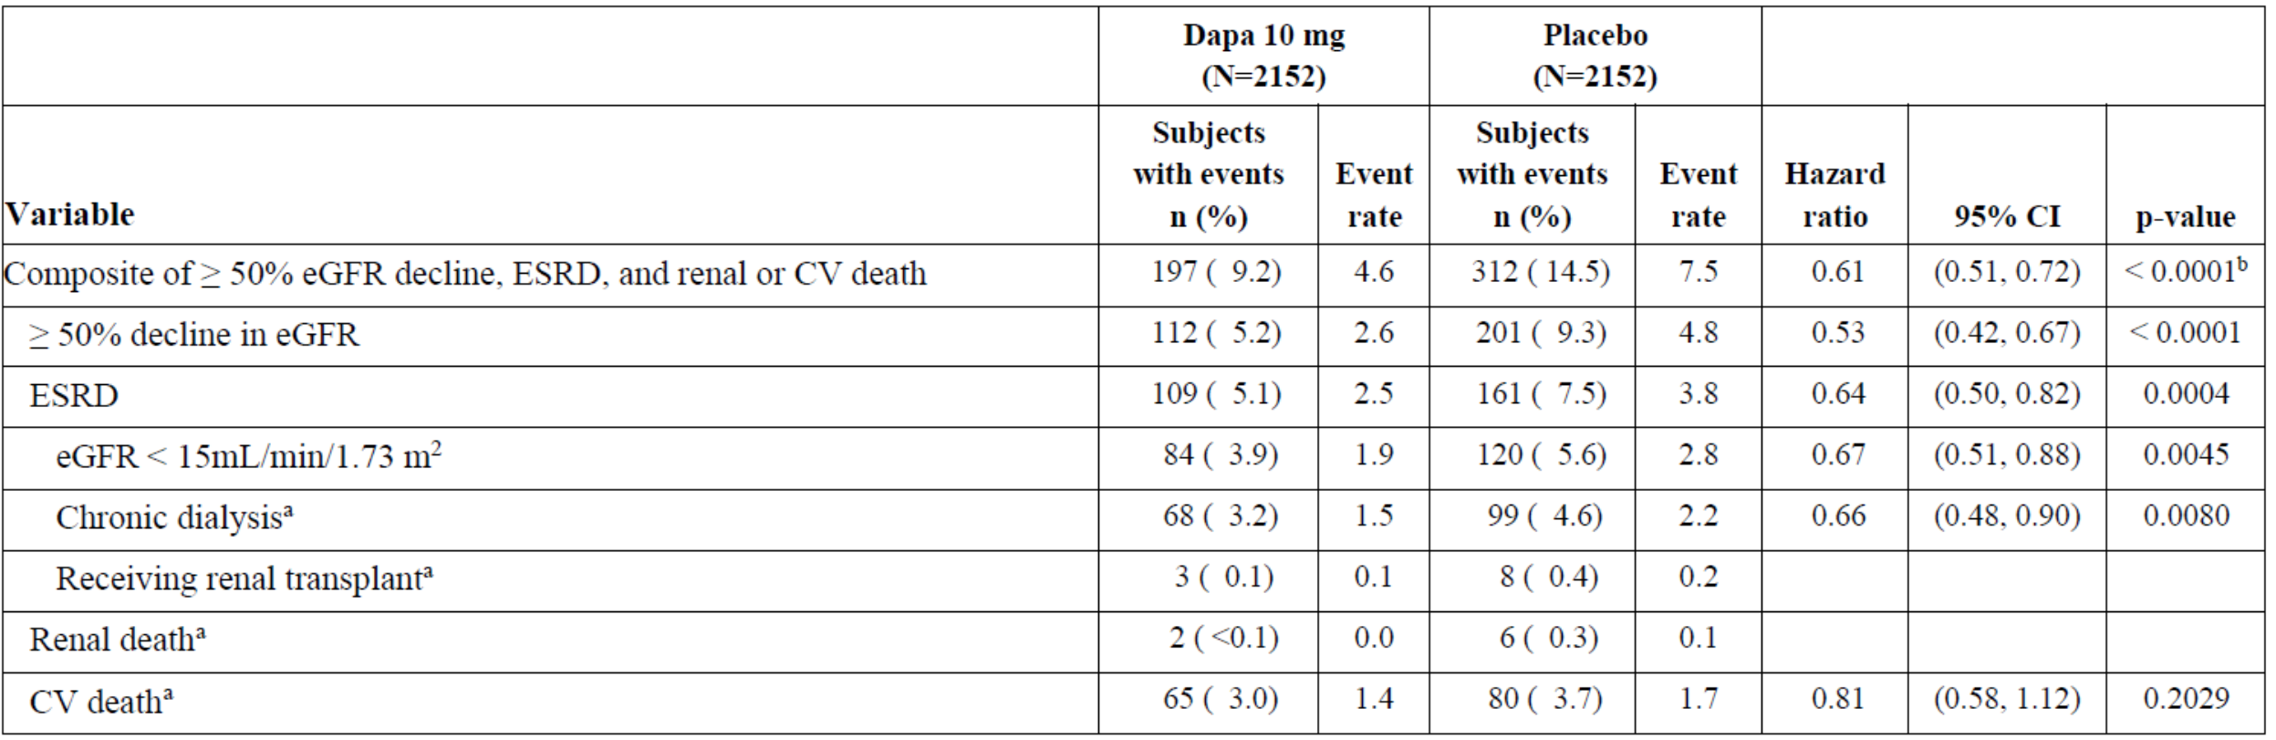

CI = confidence interval; CV = cardiovascular; Dapa = dapagliflozin; eGFR = estimated glomerular filtration rate; ESRD = end stage renal disease; N =number of subjects in treatment group; n = number of subjects included in analysis. UACR Urine albumin creatinine ratio.

a. Adjudicated.

b. Unformatted p-value 0.000000028267.

The eGFR event needs to be sustained (defined as two consecutive eGFR decline more than 28 days apart) to be an event, ≥ 50% eGFR decline is compared to Baseline.

The number of events for the individual components are the actual number of first events for each component and their sum exceeds the number of events for the composite endpoints.

Event rates are presented as the number of subjects with event per 100 patient years of follow-up.

Hazard ratio, CI and p-value are calculated from Cox proportional hazards model (score test) with factor for treatment group, stratified by randomisation stratification of type 2 diabetes mellitus status and urine albumin creatinine ratio, and adjusting for baseline eGFR.

This is not presented for variables with less than 15 events in total (both arms combined).

###### Results for other efficacy outcomes

Of the non-cardiovascular deaths, the most common categories were infections, malignancies and renal deaths.

In terms of eGFR changes, there was an initial drop in the dapagliflozin group compared with placebo and thereafter the rate of decline in renal function was reduced with dapagliflozin. The total slope in eGFR from Baseline to 30 months resulted in a difference of 0.93 mL/min/1.73 m2 (95% CI: 0.61, 1.25, p < 0.0001) between dapagliflozin and placebo.

Figure : Study D169AC00001 Adjusted mean estimated glomerular filtration rate (chronic kidney disease, epidemiology collaboration) change from Baseline and 95% confidence intervals from repeated measures model (full analysis set)

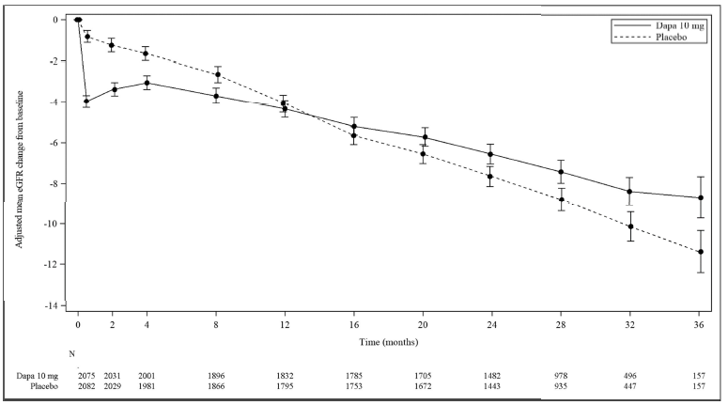CI = confidence interval; Dapa = dapagliflozin; eGFR = estimated glomerular filtration rate; N = number of patients at each visit.

The repeated measures model includes terms for randomised treatment group, baseline measurement, visit and visit by treatment group interaction.

The repeated measures model includes all windowed eGFR values through to 36 months that occur on or after first dose of study drug and on or before last dose of study drug.

One month corresponds to 30 days.

In the type 2 diabetic population, changes from Baseline in haemoglobin A1c (HbA1c)[10] from 14 days until 16 months showed a greater reduction in HbA1c compared to placebo, ranging from ‑0.05 to -0.24, representing a small change and furthermore, there were no significant differences in HbA1c between dapagliflozin and placebo from 20 months to 36 months of the study. Also, as may be expected, there was a greater reduction in weight for dapagliflozin compared to placebo from the time point of 14 days until 36 months (at 36 months the mean change from Baseline being -1.73 versus -0.93 kg in the dapagliflozin versus placebo groups, respectively (95% CI: -1.47, -0.14, p = 0.0177)).

#### Safety

The main study provided to support the extension of indication was Study D169AC00001. Duration of exposure to study drug was up to 39.0 months. The median duration exposure to study drug was similar across treatment groups, being 27.3 months in the dapagliflozin group and 27.0 months in the placebo group.

There were 90 (4.2%) patients with dose reductions in the dapagliflozin group and 61 (2.8%) for the matching placebo dose. The most frequent reason for dose reduction was AEs of 48 (2.2%) in the dapagliflozin group and 35 (1.6%) in the placebo group. Other reasons were serious adverse events (SAEs) that led to dose reductions as seen in 4 (0.2%) patients in the dapagliflozin group and 3 (0.1%) patients in the placebo group. The most common AEs that led to dose reduction of study drug were CKD and hypovolaemia in the dapagliflozin group (5 (0.2%)) and renal impairment (9 (0.4%)) in the placebo group.

Overall, numbers of subjects with AEs in any category were broadly comparable in both treatment groups and by the presence or absence of diabetes.

Table : Study D169AC00001 Number of subjects with adverse events in any category

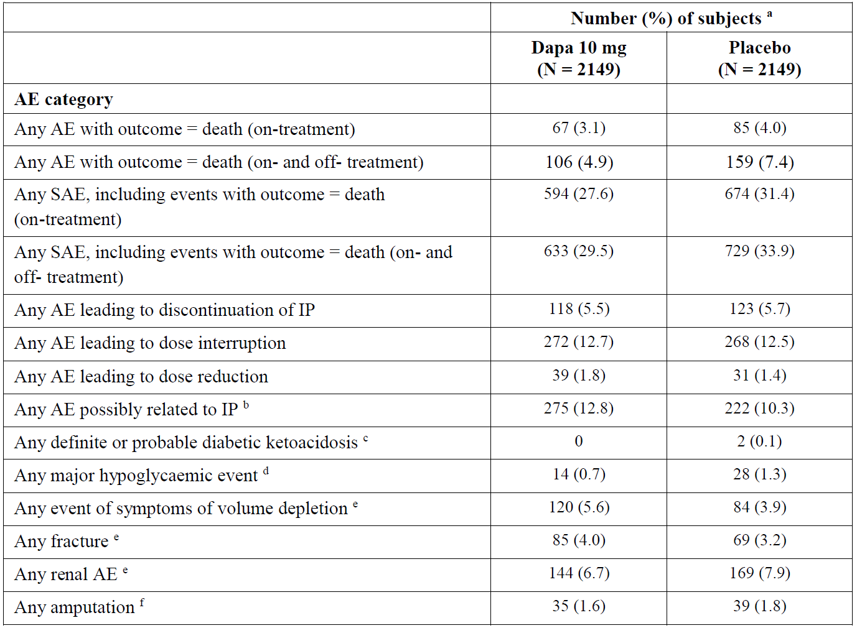

AE = adverse event; Dapa = dapagliflozin; IP = investigational product; N = total numbers of subjects in the treatment group.

a. Subjects with multiple events in the same category are counted only once in that category. Subjects with events in more than one category are counted once in each of those categories.

b. As assessed by the investigator, as with reasonable possibility caused by the IP.

c. Events adjudicated as definite or probable diabetic ketoacidosis.

d. Adverse event with the following criteria confirmed by the investigator: i) Symptoms of severe impairment in consciousness or behaviour ii) need of external assistance iii) intervention to treat hypoglycaemia iv) prompt recovery of acute symptoms following the intervention.

e. Based on predefined list of Preferred Terms.

f. Surgical or spontaneous/non-surgical amputation, excluding amputation due to trauma.

Fractures and amputations are presented for the on- and off-treatment period; AEs with outcome death and serious adverse events are presented for both the on-treatment and on- and off-treatment periods. All other safety variables are presented for the on-treatment period (AE onset date on or after date of first dose and up to and including 30 days following last dose of study drug). When summarising AEs leading to discontinuation, interruption, or dose reduction no upper cut-off day window (that is, 30 days from last dosing date) was applied. Percentages are based on the total numbers of subjects in the treatment group.

With regard to AEs of symptoms of volume depletion, there were however greater numbers of patients in the dapagliflozin group (120, 5.6%) versus the placebo group (84, 3.9%). However, SAEs of volume depletion were similar in rate for the dapagliflozin and placebo groups (0.7% for both). Very few patients discontinued study drug due to AEs of symptoms of volume depletion, being four in the dapagliflozin group and one in the placebo group. Most reported events were mild in intensity. AE profiles by subgroups (age ≤ 65 years, age > 65 years, eGFR < 45 and ≥ 45 mL/min/1.73 m2, baseline systolic blood pressure ≤ 130 or > 130 mmHg) were generally consistent with the overall results.

In terms of renal AEs of special interest, there were similar numbers of patients with any renal AE in the dapagliflozin versus placebo group. Subgroup analyses per age and baseline eGFR were again consistent with the overall results.

Table : Study D169AC00001 Summary of renal adverse events - on treatment (safety analysis set)

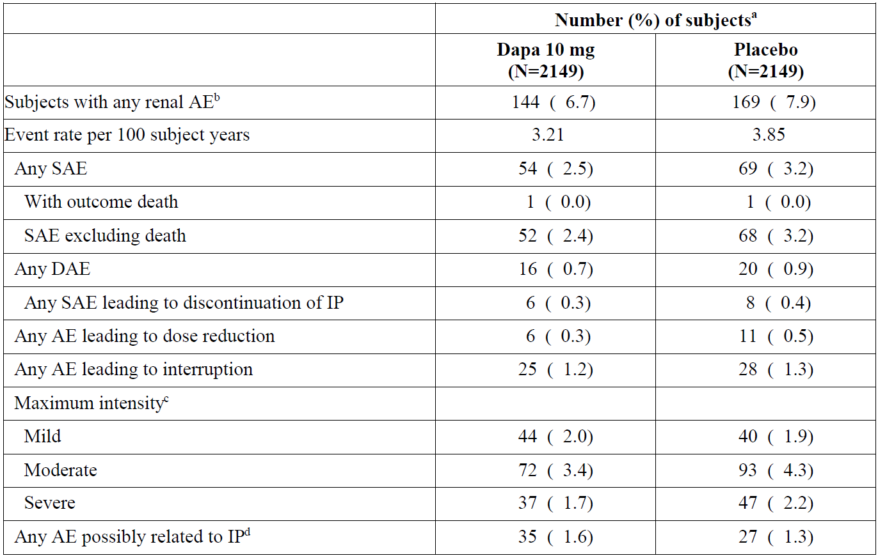

AE = adverse event; Dapa = dapagliflozin; DAE = adverse event leading to discontinuation of investigational product; IP = investigational product, N = total numbers of subjects in the treatment group.

a Subjects with multiple events in the same category are counted only once in that category. Subjects with events in more than one category are counted once in each of those categories.

b Based on predefined list of Preferred Terms.

c As reported by the investigator for each event.

d As assessed by the investigator, as with reasonable possibility caused by the IP.

The event rate is calculated as 100 times the number of patients with event, divided by the total duration of treatment (including 30 days after last dose) in the given group. This table includes AEs with an onset date on or after date of first dose and up to and including 30 days following last dose of study drug. Percentages are based on the total numbers of subjects in the treatment group.

Events of diabetic ketoacidosis (DKA) were uncommon and not greater in incidence in the dapagliflozin versus placebo group (22: 1.0% and 20: 0.9%, respectively). No event of DKA was reported for patients without diabetes.

There were low numbers of major hypoglycaemia, occurring in 14 patients (0.7%) with dapagliflozin and 28 (1.3%) with placebo. There were no major hypoglycaemic events reported for patients without diabetes. There were no significant differences when hypoglycaemic events were analysed by subgroup according to age or baseline eGFR.

There were low numbers of fractures, being comparable in the dapagliflozin versus placebo group. Moreover, there was no indication of heightened risk of fractures with dapagliflozin in patients at higher risk including female patients, the elderly and patients with low renal function.

Events of amputation and Fournier’s gangrene were uncommon and comparable in both treatment groups.

In terms of deaths, there were numerically fewer deaths in the dapagliflozin group than in the placebo group (67: 3.1% and 85: 4.0%, respectively). These were also comparable for subgroup analyses by age, renal function and diabetes status. Most deaths were in the category of cardiac disorders.

In terms of SAEs, there were fewer patients in the dapagliflozin group versus placebo (594, 27.6% versus 674, 31.4%, respectively). The most commonly reported SAEs were acute kidney injury, pneumonia and cardiac failure in the dapagliflozin and placebo groups. Sub-group analyses according to age, renal function and diabetic versus non‑diabetic status showed results consistent with the overall population.

Treatment discontinuation rates were similar between the treatment groups, the most commonly reported events that led to permanent discontinuation being CKD, GFR decrease and renal impairment in the dapagliflozin treatment group and renal impairment, GFR decreased and ESRD in the placebo group. These results were also consistent with age and baseline GFR analyses.

In terms of laboratory testing, there were no clinically relevant changes in haematology over time although, as expected, there was an increase in haemoglobin seen in the dapagliflozin group versus placebo group to the last treatment value (+3.9 g/L in the dapagliflozin group and -3.2 g/L in the placebo group). There was an initial increase in mean serum creatinine more pronounced in the dapagliflozin group than in the placebo group, as might be expected. However, this difference disappeared over the course of the study, the mean change from Baseline becoming greater in the placebo group. This was mirrored by changes in mean eGFR, as mentioned in the efficacy section above.

### Risk management plan

The most recently evaluated EU-risk management plan (RMP) was version 18 succession 1 (dated 24 October 2019; data lock point (DLP) 30 September 2019) and Australia specific annex (ASA) version 11 succession 1 (dated 8 November 2019). The sponsor submitted EU-RMP version 19 succession 3 (dated 8 May 2020; DLP 5 December 2019) and ASA version 12 succession 1 (dated 16 August 2020) as an RMP update, however it was not reviewed as the EU-RMP was not approved. In support of the extended indications, the sponsor has submitted EU-RMP version 22 succession 1 (dated 25 October 2020; DLP 17 July 2020) and ASA version 13.0 succession 1 (dated 12 November 2020).

The summary of safety concerns and their associated risk monitoring and mitigation strategies are summarised in Table 9.[11]

Table : The summary of safety concerns

|  |  |  |  |  |  |
| --- | --- | --- | --- | --- | --- |
| Summary of safety concerns | | Pharmacovigilance | | Risk minimisation | |
| **Routine** | **Additional** | **Routine** | **Additional** |
| **Important identified risks** | Urinary tract infection | ✓* | ✓† | ✓ | – |
| Renal impairment | ✓* | ✓† | ✓ | – |
| Diabetic ketoacidosis including events with atypical presentation | ✓* | ✓‡ | ✓ | – |
| **Important potential risks** | Liver injury | ✓* | ✓† | – | – |
| Amputation (ASA); Lower limb amputation (EU-RMP) | ✓* | ✓§ | – | – |
| Bladder cancer | ✓* | ✓† | – | – |
| Breast cancer | ✓* | ✓† | – | – |
| Prostate cancer | ✓* | ✓† | – | – |
| **Missing information** | Use in patients with New York Heart Association (NYHA) class IV | – | – | ✓ | – |

* Targeted questionnaire

† Observational studies

‡ Nonclinical mechanistic model study

§ Clinical trials

* The sponsor does not propose any new safety concerns for the CKD extension of indication in either the ASA or the EU-RMP. The summary of safety concerns is acceptable.
* Routine and additional pharmacovigilance is proposed for all safety concerns apart from missing information. Although additional pharmacovigilance is not listed for missing information in the summary of safety concerns table in the ASA, it is considered that studies in the ASA address this safety concern. The pharmacovigilance plan has not changed significantly from the previously reviewed ASA. In the response to rolling questions sent 25 March 2021, the sponsor provided adequate justification for not including the DETERMINE trial in the pharmacovigilance plan for the ‘use in patients with New York Heart Association’ safety concern. The pharmacovigilance plan is acceptable

### Risk-benefit analysis

#### Delegate’s considerations

The Delegate made a decision under the Therapeutic Goods Act 1989 in relation to quality, safety and efficacy.

##### Efficacy

The conduct of the popPK study provided in support of the current submission appears to be satisfactory. The dose of dapagliflozin 10 mg daily was used, as this is a currently registered dose used in type 2 diabetes, is well tolerated and in a post hoc analyses in patients with CKD and albuminuria had shown that this dose effectively reduces renal risk markers (blood pressure and albuminuria, independent of the glucose lowering effect).

Study D169AC00001 was a multicentre event-driven, randomised, double blind, parallel group, placebo controlled study evaluating dapagliflozin 10 mg versus placebo given once daily in addition to standard of care, to prevent the progression of CKD and renal or cardiovascular death.

The primary objective was to determine if dapagliflozin is superior to placebo in reducing the incidence of the primary composite endpoint (≥ 50% decline in eGFR, ESRD, cardiovascular or renal death) when added to background treatment in patients with eGFR ≥ 25 and ≤ 75 mL/min/1.73 m2 and albuminuria (UACR ≥ 200 and ≤ 5000 mg/g). According to the sponsor’s rationale, the primary outcome measure was based on the requirements of the CHMP guideline.[12] Which states that a composite endpoint of ≥ 50% sustained decline in eGFR, ESRD, and renal death (death due to ESRD when dialysis is not given) are acceptable outcome measures. cardiovascular mortality was added as a component of the composite endpoint since cardiovascular mortality in the population being studied is high and the risk for cardiovascular death correlates with the risk of developing ESRD.

Study D169AC00001 met its primary objective demonstrating that dapagliflozin was superior to placebo in reducing the incidence of the composite of a ≥ 50% sustained decline in eGFR, ESRD and renal or cardiovascular death. When components of the composite end point were analysed, there was a statistically significant reduction in all of these. The question for discussion at the Advisory Committee on Medicines (ACM)13 meeting is about the appropriateness of the components of the composite endpoint and is the proposed indication a correct reflection of this.

The Delegate proposes that the indication should include the components of primary composite endpoint used in the pivotal study (Study D169AC00001) submitted to support this indication.

Delegates’ proposed indication:

*Forxiga is indicated in adults for the treatment of chronic kidney disease to reduce the risk of sustained eGFR decline, end stage kidney disease, renal or cardiovascular death.*

Secondary objectives were to determine whether dapagliflozin versus placebo results in a reduction in the incidence of the composite endpoints of worsening of renal function; to determine whether dapagliflozin compared to placebo results in a reduction in the incidence of the composite endpoint of cardiovascular death or hospitalisation for heart failure; and to determine whether dapagliflozin compared with placebo results in a reduction in the incidence of all-cause mortality. The secondary objectives of the study were also met.

##### Safety

Patients with CKD represent a high risk patient population due to the nature of the disease and high prevalence of comorbidities. The safety assessment was based on the Phase III Study D169AC00001. As might be expected, there were heightened numbers of patients on dapagliflozin with volume depletion without an increase in SAEs. Most of these cases were mild in intensity. Patients with renal AEs including acute injury were lower in the dapagliflozin group. The number of patients who had an amputation was balanced between treatment groups. There were no other trends in clinical, metabolic or laboratory testing with dapagliflozin versus placebo.

#### Proposed action

Dapagliflozin demonstrated superiority over placebo in reducing the incidence of the primary composite endpoint (≥ 50% decline in eGFR, ESRD, cardiovascular or renal death) when added to background treatment in patients with eGFR ≥ 25 and ≤ 75 mL/min/1.73 m2 and albuminuria (UACR ≥ 200 and ≤ 5000 mg/g). These effects were consistent across diabetic and non-diabetic populations. However most patients had type 2 diabetes mellitus. Patients with renal disease due to autoimmune conditions were not included.

The large Phase III dapagliflozin versus placebo study group to 36 months did not show any new safety issues with dapagliflozin. The safety profile observed in the Study D169AC00001 is consistent with the known safety profile of dapagliflozin.

Delegate considers that Forxiga (dapagliflozin) demonstrated a positive benefit risk profile based on Study D169AC00001. The question for discussion at the ACM is about the appropriateness of the components of the composite endpoint and is the proposed indication a correct reflection of this.

The Delegate proposes that the indication should include the components of primary composite endpoint used in the pivotal study (Study D169AC00001) submitted to support this indication.

Delegates’ proposed indication:

*Forxiga is indicated in adults for the treatment of chronic kidney disease to reduce the risk of sustained eGFR decline, end stage kidney disease, renal or cardiovascular death.*

#### Advisory Committee considerations[13]

The Advisory Committee on Medicines (ACM), having considered the evaluations and the Delegate’s overview, as well as the sponsor’s response to these documents, advised the following.

##### Specific advice to the Delegate

1. ***Are the components of the composite endpoint in Study D169AC00001 (DAPA-CKD trial) appropriate?***

The ACM noted that the purpose of the DAPA-CKD trial was to prevent the progression of CKD and renal or cardiovascular death, and were of the view that the components of the composite primary endpoint, namely 50% sustained decline in eGFR, reaching ESRD, cardiovascular or renal death, were appropriate.

The ACM noted that the components within the endpoint would be of similar importance to patients and clinicians, are closely linked and shared similar relative risk reductions (or hazard ratios) within the study.

Overall, the ACM agreed that the composite endpoint was clinically relevant for the study.

1. ***Please advise on the wording of the indication.***

The ACM were of the view that the indication should be worded to ensure that treatment is focussed on those with disease progression.

The ACM recommended that ‘adults with proteinuric chronic kidney disease’ should be included in the indication, as proteinuric chronic kidney disease is a main indicator of CKD that carries the highest risk of progression

Based on this the ACM recommended the following wording for the indication:

*Forxiga is indicated to reduce the risk of progressive decline in kidney function in adults with proteinuric chronic kidney disease (CKD Stage 2, 3 or 4 and urine ACR ≥ 30 mg/mmol).*

1. ***Other advice?***

The ACM noted that there is a small but recognised risk of nonketotic diabetic ketoacidosis, particularly for patients with type 2 diabetes mellitus. As such, the ACM were of the view that the PI and CMI [Consumer Medicines Information] should include appropriate precautions regarding diabetic ketoacidosis for all users, which should include a suspension of treatment for two days prior to major surgery.

The ACM agreed that it may be beneficial to provide a clear definition of CKD to assist prescribers and reiterated that treatment with Forxiga should be focused on those with the recognised risk of disease progression, noting that it may not be appropriate for certain populations as outlined within the PI.

##### Conclusion

The ACM considered this product to have an overall positive benefit-risk profile for the indication:

*Forxiga is indicated to reduce the risk of progressive decline in kidney function in* *adults with proteinuric chronic kidney disease (CKD Stage 2, 3 or 4 and urine ACR ≥ 30 mg/mmol).*

### Outcome

Based on a review of quality, safety and efficacy, the TGA approved the registration of Forxiga (dapagliflozin) 10 mg, film coated tablet, blister pack, for the following extension of indications:

***Chronic kidney disease***

*Forxiga is indicated to reduce the risk of progressive decline in kidney function in adults with proteinuric chronic kidney disease (CKD Stage 2,3 or 4 and urine ACR ≥ 30 mg/g)*

As such, the full indications at this time were:

***Type 2 diabetes mellitus***

*Glycaemic control*

*Forxiga is indicated in adults with type 2 diabetes mellitus:*

* + *as monotherapy as an adjunct to diet and exercise in patients for whom metformin is otherwise indicated but was not tolerated.*
  + *as initial combination therapy with metformin, as an adjunct to diet and exercise, to improve glycaemic control when diet and exercise have failed to provide adequate glycaemic control and there are poor prospects for response to metformin monotherapy (for example, high initial haemoglobin A1c (HbA1c) levels).*
  + *in combination with other anti-hyperglycaemic agents to improve glycaemic control, when these together with diet and exercise, do not provide adequate glycaemic control (see Section 5.1 Pharmacodynamic properties - Clinical trials and Section 4.4 Special warnings and precautions for use for available data on different add-on combination therapies).*

*Prevention of hospitalisation for heart failure*

*Forxiga is indicated in adults with type 2 diabetes mellitus and established cardiovascular disease or risk factors for cardiovascular disease to reduce the risk of hospitalization for heart failure (see Section 5.1 Pharmacodynamic properties - Clinical trials).*

***Heart failure***

*Forxiga is indicated in adults for the treatment of symptomatic heart failure with reduced ejection fraction, as an adjunct to standard of care therapy (see Section 5.1 Pharmacodynamic properties).*

***Chronic kidney disease***

*Forxiga is indicated to reduce the risk of progressive decline in kidney function in adults with proteinuric chronic kidney disease (CKD Stage 2,3 or 4 and urine ACR ≥ 30 mg/g)*

#### Specific conditions of registration applying to these goods

* The Forxiga EU-risk management plan (RMP) (version 22 Succession 1, dated 25 October 2020, data lock point 17 July 2020), with Australian specific annex (version 13.0 Succession 1, dated 12 November 2020), included with Submission PM‑2020‑06068-1-5, to be revised to the satisfaction of the TGA, will be implemented in Australia.

An obligatory component of risk management plans is routine pharmacovigilance. Routine pharmacovigilance includes the submission of periodic safety update reports (PSURs).

Reports are to be provided in line with the current published list of EU reference dates and frequency of submission of PSURs until the period covered by such reports is not less than three years from the date of the approval letter.

The reports are to at least meet the requirements for PSURs as described in the European Medicines Agency’s guideline on Good Pharmacovigilance Practices (GVP) Module VII-periodic safety update report (Rev 1), Part VII.B Structures and processes. Note that submission of a PSUR does not constitute an application to vary the registration.

## Attachment 1. Product Information

The PI for Forxiga approved with the submission which is described in this AusPAR is at Attachment 1. For the most recent PI, please refer to the TGA website at <<https://www.tga.gov.au/product-information-pi>>.

|  |
| --- |
| Therapeutic Goods Administration |
| PO Box 100 Woden ACT 2606 Australia  Email: [info@tga.gov.au](mailto:info@tga.gov.au) Phone: 1800 020 653 Fax: 02 6232 8605  [**https://www.tga.gov.au**](https://www.tga.gov.au) |

1. The **Black Triangle Scheme** provides a simple means for practitioners and patients to identify certain types of new prescription medicines, including those being used in new ways and to encourage the reporting of adverse events associated with their use. The Black Triangle does not denote that there are known safety problems, just that the TGA is encouraging adverse event reporting to help us build up the full picture of a medicine's safety profile.
2. Australian Bureau of Statistics (ABS) Australian Health Survey: Biomedical Results for Chronic Diseases, released on 5 August 2013. Available at: <https://www.abs.gov.au/statistics/health/health-conditions-and-risks/australian-health-survey-biomedical-results-chronic-diseases/latest-release> (accessed on 15 February 2022).
3. Australian Institute of Health and Welfare (AIHW) (2019) National Mortality Database, findings based on unit record analysis, Canberra. Available at: <https://www.aihw.gov.au/about-our-data/our-data-collections/national-mortality-database> (accessed 15 February 2022).
4. Australian Institute of Health and Welfare (AIHW) (2019) National Hospital Morbidity Database, findings based on unit record analysis, Canberra. Available at: <https://www.aihw.gov.au/about-our-data/our-data-collections/national-hospitals-data-collection> (accessed 15 February 2022).
5. Australian Institute of Health and Welfare (AIHW) Chronic Kidney Disease, released on 23 July 2020. Available at: <https://www.aihw.gov.au/reports/australias-health/chronic-kidney-disease> (accessed 15 February 2022).
6. Perkovic, V. et al. Canagliflozin and Renal Outcomes in Type 2 Diabetes and Nephropathy, *N Engl J Med,* 2019; 380(24): 2295-2306.
7. National Institutes of Health (NIH) United States Renal Data System, 2018, Vol 2, Chapter 5.
8. The TGA has implemented a **priority pathway** for the registration of novel prescription medicines for Australian patients. The priority pathway provides a formal mechanism for faster assessment of vital and life-saving prescription medicines. The target timeframe of 150 working days is up to three months shorter than the standard prescription medicines registration process.
9. The Delegate’s overall benefit-risk assessment and request for Advisory Committee advice has been revised. It was reissued on 19 July 2021.
10. **Haemoglobin A1c or glycated haemoglobin (HbA1c)** is a minor component of haemoglobin chemically linked to glucose. Levels of HbA1c vary and are relative to the overall blood glucose concentration. Unlike a blood glucose concentration, levels of HbA1c are not influenced by daily fluctuations in the blood glucose concentration but reflect the average glucose levels over the prior 6 to 8 weeks. Measurement of HbA1c is used in the diagnosis of diabetes mellitus and is useful indicator of how well the blood glucose level has been controlled in the recent past and may be used to monitor the effects of diet, exercise, and drug therapy on blood glucose in patients with diabetes. In healthy people without diabetes, the HbA1c level is less than 7 percent of total haemoglobin.
11. *Routine risk minimisation* activities may be limited to ensuring that suitable warnings are included in the product information or by careful use of labelling and packaging.

    *Routine pharmacovigilance* practices involve the following activities:

    All suspected adverse reactions that are reported to the personnel of the company are collected and collated in an accessible manner;

    Reporting to regulatory authorities;

    Continuous monitoring of the safety profiles of approved products including signal detection and updating of labelling;

    Submission of PSURs;

    Meeting other local regulatory agency requirements.
12. European Medicines Agency (EMA), Committee for Medicinal Products for Human Use (CHMP), Guideline on the clinical investigation of medicinal products to prevent development/slow progression of chronic renal insufficiency, EMA/CHMP/500825/2016, 15 September 2016.
13. The ACM provides independent medical and scientific advice to the Minister for Health and the Therapeutic Goods Administration (TGA) on issues relating to the safety, quality and efficacy of medicines supplied in Australia including issues relating to pre-market and post-market functions for medicines. Further information on TGA statutory advisory committees can be found here: <https://www.tga.gov.au/tga-statutory-advisory-committees>.