|  |
| --- |
| **July 2020** |

|  |
| --- |
| Australian Public Assessment Report for Darolutamide |
| Proprietary Product Name: Nubeqa |
| Sponsor: Bayer Australia Limited |

About the Therapeutic Goods Administration (TGA)

* The Therapeutic Goods Administration (TGA) is part of the Australian Government Department of Health and is responsible for regulating medicines and medical devices.
* The TGA administers the *Therapeutic Goods Act 1989* (the Act), applying a risk management approach designed to ensure therapeutic goods supplied in Australia meet acceptable standards of quality, safety and efficacy (performance) when necessary.
* The work of the TGA is based on applying scientific and clinical expertise to decision-making, to ensure that the benefits to consumers outweigh any risks associated with the use of medicines and medical devices.
* The TGA relies on the public, healthcare professionals and industry to report problems with medicines or medical devices. TGA investigates reports received by it to determine any necessary regulatory action.
* To report a problem with a medicine or medical device, please see the information on the TGA website <<https://www.tga.gov.au>>.

About AusPARs

* An Australian Public Assessment Report (AusPAR) provides information about the evaluation of a prescription medicine and the considerations that led the TGA to approve or not approve a prescription medicine submission.
* AusPARs are prepared and published by the TGA.
* An AusPAR is prepared for submissions that relate to new chemical entities, generic medicines, major variations and extensions of indications.
* An AusPAR is a static document; it provides information that relates to a submission at a particular point in time.
* A new AusPAR will be developed to reflect changes to indications and/or major variations to a prescription medicine subject to evaluation by the TGA.

Copyright

© Commonwealth of Australia 2020  
This work is copyright. You may reproduce the whole or part of this work in unaltered form for your own personal use or, if you are part of an organisation, for internal use within your organisation, but only if you or your organisation do not use the reproduction for any commercial purpose and retain this copyright notice and all disclaimer notices as part of that reproduction. Apart from rights to use as permitted by the *Copyright Act 1968* or allowed by this copyright notice, all other rights are reserved and you are not allowed to reproduce the whole or any part of this work in any way (electronic or otherwise) without first being given specific written permission from the Commonwealth to do so. Requests and inquiries concerning reproduction and rights are to be sent to the TGA Copyright Officer, Therapeutic Goods Administration, PO Box 100, Woden ACT 2606 or emailed to <[tga.copyright@tga.gov.au](mailto:tga.copyright@tga.gov.au)>.

Contents

Common abbreviations 4

I. Introduction to product submission 6

Submission details 6

Product background 7

Regulatory status 8

Product Information 9

II. Registration timeline 9

III. Submission overview and risk/benefit assessment 10

Quality 10

Nonclinical 10

Clinical 10

Risk management plan 18

Risk-benefit analysis 19

Outcome 22

Attachment 1. Product Information 23

## Common abbreviations

|  |  |
| --- | --- |
| Abbreviation | Meaning |
| ADT | Androgen deprivation therapy |
| AE | Adverse event |
| AR | Androgen receptor |
| ARAMIS | Androgen Receptor Antagonizing Agent for Metastasis-free Survival (clinical trial) |
| ASA | Australian specific Annex |
| AST | Aspartate aminotransferase |
| AUC | Area under the plasma concentration-time curve |
| BCRP | Breast cancer resistance protein |
| BICR | Blinded independent central review |
| CI | Confidence interval |
| Cmax | Maximum observed drug concentration |
| CMI | Consumer Medicines Information |
| CRPC | Castration-resistant prostate cancer |
| CT | Computed tomography |
| CYP3A4 | Cytochrome P450 family 3 subfamily A member 4 |
| DLP | Data lock point |
| EAIR | Exposure-adjusted incidence rate |
| eGFR | Estimated glomerular filtration rate |
| EU | European Union |
| FDA | Food and Drug Administration (USA) |
| GnRH | Gonadotropin-releasing hormone |
| HR | Hazard ratio |
| HRQoL | Health-related quality of life |
| ITT | Intention-to-treat |
| mCRPC | Metastatic castration-resistant prostate cancer |
| MFS | Metastasis-free survival |
| MRI | Magnetic resonance imaging |
| NE | Non estimable |
| nmCRPC | Non-metastatic castration resistant prostate cancer |
| NYHA | New York Heart Association |
| OS | Overall survival |
| PET | Positron emission tomography |
| PFS | Progression-free survival |
| Pgp | P-glycoprotein |
| PI | Product Information |
| PK | Pharmacokinetic(s) |
| PSA | Prostate specific antigen |
| PSADT | Prostate specific antigen doubling time |
| PSMA | Prostate specific membrane antigen |
| PY | Patient year |
| RMP | Risk management plan |
| SAE | Serious adverse event(s) |
| SSE | Symptomatic skeletal event |
| TEAE | Treatment emergent adverse event(s) |
| TTPP | Time to pain progression |
| UDP | Uridine phosphorylase |
| UGT1A1 | Uridine phosphorylase-glucuronosyltransferase family 1 member A1 |
| UGT1A9 | Uridine phosphorylase-glucuronosyltransferase family 1 member A9 |
| USA | United States of America |
| VcaP | Vertebral-Cancer of the Prostate |

## I. Introduction to product submission

### Submission details

|  |  |
| --- | --- |
| *Type of submission:* | New chemical entity |
| *Decision*: | Approved |
| *Date of decision:* | 20 February 2020 |
| *Date of entry onto ARTG:* | 26 February 2020 |
| *ARTG numbers:* | 316417, 317242 |
| *Black Triangle Scheme* | Yes  This product will remain in the scheme for 5 years, starting on the date the product is first supplied in Australia. |
| *Active ingredient:* | Darolutamide |
| *Product name:* | Nubeqa |
| *Sponsor’s name and address:* | Bayer Australia Limited  875 Pacific Highway, Pymble NSW 2073 |
| *Dose form:* | Film coated tablet |
| *Strength:* | 300 mg |
| *Containers:* | Blister pack, bottle |
| *Pack sizes:* | Blister pack: 112 tablets (7 x 16)  Bottle: 120 tablets |
| *Approved therapeutic use:* | *Nubeqa is indicated for the treatment of patients with non‑metastatic castration resistant prostate cancer (nmCRPC)* |
| *Route of administration:* | Oral |
| *Dosage:* | The recommended dose is 600 mg (two film-coated tablets of 300 mg) darolutamide taken twice daily, equivalent to a total daily dose of 1200 mg.  Patients receiving Nubeqa should also receive a gonadotropin-releasing hormone (GnRH) analogue concurrently or should have had bilateral orchiectomy.  For further information refer to the Product Information (PI). |

### Product background

This AusPAR describes the application by Bayer Australia Limited (the sponsor) to register Nubeqa (darolutamide) 300 mg film coated tablet for the following proposed indication:

*Nubeqa is indicated for the treatment of patients with non-metastatic castration resistant prostate cancer (nmCRPC).*

Non-metastatic castration-resistant prostate cancer (nmCRPC) is defined by rising serum prostate specific antigen (PSA) in the setting of castrate levels of testosterone and no radiographic evidence of distant metastatic disease. Patients with nmCRPC are at higher risk of metastatic disease and prostate cancer-specific death. In patients with nmCRPC, higher baseline PSA and shorter PSA doubling time (PSADT) are associated with shorter time to metastasis and death;[1],[2],[3] but there is currently no international consensus on a definition of high risk nmCRPC. Progression to metastatic disease is associated with increased morbidity and mortality, so treatments that can prevent or delay the onset of distant metastases are of clinical benefit.

Activation of androgen receptor (AR) signalling is an important process for prostate cancer growth.[4],[5] Treatment methods for prostate cancer have targeted testosterone production or action. However, despite androgen-deprivation therapies, most prostate cancer patients build up a resistance to the treatments and develop a more aggressive form of the disease called castration-resistant prostate cancer (CRPC).[6] This resistance can develop as a result of over-expression of the AR or mutations in the AR, resulting in AR signalling in the absence of ligand or in response to very low levels of ligand. At the time the submission was under consideration, two androgen receptor antagonists were registered in Australia for the treatment of nmCRPC:

* Erlyand (apalutamide), registered in 2018, is indicated for the treatment of patients with nmCRPC.
* Xtandi (enzalutamide), registered in 2019, is indicated for:
  + the treatment of patients with nmCRPC.
  + the treatment of patients with metastatic castration resistant prostate cancer following failure of androgen deprivation therapy (ADT) in whom chemotherapy is not yet indicated.
  + the treatment of patients with metastatic castration-resistant prostate cancer (mCRPC) who have previously received docetaxel.

The approvals of apalutamide and enzalutamide in the nmCRPC setting were based on significant improvements in metastasis-free survival (MFS) compared to placebo. The median MFS was 36.6 months with enzalutamide versus 14.7 months with placebo in the PROSPER trial;[7] and 40.4 months with apalutamide versus 16.2 months with placebo in the SPARTAN trial.[8] Interim overall survival (OS) data were immature and OS data continue to be collected. In November 2018, the United States Food and Drug Administration (FDA) issued draft guidance for industry regarding the use of MFS as an endpoint in nmCRPC clinical trials.[9]

Darolutamide is a non-steroidal androgen receptor antagonist that competitively inhibits androgen binding, androgen receptor nuclear translocation and AR mediated transcription.[10], [11] Darolutamide had significant *in vivo* anti-tumour efficacy (decreased tumour cell proliferation) leading to decreased tumour volume in xenograft models of prostate cancer implemented in mice, including the castration-resistant *in vitro* model VCaP (Vertebral-Cancer of the Prostate) which overexpresses the AR.[12],[13]

This application was evaluated as part of the Australia-Canada-Singapore-Switzerland (ACSS) Consortium;[14] with work-sharing between TGA and Health Canada. Each regulator made independent decisions regarding approval (market authorisation) of the new medicine.

### Regulatory status

Nubeqa (darolutamide) is considered a new chemical entity for Australian regulatory purposes.

At the time the TGA considered this application, a similar application had been approved in the United States of America (USA) on 30 July 2019 for the following indication:

*Nubeqa is indicated for the treatment of patients with non-metastatic castration-resistant prostate cancer (nmCRPC).*

A similar application was under consideration in the European Union (EU) (submitted on 7 March 2019) for the indication:[15]

*Nubeqa is indicated for the treatment of adult men with non-metastatic castration resistant prostate cancer (nmCRPC) who are at high risk of developing metastatic disease.*

### Product Information

The Product Information (PI) approved with the submission which is described in this AusPAR can be found as Attachment 1. For the most recent PI, please refer to the TGA website at <<https://www.tga.gov.au/product-information-pi>>.

## II. Registration timeline

The following table captures the key steps and dates for this application and which are detailed and discussed in this AusPAR.

Table : Timeline for Submission PM-2019-01420-1-4

|  |  |
| --- | --- |
| Description | Date |
| Submission dossier accepted and first round evaluation commenced | 30 May 2019 |
| First round evaluation completed | 19 November 2019 |
| Sponsor provides responses on questions raised in first round evaluation | 6 December 2019 |
| Second round evaluation completed | 29 January 2020 |
| Delegate’s Overall benefit-risk assessment | 3 February 2020 |
| Sponsor’s pre-Advisory Committee response | Not applicable |
| Advisory Committee meeting | Not applicable |
| Registration decision (Outcome) | 20 February 2020 |
| Completion of administrative activities and registration on the ARTG | 26 February 2020 |
| Number of working days from submission dossier acceptance to registration decision* | 185 |

*Statutory timeframe for standard applications is 255 working days

## III. Submission overview and risk/benefit assessment

The submission was summarised in the following Delegate’s overview and recommendations.

### Quality

Darolutamide is a non-steroidal androgen receptor antagonist with a flexible polar‑substituted pyrazole structure that binds with high affinity to the receptor ligand binding domain of the AR (Figure 1).

Figure : Structural formula of darolutamide

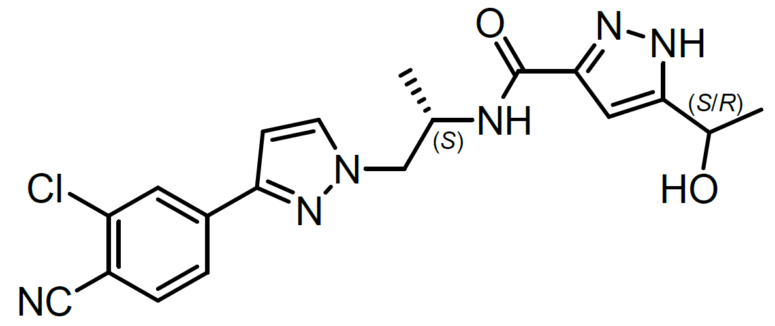

The darolutamide drug substance is a 1:1 mixture of two diastereomers ((S,S)-darolutamide and (S,R)-darolutamide), which are both similarly pharmacologically active.

All quality evaluation issues have been satisfactorily resolved. The manufacturing, quality, labelling and PI are satisfactory from a pharmaceutical chemistry perspective. The quality evaluator has no objection to the registration of darolutamide.

### Nonclinical

Nonclinical pharmacology studies support the proposed indication. *In vitro* studies indicate a number of potential pharmacokinetic (PK) drug interactions. Studies in rodents indicate minimal penetration of the blood‑brain barrier. Nonclinical safety studies do not raise any unexpected safety concerns.

The nonclinical evaluator has no objection to the registration of darolutamide, but the second round evaluation report contains further recommendations regarding the PI.

### Clinical

Nine clinical Phase I or II studies have been conducted to support the clinical pharmacology development of darolutamide. Four of them are categorized as cancer patient studies (Studies 17829 (ARADES trial), 18035 (ARADES-EXT trial), 17830 (ARAFOR trial) and 17719) and five as non-cancer subject studies (Studies 17721, 17726, 17831 (ARIADME trial), 17723 and 18860).

Clinical efficacy and safety of daralutamide plus androgen deprivation therapy (ADT) in patients with nmCRPC was supported by one Phase III pivotal study (Androgen Receptor Antagonizing Agent for Metastasis-free Survival (ARAMIS) trial) which contained a QT sub-study.[16] This pivotal study and sub-study were reviewed by the clinical evaluator.

#### Pharmacology

Maximum observed drug concentration (Cmax) is reached approximately 4 hours after administration of a 600 mg oral dose. Steady-state is reached after 2 to 5 days of repeated twice-daily dosing with food. Exposure of darolutamide and its major metabolite keto‑darolutamide increase in a nearly dose-proportional manner after single and multiple doses of 100 mg to 700 mg. Darolutamide exhibits saturated absorption at doses above 700 mg twice daily.

Absolute bioavailability of darolutamide tablet under fasted condition is 30%. Absorption is increased from 2.0 to 2.5 fold when given with a high-fat or a low-fat meal (corresponding to 60 to 75% absolute bioavailability). Administration with food is recommended.

The apparent volume of distribution of darolutamide after intravenous administration is 119 L. Darolutamide is moderately (92%) bound to human plasma proteins.

The clearance of darolutamide following intravenous administration is 116 mL/min. 63.4% of drug related material is excreted in the urine (approximately 7% unchanged) and 32.4% in the faeces (approximately 30% unchanged). The effective half-life of darolutamide and keto-darolutamide in nmCRPC patients is approximately 20 hours. Darolutamide is metabolised primarily via oxidation by cytochrome P450 family 3 subfamily A member 4 (CYP3A4), as well as via glucuronidation by uridine phosphorylase (UDP)-glucuronosyltransferase family 1 member A9 (UGT1A9) and UDP-glucuronosyltransferase family 1 member A1 (UGT1A1).

The proposed dosage, 600 mg orally twice daily with food, is recommended based on the Phase III study in nmCRPC, supported by Phase I/II studies in mCRPC. No dose adjustment is required based on age, weight, or race. Dose interruption and/or reduction to 300 mg twice daily can be used to manage toxicities. The sponsor proposes no dose adjustment for patients with mild or moderate hepatic impairment, or mild, moderate or severe renal impairment.

In Study 17721, there was an approximate 1.9 fold increase in area under the plasma concentration-time curve (AUC) in non-cancer subjects with moderate hepatic impairment (Child-Pugh class B) compared to healthy subjects.[17] No data are available in patients with severe hepatic impairment. The sponsor’s rationale for not recommending a dose adjustment in patients with moderate hepatic impairment is that the population PK analysis of nmCRPC patients in the ARAMIS trial, including 32 patients with mild hepatic impairment and no patients with moderate hepatic impairment, did not identify hepatic impairment as a significant covariate for darolutamide exposure in the target population. The sponsor also indicated that safety analyses did not reveal meaningful safety differences in patients with mild hepatic impairment, and did not show an increase in adverse drug reactions with increasing exposure.

In Study 17721, there was approximately a 2.5 fold increase in AUC in non-cancer subjects with severe renal impairment (estimated glomerular filtration rate (eGFR) 15 to 29 mL/min/1.73 m2) compared to healthy subjects. No data are available in patients with end-stage renal disease. The sponsor’s rationale for not recommending a dose adjustment in patients with severe renal impairment is that the population PK analysis of nmCRPC patients in Study 17712 showed a 1.1 fold increase in AUC for patients with mild renal impairment and 1.3 fold increase in AUC for patients with moderate renal impairment. So, based on the linear relationship between eGFR and exposure observed in Study 17721, an approximately 1.5 fold increase in darolutamide exposure is estimated for patients with severe renal impairment. The sponsor also indicated that safety analyses did not reveal increased safety concerns with increasing renal impairment or increasing exposure.

Darolutamide is a cytochrome P450 3A4 (CYP3A4), P-glycoprotein (P-gp) and breast cancer resistance protein (BCRP) substrate, and an inhibitor of BCRP. The sponsor recommends concomitant use of darolutamide with combined P-gp and strong CYP3A4 inducers should be avoided because darolutamide exposure was reduced by 72% when administered with rifampicin, a combined P-gp and strong CYP3A4 inducer (based on clinical drug interaction study data (Study 17726)). The sponsor does not propose guidance on avoiding concomitant use with combined P-gp and moderate CYP3A4 inducers, but the sponsor did accept the FDA’s labelling recommendation to extend the guidance to include moderate CYP3A4 inducers on the basis of the sponsor’s analysis predicting 36% to 58% reduction in darolutamide exposure when co-administered with a combined P-gp and moderate CYP3A4 inducer.

In the clinical drug interaction study, Study 17726, concomitant use of darolutamide with itraconazole, a combined P-gp and strong CYP3A4 inhibitor, increased darolutamide exposure by 75% and Cmax by 36%. The sponsor proposes guidance in the PI that Nubeqa may be given concomitantly with CYP3A4, P-gp or BCRP inhibitors without a clinically relevant drug-drug interaction.

In the clinical drug interaction study, Study 17723, co-administration of darolutamide and rosuvastatin (a BCRP substrate) resulted in approximately a 5 fold increase in AUC and Cmax of rosuvastatin. The sponsor proposes guidance to consult the PI regarding the BCRP substrate when co-administered with Nubeqa.

#### Efficacy

##### Study 17712 (ARAMIS trial)

The pivotal evidence for efficacy in nmCRPC is provided by ARAMIS trial, an ongoing, Phase III, multi centre, randomised, double blind, placebo controlled trial evaluating the efficacy and safety of darolutamide (600 mg twice daily, orally) in patients with nmCRPC receiving concurrent ADT (or having had bilateral orchidectomy).

The primary objective was to demonstrate superiority of darolutamide over placebo in MFS in patients with high-risk nmCRPC. MFS was defined as the time from randomisation to confirmed metastasis or death. All patients were required to maintain castrate level of testosterone either by ADT (choice of gonadotropin-releasing hormone (GnRH) agonist or antagonist at the investigator’s discretion) or surgical castration.Three rising PSA levels taken at least one week apart during ADT, and no detectable metastases by conventional imaging techniques (computed tomography (CT), magnetic resonance imaging (MRI) and bone scan) defines nmCRPC.

Other eligibility criteria included histologically or cytologically confirmed adenocarcinoma of the prostate, PSA ≥ 2 ng/mL at screening and PSADT ≤ 10 months. Exclusion criteria included any prior metastatic disease (other than pelvic lymph nodes < 2 cm), and specified cardiovascular events in the 6 months prior to randomisation (uncontrolled hypertension, stroke, myocardial infarction, severe/unstable angina pectoris, coronary/peripheral artery bypass graft, New York Heart Association (NYHA) Class III or IV;[18] congestive heart failure).

Tumour measurements (CT or MRI) of the chest, abdomen and pelvis, and whole-body radionuclide bone scans) were performed at screening and every 16 weeks until confirmed metastasis. All imaging was evaluated locally and by blinded independent central review (BICR). Confirmation by anatomic imaging (x-ray, CT, or MRI) was required when bone lesions were found in a single region on the bone scan.

Treatment with darolutamide or placebo continued until radiographic progression per investigator and BICR, withdrawal of consent, or unacceptable toxicity. The double-blind treatment period was planned to continue until the primary analysis of MFS, after which patients were to be unblinded. If the results supported a positive benefit-risk assessment, patients in the placebo arm would be offered the opportunity to receive darolutamide in an open label treatment period.

The primary endpoint was MFS by BICR. Secondary endpoints (in order of testing hierarchy) included OS, time to pain progression, time to initiation of first cytotoxic chemotherapy, and time to first symptomatic skeletal event. Exploratory efficacy endpoints included progression-free survival (PFS), time to PSA progression, and health-related quality of life (HRQoL) measures.

###### Results

1,509 patients were randomised 2:1 to receive darolutamide 600 mg twice daily with food (n = 955) or placebo (n = 554) (Figure 2). Randomisation was stratified by PSADT (≤ 6 months versus > 6 months) and use of osteoclast targeted therapy (yes versus no).

All patients were assessed as having no metastases at Baseline by the blinded independent eligibility review of imaging (reader pool 1), but 89 patients were retrospectively assessed as having metastases at Baseline following the blinded central imaging review for efficacy (reader pool 2). Fifty (22.6%) of the 221 patients with an MFS event in the darolutamide arm and 39 (18.1%) of the 216 patients with an MFS event in the placebo arm were retrospectively identified as having metastatic disease at Baseline.

The data cut-off date for the primary analysis of MFS was 3 September 2018. The intention-to-treat (ITT) population;[19] was the primary analysis population for all efficacy endpoints. Interim analyses of secondary endpoints were planned at the time of the primary MFS analysis if significant, with final analyses at the end of the study. Based on an assumed 140 OS events at interim and 240 OS events at final analysis, the alpha boundary was set at 0.0005 at interim and 0.0495 at final analysis, respectively.

Patient demographic and clinical characteristics were well balanced across the two arms. The median age of patients was 74.0 years in both treatment arms, and 87% of patients were ≥ 65 years. Most patients were White (79%) followed by Asian (13%) and Black (4%). Twelve percent of patients were from North America, 12% from Asia Pacific and 76% from the rest of the world. The median PSA was 9.0 in the darolutamide arm and 9.7 in the placebo arm. Median PSADT was 4.4 months in the darolutamide arm and 4.7 months in the placebo arm. The use of osteoclast-targeted therapy was reported in 3.8% and 5.1% of patients at randomisation in the darolutamide and placebo arms, respectively.

Primary endpoint

At the 3 September 2018 cut-off date, 437 MFS events had occurred (221 patients (23.1%) in the darolutamide arm and 216 patients (39.0%) in the placebo arm) (see Table 2, below). There was a statistically significant improvement in MFS in the darolutamide arm compared to placebo (stratified hazard ratio (HR) 0.413; 95% confidence interval (CI) 0.341, 0.500; p < 0.000001). The estimated median MFS was 40.4 months (95% CI: 34.3, not estimable (NE)) for darolutamide versus 18.4 months (95% CI: 15.5, 22.3) for placebo (see Figure 2, below).

Figure : Study 17712 (ARAMIS trial) Primary analysis of metastasis free survival (data cut-off 3 September 2018)

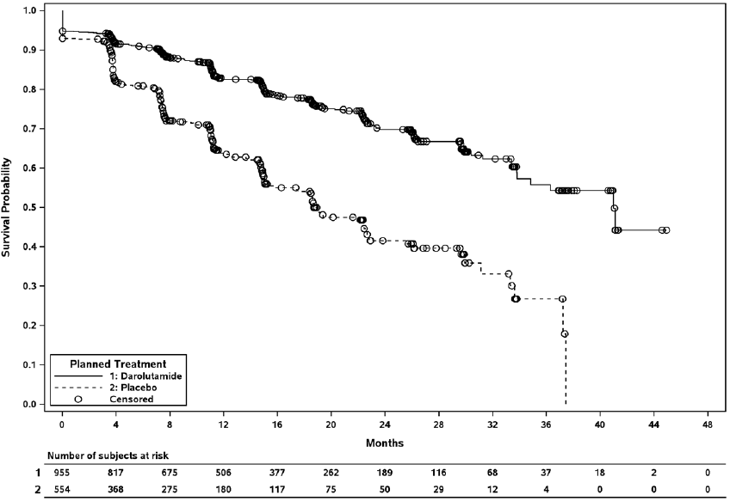

Table : Study 17712 (Aramis trial) Primary analysis of metastasis free survival (data cut-off 3 September 2018)

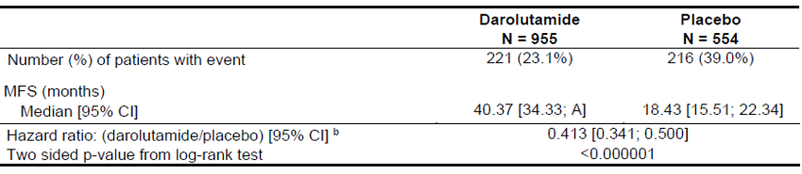

A = Value cannot be estimated; N = Total number of patients (100%); b A hazard ratio < 1 indicates superiority of darolutamide over placebo. Hazard ratio and 95% CI was based on Cox Regression Model, stratified by PSADT (≤ 6 months versus > 6 months) and use of osteoclast-targeted therapy.

The primary endpoint was supported by consistent findings from sensitivity analyses, including an analysis of MFS with censoring of patients with baseline metastases. Exploratory subgroup analyses based on demographic factors, disease characteristics and prior treatment were supportive of the primary outcome. MFS outcomes were similar for patients with baseline PSADT ≤ 6 months (HR 0.413, 95% CI: 0.330, 0.516) and > 6 months (HR 0.376, 95% CI: 0.258, 0.547). Similar MFS outcomes were observed across all four quartiles of PSADT and across all baseline PSA subgroups.

Secondary endpoints

There were 136 deaths at the interim analysis of OS (57% of the planned number of deaths for the final analysis). The interim analysis of OS showed a trend favouring darolutamide (stratified HR 0.706; 95% CI: 0.501, 0.994; p = 0.045) but the pre-specified alpha significance level (0.0005) was not met, so this result is not statistically significant. Median OS was not reached in either treatment arm.

Based on the pre-specified testing hierarchy, other secondary endpoints were not formally tested. Median time to pain progression favoured darolutamide (40.3 months) compared to placebo (25.4 months). Analyses of time to initiation of first cytotoxic chemotherapy and time to first symptomatic skeletal event also favoured darolutamide, but these results are constrained by low numbers of events.

#### Safety

The evaluation of safety is based primarily on the Phase III Study 17712 (the ARAMIS trial), comprising a safety population of 1,508 patients who received darolutamide 600 mg twice daily (N = 954) or placebo (N = 554), with concurrent ADT (or bilateral orchidectomy) (Table 3). These data are supported by pooled safety data from 173 patients with mCRPC in Phase I and II studies.

In the ARAMIS trial, the median duration of treatment was 14.8 months in the darolutamide arm and 11.0 months in the placebo arm. 37.7% in the darolutamide arm and 28.9% in the placebo arm were treated for > 12 to ≤ 24 months, and 23.1% in the darolutamide arm and 11.1% in the placebo arm were treated for > 24 months. At the cut‑off date, 64.4% of patients in the darolutamide arm and 36.1% in the placebo arm were still receiving study treatment.

Table : Study 17712 (ARAMIS trial) Overview of treatment emergent adverse events

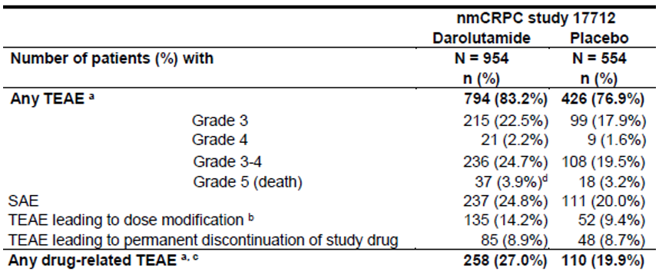

N = Total number of patients (100%); n = Number of patients with event; nmCRPC = non-metastatic castration-resistant prostate cancer; SAE = Serious adverse event; TEAE = Treatment-emergent adverse event. a Any TEAE also includes patients with grade not available for all adverse events (AEs); b Modifications include dose interruptions, and reductions; c Based on investigator’s assessment; d For some of the patients in the darolutamide arm, the start of Grade 5 event was reported within 30 days after treatment discontinuation but the death occurred more than 30 days after treatment discontinuation or after the report cut-off date.

The most common treatment emergent adverse events (TEAE) (incidence ≥ 5%, and ≥ 1% higher in the darolutamide arm than the placebo arm) were fatigue (15.8% versus 11.4%, including asthenia), diarrhoea (6.9% versus 5.6%), hypertension (6.6% versus 5.2%), pain in extremity (5.8% versus 3.2%), anaemia (5.6% versus 4.5%), and hot flush (5.2% versus 4.2%).

TEAEs with a ≥ 2% absolute increase in frequency compared to placebo arm were fatigue (15.8% versus 11.4%, including asthenia), pain in extremity (5.8% versus 3.2%), and rash (2.9% versus 0.9%).

The incidence of serious adverse events (SAE) was similar across the two arms. The only SAE occurring in ≥ 1% of patients and with a higher incidence in the darolutamide arm was pneumonia (1.4% versus 1.1%).

The incidence of discontinuations due to an adverse event (AE) was similar across the two arms (8.9% versus 8.7%). Dose reductions due to AEs occurred in 6% in the darolutamide arm and 1.3% in the placebo arm. The most common reason for dose reduction was fatigue (0.7%).

TEAEs resulting in death were reported in 37 (3.9%) patients in the darolutamide arm and 18 (3.2%) patients in the placebo arm. One death (intestinal perforation) was attributed to darolutamide by investigators. Nine cardiac deaths (cardiac arrest (1), myocardial infarction (1), cardiac failure (4), cardiac disorder (1), coronary artery disease (1), aortic dissection (1)) and 1 death due to fall were not attributed to darolutamide by investigators, but could be viewed as possibly related to treatment with darolutamide based on known effects of androgen deprivation. Patients with a recent history of cardiac disease were excluded from the ARAMIS trial.

Special topics TEAEs;[20] included bone fracture, fall, fatigue/asthenia, weight decreased, cardiac disorders, hypertension, vasodilatation/flushing, diabetes mellitus/ hyperglycaemia, mental impairment disorders, depressed mood disorders, breast disorders/gynaecomastia, seizure and rash (see Table 4). 407 (43%) patients in the darolutamide arm and 184 (33%) patients in the placebo arm experienced a special topics AE. Ninety-three (10%) patients in the darolutamide arm and 33 (6%) patients in the placebo arm experienced a Grade 3 to 4 special topics AE.

Table : Study 17712 (ARAMIS trial) Incidence of treatment emergent adverse events and exposure-adjusted treatment emergent adverse events for special topics

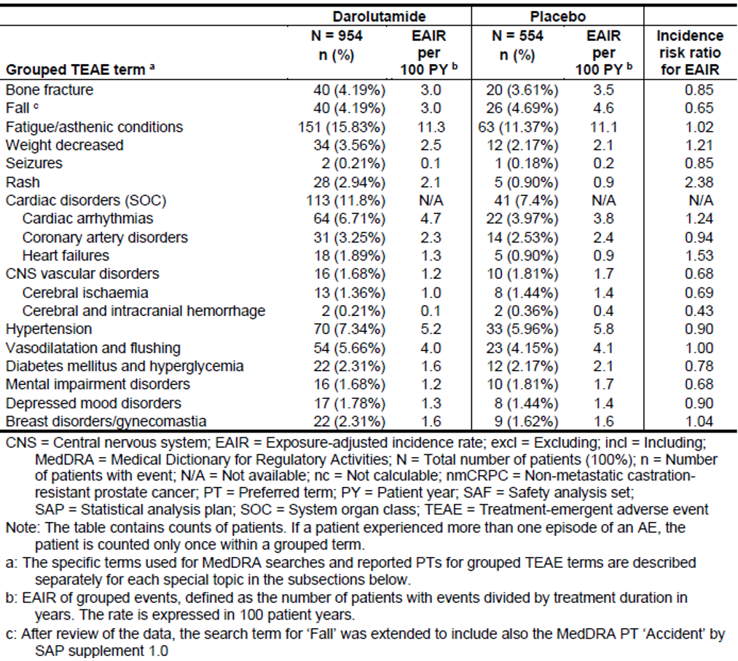The most common special topics TEAE was fatigue/asthenia, reported in 15.8% in the darolutamide arm and 11.4 % patients on the placebo arm (exposure-adjusted incidence rate (EAIR) 11.3 versus 11.1 per 100 patient year (PY)).[21]

Cardiac disorders were reported in 11.8% of patients in the darolutamide arm and 7.4% in the placebo arm, with the major contributors being cardiac arrhythmias (6.7% versus 4.0%, EAIR 4.7 versus 3.6 per 100 PY), coronary artery disorders (3.3% versus 2.5%, EAIR 2.3 versus 2.4 per 100 PY), and heart failure (1.9% versus 0.9%, EAIR 1.3 versus 0.9 per 100 PY). Coronary artery disorder events of Grade ≥ 3 were reported more commonly in the darolutamide arm (2.0%) compared to placebo (0.6%). Interpretation of cardiac safety outcomes is confounded by an imbalance in cardiac disorders at screening between the darolutamide and placebo arms (46.1% versus 40.3%, respectively).

TEAEs of rash were reported more commonly with darolutamide than placebo (2.9% versus 0.9%, EAIR 2.1 versus 0.9 per 100 PY). Most rash events were Grade 1 or 2 severity, and there were no SAEs or permanent discontinuations due to rash.

Falls (4.2% versus 4.7%), fractures (4.2% versus 3.6%), hypertension (7.3% versus 6.0%), mental disorders (1.7% versus 1.8%), depressed mood disorders (1.8% versus 1.4%), and seizures (0.2% versus 0.2%) were similar in both arms, particularly after adjusting for duration of exposure. Based on animal studies, darolutamide is purported to have low penetration of the blood-brain barrier. Patients with a history of seizure were permitted in the ARAMIS trial. None of the 12 patients enrolled in the darolutamide arm with a prior history of seizure experienced a seizure while being treated with darolutamide.

Laboratory abnormalities were mostly Grade 1 to 2, with low rates of Grade 3 to 4 events. Neutrophil count decreased (19.6% versus 9.4%, Grade 3 to 4 3.4% versus 0.6%), aspartate aminotransferase (AST) increased (22.5% versus 13.6% mostly Grade 1) and bilirubin increased (16.4% versus 6.9%) were more common with darolutamide than with placebo. There were no cases of Hy’s law.[22]

No clinically meaningful effect on cardiac conduction was detected. No dose-dependent increase in QTc;[23] interval was observed in the clinical Phase I/II studies. No large QTc prolongation effect (that is > 20 ms) was observed with darolutamide in a dedicated QTc sub study of the Phase III study.

### Risk management plan

The sponsor submitted EU-Risk Management Plan (RMP) version 0.1 (dated 31 January 2019; data lock point (DLP) 3 September 2018) and Australian specific Annex (ASA) version 1.0 (dated February 2019) in support of this application.

The sponsor has proposed no risks in the summary of safety concerns for Nubeqa. At this stage this is acceptable from an RMP perspective. The RMP evaluator considers that the risks associated with Nubeqa can be adequately addressed with routine monitoring and labelling and, that additional risk management measures are not essential to ensure that the benefits outweigh the risks.[24]

However, if the clinical or nonclinical evaluators’ recommendations require the addition of risks to the summary of safety concerns, then the sponsor should review and revise the risk management plan as necessary.

Furthermore, if new safety information becomes available that changes the benefit-risk profile, the sponsor should review the adequacy of the RMP.

#### Recommended conditions of registration

* The EU-RMP (version 0.1, date 31 January 2019; DLP 3 September 2018), with ASA (version 1.0, dated date February 2019), included with submission PM-2019-01420-1-4, and any subsequent revisions, as agreed with the TGA will be implemented in Australia.
* An obligatory component of risk management plans is routine pharmacovigilance. Routine pharmacovigilance includes the submission of periodic safety update reports (PSURs).

Unless agreed separately between the supplier who is the recipient of the approval and the TGA, the first report must be submitted to TGA no later than 15 calendar months after the date of the approval letter. The subsequent reports must be submitted no less frequently than annually from the date of the first submitted report until the period covered by such reports is not less than three years from the date of the approval letter. The annual submission may be made up of two PSURs each covering six months. If the sponsor wishes, the six monthly reports may be submitted separately as they become available.

The reports are to at least meet the requirements for PSURs as described in the European Medicines Agency’s Guideline on Good Pharmacovigilance Practices (GVP) Module VII- periodic safety update report (Rev 1), Part VII.B Structures and processes. Note that submission of a PSUR does not constitute an application to vary the registration. Each report must have been prepared within ninety calendar days of the data lock point for that report.

* Nubeqa (darolutamide) is to be included in the Black Triangle Scheme. The PI and Consumer Medicines Information (CMI) for Nubeqa must include the black triangle symbol and mandatory accompanying text for five years, which starts from the date that the sponsor notifies the TGA of supply of the product.

### Risk-benefit analysis

#### Delegate’s considerations

##### Efficacy

The pivotal study, the ARAMIS trial, was a multinational, Phase III, randomised, double blind trial of darolutamide compared with placebo in patients with nmCRPC with a PSADT ≤ 10 months. 1,509 patients were randomised 2:1 to darolutamide 600 mg twice daily versus placebo. Randomisation was stratified by PSA doubling time (≤ 6 months versus > 6 months) and use of osteoclast-targeted therapy (yes versus no). The primary endpoint was MFS per BICR. Secondary endpoints (in order of hierarchical testing) were OS, time to pain progression (TTPP), time to initiation of first cytotoxic chemotherapy for prostate cancer, and time to first symptomatic skeletal event (SSE).

The ARAMIS trial met its primary efficacy endpoint, with median MFS of 40.4 months for darolutamide versus 18.4 months for placebo (HR 0.41, 95% CI 0.34, 0.50; p < 0.0001). The demonstrated improvement in MFS (that is delaying the progression to metastatic disease) is clinically meaningful. Sensitivity analyses and subgroup analyses were supportive of the primary endpoint, with similar MFS observed across subgroups based on PSADT and baseline PSA level.

OS data were immature at the interim analysis. There was a trend favouring darolutamide (HR 0.706; 95% CI 0.501, 0.994; p = 0.045) but the pre-specified alpha significance level was not met, so this result is not statistically significant. Final analysis of OS is planned after approximately 240 events (study report anticipated to be available in the fourth quarter of 2020). Other secondary endpoints were not formally tested but the analyses were generally supportive of the primary endpoint, though outcomes for some secondary endpoints, including time to initiation of first cytotoxic chemotherapy and time to first symptomatic skeletal event, were based on small numbers of events.

##### Safety

The safety data presented in this submission are sufficient to characterise the safety profile of darolutamide in the proposed indication. The safety of darolutamide was assessed in the context of patients receiving concurrent ADT (or bilateral orchidectomy). Overall, darolutamide was well tolerated. The rate of discontinuations due to AEs in the darolutamide arm (8.9%) was similar to placebo (8.7%). The most common adverse reactions of darolutamide (≥ 2% difference to placebo) were fatigue, pain in extremities, and rash.

The incidence of seizures, falls, fractures, cognitive disorder, and hypertension were similar between the two arms. There were no seizures in patients with a prior history of seizure.

No clear cardiac safety signal was evident in ARAMIS trial. Small differences in TEAEs for cardiac disorders, including Grade ≥ 3 coronary artery disorder events, were observed but may have been influenced by an imbalance in medical history of cardiac disorders at screening. There is no evidence of a concerning QTc prolongation effect. The absence of a clear cardiac safety signal in the ARAMIS trial is reassuring, but cardiac safety concerns have been associated with androgen deprivation therapy more broadly, and patients with specified cardiovascular events in the 6 months prior to randomisation were excluded from ARAMIS trial. Therefore, it would be prudent to include a precaution in the PI that the safety of darolutamide has not been characterised in patients with recent (within 6 months) cardiovascular events, including uncontrolled hypertension, stroke, myocardial infarction, severe/unstable angina pectoris, coronary/peripheral artery bypass graft, and NYHA Class III or IV congestive heart failure;18 as these patients were excluded from the pivotal study.

The overall safety profile of darolutamide in patients with nmCRPC is acceptable.

##### Clinical pharmacology

Based on the approximately 2.5 fold increase in AUC in subjects with severe renal impairment compared to healthy subjects, the recommended dose of darolutamide should be reduced to 300 mg twice daily in patients with severe renal impairment. Similarly, based on the approximately 1.9 fold increase in AUC in subjects with moderate hepatic impairment compared to healthy subjects, the recommended dose of darolutamide should be reduced to 300 mg twice daily in patients with moderate hepatic impairment. Although the safety profile of darolutamide is reassuring overall, there is a lack of safety data in patients with moderate hepatic or severe renal impairment, and uncertainty regarding safety at higher exposures than those observed in the clinical studies (darolutamide demonstrates saturated absorption at doses above 700 mg twice daily).

Co-administration of darolutamide with rifampicin, a combined P-gp and strong CYP3A4 inducer, reduced darolutamide exposure by 72%, which may affect efficacy. Concomitant use of darolutamide with a combined P-gp and strong CYP3A4 inducer should be avoided. Darolutamide exposure is also expected to be reduced when co-administered with a combined P-gp and moderate CYP3A4 inducer. The PI guidance in Section 4.5 should be amended to recommend that concomitant use of darolutamide with a combined P-gp and strong or moderate CYP3A4 inducer should be avoided.

Co-administration of darolutamide with itraconazole, a combined P-gp and strong CYP3A4 inhibitor, increased darolutamide exposure by approximately 1.7 fold. The guidance in Section 4.5 of the PI should be amended to describe the risk of toxicity and the management of adverse reactions.

Co-administration of darolutamide with rosuvastatin, a BCRP substrate, increased the AUC and Cmax of rosuvastatin by approximately 5 fold, which may increase the risk of toxicity. The guidance in Section 4.5 of the PI should be amended to advise that concomitant use with BCRP substrates should be avoided where possible. If used together, patients should be monitored for adverse reactions more frequently, dose reduction of the BCRP substrate drug should be considered, and the PI of the BCRP substrate should be consulted.

##### Proposed indication

The ARAMIS trial recruited patients at higher risk of metastatic disease, based on PSADT ≤ 10 months at screening. The proposed indication does not refer to ‘high risk’ nmCRPC, so would apply to all patients with nmCRPC. Given the magnitude of the MFS benefit in the ARAMIS trial, the similar MFS outcomes across all quartiles of PSADT, and the lack of consensus internationally on a definition of ‘high risk’ nmCRPC, this approach is acceptable. A similar approach was taken for the registrations of apalutamide and enzalutamide in nmCRPC. It is noted that the nmCRPC indications for apalutamide and enzalutamide cross-refer to Section 5.1 of the proposed PI, but the Delegate is not convinced that the inclusion of a cross-reference to Section 5.1 provides greater clarity about the eligible population.

##### Limitations of the data and other uncertainties

Patients and investigators were not blinded to PSA results and there were more dropouts in patients with rising PSA and no evidence of metastases in the placebo arm (24.5%) compared to darolutamide (9.2%). Sensitivity analyses adjusting for these dropouts did not suggest a meaningful effect on the overall results.

The secondary endpoints, other than OS, are subject to patient and investigator bias. Unblinding of the study after the primary analysis of MFS may limit the interpretability of these results at the final analysis.

Non-metastatic status was determined by standard bone scans, CT and MRI. With the emergence of more sensitive imaging modalities, such as prostate-specific membrane antigen (PSMA) positron emission tomography (PET), it is expected that some patients classified as nmCRPC based on bone scan/CT/MRI would be reclassified as mCRPC based in PSMA-PET, but this does not compromise the key findings from ARAMIS trial.

Patients with a history of a cardiovascular event within 6 months prior to randomisation were excluded from the ARAMIS trial, so the cardiovascular risk in this setting remains uncertain.

There are no data directly comparing darolutamide to apalutamide or enzalutamide, so conclusions on the relative efficacy and safety of these treatments in nmCRPC are limited to indirect cross-trial comparisons.

##### Conclusion

The overall benefit-risk of darolutamide in the proposed indication is favourable. There are no outstanding clinical questions, so independent expert clinical advice has not been sought. The proposed use of darolutamide in nmCRPC is similar to recently approved indications for apalutamide and enzalutamide.

#### Proposed conditions of registration

* Submit the final clinical study report for the ARAMIS study when available.

The above condition is in addition to those provided by the RMP evaluator, as outlined in the Section ‘*Recommended conditions of registration*’, above.

Advisory Committee considerations[25]

The Delegate did not refer this application to the Advisory Committee on Medicines (ACM) for advice.

### Outcome

Based on a review of quality, safety and efficacy, the TGA approved the registration of Nubeqa (darolutamide) 300 mg film coated tablet for oral administration, indicated for:

*Nubeqa is indicated for the treatment of patients with non-metastatic castration resistant prostate cancer (nmCRPC).*

#### Specific conditions of registration applying to these goods

* Submit the final clinical study report for the ARAMIS study when available.
* Nubeqa (darolutamide) is to be included in the Black Triangle Scheme. The PI and CMI for Nubeqa must include the black triangle symbol and mandatory accompanying text for five years, which starts from the date that the sponsor notifies the TGA of supply of the product.
* The EU-RMP (version 0.1, date 31 January 2019; DLP 3 September 2018), with ASA (version 1.0, dated February 2019), included with submission PM-2019-01420-1-4, and any subsequent revisions, as agreed with the TGA will be implemented in Australia.

An obligatory component of risk management plans is routine pharmacovigilance. Routine pharmacovigilance includes the submission of PSURs. Unless agreed separately between the supplier who is the recipient of the approval and the TGA, the first report must be submitted to TGA no later than 15 calendar months after the date of the approval letter. The subsequent reports must be submitted no less frequently than annually from the date of the first submitted report until the period covered by such reports is not less than three years from the date of the approval letter. The annual submission may be made up of two PSURs each covering six months. If the sponsor wishes, the six monthly reports may be submitted separately as they become available.

The reports are to at least meet the requirements for PSURs as described in the European Medicines Agency’s Guideline on GVP Module VII-periodic safety update report (Rev 1), Part VII.B Structures and processes. Note that submission of a PSUR does not constitute an application to vary the registration. Each report must have been prepared within ninety calendar days of the data lock point for that report.

## Attachment 1. Product Information

The PI for Nubeqa approved with the submission which is described in this AusPAR is at Attachment 1. For the most recent PI, please refer to the TGA website at <<https://www.tga.gov.au/product-information-pi>>.

|  |
| --- |
| Therapeutic Goods Administration |
| PO Box 100 Woden ACT 2606 Australia  Email: [info@tga.gov.au](mailto:info@tga.gov.au) Phone: 1800 020 653 Fax: 02 6232 8605  [**https://www.tga.gov.au**](https://www.tga.gov.au) |

1. Smith MR et al. (2005). Natural history of rising serum prostate-specific antigen in men with castrate nonmetastatic prostate cancer. *J Clin Oncol*, (13):2918-25.
2. Smith MR et al. (2013). Denosumab and bone metastasis-free survival in men with nonmetastatic castration-resistant prostate cancer: exploratory analyses by baseline prostate-specific antigen doubling time. *J Clin Oncol,* 31(30):3800-6.
3. Smith MR et al. (2011). Disease and host characteristics as predictors of time to first bone metastasis and death in men with progressive castration-resistant nonmetastatic prostate cancer. *Cancer,* 117(10):2077-85.
4. Linja MJ et al. (2001). Amplification and overexpression of androgen receptor gene in hormone-refractory

   prostate cancer. *Cancer Res*, 61(9):3550-5.
5. Robinson D et al. (2015). Integrative clinical genomics of advanced prostate cancer. *Cell,* 161(5):1215-28.
6. Dai C et al. (2017). Androgen Signaling in Prostate Cancer. *Cold Spring Harb Perspect Med,* 7(9).
7. Hussain M et al. (2018). Enzalutamide in Men with Nonmetastatic, Castration-Resistant Prostate Cancer. *N Engl J Med.*, 378(26):2465-74.
8. Smith MR et al. (2018). Apalutamide Treatment and Metastasis-free Survival in Prostate Cancer. *N Engl J Med,* 378(15):1408-18.
9. Nonmetastatic, Castration-Resistant Prostate Cancer: Considerations for Metastasis-Free Survival Endpoint in Clinical Trials; Draft Guidance for Industry. Food and Drug Administration (USA), Docket number: FDA-2018-D-3931.
10. Moilanen AM et al. (2015). Discovery of ODM-201, a new-generation androgen receptor inhibitor targeting resistance mechanisms to androgen signaling-directed prostate cancer therapies. *Sci Rep,* 5:12007.
11. Baumgart SJ et al. (2018). Abstract (1798): A detailed comparison between second-generation AR antagonists reveals differences in the overall impact on gene regulation patterns in prostate cancer cells. *Cancer Res,* 78(13 Supplement):1798.
12. VCap cell line was established from a vertebral bone metastasis from a patient with hormone refractory prostate cancer. It was passaged as xenografts in mice then cultured *in vitro*. It is androgen sensitive *in vitro* and *in vivo.*
13. Korenchuk S, et al. (2001). VCaP, a cell-based model system of human prostate cancer. *In Vivo*, 15: 163-168.
14. The ACSS Consortium is a collaborative initiative of like-minded, medium-sized regulatory authorities between Australia's Therapeutic Goods Administration (TGA), Health Canada (HC), Singapore's Health Sciences Authority (HSA) and the Swiss Agency for Therapeutic Products (Swissmedic). Regulatory authorities face very similar challenges, such as increasing workload and increasing complexities in the medicinal applications that are being regulated, thus contributing to increasing pressure on available resources. The purpose of the consortium is to build synergies and share knowledge amongst the regulatory authorities thereby enhancing efficiency of regulatory systems.

    The ACSS Consortium consists of various projects that aim to help meet the challenges faced by regulatory authorities, including timely access to safe therapeutic products within a limited resource capacity. The ACSS uses a network of bilateral confidentiality agreements and Memoranda of Understanding to conduct their work.
15. This indication was subsequently approved on 30 January 2020.
16. The QT interval is the time taken from the start of the Q-wave to the end of the corresponding T-wave of the cardiac cycle, roughly corresponding to the onset of cardiac ventricular contraction to the end of subsequent ventricular contraction. A QT study is designed to evaluate the effect of a drug on the QT interval and the potential arrhythmia liability of a drug.
17. The Child-Pugh score is a system for assessing the prognosis for chronic liver disease and is based on 5 clinical measures. Class A: 5 to 6 points, least severe liver disease, one to five year survival rate of 95%. Class B: 7 to 9 points, moderately severe liver disease, one to five year survival of 75%. Class C: 10 to 15 points, most severe liver disease, 1 to 5 year survival rate 50%.
18. The New York Heart Association (NYHA) Classification provides a simple way of classifying the extent of heart failure. It classifies patients in one of four categories based on their limitations during physical activity; the limitations/symptoms are in regards to normal breathing and varying degrees in shortness of breath and or angina pain.

    Class I: No symptoms and no limitation in ordinary physical activity, for example, shortness of breath when walking, climbing stairs etc.

    Class II: Mild symptoms (mild shortness of breath and/or angina) and slight limitation during ordinary activity.

    Class III: Marked limitation in activity due to symptoms, even during less-than-ordinary activity, for example, walking short distances (20 to 100 m). Comfortable only at rest.

    Class IV: Severe limitations. Experiences symptoms even while at rest. Mostly bedbound patients.
19. The randomised clinical trials analysed by the intention-to-treat (ITT) approach provide the unbiased comparisons among the treatment groups. In the ITT population, none of the patients is excluded and the patients are analysed according to the randomisation scheme.
20. Special topics were defined as events/disorders representing potential or known risks associated with ADT or with novel anti-androgens.
21. Exposure-adjusted incidence rate is defined as the number of subjects exposed to the drug and experiencing a certain event divided by the total exposure time of all subjects who are at risk for the event.
22. Hy’s Law: Evidence of hepatocellular injury with ALT and/or AST > 3 x ULN and total bilirubin > 2 x ULN, and no other reason to explain rise in aminotransferases and total bilirubin.
23. QTc: The QT interval corrected for heart rate.
24. *Routine risk minimisation* activities may be limited to ensuring that suitable warnings are included in the product information or by careful use of labelling and packaging.

    *Routine pharmacovigilance* practices involve the following activities:

    All suspected adverse reactions that are reported to the personnel of the company are collected and collated in an accessible manner;

    Reporting to regulatory authorities;

    Continuous monitoring of the safety profiles of approved products including signal detection and updating of labelling;

    Submission of PSURs;

    Meeting other local regulatory agency requirements.
25. The ACM provides independent medical and scientific advice to the Minister for Health and the Therapeutic Goods Administration (TGA) on issues relating to the safety, quality and efficacy of medicines supplied in Australia including issues relating to pre-market and post-market functions for medicines.

    The Committee is established under Regulation 35 of the Therapeutic Goods Regulations 1990. Members are appointed by the Minister. The ACM was established in January 2017 replacing Advisory Committee on Prescription Medicines (ACPM) which was formed in January 2010. ACM encompass pre and post-market advice for medicines, following the consolidation of the previous functions of the Advisory Committee on Prescription Medicines (ACPM), the Advisory Committee on the Safety of Medicines (ACSOM) and the Advisory Committee on Non-Prescription Medicines (ACNM). Membership comprises of professionals with specific scientific, medical or clinical expertise, as well as appropriate consumer health issues relating to medicines.