January 2014

Australian Public Assessment Report for denosumab
  - Proprietary Product Name: Prolia
  - Sponsor: Amgen Australia Pty Ltd
About the Therapeutic Goods Administration (TGA)
- The Therapeutic Goods Administration (TGA) is part of the Australian Government Department of Health, and is responsible for regulating medicines and medical devices.
- The TGA administers the Therapeutic Goods Act 1989 (the Act), applying a risk management approach designed to ensure therapeutic goods supplied in Australia meet acceptable standards of quality, safety and efficacy (performance), when necessary.
- The work of the TGA is based on applying scientific and clinical expertise to decision-making, to ensure that the benefits to consumers outweigh any risks associated with the use of medicines and medical devices.
- The TGA relies on the public, healthcare professionals and industry to report problems with medicines or medical devices. TGA investigates reports received by it to determine any necessary regulatory action.
- To report a problem with a medicine or medical device, please see the information on the TGA website <http://www.tga.gov.au>.
About AusPARs
- An Australian Public Assessment Record (AusPAR) provides information about the evaluation of a prescription medicine and the considerations that led the TGA to approve or not approve a prescription medicine submission.
- AusPARs are prepared and published by the TGA.
- An AusPAR is prepared for submissions that relate to new chemical entities, generic medicines, major variations, and extensions of indications.
- An AusPAR is a static document, in that it will provide information that relates to a submission at a particular point in time.
- A new AusPAR will be developed to reflect changes to indications and/or major variations to a prescription medicine subject to evaluation by the TGA.
Copyright
© Commonwealth of Australia 2014
This work is copyright. You may reproduce the whole or part of this work in unaltered form for your own personal use or, if you are part of an organisation, for internal use within your organisation, but only if you or your organisation do not use the reproduction for any commercial purpose and retain this copyright notice and all disclaimer notices as part of that reproduction. Apart from rights to use as permitted by the Copyright Act 1968 or allowed by this copyright notice, all other rights are reserved and you are not allowed to reproduce the whole or any part of this work in any way (electronic or otherwise) without first being given specific written permission from the Commonwealth to do so. Requests and inquiries concerning reproduction and rights are to be sent to the TGA Copyright Officer, Therapeutic Goods Administration, PO Box 100, Woden ACT 2606 or emailed to <tga.copyright@tga.gov.au>.

Contents
I. Introduction to product submission 4
Submission details 4
Product background 4
Regulatory status 5
Product Information 5
II. Quality findings 6
III. Nonclinical findings 6
IV. Clinical findings 6
Introduction 6
Pharmacokinetics 6
Pharmacodynamics 6
Efficacy 7
Safety 8
List of questions 9
Clinical summary and conclusions 9
V. Pharmacovigilance findings 9
Risk management plan 9
VI. Overall conclusion and risk/benefit assessment 14
Quality 14
Nonclinical 14
Clinical 14
Risk management plan 22
Risk-benefit analysis 23
Outcome 32
Attachment 1. Product Information 33
Attachment 2. Extract from the Clinical Evaluation Report 33

I. Introduction to product submission

Submission details
Type of submission: | Extension of indications
Decision: | Approved
Date of decision: | 5 September 2013
Active ingredient: | Denosumab
Product name: | Prolia
Sponsor’s name and address: | Amgen Australia Pty Ltd  Level 7, 123 Epping Road  North Ryde NSW 2113
Strength: | 60 mg/mL solution for injection
Containers: | Syringe, Glass Type I Clear
Pack sizes: | 1
Approved therapeutic use: | - The treatment of osteoporosis in postmenopausal women. Prolia significantly reduces the risk of vertebral, non-vertebral and hip fractures.  - Treatment to increase bone mass in men with osteopaenia receiving androgen deprivation therapy for non-metastatic prostate cancer (see Clinical Trials).  - Treatment to increase bone mass in men with osteoporosis at increased risk of fracture.
ARTG Numbers: | AUST R 159322: Prolia denosumab 60 mg/mL solution for injection prefilled syringe  AUST R 159323: Prolia denosumab 60 mg/mL solution for injection prefilled syringe with automatic needle guard  AUST R 159324: Prolia denosumab 60 mg/mL solution for injection vial

Product background
This AusPAR describes a submission by the sponsor, Amgen Australia Pty Ltd, to extend the indications for denosumab (Prolia). Denosumab is a fully human IgG2 monoclonal antibody with high affinity and specificity for receptor activator of nuclear factor kappa-B ligand (RANKL). Denosumab has an approximate molecular weight of 147 kDa and is produced in genetically engineered mammalian (Chinese Hamster Ovary, CHO) cells. Denosumab is considered a RANKL inhibitor.
The current approved indications for Prolia are:
- “The treatment of osteoporosis in postmenopausal women. Prolia significantly reduces the risk of vertebral, non-vertebral and hip fractures
- Treatment to increase bone mass in men with osteopaenia receiving androgen deprivation therapy for non-metastatic prostate cancer.”
The proposed new indication is:
- “Treatment of osteoporosis in men.”
Denosumab is also marketed by the same sponsor under the trade name Xgeva for the following indication:
- “Prevention of skeletal related events in patients with bone metastases from solid tumours.”
The following Prolia dosage forms and strengths are currently registered:
- single use prefilled syringe with automatic needle guard containing 60 mg/mL solution for injection
- prefilled syringe containing 60 mg/mL solution for injection (not currently marketed in Australia)
- vial containing 60 mg/mL solution for injection (not currently marketed in Australia)
Xgeva is marketed in the following presentation:
- vial containing 70 mg/mL solution for injection (120 mg denosumab in 1.7 mL of solution). The dose regimen for Xgeva in treating bone metastases is 120 mg subcutaneous every 4 weeks.
No new dosage forms or strengths are proposed.

Regulatory status
Table 1 shows countries in which a similar application has been submitted, along with the details of the status, at the time of the Australian application.
Table 1: International regulatory approval status for Prolia at the time of submission.
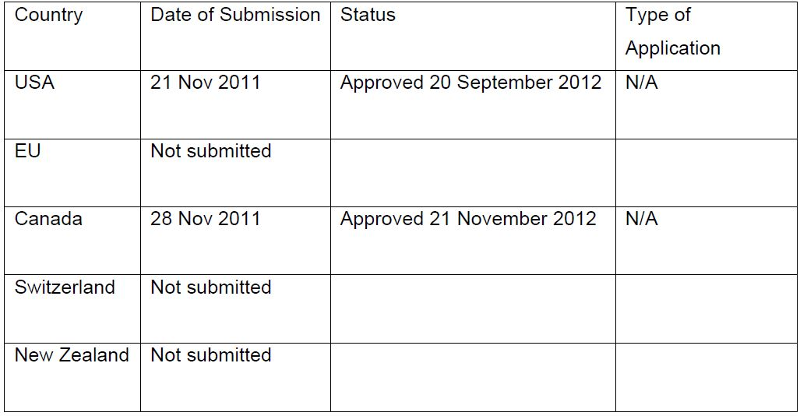

Product Information
The approved Product Information (PI) current at the time this AusPAR was prepared can be found as Attachment 1.

II. Quality findings
There was no requirement for a quality evaluation in a submission of this type.

III. Nonclinical findings
There was no requirement for a nonclinical evaluation in a submission of this type.

IV. Clinical findings
A summary of the clinical findings is presented in this section. Further details of these clinical findings can be found in Attachment 2.

Introduction
The clinical dossier documented a development program of pivotal and other clinical trials relating to the proposed extension of indications.
The submission contained the following clinical information:
- No clinical pharmacology studies
- 1 pivotal efficacy/safety study in the indication osteoporosis in men (Study 20080098)
- 5 other efficacy/safety studies in the indication osteoporosis in women (Studies 20060289, 20050233, 20080287 and 20080747); one study (20040132) had been previously evaluated and was not evaluated again
- Two documents titled Integrated Summary of Efficacy, Integrated Summary of Safety, were included, but no report is included; only tabulations of data including data from the pivotal study and 2 studies not included in the application (Studies 20030216 and 20040138) and the 120 day US safety update for Studies 20080098, 20060289, 20050233 and 20080537 (not included in application)
Comment: The Clinical Overview and Summary of Clinical Efficacy only discuss the pivotal study (20080098) and the Summary of Clinical Safety discusses the pivotal trial (20080098) in relation to Studies 20030216 and 20040138, which were not included in the submission (included in previous submissions). The additional studies in postmenopausal women (20060289, 20050233) are summarised in the US 120 day safety update, but no explanation is provided as to why they and Studies 20080287 and 20080747 are included in the submission.

Pharmacokinetics
No new pharmacokinetic studies were submitted. As the drug is currently approved for use in men, it is accepted that no new data was required.

Pharmacodynamics
No new pharmacodynamic studies were submitted. Given the new indication is related to that already approved, it is accepted that new data was not required.

Efficacy
Overall, while Study 20080098 was only for 12 months (only 2 injections of denosumab) and the analysis was a modified Intent To Treat (ITT), the results did show increases in bone mineral density (BMD) that were comparable to that seen in postmenopausal women.
The European Union (EU) guideline for the treatment of osteoporosis in men where an indication for osteoporosis in postmenopausal women has been approved requires the following conditions to be met:
- The duration of the study is at least one year
The study duration was 12 months.
- The dosage is justified
The dose was the same as that used in women and men with prostate cancer receiving androgen deprivation therapy.
- The applicant justifies the cut off of BMD, age and any other risk factor open for the inclusion of men in the pivotal study will generate a fracture risk of a similar magnitude compared with postmenopausal women that were recruited in the studies used to obtain the indication ‘treatment of postmenopausal osteoporosis in women at high risk of fractures’
Eligible subjects in the pivotal study (20080098) were men 30 to 85 years of age, inclusive, with BMD values that corresponded to a T-score ≤ -2 and ≥ -3.5 at the lumbar spine or femoral neck or ≤ -1 and ≥ -3.5 in subjects with a history of major osteoporotic fracture, no vertebral or clinical fracture in the 6 months prior to screening, and no recent exposure to bisphosphonates or other medications known to affect bone metabolism. The proportion of subjects with a prevalent vertebral fracture at baseline based on spine radiographs was 24.8% in the denosumab group and 20.7% in the placebo group.
The details of the pivotal study in postmenopausal women (20030216) are not provided in the submission; however, according to the current PI, the entry criteria for the trial was postmenopausal women aged 60 to 91 years of age with BMD T-scores at the lumbar spine or total hip between -2.5 and -4.0, of which 23.6% has prevalent vertebral fractures.
- The magnitude of the changes in BMD versus placebo is similar to that observed in postmenopausal osteoporotic women treated with the same compound and is globally proportional to the decreased incidence of fractures in treated women.
Denosumab effectively increased BMD, as assessed by dual energy X ray absorptiometry (DXA) at the lumbar spine, total hip, femoral neck, trochanter, and distal radius in men with low BMD. The mean change in lumbar spine BMD after 12 months of treatment was large (5.7% in the denosumab group as compared with 0.9% in the placebo group [p < 0.0001]).
The magnitudes of the mean BMD increases observed in Study 20080098 were similar to those observed in Studies 20030216 and 20040138 at 12 months.
Table 2: Magnitudes of the mean BMD increases across studies.
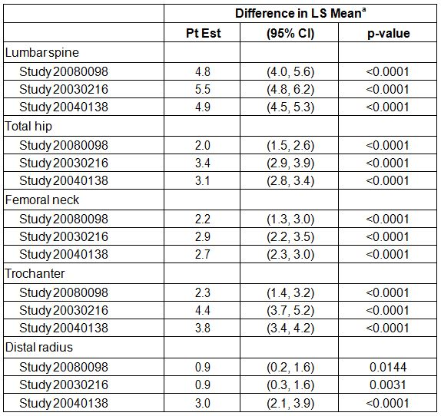
In Study 20030216, the primary efficacy analysis demonstrated the efficacy of denosumab at decreasing fracture risk, with relative risk reductions at month 36 for new vertebral, non vertebral, and hip fractures of 68%, 20%, and 40%, respectively. A decrease in fracture risk was also observed in Study 20040138, with a 62% decrease in the incidence of new vertebral fractures in the denosumab group relative to the placebo group at Month 36.
Decrease in fracture risk was not an efficacy outcome in Study 20080098 but clinical fractures were reported by the investigators and confirmed by the central imaging vendor for 1 subject in the denosumab group (0.8%) and 2 subjects in the placebo group (1.7%). New (morphometric) vertebral fractures were reported for no subjects in the denosumab group and 1 subject in the placebo group (0.8%).
Overall, it is considered that the EU criteria have been met.
It is noted that according to the EU guideline the indication should be “treatment of osteoporosis in men at high risk of fracture”.
Whether the indication should be limited by qualification of the BMD and/or BMD is uncertain – this does not appear to have been the practice with the indication for post menopausal women. If deemed necessary, then it should match the criteria for entry to the study.

Safety
The safety data seen in the pivotal study in men with osteoporosis was similar to that seen previously in studies in postmenopausal women with osteoporosis. The long term studies in postmenopausal women with osteoporosis did not identify any additional risks with the exception of the cases of osteonecrosis of the jaw. While the patients who developed these events also had local risk factors, the incidence is significant and should be better reflected in the PI.
The post marketing review of adverse events (AEs) states that there is sufficient evidence to add drug sensitivity as a post marketing adverse drug reactions to the national product labelling. This is not reflected in the proposed PI included in the submission.

List of questions
No clinical questions.

Clinical summary and conclusions

First round benefit-risk assessment

First round assessment of benefits
The benefits of Prolia in the proposed usage are:
- Increase in BMD at all skeletal sites measured: lumbar spine, proximal femur (total hip, femoral neck, trochanter), and distal radius compared with placebo at 12 months.
- The magnitudes of the mean BMD increases observed in males with osteoporosis were similar to those observed in studies in postmenopausal women.
- Increases in BMD were associated with a decrease in new vertebral, non vertebral, and hip fractures in studies in previously evaluated studies (20030216 and 20040138). It is reasonable to extrapolate the same in men with osteoporosis.
- Safety in men with osteoporosis was similar to that seen in postmenopausal women.

First round assessment of risks
The risks of Prolia in the proposed usage are:
- AEs which are similar to those previously documented for denosumab.
- Osteonecrosis of the jaw is likely in a small number of subjects with long term use of denosumab.

First round assessment of benefit-risk balance
The benefit-risk balance of Prolia, given the proposed usage, is favourable.

First round recommendation regarding authorisation
Based on the clinical data submitted, it is recommended that the application be approved.

V. Pharmacovigilance findings

Risk management plan
The sponsor submitted a Risk Management Plan (RMP) which was reviewed by the TGA’s Office of Product Review (OPR).

Safety specification
The sponsor provided a summary of ongoing safety concerns which are shown at Table 3.
Table 3: Ongoing safety concerns for Prolia.
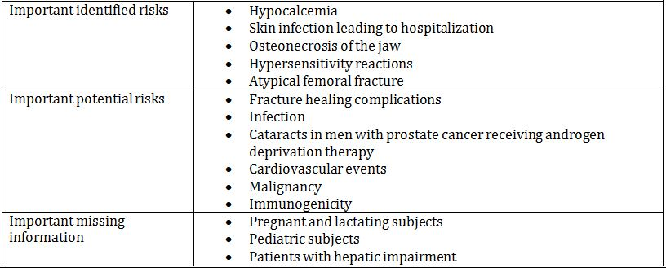

Comments
The sponsor states in RMP Version 2, submitted with the current application, that changes to the ongoing safety concerns since RMP Version 1.3 (last version submitted to the TGA) that:
Hypersensitivity and atypical femoral fracture were transitioned from potential risks to identified risks.
It is recommended to the Delegate that the sponsor re-name the important identified risk ‘Skin infection leading to hospitalisation’ to ‘Serious infection leading to hospitalisation’. That is, serious infections reported in clinical trials with Prolia encompassed not only skin infections but other organs:
WARNINGS AND PRECAUTIONS, 5.3 Serious Infections - In a clinical trial of over 7800 women with postmenopausal osteoporosis, serious infections leading to hospitalisation were reported more frequently in the Prolia group than in the placebo group [see Adverse Reactions (6.1)]. Serious skin infections, as well as infections of the abdomen, urinary tract, and ear, were more frequent in patients treated with Prolia. Endocarditis was also reported more frequently in Prolia-treated patients…” (see FDA product label page 7).
It is also recommended to the Delegate that adequate and appropriate pharmacovigilance and risk minimisation activities are assigned to this risk.
It is recommended to the Delegate that the sponsor add ‘Suppression of bone turnover’ to the list important identified risks, as supported by data from clinical studies with Prolia:
WARNINGS AND PRECUATIONS, 5.7 Suppression of Bone Turnover - In clinical trials in women with postmenopausal osteoporosis, treatment with Prolia resulted in significant suppression of bone remodeling as evidenced by markers of bone turnover and bone histomorphometry [see Clinical Pharmacology (12.2) and Clinical Studies (14.1)]. The significance of these findings and the effect of long-term treatment with Prolia are unknown. The long-term consequences of the degree of suppression of bone remodeling observed with Prolia may contribute to adverse outcomes such as osteonecrosis of the jaw, atypical fractures, and delayed fracture healing. Monitor patients for these consequences” (see FDA product label page 8).
It is also recommended to the Delegate that adequate and appropriate pharmacovigilance and risk minimisation activities are assigned to this risk.

Pharmacovigilance plan
A summary of the pharmacovigilance plan is shown in Table 4.
Table 4: Summary of pharmacovigilance plan.
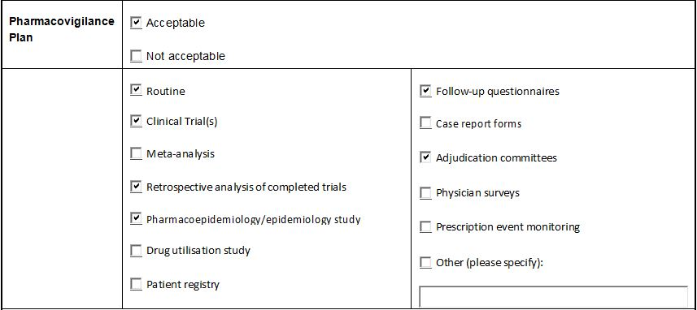

Comments
All additional pharmacovigilance activities are ongoing for Prolia. Nevertheless, it is expected that results of these studies will be communicated to the TGA via Periodic Safety Update Reports (PSURs) and updates to the RMP at the same time as other regulatory agencies.

Risk minimisation activities
A summary of the risk minimisation activities are shown in Table 5.
Table 5: Summary of risk minimisation activities.
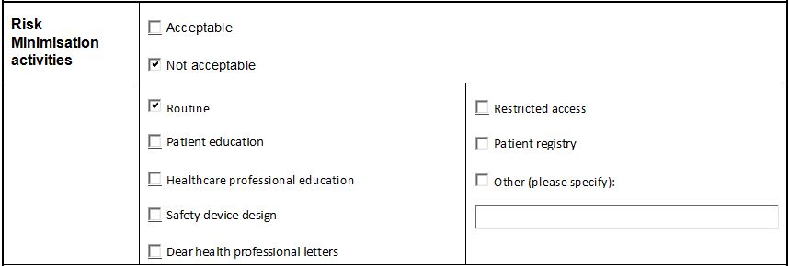

Comments
The sponsor concludes in the RMP that routine risk minimisation activities (PI and Consumer Medicines Information [CMI]) are sufficient to mitigate the risks associated with Prolia, except the four important potential risks (Fracture healing complications, Infection, Cardiovascular events, Malignancy) where no risk minimisation activities are deemed necessary.
For the important identified risk ‘Atypical femoral fracture’, the sponsor states in the RMP:
A change to the prescribing information is planned. Atypical femoral fracture will be added to the Precautions and Adverse Effects sections (submission pending)
However, this statement does not appear in the proposed Australian PI. It is recommended to the Delegate that the sponsor submit these proposed changes to the TGA.
It is also recommended to the Delegate that additional precautions be added to relevant parts of the proposed Australian PI to further inform prescribers and healthcare professionals of the risks of serious infections, dermatologic adverse reactions, osteonecrosis of the jaw and suppression of bone turnover (see relevant information from the FDA Product Label below):
5.3 Serious Infections
In a clinical trial of over 7800 women with postmenopausal osteoporosis, serious infections leading to hospitalisation were reported more frequently in the Prolia group than in the placebo group [see Adverse Reactions (6.1)]. Serious skin infections, as well as infections of the abdomen, urinary tract, and ear, were more frequent in patients treated with Prolia. Endocarditis was also reported more frequently in Prolia-treated patients. The incidence of opportunistic infections was similar between placebo and Prolia groups, and the overall incidence of infections was similar between the treatment groups. Advise patients to seek prompt medical attention if they develop signs or symptoms of severe infection, including cellulitis.
Patients on concomitant immunosuppressant agents or with impaired immune systems may be at increased risk for serious infections. Consider the benefit-risk profile in such patients before treating with Prolia. In patients who develop serious infections while on Prolia, prescribers should assess the need for continued Prolia therapy
5.4 Dermatologic Adverse Reactions
In a large clinical trial of over 7800 women with postmenopausal osteoporosis, epidermal and dermal adverse events such as dermatitis, eczema, and rashes occurred at a significantly higher rate in the Prolia group compared to the placebo group. Most of these events were not specific to the injection site [see Adverse Reactions (6.1)]. Consider discontinuing Prolia if severe symptoms develop ”
5.7 Suppression of Bone Turnover
In clinical trials in women with postmenopausal osteoporosis, treatment with Prolia resulted in significant suppression of bone remodeling as evidenced by markers of bone turnover and bone histomorphometry [see Clinical Pharmacology (12.2) and Clinical Studies (14.1)]. The significance of these findings and the effect of long-term treatment with Prolia are unknown. The long-term consequences of the degree of suppression of bone remodeling observed with Prolia may contribute to adverse outcomes such as osteonecrosis of the jaw, atypical fractures, and delayed fracture healing. Monitor patients for these consequences
5.5 Osteonecrosis of the Jaw
…A routine oral exam should be performed by the prescriber prior to initiation of Prolia treatment…
…Discontinuation of Prolia therapy should be considered based on individual benefit-risk assessment
It is recommended to the Delegate that the sponsor revise the PRECAUTION in the proposed Australian PI on Carcinogenicity to inform prescribers and healthcare professionals that malignancies with Prolia have been reported (see relevant information from the FDA Product Label below):
New Malignancies
The overall incidence of new malignancies was 4.3% in the placebo and 4.8% in the Prolia groups. New malignancies related to the breast (0.7% placebo vs. 0.9% Prolia), reproductive system (0.2% placebo vs. 0.5% Prolia), and gastrointestinal system (0.6% placebo vs. 0.9% Prolia) were reported. A causal relationship to drug exposure has not been established
New malignancies were reported in no patients in the placebo group and 4 (3.3%) patients (3 prostate cancers, 1 basal cell carcinoma) in the Prolia group
It is noted for the important potential risk - Cataracts in men with prostate cancer receiving androgen deprivation therapy the sponsor states in the RMP that “Language on cataract in men with prostate cancer receiving ADT has been included in the prescribing information.” and that in the proposed Australian PI (ADVERSE EFFECTS) it is stated “Adverse reactions defined as adverse events reported in men with bone loss associated with androgen deprivation (n = 1456) occurring in at least 2% of Prolia-treated men) and at least 1% more frequently in Prolia-treated men than placebo-treated men were: ...cataract (4.7% Prolia, 1.2% placebo).

Summary of recommendations
The OPR provides these recommendations in the context that the submitted RMP is supportive to the application; the implementation of the Prolia (denosumab) AU RMP Version 2, dated 29 August 2012 (data lock point 26 May 2012), and any future updates is imposed as a condition of registration; and the submitted EU-RMP is applicable without modification in Australia unless so qualified:
Safety considerations may be raised by the clinical and nonclinical evaluators through the consolidated section 31 request and/or the nonclinical and clinical evaluation reports, respectively. It is important to ensure that the information provided in response to these includes consideration of the relevance for the RMP, and any specific information needed to address this issue in the RMP. For any safety considerations so raised, please provide information that is relevant and necessary to address the issue in the RMP.
- It is recommended that the Delegate implement AU RMP Version 2, dated 29 August 2012 (data lock point 26 May 2012), and any future updates as a condition of registration.
- It is recommended the Delegate consider that the proposed indication may allow for prescribing in inappropriate populations, for example, those men who may not be at high risk of fracture or those who have not failed or are intolerant to other treatments.
- It is recommended to the Delegate that the sponsor re-name the important identified risk ‘Skin infection leading to hospitalisation’ to ‘Serious infection leading to hospitalisation’. That is, serious infections reported in clinical trials with Prolia encompassed not only skin infections but other organs. It is also recommended to the Delegate that adequate and appropriate pharmacovigilance and risk minimisation activities are assigned to this risk.
- It is recommended to the Delegate that the sponsor add ‘Suppression of bone turnover’ to the list important identified risks, as supported by data from clinical studies with Prolia. It is also recommended to the Delegate that adequate and appropriate pharmacovigilance and risk minimisation activities are assigned to this risk.
- It is recommended to the Delegate that the sponsor provide the proposed Australian PI changes for the important identified risk ‘Atypical femoral fracture’ (the sponsor states in the RMP: “A change to the prescribing information is planned. Atypical femoral fracture will be added to the Precautions and Adverse Effects sections (submission pending)”.
- It is also recommended to the Delegate that additional precautions be added to relevant parts of the proposed Australian PI to further inform prescribers and healthcare professionals of the risks of serious infections, dermatologic adverse reactions and osteonecrosis of the jaw and suppression of bone turnover (see relevant information extracted from the FDA Product Label in Risk Minimisation Activities section).
- It is recommended to the Delegate that the sponsor revise the PRECAUTION in the proposed Australian PI on Carcinogenicity to inform prescribers and healthcare professionals that malignancies with Prolia have been reported (see relevant information extracted from the FDA Product Label in Risk Minimisation Activities section).

VI. Overall conclusion and risk/benefit assessment
The submission was summarised in the following Delegate’s overview and recommendations:

Quality
There was no requirement for a quality evaluation in a submission of this type.

Nonclinical
There was no requirement for a nonclinical evaluation in a submission of this type.

Clinical

Efficacy
There was one pivotal efficacy study (20080098) submitted in men with osteoporosis. This was a multicentre, randomised, double blind, placebo controlled study in men with low BMD. This was a 24 month study that comprised of a 12 month double blind phase and a subsequent 12 month open label phase.
The inclusion criteria are related, in essence, to BMD measures. BMD expressed in g/cm² corresponded to T scores ≤ -2.0 and ≥ -3.5 at the lumbar or femoral neck, or a T score ≤ -1.0 and ≥ -3.5 at the lumbar spine or femoral neck in subjects with a history of major osteoporotic fracture.
Exclusion criteria were comprehensive and included past treatment with denosumab, bisphosphonates and strontium ranelate, malignancies, etc.
Study treatments were: a 12 month double blind phase during which patients were randomised 1:1 to receive single 60 mg subcutaneous administration of denosumab or matching placebo Q6M (that is, once every six months, or one dose on Day 1 and the second dose at Month 6), and a 12 month open label phase during which all patients (independent of randomisation) received 60 mg subcutaneous denosumab Q6M (that is, single doses at Month 12 and Month 18).

Efficacy endpoints
The primary efficacy outcome was the percent change from baseline in lumbar spine BMD at 12 months.
Other efficacy outcomes were as follows:
- Percent change from baseline in BMD of the total hip, femoral neck, hip trochanter, and distal radius at month 12
- Percent change from baseline in type-1 collagen C-telopeptide (CTX1) at day 15
- Percent change in BMD for all sites at 6 and 24 months
- Percent change in CTX1 at 6, 12, 18 and 24 months
- Bone histology and histomorphometry in a subset of 20 patients at 12 months
The randomisation and blinding details are discussed by the evaluator. The randomisation schedule was stratified by the minimum BMD T Score (<-2.5 versus >-2.5) at either the lumbar spine or femoral neck (whichever was lower).
In essence, “the sample size of 232 provided a minimum of 99% power to detect a 5.1% difference at lumbar spine between the treatment groups at month 12 assuming a SD of 3.8% and a two sided, type 1 error rate of 0.05”.
In relation to the primary efficacy endpoint, the analysis of the percent change from baseline in lumbar spine BMD to month 12 was performed using an analysis of covariance (ANCOVA) model with last observation carried forward (LOCF) imputation. The ANCOVA model included treatment as the main effect and the level of baseline BMD T score (randomisation stratification factor) as the covariate. The primary results were based on the point estimate for the least squares means and the two sided 95% CI (Confidence Interval) for the treatment difference (denosumab-placebo) at the 12 month time point.

Demographics
There were 232 subjects enrolled (denosumab=121, placebo=121) and 227 completed the study. In the denosumab group all were Caucasians and the mean age was 64.9 years (10.5). Other relevant demographic details are as shown in Table 6.
Table 6: Baseline BMT T scores (randomised subjects): First 12 month analysis.
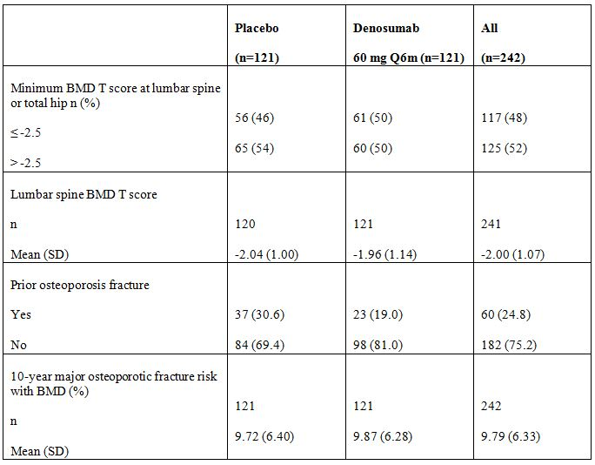

Results
The evaluator mentions that, “Subjects treated with denosumab, as compared with placebo, showed significantly greater gains in mean percent change from baseline at month 12 in lumbar spine BMD, 5.7% versus 0.9%, with a mean difference of 4.8% (p < 0.0001; 95% CI: 4.0-5.6) between the treatment groups”.
The secondary efficacy endpoints are as shown in Table 7.
Table 7: Study 20080098 Results of Secondary Endpoints – Primary Efficacy Subset, LOCF, 12 months analysis.
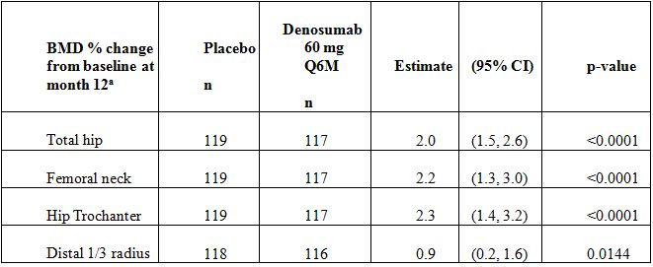
n = Number of subjects with values at baseline and at ≥ 1 post baseline visit for BMD endpoints and at baseline and at day-15 visit for serum CTX1
a. Difference from placebo and p-value based on an ANCOVA model with treatment as main effect and level of baseline BMD T-score as covariate
These changes were statistically significant compared to placebo. The data from the clinical evaluation report are shown in Figures 1-2.
Figure 1: Study 20080098 BMD Percent Change From Baseline at Month 12 by Anatomical Site: Least Squares Means and 95% CIs from ANCOVA (Primary Efficacy Analysis Set, LOCF) (First 12 Months Analysis).
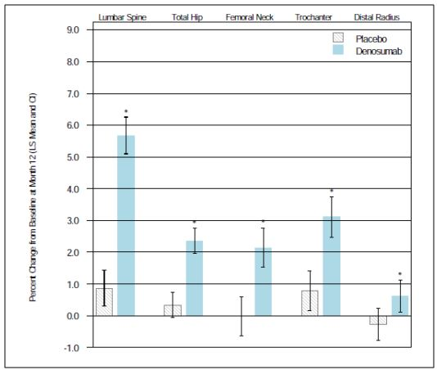
Point estimates and nominal 95% CI are based on an ANCOVA model with treatment as main effect and level of baseline BMD T-score as covariate
* Adjusted p-value < 0.05.
Figure 2: Study 20080098 Percent Change from Baseline in BMD for Secondary Endpoints: Least Squares Means and 95% CIs from ANCOVA (Primary Efficacy Analysis Set, LOCF) (First 12 Months Analysis).
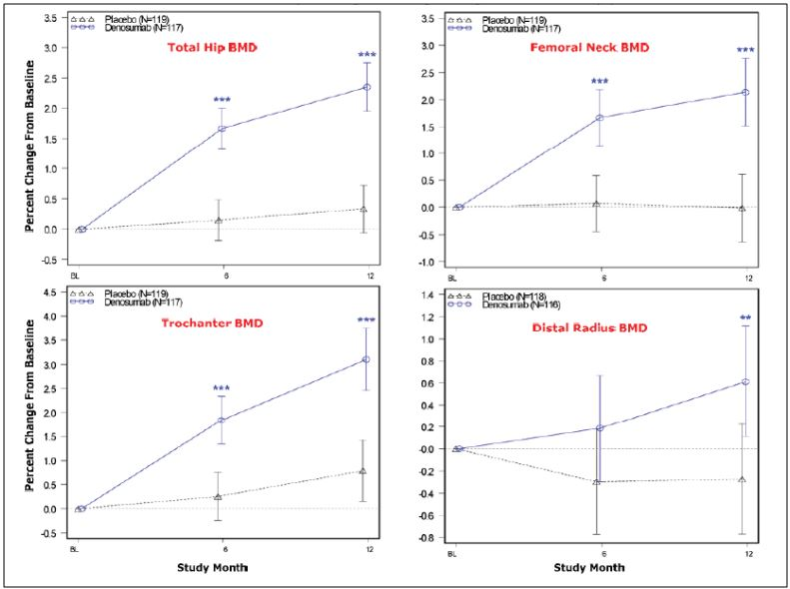
** p-value ≤ 0.025; *** p-value ≤ 0.01
No fracture data are included as secondary efficacy endpoints.
There was also a statistically significant decrease in mean serum CTX1 concentration at Day 15 and Months 6 and 12.

Bone histology
A total of 29 subjects (17 = denosumab, 12 = placebo) were enrolled to have a transiliac biopsy within 30 days prior to the 12 month visit. All results were normal.
The evaluator concludes that there was statistically significant superiority of denosumab over placebo seen in relation to lumbar BMD and other secondary endpoints. Primary analysis presented in the report is on the “per protocol” and not on the “ITT” population. The evaluator mentions that, “this study used an inclusion criterion of BMD equivalent to a T-score of ≤ -2 at the lumbar spine or femoral neck, OR ≤ -1 at the lumbar spine or femoral neck in subjects with a history of major osteoporotic fracture”. The evaluator mentions that this was in line with the recommendations of published guidelines.
Delegate’s comments: The assertion that the inclusion criteria were in line with the recommendations of the EU guideline is not entirely accurate. These guidelines discuss osteoporosis in the context of women:
The WHO operational definition defines an osteoporotic woman on the basis of a BMD measurement (spine or hip) showing a T score below -2.5. The term ‘severe or established osteoporosis’ habitually denotes a T score below -2.5 in the presence of one or more fragility fractures... No WHO definition for osteoporosis exists for men. However, in clinical practice the same cut-off for the diagnosis of osteoporosis in men, i.e. BMD below -2.5 standard deviations of the female reference range, has been used.
This study has included only 50% in the denosumab treated group who satisfy the WHO definition of osteoporosis (T-score < -2.5).

Supportive studies
The sponsor has submitted final or interim reports of the studies in postmenopausal women (20050233, 289, 747 and 287) which were the condition of registration of denosumab regarding that indication.
Study 20050233 is a long term safety study of denosumab administered to postmenopausal women with low BMD. This is an open label multicentre extension study of 20010223 which was submitted in the original application. The parent study (20010223) was a placebo controlled study that examined dose response in terms of BMD, in postmenopausal females: 6, 14 or 30 mg every 3 months or 14, 60, 100 or 210 mg every 6 months was administered. Lumbar BMD was the primary efficacy endpoint.
A total of 262 subjects completed the parent study 20010223. Of these, 200 enrolled in the extension study (20050233) and 138 (69%) completed treatment.
The evaluator mentions that 4 additional years of denosumab led to further gains in BMD. It is states that:
After 8 years of denosumab treatment, the least square means BMD percent change from the parent Study 20010223 baseline was 16.5% at the lumbar spine, 6.8% at total hip, 6.8% at the femoral neck, 11.2% at the trochanter, and 1.3% at the distal radius.
Study 2006089 is an open label single arm extension study to evaluate the long term safety and sustained efficacy of denosumab in the treatment of postmenopausal osteoporosis (PMO). This is an extension study of Study 20030216, which was submitted in the original submission. The current study, 20060089 includes interim analysis only, up to 36 months. Study 20030216 was a Phase III multicentre double blind placebo controlled study of denosumab at 60 mg SC (versus placebo) every 6 months for 3 years. The primary efficacy measure was the incidence of new vertebral fracture during the entire 36 month period.
The primary endpoint is the extension study was safety data. The secondary endpoints included BMD, subject incidence of vertebral fractures. Only descriptive statistics are used.
In regard to BMD, the evaluator mentions that:
At 36 months the long term group experienced further statistically significant gains in BMD. The LS mean percent increase in BMD from the end of Study 20030216 (extension Study 20060289 baseline) was 4.9% at the lumbar spine, 1.8% at the total hip, 1.7% at the femoral neck, and 2.8% at the trochanter and 0.6% at the radius.
The cumulative incidence of new vertebral fractures in Studies 2030216 and 20060289 was 4.9% in the long term group and was 7.3% in the crossover group.
The evaluator also discusses a high resolution peripheral quantitative computed tomography (HR-pQCT) study, 20080747, on postmenopausal women previously treated with denosumab. The main objective was to evaluate the combined effect of denosumab treatment and discontinuation on cortical thickness at the distal radius by HR-pQCT.
This was a cohort study enrolling 75 subjects from two centres from Study 20050179. In this latter study, subjects with (lumbar or total hip) BMD T score less than -2.0 or -3.0 received denosumab (n = 83), alendronate (n = 82) or placebo (n = 82) for 12 months. Treatment was discontinued for 12 months. Those randomised to denosumab or placebo and whose treatment was completed at least 12 months before were eligible to participate in the current study.
The primary endpoint was: the percent change in cortical thickness at the distal radius as determined by the HR-pQCT from baseline (the baseline is as established in protocol 20050179).
A total of 79 subjects were enrolled. The evaluator observes that:
The cortical thickness of the distal radius assessed by HR-pQCT was 1.8% below pretreatment values at month 32 in subjects who received and discontinued denosumab. In comparison, cortical thickness at the distal radius was 5.5% below pretreatment values at month 32 in subjects who received placebo. The difference between the denosumab and placebo groups was 3.7% (95% CI: [-0.4, 7.8]; p = 0.0766).
The evaluator concludes the following:
Overall, the bone parameter gains (ie. density, cortical thickness) and bone turnover marker reductions associated with denosumab administration are reversible upon denosumab discontinuation. The bone parameters assessed by HR-pQCT and DXA at the distal radius and distal tibia generally returned to pretreatment levels, but remained above levels in the placebo group, following discontinuation of denosumab treatment in postmenopausal women with low BMD.
Study 20080287 is a transiliac crest bone histology and histomorphology study in postmenopausal women with low bone mass or osteoporosis previously treated with denosumab (in Studies 20050179, 20050141, 20060237 or Study 20030216). Subjects were to have completed participation ≥ 12 and ≤ 36 months prior to the current study. A total of 15 subjects were recruited for the biopsy. All showed normal histology.
The evaluator concludes that the bone turnover and histomorphology results suggest reversibility in bone remodelling. There was no pathology observed in the specimens.

Other efficacy analyses: Cross study comparisons
There is a discussion based on cross study comparison of the pivotal study in men (20080098) with the previously submitted studies: in women (20030216) and osteopenic men with prostate cancer who had androgen deprivation therapy (ADT) (20040138). Baseline BMD T scores, baseline prevalent fracture risk, baseline 10 year fracture risk, BMD results, CTX1 results are compared across studies. Notably, the mean baseline BMD scores at entry are discussed. The evaluator states that:
Consistent with the eligibility criteria for these studies, the mean baseline BMD T-scores in Study 20030216 were lower than those in Study 20080098, which were generally lower than those in Study 20040138.
The evaluator also mentions in relation to the outcome of BMD that:
The difference in mean percent change in BMD at the lumbar spine between the denosumab and placebo treatment groups in Study 20080098 (4.8 %) was similar to the increases observed in Studies 20030216 (5.5 %) and Study 20040138 (4.9 %), and the absolute changes from baseline were similar at all anatomical sites examined. These results indicate a similar treatment effect of denosumab across all 3 studies.
It is stated there is some similarity in the 10 year fracture risk as seen below.
The baseline 10 year fracture risk was assessed using the FRAX tool and are as follows:
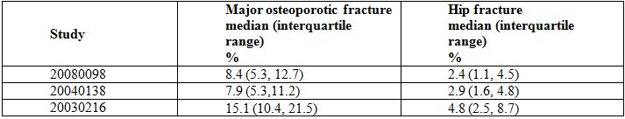
As seen above, there is some overlap across studies.
The evaluator states that since the female osteoporosis studies showed reduction in fractures with similar magnitude of reduction in BMD as the male osteoporosis study, it could be extrapolated that males will also show a similar reduction in risk of fractures.

Overall efficacy conclusion
In this section the evaluator discusses the Committee for Medicinal Products for Human Use (CHMP) Guideline Section 5.3.4. This section states that the gold standard for granting registration for the treatment of osteoporosis in men at increased risk of fractures remains the demonstration of anti fracture efficacy in a 2 year minimum placebo controlled study. This is because of the limited knowledge on the pathophysiology of osteoporosis (in the two sexes) and the action of these medicines. The guideline nevertheless concedes:
However, once an initial marketing authorisation has been granted to a new chemical entity for the treatment of postmenopausal osteoporosis in women at high risk of fracture, a separate bridging study of the same new chemical entity, using the same formulation, dose, and route of administration in male osteoporotic patients could be sufficient for being granted a marketing authorisation with the indication ‘treatment of osteoporosis in men at increased risk of fracture’ provided that:
- the duration of the study is at least one year;
- the dosage is justified
- the applicant justifies that the cut-off of BMD, age and any other risk factor chosen for the inclusion of men in the pivotal study will generate a fracture risk of a similar magnitude compared with postmenopausal women that were recruited in the studies used to obtain the indication “Treatment of postmenopausal osteoporosis in women at increased risk of fracture”
- the magnitude of the changes in BMD versus placebo is similar to that observed in postmenopausal osteoporotic women treated with the same compound and is proportional to the decreased incidence of fractures in treated women.
If these conditions are not fulfilled, or if the mechanism of action of the new chemical entity is gender specific, a bridging strategy will not be acceptable and a therapeutic study with fracture endpoints will be required in a separate trial in men.
The evaluator opines that these criteria have been met.
The evaluator also notes that according to the EU Guideline, the indication should be “treatment of osteoporosis in men at high risk of fracture”. An uncertainty is expressed whether the indication should match the criteria for study entry.
Delegate’s comments: My concern is that while all of the criteria discussed above show some overlap between studies, the pivotal study in males does not fully represent the target population, that is, males with osteoporosis at increased risk of fracture. This is because only 50% on those included satisfied the WHO definition of osteoporosis (T score ≤ -2.5 in lumbar or hip region). While the guideline recommends that studies in women could include subjects with various levels of BMD provided that there is information that the 10 year fracture risk is increased, this is not provided in relation to males in this submission. Based on the company’s calculation in the population studied, the 10 year fracture risk in women was 15.1% (10.4, 21.5); it was less in men; 8.4 % (5.3, 12.7). Thus, the male indication has not been adequately justified with the one study including 50% of subjects with osteopenia.
Other independent risk factors for fractures are not validated in this data set. In relation to prior history of osteoporotic fractures, the baseline level was 19% in the denosumab treated group. The following should be clarified in the pre Advisory Committee on Prescription Medicines (ACPM) response:
- How many subjects with a history of osteoporotic fractures had a baseline BMD score of ≤ -2.5 T score group?
This would identify the precentage who were at increased risk of fractures.
Thus, based on the data set, there is efficacy information to support the indication that denosumab increases BMD in those with osteopenia and osteoporosis.
The qualification, “at high risk of fracture” is recommended based on the EU Guideline adopted by the TGA in August 2008. This guideline replaces the NfG on postmenopausal osteoporosis in women. The present guideline discusses that the aim of treatment is to decrease the incidence of fractures; and the recommendations for the male indication are based on the premise that registration was granted for this product for the treatment of postmenopausal osteoporsis in women at high risk of fracture. It should be noted that when the original submission was evaluated, the studies were not conducted in line with this guideline, hence the recommendation for treatment of osteoporosis in postmenopausal women, without the qualification, “at risk of fractures”.

Safety
The AEs in pivotal Study 20080098 are discussed. There is safety data also provided on the extension studies (20050233 and 20060289) in postmenopausal osteoporotic women.
A total of 121 men have been exposed to denosumab in the pivotal study 20080098. The AEs by system organ class are included. The trends observed in the original submission in the studies on women (infections, malignancy, dermatological events, pancreatitis, etc.) were not observed in Study 20080098. However, the numbers in the male study may not have been sufficient to detect these trends.
Treatment related events were 1.7% in the denosumab group and 5.0% in the placebo group. There were 2 deaths in the denosumab group. They appeared not to be related to denosumab. No obvious trends in the serious AEs are observed. Of the 3 subjects who withdrew due to AEs, one was due to prostate cancer. There were no significant changes in vital signs or laboratory investigations.
The long term studies on women generally reflected the incidence of the events reported in the original postmenopasual osteoporosis studies.
There were 4 reports of osteonecrosis of the jaw (ONJ) in these long term studies. There were 7 incidents of avascular necrosis at other sites. These are not included in the draft PI and should be included.
Overall, the evaluator concludes that the safety profile is adequate. The evaluator also recommends that the ONJ observed in the long term studies in women should be included, in the draft PI.

Overall conclusion of the clinical evaluator
The evaluator concludes that the overall risk-benefit profile for the proposed indication is satisfactory. The lack of fracture data as an efficacy endpoint in the pivotal study is justified on the basis that the magnitude of change in relation to BMD in males is similar to that in females. The evaluator recommends that the indication should be changed to “treatment of osteoporosis in men at high risk of fracture” as the evaluator is of the opinion that the bridging study satisfies the requirement of the European Medicines Agency (EMA) Guideline. Other PI changes are also recommended.
In the sponsor’s response to the clinical evaluation report, it is stated that there have been safety related notifications resulting in the amendment to the PI, since submitting this application. These notifications have included hypersensitivity reactions, atypical femoral fractures, severe symptomatic hypocalcaemia and anaphylactic reactions.
Overall, there are no contentions regarding the conclusions of the evaluator.

Risk management plan
The relevant recommendations extracted from the report are:
3. It is recommended to the Delegate that the sponsor re-name the important identified risk – ‘Skin infection leading to hospitalisation’ to ‘Serious infection leading to hospitalisation’. That is, serious infections reported in clinical trials with Prolia encompassed not only skin infections but other organs. It is also recommended to the Delegate that adequate and appropriate pharmacovigilance and risk minimisation activities are assigned to this risk.
4. It is recommended to the Delegate that the sponsor add ‘Suppression of bone turnover’ to the list important identified risks, as supported by data from clinical studies with Prolia. It is also recommended to the Delegate that adequate and appropriate pharmacovigilance and risk minimisation activities are assigned to this risk.
5. It is recommended to the Delegate that the sponsor provide the proposed Australian PI changes for the important identified risk – ‘Atypical femoral fracture’ (the sponsor states in the RMP “A change to the prescribing information is planned. Atypical femoral fracture will be added to the Precautions and Adverse Effects sections (submission pending)” [see RMP page 155]).
6. It is also recommended to the Delegate that additional precautions be added to relevant parts of the proposed Australian PI to further inform prescribers and healthcare professionals of the risks of serious infections, dermatologic adverse reactions and osteonecrosis of the jaw and suppression of bone turnover (see relevant information extracted from the FDA Product Label in Risk Minimisation Activities section on page 6 of this report).
7. It is recommended to the Delegate that the sponsor revise the PRECAUTION in the proposed Australian PI on Carcinogenicity to inform prescribers and healthcare professionals that malignancies with Prolia have been reported (see relevant information extracted from the FDA Product Label in Risk Minimisation Activities section on page 6 of this report).

Risk-benefit analysis

Delegate considerations
This submission is based on one bridging study, 20080098 to support the indication, “treatment of osteoporosis in men”. This study has included BMD as the primary efficacy endpoint without fracture data in the efficacy analyses. The sponsor states, in its letter of application, that the treatment effect observed in the study in men was similar in magnitude to that observed in the pivotal studies in women in relation to BMD; in addition, the baseline fracture risk for men in Study 20080098 showed a considerable overlap with that for women with PMO in study 20030216. Thus, it is “reasonable to extrapolate the anti fracture efficacy in men, based on the anti fracture efficacy in women”.
It also states that regulatory guidance supports the evaluation of BMD to demonstrate efficacy in men with osteoporosis after the therapy has demonstrated efficacy at reducing fracture risk in women with osteoporosis. It is stated that regulatory agencies, including the US FDA and Health Canada, have endorsed BMD as the primary measure of efficacy as was communicated at scientific advice meetings held before study 2008098 was started. The 12 month double blind treatment duration is considered adequate to demonstrate effects on BMD by those agencies.
The Delegate agrees that the 12 month double blind treatment duration is considered adequate to demonstrate effects on BMD. However, the issue of extrapolating to anti fracture efficacy appears difficult on the following grounds:
- The inclusion criteria stipulated Study 20080098 uses a higher BMD cut-off of ≤ -2.0 than that used in the WHO definition for osteoporosis which is ≤ -2.5. The study on males, was stratified according to BMD; it is stated that those with ≤ -2.5 in the denosumab group was 61 (50%) at study entry. Thus, only 50% met the criteria for osteoporosis in a relatively small study. The EMA guideline suggests that patients with variable levels of BMD could be recruited (for studies in post menopausal osteoporosis) provided their 10 year risk of fracture is increased. The inclusion of only 50% of men with osteopenia is not justified with increased (10 year) fracture risk. The 10 year fracture risk is 8.4 (5.3, 12.7) in men compared to 15.1 (10.4, 21.5) in women. This is based on the current study and previously submitted study on PMO.
- The other independent risk factors in osteoporosis in males are not validated. It is also stated that 19% of the denosumab population had prior osteoporotic fractures, at baseline. The sponsor should state, in its pre ACPM response, the number who had prior osteoporotic fractures in those with BMD less than -2.5.
- Section 5.3.4 of the relevant CHMP guideline states the minimal requirement necessary in order to be granted a marketing indication for the treatment of osteoporosis in men at increased risk of fracture. This aspect of the guideline states that a bridging study could be sufficient provided that the sponsor addresses certain criteria. One criterion of note is:
The applicant justifies that the cut-off of BMD, age and any other risk factor chosen for the inclusion of men in the pivotal study will generate a fracture risk of a similar magnitude compared with postmenopausal women that were recruited in the studies used to obtain the indication “Treatment of postmenopausal osteoporosis in women at increased risk of fracture”
This clearly has not been addressed satisfactorily as the BMD cut off used in the male study is not representative of the osteoporosis target population. Other independent risk factors (including prevalent fractures) have not been identified in this population. How do factors such as age, prior fractures, a family history of hip fractures, high bone turn-over, tobacco use, alcohol abuse affect the 10 year fracture risk in men? This is not defined in this submission.
Based on these concerns, it is recommended that approval be granted for the following indication:
Treatment to increase bone mass in men with osteoporosis at high risk for fracture.
The approval in the US is based on the same study as above.
The PI recommendations recommended by the clinical and OPR evaluator are endorsed. All risk management activities recommended by the OPR evaluator are also endorsed. The Delegate also recommends that baseline characteristics relating to BMD (the number with T score < -2.5 and > -2.5 at either lumbar spine or femoral neck) should be included in the draft PI.
The committee’s advice is to be sought.

Response from sponsor

Summary
The sponsor supports the draft indication recommended by the TGA Delegate with slightly revised wording:
Treatment to increase bone mass in men with osteoporosis at increased risk of fracture
This is to reflect the terminology used in the CHMP osteoporosis guidance for the indication statement (“increased risk of fracture”). The sponsor considers the population of men in Study 20080098 was comparable to the population enrolled in Study 20030216 in women with PMO with respect to fracture risk, consistent with the requirements in the CHMP osteoporosis guidance. Subjects enrolled in Study 20080098 encompassed a broad spectrum of baseline fracture risk, as evaluated by BMD T score, prevalent vertebral fracture, prior osteoporotic failure, and 10 year major osteoporotic fracture risk. The distribution of 10 year major osteoporotic fracture risk between Studies 20080098 and 20030216 has considerable overlap. The population studied in Study 20030216 is considered to be at increased risk of fracture; the similarity in the risk distributions would indicate that the population in Study 20080098 is also at increased risk of fracture. As acknowledged by the clinical evaluator, there is a body of evidence for long term anti fracture efficacy (up to 6 years) and increases in BMD (up to 8 years) with denosumab treatment in PMO. Long term safety data in bone loss conditions has not identified any new safety issues not already described in the Australian Prolia PI. The sponsor wishes to advise the ACPM of a significant procedural inconsistency: Safety matters that have been addressed twice to the satisfaction of TGA are now raised for a third time by the Delegate. The sponsor questions the relevance of revisiting, for a third time, matters of serious infection, dermatologic adverse reactions, suppression of bone turnover, osteonecrosis of the jaw and malignancy and with the view to include some of these matters as new PRECAUTIONS or revisions to ADVERSE EVENTS in the Prolia PI, especially considering that:
- These same matters were addressed in the original PMO indication assessment and resulted in registration of the PMO indication but without change to the PRECAUTIONS or ADVERSE EVENTS sections of the Prolia PI.
- These matters were addressed at the Administrative Appeals Tribunal via mediation and resulted in a substituted decision by the TGA: the registration of the prostate HALT indication and an update to the Prolia PI regarding the CLINICAL TRIALS section, and notably without change to the PRECAUTIONS or ADVERSE EVENTS sections.
- In the male osteoporosis registration application, long term safety data in PMO (6 years) and in women with low bone mass (8 years) is acknowledged by the clinical evaluator.
Therefore, the sponsor disagrees with the recommendations for the Prolia PI (for PRECAUTIONS AND ADVERSE EVENTS sections), the risk management activities from the OPR evaluator, and endorsed by the Delegate.

Response
There is a body of evidence for long term anti fracture efficacy (up to 6 years) and increases in BMD (up to 8 years) with denosumab treatment in PMO.
The efficacy of denosumab in women with PMO has been consistent and sustained over long term treatment. For the single arm extension study (20060289) of the 20030216 pivotal fracture efficacy study in women with PMO, the TGA clinical evaluator stated:
After 6 years of denosumab administration, the safety and tolerability profile of the subjects who participated in the extension study remains similar to that observed in the original 20030216 study
and, in the cross over (placebo to denosumab) group:
There was a prompt decrease in the incidence of vertebral fractures through 36 months of the extension study, which is consistent with what was observed in the denosumab treated group of Study 20030216.
For the long term study in postmenopausal women with low BMD (Study 20050233), the TGA clinical evaluator stated:
After 8 years of denosumab treatment, the LSM BMD percent change from the parent Study 20010223 baseline was 16.5% at the lumbar spine, 6.8% at total hip, 6.8% at the femoral neck, 11.2% the trochanter, and 1.3% the distal radius.

A: Responses to TGA Delegate’s questions and recommendations for the draft Prolia PI INDICATION and CLINICAL TRIALS for Study 20080098 in men
The sponsor supports the draft indication recommended by the TGA Delegate with slightly different wording to reflect terminology used in the CHMP indication statement for ‘increased risk of fracture’ as follows:
Treatment to increase bone mass in men with osteoporosis at increased risk of fracture.
The sponsor considers the population of men in Study 20080098 was comparable to the population enrolled in Study 20030216 in women with PMO with respect to fracture risk, consistent with the requirements in the CHMP osteoporosis guidance. Subjects enrolled in Study 20080098 encompassed a broad spectrum of baseline fracture risk, as evaluated by BMD T score, prevalent vertebral fracture, prior osteoporotic fracture, and 10 year major osteoporotic fracture risk. The distribution of 10 year major osteoporotic fracture risk between Studies 20080098 and 20030216 have considerable overlap. The population studied in Study 20030216 is considered to be at increased risk of fracture; the similarity in the risk distributions would indicate that the population in Study 20080098 is also at increased risk of fracture.
The sponsor also agrees to include in the CLINICAL TRIALS section:
…baseline characteristics relating to BMD (the number with T score ≤ -2.5 and > -2.5 at either lumbar spine or femoral neck).
Request from the TGA Delegate:
The sponsor should state in its pre ACPM response, the number who had prior osteoporotic fractures in those with BMD less than -2.5.
In response, Table 8 is provided by the sponsor.
Table 8: Number of subjects with prior osteoporotic fracture by minimum baseline BMD T-score ≤ -2.5 (Study 20080098, pivotal male osteoporosis trial).
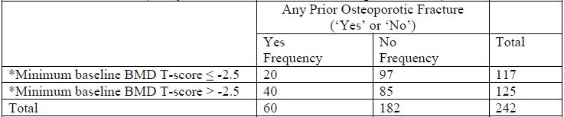
* Minimum BMD T score at lumbar spine or femoral neck
It is noteworthy that the proportion of subjects in Study 20080098 with a history of fracture is consistent with previous clinical studies of denosumab. In addition, the proportion of subjects with prevalent vertebral fracture in Study 20080098 (24.8% denosumab; 20.7% placebo) is similar to that in Study 20030216 (23.8% denosumab; 23.4% placebo) and Study 20040138 (21.1% denosumab; 23.7% placebo).
Long term safety data in bone loss conditions has not identified any new safety issues not already described in the Australian Prolia PI. Safety matters that have been addressed twice to the satisfaction of TGA are now raised for a third time.
In June 2010, initial registration of Prolia for PMO was contingent on the sponsor having addressed revisions to the PI and RMP to the satisfaction of TGA. Since then, the sponsor has implemented safety related updates to the Prolia PI (acknowledged by TGA) and has submitted five PSURs on a six monthly cycle (without reply from TGA).
Under appeal provisions pursued by the sponsor, the prostate HALT indication became a substituted decision (TGA rejection set aside and substituted with TGA approval); the substituted decision was contingent on revisions to the PI and RMP to the satisfaction of TGA and the sponsor.
The sponsor questions the relevance of revisiting, for a third time, matters of serious infection, dermatologic adverse reactions, suppression of bone turnover, osteonecrosis of the jaw and malignancy and with the view to include some of these matters as new PRECAUTIONS or revisions to ADVERSE EVENTS in the Prolia PI, especially considering that:
- These same matters were addressed in the original PMO indication assessment and resulted in registration of the PMO indication but without change to the PRECAUTIONS or ADVERSE EVENTS sections of the Prolia PI.
- These matters were addressed at the Administrative Appeals Tribunal via mediation and resulted in a substituted decision by TGA: the registration of the prostate HALT indication and an update to the Prolia PI regarding the CLINICAL TRIALS section, and notably, without change to the PRECAUTIONS or ADVERSE EVENTS sections.
- In the male osteoporosis registration application, long term safety data in PMO (6 years) and in women with low bone mass (8 years) is acknowledged by the TGA clinical evaluator:
The SAE rate in the first 36 months of the extension study was comparable to the rate in the original Study 20030216: 17.3 per 100 subject years in the denosumab group and 16.4 per 100 subject years in the placebo group.
No new adverse drug reactions have been observed with long term treatment with denosumab other than those that have also been seen with other anti resorptive agents, namely, osteonecrosis of the jaw and atypical femoral fracture. Both of these events are described in the Australian Prolia PI. Rates of other AEs, including infections and malignancies, have not increased with long term exposure. The TGA Clinical Evaluator similarly concluded for Study 20050233:
Overall, the types and incidence of AEs were not unexpected of a 4 year period in this subject population.

B: Responses to TGA Delegate’s recommendations for Prolia PI and appropriate risk management and pharmacovigilance activities
B1: It is recommended … the sponsor re-name the important identified risk 'Skin infection leading to hospitalisation' to 'Serious infection leading to hospitalisation'. That is, serious infections reported in clinical trials … encompassed not only skin infections but other organs.
The sponsor disagrees with the above recommendation.
During Study 20080098 in men with osteoporosis there was 1 serious AE of infection, reported in a subject receiving placebo (Table 9). In addition, the safety profile with respect to infections has been consistent over long term treatment in women with PMO. Thus, there is no new evidence to support making this change based on data provided in the male osteoporosis marketing application. As stated above, a systematic evaluation of AEs of infection including opportunistic infection (Table 10) was performed for the initial PMO and hormone ablation therapy (HALT) clinical development program.
Table 9: Summary of Serious AEs of Interest: Infection and Skin Infection.
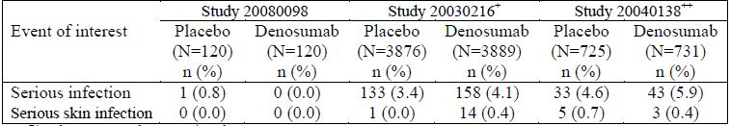
+ Pivotal PMO study
++ Pivotal prostate cancer trial in men undergoing HALT
Table 10: AEs of Opportunistic Infection: PMO and HALT Groups combined.
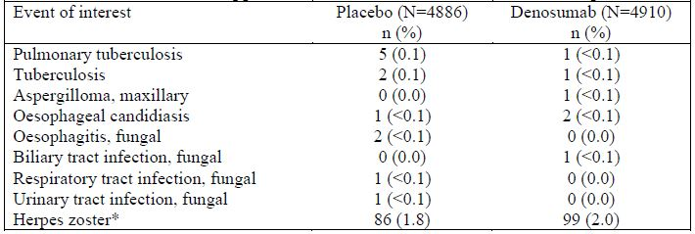
* Herpes zoster, herpes zoster ophthalmic, herpes zoster neurologic
With the exception of skin infections requiring hospitalisation, no safety signal was identified for any other infection type. Thus, the sponsor designated skin infection leading to hospitalisation as an identified risk, while other infections (including all serious AEs of infection) are designated as a potential risk in the RMP for denosumab. The identified risk is stated in the Australian Prolia PI (excerpt below):
PRECAUTIONS, Skin Infections: Patients receiving Prolia may develop skin infections (predominantly cellulitis) leading to hospitalisation (see ADVERSE EFFECTS). Patients should be advised to seek prompt medical attention if they develop signs or symptoms of cellulitis.
ADVERSE EFFECTS, Skin Infections: In two Phase III placebo controlled clinical trials in postmenopausal women with osteoporosis, skin infections leading to hospitalisation were reported more frequently in the Prolia (0.4%, 16 of 4,050) versus the placebo (0.1%, 3 of 4,041) groups, respectively. These cases were predominantly cellulitis. The overall incidence of skin infections was similar between the Prolia (1.5%, 59 of 4,050) and placebo groups (1.2%, 50 of 4,041).

Serious AEs of infection
The sponsor has comprehensively evaluated the potential for denosumab to increase the risk of serious infections generally, both in the pre market and post market settings:
- PSUR #3 of January 2012 has been provided to TGA and contained a Safety Assessment Report for pneumonia in association with the use of denosumab (Appendix 12) and Safety Assessment Report for infections in association with the use of denosumab (Appendix 13). These analyses were performed to address specific questions from the EMA via their assessment report for PSUR #2. Following detailed review of clinical and non study pneumonia events, an increased risk after denosumab administration was not established.
- PSUR #4 of July 2012 has been provided to TGA and contained a Safety Assessment Report for infections associated with latent infection with the use of denosumab (Appendix 14) and included line listings or case narratives in response to an EMA Assessment Report for PSUR #3. Following detailed review of clinical and non study infection events, worsening of latent, underlying or subclinical infections after denosumab administration was not established.
Extensive nonclinical studies provide no evidence that denosumab itself or RANKL inhibition is broadly immunosuppressive. Conditions associated with an impaired immune system may be manifested as cell mediated immune deficiency including opportunistic fungal, viral and parasitic infections. In the denosumab clinical program, no increased incidence in such infections has been observed (Table 10).
For a subgroup analysis of the primary PMO study: in denosumab treated subjects who could possibly have an impaired immune system, such as those receiving concurrent steroids (Table 11) and subjects of older age (≥75 years) (Table 12), a similar pattern of infection SAEs was demonstrated as for the overall study population providing evidence that denosumab does not increase the risk of infection in patient populations that may be immunocompromised. Further, as stated above, no increase in the incidence of infections has been observed with long term exposure in Study 20060289. Collectively, these data indicate that denosumab is not broadly immunosuppressive; hence an identified risk for all serious infections is not warranted.
Table 11: Serious adverse events (SAEs) of infection by concomitant steroid use for primary PMO safety analysis set (Study 20030216).
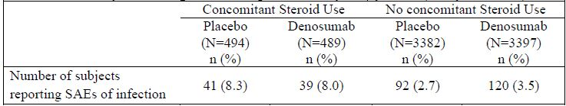
Table 12: Number of subjects reporting serious adverse events (SAEs) of infection by age subgroup for primary PMO safety analysis set (Study 20030216).
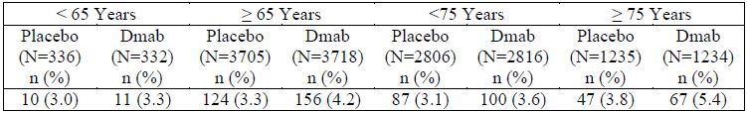

Pharmacovigilance and risk minimisation activities
For both skin infections leading to hospitalisation and SAEs of infection, the sponsor is conducting routine pharmacovigilance augmented by active surveillance, which includes collection of detailed information on events of infection received through spontaneous reports, and identification of rates of SAEs of infection in Study 20090522. Study 20090522 is a comprehensive post marketing safety observation study in women with PMO and men with osteoporosis that uses large electronic medical records databases and administrative databases to assess selected AEs of special interest, including the incidence of all infections leading to hospitalisation, emergency visit, or administration of parenteral anti infective medication. Any significant finding from Study 20090522 will be communicated to TGA via the PSURs and/or revision to the Prolia (denosumab) PI.
B2: It is recommended … that the sponsor add 'Suppression of bone turnover' to the list important identified risks, as supported by data from clinical studies with Prolia.
The sponsor disagrees with the above recommendation.
Suppression of bone turnover may lead to 3 potential events: atypical femoral fracture, ONJ, and fracture healing complications. Atypical femoral fracture and ONJ are currently classified as identified risks and stated in the Australian Prolia PI. Fracture healing complications is classified as a potential risk in the RMP.
Data from denosumab clinical studies are consistent with the nonclinical data in that there was no evidence of an adverse effect of denosumab on the union and healing of fractures as evaluated in Studies 20030216, 20040138, and 20040135 (breast HALT study). The sponsor has committed to evaluating fracture healing in Study 20050209. This study includes a specific case report form to capture information on all fracture AEs. In this way, all clinical fractures will be followed until fracture healing has been resolved. Additionally, any recurrence of fracture events at previously reported fracture sites will be reported and evaluated.
Thus, the sponsor considers that the important identified and potential risks associated with suppression of bone turnover are already adequately described in the Australian Prolia PI and RMP.
B3: There were 7 incidents of avascular necrosis at other site. These are not included in the draft PI and should be included.
Amgen disagrees with the above recommendation however Amgen will designate avascular necrosis as a potential risk in the Australian Risk Management Plan for Prolia (denosumab). The sponsor has agreed to summarise clinical study events of avascular necrosis in clinical study reports in accordance with the EU RMP for Prolia, which lists avascular necrosis as a potential risk. It is important to note, though, that there is no biological plausibility for this event being a risk of denosumab therapy and no evidence from clinical trials to support this risk. Few cases of osteonecrosis outside the jaw (avascular necrosis: 0.2% crossover group (n=4); 0.1% long term group (n=3)) were observed in the clinical program and most of the affected subjects had risk factors for the development of avascular necrosis. Known pathophysiologic mechanisms for osteonecrosis outside the jaw are related to factors that reduce blood supply to affected bone. There is no known biological mechanism by which denosumab would impair blood supply. However, since ONJ has been observed with bisphosphonates and denosumab, it is theoretically possible that an as yet unknown pathologic mechanism could occur in bones other than the jaw. Therefore, it is the sponsor’s position that avascular necrosis is not an adverse drug reaction of denosumab. The sponsor contends that information on avascular necrosis is not warranted for inclusion in the Australian Prolia PI. To achieve alignment with the pre existing EU RMP for Prolia, the sponsor will reflect avascular necrosis as a potential risk in the Australian Prolia RMP.
B4: It is also recommended … that additional precautions be added to relevant parts of the proposed Australian PI to further inform prescribers and healthcare professionals of the risks of serious infections, dermatologic adverse reactions and osteonecrosis of the jaw and suppression of bone turnover…” and “ONJ observed in the long term studies in women should be included, in the draft PI.
Serious infections, ONJ, and suppression of bone turnover are discussed above.
The sponsor’s position is that the currently approved Australian PI accurately reflects information about these events, and that no new data is included in the male osteoporosis marketing application that would change this information:
1. A breakdown of ONJ by study number is not in keeping with the entire Prolia PI format or practical to upkeep. The statement ‘In the osteoporosis clinical program, ONJ was reported rarely in patients treated with Prolia’ is contained in the Australian Prolia approved PI and is informative to healthcare professionals as to the frequency of ONJ events.
2. The risk of dermatologic events is adequately addressed in the current Australian PI. Events of eczema are included as adverse drug reaction. Consistent with the mild to moderate severity of these events, no precaution for eczema is included in the Prolia PI.
3. Based on the identification of post marketing events of ‘hypersensitivity reactions, rash urticaria, facial swelling, erythema and anaphylactic reactions’ (safety related update, October 2012 and April 2013), these events included in the Australian PI as adverse drug reactions, and as a Contraindication statement: ‘hypersensitivity to the active substance, to CHO derived proteins or to any of the excipients’
B5: It is recommended… that the sponsor revise the PRECAUTION in the proposed Australian PI on Carcinogenicity to inform prescribers and healthcare professionals that malignancies with Prolia have been reported…
The sponsor disagrees with the above recommendation.
The sponsor does not consider it warranted to include information on malignancies in the PRECAUTIONS of the Australian Prolia PI when there is no evidence of a malignancy risk with denosumab. In fact, this information would likely be confusing to prescribers since denosumab is indicated in patient populations with underlying cancer.
Under the new malignancies section of the US Prolia PI, it states that a causal relationship to drug exposure has not been established.
In the clinical program, malignancies were balanced between treatment groups. In women with PMO (Study 20030216), the overall incidence of malignancies was 4.8% and 4.3% for denosumab and placebo, respectively. No single malignancy differed by >0.2% in incidence between treatment groups (by MedDRA preferred term); there was no increase in the incidence of malignancy AEs between treatment groups with prolonged exposure … In the ongoing safety extension study to 20030216 (Study 20060289) the incidence of malignancy was similar over time in patients receiving denosumab.
There is no evidence that denosumab adversely affects cancer outcomes in men with prostate cancer’ (Study 20040138) ‘as measured by changes in prostate specific antigen (PSA), bone scintography, or overall survival
Safety data from Prolia PMO, prostate HALT and male osteoporosis studies, is supported by studies in patients with advanced cancer [Xgeva (denosumab) injection, TGA approved 29 August 2011]. Studies with Xgeva demonstrate no evidence of increased malignancy risk or of adverse effects on cancer progression or survival, using a denosumab treatment regimen approximately 13 times the dose (120 mg Q4W, SC) in PMO, osteoporosis and bone loss studies (60 mg, Q6M, SC) relative to an active comparator (zoledronic acid). Cancer progression and overall survival were similar between Xgeva and zoledronic acid treatment groups.
B6: It is recommended … that the sponsor provide the proposed Australian PI changes for the important identified risk - 'Atypical femoral fracture' … (see RMP).
The sponsor’s safety related notification was acknowledged by TGA on 2 October 2012, regarding the addition of atypical femoral fracture within the PRECAUTIONS and ADVERSE EFFECTS sections of the Australian Prolia PI.

Advisory committee considerations
The ACPM, taking into account the submitted evidence of efficacy and safety, agreed with the Delegate and considered Prolia solution for injection containing 60 mg/mL of denosumab to have an overall positive benefit-risk profile for the amended indication:
Treatment to increase bone mass in men with osteoporosis at increased risk of fracture.

Proposed conditions of registration
The ACPM agreed with the Delegate on the proposed conditions of registration.

Proposed Product Information (PI)/Consumer Medicines Information (CMI) amendments:
The ACPM agreed with the Delegate to the proposed amendments to the PI and CMI and specifically advised on the inclusion of the following:
- A statement in the Dosage and Administration and Precautions sections of the PI and relevant sections of the CMI to reflect the lack of data in the population with an estimated glomerular filtration rate (eGFR) of 30 mL/minute or less, as these patients were excluded from the trial.
- A statement in the Dosage and Administration and Precautions sections of the PI and relevant sections of the CMI to guide use in patients with renal impairment with eGFR between 35-45 mL/minute.
- A statement in the Dosage and Administration and Contraindications sections of the PI and relevant sections of the CMI to ensure this agent is not used in patients with chronic kidney disease (CKD) stage 5.
The ACPM advised that the implementation by the sponsor of the recommendations outlined above to the satisfaction of the TGA, in addition to the evidence of efficacy and safety provided would support the safe and effective use of this product.

Response from sponsor
Renal impairment does not impact the pharmacokinetics and pharmacodynamics of denosumab; therefore, no dose adjustments are required for patients with impaired renal function. As stated in the ACPM minutes:
Given there has been no evidence of a sex effect in the current or previous studies, then evidence from studies in one sex can be extrapolated to the other in support of registration. The magnitude of effect seen in safety and efficacy in men is similar to that seen in women.
The Prolia PI includes substantive information about patients with all stages of renal insufficiency. Overall, given there is no evidence of sex effect as agreed by the ACPM, the data available in the postmenopausal population with an eGFR of 30 mL/minute or less are equally applicable to support the use of Prolia in the male osteoporosis population.
The sponsor therefore disagrees with the recommendation that specific guidance is necessary for the Prolia PI regarding use in patients with an eGFR between 35-45 mL/minute or in patients with CKD stage 5.

Outcome
Based on a review of quality, safety and efficacy, TGA approved the registration of:
- Prolia denosumab 60 mg/mL solution for injection prefilled syringe
- Prolia denosumab 60 mg/mL solution for injection prefilled syringe with automatic needle guard
- Prolia denosumab 60 mg/mL solution for injection vial
for the updated indications:
- The treatment of osteoporosis in postmenopausal women. Prolia significantly reduces the risk of vertebral, non-vertebral and hip fractures.
- Treatment to increase bone mass in men with osteopaenia receiving androgen deprivation therapy for non-metastatic prostate cancer (see Clinical Trials).
- Treatment to increase bone mass in men with osteoporosis at increased risk of fracture.

Attachment 1. Product Information
The Product Information approved at the time this AusPAR was published is at Attachment 1. For the most recent Product Information please refer to the TGA website at <http://www.tga.gov.au/hp/information-medicines-pi.htm>.

Attachment 2. Extract from the Clinical Evaluation Report

European Medicines Agency, “Committee for medicinal products for human use (CHMP): Guideline on the evaluation of medicinal products in the treatment of primary osteoporosis (CPMP/EWP/552/95 Rev. 2)”, 16 November 2006, Web, accessed 2 January 2014 <www.ema.europa.eu/docs/en_GB/document_library/Scientific_guideline/2009/09/WC500003405.pdf>.
European Medicines Agency, “Committee for medicinal products for human use (CHMP): Guideline on the evaluation of medicinal products in the treatment of primary osteoporosis (CPMP/EWP/552/95 Rev. 2)”, 16 November 2006, Web, accessed 2 January 2014 <www.ema.europa.eu/docs/en_GB/document_library/Scientific_guideline/2009/09/WC500003405.pdf>.
European Medicines Agency, “Committee for medicinal products for human use (CHMP): Guideline on the evaluation of medicinal products in the treatment of primary osteoporosis (CPMP/EWP/552/95 Rev. 2)”, 16 November 2006, Web, accessed 2 January 2014 <www.ema.europa.eu/docs/en_GB/document_library/Scientific_guideline/2009/09/WC500003405.pdf>.
European Medicines Agency, “Committee for medicinal products for human use (CHMP): Guideline on the evaluation of medicinal products in the treatment of primary osteoporosis (CPMP/EWP/552/95 Rev. 2)”, 16 November 2006, Web, accessed 2 January 2014 <www.ema.europa.eu/docs/en_GB/document_library/Scientific_guideline/2009/09/WC500003405.pdf>.
European Medicines Agency, “Committee for medicinal products for human use (CHMP): Guideline on the evaluation of medicinal products in the treatment of primary osteoporosis (CPMP/EWP/552/95 Rev. 2)”, 16 November 2006, Web, accessed 2 January 2014 <www.ema.europa.eu/docs/en_GB/document_library/Scientific_guideline/2009/09/WC500003405.pdf>.
European Medicines Agency, “Committee for medicinal products for human use (CHMP): Guideline on the evaluation of medicinal products in the treatment of primary osteoporosis (CPMP/EWP/552/95 Rev. 2)”, 16 November 2006, Web, accessed 2 January 2014 <www.ema.europa.eu/docs/en_GB/document_library/Scientific_guideline/2009/09/WC500003405.pdf>.
Based on 4 years in the parent study (20010223) and 4 years in the extension study (20050233).
Based on 4 years in the parent study (20010223) and 4 years in the extension study (20050233).
Prolia AusPAR, January 2011, page 76 <www.tga.gov.au/pdf/auspar/auspar-prolia.pdf>.
Administrative Appeals Tribunal, No 2010/4818, Terms of Agreement as to Decision, 22 December 2011.
Based on 4 years in the parent study (20010223) and 4 years in the extension study (20050233).
Excerpt: Amgen Pre ADEC response of 11 January 2010 for PMO and prostate HALT indications.
Excerpt: Amgen Pre ADEC response of 11 January 2010 for PMO and prostate HALT indications.
Paraphrase from: Amgen Pre ADEC response, 11 January 2010, Prolia PMO and prostate HALT indications.

