April 2014

Australian Public Assessment Report for denosumab
  - Proprietary Product Name: Xgeva
  - Sponsor: Amgen Australia Pty Ltd

About the Therapeutic Goods Administration (TGA)
- The Therapeutic Goods Administration (TGA) is part of the Australian Government Department of Health and is responsible for regulating medicines and medical devices.
- The TGA administers the Therapeutic Goods Act 1989 (the Act), applying a risk management approach designed to ensure therapeutic goods supplied in Australia meet acceptable standards of quality, safety and efficacy (performance), when necessary.
- The work of the TGA is based on applying scientific and clinical expertise to decision making, to ensure that the benefits to consumers outweigh any risks associated with the use of medicines and medical devices.
- The TGA relies on the public, healthcare professionals and industry to report problems with medicines or medical devices. TGA investigates reports received by it to determine any necessary regulatory action.
- To report a problem with a medicine or medical device, please see the information on the TGA website <http://www.tga.gov.au>.
About AusPARs
- An Australian Public Assessment Record (AusPAR) provides information about the evaluation of a prescription medicine and the considerations that led the TGA to approve or not approve a prescription medicine submission.
- AusPARs are prepared and published by the TGA.
- An AusPAR is prepared for submissions that relate to new chemical entities, generic medicines, major variations, and extensions of indications.
- An AusPAR is a static document, in that it will provide information that relates to a submission at a particular point in time.
- A new AusPAR will be developed to reflect changes to indications and/or major variations to a prescription medicine subject to evaluation by the TGA.
Copyright
© Commonwealth of Australia 2014
This work is copyright. You may reproduce the whole or part of this work in unaltered form for your own personal use or, if you are part of an organisation, for internal use within your organisation, but only if you or your organisation do not use the reproduction for any commercial purpose and retain this copyright notice and all disclaimer notices as part of that reproduction. Apart from rights to use as permitted by the Copyright Act 1968 or allowed by this copyright notice, all other rights are reserved and you are not allowed to reproduce the whole or any part of this work in any way (electronic or otherwise) without first being given specific written permission from the Commonwealth to do so. Requests and inquiries concerning reproduction and rights are to be sent to the TGA Copyright Officer, Therapeutic Goods Administration, PO Box 100, Woden ACT 2606 or emailed to <tga.copyright@tga.gov.au>.

Contents
List of abbreviations 4
I. Introduction to product submission 6
Submission details 6
Product background 7
Regulatory status 7
Product Information 7
II. Quality findings 7
III. Nonclinical findings 7
IV. Clinical findings 8
Introduction 8
Pharmacokinetics 10
Pharmacodynamics 10
Dosage selection for the pivotal studies 10
Efficacy 10
Safety 11
First round benefit-risk assessment 13
First round recommendation regarding authorisation 13
Clinical questions 14
Second round evaluation of clinical data submitted in response to questions 14
Second round benefit-risk assessment 16
Second round recommendation regarding authorisation 16
V. Pharmacovigilance findings 16
Risk management plan 16
VI. Overall conclusion and risk/benefit assessment 35
Quality 35
Nonclinical 35
Clinical 35
Clinical evaluator’s recommendation 45
Risk management plan 45
Risk-benefit analysis 46
Outcome 53
Attachment 1. Product Information 54
Attachment 2. Extract from the Clinical Evaluation Report 54

List of abbreviations
Abbreviation | Meaning
AE | Adverse Event
US | United States
ICH | International Conference on Harmonisation
ARTG | Australian Register of Therapeutic Goods
BSAP | Bone specific alkaline phosphatase
CT | X-Ray Computed Tomography
EMA | European Medicines Agency
GCP | Good Clinical Practice
FDA | Food and Drug Administration
GCTB | Giant Cell Tumour of Bone
PK | Pharmacokinetic
MRI | Magnetic resonance imaging
PD | Pharmacodynamic
ONJ | Osteonecrosis of the jaw
PET | Positron Emission Tomography
PI | Product Information
RANK | Receptor activator of nuclear factor κB
RANK-L | Receptor activator of nuclear factor κB ligand
RECIST | Response evaluation criteria in solid tumours
SAE | Serious Adverse Event
sCTX | Serum C-telopeptide
TGA | Therapeutic Goods Administration
TRAP-5b | Tartrate-resistant acid phosphatase 5 b
uNTX | Urinary N-telopeptide
RMP | Risk Management Plan
CMI | Consumer Medicines Information
GIST | Gastrointestinal stromal tumour
ECOG | Eastern Cooperative Oncology Group
BPI-SF | Brief Pain Inventory – Short Form
AQA | Analgesic quantification algorithm
EAS | Efficacy analysis set
PSP | Patient support program
CRF | Case report form
18FDG-PET | Fludeoxyglucose (18F) positron emission tomography
PMGCTB | Primary malignant GCTB (giant cell tumour of bone)
SMGCTB | Secondary malignant GCTB (giant cell tumour of bone)

I. Introduction to product submission

Submission details
Type of submission: | Extension of indications.
Decision: | Approved
Date of decision: | 23 December 2013

Active ingredient: | Denosumab (rch)
Product name: | Xgeva
sponsor’s name and address: | Amgen Australia Pty Ltd  Mezzanine Level  115 Cotham Road  Kew  VIC 3101
Dose form: | Solution for injection.
Strength: | 70 mg/mL
Container: | Vial
Pack size(s): | 1 (one) vial and 4 (four) vials.
Approved therapeutic use: | New indication: Treatment of giant cell tumour of bone in adults or skeletally mature adolescents that is recurrent, or unresectable, or resectable but associated with severe morbidity.
Route of administration: | Injection
Dosage: | For the New Indication:  120 mg administered as a single subcutaneous injection once every 4 weeks into the thigh, abdomen or upper arm with a loading dose on Days 8 and 15 of treatment of the first month of therapy  Daily supplementation with at least 500 mg Calcium and 400 IU vitamin D is required in all patients, unless hypercalcaemia is present.
ARTG number : | 175041

Product background
Denosumab is a monoclonal antibody that targets the receptor activator of nuclear factor κB ligand (RANK-L). RANK-L regulates the differentiation, activation and survival of osteoclasts, the cells that mediate bone destruction.
The currently approved indication for Xgeva is:
The prevention of skeletal related events in patients with bone metastases from solid tumours.
This AusPAR describes the application by the sponsor to register denosumab (Xgeva) for the additional indication:
Treatment of giant cell tumour of bone in adults or skeletally mature adolescents.
Denosumab is also registered in Australia under the trade name Prolia for the following indications:
The treatment of osteoporosis in postmenopausal women. Prolia significantly reduces the risk of vertebral, non-vertebral and hip fractures; and
Treatment to increase bone mass in men with osteopaenia receiving androgen deprivation therapy for non-metastatic prostate cancer.

Regulatory status
Xgeva received initial registration on the Australian Register of Therapeutic Goods (ARTG) on 8 September 2011. No other products are currently registered for use in giant cell tumour of bone (GCTB).
At the time the TGA considered this application, the Food and Drugs Administration (FDA) in the United States (US) had approved a similar application for denosumab use on 13 June 2013 for the indication:
Treatment of adults and skeletally mature adolescents with giant cell tumour of bone that is unresectable or where surgical resection is likely to result in severe morbidity.
Decisions from Canada, the European Medicines Agency and Switzerland for a similar application are pending at the time TGA considered this application.

Product Information
The approved Product Information (PI) current at the time this AusPAR was prepared can be found as Attachment 1. For the most recent Product Information please refer to the TGA website at <http://www.tga.gov.au/hp/information-medicines-pi.htm>.

II. Quality findings
There was no requirement for a quality evaluation in a submission of this type.

III. Nonclinical findings
There was no requirement for a nonclinical evaluation in a submission of this type.

IV. Clinical findings
A summary of the clinical findings is presented in this section. Further details of these clinical findings can be found in Attachment 2.

Introduction
The currently approved dose regimen for patients with bone metastases from solid tumours is 120 mg subcutaneously every 4 weeks.
For the new indication, the sponsor is proposing essentially the same regimen, but is proposing the addition of two loading doses of 120 mg each on Days 8 and 15 of the initial 4 week period.
The sponsor is proposing changes to the Pharmacology, Clinical Trials, Precautions, Adverse Effects (AEs) and Dosage and Administration sections of the Product Information (PI), based on the clinical studies submitted in support of the new indication. No other changes to the PI are proposed. Further details of changes to the PI are beyond the scope of the AusPAR.

Clinical rationale
Giant cell tumour of bone (GCTB) is considered to be a benign but locally very destructive neoplasm. The neoplastic cells are thought to arise from primitive mesenchymal stromal cells. These neoplastic cells secrete RANK-L, which stimulates the differentiation and activation of osteoclast-like giant cells. The histological appearance of GCTB is therefore that of a mixture of mononuclear cells (thought to be derived from primitive mesenchymal stromal cells) and the osteoclast giant cells. Contrary to the name of the tumour, the giant cells are not considered to be neoplastic.
GCTB generally occurs in long bones, most commonly around the knee (distal femur, proximal tibia) but also frequently in the distal radius, proximal humerus and proximal fibula. It can also occur in the pelvic bones, sacrum and in the vertebrae. The peak frequency is in the second to fourth decades of life and is slightly more common in females. It is very rare in children unless skeletally mature (that is, with closed epiphyses). On X ray it appears as a lytic lesion. If left untreated the tumour causes progressive bone destruction. GCTB can also spread to the lungs. In these cases the histology of the pulmonary lesions is identical to that of the primary benign tumour² and these lesions are therefore considered to be “benign metastases”.
Current treatment of GCTB generally relies on surgical management (curettage of bone, complete resection where possible). Radiotherapy is also considered effective in situations where surgery is not possible. The disease is not considered responsive to chemotherapy. Bisphosphonates may reduce the risk of recurrence following surgery.
Although considered a benign tumour, it has a capacity to undergo malignant transformation. Such transformation is generally only seen in tumours that recur after radiotherapy or surgery. Giant cell tumours that display malignant behaviour de novo are considered to be a form of sarcoma and a separate clinical entity to GCTB.
The clinical rationale for use of denosumab in GCTB is summarised by the sponsor as follows:
‘In patients with GCTB, the inhibition of RANK-L secreted by the stromal component of the tumour by denosumab significantly reduces or eliminates the osteoclast-like, tumour associated giant cells. Consequently, osteolysis and the progression of the giant cell tumour are reduced, and proliferative stroma is replaced with nonproliferative, differentiated, densely woven new bone, resulting in improved clinical outcomes.
There are currently no other medicines registered for the treatment of GCTB.
As described above, previous applications for denosumab have been approved by the TGA for use in patients with metastases to bone and for the treatment of bone loss associated with osteoporosis and androgen deprivation therapy.

Guidance
The following guideline published by the European Medicines Agency (EMA) and adopted by the TGA is considered relevant to the current application:
Guideline On The Evaluation Of Anticancer Medicinal Products In Man (CPMP/EWP/205/95/Rev.3/Corr.)
Compliance with this guideline will be considered in the relevant sections of this report.

Contents of the clinical dossier
The hard copy of the submission consisted of 15 volumes (6,000 pages) of clinical data. The covering letter gave an assurance that the hard copy and electronic versions of the submission were identical. This reviewer used the electronic version.
The submission contained the following clinical information:
- Clinical study reports for 2 open label, single arm studies (20062004 and 20040215) examining the efficacy and safety of denosumab in the treatment of GCTB;
- An integrated analysis of efficacy;
- An integrated analysis of safety;
- Literature references;
- The sponsor’s Clinical Overview, Summary of Clinical Efficacy and Summary of Clinical Safety.

Paediatric data
One of the two submitted clinical trials (20062004) included 10 skeletally mature adolescents (aged between 12 and 18 years). The two trials did not include subjects who were not skeletally mature as GCTB is extremely rare in such subjects.

Good clinical practice
The study reports for the two submitted clinical trials included assurances that they were conducted in accordance with the International Conference on Harmonisation (ICH) Good Clinical Practices (GCP) guidelines and any regulations applicable in the countries where the trials were conducted. Study protocols, consent forms et cetera were reviewed by independent ethics committees.

Pharmacokinetics

Studies providing pharmacokinetic (PK) data
One of the submitted studies (20040215) included data on trough serum levels of denosumab in 37 subjects receiving the drug for GCTB.

Evaluator’s conclusions on pharmacokinetics
The trough level data from Study 20040215 demonstrated that denosumab trough levels do not decline with long term, 4 weekly dosing in subjects with GCTB, and that use of a loading dose on Days 8 and 15 results in rapid attainment of steady state levels.

Pharmacodynamics

Studies providing pharmacodynamic (PD) data
Study 20040215 included data on the effect of denosumab treatment on markers of bone resorption. Results are summarised in the efficacy section of this evaluation report.

Dosage selection for the pivotal studies
The sponsor chose to use essentially the same dosage regimen as is currently approved for the treatment of bone metastases 120 mg subcutaneously (SC) every 4 weeks. In a previously submitted Phase II dose ranging Study (20040113) in subjects with breast cancer and bone metastasis, this regimen was associated with the maximum reduction of the bone turnover marker urinary N-telopeptide (uNTX) / Cr (uNTX corrected for urine creatinine) by Week 13 compared with the other dosing regimens tested.
According to the current Australian PI, in patients with bone metastases the half life of denosumab is approximately 28 days and steady state is achieved after 6 months. The sponsor considered it desirable to achieve target levels within the first month of treatment for patients with GCTB, on the grounds that this may be associated with improved clinical outcomes. For this reason, two loading doses, at Days 8 and 15, were added to the established 4 weekly regimen.
Comment: Given the rapidly progressive nature of GCTB, the sponsor’s justification for the use of the two loading doses is considered acceptable. The PK data from Study 20040215 demonstrated that steady state levels associated with 4 weekly dosing were achieved early with the use of the loading doses.

Efficacy

Studies providing efficacy data
The two submitted studies (20040215 and 20062004) both provided efficacy data. Although both were single arm, non-comparative Phase II trials, they are both considered pivotal to the submission.

Evaluator’s conclusions on efficacy
The evidence for efficacy contained in the submission is limited. Trial 20040215 enrolled only 37 subjects. In Trial 20062004, evaluation of efficacy was only a secondary objective, no efficacy hypothesis was tested and assessments of efficacy were not standardised and were made subjectively by the investigators. The integrated analysis of objective tumour response was conducted retrospectively and, apart from response evaluation criteria in solid tumours (RECIST) version 1.1 criteria, used efficacy endpoints not usually accepted by regulatory authorities. The limitations in the efficacy data probably reflect the rarity of GCTB and the belief at the time the two trials began that bone tumours were not amenable to study with conventional oncology efficacy endpoints. Despite the limitations, the following conclusions can be drawn:
- Treatment with denosumab results in at least 90% clearance of osteoclast like giant cells from tumours (20040215). These cells are believed to be the causative agents of bone destruction in GCTB.
- In 47.5% of GCTB subjects treated with denosumab, no evidence of tumour cells could be found on biopsy (20062004).
- Treatment with denosumab is associated with a marked reduction in markers of bone resorption such as uNTX and serum C-telopeptide (sCTX) (20040215) and a notable reduction in metabolic activity in the tumour as assessed by fludeoxyglucose (18F) positron emission tomography (18FDG-PET) scan (integrated analysis).
- Treatment with denosumab is associated with an increase in the density of tumour lesions, which may be reflective of new bone formation (integrated analysis).
- In patients with unresectable disease, treatment with denosumab is associated with a low rate of subjectively assessed disease progression 4% after a median follow up of approximately 13 months (20062004 Cohort 1). In the literature GCTB is described as a rapidly progressive disease.
- In patients with resectable disease, requiring ‘immediate’ surgery, treatment with denosumab resulted in only 26% of subjects actually proceeding to surgery. The majority of these (16 out of 26 or 62%) underwent surgical procedures that were less extensive than those originally considered necessary (20062004 Cohort 2). This suggests that the drug may be of benefit as neoadjuvant therapy.
- Using conventional RECIST criteria, treatment with denosumab is associated with a 25.1% response rate. In the subgroup of patients with tumours with a soft tissue component (and hence more amenable to accurate tumour measurement) the response rate was 57.1%. These response rates are considered clinically significant.
- Responses to denosumab are sustained with response rates being maintained up to 24 weeks, and only a small proportion of patients developing progressive disease following commencement of treatment.
The drug is intended for the treatment of a serious disease and the available treatments (principally surgery) may be associated with significant morbidity. Overall, despite the limitations of the data, this reviewer concludes that there is sufficient evidence of efficacy to support approval of denosumab for the treatment of GCTB.

Safety

Studies providing safety data
Both of the submitted studies provided evaluable safety data. The sponsor’s summary of clinical safety of the submission presented a pooled analysis of safety data from the two studies and this has been used as the basis for assessing safety in this evaluation report.

Patient exposure
For the pooled analysis, the population consisted of all subjects who received at least one dose of denosumab. A total of 304 subjects were included. Of these, 147 subjects received denosumab for greater than or equal to 1 year, 46 subjects for greater than or equal to 2 years and 15 subjects for greater than or equal to 3 years.
The median number of denosumab doses received was 14.0.

Safety issues with the potential for major regulatory impact

Liver toxicity
Denosumab has not previously been associated with hepatic toxicity. All these events were Grade 1 or 2 in severity and none were considered serious. One subject in 20040215 had an isolated Grade 3 elevation of alanine amino transferase.

Haematological toxicity
Only one serious haematological adverse event was reported. This was a case of Grade 3 anaemia in Study 20062004 thought to be due to intra tumoural bleeding. The investigator considered it unrelated to denosumab.

Serious skin reactions
There were no severe cutaneous adverse reactions reported in the two submitted studies.

Cardiovascular safety
No significant cardiovascular toxicity was observed.

Unwanted immunological events - Anti-denosumab antibodies
In Study 20040215, serum samples were to be collected at baseline, Week 25, Week 49, at the end of study visit and at the safety follow up visit. Of the 37 subjects enrolled, 33 had at least one post baseline test result. All tests were negative for anti-denosumab antibodies.
In Study 20062004, serum samples were tested on Day 1, at the end of study and at follow up visits every 6 months. A total of 267 subjects were tested at baseline and all were negative for anti-denosumab binding antibodies. Results were available for only 28 subjects at the end of study and 5 subjects at the 6 month follow up. All tests were negative.

Postmarketing data
No post marketing data were included in the submission.

Evaluator’s conclusions on safety
The safety of denosumab has previously been documented in large randomised controlled trials in patients with bone metastases (compared to zoledronate) and patients with bone loss (compared to placebo). Safety in GCTB patients has been studied for a much smaller number of subjects (n = 304) and only in open, single arm trials. The absence of a comparator group in these studies makes interpretation of the data more difficult, especially with regard to assigning causality.
However, the overall safety profile of denosumab observed in these studies appears broadly comparable to that seen in patients with bone metastases. The sponsor should provide further information on the issue of bone malignancies. Apart from this issue there do not appear to be any new safety concerns arising from use of denosumab in the GCTB population.
Only 5.3% of subjects had to discontinue treatment due to AEs and only 1.0% of subjects had to discontinue due to AEs that were thought to be related to denosumab. Treatment related Grade 3 or 4 AEs only occurred in 5.3% of subjects and treatment related serious AEs in 1.0% of subjects.
Assuming the issue of bone malignancies can be resolved, and given the serious nature of the disease, this reviewer considers that the safety profile of denosumab in patients with GCTB is acceptable.

First round benefit-risk assessment

First round assessment of benefits
The clinical benefits of denosumab in the proposed usage are:
- A reduction in size of GCTB lesions in a significant proportion of patients (approximately 25 to 57%);
- A low incidence of disease progression after commencement of treatment, in a disease that is generally described as rapidly progressive;
- A possible reduction in the extent of surgery (and therefore resultant morbidity) in GCTB subjects proceeding to surgical excision.

First round assessment of risks
The risks of denosumab in the proposed usage are:
- Osteonecrosis of the jaw (occurring in approximately 1.0% of subjects);
- Hypocalcaemia, occurring in approximately 5% of subjects and generally of mild or moderate severity;
- Hypophosphataemia, occurring in approximately 10% of subjects;
- Hypersensitivity events (generally mild or moderate in severity) occurring in approximately 10% of subjects;
There is an unresolved question regarding a possible increased risk of malignant transformation of GCTB/bone malignancy. The sponsor should address this question with further information.

First round assessment of benefit-risk balance
Assuming that the question regarding malignant transformation/bone malignancy can be satisfactorily resolved, the benefit-risk balance of denosumab for the treatment of GCTB is considered favourable.

First round recommendation regarding authorisation
Assuming that the question regarding malignant transformation/bone malignancy can be satisfactorily resolved, it is recommended that the application should be approved.

Clinical questions

11.1. Pharmacokinetics
Not applicable.

11.2. Pharmacodynamics
Not applicable.

11.3. Efficacy
Not applicable.

11.4. Safety

Question one
In Study 20040215 a total of 37 subjects received denosumab. In Study 20062004, 169 and 101 subjects received denosumab in Cohorts 1 and 2 respectively. The total number of subjects who received denosumab was therefore 307. The safety database described in the sponsor’s Summary of Clinical Safety only includes 304 subjects. Please provide reasons for the exclusion of the 3 subjects from the safety analysis.

Question two
According the sponsor’s Clinical Summary of Safety there were 9 cases of bone malignancy. The overall incidence of bone malignancy (9 out of 304 or 3%) appears high, especially as the median time on study was only 11.2 months. The clinical evaluator could only locate case narratives for 3 of these 9 subjects.
Please provide more detailed information on all cases of bone malignancies/malignant transformation of GCTB observed during the two submitted studies, including individual case narratives. The following information should be provided for each case if available: age, sex, site of original GCTB, time between original diagnosis of GCTB and trial enrolment, previous treatments for GCTB, duration of denosumab treatment prior to onset of malignancy, any information on the histology of the malignancy and whether the investigator considered the malignancy to be related to denosumab.
There appear to be other cases in the trials (for example, Subject ID [information redacted]) where subjects discontinued or died due to “disease progression”. Is the sponsor able to exclude malignant transformation in these subjects?

Second round evaluation of clinical data submitted in response to questions

Question one
The sponsor has provided an explanation for the apparent discrepancy in the total number of subjects in the safety database. Three subjects who were included in Study 20040215 were subsequently enrolled in Cohort 1 of Study 20062004 and were given new subject ID numbers. Therefore, the total number of unique individuals in the safety database was 304. The sponsor’s response is acceptable.

Question two
The sponsor’s response to the safety concern relating to bone malignancies is summarised as follows:
Malignant GCTBs can be classified as either primary malignant GCTB (PMGCTB) or secondary malignant GCTB (SMGCTB). PMGCTB is a high grade sarcoma that arises side by side with a benign GCTB. It may be difficult to diagnose because it contains areas of benign GCTB, and a biopsy may not detect the malignant portion. SMGCTB arises at the site of a previously treated GCTB. There is usually an interval of several years between initial diagnosis of GCTB and the development of SMGCTB. It most commonly follows prior radiotherapy treatment, but can occur after surgical treatment. The sponsor also refers to a subtype of SMGCTB called ‘sarcomatous transformation’ (ST) which is a SMGCTB that does not have a clear residual GCTB lesion or is not associated with multinucleated giant cells. The term ‘ST’ also appears to refer to lesions that have become malignant at sites not previously treated with radiotherapy or surgery.
The sponsor provided a tabulation of the frequency of malignant GCTB among GCTB patients as reported in the literature. Reported frequencies varied from 1.8% to 18.9%.
Comment: The observed frequency in the submitted studies was approximately 3% (9 cases in 304 subjects).
The sponsor then presented an analysis of all cases of bone malignancy, or subject discontinuation due to disease progression, reported in the two studies up to a cut off date of 31 August 2012. A total of 20 such cases had been reported by this date, including the previously reported 9 cases of bone malignancy. By 31 August 2012, a total of 494 subjects had received at least one dose of denosumab in the two studies, with a median time on study of 15.44 months (range 0.1 to 71.4) and a median number of doses of 18.0 (range 1 to 78).
Five of the 20 cases were excluded from the analysis (2 subjects had histologically proven primary sarcoma prior to study enrolment, 2 subjects had no histology to confirm the presence of bone malignancy and 1 subject had disease progression without evidence of malignancy). The calculated incidence of bone malignancy was therefore 3% (15 cases in 494 subjects).
On review of the 15 cases, the sponsor concluded that 10 were cases of PMGCTB (and hence these would have had malignancy prior to denosumab exposure), 3 were cases of SMGCTB and 2 were cases of ST.
Comment: Details of the individual cases have been reviewed and the sponsor’s conclusions appear reasonable. Of the 10 cases assessed as PMGCTB, several had histological or clinical features at baseline, which in retrospect were suggestive of the presence of malignancy (for example atypical features on baseline histology, invasive disease at baseline). Others had unusually rapid disease progression after initial diagnosis. A number of patients had relatively short periods of treatment with denosumab (for example 29, 30, 38 days) prior to malignancy being detected. As described above, diagnosis of PMGCTB may be difficult, as a biopsy may not detect the malignant portion of the tumour. The three cases assessed as SMGCTB all had radiotherapy treatment for GCTB several years previously.
The time between initial diagnosis of GCTB and initial diagnosis of malignancy in the clinical studies was consistent with reports in the literature, suggesting that the administration of denosumab did not precipitate the development of malignancy. The clinical features of the subjects who developed bone malignancies were also consistent with series reported in the literature.
As requested, the sponsor reviewed other reports of discontinuation or death due to ‘disease progression’ for potential evidence of the development of bone malignancy following denosumab therapy. The additional cases identified (n = 6) either had documented bone malignancy prior to denosumab, or did not have histopathological specimens available to confirm the development of malignancy.
The sponsor also argued that malignant transformation of a benign GCTB by denosumab is not biologically plausible. The evidence cited in support of this position included:
- Preclinical data do not provide evidence for a neoplastic effect of the drug;
- In clinical studies in other settings (subjects with bone metastases from solid tumours, osteoporosis) the incidence of new malignancies was comparable in the denosumab and comparator arms.
Comment: The sponsor has adequately addressed the safety question raised. In patients diagnosed with GCTB, the incidence of bone malignancies in the literature varies widely. The incidence observed in the two submitted studies (3%) is within the range reported in the literature. In addition, several of the patients diagnosed with bone malignancy during the two studies probably had the disease prior to denosumab treatment and others had received prior radiotherapy, a known risk factor. It is noted that malignancy is listed as a potential risk in the proposed Risk Management Plan (RMP) and that therefore the issue will continue to be monitored by the sponsor.

Second round benefit-risk assessment
The benefit-risk balance of denosumab for the treatment of GCTB is considered favourable.

Second round recommendation regarding authorisation
It is recommended that the application should be approved.

V. Pharmacovigilance findings

Risk management plan
The sponsor submitted a Risk Management Plan (denosumab EU-RMP version 0.1 for Patients with Giant Cell Tumour of Bone indications, dated 16 November 2012 (data lock point 26 May 2012) in addition to an Australian-specific Annex version 1.0 dated 22 February 2013) which was reviewed by the TGA.

Safety specification
All figures and tables in this section that have been copied from the original dossier are considered by the evaluator to be an accurate representation of the reviewed data, unless qualified as such in the commentary of the report.
Table 1. Summary of Risk Management Plan (EU)
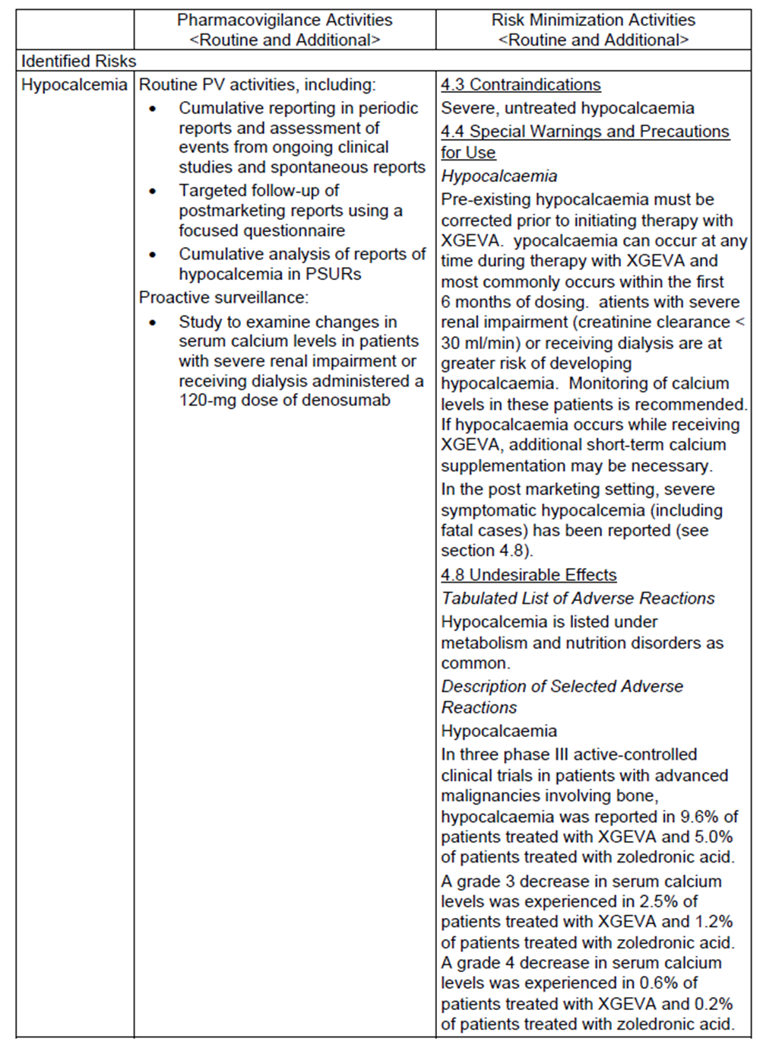
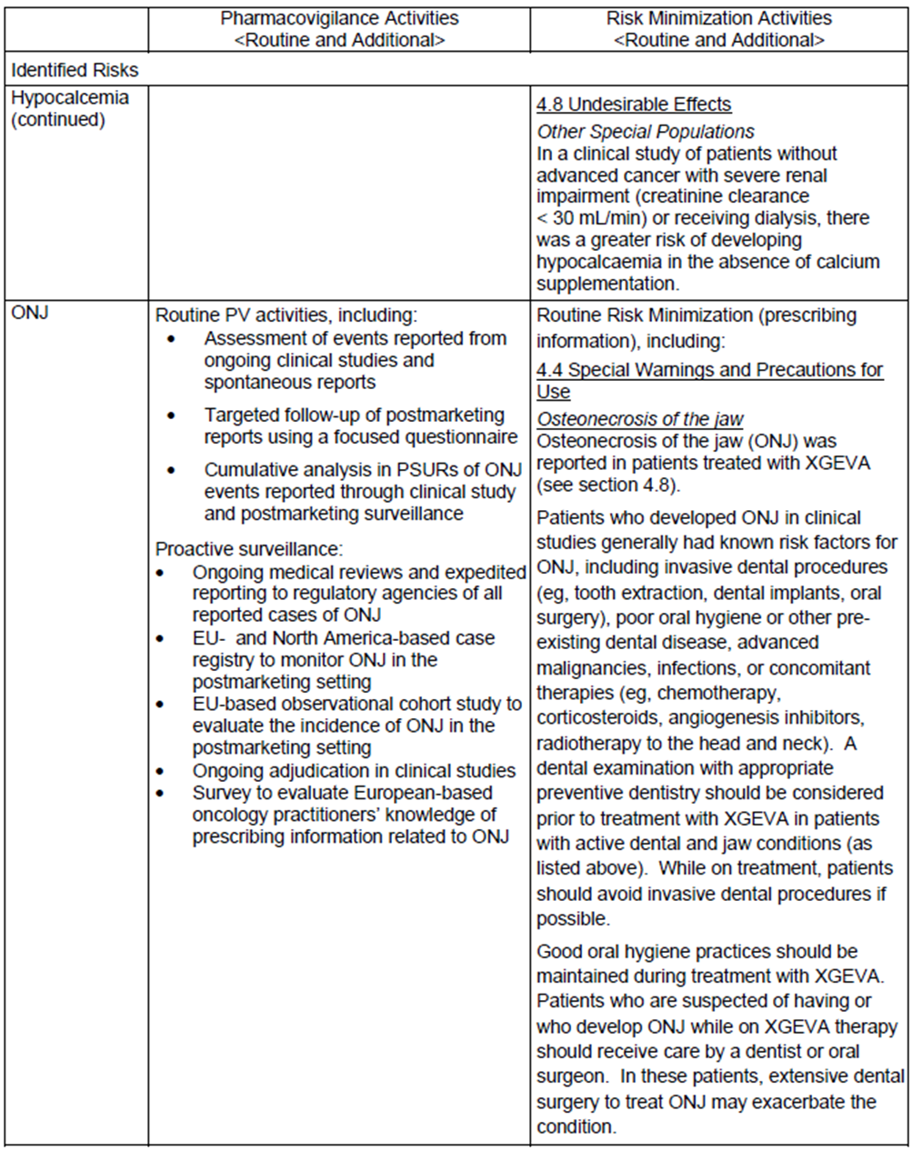
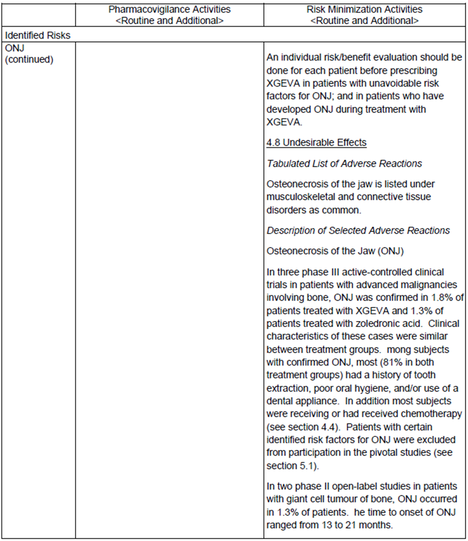
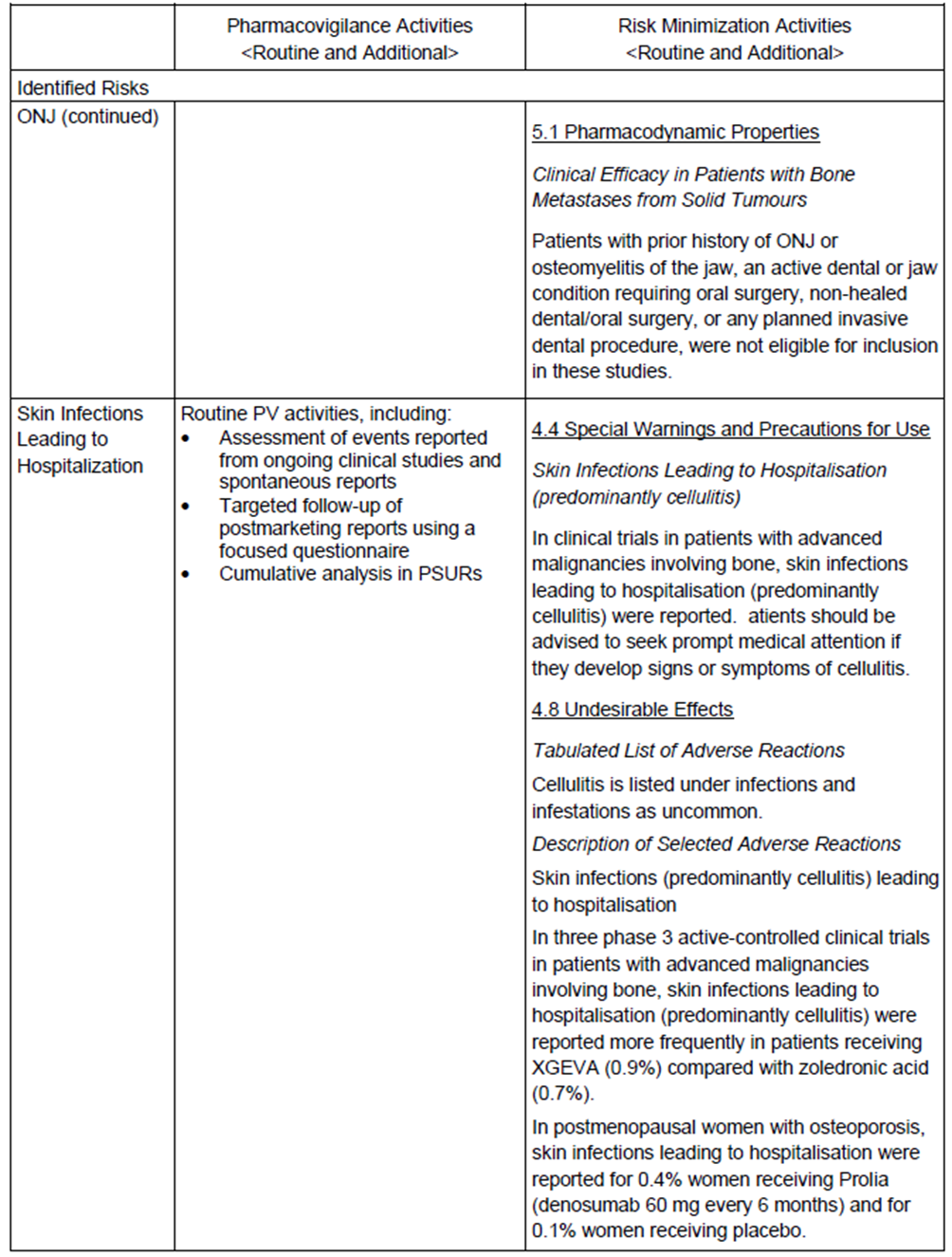
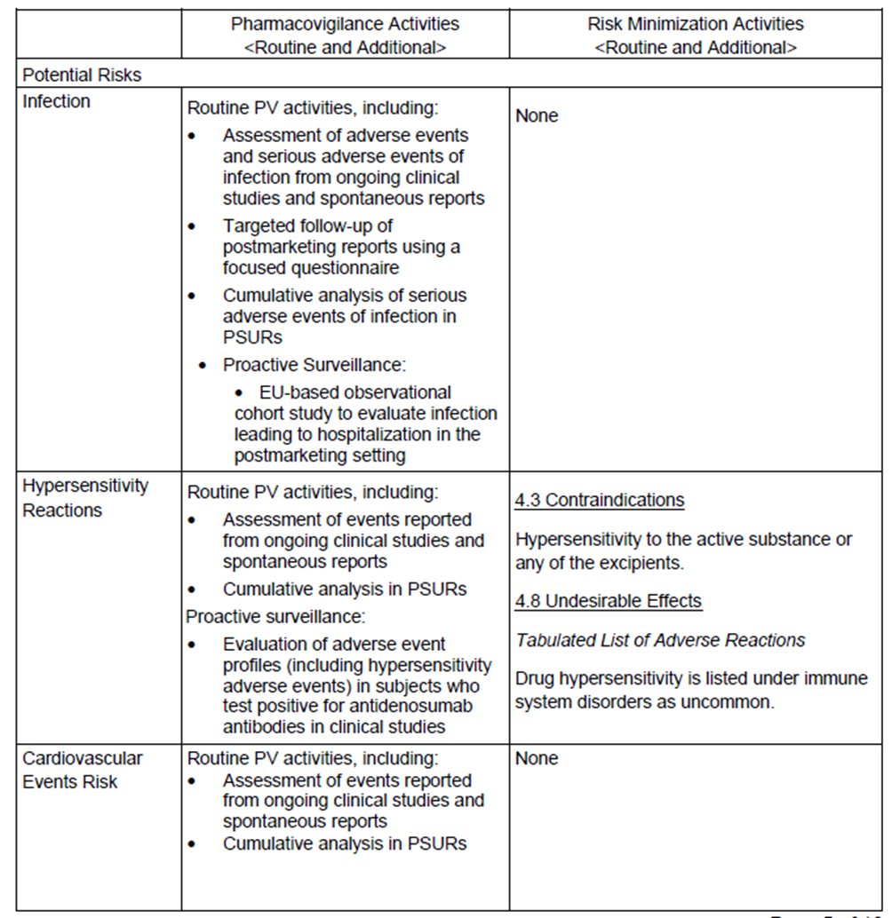
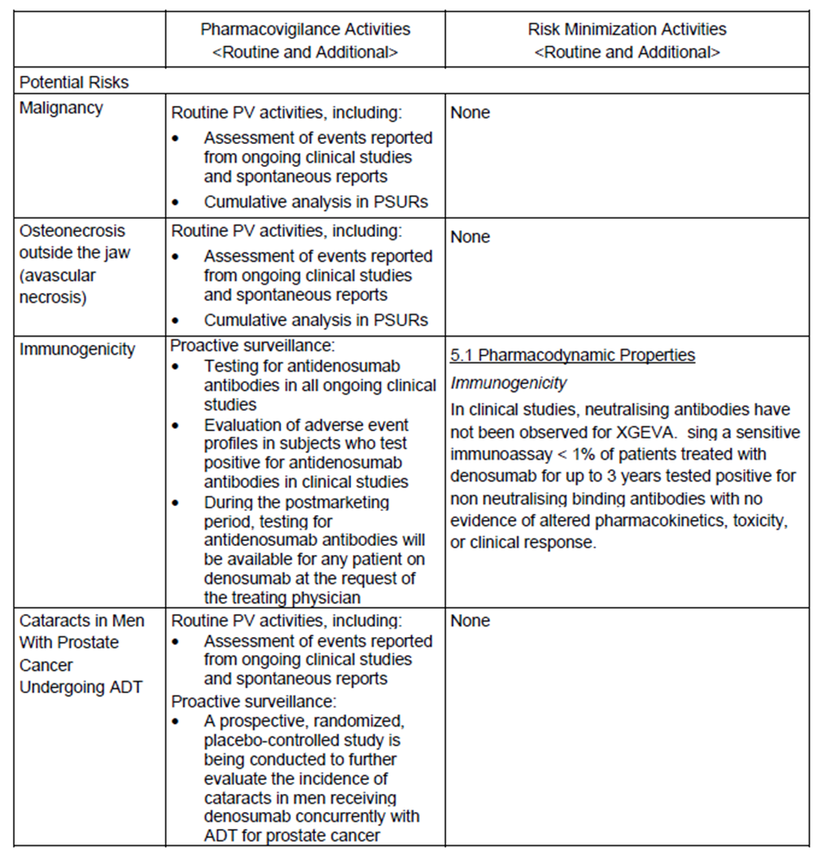
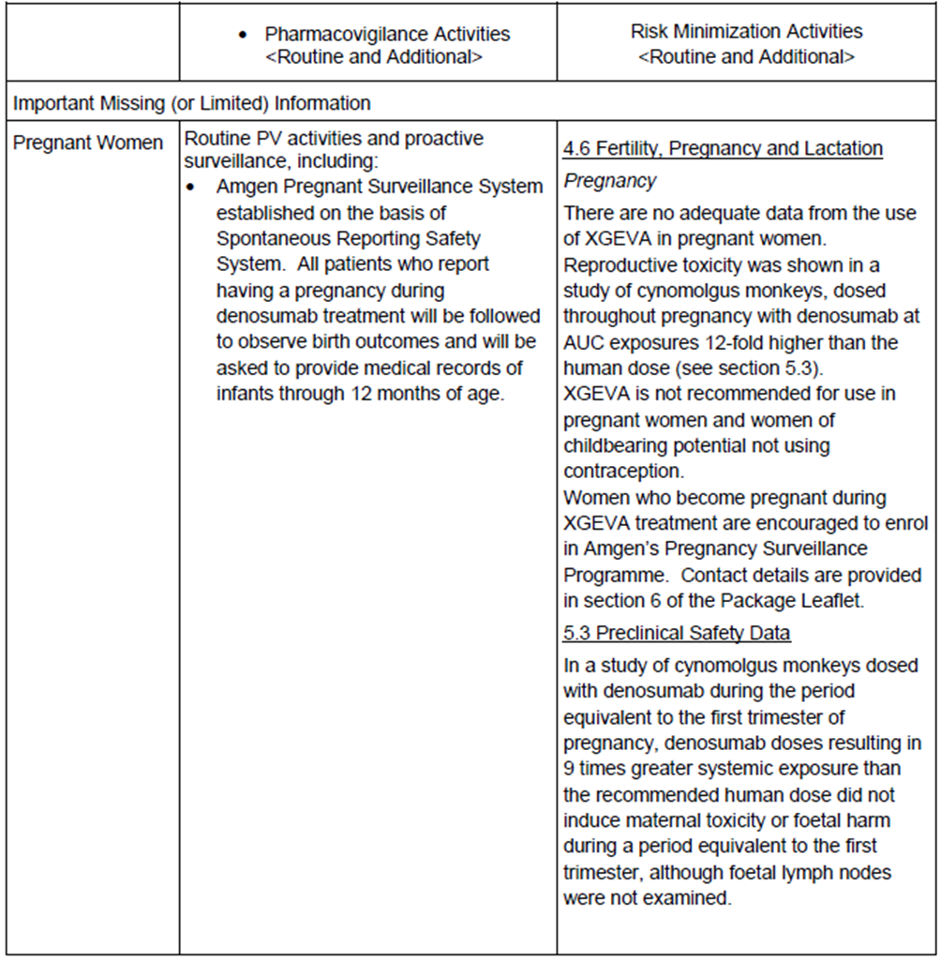
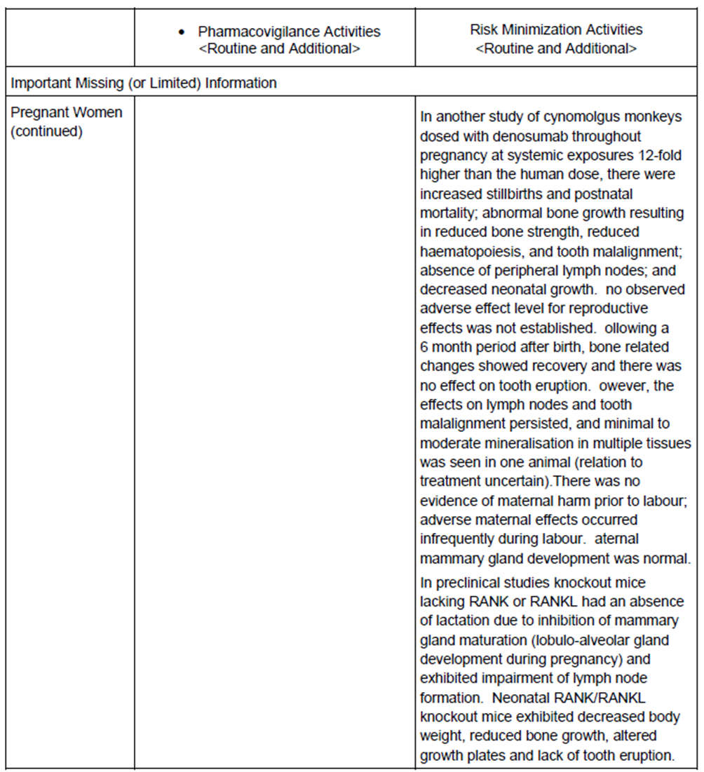
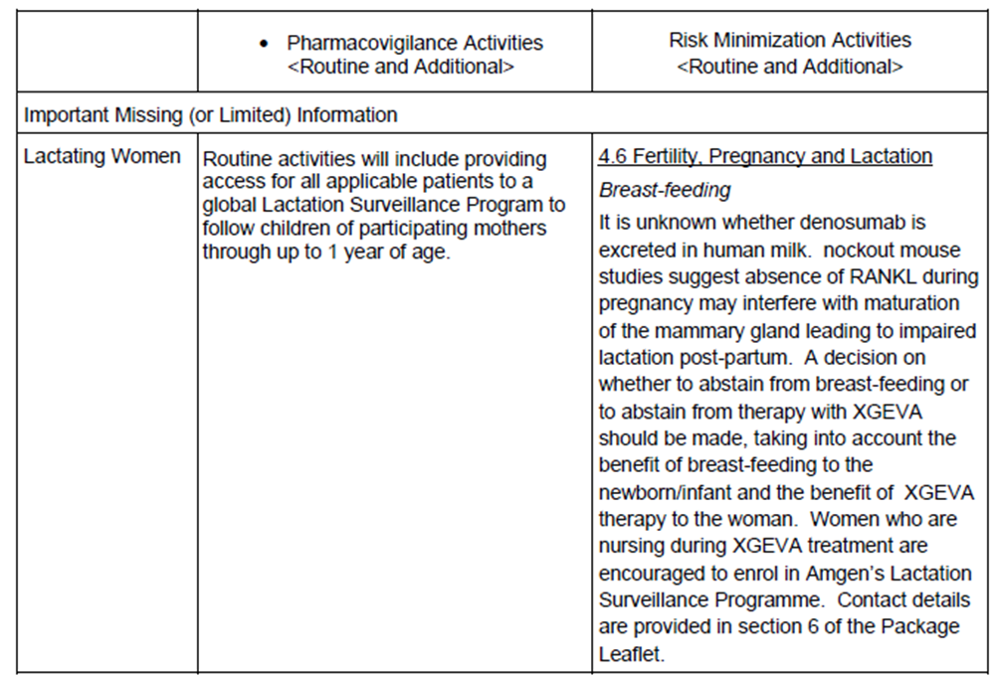
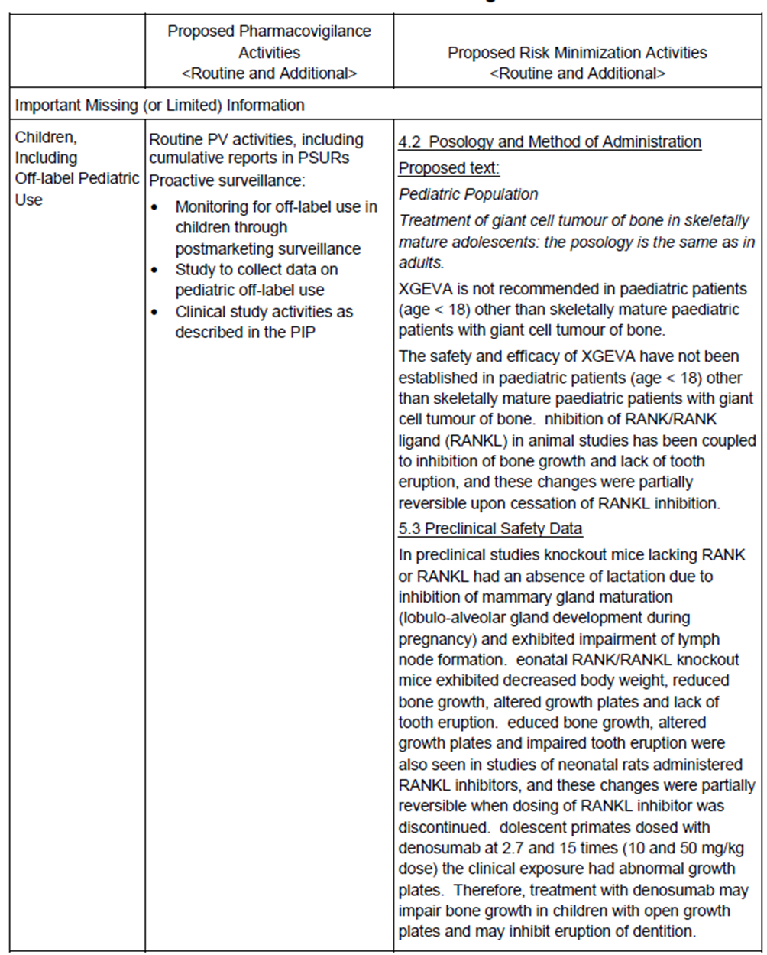
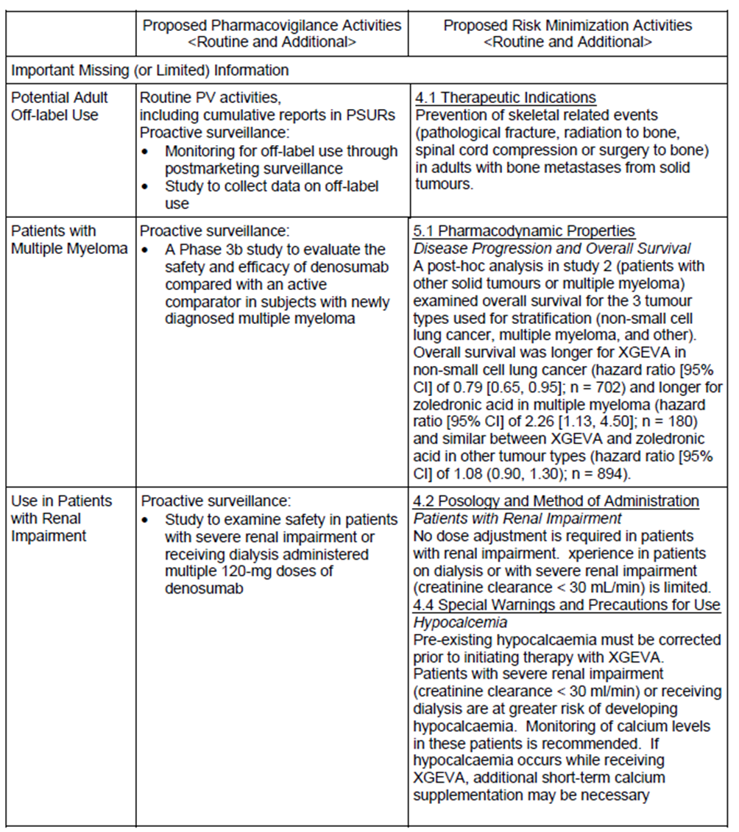
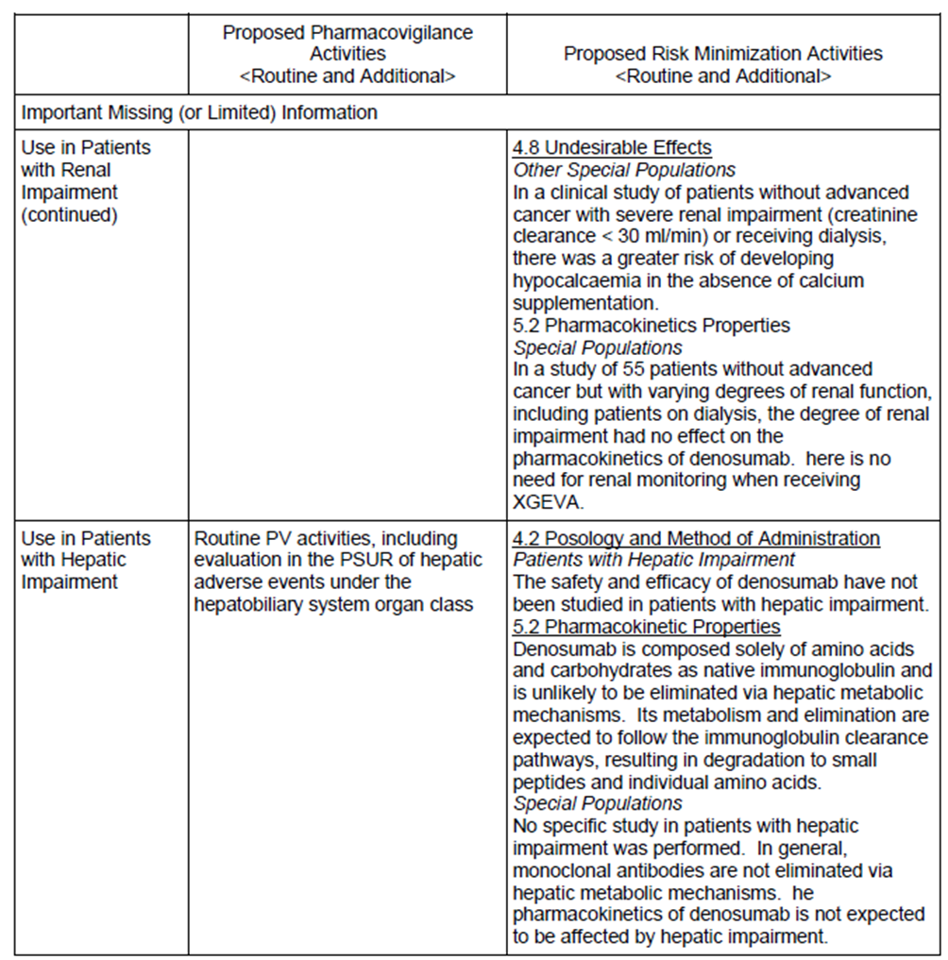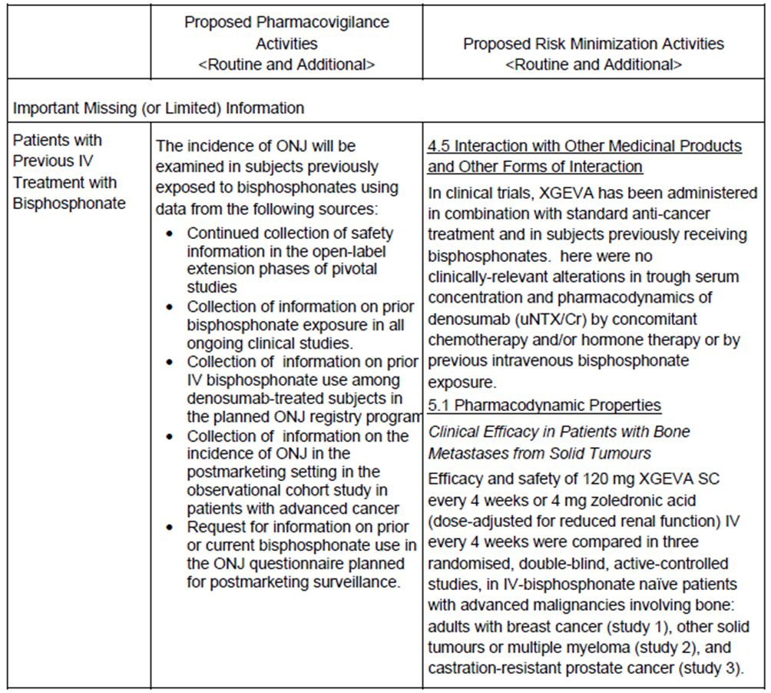

Reconciliation of issues outlined in the RMP report
Table 2 summarises the TGA’s first round evaluation of the RMP, the sponsor’s responses to the issues raised, and the TGA’s evaluation of the sponsor’s responses.
Table 2. Reconciliation of issues outlined in the RMP report
Recommendation in RMP evaluation report | Sponsor’s response | Evaluator’s comment
Safety considerations may be raised by the nonclinical and clinical evaluators through the consolidated section 31 request and/or the Nonclinical and Clinical Evaluation Reports respectively. It is important to ensure that the information provided in response to these includes a consideration of the relevance for the Risk Management Plan, and any specific information needed to address this issue in the RMP. For any safety considerations so raised, the sponsor should provide information that is relevant and necessary to address the issue in the RMP. | ‘Amgen confirms that the Clinical Evaluation Report did not raise any issues of relevance for the Risk Management Plan. Nonclinical data was not submitted with the current application.’ | The sponsor’s response is acceptable.
As the TGA has previously evaluated an RMP for denosumab (Xgeva) (PM-2010-02051-3-4), the focus of this evaluation is on the differences between the RMP versions that could have an impact on the safety profile and any new safety related information since the last evaluation. | N/A | The sponsor is not required to provide information regarding this comment.
There are inconsistencies regarding ongoing safety concerns in the EU-RMP and the ASA. The sponsor should reconcile the summary of ongoing safety concerns and other relevant parts of the EU-RMP and the ASA, including the pharmacovigilance plan and risk minimisation plan, to ensure that they consistently reflect safety concerns for denosumab. | ‘The evaluator has listed several inconsistencies between the EU-RMP and the ASA in the evaluation report. The specific comments are shown in bold italics below, followed by the company response.’ | The sponsor’s response is satisfactory.
3-1: Hypersensitivity is an identified risk in the ASA. In comparison it is a potential risk in the EU-RMP. | ‘The European RMP for denosumab 120mg Advanced Cancer and Giant Cell Tumour of Bone Indications, dated 16 November 2012, was used as the basis for preparation of the ASA. This RMP identified ‘hypersensitivity’ as a potential risk for denosumab.  Amgen determined hypersensitivity to be an ‘identified’ risk for denosumab. This change was included in version 2 of the core RMP (January 2013). At the time of submission of the full Australian giant cell tumour file the EU RMP had not yet been revised.  Subsequent to this change from potential risk to identified risk, the [information redacted]. While the registered Australian Product Information (PI) for Xgeva already included ‘hypersensitivity to any ingredient’ as a contraindication, a Safety Related Notification to update the ADVERSE EFFECTS (Postmarketing experience) section of the PI to include ‘hypersensitivity and anaphylactic reaction’ was submitted to TGA on 31 January (approved 5 March 2013). These approved PI revisions were flagged for incorporation into the giant cell tumour draft PI at the next opportunity, and are therefore included in the updated draft.  To align with the PI changes, the ASA to the RMP (prepared for submission to TGA in March 2013) updated the risk of hypersensitivity to ‘identified’.’ | The sponsor’s response is satisfactory.
3-2: Atypical femoral fracture (AFF) is an identified risk in the ASA. It is not mentioned in the EU-RMP | ‘Atypical femoral fracture was determined to be an identified risk for Xgeva. The important identified risk was included in Version 2 of the core RMP (January 2013). The ‘Precautions’ and ‘Adverse Effects’ (postmarketing experience) sections of the Australian PI were updated to reflect this newly identified risk as part of the same submission to TGA as the hypersensitivity update (approved 5 March 2013). As explained for hypersensitivity above, the ASA of the RMP was updated accordingly to align with the PI revisions.’ | The sponsor’s response is satisfactory.
3-3: ‘Potential adult off-label use included in the pharmacovigilance plan and risk minimization plan of the EU-RMP and the ASA. It is not listed in the summary of ongoing safety concerns table. | ‘Amgen monitors potential adult off-label use of denosumab to identify any potential issues. As such, it is included in the pharmacovigilance plan and risk minimisation plan of the EU-RMP and the ASA. All results are reported in the Periodic Safety Update Reports. The ongoing safety concerns table does not usually include off label use unless it is identified as an identified or potential risk (ADR). If an ADR is found, the tables are updated accordingly.’ | The sponsor’s response is satisfactory.
3-4: ‘Patients with prior bisphosphonate treatment’ is  limited/missing information in the summary of ongoing safety concerns and reflected in the CMI. However in other parts of the EU-RMP and the ASA, this safety issue is addressed as ‘patients with prior IV bisphosphonate treatment’. The sponsor should clarify if this issue only concerns IV bisphosphonates or all bisphosphonate treatment. | ‘We confirm that the ongoing safety concern regarding patients with prior bisphosphonate use relates to all bisphosphonate treatment. Completed and ongoing clinical studies record prior use of either IV or oral presentations, and as such this issue concerns all bisphosphonate treatment.’ | The sponsor’s response is satisfactory.
It is expected that updates and findings of the ongoing and planned studies will be communicated to the TGA and included in PSURs when available. It is recommended that results of these studies are communicated to the TGA at the same time as they are communicated to other regulatory agencies. | ‘Pivotal Study 20062004 is currently the only ongoing clinical trial of denosumab in giant cell tumour of bone. Amgen commit to providing the results of this ongoing study, and the following planned post-marketing studies, to TGA as they become available:  Study 20101102 - “Osteonecrosis of the Jaw (ONJ) Case Registry”.  Study 20101363 - Study 20101363 – “A Non-interventional Pharmacovigilance Study of Osteonecrosis of the Jaw and Infection Leading to Hospitalization among Patients with Cancer Treated with Xgeva or Zoledronic Acid in Sweden, Denmark, and Norway”.  Study 20110102 - ‘“Survey of Oncology Practitioners Prescribing Xgeva in Europe to Evaluate Their Knowledge of Xgeva Summary of Product Characteristics Pertaining to Osteonecrosis of the Jaw”.  Study 20101335 - “Estimation of Off-Label Use of Xgeva (denosumab) Using Population-Based Databases in Denmark”.’ | The sponsor’s response is satisfactory.
It cannot be assumed that the oncology practitioners in Australia will have the same knowledge of recommendations provided in the PI related to ONJ as their EU colleagues. The evaluator recommends that the sponsor undertake the same survey as Study 20110102 among Australian oncology practitioners. Alternatively, the sponsor may consider other additional educational measures for Australian oncologists to improve knowledge of denosumab related ONJ. | ‘Study 20110102 is a postmarketing safety surveillance study being conducted in Europe as an additional pharmacovigilance study to evaluate the natural history of the disease.  As part of this study a prescriber survey for oncology practitioners will be used to assess knowledge of the risk-minimisation recommendations for ONJ in the prescribing information.  Both the European and Australian prescribing information for Xgeva contain core information in ‘Precautions’ and ‘Adverse Effects’ concerning known risk factors for ONJ, steps to minimize the chance of ONJ developing, and oral care during treatment. The standard prescribing recommendations are therefore aligned between regions. Since launch of Xgeva in Australia several materials have also been developed that aim to improve physician awareness of ONJ, including:  A dedicated page on ONJ management and prevention in the main sales aids  Information directed to the physician and also to the patient in the Patient Support Program  Letter to the doctor, including information on ONJ, when a patient enrols in the support program  In-service training sessions have dedicated ONJ sections  Published papers available for distribution on ONJ integrated analysis  Information included in numerous presentations at congresses and local physician educational events  Locally Amgen estimates a very high level awareness of ONJ amongst prescribers. Given the alignment of prescribing information between Europe and Australia with respect to ONJ, and the measures taken locally to ensure high physician awareness, Amgen considers oncology practitioners in Australia would have at least equivalent knowledge of ONJ recommendations as those in Europe. The results of the EU survey should therefore be applicable to Australia without need for a separate survey being conducted. The results of Study 20110102 will be included in PSUR’s.’ | The sponsor’s response is acceptable.
In regard to the proposed routine risk minimisation activities, it is noted that the updates in the current PI and CMI reflecting postmarketing experience of Xgeva related atypical femoral fracture do not appear in the proposed PI provided in this submission. It is recommended to the Delegate that different PI and CMI versions are reconciled to contain all updated information. | ‘Amgen Australia submitted a Safety-Related Notification to update the Product Information for Xgeva to include risk of atypical femoral fracture and additional information on hypersenstivity reactions on 31 January 2013. This variation was approved on 5 March 2013. However, Amgen submitted the pre-submission planning form for the giant cell tumour application on 13 December 2012, prior to approval of this additional safety text. The additional safety updates were flagged for reconciliation into the current draft Product Information for giant cell tumour of bone. A minor change to the CMI was made in line with the PI update. | The sponsor’s response is satisfactory.
It is noted that several safety risks identified in the current SmPC have not been adequately reflected in the proposed Australian PI. It is recommended to the Delegate that the risk of ‘severe, untreated hypocalcaemia’ be included in the ‘contraindication’ section of the PI and the advice on avoiding concomitant treatment with bisphosphonates and patients with hereditary fructose intolerance be added in relevant parts of the PI. | N/A | This is a recommendation to the Delegate.
Consequently, it is recommended to the Delegate that the CMI be updated to reflect the above recommendation. | N/A | This is a recommendation to the Delegate.

VI. Overall conclusion and risk/benefit assessment
The submission was summarised in the following Delegate’s overview and recommendations:

Quality
There was no requirement for a quality evaluation in a submission of this type.

Nonclinical
There was no requirement for a nonclinical evaluation in a submission of this type.

Clinical
There was one pivotal efficacy/safety/pharmacokinetic study, Study 20040215. This was a Phase II open label single arm study of the use of denosumab in patients aged 19 to 63 years with recurrent or unresectable GCTB. Subjects were recruited from July 2006 and final data cut off was 16 November 2010.
One supportive trial was included, Study 20062004. This was a Phase II open label single arm with 3 cohorts, in patients aged 13 to 76 years with unresectable GCTB, resectable GCTB associated with significant morbidity and patients rolled over from Study 20040215. This included adults and “skeletally mature” adolescents. This study is ongoing in 29 Centres in North America, Europe and Australia. Patient enrolment began on 9 September 2008 and had a 3rd interim analysis date of 25 March 2011.
Treatment was the same in both trials: a single subcutaneous injection of denosumab 120mg once every 4 weeks into the thigh, abdomen or upper arm with an additional loading dose of 120mg on Days 8 and 15 of treatment in the first 4 week cycle (with the intention of achieving steady trough level earlier than the current method of administration).

Pivotal study 20040215

Primary aim - Efficacy
In the absence of a specific marker of GCTB, efficacy was assessed by 3 methods:
- Histology, sampled at baseline, 9 weeks and 25 weeks (evaluated by local and blinded central laboratory). For patients with evaluable histology, an efficacy response was defined as: at least 90% elimination of giant cells relative to baseline or complete elimination of giant cells in cases where giant cells represented less than 5% of the cells at baseline.
- Tumour imaging was performed using computed tomography (CT) or magnetic resonance imaging (MRI) at baseline, Week 13 and 25 and every 12 weeks thereafter. Longest diameter of lesion was used to assess response and had to be suitable for repeated measurement. For patients without evaluable histology, a response was defined as a lack of progression of the target lesion as assessed by CT or MRI at week 25 compared with baseline. Progressive disease was defined according to the RECIST criterion of a greater than or equal to 20% increase in longest diameter of the target lesion. Change in tumour density was assessed using a change in Hounsfield units; increase in density was assumed to be due to new bone formation.
- Fluoro-deoxyglucose-PET scan was performed to assess tumour metabolic activity at the same time points as the CT/MRI imaging.
Comment: Correlation of tumour size and density on CT with fluorodeoxyglucose PET imaging was described by Choi in 172 lesions in 40 individuals with metastatic gastrointestinal stromal tumour (GIST) following imatinib therapy. a decrease in GIST tumour size of greater than 10% or decrease in tumour density of greater than or equal to 10% was 97% sensitive and 100% specific for identifying PET response (70% reduction in maximum standardised uptake). The sponsor describes using ‘an adaptation of the Choi criteria – the original report described a reduction in density with tumour response, whereas the adaptation was to identify an increase in density in GCTB patients which was presumed due to new bone formation. This method of assessment of treatment effect has not yet been validated, or peer reviewed, in patients with GCTB and the sensitivity and specificity of the test is not described in this setting in the efficacy results. Given the lack of peer reviewed evidence, this method of assessing tumour response can only be currently considered experimental in GCTB.

Secondary aims
Safety, pharmacokinetics (trough level data), the development of anti-Denosumab antibodies and the pharmacodynamics assessment of markers of bone turnover (urinary N-telopeptide corrected for creatinine (uNTx/Cr), serum C-telopeptide (sCTx), bone–specific alkaline phosphatase (BSAP), osteocalcin and tartrate resistant acid phosphatase 5b (TRAP-5b)), evidence of an “investigator assessed clinical response”.

Inclusion criteria
Adult subjects (greater than or equal to 18 years old) with histologically confirmed GCTB, measurable and greater than or equal to 10 mm in longest length, or with recurrent GCTB confirmed by radiology or with unresectable GCTB.
Subjects had to have ECOG status 0 to 2 and written consent was required for study entry.

Pharmacokinetics (PK)
Study 20040215 evaluated data on trough serum levels of denosumab in 37 subjects receiving the drug for GCTB on Day 1(baseline), 8, 15 and Weeks 5 (Day 29), 9, 13, 25, 49 and end of study. Use of the two loading doses on Days 8 and 15, resulted in rapid achievement (by approximately Day 15) of the trough serum levels observed with chronic 4 weekly dosing. Trough levels did not decline with long term use.
Comment: No pharmacokinetic data was reported from the adolescents enrolled in Study 20062004, or any other paediatric patients.
Figure 1 Trough levels of denosumab. Study 20040215
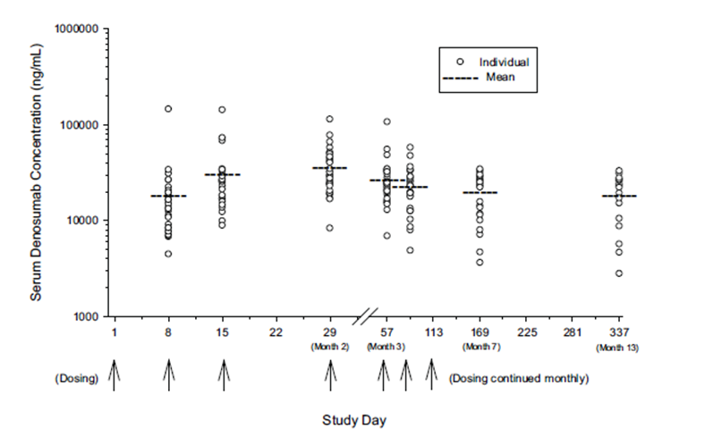

Efficacy results
Of 37 subjects recruited to the study, two did not have results included for the efficacy analysis – one did not meet the entry criterion of a GCTB lesion greater than or equal to 10 mm in its longest diameter and the other had not completed 25 weeks of study treatment by the final data cut off.
Subjects had baseline demographics representative of the broader population with advanced GCTB disease.
All 35 remaining subjects were evaluated at least 28 days from the first denosumab dose. Histology was available from biopsy or surgical specimens – the proportion is not described. Of 20 subjects with evaluable histology all achieved a response, whereas 10 out of the 15 without evaluable histology achieved a response as assessed by CT or MRI.

Secondary outcomes
Markers of bone turnover – two methods of assessing bone turnover (uNTx/Cr and sCTx) revealed a reduction in median from baseline following Denosumab therapy. The other markers of bone turnover assessed (BSAP, osteocalcin and TRAP 5b) significantly reduced, consistent with the mechanism of action of Denosumab. These markers were not compared with the efficacy end points and no prognostic value can be gained from them.
Comment: The results of measures of bone turnover have neither been compared with the effect in normal individuals nor assessed against other efficacy or clinical outcomes and cannot be used for diagnostic/prognostic assessment.
For subjects with multiple lesions who were unable to undergo surgical resection, tumour shrinkage (%) by time on study did not reveal any prognostic value.
Investigator assessed bone lesion assessments of “clinical benefit (reduced pain or improvement in functional status)”, calcification and bone repair were made in 31 subjects. The method of diagnosing or standardising these outcomes was not described. A “clinical benefit” was described in 26 subjects, calcification was described for 6 subjects and bone repair was reported for 9 subjects.

Supportive trial 20062004
This trial was a Phase II open label single arm with 3 cohorts:
- Cohort 1 – subjects with surgically unsalvageable GCTB.
- Cohort 2 – subjects with GCTB that was considered surgically salvageable, but whose planned initial on-study surgery would be associated with severe morbidity, and who had an “immediate need for surgery to treat their disease”. Subjects could proceed to surgery at any time on-study.
- Cohort 3 – subjects rolled over from the Pivotal study 20040215 (Adult subjects (18 years old and over) with histologically confirmed GCTB, measurable and greater than or equal to 10 mm in longest length, or recurrent GCTB confirmed by radiology or unresectable GCTB.) Subjects continued with the dose regimen they had received in Study 20040215 and did not receive new loading doses.
This study is ongoing in 29 Centres in North America, Europe and Australia. Patient enrolment began on 9 September 2008 and had a 3rd interim analysis date of 25 March 2011.

Entry criteria:
Subjects had to meet all the following criteria:
- Informed consent was required for study entry and before any study specific procedure.
- Pathologically confirmed GCTB within 1 year prior to study entry.
- Measurable evidence of active disease within the 1 year prior to study enrolment.
- Surgically unsalvageable disease OR subjects whose planned surgery included joint resection, limb amputation, hemipelvectomy or a surgical procedure that would result in severe morbidity.
- ECOG score 0, 1 or 2.
- Adult or “skeletally mature” adolescent weighing greater than or equal to 45 kg.
Comment: The definition of “skeletally mature” varies between Protocol Amendment 1 and the Clinical Study Report, the latter being less specific. The protocol amendment allows the inclusion of ‘adolescents who have closed epiphyseal plates’ (note plural, and presumed all plates) whereas the clinical overview states ‘adolescent subjects had radiological confirmation of skeletal maturity defined by at least 1 mature long bone (for example, closed growth epiphyseal plate of the humerus) greater than or equal to 12 years of age’. Epiphyseal fusion does not occur simultaneously at all long bone sites, thus assessment of one site does not absolutely confer a diagnosis of final skeletal maturity. Exposing adolescents to denosumab using the latter definition may contradict the warning in the currently approved PI: ‘denosumab may impair bone growth in children with open growth plates.’
The use of denosumab in Study 20062004 was the first exposure of the drug in children. The European Medicines Agency (EMA) addendum on paediatric oncology states ‘The common practice for cytotoxic drugs in paediatric Phase I trials is to use a starting dose that is 80% of the maximum tolerated dose in adults’.³ There was no dose reduction for the adolescents enrolled in Study 20062004 and the sponsor has not provided a justification for this decision.

Primary outcome
A description of the safety of Denosumab in subjects with GCTB.

Secondary outcomes
- The evaluation of time to disease progression in subjects with unsalvageable GCTB (Cohort 1).
- The evaluation of the proportion of patients with unsalvageable GCTB not requiring surgery who had previously been assessed as needing so (Cohort 2).
- Ongoing assessment of efficacy and safety in Cohort 3.
Evaluations of efficacy were based on assessments of target lesions as chosen by the investigator which were required to be both measurable and accessible for biopsy. Subjects were reviewed at 4 weekly intervals. There was no schedule of investigations to determine the main efficacy outcomes. Similarly there were no standard criteria defined for determining disease progression. Histopathology and imaging studies were performed if and when required as part of standard management. Reports of these studies had to be submitted to the sponsor, however the determination of what constituted disease progression and when it occurred was a matter for each investigator. Data on occurrence and type surgery performed were also collected.
There were a large number of ‘exploratory’ efficacy outcomes. Several of exploratory outcomes relate to pain score, which was measured using the Brief Pain Inventory – Short Form (BPI-SF). The score for each question ranges from 0 (no pain or interference) to 10 (pain as bad as can be imagined/complete interference). A minimally important difference was considered to be 2 points. Patients were asked to recall pain in either the preceding 24 hours or preceding week. The BPI-SF was administered at each visit up to 25 weeks and then every 12 weeks.
Analgesic requirement was assessed every 4 weeks by use of the Analgesic Quantification Algorithm (AQA).

Treatment
‘If a subject underwent a complete tumour resection during the study, denosumab treatment continued for 6 doses after this resection.
Comment: No justification was given for Subjects to continue denosumab following complete surgical resection.
In all other cases, denosumab treatment continued until:
- Disease progression occurred.
- An investigator's or the sponsor’s recommendation of discontinuation.
- Subject's decision to discontinue.
- Lack of clinical benefit in the investigator’s judgment.
- Administration of any proscribed therapy (bisphosphonates, chemotherapy, embolization of the tumour, radiation therapy or an investigational treatment for GCTB).
Comment: In Cohort 2, denosumab use is neoadjuvant – that is, the aim of transforming inoperable disease to operable. The EMA guideline on neoadjuvant use states that ‘it is accepted that treatment is withdrawn if tumour shrinkage is not observed after a defined treatment period’. In Study 20062004, there is neither a finite period of treatment, nor the requirement to cease treatment in cases of stable disease. However, in the pivotal study, lack of progression was considered the treatment response.
Daily supplementation with at least 500 mg of calcium and at least 400 IU of vitamin D was only strongly recommended, except in pre-existing hypercalcaemia.

Participants
By the data cut off for the 3rd interim analysis, a total of 313 subjects had been screened for enrolment. Of these, 6 decided not to participate while a further 21 did not meet the eligibility criteria (most commonly due to not having a pathologically confirmed GCTB). A total of 286 subjects were therefore enrolled. Of these, 15 were subjects rolled over from Study 20040215 into Cohort 3, and 4 of these had completed their denosumab treatment and were rolled over to complete their 2 year safety follow up. These 4 subjects did not receive denosumab in 20062004 and hence were not included in the Efficacy Analysis Set (EAS). The EAS therefore comprised 282 subjects.
A total of 170 subjects were enrolled in Cohort 1 and 101 subjects in Cohort 2. At the time of the data cut off, 238 out of 282 subjects (84%) were still receiving Denosumab.
Four patients withdrew from Study 20062004 after falling pregnant, despite the specific Study requirement to be compliant with an effective method of contraception. The outcomes of these pregnancies and denosumab exposed children have not been reported.
Comment: No safety data is currently freely available regarding in utero denosumab exposure in the human foetus. The currently approved US PI, but not the Australian PI, states that women should continue contraception for five months after the last dose of Xgeva. Given the occurrence of on Study pregnancies, this statement should be included in the Australian PI.

Results
The age and gender distributions of the study population were consistent with the known demographics of GCTB patients. The location of target lesions was consistent with the entry criteria, with the majority of Cohort 2 having lesions in long bones, and the majority of Cohort 1 having lesions in the axial skeleton or lungs.

Efficacy
Median (range) time on study was 12.98 (0.3, 29.1) months for Cohort 1, 9.23 (0.0, 28.0) months for Cohort 2, and 5.36 (4.5, 6.2) months for Cohort 3. Median for the whole study population was 10.4 (0.0 – 29.1) months.

Time to disease progression (Cohort 1)
Only 6 of 169 treated subjects (4%) in Cohort 1 had disease progression. Median time to progression could therefore not be estimated. Kaplan-Meier estimates of the probability of disease progression were 1.4% (95% CI: 0.0 to 3.4) at Week 25, 4.0% (95% CI: 0.5 to 7.5) at Week 49 and 5.6% (95% CI: 1.0 to 10.2) at Week 73.
Comment: The rate of disease progression in this study has not been compared with a historical cohort.

Need for surgery in patients with an expected need for surgery associated with severe morbidity - Cohort 2
Of the 100 Subjects in Cohort 2, 16 had a less morbid surgical procedure performed, nine had the procedure already planned and one had a more radical operation (en bloc excision rather than curettage). Of the 26 subjects who did receive surgery, median time to surgery was 723 days.
The remaining 74 Subjects had not undergone a surgical procedure, but the information contained in the dossier in insufficient to determine if these patients still had a requirement for surgery or if their disease had completely resolved.

Disease status changes – Best Response (Cohorts 1 and 2)
A total of 9.9% of subjects achieved an investigator assigned “complete response” and 37.3% of subjects achieved an investigator assigned “partial response”. Of the 25 subjects who achieved a “complete response”, none had disease recurrence.

Pathological response (Cohorts 1 and 2)
A total of 40 subjects had a post baseline histopathology specimen obtained. Of these, 19 (47.5%) had no evidence of tumour found.

Radiological changes over time - up to 30 months on study (Cohorts 1, 2 and 3)
All nine subjects in Cohort 3 had stable radiological appearances. For Cohorts 1 and 2, stable appearance occurred in 114 subjects (49%), improved appearance in 115 subjects (49.6%) and worsening in 2 subjects (0.9%).
Comment: There is a disparity between accuracy of the three assessment methods of tumour response. Change in PET assessed metabolic activity may represent the best method of assessing tumour response, as compared to the RECIST criteria, but has only been reported in 26 Subjects, and may be unavailable to all potential patients.

Clinical benefit (Cohorts 1 and 2)
Comment: The lack of documented method(s) of assessing “clinical benefit” in the Study Report was highlighted in the first round evaluation and not obtained in the sponsor’s Section 31 response.
In the Summary of Clinical Efficacy, this end point was reported for both Studies: ‘Across both studies, the proportion of subjects with investigator determined clinical benefit was similar between subjects without or with an objective tumour response (59.3% [32 out of 54 subjects] and 59.6% [81 out of 136 subjects], respectively’.

Pain scores and analgesic scores
These scores generally showed improvement in pain over time compared to baseline, without any significant increase in analgesic use.

Combined safety outcomes from Studies 20040215 and 20062004
Comment: No new safety signals were identified from either study.

Patient exposure
A total of 304 subjects were included for the pooled analysis, the population consisted of all subjects who received at least one dose of denosumab. Of these, 147 subjects received denosumab for greater than or equal to 1 year, 46 subjects for greater than or equal to 2 years and 15 subjects for greater than or equal to 3 years. The median number of denosumab doses received was 14.0.

All adverse events (irrespective of relationship to study treatment)
Overall, a total of 85.2% of subjects experienced an AE while on study. The most common adverse events were arthralgia, headache, nausea and back pain.

Treatment related adverse events (adverse drug reactions)
The incidence of adverse drug reactions (AEs for which the investigators indicated there was a reasonable possibility that they may have been related to Denosumab) was 49.0%. The most common events were fatigue, headache and nausea.

Deaths and other serious adverse events
One death occurred during treatment with denosumab.
- A 32 year old male in Study 20062004 who had a GCTB originating in the femur approximately 12 years previously and had extensive metastatic lung disease prior to enrolment. After approximately 9 months of denosumab treatment the patient developed respiratory failure and died. The investigator did not consider the event related to the Study drug.
Deaths occurring in the safety follow up phase in the two studies (that is more than 30 days after completion of denosumab treatment) were as follows:
- 5 deaths in Study 20040215: 2 subjects who died of disease progression, 1 from congestive cardiac failure and 1 due to intra operative pulmonary embolism resulting in ventricular tachycardia. These deaths were considered unrelated to Denosumab. One other death in the follow up phase was due to the development of a pleomorphic sarcoma, which the investigator considered possibly related to Denosumab treatment.
- 3 deaths in Study 20062004: 2 subjects due to progressive disease and 1 due to the development of pleomorphic sarcoma. All were considered unrelated to treatment.
The overall incidence of serious AEs (other than death) was 11.2% and the overall incidence of treatment related serious AEs was 1.0%. The only individual SAEs reported in more than 1 subject were ONJ and osteomyelitis, both of which occurred in only 2 subjects each.

Discontinuation due to adverse events
The proportion of patients who discontinued denosumab due to AEs was 5.3%. Only 3 subjects (1.0%) discontinued due to AEs that were considered related to denosumab (2 cases of ONJ and 1 case of arthralgia).

Hypocalcaemia
Hypocalcaemia is a known AE with denosumab. The overall incidence of hypocalcaemia was 4.9% (n = 15). There were no serious AEs of hypocalcaemia. In 14 of the 15 subjects the maximum severity was grade 1 (n = 14) or 2 (n = 1). One subject developed Grade 3 hypocalcaemia. According to the currently approved Australian PI, the incidence of hypocalcaemia in patients with bone metastases treated with denosumab was 9.6%, compared with 5.0% in patients treated with zoledronate. The incidence of hypocalcaemia in patients with GCTB treated with denosumab is therefore comparable.

Osteonecrosis of the Jaw (ONJ) – a detailed precaution exists in the currently approved PI
ONJ is also a known AE with denosumab in patients with risk factors – bisphosphonate exposure, poor oral health, chemotherapy, corticosteroid use and previous dental extractions. The overall incidence of ONJ was 1.3% (n = 4). Of note, 3 of the 4 cases resolved with discontinuation of denosumab. According to the currently approved Australian PI, the incidence of ONJ in patients with bone metastases treated with denosumab is 1.8%, compared with 1.3% in patients treated with zoledronate. The incidence of ONJ in patients with GCTB treated with denosumab is therefore comparable.
Comment: Additional risks for ONJ in adolescents and young adults may include: impaction of 8th molars, delayed permanent dentition and pre existing (often asymptomatic) cystic conditions of the maxilla and mandible that have peak occurrence in the second to fourth decade – dentigerous cyst, calcifying odontogenic cyst and idiopathic bone cavity.

Hypersensitivity
As a foreign protein, denosumab might be expected to cause hypersensitivity reactions. The overall incidence of AEs suggestive of hypersensitivity events was 9.9% (n = 30). Of these 30 subjects, 29 experienced a maximum severity of Grade 1 and one subject experienced a Grade 2 event. The most common individual events were rash, face oedema and eczema. There were no serious hypersensitivity AEs and none of the events resulted in discontinuation of denosumab. The incidence of hypersensitivity in GCTB subjects appears to be higher than that observed in patients with bone metastases (5.8% with denosumab versus 3.8% with zoledronate).

Infection
The currently approved Australian PI for Xgeva and Prolia contain statements regarding an increased incidence of skin infections observed with denosumab in controlled clinical trials. In the GCTB trials the overall incidence of infections was 35.9%. The incidence of serious infections was 3.0% (n = 9) and there were 10 infections of Grade 3 severity and 1 infection of Grade 4 severity. In the absence of a control group it is difficult to draw any conclusions regarding the role of denosumab in causing these infections.

Malignancy
One subject in Study 20062004 developed thyroid cancer which was not considered to be related to denosumab.
The frequency of primary and secondary malignant GCTB observed in other cohorts reported in peer reviewed journals is 1.8% to 18.9%.
At the request of the Clinical Evaluator, the sponsor presented all the cases of malignancy until 31 August 2012. A total of 15 confirmed cases were reported from 494 subjects. Of the 15 cases, 10 had PMGCTB that is malignancy prior to denosumab exposure, 3 were cases of SMGCTB and 2 were cases of ST. The incidence of malignant disease was therefore 3% (15 cases in 494 subjects).
Comment: The proportion of Subjects with malignant change could have been underestimated given that the majority did not have surgery, and therefore evaluable histology. Neither the mechanism of malignant transformation in GCTB, nor its natural history is well understood.
The two cases of sarcomatous change in Subjects without a history of surgery or radiotherapy are plausibly indirectly linked to denosumab use, contrary to the sponsor’s opinion that there is no additional risk of malignant transformation with denosumab use. Malignant change also occurs in other diseases of the bone, for example, following bony abscess; the putative mechanism of sarcomatous change in this situation is that a nidus of infarcted bone stimulates adjacent bone regeneration which then undergoes malignant change. Therefore, any condition which results in an area of bone infarction may be the precursor to malignant change. The sponsor acknowledges that the outcome of sarcomatous change in GCTB requires ongoing post marketing surveillance. In the limited number of exposed Subjects, denosumab does not appear to prevent secondary malignant change from occurring, suggesting an alternative mechanism to RANK-L. Further studies are required to determine if there is a critical period or sensitive period for malignant change to occur.

Cardiac disorders
The overall incidence of cardiac AEs was 3.9%; none of the events were serious AEs and none were considered related to denosumab according to the investigators.

Vascular disorders
The overall incidence of vascular AEs was 5.9%; none of the events were serious AEs. Eight events of hot flush/flushing were considered related to denosumab according to the investigators.

Other AEs
An increased incidence of pancreatitis was observed among denosumab treated subjects in one study in osteoporosis and this finding is included in the current PI. There were no cases of pancreatitis in the two GCTB studies.

Laboratory tests

Calcium and Phosphorus
The incidence of Grade 2 hypocalcaemia (using albumin corrected calcium levels) was 2.6%. There was no Grade 3 or 4 hypocalcaemia detected on laboratory testing. Denosumab treatment was associated with mild transient decreases in average calcium levels. The incidence of Grade 3 hypophosphataemia was 9.5%. No Grade 4 decreases were observed. Median values decreased with denosumab treatment but remained within the normal range.

Vital signs
No clinically relevant changes were observed in body weight, blood pressure, pulse, or body temperature in Study 20040215. Vital signs and body weight were measured only at screening in Study 20062004.

Post marketing experience
No post marketing data were included in the submission.

Safety issues with the potential for major regulatory impact

Liver toxicity
Denosumab has not previously been associated with hepatic toxicity. All events reported were Grade 1 or 2 in severity and none were considered serious. One subject in 20040215 had an isolated Grade 3 elevation of alanine amino transferase.

Haematological toxicity
Only one serious haematological adverse event was reported. This was a case of Grade 3 anaemia in Study 20062004 thought to be due to intra tumoural bleeding. The investigator considered it unrelated to denosumab.

Serious skin reactions
There were no severe cutaneous adverse reactions reported in the two submitted studies.

Anti denosumab antibodies
In Study 20040215, serum samples were to be collected at: baseline, Weeks 25 and 49, at the end of study visit and at the safety follow up visit. Of the 37 subjects enrolled, 33 had at least one post baseline test result. All tests were negative for anti denosumab antibodies.
In Study 20062004, serum samples were tested on Day 1, at the end of study and at follow up visits every 6 months. Of 267 subjects tested at baseline, none developed anti-denosumab binding antibodies. Results were available for only 28 subjects at the end of study and 5 subjects at the 6 month follow up. All tests were negative.

Other safety issues - Safety in special populations
Study 20062004 enrolled 10 adolescents - 8 females and 2 males between 13 and 17 years of age (median 16). There were no deaths, serious adverse events or discontinuations due to adverse events among these subjects. The pattern of AEs reported was broadly consistent with that seen in adults. The study included 10 adolescent subjects, 8 in Cohort 1 and 2 in Cohort 2. One subject was withdrawn due to pregnancy and one was lost to follow up. Median follow up was 9.02 months (range 3.3 to 17.3 months). Of the 8 Subjects in Cohort 1, five had a partial response and 3 had stable disease. Both subjects in Cohort 2 had stable disease, neither had undergone surgery. No subject had (subjectively assessed) progressive disease.
Comment: The effects of denosumab on final growth attainment and dentition have not been described in the adolescents enrolled in Study 20062004.

Safety related to drug-drug interactions and other interactions
No data was submitted for evaluation.

Clinical evaluator’s recommendation
The clinical evaluator recommends approval of the sponsor proposed indication of denosumab.

Risk management plan
The first round RMP evaluation identified the need for healthcare professionals to have an awareness of the potential for Osteonecrosis of the jaw to occur with denosumab therapy.

Recommendation:
While education measures have been put in place to inform physicians, the Delegate recommends that the sponsor undertake similar activities to inform General and Specialist Dental Surgeons (if this has not already been done) as patients may present to their Dental care provider rather than their Medical Practitioner.
The RMP proposed by the sponsor was considered generally acceptable by TGA. A number of changes to the product information, recommended by the evaluator, have been accepted by the sponsor.
In addition to those changes already made, the following changes are requested, as highlighted in the second round RMP evaluation:
- Currently, severe untreated hypocalcaemia is listed as a precaution in the PI:
‘In the postmarketing setting, severe symptomatic hypocalcaemia has been reported,’ whereas it is listed as a contraindication in the SmPC. Additionally, the SmPC advises that ‘patients with rare hereditary problems of fructose intolerance should not use Xgeva’ given that Sorbitol is an excipient of denosumab. The PI should be changed to reflect these increased risks to patients. Suggested changes are beyond the scope of this AusPAR.
- The SmPC advises that ‘patients being treated with Xgeva should not be treated concomitantly with bisphosphonates’. This advice should be included in the PI.

Risk-benefit analysis

Delegate’s considerations

Outstanding questions for sponsor

Adolescent Subjects - pharmacology
- No pharmacokinetic data was included for the adolescent subjects in Study 20062004. The sponsor is requested to provide any pharmacokinetic data it may hold on the adolescents included in Study 20062004.
- What was the justification for using the same dose in the adults and children enrolled in Study 20062004, given that the children had only to be greater than or equal to 45kg?

Adolescent subjects - safety
- What was the justification for changing the definition of skeletal maturity from that in the protocol amendment which required “closed epiphyses” to that in the Study report of “at least one closed epiphysis”, given the latter potentially contradicts the warning in the current PI?
  - For each of the ten adolescents enrolled in Study 20062004, the sponsor is requested to provide details of: how each had their skeletal maturity diagnosed, their weight and age.
  - For each of the ten adolescents enrolled in Study 20062004, the sponsor is requested to provide a clinical summary of their GCTB response following treatment.
Responses to the following questions should be included in the periodic safety review:
- What was the effect of denosumab on final growth attainment of the adolescents in Study 20062004?
- What was the effect of denosumab on final dentition of the adolescents enrolled in Study 20062004?

All subjects -efficacy
In the pivotal Study 20040215, subjects were also assessed for ‘clinical benefit (reduced pain or improvement in functional status)’. The clinical evaluator identified that the assessment methods of these outcomes had not been described in the dossier. In the Notification of Errors or Omissions in response to the Round one evaluation, the sponsor did not identify the difference between the efficacy outcome (progression free survival) and the clinical outcome (improvement in functional status). Consequently, no further information on the assessment method(s) of the clinical outcomes was provided as requested.

What were the methods of assessing “functional status?
- What was the justification for ongoing adjuvant administration of six doses of denosumab following complete surgical resection in Study 20062004?
- Did any patient who had undergone surgical resection and continued to receive denosumab develop osteonecrosis of the jaw following surgical resection?
- Why was Vitamin D and calcium supplementation only “strongly recommended” and not essential, as per the currently approved PI, in Study 20062004? How was compliance assessed for these treatments? Did poor compliance account for the episodes of hypocalcaemia reported?
- In Cohort 2 of Study 20062004, what proportion of the 74 Subjects who had not undergone surgery still have a need for a (delayed) surgical procedure?

All subjects – safety
Responses to the following questions should be included in the periodic safety review:
- The sponsor is requested to provide a clinical summary for each of the four Subjects who became pregnant during Study 20062004 and the pregnancy outcome that is live birth, miscarriage, stillbirth, or termination (spontaneous or induced).
- The sponsor is specifically requested to report any adverse events for the offspring from the four pregnancies including, as a minimum: skeletal, dentition and growth anomalies in the infants.
- The sponsor is requested to report any adverse outcomes of the infants if they were breast fed.

Proposed action
The Delegate agrees with the Clinical Evaluator that the overall risk-benefit favours denosumab, however efficacy and safety have only been demonstrated in patients with GCTB that is recurrent, unresectable or requires surgery that is associated with severe morbidity in adults and skeletally mature adolescents greater than or equal to 13 years of age. The appropriate definition and diagnosis of skeletal maturity in trial subjects is to be confirmed by the sponsor.
There is no reason to say, at this time, that the application for denosumab should not be approved for registration.
The Delegate considers that denosumab has a positive benefit/risk balance for the following modified indication:
The treatment of giant cell tumour of bone in adults, or skeletally mature adolescents greater than or equal to 13 years of age, that is recurrent, unresectable or resectable but associated with severe morbidity.

Request for ACPM advice
The advice of the Committee is requested on the following issues:
- Does the risk-benefit of denosumab favour the sponsor proposed indication of use in all adults and skeletally mature adolescents with GCTB, not just those with recurrent, unresectable or resectable disease associated with significant morbidity as were enrolled in the studies evaluated?
- Does the risk-benefit of denosumab favour use in adolescents with GCTB that have incomplete skeletal maturity?
- What is the Committee’s opinion regarding the implementation by the sponsor of an education programme for General and Specialist Dentists regarding knowledge, assessment and management of osteonecrosis of the jaw?
The committee is also requested to provide advice on any other issues that it thinks may be relevant to a decision on whether or not to approve this application.

Response from sponsor

Section A: Outstanding questions for the sponsor
Under ‘Issues’, the Delegate has raised 12 outstanding questions for the sponsor to address. These questions have not been outlined within the ‘Summary’ Section for ACPM consideration’, and appear to be outside the scope of a standard request for ACPM advice. Full responses to each of these questions have been provided.

Section B: Questions raised for the ACPM
Amgen believes that the Delegate’s recommendation to restrict use of denosumab for treatment of giant cell tumour of bone (GCTB) as shown above is unnecessarily restrictive and considers the original indication statement as proposed is appropriate.
- Does the risk-benefit of denosumab favour the sponsor proposed indication of use in all adults and skeletally mature adolescents with GCTB, not just those with recurrent, unresectable or resectable disease associated with significant morbidity as were enrolled in the Studies evaluated?
Amgen believes that the indication proposed with the initial application for GCTB is reasonable given that further detail regarding the patient cohorts studied in the GCTB clinical trials is provided in the Product Information (PI) under ‘Clinical efficacy in adults and skeletally mature adolescents with giant cell tumour of bone’.
- Does the risk-benefit of denosumab favour use in adolescents with GCTB that have incomplete skeletal maturity?
Denosumab is not recommended for use in adolescents with incomplete skeletal maturity, as reflected in the original proposed indication statement: ‘treatment of giant cell tumour of bone in adults or skeletally mature adolescents’.
The Delegate has proposed that use of denosumab in adolescents be limited to skeletally mature adolescents greater than or equal to 13 years of age. Amgen disagrees with inclusion of a specific age caveat within the indication. There is no scientific basis for defining an age limit of greater than or equal to 13 years when regardless of how Amgen determined skeletal maturity within the trial, skeletal maturation needs to be confirmed by the physician prior to initiation of treatment, irrespective of the patient’s age. Children’s growth does not mature at exactly the same time, and chronological age is not reflective of skeletal maturation due to the wide variation of ages at which accelerated growth occurs. Growth plates may be open until late adolescence, and closure varies from patient to patient depending on several genetic and non genetic factors. Patients 12 years or older may still grow. A minimum age of greater than or equal to 12 years was chosen by Amgen for Study 20062004 to prevent unnecessary screening of adolescents who are unlikely to meet entry criteria. The proposed indication statement already meets this requirement; additional age caveats are not necessary or scientifically justified.
- What is the Committee’s opinion regarding the implementation by the sponsor of an education programme for General and Specialist Dentists regarding knowledge, assessment and management of osteonecrosis of the jaw?
The current denosumab educational programme for ONJ awareness is centred around educating the prescribing physicians, and also the patients receiving denosumab. Providing appropriate information to physicians ensures they can educate and support patients by raising awareness of the risks and preventative strategies. Patients receive specific and focused information via the Consumer Medicine Information (CMI) and in some cases via a Patient Support Program (PSP). GCTB represents a much smaller patient population than for the currently registered indication of ‘prevention of skeletal related events in patients with bone metastases from solid tumours’. Patients with GCTB being typically young and in good general health are well positioned to undertake regular dental preventative measures and are less likely to need tooth extractions than those patients with advanced metastatic malignancy. As Dental Association websites and international open access Cancer treatment websites already provide information that Dental practitioners and oral surgeons can access regarding prevention, diagnosis and management of ONJ, there seems little value in further educating every dentist on the risks associated with a drug used to treat an orphan population estimated at 30 new patients per year. A more imperative and effective measure is to educate the prescribing specialists and their patients, as currently occurs, to ensure patients are aware of symptoms and risk factors, know to discuss their Xgeva treatment with their dentist prior to treatment, and know to visit their physician if these adverse reactions occur.
Since launch of Xgeva in Australia for the oncology indication, educational programmes regarding knowledge, assessment and management of ONJ have been focussed at the level of the treating physician. The Australian PI for Xgeva contains core information under ‘Precautions’ and ‘Adverse Effects’ concerning known risk factors for ONJ, steps to minimise the chance of ONJ developing, and oral care during treatment. This information will be equally applicable to the GCTB patient population. In addition, several other materials are currently made available by Amgen, including:
- A dedicated page on ONJ management and prevention, and published papers available for distribution on ONJ integrated analysis, as part of educational resources.
- Information directed to the physician and also to the patient in the Patient Support Programme.
- Letter to the doctor, including information on ONJ, when a patient enrols in the support programme.
- In hospital physician training sessions that have dedicated ONJ sections.
In addition to raising physician awareness, several materials are available to patients prescribed Xgeva in the current oncology setting. Patients can opt to enrol in a patient support programme, after which they receive information on ONJ as a potential side effect, as well as preventative measures (that is dental hygiene). Patients are provided with an ‘I’m on Xgeva’ wallet card to give to any treating physician or dentist, which includes the following warning: ‘Dental surgery while on Xgeva can lead to complications. For further information regarding Xgeva and dental treatment, please call the number below’. While receipt of these patient materials is specific to use of Xgeva in an oncology setting, Amgen commit to making a similar wallet card with the same dental warning available for prescribers to give all patients prescribed Xgeva. Furthermore, the Xgeva CMI available to all patients (https://www.ebs.tga.gov.au) for both the oncology and proposed GCTB indications contains relevant core information on signs and symptoms of ONJ. Amgen therefore believes that a specific program to raise dental awareness is unnecessary.

Section C: sponsor responses to other clinical comments raised by the Delegate

Definition of ‘skeletally mature’ in Trial 20062004.
The Delegate’s Overview stated that ‘the definition of skeletally mature varies between Protocol Amendment 1 and the Clinical Study Report, the latter being less specific. The protocol amendment allows the inclusion of ‘adolescents who have closed epiphyseal plates (note plural, and presumed all plates) whereas the clinical overview states ‘adolescent subjects had radiological confirmation of skeletal maturity defined by at least 1 mature long bone (for example closed epiphyseal plate of the humerus) greater than or equal to 12 years of age.’ Although the summary of protocol amendments contained in Clinical Study Report 20062004 states ‘Included skeletally mature adolescents (that is, adolescents who have closed epiphyseal plates)’, the full protocol amendment text defines the patient population as ‘Adults or skeletally mature adolescents (that is, radiographic evidence of at least 1 mature long bone (for example humerus with closed growth epiphyseal plate) greater than or equal to 12 years of age’. The inclusion criteria therefore remained the same for the duration of the study, and the Clinical Overview is correct. The definition of ‘skeletally mature’ remained constant throughout the trial. Occurrence of GCTB in skeletally immature adolescents is uncommon, and estimated to be less than 5% of cases.
Selection criteria of ‘at least 1 mature long bone’ was chosen as it would be inappropriate to screen all epiphyseal plates for complete closure due to the inherent risk of radiographic exposure associated with radiological screening. While the rate of long bone epiphyseal fusion is not entirely simultaneous, it is tightly coordinated and the timing largely synchronous to prevent skeletal imbalance. Asymmetric closure is therefore rare, and late adolescent growth is not body segment specific. In practice skeletal maturity is evaluated by historical growth over time and confirmed by radiological assessment of a single long bone. Commonly roentograms of only one hand and wrist are examined on the assumption that pronounced differences between the two sides are comparatively rare. Assessment of at least 1 mature long bone in Study 20062004 is therefore considered reflective of skeletal maturity.

Dosing in adolescents.
The Delegate states the following: ‘There was no dose reduction for the adolescents enrolled in Study 20062004 – the sponsor has not provided a justification for this decision’. The Delegate has quoted the EMA addendum on paediatric oncology as follows: ‘The common practice for cytotoxic drugs in paediatric Phase I trials is to use a starting dose that is 80% of the maximum tolerated dose in adults.’ This guidance is specific to cytotoxic agents which have well known off target toxicities. Denosumab has high affinity and specificity for RANK ligand, which is highly expressed in GCTB, and is less likely to cause toxicity than nonspecific multi target cytotoxic chemotherapeutic agents.
Adolescents with closed bone growth plates are largely physically mature and are similar to adults in weight. The weight range for adolescents currently enrolled in Study 20062004 (46 to 95 kg) is encompassed within the adult weight range in the studies on GCTB (as low as 38 kg in Study 20040215). These adults with a low body weight had a similar safety profile as compared to subjects in higher weight ranges. Although the database in adolescents is limited to 10 patients in Study 20062004, the safety profile appeared to be similar to adults. There were no acute adverse events associated with the loading dose and no occurrence of ONJ in adolescents.
The time to radiographic evidence of improvement of tumours was short. The median time (95% CI) to objective tumour response among responders (adults and adolescents) was 2.8 months (2.76, 2.89) based on best response using any tumour response criteria.
The median time (95% CI) to objective tumour response after the first dose of denosumab for all evaluable subjects was 3.1 months (2.89, 3.65) based on the best response using any tumour response criteria. It is unknown whether the rapid efficacy response described above could be achieved without the loading doses in low body weight patients.
The denosumab pharmacokinetic/pharmacodynamics profiles are also not notably affected by body weight. It is anticipated that skeletally mature adolescents weighing at least 45 kg will have a similar safety and pharmacokinetic/pharmacodynamic profile as adults in this lower weight range. Thus, the same dosing regimen was used in both adults and adolescents in this study.

Malignancy – Part One
The Delegate states ‘The two cases of sarcomatous change in subjects without a history of surgery or radiotherapy are plausibly indirectly linked to denosumab use, contrary to the sponsors opinion that there is no additional risk of malignant transformation with denosumab use’.
Malignancy in GCTB is a known risk associated with the disease and is generally categorised in the literature as primary malignant (PMGCTB), secondary malignant (SMGCTB), or sarcomatous transformation.
Sarcomatous transformation specifically can arise spontaneously with or without prior radiation therapy or surgery, and may also appear as a metastatic malignant lesion. These lesions may include histological features of osteosarcoma, fibrosarcoma, malignant fibrous histiocytoma, or pleomorphic undifferentiated sarcoma.
The Delegate has referred to 2 subjects with ST observed in the denosumab studies; the following additional information outlines the clinical context for these patients:
- Subject [information redacted] had ST prior to administration of denosumab. Amgen considers that this subject had ST prior to enrolment on Study 20062004, and as such relationship of the event of ST to denosumab treatment is not plausible.
- Subject [information redacted] had a lesion consistent with ST or PMGCTB. Amgen considers that this subject likely had ST, or a PMGCTB, prior to the short denosumab exposure, given the pace of disease progression, with development of new lung lesions and very rapid recurrence at 6 months.
Amgen concurs with the Delegate that there is no biological plausibility for a role of RANK-L signalling in malignant transformation and further considers that there is likewise no biological plausibility for malignant transformation with inhibition of RANK-L signalling via denosumab. Indeed, across the denosumab development program, there is no evidence that inhibition of RANK-L promotes malignancy in any of the nonclinical models or in healthy or immune compromised clinical populations, including patients with advanced malignancies involving bone. Amgen has carefully evaluated the risk of malignancy in GCTB based on available data from Studies 20062004 and 20040215, as previously provided with the company Response to Consolidated Questions dated August 2013. Based on current evidence, the observed frequency of malignancy in GCTB subjects receiving denosumab does not suggest an increased risk of malignancy. Amgen will continue to monitor the risk of malignancy in GCTB patients treated with denosumab.

Malignancy – Part two
The Delegate states ‘malignant change also occurs in other diseases of the bone … Therefore, any condition which results in an area of bone infarction may be the precursor to malignant change.’
The sponsor agrees that some authors have hypothesised a possible relationship between bone infarction and subsequent development of bone sarcoma. However the relevance of this uncertain observation to GCTB is not immediately clear. Direct support of such a hypothesis is hampered by a lack of general concordance between sites of bone infarction (which is most commonly seen in sickle cell anaemia) and the bone sites of GCTB which tends to occur in the epiphysis of long bone. The Delegate has specifically referred to bony abscess in the bone infarction sarcoma hypothesis setting; the sponsor notes that bone abscess is not a feature of GCTB, further suggesting that the two entities share little formal direct pathophysiology.

Malignancy – Part three
The Delegate comments that ‘further studies are required to determine if there is a critical period or sensitive period for malignant change to occur’.
Amgen has committed to a five year post initial exposure follow up of subjects enrolled in Study 20062004 to evaluate the long term safety profile of denosumab in patients with GCTB. The final study report will include final efficacy, safety, and pharmacokinetics results for 530 subjects, including an estimated 28 adolescents. Information regarding survival status, disease progression, and serious adverse events, including adverse events of special interest such as ONJ, pregnancy, and malignant transformation, will be systematically collected. Descriptive analyses of these safety data will be performed, including a subset analysis comparing the long term safety of denosumab in adolescent and adult subjects. Furthermore, Amgen has committed to more fully document the frequency of malignancy in GCTB, and there is currently an ongoing epidemiological study looking at natural history of malignant transformation based on literature and European registry databases. Due to the extremely low numbers of patients with giant cell tumour of bone it is not feasible to conduct a further separate study in this orphan population. The ongoing monitoring of patients in Study 20062004, coupled with pharmacovigilance activities, will offer further surveillance.

Methods of assessing functional status.
The Delegate has requested information on how functional status was determined. Functional status was assessed by the investigator as one of the components of clinical benefit in both Studies 20040215 and 20062004. Assessments were limited in detail, with investigators completing a protocol specified Case Report Form (CRF) to evaluate tumours compared to baseline. Improvement in functional status was described by the investigators. Full details of the assessment methods used were provided.

Advisory committee considerations
The Advisory Committee on Prescription Medicines (ACPM), having considered the evaluations and the Delegate’s overview, as well as the sponsor’s response to these documents, advised the following:
The submission seeks to register an extension of indications for a currently registered product.
The ACPM, taking into account the submitted evidence of efficacy, safety and quality, agreed with the Delegate and considered Xgeva solution for injection containing 70 mg/mL of denosumab to have an overall positive benefit–risk profile for the amended indication;
The treatment of giant cell tumour of bone in adults, or skeletally mature adolescents, that is recurrent, unresectable or resectable but associated with severe morbidity for example joint resection, limb amputation or hemipelvectomy.
In making this recommendation the ACPM:
- Noted the impressive efficacy results, although numbers were very small for adolescents.
- Noted the low incidence of severe toxicity despite the high number of relatively minor adverse events reported.

Proposed conditions of registration:
The ACPM agreed with the Delegate on the proposed conditions of registration and specifically advised on the inclusion of the following:
- Subject to satisfactory implementation of the Risk Management Plan most recently negotiated by the TGA,
- Negotiation of Product Information and Consumer Medicines Information to the satisfaction of the TGA.

Specific advice:
The ACPM provided the following specifically requested advice:
- Does the risk-benefit of denosumab favour the sponsor proposed indication of use in all adults and skeletally mature adolescents with giant cell tumour of bone (GCTB), not just those with recurrent, unresectable or resectable disease associated with significant morbidity as were enrolled in the Studies evaluated?
The ACPM advised that surgery is currently the first choice for GCTB. The data presented was from patients with unresectable or resectable disease associated with significant morbidity and this is the population in which this therapy is most suitable, notwithstanding the efficacy demonstrated.
- Does the risk-benefit of denosumab favour use in adolescents with GCTB that have incomplete skeletal maturity?
There were no data presented in adolescents with GCTB that have incomplete skeletal maturity. Therefore there is no basis for advice.
- What is the Committee’s opinion regarding the implementation by the sponsor of an education programme for General and Specialist Dentists regarding knowledge, assessment and management of osteonecrosis of the jaw (ONJ)?
The overall incidence reported for ONJ was 1.3 % which is significant. The evidence suggests these all resolved on discontinuation of the product. A suitable educational campaign should be instigated; however, the perspective given the campaign should be carefully thought out so as to provide awareness of the risks and the need for increased vigilance rather than prevention of necessary treatment.

Proposed Product Information (PI)/Consumer Medicine Information (CMI) amendments:
The ACPM agreed with the Delegate to the proposed amendments to the Product Information (PI) and Consumer Medicine Information (CMI) and specifically advised on the inclusion of the following:
- The statement in the Precautions section of the PI and relevant sections of the CMI should highlight the risk of hypocalcaemia and the need for supplementation.
The ACPM advised that the implementation by the sponsor of the recommendations outlined above to the satisfaction of the TGA, in addition to the evidence of efficacy and safety provided would support the safe and effective use of these products.

Outcome
Based on a review of quality, safety and efficacy, TGA approved the registration of denosumab (Xgeva) 70 mg/mL indicated for:
Prevention of skeletal related events in patients with bone metastases from solid tumours and
Treatment of giant cell tumour of bone in adults or skeletally mature adolescents that is recurrent, or unresectable, or resectable but associated with severe morbidity.

Specific conditions of registration applying to these goods
The EU-RMP version 0.1 for Patients with Giant Cell Tumour of Bone indications, dated 16 November 2012 (data lock point 26 May 2012), with Australian-specific Annex version 1.0 dated 22 February 2013, and any future updates will be implemented.

Attachment 1. Product Information
The Product Information approved for main Xgeva at the time this AusPAR was published is at Attachment 1. For the most recent Product Information please refer to the TGA website at <http://www.tga.gov.au/hp/information-medicines-pi.htm>.

Attachment 2. Extract from the Clinical Evaluation Report

Therapeutic Goods Administration
PO Box 100 Woden ACT 2606 Australia
Email: info@tga.gov.au Phone: 1800 020 653 Fax: 02 6232 8605
http://www.tga.gov.au

Reid R, Banerjee SS, Sciot R. Giant cell tumour. In: Fletcher CDM, Unni KK, Mertens F, eds. World Health Organization Classification of Tumours. Pathology and genetics of tumours of soft tissue and bone. 1st ed. Lyon: IARC Press; 2002; p.310-312.
Szendröi M. Giant-cell tumour of bone [Review]. J Bone Joint Surg (Br). 2004; 86-B: 5-12; Yasko AW. Giant cell tumour of bone. Curr Oncol Rep. 2002; 4: 520-526.
<http://www.tga.gov.au/industry/pm-euguidelines-adopted-clinical.htm#ewp020595rev4>
Therasse P et al. New Guidelines to Evaluate the Response to Treatment in Solid Tumours. J Natl Cancer Inst. 2000, 92 (3): 205-216.
Bertoni F, Bacchini P, Staals EL. Malignancy in giant cell tumour of bone. Cancer. 2003; 97(10): 2520-2529.
An Australian-specific Annex version 1.0 (dated 22 February 2013) was reviewed by the TGA. Conditions of registration include implementation of the EU-RMP version 0.1 for Patients with Giant Cell Tumour of Bone indications, dated 16 November 2012 (data lock point 26 May 2012), with Australian-specific Annex version 1.0 dated 22 February 2013, and any future updates to be implemented. Risk management activities may vary between the EU RMP and the Australian-specific annex.
The Hounsfield scale or CT numbers and is a quantitative scale for describing radiodensity.
Choi H et al. Correlation of computed tomography and positron emission tomography in patients with metastatic gastrointestinal stromal tumour treated at a single institution with imatinib mesylate: proposal of new computed tomography response criteria. Journal of clinical oncology 2007; 25:1753-1759.
The Eastern Cooperative Oncology Group (ECOG) score (published by Oken et al. in 1982), also called the WHO or Zubrod score (after C. Gordon Zubrod), runs from 0 to 5, with 0 denoting perfect health and 5 death.
Stevenson, P. Age order of epiphyseal union in man. American Journal of Physical Anthropology 1924; 7: 53-92.
European guidance on evaluation of anticancer medicinal products in man – addendum on paediatric oncology. EMEA/CPMP/EWP/569/02. July 2003a.
Shand J, Heggie, A. Cysts of the jaws and advances in the diagnosis and treatment of nevoid basal cell carcinoma syndrome. Oral & Maxillofacial Surgery Clinics of North America. 2005;17:403-411.
Torres FX, Kyriakos M. Bone infarct-associated osteosarcoma. Cancer. 1992;70:2418-2430; Desai P, Perino G, Present D, Steiner GC. Sarcoma in association with bone infarcts. Report of five cases. Arch Pathol Lab Med. 1996;120:482-489.
Driezen, DDS. et al, Bilateral Symmetry of Skeletal Maturation in the Human Hand and Wrist. AMA Am J Dis Child. 1957;93(2):122-127.
Bertoni F, Bacchini P, Staals EL. Malignancy in giant cell tumour of bone. Cancer. 2003; 97(10):2520-2529; Dahlin DC, Cupps RE, Johnson EW. Giant-cell tumour: a study of 195 cases. Cancer. 1970;25:1061-1070; Rock MG, Sim FH, Unni KK, et al. Secondary malignant giant-cell tumour of bone. Clinicopathological assessment of nineteen patients. J Bone Joint Surg Am. 1986;68:1073-1079; McGrath PJ. Giant-cell tumour of bone: An analysis of fifty-two cases. J Bone Joint Surgery. 1972;54B(2):216-229.

