|  |
| --- |
| **First round 26 April 2016**  **Second round 13 July 2016** |

|  |
| --- |
| AusPAR Attachment 2 |
| Extract from the Clinical Evaluation Report for Desmopressin |
| Proprietary Product Name: Nocdurna |
| Sponsor: Ferring Pharmaceuticals Pty Ltd |

About the Therapeutic Goods Administration (TGA)

* The Therapeutic Goods Administration (TGA) is part of the Australian Government Department of Health, and is responsible for regulating medicines and medical devices.
* The TGA administers the *Therapeutic Goods Act 1989* (the Act), applying a risk management approach designed to ensure therapeutic goods supplied in Australia meet acceptable standards of quality, safety and efficacy (performance), when necessary.
* The work of the TGA is based on applying scientific and clinical expertise to decision-making, to ensure that the benefits to consumers outweigh any risks associated with the use of medicines and medical devices.
* The TGA relies on the public, healthcare professionals and industry to report problems with medicines or medical devices. TGA investigates reports received by it to determine any necessary regulatory action.
* To report a problem with a medicine or medical device, please see the information on the TGA website < <https://www.tga.gov.au>> .

About the Extract from the Clinical Evaluation Report

* This document provides a more detailed evaluation of the clinical findings, extracted from the Clinical Evaluation Report (CER) prepared by the TGA. This extract does not include sections from the CER regarding product documentation or post market activities.
* The words [Information redacted], where they appear in this document, indicate that confidential information has been deleted.
* For the most recent Product Information (PI), please refer to the TGA website < <https://www.tga.gov.au/product-information-pi>>

Copyright

© Commonwealth of Australia 2017  
This work is copyright. You may reproduce the whole or part of this work in unaltered form for your own personal use or, if you are part of an organisation, for internal use within your organisation, but only if you or your organisation do not use the reproduction for any commercial purpose and retain this copyright notice and all disclaimer notices as part of that reproduction. Apart from rights to use as permitted by the *Copyright Act 1968* or allowed by this copyright notice, all other rights are reserved and you are not allowed to reproduce the whole or any part of this work in any way (electronic or otherwise) without first being given specific written permission from the Commonwealth to do so. Requests and inquiries concerning reproduction and rights are to be sent to the TGA Copyright Officer, Therapeutic Goods Administration, PO Box 100, Woden ACT 2606 or emailed to < [tga.copyright@tga.gov.au](mailto:tga.copyright@tga.gov.au)> .

Contents

List of abbreviations 5

1. Introduction 8

2. Clinical rationale 8

2.1. Desmopressin 8

2.2. Presentation/formulation 9

2.3. Nocturia 9

2.4. Hyponatraemia 11

2.5. Regulatory action for the risk of hyponatraemia associated with desmopressin 12

2.6. Overseas regulatory status 13

2.7. Data set similarities 14

3. Contents of the clinical dossier 15

3.1. Scope of the clinical dossier 15

3.2. Paediatric data 15

3.3. Good clinical practice 15

4. Pharmacokinetics 15

4.1. PK/PD Clinical pharmacology 15

5. Pharmacodynamics 16

6. Dosage selection for the pivotal studies 16

7. Clinical efficacy 17

7.1. Clinical trials 17

8. Clinical safety 39

8.1. CS40 40

8.2. CS41 44

8.3. Risk management plan 47

9. First round benefit-risk assessment 48

9.1. Uncertainties about benefits 48

9.2. Uncertainties about harms 49

10. First round recommendation regarding authorisation 49

11. Clinical questions 49

12. Second round evaluation of clinical data submitted in response to questions 50

12.1. Sponsor identified errors of fact or omission 50

12.2. Second round evaluation of the sponsors response 51

12.3. Other issues 55

12.4. Sponsor’s response to clinical questions 55

13. Second round benefit-risk assessment 59

## List of abbreviations

| Abbreviation | Meaning |
| --- | --- |
| ∆ | Change |
| ACE | Angiotensin-converting enzyme |
| ADR | Adverse drug reaction |
| AE | Adverse event |
| ANCOVA | Analysis of covariance |
| ANOVA | Analysis of variance |
| AUC | Area under the curve (plasma) |
| AUCinf | Area under the plasma concentration-time curve from time zero to infinity |
| AUCt | Area under the plasma concentration-time curve from time zero to time t, where t is the last scheduled time point or the last time point at which the subject shows concentration above the lower limit of quantitation |
| AVP | Arginine vasopressin |
| BPH | Benign prostatic hyperplasia |
| CDI | Central diabetes insipidus |
| CI | Confidence interval |
| Cmax | Maximum plasma concentration |
| %CV | Coefficient of variation |
| CYP450 | Cytochrome P450 |
| EC50 | Concentration at 50% of maximal effect |
| Emax | Maximal effect |
| FAS | Full Analysis Set |
| FDA | Food and Drug Administration |
| Frel | Relative bioavailability |
| FUSP | First undisturbed sleep period |
| ICIQ-N | The International Consultation on Incontinence Modular Questionnaire - Nocturia |
| ICS | International Continence Society |
| ITT | Intent to treat |
| i.v. | Intravenous |
| LOCF | Last observation carried forward |
| MED | Minimum effective dose |
| NI | Nocturia Impact |
| NP | Nocturnal polyuria |
| NPI | Nocturnal Polyuria Index |
| N-QoL | Nocturia Quality of Life questionnaire |
| NSAID | Non-steroidal anti-inflammatory drug |
| OAB | Overactive bladder |
| PD | Pharmacodynamic(s) |
| PK | Pharmacokinetic(s) |
| PNE | Primary nocturnal enuresis |
| PP | Per protocol |
| PRO | Patient reported outcome |
| PSQI | Pittsburgh Sleep Quality Index |
| QoL | Quality of life |
| SAE | Serious adverse event |
| SD | Standard deviation |
| SIADH | Syndrome of inappropriate antidiuretic hormone secretion |
| SSRI | Selective serotonin reuptake inhibitor |
| t½ | Elimination half-life |
| tmax | Time to maximum plasma concentration |
| VAS | Visual analogue scale |
| V1 | Apparent volume of the central or plasma compartment in a two compartment model |
| V2 | Apparent volume of the peripheral compartment in a two-compartment model |
| Vss | Apparent volume of distribution at steady state |
| Vz | Apparent volume of distribution during terminal phase |
| WPAI | Work Productivity and Activity Impairment questionnaire |

## Introduction

Application to extend the indication for Desmopressin.

*… for the treatment of nocturia due to nocturnal polyuria in adults who awaken to void two or more times each night to void.*

Proposed dosage

Women: 25 µg, one hour before bedtime, taken without water.

Men: 50 µg, one hour before bedtime, taken without water.

## Clinical rationale

### Desmopressin

Desmopressin is a synthetic analogue of endogenous (pituitary) arginine vasopressin. It is an antidiuretic hormone that prevents excessive water loss in urine. Compared to vasopressin, desmopressin is longer acting, has greater anti-diuretic properties and lacks a pressor effect at clinically relevant doses.

Besides the antidiuretic effect, desmopressin has a haematological effect. In higher doses it increases circulating levels of factor VIII and von Willebrand factor.

Desmopressin is currently available in Australia in various presentations (IM/IV injection, oral tablet, sublingual wafer/melt) for several indications:

* Treatment of patients with diabetes insipidus who have a deficiency of endogenous vasopressin (100 to 1,200 µg per day, divided into 2 or 3 doses).
* Measurement of the kidney’s ability to concentrate urine (that is, renal concentration capacity testing [RCCT]) or patients with suspected renal disease (single dose of 600 µg).
* Treatment of children and young adults with primary nocturnal enuresis (200 to 600 µg at bedtime).
* To prevent bleeding in patients with haemophilia A or type 1 von Willebrand’s Disease (SC injection or a higher dose of nasal spray).

Table 1: Medicines registered in Australia containing desmopressin

|  |  |  |  |  |
| --- | --- | --- | --- | --- |
| Tradename | Date of 1st registration | Presentation | Abbreviated indications | Dosage |
| Minirin  Octostim | 1993 | Minirin intranasal solution  Dropper bottles, 2.5 mL, 100 µg/mL  Minirin injection 4 µg/mL, box of 10 ampoules of 1 mL  Octostim injection 15 µg/mL, box of 10 ampoules of 1 mL | Central/cranial diabetes insipidus (CDI)  Diagnostic assessment of renal concentrating capacity  Mild/moderate haemophilia A, etcetera | Intranasal 10 to 40 µg  IM/IV 1 to 4 µg |
| Minirin nasal spray | 1997 | 6 mL spray pump, delivering 60 doses of 10 µg, intranasal | CDI, Nocturnal enuresis 6 + years refractory to alarm or alarm not suitable | 10 to 40 µg |
| Minirin tablet | 2003 | 100 µg and 200 µg tablets | CDI, Nocturnal enuresis 6 + years refractory to alarm or alarm not suitable | 100 to 200 µg x 3 per day  200 to 400 µg at night |
| Minirin melt (ODST) | 2007 | Sublingual wafer 60 µg, 120 µg and 240 µg | CDI, Nocturnal enuresis 6 + years refractory to alarm or alarm not suitable | 120 to 720 µg in 3 divided doses 120 µg at night |

In Australian clinical practice, the treatment of choice for children with primary nocturnal enuresis is the pad and bell alarm. Desmopressin is used mainly to avoid problems in short term (for example, camps, sleepovers).

The Australian PIs for Minirin tablets and melt state that: *“Initiation of treatment in patients over 65 years of age is not recommended. Should physicians decide to initiate Minirin treatment in these patients then serum sodium should be measured before beginning the treatment and 3 days after initiation or dosage increase, and at other times during treatment as deemed necessary by the treating physician.”*

### Presentation/formulation

Nocdurna is an orally disintegrating sublingual tablet (ODST) or “melt” (also called oral lyophilisate), which dissolves immediately, without the need for water. A possible advantage of the ODST is enhanced compliance in elderly patients who may have difficulty swallowing conventional oral tablets.

All the excipients used in desmopressin ODST are in widespread use in the pharmaceutical industry; and at the concentrations used, are considered safe for oral use in humans.

Study CS030 compared AUC for urine osmolality for the 60 µg ODST and the 100 µg tablet in 60 over hydrated, healthy men and women. The geometric mean ratio was 0.94 (95% CI: 0.08, 1.11). The sponsor states that this study establishes bioequivalence between the 60 µg ODST and the 100 µg tablet.

### Nocturia

The standard definition of nocturia is waking up one or more times per night to void, where each voiding episode is preceded and followed by sleep. Treatment is not usually initiated until 2 or more voids per night, as this is where bother is increased. Two or more voids per night was the criterion used to select patients for entry into the pivotal trials for Nocdurna.

Nocturia is a symptom complex associated with several underlying causes and pathologies; it is common in the elderly (occurring in perhaps up to 50% of men and women older than 75 years); and it is one of the most common reasons for sleep disruption (other causes: physical pain, heartburn, sleep apnoea, anxiety, depression and etcetera). Waking up at night to void is said to be associated with a decrease in the quality of night time sleep, followed by day time fatigue/sleepiness, an increased risk of mood disorders, and an increased risk of falls and fractures.

Adult nocturia is a different condition from primary nocturnal enuresis seen in children and young adults.

Nocturia is associated with a variety of clinical syndromes and disorders (that is, a symptom complex, as above). Broadly speaking, it can result from:

* disorders that cause frequent low volume voids (for example, overactive bladder, bladder outlet obstruction, stiffer/less compliant/functionally smaller bladder associated with aging) or
* frequent high volume voids (for example, nocturnal polyuria, global polyuria [diabetes insipidus or mellitus]) or
* a combination of both (this is common).

Patients with sleep disorders (sleep apnoea, restless leg syndrome, anxiety and etcetera) also complain of nocturia. It is often unclear whether these patients wake up because of a true need to void or because of an unrecognised sleep disturbance, which is falsely attributed to a need to void.

As in the dot points above, nocturnal polyuria is a subset of nocturia defined as excessive volume of urine produced at night. The human body typically produces less urine while asleep. People with nocturnal polyuria produce larger volumes of urine when asleep, causing them to awaken multiple times in the night to void.

The diagnosis nocturnal polyuria is age dependent:

* < 35 years: nocturnal urine volume exceeds 20% of total 24 hour volume
* 65 + years: nocturnal urine volume exceeds 33% of total 24 hour volume.

Nocturnal polyuria has been attributed to:

* Abnormalities in diurnal variation in vasopressin secretion
* Abnormalities in the diuresis of solutes (for example, urea, sodium, potassium)
* Night time mobilisation of oedematous fluid in conditions such as congestive heart failure, nephrotic syndrome, or venous insufficiency.

However, as in the dot points above, often patients have more than one problem presenting as nocturia (or nocturnal polyuria); for example, high volume of urine at night in combination with low volume bladder (perhaps associated with ageing) and bladder outlet obstruction.

That is, the situation is complicated because patients can have nocturnal polyuria overlaid on problems associated with frequent, low volume voids. These problems include:

* Stiffer/less compliant bladder associated with aging
* Overactive bladder (OAB)
* Benign prostatic hypertrophy (BPH)
* Hypotonic bladder
* Various neurological conditions
* Post-menopausal changes in women
* Pelvic organ prolapse in women.

### Hyponatraemia

Hyponatraemia is the most important safety concern associated with desmopressin. It primarily manifests as neurological symptoms secondary to cerebral oedema.[1] Symptoms are related to the degree of severity and the rate at which the sodium concentration changes (acute versus chronic). It is a potentially life threatening condition.

Table 2: Classification of hyponatraemia

|  |  |
| --- | --- |
| Severity | Sodium levels |
| Normal | 135 to 145 mmol/L |
| Mild | 130 to 134 mmol/L |
| Moderate | 126 to 130 mmol/L |
| Severe | ≤ 125 mmol/L |

The first clinical manifestations of acute hyponatremia include nausea and malaise. Very severe hyponatremia (< 120mmol/L) can lead to seizures, coma and respiratory arrest.1

The clinical manifestations of chronic hyponatremia tend to be less severe than those of acute hyponatremia due to cerebral adaption, which can occur over several days. Due to this adaption process, some patients can remain asymptomatic despite sodium levels of < 120 mmol/L. Symptoms that may occur include fatigue, nausea, gait disturbance, confusion and forgetfulness.1 Of note, even mild, chronic hyponatremia can lead to cognitive impairment, falls and fractures.[2] The increased rate of fractures is thought to be related not only to the increase risk of falls but also due to a direct impact on either bone mineral density or bone quality, although this is yet to be definitely proven.2

Conditions that can lead to hyponatraemia include:1,2

* Inappropriate fluid replacement
* Diarrhoea and vomiting
* Heart failure
* Hepatic impairment
* Renal insufficiency
* Small cell lung cancer (due to the ectopic excretion of atrial natriuretic peptide)
* Hypothyroidism
* Pregnancy
* Adrenal insufficiency
* Syndrome of inappropriate Anti-Diuretic Hormone secretion (SIADH)
* Primary polydipsia
* Marked hyperglycaemia

Drugs that cause hyponatraemia include:[3]

* Diuretics including thiazide, indapamide, amiloride and loop diuretics
* Antidepressants; Selective Serotonin Reuptake Inhibitors (SSRIs), tricyclic antidepressants and monoamine oxidase inhibitor (MAOI)
* ACE inhibitors
* Proton pump inhibitors
* Antidiabetic drugs; chlorpropamide, tolbutamide
* Non-Steroidal anti-inflammatory drugs (NSAID)
* Antipsychotic; phenothiazines and butyrophenones
* Anticonvulsant; Carbamazepine, sodium valproate and oxcarbazepine
* Chemotherapy; many including platinum compounds and vinca alkaloids and more.

Older patients are at greater risk of hyponatremia due to declining physiological processes and the frequent presence of multiple co-morbidities and concomitant medications.2Hyponatraemia is a common disorder amongst older patients (65 + years); estimated to be about 5% in an outpatient setting and up to 20% in a hospital setting.[4] This is particularly important in the context of the application of Nocdurna, given that nocturnal polyuria is also more common in people as they age.

### Regulatory action for the risk of hyponatraemia associated with desmopressin

#### United States

In 2007 the FDA issued an alert requesting all desmopressin manufacturers remove the indication for primary nocturnal enuresis for the nasal formulations. The FDA also requested an update to the PIs to include information about severe hyponatraemia and seizures.

#### EU

In 2006 the EMA’s Pharmacovigilance Working Party recommended withdrawal of the indication for primary nocturnal enuresis for the nasal formulations. They also recommended the addition of a warning about the possible risk of severe hyponatraemia when the nasal spray is used in patients with central diabetes insipidus.

#### UK

In 2008 the MHRA added a black triangle to the desmopressin melt products to expedite all reports of hyponatraemia or associated prodromal symptoms. The black triangle was removed in 2011.

### Overseas regulatory status

#### Canada

* An initial application was submitted to Health Canada in December 2011 and registered in December 2012. This registration was based on CS29 and its long term extension study CS31. Indication: *“… treatment of nocturia in adults with four or less nocturnal voids*”.
* A supplemental new drug application was submitted in August 2013 for a change to the dosing information, from men, in the product monograph from 100 µg daily to 50 µg daily, based on CS41 (dosing change approved September 2014). Dosing for women at 25 µg/day had already been approved in the original application, so CS40 was not submitted.

The short and long term efficacy of Nocdurna was evaluated and Health Canada concluded that the benefit of Nocdurna in the treatment for the proposed indication outweighs the risk.

#### EU

The application was made in April 2015 via a decentralised procedure (DCP). The reference member state (RMS) is Sweden. The concerned member states (CMS) are: Austria, Belgium, Bulgaria, Cyprus, Czech Republic, Germany, Denmark, Estonia, Greece, Spain, Finland, France, Croatia, Hungary, Iceland, Ireland, Italy, Latvia, Liechtenstein, Lithuania, Luxembourg, Malta, Netherlands, Norway, Poland, Portugal, Romania, Slovak Republic, Slovenia, and the United Kingdom.

The sponsor has provided the Day 70 preliminary assessment reports (PrARs) to the TGA, which have been used as references in this Australian evaluation.

The EU CHMP concluded that long-term clinical efficacy of NOCDURNA was adequately demonstrated by the studies conducted. Hyponatraemia was noted as a major risk, for which the specific precautionary statements included in the PI were considered as an adequate risk-mitigation strategy.

#### United States

The sponsor explained, at the pre-submission meeting with the TGA, that “the FDA was not satisfied with the outcomes of the Phase III studies CS40 and CS41.”

Nocdurna has a long history with the FDA (see http://www.fda.gov/AdvisoryCommittees/ucm426272.htm).

Studies CS29 and CS31 were submitted to the FDA in 2009. Based on the results of CS29, the FDA was concerned that the benefits of reducing the frequency of nocturnal voids might be outweighed by the harms of hyponatraemia. The FDA recommended a longer trial (3 months versus 1 month) concentrating on the lower doses (women: 25 µg; men: 50/75 µg). The sponsor submitted these studies (CS40 and CS41) in 2012.

At this point in time, the most recent information that the TGA has is that the FDA Endocrine and Metabolic Advisory Committee (EMDAC) voted 10 to 5 with 2 abstentions to recommend the FDA not approve the medicine (January/February 2015). The FDA is not required to follow the EMDAC advice, although the agency carefully considers the recommendations when making a decision. It is unclear whether the FDA has made a final decision. The sponsor was asked to clarify (TGA request for information).

Some members of EMDAC were not convinced that fewer nocturnal voids necessarily meant better sleep, happier, better rested and better functioning patients, and fewer falls and fractures. Part of the rationale behind developing a medicine for nocturnal polyuria is that nocturia has been associated with a reduction in quality of life and a potential increased risk of facture. However, hyponatraemia is associated with metabolic bone loss, osteoporosis, gait instability, and consequently a potential increased risk of fracture.

A further issue was the strong placebo effect, possibly due to life style changes and behavioural modification. Life style changes carry less risk than desmopressin.

The FDA considered that the proposed patient relevant outcome (PRO) of Nocturia Quality of life was still under development. Also, the FDA did not consider that the results from the various sleep indices were compelling.

The data from CS40 and CS41 showed a lower risk of hyponatraemia, when certain measures are taken. But, EMDAC questioned whether, in the real world of everyday clinical practice, patients would be appropriately vetted and monitored. That is, the risks of hyponatraemia were likely to be higher in the real world of everyday clinical practice than in the clinical trials. Also, certain subgroups of patients (for example, the elderly with cognitive decline) might not understand either the risk behaviours for hyponatraemia or the need for monitoring.

EMDAC advised that more data were needed in patients aged 65 + years, who are at greatest risk of hyponatraemia and who would use the drug continuously over the long term.

At End of Review and Formal Dispute Resolution Request meetings with the FDA, the sponsor stated that:

* The 33% responder rate was a measure of clinical significance
* The 50% responder rate was also statistically significant
* The increased time to first void was a measure of clinical significance
* Analysis of NQoL also suggested clinical benefit

Before the EMDAC meeting in 2015, the sponsor

* Revised the indications to only include patients with nocturnal polyuria who failed lifestyle interventions.
* Added additional conditions to the sodium monitoring scheme (all patients 65 years or older, and all patients on a medication associated with hyponatraemia, regardless of age).
* Increased the serum sodium cut-off for discontinuation to the lower limit of normal.
* Proposed new initial packaging of 8 tablets, to support compliance with serum sodium level monitoring in the first week of treatment for patients at risk of hyponatraemia.
* Proposed a new medication guide and an education guide to identify appropriate patients and maximise lifestyle changes; and describe the risk of hyponatraemia and the rationale behind the sodium monitoring scheme.
* Proposed a post approval claims based study to better characterise the risk of hyponatraemia in the real world (that is, outside of the trial).

The FDA stated that “… *while some of these changes might be helpful in minimising the risk of hyponatraemia, and thereby improving the benefit-risk calculus, the Agency is still seeking clarity on the clinical benefit.*”

### Data set similarities

The sponsor has advised the TGA that the dossiers submitted in the EU and Australia regulators are essentially the same.

## Contents of the clinical dossier

### Scope of the clinical dossier

The evaluator based his evaluation on overseas reports.

The evaluator states that the sponsor provided the following:

* Day 70 preliminary assessment reports (PAR) from EU; Sweden is the reference member state (RMS); the evaluation was still in progress at the time of the clinical overview.
* Health Canada evaluation report (2012: initially registered, based on CS29/CS31 [women: 25 µg, men: 100 µg]. 2013: change to dosing for men from 100 µg to 50 µg, based on CS41.)

The FDA briefing papers from January 2015 were publicly available: http://www.fda.gov/AdvisoryCommittees/ucm426272.htm

The sponsor advised the TGA that the dossier submitted in Australia is essentially the same as that submitted in EU (reference member state [RMS]: Sweden). The pivotal/confirmatory trials are the same as those that went to the FDA’s Endocrinologic and Metabolic Drug Advisory Committee (EMDAC) in January 2015; and, as above, Nocdurna was initially registered in Canada based on CS29/CS31; with a subsequent dose change for men, based on CS41 (these studies are in the Australian dossier).

This means that the evidence submitted in the Australian dossier has been thoroughly evaluated by trusted major regulators (FDA, Health Canada and Sweden’s Medicines Regulator). Consequently, to avoid needless and unhelpful duplication, this Australian evaluation report builds on the overseas reports; either provided by the sponsor (Canada, EU) or in the public domain (US). However, this remains very much an independent Australian evaluation.

The aim of this Australian evaluation report is to crystallise any issues around the regulatory decision in Australia and allow the sponsor the maximum opportunity to respond to them.

### Paediatric data

(Not described by the clinical evaluator.)

### Good clinical practice

(Not described by the clinical evaluator.)

## Pharmacokinetics

### PK/PD Clinical pharmacology

The clinical pharmacology of desmopressin is well characterised. Brief details relevant to this submission are given below.

Study CS30 showed that desmopressin 100 µg oral tablet formulation was bioequivalent to 60 µg of the ODST for urine osmolality and urine production.

Study CS36 [Yamaguchi, BJU Int. 2013 Mar; 111(3):474-484][5] investigated low doses of Nocdurna in water loaded Japanese nocturia patients, aged 55 to 74. The doses were: 10, 25, 50, and 100 µg. The antidiuretic effect was seen at 15 to 30 minutes after administration of Nocdurna, reached a maximum effect (defined as the time urine osmolality was > 200 mOsm/kg in water loaded participants) after 60 to 120 minutes, and had an average duration of anti‑diuretic action of 3 to 5 hours.

That is, Nocdurna doses of 25 µg (women) and 50 µg (men) have a mean duration of antidiuretic effect in the range of 3 to 5 hours. This is shorter than the duration of diuretic effect of 7 to 11 hours for higher doses of 100 to 400 µg for the tablets in primary nocturnal enuresis in children.

Study CS29 confirmed the sex difference in the PD effect of desmopressin on nocturnal urine volume. In women, desmopressin had a lower ED50 (dose giving 50% of maximal effect) in the ability to decrease the average nocturnal urine volume than in men. For women, the minimal effect dose was 25 µg, with adverse events increasing with higher doses. Additional PK/PD modelling found that the weight corrected concentration at 50% of the maximal effect (EC50) for decrease in urine volume was 2.7 (95% CI: 1.3, 8.1) times higher in men than women.

That is, women are more sensitive to desmopressin than men; however, it is unclear whether this is simply because women have a smaller body size than men.

#### Hepatic impairment

There is limited experience in patients with hepatic impairment. Routine pharmacovigilance of other medicines containing desmopressin has not identified any major safety concerns.

The proposed PI states, “No studies have been performed in this population.”

#### Renal impairment

Desmopressin is mainly eliminated by enzymatic degradation in the circulation and excreted renally in the urine. The terminal half-life in patients with renal impairment is increased and this could increase the duration of action, which could increase the risk of hyponatraemia.

The proposed PI states: “Depending on the degree of renal impairment the AUC and half-life are increased with the severity of the renal impairment. Desmopressin is contraindicated in patients with moderate and severe renal impairment (creatinine clearance below 50 mL/min).” The sponsor should amend the PI to refer to eGFR not CrCl. Given the modest efficacy of Nocdurna, it could be argued that any degree of renal impairment would mean that use should be contraindicated. Further, efficacy could be compromised with impaired kidney function.

## Pharmacodynamics

See above.

## Dosage selection for the pivotal studies

In the Australian dossier, the sponsor stated that the Nocdurna program commenced with the 28 day dose finding study CS29 (placebo versus 1 of 4 doses of desmopressin: 10, 25, 50, and 100 µg). CS31 was the open label extension study of CS29.

The sponsor then stated that, based on the results of CS29/CS31, two confirmatory studies were conducted:

* CS40 in women testing the 25 µg dose.
* CS41 in men testing the 50 µg and 75 µg doses.

## Clinical efficacy

### Clinical trials

Table 3: Clinical trails

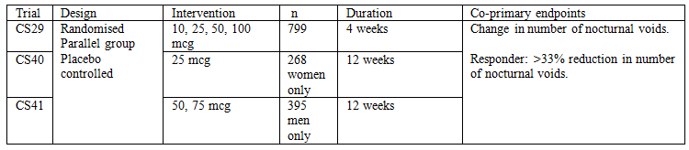

Based on the publicly available information at http://www.fda.gov/AdvisoryCommittees/ucm426272.htm

Study CS29 and its open label extension CS31 were designed as the pivotal studies to support registration for adult nocturia in the dossier submitted to the FDA in 2009.

In the “Complete Response” letter (April 2010), the FDA expressed concern that the benefits on reducing the frequency of nocturnal voids might be outweighed by the risk of hyponatraemia. The FDA recommended a further clinical trial of 3 months duration, to establish that a lower dose is safe and effective.

In response, the sponsor conducted two separate studies:

* CS40: 25 µg, women
* CS41: 50, 75 µg, men.

#### Study CS29

##### Study design

Randomised, double blind, placebo controlled, parallel group, multicentre

##### Inclusion and exclusion criteria

###### Inclusion criteria

* Men and women
* 18 + years
* Average of 2 + nocturnal voids (on a 3 day voiding diary)

###### Exclusions

* Renal insufficiency
* Hyponatraemia
* Diabetes insipidus
* Clinical suspicion of urinary retention and/or post void volume > 150 mL
* History of urological malignancy
* Any genitourinary tract pathology or neurogenic detrusor activity
* Obstructive sleep apnoea requiring treatment
* Use of loop diuretics (furosemide, torsemide, ethacrynic acid)

##### Intervention

Desmopressin ODST, 10, 25, 50, and 100 µg.

Comparator; placebo.

##### Endpoints

###### Co-primary

* Change in mean number of nocturnal voids from baseline to final visit (Day 28)
* Proportion of patients with 33%+ decrease in mean number of voids from baseline to final visit (Day 28)

Co-primary endpoint of % responders was intended to overcome the potential problem that the “arithmetic mean” might be influenced by a few outlier values. Because it was unclear from the literature as to what percentage reduction defines a clinical benefit for an individual, it was decided to use a 33% reduction (for example, from 3 voids to 2 voids). Exploratory analyses were also performed on cut-points of 50% and 75%.

###### Secondary

* Initial period of undisturbed sleep
* Total sleep time
* N-QoL; Nocturia Quality of Life questionnaire
* Nocturnal urinary volume.

##### Phases

###### Phase 1

28 days

###### Phase 2

* 6 month extension (double blind)
* Patients on active treatment continued on same treatment
* Patients on placebo were re-randomised to one of the 4 active treatment groups

CS31 was an open label extension of Part 2 of CS29. Patients on 10 µg were re-randomised

##### Measurement of primary endpoint (nocturnal voids)

Nocturnal voids were recorded in a diary on 3 consecutive 24 hour periods at baseline and during the first four weeks of the study (Days 8, 15, 22, 28). The pre-specified time point was 28 days.

##### Results

Table 4: Results Study CS29; Nocturnal voids

| Nocturnal voids | Placebo  (n = 156) | 10 µg  (n = 155) | 25 µg  (n = 152) | 50 µg  (n = 148) | 100 µg  (n = 146) |
| --- | --- | --- | --- | --- | --- |
| Baseline (mean) | 3.3 | 3.2 | 3.4 | 3.4 | 3.2 |
| Day 28 (mean)  Diff (mean)  p value versus placebo | 2.4  -0.9 | 2.4  -0.8  0.93 | 2.4  -1.0  0.31 | 2.2  -1.2  0.02 | 1.8  -1.4  < 0.0001 |
| Responders 28 day %  p value versus placebo | 47% | 47%  0.94 | 50%  0.55 | 53%  0.27 | 71%  < 0.0001 |

A post-hoc, unplanned, subgroup analysis (of CS29, to 28 days) by sex suggested that women achieved a similar response to men at lower doses. This may be related to size/weight.

###### Women

Table 5: Post-hoc, subgroup analysis (of CS29, to 28 days) of women

|  |  |  |  |  |  |
| --- | --- | --- | --- | --- | --- |
| Nocturnal voids | Placebo  (n = 66) | 10 µg  (n = 73) | 25 µg  (n = 65) | 50 µg  (n = 71) | 100 µg  (n = 66) |
| Day 28 (mean)  Diff (mean)  p value versus placebo | 2.5  -0.9 | 2.2  -1.2  0.07 | 2.1  -1.2  0.02 | 1.9  -1.2  0.01 | 1.5  -1.5  < 0.0001 |
| Responders 28 day %  p value versus placebo | 42% | 56%  0.09 | 62%  0.02 | 59%  0.04 | 77%  < 0.0001 |

###### Men

Table 6: Post-hoc, subgroup analysis (of CS29, to 28 days) of men

| Nocturnal voids | Placebo  (n = 90) | 10 µg  (n = 82) | 25 µg  (n = 87) | 50 µg  (n = 77) | 100 µg  (n = 80) |
| --- | --- | --- | --- | --- | --- |
| Day 28 (mean)  Diff (mean)  p value versus placebo | 2.4  -0.8 | 2.6  -0.5  0.09 | 2.6  -0.8  0.59 | 2.5  -1.1  0.38 | 2.1  -1.4  0.01 |
| Responders 28 day %  p value versus placebo | 50% | 39%  0.15 | 41%  0.22 | 48%  0.74 | 65%  0.05 |

The results from the secondary endpoints were generally in line with those of the co-primary endpoints. The concerns of the FDA about the validity of N-QoL have been noted by the TGA.

#### Study CS31 longer term efficacy

##### Study design

Duration of main phase: first subject enrolled 3 December 2007 and at the time of writing the report (published May 2009), the study was still ongoing. Data through to 31 December 2008 included in the report.

Participants: 70 sites (US and Canada) of the 78 sites that participated in CS29.

Study Design: This trial was multicentre, open label extension study. Planned follow up time: 2 years and 2.5 months of treatment in total.

##### Inclusion and exclusion criteria

###### Inclusion

Open to patients enrolled in Study CS29 and had completed at least visit 3E (Day 15 +/- 3 days) in Part II of that study

###### Exclusion

Using loop diuretics (furosemide, torsemide, ethacrynic acid)

##### Intervention

Desmopressin 10 µg

Desmopressin 25 µg

Desmopressin 50 µg

Desmopressin 100 µg

Patients continued with the dose received during Part II of Study CS29. However, the results of Study CS29 subsequently indicated that 10 µg was sub-therapeutic and therefore patients receiving that dose were randomly assigned at their next scheduled visit to a higher dose; 25 µg, 50 µg, or 100 µg. These subjects had their serum sodium re-evaluated five times over the next 4 weeks.

##### Endpoints

All efficacy endpoints were measured relative to the baseline values in Study CS29:

* Change in mean number of nocturnal voids
* Proportion of subjects with > 33% reduction in the mean number of nocturnal voids
* Change in the duration of the initial period of undisturbed sleep and total sleep time
* Change in the quality of life assessments: ICIQ-N (frequency and bother of day and night urination), NQoL (impact of nocturia on quality of life), PSQI (sleep quality and sleep disturbance), and SF-12v2 (impact of nocturia and lack of sleep on quality of life).

##### Discontinuations (efficacy analysis dataset)

A large proportion of patients withdrew over the duration of the trial, and of these approximately half withdrew consent.

Table 7: Study CS31 Patient participation

|  |  |  |  |  |  |
| --- | --- | --- | --- | --- | --- |
|  | 10 µg* | 25 µg | 50 µg | 100 µg | Total |
| Intent to treat | 155 | 152 | 148 | 146 | 601 |
| Re-randomised | 65 (44.9%) |  |  |  | 65 (10.8%) |
| Completed |  | 58 (38.2%) | 59 (39.9%) | 53 (36.3%) | 170 (28.3%) |
| Withdrawn | 76 (49.0%) | 86 (56.6%) | 73 (49.3%) | 84 (57.5%) | 319 (53.1%) |
| Adverse event | 7 (4.5%) | 12 (7.9%) | 15 (10.1%) | 13 (8.9%) | 47 (7.8%) |
| Serum sodium ≤ 125 mmol/L | 1 (0.6%) | 0 | 3 (2.0%) | 3 (2.1%) | 7 (1.2%) |
| Use of exclusionary medication | 1 (0.6%) | 2 (1.3%) | 1 (0.7%) | 0 | 4 (0.7%) |
| Protocol violation | 4 (2.6%) | 5 (3.3%) | 2 (1.4%) | 3 (2.1%) | 14 (2.3%) |
| Patient withdrew consent | 37 (23.9%) | 42 (27.6%) | 38 (25.7%) | 43 (29.5%) | 160 (26.6%) |
| Lost to follow up | 10 (6.5%) | 14 (9.2%) | 5 (3.4%) | 10 (6.8%) | 39 (6.5%) |
| Other | 10 (6.5%) | 7 (4.6%) | 8 (5.4%) | 8 (5.5%) | 33 (5.5%) |
| Not reported | 6 (3.9%) | 4 (2.6%) | 1 (0.7%) | 4 (2.7%) | 15 (2.5%) |
| Did not consent to enter CS31 | 14 (9.0%) | 8 (5.3%) | 16 (10.8%) | 9 (6.2%) | 47 (7.8%) |

*until re-randomised

##### Demographics

Table 8: Study CS31 Patient demographics

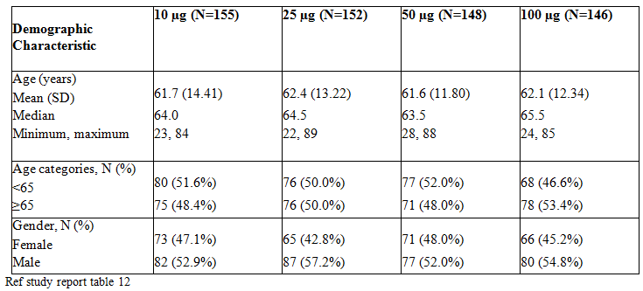

##### Results for primary endpoint

###### Nocturnal voids

The number of nocturnal voids decreased from both baseline and Day 28 (the end of Study CS29 Part 1) compared to Week 92 to 96, however as noted above there are a large number of discontinued subjects.

The following (Table 9) is an abbreviated version of table 19, in the CSR study report. The weeks are measured from baseline in Study CS29.

Table 9: Study CS31 Nocturnal voids (from of table 19 in CSR)

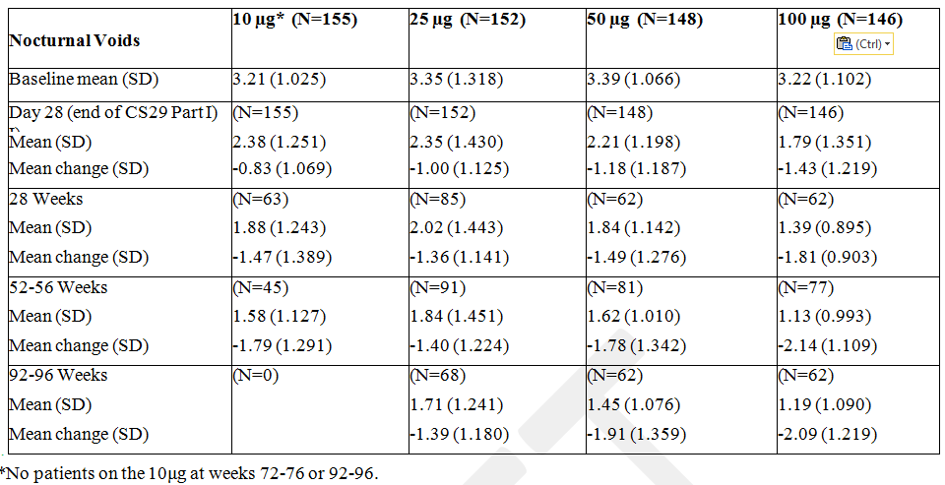

The following graph (ref Figure 2, study report) indicates the change from baseline in mean number of nocturnal voids.

Figure 1: Study CS31; change from baseline in mean number of nocturnal voids

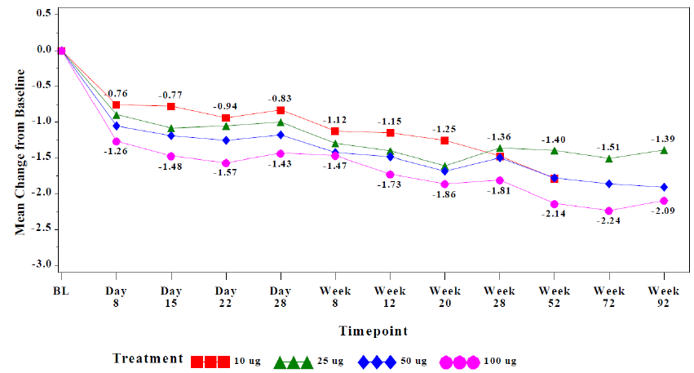

The following graph (ref Figure 3, study report) shows the change in baseline in mean number of nocturnal voids for patients who remained on treatment for at least one year.

Figure 2: Study CS31; change from baseline in mean number of nocturnal voids for patients who remained on treatment for at least one year

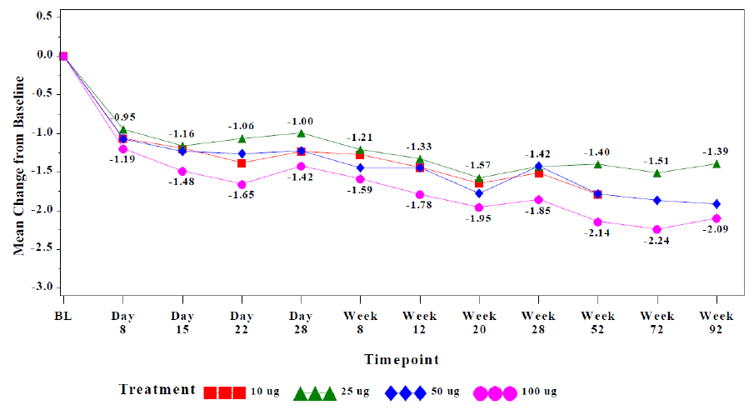

The CSR stated that “Among subjects who remained on treatment for at least 1 year, the change from baseline in mean number of nocturnal voids tended to be slightly greater at most time points than for the overall study population. This observation suggests that durability of effect was not solely the result of non-responders dropping out from the study.” However it is noted that significant proportions of the original population had withdrawn from the study at 52 to 56 week visit, thereby potentially influencing the results if non-responders dropped out of the study early. It is also noted that this was also the period in which the subjects from the 10 µg arm were re-randomised to the higher doses, potentially resulting in a more significant relative change from baseline.

The following graph (refer to Figure 4, CSR) shows the proportion of subjects with > 33% reduction in mean number of nocturnal voids from baseline to 92 to 96 weeks.

Figure 3: Study CS31; the proportion of subjects with > 33% reduction in mean number of nocturnal voids from baseline to 92 to 96 weeks

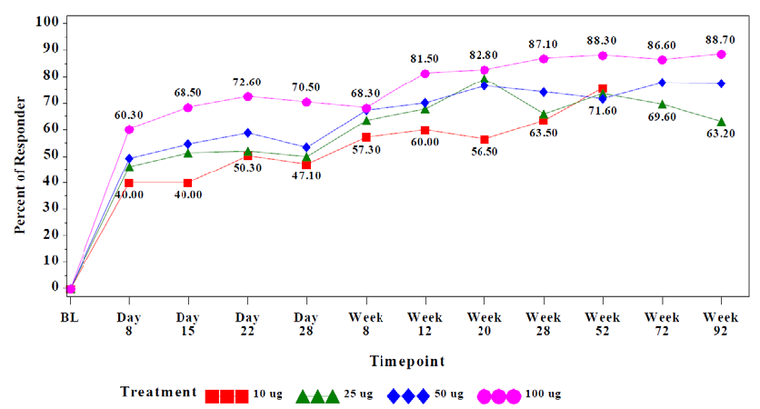

An analysis accordingly to gender in study CS29 showed that women had greater efficacy at lower doses than men. These differences continued in CS31.

#### Study CS40 (women) and Study CS41 (men)

Both studies were of 3 months duration; parallel group, placebo controlled, double blind. Study CS41 (men) had an extension phase, with a 100 µg dose, to assess whether there was any benefit in up-titrating men who had been safely exposed to a lower dose.

All patients entered a screening period before randomisation. The screening visit was within 21 days of randomisation (Day 1 of the trial). Patients were instructed on lifestyle changes to reduce night time voiding. This comprised discouraging night time intake of fluids with a diuretic effect (coffee, tea, caffeinated soft drinks, alcohol). Also instructions to empty the bladder before going to sleep and limiting fluid intake to that required to satisfy thirst.

These studies used the same co-primary endpoints as Study CS29, but used a longitudinal analysis; that is, repeated measures ANCOVA, comparing change from baseline at Week 1, Month 1, Month 2 and Month 3, adjusted for age (dichotomised at 65 years), visit, and nocturnal baseline voids. The longitudinal analysis was preferred because Study CS29 showed there was variability at an individual time point (28 days), so that the average treatment effect over a longer period might be more representative of clinical benefit.

##### CS 40

A multicentre, randomised, double blind, placebo controlled, parallel group trial to demonstrate the efficacy and safety of desmopressin orally disintegrating tablet for the treatment of nocturia in adult females.

Duration of main phase: 1st November, 2010 (first subject’s first visit) to 22 November, 2011 (last subject’s last visit).

Participants: 45 sites in the US and Canada was initiated and 39 sites randomised subjects.

Study Design: This trial was randomised and double blinded parallel trial, stratified by age (< 65years, ≥ 65 years).

###### Inclusion and exclusion criteria

Selected inclusion criteria

* Female and ≥ 18 years of age
* At least 2 nocturnal voids every night in a consecutive 3 day period during the screening period

Selected exclusion criteria

* Evidence of severe daytime voiding dysfunction (protocol defined criteria)
* Interstitial cystitis
* Urinary retention or a post void residual volume in excess of 150 ml
* Habitual or psychogenic polydipsia
* Central or nephrogenic diabetes insipidus
* Syndrome of inappropriate anti-diuretic hormone
* Current or a history of urologic malignancies
* Genitourinary tract pathology
* Neurogenic detrusor activity (detrusor overactivity)
* Suspicion or evidence of cardiac failure
* Uncontrolled hypertension
* Uncontrolled diabetes mellitus
* Hyponatremia (Serum sodium level must have been within normal limits)
* Renal insufficiency (according to protocol definition)
* Hepatic and/or biliary diseases (according to protocol definition)
* History of obstructive sleep apnoea
* Previous desmopressin treatment for nocturia
* Treatment with another investigational product 3 months prior to screening
* Concomitant treatment with any prohibited medication; for example loop diuretics. Some specific medications were allowed if the subject had been on a stable dose for the 3 months prior to the screening date; see CSR for specific medications; antimuscarinic therapy for overactive bladder, sedative/hypnotic medications, Selective serotonin reuptake inhibitors (SSRIs), non-steroidal anti-inflammatory agents (NSAIDs), chlorpropamide, carbamazepine, amiodarone
* Known alcohol or substance abuse
* Work or lifestyle that may have interfered with regular night time sleep.

###### Study treatments

Desmopressin 25 µg or comparator Placebo (double blind).

###### Endpoints

Co–primary endpoints

* Change in the mean number of nocturnal voids from baseline during 3 months of Treatment (analysed longitudinally over 3 months of treatment).
* Proportion of subjects with at least a 33% reduction in the mean number of nocturnal voids from baseline during 3 months of treatment (analysed longitudinally over 3 months of treatment).

Secondary endpoints (in hierarchical order)

* Change in the mean number of nocturnal voids from baseline at Month 3 of treatment.
* Proportion of subjects with at least a 33% reduction in the mean number of voids from baseline at Month 3 of treatment.
* Mean time to first nocturnal void at Month 3.
* Mean nocturnal urine volume and mean 24 hour urine volume at Month 3.

Exploratory endpoints

* Additional analyses of void data.
* Quality of life.

###### Measurement of endpoints

Primary

There were two co-primary endpoints and these were analysed longitudinally over 3 months of treatment:

1. Change in the mean number of nocturnal voids from baseline during 3 months of treatment.
2. Proportion of subjects with at least a 33% reduction in the mean number of nocturnal voids from baseline during 3 months of treatment.

Co-primary endpoint of % responders was intended to overcome the potential problem that the “arithmetic mean” might be influenced by a few outlier values. Because it was unclear from the literature as to what percentage reduction defines a clinical benefit for an individual, it was decided to use a 33% reduction (for example, from 3 voids to 2 voids). Exploratory analyses were also performed on cut-points of 50% and 75%.

Subjects were asked to complete 3 day voiding diaries to document the number of voids. The first morning void was not counted as a nocturnal void.

All efficacy endpoints were tested for significance using 2-sided hypothesis tests at the 5% level. For the primary endpoint, the trial was to be declared positive only if the desmopressin group had a statistically significant superiority compared to the placebo both co-primary endpoints.

All primary and secondary endpoints were analysed based on the Full analysis set (FAS) which included all randomised and exposed subjects with at least 1 efficacy assessment after dosing initiation, based on the planned (randomized) treatment.

Minimal clinically important difference (MCID)

For the sample size calculation, the MCID in a non-enriched population was specified as 0.5 voids per night.

###### Discontinuations

Table 10: Study CS40: Discontinuations

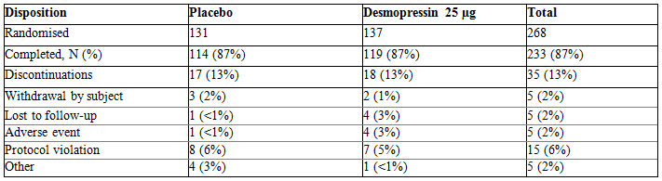

###### Baseline characteristics

Table 11 Study CS40; baseline characteristics

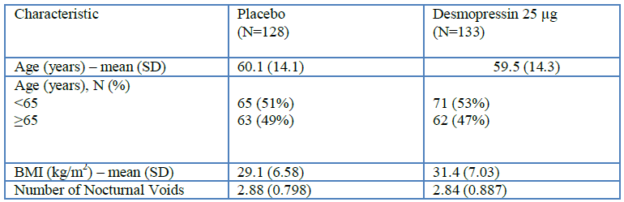

SD – standard deviation

The treatment arms were reasonably well balanced for most characteristics except for a slight imbalance for ethnic origin and weight/BMI; on the desmopressin arm, there were slightly more patients of Hispanic/Latino origin (20% versus 13%) and they were slightly heavier resulting in a higher mean BMI (31.4 versus 29.1).

###### Concomitant medications

In terms of concomitant medications, 88% of subjects on the placebo arm took any concomitant medication and 86% on the Desmopressin arm.

Table 12 is a summary of concomitant medications used by at least 10% of subjects in either treatment group (FAS) (from Table 8-9, CSR).

Table 12: Study CS40; summary of concomitant medications used by at least 10% of subjects in either treatment group (FAS)

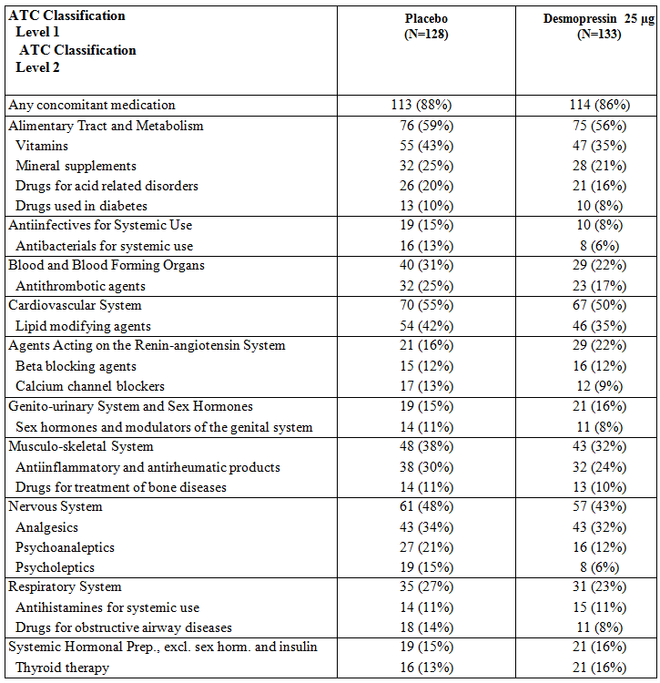

The following table (Table 13) shows concomitant medication use for selected classes of medications (safety analysis set; CSR, table 8-10).

Table 13: Study CS40; concomitant medication use for selected classes of medications

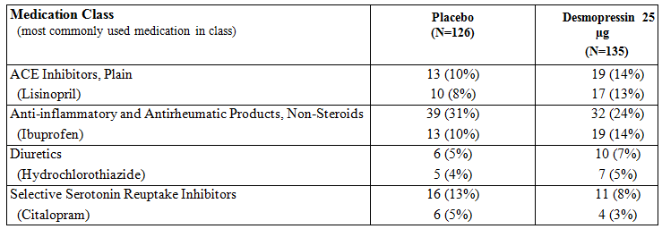

###### Results for primary endpoint

Table 14: Study CS40 change from baseline in mean number of nocturnal voids, desmopressin versus placebo, averaged over a 3 month period (Full Analysis Set)

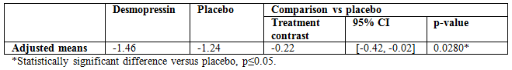

Proportion of Subjects with > 33% Reduction in Mean Number of Nocturnal Voids (FAS).

The study report presents the second co-primary endpoint as an odds ratio of the 33% responder status for desmopressin versus placebo, averaged over a 3 month period (Table 15).

Table 15: Study CS40 odds ratio of 33% responder status, desmopressin versus placebo, averaged over a 3 month period (Full Analysis Set)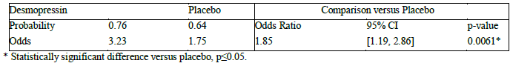

Note: GEE Method for 33% responder status at Week 1, Month 1, Month 2, and Month 3, adjusted for age (< 65, ≥ 65 years), visit, baseline nocturnal voids.

The reporting of odds ratios rather than risk ratios can be misleading to some readers.

Figure 4: Study CS40; Adjusted 33% Responder Rates by Treatment Group and Visit (Full Analysis Set)

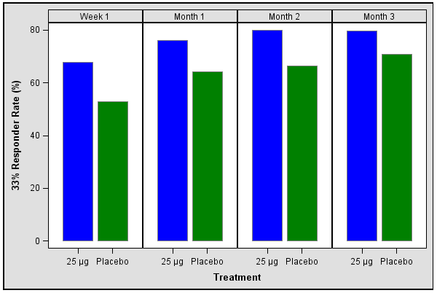

###### Selected secondary endpoints

The secondary endpoints were tested in a pre-specified order. As only the first secondary endpoint reached statistical significance, it is the only secondary endpoint reported here.

Change from Baseline in Mean Number of Nocturnal Voids at Month 3 favoured desmopressin using a Last Observation Carried Forwards (LOCF) approach.

Table 16: Change from baseline in mean number of nocturnal voids at Month 3 (Full Analysis Set)

Table 16: Change from baseline in mean number of nocturnal voids at Month 3 (Full Analysis Set)


###### Subgroup analysis by age for co-primary endpoints

The first co-primary endpoint was change from baseline in mean number of nocturnal voids. Randomisation was stratified by age (< 65 years / ≥ 65 years) and a post-hoc subgroup analysis showed potential differences in treatment effects based on age (from Table 6.4.19; EoT tables CSR):

Table 17: Study CS40; Subgroup analysis: age category by treatment interaction - Full Analysis Set

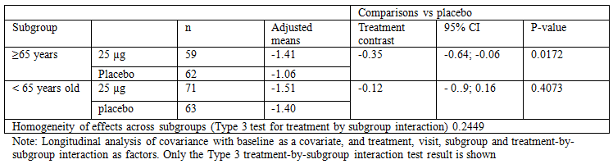

The second co-primary endpoint was the proportion of subjects with > 33% reduction in mean number of nocturnal voids. A post-hoc subgroup analysis showed possible differences in treatment effects based on age (from Table 6.4.33, EoT tables CSR).

Table 18: Study CS40; Subgroup analysis of 33% responder status: age category by treatment interaction - Full Analysis Set

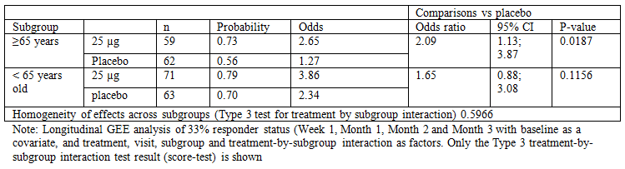

##### CS 41

A multicentre, randomised, double blind, placebo controlled, parallel group trial with an open label extension to demonstrate the efficacy and safety of desmopressin orally disintegrating tablet for the treatment of nocturia in adult males.

Duration of main phase: 15 February, 2011 (first subject’s first visit) to 20 January, 2012 (last subject’s last visit).

Participants: 56 sites were initiated in Canada and the US; 50 sites randomised subjects.

Study Design: This trial was a randomised, double blinded parallel trial with two parts, stratified by age (< 65years, ≥ 65 years).

###### Inclusion and exclusion criteria

Selected inclusion criteria

* Male and ≥ 18 years of age
* At least 2 nocturnal voids every night in a consecutive 3 day period during the screening period

Selected exclusion criteria

* Evidence of severe daytime voiding dysfunction (protocol defined criteria)
* Interstitial cystitis
* Chronic prostatitis/chronic pelvic pain syndrome
* Suspicion of bladder outlet obstruction (BOO) or urine flow < 5 mL/sec as confirmed by uroflowmetry
* Surgical treatment, including transurethral resection, for BOO or benign prostatic hyperplasia (BPH) within the past 6 months
* Urinary retention or a post void residual volume in excess of 250 ml
* Habitual or psychogenic polydipsia
* Central or nephrogenic diabetes insipidus
* Syndrome of inappropriate anti-diuretic hormone
* Current or a history of urologic malignancies
* Genitourinary tract pathology
* Neurogenic detrusor activity (detrusor overactivity)
* Suspicion or evidence of cardiac failure
* Uncontrolled hypertension
* Uncontrolled diabetes mellitus
* Hyponatremia (Serum sodium level must have been within normal limits)
* Renal insufficiency (according to protocol definition)
* Hepatic and/or biliary diseases (according to protocol definition)
* History of obstructive sleep apnoea
* Previous desmopressin treatment for nocturia
* Treatment with another investigational product 3 months prior to screening
* Concomitant treatment with any prohibited medication; for example loop diuretics. Some specific medications were allowed if the subject had been on a stable dose for the 3 months prior to the screening date; see CSR for specific medications; alpha-blockers, 5‑alphareductase inhibitors, antimuscarinic therapy for overactive bladder, sedative/hypnotic medications, Selective serotionin reuptake inhibitors (SSRIs), non‑steroidal anti-inflammatory agents (NSAIDs), chlorpropamide, carbamazepine, amiodarone, sildenafil under strict conditions
* Known alcohol or substance abuse
* Work or lifestyle that may have interfered with regular night time sleep

###### Treatments

Part 1:

* Desmopressin 50 µg (double blinded)
* Desmopressin 75 µg (double blinded)
* Placebo

Part 2:

Desmopressin 100 µg

Open label extension for safety evaluation (see Figure 5 below).

###### Endpoints

Co – Primary endpoints

* Change in the mean number of nocturnal voids from baseline during 3 months of Treatment (analysed longitudinally over 3 months of treatment)
* Proportion of subjects with at least a 33% reduction in the mean number of nocturnal voids from baseline during 3 months of treatment (analysed longitudinally over 3 months of treatment)

Secondary (in hierarchical order)

* Change in the mean number of nocturnal voids from baseline at Month 3 of treatment
* Proportion of subjects with at least a 33% reduction in the mean number of voids from baseline at Month 3 of treatment
* Mean time to first nocturnal void at Month 3
* Mean nocturnal urine volume and mean 24 hour urine volume at Month 3

Exploratory

* Additional analyses of void data
* Quality of life

Figure 5: Study CS41 Trial design

Figure 5 Study CS41 Trial design
Screening period; visit 1 within 21 days prior to Day 1 in Part 1
Part 1: Visits 2 to 8  randomised subjects on either Desmopressin 50micrograms, 75 micrograms or placebo Treatment for 85 days
Part II all subject treated with desmopressin 100 mirograms from Day 1 of this period until Day 29
End of trial visist scheduled after 4 months of treatment.

Part I: all efficacy assessments plus safety

Part II: evaluation of safety only.

###### Measurement of primary endpoints

Measurement of primary endpoint was as for CS40

Minimal clinically important difference (MCID):

For the sample size calculation, the MCID was specified as 0.3 and 0.2 mean nocturnal voids for 75 µg group and 50 µg group, respectively.

###### Discontinuations

Intent to Treat (ITT) Analysis Set (all randomized subjects, regardless if they were exposed or not)

Table 19: Study CS41 subject disposition (ITT Analysis Set)

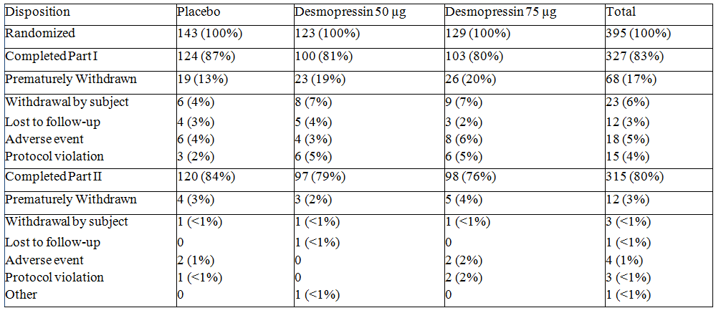

###### Baseline characteristics

Part I (FAS)

Table 19: Demographic characteristics (Full Analysis Set) – Part I

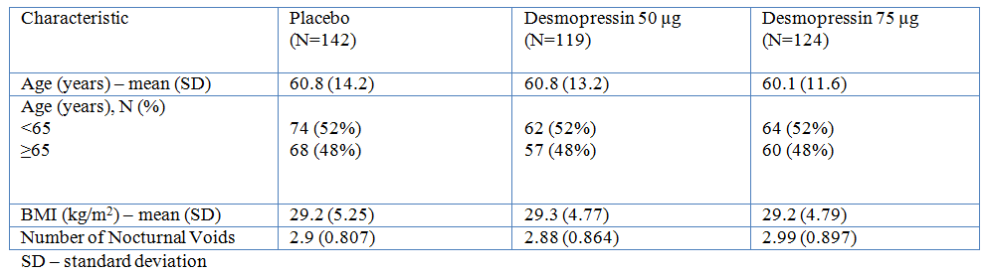

The arms were reasonably well balanced for most characteristics except for a slight imbalance for ethnic origin; on the desmopressin arms there were more patients of Hispanic/Latino origin (75 µg 23% versus 50 µg 21% versus placebo 14%).

Part II (safety analysis set)

Table 20: Demographic characteristics (Safety Analysis Set) – Part II

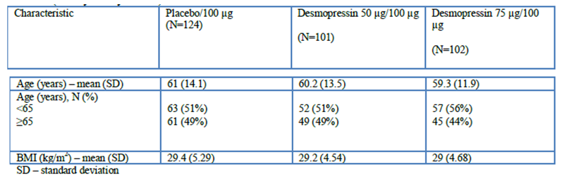

The imbalance for ethnic origin remained similar to that seen in Part I.

###### Concomitant medications

The following (Table 21) is a summary of concomitant medications used by at least 10% of subjects in either treatment group (FAS).

Table 21: Concomitant medications used by at least 10% of subjects in any treatment group (Full Analysis Set); Part I

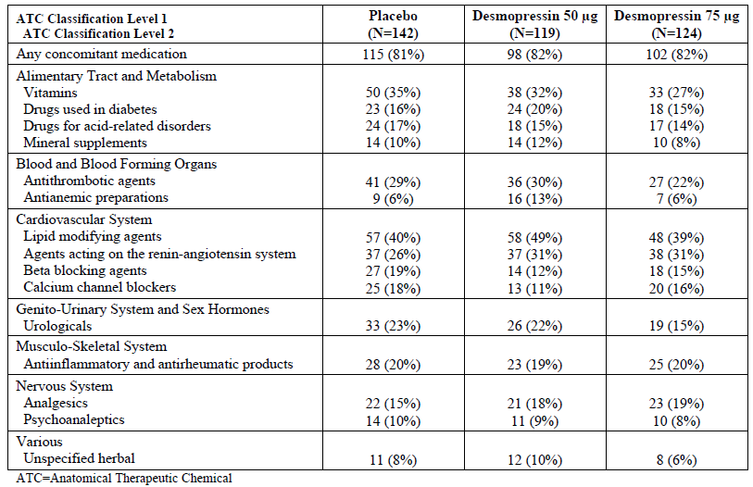

The following (Table 22) shows concomitant medication use for selected classes of medications.

Table 22: Concomitant medication use by mediation class and standardized medication name for selected medications (Safety Analysis Set)

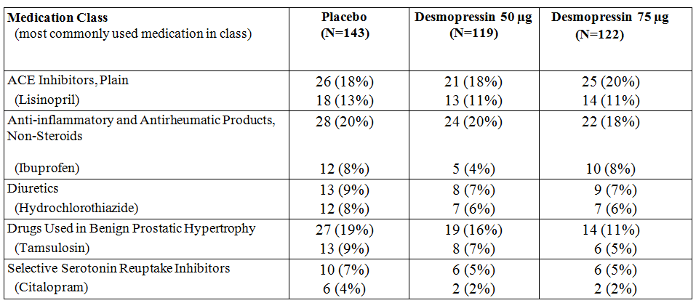

###### Results for primary endpoint

* Change in mean number of nocturnal voids (FAS)

Table 23: Change from baseline in mean number of nocturnal voids, desmopressin versus placebo, averaged over a 3 month period (Full Analysis Set)

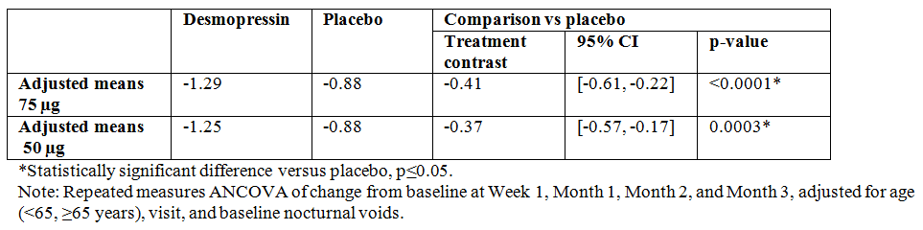

The following (Figure 6) is a graph of the adjusted change from baseline during 3 months of treatment in mean number of nocturnal voids providing helpful visualisation of the changes seen on the two desmopressin arms.

Figure 6: Adjusted change from baseline during 3 months of treatment in mean number of nocturnal Voids (Full Analysis Set)

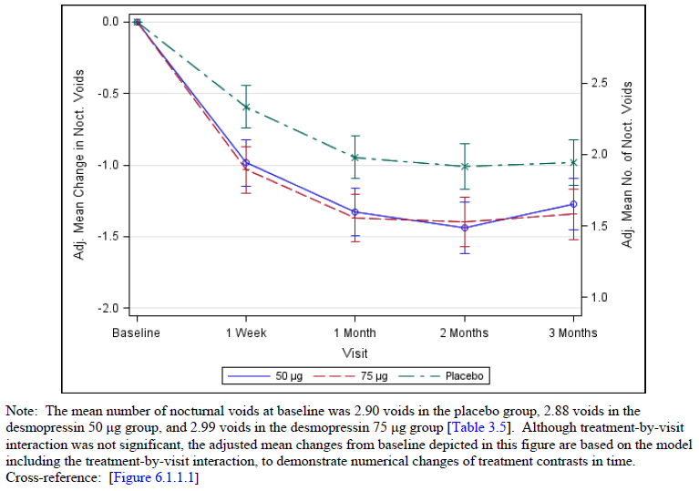

* Proportion of Subjects with > 33% Reduction in Mean Number of Nocturnal Voids (FAS).

The study report presents the second co-primary endpoint as an odds ratio of the 33% responder status for desmopressin versus placebo, averaged over a 3 month period (Table 24).

Table 24: Odds ratio of 33% responder status, desmopressin versus placebo, averaged over a 3 month period (Full Analysis Set)

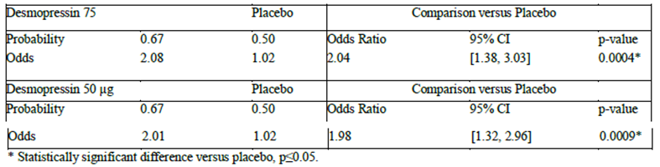

Note: GEE Method for 33% responder status at Week 1, Month 1, Month 2, and Month 3, adjusted for age (< 65, ≥ 65 years), visit, baseline nocturnal voids.

The following (Figure 7) is a graphical representation of the proportion of 33% responder status according to time point and treatment arm. As noted for CS40, measurement of absolute difference and a relative risk would be a preferred method for presenting the data however these could not be found in the study report.

Figure 7: Study CS41 Adjusted 33% Responder Rates by Treatment Group and Visit (Full Analysis Set)

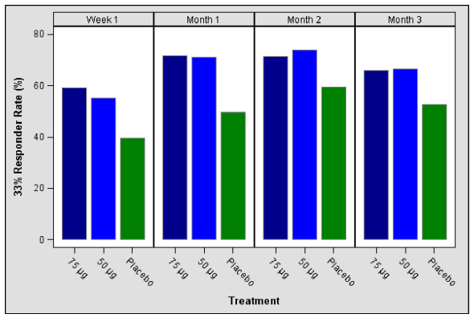

###### Selected secondary endpoints

According to the pre-specified plan, secondary efficacy endpoints were to be analysed with the following caveats:

* Statistical significance could only be declared for secondary analyses if both co-primary endpoints were statistically significant at 5% level
* According to a hierarchical step down approach, secondary endpoints were first tested in the 75 µg group and then in the 50 µg group. Only if all desmopressin 75 µg secondary endpoints were statistically significant at the 5% level could statistical significance could be claimed for endpoints in the 50 µg group. If a higher secondary endpoint did not achieve statistical significance, then statistical significance could not be declared for this endpoint or any subsequent secondary endpoints.

Accordingly, only four secondary endpoints for the desmopressin 75 µg group were positive and therefore only these will be reported here (Tables 25 to 28):

Table 25: Study CS41; Change from baseline in Mean number of nocturnal voids favouring desmopressin 75 µg

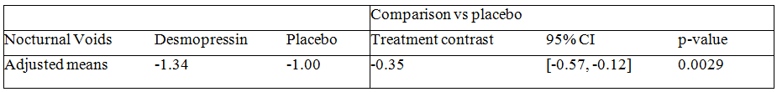

Note: ANCOVA of change from baseline adjusted for age (< 65, ≥ 65 years) and baseline nocturnal voids, using LOCF.

Table 26: Study CS41; Change from baseline in Proportion of 33% responders

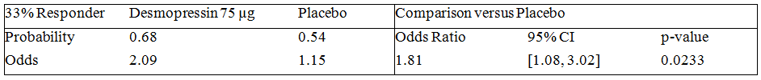

Note: Logistic regression of 33% responder status adjusted for age (< 65, ≥ 65 years) and baseline nocturnal voids using LOCF.

Table 27: Study CS41; Change from baseline in Mean time (minutes) to first nocturnal void

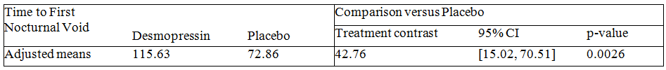

Note: ANCOVA of change from baseline adjusted for age (< 65, ≥ 65 years) and baseline time to first nocturnal void, using LOCF.

Table 28: Study CS41; Change from baseline in Mean nocturnal urine volume

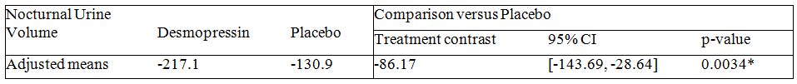

Note: ANCOVA of change from baseline adjusted for age (< 65, ≥ 65 years) and baseline nocturnal urine volume, using LOCF.

###### Change from baseline in mean number of nocturnal voids

The first co-primary endpoint was change from baseline in mean number of nocturnal voids. Randomisation was stratified by age (< 65 years / ≥ 65 years) and a post-hoc subgroup analysis showed the following treatment effects based on age (Table 29).

Table 29: Study CS41; Subgroup analysis: age category by treatment interaction - Full Analysis Set

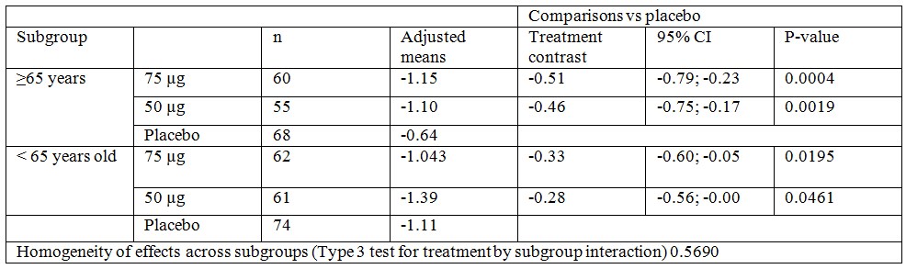

Note: Longitudinal analysis of covariance with baseline as a covariate, and treatment, visit, subgroup and treatment-by-subgroup interaction as factors. Only the Type 3 treatment-by-subgroup interaction test result is shown

###### Proportion of subjects with > 33% reduction in mean number of nocturnal voids

The second co-primary endpoint was the proportion of subjects with > 33% reduction in mean number of nocturnal voids. A post-hoc subgroup analysis showed treatment effects based on age (Table 30).

Table 30: Study CS41; Subgroup analysis of 33% responder status: age category by treatment interaction - Full Analysis Set

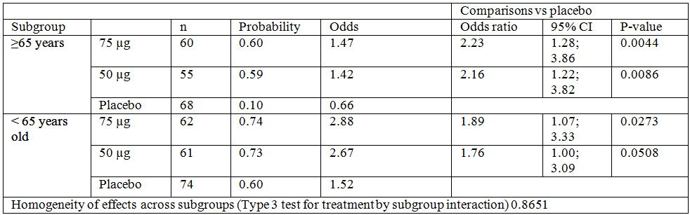

Note: Longitudinal GEE analysis of 33% responder status (Week 1 , Month 1, Month 2 and Month 3 with baseline as a covariate, and treatment, visit, subgroup and treatment by subgroup interaction as factors. Only the Type 3 treatment by subgroup interaction test result (score test) is shown

## Clinical safety

Hyponatraemia is the most important safety concern, which is based on the known mechanism of action (that is, water retention).

Thrombosis is a potential risk, based on desmopressin’s haematological effects (for example, it has a registered indication for von Willibrand’s disease). However, the dose used for von Willibrand’s disease is much higher than the doses proposed for nocturnal polyuria. There was no signal for thromboembolic events in the Studies CS40/CS41; although these trials were only of three months duration. Thrombosis is listed as an important potential risk in the summary of safety concerns; routine pharmacovigilance (spontaneous reporting) is proposed.

### CS40

The safety analysis set included all subjects who received at least one dose of either desmopressin or placebo and had at least one safety assessment even if the subject was ruled ineligible. Analyses were done according the actual treatment.

Table 31: Safety analysis set Study CS40



The following (Table 32) is a summary of the treatment emergent adverse events.

Table 32: Study CS40 Summary of treatment emergent adverse events (Safety Analysis Set)

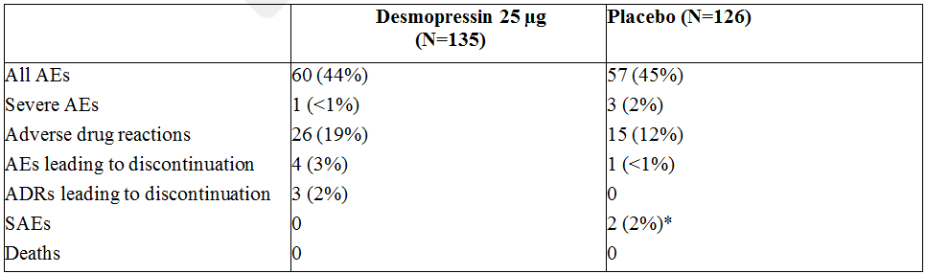

AE = adverse event; SAE = serious adverse event; ADR = adverse drug reaction: an AE assessed by the Investigator as possibly/probably related to study drug. *cellulitis and pulmonary embolus

The most common treatment emergent adverse events (> 2%) for desmopressin were the following in order of frequency (Table 33).

Table 33: Study CS40 treatment emergent adverse events reported (in order of frequency) for at least 2% of subjects in either treatment group (Safety Analysis Set)

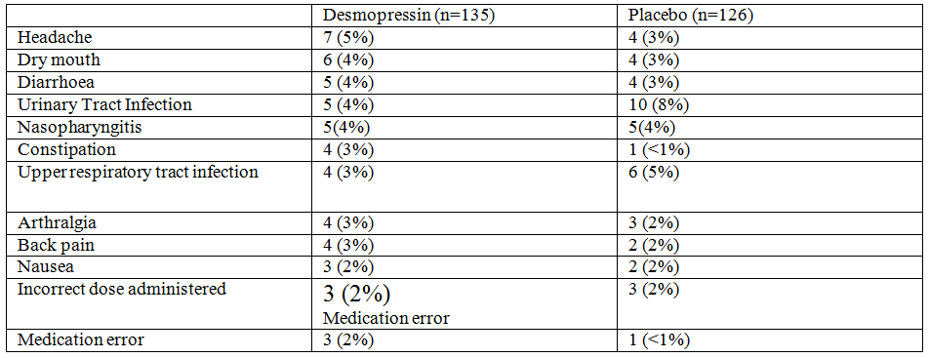

The most common (> 1%) treatment emergent adverse drug reactions reported for desmopressin were dry mouth (4% versus placebo 2%), headache (3% versus 2%), medication error (2% versus < 1%), abdominal pain (1% versus 0), hyponatremia (n = 2; 1% versus 1; < 1%), back pain (1% versus 0), muscle spasms (1% versus 0). It should be noted that if sodium was > 125 mmol/L, it was reported by the investigator if it was considered to be clinically significant. If the value was ≤ 125mmol/L, the case was reported as an SAE.

Four subjects in the desmopressin group (headache, somnolence, syncope, and hypertension) and one in the placebo group (pulmonary embolus) discontinued the study due to an AE. No subjects died during the trial.

In terms of laboratory values, some increases and decreases were seen in haematology, urinalysis and in clinical chemistry, however only 3 patients with sodium shifts to a “low” value in the desmopressin arm was considered to be clinically significant by investigators. In terms of differences between arms, mostly the changes seen were similar (≤ 3% difference) except for the following numerical differences (as shown in Table 34)

Table 34: Study CS40 Changes in laboratory parameters between arms

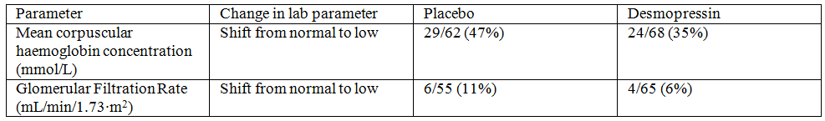

Further details of the lab parameter changes including markedly abnormal laboratory variable changes can be seen in Tables 35, 36 and 37).

Table 35: Study CS40; Summary of shifts from normal at baseline to either low or high at month for ≥ 3 subjects in either treatment group; haematology (Safety Analysis Set)

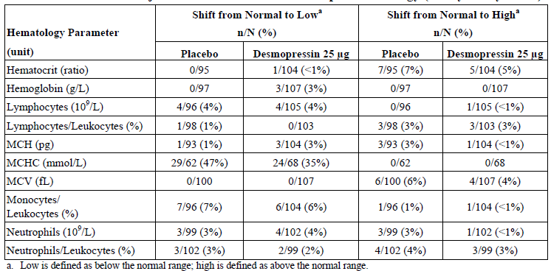

Table 36: Study CS40; Summary of shifts from normal at baseline to either low or high at Month 3 for ≥ 3 subjects in either treatment group; clinical chemistry (Safety Analysis Set)

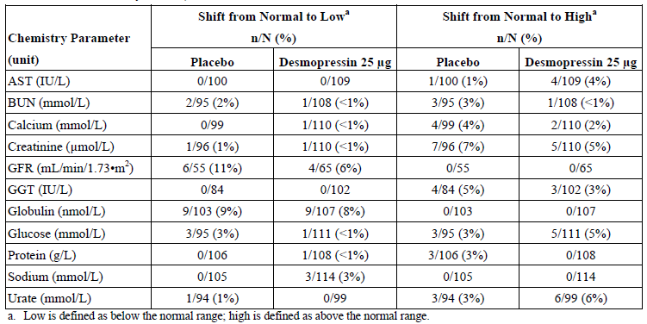

Table 37: Study CS40; Incidence of markedly abnormal changes in laboratory variables (Safety Analysis Set)

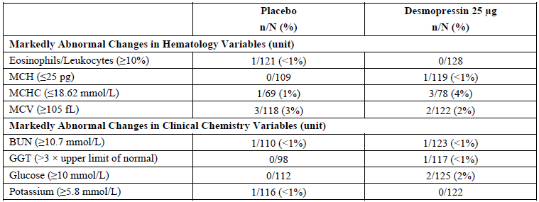

In terms of vital signs, no increases or decreases in values were considered by the investigator to be clinically meaningful. Further details were provided in the CSR (Tables 7.3.1 and 7.3.2).

#### Serum sodium

No patient had a serum sodium level ≤ 125 mmol/L during the trial and there were no discontinuations due to low serum sodium or an adverse event of hyponatremia. Three (2%) of the desmopressin patients had a serum sodium level of < 130 mmol/L (one of 71 (1%) was < 65 years and two of 63 (3%) were ≥ 65 years old). All three subjects regained sodium levels of > 130 mmol/L within 2 to 4 days without interrupting treatment.

The following table (Table 38) summarises the minimum post baseline serum sodium levels.

Table 38: Study CS40; Minimum post baseline serum sodium levels (Safety Analysis Set)

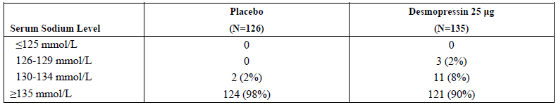

The following diagram (Figure 8) shows the minimum post dose serum sodium levels by subject age and treatment arm (figure 11-1, study report); of note, 2 subjects on the desmopressin arm were the same age (67 years) and had a minimum sodium of 132 mmol/L and are therefore represented by a single blue circle.

Figure 8: Study CS40; Minimum post dose serum sodium levels by subject age (Safety Analysis Set)

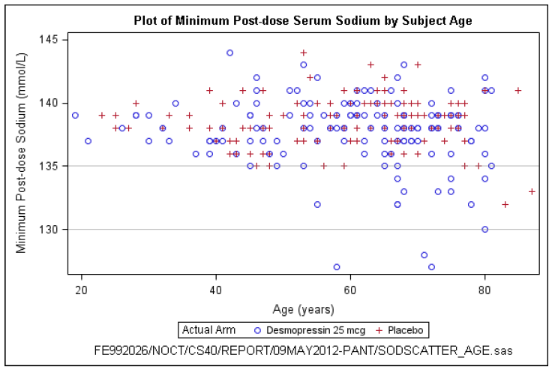

Figure 9 shows a Kaplan–Meier plot of time to hyponatremia (< 135) for all patients, suggesting that a decrease in serum sodium could occur at any time throughout the 3 month treatment period and was not confined to a particular period within starting treatment:

Figure 9: Study CS40; Kaplan-Meier plot of time to hyponatraemia: Sodium < 135 – All patients

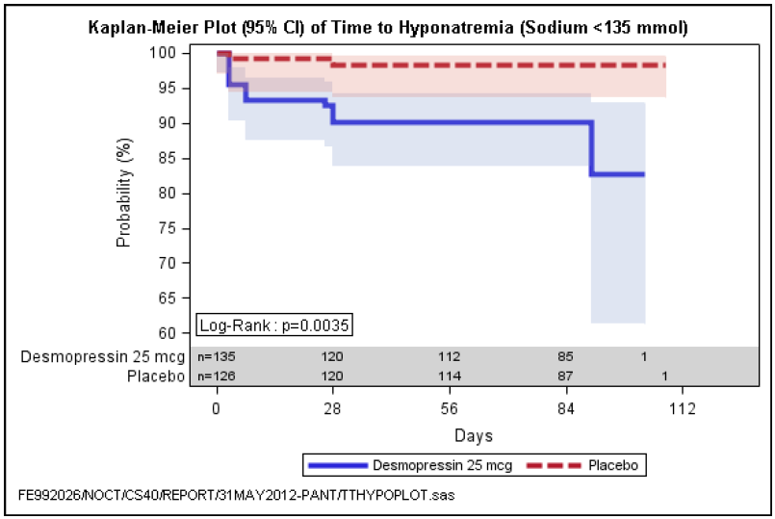

### CS41

#### Serum sodium

* Part I

The following graph (Figure 10) shows the minimum post dose serum sodium levels by treatment arm and age.

Figure 10: Minimum post dose serum sodium levels by subject age (Safety Analysis Set) – Part I

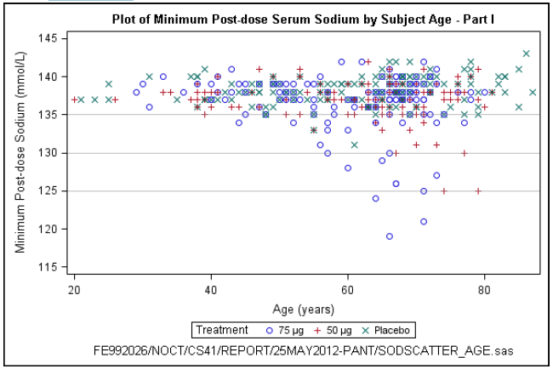

The following table (Table 39) is another summary of the minimum post baseline serum sodium levels seen in Part I.

Table 39: Minimum post baseline serum sodium levels by age group (Safety Analysis Set) – Part I

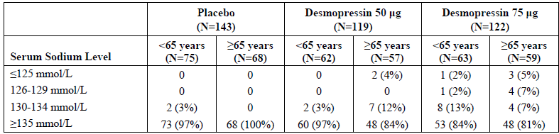

Two observations from this data set are made:

* A dose response was observed with regards to serum sodium levels in CS41
* Hyponatremia was more common among subjects ≥ 65 years of age.

It is also noted that five of the six subjects had serum sodium ≤ 125 mmol/L and discontinued the trial due to hyponatremia (per protocol). The sixth discontinued due to dizziness on Day 6 and was subsequently found to have low sodium on Day 7. Of these subjects, 5 had a normal serum sodium at baseline and the sixth had a serum sodium of 134 mmol/L.

* Part II

The following table (Table 40) is summarises the minimum post baseline serum sodium levels seen in Part II (safety analysis set; table 11-15 study report) according to desmopressin dose and age. Of note, two subjects had a post baseline serum sodium level of ≤ 125 mmol/L and both were discontinued per protocol.

Table 40: Minimum post baseline serum sodium levels by age group (Safety Analysis Set) – Part II

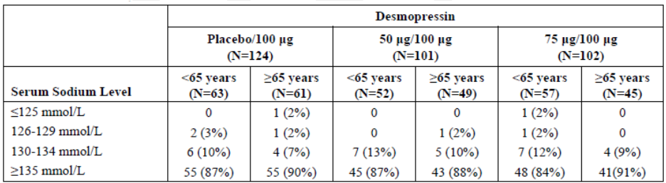

The following graph (Figure 11) shows the minimum post dose serum sodium levels by treatment arm and age.

Figure 11: Minimum post dose serum sodium levels by subject age (Safety Analysis Set) – Part II

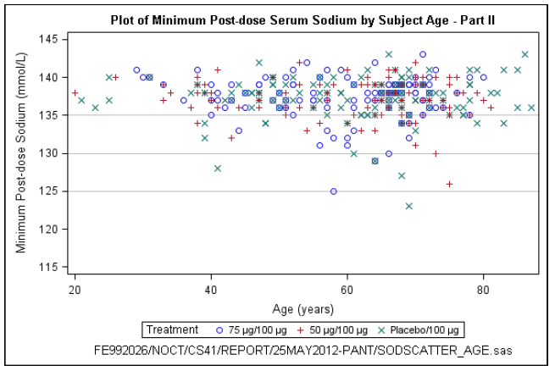

Unlike Part I, the incidence of hyponatremia was similar between subjects ≥ 65 years and < 65 years of age.

The following (Figure 12) is a Kaplan-Meier plot of the time to hyponatremia (sodium < 135mmol/L) in part II and II.

Figure 12: Kaplan-Meier plot of time to hyponatremia - Part II: Sodium < 135 –All patients

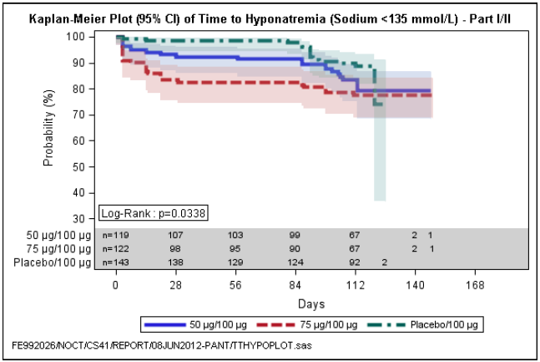

### Risk management plan

#### Summary of safety concerns

Table 41: Summary of safety concerns

|  |  |
| --- | --- |
| Important identified risks | hyponatraemia |
| Important potential risks | * Thrombosis * Anaplylactic reaction (including allergic reactions due to fish gelatine in melt formulation) |
| Missing information | none |

The evaluator suggested the following additional risks to be included as missing information:

* Limited long term safety data for usage in nocturnal polyuria in the elderly. (The available data are only for three months.)
* Limited long term efficacy data for usage in nocturnal polyuria in the elderly. (The available data are only for three months.)

#### Pharmacovigilance

Routine pharmacovigilance (that is, passive/spontaneous reporting) is proposed.

#### Risk minimisation measures

Routine risk minimisation measures were proposed.

Statements in the current PI about monitoring of serum sodium include:

* All patients 65 + years should have a serum sodium above the lower limit of the normal range before staring treatment (135 + mmol/L).
* Patients 65 + years should have their serum sodium levels checked at 4 to 8 days (the sponsor states that the earliest time at which sustained hyponatraemia can be detected is 4 to 8 days after starting Nocdurna).
* Patients 65 + years should have their serum sodium levels checked again at 1 month.

The evaluator considered the recommendations for medications and monitoring to avoid hyponatremia to be inadequate.

The serum monitoring specified in CS40/CS41 (for 3 months) is not the same as that in the PI.

* All patients in CS40/CS41 had serum sodium measured at baseline and monitored throughout the trial. The PI recommends this only for patients 65 + years.

For patients 65 + years, the PI recommends measurement of serum sodium during the first week (4 to 8 days), then again at one month, but is silent about the frequency of long term monitoring. However, in CS40/CS41 monitoring was at least monthly for 3 months.

## First round benefit-risk assessment

### Uncertainties about benefits

The results for the co-primary endpoints from CS40/CS41 were statistically significant; however, it is uncertain whether the results were clinically significant. More specifically, the average benefits of Nocdurna, based on CS40/CS41, were for women treated with 25 µg a: reduction of one night time void per 4 to 5 days; and in men treated with 50 µg a reduction of one night time void per 2 to 3 days.

The other co-primary endpoint was a 33% reduction in night time voids at 3 months. The average baseline number of voids in CS40/CS41 was 3 voids per night. Consequently, for the typical/average patient in CS40/CS41, a 33% reduction in night time voids was a decrease from 3 to 2 voids per night; the evaluator was uncertain whether such a decrease is clinically significant. It was noted that one quarter of women and one third of men did not achieve this improvement.

Various secondary endpoints in CS40/CS41 including: time to first nocturnal void, mean nocturnal void volume, N-QoL were generally supportive of a small treatment effect. In CS41 (men), the placebo subtracted time to first nocturnal void was 39 minutes longer with Nocdurna; and the placebo subtracted mean nocturnal urine volume was 78 mL less.

The evaluator was uncertain whether efficacy has been satisfactorily established within the pivotal trials.

Nocdurna was less effective when the nocturia is due a combination of nocturnal polyuria overlaid with frequent low volume voids. CS40/CS41 excluded patients with severe daytime voiding dysfunction, however, in the real world of everyday clinical practice, patients with severe (however defined) daytime voiding dysfunction might be prescribed Nocdurna. If this were to occur, the average benefit to the population of patients using Nocdurna (post-marketing) might be even more uncertain than in the pre-market studies (CS40/CS41).

The proposed Australian Indications are for nocturnal polyuria that *has not responded to lifestyle and behavioural modifications* (before bedtime drink only enough to satisfy thirst; avoid alcohol and caffeine containing beverages). Given the response in the placebo arm of the pivotal trials, there is the concern that lifestyle factors may have been inadequately studied. Lifestyle interventions do not carry the same potential harm (that is, hyponatraemia) as Nocdurna.

### Uncertainties about harms

The most important harm is the risk of hyponatraemia. Other adverse effects/reactions include dry mouth, headache and nausea, which do not carry the same risk to health as hyponatraemia.

The elderly are at greater risk of hyponatraemia because of declining physiological reserve and the frequent presence of comorbidities and concomitant medications. Prevalence estimates are: outpatients 5%, inpatients 20%.[6]

The clinical studies CS40/CS41 included a number of inclusion/exclusion criteria and monitoring to minimise the risks of hyponatremia. These included the following:

* Excluded patients at risk of hyponatremia such as those with SIADH, cardiac failure and hyponatremia (serum sodium < 135 mmol/L) at screening
* Prohibited initiation, during the trial, of specific medicines that may cause hyponatraemia (that is, TCADs, SSRIs, NSAIDs, chlorpropamide, diuretics, carbamazepine, etcetera). Patients who were already on the specific medications had to have been on a stable dose for 3 months prior to the screening date
* Excluded patients on loop diuretics
* Instructed patients to limit fluid intake 1 hour before study drug and until 8 hours after study drug
* Stopped treatment if an acute illness occurred that could result in fluid and/or electrolyte imbalances
* Withdrew patients if serum sodium was ≤ 125 mmol/L
* Measured serum sodium at baseline, twice within Week 1, and then monthly in CS40, with additional measurements in CS41 at Week 2 and 3 in part 1 and weekly measurements in Part II.

The evaluator was concerned how similar selection criteria and monitoring could occur in the real world of everyday clinical practice.

The evaluator was concerned that with longer term use of desmopressin in the real world of everyday clinical practice and the likely use of concomitant medicines the risk of hyponatraemia will be higher than that reported for CS40/CS41.

## First round recommendation regarding authorisation

[None provided]

## Clinical questions

1. For the dichotomous co-primary endpoint of 33% reduction in voids, please provide risk ratios (not odds ratios) and 95% CIs. Please amend the proposed PI: The relative risk increase was 19% for women and 34% for men; not “nearly doubled”, as suggested by the odds ratio. These changes are required because it is well known that odds ratios can mislead prescribers and patients. CIs around the relative risk increase should be included in the PI.
2. It seems that the MCID used for the sample size calculation for CS40 (women) was an average reduction of 0.5 voids per night; whereas the MCID for CS41 (men) was 0.2 voids (for the 50 µg dose). Why were different MCIDs used for the sample size calculations?
3. What were percentages of patients in the pivotal trials who were able to get an uninterrupted night’s sleep?
4. Why is a schedule for regular, long term serum monitoring of hyponatraemia not specified in the PI?
5. The PI states: “In studies of adult subjects with nocturia treated with desmopressin, those who developed low serum sodium did so usually within the first few days of commencing treatment or of a dose increase.” Please provide the numbers behind this statement (for example, a/b [c%] of patients who developed hyponatraemia [? mild/moderate/severe?] within the first three months, in the pivotal trials, did so within the first week).
6. In CS40/CS41, specific medicines that may cause hyponatraemia (that is, TCADs, SSRIs, NSAIDs, chlorpropamide, diuretics, carbamazepine, etcetera) could not be started during the trial. Given this, please explain why the proposed PI does not recommend stopping Nocdurna if the patient needs to start on one of the specified medicines.
7. How was mild/moderate hyponatraemia managed in CS40/CS41?
8. Based on experience overseas (for example, Canada), which doctors prescribe Nocdurna? (Primary care physicians/GPs, geriatricians, urologists, etcetera?)
9. Please provide an update on the status of the application to the FDA.
10. Please provide the latest reports from the EU (Sweden or CMS).
11. Please provide your responses to the questions in the Day 70 PAR (RMS: Sweden). The TGA is interested in all the responses, and is particularly interested in the responses to:
    * Whether sex differences in dosing are due to weight/size and what this might mean for an elderly man of low weight
    * Stratification of data from CS31 by age.
    * Stratification of data for the co-primary endpoints from CS40/CS41 by > 65, > 75, > 85 years.

## Second round evaluation of clinical data submitted in response to questions

### Sponsor identified errors of fact or omission

In their response, dated 28 June 2016, the sponsor stated that the “evaluator has not considered all aspects of the submitted supporting dataset in forming his or her conclusions”.

The sponsor has submitted Errors of fact or omission in the CER, which has the following three headings:

1. Uncertainty about the clinical benefits of Nocdurna
   1. Quality of life assessments
   2. Onset of action of Nocdurna
2. Uncertainty about the risk of hyponatraemia with Nocdurna
3. Other issues (8 melt starter pack was proposed in the US, but is not proposed in Australia)

The second round response to sponsor’s response is discussed under these headings, below.

### Second round evaluation of the sponsors response

The following is the evaluator’s response to the sponsor’s response under the subheadings mentioned above.

#### Uncertainty about the clinical benefits of Nocdurna

##### Quality of life assessments

The sponsor has noted that the first round CER provides excerpts from the Health Canada and Swedish NRA evaluations, which have a positive view of the quality of life data.

The protocols for CS40 and CS41 identified the nocturia quality of life (N-QoL) questionnaire as a secondary endpoint. It was not a key secondary endpoint, but was labelled as exploratory in the protocols (CS40, CS41). It is not usual practice to repeat a lot of a detail from a sponsor’s dossier on an exploratory secondary endpoint in a CER (it is not unusual for a trial to have 10 to 20 secondary endpoints).

Nevertheless, because the sponsor has raised N-QoL as their key issue, detail about the exploratory secondary endpoint is given below (see Detail on Nocturia, Quality of Life endpoint).

The results on the pre-specified co-primary endpoints were statistically significant, but the point estimates of the treatment effect were small. In terms of the benefit-risk balance, one important question is whether these small (statistically significant) treatment effects on the pre-specified co-primary endpoints (supported by the secondary endpoints) are sufficient to offset concerns about hyponatraemia, at a population level.

In the first round evaluation (CER), the secondary endpoints (including the nocturia quality of life measurements [N-QoL]) were generally supportive of a small average treatment effect.

Other regulatory agencies are not in agreement about whether the benefit-risk balance is favourable (that is, Health Canada and the Swedish NRA consider that it is; the FDA considers that it is not). It is recommended that the TGA engage two independent external Australian clinical experts to provide advice on whether the benefit-risk balance is favourable.

##### Detail on the nocturia quality of life (N-QOL) questionnaire

The N-QOL questionnaire is a self-administered questionnaire that was developed on men attending urology clinics in the United Kingdom[7] and has also been applied to women.[8]

The questionnaire has two sections: a Sleep/Energy (6 questions), a Bother/Concern (6 questions). There is also a Global Quality of Life question which is scored separately.

The questionnaire refers to the previous 2 weeks.

Patients answer 6 questions under Sleep/Energy and 6 questions under Bother/Concern, giving each of them a score from 0 to 4. Higher scores for the items in the test represent better quality of life. Summary scores are computed by transforming the raw score onto a standardized scale of 0 to 100. A patient who had perfect scores of 4 on all 12 items (that is no problem with sleep/energy or bother/concern) would have a raw score of 48 but a standardized score of 100.

From the 2004 paper by Lucy Abraham et al, the 12 questions are7:

Over the past two weeks, having to get up at night to urinate: (options are: every day, most days, some days, rarely, never);

* Has made it difficult for me to concentrate the next day.
* Has made me feel generally low in energy the next day.
* Has required me to nap during the day.
* Has made me less productive the next day.
* Has caused me to participate less in activities I enjoy.
* Has caused me to be careful about when or how much I drink
* Has made it difficult for me to get enough sleep at night.

Over the past two weeks I have been (options are: extremely, quite a bit, moderately, a little bit, not at all)

* Concerned that I am disturbing others because of having to get up at night.
* Preoccupied about having to get up at night to urinate.
* Worried that this condition will get worse in the future.
* Worried that there is no effective treatment for this condition.

Overall, how bothersome has having to get up at night been over the past two weeks? (Options are: extremely, quite a bit, moderately, a little bit, not at all).

There is also a global QoL question.

The questionnaire takes about five minutes to complete. It has good internal consistency and test-retest reliability. The score correlates with sleep quality as measured by PSQI and energy/vitality and social functioning as measured by SF-36. It was able to discriminate between the number of voids per night. Based on Table 3 in the Abraham paper, roughly speaking an decrease from 3 to 2 voids per night results in an increase of about 12 points on the N-QoL (overall score), scaled up to 100.

This is in keeping with the results from CS40/CS41. The pre-specified co-primary endpoint showed a 0.2 (women) and 0.4 (men) decrease, on average, in the number of voids/night (after 3 months). This was associated with an increase in the mean N-QoL score of about 5 or 6 points (standardised to 100).

One aspect of uncertainty is whether this small average treatment effect is sufficient to offset concerns about hyponatraemia, when Nocdurna is used in the real world of everyday clinical practice, in the Australian setting.

#### Results for N-QoL from CS40/CS41

For women in CS40 (desmopressin 25 µg versus placebo), 248/268 = 93% completed the N-QoL questionnaire at Month 1 and 212/268 = 83% completed it at Month 3. For men in CS41 (desmopressin 50 µg/75 µg versus placebo), the corresponding percentages were: Month 1: 366/395 = 93%; Month 2: 337/305 = 85%. The improvements in N-QoL are highlighted in the tables below.

Table 42: CS40 adjusted treatment differences in mean change from baseline in NQoL domain scores by visit including treatment by visit interaction term (full analysis set using repeated measures ANCOVA)

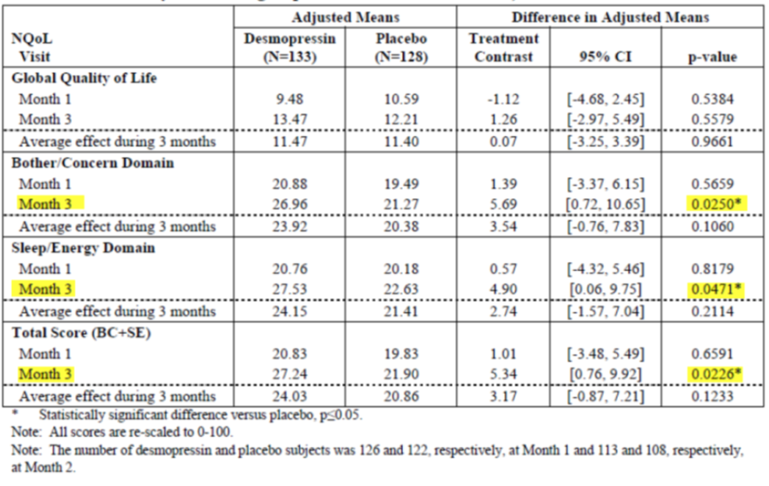

Table 43: CS41 adjusted treatment differences in mean change from baseline in NQoL domain scores by visit including treatment by visit interaction term (full analysis set using repeated measures ANCOVA)

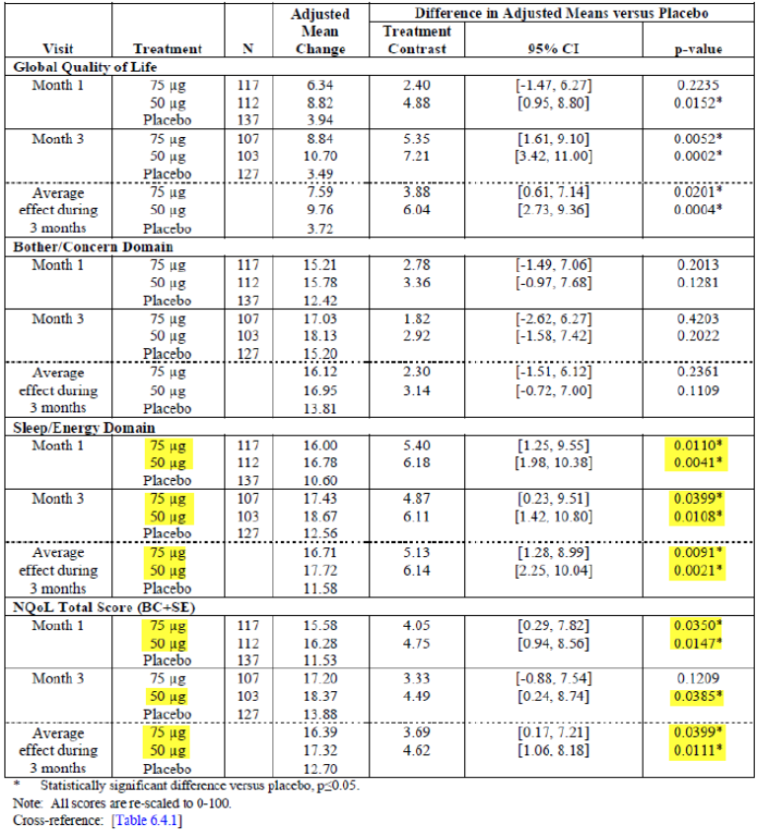

#### Onset of action of Nocdurna

The sponsor has pointed out in their response that decreases in nocturnal voids were seen by Day 4, and by the end of the first week the mean time to first nocturnal void was longer in the Nocdurna group than the placebo group.

The sponsor has included the following statement in the proposed PI (also in the SPC in EU): *Continued therapy must be carefully reconsidered in elderly patients who show no evidence of therapeutic benefit beyond 3 months.*

The sponsor’s proposed wording “no evidence of therapeutic benefit” is vague. Rather than “no therapeutic effect”, a statement about the size of the treatment effect might be more helpful to patients and prescribers; for example, stop therapy if the number of nocturnal voids is not reduced by 50% (say; or 33% or whatever) after 3 months.

The statement could be included in the PI, but it does not seem to address the issue of the small treatment effect (of contestable clinical significance) on the co-primary endpoints.

#### Uncertainty about the risk of hyponatraemia with Nocdurna

The sponsor points out that when the sodium monitoring plan from the proposed PI is retrospectively applied to the data from CS40 and CS41, the percentage of patients with hyponatraemia was about 2 to 4%, which is not much higher than that seen in the control arms, and similar to that seen with other drugs associated with hyponatraemia.

This does not address the issue of whether the results seen in the pivotal trials can be generalised to the real world of everyday clinical practice.

The sponsor also noted that the most important risk minimisation feature of Nocdurna is the lower, gender specific dose.

It is recommended that the TGA engage two independent external Australian clinical experts to provide advice on whether the risk of hyponatraemia can be satisfactorily managed in the real world of everyday clinical practice in Australia.

### Other issues

The 8 melt starter pack is not proposed for registration in Australia. A 10 melt sample pack is proposed for registration, but this will not be mandated as a starter pack.

Mention of the 8 melt starter pack has been corrected in the CER.

### Sponsor’s response to clinical questions

#### Question 1

*For the dichotomous co-primary endpoint of 33% reduction in voids, please provide risk ratios (not odds ratios) and 95% CIs. Please amend the proposed PI: The relative risk increase was 19% for women and 34% for men; not “nearly doubled”, as suggested by the odds ratio. These changes are required because it is well known that odds ratios can mislead prescribers and patients. CIs around the relative risk increase should be included in the PI.*

Risk ratios have been added; however, the sponsor has retained the odds ratios. The intention was that the risk ratios would replace the odds ratios (that is, the odds ratios would be removed).

The evaluator noted that according to statistical theories, when the baseline/placebo risk is greater than 5% or 10% [or the complement: less than 90% or 95%], the odds ratio can be misleading. More specifically, it might be incorrectly concluded that the treatment effect is larger than it is.

References

* Walter SD. Choice of effect measure in epidemiological data. J Clin Epidemiol 2000;53:931-939.
* Sinclair JC, Bracken MB. Clinically useful measure of effect in binary analyses of randomized trials. J Clin Epiemiol 1994; 47:881–9.
* Davies HTO, Crombie IK, Tavakoli M. When can odds ratios mislead? BMJ 1998; 316:989–91.
* Zhang J, Yu KF. What’s the relative risk? A method of correcting the odds ratio in cohort studies of common outcomes. JAMA 1998; 280(19):1690–1.

In CS40, the placebo risk was 64%, which is much larger than 5% or 10%. The proportion in the Nocdurna arm was 76%, which gives a risk ratio of about 1.20. This is a 20% relative benefit (relative risk increase); not nearly doubled as suggested by the odds ratio and the text in the draft PI (similarly for CS41).

Any changes to the PI will be evaluated as part of the evaluation of the whole PI, during any PI negotiations.

#### Question 2

*It seems that the MCID used for the sample size calculation for CS40 (women) was an average reduction of 0.5 voids per night; whereas the MCID for CS41 (men) was 0.2 voids (for the 50 µg dose). Why were different MCIDs used for the sample size calculations?*

The sponsor has provided more information on the MCIDs. However, it seems that there is no accepted convention about the size of the MCID for a trial of nocturnal polyuria.

#### Question 3

*What were percentages of patients in the pivotal trials who were able to get an uninterrupted night’s sleep?*

The sponsor has provided the following definition.

100% responder: a patient who had no nocturnal voids for any of 3 consecutive nights leading up to the scheduled visits (Day 4, Week 1, Month 1, Month 2, Month 3) in the pivotal trials. (Nocturnal voids were routinely recorded for the 3 night leading up to these visits.)

The following (Tables 44 and 45) are extracts from the information provided by the sponsor.

Table 44: 100% responders

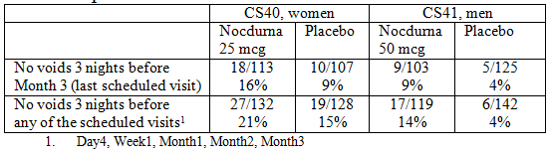

Table 45: No voids on at least one of the three nights before any of the scheduled visits

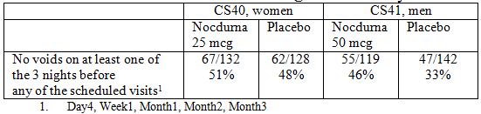

#### Question 4

*Why is a schedule for regular, long term serum monitoring of hyponatraemia not specified in the PI?*

Currently the proposed PI (under Dosing and Administration) states that all patients 65 years or older should have their serum sodium levels checked at the following times:

* before starting treatment
* at 4 to 8 days
* at 1 month.

In the response, the sponsor has stated:

All clinically significant cases of hyponatremia that occurred in CS40 and CS41 were captured by the monitoring plan within the first month of treatment with Nocdurna. It is therefore recommended that serum sodium is monitored during the first month of treatment for the patients at risk in order to adequately monitor clinically significant hyponatremia. In addition, all patients should have their serum sodium value taken before the initiation of treatment to ensure ≥ 135 mmol/L and any patients at increased risk for example due to concomitant medication or the elderly, will be requested additional sodium as stated in the PI.

Further clarification during any PI negotiations will be required as to whether all patients (regardless of age) should have serum sodium level done before starting treatment (as was the protocol in the trial) or only patients 65 + years (as is proposed in the PI).

It seems that the sponsor only recommends that patients 65 + years have their serum sodium levels checked at 4 to 8 days and again at one month (setting aside other younger patients with risk factors for hyponatraemia; and of course, good clinical practice would mean that any patient with symptoms or signs of hyponatraemia should have their serum sodium levels checked). It seems that the sponsor is not recommending that patients have their serum sodium checked after one month, unless they develop a risk or develop symptoms or signs suggestive of hyponatraemia.

It is recommended that the TGA engage two independent external Australian clinical experts to provide advice on whether the risk of hyponatraemia can be satisfactorily managed in the real world of everyday clinical practice in Australia. As part of this process, the independent expert experts will be asked about the serum sodium monitoring plan in the proposed PI.

#### Question 5

*The PI states: “In studies of adult subjects with nocturia treated with desmopressin, those who developed low serum sodium did so usually within the first few days of commencing treatment or of a dose increase.” Please provide the numbers behind this statement (e.g., a/b [c%] of patients who developed hyponatraemia [?mild/moderate/severe?] within the first three months, in the pivotal trials, did so within the first week).*

The sponsor was asked to provide the numbers behind the statement in the proposed PI that: “In studies of adult subjects with nocturia treated with desmopressin, those who developed low serum sodium did so usually within the first few days of commencing treatment or of a dose increase.”

Within the study follow-up of 3 months, 14 women given 25 µg desmopressin (CS40) developed serum sodium < 135 mmol/L; 11 mild (130 to 134) (8% of women randomised to 25 µg Nocdurna), 3 moderate (126 to 129) (2% of women randomised to 25 µg Nocdurna), 0 severe (≤ 125). Based on the tables provided by the sponsor it seems that 2 of the moderate cases occurred during the first week, with the other case occurring after the first week but before the end of the first month. Of the mild cases, 7 occurred in the first week; 3 occurred after the first week but before the end of the first month; one occurred after 1 month. There were 2 cases of mild hyponatraemia in the placebo group (2% of women randomised to placebo) (and no cases of moderate or severe hyponatraemia). One of these cases occurred in the first week and the other occurred after the first week, but before the end of the first month.

Within the study follow-up of 3 months, 11 men given 50 µg desmopressin (CS41) developed serum sodium < 135 mmol/L; 9 mild (130 to 134) (8% of men randomised to 50 µg Nocdurna), 0 moderate (126 to 129), 2 severe (≤ 125) (2% of men randomised to 50 µg Nocdurna). Based on the tables provided by the sponsor it seems that 1 of the severe cases occurred during the first week, with the other case occurring after the first week but before the end of the first month. Of the mild cases, 5 occurred in the first week; 2 occurred after the first week but before the end of the first month; 2 occurred after 1 month. There were 2 cases of mild hyponatraemia in the placebo group (1% of men randomised to placebo) (and no cases of moderate or severe hyponatraemia). One of these cases occurred in the first week and the other occurred after the first week, but before the end of the first month.

These data do not provide especially strong evidence for the statement in the proposed PI that: “In studies of adult subjects with nocturia treated with desmopressin, those who developed low serum sodium did so usually within the first few days of commencing treatment or of a dose increase.” Also, it is not clear what a dose increase is referring to.

#### Question 6

*In CS40/CS41, specific medicines that may cause hyponatraemia (i.e., TCADs, SSRIs, NSAIDs, chlorpropamide, diuretics, carbamazepine, etcetera) could not be started during the trial. Given this, please explain why the proposed PI does not recommend stopping Nocdurna if the patient needs to start on one of the specified medicines.*

Specific medicines that may cause hyponatraemia could not be started during the 3 month trial. It is unclear why the PI does not state that Nocdurna should be stopped if the patient needs to start one of these medicines.

The sponsor has stated that patients on stable doses of these medicines were enrolled in CS40 and CS41; and has provided Table 46. However, the number of patients is not given in Table 46. Also, in CS40 and CS41, follow-up was only for 3 months. Further, the confidence intervals are so wide as to make interpretation difficult. For women, HR = 0.70 (0.24, 2.06); that is, roughly speaking the risk of hyponatremia compared patients not on one of the specific concomitant medicines could be anywhere between a reduction of 80% or a doubling. For men, HR = 1.71 (0.56, 5.28); the risk could be anywhere between a halving, or a 5 fold increase. These wide confidence intervals demonstrate the uncertainty around use of Nocdurna with concomitant medicines that may cause hyponatraemia.

Table 46: Impact of concomitant medication on the risk of hyponatraemia

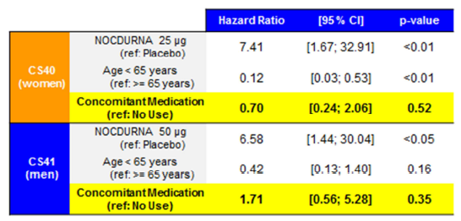

Also, the sponsor has included some examples from the literature that show that most cases of hyponatraemia occur soon after starting treatment. However, it is unclear whether this is a systematic review.

It seems that there is uncertainty (the sponsor has provided only small amounts of evidence) about whether patients can be safely started on specific medicines that may cause hyponatraemia, while on Nocdurna.

It is recommended that the TGA engage two independent external Australian clinical experts to provide advice on whether Nocdurna can be taken with medicines that may increase the risk of hyponatraemia.

#### Question 7

*How was mild/moderate hyponatraemia managed in CS40/CS41?*

The response is noted.

#### Question 8

*Based on experience overseas (for example, Canada), which doctors prescribe Nocdurna? (Primary care physicians/GPs, geriatricians, urologists, etcetera?)*

The sponsor has stated that in Canada the key prescribers are urologists and general practitioners, “with the higher prescription frequency at urologist level”. It would be helpful to have the number association with this statement.

The sponsor states that in the EU, prescribers are similarly expected to be urologists and general practitioners.

It is recommended that the TGA engage two independent external Australian clinical experts to provide advice on which types of doctors would be likely to prescribe Nocdurna in the Australian setting.

#### Question 9

*Please provide an update on the status of the application to the FDA.*

The sponsor is in discussions with the FDA about potentially conducting further studies.

#### Question 10

*Please provide the latest reports from the EU (Sweden or CMS).*

The Final Assessment Report from the Swedish NRA has been provided.

#### Question 11

*Please provide your responses to the questions in the Day 70 PAR (RMS: Sweden). The TGA is interested in all the responses, and is particularly interested in the responses to:*

* *Whether sex differences in dosing are due to weight/size and what this might mean for an elderly man of low weight*
* *Stratification of data from CS31 by age.*
* *Stratification of data for the co-primary endpoints from CS40/CS41 by >65, >75, > 85 years.*

The sponsor has referred the reader to the relevant parts of the Day 70 PAR.

## Second round benefit-risk assessment

Nocturia is an important problem that can materially reduce patients’ quality of life.

The results for the co-primary endpoints were statistically significant. Also, the results for the secondary endpoints (including N-QoL) provide some support for the co-primary endpoints.

However, the average benefits of Nocdurna were modest: women (25 µg): reduction of one night time void per 4 to 5 days; men (50 µg): reduction of one night time void per 2 to 3 days (see Section 6.1 Uncertainties about benefits).

One important concern is the risk of hyponatraemia in the real world of everyday clinical practice in Australia (see Section 6.2 Uncertainties about harms [hyponatraemia]).

There is therefore uncertainty about whether the benefit-risk balance is favourable. Of the TGA’s major regulatory partners, two (Health Canada, Swedish NRA and CMS) have decided that the benefit-risk balance is favourable; whereas the FDA have decided it is not, based on the currently available data.

* Health Canada has stated: With all recommendations and measures to be taken prior or during treatment to avoid the development hyponatremia [that is, baseline serum measures for all patients and repeat measures in Week 1 and Month 1], it can be concluded that the benefit of desmopressin in the treatment of the proposed indication outweighs its risk.
* The Swedish NRA evaluation has stated: With adequate monitoring the risk of hyponatraemia is considered possible to handle.
* The FDA stated that “… while some of these changes might be helpful in minimising the risk of hyponatraemia, and thereby improving the benefit-risk calculus, the Agency is still seeking clarity on the clinical benefit.” The sponsor is in discussions with the FDA about potentially conducting further studies.

The most recent report of the Australian Commission on Safety and Quality in Health Care on medication safety (2013) stated that 12% of medical admissions (that is, 230,000 admissions per year) were attributable to adverse reactions associated with medications; a (conservative) estimate of cost was $1.2B per year. There is concern and uncertainty around whether Nocdurna might contribute to this problem, via the well-known adverse reaction of hyponatraemia. This might be particularly the case when Nocdurna is used long term for a chronic condition, in every day clinical practice (that is, outside of the context of a closely monitored, 3 month clinical trial, which had carefully selected trial participants). There is also uncertainty as to whether the benefits of Nocdurna are sufficient to offset the risks associated with hyponatraemia.

|  |
| --- |
| Therapeutic Goods Administration |
| PO Box 100 Woden ACT 2606 Australia  Email: [info@tga.gov.au](mailto:info@tga.gov.au) Phone: 1800 020 653 Fax: 02 6232 8605  [**https://www.tga.gov.au**](https://www.tga.gov.au) |

1. Sterns R “Manifestations of hyponatremia and hypernatremia in adults” in UpToDate, Post TW (ed), US. (Accessed 11 April 2016).
2. Soiza R L, et al Hyponatremia: Special Considerations in Older Patients. *J Clin Med* 2014, 3, 944-958.
3. Liamis G, Milionis H and Elisaf M. A Review of Drug-Induced Hyponatremia *Am J Kidney Dis* 2008; 52: 144-153
4. Michelis M. Chapter 16, Geriatric Nephrology – online curricula of the American Society Nephrology available at https://www.asn-online.org/education/distancelearning/curricula/geriatrics/Chapter16.pdf
5. Yamaguchi, O et al Gender difference in efficacy and dose response in Japanese Patients with nocturia treated with four different doses of desmopressin orally disintegrating tablet in a randomized Placebo-controlled trial. *BJU Int.* 2013 ;111:474-484
6. Michelis M. Chapter 16, Geriatric Nephrology – online curricula of the American Society Nephrology available at https://www.asn-online.org/education/distancelearning/curricula/geriatrics/Chapter16.pdf
7. Abraham L et al. Urology 2004;63:481-486
8. Mock LL et al. Urology 2008;72:736-743